13 December 2014

AusPAR Attachment 2

Extract from the Clinical Evaluation Report for Ceftobiprole medocaril sodium
  - Proprietary Product Name: Zevtera
  - Sponsor: JACE Pharma Australia

About the Therapeutic Goods Administration (TGA)
- The Therapeutic Goods Administration (TGA) is part of the Australian Government Department of Health, and is responsible for regulating medicines and medical devices.
- The TGA administers the Therapeutic Goods Act 1989 (the Act), applying a risk management approach designed to ensure therapeutic goods supplied in Australia meet acceptable standards of quality, safety and efficacy (performance), when necessary.
- The work of the TGA is based on applying scientific and clinical expertise to decision-making, to ensure that the benefits to consumers outweigh any risks associated with the use of medicines and medical devices.
- The TGA relies on the public, healthcare professionals and industry to report problems with medicines or medical devices. TGA investigates reports received by it to determine any necessary regulatory action.
- To report a problem with a medicine or medical device, please see the information on the TGA website <https://www.tga.gov.au>.
About the Extract from the Clinical Evaluation Report
- This document provides a more detailed evaluation of the clinical findings, extracted from the Clinical Evaluation Report (CER) prepared by the TGA. This extract does not include sections from the CER regarding product documentation or post market activities.
- The words [Information redacted], where they appear in this document, indicate that confidential information has been deleted.
- For the most recent Product Information (PI), please refer to the TGA website <https://www.tga.gov.au/product-information-pi>.
Copyright
© Commonwealth of Australia 2016
This work is copyright. You may reproduce the whole or part of this work in unaltered form for your own personal use or, if you are part of an organisation, for internal use within your organisation, but only if you or your organisation do not use the reproduction for any commercial purpose and retain this copyright notice and all disclaimer notices as part of that reproduction. Apart from rights to use as permitted by the Copyright Act 1968 or allowed by this copyright notice, all other rights are reserved and you are not allowed to reproduce the whole or any part of this work in any way (electronic or otherwise) without first being given specific written permission from the Commonwealth to do so. Requests and inquiries concerning reproduction and rights are to be sent to the TGA Copyright Officer, Therapeutic Goods Administration, PO Box 100, Woden ACT 2606 or emailed to < tga.copyright@tga.gov.au> .

Contents
List of abbreviations 5
1. Introduction 9
2. Clinical rationale 9
3. Contents of the clinical dossier 11
3.1. Scope of the clinical dossier 11
3.2. Paediatric data 11
3.3. Good clinical practice 12
4. Pharmacokinetics 12
4.1. Studies providing pharmacokinetic data 12
4.2. Summary of pharmacokinetics 13
4.3. Pharmacokinetics in the target population 17
4.4. Pharmacokinetics in other special populations 18
4.5. Pharmacokinetic interactions 19
4.6. Evaluator’s overall conclusions on pharmacokinetics 19
5. Pharmacodynamics 20
5.1. Studies providing pharmacodynamic data 20
5.2. Summary of pharmacodynamics 20
5.3. Pharmacodynamic effects 21
5.4. Time course of pharmacodynamic effects 23
5.5. Relationship between drug concentration and PD effects 23
5.6. Genetic, gender and age related differences in PD response 26
5.7. Pharmacodynamic interactions 26
5.8. Evaluator’s overall conclusions on pharmacodynamics 26
6. Dosage selection for the pivotal studies 27
7. Clinical efficacy 27
7.1. Nosocomial or community acquired pneumonia 27
7.2. Analyses performed across trials (pooled analyses and meta-analyses) 42
7.3. Evaluator’s conclusions on efficacy of Zevetra® for NP and CAP 43
8. Clinical safety 45
8.1. Studies providing evaluable safety data 45
8.2. Patient exposure 45
8.3. Adverse events 47
8.4. Laboratory tests 52
8.5. Selection of microbiological resistant organisms including Clostridium difficile colitis 54
8.6. Post-marketing experience 54
8.7. Safety issues with the potential for major regulatory impact 54
8.8. Other safety issues 55
8.9. Safety in special populations 55
8.10. Safety related to drug-drug interactions and other interactions 56
8.11. Risk of the emergence of resistance and Clostridium difficile colitis 56
8.12. Evaluator’s overall conclusions on clinical safety 58
9. First round benefit-risk assessment 59
9.1. First round assessment of benefits 59
9.2. First round assessment of risks 60
9.3. First round assessment of benefit-risk balance 60
10. First round recommendation regarding authorisation 61
11. Clinical questions 61
11.1. Pharmacokinetics 61
11.2. Pharmacodynamics 61
11.3. Efficacy 61
11.4. Safety 61
12. Second round evaluation of clinical data submitted in response to questions 61
13. References 61

List of abbreviations
Abbreviation | Meaning
ALT | Alanine aminotransferase
AST | Aspartate aminotransferase
AE | Adverse event
ADME | Absorption, distribution, metabolism and excretion
ADR | Adverse drug reaction
AIDS | Acquired immunodeficiency syndrome
AM | Alveolar macrophages
ANC | Absolute neutrophil count
ARF | Acute renal failure
APACHE II | Acute Physiology Score and Chronic Health Evaluation II
AUC | Area under the plasma concentration−time curve
AUC_{0–∞} | Area under the plasma concentration-time curve from time zero to infinity
AUC_{0-8h} | Area under the plasma concentration-time curve over the time interval 0 to 8 h
AUC_{ss24h} | AUC over a 24 hr period at steady state
AUIC | Area under the inhibition curve
bd | Twice a day
BLQ | Below the limit of quantification
BP | Blood pressure
CAP | Community-acquired pneumonia
CDAD | Clostridium difficile associated diarrhoea
CHMP | Committee for Medicinal Products for Human Use
CI | Confidence interval
CL | Plasma clearance
CLR | Total renal clearance, estimated by CLS × fu, where fu is the fraction of dose excreted in urine within 24 h.
CL_{s} | Is the total systemic clearance estimated by CLS = dose/AUC_{0–∞.}
C_{max} | Is the observed maximum plasma concentration
C_{min} | Minimum plasma concentration
CNS | Central nervous system
COPD | Chronic obstructive pulmonary disease
Cp | Plasma concentration
CrCl | Creatinine clearance
CK | Creatine kinase
cSSSI | Complicated skin and skin structure infection
DAGT | Direct antiglobulin test
DIC | Disseminated intravascular coagulation
DIIHA | Drug-induced immune haemolytic anaemia
DSUR | Development safety update report
ECG | Electocardiogram
ELF | Epithelial lining fluid
EMEA | European medicines agency
EOI | End of infusion
EOT | End of therapy
ESBL | Extended spectrum beta lactamases
ESRD | End-stage renal disease
EUCAST | European Committee on Antimicrobial Susceptibility Testing
EU | European union
EU-RMP | European union risk management plan
EU-QPPV | EU Qualified Person for Pharmacovigilance
FBC | Full blood count
gp | Group
GPU | Global Pharmacovigilance Unit
HAP | Hospital-Acquired Pneumonia
Hb | Haemoglobin
FDA | Food And Drug Administration
GCP | Good Clinical Practice
GI | Gastrointestinal
ICH | International Conference On Harmonization
ICU | Intensive Care Unit
IDMC | Independent Data Monitoring Committee
ISR | Infusion/Injection Site Reaction
IV | Intravenous
LC/LC-MS/MS | Gradient Reversed-Phase Liquid Chromatography In Back-Flush Mode Coupled With A Tandem Mass Spectrometer
LL | Lower Limit
LRTI | Lower Respiratory Tract Infection
MAA | Marketing Authorization Application
MCS | Monte Carlo Simulation
MDR | Multi-Drug Resistant
MEDRA | Medical Dictionary For Regulatory Activities
MIC | Minimum Inhibitory Concentration
ml | Milliliters
MRSA | Methicillin-Resistant Staphlyococcus Aureus
MSSA | Methicillin-Susceptible Staphlyococcus Aureus
mth | Month
NAFLD | Non-Alcoholic Fatty Liver Disease
NIDDM | Non-Insulin Dependent Diabetes Mellitus
NOAEL | No-Observed Adverse- Effect Level
NP | Nosocomial Pneumonia
PBPs | Penicillin Binding Proteins
PD | Pharmacodynamic
PI | Prescribing Information
PK | Pharmacokinetic
pKa | Acid Dissociation Constant
PMS | Post Marketing Surveillance
PORT | Pneumonia Outcomes Research Team
PRSP | Penicillin-Resistant Streptococcus Pneumoniae
PSI | Pneumonia Outcomes Research Team Severity Index
PSUR | Periodic Safety Update Report
PT | Preferred Term
PTA | Probability Of Target Attainment
QD | Once Daily
RMP | Risk Management Plan
RTI | Respiratory Tract Infection
SAE | Serious Adverse Event
SAP | Statistical Analysis Plan
SD | Standard Deviation
SE | Standard Error
SIRS | Systemic Inflammatory Response Syndrome
SmPC | Summary Of Product Characteristics
SMR | Standardised Mortality Rate
SOC | System Organ Class
SOP | Standard Operation Procedure
tds | Three Times A Day
TEAE | Treatment-Emergent AE
TRAE | Treatment-Related AE
t_{1/2β} | Apparent Terminal Elimination Half-Life
TOC | Test-Of-Cure
UL | Upper Limit
ULN | Upper Limit Of Normal
US | United States
VAP | Ventilator-Associated Pneumonia
VRSA | Vancomycin-Resistant Staphylococcus Aureus
V_{ss} | Volume Of Distribution
WBC | White Blood Count

Introduction
This is submission to obtain registration for a new chemical entity ceftobiprole medocaril sodium powder for injection (Zevtera®) with proposed indications for the treatment of the following infections in adults:
- Nosocomial pneumonia (NP), excluding ventilator-associated pneumonia (VAP)
- Community-acquired pneumonia (CAP).

Clinical rationale
In September 2009, the European Centre for Disease Prevention and Control and the EMEA issued a joint technical report entitled ‘The bacterial challenge: time to react’ (ECDC/EMEA 2009). This report focused on antibiotic-resistant bacteria and emphasised the urgency required to ensure adequate antibiotics are available to treat human disease due to these pathogens. The 7 important pathogens cited in the report were:
- S. aureus, methicillin resistant (MRSA);
- S. aureus, vancomycin intermediate resistant and vancomycin resistant (VISA/VRSA);
- Enterococcus spp. (for example, Enterococcus faecium), vancomycin resistant (VRE);
- Streptococcus pneumoniae, penicillin resistance (PRSP);
- Enterobacteriaceae (for example, E.coli, Klebsiella pneumoniae), third-generation cephalosporin resistant;
- Enterobacteriaceae (for example, K. pneumoniae), carbapenem resistant;
- Non-fermentative gram-negative bacteria (for example, Pseudomonas aeruginosa), carbapenem resistant.
Ceftobiprole has the potential to address some of the challenges brought about by the global pandemic of multi-drug resistant bacteria having demonstrated in vitro activity against:
- MRSA including prominent healthcare-associated and community-associated strains VISA/VRSA
- PRSP including S. pneumoniae isolates highly resistant to ceftriaxone and multi-drugresistant 19A S. pneumoniae clones
Ceftobiprole has demonstrated in vitroactivity against daptomycin-nonsusceptible, tigecycline-resistant and linezolid-resistant S. aureus. Ceftobiprole’s potent activity against MRSA and PRSP extends the predominantly gram-negative spectrum of the well-established fourth-generation cephalopsorins (such as cefepime and ceftazidime), making it a ‘fifth’ generation cephalosporin.
Nosocomial pneumonia = pneumonia occurring > 48 h after hospital admission which was not incubating at the time of admission (Napolitano 2010).
VAP = pneumonia which manifests after a patient has been on a ventilator for > 48 h. NP is one of the most common infectious diseases acquired in hospitals, affecting 0.5%–1.7% of hospitalised patients (Masterton 2007, Lizioli 2003), and accounting for approximately 25% of all intensive care unit (ICU) infections (Torres 2010a). All-cause mortality for nosocomial pneumonia varies widely, ranging from 10–65% depending on patient population, clinical study setting and treatment (Muscedere 2010). NP is caused by a wide spectrum of bacterial pathogens, including more resistant gram negatives that is, P. aeruginosa (22%), Klebsiella sp. (10%), E. coli (7%), Acinetobacter sp. (7%), and Enterobacter sp. (6.5%), and gram-positives such as S. aureus (28%), particularly MRSA (Jones 2010). S. aureus has shown an increasing resistance to methicillin/oxacillin over the past four decades, with rates in Europe of 19.7% in 2009 as determined by the EARS-Net surveillance program of 198 laboratories in 22 countries (Gagliotti 2011). The rate of MRSA observed among ICU isolates of S. aureus is reported to be even higher at 34–44% in two large EU point prevalence studies (Lambert 2011, Vincent 2009). VAP represents a significant distinct clinical entity within NP related to patient factors including underlying disease and comorbidities (Sadfar 2005).
Community-acquired pneumonia=pneumonia acquired outside hospital or extended-care facilities or occurring ≤ 48 h after hospital admission; annual incidence ranging from 3-40 per 1,000, and rates of hospitalisation of 40 to 60%; the rate at which patients with CAP are admitted to the ICU is approximately 10% (Torres 2010b). Mortality rate due to hospitalised CAP is 10% (Torres 2010b). This has not substantially decreased over the past decades partially because of the emergence of multidrug-resistant (MDR) pathogens, and an increased % of the population being at risk (for example, immunocompromised patients; advanced age). Current international treatment recommendations support a prompt initiation of ‘appropriate’ empiric antibiotics (Torres 2009, BTS 2009) to avoid excess mortality and longer hospital stay (Kollef 1999). MRSA is an important cause of pneumonia, accounting for 20–40% of NP (Rubinstein 2008). The frequency of MRSA in CAP is still relatively low at < 5% in most parts of the world, but becoming more prevalent (Randolph 2011).
S. pneumoniae is the most frequent bacterial isolate in patients with CAP in the EU that is, approximately 40–50% of all CAP in adults (Höffken 2009). Drug resistance in S. pneumoniae occurs in ≤ 20% of RTI (Richter 2009), with an increase in invasive disease attributable to serotypes not covered by the current pneumococcal vaccines for example,serotype 19A (Tarrago 2011, Beall 2011). The reported EU prevalence of S. pneumoniae isolates submitted to the EARS-NET surveillance network in 2010 with 3.7% penicillin resistance; 9.3% intermediate penicillin resistance; macrolide resistance among these isolates was 15% (EARS-NET 2012). Other important bacterial causes of CAP include H. influenzae, S. aureus, and gram-negative enteric organisms. S. aureus, including MRSA, has emerged as an important pathogen in severe necrotizing CAP, with a mortality rate of up to 56% (Gillet 2007). According to reports from the US CDC, the number of severe CAP-MRSA cases continues to rise, with a peak incidence during the annual influenza season (CDC 2007, CDC 2009). High mortality rates due to community-acquired MRSA (CA-MRSA) have also been reported in Europe (Dufour 2002). Secondary bacterial pneumonia is a common cause of death in patients with seasonal influenza, with co-infections found in approximately 25% of flu-related deaths (Simonsen 1999, Bhat 2005). In a US urban study, MRSA found in 2.4% (14/595) of all cultures, and 14% of positive bacterial cultures, in CAP patients admitted to hospital during 2 consecutive flu seasons (Moran 2012).
Australia: Lower respiratory tract infections (LRTI) account for approximately 3 million visits to GPs each year (The Australian Lung Foundation, ‘Respiratory Infectious Disease Burden in Australia’, Edition 1, March 2007). The combined death rate for pneumonia and influenza positions these respiratory infections as the 6th leading cause of death. In 2002, pneumonia and influenza accounted for 3084 deaths (2.34% of all deaths in Australia) and 43,953 hospital admissions (average stay=6.3 days). Each year, CAP is associated with an overall mortality rate of 11.8% for hospitalised patients aged > 65 years. This mortality rate increases to 19.2% if ≥ 2 co-morbidities are present. The direct/indirect cost burden of CAP is > A$500million/year. This Case Statement also includes information about increasing antibiotic resistance in Australia and the need for new antibiotics to treat pathogens, namely S.pneumoniae, MDR S.aureus and MDR gram-negative pathogens. Importantly, while CAP and NP are of public health concern, there is a lack of epidemiological studies examining the incidence in Australia (Murdoch 2014).

Contents of the clinical dossier

Scope of the clinical dossier
The submission contained the following clinical information:
- 21 clinical pharmacology studies, including 14 that provided PK data and 7 that provided PD (and PK/PD) data.
- 1 population PK analyses: in 3 parts: population PK analysis, PK/PD analysis, and target attainment rate calculations.
- 2 Phase III pivotal efficacy/safety studies.
- 4 other efficacy/safety studies/reports including those conducted in cSSTI.

Paediatric data
The submission contained paediatric from one PK study, 30982081-CSI-1006.

Good clinical practice
The clinical studies in this application complied with CPMP/ICH/135/95 an internationally accepted standard for the design, conduct, recording and reporting of clinical trials (www.tga.gov.au/docs/html/ich13595.htm); however, cSSTI studies has major GCP deficiencies.

Pharmacokinetics

Studies providing pharmacokinetic data
Table 1 shows the studies relating to each PK topic.

Table 1: Submitted pharmacokinetic studies.
PK topic | Subtopic | Study ID | *
PK in healthy adults | General PK - Single dose | NP16104, BAP0006, BAP00210 | *  *
PK in healthy adults | - Multi-dose | BAP00010, BAP00058  BAP00393  JNS015-JPN-01 | *  *  *
PK in healthy adults | Bioequivalence† - Single dose | not applicable
PK in healthy adults | - Multi-dose | not applicable
PK in healthy adults | Food effect | not applicable
PK in special populations | Target population § - Single dose
PK in special populations | - Multi-dose
PK in special populations | Hepatic impairment | not done
PK in special populations | Renal impairment | BAP00018  30982081-CSI-1007  CEFTO-NOS-1001 | *
PK in special populations | Obese adults | CEFTO-CSI-1008 | *
PK in special populations | Neonates/infants/children/adolescents | 30982081-CSI-1006 | *
PK in special populations | Elderly | not done
Genetic/gender-related PK | Males versus females | BAP00036  30982081-CSI-1004 | *
PK interactions |  | not done
Population PK analyses | Healthy subjects | Completed JNJ-30982081 | *
Population PK analyses | Target population | Patients with cSSSI JNJ-30982081 | *
* Indicates the primary aim of the study. † Bioequivalence of different formulations. § Subjects who would be eligible to receive the drug if approved for the proposed indication. None of the pharmacokinetic studies had deficiencies that excluded their results from consideration.
Note: the ** studies above also included PD data which is presented in Section 5.0.

Summary of pharmacokinetics
The information in the following summary is derived from conventional PK studies unless otherwise stated.
The following information is derived from the sponsor’s summaries.

Pharmacokinetics in healthy subjects

Absorption

Sites and mechanisms of absorption
The water-soluble prodrug is rapidly and almost completely converted to ceftobiprole after IV administration.

Bioavailability

Absolute bioavailability
Ceftobiprole (as ceftobiprole medocaril) is administered IV; bioavailability is assumed to be 100%. No bioequivalence studies to compare the various formulations planned or conducted.

Bioavailability relative to an oral solution or micronised suspension
Not applicable.

Bioequivalence of clinical trial and market formulations
Not applicable.

Bioequivalence of different dosage forms and strengths
Not applicable.

Bioequivalence to relevant registered products
Not applicable.

Influence of food
Not applicable.

Dose proportionality
Systemic exposure of ceftobiprole is dose-proportional over a dose range of 125 mg to 1,000 mg. Accumulation after administration of multiple doses was negligible at a dosing interval of 8 h.

Bioavailability during multiple-dosing
Linearity / Non-linearity: Ceftobiprole exhibits linear and time-independent PK. The C_{max} and AUC of Zevtera® increase in proportion to dose over a range of 125 mg to 1 g. Steady-state active substance concentrations are attained on the first day of dosing; no appreciable accumulation occurs with every 8 h dosing in subjects with normal renal function.

Effect of administration timing
The effect of administration timing is summarised in Table 2.

Table 2: Mean (SD) PK parameters of Zevtera in adults
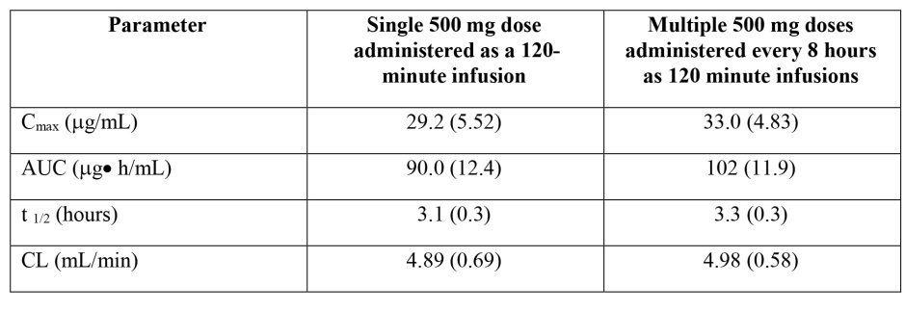

Distribution

Volume of distribution
Ceftobiprole’s steady state volume of distribution (approximately 18 L) approximates the extra-cellular fluid volume in humans - typical of cephalosporins, and suggests intra-cellular penetration of ceftobiprole does not occur to an appreciable extent. The V_{diss} is dose and time independent.

Plasma protein binding
Ceftobiprole binds minimally (16%) to plasma proteins; binding is independent of drug and protein concentration. Therefore, most is unbound in plasma and available for tissue and fluid penetration.

Erythrocyte distribution
No specific information provided in the application.

Tissue distribution
As described above.

Metabolism

Interconversion between enantiomers
Not applicable.

Sites of metabolism and mechanisms / enzyme systems involved
Conversion from the pro-drug, to the active moiety ceftobiprole, occurs rapidly via non-specific plasma esterases. Pro-drug concentrations are negligible and measurable in plasma and urine only during infusion. The metabolite resulting from the cleavage of the pro-drug is diacetyl that is, an endogenous human compound. In vitro experiments conducted in hepatocytes, showed minimal metabolism in all species. Similarly, in Phase I clinical studies, ceftobiprole was primarily eliminated unchanged in the urine; on average, non-renal clearance accounted for 19% of total body clearance. In Study 30982081-CSI-1004, approximately 83% of the dose was excreted as unchanged ceftobiprole in urine, approximately 5% of the dose was excreted in urine as the open ring metabolite. As ceftobiprole does not appear to undergo significant hepatic metabolism and PPB is low, no PK study in hepatic impairment was conducted. Preclinical toxicology studies evaluated the NOEL urinary exposures in rat, dog, marmoset, as it relates to potential precipitation of ceftobiprole in renal tubules observed in bolus studies. At the NOEL, the highest urinary concentrations were 3100 to 25000 μg/mL; averaging 3500 to 23500 μg/mL In clinical studies these ranged from 0.42 μg/mL to 6920 μg/mL. Of the approximately 250 subjects who contributed urine for PK, no subject had concentrations above 23500 μg/mL, 10 subjects had concentrations > 3500 μg/mL. No subject reported renal or urinary AE and precipitation was not observed in any of these subjects. Precipitate in the urine was noted in one BAP00036 subject at the 7-Day follow-up visit. The maximal urine concentration for that subject was 2580 μg/mL.

Non-renal clearance
Minimal hepatic metabolism as discussed above.

Metabolites identified in humans

Active metabolites
Ceftobiprole is minimally metabolised to the open-ring metabolite, which is microbiologically inactive.
Figure 1: In Vitro and In Vivo metabolism of BAL5788 (ceftobiprole medocaril)
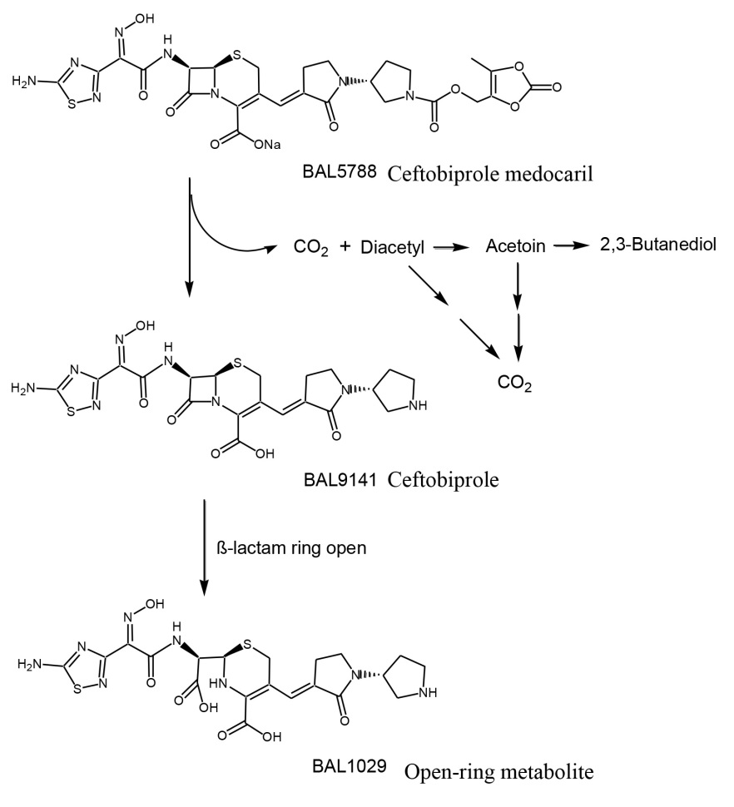

Other metabolites
Not applicable.

Pharmacokinetics of metabolites
Not applicable.

Consequences of genetic polymorphism
Not applicable.

Excretion

Routes and mechanisms of excretion
Unchanged by renal excretion; terminal elimination half-life of 3 h. Excreted in urine by glomerular filtration, does not undergo renal tubular secretion; approximately 89% of administered dose recovered in the urine.

Mass balance studies
Not applicable.

Renal clearance
The effects of various degrees of renal impairment, including mild, moderate, and severe, on the PK were investigated in a single-dose study (BAP00018). Systemic exposure in terms of AUC_{last} was 1.3-fold, 2.5-fold, and 3.3-fold higher in subjects with mild, moderate, and severe renal impairment, respectively, than in subjects with normal renal function. In subjects with renal impairment, systemic clearance correlated well with creatinine clearance (CrCl), indicating target drug levels can be maintained by dose adjustment based on the degree of renal impairment. Following single-dose administration, urinary recovery over 24 h ranged from 74% to 32% in subjects with mild to severe renal impairment. Elimination half-life increased with decreasing renal function, such that subjects with severe renal impairment exhibited the longest t_{1/2} of 11 h. Estimated C_{max} and V_{SS} similar across various degrees of renal impairment. In subjects with normal renal function, open-ring metabolite exposure was low versus ceftobiprole (4% of ceftobiprole exposure), although the extent of accumulation for the open-ring metabolite in mild, moderate, severe renal impairment remains unknown. As ceftobiprole is primarily eliminated by renal excretion, dosage adjustments in renally impaired patients were optimised by simulations and modelling, and evaluated in the Phase III programme. Table 3 shows the dose and dose interval adjustments evaluated. Phase III studies BAP00154 and BAP00414 in cSSTI, and BAP248/307 and CAP-3001 in pneumonia. In study BAP00414, PK data were obtained in a limited number of subjects with mild and moderate renal impairment. Steady-state exposure to ceftobiprole in subjects with mild renal impairment was higher (51% for C_{max}, 45% for AUCτ) than in subjects with normal renal function, when the same dosing regimen was administered. When the dose was adjusted to 500 mg bd in subjects with moderate renal impairment, C_{max} was similar, but AUC_{last} was 35% higher than in subjects with normal renal function [Module 2.7.2, Section 2.2.3]. There were no PK data collected in subjects with severe renal impairment in Phase III studies. However, based on simulations for dose adjustments, the predicted C_{max} estimates would be similar to healthy subjects (ratio of 0.92), and AUC_{0–8} would be 53% higher in patients with severe renal impairment than in those with normal renal function.

Table 3: Ceftobiprole dose adjustments based on creatinine clearance
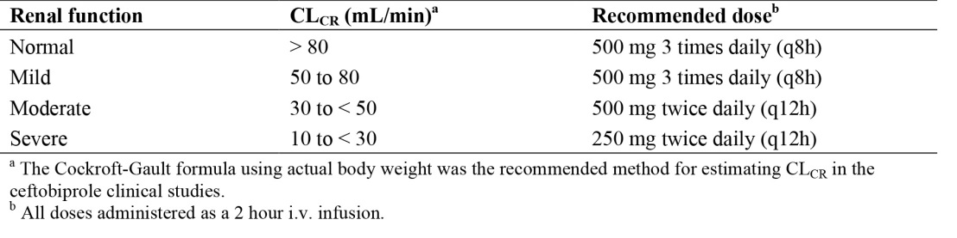
End-stage renal disease (ESRD) requiring haemodialysis: The proposed dosage in ESRD of 250 mg q24h is based on simulations of the plasma concentration-time profiles for ceftobiprole using parameter estimates derived from Study CSI-1004. The PK of ceftobiprole in subjects with ESRD requiring haemodialysis were investigated in a single-dose study (30982081-CSI-1007), in which ceftobiprole was administered as a 250 mg, 2 h IV infusion, either before or after a 4 h haemodialysis period. Exposure to both ceftobiprole and the open-ring metabolite was much higher in ESRD subjects, whether dosed pre-dialysis or post-dialysis, than in healthy subjects. In pre-dialysis ESRD subjects, the AUC was respectively twice and 12 times higher than in normal subjects for ceftobiprole and the metabolite. The corresponding increases in post-dialysis ESRD subjects were 6 times and 20 times. In pre-dialysis and post-dialysis ESRD subjects, ceftobiprole and the open-ring metabolite were still detectable in plasma on Day 3 post-treatment, in contrast to healthy subjects. These observations were expected, as both compounds are predominantly eliminated in urine. Ceftobiprole and the open-ring metabolite were easily extracted during haemodialysis, with extraction ratios of 0.69 and 0.64, respectively, consistent with the less marked increases in exposure when ESRD subjects were treated pre-dialysis rather than post-dialysis.
Subjects with CrCl >150 mL/min: A PK study was conducted in an ICU population comprising male and female ventilated and non-ventilated subjects (CEFTO-NOS-1001). Renal function estimated by CrCl covered mild renal impairment (CrCl= 50–79 mL/min), normal renal function (CrCl = 80–150 mL/min) and supra-normal renal function (CrCl > 150 mL/min). Subjects received multiple doses of 1000mg ceftobiprole as a 4 h IV infusion. On Day 2, the CrCl (Cockcroft-Gault formula) was close to the measured CrCl in these subjects. At steady-state, ceftobiprole CL_{SS} was 40% higher if CrCl > 150 mL/min versus normal renal function. Exposure was inversely related to the CrCl, as C_{max} and AUC were lower in subjects with challenged CrCl values than with normal renal function. The V_{diss} in these subjects was also 30% larger. The estimated unbound T> MIC (fT> MIC) decreased from 18.2 to 10.8 h with increasing CrCl. There was a good correlation between the systemic clearance of ceftobiprole and the CrCl in both this study and Study BAP00018.
Figure 2: An across-study comparison of ceftobiprole systemic clearance in subjects with normal and challenged renal function and subjects with renal impairment
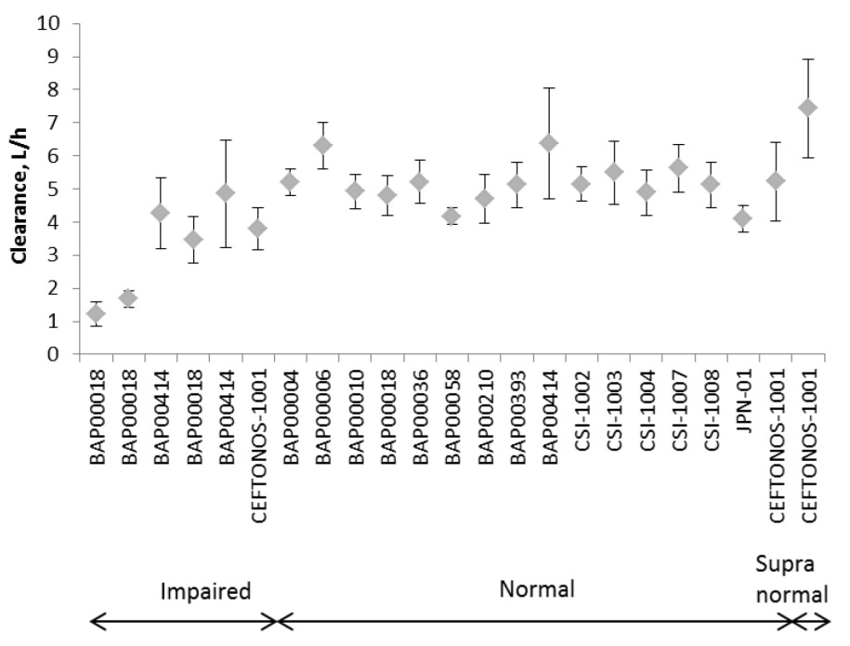

Intra- and inter-individual variability of pharmacokinetics
None significant revealed in the PK programme aside from in those with challenged renal function (see above); exposure was higher in females, relating to body weight.

Pharmacokinetics in the target population
Studies BAP248/307 and CAP-3001 were not sufficient to compare the PK in subjects with NP or CAP to the PK of healthy subjects in Phase I studies. The population PK model developed for ceftobiprole was applied to subjects with NP in BAP248/307 for whom plasma concentrations or model covariates were known, and who were also included in the microbiological ITT analysis set. Individual plasma concentration-time profiles and fT> MIC were derived for the PD targets of 30% to 60% of the q8h dosing interval, and MIC of 4 μg/mL. In NP subjects, ceftobiprole exposure in terms of %fT> MIC of the q8h dosing interval predicted clinical cure and microbiological outcome at both end-of-treatment (EOT) and the TOC visit. Although not correlated with clinical cure and microbiological eradication, appropriateness of exposure during treatment was also confirmed in VAP subjects.

Pharmacokinetics in other special populations

Pharmacokinetics in subjects with impaired hepatic function
Not specifically explored for the reasons described above.

Pharmacokinetics in subjects with impaired renal function
See under Section 4.2.1.1.3.3.

Pharmacokinetics according to age
The effect of age on ceftobiprole PK was examined through a population PK analysis. Age was not identified as a statistically significant covariate in the final population PK model in which CLCR explained the apparently lower clearance in elderly patients.

Paediatric subjects
A single-dose PK study was conducted in paediatric subjects with ages ranging from 3 months to < 18 years (Study 30982081-CSI-1006). The IV 2 h infusion dose was reduced by increasing age group: 15 mg/kg for age < 6 years, 10 mg/kg for age 6 years to < 12 years, and 7 mg/kg (max of 500 mg) for ages 12 years to < 18 years. Ceftobiprole V_{diss} and CL_{s} increased with age, approaching healthy adult values in ages 12 years to < 18 years. At the doses administered in this study, the single-dose PK of ceftobiprole were generally within the range of those previously observed in healthy adult subjects after a single dose of ceftobiprole 500 mg. The resulting exposures in each age group were well below exposures obtained in a rat juvenile toxicity study at the NOAEL, providing the dosing rationale in each age group for the Paediatric Investigation Plan.

Pharmacokinetics related to genetic factors

Gender
In BAP00036, which compared single-dose PK of ceftobiprole in males and females, systemic exposure to ceftobiprole in terms of C_{max} and AUC was approximately 21% and 15% higher, respectively, in females than in males, attributed to the lower body weight in females. Similar results in Study 30982081-CSI-1004. The degree to which systemic exposure to ceftobiprole in females exceeded males was more pronounced following single-dose administration (32% for C_{max} and 21% for AUC_{0–8}) than multiple-dose administration (16% for C_{max} and 11% for AUC_{0–8}). In both studies, V_{diss} was lower in females (20 versus 29%). Gender was confirmed to be a statistically significant, but not clinically relevant, covariate on V_{diss} in the population PK analysis; when corrected for body weight, no gender differences were apparent. In both studies, the %T> MIC corresponding to an 8 h dosing interval was similar in males and females (84% in 30982081-CSI- 1004 and 82% in BAP00036). Dosage adjustments based on gender not required.

Race
Single and multiple dose PK was investigated in Japanese males (JNS015-JPN-01), with ceftobiprole sequentially administered as a single 2 h infusion at doses of 250 mg up to 1000 mg. The multiple-dose part of the study investigated two regimens: 500 mg tds and 500 mg bd. Ceftobiprole PK was similar between male Japanese and female Caucasian subjects. Differences in C_{max}, AUC, Vd and CL_{s} values between male Japanese and Caucasians were < 30% -largely explained by body weight. As the half-lives were comparable, there is no impact on the %fT> MIC. Influence of race was also explored in the population PK analysis. Race was not identified as a significant covariate. Dose adjustments based on race not required.

Pharmacokinetics in other special population / according to other population characteristic

Obese and morbidly obese
A single-dose study (CEFTO-CSI-1008) was conducted to investigate the PK of ceftobiprole in morbidly obese versus non-obese subjects administered 500 mg ceftobiprole as a 2 h infusion. Exposure to ceftobiprole was lower in morbidly obese subjects, attributed to a larger V_{diss} and higher clearance, but without impact on %T> MIC. In the population PK, body weight was identified as a statistically significant, but not clinically relevant, covariate on central volume of distribution in the final PK model. Dose adjustments based on body weight not required.

Pharmacokinetic interactions

Pharmacokinetic interactions demonstrated in human studies
Clinical drug interaction studies have not been conducted as the overall likelihood of significant interactions is considered minimal based on its PK. Conversion from the prodrug to the active drug ceftobiprole by non-specific esterases is rapid and complete, and a literature review confirms that administration of concomitant medications is not known to reduce Type A esterase activity. Since protein binding of ceftobiprole is low (16%) and independent of concentration, displacement interactions are not anticipated. As ceftobiprole is not extensively metabolised, does not induce CYP450 isoenzymes, and minimally inhibits CYP450 isoenzymes, drug-drug interactions are not anticipated. As ceftobiprole is neither a substrate nor inhibitor of p-glycoprotein, transport-related interactions are also not anticipated. Ceftobiprole is primarily excreted unchanged in urine by glomerular filtration; a fraction of the drug is reabsorbed; ceftobiprole does not undergo renal tubular secretion, as evidenced from an interaction study with probenecid in a rat model. Ceftobiprole should therefore not affect the tubular secretion of other agents. Exploratory population PK screening indicate concomitant administration of fentanyl, lidocaine, paracetamol, diclofenac, aspirin, heparin, diphenhydramine, propofol, hydromorphone hydrochloride, methadone, hydrocodone bitartrate, metamizole sodium, furosemide dis not impact on the PK of Ceftobiprole.

Clinical implications of in vitro findings
In vitro studies have shown ceftobiprole to be bactericidal against staphylococci, streptococci, enterococci including VRE, E. coli, H. influenzae, M. catarrhalis, and, in combination with levofloxacin or amikacin exhibits synergistic bactericidal activity towards P. aeruginosa (Kresken 2011). The PK/PD relationship is discussed further in Section 5.0 below. In vitro studies demonstrate ceftobiprole is an inhibitor of the hepatocyte uptake transporters OATP1B1 and OATP1B3, but not of PgP, BCRP, MDR1, MRP2, OAT1, OAT3, OCT1 or OCT2. Ceftobiprole is potentially a weak substrate of the renal tubule cells uptake transporters OAT1 and OCT2. These findings along with the in vitro findings as detailed above suggest drug-drug (D-D) interaction potential is very low, and justifies why D-D interaction studies were not performed.

Evaluator’s overall conclusions on pharmacokinetics
The applicant has provided a comprehensive PK program (in adults) and a justification for the lack of drug-drug interaction studies. This reveals linear and time-independent PK and a drug that is excreted predominantly unchanged in urine. The program of studies in renally impaired individuals supports the proposed dosing in those with mild-moderate and severe renal impairment (including dialysis subjects).

Pharmacodynamics

Studies providing pharmacodynamic data
Table 4 shows the studies relating to each PD topic.

Table 4: Submitted pharmacodynamic studies.
PD Topic | Subtopic | Study ID | *
Primary Pharmacology | BAL penetration  Tissue penetration in adipose and skeletal tissue  penetration into bone  penetration into epithelial lining and alveolar macrophages in the lung** | 30982081-CSI-1005  30982081-CSI-1002  CEFTOPED-1001  CEFTONOS-1002 | *  *  *  *
Secondary Pharmacology | Effect on intestinal flora | CEFTO-BAC-1002 | *
Secondary Pharmacology | Effect on QTc interval | 30982081-CSI-1001  30982081-CSI-1003 | *  *
Population PD and PK-PD analyses | Healthy subjects
Population PD and PK-PD analyses | Target population
* Indicates the primary aim of the study. § Subjects who would be eligible to receive the drug if approved for the proposed indication. ‡ And adolescents if applicable.
None of the PD studies had deficiencies that excluded their results from consideration aside from Study CEFTONOS-1002 - terminated early due to very poor enrolment before study drug given.

Summary of pharmacodynamics
The information below is derived from conventional PD studies in humans unless otherwise stated.

Mechanism of action
Preclinical animal pneumonia studies demonstrate ceftobiprole attains effective concentrations at the site of infection in lung parenchyma. The broad spectrum in vitro activity is reflected in its efficacy in various animal models of infections with both gram-positive and -negative bacteria. Ceftobiprole exerts bactericidal activity through binding to important PBPs. In gram-positive bacteria, including MRSA, ceftobiprole binds to PBP2a. Ceftobiprole has demonstrated in vitro activity against strains with divergent mecA homolog (mecC or mecALGA251). Ceftobiprole also binds PBP2b in S.pneumoniae (penicillin-intermediate), PBP2x in S.pneumoniae (penicillin resistant), and PBP5 in E.faecalis.

Resistance
Ceftobiprole is inactive against enterobacteriaceae expressing Ambler class A beta lactamases that is, TEM, SHV, CTX-M ESBL and KPC-type carbapenemases, Ambler class B beta lactamases and Ambler class D beta lactamases, especially ESBL variants and carbapenemases (OXA-48). It is also inactive against strains with high Ambler class C beta lactamases expression of. Ceftobiprole is inactive against P. aeruginosa expressing Ambler class A (for example, PSE-1), class B (for example, IMP-1, VIM-1, VIM-2) and class D (for example, OXA-10) enzymes. It is inactive against isolates with acquired mutations in regulatory genes leading to de-repressed levels of expression of chromosomal Ambler class C beta lactamase, or over-expression of Mex XY efflux pump. Ceftobiprole is inactive against strains of Acinetobacter spp. that express enzymes of Ambler class A (for example, VEB-1), class B (for example, IMP-1, IMP-4), class D (for example, OXA-25, OXA-26), or with de-repressed levels of expression of the chromosomal Ambler class C beta lactamase. In vitro data also indicate that the following species are not susceptible to ceftobiprole: Chlamydophila pneumonia,
Burkholderia cepacia complex; M.pneumoniae; Mycobacteria; Nocardia spp; Stenotrophomonas maltophilia. See also under Safety for a further review of the mechanisms of resistance and the Risk Assessment of Microbial Resistance.

Pharmacodynamic effects

Primary pharmacodynamic effects
EUCAST MIC breakpoints established are described in Table 5.

Table 5: Clinical breakpoint by EUCAST
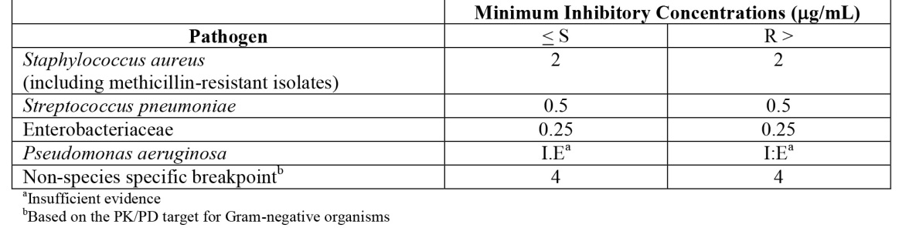
Evidence for Ceftobiprole’s antibacterial activity is based on approximately 120,000 surveillance isolates relevant to bacterial pneumonia from North America, Latin America, EU, Asia-Pacific, China and tested for susceptibility. Collective surveillance data show ceftobiprole has low MIC₉₀values (≤ 4 μg/mL) for a wide variety of important gram-positive and -negative pathogens relevant to NP and CAP that is, staphylococci, S. pneumonia, and H. influenza; MIC₅₀ values ≤ 4 μg/mL for Enterobacteriaceae and many surveillance P. aeruginosa isolates. Its spectrum of activity against gram-negatives is similar to extended-spectrum cephalosporins that is, cefepime, ceftazidime. In addition, ceftobiprole is active against MRSA and penicillin- and ceftriaxone-resistant pneumococci. The MIC₉₀ is ≤ 2 μg/mL across many studies and surveillance programs conducted in different regions of the world. Ceftobiprole is also active against surveillance isolates of MRSA with VISA and linezolid-resistant phenotypes. Ceftobiprole has MIC values ≤ 4 μg/mL against penicillin and ceftriaxone-resistant pneumococci and vancomycin-resistant/ampicillin-susceptible E. faecalis.

Table 6: Summary PK for single and multiple dosing
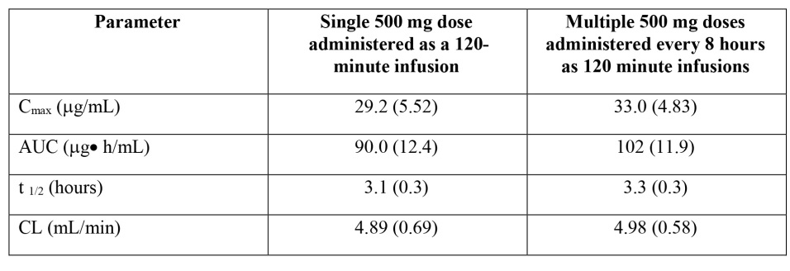

Bactericidal mode of action
This may be important in treating serious staphylococcal disease (Finberg 2004, Pankey 2004), although how important has only been convincingly demonstrated with bacteraemia (Chang 2003, Stryjewski 2007). Bactericidal activity may be of additional benefits in the immuncompromised. In vitro, ceftobiprole is bactericidal against staphylococci incl. MRSA, VISA, VRSA, streptococci including PRSP, enterococci including ampicillin-susceptible E. faecalis and VRE, E. coli, H. influenzae, M. catarrhalis, and, in combination with levofloxacin or amikacin there is synergistic bactericidal activity towards P. aeruginosa (Kresken 2011).

Secondary pharmacodynamic effects

Effect of ceftobiprole treatment on the intestinal microflora
An important aspect of all novel broad spectrum antibiotics is the negative impact on the normal gut microbiome including overgrowth with C.difficile. The effects on the faecal flora were studied in CEFTO-BAC-1002 and Step 2 of JNS015-JPN-01.

Aerobic intestinal microflora
Mean counts of E. coli decreased by approximately 1.5 log cfu/g of faeces from Day –1 to Day 14 with recovery to baseline counts on Day 21. Mean values for Enterobacteriaceae did not change from Day –1 to Day 21. The mean number of enterococci decreased 1.0 log cfu/g from Day –1 to Day 7 and then increased 2 log cfu/g of faeces to Day 14. On Day 21, number of enterococci was recovered to baseline. The number of Candida albicans was within the normal variation (≤ 2 log cfu/g). Changes in aerobic intestinal microflora were within normal variation (≤ 2 log cfu/g faeces).

Anaerobic intestinal microflora
No changes in the number of lactobacilli and bifidobacteria from Day –1 to Day 21. Counts of Clostridia increased from Day 2 to Day 7 with approximately 1.5 log cfu/g faeces and then returned to baseline. The numbers of Bacteroides were only influenced on Day 2 with a decrease of approximately 0.5 log cfu/g faeces. All alterations were within normal variation. Antibiotic susceptibility test: No new colonising aerobic and anaerobic bacteria resistant to ceftobiprole (MIC > 4 μg/mL) found.

Effect on ECG
Although discontinued early due to infusion site reactions (ISR), there were no clinically relevant differences in any QT parameters in CSI-1001. In CSI-1003, plasma ceftobiprole concentrations following the 1000 mg dose (supra-therapeutic) administered as a 2 h infusion exceeded those seen in subjects with NP and CAP, including those with mild or moderate renal impairment when receiving recommended doses of 500 mg tds or bd, respectively. In conclusion QT/QTc prolongation effect of single IV administrations of ceftobiprole at therapeutic and supra-therapeutic doses was non-inferior to, or no worse than, that of placebo. No AEs reported suggestive of pro-arrhythmic potential as specified in ICH E14.

Time course of pharmacodynamic effects
See below.

Relationship between drug concentration and PD effects

Dosing rationale based on stasis. Preclinical evidence
Results from non-clinical animal infection models have shown that proportion of the dosing interval for which drug concentration exceeds MIC (%T> MIC) to be the principle PK/PD measure predictive of in vivo efficacy for the beta lactam class of antibiotics (Bhavnani 2005). A strong correlation between T> MIC and effect was found for ceftobiprole in both in vitro and animal studies (Andes 2006). PK parameters and PD effects of ceftobiprole were also characterised in S.pneumoniae and S.aureus murine models of acute pneumonia with isolates comprising penicillin-, ceftriaxone- and cefotaxime-resistant S.pneumoniae and CA- and HA-MRSA. Regardless of the phenotypic resistance to beta lactams, maximal antibacterial activity obtained for T> MIC ranging from 6% to 22% of the dosing interval. The penetration of ceftobiprole in ELF from infected mice was 68% (Laohavaleeson 2008, Rodvold 2009). As such, the PD targets, %fT> MIC of 30% for documented gram+ve infections and 50% for broad-spectrum coverage, were used for dose selection in the Phase III studies.

Prospective probability of target attainment
Monte Carlo simulation (MCS) of antimicrobial dosing regimens is a tool for determining probabilities of achieving a specific PD index, defined as probability of target attainment (PTA). Prospective population PK models for ceftobiprole were based on clinically relevant pathogen MIC data and PK/PD targets from non-clinical animal infection models. The first set of Monte Carlo simulations were performed in 2004 (Mouton 2004) before initiation of the Phase II study (BAP00034), using limited PK data from the multiple-ascending-dose Study BAP00010. Plasma concentrations were corrected for protein binding according to a similar estimate derived from pilot studies (40%) (BAP00112, BAP00566) and were analysed via a population approach using a 2-compartment model. PTA for 3 targets (%fT> MIC 30 to 50%) was estimated for several dosing regimens for MIC-values of 0.5 to 16 (Table 7).

Table 7: Probability of target attainment for ceftobiprole
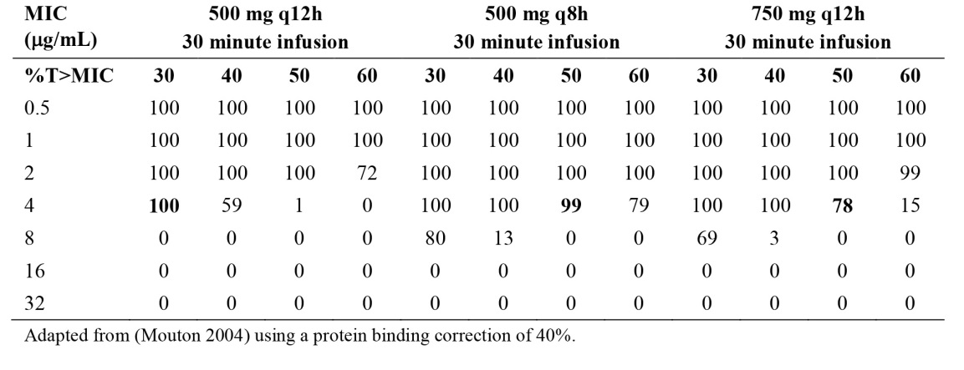
Based on these MSC, 500 mg tds was predicted to have 100% probability of target attainment assuming a 30% T> MIC target and MIC up to 4 μg/mL. Regarding the target of 50% T> MIC, 500 mg tds was predicted to have 99% probability of target attainment for MIC of up to 4 μg/mL; 750 mg bd regimen infused over 30 minutes was predicted to have a 78% probability of target attainment. The second set of MSA was performed in 2007/2008 (Lodise 2007, Lodise 2008). A large population PK analysis, formulated to include aggregate concentration data of 150 subjects from several Phase I studies, including the renal impairment study (BAP00018), plus concentration data from patients with cSSTI in BAP00034, was applied to describe the PD profile. Plasma concentrations were corrected for protein binding and analysed via a population approach. A standard 2-compartment model with first-order elimination from the central compartment and first-order inter-compartmental transfer rate constants best described ceftobiprole concentration data. Probability of target attainment for different targets (%fT> MIC 30 to 60%) was estimated for various regimen including 500mg tds as a 2 h infusion investigated in NP and CAP. As elimination is unchanged in urine, CrCl was used as a population PK covariate. The distribution of renal function among patients was integrated in the population PK model and PTA analysis was based on the distribution of CrCl from a levofloxacin study (West 2003). Overall analysis of probability of target attainment for ceftobiprole with the NP therapeutic dosing regimen is shown in Table 8. For this regimen, the probability of target attainment corresponding to 50% fT> MIC for MIC of 4 μg/mL was ≥ 80% in those normal renal function (CrCl 80-120 mL/min).The NP regimen provided > 95% probability of target attainment (achieving 50% fT> MIC) against all gram+ve organisms studied (Table 9). For Gram-ve organisms the analysis of probability of target attainment varied by pathogen (Table 10). Ceftobiprole 500 mg IV tds (2 h infusion) provided a good coverage (probability of 79% to 95%) for most Enterobacteriaceae and Enterobacter spp. studied except strains that were ceftazidime resistant or produced the most extended-spectrum beta lactamase. Probability of achieving 50% of fT> MIC was 74% for all tested P. aeruginosa. For Acinetobacter spp. probability of target attainment for 50% fT> MIC was 50%.Based on probability of target attainment from both sets of MCS the 500 mg tds 2 h infusion was selected for Phase III studies in NP. This regimen was expected to provide 87% fT> MIC or greater for patients with normal/mild renal impairment. Proposed dosage adjustments in moderate/severe renal impairment were expected to provide a fT> MIC of 100% or greater.

Table 8: Target attainment probabilities for a 500-mg dose of ceftobiprole administered as a 2 h, constant rate IV infusion every 8 h
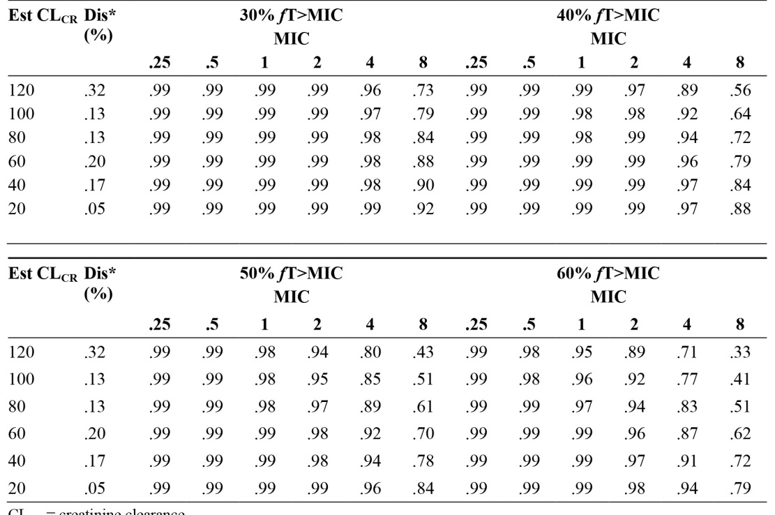

Table 9: Overall probability of target attainment against gram-positive organisms for ceftobiprole 500mg tds 2 h infusion
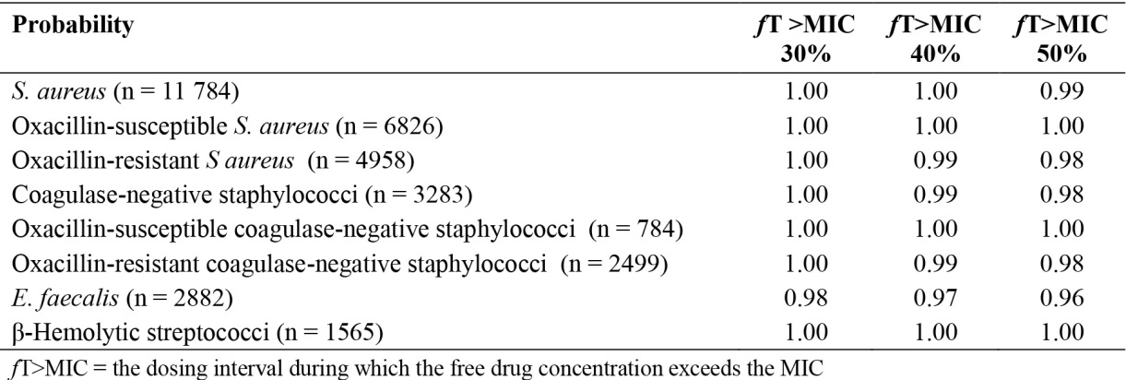

Table 10: Overall probability of target attainment against Gram-negative organisms for ceftobiprole 500 mg tid 2 h infusion
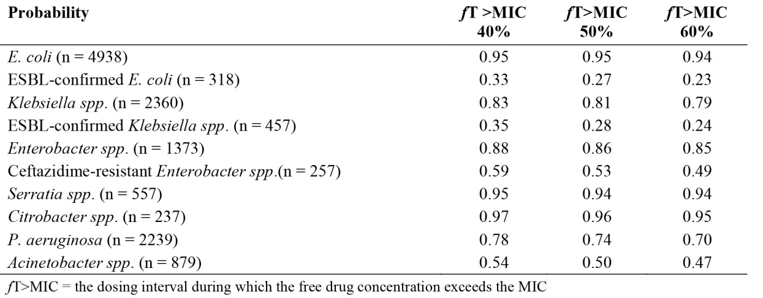

Dosing rationale based on 1 log-kill - PK/PD targets defined by bactericidal (1 log-kill) activity in pre-clinical animal models of infection

Gram-positive organisms
The exposure (%fT> MIC) of ceftobiprole necessary to achieve a bactericidal (1 log-kill) effect in animal models of gram-positive bacterial infection has been defined in five studies. The %fT> MIC values corresponding to bactericidal (1 log-kill) activity from each of these different studies are summarised in Table 11. In summary, the %fT> MIC of ceftobiprole required to achieve a 1 log-kill effect is independent of the infection model or site (lung or thigh) with S. aureus and S. pneumoniae. Very concordant %fT> MIC values were obtained for bactericidal activity (1 log-kill) of gram-positive organisms across five studies, with a range of 13.5%–25.8% fT> MIC. Consequently, an exposure target based on bactericidal (1 log-kill) activity was selected as 30% fT> MIC, corresponding to the upper limit of the range seen in the pre-clinical models with gram-positive organisms. Gram-negative organisms: Exposures (%fT> MIC) required for bactericidal (1 log-kill) activity against gram-negative organisms tended to be greater than for Gram-positive organisms. The Gram-negative exposure targets (%fT> MIC) for a 1 log-kill are summarised (Table 12). The ceftobiprole exposures required for bactericidal activity (1 log-kill) against gram-negative bacilli ranged from 35% to 60.4% fT> MIC. An exposure target based on bactericidal activity (1 log-kill) was selected by taking the upper limit of this observed range, at 60% fT> MIC.

Table 11: Exposure targets for bactericidal activity (1 log-kill) in murine models of gram-+ve infection
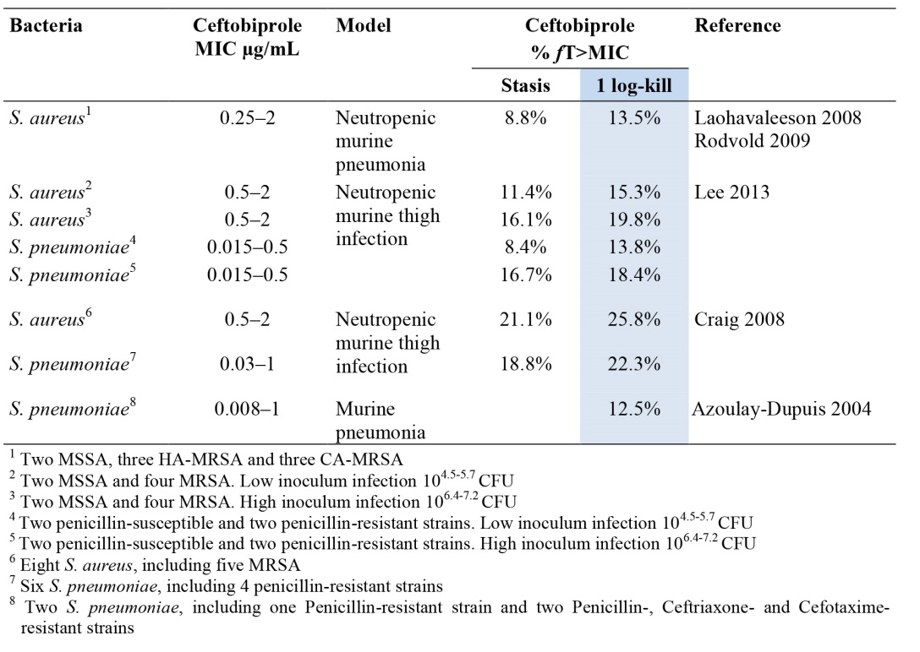

Table 12: Exposure targets required for a 1 log-kill in murine models of gram-negative infection
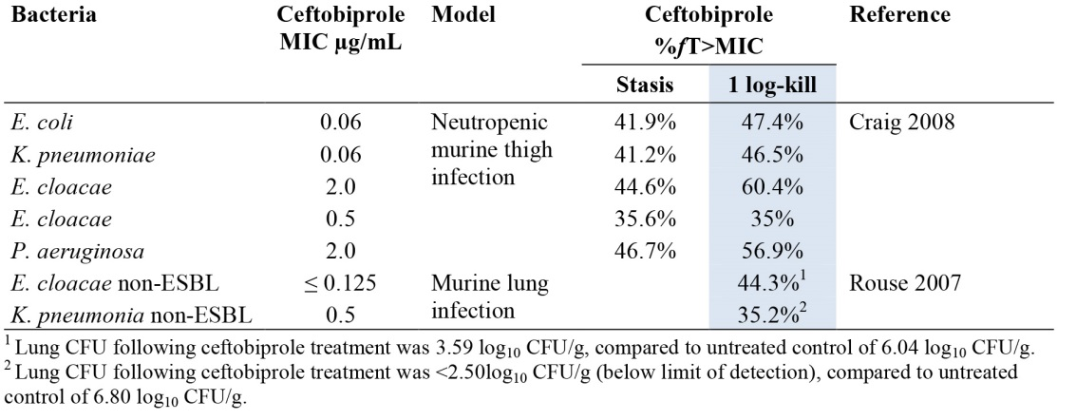

Genetic, gender and age related differences in PD response
None revealed.

Pharmacodynamic interactions
None revealed.

Evaluator’s overall conclusions on pharmacodynamics
Ceftobiprole is a fifth generation cephalosporin with potent activity in pre-clinical models against the most common pathogens causing CAP and many of those causing NP. Uniquely, it combines the broad gram negative activity of fourth generation cephalosporin, with activity against Staph aureus incl. MRSA. The drug appears to be bactericidal - this may be an advantage in some situations, and with high penetration into tissues of relevance that is, the lung. It appears well tolerated. Its broad spectrum of activity means it can be given as monotherapy. The secondary impact on faecal flora and selection for organisms such as C.difficile, have been studied, but only in the short term and faecal samples were not collected routinely in the pneumonia studies. The drug has a straightforward PK profile and aside from reduced dosing in renal impairment there is low risk of drug-drug interactions, again this makes it appealing in the clinical setting.

Dosage selection for the pivotal studies
See also Section Pharmacodynamics. Animal models demonstrate T> MIC is the PK/PD driver for ceftobiprole efficacy. For coverage including gram-negative pathogens the magnitude of %fT> MIC should be ≥ 50%. Using population PK approaches, projected and estimated probability of target attainment demonstrate the adequacy of the 500mg tds 2 h infusion dosing for broad spectrum coverage in NP. As per Section Efficacy, observed PK/PD targets and parameters from these models were predictive of microbiological and clinical response in BAP248/307.

Clinical efficacy
Only the efficacy studies that pertain to the proposed indications (NP and CAP) are included. TGA has instructed the clinical evaluator not to review the cSSTI Studies BAP00034; BAP00154; BAP00414 because of GCP concerns. Safety data arising from these studies is reviewed in Section Safety. Study 30982081, in neutropaenic patients was terminated early for admin reasons.

Nosocomial or community acquired pneumonia
The designs of the two Phase III studies are consistent with the Guideline on the evaluation of medicinal products indicated for treatment of bacterial infections (EMA 2011).

Pivotal efficacy studies

BAP248/307: Randomized (1:1), double-blind, multicenter, Phase III non-inferiority study of ceftobiprole medocaril versus ceftazidime/linezolid in the treatment of nosocomial pneumonia

Study design, objectives, locations and dates
Design: See Figure 3 below.
Study population: adults hospitalised with NP (including VAP).
Primary Objectives: to demonstrate non-inferiority of ceftobiprole versus linezolid plus ceftazidime with respect to the clinical cure rate at the Test of Cure (TOC) visit in subjects with nosocomial pneumonia (including VAP).
Secondary objectives: to compare:
- Microbiological eradication rate at the TOC visit.
- Clinical cure rate in subjects with S. aureus (including MRSA) at the TOC visit.
- Clinical cure rate in subjects with VAP at the TOC visit.
- Clinical relapse rate at late follow-up (LFU) visit.
- 30 day pneumonia-specific mortality.
Locations: 157 centres; US, Latin America, EU, Eastern Europe, Australasia, South Africa.
Dates conducted: 6 April 2005 to 22 May 2007
Number of subjects: Planned: 770 (to achieve 462 clinically evaluable).
Figure 3: Design of BAP248/307.
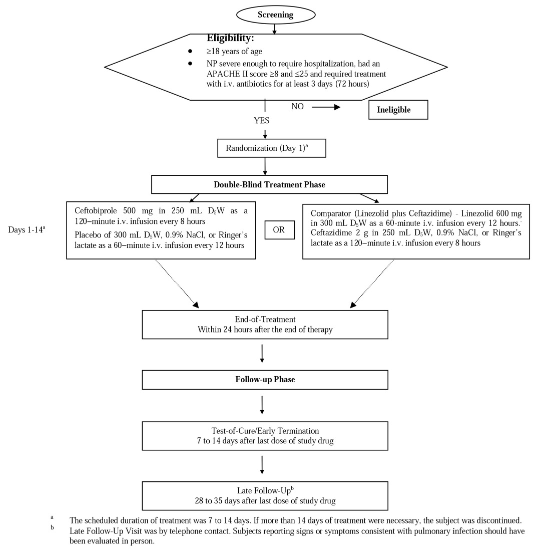
Clinical and microbiological evaluations will be done before the start of therapy (baseline), during therapy on Day 4±1, Day 8±1, and Day 14±1 (if treatment is prolonged), and within 24 h after the end of therapy (EOT). A TOC visit will be done 7 to 14 days after EOT. Subjects clinically cured at the TOC visit will also be evaluated at an LFU visit, 28 to 35 days after EOT.
Clinical evaluations comprised signs and symptoms of infection, and evaluation of clinical outcome. Microbiological assessments included pathogen identification and susceptibility testing. Safety will be assessed by physical examination, vital signs, adverse events, ECGs, and lab tests.

Inclusion and exclusion criteria
Key Inclusion criteria: 1) adults ≥ 18 years of age; 2) non-pregnant or contraception if a WOCBP; 3) nosocomial pneumonia (including VAP) defined as follows: A) Clinical diagnosis of pneumonia after a minimum of 72 h of hospitalisation or stay in a chronic care facility. B) Clinical signs/symptoms of pneumonia with ≥ 2 of the following: New onset of purulent sputum production or respiratory secretions or a worsening in character of sputum; tachypnoea (RR ≥ 20 per minute), particularly if progressive; hypoxaemia that is, PO₂ ≤ 60 mmHg on room air, or respiratory failure requiring mechanical ventilation; new/persistent radiographic infiltrates not related to another disease; Fever or leukocytosis/leukopaenia consistent with pneumonia diagnosis with ≥ 1 of the following: Fever as defined in the protocol OR leukocytosis as defined in the protocol. Additional inclusions for VAP: Subjects with NP who developed pneumonia > 48 h after onset of mechanical ventilation with microbiological samples (respiratory secretions) suitable for culture and microscopy; APACHE II score ≥ 8 and ≤ 25.
Main exclusion criteria: pregnant or lactating; known/suspected hypersensitivity to any related antinfectives; known/suspected condition or concurrent treatment contraindicated by the prescribing information for linezolid or ceftazidime; severe renal impairment (CrCl < 30 mL/min); hepatic dysfunction (bilirubin, ALT, AST ≥ 3 ×ULN; HIV-positive with CD4 counts ≤ 200 cells/mm³; Any other known or suspected condition that may have jeopardized adherence to protocol requirements; myelosuppression or neutropenia.

Exclusions related to clinical conditions that might interfere with assessments of efficacy
- Sustained shock
- Known bronchial obstruction or a history of post-obstructive pneumonia;
- Cystic fibrosis; lung abscess;
- Pleural effusion as a primary source of infection;
- Active tuberculosis;
- Required antibiotic coverage for aspiration or atypical pneumonia,

Exclusions related to microbiological conditions that might interfere with assessments of efficacy
Use of systemic antimicrobials for > 24 h in the 48 h before enrolment (some exceptions allowed).
Evidence from available surveillance cultures of (co-)infection with pathogen(s) including: ESBL, Proteus vulgaris, OR ceftazidime- or ceftobiprole-resistant non-fermenters.

Study treatments
The study treatments were Ceftobiprole medocaril (500 mg ceftobiprole tds as a 120-min IV infusion) or linezolid (600 mg bd as a 60-min IV infusion) + ceftazidime (2 g tds as a 120-min IV infusion) for 7-14 days. Subjects were randomly assigned in a 1:1 ratio to either Arm. Combination therapy with protocol-defined agents (levofloxacin, amikacin, or gentamicin) permitted if at risk of pseudomonal infection.

Efficacy variables and outcomes
Primary efficacy analysis: clinical cure rate at the TOC visit, defined as the ratio of the number of subjects with clinical outcome of ‘Cure’ at the TOC visit to the total number of subjects in the analysis set under consideration. The primary efficacy analysis was performed on the co-primary clinically Evaluable and ITT analysis sets.
Secondary efficacy analyses: non-inferiority of ceftobiprole versus linezolid + ceftazidime with respect to the following outcomes using a step-down procedure (to protect against a Type I error) in the following order: (1) microbiological eradication rate at the TOC visit, (2) clinical cure rate at the TOC visit in subjects with nosocomial pneumonia caused by S. aureus (including MRSA), (3) clinical cure rate at the TOC visit in subjects with VAP, (4) clinical relapse rate at the LFU visit in subjects with nosocomial pneumonia, (5) 30-day pneumonia-specific mortality rates in subjects with nosocomial pneumonia.
Adverse events: See Section Safety.
The main efficacy variables were: proportion of clinical cure, radiological improvement, and microbiological eradication/presumed eradication at the TOC assessment, signs and symptoms, time to microbiological eradication, duration of treatment, and pneumonia-specific mortality.
The primary efficacy outcome was clinical cure rate at the TOC visit, defined as the ratio of the number of subjects who had a clinical outcome of Cure at the TOC visit to the total number of subjects in the analysis set under consideration.
Other efficacy outcomes compared across the 2 Arms were:
- Microbiological eradication rate at the TOC visit;
- Clinical cure rate at the TOC visit in subjects infected with S. aureus;
- Clinical cure rate at the TOC visit in subjects with VAP;
- Clinical relapse rate at the LFU visit;
- 30-day pneumonia-specific mortality rates.

Randomisation and blinding methods
Eligible were randomly assigned to treatment via a central Interactive Voice Response System (IVRS) in a 1:1 ratio to 1 of the 2 treatment groups based on a computer-generated randomisation schedule prepared by the sponsor pre-study. Randomisation was balanced by using randomly permuted blocks for each of the 2 subject strata (non-VAP and VAP). The subjects were further stratified based on their APACHE II score at baseline, 8 to 19 and 20 to 25. The subjects with VAP were further stratified according to number of days on ventilation, ≥ 5 versus < 5 days.

Analysis populations
Intent-to-Treat (ITT): all subjects randomly assigned to treatment. Microbiological Intent-to-Treat (mITT): all subjects in the ITT analysis set with a valid pneumonia pathogen at baseline.
Clinically Evaluable: all ITT subjects who received ≥ 1 dose of study medication excluding those subjects with a derived clinical outcome of Not Evaluable at the TOC visit. The derived clinical outcome was based on clinical assessment and evaluability of a subject, whereas the clinical outcome collected on the CRF was based on the Investigator’s assessment. Microbiologically Evaluable (ME): all subjects in the mITT analysis set who were also clinically evaluable, excluding those with a microbiological outcome of Not Evaluable at the TOC visit. The microbiological outcomes are Eradication, Presumed Eradication, Colonisation, Persistence, Presumed Persistence, Superinfection, or Not Evaluable. Safety: all subjects in the ITT analysis set exposed to study drug.

Sample size
Based on a non-inferiority design using the CI approach for normal approximation to the difference of two binomial probability distributions the following assumptions were used in the calculations:
The clinical cure rate was 50% in both groups; non-inferiority margin 15%; level of significance twosided 5%; power 90%; clinically evaluable rate 60%.
Based on these assumptions, 770 subjects were to be enrolled to ensure 231 clinically evaluable subjects in each treatment gp.
Non-inferiority margin: A 15% non-inferiority margin was prospectively defined, in accordance with the CHMP Guideline for the choice of non-inferiority margins (EMEA/ CPMP/EWP/2158/99), based on two important elements: The first was the variability around a point estimate of clinical cure observed in clinical studies involving the treatment of patients with NP with a treatment regimen involving linezolid+ceftazidime. As no studies were identified in which these agents were combined for the treatment of NP, studies in which either of these agents were used to treat NP were included in the analysis of comparator cure rates. Since no placebo-controlled studies in patients with NP who had disease comparable to that studied in Study BAP00248/307 have been published, an estimate of the spontaneous cure rate was derived from patients who received inappropriate antibiotics. The justification of the non-inferiority margin in BAP248/307 study required a demonstration that it preserved at least 50% of the benefit of the active comparator over placebo in NP. Based on this approach, a 15% non-inferiority margin was justified.

Statistical methods
The primary hypothesis was: H0: The clinical cure rate of the ceftobiprole group is more than 15% inferior to that of the linezolid+ceftazidime gp. H1: The clinical cure rate of the ceftobiprole group is no more than 15% inferior to that of the linezolid plus ceftazidime group. The clinical cure rate was analysed by presenting a two-sided 95% CI for the between-treatment difference (ceftobiprole minus linezolid+ceftazidime) at the TOC visit. Non-inferiority of ceftobiprole compared with linezolid+ceftazidime was concluded if the lower limit of this CI was greater than or equal to –15%. The primary efficacy analysis was performed on the co-primary Clinically Evaluable and ITT analysis sets, with the analysis performed in the ITT set to support the analysis performed for the Clinically Evaluable set.

Participant flow
See Figure 4 for a summary of participant flow.
Figure 4: Study BAP 248/307 Participant flow and analysis sets.
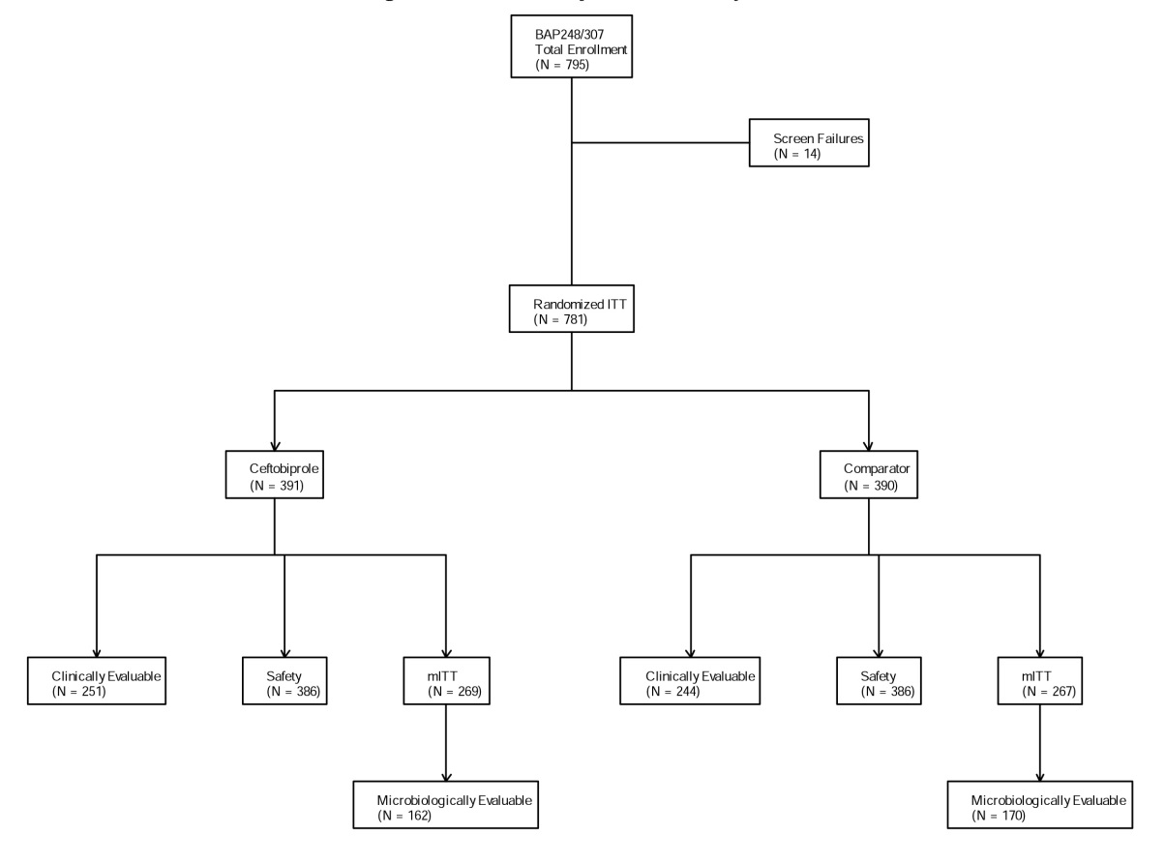

Major protocol violations/deviations
Table 13 summaries the major protocol deviations and violations.

Table 13: Reasons Subjects Were Not Clinically Evaluable at TOC Visit (BAP00248/307: ITT Analysis
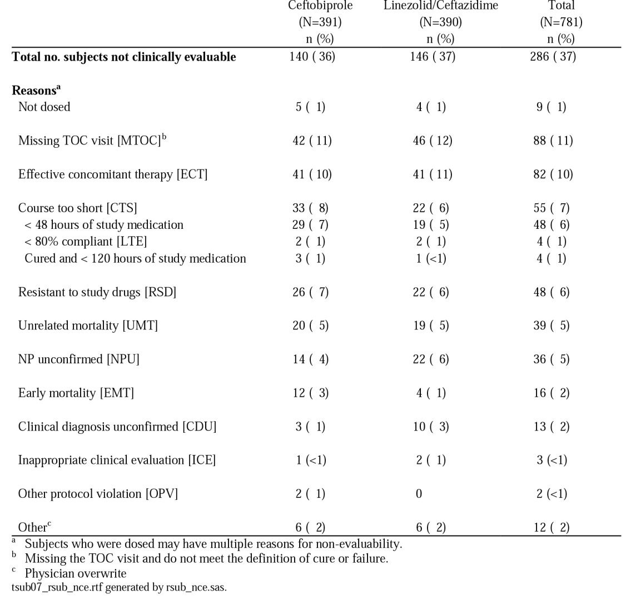

Baseline data
781 subjects were randomised to ceftobiprole (n=391) or linezolid+ceftazidime (n=390). Of the 781 randomised subjects, 251 (64%) in the ceftobiprole group and 244 (63%) in the linezolid plus ceftazidime group were considered clinically evaluable for efficacy (See Table 13 above). The study enrolled in 32 countries; 56% in Europe, 12% in the United States. 571 subjects were enrolled with NP (excluding VAP) (287 in the ceftobiprole and 284 in the linezolid/ceftazidime treatment group). 210 subjects (27%) were enrolled with VAP (104 in the ceftobiprole and 106 in the combination group); majority of subjects with VAP (77%) were mechanically ventilated for ≥ 5 days. 67% of all subjects were male; mean age 60.6 years. As shown in the Table 14 below, 69% had valid baseline pathogens, of these, 36% were gram-positive, 48% gram-negative, 24% had a polymicrobial infection. There was a baseline imbalance with respect to gender between the two treatment Arms that is, % of males in the ceftobiprole group (71%) versus 62% in the linezolid/ceftazidime group. All other demographic and baseline characteristics for subjects in the ITT set were similar.
As expected, patient characteristics were different between VAP subjects and NP (excluding VAP) subjects. Subjects in the VAP subgroup were approximately 10 years younger, and with a higher proportion (> 5% difference) of males, subjects with thoracic trauma, APACHE II scores ≥ 15, C-reactive protein (CRP) levels > 100 mg/L, albumin levels ≤ 25 g/L, supra-normal creatinine-clearance (≥ 150 mL/min). More VAP subjects had gram-negative or polymicrobial infections, infections with MSSA, P. aeruginosa or Acinetobacter species, and more VAP subjects received antipseudomonal treatment. Compared to VAP subjects, NP (excluding VAP) subjects had a higher baseline prevalence of systemic inflammatory response syndrome (SIRS) and of medical comorbidities and renal function impairment (CrCl < 50 mL/min), and more frequent chronic care utilisation.
Within the VAP subgroup, mean age was lower in the ceftobiprole treatment group - 51.7 years versus 55.3 years), and the proportion of younger VAP subjects (aged < 45 years) was 38% in the ceftobiprole Arm and 29% in the comparator. Further differences (> 5%) were apparent in the VAP subgroup related to baseline prevalences of SIRS, CRP > 100 mg/L, albumin ≤ 25 g/L, APACHE II score ≥ 15, use of anti-pseudomonal antibiotics, valid gram-negative pathogens and polymicrobial infections, all more frequent in the ceftobiprole group. Emphysema, use of antibiotics within 24 h prior to baseline and long-term ventilation were more frequent in the linezolid/ceftazidime group. Additional medical review of patient profiles showed notable imbalances in the VAP subgroup related to head trauma and polytrauma. A similar % of subjects did not complete the study in each treatment group. The distribution of subjects by reasons for discontinuation was similar between the treatment groups, with the most common reason being death (20% of ceftobiprole-treated and 19% of linezolid plus ceftazidime-treated subjects).

Table 14: Clinical and Baseline Characteristics for All Subjects (BAP00248/307: ITT Analysis)
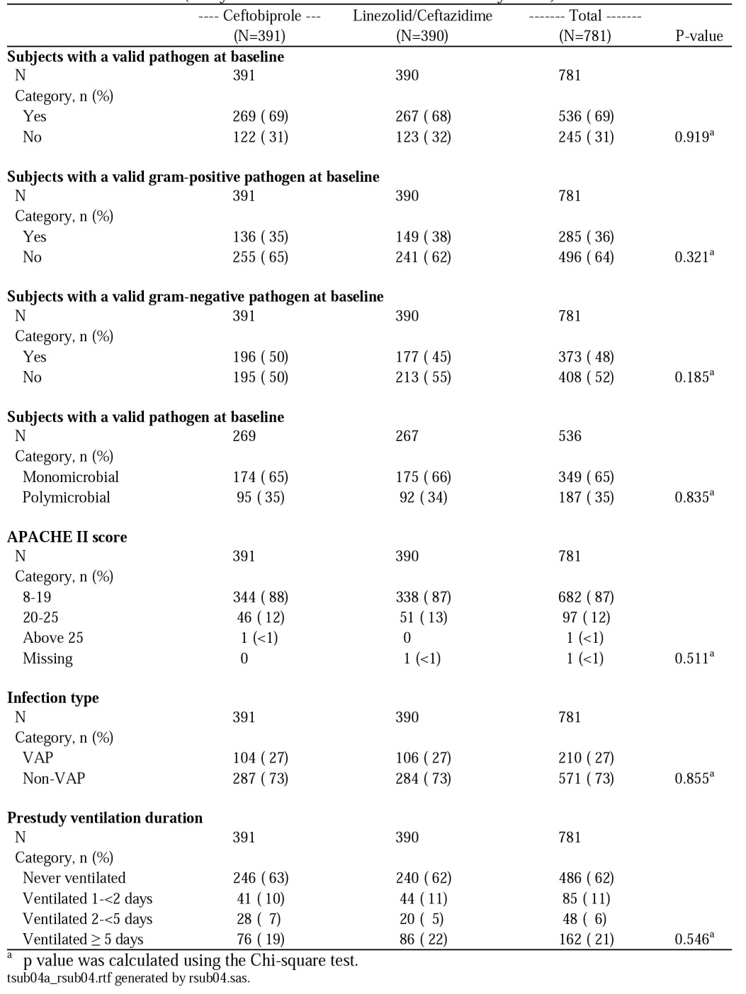

Results for the primary efficacy outcome
The primary endpoint of clinical cure at the TOC visit in the Clinically Evaluable and ITT analysis sets was similar between the two treatment groups. Clinical cure rates were 69.3% versus 71.3% (Clinically Evaluable analysis set) and 49.9% versus 52.8% (ITT analysis set) in the ceftobiprole and linezolid/ceftazidime groups respectively. The lower limit of the two-sided 95% CI for the difference was −10%, well within the −15% protocol-defined criterion for non-inferiority. Non-inferiority of ceftobiprole versus linezolid/ceftazidime was demonstrated in the pre-specified subgroup of subjects with NP (excluding VAP) subjects. The reasons for failure were similar between the 2 treatment groups in the clinically evaluable analysis set (subjects may have had ≥ 1 reason) that is, use of non-study systemic antibiotics for pneumonia (21.5% of ceftobiprole-treated and 18.9% of linezolid plus ceftazidime treated subjects); deemed clinical failures at TOC visit by investigators (16.7% of ceftobiprole treated and 16.8% of linezolid+ceftazidime treated subjects); TOC visit assessment was missing and the final clinical assessment before TOC was ‘worsened’/‘unchanged’ from baseline (9.6% of ceftobiprole-treated subjects and 6.1% of linezolid plus ceftazidime-treated subjects). In addition, during the course of the study, 7 sites were identified as being at risk for having made errors in clinical study conduct. A sensitivity analysis excluding all subjects from these sites confirmed the findings of the primary analysis.
However, non-inferiority of ceftobiprole was not demonstrated in the relatively smaller subset of VAP subjects. In VAP subjects, clinical cure rates in the clinically evaluable analysis set were 37.7% (20/53) in the ceftobiprole group and 55.9% (33/59) in the linezolid/ceftazidime group. Similar to the results for all subjects, for both non-VAP and VAP subjects the primary reason for failure was the use of non-study systemic antibiotics for pneumonia and the second most common reason was that subjects were deemed clinical failures at the TOC visit by the investigator. Similar to the results in the clinically evaluable analysis set, there was a significant difference in the ITT analysis set in the clinical cure rates between the 2 treatment groups with respect to the ventilation status for the non-VAP and VAP subject stratum. Using the Breslow-Day test, the treatment by ventilation status interaction p value was 0.047. The trend toward lower cure rates in the ceftobiprole treatment group versus linezolid+ceftazidime treatment group that was observed in VAP subjects (that is, subjects who were ventilated ≥ 48 h prior to pneumonia onset) was not observed in non-VAP subjects, regardless of whether they were never ventilated or were ventilated < 48 h prior to the onset of pneumonia. Based on the different outcomes, and the fact that VAP represents a different disease entity based on differences in patient characteristics with regard to co-morbidities and clinical prognosis, the majority of efficacy analyses that were planned to be performed on all subjects were also performed separately on NP (excluding VAP) subjects and VAP subjects.

Extent of exposure by ventilation status

Non-VAP subjects
- Exposure data for non-VAP subjects in the clinically evaluable analysis set was similar between treatment groups that is, median exposure was 7.0 days for ceftobiprole and 7.5 days for ceftazidime and linezolid.
- Exposure data for non-VAP subjects in the safety analysis set were similar to the clinically evaluable analysis set.
Exposure data for VAP subjects in the clinically evaluable analysis set show the percentage of subjects receiving < 5 days of therapy was higher in the ceftobiprole treatment group (23%) versusthe linezolid+ceftazidime treatment group (5%). This likely reflects the higher rate of clinical failures in VAP subjects in the ceftobiprole treatment group. Median exposure was 7.0 days for ceftobiprole and 8.0 days for ceftazidime+linezolid.

Table 15: Clinical cure at TOC (primary endpoint) in Study BAP248/307
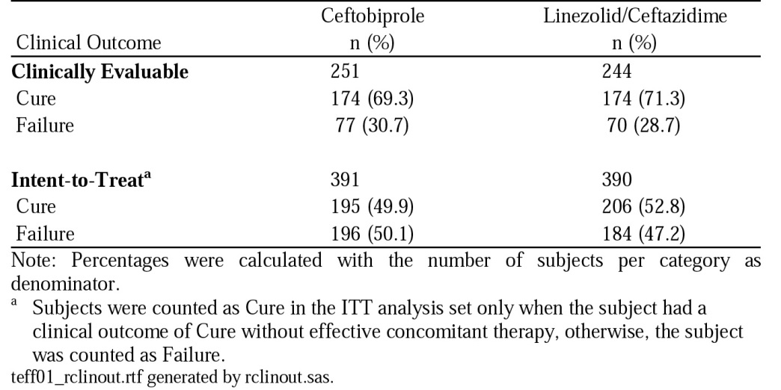

Results for other efficacy outcomes
In the Microbiologically Evaluable analysis set, microbiological eradication (including presumed eradication) rates at the TOC visit were 53.7% (87/162) for ceftobiprole, and 62.4% (106/170) for the comparator. The two-sided 95% CI for the difference in microbiological eradication rates in the Microbiologically Evaluable analysis set was −19.2% to 1.9%. In the total subject population, non-inferiority was therefore not demonstrated between the two treatments within the 15% non-inferiority margin. This result was primarily driven by lower microbiological eradication rates in the VAP subgp*. The lower bounds of the two-sided 95% CI for the difference in microbiological eradication in the larger group of NP (excluding VAP) subjects were close to the 15% margin (that is, −15.3% in the MITT analysis set and −16.7% in the Microbiologically Evaluable analysis set). Per-pathogen clinical cure rates for NP (excluding VAP) subjects in the Microbiogically Evaluable analysis set were similar between ceftobiprole and linezolid/ceftazidime treatment groups for pathogens isolated from 10 or more subjects.
*Among VAP subjects who were microbiologically evaluable, microbiological eradication (including presumed eradication) rates at the TOC visit were 30.4% (14/46) for the ceftobiprole group and 50.0% (25/50) for the linezolid plus ceftazidime group. The 2-sided 95% CI for the difference in eradication rates in microbiologically evaluable VAP subjects was –38.8% to –0.4%. Of the 46 VAP subjects in the ceftobiprole group who were microbiologically evaluable at the TOC visit, only 13 (28.3%) subjects had documented cultures at the TOC visit (that is, an outcome of eradication, persistence, colonisation, or superinfection). The microbiological outcome of the remaining 33 subjects was derived from the clinical outcome. In contrast, 23 of 50 (46.0%) subjects had a documented culture at the TOC visit in the linezolid plus ceftazidime group.

Table 16. Microbiological Outcome at the TOC Visit for All Subjects (Study BAP00248/307: Microbiologically Evaluable and Microbiological ITT Analysis Sets)
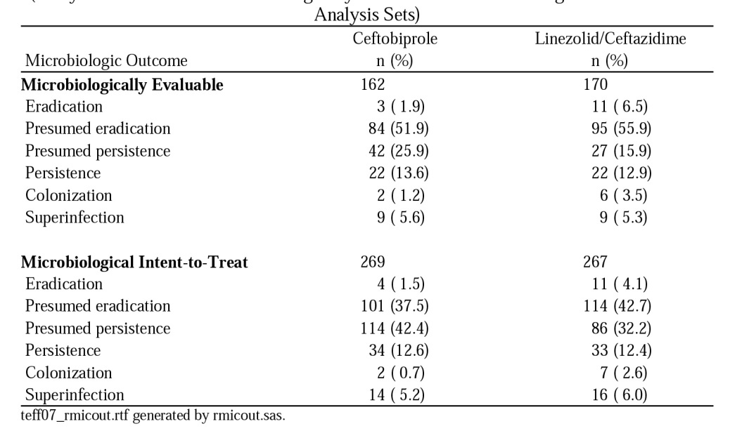
Pneumonia-specific mortality at 30 days was a pre-specified secondary endpoint. In addition, 30-day all-cause mortality was also analysed. All-cause mortality rates and pneumonia-specific mortality rates were similar between treatment groups for all subjects in the ITT analysis set (19.4% versus 18.5% [95% CI −4.5 to 6.5] for 30-day all-cause mortality, and 6.6% versus 6.2% [95% CI −2.9 to 3.9] for 30-day pneumonia-specific mortality in the ceftopibrole and comparator treatment groups, respectively). Pneumonia-specific mortality was similar between the treatment groups in NP (excluding VAP) subjects and VAP subjects. However, there was a trend towards a lower all-cause mortality rate with the comparator in the VAP subgroup (19.8% in the comparator group and 26.9% in the ceftobiprole group; 95% CI −4.3 to 18.5), while all-cause mortality was numerically higher with the comparator in NP (excluding VAP) subjects (16.7% in the ceftobiprole group and 18.0% in the comparator group; 95% CI −7.4 to 5.0). Clinical relapse at the late follow-up visit occurred in 4.6% of the ceftobiprole group and 4.5% of the linezolid/ceftazidime group. Microbiological relapse at the late follow-up visit occurred in 3.8% of the ceftobiprole group and 3.1% of the linezolid/ceftazidime group.

Safety
Overall incidences of AEs, SAEs, AEs that led to discontinuation, TRAEs were comparable between the two treatment groups. The percentage of subjects in each treatment group who reported ≥ 1 TEAE was similar (77% of ceftobiprole treated and 78% of linezolid/ceftazidime-treated subjects). 25% of subjects in both treatment groups had ≥ 1AE considered to be treatment-related. 23% in the ceftobiprole group and 22% in the linezolid/ceftazidime group died during the course of the study. See Section Safety for the pooled safety analysis of pneumonia and cSSTI studies.

30982081-CAP-3001: Randomized (1:1), double-blind, multicenter Phase III non-inferiority study of ceftobiprole medocaril versus ceftriaxone with/without linezolid in the treatment of community-acquired pneumonia.
Publications arising: (Nicholson 2012).

Study design, objectives, locations and dates
Design: Randomised, double-blind, multicentre study of ceftobiprole medocaril versus ceftriaxone with/without linezolid. See Figure 5.
Study population: adults hospitalised with CAP and requiring IV antibiotics for ≥ 72 h.
Primary objectives: To demonstrate non-inferiority of ceftobiprole versus ceftriaxone ±linezolid with respect to clinical cure rates at the TOC visit in subjects hospitalised with CAP.
Secondary objectives: microbiological eradication rates at the TOC visit; clinical cure rate at the TOC visit in those with a Pneumonia Outcomes Research Team Severity Index (PSI) score ≥ 91; 30-day pneumonia-specific mortality rates. Locations: 103 centres worldwide. Dates: 05 June 2006 to 19 July 2007.
Figure 5: Study design of 30982081-CAP-3001
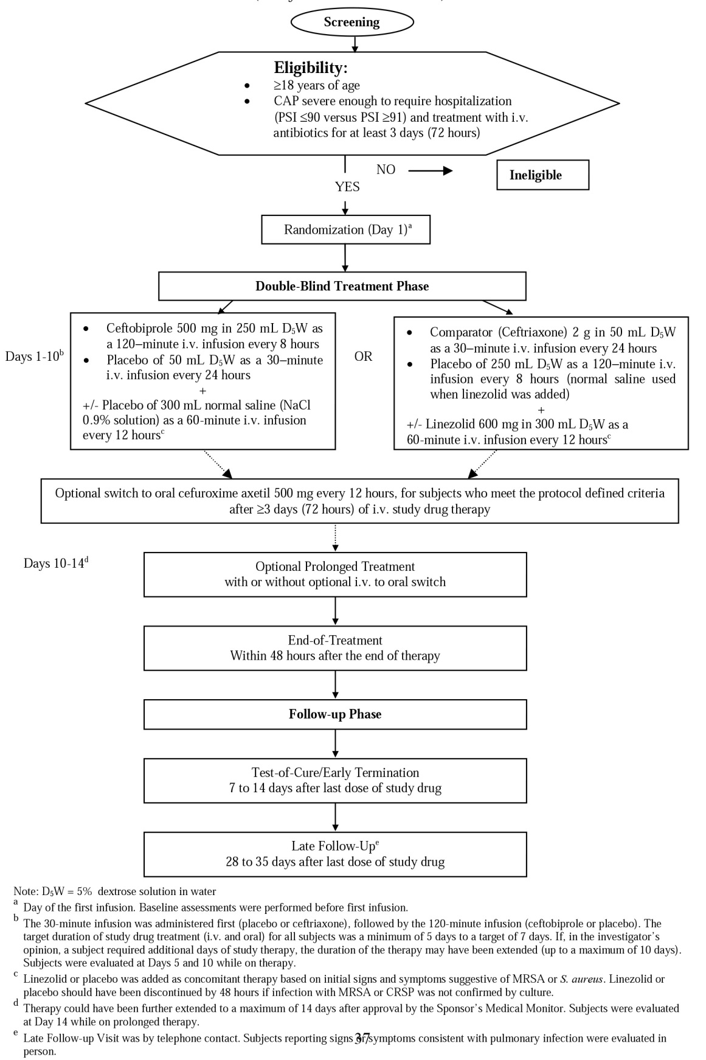

Inclusion and exclusion criteria
Key Inclusion criteria: 1) adults ≥ 18 years of age; 2) non-pregnant or contraception if a WOCBP; 3) CAP severe enough to need hospitalisation and IV antibiotics for at least 72 h defined as follows: A) Clinical diagnosis of pneumonia acquired in the community. B) Clinical signs or symptoms of pneumonia with ≥ 2 of the following: cough; purulent sputum production or a worsening in character of sputum; tachypnoea (respiratory rate ≥ 20 per minute), particularly if progressive in nature; ausculatory findings consistent with CAP; hypoxaemia with a PO₂ ≤ 60 mmHg on room air, or respiratory failure requiring mechanical ventilation; C) new or persistent radiographic infiltrates not related to another disease process; D) Fever or leukocytosis/leukopaenia consistent with a diagnosis of pneumonia with ≥ 1 of the following: Fever as defined in the protocol OR Leukocytosis as defined in the protocol. E) severity of pneumonia needs IV antibiotics.
Main exclusion criteria: pregnant or lactating; known or suspected hypersensitivity to any study drugs; severe renal impairment (calculated CLCr < 30 mL/min); hepatic dysfunction (total bilirubin, ALT, AST ≥ 3 ×ULN; HIV-positive with CD4 counts ≤ 200 cells/mm³; Any other known or suspected condition that may have jeopardized adherence to protocol requirements; myelosuppression or neutropenia.

Exclusions related to clinical conditions that might interfere with assessments of efficacy
- Sustained shock
- Known bronchial obstruction or a history of post-obstructive pneumonia; cystic fibrosis; lung abscess;
- Pleural effusion as a primary source of infection; active tuberculosis; required antibiotic coverage for aspiration or atypical pneumonia.

Exclusions related to microbiological conditions that might interfere with assessments of efficacy
Use of systemic antimicrobials for > 24 h in the 3 days before enrollment (some exceptions allowed).

Study treatments
The study treatments were Ceftobiprole medocaril (500 mg ceftobiprole tds as a 120-min IV infusion) or ceftriaxone (2g QD as a 30-min IV infusion) ±600 mg linezolid every 12 h as a 60-min IV infusion, for 5-14 days. Subjects were randomly assigned in a 1:1 ratio. A switch from IV study drugs to oral cefuroxime axetil (500 mg bd) was allowed after a minimum of 3 days of IV therapy for subjects who met all protocol-specified criteria for improvement and were candidates for hospital discharge. The total duration of study drug therapy (IV plus oral) was a minimum of 5 days and a target of 7 days. If in the investigator’s opinion a subject required additional days of study therapy, the duration of the therapy could have been extended up to a max of 10 days. Therapy could have been further extended to a max of 14 days after approval by the Sponsor’s Medical Monitor for subjects with a history of persistent bacteraemia or necrotizing pneumonia. Linezolid was to be added to ceftriaxone treatment for subjects with confirmed ceftriaxone-resistant S.pneumoniae provided the susceptibility of the isolate to linezolid had been confirmed. Linezolid was added to ceftriaxone treatment when the incidence of MRSA in CAP isolates was prevalent (> 15%) in locally, or when the subject’s initial signs and symptoms were suggestive of infection due to S. aureus.

Efficacy variables and outcomes
The main efficacy variables were: clinical cure rate at the TOC visit defined as the ratio of the number of clinically cured subjects to the total number of subjects in the analysis set under consideration.
The secondary efficacy endpoints included the following: microbiological eradication rate at the TOC visit; clinical cure rate in subjects requiring mechanical ventilation within 48 h of enrolment; microbiological cure rate in subjects requiring mechanical ventilation within 48 h of enrolment; clinical and microbiological relapse rates at the LFU visit; and 30-day pneumonia-specific mortality rates (all deaths due to pneumonia within 30 days after randomisation).
The primary efficacy endpoint was the clinical cure rate at the TOC visit, defined as the ratio of the number of subjects who had a derived clinical outcome of Cure at the TOC visit to the total number of the subjects in the analysis set under consideration.
Secondary endpoints: tested using a step-down hierarchical procedure in the following order: 1) microbiological eradication rate at TOC visit 2) clinical cure rate at TOC visit for those with PSI score ≥ 91; 3) the 30-day pneumonia-specific mortality rates

Randomisation and blinding methods
Subjects randomly assigned to treatment via a central IVRS in a 1:1 ratio based on a computer-generated balanced randomisation schedule prepared by the sponsor pre-study. Subjects were stratified at entry by PSI score: ≤ 90 or ≥ 91 and anti-staphylococcal therapy (placebo or linezolid) based on signs, symptoms, and medical history at enrolment. The study was double-blind. An unblinded pharmacist was responsible for preparing study medication for each subject in order to maintain the blind. Infusion bags and line tubings were covered by coloured sleeves. The pharmacist was monitored by an unblinded site monitor.

Analysis populations
See above.

Sample size
Based on a non-inferiority design using the CI approach for normal approximation to the difference of two binomial proportions, sample size calculation was based on the following assumptions for the ITT population: Clinical cure rate 70% in both treatment groups; Non-inferiority margin 10%; Power 80%; Level of significance two-sided 5%; Clinically evaluable rate 80%. Based on these assumptions, 670 subjects needed to be randomised (335 in each group). For the Clinically Evaluable population: Clinical cure rate 90% in both treatment groups; Clinically evaluable rate 80%. A total of 670 subjects would provide 532 clinically evaluable subjects, with 97% power for testing the primary hypothesis in the Clinically Evaluable population.
Non-inferiority margin: The justification of the non-inferiority margin required a demonstration that it preserved at least 50% of the benefit of the active comparator over placebo in the treatment of patients hospitalised with CAP. It was therefore calculated on the basis of two elements from the published literature: the variability around a point estimate of clinical cure observed in clinical trials in patients with CAP treated with ceftriaxone-containing regimens, and an estimate of the spontaneous/placebo cure rate in patients with CAP. The estimated cure rate from clinical studies with ceftriaxone ±linezolid from pooled historical data was 90.8% (95% CI 88.8–92.8). In the absence of placebo-controlled studies of CAP, the (max) estimated placebo cure rate calculated from the clinical experience with specific causative pathogens of CAP was 53%; a conservative figure of 55% was used in the calculations of non-inferiority margin. Based on these figures, the most conservative estimate for a non-inferiority margin which preserved at least 50% of the benefit of the active comparator over placebo, calculated under the formula set out in detail in CSR Appendix 2.2.1.2, was 16.9%. The margin of 10% selected therefore met this requirement.

Statistical methods
The hypotheses tested were: H0: clinical cure rate of the ceftobiprole group is more than 10% inferior to that of the ceftriaxone ±linezolid group. H1: The clinical cure rate of the ceftobiprole group is no more than 10% inferior to that of the ceftriaxone ±linezolid group. A two-sided 95% CI was calculated for the between-treatment difference (ceftobiprole minus ceftriaxone ±linezolid) at the TOC visit. Non-inferiority of ceftobiprole compared with ceftriaxone ±linezolid was concluded if the lower limit of this CI was greater than or equal to –10%. The primary efficacy analysis was performed on the clinically evaluable and ITT co-primary analysis sets. The microbiological eradication rate at the TOC visit was defined as the ratio of the number of subjects with a microbiological outcome of Eradication/Presumed Eradication at the TOC visit to the total number of subjects in the analysis set under consideration at the TOC visit. This analysis was performed on the microbiologically evaluable analysis set. The clinical cure rate for subjects who had a PSI score ≥ 91 was defined as the ratio of the number of subjects with PSI score ≥ 91 who had a clinical outcome of Cure at the TOC visit to the total number of the subjects with a PSI score ≥ 91 in the analysis set under consideration.
The analysis of the clinical cure rate for subjects who had a PSI score ≥ 91 was performed on the clinically evaluable and ITT analysis sets. Non-inferiority hypotheses similar to the primary hypothesis were tested for the microbiological eradication rate and the clinical response rate in subjects with a PSI score ≥ 91. The 30-day pneumonia-specific mortality rate was defined as the ratio of the number of deaths due to pneumonia to the total number of subjects in the analysis set under consideration. This analysis was performed on the clinically evaluable and ITT analysis sets. A 15% non-inferiority margin was used to test all secondary hypotheses. This was documented prior to database lock, but was not pre-specified in the protocol or the analysis plan. The two-sided 95% CI was computed in the same way as for the primary efficacy analysis. Other efficacy outcomes included:

Participant flow
See Figure 5.

Major protocol violations/deviations
*Due to poor understanding of the protocol and disease state at site 506002, and consequent poor compliance with several aspects of GCP, all data from 28 randomised subjects at this site (14 per treatment group) were excluded from the analyses.

Table 17: Study Completion and Discontinuation Information in CAP-3001
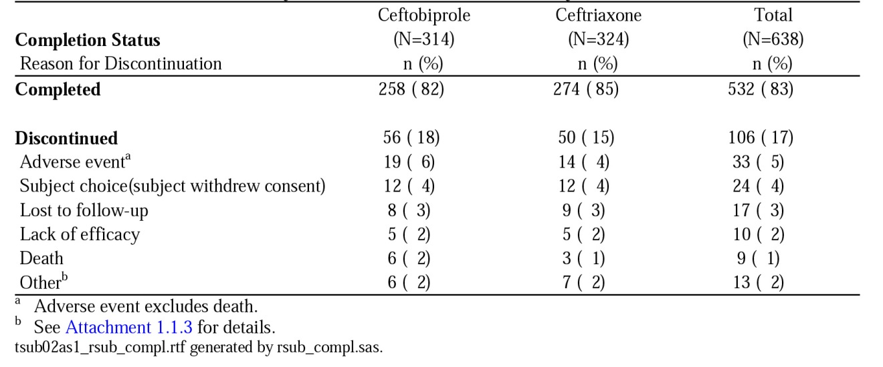

Baseline data
Planned: 670 (to achieve 532 clinically evaluable) Randomised: 666 Analysed: 638*. The ITT analysis set comprised 638 subjects randomised to ceftobiprole (314 subjects) or ceftriaxone ±linezolid (324 subjects). Of the 638 subjects, 231 (74%) in the ceftobiprole group, and 238 (73%) in the combination group were considered clinically evaluable. The study enrolled subjects in 17 countries; 41% in Europe, 13% in the United States. In the ITT analysis set, there were no significant differences between the treatment groups with respect to demographic and baseline characteristics. Mean age 54.5 years (range 18 to 94 years); 37% were ≥ 65 years old. Demographic and baseline characteristics for subjects in the Clinically Evaluable analysis set were consistent with those of the ITT set. A valid baseline pathogen was isolated from 184 (29%) of 638 subjects in the ITT analysis set: 101 subjects (16%) had ≥ 1 gram-positive pathogen, and 100 subjects (16%) had ≥ 1 gram-negative pathogen. 16 patients in ceftobiprole group and 8 in the combination group had polymicrobial infection. 11% of subjects received concomitant linezolid treatment. 48% of subjects (307/638) were in PORT Risk Classes III–V (PSI score ≥ 71), and 22% of subjects (141/638) were in PORT Risk Classes IV–V (PSI score ≥ 91). A similar % of subjects did not complete the study in each treatment group: 18% in the ceftobiprole group and 15% in the ceftriaxone with or without linezolid group. The distribution of subjects by reasons for discontinuation was similar between the treatment groups, the most common reasons for discontinuation being ‘AE’ (5%) and ‘subject choice’ (4%).

Results for the primary efficacy outcome
In subjects with CAP requiring hospitalisation, non-inferiority of ceftobiprole compared with ceftriaxone ±linezolid was demonstrated within the 10% non-inferiority margin for the primary efficacy endpoint of clinical cure rate at the TOC visit (7 to 14 days after the EOT visit), for both the clinically evaluable and ITT co-primary analysis sets. Clinical cure rates at the TOC visit were 86.6% and 87.4% in the ceftobiprole and ceftriaxone with or without linezolid groups, respectively, in the Clinically Evaluable analysis set, and 76.4% and 79.3%, respectively, in the ITT analysis set. Non-inferiority within a 10% non-inferiority margin was also shown for the subgroup of subjects in PORT Risk Classes ≥ III (PSI score ≥ 71) and PORT Risk Classes ≥ IV (PSI score ≥ 91).

Table 18: Clinical cure at TOC (primary endpoint) in CAP-3001
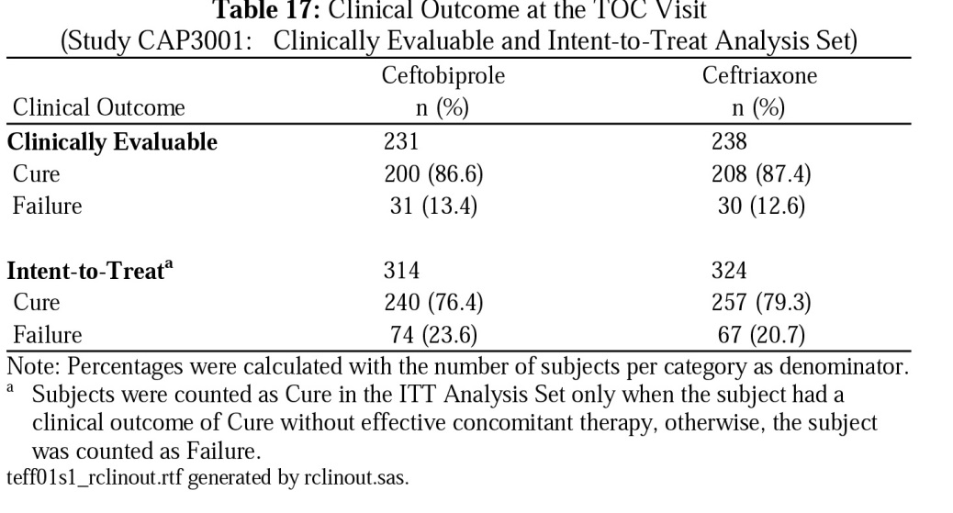
Extent of exposure: In the clinically evaluable analysis set, 103 subjects in the ceftobiprole group and 101 subjects in the combination group received only IV therapy, the 2 most frequent durations were 5 to < 7 days and 7 to < 11 days. Mean exposure for ceftobiprole and ceftriaxone were 7.2 and 7.8 days, respectively. Of the 18 subjects with linezolid added to the ceftriaxone regimen, 7 (39%) subjects received linezolid for 5 to < 7 days and 5 (28%) subjects received linezolid for 7 to < 11 days. The mean extent of exposure was 5.8 days for linezolid.128 subjects in the ceftobiprole group and 137 subjects in the ceftriaxone ±linezolid group were switched to oral cefuroxime axetil during the study. Among these subjects, 99 (77%) subjects received 7 to < 11 days of combined IV ceftobiprole and oral cefuroxime; 103 (75%) subjects received 7 to < 11 days of combined IV ceftriaxone and oral cefuroxime. Mean extents of combined IV+oral exposure for ceftobiprole and ceftriaxone groups were 9.4 and 9.3 days, respectively.

Results for other efficacy outcomes
A 15% non-inferiority margin was used to test all secondary hypotheses given the limited sample sizes for these tests. Non-inferiority of ceftobiprole versus ceftriaxone ±linezolid demonstrated for all the pre-specified 2º efficacy endpoints (microbiological eradication at the TOC visit, clinical cure rate at the TOC visit in subjects with PSI score ≥ 91 and 30 day pneumonia-specific mortality rate).
Microbiological eradication rates: 88.2% (60/68 subjects) in the ceftobiprole treatment group, and 90.8% (69/76) in the ceftriaxone ±linezolid group in the Micrbiologically Evaluable analysis set (two-sided 95% CI for the between group difference of ceftobiprole minus ceftriaxone ±linezolid: −12.6% to 7.5%). 30-day all-cause mortality (ITT ): 1.6% in the ceftobiprole group versus 2.5% in comparator Arm. 30 day pneumonia-specific mortality was 0.3% in ceftobiprole group and 0.9% in the ceftriaxone ± linezolid group. Clinical cures observed for 26 (93%) of 28 subjects with S. pneumoniae in the ceftobiprole group, including cures for both subjects with MDRSP. Clinical cures observed for all 7 subjects in the ceftobiprole group with S. aureus at baseline, including 1 MRSA. Clinical cures observed for all subjects who had H. influenzae, E. coli, M. catarrhalis, K. oxytoca, or Acinetobacter species isolated at baseline. Clinical cures observed for 6 (67%) of 9 subjects with H. parainfluenzae and 4 (80%) of 5 subjects with K. pneumoniae. The microbiological eradication rates for the pathogens listed above were similar to the clinical cure rates for subjects with those pathogens.
Safety: No significant differences observed between the treatment groups in the overall incidence of AEs, deaths, SAEs, or discontinuations due to AEs. TRAEs were more in the ceftobiprole group largely due to higher rates of treatment-related nausea (7% versus 2%, respectively) and vomiting (5% versus 2%). TRAEs considered serious or leading to treatment discontinuation were not significantly different between groups. More details in Section Safety below.

Other efficacy studies
Not applicable.

Analyses performed across trials (pooled analyses and meta-analyses)
No formal pooled analysis for efficacy was performed, but the studies were similar enough to allow comparison.

Table 19: Clinical cure at TOC visit (primary endpoint) in BAP248/307 and CAP-3001
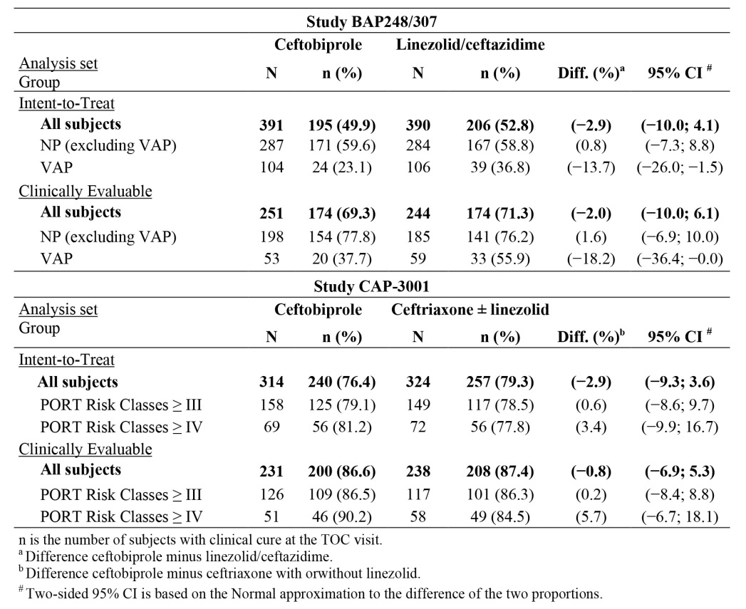

Evaluator’s conclusions on efficacy of Zevetra® for NP and CAP
The design of both studies was in accordance with the EMA guideline on the evaluation of medicinal products indicated for treatment of bacterial infections. The double-blind design adds substantially to the strength of the findings. The reason for this being so important is that ‘clinical response’ in many infectious diseases including bacterial pneumonia can be rather subjective even with clear guidance in the protocol. The double-blind design removes much of the bias. All bacterial pneumonia studies are additionally hampered by the poor yield of organisms that are causative, which is why ‘clinical cure’ is used as a primary determinant of efficacy. Both studies demonstrate the efficacy of ceftobiprole – with caveats - and as reviewed in greater detail in Section Safety, show ceftobiprole to be reasonably well tolerated and safe in the treatment of nosocomial pneumonia and CAP requiring hospitalisation. Both studies met their primary objective of demonstrating the non-inferiority of ceftobiprole, to an adequately-dosed ‘standard-of-care’ active comparator. But, there are two important issues. First, in the NP Study BAP248/307, the choice of comparator Arm whilst making good sense, is probably still not standard-of-care in most centres – let alone at the time this study was being conducted in 2005-2007. In the design, assumptions had to be made about the expected clinical cure rates of the comparator arm, as ceftazidime and linezolid had never been partnered together (at least not then) in a clinical trial. While there is robust evidence that ceftobiprole is as efficacious as cetazidime+linezold as measured by clinical cure rates, pneumonia-specific mortality, and all-cause mortality in nosocomial pneumonia, this is only true if the VAP subjects are excluded. While BAP248/307only enrolled a relatively small subset of VAP subjects (210 out of 781 (27%) subjects with NP), clinical cure and microbiological eradication rates at the TOC visit were lower and all-cause mortality numerically higher, in the ceftobiprole group than in the linezolid/ceftazidime group, although none of these differences were statistically significant. It is not completely clear to the clinical evaluator that the baseline (co-morbidities, severity of disease) and on-study differences completely explain this finding – even with the post hoc analysis. However, in such a heterogenous group with numerous confounding factors and relatively small numbers, it is difficult to draw conclusions. An in-depth PK/PD analysis (which included an analysis of %T> MIC for individual patients considering MICs from isolated pathogens) showed no apparent difference in exposure or target attainment between ceftobiprole and linezolid+ceftazidime treated VAP subjects. The sponsor concludes that this means that inadequate exposure of VAP subjects to ceftobiprole is not an explanation for the observed difference in clinical or microbiological outcome between treatment groups.
The evaluator is not sure whether to completely agree with this, organism(s) identified as the ‘likely’ organism(s) may not have been the main players, this is often the case for example with pseudomonas, which may be a ‘passenger’ and not a ‘pathogen’, It is just possible, that ceftazidime plus linezolid out-performed ceftobiprole in the VAP setting for reasons as yet to be determined. The US FDA (FDA 2010) has recently amended its regulatory guidelines for hospital-acquired pneumonia and VAP such that separate studies are conducted for VAP. This amendment recognises the heterogeneity within the study population and the ways to try and overcome these through stratification by APACHE II score and time of onset of VAP after onset of mechanical ventilation.
One of the rationales for the development of this fifth generation cephalosporin is for MDR organisms. So how well did the drug perform from the microbiological perspective? In CAP-3001, there were similar microbiological, clinical cure and microbiological eradication rates between treatment groups for gram-positive and gram-negative pathogens. With regard to the NP (excluding VAP) population, similar clinical cure rates and microbiological eradication rates were observed for gram-positive pathogens including MSSA and MRSA. For gram-negative pathogens overall, clinical cure rates were 70% (51/73) and 78% (62/80) in the ceftobiprole and linezolid/ceftazidime group, respectively; microbiological eradication rates were 59% (43/73) in the ceftobiprole group and 70% (56/80) in the linezolid+ceftazidime group.
These small difference seems to have been partially driven by an imbalance in Haemophilus species (2/5 in the ceftobiprole group versus 8/9 subjects with microbiological eradication in the linezolid+ceftazidime group). This finding does not seem consistent with the known in vitro activity of ceftobiprole against Haemophilus species and is likely a chance finding. In the NP (excluding VAP) population, another less pronounced imbalance in microbiological eradication rates was for A. baumanii (4/8 subjects in the ceftobiprole group versus 9/12 subjects with microbiological eradication in the linezolid+ ceftazidime group). Subjects with Acinetobacter infections in CAP and VAP had similar microbiological eradication with ceftobiprole. However, numbers are very small and these data should not be overcalled. Microbiological eradication rates in the nosocomial pneumonia (excluding VAP) subgroup were comparable between treatment groups for other gram negative organisms.
The results of study CAP-3001 demonstrate that ceftobiprole is as effective as a high dose of 2 g ceftriaxone QD ±linezolid in treating subjects hospitalised with CAP. The most prevalent pathogen identified in the study was S. pneumoniae but importantly it was only found in 28 subjects that is, a very small number overall. While cure rates were very high, the issue is that culture positive bacterial pneumonia occurs in the minority using traditional techniques, sequencing in blood may overcome some of these issues in future trials if such results can be provided real-time. Clinical cures for other important CAP pathogens in the ceftobiprole group included 7 (100%) Staph.aureus; 6 (100%) with E. coli, 4 (80%) with K. pneumoniae, 1 (100%) with K. oxytoca, 4 (100%) with M. catarrhalis.
Ceftobiprole constituted a unique new cephalosporin and is a welcome addition to the antibiotic armamentarium providing a new option to treat current/emerging pneumonia infections due to more resistant bacteria. In addition, it appears to have a favourable toxicity profile, at least with short exposures, although tds IV dosing is a major disadvantage in clinical practice.

Clinical safety

Studies providing evaluable safety data
The following studies provided evaluable safety data:

Pivotal efficacy studies
In the pivotal efficacy studies, BAP248/307 and 30982081-CAP-3001, the following safety data were collected:
- General AEs: assessed and graded by Investigators against standard toxicity tables. Coded using MedDRA. A TEAE is an AE that first occurred, or worsened in severity, at or after the date and time of the start of administration of the first dose of IV study drug. The number and % of subjects with specific TEAE was summarised by system organ class (SOC) and preferred term (PT) for each treatment/dose and analysed for the following subcategories: TRAEs, SAEs, treatment-related serious AEs, and AEs resulting in treatment discontinuation. AE tabulated by severity and relationship to the study medication for each treatment/dose.
- AEs of particular interest that is, GI, hypersensitivity (rash etc), were assessed as above.
- Vital Signs, Physical Examination and ECG;
- Laboratory tests, including FBC and differential; renal function, LFTs and electrolytes, performed at study visits as detailed in the protocol. Graded and assessed as above.

Pivotal studies that assessed safety as a primary outcome
Not applicable.

Dose-response and non-pivotal efficacy studies
The dose-response and non-pivotal efficacy studies provided safety data. For each of these Phase I studies, there is a summary section on safety.

Other studies evaluable for safety only
None.

Pivotal studies that assessed safety as a primary outcome
None.

Patient exposure
There are 25 completed clinical studies, with 539 subjects in 20 Phase I studies, 40 cSSTI subjects in the Phase II study BAP00034, 632 CAP subjects in CAP-3001, 772 subjects with NP in BAP248/307 and 1,593 cSSTI subjects in 2 Phase III studies BAP00154 and BAP00414. Safety data from CAP-3001 and BAP248/307 were analysed both by study and in an integrated overall safety analysis. Safety data from the 2 cSSTI Phase III and single cSSTI Phase 2 studies were integrated for analysis and compared with the pooled analysis of safety data from the 2 Phase III pneumonia studies (=safety analysis sets). See Tables 20 and 21.

Table 20: Phase II and III efficacy and safety studies
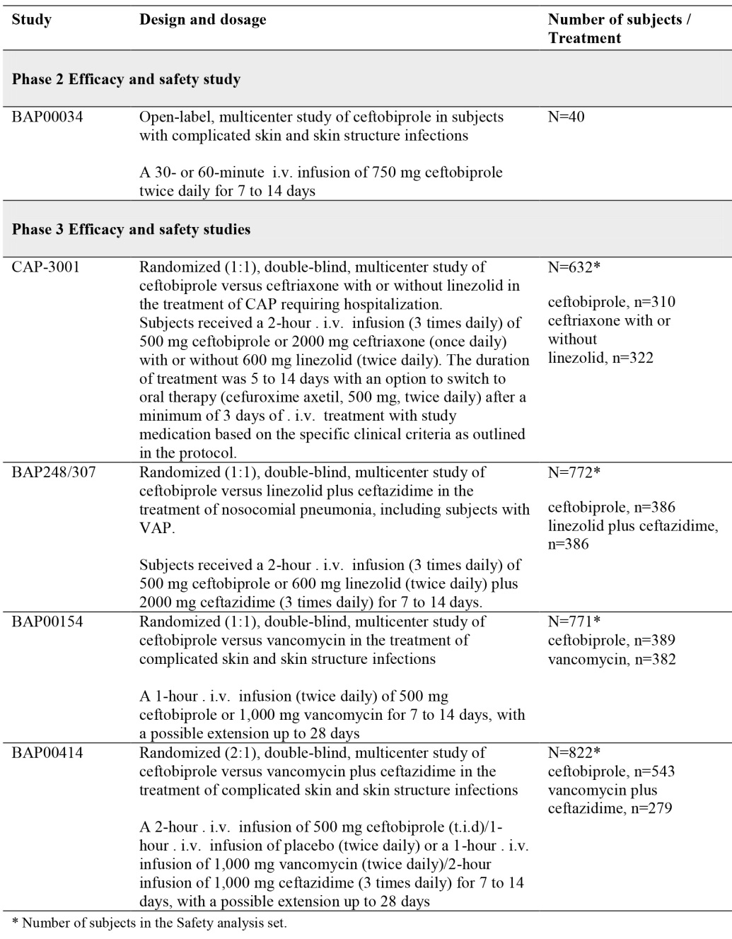

Table 21: Extent of Exposure - Ceftobiprole in the Safety analysis sets
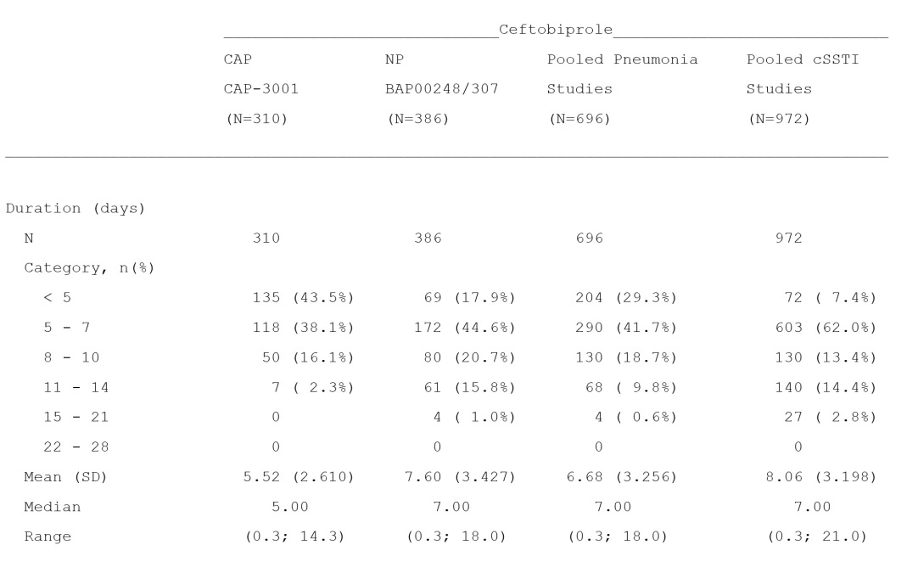

Adverse events

All adverse events (irrespective of relationship to study treatment)

Pivotal studies - Pooled Pneumonia Studies and Pooled Phase II+III cSSTI Studies (BAP00034/BAP00154/ BAP00414) Safety Analysis Set
As a result of disease severity and existing comorbidities, more subjects experienced AEs in the pneumonia studies than cSSTI studies. However, ceftobiprole and comparator treated subjects in the pooled pneumonia and pooled cSSTI studies had similar numbers of AEs, TRAEs, deaths, SAEs, treatment-related SAEs, AEs leading to discontinuation, and TRAEs leading to discontinuation.

Table 22: Summary of AE includes TRAE in the Safety analysis sets
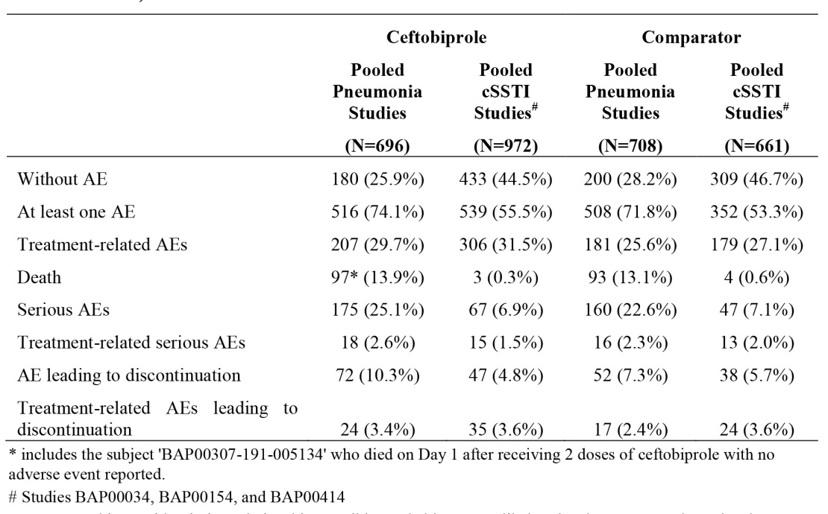

Treatment-related adverse events (adverse drug reactions)

Pivotal studies- Pooled Pneumonia Studies and Pooled Phase 2+3 cSSTI Studies (BAP00034/BAP00154/ BAP00414) Safety Analysis Set
In Study CAP-3001 there were more AEs in ceftobiprole subjects versus comparator (70% for ceftobiprole versus 64.6% for comparator). The incidence of AEs for Study BAP248/307 was the same in both arms (77.5% and 77.7% respectively); similar % of subjects receiving ceftobiprole versus comparator died, or had SAEs. A higher % of subjects receiving ceftobiprole experienced TRAEs, that is, 35.8% versus 25.8%; 5.8% and 3.7% ceftobiprole versus 2.3% and 0.9% in the comparator arm discontinued due to AEs or TRAEs respectively). A review of each pneumonia indication individually showed a different safety profile in CAP subjects versus nosocomial pneumonia subjects that is, a higher incidence of AEs, deaths, SAEs, treatment-related SAEs, AEs leading to discontinuation and TRAEs leading to discontinuation in those with NP, undoubtedly due to the fact that those with NP are just much sicker. The SOCs with the most frequently reported AEs in ceftobiprole-treated subjects across all pneumonia studies: were GI disorders (27.9%), Infections and infestations (22%), Respiratory, thoracic and mediastinal disorders (21%), General disorder and administration site conditions (18.4%), Metabolism and nutrition disorders (18.4%). Investigations, (17%) Nervous system disorders (13.8%), Vascular disorders (13.4%) and Skin and SC tissue disorders (10.6%). Across all studies the GI disorders SOC contained the most frequently reported AEs with a higher incidence of 28.7% in ceftobiprole treated subjects versus 18.9% in comparator arm in Study CAP-3001 and 27.2% of ceftobiprole-treated subjects versus 31.1% in the comparator group in Study BAP248/307. The majority of AEs in both treatment groups in the pneumonia and cSSTI studies were mild or moderate in severity. Most AEs considered life-threatening were reported in the pooled pneumonia Phase III studies that is, Cardiac disorders (30 ceftobiprole-treated versus 27 linezolid+ceftazidime-treated), Infections and infestations (21 ceftobiprole versus 24 linezolid plus ceftazidime-treated), and Respiratory, thoracic and mediastinal disorders (23 ceftobiprole versus 30 linezolid+ceftazidime- treated). Nausea was the most commonly reported AE in CAP-3001 in ceftobiprole-treated (9.7% versus 4% for comparator-treated). Nausea was the most common AE in the pooled cSSTI studies in both treatment groups. Diarrhoea was the most frequently AE in subjects in BAP248/307 in both treatment groups that is, 11.1% of ceftobiprole-treated versus 15.3% of comparator.

Table 23: TRAE by SOC in the Safety analysis sets
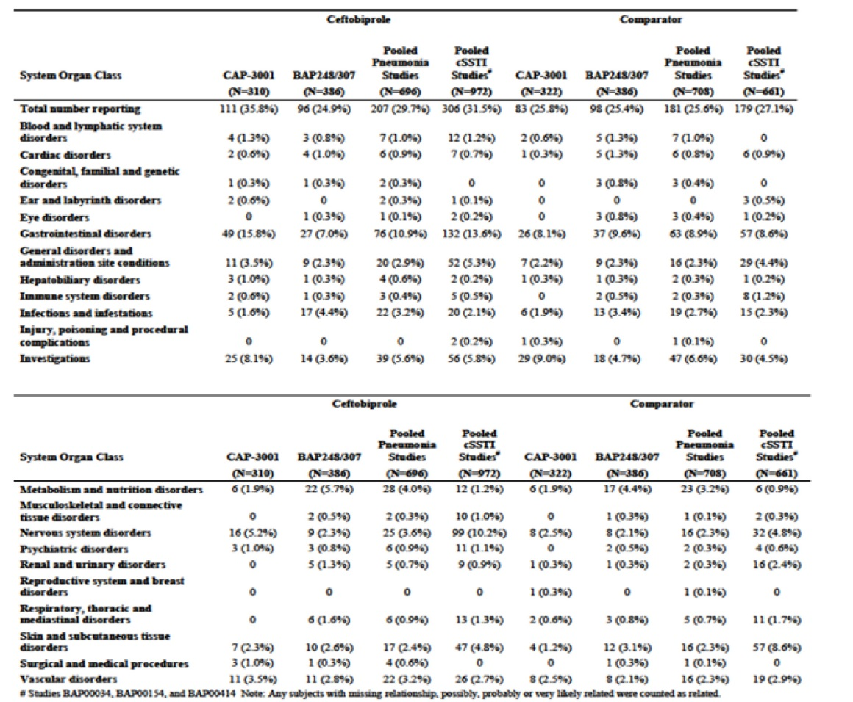

Table 24: GI AEs reported for ≥ 1% of subjects by SOC and PT in in the Safety analysis sets
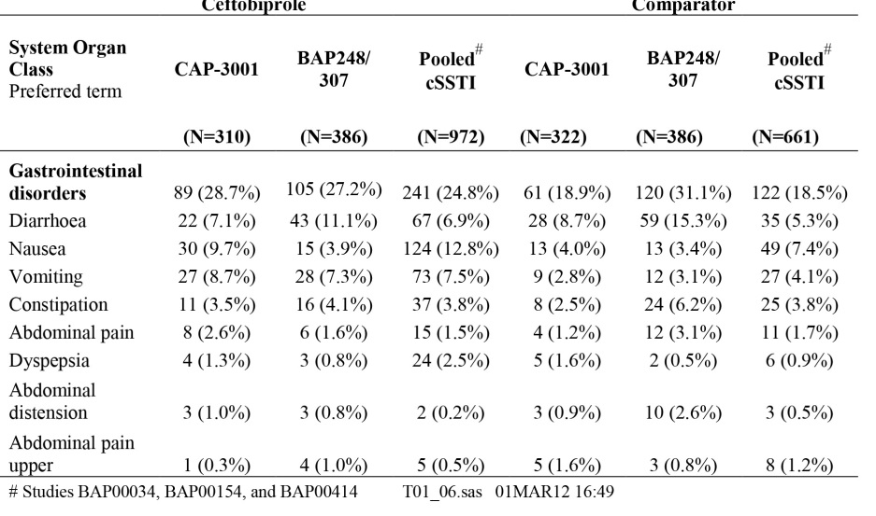
Skin and subcutaneous tissue disorders: In CAP-3001, rash was reported at a higher frequency in ceftobiprole-treated subjects (3.9%) than comparator (0.9%). In BAP248/307, incidence of rash was 2.8% in ceftobiprole-treated versus 3.1% in comparator. Similar incidences of rash (3.6% in the ceftobiprole group versus 3.2%) were reported in the pooled cSSTI studies. Incidence of pruritus and erythema were higher in the pooled cSSTI comparator-treated subjects.
Convulsions: there were convulsions reported in 20 subjects. Seven of 20 had current/prior epilepsy; a further 7 had underlying conditions for example, intracranial trauma. In 5 subjects the fits occurred between 1-16 days after ceftobiprole had been discontinued. Factors involved could include, sepsis, other drugs, electrolyte disturbance. PK studies suggest that subjects experiencing fits whilst taking ceftobiprole had normal drug levels. During BAP00414 and BAP248/307 there were reports of hyponatraemia in subjects receiving ceftobiprole. However, it was felt that this was related to the administration of 500 ml of free water infused as part of the regimen. Following the advice to study sites that in subjects at risk of hyponatraemia placebo solutions may contain sodium, reports of hyponatraemia decreased significantly.
Injection/ infusion-site-related adverse events occurred more frequently in subjects receiving ceftobiprole versus comparators for all studies and was 7.1% for Study CAP-3001, 6% for Study BAP248/307 and 7.5% for the pooled cSSTI studies. Corresponding incidence for the comparator groups were: 5% in CAP-3001, 4.7% in BAP248/307 and 6.4% in the pooled cSSTI studies.
Dysgeusia: In CAP-3001, 1.9% of ceftobiprole-treated subjects and 0.3% of comparator subjects reported dysgeusia. In BAP248/307 dysgeusia was reported by 1.3% of ceftobiprole-treated subjects versus none in the comparator group. The incidence of dysgeusia was higher in subjects who received ceftobiprole (5.7%) versus comparator (1.1%) in the pooled cSSTI studies.
TRAEs of special interest (TRAEs frequently associated with drugs/ biologicals, for example, hypersensitivity reactions, hepatotoxicity, renal toxicity, cardiotoxicity, dermatological events), were considered for second-level evaluation.
Second-level (case series) evaluation: Case-level evaluation involves medical review of all available clinical data for evidence of a causal association. A structured, systematic review process is followed using generally accepted threshold criteria (modified Edward’s criteria, CIOMS III and V threshold criteria). Table 25 displays the TRAEs, irrespective of dose and indication, considered ‘expected’ for ceftobiprole, per MedDRA SOC.

Table 25: TRAE reported with ceftobiprole and considered listed
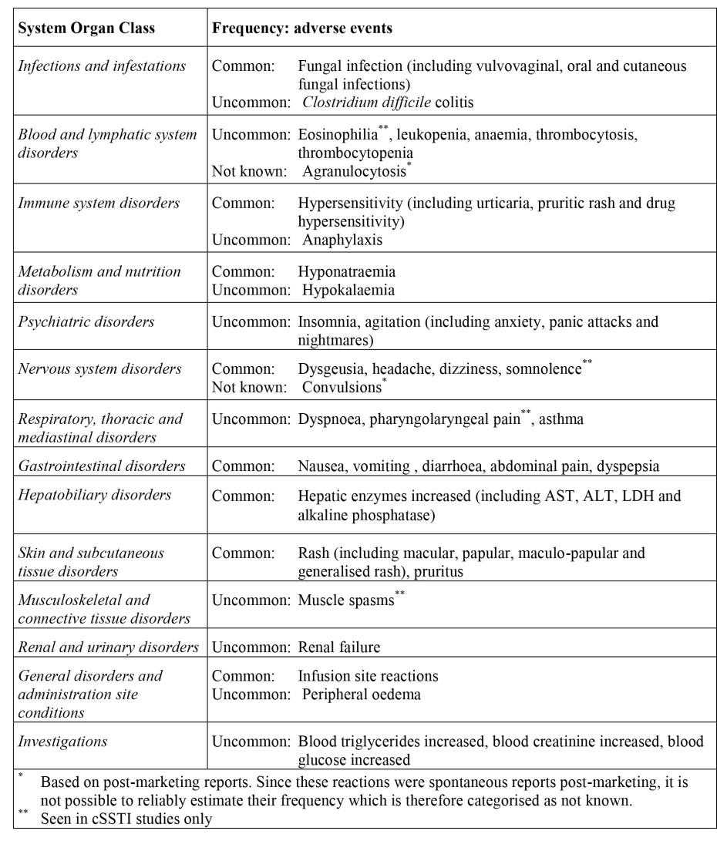

Deaths and other serious adverse events

Pivotal studies. Pooled Pneumonia Studies and Pooled Phase II+III cSSTI Studies (BAP00034/BAP00154/ BAP00414) Safety Analysis Set
Deaths: In CAP-3001, death rate was 2.9% for ceftobiprole and 2.8% for ceftriaxone ±linezolid. In BAP248/307 the death rate was 22.8% for ceftobiprole and 21.8% for ceftazidime+linezolid. In the pooled cSSTI studies, death rate was 0.3% for ceftobiprole versus 0.6%.
Analysis of deaths in study BAP248/307: 172 deaths overall, 88 (23%) in ceftobiprole and 84 (22%) in the comparator group. SOCs most frequently associated with death were Infections and infestations, Cardiac disorders, Respiratory, thoracic and mediastinal disorders; 8 (of 172) assessed as study-drug related, 4 subjects (1%) in each group. Of 283 subjects with NP excluding VAP who received ceftobiprole, 53 died; there were 35 deaths in the 103 VAP subjects on ceftobiprole.
SAE in the Phase III pneumonia studies and pooled cSSTI Studies: SAEs in CAP-3001 occurred in 11.3% ceftobiprole subjects and 11.5% of the comparator. In BAP248/307, incidence in ceftobiprole subjects was 36.3% and 31.9% for the comparator treated subjects. Within the pooled cSSTI studies, at least one SAE was reported in 6.9% of ceftobiprole-treated versus 7.1% comparator. The SOC with the most frequently reported SAEs were Infections and infestations, Respiratory, thoracic and mediastinal, Cardiac, Nervous system and Vascular disorders. A higher number of SAEs was reported in BAP248/307. In BAP248/307, 140 (36.3%) subjects in the ceftobiprole group and 123 (31.9%) subjects in the linezolid plus ceftazidime group reported SAEs during the study. The most common SAEs in both treatment groups were Infections and infestations, Respiratory thoracic, and mediastinal disorders, and Cardiac disorders. Within these SOCs, there were more SAEs reported in subjects in the ceftobiprole group versus linezolid+ceftazidime group, that is, for the PTs septic shock 12 (3.1%) subjects versus 6 (1.6%), respectively, pneumonia 10 (2.6%) subjects versus 14 (3.6%), respectively, sepsis 11 (2.8%) subjects versus 8 (2.1%), respectively, respiratory distress 6 (1.6%) versus 1 (0.3%), respectively, cardiac failure 7 (1.8%) versus 6 (1.6%), respectively, and cardiac arrest 7 (1.8%) versus 8 (2.1%) respectively.

Discontinuation due to adverse events

Pivotal studies - Pooled Pneumonia Studies and Pooled Phase II+III cSSTI Studies (BAP00034/BAP00154/ BAP00414) Safety Analysis Set
In CAP-3001, 5.8% and 3.7% in ceftobiprole and comparator group respectively discontinued treatment due to AEs. Of the 310 ceftobiprole subjects, nausea (1%) and vomiting (1.3%) were the most frequently reported AEs resulting in discontinuation; respiratory failure (0.6%) was the most frequently reported AE that resulted in discontinuation in the 322 in comparator. In BAP248/307, 14% ceftobiprole group discontinued due to AEs versus 10.4% in the comparator group. Pneumonia (1%) and hyponatraemia (1%) were the most frequently reported AEs resulting in discontinuation; for the comparator, no events resulting in discontinuation that occurred in > 0.5% of subjects. Two subjects in the ceftobiprole group discontinued treatment due to convulsions. In the pooled cSSTI studies, 4.8% ceftobiprole group discontinued treatment due to AEs versus 5.7% in the comparator. Of the 972 ceftobiprole subjects, nausea (0.5%) and vomiting (0.4%) were the most frequently reported AEs resulting in discontinuation, rash (0.9%) and pruritus (0.8%) were the most frequently reported AEs that resulted in discontinuation of the 661 comparator subjects. One subject from the ceftobiprole group was withdrawn because of fits. A similar % in both groups discontinued due to GI disorders and nausea (0.9% and 0.5% respectively).

Laboratory tests

Liver function

Pivotal studies - Pooled Pneumonia Studies and Pooled Phase II+III cSSTI Studies (BAP00034/BAP00154/ BAP00414) Safety Analysis Set
Table 26 shows the AEs reported for ≥ 1% of subjects in the Safety analysis sets.

Table 26: Investigations AEs reported for ≥ 1% of subjects by SOC and PT in the Safety analysis sets
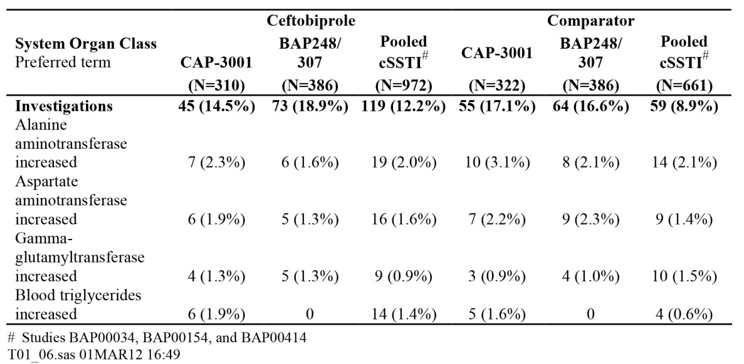
As shown in Table 26, little difference with regards to AEs across studies. Increased ALT was the most frequently reported TEAE (2.3% in ceftobiprole-treated versus 3.1% comparator-treated subjects in CAP-3001 and 1.6% ceftobiprole-treated versus 2.1 % comparator in BAP248/307). In the pneumonia studies, 3 ceftobiprole-treated subjects and no comparator-treated subjects had ALT > 3 times ULN and with a total bilirubin > 2 times ULN on the same sample. These subjects (subjects [information redacted] in the NP study and subject [information redacted] in the CAP study) did not meet the criteria as defined by Hy's law in the US FDA draft guidance on drug-induced liver injury because they either had evidence of significant baseline cholestasis before the initiation of study drug or evidence of chronic liver disease prior to enrollment.

Kidney function

Pivotal studies. Pooled Pneumonia Studies and Pooled Phase II+III cSSTI Studies (BAP00034/BAP00154/ BAP00414) Safety Analysis Set
Elevation of serum creatinine (that is, > 0.5 mg/dL from baseline and > 1.2 mg/dL) was reported at low frequencies ranging from 0 – 1.8% in ceftobiprole treated subjects versus 0.3 – 1.0% in comparator in the SAS. Renal and urinary AEs were lower in ceftobiprole subjects versus comparator in CAP-3001 (0.3% versus 0.9%) and the pooled cSSTI studies (0.4% and 1.7%). Incidence of these events in BAP248/307 was higher in ceftobiprole (6%) versus comparator (3.1%).

Table 27: Treatment-emergent renal-related adverse events in the Safety analysis sets
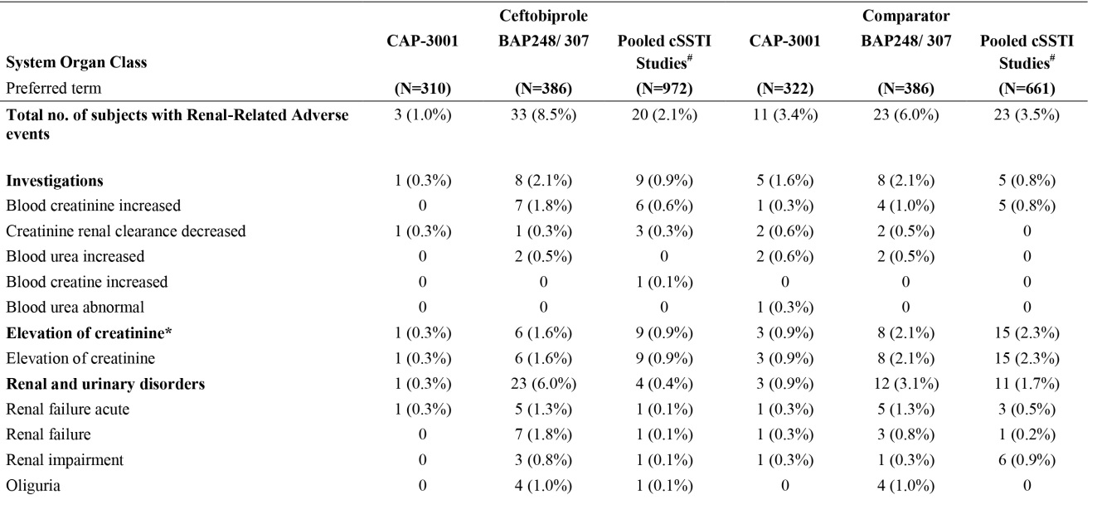

Other clinical chemistry – electrolytes

Pivotal studies. Pooled Pneumonia Studies and Pooled Phase II+III cSSTI Studies (BAP00034/BAP00154/ BAP00414) Safety Analysis Set
Hypokalaemia was the most frequently reported event across all studies. In CAP-3001 the incidence was lower for ceftobiprole treated subjects than comparator (4.2% and 5.9% respectively); in BAP248/307 incidence was higher for ceftobiprole (9.8%) than comparator (8.3%) subjects. In the pooled cSSTI studies hypokalaemia was similar between groups. Hyponatraemia occurred more frequently in BAP248/307 than CAP-3001. The difference in the incidence of hyponatraemia between ceftobiprole and comparator groups in BAP248/307 appears related to higher incidence of baseline hyponatraemia in the ceftobiprole group.

Table 28: Metabolism and nutrition AE reported for ≥ 1% of subjects by SOC and PT in the SAS
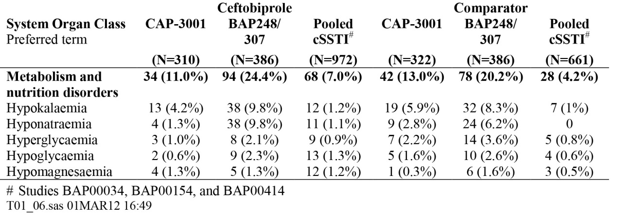

Haematology

Pivotal studies. Pooled Pneumonia Studies and Pooled Phase II+III cSSTI Studies (BAP00034/BAP00154/ BAP00414) Safety Analysis Set
Review of the lab data over time, baseline to the EOT visit, in CAP-3001 reveals little of note on comparison of the changes occurring with either ceftobiprole or comparator which are very similar for all measured biochemical and haematology parameters. The most obvious and expected changes (as a result of resolution of infection) in both groups are the very similar falls in total WBC count and % neutrophils at the end of therapy. No noteworthy changes in chemistry or haematology values over time for those receiving ceftobiprole versus comparators in the pooled skin studies. It is noteworthy that positive direct antiglobulin test may occur during treatment with cephalosporin and lead to haemolytic anaemia. However, in the clinical studies there were no cases of autoimmune haemolysis.

Electrocardiograph

Pivotal studies. Pooled Pneumonia Studies and Pooled Phase II+III cSSTI Studies (BAP00034/BAP00154/ BAP00414) Safety Analysis Set
No signal of note revealed suggestive of excessive cardiac toxicity including changes in the ECG.

Vital signs

Pivotal studies. Pooled Pneumonia Studies and Pooled Phase II+III cSSTI Studies (BAP00034/BAP00154/ BAP00414) Safety Analysis Set
Incidence of markedly abnormal vital signs in the individual pneumonia studies was very similar between the ceftobiprole and comparator groups. Similar comparison in the pooled cSSTI studies shows an excess of markedly low diastolic readings in the ceftobiprole group but this was due to the inclusion of the non-comparative Phase II study data in which low diastolic blood pressure (< 60 mm Hg) was reported for 19 (48%) subjects on ≥ 1 occasions without apparent relationship to ceftobiprole (BAP00034 CSR). High systolic blood pressure (> 180 mm Hg) and low pulse rate (< 40 bpm) were reported for one subject each. Incidence of the few markedly abnormal vital sign values in the pneumonia studies, when split by PORT Risk Class in study CAP-3001 and into the NP excluding VAP and VAP populations within BAP248/307 did not reveal any safety signal.

Selection of microbiological resistant organisms including Clostridium difficile colitis

Pivotal studies- Pooled pneumonia studies
In CAP-3001 a single report of a treatment-related SAE of C. difficile colitis in the comparator arm. In BAP248/307, there was a single report of C.difficile colitis in each arm of the study.

Post-marketing experience
Based on the 14,380 vials (500 mg) of ceftobiprole distributed worldwide since launch, estimated exposure is 5,036 person-days. Assuming average treatment duration was 7 days, < 1,000 subjects receiving ceftobiprole during the marketing period. During the period of ceftobiprole licensed use in cSSTIs, < 1,000 subjects exposed to ceftobiprole. There were 6 spontaneous cases reports from this period: 3 cases from Health Canada Pharmacovigilance of fits; 1 case of acute tubular necrosis; 1 case of pancytopaenia and diffuse maculopapular rash; 1 case of agranulocytosis recognised after 18 days therapy and resolving after ceftobiprole discontinuation.

Safety issues with the potential for major regulatory impact

Liver toxicity
None revealed.

Haematological toxicity
None revealed.

Serious skin reactions
None revealed.

Cardiovascular safety
None revealed.

Unwanted immunological events
Non revealed.

Other safety issues

Genotoxicity
Ceftobiprole medocaril sodium and ceftobiprole have been examined in vitro and in vivo assays in the pre-clinical studies. The drug was negative in the Ames and forward mutation assays. In the mouse lymphoma/thymidine kinase test, ceftobiprole medocaril sodium exhibited clastogenic activity at cytotoxic concentrations and ceftobiprole induced an unequivocal effect at very high cytotoxic concentrations of > 2500 µg/mL. In the human chromosome aberration assay, ceftobiprole medocaril sodium, but not ceftobiprole, was clastogenic under the described in vitro conditions at cytotoxic concentrations. No genotoxic activity was seen in the in vivo assays. A gentoxic liability of ceftobiprole medocaril sodium in man is not likely.

Carcinogenicity
Because of the short-term duration of the clinical therapy and the low potential of ceftobiprole medocaril sodium for genotoxicity, carcinogenicity studies have not been conducted.

Safety in special populations

Elderly population
In the pooled pneumonia studies, TRAEs reported at a slightly higher frequency of 41% in the ceftobiprole-treated subjects who were under 65 years of age versus 36.4%% in the comparator. In subjects > 65 years of age, incidence was 32.6% in ceftobiprole treated subjects versus 35.3% in the comparator. In the pooled cSSTI studies 45% versus 43% of ceftobiprole and comparator treated subjects respectively experienced TEAE in subjects less than 65 years, in subjects > 65 years, incidence was 11% of ceftobiprole treated subjects versus 9.8% of comparator-treated subjects.

Gender
Overall, incidence of TEAEs in subjects in the pooled pneumonia studies was slightly higher for ceftobiprole treated females than ceftobiprole treated males (75.7% versus 73.3%). In the cSSTI pooled studies incidence of those with ≥ 1 AE was higher for ceftobiprole treated females than ceftobiprole treated males (58.1% versus 53.7%). In the pooled pneumonia studies for the ceftobiprole treated subjects, a higher % of females experienced, nausea, diarrhoea and vomiting (12.3%, 11.1%, and 11.1%, respectively) versus males (3.3%, 8.4%, and 6.2%, respectively). In the pooled cSSTI studies, similar trends were seen with more females than males experiencing nausea, vomiting and diarrhoea. Although nausea and vomiting were more common in females, the majority of cases were mild and not treatment limiting. Race: In the pooled Phase III pneumonia studies a lower % of White subjects who received ceftobiprole experienced dysgeusia, vomiting and nausea (1.4%, 6.3%, and 5.9%, respectively) versus Black subjects (7.4%, 18.5%, and 11.1%, respectively). A similar pattern was seen when White subjects were compared with other races, except for dysgeusia, which was slightly lower (1.2%, 11.1%, and 7.4%, respectively). In the pooled cSSTI studies a different pattern was observed: dysgeusia (White 5.2%, Black 6.8%, Other 6.9%) and vomiting (White 5.2%, Black 13.5%, Other 14.5%) were reported in a higher % of Black and Other race subjects compared to White subjects and nausea (White 11.2%, Black 8.1%, Other 21.4%) was experienced by a lower % of Black subjects compared to White and Other race subjects.

Renal Impairment
In the pooled pneumonia studies a slightly higher number of subjects with renal impairment 208 (76.2%) (CrCl < 80ml/min) reported ≥ 1 AE versus those with normal renal function 281 (72.8%). A similar pattern, but more marked, was seen in the comparator group 210 (75.8%) and 257 (68.7%), respectively. In the pooled pneumonia studies, a higher % of subjects with renal impairment receiving ceftobiprole had a difference of ≥ 2% in the following AEs versus those with normal renal function who received ceftobiprole; hypokalaemia (8.4% versus 6.5%, respectively), hyponatraemia (7.7% versus 4.7%, respectively), oedema peripheral (3.7% versus 1.0%, respectively), decubitus ulcer (2.9% versus 0.5%, respectively), and cardiac failure congestive (2.6% versus 0.5%, respectively). A similar pattern was seen in comparator arm except for the AE oedema peripheral, where the incidence was slightly higher in those with normal renal function. In the pooled cSSTI studies, the above AEs were reported in a similar pattern for hyponatraemia (3.7% versus 0.5%, respectively) and showed frequency of > 2% difference. In the pooled Phase III pneumonia studies a similar % of subjects with renal impairment receiving ceftobiprole experienced nausea (7.0%) and vomiting (8.8%) versus subjects with normal renal function receiving ceftobiprole (6.5% and 7.0% respectively). Dysgeusia was experienced by a similar % with abnormal and normal renal function (1.1% and 1.6% respectively). A similar pattern was seen in the comparator group.

Paediatrics
The safety and efficacy of Zevtera in children aged birth to < 18 years have not yet been established. There is an ongoing Paediatric investigation programme.

Pregnancy and breast feeding
Effects on fertility, pregnancy and lactation in humans have not been studied. Animal studies do not indicate harmful effects with respect to fertility. Use in Pregnancy is designated as Category B1 based on past experience with cephalosporins and supported by animal studies, which do not indicate direct/indirect harmful effects with respect to pregnancy, embryonal/foetal development, parturition or postnatal development. Animal studies have shown excretion of ceftobiprole/metabolites in milk at low concentrations. It is unknown whether ceftobiprole is excreted in human milk and what the potential risks of this might be in regards to sensitisation and colonisation with other resistant pathogens including C.difficile in breast-fed infants.

Safety related to drug-drug interactions and other interactions
No D-D interactions revealed.

Assessment of creatinine and urine glucose tests.
Some other cephalosprins can interfere with the alkaline picrate assay to measure serum creatinine (Jaffé reaction), leading to erroneously high creatinine measurements. It is unknown if ceftobiprole has the same effect. Because of this uncertainty, an enzymatic method of measuring serum creatinine should be used. The same potential with some urine glucose tests using the copper reduction technique. It is recommended that an enzymatic method to detect glucosuria be used, because of potential interference.

Risk of the emergence of resistance and Clostridium difficile colitis

Emergence of resistance
The sponsor has provided the mandated Risk Assessment of Microbial Resistance. As already described, Zevtera® is best described as a fifth generation cephalosporin. Another fifth generation cephalosporin, ceftaroline fosamil (Zinfro®) is registered in Australia (since 2013) for the treatment of cSSTI and CAP. The organisms which have intrinsic resistance to the drug are described in Section Pharmacodynamics. In order to assess the risk of initially sensitive organisms developing resistance, the sponsor has conducted the conventional in vitro assays, including multi- and single passage resistance studies. Beta lactam antibiotic resistance occurs via target alteration, drug inactivation and changes in permeability/efflux. In Staphylococci, the main mechanisms are inactivation by beta-lactamase class A, and target alteration, through the acquisition of PBP (PBP2a), encoded by the mecA gene. While penicillinase production occurs in 80 to 90% of S. aureus (Kernodle 1989), this does not impact the activity of cephalosporins as they are refractory to hydrolysis by this enzyme. PBP2a-mediated beta lactam resistance is found in approximately 50% of EU and US S. aureus isolates (Appelbaum 2006, Vincent 2009) and does affect the activity of beta lactams including cephalosporins. Ceftobiprole is refractory to these main mechanisms of Staphylococcal resistance through tight binding to PBP2a (with IC₅₀ values of 0.31–1.7 μg/mL) and relative resistance to hydrolysis by penicillinases (Hebeisen 2001). The major mechanism of beta lactam resistance in gram-negatives is enzymatic degradation by beta lactamases, exacerbated by limited diffusion across the bacterial membrane and active extrusion of drug. While the number of beta lactamases found in the gram-positives is fairly small, gram negatives express multiple enzymes that is, broad-spectrum Class A beta lactamases. One of the other major challenges with gram negatives is the expression of extended-spectrum Class A enzymes (ESBLs) capable of hydrolysing third and fourth generation cephalosporins, aztreonam and even carbapenems. Class B metallo-beta lactamases also have a wide hydrolysis spectrum including the carbapenems. While Ceftobiprole is stable to many Class A and Class C beta lactamases, it is hydrolysed by ESBLs and carbapenamases. Other resistance occurs via permeability decreases, loss of outer membrane proteins, and increased efflux.

Mechanisms of resistance in gram positives and gram negative organisms relevant to the indication (NP and CAP)

Gram positive organisms
28 days of multiple passages resulted in MRSA and non-mecA MRSA laboratory strains that demonstrated high level ceftobiprole resistance. Multiple mutations in 3 genes encoding the following - PBP4, GdpP (a signaling protein) and AcrB, a multidrug resistance pump in the resistance nodulation division superfamily of transporters (Banerjee 2010) were found. The selection of these resistant strains does not appear to be a common event in the clinical setting (Banerjee 2008). In another set of serial passage experiments, ceftobiprole MIC values for other MRSA strains did not exceed 8 μg/mL (Bogdanovich 2005, Shang 2010) suggesting that the development of resistance through a PBP2a alteration is likely a very rare event. Other mechanisms of resistance include hydrolysis by S.aureus penicillinases, ceftobiprole is resistant to hydrolysis by PC1 penicillinase (Hebeisen 2001, Queenan 2007a).
After 50 serial passages of H. influenzae and M. catarrhalis, ceftobiprole MICs were no more than 2 log₂ dilution steps higher than the parental strains with the highest MIC of 1 μg/mL;
The penicillin MIC values for a set of 30 pneumococcal isolates with increasing numbers of PBP mutations was ≤ 0.015 in the ‘no mutation’ strains versus 8 μg/mL in the ‘most mutations’ strains. The ceftobiprole MIC to these same isolates increased from ≤ 0.004 to 1 μg/mL, indicating that even very resistant pneumococci remained ceftobiprole sensitive. Davies and colleagues have identified substitutions within PBP genes associated with increased ceftobiprole MICs towards a collection of ceftriaxone-resistant S. pneumoniae isolates from the USA (Davies 2007b).

Gram-negative organisms
The mechanisms of resistance have been described. Stability of ceftobiprole to beta lactamases of all molecular classes has been defined. The drug is readily hydrolysed by ESBLs, carbapenemases, and the K1 and OXA-10 enzymes. However, the broad-spectrum Class A non-ESBL enzymes (for example, ubiquitous TEM-1 and SHV-1 beta lactamases) and the AmpC chromosomal beta lactamases demonstrate low hydrolysis rates for the drug. These hydrolysis characteristics of ceftobiprole, combined with its high degree of PBP inhibition, define its overall potent activity against most gram-negative pathogens.
Overall, a ceftobiprole exposure target of 60% fT> MIC is sufficient for bactericidal (1 log-kill) activity against both gram-positive and gram-negative pathogens in pre-clinical models, and these levels predicted microbiological and clinical outcome in the NP population in BAP248/307.
The ceftobiprole MIC of most relevance is 4 μg/mL, and as demonstrated in the PK and PK/PD studies, levels well above this MIC are achieved by the proposed dosing of 500 mg tds as an IV infusion. When a ceftobiprole MIC of 4 μg/mL is considered in the context of the bactericidal (1 log-kill) exposure targets (%fT> MIC), the probability of target attainment (PTA) for Gram-positive organisms is 100%, and the PTA for Gram-negative organisms is 96.7%.
Surveillance studies (part of the SENTRY Asia-Pacific surveillance) were conducted to define of ceftobiprole susceptibility of contemporary clinical isolates in Australia (2007 (886 isolates) and 2008 (1328 isolates)). These isolates include bloodstream (24.8%), skin/soft tissue (28.1%), respiratory tract (20.2%), other (26.9%). EUCAST susceptibility interpretive criteria were used, the targeted pathogens for the proposed indication are described in the table below.

Table 29: In vitro activity from 2007 Australian bacterial surveillance; targeted pathogens
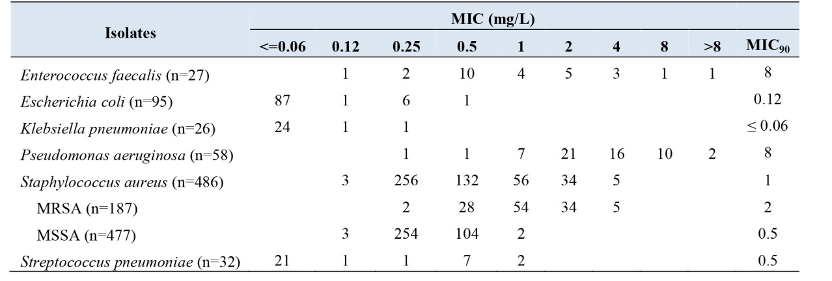
These data from 2007-2008 suggest excellent activity of the drug against Australia isolates of S. aureus (incl. MRSA), S. pneumonia, E.coli and K. pneumonia. 2013 data from AGAR, show a rise in S. aureus resistance, with 19.1% of the 2,010 S.aureus bacteraemias due to MRSA attributable to two healthcare-associated MRSA clones, ST22-IV and ST239-III. In addition, 60% of MRSA were community associated clones ST93-IV and ST1-IV. Ceftobiprole appears active against most of the SCCmec types (exception SCCmec type I), and will be active against the predominant healthcare and community MRSA.

C.Difficile
There were very few cases of C.Difficile colitis in any of the studies, but as for all broad-spectrum antibiotics it is likely that Ceftobiprole will place patients at risk of C.difficile overgrowth and the potential for colitis. Restricting duration of treatment that is, avoiding very long courses, will be important in reducing this risk but also switching to narrower spectrum antibiotics if the organism isolated is sensitive is an important strategy.

Evaluator’s overall conclusions on clinical safety
In the pooled Phase III pneumonia studies, 29.7% of all ceftobiprole-treated subjects and 25.6% of all comparator-treated subjects experienced ≥ 1 one drug-related AE. Most commonly (in ≥ 1% of those treated with ceftobiprole): nausea (4.3% of subjects), diarrhoea (4.2%), vomiting (3.3%), hyponatraemia (2.7%), phlebitis (2.3%), dysgeusia (1.6%), headache (1.4%), rash (1.1%), ALT increased (1.1%) and AST increased (1.0%). The safety of ceftobiprole was also evaluated in special populations, by age, gender, race, renal impairment and hepatic impairment. Analysis of these special populations revealed no particular safety signal of concern especially in the NP study, where patients were generally muck sicker. The clinical program did not reveal any worrisome signal in regards to the selection of resistance, but relatively few patients have been exposed over only a short period of time. Broad spectrum cephaloporins are recognised to increase the risk of C. difficile colonisation and colitis; it would be expected that Zevetra® would be no different in this regard.

What is the real risk to health of Australians with the registration of this 5th generation cephalosporin?
Overall the evaluator thinks the risk is low, the rationale for this is:
- It is clearly quite difficult for Staphylococcal and Streptococcal species to develop resistance and even very resistant species remain susceptible to the drug;
- Mechanisms of resistance to various gram negatives have been defined, some of these highly resistant strains are already resistant to the drug so ceftobiprole is unlikely to make the situation worse;
- The sponsor has projected the expected use of ceftobiprole in Australia. Use in 2016 is expected to be in 50 patients rising to 2650 in 2020, average nos of days of dosing will be 8 (extrapolated from the phase 3 pneumonia studies). In other words, there will be very restricted use of the drug (small numbers, short exposure), and this means the risk of dissemination of ceftobiprole resistant strains, should they occur, is low;
- The clinical development program confirms using the recommended dose of 500 mg tds as a 2 h IV infusion has extremely high coverage of the target pathogens isolated during the 2008 surveillance study.
In summary, although the risk of emergence of ceftobiprole resistance appears low for gram positive organisms (pneumonia-causing pathogens), the risk is likely greater for some of the gram negative organisms. Importantly, ceftobiprole resistance may occur for reasons not directly related to the use of the drug in Australia for example, global movement of very resistant pathogens as people and even populations travel and hence, ongoing international pharmacovigilance and microbiological surveillance activities are essential. In Australia, the incidence of resistance in CAP organisms is growing, but it still remains relatively low. The evaluator’s greatest concern is that when Zevetra® is approved for use in CAP, the drug will be used empirically and not stopped even when the organism is revealed to be sensitive to narrower spectrum agents. The use of a very broad-spectrum antibiotic for a common condition such as CAP which is frequently caused by sensitive bacteria for example, penicillin sensitive pneumococci when the global push is to use narrower spectrum antibiotics wherever possible, seems counter-intuitive. If the drug is misused on a global scale, then there is a risk of the selection of increasingly resistant organisms.

First round benefit-risk assessment

First round assessment of benefits
The benefits of Zevtera® in the proposed usage are:
- A broad-spectrum antibiotic that combines potent gram positive (including for MRSA) and gram negative activity against the common pneumonia causing bacteria. The evaluator can see the particular utility of this drug for nosocomial infections and perhaps for CAP in a patient with a particular risk for more resistant organisms (past/current history; other comorbidities; co-infection with respiratory tract viruses that might increase risk of invasive Staphylococcal infection including MRSA);
- Favourable PK profile with linear PK and no accumulation seen; dose adjustments for varying degrees of renal impairment appear supported by the data derived from the PK programme;
- Little potential for drug-drug interactions, this is important as the target population are more likely to be elderly with other comorbidities and using polypharmacy as a consequence;
- Rapid mode of action;
- Can be given as monotherapy which avoids the use of two (or more) different antibiotics to provide ‘appropriate’ antibiotic coverage in those very ill with bacterial pneumonia;
- Alternative agents such linezolid, while an excellent gram positive antibiotic, have idiosyncratic haematological and neurological AEs. To date no such idiosyncratic reactions have been revealed for this drug, but patient exposure is limited. Other broad-spectrum penicillins (for example, Timentin®) are well tolerated but do not have MRSA activity in which case they are often combined with glycopeptides or linezolid if MRSA is suspected.

First round assessment of risks
The risks of Zevtera® in the proposed usage are:
- While multidrug resistant organisms are of growing concern worldwide, they are not of such a great concern- yet - in Australia at least not for CAP. The problem with empirical use of such a broad spectrum antibiotic is that it will inevitably be used for sensitive organisms that simply don’t need such a broad-spectrum antibiotic for treatment. Although the development of resistance to the drug especially for gram positives is low, there still is a potential risk for the selection of resistant organisms and/or overgrowth with C.difficile and subsequent colitis;
- The drug is associated with quite a number of GI toxicities especially nausea and altered taste, while tolerated reasonably well in the clinical trials, these toxicities may be more problematic in the ‘real-life’ setting;
- The drug has to be given IV as a 2 h infusion tds, this is not very user friendly;
- The potential for the drug to interfere with some forms of testing for creatinine may be an issue, depending on how widespread those platforms are utilised in biochemistry labs. This may be an issue in those with renal impairment for whom dose adjustment is required;
- No oral equivalent at this juncture for step-down. The clinical evaluator notes the step-down option in the CAP study was a first generation cephalosporin, one could argue that most of the patients enrolled in the CAP-3001 study would have done just as well on a first generation cephalosporin from the onset.

First round assessment of benefit-risk balance
The benefit-risk balance of Zevetra®, given the proposed usage, is favourable.

First round recommendation regarding authorisation
The clinical evaluator recommends approval of the drug for nosocomial (hospital-acquired) bacterial pneumonia (excluding ventilator-associated pneumonia) and community acquired bacterial pneumonia requiring hospitalisation.

Clinical questions

Pharmacokinetics
- Renal function tests are usually supplied as an eGFR based on the MDRD or CKD-EPI formula; what is the risk in terms of incorrect dosing if the Cockcroft-Gault formula is not used to calculate creatinine clearance?

Pharmacodynamics
No questions.

Efficacy
- Unclear to what extent MRSA and NORSA and resistant S.pneumoniae are a causative agent in CAP in Australia? In which case do you really need to cover these organisms empirically when treating CAP?
- Do you have any concerns about the use of the drug for Haemophilus sp., there seemed to be a signal, albeit small that the drug did not perform so well in a couple of patients?
- How will you monitor the ‘off-label’ use in VAP which is very likely to happen, especially as definitions of VAP can be quite confusing?

Safety
No questions.

Second round evaluation of clinical data submitted in response to questions
No second round clinical evaluation was conducted.

References
Andes D and Craig WA. Pharmacodynamics of a new cephalosporin, PPI-0903 (TAK-599), active against methicillin-resistant Staphylococcus aureus in murine thigh and lung infection models: identification of an iv vivo pharmacokinetic pharmacodynamic target. Antimicrob Agents Chemother. 2006; 50(4): 1376–1383. EDMS-PSDB-6726870.
Appelbaum PC. MRSA--the tip of the iceberg, Clin Microbiol Infect 2006; 12 Suppl 2:3–10The Australian Lung Foundation, ‘Respiratory Infectious Disease Burden in Australia’, Edition 1, March 2007
Banerjee R, Gretes M, Basuino L, et al. In vitro selection and characterization of ceftobiprole-resistant methicillin-resistant Staphylococcus aureus, Antimicrob. Agents Chemother 2008;52:2089–2096.
Banerjee R, Gretes M, Harlem C, et al. A mecA-negative strain of methicillin-resistant Staphylococcus aureus with high-level beta lactam resistance contains mutations in three genes, Antimicrob Agents Chemother 2010;54:4900–4902
Barbour A, Schmidt S, Sabarinath SN, et al. Soft-tissue penetration of ceftobiprole in healthy volunteers determined by in vivo microdialysis. Antimicrobial Agents and Chemotherapy 2009; 53:2773–2776.
Beall BW, Gertz RE, Hulkower RL, et al. Shifting genetic structure of invasive serotype 19A pneumococci in the United States. J Infect Dis. 2011 May 15;203(10):1360–8.
Bhat N, Wright JG, Broder KR, et al. Influenza-associated deaths among children in the United States, 2003–2004.N Engl J Med. 2005;353:2559–67.
Bhavnani SM, Hammel JP, Cirincione BB, et al. Use of pharmacokinetic-pharmacodynamic target attainment analyses to support Phase-II and III dosing strategies for doripenem. Antimicrob Agents Chemother. 2005; 49:3944–3947. EDMS-PSDB-6727294.
Bogdanovich T, Ednie LM, Shapiro S, Appelbaum PC. Antistaphylococcal activity of ceftobiprole, a new broad-spectrum cephalosporin, Antimicrob Agents Chemother 2005;49:4210–9
BTS: Pneumonia Guidelines Committee of the BTS Standards of Care Committee. BTS guidelines for the management of community acquired pneumonia in adults: update 2009. Thorax. 2009 Oct;64 Suppl 3:iii1–55. PubMed PMID: 19783532.
Cars O. Efficacy of beta-lactam antibiotics: Integration of pharmacokinetics and pharmacodynamics. Diagn Microbiol Infec Dis 1997; 27: 29-33.
Centers for Disease Control. Mortality and Morbidity Weekly Report. Severe methicillin-resistant Staphylococcus aureus community-acquired pneumonia associated with influenza – Louisiana and Georgia, December 2006–January 2007. 2007 Apr 13;56(14):325–329.
Centers for Disease Control. Mortality and Morbidity Weekly Report. Bacterial Coinfections in Lung Tissue Specimens from Fatal Cases of 2009 Pandemic Influenza A (H1N1) – United States, May–August 2009. 2009;58(38):1071–1074.
Chang FY, Peacock JE, Musher DM, et al. Staphylococcus aureus bacteremia. Recurrence and the impact of antibiotic treatment in a prospective multicenter study. Medicine. 2003; 82:333–339.
Craig WA. Pharmacokinetic/pharmacodynamic parameters: rationale for antibacterial dosing of mice and men. Clin Infect Dis 1998; 26: 1-12.
Craig WA. The future – can we learn from the past? Diagn Microbiol Infect Dis1997; 27: 49-53.
Davies TA, Bush K, and Appelbaum PA. Activity of Ceftobiprole Against US Clinical S. pneumoniae Isolates That Are Ceftriaxone Non-Susceptible. Abstract 2025. In: 17th European Congress of Clinical Microbiology and Infectious Diseases;Barcelona, Spain; 2007.
Dufour P, Gillet Y, Bes M, et al. Community-Acquired Methicillin-Resistant Staphylococcus aureus Infections in France: Emergence of a Single Clone That Produces Panton-Valentine Leukocidin. Clinical Infectious Diseases 2002; 35:819–24.
European Antimicrobial Resistance Surveillance Network (EARS-Net) interactive database. <http://ecdc.europa.eu/en/activities/> surveillance/EARS-Net/database/Pages/database.aspx. Accessed 8 March 2012.
ECDC/EMEA Joint Technical Report. The bacterial challenge: time to react. 2009 EMEA/576176/2009. Available at <http://www.emea.europa.eu/> docs/en_GB/document_library/Report/2009/11/WC500008770.pdf.
European Medicines Agency; Committee for Medicinal Products for Human Use (CHMP), Guideline on the evaluation of medicinal products indicated for treatment of bacterial infections CPMP/EWP/558/95 rev 2; 15 December 2011.
Finberg RW, Moellering RC, Tally FP, et al. The importance of bactericidal drugs: Future directions in infectious disease. Clin Infect Dis. 2004; 39:1314–1320.
Gagliotti C, Balode A, Baquero F, et al., the EARSNet Participants (Disease Specific Contact Points for AMR). Escherichia coli and Staphylococcus aureus: bad news and good news from the European Antimicrobial Resistance Surveillance Network (EARS-Net, formerly EARSS), 2002 to 2009. Euro Surveill. 2011;16(11).
Gillet Y, Vanhems P, Lina,G, et al. Factors predicting mortality in necrotizing community-acquired pneumonia caused by Staphylococcus aureus containing Panton-Valentine leukocidin. CID 2007;45:315–321.
Hebeisen P, Heinze-Krauss I, Angehrn P, Hohl P, Page MGP, Then RL. In vitro and in vivo properties of Ro 63-9141, a novel broad-spectrum cephalosporin with activity against methicillin-resistant staphylococci. Antimicrob Agents Chemother. 2001; 45:825–36.
Höffken G, Lorenz J, Kern W, et al. Epidemiology, diagnosis, antimicrobial therapy and management of community-acquired pneumonia and lower respiratory tract infections in adults. Guidelines of the Paul-Ehrlich-Society for Chemotherapy, the German Respiratory Society, the German Society for Infectiology and the Competence Network CAPNETZ Germany. Pneumologie. 2009 Oct;63(10):E1–68.
Jones RN. Microbial etiologies of hospital-acquired bacterial pneumonia and ventilator-associated bacterial pneumonia. Clin Infect Dis. 2010 Aug 1;51 Suppl 1:S81–7.
Kernodle DS, Stratton CW, McMurray LW, Chipley JR, McGraw PA. Differentiation of beta lactamase variants of Staphylococcus aureus by substrate hydrolysis profiles. J Infect Dis. 1989; 159:103–8.
Kollef MH, Sherman G, Ward S,Fraser VJ (1999) Inadequate antimicrobial treatment of infections: a risk factor for hospital mortality among critically ill patients. Chest 115:462–474.
Kresken M, Körber-Irrgang B, Läuffer J, et al. In vitro activities of ceftobiprole combined with amikacin or levofloxacin against Pseudomonas aeruginosa: evidence of a synergistic effect using time–kill methodology. International Journal of Antimicrobial Agents 2011;38:70–75. MicroNC-000054.
Laohavaleeson S, Tessier PR, Nicolau DP. Pharmacodynamic Characterization of Ceftobiprole in Experimental Pneumonia Caused by Phenotypically Diverse Staphylococcus aureus Strains; Antimicrob.Agents Chemother. 2008; 52(7):2389–2394.
Lambert M, Suetens C, Savey A, et al. Clinical outcomes of health-careassociated infections and antimicrobial resistance in patients admitted to European intensive-care units: a cohort study. Lancet Infect Dis 2011; 11: 30–38.
Lizioli A, Privitera G, Alliata E, et al. Prevalence of nosocomial infections in Italy: result from the Lombardy survey in 2000. J Hosp Infect. 2003 Jun;54(2):141–8.
Lodise TP, Pypstra R, Kahn JB, et al. Probability of target attainment for ceftobiprole as derived from a population pharmacokinetic analysis of 150 subjects. Antimicrob Agents Chemother. 2007 Jul;51(7):2378-87.EDMS-PSDB-6727324.
Lodise TP, Patel N, Renaud-Mutart A, et al. Pharmacokinetic and pharmacodynamic profile of ceftobiprole; Diagn Microbiol Infect Dis. 2008 May;61(1):96–102.
Masterton R. The place of guidelines in hospital-acquired pneumonia. J Hosp Infect. 2007 Jun;66(2):116–22.
Moran GJ, Krishnadasan A, Gorwitz RJ et al. Prevalence of Methicillin-Resistant Staphylococcus aureus as an Etiology of Community-Acquired Pneumonia. Clinical Infectious Diseases 2012;54(8):1126–33.
Mouton JW, Schmitt-Hoffmann A, Shapiro S, Nashed N, Punt NC. Use of Monte Carlo simulations to select therapeutic doses and provisional breakpoints of BAL9141. Antimicrob Agents Chemother. 2004; 48:1713-8. Clinical-000219. Murdoch K.M et al, ‘What is the seasonal distribution of community acquired pneumonia over time?’, Australasian Emergency Nursing Journal (2014), 17, 30-42.
Muscedere JG, Day A, Heyland DK. Mortality, attributable mortality, and clinical events as end points for clinical trials of ventilator-associated pneumonia and hospital-acquired pneumonia. Clin Infect Dis. 2010;51 Suppl 1:S120–5.
Napolitano LM. Use of severity scoring and stratification factors in clinical trials of hospital-acquired and ventilator-associated pneumonia. Clin Infect Dis. 2010;51 Suppl 1:S67–80.
Nicholson SC, Welte T, File TM Jr, et al. A randomised, double-blind trial comparing ceftobiprole medocaril with ceftriaxone with or without linezolid for the treatment of patients with community-acquired pneumonia requiring hospitalisation. Int J Antimicrob Agents. 2012 Jan 7.
Pankey GA, Sabath LD. Clinical relevance of bacteriostatic versus bactericidal mechanisms of action in the treatment of gram-positive bacterial infections. Clin Infect Dis. 2004; 38:864–870.
Professional WinNonlin Version 2.1 (Scientific Consulting Inc, 1997).
Queenan AM, Shang W, Kania M, Page MGP, Bush K. Interaction of ceftobiprole, cefepime and ceftazidime with beta-lactamases of molecular classes A to D. Antimicrob Agents Chemother 2007;51:3089–95.
Randolph A, Vaughn F, Sullivan R, et al. Critically ill children during the 2009–2010 influenza pandemic in the United States. Pediatrics, published online 7 November 2011, doi: 10.1542/peds.2011–0774.
Richter SS, Heilmann KP, Dohrn CL, et al. Changing epidemiology of antimicrobial-resistant Streptococcus pneumoniae in the United States, 2004–2005. Clin Infect Dis 2009 Feb 1;48(3):e23–33.
Rodvold KA, Nicolau DP, Lodise TP, et al. Identifying Exposure Targets for Treatment of Staphylococcal Pneumonia with Ceftobiprole; Antimicrob.Agents Chemother. 2009; 53(8):3294–3301.
Rubinstein E, Kollef MH, Nathwani D. Pneumonia caused by methicillin-resistant Staphylococcus aureus. Clin Infect Dis. 2008 Jun 1;46 Suppl 5:S378–85.
Sadfar N, Crnich CJ, Maki DG. The pathogenesis of ventilator-associated pneumonia: its relevance to developing effective strategies for prevention. Respir Care 2005; 50: 725–739.
Simonsen L. The global impact of influenza on morbidity and mortality.Vaccine. 1999;17(Suppl 1):S3–10.
Shang W, Davies TA, Flamm RK, Bush K. Effects of ceftobiprole and oxacillin on mecA expression in methicillin-resistant Staphylococcus aureus isolates. Antimicrob. Agents Chemother. 2010; 54: 956–959.
Stryjewski ME, Szczech LA, Benjamin DK, et al. Use of vancomycin or first-generation cephalosporins for the treatment of hemodialysis-dependent patients with methicillin-susceptible Staphylococcus aureus bacteremia. Clin Infect Dis. 2007; 44:190–6. Clinical-000150.
Tarragó D, Aguilar L, García R, et al. Evolution of clonal and susceptibility profiles of serotype 19A Streptococcus pneumoniae among invasive isolates from children in Spain, 1990 to 2008. Antimicrob Agents Chemother. 2011 May;55(5):2297–302.
Torres A, Ewig S, Lode H, Carlet J; European HAP working group. Defining, treating and preventing hospital acquired pneumonia: European perspective. Intensive Care Med. 2009;35(1):9–29.
Torres A, Ferrer M, Badia JR. Treatment guidelines and outcomes of hospital-acquired and ventilator-associated pneumonia. Clin Infect Dis. 2010 Aug 1;51 Suppl 1:S48–53.
Torres A, Rello J. Update in CAP and nosocomial pneumonia. Am J Respir Crit Care Med 2010, vol. 181 no. 8: 782–787.
(Vancomycin Hydrochloride SmPC) vancomycin Hydrochloride 500 mg and 1 g Powder for Concentrate for Infusion (Hospira, UK 30 Jan 2009).
Vincent J, Rello J, Marshall J, et al. for the EPIC II Gp of Investigators. International Study of the Prevalence and Outcomes of Infection in Intensive Care Units. JAMA. 2009;302(21):2323–2329.
West M, Boulanger B, Fogarty C, et al. Levofloxacin compared with imipenem/cilastatin followed by ciprofloxacin in adult patients with nosocomial pneumonia: a multicenter, prospective, randomized, open-label study. Clin Ther.Feb;25(2):485–506.

Therapeutic Goods Administration
PO Box 100 Woden ACT 2606 Australia
Email: info@tga.gov.au Phone: 1800 020 653 Fax: 02 6232 8605
https://www.tga.gov.au

