February 2020

Australian Public Assessment Report for Ceftazidime/Avibactam
  - Proprietary Product Name: Zavicefta
  - Sponsor: Pfizer Australia Pty Ltd

About the Therapeutic Goods Administration (TGA)
- The Therapeutic Goods Administration (TGA) is part of the Australian Government Department of Health and is responsible for regulating medicines and medical devices.
- The TGA administers the Therapeutic Goods Act 1989 (the Act), applying a risk management approach designed to ensure therapeutic goods supplied in Australia meet acceptable standards of quality, safety and efficacy (performance) when necessary.
- The work of the TGA is based on applying scientific and clinical expertise to decision-making, to ensure that the benefits to consumers outweigh any risks associated with the use of medicines and medical devices.
- The TGA relies on the public, healthcare professionals and industry to report problems with medicines or medical devices. TGA investigates reports received by it to determine any necessary regulatory action.
- To report a problem with a medicine or medical device, please see the information on the TGA website <https://www.tga.gov.au>.

About AusPARs
- An Australian Public Assessment Report (AusPAR) provides information about the evaluation of a prescription medicine and the considerations that led the TGA to approve or not approve a prescription medicine submission.
- AusPARs are prepared and published by the TGA.
- An AusPAR is prepared for submissions that relate to new chemical entities, generic medicines, major variations and extensions of indications.
- An AusPAR is a static document; it provides information that relates to a submission at a particular point in time.
- A new AusPAR will be developed to reflect changes to indications and/or major variations to a prescription medicine subject to evaluation by the TGA.

Copyright
© Commonwealth of Australia 2020
This work is copyright. You may reproduce the whole or part of this work in unaltered form for your own personal use or, if you are part of an organisation, for internal use within your organisation, but only if you or your organisation do not use the reproduction for any commercial purpose and retain this copyright notice and all disclaimer notices as part of that reproduction. Apart from rights to use as permitted by the Copyright Act 1968 or allowed by this copyright notice, all other rights are reserved and you are not allowed to reproduce the whole or any part of this work in any way (electronic or otherwise) without first being given specific written permission from the Commonwealth to do so. Requests and inquiries concerning reproduction and rights are to be sent to the TGA Copyright Officer, Therapeutic Goods Administration, PO Box 100, Woden ACT 2606 or emailed to <tga.copyright@tga.gov.au>.

Contents
Common abbreviations 4
I. Introduction to product submission 8
Submission details 8
Product background 9
Regulatory status 10
Product Information 11
II. Registration timeline 12
III. Submission overview and risk/benefit assessment 12
Quality 12
Nonclinical 13
Clinical 14
Risk management plan 29
Risk-benefit analysis 31
Outcome 37
Attachment 1. Product Information 37

Common abbreviations
Abbreviation | Meaning
%fT > MIC | Percentage of free drug concentration > minimum inhibitory concentration over a dosing time interval
ACM | Advisory Committee on Medicines
AE | Adverse event
AGAR | Australian Group on Antimicrobial Resistance
ALT | Alanine aminotransferase
AmpC | AmpC beta (β)-lactamases
ARTG | Australian Register of Therapeutic Goods
AUC_{inf} | Area under the plasma concentration-time curve from time zero extrapolated to infinity
AUC_{0-t} | Area under the plasma concentration-time curve from time zero to time (t) corresponding to the last quantifiable concentration
BAT | Best available therapy
β-lactamase | Beta lactamase
CAZ-AVI | Ceftazidime/avibactam
CI | Confidence interval
cIAI | Complicated intra-abdominal infection
cUTI | Complicated urinary tract infection
CMI | Consumer Medicines Information
cMITT | Clinically modified intent to treat
COR-B | Comparable Overseas Regulator approach B
CrCL | Creatinine clearance
CYP450 | Cytochrome P450
CT | Critical threshold concentration
CrCL | Creatinine clearance
CXL | Ceftaroline fosamil avibactam
DAE | Discontinuation of study drug due to adverse events
DDI | Drug-drug interaction
DILI | Drug induced liver injury
DLP | Data lock point
EM | Erythema multiforme
EMA | European Medicines Agency (EU)
EOT | End of treatment
ESBL | Extended spectrum beta (β)-lactamase
ESRD | End stage renal disease
EU | European Union
EU-RMP | European Union risk management plan
FDA | Food and Drug Administration (USA)
fT > CT | Time plasma concentration of free drug meets or exceeds threshold concentration (intravenous)
GVP | Good Pharmacovigilance Practice(s)
HAP | Hospital-acquired pneumonia
HCAP | Healthcare associated pneumonia
ICH | International Conference on Harmonisation
IMP | Active-on-imipenem
IV | Intravenous
KPC | Klebsiella pneumoniae carbapenemase
LFU | Late follow up
MIC | Minimum inhibitory concentration
MITT | Modified intention to treat
mMITT | Microbiologically modified intention to treat. In the RECLAIM trial: all patients who met the disease definition of complicated intra-abdominal infection (cIAI) and had ≥ 1 baseline pathogen
MTZ | Metronidazole
NDM | New Delhi metallo-beta-lactamase
NP | Nosocomial pneumonia
OAT | Organic anion transporter
PD | Pharmacodynamic(s)
PI | Product Information
PK | Pharmacokinetic(s)
PK/PD | Pharmacokinetics/pharmacodynamics
PSUR | Periodic safety update reports
PT | Preferred Term
PTA | Probability of PK/PD target attainment
q8h, q12h, q24h, q48h | Every 8, 12, 24, or 48 hours, respectively
RECAPTURE | Studies D4280C00002 and D4280C00004, in patients with complicated urinary tract infection (cUTI)
RECLAIM | Studies D4280C00001 and D4280C00005, in patients with complicated intra-abdominal infection (cIAI)
RECLAIM 3 | Study D4280C00018
REPRISE | Study D4280C00006, in patients with ceftazidime-resistant pathogens
REPROVE | Study D4281C00001, in patients with nosocomial pneumonia (NP), including ventilator associated pneumonia (VAP)
RMP | Risk management plan
SAE | Serious adverse event
SJS | Stevens-Johnson syndrome
TEN | Toxic epidermal necrolysis
TOC | Test of cure
UGT1A1 | UDP glucuronosyltransferase family 1 member A1
ULN | Upper limit of normal
USA | United States of America
VAP | Ventilator associated pneumonia
VIM | Verona integron-encoded metallo-beta-lactamase

I. Introduction to product submission

Submission details
Type of submission: | A new fixed dose combination containing one new chemical entity
Decision: | Approved
Date of decision: | 21 February 2019
Date of entry onto ARTG: | 22 February 2019
ARTG number: | 301205
Black Triangle Scheme | Yes  This product will remain in the scheme for 5 years, starting on the date the product is first supplied in Australia.

Active ingredients: | Ceftazidime pentahydrate/avibactam sodium
Product name: | Zavicefta
Sponsor’s name and address: | Pfizer Australia Pty Ltd  Level 17 151 Clarence Street,  Sydney, NSW, 2000
Dose form: | Powder for injection
Strength: | 2000 mg ceftazidime and 500 mg avibactam fixed dose combination
Container: | Vial
Pack size: | 10
Approved therapeutic use: | Zavicefta is indicated for the treatment of the following infections in adults (see sections 4.4 Special warnings and precautions for use and 5.1 Pharmacodynamic properties):  - Complicated intra-abdominal infection (cIAI), in combination with metronidazole.  - Complicated urinary tract infection (cUTI), including pyelonephritis.  - Hospital-acquired pneumonia (HAP), including ventilator associated pneumonia (VAP).  Consideration should be given to official guidance on the appropriate use of antibacterial agents.  Zavicefta should be used in combination with an antibacterial agent(s) active against Gram-positive and/or anaerobic pathogens when these are known or suspected to be contributing to the infectious process.
Route of administration: | Intravenous infusion
Dosage: | The recommended dosage is 1 vial where each vial contains 2000 mg ceftazidime and 500 mg avibactam. Treatment is repeated every 8 hours.  The duration of treatment should be guided by the severity of the infection, the pathogen(s) and the patient’s clinical and bacteriological progress.  For further information see the Product Information (PI).

Product background
This AusPAR describes the application by Pfizer Australia Pty Ltd (the sponsor) to register Zavicefta 2000/500 (containing 2000 mg ceftazidime/500 mg avibactam), which is a new fixed drug combination of a new ingredient avibactam, with a previously approved active ingredient (ceftazidime) for the following indication:
Zavicefta 2000/500 is indicated for:
- Complicated intra-abdominal infection (cIAI)
- Complicated urinary tract infection (cUTI), including pyelonephritis
- Hospital-acquired pneumonia (HAP), including ventilator associated pneumonia (VAP)
- Infections due to aerobic gram-negative organisms in adult patients with limited treatment options.
Ceftazidime is a third generation, parenteral cephalosporin with a well-established clinical use over last 3 decades since its initial availability in 1980s. Avibactam is a novel, first-in-class, non-β-lactam β-lactamase inhibitor. The proposed product is a fixed dose combination of ceftazidime and avibactam to be supplied as sterile powder for injection in a glass vial.
At the time of submission, the registered β-lactamase inhibitors on the Australian Register of Therapeutic Goods (ARTG) include clavulanic acid (with amoxicillin) and tazobactam (with piperacillin).
The ceftazidime/avibactam combination is intended to overcome β-lactamase mediated ceftazidime resistance among Enterobacteriaceae and Pseudomonas aeruginosa.
This application was submitted through the TGA’s Comparable Overseas Regulator approach B (COR-B) process (European Medicines Agency (EMA)). The full dossier was also submitted to the TGA.

Regulatory status
Zavicefta (ceftazidime/avibactam) is a new fixed dose combination containing one new chemical entity (avibactam) for Australian regulatory purposes.
At the time the TGA considered this application, a similar application had been approved more than 10 countries globally, including in the European Union (EU) and United States of America (USA), and was under consideration in more than 30 countries, including Singapore and Switzerland (Table 1).
The Australian dossier is based predominantly on the European initial market authorisation application submitted on the 24 March 2015 and approved on 24 June 2016 and the subsequent post approval commitment variation approved on 23 February 2017.
The therapeutic indications and dosing instruction sought in Australia are same as those approved in the EU.
Table 1: International regulatory status as of 14 January 2019 (European Union and United States of America only)
Region | Submission date | Status | Indications
EU (Centralised Procedure) | 24 March 2015 | Approved on 24 June 2016, Norway: 24 June 2016; Iceland: 12 July 2016, Liechtenstein: 30 June 2016 | In adults for the treatment of:  - cIAI*^  - cUTI including pyelonephritis^  - HAP including VAP^  - infections due to aerobic Gram-negative organisms in patients with limited treatment options *^ with cross reference to the following statements under Dosage and Administration section  *To be used in combination with metronidazole when anaerobic pathogens are known or suspected to be contributing to the infectious process.  ^To be used in combination with an antibacterial agent active against Gram-positive pathogens when these are known or suspected to be contributing to the infectious process.  Consideration should be given to official guidance on the appropriate use of antibacterial agents.
EU (Centralised Procedure) | 2 December 2016 | 23 February 2017 | Completed REPROVE trial (supportive study) for HAP
USA | 25 June 2014 under the trade name, Avycaz by Forest Laboratories LLC, an affiliate of Allergan | Initial: 25 February 2015.  Indication extensions: 22 June 2016 (cIAI limitations removal); 26 January 2017 (cUTI limitations removal | Avycaz (ceftazidime and avibactam) in combination with metronidazole, is indicated for the treatment of complicated intra-abdominal infections (cIAI) caused by the following susceptible Gram negative microorganisms: Escherichia coli, Klebsiella pneumoniae, Proteus mirabilis, Enterobacter cloacae, Klebsiella oxytoca, Citrobacter freundii complex, and Pseudomonas aeruginosa in patients 18 years or older.  Avycaz (ceftazidime and avibactam) is indicated for the treatment of complicated urinary tract infections (cUTI) including pyelonephritis caused by the following susceptible Gram-negative microorganisms: Escherichia coli, Klebsiella pneumoniae, Enterobacter cloacae, Citrobacter freundii complex, Proteus mirabilis, and Pseudomonas aeruginosa in patients 18 years or older.
 | 2 August 2017 | Approved 1 February 2018 | Extension of the indication to treatment of adult patients with HABP including VABP.  Avycaz (ceftazidime and avibactam) is indicated for the treatment of hospital-acquired bacterial pneumonia and ventilator-associated bacterial pneumonia (HABP/VABP) caused by the following susceptible Gram-negative microorganisms: Klebsiella pneumoniae, Enterobacter cloacae, Escherichia coli, Serratia marcescens, Proteus mirabilis, Pseudomonas aeruginosa, and Haemophilus influenzae in patients 18 years or older.
 | 14 September 2018 | Under consideration | Under consideration. Extension of indications.

Product Information
The Product Information (PI) approved with the submission which is described in this AusPAR can be found as Attachment 1. For the most recent PI, please refer to the TGA website at <https://www.tga.gov.au/product-information-pi>.

II. Registration timeline
Table 2 captures the key steps and dates for this application and which are detailed and discussed in this AusPAR.
Table 2: Timeline for Submission PM-2018-00931-1-2
Description | Date
Submission dossier accepted and first round evaluation commenced | 30 April 2018
First round evaluation completed | 31 August 2018
Sponsor provides responses on questions raised in first round evaluation | 5 November 2018
Second round evaluation completed | 17 December 2018
Delegate’s Overall benefit-risk assessment and request for Advisory Committee advice | 21 December 2018
Sponsor’s pre-Advisory Committee response | 14 January 2019
Advisory Committee meeting | 4 March 2019
Registration decision (Outcome) | 21 February 2019
Completion of administrative activities and registration on ARTG | 22 February 2019
Number of working days from submission dossier acceptance to registration decision* | 161
*Target timeframe for COR-B applications is 175 working days

III. Submission overview and risk/benefit assessment
The submission was summarised in the following Delegate’s overview and recommendations.
This section is a TGA summary of wording used in TGA’s evaluation report, which discussed numerous aspects of overseas evaluation reports and included some information that was commercial-in-confidence.

Quality
The quality evaluation supports registration. There are no outstanding issues including sterility, endotoxin and toxicological qualification of impurities. The submission does not involve any bioequivalence data. Recommendations for the PI have been provided. In Phase I and Phase II studies, ceftazidime and avibactam were supplied in separate vials for co-administration in a single infusion solution. The fixed dose ceftazidime/avibactam combination (2000 mg /500 mg) was used in Phase III clinical trials.

Nonclinical
The nonclinical evaluator had no objections to the registration of ceftazidime/avibactam provided safety was adequately addressed by clinical data. Recommendations for the PI were provided.
The following is a summary of nonclinical findings:
- Avibactam, ceftazidime/avibactam was well tolerated in animal studies. Local effects on intravenous (IV) administration were reported for avibactam and ceftazidime/avibactam. Avibactam was not shown to be phototoxic in vitro. In vitro and in vivo studies have confirmed that avibactam is a β-lactamase inhibitor and that ceftazidime/avibactam combination is active against ceftazidime-resistant isolates.
- Avibactam inhibits class A, class C and some class D β-lactamases; including extended spectrum β-lactamases (ESBLs), Vietnamese extended spectrum β-lactamase and Klebsiella pneumoniae carbapenemases. Avibactam is not active against Ambler structural class B metallo-β-lactamases, including Verona integron-encoded metallo-β-lactamase (VIM), active-on-imipenem (IMP) and New Delhi metallo-β-lactamase (NDM)-type enzymes, and most class D β-lactamases.
- The ceftazidime/avibactam combination did not affect antibacterial activity of several commonly used antibiotics including levofloxacin and vancomycin against a number of bacteria species. Avibactam itself does not have antimicrobial activity.
- Avibactam showed no significant inhibition of cytochrome P450 (CYP450) coenzymes or UDP glucuronosyltransferase family 1 member A1 (UGT1A1), and no CYP induction potential within the clinically relevant exposure range. Avibactam is not an inhibitor of most transporters and a weak inhibitor of organic anion transporter 1 (OAT1) and organic anion transporter 3 (OAT3). Avibactam was identified as a substrate for OAT1 and OAT3.
- Genotoxicity studies showed avibactam was negative in the Ames assay and chromosomal aberration assay, as well as the rat micronucleus test. No genotoxicity studies were conducted with the ceftazidime/avibactam combination. This is considered acceptable. No carcinogenicity studies were conducted with avibactam alone or with ceftazidime/avibactam since the intended duration of therapy is less than 28 days. This is in accordance with applicable International Conference on Harmonisation (ICH) guideline; and is considered acceptable.
- Pregnancy Category B3; is considered appropriate for avibactam due to the finding of increased pre and post-implantation losses observed in rats dosed with 500 and 1000 mg/kg/day of avibactam (exposure ratio ≥ 3) and decreased fetal weight and retarded ossification were seen in rabbits at 300 and 1000 mg/kg/day avibactam (exposure ratio 5 to 21). No reproductive toxicology studies were conducted with ceftazidime/avibactam.
- In vitro resistance development studies found that concentrations of avibactam greater than 32 mg/L induced AmpC β-lactamases (AmpC) in 3 of 5 wild-type inducible isolates of Enterobacter cloacae and 4 of 5 isolates of Pseudomonas aeruginosa. Many resistant mutants obtained from Enterobacteriaceae and P. aeruginosa exhibited increases to non-β-lactam antibiotics, indicating a permeability or efflux mechanism of resistance.

Clinical
The clinical dossier consisted of twelve Phase I studies of avibactam or ceftazidime/avibactam, five Phase I studies of ceftaroline fosamil avibactam/avibactam (for avibactam data), two Phase II studies of ceftazidime/avibactam and five Phase III studies of ceftazidime/avibactam.

Pharmacokinetics
Clinical studies have demonstrated lack of interaction between ceftazidime and avibactam (Study D4280C00011) or between ceftazidime/avibactam and metronidazole (Study D4280C00012). Both ceftazidime and avibactam have simple (excreted unchanged by the kidneys; no meaningful enzyme inhibition or induction), linear pharmacokinetics. avibactam appears to have also some active renal tubular excretion in addition to the passive glomerular filtration. Summary of pharmacokinetic (PK) features in non-Asian subjects (versus Asian subjects) is shown in Figure 1.
Figure 1: Pharmacokinetic parameters (geometric mean (coefficient of variation %) for 2000 mg ceftazidime + 500 mg avibactam 2 hour IV infusion every 8 hours in Japanese (Study D428C00010), Chinese (Study D4280C00020) and non-Asian volunteers (Study D4280C00011)
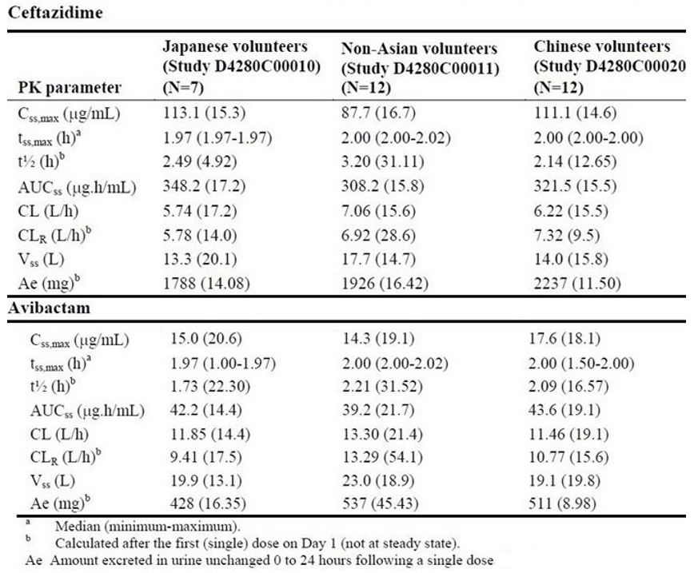
In vitro uptake of avibactam is inhibited by probenecid. No clinical study has been done with probenecid. However, concomitant use of probenecid and ceftazidime/avibactam is not recommended. The overall potential for drug-drug interactions (DDIs) with ceftazidime/avibactam is considered low. Plasma protein binding is low (< 10% for each). There little or no accumulation on 8 hourly dosing. Both ceftazidime and avibactam are haemodialysable.

Pharmacodynamics
The mechanism of action of avibactam is inhibition of bacterial β-lactamases through acylation involving reversible covalent bonding. The mechanism of action of ceftazidime is bactericidal involving bacterial cell wall proteins resulting in inhibition of cell wall synthesis.
Like all cephalosporins, the microbiological effect of ceftazidime is a function of time (as the percentage of dosing interval) during which (free drug) level of ceftazidime stays above the relevant minimum inhibitory concentration (MIC) for an organism.
Study D4280C00007, a placebo-controlled, thorough QT study; of ceftazidime/avibactam versus moxifloxacin did not indicate clinically significant effect on cardiac conduction.

Clinical efficacy
The 5 pivotal Phase III clinical trials were preceded by 2 Phase II studies in complicated intra-abdominal infections (cIAI) and complicated urinary tract infections (cUTI) patients, details shown in Table 3.
Table 3: Phase II studies of ceftazidime/avibactam
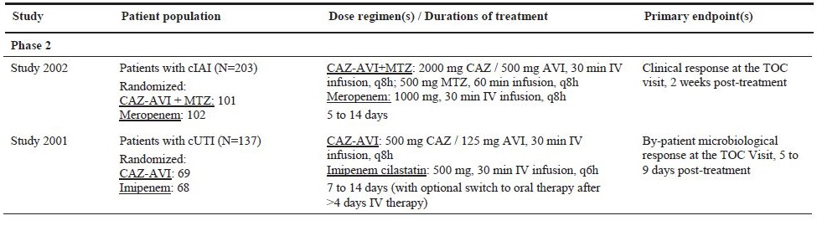
CAZ-AVI = ceftazidime/avibactam, MTZ = metronidazole; q6h = 6 hourly; q8h = 8 hourly; TOC = test of cure.
The 5 Phase III trials (two in cIAI, one in cUTI, one in ceftazidime-resistant cUTI/cIAI and one in hospital acquired pneumonia (HAP; including ventilator associated pneumonia (VAP), also referred to as nosocomial pneumonia (NP) indication) have been published.,,,,
Regarding dose selection, a PK/pharmacodynamic (PD) target of 50% free drug concentration > minimum inhibitory concentration over a dosing time interval (50%T > MIC) for cephalosporins is an established target for prediction of clinical efficacy and interpretative criteria for MIC breakpoints. This was estimated for avibactam (in the presence of ceftazidime) in in vitro and in vivo (animal models of infection) experiments and was based on clinical isolates in contemporary global surveillance studies for ceftazidime. Dose selection for Phase III studies (ceftazidime/avibactam 2000 mg/500 mg every 8 hours by IV infusion over 120 minutes) and breakpoint justification was based on prediction of at least 90% of the patient population achieving plasma exposures that simultaneously achieved 50% T > ceftazidime/avibactam MIC of 8 mg/L for ceftazidime and 50%T > critical threshold concentration (CT) of 1 mg/L for avibactam.
Clinical PK/PD targets for ceftazidime and avibactam could not be established using the subsequent Phase III data (cIAI and cUTI populations) as there were few patients in ‘unfavourable’ overall microbiological response group and the HAP dataset was too small at that point. The pre-determined PK/PD targets (from non-clinical studies) were used to conduct probability of PK/PD target attainment (PTA) simulations to evaluate the ceftazidime/avibactam dose and support the breakpoints.
The final population PK models that incorporated available Phase III data were used to confirm that the dose selected for Phase III studies achieved sufficient exposure in > 90% patients to meet the preclinical PK/PD targets. The exposure for ceftazidime and avibactam was compared in patients with cIAI, cUTI and HAP and shown to be broadly similar. The PTA analyses were also used to establish dose adjustments in patients with renal impairment.
Table 4: Pharmacology parameters in simulated patients with cIAI by renal function receiving the revised dose regimens (moderate, severe 1, severe 2 renal impairment, and end stage renal disease) and original dose regimen (normal renal function and mild renal impairment) with ceftazidime-avibactam given as a 120 minute intravenous infusion
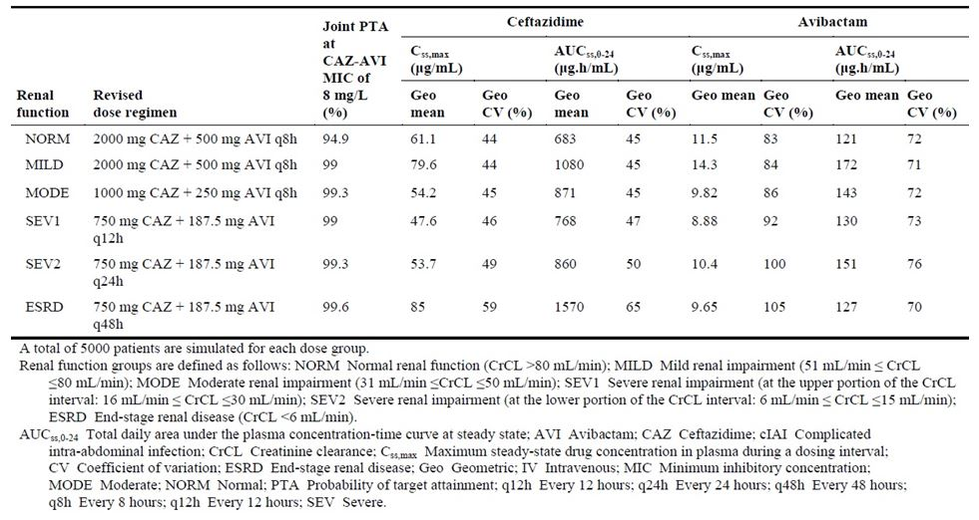
The designs of the 5 Phase III studies were as follows (all were double-blind except the REPRISE trial which was open-label treatment nominally compared with the best available therapy (BAT))
Table 5: Designs of the five Phase III studies
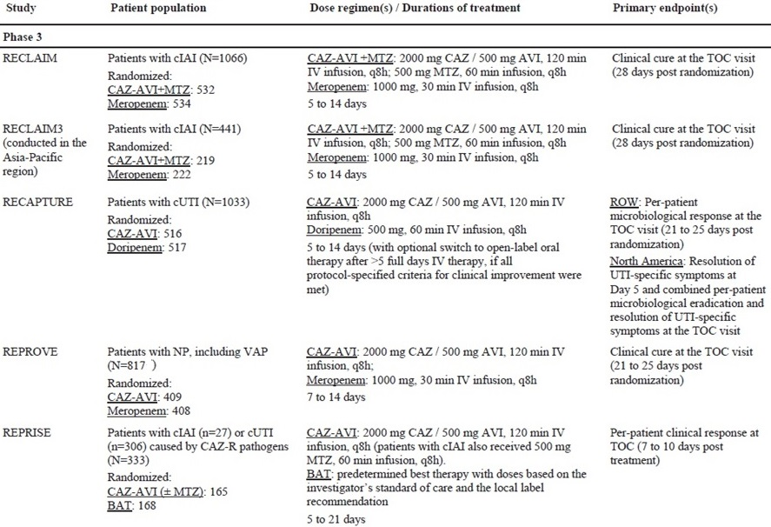
In general, clinical cure/response (using modified intent to treat (MITT) or clinically evaluable population sets) and microbiological response/cure (using microbiological modified intent to treat (mMITT) or microbiologically evaluable population sets) were assessed primarily at test of cure (TOC) time point at 3 to 4 weeks post randomisation following 5 to 14 days of treatment (except the REPRISE trial). Other time points were end of treatment (EOT) and last follow up visit (LFU). For the cIAI indication, ceftazidime/avibactam was used in combination with metronidazole. The comparator in all cases was meropenem except in the cUTI RECAPTURE trial, in which the comparator was doripenem. All trials (except the REPRISE trial) were designed as therapeutic non-inferiority trials. Pivotal results were as follows, below.

RECLAIM trial (RECLAIM 1 + 2; Studies D4280C00001 and D4280C00005, in patients with complicated intra-abdominal infection))
Clinical cure at TOC using MITT population was achieved by 429 out of 520 (82.5%) ceftazidime/avibactam + metronidazole treated patients compared with 444 out of 523 (84.9%) meropenem treated patients. The treatment difference was -2.4% (95% confidence interval (CI) -6.9%, 2.1%), Table 6.
Table 6: RECLAIM trial clinical response by visit (modified intent to treat analysis set)
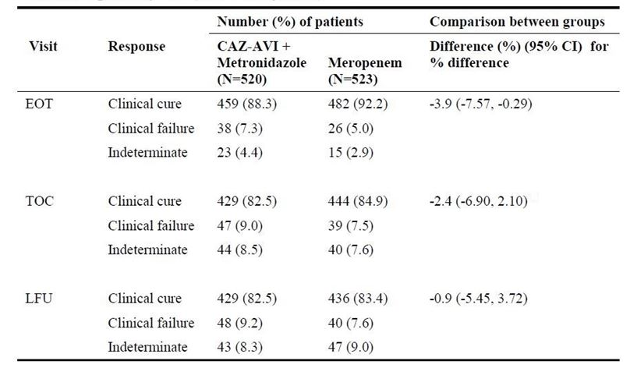
EOT = end of treatment; TOC = test of cure; LFU = last follow up; CAZ-AVI = ceftazidime/avibactam
Clinical response using clinically evaluable population was consistent with the MITT analysis. For microbiological response, see Table 7, below. Efficacy in patients with baseline renal impairment was significantly lower than in patients with normal renal function, Table 8.
Table 7: RECLAIM trial (in cIAI) per-patient microbiological response by scheduled assessment (microbiologically modified intention to treat analysis set)
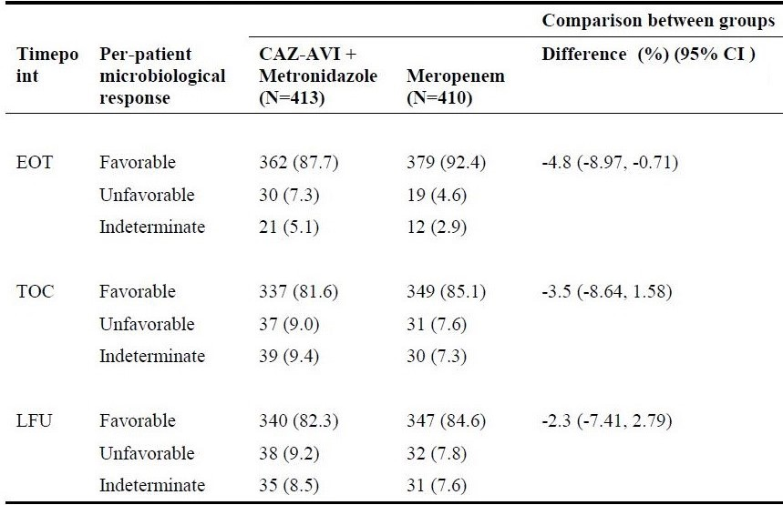
EOT = end of treatment; TOC = test of cure; LFU = last follow up; CAZ-AVI = ceftazidime/avibactam
Table 8: RECLAIM trial clinical response at end of treatment by baseline renal function (modified intent to treat analysis set)
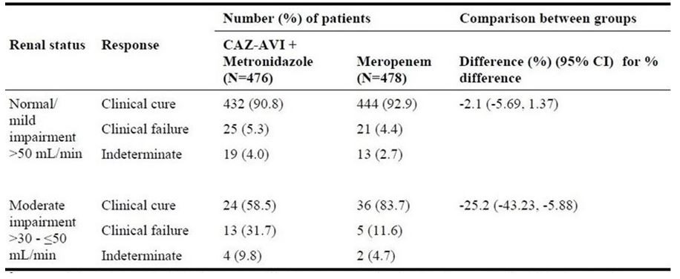
CAZ-AVI = ceftazidime/avibactam

RECLAIM 3 trial (StudyD4280C00018, in patients with complicated intra-abdominal infection)
Clinical cure at TOC using MITT population was achieved by 178 out of 214 (83.2%) ceftazidime/avibactam+ metronidazole treated patients compared with 188 out of 217 (86.6%) meropenem treated patients. The treatment difference was -3.5% (95% CI -10.33%, 3.35%), Table 9.
Table 9: RECLAIM 3 trial clinical response by visit (modified intent to treat analysis set)
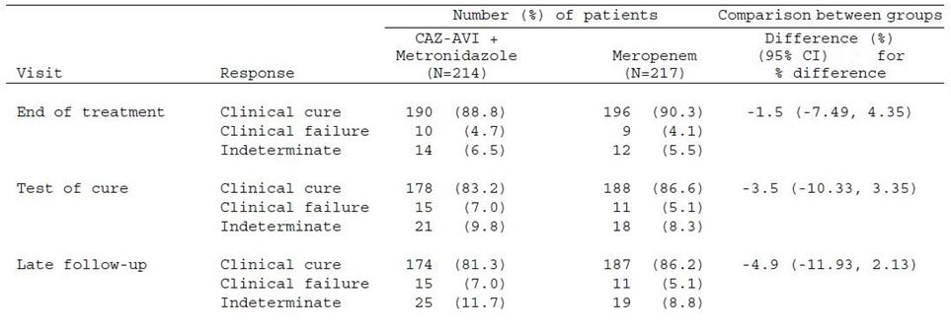
Clinical response using clinically evaluable population was consistent with the MITT analysis. For microbiological response, see Table 10. Clinical response by pathogens based on pooled data from Phase II and Phase III cIAI studies is shown in Table 11.
Table 10: RECLAIM 3 trial per patient microbiological response by scheduled assessment (microbiologically modified intention to treat analysis set)
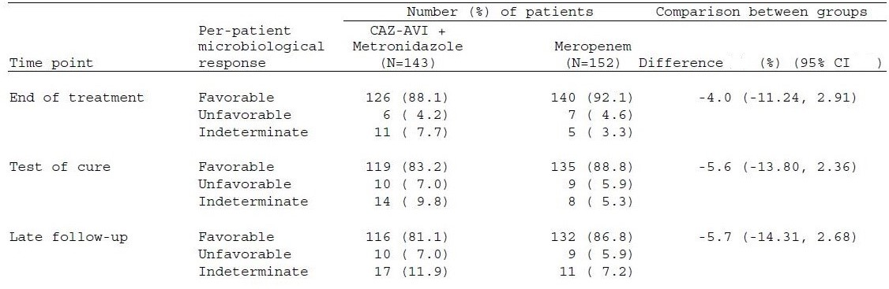
Table 11: RECLAIM 3 trial per-pathogen clinical response at test of cure, by common (combined frequency of > 10) baseline Gram-negative pathogen (pooled Phase II/III cIAI studies, microbiologically modified intention to treat analysis sets)
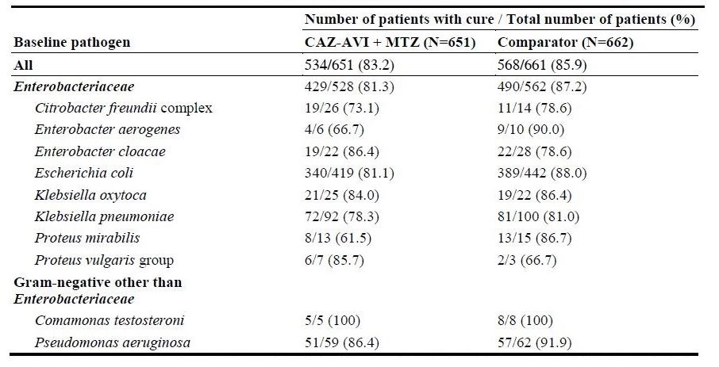

RECAPTURE trial (Studies D4280C00002 and D4280C00004, in patients with complicated urinary tract infection (cUTI))
Microbiological cure at TOC using mMITT population was achieved by 304 out of 393 (77.4%) ceftazidime/avibactam treated patients compared with 296 out of 417 (71.0%) doripenem treated patients. The treatment difference was 6.4% (95% CI 0.33%, 12.36%).
The US Food and Drug Administration (FDA) required a combined efficacy outcome consisting of patient-reported resolution of UTI symptoms and microbiological cure at TOC for which the results were as follows.
Patient-reported symptomatic response (resolution of symptoms) at TOC was achieved by 332/393 (84.5%) patients in ceftazidime/avibactam treated group compared with 360/417 (86.3%) doripenem treated patients. The treatment difference was -1.9% (95% CI -6.78%, 3.02%). Microbiological response at TOC was achieved as above. The FDA-required combined response was achieved by 280 out of 393 (71.2%) ceftazidime/avibactam treated patients compared with 269 out of 417 (64.5%) doripenem treated patients. The treatment difference was 6.7% (95%CI 0.30%, 13.12%),
Table 12: RECAPTURE trial combined patient-reported symptomatic and microbiological response at test of cure visit (microbiologically modified intention to treat analysis set)
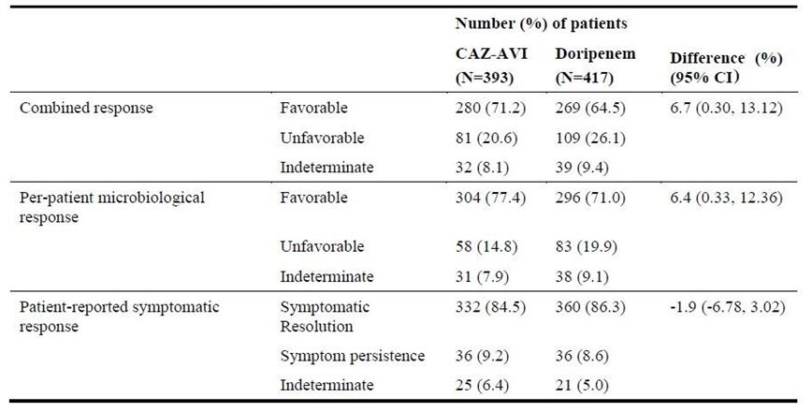
Resolution of patient-reported symptoms at Day 5 was reported by 70% and 66% of patients in ceftazidime/avibactam and doripenem groups, shown in Table 13.
Table 13: RECAPTURE trial patient-reported symptomatic response at Day 5 (microbiologically modified intention to treat analysis set)
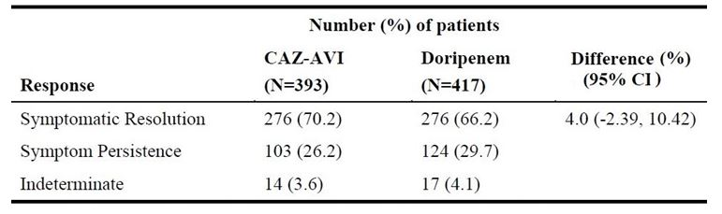

REPRISE trial (Study D4280C00006, in patients with ceftazidime-resistant pathogens)
On treatment with ceftazidime/avibactam ± metronidazole, clinical cure rates at TOC (mMITT set) were 8 out of 10 cIAI patients and 132 out of 144 (91.7%) cUTI patients. Nominal comparison with the BAT was as follows in Table 14.
Table 14: REPRISE trial clinical response at test of cure visit (microbiologically modified intention to treat analysis set)
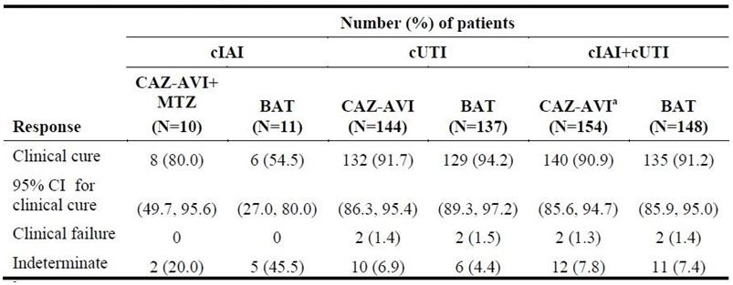
Table 15 shows microbiological response. Clinical response by pathogens at TOC based on combined RECAPTURE and REPRISE trial data is shown in Table 16.
Table 15: RECAPTURE + REPRISE trials (combined) per patient microbiological response at test of cure (microbiologically modified intention to treat analysis set)
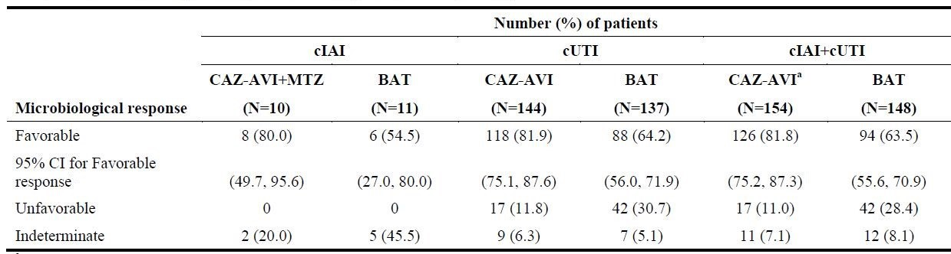
Table 16: RECAPTURE + REPRISE trials (combined) per-pathogen clinical response at test of cure, by (combined frequency of ≥ 10) baseline Gram-negative pathogen cUTI patients, microbiologically modified intention to treat sets)
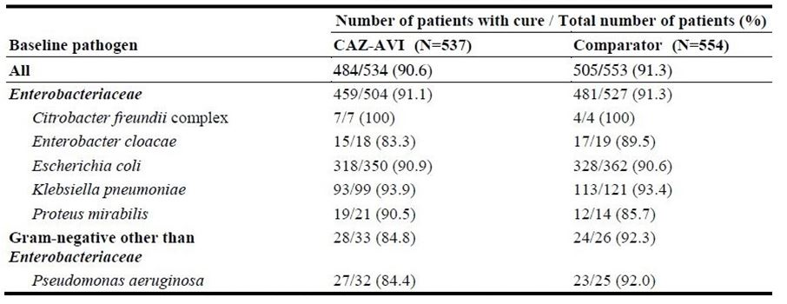

REPRISE trial (Study D4280C00006, in patients with ceftazidime-resistant pathogens)
Clinical cure at TOC (clinically modified intent to treat (cMITT) set) was achieved by 245 out of 356 (68.8%) ceftazidime/avibactam treated patients compared with 270 out of 370 (73.0%) meropenem treated patients. The treatment difference was -4.2% (95% CI -10.76%, 2.46%). The analysis using clinically evaluable set was consistent with the cMITT analysis, shown in Table 17.
Table 17: REPRISE trial clinical response at test of cure (clinically modified intent to treat and clinically evaluable analysis sets)
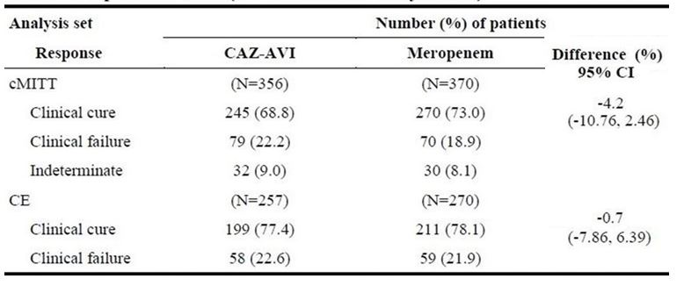
Table 18 shows microbiological response. Clinical response by pathogens is shown in Table 19.
Table 18: REPRISE trial per-patient microbiological response by scheduled assessment (microbiologically modified intention to treat analysis set)
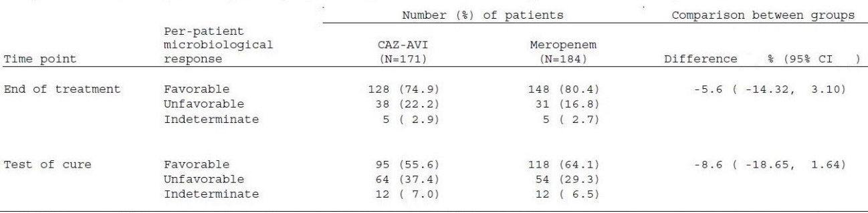
Table 19: REPROVE trial per-pathogen clinical response at test of cure, by common (combined frequency of ≥ 10) baseline Gram-negative pathogen (microbiologically modified intention to treat analysis sets)
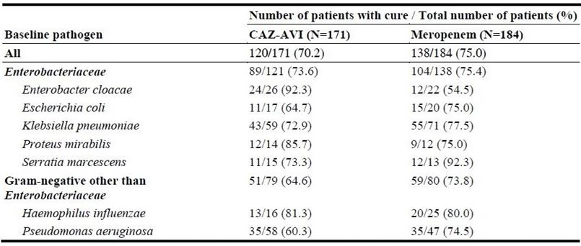

Summary
An overall overview of clinical response in clinical development program in patients with ceftazidime-resistant and ceftazidime-sensitive pathogens at baseline by each indication was as follows in Table 20.
Table 20: Per-pathogen clinical response at test of cure by Gram-negative baseline pathogen, comparing patients with ceftazidime-resistant pathogens and patients with ceftazidime-susceptible pathogens only
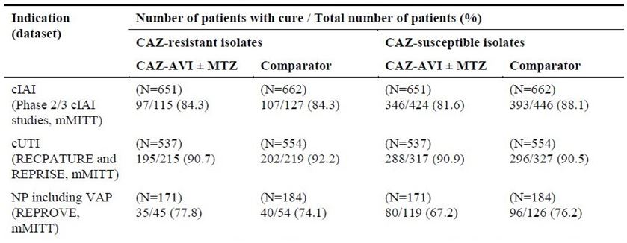
cIAI = complicated intra-abdominal infection; cUTI = complicated urinary tract infection; NC = nosocomial pneumonia; VAP = ventilator acquired pneumonia; mMITT = microbiologically modified intention to treat; CAZ = ceftazidime; AVI = avibactam; CAZ-ACI = ceftazidime/avibactam; MTZ = metronidazole

Clinical safety
Total ceftazidime/avibactam safety population comprises 2240 healthy volunteers and patients who received at least one dose of ceftazidime/avibactam including 216 subjects ceftazidime/avibactam in Phase I studies.
Of these, a total of 2024 patients were exposed to ceftazidime/avibactam in Phase II and III studies (857 cIAI patients exposed to ceftazidime/avibactam + metronidazole, 731 cUTI patients exposed to ceftazidime/avibactam and 436 HAP patients exposed to ceftazidime/avibactam). The mean exposure was 8.2 days (standard deviation 3.2) with a range of 1 to 21 days for ceftazidime/avibactam ± metronidazole. The overall reported incidence of adverse events (AEs)/serious adverse events (SAEs)/discontinuation of study drug due to adverse events (DAEs) in this dataset was as follows in Table 21.
Table 21: Adverse events up to last visit in any category, Phase II/III pool (safety analysis set)
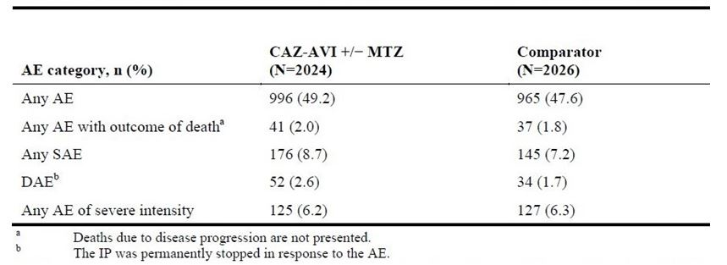
The distribution of these adverse outcomes in various age strata is shown in Table 22.
Table 22: Adverse events up to the last visit in any category by age group, Phase II/III pool (safety analysis set)
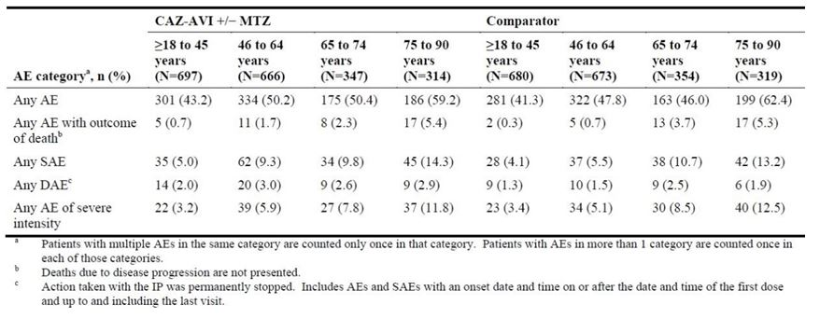
The most common AEs in this dataset are shown in Table 23.
Table 23: Most common adverse events (≥ 2% in the ceftazidime-avibactam ± metronidazole or comparator) up to the last visit by Preferred Term, Phase II/III pool (safety analysis set)
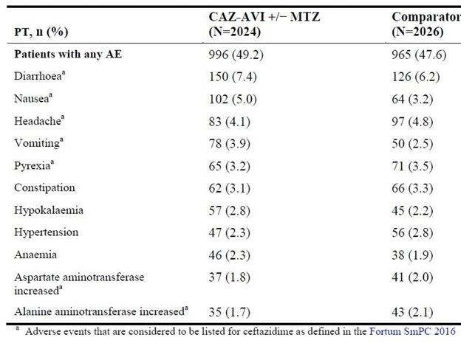
PT = Preferred Term; CAV-AVI = ceftazidime-avibactam; MTZ = metronidazole; Fortum SmPC 2016 = Fortum (ceftazidime pentrahydrate) Summary of Medicinal Product Characteristics 2016 (European Union)
The following SAEs were reported in this dataset, as shown in Table 24.
Table 24: Serious adverse events occurring in > 2 patients up to the last visit by Preferred Term, Phase II/III pool (safety analysis set)
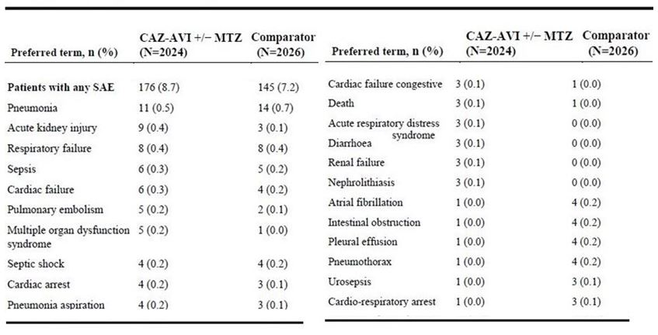
The deaths reported in this dataset by clinical indication are shown in Table 25.
Table 25: All deaths up to the last visit, Phase II/III pool (safety analysis set)
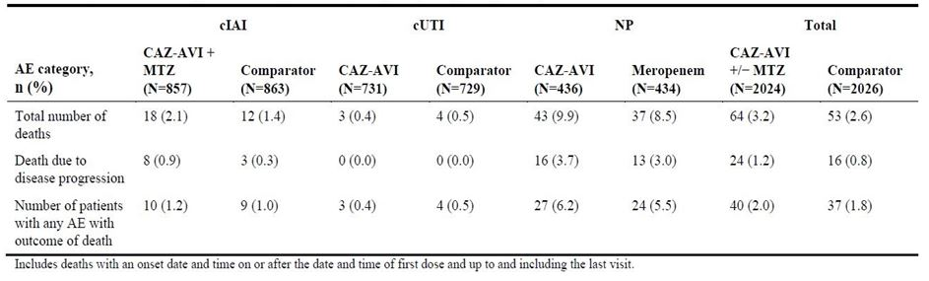
The highest mortality was reported in the HAP (NP) indication but was comparable between ceftazidime/avibactam and meropenem. The distribution of deaths by time interval was as follows in Table 26.
Table 26: Number (%) of patients who died by time interval up to the last visit, Phase II/III pool (safety analysis set)
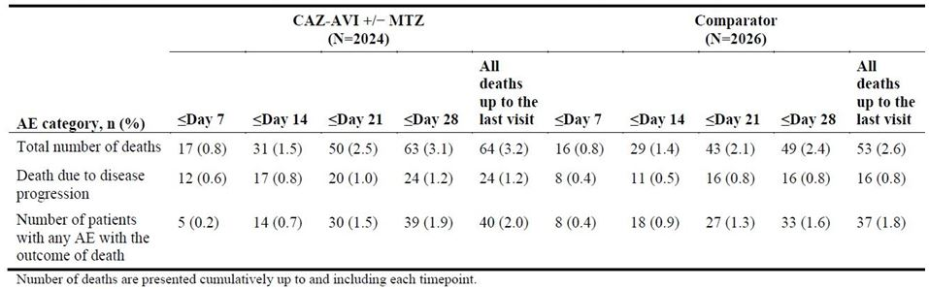
In general, higher rates of AE/SAE/deaths were reported with increasing severity of renal impairment, shown in Table 27.
Table 27: Adverse events up to the last visit in any category by baseline renal status creatinine clearance (mL/min), Phase II/III pool (safety analysis set)
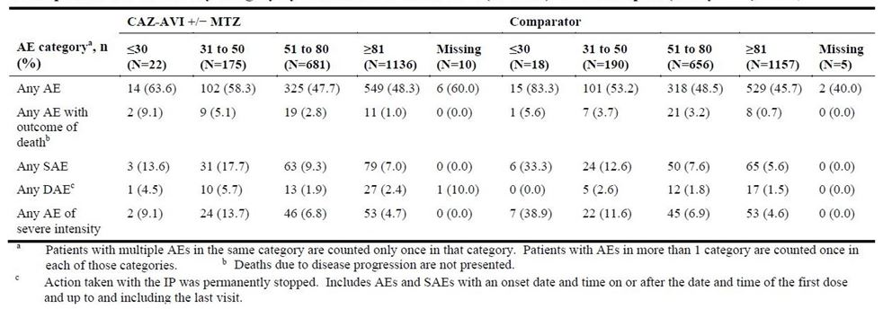
The safety topics of interest identified a priori based on class effect for cephalosporins and/or from the ceftazidime were liver disorders, diarrhoea, severe hypersensitivity (no cases of Stevens-Johnson syndrome (SJS) or toxic epidermal necrolysis (TEN) were reported), haematological disorders, and renal disorders.
Incidence of acute renal injury was higher with ceftazidime/avibactam versus comparator in shown in Table 28.
Table 28: Adverse events of renal disorders up to the last visit by Preferred Term, Phase II/III pool (safety analysis set)
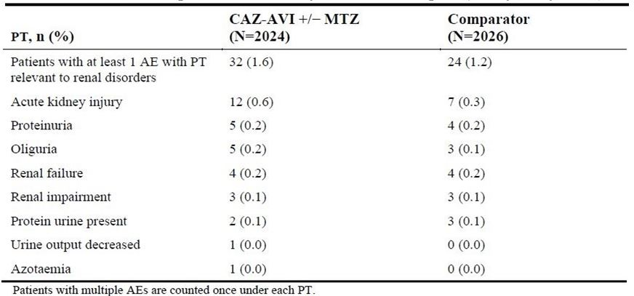
There were no reports of drug induced liver injury (DILI) or patients fulfilling Hy’s criteria. Liver related AEs were reported as shown in Table 29.
Table 29: Most common adverse events of liver disorders (≥ 1% in the ceftazidime/avibactam ± metronidazole or comparator) up to the last visit by Preferred Term, Phase II/III pool (safety analysis set)
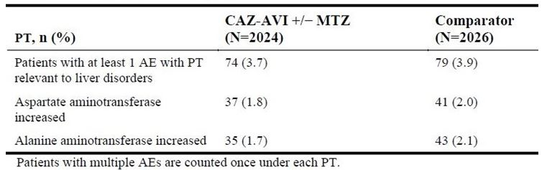
The reports of hypersensitivity AEs are shown in Table 30.
Table 30: Most common adverse events of hypersensitivity (≥ 1% in the ceftazidime-avibactam ± metronidazole or comparator) up to the last visit by subgroup and Preferred Term, Phase II/III pool (safety analysis set)
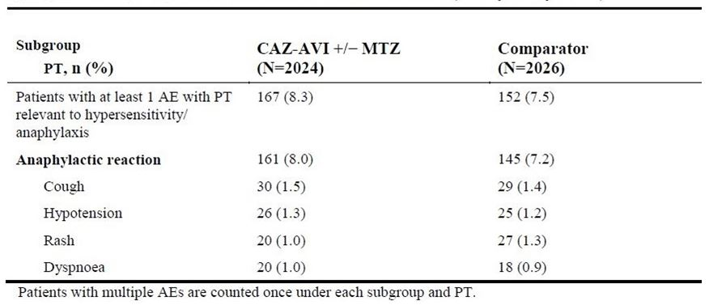
No serious skin AEs (TEN, SJS, erythema multiforme (EM)) were reported in this small dataset, see Table 31.
Table 31: Adverse drug reactions for ceftazidime/avibactam, Phase II/III pool (safety analysis set)
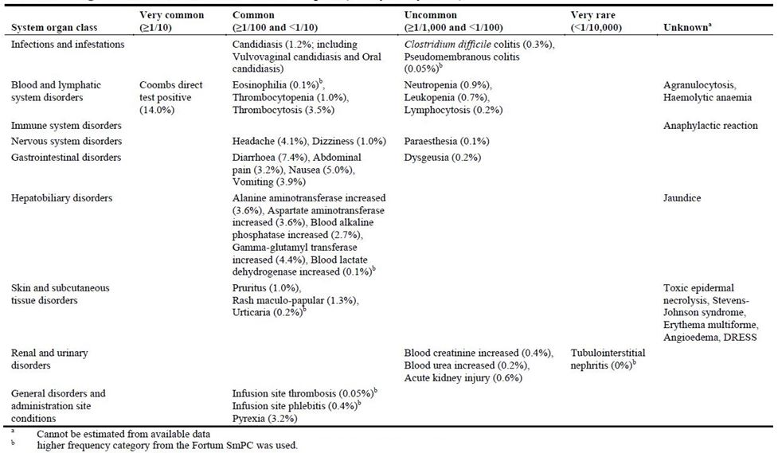
Post-market data (3 six monthly periodic safety update reports (PSURs) covering partial period from 2016 to 2018) are available and have been reviewed.
Overall, the adverse effects profile is considered acceptable in relation to the proposed clinical use. No new safety signal was identified for ceftazidime in combination with avibactam.

Risk management plan
The sponsor submitted European Union risk management plan (EU-RMP) version 1.0 (26 April 2016; data lock point (DLP) 24 August 2015) and Australian Specific Annex (ASA) version 1.0 (25 January 2018) in support of this application at the first round evaluation; and updated EU-RMP Version 2.0 (20 December 2017; DLP 24 August 2017) at the second round evaluation.
The proposed Summary of Safety Concerns and their associated risk monitoring and mitigation strategies are summarised below in Table 32.
Table 32: Summary of safety concerns
Summary of safety concerns |  | Pharmacovigilance |  | Risk Minimisation
 |  | Routine | Additional | Routine | Additional
Important identified risks | Clostridium difficile-associated diarrhoea ** | † | – |  | –
Important identified risks | Anaphylaxis and other severe hypersensitivity reactions ** |  | – |  | –
Important potential risks | Hepatotoxicity | † | – |  | –
Important potential risks | Superinfection (bacterial or fungal) |  | – |  | –
Important potential risks | Bacterial resistance development |  | * |  | –
Important potential risks | In patients with renal impairment, risk of neurological sequelae when the dose is not appropriately reduced | † | – |  | –
Missing information | Pregnancy exposure |  | – |  | –
Missing information | Lactation exposure |  | – |  | –
Missing information | Pre-existing significant hepatic impairment |  | – |  | –
Missing information | Pre-existing severe renal impairment including experience in haemodialysis/peritoneal dialysis and other renal replacement therapy |  | – |  | –
Missing information | Immunocompromised population exposure |  | – | – | –
† Specific adverse event follow-up forms.* An international antimicrobial surveillance programme. ** Australian-specific safety concerns (after being re-classified and removed from the Summary of Safety Concerns in the EU-RMP by the sponsor at the second round evaluation).
An additional pharmacovigilance activity is being implemented for bacterial resistance development, comprising an international antimicrobial surveillance programme including Australian sites. No further additional activities are considered necessary.
No additional risk minimisation activities have been proposed. It is considered that the identified risks can be managed adequately through routine risk minimisation activities.
The RMP evaluation found no outstanding issues. RMP and the ASA were established as post-market condition of approval.

Risk-benefit analysis

Delegate’s considerations

Discussion
Ceftazidime is a well-established cephalosporin which is to be supplied in fixed dose combination with a novel non-β lactam β-lactamase inhibitor avibactam (avibactam) as ceftazidime/avibactam 2000 mg/500 mg powder for injection to be administered by IV infusion after reconstitution.
The pharmaceutical chemistry and toxicological aspects have been satisfactorily studied and there are no outstanding issues in relation to these areas. PK (single dose/steady state/mass balance studies) and PD profiles have been adequately studied in the clinical development program. The proposed 8 hourly dosing with ceftazidime/avibactam (2000 mg/500 mg) for use in adults was based on Phase I/II data and population PK modelling. The 2000 mg ceftazidime dose is consistent with the current use of ceftazidime (alone) in clinical practice.
Ceftazidime/avibactam (2000 mg/500 mg) is proposed for use in adult patients with cIAI (with metronidazole), cUTI, HAP and ceftazidime-resistant patients with no other treatment options. Five Phase III trials support the proposed use in these indications. Statistical non-inferiority (clinical equivalence) was demonstrated in comparison with meropenem (cIAI, HAP, ceftazidime-resistant) and doripenem (cUTI) in appropriately designed trials.
Meropenem was marginally better in some analyses but overall the results were consistent in demonstrating non-inferiority. It is also noted that doripenem has been withdrawn from the market (for commercial reasons) following safety concerns (imbalance in mortality) in a clinical trial investigating new use.
Ceftazidime and avibactam are both exclusively excreted by kidneys as unchanged drugs. Thus standard dosing in patients with normal renal (or mild impairment) function requires modification in the presence of higher degrees of renal impairment. The dosages are based on population pharmacokinetic analysis. Significantly lower efficacy was reported in the pivotal cIAI RECLAIM trial (which included sufficient number of patients to allow subpopulation analysis).
In the Phase II/III cIAI trials, death (other than disease progression) occurred in 18 out of 857 (2.1%) ceftazidime/avibactam + metronidazole treated patients compared with 12 out of 863 (1.4%) meropenem treated patients. Furthermore, in this dataset (proposed Australian PI), among a subgroup of patients with creatinine clearance (CrCL) 30 mL/min to < 50 mL/min, death occurred in 9 out of 54 (16.7%) ceftazidime/avibactam + metronidazole treated patients compared with 4 out of 59 (6.8%) meropenem treated patients.
In the RECLAIM and RECLAIM 3 trials, the dose of ceftazidime/avibactam in patients with CrCL between 50 and 31 mL/min was ceftazidime/avibactam (1000 mg/ 250 mg) every 12 hours as 120 minute infusions. Patients with CrCL below 30 mL/min were excluded from the study but when enrolled patients subsequently had CrCL decreased between 30 and 16 mL/min, the dose was ceftazidime/avibactam (1000 mg/250 mg) every 24 hours. If CrCL was to fall below 15 mL/min, the designated dose of ceftazidime/avibactam was 500 mg/125 mg every 24 and every 487 hours.
The sponsor also reasoned that although the doses were modified in patients with renal impairment (CrCL 30 to 50 mL/min group), these were generally lower that those later shown to be predictive of clinical effect in the population PK analysis and now proposed for registration.
The overall safety dataset at this time consists of around 2000 ceftazidime/avibactam-treated patients. This is considered adequate for initial profiling of common adverse effects but ongoing post-market surveillance is needed to capture uncommon or rare effects.
The sponsor included assessment of risk of development of antimicrobial resistance that was reviewed by the TGA clinical evaluator. The post-market resistance surveillance plan has been included as part of the risk management program, see Table 33.
Table 33: Studies referenced in the pharmacovigilance plan of the risk management program
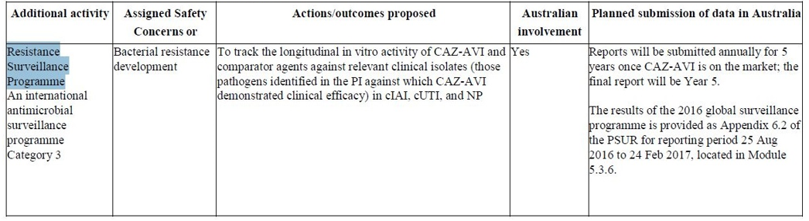
Australian antibiotic resistance prevalence data (2016) are available and are included in the PI. Any findings from post-market resistance surveillance data are to be provided as part of the PSURs. The sponsor is requested to provide further details of its surveillance activities in Australia such as the six geographical sites, minimum period of active surveillance after start of supply of the product in Australia and any contractual arrangement with the Australian Group on Antimicrobial Resistance (AGAR).
The Delegate considered that ceftazidime/avibactam (2000/500) is a welcome addition to the available tools to treat serious hospital based infections. Avibactam, acting as a β-lactamase inhibitor, restores the antimicrobial activity spectrum of ceftazidime. As the clinical data shows, it does not enhance the clinical efficacy of ceftazidime in patients with baseline ceftazidime-sensitive pathogens but has very promising carbapenem-sparing/preserving role in patients with ceftazidime-resistant pathogens.
The proposed use is supported and the Advisory Committee on Medicines (ACM) advice was sought to ensure appropriate wording for the therapeutic indication(s) in adult cIAI, cUTI and HAP indications.
The Delegate was of the view that the proposed use in ‘infections due to aerobic gram-negative organisms in adult patients with limited treatment options’ goes beyond the scope of available data (including the REPRISE trial) and the use in ceftazidime-resistant cIAI, cUTI and HAP infections in subsumed/already intended under the main therapeutic indication(s) for these infections without needing a separate indication. Therefore, ACM’s advice was requested.
A schedule for modification of dose with the degree of renal impairment is proposed based on population PK modelling. Lower efficacy and higher mortality was reported in the pivotal cIAI RECLAIM trial/combined cIAI trials which used different dose modification in renal failure to that proposed now for registration. However, there may be a component of altered response to treatment in renal impairment separate from and/or in addition to the dosage. Advice from ACM was requested. The sponsor was also requested to comment.
No change in dose is proposed in hepatic impairment. This is considered acceptable. The PI should include a note that no data are available in hepatic impairment.

Summary of issues
Advice requested on proposed indications and use in renal impairment.

Proposed action
The Delegate has no reason to say, at this time, that the application for Zavicefta should not be approved for registration.

Request for ACM advice
The Advisory Committee on Medicines (ACM) is requested to provide advice on the following issues:
- Advice is requested on the appropriate wording for the adult cIAI, cUTI and HAP indications to ensure clinical use consistent with the available clinical trials data and considerations for development of antimicrobial resistance.
- A separate indication for use in ‘gram-negative infections in patients with limited treatment option’ is not supported. Advice is requested from the ACM.
- Lower efficacy and higher mortality was reported in cIAI trials in the presence of renal impairment. Advice from ACM is requested on the suitability of the dosing directions in renal impairment any further precautions for use in this population.
- Advice is also sought from the ACM on the adequacy of the post-market surveillance for safety and the proposed plan for resistance surveillance.
The Committee is also requested to provide advice on any other issues that it thinks may be relevant to a decision on whether or not to approve this application.

Advisory Committee considerations
The ACM, having considered the evaluations and the Delegate’s overview, as well as the sponsor’s response to these documents, advised the following.
The ACM, taking into account the submitted evidence of efficacy and safety, agreed with the Delegate that Zavicefta powder for injection, containing 2000 mg/500 mg of ceftazidime/avibactam, for use as 2 hour IV infusions with three times daily dosing, has an overall positive benefit-risk profile for the proposed indication:
Zavicefta is indicated for the treatment of the following indications in adults:
- complicated intra-abdominal infections (cIAI), in combination with metronidazole
- complicated urinary tract infection (cUTI,) including pyelonephritis
- hospital-acquired pneumonia (HAP) including ventilator associated pneumonia.
Consideration should be given to official guidance on the appropriate use of antibacterial agents.
Zavicefta should be used in combination with an antibacterial agent active against Gram-positive pathogens and/or agents active against anaerobic pathogens when these are known or suspected to be contributing to the infectious process.
In providing this advice the ACM noted that:
- Zavicefta is a combined product containing ceftazidime, a third generation parenteral cephalosporin with a well-established clinical profile, and avibactam, a novel, first in class non-β-lactam β-lactamase inhibitor. It is intended to overcome β-lactamase mediated ceftazidime resistance among some isolates of Enterobacteriaceae and some isolates of Pseudomonas aeruginosa.
- The sponsor’s proposed indications for Zavicefta were:
Zavicefta is indicated for the treatment of the following infections in adults:
  - complicated intra-abdominal infection (cIAI)*^
  - complicated urinary tract infection (cUTI), including pyelonephritis.
  - hospital-acquired pneumonia (HAP), including ventilator associated pneumonia (VAP).
Zavicefta is also indicated for the treatment of infections due to aerobic gram-negative organisms in adult patients with limited treatment options.*^
Consideration should be given to official guidance on the appropriate use of antibacterial agents.
* To be used in combination with metronidazole when anaerobic pathogens are known or suspected to be contributing to the infectious process.
^ To be used in combination with an antibacterial agent active against Gram-positive pathogens when these are known or suspected to be contributing to the infectious process.
- The sponsor has suggested dose adjustments for patients with renal impairment as follows in Table 34.
- The ACM considered there to be limited evidence available to support these adjustments but suggested that they would be a reasonable starting point.
Table 34: Sponsor’s proposed dose adjustments for patients with renal impairment
Estimated CrCL (mL/min) ¹ | Dose regimen ² | Frequency | Infusion time
31 to 50 | 1,000 mg/250 mg | Every 8 hours | 2 hours
16 to 30 | 750 mg/187.5 mg | Every 12 hours | 2 hours
6 to 15 | 750 mg/187.5 mg | Every 24 hours | 2 hours
ESRD including on haemodialysis ³ | 750 mg/187.5 mg | Every 48 hours | 2 hours
1: CrCL estimated using the Cockcroft-Gault formula.2: Dose recommendations are based on pharmacokinetic modelling. 3: Ceftazidime and avibactam are removed by haemodialysis. Dosing of Zavicefta on haemodialysis days should occur after completion of haemodialysis.

Proposed conditions of registration
The ACM agreed with the Delegate on the proposed conditions of registration.

Proposed Product Information/Consumer Medicine Information amendments
The ACM agreed with the Delegate on the proposed amendments to the PI and Consumer Medicines Information (CMI) and specifically advised on the inclusion of the following:
- Clarification in the Dosage and Administration; Clinical Trials; Precautions; and Contraindications sections of the PI and relevant sections of the CMI as to the definition of cIAI, cUTI and HAP, relating back to study criteria where possible.
- A statement in the Dosage and Administration; Clinical Trials; Precautions; and Contraindications sections of the PI and relevant sections of the CMI to more accurately reflect both reduced efficacy in the setting of renal impairment and the low level of evidence available for the proposed dose reductions.
- The committee supported the inclusion of precaution of use in renal impairment in the Australian PI.

Specific advice
The Delegate requested advice on specific questions on this submission. The ACM advised the following in response to the Delegate’s questions.
- Advice is requested on the appropriate wording for the adult cIAI, cUTI and HAP indications to ensure clinical use consistent with the available clinical trials data and considerations for development of antimicrobial resistance.
The ACM considered that the first two proposed indications, for cIAI and cUTI including pyelonephritis, were reasonable, noting that the definitions of cIAI and cUTI should be addressed in the PI.
The ACM endorsed the use of the term HAP used in the PI, but noted that some elements of the inclusion criteria included patients that might be regarded as having healthcare associated pneumonia (HCAP). The definition of HAP patients included in the clinical trial should be addressed in the PI.
The ACM is of the opinion that the wording of these indications was acceptable, as this product will be used only in tertiary hospitals where the indication will be closely monitored. That said, it was noted that there is a lack of clarity throughout the PI as to the definitions of cIAI, cUTI and HAP that should be remedied, with particular attention needed for cUTI.
- A separate indication for use in ‘gram-negative infections in patients with limited treatment option’ is not supported. Advice is requested from the ACM.
The ACM agrees with the Delegate that a separate indication is not supported by the submitted data.
- Lower efficacy and higher mortality was reported in cIAI trials in the presence of renal impairment. Advice from ACM is requested on the suitability of the dosing directions in renal impairment any further precautions for use in this population.
The ACM noted that the studies provided were largely conducted on comparatively ‘well’ patients with low Apache II scores; in the RECLAIM trial renally impaired patients were noted to have worse outcomes with Zavicefta plus metronidazole, compared to meropenem. The sponsor had subsequently, after further population PK analysis, increased the dosage of Zavicefta in patients with moderate to severe renal impairment. However, the revised dosages in such patients remains untested in Phase III trials. The Committee noted that no patients in the Phase III trials had baseline end stage renal failure (CrCL < 30 mL/min) or were in dialysis. Most patients with renal impairment in the RECLAIM study had a baseline CrCL of 31 to 50 mL/min.
The ACM considered there to be little data available to guide dose reduction in the setting of renal impairment. The Committee noted the sponsor’s argument on underdosing in the RECLAIM trial and considered the population based dose modification in renal impairment to be acceptable, albeit untested. The ACM advised that dose reduction in the setting of renal impairment be further refined with post market surveillance.
- Advice is also sought from the ACM on the adequacy of the post-market surveillance for safety and the proposed plan for resistance surveillance.
The ACM was of the view that overall the proposed post-market surveillance and the proposed plan for resistance surveillance were acceptable. The Committee expressed the opinion that ongoing post-market testing, especially for evolution of resistance among Klebsiella pneumoniae carbapenemase (KPC) producing organisms, was desirable.
- The Committee is also requested to provide advice on any other issues that it thinks may be relevant to a decision on whether or not to approve this application.
The Committee commented that the Australian antibiotic resistance prevalence data needs to be better presented in the PI. The Committee advised that further data should be obtained from the sponsor regarding the antibiotic resistance prevalence table in the PI. Additional data should specify the type of isolates (clinical or screening); the type of study sites (for example tertiary or community hospitals); and the susceptibility testing methods that were employed (for example the European Committee on Antimicrobial Susceptibility Testing (EUCAST) or the Clinical and Laboratory Standards Institute (CLSI)). Additionally, the Committee provided comment that aspects of the data table provided seemed to be inaccurate.
The Committee advised that further clarification is required regarding certain terms in the PI table (such as ESBL (molecular) and ESBL (screen-negative)) and that more information about the surveillance study should be sought.

Outcome
Based on a review of quality, safety and efficacy, TGA approved the registration of Zavicefta (ceftazidime pentahydrate and avibactam sodium fixed dose combination) powder for injection, indicated for:
Zavicefta is indicated for the treatment of the following infections in adults (see sections 4.4 Special warnings and precautions for use and 5.1 Pharmacodynamic properties):
- Complicated intra-abdominal infection (cIAI), in combination with metronidazole.
- Complicated urinary tract infection (cUTI), including pyelonephritis.
- Hospital-acquired pneumonia (HAP), including ventilator associated pneumonia (VAP).
Consideration should be given to official guidance on the appropriate use of antibacterial agents.
Zavicefta should be used in combination with an antibacterial agent(s) active against Gram-positive and/or anaerobic pathogens when these are known or suspected to be contributing to the infectious process.

Specific conditions of registration applying to these goods
- Zavicefta (ceftazidime/avibactam) is to be included in the Black Triangle Scheme. The PI and CMI for Zavicefta must include the black triangle symbol and mandatory accompanying text for five years, which starts from the date that the sponsor notifies the TGA of supply of the product.
- The Zavicefta EU-RMP (version 2.0, dated 20 Dec 2017, DLP 24 August 2017), with ASA (version 1.0, dated 25 January 2018), included with submission PM-2018-00931-1-2, and any subsequent revisions, as agreed with the TGA will be implemented in Australia.
An obligatory component of risk management plans is routine pharmacovigilance. Routine pharmacovigilance includes the submission of PSURs.
Reports are to be provided in line with the current published list of EU reference dates and frequency of submission of PSURs until the period covered by such reports is not less than three years from the date of this approval letter.
The reports are to at least meet the requirements for PSURs as described in the European Medicines Agency’s Guideline on Good Pharmacovigilance Practices (GVP) Module VII-Periodic Safety Update Report (Rev 1), Part VII.B Structures and processes. Note that submission of a PSUR does not constitute an application to vary the registration.
- For all injectable products the PI must be included with the product as a package insert.

Attachment 1. Product Information
The PI for Zavicefta approved with the submission which is described in this AusPAR is at Attachment 1. For the most recent PI, please refer to the TGA website at <https://www.tga.gov.au/product-information-pi>.

Therapeutic Goods Administration
PO Box 100 Woden ACT 2606 Australia
Email: info@tga.gov.au Phone: 1800 020 653 Fax: 02 6232 8605
https://www.tga.gov.au

The COR report-based process is associated with a shortened evaluation and decision timeframe. The aim of this process is to reduce duplication of evaluation of prescription medicines that have already been approved by a COR, while maintaining existing quality, safety and efficacy standards for medicines supplied in Australia. The intention is that the TGA will only need to evaluate data generated specifically for the Australian context. For example, Australian labels, product information and consumer medicine information. However, in some instances, additional data may need to be considered. For example, safety data generated since the COR approval. Under the COR-B approach, the TGA regulatory decision will still be mostly based on a critical review of the COR assessment reports. The COR-B process has a 175 working day evaluation and decision timeframe, allowing for TGA evaluation of certain data, in addition to the label, PI and RMP.
The molecular classification of β-lactamases is based on the amino acid sequence; class A, C and D β-lactases use serine for β-lactam hydrolysis whereas substrate hydrolysis by class B β-lactamases (metalloenzymes) requires divalent zinc ions.
European Medicines Agency (EMA), Committee for Proprietary Medicinal Products (CPMP), ICH S1A Need for carcinogenicity studies of pharmaceuticals, 4 June 2013.
Australian Pregnancy Category B3: Drugs which have been taken by only a limited number of pregnant women and women of childbearing age, without an increase in the frequency of malformation or other direct or indirect harmful effects on the human fetus having been observed. Studies in animals have shown evidence of an increased occurrence of fetal damage, the significance of which is considered uncertain in humans.
The QT interval is calculated as the time taken on an electrocardiogram from the start of the Q wave to the end of the corresponding T wave and can be used to assess some of the electrical properties of the heart. The QT interval corresponds with the time taken from the start of ventricular contraction to the end of ventricular relaxation.
Mazuski, J.E. et al. (2016). Efficacy and Safety of Ceftazidime-Avibactam Plus Metronidazole Versus Meropenem in the Treatment of Complicated Intra-abdominal Infection: Results From a Randomized, Controlled, Double-Blind, Phase 3 Program, Clinical Infectious Diseases, 2016; 62: 1380-1389.
Qin, X. et al. (2017). A randomised, double-blind, phase 3 study comparing the efficacy and safety of ceftazidime/avibactam plus metronidazole versus meropenem for complicated intra-abdominal infections in hospitalised adults in Asia, International Journal of Antimicrobial Agents, 2017;49: 579–588.
Wagenlhner, F.M. et al. (2016). Ceftazidime-avibactam Versus Doripenem for the Treatment of Complicated Urinary Tract Infections, Including Acute Pyelonephritis: RECAPTURE, a Phase 3 Randomized Trial Program, Clinical Infectious Diseases, 2016; 63: 754-762.
Carmeli, Y. et al. (2016), Ceftazidime-avibactam or best available therapy in patients with ceftazidime-resistant Enterobacteriaceae and Pseudomonas aeruginosa complicated urinary tract infections or complicated intra-abdominal infections (REPRISE): a randomised, pathogen-directed, phase 3 study, Lancet Infect Dis, 2016; 16: 661-673.
Torres, A. et al. (2018). Ceftazidime-avibactam versus meropenem in nosocomial pneumonia, including ventilator-associated pneumonia (REPROVE): a randomised, double-blind, phase 3 non-inferiority trial, Lancet Infect Dis, 2018; 18: 285-295.
Hy’s Law: Evidence of hepatocellular injury with alanine aminotransferase (ALT) and/or aspartate aminotransferase (AST) > 3 x upper limit of normal (ULN) and total bilirubin > 2 x ULN, and no other reason to explain rise in aminotransferases and total bilirubin.
Routine risk minimisation activities may be limited to ensuring that suitable warnings are included in the product information or by careful use of labelling and packaging. Routine pharmacovigilance practices involve the following activities: - All suspected adverse reactions that are reported to the personnel of the company are collected and collated in an accessible manner; - Reporting to regulatory authorities; - Continuous monitoring of the safety profiles of approved products including signal detection and updating of labelling; - Submission of PSURs; - Meeting other local regulatory agency requirements.
This response is beyond the scope of this AusPAR.
The ACM provides independent medical and scientific advice to the Minister for Health and the Therapeutic Goods Administration (TGA) on issues relating to the safety, quality and efficacy of medicines supplied in Australia including issues relating to pre-market and post-market functions for medicines. The Committee is established under Regulation 35 of the Therapeutic Goods Regulations 1990. Members are appointed by the Minister. The ACM was established in January 2017 replacing Advisory Committee on Prescription Medicines (ACPM) which was formed in January 2010. ACM encompass pre and post-market advice for medicines, following the consolidation of the previous functions of the Advisory Committee on Prescription Medicines (ACPM), the Advisory Committee on the Safety of Medicines (ACSOM) and the Advisory Committee on Non-Prescription Medicines (ACNM). Membership comprises of professionals with specific scientific, medical or clinical expertise, as well as appropriate consumer health issues relating to medicines.

