Date of CER: January 2013

AusPAR Attachment 2

Extract from the Clinical Evaluation Report for catridecacog (rys)
  - Proprietary Product Name: NovoThirteen
  - Sponsor: Novo Nordisk Pharmaceuticals Pty Ltd
About the Therapeutic Goods Administration (TGA)
- The Therapeutic Goods Administration (TGA) is part of the Australian Government Department of Health, and is responsible for regulating medicines and medical devices.
- The TGA administers the Therapeutic Goods Act 1989 (the Act), applying a risk management approach designed to ensure therapeutic goods supplied in Australia meet acceptable standards of quality, safety and efficacy (performance), when necessary.
- The work of the TGA is based on applying scientific and clinical expertise to decision-making, to ensure that the benefits to consumers outweigh any risks associated with the use of medicines and medical devices.
- The TGA relies on the public, healthcare professionals and industry to report problems with medicines or medical devices. TGA investigates reports received by it to determine any necessary regulatory action.
- To report a problem with a medicine or medical device, please see the information on the TGA website <http://www.tga.gov.au>.
About the Extract from the Clinical Evaluation Report
- This document provides a more detailed evaluation of the clinical findings, extracted from the Clinical Evaluation Report (CER) prepared by the TGA. This extract does not include sections from the CER regarding product documentation or post market activities.
- The words [Information redacted] indicate confidential information has been deleted.
- For the most recent Product Information (PI), please refer to the TGA website <http://www.tga.gov.au/hp/information-medicines-pi.htm>.
Copyright
© Commonwealth of Australia 2014
This work is copyright. You may reproduce the whole or part of this work in unaltered form for your own personal use or, if you are part of an organisation, for internal use within your organisation, but only if you or your organisation do not use the reproduction for any commercial purpose and retain this copyright notice and all disclaimer notices as part of that reproduction. Apart from rights to use as permitted by the Copyright Act 1968 or allowed by this copyright notice, all other rights are reserved and you are not allowed to reproduce the whole or any part of this work in any way (electronic or otherwise) without first being given specific written permission from the Commonwealth to do so. Requests and inquiries concerning reproduction and rights are to be sent to the TGA Copyright Officer, Therapeutic Goods Administration, PO Box 100, Woden ACT 2606 or emailed to <tga.copyright@tga.gov.au>.

Contents
List of abbreviations 5
1. Clinical rationale 7
2. Contents of the clinical dossier 8
2.1. Scope of the clinical dossier 8
2.2. Paediatric data 9
2.3. Good clinical practice 9
3. Pharmacokinetics 9
3.1. Studies providing pharmacokinetic data 9
3.2. Summary of pharmacokinetics 11
3.3. Evaluator’s overall conclusions on pharmacokinetics 17
4. Pharmacodynamics 19
4.1. General comment 19
4.2. Study F13CD-1725 (pivotal Phase III study): clot solubility 20
5. Dosage selection for the pivotal studies 20
6. Clinical efficacy 21
6.1. Pivotal efficacy study (F13CD-1725): congenital FXIII deficiency 21
6.2. Extension (F13CD-3720) to the pivotal study (F13CD-1725) 31
6.3. Evaluator’s overall conclusions on efficacy 37
7. Clinical safety 39
7.1. Studies providing evaluable safety data 39
7.2. Exposure 39
7.3. Safety: pivotal (F13CD-1725) and extension (F13CD-3720) studies 39
7.4. Other studies 45
7.5. Post-marketing experience 49
7.6. Safety issues with potential for major regulatory impact 49
7.7. Evaluator’s overall conclusions on clinical safety 50
8. First round benefit-risk assessment 52
8.1. First round assessment of benefits 52
8.2. First round assessment of risks 53
8.3. First round assessment of benefit-risk balance 54
9. First round recommendation regarding authorisation 54
10. Clinical questions 54
10.1. General issue 54
10.2. Pharmacokinetics 54
10.3. Pharmacodynamics 54
10.4. Efficacy 54
10.5. Safety 56
11. Second round evaluation of clinical data submitted in response to questions 56
11.1. General issue 57
11.2. Pharmacokinetics 68
11.3. Efficacy 68
11.4. Safety 74
12. Second round benefit-risk assessment 76
12.1. Second round assessment of benefits 76
12.2. Second round assessment of risk 77
12.3. Second round assessment of benefit-risk balance 78
13. Second round recommendation regarding authorisation 79

List of abbreviations
Abbreviation | Meaning
AE | adverse event
APTT | activated partial thromboplastin time
AST | aspartate aminotransferase
ALT | alanine aminotransferase
AT | anti-thrombin
AUC | area under the curve
BMI | body mass index
bw | body weight
C30 | plasma activity/concentration at 30 minutes post dose
CD | congenital FXIII deficiency
CI | confidence interval
CL | clearance
CRF | case report form
CV | coefficient of variation
ECG | electrocardiogram
ELISA | enzyme-linked immunosorbent assay
EMA | European Medicines Agency
EOT | end-of-text
F1+2 | prothrombin fragment 1+2
FAS | full analysis set
FFP | fresh frozen plasma
FXIII | coagulation factor XIII
GCP | good clinical practice
GLP | good laboratory practice
ICH | International Conference on Harmonisation
IEC | Independent Ethics Committee
INR | international normalised ratio
IRB | Institutional Review Board
IU | international units
i.v. | intravenous
MedDRA | medical dictionary for regulatory activities
NN | Novo Nordisk
PD | pharmacodynamics
pdFXIII | plasma derived coagulation factor XIII
PK | pharmacokinetics
PP | per-protocol
PT | prothrombin time
rFXIII | recombinant human coagulation factor XIII
SAE | serious adverse event
SD | standard deviation
SOC | system organ class
t1/2 | terminal half-life
TAT | thrombin anti-thrombin
Vss | volume of distribution, steady state

Clinical rationale
Congenital factor XIII (FXIII) is a rare autosomal recessive bleeding disorder with an estimated prevalence of 1 patient per 2 to 5 million people. The Australian Bleeding Disorders Registry (ABDR) Annual Report 2010-2011 indicates that there were 17 people in Australia with FXIII deficiency at 30 June 2011, and 7 of these individuals had received FXIII-containing product in the 2010-2011 financial year.
The Clinical Overview included an acceptable clinical rationale for the development of NovoThirteen, and much of the following information has been taken from that overview. FXIII is a pro-enzyme (pro-transglutaminase) and is the terminal enzyme in the coagulation cascade. In plasma, FXIII circulates as an inactive zymogen heterotetramer [A₂B₂] held together by strong non-covalent interactions. Intra-cellular FXIII is a homodimer of two A-subunits [A₂] and is found in circulating platelets and monocytes. The A subunits are synthesized in megakaryocytes and monocyte precursors in bone marrow and placenta, and the B subunits are synthesized in hepatocytes. The FXIII A-subunits are composed of 731 amino acids and possess the catalytic site of the FXIII enzyme.
There are two phenotypic classes of congenital FXIII deficiency involving either the A-subunit or the B-subunit of FXIII. Approximately 95% of all known cases of congenital FXIII deficiency are due to mutations in the gene encoding the catalytic A-subunit. Molecular genetic analysis have demonstrated that FXIII deficiency is a highly heterogeneous genetic disorder with at least 35 unique mutations of the F13A gene being identified (primarily missense mutations). While the majority of individuals are severely affected, the genetic heterogeneity results in wide differences in bleeding patterns, tendencies and severity from patient to patient. In the majority of patients with FXIII A-subunit deficiency, the FXIII activity level is lower than 3 to 5% (or approximately 0.04 to 0.06 IU/mL), compared with a wide range of FXII activity in the normal population of from approximately 50% to 220% (0.60 to 2.60 IU/mL). Standard clotting tests are normal in FXIII deficiency, and diagnosis requires the performance of special FXIII activity assays of variable sensitivity. This increases the risk of under diagnosis, and the condition is believed to be more common than estimated.
Most patients are diagnosed with the condition in early life and then initiated on FXIII replacement therapy. When untreated, FXIII deficiency is associated with severe bleeding in the majority of patients. Typical bleeding manifestations include umbilical stump bleeding during the first few days of life, post-operative bleeding, and potentially life-threatening intracranial bleeding, which occurs in approximately 30% of untreated individuals and is observed more frequently in FXIII deficiency than in other congenital bleeding disorders. In addition, individuals with congenital FXIII deficiency suffer a life-long tendency for repeated and prolonged bleeding into the skin, subcutaneous tissues, joints and muscles. Bleeding characteristically occurs some time after minor trauma. Bleeding into muscles and joints may occur without obvious trauma or after strenuous exercise, but unexpected joint and muscle bleeds occur less frequently than in severe haemophilia A and B, and joint bleeding is more commonly periarticular than into the joint cavity.
Regular FXIII replacement therapy has been reported to virtually eliminate serious bleeding episodes including intracranial haemorrhage. Treatment of congenital FXIII deficiency normally consists of prophylactic administration of plasma-derived FXIII concentrate every 4 to 8 weeks. In Australia, plasma-derived FXIII (Fibrogammin P [CSL]) is available for the treatment of FXIII through the Special Access Scheme. Fibrogammin P is administered approximately once a month for prophylaxis of haemorrhages, immediately before surgical operations and after surgery until the wound is healed, and daily for severe haemorrhages and extensive haematomas until bleeding has stopped (UK SmPC).
Safety concerns over potential transmission of human pathogens from plasma-derived products have led to the development of recombinant bioengineered products that have become the recommended standard of care for patients with congenital bleeding disorders. However, until the development of NovoThirteen a recombinant replacement product has not been available for patients with congenital FXIII deficiency.

Contents of the clinical dossier

Scope of the clinical dossier
The submission contained the following clinical information:
- 5 clinical pharmacology studies including 1 Phase I bioequivalence study in healthy subjects, 3 Phase I PK studies in healthy subjects and 1 Phase PK study in patients with congenital FXIII deficiency;
- 1 pivotal Phase III efficacy/safety study in patients with congenital FXIII deficiency and 1 Phase III extension study of the pivotal study; 2 Phase IIIb study synopsis relating to studies in children aged 1-6 years with congenital FXIII deficiency;
- 2 clinical reports in patients undergoing cardiac surgery administered a single dose of rFXIII provided for safety purposes;
- Literature references;
- Reports of Bioanalytical and Analytical Methods for Human Studies.

Paediatric data
The submission included a statement from the sponsor that a paediatric development program is in place for NovoThirteen. The sponsor states that a Paediatric Investigation Plan (PIP) has been developed and has been reviewed and approved by the European Medicines Agency (EMA). The approved PIP includes waivers for the following requirements:
- Prevention of bleeding during surgical interventions in congenital factor XIII A-subunit deficiency
- Treatment (i.e., on demand treatment of breakthrough bleedings) of bleeding in congenital factor XIII A-subunit deficiency
- The paediatric population from birth to less than 1 year of age in the indication prevention of bleeding in congenital factor XIII A-subunit deficiency as clinical studies(s) are not feasible
A key binding element of the PIP is a paediatric PK study in children 1 year to less than 6 years of age. Therefore, a relevant study (F13CD-3760) has been conducted and was completed in January 2012. The sponsor stated that study reports, and updated technical summaries documents are currently being prepared. An extension of the indication in Europe to include children below 6 years of age is planned for submission in Q1 2013. The completed clinical study will be filed as a submission to update the Clinical Trial Section of the PI in Australia following conclusion of the initial registration application.
The pivotal Phase III study (F13CD-1725) provided in the submission includes 41 patients aged 6 years and above. The clinical trial F13CD-3835 is the safety extension study to F13CD-3760, which is still ongoing. The date for the last patient last visit is scheduled to 25 December 2013 or when NovoThirteen becomes commercially available in the subject’s respective country for the age group between 1 and 6 years, or following a maximum of 3 years participation in the trial.

Good clinical practice
The submitted studies were undertaken in accordance with the International Conference on Harmonisation (ICH) guidelines on Good Clinical Practice (GCP).

Pharmacokinetics

Studies providing pharmacokinetic data

Overview of the studies
The pharmacokinetics of rFXIII were investigated in five Phase I clinical pharmacology studies, including four studies (both single and multiple dose) in 148 healthy subjects and one study in 9 patients with congenital FXIII deficiency. In addition, PK data were assessed in patients with congenital FXIII deficiency from two Phase III studies, including 41 patients from Study F13CD-1725 with PK data from before and 1 h after each monthly dose of rFXIII and from 14 days after the initial dose, and 33 patients who continued treatment in the extension Study F13CD-3720 with PK data (trough levels) from before each monthly dose of rFXIII.
Of the five Phase I PK studies, three were conducted in Europe (NN1841-3788, F13CD-1661, F13CD-1662), one in the US (F13CD-1663), and one in Japan (NN1810-3733). The Phase III studies F13CD-1725 and F13CD-3720 were conducted in Europe, US, Canada and Israel. The majority of subjects with PK data were Caucasian, apart from healthy Japanese males with PK data from Study NN1810-3733. The age range of healthy subjects in the Phase I studies was 18 to 55 years, while the studies in patients with FXIII deficiency included a wider range of ages (19 to 76 years and 7 to 60 years for the Phase I and Phase III studies, respectively). The PK data included information on both males and females.
The main features of the studies with PK data are outlined below in Table 1.
Table 1: Overview of studies providing PK data.
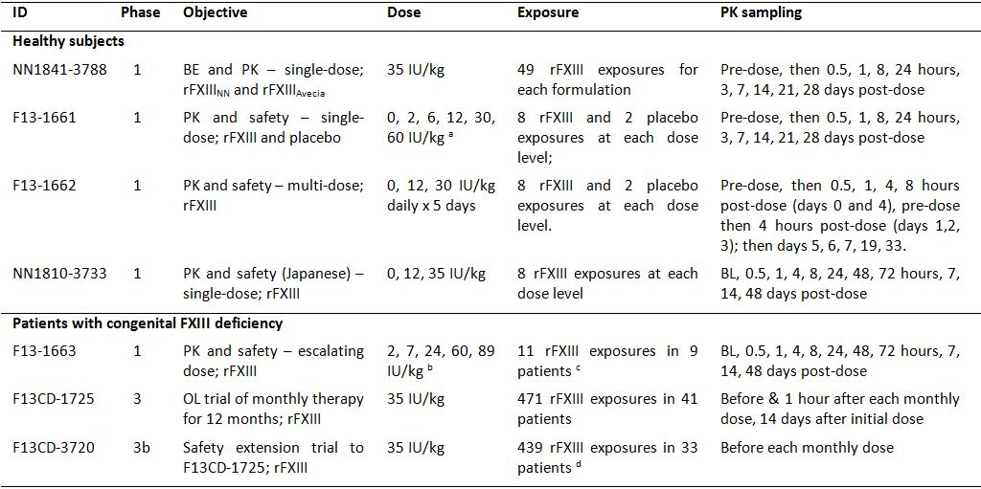
In a. PK assessment at the two highest dose levels for Berichrom assay. For enzyme linked immunosorbent assays (ELISAs), more dose levels were investigated.
b. PK assessment at the three highest dose levels.
c. Two (2) patients receiving 2 IU/kg rFXIII were re-enrolled at higher dose levels.
d. To expand the safety database, the Study F13CD-3720 protocol was amended to allow for inclusion of additional patients into the trial. As of the cut-off date of 11 February 2011, this had resulted in exposure to single additional dose in 1 patient (not included in 33 patients).
the earlier studies, rFXIII dose was expressed as U/kg while in the later studies rFXIII dose was expressed as IU/kg. The sponsor stated that the dose was expressed in U before the new rFXIII guideline was introduced, which is calibrated against an international FXIII plasma standard (WHO plasma standard). The link between U and IU is: 1 U = 1.19 IU and 0.84 IU = 1 U, or 1 mg = 167 IU or 140 U.
The PK parameters for FXIII activity were calculated using non compartmental analyses (NCA). In the PK studies in healthy subjects, the effect of baseline level of FXIII activity was accounted for by subtracting the median (NN1841-3788 and NN1810-3733) or the mean (F13CD-1661 and F13CD-1662) of three pre dose values from all post dose values prior to calculation of the PK parameters.

Analytical methods

Berichrom FXIII activity assay
The primary PK assessment was based on the FXIII Berichrom activity assay. This assay is a photometric coupled enzyme assay that detects the activity of recombinant as well as human FXIII A-subunits, irrespective of whether or not in complex with B-subunits. The Berichrom Factor XIII assay is a commercially available kit designed for monitoring plasma FXIII activity before and after substitution therapy with FXIII concentrate. The kit reagents were used to develop and validate a modified Berichrom assay to measure FXIII activity in human plasma spiked with rFXIII. The modifications refer to the calibrators and the buffers used for dilution of samples. The assay principle is as follows. FXIII present in a plasma sample is activated to FXIIIa by thrombin. FXIIIa catalyses the linkage of glycine ethyl ester to a specific peptide substrate, which results in the release of ammonia. The amount of ammonia released is determined in a parallel enzymatic reaction generating nicotinamide adenine dinucleotide (NAD+) from its reduced form (NADH). The consumption of NADH is quantified photometrically by monitoring the decrease in absorbance at 340 nm over time. A standard curve is prepared from rFXIII or a calibrated normal human plasma standard, and the rate of absorbance decrease for a sample is compared against the rate of absorbance decrease obtained from the standard.
For the Berichrom assay that was modified for use in patients with congenital FXIII deficiency, the specific activity value of the primary reference material (PRM) was adjusted from 165 or 167 IU/mg to 180 IU/mg. The consequence of this adjustment is a slightly higher estimation of FXIII activity in the clinical samples of approximately 8% (relative difference), but it is within the normal variation (±15%) of the Berichrom assay.
Comment: The modified commercially available Berichrom assay used to assess FXIII activity appears to be satisfactory. However, it is suggested that the relevant scientific/technical unit of the TGA should comment on the appropriateness of the assay. In the remainder of this CER the modified assay will be referred to as the Berichrom assay.

Exploratory Methods
- In order to support the PK assessment based FXIII activity (Berichrom assay), enzyme-linked immunosorbent assays (ELISAs) to measure total FXIII (rA2, rA2B2 and A2B2), FXIII-B subunit (uncomplexed) and FXIII tetramer (rA2B2 and A2B2). The validated FXIII antigen ELISAs were able to quantify the various FXIII molecular species separately.
- In study F13CD-1727, the use of a modified REA-chrom assays was used to measure rFXIII activity. The overall assay principle of the REA-chrom activity assay is the same as that of the Berichrom FXIII activity assay. The main difference is that NADPH replaces NADH, and that the samples are analysed a second time in the presence of a FXIII inhibitor (2-iodoacetamide) in order to estimate and subsequently subtract the background activity unrelated to FXIII.
Comment: It is suggested that the relevant scientific/technical area of the TGA comment on the appropriateness of the exploratory assays.

Summary of pharmacokinetics

Physicochemical characteristics of the active substance
The following information is derived from the sponsor’s summaries. The molecular formula of rFXIII is C₃₇₀₈H₅₇₃₅N₁₀₁₃O₁₁₁₁S₂₈ (acetylated N-terminal serine), and the relative molecular mass is 83179 Da. The higher order structure of rFXIII is provided. Purified rFXIII is contained in a buffer of 20 mM histidine, 4.25% sucrose, and 0.01% polysorbate 20 at approximately pH 8. The general properties of rFXIII are summarised below in Table 2.
Table 2: General properties of rFXIII.
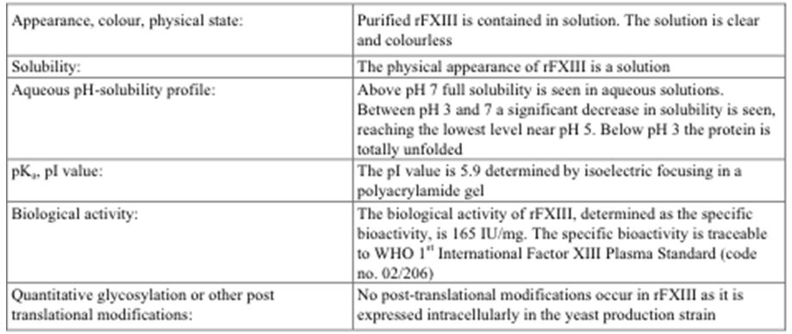

Pharmacokinetics in healthy subjects

Overview
The PK parameters for healthy subjects (n = 148) from the four Phase I studies are summarised below in Table 3. The four Phase I studies in healthy subjects included both single-dose and multiple-dose studies lasting for up to 5 consecutive days with treatment being administered once daily. Of the four Phase I studies, study NN1841-3788 included the greatest number of exposures to rFXIII and is considered to provide the most valid and comprehensive evidence of the pharmacokinetics of rFXIII at the intended dose level of 35 IU/kg in healthy subjects.

Absorption
The product is administered intravenously. Consequently, absorption studies are not required.

Bioavailability

Absolute bioavailability
Absolute bioavailability studies are not required as, by definition, products administered intravenously are 100% bioavailable.

Bioequivalence of clinical trial and market formulation
The rFXIII drug substance used for the nonclinical studies and the larger part of the clinical development program was produced by a contract manufacturing facility, Avecia (rFXIIIAvecia). The production of the rFXIII drug substance was subsequently moved in-house to Novo Nordisk (rFXIIINN). The drug substance and drug product used in the clinical development program are summarised.
The submission included one Phase I bioequivalence study (NN1841-3788) comparing single-doses (iv) of rFXIIIAvecia and rFXIIINN using a randomized, double-blind, cross-over design in 50 healthy male subjects. The primary objective of the study was to demonstrate that the two formulations were bioequivalent based on the area under the plasma concentration-time curve over 28 days (AUC0-28d) for FXIII activity (Berichrom assay). The secondary objectives included safety assessments and calculation of additional PK parameters. Subjects received single iv doses (35 IU/kg) of rFXIIIAvecia and rFXIIINN separated by a wash-out period of 9 weeks. The bioequivalence results are summarised below in Table 3.
Table 3: Bioequivalence (AUC0-28d) of rFXIII_{NN} vs rFXIII_{Avecia}; FAS.
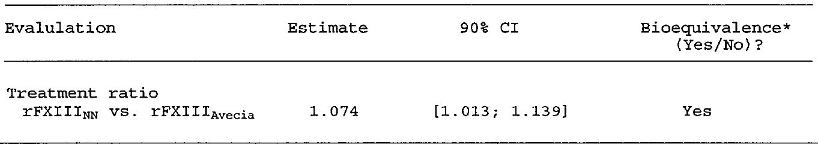
Bioequivalence concluded if the 90% for the Cl for the treatment ratio is completely contained within 0.8,1.25
The FXIII activity profiles (linear scales), both adjusted and unadjusted for pre-dose levels, are presented below in Figure 1. Adjustment was undertaken for pre-dose FXIII activity level by estimating the median of three pre-dose values and subtracting this value from the observed post-dose level prior to undertaking the PK calculations. The baseline adjusted geometric mean FXIII activity (Berichrom assay) at 30 minutes post dosing (C30min) was 0.87 IU/L (CV% = 24.1%) in the pooled data for both formulations (n=97). The baseline-adjusted geometric mean AUC0-28d was 213.20 IU•h/mL in the rFXIIIAvecia group (n=49), 227.59 IU•h/mL in the rFXIIINN group (n=49), and 220.28 IU•h/mL (23.8%) in the pooled data for formulations (n=98).
Figure 1. FXIII mean plasma activity-time profiles (unadjusted [upper dashed lines] and adjusted [lower solid lines]; linear scale.
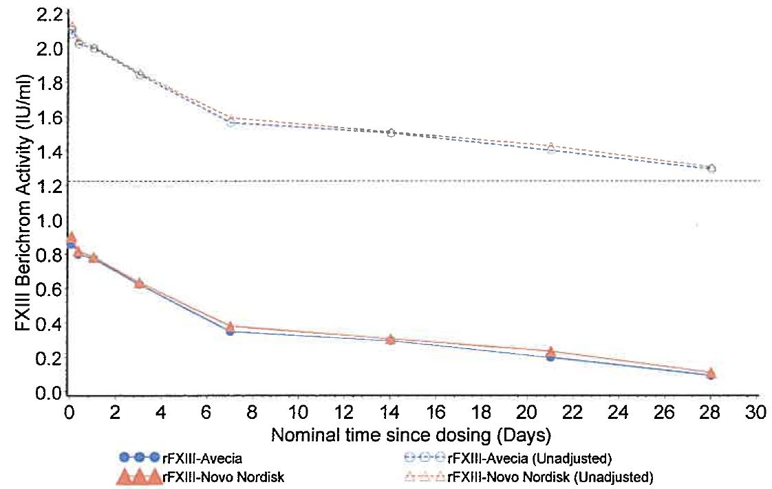
The horizontal dashed line represents the average baseline levels across the two treatments.
The study included an exploratory analysis of PK endpoints derived from the quantitative assay (ELISA) for FXIII A2B2 tetrameter. The PK parameters for A2B2 were comparable for the two rFXIII formulations and support the bioequivalence of the two products. For the exploratory calculation of PK parameters for the A2B2 ELISA the endogenous (baseline) level was not estimated as the median of the three pre-dose values, but as the minimal observed value in the whole profile. This was due to considerable variation in pre-dose values, which reduced their reliability with regards to representing the endogenous level for the subject. Using the original (protocol specified) median of three pre-dose values for baseline calculation gave rise to a number of unreliable adjusted profiles and negative AUC values.
The AUC0-28d geometric means for A2B2 following the rFXIIINN and rFXIIIAvecia formulations were 4037.8 and 4024.3 µg•h/mL, respectively (i.e., < 1% difference between the two values). The inter-subject variation expressed as the coefficient-of-variation (CV%) was considerably higher for the exploratory PK parameters of A2B2 (ELISA) compared with the PK parameters for FXIII activity (Berichrom) assay): e.g., C30min (49.7% vs 24.1%); AUC0-28d (50.8% vs 23.8%); MRT (66.7% vs 225.0%); t1/2 (64.5% vs 225.6%); CL (35.7% vs 58.2%); and Vss (24.7% vs 45.5%).
Comment: This was a good quality BE/PK study. It demonstrated that the two rFXIII formulations (Avecia and NN) are BE as regards the AUC0-28d, as the 90% CI for the relevant ratio was enclosed completely within the standard interval of 0.80 to 1.25. The geometric mean AUC0-28d was 213.20 IU/kg for rFXIIIAvecia (n=49) and 227.59 IU/kg for rFXIIINN (n=49). In addition, the PK endpoints were comparable for the two formulations. The safety profiles of the two formulations were similar. One (1) subject developed low-titre anti-rFXIII antibodies (titre = 2.3; lowest level of quantification = 2.0) following the first dose of rFXIIIAvecia and was withdrawn from the study. Follow-up sample at 6 months was antibody negative.

Dose proportionality

Study F13-1661
Phase I study F13-1661 evaluated the PKs and safety of single iv doses of rFXIII in healthy subjects. Single iv doses of 2, 5, 10, 25, and 50 U/kg of rFXIII (8 subjects in each dose group) resulted in increases in FXIII activity of 22.4, 44.6, 48.8, 64.7, and 88.6%, respectively. The sponsor commented that the FXIII activity estimates for the 2, 5, and 10 U/kg doses should be interpreted with caution as the estimates may not be distinguishable from baseline variation. Non-compartmental PK analyses were performed on baseline corrected FXIII activity (Berichrom Assay).
Comment: No dose proportionality data are available for rFXIII doses of 2, 5, and 10 U/kg, but there are descriptive dose-proportionality data for rFXIII doses of 25 U/kg (n=4) and 50 U/kg (n=7). The results for the exposure parameters (Cmax, AUC0-t, and AUCinf) showed that there was a less than dose-proportional relationship between 25 U/kg and 50 U/kg, and that the mean CL was higher with the higher dose. However, subject numbers in both the 25 U/kg and the 50 U/kg dose groups were small and inter-subject variability in the PK parameters were moderately high. Consequently, no definite conclusions regarding dose proportionality can be drawn from this study. The rFXIII doses of 25 and 50 U/kg are equivalent to rFXIII doses of 30 and 60 IU/kg, respectively.

Study NN1810-3733
In study NN1810-3733, dose-proportionality was not formally assessed but descriptive comparisons were provided for PK parameters in healthy Japanese males following single-doses of 12 IU/kg (n=8) and 35 IU/kg (n=8). In this study, the geometric mean AUC0-28d increased in a less than dose-proportional manner for the 12 IU/kg and 35 IU/kg doses (71.50 vs 152.63 IU•h/mL, respectively), while the geometric mean plasma exposure at 30 minutes after dosing (C30min) was approximately dose-proportional (0.278 vs 0.767 IU/mL, respectively). In agreement with the observed non dose-proportional increase in AUC0-28d, geometric mean clearance of rFXIII was higher after 35 IU/kg than after 12 IU/kg (0.198 vs 0.122 mL/kg, respectively). Levels of FXIII B-subunit declined shortly after administration of rFXIII reflecting combination with rFXIII A-subunits to form FXIII heterotetramers [A2B2]. The decreases in FXIII B-subunit concentrations were not dose-proportional following 12 IU/kg (2.676 decreasing to 1.319 µg/mL) and 35 IU/kg (2.899 decreasing to 0.511 µg/mL).
Comment: The sponsor speculates that the observed non dose-proportional decrease in FXIII B-units might be explained by saturation of the binding capacity of FXIII B-subunits for rFXIII A2-subunits at the higher dose level of 35 IU/kg. Excess rFXIII A2-subunits are rapidly cleared from the plasma, and this might contribute to a lower than dose-proportional exposure (AUC0-28d) when comparing the 12 IU/kg and 35 IU/kg doses. However, only 8 subjects were included at each dose level and, consequently, random variation might have influenced the results.

Bioavailability during multiple dosing
In study F13-1662, 5 daily doses of rFXIII 10 U/kg (n=8) and 25 U/kg (n=8) were administered to healthy subjects and the accumulation ratios (Day 4 to Day 0) for the Cmax and AUC0-24h were calculated. The accumulation ratios are summarised below in Table 4. The doses of 10 and 25 U/kg equate to doses of 12 and 30 IU/kg.
Table 4: Accumulation ratios (mean (SD), day 4 to day 0 following rFXIII 10 U/kg and 25 U/kg.
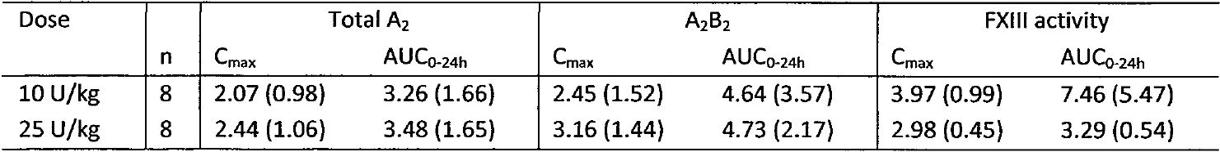

Distribution
In study NN1841-3788, the mean (SD) volume of distribution (Vss) for rFXIII following a single-dose (iv) of rFXIII (35 IU/kg) (pooled data for both formulations) in 98 healthy male subjects was 48.4 (12.0) mL/kg, and the geometric mean Vss was 47.1 mL/kg (range: 26.1, 93.8).
In study NN1841-3748, the mean residence time (MRT) of rFXIII following a single-dose (iv) of rFXIII (35 IU/kg) (pooled data for both formulations) in 98 healthy male subjects was 422.7 hours (SD = 282.3), and the geometric MRT was 371.9 hours (range: 129.7, 2084.3).
Comment: The Vss is small and indicates that rFXIII is primarily confined to the vascular compartment with negligible distribution to the extravascular compartments. There were no protein binding studies, but this is considered to be acceptable for a therapeutic protein (rFXIII [A2]) that is structurally identical to an endogenous protein (FXIII A2-subunit).

Metabolism
There were no in vitro studies or in vivo studies in humans investigating the metabolism of rFXIII.
Comment: The absence of metabolic studies is considered to be acceptable for a therapeutic protein (rFXIII [A2]) that is structurally identical to an endogenous protein (FXIII A2-subunit) where treatment aims to achieve physiological levels of FXIII. On injection, rFXIII [A2] dimers bind to endogenous circulating B-subunits to form a stable rA2B2 heterotetramer. It can be anticipated that rFXIII will follow the same catabolic routes as endogenous FXIII.

Excretion
In study NN1841-3788, the terminal half-life (t1/2) was estimated over the time points from 3 days post-dose to 28 days post-dose. In this study, the mean (SD) t1/2 following single-dose (iv) rFXIII (pooled data for both formulations) in 98 healthy male subjects was 303.0 (195.4) hours, and the geometric mean t1/2 was 265.7 hours (range: 72.6, 1374.8). The mean (SD) clearance (CL) following single-dose (iv) rFXIII (pooled data for both formulations) in 98 healthy male subjects was 0.14 (0.05) mL/h/kg, and the geometric mean CL was 0.13 mL/h/kg (range: 0.04, 0.29).
Comment: The long terminal half-life of rFXIII of about 11 days (geometric mean) supports the proposed once monthly (28±2 days) dosing regimen. There were no data in the submission investigating renal or hepatic clearance of rFXIII in humans. However, this is considered to be acceptable. The relevant TGA adopted EMA guideline states that “the main elimination pathway should be identified”. However, the guideline goes on to state that for therapeutic proteins the elimination pathway “could be predicted to a large extent, from molecular size and specific studies may not be necessary. Catabolism of proteins occurs, usually by proteolysis”. The molecular mass of rFXIII is 83.2 kDa (i.e., > 50 KDa), suggesting that elimination of rFXIII by tissue mechanisms such as receptor mediated endocytosis followed by catabolism is likely to be more important relative to renal filtration. The guideline also states that mass-balance studies “are not useful for determining the excretion pattern of the drug and drug-related material. Excreted proteins are not necessarily recovered in urine or faeces as intact substance, but instead are metabolized and reabsorbed as amino acids and incorporated in the general protein synthesis”.

Pharmacokinetics in the target population

Study F13-1663
Study F13-1633 was Phase I, open-label pilot study of rFXIII in subjects with congenital FXIII deficiency. The study included 5 dose cohorts (2, 6, 20, 50 and 75 U/kg) with each subject receiving a single-dose of iv rFXIII. Subjects became eligible for a second dose of rFXIII 100 days after the first administration and no subjects were to receive more than 2 doses during the study period. The PK analysis was undertaken in subjects who received 20, 50, or 75 U/kg of rFXIII, equating to doses of 24, 60, and 89 IU/kg, respectively. FXIII activity data (Berichrom assay) were available on 7 subjects who received single doses of rFXIII (20 IU/kg [n=2]; 50 IU/kg [n=3]; and 75 U/kg [n=2]). One subject in the 20 U/kg group had normal levels of FXIII pre-dose (data was corrected before baseline PK analyses) and one subject in the 50 U/kg group was FXIII B-subunit as well as FXIII A-subunit deficient. The Berichrom FXIII activity PKs are summarised below in Table 5.
Table 5: FXIII activity PK parameters (Berichrom assay).
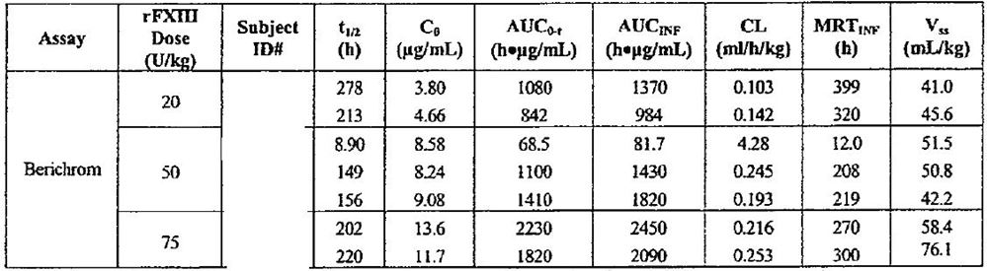
Comment: It is considered that no definitive conclusions about the PKs of rFXIII can be drawn from this small, pilot study. The dose being proposed for registration (35 IU/kg) was not assessed in this study.

Study F13CD-1725
In the Phase III clinical efficacy and safety study (F13CD-1725), blood sampling for PK assessment was undertaken in 41 patients before dosing with rFXIII 35 IU/kg and then 1 hour after dosing each 4 weeks (28±2 days) for 48 weeks, and 2 weeks (14±2 days) after the first dose. Blood samples for FXIII activity were measured using the Berichrom assay, and total FXIII A2 (rA2, rA2B2 and A2B2), FXIII B-subunit (uncomplexed), and FXIII tetramer (rA2B2 and A2B2) levels were measured using specific ELISAs. The mean age of the 41 patients in this study was ~ 26 years (range: 7, 60 years).
The results for FXIII activity (Berichrom assay) are summarised. Mean pre-dose trough levels (corresponding to 4 weeks after the preceding dose of rFXIII) were approximately 0.2 IU/mL. Dosing with rFXIII significantly increased mean FXIII activity at 1 hour post-dose to between approximately 0.7 and 0.9 IU/mL. Based on FXIII activity from 471 monthly doses of rFXIII the elimination half-life of the product is estimated to be 11.5 days in patients with congenital FXIII deficiency, which is in agreement with the elimination half-life estimated in healthy subjects.
The mean concentration-time profiles for the A2B2 tetramer and total FXIII A2 correspond to the FXIII activity profile, and indicate that concentrations increased sharply after each rFXIII administration followed by a gradual decline over the subsequent month. The mean profile for uncomplexed B-subunit is reversed with the lowest concentrations immediately after injection of rFXIII. The FXIII B-subunits are postulated to function as a carrier of the FXIII A-subunits, which explains the observed decrease in concentration of FXIII B-subunits following administration of rFXIII [A2].

Study F13CD-3720
Study F13CD-3720 is a safety extension to the pivotal study F13CD-1725, and is intended to document long-term safety of monthly treatment with rFXIII. It included preliminary safety extension data up to the cut-off point of 11 February 2011. All 33 patients who completed study FCD13-1725 were enrolled in the extension study and exposed to rFXIII. The mean age of the 33 patients in the extension study was ~29 years (range: 7, 60 years). FXIII activity measurements (Berichrom assay) were obtained prior to rFXIII administration during the extension period (i.e., tough levels corresponding to 4 weeks after the preceding dose). The mean FXIII activity pre-dose (trough levels) were approximately 0.2 IU/mL and remained relatively constant up to 72 weeks (nominal time from first dosing). Patient numbers declined over time (i.e., week 48, n=18; week 60, n=11; week 72, n=1), and the mean (SD) number of doses in the 33 subjects was 13.3 (3.6), with a range of from 3 to 19. Low mean pre-dose trough levels of FXIII [A2B2] tetramer and total FXIII [A2] subunit were observed and corresponded to the FXIII activity profile. The mean levels of B-subunits were within normal reference range. Overall, the preliminary results from the extension study F13CD-3720 support the trough levels observed in study F13CD-1725.

Pharmacokinetics in other special populations

General
There were no pharmacokinetic studies with rFXIII in subjects with impaired hepatic or renal function, or in subjects grouped according to age. The majority of the rFXIII PK data was from Caucasians, but there were PK data from healthy Japanese males (study NN1810-3733). The sponsor stated that the limited size of the development program precluded an in-depth evaluation of intrinsic and extrinsic factors potentially affecting the pharmacokinetics of rFXIII.

Japanese subjects
A comparison of PK parameters for FXIII activity following single-doses (iv) of rFXIII 35 IU/kg in healthy Japanese subjects from study NN1801-3733 and in healthy primarily white (60%) males from study NN1841-3788 is provided below in Table 6.
Table 6: FXIII activity PK parameters (Berichrom assay).
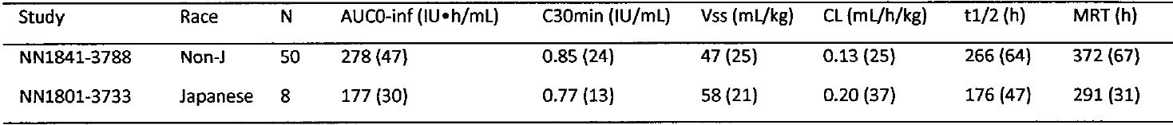
Comment: The PKs of FXIII activity differed between Japanese and non-Japanese (60% white) healthy males, with exposure (AUC0-inf and C30min) being greater in non-Japanese subjects. Consistent with the difference in exposure between the two racial groups, CL was greater and t1/2 was shorter in Japanese subjects compared with non-Japanese subjects. However, cross-study differences in the PKs of FXIII activity between the two racial groups should be interpreted cautiously because of the marked imbalance in subject numbers between the two studies and the inter-subject variability in both racial groups for the PK parameters.

Pharmacokinetic interactions
There were no studies investigating PK interactions between rFXIII and other medicinal products.
Comment: The sponsor stated that the limited size of the development program precludes an in-depth evaluation of intrinsic and extrinsic factors potentially affecting the pharmacokinetics of rFXIII. This is considered to be acceptable.

Evaluator’s overall conclusions on pharmacokinetics
Overall, the PK submitted data for rFXIII is considered to be adequate for a therapeutic protein with an identical structure to the corresponding endogenous protein in humans. However, there were no specific PK studies exclusively in children or adolescents younger than 18 years with congenital FXIII deficiency, and the were no PK data at all in children younger than 7 years of age. The lack of PK data in children younger than 7 years, and the absence of exclusive data in children and adolescents aged 7 to 17 years is considered to be a significant deficiency in the submission.
Of the four, Phase I studies in 148 healthy subjects aged at least 18 years, the single dose bioequivalence study (N1841-3788) included the greatest number of exposures to rFXIII (98 exposures in 50 subjects) at the proposed dose (35 IU kg/mL). Consequently, the PK data from this study are considered to be the most valid in healthy subjects. There was one small Phase I study in 7 patients with congenital FXIII deficiency given single doses of rFXIII of 24 IU/kg (n = 2), 60 IU/kg (n = 3), or 89 IU/kg (n = 2). There were no Phase I PK studies in patients with congenital FXIII deficiency that investigated the proposed dose of 35 IU/kg. However, limited PK data for the proposed dose of 35 IU/kg IV was investigated in the Phase III study (F13CD-1725) in patients with congenital FXIII deficiency. In this study, FXIII activity, total A₂, FXIII tetramer (rA₂B₂ and A₂B₂), and uncomplexed B subunit concentrations were measured pre dose and 1 h post dose each 28 ± days for 48 weeks in 41 patients (471 exposures). In addition, in the extension (Study FCD-1725) to Study FCD-1720, preliminary pre dose (that is, trough) levels for FXIII activity were provided each 28 ± 2 days for a further 24 weeks (that is, up to 72 weeks post first dose) in up to 33 patients.
Study N1841-3788 established that IV doses of 35 IU/kg of rFXIIIAvecia (used in nonclinical and clinical studies) and rFXIIINN (proposed formulation for registration) were bioequivalent as regards the AUC_{0-28d} of rFXIII activity (Berichrom assay). The baseline adjusted geometric mean (CV%) AUC_{0-28d} values were 213.2 (23.0%) IU•h/mL for rFXIIIAvecia (n = 49) and 227.6 IU•h/mL (24.4%) for rFXIIINN (n = 49), and the corresponding geometric means for the C_{30min} were 0.85 IU/mL in both treatment groups (respective CV% of 28.2% and 20%). The pooled geometric mean (CV%) for the AUC_{0-28d} was 220.3 (23.8%) IU•h/mL, and the corresponding geometric mean for the C_{30min} was 0.85 (24.1%).
In Study NN1841-3788 in healthy males (n = 50), following single IV doses (35 UI/kg) of rFXIIIAvecia and rFXIIINN the pooled geometric mean (%CV) PK parameters for rFXIII activity (Berichrom assay) were half life 266 (64%) h, apparent total body clearance of the drug from plasma (CL) 0.13 (36%) mL/h/kg, apparent volume of distribution at steady state (V_{ss}) 47 (24.9%) mL/kg, and mean residence time (MRT) 372 (66.8%) h. The mean geometric elimination half life for FXIII activity observed in healthy volunteers (~11.1 days) was consistent with that observed in patients with FXIII deficiency (~11.5 days). The small V_{ss} of ~47 mL/kg suggests that rFXIII remains primarily in the vascular compartment with negligible distribution to the extravascular compartments. The CV% values for the PK parameters suggest that inter subject variability is moderate.
In Study NN1810-3733 in healthy Japanese males (n = 8), the geometric mean AUC_{0-28d} increased in a less than dose proportional manner following single IV doses of 12 IU/kg and 35 IU/kg (that is, 71.5 versus 152.6 IU•h/mL, respectively). In agreement with this observation, the geometric mean clearance of rFXIII was higher after 35 IU/kg than after 12 IU/kg (0.198 versus 0.122 mL/kg, respectively). Free FXIII B subunit levels declined shortly after administration of rFXIII, which is consistent with binding of administered rFXIII to free circulating FXIII B subunits to form FXIII heterotetramers (rA₂B₂). The decreases in FXIII B subunit concentrations were not dose proportional following rFXIII doses of 12 IU/kg and 35 IU/kg. The sponsor speculates that this might be explained by saturation of the binding capacity of FXIII B subunits for rFXIII A₂ subunits at the higher dose level of 35 IU/kg. Excess rFXIII A₂ subunits are rapidly cleared from the plasma, and this might contribute to a lower than dose proportional exposure (AUC_{0-28d}) when comparing the 12 IU/kg and 35 IU/kg doses. However, only 8 subjects were included at each dose level and, consequently, random variation among subjects might have influenced the results.
In the multiple dose PK study (Study F13-1662) in healthy volunteers (n = 8), rFXIII doses of 30 IU/kg daily for 5 days resulted in mean (SD) accumulation indices (Day 4 to Day 0) for AUC_{0-24h} of 7.46 (5.47), 4.64 (3.57) and 3.26 (1.66) for FXIII activity, A₂B₂, levels and total A₂ levels, respectively, and 2.98 (0.45), 3.16 (1.44), and 2.44 (1.06) IU/mL, respectively, for the corresponding C_{max} accumulation indices.
In the Phase III study (F13CD-1725) in patients (n = 41) with congenital FXIII deficiency, the mean pre dose (that is, trough) level for FXIII activity (Berichrom assay) was approximately 0.2 IU/mL over 52 weeks with once monthly dosing with rFXIII (35 IU/kg). In this study, FXIII activity increased from pre dose levels of ~0.2 IU/mL to post dose levels at 1 h of ~0.7 to 0.9 IU/mL. In the extension study (F13CD-3720), the mean pre dose (that is, trough) levels for FXIII activity through to 72 weeks from initiation of treatment were consistent with the corresponding levels in F13CD-1725 through to Week 52 from initiation of treatment.
In Study F13CD-1725 in patients with congenital FXIII deficiency, mean concentration-time profiles for the A₂B₂ tetramer and for total FXIII A₂ corresponded to that for FXIII activity, indicating that concentrations increased sharply after each rFXIII administration followed by a gradual decline over the subsequent month. The mean concentration-time profile for uncomplexed B subunit was reversed with the lowest concentrations immediately after injection of rFXIII. The FXIII B subunits are postulated to function as a carrier in the circulation, which explains the observed decrease in FXIII B subunit concentration following administration of rFXIII (A₂).
There were no PK data in the submission investigating in vivo or in vitro metabolism of rFXIII or the elimination pathways of rFXIII. There were no data in the submission investigating the effects of renal or hepatic impairment on the PKs of rFXIII. The subject population for PK analysis was primarily Caucasian, but there was one PK study in healthy Japanese males. There were no PK data in the submission investigating the effect of interactions between rFXIII and other therapeutic products. As rFXIII (A₂) is structurally identical to endogenous FXIII A subunits, and the product is intended to replenish physiological levels, the absence of the identified PK data is considered not to prejudice registration of rFXIII.
The major deficiency in the PK data related to the lack of studies exclusively in patients aged < 18 years. There were no Phase I PK studies in healthy subjects or patients with congenital FXIII deficiency specifically in subjects aged less than 18 years. There were no PK data from the Phase III studies in patients with congenital FXIII deficiency in children aged less than 7 years, and the PK data were presented for the total patient population aged from 7 to 60 years (mean age ~26 years in the initial study and ~28 years in the extension study). This is a noteworthy deficiency in the submitted data.

Pharmacodynamics

General comment
The sponsor stated that “at present there are no markers that can quantitatively assess the in vivo pharmacodynamics of FXIII.” The sponsor noted that as FXIII deficiency affects the quality of the clot, the results of standard coagulation screening tests such as prothrombin time, activated partial thromboplastin time, fibrinogen level, platelet count and bleeding time are all normal in FXIII deficiency. Therefore, the sponsor tested clot solubility with a qualitative assay which “when performed correctly is positive only when FXIII activity in the sample is close to zero”. The sponsor indicates that the assay “is based on the ability of urea or monochloracetic acid to dissolve fibrin clots that have not undergone FXIII-induced stabilisation. Normal blood clots generally remain stable for 24 hours or more, while clots in which fibrin molecules have not been cross-linked are soluble within minutes. Elevation of the plasma activity to as little as 1-3% of normal renders the clot insoluble”. Data on the clot solubility was provided for patients with congenital FXIII deficiency from the two Phase III studies (F13CD1725 and F13CD-3720) and the one Phase I study (F13-1663). The results for the clot solubility assay from the pivotal Phase III efficacy and safety study (FCD13-1725) study are outlined below.
In addition to the clot solubility test, the Phase I study (F13-1663) in patients with FXIII deficiency included a clot strength test measured by thromboelastography (TEG). This test measures the elastic shear modulus of a blood clot during formation and lysis. A mechanical/electrical transducer and amplifier produce a tracing in which the amplitude of the tracing is directly proportional to clot strength. The TEG tests were undertaken in the laboratory of the study’s Principal Investigator. The TEG tests are considered to be exploratory and are not standard tests used in clinical practice. The TEG results are not discussed in this CER.

Study F13CD-1725 (pivotal Phase III study): clot solubility
The pivotal Phase III clinical efficacy and safety study in patients with congenital FXIII deficiency (F13CD-1725) included an assessment of clot solubility. Blood samples were drawn for analysis of clot solubility at screening, visits 1-16 and at any unscheduled visit. At dosing visits (visits 2-15 except visit 3), samples were drawn before and 1 hour after administration of rFXIII. At unscheduled visits, samples were drawn before administration rFXIII. The assay was performed at a designated central laboratory.
From pre-dose week 4 to pre-dose week 52, the lowest number of patients with clot lysis prior to dosing was 0 (0%) and the highest number was 7 (17.1%). The number of patients with clot lysis at screening and baseline was 2 (4.9%) and 8 (19.5%), respectively. Overall, at all dosing visits (n=533, all visit subjects count) the proportion of patients with abnormal clot solubility was greater pre-dose (7.5% [40/533]) compared with post-dose (1.5% [8/533]).
Comment: As expected, the proportion of patients exhibiting clot lysis at 1 hour after rFXIII dosing was lower compared with pre-dose (1.5% vs 7.5%, respectively). However, clot lysis occurred sporadically both pre-dose and post-dose throughout the study, and did not show a consistent trend in the investigated patients. The sponsor commented that 46 observations of clot lysis were observed for FXIII activity levels (Berichrom assay) > 0.10 IU/mL, which “reflects that the Berichrom assay for quantifying FXIII activity levels is prone to stochastic variations (especially at low activity levels)”. Furthermore, 7 reports of clot lysis were reported 1 hour after rFXIII administration (4 in one patient). The sponsor comments that the 7 reports of clot lysis 1 hour post-dose were “credible” and might reflect laboratory issues with handling of the clot solubility assay for the corresponding samples and/or well-known difficulties with interpretation of the clot solubility assay. The sponsor commented that the occurrence of clot lysis in the study did not appear to be associated with the onset of treatment-requiring bleeds or with temporal trends in the level of pre-dose or post-dose FXIII activity for the investigated patients. The results of clot solubility testing are considered to be exploratory. The qualitative assay is recognized as being difficult to standardise. Recommendations against the use of the clot solubility assay as the screening test for FXIII deficiency have been made as the test can only detect very severe FXIII deficiency.6 The test is only sensitive at very low levels of FXIII activity (zero or close to zero) and elevating FXIII activity to as little as 1-3% of normal renders the clot insoluble.

Dosage selection for the pivotal studies
There were no clinical dose-ranging studies in patients with congenital FXIII deficiency. The sponsor noted that the determination of an adequate FXIII strategy is complicated by poor correlation between FXIII activity and bleeding tendency, particularly attributable to the heterogeneity of congenital FXIII deficiency. The sponsor also stated that the determination of FXIII activity levels that places patients at the greatest risk of bleeding is further complicated by the fact that currently available FXIII activity assays (Berichrom and REA-chrom) are imprecise below 10% activity level.

Clinical efficacy
The efficacy of NovoThirteen for the proposed indication was supported by two clinical studies (Table 7). Study F13CD-1725 was the pivotal efficacy and safety study in patients with congenital FXIII-deficiency (n=41), and study F13CD-3720 was a safety extension study (preliminary report) in patients (n=33) who had completed the pivotal study (subsequently amended to include patients who had not participated in the pivotal study).
Table 7: Congenital FXIII deficiency – Phase III clinical studies supporting the indication.
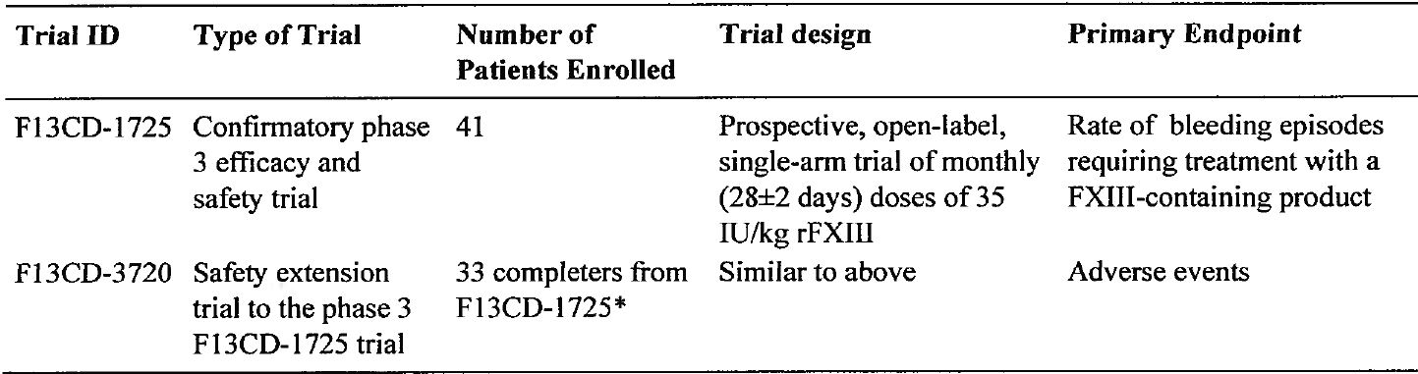
* To expand the safety data base, the F13CD-3720 protocol was amended to allow for inclusion of additional patients into the trial. As of the cut-off date of 11 February 2011, this had resulted in exposure to a single additional dose in one such patient. The only information on this additional patient at the time of analysis was the absence of any SAEs.

Pivotal efficacy study (F13CD-1725): congenital FXIII deficiency

Study design, objectives, location, dates
The pivotal Phase III study was a multi-centre, multi-national, open-label, single-arm efficacy and safety trial of rFXIII in patients with congenital FXIII deficiency. The primary objective was to evaluate the efficacy of monthly replacement therapy with rFXIII for the prevention of bleeding episodes in subjects with congenital FXIII deficiency. The secondary objective was to evaluate the safety of monthly replacement therapy with rFXIII in subjects with congenital FXIII deficiency.
The study was sponsored by Novo Nordisk A/S, Denmark. It was initiated in 29 sites, and 23 sites in 11 countries enrolled and dosed at least one patient. The country distributions (number of actively recruiting sites) were Austria (1), Canada (1), Finland (1), France (1), Germany (3), Israel (2), Italy (1), Spain (1), Switzerland (1), UK (3), and USA (8). There was 1 principal investigator for each site. The trial was initiated on 18 August 2008 and completed on 15 April 2010. The CSR was dated 17 November 2010. The trial was conducted in accordance with the Declaration of Helsinki, and ICH principles of Good Clinical Practice.
In total, 41 subjects were enrolled in the trial. Following a screening visit (Visit 1), eligible subjects entered a 4-week run-in period. Subjects receiving regular replacement therapy with an FXIII containing product before entering the trial were to receive their last standard replacement dose just before the screening visit. On completion of the run-in period, subjects entered a 52-week rFXIII treatment period of monthly (28±2 days) doses of 35 IU/kg rFXIII. The treatment period ran from Visit 2 to 15, with Visit 3 (safety visit) being undertaken 2 weeks after the first study dose of rFXIII. Subjects completed the trial at week 52, approximately 4 weeks after the last administration of trial product (Visit 16 “end-of-trial” visit). In case of premature discontinuation, the subject was, if possible, called in for a visit 4 weeks (28 ± 2 days) after the last administration of rFXIII in order to record the primary reason for discontinuation. After completion of the trial, subjects were provided with the opportunity to enrol in a rFXIII safety follow-up study. Unscheduled visits could take place if subjects required treatment with haemostatic agents to prevent bleeding. The study design is summarised below in Figure 2.
Figure 2. F13CD-1725 – Study design.
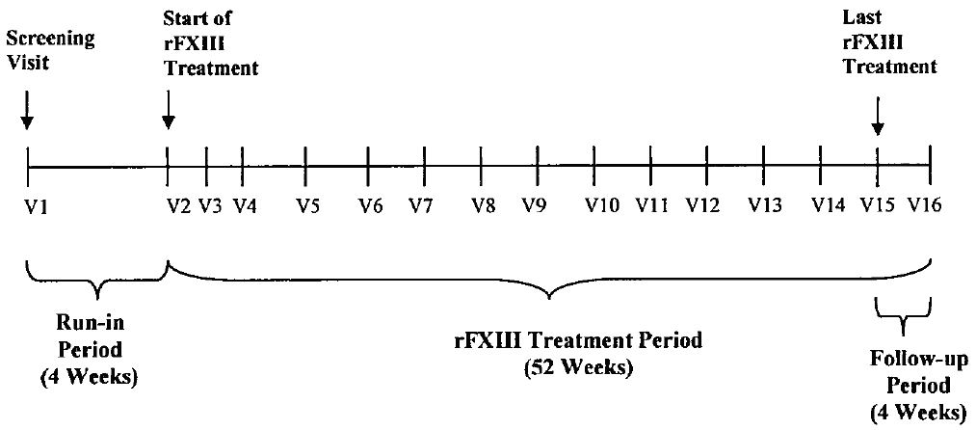
The protocol included 6 substantial amendments implemented after initiation of subject enrollment. The amendments have been examined and none are considered likely to have affected the validity of the study.
Comment: The study was open-label and single-arm. It was designed as a superiority trial comparing the efficacy of monthly rFXIII replacement therapy with retrospective data from patients with congenital FXIII A-subunit deficiency treated on-demand with FXIII-containing products. It would have been unethical to have included a placebo control due to the risk of serious bleeding in untreated patients with congenital FXIII deficiency. Based on the limited cross-section data available, the sponsor estimated that approximately 70-90% of all patients diagnosed with congenital FXIII deficiency are treated with regular plasma derived FXIII replacement therapy and a placebo controlled trial would have run the risk of exposing at east half of these patients to serious bleeding. It would also have been technically difficult to have conducted a blinded trial with an active-control plasma derived FXIII replacement product as a double-dummy technique would have been required. Furthermore, the rarity of congenital FXIII deficiency and the low incidence of bleeding events in patients on regular FXIII replacement therapy make it difficult to recruit a sufficient number of patients to conduct an adequately powered superiority or non-inferiority clinical trial comparing bleeding rates between rFXIII and FXIII replacement therapy.

Inclusion and exclusion criteria
The study enrolled patients with congenital FXIII deficiency (confirmed by genotyping at screening visit) aged > 6 years with a weight > 20 kg. Before enrolment of subjects aged > 6 to < 12 years of age in EU countries and > 6 years to < 18 years in Israel, 7 subjects were required to have been exposed for 12 weeks (3 exposures) to the trial drug in order to demonstrate a satisfactory safety profile. For subjects on regular replacement therapy prior to screening, treatment with regular FXIII replacement initiated at least 6 months prior to screening was required in addition to one of the following: a documented history of ≥ 1 treatment-requiring bleeding episode prior to initiation of regular replacement therapy or a documented family history of FXIII congenital deficiency. For subjects receiving on-demand treatment prior to treatment, a documented history of ≥ 2 bleeding episodes requiring treatment with FXIII-containing blood products within the 12 months prior to treatment was required. The inclusion and exclusion criteria are summarised. In addition to the inclusion and exclusion criteria, the study included criteria providing for the patient to be withdrawn at any time. Subjects could also be withdrawn at the discretion of the investigator or the sponsor if they were judged to be non-compliant with study procedures or there were safety concerns.

Study treatments
During the treatment period of 52 weeks (visit 2 through to visit 15), subjects received 35 IU/kg rFXIII every four weeks (28±2 days). At each visit, the dose was adjusted according to the actual weight of the subject. The reconstituted trial product was administered as a slow intravenous injection (not to exceed 1-2 mL per minute). Non-emergency use of FXIII-containing products other than rFXIII was not allowed during the trial period. In case of acute bleeding episodes, any additional treatment was to be determined by the investigator according to local standard practice, and additional doses of rFXIII could not be used to treat such break-through bleeds. The subject was asked to return to the clinic in case of bleeding episodes requiring the use of haemostatic agents, and administration of FXIII-containing products were only to be initiated subsequent to objective examination of the subject, unless earlier initiation of treatment was clearly justified based on the symptoms experienced. Treatment of bleeding episodes was to be under direct supervision of the investigator or delegated medically qualified staff.
Recombinant FXIII was supplied as a sterile lyophilized powder for injection in single-use vials of 15 mg (2505 IU) per vial. Each vial was to be reconstituted in 3.2 mL sterile water for injection, resulting in a rFXIII concentration of 835 IU/mL when reconstituted. The rFXIII product and sterile water for injection were supplied by Novo Nordisk A/S, Denmark. In the US, sterile water for injection was not supplied by the sponsor, but was presumably supplied by the individual study centres.

Efficacy variables and outcomes

Primary endpoint
- Rate (number per subject year) of “bleeding episodes requiring treatment” with a FXIII containing product during rFXIII treatment period. This endpoint was also described in the CSR as “treatment-requiring bleeds”.

Secondary endpoints
- Percentage of subjects without “bleeding episodes requiring treatment” with a FXIII containing product during the treatment period.
- Rate (number per subject year) of spontaneous “bleeding episodes requiring treatment” with a FXIII-containing product during the rFXIII treatment period.
- Rate (number per subject year) of traumatic “bleeding episodes requiring treatment” with a FXIII-containing product during the rFXIII treatment period.
- Rate (number per subject year) of intracranial “bleeding episodes requiring treatment” with a FXIII-containing product during the rFXIII treatment period.
- Percentage of subjects having a normal clot solubility one hour after rFXIII administration and 28 days after rFXIII administration.
- Number of subjects withdrawn from the trial due to lack of efficacy of rFXIII treatment.
- Level of FXIII activity one hour after rFXIII administration and 28 days after rFXIII administration.
The following efficacy variables were specified in the study:
- Bleeding episodes: Throughout the 52-week rFXIII treatment period, details of all bleeding episodes were recorded at scheduled visits as well as at unscheduled visits, the latter in case of treatment-requiring bleedings. The following details were recorded for bleeding events that required treatment with a FXIII-containing product: date and time of onset of bleeding; cause of bleed (spontaneous or traumatic); site of bleeding (central nervous system bleeding, haemarthrosis, gastrointestinal bleeding, subcutaneous bleeding, muscular bleeding or other); haemostatic drug used for treatment of bleeding episodes (drug name, dose and time of administration); other therapy used (e.g., compression, ice); and date and time of bleeding resolution.
- Clot solubility: The results for this variable have been discussed in this CER under Pharmacodynamics.
- Subject withdrawal: The proportion of subjects withdrawn due to lack of efficacy of rFXIII treatment was a planned efficacy endpoint.

Randomisation and blinding methods
No randomization or blinding, as the study was single-arm and open-label.

Analysis populations
All 41 patients who received at least one dose of trial product were included in the full analysis set (FAS) and the safety analysis set. The per-protocol (PP) analysis comprised subjects completing the 52-week rFXIII treatment period, and excluded subjects with protocol violations judged to affect the primary efficacy evaluation. A total of 33 patients completed the pre-planned treatment period, 2 of who were excluded from the PP analysis due to significant protocol violations (1 received preventive plasma-derived FXIII treatment, and 1 did not receive trial drug at week 8). The remaining 31 patients comprised the PP analysis set.
Data from subjects who were withdrawn from the study for any reason were included in the analysis up to the point of withdrawal. All data for subjects who were withdrawn from treatment but continued in the study for safety evaluation were included for safety endpoints, but data pertaining to the period after treatment withdrawal were excluded for efficacy endpoints.

Sample size

Sample size calculation
Based on retrospectively collected data, the bleeding rate for subjects treated only on-demand with FXIII containing products was estimated by a Poisson model. The estimate was 2.91 bleedings per year with a 95% confidence interval (CI) of 2.18, 3.87. The same was done for subjects receiving regular replacement therapy, and the yearly bleeding rate was estimated to be 0.33 with a 95% CI of 0.22, 0.52. Assuming a yearly bleeding rate for subjects receiving monthly replacement therapy with rFXIII of 0.52, and comparing this with a fixed rate of 2.91 bleedings per year by a Poisson model with a type I error rate of 5%, a total of 40 subjects was calculated to yield 99% power. The retrospective analysis used to estimate the historical bleeding rates is summarised below.
Comment: The study was designed to detect a statistical difference in the primary endpoint (rate of bleeding episodes requiring treatment per year) between replacement therapy with a FXIII containing product and a fixed placebo bleeding rate derived from patients with congenital FXIII requiring only on-demand FXIII treatment for bleeding episodes. The fixed placebo rate was based on historical data collected by the sponsor from patients with congenital FXIII deficiency.

Retrospective analysis (historical data)
Retrospective (historical data) were collected by the sponsor in order to describe the clinical features, medical needs and treatment pattern of patients with congenital FXIII deficiency. The sponsor collected the data from a questionnaire distributed by the sponsor’s local affiliates directly to the haematologists/treating physicians at haemophilia centres. Data were collected from a total of 13 countries from 35 centres, primarily from Europe, but also some Middle East countries, Australia and South Africa. Of the 35 centres, 16 were in Germany with each of the other countries contributing patients from 1 to 3 centres. Of the 92 patients contributing data to the analysis, 27 were from Germany, 15 from Spain and 12 from Israel, and 1 to 8 patients from each of the other countries. The centres replied with the available information, and all data received between June and September 2005 were included in the data-set.
Of the 92 subjects from whom data were collected, there were 45 females and 47 males, and the majority of patients were white. There reported mean age of the subjects was 26.7 years and the median age was 25.0 years (range: 0.1, 71.0 years). The reported mean and median body weight of the patients were 59 and 61 kg, respectively. Of the 92 patients, 87 were reported to be alive at the time of the data collection. At first diagnosis of congenital FXIII-deficiency the mean and median age reported were 7.9 and 3.5 years, respectively, ranging from diagnosis at birth to diagnosis at 53 years of age. The majority of the patients were diagnosed at birth and the most frequent reason for initiation of diagnostic procedures for evaluation of FXIII-deficiency was active bleeding.
For the majority of the patients, the subtype of the FXIII-deficiency (deficiency of the FXIII-subunit A and/or B) was unknown. A total of 39 patients were classified as FXIII-subunit A-deficient, 2 patients as FXIII-subunit B-deficient, and 4 patients as both FXIII-subunit A- and B- deficient. The minimal FXIII activity was measured in 78 patients. The measured mean and median FXIII activity were 7.1% and 3.5% of normal, respectively, and ranged from 0.0% to 55.0%.

Regular prophylaxis data from the retrospective analysis
A total of 69 of the 92 (75%) patients had a history of regular FXIII replacement therapy for bleeding prophylaxis and in the majority of these patients treatment was initiated as prophylactic therapy in childhood. In patients on current prophylaxis at the time of data collection, Fibrogammin P (pdFXIII) was the most frequently used FXIII-containing product. The mean and median doses of Fibrogammin P administered for prophylactic therapy were 20.1 U/kg and 14.9 U/kg, respectively, ranging from 5.7 U/kg to 64.1 U/kg, and administered with a frequency ranging from twice a week to once every six weeks. Overall, a total of 17 of 64 patients (27%) with a history of prophylactic treatment and available bleeding information had experienced break-through bleeding. The number of break-through bleeds per year ranged from 0 to 7 per patient, with a mean and median number of bleeds of 0.3 and 0.0 per patient, respectively. Of the 17 patients with break-through bleeding during regular prophylaxis, 5 experienced spontaneous bleedings and 12 experienced bleeding caused by trauma. A total of 8 of the 17 patients with break-through bleeding had their FXIII activity level measured at the time of the break-through bleed and the FXIII levels ranged from 2.5% to 12%.

On-demand treatment data from the retrospective analysis
A total of 20 patients without current prophylactic treatment were treated on-demand for the management of acute bleeding episodes. The number of bleeding episodes requiring on-demand treatment ranged from 0 to 12 per patient, with a mean and median number of bleeds of 2.9 and 2.0 per patient year, respectively. The most frequently FXIII-containing products administered as on-demand treatment of acute bleedings were Fibrogammin P and fresh frozen plasma (FFP). A total of 3 patients had never received any treatment (i.e., neither regular prophylaxis nor on-demand).

Summary of bleeding frequency
The bleeding history of patients included in the retrospective analysis is summarised below in Table 8.
Table 8: F13CD-Quest - Summary of bleeding frequency, retrospective analysis.
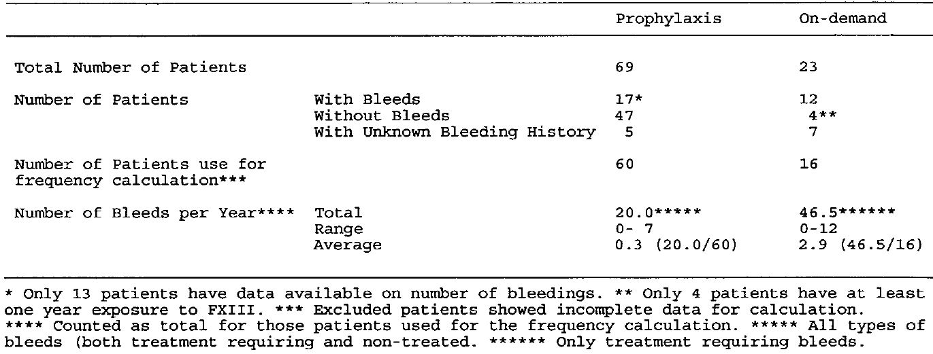
Comment: Twenty-three (23) of the 92 patients included in the retrospective analysis were treated only on-demand for the management of acute bleeding episodes, and data on 16 patients of these patients were available for analysis. In these 16 patients, 4 (25%) did not have bleeding episodes requiring on-demand treatment and 12 (75%) did have bleeding episodes requiring treatment. The number of bleeding episodes ranged from 0 to 12 per year with a mean of 2.9 episodes per year. The rate of 2.9 bleeding episodes per year in the on-demand treatment group served as a conservative estimate of the fixed placebo rate. Sixty-nine (69) of the 92 patients had a history of regular FXIII replacement therapy for bleeding prophylaxis, and data for analysis was available on 60 of these patients. Overall, the mean number of bleeds (all types, both treatment requiring and non-treatment requiring) per year for patients on regular replacement therapy was 0.33 (i.e., 20 bleeds in 60 patients).

Statistical methods

Analysis of the primary endpoint
The primary endpoint (rate of bleeding episodes requiring treatment per year) was evaluated by a Poisson model (log-link), comparing the data to a fixed placebo rate of 2.91 treatment-requiring bleeds/year, based on retrospectively collected data from patients treated only on-demand. Age was included as a continuous covariate and the total observation time during the treatment period was used as an offset in the model. The model also took into account those subjects withdrawing before the end of the trial by adjusting for the length of time under observation. The estimated rate was calculated, adjusting for overdispersion. The overdispersion was estimated by Pearson’s chi-square statistic divided by its degrees of freedom.
The null hypothesis of no difference in the bleeding rate between rFXIII treatment and on-demand treatment with FXIII containing products (defined as placebo) was to be rejected if the upper limit of the 95% CI for the yearly bleeding rate in the rFXIII group was less than 2.91. Additionally, bleeding rate was summarised by age group (<18 vs ≥18) as well as by time since last dose (<14 days vs ≥14 days). Missing values were not replaced. Consequently, in cases of missing values that were not possible to retrieve through data query, the number of observations for the variable in question was lower than the number of patients. There were no changes to the Statistical Analysis Plan (SAP) and all analyses were conducted in accordance with the SAP.

Analysis of the secondary endpoints
The percentage of subjects without ”bleeding episodes requiring treatment” with FXIII-containing products was evaluated by a binomial model including age as a covariate, comparing the data to a fixed placebo probability of whether or not subjects were experiencing any treatment-requiring bleedings. The fixed placebo probability was based on historical data collected from patients with congenital FXIII deficiency requiring on-demand treatment. The probability of not having a bleeding episode requiring treatment for subjects treated on-demand was estimated by a binomial model with a probability of 0.25 with a 95% CI of 0.10, 0.51. It was to be concluded that monthly replacement therapy with rFXIII was superior to on-demand treatment with FXIII containing products (defined as placebo) if the probability of not having any treatment-requiring bleeding episodes for the rFXIII group (p) was greater than 0.25. The null hypothesis of no difference between rFXIII and placebo was rejected if the lower limit of the 95% CI for p was ≥ 0.25. Missing values were not replaced. There were no adjustments for multiplicity of testing.

Participant flow
The subject disposition is summarised below in Table 9.
Table 9: Subject disposition.
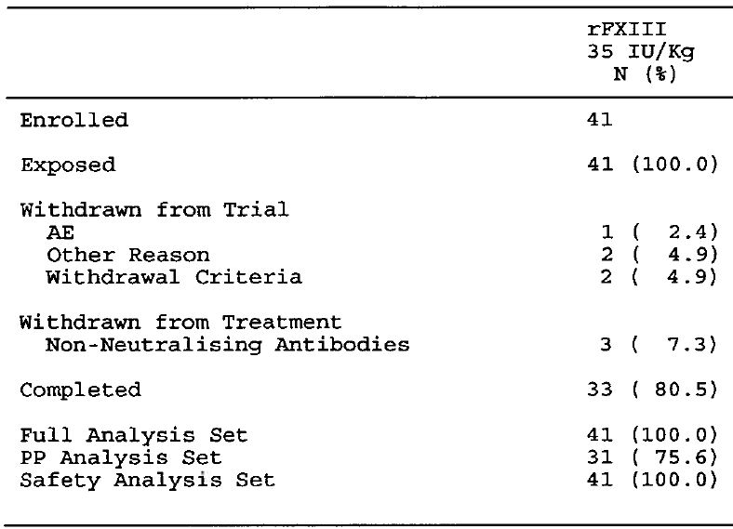
Comment: A total of 41 patients were enrolled and exposed to rFXIII, and of these 5 were withdrawn from the study: 1 withdrawn by the parents at visit 5 because parents and subject felt that there were too many blood samples; 1 withdrawn by the investigator after visit 6 due to worsening of neutropenia and leukopenia; 2 became pregnant and were withdrawn after visits 11 and 14; 1 withdrew after visit 9 for personal reasons. In addition, 3 patients were withdrawn from treatment due to development of antibodies, but remained in the trial for safety monitoring purposes. The remaining 33 patients completed the pre-defined treatment period and entered the extension study (F13CD-3720).

Major protocol violations/deviations
All trial participants met the inclusion criteria and none fulfilled any of the exclusion criteria. All patients were included in the FAS and no patients were excluded due to major protocol deviations. In addition to withdrawal from treatment or the study, 2 patients were excluded from the PP analysis due to major protocol deviations: 1 received preventive pdFXIII during hospitalization eventhough no bleeding was present; 1 did not receive trial product at visit 4.

Baseline data
The baseline demographics of the patients in the FAS are summarised below in Table 10. The racial identity of French patients was marked as “unknown” in accordance with national guidelines. Of the 41 patients, 15 were aged ≤ 18 years and of these 9 were aged ≤ 12 years. Of the 41 patients, 33 received all 13 planned monthly doses of rFXIII with the mean (SD) number of doses being 11.5 (13.9) and the median (range) number of doses being 13 (2, 24).
Table 10: Baseline demographics; FAS.
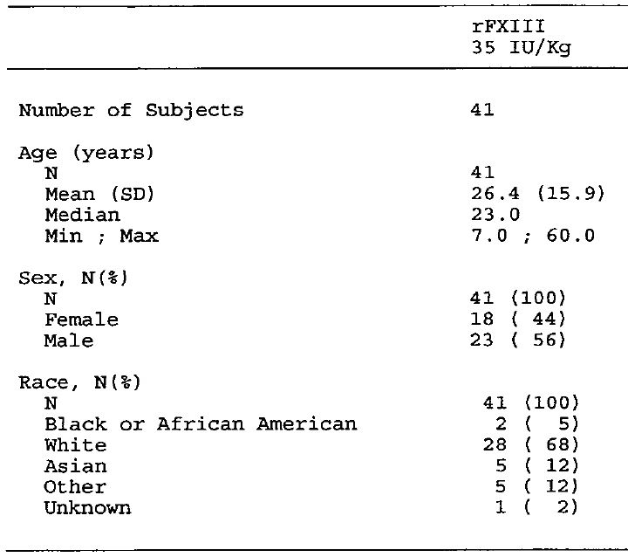
FXIII A-subunit deficiency was confirmed for all patients. One (1) patient also had a heterozygous missense mutation in the F13B gene of unknown significance. A variety of mutations were identified (e.g., splice mutations, missense mutations, nonsense mutations, insertions, deletions). The majority or mutations were indicative of severe disease and consistent with the low level of FXIII activity at the time of diagnosis. All patients except two had received regular replacement therapy with FXIII containing products prior to enrollment in the study. Of the 41 patients in the FAS, 31 had concomitant illnesses of various types (including hepatitis C).

Results for the primary efficacy endpoint
The results of the primary endpoint analysis in the FAS are summarised below in Table 11. The results showed that the age-adjusted rate (number per subject year) of bleeding episodes requiring treatment with FXIII-containing products was statistically lower than in the historical control group.
Table 11: Baseline demographics; FAS.
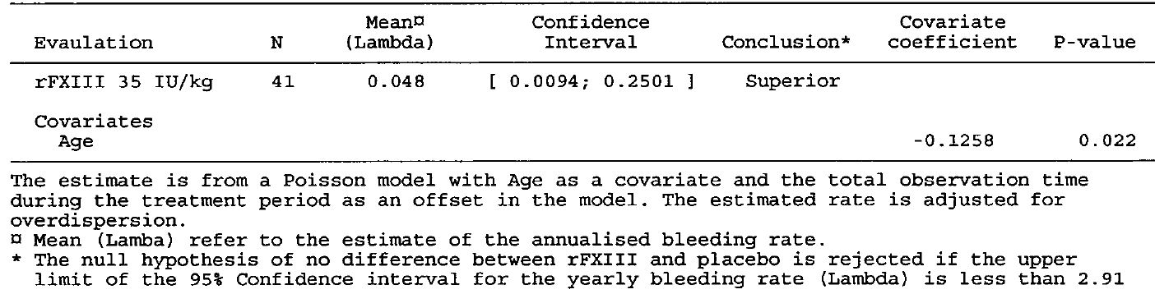
In the PP analysis set, there were 3 subjects with 4 treatment requiring treatment out of a total of 31 subjects over a mean observation period of 365 days with a mean annual bleeding rate of 0.129. The age-adjusted rate (number per subject year) of treatment-requiring bleeding from a Poisson model with age as covariate and the total observation time during the treatment period as an offset was 0.019/year (95%CI: 0.0015, 0.2368). The results were statistically significant as the upper 95%CI (0.2501/year) was less the fixed placebo rate (0.291/year). Age was a significant covariate (covariate co-efficient -0.1762, p=0.023).
The raw data for bleeding episodes requiring treatment with FXIII-containing products are summarised below in Table 12.
Table 12: Treatment requiring bleeding episodes; FAS.
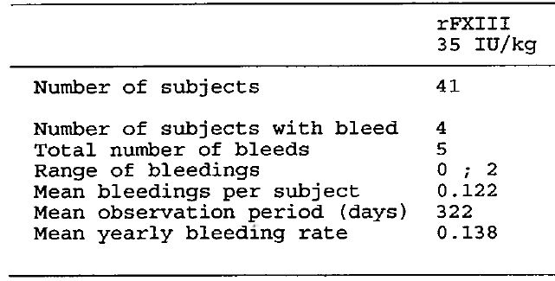
During the rFXIII treatment period (mean observation period of 322 days), 5 bleeding episodes requiring treatment with a FXIII-containing product (i.e., treatment-requiring bleeds) were observed in 4 patients. All 5 events were traumatic bleeding events and are summarised as follows: 1 patient (ID 12001) aged 8 at baseline – bleeding lip following a fall, 15 days after last rFXIII dose, treated with 1 dose of Fibrogammin; 1 patient (ID 12002) aged 10 at baseline – two episodes of soft tissue bleeding around the elbow due to fall, 14 and 22 days after last rFXIII dose, both episodes included treatment with Fibrogammin; 1 patient (ID 12002) aged 16 at baseline – nose bleeding following dislocated fracture playing football, 5 days after last rFXIII dose, initially treated with single dose of FXIII-concentrate followed about 11 days later with a further dose given with corrective ENT surgery; 1 patient (ID 18202) aged 19 – bruises to nose and face following road traffic accident with mild nose bleeding, 27 days after last rFXIII dose, treated with Fibrogammin. No spontaneous or intracranial treatment-requiring bleeding episodes occurred during the rFXIII treatment period.
Comment: The primary endpoint analysis showed that the age-adjusted rate (number per subject year) of treatment-requiring bleeding episodes in patients with congenital FXIII deficiency treated with regular rFXIII replacement therapy was statistically significantly lower than the fixed placebo rate derived from patients requiring only on-demand FXIII treatment for bleeding episodes. The null hypothesis was rejected as the upper limit of the 95% CI for the observed rate was less than 2.91. The sponsor stated that the fixed “placebo-rate” of 2.91 treatment-requiring bleeds per year based on 16 on-demand patients from the retrospective analysis (F13CD-Quest) was agreed with the FDA during trial protocol development (Clinical Overview). The sponsor stated that the estimate of 2.91 treatment-requiring bleeds per subject year “represents and estimate of the bleeding pattern in untreated patients but is likely to be a conservative estimate of the true rate of treatment-requiring bleeding in the average untreated patient for the following reasons: Firstly, patients receiving on-demand treatment would be expected to fare relatively well clinically relative to patients on regular prophylaxis; otherwise, the former group of patients would most likely be switched to regular prophylaxis. Secondly, retrospective collection of data is prone to result in underreporting due to previous bleeding episodes being forgotten or not documented”. The choice of the fixed “placebo-rate” of 2.91 treatment-requiring bleeds per subject year from a historical on-demand congenital FXIII deficiency patient population is considered to be satisfactory, but the patient number (n=16) from which the data were derived is small.
The traumatic treatment-requiring bleeding episodes did not appear to be associated with low levels of FXIII activity. Examination of the individual FXIII profiles (Berichrom assay) showed that FXIII activity levels at the time of bleeding were approximately 0.4 IU/mL to 0.7 IU/mL in the 4 subjects with an event. There was no obvious correlation between treatment-requiring bleeding and FXIII activity in the 4 patients with treatment-requiring bleeding. Data in Module 2 (Summary of Clinical Efficacy) states that mean pre-dose trough FXIII activity level was 15.9% (calculated from 1 IU/mL = 84%). Consequently, it can be estimated that FXIII activity was > 30% in each of the 4 subjects at the time of the treatment-requiring treatment event.
In this study, the screening visit (Visit 1) was planned at 4 weeks ± 2 days before the baseline visit (Visit 2) when the first dose of rFXIII was administered. For subjects treated with regular replacement therapy before entering the trial, the screening visit was scheduled to be the same day as the subject was scheduled for administration of their usual FXIII replacement dose. Therefore, based on a half-life of approximately 11 days, the “wash-out period” of 4 weeks (± 2 days) may have been too short to ensure complete elimination of FXIII product prior to the first dose of rFXIII, and a carry-over effect might have been present between the first and second dose during the first month of treatment. The EMA assessment report, provided in the submission, includes a modified analysis of bleeding rates excluding data from the first month of treatment. This analysis showed that Poisson-based bleeding rate was 0.053/year (95% CI: 0.010, 0.272); 5 bleeding events in 41 patients; mean observation period was 294 days; crude bleeding rate 0.151/year. The upper 95% CI of the Poisson-based bleeding rate was 0.272, which is less than the fixed placebo rate of 2.91 treatment-requiring bleeds/subject/year. Therefore, the mean yearly bleeding rate (Poisson-based) for the modified analysis was still statistically significant compared with the historical data for patients treated on-demand.
The mean age of the patients in the trial was 26.4 years, and the ages of the patients with treatment-requiring bleeds were 8, 10, 16, and 19 years. This suggests that in this trial there was a tendency for treatment-requiring bleeding events to occur in younger rather than in older patients. This is consistent with the covariate of age in the primary endpoint analysis being statistically significant (p=0.022). The mean yearly bleeding rate (FAS) in subjects aged < 18 years was 0.362 compared with 0.040 in subjects aged ≥ 18 years. However, the sponsor comments that all treatment-requiring bleeding events were due to trauma and such events are more likely to occur in children and adolescents than in older individuals. The age distribution of the 16 patients in the retrospective study who received on-demand FXIII treatment was comparable to the age distribution of the FAS, which effectively excludes the risk of significant bias due to age in the comparison of bleeding rates. The age characteristics of the 16 patients in the retrospective study from which the fixed placebo rate was derived were mean 31.7 years and median 32.0 years (range: 6, 63 years).
The times since last dose for the treatment-requiring bleeding events were 5, 14, 15, and 22 days. The mean yearly bleeding rate (FAS) for events requiring treatment occurring < 14 days since last dose was 0.051 compared with 0.242 for events requiring treatment occurring ≥ 14 days since last dose. There were 3 subjects with 4 events occurring < 14 days since last dose and 1 subject with 1 event occurring ≥ 14 days since last dose.
The study report also provided a summary of all bleeding episodes (traumatic or spontaneous) irrespective of whether the episodes required treatment with FXIII-containing products. The listings showed that 20 (48.8%) subjects in the FAS experienced at least one bleeding episode, and 59 bleeding episodes were reported overall. Therefore, there were 59 bleeding episodes (all) in 41 patients in the FAS giving a crude rate of 1.4 bleeding events/patient. There are no data from the retrospective analysis (F13CD-Quest Report) on the total number of bleeds (all) in the treatment on-demand population. However, the data from the retrospective analysis indicates that there were 20 break-through bleeds (all events) per year in the prophylaxis population of 60 patients giving an average of 0.3 bleeds per year (20 bleeds in 60 patients). In summarising the results of F13CD-1725, the sponsor states that the age-adjusted mean bleeding rate (number per subject) of 0.048/year (95%CI: 0.0094, 0.251) was similar to or lower that the rate for patients on regular replacement therapy of “0.3 treatment-requiring bleeds/year”. However, F13CD-Quest indicates that the bleeding rate of 0.3/year relates to all break-through bleeding events. Therefore, it is considered that the comparison (F13CD-1725 vs F13CD-Quest) should be between all break-through bleeding events, spontaneous and traumatic, and irrespective of whether treatment with FXIII-containing products was required.

Secondary efficacy endpoint analyses

Percentage of subjects without “bleeding episodes requiring treatment” with a FXIII-containing product during the treatment period.
Of the 41 patients in the FAS, 37 did not experience any treatment-requiring bleeding episode during the trial. The mean (SE) probability of the 41 patients in the trial not experiencing a treatment-requiring bleeding episode was 0.9581 (1.1045) per year, with a 95% CI of 0.7242, 0.9950. Based on retrospectively collected data from patients receiving on-demand treatment, the probability of not having any treatment-requiring bleeding during the entire observation period was 0.25 (binomial model estimate). However, due to the variable length of the observation periods for the retrospectively followed patients the probability estimates for these patients are not directly comparable with those for the patients in the trial.

Rate (number per subject year) of spontaneous “bleeding episodes requiring treatment” with a FXIII-containing product during the rFXIII treatment period.
No patients with spontaneous bleeding episodes requiring treatment with a FXIII containing product during the treatment period.

Rate (number per subject year) of traumatic “bleeding episodes requiring treatment” with a FXIII-containing product during the rFXIII treatment period.
All bleeding events requiring treatment with a FXIII-containing produce were traumatic (see Tables 13 and 14 above).

Rate (number per subject year) of intracranial “bleeding episodes requiring treatment” with a FXIII-containing product during the rFXIII treatment period.
No patients with intracranial bleeding episodes requiring treatment with a FXIII-containing product during the treatment period.

Percentage of subjects having normal clot solubility one hour after rFXIII administration and 28 days after rFXIII administration.
The results have been discussed in the ‘Pharmacokinetics’ section of this CER.

Number of subjects withdrawn from the trial due to lack of efficacy of rFXIII treatment.
No patients withdrawn from the trial due to lack of efficacy or rFXIII treatment.

Level of FXIII activity one hour after rFXIII administration and 28 days after rFXIII administration.
The results have been discussed in the ‘Pharmacokinetics’ section of this CER.

Extension (F13CD-3720) to the pivotal study (F13CD-1725)

Study design, objectives, locations, and dates
Study F13CD-3720 is a safety extension study to F13CD-1725, and is intended to document long-term safety of monthly replacement therapy with rFXIII in patients previously exposed to rFXIII in the pivotal trial. To expand the safety database, the F13CD-3720 protocol was amended to allow inclusion of additional patients into the study who had not participated in study F13CD-1725. The extension study is sponsored by Novo Nordisk, Denmark, and was initiated on 21 September 2009. As of 7 April 2011 (date of preliminary report), the study had not been completed and the cut-off date for the preliminary report was 11 February 2011. The data included in the CSR included only those patients who completed the pivotal study. The study was conducted in accordance with the Declaration of Helsinki and the principles GCP outlined in the relevant ICH guidelines.
The objectives of the extension study were to assess the long-term safety (primary objective) and efficacy (secondary objective) of monthly replacement therapy with rFXIII when used for prevention of bleeding episodes in subjects with congenital FXIII deficiency. In this section of the CER, only the secondary objective (efficacy) will be reviewed.
Overall, the design of the extension study was similar to that of the pivotal study (i.e., single-arm, open-label, 35 IU/kg rFXIII administered every four weeks [28±2 days] by slow iv injection). All patients who completed the pivotal study were offered enrollment in the extension study, and following a protocol amendment additional patients who had not been enrolled in the pivotal study could be recruited. Of the 23 actively recruiting sites for the pivotal study, 4 sites did not enrol patients into the extension study (3 sites in the USA and 1 site in Israel). The extension study included a total of six substantial amendments implemented after initiation of patient enrolment (Amendments Numbers 4 to 9). These amendments have been examined and are considered unlikely to have affected the validity of the study.

Inclusion and exclusion criteria
The inclusion criteria for patients who had been enrolled in the extension study following completion of the pivotal study were: informed consent; previous participation in FCD12-1725 (up to an including Visit 16 [end-of-trial]); and negative pregnancy test at screening (if relevant). The inclusion criteria for all other subjects (i.e., not previously enrolled in FCD13-1725) were: informed consent; diagnosis of congenital FXIII A-subunit deficiency (confirmed by genotyping at screening visit or documented results from previously performed genotyping); aged ≥ 6 years with a weight ≥ 20 kg; and negative pregnancy test (if relevant). The exclusion criteria are summarised. In addition to protocol specified inclusion and exclusion criteria, the study also included standard criteria for withdrawal, which were basically the same as those for study F13CD-1725.

Study treatments
Treatment was the same as that for the pivotal study (i.e., rFXIII 35 IU/kg; fourth weekly [28±2 days] iv injection). In the early phase of the study the administered drug substance was produced by Avecia (rFXIII_{Avecia}), and during the trial the Novo Nordisk produced drug substance was introduced (rFXIII_{NN}).

Efficacy variable and outcomes

Efficacy variables (secondary objectives)
Evaluation of efficacy of rFXIII in preventing bleeding episodes was the secondary objective of the study. Efficacy was assessed by bleeding episodes, divided into treatment-requiring bleeding episodes (the primary endpoint of study F13CD-1725), and non-treatment requiring bleeding episodes. Details of all bleeding episodes were recorded at scheduled visits as well as at unscheduled visits, the latter in case of treatment-requiring bleedings. Collected information about bleeding episodes was identical to that in F13CD-1725, except for addition of details on surgical bleeding episodes and for addition of case descriptions and severity ratings of all bleeding episodes. These latter two assessments were added to the extension study by protocol amendment.
Mild/moderate bleeding events were defined as uncomplicated bleeds. Severe bleeding events were defined as all bleeds into the central nervous system, head, neck, throat and gastrointestinal tract, persistent haematuria, forearm/calf bleed with suspicion or evidence of compartment syndrome, bleeds into retroperitoneum, hip or inguinal area, suspected ileopsoas haemorrhage and bleedings that resulted from severe trauma or major surgery. All mild or moderate bleedings that had not had stopped after 24 hours were recategorised as severe bleedings.

Efficacy endpoints (secondary)
The secondary efficacy endpoints were:
- Rate of bleeding episodes (number per subject year) requiring treatment with a FXIII containing product during the rFXIII treatment period: spontaneous bleeding episodes; traumatic bleeding episodes; and intracranial haemorrhages.
- Number of patients withdrawn from the trial due to lack of efficacy of rFXIII (as judged by the investigator).

Randomization and blinding methods
The study was neither randomised nor blinded.

Analysis populations
All analyses were performed on the full analysis set (FAS), which was identical to the safety analysis set. As in F13CD-1725, all patients who received at least one dose of trial product were included in the FAS. Data from patients who discontinued the study for any reason were included in the analysis up to the point of discontinuation. All withdrawn patients were excluded from the per protocol (PP) analysis set. No analyses on the PP population were included in the submitted preliminary report.

Sample size
Sample size was partly determined by the number of patients completing FCD13-1725 (n=33). Approximately 10-20 additional patients are expected to be enrolled, and the sponsor considers that this will “contribute substantially to the documentation of the long-term safety of monthly replacement therapy with rFXIII”. All 33 patients included in the extension study had completed F13CD-1725.

Statistical methods
No formal testing of statistical hypotheses was performed. The number of bleeding episodes requiring treatment was evaluated by a Poisson model (log-link) similar to the model used in the evaluation of efficacy in F13CD-1725. The remaining efficacy endpoints were summarised descriptively. Interim analyses were planned to take place when all patients had been exposed to rFXIII_{NN} for at least 3 and 6 months. An additional interim analysis covering all endpoints is planned to take place when all patients have completed 52 weeks of treatment. The submitted preliminary report included results obtained after at least 6 months of treatment.

Participant flow
All 33 patients who completed F13CD-1725 were enrolled and exposed to trial drug in F13CD-3720 (see Table 13). Of the 33 enrolled and dosed patients, 3 patients were withdrawn from the study (1 withdrawn by the investigator after 3 doses of rFXIII due to pregnancy [i.e., withdrawal criteria]; 1 withdrew consent after 4 doses of rFXIII due to a wish to become pregnant; 1 withdrew after 13 doses due to relocation of the clinical trial site). As of the cut-off date of 11 February 2011, no subjects had completed the trial. Two (2) patients received rFXIII_{Avecia} only and 7 patients received FXIII_{NN} only.
Table 13: Subject disposition.
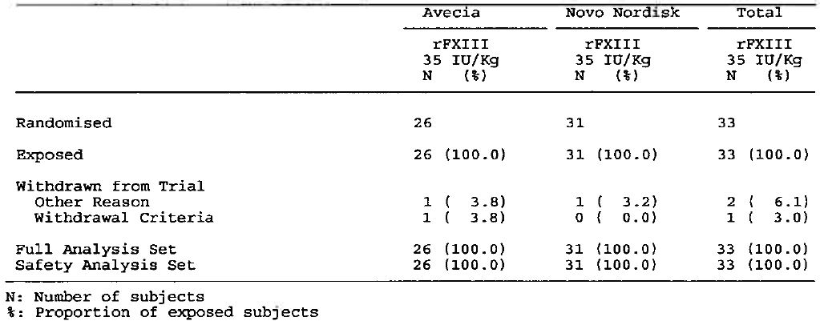

Major protocol deviations
There were 3 notable protocol deviations relating to dosing: 1 patient, one occasion 0.4 mL of the dose tissued; 1 patient, one occasion drug reconstituted with normal saline and 2.1 mL administered instead of 2.2 mL; 1 patient, one occasion drug was reconstituted with 1.3 mL of saline and 2505 IU of the drug was administered instead of correct dose of 1086 IU.
Comment: These protocol violations are unlikely to have invalidated the efficacy results.

Baseline data
The baseline demographic data are summarised below in Table 14. Baseline data for haematology, biochemistry, urinalysis, coagulation factors and vital signs for the 33 patients included in the extension study were representative of the 41 patients included in the preceding pivotal study.
Table 14: Baseline demographics; FAS.
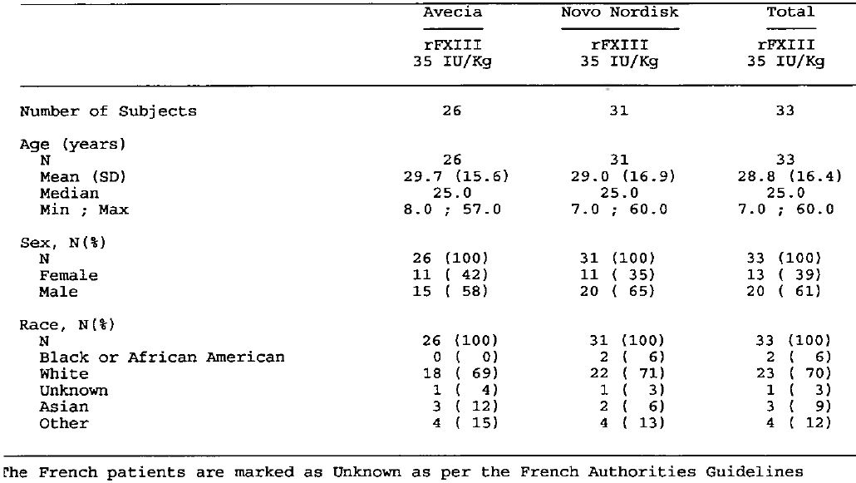

Efficacy results

Bleeding endpoints – Rate of treatment-requiring bleeds
Treatment-requiring bleeding episodes during treatment with rFXIII are summarised below in Table 15.
Table 15: Treatment-requiring bleeding episodes; FAS.
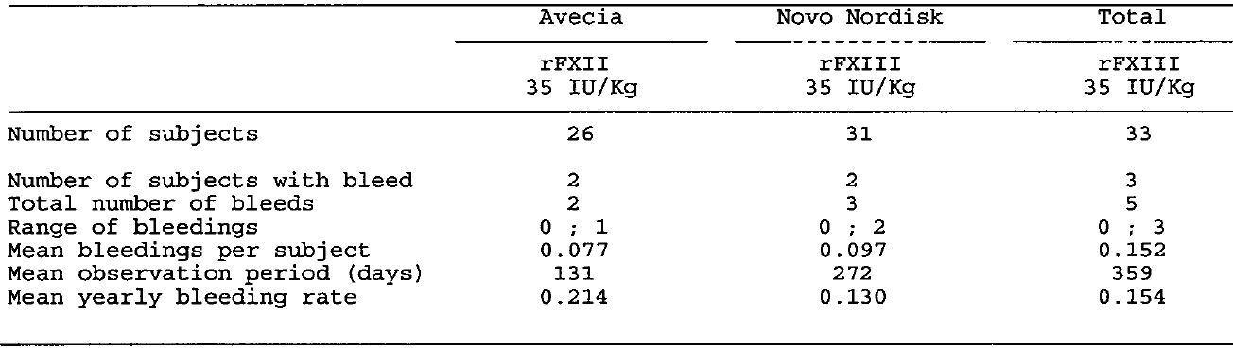
During the extension period (mean observation period 359 days), 5 bleeding episodes requiring treatment with a FXIII-containing product were reported in 3 patients. Of the 5 treatment-requiring bleeding episodes, 3 occurred spontaneously with an onset between 13 and 19 days after rFXIII dosing. No intracranial bleeds were recorded. The treatment-requiring bleeding events are summarised below in Table 16.
Table 16: Details of treatment-requiring bleeding episodes; FAS.
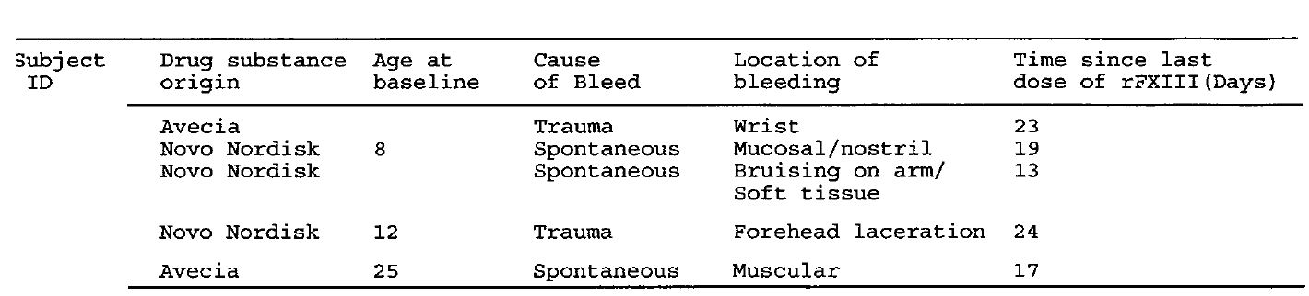
The age-adjusted rate (number per subject year) of treatment-requiring bleeds during the rFXIII treatment period was 0.038/year (95%CI: 0.0034, 0.4435); model based estimate corresponding to the mean age of the trial population of 28.8 years (Table 17). The upper 95% CI (0.4435) was less than 2.91 (i.e., null hypothesis rejected).
Table 17: Rate of treatment-requiring bleeding episodes; FAS.
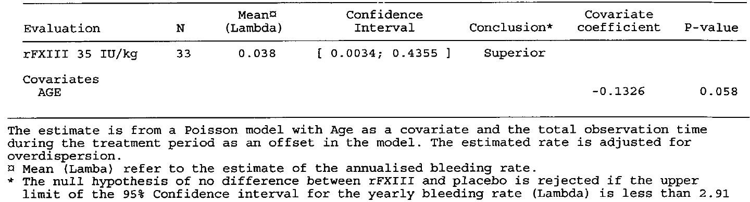
FXIII activity (Berichrom assay) was measured prior to rFXIII administration in the extension period, and only two values were below 0.10 IU/mL. The individual FXIII activity profiles of the 3 patients with bleeding episodes requiring treatment in the extension study do not suggest that these bleeds were associated with particularly low FXIII activity levels.
Comment: The age-adjusted rate (number per subject year) of treatment-requiring bleeds in the extension study of 0.038/year was similar to that in the pivotal study of 0.048/year. The results support the long-term efficacy of rFXIII based on age-adjusted rates (number per subject year) for bleeding events requiring treatment with a FXIII-containing product. FXIII activity was between approximately 0.25 IU/mL and 0.6 IU/mL at the time of the treatment-requiring bleeding episode in each of the 3 patients with events, suggesting that there is no correlation between low FXIII activity and treatment-requiring bleeding episodes.

Other efficacy endpoints

Bleeding requiring treatment by age group
In the 10 subjects aged < 18 years (FAS), 2 subjects experienced 4 bleeding events requiring treatment with a FXIII-containing product resulting in a mean yearly bleeding rate of 0.421 (mean observation period 347 day). In the 23 subjects aged ≥ 18 years, 1 subject had 1 bleeding event requiring treatment with a FXIII-containing product resulting in a mean yearly bleeding rate of 0.044 (mean observation period 364 days). The difference between the yearly bleeding rates in the small number of patients with bleeding events in the two populations stratified by age suggests that bleeding events requiring treatment with a FXIII-containing product occurred more commonly in patients aged < 18 years than in patients aged ≥ 18 years. The covariate co-efficient in the Poisson model with age as a covariate indicates that there was no statistically significant difference between the two age groups as regards the annualized bleeding rate (p=0.058). Overall, it is considered that the patient numbers in the two subgroups are too small to allow satisfactory statistical comparison.

Bleeding requiring treatment by time since last dose
The mean yearly bleeding rate occurring < 14 days since last dose was 0.061 (1 subject, 1 bleeding event) compared with 0.250 (3 subjects, 4 events) for events occurring ≥ 14 days since last dose.

No bleeding episodes requiring treatment
Of the 33 patients in the FAS, 30 (90.9%) did not experience any bleeding episodes requiring treatment with FXIII-containing products during the study. The mean probability of not experiencing a bleeding episode requiring treatment was 0.9544 (SE 1.1213) (95% CI: 0.6991, 0.9947).

Spontaneous bleeding episodes requiring treatment
Of the 33 patients in the FAS, 2 patients experienced 3 spontaneous bleeding episodes requiring treatment with FXIII-containing products. The mean yearly bleeding rate for spontaneous bleeding episodes requiring treatment was 0.092 (mean observation period of 359 days).

Traumatic bleeding episodes requiring treatment
Of the 33 patients in the FAS, 2 patients experienced 2 traumatic bleeding episodes requiring treatment with FXIII-containing products. The mean yearly bleeding rate for traumatic bleeding episodes requiring treatment was 0.062 (mean observation period of 359 days).

Intracranial bleeding episodes requiring treatment
There were no intracranial bleeds requiring treatment with FXIII-containing products reported during the trial.

Lack of efficacy
There were no patients withdrawn due to lack of efficacy of rFXIII treatment.

All bleeding episodes
There were 11 (33.3%) patients in the FAS who experienced at least one bleeding episode (all), irrespective of whether or not treatment was required. Of the 11 patients with at least one bleeding episode (all) during the study, 3 patients experienced bleeds requiring treatment with a FXIII-containing product and 8 patients experienced bleeds not requiring treatment with a FXIII-containing product. The crude bleeding rate for patients in the FAS was 0.6 bleeding events/patient (i.e., 20 episodes in 33 patients).

Evaluator’s overall conclusions on efficacy
The efficacy of rFXIII was supported by one pivotal study (F13CD-1725) in 44 patients with congenital FXIII deficiency, and interim data from one extension study (F13CD-3720) in 33 patients continuing from the pivotal study. Of the 41 patients in the pivotal study, 33 received all 13 planned monthly doses of rFXIII with the mean (SD) number of doses being 11.5 (13.9) and the median (range) number of doses being 13 (2, 24). Of the 33 patients continuing treatment in the extension phase the median observation period was 359 days.
The patient numbers supporting the efficacy of rFXIII are very small. However, this is not unexpected for a submission seeking registration of an orphan drug and is therefore considered to be acceptable. The sponsor stated that “the 41 patients recruited into the F13CD-1725 Phase III trial represent approximately 6-10% of the worldwide pool of diagnosed patients.”
The pivotal clinical study was open label and single arm in design with the primary efficacy endpoint of the rate of bleeding episodes requiring treatment with RFXIII containing products being compared with data from a historical control. The number of patients in the historical control with on-demand treatment with FXIII containing products for bleeding episodes used to calculate the fixed “placebo” rate was only 16 compared with 60 in the prophylaxis group who received regular prophylaxis with RFXIII containing products. The difference in patient numbers between the two historical treatment groups reflects the fact that regular treatment with FXIII containing products for prophylaxis rather than on-demand treatment is standard therapy for congenital FXIII deficiency.
The absence of a control group (which in this case would need to be active treatment with a rFXIII containing product), lack of randomisation and lack of double blinding exposes the trial to the well-known biases of studies without these design elements. However, the primary endpoint of the pivotal of trial of a bleeding episode requiring treatment with a FXIII containing product is considered to be a reasonable and clinically relevant end point, but is subject to potential inter subject variability due to differences in clinical practice among the trial centres. Overall, the design of the pivotal trial is considered to be acceptable for an orphan drug for a condition with such a low prevalence rate in the general population (1 patient per 2-5 million people).
The pivotal clinical study satisfactorily demonstrated the efficacy of rFXIII compared with a historical control based on a lower yearly rate of bleeding episodes requiring treatment with a FXIII containing product (treatment requiring bleeding). In the pivotal trial, rFXIII was administered once monthly (28 ± 2 days) at a dose of 35 IU/kg to patients (n = 41) with congenital FXIII deficiency and the age adjusted rate (number per subject year) of treatment requiring bleeding episodes was 0.048/year (95% Confidence Interval [CI]: 0.0094, 0.2501). The upper 95% CI of this rate (0.2501) was less than 2.91, which was the yearly treatment requiring bleeding rate in the on-demand historical control group. Consequently, the age adjusted rate (number per subject year) for treatment requiring bleeding episodes was determined to be statistically significantly lower in patients in the pivotal study compared with the historical control group. In the pivotal study there were 5 treatment requiring bleeding events (all traumatic) in 4 patients. The estimated mean probability of a subject not having any treatment requiring bleeding in the pivotal study was 0.9851/year (95% CI: 0.7242, 0.9950). In the pivotal study, age was a significant covariate the annualised treatment requiring bleeding rate (p = 0.022), and the subgroup comparison suggested that patients aged < 18 years were at a greater risk of treatment requiring bleeding than patients aged ≥ 18 years.
The extension study showed that efficacy could be maintained long term, based on the age adjusted rate (number per subject year) of treatment requiring bleeding episodes. The age adjusted rate (number per subject) of treatment requiring bleeding episodes was 0.038/year (95% CI: 0.0034, 0.4355), and the upper 95% CI (0.4355) was less than 2.91 indicating that the observed rate was statistically significantly lower compared with the historical control group. In the extension study there were 5 treatment requiring bleeding events (3 spontaneous, 2 traumatic) in 3 patients. In the extension study, age was not a statistically significant covariate (p = 0.058), but the total number of treatment requiring bleeding episodes (5 events in 3 patients) was too low to satisfactorily compare the results in patients aged < 18 years and ≥ 18 years.
A limitation of the pivotal and extension studies relates to the lack of adequate characterisation of break through bleeding (all) occurring during the rFXIII treatment period. In the pivotal study there were 59 bleeding episodes (traumatic or spontaneous; irrespective of FXIII containing treatment) in 20 of the 41 patients in the FAS. These figures give a crude bleeding rate of 1.4 events/patient. In the extension study, there were 20 bleeding episodes (all) in 33 patients in the FAS, giving a crude bleeding rate of 0.6 events/patient. No estimated yearly rates for all break through bleeding events in the two studies could be identified in the submitted data. The sponsor stated that the age related rate (number per subject year) of treatment requiring bleeding episodes in the pivotal study (0.048/year [95%CI: 0.0094, 0.2501]) was similar to, or lower than that in the historical control patients treated with regular FXIII containing products (0.3/year). However, the bleeding rate of 0.3/year derived from the patients in the retrospective analysis (F13CD-Quest) appears to relate to all break through bleeding episodes rather than just treatment-requiring bleeds. In a small published retrospective study, the rate of spontaneous bleeding during regular Fibrogammin P therapy was estimated to be 0.2 events/year compared with 2.5 events/year for patients not on prophylactic therapy calculated from a historical control.
In the pivotal and extension studies, there were a total of 10 treatment requiring bleeds at the cut off date of 11 February 2011, and these occurred post dose on Days 5, 13, 14, 15, 17, 19, 22, 23, 24 and 27 (that is, on average 17.9 days after rFXIII administration). The onset of the treatment requiring bleeds are skewed towards those occurring ≥ 15 days after dosing (7 bleeds) compared with those < 15 days after dosing (3 bleeds). This is consistent with FXIII activity being lower ≥ 15 days after dosing compared with < 15 days after dosing. However, information on the FXIII activity level at the time of bleeding was not available to the physician when deciding whether or not to treat with a FXIII containing product. Therefore, the association between treatment requiring bleeds and FXIII activity level is confounded by the fact that the decision to dose may have been influenced by knowledge of the date of the preceding dose (that is, a longer time interval between dosing and bleed might provide greater motivation to administer a FXIII containing product than a shorter time interval).
Treatment requiring bleeding reported in the pivotal study (5 episodes in 4 patients) and the extension study (5 episodes in 3 patients) were not correlated with low FXIII activity levels. In both studies, treatment requiring bleeding generally occurred at FXIII activity levels of ≥ 0.3 IU/L (that is, ≥ 25%). The dosage regimen of monthly administration of 35 IU/kg rFXIII resulted in mean pre dose “trough” FXIII activity levels of 15.9% and 18.2% in the pivotal and extension trials, respectively. Levels of FXIII activity down to 3% to 10% are considered sufficient to prevent spontaneous haemorrhage in most patients, but bleeding events have been reported at higher FXIII activity levels.
The submission did not include clinical studies assessing the efficacy of rFXIII specifically in a paediatric population with congenital FXIII A subunit deficiency. This is considered to be a deficiency in the submission. In the pivotal study (n = 41), the mean age of the study population was 26.4 years (SD = 15.9) with a range of 7 to 60 years, with 15 patients being aged < 18 years and 26 patients being aged ≥ 18 years. Information in the submission indicates that there is one on-going study in children aged 1 to < 6 years with congenital FXIII deficiency designed to characterise the PKs of rFXIII following a single dose (F13CD-3760), and one on going safety extension trial (F13CD-3835) in patients from F13CD-3760 designed to evaluate the long term safety (primary objective) and efficacy (secondary objective) of rFXIII administered monthly to children aged 1 to < 6 years.

Clinical safety

Studies providing evaluable safety data
The submission included safety data from 5 studies in patients with congenital FXIII deficiency, 4 studies in healthy subjects and 2 single-dose studies in patients undergoing cardiac surgery. The primary safety data relate to the patients from the pivotal trial F13CD-1725 and the long-term extension trial F13CD-3720. The safety review in this CER focuses on the data from these two studies.

Exposure
A wide range of doses was tested (2 to 89 IU/kg), but the majority of these were single-doses. The key dose for the assessment of safety is 35 IU/kg administered monthly (i.e., that being proposed for approval for the treatment of patients with congenital FXIII deficiency).

Safety: pivotal (F13CD-1725) and extension (F13CD-3720) studies

Exposure
In F13CD-1725, the mean (SD) number of doses in the 41 subjects in the study was 11.5 (3.6) and the median (range) was 13 (2, 14). Dose was delayed in 3 patients (median 1 dose), and the median delay was 13 days (range: 13, 29). There were a total of 471 exposures to rFXIII in the 41 subjects.
In F13CD-3720, the mean (SD) number of doses in the 33 subjects in the study was 13.3 (3.6) and the median (range) was 13 (3, 19). There were a total of 439 exposures to rFXIII in the 33 subjects.
The duration of exposure in the pooled safety data-set from studies F13CD-1725 and F13CD-3720 are summarised below in Figure 3.
Figure 3. F13CD-1725/3720 – Duration of exposure pooled safety data-set.
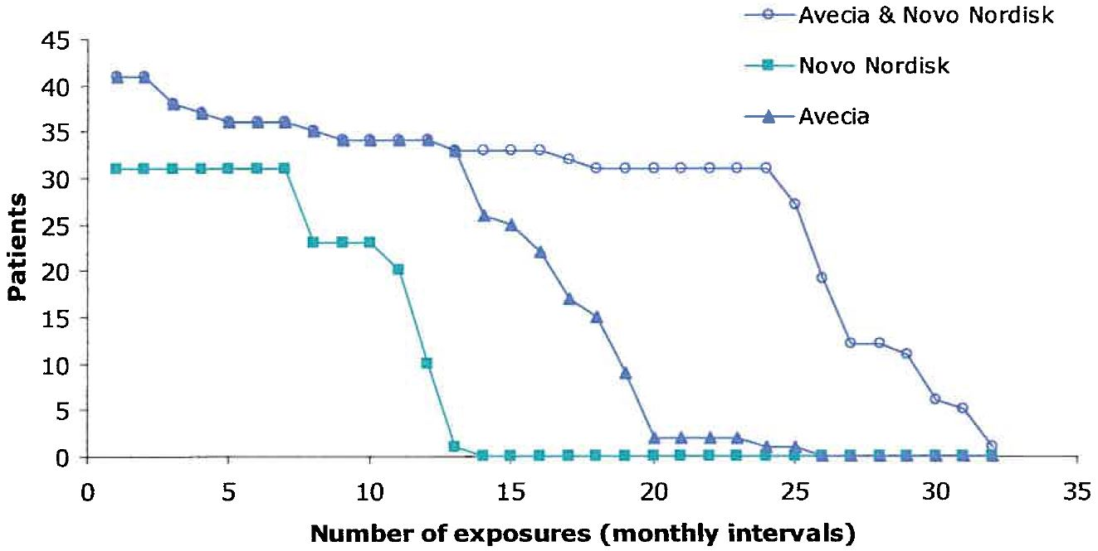

Overview of adverse events
In F13CD-1725, 41 patients completed the study and 33 of these patients entered the extension trial F13CD-3720. Treatment emergent adverse events reported in the 41 patients in the two studies combined are summarised below in Table 18.
Table 18: F13CD-1725/F13CD-3720 – Overview of treatment emergent adverse events; FAS.
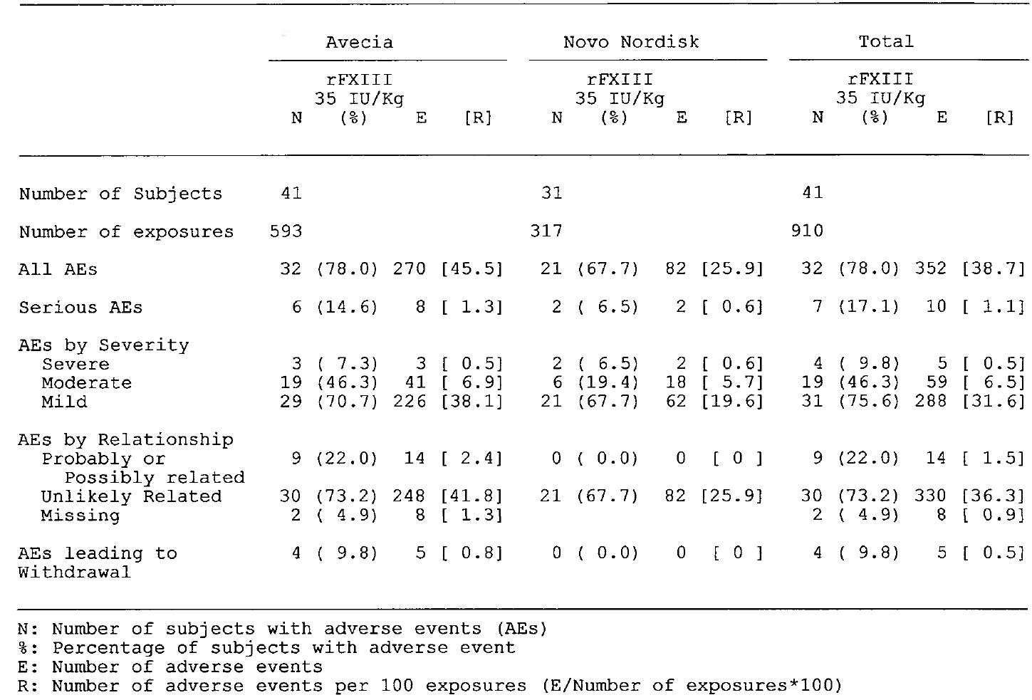
Comment: Of the 352 AEs (38.7/100 exposures) in the pooled safety data-set, 231 occurred in the pivotal study (49.1/100 exposures) and 121 occurred in the extension study (27.6/100 exposures).

Adverse events

AEs irrespective of relationship to study treatment
An adverse event (AE) was defined as any undesirable medical event reported as occurring in a subject, irrespective of whether or not related to the trial product. This definition included events occurring from the first trial-related activity after the subject had signed the informed consent until the end of the post-treatment follow-up period as defined in the protocol. All AEs observed by the investigator or reported spontaneously by subjects were recorded by the investigator and evaluated. In addition, at each contact with the site subjects were asked if they had experienced any AEs since the last evaluation. The investigator was to record the diagnosis if available and if no diagnosis was available, each sign and symptom was to be reported as individual AEs. The investigator was required to report serious adverse events to Novo Nordisk within 24 hours, with follow-up written advice within 5 days.
AEs such as medication errors, antibody formation and suspected transmission of infectious agents via trial product were, by default, considered to be medical events of special interest. In addition, all thromboembolic events were defined as medical events of special interest due to the theoretical risk of thromboembolic events associated with the mechanism of action of rFXIII. These included myocardial infarction, pulmonary embolism, cerebral thrombosis/infarction, and other significant thromboembolic events including visceral arterial embolus/thrombus, extremity arterial embolus/thrombus, portal venous thrombosis or deep venous thrombosis of extremity veins. Superficial thrombophlebitis was not considered a thromboembolic event, but was to be reported as an AE. AEs (preferred terms) occurring in ≥ 10% of patients are summarised below in Table 19.
Table 19: F13CD-1725/F13CD-3720 – Overview of treatment emergent adverse events; FAS.
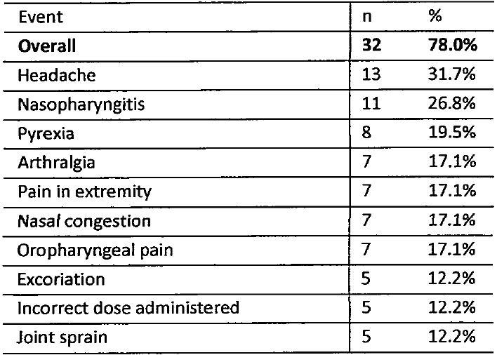

AEs considered to be causally related to rFXIII
In the pooled safety data-set there were a total of 14 AEs in 9 patients evaluated by the investigator to be possibly or probably related to rFXIII (Table 20).
Table 20: F13CD-1725/3720 – Adverse events, possibly or probably related to rFXIII.
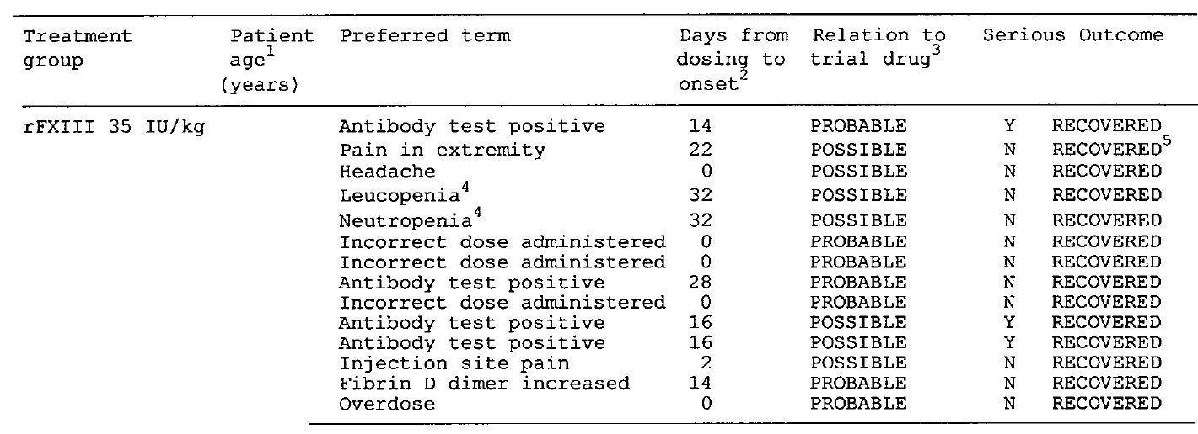
Comment: Full recovery occurred for all 14 events considered to be possibly or probably related to rFXIII. In 1 patient, one event of pain in extremity (both legs) had not recovered at the end-of-trial visit approximately two months after onset of the event, but had recovered approximately 10 months after onset of the event. Of the 14 possibly or probably related events, 4 events concerned development of low-titre, non-neutralizing anti-rFXIII antibodies following exposure to rFXIII. Coinciding and possibly related adverse events of worsening of neutropenia and leukopenia were reported in 1 patient. The patient had mild neutropenia (neutrophil count: 1200/μL; normal range: 2500-7500/ μL) before the initial trial drug administration. The neutrophil count dropped to 940/μL at Week 12, at which point the patient was withdrawn from the trial. The neutrophil count at the end-of-trial visit at Week 16 remained suppressed at 1350/μL.

Death and other serious adverse events (SAEs)
No deaths occurred in the pivotal or extension studies. There were a total of 10 SAEs recorded in 7 patients, and except for 3 SAEs of anti-rFXIII antibodies, all events were evaluated by the investigator as being unlikely to be related to rFXIII (Table 21).
Table 21: F13CD-1725/3720 – Serious adverse events.
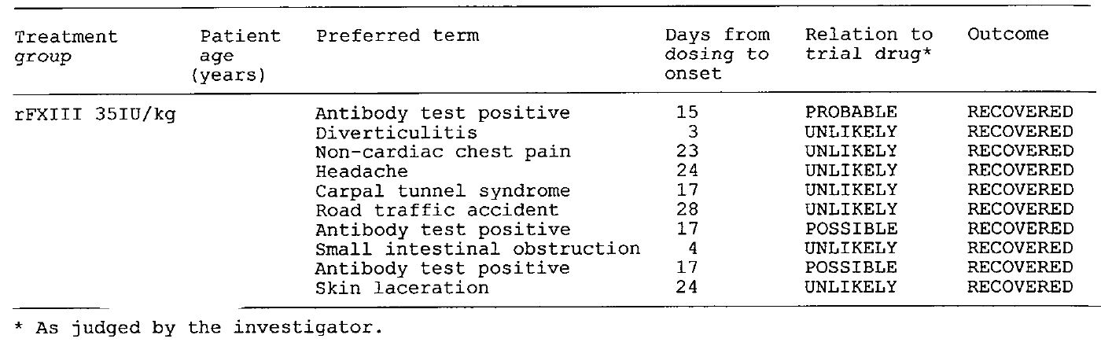

Discontinuations due to adverse events
There were 4 (9.8%) patients who discontinued prematurely due to AEs, and all 4 discontinuations occurred from the pivotal study. Three (3) patients were withdrawn due to the detection of non-neutralising antibodies, and 1 patient was withdrawn due to worsening of both leukopenia and neutropenia.

Other significant adverse events

Immunogenicity

Anti-rFXIII antibodies
As rFXIII is structurally identical to the endogenous FXIII A2-subunit dimer, there is a potential risk that anti-rFXIII antibodies might cross-react with the endogenous counterpart or with an alternative drug. Development of neutralising antibodies to rFXIII poses a potential safety concern. Therefore, the immunogenicity of rFXIII was assessed throughout the development program, and tests for anti-rFXIII antibodies were performed in all clinical trials.
In F13CD-1725, 4 patients developed transient, low-titre and non-neutralizing anti-rFXIII antibodies (titre 2.3 to 2.6; lowest level of quantification = 2.0). The results are summarised below in Table 22.
Table 22: F13CD-1725 – Non-neutralising anti-rFXIII antibodies.
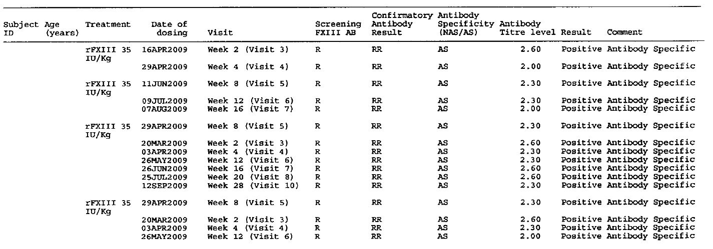
The narratives of the 4 patients (9.8%) with non-neutralising anti-rFXIII antibodies are described immediately below.
- Two subjects [Information redacted] developed low titre non-neutralizing antibodies following their first exposure to rFXIII. The patients resumed their local standard treatment of monthly replacement with FXIII-containing product (cryoprecipitate) after their second dose of rFXIII. The antibody titre had declined below the detection limit at 8 and 4 months after initial rFXIII treatment and onwards for the 16-year-old and 14-year-old patient, respectively. The investigator classified both events as SAEs of mild severity with a possible relation to trial product.
- A third subject [Information redacted] developed low titre non-neutralizing antibodies following the first exposure to rFXIII. The antibody titre had declined below the detection limit at the time of the second dose of rFXIII. The patient remained antibody negative following the third administration of rFXIII, after which the patient returned to his previous prophylactic treatment with Fibrogammin P. No anti-FXIII antibodies were detected following initiation of Fibrogammin P treatment. The event was classified as an SAE of mild severity with a probable relation to trial product.
- A fourth subject [Information redacted] developed low-titre non-neutralizing antibodies after the second exposure to rFXIII (this patient is also reported in the submission as being 7 years old). The patient continued receiving monthly treatment with rFXIII, and antibodies had declined below the detection limit 4 months later. This event was classified as a non-serious adverse event of severe severity with a probable relation to trial product.
In the 4 patients described above, no anaphylactic or allergic reactions, no bleeding episodes or changes in pharmacokinetics were observed in association with non-neutralizing antibodies or during the continuing follow-up period. Furthermore, the antibodies declined below detection limit in all 4 patients despite repeated exposure to rFXIII. In 2 of the patients the antibodies declined below detection limit whilst receiving rFXIII, and in the remaining 2 patients the antibodies declined below detection limit whilst receiving other FXIII-containing products. The anti-rFXIII antibodies were of the IgM isotype in 3 of the 4 patients with no increase in antibody levels or isotype switching. The analysis of antibody isotype was inconclusive in the fourth patient. Tests for cross-reactivity to Fibrogammin P could be performed on samples from 3 of the patients. Apart from one sample in 1 patient, there was no indication that the detected anti-rFXIII IgM antibodies cross-reacted with Fibrogammin P.

Anti-yeast antibodies
No testing for anti-yeast antibodies was undertaken in the pivotal or extension study.

Thromboembolic events
No thromboembolic events had been reported in the pooled data-set from the pivotal and extension studies at the date of data cut-off. There was 1 patient with superficial phlebitis.

Clinical laboratory evaluation

Haematology (local laboratory)

F13CD-1725
The following haematological parameters were assessed at screening, baseline (visit 0), 2 and 4 weeks post-treatment and then every 4 weeks to week 52 (inclusive): haemoglobin, haematocrit, platelet count (thrombocytes), leucocytes (total + differential: basophils, eosinophils, lymphocytes, monocytes and neutrophils) and erythrocytes. The mean difference between the baseline and post-baseline visits were measured at each time-point. No noteworthy changes were observed in the haematological parameters over 52 weeks treatment with rFXIII. Overall, the mean and median values remained within the reference range for each of the parameters.

F13CD-3720
No noteworthy changes in haematological parameters were observed over the course of the study. Mild transient eosinophilia was observed in 4 patients, but none of these changes were recorded as clinical significant by the investigator or deemed to be clinically significant by the sponsor.

Biochemistry (local laboratory)

F13CD-1725
The following biochemical parameters were assessed at screening, baseline (visit 0), 2 and 4 weeks post-treatment and then every 4 weeks to week 52 (inclusive): urea, creatinine, aspartate aminotransferase (ASAT), alanine aminotransferase (ALAT) and alkaline phosphatase. The mean difference between the baseline and post-baseline visits were measured for each parameter at each time-point. No noteworthy changes were observed in the biochemical parameters over 52 weeks treatment with rFXIII. Overall, the mean and median values remained within the reference range for each of the parameters. The following parameters were assessed in the urine at the same visits as the biochemical and haematological parameters were assessed: pH, leuocytes, glucose. The results have been examined and no noteworthy changes were observed over 52 weeks treatment with rFXIII.

F13CD-3720
No noteworthy changes in biochemical or urinalysis parameters were observed over the course of the study.

Coagulation parameters (central laboratory)

F13CD-1725
The following coagulation parameters were assessed at screening, baseline (visit 0), 2 and 4 weeks post-treatment and then every 4 weeks to week 52 (inclusive): fibrinogen, d-dimer, prothrombin time, international normalised ratio (INR), activated partial thromboplastin time (APTT), platelet count, thrombin time. Considerable variations in D-dimer levels were observed over the course of the study with values ranging from 50 to 14400 ng/mL (reference < 500 ng/mL). Median values were consistent with the reference at all time points. The sponsor speculates that individual outliers may have been caused by inappropriate sampling handling at some study centres, but no data were provided to support this argument. No noteworthy changes in the following parameters were observed during the course of the study with the majority of values being within the relevant reference ranges: fibrinogen (reference 2-4 g/L), prothrombin time (reference 9.7-12.3 seconds), INR (reference 0.8-1.2), APTT (reference 22.8-31.0 seconds), platelet count (130-394 109/L), and thrombin tine (reference 14.5, 18.5 seconds).

F13CD-1725
No noteworthy changes in the following coagulation parameters were observed over the course of the study: fibrinogen, prothrombin time, INR, APTT, and thrombin time. D-dimer levels were not assessed in this study.

Vital signs, physical examination

F13CD-1725
No noteworthy changes were observed in mean values for vital signs (supine pulse rate, diastolic blood pressure, systolic blood pressure) or physical examination over time. The median body weight increased from 59.0 kg at baseline (week 0) to 65.0 kg at week 48, which probable reflects than many of the subjects in the study were children and adolescents who are likely to have grown of the course of the study.

F13CD-3720
The changes were consistent with those observed in study F13CD-1725.

Pregnancy
In F13CD-1725, 2 pregnant patients were withdrawn from the trial. In F13CD-3720, 2 patients were withdrawn from the trial, one due to pregnancy (subsequently electively terminated) and one due to intention to become pregnant.

Other studies

Adverse events

Healthy subjects (Phase I trials)

NN1841-3788 (bioequivalence)
In the bioequivalence study, 46 AEs were reported in 26 subjects (52.0%): i.e., 21 events in 15 (30.6%) subjects after administration of rFXIIIAvecia and 25 events in 17 (34.7%) subjects after administration of rFXIIINN. No noticeable differences in the AE profiles were observed between the two formulations. No serious AEs or thromboembolic AEs were reported. No injection site reactions were observed. Three (3) AEs were considered by the investigator to be possibly or probably related to rFXIIINN (myalgia, pain in extremity and headache), and 2 events were considered by the investigator to be possibly or probably related to rFXIIIAvecia (anti-rFXIII antibody positive, and muscle tightness). The only AE resulting in withdrawal from the study occurred in the subject with treatment related anti-rFXIII antibodies.

F13-1622 (multiple dose Phase I)
In this multiple-dose study, 44 AEs were recorded in 12 (75%) subjects in the rFXIII groups, and 30 AE were recorded in 6 (75%) subjects in the placebo group. No SAEs were reported, no AEs were considered related to trial product by the investigator, and no subjects withdrew from the trial due to AEs. The most frequently reported AEs were headache, somnolence, upper respiratory tract infection, paraesthesia, fatigue and dysmenorrhoea. There were no apparent differences between placebo and active treatment in the incidence of these or any other AEs, and there was no apparent dose-dependent increase in the incidence of AEs. One (1) AE of increased C-reactive protein was reported 33 days following administration of 12 IU/kg rFXIII. This event was considered unrelated to trial product by the investigator. The C-reactive protein level at Day 33 was 24.0 mg/L, four times the upper limit of normal (normal range 0-6 mg/L), but returned to normal levels at follow-up 1 week later (3.1 mg/L) and levels were within the normal range at all other time points during the study.

F13-1661 (single dose Phase I)
In this study, 89 AEs were recorded in 32 (80%) subjects in the rFXIII groups, and 26 AEs were recorded in 6 (60%) subjects in the placebo group. No SAEs, no thromboembolic AEs, and no withdrawals due to AEs were reported. The most frequently reported AEs events were headache (17 [42.5%] subjects in the pooled rFXIII group vs 4 [40%] subjects in the placebo group), increased fibrin D-dimer (4 [10%] subjects in the pooled rFXIII group vs 2 [20%] subjects in the placebo group), muscle cramp (4 [10%] subjects in the pooled rFXIII group vs 1 [10%] subject in the placebo group), and pain in the limb (4 [10%] subjects in the rFXIII group vs 1 [10%] subject in the placebo group). There were no apparent differences between placebo and active treatment in the incidence of these or any other AEs, and there was no apparent dose-dependent increase in the incidence of AEs. Increased D-dimer levels were largely confined to one dose cohort and were not correlated with other laboratory or clinical findings. Consequently, the sponsor states these events were likely to have been caused by sample handling errors. There were 7 events in 7 patients considered by the investigator to be possibly or probably related to treatment with the trial product: 3 x headache (1 x placebo; 1 x 2 IU/kg; 1 x 6 IU/kg); 2 x prolonged thrombin time (2 x 60 IU/kg); 1 x elevated AST (6 IU/kg); 1 x nausea (12 IU/kg). No evidence of bleeding, bruising, thrombosis or other associated laboratory findings were noted in the 2 subjects considered to have possible rFXIII related prolonged thrombin times.

NN1810-3733 (Japanese subjects)
There was 1 AE report (increased AST levels) in a placebo treated subject. There were no AE reports in rFXIII treated subjects.

Patients with congenital FXIII deficiency (Phase I trials)

F13-1633
In the escalating, single-dose Phase I trial in patients with congenital FXIII deficiency, 4 (36.4%) subjects experienced at least 1 AE. There were a total of 11 AEs with the most frequently reported being headache (3 events in 3 subjects [27.3%]) followed by arthralgia (3 events in 2 subjects [18.2%]). No AEs were considered to be treatment-related. No dose-dependent relationship was observed for the reported AEs.

F13CD-3760 and F13CD-3835
As of the cut-off date of 11 February 2011, no AEs were recorded for the single paediatric patient exposed in studies F13CD-3760 and F13CD-3835 in children aged 1 to less than 6 years of age.

Patients undergoing cardiac surgery

F13CARD-1660
The primary objective of this Phase I clinical study was to evaluate the safety of escalating single doses of rFXIII administered following first time myocardial revascularization coronary by-pass surgery. In this study patients were treated with single-dose placebo (n=8) or single-dose rFXIII (n=35) (dose range 11.9 to 50 IU/kg). There were 183 AEs reported in 40 (93%) of 43 patients (including 35 events in 6 patients in the placebo group), and there were 18 SAEs reported in 11 (26%) of 43 patients (including 2 events in one patient in the placebo group). Review of the 18 SAEs suggests that most were associated with cardiac surgery. Overall, there were no noticeable differences between treatment groups in type, frequency or severity of AEs. The most frequently reported AEs in the 43 patients were nausea (19, 44.2%), atrial fibrillation (16, 37.2%) atelectasis (7, 16,3%), hypotension (7, 16.3%), fluid overload (6, 14.0%) and anaemia (5, 11.6%). No thromboembolic AEs were reported by the investigators. However, one case of myocardial infarction in a patient receiving 35 IU/kg was identified by the Data Monitoring Committee (DMC) after review of pre- and post-operative ECGs and data on cardiac enzymes. A total of 8 AEs in 7 patients were judged by the investigator to be possibly or probably related to trial product: 2 x hypotension (same patient, 11.9 IU/kg); 1 x hypercoagulation (placebo); 1 x atrial fibrillation (25 IU/kg); 1 x hyperthermia (placebo); 1 x atrial fibrillation (25 IU/kg); 1 x anaphylactic reaction (11.9 IU/kg); 1 x procedural pain (25 IU/kg); 1 x soft tissue necrosis (25 IU/kg). Of the 8 treatment related events, 2 were serious but resulted in full recovery (1 x anaphylactic reaction in a patient receiving 11.9 IU/kg, and 1 x soft tissue necrosis event in a patient receiving 25 IU/kg). There were fatal AEs or thromboembolic AEs, and no patients withdrew due to AEs.

NN1810-3540
In this on-going Phase II, single-dose, placebo-controlled study, rFXIII (17.5 or 35 IU/kg) is being investigated to assess whether it is effective in avoiding allogenic transfusions in cardiopulmonary by-pass surgery patients with pre-operative transfusion risk score of 2 or 3. Safety assessments are made frequently for the first 7 days or until discharge, which ever comes first, and at a follow-up visit at weeks 5 to 7 post-trial drug administration. Assignment to dose groups is still blinded, and any association between treatment and occurrence of AEs is therefore unknown. At the data cut-off of 11 February 2011, a total of 2292 AEs were reported in 400 (97.8%) patients, and 53 of these AEs in 46 patients (11.3%) were considered by the investigator to be probably or possibly related to the study drug. There were 150 SAEs in 107 (26.2%) patients, and 4 AEs in 4 (0.98%) patients resulted in withdrawal. The reported SAEs are consistent with the events commonly seen in patients undergoing cardiopulmonary by-pass surgery. A total 20 AEs in 19 patients (4.6%) have been identified as AEs of possibly thromboembolic aetiology. There were two fatal AEs. After a review of safety from the first 300 patients the DMC concluded that there was no longer any imbalance of Critical Adverse Events between the three treatment groups and stressed that it did not see any safety issues in the pooled data-set.

Deaths and other serious adverse events
As of the data cut-off date of 11 February 2011, no deaths had been reported following rFXIII administration in any of the clinical studies in patients with congenital FXIII deficiency or in healthy subjects. No SAEs were reported in studies F13-1663, F13CD-3760 and F13CD-3835 in patients with congenital FXIII deficiency or in studies in healthy subjects. In the cardiac surgery study (NN1810-3540), 2 patients had fatal AEs: 1 fatal case concerned a 77-year-old male and was reported as SAEs of renal failure, pericardial effusion, suspicion of systemic inflammatory response syndrome, respiratory insufficiency and sepsis, of which renal failure was evaluated as possibly related to trial drug by the investigator; 1 fatal case concerned a 72-year old male and was reported as worsening myocardial infarction evaluated as unlikely to be related to the study drug.

Immunogenicity
There was one healthy subject in NN1841-3788 with transient, low titre (titre = 2.3; LLOQ titre = 2.0), non-neutralising antibodies following his first exposure to rFXIIIAVECIA. This subject was withdrawn due to this finding. None of the post-dose FXIII activity values were below the baseline value, and the activity level 28 days and 9 weeks after administration of FXIII was similar to the baseline level, indicating that the antibodies had no effect on FXIII activity levels. In this patient, no clinically significant findings were observed for haematology, coagulation parameters, urinalysis or biochemistry, and no other safety data indicated that the antibodies were of clinical significance. A follow-up sample taken after 6 months was antibody negative.
Apart from one subject in NN1841-3788 referred to in the above paragraph, there were no other reports of anti-rFXIII antibodies in the Phase I trials in healthy subjects and patients with congenital FXIII deficiency. In the cardiac surgery trial (NN1810-3540), 1 patient tested positive for low-titre, anti-rFXIII antibodies (titre = 2.3) at both the screening visit and at a 5-7 week follow-up visit, but the positive antibody finding before exposure to trial drug indicates that this is not a true finding.
The sponsor states that low levels of anti-yeast antibodies have been detected in patients exposed to rFXIII. Overall, the sponsor reported that no clinically relevant differences in anti-yeast antibody levels have been observed between treatment groups (placebo and rFXIII), and no correlations with rFXIII dose level or clinical findings have been observed in the studies in which tests for anti-yeast antibodies were performed (F13-1663, F13-1662, F13-1661, NN1810-3733 and F13CARD-1660). The drug substance batches used in these trials contained up to 233 ppm yeast host cell protein.

Thromboembolic events
No thromboembolic adverse events have been reported in Phase I studies in patients with congenital FXIII deficiency or in healthy subjects. In the completed cardiac surgical trial (F13CARD-1660), one case of myocardial infarction in a patient receiving 35 IU/kg rFXIII was detected retrospectively after review of pre- and post-operative ECGs and cardiac enzyme data. In the ongoing cardiac surgical study NN1810-3540, 20 AEs in 19 patients were identified as AEs of possible thromboembolic aetiology. The difference between the two cardiac surgery studies in the prevalence of reported thromboembolic adverse events are at least partly attributable to differences in patient populations and reporting criteria for thromboembolic events.

Clinical laboratory evaluations

Patients with congenital FXIII deficiency
In F13-1663, 2 patients at the 60 IU/kg rFXIII dose level had increased D-dimer levels in this Phase I, escalating, single-dose congenital FXIII deficiency study. Both patients had high baseline levels (1370 ng/mL and 1110 ng/mL), and D-dimer levels remained high throughout the trial. No significant increase from baseline was observed in D-Dimer levels, and the levels were not considered to be associated with rFXIII treatment. Overall, no clinically relevant changes were observed for haematology, biochemistry and urinalysis parameters in this study. One (1) patient at the 24 IU/kg dose level had a few occurrences of elevated levels for liver function tests (ALT, AST, and LDH) post-treatment. In addition, one patient at the 24 IU/kg dose level had high C-reactive protein levels 8 hours post-treatment on Days 1, 2, and 3 (17, 35, 31, and 13 mg/L, respectively). The patient’s baseline C-reactive protein level was normal (6.9 mg/L, and on Day 7 levels had returned to normal (4.3 mg/L). The elevations in liver function enzymes and C-reactive protein were not considered by the investigator to be clinically significant.

Healthy subjects

NN1841-3788 (bioequivalence)
No noteworthy changes in coagulation, haematological, biochemical, or urinalysis parameters were observed in this study.

F13-1662 (multiple-dose study)
No noteworthy changes in coagulation parameters were observed in this study. Thrombin time was prolonged (> 16 seconds) in 2 subjects in the 30 IU/kg rFXIII group, but in neither subject was the abnormality considered to be an AE. There were a number of subjects with significantly elevated D-dimer levels, 3 of whom had levels > 500 µg/mL (2 received 30 IU/kg rFXIII and 1 received placebo). The only other abnormality of note in the haematological, biochemical, or urinalysis parameters was 1 AE of increased C-reactive protein level reported 33 days following administration of 12 IU/kg rFXIII. This subject’s C-reactive protein levels were within the normal range at all other time-points in the study.

F13-1661 (single-dose)
Three (3) AEs of prolonged thrombin time were recorded in 3 subjects after administration of 60 IU/kg rFXIII. In addition, increased D-dimer levels were observed and 8 of these events in 6 subjects were reported as AEs. The D-dimer elevations were largely confined to dosing cohort 1, with 6 events in 4 subjects (including 4 events in the two placebo treated subjects). Consequently, the sponsor stated that D-dimer elevations were likely to be related to problems with sample handling procedures. No AEs relating to clinical coagulopathy or thrombosis were observed. Overall, no clinically relevant changes in haematology, biochemistry or urinalysis parameters were reported. However, AEs of increased AST and increased C-reactive protein levels were reported following administration of 6 and 12 IU/kg rFXIII, respectively.

NN1801-3733 (Japanese subjects)
Overall, no clinically relevant changes in the investigated coagulation parameters were observed in this study. One (1) AE of increased levels of AST was reported after placebo administration. No noteworthy changes were apparent in other biochemistry, haematology or urinalysis parameters. No changes in lipids were observed. No noteworthy changes in tropinin T levels were observed.

Cardiac surgery

F13CARD-1660
Overall, the changes in safety laboratory parameters were as expected in patients undergoing cardiopulmonary bypass surgery, and no noticeable differences between treatment groups were apparent for any of the coagulation parameters. In addition, no noteworthy changes between treatment groups were observed for haematology, biochemistry or urinalysis parameters. The mean creatinine phosphokinase MB fraction (CKMB) increased after surgery (as expected) and returned to baseline levels at 72 hours post-dose. No overall differences between treatment groups were apparent. Consistent with the cardiac surgical procedure, mean troponin I values increased after surgery compared with screening levels in the treatment groups, and no noticeable differences between treatment groups were apparent.

NN1810-3540
No information on changes in clinical laboratory parameters was reported in this study.

Other observations related to safety
No noteworthy changes in vital signs or physical examination findings relating to rFXIII were observed in patients with congenital FXIII deficiency, patients undergoing cardiac surgery or in healthy subjects.

Post-marketing experience
There were no post-marketing data for rFXIII.

Safety issues with potential for major regulatory impact

Liver toxicity
There is no evidence in the submitted data that rFXIII is associated with liver toxicity. There were no reports of AEs in the hepatobiliary system in either F13CD-1725 or F13CD-13720, and there were no noteworthy abnormalities in clinical laboratory liver function tests in either of these two studies.

Renal toxicity
There is no evidence in the submitted data that rFXIII is associated with renal toxicity. In F13CD-1725, there were 3 patients (7.3%) with 5 events grouped as “renal and urinary disorders” 2 of these events were reported as dysuria and 2 were reported as pollakiuria. In F13CD-3720, there 2 patients (6.0%) each with 1 “renal and urinary disorder” AE of haematuria. There were no noteworthy changes in clinical laboratory renal function tests or urinalysis in either F13CD-1725 or F13CD-3720.

Haematological toxicity
There is no evidence that rFXIII is associated with haematological toxicity. In F13CD-1725, there were 5 patients (12.2%) with AEs grouped as “blood and lymphatic system disorders”, and the only event in more than 1 patient was neutropenia (2 patients, 4.9%). In the SOC of “investigations” there was 1 reported AE of blood fibrinogen increased in 1 patient (2.4%), and 1 reported AE of fibrin D-dimer increased in 1 (2.4%) patient. In F13CD-3720, there were only 2 (6.0%) patients with “blood and lymphatic system disorder” AEs (1 anaemia, 1 neutropenia). In the SOC of “investigations” there was 1 reported AE of APTT prolonged. Apart from variable increases in D-Dimer levels, were no noteworthy changes in clinical laboratory haematological or coagulation parameters in either F13CD-1725 or F13CD-3720.

Cardiovascular toxicity
There is no evidence in the submitted data that rFXIII is associated with cardiovascular toxicity. In F13CD-1725, there were no thromboembolic AEs or “cardiac disorders”. In F13CD-3720, “cardiac disorders” were reported in 2 (6.0%) patients (1 cardiovascular disorder, 1 tachycardia), and there were no thromboembolic AEs.

Serious skin reactions
There is no evidence in the submitted data that rFXIII is associated with serious skin reactions. In F13CD-1725, there were 5 patients (12.2%) with “skin and subcutaneous tissue disorders”, none of which were serious. In F13CD-3720, there were 5 (15.2%) patients with “skin and subcutaneous tissue disorders” with the eczema being the only event being reported in 2 patients and all other events being reported in no more than 1 patient.

Unwanted immune events
Immunogenicity has been discussed above. There is no evidence in the data that clinically significant AEs in the immune system are associated with rFXIII.

Safety in special populations
The safety of rFXIII in special populations was not investigated due to the small number of patients with congenital FXIII deficiency in the safety data-set. Therefore, the are no data on safety in children aged < 7 years, the elderly (aged ≥ 65 years), pregnant women, different racial groups, patients with hepatic, renal or cardiovascular disease, or relating to interactions between rFXIII and other medicines. There were safety data on 1 patient aged less than 7 years with congenital FXIII deficiency from the interim reports from studies F13CD-3760 and F13CD-3835 in children aged 1 to less than 6 years.

Evaluator’s overall conclusions on clinical safety
In all clinical studies assessing the effects of rFXIII, a total of 651 individuals were exposed to rFXIII (51 patients with congenital FXIII deficiency, 452 patients undergoing cardiac surgery, and 148 healthy subjects). The key safety data relate to the 41 patients with congenital FXIII deficiency in the pivotal Phase III study F13CD-1725, and to 33 of these 41 patients who continued with treatment in the extension Phase III study F13CD-3720. In the pivotal and extension studies all patients were treated with 35 IU/kg rFXIII once monthly (28 ± 2 days). It is considered that the small pooled safety data set in the two Phase III studies in patients with congenital FXIII deficiency has satisfactorily established the safety of rFXIII for this extremely rare condition. The following summary of clinical safety focuses on the pooled safety data set from the pivotal and extension studies unless otherwise stated.
In Study F13CD-1725, 41 patients completed the study and were exposed to a total of 471 doses of rFXIII, and the mean (SD) number of doses in these patients was 11.5 (3.6). Of these 41 patients, 33 continued in the extension study F13CD-3720 and were exposed to 439 doses of rFXIII with a mean (SD) of 13.3 (3.6) doses. In the two studies combined, 41 patients were exposed to a total of 910 doses of rFXIII.
In the pooled safety data set (FAS) for Studies F13CD-1725 and F13CD-3720, 32 of the 41 patients (78.0%) exposed to rFXIII experienced a total of 352 adverse events (AEs) (38.7 AEs/100 exposures). The majority of AEs were rated as mild in intensity (288) while the remainder were rated as moderate (59) or severe (5). Of the 352 AEs in the pooled safety data set, 231 occurred in the pivotal study (49.1 AEs/100 exposures) and 121 occurred in the extension study (27.6 AEs/100 exposures). The difference in the AE rates between the pivotal and extension studies suggest that the risk of experiencing an AE decreases with duration of exposure.
The most commonly reported (≥10% of patients) AEs in the 41 patients in the pooled safety data set, in diminishing order of frequency, were: headache (31.7%); nasopharyngitis (26.8%); pyrexia (19.5%); arthralgia (17.1%); pain in extremity (17.1%); nasal congestion (17.1%); oropharyngeal pain (17.1%); excoriation (12.2%); incorrect dose administered (12.2%); and joint sprain (12.2%). No thromboembolic events had been reported in the pivotal and extension studies at the date of data cut off.
There were a total 14 AEs in 9 patients considered by the investigator to be possibly or probably related to treatment with rFXIII. These treatment related AEs were: antibody test positive in 4 patients; incorrect dose administered on 2 occasions in 1 patient, and on 1 occasion in 1 patient; pain in extremity in 1 patient; headache in 1 patient; worsening of leukopenia and neutropenia in 1 patient; injection site pain, fibrin D dimer increased, and overdose in 1 patient. Full recovery occurred for all 14 AEs considered to be possibly or probably related to rFXIII.
There were no deaths in the pivotal and extension studies. There were a total of 10 SAEs recorded in 7 patients and, except for 3 serious adverse events (SAEs) of anti rFXIII antibodies, all SAEs were considered by the investigator as being unlikely to be related to rFXIII. The 10 SAEs were: 3 antibody positive events (1 probably related; 2 possibly related); 1 diverticulitis; 1 non cardiac chest pain; 1 headache; 1 carpal tunnel syndrome; 1 road traffic accident; 1 small intestinal obstruction; 1 skin laceration. Discontinuations due to AEs occurred in 4 (9.8%) patients, all from the pivotal study (non-neutralising anti rFXIII antibodies in 3 patients, and worsening leukopenia and neutropenia in 1 patient).
In Study F13CD-1725, a total of 4 patients developed transient, low titre, non-neutralising anti rFXIII antibodies (titre = 2.3 to 2.6; lowest level of quantification = 2.0). No anaphylactic or allergic reactions, bleeding episodes or changes in PK were observed in any of these patients at any time during the presence of the non-neutralising anti rFXIII antibodies or during the follow up period. Furthermore, the antibodies declined below the limit of detection in 2 patients despite repeated exposure to rFXIII and in 2 patients following exposure to other FXIII containing products. No testing for anti-yeast antibodies was undertaken in the pivotal or extension studies.
In both the pivotal and extension studies, haematological, biochemical, and urinalysis parameters were assessed at local laboratories and coagulation parameters were assessed at a central laboratory. The parameters were measured at screening, baseline, post dose Weeks 2 and 4, and then post dose every 4 weeks until the end of the study. There were no noteworthy changes in any of the assessed laboratory parameters during treatment with rFXIII, apart from considerable variations in D dimer levels. The sponsor speculates that individual D dimer level outliers may have been caused by inappropriate sampling handling at some study centres, but no data were provided to support this argument. There were no noteworthy changes in vital signs or physical examination over the course of treatment in the patients in the pivotal and extension studies.
There was no evidence of hepatic, renal, haematological or cardiovascular toxicity in the pivotal and extension studies. In these two studies, patients with renal insufficiency defined as current dialysis therapy were excluded based on the nonclinical finding of mild glomerulonephropathy in one cynomolgus monkey administered at a dose of 12.5 mg/kg. In addition, patients with any history of confirmed venous or arterial thromboembolic events were excluded from the studies. Although patients with hepatic impairment or cardiac disorders were not excluded from the pivotal and extension studies, there were no data from these studies on patients with these conditions.
The safety data from the other studies in healthy volunteers, patients with congenital FXIII deficiency and patients undergoing cardiac surgery were consistent with the pivotal and extension studies.
The safety of rFXIII in special populations was not investigated due to the small number of patients with congenital FXIII deficiency in the safety data set. Therefore, the are no adequate data on safety in children aged < 7 years, patients aged > 60 years, pregnant women, patients from different racial groups, patients with hepatic, renal or cardiovascular disease, or patients concomitantly treated with rFXIII and other medicines. There were nonclinical data suggesting a synergistic effect between rFXIII and rFVIIa at levels 17 fold and 11 fold above the recommended clinical doses, respectively, in an advanced cardiovascular model in cynomolgus monkeys where thrombosis and death occurred in 1 out of 12 monkeys tested.

First round benefit-risk assessment

First round assessment of benefits
The pivotal trial (F13CD-1725) showed that rFXIII (35 IU/kg; once monthly) significantly reduced the risk of experiencing bleeding episodes requiring treatment with FXIII containing products in patients (n = 41) of mean age 26.4 years (range: 7 to 60 years) with congenital FXIII deficiency compared with historical controls. In the pivotal study, the age adjusted rate (number per subject year) of bleeding episodes requiring treatment with a FXIII containing product was 0.048/year (95% CI: 0.0094, 0.2501). The upper 95% CI of this rate (0.2501/year) was less than 2.91/year, which was the fixed “placebo” rate in the control group treated with a FXIII-containing product on-demand. In the pivotal study, 5 bleeding events (all traumatic) in 4 patients required treatment with a FXIII containing product. Of the 41 patients in the pivotal trial, 33 received all 13 planned monthly doses of rFXIII and the mean (SD) and median (range) number of doses was 11.5 (13.9) and 13 (2, 24), respectively.
The interim extension data from the long term extension trial (F13CD-3720) showed that the benefits of regular rFXIII treatment persisted following the initial 12 months of treatment. In the 33 patients (mean age 28.8 years, range 7 to 60) who completed the pivotal trial and continued in the extension trial, the age adjusted rate (number per subject year) of bleeding episodes requiring treatment was 0.038/year (95% CI: 0.0034, 0.4355). The upper 95% CI of the observed rate in the patients in the extension trial (0.4335/year) was less than the fixed “placebo” rate of 2.91/year, and consequently the difference between the observed and control rates was statistically significant. In the extension trial, 5 bleeds (3 spontaneous. 2 traumatic) in 3 patients required treatment with a FXIII containing product. Of the 33 patients continuing treatment in the extension phase the median observation period was 359 days.
In the pivotal study, age was a statistically significant covariate (p = 0.022) for the rate (number per subject year) of bleeding episodes requiring treatment with FXIII containing products, and the subgroup comparison based on age suggested that patients aged < 18 years were at a greater risk of bleeding requiring treatment with a FXIII containing product than patients aged ≥ 18 years. However, in the extension study age was not found to be a statistically significant covariate, but the number of bleeding events requiring treatment with FXIII containing products was too small to allow a meaningful comparison to be made between patients aged < 18 and ≥ 18 years.
In the pivotal and extension studies, in the monthly treatment cycle (28 ± 2 days) bleeding episodes requiring treatment with FXIII containing products occurred more frequently ≥ 15 days after dosing (7 bleeds) compared with < 15 days after dosing (3 bleeds). However, the observed association might be confounded by investigators being unblinded to the date of rFXIII administration.
The submission did not adequately characterise the benefits of regular treatment with rFXIII in preventing all bleeding episodes, irrespective of whether treatment with FXIII-containing products was required. The crude bleeding rates (all) in the pivotal and extension studies were 1.4 bleeds/patient and 0.6 bleeds/patient, but no data could be identified for estimated yearly rates. The sponsor stated that the yearly rate of treatment-requiring bleeding was 0.3/year in historical control patients (n = 60) treated with regular FXIII-containing product, and that the corresponding rate in patients from the pivotal study of 0.048/year (95% CI: 0.0094, 0.2501) was similar to, or lower than the historical control rate. However, the data from the historical control study (F13CD-Quest) suggests that the figure of 0.3 bleeds/year relates to all bleeds, irrespective of whether treatment with FXIII-containing products was required.

First round assessment of risks
The Phase III pivotal and extensions studies are considered to have satisfactorily established the safety of rFXIII for the regular (once monthly) treatment of congenital rFXIII deficiency. The most commonly reported AEs occurring in ≥ 10% of patients in the pooled safety data set from the pivotal and extension studies (n = 41) in diminishing order of frequency were: headache (31.7%); nasopharyngitis (26.8%); pyrexia (19.5%); arthralgia (17.1%); pain in extremity (17.1%); nasal congestion (17.1%); oropharyngeal pain (17.1%); excoriation (12.2%); incorrect dose administered (12.2%); and joint sprain (12.2%). No thromboembolic events had been reported in the pivotal and extension trials at the date of data cut off.
There were no deaths in the Phase III pivotal and extension studies. There were a total of 10 SAEs recorded in 7 patients, and except for 3 SAEs of non-neutralising anti rFXIII antibodies, all events were evaluated by the investigator as being unlikely to be related to rFXIII. The 10 SAEs were: 3 antibody positive events (1 probably related, 2 possibly related), 1 diverticulitis, 1 non cardiac chest pain, 1 headache, 1 carpal tunnel syndrome, 1 road traffic accident, 1 small intestinal obstruction, 1 skin laceration. Discontinuation from the studies due to AEs occurred in 4 (9.8%) patients, all from the pivotal study. The premature discontinuations were due the presence of non-neutralizing anti rFXIII antibodies in 3 patients, and worsening leukopenia and neutropenia in1 patients.
In the pivotal Phase III study, a total of 4 patients developed transient, low titre and non-neutralising anti rFXIII antibodies (titre = 2.3 to 2.6; lowest level of quantification = 2.0). No anaphylactic or allergic reactions, bleeding episodes or changes in PK were observed in any of the patients at any time during the presence of the non-neutralising antibodies or during the follow up period. Furthermore, the antibodies declined below the limit of detection in 2 patients despite repeated exposure to rFXIII and in 2 patients following exposure to other FXIII containing products. No testing for anti-yeast antibodies was undertaken in the pivotal or extension studies.
In both the pivotal and extension studies, haematological, biochemical, and urinalysis parameters were assessed at local laboratories and coagulation parameters were assessed at a central laboratory. The clinical laboratory parameters were measured at screening, baseline, post dose Weeks 2 and 4, and then post dose every 4 weeks until the end of the study. There were no noteworthy changes in any of the assessed laboratory parameters during treatment with rFXIII. However, considerable variation in D dimer levels was observed over the course of the studies. The sponsor speculates that individual D dimer outliers may have been caused by inappropriate sampling handling at some study centres, but no data were provided to support this argument. There were no noteworthy changes in vital signs or physical examination in patients in the studies during treatment with rFXIII.
There was no evidence of hepatic, renal, haematological or cardiovascular toxicity in the pivotal and extension studies, nor were there reports of serious skin reactions occurring in these two studies. The safety of rFXIII in special populations was not investigated due to the small number of patients with congenital FXIII deficiency in the safety data set. Therefore, the are no data adequate on safety in the following groups: children aged < 7 years; patients aged > 60 years; pregnant women; patients from different racial groups; patients with hepatic, renal or cardiovascular disease; or patients being treated with rFXIII in combination with other medicines.

First round assessment of benefit-risk balance
The benefit-risk balance of rFXIII for routine prophylaxis of bleeding in patients with congenital FXIII deficiency aged 7 years and above is favourable. However, while the submission has satisfactorily demonstrated that regular treatment with rFXIII significantly reduces the risk of bleeding events requiring treatment with FXIII-containing products, the effect of rFXIII on reducing the risk of all bleeding events is unclear.

First round recommendation regarding authorisation
It is recommended that NovoThirteen be approved for routine prophylaxis of bleeding in patients aged 7 years and above with congenital FXIII A-subunit deficiency. However, the recommendation for approval is subject to satisfactory resolution of the issue relating to the incidence of all bleeding events in patients treated with rFXIII compared with historical control subjects treated with regular FXIII containing products (F13CD-Quest). It is recommended that approval be limited to patients aged 7 years and above due to the absence of adequate data in patients aged less than 7 years.

Clinical questions

General issue

Question 1
In a press release dated 23 December 2011, Novo Nordisk (US) indicated that it had received a Complete Response Letter from the FDA informing the company that the agency had completed its review of the application and will require additional information prior to considering the product for approval. Please provide a copy of the FDA’s Complete Response Letter to Novo Nordisk (US) identifying the additional information required by that agency, and provide information relating to the steps that the company has taken to address the issues raised in the FDA’s letter.

Pharmacokinetics

Question 2
In Study NN1841-3788, please account for the difference between the pooled results (97 exposures) for the FXIII activity at 30 minutes given in Table 11-2 (for example, geometric mean = 0.85 IU/mL) and Table 14.2.2 (geometric mean = 0.87 IU/mL).

Pharmacodynamics
No questions.

Efficacy

Question 3
The submission included no clinical dose ranging studies in patients with congenital FXIII deficiency. Therefore, please explain the rationale for selecting the dose of 35 IU/kg administered once monthly used in the pivotal Phase III study (F13CD-1725).

Question 4
In the pivotal Phase III study (F13CD-1725) and Phase III extension study (F13CD-3720), FXIII containing products were used for treatment requiring bleeds during the rFXIII treatment period. Please explain why additional doses of rFXIII were not used for these bleeding episodes rather than FXIII containing products.

Question 5
In the pivotal Phase III study (F13CD-1725), the screening visit (Visit 1) was planned 4 weeks (± 2 days) before the baseline visit (Visit 2). For subjects treated with regular replacement therapy before entering the trial, the screening visit was scheduled to be the same day as the subject was scheduled for administration of their usual FXIII containing product. Therefore, based on a half-life of approximately 11 days, the “wash out period” of 4 weeks (± 2 days) may have been too short to ensure complete elimination of FXIII containing product prior to the first dose of rFXIII administered at the baseline visit, and a carry-over effect might have been present between the first and second doses in the first month of treatment. The EMA assessment report, provided in the submission, includes an analysis of bleeding rates excluding data from the first month. This analysis showed that the Poisson based bleeding rate was 0.053/year (95% CI: 0.010, 0.272). Was this a post hoc analysis undertaken by the sponsor at the request of the EMA? Please provide the results of the analysis calculated by the sponsor using the same methodology as used for the primary efficacy analysis, and comment on the likelihood of a carry-over effect from FXIII containing product in the first month of treatment and the effect that this might have on the primary efficacy analysis.

Question 6
In the pivotal Phase III study (F13CD-1725), the efficacy conclusions state “when compared with retrospectively collected data from patients with congenital FXIII deficiency, the bleeding frequency observed in the present trial was similar to or lower than the bleeding frequency for patients on regular replacement therapy (on average approximately 0.3 treatment requiring bleeds/year)”. However, the data from the retrospective analysis (F13CD-QUEST) suggests that in patients on regular replacement therapy the average number of bleeds/year of 0.3 refers to all break-through bleeds (F13CD-Quest). Please clarify whether the 0.3/year rate quoted for F13CD-Quest relates to all bleeding events or is specific to bleeding events requiring treatment with FXIII containing products.

Question 7
In the Phase III studies F13CD-1725 and F13CD-3720, what was the bleeding rates/year for all bleeding events, traumatic and spontaneous, and irrespective of whether treatment with a FXIII containing product was required? Please compare these rates with the comparable rate from the retrospective analysis (F13CD-Quest) for the regular treatment (prophylaxis) subgroup. Please comment on the differences between the rates in the Phase III trials and the rate in F13CD-Quest. In addition, please comment on the differences between the calculated rates and the rates for spontaneous bleeding during regular Fibrogammin P therapy of 0.2 events/year and 2.5 events/per year for patients not on prophylactic therapy reported by Lusher et al. Furthermore, if the annualised bleeding rates (all) in the pivotal and extension studies are greater than the comparative rate in the historical control please justify why rFXIII should be approved for the treatment of congenital FXIII deficiency.

Question 8
If the bleeding rate of 0.3/year in the historical control group treated with regular FXIII therapy is not due entirely to patients with bleeding episodes requiring treatment with FXIII containing products, then please provide the bleeding rate for treatment requiring episodes for this patient group.

Safety

Question 9
In the Phase III pivotal study (F13CD-1725) and the extension study (F13CD-3720), testing for anti-yeast antibodies appears not to have been undertaken. Please justify why testing was not undertaken in these two Phase III studies.

Question 10
Please provide a summary of all subjects exposed to rFXIII in the clinical development program who developed anti yeast antibodies. Include an estimate of the incidence of anti-yeast antibodies in subjects exposed to rFXIII.

Second round evaluation of clinical data submitted in response to questions
The sponsor provided a consolidated response to the Section 31 questions raised by the TGA following the first round evaluation of the submission. The Section 31 response included information addressing the clinical questions raised by the clinical evaluator following the first round evaluation.
The clinical information included a new completed clinical report from the paediatric trial F13CD-3760 in children (n = 6) aged 1 to less than 6 years. The sponsor stated that this trial was provided to address the clinical evaluator’s proposal, following the first round clinical evaluation, to restrict the indication to patients aged 7 years and above. The Section 31 response covering letter “acknowledges that it is not standard practice to include updates to the clinical data package at this point in the evaluation process. However, in view of the nature of the condition being treated, the absence of a registered FXIII replacement treatment in Australia and the limited size of this additional trial report, we request consideration of this additional trial report. As noted in the Section 31 response document, “removing an age restriction of 7 years will extend the currently treated patient pool by only one patient in Australia.” The sponsor’s arguments regarding the submission of trial FICD-3760 at this point of the evaluation process are considered to be acceptable, and the trial has been reviewed as part of this second round clinical evaluation.
The general approach to evaluation of the Section 31 response has been to provide the question and response in full and then comment on the response. In cases where the questions and/or responses have been abridged, the clinical evaluator warrants that key information relevant to the sponsor’s Section 31 response has not been omitted. The complete appendices and references submitted by the sponsor have not been included in the clinical evaluation report, but relevant information from these documents have been provided in the body of the sponsor’s responses and/or the clinical evaluator’s comments on the responses and/or in the additional tables provided in the clinical evaluation report.
The first round clinical evaluation report (CER1) and second round clinical evaluation report (CER2) for the submission are considered to be complementary and should be considered together. Both CER1 and CER2 have been prepared by the same clinical evaluator.

General issue

Question 1
In a press release dated 23 December 2011, Novo Nordisk (US) indicated that it had received a Complete Response Letter from the FDA informing the company that the agency had completed its review of the application and will require additional information prior to considering the product for approval.
Please provide a copy of the FDA's Complete Response Letter to Novo Nordisk (US) identifying the additional information required by that agency, and provide information relating to the steps that the company has taken to address the issues raised in the FDA's letter.

Sponsor’s response
The FDA complete response letter of 23 December 2011 has been replied to. A Chemistry, Manufacturing and Controls (CMC) response document and a clinical response document have been prepared, and Novo Nordisk responded to the complete response letter with a Biologics License Application (BLA) resubmission on 27 December 2012. A key issue in the complete response letter was a request for steady state PK. Novo Nordisk included a PK evaluation on patients participating in the ongoing extension trial F13CD-3720. The FDA concern relates to the development of non-neutralising, low titre anti rFXIII antibodies and the impact on the PK. It was agreed with the FDA that PK profiles for 9 specific patients were prepared. Novo Nordisk managed to include PK profiles for 8 out of the 9 requested patients in the PK evaluation report. PK profiles for an additional 15 patients resulting in a total of 23 PK profiles presented in the PK evaluation report.

Clinical evaluator’s comment
The FDA letter of 23 December 2011 to the sponsor (Novo Disk, USA) outlined a number of deficiencies that the agency had identified in its review of the BLA for NovoThirteen. These deficiencies were grouped under broad headings of Inspectional, Chemistry, Manufacturing and Controls, Clinical, and Labelling. The FDA questions relevant to the TGA clinical evaluation relate to matters in the Novo Disk, USA, response to the FDA identified under the separate headings of Clinical, Safety, and Statistics. The relevant FDA questions (Items), the Novo Nordisk, USA, responses and the clinical evaluator’s comments follow.
- FDA ITEM 18 (CLINICAL) - The immunogenicity of NovoThirteen and the potential clinical consequences of an antibody response to the product have not been fully characterised by the clinical studies conducted to date. Three of the four subjects who scored positive for antibodies in your in-house assays were discontinued from dosing with NovoThirteen and followed only for safety. Remaining concerns for patients that make antibodies include: (i) that the antibodies may affect PK requiring adjustment of dosing; and (ii) eventually these patients may make neutralising antibodies against NovoThirteen and possibly against plasma derived Factor XIII. Therefore, further studies are required to provide additional safety information on patients who will be receiving the product post licensure, and who will form antibodies against NovoThirteen for this patient group.

Sponsor’s response
The sponsor’s response included reference to 2,540 estimated doses of rFXIII administered as of 30 September 2012 in completed and ongoing clinical trials. These clinical trials included 5 clinical trials in patients with congenital FXIII deficiency (1,990 doses), 4 PK studies in healthy volunteers (234 doses), and 2 clinical trials in patients undergoing cardiac surgery (316 doses). The new data included at the cut-off date of 30 September 2012 provided an additional 22 months of exposure data and more than 1,000 additional exposures to rFXIII since the data lock of 30 November 2010, which was applied in the original BLA submission. In monthly testing for anti FXIII antibodies, no new incidences of antibodies have been detected. No additional anti rFXIII binding antibodies have been reported up to 30 September 2012 in patients with congenital FXIII deficiency beyond the four cited in the FDA’s letter.
The sponsor’s response also provided an overview of the planned Phase IV post marketing study that will include information on rFXIII antibodies, allergic reactions, thromboembolic events, and lack of therapeutic effect. The sponsor also referred to an amendment to the on-going Study F13CD-3720, which is investigating the PKs of rFXIII at steady state, in order to support the safety and efficacy of rFXIII.
The sponsor’s response noted that there had been four patients who developed low level, transient anti rFXIII antibodies early on following initiation of treatment with rFXIII in Study F13CD-1725. No AEs of anaphylactic, allergic reactions or treatment requiring bleeding episodes were observed in any of the patients at any time during the presence of the antibodies or during the follow up period. One of the four patients remained on rFXIII treatment, while the other three patients discontinued rFXIII treatment following 2-3 administrations. There was no change in FXIII activity (peak and through levels) after dosing with rFXIII (following the detection of anti rFXIII antibodies in any of the four patients.

Clinical evaluator’s comment
There have been 4 (9.8%) patients with non-neutralising anti rFXIII antibodies in 41 patients with congenital FXIII deficiency exposed to rFXIII. The 4 patients who developed non neutralising anti rFXIII antibodies in Study F13CD-1725 are discussed in CER1. It is reassuring that there have been no further reports of anti rFXIII antibodies in subjects through to 30 September 2012. The sponsor’s commitment to undertake a Phase IV post marketing observational Study (NN1841-3868) that will further investigate the potential immunogenicity of rFXIII is noted. It is considered that the immunogenicity of rFXIII should not preclude approval of the medicine.
- FDA ITEM 19 (CLINICAL) - There is no formal repeat dose PK study in the indicated population. This is now of concern due to the observation of antibody formation to the study agent in 4 of the enrolled subjects, and the lack of information on the clinical effects of antibody formation due to the removal of most of these subjects from further exposure to the product. Many of the other subjects had 1 h post dose FXIII activity levels that were less than the targeted level of 1 IU mL, and yet there are no data to show what levels they maintain over the month until their following study visit. To address this safety concern, please submit a final study report for a PK study conducted in FXIII congenitally deficient subjects who have been exposed to at least two monthly exposures to NovoThirteen through a routine prophylaxis dose schedule.

Sponsor’s response
In order to fully evaluate the consequences of repeat dosing with rFXIII, the sponsor amended Study F13CD-3720 in order to obtain additional PK data. At a follow up teleconference between the FDA and Novo Nordisk on 11 May 2012, the FDA suggested that Novo Nordisk assess the full PK profiles over 28 days for 9 FDA specified patients that were included in Study F13CD-1725 trial to investigate if these subjects have adequate FXIII coverage during the dosing interval. In this PK assessment, samples were collected at the following time points: pre dose and then post dose at 1 and 2 h, and then 7, 14, 21 and 28 days. In total, 23 subjects, already enrolled in Study F13CD-3720, including 8 of the 9 FDA specified subjects, agreed to participate. One of the nine FDA specified subjects had been withdrawn during Study F13CD-1725 due to worsening of neutropenia and leukopenia and was not willing to participate in any PK assessment.
The steady state PK profiles, obtained from the eight FDA requested subjects participating in the PK session of the F13CD-3720 trial, clearly show that mean FXIII activity levels are within the targeted range of 0.1 and 1 IU/mL throughout the entire dosing interval, with only one individual measurement below 0.1 IU/mL. The mean FXIII activity profile in the total number of patients in the F13CD-3720 trial demonstrated that there is a mono exponential decline in the interval between 3 and 28 days post dose. The resulting mean half-life of 13.9 days in the total population (n = 20) is supportive of a monthly (28 ± 2 days) dosing schedule, where the mean FXIII activities are above the intended targeted activity range throughout the entire dosing interval. No extrinsic or intrinsic factors seem to effect the FXIII activity over time, further supported by the lack of spontaneous treatment requiring bleeding episodes as well as the absence of anti rFXIII antibodies. A dosing schedule of 35 IU/kg once monthly (28 ± 2 days) with rFXIII is thus considered sufficient to maintain adequate activity levels of FXIII in subjects with congenital deficiency of FXIII, during the entire dosing interval. The steady state PK parameters for the FDA specified subjects in Study F13CD-3720 are similar to the corresponding PK parameters from Study F13CD-1725 (Table 23).
Table 23: Sponsor’s FDA response: mean PK steady state data from Studies F13CD-1725 and F13CD-3720.
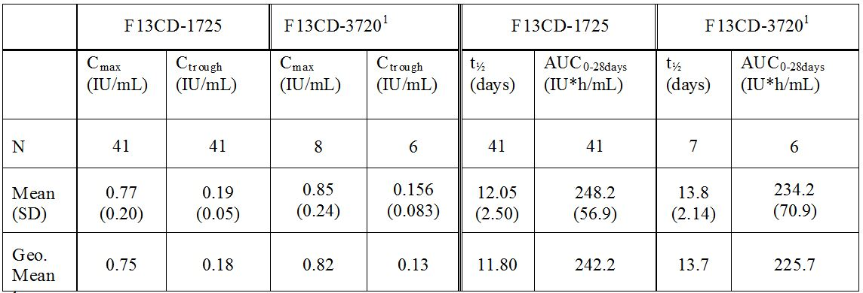
1 = Data presented to the FDA requested subjects only.

Clinical evaluator’s comment
The initial submission included repeat dose PK data in patients with FXIII deficiency from the pivotal Phase III trial (F13CD-1725) and the extension to this trial (F13CD-3720). In the pivotal trial (F13CD-1725), the mean trough level for FXIII activity in 41 patients was approximately 0.2 IU/mL over 52 weeks with once monthly dosing with rFXIII 35 IU/kg. In this trial, FXIII activity increased from pre dose levels of approximately 0.2 IU/mL to post dose levels at 1 h of approximately 0.7 to 0.9 IU/mL. In the extension trial (F13CD-3720), the mean trough levels for FXIII activity through to 72 weeks from initiation of treatment were consistent with the corresponding levels in Study F13CD-1725 through to Week 52 from initiation of treatment.
The additional PK data submitted to the FDA, based on an amendment to trial F13CD-3720, showed that satisfactory FXIII activity levels were maintained over the 28 ± 2 days dosing interval in the FDA specified patients from trial F13CD-1725. It was not entirely clear, either from the sponsor’s response to the FDA or from the amended report for F13CD-3720, why the FDA selected the 9 specified patients for analysis. It is assumed that the FDA was concerned about the ability of the specified patients to maintain adequate FXIII activity levels over the 28 day dosing interval. The PK steady state amendment to F13CD-3720 is outlined in CER1. The baseline demographic characteristics of the FDA specified and non FDA specified patients included in the F13CD-3720 amendment are provided in CER1. The FXIII activity PK parameters for the FDA specified and the non FDA specified patients assessed in F13CD-3720 were comparable, as were the FXIII activity parameters from F13CD-1725 and the total population from F13CD-3720.
- FDA ITEM 20 (CLINICAL) – This question concerned a difference between plasma derived Factor XIII (Fibrogammin P) and NovoThirteen relating to the extent to which each compete for the anti rFXIII A2 positive control antibodies in an ELISA (final report titled “NN0665-979-B Anti-Factor XIII antibodies Determination of the Isotype and Cross reactivity of anti-FXIII Antibodies in Human plasma [EDTA] Using ELISA"). NovoThirteen inhibits in the range of 77-82%, whereas Fibrogammin P inhibits in the range of 52-72%. The FDA noted that the report conjectures that this difference is due to the B subunit of Factor XIII blocking an epitope on the A subunit in Fibrogammin P, but not in NovoThirteen. However, the FDA conjectures that another possibility is that NovoThirteen contains antigenic determinants that are not present in Fibrogammin P. The FDA requested the sponsor to submit a final study report for a nonclinical study that can explain the apparent differences in antigenic structure between NovoThirteen and Fibrogammin P.

Sponsor’s response
The study report NN0665-978-B showed an apparent lower level of signal reduction using Fibrogammin P compared to NovoThirteen (rFXIII, FXIII A₂). We acknowledge that this could be interpreted as if NovoThirteen contains unique antigenic determinants not present in Fibrogammin P. In a new nonclinical study we have investigated these results further and found that the apparent lower level of signal reduction by Fibrogammin P is partly due to a Fibrogammin P dose dependent signal increase in the anti FXIII antibody ELISA in the absence of anti FXIII antibodies. This unspecific Fibrogammin P signal is seen using an antibody negative monkey plasma. In this new nonclinical study, we have therefore background adjusted the signal and by that also the level of inhibition based on signal obtained from negative monkey plasma. However, there still appears to be a lower level (69% versus 96%) of inhibition using Fibrogammin P than NovoThirteen. However, similar inhibition (91% versus 96%) can be obtained by increasing the concentration of Fibrogammin P antigen to 4 U/ml in the assay. The need for higher concentration of Fibrogammin P may be due to the B subunit of Factor XIII (or the high albumin content of the product) partially blocking epitopes on the A subunit in Fibrogammin P but not in NovoThirteen. Nevertheless, the new nonclinical study demonstrates that immunogenic epitopes of NovoThirteen (in antibody positive monkey serum) are also present in Fibrogammin P. The results are summarised in the Table 24.
Table 24: Sponsor’s FDA response: results of adding additional Fibrogammin P for signal reduction.
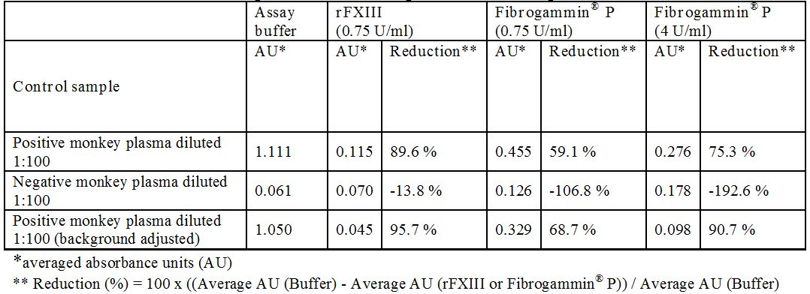

Clinical evaluator’s comment
The available data suggest that the immunogenicity of NovoThirteen is potentially greater than that of NovoThirteen due to the presence of unique antigenic determinants in the product not found in Fibrogammin P. However, from a clinical perspective the immunogenicity of rFXIII in patients with congenital FXIII deficiency has been relatively well characterised and does not give rise to serious concern. Nevertheless, it is suggested that the clinical and nonclinical evaluators review the FDA question and the sponsor’s response.
- FDA ITEM 21 (CLINICAL) – In this question, the FDA raised concerns about several patients being classified as having “antigen specific” (AS) antibodies at certain study visits, but as having “not antigen specific antibodies” (NAS) at study visits immediately preceding or following (Item 21a). The FDA states that if the operative definition of "antigen specificity" depends upon the titre of the antibody that is formed in response to exposure to the study agent, then this definition should not be used to describe the results of a clinical trial unless the two classifications AS and NAS can be shown to have clinically important correlates. The FDA also considered it inappropriate to describe the anti FXIII antibodies observed in Study F13CD-1725 as “non-neutralising”. The study protocol definition of "neutralising antibody" is based on the ability of the antibody to inhibit the Berichrom FXIII activity assay, which uses a synthetic peptide substrate to generate free ammonia consumed in a subsequent enzymatic reaction, resulting in a change in nicotinamide adenine dinucleotide (NADH) levels detected photometrically. Although the Berichrom assay has some advantages for measuring FXIII activity levels in clinical samples, this definition of “neutralising antibody” may not be sufficient because the Berichrom FXIII activity assay has not been clinically validated for this use. There may be antibodies that alter the clinical effect of FXIII, perhaps by altering its PK or by altering its ability to properly interact with its fibrin substrate, but which do not interfere with its activity as measured by the Berichrom assay. Due to this uncertainty about the clinical meaning of the observation of antibodies to FXIII which do not interfere with the Berichrom assay, but which may interfere with some FXIII functions (PK, fibrin cross linking), the FDA thought it not appropriate to describe the anti FXIII antibodies observed in Study F13CD-1725 as “non-neutralising”. It requested the sponsor to remove categorizations of antibody formation to the product based upon “neutralisation” from the product label, or submit a final report that clinically validates the use of the Berichrom assay for the detection of neutralising antibodies to the product.

Sponsor’s response
In response to Item 21a, the sponsor stated that the tiered analytical approach applied for detection of anti FXIII antibodies is in line with scientific whitepapers, and draft regulatory guidelines. Following an initial screening result above cut point (samples described as R, reactive), samples were subjected to a confirmatory assay through pre incubation with buffer, rFXIII or an unrelated antigen. The analytical method validation defines a sample as antibody POSITIVE (AS) if: (i) ≥ 30% decrease in signal absorbance units (compared to buffer alone) upon pre-incubation with rFXIII; and (ii) < 20% decrease in signal absorbance units (compared to buffer alone) upon pre incubation with rFVIIa. If the criteria are not met, the sample is NEGATIVE for anti rFXIII antibodies (NAS). Titration of antibody positive samples is performed subsequently on antibody positive samples only and this evaluation has no impact on the qualification of the sample as being positive or negative for specific antibodies against rFXIII. The procedure is outlined in Figure 4.
Figure 4. Sponsor’s FDA response: analytical flow for detection and evaluation of antibodies against rFXIII.
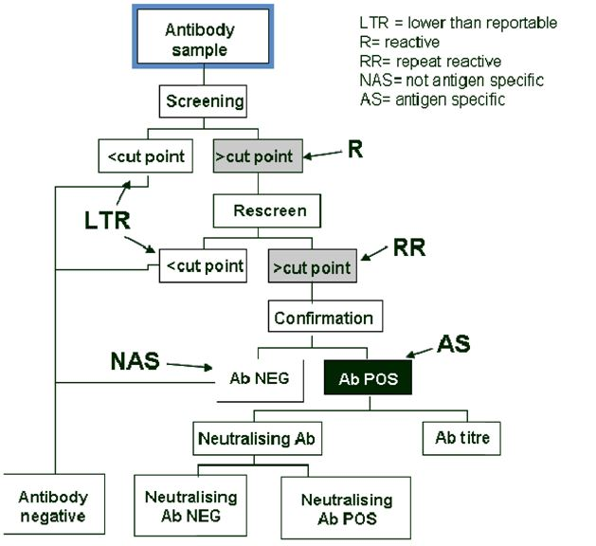
In response to Item 21b, the sponsor stated that FXIII deficiency is a very rare disease and there is limited experience with antibody development in this patient population. As antibody positive samples from patients with clinical manifestations are not available, the applied assay for the in vitro evaluation of activity neutralising antibodies has not been clinically validated. However, the assay adheres to recently published recommendations by the Factor XIII and Fibrinogen subcommittee of the International Society on Thrombosis and Haemostasis (ISTH). As there are no indications that the antibodies observed have a neutralising or inhibitory effect, we find it appropriate to describe these antibodies as non-neutralising in the product labelling.

Clinical evaluator’s comment
The sponsor’s response is considered to be reasonable from a clinical perspective. However, is suggested that the chemistry evaluator review the FDA question and the sponsor’s response.
- FDA ITEM 22 (CLINICAL) - On page 53 of 705 of the F13CD-1725 study report, in section 11.3.1.2 Clot Solubility, you state as follows:
“The fact that there are 46 clot lysis observations for FXIII activity levels >0.10 IU/mL reflects that the Berichrom assay for quantifying FXIII activity levels is prone to stochastic variations (especially at low activity levels).”
However, the FDA noted that another possible explanation for this finding may be that subjects may have antibodies to the product that interfere with the clot stabilisation process, but not with the chromogenic Berichrom assay, which measures NADH absorbance changes due to enzyme action on free ammonia that is released from a small peptide that is used as an artificial substrate for the measurement of circulating Factor XIII.

Sponsor’s response
The clot solubility test is a qualitative assay to assess the clot strength. This assay is commonly used as a primary screening test for the detection of FXIII deficiency, but this assay only detects severe deficiencies. The assay is poorly standardised and varies in degree of sensitivity. The immunogenicity of rFXIII and the clinical effects of any immunological reactions towards rFXIII were studied in the context of the pivotal Phase III Trial F13CD-1725 and the extension Trial F13CD-3720. In addition, the steady state PK assessment was recently performed and concluded that the PK parameters as well as the clearance of rFXIII are not affected by any extrinsic or intrinsic factors.

Clinical evaluator’s comment
The sponsor’s response is considered to be satisfactory.
- FDA ITEM 23 (CLINICAL) – The FDA question related to two siblings, both of whom formed anti rFXIIIA₂ antibodies very soon after initial exposure to NovoThirteen and were removed from treatment but monitored for safety. The 1 h post dose FXIII activity levels for each of these subjects remained low for the full study period, and the A₂B₂ heterotetramer levels (that is, the FXIII antigenic levels) also remained low at the 1 h post dose time point for the full study period. The FDA requested the sponsor to submit the routine prophylaxis dose schedule for each of these subjects for the full study period and analyse the 1 h post dose FXIII activity data to determine whether anti FXIII antibodies may have decreased the expected level of FXIII activity, based upon what is known about the PK of the FXIII containing product they received for routine prophylaxis. In addition, the FDA requested the sponsor to determine whether antibodies in patients receiving NovoThirteen react with plasma derived Factor XIII in binding and functional assays.

Sponsor’s response
The sponsor reviewed the data for the two siblings and undertook a statistical analysis (ANOVA) of antibody influence on the FXIII activity levels at both 1 h post dose and 28 days post dose during the entire trial (F13CD-1725) for all four subjects with antibodies. The sponsor stated that the two siblings, who changed treatment from rFXIII to cryoprecipitate, had no specific adjustment of dose as a result of the antibody formation. However, the change in treatment is likely to have resulted in a lower amount of FXIII being administered via the cryoprecipitate (4.1 to 15.1 U/kg), which in turn resulted in lower FXIII activity and antigen levels. There was no apparent difference in rFXIII activity in the presence or absence of antibodies in the two siblings. The ANOVA of the influence of rFXIII antibodies on FXIII activity demonstrated no statistical influence (Table 25). The sponsor concluded that the results of the statistical analysis strongly support the conclusion that rFXIII antibodies do not affect FXIII activity.
Table 25: Sponsor’s FDA response: statistical analysis of antibody influence on FXIII activity; ANOVA model with administered treatment, antibody presence, and subjects have been used as fixed factors in the model.
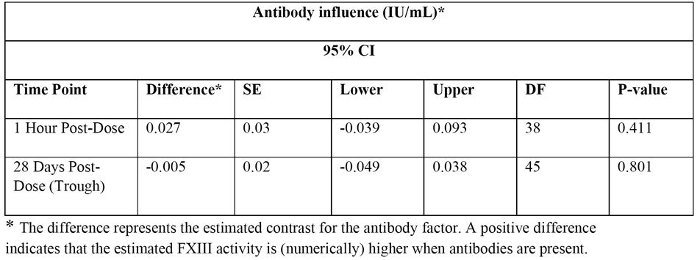
The sponsor also considers that the data from the amendment to protocol F13CD-3720 (see FDA Item 19 above) demonstrates that rFXIII antibodies have no impact on the PKs of rFXIII activity. The PK data from the amended study in 23 patients with congenital FXIII deficiency demonstrated that the PK parameters, including recovery and trough levels, are comparable with the PK parameters obtained through sparse sampling during to the first exposure to rFXIII observed in Study F13CD-1725, indicating that the clearance of rFXIII is not affected by any extrinsic or intrinsic factors. These data were also consistent with the PK parameters established in children aged 1 to less than 6 years (F13CD-3760). The data confirmed that the FXIII activity was above the lower target level at all time-points and gradually decreased over time reaching mean trough level of 21%.

Clinical evaluator’s comment
The sponsor’s response is considered to be satisfactory. The available data indicate that development of rFXIII antibodies do not significantly affect rFXIII activity.
- FDA ITEM 24 (SAFETY) – The FDA questions related to: (i) a request for additional information for three patients experiencing the adverse events of pollakiuria, dysuria or polyuria (Item 24a); (ii) a discrepancy in the number of treatment emergent AEs identified by the FDA for Study F13CD-1725 (232 events in 32 subjects) and reported by the sponsor for this study (231 events in 32 subjects) (Item 24b); and (iii) a discrepancy in the number of treatment emergent AEs identified by the FDA for Study F13CD-1725 (99 events in 20 subjects) and reported by the sponsor for this study (98 events in 20 subjects) (Item 24c).

Sponsor’s response
As regards Item 24a, the sponsor provided the requested additional information (Table 26). In all cases, the reported events were assessed by the investigator as being unrelated to treatment.
Table 26: Sponsor’s FDA response: additional safety information.
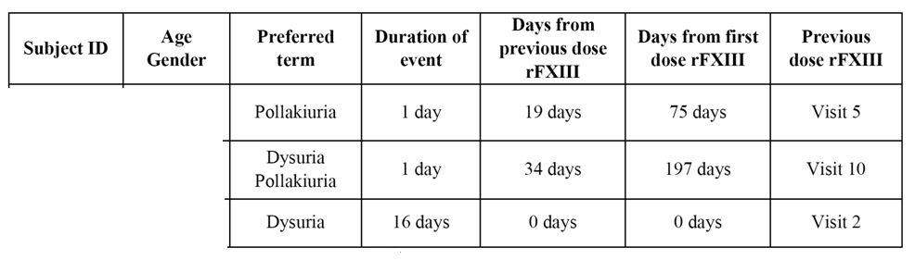
As regards Item 24b, the sponsor identified the reason for the discrepancy in the number of treatment emergent AEs as being due to an AE of influenza linked to nasopharyngitis that was included in the listings but not in the summary tabulations and text. The investigator reported the events to represent a single condition and, consequently, only nasopharyngitis was presented in the summary tabulations and text.
As regards Item 24c, the sponsor identified the reason for the discrepancy in the number of treatment emergent AEs as being due to an AE of “Limb injury” reported for one subject, which was reported by the investigator to be covered by AEs of “pain in the right arm” and “inflammation in the right arm” with an onset on the same day.

Clinical evaluator’s comment
The additional safety data do not give rise to concern.
- FDA ITEM 25 (SAFETY) – One subject was withdrawn after visit 6 for “worsening leukopenia and worsening neutropenia”. This subject had repeat reactive, antigen non-specific, antibodies at Visit 6, none of the 1 h post dose FXIII activity levels exceeded 0.5 IU/ml (that is, less than the targeted level of 1.0 IU/mL), and for the final two visits the pre-to-post-dose changes in B subunit were small (in the bottom 10%). These results are characteristic of anti FXIII antibody formation. Please submit a narrative describing the adverse events that caused the withdrawal of this subject. Please submit an update of the medical status of this, including data on the current anti FXIII antibody status.

Sponsor’s response
The investigator confirmed that the subject from Study F13CD-1725 is in good health with no issues (last dose of rFXIII administered on 12 July 2009). The subject receives monthly plasma derived FXIII without any additional medication. The subject was confirmed to be anti FXIII antibody negative at all visits while being treated with rFXIII, including Visit 1 to 6 and a follow up visit at one month after Visit 6. The events of “worsening leukopenia and worsening neutropenia” were recorded as non-serious AEs. Prior to the first administration of rFXIII at Visit 2, mild neutropenia and leukopenia were found. The neutrophil and leucocyte counts are summarised in Table 27. No other AEs were reported and no concomitant medications were administered. The patient was withdrawn by the investigator due to worsening of neutropenia and leukopenia, as a causal relationship between rFXIII and the worsening of neutropenia and leukopenia was assessed as possible. At the end of trial visit one month after the last dose of rFXIII, the AEs were reported as recovered. The neutrophil count was still suppressed but had returned to pre-treatment levels.
Table 27: Sponsor’s Section 31 response: overview of neutrophil and leucocyte counts.
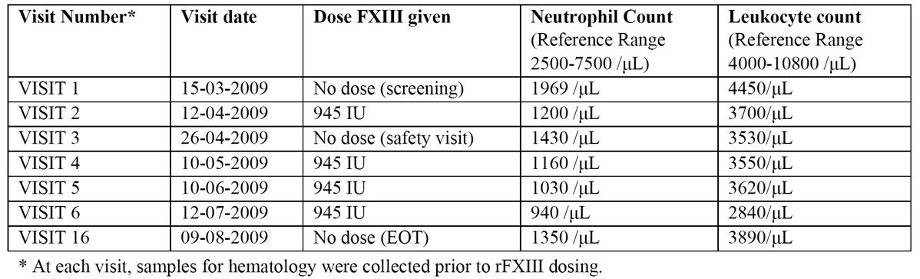

Clinical evaluator’s comment
The additional safety data do not give rise to concern.
- FDA ITEM 26 (SAFETY) - Please submit a narrative describing the AE “pain in extremity”, judged possibly related to the study agent and categorised as “not recovered”, for this subject. Please explain how the event is thought to be possibly related to the study agent.

Sponsor’s response
The AE was recorded as a non-SAE, and detailed narrative safety information was therefore not collected as per protocol. Another subject was reported as experiencing “pain in both legs” with an onset 303 days after the first dose of rFXIII in the trial and 22 days after the most recent dose of rFXIII administered at Visit 13. The pain in the legs was described as mild and intermittent. No other AEs were associated with the AE. At the end of trial visit ~2 months after the event onset, the outcome was not recovered. Follow up inquires confirmed that the patient had recovered from the event approximately 10 months after onset of the event. The patient was under observation during this period, and there were no indications of thromboembolism demonstrated by clinical examination and laboratory evaluation (coagulation parameters and D-dimer). The principal investigator assessed the event of pain in both legs to be possibly related to the administration of rFXIII. There is no further information concerning the assessment of the causal relationship to rFXIII.

Clinical evaluator’s comment
The additional safety data do not give rise to concern.
- FDA ITEM 27 (STATISTICS) - Listing 7, titled “After initiation of treatment - On-demand Treatment” (page 26 of 26 in the selected listings for the report of Trial ID: F13CD-QUEST), lists the reported number of bleeds per year requiring on-demand treatment. This listing provides the data for the historical control group that is used to demonstrate the efficacy of NovoThirteen for the routine prophylaxis indication. Please remove two subjects (11 and 12 bleeds per year reported) from the database because their reported bleed rates are outliers. Please recalculate the statistical analysis of Study F13CD-1725 and submit the results. We acknowledge your response to the previous FDA request (22 September 2011) to re-analyse the data after removing these two outliers from the control group, in which you state these two subjects may represent the natural variation in bleed rates for this rare disorder. However, the use of a historical control group can introduce bias into the analysis due to imbalances in baseline characteristics; therefore, a more conservative approach is needed.

Sponsor’s response
The sponsor recalculated the treatment requiring bleeding rate excluding the data from the two outliers. The mean (SD) recalculated rate for 14 “on-demand” patients was 1.68 (1.6) bleeds per year, ranging from 0 to 5.0 bleeds per year, and the median rate was 1.75 bleeds per year. The demographics and bleeding frequency for the retrospective on-demand subjects (n = 14), excluding the two outliers, is provided.

Clinical evaluator’s response
The data for on-demand treatment provided in the original submission, without exclusion of the outliers, indicated that the bleeding rate was 2.91 bleeds per year in the historical control (that is, 46.5 episodes in 16 patients). It is arguable whether the calculation of the bleeding rate in the on-demand historical control should include or exclude the outliers. In any event, it does not alter the conclusions relating to the comparison between the rate of treatment requiring bleeding episodes in Study F13CD-1725 and the rate of bleeding episodes in patients receiving on-demand treatment in the historical control (see FDA Item 28, below).
- FDA ITEM 28 (STATISTICS) - In addition to the planned analysis for efficacy, please submit separate analyses for the paediatric and adult age groups. As the mean yearly bleeding rate is substantially higher in subjects younger than 18 years, using the age adjust Poisson model may not actually reflect the yearly bleeding rate for all patients. Please include the results of estimate of bleeding rate with confidence intervals using unadjusted Poisson model for all patients as well as for two age groups separately to support your efficacy conclusion.

Sponsor’s response
A simple Poisson analysis without adjustment for age and over dispersion has been conducted by age group for subjects below and above 18 years of age. The same simple Poisson analysis has further been conducted for all patients as tabulated below (Table 28). In all three cases, the upper 95% CI of the yearly bleeding rate is below the recalculated bleeding rate of 1.68 for the on-demand patients in the historical control group.
Table 28: Sponsor’s FDA response: Study FICD-1725 bleeding rates and 95% CIs from a simple Poisson model.
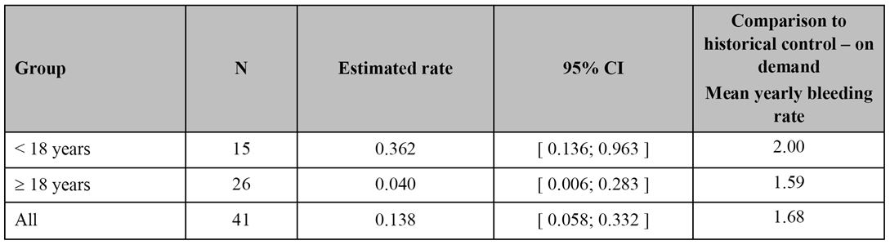

Clinical evaluator’s comment
The sponsor’s response demonstrates the superior efficacy of rFXIII prophylaxis in patients in Study F13CD-1725 compared with on-demand treatment as regards the yearly bleeding rate. The estimated bleeding rate in Study F13CD-1725 was notably higher in patients aged < 18 years compared with patients aged ≥ 18 years. However, the number of bleeds in the total population (n = 41) was low (5 bleeds in 4 subjects). There were 4 bleeds in 3 patients aged < 18 years and 1 bleed in 1 patient aged ≥ 18 years.
- FDA ITEM 29 (STATISTICS) - Please submit a dot plot of the 1 h post dose data for Study F13CD-1725 in database ADPROF for the A₂B₂ heterotetramer levels (that is, antigenic FXIII levels) plotted on the ordinate versus the FXIII activity levels plotted on abscissa. Please analyse the data to evaluate the correlation coefficients for the regions FXIII activity < 1 IU/mL and FXIII activity > 1 IU/mL, and describe the extent to which the results are to be expected based upon the study procedures and the analytical procedures that were employed.

Sponsor’s response
The sponsor’s response included three dot plots. The data were grouped according to three FXIII activity intervals requested by the FDA (0-0.5 IU/mL, 0.5-1.0 IU/mL, >1.0 IU/mL). In each of the intervals, a linear regression was conducted for each of three rFXIII activity intervals. In the initial analysis, excluding FXIII activity values relating to the treatment that three patients reverted to following withdrawal, a numerically slightly higher slope was observed in the low FXIII activity interval (< 0.5 IU/mL) compared to the intermediary FXIII activity interval (0.5-1.0 IU/mL). This difference was to a large extent driven by a single data point for subject 20101, who by mistake was dosed at Visit 4 with sterile water only, instead of rFXIII. When excluding this data point, the linear regression trend line in the low FXIII activity interval (< 0.5 IU/L) had essentially the same slope as in the intermediate FXIII activity interval (0.5 to 1.0 IU/L). However, in this analysis the slope in the high FXIII activity interval (>1.0) was noticeably lower than in the other two intervals and was essentially flat. This was primarily driven by three data points for rFXIII outside the upper limit for the plot of 2.0 IU/L. These three data points from two subjects (that is, rFXIII activity 2.93, 3.33 and 5.55 IU/L) were considered by the sponsor to be most likely due to ex vivo contamination due to using the same tubing for administration of rFXIII and post dose blood sampling. When excluding these data points, the linear regression trend line in the high activity interval has essentially the same slope as in the other two FXIII intervals (Figure 5).
Figure 5. Sponsor’s FDA response: FXIII activity versus FXIII A₂B₂ ELISA measured 1 h after dosing, excluding value from one subject dosed with sterile water (only) at Visit 4 as well as three outlier values (2.93, 3.33 and 5.55).
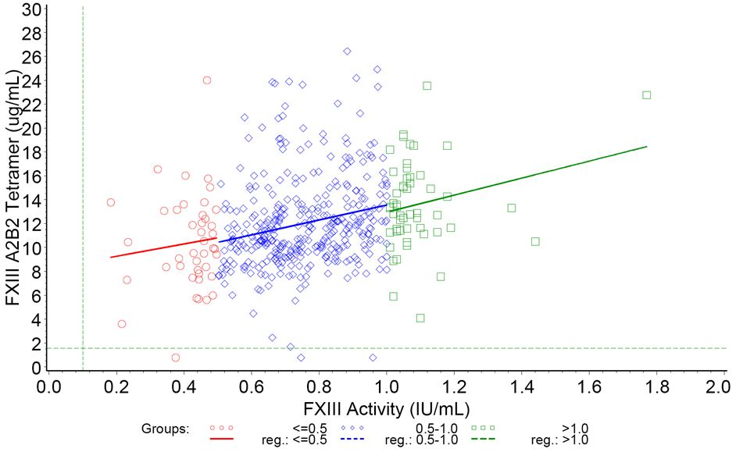
The best regression lines across 3 intervals are shown (≤0.5, 0.5-1.0 and >1.0). Values reaching Lower Limit of Quantification (LLOQ) = 0.10 IU/mL for FXIII activity and LLOQ = 1.57 µg/mL for A₂B₂ are set equal to ½ x LLOQ. LLOQ limits are illustrated with dashed green lines. For 3 subjects withdrawn from treatment, only values following dosing with rFXIII are shown. In addition, 3 outliers about FXIII activity 2.5 (IU/mL) are excluded (for 2 subjects).

Clinical evaluator’s comment
When the data from the subject dosed with sterile water and the three subjects with outlying FXIII activity values are excluded, a linear relationship was observed between FXIII activity and A₂B₂ heterotetramer levels (that is, antigenic FXIII levels).

Pharmacokinetics

Question 2
In Study NN1841-3788, please account for the difference between the pooled results (97 exposures) for the FXIII activity at 30 minutes given in Table 11-2 (for example, geometric mean = 0.85 IU/mL) and Table 14.2.2 (geometric mean = 0.87 IU/mL).

Sponsor’s response
It is the mean baseline adjusted value of 0.87 IU/mL of FXIII activity at 30 minutes in Table 11-2 in the clinical trial report that should be compared with the mean baseline adjusted change at 30 minutes in Table 14.2.2, which is also 0.87 IU/mL. Thus, no difference can be accounted for.

Clinical evaluator’s comment
The sponsor’s response is satisfactory.

Efficacy

Question 3
The submission included no clinical dose ranging studies in patients with congenital FXIII deficiency. Therefore, please explain the rationale for selecting the dose of 35 IU/kg administered once monthly used in the pivotal Phase III study (F13CD-1725).

Sponsor’s response
In the Phase I trial (Study F13-1663), performed in patients with congenital FXIII deficiency, a well approximated linear relation between the administered dose and the FXIII plasma activity was observed in the dose interval between 24 IU/kg and 89 IU/kg (Figure 6).
Figure 6. Study F13CD-1663: AUC_{0-∞} and C₀ versus dose.
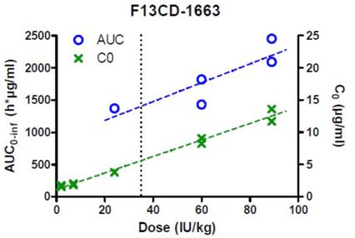
Administration of 24 IU/kg, 60 IU/kg or 89 IU/kg rFXIII resulted in absolute increases of FXIII of 57-59%, 105-129% and 160-181%, respectively, up to 1 h after dosing. It was therefore predicted that a dose of 35 IU/kg to patients with congenital FXIII deficiency would increase the activity of FXIII to well within the normal range, but below 100%, at the time of injection and maintain the activity level >10% up to four weeks post dose. A mean trough level of 10% was targeted to ensure haemostatic coverage in all patients when considering the variability in bleeding tendency at relatively low FXIII activity levels. A dose of 35 IU/kg rFXIII was anticipated to adequately address the clinical need in patients with congenital FXIII deficiency and considered sufficient for prophylactic treatment of bleedings. Subsequently, this dose has been proven to be both safe and efficacious, based on results from the pivotal Phase III trial (F13CD-1725) as well as the Phase III extension trial (F13CD-3720). The above assumptions have further been demonstrated to be correct, as observed from the mean peak and trough FXIII activity levels in the PK part of the F13CD-3720 trial (mean C_{trough} = 0.17 IU/mL and mean C_{max} level of 0.89 IU/mL).

Clinical evaluator’s comment
The sponsor’s response is satisfactory.

Question 4
In the pivotal Phase III study (F13CD-1725) and Phase III extension study (F13CD-3720), FXIII containing products were used for treatment requiring bleeds during the rFXIII treatment period. Please explain why additional doses of rFXIII were not used for these bleeding episodes rather than FXIII containing products.

Sponsor’s response
Advice obtained from regulatory authorities during design of the Phase III clinical program was that the efficacy of rFXIII should be established for prophylaxis, and that bleeding episodes, if any, should be treated according to local standard of care with other FXIII containing products. Consequently, the original trial design only allowed other FXIII containing products, that is, no rFXIII, for treatment of bleeding episodes. However, in order to obtain the indication for treatment of breakthrough bleedings during prophylaxis, a protocol amendment (Substantial amendment no. 14, dated 14 May 2012) to the ongoing Phase IIIb extension trial (F13CD-3720) permits Novo Nordisk to investigate the efficacy and safety of rFXIII in the treatment of breakthrough bleedings by allowing treatment of breakthrough bleeds with rFXIII. Therefore, if breakthrough bleeding during the trial period requires additional FXIII treatment (by investigator’s judgment), the subject will be treated with rFXIII 35 IU/kg in addition to the routine prophylactic dose. After any additional administration of rFXIII for the treatment of breakthrough bleedings, the patient will continue the originally planned monthly replacement schedule, with the next monthly rFXIII dose administered 4 weeks (28 ± 2 days) after the last prophylactic dose of rFXIII. The clinical efficacy (that is, response to treatment) will be evaluated by the patient in consultation with the investigator and will be reported on a 4 point scale (excellent, good, moderate, poor).

Clinical evaluator’s comment
The sponsor’s response is satisfactory.

Question 5
In the pivotal Phase III study (F13CD-1725), the screening visit (Visit 1) was planned 4 weeks (± 2 days) before the baseline visit (Visit 2). For subjects treated with regular replacement therapy before entering the trial, the screening visit was scheduled to be the same day as the subject was scheduled for administration of their usual FXIII containing product. Therefore, based on a half life of approximately 11 days, the “washout period” of 4 weeks (± 2 days) may have been too short to ensure complete elimination of FXIII containing product prior to the first dose of rFXIII administered at the baseline visit, and a carryover effect might have been present between the first and second doses in the first month of treatment. The EMA assessment report, provided in the submission, includes an analysis of bleeding rates excluding data from the first month. This analysis showed that the Poisson based bleeding rate was 0.053/year (95% CI: 0.010, 0.272). Was this a post hoc analysis undertaken by the sponsor at the request of the EMA? Please provide the results of the analysis calculated by the sponsor using the same methodology as used for the primary efficacy analysis, and comment on the likelihood of a carryover effect from FXIII containing product in the first month of treatment and the effect that this might have on the primary efficacy analysis.

Sponsor’s response
The Poisson analysis excluding data from the first month was not pre specified in the protocol but was conducted post hoc at the request of EMA, using the same methodology as for the primary efficacy endpoint (Table 29).
Table 29: Study F13CD-1725: post hoc analysis of rate of treatment requiring bleeding episodes excluding the first month; FAS.
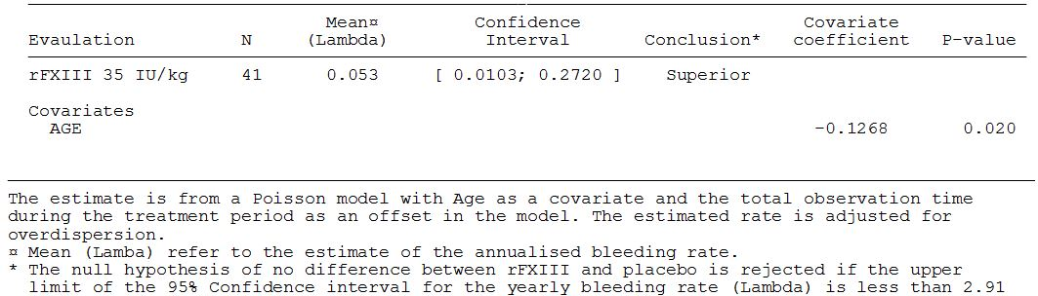
The carryover effect from the FXIII treatment received one month prior to initiation of treatment with rFXIII is judged to have had a negligible impact on the primary efficacy analysis. Given that the FXIII activity typically is quadrupled when dosing with rFXIII, the vast part of bleeding prevention in the first month will be attributable to the rFXIII treatment rather than the previous treatment. Since the first month of treatment with rFXIII further only accounts for 9% of the total duration of the treatment period (434 months), any marginal influence on the bleeding incidence in this month alone will not propagate to a traceable impact on the bleeding rate during the entire treatment period.

Clinical evaluator’s comment
The sponsor’s response is satisfactory. In the original submission (data including first month results), the mean yearly bleeding rate (Lambda [λ]) for treatment requiring bleeding episodes was 0.048 (95% CI: 0.0094, 0.2501). This rate is similar to the rate obtained when the results from the first month were excluded from the analysis. Consequently, it can be concluded that any carryover effects of previous FXIII treatment into the first month of treatment with rFXIII are clinically insignificant.

Question 6
In the pivotal Phase III Study (F13CD-1725), the efficacy conclusions state “when compared with retrospectively collected data from patients with congenital FXIII deficiency, the bleeding frequency observed in the present trial was similar to or lower than the bleeding frequency for patients on regular replacement therapy (on average approximately 0.3 treatment requiring bleeds/year)". However, the data from the retrospective analysis (F13CD-QUEST) suggests that in patients on regular replacement therapy the average number of bleeds/year of 0.3 refers to all break through bleeds (see Table 7-11; F13CD-Quest). Please clarify whether the 0.3/year rate quoted for F13CD-Quest relates to all bleeding events or is specific to bleeding events requiring treatment with FXIII containing products.

Sponsor’s response
According to Table 7-11, the 20 bleeds per year among patients on prophylaxis (0.3 bleeds/patient year) are mentioned as being all types of bleeds; whereas the 46.5 bleeds per year among patients on-demand (2.9 bleeds/patient year) are mentioned as being only treatment requiring bleeds.
The wording reflects formally the underlying questions for the two regimens:
- On demand: “Average number of bleedings per year requiring on-demand treatment”
- Prophylaxis: “Number of bleedings during prophylaxis per year”
However, when applying a consistent interpretation of the entire questionnaire, it is implicit that the answer to the question on prophylactic bleeding rate refers to treatment requiring bleeding episodes. The corresponding question for patients undertaking on-demand treatment leaves no doubt that only bleeding events requiring treatment with FXIII containing products are reported; thereby, also a comparison between prophylactic and on-demand bleeding rates is facilitated.
From a clinical point of view, and by convention when assessing efficacy of haemostatic products in clinical trials, the incidence of treatment requiring bleeds is considered to be the most objective and relevant manifestation of efficacy, as also implemented for the pivotal F13CD-1725 trial.
In conclusion, the prophylactic bleeding rate of 0.3 bleeds/patient year derived from the questionnaire is interpreted as covering treatment requiring bleeding episodes.
It should be noted that the pivotal trial was solely designed to conduct a comparison against a historical on-demand bleeding rate, since a comparison against a prophylactic bleeding rate would require several hundred patients to a achieve a power of 80%.
Consequently, the primary focus of the F13CD-Quest was to obtain a robust assessment of the rate of treatment requiring bleeding episodes during an on-demand regimen. For these reasons, a statistical comparison against the historical prophylaxis bleeding rate is not appropriate.

Clinical evaluator’s comment
The sponsor’s response indicates that the bleeding rate from the retrospectively collected historical data of 0.3 bleeds/patient year is considered to relate to treatment requiring bleeds in patients receiving prophylactic FXIII treatment.

Question 7
In the Phase III studies F13CD-1725 and F13CD-3720, what were the bleeding rates/year for all bleeding events, traumatic and spontaneous, and irrespective of whether treatment with a FXIII containing product was required? Please compare these rates with the comparable rate from the retrospective analysis (F13CD-Quest) for the regular treatment (prophylaxis) subgroup. Please comment on the differences between the rates in the Phase III trials and the rate in F13CD-Quest.
In addition, please comment on the differences between the calculated rates and the rates for spontaneous bleeding during regular Fibrogammin P therapy of 0.2 events/year and 2.5 events/per year for patients not on prophylactic therapy reported by Lusher et al. Furthermore, if the annualised bleeding rates (all) in the pivotal and extension studies are greater than the comparative rate in the historical control please justify why rFXIII should be approved for the treatment of congenital FXIII deficiency.

Sponsor’s response
In total, 54 bleeding episodes were reported in the F13CD-1725 trial, of which 5 were treatment requiring (one additional non treatment requiring bleeding episode was observed for one subject more than 200 days after being withdrawn from treatment). In the F13CD-1725 trial, the cause of a bleed was only reported for the treatment requiring bleeding episodes, but a post hoc evaluation of an apparent cause of each bleed has been made. Similarly for the F13CD-3720 trial, as of a cut off date of 11 February 2011, 20 bleeding episodes were reported with 5 episodes being treatment requiring. For the F13CD-3720 trial, the cause of non-treatment requiring bleeding episodes was not reported as of the cut-off date but collected subsequently via an amended protocol.
The number of treatment requiring and non-treatment requiring bleeding episodes in the two trials along with the accumulated patient years are summarised in Table 30. In addition, bleeding rates and 95% confidence intervals (CIs) are presented, based on a simple Poisson analysis without age adjustment and over dispersion, adjusting only for duration in the trial (as offset in the model). The mean bleeding rate estimate from the simple Poisson model corresponds with the crude mean calculated as the total number of bleedings divided by the accumulated observation time for all patients. The bleeding rate based on all types of bleeds (54 bleeding episodes in F13CD-1725) was estimated to be 1.49 bleeds per patient year (95% CI: [1.14; 1.94]). The bleeding rate for the treatment-requiring bleeds was 0.14 (95% CI: [0.06; 0.33]).
Table 30: Summary of bleeding and estimated annual rates in Novo Nordisk trials; 11 February 2011.
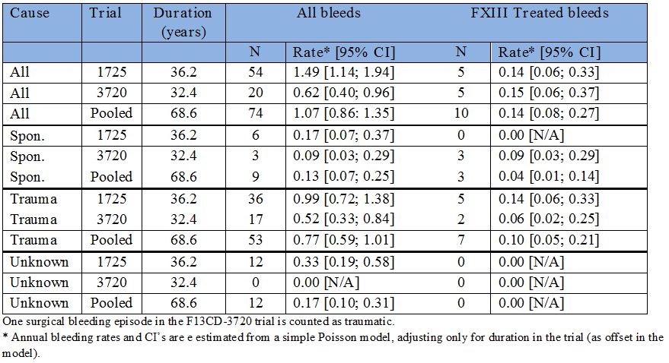
For the historical data, the same simple Poisson analysis as described above was conducted, including conservatively a 1 year observation time as an offset in the model. In this analysis, there were 2.91 bleeds per patient year (95% CI: [2.18; 3.87]) for on-demand treatment based on treatment requiring bleeding episodes.
For prophylactic treatment, the historical bleeding rate was 0.33 bleeds per patient year (95% CI: [0.22; 0.51]), reflecting treatment requiring bleeds. It is not appropriate to conduct a statistical comparison of this rate with the rate of all bleeding episodes from the F13CD-1725 trial.

Clinical evaluator’s comment
In Study F13CD-1725, the bleeding rate for treatment requiring bleeds in patients treated with rFXIII prophylaxis was 0.14 (95% CI: 0.06; 0.33) bleeds per patient year. This rate compares with 2.91 (95% CI: 2.18, 3.87) bleeds per patient year for on-demand treatment based on treatment requiring bleeding episodes. The difference between these two rates was statistically significant as the null hypothesis of no difference between rFXIII and placebo (that is, on-demand FXIII treatment, historical control) was rejected as the upper limit of the 95% CI for the yearly bleeding rate (λ) was less than 2.91 (Table 31).
Table 31: F13CD-1725: Primary endpoint analysis (rate of treatment requiring bleeds); FAS.
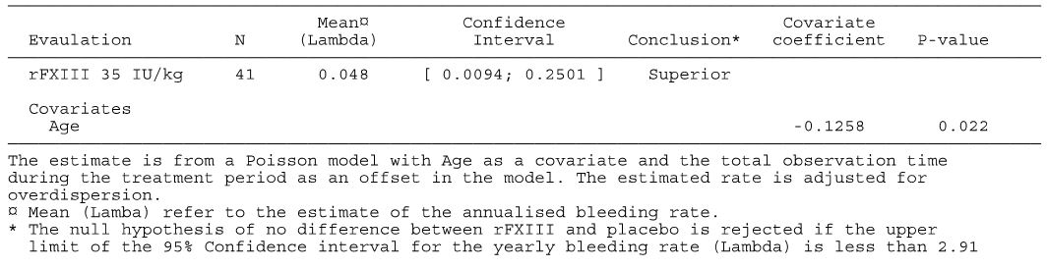
In addition, the bleeding rate for the treatment requiring bleeds of 0.14 (95% CI: 0.06; 0.33) per patient year in patients receiving prophylactic rFXIII was lower than the bleeding rate for treatment requiring bleeds of 0.33 (95% CI: 0.22, 0.51) per patient year in patients receiving prophylactic FXIII treatment from historical data.

Sponsor’s response
It should be noted that available publications on treatment of FXIII congenital patients are not explicit as to whether the reported bleeding episodes are treatment requiring or not. Focus is often put on spontaneous versus traumatic bleeding episodes. The estimated bleeding rates from historical data and the literature are summarised in Table 32.
Table 32: Estimated bleeding rates from historical data and the literature.
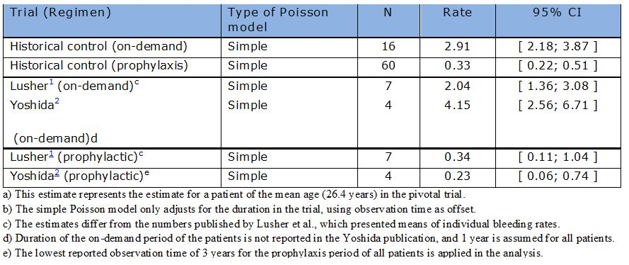
In the publication by Lusher and colleagues, the yearly bleeding rates of spontaneous bleeds for 7 FXIII deficient patients on on-demand and prophylaxis were reported. It is not clear whether the bleedings were treatment requiring or not. The publication reported mean rates of 0.2 and 2.5 bleeds per year as arithmetic averages across individual bleeding rates (for each subject). This methodology does not seem appropriate for event data, and in order to facilitate a more direct comparison with the data from the F13CD-1725 and F13CD-3720 trials, the same simple Poisson analysis as described above was applied to the Lusher data. Using this approach, the estimates from the Lusher paper changes to 0.34 bleeds per patient year (95% CI: [0.11; 1.04]) for prophylaxis treatment and 2.04 bleeds per year (95% CI: [1.36; 3.08]) for on-demand.
The Lusher paper focuses on spontaneous bleeding episodes. In the two Novo Nordisk trials, 3 spontaneous bleeding episodes requiring treatment occurred over an accumulated trial duration of 68.6 patient years. One of the original 3 spontaneous treatment requiring bleeding episodes (bruised arm for one subject) subsequently changed status to traumatic on initiative of the investigator. Thus, the bleeding rate for treatment requiring spontaneous bleeds during prophylaxis in the Novo Nordisk trials is 2/68.6 = 0.029 bleeds per patient year, which is substantially lower than the rate of 0.34 bleeds per patient year described in the Lusher paper. Including all 21 spontaneous bleeds (9 spontaneous and 12 undeterminable) from the Novo Nordisk trials (both treatment requiring and non-treatment requiring) gives a rate of 21/68.6 = 0.31 spontaneous bleeds per patient year. This is comparable to the rate of 0.34 bleeds per patient year described in the Lusher paper.
A similar conclusion may be derived based on a comparison with a paper by Yoshida and colleagues which reported bleeding data for 4 patients with congenital factor XIII deficiency receiving prophylactic treatment with FXIII for 3 to 12 years following an on-demand period. The mean prophylaxis bleeding rate was 0.23 bleedings per patient year. A mean bleeding rate of 4.15 bleedings per patient year prior to initiation of the prophylactic treatment was presented, without specifying the exact observation time. A Poisson analysis was therefore conducted using a conservative assumption of 3 years’ prophylactic treatment and 1 year on-demand treatment for each patient. This resulted in 95% CIs of [0.06; 0.74] for prophylactic treatment and [2.56; 6.71] for on-demand treatment.
In conclusion, the annualised bleeding rates during prophylactic treatment in the pivotal (F13CD-1725) and extension (F13CD-3720) study of 0.14 for all treatment requiring bleeding episodes and of 0.04 for spontaneous treatment requiring bleeding episodes are lower or comparable with the available data on historical controls. Thus, Novo Nordisk considers it justified that rFXIII should be approved for the treatment of congenital FXIII deficiency.

Clinical evaluator’s comment
The sponsor’s response is satisfactory.

Question 8
If the bleeding rate of 0.3/year in the historical control group treated with regular FXIII therapy is not due entirely to patients with bleeding episodes requiring treatment with FXIII containing products, then please provide the bleeding rate for treatment requiring episodes for this patient group.

Sponsor’s response
As described in the response to Question 6, the prophylaxis bleeding rate of 0.3 bleeds/patient year from the F13CD-Quest data collection is interpreted as referring to treatment requiring bleeds.

Clinical evaluator’s comment
The sponsor’s response is satisfactory.

Safety

Question 9
In the Phase III pivotal study (F13CD-1725) and the extension study (F13CD-3720), testing for anti-yeast antibodies appears not to have been undertaken. Please justify why testing was not undertaken in these two Phase III studies?

Sponsor’s response
The data collected in 117 subjects exposed to rFXIII in early phase trials demonstrated, that the levels of anti-yeast IgE were not related to trial drug administration. Therefore, Novo Nordisk decided not to include this analysis, but to closely monitor and characterise anti-drug antibodies through the Phase III clinical programme. Testing for anti-yeast antibodies (IgE) was performed in 5 clinical trials using commercially available assays. Details of these trials are included in Table 33.
Table 33: Clinical trials where testing for anti-yeast antibodies were performed.
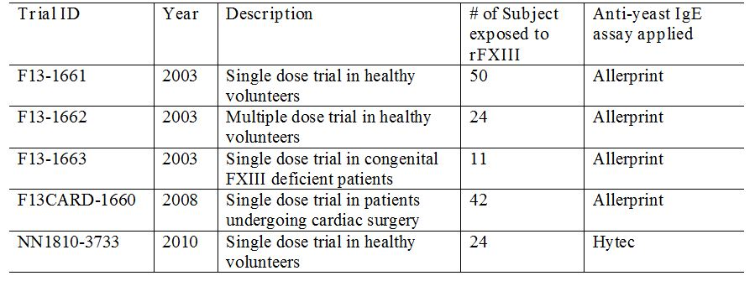
As of 11 February 2011, a total of 85 patients suffering from congenital FXIII deficiency had been exposed to a total of 924 monthly doses of rFXIII. No allergic reactions to rFXIII had been reported. Additionally, a search of all reported adverse events has been made using the Standardised MeDRA Query (SMQ) (Anaphylactic reaction (SMQ Code 20000021), Angioedema (SMQ Code 20000024), Severe cutaneous adverse reactions (SMQ Code 20000020)) with no allergic reactions related events identified.

Clinical evaluator’s comment
The sponsor’s response is considered to be satisfactory.

Question 10
Please provide a summary of all subjects exposed to rFXIII in the clinical development program who developed anti yeast antibodies. Include an estimate of the incidence of anti-yeast antibodies in subjects exposed to rFXIII.

Sponsor’s response
Anti-yeast IgE antibodies were measured using samples obtained pre and post-trial product administration in a total of 151 individuals across 5 clinical trials. Treatment included rFXIII at various dose levels (2-75 U/kg, in 117 subjects) and placebo (34 subjects). In the majority of the subjects (94/151 = 62%), anti-yeast IgE antibodies were not detected neither pre nor post dose.
In subjects exposed to rFXIII (across trial and dose levels), an increase in anti-yeast IgE was recorded in 21% (24/117). This is not statistically significant different from the 24% incidence of increase in anti-yeast IgE seen in placebo treated subjects (8/34) (p = 0.36).
Quantitatively, there were no changes in the level of IgE detected upon treatment (pre dose (average = 0.20KU/L, maximum = 0.80 KU/L), post dose (average = 0.22 KU/L, maximum = 0.73 KU/L) for subjects exposed to rFXIII.
Finally, looking at the incidence of anti-yeast antibodies in subjects exposed to rFXIII (117), 31 subjects were positive for anti-yeast IgE. And again, this is not statistically significant (p = 0.17) from the rate observed in subjects exposed to placebo (12/34).
These data does not indicate that observed anti yeast IgE antibodies are related to treatment with rFXIII.

Clinical evaluator’s comment
The sponsor’s response is considered to be satisfactory.

Second round benefit-risk assessment

Second round assessment of benefits
After consideration of the sponsor’s Section 31 response to the clinical questions, the benefits of treatment with rFXIII for the proposed usage are summarised below.
The pivotal trial (F13CD-1725) showed that prophylactic treatment with rFXIII (35 IU/kg) once monthly (28 ± 2 days) significantly reduced the risk of treatment requiring bleeding episodes in patients with congenital FXIII deficiency compared with historical controls. There were 41 patients with congenital FXIII deficiency in the pivotal trial with mean age 26.4 years (range: 7, 60 years). Of the 41 patients, 33 received all 13 planned monthly doses of rFXIII and the mean and median number of doses was 11.5 (SD = 13.9) and 13 (range: 2, 24), respectively.
In the pivotal trial (F13CD-1725), the primary efficacy endpoint analysis showed that the age adjusted rate (number per patient year) of treatment requiring bleeds during the rFXIII treatment period was 0.048/year (95% CI: 0.0094, 0.2501). The primary efficacy endpoint was evaluated by a Poisson model (log link), comparing the data to a historical rate of 2.91 bleedings per year based on retrospectively collected data for patients receiving only on-demand treatment. Age was included as a continuous covariate, and the total observation time during the treatment period was used as an offset in the model. Subject withdrawal before end of trial was taken into account in the model by adjusting the length of observation time. The estimated rate was calculated, adjusting for overdispersion (that is, observed variance greater than predicted variance). The overdispersion was estimated by Pearson’s chi-square statistic divided by its degrees of freedom. It was to be concluded that monthly replacement therapy with rFXIII is superior to on-demand treatment with FXIII containing products (defined as placebo) if the yearly bleeding rate for the rFXIII group (λ) was lower than 2.91. The pre-defined null hypothesis of no difference between rFXIII and placebo was rejected as the upper limit of the 95% CI for λ (that is, 0.2501 bleeds/patient year) was less than 2.91 (bleeds/patient-year).
In the pivotal trial (F13CD-1725), there were 5 treatment requiring bleeding events (all traumatic) in 4 out of 41 patients treated with rFXIII. Based on a total of 471 monthly doses corresponding to a cumulative observation period of 434 months, the mean rate of treatment requiring bleeds was 0.138 (95% CI: 0.058, 0.332)/patient year. This rate was numerically superior to the treatment-requiring bleeding rate of 0.3 bleeds/patient year in historical controls. In the pivotal trial (F13CD-1725), there were a total of 54 bleeds (treatment and non-treatment requiring) in 41 patients, giving an estimated total bleeding rate of 1.49 (95% CI: 1.14, 1.94) bleeds/patient-year.
In the pivotal trial (F13CD-1725), age was a statistically significant covariate (p = 0.022) for the rate (number per subject year) of bleeding episodes requiring treatment with FXIII containing products, and patients aged < 18 years were at a greater risk of treatment requiring bleeds than patients aged ≥ 18 years. Of the 5 treatment requiring bleeding events, 4 occurred in 3 patients (n = 15) aged < 18 years (rate = 0.362 [95% CI: 0.136, 0.963] bleeds/patient year), and 1 occurred in 1 patient (n = 26) aged ≥ 18 (rate = 0.040 [95% CI: 0.006, 0.283] bleeds/patient year). The difference in the treatment requiring bleeding rates between patients with congenital FXIII deficiency aged < 18 years compared with ≥ 18 years might reflect the greater risk of traumatic bleeding events in children and adolescents due to more frequent “risky” activities in younger compared with older patients.
The interim extension data from the long term extension trial (F13CD-3720) showed that the benefits of regular rFXIII treatment persisted following the initial 12 months of treatment. In the 33 patients (mean age 28.8 years, range 7 to 60) who completed the pivotal trial and continued in the extension trial, the age adjusted rate (number per subject year) of treatment requiring bleeding episodes was 0.038/year (95% CI: 0.0034, 0.4355). The upper 95% CI of the observed rate in the patients in the extension trial (0.4335/year) was less than the fixed “placebo” rate of 2.91/year, and consequently the difference between the observed and control rates was statistically significant.
In the extension trial (F13CD-3720), 5 bleeds (3 spontaneous, 2 traumatic) in 3 patients required treatment with a FXIII containing product. Of the 33 patients continuing treatment in the extension phase the median observation period was 359 days. The bleeding rate for treatment requiring bleeds (5 bleeds) was 0.15 (95% CI: 0.06, 0.37)/patient year (similar to the rate in the pivotal trial of approximately 0.14 bleeds/patient year), and the bleeding rate for all bleeds (20 bleeds) was 0.62 (95%: 0.40, 0.96)/patient year (lower than the rate in the pivotal trial of 1.49 bleeds/patient year). In F13CD-3720, age was not found to be a statistically significant covariate.
In the pivotal and extension studies, in the monthly treatment cycle (28 ± 2 days) bleeding episodes requiring treatment with FXIII containing products occurred more frequently ≥ 15 days after dosing (7 bleeds) compared with < 15 days after dosing (3 bleeds). However, the observed association might be confounded by investigators being unblinded to the date of rFXIII administration.

Second round assessment of risk
After consideration of the sponsor’s Section 31 response to the clinical questions, the risks of treatment with rFXIII for the proposed usage are summarised below.
The pivotal (FCD13-1725) and extension (F13CD-3720) trials are considered to have satisfactorily established the safety of rFXIII 35 IU/kg once monthly for the treatment of congenital rFXIII deficiency. The most commonly reported AEs occurring in ≥ 10% of patients in the pooled safety data set from the pivotal and extension trials (n = 41) in diminishing order of frequency were: headache (31.7%); nasopharyngitis (26.8%); pyrexia (19.5%); arthralgia (17.1%); pain in extremity (17.1%); nasal congestion (17.1%); oropharyngeal pain (17.1%); excoriation (12.2%); incorrect dose administered (12.2%); and joint sprain (12.2%). No thromboembolic events had been reported in the pivotal and extension trials at the date of data cut off.
There were no deaths in the pivotal and extension trials. There were a total of 10 SAEs recorded in 7 patients, and except for 3 SAEs of non-neutralising anti rFXIII antibodies, all events were evaluated by the investigator as being unlikely to be related to treatment with rFXIII. The 10 SAEs were: 3 antibody positive events (1 probably related, 2 possibly related), 1 diverticulitis, 1 non cardiac chest pain, 1 headache, 1 carpal tunnel syndrome, 1 road traffic accident, 1 small intestinal obstruction, 1 x skin laceration. Discontinuation from the trials due to AEs occurred in 4 (9.8%) patients, all from the pivotal study. The premature discontinuations were due the presence of non-neutralising anti rFXIII antibodies in 3 patients, and worsening leukopenia and neutropenia in 1 patient.
In the pivotal trial, 4 patients developed transient, low titre and non-neutralising anti rFXIII antibodies (titre = 2.3 to 2.6; lowest level of quantification = 2.0). No anaphylactic or allergic reactions, bleeding episodes or changes in PK were observed in any of the patients at any time during the presence of the non-neutralising antibodies or during the follow up period. Furthermore, the antibodies declined below the limit of detection in 2 patients despite repeated exposure to rFXIII and in 2 patients following exposure to other FXIII containing products.
In subjects exposed to rFXIII (across trials and dose levels), an increase in anti-yeast IgE antibodies was recorded in 21% (24/117) of subjects compared with 34% (8/34) of subjects exposed to placebo, and the difference was not statistically significant (p = 0.36). Overall, the incidence of anti-yeast IgE antibodies in subjects exposed to rFXIII was 26.5% (31/117) compared with 35.3% (12/34) in subjects exposed to placebo, and the difference was not statistically significant (p = 0.17).
In both the pivotal and extension trials, haematological, biochemical, and urinalysis parameters were assessed at local laboratories and coagulation parameters were assessed at a central laboratory. The clinical laboratory parameters were measured at screening, baseline, post dose Weeks 2 and 4, and then post dose every 4 weeks until the end of the trial. There were no noteworthy changes in any of the assessed laboratory parameters during treatment with rFXIII. However, considerable variation in D-dimer levels was observed over the course of the trials. The sponsor speculates that individual D-dimer outliers may have been caused by inappropriate sampling handling at some study centres, but no data were provided to support this argument. There were no noteworthy changes in vital signs or physical examination in patients during treatment with rFXIII in the trials.
There was no evidence of hepatic, renal, haematological or cardiovascular toxicity in the pivotal and extension trials, nor were there reports of serious skin reactions occurring in these two trials. The safety of rFXIII in special populations was not investigated in the first round data due to the small number of patients with congenital FXIII deficiency in the safety data set. Therefore, there were no adequate safety data in first round safety data-set in children aged < 7 years, patients aged > 60 years, pregnant women, patients from different racial groups, patients with hepatic, renal or cardiovascular disease, or patients being treated with rFXIII in combination with other medicines.
The sponsor’s Section 31 response included a new PK trial in children (n = 6) aged 1 to less than 6 years (F13CD-3760). In this trial, a single dose of rFXIII 35 IU/kg was administered and the children were followed up for 30 days after dosing. No deaths, SAEs or AEs resulting in withdrawal from the study were reported during this period. No probably/possibly treatment related AEs were reported. No medical events of special interest were reported. Two (2) mild AEs (pyrexia [29 days post dose, 2 days duration], and pain in extremity/arm [4 days post dose, duration 68 days]) were reported after exposure to rFXIII in 2 separate patients, and both children recovered. No other AEs were reported. There were no treatment requiring bleeding episodes. There were no thromboembolic events. There were no reports of anti rFXIII antibodies in the 6 patients in pre dose or post dose samples (Day 30). There were no reports of treatment-requiring bleeds during the 30 days of post dose follow up.
The sponsor states that the efficacy and safety of rFXIII in children aged 1 to less than 6 years from trial FC13CD-3760 is being monitored in the paediatric extension trial F13CD-3835, and no concerns have arisen from this trial in terms of efficacy and safety. The sponsor stated that trial F13CD-3835 has been on-going since January 2011, and the total exposure time has reached more than 8 patient years with no treatment requiring bleeding episodes reported as of 1 January 2013.

Second round assessment of benefit-risk balance
After consideration of the sponsor’s Section 31 response to the clinical questions, the benefit-risk balance of treatment with rFXIII for the proposed usage is considered to be satisfactory. It is likely that treatment with rFXIII will need to be continued indefinitely in patients with congenital FXIII deficiency. The data from the pivotal trial (F13CD-1725) showed that the risk or experiencing a treatment requiring bleed was notably greater in patients aged < 18 years compared with patients aged ≥ 18 years, but treatment requiring bleeds occurred infrequently in patients receiving rFXIII prophylactic treatment. The interim data from the single dose PK trial in children (n = 6) aged 1 to less than 6 years (F13CD-3760) demonstrated no treatment requiring bleeds in patients followed up for 30 days after administration of rFXIII and no safety issues different from those observed in patients aged ≥ 6 years. The sponsor states that children from trial F13CD-3760 have now been followed up in an extension trial for more than 8 patient years with no treatment requiring bleeding episodes reported as of 1 January 2013. However, no data from this extension trial were submitted for evaluation.

Second round recommendation regarding authorisation
After evaluation of the clinical data submitted in the sponsor’s Section 31 response it is recommended that NovoThirteen be approved for the routine prophylaxis of bleeding in patients with congenital Factor XIII A-subunit deficiency.
It should be a condition of registration that the final clinical report for the ongoing paediatric extension trial (F13CD-3835) should be submitted to the TGA for evaluation as soon as practical after its completion. In addition, it should also be a condition of registration that the long term efficacy and safety data from the ongoing extension trial (F13CD-3720) should be submitted to the TGA for evaluation soon as practical after collation of the data has been completed.

Di Paola J, et al. (2001) Current therapy for rare factor deficiencies. Haemophilia 7 Suppl 1:16-22.
National Blood Authority, “Australian Bleeding Disorder Registry (ABDR) Annual Report 2010-2011”.
Ivaskevicius V, et al. (2007) International registry on factor XIII deficiency: a basis formed mostly on European data. Thromb Haemost. 97: 914-921.
Ivaskevicius V, et al. (2007) Phenotype- genotype correlation in eight Polish patients with inherited Factor XIII deficiency: identification of three novel mutations. Haemophilia 13: 649-657.
Nugent DJ. (2006) Prophylaxis in rare coagulation disorders - factor XIII deficiency. Thromb Res. 118 Suppl 1: S23-S28.
Karimi M, et al. (2009) Factor XIII deficiency. Semin Thromb Hemost. 35: 426-438.
Di Paola J, et al. (2001) Current therapy for rare factor deficiencies. Haemophilia 7 Suppl 1:16-22; Anwar R, Miloszewski KJ. (1999) Factor XIII deficiency. Br J Haematol. 107: 468-484.
Karimi M, et al. (2009) Factor XIII deficiency. Semin Thromb Hemost. 35: 426-438; Anwar R, Miloszewski KJ. (1999) Factor XIII deficiency. Br J Haematol. 107: 468-484.
Karimi M, et al. (2009) Factor XIII deficiency. Semin Thromb Hemost. 35: 426-438.
Ivaskevicius V, et al. (2007) International registry on factor XIII deficiency: a basis formed mostly on European data. Thromb Haemost. 97: 914-921; Anwar R, Miloszewski KJ. (1999) Factor XIII deficiency. Br J Haematol. 107: 468-484; Lusher J, et al. (2010) Prophylactic therapy with Fibrogammin P is with a decreased incidence of bleeding episodes; a retrospective study. Haemophilia 16: 316-321.
Ivaskevicius V, et al. (2007) International registry on factor XIII deficiency: a basis formed mostly on European data. Thromb Haemost. 97: 914-921; Karimi M, et al. (2009) Factor XIII deficiency. Semin Thromb Hemost. 35: 426-438; Anwar R, Miloszewski KJ. (1999) Factor XIII deficiency. Br J Haematol. 107: 468-484.
Karimi M, et al. (2009) Factor XIII deficiency. Semin Thromb Hemost. 35: 426-438.
Di Paola J, et al. (2001) Current therapy for rare factor deficiencies. Haemophilia 7 Suppl 1:16-22; ; Karimi M, et al. (2009) Factor XIII deficiency. Semin Thromb Hemost. 35: 426-438; Anwar R, Miloszewski KJ. (1999) Factor XIII deficiency. Br J Haematol. 107: 468-484; Egbring R, Kröniger A, Seitz R. (1996) Factor XIII deficiency: pathogenic mechanisms and clinical significance. Semin Thromb Hemost. 22: 419-425; Hsieh L, Nugent D. (2008) Factor XIII deficiency. Haemophilia 14: 1190-1200.
Hsieh L, Nugent D. (2008) Factor XIII deficiency. Haemophilia 14: 1190-1200.
European Medicines Agency, “Committee for Medicinal Products for Human Use (CHMP): Guidelines on the clinical investigation of the pharmacokinetics of therapeutic proteins (CHMP/EWP/89249/2004)”, 24 January 2007.
European Medicines Agency, “Committee for Medicinal Products for Human Use (CHMP): Guidelines on the clinical investigation of the pharmacokinetics of therapeutic proteins (CHMP/EWP/89249/2004)”, 24 January 2007.
Karimi M, et al. (2009) Factor XIII deficiency. Semin Thromb Hemost. 35: 426-438.
Anwar R, Miloszewski KJ. (1999) Factor XIII deficiency. Br J Haematol. 107: 468-484.
Anwar R, Miloszewski KJ. (1999) Factor XIII deficiency. Br J Haematol. 107: 468-484; Hsieh L, Nugent D. (2008) Factor XIII deficiency. Haemophilia 14: 1190-1200.
Lusher J, et al. (2010) Prophylactic therapy with Fibrogammin P is with a decreased incidence of bleeding episodes; a retrospective study. Haemophilia 16: 316-321.
Egbring R, Kröniger A, Seitz R. (1996) Factor XIII deficiency: pathogenic mechanisms and clinical significance. Semin Thromb Hemost. 22: 419-425; Anwar R, Miloszewski KJ. (1999) Factor XIII deficiency. Br J Haematol. 107: 468-484; Karimi M, et al. (2009) Factor XIII deficiency. Semin Thromb Hemost. 35: 426-438.
Egbring R, Kröniger A, Seitz R. (1996) Factor XIII deficiency: pathogenic mechanisms and clinical significance. Semin Thromb Hemost. 22: 419-425.
Lusher J, et al. (2010) Prophylactic therapy with Fibrogammin P is with a decreased incidence of bleeding episodes; a retrospective study. Haemophilia 16: 316-321.
Mire-Sluis AR, et al. (2004) Recommendations for the design and optimization of immunoassays used in the detection of host antibodies against biotechnology products. J Immunol Methods 289: 1-16; Koren E, et al. (2008) Recommendations on risk-based strategies for detection and characterization of antibodies against biotechnology products. J Immunol Methods 333: 1-9.
European Medicines Agency, “Committee for Medicinal Products: Guideline on immunogenicity assessment of biotechnology-derived therapeutic proteins (EMEA/CHMP/BMWP/14327/2006)”, 24 January 2007, Web, accessed 3 March 2014 <www.ema.europa.eu/docs/en_GB/ document_library/Scientific_guideline/2009/09/WC500003947.pdf>; US Food and Drug Administration, “Guidance for Industry: Assay Development for Immunogenicity Testing of Therapeutic Proteins”, December 2009, Web, accessed 3 March 2014 <www.fda.gov/downloads/ Drugs/.../Guidances/UCM192750.pdf>.
Kohler HP, et al. (2011) Diagnosis and classification of factor XIII deficiencies. J Thromb Haemost. 9: 1404-1406.
Anwar A, Miloszewski KJ. (1999) Factor XIII deficiency. Br J Haematol. 107: 468-484; Jennings I, et al. (2003) Problems relating to the laboratory diagnosis of factor XIII deficiency: a UK NEQAS study. J Thromb Haemost. 1: 2603-2608; Lawrie AS, et al. (2010) Factor XIII - an under diagnosed deficiency - are we using the right assays? J Thromb Haemost. 8: 2478-2482.
Lusher J, et al. (2010) Prophylactic therapy with Fibrogammin P is with a decreased incidence of bleeding episodes; a retrospective study. Haemophilia 16: 316-321.
Lusher J, et al. (2010) Prophylactic therapy with Fibrogammin P is with a decreased incidence of bleeding episodes; a retrospective study. Haemophilia 16: 316-321.
Yoshida S, Fukue H, Sugimura D. (1996) Efficiency of intermittent prophylactic factor XIII substitution in congenital factor XIII A subunit deficiency. Japanese Journal of Transfusion Medicine 42: 173-177.

