This medicinal product is subject to additional monitoring in Australia. This will allow quick identification of new safety information. Healthcare professionals are asked to report any suspected adverse events at https://www.tga.gov.au/reporting-problems.
▼

AUSTRALIAN PRODUCT INFORMATION
Ronapreve® (casirivimab and imdevimab)

NAME OF THE MEDICINE
Casirivimab and imdevimab

QUALITATIVE AND QUANTITATIVE COMPOSITION
Ronapreve is available as:
a. Co-packaged 6 mL single-use vials
Each casirivimab 6 mL vial contains 300 mg of casirivimab per 2.5 mL (120 mg/mL).
Each imdevimab 6 mL vial contains 300 mg imdevimab per 2.5 mL (120 mg/mL).
b. Co-packaged 20 mL multidose vials
Each casirivimab 20 mL multidose vial contains 1 332 mg of casirivimab per 11.1 mL (120 mg/mL).
Each imdevimab 20 mL multidose vial contains 1 332 mg imdevimab per 11.1 mL (120 mg/mL).
For the full list of excipients, see section 6.1 List of excipients.

PHARMACEUTICAL FORM
Solution for injection or infusion.
Clear to slightly opalescent and colourless to pale yellow solution with a pH of 6.0.

CLINICAL PARTICULARS

THERAPEUTIC INDICATIONS
Ronapreve has provisional approval for the indications below:
Treatment
Ronapreve is indicated for the treatment of COVID-19 in adults and adolescents (aged 12 years and older and weighing at least 40 kg) who do not require supplemental oxygen for COVID-19 and who are at increased risk of progressing to severe COVID-19.

Post-exposure prophylaxis
Ronapreve is indicated for the prevention of COVID-19 in adults and adolescents (aged 12 years and older and weighing at least 40 kg) who have been exposed to SARS-CoV-2 AND who either:
- have a medical condition making them unlikely to respond to or be protected by vaccination, OR
- are not vaccinated against COVID-19.

(refer to section 4.2 Dose and method of administration and section 5.1, Clinical Trials)

Ronapreve is not intended to be used as a substitute for vaccination against COVID-19.

The decision has been made on the basis of short term efficacy and safety data. Continued approval of this indication depends on the evidence of longer term efficacy and safety from ongoing clinical trials and post-market assessment.

DOSE AND METHOD OF ADMINISTRATION
Preparation and administration of Ronapreve should be initiated and monitored by a qualified healthcare provider using aseptic technique. Administration should be under conditions where management of severe hypersensitivity reactions, such as anaphylaxis, is possible. Individuals should be monitored post intravenous infusion according to local medical practice.
Intravenous Administration
Casirivimab and imdevimab must be administered together, after dilution, as a single intravenous (IV) infusion.
Subcutaneous Administration
Casirivimab and imdevimab must be administered consecutively by separate subcutaneous injections.

Dosage

Treatment
The dosage in adult patients and adolescent patients 12 years of age and older weighing at least 40 kg is 600 mg of casirivimab and 600 mg of imdevimab administered either together as a single IV infusion via pump or gravity (see Table 1) or by subcutaneous injection (see Table 3). Intravenous infusion is strongly recommended. Subcutaneous injection is an alternative route of administration when intravenous infusion is not feasible and would lead to delay in treatment.

Casirivimab with imdevimab should be given together as soon as possible after a positive viral test for SARS-CoV-2 and not later than 7 days after the onset of first symptoms.

Prevention

Post-exposure prophylaxis (Single dose)
The dosage in adult patients and patients 12 years of age and older weighing at least 40 kg is 600 mg of casirivimab and 600 mg of imdevimab administered together either as a single IV infusion via pump or gravity (see Table 1) or by subcutaneous injection (see Table 3).

Casirivimab and imdevimab should be given concurrently as soon as possible following exposure to SARS-CoV-2.

Repeat dose for ongoing prophylaxis (Repeat dose)
For individuals in whom repeat dosing is determined to be appropriate for ongoing SARS-CoV-2 exposure (longer than 4 weeks) and who have a medical condition making them unlikely to respond to or be protected by vaccination:
● the initial (loading) dose in adult patients and in adolescent patients 12 years of age and older weighing at least 40 kg is 600 mg of casirivimab and 600 mg of imdevimab by IV infusion or subcutaneous injection.
● subsequent doses are 300 mg of casirivimab and 300 mg of imdevimab by IV infusion or subcutaneous injection once every 4 weeks until prophylaxis is no longer required. There are no data on repeat dosing beyond 24 weeks (6 doses).

Ronapreve is not intended to be used as a long term pre-exposure prophylaxis for prevention of COVID-19.

Repeat dosing regimens for prevention of COVID-19 allow for switching from intravenous infusion to subcutaneous injection or vice versa over the course of treatment.

Dose Modification
The rate of infusion may be slowed, interrupted or discontinued if the patient develops any signs of infusion-associated events or other adverse events (see section 4.8).

Delayed or Missed dose
Doses should not be missed and the dosing regimen should be adhered to as closely as possible. If a dose of Ronapreve is missed it should be administered as soon as possible. The schedule of administration should be adjusted to maintain the appropriate interval between doses.

Special populations

Paediatric use
The safety and efficacy of casirivimab and imdevimab in children < 12 years of age has not yet been established. No data are available. No dosage adjustment is recommended in paediatric individuals ≥ 12 years of age and older and weighing ≥ 40 kg (see section 5.2).

Geriatric use
No dose adjustment of casirivimab and imdevimab is required in elderly patients (see section 5.2).

Renal Impairment
No dosage adjustment is required in individuals with mild or moderate renal impairment, or in patients with creatinine clearance (CrCl) < 15 mL/min including those on dialysis. Limited data are available in individuals with severe renal impairment (see section 5.2).

Hepatic Impairment
No dosage adjustment is required in individuals with mild hepatic impairment. Limited data are available in individuals with moderate hepatic impairment. Casirivimab and imdevimab have not been studied in individuals with severe hepatic impairment (see section 5.2).

Method of Administration
Ronapreve is for intravenous infusion or subcutaneous injection only.
Do not use the medicine if the liquid discoloured or has visible particles.
The 6 mL vial is for single use in one patient only. Discard any remaining unused product.
The 20 mL vial is multi-dose and may be used to prepare doses for more than one patient.

Intravenous Infusion

Preparation of Ronapreve for intravenous infusion
Ronapreve should be prepared by a healthcare professional using aseptic technique:
1. Remove the casirivimab and imdevimab vials from refrigerated storage and allow to equilibrate to room temperature for approximately 20 minutes before preparation.
- Do not expose to direct heat.
- Do not shake the vials.
2. Inspect casirivimab and imdevimab vials visually for particulate matter and discoloration prior to administration. Should either be observed, the vial must be discarded and replaced with a new vial.
- The solution for each vial should be clear to slightly opalescent, colorless to pale yellow.
3. Obtain a prefilled IV infusion bag [made from polyvinyl chloride (PVC) or polyolefin (PO)] containing either 50 mL, 100 mL, 150 mL, or 250 mL of 0.9% Sodium Chloride Injection or 5% Dextrose Injection.
4. Withdraw the appropriate volume of casirivimab and imdevimab from each respective vial and inject into a prefilled infusion bag containing 0.9% Sodium Chloride Injection or 5% Dextrose Injection (see Table 1). For any remaining product in the vial, follow the instructions in Section 6.4.
5. Gently mix infusion bag by inversion. Do not shake.
6. Ronapreve is preservative-free and therefore, the diluted infusion solution should be administered immediately
- If immediate administration is not possible, store the diluted casirivimab and imdevimab infusion solution at 2 °C to 8 °C for no more than 48 hours and at room temperature up to 25 °C for no more than 12 hours. If refrigerated, allow the infusion solution to equilibrate to room temperature for approximately 30 minutes prior to administration.

The rate of infusion may be slowed, interrupted or discontinued if the patient develops any signs of infusion-associated events or other adverse reactions.

Table 1: Recommended dilution instructions for Ronapreve (casirivimab and imdevimab) for IV infusion
Indication | Ronapreve Dose (Total) | Total Volume for 1 Dose | Volume to be withdrawn from each respective vial and injected into a single prefilled 0.9% sodium chloride or 5% dextrose infusion bag of 50 to 250 mL for co-administration
Treatment and Post-exposure prophylaxis (single dose) | 600 mg casirivimab and  600 mg imdevimab  (1 200 mg dose) | 10 mL | 2.5 mL from two 6 mL single -use vials of casirivimab  2.5 mL from two 6 mL single-use vials of imdevimab
Treatment and Post-exposure prophylaxis (single dose) | 600 mg casirivimab and  600 mg imdevimab  (1 200 mg dose) | 10 mL | 5.0 mL from one 20 mL multidose vial of casirivimab  5.0 mL from one 20 mL multidose vial of imdevimab
Ongoing prophylaxis (repeat dose) | 300 mg casirivimab and  300 mg imdevimab  (600 mg dose) | 5 mL | 2.5 mL from one 6 mL single-use vial of casirivimab  2.5 mL from one 6 mL single-use vial of imdevimab
Ongoing prophylaxis (repeat dose) | 300 mg casirivimab and  300 mg imdevimab  (600 mg dose) | 5 mL | 2.5 mL from one 20 mL multidose vial of casirivimab  2.5 mL from one 20 mL multidose vial of imdevimab

Administration of Ronapreve by Intravenous Infusion

● Gather the recommended materials for infusion:
- Polyvinyl chloride (PVC), polyethylene (PE)-lined PVC, or polyurethane (PU) infusion set
- In-line or add-on 0.2 μm to 5 μm polyethersulfone, polysulfone, or polyamide end filter for IV administration.
● Attach the infusion set to the IV bag.
● Prime the infusion set.
● Administer the entire infusion solution in the bag via pump or gravity through an intravenous line containing a sterile, in-line or add-on 0.2 μm to 5 μm polyethersulfone, polysulfone, or polyamide end filter for IV administration (see Table 2).
● The prepared infusion solution should not be administered simultaneously with any other medication. The compatibility of casirivimab and imdevimab injection with IV solutions and medications other than 0.9% Sodium Chloride Injection or 5% Dextrose Injection is not known.
● After infusion is complete, flush the tubing with 0.9% Sodium Chloride Injection or 5% Dextrose Injection to ensure delivery of the required dose.
● Individuals should be monitored post intravenous infusion according to local medical practice.

Table 2: Minimum infusion time for IV infusion bag volumes for diluted Ronapreve 600 mg of casirivimab and 600 mg of imdevimab (1 200 mg dose) or 300 mg of casirivimab and 300 mg of imdevimab (600 mg dose)
Size of Prefilled 0.9% Sodium Chloride or  5% Dextrose Infusion Bag | Minimum Infusion Time Ronapreve  600 mg casirivimab and 600 mg imdevimab  (1 200 mg) | Minimum Infusion Time Ronapreve  300 mg casirivimab and 300 mg imdevimab  (600 mg)
50 mL | 20 minutes | 20 minutes
100 mL | 20 minutes | 20 minutes
150 mL | 20 minutes | 20 minutes
250 mL | 30 minutes | 30 minutes

Subcutaneous injection

Preparation of Ronapreve for Subcutaneous Injection
Remove the casirivimab and imdevimab vial(s) from refrigerated storage and allow to equilibrate to room temperature for approximately 20 minutes before preparation.
Do not expose to direct heat.
Do not shake the vials.

Inspect casirivimab and imdevimab vial(s) visually for particulate matter and discoloration prior to administration. Should either be observed, the vial must be discarded and replaced with a new vial. The solution for each vial should be clear to slightly opalescent, colorless to pale yellow.

1. Ronapreve should be prepared using the appropriate number of syringes (see Table 3). Obtain 3 mL or 5 mL polypropylene syringes with luer connection and 21-gauge transfer needles.
2. Withdraw the appropriate volume of casirivimab and imdevimab from each respective vial into each syringe (see Table 3) for a total of 4 syringes for the 1 200 mg combined total dose and a total of 2 syringes for the 600 mg combined total dose. For any remaining product in the vial, following the instructions in Section 6.4.
3. Replace the 21-gauge transfer needle with a 25-gauge or 27-gauge needle for subcutaneous injection.
4. This product is preservative-free and therefore, the prepared syringes should be administered immediately. If immediate administration is not possible, store the prepared casirivimab and imdevimab syringes at 2 ºC to 8 ºC for no more than 24 hours and at room temperature up to 25 ºC for no more than 6 hours. If refrigerated, allow the syringes to equilibrate to room temperature for approximately 10 - 15 minutes prior to administration.

Table 3: Preparation of Ronapreve (casirivimab and imdevimab) for subcutaneous injection
Indication | Ronapreve Dose (Total) | Total Volume for 1 Dose | Volume to be withdrawn to prepare 4 syringes
Treatment and Post-exposure prophylaxis (single dose) | 600 mg casirivimab and  600 mg imdevimab  (1 200 mg dose) | 10 mL | 2.5 mL from two 6 mL single-use vials of casirivimab  2.5 mL from two 6 mL single-use vials of imdevimab
Treatment and Post-exposure prophylaxis (single dose) | 600 mg casirivimab and  600 mg imdevimab  (1 200 mg dose) | 10 mL | 2.5 mL (2x) from one 20 mL multidose vial of casirivimab  2.5 mL (2x) from one 20 mL multidose vial of imdevimab
Indication | Ronapreve Dose (Total) | Total Volume for 1 Dose | Volume to be withdrawn to prepare 2 syringes
Ongoing prophylaxis (repeat dose) | 300 mg casirivimab and  300 mg imdevimab  (600 mg dose) | 5 mL | 2.5 mL from one 6 mL single-use vial of casirivimab  2.5 mL from one 6 mL single-use vial of imdevimab
Ongoing prophylaxis (repeat dose) | 300 mg casirivimab and  300 mg imdevimab  (600 mg dose) | 5 mL | 2.5 mL from one 20 mL multidose vial of casirivimab  2.5 mL from one 20 mL multidose vial of imdevimab

Administration of Ronapreve by Subcutaneous Injection
● For the administration of Ronapreve 1 200 mg dose (600 mg of casirivimab and 600 mg of imdevimab), gather 4 syringes (see Table 3) and prepare for subcutaneous injections.
● For the administration of Ronapreve 600 mg dose (300 mg of casirivimab and 300 mg of imdevimab), gather 2 syringes (see Table 3) and prepare for subcutaneous injections.
● Administer the subcutaneous injections consecutively, each at a different injection site, into the upper thigh, the upper outer arms, or abdomen, except for 5 cm around the navel. The waistline should be avoided.
● When administering the subcutaneous injections, it is recommended that providers use different quadrants of the abdomen or upper thighs or upper outer arms to space apart each 2.5 mL subcutaneous injection of casirivimab and imdevimab. DO NOT inject into skin that is tender, damaged, bruised, or scarred.

CONTRAINDICATIONS
Ronapreve is contraindicated in patients with a known hypersensitivity to casirivimab and imdevimab or to any of the excipients listed in section 6.1.

4.4 SPECIAL WARNINGS AND PRECAUTIONS FOR USE

Hypersensitivity Reactions including Anaphylaxis
Hypersensitivity reactions, including anaphylaxis, have been reported with administration of Ronapreve (see section 4.8). If signs or symptoms of a clinically significant hypersensitivity reaction or anaphylaxis occur, immediately discontinue administration and initiate appropriate medications and/or supportive care.

Infusion-related reactions
Infusion-related reactions (IRRs) have been observed with IV administration of Ronapreve. IRRs observed in clinical studies were mostly mild to moderate in severity and were typically observed during or within 24 hours of infusion. The commonly reported signs and symptoms for these reactions included nausea, chills, dizziness (or syncope), rash, urticaria and flushing. However, infusion related reactions may present as severe or life threatening events and may include other signs and symptoms. If an IRR occurs, consider interrupting, slowing or stopping the infusion and administer appropriate medications and/or supportive care.

Use in the elderly
The safety profile of patients who were ≥ 65 years old was similar to that in adult patients < 65 years old for both IV and SC administration (see section 4.8).

Paediatric use
The safety and efficacy of casirivimab and imdevimab in children < 12 years of age has not yet been established (see section 4.2 and 4.8).

Effects on laboratory tests
No data available.

4.5 INTERACTIONS WITH OTHER MEDICINES AND OTHER FORMS OF INTERACTIONS
No formal drug-drug interaction studies have been performed. Casirivimab and imdevimab are monoclonal antibodies, which are not renally excreted or metabolised by cytochrome P450 enzymes; therefore, interactions with concomitant medications that are renally excreted or that are substrates, inducers, or inhibitors of cytochrome P450 enzymes are unlikely.

COVID-19 Vaccines
Casirivimab and imdevimab bind to epitopes on spike protein used as immunogen in all COVID-19 vaccines, therefore it is possible that Ronapreve may interfere with the development of effective immune responses to COVID-19 vaccines. Based on the serum half-lives of casirivimab and imdevimab and the risk of reinfection, it is recommended that vaccines against COVID-19 should not be administered for at least 90 days after a dose of Ronapreve.

4.6 FERTILITY, PREGNANCY AND LACTATION

Effects on Fertility
No fertility studies have been performed.

Use in pregnancy
Category B2
There are no or limited amount of data from the use of Ronapreve in pregnant women. Animal studies have not been performed with respect to reproductive toxicity. Human immunoglobulin G1 (IgG1) antibodies are known to cross the placenta. It is unknown whether the potential transfer of Ronapreve provides any treatment benefit or risk to the developing fetus. Ronapreve should be used during pregnancy only if the potential benefit justifies the potential risk for the mother and the fetus considering all associated health factors. If a woman becomes pregnant while taking this medicine, the individual should be informed that any potential risk to the fetus is unknown.

Use in lactation
There are no available data on the presence of casirivimab and/or imdevimab in human milk or animal milk, the effects on the breastfed infant, or the effects of the drug on milk production. A risk to the newborns/infants cannot be excluded.

Maternal IgG is known to be present in human milk and any potential risk of adverse reactions from the drug in breast-feeding infants is unknown, a decision must be made whether to discontinue breast-feeding or to discontinue/abstain from Ronapreve therapy taking into account the benefit of breast-feeding for the child and the benefit of therapy for the woman.

4.7 EFFECTS ON ABILITY TO DRIVE AND USE MACHINES
Ronapreve has no or negligible influence on the ability to drive and use machines.

4.8 ADVERSE EFFECTS (UNDESIRABLE EFFECTS)

Summary of the safety profile
Overall, approximately 7116 subjects (approximately 4666 via IV administration and 2450 via subcutaneous administration) have been treated with Ronapreve in clinical trials which support the listed indications. Since Ronapreve can be administered either as intravenous infusion or as subcutaneous injection for the treatment and prevention of COVID-19, the safety profile has been presented in relation to the route of administration. The safety profile of IV administration is primarily based on the pooled safety data analysis of the study COV-2067 (phase 1/2/3) while for the subcutaneous route, it is based primarily on the study COV-2069. Expanded analysis has also been performed on safety data from the supportive studies (COV-20145, HV-2093).

The most frequently reported adverse drug reactions (ADRs) are hypersensitivity reactions which include infusion related reactions and injection site reactions (ISRs).

Tabulated summary of adverse reactions from clinical trials
The adverse reactions in Table 4 are listed below by system organ class and frequency. Frequencies are defined as Very common (≥ 1/10), (Common (≥ 1/100 to 1/10), Uncommon (≥ 1/1,000 to < 1/100), Rare (≥ 1/10,000 to 1/1,000), Very rare (< 1/10,000).
Table 4: Tabulated list of adverse reactions identified from Clinical Trials
MedDRA System organ class |  | Adverse Reaction | Frequency in Study | Frequency Category
Intravenous administration
Immune system disorders |  | Anaphylaxis³ | 0.02%³ | Rare
Nervous system disorders |  | Dizziness²* | 0.2%² | Uncommon
Vascular disorders |  | Flushing²* | <0.1%² | Rare
Gastrointestinal disorders |  | Nausea²* | 0.4%² | Uncommon
Skin and subcutaneous tissue disorders |  | Rash²* | 0.1%² | Uncommon
 |  | Urticaria²* | <0.1%² | Rare
General disorders and administration site conditions |  | Chills²* | 0.1%² | Uncommon
Injury, poisoning and procedural complications |  | Infusion related reactions² | 0.1%² | Uncommon
Subcutaneous administration
Blood and lymphatic system disorders |  | Lymphadenopathy^{1, 4*} | 0.5%⁴ | Uncommon
Nervous system disorders |  | Dizziness⁵ | 0.4%⁵ | Uncommon
Skin and subcutaneous tissue disorders |  | Pruritus⁵* | <0.1%⁵ | Rare
General disorders and administration site conditions |  | Injection site reactions⁵ | 4.2%⁵ | Common
¹ Observed with repeat dose subcutaneous administration in Study HV-2093
² Frequency determined from study COV 2067
³ Frequency determined from studies using IV administration (2066, 2067 and 20145)
⁴ Frequency determined from study HV 2093 (repeat dose subcutaneous study)
⁵ Frequency determined from study COV 2069. ISR include erythema, pruritus, ecchymosis, oedema, pain, tenderness and urticaria
* In some cases, symptoms of IRRs and ISRs have been reported as individual ADRs

Description of selected adverse drug reactions from clinical trials

Hypersensitivity Including Anaphylaxis
The following hypersensitivity reactions of varying severity were observed across the clinical development programme.

Anaphylaxis/anaphylactic reaction has been observed in the clinical development programme but was a very rare event and occurred within 1 hour of completion of the infusion and resolved after supportive treatment, which included epinephrine (see section 4.4).

Infusion-related reactions (IRR)
Infusion-related reactions have been observed with IV administration of casirivimab and imdevimab across all dose groups in clinical studies. These reactions were mostly mild to moderate in severity and were typically observed during or within 24 hours of infusion and resolved either without intervention or with usual standard of care. Commonly reported signs and symptoms for infusion related reactions included nausea, chills, dizziness (or syncope), rash, urticaria and flushing. Other known clinical presentations of IRR may also be expected (see section 4.4).

Injection Site Reactions (ISR)
Injection site reactions were reported in all studies with subcutaneous administration including single dose and repeat dose studies. All ISRs were mainly local, mild to moderate in severity and resolved either without intervention or with usual standard of care. Commonly reported signs and symptoms for these reactions included erythema, pruritis, ecchymosis, oedema, pain/tenderness and urticaria. In the repeat dose study, (HV-2093) localised lymphadenopathy was also observed.

Paediatric Population
IV administration (Treatment population): No data are available for paediatric patients < 18 years old.

Subcutaneous administration: 45 (3%) and 21 (14%) adolescents ≥ 12 and < 18 years old received treatment with Ronapreve in study COV-2069 cohort A and B, respectively and safety profile observed was similar to that in adult patients.

Elderly
IV administration: In study COV-2067, 485 (12%) patients who were ≥ 65 years old, received treatment with Ronapreve. The safety profile of these patients was similar to that in adult patients < 65 years old.

Subcutaneous administration: In studies COV-2069 (cohort A and cohort B) and HV-2093, a total of 120 (9%), 15 (10.0%) and 90 (12%) individuals who were ≥ 65 years old respectively, were treated with Ronapreve and the safety profile was similar to adults < 65 years old.

Postmarketing Experience
Not applicable

Reporting of suspected adverse reactions
Reporting suspected adverse reactions after registration of the medicinal product is important. It allows continued monitoring of the benefit-risk balance of the medicinal product. Healthcare professionals are asked to report any suspected adverse reactions at www.tga.gov.au/reporting-problems.

4.9 OVERDOSE
Doses up to 8 000 mg (4 000 mg each of casirivimab and imdevimab, approximately 7-times the recommended dose) have been administered in clinical trials with no new safety concerns identified. The safety profile for 8 000 mg IV was not substantially different to that for the recommended dose.

There is no known specific antidote for casirivimab and imdevimab overdose. Treatment of overdose should consist of general supportive measures including monitoring of vital signs and observation of the clinical status of the patient.

For information on the management of overdose, contact the Poisons Information Centre on 13 11 26 (Australia).

PHARMACOLOGICAL PROPERTIES

5.1 PHARMACODYNAMIC PROPERTIES
Casirivimab:
Pharmacotherapeutic group: Not yet assigned. ATC code: Not yet assigned.

Imdevimab:
Pharmacotherapeutic group: Not yet assigned. ATC code: Not yet assigned.

Mechanism of Action
Casirivimab (IgG1κ) and imdevimab (IgG1λ) are two recombinant human monoclonal antibodies which are unmodified in the Fc regions. Casirivimab and imdevimab bind to non-overlapping epitopes of the spike protein receptor binding domain (RBD) of SARS-CoV-2 with dissociation constants K_{D} = 45.8 pM and 46.7 pM, respectively. Casirivimab, imdevimab and casirivimab and imdevimab together blocked RBD binding to the human ACE2 receptor with IC₅₀ values of 56.4 pM, 165 pM and 81.8 pM, respectively.

In-vitro antiviral activity
In a SARS-CoV-2 virus neutralisation assay in Vero E6 cells, casirivimab, imdevimab, and casirivimab and imdevimab together neutralised SARS-CoV-2 (USA-WA1/2020 isolate) with EC₅₀ values of 37.4 pM (0.006 μg/mL), 42.1 pM (0.006 μg/mL), and 31.0 pM (0.005 μg/mL) respectively.

Effector function
Antibody-dependent cell-mediated cytotoxicity (ADCC) and antibody-dependent cellular phagocytosis (ADCP) were assessed using Jurkat target cells expressing SARS-CoV-2 spike protein. Casirivimab, imdevimab and casirivimab and imdevimab together mediated ADCC with human natural killer (NK) effector cells. Casirivimab, imdevimab and casirivimab and imdevimab together mediated ADCP with human macrophages. Casirivimab, imdevimab and casirivimab and imdevimab together did not mediate complement-dependent cytotoxicity in cell-based assays.

Antibody Dependent Enhancement (ADE) of infection
The potential of casirivimab and of imdevimab to mediate viral entry was assessed in immune cell lines co incubated with recombinant vesicular stomatitis virus (VSV) pseudoparticles expressing SARS-CoV-2 spike protein at concentrations of monoclonal antibodies down to approximately 10 fold below the respective neutralisation EC50 values. Casirivimab and imdevimab together and imdevimab alone, but not casirivimab alone, mediated entry of pseudoparticles into FcγR2+ Raji and FcγR1+/FcγR2+ THP1 cells (maximum infection in total cells of 1.34% and 0.24%, respectively, for imdevimab; 0.69% and 0.06%, respectively for casirivimab and imdevimab together), but not any other cell lines tested (IM9, K562, Ramos and U937 cells).
The potential for ADE was also evaluated in a hamster model and no evidence of enhancement of disease was observed at any dose evaluated, including sub-neutralising doses.

Antiviral resistance
There is a potential risk of treatment failure due to the development of viral variants that are resistant to casirivimab and imdevimab administered together. Prescribing healthcare providers should consider the prevalence of SARS-CoV-2 variants in their area, where data are available, when considering treatment options.

A key element in the development of casirivimab and imdevimab is to have 2 antibodies that bind to distinct, non-overlapping epitopes of the SARS-CoV-2 S protein to reduce the likelihood of viral resistance. The neutralisation potency of casirivimab alone, imdevimab alone, and casirivimab and imdevimab together was assessed against S protein variants, including known Variants of Concern/Interest, variants identified in in vitro escape studies, and variants from publicly available SARS-CoV-2 genome data obtained from the Global Initiative on Sharing All Influenza Data (GISAID).

See Table 5 for a comprehensive list of pseudotyped virus-like particles (VLP) encoding full sequences or key S protein substitutions of Variants of Concern/Interest assessed for susceptibility to casirivimab and imdevimab alone and together. Casirivimab and imdevimab retain neutralisation potency against all the Variants of Concern/Interest shown in Table 5 even if one of the antibodies is impacted. Therefore, Ronapreve is expected to retain activity against these Variants of Concern/Interest.

Table 5: Pseudotyped virus-like particle neutralisation data for full sequence or key SARS-CoV-2 S-protein variant substitutions from Variants of Concern/Interest with casirivimab and imdevimab alone or together
Lineage with Spike Protein Substitutions | Key Substitutions Tested | Reduced Susceptibility to casirivimab and imdevimab Together | Reduced Susceptibility to casirivimab Alone | Reduced Susceptibility to imdevimab Alone
B.1.1.7 (UK origin/Alpha) | Full S proteinª | no change^{d} | no change^{d} | no change^{d}
B.1.351 (South Africa origin/Beta) | Full S protein^{b} | no change^{d} | 45-fold | no change^{d}
P.1 (Brazil origin/Gamma) | Full S protein^{c} | no change^{d} | 418-fold | no change^{d}
B.1.427/B.1.429 (California origin/Epsilon) | L452R | no change^{d} | no change^{d} | no change^{d}
B.1.526 (New York origin/Iota)^{e} | E484K | no change^{d} | 25-fold | no change^{d}
B.1.617.1/B.1.617.3 (India origin/Kappa) | L452R+E484Q | no change^{d} | 7-fold | no change^{d}
B.1.617.2 (India origin/Delta) | L452R+T478K | no change^{d} | no change^{d} | no change^{d}
ª Pseudotyped VLP expressing the entire variant spike protein was tested. The following changes from wild-type spike protein are found in the variant: del69-70, del145, N501Y, A570D, D614G, P681H, T716I, S982A, D1118H.
^{b} Pseudotyped VLP expressing the entire variant spike protein was tested. The following changes from wild-type spike protein are found in the variant: D80Y, D215Y, del241-243, K417N, E484K, N501Y, D614G, A701V.
^{c} Pseudotyped VLP expressing the entire variant spike protein was tested. The following changes from wild-type spike protein are found in the variant: L18F, T20N, P26S, D138Y, R190S, K417T, E484K, N501Y, D614G, H655Y, T1027I, V1176F
^{d} No change: ≤ 5-fold reduction in susceptibility.
^{e} Not all isolates of the New York lineage harbor the E484K substitution (as of February 2021).
*Variants of interest/concern as defined by the Centers for Disease Control and Prevention (CDC, 2021) {https://www.cdc.gov/coronavirus/2019-ncov/variants/variant-info.html}

See Table 6 for a comprehensive list of authentic SARS-CoV-2 Variants of Concern/Interest assessed for susceptibility to casirivimab and imdevimab alone and together.

Table 6: Neutralisation data for authentic SARS-CoV-2 variants with casirivimab and imdevimab alone or together
Lineage with Spike Protein Substitution | Reduced Susceptibility to casirivimab and imdevimab Together | Reduced Susceptibility to casirivimab Alone | Reduced Susceptibility to imdevimab Alone
B.1.1.7 (UK origin/alpha) | no changeª | no changeª | no changeª
B.1.351 (South Africa origin/beta) | no changeª | 5-fold | no changeª
B.1.617.1 (India origin/Kappa) | no changeª | 6-fold | no changeª
ª No change: ≤ 5-fold reduction in susceptibility.

See Table 7 for a comprehensive list of variants with a ≥ 5-fold reduced susceptibility to casirivimab alone, or imdevimab alone, or casirivimab and imdevimab together.

Table 7: Pseudotyped virus-like particle neutralisation data for SARS-CoV-2 variants that impact neutralisation potency of casirivimab and imdevimab alone or together
SARS-CoV-2 Variant | Reduced Susceptibility to casirivimab and imdevimab together | Reduced Susceptibility to casirivimab | Reduced Susceptibility to imdevimab
K417E | no changeª | 182-fold | no changeª
K417N | no changeª | 7-fold | no changeª
K417R | no changeª | 61-fold | no changeª
Y453F | no changeª | > 438-fold | no changeª
L455F | no changeª | 80-fold | no changeª
E484K | no changeª | 25-fold | no changeª
F486V | no changeª | > 438-fold | no changeª
Q493K | no changeª | > 438-fold | no changeª
K444N | no changeª | no changeª | > 755-fold
K444Q | no changeª | no changeª | > 548-fold
K444T | 6-fold | no changeª | > 1033-fold
V445A | no changeª | no changeª | 548-fold
V445T | no changeª | 107-fold | no changeª
E406D | no changeª | 51-fold | no changeª
G485D | no changeª | 5-fold | no changeª
G476S | no changeª | 5-fold | no changeª
F486L | no changeª | 61-fold | no changeª
F486S | no changeª | > 715-fold | no changeª
P337L | no changeª | no changeª | 5-fold
N439K | no changeª | no changeª | 463-fold
N440K | no changeª | no changeª | 28-fold
K444L | no changeª | no changeª | 153-fold
K444M | no changeª | no changeª | 1577-fold
G446V | no changeª | no changeª | 135-fold
N450D | no changeª | no changeª | 9-fold
Q498H | no changeª | no changeª | 17-fold
P499S | no changeª | no changeª | 206-fold
E484Q | no changeª | 19-fold | no changeª
Q493E | no changeª | 446-fold | no changeª
G476D | no changeª | 1021 fold | no changeª
ª No change: < 5-fold reduction in susceptibility.

See Table 8 for a comprehensive list of variants with a < 5-fold reduced susceptibility to casirivimab alone, imdevimab alone, and casirivimab and imdevimab together. Data collection and analysis is ongoing.

Table 8: Pseudotyped virus-like particle neutralisation data for SARS-CoV-2 variant substitutions with casirivimab and imdevimab together. SARS-CoV-2 variants that do not impact neutralisation potency of either casirivimab or imdevimab alone or together
SARS-CoV-2 S Protein Variant
L18F | R346E | V382L | K458N | G485D | H519Q
W152C | R346G | P384L | K458Rª | G485S | A520S
A222V | R346K | P384S | I468V | F490L | A522S
Q321Lª | A348Tª | R403K | T470I | F490P | A522V
P322A | A352S | R408Iª | E471Q | F490S | K537R
T323I | N354Dª | Q409Eª | I472Vª | F490Y | D614G
P330S | N354S | Q414E | A475V | S494P | D614N
E340A | S359Nª | Q414R | S477N | N501Y | V687G
E340D | V367Fª | A435Sª | T478I | G504D | V1128A
E340K | N370S | N439V | T478K | G504S
V341Iª | A372T | L441Q | P479S | Y508Hª
A344Sª | F377L | Y449N | V483Aª | E516Q
T345P | K378Rª | L452R | V483F | H519Pª
ª Not assessed for casirivimab and imdevimab together

It is not known how in vitro neutralisation data correlate with clinical outcomes.

Immune Response Attenuation
There is a theoretical risk that antibody administration may attenuate the endogenous immune response to SARS-CoV-2 and make individuals more susceptible to re-infection.

Pharmacodynamic effect
Study COV-2067 evaluated Ronapreve with doses up to 7 times the recommended dose (600 mg casirivimab and 600 mg imdevimab; 1 200 mg casirivimab and 1 200 mg imdevimab; 4 000 mg casirivimab and 4 000 mg imdevimab) in ambulatory patients with COVID-19. A flat dose-response relationship for efficacy was identified for Ronapreve at all doses, based on viral load and clinical outcomes. Similar reductions in viral load (log₁₀ copies/mL) were observed in subjects for the (600 mg casirivimab and 600 mg imdevimab) IV and (600 mg casirivimab and 600 mg imdevimab) subcutaneous doses.

COV-20145
COV-20145 is a Phase 2 randomised, double-blind, placebo-controlled, parallel group study to assess the dose response profile of single IV or single subcutaneous doses of Ronapreve in outpatients with SARS-CoV-2 infection. Treatment was initiated within 3 days of obtaining a positive SARS-CoV-2 infection test result in 803 patients not at high risk of severe disease (symptomatic with no risk factors / asymptomatic). Subjects were randomised into treatment arms and placebo arms including 116 subjects who were randomised to receive an IV dose of 1 200 mg of Ronapreve (600 mg of casirivimab and 600 mg of imdevimab).

The pre-specified primary endpoint was the time weighted average (TWA) daily change from baseline in viral load (log10 copies/mL), as measured by RT-qPCR in nasopharyngeal swab samples, from Day 1 to Day 7 in subjects with a positive SARS-CoV-2 RT-qPCR result and seronegative at baseline i.e., the seronegative modified full analysis set (seronegative mFAS). Treatment with 1 200 mg IV Ronapreve resulted in a statistically significant reduction in the TWA from baseline to Day 7 in viral load compared to placebo (-0.56 log10 copies/mL, p < 0.0007). The largest reductions in viral load relative to placebo occurred in patients with high viral load (> 107 copies/mL) with a difference in TWA from Day 1 through Day 7 of -0.85 log10 copies/mL (p < 0.0001). Figure 1 shows the mean change from baseline in SARS-CoV-2 viral load over time.

Figure 1: Mean Change in viral load (log₁₀ copies /mL) at each visit from baseline to Day 7 in subjects receiving 1 200 mg IV and 1 200 mg SC (Seronegative mFAS) Study COV-20145
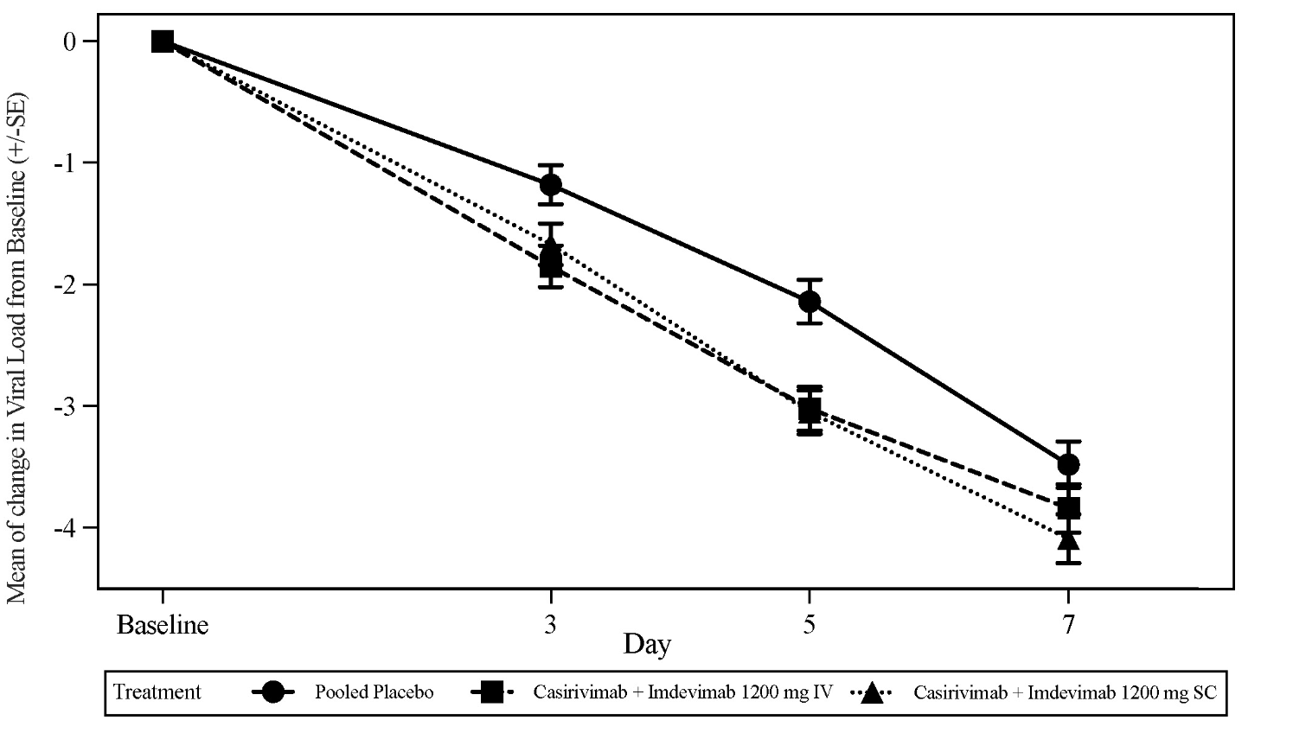

Clinical trials

Treatment of COVID-19

Study COV-2067
COV-2067 is a randomised, double-blinded, placebo-controlled clinical trial evaluating Ronapreve (casirivimab and imdevimab) for the treatment of subjects with symptomatic COVID-19 who are not hospitalised and who do not require supplemental oxygen. Eligible subjects were adults who were within 7 days of symptom onset and who had at least one risk factor for severe COVID-19 (these included age > 50 years, obesity defined as BMI ≥ 30 kg/m², cardiovascular disease including hypertension, chronic lung disease including asthma, type 1 and 2 diabetes mellitus, chronic kidney disease including those on dialysis, chronic liver disease, pregnancy and immunosuppressed).

In Phase 3 (Cohort 1) subjects with at least one risk factor for severe COVID-19 were randomised to a single intravenous infusion of Ronapreve 1 200 mg (600 mg of casirivimab and 600 mg of imdevimab) (n = 838), Ronapreve 2 400 mg (1 200 mg of casirivimab and 1 200 mg of imdevimab) (n = 1 529), Ronapreve 8 000 mg (4 000 mg of casirivimab and 4 000 mg of imdevimab) (n = 700), or placebo (n = 1 500) groups. The two Ronapreve doses at the start of Phase 3 were 8 000 mg and 2 400 mg; however, based on Phase 1/2 efficacy analyses showing that the 8 000 mg and 2 400 mg doses were similar, the Phase 3 portion of the protocol was amended to compare 2 400 mg dose vs. placebo and 1 200 mg dose vs. placebo. Comparisons were between subjects randomised to the specific Ronapreve dose and subjects who were concurrently randomised to placebo.

At baseline, in all randomised subjects with at least one risk factor, the median age was 50 years (with 13% of subjects ages 65 years or older), 52% of the subjects were female, 84% were White, 5% were Black or African American; 36% identified as Hispanic or Latino. The baseline demographics and disease characteristics were well balanced across the casirivimab and imdevimab and placebo treatment groups.
Primary endpoint
The primary endpoint was the proportion of subjects with ≥ 1 COVID-19-related hospitalisation or all-cause death through Day 29.

Table 9: Summary of primary endpoint Phase 3 results from Study COV-2067
 | 1 200 mg IV | Placebo | 2 400 mg IV | Placebo
 | n = 736 | n = 748 | n = 1 355 | n = 1 341
Patients with ≥1 COVID-19-related hospitalisation or death through day 29
Risk reduction | 70%  (p = 0.0024) |  | 71%  (p < 0.0001)
Number of patients with events | 7 (1.0%) | 24 (3.2%) | 18 (1.3%) | 62 (4.6%)
mFAS: modified full analysis set included those subjects with a positive SARS-CoV-2 RT-qPCR result from nasopharyngeal (NP) swab at randomisation, and with at least one risk factor for severe COVID-19.

Overall, similar effects were observed for Ronapreve 1 200 mg (600 mg of casirivimab and 600 mg of imdevimab) and Ronapreve 2 400 mg (1 200 mg of casirivimab and 1 200 mg of imdevimab) doses, indicating the absence of a dose effect. Results were consistent across subgroups of patients defined by nasopharyngeal viral load > 10⁶ copies/mL at baseline or serologic status.

Key Secondary Endpoints
Time to COVID-19 symptom resolution
The median time to symptom resolution, as recorded in a trial specific daily symptom diary, was reduced from 14 days with placebo to 10 days with both doses of casirivimab and imdevimab (p<0.0001).

For the primary and key secondary endpoints, results were consistent across subgroups of patients defined by nasopharyngeal viral load > 10⁶ copies/mL at baseline or serologic status.

Prevention of COVID-19
The data supporting prevention of COVID-19 are based on the efficacy analysis of data from the Phase 3 COV-2069 trial. This is a randomised, double-blind, placebo-controlled clinical trial of Ronapreve (casirivimab and imdevimab) for prevention of COVID-19 in household contacts of individuals infected with SARS-CoV-2 (index case).

The trial enrolled subjects who were asymptomatic and who lived in the same household with a SARS-CoV-2 infected patient. Subjects were randomised 1:1 to a single dose of Ronapreve 1 200 mg (600 mg of casirivimab and 600 mg of imdevimab) or placebo administered subcutaneously within 96 hours of collection of the first index case sample that gave a positive result (RT-qPCR) for SARS-CoV-2. Subjects with a negative SARS-CoV-2 RT-qPCR test result, representing a mix of pre- and post-exposure prevention patients, joined Cohort A (2069-A). Subjects with a positive SARS-CoV-2 RT-qPCR test result, representing a cohort solely of post-exposure prevention patients, joined Cohort B (2069-B). Baseline serology test results were used to further define analysis populations (seronegative subjects were considered not to have a prior infection whereas seropositive subjects were considered to have a prior infection).

Study COV-2069, Cohort A
Subjects with a negative SARS-CoV-2 RT-qPCR test result at baseline (n = 2 067) were enrolled and randomised. The primary analysis population included subjects who were SARS-CoV-2 RT-qPCR negative and seronegative at baseline. Subjects who were seropositive or who had undetermined/missing baseline serology were excluded from the primary efficacy analysis; a sensitivity analysis of the results regardless of baseline serostatus were also conducted. Of the 1 505 subjects in the primary analysis population, 753 subjects were randomised to receive Ronapreve and 752 subjects were randomised to placebo. Following randomisation and dosing, subjects had SARS-CoV-2 RT-qPCR testing via a nasopharyngeal swab every 7 days as well as weekly interviews with the investigator for assessment of COVID-19 symptoms during the 28 day efficacy assessment period. No data were collected on the type or extent of exposure to the index case.

For the primary analysis population at baseline, the median age was 44 years (with 9% of subjects ages 65 years or older), 54% of the subjects were female, 86% were White, 9% were Black; 41% identified as Hispanic or Latino. The baseline demographics and disease characteristics were well balanced across the Ronapreve and placebo treatment groups.

The primary efficacy endpoint was the proportion of subjects who developed symptomatic RT qPCR-confirmed COVID-19 through Day 29. In this population, there was a statistically significant 81% risk reduction in the development of COVID-19 with Ronapreve treatment versus placebo (see Table 10 and Figure 2).

Table 10: Key results from Phase 3 trial for the prevention of COVID-19 in uninfected individuals Study COV-2069, Cohort A
 | Ronapreve  (single 1 200 mg dose) | Placebo
Primary Analysis Population: Seronegative at Baseline | n = 753 | n = 752
Risk of COVID-19
Through Day 29 (primary endpoint)
Risk reduction  (Odds ratio, p-Value) | 81%  (0.17; p < 0.0001)
Number of individuals with events | 11 (1.5%) | 59 (7.8%)
Symptoms and viral load
Total weeks with symptoms (Key secondary)
Reduction² | 93%  (p < 0.0001)
Total Number of weeks (cumulative for all individuals in each arm) | 12.9 | 187.7
Mean Number of weeks with symptoms in symptomatic individuals³ | 1.2 | 3.2
Incidence of any RT-qPCR positive infection (Key secondary)
Risk reduction  (Odds ratio, p-Value) | 66%  (0.31; p < 0.0001)
Number of individuals with events | 36 (4.8%) | 107 (14.2%)
Total weeks of RT-qPCR positive infection regardless of symptoms (Key secondary)
Reduction² | 82%  (p < 0.0001)
Total Number of weeks (cumulative for all individuals in each arm) | 41 | 231
Mean Number of weeks with individuals infected³ | 1.1 | 2.2
Total weeks with high viral load (>10⁴ copies/mL) (Key secondary)
Reduction² | 90%  (p < 0.0001)
Total Number of weeks (cumulative for all individuals in each arm) | 14 | 136
Mean Number of weeks with high viral load in RT-qPCR positive subjects³ | 0.4 | 1.3
Incidence of high viral load (>10⁴ copies/mL) (Key secondary)
Risk Reduction  (Odds ratio, p-value) | 86%  (0.13; p < 0.0001)
Number of individuals with events⁴ | 12/745 (1.6%) | 85/749 (11.3%)
All Subjects Regardless of Serology Status at Baseline | 1046 | 1021
Risk of COVID-19 through day 29 (Sensitivity analysis)³
Risk Reduction  (Odds ratio, nominal p-value) | 82%  (0.17; p < 0.0001)
Number of individuals with events | 12 (1.1%) | 66 (6.5%)
Seropositive at Baseline | 235 | 222
Risk of COVID-19 through Day 29³
Risk Reduction  (Odds ratio, nominal p-value) | 81%  (0.19; p = 0.1369)
Number of individuals with events | 1 (0.4%) | 5 (2.3%)
1. The confidence interval (CI) with p-value is based on the odds ratio (casirivimab+imdevimab group vs placebo group) using logistic regression model with the fixed categorical effects of treatment group, age group (age in years: ≥12 to<50 and ≥50), and region (US vs ex-US)
2. Based on the normalised duration per 1000 subjects
3. Pre-specified but not included in the hypothesis testing hierarchy
4. Only individuals with post baseline viral load were included

Figure 2: COV-2069-A cumulative incidence of symptomatic COVID-19 by Study Day
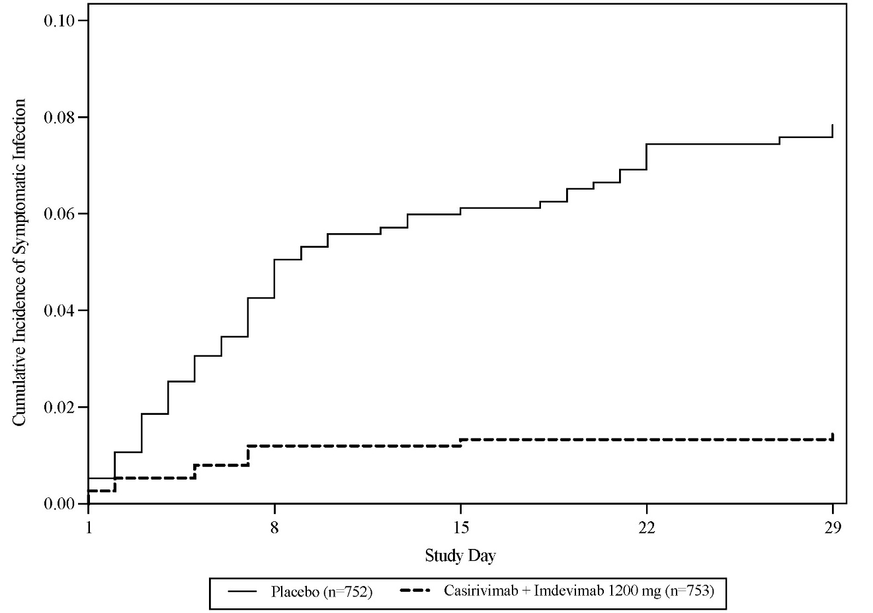

Study COV-2069, Cohort B
Asymptomatic subjects with a positive SARS-CoV-2 RT-qPCR test result at baseline (n = 314) represent a post-exposure population. The primary analysis population included asymptomatic subjects who were SARS-CoV-2 RT-qPCR positive and seronegative at baseline. Of the 204 subjects in the primary analysis population, 100 subjects were randomised to receive Ronapreve and 104 subjects were randomised to placebo. Following randomisation and dosing, subjects had SARS-CoV-2 RT-qPCR testing via a nasopharyngeal swab every 7 days as well as weekly interviews with the investigator for assessment of COVID-19 symptoms during the 28 day efficacy assessment period. No data were collected on the type or extent of exposure to the index case.

For the primary analysis population at baseline, the median age was 40 years (with 11% of subjects ages 65 years or older), 55% of the subjects were female, 85% were White, 5% were Black; 35% identified as Hispanic or Latino. The baseline demographics and disease characteristics were well balanced across the casirivimab and imdevimab and placebo treatment groups.

The primary efficacy endpoint was the proportion of subjects who developed symptomatic COVID-19 within 14 days of a positive RT-qPCR through Day 29. There was a 31% risk reduction in the development of symptomatic COVID-19 with Ronapreve vs. placebo (see Table 11). Figure 3 shows the cumulative incidence of COVID-19 through Day 29.
Table 11: Key Results in asymptomatic infected individuals Study COV-2069, Cohort B
 | Ronapreve  (single 1 200 mg dose) | Placebo
Primary Analysis Population: Seronegative at Baseline | n = 100 | n = 104
Risk of COVID-19
Overall risk reduction through Day 29 (primary endpoint)
Risk reduction  (Odds ratio, p-Value) | 31%  (0.54; p = 0.0380)
Number of individuals with events | 29 (29%) | 44 (42.3%)
Symptoms, viral load and COVID-19 related events
Total weeks with symptoms (key secondary endpoint)
Reduction  (p-Value) | 45%  (p = 0.0273)
Total Number of weeks (cumulative for all patients in each arm) | 90 | 170
Total weeks with high viral load (>10⁴ copies/mL) (key secondary endpoint)
Reduction  (p-Value) | 40%  (p = 0.0010)
Total Number of weeks (cumulative for all patients in each arm) | 48 | 82
1. The confidence interval (CI) with p-value is based on the odds ratio (casirivimab+imdevimab group vs placebo group) using logistic regression model with the fixed categorical effects of treatment group, age group (age in years: ≥12 to<50 and ≥50), and region (US vs ex-US).
2. These analyses were not part of the pre-planned statistical analysis plan, so p-values are nominal

Figure 3: Cumulative incidence of COVID-19 by study day in Study COV-2069, Cohort B
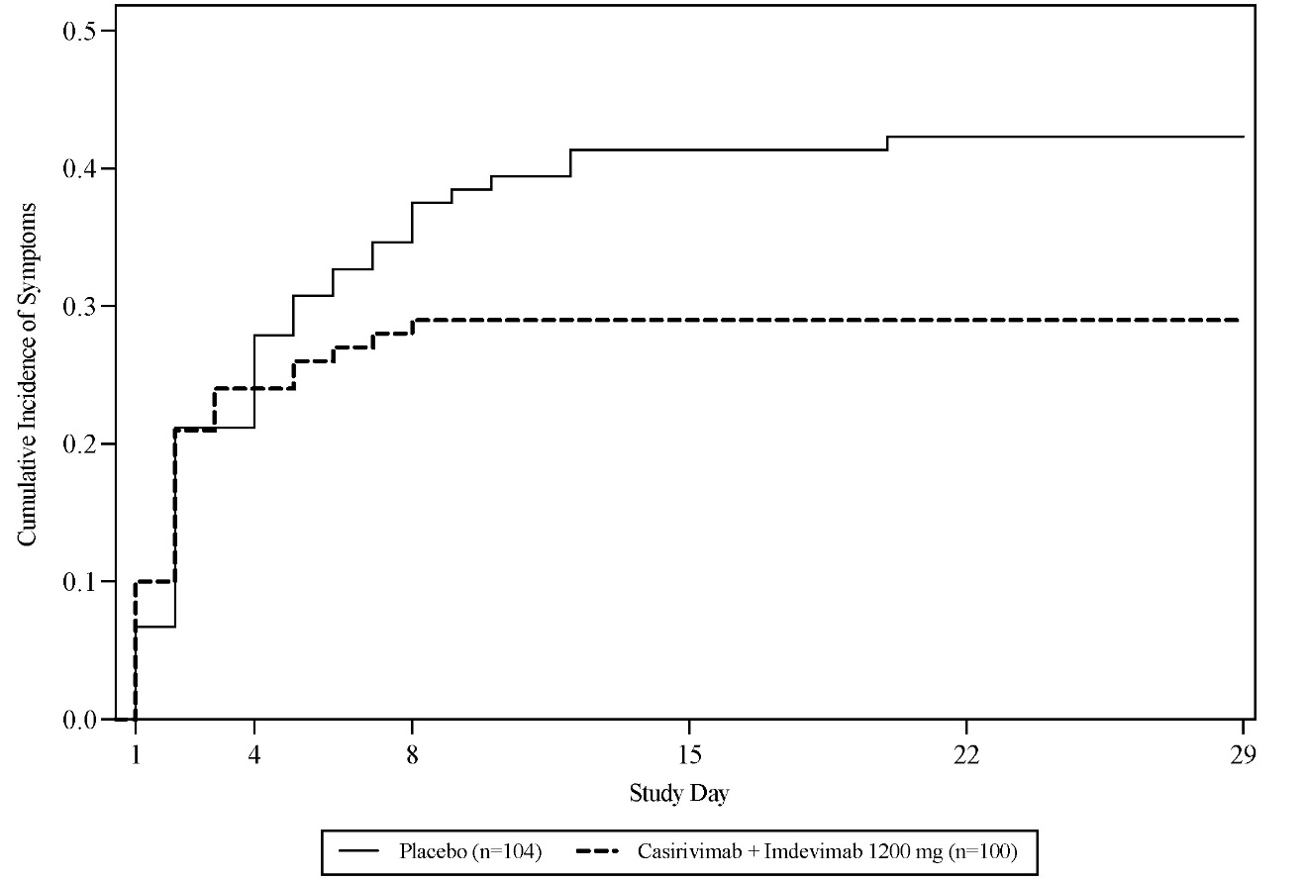

Study HV-2093
The data supporting the use for the repeat dose prevention of COVID-19 are based on the exploratory efficacy analysis of data from 969 subjects from the Phase 1 HV-2093. HV-2093 is a randomised, double-blind, placebo-controlled Phase 1 clinical trial assessing the safety, tolerability, pharmacokinetics, and immunogenicity of repeat subcutaneous doses (up to 6 monthly doses) of Ronapreve (casirivimab with imdevimab) in adult subjects who were healthy or had chronic but stable, well-controlled medical condition(s) and were negative for SARS-CoV-2 infection at baseline. Subjects were randomised in a 3:1 manner to receive subcutaneous injections every 4 weeks for 24 weeks of 1 200 mg of Ronapreve (600 mg casirivimab and 600 mg imdevimab) (n = 729) or placebo (n = 240). Note that 1 200 mg is double the recommended pre-exposure prophylaxis dose (see section 4.2).

At baseline, the median age was 47 years (with 13% of subjects ages 65 years or older), 55% of the subjects were male, 87% were White, 10% were Black; 23% identified as Hispanic or Latino. The baseline demographics and disease characteristics were well balanced across the Ronapreve and placebo treatment groups.

The primary purpose of the study was PK (see section 5.2). An explanatory exploratory efficacy endpoint was the incidence of clinically diagnosed COVID-19 (RT-PCR testing was not a requirement). During the six-month treatment period, there was a 92% risk reduction in COVID-19, with Ronapreve treatment versus placebo: 3/729 (0.4%) versus 12/240 (5.0%), respectively; odds ratio (OR) 0.08 (95% CI: 0.01, 0.30); nominal p < 0.0001 (see Figure 4). Of the subjects who developed COVID-19, 9/12 placebo recipients had a positive SARS-CoV-2 RT-PCR result or seroconverted whereas 0/3 subjects in the Ronapreve group were RT-PCR positive or seroconverted by the end of the treatment period.

Figure 4: Kaplan-Meier curve of time to symptomatic infection during the treatment period in Study HV-2093
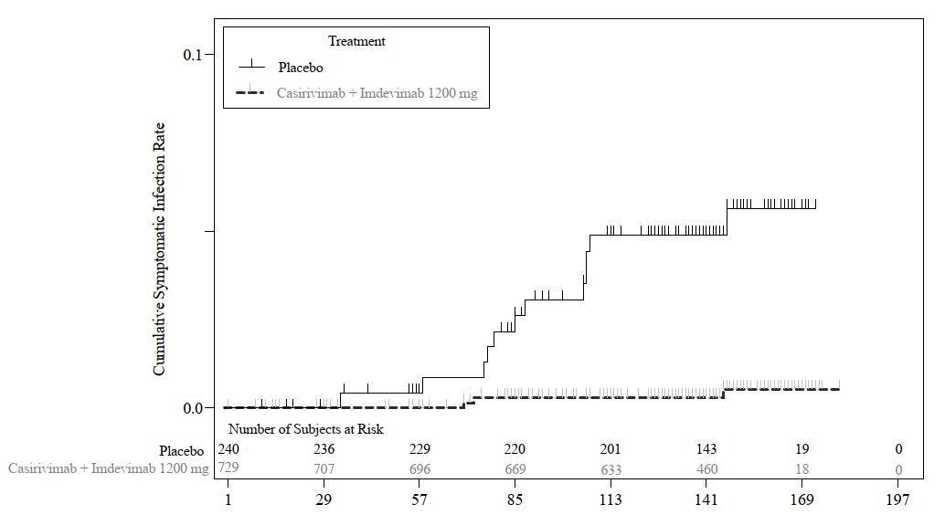

Immunogenicity
As with all therapeutic proteins, there is potential for immunogenicity. The detection of antibody formation is highly dependent on the sensitivity and specificity of the assay. Additionally, the observed incidence of antibody (including neutralising antibody) positivity in an assay may be influenced by several factors including assay methodology, sample handling, timing of sample collection, concomitant medications, and underlying disease. For these reasons, comparison of the incidence of antibodies to casirivimab and imdevimab in the studies described below with the incidence of antibodies in other studies or to other products may be misleading.

In all subjects who received Ronapreve by intravenous infusion or subcutaneous injection, the incidence of anti-casirivimab and anti-imdevimab antibodies were 0.8% and 1.7%, respectively. For subjects who received placebo, the incidence of anti-casirivimab and anti-imdevimab antibodies were 1.9% and 4.5%, respectively.

In 707 subjects treated with Ronapreve 1 200 mg (600 mg of casirivimab and 600 mg of imdevimab) subcutaneously every 4 weeks, the incidence of treatment-emergent anti-casirivimab and anti-imdevimab antibodies was 0.1% and 2.0%, respectively. Among 232 repeat dose placebo subjects, the incidence of treatment emergent anti-casirivimab and anti-imdevimab antibodies were 0% and 2.6%, respectively. The antibody titers in both Ronapreve and placebo repeat dose subjects were low, with no evidence of altered pharmacokinetic profiles of casirivimab or imdevimab.

5.2 PHARMACOKINETIC PROPERTIES
Both casirivimab and imdevimab exhibited linear and dose-proportional pharmacokinetics (PK) between 300 mg Ronapreve (150 mg casirivimab and 150 mg imdevimab) to 8 000 mg Ronapreve (4 000 mg casirivimab and 4 000 mg imdevimab) following IV administration of single dose. A summary of PK parameters after a single (600 mg casirivimab and 600 mg imdevimab) IV dose, calculated using a population PK model for each antibody based on data from 3 687 subjects (casirivimab) or 3 716 subjects (imdevimab), is provided in Table 12.
Table 12: Summary of PK parameters (for casirivimab and imdevimab) after a single 1 200 mg IV dose of Ronapreve
PK Parameter¹ | casirivimab | imdevimab
AUC₀₋₂₈ (mg·day/L)² | 1754.9 (380.50) | 1600.8 (320.88)
AUC_{inf} (mg·day/L)³ | 3563.6 (1239.61) | 2890.5 (876.31)
C_{max} (mg/L)⁴ | 182.7 (81.45) | 181.7 (77.78)
C₂₈ (mg/L)⁵ | 37.9 (10.33) | 31.0 (8.24)
¹ Mean (SD), where SD is standard deviation of the arithmetic mean; ² AUC₀₋₂₈ = Area under the concentration time curve from time 0 to 28 days after dosing; ³ AUC_{inf} = Area under the concentration time curve from time 0 to infinite time; ⁴ C_{max} = Maximum concentration in serum and represents concentration at the end of infusion; ⁵ C₂₈ = Concentration 28 days after dosing, i.e., on day 29

A summary of PK parameters after a single Ronapreve 1 200 mg (600 mg casirivimab and 600 mg imdevimab) subcutaneous dose based on the population PK model for each antibody is shown in Table 13.

Table 13: Summary of PK Parameters for casirivimab and imdevimab after a Single 1 200 mg Subcutaneous Dose of Ronapreve
PK Parameter¹ | casirivimab | imdevimab
AUC₀₋₂₈ (mg·day/L)² | 1121.7 (243.12) | 1016.9 (203.92)
AUC_{inf} (mg·day/L)³ | 2559.5 (890.35) | 2073.3 (628.60)
C_{max} (mg/L)⁴ | 52.2 (12.15) | 49.2 (11.01)
t_{max} (day)^{5, 6} | 6.7 [3.4, 13.6] | 6.6 [3.4, 13.6]
C₂₈ (mg/L)⁷ | 30.5 (7.55) | 25.9 (6.07)
¹ Mean (SD), where SD is standard deviation of the arithmetic mean; ² AUC₀₋₂₈ = Area under the concentration time curve from time 0 to 28 days after dosing; ³ AUC_{inf} = Area under the concentration time curve from time 0 to infinite time; ⁴ C_{max} = Maximum concentration in serum; ⁵ t_{max} = Time to reach C_{max}; ⁶ Median [minimum, maximum]; ⁷ C₂₈ = Concentration 28 days after dosing, i.e., on day 29

A summary of PK parameters after a single 1 200 mg intravenous loading dose of Ronapreve (600 mg casirivimab and 600 mg imdevimab) followed by multiple 600 mg Ronapreve intravenous Q4W doses (300 mg casirivimab and 300 mg imdevimab) based on the population PK model for each antibody is shown in Table 14.

Table 14: Summary of PK parameters for casirivimab and imdevimab after a single 1 200 mg IV loading dose and 600 mg IV Q4W maintenance doses of Ronapreve
PK Parameter¹ | casirivimab | imdevimab
AUC_{tau,ss} (mg∙day/L)² | 1767.5 (605.79) | 1436.8 (432.87)
C_{max,ss} (mg/L)³ | 133.8 (46.51) | 122.4 (41.67)
C_{trough,ss} (mg/L)⁴ | 42.6 (19.72) | 31.7 (13.56)
C₂₈ (mg/L)⁵ | 37.9 (10.32) | 31.0 (8.24)
AR⁶ | 1.0 (0.241) | 0.893 (0.174)
¹ Mean (SD), where SD is standard deviation of the arithmetic mean; ² AUC_{tau,ss} = Area under the concentration time curve during a dosing interval at steady-state; ³ C_{max,ss} = Maximum concentration at steady-state; ⁴ C_{trough,ss} = Trough concentration at steady-state; ⁵ C₂₈ = Concentration 28 days after the first dose; ⁶ The accumulation ratio (AR) is calculated as $\frac{{AUC}_{τ, ss}}{{AUC}_{τ, FD}}$ (FD = first dose); Q4W = Every 4 weeks

A summary of PK parameters after a single subcutaneous 1 200 mg loading dose of Ronapreve (600 mg casirivimab and 600 mg imdevimab) followed by multiple subcutaneous Q4W doses of 600 mg Ronapreve (300 mg casirivimab and 300 mg imdevimab) based on the population PK model for each antibody is shown in Table 15.

Table 15: Summary of PK parameters for casirivimab and imdevimab after a single 1 200 mg subcutaneous loading dose and 600 mg subcutaneous Q4W maintenance doses of Ronapreve
PK Parameter¹ | casirivimab | imdevimab
AUC_{tau,ss} (mg∙day/L)² | 1268.9 (434.68) | 1030.1 (310.30)
C_{max,ss} (mg/L)³ | 56.0 (16.81) | 47.0 (12.43)
C_{trough,ss} (mg/L)⁴ | 34.0 (14.56) | 26.1 (10.17)
C₂₈ (mg/L)⁵ | 30.5 (7.55) | 25.9 (6.07)
AR⁶ | 1.13 (0.288) | 1.01 (0.213)
¹ Mean (SD), where SD is standard deviation of the arithmetic mean; ² AUC_{tau,ss} = Area under the concentration time curve during a dosing interval at steady-state; ³ C_{max,ss} = Maximum concentration at steady-state; ⁴ C_{trough,ss} = Trough concentration at steady-state; ⁵ C₂₈ = Concentration 28 days after the first dose; ⁶ The accumulation ratio (AR) is calculated as $\frac{{AUC}_{τ, ss}}{{AUC}_{τ, FD}}$ (FD = first dose); Q4W = Every 4 weeks

For the repeat dose prevention of IV and subcutaneous regimens, population pharmacokinetic simulations predict that median predicted casirivimab and imdevimab C_{trough,ss} in serum are similar to observed mean day 29 concentrations in serum for a single subcutaneous dose of Ronapreve 1 200 mg (600 mg of casirivimab and 600 mg of imdevimab).

Absorption
Based on population pharmacokinetic modeling, mean (standard deviation) C_{max} and C₂₈ estimates for casirivimab and imdevimab following single IV or single subcutaneous dose 1 200 mg (600 mg each monoclonal antibody) are listed in Table 12 and Table 13, respectively. Median (range) time to reach maximum serum concentration of casirivimab and imdevimab (T_{max}) estimates following a single subcutaneous dose of Ronapreve 1 200 mg (600 mg each monoclonal antibody) are 6.6 (3.4 - 13.6) days and 6.5 (3.4 - 13.6) days for casirivimab and imdevimab, respectively (Table 13).
Following casirivimab and imdevimab administered as a single dose of Ronapreve 1 200 mg subcutaneous (600 mg each monoclonal antibody), casirivimab and imdevimab had a population PK estimated bioavailability of 71.8% and 71.7%, respectively.

Distribution
The total volume of distribution estimated via population pharmacokinetic analysis is 7.161 L and 7.425 L for casirivimab and imdevimab, respectively.

Metabolism
Specific metabolism studies were not conducted because casirivimab and imdevimab are proteins. As human monoclonal IgG1 antibodies, casirivimab and imdevimab are expected to be degraded into small peptides and amino acids via catabolic pathways in the same manner as endogenous IgG.

Elimination
Based on population PK analysis, the terminal elimination half-life and clearance of casirivimab and imdevimab are listed in Table 16.

Table 16: Summary of terminal elimination half-life and clearance values of casirivimab and imdevimab following single IV doses – Population PK estimates
 | casirivimab |  | imdevimab
Parameter | Mean | 5th, 95th percentile | Mean | 5th, 95th percentile
Half-life (day) | 29.8 | (16.4, 43.1) | 26.2 | (16.9, 35.6)
CL (L/day) | 0.188 | (0.11, 0.3) | 0.227 | (0.15, 0.35)

Excretion
Casirivimab and imdevimab are monoclonal antibodies and are therefore not likely to undergo renal excretion.

Special populations

Renal impairment
Casirivimab and imdevimab are monoclonal antibodies that are not expected to undergo significant renal elimination due to their molecular weight (> 69 kDa). Based on population PK analysis, trough concentrations of casirivimab and imdevimab in serum at steady state were comparable between patients with mild or moderate renal impairment, or patients with CrCl < 15 mL/min including those on dialysis, and patients with normal renal function. Limited data are available in patients with severe renal impairment (n = 3).

Hepatic impairment
Casirivimab and imdevimab are not expected to undergo significant hepatic elimination. The effect of hepatic impairment on the exposure of casirivimab and imdevimab was evaluated by population PK analysis in patients with mild hepatic impairment (n = 586 for casirivimab and n = 599 for imdevimab) (total bilirubin [TB] greater than 1.0 to 1.5 times the upper limit of normal [ULN] and any aspartate aminotransferase [AST]); no clinically important differences in the exposure of casirivimab and imdevimab were found between patients with mild hepatic impairment and patients with normal hepatic function. Limited data (n = 11) are available in patients with moderate hepatic impairment. The pharmacokinetics in patients with severe hepatic impairment has not been studied.

Use in the Elderly
In the population PK analysis, age (18 years to 96 years) was not identified as a significant covariate on PK of either casirivimab and imdevimab.

Compared to patients < 65 years of age, exposures of casirivimab and imdevimab were similar in patients who were aged > 65 years or ≥ 75 years after either IV or subcutaneous administration.

Paediatric use
Adolescent subjects (≥ 12 years of age and ≥ 40 kg) were enrolled in studies (COV-2067, COV-2069) however no PK data were available in these subjects. Since adolescents’ body weight range is generally within the range of body weight in adult subjects and generally body weight is the main covariate that affects exposure in this age range, exposures of casirivimab and imdevimab in adolescent subjects (≥ 40kg) are expected to be similar to those in adults. The minimum body weight of subjects in clinical studies was 35.5 kg. There is no experience of use in subjects at lower body weight where AUC and C_{max} are predicted to be at least 30% higher. The pharmacokinetics of casirivimab and imdevimab in paediatric patients (< 12 years) have not been established.

Specific Populations
A population PK analysis suggests that the following factors have no clinically significant effect on the exposure of casirivimab and imdevimab: age, gender, body weight, race, albumin level, renal impairment, and mild hepatic impairment. Compared to a reference 81 kg subject, exposures (AUC_{day28}, C_{max} and C_{day28}) are predicted to be 20 - 30% higher in subjects at the 5th percentile of body weight (55.4 kg) and 20-25% lower in subjects at the 95th percentile of body weight (123 kg) for both casirivimab and imdevimab.

5.3 PRECLINICAL SAFETY DATA

Genotoxicity
No studies have been studies have not been conducted with Ronapreve.

Carcinogenicity
No studies have been studies have not been conducted with Ronapreve.

PHARMACEUTICAL PARTICULARS

6.1 LIST OF EXCIPIENTS
Histidine
Histidine monohydrochloride monohydrate
Polysorbate 80
Sucrose
Water for injections

6.2 INCOMPATIBILITIES
In the absence of compatibility studies, this medicine must not be mixed with other medicines.

6.3 SHELF LIFE
24 months

6.4 SPECIAL PRECAUTIONS FOR STORAGE
Store at 2°C to 8°C in the outer carton in order to protect from light.
Refrigerate, do not freeze. Do not shake.
Co-packaged 20 mL multidose vials
After initial puncture: If not used immediately, the product in the vial can be stored for 16 hours at room temperature up to 25 °C or for no more than 48 hours refrigerated between 2 °C to 8 °C.

Co-packaged 6 mL single-use vials
After initial puncture: the medicinal product should be used immediately, any remaining product should be discarded.

Diluted Solution for IV Administration
Solution in vial requires dilution prior to administration. The prepared infusion solution is intended to be used immediately. If not used immediately, the prepared infusion solution can be stored for 12 hours at room temperature (up to 25 °C) and 48 hours at 2 °C to 8 °C. If refrigerated, allow the IV infusion bag to equilibrate to room temperature for approximately 30 minutes prior to administration.

Storage of Syringes for Subcutaneous Administration
This product is preservative-free and therefore, the prepared syringes should be administered immediately. If not used immediately, the prepared syringe can be stored for 6 hours at room temperature (up to 25 °C) and 24 hours at 2 °C to 8 °C. . If refrigerated, allow the syringes to equilibrate to room temperature for approximately 10 - 15 minutes prior to administration.

6.5 NATURE AND CONTENTS OF CONTAINER
Ronapreve should be prepared by a healthcare professional using aseptic technique.

Casirivimab injection is a sterile, preservative free, clear to slightly opalent, colorless to pale yellow solution supplied in a 6 mL single-use vial and a 20 mL multi dose vial.

Imdevimab injection is a sterile, preservative free, clear to slightly opalescent, colorless to pale yellow solution supplied in a 6 mL single-use vial and a 20 mL multi- dose vial.

Ronapreve (casirivimab and imdevimab) is available as individual antibody solutions in separate vials, available in a dose pack containing either one 6 mL vial of each antibody or one 20 mL of each antibody (casirivimab and imdevimab):

Ronapreve 120 mg/mL solution for infusion or injection, multidose vials
Pack of two 20 mL clear Type I glass vials with butyl rubber stopper containing one vial of 11.1 mL solution of 1 332 mg of casirivimab and one vial of 11.1 mL solution of 1 332 mg of imdevimab.

Ronapreve 120 mg/ml solution for infusion or injection, single-use vial
Pack of two 6 mL clear Type I glass vials with butyl rubber stopper containing one vial of 2.5 mL solution of 300 mg of casirivimab and one vial of 2.5 mL solution of 300 mg of imdevimab.

6.6 SPECIAL PRECAUTIONS FOR USE, HANDLING AND DISPOSAL

General precautions
Casirivimab and imdevimab vials should be inspected visually to ensure there is no particulate matter or discolouration prior to the administration. If particulate matter or discolouration is observed the vial should be discarded per local disposal guidelines.
Do not shake or freeze the vials.

Disposal
In Australia, any unused medicine or waste material should be disposed of by taking to your local pharmacy.
The following points should be strictly adhered to regarding the use and disposal of syringes and other medicinal sharps:
● Needles and syringes should never be reused.
● Place all used needles and syringes into a sharps container (puncture-proof disposable container).

6.7 PHYSIOCHEMICAL PROPERTIES
Chemical structure
Casirivimab and imdevimab are two neutralising IgG1 recombinant human monoclonal antibodies produced by recombinant DNA technology in Chinese hamster ovary cells.

Casirivimab: Casirivimab is a covalent heterotetramer consisting of two disulfide-linked human gamma heavy chains, each covalently linked through a disulfide bond to a human kappa light chain, (C6₄₅₄H₉₉₇₆N₁₇₀₄O₂₀₂₄S₄₄). The approximate molecular weight of casirivimab 145.23 kDa.
Imdevimab: Imdevimab is a covalent heterotetramer consisting of two disulfide-linked human gamma heavy chains, each covalently linked through a disulfide bond to a human lambda light chain, (C₆₃₉₆H₉₈₈₂N₁₆₉₄O₂₀₁₈S₄₂). The approximate molecular weight of imdevimab is 144.14 kDa.
CAS number:
Casirivimab: 2415933-42-3
Imdevimab: 2415933-40-1

MEDICINE SCHEDULE (POISONS STANDARD)
Prescription Only Medicine

SPONSOR
Roche Products Pty Limited
ABN 70 000 132 865
Level 8, 30 – 34 Hickson Road
Sydney NSW 2000
AUSTRALIA

Medical enquiries: 1800 233 950

DATE OF FIRST APPROVAL
18 October 2021

DATE OF REVISION OF THE TEXT
18 October 2021

Summary table of changes
Section Changed | Summary of new information

