May 2020

Australian Public Assessment Report for Caplacizumab
  - Proprietary Product Name: Cablivi
  - Sponsor: Sanofi-Aventis Australia Pty Ltd

About the Therapeutic Goods Administration (TGA)
- The Therapeutic Goods Administration (TGA) is part of the Australian Government Department of Health and is responsible for regulating medicines and medical devices.
- The TGA administers the Therapeutic Goods Act 1989 (the Act), applying a risk management approach designed to ensure therapeutic goods supplied in Australia meet acceptable standards of quality, safety and efficacy (performance) when necessary.
- The work of the TGA is based on applying scientific and clinical expertise to decision-making, to ensure that the benefits to consumers outweigh any risks associated with the use of medicines and medical devices.
- The TGA relies on the public, healthcare professionals and industry to report problems with medicines or medical devices. TGA investigates reports received by it to determine any necessary regulatory action.
- To report a problem with a medicine or medical device, please see the information on the TGA website <https://www.tga.gov.au>.

About AusPARs
- An Australian Public Assessment Report (AusPAR) provides information about the evaluation of a prescription medicine and the considerations that led the TGA to approve or not approve a prescription medicine submission.
- AusPARs are prepared and published by the TGA.
- An AusPAR is prepared for submissions that relate to new chemical entities, generic medicines, major variations and extensions of indications.
- An AusPAR is a static document; it provides information that relates to a submission at a particular point in time.
- A new AusPAR will be developed to reflect changes to indications and/or major variations to a prescription medicine subject to evaluation by the TGA.

Copyright
© Commonwealth of Australia 2020
This work is copyright. You may reproduce the whole or part of this work in unaltered form for your own personal use or, if you are part of an organisation, for internal use within your organisation, but only if you or your organisation do not use the reproduction for any commercial purpose and retain this copyright notice and all disclaimer notices as part of that reproduction. Apart from rights to use as permitted by the Copyright Act 1968 or allowed by this copyright notice, all other rights are reserved and you are not allowed to reproduce the whole or any part of this work in any way (electronic or otherwise) without first being given specific written permission from the Commonwealth to do so. Requests and inquiries concerning reproduction and rights are to be sent to the TGA Copyright Officer, Therapeutic Goods Administration, PO Box 100, Woden ACT 2606 or emailed to <tga.copyright@tga.gov.au>.

Contents
Common abbreviations 4
I. Introduction to product submission 6
Submission details 6
Product background 7
Regulatory status 8
Product Information 8
II. Registration timeline 8
III. Submission overview and risk/benefit assessment 9
Quality 9
Nonclinical 10
Clinical 11
Risk management plan 18
Risk-benefit analysis 19
Outcome 21
Attachment 1. Product Information 22

Common abbreviations
Abbreviation | Meaning
Ab | Antibody
ACM | Advisory Committee on Medicines
ADA | Anti-drug antibody
ADAMTS13 | A disintegrin and metalloproteinase with a thrombospondin type 1 motif, member 13
ASA | Australian specific Annex
ARTG | Australian Register of Therapeutic Goods
aTTP | Acquired thrombotic thrombocytopenic purpura
CNS | Central nervous system
CPD | Certified Product Details
cTnI | Cardiac troponin I
DLP | Data lock point
ELISA | Enzyme-linked immunosorbent assay
EMA | European Medicines Agency (European Union)
EU-RMP | European Union-Risk Management Plan
F | Fraction absorbed
FDA | Food and Drug Administration (United States)
GP1b | Glycoprotein 1b
IV | Intravenous
kDa | Kilodalton
LDH | Lactate dehydrogenase
Nab | Neutralising antibody
PD | Pharmacodynamic(s)
PE | Plasma exchange
PI | Product Information
PK | Pharmacokinetic(s)
pre-Ab | Pre-existing antibody
RICA | Ristocetin-induced platelet aggregation
RICO | Ristocetin-induced cofactor activity
SC | Subcutaneous
TE | Treatment-emergent
TEAE | Treatment emergent adverse event
TTP | Thrombotic thrombocytopenic purpura
ULN | Upper limit of normal
ULvWF | Ultra-large von Willebrand factor
V | Volume of distribution
vWF | von Willebrand factor
vWF: RCo | von Willebrand ristocetin cofactor
vWF:Ag | von Willebrand factor antigen

I. Introduction to product submission

Submission details
Type of submission: | New biological entity
Decision: | Approved
Date of decision: | 30 January 2020
Date of entry onto ARTG: | 5 February 2020
ARTG number: | 318058
Black Triangle Scheme | Yes  This product will remain in the scheme for 5 years, starting on the date the product is first supplied in Australia.

Active ingredient: | Caplacizumab
Product name: | Cablivi
Sponsor’s name and address: | Sanofi-Aventis Australia Pty Ltd  12-24 Talavera Road  Macquarie Park, NSW 2113
Dose form: | Powder and solvent for solution for injection
Strength: | 10 mg
Containers: | Vial (powder) and prefilled syringe (solvent)
Pack sizes: | 1 and 7 vial(s)/prefilled syringe(s)
Approved therapeutic use: | Cablivi is indicated for the treatment of adults experiencing an episode of acquired thrombotic thrombocytopenic purpura (aTTP), in conjunction with plasma exchange and immunosuppression.
Routes of administration: | Intravenous injection, subcutaneous injection
Dosage: | Treatment with Cablivi should be initiated and supervised by physicians experienced in the management of patients with thrombotic microangiopathies.  First dose  Intravenous injection of 10 mg of caplacizumab prior to plasma exchange.  Subsequent doses  Daily subcutaneous administration of 10 mg of caplacizumab after completion of each plasma exchange for the duration of daily plasma exchange treatment, followed by daily subcutaneous injection of 10 mg of caplacizumab for 30 days after stopping daily plasma exchange treatment.  If at the end of this period there is evidence of unresolved immunological disease, it is recommended to optimise the immunosuppression regimen and continue daily subcutaneous administration of 10 mg of caplacizumab until the signs of underlying immunological disease are resolved (for example, sustained normalisation of ADAMTS13 activity level).  In the clinical development program, caplacizumab has been administered daily for up to 65 days. No data on re-treatment with caplacizumab are available.  For further information refer to the Product Information.

Product background
This AusPAR describes the application by Sanofi-Aventis Australia Pty Ltd (the sponsor) to register Cablivi (caplacizumab) 10 mg powder and solvent for solution for injection, for the following proposed indication:
Cablivi is indicated for the treatment of adults experiencing an episode of acquired thrombotic thrombocytopenic purpura (aTTP), in conjunction with plasma exchange and immunosuppression.
Acquired thrombotic thrombocytopenic purpura (aTTP) is a rare, life threatening condition in which inhibitory antibodies form against ADAMTS13; a protease that cleaves von Willebrand factor (vWF). Reduction in ADAMTS13 activity results in lower vWF clearance and the formation of ultra-large vWF (ULvWF) multimers that activate platelet adhesion. Platelet adhesion produces microvascular occlusion with thrombocytopenia, haemolytic anaemia and organ ischemia. aTTP can be associated with infection, medications or pregnancy, but in most cases the cause of an episode is unknown.
Mortality from aTTP without treatment is very high, and with existing therapy can still be up to 20%. Most deaths occur within 30 days of diagnosis. Long term sequelae can include ischemic cerebral damage, depression, arterial hypertension and reoccurrence of aTTP within months of the first event.
Standard treatment for aTTP includes plasma exchange (PE) to remove ADAMTS13 antibodies and replenish this enzyme, and corticosteroids and/or rituximab for immunosuppression. At the time this submission was under consideration, there were no medications currently specifically registered for the treatment of aTTP in Australia.
Caplacizumab is a humanised bivalent nanobody which has two binding domains which recognise the A1-domain of vWF. Binding of drug to vWF inhibits the interaction between ULvWF multimers and platelets, preventing the microvascular damage typical of aTTP. In addition, reduction in vWF deposition leads to a transient reduction in the effectiveness of Factor VIII clotting activity during treatment. Caplacizumab does not terminate the underlying immunological processes producing anti-ADAMTS13 antibodies.
This submission was evaluated through the Comparable Overseas Regulator pathway A (COR-A); specifically, using assessments from the European Medicines Agency (EMA)).

Regulatory status
Cablivi (caplacizumab) is considered a new biological entity for Australian regulatory purposes.
At the time the TGA considered this application, a similar application had been approved in the United States (US) and European Union (EU; indications below), and was under consideration in Canada (submitted 22 July 2019).
European Medicines Agency (EMA) approved indications (approved 31 August 2018):
Cablivi is indicated for the treatment of adults experiencing an episode of acquired thrombotic thrombocytopenic purpura (aTTP), in conjunction with plasma exchange and immunosuppression.
US Food and Drug Administration (FDA) approved indications (approved 6 February 2019):
Cablivi is a von Willebrand factor (vWF)-directed antibody fragment indicated for the treatment of adult patients with acquired thrombotic thrombocytopenic purpura (aTTP), in combination with plasma exchange and immunosuppressive therapy.

Product Information
The Product Information (PI) approved with the submission which is described in this AusPAR can be found as Attachment 1. For the most recent PI, please refer to the TGA website at <https://www.tga.gov.au/product-information-pi>.

II. Registration timeline
Table 1 captures the key steps and dates for this application and which are detailed and discussed in this AusPAR.
Table 1: Timeline for Submission PM-2019-02057-1-6
Description | Date
Designation: Orphan | 29 January 2019
Submission dossier accepted and first round evaluation commenced | 1 July 2019
First round evaluation completed | 30 September 2019
Sponsor provides responses on questions raised in first round evaluation | 2 December 2019
Second round evaluation completed | 2 January 2020
Delegate’s Overall benefit-risk assessment | 16 January 2020
Sponsor’s pre-Advisory Committee response | Not applicable
Advisory Committee meeting | Not applicable
Registration decision (Outcome) | 30 January 2020
Completion of administrative activities and registration on the ARTG | 5 February 2020
Number of working days from submission dossier acceptance to registration decision* | 104
* The evaluation and decision timeframe for COR-A applications is 120 working days.

III. Submission overview and risk/benefit assessment
The submission was summarised in the following Delegate’s overview and recommendations.
This section is a TGA summary of wording used in the TGA’s Delegate’s overview, which discussed numerous aspects of overseas evaluation reports and included some information that was commercial-in-confidence.

Quality
Caplacizumab is a sterile, biological, with a single active ingredient. The active is a nanobody protein, consisting of a single domain antibody fragment. It is sterilised by filtration and is for single use. The formulation does not contain any anti-microbial preservatives. The dosage form is a powder for injection, together with sterile diluent water for injection. Following reconstitution, the solution for injection contains caplacizumab 10 mg/mL.
The quality evaluator has raised no objections on quality grounds to the registration of caplacizumab. The evaluator has recommended the following statement be included in the PI and labels:
‘Keep Cablivi in the refrigerator at 2°C to 8°C.
If necessary, Cablivi may be stored at room temperature up to 25°C for a single period of up to 2 months. Once the product has been taken out of the refrigerator the product should be discarded and must not be returned to the refrigerator.’
The Delegate concurs with the need for this statement but notes that the final sentence should be reworded to:
‘…Once the product has been taken out of the refrigerator the product should be discarded or used, but must not be returned to the refrigerator.’

Nonclinical
The nonclinical evaluator has noted that the information submitted was of satisfactory quality with no major deficiencies.
The following points were summarised from the nonclinical evaluation:
- The guinea pig and cynomolgus monkey were identified as pharmacologically relevant species and selected for use in toxicity studies.
- The safety pharmacology assessment incorporated into the general repeat-dose toxicity program and revealed no effect of caplacizumab on central nervous system (CNS), cardiovascular or respiratory function.
- Repeat-dose toxicity studies of up to 13 weeks duration were conducted in guinea pigs and up to 26 weeks duration in cynomolgus monkeys using the subcutaneous (SC) route, with additional 2 week studies by the intravenous (IV) route performed in monkeys. The species used, routes covered and duration are appropriate. High to very high multiples of the clinical exposure to caplacizumab were achieved at the upper dose levels used in the key studies. Major findings represented exaggerated pharmacological effects (increased bleeding tendency and secondary alterations in erythrocyte parameters), with no toxicity due to off-target effects apparent.
- No genotoxicity studies were submitted, which is acceptable for a protein drug. Carcinogenicity studies were not performed, with no particular cause for concern seen from the general repeat dose toxicity program or from knowledge of the physiological role of the target.
- No effects on fertility are predicted based on examination of sperm and male and female reproductive tissues in monkeys (in lieu of functional studies). No adverse effects on embryofetal development were observed with caplacizumab in guinea pigs. Placental transfer was evident. Pregnancy Category B1; as the sponsor proposes, is supported.
- Injection site reactions (primarily haemorrhage) were exacerbated by caplacizumab, consistent with its primary pharmacology. The maximum strength of caplacizumab tested for local tolerability in animals was less than half that to be administered to patients. This is not in accordance with the relevant TGA-adopted EMA guideline; which recommends testing of the actual clinical strength. This is not considered to be a major deficiency, though, given the expected lack of irritancy for a protein (compared with a small molecule) and the availability of clinical data to address this concern.
The Delegate concurs with the amendments to the PI proposed by the nonclinical evaluator.

Clinical
The clinical dossier submitted consisted of four Phase I studies, two Phase II studies and one Phase III study. The studies performed in patients with aTTP were the Phase II Study ALX-0681-2.1/10 (also known as the TITAN trial) with 36 patients treated and the Phase III Study ALX0681-C301 (also known as the HERCULES trial) with 73 patients treated.

Pharmacology

Pharmacokinetics
Caplacizumab is a bivalent antibody fragment (nanobody) approximately 28 kilodalton (kDa) consisting of two identical, humanised building blocks (PMP12A2hum1), joined by a tri-alanine linker. The schematic structure is shown below in Figure 1.
Figure 1: Structure of caplacizumab
Caplacizumab is administered IV for the first daily dose, then SC for subsequent daily doses. No study compared bioavailability between the IV and SC routes of administration. Absolute bioavailability was estimated at 0.999%. Bioequivalence between the initial formulation and the lyophilised formulation proposed for marketing was demonstrated in healthy volunteers.
Caplacizumab is subject to target-mediated drug disposition meaning that its pharmacokinetics (PK) is influenced by the pharmacodynamics (PD). The PK is highly variable and non-linear.
After SC administration, caplacizumab is rapidly and almost completely absorbed (estimated fraction absorbed (F) > 0.901) in the systemic circulation. The maximum concentration was observed at 6 to 7 hours post-dose and steady-state was reached following the first administration, with minimal accumulation.
Volume of distribution (V) from the PK/PD model was 3.4 L in healthy volunteers and after adjustments to the model was estimated at 6.33 L for aTTP patients.
No elimination studies have been performed. For a protein of this size, renal filtration followed by metabolism in the kidney is expected for free drug. The target bound drug is expected to be hepatically cleared as it is complexed with vWF.
Caplacizumab’s half-life is concentration and target level dependent. For a 10 mg once daily dose, the half-life was estimated at 8 hours in healthy volunteers and 20 hours in aTTP patients. There was wide inter-individual variation in PK parameters.
There were no studies in individuals with renal or hepatic impairment and no drug interaction studies.

Pharmacodynamics
The PD markers assessed in subjects participating in clinical studies were ristocetin-induced cofactor activity (RICO)/ ristocetin-induced platelet aggregation (RICA) and total plasma von Willebrand factor antigen (vWF:Ag).
vWF:Ag measures the quantity of vWF protein in the plasma. Testing methods have evolved over time, and most testing is now done using an enzyme-linked immunosorbent assay (ELISA)-based method on microtitre plates or by other automated methods using latex beads coated with antibodies to vWF and patient plasma as the source of vWF. The mean plasma level of vWF:Ag is elevated in the aTTP population. There is a broad distribution at Baseline in all different populations studied, with most values between 50% and 200%. On repeated administration of caplacizumab, a transient decrease in vWF:Ag levels was observed in all clinical studies with target levels returning to Baseline within 7 days after treatment cessation.
RICO is a functional assay which assesses the ability of vWF to bind to platelet membrane receptor glycoprotein 1b (GP1b). RIPA tests aggregation of the patient's platelets in the patient's plasma (platelet-rich plasma) at low concentrations of ristocetin, and it does not measure vWF activity. Full inhibition of vWF mediated platelet aggregation by caplacizumab is indicated by RIPA and RICO levels below 10% and 20%, respectively. All clinical studies with caplacizumab demonstrated rapid decreases in RIPA and/or RICO levels after the start of the treatment, with recovery to baseline levels within a few days of discontinuation. The proposed 10 mg daily dose of caplacizumab in patients with aTTP tested in Studies ALX-0681-2.1/10 (TITAN trial) and ALX0681-C301 (HERCULES trial) elicited full inhibition of vWF-mediated platelet aggregation, as evidenced by RICO levels of < 20% throughout the treatment period.
The level of characterisation and validation of the clinical anti-drug antibody (ADA) assay evolved during the clinical development process. Treatment-emerging antibodies were detected in 9% of the subjects in the aTTP study. ADA was not tested as a covariate in the PK/PD model, but individual PK/PD parameters were estimated for all actively treated aTTP patients with and without pre-existing antibody (pre-Ab) and drug-induced ADA. The sponsor proposed that visual inspection of data did not suggest an effect of treatment-emergent ADA on caplacizumab PK.
Pre-Abs binding caplacizumab were observed during clinical studies and during evaluation of commercially available human samples. The prevalence of these pre-Abs varied between 4% and 63%. In aTTP patients, pre-Abs can be produced by the patient or can originate from donor plasma during plasma exchange. No influence of these pre-Abs on PD, clinical efficacy or safety was found.
In the pivotal study pre-Abs were detected at a similar prevalence in both caplacizumab treated-subjects (56.7%, 55out of 97) and in placebo-treated subjects (double blind period; 63.0%, 46 out of 73). In this study, drug-induced treatment-emergent (TE) ADA responses were noted in 3.1% (3 out of 97) of the caplacizumab-treated subjects and in 1.4% (1 out of 73) of the placebo treated subjects. Using the alternative and functional neutralising antibody (Nab) assay, TE NAb were detected in 4.1% (4 out of 97) and 2.1% (2 out of 97), respectively, of the subjects treated with caplacizumab. In subjects treated with placebo (double blind period), 1.4% (1 out of 73) and 0% (0 out of 73) tested positive for TE NAb using the alternative and functional assay, respectively.
In the clinical report, it was noted that vWF is also a carrier and stabiliser for coagulation Factor VIII. vWF makes a non-covalent complex with Factor VIII preventing it from proteolytic degradation and prolonged its half-life by fivefold. Referring to the TITAN trial, it was also noted that the level of Factor VIII:C was clearly lower in patients given caplacizumab than in those given placebo by Day 1 and was maintained for the duration of caplacizumab treatment among available data. The caplacizumab and placebo Factor VIII:C levels were similar 7 days after treatment discontinuation and similarly decreased until 12 months follow-up. Factor VIII binding capacity was affected, reflecting a decrease of vWF activity by caplacizumab; however, these results should be discussed according to Factor VIII levels and safety results (especially bleeding).
Additionally, significantly lower vWF:Ag and von Willebrand ristocetin cofactor (vWF:RCo) levels have been showed in patients given caplacizumab compared to placebo demonstrating that caplacizumab decreased vWF rate and activity in caplacizumab treated subjects plasma. However, these PD parameters increased rapidly after discontinuation of treatment: 40% increase after 3 days stopping and reached the placebo level at the one month follow-up. It was considered that further studies are needed to assess the impact of a fast elevation of vWF activity on clinical symptomatology. They should be especially correlated with secondary efficacy endpoints: complete remissions, exacerbations and relapses.

Efficacy
The clinical evaluation comprises integrated summaries of safety and efficacy.
There were two clinical trials reviewed, Study ALX-0681-2.10 (TITAN trial) and Study ALX-0681-C301 (HERCULES trial).

Study ALX-0681-2.10 (TITAN trial)
The TITAN trial was a Phase II, single blind study in which patients were randomised to standard care or standard care + caplacizumab. Standard care was determined by the investigator at each site, and could include daily PE but could also include adjunctive immunosuppression (corticosteroids/rituximab), vincristine or cyclosporin, or supportive transfusion. Treatment was continued for 30 days, with PE tapered as determined by the investigator, and then patients were followed for 12 months.
Figure 2: Overview of the design and study periods of the TITAN trial
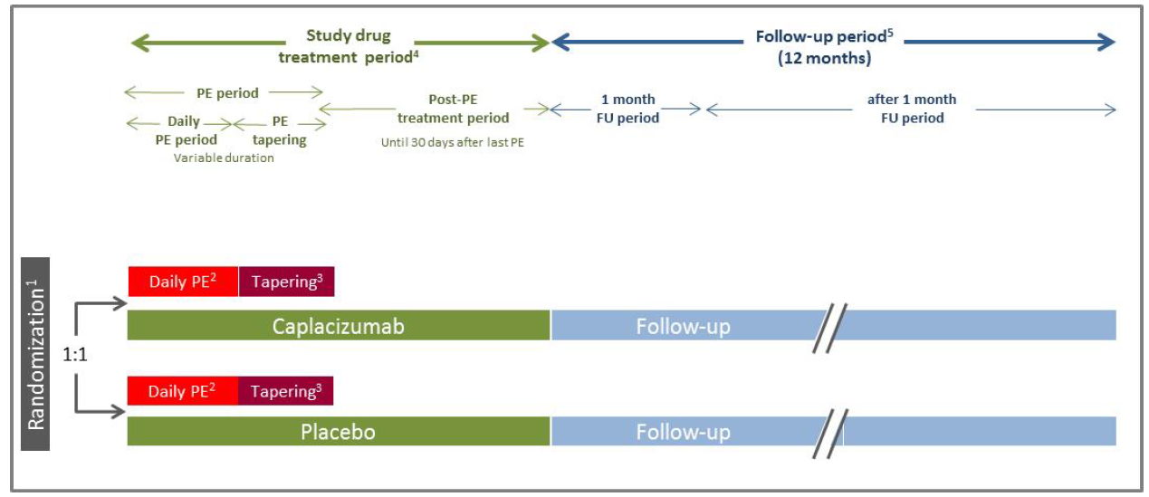
1: Subjects were randomised prior to the start of PE treatment. After the approval and implementation of Clinical Study Protocol Version 12.0, a subject could be randomised after an initial PE session, in which case the next PE session was designated as the first PE on study. 2: Daily PE treatment period. 3: PE tapering: optional, per local standard site practice. 4: Study drug treatment period: covers the period from the date of first study drug administration till the date of the last study drug administration. The treatment period incorporates a period of variable duration during which PE was administered and a 30 day post-PE period, starting from the date of the last PE. 5 FU period: covers the period from the date of the last study drug administration till the date of the 12 month FU visit. The FU period incorporates the ‘one month FU period’ (from the date of last study drug administration until the date of the one month FU visit) and the ‘after one month FU period’ (from the date of the 1 month FU visit until the date of the 12 month FU visit). Abbreviations: aTTP = acquired thrombotic thrombocytopenia purpura; PE = plasma exchange; FU = follow-up.
The primary endpoint was the time to recovery of platelets of > 150 000/µL, confirmed at 48 hours after the first recording of a platelet level exceeding this value and lactate dehydrogenase (LDH) < 2 times the upper limit of normal (ULN).
Figure 3: Time to platelet recovery in the TITAN trial, intent to treat population
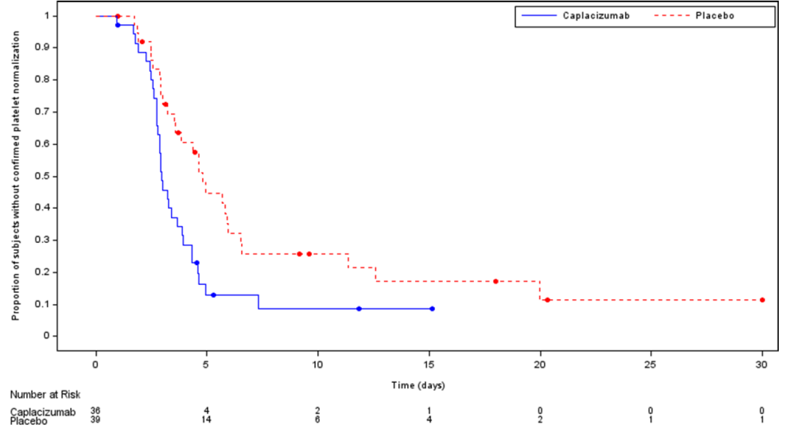
Censored observations are represented as dots. Any subject still at risk at 30 days was censored at 30 days.
The median time to platelet recovery for caplacizumab treated patients was 2.44 days, compared to 4.31 days for those receiving standard care, with this difference being statistically significant at p = 0.05.

Study ALX 0681-C301 (HERCULES trial)
This was the pivotal Phase III trial for caplacizumab, and was a double-blind, placebo controlled trial in patients experiencing an acute episode of aTTP. Patients (n = 145) were randomised 1:1 to receive standard care or standard care + caplacizumab. All patients started PE prior to randomisation, and caplacizumab was continued (in the active arm) for 30 days with the potential for risk-guided continuation for up to another 28 days with optimised immunosuppression.
Figure 4: Overview of the design and study periods of the HERCULES trial
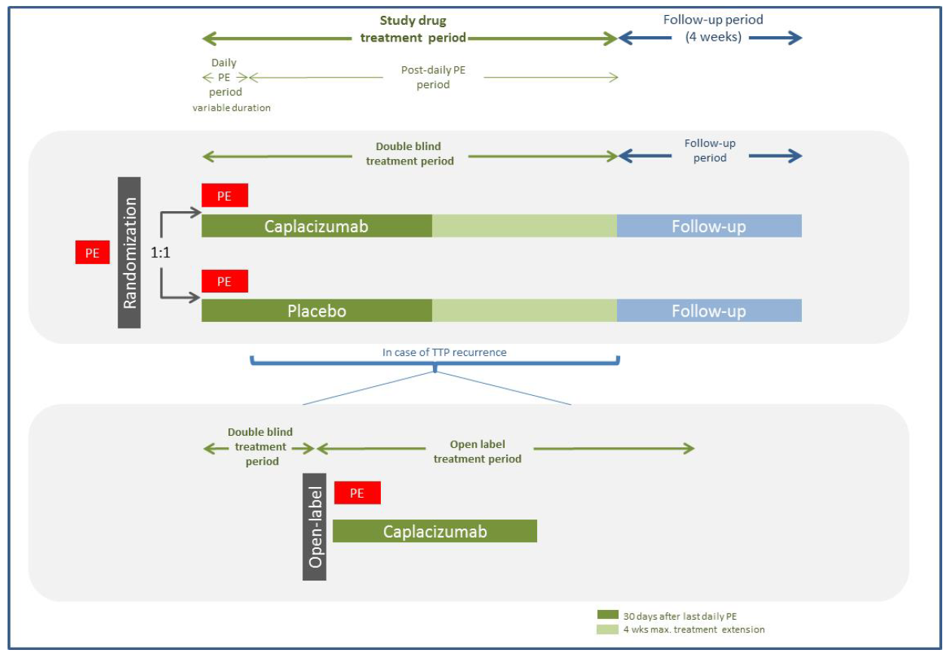
The primary endpoint of the HERCULES trial was the restoration of a normal platelet count. Secondary endpoints included:
- Proportion of subjects with thrombotic thrombocytopenic purpura (TTP)-related death, a recurrence of TTP, or at least one treatment emergent major thromboembolic event (for example, myocardial infarction, cerebrovascular accident, pulmonary embolism or deep venous thrombosis) during the study drug treatment period (including extensions).
- Proportion of subjects with a recurrence of TTP in the overall study period (including 4 week follow-up period).
- Proportion of subjects with refractory TTP, defined as absence of platelet count doubling after 4 days of standard treatment, and lactate dehydrogenase (LDH) > ULN.
- Time to normalisation of all 3 of the following organ damage marker levels:
  - Time to LDH ≤ 1 x ULN, and cardiac troponin I (cTnI) ≤ 1 x ULN, and serum creatinine ≤ 1 x ULN.
Figure 5: Time to platelet response in the HERCULES trial, intent to treat population
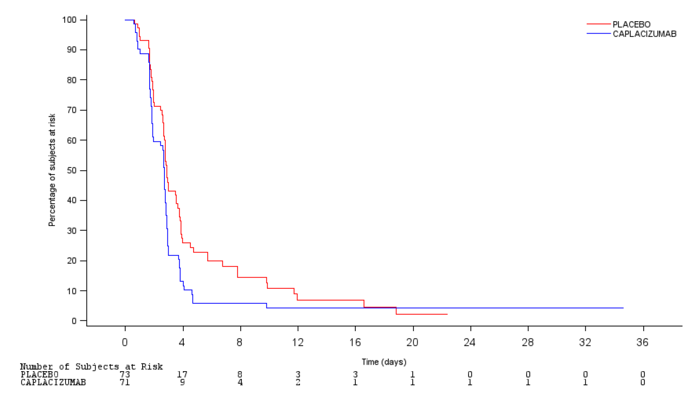
The time to confirmed platelet response was significantly shorter in the caplacizumab (p = 0.0099) than in the standard care arm, although only a difference in median time to response of 0.19 days (2.69 versus 2.88 days, respectively).
Table 2: Percentage of subjects with TTP-related death, a recurrence of TTP, or at least one treatment-emergent major thromboembolic event during the HERCULES trial
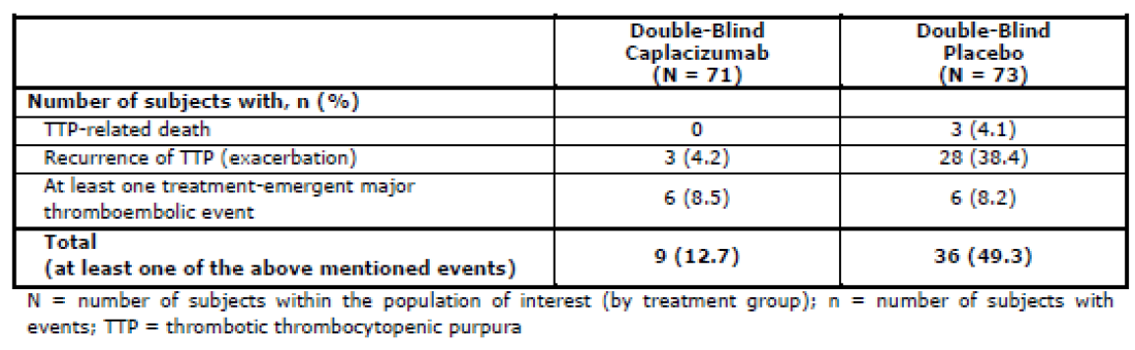
There was a significantly lower rate of the composite endpoint of death, recurrence or thromboembolic events in the caplacizumab arm than in the standard care arm of HERCULES trial (p = 0.001). This is mainly driven by the difference in the number of recurrence/exacerbations of aTTP, for example 38.4% versus 4.2% in the standard care and caplacizumab arms, respectively.
Overall, 38% of standard care patients and 13% of caplacizumab patients suffered a recurrence or exacerbation of aTTP (p = 0.0004). In the standard care arm, all events occurred during the double-blind treatment phase of the HERCULES trial. In the caplacizumab arm, 3 events occurred during double blind treatment and 6 occurred during follow-up. All of these 6 patients had ADAMTS13 levels < 10% when treatment was discontinued.
Refractoriness to treatment was defined as failure to achieve a doubling of platelet levels after 4 days of treatment and LDH > ULN. This occurred in 3 patients in the standard care arm and 0 patients in the caplacizumab arm (p = 0.0572).
Median time to normalisation of markers of organ damage was shorter in the caplacizumab arm than the standard care arm of the HERCULES trial, being 2.86 and 3.36 days respectively.

Safety
Treatment emergent adverse events (TEAEs) were reported more frequently in the standard care than the caplacizumab arm.
Table 3: Summary of treatment emergency adverse events in the pivotal HERCULES trial
The sponsor provided an integrated summary of safety based on all exposure in aTTP patients. The most commonly experienced adverse events are indicated below in Figure 6.
Figure 6: Treatment emergent adverse events experienced by at least 5% of patients
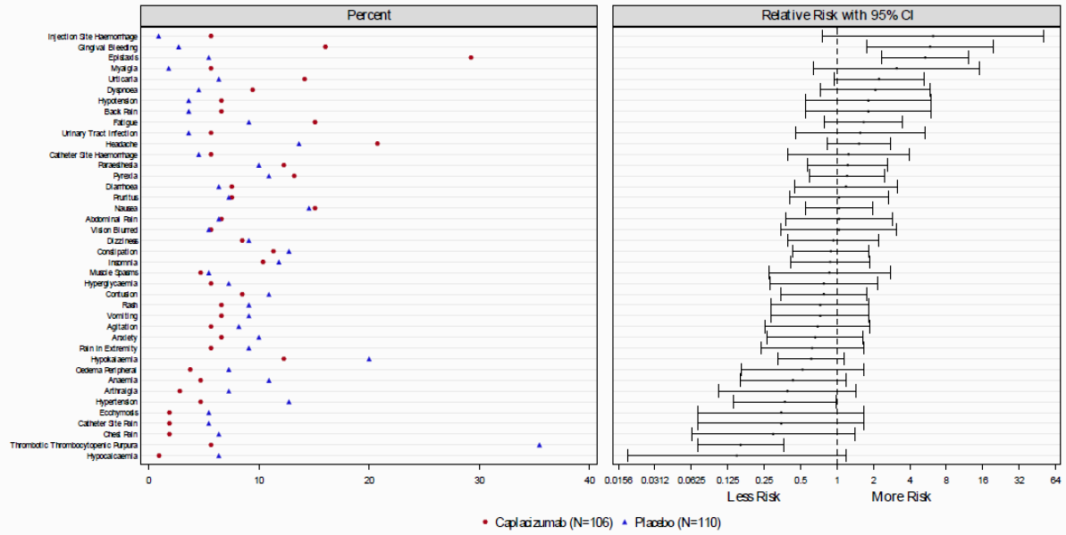
Significant TEAEs which were more frequent in caplacizumab than standard care patients included epistaxis (22.6 versus 1.8%), contusion (8.5 versus 2.7%) and gingival bleeding (9.4 versus 0%).
Study drug discontinuation due to TEAEs occurred in 6.6% of caplacizumab and 10% of standard care patients.
Six patients in the aTTP safety population died; 5 in the standard care and 1 in the caplacizumab group. The caplacizumab treated patient died of cerebral ischemia 6 days after their last dose of study drug, which was not considered related to therapy.
Two patients experienced serious bleeding related TEAEs which were considered at least potentially related to caplacizumab for example, subarachnoid haemorrhage and uterine bleeding.

Risk management plan
- The sponsor has submitted approved European Union-Risk Management Plan (EU-RMP) version 1.0 (dated 31 August 2018; data lock point (DLP) 6 March 2018) and Australian specific Annex (ASA) version 1.0 (dated 29 May 2019) in support of this application.
- The proposed summary of safety concerns and their associated risk monitoring and mitigation strategies are summarised below in Table 4.
Table 4: Summary of safety concerns
Summary of safety concerns |  | Pharmacovigilance |  | Risk minimisation
 |  | Routine | Additional | Routine | Additional
Important identified risks | Bleeding | * | – |  | ‡
Important potential risks | Serious hypersensitivity reactions | * † | – |  | –
Missing information | Use in pregnancy and lactation | * | – |  | –
Missing information | Use in patients with severe hepatic impairment |  |  |  | –
Missing information | Long term exposure, including immunogenicity | † | – |  | –
* Follow-up questionnaire. † Clinical trial. ‡ Patient alert card.
The RMP evaluator has noted that Study ALX0681-C302 will be completed in 2022 and recommends that this be made available for assessment by the TGA.
The RMP evaluator has noted that a Patient Alert Card could be considered advising to correct haemostasis with vWF in an emergency situation. However, vWF is only registered in Australia as part of a fixed combination product with Factor VIII.

Risk-benefit analysis

Delegate’s considerations
The EMA has noted that data from the TITAN trial ‘were not considered adequate to be reflected in the Product Information due to many limitations with regards the conduct of the study’. Methodological issues included several amendments to the protocol, and 75 patients being randomised without follow-up. The Delegate has therefore based their views regarding efficacy on the HERCULES trial.
The HERCULES trial provides evidence of a shortening of the time required to achieve a confirmed platelet response in caplacizumab treated patients compared to those who received standard care. It was noted that while the difference in the median-time to platelet response was relatively small between the two arms, this is not indicative of therapeutic response. This is because, as Figure 5 (above) demonstrates, approximately 50% of patients achieved similar platelet response rates whether treated with caplacizumab or standard care. The difference in the two arms is therefore driven by the remaining patients, who achieved more markedly shorter platelet response rates on caplacizumab than with standard care. Since the majority of deaths occur in this stage of therapy, the Delegate concurs that this is a significant effect.
The Delegate notes that the late separation of the Kaplan Meier curves in the HERCULES trial means that it would ideally be possible to avoid using caplacizumab, which has potential toxicity, unless needed in ‘late’ non-responders to standard care. The effectiveness of caplacizumab commenced in a non responder population cannot be extrapolated from the HERCULES trial data but may be useful in optimising use of this medication.
Treatment with caplacizumab resulted in an apparent reduction in deaths compared to standard care, which occurred in 3 versus 0 patients in each arm of the HERCULES trial, respectively. There is also superiority for caplacizumab in the time to normalisation of key tissue markers of ischemic damage.
The most common adverse reactions from caplacizumab relate to bleeding. This is not unexpected given the anti-coagulant mechanism of caplacizumab. It was noted that, if necessary, vWF could be used to correct haemostasis and has included this as a warning in the PI. The Delegate notes the RMP evaluators concerns about a pure vWF factor not being available in Australia but feels this remains useful information in the context of expert management.
The Delegate notes that the standard care was an appropriate comparator for the Australian context.
It was noted a post-hoc analysis of the TITAN trial indicated that the majority of those who relapsed in either the caplacizumab or standard-care arms had ADAMTS13 levels < 10% at the time of relapse. This suggests that the underlying immunopathology of aTTP may be still ongoing after treatment ceases, and that it may be worth testing for this prior to ceasing therapy. The Delegate feels that appropriate advice should be provided in the Dosage and Administration section of the PI.
The Delegate agrees that a Patient Alert Card may be useful, and notes the sponsor intends to provide this. However, the primary requirement for safety is that patients are closely monitored for bleeding episodes while on caplacizumab. Specific advice should be provided prominently in the PI to this effect.

Proposed action
The Delegate intends to include caplacizumab in the Australian Register of Therapeutic Goods (ARTG) with the indication:
Cablivi is indicated for the treatment of adults experiencing an episode of acquired thrombotic thrombocytopenia purpura (aTTP), in conjunction with plasma exchange and immunosuppression.
A condition of this registration will be that Study ALX0681-C302 is provided to TGA no later than it is submitted for evaluation to EMA, US FDA or Health Canada.
The PI to be approved with caplacizumab will be amended from that previously provided by the sponsor as follows:
- The Clinical Trials section will remove all reference to the TITAN trial and report the findings of the HERCULES trial. The description of this trial in the US Prescribing Information will be closely adhered to.
- Section 4.8 will include a brief description of the TITAN trial, without efficacy results, to contextualise the safety data as being a summary of two studies.
- The special warnings section on bleeding will include as the first paragraph the statement from the US Prescribing Information (omitting reference to Section 6.1):
‘Cablivi increases the risk of bleeding (see Adverse Reactions (6.1)). In clinical studies, severe bleeding adverse reactions of epistaxis, gingival bleeding, upper gastrointestinal hemorrhage, and metrorrhagia were each reported in 1% of subjects. Overall, bleeding events occurred in approximately 58% of patients on Cablivi versus 43% of patients on placebo.’
The sponsor is requested to assist with these amendments by providing an updated PI document.

Advisory Committee considerations
The Delegate did not refer this application to the Advisory Committee on Medicines (ACM) for advice.

Outcome
Based on a review of quality, safety and efficacy, TGA approved the registration of Cablivi (caplacizumab) 10 mg powder and solvent for solution for injection, indicated for:
Cablivi is indicated for the treatment of adults experiencing an episode of acquired thrombotic thrombocytopenic purpura (aTTP), in conjunction with plasma exchange and immunosuppression.

Specific conditions of registration applying to these goods
- Cablivi (caplacizumab) is to be included in the Black Triangle Scheme. The PI and Consumer Medicines Information (CMI) for Cablivi must include the black triangle symbol and mandatory accompanying text for five years, which starts from the date that the sponsor notifies the TGA of supply of the product.
- Batch release testing and compliance with Certified Product Details (CPD)
  - It is a condition of registration that all batches of Cablivi (caplacizumab) imported into Australia must comply with the product details and specifications approved during evaluation and detailed in the CPD.
  - It is a condition of registration that each batch of Cablivi (caplacizumab) imported into Australia is not released for sale until samples and/or the manufacturer’s release data have been assessed and endorsed for release by the TGA Laboratories Branch. Outcomes of laboratory testing are published biannually in the TGA Database of Laboratory Testing Results http://www.tga.gov.au/ws-labs-index
  - The sponsor should be prepared to provide product samples, reference materials and documentary evidence as defined by the TGA Laboratories branch. The sponsor must contact Biochemistry.Testing@health.gov.au for specific material requirements related to the batch release testing/assessment of the product. More information on TGA testing of biological medicines is available at https://www.tga.gov.au/publication/testing-biological-medicines.
This batch release condition will be reviewed and may be modified on the basis of actual batch quality and consistency. This condition remains in place until the sponsor is notified in writing of any variation.
Certified Product Details
The CPD, as described in Guidance 7: Certified Product Details of the Australian Regulatory Guidelines for Prescription Medicines (ARGPM) [https://www.tga.gov.au/guidance-7-certified-product-details], in PDF format, for the above products should be provided upon registration of these therapeutic goods. In addition, an updated CPD should be provided when changes to finished product specifications and test methods are approved in a Category 3 application or notified through a self-assessable change.
CPDs should be emailed to Biochemistry.Testing@health.gov.au as a single PDF document.
- A condition of this registration will be that Study ALX0681-C302 is provided to TGA no later than it is submitted for evaluation to EMA, US FDA or Health Canada.
- The Cablivi EU-RMP (version 1.0, dated 31 August 2018, DLP 6 March 2018), with ASA (version 1.0, dated 29 May 2019), included with submission PM-2019-02057-1-6, and any subsequent revisions, as agreed with the TGA will be implemented in Australia.
An obligatory component of risk management plans is routine pharmacovigilance. Routine pharmacovigilance includes the submission of periodic safety update reports (PSURs).
Reports are to be provided in line with the current published list of EU reference dates and frequency of submission of PSURs until the period covered by such reports is not less than three years from the date of this approval letter.
The reports are to at least meet the requirements for PSURs as described in the European Medicines Agency’s Guideline on Good Pharmacovigilance Practices (GVP) Module VII-periodic safety update report (Rev 1), Part VII.B Structures and processes. Note that submission of a PSUR does not constitute an application to vary the registration.

Attachment 1. Product Information
The PI for Cablivi approved with the submission which is described in this AusPAR is at Attachment 1. For the most recent PI, please refer to the TGA website at <https://www.tga.gov.au/product-information-pi>.

Therapeutic Goods Administration
PO Box 100 Woden ACT 2606 Australia
Email: info@tga.gov.au Phone: 1800 020 653 Fax: 02 6232 8605
https://www.tga.gov.au

ADAMTS13; a disintegrin and metalloproteinase with a thrombospondin type 1 motif, member 13.
The TGA makes use of assessments from comparable overseas regulators (CORs), where possible, in the regulation of prescription medicines. Under the COR-A pathway, the TGA regulatory decision will be based on a critical review of the COR assessment reports and an evaluation of the Australian label, Product Information (PI) and where required, the Risk Management Plan (RMP). The evaluation and decision timeframe for COR-A applications is 120 working days. To meet this significantly shortened timeframe, the application must meet specific requirements. Key considerations for COR-A include: identical medicine and manufacturing to that approved by the COR, with evidence of compliance with Good Manufacturing Practice (GMP); the full overseas marketing approval for the medicine is no older than 1 year; and, aside from the label, PI and RMP (where required), no additional evaluation of Australian specific data is required.
Australian Pregnancy Category B1: Drugs which have been taken by only a limited number of pregnant women and women of childbearing age, without an increase in the frequency of malformation or other direct or indirect harmful effects on the human fetus having been observed. Studies in animals have not shown evidence of an increased occurrence of fetal damage.
EMA, Committee for Medicinal Products for Human Use (CHMP), Guideline on non-clinical local tolerance testing of medicinal products, EMA/CHMP/SWP/2145/2000 Rev. 1, 22 October 2015.
Routine risk minimisation activities may be limited to ensuring that suitable warnings are included in the product information or by careful use of labelling and packaging. Routine pharmacovigilance practices involve the following activities: - All suspected adverse reactions that are reported to the personnel of the company are collected and collated in an accessible manner; - Reporting to regulatory authorities; - Continuous monitoring of the safety profiles of approved products including signal detection and updating of labelling; - Submission of PSURs; - Meeting other local regulatory agency requirements.
European Medicines Agency, European Public Assessment Report (EPAR) for Cablivi, 28 June 2018. Available from the EMA website.
FDA Prescribing Information for Cablivi. February 2019. Available from the FDA website.
The ACM provides independent medical and scientific advice to the Minister for Health and the Therapeutic Goods Administration (TGA) on issues relating to the safety, quality and efficacy of medicines supplied in Australia including issues relating to pre-market and post-market functions for medicines. The Committee is established under Regulation 35 of the Therapeutic Goods Regulations 1990. Members are appointed by the Minister. The ACM was established in January 2017 replacing Advisory Committee on Prescription Medicines (ACPM) which was formed in January 2010. ACM encompass pre and post-market advice for medicines, following the consolidation of the previous functions of the Advisory Committee on Prescription Medicines (ACPM), the Advisory Committee on the Safety of Medicines (ACSOM) and the Advisory Committee on Non-Prescription Medicines (ACNM). Membership comprises of professionals with specific scientific, medical or clinical expertise, as well as appropriate consumer health issues relating to medicines.

