January 2021

Australian Public Assessment Report for Cannabidiol
  - Proprietary Product Name: Epidyolex
  - Sponsor: Emerge Health Pty Ltd

About the Therapeutic Goods Administration (TGA)
- The Therapeutic Goods Administration (TGA) is part of the Australian Government Department of Health and is responsible for regulating medicines and medical devices.
- The TGA administers the Therapeutic Goods Act 1989 (the Act), applying a risk management approach designed to ensure therapeutic goods supplied in Australia meet acceptable standards of quality, safety and efficacy (performance) when necessary.
- The work of the TGA is based on applying scientific and clinical expertise to decision-making, to ensure that the benefits to consumers outweigh any risks associated with the use of medicines and medical devices.
- The TGA relies on the public, healthcare professionals and industry to report problems with medicines or medical devices. TGA investigates reports received by it to determine any necessary regulatory action.
- To report a problem with a medicine or medical device, please see the information on the TGA website <https://www.tga.gov.au>.

About AusPARs
- An Australian Public Assessment Report (AusPAR) provides information about the evaluation of a prescription medicine and the considerations that led the TGA to approve or not approve a prescription medicine submission.
- AusPARs are prepared and published by the TGA.
- An AusPAR is prepared for submissions that relate to new chemical entities, generic medicines, major variations and extensions of indications.
- An AusPAR is a static document; it provides information that relates to a submission at a particular point in time.
- A new AusPAR will be developed to reflect changes to indications and/or major variations to a prescription medicine subject to evaluation by the TGA.

Copyright
© Commonwealth of Australia 2021
This work is copyright. You may reproduce the whole or part of this work in unaltered form for your own personal use or, if you are part of an organisation, for internal use within your organisation, but only if you or your organisation do not use the reproduction for any commercial purpose and retain this copyright notice and all disclaimer notices as part of that reproduction. Apart from rights to use as permitted by the Copyright Act 1968 or allowed by this copyright notice, all other rights are reserved and you are not allowed to reproduce the whole or any part of this work in any way (electronic or otherwise) without first being given specific written permission from the Commonwealth to do so. Requests and inquiries concerning reproduction and rights are to be sent to the TGA Copyright Officer, Therapeutic Goods Administration, PO Box 100, Woden ACT 2606 or emailed to <tga.copyright@tga.gov.au>.

Contents
List of abbreviations 4
I. Introduction to product submission 7
Submission details 7
Product background 8
Regulatory status 10
Product Information 10
II. Registration timeline 11
III. Submission overview and risk/benefit assessment 12
Guidance used 12
Quality 12
Nonclinical 13
Clinical 14
Risk management plan 35
Risk-benefit analysis 37
Outcome 42
Attachment 1. Product Information 42

List of abbreviations
Abbreviation | Meaning
7-COOH-CBD | 7-carboxy-cannabidiol
7-OH-CBD | 7-hydroxy cannabidiol
6-OH-CBD | 6-hydroxy cannabidiol
ACM | Advisory Committee on Medicines
AED | Anti-epileptic drug
ARTG | Australian Register of Therapeutic Goods
ASA | Australian specific annex
AUC | Area under the plasma concentration time curve
AUC_{tau} | Area under plasma concentration-time curve over a dosing interval
CBD | Cannabidiol
CBD-OS | Cannabidiol oral solution
CHMP | Committee for Medicinal Products for Human Use (European Union)
CI | Confidence interval
CLB | Clobazam
C_{max} | Maximum plasma concentration
CMC | Chemistry and manufacturing control (FDA Guidance for industry, United States)
CMH | Cochran-Mantel-Haenszel test
CMI | Consumer Medicines Information
CYP | Cytochrome P450
DILI | Drug-induced liver injury
DLP | Data lock point
DRE | Drug resistant epilepsy
DS | Dravet syndrome
EAP | Extended Access Program
EMA | European Medicines Agency (European Union)
EU | European Union
FDA | Food and Drug Administration (United States of America)
GLP | Good Laboratory Practice
GMP | Good Manufacturing Practice
IMP | Investigational medicinal product
ITT | Intent to Treat
LGS | Lennox-Gastaut syndrome
MRHD | Maximum recommended human dose
N-CLB | N-desmethylclobazam (also known as norclobazam)
OR | Odds ratio
PBRER | Periodic benefit-risk evaluation report
PD | Pharmacodynamic(s)
PGIC | Patients’ Global Impression of Change scale
PI | Product Information
PK | Pharmacokinetic(s)
PSUR | Post-safety update report
RMP | Risk Management Plan
SCN1A | Voltage-gated sodium channel α1 subunit gene
SE | Status epilepticus
STP | Stiripentol
SUDEP | Sudden unexpected death in epilepsy
TGA | Therapeutic Goods Administration
THC | Tetrahydrocannabinol
T_{max} | Time to reach maximum plasma concentration
UGT | Uridine 5'-diphospho-glucuronosyltransferase
US(A) | United States (of America)
v/v | Volume per volume

I. Introduction to product submission

Submission details
Type of submission: | New chemical entity
Product name: | Epidyolex
Active ingredient: | Cannabidiol
Decision: | Approved
Date of decision: | 18 September 2020
Date of entry onto ARTG: | 21 September 2020
ARTG number: | 328860
Black Triangle Scheme: | Yes  This product will remain in the scheme for 5 years, starting on the date the product is first supplied in Australia
Sponsor’s name and address: | Emerge Health Pty Ltd  Suite 3/22 Gillman Street  Hawthorn East, VIC 3123
Dose form: | Oral liquid solution
Strength: | 100 mg/mL
Container: | Bottle
Pack size: | 100 mL
Approved therapeutic use: | Epidyolex is indicated for use as adjunctive therapy of seizures associated with Lennox-Gastaut syndrome (LGS) or Dravet syndrome (DS) for patients 2 years of age and older
Route of administration: | Oral
Dosage: | Epidyolex should be initiated and supervised by a neurologist.  The recommended starting dose of Epidyolex is 2.5 mg/kg taken twice daily (5 mg/kg/day) for one week.  After one week, the dose should be increased to a maintenance dose of 5 mg/kg twice daily (10 mg/kg/day).  Based on individual clinical response and tolerability, each dose can be further increased in weekly increments of 2.5 mg/kg administered twice daily (5 mg/kg/day) up to a maximum recommended dose of 10 mg/kg twice daily (20 mg/kg/day).  Any dose increases above 10 mg/kg/day, up to the maximum recommended dose of 20 mg/kg/day, should be made considering individual benefit and risk and with adherence to the monitoring schedule.  For further information regarding dosage, refer to the Product Information.
Pregnancy category: | B2  Drugs which have been taken by only a limited number of pregnant women and women of childbearing age, without an increase in the frequency of malformation or other direct or indirect harmful effects on the human fetus having been observed.  Studies in animals are inadequate or may be lacking, but available data show no evidence of an increased occurrence of fetal damage.  The use of any medicine during pregnancy requires careful consideration of both risks and benefits by the treating health professional. This must not be used as the sole basis of decision making in the use of medicines during pregnancy. The TGA does not provide advice on the use of medicines in pregnancy for specific cases. More information is available from obstetric drug information services in your State or Territory.

Product background
This AusPAR describes the application by Emerge Health Pty Ltd (the sponsor);2 to register Epidyolex (cannabidiol) 100 mg/mL, oral liquid solution bottle, for the following proposed indication:
Epidyolex is indicated for use as adjunctive therapy of seizures associated with Lennox-Gastaut syndrome (LGS) or Dravet syndrome (DS) for patients 2 years of age and older.
Lennox-Gastaut syndrome (LGS) is a rare epileptic encephalopathy. It usually occurs between 3 and 5 years of age and is characterised by the presence of multiple seizure types. These seizure types have onset in childhood, and many persist into adulthood. Status epilepticus (SE) may occur in some patients with LGS.
LGS is subdivided into cases of known origin (genetic, structural, metabolic, immune and infectious) and idiopathic cases, in which the first clinical sign is often the occurrence of abrupt falls. Physical injury due to drop seizures are common in LGS. Cognitive impairment occurs in greater or equal to 75% of all LGS patients within 5 years post onset. Behavioural and psychiatric comorbidities are also common. LGS is associated with an increased risk of death, because of multiple potential mechanisms including drop seizures, SE, sudden unexpected death in epilepsy (SUDEP), and other complications of seizures. One population-based study of children with epilepsy suggested that mortality due to all causes was 14 times greater in LGS than in the general population.
For LGS, the most commonly used drugs are valproate, clobazam, clonazepam, felbamate, lamotrigine, rufinamide, topiramate, and ethosuximide. Nonpharmacological therapies are also used, including surgical resection of epileptic regions, a ketogenic diet, vagus nerve stimulation, and corpus callosotomy. Despite these measures, most patients with LGS experience drug resistant epilepsy (DRE), with ongoing seizures. The incidence of drug resistance in this population has been estimated to be as high as 90%.
Dravet syndrome (DS) is also known as severe myoclonic epilepsy in infancy. It is a rare form of epilepsy characterised by a variety of treatment-resistant seizures, which usually occur in the first year of life. Onset is usually between 4 and 8 months of age, with the first seizure often triggered by fever. Other seizure types appear between 1 and 4 years of age, including myoclonic seizures, focal seizures, and atypical absences. SE is common. Most patients are treatment resistant.
DS is associated with cognitive impairment and gait difficulties. After normal initial development in the first 6 months of life, significant developmental delay becomes increasingly apparent from the second year onwards. Subjects often have neuropsychological disturbances, such as attention deficit disorder. Intellectual impairment is severe in 50% of cases and most patients are fully dependent in adulthood, with 84% of surviving patients still having seizures in adulthood. Most cases of DS (approximately 75%) have mutations in the voltage-gated sodium channel α1 subunit gene (SCN1A); mutations in other genes have been reported in the remaining 25% of SCN1A negative DS patients, and include a mutation in protocadherin-19.
Death during childhood is common in DS, with contributing causes including: SUDEP, SE, and other seizure complications. One review of 177 deaths in DS concluded that 73% of the deaths occurred before the age of 10 years, with the cause being SUDEP in 49% of cases, and SE in 32% of cases. Another longitudinal follow-up study of 100 unrelated DS patients reported 17 deaths with a median patient age of 7 years, and SUDEP was the most common cause of death (59%).
For DS, valproate is often used as a first line agent, with benzodiazepines (diazepam, midazolam, clonazepam, or clobazam) often added to limit the duration of long lasting seizures. Additional treatments options include stiripentol, topiramate, levetiracetam, bromides, and non drug measures including vagus nerve stimulation and a ketogenic diet. In most cases, patients receive multiple therapies with only partial responses to treatment.
The Delegate emphasised that the high mortality and seizure related morbidity in both LGS and DS is important in the context of the submission described in this AusPAR, because the benefit/risk profile for cannabidiol oral solution (CBD-OS) has not been well defined by the submitted studies (as advised by the clinical evaluator).
All of the anticonvulsant drugs used to treat LGS and DS have side effects. Side effects common to nearly all anti epileptic drugs (AED) include sedation and cognitive impairment, which can add to the cognitive deficits already common in these conditions. Valproate is also associated with metabolic changes, including weight gain, and hepatic abnormalities. For most patients with LGS and DS, a compromise must be sought between trying to reduce seizure frequency and severity on the one hand; while limiting the side effects of AEDs on the other. Any new drug with activity against seizures in LGS and DS has the potential to improve this balance; provided it does not cause unacceptable tolerability or safety issues.

Regulatory status
This product is considered a new chemical for Australian regulatory purposes.
At the time the TGA considered this application, similar applications had been approved in the United States of America (USA) and the European Union (EU). A proposed indication was approved in Israel and a preliminary decision of approval was given in Switzerland as of May 2020.
Table 1: International regulatory status
Region | Submission date | Status | Approved indications
United States of America | 27 October 2017 | Approved on 25 June 2018 | For the treatment of seizures associated with Lennox-Gastaut syndrome (LGS) or Dravet syndrome (DS) in patients 2 years of age and older
European Union (centralised procedure) | 21 December 2017 | Approved on 19 September 2019 | For use as adjunctive therapy of seizures associated with Lennox Gastaut syndrome (LGS) or Dravet syndrome (DS), in conjunction with clobazam, for patients 2 years of age and older
Israel | 3 June 2019 | Indication approved on 8 December 2019 (MAA under assessment) | Epidyolex is indicated for use as adjunctive therapy of seizures associated with Lennox-Gastaut syndrome (LGS) or Dravet syndrome (DS) in patients 2 years of age and older
Switzerland | 11 June 2019 | Preliminary decision of approval: on 1 May 2020 (MAA under assessment) | Epidyolex is indicated for the adjunctive therapy of seizures associated with Lennox-Gastaut syndrome (LGS) or Dravet syndrome (DS) in patients 2 years of age and older*
*Submitted indication; MAA = Marketing authorisation application.

Product Information
The Product Information (PI) approved with the submission which is described in this AusPAR can be found as Attachment 1. For the most recent PI, please refer to the TGA website at <https://www.tga.gov.au/product-information-pi>.

II. Registration timeline
The following table captures the key steps and dates for this application and which are detailed and discussed in this AusPAR.
Table 2 : Timeline for Submission PM-2020-00157-1-1
Description | Date
Designation: Orphan;  Designation: Priority; | 22 November 2019  18 December 2019
Submission dossier accepted and first round evaluation commenced | 28 February 2020
Evaluation completed | 6 July 2020
Delegate’s Overall benefit-risk assessment and request for Advisory Committee advice | 7 July 2020
Sponsor’s pre-Advisory Committee response | 21 July 2020
Advisory Committee meeting | 6 and 7 August 2020
Registration decision (Outcome) | 18 September 2020
Completion of administrative activities and registration on the ARTG | 21 September 2020
Number of working days from submission dossier acceptance to registration decision* | 140
*Target timeframe for priority applications is 150 working days from acceptance for evaluation to the decision.

III. Submission overview and risk/benefit assessment
The submission was summarised in the following Delegate’s overview and recommendations.

Guidance used
The major efficacy studies in this submission complied with most aspects the European Medicines Agency (EMA) Guideline on Clinical investigation of medicinal products in the treatment of epileptic disorders.. The sponsor also incorporated advice from the US Food and Drug Administration (FDA), the EMA, and other expert panels.
One critical issue highlighted by the clinical evaluator is with regards to EU guidance on add on studies:
‘… add on trials should be conducted optimally in the presence of only one or two pre-existing AEDs, which plasma levels are kept stable within appropriate limits. Plasma monitoring of concomitant AEDs and test agent is required to exclude interference of PK interaction with the treatment effect’.5
There is good evidence from the submitted pharmacokinetic (PK) studies and from population-PK analyses based on the efficacy studies, that concurrent CBD-OS and clobazam (CLB) treatment increases exposure to CLB and N-desmethylclobazam (N-CLB), relative to CLB alone.

Quality
Epidyolex is a colourless to yellow non aqueous, non sterile, oral solution containing 100 mg/mL CBD. Each mL of the oral solution contains 100 mg of CBD. The proposed product is packaged in a 105 mL amber glass (Type III) bottle with a white child resistant polypropylene cap with a low density polyethylene tamper evident transparent ring.
The CBD drug substance is fully dissolved in a sesame oil carrier solvent. In order to improve the palatability of the oral liquid solution, sucralose was included in the formulation as a sweetener, as well as a proprietary strawberry flavour to improve the taste of the formulation. However, as sucralose is not soluble in sesame oil, ethanol at 10% volume per volume (v/v) was required to solubilise the excipient in the drug product formulation.
The sponsor provided results from a ‘palatability feedback’ clinical trial which concluded that at 35.7% of the population tested, the formulation was ‘neither liked nor disliked’, which indicated that the formulation is acceptable to the target paediatric population, but not overly attractive to children (that is, candy like). This assertion is supported by the 16.1% response that the formulation was ‘not liked at all’, compared to the placebo product at 1.8% of the 61 children tested.
The manufacturing process is well documented, optimised and validated to ensure a drug product of reproducible quality at a commercial scale.
The drug product is manufactured in the United Kingdom. Good Manufacturing Practice (GMP) clearances for the drug substance and drug product manufacturing sites are all current and valid past the expected decision date for the submission.
The quality of the drug product is controlled by an acceptable specification that includes tests and limits for appearance and colour of solution, identification (infrared and ultra performance liquid chromatography), assay, degradants, ethanol content, water content, uniformity of mass of delivered dose from multidose containers, peroxide value, and microbial quality.
The test and limit for peroxide value is warranted and is used as a measurement of the extent to which the carrier (sesame oil) has undergone oxidation, which in turn may lead to rancidity.
The methods used to analyse the product were adequately described and validated.
The drug product is stable upon storage and stability data supplied supported a shelf life of 24 months for the unopened product when stored at or below 25°C. No other storage conditions are required.
The PI document and the proposed product labelling are considered acceptable from a pharmaceutical chemistry perspective.
Approval is recommended from a pharmaceutical chemistry and quality control perspective.

Nonclinical
The nonclinical evaluator has outlined the following conclusions and recommendations:
- The major deficiencies of the submitted nonclinical data include: the inadequate investigation of both the general toxicity and genotoxic potential of the major human metabolite 7-carboxy-cannabidiol (7-COOH-CBD); the inadequate investigation of the carcinogenic potential of CBD; and the inadequacy of the toxicokinetic data to accurately estimate animal to human exposure margins attained in the pivotal toxicity studies.
- Primary pharmacology studies demonstrated the anticonvulsant effects of CBD and its 7-hydroxy cannabidiol (7-OH-CBD) metabolite, and thus support the proposed indication.
- Secondary pharmacology studies identified weak activities in several pharmacological targets, of which the clinical relevance is unclear.
- The in vitro pharmacokinetic (PK) data suggested that a large number of potential, clinically relevant PK drug interactions are possible. These are suitably documented and addressed in the PI and Risk Management Plan (RMP) documents.
- The results of the safety pharmacology and repeat dose toxicity studies suggest that no adverse effects of CBD-OS on the cardiovascular, respiratory and central nervous systems are anticipated during clinical use. The only target organ toxicity with clinical relevance is the potential to cause hepatotoxicity.
- CBD showed no genotoxic potential. The investigation of the genotoxicity of the 7-OH-CBD and 7-COOH-CBD metabolites was either lacking or inadequate.
- The carcinogenic potential of CBD and 7-COOH-CBD were not adequately assessed.
- For reproductive toxicity, the sponsor has proposed Pregnancy Category B2. This category is appropriate based on the data submitted and is consistent with the categorisation of other cannabis derived medicines currently registered in Australia. The reproductive toxicity studies were clearly inadequate in that they did not investigate the 7-COOH-CBD metabolite.
- The toxicity profile of CBD-OS in juvenile animals was similar to that in adults. The lowest dose causing developmental toxicity (delayed sexual maturation in males, decreased locomotor activity, and increased bone mineral density) was associated with CBD maximum plasma concentration (C_{max}) exposures approximately 20 times that in paediatric subjects at the maximum recommended human dose (MRHD). The potential toxicity of the 7-COOH-CBD metabolite was not adequately evaluated in juvenile animals and is considered a significant deficiency given the potential clinical use in children and young adults.
- The findings in juvenile rats suggest potential hepatotoxicity, decrease in locomotor activity, increase in bone mineral density and delay in sexual maturation in males.
- No predictive signs of dependence and/or drug abuse are expected in humans.
- The absence of adequate toxicokinetic and carcinogenicity studies for CBD as well as the lack of toxicology studies for 7-COOH-CBD should not preclude registration. The application is approvable for registration from a nonclinical perspective provided that the clinical data are sufficient and adequate to support approval; and that the sponsor commits to conduct the following studies and submit them to the TGA once the full, audited study reports are available:
  - A mouse carcinogenicity study with purified CBD (including all toxicokinetic data for CBD and its metabolites), expected for fourth quarter of 2020.
  - An embryo-fetal development study of 7-COOH-CBD.
  - A pre- and post-natal development study of 7-COOH-CBD.
  - A juvenile animal toxicology study of 7-COOH-CBD.
  - A 2 year carcinogenicity study of CBD and 7-COOH-CBD, both directly administered.
  - GLP (Good Laboratory Practice) genotoxicity studies with both 7-OH-CBD and 7-COOH-CBD.
The nonclinical evaluator recommended changes to the draft PI. Details of these recommendations are beyond the scope of this AusPAR.

Clinical
The clinical dossier consisted of:
- Eight completed PK trials in healthy subjects (Studies GWEP1544, GWEP1431, GWEP1541, GWEP1543, GWEP17028, GWEP17075, GWEP17077, and GWEP1446).
- Two PK trials in specific populations: renal-impaired subjects (Study GWEP1540), and hepatic-impaired subjects (Study GWEP1539).
- Two supporting pharmacodynamics (PD) trials, assessing the effects of CBD-OS on sleep (Study GWEP1448) and withdrawal symptoms (Study GWEP1542).
- A study to investigate PK interactions between CLB and CBD in subjects with epilepsy (Study GWEP1428).
- Interim data from an ongoing drug-drug PK interaction study in epilepsy patients (Study GWEP1447); the results for the valproate-CBD interaction were reported but results for the stiripentol arm were not available.
- Five safety/efficacy trials in patients with epilepsy (two in DS (Studies GWEP1332 and GWEP1424), two in LGS (Studies GWEP1414 and GWEP1423), and an on-going open-label extension study (Study GWEP1415)).
- A report of the experience with open-label CBD in an Expanded Access Program.
- Seven modelling-based PK reports (four population PK analyses (Studies GWPP16110, GWPP17003, GWPP17004, GWPP18097), a dose-titration simulation (Study GWPP17045), a modelled assessment of simulated drug interactions and paediatric PK (Study GWPP17025), and a modelled assessment of the effects of hepatic impairment).
- Reports of CBD use for other indications, evaluable for safety only.
- Two studies of Sativex; one of these had a PK component, but these studies have very limited relevance to the current submission.
- Summaries including a Clinical Overview, Summary of Clinical Pharmacology Studies, Summary of Clinical Efficacy, Summary of Clinical Safety, Integrated Summary of Safety.
- Proposed PI and Consumer Medicines Information (CMI) sheets.
- Risk Management Plan.
- Literature references.

Pharmacology
The same formulation of CBD-OS was used in each phase of the clinical development program (the only study to use a non-standard oral solution was Study GWEP1332, also known as Study DS-32) which used a lower strength formulation to facilitate dose titration).

Pharmacokinetics

Absorption
CBD appears rapidly in plasma with little or no lag time and the time to reach maximum plasma concentration (T_{max}) of approximately 3 hours (range: 2.5 to 5 hours) at steady state. CBD-OS exposure exhibits nonlinear increase with the dose up to 6000 mg under fasting conditions. The absolute oral bioavailability of CBD-OS is low in the fasted state (6.49%), but it increases markedly (up to 4.5 to 5 fold) when given with a fatty meal. The clinical evaluator has highlighted this prandial variability as a major source of unmonitored variation in exposure in the major efficacy studies.

Distribution
CBD is highly bound (> 94%) to plasma proteins and it has a high apparent volume of distribution (range: 20963 to 42849 L).

Metabolism
CBD is rapidly and extensively metabolised in liver and gut, primarily by cytochrome P450 (CYP) enzymes CYP2C19, CYP3A4 and uridine 5'-diphospho-glucuronosyltransferase (UGT)1A7, UGT1A9, and UGT2B7 enzymes. The major circulating product is the pharmacologically inactive 7-COOH-CBD metabolite, followed by the parent drug, CBD, and then 7-OH-CBD, with 6-hydroxy cannabidiol (6-OH-CBD) occurring as a minor metabolite.

Excretion
CBD is associated with a long terminal elimination half life, of approximately 60 hours (range: 56 to 61 hours), but elimination is multiphasic. Steady state was reached within 2 to 4 days for parent drug CBD, suggesting that the terminal elimination phase was only a minor contributor to drug clearance.
Clearance was unaffected by renal function status, but there was a significant reduction in plasma clearance in subjects with moderate and severe hepatic impairment compared with subjects with normal hepatic function. The sponsor proposes a reduced dose in the presence of severe hepatic impairment.

Drug-drug interactions
In a population PK analysis, concomitant use of medications that were inhibitors of CYP3A4 and/or CYP2C19 did not significantly affect the PK of CBD. In a healthy volunteer drug-interaction study, itraconazole and fluconazole did not have a significant effect on CBD and metabolite exposure.

Anti-epileptic drugs
Most concomitant AEDs had little or no effect on the PK of CBD, but some effects were observed on metabolites; notably the increase in plasma exposure to 7-OH-CBD when co-administered with CLB. CBD is a direct reversible inhibitor of major hepatic CYP450 enzymes (CYP1A2, CYP2B6, CYP2C8, CYP2C19, and CYP3A4). The most potent reversible inhibition was observed with CYP3A4. CBD is also a time dependent inhibitor of CYP3A4 and CYP1A2 in vitro. A dedicated healthy volunteer drug-drug interaction trial showed no notable interaction between CBD and midazolam, a CYP3A4 probe substrate.
There was a significant drug interaction observed between CBD and CLB, observed in healthy volunteers and patients. Exposure to CLB increased 1.2 fold and the active N-CLB metabolite increased approximately 3 fold in healthy volunteers, and around 2.5 fold in patients. The interaction with CLB appears to be bidirectional, with increases (47 to 73%) also observed in plasma exposure to the active 7-OH-CBD metabolite. These effects mean that the major efficacy studies were subject to a large confounding effect, with some apparent efficacy likely to have arisen from elevated N-CLB levels rather than from CBD itself.
No notable PK interaction between valproate and CBD was observed. In healthy volunteers, CBD-OS also increased exposure (area under plasma concentration-time curve over a dosing interval (AUC_{tau})) to stiripentol by approximately 55%.

Tetrahydrocannabinol
Systemic exposure to the tetrahydrocannabinol (THC) and its metabolite was low (and often below the limits of quantification) at clinically relevant doses.

Pharmacodynamics
An exposure response analysis suggested weak but statistically significant relationship between the area under the plasma concentration time curve (AUC) of CBD and change in drop seizure frequency in LGS subjects, which provides some support for the sponsor’s claim that CBD has efficacy beyond its ability to increase N-CLB levels.
Studies assessing drug likeability showed that CBD has mild drug likeability effects, significantly different from placebo, but the subjective effects were significantly lower than the effects produced by the positive controls, alprazolam and dronabinol.
CBD-OS did not affect QTc interval or any other cardiophysiological parameters over a limited range of doses; the doses assessed in the sponsor’s QT study did not explore supratherapeutic dosing. The Delegate would like to know if additional QT study is ongoing as per the FDA review.

Dose selection
Dose selection appears broadly reasonable. Consistent with the long half life, peak to trough ratios were low at steady state, suggesting adequate coverage throughout the day with twice daily dosing. However, the clinical evaluator has questioned the effect of food and weight on dosing.

Effect of weight on dosing
The sponsor has concluded in the dossier that the dose of CBD-OS does not require adjustment by sex, weight, race, or age (in the paediatric or adult populations). The clinical evaluator questioned the sponsor’s proposed weight based dosing as this approach may lead to reduced exposure in lighter patients and increased exposure in heavier patients.
This was raised during the EMA evaluation as well: In order to address the concerns, the sponsor conducted a pooled population pharmacokinetic analysis in subjects and patients participating in Studies GWEP1544, GWEP1332A, GWEP1414, GWEP1423, GWEP1428, GWEP1539, GWEP1540, GWEP1541, GWEP1543, GWEP1446 and GWEP17028. The objective was to develop a joint population PK model for CBD and 2 major circulating metabolites 7-OH-CBD and 7-COOH-CBD, based on the data collected in healthy adult subjects; adult subjects with various degrees of renal and hepatic impairments; adult patients with epilepsy; patients with DS; and patients with LGS. The analysis focused on several potential covariates, such as baseline body weight, unit dose of CBD, prandial state, body mass index, age and concomitant medications. The results showed interindividual variability was high in the pooled PK data for all PK parameters ranging from 47 to 113% probably due to unknown food status in most of the subjects. Nevertheless, the analysis did not identify significant impact of gender, age, race on PK parameters of CBD.
In conclusion, these variables have minor or no influence on CBD PK.

Effect of food on dosing
Dose selection for the pivotal studies did not take into account the marked food effect associated with CBD, which can increase exposure up to 4.5 to 5 fold. The PI recommends that CBD should be administered consistently in either the fed or the fasting state. As the dose response between the 10 and 20 mg doses is not steep, intermittent food related differences should not have a major impact on efficacy. In addition, effectiveness was established in studies with the drug administered without any restriction related to the timing of food intake. The drug also has a long half life, and the natural variability of dosing with respect to food intake should maintain a relatively constant long term steady state exposure despite acute superimposed alterations in exposure due to individual doses. Therefore, the Delegate would support avoiding any specific recommendation to take the drug in a fed or fasted state in the PI and should be driven by clinical judgement.

Efficacy
There are four pivotal efficacy studies:
- Study GWEP1414 (also known as Study LGS-14): A randomised, double blind, placebo controlled study to investigate the efficacy and safety of cannabidiol as adjunctive treatment for seizures associated with LGS in children and adults.
- Study GWEP1423 (also known as Study LGS-23): A randomised, double blind, placebo controlled study to investigate the efficacy and safety of cannabidiol as adjunctive treatment for seizures associated with LGS in children and adults.
- Study GWEP1424 (also known as Study DS-24): A randomised, double blind, placebo controlled study to investigate the efficacy and safety of cannabidiol in children and young adults with DS.
- Study GWEP1332 (also known as Study DS-32): A double blind, placebo controlled, two part study to investigate the dose ranging safety and PK; followed by the efficacy and safety; of cannabidiol in children and young adults with DS.

Open label extension study: Study GWEP1415
This is an ongoing open label extension study primarily intended to investigate the safety of CBD in children and adults with inadequately controlled DS or LGS.

Extended access program
Additional open label safety and efficacy data comes from an Extended Access Program (EAP), which included some physician initiated usage in the US, and a compassionate access scheme in New South Wales, Australia; for patients with DRE. The EAP extended the safety database somewhat but it provided no robust efficacy data, because of the lack of a control group and the lack of well-defined efficacy endpoints.

Pivotal studies

Study design
All four pivotal trials (Study LGS-14, Study LGS-23, Study DS-24, and Study DS-32) were randomised, double blind, placebo controlled studies using a parallel group design. All four studies evaluated CBD-OS 20 mg/kg/day versus placebo as adjunctive therapy in the treatment of epilepsy. Study LGS-14 and Study DS-24 also included a 10 mg/kg/day dose arm. Figure 1 (see below) shows that after the end of the treatment period of each of the 4 studies, all lead to an open label extension study called Study GWEP1415 which studied patients on up to 30 mg/kg/day of CBD-OS.
Figure 1: Overview of the four pivotal trials
ª = Open label extension study. Pivotal studies, as included in figure are Study GWEP1414 (also known as Study LGS-14); Study GWEP1423 (also known as Study LGS-23); Study GWEP1424 (also known as Study DS-24); Study GWEP1332 (also known as Study DS-32). CBD-OS = cannabidiol oral solution.

Inclusion/exclusion criteria
Entry criteria for the pivotal studies was generally consistent across all four studies. The pivotal efficacy studies included male and female patients who were taking one or more AEDs that had been maintained at a stable dose for at least 4 weeks prior to screening. Patients or their parents or legal guardians were required to provide written informed consent, and female patients of childbearing potential (and male patients whose partner is of childbearing potential) were required to use highly effective contraception. The age range for the two target indications was different: for the LGS studies, patients had to be 2 to 55 years of age; for the DS studies, patients had to be 2 to18 years of age.
Patients were ineligible if they had used recreational or medicinal cannabis, or synthetic cannabinoid based medications, within 3 months prior to screening. Patients were also required to abstain from taking cannabinoids during the trial, apart from their randomised investigational medicinal product (IMP). Patients were also ineligible if they had a history of alcohol or substance abuse, if they had known or suspected hypersensitivity to any ingredients of the IMP, or if they did not meet laboratory and clinical health requirements at screening or baseline.
For the LGS studies (Study LGS-14 and Study LGS-23), investigators had to provide written documentation of the subject meeting electroencephalographic diagnostic criteria (slow spike and wave pattern, less than 3.0 hertz) and the patient had to exhibit evidence of more than one type of generalised seizure, including drop seizures, for at least 6 months. Patients had to have documented failures on more than one AED and they had to experience at least 2 drop seizures during each week of the 4 week baseline period. A drop seizure was defined as an episode (‘attack’ or ‘spell’) involving the entire body, trunk or head that led or could have led to a fall, injury, slumping in a chair or hitting the patient’s head on a surface; including atonic, tonic, or tonic-clonic episodes.
For the DS trials (Study DS-24 and Study DS-32), patients had to have a clinical diagnosis of DS confirmed by a committee of independent experts from The Epilepsy Study Consortium (TESC). Subjects had to have experienced 4 or more convulsive seizures during the 4 week baseline period. A convulsive seizure was defined as a tonic, clonic, tonic-clonic, or atonic seizure.
Only patients that met the seizure frequency criteria, and all other eligibility criteria, by the end of the baseline period were eligible for randomisation into the treatment period.
The dosing regimen recommended for registration consists of 2 dose increments over 8 days to reach 10 mg/kg/day, which is consistent with the timing of titration to 10 mg/kg/day used in the pivotal studies, with fewer dose increments, to benefit patients, caregivers, and prescribers. Recommended titration to 20 mg/kg/day is based on clinical evaluation and is slower than that used in the pivotal studies, in which 20 mg/kg/day was achieved within 14 days.
The regimen recommended for registration is substantially slower (11 days in total) than the titration regimen used in the pivotal studies (22 days in total), but consists of larger dose steps (4 dose increments to reach 10 mg/kg daily over 7 days versus 2 dose increments to reach 10 mg/kg/day over 8 days).
Another difference between the pivotal studies and current recommendations is that the pivotal studies commenced treatment with 2.5 mg/kg/day, but the sponsor recommends a starting daily dose of 5 mg/kg/day, on the basis that patients with low body weight required a small volume of medication to be drawn up for each dose when dosing at 2.5 mg/kg/day (1.25 mg/kg twice daily).

Endpoints
In general, the endpoints chosen in the pivotal studies were appropriate.
The primary and key secondary endpoints in all four pivotal studies were based on changes in seizure frequency, as assessed from daily seizure reports.

Lennox-Gastaut syndrome endpoints
The primary endpoint for the LGS studies was the percentage change from Baseline in drop seizure frequency during the treatment period, for CBD-OS compared with placebo. The choice of drop seizure, as the seizure type of primary interest for the trials in LGS, was consistent with the approach taken for the CLB development program in LGS, and key regulatory bodies approved this choice.

Dravet syndrome endpoints
The primary endpoint for the DS studies was the change from Baseline in convulsive seizure frequency during the treatment period, for CBD-OS compared with placebo. For Study DS-32, the endpoint was based on percentage change, whereas in Study DS-24, the endpoint was based on change in seizure frequency expressed as seizures per 28 days.

Secondary endpoints
For all four pivotal trials, a key secondary endpoint was the proportion of patients who achieved at least a 50% reduction from Baseline in the seizure type of interest (drop seizure frequency for LGS, or convulsive seizure frequency for DS).
Other key secondary endpoints (used in the two LGS trials, and Study DS-24) included the change from Baseline in total seizure frequency during the treatment period, and the Subject/Caregiver Global Impression of Change (S/CGIC) 7 point scale score.

Randomisation
Randomisation was stratified by 4 age groups for the two LGS trials (2 to under 6 years, 6 to under 12 years, 12 to under 18 years, and 18 to under 56 years) and by 3 age groups for the two DS trials (2 to under 6 years, 6 to under 13 years, and 13 to under 19 years).

Study LGS-14 (Study GWEP1414)
Study GWEP1414 (abbreviated as Study LGS-14 in this document) was positive for its primary endpoint and for all of its key secondary endpoints; with both active dose groups showing a broadly similar benefit over placebo; although there was a trend to better numerical results with the higher dose group. (A formal statistical comparison of the two dose groups was not presented). Minor endpoints also generally favoured active treatment.
The median percentage changes in the treatment period were -41.86%, -37.16% and -17.17% for CBD-OS 20 mg/kg/day, CBD-OS 10 mg/kg/day and placebo. Median differences estimated by the Hodges–Lehmann statistical method, relative to placebo, were 21.57% (95% confidence interval (CI) = -34.79, -6.67) and 19.19% (95% CI -31.24, -7.69) for CBD-OS 20 mg/kg/day and CBD-OS 10 mg/kg/day, respectively. For subjects not taking CLB, the results were weaker, with an overall reduction of drop seizures of about 12%, relative to the placebo group. For this analysis, there was an adverse dose trend, with the lower dose group achieving a significant benefit over placebo but the higher dose group showing a reduction of approximately 5%, relative to placebo, which was not significant.
The proportion of responders (with greater than or equal to 50% reduction in drop seizure frequency) was greater in the 20 mg/kg/day group (39.5%) and 10 mg/kg/day group (35.6%) than the placebo group (14.5%). The difference in favour of active treatment was statistically significant for both the 20 mg/kg/day group (p = 0.0006) and the 10 mg/kg/day group (p = 0.0030).
A significantly greater median reduction in total seizure frequency (28 day average) during the treatment period was seen in both the CBD-OS 20 mg/kg/day and the CBD-OS 10 mg/kg/day groups, relative to placebo (p = 0.0091 and p = 0.0015, respectively). The median percentage change during treatment was -38.40%, -36.44% and -18.47% in the 20 mg/kg/day, 10 mg/kg/day and placebo groups, respectively.
The Patients’ Global Impression of Change (PGIC) results favoured active treatment, with a higher proportion of CBD-OS recipients showing at least some improvement, compared to the placebo group: 57.3%, 65.8% and 44.0%, respectively. Relative to placebo, the odds of improvement were approximately 1.8 times in the 20 mg/kg/day group (odds ratio (OR): 1.83; 95% CI: 1.02, 3.30; p = 0.0439), and approximately 2.6 times in the 10 mg/kg/day group (OR: 2.57; 95% CI: 1.41, 4.66; p = 0.0020).
Overall, the study showed that CBD-OS, when added to other anticonvulsants, particularly CLB, reduces the frequency of drop seizures. It remains unclear to what extent this is due to elevated levels of N-CLB or due to a drug interaction; but even in subjects not on CLB, there were numerical trends in favour of active treatment, and one dose group achieved nominally significant superiority over placebo.

Study LGS-23 (Study GWEP1423)
Study GWEP1423 (abbreviated as Study LGS-23 in this document) demonstrated significant superiority for active treatment for the primary endpoint, key secondary endpoints, and most minor endpoints.
For the primary endpoint, reduction drop seizure frequency relative to baseline, the reduction was greater in the active group (-43.9%) than the placebo group (-21.80%), and the difference between treatment groups was statistically significant (p = 0.0135). The estimated median difference by the Hodges-Lehman method was an additional reduction of 17.2% (95% CI -30.32, -4.09).
The proportion of responders (patients with a reduction of greater or equal to 50% from their baseline drop seizure frequency) was significantly greater in the CBD-OS group (38 subjects, 44.2%) than in the placebo group (20 subjects, 23.5%), with an OR of 2.6 (p = 0.0043).
For the total seizure frequency, the reduction relative to baseline was significantly greater in the CBD-OS group (−41.24%) than the placebo group (−13.70%, p = 0.0005).
For the PGIC score, results were also superior with active treatment, with a greater proportion of CBD-OS recipients rated as improved (49 subjects, 58.3%) than placebo patients (29 subjects, 34.1%), compared to their status before the trial. The difference in favour of CBD-OS was statistically significant (OR for improvement: 2.54; 95% CI: 1.45, 4.47; p = 0.0012).
Overall, this study was consistent with the previously described study showing that CBD-OS treatment, when added onto existing anticonvulsant agents to treat refractory LGS, is associated with a modest but statistically robust reduction in drop seizures and total seizures. Subgroup analyses showed broadly similar results across all subgroups assessed, numerically favouring CBD-OS, but these analyses were often underpowered and statistical significance was often not achieved.

Study DS-32 (Study GWEP1332 Part B)
Study GWEP1332 Part B (abbreviated as Study DS-32 in this document) was a somewhat underpowered Phase II/III efficacy study combined with a PK study (Part A). It achieved significance for its primary endpoint: reduction in convulsive seizure frequency in the treatment period, relative to Baseline. The median percentage change from Baseline in total convulsive seizure frequency during the treatment period was −38.94% in the CBD-OS group compared with −13.29% in the placebo group; the estimated between-group difference in the changes was -22.79%, significantly in favour of CBD-OS (95% CI: −41.06, −5.43; p = 0.0123).
For the key secondary endpoint, the proportion of subjects with a greater than or equal to 50% reduction in convulsive seizures in the treatment period relative to Baseline, there was a trend in favour of active treatment, but this did not reach statistical significance. The proportion of patients with a reduction of greater than or equal to 50% was numerically greater in the CBD-OS group (42.6%) than in the placebo group (27.1%). The OR was favourable, but the 95% CI included unity (OR: 2.00; 95% CI: 0.93, 4.30) and the difference between treatments was not statistically significant (p = 0.0784) when analysed by the Cochran-Mantel-Haenszel (CMH) test.
Whether the remaining secondary endpoints should be considered significant depends on whether a correction is applied for multiplicity. In the EU, a hierarchical approach was adopted, with minor endpoints only considered significant if higher ranking endpoints had achieved significance. By this approach, the remaining endpoints were negative, although some achieved nominal significance. There was a borderline favourable result for the CGIC score, with the 95% CI for the estimated difference in CGIC reaching zero (95% CI: -1.0, 0.0 by the Hodges–Lehmann approach) but with a p-value that was nominally significant (p = 0.0166; using Wilcoxon rank-sum test).
Overall, the study provided evidence that adding CBD-OS to a regimen including CLB may improve seizure frequency by approximately 23%, relative to placebo.

Study DS-24 (Study GWEP1424)
For both dose groups, Study GWEP1424 (abbreviated as Study DS-24 in this document) was positive for its primary endpoint and for all three key secondary endpoints. The magnitude of the benefit was modest, but likely to represent a clinically worthwhile improvement for most clinicians and patients. Sensitivity analyses suggested that alternative analytical approaches could have led to negative results.
For the primary endpoint, percentage reduction in convulsive seizure frequency, the reduction relative to baseline was greater in both active dose groups than in the placebo group (10 mg/kg/day, 48.7% reduction; 20 mg/kg/day, 45.7% reduction; placebo, 26.9% reduction). By negative binomial regression, the difference between the 10 mg/kg/day group and the placebo group was highly significant (p = 0.0095), while the difference between the 20 mg/kg/day group in the placebo group was moderately significant (p = 0.0299).
For the percentage reduction in total seizure frequency, the reduction relative to Baseline was greater in both active dose groups than in the placebo group. The median percentage reductions were 10 mg/kg/day, 56.4% reduction; 20 mg/kg/day, 47.3% reduction; placebo, 29.7% reduction). The differences between each active dose group and placebo were statistically significant by negative binomial regression (10 mg/kg/day, p = 0.0003; 20 mg/kg/day, p = 0.0255).
For the response rate, the proportion of subjects with a reduction in convulsive seizure frequency of greater than or equal to 50% was higher in the CBD-OS 20 mg/kg/day group (49.3%) and 10 mg/kg/day group (43.9%) than the placebo group (26.2%), and the differences in proportions were statistically significant when analysed using a CMH test stratified by age (CBD-OS 10 mg/kg/day, p = 0.0332; CBD-OS 20 mg/kg/day, p = 0.0069).
For the PGIC scores, the proportion of subjects with at least some improvement was significantly greater in the active dose groups. The proportion of patients with any improvement (‘slightly improved’, ‘much improved’, or ‘very much improved’) at their last visit was higher in the and 10 mg/kg/day group (68.2%) and the 20 mg/kg/day group (60.6%) than in the placebo group (41.5%). The difference was statistically significant using ordinal logistic regression (10 mg/kg/day, p = 0.0009; 20 mg/kg/day, p=0.0279). A number of minor secondary endpoints were also positive, supporting the key findings.
The clinical evaluator suggests that CBD-OS improves seizure frequency when added to other anticonvulsants, particularly CLB. The magnitude of the benefit is modest, representing a reduction in seizure frequency of 19% to 22%, relative to placebo, and some of this is likely to be due to a PK interaction with CLB.

Study GWEP1415
In the open label extension study (Study GWEP1415), no major waning of efficacy was observed. The study appeared to be subject to marked withdrawal bias. Given the lack of a control group, no robust efficacy conclusions can be drawn.

Extended access program
In the Extended Access Program, it broadly suggests that efficacy is maintained, but it is impossible to draw any firm conclusions in the absence of a control group.

Clinical evaluator’s concerns on interactions of clobazam and its metabolite with cannabidiol oral solution
Nearly half the subjects were taking CLB at Baseline in most of the submitted studies, and this may have contributed to the observed efficacy signal. Given that CBD administration increases exposure to the active metabolite of CLB, N-CLB (and, to a lesser extent; CLB), some of the observed efficacy is likely to have been due to the pharmacological action of CLB and N-CLB. Results in subjects not taking CLB were numerically lower to those seen with subjects taking CLB, and for studies with two active dose groups, the discordance between those taking and not taking CLB was most evident for subjects assigned to CBD-OS 20 mg/kg/day. (see Table 3).
Considering just the primary endpoint in the 6 active dose groups of the 4 major studies, in patients not taking CLB at Baseline, significant effect was demonstrated for only one of them (the 10 mg/kg/day group in Study LGS-14).
Table 3: Pivotal studies Primary endpoint results (change in seizure frequency) for subjects not taking clobazam
Study | Study LGS-14 |  | Study LGS-13 | Study DS-32 |  | Study DS-24
Dose (mg/kg/day) | 10 | 20 | 20 | 10 | 20 | 20
Result in patients not on clobazam | + | - | - | - | - | -
Result in patients on clobazam | + | + | + | + | + | +
+ = Nominally significant effect, - = nonsignificant effect
The clinical evaluator conceded that these studies were not specifically powered for analysis of subjects not on CLB. However, given the PK interaction between the two drugs the studies should have been designed with such an analysis in mind.
Because of these concerns, the sponsor was asked to summarise the key results for LGS subjects, and for DS subjects, after exclusion of patients on CLB. The sponsor responded with the pooled analysis across all 4 studies in subjects not on CLB, producing the following figure (shown as Figure 2: Meta-analysis of negative binomial regression treatment estimates of primary seizure count by cannabidiol oral solution dose for patients not taking clobazam (intent to treat analysis set) below).
Figure 2: Meta-analysis of negative binomial regression treatment estimates of primary seizure count by cannabidiol oral solution dose for patients not taking clobazam (intent to treat analysis set)
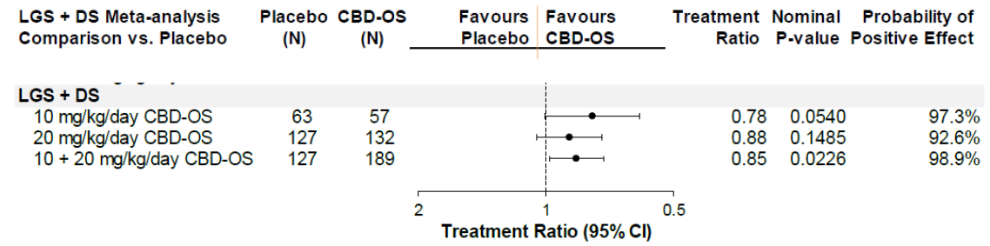
LGS = Lennox-Gastaut syndrome (subjects); DS = Dravet syndrome (subjects); CBD OS = cannabidiol oral solution; CI = confidence interval.
The clinical evaluator questioned this approach, because it pools results obtained for different seizure types in different target populations, for different proposed indications, but it does provide a very rough estimate of whether the efficacy results support a finding of efficacy without the confounding effects of CLB interactions.
Of some concern, in subjects not on CLB, the efficacy of CBD seemed to be inferior at 20 mg/kg/day, compared to 10 mg/kg/day, as shown in Figure 2 above (most of the DS patients were taking CLB). In discussions with the EMA about this issue, the sponsor suggested that this could reflect worsened seizures in some CBD recipients exposed to higher CBD doses.
Figure 3: Negative binomial regression analyses of clobazam use on primary seizure count (intent to treat analysis set)
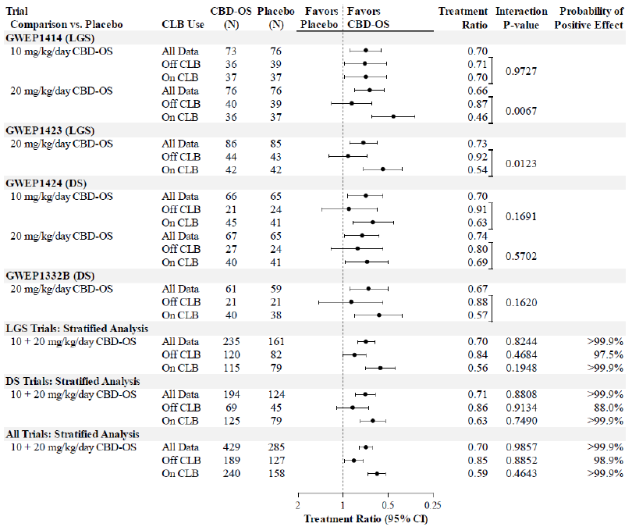
LGS = Lennox-Gastaut syndrome (subjects); DS = Dravet syndrome (subjects); CBD OS = cannabidiol oral solution; CLB = clobazam; CI = confidence interval.
The sponsor formed a similar analysis for the key secondary endpoint of response rate (and again focussed on relative results instead of absolute benefit) as shown in Figure 4, below.
Figure 4: Meta-analysis of logistic regression treatment estimates of primary seizure responders (≥ 50% reduction from Baseline) by cannabidiol oral solution dose for patients not taking clobazam (intent to treat analysis set)
LGS = Lennox-Gastaut syndrome (subjects); DS = Dravet syndrome (subjects); CBD OS = cannabidiol oral solution; CI = confidence interval.
In response to the EMA, who expressed similar concerns about the efficacy of CBD in subjects off CLB, the sponsor presented the same results slightly differently:
‘The proportion of patients not taking CLB with a ≥ 50% reduction from their baseline primary seizure frequency was 24.6% across the 10 mg/kg/day CBD-OS groups compared with 7.9% across the placebo groups; this difference in proportions was nominally statistically significant (p=0.026). The ≥ 50% responder rate for patients not taking CLB across the 20 mg/kg/day CBD-OS groups was 28.8% compared with 15.7% across the placebo groups and this difference in proportions was also nominally statistically significant (p=0.022). Importantly, CBD-OS at both 10 and 20 mg/kg/day increased the likelihood of achieving a ≥ 50% reduction in seizure frequency to a similar degree for patients taking or not taking CLB. These results support the presence of a clinically relevant treatment effect of CBD-OS that is independent of CLB therapy and that is observable both at the recommended 10 mg/kg/day maintenance dose and the maximum 20 mg/kg/day dose.’
This implies an attributable response rate of 16.7 percentage points (24.6 to 7.9) for 10 mg/kg/day and 13.1 percentage points (28.8 to 15.7) for CBD-OS 20 mg/kg/day, meaning that about 6 to 8 subjects would need to be treated to achieve one attributable response (if it is accepted that it is appropriate to pool response for different seizure types across two different syndromes). For this endpoint, the difference between subjects on CLB and not on CLB was not as marked as observed with the primary endpoint. An adverse dose trend remains evident, with better results on 10 mg/kg/day than on 20 mg/kg/day.
Figure 5: Logistic regression analyses of clobazam use on primary seizure responders (≥ 50% reduction from Baseline) (intent to treat analysis set)
LGS = Lennox-Gastaut syndrome (subjects); DS = Dravet syndrome (subjects); CBD OS = cannabidiol oral solution; CLB = clobazam; CI = confidence interval.
For other subgroup analyses, no consistent patterns emerged. Figures 6 to 9 displayed below show the primary results (change in seizure frequency for primary seizure type) and secondary results (responder rates) for all four of the major efficacy studies, for the whole cohort and for key subgroups, including those not on CLB.
Figure 6: Negative binomial regression effect modification analysis of drop seizure count during Baseline and treatment periods in LGS Studies LGS-14 and LGS-23 (intent to treat analysis set)
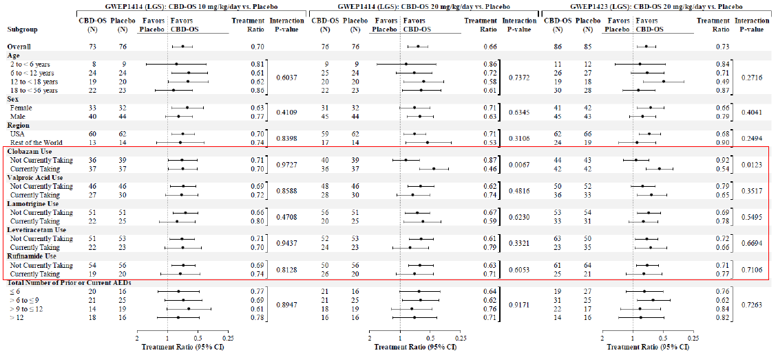
LGS = Lennox-Gastaut syndrome (subjects); CBD OS = cannabidiol oral solution; CLB = clobazam; CI = confidence interval.
Figure 7: Logistic regression effect modification analysis of drop seizure responders (≥ 50% reduction from Baseline) during the treatment period in LGS Studies LGS-14 and LGS-23 (intention to treat analysis set)
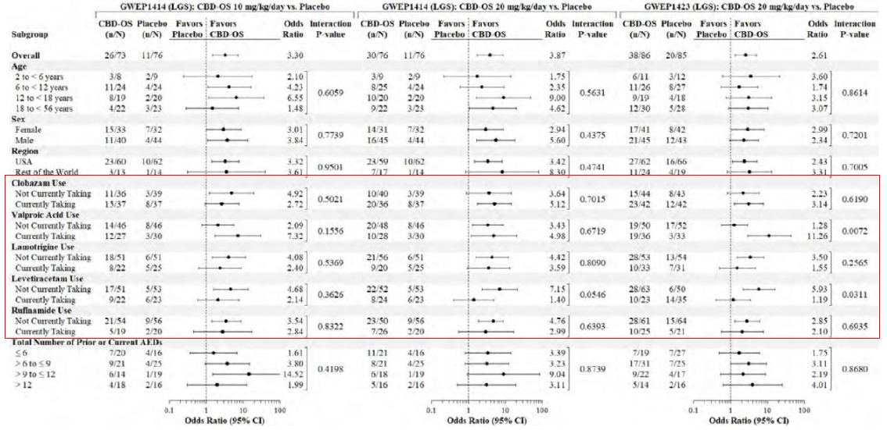
LGS = Lennox-Gastaut syndrome (subjects); CBD OS = cannabidiol oral solution; CLB = clobazam; CI = confidence interval.
Figure 8: Negative binomial regression effect modification analysis of convulsive seizure count during Baseline and treatment periods in DS Studies DS-24 and DS-32 Part B (intent to treat analysis set)
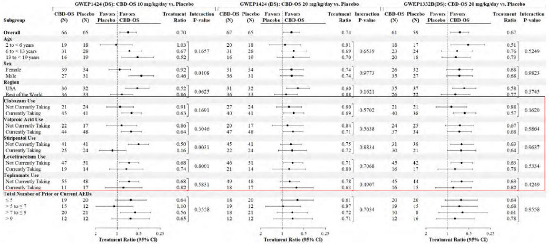
DS = Dravet syndrome (subjects); CBD OS = cannabidiol oral solution; CLB = clobazam; CI = confidence interval.
Figure 9: Logistic regression effect modification analysis of convulsive seizure responders (≥ 50% reduction from Baseline) during the treatment period in DS Studies DS-24 and DS-32 Part B (intent to treat analysis set)
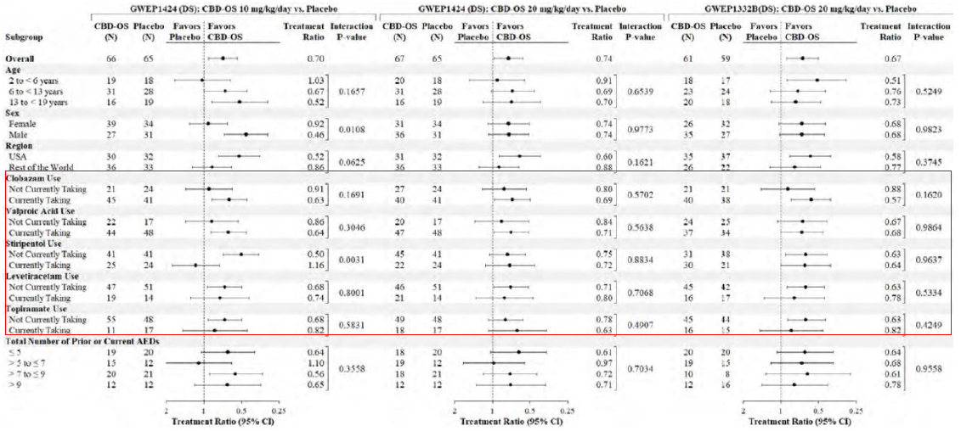
DS = Dravet syndrome (subjects); CBD OS = cannabidiol oral solution; CLB = clobazam; CI = confidence interval.

Conclusions of the European Medicines Agency Scientific Advisory Group
Because of ongoing concerns about the quality of the evidence supporting CBD use in patients not on CLB, the EMA asked for an opinion from a Scientific Advisory Group (SAG). The group’s opinions were summarised by the EMA as follows:15
‘SAG experts were split in their position about an indication that clearly excludes off CLB patients. Although it was considered that data in off CLB patients could indicate efficacy, no consensus could be reached regarding a restricted indication to this specific group.
Some members supported this restricted indication, which should be based on the evidence provided by the trials. Additionally, they expressed concerns that a different approach will increase the use of CBD instead of CLB. However, the argument that CBD will then be prescribed off label, even if the current level of evidence does not support this, was not considered a valid argument to have an indication for patients off CLB in the absence of proven efficacy.
Other experts, including the patient representatives, were against a restriction, stating the following reasons:
- Such an indication will require the use of CLB in order to prescribe CBD, thus patients who cannot tolerate CLB (often observed in children) will not be given the option to use CBD for treatment. This situation was highlighted by the patient representatives as undesirable.
- It is likely that a restricted indication may not be followed in practice – it will potentiate off label use
- Individual patients may still exist that will show clinically relevant benefit and having an additional effective treatment option is appreciated.’

European Medicines Agency conclusions
The EMA drew the following conclusions about the overall evidence of efficacy.15
‘Clinical efficacy in LGS and DS, two serious, rare, treatment resistant epileptic encephalopathies, was evaluated in four pivotal trials in which the primary outcome measure was reduction in drop seizure frequency and convulsive seizure frequency, respectively. These are considered clinically relevant endpoints. The primary endpoint was met in all four studies with an approximately 40 to 50% median reduction of seizure frequency in the active groups as compared to approximately median 15 to 25% in the placebo groups. In LGS, the primary analysis was supported by the statistically significant results of key secondary endpoints including responder analyses and PGIC scores. In terms of drop seizure free days, the treatment difference in LGS corresponded to 3 to 5 drop seizure free days per 28 days. In DS, the key secondary endpoint (responder analysis) was not met in one study (Study DS-32 Part B) whereas in the other study (Study DS-24) the key secondary analyses reached the statistical significance, supporting the results of the primary analyses.
‘Whereas the presented studies demonstrated that CBD-OS had an effect in both LGS and DS, the effect appeared mainly driven by the effect observed in CLB treated patients whereas the effect in patients off CLB was smaller or not detectable. The CHMP does not consider that it has been convincingly demonstrated that the effect size in off CLB LGS and DS patients treated with other combined treatments is statistically and clinically relevant, hence that it does not support the indication initially claimed with any kind of drug combination.
‘Therefore, the CHMP considers that the presented efficacy data supports the application for Epidyolex in the treatment of use as adjunctive therapy of seizures associated with LGS or DS in conjunction with CLB only, for patients 2 years of age and older.’.

Periodic benefit-risk evaluation report
The sponsor submitted a periodic benefit-risk evaluation report (PBRER) in response to a rolling question; this report had an approval date of 24 February 2020.
In that report, the sponsor makes the following statement conceding the weakness of the evidence establishing efficacy in subjects not on CLB:
‘Results of a subgroup analysis of patients treated with CLB compared to patients treated without CLB, indicated that there is residual statistical uncertainty regarding the treatment effect of cannabidiol in patients not taking CLB. In this population, efficacy has not been established.’

United States Food and Drug Administration position
The US FDA’s position (along with SwissMedic) differs from the above conclusion. The FDA clinical pharmacology reviewer drew the following conclusion:11
‘Clobazam (CLB) is metabolized by CYP3A4,⁹ and to a lesser extent by CYP2C19 and CYP2B6, to the active metabolite norclobazam (N-CLB), which is thought to have one third to one fifth the activity of CLB. N-CLB is metabolized by CYP2C19. CBD is known to inhibit the CYP2C19 enzyme and is therefore predicted to increase CLB and N-CLB levels. No increase in CLB levels was observed in clinical trials, but exposures to N-CLB were found to be up to 300% higher in the CBD arm compared to the placebo arm in the controlled trials. Based on this increase in N-CLB levels, the applicant explored the potential impact of CLB use and N-CLB levels on the efficacy findings; that is, whether changes in N-CLB levels could explain some or all of the effect of CBD. The applicant conducted a number of subgroup analyses in the pivotal studies for LGS and DS. Clinical pharmacology team at FDA determined that because of the small numbers of patients in the subgroups and variability in the data, the analyses were not adequately powered to allow reliable evaluation of the effects of CBD independent of CLB. Additionally, the large number of concomitant medications used by patients made it difficult to analyze the effects of CLB alone. In an attempt to further explore this issue, the applicant conducted an analysis of concomitant stiripentol (STP) use in Study 1332B. STP was used by a subset of patients in Study 1332B;¹⁷for DS (STP was not used in the LGS studies). STP, like CBD, inhibits the CYP2C19 enzyme. Patients who were taking CLB and STP at baseline did not show a further increase of N-CLB levels following the initiation of CBD, but did have improved seizure control. The applicant hypothesizes that CLB and N-CLB levels were already maximally increased by STP-induced inhibition of CYP2C19, and patients did not appear to experience further augmentation of the CYP2C19 inhibition with the initiation of CBD. An analysis of the patients taking CLB and STP showed that CBD was superior to placebo, with 80% of patients showing a reduction in seizures, versus 50% on placebo (Figure 10, below). As STP was not used in the LGS studies, this analysis could not be conducted in the LGS population. Overall, the FDA clinical pharmacology review team believes that this observation supports the sponsor’s claim that CBD has an effect on seizures that is independent of its ability to increase N-CLB.’
Figure 10: Study DS-32 Part B Cumulative distribution of seizure reduction by treatment arm (patients taking clobazam and stiripentol)
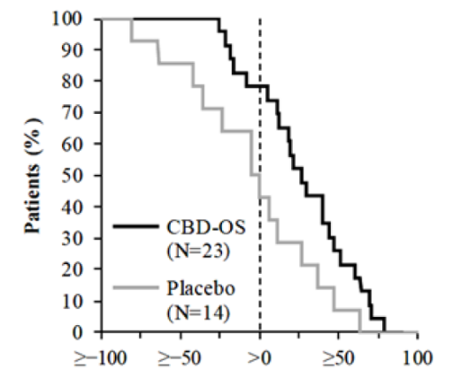
Source: FDA summary review.11 CBD-OS = cannabidiol oral solution.
In Studies LGS-14 and LGS-23, patients taking placebo without concomitant CLB had a greater reduction in seizure frequency than patients taking CBD (Figure 11: Study LGS-14 Cumulative distribution functions for drop seizures: 20mg/kg/day cannabidiol oral solution versus placebo by clobazam use (treatment period, intent to treat analysis set)Figure 11).
Figure 11: Study LGS-14 Cumulative distribution functions for drop seizures: 20mg/kg/day cannabidiol oral solution versus placebo by clobazam use (treatment period, intent to treat analysis set)
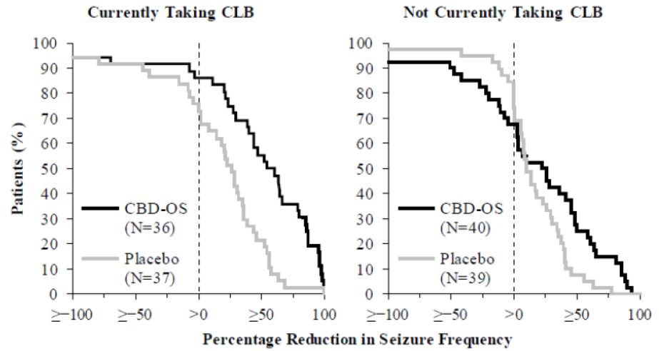
CBD-OS = cannabidiol oral solution; CLB = clobazam
Patients on CBD 10 mg/kg/day without CLB had a greater reduction in seizure frequency than patients on placebo, when the seizures improved (change in seizure frequency > 0%). There was no difference between CBD and placebo, if the patient’s seizures worsened (that is, change in seizure frequency < 0%) (Figure 12: Study LGS-14 Cumulative distribution functions for drop seizures: 10mg/kg/day cannabidiol oral solution versus placebo by clobazam use (treatment period, intent to treat analysis set))
Figure 12: Study LGS-14 Cumulative distribution functions for drop seizures: 10mg/kg/day cannabidiol oral solution versus placebo by clobazam use (treatment period, intent to treat analysis set)
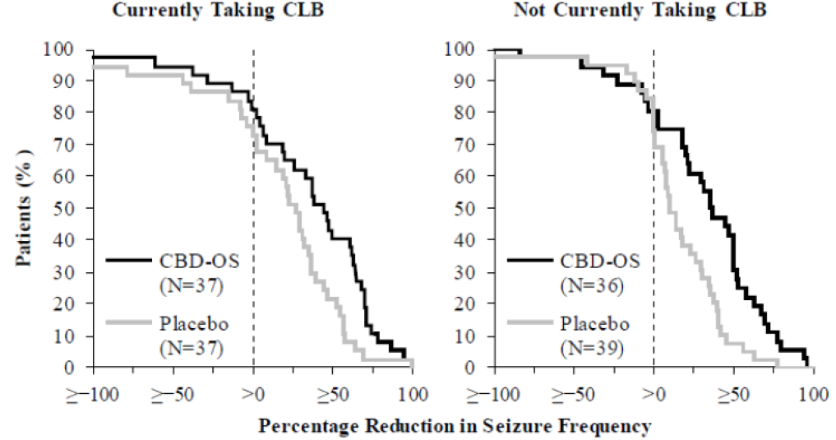
CBD-OS = cannabidiol oral solution; CLB = clobazam.
Overall, there were no clear trends in these analyses, making it difficult to determine if presence or absence of concomitant CLB had any impact on the efficacy of CBD.

Safety
The safety data for CBD reveal several important risks, acknowledged by the sponsor:
- hepatocellular injury,
- somnolence and sedation,
- lethargy,
- pneumonia, and
- rash / hypersensitivity reactions.
There are also several potential risks, some of them based on issues observed with other anticonvulsants, for which the evidence is currently inconclusive:
- suicidality (a class effect),
- seizure worsening,
- aggression,
- euphoria, and
- cognitive impairment.
Seizure worsening appeared to be most common in subjects taking CBD 20 mg/kg/day without concurrently taking CLB. A slight excess of urinary retention was noted in the major studies, and is listed by the sponsor as a potential risk, but this observation is of unknown significance. Important missing information in relation to safety is the effect of taking CBD while pregnant or lactating, and the long term safety of CBD.

Drug induced liver injury
One of the most important identified risks for CBD is the risk of drug induced liver injury (DILI). Risk factors for abnormal liver function included concurrent use of CLB or valproate, abnormal baseline liver function, and use of a higher dose of CBD. The clinical evaluator has highlighted the possibility that regular consumption in the fed state would also be expected to be a risk factor for liver injury.
There were no cases satisfying Hy’s Law. In general, the PI contains appropriate warnings about this issue, apart from in relation to severe pre-existing hepatic impairment. The sponsor recommends dose reduction in patients with severe hepatic impairment, but it would be more prudent to avoid this CBD in this context, given that further worsening due to DILI could be extremely serious or fatal. The combination of CBD and valproate should be taken with extreme caution; especially if liver function tests are already abnormal at Baseline.
CBD was also associated with some tolerability issues, with an excess of vomiting and diarrhoea. CBD was associated with an increased risk of anaemia (observed in 27% of subjects), but this was generally not sustained. CBD was associated with rash, but it is unclear whether it increases the risk of severe hypersensitivity reactions.
The clinical evaluator on reviewing both efficacy and safety findings suggest that CBD should primarily be used in subjects on CLB. The safety of the CBD and CLB combination was broadly similar to the overall safety profile of CBD, but with an increased risk of sedation and a mildly increased risk of abnormal liver function.
The proposed PI acknowledges the following adverse events associated with CBD use, as shown in Table 4.
Table 4: Tabulated list of adverse reactions associated with cannabidiol use
System Organ Class | Frequency | Adverse reactions from clinical trials
Infections and infestations | Common | Pneumonia,ª bronchitis, nasopharyngitis, urinary tract infection
Metabolism and nutrition disorders | Very common | Decreased appetite
Metabolism and nutrition disorders | Common | Increased appetite
Psychiatric disorders | Common | Irritability, insomnia, aggression, abnormal behaviour, agitation
Nervous system disorders | Very common | Somnolenceª
Nervous system disorders | Common | Lethargy, drooling, tremor
Respiratory, thoracic and mediastinal disorders | Common | Cough
Gastrointestinal disorders | Very common | Diarrhoea, vomiting
Hepatobiliary disorders | Common | Aspartate transaminase (AST) increased, alanine aminotransferase (ALT) increased, gamma-glutamyl transferase (GGT) increased, liver function test abnormal
Skin and subcutaneous tissue disorders | Common | Rash
General disorders and administration site conditions | Very common | Oyrexia, fatigue
Investigations | Common | Weight decreased
a = grouped terms: Pneumonia: pneumonia, pneumonia respiratory syncytial virus, pneumonia mycoplasmal, pneumonia adenoviral, pneumonia viral, aspiration pneumonia. Somnolence: somnolence, sedation.
Very common: ≥ 1/10; common: ≥ 1/100 to < 1/10; uncommon: ≥ 1/1000 to < 1/100.

Food effect on safety
The strong food effect associated with CBD also raises safety concerns. Switching from administration in the fed state to administration in the fasted state would constitute an abrupt reduction in exposure that would increase the risk of seizures. Switching from fasted to fed administration would potentially cause major issues with tolerance, sedative side effects, potential seizure exacerbation, and ongoing heightened risk of liver injury. This risk has been addressed adequately in the PI: ‘Food may increase Epidyolex levels and therefore it should be taken consistently either with or without food, including the ketogenic diet’.
The clinical evaluator also raised the similar concerns on safety grounds about the effect of weight on the PK and thereby affecting the safety profile of the CBD; but the evaluator concludes with the following: ‘Overall, the safety of CBD is likely to be acceptable, but care will be needed to titrate doses to minimise tolerability issues, and some patients are likely to experience drug induced liver injury. Many aspects for the dose response relationship and the effects of prandial status remain uncertain’.

Risk management plan
The sponsor provided EU-RMP version 1.0 (dated 2 July 2019; data lock point (DLP) 1 May 2017) and Australian specific annex (ASA) version 1.0 (dated 13 January 2020) with the initial submission.
In response to questions from the TGA, the sponsor has submitted an updated ASA but has continued to label it as ASA version 1.0 (dated 23 March 2020). The sponsor has also submitted EU-RMP version 1.0 (dated 2 July 2019; DLP 1 May 2017).
The summary of safety concerns and their associated risk monitoring and mitigation strategies are summarised in Table 5.
Table 5: Summary of safety concerns
Summary of safety concerns |  | Pharmacovigilance |  | Risk minimisation
 |  | Routine | Additional | Routine | Additional
Important identified risks | Hepatocellular injury | ✓* | ✓+ | ✓ | -
Important identified risks | Somnolence and sedation | ✓ | ✓+ | ✓ | -
Important identified risks | Lethargy | ✓ | ✓+ | ✓ | -
Important identified risks | Pneumonia | ✓* | ✓+ | ✓ | -
Important identified risks | Rash hypersensitivity reactions | ✓* | ✓+ | ✓ | -
Important potential risks | Suicidality | ✓ | ✓+ | ✓ | -
Important potential risks | Seizure worsening | ✓ | ✓+ | ✓ | -
Important potential risks | Aggression | ✓ | ✓+ | ✓ | -
Important potential risks | Euphoria | ✓ | ✓+ | ✓ | -
Important potential risks | Impact on cognitive development | ✓ | ✓+ | ✓ | -
Important potential risks | Urinary retention | ✓ | ✓+ | ✓ | -
Missing information | Exposure during pregnancy and lactation | ✓ | ✓++ | ✓ | -
Missing information | Long-term safety | ✓ | ✓+ | ✓ | -
*specific adverse drug reaction follow up forms
+ Category 3 post-marketing observational cohort study
++ Pregnancy registries
Subject to the evaluation of the nonclinical and clinical aspects of the safety specifications, the summary of safety concerns is considered acceptable from an RMP perspective.
The sponsor was asked to clarify if the same pharmacovigilance plan as in the EU will be implemented in Australia including the use of follow up forms and ‘enhanced pharmacovigilance plan’ and to provide copies of follow up forms for review. The sponsor was also asked to clarify if Australian patients will be included in the post marketing observational cohort study. The sponsor has confirmed that the pharmacovigilance plan in Australia will include the same follow up forms and ‘enhanced pharmacovigilance plan’ as in the EU and has provided the follow up forms for review. The sponsor has stated that Australian patients will not be included in the post marketing observational cohort study and has provided adequate justification for the extrapolation of the findings from the study to Australian patients. The pharmacovigilance plan is considered acceptable from an RMP perspective.
Only routine risk minimisation activities have been proposed for all safety concerns using draft PI and Consumer Medicines Information (CMI) (contains ‘Instructions For Use’). The sponsor was asked to include the ‘Instructions For Use’ as a package insert. The sponsor has now stated that the CMI, which contains the ‘Instructions For Use’, will be included as package insert. This approach is acceptable.

Risk-benefit analysis

Delegate’s considerations

Summary of key issues
- Significant drug interaction observed between CLB (and its metabolite) on CBD-OS and thereby affecting its efficacy and safety profile.
- Status of an additional QT study is ongoing as per FDA review.^{10, 11}
- Prandial status and its impact on exposure of CBD-OS.
- Weight based dosing or fixed dosing of CBD-OS.
- Absence of adequate toxicokinetic and carcinogenicity studies for cannabidiol as well as the lack of toxicology studies for 7-COOH-CBD, however it should not preclude registration, as per the nonclinical reviewer’s comments.

Discussion
Both Lennox-Gastault syndrome (LGS) and Dravet syndrome (DS) are rare, serious, refractory epileptic syndromes affecting children early in life. Both conditions are associated with seizures as well as a high risk of impaired cognition and/or severe neuropsychological disturbances. Currently available antiepileptic treatment such as valproate, clobazam (CLB), clonazepam, felbamate, lamotrigine, rufinamide, topiramate, and ethosuximide rarely succeeds in keeping the children free of seizures and the risk of SUDEP remains high. Thus, there remains a clear unmet medical need. In that respect, the statistically significant reduction in seizure frequency offered by cannabidiol oral solution (CBD-OS) constitutes a favourable effect in this difficult to treat population of LGS and DS.
Overall, the PK and PD data provided was sufficient to support the proposed usage in the treatment of LGS and DS. The reported PK results appear consistent across the studies. Oral bioavailability of CBD-OS was approximately 6.5 % in fasting conditions. CBD-OS appears rapidly in plasma with a T_{max} of around 3 hours (range from 2.5 to 5 hours) at steady state.
Concomitant intake of food greatly increases AUC and C_{max} exposure to CBD-OS (about 4 fold) and active metabolites (about 2 fold) in healthy volunteers. It is unknown how this affects efficacy and safety as no restrictions related to concomitant food intake were included in the Phase III clinical studies. However, as the dose of CBD-OS is gradually titrated according to efficacy and safety, this uncertainty is considered manageable if CBD-OS is administered consistently either with or without food intake as reflected in the proposed PI.
In the LGS and one of the DS studies, clinically meaningful and statistically significant reductions in seizure frequency were demonstrated and supported by a responder analysis that CBD-OS (at doses of both 20 mg/kg/day and 10 mg/kg/day), compared to placebo, significantly increases the number of patients achieving a 50% reduction in primary seizure frequency. A reduction of 50% in the frequency of seizures is considered a clinically relevant effect.
In Study LGS-14 in LGS, the median percentage change from Baseline in drop seizure (atonic, tonic, or tonic-clonic seizures that could have led to a fall) frequency per 28 days was 37.2 in the 10 mg/kg/day group and 41.9 in the 20 mg/kg group CBD groups compared to 17.2 in the placebo group (p = 0.002 and p = 0.005, respectively). In Study LGS-23 in LGS, the median percentage change from Baseline in drop seizure frequency per 28 days was 43.9 in the 20 mg/kg/day CBD group and 21.8 in the placebo group (p = 0.014). In Study DS-32 Part B in DS, the median percentage change from Baseline in convulsive seizure (tonic, clonic, tonic-clonic, or atonic) frequency per 28 days was 38.9 in the CBD group and 13.3 in the placebo group (p = 0.012). The results from these three adequate and well-controlled studies provide substantial evidence of the effectiveness of CBD for the treatment of seizures associated with LGS and DS.
The clinical evaluator has highlighted some uncertainties about the favourable effect of CBD-OS, particularly linked to co-administration of CLB, as the effect of CBD-OS without concomitant CLB was relatively smaller. Some of the difference in apparent effect size, between patients treated with and without CLB, may be ascribed to the bidirectional pharmacokinetic interaction with CLB (leading to increased CLB active metabolite N-CLB concentrations and increased CBD active metabolite 7-OH-CBD concentrations). CBD-OS and CLB have a complex 2 way metabolic interaction. CBD-OS inhibits CYP2C19 which is required to metabolise the active CLB metabolite N-CLB. This leads to a 2 to 4 fold increase in N-CLB and an approximate 1.5-fold increase in 7-OH-CBD concentrations that may partially explain the treatment difference. In the pivotal trials, a substantial proportion of patients received CLB concomitant treatment at Baseline (approximately 50% in LGS and 65% in DS).
The sponsor performed a number of analyses, attempting to examine for such an effect. In all pivotal trials, performing the primary analysis on the subgroup of patients on CLB and the subgroup of patients not on CLB consistently revealed larger treatment effect sizes in the CLB subgroups than in the non-CLB subgroups. However, certain factors affected the ability to draw definite conclusions. For example, PK data for CLB and N-CLB were not collected; therefore, the investigators could not control for increases in CLB or N-CLB during the treatment period. Additionally, assessing the effect of a single drug was difficult, as many patients were on multiple concomitant AEDs, so separating out the impact of one concomitant drug among many is difficult. There are clearly good arguments on either side on whether to restrict the use of CBD-OS to patients already receiving CLB or not. The Advisory Committee on Medicines (ACM) deliberation on this particular topic will be key to make the final decision.
Four controlled trials in LGS and DS primarily provided the safety data, with the open label extension trial and EAP providing additional supportive data. There was adequate exposure to allow for an assessment of safety. The most commonly observed adverse events in controlled clinical trials that occurred with a greater incidence in CBD treated patients than on placebo were in the following categories: central nervous system (such as somnolence, tremor and sedation), gastrointestinal (such as vomiting and diarrhoea), hepatic (such as transaminase elevations), and infections (such as pneumonia). These events were generally mild to moderate in severity. There were 21 deaths in the development program; however, as the patients were generally ill with multiple comorbidities, none of the deaths could be attributed to CBD.
Treatment with CBD-OS is clearly associated with an increased risk of hepatotoxicity. In particular, patients with concomitant treatment with valproate and pre-existing elevated transaminases are prone to experience additional elevation of transaminases. This risk is considered manageable and acceptable taking into consideration the seriousness of the conditions intended to be treated, including the grave prognosis for these children. These patients are usually cared for in a clinical setting and by physicians that are capable of and experienced in handling these safety issues.
Overall, the benefit-risk profile established by the data in the application support the approval of CBD-OS for the treatment of seizures associated with LGS or DS for patients aged 2 years of age and older.

Deficiencies of the data
Identified deficiencies include data on:
- exposure during pregnancy and lactation
- long term safety
- QTc study.¹⁰

Conditions of registration
Any changes to which the sponsor has agreed should be included in a revised RMP and ASA. However, irrespective of whether or not they are included in the currently available version of the RMP document, the agreed changes become part of the risk management system.
The suggested wording is:
‘The Epidyolex EU-Risk Management Plan (RMP) (version 1.0, dated 2 July 2019, data lock point 1 May 2017), with Australian Specific Annex (version 1.0, dated 23 March 2020), included with submission PM-2020-00157-1-1, and any subsequent revisions, as agreed with the TGA will be implemented in Australia.’
The following wording is recommended for the PSUR requirement:
‘An obligatory component of risk management plans is routine pharmacovigilance. Routine pharmacovigilance includes the submission of periodic safety update reports (PSURs).
‘Reports are to be provided in line with the current published list of EU reference dates and frequency of submission of PSURs until the period covered by such reports is not less than three years from the date of this approval letter.
‘The reports are to at least meet the requirements for PSURs as described in the European Medicines Agency’s Guideline on good pharmacovigilance practices (GVP) Module VII-periodic safety update report (Rev 1), Part VII.B Structures and processes. Note that submission of a PSUR does not constitute an application to vary the registration.
As Epidyolex is a new chemical entity, it should be included in the Black Triangle Scheme as a condition of registration. The following wording is recommended for the condition of registration:
‘Epidyolex (cannabidiol) is to be included in the Black Triangle Scheme. The PI and CMI for Epidyolex must include the black triangle symbol and mandatory accompanying text for five years, which starts from the date that the sponsor notifies the TGA of supply of the product.’

Conclusion
Overall, Epidyolex is approvable as the quality, nonclinical and clinical evaluators (subjected to PI changes) have all recommended approval. The Delegate considers that sufficient data and justification have been provided to support the registration of Epidyolex on quality, safety and efficacy grounds for the following indication:
As adjunctive therapy of seizures associated with Lennox- Gastaut syndrome (LGS) or Dravet syndrome (DS) for patients 2 years of age and older.
The question on whether to amend the indication suggested by clinical evaluator will need to be revisited after the deliberations of ACM.

Proposed action
The Delegate has no reason to say, at this time, that the application for Epidyolex should not be approved for registration.
Any approval is subject to taking into account all issues arising from the ACM deliberations and finalising matters pertaining to the PI, to the satisfaction of the TGA.

Request for Advisory Committee on Medicines advice
The Committee is requested to provide advice on the following specific issues:
- What are the ACM’s views on the efficacy of CBD-OS and to what extent is there sufficient clinical trial evidence to support the proposed indication of adjunctive therapy of seizures associated with Lennox Gastaut syndrome (LGS) or Dravet syndrome (DS) for patients 2 years of age and older?
- What are the ACM’s views on restricting the indication of Epidyolex to be used with clobazam only?
- What are the ACM’s views on weight based dosing?
- Does the ACM consider that the effect of food on the exposure adequately addressed in the PI?
- Does the ACM consider that the safety of Epidyolex for the proposed new indication is sufficiently well characterised and communicated in the PI?
- The Committee is also requested to provide advice on any other issues that it thinks may be relevant to a decision on whether or not to approve this application.

Advisory Committee considerations
The Advisory Committee on Medicines (ACM), having considered the evaluations and the Delegate’s overview, as well as the sponsor’s response to these documents, advised the following.

Specific advice to the Delegate
The ACM advised the following in response to the Delegate’s specific request for advice.
- What are the ACM’s views on the efficacy of CBD-OS and to what extent is there sufficient clinical trial evidence to support the proposed indication of adjunctive therapy of seizures associated with Lennox Gastaut syndrome (LGS) or Dravet syndrome (DS) for patients 2 years of age and older?
The ACM was of the view that there is sufficient evidence for the efficacy of CBD-OS in LGS and DS for patients aged 2 years and older. The ACM advised that the clinical trial evidence is strong, the number of patients is reasonable considering these are rare diseases, and the conduct of the trials is excellent.
The ACM considered whether it would be appropriate to remove the age requirement for DS only, as the epilepsy is often at its worst in these patients between 9 months and 2 years of age. The ACM was of the view that compassionate access and open label use thus far appears to indicate that Epidyloex is safe to use in patients under 2 years of age, although these data are limited. On balance, the ACM advised that the indication should remain for 2 years and older, as the clinical trials submitted did not have sufficient evidence for efficacy and safety in patients under 2 years of age.
- What are the ACM’s views on restricting the indication of Epidyolex to be used with clobazam only?
The ACM advised that the indication of Epidyolex should not be restricted to use with CLB. This is based on consideration of the significant drug-drug interactions of CBD-OS and CLB, as well as a recently published metanalysis of the four pivotal randomised placebo controlled trials which indicate greater seizure effects and a greater burden of adverse events when CBD is combined with CLB. The ACM was of the view that the use of CLB should be left up to the individual prescriber.
- What are the ACM’s views on weight based dosing?
The ACM advised that weight based dosing is an acceptable and safe method of dosing, and discussed the possibility of developing guidelines for a maximum total dose for adult patients.
- Does the ACM consider that the effect of food on the exposure adequately addressed in the PI?
The ACM was of the view that the effect of food on the exposure has been adequately addressed in the PI.
- Does the ACM consider that the safety of Epidyolex for the proposed new indication is sufficiently well characterised and communicated in the PI?
The ACM was of the view that the safety of Epidyolex has been adequately addressed in the PI.
- The Committee is also requested to provide advice on any other issues that it thinks may be relevant to a decision on whether or not to approve this application.
The ACM considered that in current practice the definition of LGS is ambiguous and expressed concern that this would result in misprescribing. The ACM advised that the less ambiguous criteria used in the trials should be applied to the definition of LGS for the purposes of prescribing Epidyolex.
The ACM advised that the PI should state that treatment should be initiated by an appropriately trained neurologist.
The ACM recommended that the PI should include a statement that Epidyolex should only be used following failure of common drugs for DS (sodium valproate, clobazam, stiripentol, and topiramate) and LGS (sodium valproate, clobazam and lamotrigine).
The ACM advised that it would be beneficial to have some kind of de-prescribing criteria or statement in the PI regarding de-prescribing due to lack of efficacy. This is particularly relevant to avoid unnecessary exposure to CBD-OS in young children, for whom long term safety data is lacking.
The ACM expressed concern that the statement in the PI regarding driving might endorse driving while on the product, and suggested that modification of the wording to draw attention to intoxication and legal considerations for driving may be necessary.

ACM conclusion
The ACM considered this product to have an overall positive benefit risk profile for the indication:
Epidyolex is indicated for use as adjunctive therapy of seizures associated with Lennox- Gastaut syndrome (LGS) or Dravet syndrome (DS) for patients 2 years of age and older.

Outcome
Based on a review of quality, safety and efficacy, the TGA approved the registration of Epidyolex (cannabidiol) 100 mg/mL oral liquid solution bottle, indicated for:
Epidyolex is indicated for use as adjunctive therapy of seizures associated with Lennox-Gastaut syndrome (LGS) or Dravet syndrome (DS) for patients 2 years of age and older.

Specific conditions of registration applying to these goods
- Epidyolex (cannabidiol) is to be included in the Black Triangle Scheme. The PI and CMI for Epidyolex must include the black triangle symbol and mandatory accompanying text for five years, which starts from the date that the sponsor notifies the TGA of supply of the product.
- The Epidyolex EU-Risk Management Plan (RMP) (version 1.0, dated 2 July 2019, data lock point 1 May 2017), with Australian Specific Annex (version 1.0, dated 23 March 2020), included with submission PM-2020-00157-1-1, and any subsequent revisions, as agreed with the TGA will be implemented in Australia.
An obligatory component of risk management plans is routine pharmacovigilance. Routine pharmacovigilance includes the submission of periodic safety update reports (PSURs).
Reports are to be provided in line with the current published list of EU reference dates and frequency of submission of PSURs until the period covered by such reports is not less than three years from the date of the approval letter.
The reports are to at least meet the requirements for PSURs as described in the European Medicines Agency’s Guideline on good pharmacovigilance practices (GVP) Module VII-periodic safety update report (Rev 1), Part VII.B Structures and processes. Note that submission of a PSUR does not constitute an application to vary the registration.

Attachment 1. Product Information
The PI for Epidyolex approved with the submission which is described in this AusPAR is at Attachment 1. For the most recent PI, please refer to the TGA website at <https://www.tga.gov.au/product-information-pi>.

Therapeutic Goods Administration
PO Box 100 Woden ACT 2606 Australia
Email: info@tga.gov.au Phone: 1800 020 653 Fax: 02 6232 8605
https://www.tga.gov.au

The Black Triangle Scheme provides a simple means for practitioners and patients to identify certain types of new prescription medicines, including those being used in new ways and to encourage the reporting of adverse events associated with their use. The Black Triangle does not denote that there are known safety problems, just that the TGA is encouraging adverse event reporting to help us build up the full picture of a medicine's safety profile.
Emerge Health Pty Ltd was the sponsor throughout the duration of the application. Sponsorship was changed to Chiesi Australia Pty Ltd after registration.
Orphan drugs are often developed to treat small and very specific patient populations who suffer from rare diseases and conditions. In order to facilitate orphan drug access to the Australian marketplace and help offset orphan drug development costs the TGA waives application and evaluation fees for prescription medicine registration applications if a related orphan designation is in force. A medicine may be eligible for orphan drug designation if all orphan criteria set by the TGA are met. The orphan designation application precedes the registration application and the designation is specific to the sponsor, orphan indication for which designation was granted and dosage form of the medicine.
The TGA has implemented a Priority pathway for the registration of novel prescription medicines for Australian patients. The priority pathway provides a formal mechanism for faster assessment of vital and life-saving prescription medicines.
European Medicines Agency, Clinical investigation of medicinal products in the treatment of epileptic disorders, CPMP/EWP/566/1998 Rev. 2 Corr, Effective from 1 August 2010.
Australian Pregnancy Category B2: Drugs which have been taken by only a limited number of pregnant women and women of childbearing age, without an increase in the frequency of malformation or other direct or indirect harmful effects on the human fetus having been observed. Studies in animals are inadequate or may be lacking, but available data show no evidence of an increased occurrence of fetal damage.
Sativex is the tradename for an oromucosal nabiximols spray. One of the components of Sativex is cannabidiol.
See the Efficacy section for explanation of study names.
Cytochrome P450 (CYP) enzymes: CYPs are the major enzymes involved in drug metabolism, accounting for large part of the total metabolism. Most drugs undergo deactivation by CYPs, either directly or by facilitated excretion from the body. Also, many substances are bioactivated by CYPs to form their active compounds. Many drugs may increase or decrease the activity of various CYP isozymes either by inducing the biosynthesis of an isozyme (enzyme induction) or by directly inhibiting the activity of the CYP (enzyme inhibition). This is a major source of adverse drug interactions, since changes in CYP enzyme activity may affect the metabolism and clearance of various drugs. Such drug interactions are especially important to take into account when using drugs of vital importance to the patient, drugs with important side-effects and drugs with small therapeutic windows, but any drug may be subject to an altered plasma concentration due to altered drug metabolism.
The QT interval is the time from the start of the QRS wave complex to the end of the corresponding T wave. It approximates to the time taken for ventricular depolarisation and repolarisation, that is to say, the period of ventricular systole from ventricular isovolumetric contraction to isovolumetric relaxation. The corrected QT interval (QTc) estimates the QT interval at a standard heart rate. This allows comparison of QT values over time at different heart rates and improves detection of patients at increased risk of arrhythmias.
FDA, Center for Drug Evaluation and Research (CDER), Summary Review, Epidiolex (cannabidiol) 100 mg/mL oral solution, Application 210365Orig1s000, 22 June 2018. Available from the FDA website.
These trials include two pivotal efficacy studies; four safety, tolerability and PK studies; two drug-drug interaction studies; one study on the effect of CBD on the QTc interval; and one study of CBD effect on CYP3A4 probe midazolam.
The Epilepsy Study Consortium (TESC) is a group of scientific investigators from academic medical research centres who are dedicated to accelerating the development of new therapies in epilepsy to improve patient care.
Sponsor clarification: The dosing regimen recommended for registration consists of 2 dose increments over 8 days to reach 10 mg/kg/day, which is consistent with the timing of titration to 10 mg/kg/day used in the pivotal studies, with fewer dose increments, to benefit patients, caregivers, and prescribers. Recommended titration to 20 mg/kg/day is based on clinical evaluation and is slower than that used in the pivotal studies, in which 20 mg/kg/day was achieved within 14 days.
EMA, European Public Assessment Report (EPAR), Epidyolex (cannabidiol), EMA/458106/2019, 25 July 2019. Available from the EMA Website.
Sponsor clarification: statement from the EU Summary of Product Characteristics (SmPC) description of efficacy in the approved indication in the EU.
Sponsor’s Study GWEP1332 Part B (abbreviated as Study DS-32 Part B in this document).
Drug induced liver injury (DILI) also known as drug-induced hepatoxicity, includes both acute or chronic liver damage caused by a prescription, over the counter (OTC) or complementary medicine. Hepatoxicity due to type A reactions, or intrinsic DILI, is typically dose-related and occurs in a large proportion of individuals exposed to the drug and (predictable) and onset is within a short time span (hours to days). Idiosyncratic DILI is not closely dose-related, and occurs in only a small proportion of exposed susceptible individuals (unpredictable) and exhibits a variable latency to onset of days to weeks.
Hy’s Law: Evidence of hepatocellular injury with a rise in alanine aminotransferase (ALT) and/or aspartate aminotransferase (AST) > 3 x the upper limit of normal (ULN) and total bilirubin > 2 x ULN, and no other reason to explain rise in aminotransferases and total bilirubin. Hy's Law is a rule of thumb that a patient is at high risk of a fatal drug-induced liver injury (DILI) if given a medication that causes hepatocellular injury with jaundice.
Routine risk minimisation activities may be limited to ensuring that suitable warnings are included in the product information or by careful use of labelling and packaging. Routine pharmacovigilance practices involve the following activities: - All suspected adverse reactions that are reported to the personnel of the company are collected and collated in an accessible manner; - Reporting to regulatory authorities; - Continuous monitoring of the safety profiles of approved products including signal detection and updating of labelling; - Submission of PSURs; - Meeting other local regulatory agency requirements.
The ACM provides independent medical and scientific advice to the Minister for Health and the Therapeutic Goods Administration (TGA) on issues relating to the safety, quality and efficacy of medicines supplied in Australia including issues relating to pre-market and post-market functions for medicines. The Committee is established under Regulation 35 of the Therapeutic Goods Regulations 1990. Members are appointed by the Minister. The ACM was established in January 2017 replacing Advisory Committee on Prescription Medicines (ACPM) which was formed in January 2010. ACM encompass pre and post-market advice for medicines, following the consolidation of the previous functions of the Advisory Committee on Prescription Medicines (ACPM), the Advisory Committee on the Safety of Medicines (ACSOM) and the Advisory Committee on Non-Prescription Medicines (ACNM). Membership comprises of professionals with specific scientific, medical or clinical expertise, as well as appropriate consumer health issues relating to medicines.
Bialer and Perucca. Does cannabidiol have antiseizure activity independent of its interactions with clobazam? An appraisal of the evidence from randomized controlled trials. Epilepsia, 2020;61(6):1082-9

