May 2021

Australian Public Assessment Report for Cabotegravir sodium and cabotegravir/rilpivirine
  - Proprietary Product Names: Vocabria and Cabenuva
  - Sponsor: ViiV Healthcare Pty Ltd

About the Therapeutic Goods Administration (TGA)
- The Therapeutic Goods Administration (TGA) is part of the Australian Government Department of Health and is responsible for regulating medicines and medical devices.
- The TGA administers the Therapeutic Goods Act 1989 (the Act), applying a risk management approach designed to ensure therapeutic goods supplied in Australia meet acceptable standards of quality, safety and efficacy (performance) when necessary.
- The work of the TGA is based on applying scientific and clinical expertise to decision-making, to ensure that the benefits to consumers outweigh any risks associated with the use of medicines and medical devices.
- The TGA relies on the public, healthcare professionals and industry to report problems with medicines or medical devices. TGA investigates reports received by it to determine any necessary regulatory action.
- To report a problem with a medicine or medical device, please see the information on the TGA website <https://www.tga.gov.au>.

About AusPARs
- An Australian Public Assessment Report (AusPAR) provides information about the evaluation of a prescription medicine and the considerations that led the TGA to approve or not approve a prescription medicine submission.
- AusPARs are prepared and published by the TGA.
- An AusPAR is prepared for submissions that relate to new chemical entities, generic medicines, major variations and extensions of indications.
- An AusPAR is a static document; it provides information that relates to a submission at a particular point in time.
- A new AusPAR will be developed to reflect changes to indications and/or major variations to a prescription medicine subject to evaluation by the TGA.

Copyright
© Commonwealth of Australia 2021
This work is copyright. You may reproduce the whole or part of this work in unaltered form for your own personal use or, if you are part of an organisation, for internal use within your organisation, but only if you or your organisation do not use the reproduction for any commercial purpose and retain this copyright notice and all disclaimer notices as part of that reproduction. Apart from rights to use as permitted by the Copyright Act 1968 or allowed by this copyright notice, all other rights are reserved and you are not allowed to reproduce the whole or any part of this work in any way (electronic or otherwise) without first being given specific written permission from the Commonwealth to do so. Requests and inquiries concerning reproduction and rights are to be sent to the TGA Copyright Officer, Therapeutic Goods Administration, PO Box 100, Woden ACT 2606 or emailed to <tga.copyright@tga.gov.au>.

Contents
List of abbreviations 4
I. Introduction to product submission 8
Submission details 8
Product background 11
Regulatory status 14
Product Information 16
II. Registration timeline 16
III. Submission overview and risk/benefit assessment 18
Quality 18
Nonclinical 20
Clinical 21
Risk management plan 43
Risk-benefit analysis 45
Outcome 51
Attachments 1 and 2. Product Information 53

List of abbreviations
Abbreviation | Meaning
3TC | Lamivudine
ABC | Abacavir
ACM | Advisory Committee on Medicines
AE | Adverse event
AIDS | Acquired immunodeficiency syndrome
ALT | Alanine aminotransferase
ART | Antiretroviral therapy
ARTG | Australian Register of Therapeutic Goods
ARV | Antiretroviral
ASA | Australian specific Annex
ASHM | Australasian Society for HIV, Viral Hepatitis and Sexual Health Medicine
AST | Aspartate aminotransferase
AUC | Area under the plasma concentration time curve
AUC_{0-inf} | Area under the plasma concentration time curve from time zero extrapolated to infinite time
AUC_{0-tau} | Area under the plasma concentration time curve over the dosing interval
C2h_unb | Change in the unbound concentration at 2 hours
CAB | Cabotegravir
CAR | Current antiretroviral regimen
CD4+ | Cluster of differentiation 4 positive
CD8+ | Cluster of differentiation 8 positive
CDC | Centers for Disease Control and Prevention (United States)
CI | Confidence interval
C_{max} | Maximum plasma concentration
CL/F | Apparent clearance
CMI | Consumer Medicines Information
CSF | Cerebrospinal fluid
C_{tau} | Trough concentration at the end of the dosing interval
CVF | Confirmed virological failure
CYP | Cytochrome P450
DAA | Direct-acting antiviral
DDI | Drug-drug interaction
DLP | Data lock point
DTG | Dolutegravir
EPPICC | European Pregnancy and Paediatric HIV Cohort Collaboration
ESRD | End stage renal disease
EU | European Union
FTC | Emtricitabine
F_{u} | Fraction of unbound drug in plasma
GI | Gastrointestinal
GVP | Good Pharmacovigilance Practices
HBV | Hepatitis B virus
HCV | Hepatitis C virus
HI | Hepatic impairment
HIV | Human immunodeficiency virus
HIV-1 | Human immunodeficiency virus type 1
HIV-2 | Human immunodeficiency virus type 2
IM | Intramuscular
INI | Integrase inhibitor
INSTI | Integrase strand transfer inhibitor
IQR | Interquartile range
ISR | Injection site reaction
ITT-E | Intent to treat efficacy population
kel | Elimination rate constant
LA | Long-acting
LOCF | Last-observation carried forward
M1 | Major metabolite
MATE | Multidrug and toxin extrusion
NA | Not available
NNRTI | Non-nucleoside reverse transcriptase inhibitor
NOAEL | No observed adverse effect level
NRTI | Nucleoside reverse transcriptase inhibitor
OAT | Organic anion transporter
OCT | Organic cation transporter
PASS | Post-authorisation safety study
PD | Pharmacodynamic(s)
PK | Pharmacokinetic(s)
PO | Oral (Latin: per os)
PopPK | Population pharmacokinetic(s)
PP | Per protocol
PSUR | Periodic safety update report
Q4W | Once every four weeks
Q8W | Once every eight weeks
RI | Renal impairment
RMP | Risk management plan
RPV | Rilpivirine
SAE | Serious adverse event
SC | Subcutaneous
t_{1/2} | Terminal half-life
TAF | Tenofovir alafenamide
TDF | Tenofovir disoproxil fumarate
t_{max} | Time to maximum plasma concentration
UGT | Uridine 5'-diphospho-glucuronosyltransferase
US(A) | United States (of America)
V_{c}/F | Volume of distribution
V_{p}/F | Apparent peripheral volume

I. Introduction to product submission

Submission details

Submission PM-2019-04281-1-2 (Vocabria)
Type of submission: | New chemical entity
Product name: | Vocabria
Active ingredient: | Cabotegravir sodium
Decision: | Approved
Date of decision: | 10 February 2021
Date of entry onto ARTG: | 16 February 2021
ARTG number: | 323721
Black Triangle Scheme: | Yes. This product will remain in the scheme for 5 years, starting on the date the product is first supplied in Australia.
Sponsor’s name and address: | ViiV Healthcare Pty Ltd  Level 4, 436 Johnston Street  Abbotsford, VIC, 3067
Dose form: | Film coated tablet
Strength: | 31.62 mg cabotegravir sodium (equivalent to 30 mg cabotegravir)
Container: | Bottle
Pack size: | 30
Approved therapeutic use: | Vocabria tablets are indicated in combination with rilpivirine tablets for the short-term treatment of human immunodeficiency virus type 1 (HIV-1) infection in adults who are virologically suppressed (HIV-1 RNA < 50 copies/mL) and have no known or suspected resistance to either cabotegravir or rilpivirine (see Sections 4.2 Dose and Method of Administration and 5.1 Pharmacodynamic Properties, Clinical Trials) for:  - oral lead in to assess tolerability of cabotegravir prior to administration of cabotegravir prolonged-release suspension for injection plus rilpivirine prolonged-release suspension for injection.  - oral therapy for adults who will miss planned dosing with cabotegravir prolonged-release suspension for injection.
Route of administration: | Oral
Dosage: | Vocabria should be prescribed by a physician experienced in the management of human immunodeficiency virus (HIV) infection.  Vocabria is indicated for the treatment of HIV-1 in combination with rilpivirine, therefore, the Product Information for rilpivirine should be consulted for recommended dosing.  Adults  Oral lead-in dosing  Vocabria tablets are recommended for approximately one month (at least 28 days) in virologically suppressed patients prior to the initiation of cabotegravir injections, a component of Cabenuva (cabotegravir and rilpivirine prolonged release suspensions for injection), to assess tolerability to cabotegravir. One Vocabria tablet (30 mg) should be taken with one rilpivirine tablet (25 mg) once daily.  The final oral dose should be taken on the same day injections with Cabenuva are started.  For further information refer to the Product Information.
Pregnancy category: | B1  Drugs which have been taken by only a limited number of pregnant women and women of childbearing age, without an increase in the frequency of malformation or other direct or indirect harmful effects on the human fetus having been observed.  Studies in animals have not shown evidence of an increased occurrence of fetal damage.  The use of any medicine during pregnancy requires careful consideration of both risks and benefits by the treating health professional. This must not be used as the sole basis of decision making in the use of medicines during pregnancy. The TGA does not provide advice on the use of medicines in pregnancy for specific cases. More information is available from obstetric drug information services in your State or Territory.

Submission PM-2019-04280-1-2 (Cabenuva)
Type of submission: | New fixed dose combination
Product name: | Cabenuva
Active ingredients: | Cabotegravir/rilpivirine
Decision: | Approved
Date of decision: | 18 February 2021
Date of entry onto ARTG: | 23 February 2021
ARTG numbers: | 323783, 323784
Black Triangle Scheme: | Yes  This product will remain in the scheme for 5 years, starting on the date the product is first supplied in Australia
Sponsor’s name and address: | ViiV Healthcare Pty Ltd  Level 4, 436 Johnston Street  Abbotsford, VIC, 3067
Dose form: | Prolonged-release suspension for injection
Strengths: | Fixed dose combination of cabotegravir 600 mg/3 mL / rilpivirine 900 mg/3 mL  Fixed dose combination of cabotegravir 400 mg/2 mL/ rilpivirine 600 mg/2 mL
Container: | Vials
Pack sizes: | 3 mL Cabenuva: 1 single dose vial containing 600 mg cabotegravir and 1 single dose vial containing 900 mg rilpivirine  2 mL Cabenuva: 1 single dose vial containing 400 mg cabotegravir and 1 single dose vial containing 600 mg rilpivirine
Approved therapeutic use: | Cabenuva (cabotegravir prolonged-release suspension for injection and rilpivirine prolonged-release suspension for injection) is indicated for the treatment of human immunodeficiency virus type 1 (HIV-1) infection in adults who are virologically suppressed (HIV-1 RNA < 50 copies per mL) and have no known or suspected resistance to either cabotegravir or rilpivirine (see Section 5.1 Pharmacodynamic properties, Clinical trials).
Route of administration: | Intramuscular (IM) injection
Dosage: | Cabenuva should be prescribed by a physician experienced in the management of HIV infection.  Dosing for Cabenuva consists of 3 distinct phases: An oral lead-in with cabotegravir (Vocabria) and rilpivirine (Edurant) tablets taken together, initiation injections of Cabenuva, and continuation injections with Cabenuva.  For further information regarding dosage, refer to the Product Information.
Pregnancy category: | B1  Drugs which have been taken by only a limited number of pregnant women and women of childbearing age, without an increase in the frequency of malformation or other direct or indirect harmful effects on the human fetus having been observed.  Studies in animals have not shown evidence of an increased occurrence of fetal damage.  The use of any medicine during pregnancy requires careful consideration of both risks and benefits by the treating health professional. This must not be used as the sole basis of decision making in the use of medicines during pregnancy. The TGA does not provide advice on the use of medicines in pregnancy for specific cases. More information is available from obstetric drug information services in your State or Territory.

Product background
This AusPAR describes the application by ViiV Healthcare Pty Ltd (the sponsor) to register Vocabria (cabotegravir) 30 mg film coated tablet, 400 mg/2 mL prolonged-release suspension for injection vial, and 600 mg/3 mL prolonged-release suspension for injection vial, for the following proposed indications:
Vocabria film-coated tablets
Vocabria tablets are indicated in combination with rilpivirine tablets for the short-term treatment of human immunodeficiency virus type 1 (HIV-1) infection in adults who are virologically suppressed (HIV-1 RNA < 50 copies/mL) and have no known or suspected resistance to either cabotegravir or rilpivirine (see Sections 4.2 Dose and method of administration and 5.1 Pharmacodynamic properties, Clinical trials) for:
- oral lead in to assess tolerability of Vocabria prior to administration of Vocabria prolonged-release suspension for injection plus rilpivirine prolonged-release suspension for injection.
- oral therapy for adults who will miss planned dosing with Vocabria prolonged-release suspension for injection.
Vocabria prolonged-release suspension for injection
Vocabria injection is indicated, in combination with rilpivirine injection, for the treatment of human immunodeficiency virus type 1 (HIV-1) infection in adults who are virologically suppressed (HIV-1 RNA < 50 copies /mL) and have no known or suspected resistance to either cabotegravir or rilpivirine (see Section 5.1 Pharmacodynamic properties, Clinical trials).
The sponsor also applied to register Cabenuva (cabotegravir/rilpivirine) 600 mg/3mL cabotegravir/ 900 mg/3 mL rilpivirine, and 400 mg/2 mL cabotegravir/ 600 mg/2 mL rilpivirine, prolonged-release suspension for injection, for the following proposed indication:
Cabenuva (cabotegravir and rilpivirine) is indicated for the treatment of human immunodeficiency virus type 1 (HIV-1) infection in adults who are virologically suppressed (HIV-1 RNA < 50 copies per mL) and have no known or suspected resistance to either cabotegravir or rilpivirine (see Section 5.1 Pharmacodynamic Properties, Clinical trials).
HIV transmission between humans occurs via sexual intercourse, exposure to infected blood, or during pregnancy/child birth. HIV infection affects only a small proportion of the Australian general population. The incidence of newly diagnosed HIV infection in Australia between 2013 and 2017 was 5118 cases. There are two main types of human immunodeficiency virus (HIV): HIV type 1 (HIV-1) and HIV type 2 (HIV-2). HIV-1 is responsible for the global epidemic of HIV. HIV-2 is largely restricted to West Africa, and can be resistant to the effects of some antiretroviral therapies (ART).
HIV is a retrovirus that primarily targets immune effector cells in humans, mainly cluster of differentiation 4 positive (CD4+) lymphocytes. The virus binds to cells that express CD4+ receptors that recognise the HIV glycoprotein ‘gp120’. Binding with a second co-receptor for viral entry then permits the virus to fuse with the target-cell membrane and release its contents into the cytoplasm. HIV RNA is reverse transcribed into single-strand DNA by the reverse transcriptase enzyme packaged in the virion. The single-stranded DNA is transcribed to double-stranded DNA by the viral reverse transcriptase. The double-stranded HIV DNA is integrated into the cell genome by viral integrase enzymes. Once integrated, the HIV DNA remains forever within the infected cell’s genome, which makes eradication challenging. HIV double-stranded DNA is transcribed and translated by the host-cell enzymes, producing all the components for new HIV virions. These components move to the infected cell’s outer membrane and assemble into immature HIV buds. The buds are released from the cell, and the HIV protease within the virion cleaves the polyproteins into smaller functional proteins, allowing maturation of the HIV virion.
HIV-infected cells are recognised and killed by cluster of differentiation 8 positive (CD8+) lymphocytes. Since HIV preferentially infects CD4+ lymphocytes, the CD4+ lymphocyte population is heavily reduced. This predisposes individuals to infections with microorganisms that are usually prevented with normal CD4+ lymphocyte counts. The development of these opportunistic infections is the definition of the acquired immunodeficiency syndrome (AIDS). Without treatment, these infections can be fatal, and even with treatment, they have the potential to cause significant morbidity. The development of ART has seen a marked reduction in the incidence of HIV-AIDS and its associated mortality and morbidity.
The choice of ART regimen when initiating therapy takes into account factors such as HIV RNA count, CD4+ cell count, other co-morbidities, toxicity, pill burden, and dose frequency. As at January 2020, current recommendations for the initiation of ART in treatment-naïve individuals without specific clinical considerations are to use two different nucleoside reverse transcriptase inhibitors (NRTIs) in addition to an integrase strand transfer inhibitor (INSTI), a non-nucleoside reverse transcriptase inhibitor (NNRTI), or a protease inhibitor with a pharmacokinetic (PK) enhancer (also known as a booster; the two drugs used for this purpose are cobicistat and ritonavir).
Data also support the use of the two-drug regimen, dolutegravir plus lamivudine, for initial treatment. As at January 2020, dolutegravir plus lamivudine had been approved in Australia for the initiation of antiretroviral therapy only.
The Australasian Society for HIV, Viral Hepatitis and Sexual Health Medicine’s (ASHM) Australian commentary on the United States (US) Department of Health and Human Services (DHHS) Guidelines for the use of antiretroviral agents in HIV 1-infected adults and adolescents, panel on antiretroviral guidelines for adults and adolescents;5 classifies the following regimens as recommended initial regimens for most people with HIV (in alphabetical order):
- bictegravir + tenofovir alafenamide + emtricitabine;
- dolutegravir + abacavir + lamivudine (note: only for individuals who are HLA-B*5701 negative, and without chronic hepatitis B virus (HBV) coinfection);
- dolutegravir + (emtricitabine or lamivudine) + (tenofovir alafenamide or tenofovir disoproxil fumarate);
- dolutegravir + lamivudine (note: except for individuals with HIV RNA > 500,000 copies/mL, HBV co-infection, or in whom ART is to be started before the results of HIV genotypic resistance testing for reverse transcriptase or HBV testing are available); or
- raltegravir + (emtricitabine or lamivudine) + (tenofovir alafenamide or tenofovir disoproxil fumarate).
These therapies can be used long-term to maintain virological suppression. However, in some circumstances, the initial ART regimen can be changed. Reasons for changing might be related to adverse events (AEs), drug-drug or drug-food interactions, pill burden, pregnancy, or the desire to simplify a regimen. The above-mentioned medications are available in fixed-dose combinations or individually.
The sponsor made two related submissions for the treatment for HIV:
- A new chemical entity submission (PM-2019-04281-1-2) seeking marketing approval for Vocabria (cabotegravir). Cabotegravir is an integrase inhibitor (INI) targeting the HIV integrase enzyme, thereby preventing integration of viral complementary deoxyribonucleic acid (cDNA) into the chromosome of HIV-infected cells. Vocabria was proposed to be available as both tablet and suspension for injection dosage forms. The proposed therapeutic indication for Vocabria is dependent on the dosage form.
- A new fixed dose combination submission (PM-2019-04280-1-2) seeking marketing approval to register Cabenuva (cabotegravir/rilpivirine) prolonged-release suspension for injection, for the treatment of HIV-1 infection in adults who are virologically suppressed (HIV-1 RNA < 50 copies/mL). The sponsor proposes that a two-drug combination therapy, formulated as prolonged-release products may offer better tolerability, as well as improved adherence and treatment satisfaction in virologically suppressed patients.
Both submissions have common data and are considered together in this AusPAR.

Regulatory status

Submission PM-2019-04281-1-2 (Vocabria cabotegravir)
This product is considered a new chemical entity for Australian regulatory purposes.
At the time the TGA considered this application, similar applications had been approved in the European Union (EU) and Canada, and were under consideration in the United States of America (USA) and Switzerland (see Table 1).
Table 1: International regulatory status of Vocabria as of December 2020
Region | Submission date | Status | Approved indications
Canada | 29 April 2019 | Approved on 18 March 2020 | Tablet:  Vocabria (cabotegravir tablets) is indicated in combination with Edurant (rilpivirine) as a complete regimen for short-term treatment of human immunodeficiency virus type 1 (HIV-1) infection in adults who are virologically suppressed (HIV-1 RNA less than 50 copies/mL).
USA | 29 April 2019 Resubmitted 28 July 2020; | Under consideration | Under consideration
EU | 29 July 2019 | Approved on 17 December 2020 | Film coated tablets:  Vocabria tablets are indicated in combination with rilpivirine tablets for the short-term treatment of human immunodeficiency virus type 1 (HIV-1) infection in adults who are virologically suppressed (HIV-1 RNA < 50 copies/mL) on a stable antiretroviral regimen without present or past evidence of viral resistance to, and no prior virological failure with agents of the NNRTI and INI class (see sections 4.2, 4.4 and 5.1) for:  - oral lead in to assess tolerability of Vocabria and rilpivirine prior to administration of long acting cabotegravir injection plus long acting rilpivirine injection.  - oral therapy for adults who will miss planned dosing with cabotegravir injection plus rilpivirine injection.  Prolonged release suspension for injection:  Vocabria injection is indicated, in combination with rilpivirine injection, for the treatment of human immunodeficiency virus type 1 (HIV-1) infection in adults who are virologically suppressed (HIV-1 RNA < 50 copies/mL) on a stable antiretroviral regimen without present or past evidence of viral resistance to, and no prior virological failure with agents of the NNRTI and INI class (see sections 4.2, 4.4 and 5.1).
Switzerland | 25 October 2019 | Under consideration | Under consideration
NNRTI = non-nucleoside reverse transcriptase inhibitor.

Submission PM-2019-04280-1-2 (Cabenuva cabotegravir/rilpivirine)
This product is considered a new fixed dose combination for Australian regulatory purposes.
Cabotegravir is considered a new chemical entity, while rilpivirine as a single agent was first registered in Australia on 23 December 2011 as a film coated tablet presentation.
At the time the TGA considered this application, a similar application had been approved in Canada, and an application was under consideration in the USA (see Table 2).
Table 2: International regulatory status of Cabenuva as of December 2020
Region | Submission date | Status | Approved indications
USA | 29 April 2019 Resubmitted 28 July 2020;8 | Under consideration | Under consideration
Canada | 29 April 2019 | Approved on 18 March 2020 | Cabenuva (cabotegravir injection and rilpivirine injection) is indicated as a complete regimen for the treatment of human immunodeficiency virus type 1 (HIV-1) infection in adults to replace the current antiretroviral regimen in patients who are virologically suppressed (HIV-1 RNA less than 50 copies/mL).
The combinational application was not submitted in Europe.

Product Information
The Product Information (PI) documents approved with the submissions which are described in this AusPAR can be found as Attachment 1 and 2. For the most recent PIs, please refer to the TGA website at <https://www.tga.gov.au/product-information-pi>.

II. Registration timeline
The following table captures the key steps and dates for this application and which are detailed and discussed in this AusPAR.
Table 3: Timeline for Submission PM-2019-04281-1-2
Description | Date
Submission dossier accepted and first round evaluation commenced | 31 October 2019
First round evaluation completed | 31 March 2020
Sponsor provides responses on questions raised in first round evaluation | 10 July 2020
Second round evaluation completed | 11 September 2020
Delegate’s Overall benefit-risk assessment and request for Advisory Committee advice | 3 November 2020
Sponsor’s pre-Advisory Committee response | 18 November 2020
Advisory Committee meeting | 3 and 4 December 2020
Registration decision (Outcome) | 10 February 2021
Completion of administrative activities and registration on the ARTG | 16 February 2021
Number of working days from submission dossier acceptance to registration decision* | 253
*Statutory timeframe for standard applications is 255 working days
Table 4: Timeline for Submission PM-2019-04280-1-2
Description | Date
Submission dossier accepted and first round evaluation commenced | 31 October 2019
First round evaluation completed | 31 March 2020
Sponsor provides responses on questions raised in first round evaluation | 14 August 2020
Second round evaluation completed | 29 September 2020
Delegate’s Overall benefit-risk assessment and request for Advisory Committee advice | 3 November 2020
Sponsor’s pre-Advisory Committee response | 18 November 2020
Advisory Committee meeting | 3 and 4 December 2020
Registration decision (Outcome) | 18 February 2021
Completion of administrative activities and registration on the ARTG | 23 February 2021
Number of working days from submission dossier acceptance to registration decision* | 231
*Statutory timeframe for standard applications is 255 working days

III. Submission overview and risk/benefit assessment
The submission was summarised in the following Delegate’s overview and recommendations.

Quality

Submission PM-2019-04281-1-2 (Vocabria cabotegravir)
Cabotegravir is a potent integrase inhibitor (INI).
The Vocabria tablet product in intended to be used in combination with rilpivirine tablets, as an oral lead in to Cabenuva injections.
The proposed immediate release tablets contain 31.62 mg cabotegravir sodium, equivalent to 30 mg of cabotegravir, and are presented as white, film-coated, oval-shaped tablets (8.0 × 14.3 mm) with ‘SV CTV’ debossed on one side.
The structure of cabotegravir sodium is shown in Figure 1, and the structure of cabotegravir (free acid) is shown in Figure 2.
Figure 1: Structure of cabotegravir sodium
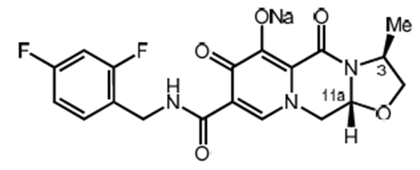
Figure 2: Structure of cabotegravir (free acid)
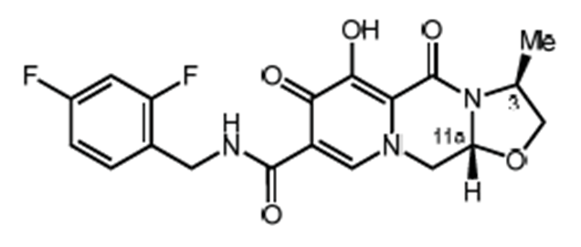
Thirty tablets are packaged in high-density polyethylene bottles with child-resistant closures with a polyethylene faced induction heat seal liner. The proposed pack size is consistent with the proposed duration of use of the tablets.
The drug product is stable and the approved shelf life is 36 months when stored below 30°C.
The application and the supporting data relating to the composition, development, manufacture, quality control, stability and bioavailability of the product have been assessed and checked for compliance, as applicable, with Australian legislation and requirements for new medicines and in accordance with pharmacopoeial standards and the technical guidelines adopted by the TGA.
Approval is recommended from a pharmaceutical chemistry and quality control aspect.
A combination pack containing cabotegravir prolonged-release injection and rilpivirine prolonged-release injection is proposed in a separate application (PM-2019-04280-1-2) and the company has agreed to the registration of the tablet only in this submission.

Submission PM-2019-04280-1-2 (Cabenuva cabotegravir/rilpivirine)
In this submission, the sponsor has applied to register a pack containing:
- cabotegravir, which is a new chemical entity, as a prolonged-release suspension for injection in a vial, containing 400 mg/2 mL or 600 mg/3 mL for intramuscular (IM) administration; and
- rilpivirine, formulated as a new dosage form, a prolonged-release suspension for injection in a vial, containing rilpivirine 600 mg/2 mL or 900 mg/3 mL for IM administration.
Rilpivirine (rilpivirine) is a diarylpyrimidine derivative and a potent non-nucleoside reverse transcriptase inhibitor (NNRTI).
The structure of rilpivirine is shown in Figure 3.
Figure 3: Structure of rilpivirine
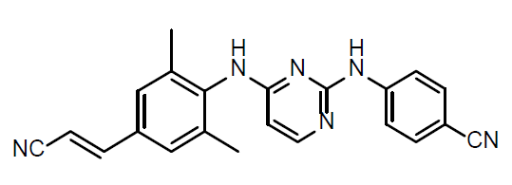
There is pack intended for initiation of injections, and a pack for continuation. The packs are:
- 3 mL Cabenuva (for initiation): 1 single dose vial containing 600 mg cabotegravir and 1 single dose vial containing 900 mg rilpivirine
- 2 mL Cabenuva (for continuation): 1 single dose vial containing 400 mg cabotegravir and 1 single dose vial containing 600 mg rilpivirine
The shelf life is of the pack is 24 months when stored between 2 to 8°C, with the condition ‘Do not freeze’.
The application and the supporting data relating to the composition, development, manufacture, quality control, stability and bioavailability of the product have been assessed and checked for compliance, as applicable, with Australian legislation and requirements for new medicines and in accordance with pharmacopoeial standards and the technical guidelines adopted by the TGA.
Approval is recommended from a pharmaceutical chemistry and quality control aspect.

Nonclinical
Cabotegravir (Vocabria) is an integrase antagonist to be used with rilpivirine for the treatment of HIV-1 in adults. Vocabria is provided as tablets for oral administration and prolonged-release suspension for injection by IM administration. No off-target effects were identified in secondary pharmacodynamic (PD) studies.
Cabotegravir is metabolised by uridine 5'-diphospho-glucuronosyltransferase (UGT) enzyme UGT1A1 and to a lesser extent, UGT1A9. Inhibitors/inducers of these UGT enzymes may alter the pharmacokinetics (PK) of cabotegravir.
Excretion of cabotegravir and/or its metabolites was predominantly via the hepatobiliary route.
In vitro, cabotegravir did not show clinically relevant inhibition of cytochrome P450 (CYP)1A2, 2A6, 2B6, 2C8, 2C9, 2C19, 2D6 or 3A4/5 activity; or UGT1A1, 1A3, 1A4, 1A6, 1A9, 2B4, 2B7, 2B15 or 2B17 activity. Cabotegravir was not an inducer of CYP1A2, 2B6 or 3A4 in in vitro assays. Interactions involving CYP450 enzymes are not expected during clinical use.
Repeat-dose toxicity studies were conducted in mice (oral (PO)), rats (PO, subcutaneous (SC) and IM) and monkeys (PO). Adequate exposures were achieved in the pivotal mouse and rat PO studies and the rat IM/SC study, while low exposures (< 5 times the clinical area under the plasma concentration time curve (AUC)) were achieved in the pivotal monkey study. The main target organs affected were the gastrointestinal (GI) tract (stomach, caecum and colon) and nasal cavity/sinuses, associated with local irritation, the liver and, following IM dosing, injection site reactions. No overlapping toxicities with rilpivirine were apparent.
Cabotegravir was not mutagenic in the bacterial mutation assay or clastogenic in vitro (in mouse lymphoma cells) or in vivo (in the rat micronucleus test). No treatment related increase in tumour incidence was observed in mice or rats in 2 year oral carcinogenicity studies.
Although cabotegravir absorbs light within the range of natural sunlight, no phototoxicity studies were conducted. However, tissue distribution studies did not show evidence of retention by pigmented tissues, suggesting a low risk of phototoxicity. Whilst, the absence of such studies is considered a deficiency, it should not preclude registration.
In vitro, cabotegravir inhibited HIV integrase activity with nanomolar potency and had antiviral activity against clinical isolates of subtype A, C, D, E, F and G and several isolates of subtype B of group M and group O. All identified mutations that conferred resistance to cabotegravir also conferred resistance to raltegravir. However, the converse was not always the case; a number of raltegravir- and elvitegravir-resistant mutations did not confer resistance to cabotegravir. In cell assays, additive effects with rilpivirine were seen, though data were limited.
The long-acting rilpivirine formulation contains the novel excipient, Poloxamer 338 (also known as Pluronics F108). Overall, the presented nonclinical studies did not reveal any notable toxicities or raise specific safety concerns about intramuscular use of Poloxamer 338, and its inclusion in the rilpivirine long-acting formulation for IM administration does not raise safety concerns from a nonclinical perspective.
Fertility was unaffected in male and female rats treated with cabotegravir at exposure levels ≤ 30 times the clinical AUC. Cabotegravir crossed the placenta in rats and could be detected in fetal tissues. There was no evidence of teratogenicity in rats at systemic exposures up to 30 times the clinical AUC. There was no evidence of adverse embryofetal effects in rabbits, but exposures were subclinical. In pre/postnatal studies in rats, parturition was delayed, the number of stillbirths was increased and the viability index of pups was reduced. Exposures at the no observed adverse effect level (NOAEL) for pup development and survival were 11 times the clinical AUC.
Due to limitations in the embryofetal development studies, Pregnancy Category B2 is recommended.
Overall, there are no nonclinical objections to the registration of Cabenuva, and Vocabria film-coated tablets. However, the Vocabria prolonged-release suspension for injection is not recommended for approval, as this product is proposed to be used with a product that is not available (that is, a rilpivirine injection product).

Clinical
The clinical evaluator supports approval of Cabenuva (cabotegravir/rilpivirine) and Vocabria (cabotegravir).

Clinical studies

Clinical pharmacology studies
Twenty-three clinical pharmacology studies were submitted in support of the current application. Of these, 21 contained data relevant to the PKs of cabotegravir and nine contained data relating to cabotegravir PD. In addition, one population PK analysis, a meta-analysis and a physiologically-based PK analysis have also been provided in support of the current submission.

Efficacy/safety studies
There are two pivotal studies assessing efficacy and safety.
Study 201584 (the FLAIR trial) is a Phase III randomised, multicentre, parallel group, open label, non-inferiority study comparing a switch to cabotegravir + rilpivirine (oral lead-in, then IM injections monthly) from combination treatment with abacavir/dolutegravir/lamivudine as a fixed dose combination tablet versus continuing this ART regimen for 48 weeks in adults with HIV-1 infection and suppressed viral load (HIV RNA < 50 copies/mL).
Study 201585 (the ATLAS trial) is a Phase III randomised, multicentre, parallel group, open label, non-inferiority study comparing a switch to cabotegravir + rilpivirine (oral lead-in, then IM injections monthly) from a current INSTI/NNRTI, or protease inhibitor ART regimen versus continuing the same regimen for 48 weeks in adults with HIV-1 infection and suppressed viral load (HIV RNA < 50 copies/mL).
A summary of the salient data from the FLAIR and ATLAS trials is included in this AusPAR. These studies have also been published.,

Supportive studies
There is one supportive study assessing efficacy and safety.
Study 207966 (the ATLAS-2M trial) is a Phase IIIb randomised, multicentre, multi-arm, parallel group, open label, non-inferiority study in adults with HIV-1 infection and suppressed viral load (HIV RNA < 50 copies/mL). Arm 1 compared a switch from an oral standard of care ART regimen to cabotegravir + rilpivirine (oral lead-in, then IM injections monthly) to continuation of a cabotegravir + rilpivirine combination from the prior Study 201585 (the ATLAS trial). Arm 2 compared a switch from an oral standard of care ART regimen to cabotegravir + rilpivirine (oral lead-in, then IM injections every two months) to a switch from cabotegravir + rilpivirine monthly injections to IM injections every two months).

Other studies
There are five other studies assessing efficacy and safety (Studies 205741, 201738, 201739, 209035, and 208580). Only a synopsis of each study was provided in the submitted dossier.

Pharmacology

Pharmacokinetics
An overview of PK parameters is shown in Table 5, below.
Table 5: Main pharmacokinetics characteristics for cabotegravir and rilpivirine
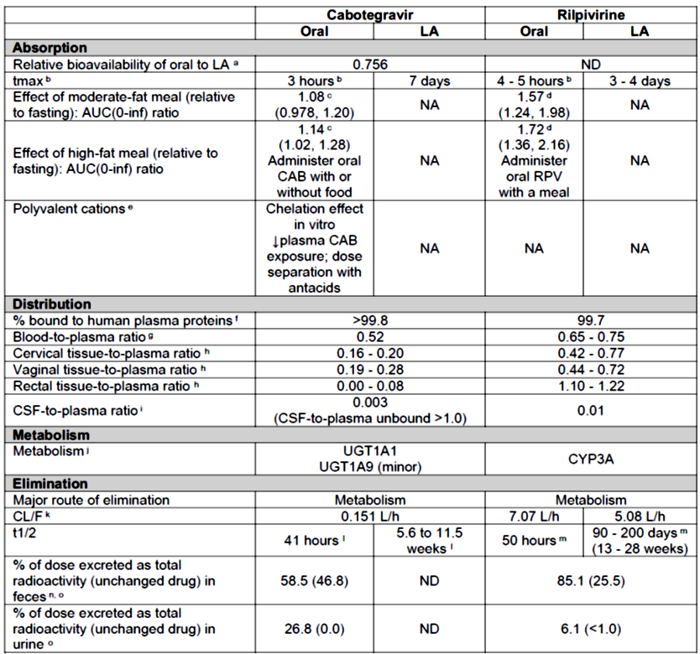
AUC_{0-inf} = Area under the plasma concentration time curve from time zero extrapolated to infinite time; cabotegravir = cabotegravir; CAB = cabotegravir; CL/F = apparent clearance; CSF = cerebrospinal fluid; CYP = cytochrome P450; LA = long-acting; NA = not applicable; ND = not determined; PopPK = population pharmacokinetics; RPV = rilpivirine; t_{1/2} = terminal half-life; t_{max} = time to maximum plasma concentration; UGT = uridine 5'-diphospho-glucuronosyltransferase.
a: Relative bioavailability of oral cabotegravir versus cabotegravir long-acting is based on PopPK estimate (F1).
b: t_{max} presented as median, data source for rilpivirine oral: Edurant PI.
c: Food effect results presented as geometric mean ratio (90% confidence interval (CI)) of fed versus fasted. The moderate-fat meal was comprised of approximately 670 kcal and 30% fat, and the high-fat meal was comprised of approximately 870 kcal and 53% fat.
d: Food effect results presented as geometric mean ratio (90% CI) of fed versus fasted. Data source: Edurant PI.18 The moderate-fat meal was comprised of approximately 533 kcal and 21 g fat, and the high-fat meal was comprised of approximately 928 kcal and 56 g fat.
e: Polyvalent cation interaction. In Phase III studies, polyvalent cation antacids were administered at least 2 hours before or 4 hours after oral cabotegravir for consistency with the recommendation for oral rilpivirine. Dose separation is not relevant for cabotegravir LA administered IM because the interaction with oral cabotegravir occurs in the GI tract.
f: Cabotegravir: plasma protein binding based on average values for oral cabotegravir 30 mg. Rilpivirine: plasma protein binding based on average values for oral rilpivirine 25 mg (data source: Edurant PI).18
g: Cabotegravir: blood-to-plasma ratio represents ratio of geometric mean total radioactivity AUC_{0-inf} for blood versus plasma for oral [¹⁴C]-cabotegravir. Rilpivirine data source: Edurant PI.18
h: Cabotegravir: tissue to plasma ratios presented as range of overall median values for single doses of cabotegravir LA 400 mg (1 x 400 mg) IM (samples collected at 2 and 8 weeks) and cabotegravir LA 400 mg (2 x 200 mg) IM (samples collected at 4 and 12 weeks). Rilpivirine: tissue to plasma ratios presented as a range of overall median values for single doses of rilpivirine LA 300, 600 or 1200 mg IM.
i: CSF to plasma ratio presented as median. CSF to unbound plasma ratio based on overall median concentration in CSF versus overall median unbound concentration in plasma at corresponding time point.
j: Rilpivirine data source: Edurant PI.18
k: CL/F presented as estimate from the PopPK analysis.
l: t_{1/2} presented as geometric mean for oral cabotegravir and as PopPK estimates for males and females for cabotegravir LA. Cabotegravir LA exhibits absorption-rate limited PK, which is reflected in a long apparent t_{1/2} following IM administration compared with oral cabotegravir administration.
m: t_{1/2} presented as geometric mean. Oral rilpivirine data source: Edurant PI.18 Rilpivirine LA exhibits absorption rate limited PK, with is reflected in a long apparent t_{1/2} following IM administration compared with oral rilpivirine administration. 90 days (13 weeks) is the estimated mean t_{1/2} from Phase I studies in healthy volunteers and 200 days (28 weeks) is the estimated mean t_{1/2} base on the rilpivirine LA PopPK model.
n: Data obtained following respective oral cabotegravir and rilpivirine human radiolabelled studies.
o: Cabotegravir: the mean total recovery of radioactivity in urine and faeces was 85.3% of the administered dose. Rilpivirine: the total mean recovery of radioactivity in urine and faeces was 91.2% of the administered dose.

Absorption

Cabotegravir
Following a 400 mg IM dose, t_{max} was 28 days, whereas following a 30 mg oral tablet dose t_{max} was 3.0 hours. The absolute bioavailability of cabotegravir has not been established, but PopPK analysis suggests it to be high based on low CL/F (0.151 L/h), a relative bioavailability of 76% compared with long-acting cabotegravir, and minimal impact of food on plasma cabotegravir absorption (exposure) and absorption rate. Following a single administration of the proposed marketing formulation of cabotegravir LA 400 mg IM, the AUC_{0-4 weeks}, AUC_{0-12 weeks} and maximum plasma concentration (C_{max}) values were 1.47, 1.33 and 1.31 fold higher than for the Phase I injectable formulation. The effect of food following oral dosing is unlikely to be clinically significant. Following single dose IM administration, long-acting cabotegravir exposures increased in a less than dose proportional manner as the dose increased from 200 mg to 400 mg.

Rilpivirine
Following a single IM injection of 600 mg long-acting rilpivirine, t_{max} was 216 hours. About 80% of the steady-state exposure is reached by 48 weeks with full steady-state reached after approximately 2 years. The long apparent terminal half-life was approximately 200 days (28 weeks). The plasma exposure of rilpivirine after monthly 600 mg IM injections is in range with that observed after daily 25 mg oral rilpivirine. Plasma long-acting rilpivirine exposure increases in proportion to dose or slightly less following single and repeat IM injection of doses ranging from 300 to 1200 mg.

Distribution

Cabotegravir
The PopPK analysis provided estimates of the central volume of distribution (V_{c}/F) and the apparent peripheral volume (V_{p}/F) of 5.27 L and 2.43 L, respectively. Cabotegravir was highly and primarily bound to plasma proteins (> 99.8%) and the blood-to-plasma ratio was 0.52. The ratios of cabotegravir concentrations in cervical and vaginal tissues compared to plasma at 2 weeks and 8 weeks after dosing with 400 mg long acting cabotegravir IM ranged from 0.16 to 0.28, and in males the median rectal tissue: plasma ratios were ≤ 0.08.

Rilpivirine
There is distribution of rilpivirine into the CSF, cervicovaginal, and rectal tissues, at concentrations that correlate with plasma concentrations at the same time point. A PopPK analysis following IM administration of long-acting rilpivirine provided estimates of the V_{c}/F, elimination rate constant (kel) and CL/F of 132 L, 0.0385 h⁻¹ and 7.07 L/h, respectively.

Metabolism

Cabotegravir
In plasma, cabotegravir is the predominant circulating compound 80.5 to 100% with no other plasma metabolites. There was no evidence for the in vivo epimerisation of cabotegravir to any of its stereoisomers.
Cabotegravir was metabolised to the major metabolite (M1) mainly by UGT1A1 and also UGT1A9. In subjects with predicted low UGT1A1 activity, cabotegravir trough concentration at the end of the dosing interval (C_{tau}), area under the plasma concentration time curve over the dosing interval (AUC_{0-tau}) and C_{max} were approximately 1.5, 1.4, and 1.3 fold higher, respectively. The UGT1A9 genetic variant (*1B) was not associated with any PK endpoints.

Rilpivirine
Rilpivirine primarily undergoes oxidative metabolism mediated by CYP3A4. No unique or major human metabolites were observed.

Excretion

Cabotegravir
Following a single, oral solution administration of 30 mg cabotegravir (containing 70 μCi [¹⁴C]-cabotegravir), 85.3% radioactivity was recovered in urine and faeces samples by 384 hours after dosing. Of this 58.5% was recovered from the faeces and the remaining 26.8% in urine (predominantly M1). Based on PopPK analysis, cabotegravir t_{1/2} and CL/F were 38.4 hours and 0.151 L/h, respectively.
After a single IM 400 mg dose, cabotegravir t_{1/2} was delayed and occurred 38.4 days after drug administration and the CL/F was 0.16 L/h. The sponsor indicates that the significantly longer apparent half-life compared to oral reflects elimination from the depot site (absorption from depot site) rather than the systemic circulation.

Rilpivirine
After single dose oral administration of [¹⁴C]-rilpivirine, on average 85% and 6.1% of the radioactivity could be retrieved in faeces and urine, respectively. In faeces, unchanged rilpivirine accounted for on average 25% of the administered dose. Only trace amounts of unchanged rilpivirine (< 1% of dose) were detected in urine.

Pharmacokinetics in the target population and special populations

Cabotegravir plus rilpivirine
Overall cabotegravir PKs were similar in healthy subjects and in the target population.
PK results indicate no clinically relevant effects of mild and moderate hepatic impairment (HI) on cabotegravir + rilpivirine. The effect of severe HI on cabotegravir or rilpivirine has not been studied.
Cabotegravir AUC_{0-inf} and C_{max} were similar in subjects with severe renal impairment and healthy, matched control subjects. Cabotegravir has not been studied in end stage renal disease (ESRD), but is not expected to be cleared by renal replacement therapies.
No rilpivirine studies in renal impairment were conducted. rilpivirine has negligible renal excretion. PopPK analysis indicated that rilpivirine exposure was similar in HIV-1 infected subjects with mild renal impairment (RI) relative to HIV-1 infected subjects with normal renal function. Long-acting rilpivirine should be used with caution and with increased monitoring in patients with severe RI or ESRD.
PK parameters in the target population are summarised in Table 6. PK parameters in special populations are summarised in Table 7.
Table 6: Summary of cabotegravir + rilpivirine pharmacokinetics parameters following administration of proposed cabotegravir + rilpivirine regimens in HIV-infected subjects
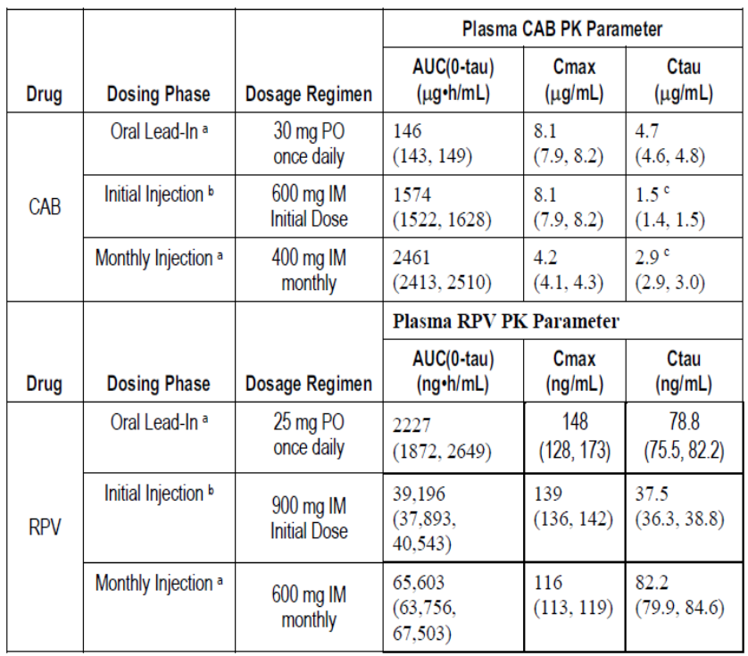
AUC_{0-tau} = area under the plasma concentration time curve over the dosing interval; CAB = cabotegravir; CL/F = apparent clearance; C_{max} = maximum plasma concentration; C_{tau} = cabotegravir trough concentration at the end of the dosing interval; IM = intramuscular; PK = pharmacokinetic; PO = oral; RPV = rilpivirine.
a. Oral lead-in PK parameter values represent steady-state; Monthly Injection PK parameter values represent Week 48.
b. Initial injection AUC_{0-tau} and C_{max} values reflect a combination of LA + oral dosing because the initial injection was administered on the same day as the last oral dose.
c. In the Phase IIb Study LAI116482, all three oral cabotegravir (10 mg, 30 mg, and 60 mg) once daily + oral rilpivirine 25 mg once daily regimens demonstrated similar efficacy at the primary endpoint Week 48 (Maintenance Phase Week 24). Oral cabotegravir 30 mg once daily is sufficiently high to assess safety and tolerability during a short oral lead-in prior to IM administration. The proposed cabotegravir LA monthly regimen maintains plasma cabotegravir C_{tau} at or above exposures following efficacious oral doses of cabotegravir 10 mg once daily.
Table 7: Summary of effect of intrinsic and extrinsic factors, and pharmacokinetics/pharmacodynamics on cabotegravir and rilpivirine
 | Cabotegravir (oral/LA) | Rilpivirine (oral/LA) | Cabotegravir + rilpivirine
Intrinsic factors
Hepatic impairment^{a, b}  (Child Pugh A/B) | Moderate: AUC_{0-inf} ↓ 27%, fraction of unbound drug in plasma (F_{u}) ↑ 90 to 114%  Geometric mean ratio (90% CI) change in the unbound concentration at 2 hours (C2h_unb) 1.401 (0.798, 2.46)  Administer in mild/moderate HI without dose adjustment  Not studied in severe HI | Mild: AUC(0-24h), ↑ 47%  Moderate: AUC_{0-24h}, ↑ 5%. Administer in mild/moderate HI without dose adjustment  Not studied in severe HI | No dose adjustment is necessary for patients with mild to moderate HI (Child Pugh A/B).  Has not been studied in severe HI.
Renal impairment ^{a, b} | Severe RI (creatinine clearance < 30 mL/min) AUC^{0-inf} ↔  F_{u} ↑ 31 to 51%  Geometric mean ratio (90% CI) C2h_unb 1.32 (0.807, 2.15)  Administer without dose adjustment in mild to severe RI (not on renal replacement therapy) | Renal elimination of rilpivirine is negligible. Effect not studied  Administer without dose adjustment in mild to moderate RI. Use with caution in severe renal impairment or ESRD and increased monitoring for adverse effects is recommended. | No dose adjustment is necessary for patients with mild to moderate renal impairment. Use with caution in patients with severe RI or ESRD and increased monitoring for adverse effects is recommended
Hepatitis C virus (HCV) co-infection | Limited data exist with the use of cabotegravir in HCV co-infection | No clinically relevant effect on rilpivirine exposure | Limited data exist with the use of cabotegravir + rilpivirine in HCV co-infection
Demographic factors | No clinically relevant effect of age, gender, race, body measure, or metabolic polymorphism | No clinically relevant effect of age, gender, race, body measure, or metabolic polymorphism | Population PK analyses from studies with cabotegravir and rilpivirine revealed that there were no clinically relevant covariates for the PK of cabotegravir or rilpivirine.
Extrinsic factors ^{c}
General drug interaction profile | Cabotegravir is a UGT1A1 substrate. cabotegravir exhibits few clinically relevant interactions with other drugs. rilpivirine does not affect cabotegravir or cabotegravir LA. | Rilpivirine is a CYP3A substrate.  Rilpivirine exhibits few clinically relevant interactions with other drugs as a perpetrator.  Cabotegravir does not affect rilpivirine or rilpivirine LA | Cabotegravir and rilpivirine have a generally favorable drug interaction profile with few clinically relevant interactions with other drugs.
Inducers (victim) | Co-administration of strong UGT1A1 inducers is contraindicated with cabotegravir due to potential for loss of therapeutic effect and development of resistance: rifampicin, rifapentine, carbamazepine, oxcarbazepine, phenobarbital, and phenytoin. | Rilpivirine LA is contraindicated with the following CYP3A inducers as it may significantly ↓ rilpivirine concentrations: rifampicin, rifabutin, rifapentine, carbamazepine, oxcarbazepine, phenobarbital, phenytoin, systemic dexamethasone (more than single dose), and St John’s wort | Co-administration of the following inducers are contraindicated with cabotegravir + rilpivirine due to potential for loss of therapeutic effect and development of resistance: rifampicin, rifabutin, rifapentine, carbamazepine, oxcarbazepine, phenobarbital, phenytoin, systemic dexamethasone (more than single dose), and St John’s wort.
Inhibitors (victim) | Cabotegravir may be co-administered with UGT1A1 inhibitors without dose adjustment. | Rilpivirine can be administered with CYP3A inhibitors without dose adjustments | No dose adjustments are needed for cabotegravir + rilpivirine when co-administered with inhibitors of their respective metabolic pathways.
Perpetrator | Based on clinical drug interaction, physiologically based pharmacokinetic modelling, mechanistic static modelling, and in vitro data, no clinical drug interaction risk was identified for cabotegravir with co- administrated substrates of drug metabolising enzymes CYP1A2, 2A6, 2B6, 2C8, 2C9, 2C19, 3A, UGT1A1, 1A3, 1A4, 1A6, 1A9, 2B4, 2B7, 2B15, and 2B17 and substrates of drug transporters P-glycoprotein, breast cancer resistance protein, bile salt export pump, multidrug resistance protein 2, organic cation transporter (OCT)1, organic anion transporter (OAT)P1B1, OATP1B3, OAT1, OAT3, multidrug and toxin extrusion (MATE)1, MATE2K, multidrug resistance-associated protein 4, and OCT2. | Because of the low drug-drug interaction (DDI) liability for rilpivirine as a perpetrator, there are no co-medications that require dose adjustment when given together with rilpivirine. | Because of the low DDI liability for cabotegravir and rilpivirine as perpetrators, there are no co-medications that require dose adjustment when given together with cabotegravir + rilpivirine.
Antiretroviral (ARV) use following discontinuation of LA dosing | There are no limitations (related to drug interactions) to the ARV regimens that can be given after discontinuation of cabotegravir LA. Based on the in vitro and clinical drug interaction profile, cabotegravir is not expected to alter concentrations of other ARV medications including protease inhibitors, NNRTIs, NRTIs, INIs, entry inhibitors, and ibalizumab | There are no limitations (related to drug interactions) to the ARV regimens that can be given after discontinuation of rilpivirine LA | Alternative highly active antiretroviral therapy should be initiated as soon as feasible, no later than one month following discontinuation of cabotegravir + rilpivirine, to maintain suppression of viral load and so reduce the chance of any cabotegravir or rilpivirine resistance emerging while concentrations of the two agents are waning. Based on the in vitro and clinical drug interaction profile, cabotegravir and rilpivirine are not expected to alter concentrations of other ARV medications including protease inhibitors, NNRTIs, NRTIs, INIs, entry inhibitors, and ibalizumab.
Pharmacodynamics in healthy subjects
Thorough QT/QTc results | Cabotegravir: A supratherapeutic dose of oral cabotegravir 150 mg once every 12 hours x 3 doses had no effect on cardiac repolarization, there was no relationship between plasma cabotegravir concentrations and ddQTcF, and there were no other safety findings with this regimen. rilpivirine: Throughout the development of rilpivirine (oral and LA), there were no safety parameters found to be correlated with rilpivirine plasma concentrations, except QT prolongation, but only at supratherapeutic oral rilpivirine doses.18 The mean rilpivirine steady-state C_{max} for the recommended 600 mg once every four weeks (Q4W) dose of rilpivirine LA is 143 ng/mL, which is, respectively, 4.4 fold and 11.6 fold lower than the mean steady-state C_{max} of the supratherapeutic oral rilpivirine doses of 75 mg once daily and 300 mg once daily. The mean steady-state C_{max} for oral rilpivirine 25 mg once daily, which is not associated with a clinically relevant effect on QTc, was 220 ng/mL.
Pharmacokinetic-pharmacodynamic relationships for cabotegravir LA + rilpivirine LA in HIV-infected subjects
Concentration – efficacy | In the pooled analysis of Study 201585 (the ATLAS trial) and Study 201584 (the FLAIR trial), the rate of confirmed virological failure (CVF) was low, 1.2%, across both treatment groups at Week 48. Cabotegravir and rilpivirine plasma concentrations for subjects with CVF at the suspected virologic failure visit overlapped with plasma concentrations of subjects with HIV-RNA < 50 copies/mL at the corresponding visit, making it difficult to establish a relationship between cabotegravir and rilpivirine plasma concentrations and the occurrence of virologic failure. Multiple factors including cabotegravir and rilpivirine plasma concentrations may be associated with the occurrence of virologic failure.
a. Elimination pathways of cabotegravir and rilpivirine are independent of formulation and route of administration; therefore, results from HI and RI studies evaluated following oral administration inform the recommendations for the cabotegravir LA + rilpivirine LA regimen.
b. Unbound rilpivirine data is not available for rilpivirine.
c. Metabolic pathways of cabotegravir and rilpivirine are independent of formulation and route of administration, and exposures are similar following oral cabotegravir and cabotegravir LA and oral rilpivirine and rilpivirine LA administration; therefore, results from oral drug-drug interaction studies inform the recommendations for the cabotegravir LA + rilpivirine LA regimen.

Drug-drug interactions
There were no clinical relevant interactions between both forms of cabotegravir (that is, long-acting and tablets) and rilpivirine. Levonorgestrel and ethinylestradiol AUC_{0-tau}, C_{max} and C_{tau} values following administration of Microgynon + cabotegravir 30 mg were comparable to values observed following Microgynon alone. Other potential DDIs are summarised in Table 7.

Population pharmacokinetics data
There were no covariates with a clinically relevant impact on the plasma cabotegravir or rilpivirine PK, including gender, race, age (≥ 18 years of age), UGT1A1 polymorphisms, smoker status, and body size (weight, body mass index (BMI)).
PopPK model based simulations indicate that once every four weeks (Q4W; 13 doses/year) and monthly (12 doses/year) dosing resulted in similar rilpivirine exposures. In addition, if rilpivirine-long-acting dosing is delayed beyond the allowed 7 day window, then a 900 mg or 600 mg long-acting rilpivirine dose should be given when the time in between injections is ≥ 2 months or < 2 months, respectively, as this will maintain effective concentrations of rilpivirine.

Pharmacokinetics data on cabotegravir and rilpivirine accumulation beyond 48 weeks of treatment
Cabotegravir: simulated cabotegravir concentration-time profiles under the monthly regimen for one year of treatment through a one year follow-up period following discontinuation indicated that for the proposed regimen, cabotegravir steady-state was reached at approximately 44 weeks, which is consistent with the results of the Phase III studies, and with Week 72 and Week 96 results in the LATTE2 trial.
Rilpivirine: based on simulations, rilpivirine steady state would not be achieved until 2.2 years after the commencement of long-acting rilpivirine treatment. This was consistent with the results of the LATTE 2 trial.

Pharmacodynamics
Cabotegravir inhibits HIV integrase by binding to the integrase active site and blocking the strand transfer step of retroviral DNA integration, which is essential for the HIV replication cycle.
Rilpivirine is a diarylpyrimidine non-nucleoside reverse transcriptase inhibitor of HIV-1. Rilpivirine activity is mediated by non-competitive inhibition of HIV-1 reverse transcriptase. Rilpivirine does not inhibit the human cellular DNA polymerases alpha, beta and gamma (α, β and γ).
PD and PK/PD relationships are summarised in Table 7.

Pharmacodynamics interactions
Following a range of doses of long-acting cabotegravir + long acting rilpivirine or cabotegravir tablets + abacavir/lamivudine once daily (QD), similar percentages of subjects (> 90%) achieved virological success at treatment Weeks 32 and 96. Following cabotegravir dose of 10 to 60 mg QD or 600 mg efavirenz, 86% and 74% of subjects attained virological success, following treatment with cabotegravir and efavirenz, respectively.

Dose selection
The proposed regimen was established in two Phase III studies. For HIV-1-infected subjects, it is oral cabotegravir 30 mg once daily + oral rilpivirine 25 mg once daily for 1 month followed by an initial dose of long-acting cabotegravir 600 mg IM + rilpivirine long-acting 900 mg IM and subsequent monthly doses of cabotegravir long-acting 400 mg IM + rilpivirine long-acting 600 mg IM. A PopPK study indicated that the proposed dosing strategy for cabotegravir would result in the maintenance of similar plasma cabotegravir trough levels throughout each phase of the dosing regimen. For rilpivirine long-acting, an initiation dose of 900 mg (a single 3 mL IM injection) was introduced to maintain higher plasma rilpivirine concentrations during the early phase. Clinical PK data is available to support the re-initiation strategy of injections following missed doses, although this is based on only the 18 individuals who experienced this scenario as part of the ATLAS and FLAIR trials. However, the rilpivirine PopPK simulations indicate that the proposed strategy for missed injections will maintain rilpivirine levels at an efficacious level.

Efficacy

Pivotal studies (Study 201584, the FLAIR trial; and Study 201585, the ATLAS trial)
Study 201584 (the FLAIR trial) was a multinational, randomised, controlled, open label Phase III study comparing cabotegravir/rilpivirine to abacavir/dolutegravir/lamivudine following a 20 week induction period with a ‘standard of care’ ART regimen containing an INSTI in the treatment of HIV-1 infected ART-naïve adults.
Study 201585 (the ATLAS trial) was a Phase III, randomised, multinational, controlled, open-label, non-inferiority study of continuing existing ART compared to cabotegravir/rilpivirine for the maintenance of HIV-1 viral suppression in people with suppressed viral load.
Figure 4: Study design of the FLAIR and ATLAS trials
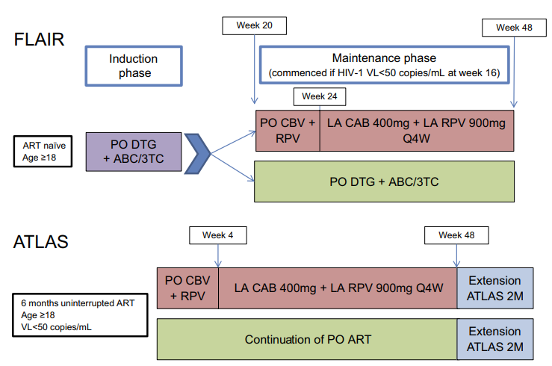
Source: Fernandez and van Halsema (2019).
ACB = abacavir; 3TC = lamivudine; CAB/CBV = cabotegravir; RPV = rilpivirine; DTG = dolutegravir; ART = antiretroviral therapy; Q4W = every 4 weeks; LA = long-acting; PO = oral.

Other main study (Study 207966, the ATLAS-2M trial)
Study 207966 (the ATLAS-2M trial) is a Phase III randomised controlled trial with an open label design comparing the efficacy and safety of cabotegravir + rilpivirine IM administered monthly versus every two months in adults who are virologically suppressed with at least six months of prior ART. This study was aimed at supporting two monthly injections for maintenance schedule.

Approach to missing data
Missing data in the pivotal studies were handled by censoring participants at the time of early withdrawal or at the end of the week 48 analysis. Missing data were imputed by the last-observation carried forward (LOCF) method.

Baseline characteristics
In the pooled analysis (Study 201584 and Study 201585), a total of 591 subjects were randomised and treated with cabotegravir/rilpivirine and 591 subjects were randomised and treated with abacavir/dolutegravir/lamivudine.
Demographic and baseline characteristics, as shown in Table 8, were similar across treatment groups. Of note, 27% and 28% of subjects were women in the pooled analysis in the cabotegravir + rilpivirine and abacavir/dolutegravir/lamivudine groups, respectively. Further, 17% and 21% of subjects were 50 years of age or older in the pooled analysis in the cabotegravir + rilpivirine and abacavir/dolutegravir/lamivudine groups, respectively.
Table 8: Summary of baseline characteristics for Study 201584, Study 201585 and pooled data (intent to treat efficacy population)
ART = antiretroviral therapy; IQR = interquartile range; ABC = abacavir; DTG = dolutegravir; 3TC = lamivudine; FTC = emtricitabine; TAF = tenofovir alafenamide; TDF = tenofovir disoproxil fumarate; PI = protease inhibitor (in this table only, otherwise PI = Product Information); HBV = hepatitis B virus, CDC = Centers for Disease Control and Prevention; NA = not available; CAR = current antiviral regimen.

Efficacy analysis at 48 weeks

Study 201584 (the FLAIR trial)
The primary efficacy analysis was the proportion of participants with plasma HIV-1 RNA ≥ 50 copies/mL at Week 48 per the FDA Snapshot algorithm for the intent to treat efficacy (IIT-E) population. The proportions were similar between the two groups, with 6 out of 283 (2.1%) and 7 out of 283 (2.5%) in the cabotegravir + rilpivirine and abacavir/dolutegravir/lamivudine groups respectively (see Table 9). When adjusting for baseline factors of sex at birth and induction baseline HIV-RNA (< 100,000 copies/mL, ≥ 100,000 copies/mL), the difference in proportions was 0.4% lower in the cabotegravir + rilpivirine group (95% CI: -2.8 to 2.1). The same analysis performed in the per protocol (PP) population yielded an adjusted difference in proportion of 0.3% lower in the cabotegravir + rilpivirine group (95% CI: -2.8 to 2.2).
Table 9: Proportion of participants with HIV-1 RNA ≥ 50 copies/mL at Week 48 per the Food and Drug Administration Snapshot algorithm for Study 201584 (the FLAIR trial)
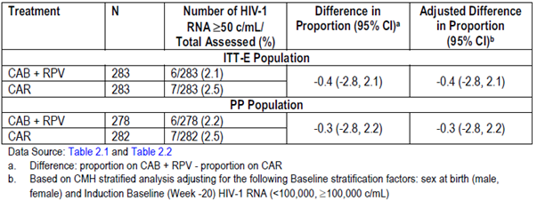
CAB = cabotegravir; CAR = current antiviral regimen (abacavir/dolutegravir/lamivudine); CI = confidence interval; ITT-E = intent to treat efficacy; PP = per protocol; RPV = rilpivirine.

Study 201585 (the ATLAS trial)
The primary efficacy analysis was the proportion of participants with plasma HIV-1 RNA ≥ 50 copies/mL at Week 48 per the US Food and Drug Administration (FDA) Snapshot algorithm for the intent to treat efficacy (ITT-E) population. The adjusted difference in proportion between cabotegravir + rilpivirine and abacavir/dolutegravir/lamivudine groups was 0.6% (95% CI: -1.2 to 2.5%) (see Table 10). Consistent results were observed in the PP analysis; adjusted difference in proportions between the cabotegravir+rilpivirine and abacavir/dolutegravir/lamivudine groups was 0.3 (95% CI: -1.4 to 2.1%) (see Table 10).
Table 10: Proportion of participants with HIV-1 RNA ≥ 50 copies/mL at Week 48 per the Food and Drug Administration Snapshot algorithm for the intent to treat efficacy population for Study 201585 (the ATLAS trial)
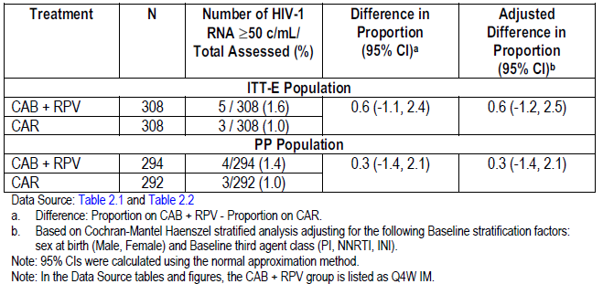
CAB = cabotegravir; CAR = current antiviral regimen; CI = confidence interval; ITT-E = intent to treat efficacy; PI = protease inhibitor (in this table only, otherwise PI = Product Information); PP = per protocol; RPV = rilpivirine.

Virological failures
The reasons for virologic failure in Study 201584 (the FLAIR trial) are delineated in Table 11. Of particular note, greater proportion of participants in the cabotegravir + rilpivirine group discontinued due to AE or death (2.8%) compared to the abacavir/dolutegravir/lamivudine group (0.7%).
Table 11: Reasons for virologic failure at Week 48 for Study 201584 (the FLAIR trial)
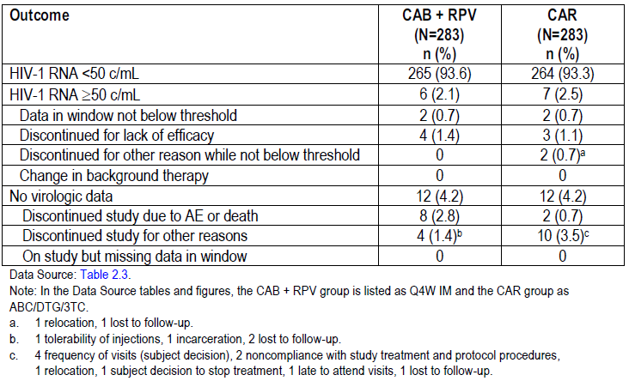
3TC = lamivudine; ABC = abacavir; AE = adverse event; CAB = cabotegravir; CAR = current antiviral regimen (abacavir/dolutegravir/lamivudine); CI = confidence interval; DTG = dolutegravir; IM = intramuscular; Q4W = once every four weeks; RPV = rilpivirine.
The reasons for virologic failure in Study 201584(the FLAIR trial) are delineated in Table 12. A higher frequency of participants in the cabotegravir + rilpivirine group discontinued the study due to AEs or death.
Table 12: Snapshot analysis of participants with plasma HIV-1 RNA ≥ 50 copies/mL for Study 201585 (the ATLAS trial)
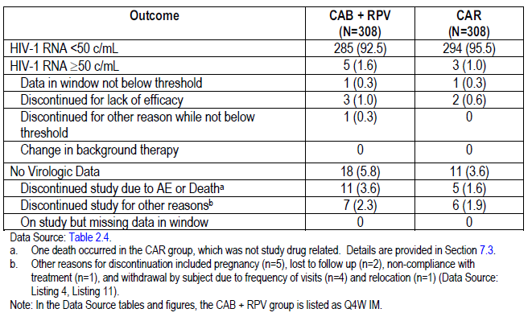
AE = adverse event; CAB = cabotegravir; CAR = current antiviral regimen; IM = intramuscular; Q4W = once every four weeks; RPV = rilpivirine.

Data on oral therapy
Oral therapy (cabotegravir 30 mg + rilpivirine 25 mg) is proposed to cover missed injection visits for a duration of up to two consecutive monthly missed injections (up to three months duration between injections) or one every two months missed injection (up to four months duration between injections).
In Studies 201584 and 201585 to Week 48, a total of 18 subjects received oral therapy for durations ranging from three days to approximately two months to cover missed injection(s). All but two subjects resumed IM dosing. No cases of confirmed virological failure (CVF) were observed during oral therapy or following resumption of IM dosing.
In Study 207966 at Week 48, a total of four subjects in the once every eight weeks (Q8W) group and 7 subjects in the Q4W group received oral therapy for durations ranging from two days to approximately two months.

Resistance development
Participants with CVF (defined as two consecutive HIV-1 RNA > 200 copies/mL after achieving an HIV-1 RNA < 200 copies/mL prior) had resistance testing. There were three participants in the abacavir/dolutegravir/lamivudine group with CVF (detected at Weeks 8, 12 and 16 respectively), none of whom had any treatment-emergent resistance-associated mutations. There were four participants in the cabotegravir + rilpivirine group with CVF (detected at Weeks 8, 20, 28 and 48, respectively). One participant had rilpivirine resistance with mutation E138E/A/K/T and cabotegravir resistance with mutation Q148R. One subject had rilpivirine resistance with mutation K101K/E/Q and cabotegravir resistance with mutation G140R. One participant had rilpivirine resistance with mutation E148K and cabotegravir resistance with mutation Q148R. One participant had oral cabotegravir + rilpivirine treatment interruption following a positive pregnancy test (later confirmed to be a false positive) who never received cabotegravir + rilpivirine injections. Virology data was not generated for this last participant. The first three participants had HIV-1 subtype A1. The fourth participant had subtype AG. None of the participants with CVF had a K103N mutation at Baseline.
The proportion of patients with HIV-1 RNA < 2 copies/mL at Week 48 was lower in the cabotegravir + rilpivirine (169 out of 280, 60%) compared to the abacavir/dolutegravir/lamivudine group (193 out of 260, 74%) suggesting there was slightly more patients with low level viraemia in the cabotegravir + rilpivirine group.
Plasma concentrations of cabotegravir after IM injection can be detected for more than a year in some subjects. Hence, to minimise the risk of developing viral resistance, it is essential to prescribe an alternative, fully suppressive ARV regimen, starting no later than one month after discontinuation of cabotegravir.

Visits which exceeded injection dosing window
In Study 201584, a total of 47 injection visits for cabotegravir + rilpivirine subjects (out of 3577 total injection visits, representing 1.3%) were more than 7 days after the planned injection date. Of these, five injection visits were more than 14 days after the planned injection visit. One subject in Study 201584 missed an injection visit without oral bridging.
In Study 201585, a total of 59 injection visits for cabotegravir + rilpivirine subjects (out of 3343 total injection visits, representing 1.8%) were more than 7 days after the planned injection date. Of these, five injection visits were more than 14 days after the planned injection visit. No subjects missed an injection in either study without oral bridging for Study 201585.
There were no cases of CVF in subjects with late injection visits.

Efficacy data at 96 weeks
Clinical study reports with 96 week efficacy data for pivotal Studies 2015854 and 201585 were provided by the sponsor in response to the first round evaluation questions.
In Study 201584, monthly cabotegravir + rilpivirine was shown to be non-inferior to continued oral abacavir/dolutegravir/lamivudine with respect to the proportion of subjects having plasma HIV-1 RNA ≥ 50 copies/mL and < 50 copies/mL (respectively) at Week 96 (Snapshot Analysis). There were no additional CVFs in the cabotegravir + rilpivirine group between Week 48 and Week 96.
In Study 201585, subjects continuing in the extension phase up to Week 96 had sustained viral load suppression of < 50 copies/mL (100% in cabotegravir + rilpivirine group; 97% in the extension switch to cabotegravir + rilpivirine group). No additional subjects in either the cabotegravir + rilpivirine group or from the extension switch to cabotegravir + rilpivirine group had CVFs during the extension phase of the study. The safety data from this ongoing study were consistent with the reporting through 48 weeks. No new adverse drug reactions of clinical concern were identified in either the cabotegravir + rilpivirine group nor from the extension switch to cabotegravir + rilpivirine group following Week 48. However, the majority of subjects transitioned to Study 207966 and small patient numbers in extension phase up to 96 weeks limited interpretation of results.
Overall, Week 96 analysis demonstrates durability of HIV-1 RNA suppression with cabotegravir long-acting + rilpivirine long-acting compared with abacavir/dolutegravir/lamivudine.

Safety
The safety of cabotegravir has been studied throughout the development of the product. In the Phase III pivotal efficacy studies, Studies 201584 (the FLAIR trial) and 201585 (the ATLAS trial), a total of 591 participants were exposed to cabotegravir for 48 weeks (see Table 13). In Study 207966 (the ATLAS-2M trial) there were 1045 participants exposed to cabotegravir (monthly or every second month) for 24 weeks (study is ongoing). A total of 509 subjects were evaluated for safety in the Phase I and II studies clinical pharmacology studies, though generally over shorter time frames. There were no studies designed purely to assess safety outcomes, except the one early phase study in healthy participants receiving supratherapeutic doses of cabotegravir that analysed the impact of cabotegravir on the cardiac QT interval. The studies were well conducted, and processes for safety evaluation were well described. Relevant AEs of interest to INSTIs and ART regimens in general were included as specific outcomes for analysis, such as the impact on weight and lipid profile.
Among the Phase III studies, cabotegravir was administered first as an oral lead-in therapy and then as a monthly (or two monthly) IM injection. As expected, the most common AE reported was an injection site reaction. The injection site reactions (ISRs) varied from pruritus and erythema to pain and abscess formation. The vast majority of these resolved completely over time. Other common AEs occurring in ≥ 5% included nasopharyngitis, upper respiratory tract infection, influenza, diarrhoea, nausea, headache, and back pain (see Table 14). Additionally, there were several AEs that were attributed to being due to cabotegravir, including, but not limited to, neuropsychiatric disorders, weight gain, headaches, dizziness, nausea and vomiting, hepatotoxicity, and pyrexia. All of these AEs and others have been adequately represented in the draft PI.
Table 13: Overview of all adverse events during the maintenance phase, pooled Phase III studies
3TC = lamivudine; ABC = abacavir; AE = adverse event; CAB = cabotegravir; CAR = current antiviral regimen; DTG = dolutegravir; IM = intramuscular; ISE = integrated summary of efficacy; ISS = integrated summary of safety; Q4W = once every four weeks; RPV = rilpivirine,;SAE = serious adverse event.
Table 14: Most common adverse events (reported in ≥ 5% of subjects in any treatment group) by Preferred Term during the maintenance phase for Study 201584, Study 201585, and pooled data (safety population)
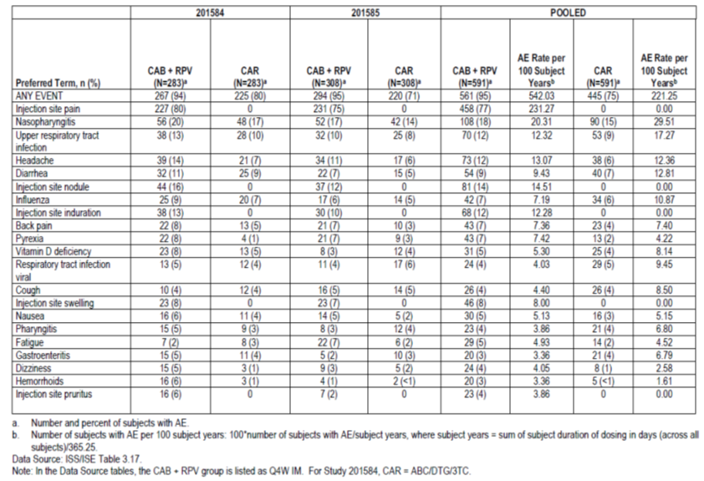
3TC = lamivudine; ABC = abacavir; AE = adverse event; CAB = cabotegravir; CAR = current antiviral regimen; DTG = dolutegravir; IM = intramuscular; ISE = integrated summary of efficacy; ISS = integrated summary of safety; Q4W = once every four weeks; RPV = rilpivirine.
Table 15: Most common drug-related adverse events (reported in ≥ 1% of subjects in any treatment group) by Preferred Term during the maintenance phase for Study 201584, Study 201585, and pooled data (safety population)
3TC = lamivudine; ABC = abacavir; AE = adverse event; CAB = cabotegravir; CAR = current antiviral regimen; DTG = dolutegravir; IM = intramuscular; ISE = integrated summary of efficacy; ISS = integrated summary of safety; Q4W = once every four weeks; RPV = rilpivirine.

Serious adverse events and deaths
During the clinical development of cabotegravir there were several deaths reported. Two deaths occurred during a pivotal Phase III study, both from the abacavir/dolutegravir/lamivudine group and both unrelated to the study treatment. There were an additional seven deaths in other efficacy or Phase II studies, though only two of these were considered to be possibly related to cabotegravir treatment. One death was due to complications of pancreatitis. The other death was due to a myocardial infarction with additional cardiovascular risk factors. Serious adverse events (SAEs) occurred with similar frequency in both the cabotegravir and abacavir/dolutegravir/lamivudine groups (approximately 5% each). There were two SAEs (septic arthritis and suicidal ideation) that were considered treatment-related. Withdrawals due to AEs occurred with higher frequency in the cabotegravir group compared to abacavir/dolutegravir/lamivudine, even when accounting for ISRs.
The most common reason for withdrawal was the development of acute viral hepatitis, of which there were eight cases in the cabotegravir group and zero cases in the abacavir/dolutegravir/lamivudine group. This particular observation requires additional explanation as to why it might have occurred, and may be appropriate for inclusion in the PI (see ‘Advisory Committee considerations’ section, below).
Table 16: Summary of adverse events leading to withdrawal/permanent discontinuation of study drug during the maintenance phase in Study 201584 and Study 201585 (safety population)
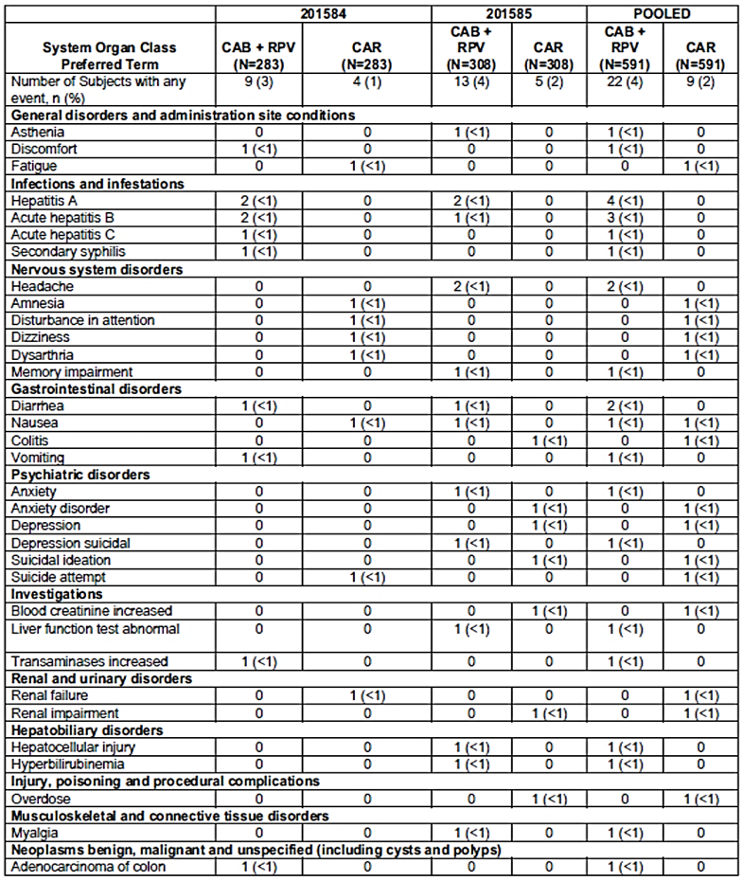
CAB = cabotegravir; CAR = current antiviral regimen; RPV = rilpivirine.

Lab parameters
Laboratory derangements of alanine aminotransferase (ALT) and aspartate aminotransferase (AST) occurred with higher frequency in the cabotegravir group, and there were a small number of drug-induced liver injuries attributable to cabotegravir as determined by a Liver Adjudication Committee. There were no clinically significant differences with respect to renal toxicity for cabotegravir compared to abacavir/dolutegravir/lamivudine.
The impact of treatment on the lipid profile was also analysed, and there appears to be no differences between cabotegravir and abacavir/dolutegravir/lamivudine at 48 weeks. However, there was a significant amount of missing data (20%), which creates uncertainty on the veracity of this observation. With the exception of the uncertain effects on the lipid profile, the other changes in laboratory parameters are appropriately mentioned in the PI.
Table 17: Summary of maximum post-Baseline emergent clinical chemistry values for lipid parameters during the maintenance phase (safety population)
3TC = lamivudine; ABC = abacavir; AE = adverse event; CAB = cabotegravir; CAR = current antiviral regimen; DTG = dolutegravir; IM = intramuscular; ISE = integrated summary of efficacy; ISS = integrated summary of safety; Q4W = once every four weeks; RPV = rilpivirine,;SAE = serious adverse event.
In the Phase III studies a greater proportion of individuals had QT prolongation with cabotegravir compared to abacavir/dolutegravir/lamivudine, with intervals extending by an additional 30 to 60 ms from Baseline (corrected for heart rate), however a supratherapeutic dosing study in healthy individuals did not observe any impact on the QT interval. There were no SAEs due to QTc prolongation. It seems unlikely that cabotegravir would have a clinically important impact on QTc.
Neuropsychiatric events of anxiety, depression and suicidal ideation occurred with similar frequency between cabotegravir and abacavir/dolutegravir/lamivudine groups in pooled analysis of Phase III Studies 201584 and 201585, however there were cases of cabotegravir-related events for each and so this has been included as a potential AE in the PI.
Weight gain of roughly 2 kg was observed over 48 weeks of treatment with cabotegravir, compared to 1 kg with abacavir/dolutegravir/lamivudine. Although small, this effect has also been listed in PI as a potential AE.
Overall, cabotegravir appears to be well tolerated with an acceptable safety profile that is similar to other ART regimens. There was no safety analysis performed separately for rilpivirine injection. ISRs are likely to be the most common AE experienced by individuals, but this needs to be weighed against the convenience of a monthly dosing regimen. There were no major safety signals of concern in the cabotegravir exposed population, with the exception of an unexplained disproportionately higher number of cases of acute viral hepatitis.

Safety data at 96 weeks
Clinical study reports with 96 week safety data for Studies 2015854 and 201585 were provided in the response to the first round evaluation.
In Study 201584, cabotegravir + rilpivirine was well tolerated with a low incidence of SAEs or AEs overall with few graded as severe and there were few discontinuations due to AEs. Interpretation of these safety results were confounded by open-label study design and comparison of an injectable with orally administered comparators. Compared to prior Phase IIb studies for cabotegravir + rilpivirine (Studies 200056 and LAI116482), no additional safety concerns were identified.
In Study 201585, the safety data were consistent with the reporting through 48 weeks. No new adverse drug reactions of clinical concern were identified in either the cabotegravir + rilpivirine group, nor from the extension switch to cabotegravir + rilpivirine group following Week 48. However, majority of subjects transitioned to Study 207966 and small patient numbers in extension phase up to 96 weeks limited interpretation of results.
Overall, no newly identified safety signals were reported during the extension period.

Other safety and efficacy studies

Study 207966 (ATLAS-2M)
Study 207966 is a Phase III randomised controlled trial with an open label design comparing the efficacy and safety of cabotegravir + rilpivirine IM administered monthly versus every two months in adults who are virologically suppressed with at least six months of prior ART. The inclusion and exclusion criteria are similar to the other Phase III efficacy Studies 201584 and 201585, and the study population were heavily recruited from Study 201585. The study population for Study 207966 (the ATLAS-2M trial) was also similar to that of Studies 201584 and 201585, being primarily young Caucasian males. The dosing regimens differed from the other pivotal efficacy studies, with participants in the Q8W group receiving a larger dose of cabotegravir 600 mg + rilpivirine 900 mg. The Q4W group received the same treatment. Outcomes at Week 48 were provided in the submitted dossier. With respect to Snapshot failure (the primary outcome), there were no apparent differences between the two treatment regimens with an adjusted differences in proportions of 0.9% (95% CI -0.6 to 2.2%), and 94% of participants in each group maintained virologic suppression (HIV-1 RNA < 50 copies/mL). The most clinically significant finding at Week 48 was a notably higher incidence of CVF in the Q8W group: 8 of the 10 CVF cases were from the Q8W group. Furthermore, it is important to note that majority of the CVF cases were observed in obese (BMI > 30 kg/m²) and female subjects. Hence, there is concern that suboptimal drug concentrations in these subgroups of patients may predispose them to higher risk of CVF.

Risk management plan
The sponsor has submitted EU-risk management plan (RMP) version 1.0; 8 July 2019; 30 August 2018 (rilpivirine) and EU-RMP version 0.1; (no date); 20 December 2018 (cabotegravir) and Australian specific Annex (ASA) version 1.0; 26 September 2019 (rilpivirine) and ASA version 1.0; 26 September 2019 (cabotegravir) in support of this application. The sponsor has provided EU-RMP version 0.2; (no date); 6 June 2019 (cabotegravir); ASA version 1.1; 3 June 2020 (rilpivirine) and ASA version 1.1; 4 June 2020 (cabotegravir) in their response to the first round evaluation. At the third round of evaluation, the sponsor provided EU-RMP version 0.3; data lock point (DLP) 6 June 2019; 7 August 2020 (cabotegravir); EU-RMP version 1.2; DLP 6 June 2019; 12 August 2020 (rilpivirine) and Vocabria ASA version 1.2; 24 August 2020. The Vocabria ASA version 1.2 has been updated to remove reference to the prolonged-release suspension for injection.
The summary of safety concerns and their associated risk monitoring and mitigation strategies are summarised in Table 18.
Table 18: Summary of safety concerns for cabotegravir and rilpivirine
Summary of safety concerns |  | Pharmacovigilance |  | Risk minimisation
 |  | Routine | Additional | Routine | Additional
Important identified risks | Hepatotoxicity (cabotegravir) |  | * |  | –
Important potential risks | Medication errors (rilpivirine)/Medication errors including treatment non-compliance (cabotegravir) |  | *§ |  | –
Missing information | Use in pregnancy (cabotegravir) (rilpivirine) |  | †‡ |  | –
* Post-authorisation safety study (PASS) study (EU only); † Pregnancy registry; ‡ EPPICC (EU only); § Drug utilisation study (EU only).
- The summary of safety concerns is acceptable from an RMP perspective.
- The sponsor has proposed routine and additional pharmacovigilance activities as identified in the table above, with the results of additional pharmacovigilance (PV) intended to be extrapolated to the Australian market. Additional PV proposed in the EU only consists of a PASS observational cohort study on hepatotoxicity, a drug utilisation study on medication errors, and participation in the EPPICC research.²⁶ Both Australian and EU patients will be included in a pregnancy registry. The proposed PV plan in the EU is applicable to Australia and acceptable from the RMP perspective.
- Routine risk minimisation has been proposed, this is acceptable from a RMP perspective.

Risk-benefit analysis

Delegate’s considerations

Quality and nonclinical evaluation
Vocabria (cabotegravir 30 mg tablets) and Cabenuva (cabotegravir 400 mg/2 mL and 600 mg/3 mL + rilpivirine 600 mg/2 mL and 900 mg/3 mL) prolonged release suspension for injection are acceptable from a quality and nonclinical point of view.

Dose selection
Dose selection was based on efficacy and safety from two Phase IIb studies; Study LAI116482 (oral cabotegravir 30 mg) and Study 200056 (cabotegravir long-acting + rilpivirine long-acting). Based on PopPK analysis using pooled data from Phase IIb and Phase III studies, no dose adjustment of cabotegravir long-acting is required based on demographic characteristics (age, gender, race, BMI, weight), Hepatitis co-infection, smoking status, or laboratory parameters. In addition, the PopPK study indicated that the proposed dosing strategy for cabotegravir would result in the maintenance of similar plasma cabotegravir trough levels throughout each phase of the dosing regimen.

Clinical evaluation summary conclusion
The sponsor has submitted two pivotal multicentre, randomised, controlled, open-label, non-inferiority, Phase III studies that evaluated efficacy for the proposed indication for these submissions. The study design was similar between them. Both studies recruited a total of 1182 adults who were HIV-1 infected ART-naïve or with virological suppression of HIV-1 infection, and randomised them to either continuation of their ART, or monthly injections of cabotegravir + rilpivirine with a one month oral lead in period. The sample population was generally representative of the individuals in Australia who are likely to use cabotegravir + rilpivirine. The primary efficacy outcome of the proportion of participants with HIV-1 RNA ≥ 50 copies/mL in the ITT-E population demonstrated non-inferiority in both studies. The same results were also seen in the PP population. When the results were pooled, the adjusted difference in proportions was 0.2% (95% CI -1.4 to 1.7%), and non-inferiority was convincingly demonstrated. In Study 201584, Study 201585, and the pooled analysis, the key secondary efficacy analyses demonstrated that cabotegravir + rilpivirine is non-inferior to abacavir/dolutegravir/lamivudine on the proportion of subjects having plasma HIV-1 RNA < 50 copies/mL at Week 48 based on the Snapshot algorithm for the ITT-E population (pooled results: 93% for cabotegravir + rilpivirine and 94% for abacavir/dolutegravir/lamivudine, adjusted difference -1.4 (-4.1, 1.4)). Specifically, both studies and the pooled analysis established non-inferiority to comparator groups for this key secondary endpoint with a non-inferiority margin of -10%.

Two monthly schedule
The sponsor has added details of two monthly dosing regimen throughout the PI in their response to the first round evaluation. This was based mainly on results observed in the Phase IIIb study (the ATLAS 2M trial) in which cabotegravir long-acting + rilpivirine long-acting administered Q8W demonstrated high efficacy through Week 48 and was non-inferior to the cabotegravir LA + rilpivirine LA administered Q4W in 1045 virologically suppressed HIV-1-infected adults. These results were already evaluated in the first round evaluation, and no new information was provided in the response to the first round evaluation.
ATLAS 2M showed a notably higher incidence of CVF in the Q8W group: 8 of the 10 CVF cases were from the Q8W group. While the final data analysis has not yet occurred, all ATLAS-2M trial Week 96 (n = 1045) visits in the ongoing ATLAS-2M trial have been completed, one additional CVF occurred on the Q8W dosing arm at Week 88. Furthermore, it is important to note that majority of the CVF cases were observed in obese (BMI > 30 kg/m²) and female subjects. Hence, there is concern that suboptimal drug concentrations in these subgroups of patients may predispose them to higher risk of CVF.
The two monthly dosing regimen has not been directly compared with the current standard of care oral therapy and efficacy/ safety of the two monthly dosing regimen has only been compared with the one monthly dosing of cabotegravir + rilpivirine up to 48 weeks.
The sponsor’s response to the second round clinical evaluation has been reviewed for this dosing schedule.
Based on the aforementioned reasons and review of the sponsor’s response, initial approval is supported only for the one monthly maintenance schedule.
The two monthly dosing schedule can be reviewed after accumulating data post-approval with respect to efficacy/safety balance and characterisation of patients suitable for two monthly dosing.
Health Canada has not approved the two monthly schedule.11
The Advisory Committee is requested to comment on acceptability of two monthly injection schedule proposed by the sponsor (see ‘Advisory Committee considerations’ section, below).

Body mass index and virologic failure
Cases of CVF are disproportionately represented by participants with a high BMI, particularly females. The associated PK analysis shows a low plasma concentration for either cabotegravir or rilpivirine was detected at some stage during IM treatment, suggesting this may be a contributing factor to the development of CVF.
A post-hoc multivariable analysis was conducted pooling data from the Phase III studies (the FLAIR and ATLAS trials) and the Phase IIIb study (the ATLAS-2M trial). In this analysis, higher BMI at Baseline (majority females) was observed to have strong associations with virologic failure events.
Although the numbers of participants in this subgroup(s) was low, there is uncertainty around whether the standard dose given monthly in these individuals is effective at maintaining viral suppression.
Figure 5: Unadjusted treatment difference in proportion (95% confidence interval) of subjects with HIV-1 RNA ≥ 50 copies/mL at Week 48 by subgroup, Baseline body mass index and gender (exploratory); Snapshot analysis
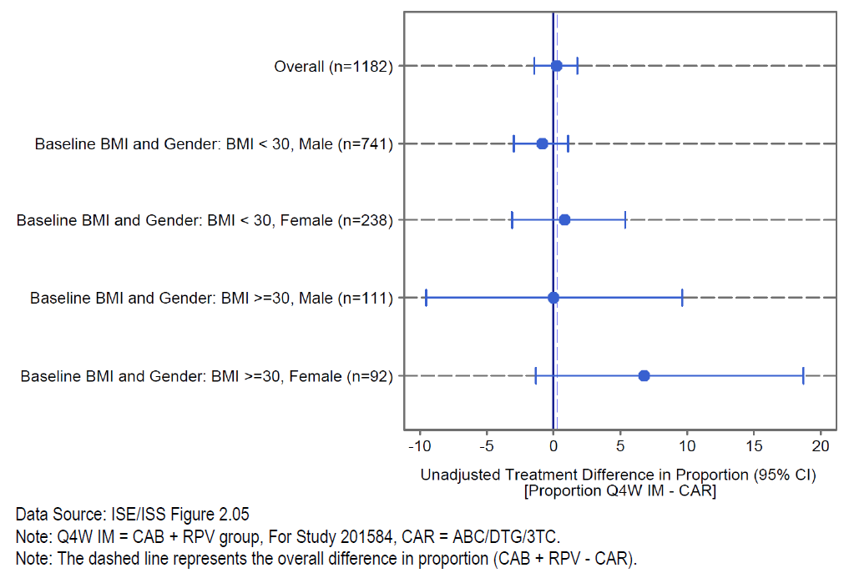
3TC = lamivudine; ABC = abacavir; BMI = body mass index; CAB = cabotegravir; CAR = current antiviral regimen; DTG = dolutegravir; IM = intramuscular; ISE = integrated summary of efficacy; ISS = integrated summary of safety; Q4W = once every four weeks; RPV = rilpivirine.
The Advisory Committee was requested to provide advice on the following (see ‘Advisory Committee considerations’ section, below):
- Inclusion of the following text in the proposed cabotegravir PI:
When administering Cabenuva, healthcare professionals should take into consideration the Body Mass Index (BMI) of the patient to ensure that the needle length is sufficient to reach the gluteus muscle.
(Reference: Canadian Product Monograph).
- Should there be additional risk minimisation activity in this regard?

Acute viral hepatitis risk
There were no major safety signals of concern in the cabotegravir exposed population, with the exception of an unexplained disproportionately higher number of cases of acute viral hepatitis, which was the most common reason for the withdrawal. All the eight viral hepatitis cases were in the cabotegravir group. This particular observation requires additional explanation as to why it might have occurred, and may be appropriate for inclusion in the PI.
The Advisory Committee is requested to comment on the high number of viral hepatitis cases in cabotegravir long-acting injection-treated subjects and whether it should be mentioned more explicitly in the PI (see ‘Advisory Committee considerations’ section, below).

Risk of resistance development
There is possibility of prolonged low drug levels in patients with suboptimal adherence. It is a concern that missing or delayed injections, causing reduction in blood levels of drug to below those required for virological suppression and leading to resistance.
The Advisory Committee is requested to comment if any specific measure for safety is required (see ‘Advisory Committee considerations’ section, below).

Hepatitis comorbidity
Important missing information on utility of Cabenuva and Vocabria is the lack of data for use in patients with important co-morbidities, mainly with the viral hepatitis. Patients with viral hepatitis were excluded from the pivotal studies. Treatment of hepatitis C in individuals on cabotegravir regimens may involve interactions between cabotegravir and antivirals for hepatitis C, for which currently there is no data available. As more than 20% HIV patients have hepatitis C co-infection, this information should be mentioned in PI under Section 4.4 (Special warnings and precautions for use).
The Advisory Committee is requested to comment on use of cabotegravir in patients on hepatitis C treatment and suggest the wordings for the cabotegravir PI (see ‘Advisory Committee considerations’ section, below).

Risk management plan
The TGA has reviewed the RMP, which will be a condition of registration along with the ASA.

Proposed action
The Delegate has no reason to say, at this time, that the application for Vocabria (30 mg tablet) should not be approved for registration. However, Vocabria 400 mg/2 mL injection and 600 mg/3 mL injection should not be approved for registration.
The Delegate has no reason to say, at this time, that the application for cabotegravir (400 mg/2 mL and 600 mg/3 mL) and rilpivirine (600 mg/2 mL and 900 mg/3 mL) prolonged release suspension for injection should not be approved for registration.
Pending consideration by the Advisory Committee, the Delegate is the view that the supplied dossiers support marketing approval of Cabenuva and Vocabria (tablets only) for the treatment of HIV-1 infection in adults who are virologically suppressed (HIV-1 RNA < 50 copies per mL) and have no known or suspected resistance to either cabotegravir or rilpivirine.
The Delegate requested advice from the Advisory Committee, see section below.

Advisory Committee considerations
The Advisory Committee on Medicines (ACM), having considered the evaluations and the Delegate’s overview, as well as the sponsor’s response to these documents, advised the following.

Specific advice to the delegate
The ACM advised the following in response to the Delegate’s specific request for advice.
- The ACM is requested to advise on dosing and administration; two monthly Cabenuva injection maintenance schedule.
Despite expressing some concern in relation to the non-inferiority design of the ATLAS-2M trial, the ACM advised that, overall, the efficacy and safety of eight week dosing appears to be similar to that of four week dosing. The most clinically significant finding at Week 48 was a higher incidence of CVF in the eight week group, which the ACM considered to be an uncommon occurrence when multiple factors are present (see advice to Question 2, below). The ACM was also of the view that, compared to monthly injections, an eight week dosing schedule is advantageous from the perspective of reducing the burden on patients and clinics.
The ACM advised that both the one monthly and two monthly dosing schedules are approvable, and recommended that the decision about which schedule to choose should be left up to the discretion of the treating clinician.
The ACM advised that a recommendation should be included in the PI that the regimen should be changed if the two monthly dosage schedule does not result in maintenance of viral suppression.
The following information should also be added to the Dosage and administration section of the PI: ‘In the clinical trial (ATLAS 2M), a higher rate of confirmed virological failure (CVF) was seen with the 2 monthly injection schedule as compared to the 1 monthly schedule’.
- ACM advice is sought for use of Cabenuva and Vocabria in subjects with high BMI.
The ACM noted CVF was an uncommon occurrence; approximately 1% overall, and approximately 1.5% in the ATLAS-2M eight week group (the majority in female patients with a BMI > 30 kg/m²). Subgroup (post-hoc) analysis suggests BMI > 30 kg/m² may increase the risk of virological failure and drug resistance, however, the ACM was of the view that other factors were also present in these cases.
The ACM noted that Section 4.4 (Special warnings and precautions) of the PI includes discussion of baseline factors, including BMI > 30 kg/m², which are associated with virological failure. The ACM advised that these should be made more prominent, and ideally should be worded as a recommendation rather than ‘caution’ and/or followed by wording suggesting consideration of four week dosing in subjects with high BMI.
The ACM agreed that a 1.5 inch length needle (included in the product pack) might not be sufficient to achieve a true IM injection in patients with high BMI, and advised that a warning to this effect should be included in the PI with a suggestion that a longer needle (1.75 inch) might be more appropriate for patients with high BMI.
- ACM advice is sought for use Cabenuva and Vocabria in subjects with hepatitis C, in view of drug interaction between hepatits C drugs and cabotegravir.
The ACM noted that other INSTIs are not contraindicated with direct-acting antiviral (DAA) treatment of hepatitis C, and advised that DAAs are unlikely to interfere with hepatic glucuronidation. However, the ACM advised that due to the lack of data for use in patients with viral hepatitis, that a statement should be included in the PI that treatment of hepatitis C in individuals on cabotegravir regimens may involve interactions between cabotegravir and antivirals for hepatitis C, for which there are currently insufficient data available.
- Can the ACM comment on the increased incidence of acute viral hepatitis with cabotegravir/Vocabria use?
The ACM advised there is no clear plausible mechanism by which cabotegravir might increase exposure or susceptibility to, or diagnosis of, hepatitis virus infections. The ACM advised that the PI should report what occurred in the trials regarding acute viral hepatitis. The ACM noted that the PI mentions hepatitis infections in the context of liver function test abnormalities, limited experience in co-infected patients and AEs leading to discontinuation seen in > 1 subject (hepatitis A and hepatitis B), and advised that hepatitis (including hepatitis C) infection should also be listed separately as an (unexplained) AE of concern.
The ACM discussed whether the participants getting the IM injections had an increased level of risk-taking behaviours, and queried whether the sponsor has any data about increased incidence of other sexually transmitted infections (such as gonorrhoea and chlamydia) in the cohort with increased incidence of viral hepatitis.
- The Committee is also requested to provide advice on any other issues that it thinks may be relevant to a decision on whether or not to approve this application.
The ACM advised that a warning should be included in the PI and Consumer Medicines Information (CMI) that rilpivirine has a long tail of exposure (drug persistence), which can cause harm, including through potential drug interactions, but doesn’t have benefit shortly after the next injection is missed.
The ACM questioned whether the warning regarding driving or operating machinery while on Cabenuva injections is necessary to include in the PI, given that these patients have had oral lead in therapy.
The ACM advised that some patients may find it useful to have a figure in the CMI showing the presentations of the medications.
Given potential issues with missed doses, the ACM discussed if there was capacity to sign patients up for phone calendar reminders about dosing, as has been introduced for some other medications.

Conclusion
The ACM considered this product to have an overall positive benefit-risk profile for the indication:
Vocabria tablets are indicated in combination with rilpivirine tablets for the short-term treatment of human immunodeficiency virus type 1 (HIV-1) infection in adults who are virologically suppressed (HIV-1 RNA < 50 copies/mL) and have no known or suspected resistance to either cabotegravir or rilpivirine for:
- oral lead in to assess tolerability of Vocabria prior to administration of Vocabria prolonged-release suspension for injection plus rilpivirine prolonged-release suspension for injection;
- oral therapy for adults who will miss planned dosing with Vocabria prolonged release suspension for injection.
Cabenuva (cabotegravir prolonged-release suspension for injection and rilpivirine prolonged-release suspension for injection) is indicated for the treatment of human immunodeficiency virus type 1 (HIV-1) infection in adults who are virologically suppressed (HIV-1 RNA < 50 copies per mL) and have no known or suspected resistance to either cabotegravir or rilpivirine.

Outcome

Submission PM-2019-04281-1-2 (Vocabria)
Based on a review of quality, safety and efficacy, the TGA approved the registration of Vocabria (cabotegravir) 30 mg film coated tablet bottle, indicated for:
Vocabria tablets are indicated in combination with rilpivirine tablets for the short-term treatment of human immunodeficiency virus type 1 (HIV-1) infection in adults who are virologically suppressed (HIV-1 RNA < 50 copies/mL) and have no known or suspected resistance to either cabotegravir or rilpivirine (see Sections 4.2 Dose and Method of Administration and 5.1 Pharmacodynamic Properties, Clinical Trials) for:
- oral lead in to assess tolerability of cabotegravir prior to administration of cabotegravir prolonged-release suspension for injection plus rilpivirine prolonged-release suspension for injection.
- oral therapy for adults who will miss planned dosing with cabotegravir prolonged-release suspension for injection.

Submission PM-2019-04280-1-2 (Cabenuva)
Based on a review of quality, safety and efficacy, the TGA approved the registration of Cabenuva (cabotegravir/rilpivirine) 600 mg/3mL cabotegravir/ 900 mg/3 mL rilpivirine, and 400 mg/2 mL cabotegravir/ 600 mg/2 mL rilpivirine, prolonged-release suspension for injection vials, indicated for:
Cabenuva (cabotegravir prolonged-release suspension for injection and rilpivirine prolonged-release suspension for injection) is indicated for the treatment of human immunodeficiency virus type 1 (HIV-1) infection in adults who are virologically suppressed (HIV-1 RNA < 50 copies per mL) and have no known or suspected resistance to either cabotegravir or rilpivirine (see Section 5.1 Pharmacodynamic properties, Clinical trials).

Specific conditions of registration applying to these goods

Submission PM-2019-04281-1-2 (Vocabria)
- Vocabria (cabotegravir) is to be included in the Black Triangle Scheme. The PI and CMI for Vocabria must include the black triangle symbol and mandatory accompanying text for five years, which starts from the date that the sponsor notifies the TGA of supply of the product.
- The Vocabria EU-RMP (version 0.3, dated 7 August 2020, DLP 6 June 2019), with ASA (version 1.2, dated 26 August 2020), included with submission PM-2019-04281-1-2, and any subsequent revisions, as agreed with the TGA will be implemented in Australia.
An obligatory component of risk management plans is routine pharmacovigilance. Routine pharmacovigilance includes the submission of periodic safety update reports (PSURs).
Unless agreed separately between the supplier who is the recipient of the approval and the TGA, the first report must be submitted to TGA no later than 15 calendar months after the date of the approval letter. The subsequent reports must be submitted no less frequently than annually from the date of the first submitted report until the period covered by such reports is not less than three years from the date of the approval letter. The annual submission may be made up of two PSURs each covering six months. If the sponsor wishes, the six monthly reports may be submitted separately as they become available.
If the product is approved in the EU during the three years period, reports can be provided in line with the published list of EU reference dates no less frequently than annually from the date of the first submitted report until the period covered by such reports is not less than three years from the date of the approval letter.
The reports are to at least meet the requirements for PSURs as described in the European Medicines Agency’s Guideline on Good Pharmacovigilance Practices (GVP) Module VII-periodic safety update report (Rev 1), Part VII.B Structures and processes. Note that submission of a PSUR does not constitute an application to vary the registration. Each report must have been prepared within ninety calendar days of the data lock point for that report.

Submission PM-2019-04280-1-2 (Cabenuva)
- Cabenuva (cabotegravir plus rilpivirine) is to be included in the Black Triangle Scheme. The PI and CMI for Cabenuva must include the black triangle symbol and mandatory accompanying text for five years, which starts from the date that the sponsor notifies the TGA of supply of the product.
- The cabotegravir EU-RMP (version 0.3 dated 7 August 2020 DLP 6 June 2019) and rilpivirine EU-RMP (version 1.2 dated 12 August 2020 DLP 6 June 2019) with Cabenuva ASA (version 1.2 dated 24 August 2020), included with submission PM-2019-04280-1-2, and any subsequent revisions, as agreed with the TGA will be implemented in Australia.
An obligatory component of risk management plans is routine pharmacovigilance. Routine pharmacovigilance includes the submission of PSURs.
Unless agreed separately between the supplier who is the recipient of the approval and the TGA, the first report must be submitted to TGA no later than 15 calendar months after the date of the approval letter. The subsequent reports must be submitted no less frequently than annually from the date of the first submitted report until the period covered by such reports is not less than three years from the date of the approval letter. The annual submission may be made up of two PSURs each covering six months. If the sponsor wishes, the six monthly reports may be submitted separately as they become available.
If the product is approved in the EU during the three years period, reports can be provided in line with the published list of EU reference dates no less frequently than annually from the date of the first submitted report until the period covered by such reports is not less than three years from the date of the approval letter.
The reports are to at least meet the requirements for PSURs as described in the European Medicines Agency’s Guideline on Good Pharmacovigilance Practices (GVP) Module VII-periodic safety update report (Rev 1), Part VII.B Structures and processes. Note that submission of a PSUR does not constitute an application to vary the registration. Each report must have been prepared within ninety calendar days of the data lock point for that report.
- For all injectable products the Product Information must be included with the product as a package insert.

Attachments 1 and 2. Product Information
The PI for Vocabria and Cabenuva approved with the submission which is described in this AusPAR is at Attachment 1 and 2. For the most recent PI, please refer to the TGA website at <https://www.tga.gov.au/product-information-pi>.

Therapeutic Goods Administration
PO Box 100 Woden ACT 2606 Australia
Email: info@tga.gov.au Phone: 1800 020 653 Fax: 02 6232 8605
https://www.tga.gov.au

The Black Triangle Scheme provides a simple means for practitioners and patients to identify certain types of new prescription medicines, including those being used in new ways and to encourage the reporting of adverse events associated with their use. The Black Triangle does not denote that there are known safety problems, just that the TGA is encouraging adverse event reporting to help us build up the full picture of a medicine's safety profile.
The Black Triangle Scheme provides a simple means for practitioners and patients to identify certain types of new prescription medicines, including those being used in new ways and to encourage the reporting of adverse events associated with their use. The Black Triangle does not denote that there are known safety problems, just that the TGA is encouraging adverse event reporting to help us build up the full picture of a medicine's safety profile.
McGregor, S. Epidemiology and natural history of HIV infection: HIV surveillance in Australia, last updated March 2019, accessed 15 January 2020, available from the Australasian Society for HIV Medicine (ASHM) website.
Turville, S. Basic virology and immunology of HIV infection: Basic HIV virology, last updated December 2018, accessed 15 January 2020, available from the Australasian Society for HIV Medicine (ASHM) website.
Australasian Society of HIV Medicine’s (ASHM), Australian commentary on the United States (US) Department of Health and Human Services (DHHS) Guidelines for the use of antiretroviral agents in HIV 1-infected adults and adolescents: What to Start: Initial Combination Regimens for the Antiretroviral-Naive Patient. Page last updated 18 December 2019. Available from the Australasian Society for HIV Medicine (ASHM) website at: arv.ashm.org.au.
AusPAR for Dovato (dolutegravir/lamivudine) fixed dose combination film coated tablet (sponsored by ViiV Healthcare Pty Ltd), registered on the ARTG on 16 September 2019. Available from the TGA website at https://www.tga.gov.au/auspar/auspar-dolutegravirlamivudine.
HIV-1 infected patients who carry the HLA-B*5701 allele can show adverse hypersensitivity reactions to antiretroviral drug regimens containing abacavir. It is routine to screen infected patients for HLA-B*5701 on first presentation.
Complete response letters (CRLs) were issued by the US Food and Drug Administration (FDA) for Cabenuva and Vocabria in December 2019, and related to the quality aspects of the US submissions. These letters communicated that the FDA had completed its review of the new drug applications, and would not approve them in their present form until complete responses were submitted that addressed the items raised by the FDA in regards to the quality aspects. Vocabria and Cabenuva new drug applications were resubmitted to the FDA on 28 July 2020, and acknowledgement letters that the resubmissions addressed the items identified in the CRLs issued by FDA were received on 26 August 2020.
Edurant (rilpivirine) 25 mg film coated tablet was first registered on the ARTG on 23 December 2011 (AUST R 176666), sponsored by Janssen-Cilag Pty Ltd.
AusPAR for Edurant (rilpivirine) 25 mg film coated tablet, available from the TGA website at https://www.tga.gov.au/auspar/auspar-rilpivirine.
Note: the monthly dosing Cabenuva new drug submission was submitted to Health Canada in 2019, and approved on 18 March 2020. The ATLAS-2M trial Week 48 primary analysis data was not provided as part of this new drug submission; however, this was submitted as a post-approval supplementary new drug submission in March 2020, and was under consideration at the time the TGA was considering the Australian application.
Rekambys (rilpivirine) injection, sponsored by Janssen-Cilag International NV, was approved in the EU on 17 December 2020. The EU-approved Vocabria application was for both the cabotegravir tablet and long-acting injection presentations.
Cytochrome P450 (CYP) enzymes: CYPs are the major enzymes involved in drug metabolism, accounting for large part of the total metabolism. Most drugs undergo deactivation by CYPs, either directly or by facilitated excretion from the body. Also, many substances are bioactivated by CYPs to form their active compounds. Many drugs may increase or decrease the activity of various CYP isozymes either by inducing the biosynthesis of an isozyme (enzyme induction) or by directly inhibiting the activity of the CYP (enzyme inhibition). This is a major source of adverse drug interactions, since changes in CYP enzyme activity may affect the metabolism and clearance of various drugs. Such drug interactions are especially important to take into account when using drugs of vital importance to the patient, drugs with important side-effects and drugs with small therapeutic windows, but any drug may be subject to an altered plasma concentration due to altered drug metabolism.
Australian Pregnancy Category B2: Drugs which have been taken by only a limited number of pregnant women and women of childbearing age, without an increase in the frequency of malformation or other direct or indirect harmful effects on the human fetus having been observed. Studies in animals are inadequate or may be lacking, but available data show no evidence of an increased occurrence of fetal damage.
The sponsor has agreed to the registration of the tablet formulation only in the Vocabria submission.
Swindells, S. et al. Long-Acting Cabotegravir and Rilpivirine for Maintenance of HIV-1 Suppression, NEJM, 2020; 382: 1112-1123.
Orkin, C. et al. Long-Acting Cabotegravir and Rilpivirine after Oral Induction for HIV-1 Infection, NEJM, 2020; 382: 1124-1135.
Product Information for Edurant (rilpivirine) 25 mg film coated tablet (AUST R 176666), sponsored by Janssen-Cilag Pty Ltd. First registered on the ARTG on 23 December 2011.
The Child-Pugh score is used to assess the prognosis of chronic liver disease. The score employs five clinical measures of liver disease. Each measure is scored 1 to 3, with 3 indicating most severe derangement. Class A: 5 to 6 points, least severe liver disease, one to five year survival rate of 95%. Class B: 7 to 9 points, moderately severe liver disease, one to five year survival of 75%. Class C: 10 to 15 points, most severe liver disease, 1 to 5 year survival rate 50%.
ddQTcF = the placebo-corrected, baseline-adjusted mean Fridericia-corrected QT interval.
Microgynon is a tradename for a combined oral contraceptive pill product containing the active ingredients ethinylestradiol (an oestrogen) and levonorgestrel (a progestogen).
Fernandez C, and van Halsema CL. Evaluating cabotegravir/rilpivirine long-acting, injectable in the treatment of HIV infection: emerging data and therapeutic potential. HIV AIDS (Auckl). 2019; 11: 179-192.
The QT interval is the time from the start of the QRS wave complex to the end of the corresponding T wave. It approximates to the time taken for ventricular depolarisation and repolarisation, that is to say, the period of ventricular systole from ventricular isovolumetric contraction to isovolumetric relaxation.
The QT interval is the time from the start of the QRS wave complex to the end of the corresponding T wave. It approximates to the time taken for ventricular depolarisation and repolarisation, that is to say, the period of ventricular systole from ventricular isovolumetric contraction to isovolumetric relaxation. The corrected QT interval (QTc) estimates the QT interval at a standard heart rate. This allows comparison of QT values over time at different heart rates and improves detection of patients at increased risk of arrhythmias.
Routine risk minimisation activities may be limited to ensuring that suitable warnings are included in the product information or by careful use of labelling and packaging. Routine pharmacovigilance practices involve the following activities: - All suspected adverse reactions that are reported to the personnel of the company are collected and collated in an accessible manner; - Reporting to regulatory authorities; - Continuous monitoring of the safety profiles of approved products including signal detection and updating of labelling; - Submission of PSURs; - Meeting other local regulatory agency requirements.
EPPICC = European Pregnancy and Paediatric HIV Cohort Collaboration.
Canadian Product Monograph for Vocabria (cabotegravir) tablets 30 mg cabotegravir (as cabotegravir sodium) and Cabenuva (cabotegravir extended release injectable suspension 200 mg cabotegravir/mL (600 mg/3 mL and 400 mg/2 mL) and rilpivirine extended release injectable suspension 300 mg rilpivirine/mL (900 mg/3 mL and 600 mg/2 mL). Date of initial approval: 18 March 2020. Available from the Government of Canada (canada.ca) website.
CDC, People Coinfected with HIV and Viral Hepatitis. Page last reviewed: 21 September 2020. Available from the CDC website.
The ACM provides independent medical and scientific advice to the Minister for Health and the Therapeutic Goods Administration (TGA) on issues relating to the safety, quality and efficacy of medicines supplied in Australia including issues relating to pre-market and post-market functions for medicines. The Committee is established under Regulation 35 of the Therapeutic Goods Regulations 1990. Members are appointed by the Minister. The ACM was established in January 2017 replacing Advisory Committee on Prescription Medicines (ACPM) which was formed in January 2010. ACM encompass pre and post-market advice for medicines, following the consolidation of the previous functions of the Advisory Committee on Prescription Medicines (ACPM), the Advisory Committee on the Safety of Medicines (ACSOM) and the Advisory Committee on Non-Prescription Medicines (ACNM). Membership comprises of professionals with specific scientific, medical or clinical expertise, as well as appropriate consumer health issues relating to medicines.

