November 2019

Australian Public Assessment Report for Buprenorphine
  - Proprietary Product Name: Buvidal
  - Sponsor: Camurus Pty Ltd

About the Therapeutic Goods Administration (TGA)
- The Therapeutic Goods Administration (TGA) is part of the Australian Government Department of Health and is responsible for regulating medicines and medical devices.
- The TGA administers the Therapeutic Goods Act 1989 (the Act), applying a risk management approach designed to ensure therapeutic goods supplied in Australia meet acceptable standards of quality, safety and efficacy (performance) when necessary.
- The work of the TGA is based on applying scientific and clinical expertise to decision-making, to ensure that the benefits to consumers outweigh any risks associated with the use of medicines and medical devices.
- The TGA relies on the public, healthcare professionals and industry to report problems with medicines or medical devices. TGA investigates reports received by it to determine any necessary regulatory action.
- To report a problem with a medicine or medical device, please see the information on the TGA website <https://www.tga.gov.au>.
About AusPARs
- An Australian Public Assessment Report (AusPAR) provides information about the evaluation of a prescription medicine and the considerations that led the TGA to approve or not approve a prescription medicine submission.
- AusPARs are prepared and published by the TGA.
- An AusPAR is prepared for submissions that relate to new chemical entities, generic medicines, major variations and extensions of indications.
- An AusPAR is a static document; it provides information that relates to a submission at a particular point in time.
- A new AusPAR will be developed to reflect changes to indications and/or major variations to a prescription medicine subject to evaluation by the TGA.
Copyright
© Commonwealth of Australia 2019
This work is copyright. You may reproduce the whole or part of this work in unaltered form for your own personal use or, if you are part of an organisation, for internal use within your organisation, but only if you or your organisation do not use the reproduction for any commercial purpose and retain this copyright notice and all disclaimer notices as part of that reproduction. Apart from rights to use as permitted by the Copyright Act 1968 or allowed by this copyright notice, all other rights are reserved and you are not allowed to reproduce the whole or any part of this work in any way (electronic or otherwise) without first being given specific written permission from the Commonwealth to do so. Requests and inquiries concerning reproduction and rights are to be sent to the TGA Copyright Officer, Therapeutic Goods Administration, PO Box 100, Woden ACT 2606 or emailed to <tga.copyright@tga.gov.au>.

Contents
Common abbreviations 5
I. Introduction to product submission 9
Submission details 9
Product background 10
Regulatory status 10
Product Information 10
II. Registration timeline 10
III. Quality findings 11
Introduction 11
Drug substance (active ingredient) 12
Drug product 12
Quality summary and conclusions 13
IV. Nonclinical findings 13
Introduction 13
Pharmacology 14
Pharmacokinetics 14
Toxicology 16
Nonclinical summary and conclusions 19
V. Clinical findings 21
Introduction 21
Pharmacokinetics 23
Pharmacodynamics 27
Dosage selection for the pivotal studies 28
Efficacy 29
Safety 30
First round benefit-risk assessment 35
First round recommendation regarding authorisation 36
Clinical questions and second round evaluation 37
Second round benefit-risk assessment 44
VI. Pharmacovigilance findings 44
Risk management plan 44
VII. Overall conclusion and risk/benefit assessment 47
Background 47
Quality 48
Nonclinical 48
Clinical 48
Risk management plan 58
Risk-benefit analysis 59
Outcome 70
Attachments 1 and 2. Product Information 71

Common abbreviations
Abbreviation | Meaning
~ | Approximately
ADR | Adverse drug reaction
AE | Adverse event
ALT | Alanine aminotransferase
ANOVA | Analysis of variance
ASA | Australian Specific Annex
AST | Aspartate aminotransferase
AUC | Area under the plasma concentration time curve
AUC_{0-t} | AUC from time zero to time t
AUC_{inf} | AUC extrapolated to infinity
AUC_{ss} | Area under the steady state plasma concentration time curve
BA | Bioavailability
BMI | Body mass index
BP | British Pharmacopoeia
CAM2038 | Depot buprenorphine (Buvidal)
CAM2038 q1w | Buprenorphine FluidCrystal once weekly subcutaneous injection depot
CAM2038 q4w | Buprenorphine FluidCrystal once monthly subcutaneous injection depot, 356 mg/mL
CDF | Cumulative Distribution Function
CHMP | Committee for Medicinal Products for Human Use
CI | Confidence interval
CL | Total plasma clearance
C_{max} | Maximum observed plasma concentration
C_{min} | Minimum plasma concentration during a dosage interval
CNS | Central nervous system
COWS | Clinical Opiate Withdrawal Scale
CPMP | Committee for Proprietary Medicinal Products
C_{ss,av} | Average plasma drug concentration at steady state
C_{ss,max} | Maximum steady state plasma drug concentration
C_{ss,trough} | Trough plasma concentration at the end of a dosing interval at steady state
CYP3A4 | Cytochrome P450 3A4
DDIs | Drug-drug interactions
DSM-5 | Diagnostic and Statistical Manual of Mental Disorders, Fifth Edition
ECG | Electrocardiogram
EMA | European Medicines Agency
EOT | End of treatment
FDA | Food and Drug Administration
GCP | Good clinical practice
GLP | Good laboratory practice
GM | Geometric mean
GMR | Geometric mean ratio
h | Hour/s
HBV | Hepatitis B
HCV | Hepatitis C
hERG | Human ether-a-go-go related gene
HIV | Human immunodeficiency virus
IC₅₀ | Half maximal inhibitory concentration
ICH | International Conference on Harmonisation
IM | Intramuscular
ITT | Intent-to-treat
IV | Intravenous
K⁺ | Potassium
ka | Absorption rate constant
ki | Inhibitory constant
LS | Least squares
MAT | Medication-assisted treatment
MATOD | Medication assisted treatment for opioid dependence
min | Minute/s
NMP | N-methyl-2-pyrrolidone
NOAEL | No observed adverse effect level
ODT | Opioid dependence therapy
OSP | Overall safety population
PD | Pharmacodynamic
PI | Product information
PK | Pharmacokinetic
PP | Per protocol
PT | Preferred Term
q1w | Once weekly
Q3 | Inter-compartmental clearance to the third compartment
q4w | Once monthly
QTc | Corrected QT interval
RR | Response rate
SAE | Serious adverse event
SC | Subcutaneous
SL | Sublingual
SOC | System Organ Class
SOWS | Subjective Opiate Withdrawal Scale
SP | Safety population
SPC | Summary of product characteristics
T_{1/2} | Half-life
T_{max} | Time of maximum plasma concentration
ULN | Upper limit of normal
USPI | United States Prescribing Information
V | Apparent volume of distribution
V3 | Volume of the third compartment
V_{c} | Central volume of distribution
V_{d} | Volume of distribution

I. Introduction to product submission

Submission details
Type of submission: | Major variation (new dose form and new dose strengths)
Decision: | Approved
Date of decision: | 22 November 2018
Date of entry onto ARTG: | 28 November 2018
ARTG numbers: | 294997, 295051, 295048, 295010, 295042, 295045, 295013
Black Triangle Scheme | No
Active ingredient: | Buprenorphine
Product names: | Buvidal Weekly and Buvidal Monthly
Sponsor’s name and address: | Camurus Pty Ltd  CCASA, Level 21  20 Bond Street  Sydney NSW 2000
Dose form: | Solution for injection
Strengths: | Buvidal Weekly: 8 mg/0.16 mL, 16 mg/0.32 mL, 24 mg/0.48 mL and 32 mg/0.64 mL  Buvidal Monthly: 64 mg/0.18 mL, 96 mg/0.27 mL, 128 mg/0.36 mL
Container: | Prefilled syringe
Pack size: | 1
Approved therapeutic use: | Buvidal Weekly is indicated for maintenance treatment of opioid dependence within a framework of medical, social and psychological support.  Buvidal Monthly is indicated for maintenance treatment of opioid dependence within a framework of medical, social and psychological support.
Route of administration: | Subcutaneous
Dosage: | Administration of Buvidal Weekly and Buvidal Monthly is restricted to healthcare professionals. Buvidal Weekly and Buvidal Monthly are indicated for individualised therapy following stabilisation on sublingual buprenorphine or buprenorphine/naloxone for at least 7 days.  For further information refer to the Product Information.

Product background
This AusPAR describes the application by Camurus Pty Ltd (the sponsor) to register Buvidal (buprenorphine) solution for injection for the following indication:
…for the treatment of opioid dependence within a framework of medical, social and psychological treatment.
Opioid dependence is characterised by cravings and compulsive use of opioids despite the negative consequences. In Australia, less than 1% of adolescents and adults habitually use illicit opioids (most commonly heroin) but the economic, social and medical costs are high. Fatal overdoses, criminal activity, family disruption, transmission of human immunodeficiency virus (HIV), hepatitis B (HBV) and hepatitis C (HCV) are all commonly associated with dependence.
Buprenorphine and methadone are approved as opioid replacement therapy for the management of opioid dependence. The successful treatment of opioid dependence requires psychological, social support and medical management. As part of this multifaceted approach, replacement pharmacotherapy is routinely used to reduce compulsion, cravings and physical adaption to chronic drug abuse.
Buprenorphine is a semi-synthetic opioid derived from the natural opium alkaloid thebaine. It is structurally similar to morphine. It is indicated for the treatment of chronic and acute pain. It is also commonly used as a pharmacological replacement in the management of morphine, heroin, and methadone addiction. It is a partial agonist opioid acting at the µ receptor, and an antagonist acting at the kappa (ĸ) receptor. Because it has a higher affinity for mu (µ) receptors than full opioid agonists, it can block the effects of µ receptor agonists such as heroin in a dose dependent manner. Buvidal is a novel, prolonged release subcutaneous formulation of buprenorphine proposed for the treatment of opioid dependence.

Regulatory status
Buprenorphine has been used for over 50 years, and it is available in Australia in various formulations for the treatment of moderate to severe pain.
At the time the TGA considered this application, a similar application was under consideration in the European Union (EU) under the European Medicine Agency’s (EMA) Centralised Procedure (submitted on 26 June 2017) and the United States of America (USA; submitted on 19 July 2017).

Product Information
The Product Information (PI) documents approved with the submission which is described in this AusPAR can be found as Attachments 1 and 2. For the most recent PI, please refer to the TGA website at <https://www.tga.gov.au/product-information-pi>.

II. Registration timeline
Table 1 captures the key steps and dates for this application and which are detailed and discussed in this AusPAR.
Table 1: Timeline for Submission PM-2017-02926-1-1
Description | Date
Submission dossier accepted and first round evaluation commenced | 31 October 2017
First round evaluation completed | 31 May 2018
Sponsor provides responses on questions raised in first round evaluation | 10 July 2018
Second round evaluation completed | 5 September 2018
Delegate’s Overall benefit-risk assessment and request for Advisory Committee advice | 4 September 2018
Sponsor’s pre-Advisory Committee response | 15 September 2018
Advisory Committee meeting | 4 October 2018
Registration decision (Outcome) | 22 November 2018
Completion of administrative activities and registration on ARTG | 28 November 2018
Number of working days from submission dossier acceptance to registration decision* | 242
*Statutory timeframe for standard applications is 255 working days
Evaluations included under Quality findings and Nonclinical findings incorporate both the first and second round evaluations.
TGA guidance at pre-submission meetings is nonbinding and without prejudice.

III. Quality findings

Introduction
Currently, there are several buprenorphine products from various sponsors which are formulated as sublingual (SL) tablets (containing buprenorphine hydrochloride (HCl)), solution for injection 30 µg/1 mL or transdermal patch.
The sponsor has submitted a Type F application; to register a new dosage form of buprenorphine which is formulated as a modified (prolonged) release solution for subcutaneous injection.
Two formulations are proposed:
- Once weekly (q1w) product in the following strengths: 8 mg/0.16 mL, 16 mg/0.32 mL, 24 mg/0.48 mL and 32 mg/0.64 mL.
- Once monthly (q4w) product in the following strengths: 64 mg/0.18 mL, 96 mg/0.27 mL, 128 mg/0.36 mL.
All products above are to be packaged in ready to use prefilled type 1 glass syringes equipped with a needle, a stopper, a needle shield, a needle prevention device and a plunger rod.
This product is indicated for the treatment of opioid dependence.

Drug substance (active ingredient)
The drug substance buprenorphine (Figure 1) is a semi-synthetic opioid derived from the natural opium alkaloid thebaine. It is a potent opioid µ agonist at low doses but has limited effect at higher doses. If used regularly, buprenorphine can block the effects of µ receptor agonists such as heroin. The symptoms of opioid withdrawal are significantly less when managed with buprenorphine.
Figure 1: Chemical structure of buprenorphine
Buprenorphine is manufactured by chemical synthesis.
It is a white crystalline powder and soluble in both methanol and ethanol. The drug substance is controlled for compliance with all parameters of the British Pharmacopoeia (BP) monograph plus additional in-house parameters for bacterial endotoxin, total aerobic microbial count and total yeast and mould count.

Drug product
The q1w product and the q4w product are formulated as a lipid based, low viscosity liquid (approximately (~) 100 to 500 millipascal seconds (mPas)) containing dissolved buprenorphine.
When either formulation is injected into subcutaneous (SC) or intramuscular (IM) tissue it is transformed into a highly viscous liquid crystal with buprenorphine encapsulated in the matrix. Buprenorphine is released by a combination of simple diffusion and biodegradation of the lipid matrix in the SC or IM tissue.
Different compositions of phosphatidyl choline and glycerol dioleate were investigated to afford the optimal in vitro release profiles that are suitable for extended release of the q1w product and the q4w product.
The q1w product contains ‘ethanol absolute’ as the viscosity modifier, whereas the q4w product contains ‘N-methyl pyrrolidone’. The proposed concentrations of these solvents in the respective formulation have been evaluated and are considered acceptable from a toxicological perspective.
Acceptable stability data has been generated under accelerated and long term conditions to support the proposed shelf life of ‘24 months when stored below 25°C, do not refrigerate, do not freeze’.

Quality summary and conclusions
Pharmaceutical chemistry issues relating to carton labels and finish product specification were resolved during the course of the evaluation.
Approval is recommended for registration of the proposed product from a pharmaceutical chemistry perspective.

IV. Nonclinical findings

Introduction
For the treatment of opioid addiction, sustained release drug formulations have various potential advantages compared with immediate release formulations. These advantages include the maintenance of more consistent circulating drug concentrations, thus avoiding possible toxicity associated with maximum drug concentrations and the loss of efficacy associated with sub therapeutic drug concentrations. The consequent decreases in adverse effects, combined with the increase in interval between doses, are likely to improve patient compliance with drug treatment.
An approach to obtaining sustained release is to incorporate the drug of interest into an appropriate matrix. Accordingly, the sponsor has developed a novel mix of amphiphilic lipids that can incorporate buprenorphine and, in the presence of water (for example, from bodily fluids), self assembles into a liquid crystalline matrix structure.
Most of the studies in the sponsor’s nonclinical dossier were focussed on the pharmacokinetics and toxicology of the sustained release formulation of buprenorphine and of two of its components, glycerol dioleate and N-methylpyrrolidone. Pharmacokinetics is a critical concern because it needs to be established that the sustained release matrix (termed FluidCrystal; comprising appropriate portions of glycerol dioleate, soybean phosphatidylcholine, and a solvent), developed by the sponsor (in Sweden), shows the following properties:
- Rapid onset of buprenorphine release;
- No dose dumping, and
- Controlled and sustained release of buprenorphine, within the therapeutic window, for a reproducible time.
The components glycerol dioleate and N-methylpyrrolidone warrant special attention because glycerol dioleate has not typically been used in sustained release matrices and because it is proposed to use N-methylpyrrolidone (a critical component of the four week sustained release matrix) at levels that could result in toxicological risks to patients.
The submitted studies were uniformly of high quality.
Both the q1w and q4w formulations of depot buprenorphine proposed for registration were referred to as CAM2038 in the submission

Pharmacology
Buprenorphine is a well-established drug in clinical practice, having been widely used as an analgesic since the 1980s, and various dosage forms (tablets, patches, et cetera) have been registered by the TGA for many years. There is extensive data in the literature regarding the pharmacological properties and safety issues associated with this drug and these have been the subject of previous TGA assessments. Accordingly, it is reasonable that the sponsor has done little research in this area.

Primary pharmacology
Buprenorphine is a high affinity partial agonist at the human µ opioid receptor (inhibitory constant (Ki) = 1.5 nM) and is a high affinity antagonist at the sigma (δ) opioid receptor (Ki = 6.1 nM) and κ (Ki = 2.5 nM) opioid receptor, as well as being a moderate affinity partial agonist for nociceptin opioid receptors (Ki = 77.4 nM). The high affinity but low intrinsic activity at µ opioid receptors may explain the ability of buprenorphine to reduce cravings for commonly abused opioid drugs. No new studies in this general area were presented by the sponsor.

Secondary pharmacodynamics and safety pharmacology
No secondary pharmacodynamics studies were presented by the sponsor.
An in vitro study examined the sensitivity of human ether-à-go-go related gene (hERG) potassium (K⁺) channels, expressed in human HEK293 cells, to inhibition by buprenorphine and its major metabolite norbuprenorphine and obtained half maximal inhibitory concentration (IC₅₀) values of 11 µM and 70 µM, respectively. According to the sponsor’s dossier, the mean maximum observed plasma concentration (C_{max}) for buprenorphine, in patients dosed with buprenorphine FluidCrystal once monthly subcutaneous injection depot (CAM2038) q4w containing 160 mg of buprenorphine, is 17.3 ng/mL (37 nM). This represents a safety margin (IC₅₀/C_{max}) of ~ 300 (and > 1000 for norbuprenorphine) and suggests that the buprenorphine released from CAM2038 has low potential to cause hERG inhibition.
No specific safety pharmacology studies were performed, although a mild increase of corrected QT interval (QTc) was noted after the first, but not the last, dose of CAM2038 q1w or CAM2038 q4w during repeat dosing for up to 9 months in dogs. The basis for this finding was not explored. Lengthening of QTc by buprenorphine has also been reported in humans.

Pharmacokinetics

Buprenorphine
Single dose studies examined the pharmacokinetics of buprenorphine release from weekly and monthly sustained-release dosage formulations (comparable with the clinical formulations) following SC injection into rats, dogs, or pigs. The monthly formulation differs from the weekly formulation in having a markedly higher concentration of buprenorphine, which necessitates a lower content of glycerol dioleate and phosphatidylcholine and the use of N-methylpyrrolidone (rather than ethanol) as the solvent. Studies in rats suggested that buprenorphine had very high bioavailability when administered SC in sustained-release form.
Administration of weekly type formulations to all three test species produced time of maximum plasma concentration (T_{max}) values for plasma buprenorphine of around one day after SC dosing. The buprenorphine concentration in rats and dogs then declined slowly with biological half-life (T_{1/2}) values of around 3 to 5 days. In contrast, SC administration of monthly type formulations to rats produced T_{max} values for plasma buprenorphine of between 1 and 2 weeks after dosing and T_{1/2} values of around 10 days. Rat and dog studies suggested that the area under the plasma concentration time curve (AUC) for buprenorphine could increase in proportion with the dose of sustained release formulation.
There was no evidence for dose dumping in any of these studies, and data from dogs suggested that C_{max} increased as a function of the surface area of the sustained release drug depot. Furthermore, it was shown that the pharmacokinetics of buprenorphine release in rats from SC weekly or monthly sustained release drug depots was not significantly influenced by mechanical challenge (squeezing and rubbing) of the drug depots or by storage of the formulations at room temperature for at least 2 years prior to administration.
Comparison of the animal pharmacokinetic results with human data; suggests both similarities and differences: AUC for buprenorphine can increase in proportion with the dose of sustained release formulation for both animals and humans; T_{max} after dosing with a weekly formulation occurred at around 24 hours for both animals and humans, although T_{max} was ≤ 10 hours for monthly formulation in humans; and T_{1/2} for monthly formulation in humans was around 3 weeks, which is somewhat longer than rat values of around 10 days. Overall, the animal results appear reasonably comparable with those from humans.
The pharmacokinetics associated with repeat SC dosing with weekly or monthly sustained release formulations were examined using dogs. For once weekly dosing, steady state was achieved after the second dose containing 7.5 mg of buprenorphine, whilst there was some accumulation of buprenorphine after four weeks when dosing was at 60 mg. Comparison of single administration of 60 mg of buprenorphine, as monthly sustained release formulation, with 4 times 15 mg doses of buprenorphine, as weekly sustained-release formulation, showed comparable exposure (AUC) for both. By comparison, steady state conditions for humans receiving 16 mg of buprenorphine per week as CAM2038 q1w were achieved after the fourth dose.1

Glycerol dioleate and N-methylpyrrolidone
The effect of sustained release formulation on circulating levels of glycerol dioleate was tested by giving rats a SC dose of pure glycerol dioleate or placebo for weekly type CAM2038 formulation (that is, lacking buprenorphine) at 960 mg/kg., Neither injectate produced an increase in plasma glycerol dioleate concentrations (measured up to 70 days after dosing), suggesting that subcutaneous glycerol dioleate is metabolised locally and does not enter the circulation.
The pharmacokinetics of N-methylpyrrolidone were examined following SC injection into rats and rabbits. For rats dosed at 100, 250, or 500 mg/kg, AUC and C_{max} increased with dose, T_{max} was at 0.3 hours for the low dose and at 1 hour for the higher doses, and T_{1/2} was 1 to 2 hours. For rabbits dosed at 50, 150, or 250 mg/kg, C_{max} increased in proportion with dose, AUC increased more than dose proportionally, T_{max} was at around 1 hour, and t_{½} increased from around 1 hour for the low dose and middle dose to around 2 hours at the high dose.
Exposure of N-methylpyrrolidone to humans were determined using plasma samples from healthy subjects given a single subcutaneous dose of 96 or 192 mg of CAM2038 q4w (the latter dose exceeds the suggested maximum), corresponding to doses of 85 and 170 mg of N-methylpyrrolidone, respectively. AUC and C_{max} increased with dose, T_{max} was at around 0.7 hours, and T_{1/2} was around 1.5 hours. This similarity suggests that rats and rabbits are reasonable models for extrapolation of the effects of N-methylpyrrolidone to humans. Human subjects receiving doses of 85 and 170 mg of N-methylpyrrolidone showed mean C_{max} values of 1300 and 2400 ng/mL, respectively, and mean AUC_{0–∞} values of 5330 and 9170 ng.h/mL, respectively. For both dose groups, plasma levels of N-methylpyrrolidone had returned to near baseline by around 10 hours after injection of CAM2038 q4w. Around 85% of N-methylpyrrolidone is released from CAM2038 q4w within 24 hours, with the remainder slowly released over the following days.

Pharmacokinetic drug interactions
No studies were performed. This is acceptable as buprenorphine is a well-established drug.

Toxicology

Acute toxicity

CAM2038
Single dose studies using SC administration of weekly or monthly sustained release formulations to rats, dogs, or pigs gave no indication of test article related effects/toxicity other than those expected of the opioid like actions of buprenorphine.
Microscopic examination of injection sites, several weeks after dose administration, showed evidence of granulomatous inflammation and cystic spaces surrounded by fibrosis. These changes appeared to be a response to the injectate and were generally comparable for CAM2038 and placebo (that is, lacking buprenorphine).

Glycerol dioleate
SC administration of glycerol dioleate to rats produced similar injection site changes to those described above for CAM2038.

N-methylpyrrolidone
The International Conference on Harmonisation (ICH) guideline Q3C (R6); lists ethanol as a class 3 solvent (‘low toxic potential’), whereas N-methylpyrrolidone is listed as a class 2 solvent (‘to be limited’) with a permitted daily exposure of 5.3 mg. The quantities of N-methylpyrrolidone in the different dose forms of CAM2038 q4w range from 57 to 142 mg. Accordingly, the daily limit of 5.3 mg is likely to be exceeded following administration of CAM2038 q4w. The possible toxicological risks to humans prompted the sponsor to examine the plasma pharmacokinetics of N-methylpyrrolidone in animals and humans and its release from CAM2038 q4w in humans (see above). The latter results suggest a rapid increase in circulating levels of N-methylpyrrolidone following injection of CAM2038 q4w, followed by fairly rapid removal.
The effects of a single SC dose of N-methylpyrrolidone were tested using rats, dosed at 100, 250, or 500 mg/kg, and rabbits, dosed at 50, 150, or 250 mg/kg. The effects were dose dependent. The injection site of moderate dose and high dose rats showed minimal to moderate inflammatory responses, whilst moderate dose and high dose rabbits showed moderate to marked erythema and ulceration. Accordingly, the low dose was used as the no observed adverse effect level (NOAEL) for both species. Comparison of mean area under the drug concentration-plasma time curve from dosing (time zero) to infinity (AUC_{0–∞}) values at the NOAELs for rats and rabbits (572 and 185 µg.h/mL, respectively) with the mean AUC_{0–∞} value for humans given a subcutaneous dose of 170 mg of N-methylpyrrolidone (9170 ng.h/mL) indicates exposure ratios of around 60 and 20, respectively.

Repeat-dose toxicity

CAM2038
Repeat dose studies were performed with dogs given SC doses of CAM2038 q1w or CAM2038 q4w or placebo (that is, sustained-release formulation without buprenorphine) for periods of up to 9 months. These studies were broadly consistent with the European Medicines Agency (EMA) guideline on repeated dose toxicity.
Five studies were performed, ranging from 4 injections over 3 weeks to weekly or monthly injections over 9 months, and the findings summarised as follows:
- No clinical signs other than those expected after buprenorphine administration;
- No consistent changes in haematology (except sometimes for neutrophils), urinalysis, organ weights, or pathology (except at injection sites), suggesting no induction of systemic toxicity;
- Microscopic changes, indicative of inflammation, were found at sites injected with CAM2038 q1w, CAM2038 q4w, or placebo and were not exacerbated by buprenorphine, suggesting that they were produced by the sustained release formulation;
- Repeated injections at the same site showed no indication of enhancing the inflammatory response from a previous injection;
- The severity of inflammatory responses decreased with time after injection of sustained release formulation.
SC injection of dogs with sustained release formulation produced a sequence of responses that is characteristic of a foreign body reaction. The first responses were haemorrhage and acute inflammation (oedema and infiltration, predominantly by neutrophils), which were noted on the day following dosing. These were followed (8 and 15 days after injection) by fibrotic encapsulation of the ‘cavity’; and chronic, granulomatous inflammation associated with giant cell formation. The incidence and/or severity of these responses subsided following a recovery period. ‘Cavity’ formation occurred at most injection sites and also resolved during the recovery period. The responses to foreign body injection and the recovery process appeared comparable in both sexes.

Glycerol dioleate
Repeat dose studies used rats given SC doses of glycerol dioleate for periods of up to 6 months at a daily dose of up to 1 g/kg with injections rotated between 6 sites and each site typically receiving 30 injections. Such treatment produced increases in monocyte and neutrophil counts (approximate doublings), but there was no evidence for systemic toxicity. The injectate produced an inflammatory response similar to that induced by sustained release formulation.

N-methylpyrrolidone
No repeat-dose studies were performed.

Genotoxicity
Various studies in the literature have shown that buprenorphine gives negative results in mutagenicity and clastogenicity assays. Similarly, literature studies have generally shown that ethanol is negative for mutagenicity and clastogenicity. The opinion of the European Commission’s Scientific Committee on Consumer Safety is that N-methylpyrrolidone is negative in in vitro and in vivo assays for genotoxicity. Soybean phosphatidylcholine (also known as lecithin) is a foodstuff that is categorised by the US Food and Drug Administration (FDA) as ‘generally recognised as safe’. And, in studies performed for the sponsor, glycerol dioleate at up to 5 mg/plate was not mutagenic, in both the presence and absence of metabolic activation, towards standard Salmonella typhimurium strains. It was also negative in a mutagenicity assay using a mouse lymphoma cell line. Under in vivo conditions (rat bone marrow micronucleus test), glycerol dioleate was negative for induction of micronuclei. The assays used and the conditions employed were consistent with the relevant EMA guideline (CPMP/ICH/141/95).
Hence, the individual components of weekly and monthly sustained release formulations of CAM2038 show no evidence for significant genotoxicity. There are, however, apparently no studies examining whether CAM2038 per se can induce genotoxicity.

Carcinogenicity
Literature studies reported that buprenorphine gave negative results in mice but induced Leydig cell adenomas in rats. The latter is considered a rat specific outcome that is not relevant to induction of cancer in humans. Similarly, the European Commission’s monograph suggests that N-methylpyrrolidone is not of carcinogenic concern to humans.

Reproductive toxicity
Results from the scientific literature suggest that buprenorphine can be fetotoxic but not teratogenic in rats.
The sponsor commissioned a study examining the effect on pregnant rats of daily SC injection from gestational day 6 till postnatal day 20 (37 to 39 injections, rotated around 6 sites) of glycerol dioleate at doses up to 1000 mg/kg/day. Consistent with previous results, SC injection of pregnant rats with glycerol dioleate produced no increase in circulating levels of glycerol dioleate. Glycerol dioleate appeared to have no significant effects on maternal and foetal parameters or on subsequent pup development. This study was consistent with relevant guidelines.
While N-methylpyrrolidone has been shown to have fetotoxic and teratogenic effects in animal studies, the doses at which these effects were found are markedly higher than those produced by injection of CAM2038 q4w.

Pregnancy classification
The sponsor has proposed Pregnancy Category C. This category is considered appropriate based on animal findings.

Local tolerance
Following SC administration of sustained release formulation to dogs, some injection sites showed very slight oedema, suggesting that the injectate is well tolerated.
Intramuscular injection of the weekly and monthly sustained release dosage formulations into the hind limbs of dogs produced neither macroscopic irritation at the injection site nor clinical findings (other than those induced by buprenorphine). Microscopic inspection of the injection sites showed (as for subcutaneous administration) evidence of inflammation. Hence, inadvertent intramuscular injection of CAM2038 would not be expected to produce any additional adverse events.

Immunotoxicity
As endogenous chemicals, glycerol dioleate and phosphatidylcholine would not be expected to show immunotoxicity. Buprenorphine has been reported to have a slight immunostimulatory effect in rats, whilst there appears to be no information available on immune system effects of N-methylpyrrolidone.

Nonclinical summary and conclusions

Summary
- Buvidal (CAM2038) comprises a mix of the amphiphilic lipids glycerol dioleate and soybean phosphatidylcholine, along with the active pharmaceutical ingredient (buprenorphine) and a solvent (ethanol for the weekly or N-methylpyrrolidone for the monthly dosage form). In the presence of water (for example, from bodily fluids), this mixture self assembles into a liquid crystalline micellar structure that can act as a sustained release drug depot.
- The nonclinical studies focussed on the pharmacokinetics and toxicology of the sustained release formulation of buprenorphine and of two of its components, glycerol dioleate and N-methylpyrrolidone. Glycerol dioleate and N-methylpyrrolidone warrant special attention because the former has not typically been used in sustained release matrices and because the latter is proposed for use at levels that could result in toxicological risks to patients. The overall quality of the nonclinical dossier was high and all pivotal safety-related studies were Good Laboratory Practice (GLP) compliant.
- Buprenorphine has been widely used as an analgesic since the 1980s. Accordingly, there is extensive evidence in the literature regarding the pharmacological and other properties of this drug. It is therefore acceptable that no specific safety pharmacology studies were performed by the sponsor.
- The pharmacokinetics of buprenorphine release from weekly and monthly sustained release formulations were examined following SC injection into rats, dogs, and pigs. The results demonstrated appropriate differences in T_{max} between the two types of formulation, no dose dumping from either type of formulation, and controlled and sustained release of buprenorphine, within the therapeutic window, for appropriate time periods, from both formulations. Comparison with human pharmacokinetic results showed reasonable similarity suggesting that the animal species chosen are potentially useful models of Buvidal action in humans. SC administered glycerol dioleate or glycerol dioleate/phosphatidylcholine mixture did not produce an increase in plasma glycerol dioleate concentrations, suggesting that SC glycerol dioleate is metabolised locally and does not enter the circulation.
- Single dose studies used SC administration of weekly or monthly sustained release formulations to rats, dogs, and pigs and showed no evidence of systemic toxicity. Microscopic examination of injection sites, several weeks after dose administration, showed evidence of inflammatory responses. SC administration of glycerol dioleate to rats produced similar inflammatory responses at injection sites.
- An exposure comparison at the NOAEL for rats and rabbits given a single SC dose of N-methylpyrrolidone against the maximum human exposure to N-methylpyrrolidone by administration of Buvidal Monthly gave exposure ratios of around 60 and 20, respectively, suggesting no safety concerns for N-methylpyrrolidone in patients.
- Repeat dose toxicity studies of weekly and monthly sustained release formulation were performed by the SC route in dogs for periods up to 9 months. There was no systemic toxicity, but microscopic inspection of injection sites showed that the sustained release formulation produced a sequence of responses that is characteristic of a foreign body reaction: haemorrhage and acute inflammation (oedema and infiltration, predominantly by neutrophils), followed by fibrotic encapsulation of the ‘cavity’;5 and chronic, granulomatous inflammation associated with giant cell formation. The incidence and/or severity of these responses subsided following a recovery period. Repeat dose studies in rats given daily SC doses of glycerol dioleate of up to 1 g/kg for periods of up to 9 months showed no evidence for systemic toxicity by glycerol dioleate, although the injectate produced an inflammatory response similar to that induced by sustained-release formulation. No repeat dose studies were performed using N-methylpyrrolidone.
- No genotoxicity studies were performed with Buvidal. Data from the literature indicates that buprenorphine, ethanol, and N-methylpyrrolidone are not genotoxic, whilst soybean phosphatidylcholine is ‘generally recognised as safe’. Studies performed by the sponsor showed that glycerol dioleate was non-mutagenic in bacterial and mammalian cell mutation assays and non-clastogenic in the rat bone marrow micronucleus test.
- No carcinogenicity studies were performed with Buvidal. Literature studies suggest that buprenorphine and N-methylpyrrolidone are not of carcinogenic concern to humans. Moreover, there is no basis for suspecting that ubiquitous, endogenously occurring lipids like glycerol dioleate and phosphatidylcholine are carcinogenic.
- Results from the scientific literature suggest that buprenorphine can be fetotoxic but not teratogenic in rats. N-methylpyrrolidone has been shown to have fetotoxic and teratogenic effects in animal studies, albeit at markedly higher doses than those produced by injection of Buvidal. No significant effects on maternal and fetal parameters or on subsequent pup development were noted when pregnant rats received daily SC injections from gestational Day 6 till postnatal Day 20 (37 to 39 injections, rotated around 6 sites) of glycerol dioleate at doses up to 1000 mg/kg/day.

Conclusions and recommendation
- The pharmacokinetics results from animal models support the clinical use of weekly or monthly sustained release forms of Buvidal.
- The repeat dose toxicity studies in dogs gave no indication that Buvidal could induce systemic toxicity in patients.
- The proposed placement of Buvidal in Pregnancy Category C,9 is considered appropriate.
- There are no nonclinical objections to the registration of Buvidal.
- The draft Product Information should be amended as directed.

V. Clinical findings
A summary of the clinical findings is presented in this section.

Introduction

Information on the condition being treated
Opioid dependence is characterised by cravings and compulsive use of opioids despite the negative consequences. In Australia, less than 1% of adolescents and adults habitually use illicit opioids (most commonly heroin) but the economic, social and medical costs are high. Fatal overdoses, criminal activity, family disruption, transmission of HIV, HBV and HCV are all commonly associated with dependence. The majority of opioid dependent subjects are male in the age range of 30 to 49 years, but 22% of the population are aged > 50 years. Approximately 10% of the dependent population are indigenous.
In Australia in 2015, there were 2,031 drug related deaths, of which 1,489 deaths were from accidental overdose, most commonly due to illicit and licit opioids. Abuse of prescription opioids is a growing concern. In 2015, it was estimated that 23% of all abuse was associated with IV injection of prescription opioids, most commonly slow release morphine capsules. In Australia, there are approximately 800 deaths per year due to prescription pain killers. In Victoria in 2015, there were 453 overdose deaths, of which 199 were related to oral or IV opioid abuse, most commonly oxycodone, codeine, and methadone.

Current treatment options
The successful treatment of opioid dependence requires psychological, social support and medical management. As part of this multifaceted approach, replacement pharmacotherapy is routinely used to reduce compulsion, cravings and physical adaption to chronic drug abuse. The Australian guideline for substitution treatment recommends methadone and buprenorphine as safe and effective treatments. In Australia in 2015, approximately 48,000 people were in methadone and buprenorphine treatment programs, representing approximately 50% of the target population. Methadone is used in approximately two thirds of subjects given pharmacotherapy. However, methadone use is associated with a higher risk of respiratory depression and overdose than buprenorphine. The choice of medication often depends on the subject’s preference, taking into account factors such as ease of use, sedating effects of methadone, risk of unintentional overdose and drug interactions.
Buprenorphine has been used for over 50 years, and it is available in Australia in various formulations for the treatment of moderate to severe pain. There are three medicines registered in Australia for the long-term management of opioid dependence:
- Methadone;
- Buprenorphine sublingual (SL) tablets (Subutex); and
- Buprenorphine/naloxone SL tablets and film (Suboxone).
In Australia, approximately 66% of subjects are treated with methadone, while the remainder receive SL buprenorphine or SL buprenorphine/naloxone in approximately similar proportions. They are usually given daily in structured medication-assisted treatment (MAT) programs. The disadvantages of current MATs include the need for daily dosing; poor compliance; misuse, abuse and diversion; and risk of overdose.

Clinical rationale
Buprenorphine is a potent opioid µ agonist at low doses, but the agonist effect is limited and does not increase with higher doses (often described as a ceiling effect). Because it has a higher affinity for µ receptors than full opioid agonists, it can block the effects of µ receptor agonists such as heroin in a dose dependent manner. Used regularly, buprenorphine reduces the need for illicit drugs such as heroin, and reduces dependence on prescription pain killers such as codeine and oxycodone. Buprenorphine is highly effective when taken sublingually, and its long half-life permits once daily dosing. The symptoms of opioid withdrawal are significantly less when managed with buprenorphine, and successful withdrawal is more likely. Buvidal (CAM2038) is a novel prolonged release solution of buprenorphine for SC injection. Presented as two formulations, it offers therapeutic levels of buprenorphine for either one week or one month. It is presented as a pre filled syringe with a needle stick prevention device, and with no need for pre mixing. The injection volumes are low and the needle is fine gauge. It is hoped that the pre filled syringe will increase satisfaction levels with medical management, remove the need for daily supervised dosing, improve compliance, and reduce the risk of misuse, diversion, and accidental overdose.
The clinical rationale for buprenorphine therapy is acceptable and in line with current guidelines for opioid substitution treatment. Substitution therapy to control withdrawal symptoms is indefinite in duration but nearly always long term. A long acting formulation of buprenorphine appears appropriate.

Guidance
A pre-submission meeting with the TGA was held on 29 June 2017. An updated literature search was recommended and provided.
A scientific advice meeting was held with the EMA’s Committee for Medicinal Products for Human Use (CHMP) on 6 October 2015, and meetings with the US FDA were held throughout the product development program. The CHMP and FDA recommended different primary efficacy analyses and these were incorporated via protocol amendment into the pivotal Phase III efficacy study. Other issues agreed included analysis populations; the handling of missing data by imputation; and choice of active comparator.

Contents of the clinical dossier
The current submission includes 5 Phase I and Phase II studies, which contain pharmacokinetic (PK) data. Two of these studies also contain pharmacodynamic (PD) data. In addition, a single population PK study has been submitted, which examines buprenorphine PKs following administration of CAM2038 in a pooled dataset containing results from healthy subjects and the target population.
The following clinical studies have been submitted:
- Two Phase I naltrexone blockade studies in healthy subjects (Studies HS-11-426 and HS-13-487),
- Three Phase I/II studies in subjects with opioid dependence (Studies HS-07-307, HS-15-549, and HS- 13-478),
- Two Phase III studies:
  - Study HS-11-421: a randomised, active controlled 6 month trial of efficacy and safety in subjects with opioid dependence; and
  - Study HS-14-499: an open label, 12 month study of efficacy and safety in subjects with opioid dependence.

Paediatric data
No paediatric data have been submitted.

Good clinical practice
All studies were conducted according to the principles of ICH GCP.

Pharmacokinetics

Studies providing pharmacokinetic data
See Table 2 for the list of studies providing pharmacokinetic (PK) data.
Table 2: Studies providing pharmacokinetic data
PK topic | Subtopic | Study ID | *
PK in healthy adults | Bioavailability | HS-11-426 | PKs and bioavailability (BA) of SC CAM2038 q1w 8 mg, 16 mg and 32 mg versus IV and SL buprenorphine under naltrexone blockage
PK in healthy adults | Bioavailability | HS-13-487 | PKs and BA of single doses of CAM2038 q4w at 4 dose levels and of repeated doses of CAM2038 q1w at one dose level versus IV and SL buprenorphine under naltrexone blockage.
PK in the target population § | Single dose | HS-07-307 | PK/PD profiles of buprenorphine and norbuprenorphine following 4 different doses of CAM2038 q1w in patients with opioid dependence
PK in the target population § | Multi dose | HS-15-549 | Buprenorphine and norbuprenorphine PKs following repeated SC administration of CAM2038 q1w at 4 different injection sites and following 4 repeated SC administration of CAM2038 q4w in patients with opioid dependence and chronic non-cancer pain.
PK in the target population § | Multi dose | HS-13-478 | Multiple dose opioid challenge study to assess blockade of subjective opioid effects of CAM2038 q1w in adults with opioid use disorder.
Population PK analyses | Target population | REP-2-CAM- 2038-PMX-1 | Population PK analysis of buprenorphine after CAM2038 administration in Studies HS-11- 426, HS-13-487, HS-13-478, and HS-15-549
* Indicates the primary PK aim of the study. § Subjects who would be eligible to receive the drug if approved for the proposed indication.

Evaluator’s conclusions on pharmacokinetics
- Five new studies, 2 undertaken in healthy subjects and 3 in the target population, which included PK data, have been provided in support of the present application. In addition, the sponsor provided a single population PK analysis. The conduct of all of these supporting trials was satisfactory, the data analyses undertaken were appropriate and the analytical methods used to measure exposure levels were validated.
- Buvidal is to be administered via SC injection into the buttock, thigh, abdomen or upper arm.

CAM2038 q1w
- Following single administrations of 8 mg, 16 mg or 32 mg CAM2038 q1w, buprenorphine T_{max} values occurred approximately 23 hours following dosing, buprenorphine C_{max} and AUC_{inf} increased in a dose proportional manner and the absolute bioavailability (BA) values compared to an IV buprenorphine injection of 0.6 mg were 165%, 171% and 163%, respectively (24 hour plasma sampling for IV buprenorphine).
- Following a single dose of 8mg CAM2038 q1w or 7 days (steady state) dosing with 8 mg buprenorphine SL once daily, the relative BA of CAM2038 q1w was 611% and for the 16 mg SC versus 16 mg SL comparison was 872%.
- The accumulation ratios for C_{max} and the area under the plasma drug concentration time curve from dosing (time zero) to 7 days (AUC_{0-7d}) following 4 doses of 16 mg CAM2038 q1w was 1.4 and steady state conditions were achieved by the fourth dose of 16 mg CAM2038 q1w.
- Following single and multiple doses of CAM2038 q1w, buprenorphine plasma concentration time curves were uniform and consistent, indicating there was no dose dumping.
- Following single SC doses of CAM2038 q1w, norbuprenorphine levels increased in a less than dose proportional manner. Baseline adjusted norbuprenorphine geometric mean C_{max} and AUC_{0-inf} values were approximately 2.5 to 5 fold lower than buprenorphine C_{max} and AUC_{inf} and the geometric mean T_{1/2} ranged between 84 hours and 97 hours.

CAM2038 q4w
- Following single administrations of 64 mg, 96 mg, 128 mg or 192 mg CAM2038 q4w, buprenorphine T_{max} values ranged from approximately 4 hours to 10 hours, buprenorphine AUC_{0-inf} increased proportionally with dose and the absolute BA values compared to an IV buprenorphine injection of 0.6 mg were 165%, 151%, 154% and 129%, respectively (24 hour plasma sampling for IV buprenorphine). For 48 hour IV buprenorphine plasma sampling, the absolute BA values were 130% and 114% for 96 and 192 mg CAM2038 q4w, respectively.
- Following a single dose of 64mg CAM2038 q1w or 7 days (steady state) dosing with 8 mg buprenorphine SL once daily, the relative BA of CAM2038 was 570.3% and for the 128 mg SC versus the seventh dose of 24 mg SL comparison was 746.7%
- Following a single dose of 64 mg CAM2038 q4w versus the fourth dose of CAM2038 q1w 16 mg, the relative BA was 96.9%. At higher doses, however, the bioequivalence between the two forms of CAM2038 decreased; however, the differences in the BA of the various dose strengths of CAM2038 q4w compared to the q1w formulation were relatively small and unlikely to be clinically relevant.
- Previously submitted studies indicate that the volume of distribution (V_{d}) following a single IV dose of buprenorphine 0.6 mg ranged from 1040 L to 1240 L and at therapeutic doses it is highly protein bound. Buprenorphine is predominantly metabolised in the liver via cytochrome P450 enzyme 3A4 (CYP3A4), with the principal metabolites being the active norbuprenorphine and its glucuronide, together with glucuronides of the parent drug. Buprenorphine excretion is primarily via the biliary route with some evidence for enterohepatic cycling following intestinal deconjugation. Following IM administration of (³H)-buprenorphine to one volunteer, 68% of the radioactivity was recovered in the faeces and 27% in the urine.

Intra-subject variability
The coefficients of variation (CV) for intra-subject variability on total plasma clearance (CL), central volume of distribution (V_{c}), inter-compartmental clearance to the third compartment (Q3) and volume of the third compartment (V3) were 0.21, 0.79, 0.38 and 0.30, respectively. For absorption rate constant (ka) and BA the CVs ranged from 0.40 to 0.86 and was 0.31, respectively. The residual unexplained error was 0.28.

PKs in the target population
- Following a single dose of CAM2038 q1w ranging from 7.5 mg to 30 mg via deep SC buttock injection, buprenorphine C_{max} and AUC_{0-7d} increased proportionally with dose, whereas, dose proportionality could not be concluded for AUC_{0-inf} or AUC_{0-last}. T_{max} was attained approximately 20 hours after dosing and the t_{1/2} was approximately 3.5 days. Norbuprenorphine T_{max} was attained approximately 50 to 70 hours after dosing and T_{1/2} values were between 74 hours and 97 hours.
- Following weekly SC administration of 32 mg CAM2038 q1w at 4 different injection sites, steady state buprenorphine plasma levels were reached by the fourth dose. Similarly, steady state was achieved at the fourth repeated monthly dose of 128 mg and 160 mg CAM2038 q4w.
- At steady state, following administration of 32 mg SC CAM2038 q1w in the buttock, abdomen, thigh or upper arm, similar buprenorphine plasma concentration time profiles and buprenorphine maximum steady state plasma drug concentration (C_{ss,max}), area under the steady state plasma concentration time curve (AUC_{ss}), and trough plasma concentration at the end of a dosing interval at steady state (C_{ss,trough}) values, were observed for all administration sites.
- Buprenorphine C_{ss,max} was reached at approximately 24 hours after administration of 32 mg CAM2038 q1w and at approximately 10 hours and 24 hours after administration of 128 mg and 160 mg CAM2038 q4w, respectively.
- The buprenorphine overall systemic exposure at steady state (C_{ss,av}) for 32 mg CAM2038 q1w was 4.17 ng/mL and was comparable buprenorphine C_{ss,av} for 128 mg CAM2038 q4w (3.89 ng/mL). The buprenorphine C_{ss,av} increased approximately proportional to dose, when the monthly dose increased from 128 mg to 160 mg CAM2038 q4w.
- Low and stable plasma concentration time profiles of norbuprenorphine were observed after SC injection of 32 mg CAM2038 q1w in the buttock, abdomen, thigh and upper arm at steady state and similar norbuprenorphine steady state plasma concentrations were observed across the monthly dosing interval for the 128 mg and 160 mg CAM2038 q4w doses.
- Norbuprenorphine C_{ss,max} and AUC_{ss} values were 2 to 5 times lower than corresponding buprenorphine values after administration of CAM2038 q1w and CAM2038 q4w.

Hepatic function
Previous studies indicate that plasma buprenorphine levels were elevated in patients with moderate to severe hepatic impairment.

Population PK analysis
- A three compartment model with first order elimination described the disposition of buprenorphine. The absorption of SL buprenorphine was described by two parallel absorption pathways; one with sequential zero and first order absorption with a lag time, and one with first order absorption. The absorption of SC CAM2038 q1w was described by two parallel absorption pathways; one with sequential zero and first order absorption, and one with first order absorption. The absorption of SC CAM2038 q4w was described by two parallel absorption pathways with first order absorption. Overall, the model predicted that buprenorphine clearance increased with body weight and decreased with age. In addition, patients with opioid dependence had a higher central volume of distribution than healthy volunteers. In addition, the fraction of dose going into the faster of the two absorption pathways for CAM2038 q1w was higher in females than in males, and higher in healthy volunteers than in patients with opioid dependence.
- Body weight, sex, age, race, population and creatinine clearance had no effect on the model parameters.

Drug-drug interactions
Previous studies have identified that adverse drug-drug interactions (DDI) exist between buprenorphine and the following drugs when co-administered: benzodiazepines, alcohol, central nervous system depressants, naltrexone, other opioid analgesics, CYP3A4 inhibitors and inducers, monoamine oxidase inhibitors. In addition, buprenorphine has been shown to reverse the effects of peri-operatively administered opioids and may precipitate withdrawal symptoms in opioid dependent patients.

Limitations of PK studies
- The PKs of the proposed 160 mg dose of CAM2038 q4w were not examined in healthy subjects and no explanation or justification is provided for the use of the 160 mg dose of CAM2038 q4w in Study HS-15-549. No clinical trials have examined CAM2038 DDIs and its use in special populations.

Pharmacodynamics

Studies providing pharmacodynamic data
All of the PD studies presented in support of the current application also contain PK data and are therefore summarised in Table 2.

Evaluator’s conclusions on pharmacodynamics
Buvidal is an opioid partial agonist/antagonist that binds to the μ and ƙ opioid receptors of the brain. It acts as a partial agonist at the μ opiate receptor with high affinity to this receptor type and as an antagonist at the ƙ receptor.

Primary PD effects
- Following administration of 7.5 mg to 30 mg CAM2038 q1w to patients with opioid dependence, Baseline, median Subjective Opiate Withdrawal Scale (SOWS) total scores, which ranged between 6.0 and 7.5, fell to a median of 1.0 at all doses. On Day 1 and Day 2 following dosing, median SOWS total scores were 0.0 for patients who had received either 7.5 mg, 22.5 mg or 30 mg buprenorphine and were 0.5 for patients who received 15 mg buprenorphine. Median decreases from Baseline in SOWS total scores were still observed until Day 7 in patients who received 7.5 mg, 15 mg or 22.5 mg.
- Following administration of 7.5 mg to 30 mg CAM2038 q1w to patients with opioid dependence, Baseline, median Clinical Opiate Withdrawal Scale (COWS) total scores, which ranged between 2.0 and 2.5, fell to a median of 0.0 in patients who received either 7.5 mg, 22.5 mg or 30 mg buprenorphine and 0.5 in patients administered 15 mg. Median COWS total scores did not rise above 1.5 up to and including Day 7.
- The most frequent time from dosing with trial medication to first intake of buprenorphine rescue medication was 10 days, ranging from 4 days. Codeine was taken by 16 patients (38.1%) overall on Day 1, falling to 3 patients overall on Day 2. Less than half of the patients took codeine rescue medication before Day 8.

Secondary PD effects
Previously submitted studies indicate that buprenorphine has low physical dependence liability compared to other opioids, it produces only mild signs of central nervous system (CNS) depression in primates and doses of up to 7mg IV (equivalent to 200 mg morphine) have no clinically significant respiratory effects. In addition, IV buprenorphine did not affect systemic or pulmonary arterial blood pressure or heart rate in patients with myocardial infarction and had no effect on cardiac output, mean arterial pressure or peripheral resistance following open heart surgery.

Relationship between PK/PD
On average, buprenorphine concentrations as low as ~ 1.20 ng/mL were sufficient to block the subjective effects of 18 mg hydromorphone and higher plasma buprenorphine concentrations were not associated with appreciable increases in blockade after treatment of 24 or 32 mg CAM2038 q1w.

Limitations of the PD studies
No new studies examined the secondary PD effects of CAM2038 or the interaction of CAM2038 with other drugs.

Dosage selection for the pivotal studies

Pharmacokinetics and pharmacodynamics: dose finding studies
The relationship between PKs and PDs of CAM2038 described in Study HS-13-478, indicates that, on average, buprenorphine concentrations as low as ~ 1.20 ng/mL were sufficient to block the subjective effects of 18 mg hydromorphone and that higher plasma buprenorphine concentrations were not associated with appreciable increases in blockade. In addition, there was little difference in the improvements in SOWS and COWS experienced by opioid dependent patients who received a range of CAM2038 doses. Overall, these findings suggest that doses of CAM2038 should be administered that result in plasma buprenorphine concentrations of approximately 1.20 mg/mL.

Phase II dose finding studies
One Phase I/II study (Study HS-07-307) and two Phase II studies (Studies HS-15-549 and HS-13-478) provided information on the PKs of CAM2038 following administration of range of single and multiple doses at a variety of injection sites in the target population. The results indicated that following a single administration of CAM2038 q1w ranging from 7.5 mg to 30 mg via deep SC buttock injection, buprenorphine C_{max} and AUC_{0-7d} increased proportionally with dose. In addition, following weekly administration of 32 mg SC CAM2038 q1w in the buttock, abdomen, thigh or upper arm, similar buprenorphine plasma concentration time profiles and buprenorphine C_{ss,max}, AUC_{ss}, and C_{ss,trough} values, were observed for all administration sites and steady state buprenorphine plasma levels were reached by the fourth dose.
Similarly, steady state was achieved at the fourth repeated monthly dose of 128 mg and 160 mg CAM2038 q4w and norbuprenorphine C_{ss,max} and AUC_{ss} values were 2 to 5 times lower than corresponding buprenorphine values after administration of CAM2038 q1w and CAM2038 q4w. It should be noted that no justification is provided for the use of the 160 mg CAM2038 q4w dose in Study HS-15-549.

Phase III pivotal studies investigating more than one dose regimen
Not applicable. CAM2038 is titrated to effect.

Evaluator’s conclusions on dose finding for the pivotal studies
It should be noted that the PKs of the proposed 160 mg dose of CAM2038 q4w were not examined in healthy subjects and no explanation or justification is provided for the use of the 160 mg dose of CAM2038 q4w in Study HS-15-549.Given that: the existing United States Prescribing Information (USPI) for Subutex SL tablets indicates that the recommended target dosage of Subutex is 16 mg as a single daily dose and that dosages higher than 24 mg have not been demonstrated to provide any clinical advantage; the BA of buprenorphine for CAM2038 is higher than that of SL buprenorphine; and that 4 times the highest weekly proposed dose of 32 mg is equivalent to 128 mg dose of CAM2038 q4w, it is unclear why the 160 mg dose of CAM2038 q4w dose is needed or being considered.

Efficacy

Studies providing efficacy data
- Study HS-11-421: a randomised, controlled 6 month trial of efficacy and safety in subjects with opioid dependence.
- Study HS-14-499: an open label, 12 month study of safety and tolerability in subjects with opioid dependence.

Evaluator’s conclusions on efficacy
A single pivotal efficacy study was submitted and this clearly demonstrated the non-inferiority of CAM2038 compared with SL buprenorphine/naloxone.
The primary objective of this pivotal efficacy study was achieved. The study was carefully designed and conducted, and the choice of active comparator was based on regulatory advice. The study was conducted in the USA where Subutex SL (buprenorphine) is no longer available. However, Suboxone (or in the US, Amneal’s generic buprenorphine/naloxone) is considered standard of care in the USA and by the CHMP. The different primary endpoints mandated by the FDA and EMA were both achieved. The results clearly confirmed the non-inferiority of CAM2038 compared with SL buprenorphine/naloxone for reduction in illicit opioid use, reduction in withdrawal symptoms, and reduction in cravings.
A total of 428 opioid dependent subjects were randomised 1:1 to receive either SL buprenorphine/naloxone or CAM2038 in a double blind, active control design for a treatment period of 24 weeks. CAM2038 or CAM2038 placebo was given q1w for 12 weeks and q4w for the remaining 12 weeks of the study. Most subjects were White with a history of heroin abuse. Treatment with CAM2038 was demonstrated to be non-inferior to SL buprenorphine/naloxone in two distinct efficacy analyses. For the FDA analysis, the primary efficacy endpoint was response rate (RR). The RR was 14.4% in the SL buprenorphine/naloxone group compared with 17.4% in the CAM2038 group. The treatment benefit in favour of CAM2038 was 3.0% (95% CI: -4.0%, 9.9%; p < 0.001), which was within the pre-defined 10% non-inferiority margin. For the EMA analysis, the primary efficacy endpoint was the percentage of negative urine samples. Using the primary imputation method for missing samples, the least squares (LS) mean was 28.4% in the SL buprenorphine/naloxone group compared with 35.1% in the CAM2038 group. The treatment benefit in favour of CAM2038 was 6.7% (95% CI: -0.1%, 13.6%), well within the non-inferiority margin of -11%. CAM2038 was also non-inferior or statistically superior to SL buprenorphine/naloxone for a range of secondary endpoints, with and without imputation for missing data. Withdrawal signs and symptoms and cravings were rapidly reduced and sustained in each treatment group. The transition from weekly to monthly CAM2038 injections after 12 weeks treatment did not appear to influence efficacy measures.
The efficacy data in Study HS-11-421 are consistent with the effects of SL buprenorphine/naloxone and methadone reported in an extensive literature base. Information contained in the proposed product information (PI) is also consistent with the literature base, and no new issues relating to buprenorphine have been identified. Buprenorphine given as CAM2038 controls withdrawal symptoms, reduces cravings, and reduces the use of other opioids. Permanent abstinence from opioid use is desirable but only achieved in a minority of opioid dependent subjects. CAM2038 gives an opportunity for long-term stabilisation and management of a condition likely to persist for prolonged periods.

Safety

Studies providing safety data

Studies providing evaluable safety data

Pivotal studies that assessed safety as the sole primary outcome
Study HS-14-499 was submitted.

Pivotal and/or main efficacy studies
Study HS-11-421 was submitted.

Other studies

Other efficacy studies
No other efficacy studies were submitted.

Studies with evaluable safety data: dose finding and pharmacology
The following studies were submitted:
- Studies HS-11-426 and HS-13-487 in healthy volunteers; and
- Studies HS-07-307, HS-15-549, and HS-13-478 in subjects with opioid dependence.

Studies evaluable for safety only
None submitted.

Patient exposure
In the pooled Phase III studies, a total of 440 subjects received 7913 injections of CAM2038 with a mean 18.0 injections per subject, corresponding to 244.5 subject exposure years. In the pivotal efficacy Study HS-11-421, 213 subjects received at least one dose of CAM2038. The mean duration of exposure to study drug was 131.3 days (range 1 to 192 days) in the SL buprenorphine/naloxone group, and 127.4 days (range 8 to 185 days) in the CAM2038 group. The majority of subjects received study drug for at least 24 weeks (56.3% SL buprenorphine/naloxone; 54.5% CAM2038). In the open label, pivotal safety Study HS-14-499, 227 subjects in the overall safety population (OSP) received CAM2038 for a mean duration of 39.1 weeks (range 1.1 to 49.9 weeks).

Safety issues with the potential for major regulatory impact

Liver function and liver toxicity
No hepatic safety signals were identified.

Integrated safety analyses
In the Phase III studies, there was one case (0.5%) of acute hepatic failure in a subject given SL buprenorphine/naloxone. No such adverse events (AE) occurred in CAM2038 treated patients.

Main/pivotal studies that assessed safety as the sole primary outcome
Study HS-14-499: In the OSP, 6.4% of subjects had shifts in alanine aminotransferase (ALT) from normal at Baseline to high at the end of treatment. Conversely, 4.8% of subjects had a shift in ALT from high at Baseline to normal at end of treatment. All hepatic laboratory abnormalities were mild or moderate in intensity.
There were no hepatic-related serious adverse events (SAE) or study drug discontinuations, and no events were considered drug- related. One subject (0.4%) had an AE related to abnormal liver function. There were no events meeting the criteria for Hy’s Law.

Pivotal and/or main efficacy studies
Study HS-11-421: The majority of subjects had normal liver function tests, haematology and clinical chemistry parameters at Baseline and throughout the treatment period. The percentage of subjects who had an ALT shift from normal at Baseline to above normal was slightly higher in the CAM2038 group compared with the SL buprenorphine/naloxone group (6.4% versus 4.0%). A total of 3.5% of subjects had an ALT value > 2 times the upper limit of normal (ULN) at Baseline. Four (1.9%) subjects in each treatment group experienced AEs related to ALT or aspartate aminotransferase (AST). Three (0.7%) subjects had a treatment emergent rise in ALT > 3 times ULN associated with a doubling of baseline total bilirubin, one of whom was receiving CAM2038. Two of the subjects had HCV infection. None of the hepatic AEs were serious, and none led to treatment discontinuation. None of the events met the criteria for Hy’s Law.
Cases of hepatic injury in subjects treated with other buprenorphine products have been identified in post marketing surveillance, often associated with underlying hepatic diseases such as chronic HCV infection. No such cases have been identified in the CAM2038 program, and the potential risk may be mitigated by the SC delivery.

Renal function and renal toxicity
No safety signals related to renal function and toxicity were identified.

Main/pivotal studies that assessed safety as the sole primary outcome
Study HS-14-499: There was a single AE related to increased serum creatinine.

Pivotal and/or main efficacy studies
Study HS-11-421: No AEs related to renal function were reported.

Other clinical chemistry
No safety signals related to clinical chemistry were identified.

Main/pivotal studies that assessed safety as the sole primary outcome
Study HS-14-499: Clinical laboratory evaluation
No clinically meaningful changes or trends from Baseline were observed for any laboratory parameter. In the OSP, 1.8% of subjects had at least one laboratory AE, none of which were serious, drug related, or led to drug discontinuation.

Pivotal and/or main efficacy studies
Study HS-11-421: Overall, the most common laboratory related treatment-emergent AEs were ALT and AST increased (1.9% each), and gamma-glutamyl transferase (GGT) increased (1.2%). No differences were observed between groups.

Haematology and haematological toxicity
No safety signals related to haematology were identified.

Main/pivotal studies that assessed safety as the sole primary outcome
Study HS-14-499: No meaningful changes or trends from Baseline were observed. No AEs related to haematology were reported.

Pivotal and/or main efficacy studies
Study HS-11-421: No meaningful changes or trends from Baseline were observed in either treatment group. No AEs related to haematology were reported in subjects given CAM2038.

Electrocardiograph findings and cardiovascular safety
No safety signals related to electrocardiographs (ECG) were identified. No clinically significant trends or differences between treatments were observed for QT intervals.

Integrated safety analyses
In the healthy volunteer studies, no AEs related to ECGs were reported. In the Phase I/II studies, two ECG-related AEs were reported in 5 patients: 4 patients in Study HS-13-478 (none clinically significant) and 1 patient in Study HS-15-549 (paroxysmal atrial fibrillation, and ventricular extrasystoles). Neither event was considered drug-related.

Main/pivotal studies that assessed safety as the sole primary outcome
Study HS-14-499: AEs related to ECGs were reported in three (1.9%) subjects. One subject experienced an SAE of ventricular tachycardia. It was not considered drug related and the subject completed the study.

Pivotal and/or main efficacy studies
Study HS-11-421: The most common AE was ECG abnormal, reported in three (0.7%) subjects.
Buprenorphine is a hERG channel inhibitor at much higher concentrations than therapeutic levels achieved in man. The risks of QTc prolongation and torsades de pointes are well understood and unlikely to differ with a long acting depot buprenorphine formulation.

Vital signs and clinical examination findings
No safety signals related to vital signs and clinical examination findings were identified.

Integrated safety analyses
No pooled analyses were performed.

Pivotal studies that assessed safety as the sole primary outcome
Study HS-14-499: In the OSP, there were few meaningful changes or trends from Baseline in vital signs. The most common vital sign AE was hypertension (3.5%).

Pivotal and/or main efficacy studies
Study HS-11-421: In the safety population (SP), there were few meaningful changes or trends from Baseline in vital signs. The most common vital sign AE was tachycardia (2.3% in each group).

Immunogenicity and immunological events
Not applicable.

Serious skin reactions
Non-severe injection site reactions were common. No serious skin reactions (including erythema multiforme, Stevens Johnson syndrome or toxic epidermal necrolysis) were reported in any study.

Other safety parameters

Integrated safety analyses
No pooled analyses were performed.

Main/pivotal studies that assessed safety as the sole primary outcome

Study HS-14-499: Injection site adverse events
In the OSP, 20.3% of subjects had at least one injection site AE, most commonly pain (15.4%), swelling (11.9%), erythema (9.3%), and pruritus (2.6%). Most events were assumed to be drug related but one event was related to infection. All but one event was mild to moderate in intensity. Two injection site ulcers resolved spontaneously on study. There was one severe AE of injection site pain, which occurred and resolved on Day 1. There were no injection site SAEs. In the OSP, injection site AEs occurred in 23.2% of subjects who were receiving SL buprenorphine/naloxone at entry, but in only 5.4% of subjects not receiving SL buprenorphine/naloxone.

Study HS-14-499: Columbia Suicide Severity Rating scale
A total of nine (5.8%) subjects reported suicidal ideation at least once after Day 1 on study. None of the subjects attempted suicide.

Study HS-14-499: Pregnancies
Three pregnancies occurred during the study, and two subjects had elective terminations of pregnancy. One subject withdrew from the study and delivered a baby with drug withdrawal syndrome, reported as a non-treatment related SAE. Before discontinuing treatment, the infant was exposed to study drug for 5 weeks and to prescription non-study SL buprenorphine/naloxone for 8 months. The infant was treated with morphine for three days after delivery.

Pivotal and/or main efficacy studies

Study HS-11-421
- Injection site reaction: Clinically significant injection site reactions are provided in the clinical study report. However, no summary table for injection site adverse events has been provided (see Section: Clinical questions, below).
- Columbia Suicide Severity Rating scale: There were no meaningful differences between treatment groups for suicide ideation. Eleven (2.6%) subjects reported suicidal ideation at least once since the last study visit. One subject in the SL buprenorphine/naloxone group unsuccessfully attempted suicide by overdose.
- Pregnancies: Four pregnancies occurred during the study. One subject had a spontaneous abortion, and two subjects had elective terminations of pregnancy. One subject discontinued the study because of the pregnancy and was lost to follow up.

Safety in special populations
In the pooled Phase III studies, the AE profile of CAM2038 was not markedly influenced by gender, age, race, or body mass index (BMI) with the following exceptions. More women than men treated with CAM2038 reported at least one AE (67.6% versus 57.6%); and AEs occurred more commonly in White subjects compared with Black subjects (65.5% versus 35.8%). Adverse drug reactions (ADRs) also occurred more commonly in White subjects compared with Black subjects (32.6% versus 7.5%).

Safety related to drug-drug interactions (DDIs) and other interactions
No new data was provided by the sponsor in relation to DDIs or other interactions. However, the Australian PI for Temgesic (SL and IV buprenorphine) identifies and describes a number adverse DDIs between buprenorphine and other drugs and these have been transcribed in the clinical evaluation report. Given the evidence that the bioavailability of CAM2038 is higher than that of either SL or IV buprenorphine, it would suggest that the possibility of adverse DDIs would be increased if CAM2038 was administered at equivalent buprenorphine doses to Temgesic.

Post marketing data
Not applicable.

Evaluator’s conclusions on safety
The safety and tolerance of CAM2038 have been assessed in 594 subjects across studies in subjects with opioid dependence of which two were Phase III studies. In the pivotal efficacy Study HS-11-421, the safety of CAM20238 was compared with SL buprenorphine given for 24 weeks in double blind fashion. The long-term safety of CAM2038 given for 48 weeks was assessed in the open label Study HS-14-499. The pattern of AEs was comparable in both studies, and in the integrated analysis.
Overall, CAM2038 given weekly or monthly was well tolerated and comparable to SL buprenorphine. In HS-11-421, the pattern of AEs in both treatment groups was consistent with the well-known effects of opioids including nausea, vomiting, and constipation. The most frequent AEs were injection site related, most commonly erythema, swelling, pain, and pruritus. However, nearly all injection site reactions were mild to moderate in severity, and were equally common in subjects given placebo injections. In the integrated safety analysis only 4.8% of AEs were severe in intensity. Overall, only one death was reported, a road traffic accident considered unrelated to treatment. In the open label study, 5.5% of subjects reported SAEs but none were considered related. In the controlled study, only one SAE was considered drug related, a subject given CAM2038 who required IV rehydration following vomiting. No cases of overdose (manifested usually by respiratory depression) were reported. No cases of accidental IV injection were reported. Overall, seven pregnancies were reported, five of which were terminated by spontaneous or elective abortions, and one of which was lost to follow up. One pregnancy resulted in the birth of an otherwise healthy neonate who required morphine for withdrawal symptoms.
The pattern of AEs was not influenced by age although no subjects aged less than 18 or greater than 65 years of age were studied. More AEs were reported in women than men, and in White subjects compared with Black subjects. Subjects with significant hepatic or renal impairment were excluded from both studies. Concomitant CYP3A4 inhibitors and inducers were also excluded. No meaningful effects on QTc were observed and there were no cases of respiratory depression. Hepatic injury has been reported in post marketing surveillance of other buprenorphine products but no cases of significant injury were reported in the study program.
Overall, the pattern and frequency of AEs in the Phase III program was consistent with the literature base for buprenorphine and methadone. The safety profile of CAM2038 given weekly or monthly is comparable to that of SL buprenorphine/naloxone, a widely used standard of care in Australia.

First round benefit-risk assessment

First round assessment of benefits
Table 3 summarises the assessment of benefits of CAM2038 for the proposed indication at the first round of evaluation.
Table 3: First round assessment of benefits
Benefits | Strengths and Uncertainties
- Rapid and sustained suppression of withdrawal symptoms and cravings.  - Non-inferior efficacy compared with daily SL buprenorphine/naloxone for RR (FDA endpoint), and percentage of urine samples negative for illicit opioids (EMA endpoint).  - Controlled, supervised administration of CAM2038 is likely to improve treatment compliance with medication assisted programs.  - The need for daily dosing is eliminated with potential cost and resource savings.  - Multiple pre-filled fixed doses permit individualised, accurate titration and flexible maintenance dosing.  - Steady state fluctuations in buprenorphine concentrations are smaller with CAM2038 q1w and q4w compared with daily Subutex.  - Exposure to the major active buprenorphine metabolite (norbuprenorphine) is reduced because first pass metabolism is eliminated.  - Well tolerated despite common AEs relating to injections.  - Overall safety profile comparable to SL buprenorphine/naloxone.  - No accidental or intentional drug overdoses in any subject given CAM2038. | - Post hoc analyses demonstrated a statistically significant benefit in favour of CAM2038.  - The norbuprenorphine metabolite is known to have greater respiratory depressant potency than buprenorphine in animal studies. Relevance not established in humans.  - Only one severe AE related to injections was reported in the overall safety population. No subjects withdrew from treatment because of injection AEs.  - There were five overdoses (four accidental) in subjects given SL buprenorphine/naloxone.

First round assessment of risks
Table 4 summarises the assessment of risks of CAM2038 for the proposed indication at the first round of evaluation.
Table 4: First round assessment of risks
Risks | Strengths and Uncertainties
- The risks of CAM2038 relate to the well-established risks associated with buprenorphine. These include respiratory depression; CNS depression (particularly when used with alcohol and benzodiazepines); use in subjects with impaired hepatic function; and use with other concomitant medications.  - Accidental intravascular injection is a risk which is minimised by restricting use to healthcare professionals.  - Reversal in the event of overdose or concurrent illness may be difficult to achieve, particularly with the once monthly formulation.  - Risks associated with long acting depot opioids in subjects with acute concurrent illnesses, for example, head injury, respiratory depression, renal failure.  - Safety and efficacy have not been established in subjects aged > 65 years. | - Buprenorphine has been used in clinical practice for 40 years. The risks are well documented and understood.  - Prolonged use of naloxone may be required.

First round assessment of benefit-risk balance
The use of CAM2038 causes rapid and sustained blocking of opioid effects and suppresses the signs and symptoms of withdrawal. The risks associated with abuse of illicit opioids and prescription opioids are well understood. Methadone has been shown to reduce mortality, use of illicit opioids, and morbidity associated with blood borne viral infections. However, methadone is a full opioid agonist with negative effects on cognition, and increased risk of QTc prolongation and cardiac arrhythmias. Accidental and deliberate overdoses are common. There are fewer risks associated with buprenorphine which has a more favourable safety profile than methadone. The use of CAM2038 permits once weekly or once monthly supervised treatment with a low risk of accidental overdose and no risk of diversion by the recipient.
The benefit-risk balance applies to all subject subgroups although there are no data in the elderly and adolescents. There are specific safety concerns related to the highest dose of the monthly formulation, in particular the risk of accidental overdose. The risks associated with accidental IV injection should also be assessed in more detail (see Clinical Questions).
Overall, the benefit risk balance for Buvidal in proposed indication is unfavourable but would become favourable if changes recommended below are adopted.

First round recommendation regarding authorisation
Approval is not recommended for the proposed indication:
Buvidal is indicated for the treatment of opioid dependence within a framework of medical, social and psychological support.
However, approval is recommended for the following modified wording for the proposed indication:
Buvidal is indicated for the treatment of adults with opioid dependence within a framework of medical, social and psychological support.
Approval for the above indication is also subject to compliance with the following:
- Input from professional bodies in the field of drug and alcohol dependence in Australia.
- Incorporation of suggested changes to the draft PI.
- Satisfactory response to clinical questions (see following section).

Clinical questions and second round evaluation
The sponsor’s responses to comments and clinical questions arising from the first round evaluation are shown below.

Question 1
As part of Study HS-11-426, the relative BA following single doses of SC CAM2038 q1w and multiple-doses of SL buprenorphine treatment (Subutex SL tablets) was compared for the same total dose. However, in one instance, there was a mismatch in the doses compared (that is, 32 mg SC versus 24 mg SL) and no explanation for this mismatch is provided in the relevant study report. The USPI for Subutex SL tablets (revised September 2017) states that for maintenance therapy:
‘The recommended target dosage of Subutex is 16 mg as a single daily dose. Dosages higher than 24 mg have not been demonstrated to provide any clinical advantage.’
Hence, there is some justification for using 24 mg as the highest dose of Subutex investigated; however, it is still not clear why 32 mg CAM2038 q1w was used and not the matching dose of 24 mg.
Therefore, can the sponsor please clarify why the 32 mg dose of CAM2038 q1w was used in this study?

Sponsor’s response
The main objective of Study HS-11-426 was to evaluate the buprenorphine PK for a head to head comparison between CAM2038 q1w and Subutex at comparable buprenorphine systemic exposure of approved Subutex doses for maintenance treatment of opioid dependence. The doses of CAM2038 q1w in the Study HS-11-426 were chosen based on single dose buprenorphine plasma concentration data from the first study with CAM2038, which was performed in patients with opioid dependence (Study HS-07-307) and predicted steady state accumulation.
This initial study suggested that weekly doses of 32 mg CAM2038 q1w would provide comparable exposure, within the C_{max} and minimum plasma concentration during a dosage interval (C_{min}) range, to the approved 24 mg daily dose of Subutex. This was later confirmed in Study HS-11-426 as well as in Study HS-15-549, and is illustrated below using population PK modelling, Figure 2.
In summary, based on predicted comparable buprenorphine exposure, the sponsor used the 32 mg CAM2038 q1w dose to compare with the 24 mg Subutex dose in the HS-11-426 Study.
Figure 2: Simulated steady state plasma concentration time profiles of buprenorphine, based on population PK analysis, after weekly SC injection of 23 mg CAM2038 q1w and daily SL administration of 24 mg SL buprenorphine
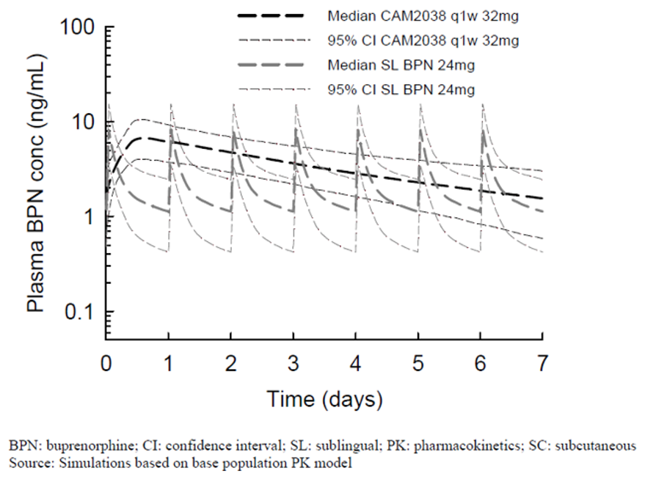

Evaluation of response
The clinical pharmacology evaluator is satisfied with the sponsor’s response.

Question 2
Given that the existing USPI for Subutex SL tablets indicates that the recommended target dosage of Subutex is 16 mg as a single daily dose and that dosages higher than 24 mg have not been demonstrated to provide any clinical advantage can the sponsor please justify the inclusion of the 160 mg dose of CAM2038 q4w in the current application especially considering the PKs of the proposed 160 mg dose of CAM2038 q4w were not examined in healthy subjects and no explanation or justification is provided for the use of the 160 mg dose of CAM2038 q4w in Study HS-15-549?

Sponsor’s response
The 160 mg CAM2038 q4w dose does not have a weekly corresponding dose and was included as a dose escalation opportunity in the Phase III studies (Studies HS-11-421 and HS-14-499) for patients on 128 mg CAM2038 q4w when this was clinically indicated at the investigator’s discretion.
The efficacy and safety results from the clinical programme demonstrated that the 160 mg dose of CAM2038 q4w provide a positive benefit-risk profile in patients with opioid dependence, both in patients who were new to treatment and in patients who were switched from sublingual buprenorphine/naloxone. However, the sponsor has decided to withdraw the 160 mg dose from the marketing authorisation application (MAA) until further data on this dose are available.

Evaluation of response
The clinical pharmacology evaluator is satisfied with the sponsor’s response.

Question 3
Please justify the inclusion of all subjects in the PP analysis in Study HS-11-421. The difference between reportable deviations and major deviations is unclear. A total of 87 subjects had reportable deviations but none were considered major. This appears unusual.

Sponsor’s response
The sponsor has submitted a post hoc correction of the clinical data which has excluded five subjects from the PP analysis. The PP-1 and PP-2 analyses are now described in the clinical evaluation report with summaries shown below in Table 5 and Table 6.
Table 5: Study HS-11-421 Mean percentage of urine samples negative for illicit opioids, (post hoc PP-1 population)
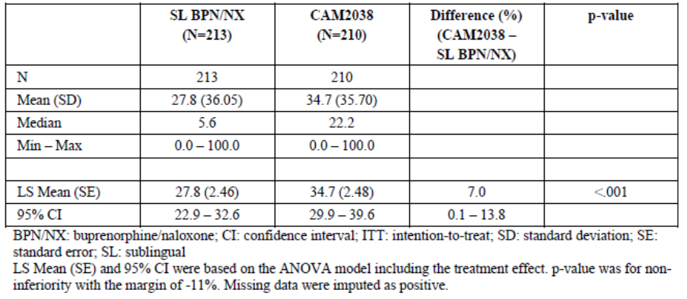
Table 6: Study HS-11-421 Mean percentage of urine samples negative for illicit opioids excluding patients who had 2 or more missing consecutive visits prior to Week 25/end of therapy, (post hoc PP-2 population)
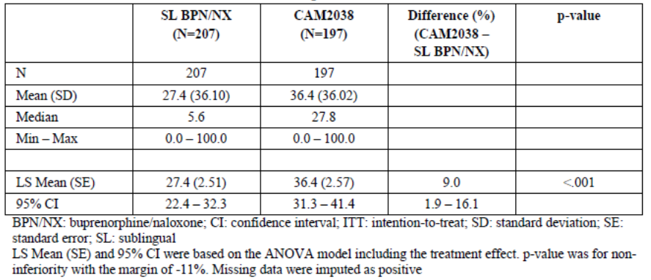

Evaluation of response
The sponsor’s response is satisfactory. The results of the revised PP sensitivity analysis are consistent with the primary analysis and do not materially influence the study outcomes or conclusions.

Question 4
In the Study HS-11-421 clinical study report, it is stated that 158 subjects (74%) received at least one dose of CAM2038 q4w. However, it is unclear what the most common dose was at the end of the 12 week treatment period. In the Study HS-14-499 clinical study report, it is unclear what percentage of subjects were stabilised on CAM2038 q4w. Please provide a summary of the median dose of CAM2038 qw4 in both study populations at end of therapy. Please state the percentage of subjects who required the 160 mg dose for long-term stabilisation of symptoms.

Sponsor’s response
In patients stabilised on CAM2038 in Study HS-11-421, the most common last dose was 96 mg as shown in Table 7 below.
Table 7: Study HS-11-421, the last (third) CAM2038 q4w dose administered in the study
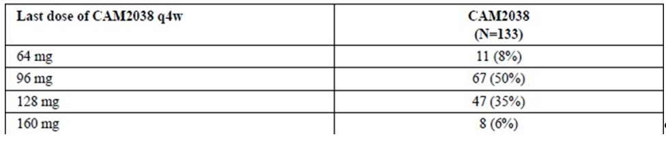
A total of 85% of patients were stabilised on doses of 96 mg or 128 mg and only 6% required 160 mg.
In Study HS-14-499, there was no strictly defined definition of a stable dose. Flexible dosing was designed to mimic clinical practice. However, to address the evaluator’s question, the sponsor has summarised the doses given in subjects who received the same dose on at least four consecutive occasions (Table 8).
Table 8: Study HS-14-499: exposure, the last dose of CAM2038 q4w given as at least 4 consecutive doses
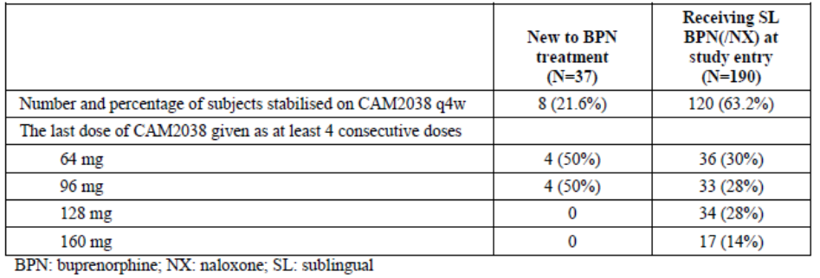
In subjects who received the same dose on at least four consecutive occasions, subjects new to buprenorphine treatment were stabilised on 64 to 96 mg. Subjects receiving SL buprenorphine/naloxone at study entry required higher doses. A total of 28% received 128 mg and 14% received the maximum 160 mg dose.
The median last dose was 96 mg in Studies HS-11-421 and HS-14-499 (Table 9 and Table 10).
Table 9: Study HS-11-421: Median last dose of CAM2038 q4w administered (mg)
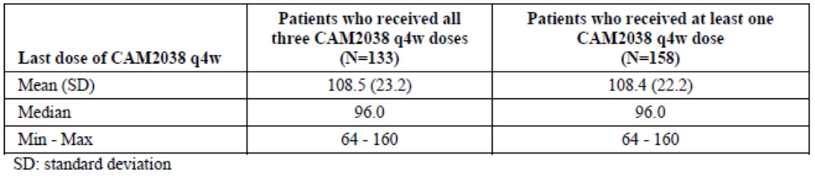
Table 10: Study HS-14-499: Median last dose of CAM2038 q4w administered (mg)
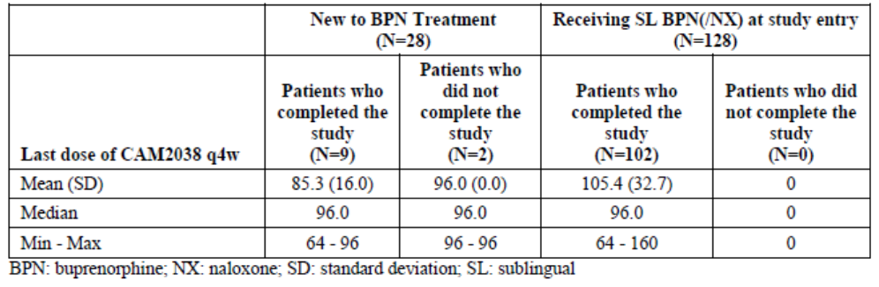

Evaluation of response
The sponsor’s response is satisfactory. The data suggest that the great majority of subjects can be stabilised on doses ranging from 64 mg to 128 mg with a median dose of 96 mg. Few subjects required the highest dose of 160 mg to control symptoms.

Question 5
Please comment on the risks associated with accidental IV injection. It is accepted that this is unlikely as injections are given by healthcare professionals. However, what PK and adverse effects might be expected to occur were it to actually happen? Has IV testing been conducted in animals?

Sponsor’s response
The sponsor reiterates the low risk of accidental IV injection and systemic embolism as injections are given by health care professionals. No cases of accidental IV administration have been reported in 729 subjects given 8,693 injections of CAM2038; nor have AEs related to local vessel blockade or embolism been reported in preclinical studies.
Direct IV injections were evaluated in three rats given CAM2038 8 mg buprenorphine in the tail vein. No PK analyses were performed but there were no clinical signs of exaggerated pharmacology. At necropsy, depot matrix material was observed in the veins proximal to the injection sites, with presumed partial or complete occlusion of the veins.
Despite the low risk of accidental IV injection, the sponsor proposes the following additional wording in the proposed PI under Administration:
‘Intravascular such as intravenous injection would present a risk of serious harm as Buvidal forms a solid mass upon contact with body fluids, which potentially could cause blood vessel injury, occlusion, or thromboembolic events’.

Evaluation of response
The sponsor’s response is satisfactory. The risk of IV injection cannot be completely eliminated but the risk minimisation precautions in the proposed PI are satisfactory.

Question 6
In Study HS-11-421, no summary of injection site AEs has been provided. Please provide a summary table modelled on that below for Study HS-14-499. Please provide a summary table of clinically significant reactions by severity if injection site reactions were not routinely recorded as AEs.

Sponsor’s response
A summary table of injection site AEs was provided in the clinical study report appendix, as shown in Table 11.
In patients given CAM2038, mild, moderate and severe AEs were reported in 13.1%, 5.6% and 0.0% of subjects respectively.
Table 11: Study HS-11-421: Summary of all injection site reactions
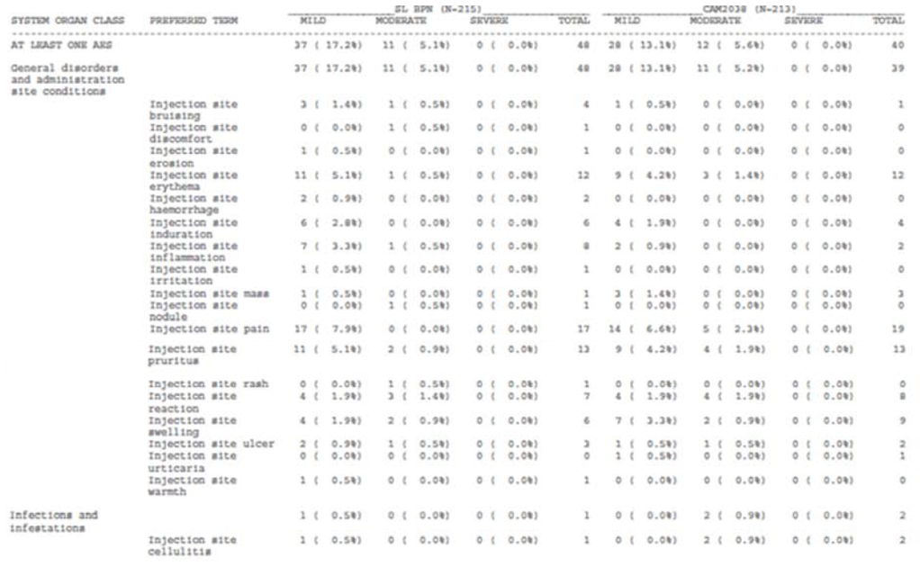

Evaluation of response
The sponsor’s response is satisfactory. Overall, injection site AEs were mild or moderate in severity and no severe reactions were reported.

Additional expert input
The evaluators recommend that additional expert input be provided by representatives of the Drug and Alcohol Services. The use of long-acting buprenorphine should be assessed within the framework of regulatory and management guidelines. Comment on the benefit-risk in relation to the one month formulation of CAM2038 would be valuable, in particular:
- The safety of the highest dose,
- The difficulty of reversing the opioid effects in emergency situations, including accidental overdose,
- The risks of accidental IV injection.
Assessment of the optimal method of initiating therapy would also be of value.

Sponsor’s response
An expert report has been provided by [Information redacted], an addiction medicine specialist and the principal investigator for Study HS-14-499.
A summary is provided below.
The introduction of depot buprenorphine is eagerly anticipated in Australia by clinicians working in the field. The main benefits are:
- Greater convenience for patients;
- Reduced treatment costs for patients and service providers;
- Less risk of diversion and misuse of medication, enhancing community safety; and
- Greater medication adherence and enhanced treatment outcomes for some patients who struggle to attend regularly for dosing with sublingual buprenorphine.
In response to the specific queries from the TGA regarding usage and risks:
- Both weekly and monthly depot products will have a role in treatment. Stabilisation will be managed with weekly injections before transitioning to monthly injections when indicated.
- The CAM2038 injections were well tolerated with most AEs related to transient, local site inflammation. There were no concerns regarding intoxication or overdose, even with the higher doses. The known ceiling effects of buprenorphine on respiratory depression and other opioid effects appear to be relevant.
- Potential problems may arise when reversing the opioid effects in emergency situations such as:
  - Overdose;
  - Reversing the effects of buprenorphine in order to achieve acute analgesia;
  - Risk of precipitated withdrawal; and
  - Risk of accidental IV injection.
The potential problems are recognised but each scenario is considered manageable, and the risks do not outweigh the potential benefits of the new formulation.
The optimal method of induction and other issues will need to be highlighted and updated in the National Guidelines for Medication-Assisted Treatment of Opioid Dependence (MATOD). Updated guidance should enhance safe and effective use of the new product. Experts in the sector will be active in ensuring the development and dissemination of guidelines for consumers and health care providers.

Evaluation of response
The expert opinion is balanced and generally supportive of the weekly and monthly formulations. The risks associated with reversing the long-acting formulation are recognised, but, in the view of the expert, they should not the limit the use of a potentially valuable new formulation. Specialists in the area will promote appropriate guidelines and risk minimisation activities.

Second round benefit-risk assessment

Second round assessment of benefits
After consideration of the responses to clinical questions, the benefits of Buvidal in the proposed usage are unchanged from those identified in the first round.

Second round assessment of risks
After consideration of the responses to clinical questions, the risks of Buvidal in the proposed usage are unchanged from those identified in the first round.

Second round assessment of benefit-risk balance
After consideration of the responses to clinical questions, the benefit-risk balance of Buvidal in the proposed usage are unchanged from those identified in the first round.

Second round recommendation regarding authorisation
Approval is recommended for the following modified wording for the proposed indication. Intended use is specified for adolescents and adults as no paediatric data are available.
Buvidal is indicated for the treatment of opioid dependence within a framework of medical, social and psychological treatment. Buvidal is intended for use in adults and adolescents aged 16 years or over.
Approval for the above indication is subject to incorporation of suggested changes to the draft PI.

VI. Pharmacovigilance findings

Risk management plan

Summary of risk management plan (RMP) evaluation
- The sponsor has submitted EU-RMP version 0.1 (dated 28 August 2017; data lock point 15 May 2017) and Australian Specific Annex (ASA) dated 19 September 2017 (version number not provided) in support of this application.
- The proposed Summary of Safety Concerns and their associated risk monitoring and mitigation strategies at the second round evaluation are summarised in Table 12.
Table 12: Summary of safety concerns
Summary of safety concerns |  | Pharmacovigilance |  | Risk Minimisation
 |  | Routine | Additional | Routine | Additional
Important identified risks | Injection site reactions |  | – |  | ‡
Important identified risks | Use in patients with severe respiratory insufficiency |  | – |  | ‡
Important identified risks | Use in patients with severe hepatic impairment |  | – |  | ‡
Important identified risks | Use in patients with acute alcoholism or delirium tremens |  | – |  | ‡
Important identified risks | Abuse and misuse |  | – |  | ‡
Important identified risks | Withdrawal reactions in opioid-dependent patients |  | – |  | ‡
Important identified risks | Concomitant use of other medications (Cytochrome P 3A4 (CYP3A4) inhibitors; benzodiazepines; other central nervous system depressants; and monoamine oxidase inhibitors (MAOI)) |  | – |  | ‡
Important identified risks | Overdose |  | – |  | ‡
Important potential risks | Intravascular injections |  | – |  | ‡
Important potential risks | Medication error |  | – |  | ‡
Important potential risks | Use in patients with various disease states (renal impairment; head injuries; increased intracranial pressure; hypotension; prostatic hypertrophy; and urethral stenosis) |  | – |  | ‡
Important potential risks | Concomitant use of gabapentinoids* |  | – | § | –
Missing information | Use in children and adolescents† |  | – |  | ‡
Missing information | Use in pregnancy and lactation† |  | – |  | ‡
*Safety concern in the EU-RMP only. † Safety concern in the ASA only. ‡ Additional risk minimisation activities in the ASA only. § Routine risk minimisation activities in the EU-RMP only.
- The sponsors proposed safety specification was not adequate in the proposed RMP and ASA as there were no specific safety concerns of areas of missing information, and extensive revision was recommended. The summary of safety concerns provided in the revised RMP documents, as shown above, were considered acceptable.
- The sponsor had not proposed any additional pharmacovigilance or risk minimisation activities. The RMP evaluator did not consider that this was adequate since previous RMPs for similar products required additional written educational material for health care professionals (HCPs) and patients. Education for health professionals and patients was considered to be necessary particularly with the novel depot formulation. The additional risk minimisation activities described in the revised RMP documents, as shown above, were considered acceptable.

New and outstanding recommendations from second round evaluation
The recommendations made in the first round evaluation, along with consideration of the sponsor response, were detailed in the risk management plan evaluation report.
- Recommendation 8: the sponsor has agreed to prepare and distribute educational material to healthcare professionals and patients on the safety concerns in the safety specification. Once approved by the TGA, this material should be distributed to addiction medicine specialists (include Australian State and Territory Drug and Alcohol health services), general practitioners and pharmacists (community and hospital) as a minimum. The sponsor should provide an assessment as to whether any other health professionals should receive this material and detail their distribution strategy of this material, including how they will determine whether adequate distribution has been achieved. The sponsor should inform the TGA of the anticipated date of product launch and ensure the draft educational material is provided to the TGA as soon as possible, and with sufficient time for revision prior to the launch date.
- Recommendation 9: The sponsor should add ‘Concomitant use gabapentinoids’ as an important potential risk of Buvidal to the ASA. Appropriate precautionary text similar to that proposed in the EU SmPC should be added to the Australian PI as routine risk minimisation for this safety concern.

Proposed wording for conditions of registration
Any changes to which the sponsor has agreed should be included in a revised RMP and ASA. However, irrespective of whether or not they are included in the currently available version of the RMP document, the agreed changes become part of the risk management system.
The suggested wording is:
The Buvidal EU-Risk Management Plan (RMP) (version 0.2, dated 24 April 2018, data lock point 15 May 2017), with Australian Specific Annex (version 0.2, dated 25 April 2018), included with submission PM-2017-02926-1-1, to be revised to the satisfaction of the TGA, will be implemented in Australia.
The following wording is recommended for the PSUR requirement:
An obligatory component of risk management plans is routine pharmacovigilance. Routine pharmacovigilance includes the submission of Periodic Safety Update Reports (PSURs).
Reports are to be provided in line with the current published list of EU reference dates and frequency of submission of PSURs until the period covered by such reports is not less than three years from the date of this approval letter.
The reports are to at least meet the requirements for PSURs as described in the European Medicines Agency’s Guideline on good pharmacovigilance practices (GVP) Module VII-Periodic Safety Update Report (Rev 1), Part VII.B Structures and processes. Note that submission of a PSUR does not constitute an application to vary the registration.

VII. Overall conclusion and risk/benefit assessment
The submission was summarised in the following Delegate’s overview and recommendations.

Background

Background on condition being treated
Opioid dependence is characterised by cravings and compulsive use of opioids despite the negative consequences. Buprenorphine and methadone are approved as opioid replacement therapy for the management of opioid dependence. The successful treatment of opioid dependence requires psychological, social support and medical management. As part of this multifaceted approach, replacement pharmacotherapy is routinely used to reduce compulsion, cravings and physical adaption to chronic drug abuse.

Australian regulatory status
Intravenous and sublingual formulations of buprenorphine were first approved in Australia in 1991 for the relief of moderate to severe pain. SL buprenorphine was approved in Australia for the treatment of opioid dependence in 2000, and SL buprenorphine/naloxone was approved in 2005.
The indication proposed for Buvidal is the same as the indication for the buprenorphine and buprenorphine/naloxone dose forms indicated for management of opioid dependence.

Overseas regulatory status
At the time this submission was under consideration, Buvidal was not approved in any country or region. Submissions had been made via the centralised procedure in the EU and to the USA.
An extended release injection for SC use containing 100 mg and 300 mg per dose (Sublocade) was approved in the USA in 2017. Dosing is monthly. Sublocade is only available through a restricted program called the Sublocade Risk Evaluation and Mitigation Strategy (REMS) Program. Healthcare settings and pharmacies that order and dispense Sublocade must be certified in this program and comply with the REMS requirements. Its use is restricted to patients who have initiated treatment with a transmucosal buprenorphine containing product, followed by dose adjustment for a minimum of 7 days. The US PI states that Sublocade is available only through the Sublocade REMS Program because of the risk of serious harm or death that could result from intravenous self-administration. Sublocade forms a solid mass upon contact with body fluids and may cause occlusion, local tissue damage, and thromboembolic events, including life threatening pulmonary emboli, if administered intravenously.
Also in the USA, Probuphine, a buprenorphine subdermal implant providing 6 months exposure to buprenorphine was approved in 2016 for the for the maintenance treatment of opioid dependence in patients who have achieved and sustained prolonged clinical stability on low to moderate doses of a transmucosal buprenorphine containing product (that is, doses of no more than 8 mg per day of Subutex or Suboxone sublingual tablet or generic equivalent). Probuphine is available only through a restricted program called the Probuphine REMS Program. The USPI for Probuphine states that Probuphine is available only through the Probuphine REMS Program, because of the risk of complications of migration, protrusion and expulsion, and nerve damage associated with the insertion and removal of Probuphine.
Subutex and Suboxone sublingual tablets have been discontinued in the USA. Other buprenorphine/naloxone combination products for SL administration are marketed in the USA for management of opioid addiction but it is not clear if SL buprenorphine alone is marketed. It is available in the EU. The USPI for a combination product, Zubsolv states that dosages higher than 17.2 mg/4.2 mg buprenorphine/naloxone have not been demonstrated to provide any clinical advantage.

Guidance used
There is no EMA guidance document for the evaluation of medicinal products for the management of opioid addiction. Australian treatment guidelines were referred to by the clinical evaluator. The sponsor advised that discussions on study design were held with the EMA and FDA.
The Australian National Guidelines for Medication-Assisted Treatment of Opioid Dependence (April 2014) were consulted.10

Quality
At the time of this summary, negotiation of specification limits was ongoing. There are no other outstanding chemistry issues which would prevent registration of Buvidal.

Nonclinical
There are no nonclinical objections to the registration of Buvidal.
The nonclinical evaluator noted that:
- The pharmacokinetics results from animal models support the clinical use of weekly or monthly sustained release forms of Buvidal.
- The repeat dose toxicity studies in dogs gave no indication that Buvidal could induce systemic toxicity in patients.
- The proposed placement of Buvidal in Pregnancy Category C,9 is considered appropriate.

Clinical
Both the q1w and q4w formulations of depot buprenorphine proposed for registration were referred to as CAM2038 in the submission and in the clinical evaluation report.

Pharmacology

Pharmacokinetics
The PK studies concentrated on the rate and extent of absorption and relative bioavailability of buprenorphine from the proposed CAM2038 formulations. Comparisons were made to the PK of buprenorphine on dosing with sublingual buprenorphine. This approach is accepted given PK parameters for distribution, metabolism and elimination are not dependent on the dose presentation and buprenorphine is currently approved in sublingual dose forms for this indication.
There are two different formulations. The q1w formulation contains ethanol anhydrous (dehydrated alcohol) as a solvent, viscosity modifier and the q4w formulation contains N-methyl-2-pyrrolidone as a solvent, viscosity modifier.
Both formulations also include soybean phosphatidylcholine and glycerol dioleate as structure forming lipid excipients. Both formulations are intended to be administered via SC injection into the buttock, thigh, abdomen or upper arm. All clinical studies were conducted using the formulations proposed for marketing.
Buprenorphine is oxidatively metabolised by 14-N-dealkylation to N-desalkyl-buprenorphine (also known as norbuprenorphine) via cytochrome P450 CYP3A4 and by glucuroconjungation of the parent molecule and the dealkylated metabolite. Norbuprenorphine is a μ opioid agonist with weak intrinsic activity.
PK data were presented for both buprenorphine and norbuprenorphine. Healthy volunteers given CAM2038 in the PK studies were under naltrexone blockage. For the CAM2038 q1w presentation single doses ranging from 8 to 32 mg in healthy volunteers had a median buprenorphine T_{max} of ~ 23 hours and median norbuprenorphine T_{max} from 71.3 to 84.6 hours across the dose groups. For the CAM2038 q4w formulation single doses from 64 to 192 mg were given to healthy volunteers. Median T_{max} for sublingual buprenorphine ranged from 4 to 10 hours and median T_{max} for norbuprenorphine from 73.7 to 107.6 hours across the dose groups.
Relative bioavailability was assessed by comparison between the CAM2038 q1w and q4w formulations and by comparison with multiple doses of sublingual buprenorphine, and to IV buprenorphine. The relative BA of one 64 mg dose of the CAM2038 q4w formulation was 96% (90% CI 81.6 to 115%) compared to after the fourth dose of 16 mg q1w CAM2038 formulation. At higher doses bioequivalence between the two formulations of CAM2038 decreased and compared to the dose normalised AUC following the fourth dose of CAM2038 q1w the geometric mean ratios (GMRs; 90% CIs) for the 96 mg CAM2038 q4w, 128 mg CAM2038 q4w and 192 mg CAM2038 qw4 doses were 87.3% (74.8 to 101.9%), 90.9% (78.2 to 105.5%) and 77.75 (65.3 to 92.3%), respectively.
Relative BA in comparison with multiple doses of buprenorphine sublingual tablets, given at comparable total doses, was much higher for both formulations of CAM2038. For the CAM2038 q1w formulation the geometric means of relative BA were 611%, 872% and 840% for the comparisons of 8 mg SC versus 8 mg SL, 16 mg SC versus 16 mg SL and 32 mg SC versus 24 mg SL, respectively. For the CAM2038 q4w formulation relative BA were 570.3% and 746.7% for the comparisons of 64 mg SC versus the seventh dose of 8 mg SL and 128 mg SC versus the seventh dose of 24 mg SL, respectively. Relative BA of the CAM2038 q4w formulation at steady state was not performed, however PK results at steady state are shown in Table 13. The table shows similar PK results for the 32 mg CAM2038 q4w dose at steady state when given at different injection sites (buttock, abdomen, thigh and upper arm). The clinical evaluator has noted that in the US PI for buprenorphine sublingual tablets that doses higher than 24 mg are not recommended. The Australian PI for these products states that a dose of 32 mg daily should not be exceeded.
Table 13: Study HS-15-549 pharmacokinetic parameters of buprenorphine after steady-state SC administration of 32 mg CAM2038 q1w at different injection sites
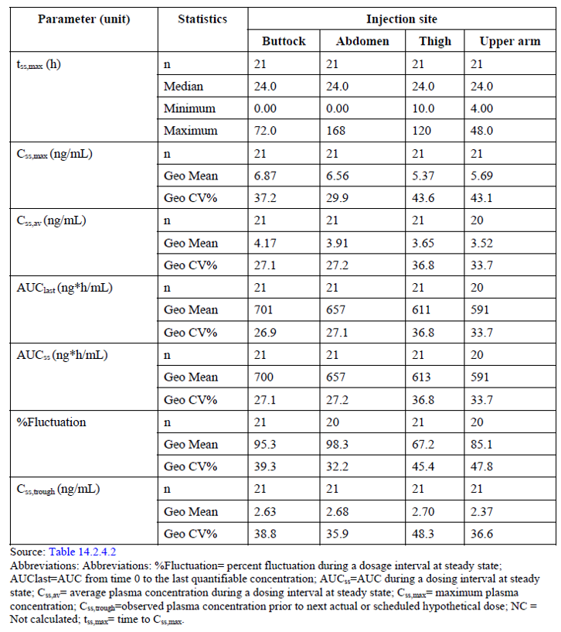
Dose proportionality between the range 8 mg to 32 mg for the CAM2038 q1w formulation and between the range 64 mg to 192 mg for the q4w formulation was demonstrated. There was no evidence of dose dumping with either formulation after single or multiple dosing within those dose ranges. On multiple dosing the accumulation ratio after 4 weekly doses of 16 mg of the q1w formulation was 1.4 for C_{max} and AUC_{0-7d}. Steady state conditions were achieved by the fourth dose of 16 mg CAM2038 q1w.

Population pharmacokinetic data
Overall, 236 subjects (median age 35 years), treated with either SL buprenorphine, SC CAM2038 q1w or CAM2038 q4w contributed 10,260 buprenorphine observations and were included in the population PK analysis. The results indicated that a three-compartment model with first order elimination described the disposition of buprenorphine (Table 14).
Table 14: Study REP-2-CAM-2038-PMX-1 parameter estimates of the final buprenorphine model
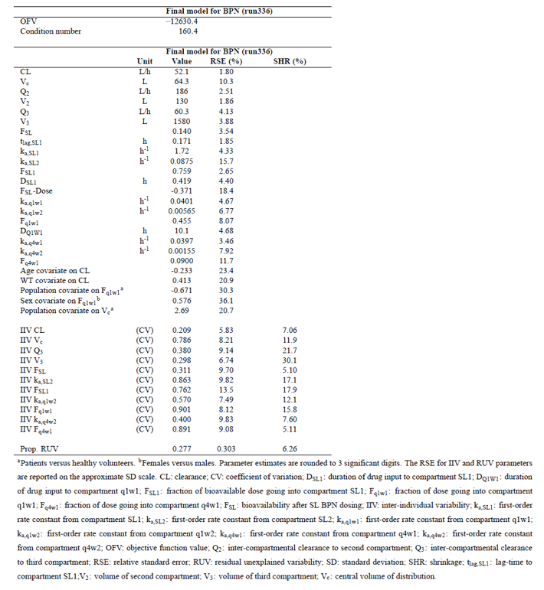
Overall, the model predicted that buprenorphine clearance increased with body weight, from 44.7 L/h at 50 kg to 59.5 L/h at 100 kg, and decreased with age, from 60.8 L/h at 18 years to 45.1 L/h at 65 years.

Pharmacodynamics
Buprenorphine is an opioid partial agonist/antagonist that binds to the μ and ƙ opioid receptors of the brain. It acts as a partial agonist at the μ opiate receptor with high affinity to this receptor type and as an antagonist at the ƙ receptor.
PD effects were evaluated by scores on the SOWS and the COWS. PD effects were also evaluated by measuring the time from dosing with trial medication until dosing with rescue medication. These effects will be described in the efficacy section of this request for advice.
The relationship between drug concentration and PD effects was examined in Study HS-13-478. The results of that study suggest that buprenorphine concentrations as low as ~ 1.20 ng/mL were sufficient to block the subjective effects of hydromorphone 18 mg given via IM injection. Higher plasma buprenorphine concentrations were not associated with appreciable increases in blockade.
Drug interactions were not separately assessed in this submission. Buprenorphine is known to be metabolised via CYP3A4. For orally administered buprenorphine there is extensive first pass metabolism. This does not apply to the SL and SC dose forms however the same drug interactions present for SL buprenorphine would be present for CAM2038. These include: CYP3A4 inhibitors and inducers as well as drugs interacting through non-PK mechanisms such as alcohol, benzodiazepines, other CNS depressants including opioids and opioid antagonists.
The effect of both formulations of CAM2038 on QT interval was assessed in the efficacy studies and no relationship between buprenorphine plasma concentration and QTcF was observed.

Efficacy
Dose finding has been based on comparative bioavailability with SL buprenorphine. The evaluator has noted that:
- In the USPI for Subutex SL tablets the recommended target dosage of Subutex is 16 mg as a single daily dose and that dosages higher than 24 mg have not been demonstrated to provide any clinical advantage;
- The BA of CAM2038 is higher than that of SL buprenorphine;
- Four times the highest weekly proposed dose of 32 mg is equivalent to 128 mg dose of CAM2038 q4w;
- It is unclear why the 160 mg dose of CAM2038 q4w dose is needed or being considered;
- Additionally, although 16 mg daily was the recommended maintenance dose in the USA for SL buprenorphine, both the Australian PI and the EU summary of product characteristics (SPC) for Subutex allow for a maximum daily dose of 32 mg. This is consistent with the proposed exposure anticipated by the 128 mg q4w CAM2038 dose.
There were two Phase III studies in subjects with opioid dependence. The pivotal study was Study HS-11-421. The second Phase III study, Study HS-14-499, was an open label study to assess efficacy over 48 weeks in subjects with opioid dependence who were previously taking SL buprenorphine/naloxone or who were actively seeking buprenorphine treatment before enrolment.

Study HS-11-421
Study HS-11-421 was a randomised, double blind, active controlled study of the efficacy and safety of once weekly and once monthly depot buprenorphine (CAM2038) in adult outpatients with opioid use disorder. The primary objective was to demonstrate the non-inferiority of CAM2038 compared with SL buprenorphine/naloxone assessed by urine samples negative for illicit opioids. The study was conducted in two parts. The study involved 4 phases: Screening (3 weeks), Phase 1 (12 treatment weeks), Phase 2 (12 treatment weeks), and Follow up (4 weeks).
Eligible participants were adults seeking treatment for moderate to severe opioid dependence (Diagnostic and Statistical Manual of Mental Disorders, Fifth Edition; DSM-5), considered good candidates for treatment with buprenorphine based on medical/psychosocial history, and willing to use reliable contraception. Those receiving pharmacotherapeutic treatment for opioid dependence within 60 days or any investigational drug within 4 weeks, or having a current moderate to severe substance use disorder other than opioids, caffeine, or nicotine considered primary or co-primary with opioid dependence were excluded.
Investigators were instructed to use manual guided psychosocial counselling for study subjects throughout the study period. All study drugs were administered in a double blind, double dummy manner, such that subjects received both SL tablets (active buprenorphine/naloxone or placebo) and SC injections (active CAM2038 q1w/CAM2038 q4w or placebo) throughout the study (with the exception of Days 2 and 3, when only SL buprenorphine/naloxone or SL placebo tablets were given). CAM2038/placebo were injected in the buttocks, abdomen, thighs, and the upper back of the arms and the injection sites were rotated such that no injections were administered into the same site.
The primary efficacy endpoints were defined a priori with the EMA and the FDA. The primary efficacy endpoint for the EMA analyses was the percentage of urine samples negative for illicit opioids based on the 18 urine samples obtained during the post-induction period (treatment Weeks 1 to 24, corresponding to sample Weeks 2 to 25). In this analysis, if urine toxicology samples were missing due to, for example, missing scheduled visit, early discontinuation of the study, or patient’s refusal to provide the samples (scheduled or random samples), the results were imputed as positive.
The primary endpoint was analysed by an analysis of variance (ANOVA) model with treatment effects. Non-inferiority was to be concluded if the lower limit of the two sided 95% CI for the difference (CAM2038-SL buprenorphine/naloxone) in percent negative urine samples was above -11%. The justification of non-inferiority margin for the percent urine samples negative for illicit opioids was based on the outcome of a comparison between SL buprenorphine/naloxone (n = 119) and placebo (n = 54). The reported values from the ANOVA in that study were 35.1% for SL buprenorphine/naloxone and 14.4% for placebo (difference: 20.7%; p < 0.001). This was translated to an approximate 95% CI for the difference of 11.5% to 29.9%. The power calculation was based on the lower limit of this CI as a non-inferiority margin, rounded to -11%.
The primary efficacy endpoint for the FDA analyses was RR, where a responder for Phase 1 of the study was defined as a patient with no evidence of use of illicit opioids at sample Week 13 and no evidence of illicit opioid use (including self-reported use) for at least 2 out of the 3 weeks from sample Weeks 10 to 12. To be a responder for Phase 2, the subjects had to have no evidence of illicit opioid use at sample Week 25 and for 4 out of the 5 additional assessments in Phase 2. To be a responder for the study, the patient had to be a responder for both Phases 1 and 2.
Evidence of illicit opioid use within a window was defined as a positive urine toxicology result or self-reported illicit opioid use within that window, including the results from random urine toxicology samples (in Phase 2) obtained within that window. Regardless of whether the urine toxicology result was positive or negative, if illicit opioid use was self-reported, there was evidence of illicit opioid use. Non-inferiority was concluded if the lower limit of the two sided 95% CI for the difference between the probabilities of response (Active-Control) was above –10%.
Endpoints which were tested in the following hierarchical order (for the EMA analysis):
- Non-inferiority with a margin of 11% point for percentage of urine samples negative for illicit opioids;
- Superiority for Cumulative Distribution Function (CDF) of percentage urine samples negative for illicit opioids collected for treatment Weeks 4 to Week 24;
- Non-inferiority with a margin of 15% for retention rate;
- Superiority of CAM2038 over SL buprenorphine/naloxone for time to sustained abstinence after 8 weeks of treatment;
- Superiority of CAM2038 over SL buprenorphine/naloxone for retention rate.
A comparison was eligible for non-inferiority or superiority testing only if all previous comparisons, if any, were successfully established at the two-sided 5% significance level.
Following screening and confirmation of eligibility, subjects were randomised to one of two treatment groups in a 1:1 ratio:
- Group 1: SL buprenorphine/naloxone tablets + placebo SC injections.
- Group 2: CAM2038 SC injections + SL placebo tablets.
Active treatment doses were titrated to patient response during the first week of Phase 1. Subjects received final SL buprenorphine/naloxone doses in the range of 16 to 24 mg daily or a total weekly dose of CAM2038 q1w between 24 and 32 mg (administered in aliquots on Days 1, 4 and if needed Days 5 to 7). Subsequently on Day 8 the SL buprenorphine/naloxone dose could be titrated down to 8 mg daily. Subjects had weekly visits after the titration in Week 1 of Phase 1. Titration down to 16 mg was permitted for CAM2038 q1w in Phase 1. Subjects were given a 7 day take home supply of SL buprenorphine/naloxone or placebo.
In Phase 1, subjects underwent initiation of buprenorphine treatment with either SL buprenorphine/naloxone or SC CAM2038 q1w for 12 weeks. Subjects then commenced Phase 2 in which those randomised to SL buprenorphine/naloxone continued daily treatment with SL buprenorphine/naloxone which was dispensed monthly and monthly placebo SC injections. Subjects randomised initially to CAM2038 q1w were transferred to monthly injections of CAM2038 q4w and monthly dispensing of daily SL placebo for a further 12 weeks.
After 12 weeks treatment with CAM2038 q1w or SL buprenorphine/naloxone Phase 2 commenced and subjects randomised to SL buprenorphine/naloxone daily continued to receive the dose they had been titrated to in Week 1 of Phase 1 while subjects randomised to CAM2038 q1w were switched to CAM2018 q4w given every 4 weeks with subjects titrated to 16 mg, 24 mg or 32 mg CAM q1w given CAM q4w doses of 64 mg, 96 mg, and 128 mg respectively. Dose adjustment was allowed up to 160 mg CAM2038 q4w or to 32 mg SL buprenorphine/naloxone daily. Subjects were given a 4 week supply of SL buprenorphine/naloxone or matching placebo at each monthly visit.
A total of 18 urine toxicology samples for illicit opioids were collected during Phase 1 and Phase 2 of the study, 12 samples were to be collected at the scheduled weekly visits during Phase 1 (sample Weeks 2 to 13) and 6 samples during the 12 weeks of Phase 2 (3 at the scheduled monthly visits (sample Weeks 17, 21, 25) and 3 at random urine toxicology visits). A self-report of drug use accompanied every urine toxicology test. Urine drug screen tests and other scheduled assessments were done at the start of the denoted week, pre-dosing, thus representing outcomes from the previous week.
600 subjects were screened, 428 were randomised and received at least one dose of study medication and 57.9% completed the study. At baseline, 61.4% of subjects were male, 75.5% were white and mean age was 38.4 years. The mean BMI was 25.9 kg/m². Opioid use history was balanced across treatment groups; 70.8% used heroine and the remainder used prescription opioid pain relievers (29.2%). 93.7% of subjects had opioid-positive urine samples on Day 1. The majority of subjects had a history of non-opioid use. Psychosocial history parameters were comparable between groups.
The least squares mean of the percentage of urine samples negative for illicit opioids in the intent-to-treat (ITT) population during Weeks 2 to 25was 28.4% (95% CI: 23.5, 33.3) in the SL buprenorphine/naloxone group, and 35.1% (95% CI: 30.3, 40.0) in the CAM2038 group. The benefit in favour of the CAM2038 group was 6.7% (95% CI: -0.1, 13.6; p < 0.001) which was within the predefined non-inferiority margin of -11%. Superiority was not tested as the lower bound of the 95% CI was less than zero. The per protocol (PP) population was the same as the ITT population. The sponsor has included all treated subjects in the PP population, though 87 subjects had protocol defined deviations most commonly due to missed study visits and/or missed urine toxicology collections. A post hoc exploratory analysis also reported non-inferiority of CAM2038q1w with SL buprenorphine/naloxone without imputation for missing values, but it is not clear if there was a difference in the treatment groups in the number and extent of protocol violations.
Of the EMA secondary variables, the median cumulative % of urine samples negative for illicit opioid over Weeks 5 to 25 was 6.7% (not including self-reported opioid use) for the SL buprenorphine/naloxone group and 26.7% (with and without self-reported opioid use) for the CAM2038 group (p = 0.004 with self-reports and 0.008 without self-reports). Non-inferiority was demonstrated for the retention rate with 58.6% of the SL buprenorphine/naloxone group and 56.8% of the CAM2038 group remaining at end of study (difference -1.8%; 95%CI -11.2, 7.6). Data for the time to sustained abstinence after 8 weeks of treatment was collected but not included in the submission.
For the FDA primary endpoint of the proportion of responders (that is, subjects with no evidence of use of illicit opioids at sample Week 13 and no evidence of illicit opioid use, including self-reported use, for at least 2 out of the 3 weeks from sample Weeks 10 to 12 was 14.4% in the SL buprenorphine/naloxone group and 17.8% in the CAM2038 group. The benefit in favour of the CAM2038 group was 3.4% (95% CI: -3.5, 10.4; p < 0.001) which was within the predefined non-inferiority margin of -10%. Superiority was not tested as the lower bound of the 95% CI was less than zero.

Study HS-14-499
Study HS-14-499 provided limited longer term efficacy data. This was an open, uncontrolled study primarily to assess the long term safety of CAM2038 q1w and q4w over 48 weeks. The secondary objective was to investigate efficacy through measures including urine toxicology, signs and symptoms of withdrawal, and cravings. 37 out of 228 (16.2%) subjects were buprenorphine treatment-naïve. For those subjects treatment was initiated with a single injection of CAM2038 q1w 16 mg after a 4 mg SL buprenorphine/naloxone test dose. Additional dosage adjustments were permitted up to a maximum weekly dose of 40 mg. For remaining subjects treatments were initiated according to previous SL buprenorphine or buprenorphine/naloxone use. 69.2% of subjects completed the study including the follow up visit. A total of 156 subjects (68.4%) were exposed to CAM2038 for 48 weeks.
A summary of urine toxicology results is shown in Table 15. In the efficacy population, the mean percentage of negative urine toxicology results was 75.9%. In subjects new to buprenorphine treatment, the mean percentage of negative urine toxicology results was notably lower (41.2%) compared with those receiving buprenorphine at entry.
Table 15: Study HS-14-499 Mean percentage negative urine toxicology results (supported by self-reported illicit opioid use)
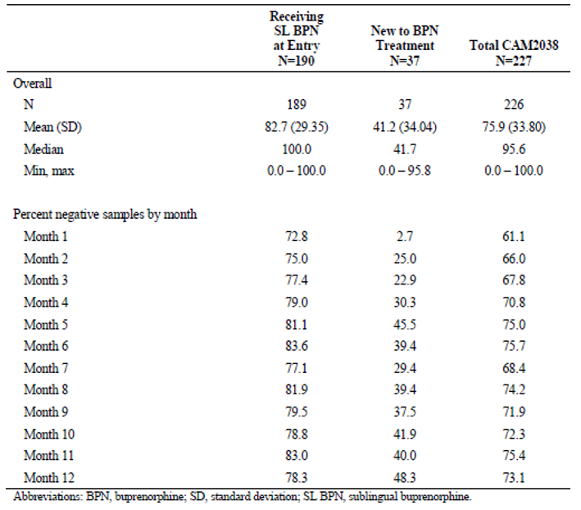

Safety
The safety of buprenorphine in humans is supported by data collected from the extensive use of buprenorphine products, such as Subutex and Suboxone, which have been on the market for many years. The proposed dose regimens for CAM2038 provide plasma levels of buprenorphine comparable to those recommended for daily SL buprenorphine so the limited safety assessment with these new formulations accepted.
Safety data were obtained from 7 clinical studies, 2 were in healthy volunteers (Studies HS-11-426 and HS-13-487) and 5 in patients with opioid dependence (Studies HS-07-307, HS-15-549, HS-13-478, HS-11-421 and HS-14-499). 729 subjects were exposed to CAM2038 in the clinical program. Of these 135 were healthy volunteers. Across regimens, 604 subjects received CAM2038 q1w and 408 received CAM2038 q4w. Many subjects received both CAM2038 q1w and CAM2038 q1w in flexible, individualised dosing regimens.
Across all studies, the mean age was 39.5 years (range: 18 to 66 years), 61.0% were male and 78.1% were white. The mean BMI was 25.6 kg/m² (range: 15 to 50 kg/m²). 128 out of 594 (21.5%) of opioid dependent subjects given CAM2038 had ongoing hepatitis at study entry, though individuals with either hepatic or renal impairment were excluded from studies.
Comparative safety data with SL buprenorphine/naloxone were available from Study HS-11-421. There was one death, due to a traffic accident which was considered unrelated to study treatments. Non-fatal SAEs were reported in 6.0% of the SL buprenorphine/naloxone group, compared with 2.3% of the CAM2038 group. Non-fatal SAEs reported by System Organ Class (SOC) and Preferred Term (PT) are shown in Table 16. Only one subject (receiving CAM2038) experienced an SAE considered possibly related to study drug, a case of moderate vomiting which required IV rehydration.
Table 16: Study HS-11-421 Summary of SAEs by SOC and PT
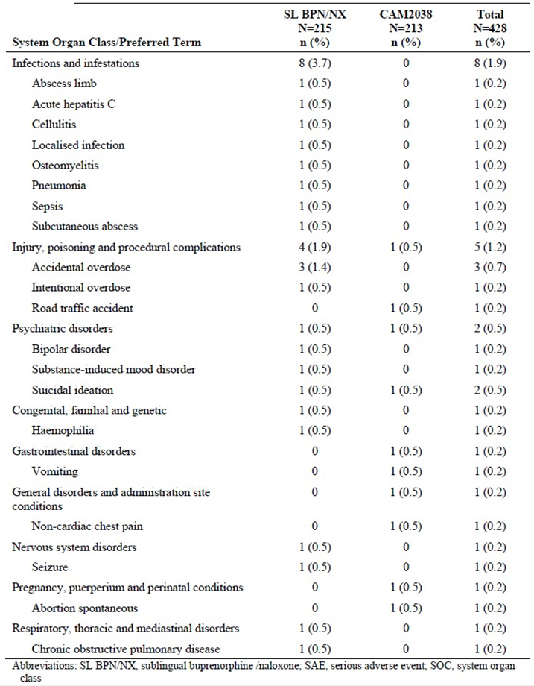
In that study, 57.7% of subjects reported at least one AE (55.3% SL buprenorphine/naloxone; 60.1% CAM2038).The most frequently reported AEs were: injection site pain (8.4%), headache (7.7%), constipation (7.5%), nausea (7.5%), injection site pruritus (6.1%), and injection site erythema (5.6%). 4.9% of subjects reported severe AEs (7.0% SL buprenorphine/naloxone; 2.8% CAM2038), and the majority were non-injection site events. Five subjects reported an overdose, all in the SL buprenorphine/naloxone group (four accidental; one intentional).
Study HS-14-499 allowed a comparison of AEs between treatment naïve and SL buprenorphine, buprenorphine/naloxone experienced subjects as well as between the q1w and q4w formulations of CAM2038.
Overall, the pattern and frequency of AEs in the Phase III program were consistent with the literature base for buprenorphine and methadone. The safety profile of CAM2038 given weekly or monthly was comparable to that of SL buprenorphine/naloxone, a widely used standard of care in Australia.

Risk management plan
The RMP evaluator has noted that the summary of safety concerns and proposed additional pharmacovigilance activities were amended during the evaluation process and these are now acceptable. The ASA is to be amended to include concomitant use of gabapentinoids as an important potential risk.
The sponsor has agreed to prepare and distribute educational material to healthcare professionals and patients on the safety concerns in the safety specification. Once approved by the TGA, this material should be distributed to addiction medicine specialists (include Australian State and Territory Drug and Alcohol health services), general practitioners and pharmacists (community and hospital), as a minimum.
The RMP evaluator stated that the sponsor should provide an assessment as to whether any other health professionals should receive this material and detail their distribution strategy of this material, including how they will determine whether adequate distribution has been achieved.
The sponsor should also inform the TGA of the anticipated date of product launch and ensure the draft educational material is provided to the TGA as soon as possible, and with sufficient time for revision prior to the launch date.

Recommended condition/s of registration
The suggested wording is:
The Buvidal EU-Risk Management Plan (RMP) (version 0.2, dated 24 April 2018, data lock point 15 May 2017), with Australian Specific Annex (version 0.2, dated 25 April 2018), included with submission PM-2017-02926-1-1, to be revised to the satisfaction of the TGA, will be implemented in Australia.
The following wording is recommended for the PSUR requirement:
An obligatory component of risk management plans is routine pharmacovigilance. Routine pharmacovigilance includes the submission of Periodic Safety Update Reports (PSURs).
Reports are to be provided in line with the current published list of EU reference dates and frequency of submission of PSURs until the period covered by such reports is not less than three years from the date of this approval letter.
The reports are to at least meet the requirements for PSURs as described in the European Medicines Agency’s Guideline on good pharmacovigilance practices (GVP) Module VII-Periodic Safety Update Report (Rev 1), Part VII.B Structures and processes. Note that submission of a PSUR does not constitute an application to vary the registration.
Additional activities for compliance monitoring
The sponsor is required to submit education materials prior to launch, and has been requested to provide the anticipated launch date.
Accidental overdose should be subject to specific post-marketing surveillance and the sponsor should provide the TGA with annual reports on this risk. These reports should be reviewed as part of the RMP Compliance Program to assess whether there are any concerns.

Risk-benefit analysis

Delegate’s considerations

Discussion
The primary efficacy measure for the EMA in the pivotal study assessed urine samples negative for illicit opioids. This endpoint was also used in the pivotal studies supporting approval of Subutex (buprenorphine) and Suboxone (buprenorphine/ naloxone). This parameter is accepted however there were relatively few urine samples obtained in the pivotal study. The Delegate notes that in the pivotal clinical trial supporting approval of Suboxone urine samples were obtained thrice weekly in a 13 week study. In the pivotal study for the two buprenorphine formulations proposed for registration in this submission urine samples were obtained on a maximum of 18 occasions over 24 weeks.
The pivotal study compared take away SL buprenorphine/naloxone doses with CAM2038 dose presentations that were administered at a clinic and thus could not be on sold or otherwise disposed of. It would have been more reflective of the usual practice to compare daily or second daily provision of SL buprenorphine/naloxone with weekly then monthly CAM2038. The comparison presented has demonstrated that efficacy of weekly then monthly CAM2038 is no worse than take away doses of SL buprenorphine/naloxone given to opioid dependent individuals who had not been previously stabilised on an opioid substitution regimen.
The National Guidelines for Medication-Assisted Treatment of Opioid Dependence;10 notes that in general, treatment of opioid dependence with methadone or buprenorphine is based on daily supervised dosing at a pharmacy or clinic. The efficacy of the takeaway doses of SL buprenorphine/naloxone provided in the pivotal study is likely to be lower than would be the case for SL buprenorphine/naloxone given with daily or second daily supply and review. Thus the comparison is not ideal. Similarly the selection of study subjects who were not stabilised on an opioid substitution regimen is likely to have reduced the efficacy of SL buprenorphine/naloxone, thereby maximising the differences in efficacy between SL buprenorphine/naloxone and CAM2038.
No clinically significant differences in safety between SL buprenorphine/naloxone and CAM2038 were demonstrated in the clinical trials. In theory, the SC dose form, if not made as widely available as the current SL buprenorphine and buprenorphine/naloxone products, would be less likely to be misused and abused, though this has not been demonstrated.
The National Guidelines advise that patients commencing opioid substitution therapy undergo induction prior to commencing maintenance therapy to safely achieve an adequate dose of medication, stabilise the patient’s opioid use, and to address co-existing conditions. Induction strategies differ with the medication used for substitution therapy. The induction regimen with CAM2038 was very brief and not tailored to the previous opioids taken by the study subjects. It would be reasonable to require that patients being considered for weekly CAM2038 therapy be first stabilised on SL buprenorphine or buprenorphine/naloxone then switched to an appropriate dose of CAM2038q1w. CAM2038 q4w should only be given to individuals who have been stabilised on weekly CAM2038 q1w. The indications for each CAM2038 product should be amended to reflect the requirements for stabilisation.
Two different products have been proposed for registration. They have different formulations and different dose regimens. Initially these products had the same tradename and PI. This was subsequently amended and that change should improve both safety and clinical utility. The clinical evaluator recommended that the indication be limited to adults and that the same indication would be acceptable for both formulations. The Delegate disagrees, for clinical utility and consistency with SL buprenorphine containing products CAM2038 should be available without a specific age restriction in the indication.
It isn’t clear which of the current opioid substitution clinics would be capable of administering depot buprenorphine products. Availability of these products may need to be limited to hospital and specialist drug rehabilitation clinics. Community pharmacy programs should be excluded from use of CAM2038 at least initially. This could be reviewed once the products have a history of use in more controlled circumstances. It has been noted by the sponsor that most clients need to attend a dosing point regularly to take their opioid pharmacotherapy drug under supervision. In 2013 to 2014 there were 2,432 dosing point sites in Australia, and 9 in 10 (89%) were located in pharmacies.

Proposed indications
The following indications are recommended.
For CAM2038 q1w:
Buvidal Weekly is indicated for the treatment of opioid dependence in patients who have initiated treatment with a transmucosal buprenorphine‐containing product, followed by dose adjustment for a minimum of 7 days.
Buvidal Weekly should be used as part of a complete treatment plan that includes counselling and psychosocial support.
For CAM2038 q4w:
Buvidal Monthly is indicated for the treatment of opioid dependence in patients who have been stabilised on treatment with weekly depot injections of buprenorphine for a minimum of 12 weeks.
Buvidal Monthly should be used as part of a complete treatment plan that includes counselling and psychosocial support.

Deficiencies of the data
SL buprenorphine in opioid replacement is usually administered daily and patients have a more intensive period of stabilisation that was given in the Phase III studies in this submission. It is not clear whether these products would be non-inferior to usual care for opioid replacement treatment in Australia.

Conditions of registration
Supply should be restricted to hospitals and opioid rehabilitation clinics where supervision by a medical practitioner is available. Community pharmacy clinics should not be able to administer these products.

Proposed regulatory action
The Delegate proposes to register both products subject to finalisation of the PIs and conditions of registration.

Questions for sponsor
- The extent of requirement for the higher strength CAM2038 products is not clear. In the Phase III studies dosage was individualised. Please submit a table showing the distribution of dose regimens of SL buprenorphine/naloxone, CAM2038 q1w and CAM2038q4w that subjects were stabilised to in Study HS-11-421. State the median dose and the range in each case. The Delegate understands this information was likely to be in a particular appendix of the study report but that appendix was not included in the submission.
- Please submit a table showing the distribution of dose regimens of CAM2038 q1w and CAM2038q4w that study subjects were stabilised to in Study HS-14-499. State the median dose and the range.

Summary of issues
- The proposed dose regimens for Buvidal Weekly and Buvidal Monthly are not fully interchangeable with SL dose forms of buprenorphine or buprenorphine/naloxone. Titration is likely to be required in an induction phase which would allow for closer monitoring and dose adjustments as needed.
- These products should only be commenced in patients who have been stabilised on SL dose forms of buprenorphine or buprenorphine/naloxone. That has not been proposed by the sponsor.
- It is not clear that the 2 highest dose strengths in both formulations, that is the 24 mg and 32 mg weekly dose strengths and the 128 mg and 160 mg monthly dose strengths, are likely to be of clinical benefit. The Delegate notes the 160 mg strength was withdrawn during the evaluation process.
- Another SC formulation of buprenorphine (approved in the USA) has been demonstrated to form a solid mass upon contact with body fluids and may cause occlusion, local tissue damage, and thromboembolic events, including life threatening pulmonary emboli, if administered intravenously. No clinical data on the effects of the buprenorphine formulations proposed for registration when administered intravenously have been supplied however data in rats suggest if injected intravenously that venous occlusion can occur with these products.
- Currently the majority of opioid replacement medications are provided to clients in pharmacies with substantial provision from community pharmacies. The Delegate considers that injection of buprenorphine in community pharmacies by pharmacists is not an optimal method of provision of this product and that it would be more appropriate to provide these products under direct medical supervision. This has not been proposed by the sponsor.

Proposed action
The Delegate has no reason to say, at this time, that the application for Buvidal should not be approved for registration, subject to satisfactory negotiation of the PI and RMP.

Request for ACM advice
- Does the Committee consider that, if approved, supply of these buprenorphine products should be restricted to hospital and specialist drug rehabilitation clinics? Community pharmacy dispensing programs would be excluded from supplying Buvidal Weekly and Buvidal Monthly.
This approach is intended to optimise patient selection, dose titration, and administration technique. It should also assist in client attendance to counselling/review sessions.
- A Boxed Warning regarding venous occlusion on accidental or intentional intravenous administration is being considered. The Committee’s opinion on a boxed warning is requested.
- Does the Committee agree that patients being considered for a Buvidal product should first be stabilised on SL buprenorphine or buprenorphine/naloxone? If so, does the Committee consider an induction period of 7 days is sufficient and that the initial transition should be to Buvidal Weekly?
- Does the Committee agree that Buvidal Monthly should only be given to individuals who have been stabilised on Buvidal Weekly?
- Does the Committee have comments on the proposed education strategy included in the RMP?

Response from sponsor
The sponsor thanks the Delegate for the Summary and Request for ACM advice. The sponsor notes that there appears to be some confusion regarding the product under assessment. Importantly, the properties, characteristics and clinical development program supporting Buvidal Weekly and Buvidal Monthly is independent of, and significantly different to, the program supporting Sublocade (Indivior) that forms the basis for its US approved PI and REMS program. For clarity, Sublocade mentioned in the Delegate’s Summary, is not the product under review in this application.

Clarification on differences between Buvidal Weekly and Monthly compared to Sublocade
In relation to the latest revisions of the PI proposed by the Delegate, the sponsor would like to clarify some important differences between Buvidal and Sublocade in terms of PK, posology and design of the pivotal Phase III program.
Table 17: Comparison of Buvidal Weekly and Monthly and Sublocade
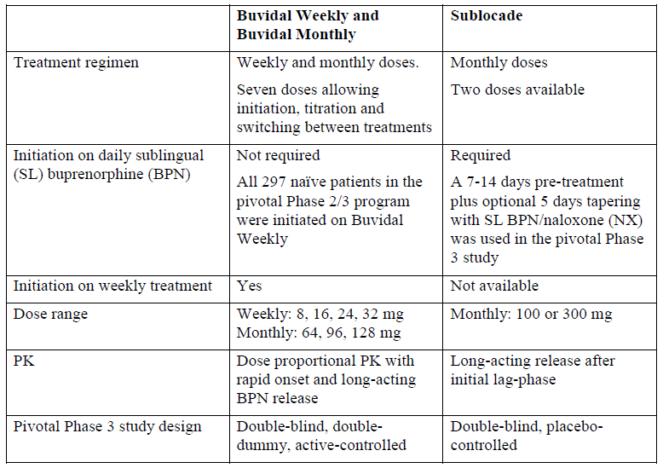

Question 1 for ACM
Does the Committee consider that, if approved, supply of these buprenorphine products should be restricted to hospital and specialist drug rehabilitation clinics? Community pharmacy dispensing programs would be excluded from supplying Buvidal Weekly and Buvidal Monthly.
This approach is intended to optimise patient selection, dose titration, and administration technique. It should also assist in client attendance to counselling/review sessions.
The sponsor initially proposed and continues to propose that administration of Buvidal Weekly and Buvidal Monthly is restricted to healthcare professionals (HCPs) only. The sponsor would like to highlight that National Guidelines for Medical-Assisted Treatment of Opioid Dependence (2014),10 state that:
‘Restricting a drug to being used only in specialist settings limits its usefulness as an intervention. In general, the balance between accessibility and quality is best maintained when general practitioners are trained to prescribe pharmacotherapies, and are able to refer patients or to consult with specialist drug and alcohol services.’
The question posed to the ACM is contrary to this principle and the sponsor is concerned that this would result in restricted patient access to Buvidal in Australia. The sponsor’s opinion is strongly supported by experts in the field of opioid dependence treatment and extracts from written statements are summarised below.
- Extract of statement from[Information redacted] Expert 1, 13 September 2018
‘[The expert] agrees that it is important that Buvidal has restrictions that it should not be dispensed or supplied directly to the patient, and that administration requires a health professional whose scope of practice includes administering subcutaneous injections of S8 medications, that is, a nurse or medical practitioner.
However, [the expert is] concerned that restricting the dispensing of Buvidal to only specialist clinics or hospitals will make Buvidal unavailable in many parts of the country where specialist clinics are sparse or do not exist, such as regional or rural settings, outer suburbs of most cities (and indeed, most of the state of Victoria where there are few if any specialist clinics with on-site pharmacists). The paradox is that it is these populations where we see the greatest advantage to patient care through the introduction of Buvidal.’
A complete statement was provided as an Appendix.
- Statement from [Information redacted] Expert 2, 13 September 2018
‘Of the 8 national jurisdictions, Victoria has almost 30% of the 49,792 Australians on medication assisted treatment for opioid dependence (MATOD). One of the most commonly reported consumer complaints about MATOD is that of ‘liquid handcuffs’. Regardless of treatment type, this refers to the consumer feeling s/he is ‘chained’ to 3 or more pharmacy visits per week which restricts the ability to work, travel and meet family commitments. With 5,136 (36%) of the 14,233 Victorian MATOD consumers receiving a buprenorphine based treatment in 2017, a depot preparation of buprenorphine, (for example, CAM2038) has the potential to eliminate the ‘liquid handcuff’ element of MATOD for some consumers. Of the 1,474 Victorian MATOD prescribers, 99% work in the private sector and over 90% of doses are delivered by 594 approved pharmacies, there are no Victorian public or private clinics. If a depot preparation of buprenorphine was only available through hospital and specialist clinics, the overwhelming majority of the Victorian MATOD consumer group, would be denied access to this new product based on our system of service delivery alone.’
- Extract of statement from[Information redacted] Expert 3, 13 September 2018
‘As an addiction specialist practising outside a capital city, [the expert] can see the benefits of long acting buprenorphine for many of our rural and regional patients, including many who cannot currently participate in opiate treatment due to the need for regular attendance for dosing. However, Buvidal should not be restricted to specialist clinics and hospital settings. General practitioners and community pharmacists are the frontline of our treatment response to opioid dependence and need to be able to prescribe and supply Buvidal in general practice settings. Practice nurses and doctors are capable of giving Buvidal injections. Depot preparations of anti-psychotic medications are commonly used in Australia for the management of schizophrenia and bipolar disorder in primary care settings, and there is no reason this should not be the same in the opioid treatment area.’
A complete statement was provided as an Appendix [not provided in this this document].
- Statement from [Information redacted] Expert 4, 12 September 2018
‘GPs play a crucial role in the treatment and management of opioid dependence with 65% of care in Australia provided by GPs. Access to care is limited (particularly rural areas) and restricting depot buprenorphine use to the specialist setting will limit care for many patients with associated poor health outcomes. GPs are trained and able to provide opioid dependency care. State health departments are happy to accredit GPs to provide care. In NSW we have recently changed our guidelines to support GPs to initiate buprenorphine treatment as we understand that it is an important and safe therapy that GPs can manage.
[This expert] has experience with one of the depot formulations and found it to be easy to administer and appropriate for use in the community setting. It was very useful for patients in the process of completing and ceasing treatment and equally useful in less stable patients. This formulation gave patients much greater autonomy as they didn’t need to attend frequent dosing at pharmacy or clinic. If it were available for me to prescribe from the general practice setting, [this expert] sees no particular problems with storage or arranging delivery from my local pharmacy for administration in my surgery.’
- Statement from [Information redacted] Expert 5, 11 September 2018
‘Due to the extensive number of community pharmacy locations, the extended hours of operation, and the professional services available from pharmacists, community pharmacies are well placed to provide opioid dependence therapy (ODT). Recent Australian Institute of Health and Welfare (AIHW) data indicates that on a snapshot day in mid-2017, over 50,000 clients received opioid pharmacotherapy at 2,732 dosing points around Australia. 89% of dosing points were community pharmacies.
Community pharmacies authorised to provide ODT should be integrated into in the distribution of Buvidal injection. By restricting access to hospital and specialist rehabilitation clinics, a barrier to access is constructed and patients may be adversely impacted, especially those in rural and remote areas.
Selected community pharmacies already have arrangements and facilities such as private consulting rooms and could provide dose administration services, thus increasing equitable access arrangements.’

Question 3 for ACM
Does the Committee agree that patients being considered for a Buvidal product should first be stabilised on SL buprenorphine or buprenorphine/naloxone? If so, does the Committee consider an induction period of 7 days is sufficient and that the initial transition should be to Buvidal Weekly?
The sponsor would like to clarify that in the clinical program for Buvidal, all 297 treatment-naïve patients who participated in the Phase II and Phase III studies were initiated directly on Buvidal Weekly, without prior stabilisation on SL buprenorphine or SL buprenorphine/naloxone. A pre-stabilisation phase on SL buprenorphine was not required, nor was it studied, in the clinical program for Buvidal. This was completely different to the clinical program for Sublocade (Indivior), which was not developed for direct treatment initiation. Thus, there were no treatment-naïve subjects initiated directly on Sublocade without a 7 to 14 days pre-stabilisation period on SL buprenorphine/naloxone before being dosed with monthly Sublocade (300 mg).
The availability of multiple doses of Buvidal Weekly combined with dose-proportional PK allows for easy initiation and dose adjustment/titration. This regimen was thoroughly studied in the Buvidal clinical program, demonstrating both effectiveness and tolerability.
In the Phase II study (Study HS-13-478), direct induction of 47 opioid dependent subjects with 24 mg or 32 mg Buvidal Weekly was successfully conducted showing complete blockade of opioid drug liking, euphoria and other subjective readouts from the first dose on Day 1 and for the duration of the study. Similarly, Buvidal Weekly was shown to effectively block other opioid effects, such as sedation, and provide rapid and sustained suppression of opioid cravings and withdrawal, which are all considered clinically important factors for the patient’s ability to stop or reduce illicit use of opioid drugs. The ability of the Buvidal Weekly treatment to effectively reduce illicit drug use and keep patients in treatment after initiation with Buvidal Weekly was demonstrated in the Phase III Studies HS-11-421 and HS-14-499. The degree of illicit drug use directly after initiation with Buvidal Weekly was in Study HS-11-421 initially similar to standard treatment with SL buprenorphine/naloxone, but already after a few weeks of treatment, patients treated with Buvidal showed less illicit opioid use than patients treated with SL buprenorphine/naloxone. The retention in treatment after direct induction on Buvidal Weekly was high in both Phase III studies, also compared to other recent studies with daily treatment with SL buprenorphine/naloxone products.
In conclusion, based on the design of the clinical program, the sponsor does not consider a prior initiation or stabilisation period on SL buprenorphine or buprenorphine/naloxone to be indicated. In addition, the long-acting duration of Buvidal Weekly ensures the patient’s treatment adherence during the initial treatment phase when patients are most vulnerable to relapse and drop out. The currently proposed PI is considered clinically appropriate.

Question 4 for ACM
Does the Committee agree that Buvidal Monthly should only be given to individuals who have been stabilised on Buvidal Weekly?
In the response to the second round of labelling questions (submitted to the TGA on 25 June 2018), the sponsor agreed to the proposal from the TGA to include instructions in section 4.2 of the PI to stabilise the subjects on 4 weeks of Buvidal Weekly before switching to Buvidal Monthly. The 4 weeks of stabilisation were used as part of the transition criteria in the Study HS-14-499 that included stable dosing of Buvidal Weekly for 4 weeks before transitioning to Buvidal Monthly. An analysis of data for the patients who reached a stable Buvidal Weekly dose in the HS-14-499 Study showed that the median time to reach a stable dose ranged from 4.5 days (for 16 mg Buvidal Weekly) to 15 days (for 32 mg Buvidal Weekly), which is considerably less than 4 weeks.
In Study HS-11-421, the 12 weeks of treatment with Buvidal Weekly before transitioning to Buvidal Monthly were chosen in order to investigate both formulations in a controlled way while retaining the blind in a double dummy study design. The 12 weeks of treatment with Buvidal Weekly were, thus, not based on a pre-defined stabilisation period.
Based on the fact that patients generally reached stable dose within 15 days, the sponsor considers a 4 week stabilisation period before patients can be transitioned from Buvidal Weekly to Buvidal Monthly to be more than sufficient. A mandated 12 week period is considered excessive and will limit the ability for individualised treatment to patients’ needs. The current wording in the PI section 4.2 is, hence, considered appropriate. However, the sponsor suggests that this information is appropriate for the posology section and should not be part of the indication section 4.1.

Question 5 for ACM and other comments on the RMP
Does the Committee have comments on the proposed education strategy included in the Risk Management Plan?
The sponsor confirms that educational material for HCPs and for patients will be submitted for TGA review prior to launch, which is planned for April 2019. The sponsor plans to provide the educational material for TGA review by January 2019 to allow for TGA review and acceptance of the material prior to the launch date.
This is in line with the TGA evaluation report for RMP, dated 12 June 2018 and the sponsor agrees to the distribution proposal as recommended by TGA; that is, that the educational material should be distributed to addiction medicine specialists (including Australian State and Territory Drug and Alcohol health services), GPs and pharmacists (community and hospital) as a minimum.
Once approved, the material will be distributed to addiction medicine specialists (including Australian State and Territory Drug and Alcohol health services), GPs and pharmacists (community and hospital).
The sponsor will assess whether any other HCPs should receive the material and detail the distribution strategy, including whether adequate distribution has been achieved.
In addition to sponsor-provided educational materials, the sponsor will work with each State Health Department to update opioid pharmacotherapy guidelines and training material with inclusion of information on Buvidal.
The educational material for consumers is planned to be distributed via the prescribers and documented by the prescriber.
The effectiveness of distribution as well as the effectiveness of the risk minimisation measures will be monitored and reported to TGA in PSURs.
The ASA included in this submission, version 0.5 dated 13 September 2018, has been updated to include the recommended wording on PSUR requirements.
The sponsor would also like to clarify that the latest submitted ASA, version 0.4 dated 20 June 2018, already includes information on gabapentinoids.
As required by TGA, the PI and CMI will be made available on the TGA website. In addition, the PI and CMI will be distributed by Guildlink. Guildlink ensures distribution to clinicians, pharmacists, publications, compendiums and consumer websites, including over 45 health information providers. http://www.guildlink.com.au/medicines-information/

Questions for sponsor
- Please submit a table showing the distribution of dose regimens of SL buprenorphine/naloxone, CAM2038 q1w and CAM2038q4w that subjects were stabilised to in Study HS-11-421. State the median dose and the range in each case.
In Study HS-11-421, an analysis of the administered doses showed that the median Buvidal Weekly dose in the first phase of the Phase III study was 24 mg (range 16 to 32 mg) at all visits after initiation (that is, from Week 2 to Week 12). In the second phase, the median Buvidal Monthly dose was 96 mg (range 64 to 160 mg). The corresponding median daily SL buprenorphine/naloxone dose was 16 mg (range 8 to 32 mg) across the Phase III study. Hence, a stable median dose was reached already after the first week of initiation and was maintained throughout the study treatment with individual dose adjustments for efficacy and tolerability occurring over time.
- Please submit a table showing the distribution of dose regimens of CAM2038 q1w and CAM2038q4w that study subjects were stabilised to in Study HS-14-499. State the median dose and the range.
Table 18 shows the doses of Buvidal Weekly and Buvidal Monthly that the patients in Study HS-14- 499 were stabilised on (defined as the same dose given for 4 or more consecutive weeks). Note that a patient can be included as stabilised on both Buvidal Weekly and Buvidal Monthly in the study. Importantly, the median doses in the flexible dose Study HS 14-499 are identical to the median doses reached in Study HS-11-421.
Table 18: Doses of Buvidal Weekly and Buvidal Monthly that patients were stabilised on in Study HS-14-499 (N = 227)
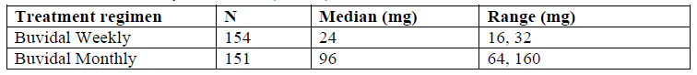

Questions on Product Information
These are beyond the scope of this AusPAR.

Other requests
- A tabulation of any serious unexpected adverse drug reactions which are not mentioned in the proposed Australian Product Information and have not been submitted previously.
A table of serious unexpected adverse drug reactions is provided in Table 19.
Table 19: CAM2038 cumulative summary tabulations unexpected serious adverse reactions (SARs) all studies
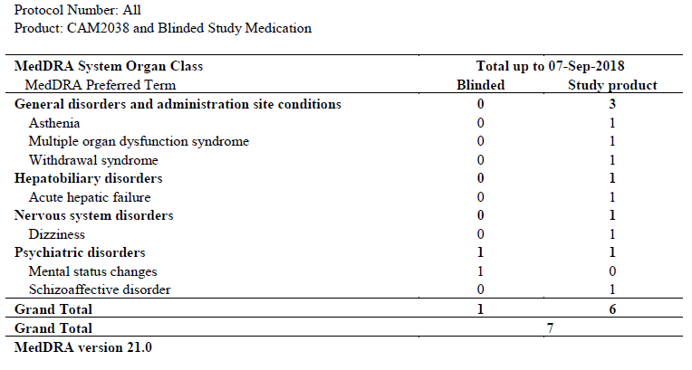

Advisory Committee Considerations
The Advisory Committee on Medicines (ACM), having considered the evaluations and the Delegate’s overview, as well as the sponsor’s response to these documents, advised the following.
The ACM taking into account the submitted evidence of efficacy, safety and quality, agreed with the Delegate and considered Buvidal prolonged release solution for injection in pre-filled syringes containing buprenorphine: 8 mg in 0.16 mL solution; 16 mg in 0.32 mL solution; 24 mg in 0.48 mL solution; 32 mg in 0.64 mL solution; 64 mg in 0.18 mL solution; 96 mg in 0.27 mL solution; 128 mg in 0.36 mL solution; 160 mg in 0.45 mL solution; to have an overall positive benefit-risk profile for the proposed indication:
Buvidal is indicated for the treatment of opioid dependence within a framework of medical, social and psychological treatment. Buvidal is intended for use in adults and adolescents aged 16 years or over.
In providing this advice the ACM noted the following:
- Study HS-11-421 was a Phase III, randomised, double blind, active controlled study of the efficacy and safety of once weekly and once-monthly depot buprenorphine (CAM2038) compared with sublingual buprenorphine/naloxone in adult patients with opioid use disorder. The primary efficacy endpoint for the EMA analyses was the percentage of urine samples negative for illicit opioids based on the 18 urine samples obtained during the post-induction period (treatment Weeks 1 to 24, corresponding to sample Weeks 2 to 25). The primary efficacy endpoint for the FDA analysis was the response rate, based on evidence of no illicit opioid use within a defined period. Non-inferiority of CAM2038 with SL buprenorphine/naloxone was demonstrated for both the EMA and FDA specified primary endpoints.
- The safety profile of CAM2038 given weekly or monthly was comparable to that of SL buprenorphine/naloxone. The most frequent adverse events were injection site related (injection site pain, pruritus and erythema).
- The depot formulation of buprenorphine may offer benefits for patients due to the reduced frequency of dose administration compared to current therapies which can require daily supervised dosing.

Proposed conditions of registration
The ACM agreed with the Delegate on the proposed conditions of registration and advised on the inclusion of the following:
- A phased introduction of Buvidal, so that administration is restricted to specialist settings initially, and can subsequently be opened up to a broader group of healthcare professionals.
- Satisfactory implementation of the Risk Management Plan most recently negotiated by the TGA.

Proposed Product Information (PI)/Consumer Medicine Information (CMI) amendments
The ACM agreed with the Delegate to most of the proposed amendments to the Product Information (PI) and Consumer Medicine Information (CMI), with additional recommendations outlined in the specific advice below.

Specific advice
The ACM advised the following in response to the Delegate’s specific questions on the submission:
- Does the Committee consider that, if approved, supply of these buprenorphine products should be restricted to hospital and specialist drug rehabilitation clinics? Community pharmacy dispensing programs would be excluded from supplying Buvidal Weekly and Buvidal Monthly. This approach is intended to optimise patient selection, dose titration, and administration technique. It should also assist in client attendance to counselling/review sessions.
The ACM considered that a phased introduction of this buprenorphine product may be appropriate, where during an initial period (that is, six months), Buvidal should be restricted to a specialist setting so that appropriate experience with the formulation is developed, and enable such specialists to provide experience informed, clinical advice to other prescribers and general practitioners, when made available subsequently for broader prescriber groups.
The ACM also noted that delivery of opioid replacement therapy varies in different Australian jurisdictions. For example, in Victoria, most treatment is provided through approved general practitioners and community pharmacies, therefore access to this formulation would be greatly limited if restricted only to hospital and specialist drug clinics.
The ACM acknowledged the advantages this formulation may have especially for rural and remote populations, where access to hospital and specialist drug rehabilitation clinics is scarce, and advised that consideration should also be given to allowing administration by pharmacists (after the initial phase in period) under the training of a specialist, for example, supervision via video consultation.
- A Boxed Warning regarding venous occlusion on accidental or intentional intravenous administration is being considered. The Committee’s opinion on a boxed warning is requested.
The ACM agreed that a boxed warning is an appropriate measure given the significant risk of harm from intravenous administration.
- Does the Committee agree that patients being considered for a Buvidal product should first be stabilised on SL buprenorphine or buprenorphine/naloxone? If so, does the Committee consider an induction period of 7 days is sufficient and that the initial transition should be to Buvidal Weekly?
The ACM agreed that patients should first be stabilised on sublingual buprenorphine or buprenorphine/naloxone, and that an induction period of seven days is sufficient.
The ACM considered that transition to a weekly or monthly Buvidal product should be left to the clinical judgment of the prescriber.
- Does the Committee agree that Buvidal Monthly should only be given to individuals who have been stabilised on Buvidal Weekly?
The ACM considered that whilst transitioning from the weekly presentation to the monthly presentation would be appropriate for some patients, stabilisation on Buvidal Weekly should not be a requirement for initiation on Buvidal Monthly, and the choice of product on commencement would be managed in clinical practice.
- Does the Committee have comments on the proposed education strategy included in the Risk Management Plan?
The ACM noted that the sponsor has agreed to prepare and distribute educational material to healthcare professionals and patients on safety concerns. The Committee considered the proposed education strategy to be reasonable, subject to the educational material being approved by the TGA.
The ACM advised that implementation by the sponsor of the recommendations outlined above to the satisfaction of the TGA, in addition to the evidence of efficacy and safety provided would support the safe and effective use of these products.

Outcome
Based on a review of quality, safety and efficacy, the TGA approved the registration of Buvidal (buprenorphine) Weekly 8 mg/0.16 mL, 16 mg/0.32 mL, 24 mg/0.48 mL and 32 mg/0.64 mL and Monthly 64 mg/0.18 mL, 96 mg/0.27 mL, 128 mg/0.36 mL solution for injection, indicated for:
Buvidal Weekly is indicated for maintenance treatment of opioid dependence within a framework of medical, social and psychological support.
Buvidal Monthly is indicated for maintenance treatment of opioid dependence within a framework of medical, social and psychological support.

Specific conditions of registration applying to these goods
The Buvidal EU-Risk Management Plan (RMP) (version 0.2, dated 24 April 2018, data lock point 15 May 2017), with Australian Specific Annex (version 0.6, dated 22 October 2018), included with submission PM-2017-02926-1-1, to be revised to the satisfaction of the TGA, will be implemented in Australia.
To ensure that the proposed educational materials will adequately mitigate the risks associated with the use of Buvidal, the sponsor should provide mock-ups to the TGA for review. This material must be acceptable to the TGA before the supply of Buvidal begins.
The sponsor must implement a restricted access scheme to ensure that distribution of Buvidal is limited, in the first 6 months of supply, to prescribers in hospital and specialist drug rehabilitation clinics who have demonstrated that they have reviewed the educational materials. The plan for this scheme must be considered adequate to the TGA before the supply of Buvidal begins.
The sponsor should implement additional risk minimisation on commencement of supply of Buvidal beyond the restricted access scheme. The evaluation of the restricted access scheme and educational materials and the revised risk minimisation plan must be considered acceptable to the TGA before the restricted access scheme concludes and broader supply of Buvidal commences.
Pharmacists should dispense Buvidal to the prescribing doctor and not directly to the patient.
An obligatory component of risk management plans is routine pharmacovigilance. Routine pharmacovigilance includes the submission of Periodic Safety Update Reports (PSURs).
Unless agreed separately between the supplier who is the recipient of the approval and the TGA, the first report must be submitted to TGA no later than 15 calendar months after the date of this approval letter. The subsequent reports must be submitted no less frequently than annually from the date of the first submitted report until the period covered by such reports is not less than three years from the date of this approval letter. The annual submission may be made up of two PSURs each covering six months. If the sponsor wishes, the six monthly reports may be submitted separately as they become available.
The reports are to at least meet the requirements for PSURs as described in the European Medicines Agency’s Guideline on good pharmacovigilance practices (GVP) Module VII-periodic safety update report (Rev 1), Part VII.B Structures and processes. Note that submission of a PSUR does not constitute an application to vary the registration. Each report must have been prepared within ninety calendar days of the data lock point for that report.

Attachments 1 and 2. Product Information
The PI documents for Buvidal approved with the submission which is described in this AusPAR is at Attachments 1 and 2. For the most recent PI, please refer to the TGA website at <https://www.tga.gov.au/product-information-pi>.

Therapeutic Goods Administration
PO Box 100 Woden ACT 2606 Australia
Email: info@tga.gov.au Phone: 1800 020 653 Fax: 02 6232 8605
https://www.tga.gov.au

These versions of the PI have had the sponsor name changed since they were approved. No other changes occurred.
A Type F application is defined as an application involving a ‘major variation (new route of administration; new strength; new dosage form; change in dosage, dose regimen or maximum daily dose; or change in patient group).
Albayaty, M. et al. (2017), Pharmacokinetic evaluation of once-weekly and once-monthly buprenorphine subcutaneous injection depots (CAM2038) versus intravenous and sublingual buprenorphine in healthy volunteers under naltrexone blockade: an open-label phase 1 study. Advances in Therapy, 2017; 34: 560–575.
International Conference on Harmonisation, Impurities; Guidelines for Residual Solvents, Q3C (R6), 17 January 2017
European Medicines Agency, Committee for Human Medicinal Products (CHMP), Guideline on repeated dose toxicity, CPMP/SWP/1042/99 Rev 1 Corr*, March 2010
The ‘cavity’ is observed when evaluating the tissue sections from the injection site under the microscope. The tissue section has been fixated onto a glass slide, and in that fixation process (using the fixation chemicals) lipids in the tissue and in the drug product lipid matrix are washed away. Therefore, the position of the lipid matrix in the tissue section now appears as a ‘cavity’ when evaluating the tissue section in the microscope.
Phillips, B.J. and Jenkinson P. (2001), Is ethanol genotoxic? A review of the published data. Mutagenesis, 2001; 16: 91–101.
European Commission Scientific Committee on Consumer Safety (SCCS), Opinion on N-Methyl-2-pyrrolidone (NMP), SCCS/1413/11, 22 March 2011.
United States Food and Drug Administration, 184.1400 Lecithin, 48 FR 51150, Nov. 7, 1983. Accessed from the United States govinfo website.
European Medicines Agency, Committee for Proprietary Medicinal Products (CPMP), Note for guidance on genotoxicity: specific aspects of regulatory genotoxicity tests for pharmaceuticals, CPMP/ICH/141/95, April 1996.
Toxicological review and risk analysis of N-methylpyrrolidone; Camurus reference no. TO-16-570
Pregnancy Category C: Drugs which, owing to their pharmacological effects, have caused or may be suspected of causing, harmful effects on the human fetus or neonate without causing malformations. These effects may be reversible. Accompanying texts should be consulted for further details.
Detailed information on the management of opioid dependency in Australia is available in the National Guidelines for Medication-Assisted Treatment of Opioid Dependence, accessed from the Australian National Drugs Strategy website.
The addition of naloxone is designed to deter parenteral misuse. The bioavailability of buprenorphine is not influenced by the addition of naloxone.
Hy’s Law: ALT > 3 times upper limit of normal (ULN) and total bilirubin > 2 times ULN.
Routine risk minimisation activities may be limited to ensuring that suitable warnings are included in the product information or by careful use of labelling and packaging. Routine pharmacovigilance practices involve the following activities: - All suspected adverse reactions that are reported to the personnel of the company are collected and collated in an accessible manner; - Reporting to regulatory authorities; - Continuous monitoring of the safety profiles of approved products including signal detection and updating of labeling; - Submission of PSURs; - Meeting other local regulatory agency requirements.
The time to sustained abstinence of opioid use in weeks could not be determined by the sponsor.
Walsh, S.L. et al. (2017), Effect of Buprenorphine Weekly Depot (CAM2038) and Hydromorphone Blockade in Individuals with Opioid Use Disorder: A Randomized Clinical Trial, JAMA Psychiatry, 2017; 74: 894-902.
Lofwall, M.R. et al. (2018), Weekly and Monthly Subcutaneous Buprenorphine Depot Formulations vs Daily Sublingual Buprenorphine With Naloxone for Treatment of Opioid Use Disorder: A Randomized Clinical Trial, JAMA Intern Med, 2018; 178: 764-773.
Amass, L. et al. (2012), A prospective, randomized, multicenter acceptability and safety study of direct buprenorphine/naloxone induction in heroin-dependent individuals, Addiction, 2012; 107: 142-151.
Webster, L. et al. (2016), Efficacy and safety of a sublingual buprenorphine/naloxone rapidly dissolving tablet for the treatment of adults with opioid dependence: A randomized trial, J Addic Dis, 2016; 35: 325-338.
The ACM provides independent medical and scientific advice to the Minister for Health and the Therapeutic Goods Administration (TGA) on issues relating to the safety, quality and efficacy of medicines supplied in Australia including issues relating to pre-market and post-market functions for medicines. The Committee is established under Regulation 35 of the Therapeutic Goods Regulations 1990. Members are appointed by the Minister. The ACM was established in January 2017 replacing Advisory Committee on Prescription Medicines (ACPM) which was formed in January 2010. ACM encompass pre and post-market advice for medicines, following the consolidation of the previous functions of the Advisory Committee on Prescription Medicines (ACPM), the Advisory Committee on the Safety of Medicines (ACSOM) and the Advisory Committee on Non-Prescription Medicines (ACNM). Membership comprises of professionals with specific scientific, medical or clinical expertise, as well as appropriate consumer health issues relating to medicines.

