Date of CER: November 2014

AusPAR Attachment 2

Extract from the Clinical Evaluation Report for budesonide
  - Proprietary Product Name: Cortiment
  - Sponsor: Ferring Pharmaceuticals Pty Ltd

About the Therapeutic Goods Administration (TGA)
- The Therapeutic Goods Administration (TGA) is part of the Australian Government Department of Health, and is responsible for regulating medicines and medical devices.
- The TGA administers the Therapeutic Goods Act 1989 (the Act), applying a risk management approach designed to ensure therapeutic goods supplied in Australia meet acceptable standards of quality, safety and efficacy (performance), when necessary.
- The work of the TGA is based on applying scientific and clinical expertise to decision-making, to ensure that the benefits to consumers outweigh any risks associated with the use of medicines and medical devices.
- The TGA relies on the public, healthcare professionals and industry to report problems with medicines or medical devices. TGA investigates reports received by it to determine any necessary regulatory action.
- To report a problem with a medicine or medical device, please see the information on the TGA website <https://www.tga.gov.au>.
About the Extract from the Clinical Evaluation Report
- This document provides a more detailed evaluation of the clinical findings, extracted from the Clinical Evaluation Report (CER) prepared by the TGA. This extract does not include sections from the CER regarding product documentation or post market activities.
- The words [Information redacted], where they appear in this document, indicate that confidential information has been deleted.
- For the most recent Product Information (PI), please refer to the TGA website <https://www.tga.gov.au/product-information-pi>.
Copyright
© Commonwealth of Australia 2016
This work is copyright. You may reproduce the whole or part of this work in unaltered form for your own personal use or, if you are part of an organisation, for internal use within your organisation, but only if you or your organisation do not use the reproduction for any commercial purpose and retain this copyright notice and all disclaimer notices as part of that reproduction. Apart from rights to use as permitted by the Copyright Act 1968 or allowed by this copyright notice, all other rights are reserved and you are not allowed to reproduce the whole or any part of this work in any way (electronic or otherwise) without first being given specific written permission from the Commonwealth to do so. Requests and inquiries concerning reproduction and rights are to be sent to the TGA Copyright Officer, Therapeutic Goods Administration, PO Box 100, Woden ACT 2606 or emailed to <tga.copyright@tga.gov.au>.

Contents
List of abbreviations 5
1. Introduction 7
2. Clinical rationale 7
3. Contents of the clinical dossier 7
3.1. Scope of the clinical dossier 7
3.2. Paediatric data 8
3.3. Good clinical practice 8
4. Pharmacokinetics 8
4.1. Studies providing pharmacokinetic data 8
4.1. Summary of pharmacokinetics 9
4.2. Evaluator’s overall conclusions on pharmacokinetics 11
5. Pharmacodynamics 12
6. Dosage selection for the pivotal studies 12
7. Clinical efficacy 12
7.1. Pivotal efficacy studies 12
7.2. Other efficacy studies 22
7.3. Analyses performed across trials (pooled & meta analyses) 24
7.4. Evaluator’s conclusions on clinical efficacy 26
8. Clinical safety 27
8.1. Studies providing evaluable safety data 27
8.2. Pivotal studies that assessed safety as a primary outcome 27
8.3. Patient exposure 27
8.4. Adverse events 27
8.5. Clinical laboratory tests 35
8.6. Vital signs 36
8.7. Physical examination 36
8.8. Other safety parameters 37
8.9. Post-marketing experience 38
8.10. Evaluator’s overall conclusions on clinical safety 39
9. First round benefit-risk assessment 39
9.1. First round assessment of benefits 39
9.2. First round assessment of risks 40
9.3. First round assessment of benefit-risk balance 40
10. First round recommendation regarding authorisation 40
11. Clinical questions 40
12. Second round evaluation 40
13. Second round benefit-risk assessment 41
13.1. Second round assessment of benefits 41
13.2. Second round assessment of risks 41
13.3. Second round assessment of benefit-risk balance 41
14. Second round recommendation regarding authorisation 41
15. References 41

List of abbreviations
Abbreviation | Meaning
ACTH | Adrenocorticotropic hormone
ADR | Adverse drug reaction
AE | Adverse event
ALT | Alanine aminotransferase
AST | Aspartate aminotransferase
AUC∞ | Area under the plasma concentration-time curve from time 0 to infinity
CAI | Clinical Activity Index
CIOMS | Council for International Organizations of Medical Sciences
Cl | Clearance
C_{max} | Peak concentration
ED | Exposure day
EU | European Union
GGT | Gamma glutamyl transpeptidase
HBV | Hepatitis B virus
HCV | Hepatitis C virus
HIV | Human immunodeficiency virus
HPA axis | Hypothalamus-pituitary- adrenal axis
IBD | Inflammatory bowel disease
IBD-QoL | Inflammatory Bowel Disease-Quality of Life
IU | International units
K-value | Incremental recovery
MedDRA | Medical Dictionary for Regulatory Activities
MMX | Multi-Matrix
MRT | Mean residual time
PK | Pharmacokinetic(s)
SAE | Serious adverse event
SD | Standard deviation
SOC | System Organ Class
SE | Standard error
TEAEs | Treatment-emergent adverse events
t_{1/2} | Half life
tds | three times daily
UC | Ulcerative colitis
UCDAI | Ulcerative Colitis Disease Activity Index
Vss | Steady-state volume of distribution

Introduction
This is an application to register a new dosage form of budesonide for a new indication. The new indication is for:
induction of remission in patients with mild to moderate active ulcerative colitis (UC).
The new dosage form is prolonged release tablets, each containing 9 mg of micronized budesonide. The proposed daily dose is one 9 mg tablet to be administered orally in the morning for up to 8 weeks.

Clinical rationale
As a synthetic glucocorticoid, budesonide is known to possess anti-inflammatory effects comparable to those of conventional glucocorticoids. There are three budesonide products currently registered on the ARTG for the treatment of IBD, of which two are oral capsules for induction of remission in mild to moderate Crohn's disease affecting the ileum and/or the ascending colon (Entocort and Budenofalk) and one is enema for use in active rectal and rectosigmoid UC (Budenofalk Foam Enema).
Due to extensive absorption from the small intestine and right ascending colon, the currently available oral budesonide formulations are deemed to be unsuitable for the treatment of distal colonic lesions, notably in UC. Using the patented Multi-Matrix (MMX) system, the proposed Cortiment prolonged-release tablets (also referred to as budesonide-MMX) are designed to deliver budesonide at a controlled manner throughout the colon, making it a potential alternative for clinical management of UC. Thus, this product represents a new dosage form of orally administered and topically acting budesonide for a new clinical indication.

Contents of the clinical dossier

Scope of the clinical dossier
This application comprises of the following seven clinical studies:
- A Phase I pilot pharmaco scintigraphic study in healthy volunteers (CRO-01-28; Brunner 2006)
- A Phase I study in healthy volunteers, exploring the effects of food on budesonide bioavailability after the administration of a single dose of Cortiment, in addition to characterising pharmacokinetics following 7 consecutive daily doses of Cortiment (CRO-PK-03-105; Brunner 2006)
- An additional Phase I study in healthy volunteers, comparing budesonide pharmacokinetics following singles doses of Cortiment 6 and 9 mg and Entocort 9 mg (3 x 3 mg) capsules (CRO-PK-06-178)
- A Phase II study in patients with active mild or moderate left sided UC, evaluating the safety and efficacy of Cortiment (CRO-03-53; D'Haens 2010)
- A Phase II dose finding study in patients with active mild or moderate UC, comparing the efficacy and safety of 3 and 9 mg oral daily doses of Cortiment (CB-01-02/05)
- Two Phase Ill studies, evaluating the efficacy and safety of Cortiment 9 mg (CB-01-02/01 and CSR CB-01-02/02).
Of these seven studies, the two Phase III trials (CB-01-02/01 and CB-01-02/02) are pivotal, with the remaining five being supportive.
In addition, this application also contains the following:
- Clinical Overview, Summary of Biopharmaceutical Studies and Associated Analytical Methods, Summary of Clinical Pharmacology Studies, Summary of Clinical Efficacy and Summary of Clinical Safety.
The Sponsor indicated that the dossier submitted in Australia is essentially the same as that submitted in the EU. However, the clinical dataset submitted to the US also contains two additional clinical studies, CB-01-02/04 and CB-01-02/06. The CB-01-02/04 study was a trial for maintenance of remission using a 6 mg once daily dose in inpatients who had already completed the pivotal Phase III studies CB-01-02/01 and CB-01-02/02. This study was conducted to address a specific request by the FDA over concerns with potential use of the product beyond the recommended 8 week regimen. The CB-01-02/06 study was an open label trial with 9 mg treatment and patients who completed this study were also included in the CB-01-02/04 maintenance study. It was stated that these two additional studies were needed only for the FDA submission.

Paediatric data
The submission did not include paediatric data.

Good clinical practice
All studies submitted in the clinical dossier were conducted in accordance to GCP standards, except for four sites in the pivotal Phase III studies CB-01-02/01 and CB-01-02/02, where major GCP violations and efficacy results deemed biologically not plausible were reported during auditing. Consequently, all patients at these four sites were excluded from the intent-to-treat (ITT) population for efficacy analysis, but remained in the safety population for safety analysis.

Pharmacokinetics

Studies providing pharmacokinetic data
A total of three PK studies were submitted, all were conducted in healthy volunteers (see Table 1 below).

Table 1: Submitted pharmacokinetic studies
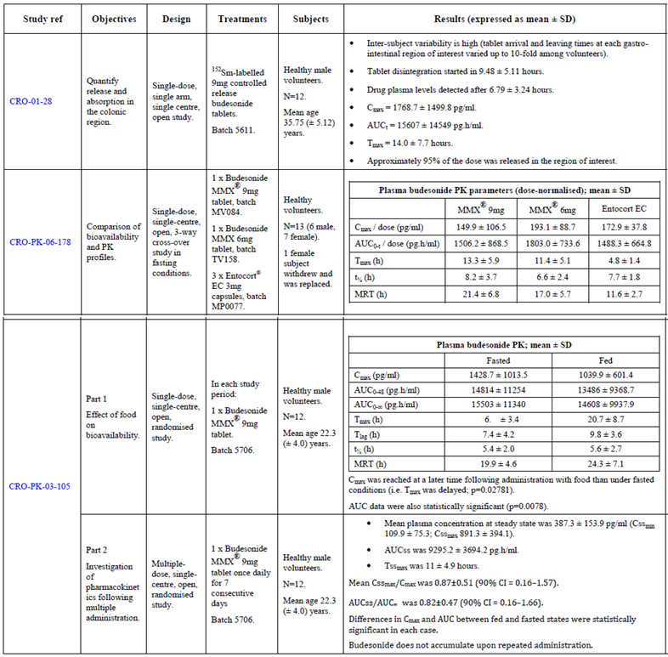
Comment: The T_{max} value for Part 1 of Study CRO-PK-03-105 was incorrectly stated as ‘6.±3.4’ h in the clinical summary, while the correct value is 16.0±3.4 h.
None of the PK studies had significant deficiencies that excluded their results from consideration.

Summary of pharmacokinetics
The clinical PK data provided in this submission contained information on GI transit, release and absorption, bioavailability, the influence of food on PK and multiple dose PK.

Gastrointestinal transit, release and absorption
The GI transit, release and absorption of budesonide were investigated in a Phase I pilot study in 12 healthy male volunteers following a single oral dose of ¹⁵³Sm-labeled budesonide controlled release tablet (CRO-01-28). This study was conducted at the Departments of Clinical Pharmacology and Nuclear Medicine, Vienna University Medical School, Austria during the period 6 to 19 August, 2002.
The study subjects (all Caucasian) were fasting while given the oral tablet containing 9 mg budesonide, with an average radioactivity dose of 1.118 ± 0.428 MBq as ¹⁵³Sm₂O₃. Standardised breakfast was served 2 h after the drug administration. Blood samples were collected at various intervals up to 24 h post dose for analysis using validated GC-MS with a LLQ of 50.0 pg/mL. Scintigraphic images were recorded at 20 min intervals up to 3 h post dose, then at 30 min intervals up to 10 h and again at 12 and 24 h post dose.
Large inter subject variations (up to 10 fold) in the PK parameters were noted. The budesonide tablet was reported to reach the ascending colon between 6 and 24 h after dosing and left the descending colon between 12 and 24 h after dosing. Plasma budesonide levels were detectable at 6.8 ± 3.2 h post dose, with a T_{max} of 14.00 ± 7.7 h. Results of the scintigraphic analysis of the GI transit of the budesonide tablet are summarised in Table 2 below.

Table 2: GI transit of ¹⁵³Sm labelled budesonide controlled release tablet.
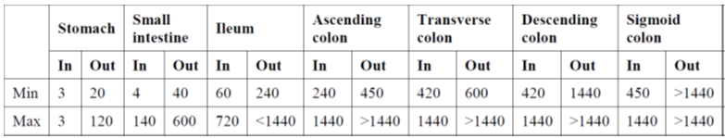
NB: presented as time (min) to arrive and leave the GI segment.

Bioavailability
The bioavailability of budesonide following a single dose of 6 and 9 mg controlled release tablet was investigated in a Phase I study of three way cross over design (CRO-PK-06-178), conducted in Switzerland.
A total of 13 healthy volunteers (all Caucasian) were enrolled, of which 12 (6 males and 6 females) completed the study as per protocol. One controlled release tablet of 9 mg (T1) or 6 mg (T2) budesonide, or three capsules of 3 mg Entocort (R) were administered in the morning under fasting conditions. A standard lunch and dinner were served at 5 and 12 h post dose. Blood and urine samples were collected at various intervals up to 36 h post dose for analysis using validated LC-MS/MS, with a LLQ of 50 pg/mL and 1 ng/mL for budesonide and its metabolite (6β-hydroxy budesonide) respectively. There was a wash out period of at least 5 days between administrations of the study products.
Large inter subject variations in the PK parameters for budesonide were again noted (see Table 1, above). Systemic absorption was noticeably slower following administration of the 9 mg and 6 mg tablet (mean plasma T_{max} of 13.3 and 11.4 h, respectively) than the Entocort capsules (mean plasma T_{max} of 4.8 h). The delay in systemic absorption was companied by an apparent increase in the residual time for the 9 mg and 6 mg tablet (mean MRT of 21.4 and 17.0 h, respectively), compared to the Entocort capsules (mean MRT of 11.6 h). The 90% CI for plasma C_{max} and AUC_{0-t} were both outside the 80 to 125% range between the 9 mg tablet and the Entocort capsules, suggesting that the two products were not bioequivalent. Urinary excretion of 6β-hydroxy budesonide was somewhat higher and faster following administration of the Entocort capsules than the 9 mg and 6 mg tablet.

Influence of food up to here
The effects of food on the PK of budesonide following a single oral dose of 9 mg controlled-release tablet was investigated in 12 male healthy volunteers in a Phase I Study CRO-PK-03-105. This study was conducted during the period 27 May to 24 June 2003. The study comprises of two parts, with Part 1 investigating the influence of food and Part 2 investigating the multiple dose PK of budesonide.
In Part 1 of the study, the budesonide-MMX 9 mg tablet was administered as a single oral dose to the study subjects (all Caucasian), either after fasting overnight for at least 10 h, or within 5 min postprandial, in a cross over design. There was a wash out period of 7 days between the fasted and postprandial administrations. Blood samples were collected pre dose and at various intervals up to 48 h post dose for determination of plasma budesonide levels using a validated GC/MS method, with a LLQ of 50 pg/mL.
Plasma C_{max} and AUC_{0-48h} for budesonide were statistically significantly higher in fasted subjects than in fed subjects (p = 0.02781 and p = 0.0078, respectively). Plasma T_{max} for budesonide was also smaller in fasted subjects than in fed subjects (mean 16.0 ± 3.4 h, versus 20.7 ± 8.7 h), although the difference did not reach statistical significance (p = 0.248). However, plasma AUC_{0-∞} for budesonide was somewhat similar in both fasted and fed subjects, suggesting minimal difference in systemic exposure between the two study conditions (see Table 1 above).

PK following multiple doses
The PK of budesonide following seven daily oral doses of 9 mg controlled release tablet was investigated in 12 male healthy volunteers in a Phase I Study CRO-PK-03-105. This study was conducted during the period 27 May to 24 June 2003. The study comprises of two parts, with Part 1 investigating the influence of food and Part 2 investigating the multiple dose PK of budesonide. There was a wash out period of 7 days between Parts 1 and 2 of the study.
In Part 2 of the study, the budesonide-MMX 9 mg tablet was administered daily for 7 consecutive days to the study subjects (all Caucasian) with each dose given after overnight fasting of 12 h. Blood samples were collected prior to administration of the 1st, 3rd, 5th, 6th and 7th doses and at various intervals up to 48 h after the 7th dose. Plasma budesonide levels were determined using validated GC/MS, with a LLQ of 50 pg/mL.
Comparison of systemic exposure to budesonide (plasma C_{max} and AUC) after a single and 7 days repeated doses revealed no evidence for accumulation of the drug following multiple administrations (see Table 1).

Evaluator’s overall conclusions on pharmacokinetics
As an established medicinal product, the PK of budesonide has previously been well characterised and documented. No data were submitted in this application on physicochemical characteristics, distribution, metabolism, excretion, PK/PD interaction, or population PK. This is considered acceptable. The absolute bioavailability of the proposed budesonide-MMX 9 mg tablet has not been investigated in the submitted clinical studies; however, given that the product is intended to act locally in the lower GIT, the absence of such data is not considered a major deficiency of the application.
The PK data submitted in this application for the proposed prolonged-release tablet (budesonide-MMX) focus primarily on GIT transit, release and absorption, bioavailability and influence of food and multiple administrations. All studies were conducted in healthy volunteers. No PK study was conducted in the targeted patient population. Given the common clinical presentations (especially diarrhoea) in UC patients, it is likely that the GIT transit, absorption and bioavailability of the product in the targeted patient population can be significantly different to those in healthy volunteers. It would therefore be more appropriate to have conducted a PK study in UC patients to further characterise the PK profile of the product in the targeted patient population. Nevertheless, the available PK data submitted in this application provided sufficient evidence for the targeted and controlled delivery of budesonide to the lower GIT and supported the proposed once daily dosing regimen.

Pharmacodynamics
No study provided.

Dosage selection for the pivotal studies
The dosage of budesonide (9 mg/day) selected for the two pivotal Phase III studies (CB-01-02/01 and CB-01-02/02) were based on information from the following two sources:
- published literature reporting that single daily oral doses of budesonide 9 mg are more efficacious than multiple daily divided doses in patients with active distal UC (Kolkman et al. 2004)
- results from the Phase II dose finding study in patients with mild or moderate active UC, comparing the efficacy and safety of daily doses of the budesonide-MMX 3 mg and budesonide-MMX 9 mg tablet (CB-01-02/05). In addition, on recommendation by the FDA, the dose of 6 mg/day budesonide was also included in the Phase III studies to try to identify the lowest effective dose for the treatment of patients with active, mild to moderate UC.

Clinical efficacy

Pivotal efficacy studies
Two pivotal Phase III studies (CB-01-02/01 and CB-01-02/02) were submitted, providing efficacy data for the proposed Cortiment 9 mg prolonged release tablet.

Study CB-01-02/01
This study was conducted in the USA, Canada, India and Mexico, during the period 20 August 2008 to 28 May 2010, to investigate the efficacy and safety of the budesonide-MMX 9 mg tablet in patients with mild or moderate active UC.

Study design
This was a multi-centre, randomised, double blind, double dummy, parallel group comparative study in patients with mild or moderate active UC. The study compared the budesonide-MMX 6 mg and 9 mg tablets to placebo and compared Asacol 6 x 400 mg over encapsulated tablets to placebo in four treatment groups over an 8 week treatment period. The Asacol over encapsulated tablet is an USA registered product containing 400 mg mesalazine (also known as mesalamine in USAN). Eligible patients underwent a wash out period of 2 days, prior to being randomised to one of the following four treatment groups as shown in Table 3.

Table 3. Study CB-01-01/01 treatment groups.
Group 1 (Budesonide-MMX 6 mg) | One budesonide-MMX 6 mg tablet, mane; and two placebo Asacol tablets, tds.
Group 2 (Budesonide-MMX 9 mg) | One budesonide-MMX 9 mg tablet, mane; and two placebo Asacol tablets, tds.
Group 3 (Placebo) | One placebo budesonide-MMX tablet, mane; and two placebo Asacol tablets, tds.
Group 4 (Asacol) | One placebo budesonide-MMX tablet, mane; and two Asacol 400 mg tablets, tds.
The patients were to refrain from taking other concomitant medications during the study; in particular, concomitant use of antibiotics, steroids, prokinetic or antimotility agents was not allowed. However, rescue medication was allowed for the control of UC symptoms. During the study, five visits to the study centre were scheduled: one at screening and four in the double blind treatment period (Day 1 and Weeks 2, 4 and 8). A safety follow up visit took place about 2 weeks after the final study visit. If patients were withdrawn from the study before Week 8, they were asked to attend the study centre as soon as possible so that the Final Visit assessments could be conducted. Serious adverse events (SAE) were to be captured for up to 30 days following the last study drug administration.

Study objectives
- Primary objective: To evaluate the efficacy and safety of budesonide-MMX 6 mg and 9 mg oral tablets when compared to placebo for the induction of remission in patients with mild or moderate active UC, when administered for 8 weeks.
- Secondary objective: To evaluate the clinical improvement and endoscopic improvement after 8 weeks treatment with budesonide-MMX 6 mg and 9 mg oral tablets when compared to placebo in patients with mild or moderate active UC.
- Other objectives: To evaluate symptom resolution and histological healing after 8 weeks of treatment with budesonide-MMX, the improvement in clinical and biohumoral parameters and in the Inflammatory Bowel Disease-Quality of Life (IBD-QoL) questionnaire after 8 weeks of treatment with budesonide-MMX and the efficacy and safety of Asacol over-encapsulated tablets (2 x 400 mg tds) when administered for 8 weeks in patients with mild or moderate active UC.

Inclusion and exclusion criteria
The inclusion and exclusion criteria of the study are shown in Table 4 and Table 5.

Table 4. Inclusion criteria in study CB-01-02/01 and study CB-01-02/02.
Patients fulfilling the following criteria at the screening visit were eligible for participation in the study
Male and female patients, 18 to 75 years old, suffering from UC for at least 6 months
Diagnosis of UC in active phase, of mild or moderate entity with UCDIA ≥ 4 and ≤ 10 according to Sutherland
All females of child bearing potential had to have a negative serum pregnancy test immediately prior to enrolment. In addition, all females of child bearing potential had to agree to be completely abstinent or be using an accepted form of contraception throughout the entire study period. Accepted forms of contraception were defined as those with a failure rate < 1% when properly applied and included: combination oral pill, some intra-uterine devices, and a sterilised partner in a stable relationship. Female patients could also not be actively breast feeding through the entire study period.
Ability to co-operate with the Investigator and to comply with the requirements of the entire study
Had to be able to understand and voluntarily sign written informed consent prior to inclusion in the study
In addition, to be included in the efficacy evaluation patients were required to have active disease on histology obtained from endoscopic biopsy

Table 5. Exclusion criteria in study CB-01-02/01 and study CB-01-02/02
Patients who met any of the following criteria at the screening visit were to be excluded from the study
Patients with limited distal proctitis (from anal verge up to 15 cm above the pectinal line)
Patients with severe UC (UCDAI > 10)
Patients with infectious colitis
Evidence or history of toxic megacolon
Severe anaemia, leucopenia or granulocytopenia
Use of oral or rectal steroids in the last 4 weeks
Use of immunosuppressive agents in the last 8 weeks before the study
Use of anti-TNFα agents in the last 3 months
Concomitant use of any rectal peparation
Concomitant use of antibiotics
Concurrent use of Cytochrome P450 3A4 (CYP3A4) inducers or CYP3A4 inhibitors
Patients with intolerance to salicylates (only for study CB-01-02/01)
Patients with verified, presumed or expected pregnancy or ongoing lactation
Patients with liver cirrhosis, or evident hepatic or renal disease or insufficiency, and/or severe impairment of the bio-humoral parameters ( that is, 2 x upper limit of normal for ALT, AST, GGT or creatinine)
Patients with severe disease in other organs or systems
Patients with local or systemic complications or other pathological states requiring a therapy with corticosteroids and/or immune-suppressive agents
Patients with type I diabetes
Patients diagnosed with, or with a family history of glaucoma
All patients with known HBV, HCV or HIV, according to the local privacy policy
Participation in experimental therapeutic studies in the last 3 months (Note: patients who participated in observational only studies were not excluded).
Any other medical condition that in the Investigator’s opinion would have made the administration of the study drug or study procedures hazardous to the patient or obscure the interpretation of AEs
In addition patients were excluded for the ITT and PP populations prior to study unblinding if they did not have evidence of active UC confirmed by histology.
Identical exclusion criteria for both studies CB-01-02/01 and CB-01-02/02, with the exception of ‘Patients with intolerance to salicylates’ with applied only for study CB-01-02/01.

Demographic and baseline characteristics
Initially, 492 patients (123 per group) were planned for randomisation to ensure evaluation of 440 patients (110 per group). Subsequently, a total of 803 patients were screened, of whom 510 were randomised, but only 349 completed the study. An overview of the patient disposition is shown in Figure 1 and a summary of the patient disposition by treatment group in Table 6.
Figure 1. Overview of patient disposition in pivotal phase III study CB-01-02/01.
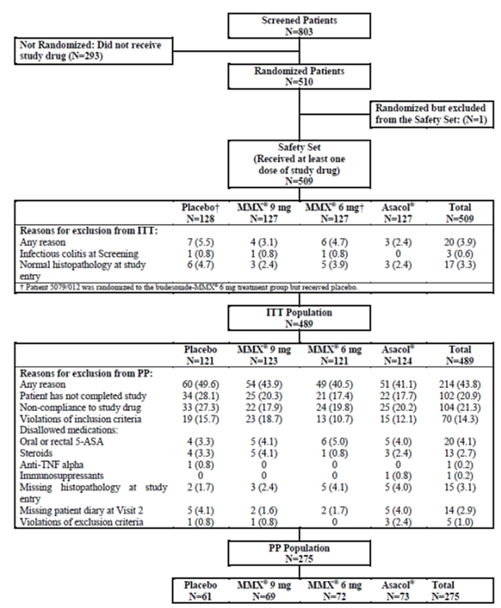

Table 6. Summary of patient disposition by treatment group (ITT) in study CB-01-02/01.
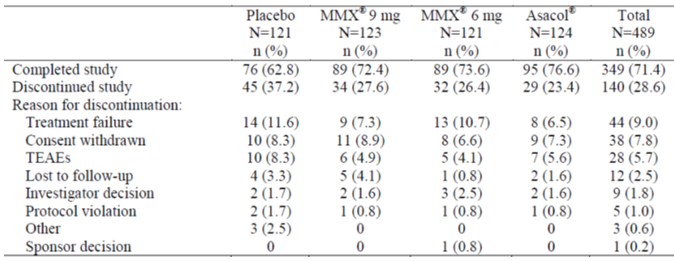
A summary of the demographic and baseline characteristics of the patients were provided.

Efficacy endpoints

Primary efficacy endpoint
The primary efficacy endpoint was the percentage of patients with clinical remission after 8 weeks of treatment. Clinical remission was defined as a UCDAI score of ≤ 1, with all of the following:
- A score of 0 for rectal bleeding and stool frequency (assessed from the patient diary)
- A normal mucosa (no evidence of mucosal friability as determined by endoscopy)
- A ≥ 1 point reduction in the endoscopy score from baseline to Visit 5/Final Visit.

Secondary efficacy endpoints
The secondary efficacy endpoints were:
- Clinical improvement, defined as a ≥ 3 point improvement in UCDAI score from baseline to Visit 5/Week 8
- Endoscopic improvement, defined as a ≥ 1 point improvement in the mucosal appearance subscore of the UCDAI from baseline to Visit 5/Week 8.

Other efficacy endpoints
The other efficacy endpoints included the following:
- Symptom resolution, defined as having score of 0 for both rectal bleeding and stool frequency from the UCDAI at Visit 5/Week 8
- Histological healing, defined as total histological assessment score of ≤ 1 on all biopsy specimens at Visit 5/Week 8, according to Saverymuttu
- Proportion of patients with a Clinical Activity Index (CAI) score ≤ 4 at Visit 3/Week 2, Visit 4/Week 4 and Visit 5/Week 8
- Treatment failure, defined as worsening of UC, requiring specific medical treatment; the proportion of patients who discontinued from the study due treatment failure at Visit 3/Week 2, Visit 4/Week 4 and Visit 5/Week 8
- Change in ESR and CRP at Visit 3/Week 2, Visit 4/Week 4 and Visit 5/Week 8
- Change in the IBD-QoL questionnaire at Visit 3/Week 2, Visit 4/Week 4 and Visit 5/Week 8.
In efficacy endpoint analysis, the level of statistical significance was set at p≤ 0.025 for the budesonide-MMX 6 mg and 9 mg groups versus placebo and at p≤ 0.05 for all other comparisons.

Results

Primary efficacy endpoint
Data on the percentage of patients with clinical remission after 8 weeks of treatment are summarised in Table 7 below. As seen in the table, a statistically significant difference was noted for the budesonide-MMX 9 mg group, compared to the placebo group, in both the ITT (p = 0.0143) and PP (p = 0.0027) populations.

Table 7: Analysis of remission rates (ITT and PP populations) in Study CB-01-02/01.
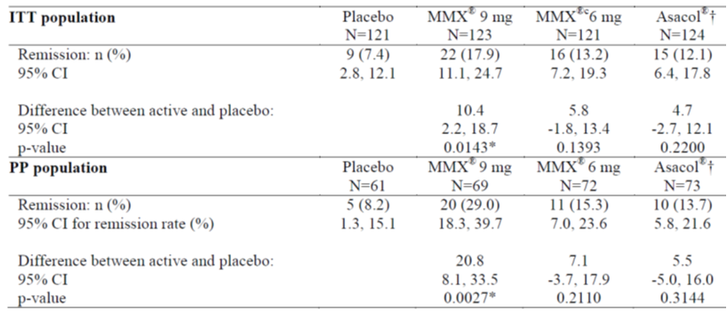
† Not powered to show statistical significance versus the budesonide-MMX groups.
Subgroup analysis of remission by gender, age and geographic region revealed that females appeared to respond better than males, patients in the greater than median age subgroup appeared to respond better than others and India showed greater remission rates than patients from other countries.

Secondary and other efficacy endpoints
Data on the secondary and other efficacy endpoints are summarised in Table 8 below. As seen in the table, some changes were noted between the treatment and placebo groups; however, with the exception of symptom resolution, the differences between the treatment and placebo groups were not statistically significant. In the case of symptom resolution, compared with the placebo group, the changes in both the budesonide-MMX 9 mg and 6 mg groups reached statistical significance in worse case analysis (p = 0.0258 and 0.0214, respectively). Nevertheless, analysis of the observed case data did not demonstrate a statistically significant difference between the placebo and any of the treatment groups (44.9%, 43.2% and 36.0% in the budesonide-MMX 9 mg, budesonide MMX 6 mg and Asacol groups, respectively, versus placebo 29.9%), with a respective p value of 0.0631, 0.0941, 0.4199 for the three treatment groups; data not presented in Table 8. In the case of histological healing the percentage of patients with this endpoint parameter was less in the budesonide-MMX 9 mg (4.1%) compared to the placebo (6.6%) group, although the difference was not statistically significant. Overall while somewhat supportive, results for the secondary and other efficacy endpoints did not appear to be very convincing.

Table 8: Summary of secondary and other efficacy endpoints in ITT population of Study CB-01-02/01.
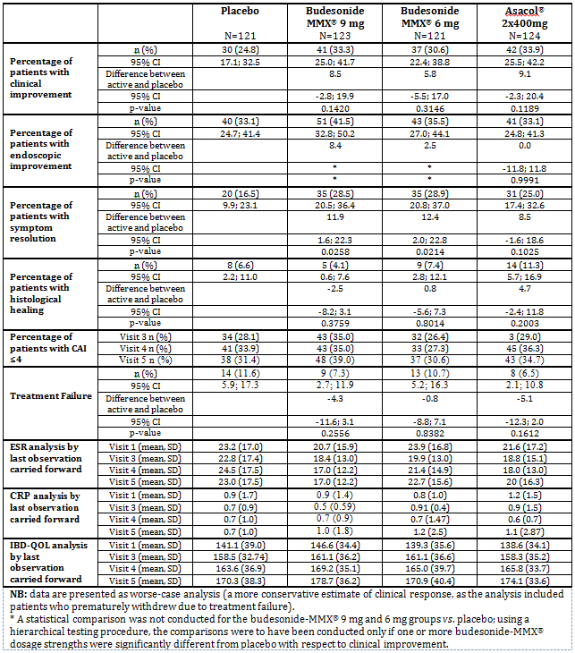

Study CB-01-02/02
This study was conducted in a total of 69 centres across 15 countries, including Australia, during the period 24 July 2008 to 27 January 2010, to investigate the efficacy and safety of the budesonide-MMX 9 mg tablet in patients with mild or moderate active UC.

Study design
This multi-centre study was of randomised, double blind, double dummy, parallel group comparative design in patients with mild or moderate active UC. The study compared the budesonide-MMX 6 mg and 9 mg tablets to placebo and also compared Entocort 3 x 3 mg capsules (9 mg) to placebo over an 8 week treatment period. Eligible patients underwent a wash out period of 2 days, prior to being randomised to one of the following four treatment groups as shown in Table 9.

Table 9. Study CB-01-02/02 treatment groups.
Group 1  (Budesonide-MMX 6 mg) | One budesonide-MMX 6 mg tablet plus three placebo Entocort capsules, mane.
Group 2  (Budesonide-MMX 9 mg) | One budesonide-MMX 9 mg tablet plus three placebo Entocort capsules, mane.
Group 3  (Entocort 9 mg) | Three Entocort 3 mg capsules plus one placebo budesonide-MMX tablet, mane.
Group 4  (Placebo) | One placebo budesonide-MMX tablet plus three placebo Entocort capsules, mane.

Study objectives

Primary objective
To evaluate the efficacy and safety of budesonide-MMX 6 mg and 9 mg oral tablets when compared to placebo in patients with mild or moderate active UC, when administered for 8 weeks.

Secondary objective
To evaluate the clinical improvement and endoscopic improvement after 8 weeks treatment with budesonide-MMX 6 mg and 9 mg oral tablets when compared to placebo in patients with mild or moderate active UC.

Other objectives
To evaluate symptom resolution and histologic healing after 8 weeks of treatment with budesonide-MMX, the improvement in clinical and biohumoral parameters and in the IBD-QoL questionnaire after 8 weeks of treatment with budesonide-MMX and the efficacy and safety of Entocort capsules (3 x 3 mg/day) when administered for 8 weeks in patients with mild or moderate active UC.

Inclusion and exclusion criteria
The inclusion and exclusion criteria of the study are shown in Table 4 and Table 5 above.

Demographic and baseline characteristics
Initially, 492 patients (123 per group) were planned for randomisation to ensure evaluation of 440 patients (110 per group). Subsequently, a total of 613 patients were screened, of whom 512 were randomised, but only 272 completed the study. An overview of the patient disposition is shown in Figure 2 and a summary of the patient disposition by treatment group was provided.
A summary of the demographic and baseline characteristics of the patients was provided.
Figure 2. Overview of patient disposition in pivotal phase III study CB-01-02/02.
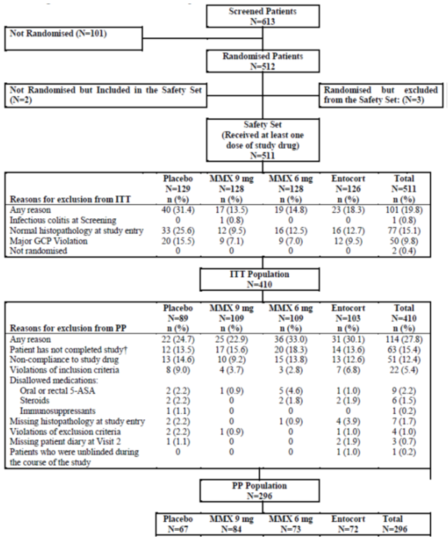

Efficacy endpoints
The primary, secondary and other efficacy endpoints of this study (Study CB-01-02/02) were identical to those of Study CB-01-02/01.
In efficacy endpoint analysis, the level of statistical significance was set at p ≤ 0.025 for the budesonide-MMX 6 mg and 9 mg groups versus placebo and at p ≤ 0.05 for all other comparisons.

Results

Primary efficacy endpoint
Data on the percentage of patients with clinical remission after 8 weeks of treatment are summarised in Table 10 below. A statistically significant difference (p = 0.0047) was noted for the budesonide-MMX 9 mg group, compared to the placebo group in both the ITT and PP populations. A statistically significant difference was also noted for the Entocort 9 mg group, compared to the placebo group, although the difference was somewhat less marked than the budesonide-MMX 9 mg group (8.1% versus 12.9% in ITT, 10.7% versus 16.6% in PP population).

Table 10: Analysis of remission rates (ITT and PP populations) in Study CB-01-02/02.
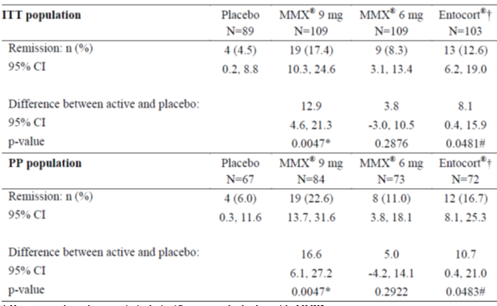
† Not powered to show statistical significance versus the budesonide-MMX groups.
Subgroup analysis of remission by gender, age and geographic region revealed that males appeared to respond better than females, patients in the less than median age subgroup appeared to respond better than others and patients from Russia and Eastern Europe showed greater remission rates than patients from other countries. Overall, the findings in the subgroup analysis were inconsistent with those in Study CB-01-02/01.

Secondary and other efficacy endpoints
Data on the secondary and other efficacy endpoints are summarised in Table 11. Some changes were noted between the treatment and placebo groups; however, with the exception of symptom resolution, the differences between the treatment and placebo groups were not statistically significant. In the case of symptom resolution, a statistically significant difference was noted in the budesonide-MMX 9 mg group (23.9%) compared to the placebo group (11.2%) in worse case analysis (p = 0.0220). A similar statistically significant difference in symptom resolution was also noted between the budesonide-MMX 9 mg group (36.1%) and the placebo group (17.5%) in observed-case analysis (p = 0.0196). In the case of histological healing, there appeared to be a clinically meaningful improvement in the budesonide-MMX 9 mg group (16.5%) compared to the placebo group (6.7%) in worse case analysis, although the difference (9.8%) was not statistically significant (p = 0.0361). In observed case analysis for histological healing, a similar improvement was also noted in the budesonide-MMX 9 mg group compared to the placebo group (25.4% versus 10.3%, p = 0.0293), although the difference (15.0%) did not reach the study protocol predefined statistical significance level at p ≤ 0.025. Overall, results for the secondary and other efficacy endpoints in this study (Study CB-01-02/02) appeared to be more supportive and convincing than those in Study CB-01-02/01.

Table 11: Summary of secondary and other efficacy endpoints in ITT population of Study CB-01-02/02.
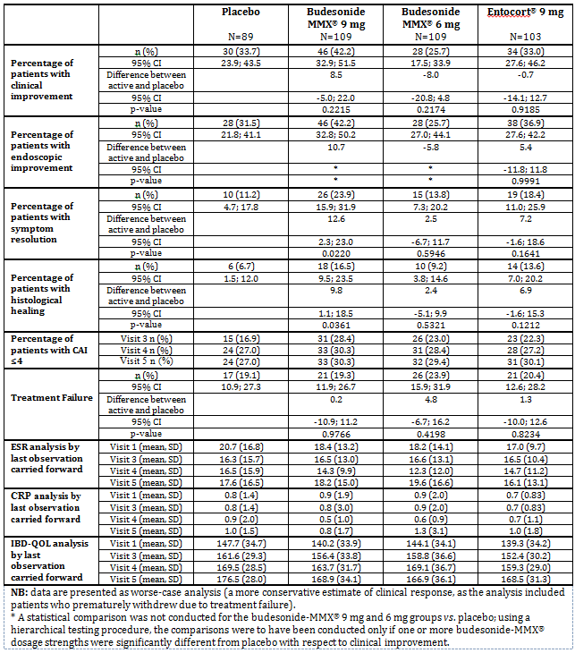

Other efficacy studies
Two Phase II studies (CRO-03-53 and CB-01-02/05) were submitted, providing preliminary efficacy data for the proposed Cortiment 9 mg prolonged release tablet.

Study CRO-03-53
This was a multi-centre, randomised, two period, placebo controlled study, with 4 weeks of blinded treatment (Period 1) followed by 4 weeks of open label extension (Period 2). The study was conducted in Austria Belgium, France and Hungary from 28 April 2004 to 24 August 2005. The main objective of the study was to assess whether the budesonide-MMX 9 mg tablet was able to induce a clinical improvement in patients with mild to moderate active left sided UC.
A total of 21 male and 15 female patients, aged 18 to 65, with left sided UC and a CAI < 14, were randomised to the placebo and budesonide-MMX 9 mg groups. Of the 36 patients, only 32 were evaluable (ITT population) and the other 4 were excluded due to protocol violations. During Period 1, the patients were treated daily with either budesonide-MMX 9 mg or matched placebo for 4 weeks. During Period 2, all patients in both groups were treated daily with budesonide-MMX 9 mg for a further 4 weeks.
The primary efficacy endpoint was the number of patients achieving a reduction by at least 50% of baseline CAI or remission (CAI ≤ 4) after 4 weeks of treatment with budesonide-MMX 9 mg or placebo. The secondary efficacy endpoints were the number of patients achieving a reduction by at least 70% of baseline CAI or remission (CAI ≤ 4) after 8 weeks, endoscopic improvement in rectal biopsies and changes in CRP levels at Weeks 4 and 8.
The preliminary efficacy data of this study are summarised in Table 12. Overall, there appeared to be a greater number of patients achieving a response to budesonide-MMX 9 mg treatment in the efficacy parameters. However, the differences between the two study groups were not statistically significant. In terms of changes from baseline, the budesonide-MMX 9 mg group showed clinically meaningful CAI and endoscopic improvements following 8 weeks of treatment, but generally not after 4 weeks of treatment, suggesting that treatment for 8 weeks was necessary for a meaningful therapeutic benefit of the product.

Table 12. Summary of preliminary efficacy (ITT population) for phase II study CRO-03-53.
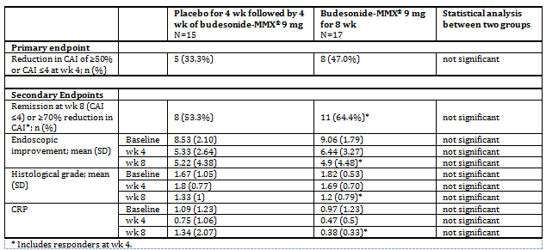

Study CB-01-02/05
This was a multi-centre, randomised, double-blind, placebo-controlled study. The study was conducted in Romania during the period 19 May 2009 to 29 September 2009. The objective of the study was to evaluate the dose response of budesonide-MMX 3 mg and 9 mg oral tablets compared to placebo in patients with mild or moderate active UC, when administered for 8 weeks.
A total of 24 male and 25 female patients, aged 18 to 75, with a UCDAI ≥ 4 and ≤ 10, were randomised to the placebo, budesonide-MMX 9 mg and budesonide-MMX 3 mg groups. Of the 49 patients, 37 had at least one post baseline evaluation completed and were included in the ITT efficacy analyses, but only 35 completed the study as per protocol. Treatment was given once a day for 8 weeks. All patients received a wash out period of 2 days prior to the commencement of treatment. Histological proof of UC at study entry was not a stated requirement in the study protocol.
The primary efficacy endpoint was the percentage of patients achieving UCDAI remission at Week 8. UCDAI remission was defined as a UCDAI score ≤ 1 with a score of 0 for rectal bleeding and stool frequency and ≥ 1 point reduction from baseline in the endoscopy score. The secondary efficacy endpoints were: percentage of patients with score 0 for blood in stools and stool frequency after 4 and 8 weeks of treatment; percentage of patients with CAI ≤ 4 after 4 and 8 weeks of treatment; percentage of patients with endoscopic healing (score 0) after 8 weeks of treatment; degree of CAI improvement after 4 and 8 weeks of treatment; and degree of UCDAI improvement after 8 weeks of treatment.
The preliminary efficacy data of this study are summarised in Table 13. A greater proportion of patients with a clinically meaningful improvement in most of the efficacy endpoints were noted in the budesonide-MMX 9 mg group, compared to the placebo and budesonide-MMX 3 mg group. As with the other preliminary Phase II Study CRO-03-53 a greater CAI improvement was apparent following 8 weeks of treatment, compared to 4 weeks of treatment. It is noteworthy that due to the small group size, a statistical analysis was not conducted for the efficacy results and thus the level of statistical significance in the differences between the study groups remains largely unknown.

Table 13: Summary of preliminary efficacy (ITT population) for Phase II Study CB-01-02/05.
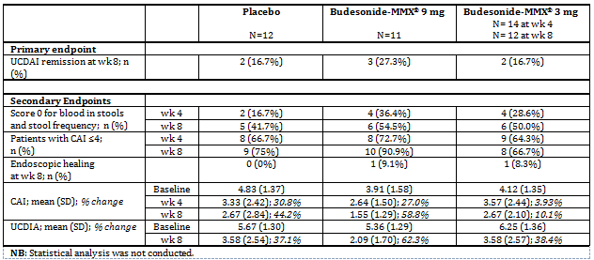

Analyses performed across trials (pooled & meta analyses)
Across trial analyses of the efficacy data were performed for both Phase III studies (CB-01-02/01 and CB-01-02/02) and one Phase II Study CB-01-02/05. The other Phase II Study CRO-03-53 was not included in the analyses, due to its different design, efficacy endpoints and patient populations. Comparisons of remission rates across the three studies and of other main efficacy parameters between the two Phase III studies are shown in Table 14. Treatment with budesonide-MMX 9 mg for 8 weeks was associated with a significant improvement in remission rates compared to placebo. The remission rates in Study CB-01-02/05 were substantially higher than in studies CB-01-02/01 and CB-01-02/02. However, it should be noted that unlike the two Phase III studies (CB-01-02/01 and CB-01-02/02), the Phase II Study CB-01-02/05 did not require histological proof of UC at study entry and thus it is not considered appropriate to directly compare the treatment population in the preliminary Phase II study with those in the pivotal Phase III studies. With regards to the other main efficacy endpoints, significant achievement in symptom resolution was also noted following 8 weeks treatment with budesonide-MMX 9 mg, compared to placebo, in both pivotal Phase III studies. Treatment with budesonide-MMX 9 mg for 8 weeks also appeared to be associated with some clinically meaningful improvement in some of the other efficacy endpoints, although the level of improvement was not statistically significant.

Table 14: Comparison of main efficacy endpoints across studies CB-01-02/05, CB-01-02/01 and CB-01-02/02.
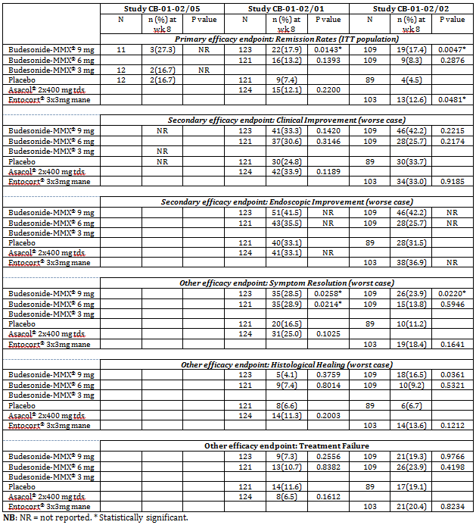

Evaluator’s conclusions on clinical efficacy
Efficacy data were generated primarily from the two pivotal Phase III studies (CB-01-02/01 and CB-01-02/02), with limited preliminary data also from the two, non-pivotal Phase II studies (CB-01-02/05 and CRO-03-53).
In the pivotal studies, almost identical study design was used, with the exception of the concurrent comparator (active control) which was mesalazine (Asacol) in Study CB-01-02/01 and budesonide capsules (Entocort) in Study CB-01-02/02. The dose of mesalazine used in Study CB-01-02/01 was 800 mg tds (2.4 g/day) which is the dose currently recommended in the US PI for Asacol and within the daily dose range of 2 to 4 g/day (given in 2 divided doses) currently recommended in the Australian Therapeutic Guidelines for induction of remission in mild to moderate active UC. Entocort is not currently registered for the treatment of UC in Australia, EU or USA; thus, the appropriateness of using Entocort as an active efficacy comparator in Study CB-01-02/02 remains questionable.
All patients in the pivotal studies had histological proof of mild or moderate UC prior to entering the studies. The primary efficacy endpoint in both studies was pre-defined clinical remission, which included normalisation of stool frequency, absence of rectal bleeding, improvement of endoscopic score and physician’s assessment of UCDAI. This is considered appropriate and compliant with the current regulatory guidelines (CHMP/EWP/18463/2006). The definition of clinical remission used in these studies was noticeably more rigorous than that described in the clinical trials section of the Australian PI for Budenofalk Foam Enema. Results from both pivotal studies demonstrated that 8 weeks treatment with budesonide-MMX 9 mg was associated with a statistically significant improvement in the rate of clinical remission compared to placebo. The placebo rate of remission was 7.4% (95% CI: 2.8-12.1%) in Study CB-01-02/01 and 4.5% (95% CI: 0.2 to 8.8%) in Study CB-01-02/02, both were somewhat lower than the value of 13% (95% CI of 9 to 18%) reported in the published literature (Su C et al 2007). Following 8 weeks of treatment with budesonide-MMX 9 mg, the remission rate was 17.9% (95% CI: 11.1 to 24.7%) in CB-01-02/01 and 17.4% (95% CI: 10.3 to 24.6%) in Study CB-01-02/02, both were higher than the placebo values in the studies and also the published literature, suggesting that the proposed product was effective for induction of clinical remission in the targeted patient population.
Supportive evidence was also observed in some of the other efficacy endpoints (most noticeably symptom resolution and less so histological healing), especially in Study CB-01-02/02. Nevertheless, no significant change in the secondary efficacy endpoints (clinical improvement and endoscopic improvement) was apparent in either of the pivotal studies following treatment with budesonide-MMX 9 mg, casting some doubt on the actual clinical benefits of the proposed product. In both studies, clinical improvement was linked with endoscopic improvement which was part of the UCDAI used for the measurement of clinical improvement. It is therefore possible that the lack of clinical improvement in these studies may have, at least in part, reflected disagreements and/or variations in endoscopic evaluation especially of proximal colonic lesions, leading to underestimates of changes in the patients (especially those with extensive pancolonic lesions). Due to differences in patient population, definition of primary endpoint and other study conditions it is obviously inappropriate to directly compare the efficacy results in the studies of budesonide-MMX 9 mg with those of the currently approved topical budesonide (Budenofalk Foam Enema).
With regards to the non-pivotal studies, there were some significant shortcomings in the design and conduct of these studies. In Study CRO-03-53, patients with only left sided UC were recruited. In Study CB-01-02/05, histological proof of UC was not required for patients entering the study, which may, at least in part, attribute to its substantially higher remission rates than in other studies. The current regulatory guideline requires that ‘only patients having confirmed ulcerative colitis should be included in trials’ (CHMP/EWP/18463/2006). Caution should therefore be exercised when interpreting the potential clinical relevance of the preliminary efficacy results in the non-pivotal studies.

Clinical safety

Studies providing evaluable safety data
Safety data in UC patients were mainly generated from the two pivotal efficacy studies (CB-01-02/01 and CB-01-02/02), with additional safety data also provided in the two preliminary efficacy studies (CRO-03-53 and CB-01-02/05). In addition, limited safety data in healthy volunteers were collected in the three PK studies (CRO-01-28, CRO-PK-03-105 and CRO-PK-06-178).
Safety assessments were conducted by evaluation of treatment emergent adverse events (TEAEs), serious adverse events (SAEs), deaths and discontinuations due to TEAEs, clinical laboratory tests (including cortisol concentrations and ACTH stimulation tests), glucocorticoid effects, physical examinations and vital signs.

Pivotal studies that assessed safety as a primary outcome
No specific study provided.

Patient exposure
A total of 613 subjects received as least one dose of budesonide-MMX treatment, with 36 as healthy volunteers and 577 as UC patients. In the 36 healthy volunteers, there were a total of 48 single dose episodes, with 12 episodes at the dose of 6 mg and 36 episodes at the dose of 9 mg. In addition, of the 36 healthy volunteers, 12 received multiple daily doses of 9 mg for 7 days. Of the 577 patients with mild or moderate active UC, 509 were exposed to budesonide-MMX at daily dose of either 6 mg (n = 254) or 9 mg (n = 255) for up to 56 days in the two pivotal efficacy studies. The remaining 68 UC patients were exposed to daily doses of budesonide-MMX at either 3 mg (n = 17) for up to 56 days, or at 9 mg for up to 28 days (n = 18) or 56 days (n = 33) in the two preliminary efficacy studies. A summary of the patient exposure data is shown in Table 15.

Table 15: Exposure to budesonide-MMX in clinical studies according to dose and duration.
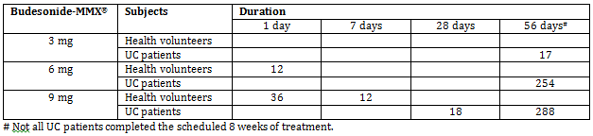

Adverse events

All adverse events (irrespective of relationship to study treatment)

Pivotal studies
A summary of the TEAEs reported in studies CB-01-02/01 and CB-01-02/02 is shown in Table 16. A total of 308/509 (60.5%) patients in Study CB-01-02/01 and 277/511 (54.2%) patients in Study CB-01-02/02 experienced at least one TEAE, with the incidence of TEAEs being somewhat similar across all study groups in both studies (57.5 to 63.0% in Study CB-01-02/01; and 44.2 to 62.5% in Study CB-01-02/02). Majority of the TEAEs were mild or moderate in severity, with only a total of 43/509 (8.4%) patients in Study CB-01-02/01 and 32/511 (6.3%) patients in Study CB-01-02/02 reported with severe TEAEs. The incidence of serious TEAEs was also comparable amongst the study groups in both studies (1.6 to 3.1% in Study CB-01-02/01; and 0.8 to 3.9% in Study CB-01-02/02).

Table 16. Summary of TEAEs in pivotal study CB-01-02/01 and study CB-01-02/02.
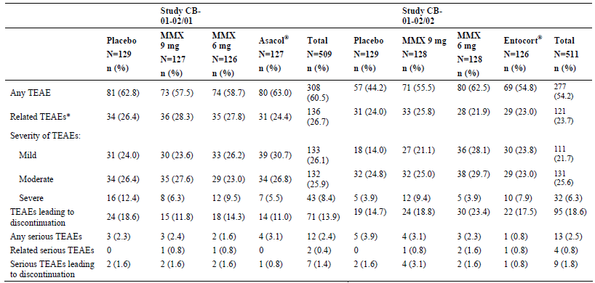
The reported TEAEs by body system and preferred term with an incidence ≥ 2.0% in the two pivotal studies were provided. The most frequently reported TEAEs in both studies were GI disorders (UC and associated symptoms), headache, nasopharyngitis and insomnia. The repeated severe TEAEs by body system and preferred term in the two pivotal studies are summarised in Tables 17 and 18.

Table 17. All severe TEAEs by body system and preferred term in study CB-01-02/01.
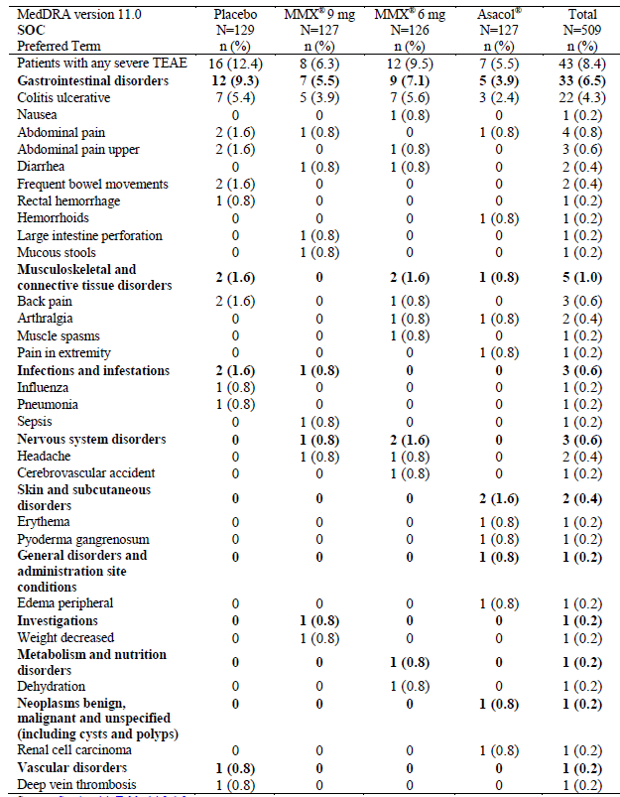

Table 18: All severe TEAEs by body system and preferred term in study CB-01-02/02.
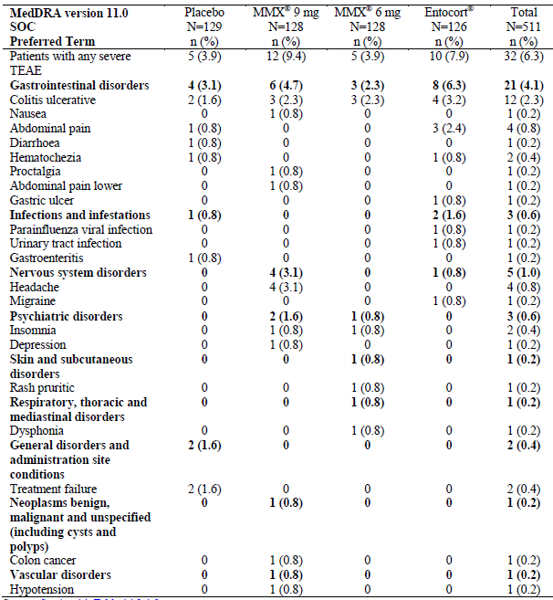

Other studies
The incidences of TEAEs in the two preliminary efficacy studies (CRO-03-53 and CB-01-02/05) are summarised in Table 19. The incidence of TEAEs was higher in Study CRO-03-53 than in Study CB-01-02/05 (100% versus 30% in the Budesonide-MMX 9 mg group). The total number of TEAEs was 69 in Study CRO-03-53, which was also higher than that of 20 in Study CB-01-02/05. The actual reason for this finding remains unclear, especially given the small number of patients in both of the studies. The reported TEAEs by body system and preferred term in Study CB-01-02/05 are summarised in Table 20. The most commonly reported TEAES in this study were GI disorders (UC and associated symptoms) and nervous system disorders (headache). One patient in this study was reported with fluid retention (tabulate as renal and urinary disorders), a potential glucocorticoid event. The most commonly reported TEAEs in Study CRO-03-53 (not tabulated by body system and preferred term) were abdominal pain, diarrhoea, flatulence, headache and flu-like symptoms.

Table 19: Summary of TEAEs in non-pivotal study CRO-03-53 and study CB-01-02/05.
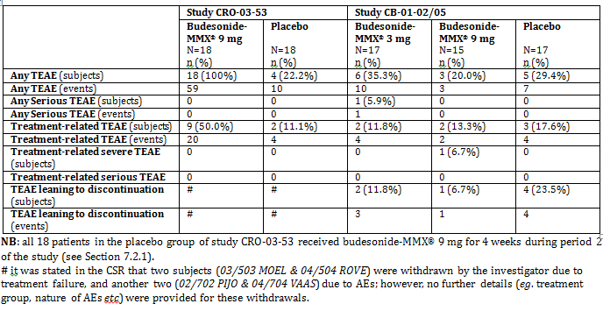

Table 20. TEAEs by body system and preferred term in study CB-01-02/05.
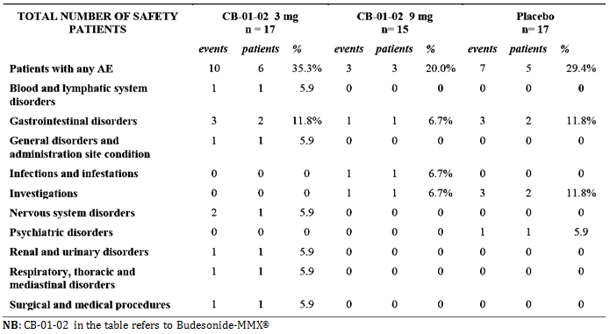
Amongst the 36 healthy volunteers in the three PK studies (CRO-01-28, CRO-PK-03-105 and CRO-PK-06-178), a total of 4 TEAEs were reported. One subject in Study CRO-PK-06-178 experienced a mild headache which was considered by the study investigators to be possibly treatment-related. All other TEAEs (nausea in Study CRO-PK-03-105; headache and upper respiratory tract infection in Study CRO-PK-06-178) were considered by the investigators to be unrelated to treatment.

Treatment related adverse events (adverse drug reactions)

Pivotal studies
Treatment related adverse events (that is, TEAEs that were assessed by the study investigators as possibly or probably related to blinded study treatment, or for which no causality was provided by the study investigators) by body system and preferred term with an incidence ≥ 2.0% in studies CB-01-02/01 and CB-01-02/02 are summarised in Tables 21and 22. Treatment related adverse events occurred in a total of 136/509 (26.7%) patients in Study CB-01-02/01 and 121/511 (23.7%) patients in Study CB-01-02/02, with somewhat comparable incidence across all study groups in both studies (24.4 to 28.3% in Study CB-01-02/01 and 21.9 to 25.8% in Study CB-01-02/02). As with overall TEAEs, the most commonly reported treatment related adverse events were gastrointestinal disorders (14.9% in Study CB-01-02/01 and 11.9% in Study CB-01-02-02), followed by headache (3.9% in Study CB-01-02/01 and 2.7% in Study CB-01-02-02).
Treatment-related adverse event of decreased blood cortisol was reported in 3.1% and 2.4% patients treated with budesonide-MMX 9 mg and 6 mg, respectively in Study CB-01-02/01 and in 4.7% and 2.3% patients treated with budesonide-MMX 9 mg and 6 mg, respectively in Study CB-01-02/02, which was dose dependent and significantly higher than the incidence in the concurrent placebo control group (0% in Study CB-01-02/01 and 0.8% in Study CB-01-02/02).

Table 21: Treatment-related adverse events with an incidence of ≥2.0% in study CB-01-02/01.
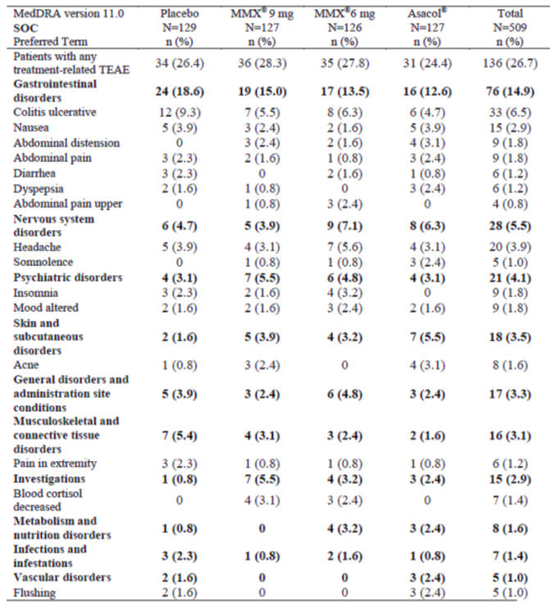

Table 22. Treatment-related adverse events with an incidence of ≥2.0% in study CB-01-02/02.
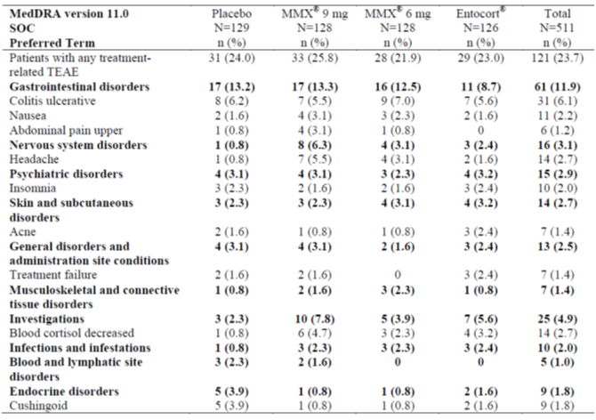

Other studies
Of the 69 TEAEs reported in Study CRO-03-53, only 24 events were considered by the investigators to be possibly (19) or probably (5) treatment related, with 20 in the budesonide-MMX 9 mg group and 4 in the placebo group. Of the 20 TEAEs reported in Study CB-01-02/05, only 10 events were regarded by the investigators as treatment-related, with 4 and 2 in the budesonide-MMX 3 mg and 9 mg groups, respectively, compared to 2 in the placebo group (see Table 19). Treatment related adverse events were not tabulated by body system and preferred term in the two non-pivotal studies (CRO-03-53 and CB-01-02/05).
Of the 4 TEAEs reported in healthy volunteers in the PK studies, only one event (mild headache) was considered by the study investigators to be possibly treatment related.

Deaths and other serious adverse events

Pivotal studies
There were no deaths. Summaries of the SAEs reported in studies CB-01-02/01 and CB-01-02/02 were provided. SAEs occurred in a total of 12/509 (2.4%) patients in Study CB-01-02/01 and 12/511 (2.3%) patients in Study CB-01-02/02. The most common SAE was worsening of UC, reported in 1.2% patients in both studies. In Study CB-01-02/01, two patients experienced a total of three treatment related SAEs; one patient in the budesonide-MMX 6 mg group had worsening of UC and the other patient in the budesonide-MMX 9 mg group had worsening of UC and large intestine perforation. In Study CB-01-02/02, three patients experienced a total of four treatment related SAEs; one patient in the budesonide-MMX 6 mg group had relapse of UC; one patient in the budesonide-MMX 9 mg group had treatment failure and one patient in the Entocort group had a gastric ulcer and exacerbation of UC. The overall profile these SAEs was consistent with the patient population with a relapsing remitting disease.

Other studies
There were no deaths in any of the clinical studies submitted in this application. No SAE was reported in Study CRO-03-53 or in any of the healthy volunteer PK studies (CRO-01-28, CRO-PK-03-105 and CRO-PK-06-178). In Study CB-01-02/05, one SAE (renal stone) was reported in one patient from the budesonide-MMX 3 mg group; this SAE was not considered to be treatment-related (Table 19).

Discontinuation due to adverse events

Pivotal studies
A summary of the common TEAEs leading to discontinuation of subjects from studies CB-01-02/01 and CB-01-02/02 is shown in Table 23 and 24. In Study CB-01-02/01, a total of 71/509 (13.9%) patients discontinued from the study due to a TEAE, with 24/129 (18.6%) patients in the placebo group, 15/127 (11.8%) in the budesonide-MMX 9 mg group, 18/126 (14.3%) in the budesonide-MMX 6 mg group and 14/127 (11.0%) in the Asacol group. In Study CB-01-02/02, a total of 95/511 (18.6%) patients discontinued from the study due to a TEAE, with 19/129 (14.7%) patients in the placebo group, 24/128 (18.8%) in the budesonide-MMX 9 mg group, 30/128 (23.4%) in the budesonide-MMX 6 mg group and 22/126 (17.5%) in the Entocort group. In both studies, the most common TEAE that led to discontinuation was UC, accounting for 10.2% (52/509) in Study CB-01-02/01 and 14.3% (73/511) in Study CB-01-02/02. Treatment failure or worsening of UC (or increase in disease activity of UC) was reported as the primary reason for vast majority of the patients who discontinued due to UC in both studies. In Study CB-01-02/01, treatment failure was reported more frequently in the placebo (11.6%) and budesonide-MMX 6 mg (10.7%) groups than in the budesonide-MMX 9 mg (7.3%) and Asacol (6.5%) groups, but the differences between the active treatment and the placebo groups did not reach statistical significance. In Study CB-01-02/02, treatment failure was higher in the budesonide-MMX 6 mg group (23.9%) than in other groups (19.3% in the budesonide-MMX 9 mg group, 20.4% in the Entocort group and 19.1% in the placebo group) but again, no statistically significant difference was apparent for any of the active treatment groups when compared with the placebo group.

Table 23. TEAEs leading to discontinuation in ≥2.0% patients in any treatment group in study CB-01-02/01.
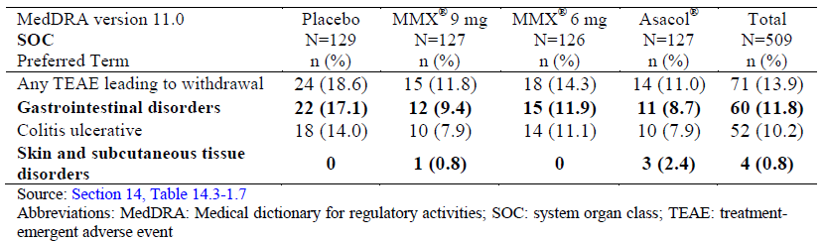

Table 24: TEAEs leading to discontinuation in ≥2.0% patients in any treatment group in study CB-01-02/02.
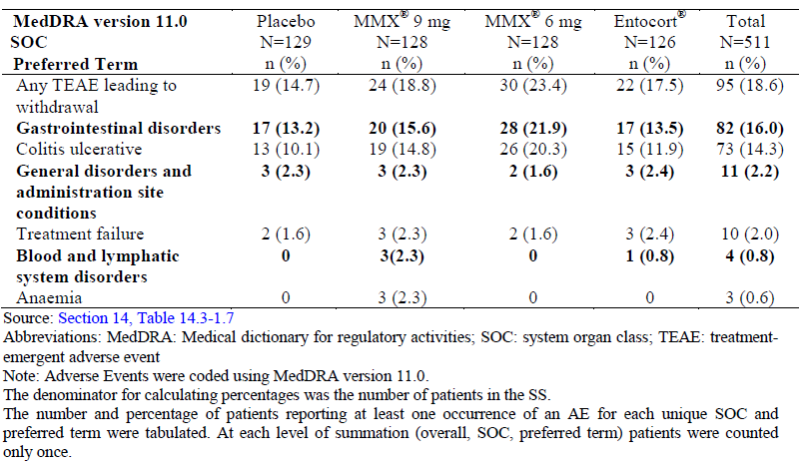

Other studies
In Study CRO-03-53 it was reported that two subjects were withdrawn by the investigator due to treatment failure and another two due to adverse events; however, no further information was provided in the CSR for these withdrawals (see Table 19).
In Study CB-01-02/05, a total of seven patients discontinued due to TEAEs, with two patients from the budesonide-MMX 3 mg group, one from the budesonide-MMX 9 mg group and four from the placebo group (see Table 19); all of the TEAEs leading to discontinuation were reported as GI associated events.
No discontinuation due to adverse events was reported in any healthy volunteers in the PK studies (CRO-01-28, CRO-PK-03-105 and CRO-PK-06-178).

Clinical laboratory tests
Data on clinical laboratory tests were provided in the two pivotal Phase III studies (CB-01-02/01 and CB-01-02/02) and the two non-pivotal Phase II studies (CRO-03-53 and CB-01-02/05).

Haematology
Analysis of the haematological data in the pivotal and non-pivotal studies in UC patients revealed no clinically significant pattern of changes related to budesonide-MMX treatment.

Clinical chemistry
Analysis of the clinical chemistry data in the pivotal and non-pivotal studies in UC patients revealed no clinically significant pattern of changes related to budesonide-MMX treatment.

Urinalysis
Urinalysis in the pivotal and non-pivotal studies in UC patients revealed no clinically significant pattern of changes related to budesonide-MMX treatment.

Morning plasma cortisol

Pivotal studies
Morning plasma cortisol levels at baseline and changes from baseline by visit in studies CB-01-02/01 and CB-01-02/02 were provided. As seen in the tables, there were large inter-subject variations in the data (evident by large SD values). Overall, dose dependent decreases from baseline in mean morning plasma cortisol levels were noted in the budesonide-MMX 6 mg and 9 mg groups at all study visits. The mean decreases ranged from 52.9 to 91.2 nmol/L in the budesonide-MMX 6 mg group and 98.6 to 175.7 nmol/L in the budesonide-MMX 9 mg group of Study CB-01-02/01 and from 48.3 to 89.2 nmol/L in the budesonide-MMX 6 mg group and 103.3 to 150.1 nmol/L in the budesonide-MMX 9 mg group of Study CB-01-02/02. The decreases did not appear to be time-dependent, as the mean decreases at Visit 5/Final Visit were not greater than at the earlier visits (Visits 3 and 4). The reported decrease in morning cortisol also did not appear to be associated with an increase in clinical glucocorticoid effects.

Other studies
Morning plasma cortisol levels were also determined in the two non-pivotal Phase II studies (CRO-03-53 and CB-01-02/05).
Data for Study CRO-03-53 was provided. Treatment with budesonide MMX 9 mg was associated with a decrease in morning plasma cortisol, more pronounced after 8 weeks of treatment than after 4 weeks of treatment. After ACTH stimulation in the short Synacthen test during the final visit at week 8, normal response in hypothalamus- pituitary-adrenal (HPA) axis function was detected in 9/15 (60%) patients treated with budesonide-MMX 9 mg for the last 4 weeks, but only in 6/14 (43%) patients treated with budesonide-MMX 9 mg for 8 weeks, indicating suppression of the HPA axis following treatment with the product.
Data for Study CB-01-02/05 were provided. Decreases in mean morning plasma cortisol levels were apparent in the budesonide-MMX 9 mg group, seemingly more marked following 8 weeks of treatment (by - 154.2 nmol/L at Visit 2) than following 4 weeks of treatment (by - 133.5 nmol/L at Visit 1). Two patients (information redacted) treated with budesonide-MMX 9 mg were reported with ‘clinically relevant abnormal’ values at Visit 1, with morning plasma cortisol in subject (information redacted) falling from 875.9 nmol/L at screening to 23.06 nmol/L at Visit 1 (a decrease of 97.4%) and that in subject (information redacted) from 614.0 nmol/L at screening to 6.98 nmol/L at Visit 1 (a decrease of 98.9%). It was concluded by the investigator that treatment with budesonide-MMX at 9 mg, but not at 3 mg, was associated with a moderate inhibition of cortisol production.

Vital signs
Data on vital signs (systolic and diastolic blood pressure, pulse rate, temperature and respiratory rate) were provided in the two pivotal Phase III studies (CB-01-02/01 and CB-01-02/02) and the two non-pivotal Phase II studies (CRO-03-53 and CB-01-02/05). Analysis of the data revealed no clinically significant pattern of changes related to budesonide-MMX treatment.

Physical examination
Physical examination data were provided in the two pivotal Phase III studies (CB-01-02/01 and CB-01-02/02) and the two non-pivotal Phase II studies (CRO-03-53 and CB-01-02/05). Analysis of the data revealed no clinically significant pattern of abnormalities related to budesonide-MMX treatment.

Other safety parameters

Glucocorticoid effects
Evaluation of clinical signs and symptoms (moon face, striae rubrae, flushing, acne, hirsutism, sleep changes, insomnia, mood change and fluid retention) that were potentially related to the use of glucocorticoids was conducted in the two pivotal Phase III studies (CB-01-02/01 and CB-01-02/02) and the two non-pivotal Phase II studies (CRO-03-53 and CB-01-02/05).

Pivotal studies
A summary of the potential glucocorticoid effects in studies CB-01-02/01 and CB-01-02/02 is shown in Table 25 and 26. Potential glucocorticoid effects occurred infrequently in both studies, with similar incidences across all treatment groups.

Table 25: Summary of potential glucocorticoid effects at the Final Visit in study CB-01-02/01.
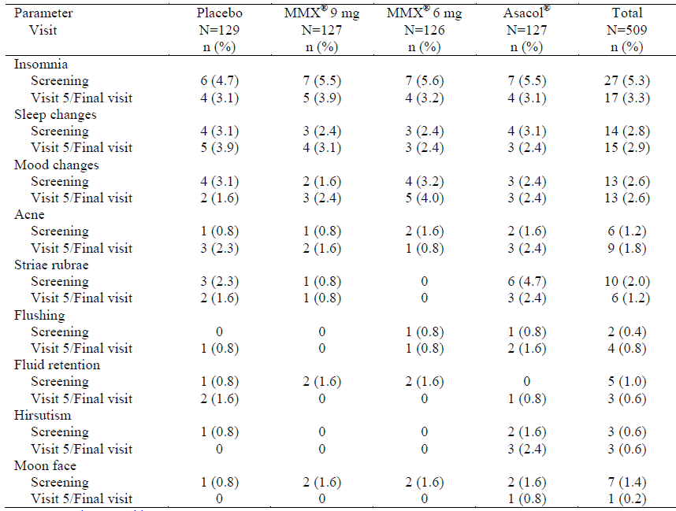

Table 26: Summary of potential glucocorticoid effects at the Final Visit in study CB-01-02/02.
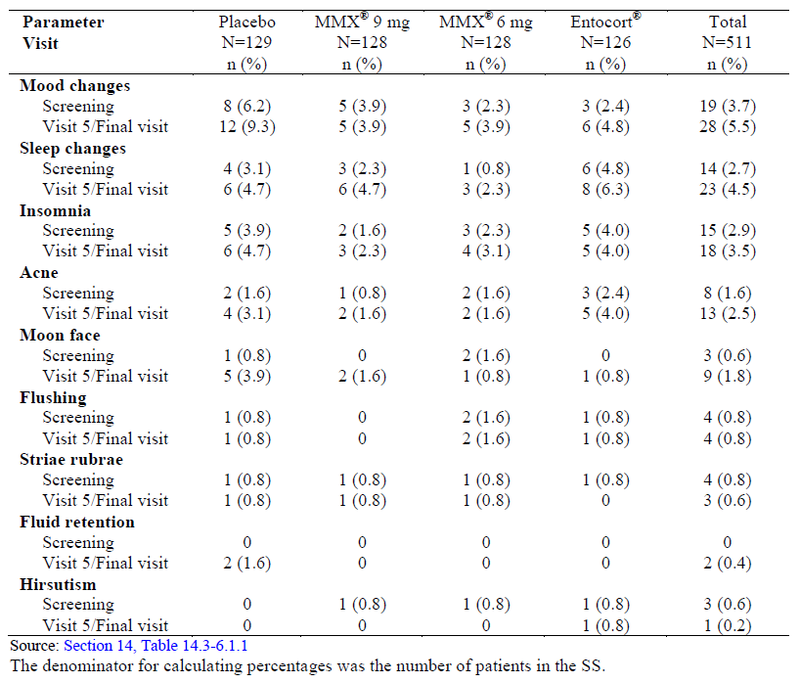

Other studies
In Study CRO-03-53, two patients treated with budesonide-MMX 9 mg were reported with mild facial acne (information redacted) or recurrent episodes of mild flushing (information redacted), which were regarded by the investigator to be probably (acne) or possibly (flushing) related to budesonide-MMX treatment. In Study CB-01-02/05, one patient treated with budesonide-MMX 3 mg was reported with fluid retention, starting from Visit 1 and persisting until the end of the study; however, a similar potential glucocorticoid effect was not noted in any of the patients treated with budesonide-MMX 9 mg.

Bone mineral density scans
In was stated in the submitted Clinical Overview that safety was also assessed by evaluation of bone mineral density scans. However, no relevant clinical data were provided by the sponsor in any of the clinical studies submitted in this application.

Post-marketing experience
One PSUR for the period of 14 January to 30 April 2013 was submitted. This is the first PSUR on budesonide-MMX since the product was first authorised as Uceris in the USA on 14 January 2013 and as Cortiment in Netherlands on 28 February 2013. This report requires evaluation by the OPR of TGA.

Evaluator’s overall conclusions on clinical safety
As an established glucocorticoid, the pharmacological and toxicological profile of budesonide has previously been well characterised and documented. With regard to the clinical safety profile of the proposed budesonide-MMX 9 mg tablet, relevant data from the pivotal Phase III and non-pivotal Phase II studies showed that the product was safe and generally well tolerated by patients with mild to moderate active UC. The incidences and severity of AEs, treatment related AEs and SAEs were generally similar across all treatment groups in these studies. No deaths have been reported and the reported SAEs were consistent with the events that would be expected in the targeted patient population with a relapsing and remitting disease. The overall safety profile of the product was generally comparable with that of Entocort which was used as an active comparator in Study CB-01-02/02.
Clinically, one of the main concerns over long term systemic use of a glucocorticoid is the potential for glucocorticoid effects and for suppression of the HPA axis. Indeed, data provided in the clinical studies showed that budesonide-MMX treatment was associated with dose dependent decreases in morning plasma cortisol levels. Results of the short SynacthenTM test in Study CRO-03-53 also showed evidence of inhibitory effects on the HPA axis following treatment with budesonide-MMX 9 mg. Nevertheless, no unequivocal evidence of glucocorticoid effects was apparent clinically in the submitted studies. Long term systemic use of glucocorticoids is known to potentially cause osteoporosis. No clinical data were provided by the sponsor for the potential adverse effects of budesonide-MMX on bone mineral density. However, given that the product is proposed for use of up to only 8 weeks for induction of remission, the absence of such data is not considered a major deficiency of this application.
Overall, the clinical safety profile of the proposed budesonide-MMX 9 mg tablet is considered to have been adequately characterised and similar to the known profile of oral budesonide. No new safety issue was identified from analysis of the submitted clinical safety data. However, it should be noted that safety assessment of the product was conducted only during the intended 8 week period of clinical use. Thus, the actual clinical safety of the product beyond the intended 8 week regimen remains largely unknown. It would therefore be prudent to consider limiting the clinical use of this product for up to 8 weeks, thereafter all patients should cease the treatment regardless of being responsive to the treatment or not. This consideration is also consistent with the current guidance in the Therapeutic Guidelines which state that corticosteroids do not prevent relapse of UC and have unacceptable long term adverse effects.

First round benefit-risk assessment

First round assessment of benefits
The current standard of treatment for induction of remission in mild to moderate active UC is a 5-aminosalicylate oral preparation (sulfasalazine, mesalazine, balsalazide or olsalazine) with or without a conventional systemic glucocorticosteroid (prednisone or prednisolone). Budesonide is an established synthetic glucocorticosteroid, with anti-inflammatory effects comparable to those of conventional glucocorticoids. There are three budesonide containing products currently registered on the ARTG for the treatment of IBD, two of which are delayed release oral formulations (Entocort modified release capsules and Budenofalk Enteric capsules) for the induction of remission in mild to moderate Crohn's disease and the other is a topical product (Budenofalk Foam Enema) for use in active rectal and rectosigmoid UC. The proposed budesonide-MMX 9 mg tablet (Cortiment) represents a new formulation of orally administered and topically acting budesonide for the induction of remission in mild to moderate active UC. Given that no oral budesonide formulation is currently available for the treatment of UC and the currently registered Budenofalk Enema is suitable only for patients with left sided disease, the proposed Cortiment tablet offers the potential benefit as an alternative option for the proposed indication, especially in patients with proximal involvement of the disease (for example, pancolitis). The intended once daily dosing regimen for the product also offers a convenient method of treatment and hence potentially assists in better compliance.

First round assessment of risks
The overall safety profile of the proposed Cortiment tablet following the intended clinical use of 8 weeks has been found to be generally comparable with that of Entocort, another controlled-release oral budesonide formulation currently registered on the ARTG for the treatment of Crohn's disease. Cross study comparison on the safety profile of the product is generally not considered appropriate due to the fact that the clinical studies were conducted under different conditions.
Evidence for suppression of the HPA axis was observed, although no unequivocal evidence for glucocorticoid effects was apparent clinically in the submitted studies. The absence of unequivocal evidence for clinically noticeable glucocorticoid effects is not unexpected given the relatively short duration of the clinical studies. The safety profile of the product (Cortiment) following a longer period of clinical use has not been investigated in the submitted clinical studies. Thus, the actual clinical safety of the product beyond the intended 8 week regimen remains largely unknown. In other words, from a regulatory view point, the potential risks of the product associated with its possible off label use (for example, for prolonged treatment in maintenance of remission) represent a safety concern, especially given that corticosteroids are deemed to have no role in maintenance therapy as they do not prevent relapse of UC and have unacceptable long term adverse effects (Therapeutic Guidelines, Gastrointestinal).

First round assessment of benefit-risk balance
The benefit-risk balance of the proposed Cortiment tablet, given its intended clinical usage, is considered favourable, as it offers a convenient alternative for the proposed clinical indication with an overall safety profile similar to that of other oral budesonide.

First round recommendation regarding authorisation
There is no clinical objection to registration of the proposed Cortiment tablet for use of up to 8 weeks for induction of remission in patients with mild to moderate active UC.

Clinical questions
No specific clinical question is raised to the sponsor in the first round Clinical Evaluation Report. However, it is noted that long term safety and efficacy data were made available to the FDA but were not included in this submission. A summary of the maintenance Study CB-01-02/04 should therefore be requested for consideration.

Second round evaluation
Pending consideration of the requested summary of the maintenance Study CB-01-02/04.

Second round benefit-risk assessment

Second round assessment of benefits
Pending additional consideration of the requested summary of the maintenance Study CB-01-02/04.

Second round assessment of risks
Pending additional consideration of the requested summary of the maintenance Study CB-01-02/04.

Second round assessment of benefit-risk balance
Pending additional consideration of the requested summary of the maintenance Study CB-01-02/04.

Second round recommendation regarding authorisation
Pending additional consideration of the requested summary of the maintenance Study CB-01-02/04.

References
Brunner M, Ziegler S, Di Stefano AF, Dehghanyar P, Kletter K, Tschurlovits M, et al. Gastrointestinal transit, release and plasma pharmacokinetics of a new oral budesonide formulation. Br J Clin Pharmacol. 2006;61:31-8.
D'Haens GR, Kovacs A, Vergauwe P, Nagy F, Molnar T, Bouhnik Y, et al. Clinical trial: Preliminary efficacy and safety study of a new budesonide MMX 9 mg extended-release tablets in patients with active left-sided ulcerative colitis. J Crohns Colitis. 2010;4:153-60.
Kolkman JJ, Möllmann HW, Möllmann AC, et al. Evaluation of oral budesonide in the treatment of active distal ulcerative colitis. Drugs Today (Barc) 2004;40:589-601.
Saverymuttu SH, Camilleri M, Rees H, Lavender JP, Hodgson HJ, Chadwick VS. Indium 111-granulocyte scanning in the assessment of disease extent and disease activity in inflammatory bowel disease. A comparison with colonoscopy, histology and fecal indium 111-granulocyte excretion. Gastroenterology. 1986;90:1121-8.
Su C, Lewis JD, Goldberg B, Brensinger C, Lichtenstein GR. A meta-analysis of the placebo rates of remission and response in clinical trials of active ulcerative colitis. Gastroenterology. 2007 132:516-626.

Therapeutic Goods Administration
PO Box 100 Woden ACT 2606 Australia
Email: info@tga.gov.au Phone: 1800 020 653 Fax: 02 6232 8605
https://www.tga.gov.au

Saverymuttu SH et al. Indium 111-granulocyte scanning in the assessment of disease extent and disease activity in inflammatory bowel disease. A comparison with colonoscopy, histology, and fecal indium 111-granulocyte excretion. Gastroenterology.1986;90:1121-1128.

