March 2017

Australian Public Assessment Report for brivaracetam
  - Proprietary Product Name: Briviact
  - Sponsor: UCB Australia Pty Ltd

About the Therapeutic Goods Administration (TGA)
- The Therapeutic Goods Administration (TGA) is part of the Australian Government Department of Health and is responsible for regulating medicines and medical devices.
- The TGA administers the Therapeutic Goods Act 1989 (the Act), applying a risk management approach designed to ensure therapeutic goods supplied in Australia meet acceptable standards of quality, safety and efficacy (performance) when necessary.
- The work of the TGA is based on applying scientific and clinical expertise to decision-making, to ensure that the benefits to consumers outweigh any risks associated with the use of medicines and medical devices.
- The TGA relies on the public, healthcare professionals and industry to report problems with medicines or medical devices. TGA investigates reports received by it to determine any necessary regulatory action.
- To report a problem with a medicine or medical device, please see the information on the TGA website <https://www.tga.gov.au>.

About AusPARs
- An Australian Public Assessment Report (AusPAR) provides information about the evaluation of a prescription medicine and the considerations that led the TGA to approve or not approve a prescription medicine submission.
- AusPARs are prepared and published by the TGA.
- An AusPAR is prepared for submissions that relate to new chemical entities, generic medicines, major variations and extensions of indications.
- An AusPAR is a static document; it provides information that relates to a submission at a particular point in time.
- A new AusPAR will be developed to reflect changes to indications and/or major variations to a prescription medicine subject to evaluation by the TGA.
Copyright
© Commonwealth of Australia 2017
This work is copyright. You may reproduce the whole or part of this work in unaltered form for your own personal use or, if you are part of an organisation, for internal use within your organisation, but only if you or your organisation do not use the reproduction for any commercial purpose and retain this copyright notice and all disclaimer notices as part of that reproduction. Apart from rights to use as permitted by the Copyright Act 1968 or allowed by this copyright notice, all other rights are reserved and you are not allowed to reproduce the whole or any part of this work in any way (electronic or otherwise) without first being given specific written permission from the Commonwealth to do so. Requests and inquiries concerning reproduction and rights are to be sent to the TGA Copyright Officer, Therapeutic Goods Administration, PO Box 100, Woden ACT 2606 or emailed to <tga.copyright@tga.gov.au>.

Contents
About AusPARs ii
Common abbreviations 5
I. Introduction to product submission 9
Submission details 9
Product background 10
Regulatory status 11
Product Information 12
II. Quality findings 12
Introduction 12
Drug substance (active ingredient) 12
Drug product 13
Biopharmaceutics 17
Quality summary and conclusions 22
III. Nonclinical findings 22
Introduction 22
Pharmacology 22
Pharmacokinetics 26
Toxicology 31
Nonclinical summary and conclusions 55
IV. Clinical findings 59
Introduction 59
Pharmacokinetics 63
Pharmacodynamics 65
Dosage selection for the pivotal studies 68
Efficacy 70
Safety 71
First round benefit-risk assessment 76
First round recommendation regarding authorisation 76
Clinical questions 76
Second round evaluation 77
Second round benefit-risk assessment 78
Second round recommendation regarding authorisation 78
V. Pharmacovigilance findings 78
Risk management plan 78
VI. Overall conclusion and risk/benefit assessment 85
Risk-benefit analysis 85
Outcome 92
Attachment 1. Product Information 92
Attachment 2. Extract from the Clinical Evaluation Report 92

Common abbreviations
Abbreviation | Meaning
≈ | approximately
ACPM | Advisory Committee on Prescription Medicines
AE | adverse event
AED | antiepileptic drug
ALP | alprazolam
AMPA | α-amino-3-hydroxy-5-methyl-4-isoxazolepropionic acid
ANOVA | analysis of variance
API | active pharmaceutical ingredient
ARCI | Addiction Research Centre Inventory
ARCI-49 | Addiction Research Centre Inventory, 49 questions sub-scale
ASA | Australian Specific Annex
AUC | area under the plasma concentration-time curve
AUC(0-∞) | area under the plasma concentration-time curve from zero to infinity
AUC(0-t) | area under the plasma concentration-time curve from zero to the time of the last measured concentration above the limit of quantification
AUC(0-t)norm | AUC(0-t) defined above, dose normalised to the BRV 50 mg reference treatment
AUCnorm | AUC defined above, dose normalised to the BRV 50 mg reference treatment
β-hCG | beta-human chorionic gonadotropin
BA | bioavailability
BCS | Biopharmaceutic Classification System
BE | bioequivalence
b.i.d. | (bis in die) twice daily
BMI | body mass index
BRV | brivaracetam
BSA | body surface area
CBZ | carbamazepine
CI | confidence interval
CL/F | apparent total plasma clearance
Cav | average plasma concentration
Cmax | maximum plasma concentration
Cmax, norm | Cmax dose normalised to the BRV 50 mg reference treatment
CMI | Consumer Medicine Information
CRF | Case Report form
CRT | choice reaction time
Css | steady state concentration
CV | coefficient of variation
DBP | diastolic blood pressure
DRM | data review meeting
DS | Drug Safety
ECG | electrocardiogram
EEG | electroencephalogram
EES | ethinylestradiol
EMA | European Medicines Agency
ES | Enrolled Set
FDA | Food and Drug Administration (US)
GCP | Good Clinical Practice
GFR | glomerular filtration rate
GFZ | gemfibrozil
GI | gastrointestinal
GMP | Good Manufacturing Practice
IPS | intermittent photic stimulation
IR | immediate release
ITT | intention to treat
IV | intravenous
GABA | gamma-amino butyric acid
LCM | lacosamide
LEV | levetiracetam
Ln | Natural logarithmic
LOAEL | lowest observed adverse effect level
LSM | Least squares means
LTFU | long-term follow-up
LTG | lamotrigine
LVN | levonorgestrel
MHD | 10-hydroxyoxcarbazepine
MRHD | Maximum Recommended Human Dose
NOAEL | no observed adverse effect level
NOEL | no observed effect level
OCP | oral contraceptive pill
PB | primidone
PBO | placebo
PD | pharmacodynamic(s)
PGN | pregabalin
PHT | phenytoin
PI | Product Information
PK | pharmacokinetic(s)
PO | per or (oral administration)
POS | partial onset seizures
PP | per protocol
PPR | photoparoxysmal EEG response
PR | pulse rate
PRM | primidone
PT | preferred term
QTcF | QT interval corrected for heart rate by Fridericia’s formula
RFP | rifampicin
RMP | Risk Management Plan
SAE | serious adverse events
SD | standard deviation
SE | standard error
SPR | Standard Photosensitive Range
SV2A | synaptic vesicle protein 2A
t½ | plasma half-life
TEAE | treatment-emergent adverse event
Tmax | Time taken to reach the maximum concentration (Cmax)
TPM | topiramate
V | volume
VAS | visual analogue scales
VGSC | Voltage-gated sodium channel
VPA | valproate
Vz/F | apparent volume of distribution at the terminal elimination phase
ZNS | zonisamide

I. Introduction to product submission

Submission details
Type of submission: | New chemical entity
Decision: | Approved
Date of decision: | 2 August 2016
Date of entry onto ARTG | 4 August 2016
Active ingredient: | Brivaracetam
Product name: | Briviact
Sponsor’s name and address: | UCB Australia Pty Ltd  PO Box 158  Malvern VIC 3144
Dose forms: | Immediate release film coated tablets, oral solution & solution for injection
Strengths: | Film Coated Tablets Containing Brivaracetam 10 mg, 25 mg, 50 mg, 75 mg and 100 mg;  Oral Solution Containing Brivaracetam 10 mg/mL;  Solution for Injection Containing Brivaracetam 50 mg/5 mL
Containers: | PVC/PCTFE//aluminium blister packs (tablets);  300 mL capacity Type III amber glass bottle with a tamper evident, polypropylene child-resistant screw cap (oral solution);  Clear, colourless 6 mL capacity Type I glass vial with a 20 mm bromobutyl rubber stopper and a 20 mm aluminium cap with white polypropylene tear-off seal (solution for injection)
Pack sizes: | 14, 56, 100 Tablets and a multipack of 168 (3 x 56) tablets;  1 x 300 mL bottle (oral solution);  10 x 6 mL capacity Type I glass vials (solution for injection)
Approved therapeutic use: | Briviact tablets and oral solution and Briviact solution for injection are indicated as add-on therapy in the treatment of partial-onset seizures with or without secondary generalisation in patients from 16 years of age with epilepsy
Routes of administration: | Oral (tablets & oral solution);  Intravenous (solution for injection)
Dosage: | 200 mg, taken with or without food in two equally divided doses (maximum recommended daily dose)
ARTG numbers: | 243792 (100 mg film-coated tablets blister pack);  243793 (10 mg/mL oral solution bottle);  243794 (10 mg film-coated tablets blister pack);  243795 (50 mg/5mL injection vial);  243796 (25 mg film-coated tablets blister pack);  243797 (50 mg film-coated tablets blister pack);  243798 (75 mg film-coated tablets blister pack)

Product background
This AusPAR describes the application by UCB Australia Pty Ltd to register Briviact (brivaracetam), a new chemical entity, as film-coated tablets, oral solution, and solution for injection.
The proposed strengths:
- 10 mg, 25 mg, 50 mg, 75 mg, 100 mg film-coated tablets;
- 10 mg/mL oral solution;
- 50 mg/5 mL solution for injections.
The proposed indication:
Briviact tablets, oral solution and solution for injection are indicated as add-on therapy in the treatment of partial-onset seizures with or without secondary generalisation in patients from 16 years of age with epilepsy.

Dosing

Enteral
Briviact at doses between 50 and 200 mg/day has been shown to be effective as adjunctive therapy in the treatment of partial onset seizures. Initial dose titration to an effective dose is not required for tolerability.
The daily dose is administered in two equally divided doses, once in the morning and once in the evening. The recommended starting dose is 100 mg/day. Based on individual patient response, the dose may be adjusted between 50 mg/day and 200 mg/day.
Briviact may be taken with or without food.
Brivaracetam may be initiated with either intravenous or oral administration. When converting from oral to intravenous administration or vice versa, the total daily dose and frequency of administration should be maintained.
In accordance with current clinical practice, if Briviact has to be discontinued, it is recommended with withdraw it gradually.
If patients missed one dose or more, it is recommended they take a single dose as soon as they remember.
The film-coated tablets must be taken orally whole with liquid.
The oral solution does not need to be diluted before swallowing. A nasogastric tube or gastrostomy tube may be used when administering the oral solution.

Use in patients with impaired renal function
No dose adjustment is needed in patients with impaired renal function. Briviact is not recommended in end-stage renal disease patients undergoing dialysis due to lack of data.

Use in patients with impaired hepatic function
Exposure to brivaracetam was increased by 50%, 57% and 59% in patients with chronic liver disease belonging to Child-Pugh classes A, B and C, relatively to matched healthy controls. A 50 mg/day starting dose should be considered. A maximum daily dose of 150 mg administered in 2 divided doses is recommended for all stages of hepatic impairment.

Use in elderly (65 years and older)
No dose reduction is necessary in elderly patients.

Use in children
There is insufficient data to recommend the use of Briviact in children under 16 years of age (see Precautions).

Parenteral
As for Enteral except for the following:
Brivaracetam solution for injection is an alternative for patients when oral administration is temporarily not feasible. Briviact solution for injection may be administered as an intravenous bolus without dilution or may be diluted in a compatible diluent and administered as a 15 minute intravenous infusion.
This medicinal product is for single use only, any unused solution should be discarded.
Product with particulate matter or discolouration should not be used.
There is no experience with twice daily intravenous administration of Briviact for a period longer than 4 days.
Briviact solution for injection is physically compatible when mixed with the following diluents and other compounds commonly co-administered in patients with epilepsy.

Regulatory status
The international regulatory status at the time of submission to TGA is listed in Table 1.
Table 1: International regulatory status.
Country | Date of submission | Regulatory status | Date of approval
EU (centralised) | 20 Nov 2014 | Approved | 14 Jan 2016
USA | 20 Nov 2014 | Approved | 18 Feb 2016
Canada | 27 Mar 2015 | Approved | 9 Mar 2016
Turkey | 27 Mar 2015 | Under evaluation | n/a
Switzerland | 26 Feb 2015 | Under evaluation | n/a
Brazil | 3 Dec 2015 | Under evaluation | n/a
Russia | 15 Dec 2015 | Under evaluation | n/a

Product Information
The approved Product Information (PI) current at the time this AusPAR was prepared can be found as Attachment 1. For the most recent PI, please refer to the TGA website at <https://www.tga.gov.au/product-information-pi>.

II. Quality findings

Introduction
The racetam derivative Brivaracetam, the 4-(1-propyl)-analog of Levetiracetam, is a new chemical entity with anticonvulsant properties developed for the treatment of partial onset seizures with or without secondary generalisation in patients from 16 years of age with epilepsy. While levetiracetam is also an anticonvulsant, other members of the drug class include the nootropic piracetam and the stimulant oxiracetam, all of which share a 2-pyrrolidone nucleus. Although over 20 members of the class have been described in the literature, only prescription medicines containing levetiracetam are currently registered in Australia. These include film-coated tablets (107 ARTG entries), oral liquids (4 entries), solutions for IV infusion (9 entries), and concentrated solutions for infusion (8 entries).
The drug substance is believed to act by binding to the ubiquitous synaptic vesicle glycoprotein 2A; however, while binding to SV2A is considered to be the primary mechanism for brivaracetam anticonvulsant activity, the precise mechanism is unknown.

Drug substance (active ingredient)
Brivaracetam or (2S)-2-[(4R)-2-oxo-4-propylpyrrolidin-1-yl]butanamide (designated UCB 34714 by the company; structure reproduced below) has 2 chiral centres associated with C(2) of the butanamide group and C(4) of the 2-oxo-4-(1-propyl)pyrrolidine ring.
Figure 1: Structures of brivaracetam and associated drug substances.
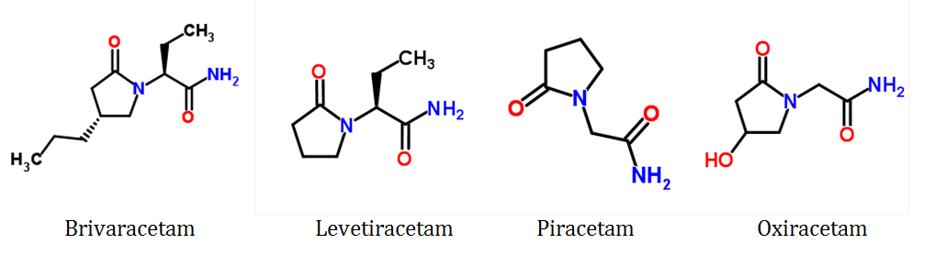
The drug substance is manufactured by a simple, convergent synthesis, in the salient step of which the ucb-108628-1 intermediate [a mixture of brivaracetam and its (2S,4S)-diastereomer (ucb 34713; structure attached)] is resolved using chiral chromatography in a Multicolumn Continuous Chromatography (“MCC”) unit comprising ≥ 5 columns. Whilst the diastereomeric structures with the alternative (2R)-absolute configuration are theoretically possible, these are precluded by the route of synthesis unless the (S)-2-aminobutanamide HCl synthon used in the synthesis of the ucb-108628-1 intermediate contains significant quantities of the (R)-isomer. The chirality of the (S)-2-aminobutanamide HCl synthon is specified as ≥ 99.0% by chiral HPLC in the API manufacturer’s specification.
Two non-solvated polymorphic forms are described in the dossier (Solid Phase 1 and Solid Phase 2), of which that designated Solid Phase 1 is the most stable form under ambient conditions in the absence of “guest” molecules and remains stable upon thermal treatment (up to 75C) and upon milling or compaction, and is the polymorphic form consistently produced by the manufacturing process.
The drug substance is BCS Class 1; whilst highly soluble across the physiological pH range, permeability data assessed across Caco-2 cell monolayers indicate the drug substance has high permeability.
The substance has no ionisable centres; therefore no pKa can be measured. The dossier states that LogP = 1.04 in octanol/water (Lit. 0.66).
The final stage of brivaracetam manufacture includes a de-lumping/milling process targeting a specific particle size distribution; that is, D(v,0.5) should be between 100 µm and 300 µm and D(v,0.9) ≤ 600 µm. Given the highly soluble nature of the drug substance, the absence of a lower limit for D(v,0.1) was not pursued.
The content of the (2S,4S)-isomer is limited to ≤ 2.50% in the oral and injectable grade drug substance specifications, whilst the content of each of the diastereomeric compounds having an absolute configuration of (2S) in the drug substance is limited to ≤ 0.15%.
One other potential impurity is controlled in the drug substance: the diastereomeric (2S)-[(4S)- and (2S)-[(4R)-(2-oxo-4-propyltetrahydro-1H-pyrrol-1-yl)butyric acid degradant pair (ucb-42144/42145)], which is limited to ≤ 0.10%. This limit has been accepted on the advice of the toxicology evaluator, and on the basis of being an inactive human metabolite.
A number of issues relating to the quality control of the brivaracetam drug substance were raised with UCB; all have been resolved except for provision of an acceptable formal API specification, and confirmation that the sponsor’s method for assessment of the repeatability of the in-house HPLC methodology is equivalent to or better than that stipulated in Ph Eur 2.2.46 and USP <621>.

Drug product

Film coated tablets
The proposed tablets are round, white to off-white (10 mg) or oval, grey, yellow, purple and green-grey (25 mg, 50 mg, 75 mg and 100 mg, respectively) film coated tablets, debossed with “u10”, “u25”, “u50”, “u75” and “u100” (respectively) on one side and plain on the other side. These will be packaged in PVC/PCTFE//aluminium blister packs containing 14, 56, 100 tablets and a multipack of 168 (3 x 56) tablets.
No overage is employed; however, a manufacturing excess of approximately 25% of each film coating solution is used to accommodate losses during the coating process.
Early Phase I and Phase IIa clinical studies (including the Phase I single ascending dose Study N01066 and multiple ascending dose study N01067) were conducted using a range of capsules that were filled with the pure active substance (10 mg, 20 mg, 40 mg, 80 mg, 100 mg, 150 mg, and 200 mg) by a hand-filling process. Brivaracetam was subsequently formulated with excipients to improve the flow properties and to enable homogeneous filling of the blend into capsules (Formulation F2) at strengths of 25 mg, 50 mg, and 200 mg. These capsules were used in Phase IIb study N01114.
White film-coated tablets (Formulation F3) containing 2.5 mg brivaracetam (core weight: 67.5 mg) and 10 mg brivaracetam (core weight: 67.5 mg) were then developed and were used in the N01193 Phase II dose ranging study. These tablets were not homothetic; also, the 2.5 mg tablets were manufactured using a wet granulation process and 10 mg tablets were manufactured using a dry granulation process.
Homothetic, white film coated tablets with brivaracetam strengths of 10 mg (core weight: 54 mg), 25 mg (core weight: 135 mg), 50 mg (core weight: 270 mg) and 100 mg (core weight: 540 mg) were subsequently developed (Formulation F4), all of which were manufactured via a dry granulation process. F4 tablets were used in Phase I bioavailability/bioequivalence studies and Phase III Efficacy studies. The 50 mg F4 tablet batch 14914 was used as the reference formulation in bioequivalence studies, except in N01256A where a low dose of 10 mg was preferred for the first exposure to brivaracetam solution for injection.
In the tablets originally proposed for commercialisation (Formulation F5), the formulation of the 10 mg tablet was revised to double the core weight in order to provide a larger area for printing, and a 75 mg tablet was introduced. Thus, the 10 mg tablet was not homothetic with the 25-100 mg tablets in this formulation. However, these tablets have not been used in any clinical studies, and were superseded by the tablets that are the subject of the current submission, of which the 10 mg, 75 mg and 100 mg strengths were used in bioequivalence Study EP0007.
The development of a discriminatory dissolution method for the tablets was considered unnecessary as the drug substance is BCS 1 and is formulated in a dosage form that releases more than 85% of its nominal content within 15 minutes across the physiological pH range. As the criteria stipulated in published guidelines for a very rapidly dissolving tablet for use of a disintegration test as a surrogate for dissolution testing have been met, disintegration testing has replaced dissolution testing in the commercial drug product specifications.
Nonetheless, in vitro dissolution testing was performed routinely during pharmaceutical development to support the formulation development activities and to characterise the dissolution behaviour of each of the developmental formulations F1-F4 and to confirm the similarity of the dissolution profiles of these and the commercial tablet formulations. In addition, dissolution testing was used during development for quality control purposes, to prove batch-to-batch consistency for the same formulation and process, and also to justify not performing bioequivalence studies. Conditions employed for all but the proposed coloured debossed tablets were USP/Ph Eur Apparatus 2 (paddles, with Japanese sinkers for capsules) at 50 rpm in 500 mL of medium at 37C for 2.5 mg, and 900 mL for all other strengths. For the coloured debossed tablets proposed for Australia, conditions were as used in stability trials; that is, USP/Ph Eur Apparatus 2 at 50 rpm in 900 mL of medium at 37C.
The common release and expiry limit proposed for the ucb-42144/42145 degradant pair in the finished products (≤ 0.20%) has been accepted by the toxicology evaluator. An acceptable justification was given for the revised common release and expiry limits proposed for Total Unspecified Impurities (≤ 0.30%) and Total Specified and Unspecified Impurities (≤ 0.50%).
The stability data support a (revised) shelf life of 36 months stored below 30C for all strengths of the tablets packaged in the PVC/PCTFE//aluminium blisters proposed for Australia. A number of issues relating to the quality control of the tablets were raised with the sponsor, of which all but confirmation of the stability of the bulk tablets packaged in the actual commercial packaging options and the provision of an acceptable formal composite release and expiry specification have been resolved.

Oral solution
The proposed oral solution is a slightly viscous, clear, and colourless to yellowish liquid which will be packaged in a 300 mL capacity Type III amber glass bottle with a tamper evident, polypropylene child resistant screw cap. The bottle will also be supplied with a 10 mL oral syringe and an adaptor for the syringe.
Whilst aqueous solutions having a brivaracetam concentration of 1 mg/mL and 10 mg/mL were developed for use in clinical trials, the latter was more appropriate for the therapeutic doses required in adults and adolescents, and is identical to that used in Phase III bioequivalence Study N01296, the finalised Phase II paediatric pharmacokinetic study N01263, and intended for commercialisation.
The 1 mg/mL oral solution, which was also used in Study N01263, was quantitatively identical to the 10 mg/mL formulation other than the concentrations of brivaracetam (1.00 mg/mL versus 10.00 mg/mL) and sucralose (4.00 mg/mL versus 40.00 mg/mL).
A pH of 5.5 was established during pre-formulation studies as being optimal for the stability of brivaracetam aqueous solutions, on the basis of which a range of 4.9-5.9 was chosen for development. Anhydrous citric acid/sodium citrate buffer was selected as appropriate for the desired pH range and based on taste considerations with citric acid considered as a flavour enhancer for its acidic taste.
Several sweeteners and flavours were evaluated to mask the bitter taste of brivaracetam, with sucralose and sorbitol solution finally selected as sweeteners and raspberry flavour 7557-A chosen on the basis of marketing considerations and its being alcohol free. Various thickeners were also evaluated to adjust the solution viscosity, with carmellose sodium and glycerol providing the desired consistency.
Studies were also performed to establish the minimum concentration of methyl hydroxybenzoate needed to meet compendial requirements for antimicrobial effectiveness (determined to be 0.8 mg/mL for batch release purposes), and a concentration of 1 mg/mL was subsequently confirmed in stability studies as suitable to retain compliance throughout the shelf life of the oral solution.
As neither brivaracetam nor the oral solution was shown to be susceptible to oxidation during forced degradation studies, no antioxidant is included in the formulation.
No overage of brivaracetam is used in the oral solution formulation.
On the basis of the submitted stability data, the company was requested to apply a tighter lower release limit to the content of methyl hydroxybenzoate in the oral solution to ensure a batch released at this limit will comply with the shelf life lower limit after 36 months storage at either 25C or 30C. The amended lower release limit is now acceptable for this purpose.
The Toxicology evaluator has accepted the expiry limit applied to the ucb-42144/42145 degradant pair in the finished product (≤ 1.0%); however, as the stability data clearly indicate levels of this impurity increase with storage, the company was requested to tighten this to ≤ 0.60% in order to ensure a batch released at this limit will comply with the shelf life limit after 36 months storage at 30C. This matter remains unresolved.
A number of other matters relating to the quality control of the oral solution were raised with the company, of which several also remain unresolved at this time.
The company originally requested a shelf life of 36 months stored below 25C for the oral solution, but amended this to 36 months stored below 30C once further stability data obtained at the higher temperature became available. However, because of the increases in the ucb-42144/42145 degradant pair in the finished product, this can only be accepted with a further tightened release limit for this impurity pair. The sponsor has been advised that the alternatives are to accept either a lower maximum recommended storage temperature of 25C in conjunction with a 36 months shelf life, or to accept a reduced shelf life of 24 months in conjunction with the release limit (as amended) currently in place. This matter remains unresolved.
An in-use shelf life of 5 months stored below 30C has been conditionally accepted for the oral solution.

Solution for injection
The solution for injection is a clear, colourless solution to be packaged in a clear, colourless Type I glass vial with a 20 mm bromobutyl rubber stopper and a 20 mm aluminium cap with polypropylene tear-off seal (packs of 10).
The commercial formulation is a simple aqueous solution containing brivaracetam (10.00 mg/mL), sodium chloride (9.00 mg/mL), sodium acetate trihydrate (1.64 mg/mL) and acetic acid (q.s. to pH 5.5) in water for injections. No overage is employed; however, each vial contains 5.4 ± 0.2 mL of the solution for injection to ensure withdrawal of the nominal volume (5.0 mL).
The density of the solution is 1.006 g/cm³ at 20C, comparable to that of Water for Injection (WFI), and the thermodynamic solubility of brivaracetam in acetate buffer is similar to the solubility of brivaracetam in water (800 g/L at 37C).
Brivaracetam solution for injection is a single use vial; as such, it contains no antimicrobial preservatives or antioxidants.
The initial formulation differed from that proposed for marketing in containing 2.70 mg/mL of sodium acetate (20 mM) instead of 1.64 mg/mL (12 mM). The reduction was shown to have no impact on product pH or relative stability; however, osmolarity decreased from 378.7 mOsm/kg 360 mOsm/kg. The impact was minimal, as both formulations are hyperosmotic in conjunction with human blood. A difference in haemolysis (0.0% 0.1%) was regarded as being irrelevant, as both formulations are considered non-haemolytic.
The initial formulation (Lot No: 15684; 3000 vials) was used in one clinical study (safety/absolute bioavailability Study N01256), whilst the commercial formulation was used two other studies (safety Study N01258 and bioavailability/bioequivalence Study EP0007).
The solution for injection has been shown to be stable upon dilution with 0.9% sodium chloride, 5% glucose or Lactated Ringer’s solution in two separate perfusion bags (PVC and polyolefin) at 2 concentrations: 10 mg/100 mL and 15 mg/100 mL, and to be qualitatively compatible with nasogastric and gastronomy feeding tubes, and with a number of other anti-epileptic drugs, as tabulated below.
Table 2: Stability for solutions of injection.
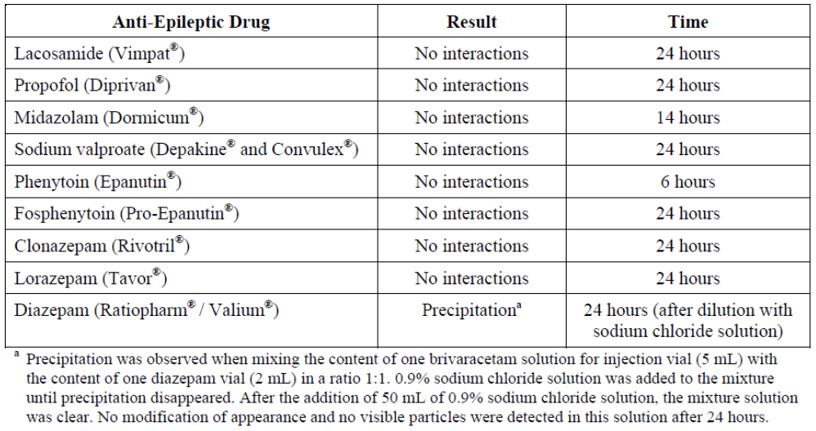
The toxicology evaluator has accepted the expiry limit applied to the ucb-42144/42145 degradant pair in the finished product (≤ 0.5%).
A number of issues relating to the quality control of the solution for injection were raised with UCB of which all, with the exception of the provision of an acceptable formal composite release and expiry specification, have been resolved.
The stability data in the original dossier support a shelf life of 36 months stored below 30C for the solution for injection packaged in the Type I glass vial proposed for Australia.

Biopharmaceutics
Four relative bioavailability and bioequivalence clinical studies were conducted to create a link between the various brivaracetam formulations that have been used during clinical development; Study ep0007, Study n01256a, Study n01287 and Study n01296. Details of these are presented below.

Relative bioequivalence study (Study ep0007)
This was a single dose, open label, randomised, 5 way crossover study for which the primary objectives were to assess the bioequivalence under fasted conditions of brivaracetam 10 mg, 75 mg, and 100 mg commercial tablets versus the F4 formulation 50 mg tablet as reference, and to assess the relative bioavailability of the commercial formulation brivaracetam 100 mg solution for injection given as a two minutes IV bolus injection versus the commercial formulation 100 mg film coated tablets and the F4 formulation 50 mg tablet as reference in healthy volunteers. The 90% CI of the ratio of the geometric LS means (reproduced below) were completely contained in the 80.00% to 125.00% interval for AUC(0-t), AUC(0-∞), and Cmax for the comparison of the commercial 10 mg, 75 mg and 100 mg tablets with the 50 mg clinical development tablet used as a reference suggesting that the tablet formulations were bioequivalent. The 100mg IV bolus injection also had similar bioavailability to the 50 mg and 100 mg tablets. However, whilst the 100 mg IV bolus injection was bioequivalent to the 50 mg and 100 mg tablets with regards to AUCnorm, it was not bioequivalent to the 50 mg and 100 mg tablets with regards to Cmax.
Table 3: Bioequivalence analysis Study ep0007.
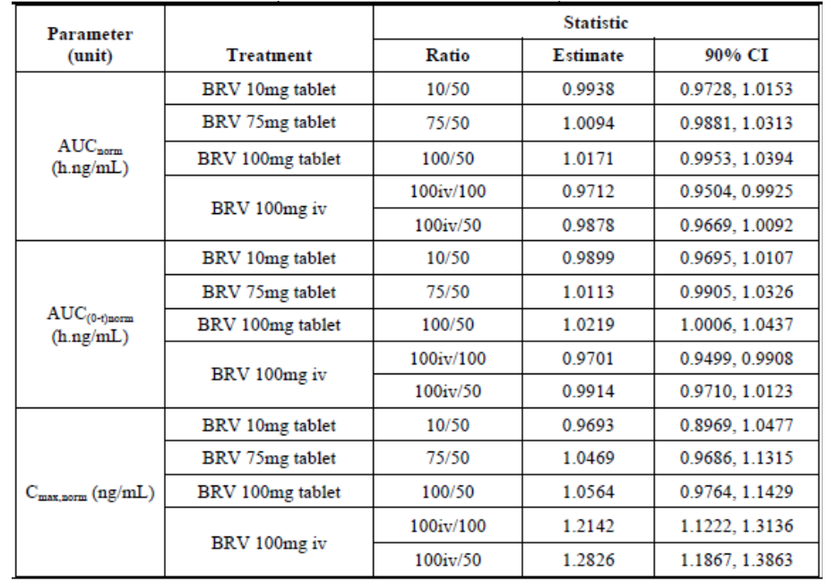

Relative bioavailability study (Study n01256a)
This was a single dose, open label, randomised, 3 way crossover bioavailability/bioequivalence study of 3 different formulations of brivaracetam in 24 healthy subjects (12 females, 12 males); that is, a single 10 mg F4 tablet (reference), the solution for injection (10 mg) given as an IV infusion over 15 minutes and the solution for injection (10 mg) given as a bolus IV injection over 12 seconds.
The bioequivalence analysis (IV infusion versus 10 mg F4 tablet; reproduced below) indicate no relevant differences were found between the IV infusion and oral tablet formulations in the tested PK parameters. Bioequivalence between IV infusion and 10 mg oral tablet was concluded since the 90% CIs of the Test 1/Reference ratio of the primary PK parameters AUC and Cmax were completely included in the predefined bioequivalence interval [80-125%].
Table 4: Bioequivalence analysis of BRV IV infusion (PP population).
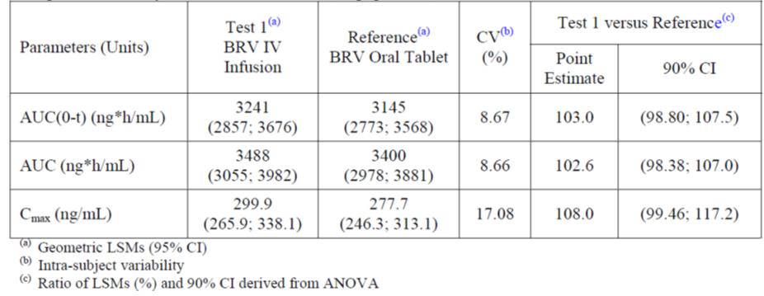
A similar outcome was concluded from the comparison of the IV bolus injection and the 10 mg oral tablet (reproduced below).
Table 5: Bioequivalence analysis of BRV IV bolus (PP population).
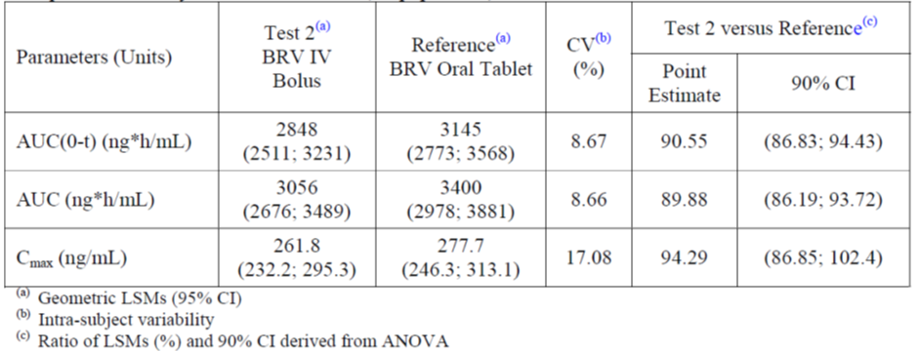

Relative bioavailability/food effect study (Study n01287)
This was a single dose, open label, randomised, 5 way crossover study for which the primary objectives were to assess the bioequivalence under fasted conditions of brivaracetam oral formulations (2 x 25 mg and 50 mg capsules [F2] and 50 mg tablets [F4] versus an extemporaneous reference oral brivaracetam solution [“powder in water”]), to assess the bioequivalence between brivaracetam capsules (2 x 25 mg and 1 x 50 mg; F2) versus brivaracetam 50 mg tablets (F4) as reference, and to assess the rate and extent of absorption of brivaracetam 50 mg tablets taken with a high fat meal, compared with fasting conditions. The results from the bioequivalence assessment under fasted conditions are reproduced below.
Table 6: Inferential analysis on PK parameters of 50 mg brivaracetam after single administration (50 mg solution, 50 mg capsules, 2 x 25 mg capsules and 50 mg tablet) in fasting healthy subjects (PP population).
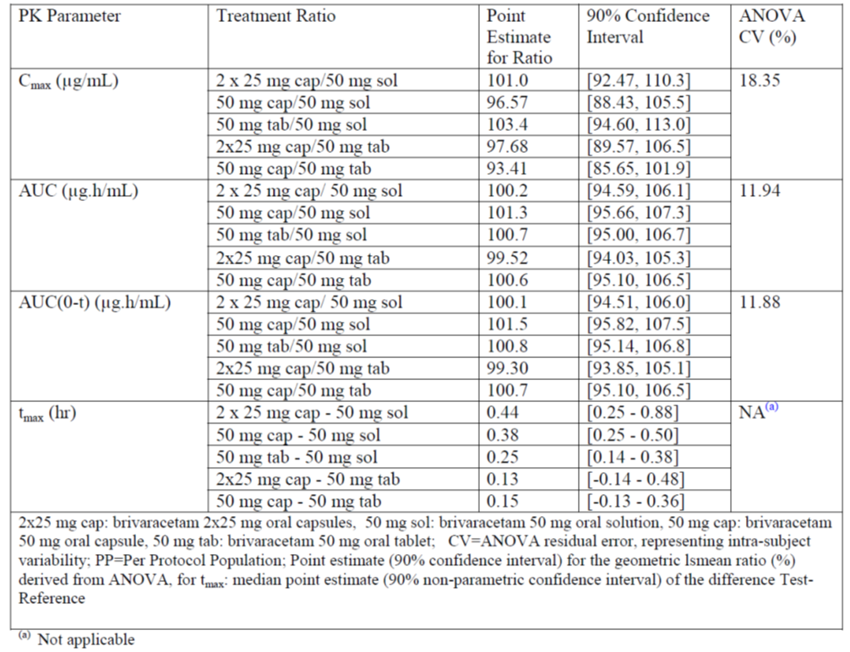
From these, it is concluded that:
- Brivaracetam plasma concentrations versus time profiles and all assessed pharmacokinetic parameter values were similar in all 4 formulations (2 x 25 mg or 1 x 50 mg F2 formulation capsules, 1 x 50 mg F4 formulation tablet, or an oral solution) under fasting conditions.
- The comparison of the treatment ratios showed geometric means for brivaracetam Cmax, AUC0-t and AUC was close to 100% and the 90% confidence intervals were completely included in the bioequivalence range of 80.00% to 125.00%.
- Bioequivalence of capsules (2 x 25 mg and 50 mg) versus solution, tablet versus solution and capsules (2 x 25 mg and 50 mg) versus tablet can be concluded.
The analysis of the food effect is reproduced below.
Table 7: Inferential analysis on PK parameters of 50 mg brivaracetam after single administration of 50 mg brivaracetam tablet in fasting or fed healthy subjects (PP population).
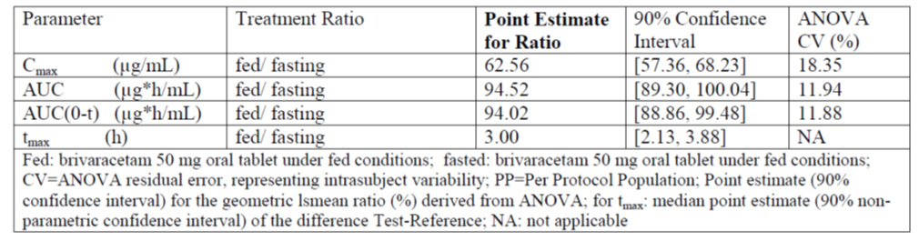
From these, it is concluded that:
- Food intake reduced the rate of absorption of brivaracetam 50 mg tablet by approximately 37% as the geometric mean ratio of Cmax was 62.56. The corresponding 90% CI was 57.36-68.23, which was outside of the 80.00-125.00% bioequivalence boundaries.
- Tmax was delayed to 3.0 h under fed conditions.
- No significant difference was observed in the extent of absorption of brivaracetam between fasting and fed conditions. The geometric mean ratios for AUC and AUC0-t were close to 100%. Corresponding 90% CIs were within the 80.00-125.00% bioequivalence boundaries.
- There was no effect on other pharmacokinetic parameters.

Relative bioavailability (Study n01296)
This was an open label, randomised, single dose, 2 way crossover bioavailability/bioequivalence study of 2 different formulations of brivaracetam in 24 healthy subjects (12 females, 12 males); that is, a single 50 mg F4 tablet (reference) and the commercial oral solution 5 mL; 10 mg/mL.
The 90% CI of the ratio of the geometric LS means for the primary assessment (reproduced below) was completely contained within the 80.00% to 125.00% interval for AUC(0-t), AUC and Cmax, suggesting that the commercial oral solution (50 mg) and the 40 mg F4 formulation film coated tablet were bioequivalent with respect to these parameters in relation to administration of a single dose in the fasted state.
Table 8: Bioequivalence analysis of BRV oral solution (5 ml, 10 mg/ml) versus 50 mg oral tablet (reference) (PP population).
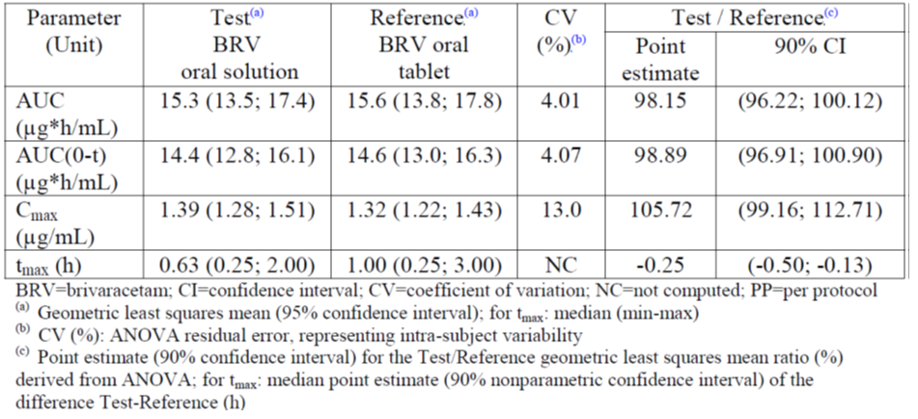

Quality summary and conclusions
There are no objections in respect of biopharmaceutics to registration of these products. However, a number of matters relating to the quality control of the finished products require resolution before approval can be recommended from a quality perspective. Of these, the inability to confirm a shelf life for the oral solution pending UCB’s decision in relation to the three options described above, and the absence of acceptable evidence of Good Manufacturing Practice (GMP) linked to UCB as sponsor the site of manufacture of the oral solution are of particular note.

III. Nonclinical findings

Introduction
Briviact tablets, oral solution and solution for injection are indicated as add-on therapy in the treatment of partial onset seizures, with or without secondary generalisation, in patients from 16 years of age with epilepsy. The sponsor has submitted a generally thorough and high quality nonclinical dossier to support the registration of brivaracetam.
No maximum duration of treatment is proposed. The evaluator has assumed that brivaracetam treatment will be long term. Notably, the Australian PI does not stipulate a maximum duration of IV administration. The US PI notes that “the clinical study experience with Briviact injection is limited to 4 consecutive days of treatment.”

Pharmacology

Primary pharmacology
Brivaracetam is a second generation levetiracetam-like Synaptic Vesicle Glycoprotein 2A (SV2A) ligand atypical anti-seizure/anti-epileptic agent. The sponsor has provided substantial primary pharmacological evidence of its anti-seizure properties although the exact pharmacological mode of action of this class of drugs (including brivaracetam) is unknown.

Overall notable features
Brivaracetam is a selective SV2A ligand with generally approximately ≥10X the affinity and efficacy of levetiracetam (the class innovator molecule). Based on levetiracetam data, high SV2A binding affinity is strongly correlated (r 8-9) with anticonvulsive properties in rodents. Critically, high rates of SV2A occupancy (approximately 90%) are required for effective anti-seizure action and the slopes of the anti-seizure dose response curves are very steep. Thus the theoretical pharmacokinetic objective in this drug class is to maintain at least approximately 90% SV2A occupancy at the plasma Cmin. Based on mouse data, a brivaracetam dose of between 10-100 mg/kg IP is required to produce ≥90% SV2A occupancy at 60 min post dosing.
Because of its lipophilicity (approximately Log P = 1), brivaracetam rapidly equilibrates across the blood brain barrier with a brain:plasma ratio of approximately 1. Distribution into brain is not dependent on active transport. This minimises the risk of pharmacogenomic and blood brain barrier transporter associated victim perpetrator interactions.
Although brivaracetam is intended for use as an add-on therapy for partial epilepsy, its use in combination with other anti-epileptics (except diazepam) was not investigated in the nonclinical program.
In most in vitro and in vivo nonclinical models, brivaracetam provided at least a similar, or in many cases greater, efficacy than levetiracetam (in most animal models of seizure and/epilepsy, brivaracetam has approximately ≥10X the potency of levetiracetam). In rodents brivaracetam can control diazepam resistant seizures, including life threatening benzodiazepam resistant self-sustaining status epilepticus. Low doses of brivaracetam devoid of behavioural effects are strong potentiators of diazepam anti-seizure activity (with behavioural effects solely attributable to diazepam). Furthermore, unlike levetiracetam, brivaracetam treatment created a window of resistance to the seizure recrudescence even after drug washout in corneally kindled rats. Notably, brivaracetam delayed, inhibited or prevented induction of a seizure-prone state by corneal kindling in some rats suggesting that brivaracetam might have efficacy for prevention of seizurogenesis.
Brivaracetam was not effective (ED50 >382 mg/kg IP) against seizures induced by bicuculline and picrotoxin, pilocarpine, 4-aminopyridine and caffeine, and high doses were required to control seizures resulting from l-glutamate 1-carboxylase inhibition by 3-mercapto-propionic acid.

Effects on ion channels
In in vitro systems that utilised normal adult neurons, brivaracetam had minimal or no effects on neuronal Na+ channels or sustained repetitive firing, even at high concentrations. In rat embryonic neocortical neurons and mouse neuroblastoma cells, brivaracetam displayed a carbamazepine-like Na+ channel blocker profile, although these effects were not observed in any non-neoplastic and adult neurons in vitro. The human relevance of these findings is uncertain. A lack of Na+ channel effects is consistent with the role of SVA2 in the neuronal presynaptic plasma membrane.

Effects on amino acid neurotransmitters
Brivaracetam reversibly inhibited NMDA induced neuronal currents but had no effect on kainate or AMPA induced neuronal ion currents. Brivaracetam does not directly affect GABA and glycine induced neuronal ionotropic effects. However, it did antagonise the chemical inhibition of GABA and glycine neuropathways. Thus, the anti-epileptogenic properties of brivaracetam may, in part, be due to inhibition NMDA excitatory pathways and disinhibition of GABA and glycine inhibitory pathways.

In vivo anti-epileptic/antiseizureogenic effects
Overall, brivaracetam displayed a high degree of anti-seizure/anti-epilepsy activity in various rodent models (chemically induced, genetic audiogenic, genetic absence epilepsy, electroshock, various kindling models, self-sustaining status epilepticus, post cardiac arrest hypoxic seizures and myoclonus) when administered 30-60 min before seizure induction (that is, under efficacy biased conditions). In most models, brivaracetam treatment produced close to 100% control of seizures with minimal to no effects on normal behaviour. The potency of brivaracetam was approximately ≥10X that of levetiracetam with superior efficacy in many models. In corneally kindled mice, brivaracetam reduced (by approximately 20X) the percentage of animals that developed seizures after 19 days of corneal kindling. This implies that brivaracetam may slow, delay or prevent seizurogenesis in this model. Previous treatment of corneally kindled, seizure prone animals with brivaracetam created a “window of resistance” against seizure recrudescence in approximately 50% of animals after a drug washout period. Brivaracetam was notably effective in stopping and controlling self-sustaining status epilepticus and diazepam resistant seizures in rodents. It is also a strong potentiator of diazepam anti-seizure effects, even at sub-therapeutic doses and in the presence of diazepam resistance.
Brivaracetam controlled complex partial seizures and temporal lobe epilepsy, suppressed epileptic foci, limited the spread of seizurogenic activity and controlled/prevented self-sustaining status epilepticus in rodents. Brivaracetam consistently displayed greater efficacy than either diazepam or phenytoin in some models.

Effects on pharmaco-resistant essential tremor in rats
In the rat harmaline model of pharmacoresistant essential tremor, brivaracetam (at its typical anti-epileptic dose range and unlike levetiracetam), produced a selective anti-tremor effect without sedative and motor side effects. A selective anti-tremor effect, though of smaller amplitude and within a narrower dose range, was also obtained with propranolol, the first choice “Standard of Care for Essential Tremor.” By contrast, pro-sedative effects and/or motor side-effects curtailed the effective dose range or totally masked selective anti-tremor efficacy in the case of primidone, clonazepam, carbamazepine, phenytoin, valproate and gabapentin.

Anti-seizure/anti-epilepsy properties of metabolites and the diastereoisomer
Ucb-107092-1, a major metabolite of brivaracetam in renally impaired patients, does not bind to SV2A and has no anti-epileptogenic properties. Other metabolites (ucb-42145, ucb-100023-1, ucb-100406-1) were inactive (mouse audiogenic seizure model), but the minor metabolite ucb-47074 has anti-seizure activity, although it is less potent than brivaracetam. The diastereomer of brivaracetam (ucb-34713) binds to SV2A but with a lower affinity than brivaracetam, and was 7-fold less efficacious in a mouse audiogenic seizure model.

Secondary pharmacodynamics and safety pharmacology

Effects on motor performance
Based on data in normal rats, brivaracetam doses equivalent to approximately 6X the human single dose MRHD (based on BSA) did not affect locomotion. Similarly, supratherapeutic doses of brivaracetam doses were required to negatively affect rotarod performance in amygdala kindled rats (≥6X the single dose MRHD based on BSA), rats with genetic absence epilepsy (≥2X the single dose MRHD based on BSA) and in mice (approximately ≥2X MRHD).
Brivaracetam doses at approximately 6X the human single dose MRHD (based on BSA) did not affect general locomotory activity levels in normal rats.

Effects on neurobehaviour and learning
The LOAEL for effects on basic neurobehavioral parameters in rats was equivalent to approximately ≤9X the human single dose MRHD (based on BSA). Accordingly, brivaracetam is expected not to have adverse effects on basic neurobehavioral parameters in humans. Brivaracetam doses equivalent to approximately 2X the single dose MRHD (based on BSA) did not affect learning and memory in the rat Morris water maze model.
High doses (100 mg/kg IV; approximately 9X the single dose MRHD based on BSA) of brivaracetam induced transient (10-15 min) muscular relaxation and sedation. However basic neuromuscular reflexes were maintained under these conditions. IV doses of approximately 18-27X the single dose MRHD (based on BSA) induced unconsciousness with loss of corneal and tail pinch reflexes. These results imply that extremely high overdoses of brivaracetam are required to produce potentially life threatening deep unconsciousness characterized by areflexia in rats.
Brivaracetam doses equivalent to approximately 1X the single dose MRHD (based on BSA) had no effect on the behavioural effects of diazepam (1 mg/kg IV) when brivaracetam + diazepam drug combinations are co-administered. All observed behavioural effects of brivaracetam + diazepam combinations were due to the effects of diazepam.
Oral brivaracetam doses equivalent to approximately 0.6X the single dose MRHD (based on BSA) reduced dexamphetamine-chlordiazepoxide associated hyperactive behaviour in rats.

Effects on nociception
Brivaracetam doses equivalent to approximately ≥2X the single dose MRHD (based on BSA) had no effect on hotplate and food pad formalin injection nociception in rats. However, brivaracetam equivalent to approximately 0.6X the single dose MRHD (based on BSA) displayed analgesic properties in rat models of sciatic nerve mechanical hyperalgesia/neuropathic pain in normal and diabetic rats.

Potential for drug abuse and drug withdrawal
Subchronic brivaracetam treatment of rats at doses equivalent approximately 32X the single dose MRHD (based on BSA) was not associated with clinical signs of classical addictive drug withdrawal in rats.
Based the potential to reinforce cocaine self-administration brivaracetam at up to doses of 10 mg/kg (IV infusion; maximum human single IV dose margin of exposure at the NOEL approximately 1X the single dose MRHD based on BSA) has a low potential to influence drug abuse behaviour in rats.
Brivaracetam engendered partial cross generalisation to chlordiazepoxide at doses ≥1 mg/kg/day (LOEL; margin of exposure approximately 1X based on BSA). The interpretation of partial generalization results in drug discrimination assays is controversial. A very conservative risk assessment interpretation would be that partial generalisation is a positive signal for abuse potential. However, the human relevance of the results of drug discrimination assays remains uncertain. When this result considered in the overall context of the available data on addiction potential, brivaracetam’s potential to induce or influence addictive behaviours is likely negligible.

Effects on cardiovascular/respiratory function
Based on in vitro data, brivaracetam treatment resulting in the maximum expected human plasma Cmax is unlikely to affect cardiac Purkinje fibre action potentials, hERG channel function, cardiac sodium channel function and cardiac calcium channel function (margin of exposure approximately ≥7 based on molar concentration comparison at the Cmax).
Based on canine data, administration is unlikely to have adverse effects on haemodynamic and respiratory function in vivo (margin of exposure approximately ≥2 based on free AUC). Notably, female dogs (conscious telemetered) displayed a greater sensitivity to the effects of PO supratherapeutic doses of brivaracetam on blood pressure. In female (but not male) dogs, doses ≥50 mg/kg PO resulted in a tendency for reduced blood pressure between 4-20 h post dosing (≤25-27 mm Hg maximum reduction in mean arterial pressure with maximum reductions of ≤29-31 mm Hg mean systolic arterial pressure and maximum reductions of 23-25 mm Hg mean diastolic pressure). This dose is 15X the single dose MRHD and plasma concentrations at 2 h post-dose were 17X the clinical Cmax. Similar effects were not seen in repeat dose dog studies at higher doses, and the human relevance of these findings is likely to be low.

Effects on gastrointestinal function
Brivaracetam treatment at the maximum human single dose is unlikely to affect GI transit times and gastric emptying (single dose MRHD margin of exposure at the NOEL/NOAEL all approximately >27 based on BSA comparisons).

Effects of metabolites
Ucb-107092-1, a major metabolite of brivaracetam in humans with renal impairment, is unlikely to induce adverse effects on basic behaviour (based on rat Irwin behavioural screen results), cardiac hERG channels, cardiac Purkinje fibre action potentials, basic cardiovascular and respiratory parameters, GI motility and gastric emptying at the proposed levels of human exposure.
Ucb-34713, the diastereoisomer of brivaracetam, is unlikely to induce adverse effects on cardiac Purkinje fibre action potentials (NOAEL >20 μg/mL in vitro) and cardiac hERG channel functions (NOAEL >20 μg/mL in vitro) at the proposed maximum level of human exposure (ucb-34713 maximum exposure of 0.1 mg/kg/day, if present at 2.5%).

Pharmacokinetics

Absorption and plasma kinetics

In vitro
Brivaracetam displayed high, non-polarised permeability to Caco-2 intestinal enterothelial cell monolayers. Consistent with this finding was that brivaracetam is not a substrate for common enterothelial transporters.

In vivo
At pharmacologically relevant doses brivaracetam is rapidly and completely absorbed from the GI tract. Fasting has little, if any, effect on absorption. Plasma Tmax after oral dosing ranged from 0.08-1h across different species. Oral bioavailability (F) in rats and dogs is approximately 100% and the route of administration makes little difference to basic pharmacokinetic parameters, consistent with rapid GI absorption and minimal first-pass extraction in these species. Cynomolgus monkeys have a species specific high first pass extraction (F <10%) and high clearance (Cl). In most species, plasma levels increased with dose allowing high multiples of the human exposure to be achieved in the toxicology studies. However, dose non-linearity was observed in some cases (particularly in dogs; a species specific effect due to metabolic differences). The plasma exposure in juvenile rats was approximately 4X that of adult animals on postnatal day (PND) 4. However, systemic exposure in juveniles was similar to that of adults at other points during development.
The terminal elimination half-life (t½) in animals is generally short (approximately 0.3h in Cynomolgus monkeys to approximately 2 h in female rats). Cynomolgus monkeys generally have approximately 2X the Cl to other species (consistent with their higher rate of metabolic clearance). However, Cl (when normalised to body weight) in non-primates was still approximately 4-21X higher than humans. The T½ in animals is approximately 0.03-0.2X the human T½ of approximately 9 h. Because of the short plasma half-life in animals, the dosing regimen in most nonclinical toxicological studies had to be adapted to ensure coverage throughout the whole day (that is, multiple daily dosing, sometimes combined with dietary administration). Unlike humans, repeat dosing to rodents and dogs (not Cynomolgus monkeys) was associated with a decrease in systemic exposure, as a result of auto-induction of metabolism.
Biological sex had minimal effects on absorption and plasma pharmacokinetic parameters except in rats where females have higher systemic exposures and slower elimination. Nonlinear kinetics occurred in the dog following IV dosing, however this appears to be a species specific effect (not observed in any other species).

Distribution
Brivaracetam essentially distributes to the total body water, including the CNS, placenta and reproductive tissues (Vz is approximately total body water volume). Based on Vz measurements, tissue sequestration as a fraction of dose appears to be negligible. Plasma protein binding ranges from 12.2-26.5% across species (humans = 20.7%). The brivaracetam erythrocyte:plasma concentration ratio ranges from 0.62-0.84 depending on species and its whole blood:plasma ratio is approximately 1:1.
Following oral dosing with 14C-brivaracetam, radioactivity mostly accumulated at sites involved in absorption (that is, the GI tract), biotransformation (the liver) and excretion (kidney).
Distribution to the brain in audiogenic seizure prone mice is very rapid (brain Tmax approximately 15 min) following oral dosing and the pharmacological effects were directly proportional to brain concentration. In rodents, rapid equilibration of tissue and plasma concentrations occurs (plasma-to-brain tissue concentration ratios of approximately 1:1). Plasma-to-brain tissue concentration ratio was not affected by route of administration, sex or sampling time in rodents.
Apparent short-term tissue sequestration was noted in the preputial/clitoral glands and/or their associated secretions and in the lens capsules. Apart from these sites of apparent sequestration, tissue radioactivity levels essentially matched the plasma concentration and tissue elimination was rapid and near complete by 24 h. Sequestration in the preputial/clitoral glands and/or their associated secretions was associated with a much slower decline in tissue radioactivity levels (returning to background at approximately 72 h post dose). This effect was specific to rats, fully reversible, not associated with metabolite formation and did not involve covalent tissue binding. As humans lack preputial/clitoral glands this finding is not regarded as human-relevant.
Brivaracetam rapidly crosses the placenta in rats with equilibration within about 1 h and maternal to foetal/placental tissue and fluid ratios of approximately 1:1.

Metabolism
The proposed metabolic pathways shown below in Figure 2.
Figure 2: Proposed metabolic pathways of brivaracetam.
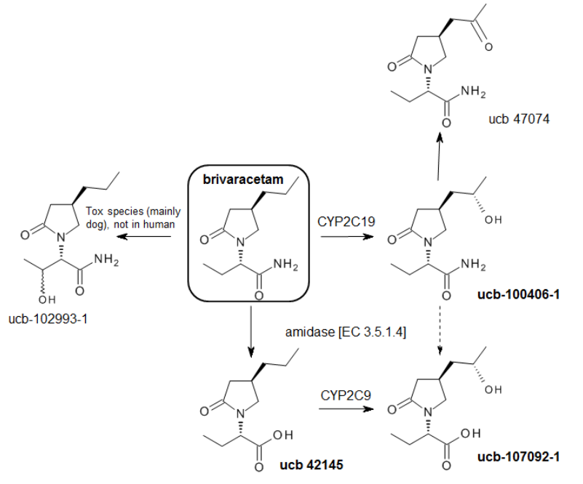
In all species examined (including humans), hepatic metabolism is responsible for most of plasma clearance of brivaracetam. Based in in vitro microsomal and hepatocyte data, humans have the slowest rate of brivaracetam metabolism, Cynomolgus monkeys have the highest metabolism and rodents are intermediate metabolisers. Brivaracetam is rapidly and extensively metabolised and the metabolites are virtually exclusively excreted in urine. The major routes of metabolism are stereo-selective hydroxylation of the propyl side-chain to form ucb-100406-1 (catalysed by CYP2C19; approximately 30-40% of the dose in all species except humans; approximately 28.2% of the dose in humans), hydrolysis of the acetamide moiety to form ucb-42145 (catalysed by amidase E.C.3.5.1.4; approximately 3-18% of the dose in all species except humans; approximately 56.4% of the dose in humans; a similar reaction occurs with levetiracetam), and both reactions to form ucb-107092-1 (catalysed by CYP2C9; approximately 2.5% of the dose in dogs and Cynomolgus monkeys; absent in rodents; approximately 15.2-15.9% of the dose in humans). No human specific in vivo metabolites were identified. Cholinesterases, carboxylesterases or aromatic esterases do not metabolise brivaracetam. Accordingly genetic variance in plasma esterase activity in humans is unlikely to affect brivaracetam pharmacokinetics. The hydrolysis rate of ucb-100406-1 into ucb-107092-1 is minimal when compared with the hydrolysis of brivaracetam into ucb-42145.
Formation of ucb-102993-1 due to hydroxylation of butyramide side chain is a species specific metabolic pathway that occurs mostly in dogs (based on in vitro and in vivo data). This metabolic pathway is associated with a species-specific increased susceptibility to adverse porphyrogenesis in dogs. The effect is associated with bioactivation of the butyramide side-chain, combined with other precipitating factors. Notably, the actual ultimate porphyrogenic metabolite in dogs remains unidentified. It is assumed that the formation of ucb-102993-1 is a surrogate marker of the bioactivation of the butyramide side-chain, and thus a marker of potential prophyrogenesis. Since ucb-102993-1 was not observed in humans, it is claimed that bioactivation of the butyramide side-chain resulting in the formation of a putative ultimate porphyrogenic metabolite does not occur at clinically relevant levels in humans. The available human metabolic and clinical data supports this conclusion.
Critically, the major human metabolite ucb-100406-1 is not porphyrogenic. Incubation of brivaracetam and ucb-100406-1 in the presence of various porphyrogenic agents and cultured canine hepatocytes species did not result in increased production of protoporphyrin IX.
Notably ucb-107092-1 is formed in larger amounts in humans with severe renal impairment (AUC increased by approximately 21.5X) compared with its formation in normal animals. This necessitated a separate and specific nonclinical evaluation for ucb-107092-1.
Brivaracetam is the major chemical species in the circulation in all animals except Cynomolgus monkeys. This characteristic is not affected by dose, route of administration, sex or treatment duration. In rodents and Cynomolgus monkeys, ucb-100406-1 was the only metabolite exceeding 10% of the total circulating material. In the dog, the major circulating metabolites are ucb-100406-1 and ucb-102993-1. Oxidation of ucb-100406-1 can result in the formation of the corresponding ketone ucb-47074, a minor metabolite.

Excretion
Brivaracetam elimination occurs predominantly via metabolism followed by metabolite excretion in urine with minimal biliary excretion (based on rat data). In all examined species, approximately ≤6% of the dose is excreted intact. Mass balance studies utilizing [14C]-brivaracetam demonstrated that approximately ≥90% of the administered radioactivity is excreted by 48-168 h post dosing. The mass balance of excretion is not affected by species, route of administration, sex or pregnancy state. Based on rat data, brivaracetam rapidly equilibrates into milk at similar concentrations to plasma levels.

Overall conclusions
The critical difference in the pharmacokinetics in animals was the much higher rate of clearance (predominantly by metabolism) and the much shorter T½ in the test species. To achieve adequate systemic exposure in the pivotal animal toxicology studies, multiple daily dosing regimens, were required. Unlike other relevant species, Cynomolgus monkeys have a species-specific high first pass extraction which results in an F <10% and rapid clearance.
High multiples of the human MRHD exposures were achieved in the nonclinical toxicology studies.
A second critical difference between humans and animals is the higher level of hydroxylation of butyramide side chain to form ucb-102993-1 in dogs. Ucb-102993-1 is assumed to be a biomarker of brivaracetam butyramide side-chain bioactivation and porphyrogenesis. Since ucb-102993-1 was not observed in humans, it is claimed that these effects are also not human-relevant. The available human metabolic and clinical data support this claim.

Pharmacokinetics of ucb-107092-1
In the presence of severe renal impairment, the plasma AUC of ucb-107092-1 increased by approximately 21.5X in humans. Ucb-107092-1 has a low oral bioavailability in rats (approximately 23%) and is very rapidly eliminated (>95% decrease in plasma concentration within 1 h of IV dosing) via renal excretion. Continuous IV infusion was required to achieve adequate systemic exposures and plasma time course profiles in the nonclinical toxicology studies.

Pharmacokinetic drug interactions
Brivaracetam (200 μM) at 12.5X the human plasma Cmax following repeated dosing at the MRHD (100 mg bid which results in a Cmax of approximately 16 μM), was associated with approximately 46% inhibition of CYP2C19. Inhibition of CYP1A2, CYP2A6, CYP2C9, CYP2D6 or CYP3A4 was not observed. Ucb-42145 and ucb-100406-1 did not inhibit any of the CYP isoforms that were tested.
Very high, supratherapeutic concentrations of brivaracetam (500 μM or approximately 31X the human plasma MRHD Cmax) induced a 3X induction of CYP3A4 in cultured human hepatocytes; however in a subsequent study no effects were noted at a concentration of 100 μM. Brivaracetam had no effect on CYP1A1, CYP1A2, CYP2B6 and CYP3A4.
Repeated oral BID dosing of Wistar rats at very high levels of exposure (approximately 50X human MRHD AUC) resulted in elevations in liver to bodyweight ratios, elevations in microsomal protein content and elevations in cytochrome P450 content. Brivaracetam exposure at approximately ≥5X the human AUC at the MRHD resulted in dose dependent induction of CYP2B (up to 150X at 1000 mg/kg/day on a per mg liver protein basis). This implies brivaracetam at supratherapeutic exposure levels may be a phenobarbitone type inducer. Mild to moderate induction of CYP 1A, CYP2E1, CYP3A and CYP4A activities was also observed, most likely due to xenosensor cross-talk. The results of non-pivotal repeat dose toxicology testing in dogs and rats support the finding that at high levels of exposure, brivaracetam is a hepatic CYP inducer.
Brivaracetam inhibited human microsomal epoxide hydrolase with an IC50 approximately ≥2X the human MRHD plasma Cmax.
Very high, supratherapeutic concentrations of brivaracetam (200 μM or approximately 12.5X the human plasma MRHD Cmax) and its metabolites ucb-42145 (10μM), ucb-100406-1 (10 μM) and ucb-107092-1 (2 μM) displayed negligible inhibition of organic anion transporters 1, 3, P1B1, and P1B3 (OAT1, OAT3, OATP1B1, OATP1B3), organic cation transporters 1 and 2 (OCT1, OCT2), breast cancer resistance protein (BCRP), P-gp, or bile salt export pump (BSEP).
Brivaracetam is not a P-gp, MRP1, MRP2, BCRP, OATP1B1/3, OAT1/3 or OCT2 transporter substrate.
Felbamate, phenytoin, carbamazepine, valproic acid, lamotrigine, zonisamide and phenobarbitone did not adversely affect CYP mediated hydroxylation of brivaracetam in human liver microsomes.
Overall, brivaractam has a low potential for drug-drug interactions or victim-perpetrator interactions involving CYP enzymes and transporters.

Toxicology

Acute toxicity of brivaracetam
High PO doses of brivaracetam (1000 mg/kg in females and 2000 mg/kg in males) induced clinical signs of CNS dysfunction (reduced activity and muscular tone, unsteady gait, loss of reflexes) in rats. This resembled the adverse effects observed during rat Irwin behavioural screening. The lower threshold for adverse effects in females is likely due their higher systemic exposure following oral dosing. Based on the results in the rat Irwin behavioural screening study, exposure during fasting is likely to exacerbate the severity. The LOEL in rats for a single PO dose was 500 mg/kg (approximately 45X the human single dose MRHD based on BSA comparison). Brivaracetam at doses ≥1000 mg/kg induced gastric irritation approximately 90X the human single dose MRHD based on BSA comparison). At 500 mg/kg, transient and slight reductions in food consumption were observed, possibly due to local gastric mucosal intolerance.
Critically, very high supratherapeutic IV doses (200-300 mg/kg in rats or approximately 18-27X the human single dose MRHD based on BSA comparison) are required to produce potentially life threatening deep unconsciousness characterised by areflexia lasting 10-15 min in rats. Full recovery occurred after approximately 1 h.

Repeat dose toxicity of brivaracetam

Relative brivaracetam exposure in the repeat dose toxicity and carcinogenicity studies
In general, high exposure ratios for brivaracetam were achieved in the nonclinical studies. The relative exposure ratios for brivaracetam and its major metabolites in the studies are summarised in the following tables.
Table 9: Relative exposure ratios for brivaracetam and its major metabolites.
Species | Study duration | Dose (mg/kg/day) | AUC_{0–24h} or AUC_{0–τ} (μg∙h/mL) | Exposure ratio#
Mouse  (CD-1; dose ranging) | 14 days  (gavage)  PSM1171 | 30 | ♂= 14.3; ♀= 18.5 | ♂ ≈0.2; ♀ ≈0.3
Mouse  (CD-1; dose ranging) | 14 days  (gavage)  PSM1171 | 90 | ♂= 44.6; ♀= 23.8 | ♂ ≈0.6; ♀ ≈0.3
Mouse  (CD-1; dose ranging) | 14 days  (gavage)  PSM1171 | 300 | ♂= 167; ♀= 118 | ♂ ≈2; ♀ ≈2
Mouse  (CD-1; dose ranging) | 14 days  (gavage)  PSM1171 | 900 | ♂= 688; ♀= 511 | ♂= 10; ♀ ≈7
Mouse  (CD-1; dose ranging) | 13 weeks  (gavage+diet)  PSM1256 | 450 | ♂= 135; ♀= 84.7 | ♂ ≈2; ♀ ≈1
Mouse  (CD-1; dose ranging) | 13 weeks  (gavage+diet)  PSM1256 | 675 | ♂= 288; ♀= 184 | ♂ ≈4; ♀ ≈3
Mouse  (CD-1; dose ranging) | 13 weeks  (gavage+diet)  PSM1256 | 1000 | ♂= 651; ♀= 618 | ♂ ≈9; ♀ ≈9
Mouse  (CD-1; Carcinogenesis) | 104 weeks  (gavage+diet)  NCD1304 | 400 | ♂= 82.2‡; ♀ =51.4 ‡ | ♂ ≈1‡; ♀ ≈1‡
Mouse  (CD-1; Carcinogenesis) | 104 weeks  (gavage+diet)  NCD1304 | 550 | ♂= 136‡; ♀ =58.6‡ | ♂ ≈2‡; ♀ ≈1‡
Mouse  (CD-1; Carcinogenesis) | 104 weeks  (gavage+diet)  NCD1304 | 700 | ♂= 252‡; ♀= 160‡ | ♂ ≈4‡; ♀ ≈2‡
Rat  (Wistar) | 4 weeks  (gavage)  TA0661 | 100 | ♂= 168 ^{ó}; ♀= 212^{ó} | ♂ ≈2; ♀ ≈3
Rat  (Wistar) | 4 weeks  (gavage)  TA0661 | 300 | ♂= 606 ^{ó}; ♀= 777 ^{ó} | ♂ ≈9; ♀ ≈11
Rat  (Wistar) | 4 weeks  (gavage)  TA0661 | 1000 | ♂= 1215 ^{ó}; ♀= 1751 ^{ó} | ♂ ≈17; ♀ ≈25
Rat  (Wistar) | 4 weeks  (gavage)  TA0661 | 1500 | ♂= 1957 ^{ó}; ♀= 1930 ^{ó} | ♂ ≈28; ♀ ≈28
Rat  (Wistar) | 4 weeks  (continuous IV infusion)  NCD1540 | 200 | ♂= 168; ♀= 518 | ♂ ≈2; ♀ ≈7
Rat  (Wistar) | 4 weeks  (continuous IV infusion)  NCD1540 | 600 | ♂= 578; ♀= 992 | ♂ ≈8; ♀ ≈14
Rat  (Wistar) | 4 weeks  (continuous IV infusion)  NCD1540 | 1000 | ♂= 710; ♀= 3061 | ♂ ≈10; ♀ ≈44
Rat  (Wistar) | 13 weeks  (gavage)  PSM0813 | 50 | ♂= 70.7*; ♀= 121* (0-12h) | ♂ ≈2; ♀ ≈3
Rat  (Wistar) | 13 weeks  (gavage)  PSM0813 | 100 | ♂= 99.5*; ♀= 251* (0-12h) | ♂ ≈3; ♀ ≈7
Rat  (Wistar) | 13 weeks  (gavage)  PSM0813 | 200 | ♂= 177*; ♀= 440* (0-12h) | ♂ ≈5; ♀ ≈13
Rat  (Wistar) | 13 weeks  (gavage)  PSM0813 | 400 | ♂= 317*; ♀= 743* (0-12h) | ♂ ≈9; ♀ ≈21
Rat  (Wistar) | 26 weeks  (diet + gavage)  PSM1029 | 100 (diet) + 50 (gavage) | ♂= 65.2; ♀= 144 | ♂ ≈1; ♀ ≈2
Rat  (Wistar) | 26 weeks  (diet + gavage)  PSM1029 | 100 (diet) + 130 (gavage) | ♂= 116; ♀= 196 | ♂ ≈2; ♀ ≈3
Rat  (Wistar) | 26 weeks  (diet + gavage)  PSM1029 | 100 (diet) + 350 (gavage) | ♂= 257; ♀= 464 | ♂ ≈4; ♀ ≈7

Species | Study duration | Dose  (mg/kg/day) | AUC_{0–24h} or AUC_{0–τ}  (μg∙h/mL) | Exposure ratio#
Rat  (Wistar; carcinogenesis) | 104 weeks  (diet + gavage; 52-wk sampling)  NCD1305 | 150 | ♂= 84.7; ♀= 121 | ♂ ≈1; ♀ ≈2
Rat  (Wistar; carcinogenesis) | 104 weeks  (diet + gavage; 52-wk sampling)  NCD1305 | 230 | ♂= 124; ♀= 197 | ♂ ≈2; ♀ ≈3
Rat  (Wistar; carcinogenesis) | 104 weeks  (diet + gavage; 52-wk sampling)  NCD1305 | 450 | ♂= 333; ♀= 529 | ♂ ≈5; ♀ ≈8
Rat  (Wistar; carcinogenesis) | 104 weeks  (diet + gavage; 52-wk sampling)  NCD1305 | 700 | ♂= 510; ♀= 635 | ♂ ≈7; ♀ ≈9
Dog  (Beagle) | 4 weeks  (gavage)  TA0660 | 6 | ♂ & ♀= 14.7* (0-12h) | ♂ & ♀ ≈0.4
Dog  (Beagle) | 4 weeks  (gavage)  TA0660 | 15ˢ | ♂ & ♀= 31.5* (0-12h) | ♂ & ♀ ≈1
Dog  (Beagle) | 4 weeks  (gavage)  TA0660 | 37.5 | ♂ & ♀= 75.1* (0-12h) | ♂ & ♀ ≈2
Dog  (Beagle) | 4 weeks  (gavage)  TA0660 | 94 | ♂ & ♀= 263* (0-12h) | ♂ & ♀ ≈8
Dog  (Beagle) | 4 weeks  (continuous infusion)  NCD1543 | 30ˢ | ♂ & ♀= 58.4 | ♂ & ♀ ≈1
Dog  (Beagle) | 4 weeks  (continuous infusion)  NCD1543 | 100 | ♂= 209; ♀= 200 | ♂ & ♀ ≈3
Dog  (Beagle) | 4 weeks  (continuous infusion)  NCD1543 | 150/200 | ♂ & ♀= 624 | ♂ & ♀ ≈9
Dog  (Beagle) | 13 weeks  (gavage)  PSM0812 | 6 | ♂ & ♀= 15.5* (0-12h) | ♂ & ♀ ≈0.4
Dog  (Beagle) | 13 weeks  (gavage)  PSM0812 | 15 | ♂ & ♀= 39.4* (0-12h) | ♂ & ♀ ≈1
Dog  (Beagle) | 13 weeks  (gavage)  PSM0812 | 37.5 | ♂ & ♀= 104* (0-12h) | ♂ & ♀ ≈3
Dog  (Beagle) | 26 weeks  (gavage)  PSM1013 | 15 | ♂ & ♀= 34.7 | ♂ & ♀ ≈0.5
Dog  (Beagle) | 26 weeks  (gavage)  PSM1013 | 37.5 | ♂ & ♀= 79.1 | ♂ & ♀ ≈1
Dog  (Beagle) | 26 weeks  (gavage)  PSM1013 | 75 | ♂ & ♀= 192 | ♂ & ♀ ≈3
Monkey  (Cynomolgus) | 4 weeks  PSM1101 | 300 | ♂ & ♀= 238 | 3.4
Monkey  (Cynomolgus) | 4 weeks  PSM1101 | 600 | ♂ & ♀= 728 | 10
Monkey  (Cynomolgus) | 4 weeks  PSM1101 | 900 | ♂ & ♀= 1518 | 22
Monkey  (Cynomolgus) | 39 weeks  PSM1140 | 300 | ♂ & ♀= 267 | 3.8
Monkey  (Cynomolgus) | 39 weeks  PSM1140 | 600 | ♂ & ♀= 1133 | 16
Monkey  (Cynomolgus) | 39 weeks  PSM1140 | 900 | ♂ & ♀= 2351 | 33
#= animal:human plasma AUC_{0–24 h} based on the derived human AUC_{0-24h} of 70 μg∙h/mL. The sponsor has used a value of 56 μg∙h/mL based on the oral AUC_{0-24h.} For precautionary reasons, the evaluator has used the IV AUC_{0-24h}. The evaluator acknowledges that IV use in humans may only likely occur for a period of several days; however the Australian PI, unlike the US PI, does not stipulate a maximum duration of IV treatment. If the value of 56 μg∙h/mL is used, the calculated AUC_{0–24 h} ratios will increase by a factor of approximately 1.25; * AUC_{0-24h} – ratios are calculated on 2x the AUC_{0-12h} values shown in the table; ‡ based on Week 52 data; ^{ó} Based on Day 1 data.

Relative exposure margins for metabolite ucb-42145 in adults
In general adequate levels of systemic exposure for ucb-42145 were achieved in the nonclinical studies in comparison with the expected level of human systemic exposure at the MHRD for normal humans. However, adequate levels of animal exposure at the animal NOAEL were not achieved in all studies with the expected level of human systemic exposure in patients with severe renal impairment.
Table 10: Relative exposure margins for metabolite ucb-42145.
Study  Species | Study duration Route | Brivaracetam Dose (mg/kg/ day) | AUC_{0–24h} or AUC_{0–τ}  (μg∙h/mL)* | Exposure ratio in normal humans# | Exposure ratio in humans with severe renal impairment#
PSM1256  Mouse (CD-1) | 13 Weeks  PO | 450 | ♂=4.06ˢ; ♀=3.11 | ♂≈1; ♀≈1 | ♂≈0.3; ♀≈0.3
PSM1256  Mouse (CD-1) | 13 Weeks  PO | 675 | ♂=9.45; ♀=11.2 | ♂≈3; ♀≈3 | ♂≈1; ♀≈1
PSM1256  Mouse (CD-1) | 13 Weeks  PO | 1000 | ♂=20.3; ♀=25.7 | ♂≈6; ♀≈7 | ♂≈2; ♀≈2
NCD1304  Mouse (CD-1) | 104 Weeks  PO | 400 | ♂=2.75ˢ; ♀=2.67 | ♂≈1; ♀≈1 | ♂≈0.2; ♀≈0.2
NCD1304  Mouse (CD-1) | 104 Weeks  PO | 550 | ♂=5.3; ♀=4.38 | ♂≈2; ♀≈1 | ♂≈0.5; ♀≈0.4
NCD1304  Mouse (CD-1) | 104 Weeks  PO | 700 | ♂=8.99; ♀=8.97 | ♂≈36; ♀≈3 | ♂≈1; ♀≈1
NCD1540  Rat (Wistar) | 4 Weeks  Continuous IV infusion | 200 | ♂=4.17; ♀=12.4 | ♂≈1; ♀≈4 | ♂≈0.4; ♀≈1
NCD1540  Rat (Wistar) | 4 Weeks  Continuous IV infusion | 600 | ♂=14.1ˢ; ♀=22.2 | ♂=4; ♀≈6 | ♂≈1 ♀≈2
NCD1540  Rat (Wistar) | 4 Weeks  Continuous IV infusion | 1000 | ♂=16.6; ♀=70.8 | ♂≈5; ♀≈20 | ♂≈2; ♀≈6
PSM1029  Rat (Wistar) | 26 Weeks  PO | 150 | ♂=1.68; ♀=3.11 | ♂≈0.5; ♀≈1 | ♂≈0.1; ♀≈0.3
PSM1029  Rat (Wistar) | 26 Weeks  PO | 230 | ♂=4.11; ♀=5.98 | ♂≈1; ♀≈2 | ♂≈0.4; ♀≈0.5
PSM1029  Rat (Wistar) | 26 Weeks  PO | 450 | ♂=7.86ˢ; ♀=12.3 | ♂≈2; ♀≈4 | ♂≈1; ♀≈1
NCD1305  Rat (Wistar) | 52 Weeks  PO  (104 week study) | 150 | ♂=2.39; ♀=3.05 | ♂≈1; ♀≈1 | ♂≈0.2; ♀≈0.3
NCD1305  Rat (Wistar) | 52 Weeks  PO  (104 week study) | 230 | ♂=3.61; ♀=5.1 | ♂≈1.0; ♀≈2 | ♂≈0.3; ♀≈0.4
NCD1305  Rat (Wistar) | 52 Weeks  PO  (104 week study) | 450 | ♂=10.2; ♀=13.7 | ♂≈3; ♀≈4 | ♂≈0.9; ♀≈1.2
NCD1305  Rat (Wistar) | 52 Weeks  PO  (104 week study) | 700 | ♂=14.1ˢ; ♀=16.0 | ♂=4; ♀≈5 | ♂≈1; ♀≈1
PSM1013  Dog (Beagle) | 26 Weeks  PO | 15 | 2.82 | ≈1 | ≈0.2
PSM1013  Dog (Beagle) | 26 Weeks  PO | 37.5 | 6.19 | ≈2 | ≈0.5
PSM1013  Dog (Beagle) | 26 Weeks  PO | 75 | 14.7 | ≈4 | ≈1
NCD1543  Dog (Beagle) | 4 Weeks  Continuous IV infusion | 30 | 5.29 | ≈2 | ≈0.5
NCD1543  Dog (Beagle) | 4 Weeks  Continuous IV infusion | 100 | 17.7 | ≈5 | ≈2
NCD1543  Dog (Beagle) | 4 Weeks  Continuous IV infusion | 150/200 | 56.3 | ≈16 | ≈5
PSM1101  Monkey | 4 Weeks  PO | 300 | ≈16.7 | ≈5 | ≈1
PSM1101  Monkey | 4 Weeks  PO | 600 | ≈51 | ≈15 | ≈4
PSM1101  Monkey | 4 Weeks  PO | 900 | ≈106.3 | ≈30 | ≈9
PSM1140  Monkey | 39 Weeks  PO | 300 | ≈18.7 | ≈5 | ≈2
PSM1140  Monkey | 39 Weeks  PO | 600 | ≈79.3 | ≈23 | ≈7
PSM1140  Monkey | 39 Weeks  PO | 900 | ≈165 | ≈47 | ≈15
* at study termination unless otherwise noted; # Healthy volunteer data from Study No. N01109 for 200 mg PO dose – AUC= 3.51 μg.h/mL, severe renal impairment data - AUC= 11.4 μg.h/mL; ˢ Study NOEL or NOAEL.

Relative exposure margins for metabolite ucb-100406-1 in adults
In general adequate levels of systemic exposure for ucb-100406-1 were achieved in the nonclinical studies in comparison with the expected level of human systemic exposure at the MHRD for both normal patients and patients with severe renal impairment.
Table 11: Relative exposure margins for metabolite ucb-100406-1.
Study Species | Study duration Route | Brivaracetam Dose (mg/kg/ day) | AUC_{0–24h} or  AUC_{0–τ} (μg∙h/mL)* | Exposure ratio in normal humans# | Exposure ratio in humans with severe renal impairment#
PSM1256  Mouse (CD-1) | 13 Weeks  PO | 450 | ♂=185ˢ; ♀=164 | ♂≈13; ♀≈12 | ♂≈3; ♀≈3
PSM1256  Mouse (CD-1) | 13 Weeks  PO | 675 | ♂=300; ♀=289 | ♂≈21 ♀≈21 | ♂≈5; ♀≈5
PSM1256  Mouse (CD-1) | 13 Weeks  PO | 1000 | ♂=403; ♀=456 | ♂≈29; ♀≈32 | ♂≈7; ♀≈8
NCD1304  Mouse (CD-1) | 104 Weeks  PO | 400 | ♂=155ˢ; ♀=148 | ♂≈11; ♀≈11 | ♂≈3; ♀≈3
NCD1304  Mouse (CD-1) | 104 Weeks  PO | 550 | ♂=241; ♀=237 | ♂≈17; ♀≈17 | ♂≈4; ♀≈4
NCD1304  Mouse (CD-1) | 104 Weeks  PO | 700 | ♂=314; ♀=341 | ♂≈22; ♀≈24 | ♂≈6; ♀≈6
NCD1540  Rat (Wistar) | 4 Weeks  continuous IV infusion | 200 | ♂=117; ♀=112 | ♂≈8 ♀≈8 | ♂≈2; ♀≈2
NCD1540  Rat (Wistar) | 4 Weeks  continuous IV infusion | 600 | ♂=352ˢ; ♀=323 | ♂≈25; ♀≈23 | ♂≈6; ♀≈6
NCD1540  Rat (Wistar) | 4 Weeks  continuous IV infusion | 1000 | ♂=658; ♀=517 | ♂≈47; ♀≈37 | ♂≈11; ♀≈9
PSM1029  Rat (Wistar) | 26 Weeks  PO | 150 | ♂=75.4; ♀=82.6 | ♂≈5; ♀≈6 | ♂≈1; ♀≈1
PSM1029  Rat (Wistar) | 26 Weeks  PO | 230 | ♂=151; ♀=151 | ♂≈11; ♀≈11 | ♂≈3; ♀≈3
PSM1029  Rat (Wistar) | 26 Weeks  PO | 450 | ♂=276ˢ; ♀=276 | ♂≈20; ♀≈20 | ♂≈5; ♀≈5
NCD1305  Rat (Wistar) | 52 Weeks  PO  (104 week study) | 150 | ♂=102; ♀=92.7 | ♂≈7; ♀≈7 | ♂≈2; ♀≈2
NCD1305  Rat (Wistar) | 52 Weeks  PO  (104 week study) | 230 | ♂=167; ♀=154 | ♂≈12; ♀≈11 | ♂≈3; ♀≈3
NCD1305  Rat (Wistar) | 52 Weeks  PO  (104 week study) | 450 | ♂=337; ♀=347 | ♂≈24; ♀≈25 | ♂≈6; ♀≈6
NCD1305  Rat (Wistar) | 52 Weeks  PO  (104 week study) | 700 | ♂=476ˢ; ♀=449 | ♂≈34; ♀≈32 | ♂≈8; ♀≈8
PSM1013  Dog (Beagle) | 26 Weeks  PO | 15 | 28.5 | ≈2 | ≈0.5
PSM1013  Dog (Beagle) | 26 Weeks  PO | 37.5 | 59.9 | ≈4 | ≈1.0
PSM1013  Dog (Beagle) | 26 Weeks  PO | 75 | 106 | ≈8 | ≈2
NCD1543  Dog (Beagle) | 4 Weeks  continuous IV infusion | 30 | 70.9 | ≈5 | ≈1
NCD1543  Dog (Beagle) | 4 Weeks  continuous IV infusion | 100 | 161 | ≈11 | ≈3
NCD1543  Dog (Beagle) | 4 Weeks  continuous IV infusion | 150/200 | 305 | ≈22 | ≈5
PSM1101  Monkey | 4 Weeks  PO | 300 | 649 | ≈46 | ≈11
PSM1101  Monkey | 4 Weeks  PO | 600 | 1069 | ≈76 | ≈19
PSM1101  Monkey | 4 Weeks  PO | 900 | 1231 | ≈87 | ≈21
PSM1140  Monkey | 39 Weeks  PO | 300 | ≈729 | ≈52 | ≈13
PSM1140  Monkey | 39 Weeks  PO | 600 | ≈1054 | ≈75 | ≈18
PSM1140  Monkey | 39 Weeks  PO | 900 | ≈1458 | ≈103 | ≈25
* at study termination unless otherwise noted. # Healthy volunteer data from Study No. N01109 for 200 mg PO dose – AUC= 14.1 μg.h/mL, severe renal impairment data - AUC= 57.5 μg.h/mL

Relative exposure margins for metabolite ucb-107092-1 in adults
In general, adequate levels of systemic exposure for ucb-107092-1 were achieved at the NOAELs in the nonclinical studies (except in the 4 week cynomolgus monkey study with regard to renally impaired humans) in comparison with the expected level of human systemic exposure at the MHRD in normal humans. Because of the propensity for increased (by approximately 21X) plasma AUC of this metabolite in humans with severe renal impairment, additional nonclinical studies with purified ucb-107092-1 were performed, in which adequate exposures in comparison to exposure to ucb-107092-1 in humans with severe renal impairment were achieved.
Table 12: Relative exposure margins for metabolite ucb-107092-1.
Study Species | Study duration Route | Brivaracetam Dose (mg/kg/ day) | AUC_{0–24h} or AUC_{0–τ} (μg∙h/mL)* |  | ER in normal humans# | ER in humans with severe renal impairment#
PSM1256  Mouse (CD-1) | 13 Weeks  PO | 450 | ♂=1.77ˢ; ♀=1.32 |  | ♂≈1; ♀≈1 | ♂≈0.05; ♀<0.1
PSM1256  Mouse (CD-1) | 13 Weeks  PO | 675 | ♂=2.92; ♀=2.93 |  | ♂≈2; ♀≈2 | ♂≈0.08; ♀≈0.1
PSM1256  Mouse (CD-1) | 13 Weeks  PO | 1000 | ♂=3.71; ♀=3.83 |  | ♂≈2; ♀≈2 | ♂≈0.1; ♀≈0.1
NCD1304  Mouse (CD-1) | 104 Weeks  PO | 400 | ♂=1.5ˢ; ♀=1.52 |  | ♂≈1; ♀≈1 | ♂≈0.04; ♀<0.1
NCD1304  Mouse (CD-1) | 104 Weeks  PO | 550 | ♂=2.57; ♀=5.15 |  | ♂≈2; ♀≈3 | ♂≈0.04; ♀≈0.1
NCD1304  Mouse (CD-1) | 104 Weeks  PO | 700 | ♂=3.48; ♀=3.42 |  | ♂≈2; ♀≈2 | ♂≈0.05; ♀≈0.1
NCD1540  Rat (Wistar) | 4 Weeks  continuous IV infusion | 200 | ♂=1.25; ♀=1.07 |  | ♂≈1; ♀≈0.6 | ♂≈0.03; ♀<0.1
NCD1540  Rat (Wistar) | 4 Weeks  continuous IV infusion | 600 | ♂=3.66ˢ; ♀=3.79 |  | ♂≈2; ♀≈2 | ♂≈0.1; ♀≈0.1
NCD1540  Rat (Wistar) | 4 Weeks  continuous IV infusion | 1000 | ♂=6.54; ♀=5.37 |  | ♂≈4; ♀≈3 | ♂≈0.2; ♀≈0.2
PSM1029  Rat (Wistar) | 26 Weeks  PO | 150 | ♂=1.37; ♀=1.35 |  | ♂≈1; ♀≈1 | ♂≈0.04; ♀≈0.04
PSM1029  Rat (Wistar) | 26 Weeks  PO | 230 | ♂=2.90; ♀=2.63 |  | ♂≈2  ♀≈2 | ♂≈0.1  ♀≈0.1
PSM1029  Rat (Wistar) | 26 Weeks  PO | 450 | ♂=4.94ˢ; ♀=4.33 |  | ♂≈3; ♀≈3 | ♂≈0.1; ♀≈0.1
NCD1305  Rat (Wistar) | 52 Weeks  PO  (104 week study) | 150 | ♂=1.97; ♀=1.07 |  | ♂≈1; ♀≈0.6 | ♂≈0.1; ♀<0.1
NCD1305  Rat (Wistar) | 52 Weeks  PO  (104 week study) | 230 | ♂=3.02; ♀=2.11 |  | ♂≈2; ♀≈1 | ♂≈0.1; ♀≈0.1
NCD1305  Rat (Wistar) | 52 Weeks  PO  (104 week study) | 450 | ♂=5.94; ♀=4.98 |  | ♂≈4; ♀≈3 | ♂≈0.2; ♀≈0.1
NCD1305  Rat (Wistar) | 52 Weeks  PO  (104 week study) | 700 | ♂=9.24ˢ; ♀=7.38 |  | ♂≈6; ♀≈4 | ♂≈0.3; ♀≈0.2
PSM1013  Dog (Beagle) | 26 Weeks  PO | 15 | 1.23 |  | ≈1 | <0.1
PSM1013  Dog (Beagle) | 26 Weeks  PO | 37.5 | 2.49 |  | ≈2 | ≈0.1
PSM1013  Dog (Beagle) | 26 Weeks  PO | 75 | 4.66 |  | ≈3 | ≈0.11
NCD1543  Dog (Beagle) | 4 Weeks  continuous IV infusion | 30 | 2.29 |  | ≈1 | ≈0.1
NCD1543  Dog (Beagle) | 4 Weeks  continuous IV infusion | 100 | 5.24 |  | ≈3 | ≈0.1
NCD1543  Dog (Beagle) | 4 Weeks  continuous IV infusion | 150/200 | 10.5 |  | ≈6 | ≈0.3
PSM1101  Monkey | 4 Weeks  PO | 300 | ≈17.8 |  | ≈11 | ≈0.5
PSM1101  Monkey | 4 Weeks  PO | 600 | ≈29.6 |  | ≈18 | ≈0.8
PSM1101  Monkey | 4 Weeks  PO | 900 | ≈34.3 |  | ≈21 | ≈1
PSM1140  Monkey | 39 Weeks  PO | 300 | ≈24 |  | ≈14 | ≈1
PSM1140  Monkey | 39 Weeks  PO | 600 | ≈34 |  | ≈20 | ≈1
PSM1140  Monkey | 39 Weeks  PO | 900 | ≈47 |  | ≈28 | ≈1
Note: since this metabolite displays substantially higher AUC values in patients with renal impairment and the level of exposure of animals to ucb-107092-1 in the above studies was insufficient, an additional series of studies specifically on this metabolite were performed. These studies have been evaluated in detail. The relative exposure achieved in these studies are summarised below.
NCD1781  Rat (Wistar) | 14 Days  continuous IV infusion | 500 |  | ♂=334ˢ; ♀=370 | ♂=200; ♀=222 | ♂≈9; ♀≈10
NCD1781  Rat (Wistar) | 14 Days  continuous IV infusion | 1000 |  | ♂=1173; ♀=1084 | ♂=702; ♀=649 | ♂≈33; ♀≈30
NCD1781  Rat (Wistar) | 14 Days  continuous IV infusion | 2000 |  | ♂=10191; ♀=7554 | ♂=6102; ♀=4523 | ♂≈285; ♀≈211
NCD1982  Rat (Wistar) | 13 week  continuous IV infusion | 500 |  | ♂=268; ♀=289 | ♂=161; ♀=173.1 | ♂≈8; ♀≈8
NCD1982  Rat (Wistar) | 13 week  continuous IV infusion | 1000 |  | ♂=605; ♀=775 | ♂=362;♀=464 | ♂≈17; ♀≈22
NCD1982  Rat (Wistar) | 13 week  continuous IV infusion | 2000 |  | ♂=1220; ♀=1818 | ♂=731;♀=1089 | ♂≈34; ♀≈51
* at study termination unless otherwise noted. # Healthy volunteer data from Study No. N01109 for 200 mg PO dose – AUC= 1.67 μg.h/mL, severe renal impairment data - AUC= 35.8 μg.h/mL

Relative exposure margins for metabolite ucb-102933-1 in adults
While TK data for this metabolite are available in the animal studies, it is generally not found in humans. It is of important as a biomarker for hepatic porphyria in animals, particularly in dogs.
Table 12: Relative exposure margins for metabolite ucb-107092-1.
Study  Species | Study duration Route | Brivaracetam Dose (mg/kg/day) | AUC_{0–24h} or  AUC_{0–τ} (μg∙h/mL)* | Exposure ratio#
PSM1256  Mouse (CD-1) | 13 Weeks  PO | 450 | ♂=22.5  ♀=11.5 | Generally not found in humans
PSM1256  Mouse (CD-1) | 13 Weeks  PO | 675 | ♂=56.5  ♀=28.7 | Generally not found in humans
PSM1256  Mouse (CD-1) | 13 Weeks  PO | 1000 | ♂=86.4  ♀=69.9 | Generally not found in humans
PSM1029  Rat (Wistar) | 26 Weeks  PO | 150 | ♂=3.67  ♀=3.66 | Generally not found in humans
PSM1029  Rat (Wistar) | 26 Weeks  PO | 230 | ♂=6.87  ♀=6.02 | Generally not found in humans
PSM1029  Rat (Wistar) | 26 Weeks  PO | 450 | ♂=16.3  ♀=14.4 | Generally not found in humans
PSM1013  Dog (Beagle) | 26 Weeks  PO | 15 | 11.8 | Generally not found in humans
PSM1013  Dog (Beagle) | 26 Weeks  PO | 37.5 | 40.8 | Generally not found in humans
PSM1013  Dog (Beagle) | 26 Weeks  PO | 75 | 117 | Generally not found in humans
PSM1101  Monkey | 4 Weeks  PO | 300 | ≈9 | Generally not found in humans
PSM1101  Monkey | 4 Weeks  PO | 600 | ≈18 | Generally not found in humans
PSM1101  Monkey | 4 Weeks  PO | 900 | ≈18 | Generally not found in humans
PSM1140  Monkey | 39 Weeks  PO | 300 | ≈40 | Generally not found in humans
PSM1140  Monkey | 39 Weeks  PO | 600 | ≈227 | Generally not found in humans
PSM1140  Monkey | 39 Weeks  PO | 900 | ≈376 | Generally not found in humans
* at study termination unless otherwise noted.

Relative exposure margins for brivaracetam and its metabolites in juveniles
Brivaracetam is not recommended for use in children <16 years of age. Although studies in juvenile animals were performed, no human AUC data for this developmental stage were submitted. Thus, relevant AUC ratios cannot be calculated. It should be noted that in juvenile animals (rats and dogs) total plasma exposure was generally similar to exposure in adult animals, except at PND 4 where approximately a 4X higher exposure was achieved in juvenile rats compared with adults.
Relevant toxicokinetic data of brivaracetam and its metabolites in juvenile rats are shown below (NOAEL = 600 mg/kg/day).
Table 13: PK parameter values of ucb 34714 and its metabolites in juvenile Wistar rats (male & female) after repeat administration of ucb 34714.
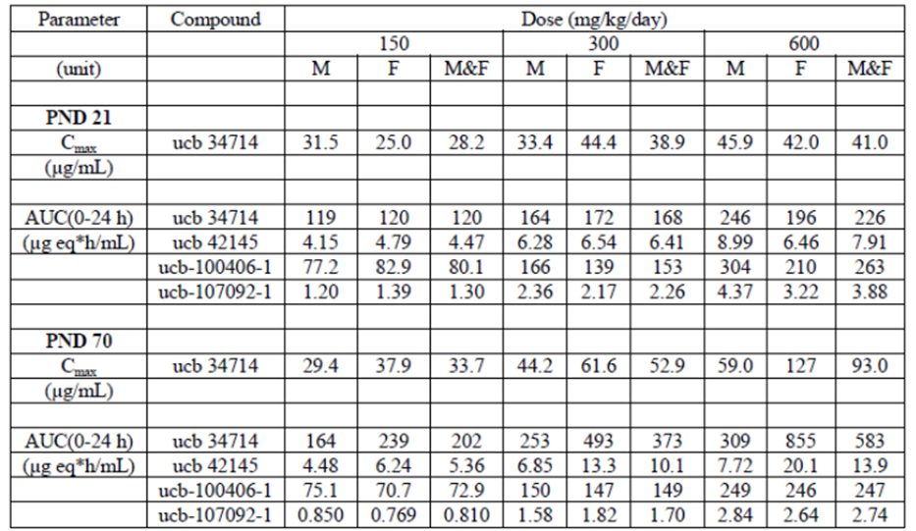
Key toxicokinetic data for brivaracetam in juvenile dogs are shown below.
Table 14: Mean PK parameter values of ucb 34714 in male & female juvenile beagle dogs after single and repeat oral administration of ucb 34714.
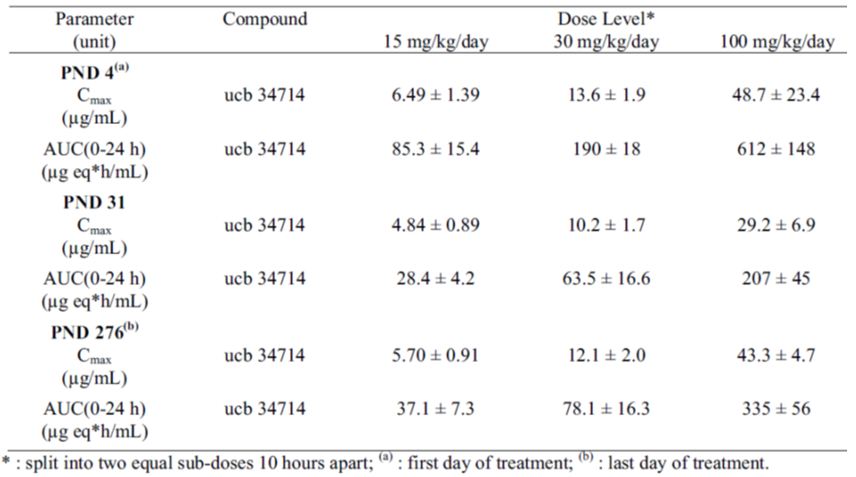

Major toxicological properties of brivaracetam

Mortality
High levels of brivaracetam exposure (approximately ≥17-25 the MRHD based on AUC comparison) were associated with euthanasia in extremis and euthanasia due to severe clinical signs in the rat 4 week repeated oral (gavage) exposure study. Severe clinical signs included dyspnoea, hunched posture, piloerection and ataxia.
Near lifetime oral exposure to brivaracetam was not associated with effects on lifespan or actuarial attrition rate in rats and mice.

Effects on food consumption, body weight and weight gain
Effects on food consumption, body weight and weight gain that exceeded maximum tolerated dose parameters (that is, >10% bodyweight loss) in adult animals were observed only after supratherapeutic levels of brivaracetam exposure (≥1X MRHD based on AUC comparison) and typically only within approximately the first week of treatment (i.e. generally before metabolic autoinduction). In dogs, decreased body weight gain was associated with serum biochemical and microanatomic evidence of liver damage.

Effects on the liver
Overall, the human risk of brivaracetam associated hepatotoxicity is low. Generally, exposures at least approximately ≥2X the MRHD based on AUC comparison were required to produce dose related metabolically adaptive (hepatomegaly, centrilobular hepatocellular hypertrophy, ± lipofuscinosis) and/or maladaptive (serum biochemical evidence of hepatocellular damage, single cell necrosis and bile duct hyperplasia and peribiliary inflammation [particularly ♂], periportal hepatocellular vacuolation [particularly ♀], ↑ pre-neoplastic foci of altered hepatocytes [particularly ♂]) changes in rodents. These effects were most likely due to relatively mild CAR-xenosensor associated (that is, phenobarbitone like) metabolic adaption/maladaptation (a largely non-human relevant mode of action). Supratherapeutic exposure in dogs resulted in porphyrigenesis associated hepatic toxicity (species specific; not human relevant).
Since relatively mild CAR xenosensor (phenobarbitone)/porphyrigenesis associated effects on the liver have limited human relevance, dose comparisons are inaccurate.
Overall, the risk of clinically significant brivaracetam associated liver damage in humans appears to be low.

Effects on the thyroid
Increased relative thyroid weight, diffuse follicular hypertrophy with colloid changes and small increases in the incidence of thyroid follicular cell neoplasia and follicular lipofuscinosis were associated with repeated dosing with brivaracetam. Given that brivaracetam is associated with modest induction of hepatic thyroxine-UGT, thus these effects are likely due to metabolic induction associated effects on the hypothalamic-pituitary-thyroid axis. Because of the lower thyroid efficiency of rats and catabolic differences, humans are regarded as being resistant to these types of effects. Accordingly these findings limited human relevance.
Transient and fully reversible lower mean serum T4 levels, without concurrent reductions in T3 levels, were observed in juvenile generation dogs exposed to brivaracetam between PND4-276. However, no overt evidence of decompensated hypothyroidism or overt disruption of the hypothalamic-pituitary-thyroid axis was observed. This is consistent with the facts that T4 is a pro-hormone and part of the circulating functional reserve pool of thyroid hormones and that no changes to serum T3 (the major penultimate active form of the hormone) were observed. The NOAEL for these effects was >1X the MRHD (based on AUC comparison). It should also be noted that brivaracetam is not intended for use in juveniles.
Overall brivaracetam appears to present a minimal risk to humans in terms of normal thyroid function.

Renal effects in male rats
Repeated daily oral gavage exposure of male rats to high doses of brivaracetam for ≥4 weeks was associated with renal proximal tubular alpha-2u globulin associated hyaline droplet nephrosis (without hyaline cast formation) in some, but not all, of the repeat dose toxicity studies in this species. The effect was also associated with chronic progressive nephropathy in the 4 week continuous infusion study and in the 104 week carcinogenesis study in rats. Hyaline droplet associated renal carcinogenesis in rats was not observed. Brivaracetam associated increase in alpha-2u globulin renal excretion in male rats was confirmed experimentally. As expected, this effect was not detected in other species and these effects are not regarded as human relevant.
Overall brivaracetam appears to present a negligible risk to humans in terms of renal function.

Effects in the salivary gland
Extreme brivaracetam doses (≥28X MRHD based on AUC comparison) were associated with degranulation of the striated ducts of the mandibular salivary gland in rats in the 4 week oral gavage study. These effects were not observed in any other study. Accordingly, this finding is not regarded as being relevant to normal clinical treatment of humans with brivaracetam.

Effects on the olfactory epithelium
Dose-responsive, minimal to slight lipofuscinosis of the olfactory mucosa was observed at brivaracetam exposures >1X the MRHD (based on AUC comparison) in the near life-time oral exposure mouse carcinogenesis study. This effect is likely due to localised brivaracetam biotransformation (that is, due to the breakdown of smooth endoplasmic reticulum in secondary lysosomes and possible metabolic autoinduction in the olfactory mucosa) and is not regarded as adverse.
Higher levels of exposure in females (>1X the MRHD based on AUC comparison) was associated with minimal to slight olfactory mucosal gland hyperplasia. This effect is regarded as adaptive and it only occurred at supratherapeutic levels of exposure compared with the MRHD.

Effects in the reproductive tract

Rats
Uterine atrophy was noted in 4/10 non-parous females treated with brivaracetam at extreme doses (approximately 28X MRHD based on AUC comparison) in the rat 4 week oral (gavage) repeat daily exposure study. This finding was not replicated in any of the other studies in rats (including the 4week continuous infusion study in rats). Given the extreme dose levels and the lack of replication (in any other study and in any other species), these findings are not regarded as human relevant under the proposed normal conditions of use of brivaracetam. Correlates in terms of possible endocrine disruptor effects were observed in male rats in the same study (male rat mammary gland feminisation, diminished secretory content of the male accessory sex glands; see below).

Effects in the male rat mammary gland
In the rat 4 week oral (gavage) repeat daily exposure study, moderate to severe mammary gland feminisation was observed in 4/10 males treated with extreme doses (approximately 28X MRHD based on AUC comparisons). Given the extreme levels of exposure in this study and the lack of replication (in any other study and in any other species), these findings in the male rat mammary gland are not regarded as human-relevant under the proposed normal conditions of use of brivaracetam.

Effects on the male rat accessory sex glands
In the rat 4 week oral (gavage) repeat daily exposure study, diminished secretory content was observed in the prostate and seminal vesicles of males administered extreme doses (approximately 28X MRHD based on AUC comparisons). Given the extreme levels of exposure in this study and the lack of replication of these effects (in any other study and in any other species), these findings are not regarded as human relevant under the proposed normal conditions of use of brivaracetam.

Neurobehavioral effects in sub-adult and adult animals

Mice
High levels of repeated daily brivaracetam exposure (approximately ≥9X the MRHD based on AUC comparison) resulted in transient gait disturbances and general behavioural depression. The threshold dose for these effects could be substantially increased by slow dose escalation (escalating by 200 mg/kg/day in mice) then only observed at extreme doses far in excess of the human MRHD (based on AUC comparisons). There were no neuroanatomical correlates.

Rats
High levels of repeated daily brivaracetam exposure (approximately ≥17X the MRHD for 4 weeks of repeat daily oral exposure based on AUC comparison; ≥2X the MRHD for 26 weeks of repeat daily oral exposure based on AUC comparison) were required to produce transient non-specific neurobehavioral signs (for example, transient effects on gait; intermittent paddling) without neuroanatomical correlates.

Dogs
Transient incoordination, lethargy and gait disturbances were only observed high levels of oral exposure (approximately 8X the MRHD based on AUC comparison) in the 4 week repeat gavage exposure study in dogs. There were no neuroanatomical correlates.

Overall risk of neurobehavioral effects
In animals high supra-therapeutic levels of brivaracetam exposure are required to produce transient effects on neurobehaviour. These effects appear to be avoidable by using dose escalation (that is, allowing for metabolite autoinduction/metabolic adaptation).
Overall, the risk to humans appears to be low to negligible.

Effects on the thymus

Dog
Continuous infusion of brivaracetam for 4 weeks induced reduced thymus weight and minimal to moderate thymic atrophy. The NOAEL for this effect was 2X the MRHD.
Repeated oral treatment with brivaracetam from PND 4-31 in pups was also associated with reduced absolute and relative thymic weight and minimal thymic atrophy. The NOAEL for this effect was 15 mg/kg/day in the pups. It should be noted that brivaracetam is not intended for use in juveniles and children.

Overall risk in humans
Since the effects of brivaracetam on thymic weight and thymic atrophy in adult animals were relatively small and only observed at high multiples of the MRHD, the risk to humans is regarded as negligible. It should be noted that brivaracetam is not intended for use in children and juveniles. Accordingly, the findings in canine pups are currently not relevant to the proposed clinical indications of brivaracetam.

Genotoxicity
The sponsor has presented a high quality data package that exceeds the standard test battery requirements. Where appropriate, the studies were validated by the use of positive controls. Brivaracetam did not induce bacterial reverse mutations, mammalian cell forward mutations or chromosomal aberrations in vitro. Brivaracetam is not genotoxic in vivo and did not induce mutations in LacZ transgenic mice or micronuclei in rats.

Mode of action/mechanistic studies
Repeated daily oral exposure of male rats to brivaracetam was associated with increased kidney alpha 2u-globulin. On an mg/mg oral dose basis, brivaracetam induced approximately 1.5-3X the amount of kidney alpha 2u-globulin than d-limonene (a classical inducer of renal alpha 2u-globulin and P2 segment renal proximal tubule hyaline droplet nephrosis in male rats). The level of kidney alpha 2u-globulin in males was closely correlated with the extent of renal proximal tubular hyaline droplet nephrosis present. Neither effect was present in female rats. These studies provided a clear mode of action basis for the brivaracetam-associated renal proximal tubular hyaline droplet nephrosis and associated chronic progressive nephropathy that was observed in male rats. These effects are not regarded as human-relevant.
More detailed evaluation of the effects on the clitoral, preputial and Zymbal’s glands were performed due to the propensity for brivaracetam to accumulate at these sites. No adverse effects were noted and these structures are not present in humans; accordingly the risk is regarded as negligible.

Carcinogenesis

Mice
Dose related increases in hepatic adenomas and carcinomas were observed in male mice at the 2 highest doses tested (550 and 700 mg/kg/day), associated with respective plasma exposures (AUC) of 2 and 4 times clinical exposure at the MRHD. At the no-effect dose (400 mg/kg/day), plasma AUC exposure was similar to clinical exposure at the MRHD. These hepatic tumour findings are consistent with the detection of altered hepatic foci in shorter duration studies, are almost certainly secondary to hepatic autoinduction and are not regarded as being human relevant.
In the mouse near lifetime carcinogenesis study, small incidence of benign luteomas and benign sertoli cell tumours in females treated at >1X the MRHD resulted in a statistically significant (p <0.05) positive trend (notably there was no overall statistically significant difference (p >0.05) between the brivaracetam exposed groups and the control. The incidence of benign luteomas observed in this study (approximately 6.6%) is only slightly higher than the maximum historical background incidence (5%). In the absence of other significant alterations in the female reproductive tract and an absence of these neoplasias in the chronic rat study, the findings regarding hormonally influenced benign luteomas are unlikely to be of human risk assessment importance. Furthermore, given that brivaracetam and its metabolites are not overt DNA interactive classical mutagens, a threshold “non-genotoxic” mode of action is likely for these neoplasias.
The incidence (approximately 5%) of benign sertoli cell tumours observed in females treated at ≥1X the MRHD was >2X the normal maximum historical background incidence (2%) for this type of neoplasia. Accordingly, this is regarded as a positive trend towards this form of neoplasia. Again, this form of neoplasia is hormonally influenced in mice. No hormonal effects on the female reproductive tract were noted in this study. In the absence of other significant alterations in the female reproductive tract and an absence of these neoplasias in the chronic rat study, the findings regarding hormonally influenced benign luteomas are unlikely to be of human risk assessment importance. Additionally, brivaracetam and its metabolites are not overt DNA interactive classical mutagens. Accordingly a threshold “non-genotoxic” mode of action is likely.
Overall the human risk of female reproductive tract neoplasia associated with the proposed clinical use of brivaracetam appears to be low and the human relevance of the findings in mice is uncertain.

Rats
High levels (approximately ≥17X the MRHD based on AUC comparison) of repeated daily oral exposure of adult rats to brivaracetam for a 4 week period resulted in small reductions in thymus weight in the absence of anatomic pathological correlates.
In the rat carcinogenesis study, benign thymoma displayed a significant trend (p <0.001) compared with controls as a result of a significantly (p <0.01) higher incidence in females dosed at approximately ≥9X the MRHD based on AUC comparison (p<0.01). The historical incidence for benign thymomas for the Charles River Edinburgh facility (provided in response to a Section 31 question) a maximum of 10%. Thus, the incidence of benign thymoma observed in females exposed at 9X the MRHD (11/50 = 22%) is approximately 2X higher than the historical control incidence and the incidence observed females treated at approximately 8X the MRHD (5/50= 10%) is the same as the maximum historical control incidence.
The available background historical control data supports a positive carcinogenesis finding for brivaracetam associated benign thymoma in female rats following exposure to 9X the MRHD.
Based on the historical control data, the NOAEL for the effect in female rats is approximately 8X the MRHD. Given the likely threshold “non-genotoxic” mode of action and the failure to replicate thymic neoplasia in second species (that is, in mice), the NOAEL in rats is regarded as being adequately protective of human health.

Overall conclusions
Overall, treatment of humans ≥16 years of age with brivaracetam at the anticipated MRHD presents a low nonclinical toxicological risk based on the available nonclinical data.

Major toxicological properties of ucb-107092-1
Separate toxicology studies were performed on ucb-107092-1, a major human metabolite of brivaracetam in patients with renal dysfunction, due to: (a) its propensity for greatly increased plasma AUC in human patients with significant renal dysfunction; and (b) the difficulty in achieving adequate ucb-107092-1 exposure to account for the pharmacokinetic situation in humans with impaired renal function in animals dosed with brivaracetam. High levels of exposure, relative to the proposed human exposure level, were achieved in the nonclinical studies (see above).

Acute toxicity
ucb-107092-1 displays very low acute toxicity (NOEL ≥10000 mg/kg for 24h continuous IV infusion; the maximum practicable IV infusible dose) in rats. The toxicologically conservative NOAEL for 14 days of continuous IV infusion in rats is approximately 9X the exposure to human patients with severe renal compromise treated with the MRHD of brivaracetam. The major effects observed in the 14 day rat IV infusion study related to minimal hepatotoxicity.
No adverse effects attributable to ucb-107092-1 were detected in beagles in a 24h continuous IV infusion ascending dose study (up to the maximum practicable IV dose of 5282 mg/kg).

Subchronic toxicity
13 weeks of continuous IV infusion of rats with ucb-107092-1 at approximately ≥7.5X the maximum anticipated exposure levels in humans with significant renal compromise were associated with small, but statistically significant (p <0.05) reductions in blood haemoglobin, erythrocyte count and haematocrit, although values remained within the normal biological ranges. These effects were also accompanied by a reticulocytosis and the effects were reversible upon the cessation of exposure. Overall, the effects are regarded as subclinical (that is, non-adverse).
Evidence of secondary systemic inflammation was noted in the study. These effects were regarded as being secondary to the infusion procedure and not test article-related.
The NOAEL for the study was approximately ≥34X the exposure to human patients with severe renal compromise treated with the MRHD of brivaracetam.

Genotoxicity
ucb-107092-1 did not induce reverse mutations in bacteria or forward mutations in mammalian cells in vitro and did not induce micronuclei in the in vivo rat bone marrow micronucleus test. The validity of the tests was confirmed by the use of positive control.

Fetal development
No maternal toxicity or adverse effects on foetal development were noted after continuous IV infusion of ucb-107092-1 to pregnant female rats from gestational day (GD) 6-17 at doses up to 1000 mg/kg/day, associated with average steady state plasma concentration of up to 33.8 µg/mL. This value is approximately 450X the clinical plasma Cmax of ucb-107092-1 following a 200 mg PO dose in healthy subjects, and approximately 39X the clinical plasma Cmax of ucb-107092-1 following a 200 mg PO dose in renally impaired subjects.

Overall conclusions
ucb-107092-1 presents a low nonclinical toxicological risk in normal patients and patients with substantial renal compromise under the proposed conditions of clinical use of brivaracetam.

Major toxicological properties of ucb-34713 (diastereoisomer of brivaracetam)
ucb-34713, the diastereomer of brivaracetam, is present as an impurity in brivaracetam batches. In the course of the development of brivaracetam, with process scale up, ucb-34713 was shown to be present at levels up to 2.5%, whereas most of the batches used in nonclinical safety studies contained less than 2%. Accordingly, the sponsor supplied additional studies on this diastereomer.

Safety pharmacology
Ucb-34713 did not induce channelopathies in hERG transfected HEK293 cells or in isolated beagle cardiac Purkinje fibres. On the basis of these data, ucb-34713 appears to be unlikely to induce Torsades des Pointes or other cardiac conduction disturbances under the proposed conditions of clinical use of brivaracetam.

Subchronic repeated oral exposure toxicity study
Repeated daily oral exposure for 13 weeks to ucb-34713 was associated with post dosing (approximately 15 min post dose) of hyperactivity sometimes followed by hypoactivity, mouth rubbing, paddling, excessive grooming and/or salivation. The effects were generally worse after the second daily sub dose. The post dose observations were first recorded on Day 9. These effects were seen in all ucb-34713 exposed animals and in the negative control animals. However, the incidence of these effects was higher in the 200 mg/kg/day (administered as 2 sub doses q10h) dose group. The incidence was also higher in males.
Nonadverse adaptive centrilobular hepatocyte hypertrophy and lipofuscinosis was observed in the 200 mg/kg/day treatment groups. Administration of ucb-34713 was associated with renal proximal tubular hyaline droplet nephrosis (most probably alpha-2u-globulin-related) in male rats. This effect is not regarded as relevant to humans.

Genotoxicity
Ucb-34713 did not induce bacterial reverse mutations or forward mutations in mammalian cells.

Overall conclusions
Ucb-34713, as an impurity in brivaracetam, is adequately qualified. Exposure to ucb-34713 in Briviact under the proposed conditions of clinical use is not associated with unacceptable human risk.

Reproductive toxicity

Relative exposure
See Table 15.
Table 15: Relative exposure.
Species | Study | Oral dose (mg/kg/day) | AUC_{0–24 h} (μg∙h/mL) or Mean plasma level (μg/mL) | ER#
PSM0978  Rat  (Wistar) | Fertility and early embryonic development | 100 | ♂= 27.7*;  ♀= 38.6* | ♂ ≈8†;  ♀ ≈11†
PSM0978  Rat  (Wistar) | Fertility and early embryonic development | 200 | ♂= 42.3*;  ♀= 55.9* | ♂ ≈12†;  ♀ ≈16†
PSM0978  Rat  (Wistar) | Fertility and early embryonic development | 400 | ♂= 52.1*;  ♀= 79.2* | ♂ ≈15†;  ♀ ≈22†
PSM0853  Rat  (Wistar) | Embryofetal development | 150 | 586 | ≈8
PSM0853  Rat  (Wistar) | Embryofetal development | 300 (F₀ maternotoxicity) | 1099 | ≈16
PSM0853  Rat  (Wistar) | Embryofetal development | 600 (F₁ adverse effects) | 1801 | ≈26
PSM0860  Rabbit  (NZW) | Embryofetal development | 30 (F₀ maternotoxicity) | 62.2 | ≈1
PSM0860  Rabbit  (NZW) | Embryofetal development | 60 (F₀ maternotoxicity) | 106 | ≈2
PSM0860  Rabbit  (NZW) | Embryofetal development | 120 (F₀ maternotoxicity) | 198 | ≈3
PSM0860  Rabbit  (NZW) | Embryofetal development | 240 (F₀ maternotoxicity) (F₁ adverse effects) | 445 | ≈6
NCD1330  Rat  (Wistar) | Pre-postnatal development | 150 | 278 (Brivaracetam) | ≈4
NCD1330  Rat  (Wistar) | Pre-postnatal development | 150 | 5.30 (ucb-42145) | ≈2‡
NCD1330  Rat  (Wistar) | Pre-postnatal development | 150 | 78.7 (ucb-100406-1) | ≈6^{κ}
NCD1330  Rat  (Wistar) | Pre-postnatal development | 300 (F₁) | 377 (Brivaracetam) | ≈5
NCD1330  Rat  (Wistar) | Pre-postnatal development | 300 (F₁) | 6.16 (ucb-42145) | ≈2‡
NCD1330  Rat  (Wistar) | Pre-postnatal development | 300 (F₁) | 132 (ucb-100406-1) | ≈9 ^{κ}
NCD1330  Rat  (Wistar) | Pre-postnatal development | 600 (F₀) | 964 (Brivaracetam) | ≈14
NCD1330  Rat  (Wistar) | Pre-postnatal development | 600 (F₀) | 20.5 (ucb-42145) | ≈6‡
NCD1330  Rat  (Wistar) | Pre-postnatal development | 600 (F₀) | 342 (ucb-100406-1) | ≈24 ^{κ}
#= animal:human plasma AUC_{0–24 h} based on the derived human AUC_{0-24h} of 70 μg∙h/mL. The sponsor has used a value of 56 μg∙h/mL based on the oral AUC_{0-24h.} For precautionary reasons, the evaluator has used the IV AUC_{0-24h}. The evaluator acknowledges that IV use in humans may only likely occur for several days; however the Australian PI, unlike the US PI, does not stipulate a maximum duration of IV treatment. If the value of 56 μg∙h/mL is used, the calculated AUC_{0–24 h} ratios will increase by a factor of approximately 1.25;
* mean plasma level;
† animal mean plasma concentration: human plasma C_{Max} of 3.54 µg/mL following IV dosing;
‡ animal:human AUC ratio data based on healthy volunteer data from Study No. N01109 for 200 mg PO dose – AUC= 3.51 μg.h/mL, AUC in patients is severe renal impairment is approximately 3.2X higher thus the exposure ratios for patients with severe renal impairment will be approximately 1/3 those provided in the table. However it is assumed that likelihood of pregnancy in patients with severe renal impairment is low;
^{κ} animal:human AUC ratio data based on healthy volunteer data from Study No. N01109 for a 200 mg PO dose – AUC= 14.1 μg.h/mL, AUC in patients with severe renal impairment is approximately 4X higher thus the exposure ratios for patients with severe renal impairment will be approximately 1/4 those provided in the table. However it is assumed that likelihood of pregnancy in patients with severe renal impairment is low.

Key features
The sponsor supplied a fertility embryonic development study in rats, embryofoetal development studies in rats and rabbits and a pre-postnatal development study in rats. Relatively high levels of systemic exposure were achieved in all studies. Pharmacokinetic radiotracing distribution studies demonstrated that brivaracetam associated radioactivity concentrates (by approximately 10X compared with non pregnant controls) in the uterus and uterine horns of pregnant rats and is more persistent at these sites compared with non-pregnant animals. Brivaracetam associated radioactivity did not concentrate in the rat foetus-foetal tissue levels essentially reflect maternal plasma concentrations. Given that in animals the milk concentration of brivaracetam is approximately the same as the plasma concentration, transmammary exposure of nursing infants appears likely.
Brivaracetam exposure at ≥15X the human MRHD (based on rat mean plasma concentrations versus clinical Cmax at the MRHD) did not adversely affect fertility and early embryonic development in rats.
Brivaracetam did not affect embryofoetal development in rats at maternal exposures equivalent to approximately ≤26X the human MRHD (based on AUC). Maternotoxicity did not occur at exposures equivalent to approximately ≤15X the human MRHD.
Poor dose ranging in the rabbit embryofoetal development study resulted in the presence of overt maternotoxicity (characterised by reduced body weight gain/body weight loss, reduced feed intake, reduced fecal output) at all tested doses. Five females dosed with brivaracetam (2 females at 30 mg/kg/day, 1 female at 120 mg/kg/day and 2 females at 240 mg/kg/day) were prematurely euthanised between GD 14 and 16 due to sustained decreases in food consumption and excessive (that is, exceeding MTD parameters) bodyweight losses (320 to 590 g, representing 10 to 16% of the bodyweight recorded on GD 6). When compared to the controls, body weight loss between GD 6 and 12 in the surviving animals treated with brivaracetam was more severe (by approximately 1.7 - 2.5 X) in animals dosed with brivaracetam (p <0.05 in the 120 and 240 mg/kg/day dose groups). Recovery (possibly due to metabolic adaptation) in the surviving animals was apparent from GD 12 and until the end of the dosing period (significantly greater recovery in the treated animals compared with the controls; p <0.05). During the treatment free period (GD 20 to 28), the mean bodyweight gain was approximately similar between treated and control groups.
Table 16: Group mean maternal body weight gain (kg) (UCB study number PSM0860).
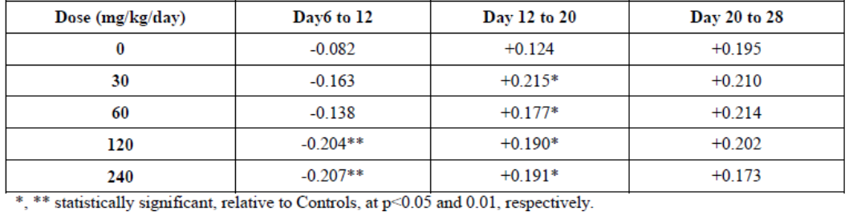
Between GD 6 and 10, the mean food consumption was significantly reduced (p <0.05) relative to controls (and pre-treatment values) in all treated groups. A dose response relationship was apparent between GD 6 and 8. Between GD 10 and 14, although the mean food consumption of all groups receiving brivaracetam remained lower than pre-treatment values, a clear trend towards recovery was noted.
Table 17: Group mean maternal food consumption (g/rabbit/day) between Day 5-14 of pregnancy (UCB study number PSM0860).
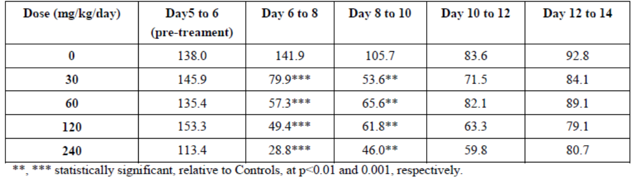
In most cases, the females showed good recovery during the treatment period (presumably associated with metabolic adaptation), as shown by increased bodyweight gain and food consumption that returned to levels comparable to the Controls between GD 12 and 14. In a small number of females, however, the decreased food consumption and the bodyweight loss persisted to an extent that these animals had to be euthanased for humane reasons (2, 1 and 2 females given 30, 120 and 240 mg/kg/day, respectively). Among these 5 animals, one (animal 39; 30 mg/kg/day group) was not pregnant. Thus the sensitivity of the rabbit to the effect of brivaracetam on food consumption is not due to pregnancy status.
Table 18: Individual maternal food consumption (g/rabbit/day) and body weight change of animals killed prematurely (UCB study number PSM0860).
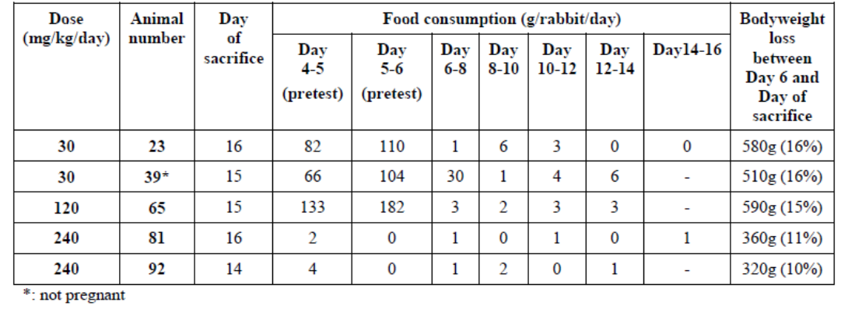
There is no obvious toxicokinetic/metabolic explanation for the difference in sensitivity between rats and rabbits, and the exact cause for the effects in rabbits is unknown. Evidence of gastric irritancy at the high dose range (300-400 mg/kg/day) was present in the preliminary dose ranging studies, although this was not apparent at lower doses. Based on in vitro data, more extensive brivaracetam biotransformation may occur in rabbits compared with rats and humans. Notably, reduced food consumption and reduced body weight gain/body weight loss was observed in the repeat dose toxicology studies in dogs and monkeys, particularly before the development of metabolic autoadaption. Furthermore, the timing of maternal recovery in the rabbit is also consistent with the development of metabolic autoadaption. This also raises the possibility that these effects could have been avoided by slow dose escalation (as was demonstrated in several of the repeated exposure rat studies). However, given the lack of definitive data, all of these potential explanations remain largely speculative.
Despite this maternotoxicity, no foetal malformations or major abnormalities were seen in rabbits at any dose. Adverse effects were limited to embryofoetal toxicity at the highest tested dose of 240 mg/kg/day, consisting of increased post-implantation loss, and decreased number of live foetuses and reduced foetal bodyweight. The foetal/development NOAEL in the rabbit is considered to be approximately 3X the MRHD (based on AUC comparison).
In the rat pre postnatal development study, brivaracetam did not produce adverse F0 maternal effects at approximately 14X the human MRHD, but did result in small (approximately 5.3-7.5% reductions), but statistically significant (p <0.05) and persistent decreases in body weight in F1 offspring, accompanied by slight, but statistically significant (p <0.05) developmental delay (delay of approximately 2 days in development of vaginal patency). The NOEL for F1 effects was 5X human MRHD, based on AUC.
Large increases in plasma AUC of several brivaracetam metabolites occurs in patients with severe renal impairment. The reproductive consequences of this were not systematically evaluated. However, an embryofoetal development study was conducted using ucb-107092-1 as the test article. As discussed above, no ucb-107092-1-associated maternal toxicity or adverse effects on foetal development were noted after continuous IV infusion of pregnant female rats from GD6-17 at doses up to 1000 mg/kg/day, with average steady-state plasma concentration of 33.8 µg/mL, which is 450X clinical Cmax after a single 200 mg PO dose (39X in renally impaired subjects).
Pharmacokinetic radiotracing distribution studies demonstrated that brivaracetam-associated radioactivity concentrates (by approximately 10X compared with non-pregnant controls) in the uterus and uterine horns of pregnant rats and is more persistent at these sites compared with non-pregnant animals. Brivaracetam associated radioactivity did not concentrate in the rat foetus: the concentration of radioactivity in the foetus essentially reflected whole blood and plasma concentrations, implying rapid equilibration of radioactivity across the placenta. This is consistent with the Log P of brivaracetam. Radioactivity in the foetus was completely cleared by 72 h post dose. Given that in animals the milk concentration of brivaracetam is approximately the same as the plasma concentration, transmammary exposure of nursing infants appears likely.

Overall conclusions
Based on the available nonclinical data, brivaracetam under the proposed conditions of clinical use does not present a significant risk to fertility, pregnancy, embryofoetal development and pre weaning postnatal development. It should be noted that the interpretability of the rabbit embryofoetal developmental study may have been affected by the overt maternotoxicity (exceeding the MTD in some cases) (technically the dataset does not meet the minimum requirements of published guidelines). However, a clear NOAEL for effects on embryofoetal development (approximately 3X the MRHD based on AUC comparison) was apparent in the study, despite the presence of maternotoxicity.
Complete data on placental pharmacokinetics are not available. Brivaracetam and/or its metabolites concentrate in the uterus and uterine horns of pregnant rats and are more persistent at these sites compared with non-pregnant animals. However, concentration in the foetus did not occur in rats.
Trans mammary exposure of nursing infants appears to be likely based on the available animal data.
The sponsor has proposed Pregnancy Category B3, which is supported by the nonclinical data.

Local tolerance
Brivaracetam has acceptable local tolerance for both IV and oral administration.
Perivenous and venous administration of brivaracetam did not result in adverse effects in rabbits. Completely reversible, minimal to mild muscular degeneration was noted at 24 h following IM injection. Extreme (in comparison with known Cmax under conditions of normal clinical use) concentrations of brivaracetam (≥30 mg/mL, that is, 3X the concentration of Briviact solution for injection) resulted in human erythrocyte haemolysis in vitro (no effect at 10 and 20 mg/mL).
Brivaracetam at doses (approximately 90X the human single dose MHRD, allometric comparison) induced gastric irritation in rats.

Impurities
There are no toxicological concerns with the proposed impurity specifications.

Paediatric use
Brivaracetam is not proposed for paediatric use. However, specific studies covering the early to juvenile developmental stages were submitted.
In a rat developmental study (brivaracetam exposure from PND4-70), high oral (gavage) doses of brivaracetam (≥300 mg/kg/day) were associated with dyspnoea, rales, pulmonary haemorrhage, and premature mortality. The premature mortality rate was approximately 2X higher females compared with males. Doses of 600 mg/kg/day were associated with >10% reduction in body weight gain without test article-associated adverse effects on food consumption. Reversible suppression of motor activity was noted in males treated at 600 mg/kg/day. Non-reversible effects on auditory startle responses were noted in rats (both sexes) treated at 600 mg/kg/day (PO, gavage). These results imply that exposure to high levels of brivaracetam over PND4-78 induced a permanent defect somewhere in the cochlea cranial nerve VIII ventral/inferior cochlear nucleus lateral lemniscus caudal pontine reticular nucleus lower motor neuron pathway in rats. The effect displayed a clear dose threshold (doses ≤ 300 mg/kg/day PO did not induce the effect). Exposure of rats to ≤ 600 mg/kg/day over PND 4-70 had no effect on learning or memory, reproductive parameters, reproductive hormone levels, clinical chemistry and haematology parameters or ophthalmoscopy results. However, reduced absolute and relative prostate weight was significantly (p <0.05) reduced in males exposed to 600 mg/kg/day PO from PND 4-70, implying that subtle endocrine disruptive effects affecting the androgen system may occur with extreme doses of brivaracetam. Hepatomegaly without microscopic anatomic pathology correlates was present in all brivaracetam exposed animals (most likely due to adaptive metabolic autoinduction).
Notably, exposure to brivaracetam at 600 mg/kg/day PO from PND 4-70 induced reductions in absolute brain weight (PND 22: ↓ 10-16%; PND 71: ↓5-9%; PND100: ↓6-10%), brain length (PND 22: ↓5%; PND 100 ↓ 3%) and brain width (PND 22: ↓ 4%; PND 71: 3%; PND 100: ↓3-4%) in the absence of microanatomic pathology correlates. Due to the apparent lack of reversibility, the effects of brivaracetam on brain weight and gross morphometry are regarded as adverse even in the absence of detectable microanatomic pathology, learning, memory and behavioural correlates (apart from effects on the auditory startle response). Separate carefully controlled vehicle only studies were performed in order to better define the normal range for rat absolute brain weight over PND 4-70. These studies demonstrated that while the mean brain weights observed in the brivaracetam exposed juveniles were generally lower than the mean of the normal range, they still fell within the vehicle treatment only normal range. Furthermore, a clear dose response threshold (NOAEL = 300 mg/kg/day) for brivaracetam associated effects on absolute brain weight and gross morphometry was apparent (equivalent to 3-9X MRHD at the NOAEL).
It should be noted that the reduction in body weight detected after exposure to 600 mg/kg/day of brivaracetam is not sufficient to explain the observed effects on brain absolute weight and brain gross morphometry, that is, a 23% reduction in final body weight in males exposed to 600 mg/kg/day correlated with a 13% increase in relative (to body weight) brain weight. The NOAEL for these effects in males and females was 300 mg/kg/day. The implications for human development of these findings are uncertain.
Brivaracetam had no effects on mortality, clinical signs, body weight, food consumption, developmental landmarks, ophthalmology, electrocardiography, neurobehaviour, haematology, urinalysis, bone densitometry and mineralisation, serum reproductive hormone levels and neuroanatomy in juvenile dogs exposed at up to 100 mg/kg/day from PND 4 to PND 276. Serum enzyme evidence of hepatocellular damage was present in juvenile dogs treated with 100 mg/kg/day. These effects were correlated with reversible hepatomegaly, hepatocellular brown pigmentation, hepatic fibrosis and inflammation, bile duct proliferation, hepatocellular hypertrophy, hepatocellular necrosis and biliary concretions. These effects were most likely associated with porphyrogensis via a non-human relevant pathway of metabolism and were typically more severe in males. Minor reductions in serum T4 levels, in the absence of any evidence of hypothyroidism (including adverse effects on development) was present in the 100 mg/kg/day high dose group, however, clear evidence of decompensated hypothyroidism (including adverse effects on brain development) were not present in the study. The study NOAEL was 30 mg/kg/day (corresponding to an AUC_{0-24 h} 190 μg eq.h/mL at PND 4, an AUC_{0-24 h} 63.5 μg eq.h/mL at PND 31 and an AUC_{0-24 h} 78.1 μg eq.h/mL on PND 276 (last day of treatment)

Nonclinical summary and conclusions

Summary
- Brivaracetam, a 4-n-propyl analogue of levetiracetam, is a Synaptic Vesicle Glycoprotein 2A (SV2A) anti-seizure/anti-epileptic drug. Like other SV2A ligands, the exact MOA of brivaracetam is unknown. Brivaracetam did not act via Na+ channels in normal adult neurons and may act, in part, by inhibiting NMDA excitatory pathways and disinhibiting GABA and glycine inhibitory pathways. Brivaracetam (not its metabolites or its diastereoisomer impurity) is the keystone agent in Briviact, reducing the risk of pharmacometabolomic/pharmacogenomic effects.
- Although brivaracetam is intended for use as an add-on therapy for partial epilepsy, combination therapy (except diazepam) was not investigated. Under efficacy biased conditions, brivaracetam (at generally behaviourally inactive doses) was, in most animal models, more potent (approximately 10X) and efficacious (approximately 100% seizure control; including diazepam resistant seizures and potentially lethal self-sustaining status epilepticus) than levetiracetam. Brivaracetam (approximately 0.9X the single dose MRHD based on BSA comparison; behaviourally inactive dose) strongly synergised diazepam anti-seizure efficacy. Unlike levetiracetam, brivaracetam induced a window of post washout resistance to seizure recrudescence in approximately 50% of corneally kindled rats. Brivaracetam reduced (by approximately 20X) corneal kindling, implying prophylactic efficacy. Unlike levetiracetam and other agents, brivaracetam controlled (without side-effects) harmaline pharmaco-resistant essential tremor in rats (superior to propranolol, the current “standard of care”). Brivaracetam did not control bicuculline, picrotoxin, pilocarpine, 4-aminopyridine or caffeine induced seizures.
- Brivaracetam (approximately ≥2X single dose MRHD based on BSA comparison) reduced rotarod performance in seizure-prone rats and normal mice (may correlate with somnolence and other CNS related symptoms observed in humans) but at approximately6X the single dose MRHD (based on BSA) did not affect levels of motor activity in normal rats. Supratherapeutic brivaracetam doses (approximately ≥3X the MRHD based on BSA) produced adverse effects on basic neurobehaviour, learning, memory, muscle tone, nociception and consciousness in rodents. Brivaracetam (approximately 0.6X the single dose MRHD based on BSA) reduced nociceptive effects in models of sciatic nerve mechanical hyperalgesia/neuropathic pain in normal and diabetic rats. Brivaracetam (approximately 0.9X the single dose MRHD based on BSA) had no effect on diazepam-induced behavioural effects. Brivaracetam (approximately 0.6X the single dose MRHD based on BSA) inhibited dexamphetamine-chlordiazepoxide induced hyperactive behaviour in rats, with negligible influence on drug-addictive associated behaviours. In rats, extreme doses of brivaracetam (approximately ≥18-27X the single dose MRHD based on BSA) induced unconsciousness characterized by areflexia.
- Brivaracetam and its key human metabolites are not cardiac relevant channelopathic, even at high (supratherapeutic) concentrations. In female (only) dogs, PO brivaracetam (approximately >15X single dose MRHD based on Cmax comparison) induced hypotension at 4-20 h post dosing (≤ 25-27 mm Hg reduction in mean arterial pressure). Brivaracetam did not affect GI motility in rats.
- Brivaracetam (Log P approximately 1) is rapidly absorbed by diffusion from the gut (PO and IV AUC and Cmax are approximately equal) and rapidly equilibrates, by diffusion (↓risk of pharmacogenomics and victim-perpetrator effects) across the blood brain barrier (brain:plasma approximately 1; Tmax brain approximately 15min; not affected by sex or administration route). Oral first pass extraction is minimal in humans, rodents and dogs, but very high in cynomolgus monkeys (F <10% approximately). Unlike humans, metabolic auto-induction reduced systemic exposures in rodents and dogs. Female rats generally had higher systemic exposure and slower elimination compared with males (species specific). Brivaracetam generally displayed dose linearity (except in dogs; metabolic difference). Cl body weight normalised in non-primates was approximately 4-21X that of humans (animal T½ approximately 0.03-0.2X human T½ [approximately 9 h]), necessitating adaption of the typical study dosing regimens to ensure 24 h drug exposure. Human relevant tissue elimination in rats was rapid and near complete by 24 h. Brivaracetam distributes to approximately total body water in rats without human relevant tissue sequestration. Plasma protein binding was low (12.2-26.5% across species) and the whole blood:plasma ratio was approximately 1:1. Brivaracetam rapidly crossed the rat placenta (equilibration approximately 1 h; maternal:foetal and maternal:placental approximately 1:1). Hepatic metabolism caused most of the plasma clearance (approximately ≤6% excreted intact). The key metabolic pathways were: stereoselective hydroxylation of the propyl side-chain to ucb-100406-1 (mostly CYP2C19; approximately 30-40% of the dose in all species except humans; approximately 28.2% of the dose in humans), hydrolysis of the acetamide moiety to ucb-42145 (amidase E.C.3.5.1.4; approximately 3-18% of the dose in all non human species; approximately 56.4% of the dose in humans), and both reactions to form ucb-107092-1 (mostly CYP2C9; approximately 2.5% of the dose in dogs; absent in rodents; approximately 15.2-15.9% of the dose in humans). There were no human specific in vivo metabolites; however, butyramide side chain hydroxylation occurs in dogs resulting in porphyrogenesis (biomarker is ucb-102993-1 formation; not human-relevant). Critically, substantial increases in the plasma AUC of (approximately 21.5X) ucb-107092-1 occurs in renally impaired humans (requiring separate nonclinical toxicology evaluations). Ucb-107092-1 is very rapidly eliminated in urine by rats (>95% decrease in plasma concentration within 1 h of IV dosing). Brivaracetam and its metabolites are rapidly and almost exclusively eliminated in urine (approximately ≥90% radioactivity in 48-168 h). Excretion mass balance is not affected by species, route of administration, sex or pregnancy state. In rats, brivaracetam had rapid transmammary equilibration (milk:plasma 1:1 approximately). Brivaracetam is unlikely to precipitate CYP or transporter mediated drug interactions. Brivaracetam was a modest CAR-xenosensor mediated CYP2B inducer in rats (human irrelevant). Lesser induction of other CYP families and thyroxine-UGT (with associated mild, human irrelevant, effects on the rat hypothalamic-pituitary-thyroid axis) occurred (probably xenosensor crosstalk).
- Single PO doses approximately ≥45X the human single dose MRHD (based on BSA) produced narcosis like effects in rats and PO doses at approximately 90X the human single dose MRHD (based on BSA) induced gastric irritation.
- Generally high MOEs (brivaracetam and metabolites) were achieved in the non-primate repeat dose toxicology studies. The non-primate brivaracetam NOEL/NOAEL exposure levels in all repeat dose studies were approximately ≥1X the MRHD (based on AUC_{0-24 h} comparison). Adequate exposure to brivaracetam was achieved in the cynomolgus monkey studies (NOAELs ≥1X the MRHD based on AUC_{0-24 h}). Non-primate exposure to the other key human metabolites was adequate (specific studies on ucb-107092-1 were performed). Very high repeated exposures to brivaracetam induced severe toxicity (euthanasia in extremis and mortality; approximately 17-25X MRHD based on AUC0-24h) or effects on growth/body weight/food consumption (approximately ≥1 X MRHD based on AUC_{0-24 h}) in rodents. In several of the studies, initial weight loss was often accompanied by recovery and/or compensatory weight gain as metabolic adaptation developed.
- Overall, the human risk of brivaracetam-associated hepatotoxicity is low. Generally, exposures at least ≥2X the MRHD based on AUC_{0-24 h} comparison resulted generally dose-responsive adaptive maladaptive adverse hepatotoxicity in rodents in association with CAR-xenosensor like (that is, phenobarbitone like) effects (limited human relevance). In general, males were more susceptible to these effects. Supratherapeutic exposure in dogs resulted in porphyrigenesis associated hepatic toxicity (species specific; not human relevant).
- Dose-responsive, minimal to slight olfactory mucosa lipofuscinosis (non adverse; secondary to metabolic adaption) was observed with brivaracetam exposures approximately ≥1X MRHD based on AUC_{0-24 h} comparison in the mouse carcinogenesis study.
- Some evidence (often not experimentally replicated) of sex hormone endocrine disruption (uterine atrophy in rats, ♂ rat mammary gland development, ↓ secretory content of rat ♂ accessory sex glands) was present in rats and mice at extreme exposure levels, although the clinical risk appears low. A small increase in sex hormone-dependent neoplasia (benign luteomas, benign sertoli cell tumours in females) was arguably present in female mice in the carcinogenesis study (see below).
- Evidence of neurotoxicity/neurobehavioral effects (gait disturbances, generalised behavioural depression) following repeated brivaracetam exposure was typically only associated with extreme exposure levels (approximately ≥8X the MRHD based on AUC_{0-24 h} comparison). Mostly, but not exclusively, these effects occurred early in the studies (presumably before reductions in systemic exposure associated with metabolic auto-induction, which does not occur in humans).
- Brivaracetam (and metabolites, including ucb-107092-1) are not directly DNA interacting mutagens. A positive trend (p <0.05; overall incidence not statistically different from control p >0.05) towards an increased incidence of hormonally dependent benign luteomas and benign sertoli cell tumours was observed in mice exposed to brivaracetam at approximately ≥1X the MRHD based on AUC_{0-24 h} comparison. The incidence of benign luteomas (approximately 6.6%) was only slightly ↑ compared with the historical control incidence (5%). No other hormonally affected adverse events were noted. Furthermore, the genotoxicity studies of brivaracetam imply a threshold “non-genotoxic” MOA. Furthermore, this form of neoplasia was only marginally observed in one species (mice; possible species specific effect). Accordingly, this finding is of unlikely human risk assessment importance.
- Brivaracetam exposure at approximately ≥2X the MRHD based on plasma concentration comparison was associated with an↑ incidence (approximately 5%) in females of benign sertoli cell tumours (approximately >2X historical background incidence of 2%) in mice. Again the lack of other hormonally influenced effects, the lack of mutagenesis, a likely threshold “non genotoxic” mode of action and lack of replication in a second species reduce the human risk assessment importance of these findings.
- In female rats, brivaracetam (approximately 9X MRHD based on AUC0-24h comparison) was associated with a significant (p <0.01) dose-related trend towards a higher incidence (22%; approximately 2X ↑ over maximum historical control incidence of approximately 10%) of benign thymomas. This supports a positive finding for thymic neoplasia in female rats. The effect was not replicated in a second species, although this form of rat neoplasia is regarded as human relevant. Assuming a threshold, “non genotoxic” mode of action, the NOEAL for these tumours (approximately 8X MRHD based on AUC_{0-24 h} comparison) is likely adequately protective of human health.
- Brivaracetam exposure (approximately ≥15X MRHD based on plasma concentrations) did not affect fertility in rats. Brivaracetam readily crosses the placenta and foetal tissue levels essentially reflect maternal plasma concentration. Exposures equivalent to approximately ≤ 26X MRHD based on AUC_{0-24 h} comparison did not affect embryofoetal development in rats (maternotoxicity did not occur at exposures approximately ≤ 16X MRHD based on AUC_{0-24 h}). The rabbit embryofoetal development study was compromised by overt maternotoxicity (exceeding MTD parameters in some cases) at all treatment levels. Despite this, a clear NOAEL for adverse effects on embryofoetal development was apparent (approximately 3X MRHD based on AUC_{0-24 h}). Higher maternal exposures (approximately 6X MRHD based on AUC_{0-24 h}) resulted in increased post implantation loss, decreased number of live foetuses and decreased foetal bodyweight. In the rat pre postnatal development study, brivaracetam did not produce adverse F0 maternal effects at approximately 14X the human MRHD based on AUC_{0-24 h} comparison. Maternal exposure at approximately 14X the human MRHD resulted in small (approximately 5.3-7.5% reductions, p <0.05), persistent decreases in body weight and developmental delay (p <0.05) in F1 offspring. No adverse effects of F0 maternal exposure on sensory function, neurobehaviour, reproductive parameters and anatomic pathology in the F1 pups were noted (NOAEL approximately 5 X MRHD based on AUC).
- Although brivaracetam is not intended to be used in children and juveniles, very high levels of exposure (600 mg/kg/day PO) in juvenile rats over PND4-70 induced non reversible lower absolute brain weight (PND 22: ↓10-16%; PND 71: ↓5-9%; PND100: ↓6-10%), brain length (PND 22: ↓5%; PND 100 ↓ 3%) and brain width (PND 22: ↓4%; PND 71: 3%; PND 100: ↓3-4%) in the absence of microanatomic pathology correlates. These effects are regarded as adverse even in the absence of detectable microanatomic pathology, learning, memory and behavioural correlates (apart from non-reversible effects on auditory startle responses). The overall human-relevance of the juvenile rat study remains uncertain.
- In juvenile dogs, the key effects related to hepatoxicity associated with porphyrigenesis (not human relevant). Brivaracetam associated reduced (but reversible following the cessation of treatment) mean serum T4, in the absence of effects on T3 and TSH, were present in males and females dosed at 100 mg/kg/day at ≥PND 114. Since T4 is a pro-hormone (part of the thyroid hormone circulating reserve pool) and there was no evidence of physiologically significant disturbance of the hypothalamic-pituitary-thyroid axis, the effects are not regarded as biologically adverse. Critically, effects on brain development were not noted in juvenile dogs. The NOAEL for brivaracetam in juvenile dogs was 30 mg/kg/day corresponding to an AUC_{0-24 h} 190 μg eq.h/mL at PND 4, an AUC_{0-24 h} 63.5 μg eq.h/mL at PND 31 and an AUC_{0-24 h} 78.1 μg eq.h/mL on PND 276 (last day of treatment).
- Brivaracetam has acceptable local tolerance.

Conclusions and recommendation
- There are no nonclinical objections regarding approval of Briviact tablets, oral solution and solution for injection as proposed by the sponsor.
- Based on the nonclinical data, brivaracetam displays good potential efficacy and low risk of adverse toxicological effects.
- Based on the animal data, the metabolite ucb-107092-1 presents a low toxicological risk in normal human patients and patients with substantial renal compromise under the proposed conditions of clinical use of brivaracetam.
- In general, the results and conclusions drawn from the nonclinical program for brivaracetam detailed in the sponsor’s draft RMP are in general concordance with those of the nonclinical evaluator, except that as levels brivaracetam in rat milk essentially reflect maternal plasma levels, trans mammary exposure of nursing infants should be suspected. Sensory motor processing (particularly auditory sensorimotor processing) should be evaluated in children who have had significant brivaracetam exposures, and included as part of the neurodevelopmental monitoring as suggested in the RMP.

IV. Clinical findings
A summary of the clinical findings is presented in this section. Further details of these clinical findings can be found in Attachment 2.

Introduction
The dossier contains preclinical and clinical data to demonstrate the quality, safety and efficacy of a new prescription medicine.

Clinical rationale
Epilepsy is a common disorder of the brain affecting 1-2% of the world’s population. Epilepsy is characterised by seizures, which are episodes of abnormal, synchronous neuronal firing usually accompanied by a reduction in awareness or by focal neurological symptoms. Seizures are usually classified into focal (‘partial’) seizures, which begin in one part of the brain, or primary generalised seizures, which involve the whole brain network from the onset of the seizure. Focal seizures may spread, eventually involving the whole brain as the seizure progresses and these are known as secondarily generalised seizures. Focal seizures are the most common form of seizures, though the seizures may spread so rapidly that the initial focal phase is not clinically apparent.
AEDs usually reduce the frequency and severity of seizures, producing lasting seizure-free intervals in some patients. Most existing anticonvulsants work by inhibiting sodium channels, by enhancing or mimicking the inhibition mediated by endogenous gamma-amino butyric acid (GABA) or by inhibiting the release of excitatory neurotransmitters. Inhibiting voltage-gated calcium channels can also be useful for some seizure types. Despite the rapid development of a range of AEDs, seizures are not adequately controlled in a third of cases, no disease-modifying therapies exist, and comorbidities are a major burden on quality of life. There is an urgent demand to address the unmet clinical needs of patients; specifically, treatments for drug resistant seizures, treatments with improved tolerability, and treatments that prevent or attenuate epileptogenesis.
Brivaracetam is pharmacologically similar to the AED levetiracetam; however, compared to levetiracetam, BRV displays a markedly higher selectivity and affinity for SV2A, and, in contrast to levetiracetam, the mode of action of brivaracetam does not involve inhibition of high-voltage activated calcium currents and AMPA-gated currents. Brivaracetam also differs from levetiracetam in that the higher affinity for SV2A appears to be associated with seizure protection in the maximal electroshock and pentylenetetrazol seizure models – the two classical screening models for AEDs where levetiracetam was found to be inactive. Brivaracetam may have an additional inhibitory activity on voltage-gated sodium channels (VGSC). Testing in various animal models of epilepsy has shown that brivaracetam provides a more potent and complete seizure suppression than levetiracetam in status epilepticus models and in models of partial, drug-resistant, and generalized epilepsy. The antiepileptogenic properties of brivaracetam against kindling acquisition also appear superior to levetiracetam by a more potent and persistent ability to counteract kindling development, in particular following cessation of treatment. Nonclinical (rat) data suggest a more rapid brain penetration of brivaracetam compared with levetiracetam.
The scientific rationale for this possible superiority is reasonable but whether brivaracetam will perform better clinically has yet to be determined since no head-to-head study has been conducted.

Guidance
No pre submission advice was given to the sponsor by TGA.

Contents of the clinical dossier
The clinical pharmacology studies used standard approaches in the investigation of the bioequivalence, bioavailability, tolerability, pharmacokinetics, and pharmacodistribution of brivaracetam.
The Phase II/III epilepsy studies employed standard approaches in the investigation of the efficacy, safety, and tolerability of brivaracetam. Key approaches included the use of placebo controls, randomised treatment groups, parallel group, double blind study designs, and standard statistical evaluations. Other clinical studies relevant to safety are included in the dossier.
The submission contained the following clinical information:
- 33 clinical pharmacology studies, including
- 2 dose finding studies.
- 3 pivotal efficacy and 1 safety study.
  - The clinical development of BRV with solid oral formulations in subjects 16 years of age and older with partial onset seizures is composed of 3 pivotal Phase III studies and 1 safety study:
- 5 ongoing, long term follow-up (LTFU) studies of BRV are presented.
- 8 other clinical study reports around safety
- Other, for example, pooled analyses, meta-analyses, PSURs, Integrated Summary of Efficacy, Integrated Summary of Safety, etc.
- Descriptions and composition of the drug products, formulation development, description of manufacturing process and process controls, reference standards, container closure systems and stability characteristics for the solution for injection, oral solution and tablets.
- Nonclinical overview, including summary of primary pharmacodynamics studies of brivaracetam, mechanism of action studies, secondary pharmacodynamic studies in preclinical models of pain, essential tremor, mania and migraine. Safety pharmacology with respect to effects on the central nervous system, cardiovascular system, respiratory and gastrointestinal system. Pharmacokinetic studies, toxicokinetic data and toxicity studies including genotoxicity, carcinogenicity, reproductive and developmental toxicity, mechanistic toxicity, local tolerance and drug abuse and dependency studies. Effects of human metabolites, drug impurities and pharmacodynamics drug-drug interactions.
- Clinical Overview, Summary of Clinical Efficacy, Summary of Clinical Safety and literature references.
- 33 clinical pharmacology studies, including
  - 6 that provided bioavailability, 4 pharmacokinetic studies in healthy subjects, 1 pharmacokinetic study in epilepsy patients, 5 intrinsic factor pharmacokinetic studies, and 12 extrinsic factor pharmacokinetic studies.
  - 4 pharmacodynamic studies in healthy subjects, 1 pharmacodynamic study in epilepsy patients using suppression of photoparoxysmal EEG responses (N01069)
- 2 dose-finding studies. N01114 and N01193:
  - Two Phase II, randomised, double blind, placebo controlled, parallel group, multicentre, dose ranging studies designed to evaluate the efficacy and safety of twice daily oral administration of brivaracetam 5 mg/day to 150 mg/day
- 3 pivotal efficacy:
  - The clinical development of BRV with solid oral formulations in subjects 16 years of age and older with partial onset seizures is composed of 3 pivotal Phase III studies and 1 safety study:
    - N01252, N01253, and N01358: Three pivotal, fixed dose, Phase III, randomized, double blind, placebo controlled, multicentre, studies in adults (≥16 years) with refractory partial onset seizures with or without secondary generalization designed to evaluate the efficacy and safety of twice-daily oral administration of brivaracetam 5 mg/day to 200 mg/day
- 1 supportive safety study:
  - N01254: One supportive flexible dose Phase III placebo controlled, flexible dose study to obtain additional safety and tolerability data for brivaracetam 20 mg/day to 150 mg/day
- 5 ongoing, long-term follow-up (LTFU) studies of BRV are presented.
  - The LTFU study data through 17 January 2014 were analysed for safety and efficacy data for the submission. As of that date, more than 1900 adult subjects were ongoing participants in the LTFU studies, some of whom had been ongoing for 8 years or more. An additional safety cut of the data through 25 June 2014 specifically examined SAEs, deaths, and discontinuations due to AEs.
    - N01125 included subjects with partial-onset, primary generalised, or Unverricht-Lundborg disease from Phase II and Phase III brivaracetam studies (N01114, N01187, N01236, N01252 [subjects from Europe], and N01254 [excluding subjects from India]).
    - N01199 included subjects with partial onset or primary generalised from N01193, N01252 (subjects from India), N01253, and N01254 (subjects from India).
    - N01379 included subjects from N01358 (partial onset adjunctive) and the subjects from the safety and tolerability study using an IV formulation in subjects with localisation related and generalised epilepsy (N01258).
    - N01315 included subjects with partial onset from the conversion to monotherapy studies (N01276 and N01306).
    - N01372 was a Phase IIIb LTFU in adult subjects continuing from a Phase IIIb core study (N01395) of brivaracetam in subjects with epilepsy switching from levetiracetam due to behavioural AEs
- 8 other clinical study reports
  - N01129 included subjects with mild-to-moderate essential tremor
  - N01162 included subjects with post herpetic neuralgia
  - N01187 and N01236 included effects on myoclonus with subjects with Unverricht-Lundberg disease
  - N01395 evaluated behavioural side effects in subjects with epilepsy switched from levetiracetam due to nonpsychotic behavioural side effects
  - N01276 and N1306 evaluated the efficacy of brivaracetam in the conversion to monotherapy in subjects with partial onset seizures when compared to a historical pseudo placebo control group
  - N01394 compared the efficacy of brivaracetam and phenytoin administered IV to adults experiencing nonconvulsive electrographic seizures
Studies included in the clinical overview regarded as pivotal are accepted by the evaluator as pivotal. The clinical development program is broadly consistent with recommended guidelines:
It should be noted that there was a relative paucity of geriatric subjects included in phase III studies (n = 38).
In the pivotal studies, primary endpoints were appropriate: dichotomising groups into responders and nonresponders as well as reporting change in seizure frequency.
Pharmacodynamic interactions and potentially additive toxic effects were sufficiently evaluated.

Paediatric data
The submission included paediatric data N01263 with primary objective to characterise the steady state PK of BRV and its metabolites in subjects from >1month of age to <16 years. Study N01266 (Registry database NCT01364597 2011-000374-60) is an open-label long-term study of adjunctive brivaracetam in paediatric subjects with epilepsy currently reported as ongoing but interpretable safety data are limited and no pharmacodynamic information is available. Further information from this study would be useful in assessing potential clinical value in paediatric patients.

Good clinical practice
The pivotal Phase III efficacy and safety studies included in the application: N01252, N01253, and N01358 were conducted in accordance with published guidelines and meet the definition of an adequate and well controlled study for registration in the US as defined in the FDA’s Code of Federal Regulations Title 21, 314.126(b).

Pharmacokinetics

Studies providing pharmacokinetic data
Table 19 shows the studies relating to each pharmacokinetic topic and the location of each study summary.
Table 19: Submitted pharmacokinetic studies.
PK topic | Subtopic | Study ID | *
PK in healthy adults | General PK - Single dose | N01185
PK in healthy adults |  | N01256a
PK in healthy adults |  | N01256b  EP0007  N01296  N01066  N01068  N01075  N01209a  N01295  N01069 | *  *  *  *
PK in healthy adults | - Multi-dose | N01067  N01079 | *
PK in healthy adults | Bioequivalence† - Single dose | N01185  N01256a  N01256b  EP0007  N01287  N01296  N01075 | *  *  *  *  *  *  *
PK in healthy adults | Food effect | N01075  N01287 | *  *
PK in special populations | Target population - Multi-dose | N01258 §
PK in special populations | Hepatic impairment | N01111 | *
PK in special populations | Renal impairment | N01109 | *
PK in special populations | Neonates/infants/children/ adolescents | N01263 | *
PK in special populations | Elderly- Single dose and  - Multi-dose | N01118 | *
PK in special populations | Japanese- Single dose | N01209a | *
PK in special populations | Japanese- Multi-dose | N01209b | *
Genetic/ gender related PK | CYP2C19 polymorphism  CYP2C8 activity  CYP4A activity | N01209a  N01259  N01261 | *  *  *
PK interactions | Ethanol | EP0041 | *
PK interactions | Oral Contraceptive pill | N01080  N01282 | *  *
PK interactions | Carbamazepine | N01081  N01133 § | *  *
PK interactions | Phenytoin | N01082 | *
PK interactions | Phenytoin | N01172 § | *
PK interactions | Phenytoin | N01135 § | *
PK interactions | Carbamazepine/valproate | N01170 § | *
PK interactions | Lamotrigine | N01171 | *
PK interactions | Gemfibrozil & rifampicin | N01259 | *
PK interactions | Midazolam | N01261 | *
PK interactions | Target population | CL0028 §  CL0178 § | *  *
PK interactions | Paediatric epileptics | CL0187 | *
* Indicates the primary aim of the study.
† Bioequivalence of different formulations.
§ Subjects who would be eligible to receive the drug if approved for the proposed indication.
None of the pharmacokinetic studies had deficiencies that excluded their results from consideration.

Evaluator’s conclusions on pharmacokinetics
Brivaracetam has been characterised as having rapid and complete oral absorption. Film-coated tablets, oral solution and IV preparations have been demonstrated to have acceptable bioequivalence. Pharmacokinetic studies show predictable metabolism and renal excretion. There were few significant drug interactions. The 3 major metabolites of brivaracetam appear pharmacologically inactive.
Because brivaracetam undergoes significant hepatic metabolism, dose adjustment in liver failure would likely be necessary as recommended in the PI. The dosing regimen proposed by the sponsor is appropriate for this. The PK information provided in the PI is satisfactory.

Pharmacodynamics

Studies providing pharmacodynamic data
Table 20 shows the studies relating to each pharmacodynamic topic and the location of each study summary.
Table 20: Submitted pharmacodynamic studies.
PD Topic | Subtopic | Study ID | *
Primary Pharmacology | Effect on Seizures | N01114 §  N01193 §  N01252 §  N01253 §  N01254 §  N01358 §  N01125 §  N01199 §  N01379 § | *  *  *  *  *  *  *  *  *
Primary Pharmacology | Effect on evoked pain  Subjective drug effects  Photosensitive epileptiform discharges | N01079  N01295  N01069 § | *  *  *
Secondary Pharmacology | Effect on Saccadic eye movements | N01066  EP0041 | *
Secondary Pharmacology | Smooth pursuit eye movements  Adaptive tracking  Effect on Number Pairs task  Effect on Choice Reaction Time  Effect on Tapping Test  Effect on ARCI 49  Effect on Bond and Lader’s VAS  Effect on Pharmacodynamic EEG  Effect on Neurological Assessments  Visual verbal learning test  Essential tremor  Post-herpetic neuralgia  Myoclonus of ULD  Myoclonus of ULD | EP0041  EP0041  N01066  N01066  N01079  N01066  N01066  N01069  N01118  N01079  N01295  N01066  N01067  N01118  EP0041  N01079  N01066  N01295  N01069 §  N01067  N01118  EP0041  EP0041  N01129  N01162  N01187  N01236 | *  *  *  *  *  *  *  *  *  *  *  *  *  *  *  *  *  *  *
PD Interactions | levetiracetam | CL0027 §
PD Interactions | ethanol | EP0041
Population PD and PK-PD analyses | Healthy subjects
Population PD and PK-PD analyses | Target population | CL0027 | *
* Indicates the primary aim of the study.
§ Subjects who would be eligible to receive the drug if approved for the proposed indication.
‡ And adolescents if applicable.
Table 21 lists pharmacodynamic results that were excluded from consideration due to study deficiencies.
Table 21: Pharmacodynamic results excluded from consideration.
Study ID | Subtopic(s) | PD results excluded
N01306 | Conversion to monotherapy | Seizure efficacy
N01394 | NCES | Seizure efficacy
N01276 | Conversion to monotherapy | Seizure efficacy
N01266 | Long term safety and tolerability study in paediatric population | Safety data
N01315 | LTFU study for safety, PK and efficacy | Seizure efficacy
N01372 | LTFU for safety and efficacy | Seizure efficacy
N01395 | Open-label study switching from levetiracetam to BRV | Tolerability

Evaluator’s conclusions on pharmacodynamics
The pooled data is useful in supporting efficacy of BRV as adjunctive therapy in POS and supported by 3 long term efficacy and safety studies and dose responsive analysis.
However, in the evaluator’s opinion, the data to support a dose responsive pharmacodynamic effect is poor.

Dosage selection for the pivotal studies
A significant weakness of the BRV development programme is identified in the choice of dose in dose ranging studies. UCB performed 2 Phase II, dose ranging studies: N01114 investigated the higher end of the proposed dose range (BRV 50 mg/day [N = 53] and 150 mg/day [N = 52]) versus PBO [N = 52]), while N01193 investigated the lower end of the dose range (BRV 5 mg/day [N = 50], 20 mg/day [N = 52], and 50 mg/day [N = 52] versus PBO [N=54]). The initial selection of doses was reportedly based on the pharmacologically active dose range predicted from animal models of epilepsy, on toxicological findings, and on the results of a PD study exploring the EEG response to BRV in subjects with photosensitive epilepsy. The maximum dose in N01114 was fixed at BRV 150 mg/day due to toxicological findings at that time. Doses of BRV 50 mg/day were investigated in both dose ranging studies to bridge them. The lowest dose of BRV 5 mg/day was chosen as it was expected to help determine a minimally effective or non effective dose.
In N01114, the estimated percent reduction over PBO in the partial onset seizure frequency per week over the Maintenance Period was 14.7% in the BRV 50 mg/day group and 13.6% in the BRV 150 mg/day group. Those reductions over PBO were not statistically significant. The model estimated that the odds of being a 50% responder were 2.16 times as high in the BRV 50mg/day group as compared to the odds for being a responder in the PBO group. This result was not statistically significant (p = 0.077). However, over the entire Treatment Period the odds ratio was 2.69 (p = 0.038). The results for the BRV 150mg/day group were in favour of BRV but were not statistically significant.
For N01193, the estimated percent reductions over PBO in the partial onset seizure frequency per week over the Treatment Period were 9.8%, 14.9% and 22.1% in the BRV 5mg/day, BRV 20mg/day and BRV 50mg/day groups, respectively, suggestive of a dose response. The reduction over PBO for BRV 50mg/day was statistically significant at the 5% level (p=0.004), while for
BRV 20mg/day the reduction approached statistical significance (p = 0.062). The hypothesis of no BRV effect was tested and rejected for each dose of BRV at the 5% significance level (meaning that there were statistically significant differences between each dose of BRV and PBO in term of responder rate). The model estimated that the odds of being a 50% responder in the BRV 5 mg/day, 20 mg/day and 50 mg/day groups were 2.66, 4.27, and 7.21 times those in the PBO group, respectively.
The doses used to evaluate the efficacy of BRV in the Phase III pivotal efficacy studies were derived from the Phase II studies N01114 and N01193. In the 2 Phase II studies as well as in 2 of the Phase III studies (N01252 and N01253), approximately 20% of subjects were using concomitant LEV.
On the basis of the Phase II study results, the Phase III BRV POS program was initiated presuming 50 mg/day as the optimal dose. Subjects in N01252 were randomised to receive BRV 20 mg/day, 50 mg/day, or 100 mg/day or matching PBO without up-titration. Subjects in N01253 were randomized to receive BRV 5 mg/day, 20 mg/day, or 50 mg/day or PBO without up-titration. Following the completion of N01252 and N01253, a meta-analysis across the fixed dose Phase II/III studies was performed to confirm BRV’s treatment effect and to examine possible variables contributing to the effect sizes. Based on the meta-analysis results, UCB reportedly concluded that the use of concomitant LEV may have influenced the overall therapeutic response in these studies. Despite the presence of subjects receiving LEV at study entry, the results for the 100 mg/day dose in N01252 were nominally statistically significant. As such, it was decided that BRV 100 mg/day would be tested in a third efficacy study, N01358, in order to confirm the treatment effect previously demonstrated in N01252. Following consultation with regulatory authorities, BRV 200 mg/day was added to obtain data on the upper end of the dose response curve. In the Phase III, flexible dose, supporting study, N01254, subjects started treatment at a dose of BRV 20 mg/day and were up-titrated at the Investigator’s discretion to either BRV 50 mg/day, BRV 100 mg/day, or BRV 150 mg/day in a stepwise manner. The ongoing LTFU studies allow individualised dosing of up to BRV 200 mg/day (administered twice daily). Initially, N01125 and N01199 started with a maximum dose of BRV 150 mg/day; however, when the maximum dose was increased to BRV 200 mg/day in N01358, the protocols for the LTFU studies were amended to allow for a maximum dose of BRV 200 mg/day.
Multiple dosing regimens of 400 mg per day were administered one study of healthy volunteers (N01067) and a study of post herpetic neuralgia.
It is likely that in the dose ranging studies, the minimum effective dose has been established (50 mg per day) but the maximum effective dose and maximum tolerated dose is less well established on the basis of the above.

Efficacy

Studies providing efficacy data

Pivotal efficacy studies
- Study N01252: This study was conducted between Sept 2007 and 2009 in 71 centres in Europe and India. This was a 24 week, Phase III, therapeutic confirmatory, double blind, parallel group, PBO controlled, randomised study conducted in 399 randomised subjects to determine efficacy and safety of BRV in subjects (≥16 to 70 years old) with POS.
- Study N01253: This study was conducted between Sept 2007 and 2009 in 71 centres in North America, South America and Australia. This was a 24 week, Phase III, therapeutic confirmatory, double blind, parallel group, PBO controlled, randomised study conducted in 399 randomised subjects to determine efficacy and safety of BRV in subjects (≥16 to 70 years old) with POS.
- Study N01358: This was a randomised, double blind, placebo controlled, parallel group conducted between Dec 2010 and 2014 in 208 sites in 27 countries to assess the Efficacy and Safety of Brivaracetam as add on therapy in Subjects (≥16 to 80 Years Old) with Partial-onset Seizures.

Other efficacy studies
- Study N0114 and N01193: In the Phase II studies, subjects were male or female, age 16 to 65 years, and were not adequately controlled while treated with 1 or 2 concomitant AEDs. In both studies, subjects had to have at least 4 POS whether or not secondarily generalised during the 4 week Baseline Period and at least 2 POS whether or not secondarily generalised per month during the 3 months preceding Visit 1.

Evaluator’s conclusions on efficacy
The pivotal add-on studies should have a randomised, double blind, placebo controlled parallel group study design.
Efficacy endpoints compared to placebo were based on the changes in seizure frequency between the treatment maintenance phase and the baseline period. Efficacy was evaluated primarily for all focal onset seizures.

Baseline period
Baseline seizure frequency was sufficiently high and of sufficient to detect decreases as well as increases in seizure frequency in the treatment phase.
The earlier pivotal studies were complicated by too many dose arms. Sufficient information is contained within Phase II and pivotal studies in order to establish the lower end of the clinically effective dose range as well but not, in the evaluator’s opinion, the optimal effective dose. It is contended that this data will be supplemented by LTFU studies, although this method is potentially problematic.
In the add-on setting determination of plasma concentrations seemed to have some bearing on pharmacodynamic effect but inspection of the dose-response graphs would suggest that this effect is fairly weak. Moreover, differences in study design appear insufficient to explain variability in efficacy variables seen across the studies.
Adequate data is submitted with regards to special populations although numbers of elderly with sufficient level of exposure are small.

Safety

Studies providing safety data
The following studies provided evaluable safety data:

Pivotal efficacy studies
In the 3 pivotal Phase III studies in adults with POS, TEAEs were defined as AEs that had onset on or after the date of first dose of study drug. In all studies, AEs were collected as spontaneous reports or observed by the Investigator at each visit. In studies that used subject diaries as source data, the Investigator reviewed them for AEs. A general prompt was given at each study visit to detect AEs, for example: “Did you notice anything unusual about your health since your last visit?”
For the purposes of the ISS integrated analyses, all AEs for clinical studies included in the ISS study pools were recorded in MedDRA Version 15.0.
In February 2011, the FDA notified UCB of their policy, based on published guidelines that an assessment of suicidal ideation and suicidal behaviour based on the Columbia-Suicide Severity Rating Scale (C-SSRS) was to be added to all new and ongoing BRV studies. The C-SSRS was added to the studies ongoing at the time (N01258, N01358, N01125, N01199, N01315, N01379, N01263 and N01266) and then prospectively included in subsequent studies (N01394, N01395 and N01372). The C-SSRS was not required in the 2 clinical pharmacology studies conducted after Feb 2011 (EP0007 and EP0041) because those studies were single dose studies in healthy subjects.
Laboratory assessments that were conducted across most of the Phase II/III studies and were analysed for each visit. ECG collection was incorporated into the pivotal Studies N01252 and N01253.

Pivotal studies that assessed safety as a primary outcome
All pivotal studies assessed safety but not as a primary outcome.

Dose-response and non-pivotal efficacy studies
The dose-response and non-pivotal efficacy studies provided safety data, as follows:
- Study EP0007: Single rising dose response: AEs, physical examinations, vital signs, 12 lead ECGs, Holter data, and laboratory test results
- Study N01256b provided data on dose response to rising single dose for AEs, physical examinations, vital signs, 12-lead ECGs, Holter data, and laboratory test results
- Study N01066: Single rising dose response assessing pharmacodynamics parameters for a sedative effect, decreased attention, alertness and motor control
- Study N01067: Multiple rising dose response assessing pharmacodynamic parameters: ARCI-49, Bond and Lader’s visual analogue scale (VAS) and neurological assessments (Ataxia rating scale, consciousness, cranial nerves and motor system)
- Study N01209b: multiple dose response assessment of safety: AEs, clinical laboratory (haematology, blood chemistry, and urinalysis), vital signs (blood pressure and heart rate in supine and standing positions), standard 12-lead ECGs, and physical examination
- Study N01133: multiple increasing doses to assess safety with carbamazepine in epileptics safety: vital signs (systolic and diastolic blood pressure, heart rate and routine ECG), clinical laboratory evaluations (blood chemistry, haematology and urinalysis), physical and neurological examinations, seizure recording and adverse events
- Study N01135: multiple increasing doses to assess safety with carbamazepine and valproate in epileptics safety: vital signs (systolic and diastolic blood pressure, heart rate and routine ECG), clinical laboratory evaluations (blood chemistry, haematology and urinalysis), physical and neurological examinations, seizure recording and adverse events
- Study N01172: multiple increasing doses BRV to assess safety with phenytoin Safety: Vital signs (systolic and diastolic blood pressure, heart rate and routine ECG), clinical laboratory evaluations (blood chemistry, haematology and urinalysis), physical and neurological examinations, seizure recording and AEs
- Study N01261: multiple increasing doses BRV to assess safety with midazolam Safety: Vital signs (systolic and diastolic blood pressure, heart rate and routine ECG), clinical laboratory evaluations (blood chemistry, haematology and urinalysis), physical and neurological examinations, seizure recording and AEs

Other studies evaluable for safety only
AEs, vital signs, haematology, clinical chemistry and ECGs were recorded in the clinical pharmacology studies. Most of these studies enrolled participants who were not in the target population and who received BRV for periods of a week or less. The notable exception was Study N01129 N01162 which included secondary efficacy studies in patients with postherpetic neuralgia and essential tremor.

Patient exposure
In the BRV clinical development program, 3425 subjects >15 years of age received BRV oral tablet or capsule, 177 IV solution and 49 received oral solution.
Table 22: Number of subjects exposed to BRV in the development program.
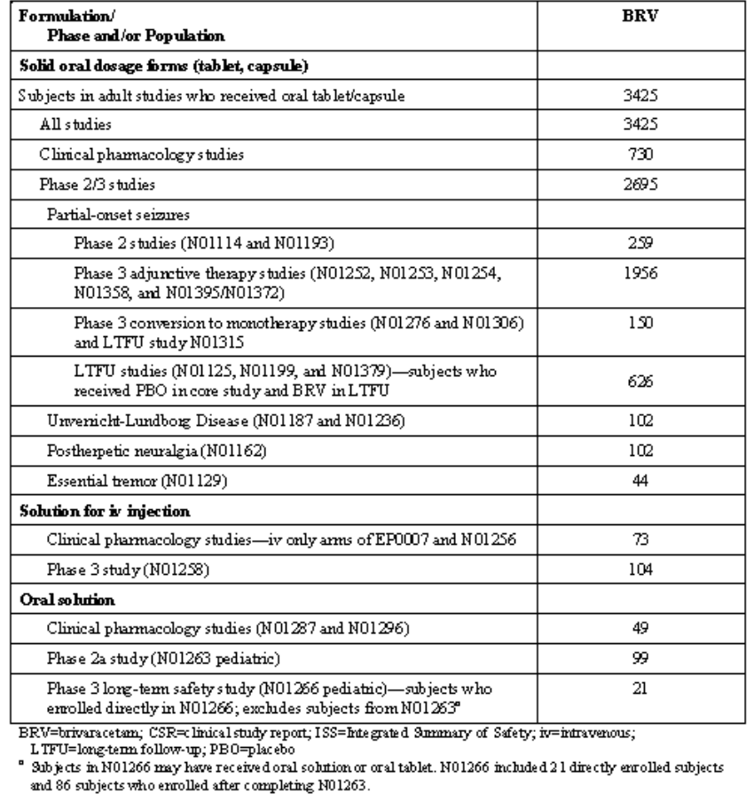
Table 23: Overall durations of exposure of BRV.
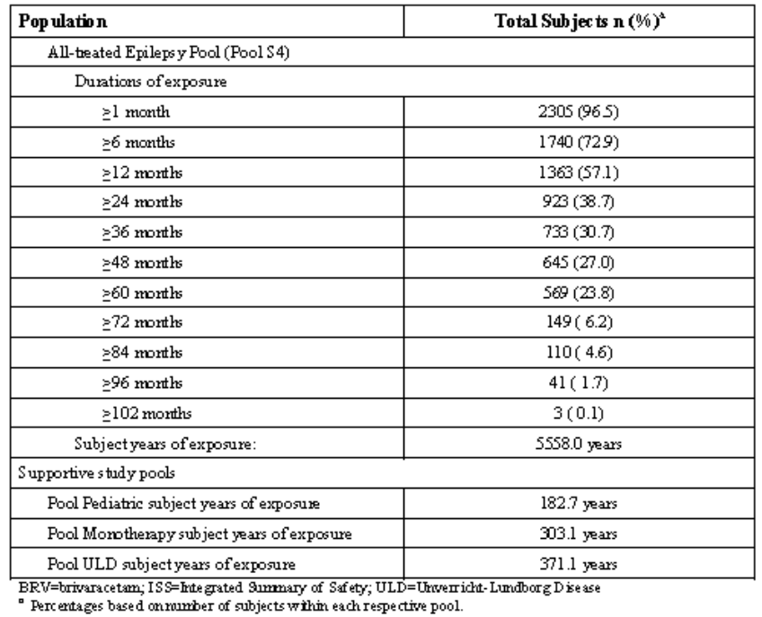
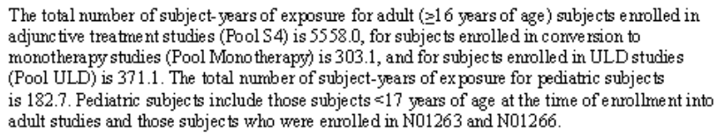
Table 24: Overall expose to BRV by maximum daily dose.
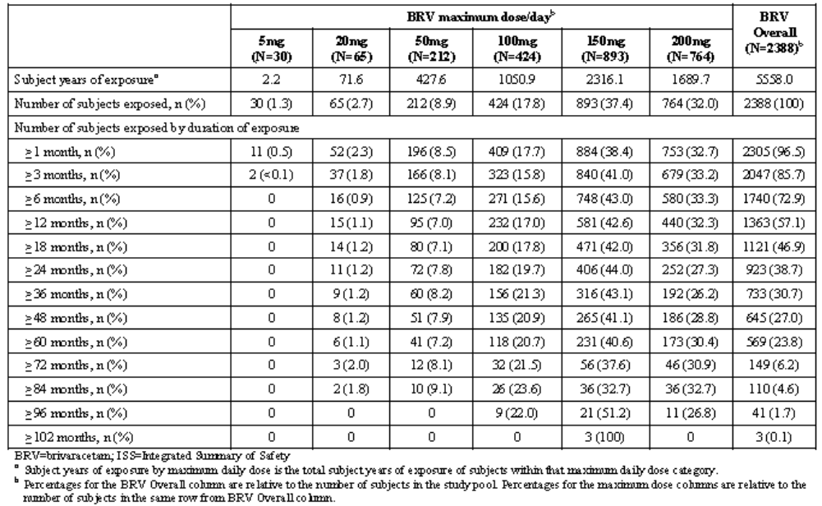

Safety issues with the potential for major regulatory impact

Liver toxicity
None identified.

Haematological toxicity
None identified.

Abuse potential
There were no reports of abuse, misuse, dependence or withdrawal with BRV. Across all study pools, dizziness, somnolence, fatigue, and asthenia were the most common CNS events of interest. The incidence of euphoric mood and feeling drunk was low in patient populations but higher in Phase I populations.

Falls
10 subjects in the PBO group and 133 in the BRV group reported at least 1 TEAE of fall.
Table 25: Falls.
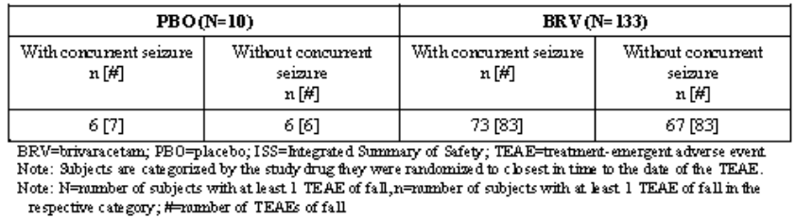

Cardiovascular safety
None identified.

Unwanted immunological events
None identified.

Post marketing data
Not applicable.

Evaluator’s conclusions on safety
The risks that were common in the healthy subjects (dizziness, somnolence, headache, and fatigue) were also common in the epilepsy subjects.
In the epilepsy Phase III double blind pool, very common AEs (fatigue, irritability, somnolence and dizziness) were more common with brivaracetam than placebo (the exception was headache which appeared reduced).
In relation to the elderly (> 65), there were only 44 subjects in the epilepsy all treated pool and only fewer in the epilepsy Phase III double blind pool. However, no increase in toxicity was reported in elderly subjects.
On the data provided, there appeared to be reduced prevalence of the more common AEs in <17 year group compared with adults.
No major safety issues are identified.

First round benefit-risk assessment

First round assessment of benefits
The benefits of brivaracetam in the proposed usage are:
- An anticonvulsant that has similarities with only one other anticonvulsant currently available (levetiracetam) with some preclinical evidence to support superiority.
- Based on the most optimistic data from the 200 mg/day BRV study group from N01358, NNT is 6.2 per additional responder compared to placebo.
- The mean Percent Change from Baseline in Seizure Frequency per 28 Days and the Responder Rate seemed to improve in those continuing on the drug.
- There are relatively few discontinuations in the long term (14.1%).

First round assessment of risks
The risks of brivaracetam in the proposed usage are:
- Safety data are thoroughly established and safety profile seems favourable in the population examined so far.
- In the add-on setting determination of plasma concentrations seemed to have some bearing on pharmacodynamic effect but inspection of the dose-response graphs would suggest that this effect is fairly weak and variable. Moreover, differences in study design appear insufficient to explain variability in efficacy variables seen across the studies.
- Adequate data is submitted with regards to special populations although numbers of elderly with sufficient level of exposure are small.
- The earlier pivotal studies were complicated by too many dose arms. Sufficient information is contained within Phase II and pivotal studies in order to establish the lower end of the clinically effective dose range but not, in the evaluator’s opinion, the optimal effective dose. It is contended that this data will be supplemented by LTFU studies – although this method is potentially problematic. Only one pivotal study supports the use of a 200 mg/day dose and in this study 200 mg was found only marginally (numerically) superior to the 100 mg comparator in that study (N01358).

First round assessment of benefit-risk balance
The benefit-risk balance of brivaracetam given the proposed usage is favourable. This is determined on the basis that the risk profile is favourable and the efficacy data generally shows efficacy over placebo in the dosage range proposed.

First round recommendation regarding authorisation
Despite the evaluator’s concerns about the relatively weaker dataset supporting the 200 mg/day dose, the recommendation is for approval of the submission as it stands.

Clinical questions
Clarification is sought by the evaluator about the pooled results presented in the table below where a percentage reduction over placebo appears different in the BRV groups than that reported in the core text of N01252.
Table 26: US primary endpoint: percent reduction over PBO for 28-day adjusted POS frequency in N01252, N01253, N01358, and Pool E1.
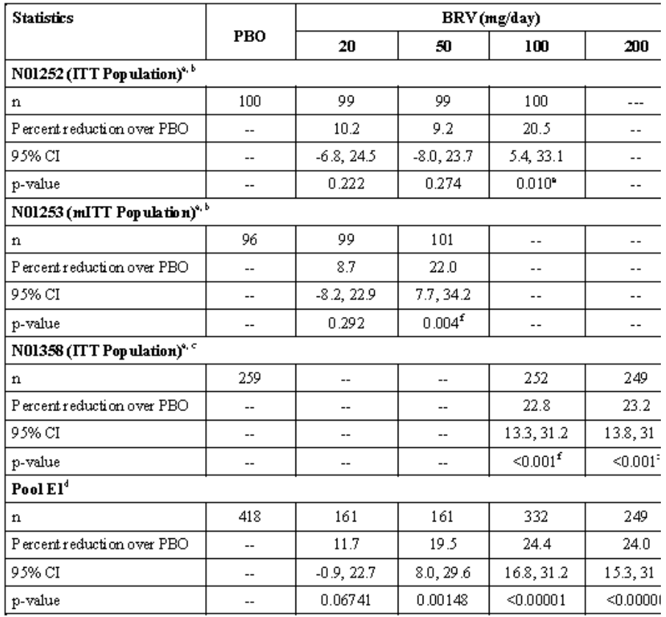
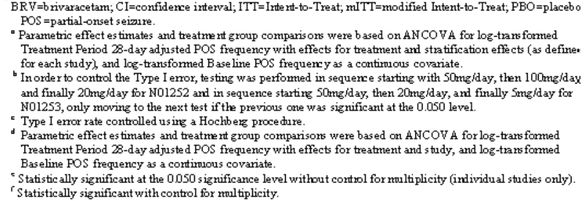

Pharmacodynamics
None

Efficacy
Pooled Safety analyses were done including both pivotal (S1) and pivotal and Phase II studies (S3) but not pooled efficacy analyses.

Other
Why are so many tablet strengths being made available? Might this not increase medication errors?

Second round evaluation
Details of sponsor’s responses to clinical questions and evaluator’s subsequent comments are contained in Attachment 2.

Second round benefit-risk assessment

Second round assessment of benefits
After consideration of the responses to clinical questions, the benefits of brivaracetam in the proposed usage are unchanged from those identified in the first round.

Second round assessment of risks
After consideration of the responses to clinical questions, the benefits of BRV in the proposed usage are unchanged from those identified in the first round.

Second round assessment of benefit-risk balance
The benefit-risk balance of BRV given the proposed usage is favourable. The reviewer accepts the antiepileptic action of BRV and the favourable side-effect profile.

Second round recommendation regarding authorisation
The reviewer accepts the submission as it stands.

V. Pharmacovigilance findings

Risk management plan
The sponsor submitted an EU-RMP Version 6 (dated 11 January 2016, data lock point [DLP] 17 January 2014), with Australian Specific Annex (ASA) Version 1.0, which was reviewed by the RMP evaluator.

Safety specification
The sponsor provided a summary of ongoing safety concerns which are shown at Table 27.
Table 27: Ongoing safety concerns.
Ongoing Safety Concerns
Important identified risks | Suicidality (class label for anticonvulsant products)
Important potential risks | Neutropenia
Important potential risks | Worsening of seizures (as an anticonvulsant product)
Important potential risks | Abuse potential (as a CNS-active product)
Missing information | Data during pregnancy and lactation
Missing information | Data in paediatrics (i.e. preterm neonates to children aged 16 years) including data on neurodevelopment
Missing information | Data in patients with pre-existing hepatic impairment
Missing information | Data in patients with pre-existing end-stage renal impairment requiring dialysis

RMP reviewer comment
Notwithstanding to the evaluation of the nonclinical and clinical aspects of the Safety Specification (SS), the summary of safety concerns is considered acceptable in the context of this application.
It is noted that the PI for injectable Briviact advises of AEs associated with intravenous administration: IV administration was associated with infusion site pain in 2.8% of the patients. The sponsor should provide details, if any, of other reports of adverse events specifically associated with injection of Briviact.

Pharmacovigilance plan

Proposed pharmacovigilance activities
In the EU-RMP, the sponsor proposes routine and additional pharmacovigilance for the identified/potential risks and missing information presented in the Summary of Safety Concerns.
Table 28: Proposed pharmacovigilance activities.
Safety concern | Planned action(s)
Important identified risks
Suicidality (class label for anticonvulsant products) | - Routine pharmacovigilance, with targeted follow-up using suicidality questionnaire
Important potential risks
Neutropenia | - Routine pharmacovigilance, with targeted follow-up using severe blood dyscrasias questionnaire
Worsening of seizures (as an anticonvulsant product) | - Routine pharmacovigilance, with targeted follow-up using drug-induced seizure aggravation questionnaire
Abuse potential (as a CNS-active product) | - Routine pharmacovigilance, with targeted follow-up using drug dependence, abuse, and diversion questionnaire
Missing information
Data during pregnancy and lactation | - Routine pharmacovigilance, with targeted follow-up using pregnancy questionnaire  - Participation in and sponsorship of EURAP and North American AED Pregnancy Registry – protocols for EURAP and the AED Registry include ‘possible’ activities to follow-up the children
Data in paediatrics (i.e. preterm neonates to children aged 16 years) including data on neurodevelopment | - Routine pharmacovigilance  - Head circumference measurements in all paediatric studies as per protocol and as agreed in the approved Paediatric Investigation Plan (PIP)  - Neurodevelopmental maturation assessment using validated scales including Achenbach CBCL, BSID-II or BSID-III, BRIEF-P/BRIEF  - Clinical study N01266 (estimated 2019 completion)  - Clinical study N01268 (estimated 2021 completion)  - Clinical study N01269 (estimated Q4 2015 for final report)  - Clinical study N01349 (estimated 2018 completion)  - Clinical study EP0065 (estimated 2020 completion)
Data in patients with pre-existing hepatic impairment | - Routine pharmacovigilance, with targeted follow-up using drug-induced liver injury questionnaire
Data in patients with pre-existing end-stage renal impairment requiring dialysis | - Routine pharmacovigilance

RMP reviewer’s comments
There is no definite objection to the pharmacovigilance plan proposed by the sponsor in the context of this application. However, the sponsor should provide comment on implications for the Australian population of the planned and ongoing pharmacovigilance activities (for example, are Australian patients included). An ASA should therefore be provided.
The sponsor has provided examples of targeted adverse event follow-up questionnaires for the safety concerns of suicidality, severe blood dyscrasias, drug induced liver injury, drug induced seizure aggravation, drug dependence/abuse/and diversion, and pregnancy. Upon review, these questionnaires appear appropriate for this pharmacovigilance activity.

Risk minimisation activities

Sponsor’s conclusion in regard to the need for risk minimisation activities
The sponsor proposes routine risk minimisation activities (that is, PI labelling) for all identified/potential safety concerns and missing information. No additional risk minimisation activities are proposed.
The proposed risk minimisation activities are discussed further below.

RMP reviewer comment
The sponsor’s conclusions with regards to proposed risk minimisation activities are considered acceptable in the context of this submission.

Reconciliation of issues outlined in the RMP report
The following section summarises the first round evaluation of the RMP, the sponsor’s responses to issues raised by the TGA RMP reviewer, and the RMP reviewer’s evaluation of the sponsor’s responses.
It is considered that the sponsor’s response to the TGA Section 31 Request has adequately addressed the majority of issues identified in the RMP evaluation report. However, there remain some outstanding issues that must be addressed prior to registration.

Recommendation #1 in RMP evaluation report
Safety considerations may be raised by the nonclinical and clinical evaluators through the consolidated Section 31 request and/or the nonclinical and clinical evaluation reports, respectively. It is important to ensure that the information provided in response to these includes consideration of the relevance for the RMP, and any specific information needed to address this issue in the RMP. For any safety considerations so raised, the sponsor should provide information that is relevant and necessary to address the issue in the RMP.

Sponsor response
UCB acknowledges the request above and will take into consideration the impact on the RMP for any safety considerations raised.

Evaluator’s comment
The sponsor’s response is noted. Issues raised in the nonclinical evaluation report have not been addressed by the sponsor (see below).

Recommendation #2 in RMP evaluation report
It is noted that the PI for injectable Briviact advises of the following AEs associated with IV administration: IV administration was associated with infusion site pain in 2.8% of the patients. The sponsor should provide details, if any, of other reports of AEs specifically associated with injection of Briviact.

Sponsor response
The sponsor has provided a detailed breakdown of the adverse events reported in the clinical trials – see the Section 31 response for this information. The Section 31 response concluded:
The iv formulation has been evaluated in the bioequivalence studies N01256 and EP0007 and safety and tolerability were also assessed in N01258, which included patients with partial-onset seizures. The studies demonstrated that the adverse event profile on treatment initiation support the safety and tolerability of the intravenous administration of BRV. As the iv formulation is proposed for short term use when the oral route is not feasible, both methods of iv administration would take place in a healthcare setting, providing additional risk mitigation.

Evaluator’s comment
The sponsor’s response is noted and is acceptable from a RMP perspective.

Recommendation #3 in RMP evaluation report
An ASA should be provided for the following reasons:
- The sponsor should provide comment on implications for the Australian population of the planned and ongoing pharmacovigilance activities (for example, are Australian patients included).
- Upon review of the risk minimisation materials, including the provided Summary of Product Characteristics (SmPC) and the proposed PI, there are some differences in the advice provided. For example, the SmPC includes additional advice for neutropenia and for the safety profile in open label extension studies (under ‘Undesirable Effects’) that is not in the PI. In this regard, an ASA should be provided for the sake of consistency and adherence to the TGA guidance. The sponsor should provide an ASA comparing the risk minimisation advice between the jurisdictions, to include justification for any differences and relevance for the Australian population.

Sponsor response
UCB agrees to submit an ASA to the RMP. As agreed with TGA on 21 January, the ASA will be provided no later than 31 March 2016.

Evaluator’s comment
The sponsor has provided an ASA in the March submission (Version 1.0). It is advised that the ASA requires minor revision to include the date of finalisation.

Recommendation #4 in RMP evaluation report
The SmPC contains warnings relating to the ingredients lactose, sodium, fructose, and methyl parahydroxybenzoate across the Briviact formulations. These warnings are not included in the PI. The Delegate may wish to consider their inclusion to mitigate risks associated with intolerance, hypersensitivity, or, in the case of sodium, controlled intake.

Sponsor response
UCB acknowledges this comment and will wait on further feedback and direction from the Delegate in relation to this matter.

Evaluator’s comment
The sponsor’s response is noted. This issue remains for final determination by the Delegate.

Summary of recommendations

Outstanding issues

Issues in relation to the RMP
The following outstanding issues should be addressed by the sponsor:
- ASA (Version 1.0) must be updated to include a date of finalisation/authorisation for document control purposes.
- “Data in paediatrics (that is, preterm neonates to children aged 16 years) including data on neurodevelopment” should be reinstated as Missing Information, and the associated additional pharmacovigilance activities be retained in the EU-RMP.
- The issues raised by the nonclinical evaluator concerning the monkey studies not providing adequate exposure to the human metabolite should be addressed in Part II Module SII of the EU-RMP.

Advice from the Advisory Committee on the Safety of Medicines (ACSOM)
ACSOM advice was not sought for this submission.

Comments on the safety specification of the RMP

Clinical evaluation report
Both the Round 1 and Round 2 reports concluded that “The Safety Specification in the draft RMP is satisfactory”

Nonclinical evaluation report
The nonclinical evaluator recommended that:
In general, the results and conclusions drawn from the nonclinical program for brivaracetam detailed in the sponsor’s draft RMP are in general concordance with those of the nonclinical evaluator except for the following points:
    - References to results in the cynomolgus monkey studies should be amended to indicate that due to pharmacokinetic differences in this species, safety assessment of the major human metabolites was not achieved.
    - The potential human implications for the finding of non-reversible effects on auditory startle responses in rats exposed to brivaracetam during PND 4-70 have not been taken into account. The rat auditory startle response is an example of a sensorimotor startle response and is a measure of auditory sensory motor processing. Humans are known to have similar startle reflexes (for example, the Start React effect) and similar pathways of sensory-motor processing. Sensory motor processing, particularly auditory sensorimotor processing should be evaluated in children who have been exposed to brivaracetam and this should be included as part of the neurodevelopmental monitoring as suggested in the RMP. Given that in rats milk levels of brivaracetam essentially reflect maternal plasma levels, transmammary exposure of nursing infants of mothers being treated with brivaracetam should be suspected.

RMP evaluator’s comments
The sponsor is recommended to update the EU-RMP to clarify that the monkey studies were not sufficient to assess the safety profile of major human metabolites.
Concerns regarding neurodevelopmental effects were addressed in version 1.0 of the EU-RMP, but this was removed from version 6. It is recommended that the effects of brivaracetam on neurodevelopment be retained as missing information in the updated EU-RMP unless adequately justified by new clinical data. Consideration of sensory motor processing should also be included in the pharmacovigilance activities. The concern regarding exposure to breastfed infants is addressed as missing information in the RMP. However the consequence of exposure through the milk should also be considered as missing information for potential effects on neurodevelopment.

Key changes to the updated RMP
EU-RMP Version 1.0 (dated 5 November 2014, DLP 17 January 2014; no ASA provided) has been superseded by:
EU-RMP Version 6.0 (dated 11 January 2016, DLP 17 January 2014) and Australian Specific Annex Version 1.0 (no finalisation date provided on the ASA)
Key changes from the version evaluated at Round 1 are summarised below.
Table 29: Summary of key updates between EU-RMP Version 1.0 and EU-RMP Version 6.0.
Summary of key updates between EU-RMP Version 1.0 and EU-RMP Version 6.0

Safety specification | ‘Aggression’ has been added as an Important Identified Risk  ‘Off-label use for unapproved epilepsy indications (including preterm neonates to children aged <16 years)’ has been added as an Important Potential Risk  ‘Data in paediatrics (ie, preterm neonates to children aged 16 years) including data on neurodevelopment’ has been removed as Missing Information  ‘Data in elderly’ has been added as Missing Information  ‘Clinical outcomes after an overdose’ has been added as Missing Information  ‘Long-term safety’ has been added as Missing Information
Pharmacovigilance activities | Routine pharmacovigilance has been proposed for the new identified risk of ‘Aggression’  Routine pharmacovigilance has been proposed for the risk of ‘Off-label use for unapproved epilepsy indications (including preterm neonates to children aged <16 years)’  Routine pharmacovigilance has been proposed for the new Missing Information ‘Data in elderly’, ‘Clinical outcomes after an overdose’ and ‘Long-term safety’.  Additional pharmacovigilance activities to address missing information in paediatrics (including neurodevelopment) have been removed (these measures included head circumference measurements, neurodevelopmental assessment and 5 clinical trials).
Risk minimisation activities | Routine risk minimisation has been proposed for the new identified risk of ‘Aggression.’  Routine risk minimisation has been proposed for the risk of ‘Off-label use for unapproved epilepsy indications (including preterm neonates to children aged <16 years)’  Routine risk minimisation has been proposed for the new Missing Information ‘Data in elderly’, ‘Clinical outcomes after an overdose’ and ‘Long-term safety’.
ASA | This is the first version of the ASA (ASA Version 1.0; no finalisation date provided on the document)

RMP evaluator comment
The removal of “Data in paediatrics (that is, preterm neonates to children aged 16 years) including data on neurodevelopment” as Missing Information, and the associated additional pharmacovigilance activities, is not supported by the RMP evaluator. No justification was provided for their removal. Unless new clinical data is available to support this removal and cessation of activities it should be reinstated in the summary of safety concerns and pharmacovigilance activities. This would also address concerns of the nonclinical evaluator regarding neurodevelopmental effects, which are detailed.
Statements from the PI document which are reported in the ASA should be updated to ensure the wording is consistent with the final PI.
The evaluator has no objection to the other changes above, and recommends to the Delegate that the updated EU-RMP version be implemented (see below). However, it is noted that the submitted ASA Version 1.0 requires a date of authorisation/finalisation in the document.

Suggested wording for conditions of registration

RMP
Any changes to which the sponsor agreed become part of the risk management system, whether they are included in the currently available version of the RMP document, or not included, inadvertently or otherwise.
The suggested wording is:
The European Risk Management Plan (Version 6, 11 January 2016, DLP 17 January 2014), with Australian Specific Annex (version 1.0, date to be provided), to be revised to the satisfaction of the TGA, must be implemented (see outstanding issues above).

VI. Overall conclusion and risk/benefit assessment
The submission was summarised in the following Delegate’s overview and recommendations:

Risk-benefit analysis

Delegate’s considerations
The clinical evaluator raised no objection to the registration of brivaracetam (Briviact) film coated tablets, oral solution and solution for injection. There are some nonclinical PI issues requiring modifications, while chemistry evaluators require resolution of quality and carton issues before supporting registration. In line with the pharmacodynamic data, it is:
- Desirable to clearly state that brivaracetam dose be initiated at 50 mg per day, increasing at 50 mg per day, say every 2 to 4 weeks, until either the effective dose or maximum permitted dose of 200 mg per day is attained. The statement in the draft PI under Dosage and Administration “Initial dose titration to an effective dose is not required for tolerability” should be deleted.
- Valuable to mention that there is decreased absorption rate, as shown by lower Cmax and longer Tmax when brivaracetam is taken with food, especially when fatty. Preference will therefore be to take brivaracetam on empty stomach.
- Unsafe to claim that “no dose adjustment is needed in patients with impaired renal function” in the draft PI when Study N01109 revealed that renal dysfunction did decrease the renal clearance of the drug (-63%). It is more appropriate to state that “dose adjustment may be necessary in renal dysfunction” even considering that less than 10% of the drug is excreted as unchanged in urine.
- Not evidence based to state that “no dose adjustment required” when one AED is affecting the plasma concentration of another. For instance, carbamazepine is stated as decreasing brivaracetam concentration by 26% while the latter is increasing the former’s plasma concentration. The decision on whether or not to make dose adjustment should be determined clinically, based on efficacy/adverse effects sequela of making dose adjustment relative to one AED or another.
Like the other AEDs, suicidal ideation/attempt or completed suicide is a rare but major safety concern and it has been captured in the draft PI under “Precautions”. Nonetheless, the benefit-risk balance is rated as favourable for the proposed indication.
The draft PI requires modifications especially as revised in the nonclinical evaluation.

Summary of issues
- Requirement for dose titration so as to minimise adverse effects
- Timing of Brivaracetam administration in relation to food
- Requirement for Brivaracetam dose reduction in kidney disease

Proposed action
The Delegate favours, at this stage, the approval of the application subject to resolving issues, which may arise from the ACPM deliberations and finalisation of matters pertaining to the draft PI, nonclinical and clinical evaluations, and RMP to the satisfaction of TGA.

Request for ACPM advice
- Acceptability of the proposed indication.
- Acceptability of the Delegate’s suggested modifications to the statements on dosage with regard to dose titration, food and renal impairment.
- Advice on any other issues relevant to a decision on whether or not to approve this application.

Response from sponsor

Proposed actions for the sponsor
- It is desirable to clearly state that brivaracetam dose be initiated at 50 mg per day, increasing at 50 mg per day, say every 2 to 4 weeks, until either the effective dose or maximum permitted dose of 200 mg per day is attained. The statement in the dPI under Dosage and Administration “Initial dose titration to an effective dose is not required for tolerability” should be deleted.

Response
The sponsor acknowledges that the proposed brivaracetam (BRV) treatment recommendation is different from the usual treatment paradigm in epilepsy and provides herein the rationale supporting the recommendation to start BRV treatment at the optimal dose without an up-titration. Based on the efficacy data and the very good tolerability profile of BRV across the 50 to 200 mg/day dose range, UCB considers that a starting dose of BRV 100 mg/day without up-titration will be beneficial for the patients by providing them an efficacious and safe dose from the first day of treatment with reduced inter individual variability in the response. UCB received a similar question from the EMA and the full response has been provided for reference. The response, which was accepted by the EMA was based on the following principles:
  - Up-titration is not required because tolerability is high and equally favourable at BRV 100 mg/day and 50 mg/day;
  - TEAEs in the first 7 days are minor and not different from later or delayed AEs;
  - Optimal efficacy is demonstrated at BRV 100 mg/day, ensuring the highest probability of a clinically relevant response;
  - A survey of patients with epilepsy and physicians found that among the items that they were asked to respond to, physicians and patients agree on reduction of seizures as most important while reducing the titration period was the one of the highest ranking element that patients and physicians disagreed on (51% versus 10%), suggesting that the burden of titration on patients is under-appreciated by healthcare professionals. Patients consider a reduction of the titration period to be a much more important factor in treatment decision making than did physicians. Therefore, the wording presented in the Australian PI in Section DOSAGE AND ADMINISTRATION accurately reflects the proposed posology recommendation:
BRIVIACT at doses between 50 and 200 mg/day has been shown to be effective as adjunctive therapy in the treatment of partial onset seizures. Initial dose titration to an effective dose is not required for tolerability. The daily dose is administered in two equally divided doses, once in the morning and once in the evening. The recommended starting dose is 100 mg/day. Based on individual patient response, the dose may be adjusted between 50 mg/day and 200 mg/day.
- It is valuable to mention that there is decreased absorption rate, as shown by lower Cmax and longer Tmax when brivaracetam is taken with food, especially when fatty. Preference will therefore be to take brivaracetam on empty stomach.

Response
Food effect: The concentration-effect relationship is not driven by Cmax but by the average drug concentration or AUC (C_{av,ss} = AUC_{tau/12}).
There is limited value in stating that the absorption rate is decreased in presence of a high fat meal but there is clear value in stating that the AUC of brivaracetam is unchanged compared to fasted conditions. Therefore the average steady state plasma concentration does not change and the efficacy is not affected by intake with food. Brivaracetam can be taken without or with food.
- It is unsafe to claim that “no dose adjustment is needed in patients with impaired renal function” in the dPI when Study N01109 revealed that renal dysfunction did decrease the renal clearance of the drug (-63%). It is more appropriate to state that “dose adjustment may be necessary in renal dysfunction” even considering that less than 10% of the drug is excreted as unchanged in urine.

Response
The sponsor acknowledges that the renal clearance of BRV is decreased by -63% in subjects with (very) severe renal impairment, but this finding is totally non relevant because renal clearance amounts to a mere 4% of total plasma clearance (non renal + renal). The plasma clearance decreases in these patients by only -18% compared to matched controls, and such a small change does not require any dose adjustment. The Applicant maintains that no dose adjustment is required in renal impairment.
- It is not evidence based to state that “no dose adjustment required” when one AED is affecting the plasma concentration of another. For instance, carbamazepine is stated as decreasing brivaracetam concentration by 26% while the latter is increasing the former’s plasma concentration. The decision on whether or not to make dose adjustment should be determined clinically, based on efficacy/adverse effects sequela of making dose adjustment relative to one AED or another.

Response
The sponsor believes the statement “while the latter [read: brivaracetam] is increasing the former’s [read: carbamazepine] plasma concentration” is not factually correct. Brivaracetam does not increase carbamazepine at all (see report CL0178), but increases a metabolite of carbamazepine, CBZ-epoxide. The increase in the metabolite CBZ-epoxide is essentially constrained below the upper limit of the reference range. No dose adjustment is warranted when brivaracetam and carbamazepine are co-administered.
Phenobarbital decreased the concentration of brivaracetam by 19% (report CL0028). Brivaracetam did not modify the concentration of phenobarbital in adult patients with epilepsy (report CL0178). Phenytoin decreased the concentration of brivaracetam by 21% (report CL0028). Brivaracetam increased the concentration of phenytoin by up to 20% at the supra-therapeutic dose of 400 mg/day (report N01172), the effect was around 10% and inconsistently dose related at brivaracetam doses of ≤200 mg/day (report CL0178).

Other delegate’s comments
Based on the evidence arising from the submitted data evaluation, the Delegate favours, at this stage, to approve the application. This is subject to resolving issues, which may arise from the ACPM deliberations and finalisation of matters pertaining to the draft PI, quality and nonclinical evaluations, and RMP, to the satisfaction of TGA.

Response
In relation to the outstanding issues pertaining draft PI, quality and nonclinical evaluations and RMP, please find below our comments with reference to the page numbers listed.

Biopharmaceutics & Microbiology
(Page 3) A shelf life of 36 months stored below 25C or of 24 months stored below 30C can also be allocated to the unopened oral solution proposed for Australia and stored the amber Type III bottles with child resistant closures at this time. Alternatively, a shelf life of 36 months stored below 30C can be allocated provided the matters identified in this report relating to its quality control and stability are satisfactorily resolved.

Response
The sponsor agrees to further reduce the release limit for the degradants ucb 42144/ucb 42145 to ≤ 0.60%, and for total degradation products to ≤ 1.1% to justify a shelf life of 36 months for the oral solution, when stored below 30C.
(Page 4) Approval cannot be recommended from a Quality or Module 1 perspective until the issues identified in this report have been satisfactorily addressed.

Response
The sponsor has addressed all outstanding Quality and Module 1 issues and the updated documents pertaining to the issues have been provided as part of this response. Further details on the specific responses and documents provided are listed.

Toxicology
(Page 4, 32, 33, 41) References to results in the cynomolgus monkey studies (for example, Module II pps 4, 5, 6, 12, 25 & 38) should be re-worded to highlight the limitations of this species as a nonclinical model

Response
This issue has been clarified (this conclusion was in fact an error in the interpretation of the data) in the revised nonclinical evaluation report and as such, this recommendation is no longer relevant. The revised nonclinical evaluation report has been provided for reference, in which UCB have also provided comment on additional errors identified. (Page 4) As levels of brivaracetam in rat milk essentially reflect maternal plasma levels, transmammary exposure of nursing infants should be suspected. Sensory-motor processing (particularly auditory sensorimotor) should be evaluated in children who have had significant brivaracetam exposures, and included as part of the neurodevelopmental monitoring as suggested in the RMP.
Response
The sponsor acknowledges the greater auditory startle response on PND 78 at the high dose of brivaracetam in juvenile rats. This effect was not accompanied by effect on habituation, nor any other effects on sensory and motor functions or learning and memory assessment at any dosage level that could indicate a neurobehavioral deficit. As agreed in the approved Paediatric Investigation Plan, head circumference is measured in all BRV paediatric studies, per protocol, and neurodevelopmental maturation is assessed by the investigator using physical examination and neurodevelopmental validated scales (including the Achenbach Child Behaviour Checklist [CBCL], the Bayley Scales of Infant Development [BSID-II or BSID-III] and the Behaviour Rating Inventory of Executive Function [BRIEF-P/BRIEF] scales). These scales were chosen to allow a sensitive analysis of infant/child development but minimising burden to children and caregivers. The BSID scales assess 5 main domains of development: cognition, language (receptive and expressive), socio-emotional behaviour and finally motor and adaptive behaviour.
In regards to the concern related to review of breastfed babies, 'Data during pregnancy and lactation' is included in 'Missing Information', so any adverse events reported for breastfed babies will be identified during routine signal detection processes. It should be noted that in the pre- postnatal development Study NCD1330, there were no adverse sensory and neurobehavioral effects in F1 pups, including in the acoustic startle response test.
(Page 4) The draft PI document should be amended as directed on pages 41–44

Response
The sponsor has incorporated the above amendments into the PIs supplied with the pre-ACPM response, with the exception of: (Page 40) Similar exposure to brivaracetam was achieved in adult and versus juvenile animals at the NOAEL, except at PND 4 in rats where higher exposure was achieved in juveniles animals compared to adults.”
The nonclinical evaluator proposed to include the qualifier “in rats’ to this sentence under the Precautions section of the PI, however in dogs, the exposure was also higher at PND 4 (2-3x) vs PND 31 or 276. As such, the sponsor proposes to not implement 'in rats' into the paragraph. This feedback has also been provided in the review of fact and error of the nonclinical evaluation report.

RMP
(Page 32) 1.1 ASA (Version 1.0) must be updated to include a date of finalisation/authorisation for document control purposes.

Response
An updated ASA with a date of authorisation has been provided as part of this response.
(Page 4, 32) 1.2 “Data in paediatrics (i.e. preterm neonates to children aged 16 years) including data on neurodevelopment” should be reinstated as Missing Information, and the associated additional pharmacovigilance activities be retained in the EU-RMP.
Response
Upon request of the EMA during the Submission process of BRV, the Important Potential Risk of “off-label use for unapproved indication” was added to the EU-RMP.
Data in paediatrics is included in this risk as it is considered that off-label use of BRV is likely in this population. The PRAC Rapporteur therefore requested removal of “Data in paediatrics” from Missing Information and also reminded UCB that the paediatric studies listed in the original EU-RMP and the information regarding neurodevelopmental monitoring are already part of the agreed Paediatric Investigation Plan and are therefore not required in the EU-RMP. Data from paediatric studies is included in routine signal detection activities.
In summary, the removal of “Data in paediatrics” from the EU-RMP has not changed the ongoing monitoring of the paediatric population, including breastfed babies. Any signals arising from routine pharmacovigilance in children of any age and resulting actions will be notified to Authorities and discussed in PBRERs.

Additional items identified
(Page 11) Brivaracetam may have an additional inhibitory activity on voltage-gated sodium channels (VGSC). Brivaracetam dose dependently inhibits voltage-dependent sodium currents

Response
This is not correct. Please see nonclinical evaluation report page 13: Effects on ion channels.
(Page 12) 3rd bullet on ethanol interaction
Response
The sponsor considers the statements (1) the pharmacodynamic effects were supra-additive and (2) possible ‘synergistic effects’ exist on sedation and cognitive function are not factually correct.
As demonstrated in study report EP0041, only adaptive tracking performance was possibly slightly supra-additive based on a post hoc exploratory statistical analysis. All other psychometric tests including sedation and cognition did not deviate from additivity (for example, sedation score of the BRV + ethanol combination is identical to the sum of sedation scores for BRV alone and ethanol alone).
The qualifiers supra-additive and synergistic should be removed.
(Page 36) bullet 1, 50 mg starting dose “in line with the pharmacodynamic data”

Response
The sponsor does not agree with the statement that the 50 mg starting dose is “in line with the pharmacodynamic data”. As shown in PK/PD modelling report CL0027, the pharmacodynamic concentration-effect curve for decrease in seizure frequency from baseline reveals a relationship that reaches a plateau around 100 to 200 mg/day, while 50 mg/day is near the middle of the ascending part of the curve, close to the EC50 value. In general, drugs are dosed near the plateau of effect (where changes in exposure do not result in changes in pharmacodynamic effect) rather than in the steep ascending part of the concentration effect curve.

Advisory Committee considerations
The ACPM, taking into account the submitted evidence of efficacy, safety and quality, agreed with the Delegate and considered Briviact film coated tablets 10 mg, 25 mg, 50 mg, 75 mg, 100 mg; oral solution 10 mg/mL and solution for injection 50 mg/5 mL containing brivaracetam to have an overall positive benefit-risk profile for the proposed indication;
Briviact tablets, oral solution and solution for injection are indicated as add-on therapy in the treatment of partial-onset seizures with or without secondary generalisation in patients from 16 years of age with epilepsy.
In making this recommendation, the ACPM:
- advised that brivaracetam demonstrated reasonable efficacy for the proposed indication with no major safety issues identified.

Proposed conditions of registration
The ACPM agreed with the Delegate on the proposed conditions of registration.

Proposed Product Information (PI)/Consumer Medicine Information (CMI) amendments
The ACPM agreed with the delegate to the proposed amendments to the PI and CMI and specifically advised on the inclusion of the following:
- A statement in the Dosage and Administration section regarding up-titrating brivaracetam to the minimal effective dose (see specific advice below).
- A statement in the Precautions/Contraindications section of the PI recommending caution/dose reduction in patients with renal and hepatic dysfunction as well as specific mention about an increase in inactive metabolites with renal impairment.
- Specific mention of the relationship between brivaracetam and carbamazepine, as evidence exists that concurrent administration lowers brivaracetam plasma concentrations whilst raising effective carbamazepine concentrations. The ACPM was of the view however that dose adjustment should be a clinical decision, based on efficacy and adverse effects sequela.

Specific advice
The ACPM advised the following in response to the Delegate’s specific questions on this submission:
- Acceptability of the proposed indication.
The ACPM advised that overall briveracetam was approvable with no major issues for the proposed indication.
- Acceptability of the Delegate’s suggested modifications to the statements on dosage with regard to dose titration, food and renal impairment.
The ACPM noted that up-titration was not part of the clinical trial protocol and the lack of up-titration did not seem to be associated with undue adverse events. However, good prescribing practice for many if not most medications requires up-titration to the best tolerated effective dose. The ACPM noted that generally, AEDs follow a titration protocol and with this precedent in mind, the ACPM agreed with the titration schedule of:
Brivaracetam dose be initiated at 50 mg per day, increasing at 50 mg per day, every 2 weeks, until either the effective dose or maximum permitted dose of 200 mg per day is attained
The ACPM noted that evidence suggested that brivaracetam did not need to be taken with specific directions in regard to food. The ACPM noted that although a high fat meal slowed absorption increasing the T_{max} from ≤ 1 h to <3 h and reduced the C_{max} by 37% (based on 50 mg tablet, food effect study (Study N01287)), the oral bioavailability (F_{oral}) was approximately 100% and the AUC was unchanged. Given twice daily dosing and the desirability for stable plasma concentrations with AEDs, specific food effect advice seems unneccessary.
Regarding renal impairment the committee noted that less than 10% of brivarecetam is normally excreted unchanged and increased exposure (AUC) to brivarecetam (active compound) was minor compared with the rise in inactive metabolites. However, the ACPM advised that a statement advising caution/dose reduction in patients with renal dysfunction and hepatic dysfunction may be worthwhile as well as specific mention about an increase in inactive metabolites with renal impairment.
The ACPM advised that that PI should include reference to the interaction with carbamazepine and would suggest adding wording: “dose adjustments may be required and monitoring of serum carbamazepine levels may be misleading.”
- Advice on any other issues relevant to a decision on whether or not to approve this application.
There were no other issues.
The ACPM advised that implementation by the sponsor of the recommendations outlined above to the satisfaction of the TGA, in addition to the evidence of efficacy and safety provided would support the safe and effective use of these products.

Outcome
Based on a review of quality, safety and efficacy, TGA approved the registration of:
    - Briviact (brivaracetam) 100 mg film-coated tablets blister pack
    - Briviact (brivaracetam) 10 mg/mL oral solution bottle
    - Briviact (brivaracetam) 10 mg film-coated tablets blister pack
    - Briviact (brivaracetam) 50 mg/5mL injection vial
    - Briviact (brivaracetam) 25 mg film-coated tablets blister pack
    - Briviact (brivaracetam) 50 mg film-coated tablets blister pack
    - Briviact (brivaracetam) 75 mg film-coated tablets blister pack
for the following indication:
Briviact tablets and oral solution and Briviact solution for injection are indicated as add-on therapy in the treatment of partial-onset seizures with or without secondary generalisation in patients from 16 years of age with epilepsy.

Specific conditions of registration applying to these goods
- The Briviact (brivaracetam) RMP (version 6, dated 11 January 2016, DLP 17 January 2014) with ASA (version 2, dated 11 May 2016), included with the submission, and any subsequent revisions and future updates, as agreed with TGA will be implemented in Australia.

Attachment 1. Product Information
The PI approved for Briviact at the time this AusPAR was published is at Attachment 1. For the most recent PI, please refer to the TGA website at <https://www.tga.gov.au/product-information-pi>.

Attachment 2. Extract from the Clinical Evaluation Report

Therapeutic Goods Administration
PO Box 100 Woden ACT 2606 Australia
Email: info@tga.gov.au Phone: 1800 020 653 Fax: 02 6232 8605
https://www.tga.gov.au

European Medicines Agency, “Note for Guidance Specifications: Test Procedures and Acceptance Criteria for New Drug Substances and New Drug Products: Chemical Substances (CPMP/ICH/367/96)”, May 2000.
Generally using experimental designs biased towards demonstrating efficacy.
Rafal M. Kaminski, Michel Gillard, and Henrik Klitgaard (2012) Targeting SV2A for Discovery of Antiepileptic Drugs. In: Jasper's Basic Mechanisms of the Epilepsies [Internet]. 4th edition.
Rafal M. Kaminski, Michel Gillard, and Henrik Klitgaard (2012) Targeting SV2A for Discovery of Antiepileptic Drugs. In: Jasper's Basic Mechanisms of the Epilepsies [Internet]. 4th edition.
Kaempf N, et al. Overlapping functions of stonin 2 and SV2 in sorting of the calcium sensor synaptotagmin 1 to synaptic vesicles. PNAS 112: 7297-302 (2015).
Nicolas J-M, et al. N-Alkylprotoporphyrin formation and hepatic porphyria in dogs after administration of a new antiepileptic drug candidate: mechanism and species specificity. Toxicol Sci. 141: 353-364 (2014).
Olson MJ, et al. A comparison of male rat and human urinary proteins: implications for human resistance to hyaline droplet nephropathy. Toxicol Appl Pharmacol. 102: 524-36 (1990).
International Conference on Harmonisation of Technical Requirements for Registration of Pharmaceuticals for Human Use (ICH), “ICH Harmonised Tripartite Guideline: Guidance on Genotoxicity Testing and Data Interpretation for Pharmaceuticals Intended for Human Use (S2[R1])”, 9 November 2011.
International Conference on Harmonisation of Technical Requirements for Registration of Pharmaceuticals for Human Use (ICH), “ICH Harmonised Tripartite Guideline: Detection of Toxicity to Reproduction for Medicinal Products & Toxicity to Male Fertility (S5[R2])”, 9 November 2011.
Pregnancy Category B3: “Drugs which have been taken by only a limited number of pregnant women and women of childbearing age, without an increase in the frequency of malformation or other direct or indirect harmful effects on the human fetus having been observed. Studies in animals have shown evidence of an increased occurrence of fetal damage, the significance of which is considered uncertain in humans.”
Kenda BM, et al. Discovery of 4-substituted pyrrolidone butanamides as new agents with significant antiepileptic activity. Journal of Medicinal Chemistry 47: 530-549 (2000); Lynch BA, et al. The synaptic vesicle protein SV2A is the binding site for the antiepileptic drug levetiracetam. PNAS 101: 9861-9866 (2004).
Pisani A, et al. Intracellular calcium increase in epileptiform activity: modulation by levetiracetam and lamotrigine. Epilepsia 45: 719-728 (2004).
Gillard M, et al. Binding characteristics of brivaracetam, a selective, high affinity SV2A ligand in rat, mouse and human brain: relationship to anti-convulsant properties. European Journal of Pharmacology 664: 36-44 (2011).
Matagne A, et al. Anti-convulsive and anti-epileptic properties of brivaracetam (ucb 34714), a high-affinity ligand for the synaptic vesicle protein, SV2A. British Journal of Pharmacology 154: 1662-1671 (2008).
Klitgaard H, et al. Evidence for a unique profile of levetiracetam in rodent models of seizures and epilepsy. European Journal of Pharmacology 353: 191-206 (1998).
Zona C, et al. Brivaracetam (ucb 34714) inhibits Na(+) current in rat cortical neurons in culture. Epilepsy Research 88: 46-54 (2010).
Matagne A, et al. Anti-convulsive and anti-epileptic properties of brivaracetam (ucb 34714), a high-affinity ligand for the synaptic vesicle protein, SV2A. British Journal of Pharmacology 154: 1662-1671 (2008).
European Medicines Agency, “Guideline on clinical investigation of medicinal products in the treatment of epileptic disorders (CHMP/EWP/566/98 Rev.2/Corr)”, 22 July 2010.
US Food and Drug Administration, “Guidance for Industry Suicidal Ideation and Behavior: Prospective Assessment of Occurrence in Clinical Trials”, August 2012.
Marinovic W, Tresilian JR. Triggering prepared actions by sudden sounds: reassessing the evidence for a single mechanism. Acta Physiol (Oxf). 217: 13-32 (2016).

