First round CER: October 2015
Second round CER: April 2016

AusPAR Attachment 2

Extract from the Clinical Evaluation Report for brivaracetam
  - Proprietary Product Name: Briviact
  - Sponsor: UCB Australia Pty Ltd

About the Therapeutic Goods Administration (TGA)
- The Therapeutic Goods Administration (TGA) is part of the Australian Government Department of Health, and is responsible for regulating medicines and medical devices.
- The TGA administers the Therapeutic Goods Act 1989 (the Act), applying a risk management approach designed to ensure therapeutic goods supplied in Australia meet acceptable standards of quality, safety and efficacy (performance), when necessary.
- The work of the TGA is based on applying scientific and clinical expertise to decision-making, to ensure that the benefits to consumers outweigh any risks associated with the use of medicines and medical devices.
- The TGA relies on the public, healthcare professionals and industry to report problems with medicines or medical devices. TGA investigates reports received by it to determine any necessary regulatory action.
- To report a problem with a medicine or medical device, please see the information on the TGA website <https://www.tga.gov.au>.
About the Extract from the Clinical Evaluation Report
- This document provides a more detailed evaluation of the clinical findings, extracted from the Clinical Evaluation Report (CER) prepared by the TGA. This extract does not include sections from the CER regarding product documentation or post market activities.
- The words [Information redacted], where they appear in this document, indicate that confidential information has been deleted.
- For the most recent Product Information (PI), please refer to the TGA website <https://www.tga.gov.au/product-information-pi>.
Copyright
© Commonwealth of Australia 2017
This work is copyright. You may reproduce the whole or part of this work in unaltered form for your own personal use or, if you are part of an organisation, for internal use within your organisation, but only if you or your organisation do not use the reproduction for any commercial purpose and retain this copyright notice and all disclaimer notices as part of that reproduction. Apart from rights to use as permitted by the Copyright Act 1968 or allowed by this copyright notice, all other rights are reserved and you are not allowed to reproduce the whole or any part of this work in any way (electronic or otherwise) without first being given specific written permission from the Commonwealth to do so. Requests and inquiries concerning reproduction and rights are to be sent to the TGA Copyright Officer, Therapeutic Goods Administration, PO Box 100, Woden ACT 2606 or emailed to <tga.copyright@tga.gov.au>.

Contents
List of abbreviations 5
1. Introduction 9
2. Clinical rationale 9
3. Contents of the clinical dossier 10
3.1. Scope of the clinical dossier 10
3.2. Paediatric data 12
3.3. Good clinical practice 12
4. Pharmacokinetics 13
4.1. Studies providing pharmacokinetic data 13
4.1. Summary of pharmacokinetics 13
4.2. Evaluator’s conclusions on pharmacokinetics 22
5. Pharmacodynamics 22
5.1. Studies providing pharmacodynamic data 22
5.2. Summary of pharmacodynamics 24
5.3. Evaluator’s conclusions on pharmacodynamics 29
6. Dosage selection for the pivotal studies 29
7. Clinical efficacy 30
7.1. Pivotal efficacy studies 30
7.2. Other efficacy studies 41
7.3. Analyses performed across trials (pooled & meta analyses) 42
7.4. Evaluator’s conclusions on clinical efficacy 42
8. Clinical safety 43
8.1. Studies providing evaluable safety data 43
8.2. Pivotal studies that assessed safety as a primary outcome 45
8.3. Patient exposure 45
8.4. Adverse events 47
8.5. Deaths and other serious adverse events 48
8.6. Laboratory tests 49
8.7. Post-marketing experience 52
8.8. Safety issues with the potential for major regulatory impact 52
8.9. Other safety issues 52
8.10. Evaluator’s overall conclusions on clinical safety 52
9. First round benefit-risk assessment 53
9.1. First round assessment of benefits 53
9.2. First round assessment of risks 53
9.3. First round assessment of benefit-risk balance 53
10. First round recommendation regarding authorisation 53
11. Clinical questions 54
11.1. Pharmacodynamics 54
11.2. Efficacy 54
11.3. Other 55
12. Second round evaluation 55
13. Second round benefit-risk assessment 56
13.1. Second round assessment of benefits 56
13.2. Second round assessment of risks 56
13.3. Second round assessment of benefit-risk balance 56
14. Second round recommendation regarding authorisation 56
15. References 56

List of abbreviations
Abbreviation | Meaning
≈ | approximately
AE | adverse event
AED | antiepileptic drug
ALP | alprazolam
AMPA | α-amino-3-hydroxy-5-methyl-4-isoxazolepropionic acid
ANOVA | analysis of variance
API | active pharmaceutical ingredient
ARCI | Addiction Research Centre Inventory
ARCI-49 | Addiction Research Centre Inventory, 49 questions sub-scale
AUC | area under the plasma concentration-time curve
AUC | area under the plasma concentration-time curve from zero to infinity
AUC(0-t) | area under the plasma concentration-time curve from zero to the time of the last measured concentration above the limit of quantification
AUC(0-t)norm | AUC(0-t) defined above, dose normalised to the BRV 50 mg reference treatment
AUCnorm | AUC defined above, dose normalised to the BRV 50 mg reference treatment
β-hCG | beta-human chorionic gonadotropin
BA | bioavailability
BCS | Biopharmaceutic Classification System
BE | bioequivalence
b.i.d. | (bis in die) twice daily
BMI | body mass index
BRV | brivaracetam
BSA | body surface area
CBZ | carbamazepine
CI | confidence interval
CL/F | apparent total plasma clearance
Cav | average plasma concentration
Cmax | maximum plasma concentration
Cmax, norm | Cmax dose normalised to the BRV 50 mg reference treatment
CMI | Consumer Medicine Information
CRF | Case Report form
CRT | choice reaction time
Css | steady state concentration
CV | coefficient of variation
DBP | diastolic blood pressure
DRM | data review meeting
DS | Drug Safety
ECG | electrocardiogram
EEG | electroencephalogram
EES | ethinylestradiol
EMA | European Medicines Agency
ES | Enrolled Set
FDA | Food and Drug Administration (US)
GCP | Good Clinical Practice
GFR | glomerular filtration rate
GFZ | gemfibrozil
GI | gastrointestinal
GMP | Good Manufacturing Practice
IPS | intermittent photic stimulation
IR | immediate release
ITT | intention to treat
IV | intravenous
GABA | gamma-amino butyric acid
LCM | lacosamide
LEV | levetiracetam
Ln | Natural logarithmic
LOAEL | lowest observed adverse effect level
LSM | Least squares means
LTFU | long-term follow-up
LTG | lamotrigine
LVN | levonorgestrel
MHD | 10-hydroxyoxcarbazepine
MRHD | Maximum Recommended Human Dose
NOAEL | no observed adverse effect level
NOEL | no observed effect level
OCP | oral contraceptive pill
PB | primidone
PBO | placebo
PD | pharmacodynamic(s)
PGN | pregabalin
PHT | phenytoin
PI | Product Information
PK | pharmacokinetic(s)
PO | per or (oral administration)
POS | partial onset seizures
PP | per protocol
PPR | photoparoxysmal EEG response
PR | pulse rate
PRM | primidone
PT | preferred term
QTcF | QT interval corrected for heart rate by Fridericia’s formula
RFP | rifampicin
RMP | Risk Management Plan
SAE | serious adverse events
SD | standard deviation
SE | standard error
SPR | Standard Photosensitive Range
SV2A | synaptic vesicle protein 2A
t½ | plasma half-life
TEAE | treatment-emergent adverse event
Tmax | Time taken to reach the maximum concentration (Cmax)
TPM | topiramate
V | volume
VAS | visual analogue scales
VGSC | Voltage-gated sodium channel
VPA | valproate
Vz/F | apparent volume of distribution at the terminal elimination phase
ZNS | zonisamide

Introduction
This is an application for a new chemical entity for Australian regulatory purposes.
The application is for the registration of a new active substance entity Briviact (brivaracetam) film-coated tablets 10, 25, 50, 75, 100 mg, 10 mg/ml Oral Solution, 50 mg/5 ml Solution for injection for the proposed indication of:
Briviact tablets, oral solution and solution for injection as add-on therapy in the treatment of partial-onset seizures with or without secondary generalisation in patients from 16 years of age with epilepsy.
The dossier contains preclinical and clinical data to demonstrate the quality, safety and efficacy of a new prescription medicine.

Clinical rationale
Epilepsy is a common disorder of the brain affecting 1-2% of the world’s population. Epilepsy is characterised by seizures, which are episodes of abnormal, synchronous neuronal firing usually accompanied by a reduction in awareness or by focal neurological symptoms. Seizures are usually classified into focal (‘partial’) seizures, which begin in one part of the brain, or primary generalised seizures, which involve the whole brain network from the onset of the seizure. Focal seizures may spread, eventually involving the whole brain as the seizure progresses and these are known as secondarily generalised seizures. Focal seizures are the most common form of seizures, though the seizures may spread so rapidly that the initial focal phase is not clinically apparent.
AEDs usually reduce the frequency and severity of seizures, producing lasting seizure-free intervals in some patients. Most existing anticonvulsants work by inhibiting sodium channels, by enhancing or mimicking the inhibition mediated by endogenous gamma-amino butyric acid (GABA) or by inhibiting the release of excitatory neurotransmitters. Inhibiting voltage-gated calcium channels can also be useful for some seizure types. Despite the rapid development of a range of AEDs, seizures are not adequately controlled in a third of cases, no disease-modifying therapies exist, and comorbidities are a major burden on quality of life. There is an urgent demand to address the unmet clinical needs of patients; specifically, treatments for drug resistant seizures, treatments with improved tolerability, and treatments that prevent or attenuate epileptogenesis.
Brivaracetam is pharmacologically similar to the AED levetiracetam; however, compared to levetiracetam, BRV displays a markedly higher selectivity and affinity for SV2A, and, in contrast to levetiracetam, the mode of action of brivaracetam does not involve inhibition of high-voltage activated calcium currents and AMPA-gated currents. Brivaracetam also differs from levetiracetam in that the higher affinity for SV2A appears to be associated with seizure protection in the maximal electroshock and pentylenetetrazol seizure models – the two classical screening models for AEDs where levetiracetam was found to be inactive. Brivaracetam may have an additional inhibitory activity on voltage-gated sodium channels (VGSC). Testing in various animal models of epilepsy has shown that brivaracetam provides a more potent and complete seizure suppression than levetiracetam in status epilepticus models and in models of partial, drug-resistant, and generalized epilepsy. The antiepileptogenic properties of brivaracetam against kindling acquisition also appear superior to levetiracetam by a more potent and persistent ability to counteract kindling development, in particular following cessation of treatment. Nonclinical (rat) data suggest a more rapid brain penetration of brivaracetam compared with levetiracetam.
The scientific rationale for this possible superiority is reasonable but whether brivaracetam will perform better clinically has yet to be determined since no head-to-head study has been conducted.

Contents of the clinical dossier

Scope of the clinical dossier
The clinical pharmacology studies used standard approaches in the investigation of the bioequivalence, bioavailability, tolerability, pharmacokinetics, and pharmacodistribution of brivaracetam.
The Phase II/III epilepsy studies employed standard approaches in the investigation of the efficacy, safety, and tolerability of brivaracetam. Key approaches included the use of placebo controls, randomised treatment groups, parallel group, double blind study designs, and standard statistical evaluations. Other clinical studies relevant to safety are included in the dossier.
The submission contained the following clinical information:
- 33 clinical pharmacology studies, including
- 2 dose finding studies.
- 3 pivotal efficacy and 1 safety study.
  - The clinical development of BRV with solid oral formulations in subjects 16 years of age and older with partial onset seizures is composed of 3 pivotal Phase III studies and 1 safety study:
- 5 ongoing, long term follow-up (LTFU) studies of BRV are presented.
- 8 other clinical study reports around safety
- Other, for example, pooled analyses, meta-analyses, PSURs, Integrated Summary of Efficacy, Integrated Summary of Safety, etc.
- Descriptions and composition of the drug products, formulation development, description of manufacturing process and process controls, reference standards, container closure systems and stability characteristics for the solution for injection, oral solution and tablets.
- Nonclinical overview, including summary of primary pharmacodynamics studies of brivaracetam, mechanism of action studies, secondary pharmacodynamic studies in preclinical models of pain, essential tremor, mania and migraine. Safety pharmacology with respect to effects on the central nervous system, cardiovascular system, respiratory and gastrointestinal system. Pharmacokinetic studies, toxicokinetic data and toxicity studies including genotoxicity, carcinogenicity, reproductive and developmental toxicity, mechanistic toxicity, local tolerance and drug abuse and dependency studies. Effects of human metabolites, drug impurities and pharmacodynamics drug-drug interactions.
- Clinical Overview, Summary of Clinical Efficacy, Summary of Clinical Safety and literature references.
- 33 clinical pharmacology studies, including
  - 6 that provided bioavailability, 4 pharmacokinetic studies in healthy subjects, 1 pharmacokinetic study in epilepsy patients, 5 intrinsic factor pharmacokinetic studies, and 12 extrinsic factor pharmacokinetic studies.
  - 4 pharmacodynamic studies in healthy subjects, 1 pharmacodynamic study in epilepsy patients using suppression of photoparoxysmal EEG responses (N01069)
- 2 dose-finding studies. N01114 and N01193:
  - Two Phase II, randomised, double blind, placebo controlled, parallel group, multicentre, dose ranging studies designed to evaluate the efficacy and safety of twice daily oral administration of brivaracetam 5 mg/day to 150 mg/day
- 3 pivotal efficacy:
  - The clinical development of BRV with solid oral formulations in subjects 16 years of age and older with partial onset seizures is composed of 3 pivotal Phase III studies and 1 safety study:
    - N01252, N01253, and N01358: Three pivotal, fixed dose, Phase III, randomized, double blind, placebo controlled, multicentre, studies in adults (≥16 years) with refractory partial onset seizures with or without secondary generalization designed to evaluate the efficacy and safety of twice-daily oral administration of brivaracetam 5 mg/day to 200 mg/day
- 1 supportive safety study:
  - N01254: One supportive flexible dose Phase III placebo controlled, flexible dose study to obtain additional safety and tolerability data for brivaracetam 20 mg/day to 150 mg/day
- 5 ongoing, long-term follow-up (LTFU) studies of BRV are presented.
  - The LTFU study data through 17 January 2014 were analysed for safety and efficacy data for the submission. As of that date, more than 1900 adult subjects were ongoing participants in the LTFU studies, some of whom had been ongoing for 8 years or more. An additional safety cut of the data through 25 June 2014 specifically examined SAEs, deaths, and discontinuations due to AEs.
    - N01125 included subjects with partial-onset, primary generalised, or Unverricht-Lundborg disease from Phase II and Phase III brivaracetam studies (N01114, N01187, N01236, N01252 [subjects from Europe], and N01254 [excluding subjects from India]).
    - N01199 included subjects with partial onset or primary generalised from N01193, N01252 (subjects from India), N01253, and N01254 (subjects from India).
    - N01379 included subjects from N01358 (partial onset adjunctive) and the subjects from the safety and tolerability study using an IV formulation in subjects with localisation related and generalised epilepsy (N01258).
    - N01315 included subjects with partial onset from the conversion to monotherapy studies (N01276 and N01306).
    - N01372 was a Phase IIIb LTFU in adult subjects continuing from a Phase IIIb core study (N01395) of brivaracetam in subjects with epilepsy switching from levetiracetam due to behavioural AEs
- 8 other clinical study reports
  - N01129 included subjects with mild-to-moderate essential tremor
  - N01162 included subjects with post herpetic neuralgia
  - N01187 and N01236 included effects on myoclonus with subjects with Unverricht-Lundberg disease
  - N01395 evaluated behavioural side effects in subjects with epilepsy switched from levetiracetam due to nonpsychotic behavioural side effects
  - N01276 and N1306 evaluated the efficacy of brivaracetam in the conversion to monotherapy in subjects with partial onset seizures when compared to a historical pseudo placebo control group
  - N01394 compared the efficacy of brivaracetam and phenytoin administered IV to adults experiencing nonconvulsive electrographic seizures
Studies included in the clinical overview regarded as pivotal are accepted by the evaluator as pivotal. The clinical development program is broadly consistent with recommended guidelines:
It should be noted that there was a relative paucity of geriatric subjects included in phase III studies (n = 38).
In the pivotal studies, primary endpoints were appropriate: dichotomising groups into responders and nonresponders as well as reporting change in seizure frequency.
Pharmacodynamic interactions and potentially additive toxic effects were sufficiently evaluated.

Paediatric data
The submission included paediatric data N01263 with primary objective to characterise the steady state PK of BRV and its metabolites in subjects from >1month of age to <16 years. Study N01266 (Registry database NCT01364597 2011-000374-60) is an open-label long-term study of adjunctive brivaracetam in paediatric subjects with epilepsy currently reported as ongoing but interpretable safety data are limited and no pharmacodynamic information is available. Further information from this study would be useful in assessing potential clinical value in paediatric patients.

Good clinical practice
The pivotal Phase III efficacy and safety studies included in the application: N01252, N01253, and N01358 were conducted in accordance with published guidelines and meet the definition of an adequate and well controlled study for registration in the US as defined in the FDA’s Code of Federal Regulations Title 21, 314.126(b).

Pharmacokinetics

Studies providing pharmacokinetic data
Table 1 shows the studies relating to each pharmacokinetic topic and the location of each study summary.
None of the pharmacokinetic studies had deficiencies that excluded their results from consideration.

Summary of pharmacokinetics
The information in the following summary is derived from conventional pharmacokinetic studies unless otherwise stated.
Brivaracetam is rapidly and completely absorbed orally. Brivaracetam is weakly bound to plasma proteins (<20%). Its volume of distribution (Vz) is 0.5L/kg, a value that is close to the volume of total body water.
The major biotransformation pathway of BRV occurs through hydrolysis of the acetamide group to the corresponding carboxylic acid and is mediated by a specific amidase (E.C.3.5.1.4). A secondary pathway involves ω1-hydroxylation by isoform 2C19 of cytochrome P450 (CYP).
Combination of these 2 pathways leads to the formation of the hydroxyacid metabolite. These 3 metabolites are not pharmacologically active. The plasma half-life of BRV is approximately 9 hours in adults. More than 95% of the dose, including 9% as unchanged BRV, is excreted in the urine within 72 hours after dosing.
Bioequivalence has been demonstrated between the oral tablet, capsule, and solution, and iv solution for injection.
Few relevant pharmacological interactions are found and use of BRV with concomitant AEDs does not require dose adjustment of either BRV or other AEDs based on the data presented. BRV doesn’t appear to significantly effect pharmacokinetics or pharmacodynamics of the OCP.

Physicochemical characteristics of the active substance
The active ingredient brivaracetam is a white to off-white crystalline powder, Molecular formula C₁₁H₂₀N₂O₂ with a MW 212.29. It is very soluble in water, buffer (pH 1.2, 4.5 and 7.4), ethanol, methanol, and glacial acetic acid. It is freely soluble in acetonitrile and acetone and soluble in toluene. It is very slightly soluble in n-hexane.
Brivaracetam, is (2S)-2-[(4R)-2-oxo-4-propyltetrahydro-1H-pyrrol- 1-yl] butanamide. Brivaracetam displays a high and selective affinity for synaptic vesicle protein 2A (SV2A) in the brain. Binding to SV2A is believed to be the primary mechanism for brivaracetam anticonvulsant activity.
The brivaracetam molecule has two chiral centers and is the (2S, 4R) diastereoisomer of the four stereoisomers. The other stereoisomers, ucb 34713, ucb-100229-1 and ucb-100230-1, are potential impurities controlled in the brivaracetam drug substance specification.
Distribution: Brivaracetam is weakly bound (≤20%) to plasma proteins. The volume of distribution is 0.5 L/kg, a value close to that of the total body water. Due to its favourable lipophilicity (Log P) resulting in high cell membrane permeability, brivaracetam penetrates rapidly into the brain. Brivaracetam is rapidly and evenly distributed in most tissues. In rodents, the brain-to-plasma concentration ratio equilibrates rapidly, indicating fast brain penetration, and is close to 1, indicating absence of active transport.

Table 1: Submitted pharmacokinetic studies.
PK topic | Subtopic | Study ID | *
PK in healthy adults | General PK - Single dose | N01185
PK in healthy adults |  | N01256a
PK in healthy adults |  | N01256b  EP0007  N01296  N01066  N01068  N01075  N01209a  N01295  N01069 | *  *  *  *
PK in healthy adults | - Multi-dose | N01067  N01079 | *
PK in healthy adults | Bioequivalence† - Single dose | N01185  N01256a  N01256b  EP0007  N01287  N01296  N01075 | *  *  *  *  *  *  *
PK in healthy adults | Food effect | N01075  N01287 | *  *
PK in special populations | Target population - Multi-dose | N01258 §
PK in special populations | Hepatic impairment | N01111 | *
PK in special populations | Renal impairment | N01109 | *
PK in special populations | Neonates/infants/children/ adolescents | N01263 | *
PK in special populations | Elderly - Single dose and Multi-dose | N01118 | *
PK in special populations | Japanese- Single dose | N01209a | *
PK in special populations | Japanese- Multi-dose | N01209b | *
Genetic/ gender related PK | CYP2C19 polymorphism  CYP2C8 activity  CYP4A activity | N01209a  N01259  N01261 | *  *  *
PK interactions | Ethanol | EP0041 | *
PK interactions | Oral Contraceptive pill | N01080  N01282 | *  *
PK interactions | Carbamazepine | N01081  N01133 § | *  *
PK interactions | Phenytoin | N01082 | *
PK interactions | Phenytoin | N01172 § | *
PK interactions | Phenytoin | N01135 § | *
PK interactions | Carbamazepine/valproate | N01170 § | *
PK interactions | Lamotrigine | N01171 | *
PK interactions | Gemfibrozil & rifampicin | N01259 | *
PK interactions | Midazolam | N01261 | *
PK interactions | Target population | CL0028 §  CL0178 § | *  *
PK interactions | Paediatric epileptics | CL0187 | *
* Indicates the primary aim of the study; † Bioequivalence of different formulations; § Subjects who would be eligible to receive the drug if approved for the proposed indication.

Pharmacokinetics in healthy subjects

In vitro studies
The pharmacokinetics of brivaracetam are well characterised in terms of absorption, distribution, bioavailability, metabolism and elimination following oral and/or intravenous administration in mice, rats, dogs and monkeys.

In vivo studies
The clinical pharmacology program for BRV includes single and multiple rising dose studies, a radiolabelled mass balance study, a regional intestinal absorption study, drug-drug interaction studies with antiepileptic drugs (AEDs) and other drugs (oral contraceptive, midazolam, gemfibrozil, rifampicin), studies in special populations (elderly subjects, pediatric subjects, subjects with renal impairment, subjects with hepatic impairment, Japanese subjects genotyped for cytochrome P450 [CYP] isoform 2C19), a QT/QTc study, an abuse liability study, and an ethanol interaction study.

Absorption

In vitro studies
After single oral dosing to animal species at pharmacologically relevant doses (ca 1-10mg/kg), brivaracetam showed rapid and complete absorption with limited food effect, if any. Peak plasma concentrations were typically achieved within 1h after oral dosing. The oral bioavailability (F) of brivaracetam was ca 100% in rats and dogs, confirming unrestricted absorption and low first-pass extraction. In Cynomolgus monkeys, F was <10%, a finding related to the high first-pass metabolism in that species, not to absorption issues.

Sites and mechanisms of absorption
The absorption of brivaracetam is not pH dependent, the drug itself is not ionizable, and it is completely absorbed across the gastrointestinal tract.

Bioavailability

Absolute bioavailability
Brivaracetam was completely and rapidly absorbed after oral administration of [14C]-BRV in the radioactive mass balance study N01068. Overall, 96.8% of the administered radioactivity was recovered in urine, of which 92.2% was recovered within 48 hours, and <10% as parent compound. In plasma, unchanged BRV represented 83% to 99% of total radioactivity up to 24h postdose.
Oral bioavailability was confirmed to be approximately 100% for the 10mg tablet and 100mg tablet compared to IV administration.
Brivaracetam is weakly bound to plasma proteins (<20%), and saliva concentration is similar to plasma concentration. Brivaracetam follows single-compartment first-order PK, without an apparent distribution phase. The volume of distribution is approximately 0.5L/kg

Bioequivalence of clinical trial and market formulations
Four bioequivalence/bioavailability (BE/BA) studies were conducted to compare the pharmacokinetics (PK) of the different BRV formulations used in clinical development and the proposed commercial ones. Bioequivalence comparisons between the solid oral formulation (film-coated tablets) used in clinical development) and the BRV solution for injection were performed in 2 clinical pharmacology studies. In N01256A, bioequivalence was concluded between BRV 10mg solution for injection (50mg/min IV bolus) and BRV 10mg tablet and also between BRV 10mg solution for injection (15-minute IV infusion) and BRV 10mg tablet. EP0007 confirmed the bioequivalence for AUCnorm of the BRV solution for injection (50mg/min IV bolus) at a dose of 100mg with the 50mg tablet used during development and the 100mg commercial tablet. Bioequivalence could not be formally concluded for Cmax, which was approximately 20% higher for the solution for injection compared to the tablet formulations. However, at 1.5h postdose, plasma concentration following IV bolus became superimposable to those following 100mg tablets. In N01287, all formulations tested (50mg oral solution, 2x25mg capsules, 50mg capsule, 50mg tablet [fasted] and 50mg tablet [fed]) were demonstrated to be bioequivalent with the oral solution; the results of N01287 allow for bridging of the formulations used during development. In N01296, bioequivalence was shown for the BRV commercial oral solution (5mL of a 10mg/mL solution) with the BRV 50mg tablet used during development. Comparable results in N01287 and N01296 demonstrate that the excipients (e.g., sorbitol) included in the commercial oral solution formulation do not impact the absorption.

Bioequivalence of different dosage forms and strengths
Oral bioavailability was confirmed to be approximately 100% for the 10mg tablet (N01256A) and 100mg tablet (EP0007) compared to iv administration.

Influence of food
A food effect analysis with the BRV 50mg tablet in N01287 showed that a high fat meal reduced the Cmax of BRV by approximately 37% and prolonged the tmax to 3h indicating a decrease in the rate of absorption, but did not affect the extent of absorption (AUC) of the BRV 50mg tablet. Similar results were observed in N01075 (150mg pure substance in a capsule without excipients): food reduced the Cmax of BRV by approximately 28% and prolonged the median tmax to 3.5h (from 0.5h in a fasted state), and no difference was noted in the extent of absorption of BRV between the fed and fasted conditions (fed/fasted AUC ratio of 0.992, 90% CI 0.918- 1.072). The decreased absorption rate, as evidenced by lower Cmax and longer tmax with a high fat meal, are considered to be of no clinical consequence.

Dose proportionality
The clinical development started with a single rising oral dose study (N01066). The maximum tolerated dose was set at 1000mg. The AUC was dose proportional from 10 to 600mg with slight hypoproportionality at higher doses.

Bioavailability during multiple-dosing
In a multiple rising oral dose study of BRV at doses of 100, 200, and 400mg twice daily (N01067), slight auto-induction was seen at the highest dose (clearance increase of +12% and +14% on Days 7 and 14, respectively), which was not observed at the lower doses. The minimum intolerated dose for multiple-dose administration was not reached at 400mg bid (800mg/day).

Effect of administration timing
No data provided but not likely clinically relevant.

Distribution

Volume of distribution
The volume of distribution is approximately 0.5L/kg.

Plasma protein binding
Brivaracetam is weakly bound to plasma proteins (<20%), and saliva concentration is similar to plasma concentration. Brivaracetam follows single-compartment first-order PK, without an apparent distribution phase.

Erythrocyte distribution
In vitro distribution studies showed that brivaracetam (from 0.5-1 to 100μg/mL) distributed evenly between blood cells and plasma (ratio of ca 1), and had a low plasma protein binding in the 12-27% range (21% in human), irrespective of the tested concentration or species.

Tissue distribution

In vitro tissue distribution studies
In the in vivo studies, blood, tissues and excreta were collected at various post-dosing times. Total radioactivity was measured by QWBA and liquid scintillation counting (where applicable, after combustion).

In vivo distribution study
Brivaracetam was completely and rapidly absorbed after oral administration of [14C]-BRV in the radioactive mass balance study N01068. Overall, 96.8% of the administered radioactivity was recovered in urine, of which 92.2% was recovered within 48 hours, and <10% as parent compound. In plasma, unchanged BRV represented 83% to 99% of total radioactivity up to 24h postdose.

Metabolism

Interconversion between enantiomers
No significant interconversion is observed to take place between Brivaracetam and ucb 34713; the small amount of ucb 34713 observed was already present in the administered brivaracetam (ucb 34714).

Sites of metabolism and mechanisms / enzyme systems involved
The main routes of biotransformation involve hydrolysis of the amide group into the carboxylic acid metabolite ucb 42145 mediated by amidase (E.C.3.5.1.4), ω-1 hydroxylation into the hydroxy metabolite ucb 100406-1 mediated by CYP2C19, and the combination of the 2 pathways into the hydroxyacid metabolite ucb-107092-1. The plasma and urinary pharmacokinetics of these 3 metabolites have been extensively characterized in multiple clinical studies. The 3 metabolites of BRV are not pharmacologically active. CYP-mediated oxidation is responsible for a limited portion of BRV’s elimination; therefore, coadministration with CYP inhibitors is unlikely to significantly affect BRV exposure. There is no evidence of chiral inversion of BRV.
The plasma half-life of BRV is approximately 9h in healthy adults and 9.4h in adult subjects with POS in the absence of enzyme inducer AEDs.

Non-renal clearance
Brivaracetam is eliminated primarily by metabolism and by excretion in the urine. More than 95% of the dose, with less than 9% as unchanged BRV, is excreted in urine within 72 hours after dosing.

Metabolites identified in humans

Active metabolites
The 3 metabolites of BRV are not pharmacologically active.

Other metabolites
In N01068, the carboxylic acid metabolite ucb 42145 amounted to 34.2% of the radioactive dose recovered in urine over 48h after administration. The hydroxy metabolite ucb-100406-1 and the hydroxyacid metabolite ucb-107092-1 amounted to 15.9% and 15.2%, respectively, of the dose recovered in urine. Only 8.7% of the radioactive dose was recovered in urine as unchanged BRV in N01068, the remainder being identified as non-cytochrome P450- and cytochrome P450-dependent biotransformation products. Minor amounts of taurine and glucuronic acid conjugates and other oxidized derivatives were also identified.

Pharmacokinetics of metabolites
In study N01209A the overall plasma concentration-time profiles of ucb 42145 and ucb-107092-1 seem independent of dose. Cmax and AUC0-t for ucb 42145 and ucb-107092-1 increase their mean values dose dependently. The inter-subject variability of ucb 42145 and ucb-107092-1 PK parameters seems low.
Pharmacokinetic parameters of ucb-100406-1 are highly variable with inter-subject variability higher than 100%. In the 3 metabolites, t1/2, tmax, and CLR are BRV dose independent. Formation clearance (CLfm/F) of ucb 42145 is also dose independent, while CLfm/F of ucb-100406-1 is highly variable.

Consequences of genetic polymorphism
In study N01209A genotype analysis, it is suggested that CYP2C19 is the main enzyme involved in the hydroxylation of BRV into ucb-100406-1. However, the effect of CYP2C19 polymorphism on the BRV concentration appears to be modest and not clinically relevant in terms of efficacy and safety.

Excretion

Routes and mechanisms of excretion
Brivaracetam is eliminated primarily by metabolism and by excretion in the urine. More than 95% of the dose, including metabolites, is excreted in the urine within 72 hours after intake. Less than 1% of the dose is excreted in faeces and less than 10% of brivaracetam is excreted unchanged in urine. The terminal plasma half-life (t1/2) is approximately 9 hours.

Mass balance studies
Brivaracetam was completely and rapidly absorbed after oral administration of [14C]-BRV in the radioactive mass balance study N01068. Overall, 96.8% of the administered radioactivity was recovered in urine, of which 92.2% was recovered within 48 hours, and <10% as parent compound. In plasma, unchanged BRV represented 83% to 99% of total radioactivity up to 24h postdose.

Renal clearance
In N01068 brivaracetam was shown to be eliminated primarily by metabolism and by excretion in the urine. More than 95% of the dose, including metabolites, is excreted in the urine within 72 hours after intake. Less than 1% of the dose is excreted in faeces and less than 10% of brivaracetam is excreted unchanged in urine. The terminal plasma half-life (t1/2) is approximately 9 hours.

Intra- and inter-individual variability of pharmacokinetics
Inter-individual variability is modelled in CL0028.

Pharmacokinetics in the target population
The plasma half-life of BRV is approximately 9h in healthy adults and 9.4h in adult subjects with POS in the absence of enzyme inducer AEDs (CL0028 Modelling Report Figure 20).

Pharmacokinetics in other special populations
Several clinical pharmacology studies evaluated the effects of intrinsic factors (age, gender, race, and impaired renal and hepatic function) on the PK of BRV. In addition, body weight, age, gender, race, and creatinine clearance were evaluated as covariates of BRV plasma clearance in a retrospective population PK modelling in adult subjects with POS (CL0028 Modelling Report).

Pharmacokinetics in subjects with impaired hepatic function
The influence of hepatic impairment was evaluated in N01111 (Table 2). The exposure to BRV was increased by about 50% to 60% in subjects with mild to severe liver impairment. It was concluded that the maximum daily dose of BRV in subjects with any grade of hepatic impairment should be 150mg, compared to 200mg in subjects with normal liver function. The half-life of brivaracetam (9.8h in normal subjects) was prolonged by 4.4h, 6.6h, and 7.6h in subjects with mild, moderate, and severe hepatic impairment.
Table 2: Pharmacokinetic parameters of brivaracetam (geometric mean [CV%]) (ITT population).
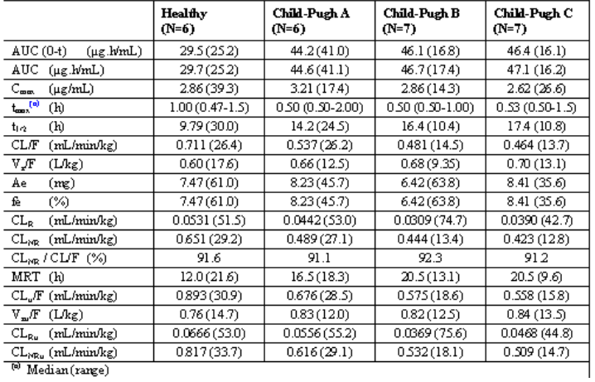

Pharmacokinetics in subjects with impaired renal function
The influence of renal impairment was evaluated in N01109. Differences in PK parameters between subjects with severe renal impairment (creatinine clearance<30mL/min/1.73m2) and healthy subjects were not considered to be clinically relevant, and creatinine clearance was not a significant covariate of BRV plasma clearance in the population PK modelling in adult subjects with POS.

Pharmacokinetics according to age
The effect of age on the PK of BRV was evaluated in healthy elderly (N01118) and in paediatric subjects with epilepsy (N01263). Differences in PK parameters between elderly (>65 years) and non-elderly adult subjects (18-55 years) were insignificant, and age was not a significant covariate in the population PK modelling in adult subjects with POS. In CL0187, a population PK modelling of BRV in paediatric subjects with epilepsy from N01263, predicted BRV plasma half-life ranged from 9.1h for subjects aged 16 years to 5.6h for subjects aged less than 1 year.

Pharmacokinetics related to genetic factors
The influence of CYP2C19 genotype was investigated in Japanese subjects in N01209. The PK profile of BRV was consistent with that previously reported in healthy male Caucasian adults; the reduction in BRV clearance in poor metabolisers possessing two non-functional alleles of CYP2C19 was modest, and no dose reduction was required. Race and ethnicity (Caucasian, Black/African American, Asian, American Indian/Alaska Native, Hispanic/Latino) were evaluated as covariates in the population PK analysis in adult subjects with POS, and the effect was found to be insignificant (CL0028 Modelling Report).

Pharmacokinetics
See comments under pharmacokinetic interactions with other AEDs – of particular relevance to the target population. There are no adequate data on the use of brivaracetam in pregnant women. There are no data on placental transfer. The potential risk for humans is unknown.

Pharmacokinetic interactions

Pharmacokinetic interactions demonstrated in human studies

Antiepileptic drugs
Potential drug-drug interactions with AEDs were evaluated in healthy subjects between BRV and carbamazepine, lamotrigine, phenytoin, and topiramate. The results of N01081 show that BRV is a moderate reversible inhibitor of epoxide hydrolase resulting in increased concentration of carbamazepine epoxide, an active metabolite of carbamazepine. In subjects with POS (CL0178), the carbamazepine epoxide plasma concentration mean increases from Baseline were 37%, 62% and 98% at BRV doses of 50mg/day, 100mg/day, and 200mg/day, respectively. No effects of BRV on other AEDs or other AEDs on BRV PK were seen.
In the population PK modelling in adult subjects with POS (CL0028), carbamazepine, phenytoin, and phenobarbital reduced the average steady-state plasma concentration of BRV by 26%, 21%, and 19%, respectively. It was concluded that no dose adaptation is required when BRV is coadministered with these 3 inducer AEDs. The PK interactions between BRV and other AEDs are summarized in the Table 3.
Table 3: Interactions between BRV and other AEDs.
AED coadministered | Influence of AED on BRV plasma concentration | Influence of BRV on AED plasma concentration
carbamazepine | 26% decrease, No dose adjustment required | None Increased carbamazepineepoxide
Lacosamide | No data | None
Lamotrigine | None | None
Levetiracetam | None | None
Oxcarbazepine | None | None (monhydroxy derivative)
Phenobarbital | 19% decrease No dose adjustment required | None
Phenytoin | 21% decrease No dose adjustment required | None
Pregabalin | No data | None
Topiramate | None | None
Valproic acid | None | None
Zonisamide | No data | None

The oral contraceptive pill
The potential influence of BRV on the PK and PD of a combination oral contraceptive (ethinylestradiol 30μg and levonorgestrel 150μg) as well as the influence of oral contraceptive on BRV PK was evaluated. It was concluded that BRV 50mg/day to 200mg/day is not expected to affect the efficacy of combination oral contraceptives.

Ethanol
In a PK and PD interaction study in healthy subjects, BRV was shown to enhance the effects of alcohol in the absence of a relevant PK interaction (EP0041).

Other Drug-Drug interactions
Potential drug-drug interactions with probe drugs were evaluated between BRV and gemfibrozil (CYP2C8 and CYP2C9 inhibitor), rifampicin (potent inducer), and midazolam (CYP3A substrate). Generally, no important PK interactions of AEDs and other drugs with BRV were identified except for the potent CYP inducer rifampicin; coadministration of BRV with rifampicin may decrease BRV plasma concentrations by 45% (N01259) and BRV dose adaptation should be considered.

Clinical implications of in vitro findings
In vitro studies are reported to show that BRV is highly permeable, is not actively transported, has negligible binding to human plasma proteins and is partitioned evenly between blood cells and plasma. Together with the physicochemical properties of BRV and its low distribution volume, these features suggest potentially rapid and extensive brain penetration and absence of blood brain barrier limitations. The main routes of biotransformation in vitro include the hydrolysis of the amide group into the carboxylic acid metabolite ucb 42145, ω-1 hydroxylation into the hydroxyl metabolite ucb 100406-1, and the combination of the 2 pathways into the hydroxyacid metabolite ucb-107092-1. In vitro interaction studies suggest that BRV is unlikely to produce major PK interactions with other drugs, and other drugs are unlikely to produce relevant PK interactions with BRV.

Evaluator’s conclusions on pharmacokinetics
Brivaracetam has been characterised as having rapid and complete oral absorption. Film-coated tablets, oral solution and IV preparations have been demonstrated to have acceptable bioequivalence. Pharmacokinetic studies show predictable metabolism and renal excretion. There were few significant drug interactions. The 3 major metabolites of brivaracetam appear pharmacologically inactive.
Because brivaracetam undergoes significant hepatic metabolism, dose adjustment in liver failure would likely be necessary as recommended in the PI. The dosing regimen proposed by the sponsor is appropriate for this. The PK information provided in the PI is satisfactory.

Pharmacodynamics

Studies providing pharmacodynamic data
Table 4 shows the studies relating to each pharmacodynamic topic and the location of each study summary.
Table 4: Submitted pharmacodynamic studies.
PD Topic | Subtopic | Study ID | *
Primary Pharmacology | Effect on Seizures | N01114 §  N01193 §  N01252 §  N01253 §  N01254 §  N01358 §  N01125 §  N01199 §  N01379 § | *  *  *  *  *  *  *  *  *
Primary Pharmacology | Effect on evoked pain  Subjective drug effects  Photosensitive epileptiform discharges | N01079  N01295  N01069 § | *  *  *
Secondary Pharmacology | Effect on Saccadic eye movements | N01066  EP0041 | *
Secondary Pharmacology | Smooth pursuit eye movements  Adaptive tracking  Effect on Number Pairs task  Effect on Choice Reaction Time  Effect on Tapping Test  Effect on ARCI 49  Effect on Bond and Lader’s VAS  Effect on Pharmacodynamic EEG  Effect on Neurological Assessments  Visual verbal learning test  Essential tremor  Post-herpetic neuralgia  Myoclonus of ULD  Myoclonus of ULD | EP0041  EP0041  N01066  N01066  N01079  N01066  N01066  N01069  N01118  N01079  N01295  N01066  N01067  N01118  EP0041  N01079  N01066  N01295  N01069 §  N01067  N01118  EP0041  EP0041  N01129  N01162  N01187  N01236 | *  *  *  *  *  *  *  *  *  *  *  *  *  *  *  *  *  *  *
PD Interactions | levetiracetam | CL0027 §
PD Interactions | ethanol | EP0041
Population PD and PK-PD analyses | Healthy subjects
Population PD and PK-PD analyses | Target population | CL0027 | *
* Indicates the primary aim of the study; § Subjects who would be eligible to receive the drug if approved for the proposed indication; ‡ And adolescents if applicable.
Table 5 lists pharmacodynamic results that were excluded from consideration due to study deficiencies.
Table 5: Pharmacodynamic results excluded from consideration.
Study ID | Subtopic(s) | PD results excluded
N01306 | Conversion to monotherapy | Seizure efficacy
N01394 | NCES | Seizure efficacy
N01276 | Conversion to monotherapy | Seizure efficacy
N01266 | Long term safety and tolerability study in paediatric population | Safety data
N01315 | LTFU study for safety, PK and efficacy | Seizure efficacy
N01372 | LTFU for safety and efficacy | Seizure efficacy
N01395 | Open-label study switching from levetiracetam to BRV | Tolerability

Summary of pharmacodynamics
The information in the following summary is derived from conventional pharmacodynamic studies in humans unless otherwise stated.
Two dose-finding pharmacodynamic studies were undertaken (N01114 and N01193). In neither of these studies was a significant dose-response effect observed. Only one dose group (50mg/day) in one of these studies (N01193) achieved a statistically significant reduction in POS frequency over placebo. In the other dose ranging study, the effects on seizure frequency of the 50mg/day dose did not reach significance. Therefore, the anticonvulsant effects of brivaracetam are inferred from the seizure frequency observed in efficacy studies. The dose-responsivity of the pharmacodynamic effect is not well demonstrated with considerable variability in the primary efficacy variable noted (reduction in seizure frequency over placebo).
Dose related sedation and effects on psychomotor performance were demonstrated in this submission, with maximal effects generally evident at Cmax with effects evident from a single dose of 600mg onwards (N01066). A single (higher) dose of 200mg of brivaracetam was demonstrated to affect body sway/postural stability. However, body sway has not been evaluated at the doses which will be used in clinical practice. The Pop-PK analysis in did not demonstrate any specific brivaracetam exposure-adverse event (AE) relationships.
There were no significant adverse pharmacodynamic interactions with other AEDs with regards to seizures but the pharmacodynamic effects of BRV and alcohol were supra additive (in the absence of significant PK interactions. The evaluator assumes that even greater effects with all three agents together may also occur. Patients co-prescribed other AEDs and BRV or consuming alcohol while taking BRV should be made aware of the possible ‘synergistic effects’ on sedation and cognitive function, as they may affect an individual’s ability to drive or operate machinery.
From the data presented in this application, brivaracetam appears to have low arrhythmogenic potential with no evidence that there is an effect on the QT interval, no apparent effect on inducing an immediate or delayed skin phototoxicity reaction and low potential for drug abuse.

Mechanism of action
Brivaracetam is pharmacologically similar to the AED levetiracetam; however, compared to levetiracetam, BRV displays a markedly higher selectivity and affinity for SV2A,^{1, 2} and, in contrast to levetiracetam, the mode of action of brivaracetam does not involve inhibition of high-voltage activated calcium currents and AMPA-gated currents.³ Brivaracetam also differs from levetiracetam in that the higher affinity for SV2A appears to be associated with seizure protection⁴ in the maximal electroshock and pentylenetetrazol seizure models⁵ – the two classical screening models for AEDs where levetiracetam was found to be inactive.⁶ Brivaracetam may have an additional inhibitory activity on voltage-gated sodium channels (VGSC).⁷ Brivaracetam dose dependently inhibits voltage-dependent sodium currents and reverses the inhibitory effects of negative modulators on gamma-aminobutyric acid (GABA)- and glycine-induced currents.

Pharmacodynamic effects

Primary pharmacodynamic effects
A statistically significant correlation has been demonstrated between brivaracetam plasma concentration and seizure frequency reduction from baseline in pivotal clinical studies in adjunctive treatment of partial onset seizures (CL0027).

Secondary pharmacodynamic effects
There was an apparent dose responsive relationship between brivaracetam and fatigue evident in the integrated summary of safety. Other common TEAEs appeared to be increased but without dose effect.
Table 6: TEAEs.
In the population analysis, the data suggested an apparent trend for increased incidence of somnolence and fatigue with increasing plasma concentration but not for dizziness (CL0027).
Negative psychomotor and cognitive effects of brivaracetam and ethanol appear to be supra additive but include increased somnolence, dizziness and feeling drunk (EP0041).
Support for the primary mechanism of action was provided in a study in 19 subjects with photosensitive epilepsy (N01069), in which BRV 10 to 80mg was effective in attenuating or suppressing the photoparoxysmal electroencephalogram (EEG) response (PPR) evoked by intermittent photic stimulations. The dose of BRV 80mg resulted in long-lasting suppression of PPR in all subjects, with a median duration of 60 hours (range 28 to 72 hours).
Median time to first response was 0.5 hours after BRV administration no matter the dose used.
In the human abuse potential study, single doses of BRV 50 mg, 200 mg and 1000 mg were compared to alprazolam (1.5 mg and 3 mg). BRV showed fewer sedative, euphoric, stimulant, dizziness, and negative effects as compared to alprazolam; however, BRV was not significantly different from alprazolam on some measures of balance and positive effects at the supratherapeutic doses (200 mg and 1000 mg).
Somnolence, euphoric mood, dizziness, and fatigue were the most commonly reported adverse events in the human abuse potential study. Overall, 1000 mg BRV was associated with the highest incidence of euphoric mood, followed by the other BRV doses, while the incidence of euphoric mood following alprazolam was lower. Sedative effects were observed in healthy subjects in the single ascending dose and multiple ascending dose studies; however, no euphoria or stimulant-like effects were observed using controlled pharmacodynamic measures (eg, ARCI, VAS).

Time course of pharmacodynamic effects
The psychomotor and cognitive affects appear to correlate with the Cmax of BRV in the ethanol interaction study.

Relationship between drug concentration and pharmacodynamic effects
The EC50 (brivaracetam plasma concentration corresponding to 50% of the maximum effect) was estimated to be 0.57 mg/L. This plasma concentration is slightly above the median exposure obtained after brivaracetam doses of 50 mg/day. Further seizure frequency reduction is obtained by increasing the dose to 100 mg/day and reaches a plateau at 200 mg/day.
Figure 1: Population analysis of mean patient BRV plasma concentrations vs seizure rate during treatment as a percentage change from baseline appear in the figure below (from CL0027).
In general, some aspects of the dose response relationship of the primary pharmacodynamic effect in the opinion of the evaluator appear confusing. If one considers the dose-ranging studies in addition to the pivotal studies, the reported reduction in seizure frequency over placebo displays variability between studies despite apparent consistencies across trials with design and eligibility criteria. For instance, in N01193, the reduction over placebo with 50mg/day was 22.1%, compared to 6.5% with the same dose in N01252, 12.8% in N01253 and 14.7% in N0114.
When doses in the range of 100mg/day of BRV are considered compared to placebo, similar variability is encountered in seizure reductions: 7.3% over placebo in N01254 (mean approx. 80mg/d BRV), 22.8% over placebo in N01358 and 11.7% in N01252.
Clarification is sought by the evaluator about the pooled results presented in the table below (clinical-overview-global-eu) – where a percentage reduction over placebo appears different in the BRV groups than that reported in the core text of N01252.
Table 7: US primary endpoint: per cent reduction over PBO for 28-day adjusted POS frequency in N01252, N01253, N01358 and Pool E1.
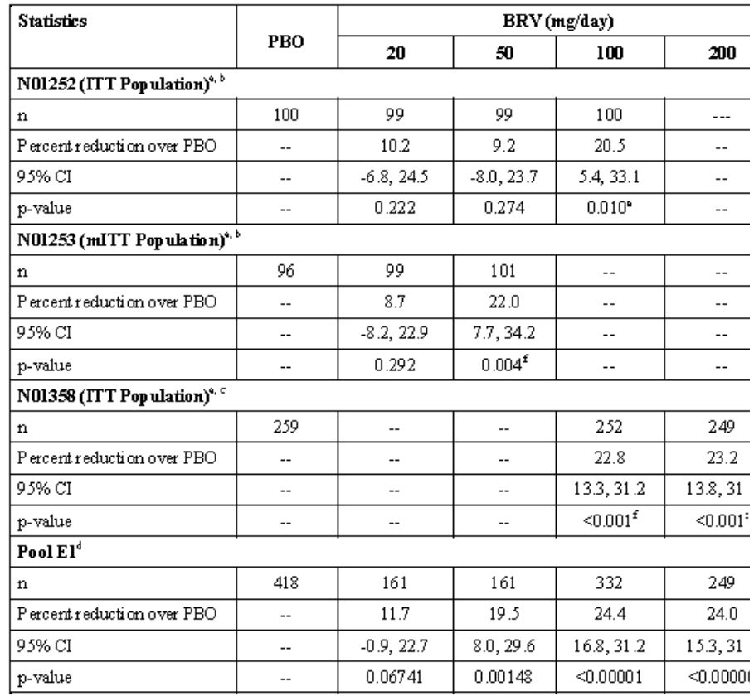
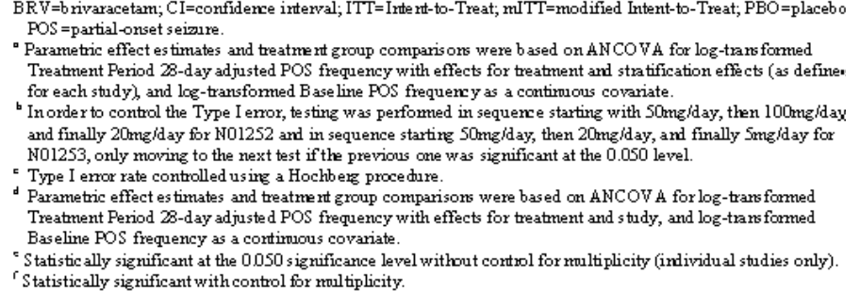
In the population analysis, the data suggested an apparent trend for increased incidence of somnolence and fatigue with increasing plasma concentration but not for dizziness (CL0027).

Genetic, gender and age related differences in pharmacodynamic response
No differences in PK or PD properties are evident on the basis of gender.

Pharmacodynamic interactions
In population analysis, LEV co-administration was shown to significantly influence the response to BRV treatment; no other AEDs were shown to significantly change effectiveness of BRV (CL0027).
There were no significant adverse pharmacodynamic interactions with other AEDs with regards to seizure frequency but the pharmacodynamic effects of BRV and alcohol were supra additive (in the absence of significant PK interactions. The evaluator assumes that even greater effects with all three agents together may also occur. Patients co-prescribed other AEDs and BRV or consuming alcohol while taking BRV should be made aware of the possible ‘synergistic effects’ on sedation and cognitive function, as they may affect an individual’s ability to drive or operate machinery.

Evaluator’s conclusions on pharmacodynamics
The pooled data is useful in supporting efficacy of BRV as adjunctive therapy in POS and supported by 3 long term efficacy and safety studies and dose responsive analysis.
However, in the evaluator’s opinion, the data to support a dose responsive pharmacodynamic effect is poor.

Dosage selection for the pivotal studies
A significant weakness of the BRV development programme is identified in the choice of dose in dose ranging studies. UCB performed 2 Phase II, dose ranging studies: N01114 investigated the higher end of the proposed dose range (BRV 50 mg/day [N = 53] and 150 mg/day [N = 52]) versus PBO [N = 52]), while N01193 investigated the lower end of the dose range (BRV 5 mg/day [N = 50], 20 mg/day [N = 52], and 50 mg/day [N = 52] versus PBO [N=54]). The initial selection of doses was reportedly based on the pharmacologically active dose range predicted from animal models of epilepsy, on toxicological findings, and on the results of a PD study exploring the EEG response to BRV in subjects with photosensitive epilepsy. The maximum dose in N01114 was fixed at BRV 150 mg/day due to toxicological findings at that time. Doses of BRV 50 mg/day were investigated in both dose ranging studies to bridge them. The lowest dose of BRV 5 mg/day was chosen as it was expected to help determine a minimally effective or non-effective dose.
In N01114, the estimated percent reduction over PBO in the partial onset seizure frequency per week over the Maintenance Period was 14.7% in the BRV 50 mg/day group and 13.6% in the BRV 150 mg/day group. Those reductions over PBO were not statistically significant. The model estimated that the odds of being a 50% responder were 2.16 times as high in the BRV 50mg/day group as compared to the odds for being a responder in the PBO group. This result was not statistically significant (p = 0.077). However, over the entire Treatment Period the odds ratio was 2.69 (p = 0.038). The results for the BRV 150mg/day group were in favour of BRV but were not statistically significant.
For N01193, the estimated percent reductions over PBO in the partial onset seizure frequency per week over the Treatment Period were 9.8%, 14.9% and 22.1% in the BRV 5mg/day, BRV 20mg/day and BRV 50mg/day groups, respectively, suggestive of a dose response. The reduction over PBO for BRV 50mg/day was statistically significant at the 5% level (p=0.004), while for BRV 20mg/day the reduction approached statistical significance (p = 0.062). The hypothesis of no BRV effect was tested and rejected for each dose of BRV at the 5% significance level (meaning that there were statistically significant differences between each dose of BRV and PBO in term of responder rate). The model estimated that the odds of being a 50% responder in the BRV 5 mg/day, 20 mg/day and 50 mg/day groups were 2.66, 4.27, and 7.21 times those in the PBO group, respectively.
The doses used to evaluate the efficacy of BRV in the Phase III pivotal efficacy studies were derived from the Phase II studies N01114 and N01193. In the 2 Phase II studies as well as in 2 of the Phase III studies (N01252 and N01253), approximately 20% of subjects were using concomitant LEV.
On the basis of the Phase II study results, the Phase III BRV POS program was initiated presuming 50 mg/day as the optimal dose. Subjects in N01252 were randomised to receive BRV 20 mg/day, 50 mg/day, or 100 mg/day or matching PBO without up-titration. Subjects in N01253 were randomized to receive BRV 5 mg/day, 20 mg/day, or 50 mg/day or PBO without up-titration. Following the completion of N01252 and N01253, a meta-analysis across the fixed dose Phase II/III studies was performed to confirm BRV’s treatment effect and to examine possible variables contributing to the effect sizes. Based on the meta-analysis results, UCB reportedly concluded that the use of concomitant LEV may have influenced the overall therapeutic response in these studies. Despite the presence of subjects receiving LEV at study entry, the results for the 100 mg/day dose in N01252 were nominally statistically significant. As such, it was decided that BRV 100 mg/day would be tested in a third efficacy study, N01358, in order to confirm the treatment effect previously demonstrated in N01252. Following consultation with regulatory authorities, BRV 200 mg/day was added to obtain data on the upper end of the dose response curve. In the Phase III, flexible dose, supporting study, N01254, subjects started treatment at a dose of BRV 20 mg/day and were up-titrated at the Investigator’s discretion to either BRV 50 mg/day, BRV 100 mg/day, or BRV 150 mg/day in a stepwise manner. The ongoing LTFU studies allow individualised dosing of up to BRV 200 mg/day (administered twice daily). Initially, N01125 and N01199 started with a maximum dose of BRV 150 mg/day; however, when the maximum dose was increased to BRV 200 mg/day in N01358, the protocols for the LTFU studies were amended to allow for a maximum dose of BRV 200 mg/day.
Multiple dosing regimens of 400 mg per day were administered one study of healthy volunteers (N01067) and a study of post herpetic neuralgia.
It is likely that in the dose ranging studies, the minimum effective dose has been established (50 mg per day) but the maximum effective dose and maximum tolerated dose is less well established on the basis of the above.

Clinical efficacy
Proposed indication: Add-on therapy in adult focal epilepsy with partial-onset seizures not fully controlled despite current treatment with other AEDs

Pivotal efficacy studies

Study N01252

Study design, objectives, locations and dates
This study was conducted between Sept 2007 and 2009 in 71 centres in Europe and India. This was a 24-week, Phase 3, therapeutic confirmatory, double-blind, parallel-group, PBO-controlled, randomized study conducted in 399 randomized subjects to determine efficacy and safety of BRV in subjects (≥16 to 70 years old) with POS.

Inclusion and exclusion criteria
Included were subjects with uncontrolled POS epilepsy syndrome despite 1 or 2 concomitant AEDs and between ages 16 and 70. These subjects had at least 2 POS per month in the 3 months preceding Visit 1 and at least 8 POS in the 8 week baseline period.

Study treatments
Subjects were enrolled and entered an 8-week Baseline Period. At the end of the Baseline Period, subjects were randomized in a 1:1:1:1 fashion to 1 of 4 treatment arms (BRV 20mg/day, 50mg/day, 100mg/day, or PBO). Subjects were randomized to the full dose without any Titration Phase. The Treatment Period lasted 12 weeks. The daily dose was administered in 2 equal intakes, morning and evening. One fall back option was offered. At the end of the Treatment Period, the subject either entered a long term follow-up (LTFU) study at a recommended starting dose of BRV 50mg/day, or entered a Down-Titration Period of 2 weeks followed by a 2-week Study Drug-Free Period.
Figure 2: Study design.

Efficacy variables and outcomes
The main efficacy variables were:
- The primary efficacy variable was the POS (Type I) frequency per week over the Treatment Period compared to placebo
- Main secondary variable was Responder rate (the proportion of subjects who had a ≥50% reduction in seizure frequency per week from Baseline) for POS (Type I) over the Treatment Period compared to placebo
Efficacy variables are consistent with TGA-adopted guidelines.
Other efficacy outcomes included:
- All seizure frequency (Type I+II+III) per week over the Treatment Period
- Percent reduction for POS (Type I) frequency per week from Baseline to the Treatment Period
- Categorized percentage reduction from Baseline in seizure frequency for POS (Type I) over the Treatment Period - The categories include: <-25%, -25% to < 25%, 25% to < 50%, 50% to < 75%, 75% to < 100%, and 100%.
- Seizure freedom rate (all seizure types) over the Treatment Period
- Time to nth (n=1, 5, 10) Type I seizure during the Treatment Period
- Reduction of seizure frequency ratio (Type IC/Type I) from Baseline to the Treatment Period
- Total Patient Weighted Quality of Life in Epilepsy Inventory-Form 31 (QOLIE-31-P) score
- Seizure Worry QOLIE-31-P score
- Daily Activities/Social Functioning QOLIE-31-P score
- Remaining QOLIE-31-P domain scores (Energy/Fatigue, Emotional Well-being, Cognitive Functioning, Overall Quality of Life and Medication effects)
- Hospital Anxiety and Depression Scale (HADS) scores (Anxiety, Depression)
- Patient’s Global Evaluation Scale (P-GES)
- Investigator’s Global Evaluation Scale (I-GES)

Randomisation and blinding methods
A 1:1:1:1 central randomization (random permuted blocks) stratified per geographical region (Eastern Europe, Western Europe, India) and for the use of levetiracetam (LEV; with or without concomitant LEV use at study entry) was used in the study to ensure overall balance across the different treatment groups. Oral tablets of BRV (10mg and 25mg) and matching PBO were used in the study.

Analysis populations
The remaining 399 subjects were randomized to receive PBO or BRV (20mg/day, 50mg/day, or 100mg/day). One subject randomized to the BRV 50mg/day group died before consuming any study drug; this subject was excluded from the ITT Population. Thus, 398 subjects were included in the ITT Population. The Safety Population was comprised of the same set of subjects as the ITT Population.

Sample size
With a power of 90% and a 2-sided level of significance of 5%, 87 subjects per arm were required to detect a treatment difference of -0.223 in log-transformed seizure frequency per week between BRV and PBO. The treatment difference of -0.223 in log-transformed seizure frequency corresponds to a 20% reduction over PBO. Since the 3 doses of BRV were tested hierarchically at the 5% significance level starting with BRV 50mg/day, power was lost for BRV 100mg/day and BRV 20mg/day. In order to compensate for this loss in power, 100 subjects per arm were included.

Statistical methods
Statistical methods used were appropriate.
The primary efficacy variable was the POS (Type I) frequency per week over the Treatment Period.
This variable was transformed prior to being analysed using the logarithmic transformation loge [x+1] (where x is the seizure frequency per week). The log-transformed POS frequency per week over the Treatment Period was analysed applying an analysis of covariance (ANCOVA) model, including treatment and a stratification effect combining study region and concomitant LEV use (as recorded in the case report form) as factors and the log-transformed Baseline seizure frequency per week as covariate. It was planned that the 3 doses of BRV would be tested at the 5% significance level against PBO, according to a predefined hierarchical sequential rejective testing procedure. For Step 1, the hierarchical testing procedure began with the BRV 50mg/day dose versus PBO.
If the comparison was not statistically significant, the procedure stopped and no groups were declared different from PBO. If the comparison was statistically significant, the BRV 50mg/day group was considered different from PBO and the procedure continued with the second step. Step 2 tested PBO against BRV 100mg/day dose in a similar manner to Step 1, and if the comparison was statistically significant, Step 3 tested PBO against BRV 20mg/day. This procedure strongly controlled the overall Type I error rate to 0.05.

Participant flow
A total of 486 subjects were screened and 87 of these subjects were screen failures. The most common reasons for screen failure were ineligibility (62 of 87 subjects) and withdrawal of consent for personal reasons (not related to AEs) (15 of 87 subjects). Overall, 92% of subjects completed the study, and 87% of these continued in the LTFU study; 7.8% of subjects discontinued the study and the most common reason for discontinuation was AE (4.8%). The rate of study completion and discontinuation was similar across treatment groups. 100 subjects were randomised to placebo, 99 to 20mg/day BRV, 100 to 50mg/day BRV, and 100 to 100mg BRV.

Major protocol violations/deviations
Not applicable

Baseline data
Mean age 37.24, 49% female, age at first seizure onset 15.48 with partial onset epilepsy with approx. median seizure frequency of 2/week. Mean weight, height, and BMI were 72.4kg, 169.4cm, and 25.1kg/m2, respectively.

Results for the primary efficacy outcome
The primary outcome for study N01252 did not achieve statistical significance based on the sequential testing procedure, which required statistical significance at the 0.050 level for BRV 50mg/day versus PBO prior to the testing of BRV 100mg/day and BRV 20mg/day in sequence. For the primary efficacy variable, the BRV 50mg/day group showed a reduction in log-transformed POS frequency per week of 6.5% over PBO; however, this reduction was not statistically significant (p=0.261), therefore this study did not achieve its primary endpoint. Further sensitivity analyses (Linear Effects Mixed Model, rank-ANCOVA, and primary ANCOVA analysis on Per-Protocol Population) were consistent with the primary analysis. For BRV 50mg/day, 27.3% of subjects achieved a 50% response rate compared with 20.0% for PBO, while the median percent reduction from Baseline was 26.83% compared with 17.03% for PBO.
Although the primary outcome for N01252 did not achieve statistical significance based on the sequential testing procedure to control for multiplicity, the comparison of BRV 100mg/day versus PBO was nominally statistically significant with an 11.7% reduction over PBO for the primary outcome (p=0.037).

Results for other efficacy outcomes
The secondary endpoints were consistent with the primary endpoint, with statistical significance achieved with BRV 100mg/day versus PBO for the 50% responder rate (36.0% vs 20.0%, p=0.023) and median percent reduction from Baseline (32.45% vs 17.03%, p=0.004), respectively.
Additionally, 4 subjects receiving BRV 100mg/day were seizure free for the entire Treatment Period compared to 0 subjects receiving PBO.
There were no meaningful differences in health-related quality of life or indirect or direct cost parameters between any BRV dose group and PBO. With respect to other exploratory variables, no meaningful trends were noted.

Study N01253

Study design, objectives, locations and dates
This study was conducted between Sept 2007 and 2009 in 71 centres in North America, South America and Australia. This was a 24-week, Phase 3, therapeutic confirmatory, double-blind, parallel-group, PBO-controlled, randomized study conducted in 399 randomized subjects to determine efficacy and safety of BRV in subjects (≥16 to 70 years old) with POS.

Inclusion and exclusion criteria
Included were subjects with uncontrolled POS epilepsy syndrome despite 1 or 2 concomitant AEDs and between ages 16 and 70. These subjects had at least 2 POS per month in the 3 months preceding Visit 1 and at least 8 POS in the 8 week baseline period.

Study treatments
Subjects were enrolled and entered an 8-week Baseline Period. At the end of the Baseline Period, subjects were randomized in a 1:1:1:1 fashion to 1 of 4 treatment arms (BRV 5mg/day, 20mg/day, 50mg/day, or PBO). Subjects were randomized to the full dose without any Titration Phase. The Treatment Period lasted 12 weeks. The daily dose was administered in 2 equal intakes, morning and evening. One fallback option was offered. At the end of the Treatment Period, the subject either entered a long term follow-up (LTFU) study at a recommended starting dose of BRV 50mg/day, or entered a Down-Titration Period of 2 weeks followed by a 2-week Study Drug-Free Period.
Figure 3: Study design.

Efficacy variables and outcomes
The main efficacy variables were:
- The primary efficacy variable was the POS (Type I) frequency per week over the Treatment Period compared to placebo
- Main secondary variable was Responder rate (the proportion of subjects who had a ≥50% reduction in seizure frequency per week from Baseline) for POS (Type I) over the Treatment Period compared to placebo
Efficacy variables are consistent with TGA-adopted guidelines.
Other efficacy outcomes included:
- All seizure frequency (Type I+II+III) per week over the Treatment Period
- Percent reduction for POS (Type I) frequency per week from Baseline to the Treatment Period
- Categorized percentage reduction from Baseline in seizure frequency for POS (Type I) over the Treatment Period - The categories include: <-25%, -25% to < 25%, 25% to < 50%, 50% to < 75%, 75% to < 100%, and 100%.
- Seizure freedom rate (all seizure types) over the Treatment Period
- Time to nth (n=1, 5, 10) Type I seizure during the Treatment Period
- Reduction of seizure frequency ratio (Type IC/Type I) from Baseline to the Treatment Period
- Total Patient Weighted Quality of Life in Epilepsy Inventory-Form 31 (QOLIE-31-P) score
- Seizure Worry QOLIE-31-P score
- Daily Activities/Social Functioning QOLIE-31-P score
- Remaining QOLIE-31-P domain scores (Energy/Fatigue, Emotional Well-being, Cognitive Functioning, Overall Quality of Life and Medication effects)
- Hospital Anxiety and Depression Scale (HADS) scores (Anxiety, Depression)
- Patient’s Global Evaluation Scale (P-GES)
- Investigator’s Global Evaluation Scale (I-GES)

Randomisation and blinding methods
A 1:1:1:1 central randomization (random permuted blocks) stratified per geographical region and for the use of levetiracetam (LEV; with or without concomitant LEV use at study entry) was used in the study to ensure overall balance across the different treatment groups. Oral tablets of BRV (10mg and 25mg) and matching PBO were used in the study.

Analysis populations
The remaining 400 subjects were randomized to receive PBO or BRV (5mg/day, 20mg/day, or 50mg/day). Four subjects were excluded from the Intent-to-Treat (ITT) Population due to failure to take study medication and randomization errors.

Sample size
With a power of 90% and a 2-sided level of significance of 5%, 87 subjects per arm were required to detect a treatment difference of -0.223 in log-transformed seizure frequency per week between BRV and PBO. The treatment difference of -0.223 in log-transformed seizure frequency corresponds to a 20% reduction over PBO. Since the 3 doses of BRV were tested hierarchically at the 5% significance level starting with BRV 50mg/day, power was lost for BRV 20mg/day and BRV 5mg/day. In order to compensate for this loss in power, 100 subjects per arm were included.

Statistical methods
Statistical methods used were appropriate.
The primary efficacy variable was the POS (Type I) frequency per week over the Treatment Period.
This variable was transformed prior to being analysed using the logarithmic transformation loge [x+1] (where x is the seizure frequency per week). The log-transformed POS frequency per week over the Treatment Period was analysed applying an analysis of covariance (ANCOVA) model, including treatment and a stratification effect combining study region and concomitant LEV use (as recorded in the case report form) as factors and the log-transformed Baseline seizure frequency per week as covariate. It was planned that the 3 doses of BRV would be tested at the 5% significance level against PBO, according to a predefined hierarchical sequential rejective testing procedure. For Step 1, the hierarchical testing procedure began with the BRV 50mg/day dose versus PBO.
If the comparison was not statistically significant, the procedure stopped and no groups were declared different from PBO. If the comparison was statistically significant, the BRV 50mg/day group was considered different from PBO and the procedure continued with the second step. Step 2 tested PBO against BRV 20mg/day dose in a similar manner to Step 1, and if the comparison was statistically significant, Step 3 tested PBO against BRV 5mg/day. This procedure strongly controlled the overall Type I error rate to 0.05.

Participant flow
A total of 509 subjects were screened and 109 of these subjects were screen failures. The most common reasons for screen failure were ineligibility (83 of 109 subjects) and withdrawal of consent for personal reasons (12 of 109 subjects). 99 patients were randomised to placebo, 99 to the 5mg/day group, 100 to the 20mg/day group and 102 to the 50mg/day group.

Major protocol violations/deviations
None relevant

Baseline data
Mean age was 38.13 years, age of onset of POS 14.29, 50.8% female with at least 1 AED.

Results for the primary efficacy outcome
For the primary efficacy variable, the BRV 50mg/day group showed a reduction in log-transformed POS frequency per week of 12.8% over PBO (p=0.025); thus, this study achieved its primary endpoint. Statistical significance was not observed for the BRV 20mg/day or BRV 5mg/day groups for the primary efficacy variable. Similar positive findings were seen in the responder analysis (50% reduction in weekly POS frequency from Baseline to the Treatment Period) and in the median percent reduction from Baseline in POS frequency per week.

Results for other efficacy outcomes
The results of secondary efficacy analyses were consistent with the primary analysis. A statistically greater proportion of subjects in the BRV 50mg/day group (32.7%) were 50% responders compared with the PBO group (16.7%; p=0.008). The median percent reduction from Baseline was 30.47% with BRV 50mg/day and 17.75% with PBO (p=0.003). Additionally, 4 subjects receiving BRV 50mg/day were seizure free for the entire Treatment Period compared with 0 subjects receiving PBO. Primary ANCOVA analysis of the log-transformed POS frequency per week over the
Treatment Period, including a treatment-by-region interaction term, showed that the treatment-by-region interaction was not significant at the 0.10 level, as specified in the SAP (p=0.310). The treatment effect (percent reduction over PBO) with BRV for the primary efficacy analysis of POS frequency per week was highest in both regions (North America/Australia [NAA]=8.9%; Latin America [LA]=18.1%) in subjects receiving BRV 50mg/day. Results of the secondary endpoints for 50% responders and median percent reduction from Baseline were generally consistent with the primary efficacy analysis.
There were no meaningful differences in HRQoL or indirect or direct cost parameters between any BRV dose group and PBO.

Study N01358

Study design, objectives, locations and dates
This was a randomised, double-blind, placebo-controlled, parallel group conducted between Dec 2010 and 2014 in 208 sites in 27 countries to assess the Efficacy and Safety of Brivaracetam as add on therapy in Subjects (≥16 to 80 Years Old) with Partial-onset Seizures.

Inclusion and exclusion criteria
Main inclusion criteria
- Subjects were from 16 to 80 years of age, both inclusive. Subjects under 18 years may only have been included where legally permitted and ethically accepted.
- Subjects had well-characterized focal epilepsy/epileptic syndrome according to the 1989 International League Against Epilepsy (ILAE) classification.
- Presence of an electroencephalogram (EEG) reading compatible with the clinical diagnosis of focal epilepsy within the last 5 years.
- Presence of a brain magnetic resonance imaging (MRI)/computed tomography (CT) scan performed within the last 2 years.
- Subjects had at least 8 Type I seizures (POS; focal seizures [according to the 1981 ILAE classification]) during the 8-week Baseline Period with at least 2 Type I seizures during each 4-week interval of the Baseline Period.
- Subjects had at least 2 POS whether or not secondarily generalized per month during the 3 months preceding Visit 1.
- Subjects were uncontrolled while treated by 1 or 2 permitted concomitant AED(s). Vagal nerve stimulation (VNS) was allowed and was counted as a concomitant AED.
Main exclusion criteria
- Seizure Type IA (1981 ILAE classification) nonmotor as only seizure type.
- Subject was currently treated with LEV.
- Subject had taken LEV within 90 days prior to Visit 1.
- Subjects whose seizures could not be reliably counted on a regular basis due to their fast and repetitive occurrence (clusters or flurries).
- History or presence of status epilepticus during the year preceding Visit 1 or during Baseline

Study treatments
Subjects completed an 8-week prospective Baseline Period, during which subjects remained on a stable dose of their present AEDs and maintained a seizure diary. This was followed by a 12-week double-blind Treatment Period. Subjects were randomized to receive PBO, BRV 100mg/day, or BRV 200mg/day (2 equally divided doses administered twice daily) without up-titration. Subjects may have been eligible for conversion to a long-term follow-up (LTFU) study (N01379) upon completion of the Treatment Period.
Figure 4: Study design.

Efficacy variables and outcomes
The main efficacy variables were:
- The primary efficacy variable was the POS (Type I) frequency per week over the Treatment Period compared to placebo for USA based on ANCOVA
- The primary efficacy outcome for EU was Responder rate (the proportion of subjects who had a ≥50% reduction in seizure frequency per week from Baseline) for POS (Type I) over the Treatment Period compared to placebo
Efficacy variables are consistent with TGA-adopted guidelines.
Other efficacy outcomes included:
- Percent reduction for POS (Type I) frequency per week from Baseline to the Treatment Period
- Categorized percentage reduction from Baseline in seizure frequency for POS (Type I) over the Treatment Period
- Seizure freedom rate (all seizure types) over the Treatment Period
- All seizure frequency (Type I+II+III) per week over the Treatment Period
- Time to nth (n=1, 5, 10) Type I seizure during the Treatment Period
- Total Patient Weighted Quality of Life in Epilepsy Inventory-Form 31 (QOLIE-31-P) score
- Remaining QOLIE-31-P domain scores (Energy/Fatigue, Emotional Well-being, Cognitive Functioning, Overall Quality of Life and Medication effects)
- Hospital Anxiety and Depression Scale (HADS) scores (Anxiety, Depression)
- Patient’s Global Evaluation Scale (P-GES), Number of hospital stays

Randomisation and blinding methods
A 1:1:1 central randomization (random permuted blocks) with stratification for country, LEV status (never used LEV vs prior LEV use only), and number of AEDs previously used, but discontinued prior to study entry (≤2 vs >2 AEDs) was used to ensure the balance across treatment groups (PBO, BRV 100mg/day, and BRV 200mg/day) within each combination of stratification levels. Randomization was not stratified by study centre due to the expected small number of randomized subjects per study centre. No restrictions were placed on the proportion of randomized subjects within each stratification level, either overall or on a regional basis.

Analysis populations
A total of 1045 subjects were screened and 277 of these subjects were screen failures. The most common reason for screen failure was ineligibility (222 of 277 subjects). The remaining 768 subjects were randomized to receive PBO or BRV (100mg/day or 200mg/day). Of the 768 randomized subjects, 696 subjects (90.6%) completed the study. Overall, there were 760 subjects included in the ITT Population. The Safety Population was comprised of 764 subjects; 4 subjects received at least 1 dose of study drug (and were included in the Safety Population) but did not have at least 1 post-Baseline seizure diary day (and were therefore excluded from the ITT Population).
Overall, the number of subjects discontinuing the study for any reason during the Treatment Period was low (72 subjects [9.4%]). The most common reason for discontinuation was AE (10 subjects [3.8%] in the PBO group, 21 subjects [8.3%] in the BRV 100mg/day group, and 17 subjects [6.8%] in the BRV 200mg/day group).

Sample size
The sample size for the study was based on 50% responder outcome since this yields the larger sample size across primary outcomes. Based on 50% responder outcome, 231 analysable subjects per treatment group were required. Actual power for the primary outcome for the USA was 94% based on this sample size. Because some randomized subjects may not have qualified for the primary analysis, 240 subjects were randomized in each arm, for a total of 720 randomized subjects across all 3 treatment groups.

USA primary efficacy analysis
A total of 194 analysable subjects per treatment group provides 90% power to detect a difference of 0.223 in least square (LS) means on the log-transformed scale at the 0.025 significance level assuming a SD of 0.62. The treatment difference of 0.223 corresponds to a 20% reduction over PBO after back-transformation. The SD of 0.62 was based on the observed SD from a pooled analysis of subjects not receiving concomitant LEV from N01252 and N01253. A total of 582 analysable subjects were required across all treatment groups.

European primary efficacy analysis
A total of 231 analysable subjects per treatment group provided 90% power to detect a 15% difference between BRV and PBO at the 0.025 significance level, assuming responder rates of 20% and 35% for PBO and BRV. A total of 693 analyzable subjects were required across all treatment groups.

Statistical methods
The primary efficacy outcome for the USA was the percent reduction in POS frequency over PBO based on ANCOVA. The primary efficacy outcome for the EU was the 50% responder rate based on percent reduction in POS frequency from Baseline to the 12-week Treatment Period.
For the USA, the EU primary outcome was analyzed as a secondary variable with statistical testing at the nominal 0.05 level without applying a Hochberg procedure. Similarly, the USA primary analysis was a secondary analysis for the EU, with testing at a nominal 0.050 level without applying a Hochberg procedure.
All statistical testing for supportive and secondary analyses was carried out at a nominal 2-sided 0.05 significance level. Unless otherwise indicated, all efficacy analyses were carried out for the Intent-to-Treat (ITT) Population.
The primary analysis for the USA was based on ANCOVA with log-transformed [log(x+1)] Treatment Period 28-day adjusted POS frequency as the outcome and an effect for treatment, an effect for country, and an effect for the 4 combination of levels for LEV status and number of previous AEDs (≤2 vs >2), and log-transformed Baseline POS frequency as a continuous covariate. Statistical treatment group comparisons were based on the comparison of each BRV treatment group to PBO on the log-transformed scale using the above ANCOVA model.
The evaluation of statistical significance was based on the Hochberg multiple comparison procedure. Both multiplicity-adjusted and unadjusted p-values were presented. Two-sided 95% confidence intervals (CIs) for the comparison of each BRV treatment group to PBO were also obtained using the above ANCOVA model. Confidence limits were back-transformed using the above formula to obtain confidence limits for percent reduction over PBO. Confidence limits were not adjusted for multiplicity and corresponded to a nominal 2-sided 0.05 significance level. The primary outcome for the EU was the 50% responder rate based on percent reduction in POS frequency from Baseline to the Treatment Period. Subjects with a 50% or greater reduction in POS frequency from Baseline were defined as a responder whether or not the subject completed the Treatment Period. The analysis of 50% responder outcome was based on a logistic regression model with an effect for treatment, an effect for country, and an effect for the 4 combination of levels for LEV status and number of previous AEDs (≤2 vs >2), and log-transformed Baseline POS frequency as a continuous covariate. Odds ratios and corresponding 95% 2-sided Wald CIs were provided. The evaluation of statistical significance for the primary analysis was based on a Hochberg multiple comparison procedure. Both multiplicity-adjusted p-values and unadjusted p-values were presented.
Subgroup assessments of the primary outcomes for the USA and for the EU were carried out for geographic region and LEV status. Statistical models for these subgroup evaluations included effects for treatment and log-transformed Baseline POS frequency.

Participant flow
259 subjects were randomised to placebo, 252 to BRV 100mg/day and 249 to BRV 200mg per day.

Major protocol violations/deviations
None relevant

Baseline data
The mean age of 764 subjects was 39.5 years of which 51.8% female. Their age at time of first seizure was 17.3 years and 100 percent with POS. Baseline Type I seizure frequency was 9.5 (per 28 days).

Results for the primary efficacy outcome
The primary efficacy variable was the POS (Type I) frequency per 28 days during the 12-week Treatment Period. The percent reduction in POS frequency over the PBO group (the primary efficacy outcome for the USA) was 22.8% and 23.2% for the BRV 100mg/day and 200mg/day groups, respectively. The 50% responder outcome based on percent reduction in POS frequency during the Treatment Period (the primary efficacy outcome for the EU) was 38.9% and 37.8% for subjects in the BRV 100mg/day and 200mg/day groups, respectively, compared with 21.6% of subjects in the PBO group. Both outcomes were statistically significant (p<0.001) and clinically relevant for the BRV 100mg/day and 200mg/day groups, with no dose response present.

Results for other efficacy outcomes
Results of the secondary efficacy analyses (percent reduction in POS frequency from Baseline, categorized percent reduction in POS frequency from Baseline, seizure freedom rate during the Treatment Period, all seizure frequency during the Treatment Period, and time to the nth seizure during the Treatment Period) supported BRV efficacy in subjects with POS. Both BRV groups showed noteworthy improvement in the QOLIE-31-P seizure worry subscale compared with the PBO group (7.1 for the BRV 100mg/day group, 8.8 for the BRV 200mg/day group, and 2.3 for the PBO group). The P-GES and I-GES showed statistically significant improvements in the BRV groups compared with the PBO group at Visit 7 and the Last Visit (p<0.001). There were no other meaningful differences in healthcare resource parameters between the BRV groups and the PBO group.

Other efficacy studies

Study N0114 and N01193
In the Phase 2 studies (N01114 and N01193), subjects were male or female, age 16 to 65 years, and were not adequately controlled while treated with 1 or 2 concomitant AEDs. In both studies, subjects had to have at least 4 POS whether or not secondarily generalized during the 4-week Baseline Period and at least 2 POS whether or not secondarily generalized per month during the 3 months preceding Visit 1. Exclusion criteria were consistent with standards in Phase 2 POS studies and with the Phase 3 BRV POS studies. Subjects with only Type IA nonmotor seizures were not eligible to participate. In addition, subjects with impaired hepatic function, as defined by elevations in AST, ALT, alkaline phosphatase, or GGT >3X the upper limit of normal, were not eligible.
UCB performed 2 Phase 2, dose-ranging studies: N01114 investigated the higher end of the dose range (BRV 50mg/day [N=53] and 150mg/day [N=52]) versus PBO [N=52]), while N01193 investigated the lower end of the dose range (BRV 5mg/day [N=50], 20mg/day [N=52], and 50mg/day [N=52] vs PBO [N=54]). The initial selection of doses was based on the pharmacologically active dose range predicted from animal models of epilepsy, on toxicological findings, and on the results of a PD study exploring the EEG response to BRV in subjects with photosensitive epilepsy. The maximum dose in N01114 was fixed at BRV 150mg/day due to toxicological findings at that time. Doses of BRV 50mg/day were investigated in both dose ranging studies to bridge them. The lowest dose of BRV 5mg/day was chosen as it was expected to help determine a minimally effective or non-effective dose.
In N01114, the estimated percent reduction over PBO in the partial-onset seizure frequency per week over the Maintenance Period was 14.7% in the BRV 50mg/day group and 13.6% in the BRV 150mg/day group. Those reductions over PBO were not statistically significant. The model estimated that the odds of being a 50% responder were 2.16 times as high in the BRV 50mg/day group as compared to the odds for being a responder in the PBO group. This result was not statistically significant (p=0.077). However, over the entire Treatment Period the odds ratio was 2.69 (p=0.038). The results for the BRV 150mg/day group were in favour of BRV but were not statistically significant.
For N01193, the estimated percent reductions over PBO in the partial-onset seizure frequency per week over the Treatment Period were 9.8%, 14.9% and 22.1% in the BRV 5mg/day, BRV 20mg/day and BRV 50mg/day groups, respectively, suggestive of a dose response. The reduction over PBO for BRV 50mg/day was statistically significant at the 5% level (p=0.004), while for BRV 20mg/day the reduction approached statistical significance (p=0.062). The hypothesis of no BRV effect was tested and rejected for each dose of BRV at the 5% significance level (meaning that there were statistically significant differences between each dose of BRV and PBO in term of responder rate). The model estimated that the odds of being a 50% responder in the BRV 5mg/day, 20mg/day and 50mg/day groups were 2.66, 4.27, and 7.21 times those in the PBO group, respectively.

Analyses performed across trials (pooled & meta analyses)
Pooled analyses of the primary endpoint are presented for EU and USA endpoints (see earlier for the latter).
Table 8: EU primary endpoint fifty per cent responder rate in POS frequency over the treatment period in N01252, N01253, N01358 and Pool E1.
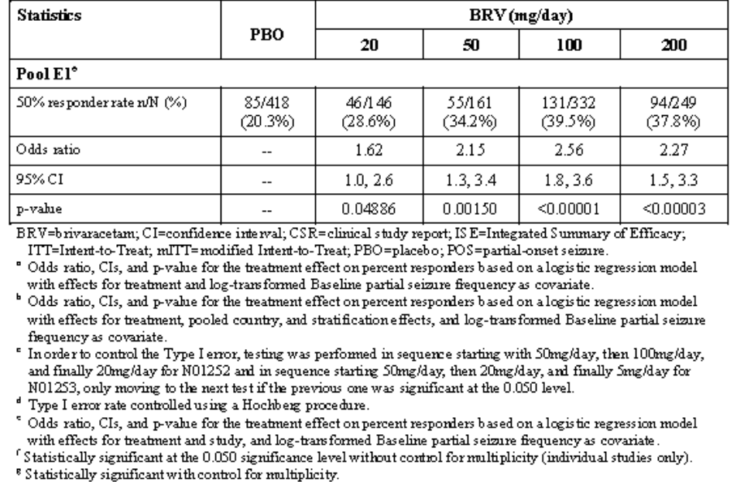
Pooling of pivotal studies appears appropriate – although the evaluator wonders what might result from including phase 2 studies in the pooled analysis.
From the pooled analysis, with regard to dose-response, a larger effect was observed for BRV 100mg/day compared with BRV 50mg/day, with almost a 40% increase in placebo-adjusted effect for BRV 100mg/day (39.5% versus 20.3% for BRV 100mg/day versus PBO [absolute difference 19.2%]) compared with BRV 50mg/day (34.2% versus 20.3% for BRV 50mg/day versus PBO [absolute difference 13.9%]) for Pool E1. The separation of observed effects for BRV 100mg/day and 200mg/day is small, with observed responder rates of 39.5% versus 37.8% for BRV 100mg/day and 200mg/day, respectively. The evaluator could not find confidence intervals for this quoted dose-effect.

Evaluator’s conclusions on clinical efficacy
The pivotal add-on studies should have a randomised, double-blind, placebo-controlled parallel group study design.
Efficacy endpoints compared to placebo were based on the changes in seizure frequency between the treatment maintenance phase and the baseline period. Efficacy was evaluated primarily for all focal onset seizures.

Baseline period
Baseline seizure frequency was sufficiently high and of sufficient to detect decreases as well as increases in seizure frequency in the treatment phase.
The earlier pivotal studies were complicated by too many dose arms. Sufficient information is contained within phase II and pivotal studies in order to establish the lower end of the clinically effective dose range as well but not, in the evaluator’s opinion, the optimal effective dose. It is contended that this data will be supplemented by LTFU studies – although this method is potentially problematic.
In the add-on setting determination of plasma concentrations seemed to have some bearing on pharmacodynamic effect but inspection of the dose-response graphs would suggest that this effect is fairly weak. Moreover, differences in study design appear insufficient to explain variability in efficacy variables seen across the studies.
Adequate data is submitted with regards to special populations although numbers of elderly with sufficient level of exposure are small.

Clinical safety

Studies providing evaluable safety data
The following studies provided evaluable safety data.

Pivotal efficacy studies
In the 3 pivotal Phase 3 studies in adults with POS, TEAEs were defined as AEs that had onset on or after the date of first dose of study drug. In all studies, AEs were collected as spontaneous reports or observed by the Investigator at each visit. In studies that used subject diaries as source data, the Investigator reviewed them for AEs. A general prompt was given at each study visit to detect AEs, e.g. “did you notice anything unusual about your health since your last visit?”
For the purposes of the ISS integrated analyses, all AEs for clinical studies included in the ISS study pools were recorded in MedDRA Version 15.0.
In Feb 2011, the FDA notified UCB of their policy, based upon the Draft Guidance for Suicidality: Prospective Assessment of Occurrence in Clinical Trials that an assessment of suicidal ideation and suicidal behaviour based on the Columbia-Suicide Severity Rating Scale(C-SSRS) was to be added to all new and ongoing BRV studies. The C-SSRS was added to the studies ongoing at the time (N01258, N01358, N01125, N01199, N01315, N01379, N01263 and N01266) and then prospectively included in subsequent studies (N01394, N01395 and N01372). The C-SSRS was not required in the 2 clinical pharmacology studies conducted after Feb 2011 (EP0007 and EP0041) because those studies were single-dose studies in healthy subjects.
Laboratory assessments that were conducted across most of the phase 2/3 studies are summarised in the table below and were analysed for each visit. ECG collection was incorporated into the pivotal studies N01252 and N01253.

Table 9: Parameters examined.

Pivotal studies that assessed safety as a primary outcome
All pivotal studies assessed safety but not as a primary outcome.

Dose-response and non-pivotal efficacy studies
The dose-response and non-pivotal efficacy studies provided safety data, as follows:
- Study EP0007: Single rising dose response: Adverse events (AEs), physical examinations, vital signs, 12-lead electrocardiograms (ECGs), Holter data, and laboratory test results.
- Study N01256b provided data on dose-response to rising single dose for adverse events (AEs), physical examinations, vital signs, 12-lead electrocardiograms (ECGs), Holter data, and laboratory test results.
- Study N01066: Single rising dose response assessing Pharmacodynamics parameters for a sedative effect, decreased attention, alertness and motor control
- Study N01067: Multiple rising dose response assessing Pharmacodynamic parameters: ARCI-49, Bond and Lader’s visual analogue scale (VAS) and neurological assessments (Ataxia rating scale, consciousness, cranial nerves and motor system).
- Study N01209b: multiple dose response assessment of safety: Adverse events (AEs), clinical laboratory (haematology, blood chemistry, and urinalysis), vital signs (blood pressure and heart rate in supine and standing positions), standard 12-lead electrocardiograms (ECG), and physical examination
- Study N01133: multiple increasing doses to assess safety with carbamazepine in epileptics Safety: Vital signs (systolic and diastolic blood pressure, heart rate and routine ECG), clinical laboratory evaluations (blood chemistry, haematology and urinalysis), physical and neurological examinations, seizure recording and adverse events.
- Study N01135: multiple increasing doses to assess safety with carbamazepine and valproate in epileptics: Safety: Vital signs (systolic and diastolic blood pressure, heart rate and routine ECG), clinical laboratory evaluations (blood chemistry, haematology and urinalysis), physical and neurological examinations, seizure recording and adverse events.
- Study N01172: multiple increasing doses BRV to assess safety with phenytoin Safety: Vital signs (systolic and diastolic blood pressure, heart rate and routine ECG), clinical laboratory evaluations (blood chemistry, haematology and urinalysis), physical and neurological examinations, seizure recording and adverse events.
- Study N01261: multiple increasing doses BRV to assess safety with midazolam Safety: Vital signs (systolic and diastolic blood pressure, heart rate and routine ECG), clinical laboratory evaluations (blood chemistry, haematology and urinalysis), physical and neurological examinations, seizure recording and adverse events.

Other studies evaluable for safety only
AEs, vital signs, haematology, clinical chemistry and ECGs were recorded in the clinical pharmacology studies. Most of these studies enrolled participants who were not in the target population and who received BRV for periods of a week or less. The notable exception was Study N01129 N01162 that which included secondary efficacy studies in patients with postherpetic neuralgia and essential tremor.

Pivotal studies that assessed safety as a primary outcome
Not applicable.

Patient exposure
In the BRV clinical development program, 3425 subjects >15 years of age received BRV oral tablet or capsule, 177 IV solution and 49 received oral solution.

Table 10: Number of subjects exposed to BRV in the development program.
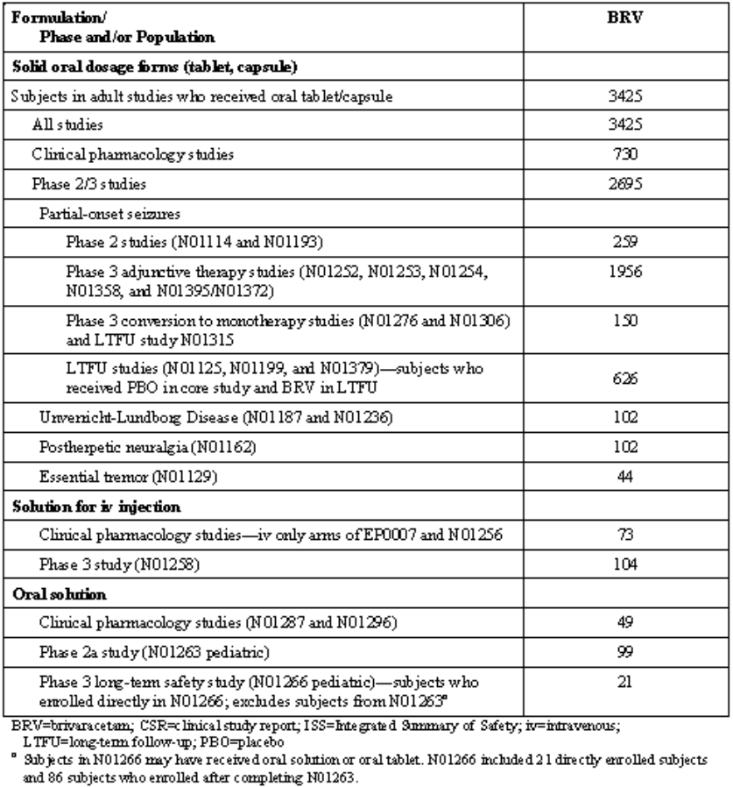
Table 11: Overall durations of exposure of BRV.
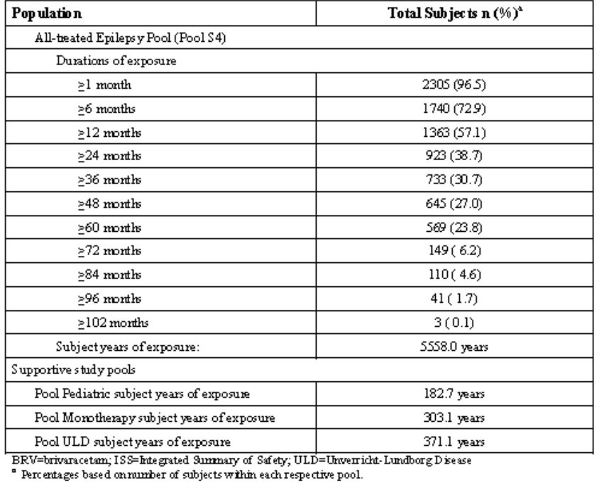
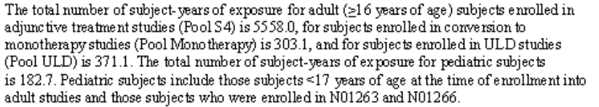
Table 12: Overall expose to BRV by maximum daily dose.
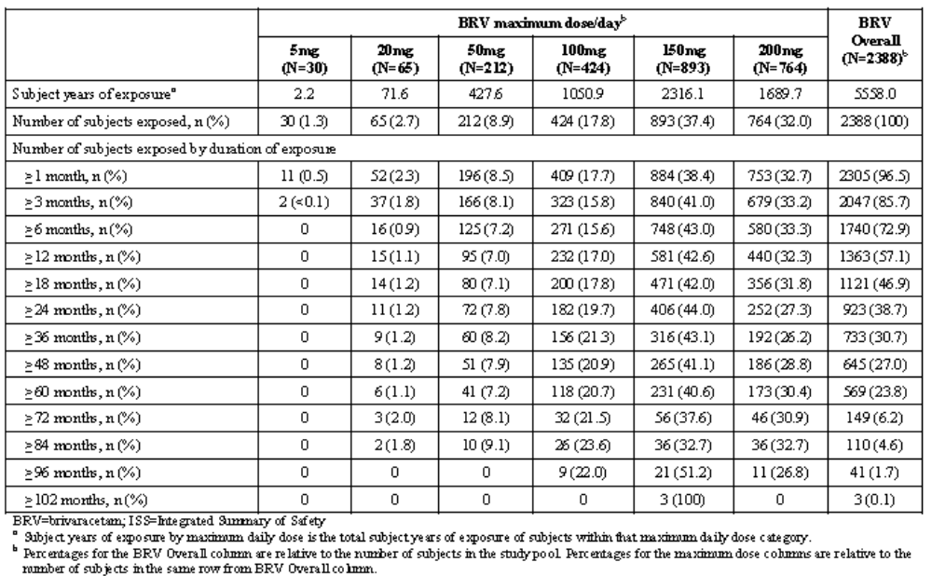

Adverse events

All adverse events (irrespective of relationship to study treatment)

Pivotal studies
See Table 13.

Other studies
See Table 13.
Table 13: Incidence of common TEAEs reported in >=5% or BRV subjects in all studies by dose.
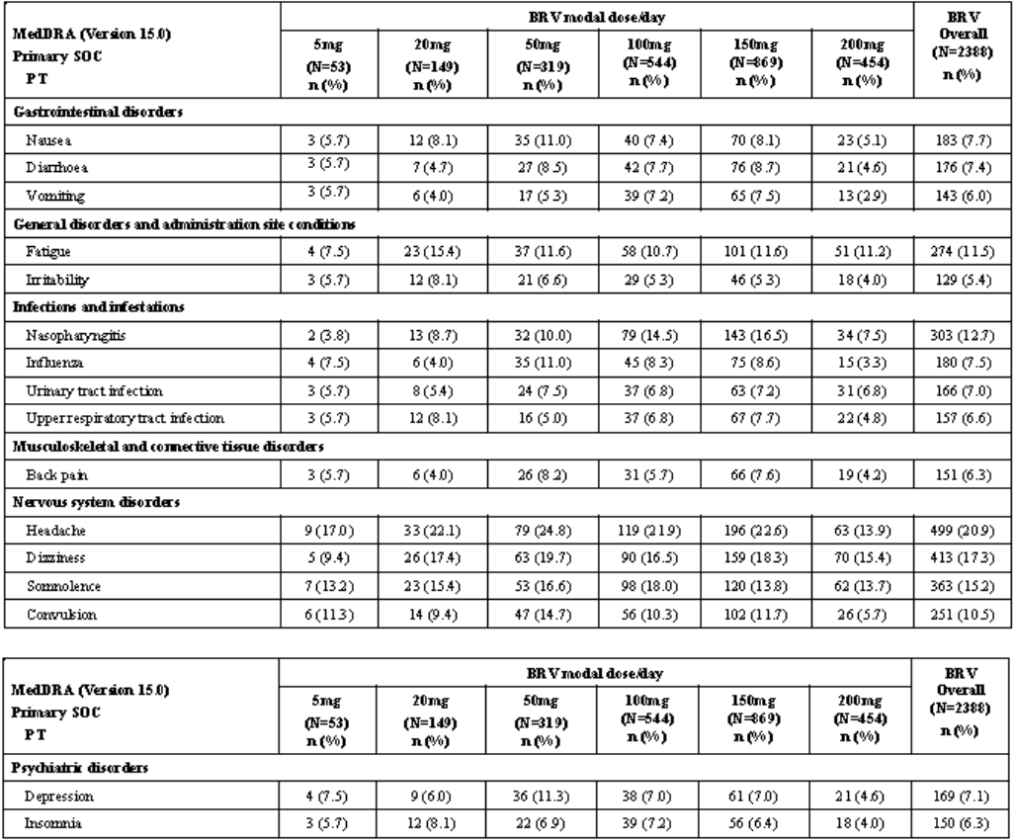
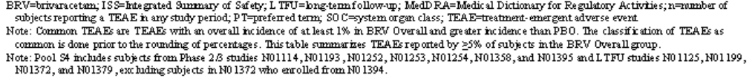

Treatment-related adverse events (adverse drug reactions)

Pivotal studies
In the pivotal studies, a total of 122 subjects (26.6%) in the PBO group and 446 subjects (40.6%) in the BRV Overall group reported TEAEs considered drug-related by the Investigator. There was no apparent relationship between BRV dose and the overall incidence of drug related TEAEs. Somnolence, dizziness, fatigue, and headache were the most frequently reported TEAEs considered drug-related by the Investigator, and these were reported more frequently by subjects in the BRV Overall group (12.1%, 8.7%, 6.9%, and 4.2%, respectively) compared with the PBO group (6.8%, 3.7%, 1.7%, and 3.1%, respectively).

Rare reactions of interest
- One subject (0.2%) in the BRV 100mg/day group (N01254-304-F473) reported a TEAE of erythema multiforme, which was considered possibly related to study drug by the Investigator, led to permanent discontinuation of study drug, and was not a treatment-emergent SAE. A full narrative is provided for this subject.
- One subject in the BRV 100mg/day group (N01236-135-0237/N01125-935-1002) who was taking concomitant topiramate, valproate semisodium, and pantoprazole sodium sesquihydrate (as well as other medications) had a TEAE of pancreatitis that was considered possibly related to study drug by the Investigator and was reported as an SAE.
- One subject in the BRV 150mg/day group (N01254-266-K360/N01199-1266-0005) had a treatment-emergent SAE of renal failure that led to permanent discontinuation of study drug and was considered possibly related to study drug by the Investigator.
- In pooled analysis, treatment-emergent SAEs of completed suicide were reported for 1 subject (0.2%) in the BRV 100mg/day group who had a history of depression and 1 subject (0.1%) in the BRV 150mg/day group who had poor seizure control in the preceding days. Both subjects had been exposed to BRV for more than 6 months with no recent dose changes.
- Serious TEAEs of suicidal ideation and suicide attempt were reported for 12 subjects (0.5%) each, and self-injurious ideation was reported for 1 subject (1<0.1%). In addition there were 2 fatal cases of drowning reported where suicidality could not be excluded and 1 case reported as suicidal ideation but with some suicidal behaviour which UCB considers escalates this case to a suicide attempt. The incidence rate for completed suicide and suicide attempt is 0.32 per 100 subject-years (95% CI: 0.20, 0.50).

Deaths and other serious adverse events

Pivotal studies
A total of 14 subjects (3.1%) in the PBO group and 27 subjects (2.5%) in the BRV Overall group reported SAEs. There was no dose relationship across BRV groups and the incidence rates were similar or lower for BRV Overall compared with PBO.

Other studies
The majority of SAEs occurred in the LTFU studies, which is not unexpected given the duration of exposure. The SAEs reported were not unexpected for a pharmacoresistant epilepsy population. The most frequently reported SAEs for subjects in the BRV Overall group were convulsion (60 subjects [2.5%]), status epilepticus (20 subjects [0.8%]), pneumonia (13 subjects [0.5%]), epilepsy (13 subjects [0.5%]), suicidal ideation (12 subjects [0.5%]), and suicide attempt (12 subjects [0.5%]).
A total of 46 fatal cases have been reported in the BRV program as of the safety cutoff of 25 Jun 2014 (representing 5558 subject-years of exposure). No subject died in any of the Phase 1 studies investigating BRV in healthy subjects. Forty-three deaths occurred in BRV-treated subjects, 2 deaths occurred during a Pretreatment Period, and 1 death occurred in a PBO-treated subject. Out of the 43 BRV treatment-emergent cases, 10 deaths occurred after BRV discontinuation. Five deaths occurred during the double-blind studies, and 38 deaths occurred during the open-label LTFU studies (including 2 deaths in the paediatric LTFU study N01266). A total of 16 deaths were considered at least possibly due to SUDEP. The overall mortality and SUDEP rates reported in the BRV program falls within the range reported in other AED development programs and community based epidemiological studies.

Discontinuation due to adverse events

Pivotal studies
The overall incidence of TEAEs leading to permanent discontinuation of study drug was low (ISS Section 6.10.1). A total of 16 subjects (3.5%) in the PBO group and 69 subjects (6.3%) in the BRV Overall group reported TEAEs leading to permanent discontinuation of study drug. There was no dose relationship across BRV groups. Dizziness, convulsion, depression, and headache were the most frequently reported TEAEs leading to discontinuation, and these were reported more frequently by subjects in the BRV Overall group (0.8%, 0.6%, 0.5%, and 0.5%, respectively) compared with the PBO group (0.2%, 0.4%, 0.2%, and 0%, respectively). In general, the incidences of TEAEs leading to discontinuation were similar across BRV groups.

Other studies
A total of 337 subjects (14.1%) in the BRV Overall group reported TEAEs leading to permanent discontinuation of study drug. The most frequently reported TEAEs leading to permanent discontinuation of study drug for subjects in the BRV Overall group were convulsion, pregnancy, dizziness, depression, fatigue, and somnolence (ISS Section 6.10.2).

Laboratory tests

Liver function
No changes in laboratory values, or excess in the number and percentage of study participants with potentially clinically significant abnormal laboratory values or organ related AEs seen in pivotal or LTFU studies.
Table 14: Evaluation of potential hepatotoxicity (Pool S1).
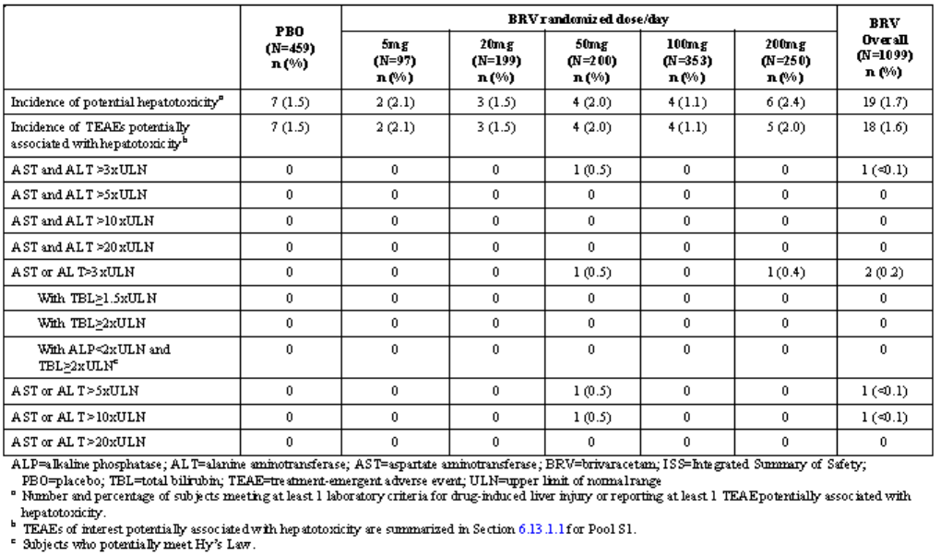

Kidney function
No changes in laboratory values, or excess in the number and percentage of study participants with potentially clinically significant abnormal laboratory values or organ related AEs seen in pivotal or LTFU studies.
Table 15: Summary of TEAEs of interest potentially associated with renal impairment (Pool S4).
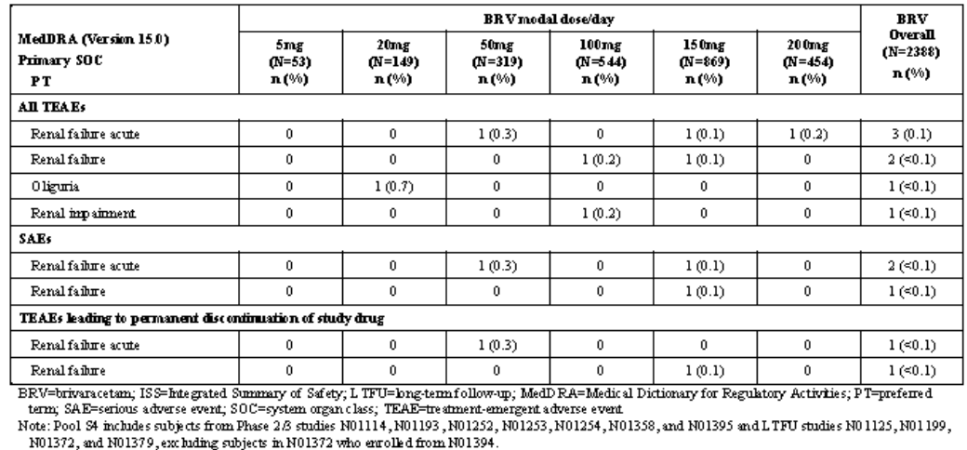

Other clinical chemistry
No changes in laboratory values, or excess in the number and percentage of study participants with potentially clinically significant abnormal laboratory values or organ related AEs seen in pivotal or LTFU studies.

Abuse potential
There were no reports of abuse, misuse, dependence or withdrawal with BRV. Across all study pools, dizziness, somnolence, fatigue, and asthenia were the most common CNS events of interest. The incidence of euphoric mood and feeling drunk was low in patient populations but higher in Phase 1 populations.

Falls
10 subjects in the PBO group and 133 in the BRV group reported at least 1 TEAE of fall.
Table 16: Falls.
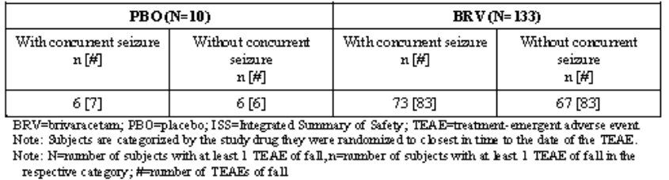

Haematology

Pivotal studies
No excess in number or percentage of blood dyscrasias seen in pivotal studies, no SAEs or TEAEs leading to drug discontinuation.
Table 17: Summary of TEAEs of interest potentially associated with blood dyscrasias (Pool S1).
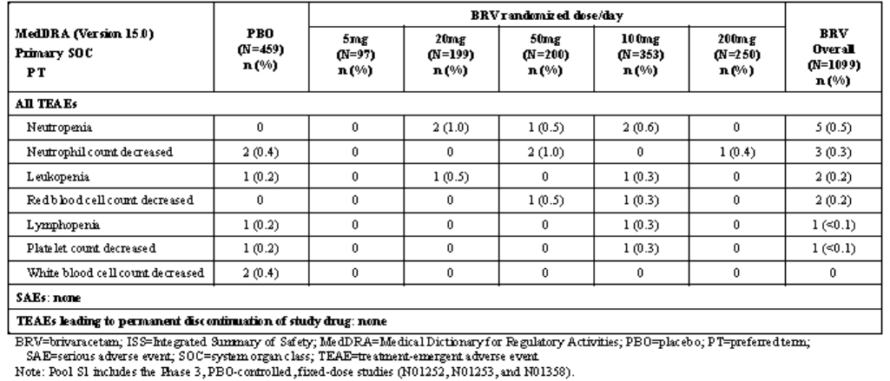

Other studies
- Subject [information redacted] had a report of neutropenia that was considered possibly related to study drug by the Investigator and led to permanent discontinuation of study drug (ISS Table 5.10.3.1).
- Subject [information redacted] enrolled in N01162, a study investigating the effects of BRV in PHN, had a treatment-emergent SAE of thrombocytopenia with vascular pupura that was considered possibly related to study drug by the Investigator and did not lead to permanent discontinuation of study drug or dose change.

ECG
No prolongation in QT interval in any studies. No increase in clinically relevant cardiac arrhythmias.
Table 18: Summary of TEAEs of interest potentially associated with other cardiac arrhythmias (Pool S1).
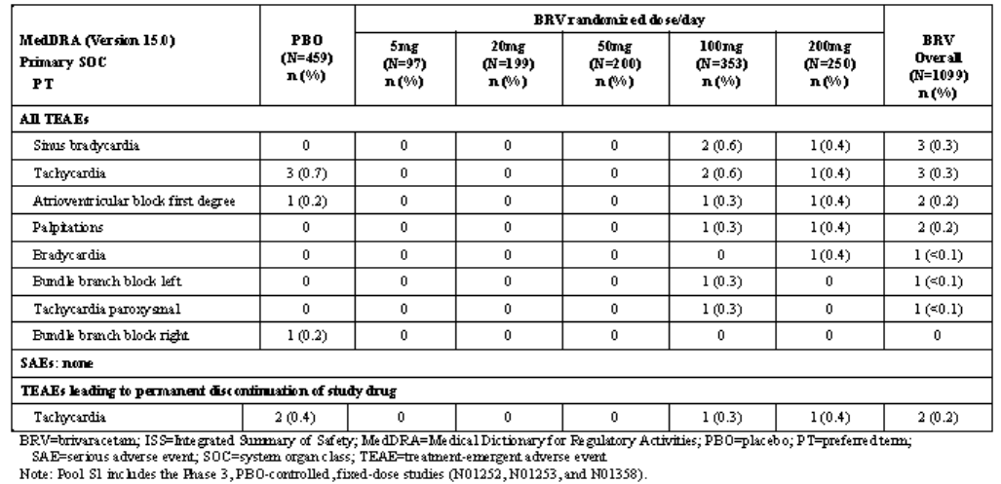

Post-marketing experience
Not applicable.

Safety issues with the potential for major regulatory impact

Liver toxicity
None identified.

Haematological toxicity
None identified.

Abuse potential
There were no reports of abuse, misuse, dependence or withdrawal with BRV. Across all study pools, dizziness, somnolence, fatigue, and asthenia were the most common CNS events of interest. The incidence of euphoric mood and feeling drunk was low in patient populations but higher in Phase I populations.

Falls
10 subjects in the PBO group and 133 in the BRV group reported at least 1 TEAE of fall.

Cardiovascular safety
None identified.

Unwanted immunological events
None identified.

Other safety issues

Safety in special populations
The highest incidences of common TEAEs in the 44 subjects ≥65 years of age were convulsion (7 subjects [15.9%]), somnolence (7 [15.9%]), dizziness (6 [13.6%]), headache (6 [13.6%]), and fall (5 [11.4%]). These TEAEs were consistent with the TEAEs observed in subjects 17 to <65 years of age, and with those observed in pooled pivotal studies. It is important to keep in mind when evaluating these results that the population ≥65 years of age in Pool S4 was 44 BRV-treated subjects.

Safety related to drug-drug interactions and other interactions
The sedative effects of BRV may be additive to that of other AEDs although no data are presented to explore this possibility.

Evaluator’s overall conclusions on clinical safety
The risks that were common in the Healthy subjects (dizziness, somnolence, headache, and fatigue) were also common in the epilepsy subjects.
In the Epilepsy Phase III Double-blind Pool very common AEs (fatigue, irritability, somnolence and dizziness) were more common with brivaracetam than placebo (the exception was headache which appeared reduced).
In relation to the Elderly (> 65) there were only 44 subjects in the Epilepsy All Treated Pool and only fewer in the Epilepsy Phase III Double-blind Pool. However, no increase in toxicity was reported in elderly subjects.
On the data provided there appeared to be reduced prevalence of the more common AEs in <17 year group compared with adults.
No major safety issues are identified.

First round benefit-risk assessment

First round assessment of benefits
The benefits of brivaracetam in the proposed usage are:
- An anticonvulsant that has similarities with only one other anticonvulsant currently available (levetiracetam) with some preclinical evidence to support superiority.
- Based on the most optimistic data from the 200 mg/day BRV study group from N01358, NNT is 6.2 per additional responder compared to placebo.
- The mean Percent Change from Baseline in Seizure Frequency per 28 Days and the Responder Rate seemed to improve in those continuing on the drug.
- There are relatively few discontinuations in the long term (14.1%).

First round assessment of risks
The risks of brivaracetam in the proposed usage are:
- Safety data are thoroughly established and safety profile seems favourable in the population examined so far.
- In the add-on setting determination of plasma concentrations seemed to have some bearing on pharmacodynamic effect but inspection of the dose-response graphs would suggest that this effect is fairly weak and variable. Moreover, differences in study design appear insufficient to explain variability in efficacy variables seen across the studies.
- Adequate data is submitted with regards to special populations although numbers of elderly with sufficient level of exposure are small.
- The earlier pivotal studies were complicated by too many dose arms. Sufficient information is contained within Phase II and pivotal studies in order to establish the lower end of the clinically effective dose range but not, in the evaluator’s opinion, the optimal effective dose. It is contended that this data will be supplemented by LTFU studies – although this method is potentially problematic. Only one pivotal study supports the use of a 200 mg/day dose and in this study 200 mg was found only marginally (numerically) superior to the 100 mg comparator in that study (N01358).

First round assessment of benefit-risk balance
The benefit-risk balance of brivaracetam given the proposed usage, is favourable. This is determined on the basis that the risk profile is favourable and the efficacy data generally shows efficacy over placebo in the dosage range proposed.

First round recommendation regarding authorisation
Despite the evaluator’s concerns about the relatively weaker dataset supporting the 200 mg/day dose, the recommendation is for approval of the submission as it stands.

Clinical questions
- Clarification is sought by the evaluator about the pooled results presented in the table below where a percentage reduction over placebo appears different in the BRV groups than that reported in the core text of N01252.
Table 19: US primary endpoint: percent reduction over PBO for 28-day adjusted POS frequency in N01252, N01253, N01358, and Pool E1.
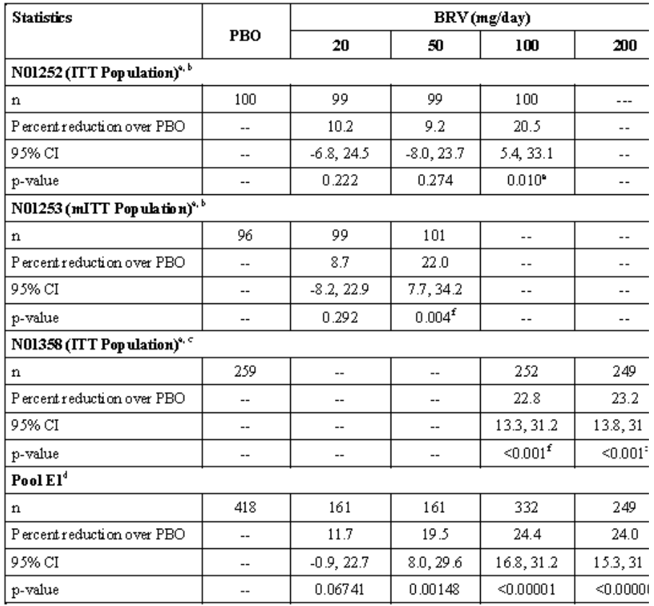
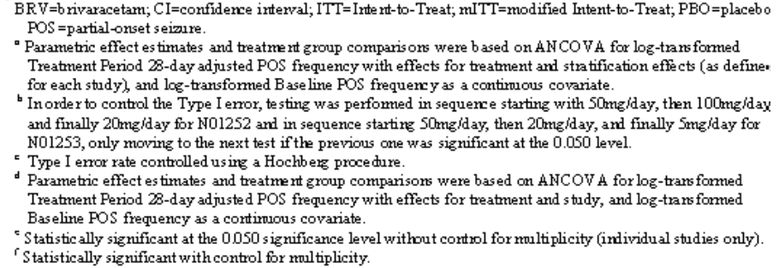

Pharmacodynamics
None

Efficacy
- Pooled Safety analyses were done including both pivotal (S1) and pivotal and Phase II studies (S3) but not pooled efficacy analyses.

Other
- Why are so many tablet strengths being made available? Might this not increase medication errors?

Second round evaluation
- Question: Clarification is sought by the evaluator about the pooled results presented in the table below (clinical-overview-global-eu) – where a percentage reduction over placebo appears different in the BRV groups than that reported in the core text of N01252.
Evaluation of response:
The Sponsor replied that in order to harmonize the analysis of data across the 3 studies, all pooled study summaries for the evaluation of percent reduction over placebo were based on 28-day adjustment. This tended to increase the observed treatment effect compared to the 7-day POS frequency analysis.
This explanation is acceptable to the reviewer.
- Question: Pooled Safety analyses were done including both pivotal (S1) and pivotal and phase II studies (S3) but not pooled efficacy analyses.
Evaluation of response:
It may be that further pooling could improve the justification for proposed dosing of brivaracetam. However, the reviewer accepts the Sponsor’s proposal that is most appropriate to combine data from studies that are of similar design, that is, similar in dose, duration, choice of control, methods of ascertainment, etc.
- Question: Why are so many tablet strengths being made available? Might this not increase medication errors?
Evaluation of response:
Not all studies appeared to use 10mg tablets in the down-titration period
For example:
In study NO1187, the Down-titration Period consisted of 1 week at 100mg/day and 1 week at 50mg/day for subjects having received 150mg/day. For subjects having received 50mg/day, the down-titration was as follows: 1 week of 25mg/day (morning dose, and PBO in the evening), followed by 1 week PBO. No 10mg dose was used and no rebound effects were reported.
N01125 did not apparently use the 20mg/day dosing.
In study N01372/N01379/N01315/N01199, there was a Down-Titration Period, in which the BRV dose was decreased in steps of 50mg/day on a weekly basis. The last down-titration step at 20mg/day for 1week was included.
No evidence for a rebound effect is presented in the evaluation using the down-titration strategies employed.
Given these data presented above, it is therefore reasonable to include 10 mg tablets.

Second round benefit-risk assessment

Second round assessment of benefits
After consideration of the responses to clinical questions, the benefits of brivaracetam in the proposed usage are unchanged from those identified in the first round.

Second round assessment of risks
After consideration of the responses to clinical questions, the benefits of BRV in the proposed usage are unchanged from those identified in the first round.

Second round assessment of benefit-risk balance
The benefit-risk balance of BRV, given the proposed usage, is favourable. The reviewer accepts the antiepileptic action of BRV and the favourable side-effect profile.

Second round recommendation regarding authorisation
The reviewer accepts the submission as it stands.

References
1. Kenda BM, Matagne AC, Talaga PE, et al. Discovery of 4-substituted pyrrolidone butanamides as new agents with significant antiepileptic activity. Journal of medicinal chemistry 2004;47:530-549.
2. Lynch BA, Lambeng N, Nocka K, et al. The synaptic vesicle protein SV2A is the binding site for the antiepileptic drug levetiracetam. Proceedings of the National Academy of Sciences of the United States of America 2004;101:9861-9866.
3. Pisani A, Bonsi P, Martella G, et al. Intracellular calcium increase in epileptiform activity: modulation by levetiracetam and lamotrigine. Epilepsia 2004;45:719-728.
4. Gillard M, Fuks B, Leclercq K, Matagne A. Binding characteristics of brivaracetam, a selective, high affinity SV2A ligand in rat, mouse and human brain: relationship to anti-convulsant properties. European journal of pharmacology 2011;664:36-44.
5. Matagne A, Margineanu DG, Kenda B, Michel P, Klitgaard H. Anti-convulsive and anti-epileptic properties of brivaracetam (ucb 34714), a high-affinity ligand for the synaptic vesicle protein, SV2A. British journal of pharmacology 2008;154:1662-1671.
6. Klitgaard H, Matagne A, Gobert J, Wulfert E. Evidence for a unique profile of levetiracetam in rodent models of seizures and epilepsy. European journal of pharmacology 1998;353:191-206.
7. Zona C, Pieri M, Carunchio I, Curcio L, Klitgaard H, Margineanu DG. Brivaracetam (ucb 34714) inhibits Na(+) current in rat cortical neurons in culture. Epilepsy research 2010;88:46-54.

Therapeutic Goods Administration
PO Box 100 Woden ACT 2606 Australia
Email: info@tga.gov.au Phone: 1800 020 653 Fax: 02 6232 8605
https://www.tga.gov.au

Kenda BM, et al. Discovery of 4-substituted pyrrolidone butanamides as new agents with significant antiepileptic activity. Journal of Medicinal Chemistry 47: 530-549 (2000); Lynch BA, et al. The synaptic vesicle protein SV2A is the binding site for the antiepileptic drug levetiracetam. PNAS 101: 9861-9866 (2004).
Pisani A, et al. Intracellular calcium increase in epileptiform activity: modulation by levetiracetam and lamotrigine. Epilepsia 45: 719-728 (2004).
Gillard M, et al. Binding characteristics of brivaracetam, a selective, high affinity SV2A ligand in rat, mouse and human brain: relationship to anti-convulsant properties. European Journal of Pharmacology 664: 36-44 (2011).
Matagne A, et al. Anti-convulsive and anti-epileptic properties of brivaracetam (ucb 34714), a high-affinity ligand for the synaptic vesicle protein, SV2A. British Journal of Pharmacology 154: 1662-1671 (2008).
Klitgaard H, et al. Evidence for a unique profile of levetiracetam in rodent models of seizures and epilepsy. European Journal of Pharmacology 353: 191-206 (1998).
Zona C, et al. Brivaracetam (ucb 34714) inhibits Na(+) current in rat cortical neurons in culture. Epilepsy Research 88: 46-54 (2010).
Matagne A, et al. Anti-convulsive and anti-epileptic properties of brivaracetam (ucb 34714), a high-affinity ligand for the synaptic vesicle protein, SV2A. British Journal of Pharmacology 154: 1662-1671 (2008).
European Medicines Agency, “Guideline on clinical investigation of medicinal products in the treatment of epileptic disorders (CHMP/EWP/566/98 Rev.2/Corr)”, 22 July 2010.

