September 2018

Australian Public Assessment Report for Brexpiprazole
  - Proprietary Product Name: Rexulti
  - Sponsor: Lundbeck Australia Pty Ltd

About the Therapeutic Goods Administration (TGA)
- The Therapeutic Goods Administration (TGA) is part of the Australian Government Department of Health and is responsible for regulating medicines and medical devices.
- The TGA administers the Therapeutic Goods Act 1989 (the Act), applying a risk management approach designed to ensure therapeutic goods supplied in Australia meet acceptable standards of quality, safety and efficacy (performance) when necessary.
- The work of the TGA is based on applying scientific and clinical expertise to decision-making, to ensure that the benefits to consumers outweigh any risks associated with the use of medicines and medical devices.
- The TGA relies on the public, healthcare professionals and industry to report problems with medicines or medical devices. TGA investigates reports received by it to determine any necessary regulatory action.
- To report a problem with a medicine or medical device, please see the information on the TGA website <https://www.tga.gov.au>.
About AusPARs
- An Australian Public Assessment Report (AusPAR) provides information about the evaluation of a prescription medicine and the considerations that led the TGA to approve or not approve a prescription medicine submission.
- AusPARs are prepared and published by the TGA.
- An AusPAR is prepared for submissions that relate to new chemical entities, generic medicines, major variations and extensions of indications.
- An AusPAR is a static document; it provides information that relates to a submission at a particular point in time.
- A new AusPAR will be developed to reflect changes to indications and/or major variations to a prescription medicine subject to evaluation by the TGA.
Copyright
© Commonwealth of Australia 2018
This work is copyright. You may reproduce the whole or part of this work in unaltered form for your own personal use or, if you are part of an organisation, for internal use within your organisation, but only if you or your organisation do not use the reproduction for any commercial purpose and retain this copyright notice and all disclaimer notices as part of that reproduction. Apart from rights to use as permitted by the Copyright Act 1968 or allowed by this copyright notice, all other rights are reserved and you are not allowed to reproduce the whole or any part of this work in any way (electronic or otherwise) without first being given specific written permission from the Commonwealth to do so. Requests and inquiries concerning reproduction and rights are to be sent to the TGA Copyright Officer, Therapeutic Goods Administration, PO Box 100, Woden ACT 2606 or emailed to <tga.copyright@tga.gov.au>.

Contents
Common abbreviations 5
I. Introduction to product submission 9
Submission details 9
Product background 9
Regulatory status 11
Product Information 12
II. Quality findings 12
Introduction 12
Drug substance (active ingredient) 12
Drug product 13
Biopharmaceutics 13
Quality summary and conclusions 20
III. Nonclinical findings 21
Overview 21
Genotoxicity 24
Carcinogenicity 24
Reproductive toxicity 26
Nonclinical summary and conclusions 30
IV. Clinical findings 30
Introduction 30
Pharmacokinetics 31
Pharmacodynamics 33
Dosage selection for the pivotal studies 34
Efficacy 35
Safety 36
First round benefit-risk assessment 40
First round recommendation regarding authorisation 41
Clinical questions and second round evaluation of clinical data submitted in response to questions 42
Second round benefit-risk assessment 42
Second round recommendation regarding authorisation 42
V. Pharmacovigilance findings 42
Risk management plan 42
VI. Overall conclusion and risk/benefit assessment 47
Quality 47
Nonclinical 47
Clinical 48
Risk management plan 69
Risk-benefit analysis 69
Outcome 76
Attachment 1. Product Information 76
Attachment 2. Extract from the Clinical Evaluation Report 76

Common abbreviations
Abbreviation | Meaning
5-HT | 5-hydroxytryptamine/serotonin
5-HT_{1A} | Serotonin 1A receptor subtype
5-HT_{2A} | Serotonin 2A receptor subtype
ACM | Advisory Committee on Medicines
ADHD | Attention deficit hyperactivity disorder
ADR | Adverse drug reaction
AE | Adverse event
ANCOVA | Analysis of covariance
APTS | All patients treated set
APTS | All patients treated set
ARTG | Australian Register of Therapeutic Goods
ASA | Australian Specific Annex
AUC | Area under the curve
AUC_{0-t} | Area under the curve from time 0 to last measured concentration
AUC_{0-∞} | Area under the curve from time 0 to infinity
BCRP | Breast cancer resistance protein
BCS | Biopharmaceutics Classification System
BMI | Body mass index
BPRS | Brief Psychiatric Rating Scale
C-SSRS | Columbia-Suicide Severity Rating Scale
CGI | Clinical Global Impression scale
CGI-I | Clinical Global Impression Improvement scale
CGI-S | Clinical Global Impression-Severity scale
CK | Creatine kinase
C_{max} | Maximum serum concentration
CMI | Consumer Medicines Information
CNS | Central nervous system
CYP | Cytochrome P450
D₂ | Dopamine D2 receptor
DLP | Data lock point
DM-3411 | Major brexpiprazole metabolite
DSM-IV-TR | Diagnostic and Statistical Manual of Mental Disorders, Fourth Edition, Text Revision
EC₅₀ | Half maximal effective concentration
ECG | Electrocardiogram
ECT | Electroconvulsive therapy
EMA | European Medicines Agency
E_{max} | Maximal effect attributable to a drug
EPS | Extrapyramidal symptoms
F₀ | Parental generation
F₁ | First filial generation
f₂ | Similarity factor
FAS | Full analysis set
FDA | Food and Drug Administration
GAF | Global Assessment of Functioning scale
GCP | Good Clinical Practice
GMP | Good Manufacturing Practice
GMR | Geometric mean ratios
H₁ | Histamine type-1 receptor
hERG | Human ether-a-go-go
ICH | International Conference on Harmonisation
I_{Ks} | Slowly activating potassium channel subtype
INN | International Nonproprietary Name
ITT | Intention to treat
IV | Intravenous
LD | Lactation day
LOCF | Last observation carried forward
LTSS | Long term stability supply
MDD | Major depressive disorder
MINI | Mini-International Neuropsychiatric Interview
MMRM | Mixed effect model repeat measurement
MNAR | Missing not at random
MRHD | Maximum recommended human dose
Na_{v}1.5 | Cardiac voltage-dependent sodium channel subtype
NMS | Neuroleptic malignant syndrome
OC | Observed case
OPC-331 | Brexpiprazole development name
OPC-34712 | Brexpiprazole development name
PANSS | Positive and Negative Syndrome Scale
PD | Pharmacodynamic(s)
PEC | PANSS Excited Component
PET | Positron emission tomography
PI | Product Information
PK | Pharmacokinetic
pKa | Logarithmic acid dissociation constant
POCA | Phonetic and orthographic computer analysis
Ppm | Parts per million
PRAC | Pharmacovigilance Risk Assessment Committee (EMA)
PSP | Personal and Social Performance Scale
PSP | Personal and Social Performance scale
PTSD | Post-traumatic stress disorder
QSAR | Quantitative structure-activity relationship
QTc | Corrected QT interval
QTcF | QT interval corrected according to Fridericia's formula
QTcI | Individually corrected QT interval
RCT | Randomised control trial
RMP | Risk Management Plan
RR | Risk ratio
SERT | Serotonin transport
SMQ | Standardised MedDRA Queries
TEAE | Treatment emergent adverse event
T_{max} | Time to maximum plasma concentration
US | United States
USAN | United States Adopted Name
XR | Extended release
α_{1B} | Noradrenaline alpha 1B receptor subtype
α_{2C} | Noradrenaline alpha 2C receptor subtype

I. Introduction to product submission

Submission details
Type of submission: | New chemical entity
Decision: | Approved
Date of decision: | 17 May 2017
Date of entry onto ARTG | 19 May 2017
Active ingredient: | Brexpiprazole
Product name: | Rexulti
Sponsor’s name and address: | Lundbeck Australia Pty Ltd  PO Box 1973 Macquarie Centre NSW 2113
Dose form: | Film coated tablet
Strength: | 0.25 mg, 0.5 mg, 1 mg, 2 mg, 3 mg and 4 mg
Container: | Blister pack
Pack size: | 30 tablets
Approved therapeutic use: | Rexulti is indicated in adult patients for the treatment of schizophrenia.
Route of administration: | Oral
Dosage: | The recommended starting dose for Rexulti in the treatment of patients with schizophrenia is 1 mg once daily on Days 1 to 4.  The recommended target dose range is 2 mg to 4 mg once daily. Titrate to 2 mg once daily on Day 5, then to 4 mg on Day 8 based on the patient’s clinical response and tolerability. The maximum recommended daily dosage is 4 mg.  Maintenance treatment: The recommended maintenance dose range is 2 mg/day to 4 mg/day. Periodically reassess to determine the continued need for maintenance treatment and appropriate dosage.  Rexulti can be given with or without food.
ARTG numbers: | 273220, 273221, 273222, 273223, 273224 and 273225

Product background
This AusPAR describes the application by the sponsor to register the new chemical entity brexpiprazole as Rexulti film coated tablets for the following indication:
‘For the treatment of adult patients with schizophrenia’.
According to the sponsor, brexpiprazole is a new chemical entity discovered by Otsuka Pharmaceutical Co, Ltd that is being co-developed with the sponsor.
Schizophrenia is a severely debilitating mental illness characterised by delusions, hallucinations, and disordered cognition that affects approximately 1% of the world population. It has been estimated that, globally, schizophrenia reduces life expectancy by an average of 10 years. The illness, typically emerging between the late teens and mid-thirties, is characterised by the presence of positive symptoms (for example, hallucinations and delusions) as well as negative symptoms (for example, social withdrawal and lack of emotion, energy and motivation) and cognitive impairments. While there are several currently marketed drugs for the treatment of schizophrenia, both efficacy and their side effect profiles limit their use in some patients and there remains an unmet need for further treatment options.
The course of schizophrenia is highly variable but often characterised by acute episodes of psychosis, characterised by the positive symptoms (all considered ‘relapses’ after the first occurrence), repeating themselves at varying intervals between periods of relative symptomatic stability. Negative symptoms and cognitive disturbance can persist between episodes and contribute significantly to disability. They also tend to be less responsive to currently available treatments. After relapsing, patients with schizophrenia rarely return to their ‘pre-relapse’ state and this erosion can increase the patient’s sense of isolation and difficulty in finding and sustaining employment and meaningful relationships. Thus, prevention of future exacerbations and relapses is a crucial goal of schizophrenia management, providing adequate treatment as early as possible in the course of the illness is a logical therapeutic goal.^{1,2,3,,}
The first antipsychotics developed for the treatment of schizophrenia were dopamine D₂ receptor antagonists, following the incidental discovery of the antipsychotic potential of chlorpromazine. These agents were effective against positive symptoms (for example, hallucinations and delusions) but showed low efficacy for negative symptoms (such as social withdrawal and lack of emotion, energy, and motivation) and were also associated with a high incidence of hyperprolactinemia and extrapyramidal symptom (EPS) related side effects (including tardive dyskinesia), and other side effects including sedation, seizure, agranulocytosis, and neuroleptic malignant syndrome., Second generation antipsychotics, commonly referred to as ‘atypical antipsychotics’ represent a significant advancement in the treatment of psychotic disorders because they are efficacious on positive symptoms; appear to have some effect, although not satisfactory, on negative symptoms; and at the same time exhibit a reduced tendency to promote EPS, especially tardive dyskinesia, relative to typical antipsychotics.
The tolerability with second generation antipsychotics remains an important cause of medication discontinuation due to side effects of somnolence, sedation, akathisia, hyperprolactinemia, and weight gain. Some agents are associated with high rates of weight gain (for example, olanzapine and quetiapine), while others have high rates of hyperprolactinemia and associated sexual dysfunction or sedation. Therapeutic options for patients with schizophrenia that offer improved tolerability also have the potential of providing significant direct and indirect benefits. That is, improved tolerability may lead to better medication adherence thus diminishing the risk of relapse and rehospitalisation, and consequently reducing overall public health burden.
Amongst the atypical antipsychotics, aripiprazole was the first D₂ partial agonist to be approved for treatment of schizophrenia. Whilst it has a particularly favourable metabolic profile, it has been associated with high rates of activating side effects (such as akathisia and insomnia) particularly when used in higher or rapidly up titrated dose.
While the precise mechanism of action of brexpiprazole in the treatment of schizophrenia is not fully understood, the pharmacology of brexpiprazole is believed to be mediated through modulation of monoaminergic neurotransmitter systems in the brain. Brexpiprazole acts as a partial agonist at serotonin or 5-hydroxytryptamine (5-HT) 1A receptor subtype (5-HT_{1A}) and dopamine D2 receptors (D₂) and as an antagonist at the serotonin 2A (5-HT_{2A}) receptors, all with similar potency. Brexpiprazole is also an antagonist at noradrenergic alpha 1B (α_{1B}) and alpha 2C (α_{2C}) receptors and several other monoaminergic receptor subtypes.
Brexpiprazole is thus described as being pharmacologically designed to address these liabilities by balancing activities on dopaminergic (D₂ partial agonist activity), serotonergic (potent 5-HT_{2A} antagonism and partial agonist activity at 5-HT_{1A}), and adrenergic (α_{1B} receptors antagonism) monoamine systems.

Regulatory status
The product received initial registration on the Australian Register of Therapeutic Goods (ARTG) on 19 May 2017.
At the time the TGA considered this application, similar applications had been approved or were under consideration in the countries or regions as listed in Table 1, below.

Table 1: International regulatory status
Country | Trade name | Submission Date | Current status | Approval Date | Approved/proposed Indications
USA | Rexulti | 11 July 2014 | Approved | 10 July 2015 | Approved indication:  Rexulti is indicated for:  1) Adjunctive treatment of major depressive disorder (MDD).  2) Treatment of schizophrenia.
Canada | Rexulti | 26 February 2016 | Approved | 16 February 2017 | Approved indication: Rexulti is indicated for the treatment of schizophrenia.
Switzerland | Rexulti | 27 September 2016 | Under evaluation |  | Proposed indication: Rexulti is indicated for the treatment of schizophrenia.
EU | Rexulti | 28 February 2017 | Under evaluation |  | Proposed indication: Rexulti is indicated for the treatment of schizophrenia.
Japan | Rexulti | 06 January 2017 | Under evaluation |  | Proposed indication: Treatment of schizophrenia.
An assurance was provided by the sponsor that this application has not been refused market approval or withdrawn in any region or country.

Product Information
The Product Information (PI) approved with the submission which is described in this AusPAR can be found as Attachment 1. For the most recent PI, please refer to the TGA website at <https://www.tga.gov.au/product-information-pi>.

II. Quality findings

Introduction
The atypical antipsychotic agent brexpiprazole binds with high affinity to multiple serotonin, dopamine and noradrenergic receptors, with both presynaptic dopamine autoreceptor agonistic activity and postsynaptic D₂ receptor antagonistic activity and has structural similarity to aripiprazole (structures shown in Figures 1 and 2, below).
Figure 1: Chemical (skeletal) structure of brexpiprazole
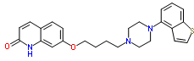
Full chemical name: 7-{4-[4-(1-Benzothiophen-4-yl)piperazin-1-yl]butoxy}quinolin-2(1H)-one
Figure 2: Chemical (skeletal) structure of aripiprazole
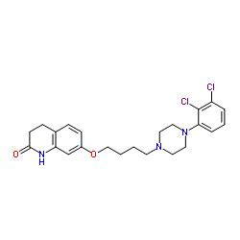

Drug substance (active ingredient)
Brexpiprazole (designated OPC-34712 and OPC-331 by the sponsor during development; structure shown in Figure 1, above) has no chiral centres.
The drug substance is manufactured by a chemical synthesis.
Whilst predicted logarithmic acid dissociation constant (pKa) values are 13.56 (strongest acidic) and 8.4 (strongest basic), the dossier states that the latter value is 7.8. The dossier also states that the apparent n-octanol/water Britton-Robinson partition coefficient at controlled room temperature [Log(Po/w)] is 0.3 at pH 2.06, increasing to 3.4 at pH 6.11 and to > 4 at ≥ pH 7.06.
The particle size distribution was expected to impact on the dissolution and/or disintegration rates of the finished products. Consequently, the drug substance is milled to target a specific particle size distribution.
4 potential impurities are controlled in the drug substance: The limits of these have been accepted on the advice of the toxicology evaluator.
A number of issues relating to the quality control of the brexpiprazole drug substance were raised directly with the active pharmaceutical ingredient manufacturer; all have been resolved except for provision of an acceptable formal active pharmaceutical ingredient specification as applied by the finished product manufacturer, in respect of which the company’s ongoing inability to do so will be referred to those responsible for manufacturing quality within the TGA for potential further action with the company at the next Good Manufacturing Practice (GMP) audit of the manufacturing facility.

Drug product
Each strength of the proposed tablets is described as a round, shallow convex, bevel edged (film coated) tablet, debossed with ‘BRX’ and ‘QQQ’ on one side, where ‘QQQ’ = 0.25, 0.5, 1, 2, 3 or 4, as appropriate. Tablet colours are light brown (0.25 mg), light orange (0.5 mg), light yellow (1 mg), light green (2 mg), light purple (3 mg) and white (4 mg). These will be packaged in PVC/aluminium blister packs containing 30 tablets and starter packs of 10 tablets (1 mg and 2 mg strengths only).
No overage is employed in the manufacture of the tablets.
In Phase I trials, 0.25 mg and 1 mg tablets were used, as well as the subsequently discontinued 0.05 mg and 5 mg tablets. In Phase II trials, 0.25 mg, 1 mg and 0.05 mg tablets were used, whilst 0.25 mg, 0.5 mg, 1 mg, 2 mg, 3 mg and 4 mg tablets were used in Phase III trials. All strengths of the clinical trial tablets and the proposed commercial tablets were the same shape, 6 mm in diameter and weighed 93 mg, and no changes were made except in respect of the film coating components and debossing.
The dissolution test was designed so that it could distinguish among differences in formulation and manufacturing process variants, and to achieve a dissolution profile with a gradual curve completed within 60 minutes.
In vitro dissolution studies were conducted at various pH values to compare the long term stability supply (LTSS)/commercial tablets with the Phase III clinical tablets.
The stability data support a (revised) shelf life of 36 months stored below 30°C for all strengths of the tablets packaged in the PVC/aluminium blisters proposed for Australia. A number of issues relating to the quality control of the tablets were raised with the sponsor, all of which have been resolved.

Biopharmaceutics
6 relative bioavailability and bioequivalence clinical studies were conducted to create a link between the brexpiprazole formulations that have been used during clinical development; Studies 331-10-241, 331-10-246, 331-10-243, 331-10-245, 331-13-209 and 331-10-005. Details of these are presented below.

Absolute bioequivalence study (Study 331-10-241)
This was a single centre, open label, 2 way crossover study for which the objective was to determine the absolute bioavailability of oral brexpiprazole tablets in healthy male and female subjects following single dose administration of a 2 mg oral tablet and a 0.25 mg intravenous (IV) solution of brexpiprazole. Summaries of the brexpiprazole and DM-3411 metabolite pharmacokinetic (PK) parameters following administration of both treatments are reproduced below in Tables 2 to 4, along with the results of the dose adjusted area under the curve (AUC) geometric means and bioavailability (F) with 90% CI for brexpiprazole after administration of a 2 mg brexpiprazole oral tablet in comparison to a 0.25 mg brexpiprazole IV infusion.

Table 2: Mean (SD) brexpiprazole PK parameters following administration of 0.25 mg brexpiprazole IV infusion and 2 mg brexpiprazole oral table to healthy subjects
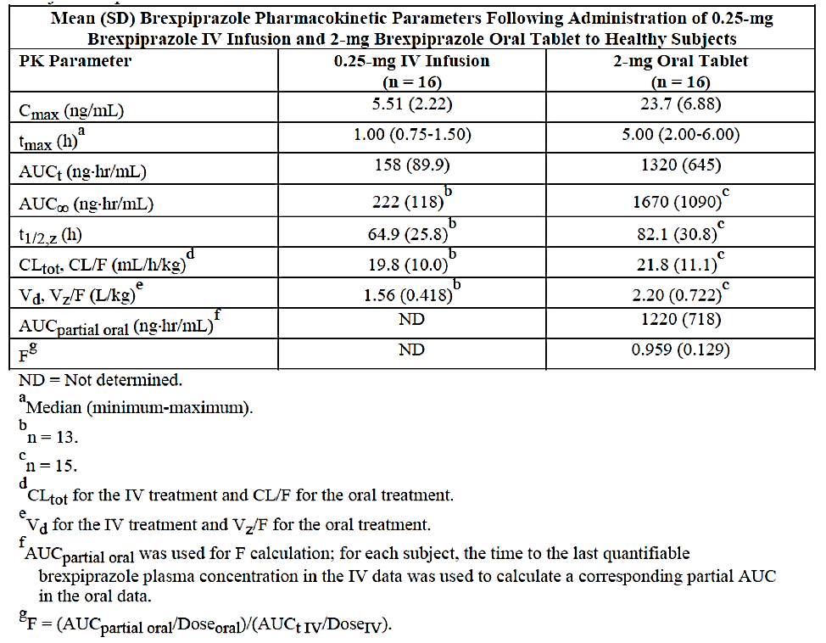

Table 3: Mean (SD) DM-3411 PK parameters following administration of 0.25 mg brexpiprazole IV infusion and 2 mg brexpiprazole oral table to healthy subjects
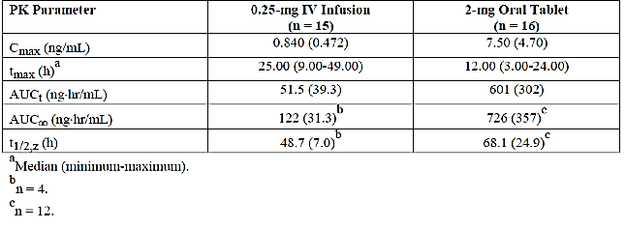

Table 4: Brexpiprazole absolute bioavailability and 90% CI following administration of 2 mg brexpiprazole oral table to healthy subjects
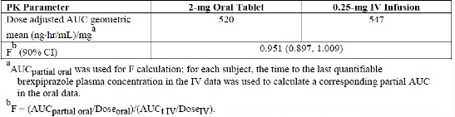
The sponsor’s conclusion with respect to absolute bioavailability was accepted as valid without recalculation on a risk management basis.

Food effect study (Study 331-10-246)
The study was a randomised, single centre, open label, 2 sequence, 2 way crossover, bioavailability/bioequivalence study to assess the effect of a high-fat meal on the PK of the intended commercial LTSS brexpiprazole (OPC-34712) 4 mg tablets in 16 healthy male and female subjects. The secondary objective of the study was to gain additional information about the safety and tolerability of brexpiprazole. The mean results for both analytes (brexpiprazole and the DM-3411 metabolite) and the assessment of bioequivalence in respect of brexpiprazole maximum serum concentration (C_{max}), area under the curve from time 0 to last measured concentration (AUC_{0-t}) and the area under the curve from time 0 to infinity (AUC_{0-∞}) are reproduced below in Tables 5 to 7.

Table 5: Mean (SD) brexpiprazole PK parameters following administration of 4 mg brexpiprazole to healthy subjects in a fed or fasted state
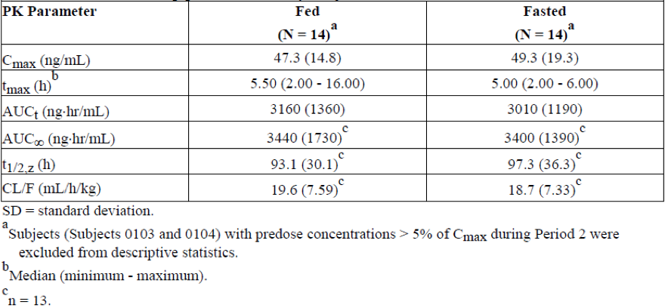

Table 6: Mean (SD) DM-3411 PK parameters following administration of 4 mg brexpiprazole to healthy subjects in a fed or fasted state
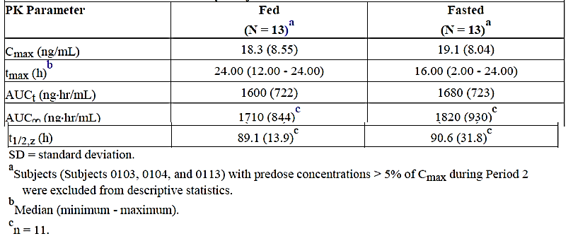

Table 7: Geometric mean ratios and 90% CIs for brexpiprazole PK parameters following administration of 4 mg brexpiprazole to healthy subjects in a fed or fasted state
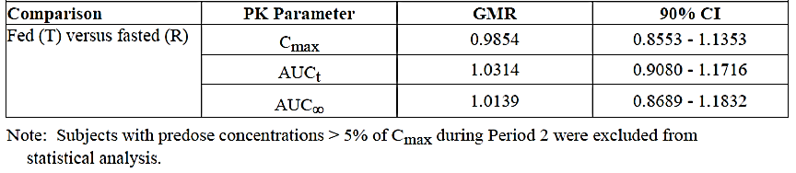
The sponsor’s conclusion with respect to food effect analysis; that is, the geometric mean ration (GMR) and 90% CIs for brexpiprazole C_{max}, AUC_{0-t} and AUC_{0-∞} following administration of a 4 mg brexpiprazole LTSS tablet to healthy subjects in a fed or fasted state were within the accepted range for bioequivalence of 0.80 to 1.25 were accepted as valid without recalculation on a risk management basis.

Bioequivalence study (LTSS versus Phase II/III clinical trial formulations (Study 331-10-243)
This was a randomised, 2 arm, single centre, open label, 2 way crossover study in which a 3 mg dose of brexpiprazole was administered to each subject as 1 x 3 mg LTSS tablet (test) or 3 x 1 mg Phase II/III formulation tablets (reference) on Days 1 and 16 according to the randomisation schedule (Arm 1), and a 2 mg dose of brexpiprazole was administered to each subject as 1 x 2 mg LTSS tablet (test) or 2 x 1 mg Phase II/III tablets (reference) on Days 1 and 16 according to the randomisation schedule.
The results of the assessments of bioequivalence in respect of brexpiprazole C_{max} and AUC_{0-t} and AUC_{0-∞} are reproduced below in Tables 8 to 10. The sponsor’s results were confirmed by the evaluator.

Table 8: Mean (SD) brexpiprazole PK parameters following administration of 2 mg LTSS and 2 x 1 mg Phase II/III brexpiprazole tablets to healthy subjects
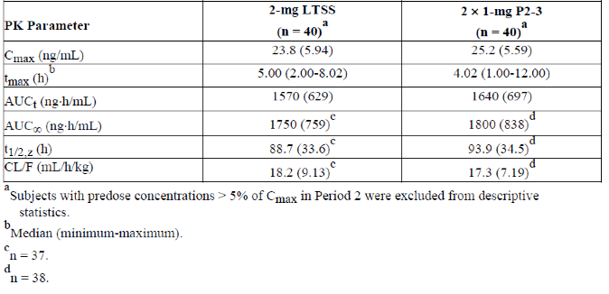

Table 9: Mean (SD) DM-3411 PK parameters following administration of 2 mg LTSS and 2 x 1 mg Phase II/III brexpiprazole tablets to healthy subjects
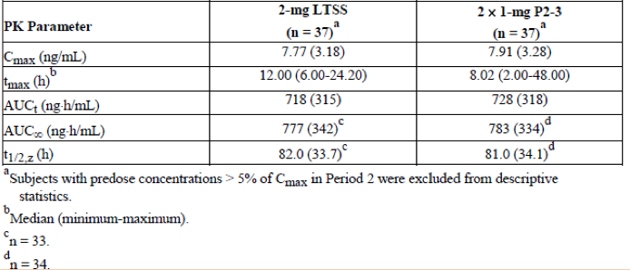

Table 10: GMRs and 90% CIs for brexpiprazole PK parameters following administration of 3 mg LTSS and 3 x 1 mg Phase II/III (Arm 1) or 2 mg LTSS and 2 x 1 mg Phase II/III tablets to healthy subjects

Bioequivalence study, 1 x 4 mg LTSS versus 4 x 1 mg LTSS formulations (Study 331-10-245)
This was a randomised, single centre, open label, 2 way crossover study in which a 4 mg dose of brexpiprazole was administered to each subject as 1 x 4 mg LTSS tablets (test) or 4 x 1 mg LTSS tablets (reference) on Days 1 and 18 according to the randomisation schedule. The study design, inclusion/exclusion criteria, blood collection times, bioanalytical method and its validation, PK parameters assessed for brexpiprazole and DM-3411 and the associated means of analysis of the concentration versus time data and the statistical analysis were essentially identical to those from either Arm of Study 331-10-243. For this reason, the sponsor’s results for brexpiprazole and DM-3411 (reproduced in Tables 11 to 13, below) were accepted on a risk management basis without further investigation.

Table 11: Mean (SD) brexpiprazole PK parameters following administration of 4 x 1 mg LTSS and 1 x 4 mg LTSS brexpiprazole tablets to healthy subjects
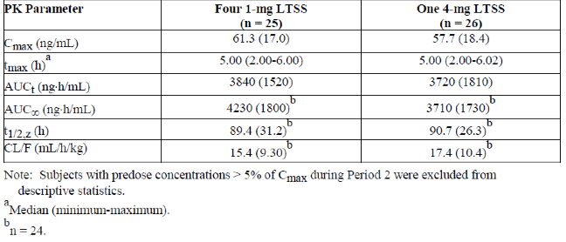

Table 12: Mean (SD) DM-3411 PK parameters following administration of 4 x 1 mg LTSS and 1 x 4 mg LTSS brexpiprazole tables to healthy subjects
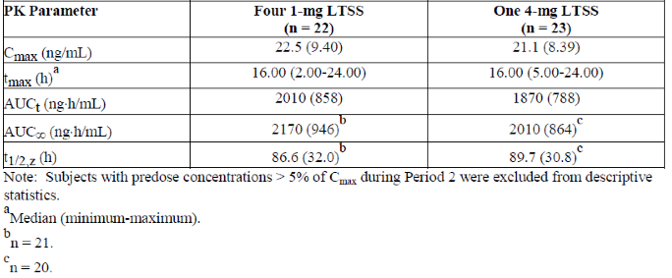

Table 13: GMRs and 90% CIs for brexpiprazole PK parameters following administration of 4 x 1 mg LTSS and 1 x 4 mg LTSS brexpiprazole tablets to healthy subjects
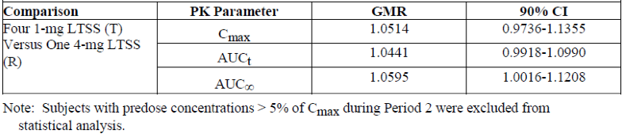

Bioequivalence study, LTSS versus Phase III clinical trial formulations (Study 331-13-209)
This was a randomised, single centre, open label, 2 way crossover study in which a 3 mg dose of brexpiprazole was administered to each subject as 1 x 3 mg LTSS tablet (test) or 1 x 3 mg Phase III tablet (reference) on Days 1 and 22 according to the randomisation schedule. As the study design, inclusion/exclusion criteria, blood collection times, bioanalytical method and its validation, PK parameters assessed for brexpiprazole and DM-3411 and the associated means of analysis of the concentration versus time data and the statistical analysis were essentially identical to those from either Arm of Study 331-10-243 or from Study 331-10-245, the company’s results for brexpiprazole and DM-3411 (reproduced in Tables 14 to 16, below) were also accepted on a risk management basis without further investigation.

Table 14: Mean (SD) brexpiprazole PK parameters following administration of 3 mg as 1 x 3 mg tablet and 1 x 3 mg Phase III tablet to healthy subjects
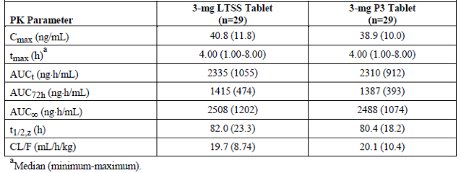

Table 15: Mean (SD) DM-3411 PK parameters following administration of 3 mg as 1 x 3 mg tablet and 1 x 3 mg Phase III tablet to healthy subjects
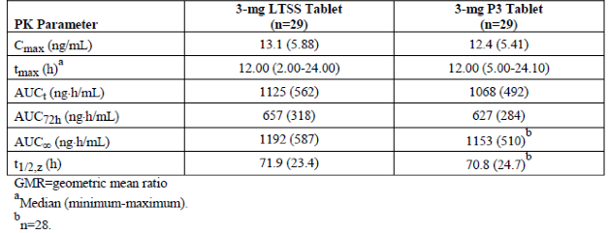

Table 16: GMRs and 90% CIs for brexpiprazole PK parameters following administration of 3 mg brexpiprazole as 1 x 3 mg LTSS tablet and 1 x 3 mg Phase III tablet to healthy subjects
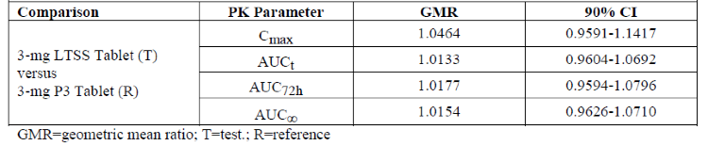

Relative bioavailability study (Study 331-10-005)
This was a randomised, single dose, single centre, open label, 2 way crossover study for which the primary objectives were to assess the relative bioavailability/bioequivalence of 2 different formulations of brexpiprazole in 32 healthy Japanese subjects (all males); that is to say, a single 4 mg ‘to be marketed’ tablet (reference) and a brexpiprazole oral solution (4 mL; 1 mg/mL). The secondary objectives of the study were to gain additional information about the safety and tolerability of brexpiprazole, and to determine genotypes, and estimated phenotypes for the cytochrome P450 (CYP) isozyme CYP2D6. All but 1 subject completed the study.
Although the study design and bioanalytical method are not identical to those used in Studies 331-10-243, 331-10-245 or 331-13-209, they were sufficiently similar as to accept without further review, particularly given the specific ethnicity of the subjects and the fact that an absolute bioavailability study had already been conducted.
The mean brexpiprazole and DM-3411 PK parameters are reproduced below in Tables 17 and 18.
The GMR and 90% CI for brexpiprazole, AUC_{t} and AUC∞ were within the 0.8000 to 1.2500 bioequivalence range following administration of brexpiprazole oral solution compared to tablet, but the GMR for brexpiprazole C_{max} was 1.2236 and the 90% CI was 1.1293 to 1.3259, which was not within the 0.8000 to 1.2500 bioequivalence range.

Table 17: Mean (SD) brexpiprazole PK parameters following administration of 4 mL oral solution (1 mg/mL) and 4 mg tablets to healthy subjects
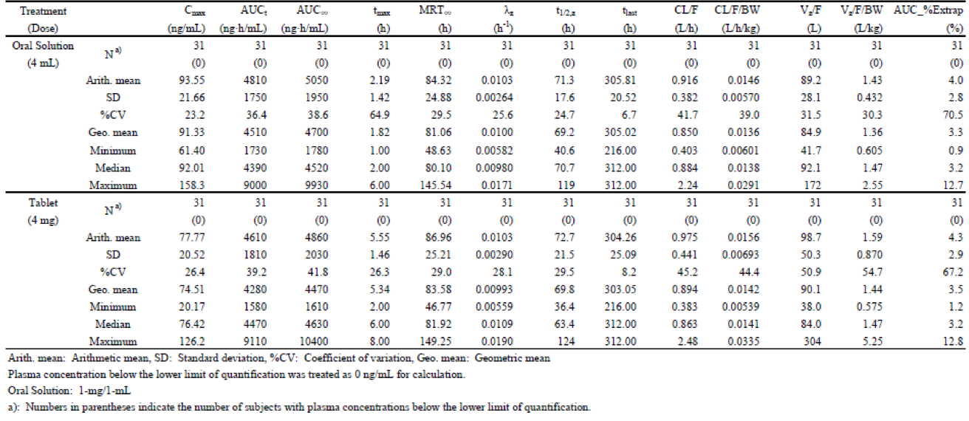

Table 18: Mean (SD) DM-3411 PK parameters following administration of 4 mL oral solution (1 mg/mL) and 4 mg tablets to healthy subjects
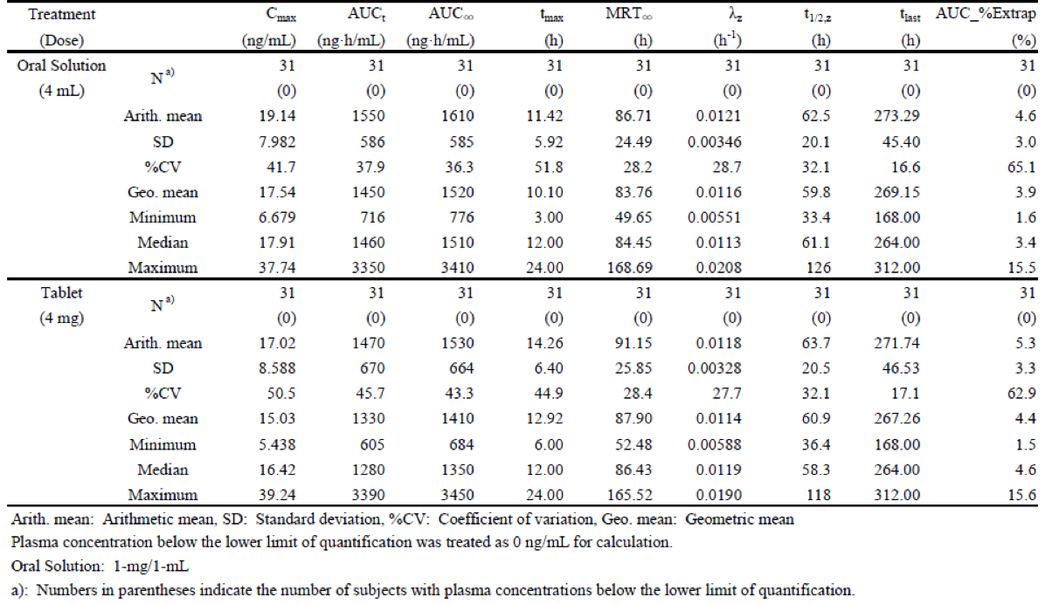
In the secondary analysis, all parameters except brexpiprazole time to maximum plasma concentration (T_{max}) were within the bioequivalence range. Brexpiprazole T_{max} was significantly earlier in the oral solution compared to tablet. These results suggest that absorption in the oral solution was faster than that in tablet, resulting in higher C_{max} values for the oral solution than for the tablet. Similar to the parent, DM-3411 C_{max} was not within the bioequivalence range and the T_{max} was significantly different (p < 0.05). All other parameters for DM-3411 were within the bioequivalence range.

Quality summary and conclusions
Whilst there are no objections to registration from a biopharmaceutics perspective, registration from a quality perspective can only be recommended subject to satisfactory qualification of the limit applied to one impurity (as indicated by the toxicology evaluator), to the appearance in the Manufacturers Information System (MIS) Repository of satisfactory current evidence of GMP for the manufacturing sites linked to the sponsor and appropriate for the nominated functions and to the ultimate acceptance by the Advisory Committee of Medicines (ACM) of the proposed trade name.

Addendum
Following clarification from the sponsor regarding the nomenclature applied to the impurity, the toxicology evaluator has subsequently advised that the impurity can now be considered qualified at the limit applied to other individual Impurities in the drug substance. This issue is therefore no longer an impediment to a recommendation of approval from a quality perspective.

III. Nonclinical findings

Overview
The sponsor has applied to register a new chemical entity, brexpiprazole (Rexulti), a serotonin-dopamine activity modulator, atypical antipsychotic for the treatment of adult (≥ 18 years) schizophrenia (maximum recommended human dose (MRHD) 4 mg/day orally once daily). Brexpiprazole use is based upon the dopamine hypothesis of schizophrenia. A high quality International Conference on Harmonisation (ICH) compliant nonclinical dossier was provided by the sponsor. However good animal models of schizophrenia, neuroleptic malignant syndrome, and tardive dyskinesia/tardive dystonia are unavailable, and the animal models used are poorly predictive of metabolic syndromes and diabetes mellitus.
Brexpiprazole pharmacologically resembles the related serotonin-dopamine activity modulator, aripiprazole, except for increased D₂ antagonism. Effects at 5-HT_{1A} (partial agonist), 5-HT_{2A} (antagonist), the noradrenaline alpha 1A subtype receptors (α_{1A}) (potent antagonist), α_{1B} (potent antagonist) and histamine type-1 receptors (H₁) (potent antagonist) are likely at clinical doses. The sponsor has claimed that α_{2A} and α_{2C} effects may also occur. Brexpiprazole induced non-dose related decreases (18 to 26%) in rat nucleus accumbens extracellular dopamine and increased dopamine metabolites in the nucleus accumbens and medial prefrontal cortex.
Based on nonclinical data, brexpiprazole may have a lower risk of akathisia and extrapyramidal symptoms compared with aripiprazole (catalepsy, ptosis and central nervous system (CNS) depression in rats). Other adverse pharmacological effects included: ptosis (decreased α adrenergic tone and CNS depression), scrotal flaccidity/dilatation and penile prolapse (decreased α adrenergic tone), decreased body temperature (D₂ and/or 5-HT_{1B} effects and CNS depression), decreased potassium human ether-a-go-go (hERG) channel currents in vitro, transient post-dose hypotension in dogs and lengthened corrected QT interval (QTc) in conscious dogs and monkeys. These effects generally occurred at high doses/concentrations compared with clinical exposure. Increased QTc correlated with hypothermia (a known cause). The risk of slowly activating potassium channel subtype (I_{Ks}) and cardiac voltage-dependent sodium channel subtype (Na_{v}1.5) effects on QTc were not specifically evaluated. Arrhythmia prone animal models were not used. Brexpiprazole is a possible breast cancer resistance protein (BCRP) inhibitor.
Brexpiprazole PK in animals resembled human kinetics. Brexpiprazole is protein bound (91.8 to 95.5%), displaces digitoxin and is melanophilic. In rats, hypothermia increased the brexpiprazole CNS: plasma ratio by ≥ approximately 2.7 times (correlated with neurotoxicity). Drug associated radioactivity distributed evenly across CNS grey matter with low levels in white matter and oligodendrocytes. Radioactivity had transplacental (fetus: blood 1:1) and transmammary (blood: milk by 1 to 1.7 times) distribution. The major catabolic pathways were cytochrome P450 (CYP) isozymes CYP3A4/CYP2D6-mediated sulfoxidation to DM-3411 (major circulating metabolite) and CYP2D6-mediated hydroxylation to DM-3412. Excretion in rats was largely fecobiliary with extensive (approximately 37%) metabolite enterohepatic cycling.
In rats, acute toxicity was characterised by central nervous system (CNS) depression, catalepsy, hypoactivity, hypothermia (often severe), decreased food consumption, decreased body weight and decreased α-adrenergic tone); in monkeys, by sopor and abnormal postures. Toxicity was slowly reversible in survivors. Hypothermia was associated with a non-progressive diffuse demyelinating spongiform polioleukoencephalopathy with oligodendrocyte necrosis, Purkinje cell necrosis, central neuronal chromatolysis and testicular lesions in rats (mostly preventable by preventing hypothermia; except some testicular lesions).
Excessive mortality (hypothermia not controlled) occurred during the early, pre-adaptation dosing phases of the repeat dose studies. CNS lesions occurred in dead/moribund rats and monkeys. Acute brexpiprazole toxicity often occurred at the T_{max} and mostly resolved with drug adaptation. Persistent decreased food consumption and decreased body weight were noted in some studies. Stereotypy (5 x maximum recommended human dose (MRHD), area under the plasma concentration versus time curve (AUC)), post-dose (2 to 24 hours) hypotension (≥ approximately 1 x MRHD) and increased QT/QTc interval (≥ approximately 3 x MRHD) were noted in monkeys. D₂ antagonist disruption of hypothalamic pituitary gonad/reproductive tract axes and mammary glands was present in rats and mice (supersensitive models in contrast to humans). Chronic treatment of rats was associated with an increased incidence of retinal atrophy (correlated with increased survival rates). Although the incidence was within the upper range of historical control data, this effect has also been reported for aripiprazole. The available rat data regarding the risk of retinopathy are inconclusive.
Brexpiprazole was mutagenic in mammalian cells only at cytotoxic concentrations +S9 in vitro, and not in bacterial or higher tier in vivo assays. Overall there is a low risk of genotoxicity. Typical D₂ antagonist-associated mammary gland lobular hyperplasia, mammary gland carcinogenesis and pituitary pars distalis adenomas occurred in females, but not male mice at subclinical exposures. Neoplasia did not occur in rats. D₂ antagonist neoplasia is a long standing clinical concern (particularly breast cancer) in this drug class and rodents are supersensitive to these effects in contrast to humans. Brexpiprazole may have a slightly less favourable profile compared with aripiprazole in relation to these effects, given its relatively increased D₂ antagonism.
Brexpiprazole prolonged dieostrus and decreased fertility in female rats at subclinical exposures, and at higher doses (4 x clinical exposure) prolonged mating and increased preimplantation loss. Despite the adverse effects in rat toxicology studies (testicular lesions at around 6 x clinical exposure; decreased sperm in epididymis at 37 x clinical exposure), brexpiprazole did not affect male rat reproductive performance at exposures up to 18 x clinical exposure. Despite maternotoxicity, brexpiprazole did not adversely affect embryofetal development in rats or rabbits at ≤ 4 x and ≤ 7 x clinical exposure respectively. In the rat pre-postnatal study, dosing of parental generation (F₀) dams at around 5 x clinical exposure was associated with increased stillbirths, increased postnatal deaths, decreased birth index and poor maternal nursing behaviour, and first filial generation (F₁) pups had decreased birth weight, decreased lactation day (LD) 4 viability index (live pups on LD 4/live born pups on LD 1), decreased body weight and delayed pinna unfolding (no observable adverse effect level exposure approximately that of clinical exposure). However, treatment of the F_{O} dams had no adverse effects on F₁ post-weaning development (excluding pinna unfolding) or function. Juvenile rat and dog studies were evaluated, although brexpiprazole is not proposed for humans < 18 years of age.
Brexpiprazole is not immunotoxic, is not a clinically relevant photosensitiser, has a low dependence/abuse potential based on animal studies, and has acceptable local tolerance.
The proposed limits for 4 impurities in the drug substance and 1 in the drug product were initially not been adequately qualified. The results of qualifying study reports have been cited in the sponsor’s response to TGA questions.

General comments
A high quality US FDA evaluation of the sponsor’s dossier is available. As an overarching generalisation, the nonclinical features of brexpiprazole resemble those of other members of the SDAM atypical antipsychotic drug class (for example, aripiprazole; developed by Otsuka, a partner with Lundbeck in the development of brexpiprazole) and most of the adverse nonclinical effects of brexpiprazole are due to its pharmacological actions.
In the USA, brexpiprazole is also used as an adjunctive therapy for major depressive disorder. This indication is not currently being sought in Australia. The related SDAM, aripiprazole, has also been used for the treatment of acute mania in bipolar disorders, control of irritability/hyperactivity/stereotypy in autism and as an add-on therapy for obsessive compulsive disorder. Again, none of these indications are currently being sought for brexpiprazole registration in Australia.
There are currently no existing animal models that replicate all the aspects of human schizophrenia. Various genetically modified rodent models based on risk alleles identified in genome-wide association studies are progressively becoming available and the prepulse inhibition of the acoustic startle response in rodents has been used as a marker for effects on information-processing deficits in neuropsychiatric disorders such as schizophrenia. Brexpiprazole has not been evaluated in these models. However, these models are unlikely to provide additional useful regulatory information. Overall, the primary pharmacological efficacy of brexpiprazole must be assessed on the basis of human clinical data.
Critically, the available animal models of neuroleptic malignant syndrome (reported with aripiprazole) and tardive dyskinesia/tardive dystonia (suspected with aripiprazole; causal relationship not established) are generally poorly predictive of these well-known, rare but severe, side effects of atypical antipsychotics. The animal models used in the nonclinical studies are also relatively poor predictors of metabolic syndromes and diabetes mellitus, all of which are important, well-known potential adverse effects of antipsychotic drugs (metabolic syndrome and/or diabetes mellitus prone animal strains were not used).

Genotoxicity
An ICH S2 (R1) compliant screening battery for brexpiprazole was supplied (in vitro bacterial reverse mutation assay conducted (± S9; plate incorporation method); in vitro mammalian cell Tk^{+/−} forward mutation assay (± S9); in vitro chromosome aberration test; in vivo chromosomal aberration test; in vivo hepatocyte unscheduled DNA synthesis test). Assay validity was confirmed by the use of positive and negative controls. The validity of the in vivo assays was supported by a toxicokinetics study of brexpiprazole and its metabolites (OPC-3952, SFO-34318, MOP-54522, DM-3404, DM-3411, DM-3412, and DM-3413 were quantifiable in both sexes, and OPC-54050 was quantifiable only in males).
Brexpiprazole was not mutagenic in the bacterial reverse mutation assay but was weakly mutagenic in the + S9 mammalian cell forward mutation assay (only at cytotoxic concentrations) and induced chromosomal aberrations in vitro in the presence of S9 (only at cytotoxic concentrations). Brexpiprazole was not genotoxic in the higher tier in vivo assays (did not induce micronuclei or unscheduled DNA synthesis in rats in vivo). There is no evidence that brexpiprazole or its metabolites are mitotic spindle or kinetochore agents.
Based on the results of the in vitro bacterial reverse mutation assay and the higher tier in vivo assays, brexpiprazole has a low potential for classical mutagenicity.

Carcinogenicity
Carcinogenic potential was assessed in near-lifetime studies in rats and mice. The studies were ICH compliant and experimentally appropriate.

Mice
Excessive premature mortality in the negative control males and in the low dose females resulted in early experimental termination (males at experiment Week 91 (90 weeks of dosing), females at experiment Week 99 (98 weeks of dosing)). No treatment related changes in the number of tumours or number of tumour bearers, and no treatment-related tumours, hyperplastic lesions, or non-neoplastic lesions were observed in males treated with brexpiprazole at exposures ≤ 5 mg/kg/day at around 4 x MRHD exposure (AUC comparison). Brexpiprazole induced hyperprolactinaemia associated neoplasia (consistent with the D₂ antagonist properties of brexpiprazole) was observed in the female mammary and pituitary.
Notably, elevated rates of mammary gland neoplasia occurred following dosing with brexpiprazole at ≥ 0.75 mg/kg/day at around 0.2 x MRHD (AUC comparison) as shown in Table 19, below.

Table 19: Treatment related tumours and hyperplastic lesions in female mice given brexpiprazole

Rats
Brexpiprazole dosing at up to 10 mg/kg/day at around 1 x MRHD (AUC comparison) in males and 30 mg/kg/day at around 6 x MRHD (AUC comparison) in females did not induce test article associated neoplasia or hyperplastic lesions. Consistent with its D₂ antagonist properties, treatment with brexpiprazole reduced the incidence of pituitary pars distalis adenomas. Brexpiprazole treatment was associated with an increased incidence of pars distalis focal hyperplasia in females, as shown in Table 20, below.

Table 20: Treatment related tumours and hyperplastic lesions in rats given brexpiprazole
Consistent with the findings of decreased pituitary neoplasia, brexpiprazole treatment was associated with increased survival rate (71.7% at 6 x MRHD contrasted with 35.0% in vehicle controls) in females. A trend towards increased survival rate (58.3% at 1 x MRHD contrasted with 48.3% in vehicle controls) was observed in males.

Human relevance of carcinogenicity findings
The traditional toxicological interpretation of hyperprolactinaemia-associated, non-genotoxic neoplasia in rodents (particularly mammary neoplasia) is that it is of lesser human relevance. However, recent human clinical case, epidemiological and cell biological evidence has demonstrated that hyperprolactinaemia is associated with an increase in breast cancer risk in both post and premenopausal women, and that rodent carcinogenicity studies are predictive of the human response. However the relative sensitivity of the rodent model compared with humans remains an issue of contention, with mice often being regarded as a supersensitive model.
The issue of D₂ antagonist antipsychotic-induced hyperprolactinaemia and neoplasia has been a long standing one in human clinical practice. The greatest concern has been with breast cancer where a relatively clear mode of action between hyperprolactinaemia and neoplasia exists. A lesser concern has been with prostate cancer where the mode of action relationship between prolactin and disease is less clear. Notably the related drug aripiprazole has a favourable profile relative to the currently available D₂ antagonist antipsychotics in terms of prolactin-related concerns. Brexpiprazole is likely somewhat more biased towards hyperprolactinaemia concerns due to its greater D₂ antagonist properties.
What can be noted is that brexpiprazole dosed at ≥ around 0.2 x MRHD was clearly associated with an approximate 3 x (compared to negative controls) to around 7 x (compared with vehicle only controls) increase in the incidence of mammary malignant adenocarcinoma, and a 4 to 5, to 6 to 8 x increase in the incidence of total mammary neoplasias in mice. Dosing at around 1 x MRHD was associated with up to a 15 x increased incidence of mammary adenosquamous carcinoma in mice.
Tempering these findings in mice is the lack of repeatability in the rat study (species is notably susceptible to prolactin-associated mammary gland carcinogenesis) and the fact that interpretation of mammary carcinogenesis in mice almost always complicated by the presence of either an exogenous mouse mammary tumour virus, or a less virulent endogenous provirus. The stem cells of the human and rodent mammary glands also have different responses to prolactin.,
Overall, the human risk assessment relevance of brexpiprazole-associated mouse mammary gland neoplasia remains uncertain. However, there is insufficient information to completely disregard the potential risk of hyperprolactinaemia-associated mammary neoplasia in humans.

Reproductive toxicity
An ICH-compliant package of reproduction/early development studies was supplied. Overall, adequate levels of exposure were achieved (Table 21).

Table 21: Relative exposure in pivotal reproductive toxicity studies
Species | Study | Dose (mg/kg/day) | AUC_{0–24 h} (ng∙h/mL) | Exposure ratio#
Rat (SD) | Fertility & early embryonic development (Report No. 020004) | 0.3 | ND | NC
Rat (SD) | Fertility & early embryonic development (Report No. 020004) | 3 | 690∴ | ≈0.2
Rat (SD) | Fertility & early embryonic development (Report No. 020004) | 30 | 13140∴ | ≈4
Rat (SD) | Male fertility (Report No. 020420) | 3 | 459∴ | ≈0.1
Rat (SD) | Male fertility (Report No. 020420) | 10 | 2878∴ | ≈1
Rat (SD) | Male fertility (Report No. 020420) | 100 | 58410∴ | ≈18
Rat (SD) | Embryofetal development (Report No. 019640) | 3 | 690∴ | ≈0.2
Rat (SD) | Embryofetal development (Report No. 019640) | 10 | 2292∴ | ≈1
Rat (SD) | Embryofetal development (Report No. 019640) | 30 | 13140∴ | ≈4
Rat (SD) | Pre-postnatal  (Report No. 023985) | 3 | 1140∵ | ≈0.4
Rat (SD) | Pre-postnatal  (Report No. 023985) | 10 | 2659∵ | ≈1
Rat (SD) | Pre-postnatal  (Report No. 023985) | 30 | 16390∵ | ≈5
Rabbit (NZW) | Embryofetal development  (Report No. 020175) | 10 | 11870∷ | ≈4
Rabbit (NZW) | Embryofetal development  (Report No. 020175) | 30 | 23220∷ | ≈7
Rabbit (NZW) | Embryofetal development  (Report No. 020175) | 150 | 65350∷ | ≈21
Human (Patients) | Steady state‡ | 4 mg/day | 3160‡ | –
# = animal:human plasma AUC_{0–24 h}. ‡ = Human AUC_{0-τ} = 3160 ng.h/mL based on pooled analysis at the MRHD from studies 331-08-205, 331-08-209, 331-09-221, 331-10-242 n=106; derived from Dossier. ND=no data; NC = not calculable; ∴ = on ED 85; ∵ = on ED 89; ∷ = on ED 18.

Female fertility and early embryonic development in rats
Toxicity in females resembled that described in the repeat dose toxicity studies (hypoactivity, ptosis, complete eyelid closure, lacrimation and loose stool at 30 mg/kg/day at around 4 x MRHD AUC comparison). Increased body weight and food consumption at ≥ 3 mg/kg/day at around 0.2 x MRHD (AUC comparisons) occurred in the pre-mating phase while slightly decreased bodyweight gain at 3 mg/kg/day at around 0.2 x MRHD (AUC comparison) and decreased food consumption and decreased body weight gain at 30 mg/kg/day at around 4 x MRHD (AUC comparison) occurred during early embryonic development.
Brexpiprazole dosing at ≥ 3 mg/kg/day at around 0.2 x MRHD (AUC comparison) resulted in prolonged dioestrus and decreased fertility (fertility index decreased around 10% compared to control). An approximate doubling of the mating phase occurred following dosing at 30 mg/kg/day at around 4 x MRHD (AUC comparison) and dosing at this level was associated with significantly (p < 0.05) increased preimplantation loss (increased around 6 x per litter compared with controls). The no observable adverse effect level (NOAEL) for maternotoxicity and female reproductive performance was 0.3 mg/kg/day around 0.7 x MRHD (body surface area comparison) and the NOAEL for early embryonic development was around 0.2 x MRHD (AUC comparison). The observed effects are consistent with hypogonadism and effects on the female reproductive tract secondary to D₂ antagonist disruption of the hypothalamic-pituitary-reproductive tract axis.

Male fertility
Brexpiprazole associated clinical signs were consistent with those previously discussed (dosing at 100 mg/kg/day at around 18 x MRHD (AUC comparison) associated with hypoactivity, hunchback position, closed eyes, ptosis, flaccidity and dilatation of scrotum, decreased food consumption and decreased body weight; NOAEL 10 mg/kg/day at around 1 x MRHD (AUC comparison)). Despite the effects of brexpiprazole on the male reproductive system observed in the toxicology studies (testicular lesions at around 6 x MRHD (AUC comparison); decreased sperm in epididymis at around 37 x MRHD (AUC comparisons)) dosing of male rats at ≤ around 18 x MRHD (AUC comparisons) for about 1 spermatic cycle (63 days), had no effect on male reproductive performance (NOAEL ≥ 100 mg/kg/day at around 18 x MRHD (AUC comparison)).

Embryofetal development

Rats
Based on the preliminary study, dosing of pregnant rats from GD7-17 with brexpiprazole at 100 mg/kg/day at around 227 x MRHD (body surface area comparison) was severely maternotoxic (death in 2/7 animals; moribund condition resulting in euthanasia 1/7 animals; minimal food consumption; decreased body weight and body weight gain). Severe clinical signs consistent with brexpiprazole toxicity occurred in dams dosed at 100 mg/kg/day at around 227 x MRHD (body surface area comparison). The brexpiprazole associated clinical signs (less severe and transient) were also observed at 10 mg/kg/day at around 23 x MHRH and 30 mg/kg/day at around 68 x MRHD (body surface area comparisons). In surviving dams dosed at 100 mg/kg/day at around 227 x MRHD (body surface area comparison) 3/4 animals had total litter loss. In the surviving single litter, decreased fetal weight was noted. No adverse effects were noted at doses ≤ 30 mg/kg/day at around 68 x MRHD (body surface area comparisons). Dosing at ≤ around 68 x MRHD (body surface area comparisons) was not associated with any effects on fetal viability or morphology (retarded ossification observed at 30 mg/kg/day at around 68 x MRHD (body surface area comparison)).
In the main study, brexpiprazole associated clinical signs were present in dams dosed at ≥ 10 mg/kg/day at around 1 x MRHD (AUC comparison; NOAEL at around 0.2 x MRHD). No adverse effects on fetal development were noted at maternal doses ≤ 30 mg/kg/day at around 4 x MRHD despite the clear presence of brexpiprazole induced maternotoxicity.

Rabbit
Based on the preliminary study, dosing of pregnant rabbits from GD6-18 with brexpiprazole at 100 mg/kg/day (> 500 to around 568 x) and 150 mg/kg/day (at around 850 x MRHD) (both body surface area comparisons) resulted in abortions (1/7 animals per group). Clinical signs consistent with those described in rats occurred in rabbits dosed at ≥ 30 mg/kg/day at around 170 x MRHD (body surface area comparisons) and decreased body weight secondary to decreased food consumption occurred following dosing at ≥ around 568 x MRHD (body surface area comparisons). Maternal dosing at around 850 x MRHD was associated with reduced fetal weights (consisted with decreased maternal food consumption and secondarily decreased maternal body weight). No effects on fetal growth, viability or morphology were noted with maternal dosing at ≤ around 568 x MRHD.
In the pivotal study, maternal dosing at 150 mg/kg/day, around 21 x MRHD (AUC comparison) was associated with mortality in pregnant and non-pregnant females (data from these animals were excluded from further evaluation). Following dosing at 150 mg/kg/day, around 21 x MRHD (AUC comparison; exceeded maximum tolerated dose parameters), 4/21 dams aborted and exhibited severe clinical signs that were consistent with brexpiprazole toxicity (emaciation, hypoactivity, lacrimation, miosis, closed eyes, incomplete eyelid closure, diarrhoea, loose stool, vaginal haemorrhage, evidence of gastric haemorrhages, severely decreased food consumption with secondary decreased body weight) before aborting. The clinical signs in surviving dams dosed at 150 mg/kg/day, around 21 x MRHD (AUC comparison) were also consistent with brexpiprazole toxicity. Overt maternotoxicity was noted following dosing at 30 mg/kg/day, around 7 x MRHD but not at 10 mg/kg/day, around 4 x MRHD (AUC comparisons).
Despite the presence of overt maternotoxicity in the higher dose groups, brexpiprazole treatment had no effect on fetal viability. Consistent with decreased food consumption/secondary decreased body weight and overt, severe maternotoxicity, decreased fetal weight and retarded ossification occurred following maternal dosing at 150 mg/kg/day 21 x MRHD (AUC comparison). No specifically brexpiprazole associated visceral or skeletal malformations were noted at any dose level despite the presence of severe, overt maternotoxicity in the high dose group. The NOAEL for embryofetal development and reproductive toxicity was 30 mg/kg/day, at around 7 x MRHD and the NOAEL for maternotoxicity was 10 mg/kg/day, around 4 x MRHD (AUC comparisons).

Pre-postnatal study in rats
Clinical signs, consistent with brexpiprazole toxicity occurred in F_{O} dams (hypoactivity, irregular respiration, ptosis at ≥ 10 mg/kg/day, around 1 x MRHD (AUC comparison); prone position, piloerection, decreased food consumption and decreased body weight during gestation and lactation at around 5 x MRHD (AUC comparisons)). Dosing of the F_{O} dams at 30 mg/kg/day at 5 x MRHD (AUC comparison) was associated with increased stillbirths, increased postnatal deaths, decreased birth index and evidence of poor maternal nursing behaviour (pups scattered about the cage, hypothermic pups, evidence of lack of suckling by the pups). Pups from F_{O} dams dosed at 30 mg/kg/day, around 5 x MRHD (AUC comparison) were decreased birth weight, decreased LD4 viability index, decreased body weight, and delayed pinna unfolding. However, brexpiprazole treatment of the F_{O} dams had no effect on weaning index, physical development (excluding pinna unfolding), early behaviour, sensory functions, open-field test, conditioned avoidance response, mating ability, fertility, or gross pathology of F₁ offspring or for early development of F₂ embryos. The NOAEL for F_{O} maternotoxicity was 3 mg/kg/day, around 0.4 x MRHD (AUC comparison) whereas the NOAEL for F_{O} maternal reproductive function (maintenance of pregnancy, delivery and nursing and F₁ development) was 10 mg/kg/day, around 1 x MRHD (AUC comparison).

Pregnancy classification
The sponsor has proposed Pregnancy Category C. This category is appropriate given the previous discussion on the effects of brexpiprazole on reproduction and subsequent neonatal development.²⁸

Nonclinical summary and conclusions
Overall, there is no nonclinical objection to approval.
The risk of sudden cardiac death due to torsades des pointes due to effects on I_{Ks} (KCNQ1-KCNE1) and Na_{v}1.5 (SCN5A) has not been specifically studied.
The proposed Pregnancy Category C is appropriate. The risk of transmammary exposure of children should be carefully weighed in relation to the benefits of treatment.
The nonclinical data imply that in cases of (severe) overdose, drug induced hypothermia should be adequately managed due to the possible risk of CNS damage.
Several impurities required additional toxicological qualification (see below).

Addendum
The second round nonclinical evaluation report noted that several impurities remained unqualified at the sought specifications. In particular, there was inadequate genotoxicity assessment of a number of impurities in the drug substance and 1 in the drug product.

IV. Clinical findings
A summary of the clinical findings is presented in this section. Further details of these clinical findings can be found in Attachment 2.

Introduction

Clinical rationale
While there are several currently marketed drugs for the treatment of schizophrenia, both efficacy and their side effect profiles limit their use in some patients and there remains an unmet need for further treatment options.
Amongst the atypical antipsychotics, aripiprazole was the first D₂ partial agonist to be approved for treatment of schizophrenia. Whilst it has a particularly favourable metabolic profile, it has been associated with high rates of activating side effects (such as akathisia and insomnia) particularly when used in higher or rapidly up titrated dose.
Brexpiprazole is thus described as being pharmacologically designed to address these liabilities by balancing activities on dopaminergic (D₂ partial agonist activity), serotonergic (potent 5-HT_{2A} antagonism and partial agonist activity at 5-HT_{1A}), and adrenergic (α_{1B} receptors antagonism) monoamine systems.

Contents of the clinical dossier
A total of 28 clinical pharmacology trials have been performed as part of the brexpiprazole oral tablet development program. There are 15 trials in healthy subjects, 2 trials in specific populations (renal impaired, hepatic impaired), 4 trials in subjects with schizophrenia, 2 trials in subjects with major depressive disorder (MDD), and 1 trial in subjects with attention deficit hyperactivity disorder (ADHD). 4 trials (3 trials with oral tablet and one trial with an oral solution formulation) have been conducted in an Asian country.

Paediatric data
1 safety, tolerability and PK trial is ongoing, in adolescents (13 to 17 years old) with schizophrenia or other related psychiatric disorders.

Good clinical practice
All trials appear to have been performed in a manner consistent with Good Clinical Practice (GCP).

Pharmacokinetics

Studies providing pharmacokinetic (PK) data
Table 22, shown below, gives an overview of the studies submitted that provided PK data for brexpiprazole.

Table 22: Submitted pharmacokinetic studies
PK topic | PK Subtopic | Study ID
PK in healthy adults | General PK - Single dose | 331-07-201ª Arm 1
PK in healthy adults | General PK - Multi dose | 331-08-206ª
PK in healthy adults | Absolute bioavailability | 331-10-241ª
PK in healthy adults | Bioavailability compared to oral solution | 331-10-005ª
PK in healthy adults | Bioequivalence † (Single dose) | 331-10-243^{b}
PK in healthy adults | Bioequivalence † (Single dose) | 331-10-245^{b}
PK in healthy adults | Bioequivalence † (Single dose) | 331-13-209^{b}
PK in healthy adults | Bioequivalence (Multi dose) | No studies
PK in healthy adults | Food effect | 331-10-246ª
PK in healthy adults | Food effect | 331-07-201ª Arm 3
PK in healthy adults | Mass balance study | 331-07-201ª Arm 2
PK in special populations | Target population § (Single dose/Multi dose) | 331-10-001^{c}
PK in special populations | Major depressive disorder | 331-09-221
PK in special populations | Major depressive disorder | 331-08-205^{c}
PK in special populations | Hepatic impairment | 331-09-225ª
PK in special populations | Renal impairment | 331-09-226ª
PK in special populations | Neonates/infants/children/adolescents | 331-10-233^{c}
PK in special populations | Elderly | 331-12-291ª
PK in special populations | Elderly | 331-10-244ª
PK in special populations | Other special populations: Japanese males | 331-07-002ª
PK in special populations | Other special populations: Korean males | 331-KOA-0701ª
Genetic/gender related PK | Males versus females | 331-10-224
Genetic/gender related PK | CYP2D6 genotypes | 331-12-208
PK interactions | Ketoconazole, ticlopidine, quinidine, lovastatin, bupropion, fexofenadine | 331-08-207ª
PK interactions | Ketoconazole, ticlopidine, quinidine | 331-08-208ª
PK interactions | Rifampin | 331-09-224ª
PK interactions | Activated charcoal/sorbitol | 331-10-239ª
PK interactions | Omeprazole | 331-10-240ª
PK interactions | Rosuvastatin (Breast Cancer Resistance Protein (BCRP) Efflux Transporter) | 331-12-207ª
Population PK analyses | Mixed population (Healthy subjects and schizophrenia) | 331-12-208ª
Population PK analyses | Target population (exposure response) | 331-13-210ª
Population PK analyses | Schizophrenia (validation of population PK) | 331-15-214ª
Superscript following Study ID signify the following: a) indicates the primary PK aim of the study; b) bioequivalence of different formulations; c) subjects who would be eligible to receive the drug if approved for the proposed indication; * indicates ongoing study.

Evaluator’s conclusions on pharmacokinetics
A broad set of PK studies have been conducted by the sponsor. These have adequately addressed the major PK issues to inform the proposed clinical use of the medication.
Some minor issues were not addressed in the studies submitted. For example, there were no studies addressing potential drug-drug interactions with mood stabilisers. While the application relates to schizophrenia, brexpiprazole might be used for the treatment of schizoaffective disorder, while it seems likely that brexpiprazole may be used in bipolar disorder to treat acute psychotic relapses. Thus, either a clinical study or an in vitro investigation would seem to be warranted. Generally, the in vitro studies have been predictive of the in vivo findings with brexpiprazole. Some studies were conducted in specific Asian populations but there was no post hoc comparisons with the data obtained from Caucasian and Black populations in the comparable single dose studies. While race did not appear as a significant covariate in the population PK analysis, a post hoc comparison could reinforce the findings from the population PK analysis. The pre-clinical findings indicated that brexpiprazole seemed to accumulate in the eye as well as having an affinity for melanin. While the difficulty of studying such an effect in human populations is appreciated this potential effect did not appear to have been taken into account in the PK trials. For example, were any fundoscopic examinations conducted and what were the results of these? Given the propensity for some other antipsychotics (mainly phenothiazines) to cause retinal pigmentation and their affinity for melanin it would seem that this effect needs to be addressed in the longer term clinical trials (if it has not already been done). Information on this effect with aripiprazole (a closely related compound) might be informative. The issue is not mentioned in the Product Information (PI) or Consumer Medicines Information (CMI).
The PK information in both the PI and CMI satisfactorily represents the information from the studies conducted. There evaluator recommended some changes [outside the scope of this document].

Pharmacodynamics

Studies providing pharmacodynamic data
Table 23, shown below, provides an overview of the submitted studies providing pharmacodynamic (PD) data.

Table 23: Submitted pharmacodynamic studies
PD Topic | Subtopic | Study ID
Primary pharmacology | PET study healthy subjects | 331-07-202
Primary pharmacology | PET study schizophrenia | 331-09-219
Secondary pharmacology | Thorough QTc study | 331-10-242
Secondary pharmacology | Sleep polysomnography | 331-08-209
Gender, other genetic and age related. Differences in PD response | Effect of gender
 | Effect of genetic characteristic
 | Effect of age
PD Interactions | No studies
PD Interactions | Drug B
PD Interactions | Drug C
Population PD and PK-PD analyses | Target population (exposure response) | 331-13-210
Note: All subtopics were the primary PD aim for each listed study.

Evaluator’s conclusions on pharmacodynamics
The PD studies focused on 3 primary areas: receptor occupancy determined by 2 positron emission tomography (PET) studies, the effect on QTc interval and the effect on sleep.
The QTc study suggested a lack of significant clinical effects of brexpiprazole even at doses (12 mg) about 3 times higher than the recommended daily dose. As this study was conducted in the intended patient population it provides reassurance, along with electrocardiogram (ECG) data from the PK studies, that the drug is unlikely to affect the electrical conductivity of the heart. Plasma concentrations of the drug were not related to ECG findings. This does not preclude effects as a result of an overdose of the medication.
A study in healthy volunteers suggested that doses to be used in clinical studies are likely to provide adequate receptor occupancy (> 80%) of the D₂/D₃ receptors to be effective in schizophrenia. Furthermore, this study demonstrated that receptor occupancy was dose dependent. The second PET study, conducted in patients with schizophrenia, assessed the occupancy of other receptors thought to be relevant to the drug action. Occupancy of D₂ receptors was somewhat less than the healthy volunteer study at the dose employed (4 mg) but suggests that brexpiprazole repeated dosing is likely to provide sufficient receptor occupancy for therapeutic effects. The 5-HT_{2A} receptors were occupied to a smaller extent than D₂ receptors. This may be relevant to a lower potential to cause extrapyramidal side effects and tardive dyskinesia, as is seen with other antipsychotics demonstrating a similar binding profile. At the doses used there was negligible occupancy of 5-HT_{1A} and serotonin transporter. The relevance of the partial agonist effects at 5-HT_{1A} receptors identified by in vitro studies to the drug’s mechanism of action is therefore dubious.
Plasma concentrations of brexpiprazole were not related to clinical outcome measures using a maximal effect attributable to a drug (E_{max}) modelling approach. A therapeutic drug concentration window has not been established. Plasma concentrations to achieve 50% maximum obtainable receptor occupancy in caudate and putamen were established in the healthy volunteer PET study. These concentrations are achieved in repeated dosing studies with recommended doses.
The sleep study compared the effects of 4 mg brexpiprazole with 20 mg aripiprazole in patients with schizophrenia. There was no difference between the drugs with respect to subjective or objective, polysomnographic recordings, sleep parameters. It is not clear what the relevance of this study was to the overall clinical use of the drug. A summary of significant changes induced by brexpiprazole from Baseline in sleep stages and subjective measures of sleep may have more relevance to clinical usage.
The submission did not contain any studies examining the effect of acute or repeated doses on psychomotor/cognitive performance or the effect of alcohol combined with brexpiprazole on these parameters. While it can be appreciated that this is a sedative agent and that decrements in performance are likely to occur, clinical studies can usefully examine the domains in which such decrements are likely to occur.
Some of the issues raised here are no doubt addressed in the clinical efficacy studies which are more relevant to use in the intended patient population.

Dosage selection for the pivotal studies

Studies providing dose finding data for the pivotal studies
The specific doses of brexpiprazole selected for investigation in Phase III were based on the results from a PET trial in healthy subjects (Study 331-07-202) and the Phase II trial in adults with schizophrenia (Study 331-07-203).
Results from the PET trial in healthy subjects predicted steady state D₂ receptor occupancies of at least 80% to 90% at brexpiprazole doses of 1 to 2 mg/day and higher (79.3% predicted occupancy at brexpiprazole 1 mg, 88.8% at brexpiprazole 2 mg, and 95.1% at brexpiprazole 4 mg).

Evaluator’s conclusions on dose selection for the pivotal studies
Based on the available pharmacodynamic data the dose finding process for the pivotal studies appears appropriate. The methodology used in this process represents the best currently available, despite the obvious questions related to the lack of clarity in the relationship between specific receptor occupancy and antipsychotic efficacy.

Efficacy

Studies providing efficacy data
3 pivotal studies examining the use of brexpiprazole in schizophrenia were identified:
- Study 14644A was a randomised, double blind, parallel group, placebo controlled, active reference, flexible dose study of brexpiprazole in patients with acute schizophrenia.
- Study 331-10-232 was a Phase III, multicentre, randomised, double blind, placebo controlled trial to evaluate the efficacy, safety, and tolerability of brexpiprazole (OPC-34712) as maintenance treatment in adults with schizophrenia.
- Study 331-10-203 was a Phase II, 6 week, multicentre, randomised, double blind, placebo controlled study to evaluate the efficacy, safety, and tolerability of oral OPC-34712 once daily and aripiprazole once daily for treatment of hospitalised adult patients with acute schizophrenia.
In addition, data from 2 other Phase III studies (Study 331-10-230 and Study 331-10-231) were evaluated.

Evaluator’s conclusions on efficacy
From the evidence available, there are some good quality data available from randomised controlled studies evaluating the efficacy, side effects and tolerability of brexpiprazole compared with placebo and within 2 trials comparing brexpiprazole with aripiprazole and quetiapine respectively.
All but 1 of the randomised control trials (RCT) were of short duration and conducted within 6 weeks. The only longer term study was conducted over 52 weeks and included an evaluation of relapse rates and time to discontinuation rates of brexpiprazole at various doses versus placebo.

Limitations
These are short terms trials, mostly conducted in acute inpatient setting where the patient was able to provide consent. Despite these being short term trials, the dropout rates, although not very different from other intervention or placebo groups, were around the 30% mark which is a bit high. There are some methodological limitations as outlined in the individual study risk of bias tables, especially in relation to allocation concealment, testing blinding and accounting for missing data using observed case (OC) and last observation carried forward (LOCF) measures. Thus, the overall results need to be interpreted with caution.

Overall comments
A positive attribute amongst these trials is to note that ≥ 30% reduction in Positive and Negative Syndrome Scale (PANSS) score was noted as a criterion for improvement which is an improvement over trials in this nature historically which defined ≥ 20% as improvement. The authors have been able to demonstrate improvement versus placebo on this measure. It is interesting to note that there have been significant response rates to placebos throughout these trials. The reasons for this should be explored further. The dose ranges studied seemed to be appropriate and the dose of 0.25 mg clearly comes across as sub-therapeutic. The majority of the optimal efficacy appears to occur in the 4 mg a day dose range although the lower dose ranges have been effective. Brexpiprazole seems to work better than placebo in reducing PANSS scores most of the time, however only in the higher dose range and it was not much different to quetiapine or aripiprazole.
[information redacted]

Safety

Studies providing safety data
The same 3 studies evaluating the efficacy of brexpiprazole in the treatment of schizophrenia were identified by the evaluator as pivotal. These were: Study 14644A, Study 331-10-232 and Study 331-07-203.
Data from 2 other Phase III efficacy studies (Study ID 331-10-230 and Study ID 331-10-231) were also evaluated.
Within the safety data set, several open label trials of brexpiprazole in schizophrenia were also identified. These were: Trial 331-08-210 (completed Phase II study), Trial 331-10-237 (ongoing Phase III study), and Trial 14644B (ongoing Phase III study).
Taken together, the pivotal, additional completed efficacy studies and open label studies were pooled in the submission as the ‘schizophrenia trials’ and this data was mainly utilised by the evaluator as the most relevant data set to the requested indication.
In addition, the following studies were identifiable as part of the dose finding and pharmacology development of the molecule that provided evaluable safety data:
- Study 331-07-201: Arm 1; Healthy subjects; single rising dose, safety, tolerability, and PK; brexpiprazole dose 0.2, 0.5, 1, 2, 4, 6 and 8 mg.
- Study 331-08-206: Healthy subjects; multiple rising dose safety, tolerability, and PK; brexpiprazole dose 0.5, 1, 2 and 3 mg.
- Study 331-08-205; Subjects with Schizophrenia; Multiple rising dose safety, tolerability, and PK; brexpiprazole dose 1, 2, 4, 6, 8, 10 and 12 mg.
- Study 331-09-221: Subjects with MDD; Multiple dose safety, tolerability, and PK; brexpiprazole dose 1.5, 2, 3 and 4 mg.
- Study 331-09-220: Subjects with ADHD; Multiple dose safety, tolerability, and PK; brexpiprazole dose 3 and 4 mg.
- Study 331-12-291: Subjects with MDD; Multiple dose safety, tolerability, and PK in elderly; brexpiprazole dose 2 mg
- Study 3331-09-226: Healthy subjects; Effect of severe renal impairment; brexpiprazole dose 3 mg.
- Study 331-10-244: Healthy Subjects; Effect of age and gender on brexpiprazole; brexpiprazole dose 2 mg.

Patient exposure
As of 15 May 2015 (data cut-off date), the number of subjects with schizophrenia who have been exposed to 1 dose of brexpiprazole was 1406 in the short term controlled trials, 97 in the long term controlled trial and 1265 in the long term open label trials. In the long term, open label trials, 604 subjects were exposed to brexpiprazole for 26 weeks (6 months) and 372 subjects for 52 weeks (1 year) from long term Baseline, not including possible exposure in the parent trial. Exposure is shown in Table 24, below,

Table 24: Exposure to brexpiprazole and comparators in clinical studies in schizophrenia
Study type/ indication | Controlled studies |  |  |  | Uncontrolled studies | Total brex
Study type/ indication | Brex | Placebo | Quetiapine | Aripiprazole | Brex | Total brex
Schizophrenia
Short term, controlled | 1406 | 624 | 154 | 50 |  | 1406
Long term | 97 | 104 |  |  |  | 97
Open label |  |  |  |  | 1265 | 1265
Total: | 1503 | 728 | 154 | 50 | 1265 | 2768
Looking at duration of exposure from the long term and open trials, a total of 681 subjects with schizophrenia had exposure longer than 6 months, and 413 longer than 12 months. The mean dose of brexpiprazole exposure was 2.4 (± 1.3), 3.6 (± 0.7), and 3.1 (± 0.8) mg in the short term controlled, long term controlled and open label studies respectively.
In the 4 short term controlled trials, the mean duration of treatment was slightly shorter at sites in North America (31.7 days) compared with sites in Europe (35.7 days), Asia, (35.0 days) and Latin America (39.3 days). The mean duration of treatment was similar across treatment groups for the different age groups, genders and race groups.
Measuring exposure to controlled treatment in the single long term controlled study is made slightly more complex by the nature of the design. It is however noteworthy that only 77 subjects with schizophrenia have had more than 6 months exposure to brexpiprazole in a controlled trial. This number could reasonably be considered at the lower end of the range for safety evaluation. This point is counterbalanced by the relatively large amount of longer term exposure in the open label studies. The mean duration of exposure to brexpiprazole was 197.1 days in the long term, open label trials group. Of the 1265 subjects with schizophrenia exposed to brexpiprazole in the long term, open label trials, 604 subjects (47.7%) were exposed to ≥ 26 weeks of treatment and 372 subjects (29.4%) were exposed to ≥ 52 weeks of treatment. The overall level of exposure to the compound in subjects with schizophrenia could thus be considered adequate for safety evaluation.
Although containing subjects with other indications including MDD and post-traumatic stress disorder (PTSD), the broader ‘All brexpiprazole trials group’ contained, as of the data cut-off date of 15 May 2015, 5636 subjects who had been exposed to at least 1 dose of brexpiprazole across the Phase II/III trials for schizophrenia, MDD and ADHD. Overall, 1504 subjects (26.7%) have been exposed to brexpiprazole for 52 weeks. Overall, 2048 subjects were exposed to 1 mg (< 1.5 mg) brexpiprazole across indications (schizophrenia, MDD, ADHD). The majority of subjects (n = 3501) were exposed to brexpiprazole within the proposed therapeutic dose range (2 to 4 mg/day); 1619 subjects were exposed to 2 mg (1.5 to < 2.5 mg) doses, 1158 subjects were exposed to 3 mg (2.5 to < 3.5 mg) doses, and 724 subjects were exposed to 4 mg (3.5 to 4.5 mg) doses of brexpiprazole. A total of 87 subjects received doses of brexpiprazole > 4 mg (> 4.5 mg). This therefore constituted an important supplementary set of exposure and safety data.

Safety issues with the potential for major regulatory impact
A detailed analysis of the safety issues with the potential for major regulatory impact is available in Attachment 2.
Attachment 2 addresses a number of broad safety parameters including liver function; renal function; other clinical chemistry including electrolytes, plasma proteins, haematology and coagulation parameters; vital signs; electrocardiograph findings and cardiovascular safety; and immunogenicity and immunological events.
In addition, a number of issues were identified as having potential relevance related to atypical antipsychotics. These included changes in creatine kinase, rhabdomyolysis, prolactin related side effects, neuroleptic malignant syndrome, and extrapyramidal symptoms. The following safety issues were specifically referred to as being potentially clinically relevant:
- Increased creatine kinase: although uncommon, lack a current clear explanation and may require further evaluation. The views of the sponsor should be sought, although it is noteworthy that frank NMS was not reported.
- Changes in bodyweight: There were discrepancies between the findings in longer term trials leaves some reservation about the scale of any potential weight gain with brexpiprazole, although the level of weight gain seen in the longer term uncontrolled studies was only a mean of 2.2 kg. Of note, a time analysis suggested the majority of this weight gain occurred in the first 6 months of therapy. When looked at in term of clinically significant weight gain, this discrepancy becomes a bit more obvious. The percentage of subjects who had a weight increase that met the potentially clinically relevant criterion (increase of ≥ 7% in body weight) in the long term open label trials (18.0%) was higher than that in the short term and long term controlled trials (9.8% and 5.2%, respectively, of subjects in the all brexpiprazole group).

Postmarketing data
The dossier did not contain any specific information on post-marketing experience, noting that the brexpiprazole has thus far only been made available in the USA. An update could be sought from the sponsors.

Evaluator’s conclusions on safety
Overall the dossier demonstrates an appropriate level of information on clinical safety, evaluated utilising adequate and contemporary methodology. The overall exposure to the compound in the population with the requested indication of schizophrenia is adequate with the caveat that the longer term exposure (particularly ≥ 6 months) in the controlled trials is somewhat limited. This is offset by the availability of data from a number of longer term, open label trials in schizophrenia.
The most likely impact of this relative weakness in the dataset in terms of safety is the evaluation of safety issues more likely to become relevant with long term exposure. Of these, the most likely relevant is the metabolic issues which are in general 1 of the major safety concerns with this class. Indeed, there does appear to be some conflict between the weight gain and metabolic parameter data between the longer term controlled data and the open label data, with the latter suggesting a small metabolic signal whereas the former suggest essentially none. Any concern in this area could be added to by the clearly higher rates of weight gain in particular seen in the adult MDD trials. This does need to be interpreted with some caution however: this is not the requested indication, rates of weight gain seen in affective disordered patients are higher with most atypical antipsychotics trialled in such populations than in those with schizophrenia and even the strongest interpretation of the available data does not suggest this brexpiprazole has a concerning metabolic signal relative to the worst agents in the atypical class. The reviewer noted the occurrence of 1 case of diabetic ketoacidosis in the available dataset that was judges as potentially related to the brexpiprazole, although after reviewing the available information, this level of attribution does appear reasonable and the single case not sufficient to warrant further concern at this time. Indeed, it would have been surprising had that been found given its close chemical relationship to aripiprazole, clearly one of the metabolically safest of the atypical antipsychotics.
Within the treatment emergent adverse event (TEAE) data the presence of akathisia as an early treatment phase issue is relatively clear, and this is supported by the formal measurement. Again, given the relatively high frequency of this issue with the related compound aripiprazole, this is not surprising and indeed consistent with the suggested receptor profile. Overall the rates of akathisia as a serious TEAE are not particularly high, and rates of discontinuation due to akathisia also not particularly high. This could be seen to suggest that the dose titration regime recommended in the PI and utilised in many but not all of the trials is appropriate and probably reduces this rate. Although not a direct criterion for evaluation, an underestimation of the impact of early treatment akathisia and an aggressive initial titration recommendation with aripiprazole had a significant impact on the utilisation of that compound, despite the very important long term value of its metabolic safety.
The presence of a small signal with events of rhabdomyolysis and/or elevation of creatine kinase suggest that the compound is capable of inducing neuromuscular reactions that could be considered part of the full spectrum of neuroleptic toxicity, even in the absence of any confirmed cases of full blown neuroleptic malignant syndrome (NMS). This is entirely consistent with the receptor binding profile of the compound and the available safety and post marketing data with other compounds within class that have a similar binding profile and the overall rate is low. It would be of some value never the less to request an update from the sponsor about all post marketing experience in the USA and particularly ask if there is any further signal in this area.
Other aspects of note include what appears to be a very low level of electrocardiographic impact and pleasingly low levels of prolactin elevation with this compound. Elevations of hepatic enzymes overall appear low, despite the presence of 3 discontinuations of brexpiprazole due to such irregularities in the short term trials and the evaluator does not think they constitute sufficient reason to recommend further monitoring.
Given this overall positive interpretation of the safety data, it is also worth reiterating the obvious fact that the available safety data in schizophrenia is almost entirely in adults and conclusions about safety in children and adolescents and the elderly with schizophrenia cannot be drawn.

First round benefit-risk assessment

First round assessment of benefits
The first round assessment of benefits, and strengths and uncertainties related to the data, is shown below in Table 25.

Table 25: First round assessment of benefits and strengths and uncertainties of data
Benefits | Strengths and uncertainties
Schizophrenia is an uncommon but not rare disease effecting 1% of the population. Currently available treatments are somewhat effective, with most sharing a similar rate of improvement in positive symptoms of illness but modest impact on negative and cognitive symptoms. Any new treatment should at least share this efficacy, noting that the predictive capacity to identify which individual agent will benefit which patient is currently limited.  Rates of relapse in schizophrenia are high, presumably partly reflective of the neurobiology of the disease, risk factors such as substance abuse but also poor adherence to otherwise effective antipsychotic therapy. New therapies should thus be not just acutely effective (the usual basis for judgement) but show evidence of relapse prevention and the capacity through good tolerability to potentially contribute to improving adherence. With increasing evidence of the reduced life expectancy in patients with schizophrenia (approximately 15 to 20 years in Australia) that is predominantly due to metabolic diseases, new agents should also show a strong profile in this area. | Brexpiprazole has been demonstrated to show appropriate levels of efficacy in a number of acute trials in schizophrenia. The trials are of a standard design, apart from the setting of a 30% improvement in PANSS scores as being indicative of response, arguably a tougher test than is sometimes used. These positive findings come despite a relatively high placebo response rate in some of the trials.  The controlled, longer term data is also supportive of efficacy and although only 1 long term controlled study is available, such data is difficult to obtain.  Brexpiprazole also appears to have a relatively favourable safety profile, with expected rates of akathisia which led to few withdrawals when using the standard titration regime.  Its metabolic profile also appears generally favourable, although not completely clean certainly amongst those atypical antipsychotics with a more favourable profile.

First round assessment of risks
The first round assessment of risks, and strengths and uncertainties related to the data, is shown below in Table 26.

Table 26: First round assessment of risks, and strengths and uncertainties of data
Risks | Strengths and uncertainties
Central to treatment risk in this population is the often acute nature of presentation which may frequently involve polypharmacy, rapid dose escalation in individuals with schizophrenia and multiple comorbidities. The risks of overdose are real with any pharmacotherapy in this setting.  The other longer term risk with the atypical antipsychotics is the underestimation of the level of metabolic risk due to the relatively short term nature of pre-release data for a condition that will often involve very long term therapy. | The available dataset with brexpiprazole shares the usual weaknesses and strengths in this regard.  There is little data on comorbid populations currently available.  One of the particular risks that may occur with this compound will be more rapid dose escalation than recommended in the PI, particularly given the relatively low level of sedation seen with the compound. This is highly likely to produce higher rates of akathisia and intolerability and ultimately this may limit the acute utility of the drug.  The uncertainty around the level of metabolic impact when comparing the 2 forms of longer term data available (controlled or open) does leave some room for uncertainty about the exact level of concern regarding metabolic impact.

First round assessment of benefit-risk balance
On the above basis, the dossier contains evidence that indicates brexpiprazole has an adequate risk benefit ration that is comparable to that of other currently available atypical antipsychotics. Importantly, the probably quite favourable metabolic profile is desirable as the emphasis on better long term physical health in individuals with schizophrenia is increasingly reflected in contemporary guidelines where agents such as olanzapine are now considered second line therapy.

First round recommendation regarding authorisation
The recommendation of the evaluator is to authorise brexpiprazole for the indication of schizophrenia.

Clinical questions and second round evaluation of clinical data submitted in response to questions
For details of the clinical questions, sponsor’s responses and the evaluation of these responses, please see Attachment 2.

Second round benefit-risk assessment

Second round assessment of benefits
After consideration of the responses to clinical questions, the benefits of brexpiprazole in the proposed usage are unchanged from those identified above.

Second round assessment of risks
After consideration of the responses to clinical questions, the risks of brexpiprazole in schizophrenia are largely unchanged from those identified previously, with the exception of the concerns stated in relation to the risk of the akathisia. Based on the interpretation of the previously outlined data contained in the applicant’s response (see clinical question 8, in Attachment 2) this risk is considered of lower concern.

Second round assessment of benefit-risk balance
The benefit-risk balance of brexpiprazole, given the proposed usage, is favourable.

Second round recommendation regarding authorisation
Approval of brexpiprazole is recommended for adult patients with schizophrenia.

V. Pharmacovigilance findings

Risk management plan
The sponsor submitted a Risk Management Plan (RMP) version 1.0 (dated 4 March 2016; data lock point (DLP) 15 May 2015) and an Australian Specific Annex (ASA) version 1.0 (dated March 2016) in support of this application. Revised RMP documents were not submitted with the sponsor’s response to TGA questions.

Safety specification
The sponsor has proposed the following summary of safety concerns shown in Table 27.

Table 27: Sponsor’s summary of safety concerns
Summary of safety concerns
Important identified risks | Extrapyramidal Symptoms (EPS)
Important potential risks | Seizure
Important potential risks | Suicidality
Important potential risks | Dyslipidaemia
Missing information | Use in Pregnancy and lactation
Missing information | Use in paediatrics
Missing information | Use in elderly (age > 65)
Missing information | Use in patients with hepatic impairment
Missing information | Psychiatric comorbidities: include generalised anxiety disorder, panic disorder, obsessive compulsive disorder (OCD) and social phobia
Missing information | Patients with chronic medical illnesses (clinically significant or uncontrolled medical illnesses)
Missing information | Substance abuse
Missing information | Insulin dependent diabetes mellitus (IDDM)

Pharmacovigilance plan
Routine pharmacovigilance proposed. There are no proposed or ongoing additional pharmacovigilance activities.

Risk minimisation activities
Routine risk minimisation proposed. There are no proposed or ongoing additional risk minimisation activities.

Reconciliation of issues outlined in the RMP report
Table 28, below, summarises the RMP evaluator’s first round evaluation of the RMP, the sponsor’s responses to issues raised, and the evaluation of the sponsor’s responses.

Table 28: Reconciliation of first round recommendations
Reconciliation of first round recommendations
Recommendation 1. Any safety concerns identified by the clinical or nonclinical evaluators that impact on the safety specifications should be addressed in a revised RMP.
Sponsor’s response: The sponsor will ensure that the revised RMP properly addresses all changes made to the safety specifications.
RMP evaluator comment: The second round clinical and nonclinical evaluation reports should be referred to.
Recommendation 2. The following safety concerns should be added with consideration then given to the need for appropriate pharmacovigilance and risk minimisation measures.
Sponsor’s response: Please refer to the sponsor’s response document.
RMP Evaluator comment: Recommended changes to the summary of safety concerns agreed to by the sponsor […] are not discussed in this reconciliation. The sponsor has added 7 important potential risks, reclassified one important potential risk as an important identified risk, and included tardive dyskinesia within the important identified risk: EPS.
The sponsor has objected to the remaining changes recommended to be made to the safety concerns and has provided acceptable justifications which have been reconciled below:
Pregnancy and lactation (resolved): The sponsor asserts that altering the safety specification to promote the missing information category to an important potential risk will not provide any additional value in terms of risk minimisation and therefore proposes to maintain this as missing information, as for other drugs in the class (Abilify, Maintena, Latuda). In the clinical development program 16 pregnancies were reported, with outcomes for 12: 3 spontaneous abortions, 2 elective terminations and 7 live births without evidence of teratogenicity. The RMP evaluator agrees that no change in the risk minimisation advice regarding pregnancy exposure is needed; specifically, the PI statements on animal study reproductive toxicity, known class effects on neonatal outcomes and the pregnancy category are considered adequate in the context of the RMP evaluation for risks in pregnancy. The risk of exposure in breast milk resulting in hyperprolactinaemia is discussed [not included here]. The missing information category for ‘use in pregnancy and lactation’ and product information statement on breast feeding are considered acceptable monitoring and mitigation for this risk.
Suicidality (resolved): The sponsor differentiates between the risk of suicidality with the use of antipsychotics in the treatment of depression and schizophrenia. The stated frequency of suicidality TEAE related to brexpiprazole was low and similar to placebo groups in the schizophrenia trials. The precaution and warning statements in the draft PI and CMI are adequate. Considering the above, the sponsor’s response is acceptable.
QTc Prolongation (resolved, risk minimisation suggested): The nonclinical evaluator concluded that ‘Based on the nonclinical data, post-market surveillance of QTc prolongation should be undertaken, especially in cases where brexpiprazole will be used in patients at high risk for QTc prolongation and Torsades des Pointes’ This was based largely on the limitations and of the nonclinical studies, and findings of QT prolongation in 2 animal species at comparatively high doses, early in dosing phase before adaptation, and associated with hypothermia. However, the sponsor’s thorough QT study and clinical trial safety data reviewed in the clinical evaluation support the conclusion that brexpiprazole has not been shown to be associated with clinically significant QT prolongation (even at 3 x therapeutic dose). The discussion of QT prolongation in the draft PI is limited to a description of the results of the Thorough QT study in pharmacodynamics, and in the overdose section.
Comparatively, the PI for the similar drug aripiprazole provides the following advice regarding QT syndrome prolongation: ‘Precautions: As with other antipsychotics, aripiprazole should be used with caution in patients with a family history of QT prolongation’ and ‘Interactions with other medicines: ‘If aripiprazole is administered concomitantly with medicinal products known to cause QT prolongation or electrolyte imbalance, caution should be used’.
The Delegate is asked to consider if a similar statement incorporating the nonclinical evaluator’s advice should be included in the PI for Rexulti. Considering the class effect and incomplete nonclinical studies, an additional warning is considered appropriate.
Orthostatic hypotension/syncope (resolved): The clinical trial safety data referenced by the sponsor did not show consistent or sustained changes in blood pressure in a safety population of 5500 subjects. There were no reports of orthostatic hypotension during the double blind maintenance phase of Trial 331-10-232, and in the EU RMP the sponsor states across the clinical trials ‘Orthostatic hypotension occurred at similar rates in the brexpiprazole groups as in the placebo groups, and was transient in nature’. The current precaution in the PI and description in the CMI under ‘side effects’ are acceptable and should be retained due to the class related risk. Considering the supportive clinical data supplied this class risk is not deemed important for brexpiprazole. The sponsor’s response is acceptable.
Leukopaenia/agranulocytosis (resolved): 1 transitory case of agranulocytosis was reported in the clinical development program across MDD and schizophrenia. Mean changes from Baseline in haematology parameters (including white cell count) were inconsistent and minimal across the clinical development program. The sponsor notes that the European Medicines Agency (EMA) Pharmacovigilance Risk Assessment Committee (PRAC) has recently considered that agranulocytosis/leukopenia does not impact the safety profile of another drug in class (intramuscular depot aripiprazole) and therefore does not need to be included in the RMP as an important identified risk.
The findings presented by the sponsor are supportive of the safety profile in this regard. The PI contains a precaution that discusses this risk in the context of antipsychotics generally. This is considered acceptable. Routine pharmacovigilance for this risk is recommended.
Body temperature dysregulation (resolved): The sponsor objects based on clinical study data from Phase I and III trials. These data were not reviewed. The PI and CMI have adequate precaution statements regarding the risk of temperature dysregulation. In this context, the sponsor’s approach is acceptable.
Somnolence (resolved): The sponsor suggests in the clinical development program, only 1 case was defined as severe and no cases were treatment limiting. The incidence in Study 14644A was less than quetiapine (7% compared to 26%). From this the sponsor concludes that it is not an important potential risk, but has included additional advice on the observed incidence under ‘effect on ability to drive and use machines’ (see also Recommendation 3b, below). This is acceptable.
Recommendation 3: It is recommended to the Delegate that the PI be revised to:
Provide additional information on the age stratified risk of suicide as provided in the US Label.
Discuss somnolence.
Sponsor’s response:
While it is acknowledged that age stratified data on risk of suicide are included in the US Label, the sponsor would like to highlight that this information is based exclusively on data generated in a pooled analyses of antidepressant drugs. Concluding statements from the analysis strictly refer to patients suffering from depression. Product labels for antipsychotics in the US which carry the safety risk with the age-stratified data are those which include an indication to treat patients with depression. Antipsychotics which do not have such an indication do not include such warning information. As provided in the response to Recommendation 2, currently there is no evidence that treatment with brexpiprazole is associated with an increased risk of suicide in patients with schizophrenia. The sponsor is therefore of the opinion that currently provided information in the proposed PI for brexpiprazole adequately addresses the risk of suicide in patients with schizophrenia.
Discuss somnolence. As explained in relation to Recommendation 2, query xii, the sponsor agrees to provide information on somnolence in the PI, section Effect on ability to drive and use machines.
The following text will be added:
In the short-term, placebo-controlled clinical trials in patients with schizophrenia, somnolence (including sedation and hypersomnia) was reported in 5% of Rexulti treated patients compared to 4% of placebo-treated patients.
RMP Evaluator comment:
The sponsor’s objection to the inclusion of such pooled age-stratified suicide risk data is acceptable. The draft PI includes a precaution on suicidal risk which is considered adequate risk minimisation. The additional information in the US label refers specifically to antipsychotics used for the treatment of depression and represents pooled safety data. As this application seeks an indication for schizophrenia, this data is not relevant to the population treated in Australia.
The proposed PI statement regarding somnolence is acceptable in the context of the RMP evaluation and is recommended to the Delegate for consideration.
Recommendation 4: The ASA should provide a comparison of the risk minimisation content in the PI and the overseas label addressing each safety concern. The ASA should also be updated to include the risk minimisation statements made in the PI and CMI that address the pharmacological class effects which have been recommended for addition to the summary of safety concerns.
Sponsor’s response: The ASA will be updated as requested.
RMP Evaluator comment: The sponsor should submit revised RMP and ASA documents, revised as agreed in the sponsor’s response, prior to approval.

Summary of recommendations
The recommendations made in the first round RMP evaluation report (Recommendations 1 to 4, shown in Table 28, above) have been addressed. The following is a new recommendation arising from the changes made to the RMP in response to the first round evaluation:
Recommendation 5: The ASA should be revised to include the changes agreed to in the sponsor’s first round response and to document the pharmacovigilance and risk minimisation activities assigned to all safety concerns. Routine pharmacovigilance should be proposed for all safety concerns.

Wording for the conditions of registration
A revised RMP containing the agreed changes to the safety specification, with corresponding updates to the pharmacovigilance and risk minimisation plans, must be submitted before a condition of registration can be provided.

VI. Overall conclusion and risk/benefit assessment
The submission was summarised in the following Delegate’s overview and recommendations.

Quality
The quality evaluator recommended that:
- A shelf life cannot be allocated to the tablets at this time. However, a shelf life of 36 months stored below 30°C can be allocated to the 2 mg, 3 mg and 4 mg tablets proposed for Australia and stored in the PVC/aluminium blisters described, provided the limits proposed for the impurities specified in the finished product specifications are accepted by the TGA.
- Further to Recommendation 1 (above), a shelf life of 36 months stored below 30°C can only be allocated to the 0.25 mg, 0.5 mg and 1 mg tablets proposed for Australia and stored in the PVC/aluminium blisters described, provided the limits proposed for the impurities specified in the finished product specifications are accepted by the TGA and the release limits calculated by the evaluator for these impurities and for total impurities are adopted. However, a reduced shelf life could be allocated to these tablet strengths provided these were supported by the release limits adopted for these parameters.
- Approval is recommended from a biopharmaceutics perspective.
- Approval cannot be recommended from a quality or Module 1 perspective until the unresolved issues identified in this report have been satisfactorily addressed.

Nonclinical
The nonclinical evaluator stated that:
- Overall, there is no nonclinical objection to approval.
- The risk of sudden cardiac death due to torsades des pointes due to effects on I_{Ks} (KCNQ1, KCNE1) and Na_{v1.5} (SCN5A) has not been specifically studied.
- The proposed Pregnancy Category C is appropriate.²⁸ The risk of transmammary exposure of children should be carefully weighed in relation to the benefits of treatment.
- The nonclinical data imply that in cases of (severe) overdose, drug induced hypothermia should be adequately managed due to the possible risk of CNS damage.
Several impurities required further qualification. In particular, there was inadequate genotoxicity assessment of a number of impurities in the drug substance and 1 in the drug product. The sponsor in its response provided in silico assessments of genotoxic potential for several of these impurities and these were negative (see Nonclinical findings page 30 above).

Clinical

Pharmacokinetics

Studies evaluated
A full list of the PK studies identified by the clinical evaluator in the submission along with the relevant study title can be found in Attachment 2. Table 22, shown above, provides an overview of these studies in relation to the PK subtopic of interest.

Summary of pharmacokinetics as per the sponsor
- The overall PK characteristics of brexpiprazole were evaluated in a series of single and repeated dose studies conducted in healthy volunteers from different ethnic groups as well as in the patient population (patients with schizophrenia) for which the drug is intended.
- Brexpiprazole was highly bioavailable; the absolute bioavailability of a single 2 mg oral dose was 95.1%.
- After single and multiple dose, once daily brexpiprazole administration, brexpiprazole and 1 major metabolite with minimal pharmacologic activity, DM-3411, are the major analytes with > 10% exposure in the systemic circulation.
- Administration of brexpiprazole with food (high fat meal) or with gastric acid pH modifiers (antacids, H₂ receptor antagonists, and proton pump inhibitors) did not affect the rate or extent of brexpiprazole absorption.
- After multiple dose (4 mg, 21 days) once daily administration of brexpiprazole to patients with schizophrenia, the metabolite-to-parent ratio for DM-3411was 32.6% and was similar to that observed following single dose (2 mg) administration of brexpiprazole (34.9%) to healthy subjects.
- Brexpiprazole and DM-3411 PK parameters (C_{max} and AUC) increase in proportion to the dose administered after single (0.2 mg to 8 mg) and multiple dose (0.5 mg to 4 mg), once daily administration.
- Brexpiprazole and DM-3411 are highly protein bound (> 99% and 96%, respectively). Brexpiprazole protein binding is not affected by renal or hepatic impairment.
- Hepatic clearance is the major route of elimination (46.0%) followed by renal excretion (24.6%). Brexpiprazole steady state is reached after 10 to 12 days of multiple, once daily oral administration of brexpiprazole (1 mg to 4 mg), and its accumulation ratio is 3.5 to 4.1 fold (based on AUC_{t}). No time dependency for brexpiprazole or DM-3411 PK parameters has been observed after multiple dose, once daily administration.
- Brexpiprazole is highly metabolised, primarily by the hepatic CYP P450 isozymes, CYP3A4 and CYP2D6 and is not a substrate or inhibitor of any other CYP isozymes or transporters.
- Co-administration of brexpiprazole with strong inhibitors of CYP2D6 or CYP3A4 requires dose adjustment. It is recommended that patients with known poor CYP2D6 metabolism status also have a dose adjustment of the recommended maintenance dose. Co-administration of brexpiprazole in CYP2D6 PM subjects with CYP3A4 inhibitors or CYP2D6 EM subjects with strong CYP2D6 and CYP3A4 inhibitors (population PK model simulations) is expected to yield a 4.8 and 5.1 fold increase in brexpiprazole concentrations (AUC_{t}), respectively, warranting a dose reduction. Co-administration of a potent CYP3A4 inducer (rifampin, 600 mg once daily) with brexpiprazole resulted in a 73% lower brexpiprazole exposure (based on AUC_{t}). Consequently, when administered with strong CYP3A4 inducers adjustment of the dose of brexpiprazole may be warranted.
- No dose adjustment is recommended based on subject’s age, sex, race and body weight.
- In patients with moderate or severe renal impairment (creatinine clearance < 60 mL/min), lower doses of brexpiprazole are recommended.
- In patients with moderate to severe hepatic impairment (Child-Pugh score ≥ 7) lower doses of brexpiprazole are recommended.

Clinical evaluator’s overall conclusions on pharmacokinetics
A copy of the clinical evaluators overall conclusions on pharmacokinetics can be found under Section IV. Clinical findings, above.

Pharmacodynamics
- A full list of the studies the PD studies identified by the evaluator can be found above in Table 23, and in further detail in Attachment 2.
- No studies explored the specific effects of age, gender or genetic polymorphism on the PD parameters investigated.
- No PD interaction studies were conducted.

Summary of pharmacodynamics as per the sponsor
- Occupancy of the D₂/D₃ receptor by brexpiprazole was investigated using PET in healthy subjects after administration of single doses (to 6 mg). The study suggested that once daily administration of 1 mg or higher doses of brexpiprazole would result in at least 80% occupancy of the D₂/D₃ receptor. The results of the study were used to select doses for testing in the Phase II safety and efficacy trials in schizophrenia.
- An exploratory receptor occupancy study evaluated steady state D₂/D₃, 5-HT_{1A}, 5-HT_{2A} and SERT occupancies of brexpiprazole (1 mg/day; 4 mg/day) in subjects with schizophrenia. There was negligible occupancy detected at 5-HT_{1A} receptors and SERT. D₂ occupancy was about 70% and 5-HT_{2A} 45% in this study.
- No prolongation of corrected QT interval (QTcI) was observed in patients with schizophrenia in a thorough QTc study. Increasing brexpiprazole doses were not associated with categorical changes in QTc. No subjects displayed QTcI or QTcF changes greater than 60 ms or new onset QTcI or QTcF of > 500 ms with brexpiprazole treatment. No clinically meaningful or statistically significant effects of increasing brexpiprazole plasma concentrations on QTcI or QTcF were observed.
- Exposure-response analyses were conducted to explore potential relationships between brexpiprazole exposure and safety endpoints. Analyses were also conducted to develop exposure-efficacy response model. In subjects with schizophrenia, there was a trend for improvement in PANSS score from Baseline over placebo. When a maximal effect attributable to a drug (E_{max}) model, with random effect on E_{max} but not on half maximal effective concentration (EC₅₀) was used to characterise this trend, the concentrations achieved by daily administration of 1 mg or more exceeded the EC_{50.} In long term treatment of schizophrenia, no plausible exposure response relationship was observed.
- A pilot study to investigate the effects of brexpiprazole on sleep parameters was conducted in patients with stable schizophrenia. No statistically significant differences between 4 mg brexpiprazole and 20 mg aripiprazole were observed for any objective (polysomnographic) or subjective sleep parameters.

Clinical evaluator’s overall conclusions on pharmacodynamics
A copy of the clinical evaluators overall conclusions on pharmacodynamics can be found under Section IV. Clinical findings, above.

Dose finding studies
2 previously described PD and PK studies with dose finding data:
- Study 331-07-202
- Study 331-07-203.

Summary of dose finding studies as per sponsor
- Results from the PET trial (Study 331-07-202) in healthy subjects predicted steady state D₂ receptor occupancies of at least 80% to 90% at brexpiprazole doses of 1 to 2 mg/day and higher (79.3% predicted occupancy at brexpiprazole 1 mg, 88.8% at brexpiprazole 2 mg, and 95.1% at brexpiprazole 4 mg).
- The outcome of the Phase II trial (Study 331-07-203) in adults with schizophrenia suggested that the active dose range of brexpiprazole lies above 0.25 mg/day because improvement in PANSS Total Score for subjects in this fixed dose group was smaller than placebo; whereas, numerical improvements in the brexpiprazole flexible dose groups (1.0 ± 0.5, 2.5 ± 0.5, and 5.0 ± 1.0 mg/day) were greater than placebo.

Clinical evaluator’s conclusions on dose finding for the pivotal studies
A copy of the clinical evaluators overall conclusions on dose finding for the pivotal studies can be found under Section IV. Clinical findings, above.

Efficacy

Pivotal studies
- There were 3 pivotal studies with efficacy data:
  - Study 14644A: A randomised, double blind, parallel group, placebo controlled, active reference, flexible dose study of brexpiprazole in patients with acute schizophrenia.
Study 331-10-232: A Phase III, multicentre, randomised, double blind placebo controlled trial to evaluate the efficacy, safety, and tolerability of brexpiprazole (OPC-34712) as Maintenance Treatment in Adults with Schizophrenia.
  - Study 331-07-203: A Phase II, 6 week, multicentre, randomised, double blind, placebo controlled study to evaluate the efficacy, safety, and tolerability of oral OPC-34712 once daily and aripiprazole once daily for treatment of hospitalised adult patients with acute schizophrenia.

Study 14644A
This was a 6 week, multicentre (70 centres around the world including centres in US, Eastern Europe and India), randomised, double blind, parallel group study, designed to evaluate the various doses of brexpiprazole (dose 2 to 4 mg/day) in comparison with placebo and a quetiapine (dose 400 to 800 mg/day) arm as an active reference. Randomisation was in a 1:1:1 ratio and a total of 465 patients (155 per treatment group) were to be enrolled.
The inclusion criteria were:
- Willingness to be hospitalised
- An acute exacerbation of psychotic symptoms and marked deterioration of usual function (PANSS total score ≥ 80)
- Score of ≥ 4 at least in 2 of the following PANSS items: hallucinatory behaviour, unusual thought content, conceptual disorganisation, or suspiciousness/persecution and Clinical Global Impression (CGI) Severity scale (CGI-S) score ≥ 4.
The clinical evaluator noted that these were only inpatients and those who were willing to be admitted as inpatients and be treated.
The exclusion criteria were:
- schizoaffective disorder
- any other axis 1 or 2 disorders including but not limited to PTSD, major depression, or significant suicidal ideation
- pregnancy and breast feeding
- treatment resistance
- other medical conditions/abnormal lab values.
The clinical evaluator stated that the exclusion criteria seem reasonable.
There was a 2 week washout phase prior to the start of the treatment trial. The starting dose of brexpiprazole was 1 mg a day and titrated up by 1 mg a day to a maximum of 4 mg a day. Quetiapine extended release (XR) was initiated at 300 mg on Day 1 and increased to 600 mg on Day 2 or 3 and then further up to 800 mg to optimise clinical effect and tolerability. Other concomitant medications allowed (rescue medications) included benzodiazepines. Medication not allowed included other antipsychotics and psychotropic as well as certain dietary restriction of particular fruit juices.
The clinical evaluator stated that the above is reasonable clinical practice and all appropriate.
The primary objective was to evaluate the efficacy of brexpiprazole (2 to 4 mg/day) versus placebo for the treatment of acute schizophrenia.
The secondary objectives were to explore various other efficacy measures and adverse events.
The key efficacy outcome variables assessed as per the clinical evaluator included the following:
- Primary:
  - Positive and Negative Syndrome Scale (PANSS) change in baseline PANSS total score at Week 6.
- Secondary:
  - Clinical Global Impression, Global Improvement (CGI-I)
  - Clinical Global Impression, Severity of Illness (CGI-S)
  - Personal and Social Performance Scale (PSP)
- Exploratory/Tertiary:
  - Readiness to Discharge Questionnaire (RDQ)
  - Drug Attitude Inventory, 10 Item (DAI-10)
  - CogState cognitive test battery
  - Karolinska Sleepiness Scale (KSS)
  - Schizophrenia Quality of Life scale (S-QoL).
The clinical evaluator stated that the above rating scales are well validated as measuring instruments both for efficacy and side effects and that their use is appropriate.
Risk of bias estimation: The clinical evaluator rated the study methodology using the Cochrane Risk of Bias rating tool to ensure uniformity and consistency in rating the quality of randomisation and risk rating. The risk of rating tool has 3 risk ratings: Low risk, Unclear risk and High risk. The quality of the study or methodology decreases from low risk (high quality) to high risk (low quality) in terms of the bias that is potentially introduced due to methodological issues.
As per the clinical evaluator’s judgement [see Attachment 2 for further details]:
- Random sequence generation (selection bias) is rated as Low risk
- Allocation concealment (selection bias) is rated as High risk
- Blinding of participants and personnel (performance bias) is rated as Unclear risk
- Blinding of outcome assessment (detection bias) is rated as High risk
- Incomplete outcome data (attrition bias) is rated as Unclear risk
- Selective reporting (reporting bias) is rated as Unclear risk
- Other bias is rated as ‘Unclear’ risk.
The clinical evaluator commented that the study was designed according to principles of Declaration of Helsinki, availability of dummy tables. Ethics handling was adequate. All raters received appropriate training as outlined in detail how they would be trained in administering the rating scales. Amendments to protocol reviewed no concerns.
Analysis of populations: The analysis of the primary efficacy outcome was conducted in patients with schizophrenia who were hospitalised. Efficacy analyses were based on the Full analysis set (FAS) and the safety analyses were based on the All patients treated set (APTS).
The clinical evaluator commented that the populations were chosen such that the results from this study would only be generalisable to inpatients (voluntarily) admitted and treated for 6 weeks. The study was multicentre and spanned 3 continents and generalisable to inpatients around the world as such, however the duration of the study was only 6 weeks and for a condition such as schizophrenia which requires longer term treatment, this one study in itself is not generalisable.
Sample size: The authors stated that ‘The sample size calculation was based on the comparison of brexpiprazole and placebo using a significance level of 5%, and assuming a standard deviation of 20 for the primary endpoint (change from Baseline to Week 6 in PANSS total score). A total of 450 patients (150 per treatment group) were needed for an LOCF analysis to provide a power of approximately 90% for finding brexpiprazole statistically significantly superior to placebo if the effect was an improvement of 7.5 points. To account for 3% of the patients not contributing to the analysis, a total of 465 patients (155 per treatment group) were to be enrolled in the study’.
The clinical evaluator commented that the authors were able to recruit the required number of participants; however the sample size was not sufficiently large enough to power subgroups analyses adequately. It was adequate for primary outcome based on recruitment. There was however high dropout rates even within a 6 week inpatient study that one needs to consider whilst interpreting the results.
Statistical methods: The clinical evaluator stated that:
- The statistical analysis plan is provided in detail within both the protocol and full report for the study
- A continuous outcome for the endpoint measures of the primary outcome is appropriate
- The authors have also chosen to report an improvement classed as ≥ 30% improvement in PANSS which is laudable compared to trials of the past which would report ≥ 20% improvement as a standard measure for defining improvement; and
- The statistical analysis plan included in the appendix clarifies the following analyses:
  - All patients randomised set (APRS) = all randomised patients
  - All patients treated set (APTS) = all patients in the APRS who took at least 1 dose of double blind brexpiprazole
  - Full analysis set (FAS) = all patients in the APTS who had a baseline assessment and at least 1 post Baseline assessment of the PANSS total score; covering the period until withdrawal/completion.
The clinical evaluator stated that baseline characteristics were assessed and adequately reported and the authors used Review Manager (Cochrane RevMan tool) analysis of continuous outcome data.
The clinical evaluator commented that, as stated in a table of the clinical evaluation report [see Attachment 2] there are many limitations to using the LOCF methodology. The TGA recommended EMA Guideline on Missing Data in Confirmatory Clinical Trials states ‘Only under certain restrictive assumptions does LOCF produce an unbiased estimate of the treatment effect. Moreover, in some situations, LOCF does not produce conservative estimates. However, this approach can still provide a conservative estimate of the treatment effect in some circumstances’. The use of LOCF hence may be considered not an appropriate measure as the statistical assumptions are too many to generalise it into day to day clinical situations.
The clinical evaluator stated that there are no major protocol violations/deviations of concern.
Baseline data: The clinical evaluator stated that treatment groups were similar with respect to age, sex, and race distribution: the mean age of the patients was 41 years. Overall, the demographics of the patients who were withdrawn from the study were similar to that of the patients who completed the study.
There were no clinically relevant differences between the treatment groups in terms of the mean height, weight, body mass index (BMI) and waist circumferences. Schizophrenia history at Baseline was similar across the treatment groups. Overall, the mean time (years) since the first diagnosis for schizophrenia was 13.6 years and the mean time (years) since the first antipsychotic treatment was 14.1 years. Overall, the baseline schizophrenia history of the patients who were withdrawn from the study was similar to that of the patients who completed the study. The most common (> 5% in any treatment group) family psychiatric history comprised (placebo, brexpiprazole, and quetiapine): alcohol/substance abuse, father (11%, 9%, and 10%), schizophrenia, mother (6%, 8%, and 5%), and depression, mother (7%, 3%, and 5%).
Primary efficacy outcome as per the clinical evaluator: The analysis of brexpiprazole versus placebo as a primary objective is outlined below in Figure 3.
Figure 3: Analysis of brexpiprazole versus placebo (primary objective)
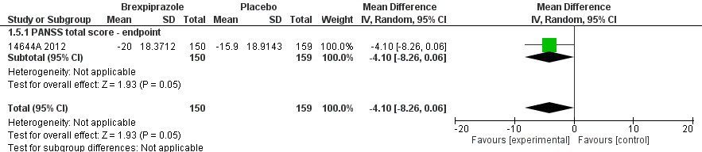
The clinical evaluator stated that based on the analysis above, the brexpiprazole arm showed a tendency towards being beneficial compared with placebo; however the results were not statistically significant.
Analysis of brexpiprazole versus quetiapine as a secondary objective is outlined below in Table 29.

Table 29: Analysis of brexpiprazole versus quetiapine (secondary objective)
Efficacy data | Participants | Measure used | Effect estimate
Efficacy data (LOCF) | 237 | Mean difference (IV, fixed, 95% CI) | 1.79 (-2.04, 5.62)
Efficacy data (ITT) | 300 | Mean Difference (IV, fixed, 95% CI) | 1.79 (-1.60, 5.18)
The clinical evaluator stated that in addition, based on the results reported for the comparison of brexpiprazole versus quetiapine, the clinical evaluator outlined the analyses as reported using the LOCF data as reported by the authors and using intention to treat (ITT) that the clinical evaluator analysed these based on the assumption of ‘once randomised always analyse method’. There is no statistically significant difference between the 2 efficacy analyses (for the 2 drugs).
Other (secondary and tertiary) efficacy outcomes {secondary objectives) included:
- The clinical evaluator stated that trial defined ≥ 30% improvement on PANSS total score as ‘improvement’.
- CGI-S showed statistically significant improvements compared with placebo (< 0.05) and similar improvements comparing CGI-I and PSP total scores compared with placebo.
- Leaving the study early is not an efficacy outcome, however can be considered an indication of tolerability and if people left the study early due to lack of efficacy, that in itself is an important outcome.
The clinical evaluator commented that: Overall, for the primary efficacy outcome, ‘treatment with brexpiprazole did not reach statistical significance in the primary efficacy variable, the change from Baseline in PANSS total score at Week 6, compared to placebo’. It showed some improvements in other outcomes, however were only brief lasting within analyses of data in weeks 2 to 4 and did not have any benefit over 6 weeks, which would be important in the clinical context of treating schizophrenia over longer periods as happens in clinical practice.

Study 331-10-232
This was a 52 week, Phase III multicentre (50 sites around the world), randomised, double blind, placebo controlled trial of 3 fixed doses OPC-34712 in the treatment of adults with acute schizophrenia.
There were 3 parts/phases (A, B and C) to the trial:
- Phase A (conversion phase): After a screening period of 2 to 15 days, eligible patients (N = 524, both sexes, age range = 18 to 65 years) entered this phase where other medications were washed out.
- Phase B (single blind stabilisation phase): After Phase A, patients entered Phase B where, the dose of brexpiprazole was titrated from 1 mg a day up to a maximum of 4 mg a day (that is, patients converted from current antipsychotic to brexpiprazole 1 to 4 mg/day) that would maintain stability of psychotic symptoms over 12 consecutive weeks (within a maximum of 36 weeks), while minimizing tolerability issues. Patients discontinued if did not tolerate 1 mg/day of brexpiprazole.
- Phase C (double blind phase): Following Phase B, patients entered Phase C where, they were randomised to receive a stabilisation dose of brexpiprazole or placebo. Randomisation was in a 1:1 ratio (N = 202, that is brexpiprazole N = 101; placebo N = 101). The duration was 52 weeks.
The gamut of trial design is shown below in Figure 4.
Figure 4: Study 331-10-232 design overview
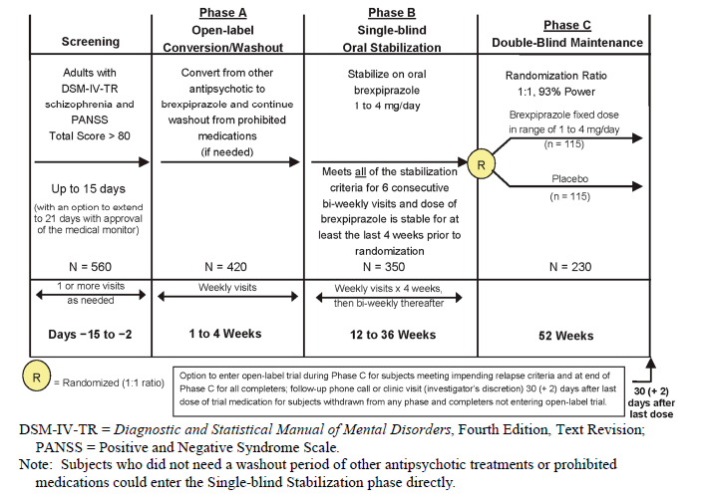
The inclusion criteria were:
- diagnosis of schizophrenia according to Diagnostic and Statistical Manual of Mental Disorders, Fourth Edition, Text Revision (DSM-IV-TR) and confirmed by Mini International Neuropsychiatric Interview (MINI)
- ability to provide informed consent
- ill for at least 3 years
- living in a stable environment
- requiring ongoing management for schizophrenia
- PANSS score > 80
- history of relapse and/or exacerbation of symptoms when they were not receiving antipsychotic treatment
- willing to discontinue medications
- for the Phase C, patients had to be outpatients, with PANSS < 70, CGI-S < 4 and no risk history to self or others.
The exclusion criteria were:
- schizoaffective disorder and any other axis 1 or 2 disorders
- those who had ≥ 30% improvement in PANSS rating between screening and baseline scores
- other major mental health disorders, including but not limited to PTSD, major depression or significant suicidal ideation
- pregnancy and breast feeding
- treatment resistance
- other medical conditions
- abnormal lab values
The clinical evaluator commented that the above seem reasonable.
Primary (key) efficacy outcome variables: Time from randomisation to exacerbation of psychotic symptoms/impending relapse in the double blind maintenance phase, defined as meeting any of the following 4 criteria:
- Clinical Global Impression - Improvement scale (CGI-I) score ≥ 5; and
  - an increase on any of the following individual Positive and Negative Syndrome Scale (PANSS) items (conceptual disorganization, hallucinatory behaviour, suspiciousness, unusual thought content) to a score of > 4 with an absolute increase of ≥ 2 on that specific item since randomisation; or
  - an increase on any of the following individual PANSS items (conceptual disorganization, hallucinatory behaviour, suspiciousness, unusual thought content) to a score of > 4 and an absolute increase of ≥ 4 on the combined 4 PANSS items (conceptual disorganization, hallucinatory behaviour, suspiciousness, unusual thought content) since randomisation.
- Hospitalisation due to worsening of psychotic symptoms (including partial hospitalisation programs), but excluding hospitalisation for psychosocial reasons (for example, homelessness or need for shelter that is unrelated to the subject’s underlying psychiatric condition); or
- Current suicidal behaviour as assessed by the Columbia-Suicide Severity Rating Scale (C-SSRS) (that is, an answer of ‘yes’ to any of the questions on the Suicidal Behaviour section of the C-SSRS); or
- Violent or aggressive behaviour resulting in clinically significant self-injury, injury to another person, or property damage.
Secondary efficacy outcome variables: Percentage of subjects meeting impending relapse criteria.
Other secondary outcome variables: Proportion of subjects meeting stability criteria at endpoint in each treatment group with reference to:
- Change from Baseline to endpoint in PANSS Total Score
- Change from Baseline to endpoint in PANSS Positive Subscale score
- Change from Baseline to endpoint in PANSS Negative Subscale score
- Change from Baseline to endpoint in CGI-S score
- CGI-I score at endpoint
- Change from Baseline to endpoint in PSP score
- Change from Baseline to endpoint in Global Assessment of Functioning scale (GAF) score
- Time to discontinuation due to all causes
- Change from Baseline to endpoint in PANSS Excited Component (PEC) score
- Change from Baseline to endpoint in PANSS Marder Factor scores
Other (tertiary) outcome variables included:
Changes in composite score for the CogState computerised cognitive test battery and results for the individual test domains were examined as other outcomes.
The proportion of subjects with remission was examined as an exploratory endpoint. Remission was defined as a score of ≤ 3 on each of the following specific PANSS items, maintained for a period of 6 months: delusions (P1), unusual thought content (G9),hallucinatory behaviour (P3), conceptual disorganisation (P2), mannerisms/posturing (G5), blunted affect (N1), passive/apathetic social withdrawal (N4), and lack of spontaneity and conversation flow (N6).
Pharmacokinetic endpoints:
Plasma concentrations were determined for brexpiprazole and its major metabolite, DM-3411. The PK data was summarised graphically with descriptive statistics. The collected PK samples were used for population PK modelling.
The clinical evaluator marked this as a pivotal study because it is the study that provides longer term data which is applicable for maintenance treatments. The study is described as a long term, maintenance, controlled trial but the design is more complex, suggesting potential enrichment in sampling as is common in this area of study. It is basically done in 3 phases. In the first phase or phase A, other study medications were washed out based on what they were between 2 and 15 days. In Phase B, brexpiprazole was gradually titrated upwards. Until this point, it was open label and there was no randomisation or blinding. Once titrated and symptoms of schizophrenia stabilised, then patients entered a randomisation phase where they were given either a placebo or brexpiprazole.
Risk of bias estimation: As per the clinical evaluator’s judgement [details are given in Attachment 2]:
- Random sequence generation (selection bias) is rated as Low risk
- Allocation concealment (selection bias) is rated as High risk
- Blinding of participants and personnel (performance bias) is rated as Unclear risk
- Blinding of outcome assessment (detection bias) is rated as High risk
- Incomplete outcome data (attrition bias) is rated as Unclear risk
- Selective reporting (reporting bias) is rated as Low risk
- Overall comment: Unclear risk as the trial is company funded.
Analysis populations: The clinical evaluator commented in the clinical evaluation report [see Attachment 2]: Although a frequently required methodology, the evaluator would like to note some concerns about the ethical aspects of changing a patient whose mental state has stabilised into a placebo arm and essentially not treating them for up to a year. This is something the ethics approval bodies and institutional review boards have considered and is probably a requirement for the FDA, nevertheless sits uneasy in terms of not treating someone with a known and available medication when the risks of non-treatment and cognitive deficits and risks are known to increase. The results however, indicate that the trial was terminated because the interim analyses stopping rules had been met.
Sample size: The clinical evaluator stated that although the schematic flow diagram (see Figure 5, above) of participants through the trial across the different phases indicated N = 230 for the double blind Phase C, the trial appeared to terminate early at N = 202 as the interim analysis outcomes were met and it was predominantly a time to discontinuation or time to relapse study.
Statistical methods: The clinical evaluator stated that for the main outcome, hazard ratios were provided using cox proportional hazard model. For key secondary outcomes in the double blind phase, the usual models analysed in other studies using mixed effect model repeat measurement (MMRM) for observed data and LOCF for missing data were used. The analysis seemed appropriate as per the clinical evaluator.
Major protocol violations/deviations: The clinical evaluator stated that no issues were identified.
Baseline data: The clinical evaluator stated that within the double blind phase, demographic and baseline characteristics of the subjects were well balanced between the groups. Subjects were representative of an acutely ill population of adults with schizophrenia prior to entry into the stabilisation phase, with mean baseline PANSS Total Score of 84.4 and a mean CGI-S score of 4.3. At Baseline in the double blind maintenance phase, subjects were representative of a symptomatically stable population, with a mean PANSS Total Score of 56.5 and 58.1 for the brexpiprazole and placebo groups, respectively. Overall it appears that the demographics had been matched and confounders potentially equally distributed. The randomisation process appears to have been reasonably successful.
Primary efficacy outcome as per the clinical evaluator: The clinical evaluator found that the authors used ‘time to impending relapse’ as a key outcome and stated that: the time to impending relapse was significantly delayed with brexpiprazole compared with placebo in both the interim and final analyses (p = 0.0008 and p < 0.0001, respectively; log-rank test). For the final analysis, the hazard ratio was reported as 3.420 (95% CI = 1.825, 6.411).
The clinical evaluator commented in their report [see Attachment 2]: The clinical evaluator has been unable to independently perform these analyses, however it appears to be accurate and compared to placebo, brexpiprazole does appear to reduce relapse and thereby rehospitalisation rates (Final analysis: 13.54% versus 38.46%, p < 0.0001).
Other efficacy outcomes as per the clinical evaluator:
- Other secondary outcomes also favoured brexpiprazole over placebo. These were the proportion of subjects meeting:
  - stability criteria
  - improvement in clinical symptomology (as assessed by PANSS, CGI-S, and CGI-I)
  - improved functioning (as assessed by PSP and GAF scales)
  - prolonged time to trial discontinuation, as compared with placebo.
The clinical evaluator reported that: The first phase is appropriate where there was a washout period to ensure there was no cross contamination of the medications and the effects of the intervention drug can be attributed to it alone and not previous antipsychotics. Phase B is relatively straightforward as it was titrating the medication upwards and ensuring tolerability. The efficacy data do appear to show that brexpiprazole delayed the onset of relapse compared to placebo and some improvements were noted compared to placebo when measured using PANSS and CGI-S scales for mental state data. Safety data appeared to show that there were no deaths in either group and TEAEs were not statistically significant between the 2 groups and were minimal.

Study 331-10-203
This was a 6 week, Phase II multicentre (Bulgaria, Croatia, India, the Philippines, Romania, Russian Federation, Serbia, Slovakia, South Korea, Taiwan, Ukraine, and the US) randomised, double blind, placebo controlled study to evaluate the efficacy, safety, and tolerability of oral OPC-34712 once daily and aripiprazole (active control) once daily for treatment of hospitalised adult patients with acute schizophrenia. 459 patients (both sexes, age range 18 to 65 years) were randomised in a 1:2:2:2:2:1 ratio into 6 groups:
- Brexpiprazole: dose 0.25 mg/day (N = 42)
- Brexpiprazole: dose 1 mg/day (N = 89)
- Brexpiprazole: dose 2.5 mg/day: (N = 90)
- Brexpiprazole: dose 5 mg/day: (N = 93)
- Placebo: (N = 95)
- Aripiprazole: dose 15 mg/day (N = 50).
The inclusion criteria were:
- schizophrenia (DSM-IV-TR) and confirmed by the Mini International Neuropsychiatric Interview (MINI)
- informed consent obtainable
- recently hospitalised patients or patients willing to be hospitalised
- acute relapse of schizophrenia
- marked deterioration of usual function (PANSS total score ≥ 80 and score of ≥ 4 at screening and Baseline
- willing to discontinue all prohibited psychotropic drugs.
The exclusion criteria were:
- hospitalisation for ≥ 14 days
- schizoaffective disorder and any other axis 1 or 2 disorders including but not limited to PTSD, major depression, significant suicidal ideation
- pregnancy and breast feeding
- treatment resistance
- other medical conditions/abnormal lab values.
- taking a list of drugs which are prohibited prior to assessments
- drinking certain fruit juices which are prohibited 72 hours prior to dosing
- having electroconvulsive therapy (ECT) which is prohibited 60 days prior to trial.
Primary efficacy outcome variable: Positive and Negative Syndrome Scale (PANSS). The primary efficacy outcome was change from Baseline to Week 6 in PANSS total score.
Secondary efficacy outcome variables:
- CGI-I
- CGI-S
- PSP
Risk of bias estimation: As per the clinical evaluator’s judgement:
- Random sequence generation (selection bias) is rated as Low risk
- Allocation concealment (selection bias) is rated as High risk
- Blinding of participants and personnel (performance bias) is rated as Low risk
- Blinding of outcome assessment (detection bias) is rated as High risk
- Incomplete outcome data (attrition bias) is rated as High risk
- Selective reporting (reporting bias) is rated as Unclear risk
- Overall comment: Unclear risk as the trial is company funded.
Analysis populations: As described in the study design above.
Sample size: The clinical evaluator stated that the total number randomised was 459 and that there were 6 groups in total including, 1 placebo group and an active control (aripiprazole). In order to maintain a nominal alpha level at 0.05 (2 sided) after accounting for multiple comparisons, the Hochberg procedure was used. To power the sample size to achieve at least 80% power at an alpha level of 0.0167 (2 sided) to detect a difference of -11.5 points in the mean change from Baseline in PANSS Total Score at Week 6 (LOCF) between an individual brexpiprazole treatment group (except the 0.25 mg QD fixed dose group) and placebo using a 2 sided z-test, they calculated the resulting sample size was 90 subjects in each of the remaining 3 brexpiprazole groups and 90 subjects in the placebo group. The total sample size was calculated as 450 to adequately power the study at all arms and they were able to recruit adequate numbers to the study.
Statistical methods: The clinical evaluator stated that similar to other studies in this submission (such as Study 14644A), this study used MMRM for evaluating its primary outcomes. The authors defined it as ‘Used treatment, study centre, visit, and treatment visit interaction as fixed effects and baseline as covariate with an unstructured variance covariance matrix structure to the visits, and was applied to the change from Baseline in PANSS Total Score at Week 6 (OC) data in each of the 3 OPC-34712 flexible dose group comparisons versus placebo (sensitivity analysis for analysis of covariance (ANCOVA) 1)’.
The clinical evaluator stated that in addition and similar to Study 14644A, they (the authors) used LOCF and OC analysis to account for missing data/variables. The latter has its associated disadvantages as outlined previously.
Major protocol violations/deviations: The clinical evaluator stated that there were no concerns
Baseline data: The clinical evaluator mentioned that Baseline characteristics were evenly matched across the different variables. There was no concern in terms of baseline characteristics influencing the eventual outcome due to selection bias. The results report that ‘the trial population had a mean age of 39.1 years, weight of 75.2 kg, and BMI of 26 kg/m2. The trial population was 62.5% male, 62.5% White, 20% Asian, 16.8% Black or African American, and 5.2% of subjects were of Hispanic or Latino ethnicity’. Baseline scores were similar across treatment groups, with the authors reporting ‘the trial population as a whole had the following baseline scores (mean (± SD)): PANSS Total Score, 97.5 (± 10.2); PANSS Positive Subscale Score, 25.5 (± 3.7); PANSS Negative Subscale Score, 24.9 (± 4.5); CGI-S score, 4.9 (± 0.6); and PSP score, 45.8 (± 11.2)’.
Primary efficacy outcome: The clinical evaluator stated that the overall treatment compliance for the medications including the placebo groups was good and that the authors used change data with least square means. There were no standard errors or standard deviations readily available in the Clinical Study Report to perform independent calculations. The evaluator was however able to find the standard deviations on the Clinical Trials.gov website which was used for the analysis.
As per the clinical evaluator:
- The data was reanalysed for the dose of brexpiprazole 4 mg a day, which seems to be the most efficacious dose and the results demonstrate that for the primary outcome, the mean difference effect score was -6.47 with a 95% CI of -10.63 to -2.31. This does demonstrate statistically significant superiority over placebo, although the confidence intervals are rather narrow.
- Similarly, the brexpiprazole arm demonstrated superiority over the placebo arm in all other dose ranges apart from perhaps what might be expected in the 0.25 mg dose range. For this dose, the placebo arm fared better.
- When compared with aripiprazole however, there was no statistically significant difference between the 2 arms. The mean difference was -0.27 with a 95% CI of between -7.51 and 6.97.
Other efficacy outcomes: As per the clinical evaluator, when the authors/trial leads performed a further sensitivity analysis, on the observed case data set, they found that although the results supported the primary analysis, the magnitude of the placebo effect for mean change from Baseline in PANSS total score at Week 6 was quite big and no significant differentiation from placebo was observed for any of the OPC-34712 flexible dose groups or for the aripiprazole group, and the 0.25 mg/day dose was shown to be less effective than placebo.
The clinical evaluator commented in their report [see Attachment 2] that: There are a few risks of bias issues to consider with this study and other similar studies in terms of lack of description around allocation concealment, further steps to test blinding and other biases that may have crept in as a result. The baseline characteristics are matched evenly. The study appears to be powered adequately. The issues with using LOCF have been highlighted previously in accounting for missing data. Based on the available evidence presented, apart from the 0.25 mg dose of brexpiprazole, all the other dose ranges were efficacious compared to placebo but not significantly better compared to aripiprazole.

Other efficacy studies
The 2 other efficacy studies were:
- Study 331-10-230
- Study 331-10-231

Study 331-10-230
This was a 6 week, Phase III, multicentre (Colombia, Croatia, Mexico, Philippines, Russia, Slovakia, Taiwan, and the US), randomized, double blind, placebo controlled trial of fixed dose OPC-34712 (4, 2, and 1 mg/day) in the treatment of adults with acute schizophrenia. Subjects who completed all trial visits through the Week 6 visit may have been offered entry into an optional open label rollover Trial 331-10-237 (an ongoing Phase III, open label trial that assessed the long term safety and efficacy of brexpiprazole in adults with schizophrenia).
674 patients (males and females, age range of 18 to 65 years) were randomised in a 3:3:2:3 ratio (brexpiprazole: 4 mg/day N = 184, 2 mg/day N = 186, 1 mg/day N = 120; placebo N= 184)
The inclusion criteria were:
- willing/consenting to be hospitalised
- an acute exacerbation of psychotic symptoms
- marked deterioration of usual function as demonstrated by meeting all of the following criteria at the screening and Baseline visits:
  - Total Brief Psychiatric Rating Scale (BPRS) score ≥ 40
  - Score of ≥ 4 on 2 or more of the following BPRS items: hallucinatory behaviour, unusual thought content, conceptual disorganisation, or suspiciousness
  - CGI-S score ≥ 4 (moderately ill).
The exclusion criteria were:
- schizoaffective disorder
- any other axis 1 or 2 disorders
- those who had ≥ 30% improvement in PANSS rating between screening and baseline scores,
- other major mental health disorders, including but not limited to PTSD, major depression, significant suicidal ideation
- pregnancy and breast feeding
- treatment resistance
- ‘other’ medical conditions/abnormal lab values.
The clinical evaluator stated that the exclusion criteria seem reasonable.
The efficacy outcome variables assessed as per the clinical evaluator included the following:
- Primary:
  - PANSS; total, positive and negative.
- Secondary:
  - CGI-S scale
  - PSP scale
  - CGI-I scale
  - PANSS Excited Component (PEC) score (derived from the PANSS)
  - PANSS Marder Factor score (derived from the PANSS).
Risk of bias estimation: As per the clinical evaluator’s judgement [see Attachment 2 for details]:
- Random sequence generation (selection bias) is rated as Low risk
- Allocation concealment (selection bias) is rated as High risk
- Blinding of participants and personnel (performance bias) is rated as Unclear risk
- Blinding of outcome assessment (detection bias) is rated as High risk
- Incomplete outcome data (attrition bias) is rated as High risk
- Selective reporting (reporting bias) is rated as Low risk
- Overall comment: Unclear risk
Primary efficacy outcome:
As per the clinical evaluator:
- This study demonstrated an improvement in PANSS Total Score from Baseline to Week 6.
- Brexpiprazole 4 mg/day group fared better compared with the placebo group (LS mean difference = -6.47, p = 0.0022).
Other efficacy outcomes:
As per the clinical evaluator:
- Improvements in the brexpiprazole arm compared to the placebo arm were noted for all dose ranges across the trial Weeks 1 to 6.
- The brexpiprazole 4 mg a day group also fared better than placebo on measures of change in PSP score, CGI-S, CGI-I and all subscales of PANSS scores at endpoint.
The clinical evaluator commented in their report [see Attachment 2 for further details]: No deaths occurred in this study during the study period or for 30 days after. This is a placebo controlled study and brexpiprazole , particularly the 4 mg a day arm, fared well compared to placebo on all primary and secondary efficacy outcome measures. Approximately 30% of patients left the study early in the brexpiprazole arms with similar numbers in the placebo arm. This continues to remain on the higher side for a 6 week inpatient study. The clinical evaluator was not sure what the explanation for this is.

Study 331-10-231
This was considered quite similar to the study above with slightly different doses of brexpiprazole as per the clinical evaluator.
Study 331-10-231 was a 6 week, Phase III, multicentre (US, Canada, Japan, South Korea, Latvia, Malaysia, Poland, Romania, Serbia and Ukraine), randomised, double blind, placebo controlled trial of 3 fixed doses OPC-34712 in the treatment of adults with acute schizophrenia. 636 patients (both sexes, age range 18 to 65 years) were randomised into 4 groups in a 2:2:1:2 ratio to receive:
- Brexpiprazole dose 4 mg/day (N = 180)
- Brexpiprazole dose 2 mg/day (N = 182)
- Brexpiprazole dose 0.25 mg/day (N = 90)
- Placebo (N = 184).
The inclusion criteria were:
- Schizophrenia as diagnosed by DSM-IV-TR and confirmed by MINI
- willing/consenting to be hospitalised and would benefit from hospitalization or continued hospitalisation for treatment of a current acute relapse of schizophrenia.
- an acute exacerbation of psychotic symptoms
- marked deterioration of usual function as demonstrated by meeting all of the following criteria at the screening and baseline visits:
  - Total BPRS score ≥ 40
  - Score of ≥ 4 on 2 or more of the following BPRS items: hallucinatory behaviour, unusual thought content, conceptual disorganization, or suspiciousness
  - CGI-S score ≥4 (moderately ill).
The exclusion criteria were:
- schizoaffective disorder and any other axis 1 or 2 disorders
- those who had ≥ 30% improvement in PANSS rating between screening and baseline scores
- other major mental health disorders, including but not limited to PTSD, major depression, significant suicidal ideation
- pregnancy and breast feeding
- treatment resistance
- other medical conditions/abnormal lab values
The above seemed reasonable by the clinical evaluator.
The efficacy outcome variables assessed as per the clinical evaluator included the following:
- Primary efficacy outcome:
  - PANSS; total, positive and negative. The primary efficacy measure was the change from Baseline to Week 6 on the PANSS total score.
- Secondary efficacy outcomes:
  - CGI-S scale
  - PANSS Excited Component (PEC) scores
  - PANSS Marder Factor scores
  - CGI-I scale
  - PSP scale.
Risk of bias estimation as per the clinical evaluator’s judgement [see Attachment 2 for further details]:
- Random sequence generation (selection bias) is rated as Low risk
- Allocation concealment (selection bias) is rated as High risk
- Blinding of participants and personnel (performance bias) is rated as Unclear risk
- Blinding of outcome assessment (detection bias) is rated as High risk
- Incomplete outcome data (attrition bias) is rated as High risk
- Selective reporting (reporting bias) is rated as Low risk
- Overall comment: Unclear risk.
Results for the primary efficacy outcome as per the clinical evaluator included:
- There were statistically significant improvements in the brexpiprazole 2 mg and 4 mg arm compared to placebo, but no difference between brexpiprazole 0.25 mg arm and placebo.
- They (the authors) also used the Hochberg approach to recalculate data and the results were no different.
- The significant results seem to arise from Week 3 onwards and remained through to Week 6.
Other efficacy outcomes as per the clinical evaluator included:
- For the CGI-I, CGI-S and PSP scores, the brexpiprazole 2 mg and 4 mg arms were superior to placebo but not the 0.25 mg arm.
- PANSS subscale data are reported as being superior for the same outcomes.
The clinical evaluator commented that: Handling of missing data is an issue to note across all the trials as outlined in more detail within Study 14644A. Risk of bias is an issue similar to other studies of this nature outlined previously. Brexpiprazole appears to prevent relapse compared to placebo in adequate doses and it is reasonably clear that the dose range of 4 mg/day is much more optimal compared with the smaller doses, for example 0.25 mg a day.

Analyses performed across trials: pooled and meta-analyses
The clinical evaluator stated: There were no specific meta-analyses available; however, the clinical evaluator has performed their own pooled meta-analyses from the available data. These were conducted using data available from the documents provided and for only the key efficacy outcomes. Additional data was gathered, such as standard deviations from the ClinicalTrials.gov website when they were not clearly reported in the study reports. Please note that these are not fully conducted systematic reviews of literature that supported the meta-analysis as that was outside the scope of this review. Key efficacy measures and dichotomous outcomes on leaving the study early due to the various reasons listed in the respective studies were included. There were only 2 studies that compared brexpiprazole versus other antipsychotics for schizophrenia. Efficacy analysis from these are analysed as well.

Analysis 1
Figure 5, below, gives details of the reasons for dropout across all studies.
Figure 5: Analysis 1 Reasons for dropout (All studies)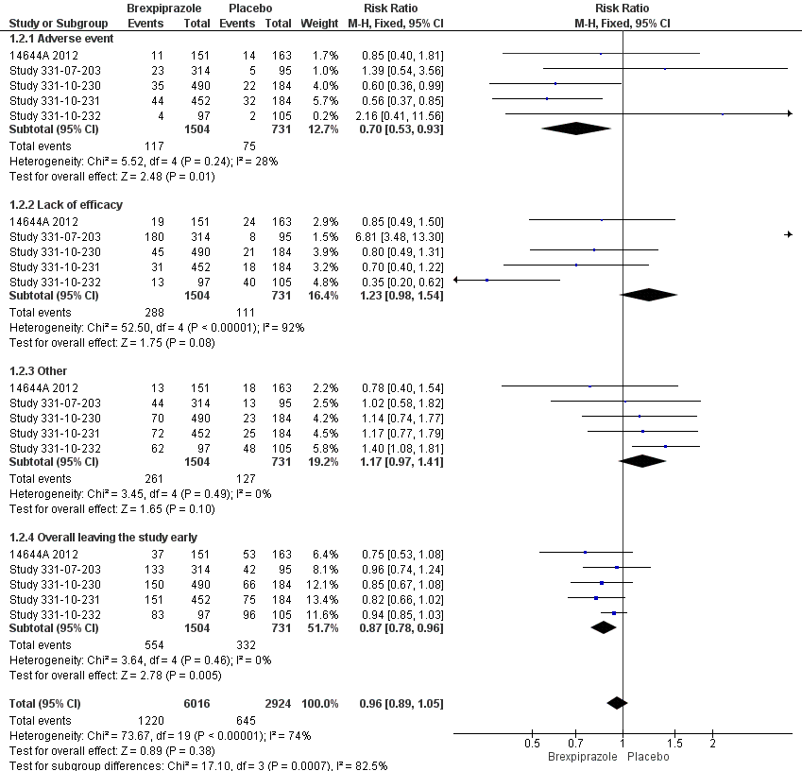
For the individual outcomes of overall leaving the study early, brexpiprazole arm was superior to placebo. Similarly, brexpiprazole appeared to be superior to placebo for the outcome of adverse events. On the other hand, for other outcomes which included things such as protocol deviations, investigator led discontinuation and lack of efficacy, the trends seemed to favour placebo however, and these were not significant. When all of these outcomes are pooled using risk ratios (RR) fixed effect model, there was no difference between the 2 groups. The overall pooled effect score was RR 0.96, 5 RCTs, 95% CI (0.89, 1.05).

Analysis 2
Analysis from 4 RCTs providing data on continuous variables reporting change in PANSS total score, which has been the primary efficacy score across the trials, and results are shown in Figure 7, below.
Figure 6: Analysis 2 Primary efficacy outcome (All studies)
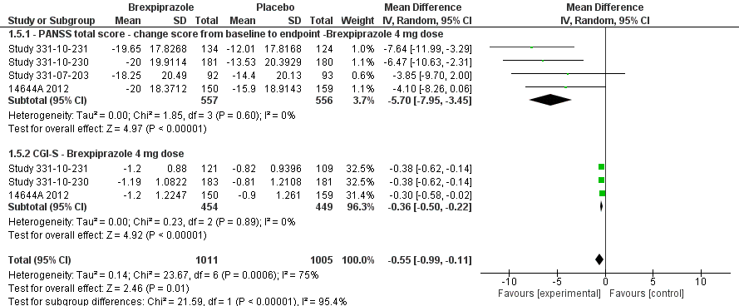
For the key outcome of change in PANSS score from Baseline to endpoint, which has been considered as a measure of efficacy against both placebos and other atypical antipsychotics, the data available has been largely skewed as noted in the graphs above. If we were to apply the reliable formula that data are skewed when the Mean < 2 x SD, then it is numerically obvious as well. Hence comparing these data should be interpreted with caution. The trend seems to favour brexpiprazole compared with placebo. The pooled mean difference is -5.70 95% CI (-7.95 to -3.45) for 4 RCTs with a total population of 1113 participants.
The efficacy was a bit more robust for the measures of CGI-S and the confidence intervals were narrower favouring brexpiprazole: mean difference -0.55 (-0.99, -0.11).
Heterogeneity for both the outcomes is low, however higher when pooled as expected.

Analysis 3
Figure 7: Analysis 3 Efficacy data based on PANSS score change for brexpiprazole and active references used in these studies (LOCF data)
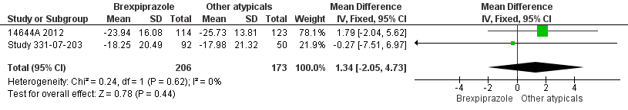
The Study 14644A related to brexpiprazole and quetiapine and the second study (Study 331-10-203) related to brexpiprazole and aripiprazole. These are LOCF data and need to be interpreted with caution. There were no statistically significant differences between the 2 groups.
Overall risk of bias ratings from all included RCTs is outlined in 2 ways (Risk of bias graph and Risk of bias summary) as shown below in Figures 8 and 9.
Risk of bias graph: A review of the authors' judgements about each risk of bias item, presented as percentages, across all included studies.
Figure 8: Risk of bias across studies
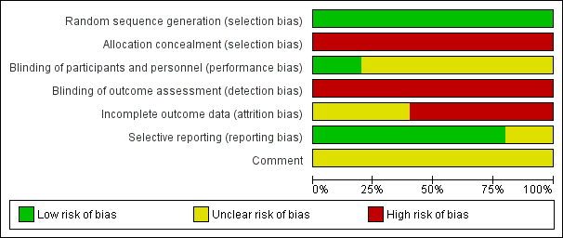
Risk of bias summary: A review of the authors' judgements about each risk of bias item for each included study.
Figure 9: Risk of bias summary
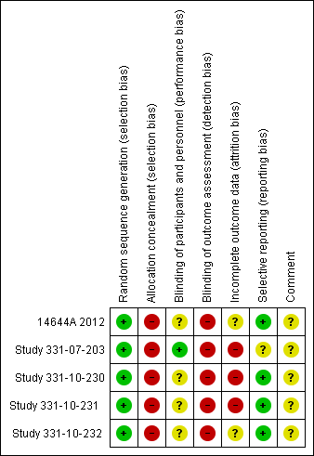
Of note, the other studies evaluated are largely uncontrolled studies, majority of which are open label studies that followed on from previous RCTs; some are longer term of up to 52 weeks. Due to high risk of bias inherent in the trial design, these have not been evaluated in detail for risk of bias.

Clinical evaluator’s conclusions on clinical efficacy
A copy of the clinical evaluator’s overall conclusions on clinical efficacy can be found under Section IV. Clinical findings, above.

Safety
A copy of the clinical evaluator’s overall conclusions on safety can be found under Section IV. Clinical findings, above.

First round benefit-risk assessment
The Delegate reproduced a copy of the first round assessment of benefits and risks as per the clinical evaluator, as shown in Tables 26 and 27, above. A copy of the clinical evaluator’s first round benefit-risk assessment can be found under Section IV. Clinical findings, above.
The first round recommendation regarding authorisation as per the clinical evaluator was to authorise brexpiprazole for the indication of schizophrenia.

Second round benefit-risk assessment
The Delegate reproduced a copy of the clinical questions posed to the sponsor following the first round evaluation. Please see Attachment 2 for a copy of these questions along with evaluation of the sponsor’s answers.
A copy of the clinical evaluator’s second round benefit-risk assessment can be found under Section IV. Clinical findings, above.

Clinical evaluator’s recommendation
The second round recommendation regarding authorisation as per the clinical evaluator was ‘approval of brexpiprazole is recommended for adult patients with schizophrenia’.

Risk management plan
A copy of the reconciliation of the recommendations in the first round RMP evaluation report and the sponsor’s response is presented above in Table 28.
The sponsor did not submit revised RMP documents with their first round response. However, the sponsor proposed a revised summary of safety concerns in their response, which partially addresses the concerns listed in Recommendation 2 of Table 28.
The pharmacovigilance and risk minimisation activities for the safety concerns included in the sponsor’s response should be documented in the ASA. Routine pharmacovigilance is recommended.

Risk-benefit analysis

Delegate’s considerations
In conclusion, the clinical evaluator remarked that all but 1 of the RCTs were of short duration (conducted within 6 weeks) and that the 1 longer term RCT (Study 331-10-232), was conducted over 52 weeks (an evaluation of relapse rates and time to discontinuation rates involving various doses of brexpiprazole versus placebo). Nonetheless, the clinical evaluator recommended that the application to register brexpiprazole for the proposed indication of schizophrenia in adults (> 18 years) is approvable. The quality evaluator stated that registration can only be recommended provided, that certain unanswered aspects of the quality perspective are resolved satisfactorily. While stating that there is no nonclinical objection to approval, the nonclinical evaluator referred to an unqualified impurity issue and the mutagenicity of several unspecified potential impurities in the evaluated data. The RMP evaluator has a caveat (submission of a revised RMP and ASA documents, revised as agreed in the sponsor’s response to TGA questions) prior to the final approval of brexpiprazole.
Although, the proposed trade name Rexulti was deemed acceptable by a TGA representative on the basis of its acceptance in the US, the Delegate has reservations for such proposed trade name as the Delegate given that:
- it has promotional connotation (the word Rexulti gives the false impression that brexpiprazole is the compound that provides the absolute outcome, that is, the result in schizophrenia management, in the absence of substantive supportive data)
- efficacy is based only on 1 long term study and the submission is associated with a higher placebo response rate in a number of the trials
- there is no evidence of brexpiprazole superiority over the other 2 atypical antipsychotic comparators (quetiapine and aripiprazole) in the submitted data evaluated
- the marketing launching code standards for a new chemical entity in the US may be different, for example in terms of regulation, from those in Australia. The proposed trade name Rexulti implicitly gives room for promotional activity during the marketing of the new chemical entity.
There are no major concerns in terms of safety and the benefit; risk balance is adjudged to be favourable.
The draft PI requires amendments as suggested by the clinical, quality, nonclinical and RMP evaluators. The Delegate believes that deliberations on the registration of brexpiprazole need to consider quality and nonclinical evaluator raised issues in addition to the RMP evaluator’s caveat being brought to TGA acceptable conclusions.

Summary of issues
- The quality evaluator stated that whilst there are no objections to registration from a biopharmaceutics perspective, registration from a quality perspective can only be recommended subject to:
  - satisfactory qualification of the limit applied to the a single impurity (as indicated by the toxicology evaluator)
  - the appearance in the MIS Repository of satisfactory current evidence of GMP for the manufacturers linked to the as sponsor and appropriate for the nominated functions
  - the ultimate acceptance by the ACM of the proposed trade name.
- The nonclinical evaluator stated that there is no nonclinical objection to approval but that there:
  - is an unqualified impurity at the specification limit
  - are several unspecified potential impurities classified as a mutagenic alerting impurity
Of the 3 clinical studies identified as pivotal (Study 14644A: A 6 week, randomised, double blind, parallel group, placebo controlled, active reference(quetiapine), flexible dose study of brexpiprazole in patients with acute schizophrenia; Study 331-10-232: A Phase 3, Multicentre, Randomized, Double-blind, Placebo-controlled Trial to Evaluate the Efficacy, Safety, and Tolerability of Brexpiprazole (OPC-34712) as Maintenance Treatment in Adults with Schizophrenia and Study 331-10-203: A Phase II, 6 week, multicentre, randomised, double blind, placebo controlled study to evaluate the efficacy, safety, and tolerability of oral OPC-34712 once daily and aripiprazole once daily for treatment of hospitalised adult patients with acute schizophrenia), it transpired that only 1 had sufficient study duration in terms of efficacy and safety of brexpiprazole for the management of a rather long term condition.
The data from Study 331-10-232 revealed that for the primary efficacy outcome:
- For Trial 331-10-230 brexpiprazole 4 mg a day seems to be the most efficacious dose with statistically significant superiority over placebo, although the confidence intervals are rather narrow, (the mean difference effect score was -6.47 with a 95% CI of -10.63 to -2.31).
- The brexpiprazole arm similarly, demonstrated superiority over the placebo arm in all other dose ranges with exception of the 0.25 mg dose (observed in Trials 331-10-231 and 331-07-203). For this dose, the placebo arm fared better.
- For Trial 331-07-203 there was no statistically significant difference between brexpiprazole and the active reference aripiprazole when compared (the mean difference was -0.27 with a 95% CI of between -7.51 and 6.97).
The limited data from Study 14644A suggested that:
- there was no statistically significant difference between brexpiprazole and the active reference quetiapine efficacy analyses for schizophrenia.
Based on the evidence arising from the submitted data evaluation, the Delegate was inclined at this stage to favour approvability of the application subject to resolving issues, arising from the ACM deliberations and finalisation of matters pertaining to the raised quality and nonclinical issues, the RMP caveat and the draft PI modifications to the satisfaction of the TGA.

Proposed action
The Delegate has no reason to say, at this time, that the application to register brexpiprazole for the proposed indication should not be approved, subject to resolving issues arising from the ACM deliberations and finalisation of the raised quality and nonclinical issues, the RMP caveat and the draft PI modifications to the satisfaction of the TGA.

Request for ACM advice
The Delegate asked the committee to comment on the following:
- The appropriateness of the Delegate’s view that approvability of the application is dependent on bringing the raised quality and nonclinical issues, in addition to the RMP caveat, to satisfactory conclusions.
- Consideration and suitability of the proposed trade name Rexulti for brexpiprazole.

Response from sponsor
The sponsor provided the following responses to issues raised in the Delegate’s overview.

Sponsor’s response to issues raised by the quality and nonclinical evaluators
After clarification with the quality/toxicology evaluator, the impurity is now considered qualified (email dated 10 March 2017). Inconsistent nomenclature was unfortunately used in the dossier by the sponsor and this caused the issue to be raised by the evaluator. Regarding the potential impurities (The control strategies are provided in the impurity report [not included in this document]).

Sponsor’s response to the RMP caveat
The sponsor will update the RMP and the ASA in accordance with the suggestions in the sponsors response and subsequent evaluation of TGA questions. An updated RMP and ASA will be submitted to the TGA by 31 March 2017.

Sponsor’s response to the proposed tradename Rexulti for brexpiprazole
The sponsor provided a response to the TGA’s outstanding concern about the proposed trade name for brexpiprazole film coated tablets, Rexulti, on 6 January 2017. The TGA confirmed their acceptance of the sponsor’s justification for Rexulti as the proposed tradename (email response dated 6 January 2017).
There is both a registration history and original brand name testing results that support the acceptability of Rexulti as a tradename. Additionally, to further support this case, the sponsor has recently (November 2016) conducted additional brand name testing, which further demonstrated that the name poses no safety concerns and is neither exaggerative or misleading, nor inappropriate for the target therapeutic use.

Regulatory history
Between 2012 to 2014 Rexulti and Brintellix were evaluated and accepted as trade names by the TGA under the streamlined submission process during the evaluation of vortioxetine (as hydrobromide), and were approved on 19 March 2014. Subsequently, the preferred alternate trade name for vortioxetine, Brintellix, was chosen as the global tradename. The Rexulti entries were cancelled from the ARTG on 3 June 2014. No product containing vortioxetine has ever been manufactured, distributed or marketed worldwide under the tradename Rexulti.
As the sponsor aims to choose a trade name for products that are globally acceptable, Rexulti was later chosen as the preferred global trade name for brexpiprazole film coated tablets. This trade name has been accepted by the US FDA and Health Canada, and is the preferred global trade name for other ongoing international marketing applications. The sponsor makes every effort to limit any confusion globally regarding trade names by keeping the same trade name wherever possible.
Since the approval of Rexulti in the US in July 2015 and the subsequent launch, no complaints relating to the product trade name have been received. Although approved in February 2017, Rexulti is not yet launched in Canada.

Brand name testing
In 2012 a brand name screening was performed for Brintellix and Rexulti and an array of trademark and regulatory databases were utilised. A target audience including 50 Australian healthcare professionals (primary care physicians, psychiatrists, pharmacists and nurses) were utilised in the safety research. Screening assessment included an analysis of identical/near identical trademarks, phonetic variations, rhyming alliterations and specific use of prefixes and suffixes. Further evaluations included scripting analysis, prescription interpretation studies, safety surveys for identifying sound alike and look alike marketed names and medical terms, phonetic/orthographic computer analysis and a comparative safety analysis (side by side comparison of test name/investigational product attributes against those of sound alike/ look alike marketed products).
Following composite assessment of both safety and marketing related measurements, Brintellix and Rexulti were both shown to have minimal product profile overlaps (including any look alike/sound alike products), acceptable prescription simulation studies and minimal promotional concerns, resulting in a low potential for medication error. This information is referenced in the Brintellix ASA, dated 7 March 2014 and submitted to the TGA.
More recent brand testing was carried out in November 2016 in Australia, where the proposed name Rexulti was again evaluated in a further sample of 50 Australian healthcare professionals. The research methodology encompasses the recommendations as set forth in the May 2014 FDA draft Guidance for Industry entitled ‘Best Practices in Developing Proprietary Names for Drugs’. The summary findings for the recent brand testing are noted below.
The research:
- did not identify any naming characteristics being known to cause or contribute to medication errors such as an inappropriate reference to a dosing interval, dosage form/route of administration, medical and/or product name abbreviation, misleadingly includes or suggests the composition of the drug product, suggests/implies an unsubstantiated unique effectiveness/composition, superiority claims, exaggerated product efficacy, broadening product indication or minimizes the risk of the product (for example, making superiority claims such as 'CureAll'), includes or implies an ingredient that is not included in the drug product, references an inert or inactive ingredient, used for another product that does not share at least 1 common ingredient, and does not contain a currently approved United States Adopted Name (USAN)/International Nonproprietary Name (INN) stem.
- did not identify any sound alike and/or look alike names of concern with the test name from practicing healthcare professionals, market research expert opinions, various drug references, databases, phonetic and orthographic computer analysis (POCA), or handwritten name generation samples.
- did not identify any medical term/lab test or overall impression opinion from the actively practicing Australian healthcare professionals that would be considered a concern for the proposed name.
- did not identify any misinterpretations of the test name that resulted in identification of an existing Australian marketed proprietary/non-proprietary drug name in the name simulation studies.
- did not find the name exaggerative, misleading, or inappropriate as reviewed by the market research Internal Expert Panel, and
- the failure mode effects analysis conducted internally by the organisation found all of the names identified in the research to have enough sound alike and/or look alike differences, and/or product profile characteristic differences to minimise the risk for confusion with Rexulti.
In conclusion, the sponsor maintains that Rexulti is an acceptable trade name for brexpiprazole film coated tablets and that, in addition to previous regulatory approval in Australia, brand testing has shown both in Australia and overseas in other English speaking jurisdictions, that the name poses no safety concerns and is neither exaggerative, misleading nor inappropriate for the proposed therapeutic area. The sponsor also believes there is significant value in ensuring global alignment for prescription product trade names wherever possible to reduce risk of confusion of healthcare professionals.

Other sponsor comments on the delegate’s overview
In general, the sponsor is in agreement with the overall conclusion by the clinical evaluator on the efficacy and safety of brexpiprazole. The sponsor’s only concern is on the details of quoted studies and data. With reference to the sponsor’s comments on the previous rounds of the clinical evaluation report the sponsor would like to point out that there are several places where study numbers are incorrectly referenced and analyses and data are not presented in accordance with the clinical study reports. In particular, the protocol defined primary analysis method for the pivotal Studies 331-10-231, 331-10-230 and 14644A was the MMRM analysis and not the ANCOVA LOCF as stated and criticised in the report. The sponsor is aware of the issues around accounting for missing data and has therefore chosen the MMRM method as the primary analysis, complimented by sensitivity analyses with different approaches to account for missing data. Sensitivity analyses included pattern-mixture modelling, using multiple imputations to account for various assumptions of missing data being missing not at random (MNAR), which supported the robustness of the results seen in the primary analyses. In addition, analyses of Covariance of the OC and LOCF data were done as part of the sensitivity analyses. One exception to this was the initial Phase II Study 331-07-203 in which ANCOVA LOCF was used as the primary analysis. However, the MMRM analysis was done later for Study 331-07-203 in order to compare with the Phase III data in the across-study comparison section in the Clinical Summary of Efficacy. The sponsor is of the opinion that appropriate methods have been applied and that the robustness of the results has been shown.
Risk of bias related to blinding is addressed by the evaluator. The sponsor would like to highlight that the study protocols described the treatment allocation concealment to investigators and subjects as well as the procedures to access the randomisation assignment for individual subjects in case of emergencies. In addition, the Clinical Study Reports describe all cases where unblinding has taken place including reasons and how the subject’s data were handled. The attrition of subjects is accounted for in the statistical analysis (see above), and all data collected are accounted for to avoid selective reporting.
Two Phase III, short term, placebo controlled Studies 331-10-231 and 331-10-230 are referred to as ‘non-pivotal’ in the assessment report, but the sponsor considers these 2 studies as pivotal and the studies are included as part of both the efficacy and safety evaluation of brexpiprazole in the sponsor’s Clinical Summary of Efficacy and Clinical Summary of Safety, respectively. Furthermore, the adverse drug reaction (ADR) section of the PI is based on Studies 331-10-231 and 331-10-230.
Of note, in the sponsor’s view the following errata should be considered:
- Study 14644A
  - Analysis of response (30% reduction on PANSS total score) the p-value is stated to be 0.056 in the ACM report, the real p-value = 0.003.
- Trial 331-07-203
  - The result of a 4 mg dose (LS Means = -6.47) is quoted in connection with Study 331-07-203, but the result comes from another placebo controlled 6 week Study 331-10-230.
- The table ‘primary efficacy outcome’ in the clinical evaluation report (All studies)
  - The table presents meta-analyses on the PANSS total score and on the CGI-S score. The sponsor interprets the last part of this table such as the 2 analyses using the original scales for the PANSS and CGI-S are combined into 1 analysis, seemingly without accounting for the different metrics of the scales. The sponsor does not agree with this final weighting.

Status of the GMP clearance application
The status of the Good Manufacturing Practice (GMP) clearance was raised in the Quality and Biopharmaceutics Summary. The current status of the GMP clearance for the sites involved in the manufacturing of brexpiprazole is outlined below in Table 30.

Table 30: Status of the GMP clearance application
Manufacturing site ID | Clearance expiry date | Status
1 | 30 January 2019 | Approved on 27 February 2017
2 |  | Under Review. All evidence received by TGA. This clearance uses a Letter of Access to another sponsor’s clearance.
3 |  | Under Review. All evidence received by TGA.

Advisory Committee Considerations
The Advisory Committee on Medicines (ACM) taking into account the submitted evidence of efficacy, safety and quality, agreed with the Delegate and considered Rexulti film coated immediate release tablets containing 0.25 mg, 0.5 mg, 1 mg, 2 mg, 3 mg and 4 mg of brexpiprazole are of the opinion that there is an overall positive benefit-risk profile for the indication:
‘For the treatment of adult patients with schizophrenia’.
In making this recommendation, the ACM:
- noted that 3 pivotal clinical trials had been submitted in support of the efficacy and safety of brexpiprazole for the proposed indication.
- noted that brexpiprazole and quetiapine were not different in an efficacy analysis for schizophrenia.
- noted that a submaximal dose of aripiprazole was used in the non-inferiority study.
- noted that brexpiprazole was well tolerated and caused little weight gain in patients.
- noted that brexpiprazole has similar safety issues to the other antipsychotics.
- noted that there were limited long term safety data; only 1 study had a sufficient duration in terms of efficacy and safety for the management of a long term condition.
- noted that longer exposure in more patients is probably needed to detect a NMS signal.

Proposed conditions of registration
The ACM agreed with the Delegate on the proposed conditions of registration.

Specific advice
The ACM advised the following in response to the Delegate’s specific questions on the submission:
- Appropriateness of the Delegate’s view that approvability of the application is dependent on bringing the raised quality and nonclinical issues, in addition to the RMP caveat, to satisfactory conclusion.
The issues raised by the quality and nonclinical evaluators concerning impurities have been resolved. The GMP clearance issue is yet to be resolved. An amended and updated RMP has been submitted to the TGA.
- Consideration and suitability of the proposed trade name ‘Rexulti’ for brexpiprazole.
The ACM had no concerns or objections to the sponsor’s trade name Rexulti. The trade name has been accepted by the US FDA and Health Canada and is the sponsor’s preferred global trade name.
The ACM advised that implementation by the sponsor of the recommendations outlined above to the satisfaction of the TGA, in addition to the evidence of efficacy and safety provided would support the safe and effective use of this product.

Outcome
Based on a review of quality, safety and efficacy, the TGA approved the registration of Rexulti brexpiprazole 0.25 mg, 0.5 mg, 1 mg, 2 mg, 3 mg and 4 mg film coated tablets, indicated for:
‘Rexulti is indicated in adult patients for the treatment of schizophrenia’.

Specific conditions of registration applying to these goods
Implement the Rexulti RMP version 2.0, dated 27 March 2017; DLP 15 May 2015 with ASA version 2.0, March 2017 as submitted with this application, and any future updates as a condition of registration.

Attachment 1. Product Information
The PI for Rexulti approved with the submission which is described in this AusPAR is at Attachment 1. For the most recent PI, please refer to the TGA website at <https://www.tga.gov.au/product-information-pi>.

Attachment 2. Extract from the Clinical Evaluation Report

Therapeutic Goods Administration
PO Box 100 Woden ACT 2606 Australia
Email: info@tga.gov.au Phone: 1800 020 653 Fax: 02 6232 8605
https://www.tga.gov.au

Rössler W, et al. Size of burden of schizophrenia and psychotic disorders. Eur Neuropsychopharmacol. 2005;15(4): 399-409.
Karasu T, et al. Practice Guideline for the Treatment of Patients With Major Depressive Disorder. Second ed. American Psychiatric Association. 2000.
Lublin H, et al. Current therapy issues and unmet clinical needs in the treatment of schizophrenia: a review of the new generation antipsychotics. Int Clin Psychopharmacol. 2005; 20: 183-198.
Messias E, et al. Epidemiology of schizophrenia: Review of findings and myths. Psychiatr Clin North Am. 2007;30:323-338.
McGrath J, et al. Schizophrenia: A concise overview of incidence, prevalence, and mortality. Epidemiol Rev. 2008;30:67-76.
Novick D, et al. Predictors and clinical consequences of non-adherence with antipsychotic medication in the outpatient treatment of schizophrenia. Psychiatry Res. 2010;176:109-13.
Thornicroft G, et al. for the INDIGO Study Group. Global pattern of experienced and anticipated discrimination against people with schizophrenia: a cross-sectional survey. Lancet. 2009;373:408-15.
van Os J, Kapur S. Schizophrenia. Lancet. 2009;374:635-45.
May have a slightly less favourable receptor profile compared with aripiprazole for adjunctive control of antipsychotic-induced hyperprolactinaemia. Adjunctive treatment with aripiprazole has been used to manage antipsychotic-induced hyperprolactinaemia in human patients. Aripiprazole doses that induce clinically relevant D₂ antagonist hyperprolactinaemia are higher than typical adjunctive therapy doses.
The use of ptosis as a marker of extrapyramidal effects was potentially compromised by brexpiprazole-mediated α-adrenergic antagonist-mediated decreased superior tarsal muscle tone.
Excessive lacrimation (likely increased relative M₃ effects due to decreased α tone), scrotal flaccidity/dilatation (likely decreased tunica dartos muscle tone due to decreased α tone), prolapse of the penis (likely decreased pudendal, hypogastric and pelvic nerve α tone) and atrial pallor in ♀ (likely cardiacomediastinal arterial dilation due to decreased α tone).
The QT interval is the time from the start of the Q wave to the end of the T wave. It represents the time taken for ventricular depolarisation and repolarisation, effectively the period of ventricular systole from ventricular isovolumetric contraction to isovolumetric relaxation. The QT shortens at faster heart rates and the QT lengthens at slower heart rates. An abnormally prolonged QT is associated with an increased risk of ventricular arrhythmias, especially Torsades de Pointes.
The S9 fraction is the product of an organ tissue homogenate used in biological assays and contains CYP isoforms and other enzyme activities. Chemical substances sometimes require metabolic activation in order to become mutagenic and the metabolic enzymes of bacteria used in the Ames test differ substantially from those in mammals. Therefore, to mimic the metabolism of test substance that would occur in mammals, the S9 fraction is often added to the Ames test.
Burrows EL, Hannan AJ. Biol Psychol. 2016 Apr;116:82-9.
Brisch R, et al. Front Psychiatry. 2014 May 19;5:47.
Belvederi Murri M, et al. Drugs R D. 2015 Mar;15(1):45-62.
Preskorn SH, Macaluso M. J Psychiatr Pract. 2016 Mar;22(2):117-23; Macaluso M, Flynn A, Preskorn S. J Psychiatr Pract. 2016 May;22(3):203-20; Macaluso M, Flynn A, Preskorn S. J Psychiatr Pract. 2016 Jan;22(1):42-9; Preskorn S, Flynn A, Macaluso M. J Psychiatr Pract. 2015 Sep;21(5):359-69.
Nisijima K, et al. Prog Brain Res. 2007; 162:81-104; Belvederi Murri M, et al. Drugs R D. 2015 Mar;15(1):45-62; Smit M, et al. Neurosci Biobehav Rev. 2016 Jun; 65:264-75.
Note: use of the related SDAM drug aripiprazole is reputed to reduce the risk of diabetes mellitus and metabolic syndromes in human patients being treated with antipsychotics.
International Conference on Harmonisation (ICH) guideline S2 (R1) on genotoxicity testing and data interpretation for pharmaceuticals intended for human use; June 2012.
The S9 is the supernatant fraction obtained from an organ (usually liver) homogenate by centrifuging at 9000 g for 20 minutes in a suitable medium; this fraction contains cytosol and microsomes.
Harvey PW, et al. J Psychopharmacol. 2008 Mar;22(2 Suppl):20-7; Harvey PW, et al. Hum Exp Toxicol. 2006 Jul;25(7):395-404; Harvey PW. J Appl Toxicol. 2005 May-Jun;25(3):179-83.
Froes Brandao D, et al. Cancer. 2016 Jan 15;122(2):184-8; Besnard I, et al. Encephale. 2014 Feb;40(1):86-94; Peuskens J, et al. CNS Drugs. 2014 May;28(5):421-53; Smithline F, et al. N Engl J Med. 1975 Apr 10;292(15):784-92.
Peuskens J, et al. CNS Drugs. 2014 May;28(5):421-53.
Russo J. Toxicol Pathol. 2015 Feb;43(2):145-70.
Russo J. Toxicol Pathol. 2015 Feb;43(2):145-70.
In rodents, prolactin induces the differentiation and growth of alveolar progenitor cells from the ductal epithelium (may involve both clonal growth from committed precursors and induction of phenotypic changes in cells that are near specialised ‘organiser’ cells). Prolactin is also an essential survival factor for lobuloalveolar cells during pregnancy and lactation. The rodent mammary gland is an important site of prolactin synthesis and secretion, that is, both local and systemic prolactin are involved in regulation of the rodent mammary gland. It is hypothesised that local prolactin production is important in rodent mammary gland carcinogenesis. In contrast, prolactin effects in the human mammary gland are restricted to lobule types 3 and 4 and development towards lactation. The major stimulus to mammary gland development during human pregnancy is likely placental lactogens rather than pituitary prolactin. Post-partum, there is a switch to pituitary prolactin dominated regulation of mammary function (suckling-induced neuroendocrine reflex). Prolactin stimulates the secretory lobuloalveolar epithelium phenotype in lobule types 3 and 4.
Australian Pregnancy Category C: Drugs which, owing to their pharmacological effects, have caused or may be suspected of causing, harmful effects on the human fetus or neonate without causing malformations. These effects may be reversible. TGA; Canberra, Australia.
Lublin H, et al. Current therapy issues and unmet clinical needs in the treatment of schizophrenia: a review of the new generation antipsychotics. Int Clin Psychopharmacol. 2005; 20: 183-198.
The sponsor used the MMRM methodology in its primary analyses for the pivotal studies. For study 331-1-0-203 for LOCF was used
The Positive and Negative Syndrome Scale (PANSS) is a 30 item standardised measurement scale providing a representation of positive symptoms (excess or extortion of normal functions) and negative symptoms (diminution or loss of normal functions) and gauges their relationship to one another and to global psychopathology. Kay S, et al. The positive and negative syndrome scale (PANSS) for schizophrenia. Schizophr Bull. 1987;13(2):261-76.
Quetiapine and aripiprazole were included as active references to assess assay sensitivity
The sponsor considers Ttrials 331-10-231 and 331-10-230 as pivotal. Trial 331-10-203 was a Phase II trial which failed to show assay sensitivity and therefore not considered pivotal.
This issue was further addressed through a clinical question to the sponsor. For details of this question, and the evaluator’s response, see Attachment 2 Section 12, Question 8: ‘Would the sponsor consider some expansion of the wording around akathisia within the PI and CMI, noting that higher dose and rapid dose escalation is likely despite their appropriate advice not to.’
This issue was further addressed through a clinical question to the sponsor. For details of this question, and the evaluator’s response, see Attachment 2 Section 12, Question 8: ‘Would the sponsor consider some expansion of the wording around akathisia within the PI and CMI, noting that higher dose and rapid dose escalation is likely despite their appropriate advice not to.’
Routine pharmacovigilance practices involve the following activities: •All suspected adverse reactions that are reported to the personnel of the company are collected and collated in an accessible manner; •Reporting to regulatory authorities; •Continuous monitoring of the safety profiles of approved products including signal detection and updating of labeling; •Submission of PSURs; •Meeting other local regulatory agency requirements.
Routine risk minimisation activities may be limited to ensuring that suitable warnings are included in the product information or by careful use of labelling and packaging.
Module 1 concerns the administrative information and prescribing information submitted with the application.
The Clinical Global Impression (CGI) scale comprises of 2 single item clinician rated measures: the Clinical Global Impression-Severity scale (CGI-S) is a measure of the severity of psychopathology; and the Clinical Global Impression-Improvement (CGI-I) is a measure of the change from the initiation of treatment (baseline). Both are scored on a 7 point scale. Guy W, editor. ECDEU Assessment Manual for Psychopharmacology. Rockville, MD: US Department of Health, Education, and Welfare Public Health Service Alcohol, Drug Abuse, and Mental Health Administration; 1976.
The clinical evaluator stated that in addition and similar to Study 14644A, they (the authors) used LOCF and OC analysis to account for missing data/variables. The latter has its associated disadvantages as outlined previously
Study 14644A included quetiapine only as an active reference to confirm assay sensitivity and was not designed or powered with the purpose to compare brexpiprazole versus quetipine.
The sponsor stated that OC/LOCF was not used to account for missing values. OC/LOCF was used as sensitivity analysis; as presented in the CSR the sponsor used other sensitivity analyses using pattern-mixture models, valid under MNAR.
Quetiapine and aripiprazole were included as active references to assess assay sensitivity
Arippirazole was an active reference.
Quetiapine was an active reference..
Brand Institute. Brand Test Market Research for Lundbeck. Project Name: BACKUP. Report Date: 31 October 2012.
Brand Institute. Nomenclature research for Lundbeck. Project Name: BREX_2016. Report Date: 16 November 2016.
The US Food and Drug Administration (FDA). Draft Guidance for Industry on Best Practices in Developing Proprietary Names for Drugs. 29 May 2014.
An updated ASA was also submitted.

