First round report: 4 September 2015
Second round report: 31 May 2016

AusPAR Attachment 2

Extract from the Clinical Evaluation Report for Brentuximab vedotin
  - Proprietary Product Name: Adcetris
  - Sponsor: Takeda Pharmaceuticals Australia Pty Ltd

About the Therapeutic Goods Administration (TGA)
- The Therapeutic Goods Administration (TGA) is part of the Australian Government Department of Health, and is responsible for regulating medicines and medical devices.
- The TGA administers the Therapeutic Goods Act 1989 (the Act), applying a risk management approach designed to ensure therapeutic goods supplied in Australia meet acceptable standards of quality, safety and efficacy (performance), when necessary.
- The work of the TGA is based on applying scientific and clinical expertise to decision-making, to ensure that the benefits to consumers outweigh any risks associated with the use of medicines and medical devices.
- The TGA relies on the public, healthcare professionals and industry to report problems with medicines or medical devices. TGA investigates reports received by it to determine any necessary regulatory action.
- To report a problem with a medicine or medical device, please see the information on the TGA website <https://www.tga.gov.au>.
About the Extract from the Clinical Evaluation Report
- This document provides a more detailed evaluation of the clinical findings, extracted from the Clinical Evaluation Report (CER) prepared by the TGA. This extract does not include sections from the CER regarding product documentation or post market activities.
- The words [Information redacted], where they appear in this document, indicate that confidential information has been deleted.
- For the most recent Product Information (PI), please refer to the TGA website <https://www.tga.gov.au/product-information-pi>.
Copyright
© Commonwealth of Australia 2017
This work is copyright. You may reproduce the whole or part of this work in unaltered form for your own personal use or, if you are part of an organisation, for internal use within your organisation, but only if you or your organisation do not use the reproduction for any commercial purpose and retain this copyright notice and all disclaimer notices as part of that reproduction. Apart from rights to use as permitted by the Copyright Act 1968 or allowed by this copyright notice, all other rights are reserved and you are not allowed to reproduce the whole or any part of this work in any way (electronic or otherwise) without first being given specific written permission from the Commonwealth to do so. Requests and inquiries concerning reproduction and rights are to be sent to the TGA Copyright Officer, Therapeutic Goods Administration, PO Box 100, Woden ACT 2606 or emailed to <tga.copyright@tga.gov.au>.

Contents
List of common abbreviations 5
1. Introduction 8
1.1. Submission type 8
1.2. Drug class and therapeutic indication 8
1.3. Dosage forms and strengths 9
2. Clinical rationale 9
2.1. Background 9
2.2. Clinical rationale 14
3. Contents of the clinical dossier 18
3.1. Scope of the clinical dossier 18
3.2. Paediatric data 18
3.3. Good clinical practice 18
4. Pharmacokinetics 19
4.1. Absorption, metabolism and excretion 19
4.2. Pharmacokinetics in special populations 20
4.3. Drug-drug interactions 22
4.4. Immunogenicity 23
4.5. Evaluator’s overall conclusions on submitted pharmacokinetics data 24
5. Pharmacodynamics 26
5.1. Primary pharmacodynamic effect 26
5.2. Secondary pharmacodynamic effects 26
5.3. Pharmacodynamic drug interactions 27
5.4. Evaluator’s overall conclusions on pharmacodynamic data 28
6. Dosage selection for the pivotal studies 28
7. Clinical efficacy 28
7.1. Pivotal efficacy studies 28
7.2. Evaluator’s conclusions on clinical efficacy 75
8. Clinical safety 80
8.1. Evaluable safety data 80
8.2. Patient exposure 82
8.3. Adverse events 82
8.4. Laboratory tests 94
8.5. Post-marketing experience 95
8.6. Safety issues with the potential for major regulatory impact 102
8.7. Evaluator’s overall conclusions on clinical safety 124
9. First round benefit-risk assessment 127
9.1. First round assessment of benefits 127
9.2. First round assessment of risks 127
10. First round recommendation regarding authorisation 129
11. Clinical questions 129
11.1. Extension of indication 129
11.2. Dosing in renal or hepatic impairment 129
11.3. Clinical rationale 130
11.4. Pharmacokinetics 130
11.5. Efficacy 131
11.6. Safety 132
12. Second round evaluation of clinical data submitted in response to questions 133
12.1. Extension of indication 133
12.2. Dosing in renal or hepatic impairment 134
12.3. Clinical rationale 136
12.4. Pharmacokinetics 142
12.5. Efficacy 147
12.6. Safety 170
12.7. Second round summary of clinical data submitted in response to questions 175
13. Second round benefit-risk assessment 176
13.1. Second round assessment of benefits 176
13.2. Second round assessment of risks 176
13.3. Second round assessment of benefit-risk balance 179
14. Second round recommendation regarding authorisation 181
15. References 182

List of common abbreviations
Abbreviation | Meaning
ADC | antibody-drug conjugate
ADR | adverse drug reaction
AE | adverse event
ALT | Alanine aminotransaminase
AST | Aspartate aminotransaminase
ARDS | acute respiratory distress syndrome
ARTG | Australian Registry of Therapeutic Goods
ASCT | autologous stem cell transplant
ATA | antitherapeutic antibodies
BEAM | carmustine (BCNU), etoposide, cytarabine (Ara-C), and melphalan
BLA | biologics license application
BSC | best supportive care
CBV | cyclophosphamide, carmustine (BCNU), and etoposide
CD30+ | CD 30 positive (the cell membrane protein receptor CD 30 is expressed)
CHMP | Committee for Human Use of Medicinal Products
CI | confidence interval
CR | complete remission
CRu | complete remission unconfirmed
CSR | clinical study report
CT | computed tomography
ECOG | Eastern Cooperative Oncology Group
EMA | European Medicines Agency
FDA | Food and Drug Administration
FDG | fluorodeoxyglucose
FFTF | freedom from treatment failure
HL | Hodgkin lymphoma
HR | hazard ratio
ICH | International Conference on Harmonisation
IDMC | independent data monitoring committee
IND | investigational new drug
IRF | independent review facility
IRR | infusion-related reaction
ITT | intent to treat
MAH | marketing authorization holder
MEB | Medicines Evaluation Board
MDS | myelodysplastic syndrome
MedDRA | Medical Dictionary for Regulatory Activities
MID | minimally important difference
MHLW | Japanese Ministry of Health, Labour and Welfare
MMAE | monomethyl auristatin E
ODAC | Oncologic Drugs Advisory Committee (FDA)
OR | objective response
ORR | objective response rate
OS | overall survival
PD | progressive disease
PEI | Paul Erlich Institute
PET | positron emission tomography
PFS | progression-free survival
PI | Product Information
PIL | patient information leaflet
PK | Pharmacokinetic
PMR | post marketing requirement
PN | peripheral neuropathy
PPS | post-progression survival
PR | partial remission
PRAC | Pharmacovigilance Risk Assessment Committee (EMA)
PT | preferred term
r/r HL | relapsed or refractory Hodgkin Lymphoma
SAE | serious adverse event
sALCL | systemic anaplastic large cell lymphoma
SAP | statistical analysis plan
sBLA | supplemental Biologics License Application
SD | stable disease
SmPC | Summary of Product Characteristics
SMQ | Standardised MedDRA Query
SOC | system organ class
SPA | Special Protocol Assessment
TEAE | treatment-emergent adverse event
US | United States

Introduction

Submission type
This is an extension of indication submission for brentuximab vedotin (Adcetris) to include patients with CD30+ Hodgkin Lymphoma (HL) who are at risk of relapse or progression following autologous stem cell transplant (ASCT).
An additional submission was included following a two month stop clock during the Round 2 evaluation; a safety related update to the Product Information.
Comment: There were some inconsistencies in the wording of the indication in different documents in the sponsor’s original extension of indications submission. In response to a clinical question regarding this (see Section 12, Clinical Question 1), the sponsor has proposed that the indication be amended to:
‘Treatment of patients with CD30+ HL at increased risk of relapse or progression following ASCT (see ‘Clinical Trials’)’
Subsequent sections of this CER have been revised to refer to the sponsor’s amended proposed indication.
The evaluator would, however, prefer the following wording:
‘Treatment of adult patients with CD30+ HL at high risk of relapse or progression following ASCT, as shown by the presence of two or more risk factors (see ‘Clinical Trials’).
This indication was approved based on promising progression free survival in a placebo controlled trial. The data did not demonstrate an increased survival or improved quality of life with Adcetris.’
The evaluator’s rationale for this recommendation was provided in comments on the PI [beyond the scope of this document].

Drug class and therapeutic indication
Brentuximab vedotin (Adcetris) is an anti-neoplastic agent that is active against CD30-expressing tumour cells. It is an antibody drug conjugate (ADC) consisting of three components:
- the chimeric IgG1 antibody cAC10, specific for the human cell membrane receptor CD30;
- the micro-tubule disrupting agent monomethyl auristatin E (MMAE) that is covalently bound to the cAC10 moiety; by
- a protease cleavable linker (see Figure 1 below).
Figure 1. Schematic of brentuximab vedotin structure
The biological activity of the ADC is thought to result from a multi-step process that ends in apoptotic cell death of CD30-expressing cells. Efficacy of a regimen of brentuximab vedotin of 1.8 mg/kg every 3 weeks has been shown in patients with relapsed or refractory HL or sALCL.
The currently approved indications are:
- ‘Treatment of adult patients with relapsed or refractory CD30+ Hodgkin lymphoma (HL):
  - following autologous stem cell transplant (ASCT) or
  - following at least two prior therapies when ASCT or multi-agent chemotherapy is not a treatment option
- Treatment of adult patients with relapsed or refractory systemic anaplastic large cell lymphoma (sALCL)’
The proposed extension of indications is a new Hodgkin Lymphoma indication:
- ‘The treatment of patients with CD30+ Hodgkin Lymphoma at increased risk of relapse or progression following autologous stem cell transplant (ASCT).’

Dosage forms and strengths
Brentuximab vedotin (rch) (Adcetris) 50 mg powder for injection vial is currently registered. No new dosage forms or strengths are proposed.

Clinical rationale

Background
Hodgkin lymphoma is a relatively rare haematological malignancy. The overall incidence for HL in Australia was 2.7 cases per 100,000 people in 2011, increasing from 2.2 cases per 100,000 people in 1982. The age distribution of incidence is bi-modal with a peak in young adults aged 15 to 34 years and a further peak observed in older adults aged 60 to 80 years. Approximately 550 to 600 new diagnoses of HL are made per year and approximately 60 deaths due to HL are reported per year.
HL is characterised by the presence of Hodgkin and CD30-expressing Reed-Sternberg (HRS) cells within a cellular infiltrate of non-malignant inflammatory cells that make up the majority of the tumour tissue. It is classified as either nodular lymphocyte predominant (NLPHL) or the more common classical HL. There are four histological sub-types of classical HL but no difference in their prognosis or management. NLPHL makes up 5% of all HL. It differs histologically and HRS cells are not present. NLPHL is usually managed differently from classical HL.
Clinical presentation of classical HL is usually with painless lymphadenopathy, which is most commonly cervical or supraclavicular. Mediastinal disease is identified in 80% of patients. Systemic symptoms of drenching night sweats, unexplained fever > 38°C, and weight loss of > 10% over 6 months are termed ‘B symptoms’ and are identified in approximately 25% of patients.
Treatment varies according to staging and risk stratification at diagnosis (shown in Figure 2, below). Staging is according to the number and location of lymph node involvement, bulk, presence of extra-nodal disease and B symptoms. Unfavourable risk factors include age (> 40 to 50 years), presence of extra-nodal or bulky disease, presence of B symptoms or elevated ESR, low albumin (< 4 g/dL) or anaemia or leucocytosis.
Figure 2. ESMO treatment algorithm for Hodgkin Lymphoma
Notes: Therapeutic algorithm for newly diagnosed Hodgkin’s lymphoma. HL, Hodgkin lymphoma; RT, radiotherapy; ABVD, adriamycin, bleomycin, vinblastine, dacarbazine; BEACOPPesc, bleomycin, etoposide, adriamycin, cyclophosphamide, vincristine, procarbazine, prednisone escalated dose regimen; ISRT, involved-site radiotherapy; PET, positron emission tomography; NLPHL, nodular lymphocyte-predominant Hodgkin’s lymphoma; IFRT, involved-field RT.
HL usually responds well to frontline therapy: 90% of patients with ‘classical’ or localised disease and 30% of patients with disseminated HL have a curative response. For those 10% to 20% of patients with HL who do not respond to frontline therapy or who relapse following an initial response to frontline therapy (r/r HL), the treatment of choice consists of high-dose ‘salvage’ chemotherapy followed by autologous stem cell transplantation (ASCT). Salvage chemotherapy regimens such as dexamethasone/high-dose Ara-C/cisplatin (DHAP), ifosfamide/gemcitabine/vinorelbine (IGEV) or ifosfamide/carboplatin/etoposide (ICE) are given to reduce the tumour burden and determine eligibility for ASCT. Patients with significant organ disease, poor performance status or lack of response to salvage therapy are usually not considered eligible.
High-dose chemotherapy and ASCT therapy may be curative in up to 50% of patients. Of the patients eligible for this therapy, median 5-year overall survival rates of 51 to 64% and 10-year OS of 50% have been described in single centre retrospective audits, as shown in Table 1 below. Outcomes have been shown to vary according to a variety of risk factors and have been consistently worse if two or more risk factors are present (intermediate to high risk).

Table 1. Outcomes of ASCT for relapsed or refractory HL
 | N | OS | PFS | Median OS | Median PFS
Lavoie* | 100 | 54% (15 years) |  |  | 7.9 months
Majhail* | 141 | 53% (5 years) | 48% (5 years)
 |  | 71% low risk | 67% low risk
 |  | 49% intermediate | 37% intermediate
 |  | 13% high risk | 9% high risk
Sirohi* | 195 | 55% (5 years) | 44% (5 years) | 9 years | 2.9 years
 |  | 71% low risk | 60% low risk
 |  | 41.5% high risk | 32% high risk
Sureda* | 357 | 57% (5 years)
Moskowitz# | 153 | 71% | 63% (‘event-free survival’)
*retrospective audit with median follow-up 6 to 11 years. N=patient numbers. #prospective audit, median follow-up 8.6 years
Up to 50% of patients treated with ASCT, however, may relapse following this therapy, or not respond. Information regarding the outcome of these patients is also largely from single centre retrospective audits, shown below in Table 2.

Table 2. Outcome of patients who relapse following ASCT for HL
 | Number (relapse post ASCT) | Median OS post-ASCT relapse (range) months | OS (5 year) | Median PFS (months)
Lavoie (2005) | 32 | 7.3 (0.1 to 72)
Sureda (2005) | 77 | 12 (1 to 76)
Von Tresckow (2014) | 149 |  | 20%
Use of Brentuximab Vedotin as rescue therapy |  |  | OS (3 year)
Gopal (2015) | 102 | 40.5 | 47% | 9.3
CR with Brentuximab vedotin | 34 | Not reached | 73%
These historical outcomes show that patients experiencing progressive disease following ASCT had a poor prognosis with median survival of 15 to 25months and a 5-year overall survival of 20% or less. Patients who relapse early after ASCT (within 6 months) have been shown to have a worse outcome with median survival of 15 months and 25% 5-year OS, compared to median survival of 36 months and 40% 5-year OS for patients relapsing after 6 months.
Risk factors for progression following ASCT have been extensively studied to identify patients most likely to beneﬁt from ASCT. Pre-ASCT risk factors consistently reported to be associated with relapse or refractory disease post-ASCT include primary refractory Hodgkin’s lymphoma, initial remission duration of less than 12 months, Ann Arbor stage III or IV at relapse, presence of extra-nodal or advanced-stage disease at time of relapse, presence of B symptoms, lack of response to pre- transplantation salvage chemotherapy, and residual disease pre-ASCT (defined by CT or PET scans). A variety of prognostic indices have been proposed but no universal agreement has been reached. These indices commonly divide patients into low, intermediate or high risk groups according to the number of risk factors present (for example, 0 or 1, 2, 3 or more risk factors respectively). The 5-year progression-free survival (PFS) rate for patients identified by different prognostic indexes is approximately 65 to 80% for low risk, 25% to 40% for moderate risk and 10% to 20% for high risk. The 5-year OS for patients has been variably reported as 80% to 100% for low risk, 55% to 85% for intermediate risk and 13% to 57% for high risk.
Determining the proportion of patients who would be at increased risk for relapse or refractory disease following ASCT is difficult due to the lack of consensus regarding the most relevant risk factors and the variety of prognostic indices described. Ferme et al in a prospective audit of 157 patients treated with ASCT versus salvage chemotherapy/radiotherapy alone for relapsed or refractory HL published in 2006 found that 12 patients had no risk factors, 53 had one factor, 54 had two factors, 38 had three risk factors. Moskowitz et al in 2010, described 153 patients having ASCT for relapsed or refractory HL. Of these 36 had no risk factor, 51 had one, 56 had two and 8 had three risk factors. From this, it would appear that most patients having ASCT for relapsed or refractory HL have at least one risk factor for progression following ASCT, although only around half will actually progress.
There have been few treatment options for patients who relapse following ASCT. Repeat ASCT, radiation, and multiple agent chemotherapy have been tried. Allogeneic stem cell transplant is potentially curative but associated with a low long-term PFS rate of 20% to 30% and high rates of morbidity and treatment-related mortality (20% to 60%).
Consolidation, maintenance or adjuvant therapy following ASCT have been used in an attempt to reduce relapse and improve outcome. Most anti-cancer therapies are considered to be maximally effective when the tumour burden is lowest. Pre-transplantation salvage chemotherapy may reduce the lymphoma burden significantly and use of adjuvant therapy following ASCT may offer the best chance of eradicating any residual lymphoma. According to the Clinical Overview, other studies exploring this, using local radiation and conventional chemotherapy or panobinostat maintenance, were not successful with the reason given that most patients were unable to tolerate the proposed treatments.
Brentuximab vedotin (Adcetris) is an anti-neoplastic agent active against CD30-expressing cells. CD30 is a member of the tumour necrosis factor receptor (TNFR) and was originally described as a marker of Hodgkin's and Reed-Sternberg cells in Hodgkin's lymphoma. It may also be expressed on virus-infected lymphocytes and other neoplasms of lymphoid origin. In non-pathologic conditions, CD30 expression is generally restricted to activated B and T lymphocytes and NK cells, with lower levels in activated monocytes and eosinophils. It is generally not detected on healthy tissue or resting lymphocytes.
The use of brentuximab vedotin in patients with severe HL who have relapsed, or were refractory, following ASCT was shown to be efficacious in a single-arm multicentre Phase II study of 102 patients with a median follow-up of 9 months. This found that 75% of patients achieved an objective response and 34% of patients achieved complete response per independent central review. On the basis of these results, brentuximab vedotin was submitted and approved for marketing in a number of jurisdictions for the treatment of patients with relapsed or refractory HL after ASCT (including Australia in December 2013). The results of a three year follow-up of the 102 patients in the Phase II study were publically presented in 2013 and published in February 2015. This found that after the median follow-up of 33 months, 48/102 patients were still alive and that 18 patients were still in remission. The estimated median OS was 40.5 months (95% CI: 28.7, upper bound not determined (—)) and the updated estimated PFS per investigator for all patients was 9.3 months. For the patients who achieved CR on brentuximab vedotin, there was an estimated 3-year overall survival and progression-free survival rates of 73%. Fifteen patients (13 with a best response of CR and 2 with a best response of PR) had been followed for at least 50 months without progression. Updated long-term results of this study, to April 2015, were described in the sponsor’s most recent PSUR (August 2014 to August 2015) that was provided during the second round evaluation:

Outcome of long-term follow-up of the Phase II study for use of brentuximab vedotin as rescue therapy for relapse following ASCT
SG035-0003
Study SG035-0003 is a pivotal study assessing antitumour efficacy of a single-agent brentuximab vedotin in r/r systemic HL following ASCT.
Long-term follow-up has been completed for this study.
As of database close (April 2015), the estimated 5-year OS rate was 41% (95% CI: 31%, 51%) and the median OS was 40.5 months (95% CI: 28.7, 61.9 (range, 1.8 to > 72.9). Median OS by best clinical response was CR (n = 34): median not reached, partial remission (PR, n = 39): 39.4 months; and stable disease (SD, n = 28): 18.3 months. The median PFS was 9.3 months overall, but was not reached in CR patients. Of the 102 enrolled patients, 15 remained in follow-up and in remission at study closure. Among these 15 patients, 6 received consolidative allo-stem cell transplant and 9 have received no further therapy since completing brentuximab vedotin.
As of July 2015, there are over 50 studies researching (active, recruiting or soon to start recruiting) the use of brentuximab vedotin in Hodgkin Lymphoma registered at ClinicalTrials.gov. These studies are investigating the use of brentuximab vedotin at different stages of HL, including frontline therapy or after first relapse; in different patient populations (over 60 years old and paediatric); in combination with other agents; in different roles (alternative to salvage chemotherapy prior to ASCT, adjuvant therapy post allogeneic stem cell transplant).

Clinical rationale
The Clinical Overview provides a brief background description, including a discussion of risk factors for progressive disease following ASCT, and a description of the pivotal study. The proposed new HL indication for use as adjuvant therapy in patients following ASCT for relapsed or refractory CD 30+ HL is based on the results of a Phase III randomised, double blinded, placebo controlled, 2 arm multicentre study in 329 patients at risk of relapse or progression following ASCT (Study SGN35-005, AETHERA). This study was designed such that treatment was initiated as early as possible post-ASCT, when acute toxicities have resolved and the lymphoma is in a minimal residual state. According to the Clinical Overview, it is not possible to distinguish patients cured by ASCT alone from patients destined to relapse at this time (approximately 30 to 45 days post-ASCT): residual masses on CT scans may continue to resolve over months and patients who appear to be in complete remission may have microscopic disease not measurable by radiographic scans. Pre-ASCT risk factors were therefore used to select patients at increased risk of progression.
A discussion of the involvement of regulatory authorities (including EMA, Netherlands’ Medicines Evaluation Board, Paul Erlich Institute and FDA) in the development of design and protocol amendments of this study is provided in the Clinical Overview. Brief descriptions of pre-submission discussions with the Netherlands’ Medicines Evaluation Board, Paul Erlich Institute were also provided. The Netherlands MEB were reported to comment that: 'it was unsurprising that the interim analysis of the secondary OS endpoint did not show a survival difference due to the study design and the limited number of events but requested further explanation of these data, including the influence of crossover effects, in the dossier’. The Clinical Overview comments that: ‘The clinical relevance of the PFS result in light of no OS improvement and the advantages of treating patients post-ASCT rather than within the licensed indication were discussed’ with the reported opinion of the Netherlands MEB that ‘the importance of treating early and effectively when the tumour burden is low rather than waiting for relapse should be emphasise’ and that the MEB and Paul Erlich Institute were in agreement that there were no universal criteria to define patients at high risk of relapse or progression.
Brief descriptions of the discussions with the FDA were provided. It was noted that the FDA was concerned by the heterogeneity of the proposed patient population and the use of progression free survival as the primary endpoint such that it did not agree that the study was a suitable confirmatory study for change from accelerated approval to regular approval. There was agreement that the study data supported submission of a supplemental Biologics Licensing Application.
Comment: For the first and second evaluations (including information from the sponsor’s response to Clinical Questions), the rationale as presented in the Clinical Overview provides a description of HL, the use of ASCT, the poor prognosis of patients who relapse following ASCT for HL and a description of brentuximab vedotin and its potential role as adjuvant therapy for this group of patients is described. A description of the Phase III study and involvement of regulatory bodies in its design is provided. The rationale is adequate but has some gaps in its discussion.
Patients at risk of developing refractory or relapsed HL following ASCT are presented as having an ‘unmet need’ due to poor prognosis and the lack of effective therapies. The Clinical Overview offers 9 different pre-ASCT factors that may indicate at-risk patients and comments that no single factor can ‘sufficiently identify every patient at increased risk of relapse’, although the more risk factors that are present, the worse the projected 5-year progression free survival rate. The Clinical Overview does not provide a discussion, or an estimate, of the proportion of patients having ASCT for HL who would have one or more risk factors present.

Estimated Australian population for the proposed usage
In response to a clinical question (see Section 12: Question 3 ‘Estimated Australian Population’ with the sponsor’s response) the sponsor has provide additional information regarding the use of ASCT for HL in Australia and New Zealand, citing the Australasian Bone Marrow Transplant Recipient Society (ABMTRS) Annual Data Summary 2014 as source.
The sponsor notes that the use of ASCT for HL has declined in recent years (from 95 in 2009 to 55 in 2014) and speculates that this is due to improved frontline therapies resulting in cures in more patients. In the source material, the evaluator notes that there were 60 patients in Australia and New Zealand who received ASCT for HL in 2014 (see Figure 4, below). This source also provides data regarding cause of death in the first 12 months post-transplant for the years 1998 to 2013 (see Figure 4 below). This shows that of the patients who died within the first 12 months after ASCT, around 20% of patients being treated with ASCT died from complications related to ASCT (a similar graphic for allogeneic transplants found transplant related mortality of around 60%) and around 70% of deaths were due to progressive disease.
Figure 4. Primary cause of death in the first 12 months following ASCT in Australia between 1998 to 2013
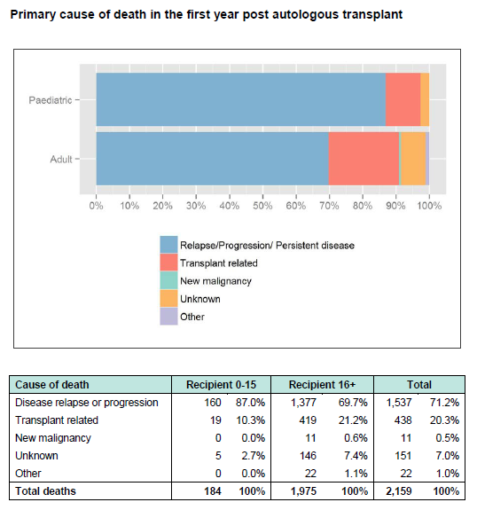
The ABMTRS 2014 summary also provided 10-year survival curves according to condition requiring ASCT.¹⁷ The curve for HL is shown below.
Figure 5. 10 Year survival curve for patients aged ≥ 16 years receiving ASCT for Hodgkin Lymphoma in Australia and New Zealand
This data indicates that around 55% of HL patients treated with ASCT in Australia are effectively cured of the disease.
The sponsor has provided an estimate of around 60% of patients who receive ASCT for HL in Australia as having one or more risk factor(s) for relapse following ASCT. This estimate is based on advice from clinicians on an Australian Advisory Board for Adcetris who estimated that 50% to 70% of patients would have risk factors for progression post-ASCT. The sponsor took the mid-point of this estimate for the calculation. Using the annual number of patients receiving ASCT and the estimate of 60% of these having ≥ 1 risk factor for relapse, the sponsor has estimated that approximately 33 patients per year who would be suitable for treatment with brentuximab vedotin under the proposed indication in Australia.

Rescue or consolidative (adjuvant) therapy
The Clinical Overview makes little mention of the impact of the product when used as rescue therapy in patients who relapse after ASCT, as currently approved. It comments that the response achieved when used as rescue therapy is not ‘curative’, although it describes long-lasting complete remission in ‘a small number’ of patients. The use of brentuximab vedotin has been described by others as a game changer in patients with refractory or relapsed HL following ASCT and sALCL: ‘Before the advent of brentuximab vedotin, both conditions had few therapeutic options, all of limited efficacy, and their prognosis was overall dismal’.
Brentuximab vedotin was approved for the indication of the treatment of relapsed or refractory Hodgkin lymphoma (HL) in the USA in August 2011, in the EU in October 2012 and in Australia in December 2013. Despite this, the Clinical Overview does not provide a discussion of the use of brentuximab vedotin as rescue therapy (the currently approved indication) compared to use as consolidative therapy (the proposed extension to indication). The results of the three year follow-up of the Phase II study, described above in this evaluation, were not referred to although these results were first publically available in June 2013. These results can assist in the determination of any advantage in the use of brentuximab vedotin as adjuvant therapy compared to its currently approved use as ‘rescue therapy’.
The sponsor has provided a discussion that addresses this question in response to a clinical question (see Section 12, Question 4 ‘Consolidation versus rescue therapy’ along with the sponsor’s response). In this response, the sponsor argues that the use of brentuximab vedotin as consolidative therapy following ASCT in all patients at increased risk of relapse will result in fewer patients being confronted by the trauma of HL recurrence and the poor prognosis consequent to this. The sponsor presents data that, according to PFS by investigator, approximately 55% of placebo patients in the pivotal who were at increased risk of relapse were not cured by ASCT alone, as opposed to approximately 35% of patients receiving consolidation treatment with brentuximab vedotin. From this the sponsor concludes that consolidation therapy with brentuximab vedotin offers sustained progression-free survival, and the potential for cure, to approximately 20% more patients.
The evaluator has two main concerns with this contention. Firstly, given the relatively brief duration of follow-up (median observation time of 30 months), it is not clear to the evaluator that the term ‘cure’ can be used. Longer follow-up is needed to determine if brentuximab vedotin as consolidative therapy following ASCT has resulted in cure or merely in a delay in relapse. Secondly, it is important to remember that historical data shows that around 50% of patients receiving ASCT for relapsed HL are effectively cured and that 45% of patients in the placebo arm of the pivotal study experienced sustained progression free survival from ASCT alone. If brentuximab vedotin is used as proposed, these patients would be exposed to the risks of brentuximab vedotin therapy without experiencing any benefit. The risks of brentuximab vedotin therapy are considerable, and include a number of reactions that have been associated with fatal outcome.
To avoid exposing patients who would otherwise be cured by ASCT alone to these risks, it is necessary to identify the patients who will most benefit from consolidative therapy. If this cannot be done, and if the proposed usage is approved, it must be ensured that the risks are made explicit in the information provided to prescribers and consumers to enable informed prescribing and consent.

Contents of the clinical dossier

Scope of the clinical dossier
- Clinical Overview
- Summary of Clinical Efficacy, Summary of Clinical Safety (these refer only to Study SGN35-005)
- One pivotal efficacy/safety study, Study SGN35-005
- One separate immunochemistry report for Study SGN35-005
- Method validation reports for:
  - electrochemiluminescent method to detect antibodies to SGN-35 in human serum; and
  - determination of free MMAE in human sodium citrate plasma by HPLC with MS/MD detection.
- 5 Periodic Safety Update Reports (PSURs), each covering a 6-month period, from 19 August 2012 to 18 February 2015
Comment: The following were provided during the second round evaluation:
    - Clinical Study Report for SGN35-008b
    - An additional PSUR covering the period August 2014 to August 2015
    - Cumulative reviews for pulmonary toxicity and hepatotoxicity were provided in the sponsor’s responses to Clinical Questions
    - The Safety Related Request which included updated safety information for the 2 Phase II registrational studies for the currently approved indication and cumulative reviews for pulmonary toxicity, hepatotoxicity and gastrointestinal complications.

Paediatric data
The submission did not include paediatric data.

Good clinical practice

Study SGN35-005
The Clinical Overview states that the study was conducted in accordance with Directive 2001/20/EC and Good Clinical Practice (GCP) regulations and guidelines (21 CFR Parts 11, 50, 54, 56, 312; ICH E6). A sample consent form, Clinical Study Report Approval form and Audit certificate (routine audits of 8 study sites and 4 service providers) were provided with the CSR.

Study SGN35-008b
The CSR states that the study was conducted in accordance with principles enunciated in the declaration, the International Conference on Harmonisation Good Clinical Practices, and applicable Food and Drug Administration (FDA) regulations/guidelines.

Pharmacokinetics
The pharmacokinetics and pharmacodynamics of brentuximab vedotin were presented in the 2012 submission of brentuximab vedotin as a new clinical entity for the currently approved indications. This included: 2 Phase I dose escalation studies, one study to assess the effect of brentuximab on cardiac repolarisation and one study to investigate drug-drug interactions between brentuximab vedotin and substrates of CYP3A4 or modulators of CYP activity. Some limited pharmacology information was also provided by 2 Phase II studies.
A detailed evaluation of the pharmacokinetic and pharmacodynamic information provided can be found in Section VI: Overall conclusion and risk/benefit assessment of the Australian Public Assessment Report (AusPAR) for Brentuximab vedotin (Adcetris). Descriptions of the pharmacology of brentuximab vedotin can also be found in the EPAR for the initial approval of brentuximab vedotin.
No new pharmacokinetic or pharmacodynamics information is presented in the original dossier except for a description of the incidence of anti-therapeutic antibodies (ATA) in Study SGN35-005 (AETHERA study) as described below (see Table 3).
The CSR for Study SGN35-008b was provided by the sponsor upon request during the second round evaluation process.

Table 3. Submitted pharmacokinetic studies
PK topic | Subtopic | Study ID
PK in target population | Incidence of anti-therapeutic antibodies | Study SGN35-005
 | PK in hepatic or renal impairment | Study SGN3-008b
A brief summary of the pharmacokinetics as currently available is provided below as background for subsequent sections in this report. The results of the study of the incidence of anti-therapeutic antibodies is summarised in Section 4.4, Immunogenicity.

Absorption, metabolism and excretion
Brentuximab vedotin is only administered by intravenous infusion. The PK profile includes the three components:
- Brentuximab vedotin, the antibody-drug complex (ADC)
- MMAE, the released small molecule
- The antibody, cAC10
Little information is available regarding the pharmacokinetics of the antibody. It is thought that it is catabolised as a protein with component amino acids recycled. More information is available regarding the other two components, as shown in Table 4. MMAE is released following CD-30 mediated internalisation of the ADC. Free extracellular MMAE appears over several days and is measurable in the blood. This may be through leakage from cells in which it has been released following endocytosis and/or by catabolism of the ADC.

Table 4. Pharmacokinetic parameters of the ADC and MMAE
 | Mean steady state volume of distribution | Timing of maximum concentration | Time to Steady state with 3 weekly administration | Terminal half-life
ADC | 8 to 10 L | At infusion end | 21 days (by cycle 2) | 4 to 6 days
MMAE | 44 L | 1 to 3 days post-dose | 21 days (by cycle 2) | 3 to 4 days
The ADC had limited distribution beyond the vascular space, consistent with an immunoglobulin. Rat studies with MMAE indicate wide tissue distribution. The volume of distribution seen in humans is consistent with wide distribution and/or tissue uptake. No accumulation according to plasma levels was seen of the ADC or MMAE with third weekly dosing at the approved dose of 1.8 mg/kg. The exposure to MMAE (according to serum levels) appears to decrease with repeated dosing: 20% to 50% decrease at Cycles 2 to 3. The mechanism of this is unknown.
Free MMAE is thought to be largely excreted unchanged in the faeces (via biliary excretion) and urine. An excretion study, Study SGN35-008a, that was conducted in 8 patients for one week following a single dose of brentuximab vedotin found that 24% of the total MMAE contained in the administered dose was recovered unchanged from the faeces and urine during this one week period (72% faeces, 28% urine). This is consistent with the postulated main route of excretion but it is notable in that only one quarter of the administered dose was recovered. This is not consistent with the plasma half-life of MMAE (see Table 4 above) and suggests retention, with possible accumulation, in the body’s tissues and/or metabolism to unidentified substances. This may contribute to the ‘off-target’ effects of brentuximab vedotin.
A small amount of MMAE is metabolised by CYP3A4 and possibly CYP2D6. In vitro studies showed inhibition of CYP3A4/5 by MMAE, although at concentrations much higher than those seen in clinical application. At least one metabolite of MMAE has been shown to be active in vitro.

Pharmacokinetics in special populations

Hepatic and renal impairment
Comment: Study SGN35-008b investigated the pharmacokinetics of brentuximab vedotin in patients with renal or hepatic impairment. The Final CSR for this component of Study SGN35-008 was not available to the clinical evaluator for the submission of brentuximab vedotin as a new chemical entity, although top-line data from this study was provided to the delegate during the evaluation process. The Final CSR was not subsequently provided to the TGA until requested during the evaluation for the current extension of indication submission after it was noted that the US and Canadian recommendations for doing in hepatic and renal impairment were more cautious than those of Europe and Australia and that this was based on the results of Study SGN35-008b (see Section 12, Question 2: Dosing in renal or hepatic impairment). The complete CSR for Study SGN35-008b was not provided to the evaluator; the appendices, including the study protocol, statistical analysis plan, protocol deviations and individual patient pharmacokinetic data were not included. [A summary of the study and study data was presented separately by the clinical evaluator.]
Study SGN35-008b was an open label, non-randomised, Phase I, multicentre study (6 centres in USA) with two concurrently run treatment arms, one for patients with hepatic impairment (Arm B-hep) and one arm for patients with renal impairment (Arm B-ren). Patients were scheduled to receive two 21 day cycles of brentuximab vedotin, and the Cycle 1 pharmacokinetics of brentuximab vedotin were evaluated using regular sampling. The effect of renal or hepatic impairment on the PK of brentuximab vedotin (including ADC and MMAE) was evaluated by comparing PK parameters (C_{max} and AUC) during Cycle 1 for patients with renal or hepatic impairment to the Cycle 1 pharmacokinetics of patients with normal renal or hepatic function who received 1.2 mg/kg in Part A of the study (chosen from Arm A-ketoconazole), the ‘unimpaired group’. The adverse event profile of patients with renal or hepatic impairment was also compared to the unimpaired group.
The study included:
- 10 patients with renal impairment, none of whom were receiving dialysis – 4 patients with mild impairment (CrCl = 50 to 80 mL/min), 3 with moderate (CrCl = 30 to 50 mL/min) and 3 with severe (CrCl < 30 mL/min)
- 7 patients with hepatic impairment, 1 patient with mild impairment (Child-Pugh A), 5 with moderate (Child-Pugh B) and one with severe (Child-Pugh C)
- 8 patients with no renal or hepatic impairment (from the ketoconazole arm of Study SGN35-008a).
The study reported that:
- Pharmacokinetics of the ADC did not appear to be significantly affected by hepatic or renal impairment
- Both AUC_{0-∞} and C_{max} are increased in patients with:
  - moderate (CrCl 30 to 50 mL/min) and severe renal impairment (CrCl < 30mL/min)
  - moderate hepatic impairment (Child-Pugh B and C). The effect of mild or severe hepatic impairment is not established as there was only one patient from each classification included in the study
- These increases in AUC_{0-∞} and C_{max} were more marked in the patients with hepatic impairment compared to the patients with renal impairment
- The adverse event profile appeared to be worse in patients with hepatic or renal impairment compared to patients with normal renal and hepatic function and worse in patients with hepatic impairment compared to patients with renal impairment
- The increase in AUC_{0-∞} and C_{max} were attributed to reduced clearance of MMAE.

Table 5 Study SGN35-008b MMAE PK parameters in unimpaired, hepatic impairment and renal impairment
 | Unimpaired N = 8 | Hepatic impairment  N = 7 | Renal impairment  N = 9
AUC_{0-∞} (dmcg/mL) Geometric Mean (%CV) | 27.2 (80) | 62.3 (61) | 31.7 (65)
C_{max} (mcg/mL)Geometric Mean (%CV) | 4.1 (75) | 6.8 (51) | 4.4 (74)
This study was limited by small numbers enrolled, even smaller numbers with all PK sampling performed, exclusion of patients requiring dialysis, lack of investigation of the effect of repeated dosing and use of a control arm that was receiving ketoconazole during the last 3 days of cycle 1.
However, within these limitations, it appears that both renal and hepatic impairment increases MMAE exposure in a way that is clinically meaningful, and that hepatic impairment has a more marked effect, as shown in Table 5 above. This is consistent with the postulated routes of excretion, with biliary excretion and loss in the faeces being the main route, and the excretion study in SGN35-008a which found that two thirds of excreted MMAE was lost in the faeces and one third in the urine. Administration of brentuximab vedotin to patients with impaired hepatic or renal function in Study SGN35-008b was also found to be associated with a worse adverse event profile. This is consistent with toxicities that are dose dependent according to MMAE exposure.

The elderly and children
The clinical studies of brentuximab vedotin did not include sufficient number of patients aged less than 18 or more than 65 years to determine if the pharmacokinetics differed in the paediatric or elderly populations.

Obesity
From the EPAR for the application of brentuximab vedotin as a new chemical entity in 2012, ‘Adcetris dosing was capped at 100 kg in clinical trials. This was not based on PK data but based on experience with other mAbs that as an obese individual is less vascularised per kg body weight than a lean individual, this may lead to over-compensation for increasing body weight.’

Drug-drug interactions
Study SGN35-008a investigated drug-drug interactions. This study was evaluated in a previous submission. Co-administration with ketoconazole, a strong CYP3A4 and P gp inhibitor, reduced clearance of MMAE; co-administration with rifampicin, a strong CYP3A4 inducer, increased clearance of MMAE; co-administration with midazolam, a CYP3A4 substrate, did not affect midazolam exposure.
Comment: According to the design of Study SGN35-005, patients who were ATA positive also had free MMAE levels measured. Analysis of these levels in patients concurrently receiving CYP3A4 and P-gp inhibitors was requested, in case this offered further insights into these potential drug interactions. The sponsor has provided an analysis of this convenience sample of patients. There were 18 patients for whom MMAE levels were available and who had received concomitant treatment with a P gp or CYP3A4 inhibitor and 40 patients for whom MMAE levels were available and who had not received concomitant treatment with a P-gp or CYP3A4 inhibitor. Mean, median, minimum and maximum MMAE levels were provided by cycle and for unscheduled visits. Apart from what appeared to be one patient in cycle 16 who received both a P-gp and CYP3A4 inhibitor and had a markedly elevated MMAE level, there was no convincing difference in the MMAE levels between the two groups. However, given that this requested analysis is exploratory, post-hoc and of a subset of patients, no conclusions can be drawn. See Section 12: Question 6, drug-drug interactions along with the sponsor’s response for more detail.

Immunogenicity
Immunogenicity refers to an unwanted immune response directed at a biotherapeutic and is demonstrated by the presence of antibodies in the patient that are specific to the biotherapeutic and referred to as ‘anti-therapeutic antibodies’ (ATA). The development of ATA may result in unwanted consequences including: hypersensitivity or anaphylactic reactions, neutralising of the therapeutic agent’s biological activity, alterations in the pharmacokinetics of the therapeutic agent (causing increased or decreased activity), formation of immune-complexes with subsequent organ injury. The presence of ATA may also have no discernible effects.
Approximately 35% of patients in Phase I and II studies of the clinical programme for brentuximab vedotin were found to develop antibodies to brentuximab vedotin (ATA). This was not observed to be associated with a reduction in efficacy but was associated with a higher incidence of infusion-related reactions in patients with persistently elevated titres.
Comment: See ATA assay issues described below and in the sponsor’s response to clinical question (Section 12, Question 5) that affect the validity of these conclusions.

Study SGN35-008b and anti-therapeutic antibodies
The presence of ATA was assessed at baseline (Cycle 1, Day 1); Cycle 2, Day 1; and at the end of treatment.
There were 16/17 patients with ATA data available. The titres of all confirmed positive ATA results in this study were ≤ 125.
- 5/16 had confirmed ATA at Baseline; 2 of these 5 patients also tested positive for confirmed ATA post-baseline; 3 did not
- 2/16 patients first had a confirmed positive ATA test at C2D1.
Two patients, one in Arm B-hep and one in Arm B-ren, experienced infusion reactions that did not interrupt the first infusion of brentuximab vedotin. One of these patients tested positive for ATA at baseline but was subsequently negative. The other was negative at Baseline but had no later results.
Comment: The results for ATA raise similar concerns regarding the assay used as described below for Study SGN35-005, with the high rate of false positives (5/16, 31%, positive at Baseline without prior exposure to brentuximab vedotin). This is suggestive of an unreliable assay.

Study SGN35-005 and anti-therapeutic antibodies
Study SGN35-005 (AETHERA) was a Phase III efficacy and safety study with a secondary objective of characterising the incidence of anti-therapeutic antibodies (ATA). A detailed description of the clinical component of the study is provided in the Efficacy and Safety sections below. A detailed description of the immunogenicity component of the study [was given but is not part of this document]. The conclusions drawn in the dossier were that:
- The incidence of ATA in Study SGN35-005 was similar to that observed in the Phase II studies: 35% of evaluable patients in the brentuximab vedotin arm tested positive at any post-baseline visit
- The presence of ATA was associated with a higher incidence of infusion related reactions in the ‘persistently positive’ patients in the brentuximab vedotin arm, with persistently positive defined as more than 2 confirmed positive ATA samples post-baseline
- The presence of ATA was not associated with a difference in efficacy
Comment: The results of the immunogenicity component of Study SGN35-005 had some surprising elements that were not accounted for, or discussed, in the Clinical Study Report or the Clinical Overview. In particular there was a high rate of positive results at baseline in both arms of the study. There were also gaps in the analyses provided that limits the interpretation of the results such that the evaluator could not determine if the above conclusions drawn by the sponsor are warranted.
The first round evaluation continued on to describe a number of issues with the ATA results from Study SGN35-005 and to suggest further analyses. These requests have been superseded by information provided by the sponsor. The evaluator has, therefore, deleted part of the Round 1 comment.
In response to a Clinical Question, the sponsor has stated that ‘Study SGN35-005 used an anti-therapeutic antibody (ATA) assay that has since been redeveloped. The former assay in use for this trial is extremely sensitive (see specifications in sponsor’s response to Clinical Question 5 [part B]) and thus likely returns a high rate of background positivity, regardless of randomisation therapy.’ This is confirmed by the false positive rate of around 22% seen in the results of the study, although the assay’s false positive rate was estimated at 6.5% (see Study SGN35-005 Pharmacology summary and Section 12: Clinical Question 5).
The evaluator had requested a number of further analyses of the data regarding ATA status in Clinical Questions [not in this document] to the sponsor. The sponsor did not provide these analyses on the basis that they could not be anticipated to yield meaningful results. Given that the assay used in Study SGN35-005 is unreliable, the evaluator agrees that no further analysis would be useful.
The narratives of 27 patients (24 patients from the brentuximab vedotin arm and 3 patients from the placebo arm) in whom infusion related reactions were reported were provided by the sponsor in response to a clinical question [not in this document]. ATA status of the patients was included. All 3 patients from the placebo arm were ATA negative throughout, as were 5 of the patients from the brentuximab arm. Of the other 19 patients from the brentuximab vedotin arm, 3/19 were ATA positive at baseline and persistently positive during treatment with peak titres of 125, 3125 and 25 respectively. The other patients were ATA negative at baseline: 11/19 were subsequently transiently positive with peak titres of 5 (n = 2), 25 (n = 4) and 125 (n = 4); 6/19 were subsequently persistently positive with peak titres of 25 (n = 1), 125 (n = 1), 625 (n = 1) and 3125 (n = 2); 5/19 were ATA negative. There was no discernible pattern between ATA titres and infusion related reactions.

Evaluator’s overall conclusions on submitted pharmacokinetics data
The summary of pharmacokinetics provided above is largely based on the information provided in the AusPAR and EPAR to provide background for subsequent sections in this report.¹⁴ The only new pharmacokinetic data submitted with the original application was the incidence of anti-therapeutic antibodies (ATA) in Study SGN35-005, the pivotal efficacy and safety study provided for the proposed indication. Study SGN35-008b was provided by the sponsor upon request during the Round 2 evaluation.
Study SGN35-008b was an open-label, non-randomised, Phase I study that investigated the PK and adverse event profile of brentuximab vedotin in patients with hepatic or renal impairment, with comparison made to patients with normal renal and hepatic function. This study was limited by small numbers enrolled, even smaller numbers with all PK sampling performed, exclusion of patients requiring dialysis, lack of investigation of the effect of repeated dosing and use of a control arm that was receiving ketoconazole during the last 3 days of cycle 1. However, within these limitations, it appears that both renal and hepatic impairment increases MMAE exposure in a way that is clinically meaningful, and that hepatic impairment has a more marked effect. This is consistent with the postulated routes of excretion, with biliary excretion and loss in the faeces being the main route, and the excretion study in SGN35-008a which found that two thirds of excreted MMAE was lost in the faeces and one third in the urine. Consistent with toxicities that are dose dependent according to exposure to MMAE, administration of brentuximab vedotin to patients with impaired hepatic or renal function in Study SGN35-008b was also found to be associated with a worse adverse event profile. After review of this study, the evaluator is of the opinion that more cautious recommendations regarding the use in hepatic or renal impairment are appropriate.
The ‘Incidence of ATA’ component of Study SGN35-005 [was described elsewhere and not included in this document] but is summarised above. Inconsistent results in this study raised concerns that were the subject of a number of clinical questions to the sponsor. These concerns and the sponsor’s responses to the questions posed are described above and in a clinical question (see Section 12, Question 5 below) along with the sponsor’s response. The following discussion regarding the incidence of ATA, and implications regarding the state of knowledge of immunogenicity of brentuximab vedotin, is based on information provided by the sponsor in response to clinical questions and was not part of the Round 1 CER.
Of note is that in the response to one of the clinical questions, the sponsor stated: ‘Study SGN35-005 used an anti-therapeutic antibody (ATA) assay that has since been redeveloped. The former assay in use for this trial is extremely sensitive (see specifications in sponsor’s response to Clinical Question 5 [Part b]) and thus likely returns a high rate of background positivity, regardless of randomisation therapy.’ The ‘extreme sensitivity’ of the assay is demonstrated by the false positive rate of 22% observed in Study SGN35-005. Narratives of infusion related reactions were provided in response to another clinical question. On review of these narratives, no discernible relationship between ATA status or titres and infusion related reactions could be identified. The evaluator is of the opinion that, given the unreliability of the assay, all of the ATA results for this study, together with any conclusions drawn from these results, should be disregarded.
The study report of the validation study for this assay provided in the dossier. The final study report is dated 2009, with amendments dated July 2011, December 2011 and June 2013. ATA status has been determined in other studies in the Clinical Trial Programme and the evaluator does not know if the same assay has been used throughout the clinical development programme. Of note is that the false positive rate in Study SGN35-008b was 31%. The current PI contains the following statements:
‘Approximately 7% of patients in the Phase II studies and 6% of patients in the Adcetris arm of the Phase III study developed persistently positive anti-therapeutic antibodies. There was a higher incidence of infusion-related reactions observed in patients with persistently positive antibodies to brentuximab vedotin relative to patients who tested transiently positive or negative.’ and ‘The presence of antibodies to brentuximab vedotin did not correlate with a clinically meaningful reduction in serum brentuximab vedotin levels and did not result in a decrease in the efficacy of brentuximab vedotin.’
If the assay used in these earlier studies is the same assay as that used in Study SGN35-005 (the Phase III study referred to in these statements), then the evaluator is of the opinion that the results with this assay are too flawed to enable any conclusions to be drawn and these statements should be removed from the PI. The immunogenicity of brentuximab vedotin, the incidence of ATA and possible effects of ATA on safety and efficacy should be regarded as ‘missing information’.

Pharmacodynamics
No new pharmacodynamics data was included in this submission. A brief summary of the pharmacodynamics as currently known (and described in the AusPAR and EPAR) is provided below to provide background for subsequent sections in this report.¹⁴
Brentuximab vedotin is an antineoplastic agent active against CD30-expressing cells. It consists of three parts: the microtubule disrupting agent MMAE joined to the IgG1 antibody cAC10 specific for human CD30 by a peptide based linker. On average, 4 molecules of MMAE are linked to each IgG with the peptide link stable under physiological conditions but readily cleaved by intracellular proteases.
The surface antigen CD30, a member of the tumour necrosis factor receptor superfamily, is expressed on Reed-Sternberg cells, the presence of which defines classical HL, and on the large abnormal lymphoid cells seen in systemic anaplastic large cell lymphoma (sALCL). CD30 may also be expressed on tumour cells of other neoplasms of lymphoid origin. Expression in non-malignant cells is generally restricted to some activated B and T lymphocytes and NK cells, with lower levels in activated monocytes and eosinophils. It is generally not detected on healthy tissue or resting lymphocytes.

Primary pharmacodynamic effect
The anti-tumour activity of brentuximab vedotin is not fully understood but is postulated to result from a multi-step process:
- the IgG component of the ADC binds to CD30 on the cell surface
- the ADC-CD30 complex is internalised by endocytosis and the membrane vesicle fuses with lysosomes
- lysosomal proteases cleave the linker with the release of MMAE within the tumour cell
- MMAE inhibits microtubule assembly, preventing cell division and resulting in apoptotic death
- Some MMAE diffuses across cell membranes. This free MMAE may have toxic effects on nearby cells. It may also reach more distant tissues via the circulation for other ‘off-target’ effects.
Comment: No clinical studies addressing the mechanism of action were submitted with this submission or with the earlier submission.

Secondary pharmacodynamic effects
Brentuximab vedotin toxicity is thought to be due to the effect of free MMAE and to the effect of brentuximab vedotin on non-malignant CD30+ cells. Target organs for toxicity identified in non-clinical studies were haematopoietic tissues in the bone marrow (atrophy, hypocellularity), liver (including hepatocellular necrosis, bile duct hyperplasia/hypertrophy, and inflammation), intestine (crypt epithelium single-cell necrosis), pancreas (acinar cell single-cell necrosis) and atrophy of lymphoid tissues in the mesenteric lymph nodes, thymus and spleen. In humans, the most commonly affected organs are the bone marrow and peripheral nervous system.

Myelosuppression
Administration of brentuximab vedotin is associated with myelosuppression, with this thought to be due to blockage of mitosis and proliferation of the rapidly cycling bone-marrow cells.

Peripheral neuropathy
Administration of brentuximab vedotin is associated with a cumulative, dose-dependent peripheral neuropathy (PN). PN has also been noted with other microtubule targeting agents such as paclitaxel and the vinca alkaloids. The mechanism of neurotoxicity is unclear but is speculated to be due to the microtubule targeting agent interfering with intra-neuronal microtubular networks. As there are no CD30 receptors expressed on neuronal cells, this toxicity with brentuximab vedotin presumably results from free MMAE.

Other organs
Toxicity involving the lungs, liver, gastro-intestinal tract and skin have been described. It is not clear how much these may be idiosyncratic reactions or may be dose-dependent.

QT effects
There was no evidence of clinically relevant prolongation of the QT/QTc interval at a dose of 1.8 mg/kg.

Pharmacodynamic drug interactions

Bleomycin
From the EPAR: ‘it is known from clinical studies outside the claimed indication that combined use of bleomycin and brentuximab vedotin causes pulmonary toxicity (data not shown) and the concurrent use of the two is contraindicated’

Bendamustine
From the PSUR dated 18 August 2015, the Safety Monitoring Committee for Study SGN35-015, Phase II multi-arm, open-label study designed to evaluate the safety and efficacy of brentuximab vedotin (Arm A) as a single agent and in combination with dacarbazine (Arm B) or bendamustine (Arm C) in elderly patients with newly diagnosed HL, identified a higher incidence of SAEs in Arm C compared to Arm A or Arm B of the study. The protocol was amended ‘to require a reduction in the starting dose of bendamustine from 90 mg/m² to 70 mg/m² to improve the tolerability of the regimen’. According to the PSUR, ‘The sponsor does not believe that this finding is relevant to the labelled patient population because brentuximab vedotin is not approved for combination use with any other therapeutic agents’.

AVD
From the sponsor’s response to questions posed by the RMP evaluator, and an ad-hoc review of safety data for Study C25003 (A randomised, open-label, Phase III trial of BV+AVD versus ABVD as frontline therapy in patients with advanced classical Hodgkin lymphoma) observed higher rates of neutropaenia and febrile neutropaenia in the BV + AVD arm when compared to the ABVD arm and recommended that colony-stimulating factors (CSF) be given prophylactically to all new patients randomised to the BV + AVD arm beginning with treatment Cycle 1. The Safety Monitoring Committee also noted trends in serious and fatal pulmonary complications in the ABVD arm, particularly in older patients.

Evaluator’s overall conclusions on pharmacodynamic data
No new pharmacodynamic data were included in this submission. The summary provided above is based on the information provided in the AusPAR and current PI to provide background for subsequent sections in this report.¹⁴
Of note is that no studies investigating the postulated mechanism of action have been submitted by the sponsor. Also of note is that pharmacodynamic drug-drug interactions have been identified through other studies investigating combination regimens in the Clinical Development programme. These interactions were not described in the submission, although information regarding some of these interactions is available in the PSURs.
This information is dealt with inconsistently in the proposed PI. Concurrent use of bleomycin is listed as a contra-indication in the proposed PI. No mention is made of other possible pharmacodynamics drug-drug interactions with other chemotherapy agents and the Interactions with Other Medicine section states: ‘There are no drug-drug interactions data available with other chemotherapy regimens.’ The evaluator notes the evaluator for the RMP for this submission proposed that the PI include the information that brentuximab vedotin is indicated as monotherapy only (TGA RMP questions [not in this document]). This evaluator agrees with the RMP evaluator that it should be explicit in the PI that the safety of brentuximab vedotin in combination chemotherapy regimens has not been established.

Dosage selection for the pivotal studies
The dose of 1.8 mg/kg administered every three weeks was based on the Phase I dose escalation studies which found 1.8 mg/kg to be the maximum tolerated dose (MTD) and the 3 week interval to provide the best balance between efficacy and cumulative toxicity, in particular peripheral neuropathy. The number of cycles is limited to a maximum of 16, also due to cumulative toxicities. This dosing regimen was found to be clinically effective in the Phase II study in relapsed/refractory HL following ASCT with an acceptable toxicity profile. Use of a placebo control was considered reasonable as there is no currently registered product for the proposed indication extension.

Clinical efficacy
Indication: ‘Treatment of patients with CD 30+ Hodgkin Lymphoma (HL) who are at increased risk of relapse or progression following autologous stem cell transplant (ASCT).’

Pivotal efficacy studies

Study SGN35-005 (AETHERA)
Study SGN35-005 is summarised in Table 6, below.

Table 6. Study SGN35-005 Summary
Study title | A randomised, double blind, placebo controlled Phase III study of SGN35 and best supportive care (BSC) versus placebo and BSC in the treatment of patients at high risk of residual Hodgkin Lymphoma following autologous stem cell transplant
Related Publication | Moskowitz et al. Brentuximab vedotin as consolidation therapy after autologous stem cell transplantation in patients with Hodgkin’s Lymphoma at risk of relapse or progression (AETHERA): a randomised, double-blind, placebo-controlled Phase III trial. Lancet 2015; 385: 1853-62
Design | Randomised, double blind, placebo controlled Phase III study of brentuximab vedotin and best supportive care versus placebo and best supportive care
Patient group | Patients at high risk of residual Hodgkin Lymphoma following autologous stem cell transplant as shown by the presence of one or more of 3 specific risk factors
Dates | First patient enrolled: 06 April 2010  Last patient assessed for primary outcome: 18 August 2014
Locations | 28 sites in the United States (US) and 50 sites in the European Union (EU), Russia, and Serbia (135 patients were enrolled from the US and 194 patients were enrolled from the EU, Russia, and Serbia)
Main Eligibility Criteria | Patients who had received an ASCT for HL in the previous 30 to 45 days were assessed for eligibility according to the presence of risk factors prior to ASCT and the response to salvage therapy. Patients with progressive disease after salvage therapy were excluded from the study.
Randomisation and Blinding | Patients were randomised 1:1 to brentuximab vedotin or placebo. Randomisation was stratified by eligibility criteria and response to salvage chemotherapy prior to ASCT. Patients and study investigators were blinded to treatment arm. Unblinding could occur on disease progression with placebo patients offered off-study treatment with brentuximab vedotin.
Study treatments | Brentuximab vedotin 1.8 mg/kg or placebo, administered as a single outpatient intravenous (IV) infusion on Day 1 of each 21-day cycle, to a maximum of 16 cycles
Outcome Measures | Primary: progression free survival by independent review facility using the Revised Response Criteria for Malignant Lymphoma (ITT analysis)  Secondary: overall survival; PFS by investigator  Other: quality of life and medical resource utilisation
No of subjects | 329 patients, 165 in the brentuximab vedotin arm; 164 in the placebo arm
Duration of follow-up | Median observation time of 30 months (range 0 to 50 months)
Results – Demographics | Baseline characteristics were generally similar between treatment groups. Median age 33 (range 18 to 76), 94% white, around 50% male
Primary Efficacy Outcome | Median PFS by IRF 42.9 months (95% CI 30.4 to 42.9) in the brentuximab vedotin arm and 24.1 months (11.5, not estimable) in the placebo arm; hazard ratio (HR) 0.57, 95% CI 0.40 to 0.81; p = 0.0013
Secondary and other outcome measures | Median PFS per investigator: for patients who received brentuximab vedotin was not yet reached (95% CI (26.4, not estimable) compared with 15.8 months (95% CI (8.5, not estimable)) for patients who received placebo; HR 0.50 (95% CI (0.36, 0.70)).  Overall survival: At the time of analysis for PFS, 28 patients (17%) in the brentuximab vedotin arm and 25 patients (16%) in the placebo arm had died. Median OS was not reached for patients in either treatment arm; interim OS analysis showed no difference (HR 1.15, 95% CI 0.67, 1.97; p = 0.620). 72 (85%) of 85 patients in the placebo group had received brentuximab vedotin after disease progression and unblinding.  Quality of life: no significant difference.  Medical resource utilisation: not reported
Post-hoc analysis according to number of risk factors | 6 risk factors for progression were pre-specified for subgroup analysis:  - Relapsed < 12 months or refractory to frontline therapy  - Best response of PR or SD to most recent salvage therapy  - Extra-nodal disease at pre-ASCT relapse  - B symptoms at pre-ASCT relapse  - 2 or more prior salvage therapies  - PET status prior to ASCT (positive or negative)  5 of these were used in a post-hoc analysis according to number of risk factors present (1, 2 or ≥ 3); PET status was not included (not available for 30% of patients). This found patients with only one risk factor, may fare worse with respect to both PFS and OS if they receive brentuximab vedotin as consolidative therapy post-ASCT.

Study objectives
Primary:
- To compare the progression-free survival (PFS) of brentuximab vedotin and best supportive care (BSC) versus placebo and BSC
Secondary:
- To compare overall survival (OS) between the 2 treatment arms
- To evaluate the safety and tolerability of brentuximab vedotin compared to placebo
- To characterise the incidence of anti-therapeutic antibodies (ATA)
Additional:
- To evaluate medical resource utilization (MRU) and calculate utility values using a preference-based patient reported outcomes (PRO) instrument (European Quality of Life 5 Dimensional (EQ-5D))

Study design
Study SGN35-005 was a randomised, double blind, placebo controlled Phase III study of brentuximab vedotin and best supportive care versus placebo and best supportive care in the treatment of patients at high risk of residual Hodgkin Lymphoma following autologous stem cell transplant. Patients who had received an ASCT for HL in the previous 30 to 45 days were assessed for eligibility according to the presence of risk factors prior to ASCT and the response to salvage therapy. Patients with progressive disease after salvage therapy were excluded from the study. Eligible patients were randomised in a 1:1 manner to receive brentuximab vedotin or placebo. All patients received best supportive care (BSC). Randomisation was stratified by eligibility criteria and response to salvage chemotherapy prior to ASCT by investigator assessment (see Figure 6, below).
Figure 6. Study SGN35-005 Design

Inclusion and exclusion criteria

Key inclusion criteria
Eligible patients had histologically confirmed classical HL, had received ASCT in the previous 30 to 45 days, and were at high risk of residual HL post-ASCT as indicated by at least one of the following criteria:
- History of refractory HL (defined as patients progressing on or failing to achieve a complete remission following frontline standard chemotherapy or a combined modality treatment program)
- Relapsed or progressive HL that occurred < 12 months from the end of frontline standard chemotherapy or a combined modality treatment program
- Extra-nodal involvement at the time of pre-ASCT relapse

Other inclusion criteria
- Age ≥ 18 years
- ECOG of 0 or 1
- Adequate organ function

Key exclusion criteria:
- Previous treatment with brentuximab vedotin
- Histologically confirmed nodular lymphocyte predominant Hodgkin lymphoma (NLPHL)
- Previously received an allogeneic transplant
- Patients who were determined to have a best clinical response of progressive disease with pre-transplantation salvage chemotherapy
- History of another primary malignancy that has not been in remission for at least 3 years
- Post ASCT or current therapy with other systemic anti-neoplastic or investigational agents
- Age less than 18 years
- Renal, hepatic or cardiac impairment
- Known cerebral/meningeal disease, including a history of progressive multifocal leukoencephalopathy (PML); or have had any Grade 3 or higher active infection within 1 week before their first dose of study treatment.

Study treatments
Eligible patients who had received an ASCT in the previous 30 to 45 days were randomised in a 1:1 manner to receive brentuximab vedotin 1.8mg/kg or placebo, administered as a single outpatient intravenous (IV) infusion on Day 1 of each 21-day cycle, to a maximum of 16 cycles. Actual weight was to be used except for patients weighing greater than 100 kg; doses for these patients were to be based on a weight of 100 kg (maximum dose of 180 mg). Dose adjustments were to occur if the patient’s weight changed more than 10% from baseline.
Brentuximab vedotin and placebo were supplied as sterile, preservative-free, white to off-white lyophilised cakes for reconstitution for IV administration and are supplied by Seattle Genetics in single-use glass vials. Each vial of the brentuximab vedotin product contains brentuximab vedotin, trehalose, sodium citrate, and polysorbate 80; each vial of placebo contains trehalose, sodium citrate and polysorbate 80.
Dose modifications and dose delays were allowed as follows:
- Any patient who came on study with Grade 2 peripheral neuropathy was to receive 1.2 mg/kg.
- Intra-patient dose reductions to 1.2 mg/kg were allowed depending on the type and severity of toxicity.
- The start of the next cycle may have been delayed for up to 3 weeks if additional time was required for the patient to recover from study treatment-associated toxicity experienced during the current cycle. Delays of greater than 3 weeks were prohibited without approval of the sponsor.
Crossover was allowed if patients met radiological criteria for progressive disease, as determined by the investigator, treatment assignment could be revealed and patients in the placebo group were given the opportunity to receive brentuximab vedotin. If this was not available commercially in the region, it was provided as part of a separate study (Study NCT01196208).
Study treatment could be discontinued for any of the following reasons:
- Disease progression
- Adverse event
- Completed 16 cycles of study treatment
- The investigator or patient deemed it in the patient’s best interest to discontinue. The reason for study treatment withdrawal was to be documented in the CRF.
A patient could be discontinued from the study (during treatment cycle or follow up) due to death, withdrawal of consent for further follow up or due to being lost to follow up.
Infection prophylaxis for herpes simplex virus and varicella-zoster virus after autologous stem-cell transplantation were to be followed as per standard international guidelines. Pneumocystis jiroveci (PCP) prophylaxis was required for all patients on this study and was to be administered from the time of engraftment (or the time of first study treatment dosing) for at least 6 months after ASCT. Growth factor and blood product support was allowed.
All concomitant medications and blood products administered were to be recorded from Day 1 (pre-dose) through the safety reporting period. Any concomitant medication given for a study protocol-related adverse event was to be recorded from the time of informed consent. Supportive measures consistent with optimal patient care were to be provided throughout the study according to institutional standards.
Assessment for disease progression during the progress of the study are shown in Figure 7 below, assuming 16 cycles of treatment are received.
Figure 7. Study SGN35-005 Efficacy assessments and timing
After completion of the treatment cycles (approximately 12 months if 16 cycles completed), patients were to continue regular assessments for a further 12 months (‘long-term follow-up phase’). At the end of 24 months, assessment for primary outcome measure of progression free survival (PFS) by independent review facility (IRF) was to occur. Patients could continue to have 6 monthly assessments by the investigator thereafter but these would not be reviewed by the IRF. CT scans were of the chest, abdomen and pelvis. These were performed according to the calendar as shown and were not associated with specific treatment cycles to ensure consistent assessment between treatment arms. A CT scan was also to be performed at the end of treatment (EOT) visit and at the time of suspected clinical progression. Biopsies to assess HL progression were performed as clinically indicated.

Efficacy variables and outcomes

Main efficacy variables
Disease progression:
- Determined by the independent review facility (IRF) using the Revised Response Criteria for Malignant Lymphoma (see below) with CT scans performed specifically at baseline and at months 3, 6, 9, 12, 18, and 24 after first dose.
  - Criteria for progressive disease by CT scans, were:
    - Nodal masses: Appearance of a new lesion(s) > 1.5 cm in any axis; ≥ 50% increase in sum of the product of the diameters (SPD) of more than one node; or ≥ 50% increase in longest diameter of a previously identified node >1 cm in short axis.
    - Liver or spleen: ≥ 50% increase from nadir in the SPD of any previous lesions
  - Determined by the investigator according to radiographic assessments and biopsy results and was to follow the definition of progressive disease (PD). Investigator assessment of progression was used for all treatment decisions and administration of new therapy). After 24 months, clinical lymphoma assessments by the investigator were continued 6 monthly for patients whose disease had not yet progressed.
  - Overall survival as determined at the time of analysis for the primary endpoint.

Other efficacy variables
- Incidence of anti-therapeutic antibodies (ATA)
  - See Sections 4 and 5 (Pharmacokinetics/Pharmacodynamics) above
- Quality of Life (QoL) Assessments (using the EQ-5D health questionnaire)
- Health economics and outcomes research (HEOR) (using medical resource utilisation data)
- Demographic variables for baseline comparison of the treatment groups including:
  - Age, gender, ethnicity, race, baseline height, weight, body mass index, ECOG score
  - Disease-specific characteristics including time from diagnosis, time from most recent stem cell transplant, and previous cancer-related treatments
- Safety: recording of adverse events, including serious adverse events, concomitant drugs, physical examination findings, and laboratory tests. Adverse events were classified by system organ class and preferred MedDRA term and graded using the National Cancer Institute Common Terminology Criteria for Adverse Events (NCI CTCAE), Version 4.0

Efficacy and safety outcomes
The primary efficacy endpoint was progression free survival by independent review facility, defined as the time from randomisation to the first documentation of tumour progression or death.
The secondary efficacy endpoint was overall survival defined as the time from randomisation to documentation of death from any cause.
Other endpoints were quality of life and medical resource utilisation.
Safety endpoints were type, incidence, severity, seriousness and relatedness of adverse events, laboratory abnormalities and incidence of ATA.

Randomisation and blinding methods
Participants were randomly assigned (1:1), via fixed block randomisation with computer-generated random numbers, to receive either 1.8 mg/kg intravenous brentuximab vedotin or placebo.
Randomisation was stratified by:
- Refractory/relapsed status after the end of frontline standard chemotherapy or a combined modality treatment program:
  - Any refractory HL
  - Relapsed HL that occurred < 12 months after the end of frontline therapy
  - Relapsed HL that occurred ≥ 12 months after the end of frontline therapy (with this defined as also having extra-nodal involvement at the time of pre-ASCT relapse)
- Best clinical response, according to the Revised Response Criteria for Malignant Lymphoma, achieved after completion of salvage therapy prior to ASCT:
  - Complete response (CR)
  - Partial response (PR)
  - Stable disease (SD)
Patients and study investigators were blinded to treatment arm. Unblinding could occur under two circumstances:
- Emergency: when clinical circumstances warranted determination of the treatment the patient was receiving
- On disease progression, the patient could be informed of the treatment allocation. This was to enable patients who progressed on the placebo arm to receive brentuximab vedotin. In this circumstance the sponsor was to remain blinded.
There were no reports of emergency unblinding in either treatment arm. Treatment assignments were unblinded for 129 patients overall: 46 patients in the brentuximab vedotin arm and 83 patients in the placebo arm. According to the dossier, the sponsor remained blinded in these cases. One other patient’s treatment assignment was unblinded to the sponsor’s Drug Safety Department and the patient’s physician for risk assessment purposes due to a potential new safety signal of acute pancreatitis.

Analysis populations
The intent-to-treat (ITT) analysis set was to be used for the primary efficacy analysis and includes all randomised patients. Patients were to be included in the treatment arm assigned at randomisation regardless of the actual treatment received.
The per-protocol analysis set was to be used for secondary analyses of efficacy endpoints and includes the patients who were randomised, received at least one dose of assigned treatment, and did not have major protocol deviations.
The primary safety analysis set consisted of all randomised patients who received at least one dose of either brentuximab vedotin (SGN-35) or placebo. Patients receiving any dose of brentuximab vedotin will be grouped into the brentuximab vedotin and BSC group. Patients who do not receive brentuximab vedotin but any dose of placebo will be grouped into the placebo and BSC group. All patients in the safety analysis set will be analysed according to the actual treatment received. The safety analysis set will be used for all safety analyses.

Sample size
Sample size calculations were affected by two protocol amendments.
The original sample size calculation dated April 2009 was for 175 patients to be enrolled and analysis to occur after 93 progression events had occurred. Prior to enrolment of any patients, the sample size calculation was changed in a Protocol Amendment dated October 2009:
Approximately 322 patients (approximately 161 patients per treatment arm) will be randomised in this study.
Approximately 202 events (progression or death due to any cause) are required for the final analysis to detect a hazard ratio of 0.667 (18 months median PFS for SGN-35 versus 12 months for placebo) using the log-rank test with 80% power and an overall Type I error rate of 0.025 (one-sided).
In Amendment 6 dated December 2013 the analysis was changed from event driven to time-point driven, after it became apparent that the estimated 202 events were not likely to occur. The sample size determination was changed to:
Approximately 322 patients (approximately 161 patients per treatment arm) will be randomised in this study.
Approximately 202 events (progression or death due to any cause) were originally planned for the primary efficacy analysis to detect a hazard ratio of 0.667 (18 months median PFS for SGN-35 and BSC versus 12 months for placebo and BSC) using the log-rank test with 80% power and an overall one-sided alpha level of 0.025. The assumed median PFS of the placebo and BSC group is based on the long-term results of ASCT for primary refractory or relapsed HL (Majhail 2006b). With protocol amendment 6, the primary efficacy analysis will be performed when all scheduled study radiographic progression assessments are completed; at that time, approximately 161 projected events would provide 73% power to detect a hazard ratio of 0.667 using the log-rank test with an overall one-sided alpha level of 0.025. Final power will depend on the number of events observed at the time of the primary analysis.
Comment: At the time of this amendment in December 2013, 329 patients had been recruited and completion of all assessments for the primary outcome measure had occurred by August 2014. At the time of the primary analysis for efficacy, 135 events had actually occurred.

Statistical methods

General
Descriptive statistics (mean, median, standard deviation, minimum and maximum) will be used to summarise continuous variables. Frequencies and percentages will be used to summarise categorical variables. The median survival time will be calculated as the smallest observed time for which the value of the estimated survival function is less than or equal to 0.5.

Handling of missing data
Patients with missing values of a variable other than the time-to-event endpoints (PFS and OS) and QoL endpoints will be excluded from the analysis of that endpoint. Missing values of a variable to be summarised will not be imputed, with the following exceptions:
- AE onset and end dates
- Incomplete date of initiation of first new cancer-related therapy in long-term follow-up: the date will be imputed to the last day of the month if only the day is missing.
- QoL analysis: EQ-5D TTO index scores will be imputed at EOT and 3-month intervals through month 24 for all patients who were either still on study at the expected time-point or off-study for reason of death. Visits for patients who were last known to be alive will be imputed using last observation carried forward (LOCF), while visits for patients who had died within or prior to a one-week window of the expected visit date will be imputed as zero. Visits where the EQ-5D was partially completed will have the index score imputed as if the entire visit was missing. No imputation will be done on EQ-5D VAS scores.

Efficacy analyses
The primary statistical hypothesis can be expressed in terms of the hazard ratio λSGN-35 /λPlacebo where λSGN-35 represents the hazard of progression on the SGN-35 arm and λPlacebo represents the hazard of progression on the placebo arm. A hazard ratio < 1 indicates that the duration of PFS is prolonged for patients on the SGN-35 arm compared with patients on the placebo arm.
The null and alternative hypotheses can be written respectively as:
- H0 = λSGN-35 / λPlacebo ≥ 1
- HA = λSGN-35 / λPlacebo < 1
The statistical hypotheses of OS are similar to that of PFS.

Stratification factors
The 6 stratification factors are described above in the section on the randomisation process. If one or more of the 3 x 3 = 9 strata cannot be included in the analysis (for example, because no patients are randomised to a stratum), strata may be pooled in the following order: first relapse < 12 with > 12 months relapse, then relapse PR with SD. If further pooling is necessary, analysis will be done unstratified.

Subgroup analyses
As exploratory analyses, subgroup analyses may be conducted for the efficacy endpoints of PFS and OS using the following subgroups:
- Age (< 45, ≥ 45; 18 to 64, ≥ 65 years)
- Sex (Male, Female)
- Categorised weight at baseline (≤ 100 and > 100 kg)
- ECOG performance status at Baseline (0, 1)
- Number of treatments (frontline and salvage) prior to ASCT (2, > 2)
- Geographic region (North America/Rest of world; North America, EU and Other)
- PET negative prior to ASCT (Yes)
- PET positive prior to ASCT (Yes)
- B symptoms after failure of frontline therapy (Yes/No)

Multiple comparisons/multiplicity
The overall one-sided alpha level is 0.025. One interim analysis of futility based on PFS is planned. Early stopping of the trial due to overwhelming efficacy is not planned. A fixed sequential testing procedure will be used to test between PFS and OS such that OS will be tested only if the test of PFS is statistically significant.
An interim analysis of OS will be performed at the time of the primary analysis of PFS with a fixed one-sided p-value of 0.008. This alpha level is based on an O’Brien-Fleming boundary with the estimated information expected to be available at the time of the interim analysis. The final analysis of OS will be tested at a one-sided 0.017 level, ensuring an overall one-sided 0.025 alpha level.

Primary endpoint analysis, progression-free survival
Progression-free survival (PFS) is defined as the time from randomisation to the first documentation of disease progression (PD) by independent review facility (IRF) or to death due to any cause, whichever comes first:
PFS = Date of first documented PD or death minus Date of randomisation + 1
If PD is not documented and the patient is alive at the time of the data cut-off or study withdrawal, whichever occurs first, PFS will be censored as described in Table 7 below.

Table 7. Study SGN35-005 censoring rules for primary PFS analysis
For the primary efficacy analysis, the stratified log-rank test was used to compare the difference in PFS between the 2 treatment groups. Estimation of the stratified hazard ratio (HR) was based upon the Cox regression model. PFS was also summarised using the Kaplan-Meier method. The median PFS and its two-sided 95% CI for the median and 3-month intervals were calculated using the complementary log-log transformation method. Percentage of PFS at various time intervals (for example, every 6 months) were calculated using the Kaplan-Meier estimate.

Secondary analyses of PFS
Using the same censoring method for the primary PFS analysis but alternative statistical tests and with no p-values calculated:
- PFS per Investigator on ITT analysis set
- PFS per IRF, Unstratified Analysis
- PFS per Investigator, Unstratified Analysis
- PFS per IRF, Per-Protocol Analysis Set

Evaluation of the impact by the change in timing of primary analysis
The possible bias introduced by the change in timing of primary analysis was evaluated by comparing the frequency of scans received prior to and after the announcement of protocol 6.0 amendment between treatment groups.

Sensitivity analyses of PFS
These were provided in StudySGN35-500 study documents [not in this document].
Using alternative censoring methods, statistical tests and analysis sets:
- PFS per IRF, only censoring and events at scheduled visit dates based on ITT
- PFS per Investigator, only censoring and events at scheduled visit dates based on ITT
- PFS per Investigator, including Investigator Claim of Progression as an event on ITT
- PFS per IRF, based on EMA Guideline on the Evaluation of Anti-cancer Medicinal Products in Man, 2012, Appendix 1 (Methodological Considerations for Using Progression-free Survival or Disease-free Survival in Confirmatory Trials)
- PFS per IRF, subsequent New Antitumor Therapy Considered an Event on ITT
- PFS per Investigator, subsequent New Antitumor Therapy Considered an Event on ITT.
For the PFS per IRF Based on EMA Guideline on the Evaluation of Anticancer Medicinal Products in Man, 2012, Appendix 1 (Methodological Considerations for Using Progression-free Survival or Disease-free Survival in Confirmatory Trials), the censoring rules differ in that Death or documented progression after initiation of new anti-cancer treatment and Death or progression documented after more than one consecutively missed visit counted as events rather than being censored.

Secondary endpoint analysis, overall survival
Overall survival is defined as the time from randomisation to date of death due to any cause. In the absence of confirmation of death, OS will be censored at the last date the patient is known to be alive.
The primary analysis of OS will be the stratified log-rank test using the randomised stratification factors. Strata may be pooled if at least 1 stratum does not have a death. A stratified Cox regression model will be used to estimate the hazard ratio and the corresponding 95% CI for the treatment effect. The two-sided 95% confidence intervals (CI) for the median OS and 3-month intervals will be calculated using the complementary log-log transformation method. Percentage of OS at various time intervals (for example, every year) will also be calculated using the Kaplan-Meier estimate.
Secondary analyses of OS include:
- Unstratified analysis
- Per-protocol analysis

Analysis adjusting for crossover
The overall survival analysis could be confounded by patients who experience progressive disease on study and receive subsequent therapy with SGN-35 after unblinding. To deal with this, a sensitivity analysis of OS using rank preserving structural failure time models (RPSFT) will be conducted using unvalidated R software. Procedural controls will be in place for verification of the results. At a later time, an exploratory analysis of OS using the Inverse probability of censoring weighted (IPCW) method may be conducted.

Immunogenicity
See Section 4.4 (Study SGN35-005; anti-therapeutic antibodies) and Section 4.5 (Evaluator’s overall conclusions on submitted pharmacokinetics data), above.
Comment: As described in Section 4, the evaluator is of the opinion that, given the unreliability of the assay, all of the ATA results for this study, together with any conclusions drawn from these results, should be disregarded.

Safety
The patient incidence of AEs was summarised by system organ class, preferred term, severity, seriousness, and relationship to study drug. Summary statistics for actual values and change from baseline were tabulated for laboratory results by treatment group and scheduled visit. The patient incidence of laboratory toxicities was summarised by treatment group and by maximum grade for each laboratory test.
Adverse events of peripheral neuropathy, pulmonary toxicity, infusion related reactions opportunistic infections, haematologic toxicities, hyperglycaemia, hepatotoxicity, viral hepatitis, secondary malignancies, and other rare serious AEs will be considered AEs of special importance

Protocol amendments
The original version of the study protocol was dated April 2009. There were 6 subsequent versions due to protocol amendments. The major of these changes were a change in the sample size calculations (Amendment 2) and a change from an event driven analysis (analysis to occur after 202 events had been recorded) to a time-point driven analysis (Amendment 6) (analysis to occur in August 2014 when all scheduled radiographic assessments for the primary outcome measure were complete). This change was made when it became apparent that the number of events estimated in the second sample size calculations were unlikely to occur, both are described above.

Participant flow
A total of 329 patients were enrolled and randomised in the study. All patients had completed or discontinued study treatment as of August 2013. Follow-up assessments for the primary outcome measure were completed in August 2014. Participant flow is shown below (long-term follow-up in this schematic refers to follow up from completion of treatment cycles to 24 months from study entry).
Figure 8. Patient disposition flow chart
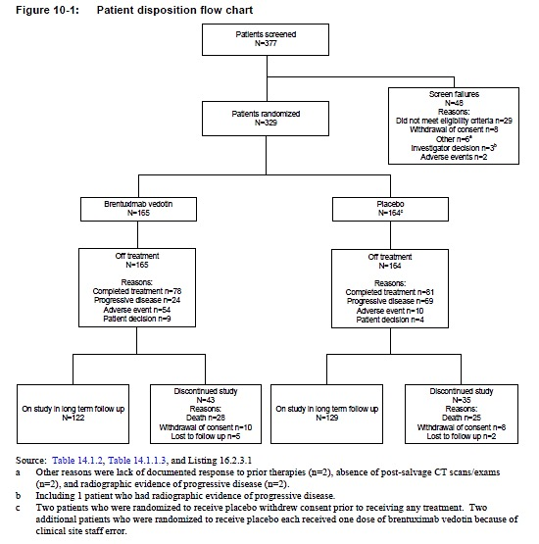
Comment: Of the screening failures, 7/48 were ineligible due to having no risk factor for increased risk of relapse post-ASCT. The largest group (17/48) was ineligible due to progressive disease after salvage therapy.
At data cut-off for the primary efficacy outcome analysis (24 months), 251 patients remained in the study (122/165 patients in the brentuximab vedotin arm and 129/164 patients in the placebo arm) and 78/329 (24%) patients had discontinued the study for reasons given below in Table 8.

Table 8. Study SGN35-005 Reasons for study discontinuation
Reason for Study Discontinuation | Brentuximab vedotin group; Number (%) | Placebo group; Number (%)
Death | 28 (17%) | 25 (15%)
Withdrawal of Consent | 10 (6%) | 8 (5%)
Lost to follow up | 5 (3%) | 2 (1%)
Total | 43 | 35

Study drug exposure and treatment discontinuation
Of the 329 patients enrolled in the study, 165 were randomised to receive brentuximab vedotin and 164 to the placebo arm: these 329 patients are included in the ITT analysis set. Of the 329 randomised patients, 327 patients received at least 1 dose of study treatment; 2 patients randomised to receive placebo withdrew consent prior to receiving the first dose of study drug. Two patients in the placebo arm received the study drug in error. An additional 72 patients in the placebo arm were treated with brentuximab vedotin following progression (investigator and/or IRF assessment).
The median number of treatment cycles in each arm was 15 cycles (range 1 to 16) and 159 patients (49%) received 16 cycles: 78 in the brentuximab vedotin arm and 81 in the placebo arm as shown in Figure 9, below. A total of 170 patients did not complete 16 cycles of treatment. The reasons for treatment discontinuation are shown below in Table 9.

Table 9. Study SGN35-005 Reasons for treatment discontinuation
Reason for Treatment Discontinuation | Brentuximab vedotin group; Number (%) | Placebo group, Number (%)
Adverse events | 54 (33%) | 10 (6%)
Progressive Disease | 24 (15%) | 69 (42%)
Patient decision | 9 (5%) | 4 (2%)
Total | 87 | 83
Figure 9. Study SGN35-005 Duration of treatment according to number of cycles
Comment: Table 10 (below), on which this graph is based was provided in response to a clinical question (Section 12 of this document).

Table 10. Study SGN35-005: Overall summary of treatment cycles (ITT population)
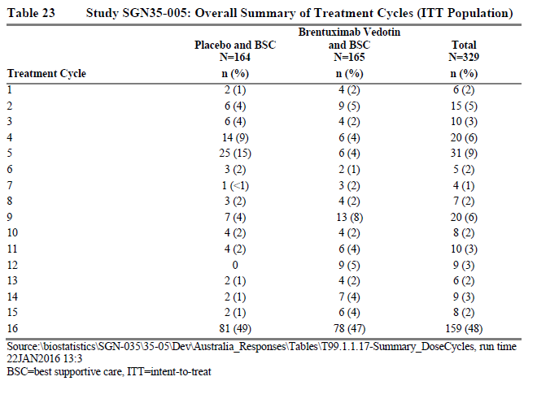
There is a different pattern of treatment discontinuation in the placebo and brentuximab vedotin arms, with more patients in the placebo group discontinuing during the first few cycles: 53/83 (64%) of the placebo group discontinue treatment during the first 5 cycles compared to 29/87 (33%) of the brentuximab vedotin group.

Major protocol violations/deviations
Of the 329 patients randomised in the study, 69 (21%) had a protocol violation: 39 patients (24%) in the brentuximab vedotin arm and 30 patients (18%) in the placebo arm, shown in Table 11.

Table 11. Study SGN35-005 Protocol violations
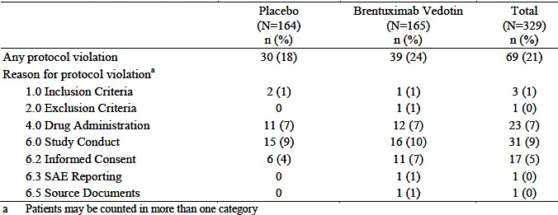
Study conduct violations were the most frequently reported category of protocol violations in the study (31 patients: 16 patients in the brentuximab vedotin arm and 15 patients in the placebo arm). The majority of these violations were randomisation stratification errors, involving 10/165 patients randomised to brentuximab vedotin and 12/164 patients randomised to placebo. All but 1 of the other study conduct violations were related to missed radiographic assessments and/or visits (4 patients randomised to brentuximab vedotin and 6 patients randomised to placebo). The remaining study conduct violation was a patient in the brentuximab vedotin arm who received 1 additional cycle of treatment after disease progression was recorded.
Study drug administration violations were reported for 23 patients; 12 patients in the brentuximab vedotin arm and 11 patients in the placebo arm. The majority of these (17 of 23 patients) were because dose adjustments were not performed per protocol for weight changes greater than 10% from baseline or because of dose miscalculations by site staff. There were 4 patients who had protocol violations resulting in administration of the wrong arm for one cycle: 2 patients randomised to receive brentuximab vedotin received placebo in error; 2 patients in the placebo arm received the brentuximab vedotin in error.
Informed consent violations were reported for 17 patients (11 patients in the brentuximab vedotin arm and 6 patients in the placebo arm, with most of these occurring because patients were not re-consented in a timely manner after updates were made to the risk profile section of the informed consent form (ICF). One site in the UK was reported by the sponsor to the Medicines and Healthcare Regulatory Agency as a potential breach of GCP/Trial Protocol due to a delay of several months in re-consenting 2 patients.
Comment: None of the described protocol violations are expected to affect the study outcomes.

Baseline data
Baseline data is shown below in Table 12. Demographics and baseline characteristics were largely similar apart from a higher percentage of females and Black/African American patients enrolled in the brentuximab vedotin arm relative to the placebo arm.

Table 12. Baseline characteristics of study participants, including risk factors for relapse and prior cancer-related therapies
Comparison of Baseline HL characteristics, shown below in Table 13, reveal no major relevant difference between the treatment arms. FDG-PET scans were not available at all sites and were not required by the study protocol.

Table 13. Study SGN35-005 Baseline HL characteristics
As described above, patients were stratified according to their status following frontline therapy (refractory, relapse within 12 months, or relapse ≥ 12 months with extra-nodal disease) and to their most recent pre-ASCT salvage therapy (CR, PR, or SD). The number of patients stratified to each of the 9 cohorts is shown in Table 14, below.

Table 14. Study SGN35-005 Summary of randomisation by stratification factors
Stratification errors were reported for 22 of 329 patients (7%) with similar rates for each arm of the study: 10/165 patients for patients randomised to brentuximab vedotin and 12/164 patients for patients randomised to placebo. After stratification error correction, there were minor differences in numbers in some stratification cohorts, but these are unlikely to be of any relevance.
Comment: The overall patient population was heterogeneous with regard to factors of prognostic importance, for example response to salvage chemotherapy, PET-FDG state, presence of B symptoms, stage at initial diagnosis. Comparison of the treatment groups for individual risk factors suggests that the two arms were reasonable well-matched. Comparison according to the presence of more than one risk factor is not possible with the data as presented. This may result in subgroups that derive different benefit from brentuximab vedotin.
Patients were enrolled within 30 to 45 days of ASCT. Assessment for the presence of residual disease is unreliable at this time. This could result in patients with no residual disease post-ASCT and patients with residual disease post-ASCT being enrolled and add to the heterogeneity of the study population. Patients who progress early may represent the group with residual disease.

Results for the primary efficacy outcome
The primary efficacy analysis was PFS per IRF, defined as the time from randomisation until objective tumour progression per IRF or death. The median follow-up time from randomisation to the primary efficacy analysis was 22.1 months (range, 0 to 49). Results are shown in Table 15, below.
At the time of the primary efficacy analysis, 135 of the 329 patients (41%) in the ITT set had progressed per IRF or died: 60/165 patients (36%) in the brentuximab vedotin arm versus 75/164 patients (46%) in the placebo arm. Of these progression events, 131 had PD as assessed by independent review and 4 patients had died. Of the other 194 patients, 152 had no documented progression (by IRF) at the time of the primary efficacy analysis: 88 in the brentuximab vedotin arm and 64 in the placebo arm (observed 12 month progression free survival of 53% and 39% respectively). Of the remaining 42 patients, 12 had discontinued from the study, 27 had received other anti-tumour therapy and 3 did not have an adequate baseline tumour assessment.
The median PFS per IRF for patients who received brentuximab vedotin was 42.9 months (95% CI 30.4, 42.9) and the median PFS for patients who received placebo was 24.1 months (95% CI 11.5, upper limit not determined). The difference between the 2 arms was statistically significant in favour of brentuximab vedotin (p = 0.001; stratified log-rank test) and the stratified hazard ratio was 0.57 (95% CI 0.40, 0.81). This met the pre-specified difference in PFS of 6 months (estimated median PFS of 18 months for the brentuximab group and 12 months for the placebo group) and hazard ratio of 0.667.

Table 15. Study SGN35-005 Progression free survival per IRF (ITT set)
The Kaplan-Meier plot of PFS per IRF assessment is shown below in Figure 10. The estimated 24-month PFS rate was 63% (95% CI 55%, 70%) for patients in the brentuximab vedotin arm versus 51% (95% CI 43%, 59%) for patients in the placebo arm.
Figure 10. Study SGN35-005 PFS per IRF (ITT analysis set)
Comment: PFS by IRF was better than expected and/or better than historical controls for both the placebo arm and the brentuximab vedotin arm: the estimated PFS by IRF in the sample size calculation was 18 months and 12 months for the brentuximab vedotin and placebo arms respectively compared to 42.9 months and 24.1 months observed in the study; 161 progression events were expected to occur compared to 135 observed.
In response to a clinical question regarding the unexpectedly good outcomes, the sponsor speculated that these were due to difficulties in comparison to historical data and improvements in transplantations and supportive care. Any contribution of the use of brentuximab vedotin as rescue therapy in the placebo arm is not commented on (see Section 12: Question 7 along with the sponsor’s response). The evaluator is of the opinion that the use of brentuximab vedotin as both rescue therapy (received by 72/164 patients in the placebo arm) and as consolidative therapy post ASCT is a major factor contributing to these better than historical results.
Additional data regarding the 72 patients in the placebo arm who developed progressive disease and were treated with brentuximab vedotin as rescue therapy was provided in sponsor’s response to clinical question (see Section 12, Question 9). An analysis of time to next treatment after brentuximab vedotin therapy in these patients (TTNT) was provided by the sponsor for these 72 patients and may provide a rough approximation of the PFS with brentuximab vedotin used as rescue therapy (PFS2). Follow-up in the study was for 12 months after completion of, or discontinuation from, the initial randomised treatment. The median time from discontinuation of this treatment to subsequent treatment was 1.5 months. At the end of the 12 month follow-up period, the median TTNT for the 72 patients who received brentuximab vedotin as rescue therapy was 9.6 months (95% CI 6.7 to 12.7) and the estimated PFS at 24 months was 26.8%.
A single arm Phase II study investigated the use of brentuximab vedotin in patients who had relapsed following ASCT for relapsed HL and is described in the AusPAR for the submission of brentuximab vedotin as a new chemical entity (the three year follow-up results of this study were published in 2015 and have also been described above).¹⁴ Approval for the use of brentuximab vedotin as rescue therapy in patients who relapse following ASCT was based on the results of this study due to the considerable improvement over historical controls. Progression free survival was a secondary outcome measure in the Phase II study and was assessed 12 months after completion of treatment. At this time-point, the median duration of progression free survival of 5.6 months and the estimated PFS at 24 month was 23%. The median event free survival was 29 weeks (95% CI 23.9 to 38.3 weeks). The results of this study are similar to those seen for the TTNT analysis above.
This would suggest that the unexpectedly good outcome in the placebo arm of the AETHERA study can be attributed to the use of brentuximab vedotin as rescue therapy for patients in this arm who developed progressive disease.

Results of secondary analyses and sensitivity analyses of progression free survival
A number of secondary analyses of progression free survival and sensitivity analyses were performed as per the statistical analysis plan. The results of these (with some described below) all supported the results of the primary analysis of progression free survival by IRF.

Progression-free survival using Investigator-assessed progression
Comment: Progression assessments by IRF were made on the basis of strictly scheduled CT scans (see study design above) and/or biopsy results. Assessments by investigators could be based on clinical findings and/or CT scans and/or biopsy results and could occur at scheduled or unscheduled visits. Patients assessed by the investigator as having progressive disease could be commenced on new anti-tumour therapy prior to the next scheduled visit – these patients were censored in the assessment by IRF.
At the time of the primary efficacy assessment, 149/329 patients in the ITT analysis set had progressed or died by investigator assessment, compared to 135/329 by IRF. More progression events were recorded in the investigator assessment in each treatment arm: 21 (13%) patients in the placebo group and six (4%) patients in the brentuximab vedotin group were censored from the analysis of progression-free survival by independent review because of investigator determination of disease progression and initiation of subsequent therapies without independent-review facility assessed progression.
An assessment of concordance between IRF and investigator showed that assessment of PD (yes/no) was concordant between IRF and investigator assessment for 286/329 patients (87%). The overall concordance rate in the brentuximab vedotin arm was 89% and the overall concordance rate in the placebo arm was 85%.
The median PFS per investigator for patients who received brentuximab vedotin was not yet reached (95% CI 26.4, upper limit not determined) compared with 15.8 months (95% CI 8.5, upper limit not determined) for patients who received placebo. The stratified HR was 0.50 (95% CI 0.36, 0.70). The estimated 24-month PFS rate was 65% (95% CI 57%, 72%) for patients in the brentuximab vedotin arm versus 45% (95% CI (37%, 52%)) for patients in the placebo arm.
Results are given in Table 16 and Figure 11, below.

Table 16. Study SGN35-005 Progression-free survival per investigator
Figure 11. Study SGN35-005 PFS per investigator, ITT analysis set
A similar result was found in the sensitivity analysis of PFS per investigator including clinical lymphoma assessments. This analysis included those patients who had not progressed at the time of the primary efficacy analysis and who continued in follow-up after this time. Clinical lymphoma assessments (± scans) were performed every 6 months by the investigators. None of these scans were reviewed by the IRF. Only 4 progression events were observed after the 24-month evaluation period.

Progression-free survival per IRF, per-protocol population
The median PFS per IRF in the PP population was not met in the brentuximab vedotin arm (95% CI 30.4, upper limit not determined) compared with 17.8 months (95% CI 6.5, upper limit not determined) with placebo. The stratified hazard ratio was 0.45 (0.30, 0.68).

Progression-free survival per IRF, using EMA censoring guidelines
A sensitivity analysis, PFS per IRF using EMA censoring rules (described above) found that the median PFS per IRF for patients who received brentuximab vedotin was 39.9 months (95% CI 30.4, 42.9) (range, 0.03 to 42.94) compared with 24.1 months (95% CI 11.5, upper limit not determined) (range, 0.03+ to 42.35+) for patients who received placebo. The stratified HR was 0.55 (95% CI 0.39, 0.77). By Kaplan-Meier analysis, shown in Figure 12 below, the estimated 24-month PFS rate was 63% (95% CI 55%, 71%) for patients in the brentuximab vedotin arm versus 50% (95% CI 42%, 58%) for patients in the placebo arm.
Figure 12. Study SGN35-005 PFS per Investigator using EMA censoring guidelines, ITT analysis set
Comment: It is notable that in the KM survival curves for the primary outcome measure and for the secondary analyses of the primary outcome measure, the curves for the two treatment arms parallel each other after an early dip in the placebo arm (due to a number of progression events in the first six months in the placebo group) and both treatment arm curves appear to plateau at around 24 months. The difference in overall PFS would appear to be largely due to the patients with early progression in the placebo arm and this may represent a subgroup that benefits from brentuximab vedotin administered as adjuvant therapy following ASCT – the results of post hoc subgroup analyses requested in clinical questions to the sponsor are described below in the following sections: Results of subgroup analyses of progression-free survival; and results of a post-hoc analysis of progression-free survival per IRF according to risk factors.
The results of other sensitivity analyses are shown in Table 17, below.

Table 17. Study SGN35-005 Summary of PFS sensitivity analyses
Note: IRF = assessment by independent review facility; INV = investigator assessment

Evaluation of the effect of Protocol Amendment 6 (change in the timing of the primary efficacy analysis)
Under Protocol Amendment 6, the timing of the primary efficacy analysis was changed from an event-driven analysis to a time-point driven analysis. In accordance with the statistical analysis plan, possible bias in the timing of progression assessments due to this change was evaluated by comparing the frequency of scans received prior to and after the announcement of the amendment between treatment groups. This showed that compliance of completing protocol-scheduled time point scans and the pattern of scanning and frequency of unscheduled scans was similar before and after Protocol Amendment 6.
Comment: At the time of this amendment in Dec 2013, 329 patients had been recruited and completion of all assessments for the primary outcome measure had occurred by August 2014. There were 80 scans performed after protocol amendment 6 compared to 1669 scans before.

Results of subgroup analyses of Progression-free survival
Univariate subgroup analyses of PFS were performed by demographics and baseline characteristics, stratification factors, and other pre-specified risk factors (see above). An additional post-hoc analysis by numbers of risk factors present was also performed. Results were descriptive only. No formal comparisons and no adjustments for multiplicity were made for subgroup analyses.
Comment: Pre-specified subgroups for exploratory analysis were:
    - Age (< 45, ≥ 45 years, 18 to < 65 years, ≥ 65 years)
    - Gender (male, female)
    - Categorised weight at baseline (≤ 100 and > 100 kg)
    - Geographic region (North America versus Rest of World; North America versus EU, versus Other (Russia and Serbia))
    - ECOG performance status at baseline (0, 1)
    - Number of treatments (frontline and salvage) prior to ASCT (2, > 2)
    - PET status prior to ASCT (positive or negative)
    - B symptoms after failure of frontline therapy (yes/no)
    - Extra-nodal disease at the time of pre-ASCT relapse (yes/no)
    - Confirmed negative/positive ATA at baseline and subsequently negative, transiently positive, or persistently positive post-baseline
    - Refractory/relapsed status after the end of frontline standard chemotherapy or a combined modality treatment program (refractory HL, relapsed HL that occurred < 12 months, and relapsed HL that occurred ≥ 12 months)
    - Best response per the Revised Response Criteria for Malignant Lymphoma (Cheson 2007) obtained after the completion of salvage therapy prior to ASCT, as assessed by the investigator (CR, PR, or SD)
A forest plot of the primary analysis of PFS and tabular summary of estimated stratified HRs by stratification variables, baseline characteristics, and risk factors is shown below in Figure 13. The subgroup of patients aged ≥ 65 years, showed no benefit from brentuximab vedotin although interpretation of this is difficult given that there were only 8 patients in this category.
Figure 13. Study SGN35-005 Progression-free survival by prognostic factors and other patient characteristics
Comment: A number of more detailed subgroup analyses are provided in the Clinical Overview, including median progression free survival and estimated progression-free rate at 12 and 24 months for each subgroup. These are not discussed in the clinical study report but [were] available in the CSR. The Clinical Overview draws the conclusion that all subgroups show an efficacy benefit with brentuximab vedotin.
On comparing the median progression free survival as shown in the tables provided in the Clinical Overview, the subgroup analysis shows variable response. The results according to the presence of low or high risk factors for progression following ASCT have been summarised in Table 18, below. Some subgroups that have historically been identified as low risk for relapse following ASCT (relapse after 12 months, ≤ 2 prior treatment lines, absence of B symptoms after frontline therapy, CR following salvage therapy) do not appear to gain any benefit from brentuximab vedotin administered as consolidative therapy; this is also evident on the graphic above with the confidence intervals crossing 1 for these subgroups. Other subgroups historically identified as being at high risk of progression gained significant improvements in median PFS with brentuximab vedotin as consolidative therapy.

Table 18. Study SGN35-005 Subgroups and median progression-free survival
Risk factor for progressive disease following ASCT for HL | Median PFS by IRF in months (95% CI)
Risk factor for progressive disease following ASCT for HL | Placebo* | Brentuximab vedotin*
Low risk for progression
2 treatment lines prior to ASCT | Not yet reached (12.3, -) | 34.3 (24.8, -)
PET-negative prior to ASCT | Not yet reached (18.0, -) | 42.9 (34.3, 42.9)
no B symptoms at the time of relapse prior to ASCT | Not yet reached (12.0, -) | 34.3 (26.4, -)
Complete response to salvage therapy | Not yet reached (23.7, -) | 42.9 (34.3, 42.9)
High risk for progression
Refractory disease after frontline therapy | 17.8 (6.0, -) | 30.4 (18.0, -)
> 2 treatment lines prior to ASCT | 7.1 (3.3, 15.3) | Not yet reached (26.4, -)
B symptoms at the time of relapse prior to ASCT | 12.3 (3.1, 24.5) | 42.9 (18.0, 42.9)
PET positive prior to ASCT | 12.0 (3.1, -) | 30.4 (13.9, -)
Partial response to salvage therapy | 12.0 (3.3,-) | Not yet reached (26.4, -)
≥ 3 risk factors | 7.1 (3.3, 17.8) | Not yet reached (18.0, -)
* patient number in each arm for each subgroup ranged from 40 to 122
Comment: Additional post-hoc subgroup analyses were requested by the evaluator in an attempt to determine the group most likely to benefit from brentuximab vedotin as consolidative therapy post-ASCT. Please see Section 12, Question 8 (Progression-free survival Kaplan-Meier curves); Question 9 (Overall survival analysis); and Question 12 (Risk factors for progression) below.
The requested analyses were 1) comparison of the patients who progressed in the first 8 months following ASCT compared to the patients who did not (see Question 8 with the sponsor’s response) and 2) comparison of the patients in the placebo arm who developed progressive disease to the patients who did not. An additional subgroup analysis according to the number of risk factors present is described in the next section of this report.

Patients with early (≤ 8 months) progression
Comparison of the patients in the placebo arm who progressed early (≤ 8 months) to the patients from the brentuximab vedotin arm who progressed early showed little difference between the groups in terms of risk factors and median PFS (3.0 months compared to 4.9 months respectively, see Table 19 below).

Table 19. Study SGN35-005 Analysis of time to progression or death per investigator (ITT population with disease progression ≤ 8 months by treatment arm
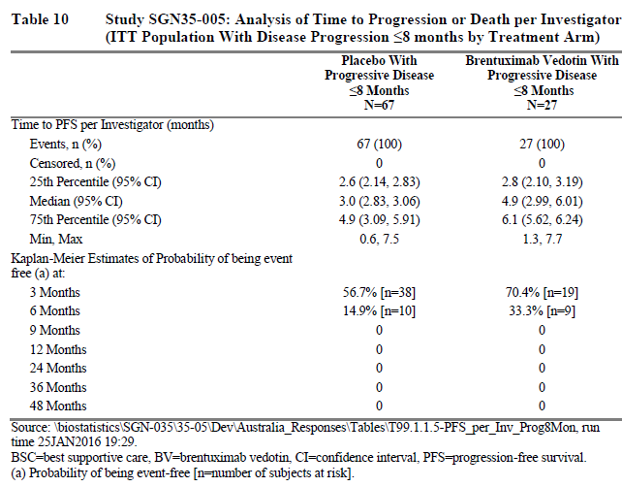
Comparison (shown in Table 20) of the patients in the placebo arm who progressed early (≤ 8 months) to the patients from the placebo arm who did not progress early according to the presence of poor prognosis risk factors shows that these factors were present more frequently in the patients in the placebo arm who progressed early, with the difference most marked for the occurrence of 3 or more risk factors.

Table 20. Comparison of occurrence of poor prognosis risk factors in the placebo arm (broken down according to progression within 8 months) and the brentuximab vedotin arm of Study SGN35-005
Poor prognostic factors* | Placebo arm |  |  |  | Brentuximab vedotin arm
Poor prognostic factors* | Progression¹ |  | No progression¹ |  | All patients
Poor prognostic factors* | N | % | N | % | N | %
Poor prognostic factors* | 67 |  | 97 |  | 165
Refractory HL | 41 | 61.2 | 56 | 57.7 | 99 | 60.0
Lack of responsiveness to pre-ASCT salvage therapy or residual disease at time of ASCT (PR or SD post-salvage therapy) | 49 | 73.1 | 53 | 54.6 | 104 | 63.0
B symptoms after frontline therapy | 22 | 32.8 | 18 | 18.6 | 47 | 28.5
Extra-nodal disease present at pre-ASCT relapse | 25 | 37.3 | 28 | 28.9 | 47 | 28.5
Multiple relapses prior to ASCT (≥ 2 prior treatment lines) | 40 | 59.7 | 38 | 39.2 | 71 | 43.0
≥ 3 risk factors | 45 | 67.2 | 39 | 40.2 | 82 | 49.7
Source: Based on table from sponsor’s response to Question 10 [Question 8 in this document]
*The risk factor of Pre-ASCT PET status has not been included in this table due to the number of missing results in each group.
¹ Progression/no progression at ≤ 8 months
As the sponsor notes, no single characteristic seems conclusively linked to early progression. It appears, in keeping with historical data, that patients with poor prognosis risk factors or ≥3 risk factors are more likely to experience earlier progression. It also appears that in patients who develop disease progression within 8 months of ASCT, the use of brentuximab vedotin as consolidative therapy has provided little benefit over placebo in terms of PFS.

Placebo arm patients and progressive disease
A comparison of the patients in the placebo arm who did not develop progressive disease to those patients who did (as shown by the administration of subsequent anti-tumour therapy) was provided in response to a separate clinical question (see Figures 14 and 15 below, and Section 12, Question 9 (Overall survival analysis) along with the sponsor’s response).
Figure 14. Study SGN35-005 Comparison of placebo patients who required subsequent therapy to those who did not, Kaplan Meier plots of PFS per IRF and OS per IRF (ITT population)
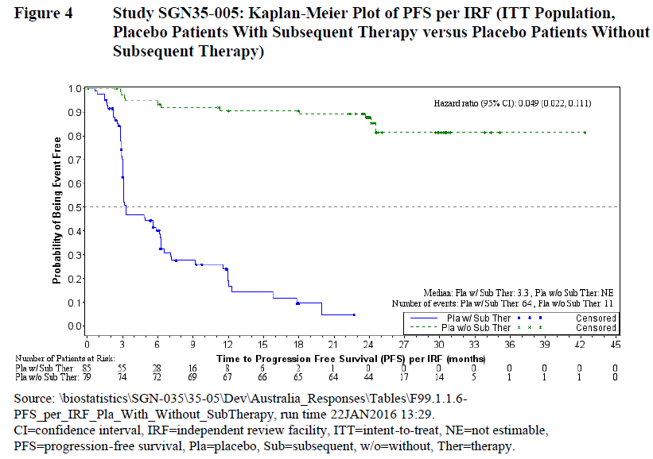
Figure 15. Study SGN35-005 Comparison of placebo patients with subsequent therapy versus placebo patients without, Kaplan-Meier plot of overall survival per IRF (ITT population)
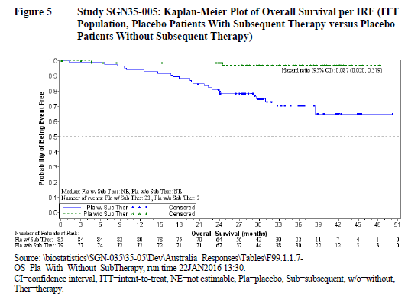
It is apparent from this analysis that there is a group of patients in the placebo arm who have an excellent response to ASCT with, according to the analysis of PFS by IRF, an estimated 89.3% event free at 21 months, compared to 4.8% event-free at this time-point in the placebo patients who received subsequent therapy. The median PFS for these two groups was not estimable although the 25 percentile for the placebo group who did not receive subsequent therapy was 30.9 months. Of note is that this difference in PFS did translate into a difference in overall survival, according to the Kaplan Meier analysis. Administration of brentuximab vedotin as consolidation therapy post-ASCT to this subgroup would be unlikely to improve outcome. Review of the data provided in response to Question 8 (Progression-free survival, Kaplan-Meier curves), with subgroup analysis according to progression within 8 months or not, does not assist in identifying this group of ‘ASCT responders’.

Results of a post-hoc analysis of Progression-free survival per IRF according to risk factors
A post-hoc analysis according to the number of risk factors present is described in the Clinical Overview and published article but not discussed in the study report. A nested analysis (≥ 1 versus ≥ 2 versus ≥ 3 risk factors) was performed using the following five risk factors:
- Relapsed < 12 months or refractory to frontline therapy
- Best response of PR or SD to most recent salvage therapy
- Extra-nodal disease at pre-ASCT relapse
- B symptoms at pre-ASCT relapse
- Two or more prior salvage therapies
Comment: Pre-specified subgroups for analysis in terms of risk factors for progression according to the statistical analysis plan were:
    - Refractory/relapsed status after the end of frontline standard chemotherapy or a combined modality treatment program (refractory HL, relapsed HL that occurred <12 months, and relapsed HL that occurred ≥12 months)
    - Best response of CR, PR or SD after the completion of salvage therapy prior to ASCT, as assessed by the investigator
    - Extra-nodal disease at the time of pre-ASCT relapse (yes/no)
    - Number of treatments (frontline and salvage) prior to ASCT (2, >2)
    - B symptoms after failure of frontline therapy (yes/no)
    - PET status prior to ASCT (positive or negative)
The pre-specified subgroup of PET status was not included in the post-hoc analysis. No explanation for this was provided in the Clinical Overview. The exclusion of this risk factor may have been due to PET scans not being required per protocol, and only being performed in 69% of the ITT population (228/329).
Based on the study inclusion criteria, all patients enrolled in the study had at least 1 of these risk factors. This subgroup analysis found that the median PFS declined with increasing numbers of risk factors from 24.1 months to 7.1 months for the placebo group (rate from 57% to 45%) but remained unchanged for the brentuximab vedotin arm (although not yet reached for the ≥ 3 risk factors group).

Table 21. Study SGN35-005 Post-hoc subgroup analysis of outcome per IRF (ITT set, by number of risk factors)
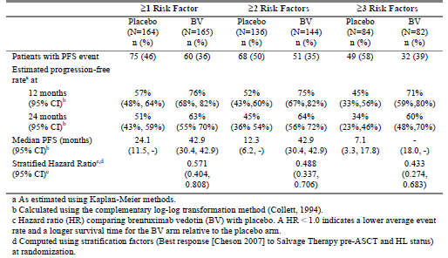
Comment: This analysis shows that patients with three or more risk factors in this study did considerably worse in the placebo group with a median PFS of 7.1 months compared to a median PFS that had not been reached for the brentuximab vedotin group.
Risk factor stratification has been more commonly described in historical studies by discrete groups (0 or 1, 2, 3 or > 3) rather than the nested groups shown. The number of patients in each arm with 1, 2, 3 or > 3 risk factors is not apparent in either the article or the Clinical Overview. This limits the ability to compare to historical controls although it would appear that even the placebo arm in the study has performed surprisingly well, with estimated progression free survival rates of 34% at 12 months in the high risk group (3 or more risk factors) compared to historical reports of 10% to 20% for high risk.
An analysis of efficacy according to the number of risk factors as discrete groups, was provided in response to a clinical question (see Section 12, Question 12 (Risk factors for progression) along with the sponsor’s response). This analysis used the same 5 risk factors as the above analysis.

Table 22. SGN35-005 Analysis of PFS per IRF (ITT population by risk factor 1, 2, or ≥ 3 subsets)
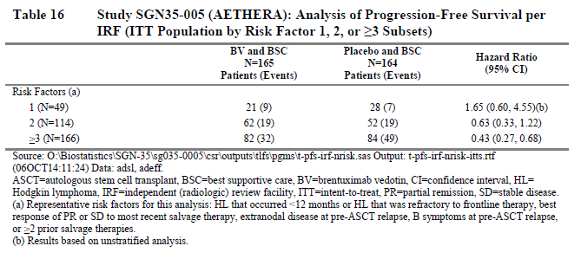

Table 23. Study SGN35-005 PFS duration per IRF (ITT population by risk factor 1, 2, or ≥ 3 subsets)
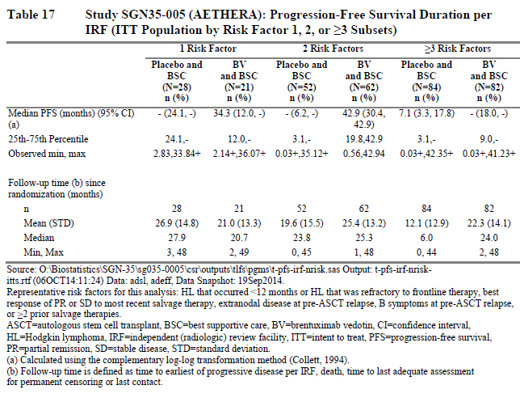
Figure 16. Study SGN35-005 Kaplan-Meier analysis of PFS per IRF (ITT population by risk factor 1, 2, or ≥ 3 subsets)
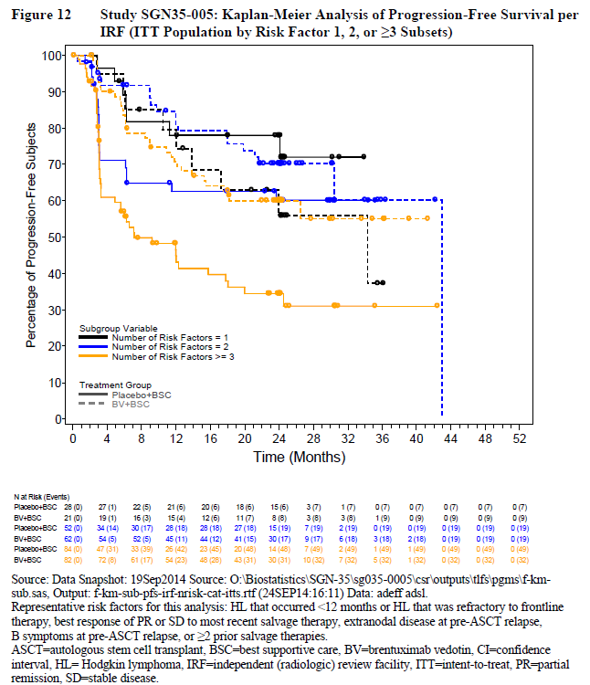

Table 24. Study SGN35-005 Analysis of overall survival per IRF (ITT population by risk factor 1, 2, or ≥ 3 subsets)
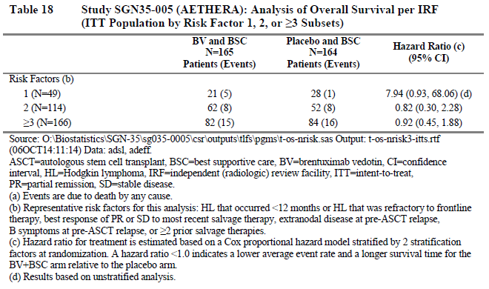
Figure 17. Study SGN35-005 Kaplan Meier analysis of overall survival (ITT population by risk factor 1, 2, or ≥ 3 subsets)
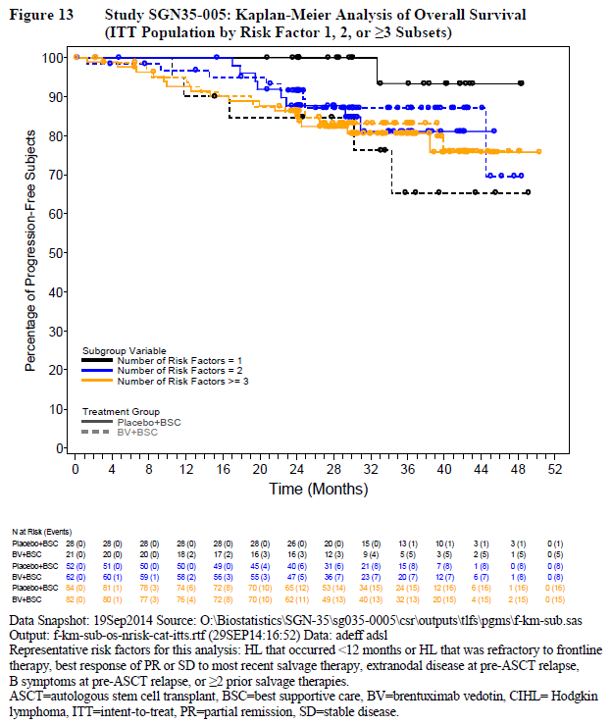
This subgroup analysis according to the number of risk factors, suggests that the patients with low risk of progression, as shown by the presence of only one risk factor, may fare worse with respect to both PFS and OS if they receive brentuximab vedotin as consolidative therapy post-ASCT.
For this group of 49 patients with one risk factor for progression following ASCT for HL (21 in the brentuximab arm and 28 in the placebo arm), 9/21 patients experienced progression events in the brentuximab arm compared to 7/28 patients in the placebo arm. The median PFS was 34.3 months for the brentuximab vedotin arm but not estimable for the placebo arm, although the 25th percentile was 24.1 months. There were 5 OS events in patients with one risk factor the brentuximab vedotin arm compared to one in the placebo arm. Causes of deaths were provided in the sponsor’s response: the death in the placebo arm was attributed to myelodysplastic disease; 3 deaths in the brentuximab arm were attributed to progressive disease; one death in the brentuximab arm was attributed to MDS that developed 12 months after 16 cycles of brentuximab and was reported as a secondary malignancy related to brentuximab vedotin; one patient died from bladder cancer that developed during treatment with brentuximab vedotin and was not considered related to study drug. Narratives were not provided for the 3 patients whose deaths were attributed to progressive disease. Review of narratives provided in response to other clinical questions indicates that determining the cause of death in these complex patients can be difficult. The evaluator notes that with the increasing recognition of pulmonary toxicity, hepatotoxicity and gastrointestinal complications with brentuximab vedotin therapy, it is possible that causes of death in early studies may be miss-attributed.
Given that this is a post-hoc analysis that involves only small numbers, interpretation of the results must be cautious.
The subgroup analyses requested by the evaluator that have been described above were to attempt to better delineate the patients most likely, or least likely, to benefit from brentuximab vedotin administered as consolidative therapy after ASCT. From the analyses provided, no single characteristic presented in the analyses appears to define these patients although it would appear that patients with only one risk factor for relapse following ASCT and patients aged 65 years or more are least likely to benefit with regard to both progression free survival and overall survival.

Subsequent Anticancer Therapy
Patients who received other anticancer therapy during the study are shown in Table 25, below. Note that 72 patients in the placebo arm received brentuximab vedotin as did 9 in the brentuximab vedotin arm.

Table 25. Study SGN35-005 Subsequent anti-tumour therapy (ITT set)
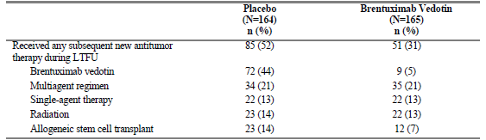
Comment: The circumstances under which 9 patients in the brentuximab vedotin arm received brentuximab vedotin following progression are not described in the study report. It is unclear from the study report and the Clinical Overview as to when subsequent anti-tumour therapies were commenced. The table indicates that the therapies were ‘received’ during the LTFU, that is, the period from 12 to 24 months in the study but does not indicate if the therapies were commenced or continued in this time period. (see Section 12, Question 13 (Subsequent anti-tumour therapy)).
According to the sponsor, ‘patients may have received brentuximab vedotin after 1 or more intervening therapies, a phenomenon presumably most common among the 9 patients randomised to brentuximab vedotin who later received brentuximab vedotin retreatment’. The evaluator notes that retreatment with brentuximab vedotin in patients who have previously responded to it was approved by the EMA in November 2015, based on the results of Study SGN35-006, a Phase II open label ‘retreatment study’.

Results for overall survival
Overall survival (OS) was a secondary outcome measure in the study and defined as the time from randomisation to date of death due to any cause. The median overall survival had not been reached in either arm: 28/165 patients (17%) in the brentuximab vedotin arm and 25/164 patients (15%) in the placebo arm had died. An interim analysis of OS was performed at this time, showing no difference between the treatment arms (HR 1.15 (95% CI 0.67, 1.97; p = 0.620). The estimated 24-month OS rate was 88% (brentuximab vedotin) and 89% (placebo). Similar results were seen with an unstratified analysis of the ITT analysis set and analysis of the per-protocol set.
Figure 18. Study SGN35-005 Overall survival (ITT analysis set)
Comment: Historical results from published studies indicate a 5-year overall survival rate of 51% to 60% following ASCT for relapsed or refractory HL. In this study, the estimated OS rate at 36 months was over 80% for both arms. This was attributed to the use of brentuximab vedotin both as adjuvant therapy, to prevent relapse, and as rescue therapy, after relapse. On this analysis, use as adjuvant therapy does not appear to provide any survival advantage compared to use as rescue therapy.

Sensitivity analysis for crossover
Overall, 51 patients (31%) on the brentuximab vedotin arm and 85 patients (52%) on the placebo arm received subsequent anti-tumour therapies during the study. As described above, patients in the placebo arm who developed progressive disease (as assessed by the investigator) could receive brentuximab vedotin. This occurred in 72/85 patients in the placebo arm. In addition, 9/51 patients (18%) on the brentuximab vedotin arm received subsequent brentuximab vedotin. Twelve patients on the brentuximab vedotin arm and 23 patients on the placebo arm received subsequent allogeneic stem cell transplant.

Table 26. Study SGN35-005 Subsequent new anti-tumour therapies
A sensitivity analysis was conducted using rank-preserving structural failure time (RPSFT) models (Robins 1991) in an attempt to adjust for placebo patients who were exposed to brentuximab vedotin as a subsequent therapy after progression on the study. As evaluated by log-rank test using RPSFT models, there was no statistical difference in OS between the 2 arms. The estimated stratified HR was HR 1.15 (95% CI 0.64, 1.87) (compared to above result of HR 1.15 (95% CI 0.67, 1.97)).
Subgroup analyses of overall survival showed no consistent pattern in either direction for any of the subgroups.

Results for other efficacy outcomes, quality of life assessments
Quality of Life (QoL) assessments using the patient-reported quality of life instrument EuroQol 5 dimensional 3 level (EQ-5D) were presented as an addendum to the study report for SGN35-005. This was a pre-specified exploratory endpoint in the protocol and statistical analysis plan. The EQ-5D self-report questionnaire was implemented with protocol amendment 2 in August 2010; Baseline EQ-5D data are not available for 17 patients who were enrolled prior to this amendment and the 2 patients who were enrolled but never treated with study drug.

Method
The EQ-5D self-report questionnaire was administered in the clinic at the beginning of each treatment cycle, as well as at the end of treatment (EOT) visit. During the follow-up period (from 12 to 24 months), data were collected by telephone or in the clinic every 3 months until 24 months post-randomisation for all patients. All patients who were on study at the time of follow-up were expected to complete the assessments.
The EQ-5D descriptive system comprises the following 5 dimensions: mobility, self-care, usual activities, pain/discomfort and anxiety/depression. The 3-level version of the EQ-5D was used in which each question has 3 possible responses: no problems, some problems, or extreme problems. The patient is asked to indicate his or her health state in the box corresponding to the most appropriate statement for each of the 5 questions. The EQ VAS records patient-reported health on a vertical, visual analogue scale, with endpoints labelled ‘Best imaginable health state’ and ‘Worst imaginable health state.’
The EQ-5D utility index value scores were calculated using the time trade-off (TTO)-valuation method for US-based and UK-based value sets. EQ VAS scores and EQ-5D TTO-indexed scores were summarised with descriptive statistics (mean ± 95% confidence interval (CI)) using line plots and tables by treatment group and time-point. Data were summarised through Month 24 in 3-month increments for most analyses and by cycle for some analyses.
Missing index scores were imputed at EOT and 3-month intervals through Month 24 for all patients who were either still on study at the expected time-point or off-study for reason of death. Visits for patients who were last known to be alive were imputed using a last observation carried forward (LOCF) approach, while visits for patients who had died within or prior to a one week window (visits indexed from baseline) or a one month window (visits indexed from EOT or progression per investigator) of the expected visit date were imputed as zero.

Results
Adherence rates for completion of the self-report questionnaire were described as generally high throughout the study and as similar between the 2 treatment arms at all stages of the trial. The range of responses (completed/expected expressed as a percentage) was 69 to 100% for the placebo group and 62 to 100% for the brentuximab vedotin group (excluding the first follow-up visit which showed low compliance in both treatment arms).

Table 27. Study SGN35-005 Adherence in completion of the EQ-5D self-report questionnaire
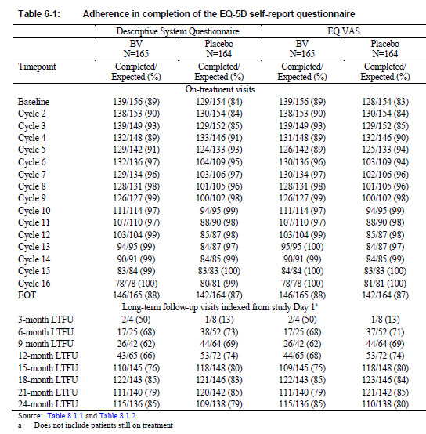
Comment: This table shows patients entering LTFU as the treatment cycles are discontinued, for whatever reason. The 3, 6, 9, 12-month LTFU numbers represents those patients who did not complete 16 treatment cycles. The 15, 18, 21 and 24-month LTFU show the addition of the patients who did complete 16 cycles of treatment.
72 patients in the placebo arm received brentuximab vedotin during the LTFU period (12 to 24 months). On the basis of the expected number of responses, many of these patients have been included in the placebo group for the quality of life assessments during the LTFU period included.
Further information regarding the 72 patients in the placebo arm who received brentuximab vedotin therapy as rescue therapy was requested in clinical questions. There were 83 patients in the placebo arm who discontinued treatment during the treatment period, with this due to progressive disease in 69 patients. Most of these 69 patients received brentuximab vedotin as rescue therapy (72/85 patients in the placebo arm who developed progressive disease throughout the study went on the receive brentuximab vedotin). The median time from last dose of randomised treatment to the first dose of subsequent brentuximab vedotin therapy in the placebo group was 1.5 months (approximately 45 days). The median time to another treatment following brentuximab vedotin as rescue therapy was 9.6 months. This means that over a third of ‘placebo’ patients may have been receiving brentuximab vedotin throughout much of the follow-up period. The results of these patients using the quality of life instrument have been included in the placebo arm results. This would favour the brentuximab vedotin arm.
Results for both US and UK value sets were very similar so only the results for US-based set are presented below. The EQ-5D utility index value scores declined for both treatment arms during the study. Scores on the brentuximab vedotin treatment arm were slightly lower than those on the placebo arm throughout, with this more marked for months 9 to 18. This did not exceed the minimally important difference (MID) of 0.06 except for the time-points Months 15 and 18.
Figure 19. Study SGN35-005 ITT US indexed mean (± 95% CI) EQ-5D TTO scores
Comment: Note that at each time point and for each arm in the first 12 months, there will be 2 groups included; those still receiving treatment cycles and those who have discontinued treatment cycles. During the months 12 to 24, the placebo group will include some patients receiving brentuximab vedotin following the development of progressive disease. These factors make the results difficult to interpret, but would favour the brentuximab vedotin arm. This is also the case for the EQ VAS below.
EQ VAS scores did not show a significant difference between treatment arms.
Figure 20. Study SGN35-005 ITT mean (± 95% CI) EQ VAS scores
Analysis was also performed according to:
- treatment state, on or off treatment
- development of progressive disease
- development of peripheral neuropathy.

Treatment state
During the 16 cycles of treatment, index scores were slightly lower scores in the brentuximab vedotin arm compared to the placebo arm, although not reaching the threshold for a MID at any time-point. During the follow-up period (for 12 months from EOT), index scores were lower at most time-points compared with EOT in both treatment arms. Again, scores appeared to be slightly lower in the brentuximab vedotin arm, than scores in the placebo arm. The mean differences between arms at Month 3 (-0.073, 95% CI-0.113 to -0.033) and Month 6 following EOT (-0.074, 95% CI -0.123 to -0.025) marginally exceeded the MID with 95% CIs excluding zero. Comparison of the two arms in the months 18 to 24 post-EOT is limited by small numbers (includes only those patients who entered LTFU early due to only completing a small number of treatment cycles).
Figure 21. Study SGN35-005 On treatment US indexed mean (± 95% CI) EQ-5D TTO scores
Figure 22. Study SGN35-005 Off treatment US indexed mean (± 95% CI) EQ-5D TTO scores
Comment: Note that the timing of this graph commences at EOT, regardless of whether this was after 1 cycle or 16. The planned long-term follow-up (LTFU) continued for 12 months after EOT assessment. Patients who entered LTFU earlier, due to not completing 16 treatment cycles, had a longer period of LTFU. Patients in the placebo arm who received brentuximab vedotin during the LTFU (72/164 patients) have been included in the placebo group in the analysis presented.

Development of progressive disease
Analysis according to the development of progressive disease (PD) showed that patients with PD had lower mean index scores versus patients who did not experience PD within each treatment arm. The mean differences exceeded the MID from Months 15 to 24 for the brentuximab vedotin arm and from Months 9 to 24 for the placebo arm.
Figure 23. Study SGN35-005 US indexed mean (± 95% CI) EQ-5D TTO scores with or without progression per investigator on the brentuximab vedotin arm
Figure 24. Study SGN35-005 US indexed mean (± 95% CI) EQ-5D TTO scores with or without progression per investigator on the placebo arm
Comment: Of the patients who developed progressive disease, 9 patients in the brentuximab vedotin arm and 72 patients in the placebo arm were treated with brentuximab vedotin.
To better determine the impact of treating patients with brentuximab vedotin, without the confounding effects of progressive disease (± subsequent treatment with brentuximab vedotin), two additional analyses were requested: 1) comparison of the mean EQ-5D TTO scores for the two groups (placebo and brentuximab vedotin treatment arms) that did not develop progressive disease throughout the 24 months of the study and who did receive 16 cycles of treatment, and 2) comparison of the mean EQ-5D TTO scores of the patients in the brentuximab vedotin arm who discontinued treatment cycles due to AEs and who did not develop progressive disease throughout the 24 months of the study to the patients in the brentuximab vedotin arm who completed 16 cycles and who did not develop progressive disease.
These analyses were provided in response to a clinical question (see Section 12, Question 11 (Crossover and Quality of life measure) along with the sponsor’s response):
1. Analysis of the two groups (placebo and brentuximab vedotin treatment arms) that did not develop progressive disease throughout the 24 months of the study and who did receive 16 cycles of treatment
Figure 25. Study SGN35-005 US indexed EQ-50 TTO scores over time with imputation of death (ITT population, patients who received 16 cycles of therapy and who did not develop progressive disease within 24 months
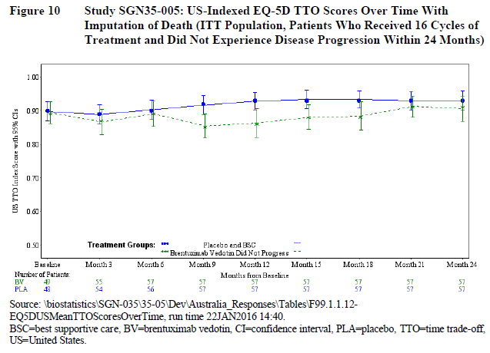
This analysis of those patients in each arm who completed 16 cycles of treatment and who did not experience disease progression shows a dip in the quality of life measure for the patients receiving brentuximab vedotin from halfway through the treatment and extending for some months into the off-treatment phase with this measure before returning to that of the placebo group at the end of the observation period. This is consistent with the toxicities associated with brentuximab vedotin therapy. The evaluator acknowledges the sponsor’s point that the differences met the MID at months 9 and 12 only and that there was little change between the baseline and 24 month measures for either group. It is important to remember that the baseline quality of life measure was taken within 30-45 days of the patients having received an ASCT. It is surprising that there is minimal change from this over a 24 month period in the placebo group who did not develop progressive disease. This raises concerns regarding the appropriateness/sensitivity of the quality of life measure.
2. Analysis of the patients in the brentuximab vedotin arm who discontinued treatment cycles due to AEs and who did not develop progressive disease throughout the 24 months of the study to the patients in the brentuximab vedotin arm who completed 16 cycles and who did not develop progressive disease.
The intent of this analysis was to compare the quality of life in two groups of patients who did not have progressive disease – one group that was recovering from AEs resulting from receiving brentuximab vedotin therapy and one group that continued to receive brentuximab vedotin therapy.
Figure 26. Study SGN35-005 US indexed EQ-50 TTO scores over time with imputation of death (ITT population, brentuximab vedotin-randomised patients without progression within 24 months) (Completed 16 cycles of treatment versus EOT due to AE)
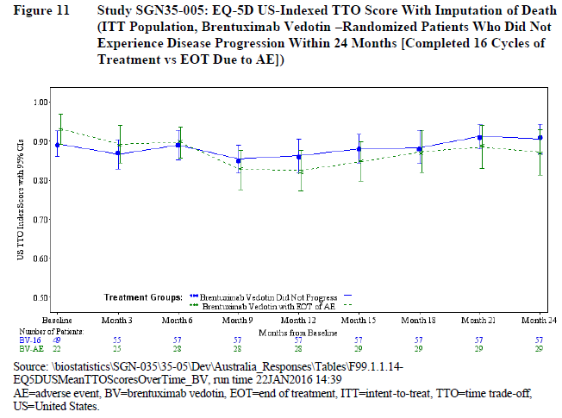
This analysis showed no significant difference in quality of life according to the measure used. Interpretation is difficult though, as the number of cycles completed before treatment discontinuation is not known. From the data provided in response to a separate clinical question (see Section 12, Question 14 (Early relapse patients)) there was a steady loss of patients from the brentuximab arm due to study treatment discontinuation during the treatment period, averaging at 5 to 6 patients per treatment cycle. This would prevent a clear comparison between the two groups. The evaluator notes that in this analysis there is, again, virtually no change between the baseline quality of life measure and the measure 24 months later.
According to the quality of life measure used, brentuximab vedotin therapy does not appear to have a major effect on quality of life, when the confounding effects of progressive disease and subsequent anti-tumour therapies are removed. The evaluator questions the sensitivity of the quality of life instrument used for this setting given that there is no apparent change from baseline (measured 30 to 45 days post ASCT) to the measurement 24 months later, even in the group of placebo patients who did not develop progressive disease. Patients this soon after ASCT can be expected to have a poor quality of life with this progressively improving over months as recovery occurs.

Development of peripheral neuropathy
Scores in patients in the brentuximab arm who experienced treatment-emergent peripheral neuropathy at any time did not appear to have lower scores than those patients who did not experience treatment emergent peripheral neuropathy. Lower overall scores in the brentuximab arm therefore could not be explained by treatment-emergent peripheral neuropathy.
Figure 27. Study SGN35-005 EQ-50 TTO scores according to presence of peripheral neuropathy in the brentuximab vedotin arm
The conclusion drawn in the Clinical Overview from the analysis of this quality of life measure is that: use of the EQ-5D self-report questionnaire revealed only minor and inconsistent effects upon patient quality of life as a result of treatment with brentuximab vedotin versus placebo in HL patients at risk of disease progression following ASCT.
Comment: The study found no overall difference in quality of life, using the measures EQ-5D and EQ VAS, between the placebo and brentuximab vedotin arms. This was the subject of a clinical question to the sponsor (see Section 12, Question 10 (Quality of life measure) along with the sponsor’s response). The sponsor acknowledged a general decline in QOL over time for both study arms with this possibly due to toxicity associated with brentuximab vedotin use and/or to disease progression with the receipt of subsequent anti-tumour therapies. The sponsor also suggests that the improved quality of life expected with the resolution of these toxicities associated with brentuximab vedotin and with the increase in PFS is not shown in this study as the period of follow up was not long enough.
The evaluator accepts that the occurrence of progressive disease would result in a decline in QoL, and this is demonstrated in the analyses above. It is, however, concerning that the considerable increase in progression free survival observed in the brentuximab vedotin arm has not translated into the patients in this arm overall reporting a quality of life demonstrably better than the patients in the placebo arm. From the analyses provided above, the quality of life is no better in the brentuximab vedotin arm compared to the placebo arm regardless of the presence of progression and off-treatment status. The lack of change from baseline to measurement at 24 months in the placebo group who did not progress is also concerning and raises questions about the appropriateness of the quality of life instrument used.
Interpretation of the quality of life measurement is made more difficult due to the ‘placebo arm’ including patients who were treated with brentuximab vedotin for progressive disease. This would favour the brentuximab vedotin arm.
The evaluator also notes the comment made by a committee member at the ODAC meeting on 14/07/2011 at which brentuximab vedotin and the AETHERA study design was discussed: ‘ODAC has deliberated a lot over the past year and a half about adequate endpoints in confirmatory studies, particularly a couple weeks ago. We've been fairly consistent in emphasizing that if PFS is going to be used, it be used in conjunction with a validated quality of life instrument so that it can be demonstrated that if patients aren't living longer, at least they're living better, or that overall survival be used as an endpoint.’

Results for other efficacy outcomes, Health economics and outcome research
This was described in the study plan as an additional efficacy outcome. The results for this analysis have not been included.

Efficacy in Special Populations
Elderly: 8 patients aged 65 years or older participated in the study. Interpretation of the outcomes of these patients is limited by the small number, although the data is suggestive of a worse outcome for this group.
Paediatric: no patients aged less than 18 years participated in the study
Hepatic or renal impairment: patients with significant organ impairment were excluded from the study.

Evaluator’s conclusions on clinical efficacy
For the extension of the indication for brentuximab vedotin to include:
‘treatment of patients with CD30+ HL at increased risk of relapse or progression following ASCT.’
Comment: The following conclusions have been revised to incorporate information and data that was available after the Round 1 evaluation.
In support of clinical efficacy for the proposed indication the sponsor presented a randomised, double blind, placebo controlled, Phase III study, SGN35-005, in which 165 patients receiving brentuximab vedotin were compared to 164 patients receiving placebo following ASCT for relapsed or refractory classical Hodgkin lymphoma. Both groups received best supportive care. The main inclusion criteria were: histologically confirmed classical HL, ASCT in the previous 30 to 45 days and increased risk of progression post-ASCT according to the presence of one or more of three risk factors (history of refractory HL, relapsed or progressive HL that occurred < 12 months of prior chemotherapy, extra-nodal involvement at the time of pre-ASCT relapse). Patients aged less than 18 years or with significant organ failure (renal, hepatic, cardiac) or who had previously received brentuximab vedotin were excluded. The study was reported to have been conducted in accordance with GCP. The study population and study inclusion/exclusion criteria were consistent with the proposed indication except that the trial population only included adult patients and ‘increased risk’ was defined by the presence of one or more of three specific risk factors.
There were two major protocol amendments during the study. The first, a change in the sample size calculation, was made prior to the enrolment of any patients. The other, a change from event-driven to time-point defined analysis for the primary outcome measure, was made in the last 8 months of the study and after all patients had been recruited. Neither amendment is likely to have affected the outcome of the study.
The study found clinically important and statistically significant improvements in the primary outcome measure of progression free survival per independent review facility in the brentuximab vedotin arm compared to the placebo arm. The median PFS per IRF for patients who received brentuximab vedotin was 42.9 months (95% CI 30.4 to 42.9) in the brentuximab vedotin arm and 24.1 months (95% CI: 11.5, —) in the placebo arm; hazard ratio (HR) 0.57, 95% CI 0.40 to 0.81; p = 0.0013. The results of the secondary analyses of PFS and sensitivity analyses were consistent with this outcome.
The secondary outcome measures included overall survival, a quality of life measure and a measure of medical resource utilisation.
Overall survival results were not mature at the time of analysis for the primary outcome measure. The median overall survival had not been reached in either arm: 28/165 patients (17%) in the brentuximab vedotin arm and 25/164 patients (15%) in the placebo arm had died. The interim analysis of OS performed at this time found no difference between the treatment arms (HR 1.15 (95% CI 0.67, 1.97; p = 0.620). The estimated 24-month OS rate was 88% (brentuximab vedotin) and 89% (placebo). This result was potentially affected by crossover: 72 (85%) of 85 patients in the placebo group had received brentuximab vedotin after disease progression and unblinding. A sensitivity analysis was conducted using rank-preserving structural failure time (RPSFT) models to adjust for placebo patients who were exposed to brentuximab vedotin as a subsequent therapy after progression on the study. This also found no statistical difference in OS between the 2 arms.
The quality of life measure used, EQ-5D, did not show any benefit in the brentuximab vedotin arm. Additional analyses were requested of the sponsor to try to separate out the effects of progressive disease. These analyses also showed little difference between the brentuximab vedotin arm and the placebo arm. It was notable that the group of placebo arm patients who did not develop progressive disease had minimal change in the quality of life measurements from baseline (30 to 45 days following ASCT) to 24 months later. The lack of change from Baseline to measurement at 24 months in patients who should be recovering from ASCT and who had not developed progressive raises questions about the appropriateness of the quality of life instrument used. Interpretation of the quality of life measurement is made more difficult due to the ‘placebo arm’ including an unknown number of patients who were treated with brentuximab vedotin for progressive disease. This would favour the brentuximab vedotin arm.
The results of the medical resource utilisation evaluation weren’t provided with the CSR for this study and were not referred to elsewhere in the sponsor’s dossier. It is important that it be provided when available to enable a more comprehensive assessment of the impact of brentuximab vedotin therapy on patients in this setting.
A post-hoc analysis according to the number of risk factors present was performed. The study design pre-specified 6 risk factors for subgroup analysis:
- Relapsed < 12 months or refractory to frontline therapy
- Best response of PR or SD to most recent salvage therapy
- Extra-nodal disease at pre-ASCT relapse
- B symptoms at pre-ASCT relapse
- Two or more prior salvage therapies
- PET status prior to ASCT (positive or negative)
The post-hoc analysis according to number of risk factors used five of these; PET status was not included (not available for 30% of patients). This was presented as a nested analysis in the Clinical Overview (≥ 1 risk factor, ≥ 2 risk factors, ≥ 3 risk factors) and showed that patients with 3 or more risk factors appeared to receive the greatest benefit from brentuximab vedotin therapy. A further analysis according to discrete groupings (1, 2 or ≥ 3 risk factors) was subsequently provided. This found patients with only one risk factor may fare worse with respect to both PFS and OS if they receive brentuximab vedotin as consolidative therapy post-ASCT.
The results of the study raise some questions:
- Enrolment of patients prior to determining the response to ASCT:
  - Patients were enrolled within 30 to 45 days of ASCT. At this time, the response to ASCT cannot be determined. The outcome of patients with active disease following ASCT can be expected to differ from that of patients who achieve CR with ASCT. Enrolling patients prior to determining this contributes to a heterogeneous study population and risks randomising patients with active disease post-ASCT to the placebo arm.
- Results compared to historical controls:
  - The outcome results for median PFS for both arms were surprisingly good compared to historical controls, and better than expected by the study designers. The original sample size calculations predicted 202 progression events and median PFS of 18 months for the brentuximab vedotin arm and 12 months for the placebo arm. In the end, 135 progression events occurred during the study and the median PFS was 42.9 months and 24.1 months for the brentuximab vedotin and placebo arms respectively.
  - In response to a clinical question regarding the unexpectedly good outcomes, the sponsor speculated that these were due to difficulties in comparison to historical data and improvements in transplantations and supportive care.
  - The evaluator is of the opinion that the use of brentuximab vedotin as both rescue therapy (received by 72/164 patients in the placebo arm) and as consolidative therapy post ASCT is a major factor contributing to these better than historical results in the placebo arm. Additional data regarding the 72 patients in the placebo arm who developed progressive disease and were treated with brentuximab vedotin as rescue therapy was provided by the sponsor. Using time to next treatment (TTNT) after rescue brentuximab vedotin therapy as an approximation of PFS 2, the results were not dissimilar to those of the Phase II study provided to support the indication of treatment of relapsed HL following ASCT in an earlier application. At the end of the 12-month follow-up period, the median TTNT for the 72 patients who received brentuximab vedotin as rescue therapy was 9.6 months (95% CI 6.7 to 12.7) and the estimated PFS at 24 months was 26.8%. Analysis of progression free survival in the Phase II study, as assessed 12 months after completion of treatment, found the median duration of progression free survival of 5.6 months and the estimated PFS at 24 month was 23%. These results are consistent with the results of the Phase II study that supported registration of brentuximab as rescue therapy in patients with HL who developed progressive disease following ASCT.
- Progression free survival and patient important outcomes:
  - The primary efficacy measure of progression free survival was determined predominantly by radiographic assessment, together with diagnostic biopsy if this was performed. The radiological criteria for progression included small changes in the size of nodal masses and may be subject to inter-interpreter variation. Given this, it is particularly important that an improvement in progression free survival is associated with other clinically important and patient relevant outcomes. The study demonstrated a major improvement in progression free survival in the brentuximab vedotin arm but did not demonstrate any improvement in quality of life or overall survival, although the latter analysis was immature.
- Progression free survival analysis and exploratory subgroup analyses:
  - The Kaplan-Meier survival curves for the two treatment arms in the analysis of primary outcome measure, and for the secondary analyses of the primary outcome measure, parallel each other after an early dip in the placebo arm and both treatment arm curves appear to plateau at around 24 months. The difference in overall PFS appears to be due to the number of patients with early progression in the placebo arm (79 progression events in the first 8 months in the placebo group compared to 36 in the brentuximab vedotin group). A description of the patients in the placebo group who developed progressive disease within the first 6 to 8 months post-ASCT was provided in response to a clinical question. This showed that patients in either arm who developed progressive disease in the first 8 months of enrolment appeared more likely to have 3 or more risk factors for progression but that there was no feature that conclusively identified the group of ‘early progressers’. It was also notable that there was little difference in the median PFS for the ‘early progressers’ between the two arms of the study (3.0 months for patients in the placebo arm compared to 4.9 months for patients in the brentuximab vedotin arm).
  - The pre-specified subgroup analyses provided showed variability in outcomes. Some subgroups that have historically been identified as low risk for progression appeared to have little benefit from brentuximab vedotin, according to the median PFS. Other subgroups historically identified as high risk who received brentuximab vedotin had median PFS substantially better than that of the placebo group.
  - Post hoc subgroup analysis of the placebo arm confirmed two distinct groups of patients, with one group having an excellent response to ASCT. According to the analysis of PFS by IRF, this group had an estimated 89.3% event-free at 21 months, compared to 4.8% event free at this time-point in the placebo patients who received subsequent therapy. The median PFS for these two groups was not estimable although the 25th percentile for the placebo group who did not receive subsequent therapy was 30.9 months. This difference in PFS also translated into a difference in overall survival, according to the Kaplan-Meier analysis. Administration of brentuximab vedotin as consolidation therapy post-ASCT to this subgroup of ‘ASCT responders’ would not improve outcome but could cause harm.
- Post hoc analysis according to the number of risk factors:
  - The post-hoc analysis of PFS per IRF according to the number of risk factors suggests that the patients in the placebo arm with 3 or more risk factors fare considerably worse than other groups. Presentation of the analysis as discrete groups (1, 2, 3, > 3) rather than overlapping groups (≥ 1, ≥ 2 and ≥ 3) was requested of the sponsor. The results of this analysis suggest that the patients with low risk of progression, as shown by the presence of only one risk factor, may actually fare worse with respect to both PFS and OS if they receive brentuximab vedotin as consolidative therapy post-ASCT. It should be noted that there were only 49 patients with one risk factor for progression following ASCT for HL (21 in the brentuximab arm and 28 in the placebo arm).
- Confounding due to crossover and use as rescue therapy:
  - In the study, brentuximab vedotin was administered both as adjuvant therapy, to prevent relapse in the brentuximab vedotin arm and as rescue therapy to patients who developed progressive disease in the placebo arm (72/164, 44%). This could confound the results for overall survival.
  - Use of brentuximab vedotin as rescue therapy in patients with HL who have developed progressive disease post-ASCT was shown to be efficacious in a Phase II study that used the surrogate end-point of overall response rate compared to historical controls. A subsequent publication reported the three year follow-up of participants in this study and found that 48/102 (47%) were still alive and the estimated median OS for all patients was 40.5 months. The median OS and PFS had not been reached for the subgroup that achieved complete response with brentuximab vedotin. These results are considerably better than the historical median survival range of 15 to 25 months.
- Use as adjuvant or use as rescue therapy:
  - The lack of difference in OS for the two arms of the Phase III study and the better than expected overall survival results in comparison to historical controls may be attributable to the use of brentuximab vedotin both as adjuvant therapy in the brentuximab vedotin arm and as rescue therapy in the placebo arm patients who developed progressive disease. This would suggest that brentuximab vedotin when used as adjuvant therapy offers no survival advantage compared to the currently approved use as rescue therapy.
- Quality of Life measure:
  - It is concerning that the considerable increase in progression free survival observed in the brentuximab vedotin arm has not translated into the patients in this arm overall reporting a quality of life demonstrably better than the patients in the placebo arm. From the analyses provided above, the quality of life is no better in the brentuximab vedotin arm compared to the placebo arm regardless of the presence of progression and off-treatment status. The evaluator notes the comment made by a committee member at the FDA’s Oncologic Drugs Advisory Committee (ODAC) meeting on 14/07/2011 at which brentuximab vedotin and the AETHERA study design was discussed:
    - ‘ODAC has deliberated a lot over the past year and a half about adequate endpoints in confirmatory studies, particularly a couple weeks ago. We've been fairly consistent in emphasizing that if PFS is going to be used, it be used in conjunction with a validated quality of life instrument so that it can be demonstrated that if patients aren't living longer, at least they're living better, or that overall survival be used as an endpoint.’²³

Summary
Study SGN35-005 found that patients with CD 30+ HL who received brentuximab vedotin as consolidative therapy following ASCT had a substantially and clinically important increase in median PFS by IRF of 19 months in comparison to patients receiving placebo (median PFS of 42.9 months compared to 24.1 months). An improvement of this magnitude would be important to patients. It is concerning, however, that this did not translate into the other patient important outcomes of improved quality of life and improved overall survival.
The results of the AETHERA study also indicate that 45% of patients who received ASCT for relapsed/refractory HL would be cured by ASCT alone, that an additional 20% of patients may be cured by the use of brentuximab vedotin as consolidative therapy and that 35% of patients would progress despite brentuximab vedotin. It is evident from this, and from subgroup analyses, that there are groups within the study population who obtain varying benefits from the use of brentuximab vedotin as consolidative therapy, with one group (patients with only one risk factor for progression) appearing to fare worse.
The sponsor has estimated that 50 to 70% of patients who receive ASCT for relapsed or refractory Hodgkin Lymphoma would have at least one risk factor for progression post-ASCT and proposes that all of these patients receive brentuximab vedotin as consolidative therapy following ASCT. Given the varying response in the subgroups and the lack of demonstrable improvement in OS and QoL, it is clear that this use of brentuximab vedotin will not benefit all of these patients. There is clearly a subgroup of patients who would otherwise have been cured by ASCT and who therefore risk only harm from brentuximab vedotin therapy. Better characterisation of patients who will develop progressive disease following ASCT, and/or who will be cured by ASCT alone, would enable more targeted use of brentuximab vedotin.

Clinical safety
The existing safety profile of brentuximab vedotin was established in its evaluation as a new chemical entity in 2012 and is largely based on two single arm Phase II studies. Treatment-related adverse events were common in the Phase II studies, resulting in treatment discontinuation in 19% or dose modifications in 46%. Safety issues of concern were peripheral neuropathy, neutropaenia, infection and infusion related reactions. Peripheral neuropathy was reported in 45% of patients. This required dose modification (delay or reduction) in 18% and treatment discontinuation in 12%. Peripheral neuropathies were usually mild, with 89% Grade 2 or less, and reversible with improvements occurring over a median of 16 weeks. Neutropaenia was observed in 21% of patients and was managed with dose delay and/or growth factor support. Less than half of the patients with neutropaenia had temporally associated infections and these were usually mild (Grade 1 or 2). Infections were observed in 61% of patients overall but, again, these were usually mild and no patient discontinued treatment due to infection. One patient developed PML and died. Infusion related reactions occurred in 11% and were mild to moderate in severity although two cases of anaphylaxis were reported in the Phase I studies. A more detailed description of the safety aspects identified in the earlier studies can be found in the Australian Public Assessment Report for Brentuximab vedotin (Adcetris).

Evaluable safety data
Comment: The Clinical Overview and Summary of Clinical Safety provide a lengthy discussion regarding the safety outcomes of Study SGN35-005. A statement is made that ‘All periodic adverse drug experience (PSUR) reports and updates submitted since conditional marketing authorization was granted are provided’. These are not otherwise referred to. No reference to other studies is made except for ‘The safety findings from the AETHERA study are similar to those from the pivotal Phase II studies, SGN35-0003 and SGN35-0004’. It is disappointing that a more comprehensive review of the safety of this relatively new drug with a rapidly evolving adverse event profile was not provided by the sponsor. A considerable amount of safety information was requested in clinical questions to the sponsor. A Safety Related Request was subsequently submitted by the sponsor during the Round 2 evaluations process when more information to support ‘sponsor initiated revisions to the PI’ was requested.
The following provided evaluable safety data:
- In the original dossier:
  - Pivotal efficacy study, Study SGN35-005
  - 5 Periodic Safety Update Reports (PSURs) covering the period from 19 August 2012 to 18 February 2015
- In the sponsor’s response to clinical questions
  - This included cumulative reviews of pulmonary toxicity and hepatotoxicity and a more recent PSUR (August 2014 to August 2015) which included a cumulative review of a new safety concern, gastrointestinal complications.
- In the Safety Related Request
  - This included the cumulative reviews that had been provided and updated information regarding the Phase II population.
- In the CSR for Study SGN35-008b
  - This study provided information regarding the adverse event incidence in patients with renal or hepatic impairment.
All evaluable safety-related information has been incorporated into the Clinical Safety evaluation below.

Pivotal efficacy study, SGN35-005
The study design is described above.
The safety analyses were performed for the safety analysis set, which consisted of all patients who received at least 1 dose of the study treatment, either brentuximab vedotin or placebo. Any patient who received at least 1 dose of brentuximab vedotin was included in the brentuximab vedotin treatment arm, regardless of the treatment arm to which they were randomised. Safety data were collected during the treatment cycles, and for 30 days after EOT. Safety results are presented on the basis of safety data as of the 18 August 2014 cut off for data analysis.
The following safety data were collected:
General adverse events (AEs): Adverse events (AEs) and serious adverse events (SAEs) were to be reported from Study Day 1 before administration of the first dose of study treatment through the later of 30 days after the last dose of study treatment or the end-of-treatment (EOT) visit. SAEs that occurred after the 30-day safety reporting period and were considered to be treatment related, according to investigator assessment, were also to be reported. Secondary malignancies were to be reported until the end of the study
The Investigator and study personnel were to report all AEs and SAEs whether elicited during open-ended or non-directed patient questioning at each study visit, discovered during physical examination, laboratory testing and/or other means by recording them on the Adverse Event/Pre-existing Condition CRF and/ or SAE form, as appropriate. The following information was to be recorded on the Adverse Events and Pre-existing Conditions CRF:
- Description of the adverse event including onset and resolutions dates
- Severity of Adverse Event
- Relationship to study treatment or other causality
- Outcome of each event
- Whether the event met SAE criteria
Adverse events were classified by system organ class and preferred MedDRA term and graded using the National Cancer Institute Common Terminology Criteria for Adverse Events (NCI CTCAE), Version 4.0.
Infusion related reactions: Each sign or symptom was to be recorded as an individual adverse event. The terms ‘cytokine release syndrome’, ‘acute infusion reaction’ or ‘allergic or hypersensitivity reaction’ were not to be used. If multiple signs or symptoms occur with a given infusion-related event, each sign or symptom should be recorded separately with its level of severity.
AEs of special interest: were assessed as for general adverse events. They included:
- peripheral neuropathy, pulmonary toxicity, infusion related reactions, opportunistic infections, hematologic toxicities, hyperglycaemia, hepatotoxicity, viral hepatitis, secondary malignancies, and other rare serious AEs
Laboratory tests: These included:
- chemistry panel (including sodium, chloride, potassium, blood urea nitrogen (BUN), lactate dehydrogenase (LDH), creatinine, calcium, phosphorus, albumin, glucose, total bilirubin, alkaline phosphatase, ALT, AST, and uric acid), haematology panel (including white blood cell count, haemoglobin/haematocrit, platelets and the differential includes: neutrophils, lymphocytes, monocytes, eosinophils, and basophils) performed at baseline, with each cycle and at EOT
- thyroid function (T3, T4, TSH), HbA1c was performed at baseline and EOT
- ECG was performed at baseline and EOT
Physical examination: was performed at baseline, with each treatment and at EOT
Concomitant drugs
Safety and ATA: see also Section Pharmacokinetics: Immunogenicity (above).

Patient exposure
A total of 329 patients were enrolled and randomised to receive brentuximab vedotin (N = 165) or placebo (N = 164). Of the 329 randomised patients, 327 patients received at least 1 dose of study treatment; 2 patients randomised to receive placebo withdrew consent prior to receiving the first dose of study drug. Two patients in the placebo arm received a single dose the study drug in error and 72 patients in the placebo arm were treated with brentuximab vedotin following progression (investigator and/or IRF assessment).
Of the 327 patients, 159/327 (49%) patients completed 16 cycles of treatment, 78 patients in the brentuximab vedotin arm and 81 in the placebo arm. The median number of treatment cycles in each arm was 15 cycles (range 1 to 16). Of the 327 patients, 170 did not receive 16 cycles of treatment. The most common reason for this in the brentuximab vedotin arm was adverse events and in the placebo arm, progressive disease, as shown in Table 28.

Table 28. Study SGN35-005 Reasons for treatment discontinuation
Reason for Treatment Discontinuation | Brentuximab vedotin group Number (%) | Placebo group Number (%)
Adverse events | 54 (33%) | 10 (6%)
Progressive disease | 24 (15%) | 69 (42%)
Patient decision | 9 (5%) | 4 (2%)
Total | 87 | 83
Comment: From ‘Table: Summary of Treatment Actually Received, ITT set’ of the CSR [not in this document] a total of 72 patients in the placebo arm received brentuximab vedotin as treatment of progressive disease. A description of exposure to, and occurrence of any adverse events, for this group of 72 patients has not been provided. According to the sponsor, this was not a formal crossover study and AEs in patients from the placebo arm who subsequently received brentuximab vedotin were not collected as part of this study.

Adverse events

All adverse events (irrespective of relationship to study treatment)
In the safety analysis set, at least 1 AE of any grade was reported in 305 patients, 163 (98%) patients in the brentuximab vedotin arm and 142 (89%) in the placebo arm. Of these, 88% of the AEs in the brentuximab vedotin arm were assessed as treatment related, compared to 49% of the placebo arm. At least 1 Grade 3 or higher AE was reported for 93 patients (56%) of patients in the brentuximab arm. The most common of these Grade 3 or higher AEs were neutropaenia (49 patients; 29%), peripheral sensory neuropathy (17 patients; 10%), and peripheral motor neuropathy (10 patients; 6%). A total of 21 (13%) patients in the brentuximab vedotin arm and 10 patients (6%) in the placebo arm had Grade 4 AEs. The most common Grade 4 event was neutropaenia, which occurred in 12 patients (7%) in the brentuximab vedotin arm and 6 patients (4%) in the placebo arm. The only other Grade 4 AE reported in more than 1 patient in either treatment arm was thrombocytopenia, which occurred in 4 patients (2%) in the brentuximab vedotin arm and 3 patients (2%) in the placebo arm. At least 1 SAE was reported for 61 patients (19%) across both arms, of these 26 were assessed as treatment related and 41/61 occurred in patients in the brentuximab arm. An AE led to treatment discontinuation for 64 patients (20%).
A summary of adverse events and treatment-emergent adverse events (TEAEs) of any grade reported in ≥ 10% of patients in the brentuximab vedotin group are presented in the tables below.

Table 29. Study SGN35-005 Summary of adverse events, safety set
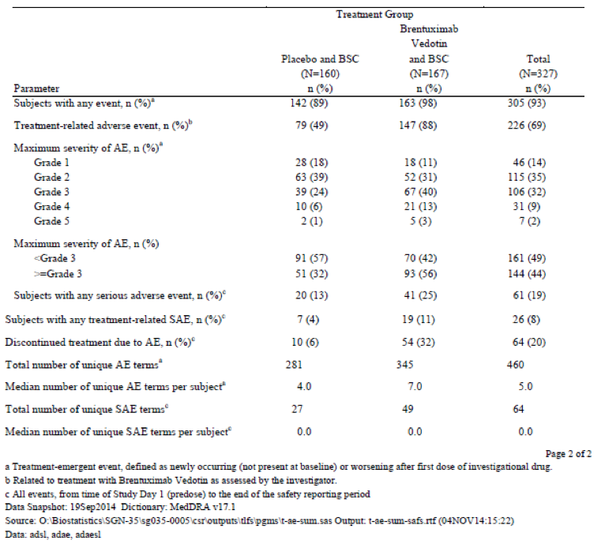
The most common AE by preferred term in the brentuximab vedotin arm was peripheral neuropathy; in the placebo arm it was upper respiratory tract infection as shown in Table 30, below.

Table 30. Study SGN35-005 Most commonly reported AEs by preferred term
Comment: The rate of AE occurrence in the placebo arm, including peripheral sensory neuropathy and neutropaenia, is high but consistent with the population (post-ASCT patients for r/r HL). Peripheral neuropathy is not unusual in patients with HL, both due to prior chemotherapy (for example, vinblastine or vincristine) or as a complication of HL itself. Pre-existing PN was present in 38% of the study population and in 39 patients (23%) in the Pivotal Phase II HL Population.
Abdominal pain and weight loss have been added to the list of expected events in the PI on the basis of the findings in Study SGN35-005.
A confounding effect due to patients in the placebo arm who develop progressive disease and receive brentuximab vedotin as rescue therapy is also possible. There were 83 patients in the placebo arm who discontinued treatment during the treatment period, with this due to progressive disease in 69 patients. Most of these 69 patients received brentuximab vedotin as rescue therapy (72/85 patients in the placebo arm who developed progressive disease throughout the study went on the receive brentuximab vedotin). The median time from last dose (brentuximab vedotin or placebo) to first of any subsequent brentuximab vedotin therapy in the placebo group was 1.495 months (approximately 45 days). This means that around 34 patients in the placebo arm who received subsequent brentuximab vedotin therapy during the treatment period would have done so within this time. How many of these received brentuximab vedotin during the adverse event reporting window of 30 days from last study drug treatment is not known. What contribution brentuximab vedotin therapy administered to patients in the placebo arm during the 30 day period of observation may have had on the adverse event profile of the placebo arm is also not known. Many AEs, including pulmonary toxicity and hepatotoxicity, may be described with the first cycles of brentuximab vedotin. Failure to exclude any patients from the placebo arm who received brentuximab vedotin within 30 days of study treatment may have resulted in an adverse event profile in the placebo arm that favoured brentuximab vedotin.
A graphical representation of TEAEs reported in ≥ 10% of patients in either treatment arm arranged in order by relative risk is presented below in Figure 27. TEAEs that had a higher risk of occurring in patients in the brentuximab vedotin arm compared with patients in the placebo arm (as indicated by a relative risk > 1 and confidence intervals that do not include 1) were peripheral motor neuropathy, paraesthesia, abdominal pain, constipation, peripheral sensory neuropathy, weight decreased, neutropaenia, nausea, myalgia, vomiting, diarrhoea, and arthralgia.
Figure 27. Study SGN35-005 Relative risk of Treatment Emergent AEs in ≥ 10% of patients in either treatment arm

Adverse events leading to dose reduction or adjustments or delays
Unplanned dose modifications, numbers were categorised into 3 groups:
- Dose delays (limited to doses delayed for per-protocol reasons; for example, adverse events)
- Planned dose reductions
- Unplanned dose adjustments or infusion interruptions
Numbers of patients with dose modifications in each group for each arm are given in Table 31, below.

Table 31. Study SGN35-005 Dose modifications by patient
Dose delays for ‘per protocol reasons’ (that is, AEs) occurred in 186/2004 doses of brentuximab vedotin (9%) and 56/1756 doses of placebo (3%), affecting 90 and 41 patients respectively. The majority of dose delays in the brentuximab vedotin arm occurred during Cycles 2 to 8 (affecting 16 to 30 patients per cycle). Dose reductions were instituted at least once during the study for 53 patients in the brentuximab vedotin arm and 4 patients in the placebo arm, with this most commonly occurring after 5 to 8 cycles of 1.8 mg/kg dose. In the brentuximab vedotin arm, peripheral sensory or motor neuropathies were the most frequently reported AEs leading to dose reduction (46 patients).
Unplanned infusion interruption or early stoppage due to infusion-related reactions occurred in 12 patients in the brentuximab vedotin arm.

Treatment-related adverse events (adverse drug reactions)
At least 1 treatment-related TEAE of any grade was reported for 146 patients (87%) in the brentuximab vedotin treatment arm and 77 patients (48%) in the placebo arm. All of the peripheral neuropathy events were assessed as treatment-related, as were 53/58 of the neutropaenia AEs. The most commonly reported treatment related TEAE’s are given in Table 32, below.

Table 32. Study SGN35-005 Most commonly reported treatment-related AEs by preferred term (in ≥ 10% of patients)

Deaths and other serious adverse events

Deaths
At the time of database lock, 53 patients had died; 28 patients (17%) in the brentuximab vedotin arm and 25 patients (16%) in the placebo arm. Most of the deaths occurred 30 days or more after the last dose, 27/28 in the brentuximab vedotin group and 25/25 of the placebo group. Most of the deaths were assessed as disease related. Two deaths in the brentuximab vedotin arm were assessed as treatment related, and are described below in Table 33.

Table 33. Study SGN35-005 Summary of deaths
There were 7 deaths due to Grade 5 AEs:
- Cause of death for the 5 patients in the brentuximab vedotin arm who had Grade 5 AEs was:
  - Acute respiratory distress syndrome (ARDS) in 2 patients:
    - considered related to study treatment in one patient who died within 30 days of the last dose of study treatment
    - considered unrelated to study treatment in the other patient, but followed ‘recurrence’ of ARDS occurring 3 days post-extubation for treatment-related acute pancreatitis and ARDS. The patient died on Study Day 40.
  - Myelodysplastic syndrome (MDS) considered related to study treatment
  - Pancreatic carcinoma considered unrelated to study treatment
  - Bladder cancer considered unrelated to study treatment
- Cause of death for the 2 patients in the placebo arm who had Grade 5 AEs was:
  - MDS considered related to study treatment
  - ARDS considered unrelated to study treatment
Comment: The narratives of 4/7 deaths were provided in the CSR. On the information provided, it would not seem unreasonable to consider both deaths from ARDS in the brentuximab vedotin arm as treatment related.

Serious adverse events
Of the 327 patients in the safety evaluable population, 61 experienced at least one SAE: 41 patients (25%) in the brentuximab vedotin arm and 20 patients (13%) in the placebo arm. SAEs were considered treatment-related in 19 patients in the brentuximab vedotin arm and 7 patients in the placebo arm. Treatment-related SAEs reported in ≥ 2 patients in either arm are shown below in Table 34.

Table 34. Study SGN35-005 SAEs reported for two or more patients (Safety analysis set)
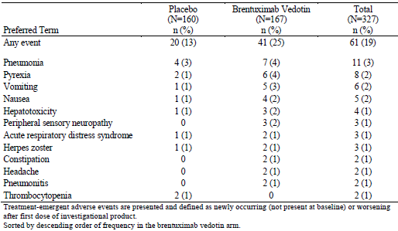
Comment: Narratives for 37/61 patients experiencing from 1 to 9 SAEs per patient were provided in the CSR, assessment of these as related or unrelated to study drug seemed reasonable according to the information available.
The most recent PSUR (19 August 2014 to 18 February 2015) provides information on serious adverse events recorded for all participants in the clinical study programme, not including Study SGN35-005 (See Table 74, in Section 12: Question 15). The most common SAES reported were infections and infestations in 12.7%, blood and lymphatic disorders in 9.8% and gastrointestinal disorders in 9.4%. Nervous system disorders (including peripheral neuropathy), were reported in 3.5%.

Discontinuation due to adverse events
Patients were to remain on treatment until disease progression or unacceptable toxicity, up to a maximum of 16 treatment cycles. A total of 64 patients (20%) experienced an AE that resulted in treatment discontinuation: 54 patients (32%) in the brentuximab vedotin arm and 10 patients (6%) in the placebo arm. AEs resulting in ≥ 2 discontinuations are given in Table 35 below.

Table 35. Adverse events resulting in discontinuation in ≥ 2 patients in either treatment arm
Comment: Narratives for 36/54 patients discontinuing from the brentuximab vedotin arm are provided the CSR [not included in this document]. 29 patients discontinued due to peripheral neuropathy (including 2 with paraesthesia and one with hyporeflexia). Assessments as related or unrelated to study drug seem reasonable for most although it was unclear why the case of hyporeflexia was not considered to be related to study drug.
Regarding narratives for deaths, SAEs and discontinuations due to AEs: Narratives for all deaths, SAEs and discontinuations were requested in a clinical question (see Section 12, Question 16 (Narratives for deaths, SAEs, and discontinuations due to AEs) below). In reply the sponsor stated: ‘Narratives were produced for serious (including fatal) adverse events occurring within 30 days of patients’ last dose of randomisation therapy. Fatal events sourced from the efficacy database beyond that time collected through long-term follow up overall survival were not associated with serious adverse events and thus reported as efficacy outcomes, only’. The reply also stated that narratives for the following had been provided in the CSR for patients in the brentuximab vedotin arm:
    - Deaths (Total, n = 4)
    - Other SAEs (Total, n = 61; Unique, n = 57)
    - Discontinuations due to AEs (Total, n = 61; Unique, n = 39)
From Table 27 above (copied from CSR), there were:
    - 41 subjects in the brentuximab vedotin arm and 20 in the placebo arm who had SAEs reported
    - 54 subjects in the brentuximab vedotin arm who discontinued treatment due to AEs
The evaluator can locate the narratives for 5 deaths, 37 patients with SAEs, 31 patients who discontinued treatment and 4 ‘other significant events’ in the CSR for SGN35-005.
Narratives for most of the patients in the brentuximab arm who experienced SAEs have been provided, assuming deaths were considered SAEs. Narratives for many of the patients who discontinued due to AES appear not to have been provided (23/54). It may be that these patients also had SAEs or died and so have been included in other narratives but this has not been clarified by the sponsor.

Adverse events of special interest
These were pre-specified and included peripheral neuropathy, pulmonary toxicity, infusion related reactions, opportunistic infections, haematologic toxicities, hyperglycaemia, hepatotoxicity, viral hepatitis, secondary malignancies, and other rare serious AEs.

Peripheral neuropathy (PN)
Using broad search terms, that included preferred terms such as gait disturbance, hypoaesthesia, paraesthesia, muscular weakness as well as the term peripheral sensory neuropathy and peripheral motor neuropathy, a total of 143 patients (44%) who experienced at least one treatment-emergent PN event. Of these, 112 patients were in the brentuximab vedotin arm and 31 patients in the placebo arm. PN events of Grade 3 in severity were reported for 13% of patients in the brentuximab vedotin group and 1% of patients in the placebo group. No Grade 4 events were reported.
A total of 123 patients (38%) enrolled on this study had pre-existing PN, presumed due to prior neurotoxic chemotherapy regimens or other pre-existing conditions. The proportion of patients with pre-existing PN was similar between the 2 treatment arms (41% in the brentuximab vedotin arm and 34% in the placebo arm). Of the 69 patients in the brentuximab vedotin arm who had pre-existing PN, the neuropathy worsened in severity post-baseline in 25 patients but later returned to baseline in 19.
A total of 38/165 patients (23%) in the brentuximab vedotin arm discontinued treatment due to PN and 51 patients required management of PN by dose modifications (delay and/or reduction). The median time to onset of a PN event in the brentuximab vedotin group was 13.7 weeks (range 0.1 to 47.4) or approximately 4 cycles, and the median time to onset of worst grade PN was 28.2 weeks (range 0.1 to 106.4) or approximately 7 cycles. At last follow-up, 32/44 (73%) of brentuximab vedotin patients with PN had resolution (17, 39%) or improvement (15, 34%) with a median time to resolution or improvement of 20.6 weeks (range 0.4 to 111.9 weeks). A total of 12 patients (27%) did not have resolution or improvement as of last follow up.

Pulmonary toxicity
Overall, 13 patients (4%) experienced at least 1 event of pulmonary toxicity, which included 8 patients (5%) in the brentuximab vedotin group and 5 patients (3%) in the placebo group, detailed below in Table 36. Preferred terms reported in more than 1 patient in the brentuximab vedotin arm were pneumonitis in 4 patients and ARDS and pulmonary toxicity in 2 patients each. Lung infiltration was the only preferred term reported in more than 1 patient in the placebo arm.

Table 36. Study SGN35-005 Pulmonary Toxicity TEAEs

Brentuximab vedotin arm
Five patients discontinued treatment due to pulmonary toxicity (or death). Treatment-emergent pulmonary toxicity events were reported as SAEs in 4 patients in the brentuximab vedotin arm and resulted in treatment discontinuation:
- Grade 3 pneumonitis considered unrelated to study treatment, reported as an SAE
- Grade 4 pulmonary toxicity considered unrelated to study treatment, reported as an SAE
- Grade 4 pneumonitis and Grade 5 ARDS considered related to study treatment, reported as an SAE
- Treatment-related Grade 3 ARDS that was associated with treatment-related acute pancreatitis. Three days after resolution of the Grade 3 ARDS and 6 days after resolution of the acute pancreatitis, the patient had an event of Grade 4 ARDS that was considered unrelated to study treatment by the investigator and resulted in death 15 days later, reported as a death.
- Grade 2 lung infiltration considered treatment-related and reported as AE
Another 2 patients had pulmonary toxicity AEs that were considered related to study treatment but did not result in discontinuation:
- Grade 2 pneumonitis
- Grade 2 pulmonary toxicity

Placebo arm
Treatment-emergent pulmonary toxicity events were reported as SAEs in 2 patients:
- Grade 5 ARDS considered unrelated to study treatment
- Grade 4 idiopathic pneumonia syndrome considered related to study treatment.

Infusion related reactions
Investigators considered AEs experienced by 25 patients (15%) to be infusion-related reactions (IRRs) caused by brentuximab vedotin administration. The following discussion refers only to these 25 patients in the brentuximab vedotin arm.
The most frequently reported IRRs were nausea in 7 patients (4%), chills in 6 patients (4%), and dyspnoea, headache, pruritus, and rash in 4 patients each (2%). IRRs tended to occur early in exposure (4 patients in cycle 1, 15 patients with cycle 2 and 3 in cycle 5 or later). Most patients had only one IRR (13/25), 7 patients had 2 and 5 patients had 3 or more. Most IRRS were Grade 1 or 2 in severity and did not require infusion interruption or cessation (19/25). No patient had a Grade 4 IRRs and no cases of anaphylaxis were reported. Three patients had Grade 3 IRRs and two patients had IRRs that were reported as SAEs, the latter two were the only patients who discontinued treatment due to IRRs. The preferred terms used for these 5 patients were:
- Face oedema, erythema, pharyngeal oedema, throat irritation and dysphonia
- Bronchospasm, rash, and pruritus
- Syncope
- Grade 3 syncope and Grade 2 bradycardia (SAE)
- Grade 2 presyncope, rash, and bronchospasm and Grade 1 vomiting (SAE)
Comment: It is surprising that the patient with face oedema, pharyngeal oedema and dysphonia (suggesting potential for airway compromise) was not reported as an SAE.
The narratives of 27 patients (24 patients from the brentuximab vedotin arm and 3 patients from the placebo arm) in whom infusion related reactions were reported was provided by the sponsor in response to a clinical question [not reproduced in this document]. ATA results were included in these analyses. The evaluator could find no discernible pattern between ATA titres and infusion related reactions (see also Section 4.4: Study SGN35-005, anti-therapeutic antibodies, above).

Serious and Opportunistic Infections
Serious infections, summarised below in Table 37, were reported for 15 patients (9%) in the brentuximab vedotin arm and 7 patients (4%) in the placebo arm.

Table 37. Study SGN35-005 Summary of serious and opportunistic infections
The most common serious infection was pneumonia, which was reported for 7 patients (4%) in the brentuximab vedotin arm and 4 patients (3%) in the placebo arm. A single case of Grade 4 septic shock considered unrelated to treatment was reported in the placebo arm. No events of bacteraemia, sepsis or septic shock were reported in the brentuximab vedotin arm. A single case of treatment-related febrile neutropaenia was reported in the brentuximab vedotin arm. No cases of febrile neutropaenia were reported in the placebo arm.
The most commonly reported opportunistic infections were herpes zoster and simplex. Both of these were reported more frequently in the brentuximab vedotin arm and despite antiviral prophylaxis in most of the patients: 8/12 patients in the brentuximab vedotin arm and 4/4 patients in the placebo arm were receiving prophylaxis prior to reactivation. Fungal pneumonia was reported in 2 patients in the placebo arm. There was one case of acute hepatitis B infection in a patient in the brentuximab vedotin arm. One case of PCP was reported, this brentuximab vedotin arm patient was not taking the protocol-required PCP prophylaxis at the time of infection. Oral candidiasis was reported for 7 patients in the brentuximab vedotin arm and 3 patients in the placebo arm and was considered to be treatment related for 2/7 patients in the brentuximab vedotin arm and 1/3 patient in the placebo arm. It was Grade 1 for all the placebo arm patients and Grade 2 for 6/7 of the patients in the brentuximab vedotin arm. Oral candidiasis led to a dose delay for 1 patient in the brentuximab vedotin arm.

Haematologic toxicities
Neutropaenia of any grade: was reported in 58 patients (35%) in the brentuximab vedotin arm and 19 patients (12%) in the placebo arm. In the brentuximab vedotin arm, Grade 3 neutropaenia was reported in 37 patients (22%), Grade 4 neutropaenia was reported in 12 patients (7%) and there was a single case of non-serious, treatment-related febrile neutropaenia. Neutropaenia was managed with dose delay and/or growth factor support - 42 patients in the brentuximab vedotin arm and 17 patients in the placebo arm received treatment with colony stimulating factors. No patients required dose reduction or discontinued treatment for neutropaenia.
Thrombocytopaenia of any grade: was reported in 12 patients (7%) in the brentuximab vedotin arm and 5 patients (3%) in the placebo arm. In the brentuximab vedotin arm, Grade 3 thrombocytopaenia was reported in 3 patients and Grade 4 was reported in 4 patients. Thrombocytopaenia led to a dose delay for 3 patients in the brentuximab vedotin arm and one patient from each treatment group had treatment discontinued due to thrombocytopaenia.
Anaemia of any grade: was reported in 14 patients (8%) in the brentuximab vedotin arm (Grade 3 in 6 patients) and 4 patients (3%) in the placebo arm. No Grade 4 anaemia, dose delay or treatment discontinuation due to anaemia was reported in either treatment arm.

Hyperglycaemia
Hyperglycaemia was reported for 5 patients (3%) in the brentuximab vedotin treatment arm and 1 patient (0.6%) in the placebo arm.
In the brentuximab vedotin arm, hyperglycaemia was Grade 3 for 4 patients and Grade 1 for 1 patient and hyperglycaemia was considered to be treatment related for 2 patients. Hyperglycaemia was considered to be steroid induced for the other 3 patients. Grade 1 Type 2 diabetes was also reported for 1 of the patients with Grade 3 hyperglycaemia, and was considered to be treatment related. All 5 patients in the brentuximab vedotin arm had pre-existing Grade 3 or Grade 4 obesity and 2 of the 5 patients had pre-existing Grade 1 hyperglycaemia. Hyperglycaemia resolved for 3 of the 5 patients by the end of treatment.

Hepatotoxicity
Overall, 11 patients (7%) in the brentuximab vedotin arm and 4 patients (3%) in the placebo arm experienced AEs consistent with hepatotoxicity, events are summarised in Table 38, below. Some hepatotoxicity events observed in each group occurred in the setting of other AEs that may have had a causative role, including reactivation of chronic viral hepatitis, acute hepatitis B infection, and systemic antifungal therapy administration for pulmonary aspergillosis.

Table 38. Study SGN35-005 Incidence of treatment-emergent hepatotoxicity
Grade 3 or higher events were reported for 7 patients (4%) in the brentuximab vedotin arm and 4 patients (3%) in the placebo arm. Hepatotoxicity SAEs were reported for 3 patients in the brentuximab vedotin arm and 2 patients in the placebo arm. The majority of patients with hepatotoxicity AEs in the brentuximab vedotin arm had improvement or resolution of their events (7 of 11 patients; 64%) and most continued on treatment. Grade 3 or 4 hepatotoxicity in the brentuximab vedotin arm was managed primarily with dose delays and dose reductions.
Five patients in the brentuximab vedotin arm and 2 patients in the placebo arm, had elevated post-baseline liver function tests (≥ Grade 3 AST, ≥ Grade 3 ALT or ≥ Grade 2 bilirubin) without associated treatment-emergent AEs consistent with hepatotoxicity. Of these, 1 patient was evaluated as a possible Hy’s Law candidate:
‘The patient had a medical history of chronic viral hepatitis and was hepatitis B surface antigen-positive. After 4 cycles of brentuximab vedotin, increases in total bilirubin, ALT, AST, and alkaline phosphatase (bilirubin = 1.40 mg/dL, ALT = 1766 IU/L, AST = 937 IU/L, alkaline phosphatase = 265 IU/L) were noted. The investigator attributed this to a reactivation of viral hepatitis B and the patient was therefore not considered to have met the criteria for Hy’s Law.’

Secondary malignancies
A secondary malignancy was reported for 4 patients in the brentuximab vedotin arm and 2 patients in the placebo arm. The secondary malignancies reported for the brentuximab vedotin arm were bladder cancer, myelodysplastic syndrome (MDS), pancreatic cancer, and lung cancer. Those reported for the placebo arm were mantle cell lymphoma and MDS. All 6 patients with secondary malignancies died, in four of these patients the malignancy was reported as the primary cause of death.
The 6 patients who developed secondary malignancies were aged between 55 to 71 years and considerably older than the median age of 32 years of the overall study population. Additional risk factors were also identified for some of these patients.

Rare serious AEs
Grade 4 acute pancreatitis and Grade 3 myelitis (radiation myelitis in a previous radiation field) were reported for 1 patient each in the brentuximab vedotin treatment arm. The acute pancreatitis resolved; the myelitis did not.
Stevens-Johnson syndrome, toxic epidermal necrolysis, tumour lysis syndrome, and progressive multifocal leukoencephalopathy were not reported for any patient in Study SGN35-005.

Laboratory tests
At least 1 Grade 3 or higher laboratory abnormality was reported for 69 (41%) patients in the brentuximab vedotin arm and 29 (18%) patients in the placebo arm, shown below in Table 39.

Table 39. Study SGN35-005 Abnormal laboratory values ≥ Grade 3 in ≥ 5 patients in either treatment arm
Per protocol, clinically significant laboratory abnormalities were to be captured as AEs; see descriptions above for abnormal liver function tests (ALT, AST, bilirubin, transaminases) that were reported as AEs, haematologic toxicities and hyperglycaemia.

Electrocardiograph
ECGs for 6 patients were noted as having clinically significant abnormalities; all were associated with cardiac AEs or baseline conditions. 4 patients (all in the brentuximab vedotin arm) had clinically significant ECG abnormalities noted prior to the first dose of study treatment only and 2 patients (both in the placebo arm) had ECG abnormalities at the end of treatment (EOT) only. With the exception of Grade 3 pleural effusion at EOT in a patient in the placebo arm, all cardiac AEs associated with clinically significant ECGs were Grade 1 or 2 in severity.

Vital signs and physical examination
Routine vital signs and physical examination data were not collected in the study database. Any clinically significant changes were to be captured as AEs.

ECOG
The majority of patients in both treatment arms had no change in ECOG performance status from Baseline to end of treatment (104 patients (62%) in the brentuximab vedotin arm and 106 patients (66%) in the placebo arm). In comparison to baseline, ECOG status was noted to worsen in 59 patients (36%) in the brentuximab vedotin arm and 39 patients (25%) in the placebo arm and to improve in 36 patients (22%) in the brentuximab vedotin arm and 43 patients (27%) in the placebo arm.

Drug-drug interactions
MMAE exposure may be increased by concomitant administration of ketoconazole, a strong CYP3A4 and P-gp inhibitor and may be reduced by co-administration with rifampicin, a strong CYP3A4 inducer. The CSR provides no information regarding these possible drug-drug interactions in the study population.
Comment: This was the subject of a clinical question to the sponsor (see Section 12, Question 6 (Drug-drug interactions), below). Post hoc analysis of a convenience sample of 18 patients for whom MMAE levels were available and who also had received concomitant treatment with a P-gp or CYP3A4 inhibitor compared to 40 patients for whom MMAE levels were available and who had not received concomitant treatment with a P-gp or CYP3A4 inhibitor was provided by the sponsor. Mean, median, minimum and maximum MMAE levels were provided by cycle and for unscheduled visits. Apart from what appeared to be one patient in cycle 16 who received both a P-gp and CYP3A4 inhibitor and had a markedly elevated MMAE level, there was no convincing difference in the MMAE levels between the two groups.

Post-marketing experience
Comment: No summary or discussion of post-marketing experience is provided by the sponsor in the Clinical Overview or Summary of Clinical Safety. The information below is compiled from the discussions and descriptions provided in the PSURs and in the Risk Management Plan.
No post-marketing studies were provided. Five periodic safety update reports were provided. These were dated:
- PSUR 1: 19 August 2012 to 18 February 2013
- PSUR 2: 19 February 2013 to 18 August 2013
- PSUR 3: 19 August 2013 to 18 February 2014
- PSUR 4: 19 February 2014 to 18 August 2014
- PSUR 5: 19 August 2014 to 18 February 2015
Comment: A more recent PSUR (PSUR 6) for the period 19 August 2014 to 18 August 2015 was provided during the Round 2 evaluation period to support inclusion of Gastrointestinal Complications as a Precaution in the proposed PI. Data from this PSUR has been used to update the sections below where relevant.

Periodic safety update reports

Exposure
From PSUR 5:
- 2221 patients have been exposed to brentuximab vedotin in clinical trials sponsored by the marketing authorisation holder; cumulative exposure by age group in the clinical trial programme is shown below in Table 40.

Table 40. PSUR 5 Cumulative exposure to brentuximab vedotin from completed studies presented by age and sex
- Cumulative post-marketing patient exposure to brentuximab vedotin is estimated at 12,569 patients worldwide since launch (International Birth Date of brentuximab vedotin is designated as 19 August 2011). This has been estimated from the total number of vials shipped (see page 25 of PSUR 5 for a description of the method used). Most of the exposure has occurred in the USA and EU.
In the more recent PSUR 6, the cumulative estimated patient-exposure to brentuximab vedotin is 22,240 patients, including 2415 in company sponsored clinical trials. The highest usage is reported in the USA and Europe.

SAEs from the clinical trials programme
PSUR 6 includes a table shown below (Table 41) of serious adverse events recorded for all participants in the clinical study programme, not including Study SGN35-005. Overall, 3671 subjects have been enrolled in company-sponsored clinical trials with brentuximab vedotin, of whom 2415 have been exposed to brentuximab vedotin. From PSUR 5, the most common SAEs in the brentuximab exposed group were infections and infestations reported in 12.7%, blood and lymphatic disorders in 9.8% and gastrointestinal disorders in 9.4%. Nervous system disorders (including peripheral neuropathy), were reported in 3.5%.

Table 41. Cumulative summary of adverse events from clinical trials
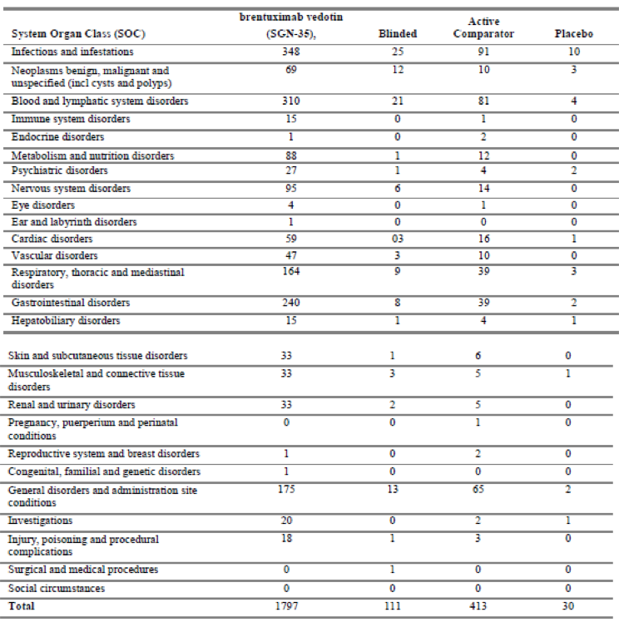
Source: PSUR 6

Adverse drug reactions (post-marketing sources)
PSUR 6 provides a summary of the ADRs reported from post-marketing sources. The estimated cumulative patient exposure from marketing experience since the first approval of the product is estimated to be approximately 16,328 patients.

Table 42. Cumulative summary of ADRs from post-marketing sources, reported by SOC
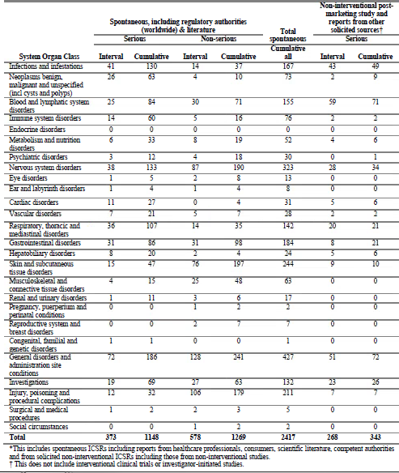
Note: ‘Interval’ refers to August 2014 to February 2015; ‘cumulative’ to August 2012 to February 2015. Source: PSUR 6
Additional detail is provided by preferred term elsewhere in PSUR 5. Table 43 (below) is compiled from this data, looking at the SOCs with > 50 serious ADRs and preferred terms with a total cumulative incidence > 20, and serious ADRs of special interest. Preferred terms are grouped according to clinical relevance where appropriate.

Table 43. Cumulative number of serious ADRs by preferred term
SOC, Preferred term | Cumulative number of serious ADRs from all post-marketing sources
Infections and infestations | 144
Pneumonia | 23
Sepsis | 27
Neoplasms | 54
Hodgkin’s disease | 22
Blood and Lymphatic Disorders | 122
Neutropaenia | 47
Thrombocytopenia | 18
Immune System Disorders | 51
Anaphylactic reaction | 25
Nervous System Disorders | 136
Neuropathy, peripheral; peripheral motor neuropathy; peripheral sensorimotor neuropathy; peripheral sensory neuropathy | 61
Respiratory, thoracic and mediastinal disorders | 112
Dyspnoea | 21
Pneumonitis, pulmonary toxicity, lung infiltration, interstitial lung disease | 31
ARDS, respiratory failure, acute respiratory failure | 16
Gastrointestinal, hepatobiliary disorder | 117
Pancreatitis, pancreatitis acute, pancreatitis necrotising | 21
Nausea | 11
Diarrhoea | 11
Acute hepatic failure, hepatic failure, hepatitis fulminant | 4
Skin and Subcutaneous tissue disorder | 49
Stevens-Johnson Syndrome | 4
Toxic epidermal necrolysis | 3
Pruritus, rash pruritic, urticaria | 10
General disorders and administration site conditions | 188
Death | 38
Disease progression | 56
Pyrexia | 22
Injury, poisoning and procedural complications | 28
Infusion related reaction | 17
Source: PSUR 5

Actions taken in the reporting interval for safety reasons
Each PSUR was checked for any actions taken for safety reasons. In all PSURs it was stated that no trial had been suspended or terminated early due to safety findings or a lack of efficacy; the product had not been withdrawn or suspended in any jurisdiction; the product had not failed to gain marketing authorisation for a tested indication including voluntary withdrawal of a marketing authorisation application.
Descriptions of post-marketing study requirement(s) for conditional or accelerated approval imposed by the EMA, Canada and the FDA were given. Descriptions of actions taken for safety reasons and changes to reference safety information were provided in each PSUR. These track the recognition/refinement of safety signals (including pulmonary toxicity, hepatotoxicity, pancreatitis, SJS/TEN, gastrointestinal complications), the investigation of these through cumulative reviews or safety updates, and later inclusion as potential and/or identified risks in the SmPC. The resulting changes in the SmPC, due to additions/inclusions to relevant sections, are listed below.
Additions/inclusions:
- Important potential risks: acute pancreatitis, pulmonary toxicity with monotherapy, and hepatotoxicity with monotherapy
- Important identified risks: febrile neutropaenia, toxic epidermal necrolysis (TEN), gastrointestinal complications
- Warnings and Precautions: sepsis/septic shock (including fatal outcomes), fatal infections, and specific mention of bacterial, viral and fungal infections; Infusion related reactions (IRR) are more frequent and more severe in patients with antibodies to brentuximab vedotin; hepatotoxicity; haematological toxicity including neutropaenia, anaemia and thrombocytopaenia; serious dermatologic reactions (SJS, TEN)
- Expected events: weight loss, abdominal pain
- Adverse drug reactions: aminotransferase/aspartate aminotransferase (ALT/AST) increase; weight decrease; abdominal pain; hyperglycaemia
- Contraceptive advice: recommendation for use of two effective contraceptive methods during treatment and for 6 months thereafter; notification that the effect of brentuximab vedotin on spermatogenesis is unknown, and men are advised not to father a child during treatment and for up to 6 months following the last dose
- Drug interaction: in vitro data on P-glycoprotein (P-gp) inhibitors and their potential effect on MMAE exposure, and to provide a cautionary statement regarding concomitant use.
- Boxed Warning (Canada): hepatotoxicity; Risks where fatal outcomes have occurred (SJS/TEN, Serious infections, and Acute pancreatitis)
- Patient counselling information regarding symptoms of hepatitis, acute pancreatitis and advice regarding when to contact a healthcare provider.

Overview of safety signals
PSUR 5 provides a summary of important safety concerns as of August 2014 and in alignment with the risk management plan (RMP), shown below in Table 44.
Table 44. Summary of Safety Concerns (PSUR 5)
Important identified risks | Progressive multifocal leukoencephalopathy  Pulmonary toxicity associated with combination use of bleomycin and brentuximab vedotin  Peripheral neuropathy (sensory and motor)  Neutropaenia  Febrile neutropaenia  Thrombocytopaenia  Anaemia  Infection including bacteraemia/sepsis/septic shock  Opportunistic infection  Infusion-related reaction  Hyperglycaemia  Stevens-Johnson syndrome/Toxic epidermal necrolysis  Tumour lysis syndrome  Anti-therapeutic antibodies
Important potential risks | Pancreatitis acute  Hepatotoxicity  Pulmonary toxicity  Reproductive toxicity  Thymus depletion (paediatric)  Infection with drugs modifying CYP3A4 activity
Missing information | Safety in paediatrics  Safety in the elderly  Safety in patients with hepatic, cardiac or renal impairment  Long term safety
Comment: The Summary of Safety Concerns is unchanged in PSUR 6 as ‘GI complications’ was recognised as a new important potential risk during the reporting period.

Safety issues with the potential for major regulatory impact
Comment: Information regarding the safety issues described below is collated from the PSURs. In general, the signal evaluation is presented in the PSUR as an overview of the condition followed by a description of the findings in the ‘Pivotal Phase II Studies’. For new signals, a more comprehensive cumulative review may also have been performed. PSUR 5 provides a summary table of numbers up to data lock point for that update, as sourced from the clinical trials programme and from post-marketing sources. The safety findings of the Phase III study, SGN35-005 (described in the efficacy and safety sections above) have not been included in the updates in the PSUR 5, although a study synopsis is provided elsewhere in the PSUR.
Two new safety concerns were addressed in PSUR 6: gastrointestinal complications and posterior reversible encephalopathy syndrome (PRES). These have been included below.
Notes are made where information related to the risk have been included in the European SmPC to be consistent with the terminology used in the PSURs. This information in general is also included in the Australian version of the SmPC (the Product Information).

Neurological toxicity

Peripheral neuropathy
Peripheral neuropathy is a relatively common dose-limiting toxicity of brentuximab vedotin and is discussed at length in several of the PSURs, most recently in PSUR 5.
Peripheral neuropathy, including peripheral sensory neuropathy and peripheral motor neuropathy, emerged as a clinically important neuromuscular AE early in the clinical trial program of brentuximab vedotin. It ranged from mild distal paraesthesia, affecting fingers and toes, to frank motor weakness. The development of PN is considered to be due to cumulative and dose-dependent exposure to brentuximab vedotin. The mechanism of neurotoxicity is unclear but is presumed to be due to the cytotoxic component of brentuximab vedotin (MMAE) and consistent with a class effect of microtubule inhibitors. The proposed mechanism is breakdown of microtubules in axons, compromising axoplasmic flow and leading to neuronal injury and dysfunction.
In the Pivotal Phase II Population, treatment-emergent PN (sensory and motor) was reported in 56% of the patients. Of these, 13% experienced at least 1 event considered Grade 3. No events were considered Grade 4, but 4% of patients experienced 1 or more serious events. Median time to onset of the first report of treatment-emergent PN was approximately 25 weeks. The PN was progressive, with Grade 3 following lower grades and the median time to Grade 3 PN was approximately 38 weeks. The neuropathy was generally reversible by dose delay, dose reduction, or discontinuation. The median time from onset to resolution or improvement of PN symptoms was 16.1 weeks.
In the update provided in PSUR 6, there had been 1398 (47%) patients with PN as a TEAE in the clinical trials programme. Of these 32 were reported as SAEs, 189 were grade 3 or 4 events, 1358 were Grade 1 or 2 events and there were no fatal outcomes. There had been another 128 SAEs reported from other sources. Of these 15 were considered to be Grade 3 to 4 in severity and there were 2 with fatal outcome.
The SmPC advises monitoring for symptoms and signs of PN, with management by dose delays or adjustment if it develops. Advice regarding dosing according to the severity of the PN is provided.

Convulsions
A cumulative review of the occurrence of convulsions in association with the administration of brentuximab vedotin is presented in PSUR 3. The estimated incidence of events concerning convulsion/seizure derived from clinical trial data was uncommon (0.18%, 7 patients), and the post-marketing reporting rate (with its data limitations) was rare (0.03%, 2 spontaneous reports). The cases are described in the review and it is apparent that, in the well-documented cases, there was usually a history of a seizure disorder. The conclusion of the review was that an association was not established at that time.

Posterior reversible encephalopathy syndrome
A possible safety signal for posterior reversible encephalopathy syndrome (PRES) was investigated in PSUR6 following reports that had been received from both spontaneous and clinical trial sources.
The background provided in the PSUR was: ‘Risk factors for PRES include hypertension, allogeneic stem cell transplant, immunotherapy, infection/sepsis, hematologic malignancy, autoimmune disease and high dose chemotherapy. These risk factors are common in cancer patients. The background rate of PRES in HL is unknown. Incidence rates up to 9% have been reported in post-allogeneic transplant patients following conditioning therapy and cyclosporine immunosuppression’.
A cumulative search with a data cut-off date of 5 June 2015 was made of the Global Safety Database (GSDB) for all cases that included a preferred term (PT) within the ‘Non-infectious Encephalopathy/ Delirium’ standard MedDRA Query (SMQ). There were 14 cases were identified, of which 7 were excluded from the evaluation as being non-PRES related. Of the 7 cases included in the evaluation (4 from clinical trials and other solicited sources and 3 from spontaneous sources), 5 were reported as PRES and 2 as leukoencephalopathy. Medical histories were available for 5 out of 7 cases; these were provided as brief summaries in the PSUR. Analysis by the sponsor of these 5 cases was that all of these cases were confounded by known risk factors for PRES including: stem cell transplant in 5/5 (type of stem cell transplant not described for 3/5), polyarthritis in one patient, steroid use in 3 patients and hypertension in one patient. The indication for treatment was Hodgkin lymphoma in all 5 patients. The time to onset from first dose of brentuximab vedotin was after cycle 2 in the 5 cases with known time courses. In 3/5 patients, the diagnosis was confirmed by MRI. On the basis of confounding factors, the sponsor’s conclusion was that the evidence does not support a causal association between PRES and brentuximab vedotin use and the signal was refuted.

Liver toxicity
The liver was first identified as a target organ in single-and repeat-dose toxicity studies in animals. A cumulative review was presented in PSUR 2; this identified 82 patients from all sources, with an estimated incidence of hepatobiliary disorders derived from clinical trial data of 1.40%, and the post-marketing reporting rate of 0.61%. The majority of events of hepatotoxicity were asymptomatic with mild to moderate transient elevations in aspartate aminotransferase (AST) and alanine aminotransferase (ALT) that occurred after 1 to 2 treatment cycles. Mild to moderate elevation in liver enzymes was observed upon rechallenge for some patients.
Of the 82 cases described in the PSUR 2 review, 17 had died with 2 of these thought to be possibly related to brentuximab therapy. One patient with HL developed elevated transaminases after the first cycle and died from fulminant hepatitis after the second cycle. The reporter assessed the event as possibly related to brentuximab vedotin based on the temporal association. One patient with ALCL died from multiple organ failure 15 days after the first cycle. The post-mortem showed steatohepatitis that was considered to be related to brentuximab vedotin by the reporter of the case. These cases, and the other fatal outcomes associated with hepatotoxicity (as described in the review) were confounded by comorbidities and/or concomitant medications with known hepatotoxic potential. The conclusion drawn by the review was that hepatotoxicity was a new and important potential risk associated with brentuximab vedotin therapy; although an absolute causal association could not be established at that time.
In the update provided in PSUR 5, there have been 177 patients with hepatotoxicity reported as a TEAE in the clinical trials programme, 69 of these were Grade 3 or 4 events and there were 2 fatal outcomes. Another 83 SAEs of hepatotoxicity were reported from outside the clinical trials programme, including 7 with fatal outcomes.
Hepatotoxicity was added as an important potential risk to the SmPC in 2013. Advice is also provided that liver function should be routinely monitored during treatment.
Comment: In response to a clinical question (see Section 12, Question 18 (Hepatotoxicity), below), the sponsor has provided a review of all cases in the Global Safety Database with the Data Lock of 18 February 2015 (consistent with PSUR5) for all cases that coded to any of the preferred terms (PTs) in the Hepatotoxicity SMQs as defined in the EU-RMP. An additional review with a data lock point of 18 August 2015 that was conducted in September 2015 was also provided. The latter review was provided with the SRR with the additional information that this cumulative review had been conducted in response to a Request for Supplementary Information made by the EMA’s Rapporteur following review of PSUR 5. The findings of these reviews are summarised below. The full text of the reviews can be found in the sponsor’s document [not included here].

Cumulative review with data lock point 18 February 2015
In the first review with data lock of 18 February 2015, the Global Safety Database was searched using the preferred terms of: Cholestasis and jaundice of hepatic origin; Hepatic failure, fibrosis and cirrhosis and other liver damage-related conditions; Hepatitis, non-infectious; Liver related investigations, signs and symptoms. At this time there were 5475 patients who received treatment with brentuximab vedotin in clinical trials and an estimated 12,569 patients who received brentuximab vedotin in the post-marketing setting. A total of 131 cases were identified using the above search strategy including 82 cases from clinical trials and other solicited sources and 49 cases from commercial use.

Clinical trials source
Of these 82 cases, 44 cases were reported from company-sponsored clinical trials, 8 cases were reported from ISTs, 28 cases were reported from compassionate use programmes, and 2 cases were reported from a market survey programme. Over half of the cases (49/82, 59%) were evaluated by clinical investigators as at least possibly related to brentuximab vedotin treatment. Most of the cases (77/82, 93%) reflect hepatocellular injury, and approximately half of the cases (42/82, 51%) represent hepatotoxicity consistent with elevation of liver enzymes (ALT, AST, GGT, ‘transaminases’).
A table [not in this document] provided by the sponsor in response to TGA questions lists the preferred terms by number of reports, with some patients having multiple PTs reported. This table has been reorganised here as Table 45, for more clinical relevance.

Table 45. Review of hepatotoxicity, according to preferred terms
Brentuximab Vedotin Hepatobiliary Preferred Terms; Solicited Sources
Preferred terms, combined into clinically relevant groups as indicated | Total | Serious | Fatal
Hepatic failure, Hepatitis fulminant, Hepatic necrosis, Hepatic steatosis, Liver disorder, Hepatocellular injury, Hepatotoxicity, Hepatitis, Drug-induced liver injury | 25 | 19 | 4
Hepatocellular: Hepatic function abnormal, Hypertransaminasaemia, Alanine aminotransferase abnormal, Alanine aminotransferase increased, Aspartate aminotransferase abnormal, Aspartate aminotransferase increased, Gamma-glutamyltransferase abnormal, Gamma-glutamyltransferase increased, Hepatic enzyme increased, Transaminases increased, Liver function test abnormal | 62 | 31 | 1
Cholestatic: Cholestasis, Hyperbilirubinaemia, Blood alkaline phosphatase increased, Blood bilirubin increased, | 10 | 8 | 0
Other: Hepatosplenomegaly, Ischaemic hepatitis, Hypoalbuminaemia, Hepatic encephalopathy, ascites, acute GVHD | 11 | 8 | 1
Of these 82 cases reported from clinical trials and other solicited sources, 14 cases had a fatal outcome, with this attributed to the hepatic adverse event in 5/14 cases. Of these 5 cases, the hepatic adverse event was reported as related to brentuximab vedotin in 2 cases:
- one patient (also described above) with HL developed elevated transaminases after the first cycle and died from fulminant hepatitis after the second cycle
- one patient with CD30+ non-lymphomatous malignancy developed hepatorenal failure 6 days after the second dose of brentuximab vedotin.
In the other 9/14 patients in whom the death was not considered related to the hepatic adverse event, death was attributed to the following causes: disease progression (7), idiopathic pulmonary syndrome following stem cell transplant (1), and septic shock (1).

Post-marketing sources
A total of 49 spontaneous case reports were received from post-marketing sources. The majority of cases (32/49, 65%) represent hepatotoxicity consistent with the elevation of liver enzymes. The most commonly reported PTs (occurring in ≥ 2 patients) under Hepatobiliary disorders SOC included acute hepatic failure (2), hepatic steatosis (2), jaundice (2), and liver disorder (2).
There were 11 cases with fatal outcomes (two of these were received after data lock of February 18, 2015). In 2 cases, death was attributed to the hepatic adverse event and was considered by the reporter to be related to brentuximab vedotin:
- a patient with ALCL died from multiple organ failure 15 days after the first cycle and whose post-mortem showed steato-hepatitis (this case is described above)
- a patient with HL and past history of steatohepatitis who developed active steatohepatitis followed by hepatorenal failure 6 days after receiving brentuximab vedotin, with this preceded by a course of ABVD. The patient died approximately 5 weeks later

Deaths not considered related to the Hepatic Adverse Event or to Brentuximab Vedotin
There were 12 patients from the clinical trials with fatal outcome and hepatic adverse event in whom death was not considered related either the hepatic adverse event or to brentuximab vedotin. In these patients, death was attributed to the following causes: disease progression (7), ‘idiopathic pulmonary syndrome’ following stem cell transplant (1), and septic shock (1).
There were also 9 patients from post-marketing sources with fatal outcome and hepatic adverse event in whom death was not considered related to either the hepatic adverse event or to brentuximab vedotin. In these patients, death was attributed to the following causes: progressive disease (4), GVHD (2), sepsis (1), alcohol abuse (1) and pancreatitis (1).
Brief narratives of cases with fatal outcome and with hepatic adverse events from both Clinical Trials and Post-marketing sources were provided (3 deaths reported as related to brentuximab vedotin and 20 deaths reported as not due to the hepatic adverse event) in the sponsor’s response). These brief summaries indicate patients with complex conditions. With the details provided, it is not possible to separate out any possible contribution of brentuximab vedotin to the hepatic adverse event or the hepatic adverse event to the fatal outcome for most of the patients. A contribution by brentuximab vedotin to the deaths of these patients cannot be excluded. The use of immunosuppressive therapies, including corticosteroids, in the management of cases of hepatotoxicity is not described in the narratives provided.

Additional safety analysis with data lock 18 August 2015
This review used a broad search strategy and included AEs reported to the Global Safety Database from solicited and spontaneous sources and AEs reported in the clinical database from company-sponsored clinical trials sources. Summarised data was presented by reporting source and broken down by toxicity grade and treatment cycle [Tables not in this document]. This has been pooled and presented only according to cycle number in Table 46, below. The majority of events occurred early in treatment (within 1 or 2 cycles) although there were events reported in later cycles.

Table 46. Hepatotoxicity events by treatment cycle number
Hepatotoxicity Events (All Toxicity Grade) by Treatment Cycles
 | Number of Hepatotoxicity Adverse Events
Treatment cycle number | Cycle unknown | 1 or 2 | 3 or 4 | 5 or 6 | 7 or 8 | 9 or 10 | ≥ 10
Global Safety Database Output; Solicited Sources | 23 | 86 | 8 | 4 | 1 | 7 | 1
Global Safety Database Output; Spontaneous Sources | 50 | 28 | 0 | 0 | 0 | 0 | 0
Clinical Database Output | 2 | 420 | 99 | 56 | 19 | 14 | 25
Total | 75 | 534 | 107 | 60 | 20 | 21 | 26
Source: Derived from sponsor tables provides as part of sponsor’s response to TGA questions
Most events are Grade 1 to 2 in severity. In the clinical database 491/650 (75.6%) events were Grade 1 to 2, 140/650 (21.6%) were Grade 3 to 4 and 2/650 (0.3%) were Grade 5.
The outcome of cases and measures taken with respect to hepatotoxicity were also analysed and presented in tables [not included in this document], broken down according to data source. This is summarised in Table 47, below.

Table 47. Hepatotoxicity events by outcome
Hepatotoxicity Events by Outcome and Source of Report
 | Number of Hepatotoxicity Adverse Events
 | Total number of cases | Number with outcome available | Fatal | Not recovered/resolved | Worsened | Improved/resolved
Global Safety Database Output; Solicited Sources | 130 | 116 | 8 | 23 | 1 | 84
Global Safety Database Output; Spontaneous Sources | 73 | 41 | 4 | 14 | 0 | 23
Clinical Database Output | 666 | 647 | 2 | 167 | 12 | 466
Total | 869 | 804 | 14 | 204 | 13 | 573
Source: Derived from sponsor tables provides as part of sponsor’s response to TGA questions
Most of the events (71.3%) were reported as resolved or improved, 27% had not recovered or had worsened and 1.7% had fatal outcome. The analysis by actions taken (no action, dose delayed, dose reduced or treatment ceased) found that no action was taken with most of the reported events (91.3%), the dose was delayed for 5.7%, reduced for 2.6% and ceased in 0.5%.
The sponsor described several actions taken following these reviews:
- The current CCDS text was expanded to include a recommendation for liver function testing prior to initiating treatment with brentuximab vedotin. The rationale for this precaution was that it will allow prescribers to assess the patient’s baseline hepatic function and therefore enable more informed monitoring during the patient’s treatment.
- The CCDS was updated to include the recommendation that dose delay, dose reduction, or discontinuation of brentuximab vedotin be considered in response to hepatic AEs.
- Routine monitoring of hepatic function throughout the treatment period remained as a recommendation in the CCDS as, although the majority of the AEs occurred in the earlier cycles of treatment, some AEs, including Grade 3 to 5 events, have occurred in later treatment cycles.
The sponsor has also proposed that the Australian PI be revised to reflect this information with the following sponsor initiated PI revision concerning hepatotoxicity:
‘Hepatotoxicity in the form of elevations in alanine aminotransferase (ALT) and aspartate aminotransferase (AST) have been reported with brentuximab vedotin. Serious cases of hepatotoxicity, including fatal outcomes, have also occurred. Pre-existing liver disease, comorbidities, and concomitant medications may also increase the risk. Liver function should be tested before initiating the treatment and routinely monitored during the treatment in patients receiving brentuximab vedotin. Patients experiencing hepatotoxicity may require a delay, change in dose or discontinuation of brentuximab vedotin.’
A sentence by sentence justification of this was provided. The rationale for the statement ‘Pre-existing liver disease, comorbidities, and concomitant medications may also increase the risk’ is that in the three cases that involved fatal hepatic events that were possibly related to brentuximab vedotin, confounding factors including pre-existing liver disorders, comorbidities, and concomitant administration of medications with known hepatotoxic effects were present. The rationale for the statement ‘Patients experiencing hepatotoxicity may require a delay, change in dose or discontinuation of brentuximab vedotin’ is that although the majority of hepatic AEs did not result in any action, about 10% of the events did require a dose delay, dose reduction, and/or drug discontinuation. The rationale for not providing a recommendation for the frequency of monitoring hepatic function is that 75% of events were Grade 1-2 in severity and 90% did not result in any action being taken.
The evaluator agrees that the PI should be updated to include additional information regarding hepatotoxicity but does not consider the proposed wording to be adequate. More clinical detail should be provided and dose delay or discontinuation advice in the event of hepatotoxicity should be included in Dosage and Administration section. The evaluator agrees with the cautious approach of advising that pre-existing liver disease, co-morbidities and concomitant administration of known hepatotoxic medications may increase the risk of serious hepatotoxicity, even though there is insufficient information to confirm this. The evaluator is also of the opinion that a more cautious approach to monitoring advice and dose delay/reduction is appropriate for the following reasons:
- The proposed indication would result in patients who will not benefit from brentuximab vedotin receiving it. It is essential that patients who may only experience the risks of brentuximab vedotin are closely monitored if these risks are to be minimised. The evaluator notes that the frequency of LFT monitoring in the pivotal study was with every cycle.
- Mild hepatic impairment has been demonstrated to result in greater exposure to MMAE and greater toxicity.
The evaluator proposes the following wording:
‘Hepatotoxicity
Cases of hepatotoxicity, ranging from asymptomatic elevations in serum transaminase levels to hepatic failure and fulminant hepatitis have been reported in patients receiving brentuximab vedotin. These have included fatal outcomes. Pre-existing liver disease, comorbidities, and concomitant medications may increase the risk of serious or fatal hepatotoxicity.
Hepatotoxicity most commonly presents as asymptomatic minor elevations in transaminases, although cholestasis has also been reported. In most patients with minor elevations, brentuximab vedotin was continued and the elevated transaminase levels resolved. Dose delay or reduction or discontinuation has also been described. The use of immunosuppressive drugs, including corticosteroids in the treatment of hepatitis associated with brentuximab vedotin has not been described.
Liver function should be tested before initiating the treatment and with every cycle during the treatment in patients receiving brentuximab vedotin. In the event of moderately elevated transaminases or other indications of hepatic dysfunction, brentuximab vedotin should be delayed until hepatic function improves. If brentuximab vedotin is continued during mild hepatic dysfunction (Child-Pugh A) the dose should be reduced to 1.2 mg/kg.’
The evaluator notes that sequential cumulative reviews have resulted in an increasing recognition of hepatotoxicity as a potentially fatal risk with brentuximab vedotin. Using the clinical trials data as the most reliable data available, there have been 14/5475 (0.26%) deaths in patients who have had a hepatic adverse event.

Pulmonary toxicity
Pulmonary toxicity with brentuximab vedotin was identified as a concern when 11 of the 25 patients (44%) enrolled in the brentuximab vedotin + ABVD arm of a study investigating brentuximab vedotin in combination with ABVD or AVD as frontline therapy for HL (Study SGN35-009). Affected patients had cough, dyspnoea and interstitial infiltrates on radiological studies and most responded well to corticosteroid therapy. Pulmonary toxicity was not observed in the brentuximab vedotin + AVD arm and so it was concluded that combined use of brentuximab vedotin and bleomycin causes pulmonary toxicity. Use of brentuximab vedotin in patients receiving bleomycin has since been listed as a contraindication in the SmPC.
PSUR 4 provides further information regarding possible pulmonary toxicity with monotherapy. This concern was first raised in 2013, a review at that point did not find evidence for a causal association. In April 2014, an analysis of FDA FAERS data by the sponsor also identified a positive signal of disproportionate reporting for pulmonary toxicity associated with brentuximab vedotin monotherapy. The sponsor performed a cumulative review of all non-study derived (that is, post-marketing and compassionate use) events of acute pulmonary toxicity to a data lock point (DLP) of 30 April 2014. This identified 28 reports consistent with drug-induced interstitial lung disease. The review concluded that, although the sponsor did not find clear evidence of a causal relationship between brentuximab vedotin use and pulmonary toxicity, a causal relationship (that is, potential risk) could not be ruled out. It was also noted that ‘pulmonary toxicity has been observed with most microtubule inhibitors’ and that ‘Further characterization of the risk is pending completion of the AETHERA trial’. The results of Study SGN35-005 (AETHERA) were presented in PSUR 5 with the note that ‘More patients in the brentuximab vedotin arm experienced pulmonary toxicity than in the placebo arm (5% versus 3%)’ but no further discussion was provided.
As of the DLP for PSUR 5, cumulative results were that 75 patients (3%) in the clinical trial population had experienced a TEAE consistent with pulmonary toxicity, 40 patients had experienced a SAE and there had been 6 deaths. There had been an additional 38 SAE reports from non-study sources, including 12 with fatal outcome.
As of the DLP for PSUR 6, cumulative results were that 90 patients (3%) in the clinical trial population had experienced a TEAE consistent with pulmonary toxicity, 46 patients had experienced a SAE and there had been 9 deaths. The number of spontaneous reports had almost doubled: the cumulative total of reports from non-study sources was 64, including 17 deaths.
Pulmonary toxicity as monotherapy is listed as an Important Potential Risk in the SmPC.
Comment: A cumulative review dated March 2015, and including patients from Study SGN35-005, was provided by the sponsor in response to a clinical question (see Section 12, Question 17 (pulmonary toxicity with monotherapy)). The review is summarised below. The same cumulative review has also been provided in the Safety Related Request.

Pulmonary toxicity with brentuximab vedotin as monotherapy review
This review was confined to available data from brentuximab vedotin monotherapy cohorts of company-sponsored clinical trials and included interstitial lung disease (ILD) events up to the March 2015 data lock points. The ILD standardised Medical Dictionary for Regulatory Activities (MedDRA) query was used to identify potential cases. The search terms used in the SMQ to determine the number of cases with ILD were not further described. The same query is used in Section 16 of the PSURs although these specify that a ‘broad’ search is used. Definitions of ILD with infectious aetiology versus non-infectious aetiology provided.
The population analysed in this review was limited to patients who received brentuximab vedotin as monotherapy in company sponsored studies. This is a much smaller group than the clinical study population reported in the PSURs.
The review reports that, across the company sponsored trials:
- 562 patients received brentuximab vedotin monotherapy
- There were 33 patients (5.9%) with ILD of whom 29/33 had ‘non-infectious’ aetiology:
  - 15/29 had treatment-emergent non-infectious ILD
  - 4/33 cases had ‘documented infectious aetiology’ of ILD and were excluded from subsequent analysis
The characteristics of the 15 patients described as having treatment-emergent non-infectious ILD were presented in the review:
- 11/15 were receiving brentuximab vedotin for HL, 12/15 were aged < 50 years
- All cases occurred during the first 5 cycles of brentuximab vedotin monotherapy with 5/15 reported during the first cycle of treatment
- Cough, and dyspnoea were the most commonly reported symptoms of non-infectious ILD
- 3/15 patients died:
  - one patient developed ARDS in association with acute pancreatitis requiring invasive ventilation after 1 cycle of brentuximab vedotin Three days post-extubation, ARDS ‘recurred’ with re-intubation and death from worsening ARDS with cardiac arrest some time later.
  - one patient developed a bilateral lung infiltrate after emergency surgery for bowel perforation after 2 cycles of brentuximab vedotin. Despite aggressive treatment with high-dose steroids, diuretics, and antibiotics, he continued to deteriorate and died several weeks later.
  - one patient developed bilateral lung infiltrate with elevated troponin level but no other indication of cardiac cause. He received palliative care and died 4 days later.
- 7/15 were described as serious events, including the three patients who died. In 5/7 patients, onset was after the first cycle of brentuximab vedotin, in one patient the onset was after 2 cycles, in the other the onset was after 5 cycles. All patients were hospitalised with rapidly deteriorating lung function; several required mechanical ventilation; 6/7 received high dose systemic corticosteroids (one received comfort care). Of the 7 patients; 3/7 died; in 2/7 the pneumonitis resolved and the patient completed more than 5 subsequent cycles of brentuximab vedotin without recurrence; in 2/7 treatment with brentuximab vedotin was discontinued. It is not clear to the evaluator from the narratives provided as to whether corticosteroid treatment in addition to with-holding brentuximab vedotin was effective.
- 8/15 were described as non-serious events, with the onset of symptoms after 2 to 5 cycles. Of these patients, 4/8 completed 16 cycles, 1/8 discontinued treatment with brentuximab vedotin due to persistent pneumonitis, 3/8 subsequently treatment due to disease progression or other AE. None of these patients were treated with corticosteroids. In 3/8, the pneumonitis resolved; in 5/8 it was reported as not resolved.
There were 14 patients in the review who were described as having non-infectious ILD at Baseline. How this was determined is not described in the review. Nine of these patients were treated with corticosteroids. None of the 14 patients experienced worsening of ILD during treatment with brentuximab vedotin. Six of the patients were reported to have recovered or resolved during this treatment; 4 of these patients were receiving corticosteroids.
Narratives for the 15 patients considered to have treatment emergent non-infectious ILD were provided. No narratives were provided for the 18 patients not considered to have treatment emergent non-infectious ILD so the appropriateness of this categorisation could not be assessed by the evaluator. The by patient listing for the 29/33 patients with non-infectious ILD reported outcome of the event only.
On the basis of this review, the Company Core Datasheet was revised from:
‘Pulmonary Toxicity
Cases of pulmonary toxicity have been reported in patients receiving Adcetris. Although a causal association with Adcetris has not been established, the risk of pulmonary toxicity cannot be ruled out. In the event of new or worsening pulmonary symptoms (e.g. cough, dyspnoea), a prompt diagnostic evaluation should be performed and patients should be treated appropriately.’
To:
‘Pulmonary Toxicity
Cases of pulmonary toxicity including pneumonitis, interstitial lung diseases and acute respiratory distress syndrome (ARDS), some with fatal outcomes have been reported in patients receiving Adcetris. Although a causal association with Adcetris has not been established, the risk of pulmonary toxicity cannot be ruled out. In the event of new or worsening pulmonary symptoms (e.g. cough, dyspnoea), a prompt diagnostic evaluation should be performed and patients should be treated appropriately. Consider holding Adcetris dosing during evaluation and until symptomatic improvement.’
The sponsor has proposed that the PI be similarly updated. The evaluator agrees that the PI should be updated but does not consider the proposed wording to be adequate. More clinical detail should be provided and dose delay or discontinuation advice in the event of pulmonary toxicity should be included in Dosage and Administration section. The evaluator proposes the following wording:
‘Pulmonary Toxicity
Cases of pulmonary toxicity, including pneumonitis, interstitial lung disease, and acute respiratory distress syndrome (ARDS), some with fatal outcomes, have been reported in patients receiving brentuximab vedotin. Although a causal association with brentuximab vedotin has not been established, the risk of pulmonary toxicity cannot be ruled out.
Cases of pulmonary toxicity most commonly developed during the first 5 cycles of brentuximab vedotin and presented with cough, dyspnoea and interstitial infiltrates on radiological studies. Severity has been variable, with increased severity more likely with early onset. Some cases in which pneumonitis developed after the first cycle of Adcetris have had a fulminant course, requiring mechanical ventilation, treatment with high dose systemic corticosteroids and discontinuation of brentuximab vedotin. Some of these cases have had fatal outcome despite these measures; in others, the pneumonitis has resolved and treatment with brentuximab vedotin was resumed without recurrence of pneumonitis. Non-serious cases were more likely to occur after 3-5 cycles. These have been variably managed with brentuximab vedotin continued or dose delay or discontinuation. Corticosteroids were not administered and in some of these patients the pneumonitis did not resolve.
In the event of new or worsening symptoms that are rapidly progressive or occur in the first one to two cycles, brentuximab vedotin should be with-held and treatment with systemic corticosteroids considered. If full resolution occurs, resumption of brentuximab vedotin treatment may be considered. If the presentation is non-serious with onset after several cycles of brentuximab vedotin, management may be by dose delay. (see Dosage and Administration)’
The evaluator notes that sequential cumulative reviews have resulted in an increasing recognition of pulmonary toxicity with monotherapy as a potentially fatal risk with brentuximab vedotin. Using the company sponsored clinical trials data provided, there have been 3/562 (0.53%) deaths in patients who have had a pulmonary adverse event.

Haematological toxicity
Reversible neutropaenia, anaemia and thrombocytopaenia occur commonly with brentuximab vedotin. The SmPC recommends monitoring with complete blood counts prior to administration of each dose. Management may be by dose delay, growth factor support and blood product transfusion.

Neutropaenia and febrile neutropaenia
In the pivotal Phase II studies, neutropaenia was a relatively common treatment-emergent adverse event (TEAE), occurring in 21% of patients. Of these, Grade 3 or 4 neutropaenia occurred in 13% and 7% of the patients, respectively. Neutropaenia appeared to be well managed by dose delay and growth factor support as the median duration of Grade 3 or 4 neutropaenia was less than 1 week, fewer than half of the patients with neutropaenia had temporally associated infection and most of these infections were minor (Grade 1 or 2). No episodes of febrile neutropaenia were reported. The relative dose intensity in these trials was > 90%, indicating that dose delay for neutropaenia was unlikely to affect efficacy.
Although not reported in the Phase II studies, febrile neutropaenia has been reported by post-marketing sources and from clinical trials of brentuximab vedotin used in combination with other chemotherapy regimens. A cumulative review of febrile neutropaenia is provided in PSUR 1. This found 12 cases of febrile neutropaenia associated with brentuximab vedotin as monotherapy, with 3 fatal outcomes. The estimated incidence rate of febrile neutropaenia in the clinical trials was 1.1%, considerably lower than the reported incidence rate of 11% for all chemotherapy regimens. The review concluded that, despite the low incidence observed during brentuximab vedotin monotherapy, febrile neutropaenia was assessed as a potential risk and the SmPC was updated accordingly.
In the update of neutropaenia provided in PSUR 5, in the clinical trials programme, there had been 617 patients with neutropaenia as TEAE, including 511 Grade 3 or 4 events but none associated with fatal outcomes. There had been another 45 spontaneous AE reports from post-marketing sources, also with no fatal outcome.
In the update of febrile neutropaenia provided in PSUR5, there had been 124 patients in the clinical trials programme with this as a TEAE, including one death, and spontaneous reports of another 56, including 2 with a fatal outcome. In PSUR 6, this was updated to show 224 events reported as SAEs in the clinical trials programme and 2 with fatal outcome (2/2962, 0.07%). The number reported from other sources had increased to 85, of which 2 had fatal outcome.

Thrombocytopaenia
Thrombocytopaenia was reported as a TEAE in 10% of patients in the pivotal Phase II Population, although there was only one report of a coincident bleeding event. Another 30 reports from post-marketing sources are described in PSUR 5, including 3 with fatal outcome.

Anaemia
The overall incidence of treatment-emergent anaemia in the pivotal Phase II Population was 9%, with Grade 3 or 4 severities in 7%. Spontaneous reports were rare, with 18 SAEs, although one had a fatal outcome.

Infection, including bacteraemia, sepsis and septic shock; opportunistic infections
Infection is common in patients receiving brentuximab vedotin therapy and may not be associated with neutropaenia. A proposed mechanism is that binding of brentuximab vedotin to normal CD30-positive T cells could render these cells ineffective thus leading to alterations in immune function and a higher risk of infection.
Infection was observed in 58% of patients in the pivotal Phase II population, with the majority of events reported to be Grade 1 or 2 in severity. The most frequently reported infection was Grade 1 or 2 upper respiratory tract infection (URTI). Grade 3 or 4 infections were reported in approximately 10%. No patient discontinued treatment due to these events although dose delays occurred in approximately 18% of patients. One patient died from febrile neutropaenia and septic shock.
In the update provided in PSUR 5, there were 708/2082 patients with a TEAE of infection from the clinical trials programme, including 8 fatal outcomes. There were also 160 SAEs reported by post-marketing sources, including 45 with fatal outcome. In patients following ASCT, upper and lower respiratory infections were reported in 27% of patients, herpes zoster in 18% and fungal infection in 13%. An update of Infection, including bacteraemia/sepsis/septic shock was provided in PSUR 6. In the 2962 patients in the clinical trials programme, there had been 1011 TEAEs reported. Of these, 195 were SAEs and 18 had fatal outcome.
Opportunistic infection was observed in 13% of patients in the pivotal Phase II Population with 2 fatal outcomes. From the update in PSUR 5, there have been 171/2082 patients with the TEAE of opportunistic infection from the clinical trial programme and included 2 deaths (0.1%). There have been 29 SAEs from post-marketing sources that included 4 events with fatal outcome: aspergillosis infection, cytomegalovirus (CMV) together with pseudomonal infection, CMV and multiple organ failure and pnuemocytosis. Other reported infections included Candida, herpes simplex, herpes zoster, and Pneumocystis jirovecii.
The SmPC recommends careful monitoring during treatment for the emergence of possible serious infection. Recommendations are provided regarding early use of antibiotics and the use of prophylactic anti-microbials in accordance with current practice guidelines.

Serious skin reactions
Stevens-Johnson Syndrome (SJS) and Toxic Epidermal Necrolysis (TEN) are severe mucocutaneous adverse reactions that are most commonly triggered by medications. They are characterised by fever and extensive necrosis/detachment of the epidermis. TEN is considered to be the most severe form of SJS, and is defined according to the percentage of body surface involved with skin detachment. Patients who develop SJS/TEN may require prolonged hospitalisation and can suffer death, usually due to sepsis, or permanent dermatologic, mucosal, ocular, and pulmonary complications. The incidence of SJS and TEN in the general population across all therapeutic areas has been reported to be 1 to 2 cases per million persons per year. Mortality rates for SJS and TEN, across all therapeutic areas, have been reported to be 1% to 3% and 25% to 30%, respectively.
In PSUR 1, it was reported that there had been 10 cases of SJS as a TEAE from the clinical trials programme (incidence 1/100), with 9 of these Grade 1 or 2, and another 2 cases of SJS as a SAE from post-marketing sources. There was one case of TEN from the clinical trials programme; this was reviewed in PSUR 2 with the conclusion that a causal relationship with brentuximab vedotin could not be ruled out.
A cumulative review of TEN is presented in PSUR 3. At that time there had been one report from the clinical trial programme and one spontaneous report. In each report, the patient died from presumed sepsis. The conclusion drawn was that, although there were many confounding factors in each case, the temporal relationship with brentuximab vedotin, and possible causal relationship, could not be excluded. TEN was identified as a new and important risk with brentuximab vedotin. This information was added to the SmPC and also included in the boxed warning regarding risks with possible fatal outcomes in the Canadian PI.
In the update provided in PSUR 6, there had been 26 patients in the clinical trials programme with SJS/TEN as a TEAE, including one death, and spontaneous reports of another 9, also including 1 death.

Cardiovascular safety

Cardiac failure/dysfunction
A cumulative review of cardiotoxicity is provided in PSUR 4, and updated in PSUR 5. The review was conducted following reports of cardiac failure and cardiac dysfunction with brentuximab vedotin, from both post-marketing and clinical trial sources. The background provided in the review was that clinical heart failure with chemotherapy agents appears to be in the range of 1% to 5%, and asymptomatic decreases in left ventricular function in the range of 5% to 20%. Cardiotoxicity has been reported to be higher in patients receiving CHOP: early cardiotoxicity was reported to occur in 20% of patients treated with CHOP, with clinical signs of congestive heart failure in half of them. With respect to the development of brentuximab vedotin, there had been no cardiac safety findings attributed to brentuximab vedotin in non-clinical studies and a clinical Phase I cardiac repolarisation study (Study SGN35-007), had not demonstrated any clinically relevant QT prolongation.
The cumulative review identified a total 22 cases with PTs consistent with cardiotoxicity: 19 from clinical trials, with 14 from company sponsored trials and 3 from post-marketing sources. This gave an overall cardiotoxicity rate of 0.45% (19/4239). The range calculated for individual studies was 0.61% to 12.8%, with higher rates noted in studies in which brentuximab vedotin was combined with CHOP, CHP or r-CHOP. Cardiac risk factors such as previous cardiovascular disease, chemotherapy, radiotherapy or presence of metabolic risk factors (diabetes, hyperlipidaemia) were identified with most of the 22 cases.
The conclusion drawn from the review, and update, was that ‘the evidence does not support a causal association between cardiac failure/dysfunction and brentuximab vedotin use’.

QT/QTc prolongation
Fifty-two patients with relapsed or refractory CD30-positive lymphomas were treated with brentuximab vedotin in a Phase I clinical pharmacology study (Study SG035-007) to evaluate the effect of brentuximab vedotin on the duration of cardiac ventricular repolarisation. No evidence of QT/QTc prolongation was found.

Infusion-related reactions and immunogenicity
Treatment with biologics and protein-derived therapeutics are commonly associated with acute reactions typically referred to as infusion-related reactions (IRRs). These reactions are immune mediated and can be either allergic (antibody mediated) or non-allergic (anaphylactoid) in nature. Brentuximab vedotin is a chimeric antibody-MMAE conjugate. As a chimeric antibody, there is a high risk of the development of anti-therapeutic antibodies (ATA) and immunogenicity. Hypersensitivity reactions observed with brentuximab vedotin may also be due to the polysorbate 80 excipient, which in animal models and humans has been shown to cause such reactions.
According to the PSURs, ATA to brentuximab vedotin were measured in patients across the Phase II studies and showed that brentuximab vedotin was immunogenic: approximately 35% of individuals developed ATA, with 8% being persistently positive (for example, > 2 positive samples).
In the brentuximab vedotin Phase II clinical development studies, investigators were specifically directed to identify any potential IRRs. These were reported in 11% of patients in these studies. Most of the events were mild to moderate in severity, and most occurred during the first 2 treatment cycles. The most common PTs reported as IRRs by the investigators were chills (4%), nausea (3%), dyspnoea and pruritus (3% each), and cough (2%). No events of anaphylaxis were reported in the Phase II studies, although 2 were reported in the Phase I studies.
In the Phase II studies, a higher incidence of IRRs was observed in patients who became persistently ATA-positive exposure to brentuximab vedotin. Two patients in the Phase II studies discontinued treatment because of IRRs. In general, IRRs were managed by infusion interruption for specific treatment of the reaction, followed by successful completion of the dose at a slower administration rate after symptom resolution. Subsequent doses were given with or without prophylaxis according to the clinical judgement of the investigator.
An interim data analysis in the ongoing clinical trial SGN35-016 (a Phase I/II, single arm, open-label study evaluating the safety and efficacy of brentuximab vedotin in combination with bendamustine in patients with r/r HL) identified a higher incidence and greater severity of IRRs than was observed in the brentuximab vedotin monotherapy pivotal trials. A protocol amendment was implemented to require prophylactic medication prior to dosing on each treatment day, which effectively mitigated the risk of IRRs (both the incidence and severity) in the study.
The update in PSUR 5 shows that 1431 patients in the clinical trials have had a TEAE consistent with an IRR, with 188 of these categorised as Grade 4 in severity, but none of whom died. There have been 239 SAEs from post-marketing sources, including 4 that had a fatal outcome. In the update provided in PSUR 6, there had been 2 events with fatal outcome in the clinical trials population of 2962.
The SmPC recommends that patients should be carefully monitored during and after infusion and that any patient who have experienced a prior IRR should be pre-medicated for subsequent infusions.
Comment: The reliability of any data regarding ATA is questionable given issues with the ATA assay used (see Section 4.4, Study SGN35-005 and anti-therapeutic antibodies, above).

Other safety issues

Pancreatitis
Acute pancreatitis has been reported in patients treated with brentuximab vedotin and has contributed to fatal outcomes in some cases. A cumulative review is provided in PSUR 2. Onset of the reported events has typically occurred after 1 to 2 doses of brentuximab vedotin. Early symptoms included severe abdominal pain, nausea, and vomiting. There were 9 cases reported from the clinical studies, including 2 with fatal outcomes, and another 3 spontaneous reports from post-marketing sources. Of the reported cases, 6/12 were considered to have a possible causal relationship with brentuximab vedotin. The conclusion drawn was that acute pancreatitis was a new and important potential risk associated with brentuximab vedotin therapy, although an absolute causal association between brentuximab vedotin treatment and pancreatitis could not be established at that time.
In the update provided in PSUR 5, the incidence of acute pancreatitis in the clinical trials programme, was rare (< 1%, 11/2082 cases of TEAE) and 24 cases had been reported from post-marketing sources. Of these, 6/24 had a fatal outcome. In PSUR 6, there had been 13 reported events in the clinical study programme, none of which had fatal outcome. Results from a search (MedDRA pancreatitis acute SMQ broad, with algorithm) conducted from other sources outside of the Overall Clinical Study Population for the potential risk of acute pancreatitis revealed that 33 SAEs had been reported as of the data lock date. Of these, 7 resulted in a fatal outcome and 4 were severity Grade 3 or 4.
This risk was added as to the SmPC in 2013. Advice regarding symptoms and evaluation, and the recommendation to discontinue brentuximab vedotin if acute pancreatitis develops, is included in the PI.

Gastrointestinal toxicity
Comment: In the Responses to Comments on the Draft PI section of the sponsor’s document [not included in this document] the sponsor proposed the following as a ‘sponsor initiated revision’ to the PI:
Addition of a new Precaution ‘Gastrointestinal Complications’:
‘Gastrointestinal complications
Gastrointestinal (GI) complications including intestinal obstruction, ileus, enterocolitis, neutropenic colitis, erosion, ulcer, perforation and haemorrhage, some with fatal outcomes, have been reported in patients treated with Adcetris. Some cases of GI perforations were reported in patients with GI involvement of underlying lymphoma. In the event of new or worsening GI symptoms, perform a prompt diagnostic evaluation and treat appropriately.’
This is a new safety concern with brentuximab vedotin: gastrointestinal complications of this nature related to brentuximab vedotin are not described as a concern in the CSR of Study SGN35-005, or the most recent PSUR provided with the submission (PSUR 5) or in the original PI for this submission. The background and data supporting the inclusion of this new Precaution in the PI was requested of the sponsor. The most recent PSUR (PSUR 6 for the period 19 August 2014 to 18 August 2015) was provided by the sponsor, and a Safety Related Request (SRR) subsequently submitted. The introduction of PSUR 6 notes:
‘New important potential risk of gastrointestinal complications: During the reporting period of this report, a signal of Gastrointestinal complications was evaluated and subsequently validated. The risk of gastrointestinal complications includes intestinal obstruction, ileus, colitis, enterocolitis, neutropaenic colitis, gastrointestinal erosion/ulcer, gastrointestinal perforation and gastrointestinal haemorrhage. An update to the company core data sheet (CCDS) to describe this new potential risk in the Special Warnings and Precautions section was ongoing at the time of this report. The new important potential risk of Gastrointestinal complications does not alter the overall positive benefit-risk profile of brentuximab vedotin’
The information subsequently provided in PSUR 6 is the same as that provided in the SRR. The following background was provided in the PSUR:
‘Reports of gastrointestinal (GI) complications associated with brentuximab vedotin use have been received from both spontaneous and clinical trial sources. In addition, signals for ileus, intestinal obstruction and colitis associated with commercial use of Adcetris (brentuximab vedotin) were observed in public data bases.
In non-clinical studies, the intestine was a target organ (single cell necrosis) both in single-dose and repeat-dose (up to 1 month) non-GLP toxicity studies of brentuximab vedotin in rats. The intestine was not identified as a target organ for brentuximab vedotin toxicity in monkeys. GLP-compliant tissue cross-reactivity studies were negative for brentuximab vedotin in human tissue panels including normal intestinal tissue.
Risk factors for GI complications are common in the cancer patient population, and include chemotherapy, radiation, surgery, stem cell transplant, immunosuppression, electrolyte imbalance and metabolic disturbance. The background rates for serious GI complications are high and associated with significant mortality when accompanied by sepsis or ischemia. Incidence rates of small intestine obstruction up to 8% have been reported as a late complication (over several years) of treatment in HL. Neutropenic colitis is also a well-established risk associated with myelosuppressive chemotherapy with an incidence rate of 5.3% reported in adults hospitalised for hematological malignancies, high dose chemotherapy for solid tumors or aplastic anemia.’
A cumulative search of the Global Drug Safety Database was made with a data cut-off date of 30 April 2015. The search included all cases that included a Preferred Term within any of the following MedDRA (v17.1) Standardised Queries (SMQ) or High Level Terms (HLT):
- GI perforation (SMQ) narrow
- GI ulceration (SMQ) narrow
- GI obstruction (SMQ) narrow
- GI perforation, ulcer, haemorrhage, obstruction non-specific findings/procedures (SMQ) narrow
- Ischemic colitis (SMQ) broad
- HLT colitis (excluding infective)
There were 107 cases identified, of which 7 were excluded from the evaluation as being non-relevant (that is, anal/perirectal abscesses and impaired gastric emptying). The 100 cases (representing 95 unique patients) included in the evaluation were divided into 3 separate categories and summarised in the table below:
- Intestinal obstruction/ileus (most common PTs included: small intestine obstruction, intestinal obstruction, ileus, paralytic ileus)
- Colitis (most common PTs included: colitis, enterocolitis, neutropenic colitis)
- GI erosion, ulcer and perforation (most common PTs included: intestinal perforation, erosion, ulcer, gastrointestinal haemorrhage)

Table 48. Summary of gastrointestinal complications identified by a search of the GSDB
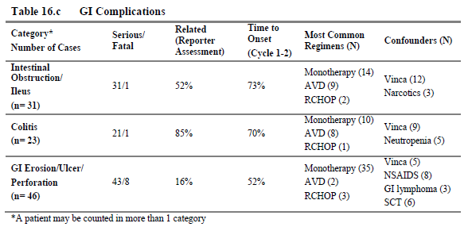
Of the cases identified, 59/100 were reported in patients receiving brentuximab vedotin as monotherapy, 95/100 were categorised as serious and 10/100 had fatal outcome. Most of the cases, 85/100 were from clinical trials.
As of 18 May 2015, 5748 patients had received brentuximab vedotin through clinical trials, making the incidence of these gastrointestinal complications 1.5%. Of the 10 patients who died, 6 were reported from clinical trial sources making the estimated incidence of death 0.11% (6/5748).

Table 49. Estimated incidences of GI complications according to reporting source
 | Clinical Trials source  (N = 5478) | Spontaneous source  (N = 14273)
Intestinal obstruction/ileus | 0.47% (27/5748) | 0.03% (4/14,273)
Colitis | 0.35% (20/5748) | 0.02% (3/14,273)
GI erosion, ulcer and perforation | 0.68% (39/5748) | 0.05% (7/14,273)
Combined reporting rate | 1.4% (81 unique patients/5748) | 0.1% (14/14,273)
Almost all cases (95/100) were serious. Of the 10 cases with fatal outcome, 8 cases were due to intestinal perforation and/or GI bleeding, of which 3 were attributed to disease progression; 2 cases were attributed to a treatment effect; 1 resulted from a complication of colonoscopy, and 2 cases did not provide causality. Of the remaining 2 fatal cases, 1 report of neutropenic colitis was attributed to brentuximab vedotin by the reporter and 1 report of small bowel obstruction was attributed to disease progression.
Brief narratives of the 10 cases with fatal outcome were provided. For some of these cases, information was very limited. In the 8/10 cases for which more information was available, confounding factors were present in 6 cases with these including: lymphomatous bowel infiltration (n = 2), colonoscopy-related perforation in a patient with GVHD affecting the GIT (n = 1), other chemotherapy following or with brentuximab vedotin (n = 2). No obvious confounding factors were present in the other 3 cases; each of these cases involved intestinal perforation.
The conclusion drawn by the sponsor was that:
‘the MAH considers gastrointestinal complications (including intestinal obstruction, ileus, enterocolitis, neutropenic colitis, erosion, ulcer, perforation and hemorrhage) to be an important potential risk. Although the MAH did not find clear evidence of a causal relationship between brentuximab vedotin use and GI complications, a causal relationship cannot be ruled out.’
The evaluator notes that the FDA approved ‘label’ was updated to included ‘the addition of a new Warning and Precaution for Gastrointestinal Complications’ on March 4, 2016 in response to a Supplemental Biologics License Application (sBLA), dated December 3, 2015.
Figure 28. FDA approved label: Gastrointestinal complications
5.12 Gastrointestinal Complications
Fatal and serious gastrointestinal (GI) complications including perforation, hemorrhage, erosion, ulcer, intestinal obstruction, enterocolitis, neutropenic colitis, and ileus have been reported in ADCETRIS-treated patients. Lymphoma with preexisting GI involvement may increase the risk of perforation. In the event of new or worsening GI symptoms, perform a prompt diagnostic evaluation and treat appropriately.
The evaluator agrees that this newly identified risk should be included in the PI as a Precaution but suggests some rewording given the high proportion of serious or fatal events:
‘Gastrointestinal complications
Fatal and serious gastrointestinal (GI) complications including intestinal obstruction, ileus, enterocolitis, neutropenic colitis, erosion, ulcer, perforation and haemorrhage, have been reported in patients treated with Adcetris. Some cases of GI perforations were reported in lymphoma patients with pre-existing GI involvement. In the event of new or worsening GI symptoms, withhold Adcetris, perform a prompt diagnostic evaluation and treat appropriately.’

Progressive multifocal leukoencephalopathy
Progressive multifocal leukoencephalopathy (PML) is a rare demyelinating disease of the central nervous system that results from reactivation of latent John Cunningham virus (JCV) and is usually fatal. JC virus infection is ubiquitous, with a sero prevalence range from 66% to 92% in the worldwide adult population. However, PML is rare and is usually seen in association with underlying immunosuppressive conditions. Patients with PML may present with new or worsening neurological, cognitive, or behavioural signs or symptoms. From the summary provided in PSUR 5, PML has been has been reported in 7 patients who have received brentuximab vedotin after receiving multiple prior chemotherapy regimens; 6 of these patients have died, 4 due to PML. Most of the patients were receiving brentuximab vedotin for relapsed or refractory HL. The reporting rate was estimated at less than 0.05% and, as such, is within the range reported for patients with lymphoproliferative disorders treated with chemotherapy (0.07 to 0.52%).
Comment: PSUR 6 was provided by the sponsor during the Round 2 evaluation. This documented 2 new patients receiving brentuximab vedotin in whom PML was reported (cumulative total of 9 patients). In one of these cases the outcome was fatal. The outcome in the other case was not known.

Table 49. Estimated reporting rate of PML in patients treated with brentuximab vedotin
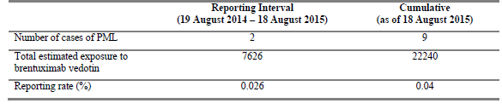
The conclusion drawn by the sponsor was unchanged from that described in PSUR 5: ‘The rate of PML in patients treated with brentuximab vedotin is not increased and compared with the published background rate of PML in patients with lymphoproliferative disorders treated with chemotherapy remains below the reported range of 0.07% to 0.52%’. Assuming all patients with PML have a fatal outcome, the rate of this would be the same as the reporting rate, 0.04%.

Hyperglycaemia
In the pivotal Phase II Population, hyperglycaemia/blood glucose increased was reported as a TEAE in 7% of patients. In general, it developed early during treatment with brentuximab vedotin (that is usually after 1 or 2 doses). Most patients who developed new-onset hyperglycaemia or diabetes had a risk factor such as elevated body mass index (BMI) at enrolment or prior elevated glucose levels. The new-onset hyperglycaemia was usually well controlled using conventional doses of insulin or oral hypoglycaemic agents.
In the safety update provided in PSUR 5, the rate of occurrence in the clinical trial population was 5% and 26 SAEs had been reported by post-marketing sources.
The SmPC recommends that any patient who experiences an event of hyperglycaemia should have their serum glucose closely monitored and that treatment should be administered as appropriate.

Tumour lysis syndrome
From PSUR 5, six cases of TLS have been reported in the clinical trial population and another 6 SAEs have been reported by post-marketing sources, with 2 of the latter having a fatal outcome. The SmPC recommends that patients with rapidly proliferating tumour and high tumour burden, who are most at risk of developing TLS, should be monitored closely and managed according to best medical practice.

Thymic depletion
Thymic depletion was observed in toxicity studies in animals. In humans, as the thymus is the organ of T-cell development, defects in thymocyte development can lead to a profound T-cell immunodeficiency. This would be especially relevant to paediatric patients prior to puberty before involution of the thymus occurs. There have been no events of thymus depletion (paediatric) reported during clinical trials of brentuximab vedotin as of data lock date for PSUR 5. However, children have largely been excluded from the clinical trial programme, with only 5 patients in the pivotal Phase II studies between 12 and 18 years of age.
The SmPC states that safety and efficacy in children younger than 18 years have not yet been established.

Safety in special populations

Reproductive toxicity
Nonclinical toxicology studies of brentuximab vedotin have shown reproductive toxicity, including embryo-foetal lethality. There have been no reports of pregnancy in patients in the clinical trials programme; use of contraception was a clinical trial requirement during the development of brentuximab vedotin. There have been 6 reports outside this programme. Of these, 4 were of female patients receiving brentuximab vedotin becoming pregnant and 2 were of a male patient’s partner becoming pregnant. There is limited information available for these cases. Of the female patients who became pregnant, one had a spontaneous abortion, two were said to have delivered healthy babies, and the outcome in the other is unknown. Of the two cases where a male patient’s partner became pregnant, one is said to have delivered a healthy baby and the outcome of the other is unknown.
In the SmPC, women of childbearing potential are directed to use 2 methods of effective contraception during treatment with brentuximab vedotin and until 30 days after treatment and men are advised not to father a child during treatment and for up to 6 months following the last dose.

Breastfeeding women
There are no data as to whether brentuximab vedotin or its metabolites are excreted in human milk. A risk to the newborn/infant cannot be excluded.

Paediatric
Safety and efficacy in children younger than 18 years have not yet been established. In the pivotal Phase II Population, 5 patients were aged less than 18 years at study entry.

Elderly
The safety and efficacy in elderly patients aged 65 and older have not been established. Completed clinical studies did not include sufficient numbers of patients aged 65 and older to determine whether these patients respond differently from younger patients. In the pivotal Phase II Population, 12 patients (8%) were age 65 or older at study entry.

Renal or hepatic impairment
According to the Risk Management Plan, data regarding hepatic/renal impairment has been collected as part of as part of routine pharmacovigilance and in Study SGN35-008 (Part B). Results from Study SGN35-008 (Part B) indicate that, compared to patients with normal hepatic function, MMAE exposure is increased by approximately 2.3-fold in patients with hepatic impairment. Compared to patients with normal renal function, MMAE exposure increased approximately 1.9-fold in patients with severe renal impairment (creatinine clearance < 30 mL/min). No effect was observed in patients with mild or moderate renal impairment. This resulted in the recommendation of reduced dosing in patients with hepatic impairment or severe renal impairment.
The risks associated with administration of brentuximab vedotin in renal or hepatic impairment appear to have been interpreted differently by the different regulatory bodies, resulting in different advice provided in the PI for each region, most notably with the advice in the North American PIs that use should be avoided in severe renal or hepatic impairment, compared to recommendations for dose reduction in the European and Australian PIs. PI provided dosage recommendations are given below in Table 50.
Comment: In the sponsor’s response to the clinical question regarding this (see Section 12, Question 2 (Dosing in renal or hepatic impairment), the sponsor has stated that ‘Takeda confirm that the same dataset was submitted to the United States (US) and Canadian agencies, and these resulted in different recommendations as noted by the evaluator’. The most recent PSUR (PSUR 6 August 2014 to August 2015) was provided by the sponsor following a request for further information during the Round 2 evaluation regarding a different issue. According to the PSUR section ‘Detailed Description of Action Taken During the Reporting Period Marketing Experience’, both of the US and Canadian PIs were changed after the initial approval (in November 2014 and May 2015 respectively) to include the recommendation of a lower dose in hepatic impairment and to advise that use be avoided in severe renal impairment or moderate-severe hepatic impairment. These recommendations were on the basis of results from Study SGN35-008B, a PK Study of brentuximab vedotin in patients with hepatic or renal impairment. Study SGN35-008B was not available for the Clinical Evaluation Report for the previous submission. ‘Topline’ data from this study was subsequently made available to the delegate in October 2013, and is discussed by the Delegate in Section VI Overall conclusion and risk/benefit assessment of the AusPAR for that submission.¹⁴ During the Round 2 process of this evaluation, it has been confirmed by the Delegate with the sponsor’s representative that only this interim data of Study SGN35-008b has been provided to the TGA for evaluation.

Table 50. Dosing recommendations for different jurisdictions, as provided in the PI
Jurisdiction | Recommendations regarding dosing in patients with renal or hepatic failure
Australia | The recommended starting dose in patients with severe renal impairment is 1.2 mg/kg administered as an intravenous infusion over 30 minutes every 3 weeks. Patients with renal impairment should be closely monitored for adverse events.  Adcetris should be used with caution in patients with hepatic impairment. A lower starting dose should be considered. In a clinical study, doses of 1.2 mg/kg have been administered to patients with hepatic impairment
EU | Renal impairment: The recommended starting dose in patients with severe renal impairment is 1.2 mg/kg administered as an intravenous infusion over 30 minutes every 3 weeks. Patients with renal impairment should be closely monitored for adverse events.  Hepatic impairment: The recommended starting dose in patients with hepatic impairment is 1.2 mg/kg administered as an intravenous infusion over 30 minutes every 3 weeks. Patients with hepatic impairment should be closely monitored for adverse events
Canada | Severe renal insufficiency: Avoid use in patients with severe renal impairment (creatinine clearance <30 ml/min).  Hepatic insufficiency: The starting dose should be 1.2 mg/kg for patients with mild hepatic impairment (Child-Pugh A). Closely monitor these patients for adverse reactions. Avoid use in patients with moderate (Child-Pugh B) or severe (Child-Pugh C) hepatic impairment
USA | Renal impairment  Mild (creatinine clearance > 50 to 80 mL/min) or moderate (creatinine clearance 30 to 50 mL/min) :1.8 mg/kg up to 180 mg  Severe (creatinine clearance less than 30 mL/min): Avoid use  Hepatic impairment  Mild (Child-Pugh A): 1.2 mg/kg up to 120 mg  Moderate (Child-Pugh B) or severe (Child-Pugh C): Avoid use
The Final CSR for Study SGN35-008b was provided during this Round 2 evaluation process [this was summarised by the evaluator, but not reproduced in this document]. The analysis provided in this study included:
- 10 patients with renal impairment, none of whom were receiving dialysis; 4 patients with mild impairment (CrCl 50 to 80 mL/min), 3 with moderate (CrCl = 30 to 50 mL/min) and 3 with severe (CrCl < 30 mL/min)
- 7 patients with hepatic impairment: 1 patient with mild impairment (Child-Pugh A), 5 with moderate (Child-Pugh B) and one with severe (Child-Pugh C)
- 8 patients with no renal or hepatic impairment as a ‘control group’
All patients received one dose of brentuximab vedotin 1.2 mg/kg for the PK analysis.
This study was limited by the small numbers enrolled, even smaller numbers with all PK sampling performed, exclusion of patients requiring dialysis, lack of investigation of the effect of repeated dosing and use of a control arm that was receiving ketoconazole during the last 3 days of cycle 1. However, within these limitations, it appears that both renal and hepatic impairment increases MMAE exposure, with hepatic impairment having a more marked effect. This is consistent with the postulated routes of excretion, with biliary excretion and loss in the faeces being the main route, and the excretion study in SGN35-008a which found that two thirds of excreted MMAE was lost in the faeces and one third in the urine. Administration of brentuximab vedotin to these patients with impaired hepatic or renal function was also found to be associated with a worse adverse event profile, including several deaths in the hepatic impairment arm. Subgroup analysis of patients according to the degree of organ impairment is not possible due to the small numbers of patients. This prevents evidence based dosage recommendations according to the degree of organ impairment.
At a pragmatic level, appropriate dosage recommendations for inclusion in the PI could be:
- Renal impairment:
  - Mild (creatinine clearance 50 to 80 mL/min): 1.8 mg/kg up to 180 mg
  - Moderate (creatinine clearance 30 to 50 mL/min): 1.2 mg/kg up to 120mg
  - Severe (creatinine clearance less than 30 mL/min): Avoid use
- Hepatic impairment:
  - Mild (Child-Pugh A): 1.2 mg/kg up to 120 mg
  - Moderate (Child-Pugh B) or severe (Child-Pugh C): Avoid use
Given that hepatotoxicity may be associated with brentuximab vedotin. The Dosage and Administration section should provide appropriate advice regarding dose delay and/or reduction if this occurs.
The evaluator notes that the sponsor agreed to the inclusion of additional cautionary information in the PI as recommended by the evaluator based on information available during the Round 1 evaluation (draft PI [not in this document]). As a result of information subsequently available and described above, the evaluator is now of the opinion that these recommendations were not adequate and that dosing advice as described above should be included.

Patients of different racial and/or ethnic origin
The potential impact of different ethnic origins on the safety and/or efficacy of brentuximab vedotin has not been specifically investigated in the clinical trial program. The effect of different ethnic origins on the safety and/or efficacy of brentuximab vedotin has not been established. Non-Caucasians represented approximately 15% of the pivotal Phase II Population.

Long-term safety
According to most recent PSUR (PSUR 6 August 2014 to August 2015), a commitment was made to follow patients enrolled in Studies SG035-0003 and SG035-0004 to investigate the long-term effects of brentuximab vedotin, including a sub-analysis of patients ≥ 100 kg. An update of these studies is provided in the Safety Related Request that was submitted during the Round 2 evaluation of this report.
Studies SG035-0003 and SGO35-0004 were the pivotal studies for the current indications for brentuximab vedotin. Patients in the these studies received a starting dose of 1.8 mg/kg brentuximab vedotin every 3 weeks (q3wk) with the possibility of dose reduction to 1.2 mg/kg for the management of selected adverse events (AEs); treatment was to continue to a maximum of 16 cycles. At the data lock point for the SRR, all patients in both studies had had the opportunity to complete 16 cycles.
Survival and disease status are being assessed every 3 months for 2 years, every 6 months during years 3 to 5, and annually thereafter. Annual reports for SG035-0003 were to continue until 2015 or when the OS data are sufficiently mature (at least 50% of OS events observed), whichever occurs earlier. Annual reports for SG035-0004 will continue until 2016 or when the OS data are sufficiently mature (at least 50% of OS events observed), whichever occurs earlier.
Study SG035-0003 assessed antitumor efficacy of single-agent brentuximab vedotin in 160 patients with r/r systemic HL following ASCT. Patients exposed to brentuximab vedotin in this study had a median treatment duration of approximately 27 weeks (9 cycles); this is unchanged from previous reports.
From PSUR 6, long-term follow-up has been completed for this study. As of database close (April 2015), the estimated 5-year OS rate was 41% (95% CI: 31 %, 51%) and the median OS was 40.5 months (95% CI: 28.7, 61.9 (range, 1.8 to > 72.9)). Median OS by best clinical response was CR (n = 34): median not reached; partial remission (PR, n = 39): 39.4 months; and stable disease (SD, n = 28): 18.3 months. The median PFS was 9.3 months overall, but was not reached in CR points. Of the 102 enrolled patients, 15 remained in follow-up and in remission at study closure. Among these 15 pts, 6 received consolidative allo-stem cell transplant (SCT) and 9 have received no further therapy since completing brentuximab vedotin.
SG035-0004 assessed antitumor efficacy of single-agent brentuximab vedotin in 58 patients with r/r sALCL following frontline chemotherapy or other multi-agent chemotherapy delivered with curative intent). Patients exposed to brentuximab vedotin in this study had a median treatment duration of 23.5 weeks (7 cycles); this is an increase of approximately 3.5 weeks (one cycle) compared to the previous report.
From PSUR 6, as of the most recent data cut (June 2014), which represents approximately 4 years (median observation time from first dose = 46.3 months; range, 0.8 to 57.7 months) of follow-up, the estimated 4-year survival rate was 64% (95% CI: 51%, 76%), and the median PFS per investigator was 20.0 months (95% CI: 9.4 months (range, 0.8 to > 54.9 months)). Of the 58 enrolled patients, 36 (62%) were alive at last contact. Nineteen patients (all with a best response of CR on treatment) remain free of progression. Of these 19 patients, 11 received consolidative SCT following treatment with brentuximab vedotin. No other post-brentuximab vedotin anti-cancer therapy was given to any of the 19 patients who remain in remission.
The SRR presents pooled information for this ‘pivotal Phase II population’. This found little difference in comparison to the pooled data provided in the submission as an NCE, although there was a small increase in the proportion of patients discontinuing due to AEs (19% to 23%) with this due to an additional 16 patients in SG035-0004 discontinuing treatment for this reason. There were an additional 30 deaths reported, with all of these occurring more than 30 days after the last dose of brentuximab vedotin.
PSUR 6 states: ‘There has otherwise been no clinically important safety or efficacy findings arising from long-term follow-up assessments made during the reporting period.’

Safety related to drug-drug interactions and other interactions
As the major route of metabolism of MMAE is through CYP3A4, a theoretical potential for a drug-drug interaction exists with other drugs metabolised via the CYP3A4 route or drugs that modify CYP3A4 activity. As of the data lock date for PSUR 5, there had been no AEs of drug interaction or potentiating drug interaction (MedDRA preferred terms) reported in the brentuximab vedotin clinical program or from spontaneous sources.
The SmPC advises that co-administration of brentuximab vedotin with strong CYP3A4 and P-gp inhibitors may increase the incidence of neutropaenia.

Evaluator’s overall conclusions on clinical safety
Comment: The following conclusions have been revised to incorporate information and data that was available after the Round 1 evaluation.
Treatment with brentuximab vedotin was described as well-tolerated. Despite this, only 47% of patients in the pivotal Phase III study, Study SGN35-005, were able to complete the proposed 16 cycles of treatment. Adverse events have been shown to occur commonly with brentuximab vedotin, with at least one treatment-related AE of any grade reported in 88% of patients in the brentuximab vedotin arm of Study SGN35-005. Most of these AES were minor and the most common, peripheral neuropathy and neutropaenia, were reversible and could usually be managed by dose delay. However, more serious AEs (Grade 3 or higher) were reported in 44% of patients and 32% discontinued treatment with brentuximab vedotin due to AEs. A considerable proportion of patients required dose delays (54%) or dose reduction (32%) to manage adverse events.
The evaluator notes that the quality of life measurements reported in Section 7.1.1.17: Results for the other efficacy outcomes, quality of life assessments above appear inconsistent with the rate of occurrence of AEs reported in the study. According to the instrument used, there was little change in the quality of life measure from baseline to the end of the follow-up period for those patients who did not develop progressive disease. Despite this, AES in 32% of the patients in the brentuximab arm were significant, or distressing, enough for these patients to discontinue treatment.
The safety assessment provided by the sponsor referred only to Study SGN35-005. As a consequence, serious albeit rare, risks associated with brentuximab vedotin treatment were not given sufficient consideration in the benefit-risk evaluation provided by the sponsor. Safety issues of concern identified in the whole clinical trials programme were common AEs including peripheral neuropathy, neutropaenia, infection, hyperglycaemia and infusion related reactions together with the rare risks of serious skin reactions and progressive multifocal leukoencephalopathy (PML). Post-marketing reports, and cumulative reviews of the clinical studies safety data, have identified a number of other real or potential risks that have been associated with fatal outcomes, including acute pancreatitis, febrile neutropaenia, severe sepsis/septic shock, opportunistic infection, hepatotoxicity with fulminant hepatic failure, pulmonary toxicity with monotherapy resulting in pneumonitis and ARDS, serious skin reactions (including Stevens-Johnson Syndrome and Toxic Epidermal Necrolysis), anaphylaxis and gastrointestinal complications.

Common AEs
- Treatment emergent peripheral neuropathy (PN) was reported in 67% of patients in the brentuximab vedotin arm of Study SGN35-005, 56% of patients in the Phase II Population and is the most common spontaneously reported AE from post-marketing sources. In the patients in the brentuximab arm of the Phase III study, the PN was usually mild (Grade 3 severity in 13% and no Grade 4 severity), reversible, described as having little effect on quality of life and was managed by dose delay or reduction. Despite this, one third of the patients who developed PN discontinued treatment with brentuximab vedotin due to this AE.
- Neutropaenia was reported in 35% of patients in the brentuximab vedotin arm of Study SGN35-005, 21% of patients in the Phase II Population and is the cause of a number of spontaneous reports from post-marketing sources. In the clinical studies, neutropaenia appeared to be well managed by dose delay and growth factor support. In the Phase III study, Grade 4 neutropaenia was reported in a small number of patients and there was one report of febrile neutropaenia. In the Phase II Population, there was one report of febrile neutropaenia and septic shock with a fatal outcome. Febrile neutropaenia with fatal outcomes has also been reported from post-marketing sources. Other manifestations of haematological toxicity, including anaemia and thrombocytopaenia, have been reported during brentuximab vedotin therapy.
- Infections were common in the clinical studies, although these were most commonly mild with upper respiratory tract infection in 26% of brentuximab vedotin patients in the Phase III study. Serious infections were uncommon and reported for 9% in the brentuximab vedotin arm of the Phase III study and 10% of the Phase II Population. Serious infections in the Phase III study included pneumonia and opportunistic infections such as reactivation of herpes zoster, herpes simplex and one case of Pneumocystis jiroveccii pneumonia. Many of these infections were also reported for the placebo arm, although at a lower incident rate. There were 2 deaths from opportunistic infection in the Phase II Population and a number of opportunistic infections with fatal outcome have been reported by post-marketing sources, including aspergillosis, CMV and pseudomonas infection.
- Infusion-Related Reactions were reported in 15% of patients in the brentuximab vedotin arm of Study SGN35-005, 11% of patients in the Phase II Population and were frequently reported by post-marketing sources. The adverse events most commonly associated with infusion-related reactions were mild to moderate (Grade 1 or Grade 2) and included headache, rash, back pain, vomiting, chills, nausea, dyspnoea, pruritus, and cough. No cases of anaphylaxis have been reported in the Phase II or III populations, although 2 cases were reported in the Phase I population. There have been 4 reports of fatal outcome in association with IRR from post-marketing sources. Measurement of ATA in patients exposed to brentuximab vedotin seem to indicate that patients who become ‘persistently positive’ are more likely to have IRRs and that these reactions may be more severe. The reliability of the assay on which this conclusion is based is questioned and these conclusions may not be valid. IRRs in the clinical study population were usually successfully managed by infusion interruption, treatment of the reaction, followed by recommencement of the infusion at a lower rate. Subsequent doses were administered with or without prophylaxis. The SmPC recommends the use of prophylaxis with subsequent doses if a patient experiences an IRR, and discontinuation if anaphylaxis occurs.
- Hyperglycaemia has been reported in 3% of the Phase II study population and 7% of the Phase II population. Predisposing factors are thought to be obesity or pre-existing hyperglycaemia. It was usually managed by insulin or oral hypoglycaemics.

Uncommon and unpredictable adverse events
A number of rare, life-threatening adverse events have been observed in association with brentuximab vedotin. Of these, hepatotoxicity and gastrointestinal complications were predictable from the non-clinical studies. However, pulmonary toxicity with monotherapy, serious skin reactions, acute pancreatitis and gastrointestinal complications were not. A direct causal relationship has not been established for each of these risks.
- Hepatotoxicity was reported in 7% of patients in the brentuximab vedotin arm of Study SGN35-005. The incidence in the Clinical Studies programme has been estimated at 1.4%. The majority of events in the studies were asymptomatic with mild to moderate transient elevations in aspartate aminotransferase(AST) and alanine aminotransferase (ALT) that occurred after 1 to 2 treatment cycles and were reversible. A number of cases of severe or fulminant hepatitis have been reported from the clinical studies and from post-marketing sources, including one case from the Phase III study. Some of these cases have had fatal outcome. Hepatotoxicity was identified as an Important Potential Risk in 2013. Following a cumulative review of hepatotoxicity performed in 2015, the sponsor has suggested strengthening the warning in the PI.
- Pulmonary toxicity was reported in 5% of patients in the brentuximab vedotin arm of the Phase III study and for 3% of the overall clinical studies population. It usually manifested as a mild disorder with cough, dyspnoea and lung infiltrates. More severe pulmonary toxicity with acute respiratory distress syndrome (ARDS) has also been described and has been associated with fatal outcome, including 2 deaths attributed to ARDS in the Phase III study. Pulmonary toxicity with monotherapy was listed as an Important Potential Risk in the SmPC in 2014. Following a cumulative review of pulmonary toxicity with monotherapy performed in 2015, the sponsor has suggested strengthening the warning in the PI.
- Acute pancreatitis has been reported in a small number of patients from the clinical studies population (incidence < 1%), including one patient from the brentuximab vedotin arm of the Phase III study. The disorder was commonly severe and has been associated with fatal outcome. Acute pancreatitis was listed as an Important Potential Risk in the SmPC in 2013.
- Stevens Johnson Syndrome (SJS) in association with brentuximab vedotin therapy was reported early in the clinical trials programme, with an estimated incidence of 1%. Two cases of toxic epidermal necrolysis (TEN), each with a fatal outcome, have been reported: one from the clinical trials programme and one from post-marketing sources. TEN, together with SJS, was therefore identified as a new and important risk with brentuximab vedotin. This information was added to the SmPC and also included in the boxed warning regarding risks with possible fatal outcomes in the Canadian PI.
- Progressive multifocal leukoencephalopathy (PML) has been has been reported in no patients who have received brentuximab vedotin after receiving multiple prior chemotherapy regimens, 7 of whom have died and the outcome is unknown for one. The reporting rate is estimated at less than 0.05% and a causal relationship has not been established.
- Tumour lysis syndrome has been reported in a small number of patients receiving brentuximab vedotin and has been associated with fatal outcome.
- Other safety signals, such as cardiac dysfunction, PRES and thymus depletion are being closely monitored.
A number of other questions regarding the safety profile of brentuximab vedotin have yet to be answered. These include use in special populations (paediatric, elderly, renal or hepatic impairment) and immunogenicity, including the effects of ATA on efficacy and safety. Determining the meaning and significance of anti-brentuximab vedotin antibodies will require development of a more precise assay. Wider use and reports from post-marketing sources may identify other safety concerns or help refine existing ones (for example, cardiac dysfunction). Possible delayed adverse effects of brentuximab vedotin (in particular, secondary malignancies) may yet be identified through prolonged follow-up of the clinical studies populations.

First round benefit-risk assessment

First round assessment of benefits
The benefits of brentuximab vedotin in the proposed usage is an increase in progression free survival when used following ASCT for relapsed or refractory Hodgkin Lymphoma in adult patients at increased risk of progression following ASCT. This increase was clinically relevant and statistically significant. However, the demonstrated increase in progression free survival did not translate into an increase in overall survival, although this was an interim analysis, or into improved quality of life. The patient population in the pivotal study presented was heterogeneous with regard to risk of progression following ASCT and better characterisation of patients at risk would be helpful.

First round assessment of risks
The risks of brentuximab vedotin in the proposed usage are:

Predictable complications
These adverse events have been observed with brentuximab vedotin therapy:
- Neutropaenia is common during brentuximab vedotin therapy. Prolonged (≥ 1 week) Grade 3 or Grade 4 neutropaenia can occur with brentuximab vedotin. This can be managed by monitoring, dose delay and growth factor support. However, life-threatening febrile neutropaenia has also been described.
- Peripheral neuropathy is commonly described in patients receiving brentuximab vedotin, and may be severe. It may be managed by dose reduction or discontinuation and is usually reversible, but this may take a prolonged time (median 16 weeks).
- Serious infections, such as pneumonia, staphylococcal bacteraemia, sepsis/septic shock (including fatal outcomes), and opportunistic infections such as oral candidiasis, Pneumocystis jirovecii pneumonia and herpes zoster, have been reported in patients treated with brentuximab vedotin
- Tumour lysis syndrome has been reported
- Antibodies to brentuximab vedotin (anti-therapeutic antibodies (ATA)) may develop in approximately one third of patients, with around 7% having ‘persistently positive’ assays. This may be associated with infusion related reactions. Other long-term complications may yet be identified.

Idiosyncratic reactions
A number of rare, unpredictable adverse events have been reported with brentuximab vedotin therapy. A clear causal relationship has not been identified for all of the complications listed below but they have been identified as important ‘potential’ risks. The complications listed have been associated with fatal outcome, or may be life-threatening, and include:
- Acute pancreatitis
- Hepatotoxicity. This may occur in 1% of patients receiving brentuximab vedotin and is usually a mild, reversible hepatocellular injury. However, fulminant hepatitis has also been described in patients receiving brentuximab vedotin.
- Stevens-Johnson syndrome and toxic epidermal necrolysis
- Progressive multifocal leukoencephalopathy (PML)
- Infusion related reactions, including life-threatening anaphylaxis
- Pulmonary toxicity with cough, dyspnoea and lung infiltrates. Acute respiratory distress syndrome (ARDS) has also been reported.
Safety in the elderly, children, patients with renal or hepatic or cardiac impairment has not been established. Given that brentuximab vedotin has only been available commercially for 4 years, there may be rare complications and delayed complications that have yet to be identified.

First round assessment of benefit-risk balance
An assessment of the benefit-risk balance is not possible at this time. Further information, as provided by the sponsor’s responses to questions regarding clinical efficacy and safety will assist in the assessment. The main issue of concern is that the proposed indication of patients ‘at risk’ of progression will include, by definition, any patient receiving treatment by ASCT for r/r HL. Historical outcomes tell us that approximately 50% of patients may be cured by ASCT. Administration of brentuximab vedotin in accordance with the proposed extension of indication of ‘at risk’ may result in patients who would otherwise be cured by ASCT being exposed to the serious risks of brentuximab vedotin while receiving no benefit.
Subgroup analysis in the pivotal study, using the outcome measure of median progression free survival, supports the argument that patients at low risk of progression following ASCT may not benefit from brentuximab vedotin treatment as consolidation therapy following ASCT. Better characterisation of patients at greater risk of progression may enable limiting brentuximab vedotin consolidation therapy to those most likely to benefit. Within the limits of the pivotal study, in particular the heterogeneity of the study population and the immature results for overall survival, it is also concerning that the administration of brentuximab vedotin as consolidation therapy does not provide a clear benefit in either overall survival or quality of life compared to the currently approved administration as rescue therapy following relapse.
Under the current indications, brentuximab vedotin is administered to patients who have very little, or no, other treatment options available and higher levels of treatment related risk can be acceptable. Under the proposed indication of ‘patients at risk of progression’, it is possible for patients to receive adjuvant treatment with brentuximab vedotin who may otherwise have responded to ASCT alone. Given the alternative of ‘no therapy’ in these patients, better delineation of the risks potentially associated with treatment is important. Inclusion of a boxed warning to clearly describe some of the potentially fatal risks to both prescribers and patients may assist in ensuring informed decisions are made.
Approval for the new indication ‘for the treatment of patients with classical Hodgkin lymphoma at high risk of relapse or progression as post-autologous hematopoietic stem cell transplantation (auto-HSCT) consolidation’ was granted by the FDA on 17 August 2015. In the approved labelling, the reader is referred to the Clinical Trials section where ‘High risk of post-auto-HSCT relapse or progression was defined according to status following frontline therapy: refractory, relapse within 12 months, or relapse ≥ 12 months with extra-nodal disease. Patients were required to have obtained a CR, PR, or stable disease (SD) to most recent pre-auto-HSCT salvage therapy.’

First round recommendation regarding authorisation
The evaluator is unable to make a recommendation at this time.

Clinical questions

Extension of indication
- The proposed extension of indication as described in the letter of application and the draft PI is: ‘Patients with CD 30+ Hodgkin Lymphoma (HL) who are at risk of relapse or progression following autologous stem cell transplant (ASCT).’
The proposed extension of indication as described in the Clinical Overview is: ‘The treatment of adult patients with HL at increased risk of relapse or progression following ASCT.’
Please clarify and update the submitted documents (Clinical Overview, PI, and CMI) accordingly.

Dosing in renal or hepatic impairment
- There is inconsistency across jurisdictions regarding dosing in hepatic and renal impairment suggesting that the risks associated with this (in Study SGN35-008) have been assessed differently by the different regulatory bodies (see Table 50: ‘Dosing recommendations for different jurisdictions, as provided in the PI’ above). Could the sponsor provide any more recent information to guide dosing in renal and hepatic impairment, including any information provided to other regulatory bodies?

Clinical rationale
- Estimated Australian Population: The rationale as presented in the Clinical Overview describes patients at risk of developing refractory or relapsed HL following ASCT as having an ‘unmet need’ given the poor prognosis of these patients and the lack of effective therapies. It offers 9 different pre-ASCT factors that may indicate at risk patients and comments that no single factor can ‘sufficiently identify every patient at increased risk of relapse’, although the more risk factors that are present, the worse the projected 5-year progression free survival rate. Could the sponsor provide an estimate of the proportion of patients having ASCT for relapsed or refractory CD30+ HL in Australia who would have one or more risk factors? Could the method of determining this estimate also be provided?
- Consolidation versus Rescue therapy: In light of the results of the three year follow-up of the 102 patients in the open label Phase II study (Study SGN35-003) published as Gopal et al. Durable remissions in a pivotal phase 2 study of brentuximab vedotin in relapsed or refractory Hodgkin lymphoma. Blood. 2015;125(8):1236-1243, could the sponsor provide a discussion of the advantage(s) of the use of brentuximab vedotin as consolidative therapy in patients ‘at risk of relapse or progression following autologous stem cell transplant (ASCT)’ compared to its use as rescue therapy in patients who relapse following ASCT as currently approved?

Pharmacokinetics
- Development/occurrence of ATA:
- Immunogenicity and the Development of ATA: In Study SGN35-005, 12 of the placebo group and 19 of the brentuximab vedotin group were ATA positive at baseline. Patients previously treated with brentuximab vedotin were excluded from the study. How does the sponsor account for these patients testing positive for ATA? Also, 38 of the placebo group who were negative for ATA at baseline subsequently tested positive for ATA; how does the sponsor account for these patients testing positive for ATA? Also, a number of patients in the brentuximab vedotin arm who were ATA-positive at baseline, subsequently tested negative (7/19); how does the sponsor account for this?
- The ATA assay: Could the sponsor provide the sensitivity, specificity and false positive rate for the assay used to determine if the patient was positive for ATA?
- Drug-Drug Interactions:
- P-gp Inhibitors: MMAE exposure may be increased by concomitant administration of ketoconazole, a strong CYP3A4 and P-gp inhibitor and may result in more severe neutropaenia. Can the sponsor provide any more recent information regarding this drug-drug interaction, including the study population of SGN35-005? For example, was ketoconazole or itraconazole or other P-gp inhibitors co-administered to patients in the brentuximab vedotin arm of Study SGN35-005 and if so, was this was associated with more severe neutropaenia?
- MMAE levels and drug interactions: Free MMAE may be increased by co-administration of P-gp inhibitors and reduced by rifampicin. In the description of the characterisation of ATA in the study population of SGN35-005, it was said that samples that tested positive for ATA were further evaluated for concentrations of brentuximab vedotin ADC, total antibody, and free MMAE. Many patients in both arms of the study were found to be ATA positive and should, therefore, have had free MMAE concentrations performed. Were there any patients who were ATA positive and who were also receiving P-gp inhibitors or CYP3A4 inducers such as rifampicin? If yes, could the free MMAE levels of these patients be compared to the free MMAE levels of patients who were ATA positive but not receiving CYP3A4 inhibitors or inducers? Could the sponsor also provide any other updated information regarding drug-drug interactions with brentuximab vedotin, including any information provided to other regulators?

Efficacy
- Outcome measures: Both the PFS by IRF and the overall survival were better than expected and/or better than historical controls for both the placebo arm and the brentuximab vedotin arm: the estimated PFS by IRF in the sample size calculation was 18 months and 12 months for the brentuximab vedotin and placebo arms respectively compared to 42.9 months and 24.1 months observed in the study; 202 progression events were expected to occur compared to 135 observed; the estimated 3-year OS was over 88% for both arms compared to historical outcomes of 5-year OS 50% to 60%. How does the sponsor account for these better than expected results for both arms of the study?
- Progression-free survival Kaplan-Meier curves: It is notable that in the KM survival curves for the primary outcome measure and for the secondary analyses of the primary outcome measure, the curves for the two treatment arms parallel each other after an early dip in the placebo arm (due to a number of progression events in the first six months in the placebo group) and both treatment arm curves appear to plateau at around 24 months. The difference in overall PFS would appear to be due to the patients with early progression in the placebo arm and this may represent a subgroup that benefits from brentuximab vedotin administered as adjuvant therapy following ASCT. Could the baseline characteristics patients who progressed or who received new anti-tumour therapy(ies) within the first 8 months in the placebo arm be provided? Could the median PFS, stratified HR and Kaplan-Meier curve for this group also be provided?
- Overall survival analysis: No difference was found in overall survival between the placebo and the brentuximab vedotin arm. This result was confounded by cross-over as 72/164 patients in the placebo arm were reported as receiving brentuximab vedotin treatment. A sensitivity analysis using the RPSFT model to correct for crossover was unhelpful. What were the results (PFS by IRF and OS) for the two subgroups of placebo patients, that is the group who did not receive brentuximab vedotin treatment (or other subsequent anti-tumour therapies) and the group who did? What was the PFS (PFS2) of the subgroup of placebo arm patients treated with brentuximab vedotin, after receiving brentuximab vedotin?
- Quality of life measure: The study found no difference in quality of life, using the measures EQ-5D and EQ VAS, between the placebo and brentuximab vedotin arms. If anything, there was a trend for the brentuximab arm to be worse, particularly after the end of treatment. How does the sponsor account for brentuximab vedotin seeming to worsen quality of life after completing treatment?
- Crossover and Quality of life measure: Figures 6-4 and 6-5 in the report for the quality of life measure [viewable above as Figures 23 and 24 respectively] compare US TTO index score for patients with progressive disease versus patients without progressive disease for the brentuximab vedotin arm (fig 6-4 [Figure 23 above]) and the placebo arm (fig 6-5 [Figure 24 above]). Of the patients who developed progressive disease, 9 patients in the brentuximab vedotin arm and 72 patients in the placebo arm were treated with brentuximab vedotin during the LTFU. To better determine the impact of treating patients with brentuximab vedotin, without the confounding effects of progressive disease (± subsequent treatment with brentuximab vedotin), it would be helpful to similarly display a comparison of the mean EQ-5D TTO scores for:
- the two groups (placebo and brentuximab treatment arms) that did not develop progressive disease throughout the 24 months of the study and who did receive 16 cycles of treatment
- the patients in the brentuximab vedotin arm who discontinued treatment cycles due to AEs and who did not develop progressive disease throughout the 24 months of the study compared to the patients in the brentuximab arm who completed 16 cycles and who did not develop progressive disease.
- Risk factors for progression: Some of the risk factors for progression post-ASCT were used as inclusion criteria for the study. Historically, the presence of increasing numbers of risk factors has been associated with worsening prognosis and a number of indices have been developed although none are universally used. These usually divide the patients into low, intermediate and high risk according to the number of risk factors (0 to 1, 2, 3 or more respectively). The number of patients with 1, 2 or ≥ 3 risk factors at baseline was not included in the baseline characteristics and an efficacy analysis according to the number of risk factors present is not provided. A post-hoc analysis of PFS per IRF according to the number of risk factors is provided in the Clinical Overview. However, this analysis is provided as overlapping numbers of risk factors (≥ 1, ≥ 2, ≥ 3). Could the post-hoc analysis be repeated according to the patients in each treatment arm with 1 or 2 or ≥ 3 risk factors for progression (that is, discrete groups rather than overlapping)? Could this analysis include the median PFS, stratified HR and Kaplan-Meier curve are requested for these subgroups?
- Subsequent anti-tumour therapy: Patients who received other anticancer therapy during the study are shown in Table 11-13 [see Table 26 of this document] of the SGN35-005 CSR: 72 patients in the placebo arm received brentuximab vedotin as did 9 in the brentuximab vedotin arm. Can the sponsor explain the circumstances under which patients in the brentuximab vedotin arm received brentuximab vedotin as subsequent anti-tumour therapy? Could the sponsor provide more detail regarding the two groups of patients who received brentuximab vedotin as subsequent anti-tumour therapy with respect to the timing of cessation of treatment, and commencement of brentuximab vedotin as rescue therapy, in particular was this treatment commenced during the treatment period or LTFU period? Some of the patients from the placebo arm who progressed received brentuximab vedotin through participation in Study SGN35-010. It is important that the report of this study be provided when available.

Safety
- Early Relapse Patients: It is evident from the KM curves for the primary outcome measure that most progression events occurred early (within the first 6 to 8 months) in the placebo group. On progression, patients could be discontinued from study treatments and had the option of unblinding and commencement on brentuximab vedotin – this occurred for 72 patients in the placebo arm. Could the sponsor provide a table of the data used to construct the graph in Figure 12-1 [reproduced as Figure 42 in the sponsor’s response, to this question in Section 12, below] of the Study SGN35-005 CSR?
- Crossover and adverse event monitoring: For the 72 patients in the placebo group who received brentuximab vedotin as anti-tumour therapy during the course of the study, can the sponsor describe how these patients were monitored for adverse events?
- Narratives for deaths, SAEs and discontinuations due to AEs: There were 53 patient deaths during the study: narratives are provided for only 4 of these. There were 64 patients who discontinued due to AEs, with 54 of these in the brentuximab vedotin arm. There are narratives provided for 36 patients in the brentuximab vedotin arm who discontinued due to AEs. The CSR states: ‘Narratives for all patients who discontinued treatment because of an AE are provided in Section 14.3.3.’ Could the sponsor please clarify the location of the missing narratives regarding deaths and discontinuations as they could not be found in the CSR? Could the sponsor also confirm if all narratives for SAES have been provided? The evaluator could locate narratives for 37 patients, each of whom experienced between 1 and 9 SAEs.
- Pulmonary toxicity with monotherapy: A review of this is provided in PSUR 4. This concluded that, although the sponsor did not find clear evidence of a causal relationship between brentuximab vedotin use and pulmonary toxicity, a causal relationship (i.e. potential risk) could not be ruled out. It was also noted that ‘Further characterization of the risk is pending completion of the AETHERA trial’. The results of Study SGN35-005 (AETHERA) were presented elsewhere in PSUR 5 with the note that ‘More patients in the brentuximab vedotin arm experienced pulmonary toxicity than in the placebo arm (5% versus 3%)’ Can the sponsor provide an updated assessment of the risk of pulmonary toxicity with monotherapy that includes the results of Study SGN35-005 and an updated cumulative review?
- Hepatotoxicity: Can the sponsor also provide an updated cumulative review of the risk of hepatotoxicity with brentuximab vedotin that includes the results of Study SGN35-005?

Second round evaluation of clinical data submitted in response to questions

Extension of indication

Question 1
- The proposed extension of indication as described in the letter of application and the draft PI is: ‘Patients with CD 30+ Hodgkin Lymphoma (HL) who are at risk of relapse or progression following autologous stem cell transplant (ASCT).’
The proposed extension of indication as described in the Clinical Overview is: ‘The treatment of adult patients with HL at increased risk of relapse or progression following ASCT.’
Please clarify and update the submitted documents (Clinical Overview, PI, and CMI) accordingly.

Sponsor’s response
Takeda have amended the proposed indication to include ‘at increased risk’ for alignment with the European Union (EU) indication.

Clinical evaluator’s comment
The evaluator notes that the amended proposed indication is:
‘Treatment of patients with CD30+ HL at increased risk of relapse or progression following ASCT (see Clinical Trials).’
The descriptor ‘adult’ has not been included in the amended proposed indication. The evaluator is of the opinion that ‘adult’ should be included in the proposed indication for the following reasons:
- Safety and efficacy in the paediatric population has not been established
  - No materials from the sponsor indicate that brentuximab vedotin has been investigated in the paediatric population and the PSURs describe ‘Safety in paediatrics’ as ‘Missing Information’.
- The descriptor of ‘adult’ is included in both of the currently approved indications. There is no data within the dossier provided for the proposed indication to suggest that this indication should be treated differently.
- The ‘Clinical Trials’ section referred to in the amended indication does not include the information that patients aged less than 18 years were excluded from the pivotal study.
The evaluator also notes that the extension of indication submitted to the EMA is ‘the treatment of adult patients at increased risk of relapse or progression following ASCT’.
The evaluator’s opinion regarding the proposed wording has changed following review of the sponsor’s responses to clinical questions with the preferred wording of:
‘Treatment of adult patients with CD30+ HL at high risk of relapse or progression following ASCT, as shown by the presence of two or more recognised risk factors (see ‘Clinical Trials’).
This indication was approved based on promising progression free survival in a placebo controlled trial. The data did not demonstrate an increased survival or improved quality of life with Adcetris.’
This preferred wording is further discussed and justified by the evaluator in the second round comments on the PI [not included in this document].

Dosing in renal or hepatic impairment

Question 2
- There is inconsistency across jurisdictions regarding dosing in hepatic and renal impairment suggesting that the risks associated with this (in Study SGN35-008) have been assessed differently by the different regulatory bodies (see Table 50: ‘Dosing recommendations for different jurisdictions, as provided in the PI’ above). Could the sponsor provide any more recent information to guide dosing in renal and hepatic impairment, including any information provided to other regulatory bodies?

Sponsor’s response
The recommendations included in the Australian PI are aligned with those currently recommended for Adcetris in the EU. The dosing recommendations for patients with hepatic and renal impairment included in the current approved Adcetris Product Information were mutually agreed by Takeda and the TGA Delegate during the evaluation of the initial registration application for Adcetris. The data upon which these recommendations were based were from Study SGN35-008 Part B as well as from patients with renal impairment enrolled on pivotal studies SG035-0003 and SG035-0004. Takeda confirm that the same dataset was submitted to the United States (US) and Canadian agencies, and these resulted in different recommendations as noted by the evaluator. Whilst the recommendations differed, the assessments used a single dataset, for which no further data are available.

Clinical evaluator’s comment
The sponsor’s response is noted. Study SGN35-008B was a PK Study of brentuximab vedotin and MMAE in patients with hepatic or renal impairment. No results of this study were available for the previous submission. An addendum to the Clinical Overview that used data from Study SGN035-008BB was subsequently made available to the delegate. The available data from the study was presented in a document called ‘Hepatic or Renal Impairment Report - Safety also known as ‘Interim Report Regarding MEA-001 (Hepatic or Renal Impairment)’ and dated 9 October 2013. This data is discussed in Section VI Overall conclusion and risk/benefit assessment of the AusPAR for that submission.¹⁴ In the discussion, the delegate expressed the concern that the benefit-risk ratio could be unfavourable in hepatic impairment. The evaluator notes that the ACPM advice regarding use in hepatic impairment was that:
‘The projected benefit: risk ratio in all patients justifies cautious use of brentuximab in patients with hepatic impairment rather than exclusion. The current SGN35 008 Part B study will provide further data and ongoing approval should be contingent on confirmation of efficacy and safety.’
As it was not clear to the evaluator as to whether the completed clinical study report for Study SGN35-008B had been submitted to the TGA for full evaluation, the sponsor was asked by the delegate to clarify this. In an email exchange, the sponsor stated:
‘[The sponsor] can confirm that the report submitted to the TGA was an interim report for Study SGN35-008B. [The sponsor] understands that a full study report for Study SGN-008B is available however, [the sponsor] doesn’t hold a copy of the report locally.’
From information provided in PSUR 6 (covering the period August 2014 to August 2015 and provided in response to a separate clinical question), the US and Canadian PIs were changed after the initial approval to include the recommendation that brentuximab vedotin be avoided in severe renal impairment or moderate-severe hepatic impairment based on the results of SGN35-008B. The US PI was updated with this change on 23 November 2014 and the Canadian PI on 15 May 2015. Provision of the full report of Study SGN35-008B to the FDA and Health Canada and its subsequent evaluation may account for the differences in advice regarding use in renal and hepatic impairment noted by the evaluator above.
The Final CSR for Study SGN35-008b was subsequently provided by the sponsor during this Round 2 evaluation process and is summarised by the evaluator [not reproduced in this report]. The analysis provided in this study included:
- 10 patients with renal impairment, none of whom were receiving dialysis; 4 patients with mild impairment (CrCl 50 to 80 mL/min), 3 with moderate (CrCl = 30 to 50 mL/min) and 3 with severe (CrCl < 30 mL/min)
- 7 patients with hepatic impairment; 1 patient with mild impairment (Child-Pugh A), 5 with moderate (Child-Pugh B) and one with severe (Child-Pugh C)
- 8 patients with no renal or hepatic impairment as a ‘control group’
All patients received one dose of brentuximab vedotin 1.2 mg/kg for the PK analysis.
This study was limited by the small numbers enrolled, even smaller numbers with all PK sampling performed, exclusion of patients requiring dialysis, lack of investigation of the effect of repeated dosing and use of a control arm that was receiving ketoconazole during the last 3 days of Cycle 1. However, within these limitations, it appears that both renal and hepatic impairment increases MMAE exposure, with hepatic impairment having a more marked effect. This is consistent with the postulated routes of excretion, with biliary excretion and loss in the faeces being the main route, and the excretion study in SGN35-008a which found that two thirds of excreted MMAE was lost in the faeces and one third in the urine. Administration of brentuximab vedotin to these patients with impaired hepatic or renal function was also found to be associated with a worse adverse event profile, including several deaths in the hepatic impairment arm. Subgroup analysis of patients according to the degree of organ impairment is not possible due to the small numbers of patients. This prevents evidence based dosage recommendations according to the degree of organ impairment.
At a pragmatic level, appropriate dosage recommendations for inclusion in the PI could be:
- Renal impairment:
  - Mild (creatinine clearance 50 to 80 mL/min): 1.8 mg/kg up to 180 mg
  - Moderate (creatinine clearance 30 to 50 mL/min): 1.2 mg/kg up to 120 mg
  - Severe (creatinine clearance less than 30 mL/min): Avoid use.
- Hepatic impairment:
  - Mild (Child-Pugh A): 1.2 mg/kg up to 120 mg
  - Moderate (Child-Pugh B) or severe (Child-Pugh C): Avoid use.
The evaluator notes that the sponsor had agreed to the inclusion of additional cautionary information in the PI as recommended by the evaluator in the Round 1 evaluation. Having evaluated the Final Clinical Study Report for Study SGN35-008B, the evaluator does not believe that the additional cautionary information proposed is adequate and recommends that dosing advice as shown above be included in the PI.

Clinical rationale

Question 3
- Estimated Australian Population: The rationale as presented in the Clinical Overview describes patients at risk of developing refractory or relapsed HL following ASCT as having an ‘unmet need’ given the poor prognosis of these patients and the lack of effective therapies. It offers 9 different pre-ASCT factors that may indicate at risk patients and comments that no single factor can ‘sufficiently identify every patient at increased risk of relapse’, although the more risk factors that are present, the worse the projected 5-year progression free survival rate. Could the sponsor provide an estimate of the proportion of patients having ASCT for relapsed or refractory CD30+ HL in Australia who would have one or more risk factors? Could the method of determining this estimate also be provided?

Sponsor’s response
55 patients with HL underwent an autologous stem cell transplant (ASCT) in Australia in 2014 (Australasian Bone Marrow Transplant Recipient Registry, ABMTRR, 2014). Of these it is estimated that approximately 60% (or approximately 33 patients) would fall into the ‘AETHERA’ category. The percentage of patients who subsequently progress, that is, experience recurrent HL after an ASCT, was estimated from a review of the literature (summarised in Table 51, below).

Table 51. Literature survey: Proportion of patients experiencing HL progression after ASCT
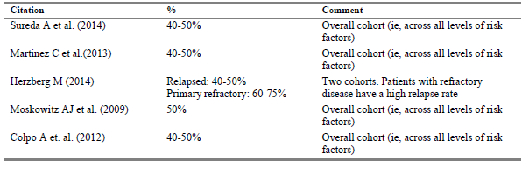
Whilst the papers presented above in Table 51 indicate a failure rate post ASCT from 40% to 50%, caveats are associated with the interpretation of these data, largely because they are historical series representing a period during the evolution of the current frontline clinical management in these patients. The number of ASCT procedures in HL patients in Australia have generally declined relative to 4 to 5 years ago (see Table 52, below), largely due to more efficient frontline treatments for patients diagnosed with HL. That is, more HL patients are cured in the frontline setting and do not need treatment with high-dose chemotherapy and an ASCT.

Table 52. Number of ASCT procedures in Australian patients with Hodgkin lymphoma
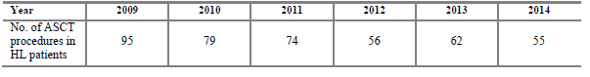
Advice from an Australian Advisory Board for Adcetris held in October 2014 indicated that patients who relapse or are refractory and require an ASCT as frontline salvage treatment are sicker patients with an increased number of risk factors and thus are at higher risk of subsequent failure after ASCT. The clinicians felt that the current failure rate in these patients was probably between 50% to 70%. In the interests of conservatism, the calculation of the patient numbers has used 60%, the midpoint of their estimate. The aforementioned estimates were presented in the sponsor’s application to the Pharmaceutical Benefits Advisory Committee without contest.
A reference list is provided.

Clinical evaluator’s comment
This estimate of approximately 33 patients per year has been added to the relevant section of the CER, together with a summary of the rationale. This estimate is consistent with the evaluator’s rough calculation of approximately 40 to 50 patients with this based on the AIHW data that indicates 550 to 600 patients per year are diagnosed with HL and that, according to historical data, around 10% of these patients are not cured by frontline therapy and may be treated with ASCT and that 10 to 20% of these will have at least one risk factor for progression.
The evaluator notes the sponsor’s suggestion that historical data indicating a 40 to 60% cure rate with ASCT may not represent the current situation, as patients who relapse or are refractory to the improved frontline therapies now available may be ‘sicker patients with an increased number of risk factors and thus are at higher risk of subsequent failure after ASCT’. In support of this contention, the sponsor provides the opinions of clinicians on an Australian Advisory Board for Adcetris.

Question 4
- Consolidation versus Rescue therapy: In light of the results of the 3-year follow-up of the 102 patients in the open label Phase II study (SGN35-003) published as Gopal et al. Durable remissions in a pivotal Phase II study of brentuximab vedotin in relapsed or refractory Hodgkin lymphoma. Blood. 2015;125(8):1236-1243, could the sponsor provide a discussion of the advantage(s) of the use of brentuximab vedotin as consolidative therapy in patients ‘at risk of relapse or progression following autologous stem cell transplant (ASCT)’ compared to its use as rescue therapy in patients who relapse following ASCT as currently approved?

Sponsor’s response
Evaluator comment: The sponsor has provided a lengthy discussion that is reproduced in its entirety given the importance of this issue.
- AETHERA Study
The SGN35-005 (AETHERA) trial was conducted in patients with Hodgkin lymphoma (HL) following autologous stem cell transplantation (ASCT). Currently, this treatment setting is managed through watchful waiting. ASCT is used with curative intent, and it is understood that approximately half of HL cases might be cured without further therapy. Yet in the other cases, HL will return with devastating consequences for these typically young and otherwise productive patients who have endured previous aggressive and invasive therapy. Historically, relapse in this setting is associated with a median post-progression survival of only 1.3 years (Arai 2013; von Tresckow 2014).
The AETHERA study demonstrated that brentuximab vedotin treatment produced a statistically significant benefit in progression-free survival (PFS). PFS was selected as the primary endpoint of the study because it represents a clinically relevant measure of benefit in this population of patients who are typically in a very productive and responsible phase of their careers and personal lives. For these patients, delaying or preventing relapse is an important treatment goal, and as will be shown in the analyses that follow, this PFS benefit can translate to other objective measures of clinical benefit.
- If ASCT fails
Failure to attain a cure in HL is noted as a burden for patients and caregivers. In the current HL treatment paradigm, despite the advantages offered by brentuximab vedotin in the relapsed or refractory setting, ASCT represents patients’ last and best chance of cure. Among all patients requiring ASCT for HL, 50% of patients, cure will not be attained with ASCT alone (Arai 2013; von Tresckow 2014). For those whose disease is not cured, the human cost is high. As described by AETHERA Principal Investigator, from their experience at the Memorial Sloan Kettering Cancer Center, the remainder of these young patients’ lives becomes focused around their treatment. Typical patients with refractory or recurrent disease post ASCT receive a median of 5 investigational agents, without long breaks between those agents, prior to their deaths before age 40 (Personal communication dated 5 May 2015).
As illustrated by the AETHERA trial data, approximately 55% of placebo patients at increased risk of relapse were not cured by ASCT alone, as opposed to approximately 35% of patients receiving consolidation treatment with brentuximab vedotin (PFS per investigator with clinical lymphoma assessments beyond 24 months to define events and censor patients who had not yet progressed, as shown below in Figure 29).
Figure 29. Study SGN35-005 PFS per investigator including radiographic, biopsy, and clinical lymphoma assessments (ITT Set)
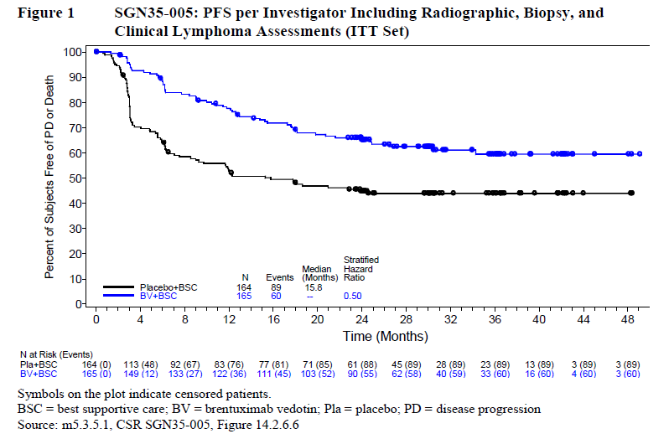
The analysis of PFS per investigator including clinical lymphoma assessments demonstrates that each arm appears to have reached a stable plateau beyond 24 months with marked separation between the curves. This analysis yielded a stratified hazard ratio (HR) of 0.50 (95% CI 0.36, 0.70)).
The 55% of placebo patients with disease progression in the plateau phase represents a greater proportion than the 50% it is expected will not be cured by ASCT alone, suggesting that patients risk factors for relapse or progression present a higher unmet medical need. Further, in the relapsed or refractory setting post ASCT, despite the use of brentuximab vedotin to extend such patients’ lives, very few can be cured, as also illustrated with the marketing authorisation holder’s (MAH’s) own data, as further described below.
- Long-term follow-up of Study SG035-0003
The MAH’s earlier clinical investigation in patients with HL that had been refractory to or relapsed after ASCT (Study SG035-0003) suggests that brentuximab vedotin delays but does not ultimately prevent disease progression or death in most patients who receive the drug later in their treatment course. At the time of termination of Study SG035-0003, the estimated 5-year investigator-assessed PFS rate was 22% and the estimated 5-year overall survival (OS) rate per Kaplan-Meier (K-M) analysis was 41% (SG035-0003 CSR Addendum 2). This study’s finding of a median OS duration of 40.5 months in the relapsed or refractory setting also corroborates the likelihood that the AETHERA OS data will remain immature for years to come.
Ultimately at the time of closure of the SG035-0003 study, 15 of its 102 patients (15%) were known to be in remission. The majority of these patients with sustained remissions (13 of 15 patients with sustained remissions, 87%) had attained a complete remission (CR) with initial brentuximab vedotin treatment. These data illustrate that achieving complete remission is of vital importance to curing HL and to patients’ long-term survival (SG035-0003 Clinical Study Report Addendum 2). Further, of these 15 patients still alive and in remission at study closure, 6 patients (40%) had received a later consolidative allogeneic stem cell transplant. Thus, in the treatment of relapsed or recurrent HL, brentuximab vedotin alone does not result in cure in > 90% of patients. The very poor prognosis for patients with HL that returns post ASCT underscores the vital importance of increasing cure rates earlier in therapy (Chen 2015).
- Analysis for delay of next subsequent therapy
In this post-hoc analysis of time-to-next-treatment (TTNT), investigator-reported receipt of therapy for HL subsequent to placebo (placebo arm) or brentuximab vedotin (brentuximab vedotin arm) was considered a TTNT event. Patients without a TTNT event were censored at the date of their last follow-up.
As shown in Table 53 below, 51 patients randomised to brentuximab vedotin (31%) received subsequent therapy versus 85 patients (52%) randomised to placebo (HR = 0.448). This effect appeared durable, with an estimated 36-month subsequent-therapy-free rate of 65.6% for patients randomised to brentuximab vedotin versus 45.8% for patients randomised to placebo.

Table 53. Study SGN35-005 (AETHERA) Analysis of time from randomisation to first of any subsequent therapy (ITT Population)
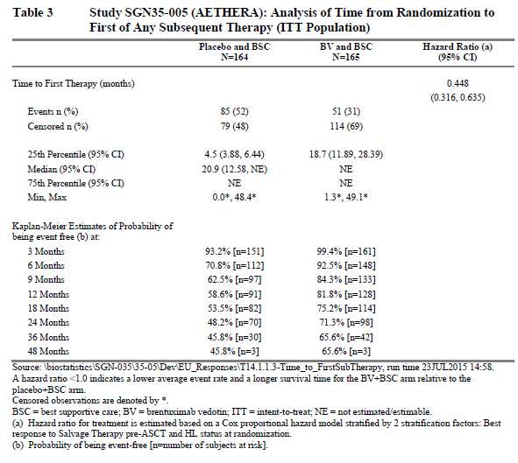
Figure 30 that follows presents the Kaplan-Meier analysis of time to next subsequent therapy.
Figure 30. Study SGN35-005 Kaplan-Meier analysis of time from randomisation to first of any subsequent therapy (ITT population)
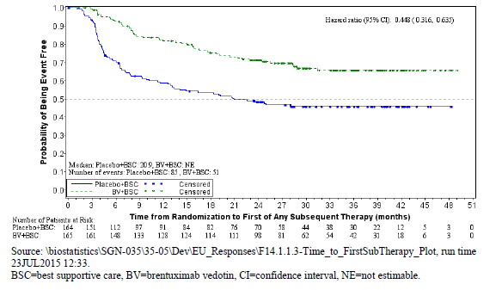
- Summary
The majority of patients who are not cured by ASCT alone face further disease progression, treatment, and eventually HL-related death. Consolidation therapy with brentuximab vedotin offers sustained progression-free survival, and the potential for cure, to approximately 20% more patients, of crucial benefit in this setting where the return of HL is usually repeated until it results in death. Moreover, this clinical benefit is also evidenced by a prolonged time to next therapy. Taken together, these data suggest that post-ASCT consolidation with brentuximab vedotin reduces the need for further treatment and offers better outcomes than watchful waiting.

Clinical evaluator’s comment
The sponsor argues that the use of brentuximab vedotin as consolidative therapy following ASCT in all patients at increased risk of relapse will result in fewer patients being confronted by the trauma of HL recurrence and the poor prognosis consequent to this. The evaluator would argue that the use of brentuximab vedotin as consolidative therapy following ASCT in all patients at increased risk of relapse will result in approximately half of these patients, who would otherwise have been cured by ASCT, being exposed to the trauma and considerable risks of unnecessary treatment with brentuximab vedotin.
To address the sponsor’s main points:
- The sponsor argues that the current treatment paradigm following ASCT is watchful waiting and that relapsed disease has a high human cost with typical patients with refractory or recurrent disease post ASCT receiving ‘a median of 5 investigational agents, without long breaks between those agents, prior to their deaths before age 40’. This argument does not allow for the effectiveness of brentuximab vedotin when used as currently approved and that this has changed the treatment paradigm. As noted by the evaluator in the CER above, the use of brentuximab vedotin has been described by others as a ‘game changer’ in patients with refractory or relapsed HL following ASCT: ‘Before the advent of brentuximab vedotin, both conditions had few therapeutic options, all of limited efficacy, and their prognosis was overall dismal’.¹⁸
- The sponsor’s assessment is that brentuximab vedotin when used as rescue therapy delays but does not ultimately prevent disease progression or death in most patients. Despite this, the 3-year follow-up of the pivotal study for this indication (Study SG035-0003) has found median OS duration of 40.5 months in the relapsed or refractory setting, compared to historical results of median OS of 7 to 12 months.^{3,6} As the sponsor notes, AETHERA OS data will remain immature for years to come, so it is not known at this time as to whether the use of brentuximab vedotin as consolidative therapy will also result only in delay but not ultimately prevent disease progression or death in most patients.
- The sponsor notes that of the 15/102 patients with sustained complete remission in Study SG035-0003, 6 had received consolidative allogeneic stem cell transplant and that this undermines the results of the study with regard to possible curative effect. It is not known, however, if this consolidative therapy prevented relapse or if it was an unnecessary burden and risk to patients who would have remained in complete remission without this additional therapy.
- The sponsor presents data that approximately 55% of placebo patients at increased risk of relapse were not cured by ASCT alone, as opposed to approximately 35% of patients receiving consolidation treatment with brentuximab vedotin, according to PFS by investigator. From this the sponsor concludes that consolidation therapy with brentuximab vedotin offers sustained progression-free survival, and the potential for cure, to approximately 20% more patients. Given the duration of follow-up, it is not clear to the evaluator that the term ‘cure’ can be used as yet. Also, for the sake of those approximately 20% more patients who gained sustained progression free survival, the 45% of patients who would otherwise have gained sustained progression free survival from ASCT alone, were exposed to the risks of brentuximab vedotin therapy.
The evaluator agrees that brentuximab vedotin is of benefit as consolidative therapy after ASCT for some patients. If brentuximab vedotin therapy had minimal risks and presented little burden to the patients, then administration to all patients eligible for the proposed usage may be reasonable. However, brentuximab vedotin is associated with both discomfort, as shown by the high discontinuation rate in the pivotal study, and potentially fatal risks as identified in the periodic Safety Update Reports. The difficulty is to identify those patients who are most likely to benefit so that patients who would otherwise be cured by ASCT are not subjected to an unnecessary therapy.

Pharmacokinetics

Question 5
- Development/occurrence of ATA:
  - Re-immunogenicity and the Development of ATA: In Study SGN35-005, 12 of the placebo group and 19 of the brentuximab vedotin group were ATA positive at Baseline. Patients previously treated with brentuximab vedotin were excluded from the study. How does the sponsor account for these patients testing positive for ATA? Also, 38 of the placebo group who were negative for ATA at baseline subsequently tested positive for ATA; how does the sponsor account for these patients testing positive for ATA? Also, a number of patients in the brentuximab vedotin arm who were ATA-positive at baseline, subsequently tested negative (7/19); how does the sponsor account for this?
  - The ATA assay: Could the sponsor provide the sensitivity, specificity and false positive rate for the assay used to determine if the patient was positive for ATA?

Sponsor’s response (part A)
Study SGN35-005 used an anti-therapeutic antibody (ATA) assay that has since been redeveloped. The former assay in use for this trial is extremely sensitive (see specifications in the sponsor’s response to Clinical Question 5 part B) and thus likely returns a high rate of background positivity, regardless of randomisation therapy.
Nonetheless, as shown in Table 54, the median and maximum titres of ATA-positive samples in the brentuximab vedotin-treated patients were much higher, suggesting that the assay is qualitatively able to distinguish true (high titre) positive values from false (low titre) positive values.
Table 54 below presents a summary of titres for confirmed ATA-positive samples by treatment arm and cycle. Maximum post-baseline ATA titres in the brentuximab vedotin arm were consistently higher than in the placebo arm at all treatment cycles. Post-baseline median ATA titres for patients in the placebo arm were generally comparable to baseline titres.

Table 54. Study SGN35-005 Titre of positive ATA samples
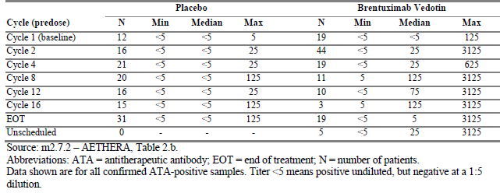

Clinical evaluator’s comment
Comparison of minimum and maximum values in the placebo and brentuximab arms show that there was overlap in the titres observed in the different cycles, although some patients in the brentuximab arm appear to have had relatively high titres. Regardless of this, the sponsor has stated that the assay has required redevelopment. Given this, results from the earlier assay cannot be interpreted.

Sponsor’s response (part B)
A summary of the ATA electrochemiluminescent (ECL) assay performance characteristics of the assay used in Study SGN35-005 is shown below in Table 55.

Table 55. ATA ECL assay characteristics
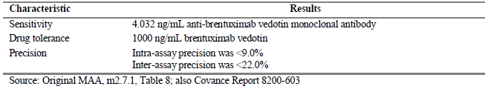
The assay’s false-positive rate is 6.5% (Covance Report 8200-603, page 7 and Table 2 [not in this document]).
The sponsor also provided a description of the ‘Method Specificity/Free Drug Tolerance’ that is not reproduced by the evaluator here.

Clinical evaluator’s comment
Patients who had received prior therapy with brentuximab vedotin were excluded from Study SGN35-008. Despite this, there were 12/154 in the placebo group and 19/157 in the brentuximab vedotin group who tested positive for ATA at baseline. Of the 142 patients in the placebo group who were negative at baseline, 38 subsequently tested positive at a post-baseline visit. From this it would seem that 22% of subjects had false positive results, rather than the quoted rate of 6.5%.
Comment: The evaluator requested a number of further analyses of the data regarding ATA status, most of which the sponsor did not provide on the basis that the analyses would not be anticipated to yield meaningful results. Given the issues with the assay used in Study SGN35-005, the evaluator agrees that no further analyses would be useful and is of the opinion that all of the ATA results for this study should be disregarded, together with any conclusions drawn from these results. These clinical questions have therefore been removed and sponsor’s responses have not been included.

Question 6
- Drug-Drug Interactions:
  - P-gp Inhibitors: MMAE exposure may be increased by concomitant administration of ketoconazole, a strong CYP3A4 and P-gp inhibitor and may result in more severe neutropaenia. Can the sponsor provide any more recent information regarding this drug-drug interaction, including the study population of Study SGN35-005? For example, was ketoconazole or itraconazole or other P-gp inhibitors co-administered to patients in the brentuximab vedotin arm of Study SGN35-005 and if so, was this was associated with more severe neutropaenia?
  - MMAE levels and drug interactions: Free MMAE may be increased by co-administration of P-gp inhibitors and reduced by rifampicin. In the description of the characterisation of ATA in the study population of Study SGN35-005, it was said that samples that tested positive for ATA were further evaluated for concentrations of brentuximab vedotin ADC, total antibody, and free MMAE. Many patients in both arms of the study were found to be ATA positive and should, therefore, have had free MMAE concentrations performed. Were there any patients who were ATA positive and who were also receiving P-gp inhibitors or CYP3A4 inducers such as rifampicin? If yes, could the free MMAE levels of these patients be compared to the free MMAE levels of patients who were ATA positive but not receiving CYP3A4 inhibitors or inducers? Could the sponsor also provide any other updated information regarding drug-drug interactions with brentuximab vedotin, including any information provided to other regulators?

Sponsor’s response (part A)
Table 56 below summarises the incidence of Grade 3 or 4 neutropaenia or low absolute neutrophil count (ANC) and dose modifications by receipt of cytochrome P450 3A4 (CYP3A4) inhibitors or inducers. The incidence of neutropaenia or low ANC did not appear to be related to receipt of CYP3A4 inhibitors. Dose modifications were slightly more common in the small set of patients receiving a CYP3A4 inhibitor (14 of 20 patients, 70%) as opposed to those receiving no CYP3A4 inhibitor or inducer (85 of 146 patients, 58%), but it is unclear if this is a trend or an effect of sampling error due to small sample size.

Table 56. Study SGN35-005 Number of patients with Grade 3 or Grade 4 treatment emergent neutropaenia and dose modification by CYP3A status (Safety population, patients receiving brentuximab vedotin)
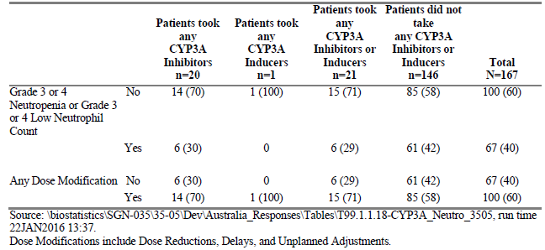

Clinical evaluator’s comment
The evaluator thanks the sponsor for providing this analysis and agrees that firm conclusions cannot be drawn given the small sample size.

Sponsor’s response (part B)
Patients across either study arm who were ATA positive at any time post-baseline who received inhibitors or inducers of P-glycoprotein (P-gp) or CYP3A4 are summarised below in Table 57. The majority of patients (85/110 patients (77%); 40/59 brentuximab vedotin-treated patients (68%)) did not receive these classes of concomitant medications. However, P-gp inhibitors were the most common of these, with 18 of 59 post-baseline ATA-positive patients (31%) receiving brentuximab vedotin with a concomitant P-gp inhibitor.

Table 57. Study SGN35-005 Summary of post-baseline ATA-positive patients by receipt of P-gp and strong CYP3A4 inhibitors and inducers (Safety population, patients ATA-positive at any time post-baseline)
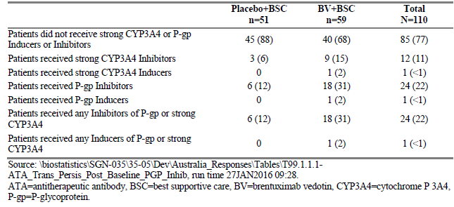
As shown below in Table 58, receipt of a strong CYP3A4 inhibitor did not appreciably alter MMAE concentrations over the course of the study.

Table 58. Study SGN35-005 Summary of monomethyl auristatin E (MMAE) concentration (ng/mL) (Safety population, ATA post-baseline positive patients who received brentuximab vedotin)
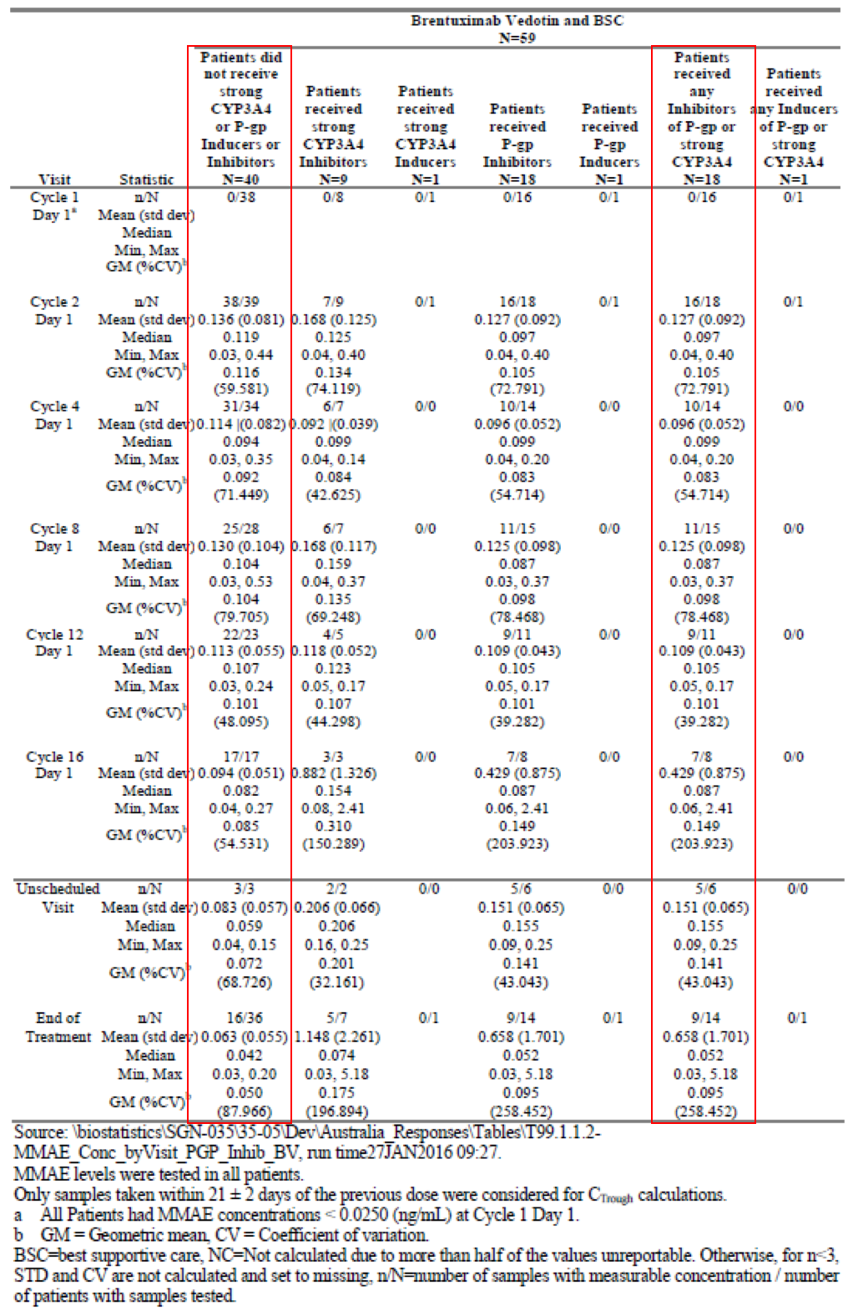

Clinical evaluator’s comment
As noted by the sponsor, there were 18 patients for whom MMAE levels were available and who had received concomitant treatment with a P-gp or CYP3A4 inhibitor and 40 patients for whom MMAE levels were available and who had not received concomitant treatment with a P-gp or CYP3A4 inhibitor. Mean, median, minimum and maximum MMAE levels were provided by cycle and for unscheduled visits. Apart from what appeared to be one patient in cycle 16 who received both a P-gp and CYP3A4 inhibitor and had a markedly elevated MMAE level, there was no convincing difference in the MMAE levels between the two groups. However, given that this requested analysis is exploratory, post-hoc, included a subset of patients and had small numbers, no conclusions can be drawn.

Efficacy

Question 7
- Outcome measures: Both the PFS by IRF and the overall survival were better than expected and/or better than historical controls for both the placebo arm and the brentuximab vedotin arm: the estimated PFS by IRF in the sample size calculation was 18 months and 12 months for the brentuximab vedotin and placebo arms respectively compared to 42.9 months and 24.1 months observed in the study; 202 progression events were expected to occur compared to 135 observed; the estimated 3-year OS was over 88% for both arms compared to historical outcomes of 5-year OS 50% to 60%. How does the sponsor account for these better than expected results for both arms of the study?

Sponsor’s response
The historical controls that informed the AETHERA study design evaluated a variety of risk factors, making it difficult to perfectly match the previously studied patient populations [the sponsor refers the evaluator to a section and table of the Clinical Overview, AETHERA addendum not included in this document]. Further, some of these historical data predate the use of positron emission tomography (PET) to detect metabolically active disease. Lastly, it is likely that improvements in transplantation and supportive care may also have contributed to the prolonged PFS and OS observed on both arms of the AETHERA study.
Despite this unexpected result, it is important to note that the AETHERA study was randomised and controlled, and a highly statistically significant improvement in PFS per IRF was nonetheless detected with brentuximab vedotin.

Clinical evaluator’s comment
The evaluator agrees that the historical studies used a variety of risk factors to describe patients. However, there is considerable overlap between the risk factors shown in [table not included in this document] and the risk factors used as inclusion criteria for the AETHERA study (Study SGN35-005). The use of PET in determining risk is described in a minority of studies and only studies published after commencement of the AETHERA study. The evaluator also notes that the studies referred to in the Clinical Overview to describe outcome following ASCT were published in 2013 and 2014 (Arai and von Tresckow); this would suggest that improvements in transplantation and supportive care did not contribute to the better than expected results observed in the study.
The evaluator is of the opinion that one factor contributing to these better than historical results may be the use of brentuximab vedotin as both rescue therapy (received by 72/164 patients in the placebo arm) and as consolidative therapy post ASCT.

Question 8
- Progression free survival Kaplan-Meier curves: It is notable that in the KM survival curves for the primary outcome measure and for the secondary analyses of the primary outcome measure, the curves for the two treatment arms parallel each other after an early dip in the placebo arm (due to a number of progression events in the first six months in the placebo group) and both treatment arm curves appear to plateau at around 24 months. The difference in overall PFS would appear to be due to the patients with early progression in the placebo arm and this may represent a subgroup that benefits from brentuximab vedotin administered as adjuvant therapy following ASCT. Could the baseline characteristics patients who progressed or who received new anti-tumour therapy(ies) within the first 8 months in the placebo arm be provided? Could the median PFS, stratified HR and Kaplan Meier curve for this group also be provided?
Later clarification: sponsor-initiated request for clarification submitted 21 December 2015, sponsor query concerning original Clinical Question (efficacy)
- The sponsor can [supply] the median PFS per investigator among the placebo patients who experienced progressive disease (PD) within the first 8 months of randomisation and provide a corresponding KM curve for these patients. However, a HR requires a comparative analysis and, as such, it is unclear which comparative analysis is desired. Can the evaluator please clarify the request?
TGA response to request for clarification (11 January 2016)
- The baseline characteristics, with these including risk factors for progression, together with PFS and CIs should be Ok. In terms of the comparative analysis, the evaluator was interested in two comparisons: a comparison of the early progressers to the active arm and a comparison of the early progressers to the rest of the placebo group. The evaluator is trying work out if the early progressers were a different population within the placebo group. If the sponsor could provide the comparative analyses, that may be helpful.

Sponsor’s response
Table 59 below summarises patients’ baseline characteristics by treatment arm and disease progression status (progressed within 8 months versus not progressed). Whilst some differences in baseline characteristic are present by progression timeframe status, none seems definitive of early progression.

Table 59. Study SGN35-005 Summary of baseline characteristics by treatment arm and per-investigator disease progression status (ITT population)
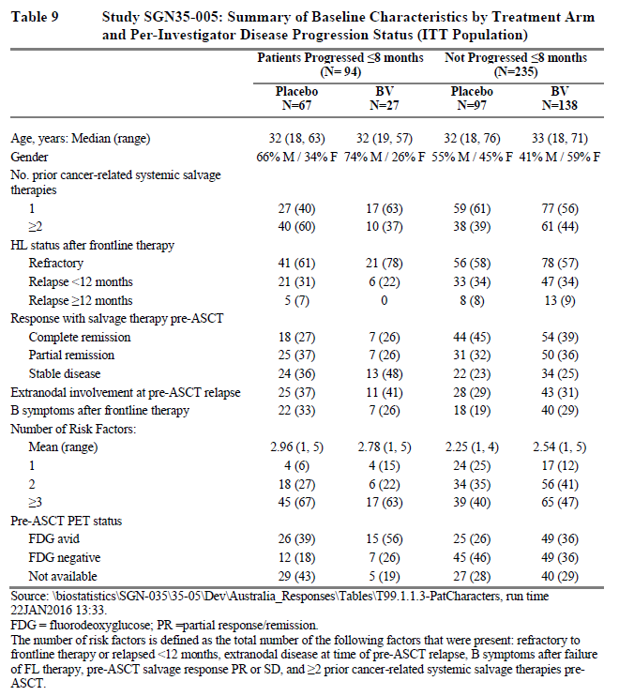
As opposed to the independent review facility assessments, investigators’ determinations of disease progression, in practice, determined patients’ receipt of subsequent therapy. Figure 31 below shows a comparative Kaplan-Meier analysis of PFS per investigator for the subset of patients who experienced disease progression within 8 months (randomised to placebo versus randomised to brentuximab vedotin). The median PFS duration for the 67 placebo patients who experienced early progression (≤ 8 months) was 3.0 months; the median PFS duration for the 27 brentuximab vedotin patients who experienced early progression (≤ 8 months) was 4.9 months. In this post hoc analysis, PFS duration was longer in patients randomised to brentuximab vedotin (HR 0.578, 95% CI 0.345, 0.968).
Figure 31. Study SGN35-005 Kaplan Meier plot of PFS per investigator (ITT population, patients who experienced disease progression ≤ 8 Months)
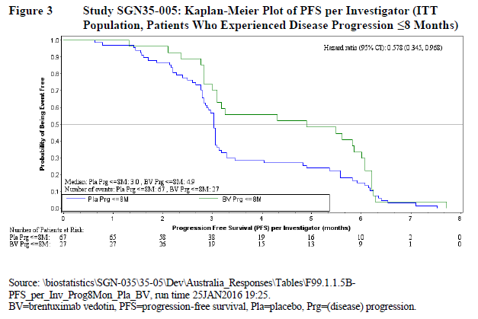
Lastly, Table 60 below provides a summary of PFS duration per investigator by treatment arm and progression timeframe.

Table 60. Study SGN35-005 Analysis of time to progression or death per investigator (ITT population with disease progression ≤ 8 months by treatment arm

Clinical evaluator’s comment
Comparison of the patients in the placebo arm who progressed early (≤ 8 months) to the patients from the brentuximab vedotin arm who progressed early, as shown in the sponsor’s table (Table 59) above, showed little difference between the groups in terms of risk factors and outcome (median PFS 3.0 months compared to 4.9 months respectively). Comparison of the patients in the placebo arm who progressed early (≤ 8 months) to the patients from the placebo arm who did not progress early according to the presence of poor prognosis risk factors shows that these factors were present more frequently in the patients in the placebo arm who progressed early, with the difference most marked for the occurrence of 3 or more risk factors (see Table 61 below).

Table 61. Comparison of occurrence of poor prognosis risk factors in the placebo arm (broken down according to progression within 8 months) and the brentuximab vedotin arm of Study SGN35-005 (AETHERA)
 | Placebo arm |  |  |  |  | Brentuximab vedotin arm
 | Progression ≤ 8 months |  | No progression ≤ 8 months |  | All patients
 | Number | % | Number | % | Number |  | %
 | 67 |  | 97 |  | 165
Poor prognostic factors
Refractory HL | 41 | 61.2 | 56 | 57.7 | 99 |  | 60.0
Lack of responsiveness to pre-ASCT salvage therapy or residual disease at time of ASCT (PR or SD post-salvage therapy) | 49 | 73.1 | 53 | 54.6 | 104 |  | 63.0
B symptoms after frontline therapy | 22 | 32.8 | 18 | 18.6 | 47 |  | 28.5
Extra-nodal disease present at pre-ASCT relapse | 25 | 37.3 | 28 | 28.9 | 47 |  | 28.5
Multiple relapses prior to ASCT (≥ 2 prior treatment lines) | 40 | 59.7 | 38 | 39.2 | 71 |  | 43.0
≥ 3 risk factors | 45 | 67.2 | 39 | 40.2 | 82 |  | 49.7
The risk factor of Pre-ASCT PET status has not been included in this table due to the number of missing results in each group.
As the sponsor notes, this is a post-hoc analysis and no single characteristic seems conclusively linked to early progression. It appears that patients with 3 or more risk factors are more likely to experience earlier progression and this seems to be largely unaffected by brentuximab vedotin as consolidative therapy. The analysis has not enabled identification of a group most likely to benefit from brentuximab vedotin administered in this way.

Question 9
- Overall survival analysis: No difference was found in overall survival between the placebo and the brentuximab vedotin arm. This result was confounded by cross-over as 72/164 patients in the placebo arm were reported as receiving brentuximab vedotin treatment. A sensitivity analysis using the RPSFT model to correct for crossover was unhelpful. What were the results (PFS by IRF and OS) for the 2 subgroups of placebo patients, that is the group who did not receive brentuximab vedotin treatment (or other subsequent anti-tumour therapies) and the group who did? What was the PFS (PFS2) of the subgroup of placebo arm patients treated with brentuximab vedotin, after receiving brentuximab vedotin?

Sponsor’s response
Results of the requested post hoc analyses of PFS per IRF (Figure 32 and Table 62) and OS (Figure 33 and Table 63) are shown below for placebo patients receiving subsequent therapy versus placebo patients not receiving subsequent therapy.
Figure 32. Study SGN35-005 Kaplan-Meier plot of PFS per IRF (ITT population, placebo patients with subsequent therapy versus placebo patients without subsequent therapy)

Table 62. Study SGN35-005 Analysis PFS per IRF (ITT population, placebo patients with subsequent therapy versus placebo patients without subsequent therapy)
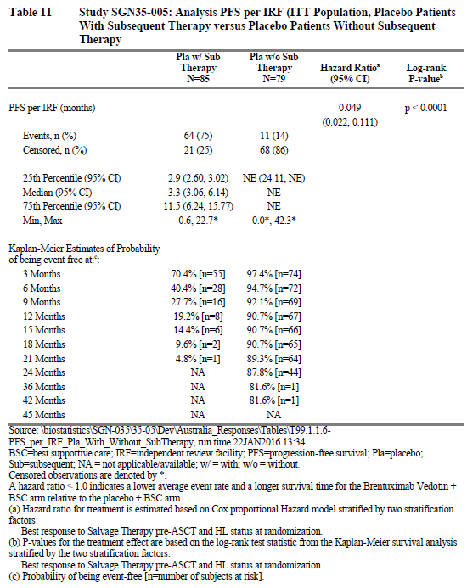
Figure 33. Study SGN35-005 Kaplan-Meier plot of overall survival per IRF (ITT population, placebo patients with subsequent therapy versus placebo patients without subsequent therapy)

Table 63. Study SGN35-005 Analysis of overall survival (ITT population, placebo patients with subsequent therapy versus placebo patients without subsequent therapy)
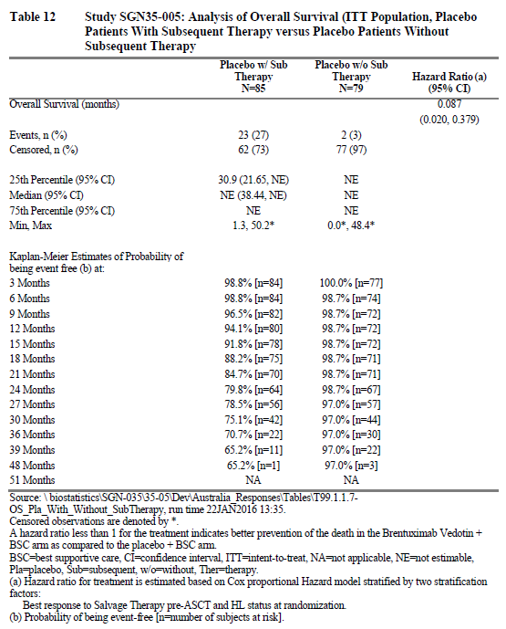
Progression-free survival with next subsequent therapy (PFS2) data are not available. In lieu of PFS2, the sponsor has provided an analysis of time to start of next subsequent treatment (Figure 34 and Table 64, both below). As patients are typically treated soon after disease progression, this analysis of time to next treatment (TTNT) tracks well with PFS2. Further, as disease progression in the post-ASCT setting is associated with a much poorer prognosis, time to next treatment is likewise a good measure of clinical benefit.
Figure 34. Study SGN35-005 Kaplan-Meier plot of time to next subsequent therapy or death after first BV treatment post ASCT (ITT population, placebo patients receiving subsequent brentuximab vedotin)
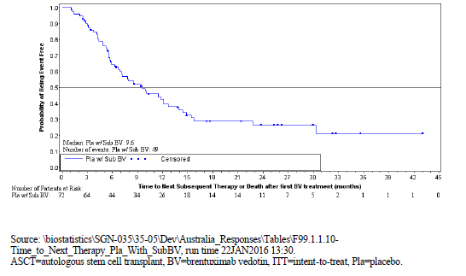

Table 64. Study SGN35-005 Analysis of time to next subsequent therapy or death after first BV treatment post ASCT (ITT population, placebo patients receiving subsequent brentuximab vedotin)
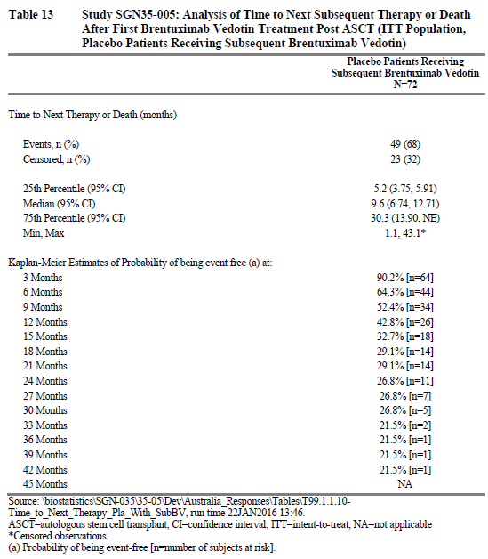

Clinical evaluator’s comment
The information from the sponsor regarding the placebo group that did not require subsequent anti-tumour therapy and the placebo group that did, has been summarised in Table 65 below, together with the group that received brentuximab vedotin for further comparison.

Table 65. Comparison of the Placebo group patients who did not require subsequent therapy to the Placebo group patients who did require subsequent therapy and the Brentuximab Vedotin group in Study SGN35-005
 | Placebo group (ITT set by IRF) |  | Brentuximab vedotin group  (ITT set by IRF)
 | with no subsequent therapy | with subsequent therapy | Brentuximab vedotin group  (ITT set by IRF)
 | N = 79 | N = 85 | N = 165
number of events (%) | 11 (13.9) | 64 (75.3) | 60 (36.9)
median progression free time (months) | NE | 3.3 | 42.9
estimate of event free rate at 18 months (%) | 90.7 | 9.6 | 68
number of deaths (%) | 2 (2.5) | 23 (27.1) | 28 (17.0)
median overall survival (months) | NE | NE | NE
estimated overall survival rate at 36 months (%) | 97 | 30.7 | 82
It is apparent from this analysis that there is a group of patients in the placebo arm who have an excellent response to ASCT with, according to the analysis of PFS by IRF, an estimated 89.3% event free at 21 months, compared to 4.8% event-free at this time point in the placebo patients who received subsequent therapy. A difference in overall survival is also apparent with 2/79 deaths and an estimated survival at 36 months of 97% in the ASCT responders compared to 23/85 deaths and estimated overall survival at 36 months of 71% in the placebo patients who received subsequent therapy. Addition of brentuximab vedotin as consolidative therapy to this group of ASCT responders appears unlikely to provide any improvement in response. The difficulty, however, is in identifying this group. The analyses provided in the response to Question 8 above, with comparison of the placebo patients who progressed early (≤ 8 months) to those who didn’t, does not assist in this as the analyses do not describe two clearly different groups.
- Brentuximab vedotin as rescue therapy
There were 85 patients who relapsed following ASCT in the placebo group and 72 of these patients received brentuximab vedotin. The analysis of time to next treatment (TTNT) provided by the sponsor for these 72 patients may provide a guide to the PFS with brentuximab when used as rescue therapy in these patients, although TTNT does not include death as an event. Follow-up in the Phase III study was for 12 months after completion of treatment. At this time, the median TTNT was 9.6 months (95% CI 6.7 to 12.7) and the estimated PFS at 24 months was 26.8%.
A single arm Phase II study investigated the use of brentuximab vedotin in patients who had relapsed following ASCT for relapsed HL. This was the pivotal study for the indication of brentuximab vedotin in patients with relapsed HL following ASCT. The study is described in the AusPAR for the submission of brentuximab vedotin as a new chemical entity and the CSR was included in thatsubmission.¹⁴ Progression free survival was a secondary outcome measure in the Phase II study and was assessed 12 months after completion of treatment. At this time-point, the median duration of progression free survival of 5.6 months and the estimated PFS at 24 month was 23%. The median event free survival was 29 weeks (95% CI 23.9 to 38.3 weeks).
This would suggest that the outcomes in the placebo patients who developed progressive disease and were subsequently treated with brentuximab vedotin in Study SGN35-005 were similar to those of the patients in the Phase II study. It is worthy of note that the results of 3-year follow-up of the 102 patients in the Phase II study were published in February 2015.⁹ This found that after a median follow-up of 33 months, 48/102 patients were still alive (actual 3 year survival of 47%) and that 18 patients were still in remission. The estimated median OS was 40.5 months (95% CI: 28.7, —) and the updated estimated PFS per investigator for all patients was 9.3 months. For the patients who achieved CR on brentuximab vedotin, there was an estimated 3-year overall survival and progression-free survival rates of 73%. For comparison, the patients who received brentuximab vedotin following ASCT as consolidative therapy, with analysis at 12 months after treatment completion, the median progression free survival was much longer at 42.9 months and the estimated overall survival at 3 years was 82%.

Question 10
- Quality of life measure: The study found no difference in quality of life, using the measures EQ-5D and EQ VAS, between the placebo and brentuximab vedotin arms. If anything, there was a trend for the brentuximab arm to be worse, particularly after the end of treatment. How does the sponsor account for brentuximab vedotin seeming to worsen quality of life after completing treatment?

Sponsor’s response
Quality of life (QOL) was measured throughout the treatment period (approximately 12 months for typical patients) and throughout long-term follow up to a maximum of 24 months from randomisation. A general decline in QOL was observed over time for both study arms, possibly due to toxicity associated with brentuximab vedotin use and to disease progression. Notably, a decrease in QOL is associated with disease progression regardless of treatment assignment as shown in Figure 35 (brentuximab vedotin ITT patients) and Figure 36 (placebo ITT patients) below.
Figure 35. Study SGN35-005 Mean (± 95% CI) US-Indexed EQ-5D TTO scores over time by disease progression status per investigator with imputation of death (ITT population randomised to brentuximab vedotin)
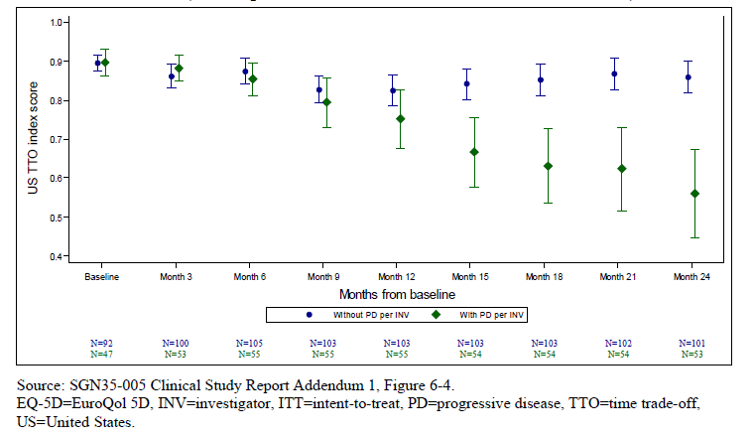
Figure 36. Study SGN35-005 Mean (± 95% CI) US-Indexed EQ-5D TTO scores over time by disease progression status per investigator with imputation of death (ITT population randomised to placebo)
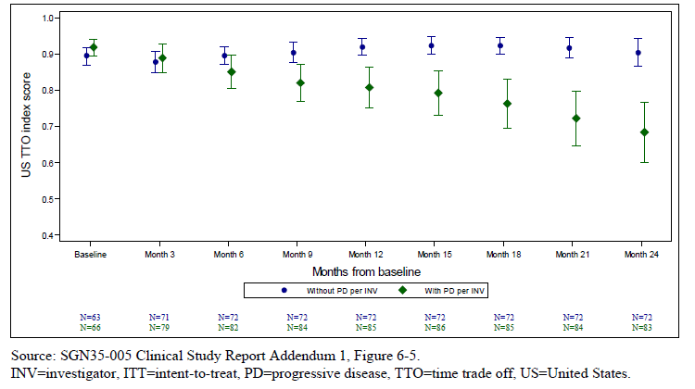
The AETHERA study did not incorporate crossover within the study; however, patients experiencing disease progression could have their treatment assignment unblinded, and patients randomised to placebo could receive subsequent brentuximab vedotin through a treatment option protocol (Study SGN35-010) or, later, as commercial drug.
Of those patients randomised to placebo who experienced disease progression and received subsequent therapy (n = 85), a high proportion (72 of 85 patients, 85%) received brentuximab vedotin. Additionally, receipt of non-BV therapies in the placebo group following progression or EOT, including allogeneic transplantation, could also have contributed to this decline in QOL over time. This difference in scores between BV and placebo did not reach the threshold for a minimally important difference (MID) at any time point during 16 cycles of treatment.
Figure 37. Study SGN35-005 Off-treatment US-indexed mean (± 95% CI) EQ-5D TTO scores
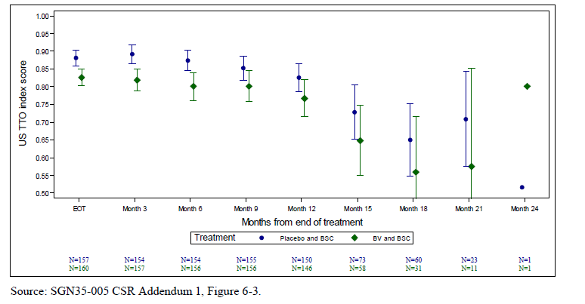
EQ-5D follow up time was calculated from EOT. As shown in Figure 37 above, the US-indexed EQ-5D analysis commencing at EOT shows reliable data (high N’s) through 12 months post EOT. There is a QOL difference, particularly in the first 6 months after EOT; this difference is slight and may be a result of toxicity. Placebo patients tended to have an earlier EOT visit due to disease progression and thus were followed longer. However, the number of patients analysed more than 12 months after EOT was small and likely represents patients who discontinued therapy early due to toxicity or disease progression. Patients experiencing disease progression among this group are likely to have received subsequent therapies (72/164 patients) and thus it is difficult to infer a true difference in QOL beyond that time.

Clinical evaluator’s comment
The evaluator accepts that the occurrence of progressive disease would result in a decline in QoL. It is, however, concerning that the considerable increase in progression free survival observed in the brentuximab vedotin arm has not translated into the patients in this arm reporting a quality of life demonstrably better than the patients in the placebo arm. According to the measure used, the quality of life is no better in the brentuximab vedotin arm compared to the placebo arm regardless of the presence of progression or off-treatment status. The sponsor suggests that this is due to toxicities associated with brentuximab vedotin and that the improved quality of life expected with the resolution of these toxicities is not shown in this study as the period of follow up was not long enough. This is speculation on the part of the sponsor and has not been demonstrated.

Question 11
- Crossover and Quality of life measure: Figures 6-4 and 6-5 in the report for the quality of life measure [viewable above as Figures 23 and 24 respectively] compare US TTO index score for patients with progressive disease versus patients without progressive disease for the brentuximab vedotin arm (fig 6-4 [Figure 23 above]) and the placebo arm (fig 6-5 [Figure 24 above]). Of the patients who developed progressive disease, 9 patients in the brentuximab vedotin arm and 72 patients in the placebo arm were treated with brentuximab vedotin during the LTFU. To better determine the impact of treating patients with brentuximab vedotin, without the confounding effects of progressive disease (± subsequent treatment with brentuximab vedotin), it would be helpful to similarly display a comparison of the mean EQ-5D TTO scores for:
  - the two groups (placebo and brentuximab treatment arms) that did not develop progressive disease throughout the 24 months of the study and who did receive 16 cycles of treatment
  - the patients in the brentuximab vedotin arm who discontinued treatment cycles due to AEs and who did not develop progressive disease throughout the 24 months of the study compared to the patients in the brentuximab arm who completed 16 cycles and who did not develop progressive disease.

Sponsor’s response
Among the ITT population who did not progress and received 16 cycles of BV across 24 months, no significant difference in EQ-5D time trade-off (TTO) scores was observed as depicted in Table 66 and Figure 38.

Table 66. Study SGN35-005 Summary of US-indexed EQ-5D TTO scores over time with imputation of death (ITT population, patients who received 16 cycles of treatment and did not experience disease progression within 24 months)
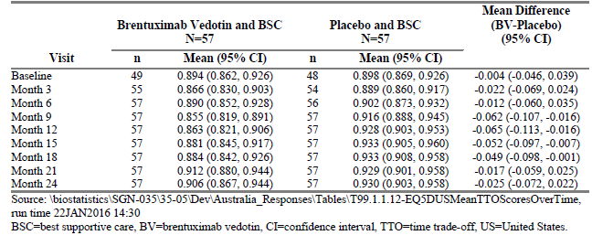
Figure 38. Study SGN35-005 Summary of US-indexed EQ-5D TTO scores over time with imputation of death (ITT population, patients who received 16 cycles of treatment and did not experience disease progression within 24 months)
Trends of decline in ED-5D TTO scores in BV compared to placebo were observed at Months 9 and 12, wherein differences reached MID at these two instances only. However, at 24 months, EQ-5D TTO did not differ between BV and placebo. Additionally, the change from Baseline at 24 months in both the BV and placebo groups was minimal.
For patients randomised to brentuximab vedotin who did not experience disease progression within 24 months, no significant differences were seen in EQ-5D US TTO during 24 months of observation between those who completed 16 cycles of treatment versus those experienced AEs and discontinued without PD. Additionally, any differences did not reach the MID threshold (all were < 0.06). At the end of 24 months, the change from baseline in EQ-5D was minimal if any in both groups (Table 67/ Figure 39).

Table 67. Study SGN35-005 Summary of EQ-5D US-indexed TTO score over time with imputation of death (ITT population, brentuximab vedotin, randomised patients who did not experience disease progression within 24 months (completed 16 cycles of treatment versus EOT due to AE)
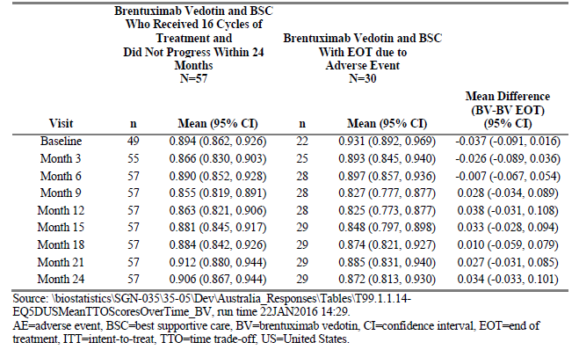
Figure 39. Study SGN35-005 Summary of EQ-5D US-indexed TTO score over time with imputation of death (ITT population, brentuximab vedotin-randomised patients who did not experience disease progression within 24 months (completed 16 cycles of treatment versus EOT due to AE)

Clinical evaluator’s comment
These analyses were requested by the evaluator to better characterise the impact of brentuximab therapy on quality of life, without the confounding effect of disease progression. The first analysis of those patients in each arm who completed 16 cycles of treatment and who did not experience disease progression shows a dip in the quality of life measure for the patients receiving brentuximab vedotin towards the end of treatment and in the off-treatment phase with this measure then returning to that of the placebo group at the end of the observation period. The sponsor notes that the differences met the MID at months 9 and 12 only and that there was minimal difference between the baseline and 24 month measures for either group. It is important to remember that the baseline measure was taken within 30-45 days of the patients having received an ASCT and that minimal change from this over a 24-month period rises concerns regarding the sensitivity of the instrument. The lack of improved quality of life in the brentuximab vedotin arm compared to placebo, despite the increase in progression free survival, is concerning as it raises the possibility that although patients are disease free for longer, they are not ‘living better’.
The second analysis was of those patients in the brentuximab arm who did not experience disease progression with the patients who completed 16 cycles of treatment compared to those who did not. This showed no significant difference in quality of life according to the measure used. Interpretation is difficult though, as the number of cycles completed before treatment discontinuation is not known.
Overall, the evaluator recommends that the quality of life data should be looked at with caution given concerns regarding the sensitivity of the instrument used and given that many patients in the ‘placebo arm’ were receiving brentuximab vedotin.

Question 12
- Risk factors for progression: Some of the risk factors for progression post-ASCT were used as inclusion criteria for the study. Historically, the presence of increasing numbers of risk factors has been associated with worsening prognosis and a number of indices have been developed although none are universally used. These usually divide the patients into low, intermediate and high risk according to the number of risk factors (0 to 1, 2, 3 or more respectively). The number of patients with 1, 2 or ≥ 3 risk factors at baseline was not included in the baseline characteristics and an efficacy analysis according to the number of risk factors present is not provided. A post-hoc analysis of PFS per IRF according to the number of risk factors is provided in the Clinical Overview. However, this analysis is provided as overlapping numbers of risk factors (≥ 1, ≥ 2, ≥ 3). Could the post-hoc analysis be repeated according to the patients in each treatment arm with 1 or 2 or ≥ 3 risk factors for progression (that is, discrete groups rather than overlapping)? Could this analysis include the median PFS, stratified HR and Kaplan-Meier curve are requested for these subgroups?

Sponsor’s response
Table 68 presents the results of a stratified Kaplan-Meier analysis of PFS by risk factor subgroup (1, 2, or ≥ 3 risk factors; analyses of the 1 risk factor group were unstratified due to the small sample size). Of these subsets, only the placebo patients with ≥ 3 risk factors had recorded > 50% of possible PFS events. For patients with 2 and ≥ 3 risk factors, a positive PFS trend (HR < 1) was observed.

Table 68. Study SGN35-005 Analysis of progression-free survival per IRF (ITT population by risk factor 1, 2 or ≥ 3 subsets
Table 69 shows the median duration of PFS per IRF by risk factor group and randomisation therapy. Median estimates are not yet possible for several risk factors.

Table 69. Study SGN35-005 Progression-free survival duration per IRF (ITT population by risk factor 1, 2, or ≥ 3 subsets
A Kaplan-Meier analysis of PFS per IRF by risk factor subgroup and randomisation therapy is illustrated below in Figure 40.
Figure 40. Study SGN35-005 Kaplan-Meier analysis of progression free survival per IRF (ITT population by risk factor 1, 2, or ≥ 3 subsets)
Table 70, Table 71, and Figure 41 present parallel subgroup analyses of OS. Although all confidence intervals are wide as is expected with small sample sizes and immature OS data, a positive OS trend was observed for patients with 2 or more risk factors.

Table 70. Study SGN35-005 Analysis of overall survival per IRF (ITT population by risk factor 1, 2 or ≥ 3 subsets)

Table 71. Study SGN35-005 Overall survival duration (ITT population by risk factor 1, 2 or ≥ 3 subsets)
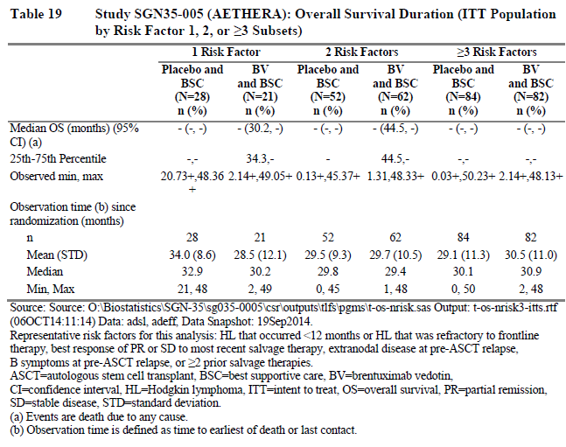
Figure 41. Study SGN35-005 Kaplan-Meier analysis of overall survival (ITT population by risk factor 1, 2 or ≥ 3 subsets
In the subset of patients with 1 risk factor, there were 5 OS events in patients randomised to brentuximab vedotin and 1 OS event in a patient randomised to placebo. Table 72 below provides further detail regarding these cases.

Table 72. Study SGN35-005 Listing of patients with an OS event (ITT population, subset of patients with 1 risk factor
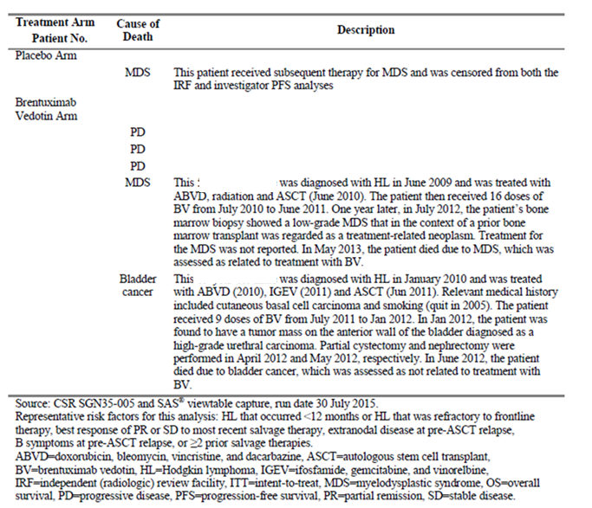
For patients with only 1 risk factor, Table 73 summarises the frequency of the 3 inclusion criteria risk factors for the AETHERA Safety Set by treatment arm. (For this subset of patients, the Safety Set and ITT subsets are the same).

Table 73. Study SGN35-005 Summary of patients with only 1 risk factor (Safety set by risk factor = 1 subset)
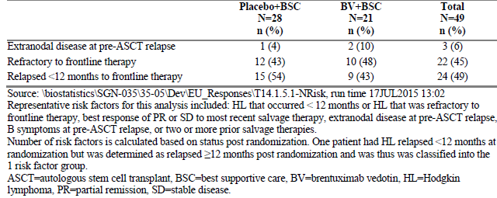
In conclusion, the results of exploratory post hoc analyses by risk factor groups show a trend for improved PFS and OS with brentuximab vedotin with an increasing number of risk factors. Neither a positive PFS nor a positive OS trend was observed in the subset of patients with only 1 risk factor (brentuximab vedotin, n = 21; placebo, n = 28); however, the small and somewhat imbalanced sample sizes complicate the interpretation of this result.

Clinical evaluator’s comment
As with Question 8 above, this analysis was requested to try to delineate the patients most likely, or least likely, to benefit from brentuximab vedotin administered as consolidative therapy after ASCT. The analysis provided suggests that patients with only one risk factor for relapse following ASCT are least likely to benefit with regard to both progression free survival and overall survival. The 21 patients with one risk factor in the placebo group may represent a subset of the 79 ‘ASCT responders’ within the placebo arm identified in the response to Question 11. As such, the presence of only one risk factor would not identify the whole group of patients least likely to benefit from brentuximab vedotin therapy but may still be useful information. The evaluator acknowledges the sponsor’s caveats to the interpretation of the analysis provided. The evaluator also notes that, despite the presence of only one risk factor for relapse following ASCT, 9 patients in the brentuximab group and 7 in the placebo group experienced progression events.

Question 13
- Subsequent anti-tumour therapy: Patients who received other anti-cancer therapy during the study are shown in Table 11-13 [see Table 26 of this document] of the SGN35-005 CSR: 72 patients in the placebo arm received brentuximab vedotin as did 9 in the brentuximab vedotin arm. Can the sponsor explain the circumstances under which patients in the brentuximab vedotin arm received brentuximab vedotin as subsequent anti-tumour therapy? Could the sponsor provide more detail regarding the two groups of patients who received brentuximab vedotin as subsequent anti-tumour therapy with respect to the timing of cessation of treatment, and commencement of brentuximab vedotin as rescue therapy, in particular was this treatment commenced during the treatment period or LTFU period? Some of the patients from the placebo arm who progressed received brentuximab vedotin through participation in Study SGN35-010. It is important that the report of this study be provided when available.

Sponsor’s response
Patients experiencing disease progression per investigator on Study SGN35-005 could be individually unblinded and, if found to have received placebo, receive subsequent therapy with brentuximab vedotin. This receipt of subsequent brentuximab vedotin did not constitute formal crossover within the design of Study SGN35-005; rather, patients could have received brentuximab vedotin either through a separate treatment option protocol (Study SGN35-010), which was not designed to capture efficacy data, or through commercial use. Further, patients may have received brentuximab vedotin after 1 or more intervening therapies, a phenomenon presumably most common among the 9 patients randomised to brentuximab vedotin who later received brentuximab vedotin retreatment.
Of note, Study SGN35-010 is ongoing and serves as a treatment option protocol across multiple other studies in addition to SGN35-005/AETHERA. No report yet exists for it.
Table 74 provides a summary of patients’ time to subsequent brentuximab vedotin use.

Table 74. Study SGN35-005 Summary of time from last dose (brentuximab vedotin or placebo) to first of any subsequent brentuximab vedotin therapy (ITT population)
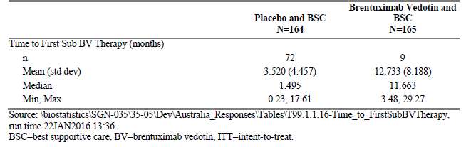

Clinical evaluator’s comment
[Response] noted. From the analysis provided of patients in the placebo arm who subsequently received brentuximab vedotin, it would appear, given the median of 1.5 months between the last treatment dose and the subsequent dose of brentuximab vedotin, that a number of patients in the placebo arm would have received brentuximab vedotin during the first 12 months of study participation. The response provided to Question 14 below indicates that 53 patients in the placebo arm had discontinued treatment within the first 5 months. With respect to the quality of life measures presented in the answer to Question 10, these patients would be confined to the placebo patients who experienced progressive disease.

Safety

Question 14
- Early Relapse Patients: It is evident from the KM curves for the primary outcome measure that most progression events occurred early (within the first 6 to 8 months) in the placebo group. On progression, patients could be discontinued from study treatments and had the option of unblinding and commencement on brentuximab vedotin – this occurred for 72 patients in the placebo arm. Could the sponsor provide a table of the data used to construct the graph in Figure 12-1 [reproduced as Figure 42 in the sponsor’s response, below] of the Study SGN35-005 CSR?

Sponsor’s response
Table 75 (below) displays the by-cycle exposure data underlying CSR Figure 12-1 (here reproduced for convenience as Figure 42).

Table 75. Study SGN35-005 Overall summary of treatment cycles (ITT population)
Figure 42. Study SGN35-005 Duration of treatment, number of cycles (ITT population)
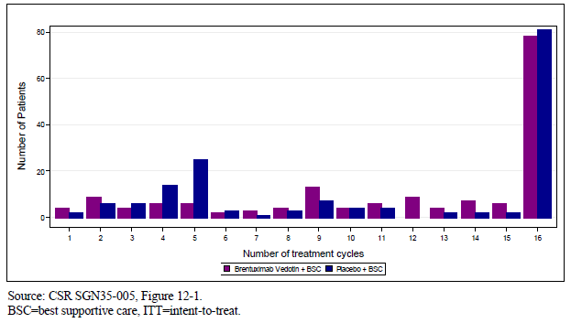
It should be noted that both Table 75 and Figure 42 above show therapy received on Study SGN35-005; receipt of subsequent brentuximab vedotin, if it occurred, was not an integrated part of the study and may have occurred either through a separate treatment option protocol (Study SGN35-010) or via commercial use.

Clinical evaluator’s comment
From the table and the graph, the majority of patients in the placebo arm who did not complete 16 cycles of treatment (53/83, 64%), discontinued at or before Cycle 5 (15 weeks into the treatment period). It may have been more informative if the evaluator had requested that this group be the subject of Question 10, rather than the patients who progressed within the first 8 months (32 weeks) as these discontinuations in the first 3 to 4 months may better represent a group that progressed early following ASCT.

Question 15
Crossover and adverse event monitoring: For the 72 patients in the placebo group who received brentuximab vedotin as anti-tumour therapy during the course of the study, can the sponsor describe how these patients were monitored for adverse events?

Sponsor’s response
Per the study protocol for Study SGN35-005, adverse events were to be followed as shown:
- All non-serious AEs were to be followed through the EOT visit or 30 days after the last study treatment (brentuximab vedotin or placebo), whichever was later.
- Serious adverse events (SAEs) were to be followed until significant changes returned to baseline, the event stabilised or was no longer considered clinically significant by the Investigator, or the patient died or withdrew consent.
- Adverse events of peripheral neuropathy were to be followed until they returned to baseline or Grade 1, the patient died or withdrew consent, or the study was closed. Certain other adverse events of interest may have been followed until resolution, return to baseline, or study closure.
It is possible that brentuximab vedotin could have been initiated during this 30 day observation period; AEs occurring during this time would have been recorded per protocol. As suggested by the minimum value in Table 74 above, this may have occurred for at least 1 patient randomised to placebo. However, as also evidenced by the 3 month mean shown for placebo patients, subsequent brentuximab vedotin was typically initiated after the 30 day safety observation period had concluded.
Patients receiving subsequent brentuximab vedotin on treatment option protocol SGN35-010 (see the sponsor’s response to Question 13 for further detail) would have had safety data collected as part of that study; patients receiving subsequent brentuximab vedotin via commercial use would have been subject to spontaneous reporting of serious adverse events.

Clinical evaluator’s comment
The placebo arm of the participant flow graphic is shown below.
Figure 43. Study SGN35-005 Participant flow in the placebo arm
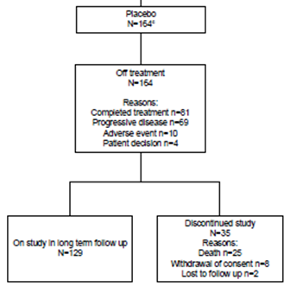
From this, 83 patients in the placebo arm discontinued treatment during the treatment period, with this due to progressive disease in 69 patients. The sponsor’s response to Question 15 shows a skewed distribution of the time from last dose (brentuximab vedotin or placebo) to first of any subsequent brentuximab vedotin therapy in the placebo group (Table 74): the mean was 3.5 months, as stated by the sponsor, but the median was 1.495 months. Half of the patients who received subsequent brentuximab vedotin therapy in the placebo arm during the treatment period would have done so within approximately 40 days of last treatment – this would be around 34 patients. How many of these received brentuximab vedotin during the adverse event reporting window of 30 days from last study drug treatment is not known, but it is likely to be considerably more than the single patient suggested by the sponsor. What contribution brentuximab vedotin therapy administered to patients in the placebo arm during the 30 day period of observation may have had on the adverse event profile of the placebo arm is not known.

Question 16
- Narratives for deaths, SAEs and discontinuations due to AEs: There were 53 patient deaths during the study: narratives are provided for only 4 of these. There were 64 patients who discontinued due to AEs, with 54 of these in the brentuximab vedotin arm. There are narratives provided for 36 patients in the brentuximab vedotin arm who discontinued due to AEs. The CSR states: Narratives for all patients who discontinued treatment because of an AE are provided in Section 14.3.3. Could the sponsor please clarify the location of the missing narratives regarding deaths and discontinuations as they could not be found in section 14.3.3 of the CSR? Could the sponsor also confirm if all narratives for SAES have been provided? The evaluator could locate narratives for 37 patients, each of whom experienced between 1 and 9 SAEs.

Sponsor’s response
In general, narratives were provided only for patients randomised to brentuximab vedotin unless otherwise specified.
Observation periods were as follows:
- Deaths
Per protocol SGN35-005, fatal outcomes within the 30 days post last dose of randomisation therapy window) are considered serious adverse events (SAEs) and reported as safety outcomes. Narratives were produced for serious (including fatal) adverse events occurring within 30 days of patients’ last dose of randomisation therapy. Fatal events sourced from the efficacy database beyond that time collected through long-term follow up overall survival were not associated with serious adverse events and thus reported as efficacy outcomes, only.
- SAEs
Serious adverse events occurring within the 30 days post last dose of randomisation therapy window were included.
The SGN35-005 clinical study report (CSR) provided narratives for deaths, serious adverse events (SAEs), and discontinuations due to adverse events (AEs) according to the following narratives plan:
- Deaths (Total N = 4)
  - Deaths within safety reporting period
  - Deaths due to AE that began on-study, regardless of safety reporting period
  - Not included: Deaths due to progression of disease
- Other SAEs (Total N = 61; Unique N = 57)
  - All related SAEs (regardless of safety reporting period)
  - All unrelated SAEs
- Discontinuations due to AEs (Total N = 61; Unique N = 39)
  - All related AE discontinuations of study drug
  - All unrelated AE discontinuations of study drug
- Medically Important Events
  - Treatment-emergent AEs (TEAEs) ONLY if fall into another category (Death, Other SAE, AE Discontinuation) for:
    - Peripheral neuropathy
    - Infusion-related reaction
    - Hematologic toxicity
    - Serious and opportunistic infection
    - Hyperglycaemia
    - Viral hepatitis
  - TEAEs all grades in active treatment group only for:
    - Pulmonary toxicity (standardised MedDRA query (SMQ)) (inclusion of placebo patients to be decided after unblinding)
    - Hepatotoxicity (system organ class (SOC) Hepatobiliary and SOC Investigations) (selected AEs)
Hepatobiliary SOC: Hepatic cirrhosis, hepatitis steatosis, hepatomegaly, hepatotoxicity, and hepatitis toxic (the coding for the last term may change to hepatotoxicity)
Investigations SOC: Hepatic enzyme increased, transaminases increased, alanine aminotransferase (ALT) increased, aspartate aminotransferase (AST) increased, and blood bilirubin increased
    - Secondary malignancies (SOC neoplasm, preferred term [PT] myelodysplastic syndrome, not PTs of tumor pain or recurrent HL)
Neoplasm SOC: Bladder, lung neoplasm malignant, mantle cell lymphoma, myelodysplastic syndrome, and pancreatic carcinoma
    - Rare but serious AEs:
Pancreatitis (PT pancreatitis, pancreatitis acute)
PT transverse/radiation myelitis
Please refer to SGN35-005 CSR Supplement 1, Additional Safety Narratives, for cases involving patients randomised to placebo [not available in this document].

Clinical evaluator’s comment
The evaluator can locate the narratives for 5 deaths, 37 SAEs, 31 discontinuations and 4 ‘other significant events’ in the CSR for SGN35-005. These numbers do not match the numbers provided in the sponsor’s response above or the numbers in a table of the CSR [not in this document]. According to this table there were:
- 41 subjects in the brentuximab vedotin arm and 20 in the placebo arm who had SAEs reported
- 54 subjects in the brentuximab vedotin arm who discontinued treatment due to AEs.
Narratives for most of the patients in the brentuximab arm who experienced SAEs have been provided, assuming deaths were considered SAEs. Narratives for many of the patients who discontinued due to AES appear not to have been provided (23/54). It may be that these patients also had SAEs and so have been included in the SAE narratives but this has not been established by the sponsor.
The narratives provided in the sponsor’s response were read by the evaluator. These included narratives for reported infusion related reactions with ATA results. Information from these narratives has been included in the Round 2 CER.

Question 17
- Pulmonary toxicity with monotherapy: A review of this is provided in PSUR 4. This concluded that, although the sponsor did not find clear evidence of a causal relationship between brentuximab vedotin use and pulmonary toxicity, a causal relationship (i.e. potential risk) could not be ruled out. It was also noted that ‘Further characterization of the risk is pending completion of the AETHERA trial’. The results of Study SGN35-005 (AETHERA) were presented elsewhere in PSUR 5 with the note that ‘More patients in the brentuximab vedotin arm experienced pulmonary toxicity than in the placebo arm (5% versus 3%)’ Can the sponsor provide an updated assessment of the risk of pulmonary toxicity with monotherapy that includes the results of Study SGN35-005 and an updated cumulative review?

Clinical evaluator’s comment
The sponsor provided a cumulative review of all cases of non-infectious interstitial lung disease reported in any company associated trial that included a brentuximab vedotin monotherapy arm, including Study SGN35-005, to a data lock point of March 2015. Information from this review has been added to the Round 2 CER (see Section 8.6.3, Pulmonary toxicity above). The full text of the review can be found in the sponsor’s document [not produced in this document]. This document has also been attached to the appendix of this evaluation report.
As a result of the review the Company Core Data Sheet was updated to:
‘Pulmonary Toxicity:
Cases of pulmonary toxicity, including pneumonitis, interstitial lung disease, and acute respiratory distress syndrome (ARDS), some with fatal outcomes, have been reported in patients receiving Adcetris. Although a causal association with Adcetris has not been established, the risk of pulmonary toxicity cannot be ruled out. In the event of new or worsening pulmonary symptoms (e.g. cough, dyspnea), a prompt diagnostic evaluation should be performed and patients should be treated appropriately. Consider holding Adcetris dosing during evaluation and until symptomatic improvement’.
The sponsor has proposed that the PI be similarly updated.

Question 18
- Hepatotoxicity: Can the sponsor also provide an updated cumulative review of the risk of hepatotoxicity with brentuximab vedotin that includes the results of Study SGN35-005?

Clinical evaluator’s comment
The sponsor provided a review of all cases in the Global Safety Database with the Data Lock of 18 February 2015 (consistent with PSUR 5) for all cases that coded to any of the preferred terms (PTs) in the Hepatotoxicity SMQs as defined in the EU-RMP. An additional review with a data lock point of 18 August 2015 that was conducted in September 2015 was also provided. Information from these reviews has been added to Section 8.6.2 Liver toxicity, of the Round 2 CER.
On the basis of these reviews the sponsor has updated the CCDS and proposes that the PI be similarly updated to:
‘Hepatotoxicity in the form of elevations in alanine aminotransferase (ALT) and aspartate aminotransferase (AST) have been reported with brentuximab vedotin. Serious cases of hepatotoxicity, including fatal outcomes, have also occurred. Pre-existing liver disease, comorbidities, and concomitant medications may also increase the risk. Liver function should be tested before initiating the treatment and routinely monitored during the treatment in patients receiving brentuximab vedotin. Patients experiencing hepatotoxicity may require a delay, change in dose or discontinuation of brentuximab vedotin.’

Second round summary of clinical data submitted in response to questions
A considerable amount of data was provided in response to TGA questions and to questions arising from these responses. Relevant clinical information, together with its evaluation and new insights resulting from the information provided, have been incorporated into the body of the Round 2 Clinical Evaluation Report above. The evaluation of the sponsor’s response to individual clinical questions has also been provided as a ‘clinical evaluator’s comment’ following the sponsor’s response in the section above.
The evaluator has been left with some major concerns regarding the proposed usage of brentuximab vedotin. Of these, the most important is how those patients who would otherwise be cured by ASCT alone may be identified so that they are not unnecessarily exposed to the risks of consolidative treatment with brentuximab vedotin. Other concerns relate to the safety in special populations: the elderly, children, patients with impaired organ function (cardiac, renal and hepatic).

Second round benefit-risk assessment
Comment: The Second Round assessments of Benefits, Risks and Benefit-risk balance have incorporated information from the sponsor’s responses to clinical questions and contain some differences from the First Round assessments.

Second round assessment of benefits
After consideration of the responses to clinical questions, the benefit of brentuximab vedotin in the proposed usage is a substantial increase in progression free survival when used following ASCT for adult patients with relapsed or refractory CD 30+ Hodgkin Lymphoma at increased risk of progression following ASCT. This increase was clinically relevant and statistically significant. However, the demonstrated increase in progression free survival did not translate into an improved quality of life so it cannot be said that patients were both remaining disease free for longer and ‘living better’. The increase in progression free survival also did not translate into an increase in overall survival, although overall survival results were immature at the time of the analysis.
The patient population in the pivotal study presented was heterogeneous with regard to risk of progression following ASCT and subgroup analyses showed that all groups did not receive equal benefits from brentuximab vedotin. Those groups at highest risk of progression according to historical data (refractory disease after frontline therapy, > 2 treatment lines prior to ASCT, B symptoms at the time of relapse prior to ASCT, partial response to salvage therapy and the presence of 3 or more risk factors) appeared more likely to benefit. The group historically at low risk of progression (relapse after 12 months, ≤ 2 prior treatment lines, absence of B symptoms after frontline therapy, CR following salvage therapy) appeared to gain little benefit in terms of PFS with brentuximab vedotin. One subgroup at low risk of progression, as shown by the presence of only one risk factor, appeared to fare worse with brentuximab vedotin.
Better characterisation of patients at greatest risk of progression and/or at least risk may enable better targeting of this therapy. Apart from identifying the patients with one risk factor as a group least likely to benefit and the group with 3 or more risk factors as more likely to progress, the additional subgroup analyses requested by the evaluator were unhelpful with regards to this desired better characterisation. It is possible that an absolute determination of the patients group that is most likely to benefit and least likely to be harmed with brentuximab vedotin in the proposed usage is not possible with currently available information.

Second round assessment of risks
After consideration of the responses to clinical questions, the risks of brentuximab vedotin in the proposed usage are those of morbidity and mortality due to adverse events or complications of brentuximab vedotin therapy. There is also the risk that, despite the increase in progression free survival, quality of life may not be improved and the patients may receive little benefit from the extra months of life.

Morbidity and mortality due to complications of therapy
Complications of brentuximab vedotin treatment may be divided into predictable and idiosyncratic.

Predictable complications
Adverse events are common with brentuximab vedotin therapy (88% of patients in the brentuximab arm of Study SGN35-005 experienced TEAEs). Their occurrence is believed to be due to ‘off-target’ effects of free MMAE and to the effects on non-malignant CD30+ lymphocytes. The following adverse events have been observed with brentuximab vedotin therapy.
- Neutropaenia is reported in over a third of patients during brentuximab vedotin therapy. It may be prolonged (≥ 1 week) or severe (Grade 3 or Grade 4). It can usually be managed by monitoring, dose delay and growth factor support. However, febrile neutropaenia has been reported as an SAE in 8% of patients receiving brentuximab vedotin and deaths from this have been described.
- Peripheral neuropathy is a cumulative dose dependent toxicity that has been described in almost half of the patients receiving brentuximab vedotin, and may be severe. It may be managed by dose reduction or discontinuation and is usually reversible, but this may take a prolonged time (median 16 weeks). Peripheral neuropathy was the cause of treatment discontinuation in 21% of patients in the brentuximab vedotin arm of Study SGN35-005.
- Serious infections, such as pneumonia, staphylococcal bacteraemia, sepsis/septic shock (including fatal outcomes), and opportunistic infections such as oral candidiasis, Pneumocystis jirovecii pneumonia and herpes zoster, have been reported in patients treated with brentuximab vedotin. These have resulted in fatal outcomes
- Tumour lysis syndrome has been reported infrequently but has been associated with fatal outcome
- Infusion related reactions occur commonly during brentuximab vedotin therapy and have included fatal anaphylaxis. The relationship of these reactions to the development of anti-therapeutic antibodies to brentuximab vedotin cannot be determined due to issues related to the ATA assay used.

Idiosyncratic reactions
A number of rare, unpredictable adverse events have been reported with brentuximab vedotin therapy. A clear causal relationship has not been identified for all of the complications listed below but they have been recognised as important risks (‘identified’ or ‘potential’). Cumulative reviews performed in 2015 have strengthened the concerns related to hepatoxicity and pulmonary toxicity. Gastrointestinal complications were recognised as an important potential risk, also in 2015. The complications listed here have all been associated with fatal outcome:
- Acute pancreatitis
- Hepatotoxicity. This may occur in 1% of patients receiving brentuximab vedotin and is usually a mild, reversible hepatocellular injury. However, fulminant hepatitis has also been described in patients receiving brentuximab vedotin.
- Stevens Johnson Syndrome and Toxic Epidermal Necrolysis
- Progressive Multifocal Leukoencephalopathy (PML)
- Infusion related reactions, including life-threatening anaphylaxis
- Pulmonary toxicity with cough, dyspnoea and lung infiltrates. Acute respiratory distress syndrome (ARDS) has also been reported.
- Gastrointestinal complications
- Secondary malignancies
The risk of death from each of these adverse events or reactions is small. The cumulative risk of death from these possible complications of brentuximab vedotin treatment can be approximated from data provided in the most recent PSUR (PSUR 6) and data from the cumulative reviews provided by the sponsor in response to clinical questions.

Table 75. Approximate risk of death due to adverse events with fatal outcome reported with use of brentuximab vedotin
Complication | Fatality rate (%) | Source, number of fatal events/population
Peripheral neuropathy | 0.006 | Post marketing sources 1/16238
Tumour lysis syndrome | 0.012 | Post marketing sources 2/16238
Febrile neutropaenia | 0.07 | Clinical Study Programme 2/2962
Anaemia, thrombocytopenia | 0.03 | Post marketing sources 5/16238
Infection Including Bacteraemia/Sepsis/Septic Shock | 0.6 | Clinical Study Programme 18/2962
Opportunistic infection | 0.07 | Clinical Study Programme 2/2962
Infusion related reactions | 0.07 | Clinical Study Programme 2/2962
PML | 0.04 | All sources 9/22240
SJS/TEN | 0.03 | Clinical Study Programme 1/2962
Acute pancreatitis | 0.04 | Post marketing sources 7/16238
Hepatotoxicity* | 0.11 | ‘Solicited sources’ 6/5475
Pulmonary toxicity (monotherapy)* | 0.53 | Company sponsored studies (monotherapy) 3/562
Gastrointestinal complications | 0.11 | Clinical trials 6/5748
Secondary malignancy | ? | ?
Total | 1.68
Sources: PSUR 6 Section 16 data tables, * Cumulative reviews of pulmonary toxicity and hepatotoxicity provided in the Sponsor’s response to clinical question.
Analysis assumes 1) all deaths were due to the reported AE and that these, in turn, were due to brentuximab vedotin; 2) individual cases were not reported for more than one category; 3) no data regarding the incidence and fatality rate of secondary malignancies was available
Other risks due to complications of brentuximab vedotin therapy relate to missing information. Safety in the elderly, children, and patients with cardiac impairment has not been established. The safety in the setting of possible risk factors for complications such as pre-existing hepatic impairment and hepatotoxicity and pre-existing lymphomatous involvement of the gastro-intestinal tract and bowel perforation has not been established. The relationship of anti-therapeutic antibodies to safety and efficacy has not been determined. Given that brentuximab vedotin has only been available commercially for 4 years, there may be other rare complications and delayed complications that have yet to be identified.

Quality of life
This was assessed in Study SGN35-005. According to the instrument used (EQ-5D), quality of life reported by study participants for the 24 month duration of the study was no better for the patients who received brentuximab vedotin compared to placebo. The ability of this instrument to detect changes in quality of life must be questioned, though, as there was minimal change in quality of life across the study for all patients who did not develop progressive disease. This is surprising as the baseline measure was taken within 30-45 days of autologous stem cell transplant and an improvement in quality of life may have been expected as patients recovered from this. Other markers of the quality of life impact of brentuximab vedotin therapy in this study may be the number of patients who discontinued treatment due to adverse events and any changes in the ECOG status of patients during the study. Of the patients receiving brentuximab vedotin, 32% discontinued treatment due to AEs, compared to 6% in the placebo arm. Peripheral neuropathy (motor and/or sensory) was the most common reason for patients in the brentuximab vedotin arm to cease treatment (21%). The severity of peripheral neuropathy is variable but is usually reversible. This may, however, take some months and could be expected to impact on the patient’s quality of life during this time. Each patient’s ECOG status was assessed regularly throughout the study. In comparison to baseline, ECOG status remained unchanged for many patients. However, it was noted to worsen in 59 patients (36%) in the brentuximab vedotin arm compared to 39 patients (25%) in the placebo arm and to improve in 36 patients (22%) in the brentuximab vedotin arm compared to 43 patients (27%) in the placebo arm.

Second round assessment of benefit-risk balance
The benefit-risk balance of brentuximab vedotin is unfavourable for the proposed usage, but could become favourable if the changes recommended in this section (Second round assessment of benefit-risk balance) and changes recommended regarding the draft PI [not included in this document] are adopted.
The evaluator recognises the importance of the improved progression free survival demonstrated in the pivotal study but is concerned by the lack of improvement in quality of life and the lack of benefit in overall survival. It is not clear to the evaluator that the use of brentuximab vedotin as adjuvant therapy offers a meaningful improvement over its use as rescue therapy. The evaluator is also concerned that, with the proposed usage, there will inevitably be patients who would otherwise have been cured by ASCT who will be exposed to the potentially fatal complications associated with brentuximab vedotin. Individually these potentially fatal adverse effects are rare. However, together they add up to a substantial risk to the patients.
The evaluator is also of the opinion that the potential risks associated with brentuximab vedotin have not, as yet, been fully characterised. Brentuximab vedotin has been available in the wider non-trial population for only a few years – it was first approved for marketing in the US in 2011. During this time, the concerns regarding toxicity of brentuximab vedotin have increased considerably due to the progressive recognition of many of the life-threatening complications associated with treatment that have been detailed above. An example of this is the identification of the association with potentially fatal gastrointestinal complications that has occurred in just the last few months.
Under the currently approved indications, patients receiving brentuximab vedotin have poor prognosis and no other less toxic therapeutic options. At the time of this approval in December 2013, the Delegate noted:
‘The most significant common toxicity was peripheral neuropathy, which may detract from quality of life and may require discontinuation from treatment. There were rarer, more serious AEs, for example anaphylaxis; Stevens Johnson syndrome (SJS)/TEN; possibly PML (the signal for this latter AE was difficult to distinguish from baseline).’
As detailed above, the risk profile for brentuximab vedotin has worsened since the approval as a NCE. In those patients who are treated under the current indications, and for whom the prognosis is very poor and alternative therapies of little benefit, the risks associated with brentuximab vedotin would remain acceptable. However, with the proposed usage, patients who would be cured by ASCT alone will be exposed to brentuximab vedotin. The risks to these patients are considerable and the benefit nil. Unfortunately, with the information provided by the sponsor, those patients who would not benefit from this adjuvant therapy cannot be identified.
For brentuximab vedotin to be considered for adjuvant therapy, several measures are required to ensure that appropriately informed prescribing (within the limits of current knowledge) occurs, that patients are fully cognisant of the potential risks and benefits and that timely emergency care is provided to patients developing potentially life-threatening complications. This will require:
- Substantial rewording of the proposed indication to:
‘Treatment of adult patients with CD30+ HL at high risk of relapse or progression following ASCT, as shown by the presence of two or more risk factors (see Clinical Trials).
This indication was approved based on promising progression free survival in a placebo controlled trial. The data did not demonstrate an increased survival or improved quality of life with Adcetris’.
- Explicit recognition of the risks associated with the use of brentuximab vedotin is required in both the PI and CMI is essential to ensure most appropriate prescribing and informed consent. This should include a boxed warning at the beginning of the PI and CMI as shown:
Figure 44 Boxed warning for the PI
Serious Warnings and Precautions
Clinically significant and/or life threatening and/or fatal adverse events have been reported with the use of Adcetris.
These include: JC virus infection resulting in progressive multifocal leukoencephalopathy (PML), serious and opportunistic infections, Stevens-Johnson Syndrome/Toxic Epidermal Necrolysis, hepatotoxicity, pulmonary toxicity, acute pancreatitis and gastrointestinal complications
(see Precautions)
Figure 45. Boxed warning for the CMI
Fatal complications have occurred with brentuximab vedotin treatment. These include lung injury, liver injury, serious infections, pancreatitis, allergic reactions, blistering skin reactions and a rare brain infection called progressive multifocal leukoencephalopathy (PML). Ask your doctor to find out more about these and to discuss your personal situation.
Other changes to the proposed PI and CMI as recommended by the evaluator [are beyond the scope of this document]. To assist the prescriber in providing the necessary information to the patient, the PI should include a ‘Patient Counselling Section’.
- A registry of the use of brentuximab vedotin as both rescue and adjuvant use in the Australian population. This will provide ‘real-world data’ of safety and efficacy and may assist in better characterisation of identified safety concerns and in the recognition of any new safety concerns. Reliance on voluntary reporting of adverse events is inadequate for this. The financial cost of this registry should be borne by the sponsor.
- A patient safety card with information on one side that advises the patient of when to seek urgent medical attention and information on the other side to advise medical practitioners providing emergency care of the complications unique to this medication. [Further discussion of this is beyond the scope of this document].
- A healthcare professional information brochure to provide easily accessible information for all healthcare professionals involved in the care of the patients receiving brentuximab vedotin should be available. This should supplement but not replace the PI and should be provided for display in locations in which brentuximab vedotin will be administered. [Further discussion of the draft-PI is beyond the scope of this document].
In addition, further studies to assist in identification of the group that progress early and receive little benefit from brentuximab vedotin and the group that respond well to ASCT alone would enable those patients most likely to benefit receive the therapy and those least likely to benefit, or who may be harmed by the therapy, do not receive it.

Second round recommendation regarding authorisation
The second round recommendation regarding authorisations is unfavourable, but could become favourable if the changes recommended in Section 13.3 above and changes recommended to the product documentation are adopted. The evaluator is also of the opinion that it may be helpful to obtain advice from independent Australian specialists experienced in the care of patients with relapsed/refractory Hodgkin Lymphoma to assist in the decision making process.
The evaluator considers that the decision regarding approval of brentuximab vedotin for the proposed extension of indication is complex. Of note is that submissions for the same extension of indication and using the same dataset were made to the FDA on 18 February 2015 and to the EMA on 11 March 2015. From publically available information, these submissions have had different outcomes.
- The extension of indication was approved in August 2015 by the FDA with the wording: ‘Classical HL at high risk of relapse or progression as post-auto-HSCT consolidation’. In the approved labelling, the reader is referred to the Clinical Trials section where ‘High risk of post-auto-HSCT relapse or progression was defined according to status following frontline therapy: refractory, relapse within 12 months, or relapse ≥ 12 months with extra-nodal disease. Patients were required to have obtained a CR, PR, or stable disease (SD) to most recent pre-auto-HSCT salvage therapy’.
- At the time of this evaluation, no decision had been reached as yet by the EMA and no final recommendation had been made by the CHMP. According to publically available documents, the sponsor’s application was discussed at both the June 2015 and October 2015 CHMP meetings and is to be discussed again at the April 2016 meeting. The June 2015 meeting minutes note that the ‘The Committee agreed to seek clarification on the benefit/risk in the proposed extension of indication with specific focus on the target population’. The October meeting minutes note that a discussion of issues identified in the application focussed on ‘the clinical efficacy and the outcome seen for progression free survival versus overall survival. Furthermore the safety profile was discussed in relation to the drop-out rate of the clinical trial.’ The publically available agenda for the April 2016 CHMP meeting has the proposed extension of indication for discussion again, with this including an ‘Oral explanation, report by Prof Jonas Bergh from SAG Oncology meeting held on 14 April 2016’ and notes that an additional request for supplementary information was made in January 2016.

References
Australian Institute of Health and Welfare (AIHW) 2015. Australian Cancer Incidence and Mortality (ACIM) books: Hodgkin Lymphoma. Canberra: AIHW. http://www.aihw.gov.au/acim-books
Eichenauer DA et al, ESMO Guidelines Working Group. Hodgkin's lymphoma: ESMO Clinical Practice Guidelines for diagnosis, treatment and follow-up. Ann Oncol. 2014 Sep;25 Suppl 3
Lavoie JC, Connors JM, Phillips GL, Reece DE, Barnett MJ, Forrest DL, et al. High-dose chemotherapy and autologous stem cell transplantation for primary refractory or relapsed Hodgkin lymphoma: Long-term outcome in the first 100 patients treated in Vancouver. Blood 2005;106:1473-8
Majhail NS, et al. Long-term results of autologous stem cell transplantation for primary refractory or relapsed Hodgkin's lymphoma. Biology of Blood & Marrow Transplantation 2006;12(10):1065-72
Sirohi, B., et al. Long-term outcome of autologous stem-cell transplantation in relapsed or refractory Hodgkin's lymphoma Annals of Oncology 2008;19(7): 1312-1319
Sureda A, et al. Prognostic factors affecting long-term outcome after stem cell transplantation in Hodgkin's lymphoma autografted after a first relapse. Annals of Oncology 2005;16(4):625-33
Moskowitz, A. J., et al. Pretransplantation functional imaging predicts outcome following autologous stem cell transplantation for relapsed and refractory Hodgkin lymphoma. Blood 2010; 116(23): 4934-4937
von Tresckow, B., et al. (2014). ‘Outcome and risk factors of patients with Hodgkin Lymphoma who relapse or progress after autologous stem cell transplant.’ Leukemia & Lymphoma 55: 1922-1924
Gopal et al. Durable remissions in a pivotal phase 2 study of brentuximab vedotin in relapsed or refractory Hodgkin lymphoma. Blood. 2015;125(8):1236-1243
Moskowitz A, Perales MA, Kewalramani T, et al. Outcomes for patients who fail high dose chemoradiotherapy and autologous stem cell rescue for relapsed and primary refractory Hodgkin lymphoma. Br J Haematol 2009;146:158-163
Ferme C, Mounier N, Divine M, Brice P, Stamatoullas A, Reman O, Voillat L, Jaubert J, Lederlin P, Colin P, Berger F and Salles G (2002). Intensive salvage therapy with high-dose chemotherapy for patients with advanced Hodgkin's disease in relapse or failure after initial chemotherapy: results of the Groupe d'Etudes des Lymphomes de l'Adulte H89 Trial. J ClinOncol 20: 467-75.
Moskowitz AJ, Yahalom J, Kewalramani T, Maragulia JC, Vanak JM, Zelenetz AD and Moskowitz CH. Pretransplantation functional imaging predicts outcome following autologous stem cell transplantation for relapsed and refractory Hodgkin lymphoma. Blood 2010;116: 4934-7.
Younes A, Gopal AK, Smith SE, Ansell SM, Rosenblatt JD, Savage KJ, Ramchandren R, Bartlett NL, Cheson BD, de Vos S, Forero-Torres A, Moskowitz CH, Connors JM, Engert A, Larsen EK, Kennedy DA, Sievers EL, Chen R. Results of a pivotal phase II study of brentuximab vedotin for patients with relapsed or refractory Hodgkin's lymphoma. J Clin Oncol. 2012 Jun 20;30(18):2183-9
Australian Public Assessment Report for brentuximab vedotin; Proprietary Product Name: Adcetris. Sponsor: Takedo Pharmaceuticals Australia Pty Ltd. Date of AusPAR May 2014. Therapeutic Goods Administration.
Gopal et al. Durable remissions in a pivotal Phase II study of brentuximab vedotin in relapsed or refractory Hodgkin lymphoma. Blood. 2015;125(8):1236-1243
Australasian Bone Marrow Transplant Recipient Society Annual Data Summary 2014. Provided with the Sponsor’s Responses to the Milestone 3 and RMP Reports, Including Responses to Comments on the Draft PI and CMI
Vaklavas C, Forero-Torres A. Safety and efficacy of brentuximab vedotin in patients with Hodgkin lymphoma or systemic anaplastic large cell lymphoma. Ther Adv Hematol (2012) 3(4) 209–225
PBS listing of brentuximab vedotin
Final Minutes CHMP 22 to 25 June 2015 meeting for publication.
Final Minutes CHMP 19 to 22 October 2015 meeting for publication
Section VI. Overall conclusion and risk/benefit assessment (pp47-52), Australian Public Assessment Report for brentuximab vedotin; Proprietary Product Name: Adcetris. Sponsor: Takedo Pharmaceuticals Australia Pty Ltd. Date of AusPAR May 2014. Therapeutic Goods Administration.
European Medicines Agency Assessment Report Adcetris (brentuximab vedotin) dated July 2012
Moskowitz et al. Brentuximab vedotin as consolidation therapy after autologous stem cell transplantation in patients with Hodgkin’s Lymphoma at risk of relapse or progression (AETHERA): a randomised, double-blind, placebo-controlled phase 3 trial. Lancet 2015; 385: 1853-62
EMA Adcetris – Procedural steps taken and scientific information after the authorisation EMA/79642/2016
Transcript of the FDA CDER Meeting of the Oncologic Drugs Advisory Committee 14/07/2011 Morning session, page 131.
FDA Supplement Approval Letter dated 4 March 2016
Adcetris FDA prescribing information, FDA Approval letter
FDA approved label dated March 2016.

Therapeutic Goods Administration
PO Box 100 Woden ACT 2606 Australia
Email: info@tga.gov.au Phone: 1800 020 653 Fax: 02 6232 8605
https://www.tga.gov.au

Australian Institute of Health and Welfare (AIHW) 2015. Australian Cancer Incidence and Mortality (ACIM) books: Hodgkin Lymphoma. Canberra: AIHW.
Eichenauer D et al, ESMO Guidelines Working Group. Hodgkin's lymphoma: ESMO Clinical Practice Guidelines for diagnosis, treatment and follow-up. Ann Oncol. 2014 Sep;25 Suppl 3.
Lavoie J et al. High-dose chemotherapy and autologous stem cell transplantation for primary refractory or relapsed Hodgkin lymphoma: Long-term outcome in the first 100 patients treated in Vancouver. Blood 2005;106:1473-8.
Majhail N et al. Long-term results of autologous stem cell transplantation for primary refractory or relapsed Hodgkin's lymphoma. Biology of Blood & Marrow Transplantation 2006;12(10):1065-72.
Sirohi, B et al. Long-term outcome of autologous stem-cell transplantation in relapsed or refractory Hodgkin's lymphoma Annals of Oncology 2008;19(7): 1312-1319.
Sureda A et al. Prognostic factors affecting long-term outcome after stem cell transplantation in Hodgkin's lymphoma autografted after a first relapse. Annals of Oncology 2005;16(4):625-33.
Moskowitz A et al. Pre-transplantation functional imaging predicts outcome following autologous stem cell transplantation for relapsed and refractory Hodgkin lymphoma. Blood 2010; 116(23): 4934-4937.
von Tresckow B et al. (2014). ‘Outcome and risk factors of patients with Hodgkin Lymphoma who relapse or progress after autologous stem cell transplant.’ Leukemia & Lymphoma 55: 1922-1924.
Gopal et al. Durable remissions in a pivotal phase 2 study of brentuximab vedotin in relapsed or refractory Hodgkin lymphoma. Blood. 2015;125(8):1236-1243.
Moskowitz A, et al. Outcomes for patients who fail high dose chemoradiotherapy and autologous stem cell rescue for relapsed and primary refractory Hodgkin lymphoma. Br J Haematol 2009;146:158-163.
Ferme C et al. (2002). Intensive salvage therapy with high-dose chemotherapy for patients with advanced Hodgkin's disease in relapse or failure after initial chemotherapy: results of the Groupe d'Etudes des Lymphomes de l'Adulte H89 Trial. J ClinOncol 20: 467-75.
Moskowitz A, et al. Pre-transplantation functional imaging predicts outcome following autologous stem cell transplantation for relapsed and refractory Hodgkin lymphoma. Blood 2010;116: 4934-7.
Younes A et al. Results of a pivotal Phase II study of brentuximab vedotin for patients with relapsed or refractory Hodgkin's lymphoma. J Clin Oncol. 2012 Jun 20;30(18):2183-9
Australian Public Assessment Report for brentuximab vedotin; Proprietary Product Name: Adcetris. Sponsor: Takeda Pharmaceuticals Australia Pty Ltd. Date of AusPAR May 2014. Therapeutic Goods Administration.
Gopal et al. Durable remissions in a pivotal phase 2 study of brentuximab vedotin in relapsed or refractory Hodgkin lymphoma. Blood. 2015;125(8):1236-1243
Accessed June 2015 at www.clinicaltrials.gov using search term ‘brentuximab vedotin AND Hodgkin Lymphoma’
Australasian Bone Marrow Transplant Recipient Society Annual Data Summary 2014. Provided with the sponsor’s Responses to the Milestone 3 and RMP Reports, Including Responses to Comments on the Draft PI and CMI.
Vaklavas C et al. Safety and efficacy of brentuximab vedotin in patients with Hodgkin lymphoma or systemic anaplastic large cell lymphoma. Ther Adv Hematol (2012) 3(4) 209–225.
Section VI. Overall conclusion and risk/benefit assessment, Australian Public Assessment Report for brentuximab vedotin; Proprietary Product Name: Adcetris. Sponsor: Takeda Pharmaceuticals Australia Pty Ltd. Date of AusPAR May 2014. Therapeutic Goods Administration, Canberra.
European Medicines Agency Assessment Report: Adcetris (brentuximab vedotin) dated July 2012.
Moskowitz et al. Brentuximab vedotin as consolidation therapy after autologous stem cell transplantation in patients with Hodgkin’s Lymphoma at risk of relapse or progression (AETHERA): a randomised, double-blind, placebo-controlled phase 3 trial. Lancet 2015; 385: 1853-62
EMA Adcetris: Procedural steps taken and scientific information after the authorisation EMA/79642/2016
Online transcript of the FDA CDER Meeting of the Oncologic Drugs Advisory Committee 14 July 2011 Morning session, page 131.
FDA Supplement Approval Letter dated 04 March 2016.
FDA Supplemental Biologics License Applications (sBLA) approval: BLA 125388/S-080; BLA 125388/S-081. 17 August 2015.
On 26 May 2016, the Committee for Medicinal Products for Human Use (CHMP) adopted a positive opinion recommending a change to the terms of the marketing authorisation for the medicinal product Adcetris. The marketing authorisation holder for this medicinal product is Takeda Pharma A/S. The CHMP adopted a new indication as follows: ‘Adcetris is indicated for the treatment of adult patients with CD30+ HL at increased risk of relapse or progression following ASCT (see section 5.1)’. For information, the full indications for Adcetris will be as follows1: ‘Adcetris is indicated for the treatment of adult patients with relapsed or refractory CD30+ Hodgkin lymphoma (HL) following autologous stem cell transplant (ASCT) or following at least two prior therapies when ASCT or multi-agent chemotherapy is not a treatment option.’

