PRODUCT INFORMATION

XEOMIN® powder for solution for injection (50 LD₅₀ Units or 100 LD₅₀ Units)
incobotulinumtoxinA
Purified neurotoxin free from complexing proteins

NAME OF THE MEDICINE

Active ingredient

incobotulinumtoxinA

Chemical Structure

The active ingredient is synthesised by Clostridium botulinum type A as a single chain protein (1,296 amino acid residues), which is subsequently split between residues 448 and 449 by an endogenous protease, during post translational modification. This results in a heavy chain, with a molecular weight of ~100 kD, and a light chain, with a molecular weight of ~50 kD. These separate chains are covalently linked via a disulfide bond. The light chain is associated with one atom of zinc. The protein exists in a monomeric form under normal conditions.

DESCRIPTION

Native botulinum toxin is a high molecular weight complex, which, in addition to the toxin (150 kD), contains other bacterial non-toxic proteins, like haemagglutinins and non-haemagglutinins. In contrast to conventional preparations containing the botulinum toxin A complex, Xeomin contains pure (150 kD) toxin since it is free from complexing proteins and thus has a low foreign protein content. The foreign protein content administered is considered as one of the factors for secondary therapy failure.

IncobotulinumtoxinA is produced from the fermentation of Clostridium botulinum and is subsequently purified to remove complexing proteins. It consists of the purified neurotoxin which has been separated from complexing proteins (haemagglutinins and a non-toxic non-haemagglutinating protein) during production. The formulated product solution is sterile filtered prior filling into vials and subsequent lyophilisation. The final product is a white to off-white solid which is sealed under nitrogen in Type I glass vials. Xeomin is reconstituted for use using 0.9% physiological saline.

Each vial of Xeomin powder for solution for injection contains 50 or 100 LD₅₀ units of incobotulinumtoxinA. One unit corresponds to the median lethal dose (LD₅₀) when the reconstituted product is injected intraperitoneally into mice under defined conditions.

Each vial of Xeomin powder for solution for injection also contains 4.7 mg sucrose and 1.0 mg albumin (human).

PHARMACOLOGY

Pharmacodynamics

Pharmacotherapeutic group: other muscle relaxants, peripherally acting agents [ATC code: M03AX01]

IncobotulinumtoxinA blocks cholinergic transmission at the neuromuscular junction by inhibiting the release of acetylcholine from peripheral cholinergic nerve terminals. This inhibition occurs according to the following sequence:

- heavy chain of toxin binding to cholinergic nerve terminals
- internalization of the toxin within vesicles into the nerve terminal
- translocation of the light-chain of the toxin molecule into the cytosol of the nerve terminal
- enzymatic cleavage of SNAP25, a presynaptic target protein essential for the release of acetylcholine.

Complete recovery of endplate function/impulse transmission after intramuscular injection normally occurs within 3-4 months as nerve terminals sprout and reconnect with the muscle endplate and the presynaptic neurotransmitter release mechanism becomes functional again.

Pharmacokinetics

Classical absorption, distribution, metabolism and elimination studies cannot be conducted with incobotulinumtoxinA because the active substance is applied in such small quantities (picograms per injection), and because it binds so rapidly and irreversibly to cholinergic nerve terminals.

Human pharmacokinetic studies with Xeomin have not been performed for the reasons detailed above.

CLINICAL TRIALS

Cervical Dystonia

Xeomin has been investigated in a Phase 3, randomised, double-blind, placebo-controlled, multi-centre trial in a total of 233 patients with cervical dystonia. Patients had a clinical diagnosis of predominantly rotational cervical dystonia, with baseline Toronto Western Spasmodic Torticollis Rating Scale (TWSTRS) total score ≥20, TWSTRS severity score ≥10, TWSTRS disability score ≥3, and TWSTRS pain score ≥1. For patients who had previously received a botulinum toxin treatment for cervical dystonia, the trial required that ≥10 weeks had passed since the most recent botulinum toxin administration. Patients with swallowing disorders or any significant neuromuscular disease that might interfere with the study were excluded from enrolment.

Patients were randomised (1:1:1) to receive a single administration of Xeomin 240 Units (n=81), Xeomin 120 Units (n=78), or placebo (n=74). Each patient received a single administration of 4.8 mL of reconstituted study agent (Xeomin 240 Units, Xeomin 120 Units, or placebo). The investigator decided which muscles would receive injections of the study agent, the number of injection sites, and the volume at each site. The muscles most frequently injected were the splenius capitis/semispinalis, trapezius, sternocleidomastoid, scalene, and levator scapulae muscles. The median dose of Xeomin administered was 120 U, 25% of patients given Xeomin received between 186 and 300 U and 25% of patients given Botox received doses between 180 and 280 U.

Most patients received a total of 2-10 injections into the selected muscles. Patients were assessed by telephone at one week post-injection, during clinic visits at Weeks 4 and 8, and then by telephone assessments or clinic visits every two weeks up to Week 20.

The mean age of the study patients was 53 years, and 66% of the patients were women. At study baseline, 61% of patients had previously received a botulinum toxin as treatment for cervical dystonia.

The primary efficacy endpoint was the change in the TWSTRS total score from baseline to Week 4 post-injection, in the intent-to-treat (ITT) population, with missing values replaced by the patient’s baseline value. In the ITT population, the difference between the Xeomin 240 Unit group and the placebo group in the change of the TWSTRS total score from baseline to Week 4 was -9.0 points, 95% confidence interval (CI) -12.0; -5.9 points; the difference between the XEOMIN 120 Unit group and the placebo group in the change of the TWSTRS total score from baseline to Week 4 was -7.5 points, 95% CI -10.4; -4.6 points.

Figure 1 illustrates the cumulative percentage of patients from each of the three treatment groups who had attained the specified change in TWSTRS Score from baseline versus 4 weeks post-injection. Three change scores have been identified for illustrative purposes, and the percent of patients in each group achieving that result is shown.

The curves demonstrate that both patients assigned to placebo and Xeomin have a wide range of responses, but that the active treatment groups are more likely to show greater improvements. A curve for an effective treatment would be shifted to the left of the curve for placebo, while an ineffective or deleterious treatment would be superimposed upon or shifted to the right of the curve for placebo.

Comparison of each Xeomin group to the placebo group was statistically significant at p<0.001. Initial Xeomin doses of 120 Units and 240 Units demonstrated no significant difference in effectiveness between the doses. The efficacy of Xeomin was similar in patients who were botulinum toxin naïve and those who had received botulinum toxin prior to this study.

Blepharospasm

Xeomin has been investigated in a Phase 3, randomised, double-blind, placebo-controlled, multi-centre trial in a total of 109 patients with blepharospasm. Patients had a clinical diagnosis of benign essential blepharospasm, with baseline Jankovic Rating Scale (JRS) Severity subscore ≥2, and a stable satisfactory therapeutic response to previous administrations of onabotulinumtoxinA (Botox). At least 10 weeks had to have elapsed since the most recent onabotulinumtoxinA administration. Patients with any significant neuromuscular disease that might interfere with the study were excluded from enrolment. Patients were randomised (2:1) to receive a single administration of Xeomin (n=75) or placebo (n=34). Each patient in the Xeomin group received a Xeomin treatment (dose, volume, dilution, and injection sites per muscle) that was similar to the most recent onabotulinumtoxinA injection sessions prior to study entry. The highest dose permitted in this study was 50 Units per eye; the mean Xeomin dose was 33 Units per eye. The sites of injection were: temporal area; eyebrow area; upper lid; and orbital rim.

Patients were assessed during clinic visits at Weeks 3 and 6, and then by telephone or at clinic visits every two weeks up to Week 20.
The mean age of the study patients was 62 years, and 65% of the patients were women. The study was completed by 94% of study patients. Approximately one third of patients had other dystonic phenomena; in all but 1% this was limited to facial, cervical, perioral and mandibular muscles.
The primary efficacy endpoint was the change in the JRS Severity subscore from baseline to Week 6 post-injection, in the intent-to-treat (ITT) population, with missing values replaced by the patient’s most recent value (i.e., last observation carried forward). In the ITT population, the difference between the Xeomin group and the placebo group in the change of the JRS Severity subscore from baseline to Week 6 was -1.0 (95% CI -1.4; -0.5) points (Figure 2). Comparison of the Xeomin group to the placebo group was statistically significant at p<0.001.

Post-stroke spasticity of the upper limb

Xeomin has been investigated in a Phase 3, randomised, double-blind, placebo-controlled, multi-centre trial in a total of 148 patients (Xeomin: n = 73; placebo n = 75) with a confirmed diagnosis of post-stroke spasticity of the upper limb. All patients had clinical patterns for flexed wrist and clenched fist with an Ashworth score of ≥ 2. Besides these, flexed elbow, pronated forearm, and thumb-in-palm had to be treated if the Ashworth score was ≥ 2 and could also be treated if the Ashworth score was at least 1. Dosing followed the recommended doses for initial treatment as provided in “Dosage and Administration”.

The mean age of the study patients was 55.6 years, and 64.2% of the patients were male.
The primary outcome measure of efficacy was a responder analysis at Week 4 for patients with at least a 1-point improvement (reduction) from baseline in the Ashworth score for wrist flexors. Amongst others secondary outcome variables, the extent of functional impairment was measured by the Disability Assessment Scale (DAS).

In the ITT population, the responder rate in the Xeomin group (50 patients, 68.5%) was significantly higher (p<0.001) than in the placebo group (28 patients 37.3%). There was a statistically significant and clinically relevant higher likelihood that a patient treated with Xeomin had at least 1-point improvement in the Ashworth Scale score for wrist flexors compared with placebo (Odds Ratio Xeomin: Placebo for all covariates = 3.97; 95% CI: [1.90; 8.30], p<0.001). The responder rate in favour of Xeomin remained significant at all post-injection visits until Week 12.Median time to onset of treatment effect was 4 days for patients given Xeomin.

Glabellar Frown Lines

Two identically designed randomised, double-blind, multi-centre, placebo-controlled Phase 3 clinical trials (Study 1 and Study 2) were conducted to evaluate Xeomin for the use in the temporary improvement of moderate to severe glabellar lines. The studies included a total of 547 subjects of which 193 subjects were > 50 years of age and 55 subjects were male. The study patients received either 20 units Xeomin or an equal amount of placebo. The total dose was delivered in 5 equally divided aliquots of 4 units each to specific injection sites.

Overall, treatment success was defined as a 2-point improvement at maximum frown on Day 30 on a 4-point scale (Facial Wrinkle Scale, FWS, 0=none, 1=mild, 2=moderate, 3=severe) compared to baseline for both the investigator’s and patient’s assessments (composite endpoint).

At Day 30, Xeomin improved wrinkles significantly better than placebo (2-point simultaneous improvement on investigator and patient assessment). There was a statistically significant (p <0.0001) response rate between Xeomin and placebo for the composite endpoint.

Xeomin also consistently showed better efficacy than placebo at maximum frown based on both the investigator’s and patient’s rating on the 4-point scale. Secondary efficacy endpoints support the results of the primary endpoint.

The highest response rates were observed on Day 30 (subjects were evaluated on the efficacy assessment at baseline and Days 7, 30, 60, 90 and 120) and then decreased until nearly all subjects had lost response by Day 120.

Table 1: Treatment Success at Day 30 (at Least 2 Grades Improvement from Baseline at Maximum Frown)
 | GL-1 |  | GL-2
 | XEOMIN  (N=184) | Placebo  (N=92) | XEOMIN  (N=182) | Placebo  (N=89)
Composite Treatment Success* | 111 (60%) | 0 (0%) | 87 (48%) | 0 (0%)
Investigator Assessment | 141 (77%) | 0 (0%) | 129 (71%) | 0 (0%)
Subject Assessment | 120 (65%) | 0 (0%) | 101 (55%) | 1 (1%)
* Success on both the Investigator and Subject Assessments

INDICATIONS

Xeomin is indicated for use for the treatment of:

Cervical dystonia in adults

Blepharospasm in adults

Post-stroke spasticity of the upper limb in adults

Glabellar frown lines in adults

CONTRAINDICATIONS

Hypersensitivity to the active substance or to any of the excipients.

Generalised disorders of muscle activity (e.g. myasthenia gravis, Lambert-Eaton Syndrome).

Infection or inflammation at the proposed injection sites.

PRECAUTIONS

Prior to administering Xeomin the physician must familiarise himself/herself with the patient’s anatomy and any alterations to the anatomy due to prior surgical procedures.

If proposed injection sites are marked with a pen, the product must not be injected through the pen marks; otherwise a permanent tattooing effect may occur.

Care should be taken to ensure that Xeomin is not injected into a blood vessel.

Xeomin should be injected carefully when injected at sites close to sensitive structures, such as the carotid artery, lung apices and oesophagus.

Xeomin should be used with caution:
- if bleeding disorders of any type occur
- in patients receiving anticoagulant therapy or taking other substances in anticoagulant doses.

Local and Distant Spread of Toxin Effect

The recommended dosages and frequencies of administration for Xeomin should not be exceeded. Extensive or inappropriate doses outside the recommended dosage range may lead to an increased risk of adverse effects. Undesirable effects may occur from misplaced injections of incobotulinumtoxinA that temporarily paralyse nearby muscle groups.

There have been reports of undesirable effects that might be related to the spread of the toxin to sites far from the injection site (see ADVERSE EFFECTS). The symptoms are consistent with the mechanism of action of botulinum toxin and may include asthenia, generalised muscle weakness, diplopia, blurred vision, ptosis, dysphagia, dysphonia, dysarthria, urinary incontinence and breathing difficulties. These symptoms have been reported hours to weeks after injection. Swallowing and breathing difficulties can be life threatening and there have been reports of death related to the spread of toxin effects.

The risk of symptoms is probably greatest in children treated for spasticity but symptoms can occur in adults treated for spasticity and other conditions, and particularly in those patients who have underlying conditions that would predispose them to these symptoms. In unapproved uses, including spasticity in children and adults, and in approved indications, symptoms consistent with spread of toxin effect have been reported at doses comparable to or lower than doses used to treat cervical dystonia.

Patients treated with therapeutic doses may experience exaggerated muscle weakness.

Patients or caregivers should be advised to seek immediate medical care if swallowing, speech or respiratory disorders occur.

Dysphagia has also been reported following injection to sites other than the cervical musculature.

Pre-existing Neuromuscular Disorders

Patients with neuromuscular disorders may be at increased risk of exaggerated muscle weakness. The botulinum toxin product should be used under specialist supervision in these patients and should only be used if the benefit of treatment is considered to outweigh the risk.

Patients being treated for neurological indications that have a history of dysphagia and aspiration should be treated with extreme caution.

The use of Xeomin for aesthetic indications is not recommended for patients with a history of dysphagia and aspiration.

Xeomin should be used with caution:

in patients with amyotrophic lateral sclerosis

in patients with other diseases which result in peripheral neuromuscular dysfunction

in targeted muscles which display pronounced weakness or atrophy.

Hypersensitivity Reactions

Hypersensitivity reactions have been reported with botulinum toxin products. If serious (e.g. anaphylactic reaction) and/or immediate hypersensitivity reactions occur, appropriate medical therapy should be instituted.

Antibody formation

Formation of neutralising antibodies to incobotulinumtoxinA may reduce the effectiveness of Xeomin treatment by inactivating the biological activity of the toxin. The critical factors for neutralising antibody formation have not been well characterised. Too frequent doses may increase the risk of antibody formation, which can result in treatment failure even if the product is being used to treat other indications. The potential for antibody formation may be minimised by injecting with the lowest effective dose given at the lowest feasible intervals between injections.

Lack of interchangeability between botulinum toxin products

The potency Units of Xeomin are specific to the preparation and assay method utilised. They are not interchangeable with the other preparations of botulinum toxin products and, therefore, Units of biological activity of Xeomin cannot be compared to or converted into Units of any other botulinum toxin products assessed with any other specific assay method (see also DOSAGE AND ADMINISTRATION).

Cervical Dystonia

Patients should be informed that injections of Xeomin for the management of cervical dystonia may cause mild to severe dysphagia with the risk of aspiration and dyspnoea. Patients with pre-existing swallowing or breathing difficulties may be more susceptible to these complications. In most cases, this is a consequence of weakening of muscles in the area of injection that are involved in breathing or swallowing. When distant effects occur, additional respiratory muscles may be involved.

Deaths as a complication of severe dysphagia have been reported after treatment with botulinum toxin. Dysphagia may persist for several months, and require use of a feeding tube to maintain adequate nutrition and hydration. Aspiration may result from severe dysphagia and is a particular risk when treating patients in whom swallowing or respiratory function is already compromised.

Treatment of cervical dystonia with botulinum toxins may weaken neck muscles that serve as accessory muscles of ventilation. This may result in critical loss of breathing capacity in patients with respiratory disorders who may have become dependent upon these accessory muscles. There have been post-marketing reports of serious breathing difficulties, including respiratory failure, in patients with cervical dystonia treated with botulinum toxin products.

Patients with smaller neck muscle mass and patients who require bilateral injections into the sternocleidomastoid muscles have been reported to be at greater risk of dysphagia. In general, limiting the dose injected into the sternocleidomastoid muscle may decrease the occurrence of dysphagia.

Patients treated with botulinum toxin may require immediate medical attention should they develop problems with swallowing, speech or respiratory disorders. These reactions can occur within hours to weeks after injection with botulinum toxin.

Blepharospasm

Injections near the levator palpebrae superioris should be avoided to reduce the occurrence of ptosis. Diplopia may develop as a result of incobotulinumtoxinA diffusion into the inferior oblique. Avoiding medial injections into the lower lid may reduce this adverse reaction.

Reduced blinking from injection of botulinum toxin products in the orbicularis muscle can lead to corneal exposure, persistent epithelial defect and corneal ulceration, especially in patients with VII nerve disorders. Careful testing of corneal sensation in eyes previously operated upon, avoidance of injection into the lower lid area to avoid ectropion, and vigorous treatment of any epithelial defect should be employed. This may require protective drops, ointment, therapeutic soft contact lenses, or closure of the eye by patching or other means. Because of its anticholinergic effects, Xeomin should be used with caution in patients at risk of developing narrow angle glaucoma. To prevent ectropion, botulinum toxin products should not be injected into the medial lower eyelid area.

Ecchymosis easily occurs in the soft tissues of the eyelid. Immediate gentle pressure at the injection site can limit that risk.

Risk of ptosis in patients treated with Xeomin for glabellar lines

Do not exceed the recommended dosage and frequency of administration of Xeomin.

In order to reduce the complication of ptosis the following steps should be taken:

Avoid injection near the levator palpebrae superioris, particularly in patients with larger brow depressor complexes.

Corrugator injections should be placed at least 1cm above the bony supraorbital ridge.

Human albumin and transmission of viral diseases

This product contains a small amount of human albumin. The risk of transmission of viral infection or prion-related infection such as Creutzfeldt-Jakob Disease (CJD) cannot be excluded with absolute certainty following the use of human blood or blood products.

Effects on fertility

There are no clinical data from the use of incobotulinumtoxinA.

Male and female fertility was unaffected in rabbits following intramuscular doses of Xeomin starting 2 weeks prior to mating and administered every 2 weeks at ≤3.5 LDU/kg for a total of 5 and 3 doses, respectively. Relative exposure ratios were 1.3 for females and 2.2 for males, the maximum recommended human dose for post-stroke spasticity of the upper limb (400 Units) on a dose per body weight basis.

Use in pregnancy
There are no adequate data from the use of incobotulinumtoxinA in pregnant women. Studies in animals have shown reproductive toxicity. The potential risk for humans is unknown. Xeomin should not be used during pregnancy unless clearly necessary.
Category B3: Drugs which have been taken by only a limited number of pregnant women and women of childbearing age, without an increase in the frequency of malformation or other direct or indirect harmful effects on the human fetus having been observed.
There was no evidence of teratogenicity in animal studies. However, Xeomin showed minor adverse effects on embryo-fetal development in rats and increased abortions in rabbits when given at doses of about 10- and 2- fold higher, respectively, than the maxi-mum recommended human dose (MRHD) for post-stroke spasticity of the upper limb (400 U) on a dose per body weight basis. The significance of the findings are considered uncertain in humans and are consistent with those reported for other botulinum neurotoxin type A agents.
When Xeomin was administered intramuscularly to pregnant rats during organogenesis (i.e., a total of 3 injections at doses of 3, 10, or 30 U/kg on gestational day [GD] 6, 12, 19; or 14 injections at 7 U/kg on GD 6 to 19; or 5 injections at 2, 6, or 18 U/kg on GDs 6, 9, 12, 16, 19), decreases in fetal weight and skeletal ossification were observed at mater-notoxic doses. The no effect level for embryo-fetal development in rats was a total dose of 90-98 LDU/kg [i.e., 14 injections at 7 LDU/kg or 3 injections at 30 LDU/kg or 5 injections at 18 LDU/kg (11.25 to12.25-fold the MRHD for post-stroke spasticity of the upper limb on a dose per body weight basis).
Intramuscular administration to pregnant rabbits during organogenesis (1.25, 2.5, or 5 U/kg on GDs 6, 18, and 28) resulted in an increased rate of abortions at a maternally toxic dose level of 5 U/kg. In rabbits, the no effect level for abortion was 2.5 U/kg [relative exposure is 0.9-fold the MRHD for post-stroke spasticity of the upper limb (400 U) on a dose per body weight basis].

Use in lactation

It is not known whether incobotulinumtoxinA is excreted into the breast milk. The use of Xeomin during lactation cannot be recommended.

Paediatric use

Xeomin has not been studied in the paediatric population and is therefore not recommended in the paediatric age group.

Use in the elderly

There are no additional precautions regarding the use of Xeomin in the elderly population.

Use in renal, hepatic or cardiovascular impairment

No information is available on the use of Xeomin in this population.

Genotoxicity

No genotoxicity studies have been conducted with Xeomin.

Carcinogenicity

No long term carcinogenicity studies in animals have been conducted with Xeomin injection.

Effect on ability to drive and use machinery

No studies on the effects on the ability to drive and use machines have been performed.

Patients should be counselled that if loss of strength, muscle weakness, blurred vision, tiredness, dizziness or drooping eyelids occur, they should avoid driving a car or engaging in other potentially hazardous activities.

INTERACTIONS WITH OTHER MEDICINES

Coadministration of Xeomin and aminoglycoside antibiotics or other agents interfering with neuromuscular transmission, e.g., tubocurarine-type muscle relaxants, should only be performed with caution as these agents may potentiate the effect of the toxin.

ADVERSE EFFECTS

The following tables summarises the frequency of adverse events reported for Xeomin and placebo during clinical trials (Tables 2 to 5).

Table 2: Cervical Dystonia, Adverse Events >2%
Adverse events | Xeomin  (N=159)(%) | Placebo  (N=74)(%)
Musculoskeletal and Connective Tissue Disorders  Neck Pain  Muscular weakness  Musculoskeletal pain  Muscle spasms  Musculoskeletal stiffness | 43 (27.04)  16 (10.06)  14 (8.81)  9 (5.66)  4 (2.52)  5 (3.14) | 8 (10.81)  3 (4.05)  1 (1.35)  1 (1.35)  2 (2.70)  1 (1.35)
Gastrointestinal Disorders  Dysphagia  Nausea | 33 (20.75)  24 (15.09)  6 (3.77) | 5 (6.76)  2 (2.70)  0
Nervous System Disorders  Headache  Dizziness | 25 (15.72)  7 (4.40)  4 (2.52) | 5 (6.76)  3 (4.05)  1 (1.35)
Infections and Infestations  Sinusitis | 19 (11.95)  5 (3.14) | 9 (12.16)  2 (2.70)
General Disorders and Administration Site Conditions  Injection site Pain | 21 (13.21)  11 (6.92) | 6 (8.11)  4 (5.41)
Respiratory, Thoracic and Mediastinal Disorders  Oropharyngeal pain  Asthma | 17 (10.69)  4 (2.52)  4 (2.52) | 2 (2.70)  2 (2.70)  0
Note: based on pooled placebo-controlled clinical studies

Table 3: Blepharospasm, Adverse Events >2%
Adverse events | Xeomin  (N=74)(%) | Placebo  (N=34)(%)
Eye Disorders  Dry eye  Eyelid ptosis  Vision blurred  Visual impairment  Lacrimation increased | 31 (41.89)  14 (18.92)  14 (18.92)  4 (5.41)  6 (8.11)  2 (2.70) | 6 (17.65)  4 (11.76)  2 (5.88)  2 (5.88)  0  1 (2.94)
Gastrointestinal Disorders  Dry mouth  Diarrhoea  Dysphagia  Lip disorder | 21 (28.38)  11 (14.86)  6 (8.11)  3 (4.05)  2 (2.70) | 5 (14.71)  1 (2.94)  0  2 (5.88)  0
Infections and Infestations  Nasopharyngitis  Respiratory tract infection  Gastroenteritis viral  Tooth infection  Urinary tract infection | 17 (22.97)  4 (5.41)  5 (6.76)  2 (2.70)  2 (2.70)  2 (2.70) | 6 (17.65)  2 (5.88)  1 (2.94)  0  0  0
General Disorders and Administration Site Conditions  Asthenia  Injection site haematoma  Injection site pain | 9 (12.16)  3 (4.05)  2 (2.70)  3 (4.05) | 10 (8.82)  0  1 (2.94)  0
Nervous System Disorders  Headache | 11 (14.86)  7 (9.46) | 1 (2.94)  1 (2.94)
Respiratory, Thoracic and Mediastinal Disorders  Dyspnoea | 8 (10.81)  4 (5.41) | 1 (2.94)  1 (2.94)
Injury, Poisoning and Procedural Complications  Muscle strain | 3 (4.05)  2 (2.70) | 1 (2.94)  0
Vascular Disorders  Hypertension | 2 (2.70)  2 (2.70) | 0  0
Note: based on pooled placebo-controlled clinical studies

Table 4: Post-stroke spasticity of the upper limb, Adverse Events >2%
Adverse events | Xeomin  (N=73)(%) | Placebo  (N=75)(%)
Nervous System Disorders  Headache  Epilepsy | 5 (6.85)  2 (2.74)  2 (2.74) | 7 (9.33)  1 (1.33)  0
Metabolism and Nutrition Disorders  Hypercholesterolaemia  Hyperglycaemia | 6 (8.22)  2 (2.74)  3 (4.11) | 7 (9.33)  1 (1.33)  0
Gastrointestinal disorders  Diarrhoea | 3 (4.11)  2 (2.74) | 5 (6.67)  2 (2.67)
Note: based on pooled placebo-controlled clinical studies

Table 5: Glabellar Frown Lines, Adverse Events >2%
Adverse events | Xeomin  (N=678)(%) | Placebo  (N=316)(%)
Infections and Infestations  Nasopharyngitis  Sinusitis  Bronchitis | 138 (20.35)  50 (7.37)  21 (3.10)  14 (2.06) | 59 (18.67)  31 (9.81)  10 (3.16)  0
Nervous System Disorders  Headache | 110 (16.22)  84 (12.39) | 39 (12.34)  30 (9.49)
Note: based on pooled placebo-controlled clinical studies

Adverse Reactions reported by Indication

Based on clinical experience information on the frequency of adverse reactions for the individual indications is given below. The frequency categories are defined as follows: very common (≥1/10); common (≥1/100 to <1/10); uncommon (≥1/1,000 to <1/100), rare (≥1/10,000 to <1/1,000); very rare (<1/10,000).

Cervical dystonia

Table 6: Cervical Dystonia, Adverse Reactions
Body System | Preferred Term
Gastrointestinal disorders: | Very common: dysphagia  Uncommon: dry mouth, nausea
General disorders: | Common: injection site pain  Uncommon: asthenia
Musculoskeletal and connective tissue disorders | Common: neck pain, muscular weakness, musculoskeletal pain, musculoskeletal stiffness  Uncommon: muscle spasm
Nervous system disorder: | Common: headache  Uncommon: presyncope, dizziness, speech disorder
Respiratory thoracic and mediastinal disorders: | Uncommon: dysphonia, dyspnoea  Unknown: upper respiratory tract infection
Skin and subcutaneous tissue disorders: | Uncommon: hyperhidrosis, rash
Note: based on placebo-controlled, active-controlled and uncontrolled

Blepharospasm

Table 7: Blepharospasm, Adverse Reactions
Body System | Preferred Term
Nervous system disorders: | Uncommon: headache  Unknown: facial paresis
Eye disorders: | Common: eyelid ptosis, dry eyes, blurred vision  Uncommon: visual impairment; diplopia, lacrimation increased
Gastrointestinal disorders: | Common: dry mouth;  Uncommon: dysphagia
General disorders: | Common: injection site pain  Uncommon: fatigue
Musculoskeletal and connective tissue disorders: | Uncommon: muscular weakness
Note: based on placebo-controlled, active-controlled and uncontrolled studies

Post-stroke spasticity of the upper limb

Table 8: Post-stroke spasticity of the upper limb, Adverse Reactions
Body System | Preferred Term
Gastrointestinal disorders: | Uncommon: dysphagia
General disorders: | Uncommon: asthenia; feeling hot
Musculoskeletal and connective tissue disorders: | Common: muscular weakness  Uncommon: pain in extremity  Unknown: myalgia
Nervous system disorders: | Uncommon: headache, dysaesthesia, hypoaesthesia

Note: based on placebo-controlled, active-controlled and uncontrolled studies

Glabellar frown lines

Table 9: Glabellar Frown Lines, Adverse Reactions
Body System | Preferred Term
General disorders: | Uncommon: injection site haematoma, injection site pain  Rare: influenza like illness, tenderness, fatigue
Musculoskeletal and connective tissue disorders: | Uncommon: sensation of heaviness  Rare: muscle spasms
Nervous system disorders: | Common: headache  Uncommon: facial paresis (brow ptosis)
Eye disorders: | Uncommon: eyelid oedema  Rare: vision blurred, eyelid ptosis
Skin and subcutaneous tissue disorders: | Uncommon: pruritus
Infections and infestations: | Rare: nasopharyngitis
Note: based on placebo-controlled, active-controlled and uncontrolled studies

Administration related adverse effects

As it is expected for any injection procedure localised pain, inflammation paraesthesia, hypoaesthesia, tenderness, swelling, oedema, erythema, itching, localised infection, haematoma, bleeding and/or bruising may be associated with the injection.

Needle related pain and/or anxiety may result in vasovagal responses, including transient symptomatic hypotension, anxiety, nausea, tinnitus and syncope.

Adverse effects related to pharmacological class

Localised muscle weakness is one expected pharmacological effect of botulinum toxin.

Toxin spread

When treating neurological indications, side effects related to spread of toxin distant from the site of administration have been reported very rarely (exaggerated muscle weakness, dysphagia, and aspiration pneumonitis with fatal outcome).

Undesirable effects such as these cannot be completely ruled out with the use of Xeomin in aesthetic indications.

Dysphagia

The management of cervical dystonia may cause dysphagia with varying degrees of severity with the potential for aspiration which may require medical intervention. Dysphagia may persist for two to three weeks after injection, but has been reported in one case to last five months. Dysphagia appears to be dose-dependent.

Hypersensitivity reactions

Serious and/or immediate hypersensitivity reactions have been rarely reported, including anaphylaxis, serum sickness, urticaria, soft tissue oedema, and dyspnoea. Some of these reactions have been reported following the use of conventional botulinum toxin A complex either alone or in combination with other agents known to cause similar reactions.

Post-market experience
Flu-like symptoms and hypersensitivity reactions like swelling, oedema (also apart from injection site), erythema, pruritus, rash (local and generalised) and breathlessness have been reported.

DOSAGE AND ADMINISTRATION

Xeomin may only be administered by medical practitioners with suitable qualifications and proven experience in the application of botulinum toxin and in the use of the necessary equipment.

Due to unit differences in the LD₅₀ assay, Xeomin units are specific to Xeomin. Therefore unit doses recommended for Xeomin are not interchangeable with those for other preparations of botulinum toxin. One unit of Xeomin is therefore not equivalent to one unit of other preparations of botulinum toxin.

Comparative clinical study results suggest that Xeomin and the comparator product containing conventional botulinum toxin A complex (900 kD) are of equal potency when used in a dose conversion ratio of 1:1.

Reconstitution

Product is for single use in one patient only. Discard any residue.

Xeomin is reconstituted prior to use with sodium chloride 9 mg/mL (0.9%) solution for injection. A suitable sterile needle should be used for administration.

Possible dilutions are indicated in the following table:

50 LD₅₀ Units  Solvent added  (sodium chloride 9 mg/ml (0.9%)  solution for injection) | 100 LD₅₀ Units  Solvent added  (sodium chloride 9 mg/ml (0.9%)  solution for injection) | Resulting dose in units per 0.1 ml
0.25 ml  0.5 ml  1.0 ml  - ml  4.0 ml | 0.5 ml  1.0 ml  2.0 ml  - ml  8.0 ml | 20.0 U  10.0 U  5.0 U  2.5 U  1.25 U

It is good practice to perform vial reconstitution and syringe preparation over plastic-lined paper towels to catch any spillage. An appropriate amount of solvent is drawn up into a syringe (see Figure 3). After vertical insertion of the needle through the rubber stopper the solvent is injected gently into the vial in order to avoid foam formation. A 20-27 G short bevel needle is recommended for reconstitution. The vial must be discarded if the vacuum does not pull the solvent into the vial. Remove the syringe from the vial and mix Xeomin with the solvent by carefully swirling and inverting the vial – do not shake vigorously. If needed, the needle used for reconstitution should remain in the vial and the required amount of solution should be drawn up with a new syringe suitable for injection.

Figure 3 Reconstitution Method

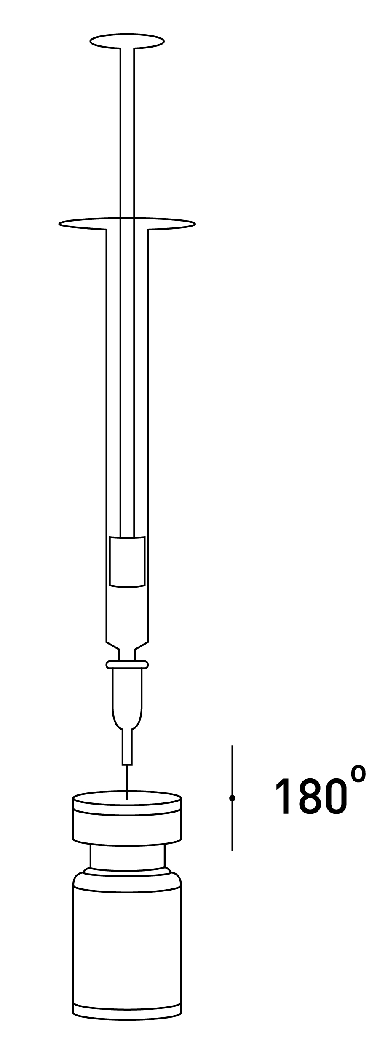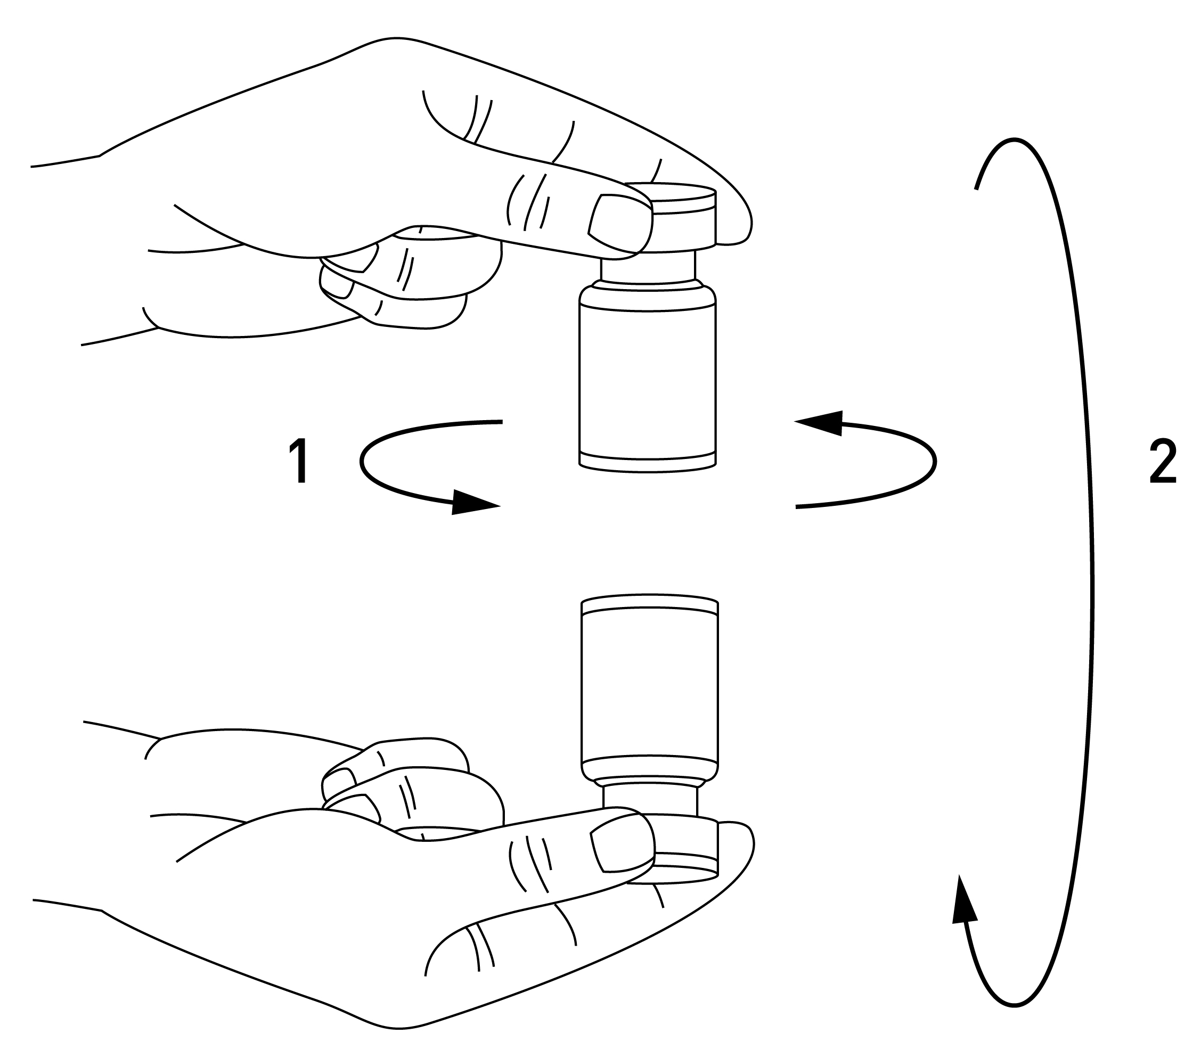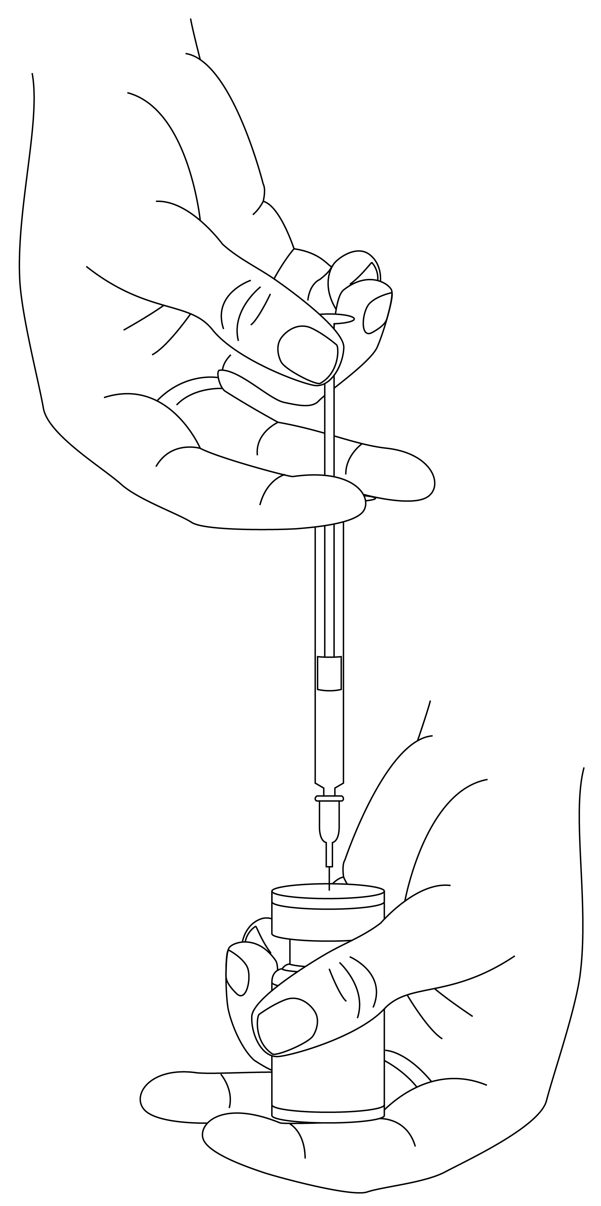

Reconstituted Xeomin is a clear, colourless solution free of particulate matter. Xeomin should not be used if the reconstituted solution (prepared as above) has a cloudy appearance or contains floccular or particulate matter.

Reconstituted Xeomin is intended for intramuscular injection.

Cervical dystonia

The optimum dose and number of injection sites in the treated muscle(s) should be individualised for each patient and determined by the treating doctor.

Recommended injection volume/injection site: approximately 0.1 to 0.5 mL. Normally, the total dose should not exceed 200 U per treatment session. Doses of up to 300 U may be given. No more than 50 U should be given at any one injection site. As with any drug treatment, initial dosing should begin at the lowest effective dose.

Xeomin is usually injected into the sternocleidomastoid, levator scapulae, splenius capitis, scalenus, and/or the trapezius muscle(s). This list is not exhaustive as any of the muscles responsible for controlling head position may require treatment.

Median time to first onset of effect: within seven days after injection.

Effect of each treatment generally lasts approximately 3-4 months, however, it may last significantly longer or shorter.

Repeat treatment should generally be no more frequent than every 6 weeks. In a controlled clinical trial Xeomin has been efficacious and well-tolerated when injected in intervals between 6 and 20 weeks (median: 12 weeks). Treatment intervals should be determined based on the actual clinical need of the individual patient.

Blepharospasm

The optimum dose and number of injection sites in the treated muscle(s) should be individualised for each patient and determined by the treating doctor.

Initial recommended dose: 1.25 to 2.5 U (0.05-0.1 mL volume)/injection site. The initial dose should not exceed 35 U/eye for pre-treated patients, if the previous dose of botulinum toxin is not known.

The initial dose should not exceed 25 U/eye for treatment naïve patients.

Normally, the total dose should not exceed 100 U per treatment session.

Repeat treatment should generally be no more frequent than every 6 weeks. In a controlled clinical trial Xeomin has been efficacious and well-tolerated when injected in intervals between 6 and 20 weeks (median: 12 weeks). Treatment intervals should be determined based on the actual clinical need of the individual patient.

Xeomin is injected into the medial and lateral orbicularis oculi muscle of the upper lid and the lateral orbicularis oculi muscle of the lower lid. Additional sites in the brow area, the lateral orbicularis oculi muscle and in the upper facial area may also be injected if spasms here interfere with vision.

Median time to first onset of effect: within four days after injection.

Effect of each treatment generally lasts approximately 3-4 months, however, it may last significantly longer or shorter in individual patients.

Post-stroke spasticity of the upper limb

The optimum dose and number of injection sites in the treated muscle(s) should be individualised for each patient and determined by the treating doctor.

Recommended initial doses:

Clinical Pattern  Muscle | Units

Flexed Wrist
Flexor carpi radialis | 50
Flexor carpi ulnaris | 40

Clenched Fist
Flexor digitorum superficialis | 40
Flexor digitorum profundus | 40

Flexed Elbow
Brachioradialis | 60
Biceps | 80
Brachialis | 50

Pronated Forearm
Pronator quadratus | 25
Pronator teres | 40

Thumb-in-Palm
Flexor pollicis longus | 20
Adductor pollicis | 10
Flexor pollicis brevis/Opponens pollicis | 10

Recommended doses for repeated treatment:

Clinical Pattern  Muscle | Units (Range) | Number of injection sites per muscle

Flexed Wrist
Flexor carpi radialis | 25-100 | 1-2
Flexor carpi ulnaris | 20-100 | 1-2

Clenched Fist
Flexor digitorum superficialis | 40-100 | 2
Flexor digitorum profundus | 40-100 | 2

Flexed Elbow
Brachioradialis | 25-100 | 1-3
Biceps | 75-200 | 1-4
Brachialis | 25-100 | 1-2

Pronated Forearm
Pronator quadratus | 10-50 | 1
Pronator teres | 25-75 | 1-2

Thumb-in-Palm
Flexor pollicis longus | 10-50 | 1
Adductor pollicis | 5-30 | 1
Flexor pollicis brevis/  Opponens pollicis | 5-30 | 1

Maximum total recommended dose: up to 400 units per treatment session. Median time to first onset of effect: within four days after injection. Maximum effect as an improvement of muscle tone: within 4 weeks. In general, the treatment effect lasted 12 weeks. Repeat treatment should generally be no more frequent than every 12 weeks.

The exact dosage and number of injection sites should be tailored to the individual patient based on size, number and localization of muscles involved, the severity of spasticity and the presence of local muscle weakness.

Glabellar frown lines

The optimum dose and number of injection sites in the treated muscle(s) should be individualised for each patient and determined by the treating doctor.

Dosage

Reconstitution: 50 units/1.25 mL

Recommended injection volume: 0.1 mL (4 units) into each of the 5 injection sites: two injections in each corrugator muscle and one injection in the procerus muscle (Figure 4).

The standard dose is 20 units. The dose may be increased by the physician to up to 30 units if required by the individual needs of the patients. Improvement in the glabellar frown lines: generally within 2 to 3 days

Maximum effect: on day 30. The effect lasts up to 4 months after the injection.

The intervals between treatments: ≥ 3 months.

Figure 4 Injection Scheme

Method of administration

To reduce the risk of blepharoptosis, injections near the levator palpebrae superioris and into the cranial portion of the orbicularis oculi should be avoided. Injections into the corrugator muscle should be done in the medial portion of the muscle, and in the central portion of the muscle belly at least 1 cm above the bony edge of the eye socket.

Recommendations should any incident occur during the handling of botulinum toxin

Any spills of the product must be wiped up: either using absorbent material impregnated with any of the below listed solutions (see PRESENTATION AND STORAGE CONDITIONS, Procedure to follow for a safe disposal of vials, syringes and materials used) in case of the powder, or with dry, absorbent material in case of reconstituted product.

The contaminated surfaces should be cleaned using absorbent material impregnated with any of the below listed solutions, then dried. (see also PRESENTATION AND STORAGE CONDITIONS, Procedure to follow for a safe disposal of vials, syringes and materials used).

If a vial is broken, proceed as mentioned above by carefully collecting the pieces of broken glass and wiping up the product, avoiding any cuts to the skin.

If the product comes into contact with skin, rinse the affected area abundantly with water.

If product gets into the eyes, rinse thoroughly with plenty of water or with an ophthalmic eyewash solution.

If product comes into contact with a wound, cut or broken skin, rinse thoroughly with plenty of water and take the appropriate medical steps according to the dose injected.

OVERDOSE

Contact the Poisons Information Centre on telephone 13 11 26 for advice on management of overdose.

Symptoms of overdose

Increased doses of incobotulinumtoxinA may result in pronounced neuromuscular paralysis distant from the injection site with a variety of symptoms (symptoms may include general weakness, ptosis, diplopia, breathing difficulties, speech difficulties, paralysis of the respiratory muscles or swallowing difficulties which may result in an aspiration pneumonia). Symptoms of overdose are not immediately apparent post-injection.

Measures in cases of overdose

In the event of overdose the patient should be medically monitored for symptoms of excessive muscle weakness or muscle paralysis. Symptomatic treatment may be necessary. Respiratory support may be required if paralysis of the respiratory muscles occurs.

PRESENTATION AND STORAGE CONDITIONS

Xeomin contains 50 or 100 LD₅₀ units of incobotulinumtoxinA in a type I glass vial sealed with a bromobutyl rubber stopper and tamper-proof aluminium cap.

Each pack contains 1 vial of Xeomin 50 or 100 LD₅₀ units.

Unopened vial

Store below 25 °C.

Reconstituted solution

To reduce microbiological hazard, use as soon as practicable after reconstitution. lf storage is necessary, hold at 2-8°C for not more than 24 hours.

Procedure to follow for a safe disposal of vials, syringes and materials used

Any unused vials, residual reconstituted solution in the vial and/or syringe should be inactivated by adding one of the following solutions: 70% ethanol, 50% isopropanol, diluted sodium hydroxide solution (0.1 N NaOH), or diluted sodium hypochlorite solution (at least 0.1% NaOCl).

Used vials, syringes, and materials should not be emptied and should be discarded into appropriate containers and disposed of in accordance with local requirements.

NAME AND ADDRESS OF THE SPONSOR

Merz Australia Pty Ltd

Level 1, 201 Sussex Street

Sydney NSW 2000

POISON SCHEDULE OF THE MEDICINE

Schedule 4 – Prescription Only Medicine

DATE OF FIRST INCLUSION IN THE AUSTRALIAN REGISTER OF THERAPEUTIC GOODS (THE ARTG):

21 March 2014

