October 2013

Australian Public Assessment Report for Botulinum toxin, type A
  - Proprietary Product Name: Botox
  - Sponsor: Allergan Australia Pty Ltd

About the Therapeutic Goods Administration (TGA)
- The Therapeutic Goods Administration (TGA) is part of the Australian Government Department of Health and is responsible for regulating medicines and medical devices.
- The TGA administers the Therapeutic Goods Act 1989 (the Act), applying a risk management approach designed to ensure therapeutic goods supplied in Australia meet acceptable standards of quality, safety and efficacy (performance), when necessary.
- The work of the TGA is based on applying scientific and clinical expertise to decision-making, to ensure that the benefits to consumers outweigh any risks associated with the use of medicines and medical devices.
- The TGA relies on the public, healthcare professionals and industry to report problems with medicines or medical devices. TGA investigates reports received by it to determine any necessary regulatory action.
- To report a problem with a medicine or medical device, please see the information on the TGA website <http://www.tga.gov.au>.
About AusPARs
- An Australian Public Assessment Record (AusPAR) provides information about the evaluation of a prescription medicine and the considerations that led the TGA to approve or not approve a prescription medicine submission.
- AusPARs are prepared and published by the TGA.
- An AusPAR is prepared for submissions that relate to new chemical entities, generic medicines, major variations, and extensions of indications.
- An AusPAR is a static document, in that it will provide information that relates to a submission at a particular point in time.
- A new AusPAR will be developed to reflect changes to indications and/or major variations to a prescription medicine subject to evaluation by the TGA.
Copyright
© Commonwealth of Australia 2013
This work is copyright. You may reproduce the whole or part of this work in unaltered form for your own personal use or, if you are part of an organisation, for internal use within your organisation, but only if you or your organisation do not use the reproduction for any commercial purpose and retain this copyright notice and all disclaimer notices as part of that reproduction. Apart from rights to use as permitted by the Copyright Act 1968 or allowed by this copyright notice, all other rights are reserved and you are not allowed to reproduce the whole or any part of this work in any way (electronic or otherwise) without first being given specific written permission from the Commonwealth to do so. Requests and inquiries concerning reproduction and rights are to be sent to the TGA Copyright Officer, Therapeutic Goods Administration, PO Box 100, Woden ACT 2606 or emailed to <tga.copyright@tga.gov.au>.

Contents
List of abbreviations 3
I. Introduction to product submission 5
Submission details 5
Product background 6
Regulatory status 7
Product Information 7
II. Quality findings 7
III. Nonclinical findings 8
IV. Clinical findings 8
Introduction 8
Good clinical practice 9
Pharmacokinetics 9
Pharmacodynamics 10
Efficacy 10
List of questions 25
Second round evaluation of clinical data submitted in response to questions 28
Clinical summary and conclusions 38
V. Pharmacovigilance findings 39
Risk management plan 39
VI. Overall conclusion and risk/benefit assessment 47
Quality 48
Nonclinical 48
Clinical 48
Risk-benefit analysis 56
Outcome 62
Attachment 1. Product Information 63
Attachment 2. Extract from the Clinical Evaluation Report 63

List of abbreviations
Abbreviation | Meaning
ADRs | Adverse drug reactions
ANCOVA | Analysis of covariance
BOTOX® | Botulinum Toxin Type A Purified Neurotoxin Complex
BPH | Benign prostatic hyperplasia
CI | Confidence interval
CIC | Clean intermittent catheterization
DC | Detrusor compliance
EFP | End fill pressure
ELISA | Enzyme-linked immunoassay
EMA | European Medicines Agency
FDA | Food and Drug Administration
HRQOL | Health-related quality of life
IDC | Involuntary detrusor contraction
IND | Investigational New Drug
ITT | Intent-to-treat
I-QOL | Incontinence Quality of Life
KHQ | King’s Health Questionnaire
LS | Least squares
MCC | Maximum cystometric capacity (ml)
MDP | Maximum detrusor pressure (cm H20)
MedDRA | Medical Dictionary for Regulatory Activities
MPA | Mouse protection assay
NA | Not applicable
NDO | Neurogenic detrusor overactivity
OAB | Overactive bladder
PDSOT | Possible distant spread of toxin
P2X3 | Ionotropic purinergic receptor type 3
PTNS | Peripheral tibial nerve stimulation
PVR | Post-void residual
QOL | Qualify of life
SF-12v2® | Short form 12 health survey version 2
SNAP-25 | Synaptosomal protein of molecular weight 25 kDa
SNARE | Soluble NSF [N-ethylmaleimide-sensitive factor] Attachment Protein Receptor
TBS | Treatment Benefit Scale
TNA | Toxin neutralising antibodies
TRPV1 | Transient receptor potential vanilloid 1
Tx | Treatment
UI | Urinary incontinence
Unit (U) | One unit of BOTOX corresponds to the calculated median lethal intraperitoneal
UUI | Urinary urgency incontinence
UTI | Urinary tract infection

I. Introduction to product submission

Submission details
Type of submission: | Major Variation/Extension of Indications
Decision: | Approved
Date of decision: | 6 August 2013
Active ingredient: | Botulinum toxin type A
Product name: | Botox
Sponsor’s name and address: | Allergan Australia Pty Ltd  Locked Bag 1514, Pymble NSW 2073
Dose form: | Powder for Injection
Strengths: | 50 units (U), 100 units (U) or 200 U/vial
Container: | Glass Vial
Pack size: | Single vials
Approved therapeutic use: | Botox® (botulinum toxin type A) purified neurotoxin complex is indicated for the following therapeutic indications:  - Treatment of overactive bladder with symptoms of urinary incontinence, urgency and frequency, in adult patients who have an inadequate response to or are intolerant of an anticholinergic medication  - Treatment of urinary incontinence due to neurogenic detrusor overactivity resulting from a defined neurological illness (such as spinal cord injury or multiple sclerosis) and not controlled adequately by anticholinergic agents.
Routes of administration: | Intravesically
Dosage: | The recommended dose is 100 U intravesically.
ARTG numbers: | 172264, 67311 and 195530

Product background
This AusPAR describes the application by Allergan Australia Pty Ltd to extend the indications for botulinum toxin, type A to include treatment of overactive bladder (OAB) with symptoms of urinary incontinence (UI), urgency and frequency, in adult patients who have an inadequate response to or are intolerant of an anticholinergic medication.
Bladder emptying is normally triggered by a stretch reflex in which increasing bladder volume triggers detrusor muscle contraction but this reflex is strongly modified by descending inhibition so that voiding can usually be postponed for hours and even the awareness of bladder fullness can subside until further stretch triggers another round of bladder awareness. This system allows people to detect bladder fullness but also choose a convenient time for voiding. Overactive bladder (OAB) is a condition in which this normal physiological balance is disturbed.
The causes of idiopathic OAB are poorly understood but multiple factors associated with an ageing bladder wall, reduced sphincter function and impairment of cerebral and spinal inhibitory circuits are likely to play a role. The symptoms of OAB may also be sensitive to psychological factors given that anxiety may make OAB worse.
The active ingredient of Botox, Clostridium botulinum type A neurotoxin blocks peripheral acetylcholine release at presynaptic cholinergic nerve terminals by cleaving SNAP-25, a protein integral to the docking and release of acetylcholine from vesicles located within the nerve terminals.
Botox is available as single use vials in three strengths: 50 units (U), 100 units (U) or 200 U of botulinum toxin, type A, as a haemagglutinin complex per vial. Botulinum toxin has been previously considered by the TGA’s Advisory Committee on Prescription Medicines (ACPM) on numerous occasions, most recently in February 2012 for the neurogenic detrusor overactivity (NDO) indication:
Treatment of urinary incontinence due to neurogenic detrusor overactivity resulting from a defined neurological illness (such as spinal cord injury or multiple sclerosis) and not controlled adequately by anticholinergic agents. This does not include idiopathic overactive bladder.
The NDO indication is closely related to the proposed indication of idiopathic OAB. NDO can be considered as a subset of OAB in which the cause of the OAB is clearly related to a defined neurological illness, whereas idiopathic OAB is multifactorial and is not associated with a clear neurological disease or deficit.
Botox is currently approved in Australia for:
- Treatment of urinary incontinence due to neurogenic detrusor overactivity resulting from a defined neurological illness (such as spinal cord injury or multiple sclerosis) and not controlled adequately by anticholinergic agents. This does not include idiopathic overactive bladder.
- Prophylaxis of headaches in adults with chronic migraine (headaches on at least 15 days per month of which at least 8 days are with migraine).
- Treatment of strabismus in children and adults.
- Treatment of blepharospasm associated with dystonia, including benign blepharospasm and VIIth nerve disorders (specifically hemifacial spasm) in patients twelve years and older.
- Treatment of cervical dystonia (spasmodic torticollis).
- Treatment of focal spasticity of the upper and lower limbs, including dynamic equinus foot deformity, due to juvenile cerebral palsy in patients two years of age and older.
- Treatment of severe primary hyperhidrosis of the axillae.
- Treatment of focal spasticity in adults.
- Treatment of spasmodic dysphonia.
- Temporary improvement in the appearance of upper facial rhytides (glabellar lines, crow's feet and forehead lines) in adults.
The sponsor has proposed the following new indication
Treatment of overactive bladder with symptoms of urinary incontinence, urgency, and frequency, in adult patients who have an inadequate response to or are intolerant of an anticholinergic medication.
In addition to a number of general guidelines, there is one TGA adopted European guideline specific to this indication:
- CPMP/EWP/18/01: Note for Guidance on the Clinical Investigation of Medicinal Products for the Treatment of Urinary Incontinence. Effective: 4 February 2004

Regulatory status
Botulinum toxin was first approved in Australia in July 1999 and is currently approved for use in a variety of neuromuscular conditions including spasticity, blepharospasm, and dystonia. It is also used for cosmetic indications, to reduce facial wrinkling associated with muscle activity (see list above).
Botulinum toxin has been approved for the OAB indication in the USA (January 2013) and EU (January 2013). Table 1 below summarises the international marketing status of this product.
Table 1. International regulatory status
Country | Approval date | Indication
USA | 18 January 2013 | Treatment of overactive bladder with symptoms of urge urinary incontinence, urgency, and frequency, in adults who have an inadequate response to or are intolerant of an anticholinergic medication.
EU | 22 January 2013 | Idiopathic overactive bladder with symptoms of urinary incontinence, urgency and frequency in adult patients who have an inadequate response to, or are intolerant of, anticholinergic medication.

Product Information
The approved Product Information (PI) current at the time this AusPAR was prepared can be found as Attachment 1.

II. Quality findings
There was no requirement for a quality evaluation in a submission of this type.

III. Nonclinical findings
There was no requirement for a nonclinical evaluation in a submission of this type.

IV. Clinical findings
A summary of the clinical findings is presented in this section. Further details of these clinical findings can be found in Attachment 2.

Introduction

Clinical rationale
Bladder emptying is normally triggered by a stretch reflex in which increasing bladder volume triggers detrusor muscle contraction but this reflex is strongly modified by descending inhibition so that voiding can usually be postponed for hours and even the awareness of bladder fullness can subside until further stretch triggers another round of bladder awareness. This system allows people to detect bladder fullness but also choose a convenient time for voiding.
Overactive bladder (OAB) is a condition in which this normal physiological balance is disturbed. The hallmark of the condition is excessive activity of the detrusor muscle which may manifest as sensations of fullness or detrusor contraction at low bladder volumes leading to urinary frequency and nocturia or vigorous contractions that are not easily overridden by descending inhibition which is followed by urgency and incontinence. Urgency can vary in intensity but essentially involves difficulty in postponing voiding such that patients may have to rush to the toilet at the first sensation of bladder fullness. There are sensory and motor components to the disorder with excessive sensations of fullness and excessive motor responses to fullness; the relative contribution of sensory and motor abnormalities may vary amongst patients.
A number of neurological conditions can cause OAB including multiple sclerosis, spinal cord injury and a variety of cerebral lesions. In these cases, the condition is sometimes designated neurogenic detrusor overactivity (NDO). Botox has already been approved for use in NDO on the basis of studies that showed reduced incontinence following intravesical injection of Botox.
Idiopathic OAB in the absence of a clear neurological cause is even more common than NDO, particularly in women, and it increases in prevalence with advancing age. The prevalence data is summarised by the sponsor as follows:
‘OAB is a prevalent disorder that is reported to affect between 12% and 17% of the general population in North America and Europe (Milsom et al, 2001; Stewart et al, 2003; Irwin et al, 2006a; Herschorn et al, 2008), with a similar prevalence also being reported in Asia and South America (Homma et al, 2005; Yu et al, 2006; Teloken et al, 2006). Overall, approximately one third of OAB patients have OAB with urgency incontinence (‘wet’ OAB), with reported prevalence rates of approximately 5% to 6% (Milsom et al, 2001; Stewart et al, 2003; Herschorn et al, 2008). The prevalence of ‘wet’ OAB is considerably higher in women than men; approximately 7% to 12% of all females are reported to have this condition compared to 3% of males (Stewart et al, 2003; Irwin et al, 2006a; Herschorn et al, 2008; Lawrence et al, 2008). Both OAB and ‘wet’ OAB increase with advancing age, and the rate of increase of ‘wet’ OAB with age is greater in females than men (Milsom et el, 2001; Tubaro, 2004). Thus the typical ‘wet’ OAB population is middle aged to elderly females.’
The causes of idiopathic OAB are poorly understood but multiple factors associated with an ageing bladder wall, reduced sphincter function and impairment of cerebral and spinal inhibitory circuits are likely to play a role. The symptoms of OAB may also be sensitive to psychological factors given that anxiety may make OAB worse.
For patients, OAB can be a devastating condition, particularly if it is associated with incontinence. Subjects with OAB may fear going to public places or avoid socialising because of the risk of incontinence, or they may have to organise their lives to ensure proximity to a toilet. OAB can cause low self-esteem and destroy sexual confidence. Several studies have documented that OAB increases the risk of social isolation and depression which can have profound effects on patients’ quality of life.
OAB is traditionally treated with anticholinergic (anti-muscarinic) agents, which relax the bladder wall. Unfortunately, these agents are often ineffective or poorly tolerated. The tolerability issues include other autonomic effects such as dry mouth, constipation and blurred vision as well as sedation. There is, therefore, a clear unmet need for safe and effective treatments for OAB.
Botox is already widely used as a local agent that can weaken targeted muscles. It has a complex mechanism of action, summarised in the Pharmacodynamic section.
Intravesical Botox is an obvious candidate for the treatment of OAB because it can be applied locally and it has the potential to reduce detrusor activity without systemic side-effects. Furthermore, efficacy has already been demonstrated for the related condition of neurogenic detrusor overactivity (NDO). Such treatment comes with a risk, however, of weakening the detrusor muscle excessively, with resulting problems such as urinary retention and increased urinary tract infections.

Contents of the clinical dossier
The submission consisted of four efficacy/safety studies of Botox in OAB and the associated summaries of efficacy and safety. No pharmacokinetic or pharmacodynamic studies were performed.
The submission contained the following clinical information:
- Two completed pivotal efficacy/safety studies (191622-095, 191622-520).
- One completed Phase II dose-finding study (191622-077).
- One ongoing open-label extension study (191622-096, interim analysis included).
- The sponsor’s Integrated Summary of Efficacy and Integrated Summary of Safety
There were no clinical pharmacology studies or population pharmacokinetic analyses.

Paediatric data
The submission did not include paediatric data.

Good clinical practice
Appropriate assurances were provided that the submitted studies had been performed in accordance with the principles of Good Clinical Practice.

Pharmacokinetics
Botox is a local agent and, because of its potential toxic effects, cannot be used systemically, so formal PK studies have never been performed.

Pharmacodynamics
No pharmacodynamic (PD) studies were submitted. The relationship between Botox treatment and bladder effects can only be inferred indirectly from the safety/efficacy studies.
No new information was submitted to explain the mechanism of action of Botox. The following summary is derived from a previous related submission (Botox for Neurogenic Detrusor Overactivity).
Botulinum toxin is a naturally occurring toxin produced by bacteria, and it is responsible for the clinical syndrome of botulism.
The toxin is internalized intracellularly after binding to a high-affinity receptor, synaptic vesicle protein 2 (SV2), which is exposed on the cell membrane during the exocytosis process associated with neurotransmitter release. Following binding, the toxin is known to block the presynaptic release of acetylcholine (ACh), and this underlies its efficacy in weakening skeletal muscle. It was first used in bladder overactivity on the theory that it would also inhibit ACh release in the smooth muscle of the detrusor, producing weakness. This is probably its primary mode of action and there is evidence of an appropriate substrate for this effect in a study of human cadaveric bladders (Coelho et al, 2010).
Evidence from animal studies suggest that, in addition to this effect on the efferent (motor) pathways involved in detrusor contraction, Botox may also inhibit afferent (sensory) bladder pathways, including those underlying the perception of urinary urgency and those mediating the afferent limb of the detrusor stretch reflex. Evidence for this afferent mechanism is summarised in a literature review by Apostolidis et al (2006).
The actual molecular mechanisms by which Botox inhibits neural function are complex. It inhibits synaptic vesicle-mediated neurotransmission through the cleavage of SNAP-25 (a synaptosomal protein of molecular weight 25 kDa) in the nerve terminal. SNAP-25 is part of the SNARE complex (soluble NSF [N-ethylmaleimide-sensitive factor] Attachment Protein Receptor), which is involved in attachment of synaptic vesicles at the nerve terminal membrane. The SNAP-25 complex is also involved in the delivery of receptors such as TRPV1 (transient receptor potential vanilloid 1) to the nerve terminal, so Botox inhibits both the release of neurotransmitters and the expression of receptors at the nerve terminal. Botox has also been shown to inhibit various sensory neurotransmitters including substance P, calcitonin gene-related peptide (CGRP), and adenosine triphosphate (ATP) (Chancellor et al, 2008). It has been proposed that Botox may reduce the expression of some sensory receptors thought to be up-regulated in patients with detrusor overactivity, (TRPV1 and ionotropic purinergic receptor type 3) (Apostolidis et al, 2005; Apostolidis et al, 2006; Chancellor et al 2008).
Which of these mechanisms are clinically significant remain somewhat unclear but the primary effect of injecting intra-detrusor Botox appears to be a reduction in the strength of the detrusor muscle, with some additional reduction in sensory function. The role of various receptors and transmitters is likely to vary according to the aetiology of detrusor overactivity, which is why efficacy in one diagnostic category of overactive bladder cannot be generalised to others.

Efficacy
The sponsor submitted four efficacy studies. These are tabulated below, and included a Phase II dose-ranging study (077), two very similar Phase III pivotal studies (095 and 520) and an open-label extension of the pivotal studies (096).
Table 2. Design features of clinical studies of Botox in overactive bladder
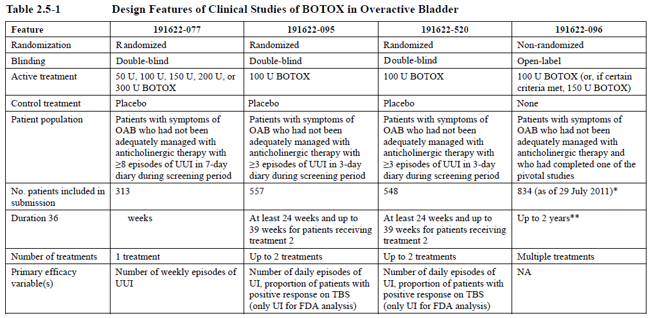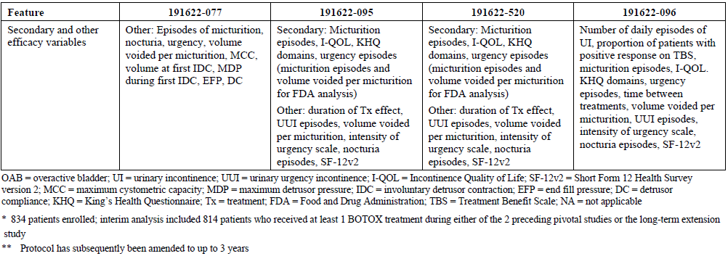

Evaluator’s conclusions on clinical efficacy
The conclusions on efficacy are primarily derived from the pivotal studies and are summarised in Conclusion Pivotal Studies see Attachment 2). The pivotal studies were strongly positive, in the statistical sense, for all primary and secondary endpoints, which are summarised below. (The two pivotal studies produced similar results and were independently positive as well as positive when pooled).
Table 3. Summary of efficacy endpoints achieved in both pivotal Phase III studies for up to 12 weeks post treatment 1. ITT population.
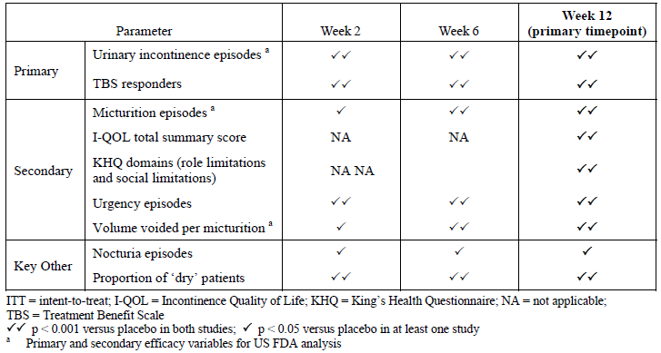
The magnitude of the benefit, in clinical terms, was modest, amounting to 1.79 episodes of incontinence prevented each day (95%CI -2.14 to -1.44 episodes, p<0.001), from a baseline incontinence frequency of 5.39 to 5.49 episodes per day.
In other words, for most subjects, the frequency of episodes of incontinence was not prevented by active treatment: the percentage reduction in incontinence was narrowly >50% in the active group (50.5%) but this included a placebo response of 14.6%.
For the co-primary endpoint of TBS, positive responses at 12 weeks were significantly more common with active treatment (61.8%) compared to placebo (28.0%) and the difference was statistically significant (p<0.001). The attributable response rate thus amounts to about one patient in three.
Table 4. Summary of overactive bladder symptoms and volume voided per micturition at week 12 post-treatment 1 (pooled ITT population).
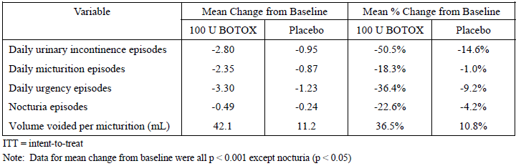
Results in the dose-ranging study (Study 077) were negative for the 100 U dose but the study was underpowered and the placebo response in the placebo group was unexpectedly large. The long-term extension study (Study 096) showed that efficacy was similar across multiple doses and similar between doses of 100 U and 150 U but interpretation of the results is difficult as treatment was neither randomised nor blinded.
The efficacy of Botox in men and women was not studied separately but there are many a priori reasons to suspect that efficacy might be different in the two gender groups, and in retrospect, pooling these two populations was not appropriate. A subgroup analysis showed that results in men were disappointing. On average, the reduction in incontinence in men was only 0.42 episodes per day and the majority of men (59.3%) rated their symptoms as unchanged or worse after treatment. These outcomes were numerically superior to placebo but they were not statistically significant. This was considered to be of limited clinical utility even if confirmed in a larger study of men with OAB.
Table 5. Daily frequency of urinary incontinence episodes for treatment cycle 1 by sex. Study baseline and change from baseline. Studies 095/520 pooled. ITT population with LOCF imputation.
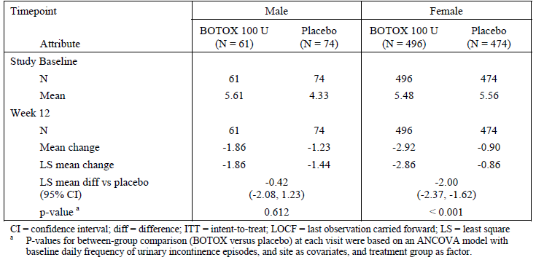
Table 6. Proportion of patients with a positive treatment response on the treatment benefit scale during treatment cycle 1 by sex. Studies 095/520 pooled. Placebo controlled ITT population with LOCF imputation.
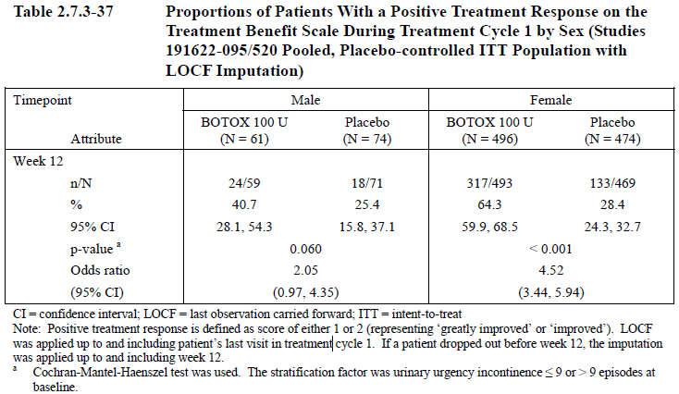

Safety
Botox has been available for many years, in Australia and worldwide, for treatment of a large range of neuromuscular and cosmetic conditions. The drug is administered locally and should not (except by accident) enter the systemic circulation, so the safety profile of Botox is highly dependent upon where it is injected and the dose administered.
Botox has already been approved for intravesical injection in the treatment of neurogenic detrusor overactivity (NDO) at a dose of 200 U, so the proposed dose of 100 U at the same site does not pose any major new safety risks. When administered for NDO, Botox had an acceptable safety profile but intravesical treatment with 200 U was associated with an increased incidence of urinary retention, increases in post-void residual urine volume, an increased incidence of urinary tract infections (UTIs) and a proportion of patients who had to commence clean intermittent catheterisation (CIC) as a direct result of Botox mediated impairment of bladder emptying.
The proposed dose for OAB (100 U) is only half that proposed for NDO (200 U), which might be expected to be associated with a reduced incidence of urological complications. The largely unknown causes of idiopathic OAB are necessarily different from the specific neurological deficits causing NDO, however, the balance between detrusor overactivity and underactivity is likely to be different, and the dose-dependence of urological complications is not necessarily the same for the two conditions. As discussed below, 100 U in the current submission was associated with a similar profile of adverse urological effects as was observed with 200 U given for NDO, including an increased incidence of urinary retention, UTIs and increased residual urine volume.
Occasional reports of possible systemic effects of Botox have been reported in the literature following local use of Botox for a variety of conditions., , In a previous TGA submission for intravesical Botox there was no clear case of systemic spread but constipation was increased in the 300 U treatment group, which possibly indicated some local spread at this dose. Potential systemic effects in the context of the current submission are discussed under Potential distant spread of toxin in Attachment 2).

Studies providing evaluable safety data
All four submitted studies provided evaluable safety data but the most important data was provided in the first cycle of the placebo-controlled pivotal studies (Study 095 and 520). Study 077 provided a dose comparison for adverse events in the range 50 U to 300 U. The long-term extension study (Study 096) was somewhat useful, in that it followed patients for up to two years and assessed the safety of repeated doses but interpretation of event rates was limited by the fact that treatment was unblinded, non-randomised and lacked a placebo control. Two doses were used in Study 096 but escalation to the higher dose was non-random and initiated by patients, a methodological feature that would automatically select for patients likely to tolerate Botox well.

Patient exposure
The primary safety analysis was based on the placebo-controlled safety population which includes subjects receiving randomised blinded treatment with Botox (n=607) or placebo (n=585).
Placebo-controlled exposure to the proposed intravesical dose of 100 U is summarised in the table below. Exposure tended to be briefer with placebo treatment, with lower median duration of exposure and a lower number of subjects exposed for ≥ 24 weeks; this reflects the fact that placebo-treated patients did not experience any true treatment-effect.
Table 7. Summary of exposure information for placebo controlled treatment cycle 1. Placebo controlled safety population.
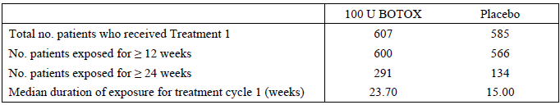
Table 8. Cumulative duration of exposure. Treatment cycle 1. Placebo controlled safety population
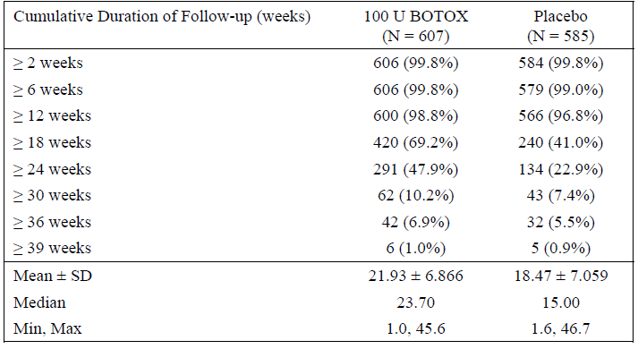
The population of Botox-treated subjects included initial placebo patients that received a second open-label treatment cycle (first active cycle) in the pivotal studies or in the long-term extension study. Exposure in this larger group is summarised below. A total of 1104 subjects received at least one dose of Botox at doses of 100 U or 150 U, a total of 594 patients received two doses and lesser numbers received additional treatments. The table below shows the dose given each cycle, with the final row dividing patients into those who received 100 U for all treatments (n=863) and those who received 150 U at least once (n=241). The subsequent table lists the duration of follow-up available for each dose, regardless of treatment cycle.
Table 9. Number of patients included in the analysis population by Botox treatment cycle. Botox treated patients.
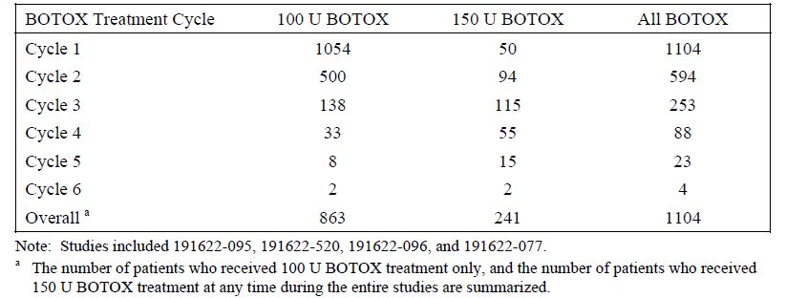
Table 10. Cumulative duration of exposure, regardless of number of treatment cycles. Botox treated population.
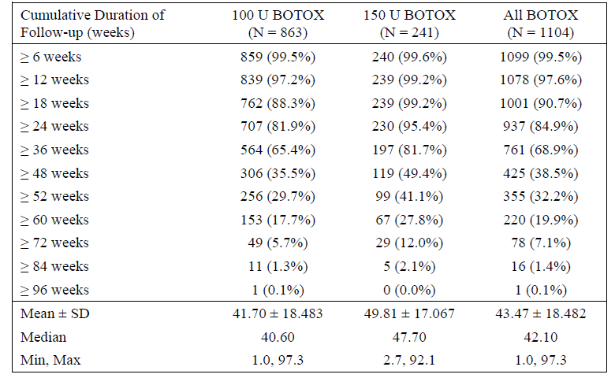
The placebo-controlled safety population was broadly representative of the intended target population with OAB. The mean age was about 60 years and the majority (88.6%) were female. A small subgroup (~15%) of patients was over the age of 75 years.
Table 11. Baseline demographics. Placebo controlled safety population.
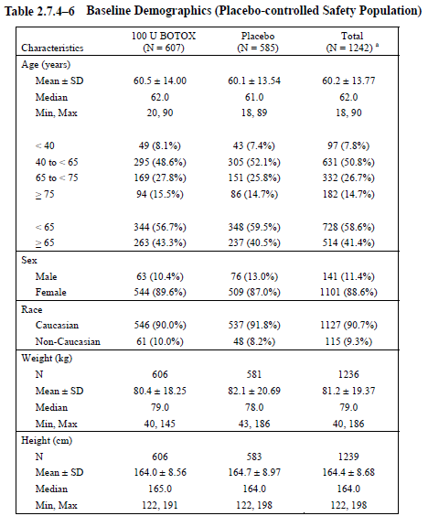

Postmarketing experience
There is an extensive postmarketing experience with Botox, with more than 34 million vials distributed worldwide, including cosmetic formulations and more than 24 million vials distributed as Botox 100 U, as shown in the table below. Postmarketing surveillance has not detected any adverse effects unexpected from the drug’s mode of action.The risks of Botox therapy primarily relate to excess weakening of targeted muscles or accidental weakening of non-targeted muscles.
Serious Adverse Events (SAEs) reported in the postmarketing context are summarised in the table below. The number of patients at risk was not stated by the sponsor, who provided the table.
Table 12. Summary of postmarketing SAEs for Botox treatment of hypertonic bladder.
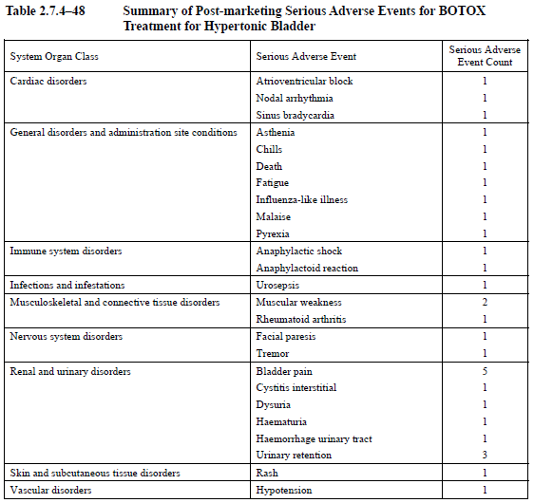
Postmarketing AEs are tabulated below. (The heading of the middle column should read ‘Adverse Event’; the sponsor has confirmed that this was an editing error.)
Table 13. Summary of postmarketing AEs for Botox treatment of hypertonic bladder.
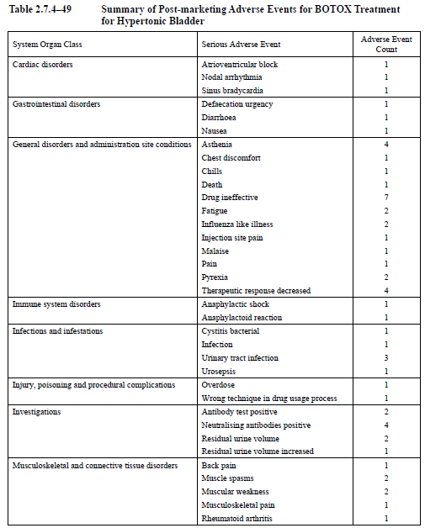
Table 13 (continued). Summary of postmarketing AEs for Botox treatment of hypertonic bladder.
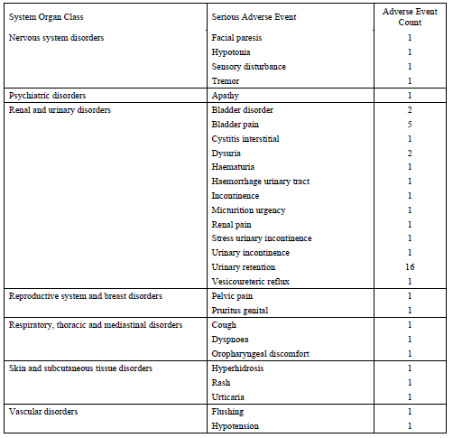
The sponsor also provided the following summaries of previously published studies of Botox in OAB. A full critique of those summaries is beyond the scope of this report but a review of the evidence does not raise new concerns. Brubaker et al confirmed that UTIs are more common after Botox (44% versus 22%). Flynn et al did not show an excess of UTIs with active treatment but the study was underpowered; 3 of 4 UTIs occurred within 5 days of injection, suggesting that this was a procedural complication. Sahai et al showed that 25% of subjects required CIC after multiple injections, and Tincello et al showed that Botox was associated with an increased incidence of UTI (31% versus 11%). Denys et al showed no major effect on UTIs. Overall, these studies do not modify the general safety conclusions drawn from the submitted studies.
Table 14. Published randomized, placebo controlled clinical studies reporting the safety of Botox in patients with idiopathic OAB.
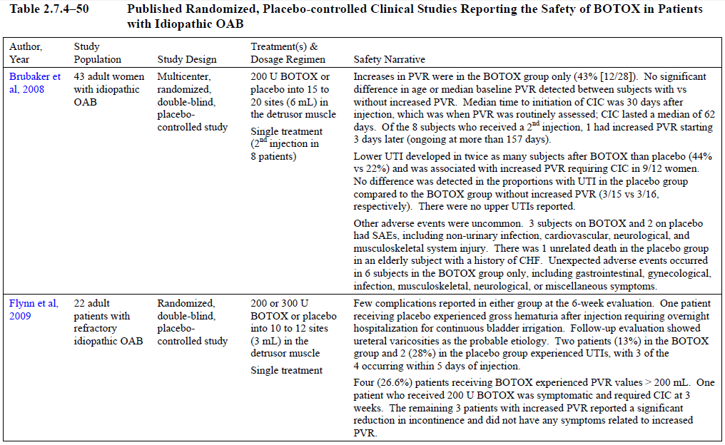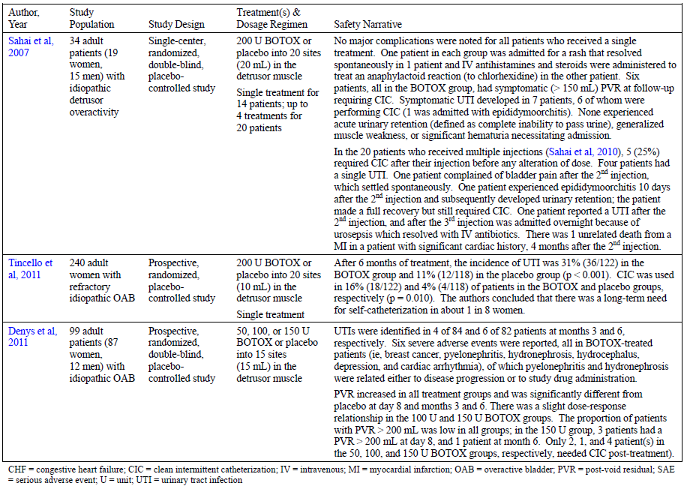

Safety issues with the potential for major regulatory impact

Liver toxicity
No evidence of serious liver toxicity following intravesical injection of Botox was observed on the basis of AEs and the incidence of biochemical changes (discussed above). There is also no reason to suspect such toxicity from a local injection in the pelvis given the extensive postmarketing experience with Botox.

Haematological toxicity
No evidence of serious haematological toxicity following intravesical injection of Botox was observedbased on the reported AEs and postmarketing experience of Botox. Shift tables did not show any important safety signals (see Attachment 2).

Serious skin reactions
In the pivotal studies following intravesical injection of Botox the reported AEs skin reactions did not feature in any of the tables of common AEs. Also, the postmarketing experience with the use of Botox has not revealed a risk of skin reactions and these would not be expected from an intravesical injection.

Cardiovascular safety
There was a slightly higher incidence of cardiovascular AEs with active treatment as shown in the table below. In frail elderly patients it can be speculated that this risk was related to the stress of the invasive procedure and associated anaesthetic. Overall it was considered that the cardiovascular safety associated with intravesical Botox was acceptable.
Table 15. Cardiovascular AEs occurring in >1 patient in any treatment group.
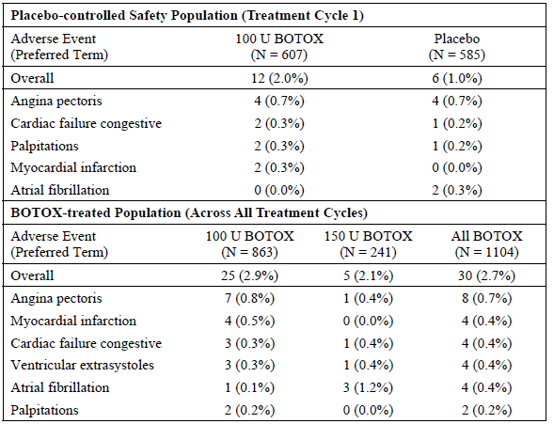

Unwanted immunological events
AEs potentially consistent with hypersensitivity reactions were rare and slightly less common with active treatment than placebo.
Table 16. Patients reporting AEs potentially indicating hypersensitivity reactions
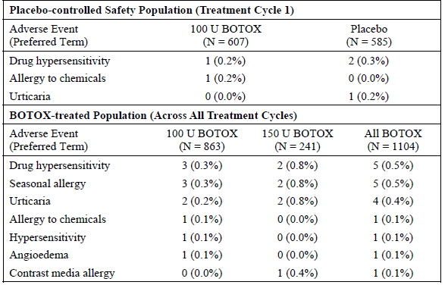
Botox administration can be associated with the development of neutralising antibodies but the risk is reduced when doses are minimised and treatments widely separated in time. In the pivotal OAB studies (Studies 095 and 520) and the long-term extension study (Study 096) but not the Phase II dose-ranging study (Study 077), a total of 1023 patients were assessed for the development of neutralizing antibodies using a validated enzyme-linked immunosorbent assay (ELISA) and no neutralising antibodies were found (26 patients developed low-titre binding antibodies that did not neutralise the pharmacological effect of the toxin in a neutralising assay). This total of 1023 patients includes placebo patients who were not expected to be at risk of developing antibodies.

Evaluator’s overall conclusions on clinical safety
A dose of 100 U, when administered to a population with OAB, causes an increased incidence of urinary tract infections (26.4% versus 10.1% with placebo), acute urinary retention (7.1% versus 0.5% with placebo) and increases in post-void residual (PVR) urine volume. PVR volumes at Week 2 were increased by a mean of ~50 mL (48.2 mL, 95%CI 39.1 to 57.3 mL), though this improved to a mean of ~30 mL by Week 12. Increases were not uniform, and 29% of subjects showed an increase of >100 mL after Botox; this was relatively rare in placebo recipients (7%). Asymptomatic increases in PVR or episodes of frank urinary retention may both lead to some patients requiring catheterisation and patients need to return 2 weeks post-treatment to have their PVR volume assessed, with additional monitoring as required. In the placebo-controlled pivotal study population, clean intermittent catheterisation (CIC) was initiated post-treatment in 48 of 552 Botox recipients (8.7%), compared to 9 of 542 placebo recipients (1.7%), as shown in the table below. The use of CIC was associated with an increased risk of UTI, particularly in Botox recipients. UTI was also increased markedly in those with more extreme increases of PVR volume, reaching 61.9% amongst the 21 Botox recipients who retained ≥ 350 mL. Despite the above the safety of intravesical Botox is considered, overall, to be acceptable.
Table 17. Proportion of patients with UTI by PVR category and use of clean intermittent catheterisation. Placebo controlled pivotal study safety population.
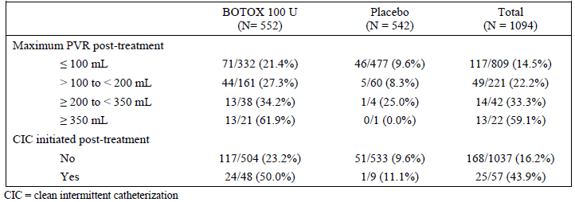
Also, the procedure itself is associated haematuria and bladder pain in a small proportion of subjects. Patients must take prophylactic antibiotics to reduce the risk of a procedure-related infection. For patients on anticoagulation or warfarin, there is likely to be some associated risk due to interruptions to these treatments.
Apart from these urological complications, the drug is well tolerated. There is a small theoretical risk of collateral spread of toxin but so far, from the evidence of the submitted studies, there is only weak evidence that the rate of constipation might be increased.
A review of serious adverse events and deaths did not raise any new concerns.
The postmarketing experience with Botox has been extensive and it is unlikely that there unsuspected toxicities associated with its use. In most cases, safety issues reported with Botox relate directly to its mode of action.

First round benefit-risk assessment

First round assessment of benefits
The benefits of Botox in the proposed usage are:
- a reduction in the frequency of incontinence of ~2 episodes pr day in women, or 0.42 episodes in men, from a mean baseline incontinence of 5-6 episodes per day
- a small proportion of patients achieving the ‘dry’ state (27.1% of Botox recipients versus 8.4% of placebo recipients).
- a subjective positive response rate (that is, symptoms improved or greatly improved) of 64.3% in women, compared to 28.4% with placebo, consistent with an attributable response rate of 35.9%
- a subjective positive response rate of 40.7% in men, compared to 25.4% with placebo, consistent with an attributable response rate of 15.3%
- parallel improvements in other measures of urgency and frequency
- modest but significant improvements in quality of life

First round assessment of risks
The risks of Botox in the proposed usage are:
- on-going incontinence can be expected in the majority of patients
- an increased incidence of UTI, increased post-void residual urine volume and increased incidence of acute urinary retention
- the need to return for measuring post-void residual urine volume
- patients may need to commence catheterisation after treatment
- most men can be expected to report no change or worsening of their symptoms

First round assessment of benefit-risk balance
The benefit-risk balance of Botox given the proposed usage was considered to be favourable in women, provided they are prepared to undergo catheterisation if necessary. This balance is reflected in their positive responses on the Treatment Benefit Scale, which would be expected to incorporate the urological benefits and risks from a patient perspective.
The benefit-risk balance in men was considered to be largely negative, as evidenced by the fact that most reported their symptoms as unchanged or worse, and that the combined incidence of UTI and urinary retention in men was roughly equal to the attributable positive response rate on the TBS.

First round recommendation regarding authorisation
The application to register Botox 100 U for the treatment of idiopathic overactive bladder associated with incontinence that has failed a trial of anticholinergic agents (‘wet’ and refractory OAB) was recommended for approval in women.
Efficacy in men has not been adequately demonstrated and this is not simply a matter of not having an adequately powered subgroup analysis; the results were quantitatively unimpressive in men and a significant treatment-by-gender interaction was demonstrated. The majority of men (~60%) reported no change or a worsening of their symptoms after Botox treatment and only 15% had an attributable positive response to treatment.
The recommendation of this report is therefore to deny registration of Botox for OAB in men.
An alternative approach, not recommended here but worthy of consideration, would be to approve Botox 100 U for ‘wet’ and refractory OAB in both genders, after changes to the proposed Product Information. These changes would need to include reports of the relatively poor benefit demonstrated in men with OAB. Approving Botox for treatment of OAB in both genders would potentially allow clinicians to treat the subset (~15%) of male patients who might benefit from treatment. The main problem with this approach, and the reason it is not recommended, is that the current evidence does not indicate how this small group of male responders could be identified. Approving Botox for treatment of OAB in men, even if accompanied by adequate warnings in the PI, would raise a number of concerns: it would allow a patient group to be treated that already has statistical evidence of a significantly worse outcome than women with OAB; it would disregard the fact that there is currently no robust statistical evidence that active treatment in men is superior to placebo; and it would ignore the results of the pivotal studies which suggested that the majority of men are non-responders. For all of these reasons, the approval of Botox for OAB in men is not recommended on the current evidence. This situation could change if future studies led to different conclusions but obviously such studies would have to be part of a new submission.

List of questions
The evaluator’s rationale behind each question has been summarised below each question.

Pharmacokinetics
No questions posed.

Pharmacodynamics
No questions posed.

Efficacy
- What is the efficacy of Botox in men with OAB?
The efficacy of Botox in men with OAB remains poorly characterised but there is reasonably good evidence that the efficacy is inferior to that demonstrated in women. The efficacy in men should be further characterised but this is not a question that can be answered on the basis of the current evidence because too few men were recruited to the pivotal studies. Appropriately powered studies in men with OAB are required.
- The proposed dose for idiopathic OAB (100 U) is half that registered for the NDO indication (200 U). Given the similarity between the two conditions, why are the doses so different? Would 100 U have been a more appropriate dose for the NDO indication?
In the selection of a dose for the pivotal NDO studies, the main doses being considered were 200 U and 300 U. In the context of that earlier submission, the dosage considerations were summarised in the evaluation report as follows:
‘In the pivotal [NDO] studies, most efficacy endpoints showed very similar results across the two active dose groups, as summarised in the table below. Given that AEs were higher in the 300 U group, as discussed in the Safety Section, the 200 U appears to offer a better risk-benefit balance. Doses lower than 200 U were considerably less effective in the dose-ranging study 518, with a duration of action that resembled placebo, but this study was underpowered. It did show a significant dose-trend across doses to 200 U, but did not specifically show a significant benefit of 200 U over 100 U. On balance, the efficacy evidence favours the proposed dose of 200 U.’
Table 18. Change from study baseline in select efficacy measures for treatment cycle 1 in the 300 U and 200 U Botox dose groups. Placebo controlled pivotal study ITT population.
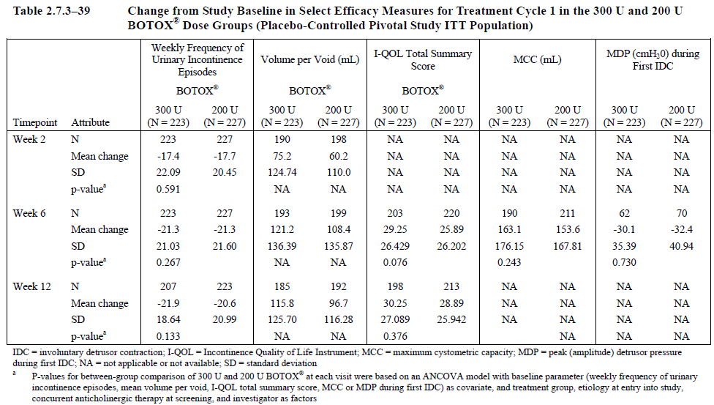
In retrospect, given that comparisons between 100 U and 200 U were underpowered in the dose-ranging study performed in NDO, it might have been worthwhile exploring the efficacy of 100 U for the NDO indication with additional studies. As the current evidence stands, adequate studies of 100 U in NDO have not been performed and there is no good case for changing the recommended dose in NDO. It is plausible that a higher dose might be needed for NDO than for idiopathic OAB and that the more substantial neurological lesions typical of NDO might lead to more pronounced bladder spasticity but this has not been demonstrated. The new submission for OAB shows that 100 U can have efficacy in some cases of OAB and may be less risky than 200 U, so the potential role of the 100 U dose in NDO remains somewhat unclear.
- Can the sponsor please confirm that bladder diaries in the pivotal studies were not censored during urinary tract infections?
In the previous (NDO) submission, patients were asked not to fill out their diaries while they had a urinary tract infection (UTI). UTIs were more common with Botox recipients than placebo recipients, and UTIs are usually associated with increased urgency, so the decision to censor diaries during UTIs appeared to bias the study design in such a way as to potentially hide once source of treatment-related increase in incontinence. A subsequent sensitivity analysis showed that this potential bias was not likely to be significant, even with pessimistic assumptions about how much incontinence had been censored. For the current (idiopathic OAB) submission, it is unclear what advice was given to patients about recording incontinence during UTIs, and whether similar censoring took place.

Safety
- Could the sponsor please provide summary tables for abnormal laboratory values, abnormal vital signs, and ECG results in Botox recipients in comparison to placebo recipients?
As discussed in the Safety section, the sponsor’s Clinical Summary of Safety refers the reader to tables in the Integrated Summary of Safety that are not in a suitable format for assessing overall trends and differences between the active and placebo groups. Each parameter of interest appeared on a page of its own, as shown in the example for ‘Basophils’ below, so that checking this data for concerning safety signals was virtually impossible. Could the sponsor please produce standard summary tables, with all of the abnormal haematology results in a single page, all of the important biochemistry results in a single page, and so on? The primary parameters to report are the incidence of laboratory values above and below the reference range, and the incidence of shifts from normal to abnormal, in the active and placebo groups.
Table 19. Haematology. Summary of clinical laboratory data for treatment cycle 1. Basophils (%).Placebo controlled safety population.
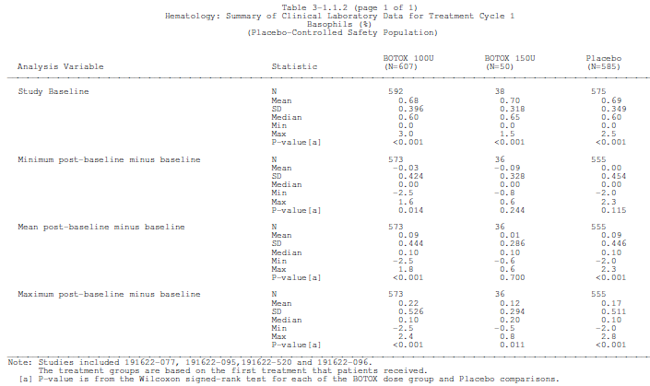
- Could the sponsor also please explain the p-values in the tables that have already been provided, such as the one above? The footnote above refers to a Wilcoxon signed-rank test for each of the Botox dose group and placebo comparisons. What exactly is being compared with what? Does the sponsor really mean to imply that there was a highly significant difference (p<0.001) between placebo and Botox for basophils, as the above table seems to imply?

Second round evaluation of clinical data submitted in response to questions
The sponsor provided responses to the clinical questions. For each question, the sponsor’s response has been considered in a separate sub-section below. In addition, the new safety data from the Safety Question has been integrated into the body of the report (Attachment 2) where appropriate.
In the evaluator’s opinion, the sponsor’s responses were satisfactory, with the exception of the discussion of efficacy of Botox in men with OAB.

Question 1. Efficacy of Botox in men with OAB
The submitted data strongly suggested that the efficacy of Botox in men with OAB is inferior to the efficacy in women, as has already been discussed. The sponsor was asked to comment on this and to estimate the efficacy of Botox in men with OAB.
The sponsor’s response was to characterise apparent gender differences as the result of an under-powered subgroup analysis and to claim that the target organ (the detrusor) is the same in both genders:
“The target organ of the detrusor muscle does not differ by sex. Since BOTOX® is injected directly into the detrusor muscle, it would therefore be expected to exhibit a similar treatment effect in both men and women. Indeed, even though fewer men than women were enrolled in the Allergan studies, important treatment benefits were demonstrated for men, though they were not necessarily statistically significant due to the small sample size.”
This response does not acknowledge the magnitude of the observed gender effect; nor does it acknowledge that the interaction between the detrusor and the sphincter, and the underlying pelvic anatomy, is radically different in the two genders.
The efficacy of Botox in men with OAB is not well defined and small sample sizes in men are part of the problem. No submitted study was specifically powered to address the efficacy of Botox in men with OAB, so until further studies are performed, the analysis is limited to underpowered, post-hoc subgroup analyses. The pooled analysis of Study 095 and Study 520 is the most useful of the available subgroup analyses, because it had better statistical power than that achieved in individual studies but only completely new studies in men would be able to resolve the issue.
The results of the pooled subgroup analysis of the pivotal studies are displayed in the tables below. In men, the placebo-subtracted reduction in urinary incontinence episodes achieved with Botox was 0.42 episodes per day, from a baseline of 5.61 episodes (baseline 4.33 in the placebo group). The estimated treatment effect (LS mean difference versus placebo, -0.42 episodes) was small compared to the placebo effect in men (-1.23 mean change, -1.44 LS mean change), and it was associated with a broad confidence interval that included the possibility of no effect or even a deleterious effect, increasing incontinence by more than one episode per day (95%CI -2.08 to +1.23).
Table 20. Daily average frequency of urinary incontinence episodes for treatment cycle 1 by sex. Study baseline and change from study baseline. Studies 095/520 pooled. ITT population with LOCF imputation.
Note that it is not merely the statistical uncertainty reflected in the confidence interval that makes this result unsatisfactory. The mean treatment effect in men, even if confirmed in a larger population, would be of dubious clinical utility: less than half an episode prevented per day. Also, note that the mean treatment effect in men (-0.42) is well outside the 95%CI for the treatment effect obtained in women (-2.37 to -1.62). This is not equivalent to finding a statistically significant gender difference, because the 95%CIs overlapped but it raises the strong possibility that further studies would confirm a gender difference.
Importantly, the sponsor’s original submission included an acknowledgement of a statistically significant treatment-by-gender interaction. In the sponsor’s Summary of Clinical Efficacy, the following statement appears:
“Assessment of the quantitative treatment-by-sex interaction showed a significant interaction between treatment and sex for daily frequency urinary incontinence episodes (p < 0.001; Module 5.3.5.3, ISE Table 3-5), suggesting that the magnitude of the treatment effect is modified by sex.” *
The other main efficacy variable, the Treatment Benefit Scale (TBS), also suggests that efficacy in men is inferior to that observed in women. The majority (59.3%) of men receiving Botox felt that their condition was ‘unchanged’ or ‘worse’ following treatment. The 95%CI for the odds ratio in men includes the possibility of no benefit relative to placebo and the p-value for the comparison between Botox and placebo, by the Cochran-Mantel-Haenszel test, merely shows a trend in favour of active treatment (p=0.06). To some extent, the sponsor is correct in observing that this reflects a lack of statistical power but it also appears to reflect poor efficacy in men.
Table 21. Proportion of patients with a positive treatment response on the treatment benefit scale during treatment cycle 1 by sex. Studies 095/520 pooled. ITT population with LOCF imputation.
Even if statistical power were improved, the available evidence suggests that the actual proportion of male subjects showing a positive TBS response is of marginal clinical value. Of the minority (40.7%) of men showing a positive response in the TBS, a large proportion of the responses could be attributed to a placebo effect, because positive responses were observed in many subjects receiving placebo (25.4%). The placebo-subtracted (attributable) proportion of male subjects with a positive response was only 15.3% (40.7% - 25.4%), which is less than half of the placebo-subtracted proportion of positive responses in women (64.3%-28.4% = 35.9%).
Given that there is a reasonable a priori case to be made that bladder function in men and women is different, coupled with the statistical finding of a significant treatment-by-gender interaction for incontinence episodes, and a majority of men reporting no benefit with treatment, the onus of proof is on the sponsor to show that that the poor response in men is merely due to a lack of statistical power. On the current evidence, it seems more likely than not that treatment in men is less effective than in women (though it is also likely that active treatment in men is, on average, slightly more effective than placebo).
In the sponsor’s response to this issue, the sponsor has raised several points, which can be summarised as follows:
- The gender ratio in the submitted studies is typical of the target population and of other studies of OAB, such as several published studies of anticholinergics.
- The target organ, the detrusor, does not differ in the two genders.
- The demographic and baseline disease characteristics in the pivotal studies were similar in men and women.
- A positive treatment effect was demonstrated in men for both primary efficacy variables (incontinence frequency and TBS), but did not achieve significance because of poor statistical power.
- The Gail-Simon test did not show a significant qualitative difference between the two genders.
Most of these claims could be characterised as true but irrelevant. They are considered in sequence, below.
  - The gender ratio in the submitted studies is typical of the target population and of other studies of OAB, such as several published studies of anticholinergics.
The sponsor begins their response with these paragraphs:
“The prevalence of overactive bladder (OAB) with urinary incontinence (‘wet’ OAB) is considerably higher in women than men; approximately 7% to 12% of all adult females are reported to have this condition compared to 3% of all adult males (Stewart et al, 2003; Irwin et al , 2006a; Herschorn et al, 2008; Lawrence et al, 2008). In addition, ‘wet’ OAB is predominantly a condition in females over 40 to 50 years of age. Given that 88.6% of patients enrolled into Allergan’s large multinational Phase 3 studies were female the demographic profile within this study programme is therefore consistent with the epidemiology of this condition (Module 2.7.4, Table 2.7.4-6).
The target population of Allergan’s BOTOX® clinical studies are those OAB patients who had not been adequately managed with prior anticholinergic therapy. Phase 3 studies demonstrating efficacy of approved anticholinergic drugs in the treatment of OAB (Chapple et al, 2005a; Cardozo et al, 2008; Chapple et al, 2007), predominantly enrolled female patients as this is the main population suffering from OAB. For example, in the registration trials for solifenacin and tolterodine the percentage of male patients ranged from 10.9% to 14.7% (Chapple et al, 2005a; Cardozo et al, 2008). This was only slightly less than the Phase 3 study for fesoterodine, where 20% of patients enrolled were male (Chapple et al, 2007).The percentage of male patients in the Allergan clinical studies (12.2%) is therefore comparable to the randomised Phase 3 studies of various anticholinergics used and approved in many countries for treatment of OAB.”
While these observations help to explain why the subgroup analysis in men was underpowered, they do not explain why the results in men were inferior to those obtained in women. Instead, these paragraphs actually undermine the sponsor’s claim that the target organ in men and women is equivalent. The gender imbalance that the sponsor notes in previous OAB studies merely adds to the evidence that men and women have different bladder physiology. Also, if it is already well known that studies of OAB tend to recruit substantially less men, then the lack of statistical power in this important subgroup was foreseeable and preventable.
The sponsor’s observation that ‘the demographic profile within this study programme is therefore consistent with the epidemiology of this condition’ (underlined above) is not relevant to the question of whether the treatment is effective in men. Clinicians may treat a mixed population of patients with OAB and that population is indeed likely to have a gender balance resembling that seen in the pivotal studies but clinicians make management decisions based on individual cases where the gender is known. For this condition, the results obtained in a mixed, primarily female population cannot be generalised to both genders.
- The target organ, the detrusor, does not differ in the two genders.
The incidence of incontinence differs in the two genders at different ages and for different subtypes of incontinence. For OAB in particular, there is overwhelming evidence that ‘wet OAB’ is more common in women, which is why most studies of OAB have recruited relatively few men (as noted by the sponsor above). This gender imbalance proves that there are clinically relevant differences in bladder physiology between men and women and that these affect the incidence of OAB. But if gender-based physiological differences can affect the incidence of OAB, it is plausible that these or other differences could also affect the response of OAB to treatment. Indeed, common sense suggests that the sphincters of men and women are different and that the interaction between the detrusor and the sphincters must also be different.
The notion that the detrusor can be considered in isolation, without considering the rest of the pelvic anatomy, is not only simplistic, it is undermined by the sponsor’s own results. The sponsor’s analysis of the pooled pivotal studies showed that the treatment-by-gender interaction was highly significant (p<0.001), which refutes the claim that the target organ can be considered in a gender-blind fashion.
- The demographic and baseline disease characteristics in the pivotal studies were similar in men and women.
The sponsor submitted several tables comparing the baseline demographic and disease features in men and women. There were no important differences. This merely suggests that gender itself, not some other confounding factor, is responsible for the observed differences in the results.
- A positive treatment effect was demonstrated in men for both primary efficacy variables (incontinence frequency and TBS), but did not achieve significance because of poor statistical power.
Putting aside issues of statistical significance, the results in men were indeed numerically positive but the effect was of borderline clinical utility. For incontinence frequency, the number of episodes prevented in men was 0.42 episodes per day, from a baseline of 5.61 episodes (baseline 4.33 in the placebo group). The majority of men receiving Botox indicated a treatment effect of ‘no change’ or ‘worse’ on the TBS, and the attributable percentage of favourable TBS responses was only 15.3% (40.7% - 25.4%), which is less than half of the placebo-subtracted proportion of positive TBS responses in women (64.3%-28.4% = 35.9%). Even if male patients and clinicians were prepared to accept this low chance of a positive response, they should at least be warned that the response to Botox treatment is likely to prove disappointing. The sponsor’s proposed PI did not provide enough information for male patients to make an informed decision.
If lack of statistical power were the only reason that a significant result was not obtained in men, the mean results in men might be expected to resemble those in women but be associated with broader confidence intervals; instead, the results were markedly inferior in men, with the mean treatment effect in men outside the 95% confidence interval for the treatment effect in women for the primary endpoint of incontinence frequency. In the absence of evidence to the contrary, it appears that the most likely result of increasing statistical power with larger, adequately powered studies in men would be to narrow the confidence limits around the existing mean result in men, eventually leading to a lack of overlap between the results in men and women.
- The Gail-Simon test did not show a significant qualitative difference between the two genders.
In the original submission, the sponsor acknowledged that the treatment-by-gender interaction was highly statistically significant (p<0.001) but mentioned that the Gail-Simon test for a so-called ‘qualitative‘ subgroup difference was not significant (p=0.5). The Gail-Simon test was clearly presented as a test of secondary importance.
In the sponsor’s response to the question Efficacy of Botox in men with OAB (see above), however, the sponsor has attempted to draw conclusions from the Gail-Simon test that cannot be justified, while omitting mention of the significant treatment-by-gender interaction.
In the sponsor’s Summary of Clinical Efficacy the sponsor wrote (emphasis added):
“Assessment of the quantitative treatment-by-sex interaction showed a significant interaction between treatment and sex for daily frequency urinary incontinence episodes (p < 0.001; Module 5.3.5.3, ISE Table 3-5), suggesting that the magnitude of the treatment effect is modified by sex. However, the results of the Gail-Simon test, which is considered an accepted statistical approach to assess the direction of treatment effect across subgroups, showed no qualitative treatment-by-sex interaction (p = 0.500; Module 5.3.5.3, ISE Table 3-5).”
In the sponsor’s response to the TGA’s request for information there was a shift in the argument (emphasis added):
“To further investigate the treatment effect by sex, a Gail-Simon test (Gail and Simon, 1985) was performed, which is an accepted statistical approach to assess the direction of treatment effect across subgroups. The Gail-Simon test showed no qualitative treatment-by-sex interaction (p = 0.500; Module 5.3.5.3, ISE Table 3-5). These results therefore indicate that a positive BOTOX® treatment effect is present for both sexes even though a statistically significant difference compared to placebo was not reached for males.”
Note that, in the sponsor’s response to the question Efficacy of Botox in men with OAB, there is no mention of the significant treatment-by-gender interaction, a very serious omission. Instead of providing an open discussion of the statistical state of the evidence, the sponsor has emphasised a single test of limited relevance, the Gail-Simon test. The abstract of Gail and Simon’s paper is produced below. As indicated by the abstract and indirectly acknowledged by the sponsor (in their use of the underlined terms in the quotations above), the Gail-Simon test assesses situations in which the direction of the treatment effect appears to be different in different subgroups, and this test has no relevance to the question of whether the magnitude of the effect is weaker in one subgroup. Note that, in this context, ‘qualitative interaction’ has a specific meaning, somewhat different to conventional usage and refers to situations where one treatment (such as Botox) is superior for some subset of patients and the alternative treatment (such as placebo) is superior for other subsets; this is sometimes referred to as a crossover interaction. The Gail-Simon test does not assess for the situation where there is variation in the magnitude, but not the direction, of the treatment effect among subgroups (quantitative or non-crossover interactions).
Gail M, Simon R. (1985). Testing for qualitative interactions between treatment effects and patient subsets. Biometrics 41(2):361-72. <http://www.ncbi.nlm.nih.gov/pubmed/4027319>
Evaluation of evidence that treatment efficacy varies substantially among different subsets of patients is an important feature of the analysis of large clinical trials. Qualitative or crossover interactions are said to occur when one treatment is superior for some subsets of patients and the alternative treatment is superior for other subsets. A non-crossover interaction arises when there is variation in the magnitude, but not in the direction, of treatment effects among subsets. Some authors use the term quantitative interaction to mean non-crossover interaction. Non-crossover interactions are usually of less clinical importance than qualitative interactions, which often have major therapeutic significance. A likelihood ratio test is developed to test for qualitative interactions. Exact critical values are determined and tabulated.
Given that the direction of the benefit in men was weakly in favour of active treatment, the results were not suggestive of a ‘crossover’ situation and the Gail-Simon test would not be expected to find statistical evidence of a crossover interaction. The lack of statistical significance for the Gail-Simon test, in this context, simply confirms what was already obvious from inspection of the results: the data provides no statistical evidence that the treatment effect for Botox is in a different direction in men and women (that is, that Botox is worse than placebo in men). The Gail-Simon test does not help to determine whether the magnitude of the benefit is different in men and women. In fact, in their original submission, the sponsor had already conceded that the magnitude of the effect is clearly different in the two genders (p<0.001), as evidenced by their finding of a ‘significant interaction between treatment and sex’ (see the quotation above). There does not appear to be any legitimate motivation for performing the Gail-Simon test in this setting, and its use obscures, rather than clarifies, the nature of the data.
Finally, even if an appropriate post-hoc statistical test had failed to show a significant difference between men and women, this would not provide any real reassurance that efficacy in men was equivalent to efficacy in women. Lack of statistical proof of a difference is not equivalent to statistical proof of a lack of a difference; ‘absence of proof’ is not ‘proof of absence’. Simple inspection of the results in the tables above shows that the mean result in men, for change in incontinence frequency, was outside the 95%CI for women and this observation is worthy of further investigation. Until further evidence is provided, it seems more likely than not that the efficacy of Botox in men with OAB is inferior; possibly so inferior that adequately informed clinicians and patients would not pursue this form of treatment.
In conclusion, the sponsor’s response to this question does not alter the discussion.

Question 2. Would 100 U have been a more appropriate dose for the NDO indication?
For this question, the sponsor provided an adequate response, arguing that the more severe forms of bladder overactivity associated with NDO require higher doses than those required for idiopathic OAB. On balance, this seems likely to be correct.
Their response is reproduced here in full:
“Neurogenic detrusor overactivity (NDO) is not considered to be comparable to idiopathic overactive bladder (OAB). In NDO, there is a known neurological lesion (e.g. due to a spinal cord injury/SCI or Multiple Sclerosis) which leads to a definitive dysfunction in the neurological control of the bladder with resulting neurogenic detrusor overactivity. NDO patients not only have issues with the storage of urine leading to symptoms such as urinary incontinence, they also frequently have high intradetrusor pressures which put at risk the upper urinary tract, and may need to perform clean intermittent catheterisation to regularly empty their bladder. NDO patients, particularly those with SCI, also commonly have a thickened, trabeculated detrusor muscle.
These aspects are not applicable to patients with OAB, which is a symptom-based diagnosis in the absence of other known causes. Therefore, a higher dose is expected in NDO patients whose bladders are more dysfunctional; not only to control their symptoms, but also to reduce the elevated detrusor pressures. Based on the Phase 3 development programme, 200U is the adequate dose for NDO.”
The argument that the two conditions are different was considered to be reasonable. Dose selection was discussed in the original TGA evaluation of the NDO submission and 200 U did appear to be the most appropriate dose. In the absence of any better information, there is no reason to change the recommended dose for NDO, despite differences with the dosing recommendations for OAB.

Question 3. Please confirm that bladder diaries in the pivotal studies were not censored during urinary tract infections.
In response to this question, the sponsor conceded that bladder diaries had been censored during UTIs.
“Patients were asked not to fill out their diaries during symptomatic UTI’s, on the grounds that their incontinence frequency at this time was not reflective of their true underlying incontinence.”
Similar censoring was performed in the pivotal NDO studies, on the basis that incontinence during UTIs is due to factors beyond the baseline condition. The problem with such censoring is that Botox increases the risk of UTIs, so UTI-related incontinence was not necessarily random or irrelevant. All treatment-related changes in the patients’ incontinence are relevant to the efficacy of Botox, regardless of how they are mediated. If Botox caused an increase in UTIs, and the UTIs increased incontinence, this might offset some of the gains made by Botox in reducing non-UTI incontinence. By censoring the negative impacts of Botox on incontinence, this could produce a methodological bias in the studies inflating the apparent efficacy of the drug.
To address these concerns, the sponsor performed a sensitivity analysis, which was generally reassuring. Firstly, the number of subjects affected by censoring was low (n=3). Secondly, even with pessimistic imputation methods, the overall results were similar to the primary, censored analysis, as shown in Table 22 below. The imputation methods employed were those originally suggested during discussion of the sponsor’s earlier submission for the NDO indication. In the least pessimistic analysis, the missing data were simply replaced with baseline incontinence values. Subsequently, the data were replaced with incontinence values 50% worse than baseline and then 100% worse than baseline.
Despite a high incidence of UTIs, most subjects completed a 3 day diary within the Week 12 analysis window. The sponsor writes:
“There were 76 patients who reported a UTI within the Week 12 analysis window (day 65 to day 106). Among these 76 patients, 73 had the full 3-day diary data, 1 patient had 2 or less days of diary data, and 2 patients had no diary data (source: Table Q3-2). Therefore a total of 3 patients’ data (3 patients from the 100 U group and 0 from the placebo group) were imputed and the results are summarised in Table 3.”
It is somewhat unclear why imputation only affected 3 patients when 76 patients reported a UTI. The diary was only completed for 3 days, whereas Week 12 obviously lasted for 7 days but this does not appear to account for the large discrepancy. One possible explanation is that 73 subjects had asymptomatic UTIs (detected with urinalysis) and only 3 had symptomatic UTIs (censoring only applied to symptomatic UTIs). Another possibility is that many subjects had symptomatic UTIs that had become asymptomatic by the time of data collection. The sponsor should be asked to clarify this. Assuming that there is a satisfactory explanation of this point, the overall effect of diary-censoring appears to have been minimal.
Table 22. Daily urinary incontinence at week 12 including patients who had a UTI during week 12 and missing diary days with imputation of baseline, 50% increase from baseline and 100% increase from baseline. Studies 095/520 pooled. ITT population.
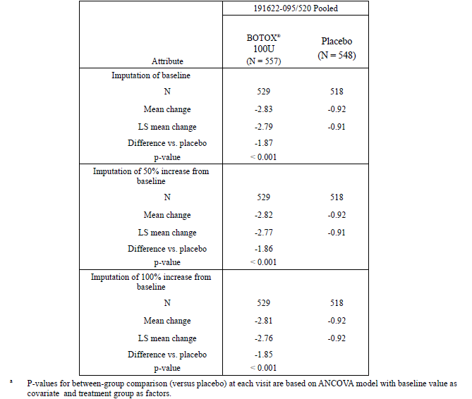

Question 4. Please provide summary tables for abnormal laboratory values, abnormal vital signs, and ECG results in Botox recipients in comparison to placebo recipients.
The sponsor has provided tables addressing the deficiencies in the original reporting of laboratory data, and these tables have now been incorporated into the body of the clinical evaluation report (see Attachment 2). The sponsor did not perform routine ECG monitoring. Given that Botox has been used widely for a large number of indications and significant cardiac safety concerns have not emerged, the lack of ECGs was considered acceptable. There is no reason to expect that injection of Botox into the bladder of OAB patients would produce new cardiac risks relative to the many existing indications for Botox.

Question 5. Please explain the p-values in the [laboratory] tables that [were provided in the original submission].
In the original submission, the sponsor did not present laboratory data in a convenient tabular format but instead referred readers to an appendix containing a separate table for each parameter of interest. For instance, ‘basophils’ were presented in one table, ‘haemoglobin’ in another, and so on, rather than summarising all haematological abnormalities; see the example below. These tables also included highly significant p-values, with no discussion of what was being compared with what.
Table 23. Haematology. Summary of clinical laboratory data for treatment cycle 1. Basophils (%)>.Placebo controlled safety population.
The sponsor writes:
“The inclusion of the p<0.001 implies that there was statistical evidence that the median baseline basophils is not zero. For the change from baseline values, the p < 0.001 implies that there was statistical evidence that the median change from baseline in basophils is not zero.”
The sponsor’s explanation now indicates that the p-values were largely irrelevant. In fact, for each parameter, the first p-value in each column merely expressed the unremarkable fact that the laboratory values were non-zero. These p-values appear to have been the result of using automated data analysis without adapting the output for a human reader.
Now that adequate tables have been provided, this was not considered to be an important issue.

Question 6. For indications other than OAB, are placebo recipients included in the patient numbers purporting to be the number of patients tested for neutralising antibodies?
As noted in the discussion of the proposed PI, the sponsor included placebo recipients when citing the total number of patients tested for neutralising antibodies. The results in placebo recipients are largely irrelevant, so including them inflates the apparent immunological safety of Botox. The sponsor was asked to correct the PI and to confirm that a similar mistake had not been made for other indications.
The sponsor replied:
“The agency is correct that the number of OAB patients with analysed specimens cited in the PI includes both BOTOX® and placebo patients. This was an unintentional error, as we should only be reporting the number of patients who received BOTOX® injections (n=615) (ISS Table 3-86 in original submission). Other indications within the PI also report only the number of patients with analysed specimens who received BOTOX® injections. The PI has been corrected for the OAB indication to reflect the appropriate number of patients. The annotated PI is attached as Appendix 3.”
A review of the new proposed PI shows that the error has been corrected. In particular, the following sentence
“In the pivotal studies, none of the 1023 overactive bladder patients with analysed specimens developed the presence of neutralizing antibodies”
has been replaced with:
“In the pivotal studies, none of the 615 overactive bladder patients with analysed specimens developed the presence of neutralizing antibodies.”
No other corrections pertaining to this issue are needed.

Clinical summary and conclusions

Second round benefit-risk assessment
Overall, the new data provided do not change the benefit-risk assessment. The apparent finding of poor efficacy of Botox in men with OAB remains a substantial issue and the sponsor’s discussion of this problem did not address any of the original concerns.
The discrepancy between the doses recommended for NDO and idiopathic OAB has been satisfactorily justified.
The potential methodological bias introduced by censoring diaries during UTIs does not appear to have had any important impact on the overall results.
The provision of adequate laboratory tables confirms expectations that Botox is relatively unlikely to cause significant laboratory abnormalities.

Second round recommendation regarding authorisation
Botox should be approved for treatment of idiopathic OAB in women, following adequate correction of the PI along the lines indicated.
In particular, the proposed PI should be modified to highlight the lack of evidence of satisfactory efficacy in men.
Regulatory authorities have two options for dealing with the poor evidence of efficacy in men:
- Option 1. Deny approval for use of Botox in men with OAB until adequate studies have been performed showing efficacy. This is the evaluator’s preferred option.
- Option 2. Approve Botox for use in both genders, but modify the PI to highlight the state of the evidence in men with OAB so that patients and clinicians can make an adequately informed decision.
Regardless of whether treatment in men is approved or not, the PI needs to be modified to describe the results in men. The modifications would need to include mention of the following facts:
- No significant benefit has been found in men for incontinence frequency or Treatment Benefit Scale.
- A significant treatment-by-gender interaction exists (p<0.001; this acknowledgement should not be obfuscated by mention of the Gail-Simon test).
- A numerically favourable trend was noted in men for incontinence frequency, but the mean reduction in incontinence frequency was only 0.42 episodes per day in men, from a baseline of 5.61 episodes, and this mean was outside the 95%CI for reduction in incontinence in women.
- Most men (59.3%) reported that their condition was unchanged or worse after Botox .
- Only a small proportion of men (15.3%) had an attributable (placebo-subtracted) TBS response to Botox that was favourable.

V. Pharmacovigilance findings

Risk management plan
The sponsor submitted a Risk Management Plan which was reviewed by the TGA’s Office of Product Review (OPR).

Safety specification
The sponsor provided a summary of Ongoing Safety Concerns which are shown at Table 24.
Table 24. Sponsor’s summary of ongoing safety concerns
Important identified risks | Hypersensitivity reactions  Pre-existing neuromuscular disorders  Immunogenicity, drug resistance and antibody formation  Dysphagia in Cervical Dystonia and in Chronic Migraine patients  Worsening or Intractable Migraine/Headache in Chronic Migraine Treatment  Distant spread of toxin  Urinary tract infections in patients with bladder disorders with urinary incontinence  Urinary retention in patients with bladder disorders with urinary incontinence
Important potential risks | Seizure  Cardiovascular events  Death  Guillain-Barré Syndrome (GBS)  Pyelonephritis in patients with bladder disorders with urinary incontinence.  Multiple Sclerosis (MS) Exacerbation  Potential medication error, overdose from misuse of 200U vial (in those countries where the 200U vial is available)  Interaction with other neuromuscular junction (NMJ) acting agents  Interaction with different botulinum toxin serotypes at the same time or within several months
Important missing information | Pregnancy  Lactation  Renal and Hepatic impairment
‘Multiple sclerosis exacerbation’ has been added as an Important potential risk in this version of the RMP based on results of pivotal NDO studies. Also in this version, the previous Important identified risks ‘urinary tract infection’ and ‘urinary retention’ and Important potential risk ‘pyelonephritis’ have been expanded to include “in patients with bladder disorders with urinary incontinence” to reflect that these risks are also associated with the proposed indication as well as the NDO indication.
Notwithstanding the evaluation of the clinical and nonclinical aspects of the Safety Specification it was considered that the list of Ongoing Safety Concerns specified by the sponsor was consistent with the RMP previously accepted by the TGA and this was considered acceptable.

Pharmacovigilance plan
The pharmacovigilance plan is similar to that accepted in the previous RMP evaluation.
Routine pharmacovigilance was proposed by the sponsor for all safety concerns.
The Important identified risk ‘distant spread of toxin’ is subject to enhanced pharmacovigilance and will be a special safety topic in each Periodic Safety Update Report (PSUR).
The Important potential risk ‘Guillain-Barré syndrome’ is subject to enhanced pharmacovigilance including a targeted questionnaire and special consideration in each PSUR.
Targeted questionnaires are also proposed for the Important potential risks ‘pyelonephritis in patients with bladder disorders with urinary incontinence’ and ‘multiple sclerosis (MS) exacerbation’. Copies of the questionnaires have been provided as annexes to the RMP and were considered to be acceptable.

Risk minimisation activities
Routine risk minimisation (product labelling) was proposed by the sponsor to mitigate all safety concerns except for the Important potential risk ‘Guillain-Barré syndrome’ and Important missing information ‘renal and hepatic impairment’ for which no risk minimisation is proposed.
In Table 5 Summary of Risk Management Plan (RMP p182) and Table 3.1 Summary of Planned Actions (RMP p168) for the Important potential risk ‘multiple sclerosis exacerbation’ under risk minimisation it is stated: “insufficient information to support inclusion on product label”. However it would appear that the proposed PI does include some information under the Neurogenic Detrusor Overactivity section of Adverse Effects. This is considered routine risk minimisation for this safety concern and should be represented appropriately in the Risk Minimisation Plan.
Clinical trial related additional risk minimisation activities are also listed for the Important identified risk ‘distant spread of toxin’ and Important missing information ‘pregnancy’. Although they do not technically relate to post-market use of the product the evaluator has no objection to these activities.
Notwithstanding the above concerns, the risk minimisation plan was generally consistent with the RMP previously accepted by the TGA and was considered acceptable.

Table 25. Reconciliation of issues outlined in the RMP report
Recommendation in RMP evaluation report | Sponsor’s response | OPR evaluator’s comment
- Safety considerations may be raised by the clinical and nonclinical evaluators through the TGA’s consolidated request for information and/or the nonclinical and clinical Evaluation Reports respectively. It is important to ensure that the information provided in response to these includes consideration of the relevance for the Risk Management Plan, and any specific information needed to address this issue in the RMP. For any safety considerations so raised, please provide information that is relevant and necessary to address the issue in the RMP. | Allergan has noted the recommendations made by the TGA above. | This was considered acceptable.
- The AU RMP has been provided for evaluation. The sponsor should clarify in their response that this document is identical in content to the current EU RMP or provide detail on how it differs from that document. | The majority of the AU RMP v5.0 is identical in content to the EU RMP v5.0 submitted with the OAB filing in Europe. Within the body of the RMP, the only difference in content is in Section 4.2, where the AU-RMP describes risk minimisation activities applicable only to Australia. In the EU RMP, Section 4.2 describes risk minimisation activities applicable only to EU.  The other difference is that the AU RMP Annex 2 included the Australian PI and CMI, while the EU SmPC and PIL is included in the EU RMP. | This was considered acceptable.
- Version 4 of the RMP was previously evaluated by the TGA for the NDO indication. In that evaluation it was recommended that an update to the RMP should reflect the clinical evaluator's comments at that time regarding the relationship between the risk of urinary tract infection and impaired bladder emptying as a result of the procedure itself. It is not entirely clear whether this update has occurred and the sponsor should provide information on how this recommendation was addressed in the RMP. | In the NDO Clinical Evaluation Report, the evaluator commented that, “…there is also a need to inform patients that they may have UTIs as a result of impaired bladder emptying, and patients should be monitored for elevated post-void residual volumes. The RMP should reflect the increased risk of UTIs via this additional mechanism.”  Table 1-37 of the AU-RMP v5.0 describes measures for monitoring patients for elevated post-void residual (PVR) volumes. As discussed in the RMP, preventative measures includes, “Assessment of PVR volumes within 2 weeks and periodically as medically appropriate during the post-treatment period in order to institute clean intermittent catheterisation as early as possible which may prevent UTIs due to urinary retention and incomplete bladder emptying.” | This was considered acceptable.
- The RMP describes several ongoing studies (191622-094, 191622-096, 191622-082) related to the important identified risk 'urinary retention in patients with bladder disorders with urinary incontinence' and important potential risk ‘pyelonephritis in patients with bladder disorders with urinary incontinence'. Study 191622-094 will also continue to be assessed for MS exacerbation rates. It is expected that the associated study reports will be forwarded to the TGA when available and detailed in PSURs accordingly. | The studies described above are still ongoing. Any associated study reports will be forwarded to the TGA when available and also detailed in the PSUR accordingly. | This was considered acceptable.
- Although the sponsor has submitted an AU RMP the risk minimisation plan often refers to the EU Summary of Product Characteristics (SmPC) rather than the Australian PI (this is particularly the case in section 5 Summary of the Risk Management Plan). There are also several other inconsistencies with how the risk minimisation plan is presented in this RMP many of which are outlined below. The sponsor should endeavour to make the AU RMP internally consistent with regards to its description of the risk minimisation plan as it applies to Australia. | As previously discussed in RMP Question 2, the AU RMP v5.0 is identical in content to the EU RMP v5.0, with the exception of Section 4.2 and Annexures for the Australian PI and CMI. As Allergan recognises there are regional differences, within the body of the document, differences between Europe and Australia are distinguished, where appropriate. For example, in Table 1-32 of the AU RMP v5.0, labelling differences between the EU SmPC and Australian PI are noted in the row describing “Regulatory actions taken.”  However, if there are no differences between the European and Australian data, the information will only be presented once. For example, the routine risk minimisation activity described for Hypersensitivity Reactions in Section 5 (Summary of Risk Management Plan) of the AU RMP v5.0 does not differ between Europe and Australia, so only the EU SmPC is referenced. Allergan would like to maintain a unified and comprehensive benefit/risk assessment document across multiple regions and has no plans to develop an Australian specific RMP at this time. | This was considered acceptable.
- In Table 3.1 Summary of Planned Actions (RMP p167) for the Important identified risks ‘dysphagia in cervical dystonia and in chronic migraine patients' and ‘worsening or intractable migraine/headache in chronic migraine treatment' it is stated "N/A" however routine risk minimisation (product labelling) does apply to these safety concerns. This should be corrected in an update to the AU RMP. | In Section 3 (Evaluation of the need for risk minimisation activities) of Annex C (Template for EU Risk Management Plan) of the EMA Guidelines, it is stated that “If, for any safety concern, no risk minimisation activities at all are proposed this should be fully justified.”  Allergan’s reason for stating “N/A” for the Important identified risks 'dysphagia in cervical dystonia and in chronic migraine patients' and 'worsening or intractable migraine/headache in chronic migraine treatment' was to highlight that routine risk minimisation activities were not sufficient. In addition to routine risk minimisation activities, Allergan believes enhanced risk minimisation activities are also necessary. A description of the enhanced risk minimisation activities are further detailed in Section 2.3 (Detailed action plan for specific safety concerns).  Of note, in Section 2.3, both routine and enhanced pharmacovigilance activities for these risks are listed. | The evaluator considers that the activities described in section 2.3 of the RMP are pharmacovigilance activities and not strictly risk minimisation.  It would therefore appear that only routine risk minimisation (product labelling) apply to these safety concerns. Section 5 Summary of the Risk Management Plan would seem to also confirm this.  Unless the sponsor can provide information about specific additional risk minimisation activities for these safety concerns then the RMP should be amended to reflect this.  Please note that the evaluator has no objection to routine risk minimisation only for these safety concerns.
- In Australia, healthcare professional education materials are proposed for the Important identified risk 'distant spread of toxin' in the form of a letter highlighting the associated information in the PI as well as an Injector training programme. The sponsor should provide these materials to the TGA in and include them as annexes to the RMP when it is next updated. The effectiveness measures of these activities as outlined in the RMP are considered appropriate however the sponsor should confirm how the results will be communicated to the TGA. These details should also be included in an update to the RMP. | The sponsor provided copies of the educational materials in their response. | This was considered acceptable.
- Table 5 Summary of Risk Management Plan (AU RMP v5.0) includes "patient education" as additional risk minimisation for the Important identified risk 'distant spread of toxin' in Australia. The evaluator considers that the CMI alone is not technically additional risk minimisation and therefore the sponsor should clarify whether other patient-specific educational materials are planned. If not, this should be made clear in this summary table. | To ensure that patients are adequately educated with respect to “distant spread of toxin”, Allergan has taken the following steps:  The PI states under section Precautions – Information for Patients:  “Patients should be informed that the BOTOX® Consumer Medicines Information leaflet is available and must be provided to them by prescribers”.  The DHCP letter reiterates to the physicians the possibility of this adverse event and their obligation to discuss it with their patient as well as direct the patient to read the CMI.  This information will also be communicated in the physician education package that will be distributed to the doctors along with the questionnaire on the NDO urology site.  Allergan therefore believes that the above listed items in addition to the CMI are adequate risk management activities. | This was considered acceptable.
- In accordance with the previous RMP evaluation the sponsor has committed to distributing a Dear Health Professional letter in Australia if they decide to market the 200U vial of Botox. The evaluator wishes to emphasise that in the event that this occurs, the letter should be provided to the TGA. | Although the 200U vial has been approved in Australia, Allergan has not yet marketed this product. If Allergan decides to market the 200U vial, a “Dear Dr. Letter” will be sent to the physicians addressing the points as per Table 4-2 of the AU RMP v5.0. This letter will also be made available to the TGA at the time. | This was considered acceptable.
- In regard to routine risk minimisation, it is recommended to the Delegate that the draft product information (PI) is revised as follows:  Given 'renal and hepatic impairment' is listed as Important missing information it is recommended that the sponsor include a statement in the PI that is in accord with the statement in the RMP that "there have been no studies performed to evaluate the use of Botox in patients with renal or hepatic impairment" or provide a compelling justification for its omission | In Section 3.6.2b (Populations not studied in the pre-authorisation phase) of Volume 9A of The Rules Governing Medicinal Products in the European Union, “Patients with relevant comorbidity such as hepatic or renal disorders” is a population listed in the guidelines that should be considered for discussion.  As discussed in the RMP, classical absorption, distribution, biotransformation and elimination studies have not been performed in humans due to the nature of botulinum toxin type A. Since Botox® is administered by local injection directly into the intended sites of clinical effects, it is not expected to impact patients with renal and/or hepatic impairment. Therefore, Allergan included the appropriate information in the RMP and does not agree that this statement is required to be included in the PI. | The sponsor’s justification was considered acceptable.

It was considered that the sponsor’s response to the TGA’s consolidated request for information regarding the RMP has adequately addressed all of the issues identified in the RMP evaluation report.

Summary of recommendations

Outstanding issues

Issues in relation to the RMP
There are no outstanding issues in relation to the RMP for this submission.

Advice from the Advisory Committee on the Safety of Medicines (ACSOM)
ACSOM advice was not sought for this submission.

Suggested wording for conditions of registration

RMP
Implement the Botox AU-RMP version 5 (document date 22 June 2012, data lock point 31 December 2011) and any future updates as a condition of registration.

PSUR
The Botox AU Risk Management Plan (RMP), version 5, (Data Lock Point 31 December 2011, Document date 22 June 2012), included with submission PM-2012-01467-3-3, and any subsequent revisions, as agreed with the TGA will be implemented in Australia.
The TGA notes the sponsor’s confirmation that the next update to the RMP that incorporates the changes recommended by the RMP evaluator in relation to Section 4 (question 6) of the RMP report will be submitted to the TGA before the end of 2013.
An obligatory component of Risk Management Plans is Routine Pharmacovigilance. Routine Pharmacovigilance includes the submission of Periodic Safety Update Reports (PSURs). Reports are to be provided annually until the period covered by such reports is not less than three years from the date of this approval letter. No fewer than three annual reports are required. The reports are to at least meet the requirements for Periodic Safety Update Reports (PSURs) as described in the European Medicines Agency’s Guideline on Good Pharmacovigilance Practices (GVP) Module VII-Periodic Safety Update Report, Part VII.B. "Structures and processes". Note that submission of a PSUR does not constitute an application to vary the registration. Each report must have been prepared within ninety calendar days of the data lock point for that report.
Unless agreed separately between the supplier who is the recipient of the approval and the TGA, the first report must be submitted to TGA no later than 15 calendar months after the date of this approval letter. The subsequent reports must be submitted no less frequently than annually from the date of the first submitted report until the period covered by such reports is not less than three years from the date of this approval letter.
The annual submission may be made up of two Periodic Safety Update Reports each covering six months. If the sponsor wishes, the six monthly reports may be submitted separately as they become available.

VI. Overall conclusion and risk/benefit assessment
The submission was summarised in the following Delegate’s overview and recommendations:

Quality
There was no requirement for a quality evaluation in a submission of this type.

Nonclinical
There was no requirement for a nonclinical evaluation in a submission of this type.

Clinical
The clinical evaluator reviewed the submitted data, which included:
- 2 Phase III pivotal studies (Study 191622-095 and Study 191622-520)
- 1 Phase III supportive extension study (Study 191622-096)
- 1 Phase II supportive study (Study 191622-077)
- 1 Integrated summary of Efficacy
- 1 Integrated summary of Safety
The clinical evaluator recommended approval in women in the evaluation report. Alternatively, the clinical evaluator considered that approval in both sexes could be approved if changes were made to the Product Information highlighting the relatively poor efficacy demonstrated in men with OAB.
The benefits noted by the evaluator included:
- a reduction in the frequency of incontinence of ~2 episodes per day in women and 0.42 episodes in men, from a mean baseline incontinence of 5-6 episodes per day
- 27.1% of Botox recipients versus 8.4% of placebo recipients achieving the ‘dry’ state.
- a subjective positive response rate (i.e. symptoms improved or greatly improved) of 64.3% in women, compared to 28.4% with placebo, consistent with an attributable response rate of 35.9%
- a subjective positive response rate of 40.7% in men, compared to 25.4% with placebo, consistent with an attributable response rate of 15.3%
- parallel improvements in other measures of urgency and frequency
- modest but significant improvements in quality of life
The concerns noted by the evaluator included:
- on-going incontinence can be expected in the majority of patients
- an increased incidence of UTI, increased post-void residual urine volume, and increased incidence of acute urinary retention
- the need to return for measuring post-void residual urine volume
- patients may need to commence catheterisation after treatment
- most men can be expected to report no change or worsening of their symptoms

Pharmacology:
No clinical pharmacology studies were submitted

Efficacy
There were 2 pivotal efficacy studies, 191622-095 (Study 95) and 191622-520 (Study 520). As these 2 studies had almost identical designs, pooled results will be presented preferentially, with individual trial results discussed if different from the pooled results. Supportive information was provided by a Phase II dose-ranging study (191622-077, Study 77) and the open-label extension of the pivotal studies (191622-096, Study 96).
A dose of 100 U was selected as the optimal dose for balancing safety and efficacy of botulinum toxin, based on Study 77, which was initially evaluated in the NDO submission.

Studies 191622-095 (Study 95) and 191622-520 (Study 520)
These pivotal Phase III, randomised, double-blind, placebo-controlled, parallel design trials compared botulinum toxin 100 U or matching placebo injected into the bladder wall in patients with idiopathic OAB and associated urgency incontinence of ≥ 6 months duration, that had not been controlled after at least 2 weeks on an optimised dose of anticholinergic therapy. Patients had to have a negative urine dipstick at randomisation and to be willing to use clean intermittent catheterization (CIC) if deemed necessary by the investigator. Study 95 was conducted in the US and Canada (n=557) and Study 520 was conducted in the US and Europe (n=549). Patients could receive a second treatment of open-label Botox 100 U (regardless of initial treatment) at least 12 weeks after the first treatment if they had ≥ 2 episodes of urinary urgency incontinence (UUI) in their 3 day patient bladder diary and no more than one urgency incontinence-free day in the previous week. Antibiotics were given one day prior to study treatment and continued for at least 3 days following treatment. Patients were studied for at least 24 weeks (39 weeks if a second treatment was given), with only the first 12 weeks definitely placebo-controlled and double-blind.
Exclusion criteria were aimed at excluding patients with other urological conditions, including non-idiopathic OAB or factors that could have confounded the assessment of efficacy or safety and included: OAB secondary to any known neurological reason, a predominance of stress incontinence, anticholinergic treatment or any other therapies for OAB within the 7 days prior to baseline (such subjects could enter after a 7 day washout period), already using CIC or an indwelling catheter, intravesical treatment with capsaicin or resiniferatoxin within the previous 12 months, previous botulinum toxin therapy within the previous 12 weeks or immunisation for any botulinum toxin serotype, significant pelvic or urological abnormalities other than OAB, history of urothelial malignancy or a prostate-specific antigen level > 10 ng/mL, post-void residual (PVR) urine volume > 100 mL at screening, history of urinary retention or elevated PVR urine volume that had been treated with an intervention (such as catheterisation) within the previous 6 months, 24 hour urine volume > 3000 mL, history of 2 or more UTIs within the previous 6 months, or taking prophylactic antibiotics to prevent chronic UTIs, serum creatinine level > 2 times the upper limit of normal at screening, current or previous un-investigated haematuria, bleeding disorders, pregnant, nursing or planning a pregnancy.
Baseline characteristics were similar between the treatment groups in both studies (pooled mean age 60 years, 88% female, 91% Caucasian, median duration of OAB 5.0 years, mean 5.4 daily episodes of UI, mean 4.9 daily episodes of UUI, mean 11.7 daily episodes of micturition, mean 8.6 daily average urgency episodes, mean 2.1 daily nocturia episodes, mean volume voided per micturition of 153.6 mL, mean PVR urine volume of 21 mL, and a mean number [2.4] and duration [119 weeks] of prior anticholinergic use). Study discontinuation was 12.5% overall. A higher proportion of the placebo group requested a second treatment after week 12 compared with the botulinum toxin group (Week 12: 48-49% versus 22-28%, Week 18: 67-70% versus 39-46%, Week 24: 76-82% versus 50-59%, respectively). Protocol deviations were reasonably common (15-17%, including not meeting inclusion criteria, not receiving randomised treatment, and incomplete diary assessments), but were not considered by the evaluator to have introduced bias. The studies had 82% power to detect a between group difference of 2.3 incontinence episodes per 3 days in change from baseline. For the co-primary endpoint of Treatment Benefit Scale (TBS) (which was only applicable to the EU submission), the studies had 99% power, assuming that the proportion of patients with a positive response was 76% with active treatment compared to 54% in the placebo group. A 2-sided p-value ≤ 0.05 for both co-primary efficacy variables was considered to be statistically significant for the primary efficacy analysis in the EU submission, whereas the single primary endpoint of number of UI episodes was assessed with a p-value ≤ 0.05 in the FDA submission. Because the studies used multiple endpoints, a hierarchical testing strategy was employed, starting with the primary efficacy variable(s) and followed by the secondary efficacy variables. Only if statistical significance was demonstrated in a higher ranking endpoint were lower ranking endpoints evaluated.
The primary efficacy endpoint was daily frequency of UI episodes at Week 12. The European Medicines Agency (EMA) requested an additional co-primary endpoint (TBS), consistent with their guidance that subjective improvement should be the major clinical outcome measure. The TBS is a qualitative assessment completed by the patient comparing their current urinary condition to their condition before they received any treatment in the study (greatly improved, improved, not changed, or worsened). An assessment of ‘greatly improved’ or ‘improved’ was considered a positive response. A retrospective psychometric validation of the TBS in the context of 2 large Phase III trials of anti-muscarinic treatment of patients with OAB, demonstrated strong validity and responsiveness of the instrument compared with other validated patient-reported assessments (the King’s Health Questionnaire and the short form of the International Consultation on Incontinence Questionnaire; both used as secondary endpoints in the pivotal trials).
The primary efficacy endpoint showed botulinum toxin was superior to placebo with a mean reduction in daily UI episodes at Week 12 of 2.80 versus 0.95 (p<0.001, ITT, pooled analysis) from a baseline frequency of 5.49 versus 5.39 daily episodes. The treatment effect relative to placebo was estimated to be -1.79 episodes prevented by a LS mean difference method (95%CI: -2.14 to -1.44 episodes). The individual study results were consistent with the pooled results. Support for the primary analysis was given by a responder analysis for the UI variable which showed that 27% of patients receiving botulinum toxin achieved a 100% reduction in incontinence compared with 8.4% of placebo patients (p<0.001).
Figure 1. Mean change from baseline in daily frequency of urinary incontinence episodes during cycle 1 (first 12 weeks) (ITT population with LOCF imputation).
ITT = intent to treat; LOCF = last observation carried forward; data are means ± 95% confidence intervals; **p<0.001 (p-values calculated for difference between BOTOX and placebo using LS mean change in an ANCOVA model)
The co-primary endpoint of TBS also showed that botulinum toxin was superior with 62% responders (‘greatly improved’ or ‘improved)’ at week 12 compared with 28% to placebo (p<0.001; OR: 4.15, 95% CI: 3.22, 5.35, ITT). The individual study results were consistent with the pooled results.
An indication of duration of efficacy was given by the requests received for retreatment in the pivotal trials (not allowed before Week 12). In the botulinum toxin group, 22-28% requested a second treatment at Week 12 compared with 48-50% of placebo recipients. The median duration of response in the botulinum toxin group was 127-148 days versus 87-90 days in the placebo group (see also Study 96 [long-term extension] results).
Figure 2. Proportion of patients with a positive treatment response on the treatment benefit scale during cycle 1 (first 12 weeks) (ITT population with LOCF imputation).
ITT = intent to treat; LOCF = last observation carried forward; data are means ± 95% confidence intervals; **p<0.001; positive treatment response defined as a score of either 1 or 2 (‘greatly improved’ or ‘improved’)
The secondary endpoints also demonstrated the superiority of botulinum toxin compared with placebo at Week 12 (the individual study results were consistent with the pooled results, CER):
- number of micturition episodes:
  - baseline: 11.99 versus 11.48 episodes
  - mean reduction 2.35 versus 0.87 episodes, mean diff versus placebo -1.37, 95%CI -1.69, -1.05, p<0.001
- number of UUI episodes:
  - baseline: 4.97 versus 4.84 episodes
  - mean reduction 2.62 versus 0.74 episodes, mean diff versus placebo -1.82, 95%CI -2.17, -1.48, p<0.001
- daily frequency of urgency symptoms:
  - baseline: 8.82 versus 8.31 episodes
  - mean reduction 3.30 versus 1.23 episodes, mean diff versus placebo -1.96, 95%CI -2.41, -1.05, p<0.001
- volume voided per micturition:
  - baseline: 150.4 versus 156.9 mL
  - mean change 42.1 versus 11.2 mL, mean diff versus placebo 30.0mL, 95%CI 21.6, 38.4, p<0.001
- Incontinence Quality of Life (I-QOL) total summary score:
  - baseline: 34.1 versus 34.7
  - mean change 22.5 versus 6.6, mean diff versus placebo 15.9, 95%CI 13.3, 18.5, p<0.001
- King’s Health Questionnaire (KHQ) Role Limitation domain scores:
  - baseline: 65.4 versus 61.2; -25.4 versus -3.7, mean diff versus placebo -20.4, 95%CI -23.9, -16.9, p<0.001
- KHQ Social Limitation domain scores:
  - baseline: 44.8 versus 42.4; mean change -16.8 versus -2.5, mean diff versus placebo -13.6, 95%CI -16.7, -10.6, p<0.001
Post-hoc subgroup analyses of the pooled pivotal studies showed that botulinum toxin is effective in reducing mean UI or improving TBS response across the majority of subgroups (including age, race, presence of diabetes mellitus, presence of benign prostatic hyperplasia (BPH) (in male patients), baseline UUI episodes, reason for anticholinergic failure, and number of failed anticholinergics), with most also having a 95% CI below 0 (or OR >1 for TBS) (CER and shown in figure below).
However, the efficacy of botulinum toxin in men was marginal (numerically in favour of active treatment), and not statistically significant when compared with placebo:
- Baseline frequency of 5.61 versus 4.33 episodes
- LS mean reduction in UI episodes in men: 1.86 versus 1.44 (LS mean diff versus placebo -0.42, 95%CI -2.08, +1.23, p=0.612)
- LS mean reduction in UI episodes in women: 2.86 versus 0.86 (LS mean diff versus placebo -2.00, 95%CI -2.37, -1.62, p<0.001).
- A statistically significant treatment-by-sex interaction was reported for both primary efficacy variables.
- Proportion of men with a positive treatment response was low at 40.7% versus 25.4% on placebo, p=0.060 indicating a trend for a response.
- Proportion of women with a positive treatment response was higher at 64.3% versus 28.4% on placebo, p<0.001 indicating a significant response.
Men comprised only a small percentage of the study participants (12%), reflecting the epidemiology of OAB. While a lack of statistical power is one potential explanation for the different result seen in men, other possibilities include: gender differences in bladder outlet anatomy/physiology, reduced sphincter function in women after childbirth and prostatism and partial outlet obstruction in men.
Safety risks with the treatment procedure (UTI and urinary infection) are of similar magnitude to the attributable TBS benefit in males.
Figure 3. Forest Plot for LS mean between-treatment differences in urinary incontinence episodes at week 12 for subgroups of sex, baseline urinary incontinence, diabetes status, and race (placebo-controlled ITT population with LOCF imputation)
CI = confidence interval; ITT = intent-to-treat; LOCF = last observation carried forward; LS = least squares, UUI = urinary urgency incontinence
Study 191622-077 (Study 77)
This was a supportive Phase II, randomised, double-blind, placebo-controlled, parallel design, dose-finding study comparing 5 doses of botulinum toxin (300, 200, 150, 100 and 50U) to placebo in the treatment of patients with idiopathic OAB (n=313, 54 on 100 U). The primary endpoint was incontinence frequency (expressed as the number of episodes of UUI per week) at week 12 in comparison to baseline. This study was previously evaluated by the TGA in the NDO submission but was not as relevant (in the context of that submission) as patients had OAB, not NDO. Because of an unexpectedly large placebo effect, the 100 U dose of botulinum toxin only demonstrated a statistically significant result in UUI at Weeks 18 and 24, compared with the 200 U dose which was significant at Weeks 6, 12, 18, 24, 30 and 36. However, based on the cumulative safety and efficacy of the doses, 100 U was selected as having the appropriate benefit/risk balance in OAB for the phase III studies (CER).

Study 191622-096 (study 96)
This is an ongoing open-label extension of Studies 95 and 520 which is primarily observational and descriptive. Patients who completed either of these studies were eligible to receive additional Botox treatment cycles (100 U or 150 U [third cycle or later only]) on the basis of recurrent symptoms and will be followed for up to two years (104 weeks). At the interim data cut-off date (29 July 2011), 834 patients had enrolled, but only 814 patients had received at least one dose of active treatment. Up to 4 treatment cycles have been completed but only in 88 patients. It is not clear whether the reduction in patient numbers in the later cycles is due to discontinuation, staggered entry into the study, patients not meeting criteria for (or not requesting) further treatment, or a combination of these factors.
The primary efficacy outcome is change from original pivotal study baseline in the number of episodes of UI at Week 12 post each treatment cycle. The reduction in UI was similar over multiple treatment cycles (3 to 4 UI episodes) and for both doses and was consistent with the results seen in the original studies. The evaluator recommended extreme caution in interpreting these results because there is no placebo control, treatment is open-label, and the potential for selection bias (non-responders likely to have discontinued). TBS was also measured, and again remained relatively stable irrespective of treatment cycle or dose (66% – 82% responders) and was consistent with the results seen in the original studies. Despite study design limitations, duration of effect was estimated based on either time to patient request for re-treatment or time to patient qualification for re-treatment. Depending on the cycle and dose, this ranged from a median 99-169 days and 121-169 days, respectively.

Safety
In total, 1104 patients in the pooled Phase II and III studies received at least one dose of botulinum toxin: 1054 received 100 U, and 50 received a dose of 150 U in the open-label extension; 585 patients received placebo as their first treatment. A total of 594 patients received at least 2 doses (100 U or 150 U), 253 received 3 doses, and 88 received 4 doses.
In the first 12 weeks of the pooled studies, AEs occurred in 58% of the botulinum toxin and 45% of the placebo groups and were generally mild to moderate in severity. Most individual AEs were more common in patients receiving botulinum toxin compared with those receiving placebo, the most common being: urinary tract infections (UTIs) (18 versus 5%), dysuria (8 versus 7%), bacteriuria (4 versus 2%), and urinary retention (7 versus 1%). AEs increased with age in both treatment groups, mostly due to an increase in UTIs. UTIs were also more common in women than men. These AEs are expected, generally considered treatment-related in patients receiving botulinum toxin (based on its mode of action) and are consistent with those seen in the previously evaluated NDO studies.
In the non-placebo-controlled and open-label extension phases of the studies, AEs occurred in 51–66% of patients depending on treatment cycle. UTIs (18–26%), dysuria (3–9%), bacteriuria (2–7%) and urinary retention (3-7%) remained the most common AEs, with no new unexpected AEs identified.
A statistically significant increase in mean post-void residual volume (PVR) was seen in the botulinum toxin groups by Week 2 (+48.2 mL) compared with the placebo groups (+5.6 mL), which had declined by Week 12 (+29.3mL versus +4.2mL, respectively). In addition, a higher percentage of patients on botulinum toxin had a >100mL increase in PVR compared with those on placebo (29.3% versus 6.8%. p<0.001). This resulted in a higher use of clean intermittent catheterisation (CIC) with botulinum toxin treatment (8.7%) than with placebo (1.7%), which in turn was associated with an increased risk of UTI.
AEs potentially related to the intra-detrusor injection procedure (haematuria [2%], and dysuria [5–6%]), occurred in a similar proportion of patients on both active and placebo treatment. Of the potential local spread/systemic AEs, only constipation was more common in patients receiving botulinum toxin (1.5 versus 0.7%). Botulinum toxin administration can be associated with the development of neutralising antibodies. However among the 615 patients assessed for the development of neutralizing antibodies using a validated Enzyme-linked immunosorbent assay (ELISA), no neutralising antibodies were found (26 patients developed low-titre binding antibodies that did not neutralise the pharmacological effect of the toxin in a neutralising assay).
Three deaths were reported in the pooled studies (2 on placebo, 1 on botulinum toxin 100 U), with none considered likely to be treatment-related. Serious AEs were similar in frequency in the botulinum toxin groups (4.3%) and placebo groups (3.8%), with urinary retention (0.5 versus 0.0%) and osteoarthritis (0.7 versus 0.5%) the only individual SAEs that were higher in the botulinum toxin group and seen in at least 3 patients. While there were more SAEs reported during the non-placebo-controlled and open-label extension phases of the studies (3-8%, reducing on later treatment cycles potentially due to the discontinuation of patients intolerant of treatment), the pattern of events was similar. Across all treatment cycles the most common SAEs were: myocardial infarction (n=4), atrial fibrillation (n=4), pneumonia (n=6), cellulitis (n=4), osteoarthritis (n=12), breast cancer (n=3), basal cell carcinoma (n=3), urinary retention (n=4), acute renal failure (n=3), pulmonary embolism (n=3). Of these, only urinary retention was considered treatment-related. AEs leading to discontinuation in the pooled studies were higher on botulinum toxin than placebo (1.5 versus 1.0%), but no AE occurred more than once. Biochemical and haematological abnormalities were infrequent and similar in both groups. Routine ECGs were not performed and no significant differences were seen in vital signs.

Risk management plan
The Office of Product Review has accepted the Botox AU Risk Management Plan (RMP) version 5, (Data Lock Point 31 December 2011, Document date 22 June 2012) and recommended further changes as outlined below from their report:
- In the absence of additional information to the contrary, it is recommended that the RMP is updated to reflect that there are only routine (not enhanced) risk minimisation strategies for ‘dysphagia in cervical dystonia and in chronic migraine patients’, and ‘worsening or intractable migraine/headache in chronic migraine treatment’.
The sponsor should address these matters in the Pre-ACPM Response and follow up where appropriate with the TGA’s Office of Product Review.

Risk-benefit analysis

Delegate considerations

Efficacy
Botulinum toxin has demonstrated superiority to placebo in two large, well designed, Phase III trials in patients with idiopathic OAB and associated urgency incontinence of ≥ 6 months duration that had not been controlled after at least 2 weeks on an optimised dose of anticholinergic therapy. The choice of endpoints, comparator, design and safety aspects of these trials were in accordance with the relevant indication specific EU guideline. The possible exception was in the selection of patients, who appear to have been recruited on the basis of symptoms rather than signs or urodynamic measurements (although they may have met these diagnostic criteria prior to being prescribed anticholinergic therapy). The mean reduction in urinary incontinence episodes at Week 12 was 2.80 on botulinum toxin compared with 0.95 on placebo in the pooled studies (LS mean difference -1.79 episodes; 95%CI: -2.14 to -1.44 episodes). However, only a small proportion of patients achieved a 100% reduction in incontinence (27 versus 8%, respectively). Botulinum toxin was also superior to placebo on the co-primary endpoint of the Treatment Benefit Scale at Week 12 with 62% responders compared with 28% (p<0.001; OR: 4.15, 95% CI: 3.22, 5.35, ITT). Improvements were also seen in the secondary efficacy endpoints, including other measures of urgency and frequency, and in quality of life. Post-hoc subgroup analyses in the pooled studies showed a consistent benefit in most groups, with the exception of gender. The reduction in UI in the open label extension study was similar over multiple treatment cycles and for both doses, and was consistent with the results seen in the original studies but this study had limitations.

Use in males and indication
In men, the efficacy of botulinum toxin was for marginal for UI (mean reduction in UI episodes: 1.86 versus 1.23 in men [p=0.612] compared with 2.92 versus 0.90 in women [p<0.001]) and also less convincing for positive responses on the TBS (41% versus 25% in men [p=0.06], compared to 64% versus 28% in women [p<0.001]), with both outcomes having a statistically significant treatment-by-sex interaction. The sponsor attributed the lack of significance primarily to poor statistical power. However, as highlighted by the clinical evaluator, in addition to the wider CIs around the results as expected with lack of power, the point estimates in males were also much smaller. This suggests that other factors may be involved such as gender differences in bladder outlet anatomy/physiology, reduced sphincter function in women post-childbirth, prostatism and partial outlet obstruction in men and so on. The findings in males were not statistically significant, especially since almost 60% of males deemed that their condition was either unchanged or worse following treatment with botulinum toxin, and only a modest reduction in UI episodes (-0.42) was observed. However this reduction was numerically in favour of botulinum toxin and 41% versus 25% of men reported a positive response which was of borderline significance (p=0.060).
An analysis of AEs by gender showed that men were less likely to develop an AE on botulinum toxin than women (59% versus 70%), largely due to the much lower incidence of UTIs in men (10% versus 28%), with urinary retention affecting a similar proportion (8% versus 7%).
Given the gender analysis is a post-hoc one, the pivotal studies were not powered to show a treatment benefit in males (only 12% of subjects in the pivotal studies were male), the trend for a positive treatment response in males (40.7% versus 25.4% on placebo, p=0.060), the reduction in UI episodes was numerically favouring botulinum toxin compared to placebo (1.86 versus 1.23 in men, p=0.612) and the similar safety profile to women, then it may be preferable to leave the indication gender-neutral but to incorporate a detailed discussion about the lack of demonstrated efficacy in males in the Clinical Trials and Precautions sections of the PI.

NDO indication
The evaluator was concerned that the dose approved for the NDO indication (200 U) may be excessive, given that 100 U of botulinum toxin has been found to be efficacious in the OAB indication. The doses selected for the pivotal NDO trials (200 U and 300 U) were based on a dose-ranging study that was inadequately powered to compare these higher doses with 100 U and the sponsor was asked to comment on whether 100 U may have been effective in the treatment of NDO. The sponsor stated that NDO is not comparable to OAB because the neurological aetiology is associated with high intradetrusor pressures, a thickened trabeculated detrusor muscle and an increased likelihood of upper urinary tract damage which are not present in patients with OAB, thus justifying the higher dose required with NDO. This argument was accepted by the evaluator.

Safety and RMP
In the first 12 weeks of the pooled studies, more AEs occurred with botulinum toxin (58%) than with placebo (45%), but they were generally mild to moderate in severity. The most common AEs in patients receiving botulinum toxin compared with placebo were: UTIs (18 versus 5%), dysuria (8 versus 7%), bacteriuria (4 versus 2%), and urinary retention (7 versus 1%), which may have necessitated catheterisation. AEs increased with age in both treatment groups, mostly due to an increase in UTIs. UTIs were also more common in women than men. Based on its mode of action, these AEs are expected with botulinum toxin and are consistent with (but at a lower frequency than) those seen in the previously evaluated NDO studies. Procedural AEs were similar on botulinum toxin and placebo, constipation was the only potentially locally spread AE that was higher on botulinum toxin (1.5 versus 0.7%), and no patient developed neutralising antibodies. No new unexpected AEs were identified in the non-placebo-controlled and open-label extension phases of the studies (mean duration of exposure 43 weeks). SAEs were similar on botulinum toxin and placebo and the only SAE considered treatment-related was urinary retention.

Data deficiencies
A lack of long term controlled data on repeated use.

Conditions of registration
The following are proposed as conditions of registration:
- The implementation in Australia of the Botox AU Risk Management Plan (RMP) version 5, (Data Lock Point 31 December 2011, Document date 22 June 2012) and any subsequent revisions, as agreed with the TGA.
- The following studies must be submitted to the TGA, as soon as possible after completion, for evaluation as a Category 1 submission:
  - Study 191622-096.

Summary
Overall at present the submission appears approvable with demonstrated efficacy and an acceptable safety profile. The principal issue is whether the equivocal results in men (based on post-hoc analyses) warrant a restriction of the indication to women only.
The Delegate was inclined to approve this submission by Allergan Australia Pty Ltd to register Botox (botulinum toxin A) 50, 100 U and 200 U for the new indication of treatment of overactive bladder based on the quality, safety and efficacy of the product being satisfactorily established for the indication below and for the reasons stated above in the Risk/Benefit Discussion:
Botox is indicated for treatment of overactive bladder with symptoms of urge urinary incontinence, urgency, and frequency, in adult patients who have an inadequate response to or are intolerant of an anticholinergic medication.
The Delegate asked the sponsor to address the following issues in the Pre-ACPM response:
- At the interim data cut-off date (29 July 2011) in Study 96, 834 patients had enrolled, but only 814 patients had received at least one dose of active treatment. Up to 4 treatment cycles have been completed but only in 88 patients. Please comment on the explanation for this reduction in patient numbers in the later cycles, such as discontinuation, staggered study entry, patients not meeting criteria for (or not requesting) further treatment or other factors.
- Please comment on whether the selection of patients in the pivotal trials, who appear to have been recruited on the basis of symptoms rather than signs or urodynamic measurements, may not be in accordance with the EU guideline.
- To further explore the difference in efficacy seen in males compared with females, please provide patient disposition and time to patient request/qualification for re-treatment separately for males and females for each treatment cycle.
- Are any further studies being conducted to examine the efficacy and safety of Botox in males?
The Delegate requested advice from the ACPM regarding:
- Should the indication be restricted to females only, or would amending the PI to highlight the relatively poor efficacy in men be adequate?
- Should the indication specify urge urinary incontinence (as per the US PI) consistent with the pivotal study inclusion/exclusion criteria?
The Delegate’s Overview was submitted for ACPM advice

Response from sponsor
Allergan Australia Pty Ltd. concurred with the recommendation of the Delegate to approve the extension of indication for Botox® (botulinum toxin type A) as follows:
“Treatment of overactive bladder with symptoms of urinary incontinence, urgency, and frequency, in adult patients who have an inadequate response to or are intolerant of an anticholinergic medication.”
Allergan discussed the following points for which advice has been sought from the ACPM in their response:
- Restriction of indication to females only
Should the indication be restricted to females only, or would amending the PI to highlight the relatively poor efficacy in men be adequate?
- Wording of indication (that is, inclusion of urge urinary incontinence)
Should the indication specify urge urinary incontinence (as per the US PI) consistent with the pivotal study Inclusion /exclusion criteria?
- Evaluator’s recommendations for the Product Information and Consumer Medicine Information
- Additional issues raised by the Delegate
- Risk Management Plan.

Restriction of indication to females only
The efficacy in men was discussed extensively in the response to the List of clinical questions sent to the TGA on 4 Feb 2013 and further discussed below:
The prevalence of OAB with urinary incontinence (‘wet’ OAB) is considerably higher in women than men; approximately 7% to 12% of all females are reported to have this condition compared to 3% of all males., , , Both OAB and ‘wet’ OAB increase with advancing age, and the rate of increase of ‘wet’ OAB with age is noted to be greater in females than males., Indeed, ‘wet’ OAB is predominantly a condition of females over 40 to 50 years of age. It is therefore not surprising that the demographic profile of patients enrolled into Allergan’s large multinational Phase III studies was predominantly female patients over 40 years of age since this reflects the epidemiology of this condition.
Although fewer males were enrolled in the Allergan studies important treatment benefits were demonstrated, though they were not necessarily statistically significant due to the small sample size of the male patient sub-group. However, since Botox® is injected directly into the detrusor muscle, and the target organ does not differ between sexes, a treatment effect across both male and female subgroups is expected. Thus Botox® can provide a useful option for male patients with OAB for whom there are currently limited therapeutic alternatives after anticholinergic therapy has failed.
The target population of Allergan’s Botox® clinical studies were those OAB patients who had not been adequately managed with prior anticholinergic therapy. A similar demographic profile of patients were also enrolled in anticholinergic Phase III studies of approved OAB drugs,,, as this is the main population suffering from OAB. For example, in the registration trials for solifenacin and tolterodine the percentage of male patients ranged from 10.9% to 14.7%.^{17, 18} This was only slightly less than the Phase III study for fesoterodine, where 20% of patients enrolled were male. The percentage of male patients in the Allergan clinical studies (12.2%) is therefore comparable to the randomised Phase III studies of various anticholinergics used and approved in many countries for the treatment of OAB. The approved wording of the indications in the Australian PI’s for OAB treatments such as tolterodine (Detrusitol) and solifenacin (Vesicare) are not restricted to females only, even though male patient numbers were small. The sponsor therefore believed a restriction to female patients only should not be applied to the proposed indication for Botox®. Allergan thus requests that the original proposed indication of
“Treatment of overactive bladder with symptoms of urinary incontinence, urgency, and frequency, in adult patients who have an inadequate response to or are intolerant of an anticholinergic medication”
be maintained. However, the sponsor recognised the clinical evaluator and Delegate’s comments on the limited data available in men. Therefore, the sponsor proposed to add further information on limited efficacy data in male patients in the Precautions section of the PI.
The addition of this wording in the Precautions section will adequately allow male patients and clinicians to make an informed decision about the benefit risk balance when considering treatment with Botox®.

Wording of indication (inclusion of urge urinary incontinence)
Allergan requested that the indication remain as originally submitted;
Botox® is indicated for the treatment of overactive bladder with symptoms of urinary incontinence, urgency, and frequency, in adult patients who have an inadequate response to or are intolerant of an anticholinergic medication
since the co-primary endpoint in the two pivotal trials was urinary incontinence rather than urgency urinary incontinence.

Evaluator’s recommendations for the PI and CMI
The sponsor also responded to recommendations made by the evaluator regarding amendments to the PI and CMI but these are beyond the scope of this AusPAR.

Other issues raised by the Delegate
At the interim data cut-off date (29 July 2011) in Study 96, 834 patients had enrolled, but only 814 patients had received at least one dose of active treatment. Up to 4 treatment cycles have been completed, but only in 88 patients. Please comment on the explanation for this reduction in patient numbers in the later cycles, such as discontinuation, staggered study entry, patients not meeting criteria for (or not requesting) further treatment or other factors.
- 1105 patients were randomised to receive either BOTOX® 100U or placebo in the two phase 3 studies, 191622-095 and 191622-520 and 967 patients completed participation in these studies.
- 138 patients (12.5%) dropped out of these studies, the most common reason being personal reasons [57 patients (5.2%)]. 20 patients (1.8%) withdrew from the phase 3 studies due to an adverse event and 4 patients (0.4%) withdrew due to lack of efficacy. (ISE Table 1-2.1)
- As of the cut-off date for the first interim analysis, 834 of the 967 eligible patients (86%) chose to enrol into the long term follow-up study 191622-096 and 814 of these patients received at least 1 BOTOX® treatment in either of the 2 preceding studies, 191622-095 or 191622-520, or the long-term study. At the time of the data cut-off for this first interim report, none of the patients had completed study 191622-096. The majority of the patients, 89.6% (729/814), were still ongoing and 10.4% (85/814) of patients had discontinued the study. The most common reason being personal reasons [33 patients (4.1%)]. Eleven patients (1.4%) withdrew from the long-term follow-up studies due to an adverse event and 16 patients (2%) withdrew due to lack of efficacy.

Study 191622-096
As noted by the Delegate, at the time of the first interim cut only 88 patients had received 4 injections. The primary explanation for this reduced number at cycle 4 is that the median duration of follow-up at the time of the interim cut was 42.1 weeks (ISS Table 1-4.1). Therefore, even though 729 patients are still ongoing, it is reasonable to infer that most patients would have completed only one or two cycles of treatment, given that the median duration of effect is 23.7 weeks. Those patients who have reached Treatment Cycle 4 may be those patients who have participated in the long term study for a longer time period and/or those with a shorter duration of effect (that is, less than the median).

Please comment on whether the selection of patients in the pivotal trials, who appear to have been recruited on the basis of symptoms rather than signs or urodynamic measurements, may not be in accordance with the EU guideline.
OAB is a symptom based diagnosis, not a urodynamic finding. The TGA make reference to the CPMP/EWP/18/01 Note for Guidance on the Clinical Investigation of Medicinal Products for the treatment of urinary incontinence, 2004. However European guidelines have since been updated. As per the table on page 20 of the EAU Guidelines on Urinary Incontinence 2013, urodynamics have no predictive value regarding the outcome of conservative or surgical therapies. In addition, in countries in the EU, OAB is approved on the basis of symptomatic findings and not urodynamic measurements. Allergan therefore believes that the selection of patients as part of the clinical trials has been in accordance with appropriate EU guidelines at the time.

To further explore the difference in efficacy seen in males compared with females, please provide patient disposition and time to patient request/qualification for re-treatment separately for males and females for each treatment cycle.
Allergan has provided tables to address the above request. These tables cover 4 treatment cycles and were provided separately for males and females.
Overall, no clinically relevant differences in patient disposition was seen between male and female patients in the 4 cycles analysed. The median time to qualification for re-treatment for males tended to be shorter than for females in Cycle 1 but this data is inconclusive for the other treatment cycles.

Are any further studies being conducted to examine the efficacy and safety of Botox® in males?
Allergan is currently conducting a Phase IIIb study (191622-125). Female and male patients will be enrolled and therefore additional male patients will be studied.

Risk Management Plan
Allergan confirmed that the changes recommended of the RMP Report, will be reflected in the next update to the RMP to be submitted to the TGA.

Conclusion
In conclusion, Allergan concurred with the recommendation of the Delegate to approve the extension of indication for Botox® (botulinum toxin type A) as per the company proposed indication wordings without any restriction by gender.

Advisory Committee Considerations
The ACPM, taking into account the submitted evidence of efficacy and safety agreed with the delegate and considered these products to have an overall positive benefit–risk profile for the proposed indication;
Botox is indicated for:
Treatment of overactive bladder with symptoms of urinary incontinence, urgency, and frequency, in adult patients who have an inadequate response to or are intolerant of an anticholinergic medication.

Proposed conditions of registration:
The ACPM agreed with the Delegate on the proposed conditions of registration.

Proposed PI/CMI amendments:
The ACPM agreed with the Delegate to the proposed amendments to the Product Information (PI) and Consumer Medicine Information (CMI) and specifically advised on the inclusion of the following:
- A statement in the Clinical Trials section of the PI and relevant sections of the CMI to accurately reflect the results in males including information on reduced efficacy.
The ACPM advised that the implementation by the sponsor of the recommendations outlined above to the satisfaction of the TGA, in addition to the evidence of efficacy and safety provided would support the safe and effective use of these products.

Outcome
Based on a review of quality, safety and efficacy, TGA approved the registration of Botox containing botulinum toxin type A purified neurotoxin complex (at 100 and 200 U) for intravesical injection for the new indications:
Botox® (botulinum toxin type A) purified neurotoxin complex is indicated for the following therapeutic indications:
  - Treatment of overactive bladder with symptoms of urinary incontinence, urgency and frequency, in adult patients who have an inadequate response to or are intolerant of an anticholinergic medication
  - Treatment of urinary incontinence due to neurogenic detrusor overactivity resulting from a defined neurological illness (such as spinal cord injury or multiple sclerosis) and not controlled adequately by anticholinergic agents.

Specific conditions applying to these therapeutic goods
- The Botox AU Risk Management Plan (RMP), version 5, (Data Lock Point 31 December 2011, Document date 22 June 2012), included with submission PM-2012-01467-3-3, and any subsequent revisions, as agreed with the TGA will be implemented in Australia.
The TGA notes the sponsor’s confirmation that the next update to the RMP that incorporates the changes recommended by the RMP evaluator will be submitted to the TGA before the end of 2013.
An obligatory component of Risk Management Plans is Routine Pharmacovigilance. Routine Pharmacovigilance includes the submission of Periodic Safety Update Reports (PSURs). Reports are to be provided annually until the period covered by such reports is not less than three years from the date of this approval letter. No fewer than three annual reports are required. The reports are to at least meet the requirements for Periodic Safety Update Reports (PSURs) as described in the European Medicines Agency’s Guideline on Good Pharmacovigilance Practices (GVP) Module VII-Periodic Safety Update Report, Part VII.B. "Structures and processes". Note that submission of a PSUR does not constitute an application to vary the registration. Each report must have been prepared within ninety calendar days of the data lock point for that report.
Unless agreed separately between the supplier who is the recipient of the approval and the TGA, the first report must be submitted to TGA no later than 15 calendar months after the date of this approval letter. The subsequent reports must be submitted no less frequently than annually from the date of the first submitted report until the period covered by such reports is not less than three years from the date of this approval letter.
The annual submission may be made up of two Periodic Safety Update Reports each covering six months. If the sponsor wishes, the six monthly reports may be submitted separately as they become available.
- The following study must be submitted to the TGA, as soon as possible after completion, for evaluation as a Category 1 submission:
  - Study 191622-096.

Attachment 1. Product Information
The Product Information approved at the time this AusPAR was published is at Attachment 1. For the most recent Product Information please refer to the TGA website at <http://www.tga.gov.au/hp/information-medicines-pi.htm>.

Attachment 2. Extract from the Clinical Evaluation Report

http://www.tga.gov.au/pdf/euguide/ewp001801en.pdf
Bhatia KP, Münchau A, Thompson PD, et al. J Neurol Neurosurg Psychiatry. 1999 Jul;67(1):90-3. Generalised muscular weakness after botulinum toxin injections for dystonia: a report of three cases.
Dutton JJ. Surv Ophthalmol. 1996 Jul-Aug;41(1):51-65. Botulinum-A toxin in the treatment of craniocervical muscle spasms: short- and long-term, local and systemic effects.
Coban A, Matur Z, Hanagasi HA, Parman Y. Clin Neuropharmacol. 2010 May;33(3):158-60. Iatrogenic botulism after botulinum toxin type A injections.
Brubaker et al Refractory Idiopathic Urge Urinary Incontinence and Botulinum A Injection J Urol. 2008 July; 180(1): 217–222
Flynn et al. Outcome of a Randomized, Double-Blind, Placebo Controlled Trial of Botulinum A Toxin for Refractory Overactive Bladder. J Urol. 2009 June; 181(6): 2608–2615.
Sahai, A., Dowson, C., Khan, M. S. & Dasgupta, P. Repeated injections of botulinum toxin-A for idiopathic detrusor overactivity. Urology 75, 552–558 (2010).
Tincello et al. Botulinum Toxin A Versus Placebo for Refractory Detrusor Overactivity in Women: A Randomised Blinded Placebo-Controlled Trial of 240 Women (the RELAX Study). Eur Urol 62:e49-e68
Denys et al (2012). Efficacy and Safety of Low Doses of OnabotulinumtoxinA for the Treatment of Refractory Idiopathic Overactive Bladder: A Multicentre, Double-Blind, Randomised, Placebo-Controlled Dose-Ranging Study. Eur Urol 61:520-529.
* Further discussion of the statistical significance of the treatment-by-sex interaction and the sponsor’s use of the Gail-Simon test, is found below.
Table referred to is reproduced below.
Stewart et al, World J Urol (2003) 20: 327-336
Irwin et al, EurUrol. 2006: 50(6); 1306-1315
Herschorn et al, BJU Intnl, 2007; 101; 52-58
Lawrence et al, Obstet Gynecol. 2008;111(3):678-685
Milsom et al, BJU Intnl, 2001; 87; 760-766
Tubaro, Urology. 2004;64(Suppl 6A):2–6
Chapple et al, EurUrol, 2005; 48; 464-470
Cardozo et al, BJU Intnl, 2008;102; 1120-1127
Chapple et al, EurUrol, 2005; 48; 464-470
Chapple et al, EurUrol, 2007; 52; 1204-1212
<http://www.uroweb.org/gls/pdf/16052013Urinary_Incontinence_LR.pdf>
The full indications are now: Botox® (botulinum toxin type A) purified neurotoxin complex is indicated for the following therapeutic indications: Treatment of overactive bladder with symptoms of urinary incontinence, urgency and frequency, in adult patients who have an inadequate response to or are intolerant of an anticholinergic medication Treatment of urinary incontinence due to neurogenic detrusor overactivity resulting from a defined neurological illness (such as spinal cord injury or multiple sclerosis) and not controlled adequately by anticholinergic agents Prophylaxis of headaches in adults with chronic migraine (headaches on at least 15 days per month of which at least 8 days are with migraine) Treatment of strabismus in children and adult Treatment of blepharospasm associated with dystonia, including benign blepharospasm and VIIth nerve disorders (specifically hemifacial spasm) in patients twelve years and over Treatment of cervical dystonia (spasmodic torticollis) Treatment of focal spasticity of the upper and lower limbs, including dynamic equinus foot deformity, due to juvenile cerebral palsy in patients two years and older Treatment of severe primary hyperhidrosis of the axillae Treatment of focal spasticity in adults Treatment of spasmodic dysphonia Botox® (botulinum toxin type A) purified neurotoxin complex is indicated for the following cosmetic indications: Temporary improvement in the appearance of upper facial rhytides (glabellar lines, crow’s feet and forehead lines) in adults

