First round report: 31October 2012
Second round report: 26 March 2013

AusPAR Attachment 2

Extract from the Clinical Evaluation Report for Botulinum toxin, type A
  - Proprietary Product Name: Botox
  - Sponsor: Allergan Australia Pty Ltd

About the Therapeutic Goods Administration (TGA)
- The Therapeutic Goods Administration (TGA) is part of the Australian Government Department of Health and is responsible for regulating medicines and medical devices.
- The TGA administers the Therapeutic Goods Act 1989 (the Act), applying a risk management approach designed to ensure therapeutic goods supplied in Australia meet acceptable standards of quality, safety and efficacy (performance), when necessary.
- The work of the TGA is based on applying scientific and clinical expertise to decision-making, to ensure that the benefits to consumers outweigh any risks associated with the use of medicines and medical devices.
- The TGA relies on the public, healthcare professionals and industry to report problems with medicines or medical devices. TGA investigates reports received by it to determine any necessary regulatory action.
- To report a problem with a medicine or medical device, please see the information on the TGA website <http://www.tga.gov.au>.
About the Extract from the Clinical Evaluation Report
- This document provides a more detailed evaluation of the clinical findings, extracted from the Clinical Evaluation Report (CER) prepared by the TGA. This extract does not include sections from the CER regarding product documentation or post market activities.
- The words [Information redacted], where they appear in this document, indicate that confidential information has been deleted.
- For the most recent Product Information (PI), please refer to the TGA website <http://www.tga.gov.au/hp/information-medicines-pi.htm>.
Copyright
© Commonwealth of Australia 2013
This work is copyright. You may reproduce the whole or part of this work in unaltered form for your own personal use or, if you are part of an organisation, for internal use within your organisation, but only if you or your organisation do not use the reproduction for any commercial purpose and retain this copyright notice and all disclaimer notices as part of that reproduction. Apart from rights to use as permitted by the Copyright Act 1968 or allowed by this copyright notice, all other rights are reserved and you are not allowed to reproduce the whole or any part of this work in any way (electronic or otherwise) without first being given specific written permission from the Commonwealth to do so. Requests and inquiries concerning reproduction and rights are to be sent to the TGA Copyright Officer, Therapeutic Goods Administration, PO Box 100, Woden ACT 2606 or emailed to <tga.copyright@tga.gov.au>.

Contents
List of abbreviations 4
1. Clinical rationale 6
2. Contents of the clinical dossier 7
2.1. Scope of the clinical dossier 7
2.2. Paediatric data 8
2.3. Good clinical practice 8
3. Pharmacokinetics 8
4. Pharmacodynamics 8
5. Dosage selection for the pivotal studies 9
6. Clinical efficacy 11
6.1. Pivotal efficacy studies (Studies 095 and 520) 12
6.2. Other efficacy studies 47
6.3. Study 096 (open-label extension study) 59
6.4. Analyses performed across trials (pooled analyses and meta-analyses) 70
6.5. Evaluator’s conclusions on clinical efficacy 81
7. Clinical safety 83
7.1. Studies providing evaluable safety data 84
7.2. Patient exposure 84
7.3. Adverse events 87
7.4. Laboratory tests 98
7.5. Electrocardiograph 100
7.6. Vital signs 100
7.7. Postmarketing experience 101
7.8. Safety issues with the potential for major regulatory impact 106
7.9. Other safety issues 107
7.10. Evaluator’s overall conclusions on clinical safety 121
8. First round benefit-risk assessment 122
8.1. First round assessment of benefits 122
8.2. First round assessment of risks 122
8.3. First round assessment of benefit-risk balance 123
9. First round recommendation regarding authorisation 123
10. Clinical questions 124
10.1. Pharmacokinetics 124
10.2. Pharmacodynamics 124
10.3. Efficacy 124
10.4. Safety 125
10.5. PI and CMI 126
11. Second round evaluation of clinical data submitted in response to questions 126
11.1. Question 1. Efficacy of Botox in men with OAB 126
11.2. Question 2. Would 100 U have been a more appropriate dose for the NDO indication? 132
11.3. Question 3. Please confirm that bladder diaries in the pivotal studies were not censored during urinary tract infections. 133
11.4. Question 4. Please provide summary tables for abnormal laboratory values, abnormal vital signs, and ECG results in Botox recipients in comparison to placebo recipients. 134
11.5. Question 5. Please explain the p-values in the [laboratory] tables that [were provided in the original submission]. 134
11.6. Question 6. For indications other than OAB, are placebo recipients included in the patient numbers purporting to be the number of patients tested for neutralising antibodies? 135
12. Second round benefit-risk assessment 136
13. Second round recommendation regarding authorisation 136
14. References 137
14.1. References supplied by the sponsor 137
14.2. Additional references 139

List of abbreviations
Abbreviation | Meaning
ADRs | Adverse drug reactions
ANCOVA | Analysis of covariance
BOTOX® | Botulinum Toxin Type A Purified Neurotoxin Complex
BPH | Benign prostatic hyperplasia
CI | Confidence interval
CIC | Clean intermittent catheterization
DC | Detrusor compliance
EFP | End fill pressure
ELISA | Enzyme-linked immunoassay
EMA | European Medicines Agency
FDA | Food and Drug Administration
HRQOL | Health-related quality of life
IDC | Involuntary detrusor contraction
IND | Investigational New Drug
ITT | Intent-to-treat
I-QOL | Incontinence Quality of Life
KHQ | King’s Health Questionnaire
LS | Least squares
MCC | Maximum cystometric capacity (ml)
MDP | Maximum detrusor pressure (cm H20)
MedDRA | Medical Dictionary for Regulatory Activities
MPA | Mouse protection assay
NA | Not applicable
NDO | Neurogenic detrusor overactivity
OAB | Overactive bladder
PDSOT | Possible distant spread of toxin
P2X3 | Ionotropic purinergic receptor type 3
PTNS | Peripheral tibial nerve stimulation
PVR | Post-void residual
QOL | Qualify of life
SF-12v2® | Short form 12 health survey version 2
SNAP-25 | Synaptosomal protein of molecular weight 25 kDa
SNARE | Soluble NSF [N-ethylmaleimide-sensitive factor] Attachment Protein Receptor
TBS | Treatment Benefit Scale
TNA | Toxin neutralising antibodies
TRPV1 | Transient receptor potential vanilloid 1
Tx | Treatment
UI | Urinary incontinence
Unit (U) | One unit of BOTOX corresponds to the calculated median lethal intraperitoneal
UUI | Urinary urgency incontinence
US(A) | United States (of America)
UTI | Urinary tract infection

Clinical rationale
Bladder emptying is normally triggered by a stretch reflex in which increasing bladder volume triggers detrusor muscle contraction but this reflex is strongly modified by descending inhibition, so that voiding can usually be postponed for hours and even the awareness of bladder fullness can subside until further stretch triggers another round of bladder awareness. This system allows people to detect bladder fullness but also choose a convenient time for voiding.
Overactive bladder (OAB) is a condition in which this normal physiological balance is disturbed. The hallmark of the condition is excessive activity of the detrusor muscle, which may manifest as sensations of fullness or detrusor contraction at low bladder volumes, leading to urinary frequency and nocturia, or vigorous contractions that are not easily overridden by descending inhibition, leading to urgency and incontinence. Urgency can vary in intensity but essentially involves difficulty in postponing voiding, such that patients may have to rush to the toilet at the first sensation of bladder fullness. There are sensory and motor components to the disorder, with excessive sensations of fullness and excessive motor responses to fullness; the relative contribution of sensory and motor abnormalities may vary amongst patients.
A number of neurological conditions can cause OAB, including multiple sclerosis, spinal cord injury and a variety of cerebral lesions. In these cases, the condition is sometimes designated neurogenic detrusor overactivity (NDO). Botox has already been approved for use in NDO, on the basis of studies that showed reduced incontinence following intravesical injection of Botox.
Idiopathic OAB in the absence of a clear neurological cause is even more common than NDO, particularly in women, and it increases in prevalence with advancing age. The prevalence data is summarised by the sponsor as follows:
‘OAB is a prevalent disorder that is reported to affect between 12% and 17% of the general population in North America and Europe (Milsom et al, 2001; Stewart et al, 2003; Irwin et al, 2006a; Herschorn et al, 2008), with a similar prevalence also being reported in Asia and South America (Homma et al, 2005; Yu et al, 2006; Teloken et al, 2006). Overall, approximately one third of OAB patients have OAB with urgency incontinence (‘wet’ OAB), with reported prevalence rates of approximately 5% to 6% (Milsom et al, 2001; Stewart et al, 2003; Herschorn et al, 2008). The prevalence of ‘wet’ OAB is considerably higher in women than men; approximately 7% to 12% of all females are reported to have this condition compared to 3% of males (Stewart et al, 2003; Irwin et al, 2006a; Herschorn et al, 2008; Lawrence et al, 2008). Both OAB and ‘wet’ OAB increase with advancing age, and the rate of increase of ‘wet’ OAB with age is greater in females than men (Milsom et el, 2001; Tubaro, 2004). Thus the typical ‘wet’ OAB population is middle aged to elderly females.’
The causes of idiopathic OAB are poorly understood but multiple factors associated with an ageing bladder wall, reduced sphincter function and impairment of cerebral and spinal inhibitory circuits are likely to play a role. The symptoms of OAB may also be sensitive to psychological factors, given that anxiety may make OAB worse.
For patients, OAB can be a devastating condition, particularly if it is associated with incontinence. Subjects with OAB may fear going to public places or avoid socialising because of the risk of incontinence, or they may have to organise their lives to ensure proximity to a toilet. OAB can cause low self-esteem and destroy sexual confidence. Several studies have documented that OAB increases the risk of social isolation and depression, with profound effects on patients’ quality of life.
OAB is traditionally treated with anticholinergic (anti-muscarinic) agents, which relax the bladder wall. Unfortunately, these agents are often ineffective or poorly tolerated. The tolerability issues include other autonomic effects, such as dry mouth, constipation and blurred vision as well as sedation. There is, therefore, a clear unmet need for safe and effective treatments for OAB.
Botox is already widely used as a topical agent that can weaken targeted muscles. It has a complex mechanism of action, summarised in the Pharmacodynamic section.
Intravesical Botox is an obvious candidate for the treatment of OAB because it can be applied topically and it has the potential to reduce detrusor activity without systemic side-effects. Furthermore, efficacy has already been demonstrated for the related condition of NDO. Such treatment comes with a risk, however, of weakening the detrusor muscle excessively, with resulting problems such as urinary retention and increased urinary tract infections.

Contents of the clinical dossier

Scope of the clinical dossier
The submission consisted of four efficacy/safety studies of Botox in OAB and the associated summaries of efficacy and safety. No pharmacokinetic or pharmacodynamic studies were performed.
In detail, the submission contained the following clinical information:
- No clinical pharmacology studies.
- No population pharmacokinetic analyses.
- Two completed pivotal efficacy/safety studies (191622-095, 191622-520).
- One completed Phase II dose-finding study (191622-077).
- One ongoing open-label extension study (191622-096, interim analysis included).
- Sponsor’s Integrated Summary of Efficacy and Integrated Summary of Safety

Paediatric data
The submission did not include paediatric data.

Good clinical practice
The submitted studies included appropriate assurances that they had been performed in accordance with the principles of Good Clinical Practice.

Pharmacokinetics
Botox is a topical agent and cannot be used systemically because of its potential toxic effects, so formal PK studies have never been performed.

Pharmacodynamics
No pharmacodynamic (PD) studies were submitted. The relationship between Botox treatment and bladder effects can only be inferred indirectly from the safety/efficacy studies.
No new information has been submitted to explain the mechanism of action of Botox. The following summary is derived from a previous related submission (Botox for Neurogenic Detrusor Overactivity).
Botulinum toxin is a naturally occurring toxin produced by bacteria, and it is responsible for the clinical syndrome of botulism.
The toxin is internalized intracellularly after binding to a high-affinity receptor, synaptic vesicle protein 2 (SV2), which is exposed on the cell membrane during the exocytosis process associated with neurotransmitter release. Following binding, the toxin is known to block the presynaptic release of acetylcholine (ACh), and this underlies its efficacy in weakening skeletal muscle. It was first used in bladder overactivity on the theory that it would also inhibit ACh release in the smooth muscle of the detrusor, producing weakness. This is probably its primary mode of action and there is evidence of an appropriate substrate for this effect in a study of human cadaveric bladders (Coelho et al, 2010).
Evidence from animal studies suggest that, in addition to this effect on the efferent (motor) pathways involved in detrusor contraction, Botox may also inhibit afferent (sensory) bladder pathways, including those underlying the perception of urinary urgency and those mediating the afferent limb of the detrusor stretch reflex. Evidence for this afferent mechanism is summarised in a literature review by Apostolidis et al (2006).
The actual molecular mechanisms by which Botox inhibits neural function are complex. It inhibits synaptic vesicle-mediated neurotransmission through the cleavage of SNAP-25 (a synaptosomal protein of molecular weight 25 kDa) in the nerve terminal. SNAP-25 is part of the SNARE complex (soluble NSF [N-ethylmaleimide-sensitive factor] Attachment Protein Receptor), which is involved in attachment of synaptic vesicles at the nerve terminal membrane. The SNAP-25 complex is also involved in the delivery of receptors such as TRPV1 (transient receptor potential vanilloid 1) to the nerve terminal, so Botox inhibits both the release of neurotransmitters and the expression of receptors at the nerve terminal. Botox has also been shown to inhibit various sensory neurotransmitters including substance P, calcitonin gene-related peptide (CGRP), and adenosine triphosphate (ATP) (Chancellor et al, 2008). It has been proposed that Botox may reduce the expression of some sensory receptors thought to be up-regulated in patients with detrusor overactivity, (TRPV1 and ionotropic purinergic receptor type 3) (Apostolidis et al, 2005; Apostolidis et al, 2006; Chancellor et al 2008).
Which of these mechanisms are clinically significant remain somewhat unclear but the primary effect of injecting intra-detrusor Botox appears to be a reduction in the strength of the detrusor muscle, with some additional reduction in sensory function. The role of various receptors and transmitters is likely to vary according to the aetiology of detrusor overactivity, which is why efficacy in one diagnostic category of overactive bladder cannot be generalised to others.

Dosage selection for the pivotal studies
Dose selection was made on the basis of the Phase II dose-ranging study (Study 077), which is discussed in detail in the Efficacy section. In that study, a significant reduction in urinary incontinence was not demonstrated for the 100 units (U) dose but efficacy was demonstrated for the neighbouring doses of 50 U and 150 U and the overall pattern of results was consistent with increasing efficacy in the range 50 U to 300 U. An analysis of rank residual scores for the primary endpoint of incontinence frequency, as illustrated below suggests that a substantial proportion of the ultimate efficacy is achieved with a dose of 150U.
Figure 1. Cumulative Efficacy (AUC) Using Rank Residual Score for Urinary Urgency Incontinence Episodes (ITT Population).
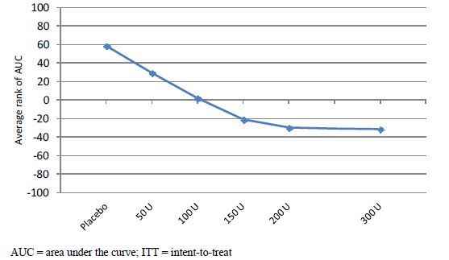
The same study allowed a comparison of the safety of the different doses. Dose trends were observed for urological adverse events and also for increases in post void residual (PVR) urine volume. A dose of 150 U was associated with an increased risk of elevated PVR volume, relative to lower doses and an increased risk of urinary tract infections (UTIs) and urinary retention.
Table 1. Summary of Key Safety Parameters (Study 191622-077; ITT And Safety Populations)
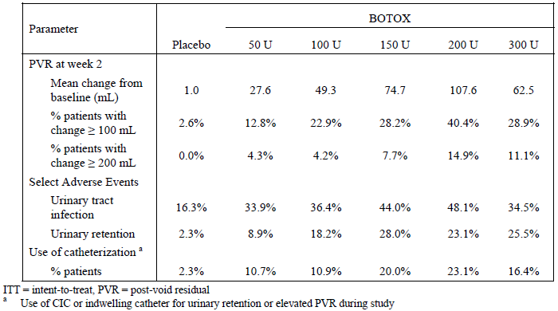
Combining efficacy and safety considerations suggested that dose increases to 100 U did not greatly increase the risk of urological complications but did improve efficacy, whereas increases to 150 U or beyond increased the risk of adverse urological effects with only small gains in efficacy. This is illustrated graphically below, using a rank residual score approach.
Figure 2. Cumulative Efficacy and Safety (AUC) Using Rank Residual Score for Urinary Urgency Incontinence Episodes and Post-Void Residual Volume (ITT Population).
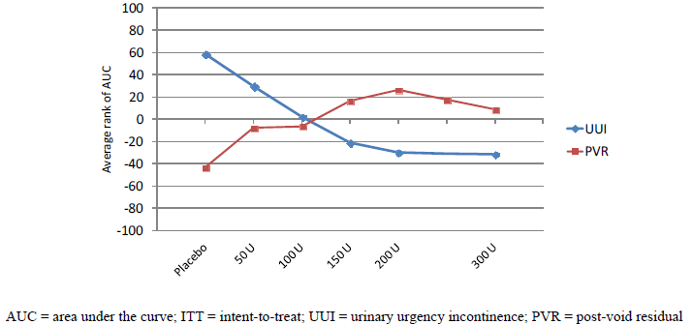
It should be noted that similar considerations led to the selection of a different dose (200 U) for the NDO indication. In the selection of a dose for the pivotal NDO studies, the main doses being considered were 200 U and 300 U. In the context of that earlier submission, the dosage considerations were summarised in the evaluation report as follows:
‘In the pivotal [NDO] studies, most efficacy endpoints showed very similar results across the two active dose groups, as summarised in the table below. Given that AEs were higher in the 300 U group, as discussed in the Safety Section, the 200 U appears to offer a better risk-benefit balance. Doses lower than 200 U were considerably less effective in the dose-ranging study 518, with a duration of action that resembled placebo, but this study was underpowered. It did show a significant dose-trend across doses to 200 U, but did not specifically show a significant benefit of 200 U over 100 U. On balance, the efficacy evidence favours the proposed dose of 200 U.’
Table 2. Change from Study Baseline In Select Efficacy Measures For Treatment Cycle 1 in 300 U And 200 U Botox Dose Groups (Placebo Controlled Pivotal Study; ITT Population).
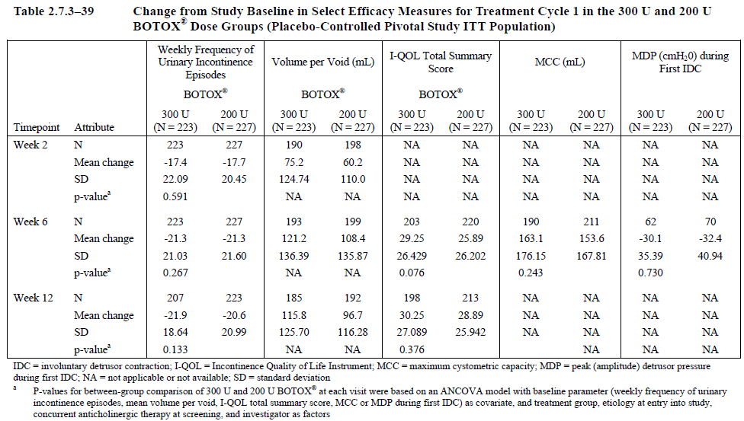
In retrospect, given that comparisons between 100 U and 200 U were underpowered in the dose-ranging study performed in NDO, it might have been worthwhile exploring the efficacy of 100 U for the NDO indication with additional studies. As the current evidence stands, adequate studies of 100 U in NDO have not been performed and there is no good case for changing the recommended dose in NDO. It is plausible that a higher dose might be needed for NDO than for idiopathic OAB, and that the more substantial neurological lesions typical of NDO might lead to more pronounced bladder spasticity but this has not been demonstrated. The new submission for OAB shows that 100 U can have efficacy in some cases of OAB and may be less risky than 200 U, so the potential role of this dose in NDO remains somewhat unclear. The sponsor should be asked to comment on this.

Clinical efficacy
The sponsor submitted four efficacy studies, as tabulated below. This included a Phase II dose-ranging study (077), two very similar Phase III pivotal studies (095 and 520), and an open-label extension of the pivotal studies (096).
Table 3. Design features of clinical studies of Botox in Overactive Bladder
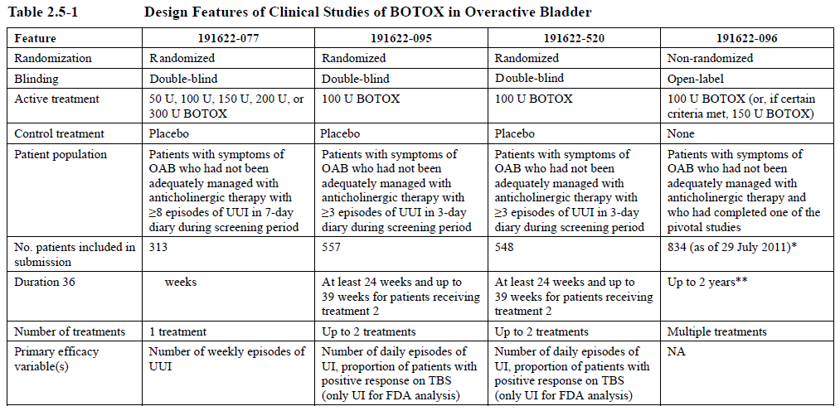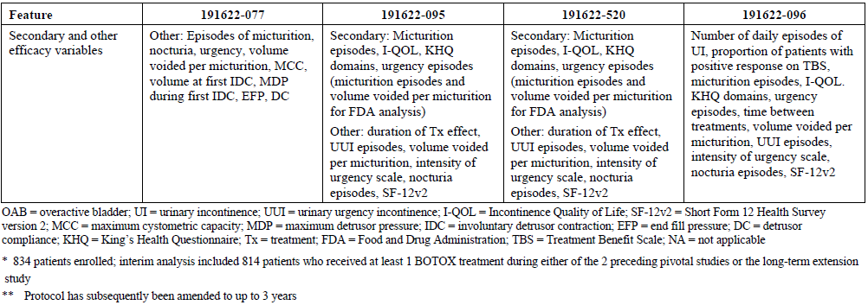

Pivotal efficacy studies (Studies 095 and 520)
The sponsor performed two pivotal efficacy studies that had almost identical designs, including inclusion criteria, doses, treatment duration and endpoints. They are therefore described together in the sponsor’s Clinical Overview and Summary of Clinical Efficacy, as well as in this evaluation report.

Study designs, objectives, locations and dates
Both pivotal studies (191622-095, abbreviated as 095, and 191622-520, abbreviated as 520) were randomised, placebo-controlled, parallel-group studies in which patients with idiopathic overactive bladder and associated urgency incontinence that had not been controlled with anticholinergics received either Botox 100 U or matching placebo injected into the bladder wall. Subjects were studied for at least 24 weeks and they received up to two treatments; the second treatment if applicable was open-label Botox 100 U.
Study 095 (n=557) was performed in the United States and Canada, between 15 September 2009 and 21 July 2011.
Study 520 (n=549) was performed in the United States and Europe, between 9 October 2009 and 17 August 2011.

Inclusion and exclusion criteria
The key inclusion criteria were as follows:
- adults of either gender, ≥ 18 years old, weight ≥ 40 kg
- symptoms of idiopathic OAB (frequency and urgency) with urinary incontinence for ≥ 6 months
- ≥ 3 episodes of urinary urgency incontinence, with no more than one urgency incontinence-free day, in the 3 day screening bladder diary
- urinary frequency, defined as an average of ≥ 8 micturitions (toilet voids) per day
- not adequately managed with anticholinergic therapy (defined as an inadequate response after ≥ 4 weeks of anticholinergic therapy or intolerable side effects after ≥ 2 weeks on an optimised dose)
- willing to use clean intermittent catheterisation (CIC) if determined to be necessary by the investigator
- had a negative urine dipstick at randomisation asymptomatic for urinary tract infection (UTI) on the day of treatment
The key exclusion criteria were aimed at excluding patients with other urological conditions, including non-idiopathic OAB or factors that could have confounded the assessment of efficacy or safety. The following were grounds for exclusion:
- OAB secondary to any known neurological reason
- a predominance of stress incontinence
- anticholinergic treatment or any other therapies for OAB within the 7 days prior to baseline (such subjects could enter after a 7 day washout period)
- already using CIC or an indwelling catheter
- intravesical treatment with capsaicin or resiniferatoxin within the previous 12 months
- previous botulinum toxin therapy within the previous 12 weeks or immunisation for any botulinum toxin serotype
- significant pelvic or urological abnormalities other than OAB
- history of urothelial malignancy or a prostate-specific antigen level > 10 ng/ml
- post-void residual (PVR) urine volume > 100 ml at screening
- history of urinary retention or elevated PVR urine volume that had been treated with an intervention (such as catheterisation) within the previous 6 months
- 24 hour urine volume > 3000 ml
- history of 2 or more UTIs within the previous 6 months, or taking prophylactic antibiotics to prevent chronic UTIs
- serum creatinine level > 2 times the upper limit of normal at screening
- current or previous un-investigated hematuria
- bleeding disorders
- pregnant, nursing, or planning a pregnancy

Study treatments
All subjects initially received Botox 100 U or matching placebo injected into the bladder wall endoscopically. Patients could receive a second treatment at least 12 weeks after their first treatment if they had ≥ 2 episodes of urinary urgency incontinence in their 3 day patient bladder diary and no more than one urgency incontinence free day in the previous week. If subjects became eligible for a second treatment, they received Botox 100 U regardless of their initial treatment.
The two treatment sequences (A and B) were therefore as follows:
- 100 U BOTOX (treatment 1) +/- 100 U BOTOX (Treatment 2)
- Placebo (treatment 1) +/- 100 U BOTOX (Treatment 2)
Treatments were administered as 10 ml of study drug, divided into 20 injections each of 0.5 ml.
Patients were also given antibiotic medication one day prior to study treatment and continued the antibiotics for at least 3 days following treatment. (The choice of antibiotic was left up to the investigator but was often ciprofloxacin.)
Patients on anticholinergic medication at the time of screening underwent a washout period of at least 1 week prior to Botox or placebo treatment.

Efficacy variables and outcomes

Primary efficacy endpoints
The sponsor had two sets of endpoints, which differed for the FDA (United States) and European Medicines Agency (EMA) submission. The European submission was consistent with the EMA Note for Guidance on the conduct of such studies, because it included a co-primary endpoint assessing global subjective benefit, as discussed below. The FDA submission was not consistent with the Note for Guidance and should therefore be considered of less direct relevance in the Australian context.
The primary efficacy endpoint for the FDA submission was the daily frequency of urinary incontinence episodes. This was also a co-primary endpoint for the European submission and should be considered the major endpoint of the studies. Note that this endpoint includes incontinence not attributed to urgency, which is appropriate because the attribution of the cause of incontinence is subjective and also because there would be little value in a treatment that merely shifted the attribution of the cause of incontinence from one type to another without actually changing the frequency.
Unlike the previous NDO studies, it did not appear to be the case that bladder diaries were censored during UTIs. Missing data was imputed with a last-observation carried forward (LOCF) approach. Given that completion rates were reasonable and roughly equal across treatment groups, this approach does not seem likely to have introduced any major bias into the study.
For the EMA (European) submission, an additional co-primary endpoint was used, the Treatment Benefit Scale (TBS). This is a single-item, subjective, numerical scale, completed by the patient at pre-specified study visits. In the pivotal Botox studies, it was assessed at all post-treatment visits except the Treatment 2 visit and the 18 weeks post Treatment 1 visit.
The TBS questionnaire asks the patient to consider their current urinary condition in comparison to their condition before they received any treatment in the study. The patient can answer with one of the following scores:
- = greatly improved
- = improved
- = not changed
- = worsened
A score of 1 or 2 was considered a positive response.
The addition of a qualitative score as a co-primary endpoint was recommended by the EMA and therefore included in the EMA submission. This approach has some advantages and disadvantages. The TBS has been used by other investigators to assess patient-reported benefits of treatment of OAB (Colman et al, 2008) but this test cannot be considered to be widely validated. The TBS is subjective, and therefore it is potentially susceptible to bias in the event of unblinding. The difference between ‘improved’ and ‘greatly improved’ is likely to mean different things to different people, with no clear method for standardising, calibrating or interpreting responses. On the other hand, this measure may be better at capturing the overall effect of intravesical Botox treatment than incontinence frequency alone, because it incorporates the adverse urological effects of Botox (impaired bladder emptying) as well as the benefits (reduced urgency and reduced incontinence) to give a single summary measure from the patients’ perspective.
On balance, as a supportive endpoint for the more objective measure of incontinence frequency, the TBS was appropriate and useful.

Secondary efficacy endpoints
Secondary endpoints varied in the FDA and EMA analyses but included the number of micturition episodes in both submissions. This is a measure of the number of times a patient voids in the toilet, which is usually increased in the setting of an overactive bladder. Subjects with OAB are primarily distressed by incontinence (if this is present) but they are also inconvenienced by the mere threat of incontinence and the need to void frequently to avoid incontinence. The fear of incontinence and the need to stay close to a toilet may be severely socially limiting. Even if Botox did not reduce incontinence episodes, therefore, it would potentially be of value if it reduced the number of voiding episodes needed per day.
A related endpoint (which was considered a secondary endpoint for the EMA submission but not the FDA submission) was the number of urgency episodes (based on a ‘yes’ response to the diary question of ‘Was this episode associated with a sudden and urgent need to urinate?’). This endpoint is useful because it focuses on a key symptom of OAB but it does not include non-urgent voiding. Because patients can sometimes limit urgency by frequent pre-emptive toileting, the frequency of urgency alone does not necessarily capture the true extent of the patients’ problems.
The FDA submission also considered the volume voided per micturition. This is usually inversely related to the number of micturition episodes per day, given that the overall urine volume produced in a day can be eliminated by a small number of large-volume voids or a higher number of small-volume voids. The EMA submission did not include this measure, but instead included a couple of extra quality-of-life (QOL) measures. The Incontinence-Specific Quality of Life Instrument (I-QOL) is a self-administered assessment tool designed to assess QOL in patients with urinary incontinence; it has been validated for this purpose and shown to be reproducible (Wagner et al, 1996). This questionnaire is described by its designers as follows:
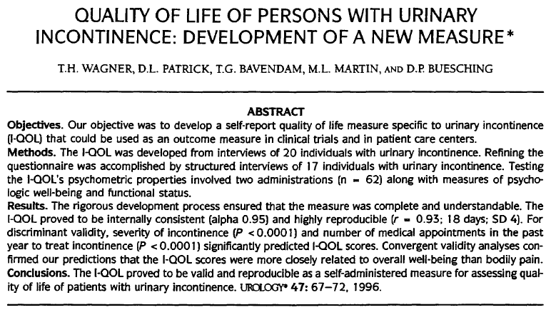
The I-QOL is scored as 4 variables: total I-QOL summary score, and its 3 domains (Avoidance and Limiting Behaviour, Psychosocial Impacts, and Social Embarrassment). Higher scores indicate better quality of life. From the scored responses to each question, each variable is transformed to a 0 to 100 scale as follows:
Domain score (or total summary score) = [(Sum of the items – lowest possible score)/possible raw score range] × 100
The King’s Health Questionnaire (KHQ) is another disease-specific health-related QOL questionnaire designed to measure QOL of patients with urinary incontinence; it has been shown to be reliable and responsive to treatment-induced changes in clinical trials (Reese et al, 2003). Development, validation and instructions for conducting the questionnaire were described by Kelleher et al (1997) and updated in 2004 (Kelleher 2004). It includes questions in several domains: Incontinence impact, Role limitations, Physical limitations, Social limitations, Personal relationships, Emotions, Sleep and energy, Severity measures, General health perceptions and Symptom severity. The sponsor used the domains of Social limitations and Role limitations as a secondary endpoint, which is broadly appropriate given that symptoms were more directly assessed with other endpoints such as the incontinence frequency and TBS.
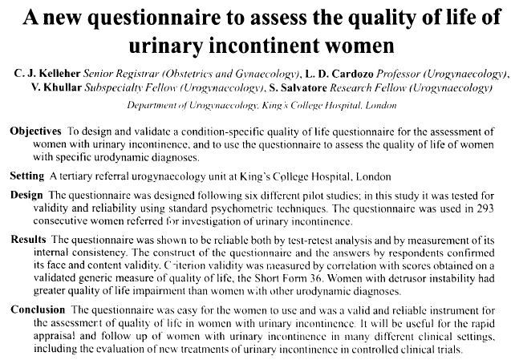
The sponsor also used the 12-item short form health questionnaire (version 2) as a tertiary endpoint. The SF-12 is a widely used, validated, general assessment of health status. It uses two component scores: a Physical Component Summary Score and a Mental Component Summary Score. All 12 items contribute to both summary scores. Further discussion of the conduct and validation of this assessment tool has been provided by Ware et al (2002).
In summary, for the FDA submission, there were two secondary efficacy measures:
- number of micturition episodes
- volume voided per micturition
For the EMA submission, there were 4 secondary efficacy measures:
- number of micturition episodes
- I-QOL total summary score
- KHQ Role Limitation and Social Limitation domain scores
- number of urgency episodes
These and other endpoints are summarised in the table below. The full list of efficacy assessments in all of the submitted studies is displayed in the subsequent table.
On balance, the secondary endpoints were appropriate and the key conclusions of the studies did not depend on whether the FDA or EMA endpoints were considered.
Table 4. Summary of Parameters for Assessment of Efficacy in Pivotal Phase III Studies.
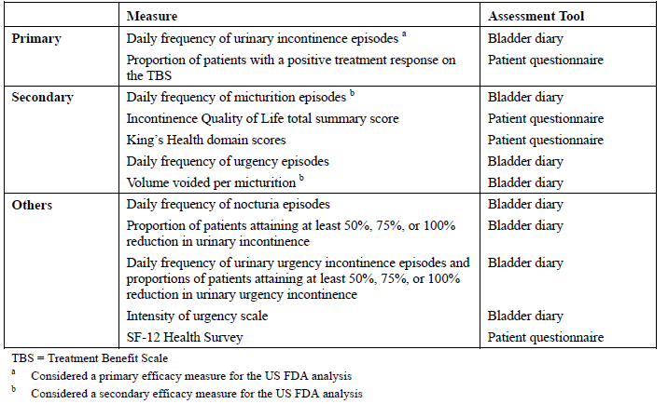
Table 5. Efficacy Evaluations in Clinical Studies
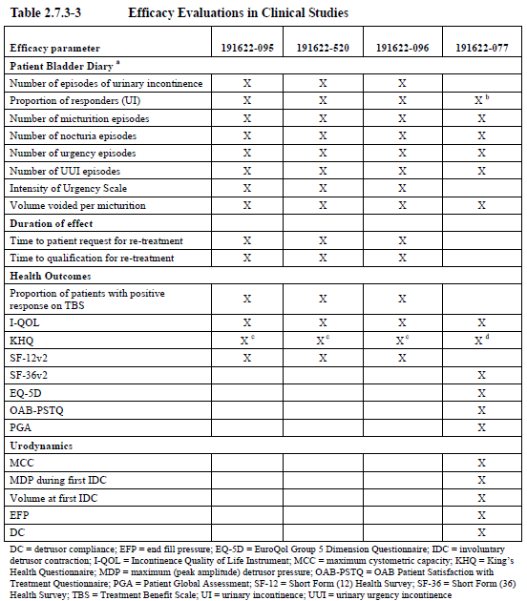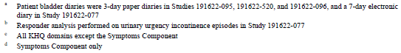

Randomisation and blinding methods
Randomisation in the pivotal studies was stratified by centre and by the number of urgency incontinence episodes reported at baseline (≤ 9 or > 9 episodes over the 3 day screening diary), in an attempt to ensure balance in baseline disease severity across the treatment groups.
Blinding was achieved by providing Botox and placebo in identical vials. The lack of any systemic effects of Botox treatment means that the potential for unblinding was fairly low. The urological effects of Botox therapy, including impaired bladder emptying are within the spectrum of problems that patients with OAB might experience anyway so patients were not likely to infer their treatment group from any specific bladder symptom. Furthermore, some procedural discomfort might be expected with either treatment, so blinding is likely to have been maintained in most cases.

Analysis populations
The primary analysis was based on all subjects who were randomised and it was performed according to their treatment allocation; this was considered the intent-to-treat (ITT) population. It excludes one treated subject in Study 520 who was not randomised. A small number of subjects (7 in Study 095 and 4 in Study 520) were randomised but did not receive treatment, usually because they did not tolerate the cystoscopy procedure. These subjects are nonetheless included in the ITT population; this potentially dilutes the observed treatment effect but is consistent with real-life clinical practice where procedural failures would also reduce the potential benefit of Botox.
The per-protocol (PP) population included all randomised patients who received treatment with no major protocol deviations; this was determined prior to database lock. Data from the PP population was not qualitatively different from the ITT population and is not reproduced in this evaluation report. The Safety population included all patients who received study treatment, and was based on the actual treatment received, regardless of randomised treatment assignment.

Sample size
Sample size considerations were clearly explained for Study 095 and would be expected to apply equally to Study 520, which had the same design.
In Study 095, the planned number of enrolled patients was approximately 534 patients, which factored in an anticipated 15% attrition rate. This target was exceeded in both pivotal studies.
For the primary endpoint of frequency of urinary incontinence, 227 patients per treatment group were estimated to give the study 82% power to detect a between-group difference of 2.3 incontinence episodes per 3 days in change from baseline.
The estimate assumed a standard deviation of 8.5 episodes and a 2-sided type I error rate of 0.05, using a 2-sample t-test in mean change from baseline, using commercial statistical software nQuery Advisor (procedure MTT0-1), version 6 (Elashoff, 2005).
The standard deviation was in turn estimated from the Allergan Phase II study, 191622-077, using the first 3 days of data captured in the 7 day diary in the 100 U BOTOX group and the placebo group.
For the co-primary endpoint of TBS (which was only applicable to the EMA submission), the same recruitment was estimated to give 99% power, assuming that the proportion of patients with a positive response (‘greatly improved’ or ‘improved’) was 76% with active treatment compared to 54% in the placebo group. These figures were compatible with previous studies employing TBS in the investigation of OAB (Colman et al, 2008).
Given that the study achieved statistical significance for all of its major endpoints, these estimations appear to have been broadly valid.

Statistical methods
For the primary endpoint of number of urinary incontinence episodes, a comparison of Botox 100 U and placebo at Week 12 post Treatment 1 was made using analysis of covariance (ANCOVA). Treatment was evaluated as the factor of interest, with baseline value and site as covariates.
For the co-primary endpoint of TBS, results on the 4-point categorical scale were dichotomised into ‘responders’ and ‘non-responders’: patients were considered responders if they scored either 1 or 2, representing ‘greatly improved’ or ‘improved’, and non-responders if they scored either 3 or 4, representing ‘not changed’ or ‘worsened’. The proportion of responders in each treatment group at Week 12 post-treatment was assessed with the Cochran-Mantel-Haenszel (CMH) method. The categorised number of urinary urgency incontinence episodes at baseline (≤ 9 versus > 9 over the 3 day baseline bladder diary) was used as a stratification factor.
A 2-sided p-value ≤ 0.05 for both co-primary efficacy variables was considered to be statistically significant for the primary efficacy analysis in the EMA submission, whereas the single primary endpoint of number of urinary incontinence episodes was assessed with a p-value ≤ 0.05 in the FDA submission.
Because the studies used multiple endpoints, a hierarchical testing strategy was employed, starting with the primary efficacy variable(s) and followed by the secondary efficacy variables in the order listed above (which differed in the FDA and EMA submissions). Only if statistical significance was demonstrated in a higher-ranking endpoint were lower-ranking endpoints evaluated.
In general, these statistical methods were appropriate, and the sponsor’s conclusions did not appear to be strongly linked to the choice of any particular statistical approach.

Participant flow
Patient disposition in the two pivotal studies and the other two submitted studies is summarised in the table below. (In Study 520, a total of 549 patients were treated but one was not randomised and is therefore not included in the table). Most patients completed the study in which they were enrolled, which is not surprising as the decision to remain in the study did not force them to continue to receive treatment; even in the face of adverse events or dissatisfaction with their treatment, the Botox effect from their first treatment would be expected to continue regardless of whether they remained in the study.
Table 6. Patient Disposition in the Efficacy Studies of Botox for OAB with Urinary Incontinence (ITT Population).
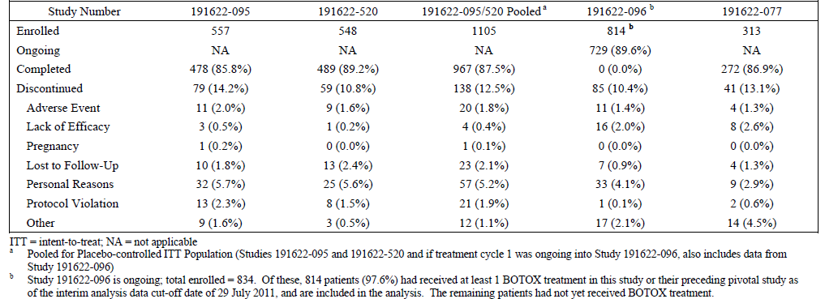
Patient disposition was similar in the active and placebo groups, as shown in the tables below, apart from a higher number of placebo recipients leaving Treatment Cycle 1 after Week 12 because they had requested a second treatment.
Table 7. Number (percent) of Patients by Cumulative Patient Disposition for Scheduled Visits: Treatment Cycle 1 (ITT population). Study 095
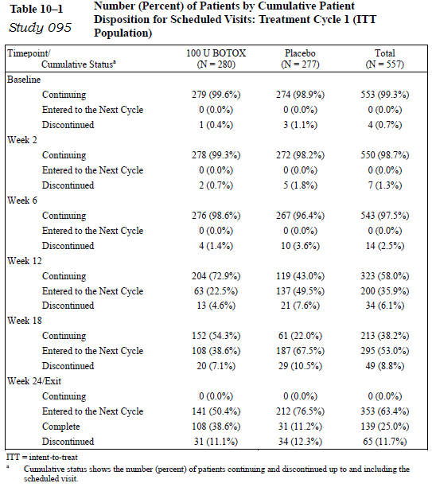
Table 8. Number (percent) of Patients by Cumulative Patient Disposition for Scheduled Visits: Treatment Cycle 1 (ITT population). Study 520
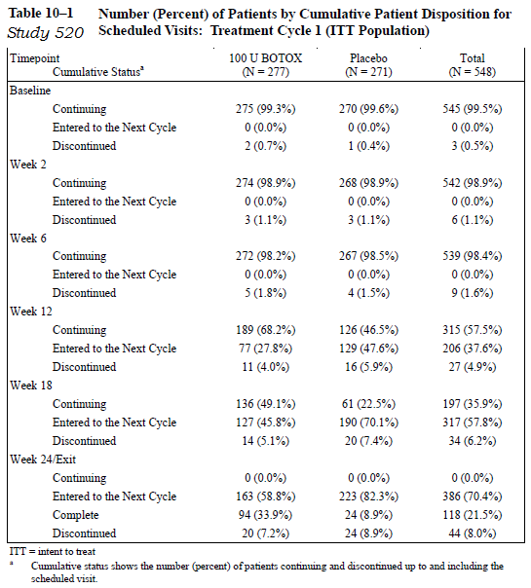

Major protocol violations/deviations
Protocol violations were reasonably common and included mistakes in patient selection as well as incomplete efficacy assessments.
In Study 095, a total of 96 patients had at least one significant protocol deviation identified prior to database lock, including 26 patients who did not meet the criteria for having been inadequately managed with one or more anticholinergic agents for their OAB, 11 patients who did not experience urinary frequency, defined as an average of ≥ 8 micturitions per day in the 3 day diary and 9 patients who did not experience ≥ 3 episodes of urinary urgency incontinence, with no more than 1 urgency incontinence-free day, in the 3 day diary. In 7 patients, diaries were not completed adequately.
Seven patients were randomised but never received treatment during Treatment Cycle 1.
In Study 520, a total of 81 patients had significant protocol deviations. This included 14 patients who did not satisfy the criteria of failing anticholinergic therapy, 9 patients who did not experience sufficient urinary frequency to be eligible and 4 patients with insufficient urgency incontinence. Four patients were randomised and never received treatment. One patient assigned to Botox 100 U received 200 U.
Overall, these protocol deviations are within the range expected for a complex study of this nature. They do not appear likely to have introduced any major biases but may instead have diluted the observed treatment effect.

Baseline data
The baseline demographic data in each pivotal study, as well as the pooled pivotal studies and two supportive studies, are shown in the table below. Subjects were, on average, about 60 years old and 88% of subjects in the pivotal studies were female. Most subjects were Caucasian. The population appears representative of the patients who would receive Botox if it were registered. Males with OAB were not adequately represented and, as will be discussed, the efficacy in this subgroup remans poorly characterised.
Table 9. Baseline Demographics (ITT population)
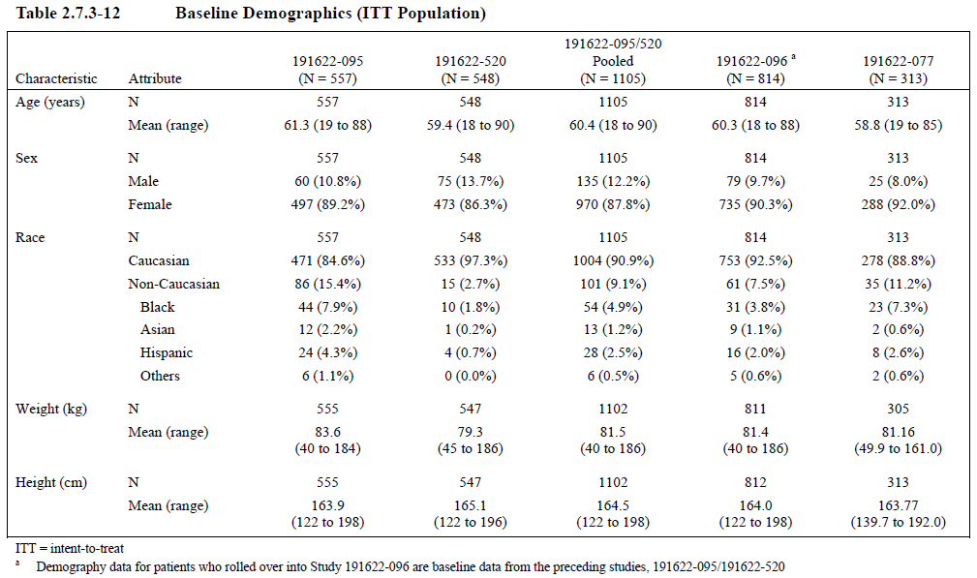
The baseline disease characteristics in the pivotal studies are tabulated below. Subjects had suffered from OAB for a median of 5 years and had tried anticholinergics for an average of ~120 days. About a third of subjects had tried a single anticholinergic agent; the others had tried >1 agent. The pooled pivotal population had 4.9 episodes of urgency incontinence per day (5.4 episodes of all-cause incontinence in total), and 12 episodes of micturition per day. The mean post-void residual urine volume, prior to treatment, was low (21 ml), which partially reflects the fact that subjects with substantially elevated PVR volume (> 100mls) or a history of intervention for elevated PVR were excluded.
Table 10. Baseline Disease Characteristics (ITT population)
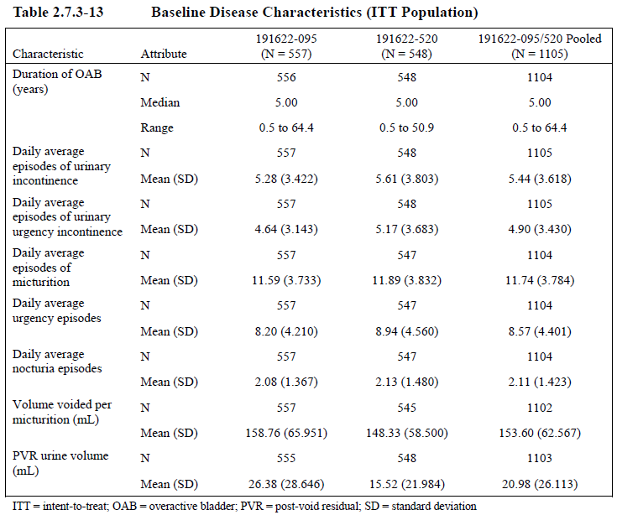
Table 11. Prior Anticholinergic Medication (ITT population)
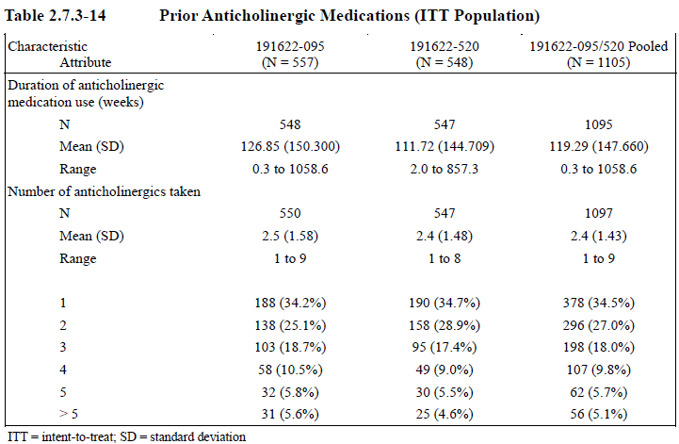
The balance of these factors between treatment groups is shown in the following four tables: baseline demographics and disease characteristics for Study 095, then baseline demographics and disease characteristics for Study 520. Overall, the groups appeared well matched, without any significant differences at baseline that would have biased either study.
Table 12. Baseline Demographics (ITT population) Study 095
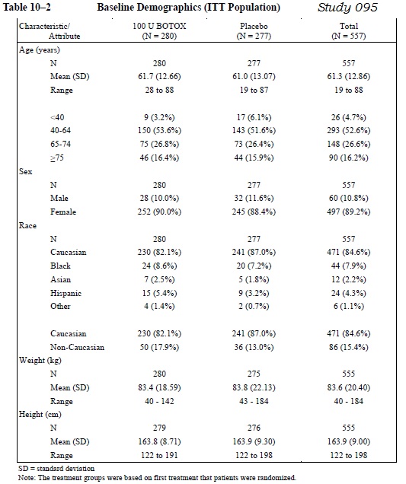
Table 13. Baseline Disease Characteristics (ITT population) Study 095
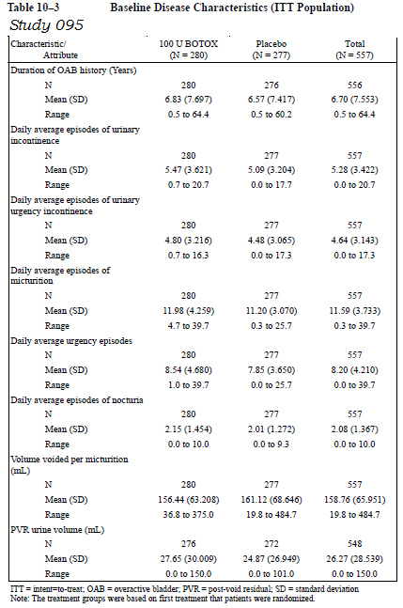
Table 14. Baseline Demographics (ITT population) Study 520
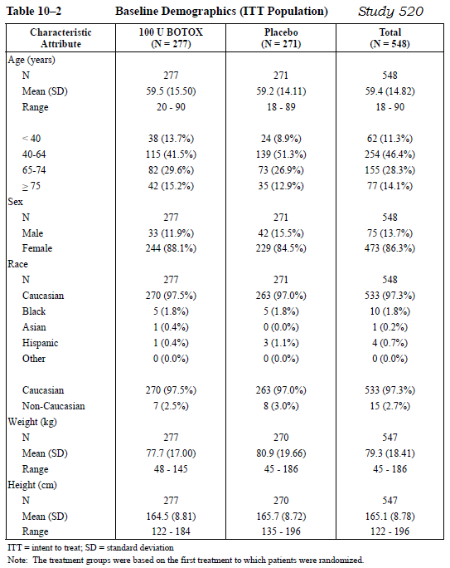
Table 15. Baseline Disease Characteristics (ITT population) Study 520
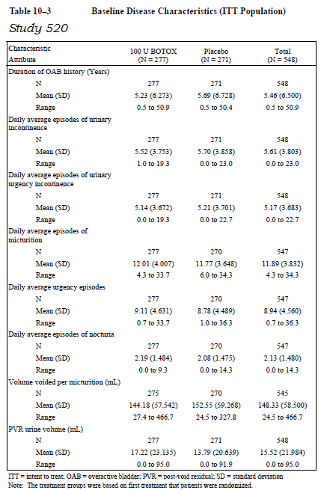

Results for the primary efficacy endpoints

Frequency of incontinence
For the main primary endpoint of incontinence frequency (the sole primary endpoint for the FDA submission and the more objective of two co-primary endpoints for the EMA submission), both pivotal studies were strongly positive (p<0.001 in each study, by ANCOVA). In general, the primary results for each individual pivotal study were similar to the pooled analysis of both studies, with no important differences noted in comparing Study 095 and 520.
Although the sponsor was clear about how these endpoints would be evaluated in terms of the ANCOVA, the sponsor did not commit to a specific style of describing these results. The statistical analysis plan stated: “In addition to summary statistics for mean values at each visit, baseline and change from baseline at each applicable visit will be summarized as mean, median, standard deviation,95% confindence[sic] interval (for both arithematics [sic] means and LS means), minimum,maximum.” All methods of describing the results (differences expressed in arithmetic means, LS means and 95%CIs) should be considered to be of similar weight, though the 95% CI is the most informative.
From a mean baseline incontinence frequency of 5 to 6 episodes per day, Botox was associated with a mean reduction of nearly 3 episodes (a mean reduction of 2.8 episodes in the pooled data; a mean reduction of 2.65 episodes in Study 095 and 2.95 in Study 520). Placebo was associated with a reduction of about 1 episode (mean 0.95 episodes pooled; 0.87 in Study 0.95; 1.03 in Study 520). The treatment effect relative to placebo was estimated to be 1.79 episodes prevented by a LS mean difference method (95%CI -2.14 to -1.44 episodes). This is likely to be considered a substantial and meaningful clinical response by patients and clinicians, though it allows the majority of incontinence episodes to continue.
These results were subjected to a range of subgroup analyses. This includes subgroup analyses based on age, gender and the randomisation factor of incontinence severity at baseline. With the exception of gender, the results were consistent across populations.
The results were also recalculated for the per-protocol population, and were qualitatively similar to those observed in the ITT population: at Week 12, the mean difference with active treatment versus placebo was -1.98 episodes (95%CI -2.37,-1.59).
Table 16. Daily Average Frequency of Urinary Incontinence Episodes During Treatment Cycle 1. Baseline and Change from Baseline (Placebo controlled ITT Population with LOCF Imputation).
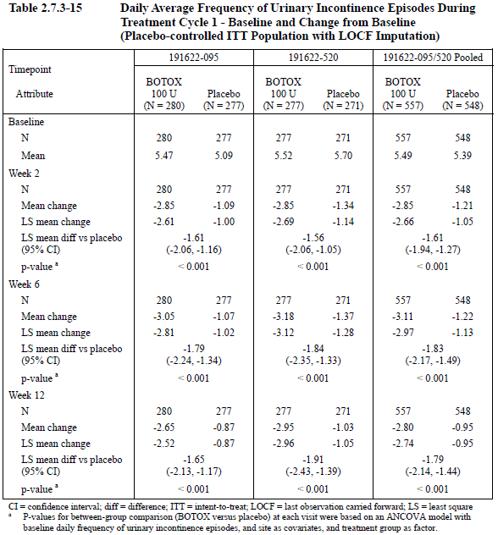
The results for the incontinence endpoint are shown for each study in the figure below. Note that the vertical scale in the figures has been based on the change from baseline and therefore necessarily shows the treatment effect in the active groups filling the vertical space available. The results would be less impressive, graphically, if the vertical scale had been based on the actual baseline incontinence frequency (mean ~5.4, range up to 23).
Figure 3. Mean Change From Baseline in Daily Frequency of Urinary Incontinence Episodes During Placebo-Controlled Treatment Cycle 1 for the 2 Pivotal Phase III Studies (ITT Population With LOCF Imputation).
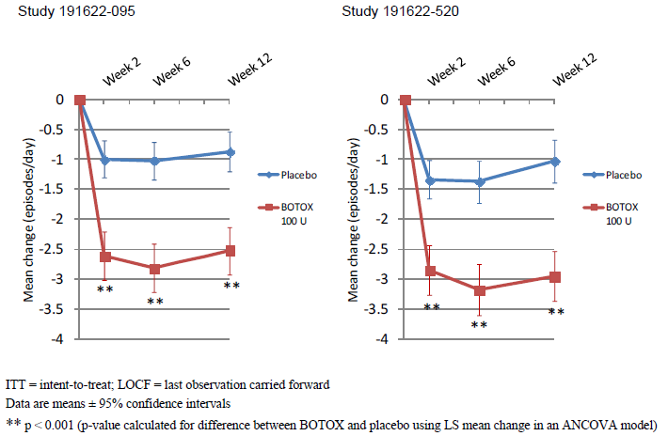
The sponsor also performed a responder analysis for this efficacy variable, assessing the proportions of patients in each treatment group that achieved 50%, 75% or 100% reductions in incontinence. This analysis should be considered merely supportive but it is of interest because most patients agreeing to undergo an invasive treatment for incontinence would hope for a 100% reduction in incontinence and the responder analysis allows estimates of how often this highly-desired outcome is actually achieved. With active treatment, 27.1% of patients in the pooled pivotal population achieved a 100% reduction in incontinence (that is, became “dry”), whereas only 8.4% of placebo recipients achieved this goal. This is likely to be perceived by patients and clinicians as a worthwhile difference but these figures also suggest that about 3 quarters of patients can expect to have some continued incontinence despite the invasive treatment and this should be made clear prior to obtaining their consent.
Table 17. Number and Percent of Responders At Different Thresholds of Decrease in Daily Frequency (%) Of Urinary Incontinence Episodes at Week 12 in Treatment Cycle 1 (Placebo Controlled ITT Population With LOCF).
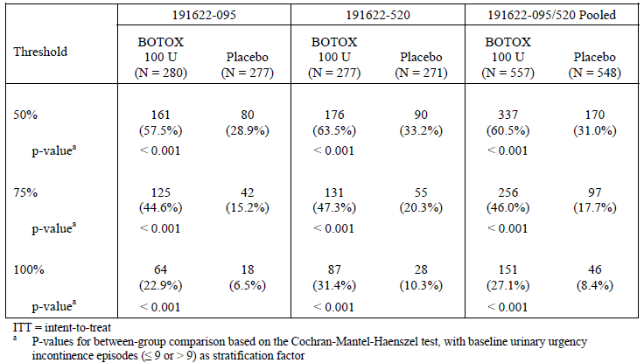

Treatment benefit scale
For the subjective co-primary endpoint of TBS (not included in the FDA submission), active treatment was associated with a highly significant treatment effect in both pivotal studies.
Figure 4. Proportion of Patients with a Positive Treatment Response on the Treatment Benefit Scale during Placebo Controlled Treatment Cycle 1 for the 2 Pivotal Phase III studies (ITT Population with LOCF Imputation)
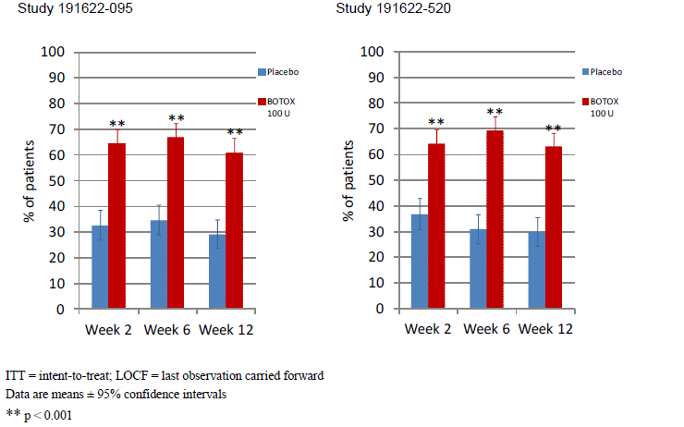
In Study 095, the proportion of responders at Week 12 was 60.8% with active treatment, but only 29.2% with placebo (p<0.001), and the 95% confidence intervals (95%CIs) were widely separated.
Table 18. Proportions of Patients with a Positive Treatment Response on the Treatment Benefit Scale during Treatment Cycle 1 (ITT Population). Study 095
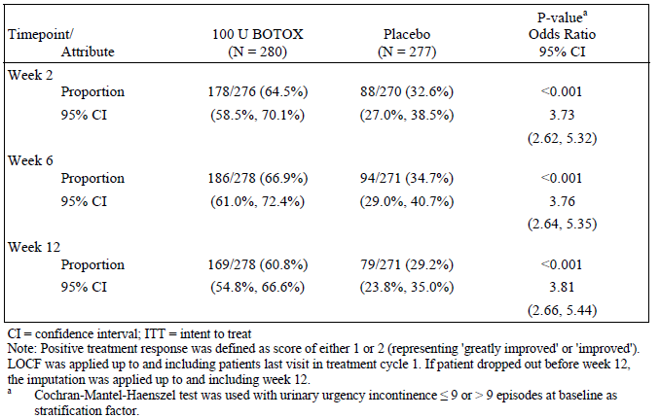
In Study 520, qualitatively similar results were obtained: 62.8% of the active group were responders at Week 12, compared to 26.8% of the placebo group. The difference was highly significant (p<0.001) and the 95%CIs were clearly separated.
Table 19. Proportions of Patients with a Positive Treatment Response on the Treatment Benefit Scale during Treatment Cycle 1 (ITT Population). Study 520
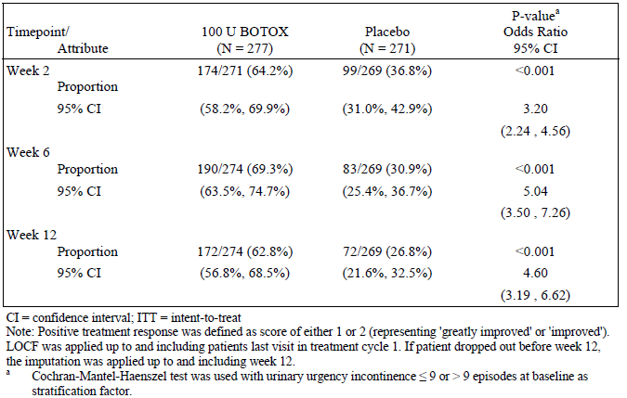
At Week 6, the proportion of subjects with a favourable response was slightly higher compared to the Week 12 results, in both studies. This does not necessarily indicate a waning of pharmacodynamic effect because the drop-off in satisfaction with treatment was observed in all groups including the placebo group.
Overall, roughly 2/3 of subjects receiving active treatment had a favourable view of their treatment during the first 12 weeks, compared to 1/3 of placebo recipients. This indicates that, of 3 patients treated with intravesical Botox for OAB, one is likely to have a favourable response that is attributable to active treatment, one is likely to have a favourable response that reflects the placebo effect or natural variability in symptoms and one is likely to have an unfavourable response. This is consistent with a modest but worthwhile treatment effect.
The TBS results for each pivotal study and for the pooled pivotal ITT population are shown side by side in the table below. The per protocol (PP) population also showed a significant treatment effect for TBS, with p<0.001 at all time-points, as shown in the Table 21 below.
A more detailed breakdown of categorical (non-dichotomised) TBS results is shown in the subsequent table and broadly supports the primary analysis.
Table 20. Proportions of Patients with a Positive Treatment Response on the Treatment Benefit Scale during Treatment Cycle 1 (Placebo controlled ITT Population with LOCF imputation).
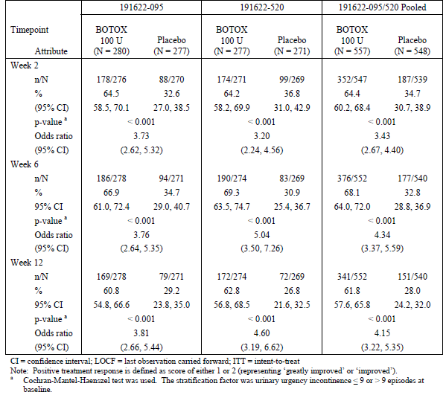
Table 21. Treatment Benefit Scale: Proportions of Patients with a Positive Treatment Response. PP population without LOCF imputation. Treatment Cycle 1.
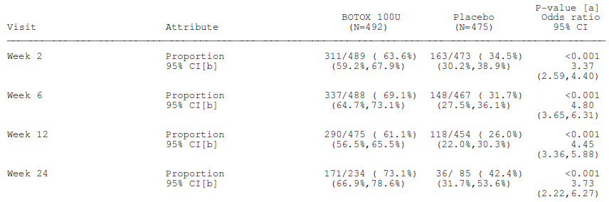
Table 22. Frequency Distribution of Patients by TBS Category during Treatment Cycle 1 (Placebo controlled ITT population).
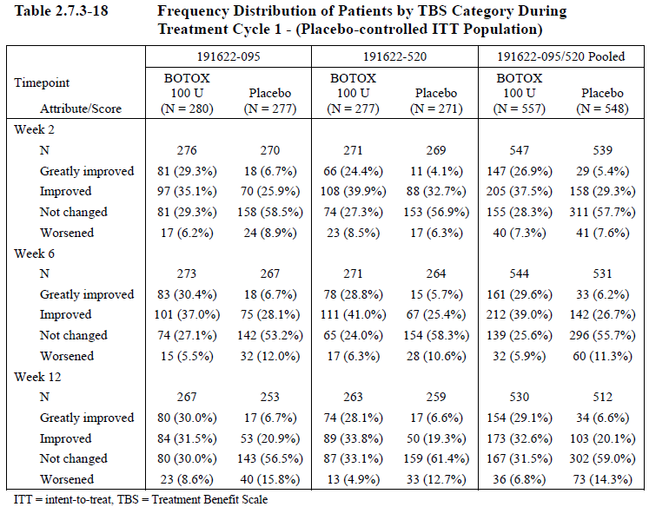

Results for other efficacy endpoints
In general, the results for secondary and tertiary endpoints were similar across the two pivotal studies and the following discussion is based primarily on the pooled results. For some endpoints (frequency of micturition, and frequency of urgency), some minor differences between studies were noted. Because the studies had identical designs and all groups were broadly similar at baseline, there is no clear reason for these minor differences and they are likely to reflect random variation in outcomes that was present in the individual studies but averaged out in the larger pooled population.

Frequency of urgency incontinence
Urgency incontinence is the primary symptom targeted by intravesical Botox but it is appropriate to treat it as a secondary endpoint because the cause of incontinence is not always clear and the overall number of episodes of incontinence is more important. The table below shows that the number of episodes of incontinence attributed to urgency represented a large proportion of the overall number of episodes of incontinence and the reductions attributable to active treatment were similar to those observed for the primary endpoint of all-cause incontinence.
Table 23. Daily Average Frequency of Urinary Urgency Incontinence Episodes during Treatment Cycle 1- Baseline and Change from Baseline. (Placebo controlled ITT population).
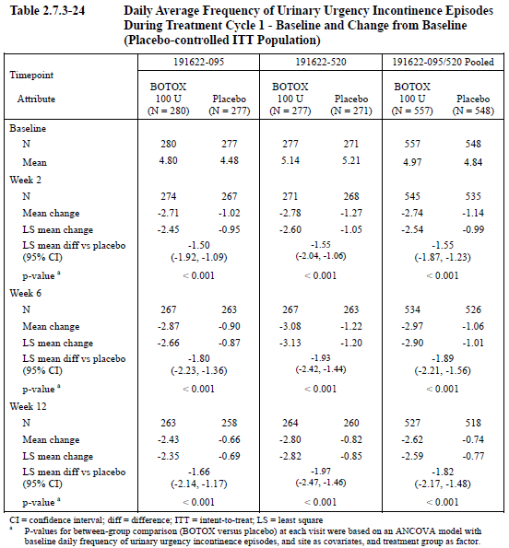

Frequency of micturition
The frequency of micturition was favourably affected by active treatment, with statistically significant benefits over placebo in both pivotal studies but the results were modest in clinical terms. From a mean baseline micturition frequency of ~12 episodes per day, active treatment reduced the number of episodes by a little over two episodes (mean 2.35 in the pooled analysis), compared to a reduction of a little under one episode with placebo (mean 0.87). The attributable reduction was therefore 1.48 episodes compared to baseline (1.37 by least-squares mean difference). Results in the individual studies were broadly consistent with the pooled analysis, as shown in the table. (In Study 520, the mean change in the active group was a little greater than observed in the other study and the mean change in the placebo group was a little smaller, so the placebo-subtracted treatment effect appeared better in this study. There are no apparent reasons for this apart from random variation in a heterogeneous and variable condition.)
Table 24. Daily Average Frequency of Micturition Episodes. Baseline and Change from Baseline in Treatment Cycle 1 (ITT population).
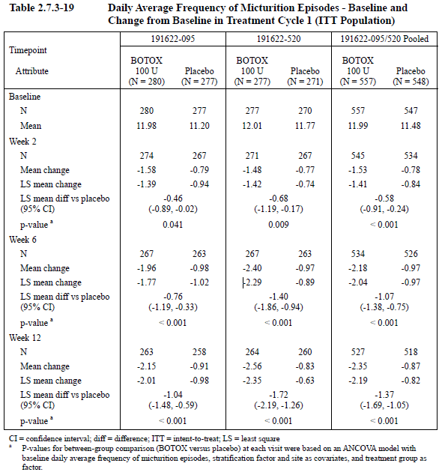
The sponsor also presented the micturition results graphically. Note, again, that the vertical axis has been scaled according to the change from baseline and that the curves would look less dramatic if scaled against the mean baseline micturition frequency (~12 episodes/day).
Figure 5. Mean Change from Baseline in Daily Frequency of Micturition Episodes During Placebo controlled Treatment Cycle 1 for the 2 Pivotal Phase III Studies (ITT Population).
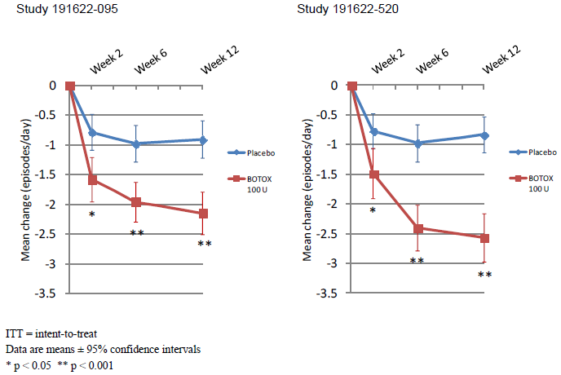

Frequency of urgency
The frequency of urgency symptoms was favourably affected by active treatment. From a baseline frequency of ~8 to 9 episodes per day (8.82 in the pooled Botox group, 8.31 in the pooled placebo group), active treatment reduced the frequency of urgency by a mean of 3.3 episodes whereas placebo was associated with a reduction of only 1.23 episodes. The difference was highly statistically significant in both pivotal studies (p<0.001), as well as the pooled analysis (p<0.001) and amounts to about two episodes of urgency prevented by active treatment (LS mean difference from placebo was -1.96). As a percentage of the baseline urgency in the Botox group, this represents a reduction of ~22%, which most patients would regard as useful. As noted for the closely related endpoint of frequency of micturition, the results in Study 520 were numerically more impressive than in Study 095, though they were qualitatively similar. The studies had identical designs and involved a similar population at baseline, so this difference is likely to reflect random variation in outcome. The pooled analysis, by averaging out such variation, is likely to reflect the treatment effect more accurately than either study in isolation.
Table 25. Daily Average Frequency of Urgency Episodes- Study Baseline and Change from Study Baseline in Treatment Cycle 1 (ITT population).
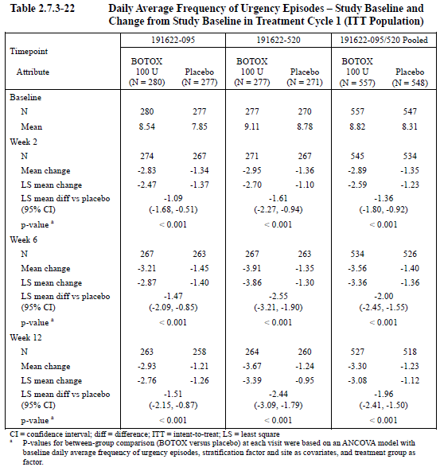
The same results are shown graphically below (scaled once more by the reduction seen in the Botox group.)
Figure 6. Mean Change from Baseline in Daily Frequency of Urgency Episodes during Placebo Controlled Treatment Cycle 1 for the 2 Pivotal Phase III Studies. (ITT population)
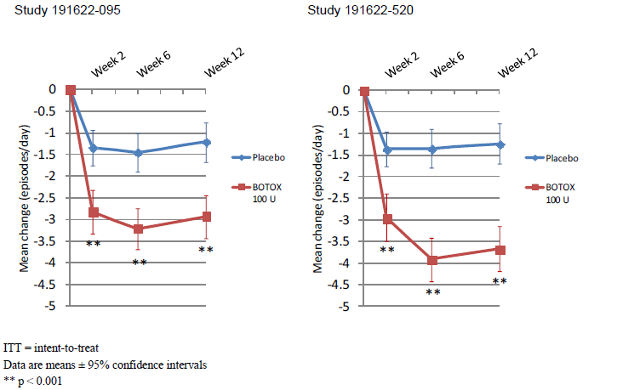

Frequency of nocturia
Nocturia was significantly reduced with active treatment but the magnitude of the treatment effect was modest, with less than a quarter of an episode of nocturia prevented each night, on average, by active treatment (LS mean difference in the pooled analysis -0.23). The individual study results were consistent with the pooled analysis, as shown in the table and figure below.
Table 26. Daily Average Frequency of Nocturia Episodes during Treatment Cycle 1- Baseline and Change from Baseline (Placebo Controlled ITT population).
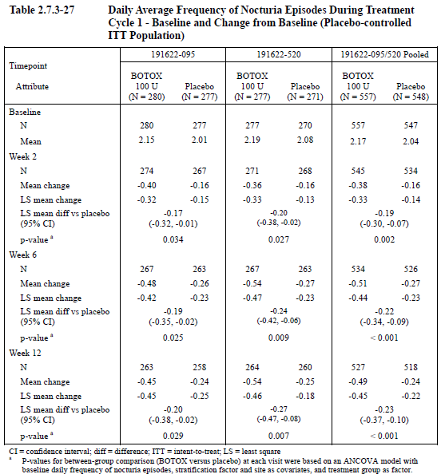
Figure 7. Mean Change from Baseline in Nocturia Episodes during Placebo-Controlled Treatment Cycle 1 for the 2 Pivotal Phase III Studies. (ITT population)
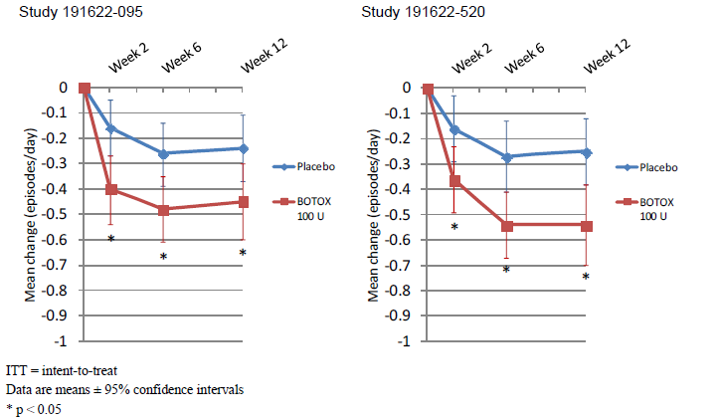

Volume voided per micturition
For a constant volume of urine production per day, the volume voided per micturition is inversely proportional to the number of micturition episodes, so this efficacy variable reflects the micturition frequency, which has already been discussed. Not surprisingly, there was a favourable effect with active treatment, amounting to a mean of 30 mL more urine voided per micturition, from a baseline of ~150-160 mL (results in each study as well as the pooled analysis suggested ~30 mL of benefit, as shown in the table and figure below). This is a useful corroboration of the improvement in micturition frequency but is not in itself clinically meaningful; patients would hardly be expected to notice if their urine volume increased by 30 mL.
Table 27. Mean Volume Voided per Micturition (mL). Study Baseline and Change from Study Baseline in Treatment Cycle 1. (ITT population).
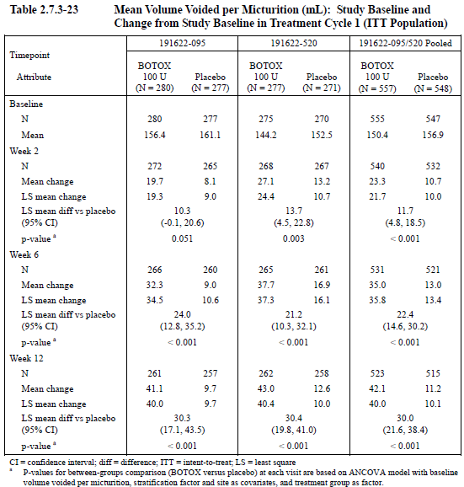
Figure 8. Mean Change from Baseline in Volume Voided (mL) per Micturition during Placebo Controlled Treatment Cycle 1 for the 2 Pivotal Phase III Studies. (ITT population)
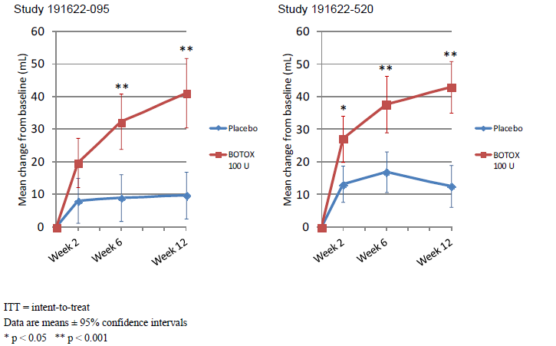

Quality of life
Given the modest gains in many clinical parameters, such as frequency of micturition, urgency and nocturia, and the fact that most patients remained incontinent after Botox therapy, it is important to consider their overall quality of life after treatment. Modest improvements in objective parameters could be considered worthwhile if patients perceived the changes as an improvement in their quality of life (QOL).
QOL was assessed as a secondary endpoint using a couple of different tools: the Incontinence-related Quality of Life Total Summary Score (I-QOL), and the King’s Health Questionnaire (KHQ).
At Week 12, the I-QOL showed positive changes (improved quality of life) in both the active and placebo groups but the active groups were significantly superior to placebo in both pivotal studies. The treatment effect was approximately three times the placebo improvement, suggesting a robust and worthwhile change (see figure below the table).
Table 28. Incontinence Quality of Life Total Summary Score- Study Baseline and Change from Baseline at Week 12 in Treatment Cycle 1. (ITT population)
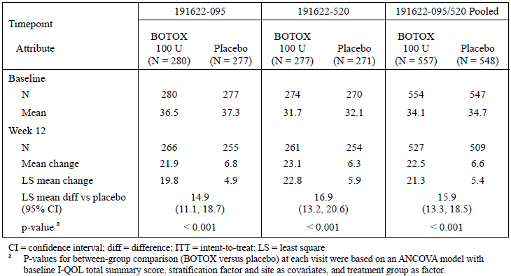
Figure 9. Mean Change from Baseline in Incontinence Quality of Life Total Summary Score at Week 12 during Placebo Controlled Treatment Cycle 1 for the 2 Pivotal Phase III Studies. (ITT population)
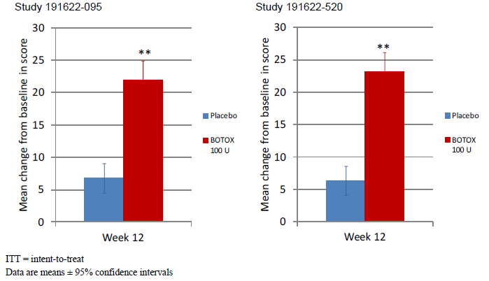
The KHQ has a couple of domains relevant to the social cost of incontinence, including ‘Role Limitations’ and ‘Social Limitations’. For both of these domains, and in both pivotal studies, decreases in scores (improvements) were observed with active treatment that were clearly superior to the minor improvements seen in the placebo group. The differences were statistically significant (p<0.001 for all comparisons with placebo) and likely to have clinical value for patients.
Table 29. King’ Health Questionnaire: Role Limitations and Social Limitations Domain Scores- Study Baseline and Change from Baseline at Week 12 in Treatment Cycle 1. (ITT population)
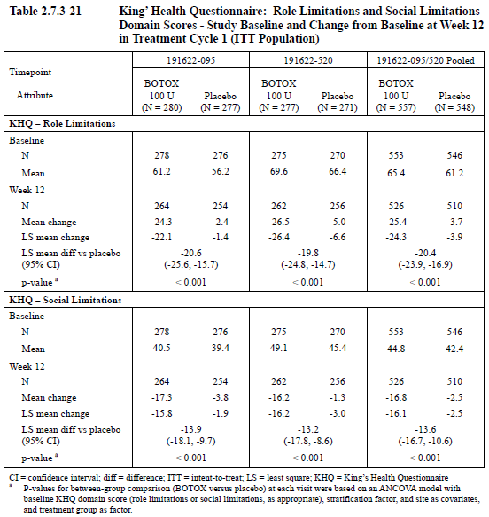
Figure 10. Mean Change From Baseline in King’ Health Questionnaire: Role Limitations and Social Limitations Domain Scores at Week 12 during Placebo Controlled Treatment Cycle 1. (ITT population) for the Pivotal 2 Phase III Studies. (ITT population)
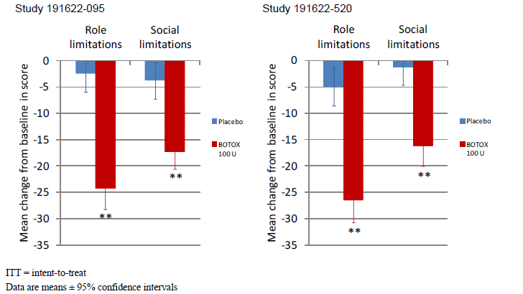
Patients also completed a standardised, previously validated health questionnaire (SF-12), though this was not considered a secondary endpoint in either the FDA or EMA submissions. In both pivotal studies, the results were numerically favourable for the physical component of the SF-12 and the difference relative to placebo was statistically significant for the pooled analysis. For the mental component of the SF-12, the differences between active treatment and placebo were significant in each individual study, as well as the pooled analysis.
Table 30. SF-12v2 Physical Component and Mental Component Summary Scores - Study Baseline and Change from Baseline at Week 12 in Treatment Cycle 1. (ITT population).
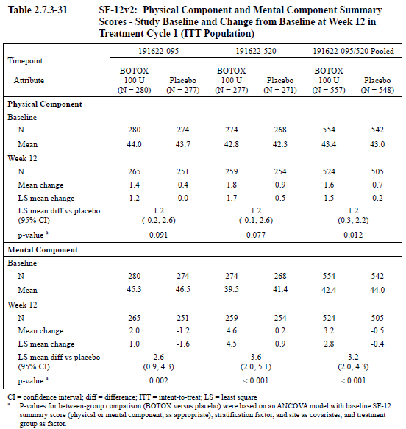

Duration of efficacy
The time to request retreatment and the time to qualify for retreatment were considered tertiary endpoints in the pivotal studies. Because patients were offered entry into the follow-up study (Study 096) and many received their second treatment in that context, the retreatment data is more appropriately considered across the full Botox-treated population of all three studies. This is discussed in Duration of Efficacy below).
A review of the participant flow in the pivotal studies shows that, at 12 weeks (which was the first opportunity to request retreatment), many more placebo patients commenced open-label Botox than did patients who had received active therapy. In Study 095, 22.5% of Botox recipients and 49.5% of placebo recipients entered Treatment Cycle 2 at Week 12. In Study 520, 27.8% of Botox recipients and 47.6% of placebo recipients entered Treatment Cycle 2 at Week 12. These differences were not subjected to statistical analysis but strongly suggest a duration of effect that exceeds 12 weeks in most subjects.

Conclusions, pivotal studies
The two pivotal studies shared identical designs and are appropriately considered together. They both involved treatment of patients with refractory idiopathic OAB with incontinence and showed that Botox 100 U was associated with significant reductions in incontinence over and above the placebo effect. The magnitude of the treatment effect at the primary time-point of Week 12 was modest, amounting to 1.79 episodes prevented each day by a least squares (LS) mean difference method (95%CI -2.14 to -1.44), from a baseline incontinence frequency of 5.39 to 5.49 episodes per day. This reduction was statistically significant (p<0.001) and is clinically meaningful but it implies that the majority of incontinence episodes continued after treatment.
The response to treatment was not uniform across all subjects and a small proportion of each treatment group achieved a 100% reduction in incontinence (becoming ‘dry’): 27.1% of Botox recipients versus 8.4% of placebo recipients. This is a worthwhile difference but note that about ¾ of patients can expect to have some persistent incontinence despite active treatment.
For the co-primary endpoint of TBS, responders were defined as those reporting that their symptoms were ‘improved’ or ‘greatly improved’; non-responders were defined as those reporting ‘not changed’ or ‘worsened’. The response rate at 12 weeks was significantly higher with active treatment (61.8%) compared to placebo (28.0%) and the difference was statistically significant (p<0.001). Response rates before 12 weeks were slightly higher. Overall, this means that, of three patients treated with Botox, one could be expected to report improvement because of treatment, one would have reported improvement even with placebo, and one could be expected to report no change or a worsening of their symptoms despite treatment. This is a positive result, overall but rather modest.
A per protocol analysis of the primary endpoints produced a very similar set of conclusions.
Secondary endpoints were generally consistent with these primary endpoints, including micturition frequency, nocturia and urgency frequency. Quality of life measures showed statistically significant improvements in mean quality of life with active treatment but the magnitude of the benefits is difficult to put into context. Clearly, for the majority of patients, the improvement in QOL was substantially less than would have been achieved if they had achieved the ‘dry’ state.
Most Botox-treated patients showed a response to active treatment within 2 weeks and their incontinence remained superior to placebo beyond 12 weeks.

Other efficacy studies

Study 077 (Phase II dose-finding study)
Study 077 was a dose-ranging Phase II study that was positive for some endpoints and some doses but largely negative for the proposed dose of 100 U; at this dose, it was even negative for its primary endpoint. It is therefore only weakly supportive of the proposed dose and indication, though it did assist with dose-selection for the pivotal studies.

Design
Study 077 was a randomised, double-blinded, dose-ranging Phase II study (n=313), which was designed to evaluate the safety and efficacy of a single intra-detrusor Botox treatment, at each of 5 doses (300, 200, 150, 100 and 50U), relative to placebo, in the treatment of patients with ‘idiopathic overactive bladder with urinary urge incontinence’ (IOAB).
This was a multicentre study, with 25 centres in North America and 15 in Europe. Participating centres were specialist urology or urogynaecology clinics.
As in the pivotal studies, patients had to have been inadequately controlled on anticholinergic therapy. Subjects were adults of either gender (aged 18 to 85 years old), with weight ≥ 50 kg.
They had to have had symptoms of idiopathic overactive bladder (frequency and urgency) with urinary urge incontinence for a period of at least 6 months prior to screening. The severity of their condition had to be confirmed during baseline diary assessments: ≥ 8 episodes of urinary urge incontinence per week, with no more than one incontinence-free day and urinary frequency, defined as an average of ≥ 8 micturitions per day.
Subjects were excluded if they had a predominance of stress incontinence, or if they used CIC to manage urinary incontinence, or if they were pregnant or at risk of pregnancy. Patients with incontinence related to poor mobility (those unable to get t a toilet quickly enough) were also excluded. Other exclusion criteria were similar to those listed for the pivotal studies.
The study had a parallel group design and patients were assigned to one of the six treatments (including placebo) in a ratio of 1:1:1:1:1:1, using a 6-subjects-per-block allocation system. Blinding was achieved through the use of matching vials of Botox or placebo; both solutions were clear and colourless.
Treatment was given with 20 injections of 0.5 ml, as in the pivotal studies.
Anticholinergics and sympathomimetic medications for the treatment of OAB were prohibited within the 21 days prior to treatment and throughout the study. Other endovesical pharmacological agents (capsaicin, resiniferatoxin) were also prohibited.
Total study duration per patient was 36 weeks post-treatment.
The primary endpoint was incontinence frequency (expressed as the number of episodes of urgency incontinence per week) at Week 12, in comparison to baseline.
Secondary endpoints included the total number of episodes of micturition (both by voluntary urination and by catheterisation), nocturia, and the presence of urgency (recorded as ‘yes’ or ‘no’) associated with each micturition.
Urodynamic parameters were also measured during the screening period and at Weeks 12 and 36. The parameters measured were the standard pressures and volumes assessed in a urodynamic study, with an intravesical pressure gauge and volumetric recordings of bladder inflow and outflow. These included: volume at first involuntary detrusor contraction (IDC); maximum detrusor pressure (MDP) during first IDC; maximum cystometric capacity (MCC); end fill pressure (EFP) measured at MCC or the pressure prior to terminal IDC; detrusor compliance (DC).* Post void residual (PVR) urine volume was also assessed with ultrasound.
Quality of life was assessed with standard, validated health questionnaires (the SF-36v2™ Health Survey, the King’s Health Questionnaire , the Incontinence Quality of Life Instrument and a visual analogue scale from the EQ-5D Health Questionnaire**).
Patients were not offered a second dose, so this study did not obtain any information available on the time to retreatment.

Statistical analysis plan
The study was analysed as a superiority study, with the primary hypothesis being that at least one dose of Botox would be more effective than placebo in reducing weekly frequency of urinary urge incontinence.
The hypothesis was tested using an ANCOVA model with treatment group and investigator as factors and baseline frequency as a covariate. A 2-sided test based on pair-wise contrasts from the ANCOVA model was used, with a p-value ≤ 0.05 considered statistically significant. No adjustment of significance levels was made for multiplicity of comparisons.
The study was ultimately underpowered, despite reasonable assumptions during the planning stages. The sponsor estimated that, with 42 patients per treatment group, the power to detect between-group differences in mean change from baseline was 80% for a difference in incontinence of 5 episodes per week (for a difference of 4, 5 or 6 episodes per week, the power was 61, 80, or 92%, respectively). This calculation assumed a common standard deviation of 8 episodes and was based on a 2-samples t-test in mean change from baseline.
Recruitment was better than planned but the power of the study was subsequently undermined by a powerful placebo response. This response dwarfed the treatment effect, and the placebo-subtracted treatment effect was therefore much less than anticipated. (The power calculations had assumed a between-group difference of 4-6 episodes per week; in the 100 U group the difference was only 1 episode per week.)

Baseline characteristics
There were no statistically significant differences between groups for any of the baseline demographic characteristics (Table 31A, below). The disease characteristics were also similar, but there was a higher baseline incontinence frequency in the placebo group (Table 31B).
Table 31A. Baseline Demographics (ITT population)
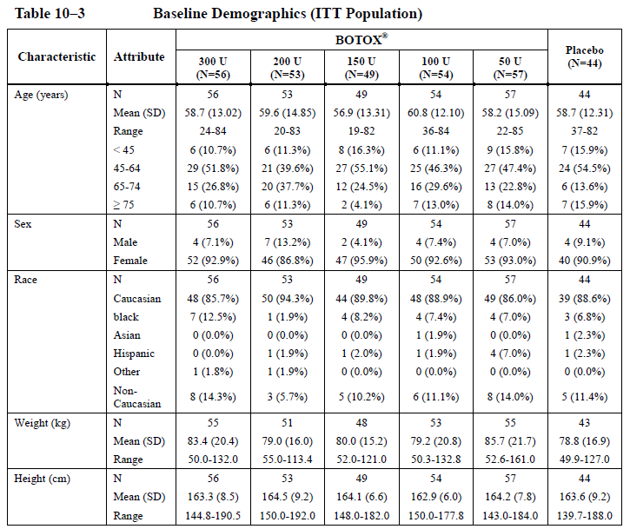
Table 31B. Baseline Disease Characteristics (ITT population)
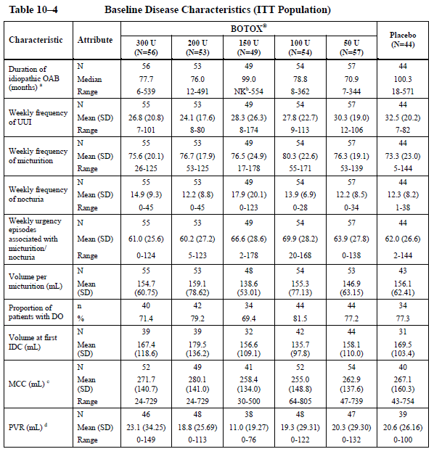

Results
Results for all major endpoints are shown in the table below. For the primary endpoint, change in urinary urgency incontinence (UUI), there was no significant treatment effect at the proposed dose of 100 U, relative to placebo. Part of the difficulty the sponsors faced with this study is that the placebo effect was profound, with a mean reduction in urinary urgency incontinence of 17.4 episodes per week (2.49 episodes per day). The reduction in the 100 U group was only marginally better than this, at 18.4 episodes per week (2.63 episodes per day). This reduction occurred with a baseline incontinence of 24-33 episodes per week (as shown in the subsequent table), so the difference between 100 U and placebo (1 episode per week) is clinically trivial. Other dose groups had slightly better reductions, and achieved a statistically significantly superior result to the placebo group but the dose trend was weak and the 100 U group was broadly similar to the 200 U and 300 U groups. Note that the p-values cited in the table below have not been corrected for the multiple doses assessed.
Table 32. Summary of Key efficacy Parameters at Week 12 (ITT Population, Study 007).
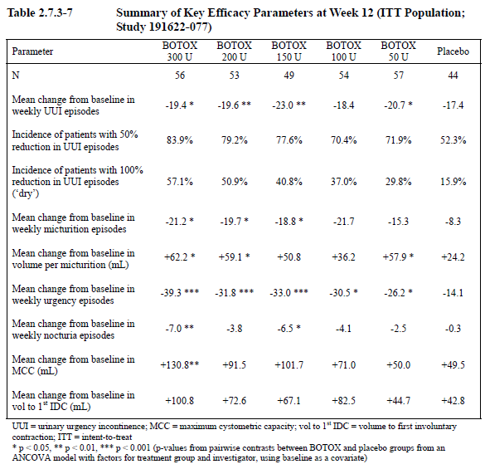
The magnitude of the placebo effect in this study was unusual. Note that a highly significant within-group reduction was observed in all 6 treatment groups, including placebo, as early as Week 2 and this reduction remained statistically significant at all time points and in all treatment groups (p<0.001). This is shown in the table below (derived from the earlier submission).
Table 33. Weekly frequency of Urinary Urge Incontinence Episodes with Imputation. Baseline and Change from Baseline. (ITT population)
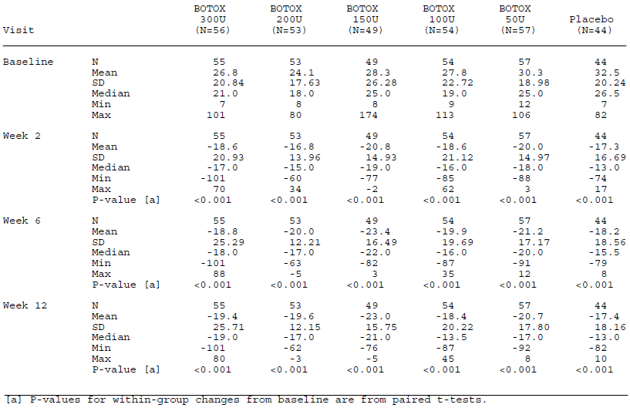
The results are shown graphically below (in a figure derived from the earlier submission). Although the curve for placebo appears higher than all the active treatment curves, showing more incontinence episodes per week, it is also higher at baseline. If the curves were equalised at baseline and expressed as absolute changes, then they would overlap. Also, the flatness of the curves from Week 6 to Week 36 is not suggestive of a convincing pharmacodynamic effect given that Botox, used for other applications, usually shows a waning of efficacy after 3 months.
Figure 11. Plot of Mean Urinary Urge Incontinence Episodes by Visit for All Groups. (ITT population)
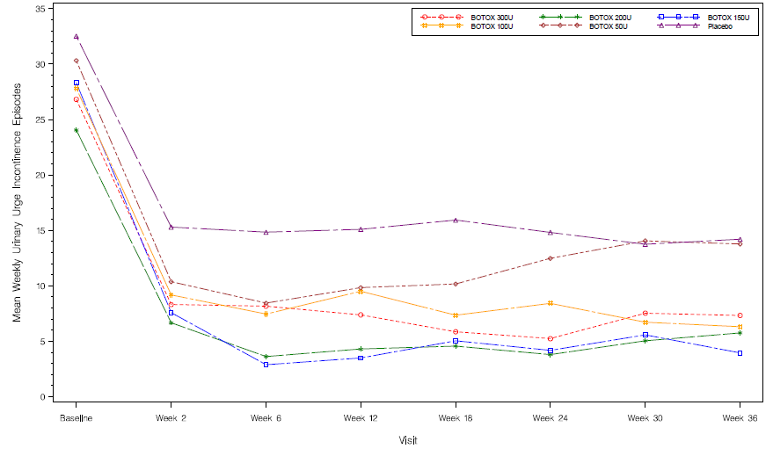
The primary endpoint was UUI at Week 12. When the UUI was considered at other timepoints, the 100 U dose group did show a temporary statistical separation from the placebo group, at Weeks 18 and 24 (as shown in the table below, from the earlier submission). Given that the pharmacodynamic effects of treatment might be expected to be wearing off at this time, this does not represent robust evidence of a treatment effect.
Table 34. Weekly Frequency of UUI Episodes- Baseline and Change from Baseline. (ITT population with imputation)
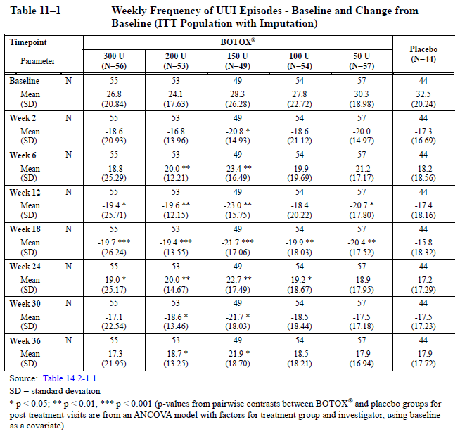
The sponsor also performed a responder analysis, which showed that active treatment was associated with higher proportions of patients achieving various levels of percentage reduction in UUI. Patients were more than twice as likely to achieve a 100% reduction in incontinence (become ‘dry’) with Botox 100 U as they were with placebo (37.0% and 15.9%, respectively). For the proportion becoming ‘dry’, there was an apparent dose trend, with 57.1% of subjects achieving this after 300 U, compared to 50.9%, 40.8%, 37.0%, 29.8% and 15.9% at doses of 200 U, 150 U, 100 U, 50 U and with placebo, respectively.
Table 35. Incidence of Responders at Week 12 with 50%, 75% and 100% Reduction in UUI Episodes from Baseline.
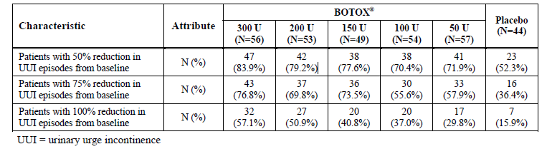
Secondary endpoints were similarly disappointing, particularly for the proposed dose of 100 U. Only one endpoint was statistically significantly superior to placebo for this dose: mean change from baseline in weekly urgency (see table at the start of this section).
For higher doses, there was a significant treatment effect on ‘volume at first involuntary detrusor contraction’ (first IDC), as shown in the table below, but it was only significant at Week 36 when the effect of the Botox should have been becoming less, rather than more evident. There was no consistent effect on peak detrusor pressure, even at higher doses and at 100 U the peak pressure was worse (higher) than with placebo. For maximum cystometric capacity (MCC), the 300 U dose showed a significant effect but lower doses merely showed a favourable trend. The 100 U dose was associated with a mean 71 ml increase in capacity, compared to a placebo increase of 49.5 mL.
No significant treatment effect was seen for end-fill pressure (EFP) but significant results were observed for detrusor compliance, as shown in the tables below.
Table 36. Volume at First IDC (mL)- Baseline and Change from Baseline (ITT population).
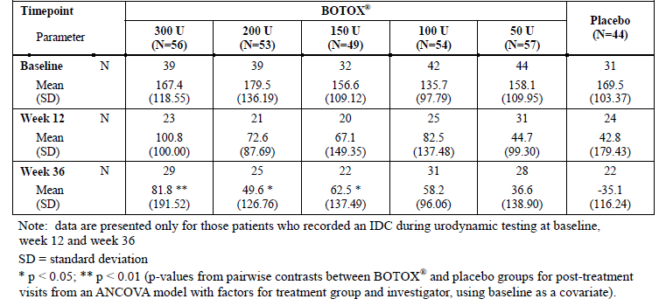
Table 37. Peak Detrusor Pressure during First IDC (cm H₂O). Baseline and Change from Baseline (ITT population).
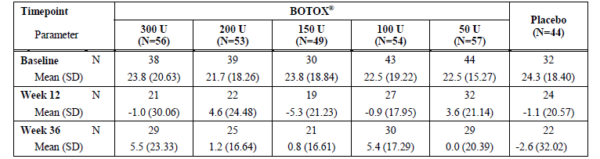
Table 38. Maximum cystometric capacity (mL). Baseline and Change from Baseline (ITT population).
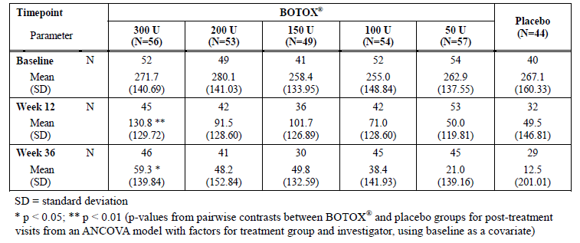
Table 39. End Fill Pressure at MCC (cm H₂O-Baseline and Change from Baseline (ITT population).
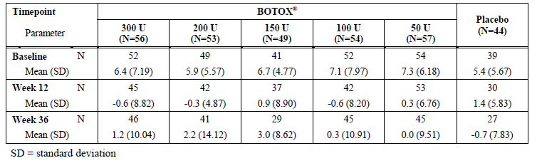
Table 40. Detrusor Compliance (mL/cm H₂O)- Baseline and Change from Baseline. (ITT population)
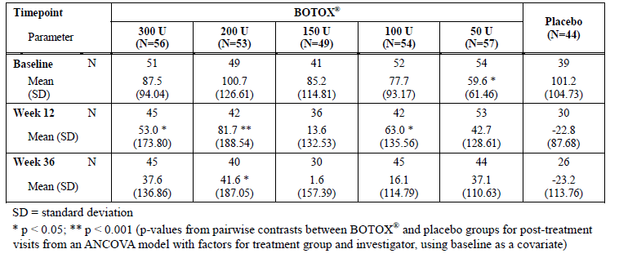
For the quality of life assessments, the overall results were positive. For the I-QOL, statistically significant improvements in the mean change from baseline in Total I-QOL Scores were observed between the 300, 200, 150 and 100 U groups and the placebo group at all post-treatment visits through Week 36 (p ≤0.036). At the primary assessment timepoint of Week 12, the mean increases in the I-QOL scores ranged from 29.8 in the 50 U group to 39.7 in the 300 U group, compared to a mean increase of 17.9 in the placebo group.
The following figures summarise these results.
Figure 12. Proportion of Patients with 100% Reduction from Baseline in UUI (ITT population).
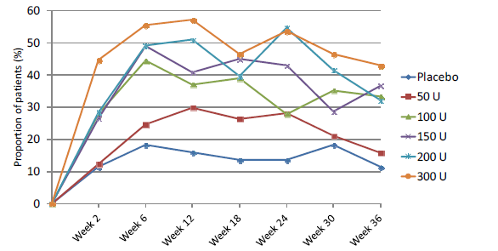
Figure 13. Mean Change from baseline in Symptoms Component Score of King’s Health Questionnaire (ITT population).
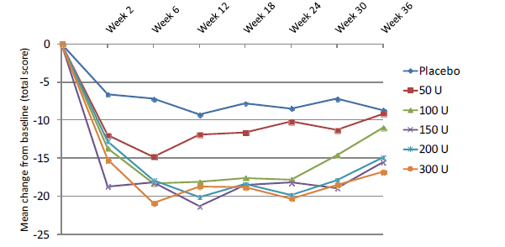
Figure 14. Mean Change from Baseline in OAB Symptoms: a) Weekly UUI; b)Weekly Micturition Episodes; c)Weekly Urgency Episodes; d) Weekly Nocturia Episodes (ITT population)
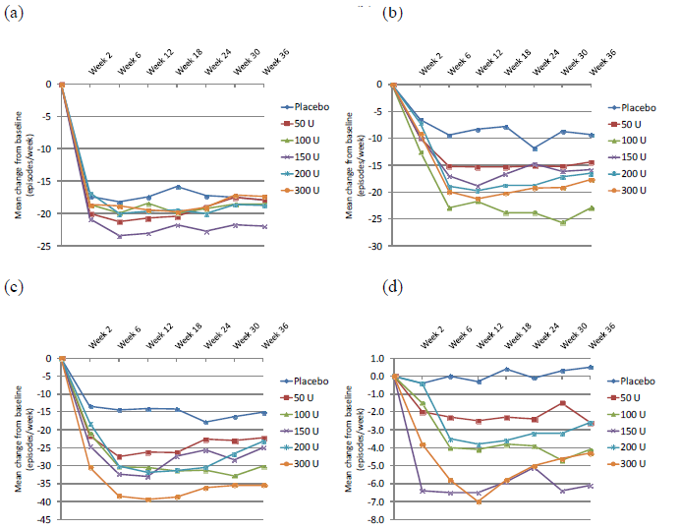

Conclusion, study 077
The placebo effect was so profound in this study that it made it difficult to assess the Botox treatment effect, and for the proposed dose of 100 U the results were qualitatively similar to those observed with placebo. This could indicate poor efficacy of the drug or simply an underpowered study. This study is therefore only weakly supportive of the proposed indication.
Table 41. Summary of OAB Symptom Efficacy variable at Week 12 by Presence or Absence of Detrusor Overactivity Recorded at Baseline (Study 077).
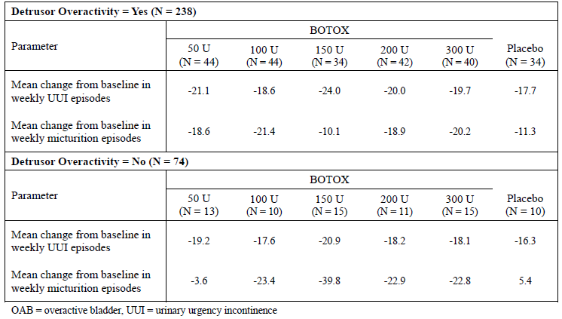

Study 096 (open-label extension study)

Design
Study 096 is an ongoing open-label extension study in which subjects who have completed either of the pivotal studies are being followed through additional treatment cycles, administered when they become eligible on the basis of recurrent symptoms. Patients will be followed for up to two years (104 weeks). The study is not complete but the sponsor presented interim results. At the interim data cut-off date, 834 patients had enrolled but only 814 patients had received at least one dose of active treatment, to be included in the Botox-treated population
The main entry requirements were eligibility for the initial pivotal studies and fulfilment of the pivotal studies’ exit criteria (completion of at least 24 weeks post randomisation and, if a second treatment was received in the pivotal study, completion of at least 12 weeks post-treatment follow-up for that treatment).
Subjects entering the extension study could already have received one or two previous treatments, including placebo. They received additional treatments as needed, not necessarily on entry to the extension study but when they became eligible on the basis of the following criteria:
- the patient had to request retreatment
- the patient had experienced ≥ 2 episodes of urinary urgency incontinence, with no more than one urgency-incontinence free day in the 3-day bladder diary
- PVR urine volume was < 200 ml
- the investigator deemed that treatment was appropriate
- at least 12 weeks had elapsed since the previous treatment (in any study)
- at least 12 weeks had elapsed since any Botox treatment for any non-urological condition.
Most treatments consisted of the standard proposed 100 U dose but when subjects became eligible for their third treatment cycle (third overall, including the previous study and possibly including a placebo cycle), they were given 150 U if the following conditions were met:
- the patient desired a dose increase
- the investigator deemed that patient request was reasonable in terms of safety and efficacy
- the PVR urine volume had not been ≥ 200 ml at any time since entry into the pivotal study
All treatment was active, there was no placebo group and no attempt was made to blind subjects or investigators to dose.
Figure 15. Botox Treated Population
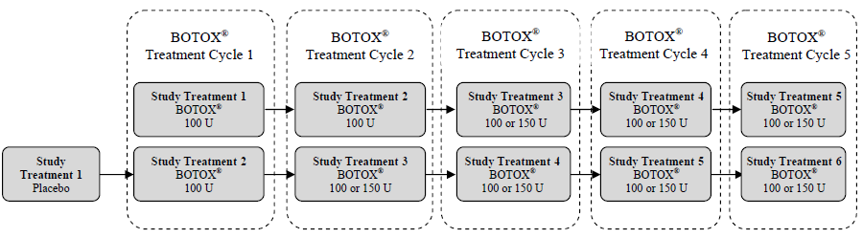
For most analyses, efficacy was assessed according to the active treatment cycle (dashed boxes in figure above), ignoring any initial placebo cycle, and disregarding whether a cycle occurred in the original pivotal study or in the extension study.
The following efficacy measures were assessed, using the same methodology as the pivotal studies.
- number of urinary incontinence episodes
- proportion of patients with a positive response on the TBS
- number of micturition episodes
- I-QOL total summary score
- KHQ Role Limitation and Social Limitation domain scores
- number of urgency episodes
- volume voided per micturition
- number of urinary urgency incontinence episodes
- intensity of urgency scale*
- number of nocturia episodes
- Short Form-12 version 2 (SF-12 v2®) Health Survey

Statistical analysis plan
Statistical analysis was based on the Botox-treated population, which included all patients enrolled into study 191622-096 who had received at least one Botox treatment since the start of the original pivotal study. Efficacy evaluations performed after placebo treatment were not included in the analyses. Because there was no placebo group and doses were not blinded, the sponsor focussed on descriptive statistics: for each efficacy variable, the mean raw value, mean change from baseline, and 95% confidence intervals (CIs) were assessed for each treatment cycle. The primary timepoint for each cycle was Week 12 after each treatment. Baseline was defined as the values prior to any study participation, referring back to the pivotal study baseline.
In the original study plan, none of the efficacy variables was clearly designated as primary but in an amendment the sponsor clarified that the primary variable for the US FDA analysis was the change from baseline in the number of episodes of urinary incontinence.
An exploratory dose-comparison was also performed for the subset of patients who received both 100 U and 150 U. The change in frequency of urinary incontinence from baseline was assessed at the primary timepoint of Week 12 across all treatment cycles and the effect of dose was assessed using a mixed effects model. In the model, patients were treated as random effects, which took into account the within-patient correlation across different treatment cycles, whereas period effects (treatment cycles) and doses were treated as fixed effects. A paired t-test was also performed for within-patient comparisons, using the preceding 100 U treatment in comparison with the first 150 U treatment and assessing the change from study baseline in urinary incontinence frequency at Week 12 post-treatment.

Baseline characteristics
The baseline demographics are shown below for all subjects. Note that patients grouped under ‘150 U’ also received 100 U; in demographic terms, these patients did not differ substantially from the patients who stayed on the standard dose.
Table 42. Baseline Demographics (BOTOX treated Population)
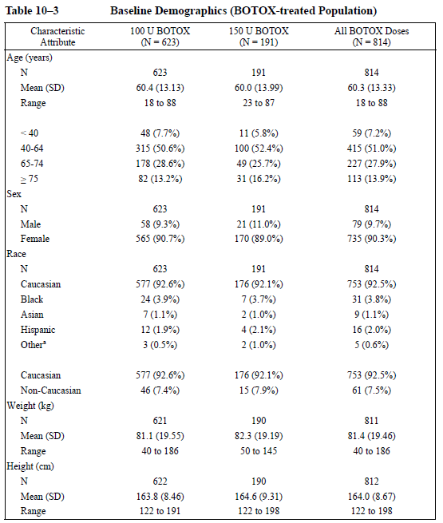
The table below shows the disease characteristics for patients who stayed on 100 U throughout the study, in comparison to those who requested and received a higher dose at least once. The groups were largely overlapping in disease severity but the subset requesting a higher dose had slightly more incontinence and more frequency.
Table 43. Baseline Disease Characteristics (BOTOX treated Population)
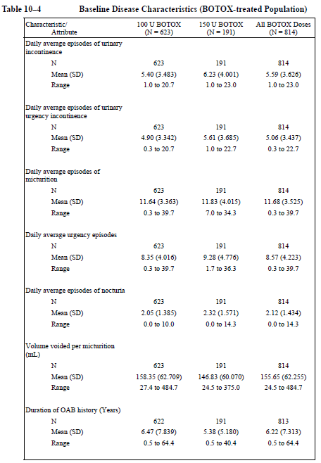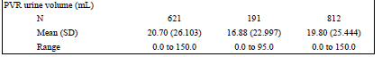

Results
The main efficacy results for each Botox-treatment cycle are shown in the table below. The daily frequency of urinary incontinence should be considered the primary endpoint of the study. The TBS was a co-primary endpoint in the pivotal studies but was not clearly designated a primary endpoint in the extension study.
The reduction in urinary incontinence, relative to the original pivotal-study baseline, appeared roughly constant over multiple treatment cycles. This result should be interpreted with extreme caution, however, because treatment was unblinded and patients were selected on the basis of wanting retreatment. Later cycles would be expected to be enriched with patients who seemed to respond well to treatment, whereas patients with disappointing responses would be expected to drop out between studies or fail to initiate new cycles of treatment.
The proportion of responders improved from Botox Cycle 1 to Botox Cycle 4 but this could be due to enrichment of the study population with subjects who believed they had a positive response to treatment. Note that only 88 subjects had received a fourth active treatment cycle at the time of data cut-off, compared to 999 who received a first active treatment cycle.
Dose comparisons in the table below are also problematic, because the 150 U group is enriched with those who were dissatisfied with the 100 U dose. For Cycle 2, the mean change in incontinence was less beneficial with the higher dose and the proportion of TBS responders was also less; this is likely to reflect a greater number of patients with refractory incontinence requesting a higher dose.
Table 44. Baseline and Change from Study Baseline in Daily Frequency of Urinary Incontinence Episodes and Proportions of Treatment Benefit Scale Responders at Week 12 by Treatment Cycle (BOTOX- Treated Population).
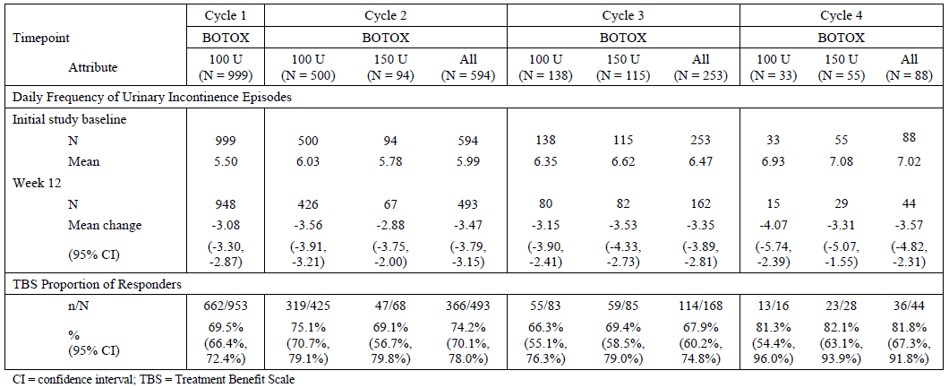
The multi-page table below shows the incontinence frequency at Weeks 2, 6 and 12 for each treatment cycle. It is difficult to draw any firm conclusions from this data. The change relative to the original baseline was broadly consistent across the weeks of each cycle, without the expected waning of efficacy. Improvements from Cycle 1 to Cycle 4, as previously discussed, may reflect the progressive selection of a responsive subgroup who asked for more treatment.
Table 45. Daily Frequency of Urinary Incontinence Episodes- Study Baseline and Change from Baseline at Visits up to Week 12 by Botox Treatment Cycle (BOTOX- Treated Population). Table continued across two pages.
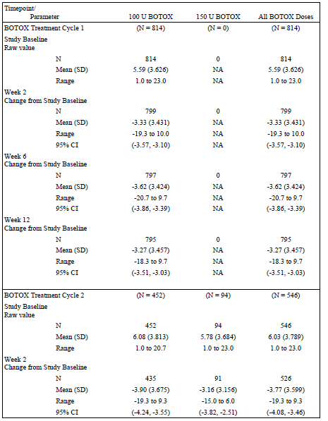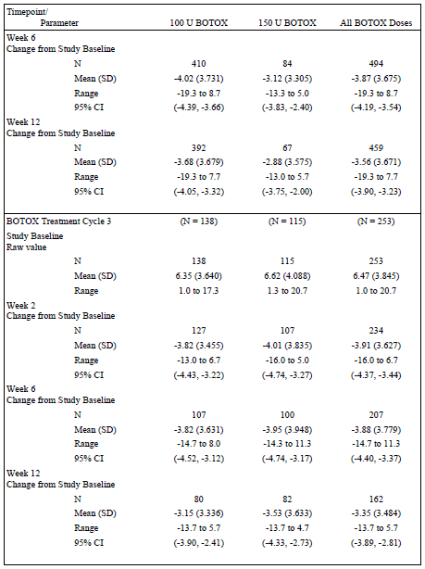
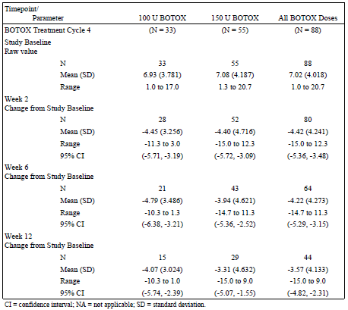
Similar incontinence data is displayed in the table below, expressed as a percentage of baseline incontinence.
Table 46. Percentage Change from Study Baseline in Daily Frequency UIE at Week 12 by Botox Treatment Cycle (Botox Treated Cycle).
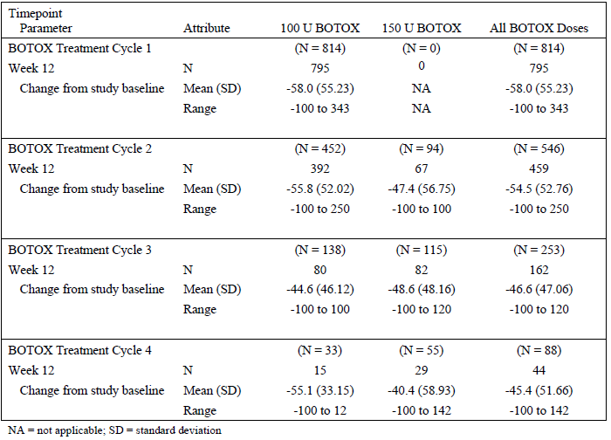
The sponsor also presented a responder analysis based on different percentage reductions of incontinence. The most important is the proportion of patients achieving 100% reduction in incontinence (becoming ‘dry’). This proportion reduced over time but it is difficult to interpret because subjects were not eligible for retreatment if they were completely dry. The subset of patients reaching Cycle 4 would be expected to be enriched for patients with apparent treatment responses (because they still wanted treatment) but also for patients with eventual treatment failures (because they qualified for retreatment). How these opposing selection effects interact is not clear. It is of some reassurance that 88 subjects were willing to undergo a fourth treatment cycle and that 13.6% were still able to achieve the ‘dry’ state after treatment but this represents a very small proportion of the original pooled pivotal population: 6 of 1105 (0.5%). The study is not yet complete, so the final proportions of subjects willing to persist with treatment is not yet known.
Table 47. Proportion of responders at Different Thresholds of Decrease in Daily Frequency of Urinary Incontinence Episodes at Week 12 by Treatment Cycle (BOTOX-treated Population).
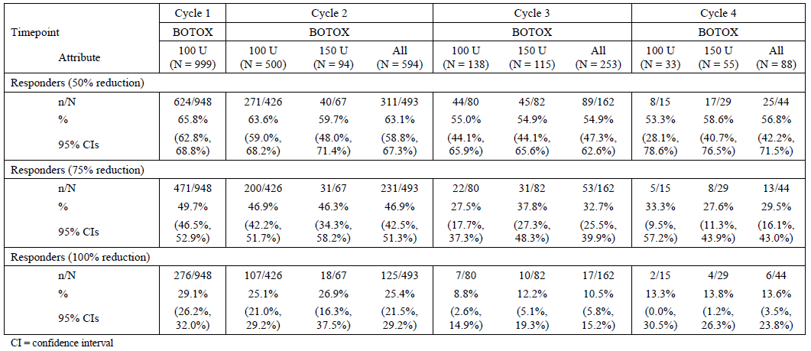
For other efficacy endpoints, similar problems of interpretation arise. As shown in the figure below, there was an apparent persistence of efficacy across multiple treatment cycles for a number of efficacy variables: urinary incontinence, micturition frequency, urgency episodes, nocturia and TBS. This persistence could be partially explained by progressive selection of responsive patients and dropout of unresponsive patients but at least it shows that there is no obvious loss of efficacy with continued treatment.
Figure 16. Mean Change from Baseline in OAB Symptoms at Week 12 by BOTOX Treatment Cycle, Daily Episodes: a) Urinary Incontinence b) Micturition, c) Urgency d) Nocturia (BOTOX- Treated Population)
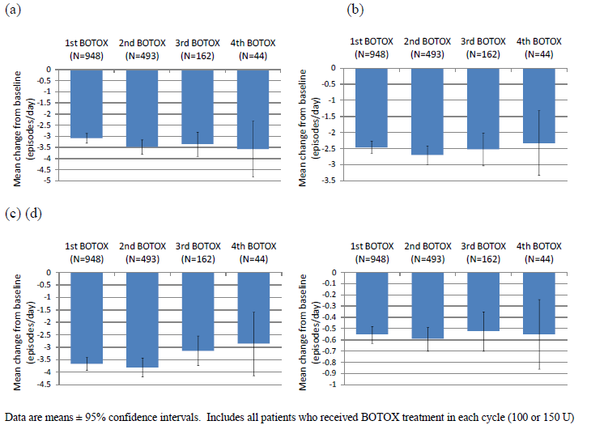
Figure 17. Proportion of Patients with Positive Treatment Response Using the Treatment Benefit Scale at Week 12 by BOTOX Treatment Cycle (BOTOX-treated Population)
.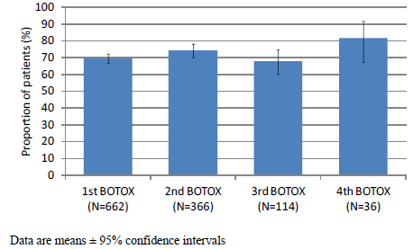

Duration of efficacy
Despite the unblinded and non-randomised nature of this study and the selection effects already discussed, the results allow some estimation to be made of the duration of the Botox treatment effect.
Duration of effect can be assessed in two ways: by the time to the patient’s request for retreatment, which reflects the subjective perception of a waning of efficacy; and the time to qualification for retreatment, which involves a request for retreatment as well as diary evidence of urgency and incontinence. Note that subjects were not eligible for the first 12 weeks after treatment (84 days), plus whatever logistical delays occurred between reaching 12 weeks on the calendar and seeing the investigator in the clinic, so rapid waning of efficacy could not be captured by this analysis even if it occurred.
The median time to request retreatment was 166 days (~24 weeks) in the first cycle, followed by 168 in the second cycle and 116 in the third cycle, as shown in the table below. Subjects asking for a higher dose in one cycle also requested treatment earlier for the next cycle, which is not surprising because such subjects are likely to have more severe incontinence. (The table does not allow conclusions to be drawn about whether the duration of effect was different on the higher dose on a per-patient basis.) Similar results were obtained for time to request retreatment and time to qualification for retreatment, especially in the first two cycles but by Cycle 3 the median time to request retreatment was somewhat earlier than patients were eligible.
Table 48. Duration of Treatment Effect for BOTOXTreatment Cycles 1 to 3- Kaplan Meier Analysis.( BOTOX- Treated population).
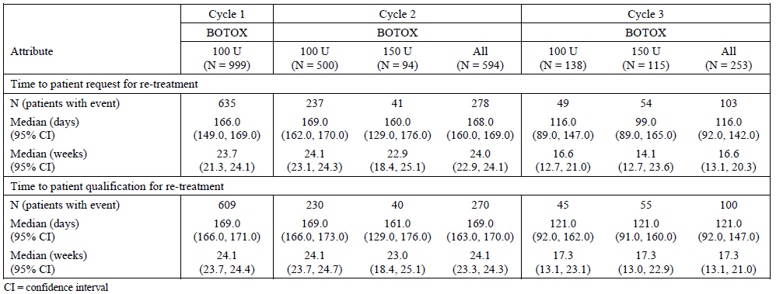

Conclusion, study 096
Study 096 provides useful long-term follow-up of OAB patients across multiple cycles but interpretation of the efficacy results is problematic because the treatments were neither blinded nor randomised. There was no major loss of efficacy for up to 4 cycles of treatment but the number of patients receiving a fourth cycle was very limited. The magnitude and duration of the treatment effect appeared largely stable over time. There was no apparent superiority of the 150 U dose over the 100 U dose but subjects seeking a higher dose are likely to have had more severe or refractory incontinence, potentially obscuring any benefit from the higher dose.

Analyses performed across trials (pooled analyses and meta-analyses)
The two pivotal studies were almost identical in design, which allowed the results to be pooled. Key pooled results for the primary and secondary variables have already been presented during the main discussion of the pivotal study results above. The pooled results were very similar to the results of the individual studies.
The pooled analysis had sufficient statistical power that a number of subgroup analyses could be performed. These analyses suggest that the effect of Botox is fairly uniform across a range of subgroups, with the noted exception of gender.

Subgroup analysis by age
The tables and figures below confirm that Botox is effective in all age brackets assessed, though there were too few patients <40 or ≥ 75 years to achieve adequate statistical power. This conclusion applies to the primary endpoint of urinary incontinence frequency, as well as the co-primary endpoint of TBS.
Table 49. Daily Frequency of Urinary Incontinence Episodes for Treatment by Cycle 1 by Age < 65 and ≥65 years of age: Study Baseline and Change from Study baseline. (Studies 095/520 Pooled, Placebo-controlled ITT Population with LOCF Imputation).
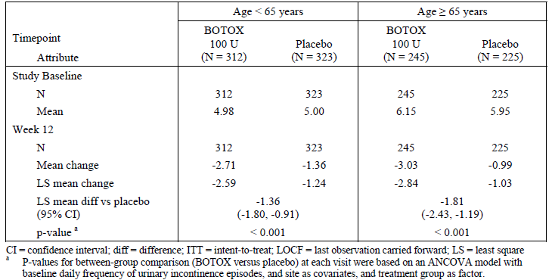
Figure 18. Forest Plot for LS Mean Between-Treatment Differences in Urinary Incontinence Episodes for Age Subgroups at Week 12. (Placebo controlled ITT Population with LOCF Imputation).
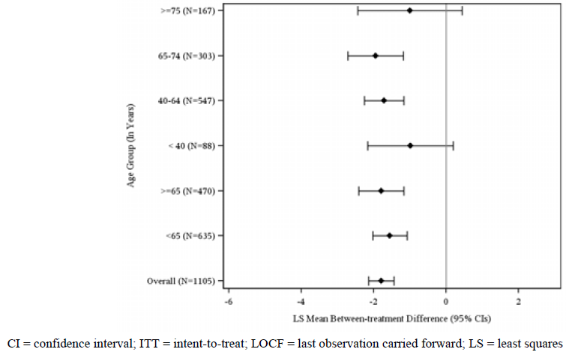
Table 50. Daily Frequency of Urinary Incontinence Episodes for Treatment by Cycle 1 by Age groups: Study Baseline and Change from Study Baseline. (Studies 095/520 Pooled. Placebo-controlled ITT Population with LOCF Imputation).
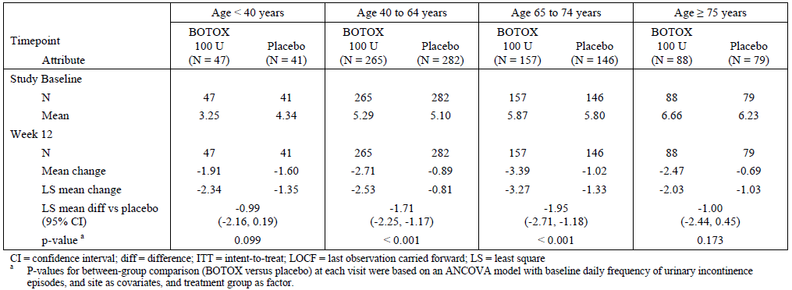
Table 51. Proportions of Patients with a Positive Treatment Response on the Treatment Benefit Scale During Treatment Cycle 1 by Age <65 years and ≥65 years of Age.( Studies 095/520 Pooled, Placebo-controlled ITT Population with LOCF Imputation).
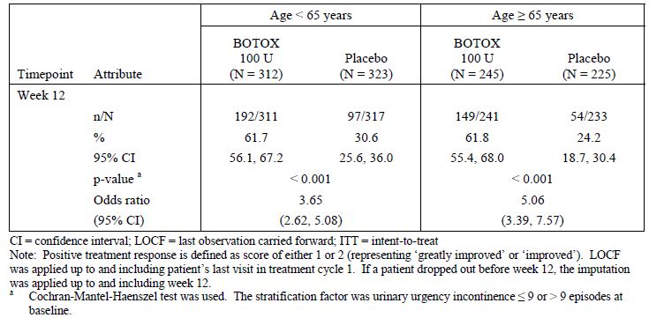
Table 52. Proportions of Patients with a Positive Treatment Response on the Treatment Benefit Scale During Treatment Cycle 1 by Age Group. (Studies 095/520 Pooled, Placebo-controlled ITT Population with LOCF Imputation).
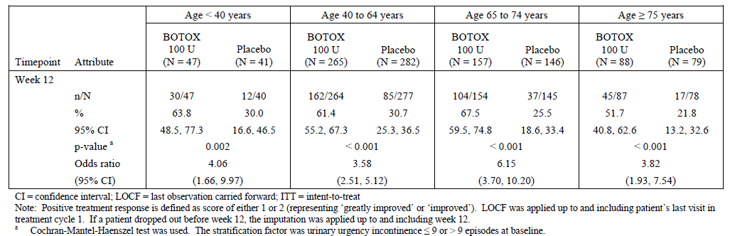
Figure 18. Forest Plot for Odds Ratios from TBS Responder Analysis at Week 12 by Age Subgroups. (Placebo controlled ITT Population with LOCF Imputation).
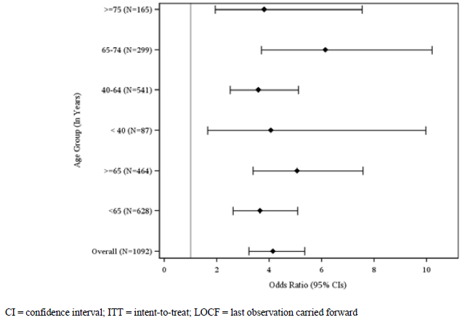

Subgroup analysis by gender
The pivotal study population was predominantly female and, as a consequence, subgroup analyses in men were underpowered. The results in women were very similar to the overall results and were strongly positive but the results in men were borderline, suggesting that more study is needed to clarify the efficacy of Botox in this population.
As shown in the table below, the trend for incontinence frequency in men with OAB was numerically in favour of active treatment but the effect was very minor, amounting to a difference of either 0.63 incontinence episodes per day (comparing mean changes in each group) or 0.42 episodes (using a LS mean difference approach). This result did not approach statistical significance (p=0.612) and the magnitude of the observed treatment effect is of dubious clinical significance. The 95%CI not only included the possibility of zero change in incontinence but also the possibility that Botox increased incontinence by more than one episode per day.
Table 53. Daily Average Frequency of Urinary Incontinence Episodes for Treatment by Cycle 1 by Sex: Study Baseline and Change from Study Baseline. (Studies 095/520 Pooled, Placebo-controlled ITT Population with LOCF Imputation).
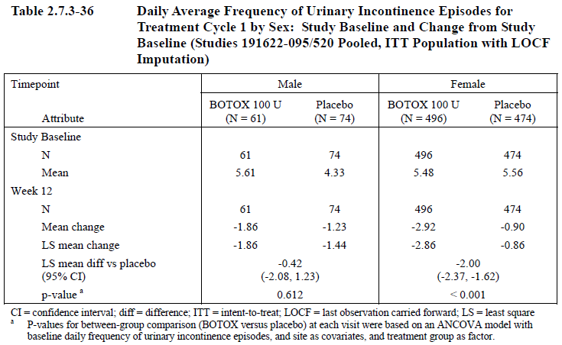
The figure below shows how various subgroup analyses compare with each other. While some of the subgroup analyses were relatively underpowered and had broad confidence intervals as a result, the subgroup analysis in men appears qualitatively different to all the others.
Figure 18. Forest Plot for LS Mean Between-Treatment Differences in Urinary Incontinence Episodes for Subgroups of Sex, Baseline Urinary Incontinence, Diabetes Mellitus Status and Race at Week 12. (Placebo- controlled ITT Population with LOCF Imputation).
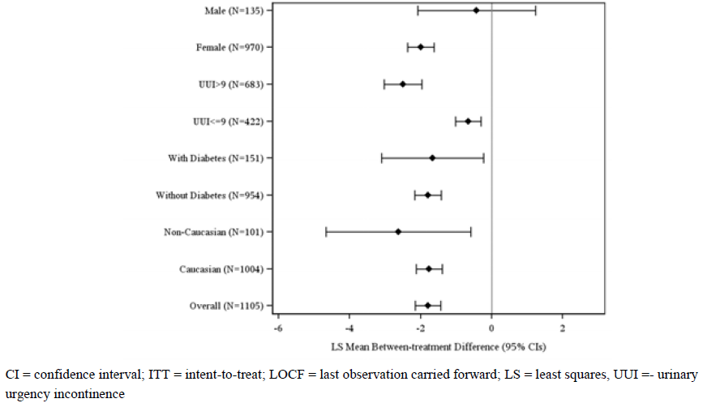
Results for the TBS in men were also unsatisfactory. The positive response rate was numerically higher in men receiving active treatment than in men receiving placebo and this difference approached statistical significance (p=0.06), but the response rate was not high enough to make a good case for using this invasive therapy in men. As shown in the table below, only a minority of male subjects (40.7%) had a positive treatment response; the majority (59.3%) felt that treatment had either produced no benefit or had a negative impact. Discounting the positive response rate by the placebo response rate (25.4%) suggests that only 15.3% of subjects (40.7%-25.4%) had a positive subjective response attributable to active treatment. The proportion of male subjects rating their symptoms as ‘greatly improved’ would be expected to be lower still, but this statistic was not provided.
This result does not merely reflect an underpowered subgroup analysis: quantitative assessment of the treatment-by-sex interaction showed a significant interaction for the proportions of patients with a positive response on the TBS at Week 12 (p=0.043).
Table 54. Proportions of Patients with a Positive Treatment Response on the Treatment Benefit Scale During Treatment Cycle 1 by Sex (Studies 095/520 Pooled, Placebo-controlled ITT Population with LOCF Imputation).
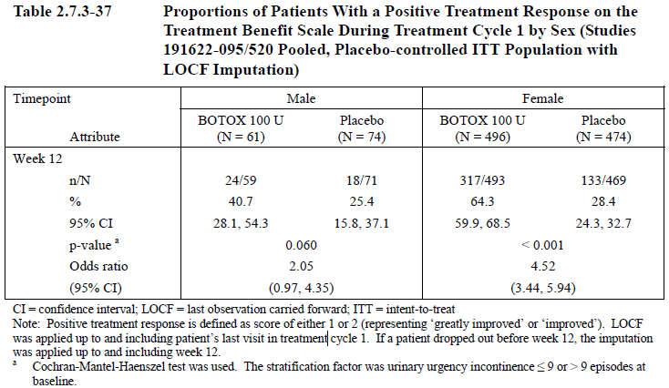
The Forest plot for various TBS subgroup analyses is shown below. Note that the result for men falls on the ‘placebo better’ side of a neutral odds ratio of 1.0 but this does not amount to much as the response rate with placebo meant that three quarters of male subjects given placebo felt their symptoms were the same or worse than before treatment.
Figure 19. Forest Plot for Odds Ratios from TBS Responder Analysis at Week 12 by Subgroups of Sex, Baseline Urinary Incontinence, Diabetes Status and Race. (Placebo controlled ITT Population with LOCF Imputation).
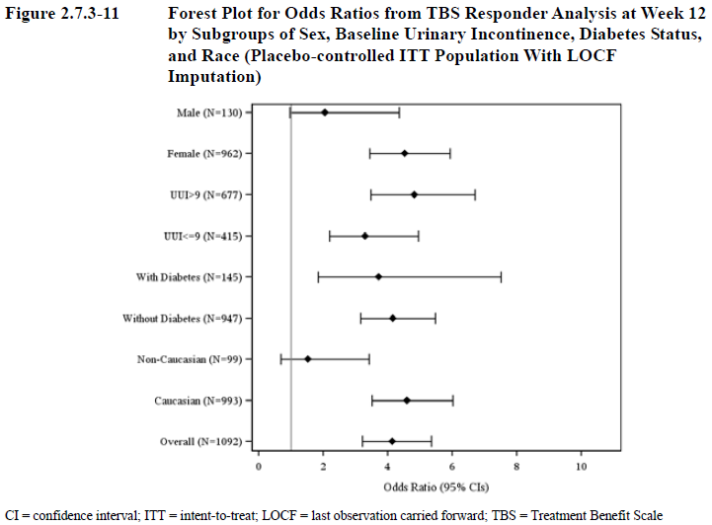
Overall, considering both of these co-primary endpoints, the data on men is currently inadequate but the evidence so far suggests that the benefit of Botox for OAB in men is likely to be substantially less than in women and needs further characterisation.
This is an important result that cannot be dismissed as a statistical anomaly in an underpowered subgroup analysis. The very fact that men were severely under-represented in the study is proof that the mechanisms of OAB in men and women are different. In general, under-powered subgroup analyses are of minor importance but in this situation it would be inappropriate to conclude that the disappointing results in men necessarily reflect lack of statistical power. In fact, these results raise the question of whether the sponsor should have lumped men and women together in the first place, performing studies that were not sufficiently powered to answer the important question of whether Botox is effective in men with OAB.
There are many a priori reasons to expect that continence management in men and women might require different approaches. The anatomy of the bladder outlet is obviously quite different in men and women, as are the typical range of urological symptoms that occur with aging. Women, especially following childbirth, are prone to stress incontinence and have relatively reduced sphincter function. Men, especially in the setting of prostatic hypertrophy (which becomes universal with advancing age) are prone to prostatism and partial outlet obstruction with hesitancy and a poor urine stream. In complete contrast to women, stress incontinence is relatively rare in men.
Normal bladder function requires that sphincter contraction resists fluctuations in detrusor tone during periods of urine storage and that detrusor contraction overcomes the sphincter tone and bladder outlet resistance during periods of voluntary voiding. It would be simplistic to expect that the balance between the detrusor and sphincter is the same in men and women or that weakening the detrusor with Botox would have an identical effect in the two gender subgroups. The results of the pivotal studies demonstrate that the effect is, indeed, qualitatively different.
Overall, these considerations suggest that more work needs to be done by the sponsor to demonstrate a worthwhile effect of intravesical Botox therapy in men with OAB. At a minimum, the Product Information sheet (PI) needs to point out that the benefit in men is uncertain and that most men (~60%) did not report a favourable effect.

Other subgroup analyses
The sponsor performed a number of other subgroup analyses, as shown in the tables and figures below. (Some figures have been repeated from the previous section.) Patients showed a significant reduction in incontinence regardless of whether they had mild or severe incontinence at baseline (>9 episodes or ≤ 9 episodes per 3 days at baseline). Those with and without diabetes both showed a significant benefit. For the objective primary endpoint of incontinence frequency, Caucasians and non-Caucasians both showed a significant benefit. For the more subjective co-primary endpoint of TBS, a significant benefit was not demonstrated for non-Caucasians, but the analysis was underpowered and, unlike the gender comparison, there is no a priori reason to suspect a significant racial difference in response to Botox.
For the stratification factor if incontinence at baseline, the subgroup analysis is shown in the table below. The benefit, in terms of change in incontinence frequency, was numerically smaller in those with less incontinence as expected but statistical significance was demonstrated in both stratification groups (p<0.001 for both UUI ≤ 9 and UUI >9).
Table 55. Daily Frequency of Urinary Incontinence Episodes for Treatment Cycle 1 by Stratification factor: Study baseline and Change from Baseline. (Studies 095/520 Pooled., ITT Population with LOCF Imputation).
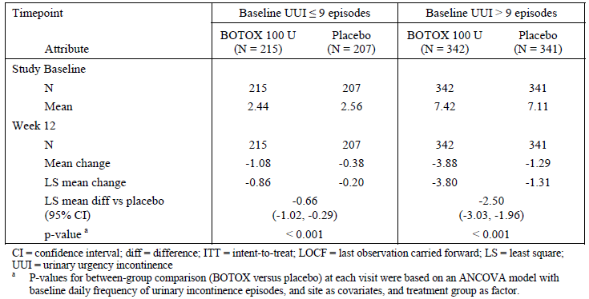
The sponsor also performed subgroup analyses based on two important complications of Botox therapy; the commencement of clean intermittent catheterisation (CIC) and the occurrence of urinary tract infections (UTIs). As shown in the tables at the end of this section, a treatment benefit was demonstrated even when these outcomes occurred, both in terms of overall response (TBS) and in quality of life measures. This suggests that, for most patients, the development of CIC or UTIs is offset by sufficient quality-of-life gains that they still regarded the overall balance of effects as positive.
Figure 20. Forest Plot for LS Mean Between Treatment Differences in Urinary Incontinence Episodes for Subgroups of Sex, Baseline Urinary Incontinence, Diabetes Mellitus Status and Race at Week 12. (Placebo controlled ITT Population with LOCF Imputation).
Figure 21. Forest Plot for Odds Ratios from TBS Responder Analysis at Week 12 by Subgroups of Sex, Baseline Urinary Incontinence, Diabetes Mellitus Status and Race. (Placebo -controlled ITT Population with LOCF Imputation).
Figure 22. Forest Plot for LS Mean Between-Treatment Differences in Urinary Incontinence Episodes by Number of Failed Anticholinergics and Reason for Anticholinergic Failure at Week 12. (Placebo- controlled ITT Population with LOCF Imputation).
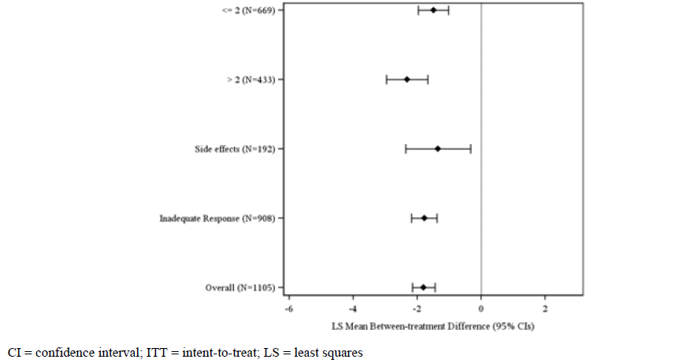
Table 56. Daily Frequency of Urinary Incontinence Episodes for Treatment Cycle 1 by Stratification factor: Study baseline and Change from Study Baseline. (Studies 095/520 Pooled, ITT Population with LOCF Imputation).
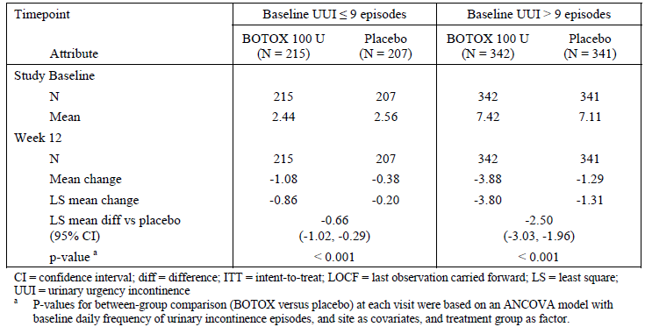
Table 57. Proportion of Patients with a Positive Treatment Response on the Treatment Benefit Scale During Treatment Cycle 1 by Stratification factor. (Studies 095/520 Pooled, ITT Population with LOCF Imputation).
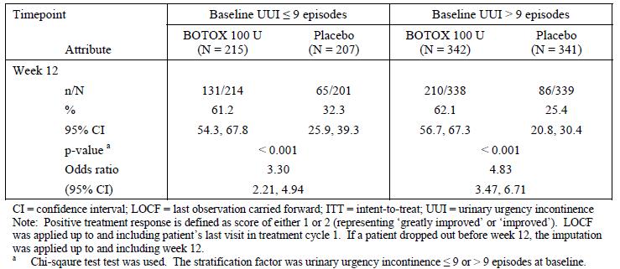
Table 58. Efficacy Results at Week 12 by Post-treatment CIC status (Yes/No). (Studies 095/520 Pooled, Placebo controlled ITT Population).
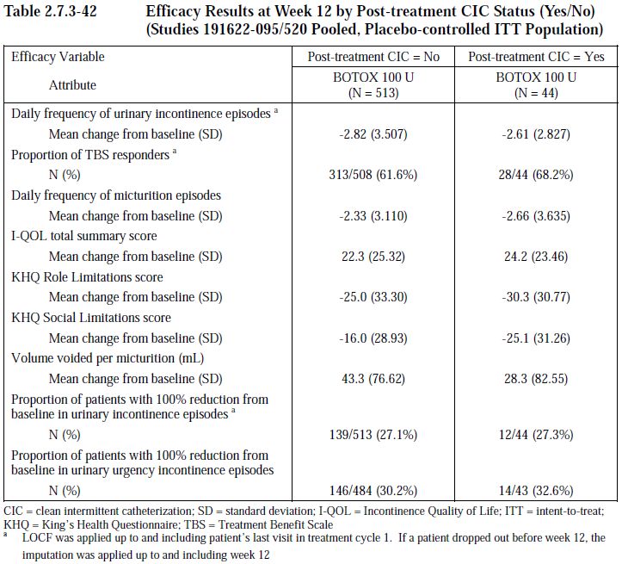
Table 59. TBS responders at Week 12 by Post-Treatment UTI status (Yes/No). (Studies 095/520 Pooled, Placebo controlled ITT Population with LOCF Imputation).
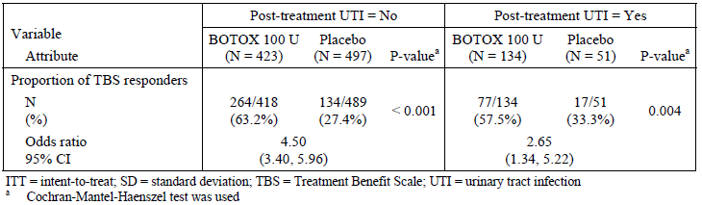

Evaluator’s conclusions on clinical efficacy
The overall conclusions on efficacy are primarily derived from the pivotal studies and are summarised in Conclusion Pivotal Studies above). The pivotal studies were strongly positive, in the statistical sense, for all of their primary and secondary endpoints, as summarised below. (The two pivotal studies produced similar results and were independently positive as well as positive when pooled).
Table 60. Summary of Efficacy Endpoints Achieved in Both Pivotal Phase III Studies for up to 12 Weeks Post Treatment 1. ITT Population.
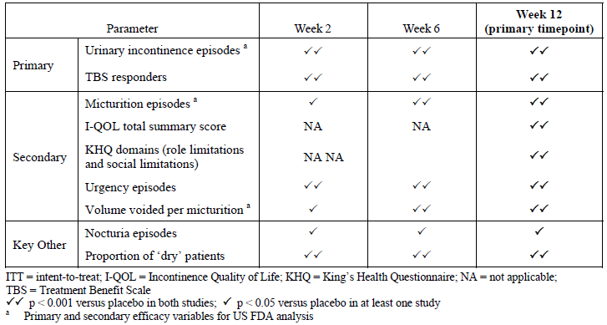
The magnitude of the benefit, in clinical terms, was modest, amounting to 1.70 episodes of incontinence prevented each day (95%CI -2.14 to -1.44 episodes, p<0.001), from a baseline incontinence frequency of 5.39 to 5.49 episodes per day.
In other words, the majority of incontinence was not prevented by active treatment: the percentage reduction in incontinence was narrowly >50% in the active group (50.5%) but this includes a placebo response of 14.6%.
For the co-primary endpoint of TBS, positive responses at 12 weeks were significantly more common with active treatment (61.8%) compared to placebo (28.0%) and the difference was statistically significant (p<0.001). The attributable response rate thus amounts to about one patient in three.
Table 61. Summary of Overactive Bladder Symptoms and Volume Voided Per Micturition at Week 12 Post-treatment 1 (Pooled ITT Population).
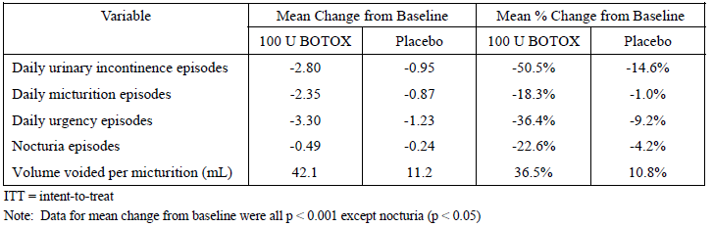
Results in the dose-ranging study (Study 077) were negative for the 100 U dose but this study was underpowered and the placebo response in the placebo group was unexpectedly large. The long-term extension study (Study 096) showed that efficacy was similar across multiple doses and similar between doses of 100 U and 150 U, but interpretation of the results is difficult as treatment was neither randomised nor blinded.
The sponsor did not set out to study the efficacy of Botox in men and women separately but there are many a priori reasons to suspect that efficacy might be different in the two gender groups, and in retrospect, pooling these two populations was not appropriate. A subgroup analysis showed that results in men were disappointing. On average, the reduction in incontinence in men was only 0.42 episodes per day, and the majority of men (59.3%) rated their symptoms as unchanged or worse after treatment. These outcomes were numerically superior to placebo but they were not statistically significant and would be of limited clinical utility even if confirmed in a larger study of men with OAB.
Table 62. Daily Frequency of Urinary Incontinence Episodes for Treatment Cycle 1 by Sex. Study baseline and Change from Baseline. (Studies 095/520 Pooled. ITT Population with LOCF Imputation).
Table 63. Proportion of Patients with a Positive Treatment Response on the Treatment Benefit Scale During Treatment Cycle 1 by Sex. (Studies 095/520 Pooled., Placebo controlled ITT Population with LOCF Imputation).

Clinical safety
Botox has been available for many years in Australia and worldwide, for treatment of a large range of neuromuscular and cosmetic conditions. The drug is administered topically and should not (except by accident) enter the systemic circulation, so the safety profile of Botox is highly dependent upon where it is injected and the dose administered.
Botox has already been approved for intravesical injection in the treatment of neurogenic detrusor overactivity (NDO), at a dose of 200 U, so the proposed dose of 100 U at the same site does not pose any major new safety risks. When administered for NDO, Botox had an acceptable safety profile but intravesical treatment with 200 U was associated with an increased incidence of urinary retention, increases in post-void residual urine volume, an increased incidence of UTIs and a proportion of patients who had to commence clean intermittent catheterisation (CIC) as a direct result of Botox-mediated impairment of bladder emptying.
The proposed dose for OAB (100 U) is only half that proposed for NDO (200 U), which might be expected to be associated with a reduced incidence of urological complications. The largely unknown causes of idiopathic OAB are necessarily different from the specific neurological deficits causing NDO, however, so the balance between detrusor overactivity and underactivity is likely to be different, and the dose-dependence of urological complications is not necessarily the same with the two conditions. As discussed below, 100 U in the current submission was associated with a similar profile of adverse urological effects as was observed with 200 U given for NDO, including an increased incidence of urinary retention, UTIs and increased residual urine volume.
Occasional reports of possible systemic effects of Botox have been reported in the literature following local use of Botox for a variety of conditions (Dutton JJ, 1996; Bhatia KP et al, 1999; Coban A et al, 2010). In the previous submission for intravesical Botox, there was no clear case of systemic spread but constipation was increased in the 300 U treatment group, which possibly indicated some local spread at this dose. Potential systemic effects in the context of the current submission are discussed under Potential distant spread of toxin below).

Studies providing evaluable safety data
All four submitted studies provided evaluable safety data but the most important data came from the first cycle of the placebo-controlled pivotal studies (Study 095 and 520). Study 077 provided a dose comparison for adverse events in the range 50 U to 300 U and was also useful. The long-term extension study (Study 096) was somewhat useful, in that it followed patients for up to two years and assessed the safety of repeated doses but interpretation of event rates is limited by the fact that treatment was unblinded, non-randomised and lacked a placebo control. Two doses were used in Study 096, but escalation to the higher dose was non-random and initiated by patients, a methodological feature that would automatically select for patients likely to tolerate Botox well.

Pivotal efficacy studies
In the pivotal efficacy studies, the following safety data were collected:
- General adverse events (AEs) were assessed by interview at regular scheduled visits and monitoring of unscheduled hospital or clinic attendances, as well as screening for abnormalities on laboratory testing.
- AEs of particular interest included urological complications of Botox therapy and symptoms potentially indicative of local or systemic toxin spread. These were primarily assessed by searching the AE database for terms that matched or were suggestive of the AE of interest. To characterise the adverse urological effects of Botox therapy, including urinary retention and increased post-void residual urine volume, subjects also underwent urodynamic studies and bladder ultrasound.
- Laboratory tests, including routine biochemistry and haematology, as well as urinalysis, were performed at regular intervals.

Pivotal studies that assessed safety as a primary outcome
No studies assessed safety as a primary outcome.

Dose-response and non-pivotal efficacy studies
The dose-response Study 077 and the long-term extension Study 096 provided similar safety data to the pivotal studies, including AE collection, laboratory monitoring and urodynamic assessment.

Pivotal studies that assessed safety as a primary outcome
None applicable.

Patient exposure
The primary safety analysis was based on the placebo-controlled safety population, which includes subjects receiving randomised blinded treatment with Botox (n=607) or placebo (n=585).
Placebo-controlled exposure to the proposed intravesical dose of 100 U is summarised in the table below. Exposure tended to be briefer with placebo treatment, with lower median duration of exposure and a lower number of subjects exposed for ≥ 24 weeks; this reflects the fact that placebo-treated patients did not experience any true treatment-effect and so they qualified for retreatment sooner.
Table 64. Summary of Exposure Information for Placebo Controlled Treatment Cycle 1. (Placebo controlled Safety Population).
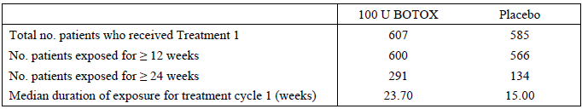
Table 65. Cumulative Duration of Exposure. Treatment Cycle 1. (Placebo controlled Safety Population)
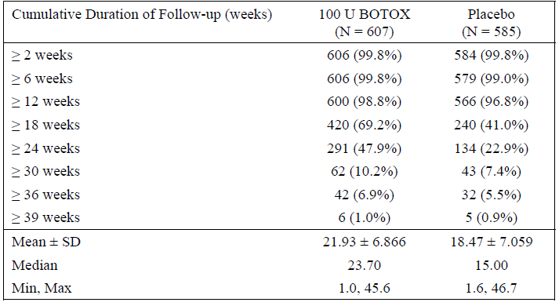
The full population of Botox-treated subjects included initial placebo patients that received a second open-label treatment cycle (first active cycle) in the pivotal studies or in the long-term extension study. Exposure in this larger group is summarised below. A total of 1104 subjects received at least one dose of Botox at doses of 100 U or 150 U, a total of 594 patients received two doses and lesser numbers received additional treatments. The table below shows the dose given each cycle, with the final row dividing patients into those who received 100 U for all treatments (n=863) and those who received 150 U at least once (n=241). The subsequent table lists the duration of follow-up available for each dose, regardless of treatment cycle.
Table 66. Number of Patients Included in the Analysis Population by BOTOX Treatment Cycle. (BOTOX- Treated Patients).
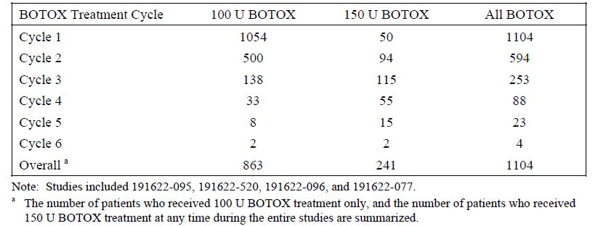
Table 67. Cumulative duration of Exposure, Regardless of Number of Treatment Cycles. (BOTOX- Treated Population).
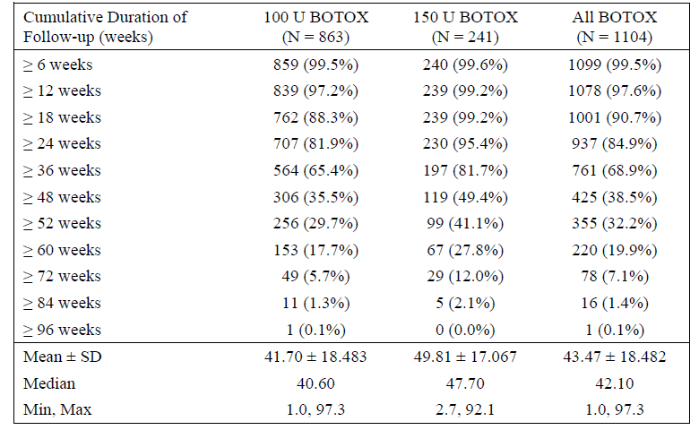
The placebo-controlled safety population was broadly representative of the intended target population with OAB. The mean age was about 60 years and the majority (88.6%) were female. A small subgroup (~15%) were over 75 years of age.
Table 68. Baseline Demographics. (Placebo Controlled Safety Population).
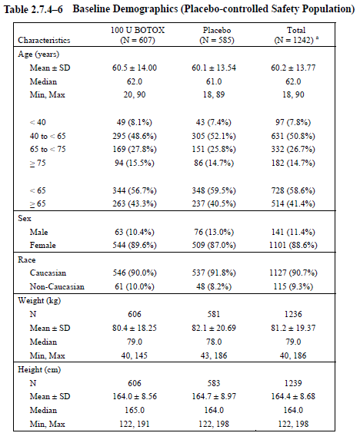

Adverse events
Because the duration of exposure was not equal in the active and placebo groups, adverse events (AEs) were analysed in two ways: for the first 12 weeks of Treatment Cycle 1 and across the full extent of Treatment Cycle 1. The first method allows direct comparison of event rates in the active and placebo groups, whereas the second is more inclusive and potentially captures late complications of treatment.
Even when the analysis was restricted to the first 12 weeks, AEs were more common with Botox 100 U (57.5% of subjects) than with placebo (44.6% of subjects). As shown in the table below, this excess of AEs with active treatment was also seen for AEs with a presumed causal relationship to treatment (treatment-related AEs 27.2% versus 14.9%), and to a lesser extent for serious AEs (SAEs, 4.3% versus 3.8%) and for discontinuations due to AEs (1.0% versus 0.5%). These AE categories will be discussed in later sections.
Table 69. Overall Summary of AEs during Placebo Controlled Treatment Cycle 1. (Placebo Controlled Safety Population).
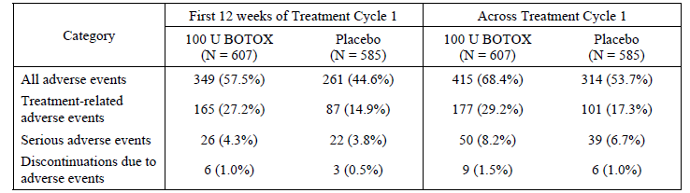

All adverse events (irrespective of relationship to study treatment)
The table below shows the relative incidence of common AEs (occurring in >3% of patients) in Botox recipients compared to placebo recipients. Nearly all of these AEs were more common in Botox recipients; a >1% excess was seen for UTI, dysuria, bacteruria, urinary retention, abnormal residual urine volume, sinusitis and leukocytouria.
With the exception of nasopharyngitis, these AEs are expected in the Botox population on the basis of previous studies of intravesical Botox (including the previous submission for Botox in Neurogenic Detrusor Overactivity). By inhibiting detrusor function, Botox reduces bladder emptying, encouraging an increase in the post-void residual volume. This in turn increases the risk of urine infection because of a reduction in the normal flushing mechanism of the bladder, and the preservation of a stagnant pool of urine between voids that provides a sanctuary for bacteria.
Table 70. Adverse Events Occurring in >3% of patients in any Treatment Group During Placebo Controlled Treatment Cycle 1. (Placebo Controlled Safety Population).
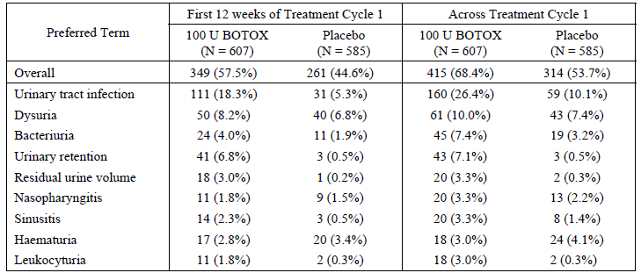
In the full Botox-treated safety population (which includes open-label and non-placebo-controlled treatment), a similar distribution of events was observed. Note that some of the AEs in the table below were not actually common in the combined Botox group but occurred with a frequency of >3% by virtue of being experienced by just 2-4 patients in some of the smaller treatment groups (those receiving 150 U, or those receiving a fourth treatment cycle, for instance). This applies to gastrointestinal disorders, diarrhoea, pyrexia, arthralgia and malignancy. The subsequent table shows similar information but with the 100 U and 150 U treatments pooled.
Table 71. AEs Occurring in ≥3% of Patients and More than 1 Patient in Any Treatment Group by BOTOX Treatment Cycle. (BOTOX- Treated Population).
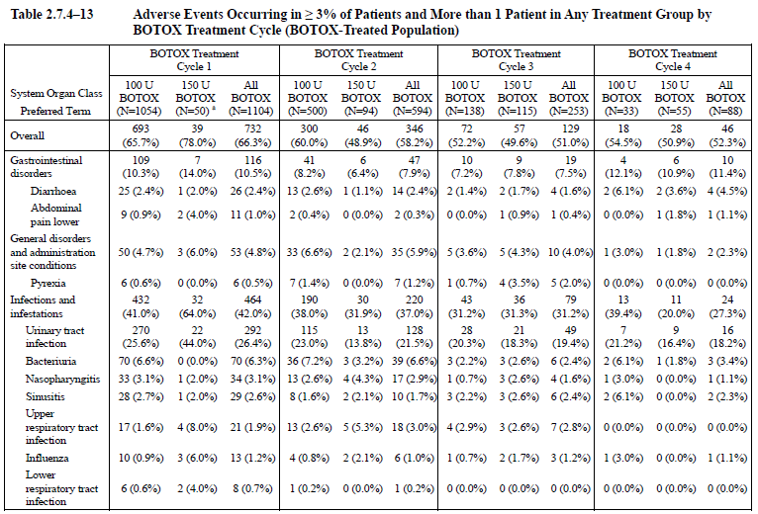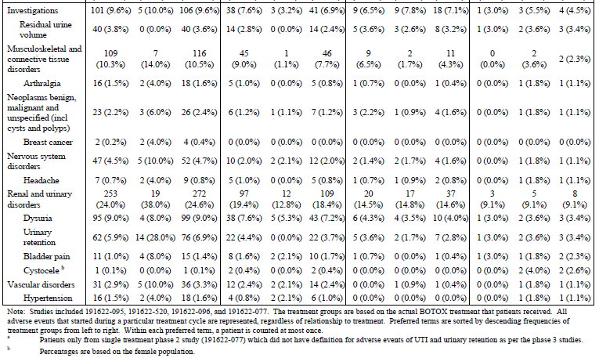
Table 72. AEs Occurring in ≥3% of Patients or More Than 1 Patient by BOTOX Treatment Cycle. (BOTOX- Treated Population).
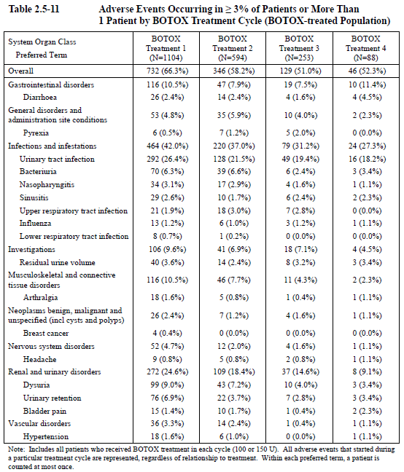

Treatment-related adverse events (adverse drug reactions)
Investigators were asked to indicate which AEs they felt had a causal relation to study treatment, as is standard for studies of this nature. Causal attribution in such settings is inherently unreliable, because investigators are unlikely to propose a causal relationship for rare or unexpected events and may make a false inference of causality because the timing of an unrelated event mimicked a drug reaction.
So-called treatment-related AEs (TRAEs) are tabulated below for all such AEs occurring in >3% of subjects. There was a clear excess of urinary retention, UTI and increased residual urine volume, which were common as TRAEs in Botox recipients but relatively rare in placebo recipients. Dysuria was usually interpreted as a TRAE but occurred with similar frequency in the active (5.8%) and placebo groups (5.0%).
Table 73. Treatment-Related AEs Occurring in ≥3% of Patients in Any Treatment Group During Placebo Controlled treatment Cycle 1. (Placebo Controlled Safety Population).
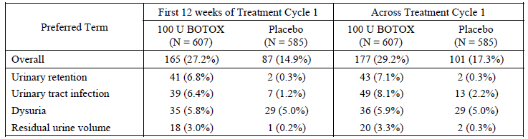
Similar TRAEs were observed in the full Botox-treated population but it is difficult to draw conclusions about the likely causal role of Botox as the data lacks a control group. A comparison across cycles is also problematic, because subjects experiencing major problems in the first one or two cycles are less likely to request additional treatments. The incidence of TRAEs did not substantially change with continued treatment, except that, as a group, renal and urinary disorders became less prevalent; this is likely to reflect the fact that patients prone to urinary retention were less likely to request treatment and those with significant increase in post void residual urine volume were explicitly excluded from further treatment.
Table 73. Treatment-Related AEs Occurring in ≥3% of Patients in Any Treatment Group by BOTOX Treatment Cycle. (BOTOX- Treated Population).
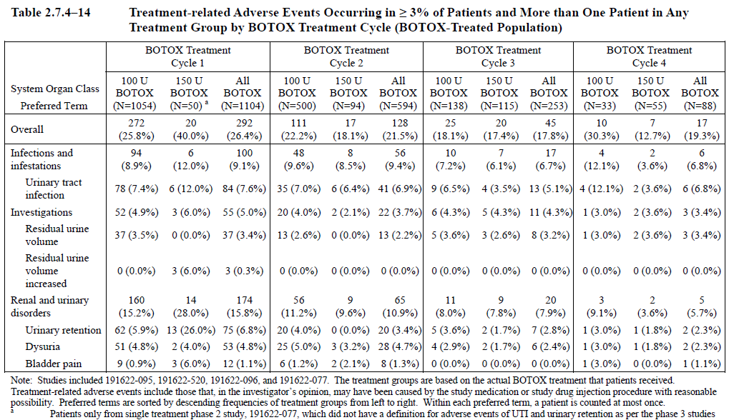

Deaths and other serious adverse events
Three deaths were reported across the 2 pivotal Phase III OAB studies. None were considered likely to be treatment-related by the investigators and reviews of the narrative summaries (see below) did not suggest a causal relationship with Botox. No deaths were reported in Study 077 or in Study 096 at the time of the interim data cut-off.

Deaths
An 80 year old woman with a history of rectocoele and constipation received placebo, and 93 days later developed diverticulitis in the setting of dehydration. She underwent surgery, which was complicated by pneumothorax and subsequently led to her death. The gap between the intravesical procedure and these events makes it unlikely that they were causally related, particularly in view of the fact she did not receive active treatment.
A 73 year old woman received placebo for treatment 1 and 100 U BOTOX for Treatment 2. She developed pneumonia 138 days after the injection of 100 U BOTOX, which was subsequently complicated by ventricular fibrillation, pulmonary embolism and myocardial infarction, which led to death. The marked delay before the development of these problems makes it unlikely the intravesical procedure or Botox played any causal role.
A 78 year old man with a history of aortic stenosis and hypertension received 100 U BOTOX for Treatment 1 and experienced acute myocardial infarction 154 days later, dying the same day. The delay from treatment to the myocardial infarction and the lack of a plausible pharmacological mechanism linking Botox to myocardial ischaemia makes it extremely unlikely that Botox played a causal role.

SAEs in the placebo-controlled population
Serious adverse events (SAEs) were marginally more common in the 100 U Botox group (4.3%) than in the placebo group (3.8%) during the first 12 weeks of Treatment Cycle 1. A survey of the individual types of SAE, as in the table below, did not reveal any particular concerning pattern, with the exception of urinary retention, which occurred as an SAE in 3 Botox recipients (0.5%) but no placebo recipients. Most individual SAEs were rare, occurring in 1 or 2 patients. Osteoarthritis was slightly more common and occurred in 4 Botox recipients but it also occurred in 3 placebo recipients.
Overall, the SAE data merely confirms that there is a risk of urinary retention with Botox.
Table 75. All Serious Adverse Events. First 12 Weeks of Treatment Cycle 1. (Placebo Controlled Safety Population). Table continued across two pages.
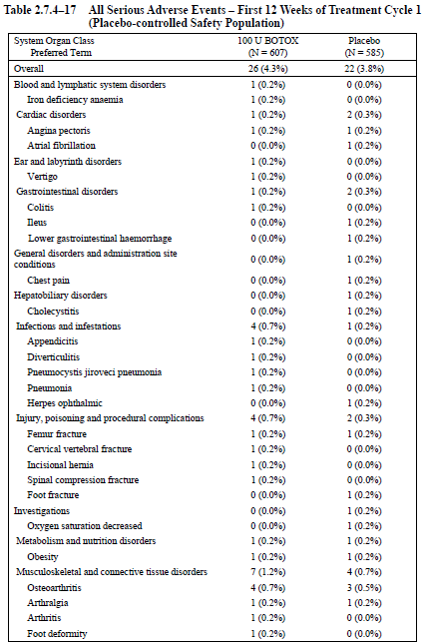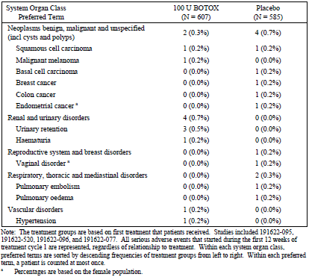
When SAEs were considered over the whole treatment cycle, the pattern was similar but the longer follow-up led to more events, as shown in the table below.
Table 76. All Serious Adverse Events. Treatment Cycle 1. (Placebo Controlled Safety Population). Table continued across three pages.
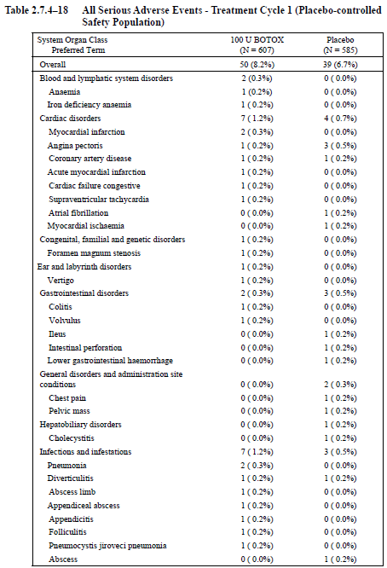
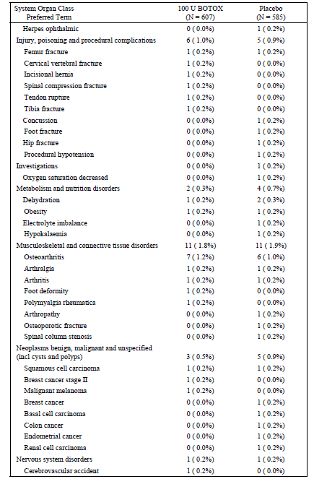
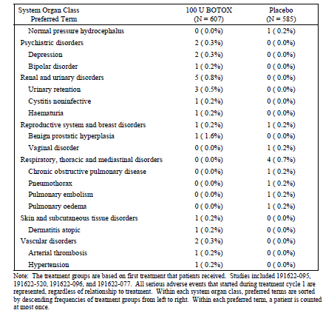

SAEs in the full Botox-treated population
The incidence of SAEs in the full Botox-treated population by treatment cycle was 7.7% (85/1104), 5.7% (34/594), 3.6% (9/253) and 3.4% (3/88) in Botox Treatment Cycles 1, 2, 3, and 4, respectively. This does not suggest an increasing incidence of problems with repeat treatment, but interpretation is difficult because subjects asking for repeat treatments are more likely to be those tolerating the treatment well.

Discontinuation due to adverse events

Placebo-controlled population
Discontinuations due to AEs were broadly similar in the active and placebo groups, with a slight excess in the active group but no individual type of AE represented more than once.
Table 77. All Serious Adverse Events Leading to Study Discontinuation in Descending Incidence. Treatment Cycle 1. (Placebo Controlled Safety Population).
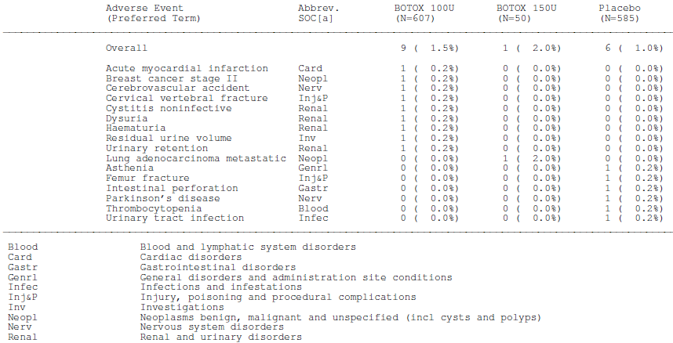

Full Botox-treated population
During Botox Treatment Cycle 1, the rate of adverse events leading to study discontinuation was 1.3%; in Botox Treatment Cycle 2, the rate was 0.8% (5/594); in Cycle 3, 4 patients discontinued because of AEs (4/253, 1.6%); and in Cycle 4, 2 patients discontinued because of AEs (2/88, 2.3%). Overall, a review of the individual AEs did not raise any new concerns.

Laboratory tests

Deficiencies in the original submission
In the sponsor’s original submission, laboratory results were not reported in a convenient format. The sponsor asserted that there were no important differences between the active and placebo groups for haematology and biochemistry values but the sponsor’s Summary of Clinical Safety referred to tables that dealt with one parameter per page, such as ‘Basophils’ or ‘Uric Acid’. The full data set thus ran to hundreds of columns of poorly summarised data.
Many of the tables featured significant p-values, such as in the sample table below, which were said to reflect ‘the Botox dose group and placebo comparisons’, but the reasons for this marked statistical outcome were not clear and it was not explicitly stated what was being compared with what. The sponsor has since clarified that the p-values are the outcome of a Wilcoxon signed-rank test in which each parameter was compared to zero; a baseline p-value of p<0.001 for basophils, for instance, merely represents confidence that the actual baseline basophil counts differed from zero. This is not a comparison with any conceivable utility in assessing the safety of Botox, so the p-values are essentially meaningless (see Second Round Evaluation of Clinical Data Submitted in Response to Questions (Question 5)).
Table 78. Haematology Summary of Clinical Laboratory Data for treatment Cycle 1.Basophils (%) (Placebo Controlled Safety Population).
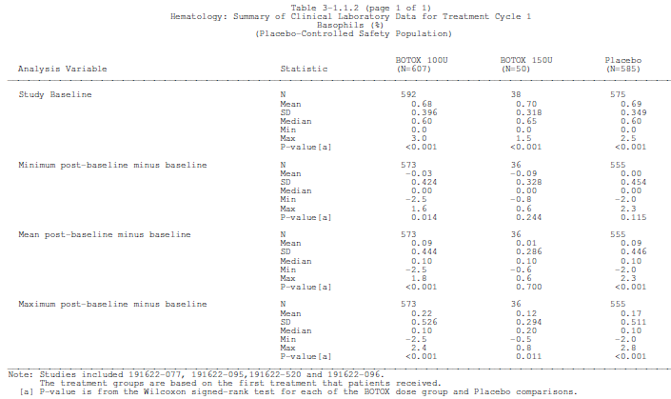
The same lack of any decent summary table affected the shift data. Each parameter was given a separate page, as in the sample table below.
Table 79. Haematology Shift table for Clinical Laboratory Data for Treatment Cycle 1 From baseline to Exit Day/Second Treatment Day Evaluation.( Placebo Controlled Safety Population). Basophils (%)
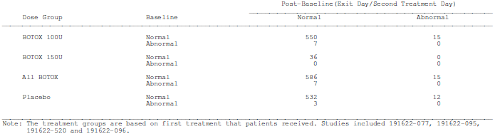
An attempt was made to review this data but given that it was presented in a largely undigested format, it remained uncertain whether the data might contain concerning safety signals.
In response to first-round questions about these deficiencies, the sponsor has provided new tables, which are considered in the sections below.

Haematology
Shifts in haematological parameters occurred with a low frequency in both active and placebo groups, with no overall differences noted.
Table 80. Haematology: Number of patients Shifted from Normal to Abnormal for treatment Cycle 1 from Baseline to Exit Day/Second Treatment Day Evaluation. (Placebo Controlled Safety Population). To Address Questions from TGA.
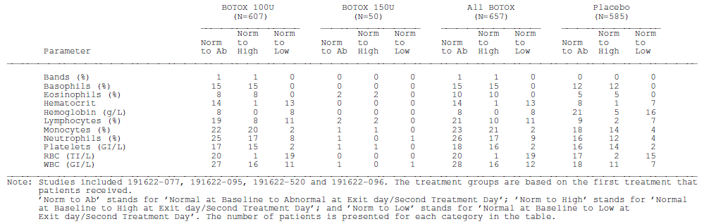

Biochemistry
Shifts in key biochemistry parameters are summarised in the table below. There was no evidence of any important difference between the active and placebo groups, as expected from the extensive post-marketing experience with Botox.
Table 81. Chemistry: Number of patients Shifted from Normal to Abnormal for treatment Cycle 1 from Baseline to Exit Day/Second Treatment Day Evaluation. (Placebo Controlled Safety Population). To Address Questions from TGA.
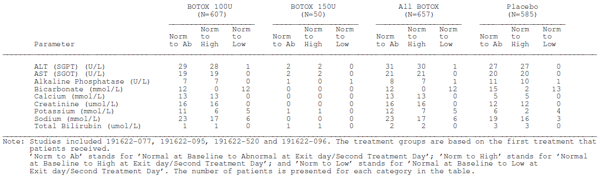

Electrocardiograph
The terms ‘ECG’, ‘EKG’, ‘electrocardiogram’ and ‘electrocardiograph’ did not feature once in a digital search of the sponsor’s Summary of Clinical Safety.
AEs featuring the electrocardiogram did not appear in any of the sponsor’s summary tables and are not expected on the basis of the known pharmacology of Botox and the site of injection which is a long distance from the heart.
In response to First Round Questions, the sponsor has since confirmed that routine ECGs were not performed in the pivotal studies (see below). Given the extensive postmarketing experience with Botox, this omission was considered acceptable.

Vital signs
The sponsor asserted that vital signs were not significantly different in the active and placebo groups. As with laboratory data, the evidence underlying this assertion was not presented in convenient format for evaluation. An attempt was made to look through the many tables listing vital signs at different time points and no concerning pattern was identified.
The sponsor has since provided a summary table of shifts in systolic blood pressure, diastolic blood pressure and pulse rate, as shown below. There are no concerning differences between the groups.
Table 82. Vital Signs: Number of patients Shifted from Normal to Abnormal for treatment Cycle 1 from Baseline to Exit Day/Second Treatment Day Evaluation. (Placebo Controlled Safety Population). To Address Questions from TGA.
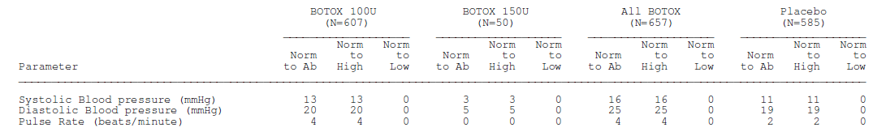

Postmarketing experience
There is an extensive postmarketing experience with Botox, with more than 34 million vials distributed worldwide, including cosmetic formulations and more than 24 million vials distributed as Botox 100 U, as shown in the table below. Postmarketing surveillance has not detected any adverse effects unexpected from the drug’s mode of action and the risks of Botox therapy primarily relate to excess weakening of targeted muscles or accidental weakening of non-targeted muscles.
SAEs reported in the postmarketing context are summarised in the table below. The number of patients at risk was not stated by the sponsor, who provided the table.
Table 83. Summary of Postmarketing SAEs for Botox treatment of Hypertonic Bladder.
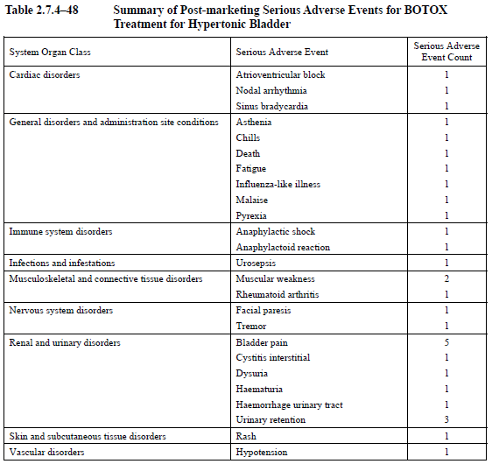
Postmarketing AEs are tabulated below. (The heading of the middle column should read ‘Adverse Event’; the sponsor has confirmed that this was an editing error.)
Table 84. Summary of Postmarketing AEs for Botox treatment of Hypertonic Bladder. Table continued across two pages.
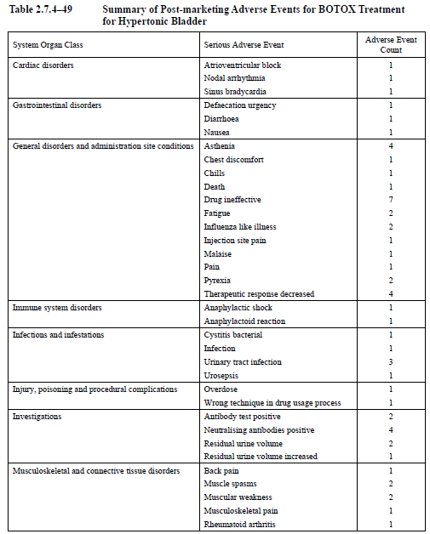
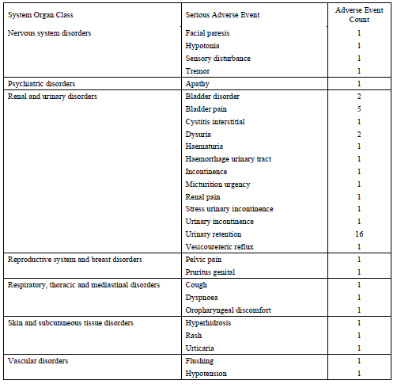
The sponsor also provided the following summaries of previous published studies of Botox in OAB. A full critique of those non-submitted studies is beyond the scope of this report but a review of the evidence does not raise new concerns. Brubaker et al confirmed that UTIs are more common after Botox (44% versus 22%). Flynn et al did not show an excess of UTIs with active treatment, but the study was underpowered; 3 of 4 UTIs occurred within 5 days of injection, suggesting that this was a procedural complication. Sahai et al showed that 25% of subjects required CIC after multiple injections, and Tincello et al showed that Botox was associated with an increased incidence of UTI (31% versus 11%). Denys et al showed no major effect on UTIs. Overall, these studies do not modify the general safety conclusions drawn from the submitted studies.
Table 85. Published Randomised, Placebo Controlled Clinical Studies Reporting the Safety of BOTOX in patients with Idiopathic OAB.
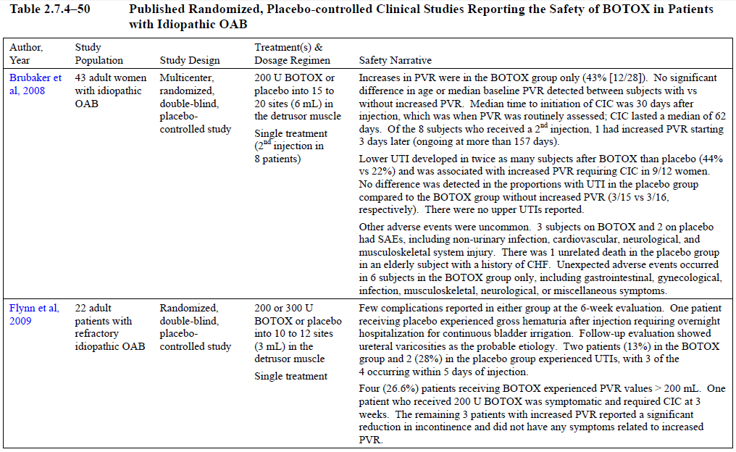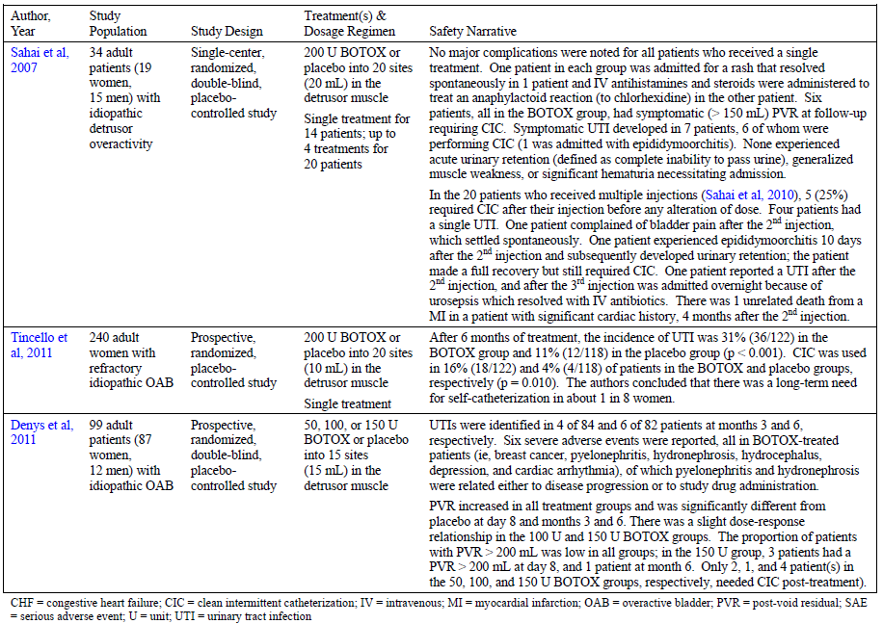

Safety issues with the potential for major regulatory impact

Liver toxicity
There is no evidence of serious liver toxicity following intravesical injection of Botox, on the basis of AEs and the incidence of biochemical changes (discussed above). There is also no reason to suspect such toxicity from a topical injection in the pelvis, especially given the extensive postmarketing experience with Botox.

Haematological toxicity
There is no evidence of serious haematological toxicity following intravesical injection of Botox, on the basis of the reported AEs and pos-marketing experience of Botox. Shift tables did not show any important safety signals (see above).

Serious skin reactions
There is no evidence of serious skin reactions following intravesical injection of Botox on the basis of the reported AEs in the pivotal studies, where skin reactions did not feature in any of the tables of common AEs. Also, the postmarketing experience of Botox has not revealed a significant risk of skin reactions and these would not be expected from an intravesical injection.

Cardiovascular safety
The cardiovascular safety of intravesical Botox is acceptable, with the only potential risks related to the stress of the invasive procedure and any associated anaesthetic, which might be significant in frail elderly patients. There was a slightly higher incidence of cardiovascular AEs with active treatment as shown in the table below, but no concerning patterns overall.
Table 86. Cardiovascular AEs Occurring in >1 Patient in Any treatment Group.
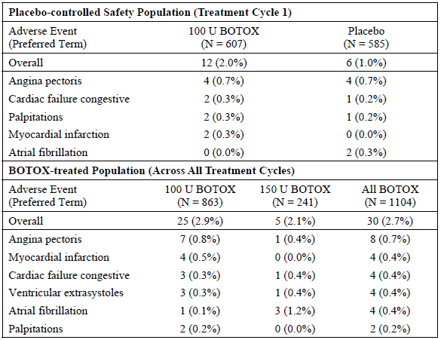

Unwanted immunological events
AEs potentially consistent with hypersensitivity reactions were rare and slightly less common with active treatment than placebo.
Table 87. Patients Reporting AEs Potentially Indicating Hypersensitivity Reactions
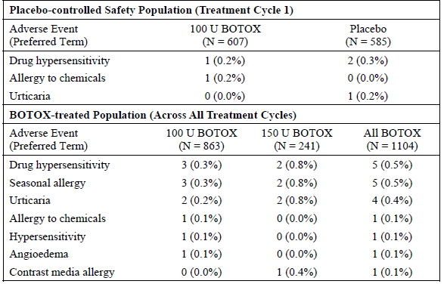
Botox administration can be associated with the development of neutralising antibodies but the risk is reduced when doses are minimised and treatments widely separated in time. In the pivotal OAB studies (Studies 095 and 520) and the long-term extension study (Study 096), but not the Phase II dose-ranging study (Study 077), a total of 1023 patients were assessed for the development of neutralising antibodies using a validated enzyme-linked immunosorbent assay (ELISA) and no neutralising antibodies were found (26 patients developed low-titre binding antibodies that did not neutralise the pharmacological effect of the toxin in a neutralising assay). This total of 1023 includes placebo patients who were not expected to be at risk of developing antibodies.

Other safety issues

Safety in special populations
Botox was administered to subjects with a range of ages, allowing a comparison of AE rates at different ages. AEs were more common in older subjects as shown in the table below. This trend was present with both active and placebo treatment but more marked with Botox recipients. Below 40 years of age, subjects had similar AE rates regardless of the treatment they received (AE incidence was marginally lower with Botox than placebo). Above 40 years, there was a clear excess of AEs in the active group, such that Botox recipients ≥ 40 years had a higher incidence of AEs than placebo recipients in any age bracket.
Table 88. Number (%) of Patients with Overall, UTI, and Urinary Retention AEs during Treatment Cycle 1 by Age. Placebo Controlled Safety Population.
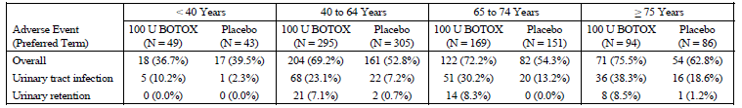
Most of the differences between active and placebo treatment could be accounted for by the incidence of UTI, which increased markedly with age, particularly with active treatment. For subjects ≥ 75 years, UTIs occurred in 38.3% of Botox recipients and 18.6% of placebo recipients, an attributable incidence of 19.7%. The attributable incidence of UTIs was lower in younger patients but even in subjects <40 years, active treatment was associated with an attributable incidence of 7.9% (10.2% - 2.3%). Urinary retention also showed an increasing incidence with age; it did not occur in subjects <40 but occurred in ~7-8% of Botox recipients ≥ 40 years. It remained relatively rare (0-1.2%) in placebo recipients, even in older groups.
An analysis of AEs by gender showed that women were more likely to develop an AE and this was partly attributable to the much higher incidence of UTI in women. In both genders groups, active treatment increased the risk of a UTI, as shown in the table below. The genders were equally susceptible to Botox-induced urinary retention, which had an attributable incidence of 6.6% in women (7.0% - 0.4%) and also 6.6% in men (7.9% - 1.3%). (Note that these figures refer to the entire duration of Treatment Cycle 1, which was unequal in the active and placebo groups, potentially inflating the differences.)
Table 89. Number (%) of Patients with Overall, UTI and Urinary Retention AEs during Treatment Cycle 1 by Sex. (Placebo Controlled Safety Population).
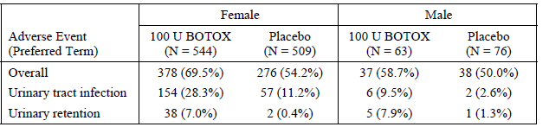
The sponsor also assessed the incidence of AEs according to whether patients had diabetes. Subjects with diabetes had a higher incidence of AEs than non-diabetic subjects but both subgroups showed a similar increase in AEs with active treatment, relative to placebo. UTIs were slightly more common in diabetic subjects but the increase in UTIs with active treatment was similar in diabetics and non-diabetics.
Although based on a small number of observations, only 81 diabetic subjects received active treatment, the data suggest that the combination of diabetes and Botox treatment increases the risk of urinary retention. Diabetic subjects receiving Botox 100 U had roughly twice the incidence of urinary retention (12.3%) as experienced by non-diabetic subjects treated with Botox 100 U (6.3%). Urinary retention was rare in placebo recipients, regardless of diabetic status.
Table 90. Number (%) of Patients with Overall, UTI and Urinary Retention AEs during Treatment Cycle 1 by Diabetes Status. (Placebo Controlled Safety Population).
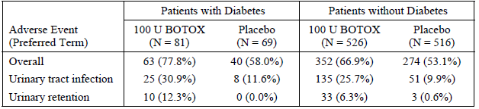

Safety related to drug-drug interactions and other interactions
In the pivotal placebo-controlled safety population, nearly all subjects received concomitant medications of various types, as expected in an older population. Thus, the safety profile emerging from those studies already factors in some of the potential for drug interactions and no obvious problems were noted. On the other hand, no specific analysis was performed to look for drug interactions and, even if a drug interaction had occurred, it is not clear that investigators would have correctly inferred that a drug interaction had taken place if they did not know of the potential beforehand.
The PI for Botox cautions against combining Botox with drugs known to interfere with neuromuscular transmission, such as curare-like compounds. In the absence of further evidence about the potential for such interactions, the caution is appropriate.
Subjects in the submitted studies were not permitted to use anticholinergic agents, so the potential for drug interactions involving Botox and anticholinergics has not been assessed. It would be expected that this combination would markedly impair bladder emptying and increase the risk of urinary retention and UTI, so anticholinergics should be avoided in Botox recipients unless the patient is closely monitored for changes in post-void residual urine volume, or is already performing regular catheterisation.
Anticoagulants and antiplatelet agents were avoided during the periprocedural period but would be expected to increase the risk of haematuria. The decision to continue such agents before or during a cystoscopy and intravesical injection procedure should only be made in exceptional circumstances after weighing the risks and benefits.
If injected Botox spread to adjacent bowel or rectum, it might increase the risk of constipation. In the placebo-controlled safety population of this submission, constipation was twice as common in the first 12 weeks with Botox 100 U (1.5%) as with placebo (0.7%). In the related NDO submission, an increased incidence of constipation was observed following intravesical injection of Botox 300 U for neurogenic detrusor overativity but rates of constipation after 200 U were similar to placebo. If local constipating effects did occur with Botox, an interaction with other constipating drugs (anticholinergics and narcotics, for instance) might be observed. Most clinicians could be expected to consider the role of narcotics and anticholinergics in such a setting, and make the necessary adjustments.

Urological safety
The major attributable adverse effects of intravesical Botox are urological, and are intrinsically tied to its mode of action. By reducing the sensory function of the bladder and reducing neuromuscular transmission to weaken the bladder, Botox shifts bladder activity away from overactivity at the risk of causing underactivity. With this shift comes impaired bladder emptying, an increased post-void residual urine volume that in turn increases the risk of UTI, and a small but definite risk of acute urinary retention requiring catheterisation for relief.
As expected from previous experience with Botox (including the previous submission for the related indication of Botox for NDO), urological AEs as a group were more common with Botox, as shown in the table below.
Table 91. Number (%) of Patients with Urological AEs Reported in ≥1% of Patients in Any Treatment Group during Treatment Cycle 1. (Placebo Controlled Safety Population).
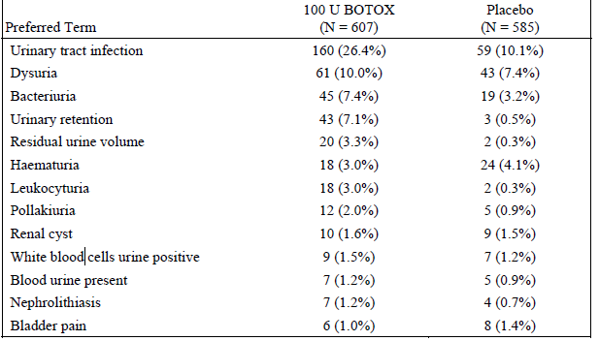
As already noted above, these risks are enhanced in older patients, and the risk of UTI is particularly increased in women but both genders face a similar risk of urinary retention. The table below groups these observations into one place. (Note that some figures appear in the wrong column due to formatting errors in the sponsor’s submission but the percentages are correctly placed.)
Table 92. Summary of the Incidence of Adverse Events of Urinary Tract Infection and Urinary Retention by Subgroup. (Placebo Controlled Safety Population).
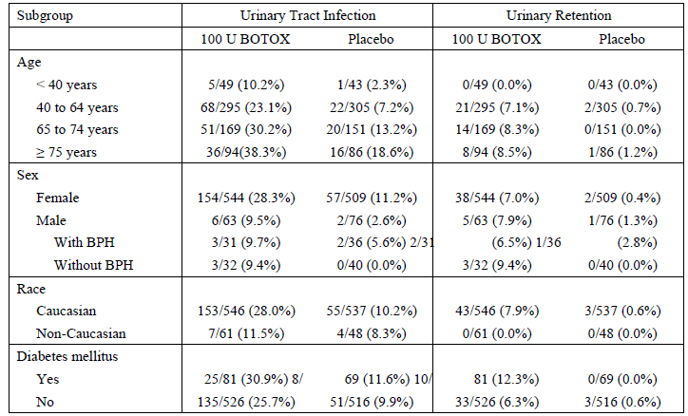
A logistic regression analysis confirmed that active treatment, age and gender were important risk factors for the development of UTI and that active treatment was a significant risk factor for the development of urinary retention (see tables below)
Table 93.Logistic Regression Model Analysing the Proportion of All patients with Urinary Tract Infection during Treatment Cycle 1.( Placebo Controlled Pivotal Study Safety Population).
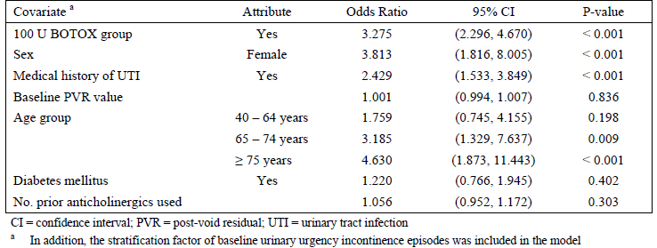
Table 94.Logistic Regression Model Analysing the Proportion of All patients with Urinary Retention during Treatment Cycle 1. (Placebo Controlled Pivotal Study Safety Population).
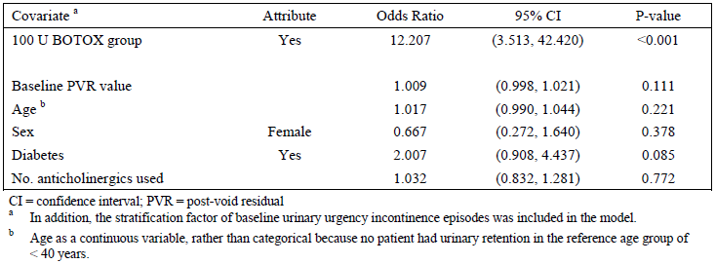
The sponsor also performed urodynamic monitoring of the patients’ post-void residual urine volume, and this showed a significant increase in Botox recipients. The mean increase at week 2 was nearly 50 mL (48.2 mL, 95%CI 39.1 to 57.3 mL), which reduced to ~30 mL by Week 12. Changes in the placebo group were comparatively trivial and the difference was statistically significant, with non-overlapping 95%CIs.
Of more concern, some subjects had a more marked response, with increases of >100 mL, ≥ 200 mL and ≥ 350mls as shown in the table below. A total of 161 patients (161/552, 29%), or nearly one in three subjects, showed an increase in their post-void residual of >100 mL after Botox; this was relatively rare in placebo recipients (37/542, 7%).
Table 95. Change from baseline in Post-Void Residual Urine Volume and Proportions of patients with Change from Baseline to Different Thresholds during Placebo Controlled Treatment Cycle 1. (Placebo Controlled Pivotal Study Safety Population).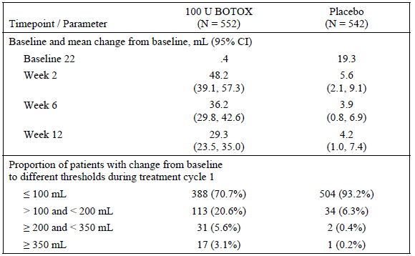
Figure 23. Change from Baseline in Post-Void Residual Urine Volume in Phase II Study 077. (ITT Population).
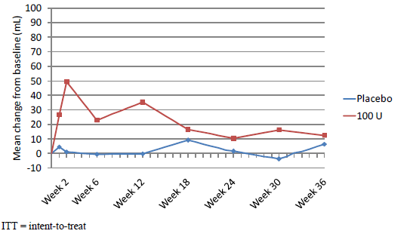
Subsequent tables display this data in more detail, with ranges and p-values in Table 96, a categorical breakdown in Table 97, and an analysis by cycle in Table 98 and Figure 24. The mean change in PVR did not show obvious progression over multiple cycles but this data is difficult to interpret as subjects with marked increases in PVR were not eligible for continued treatment.
Table 96. Change from Study Baseline in Post-Void Residual Volume (mL)- Treatment Cycle 1. (Placebo Controlled Pivotal Study Safety Population).
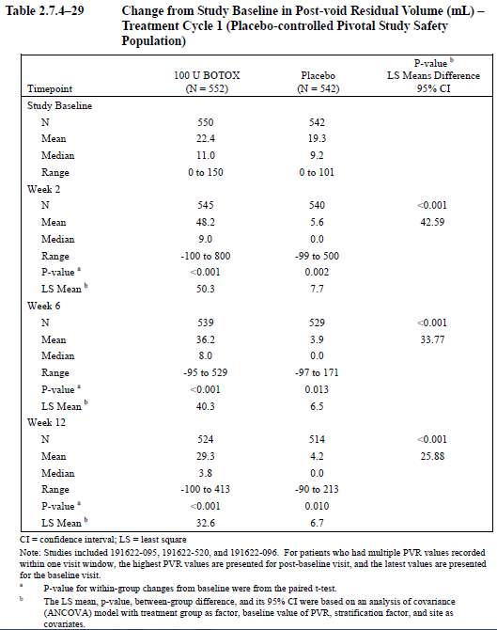
Table 97. Proportion of Patients with Change from Baseline in Post-Void Residual Volume at Various levels- Treatment Cycle 1. (Placebo Controlled Pivotal Study SafetyPopulation)
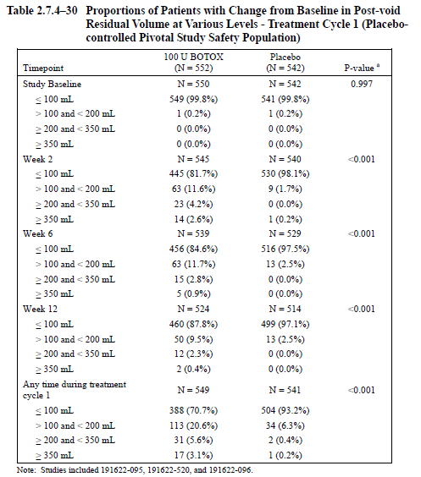
Figure 24. Mean Change from Baseline At Week 2 in Post-void Residual Urine Volume by BOTOX Treatment Cycle. (BOTOX- Treated Population).
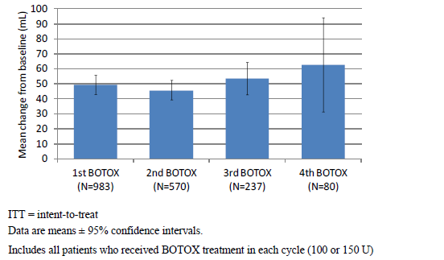
Table 98. Proportion of Patients with Change from Study baseline in Post-Void Residual Volume at Various Levels by BOTOX Treatment Cycle. (BOTOX- Treated Population Excluding Study 077).
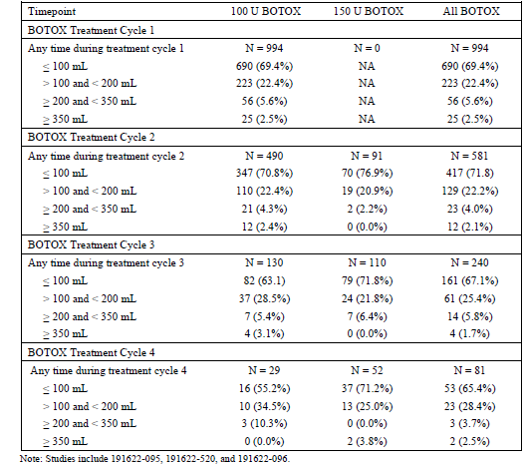
In Study 077, the effect of different doses on PVR could be assessed. The results are displayed graphically below. There is a general trend to increased PVR at increasing doses, though the study was underpowered and the results were somewhat variable. In most dose groups, the maximum effect was seen at Week 2.
Figure 25. Mean Change from baseline in Post-Void Residual Urine Volume. (ITT Population).
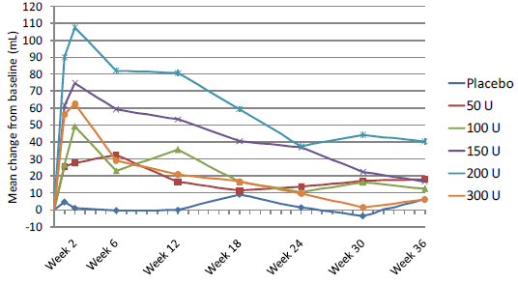
Unsurprisingly, given its effects on PVR volume, the use of Botox was associated with a substantial increase in the risk of needing catheterisation. In the placebo-controlled pivotal study population, CIC was initiated post treatment in 48 of 552 Botox recipients (8.7%), compared to 9 of 542 placebo recipients (1.7%). The use of CIC was associated with an increased risk of UTI, particularly in Botox recipients. UTI was also increased markedly in those with more extreme increases of PVR volume, reaching 61.9% in those Botox recipients who retained ≥ 350 mL.
Table 99. Proportion of Patients with Urinary Tract Infection by PVR Category and Use of Clean Intermittent Catheterisation. (Placebo Controlled Pivotal Study Safety Population).
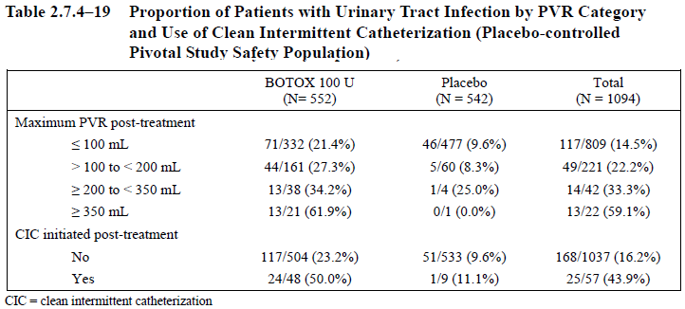
Considering the full Botox-treated population, the number of patients requiring CIC remained roughly stable over multiple cycles.
Table 100. Number (%) of patients Using Clean Intermittent Catheterisation Post-Treatment by BOTOX Treatment Cycle. (BOTOX- treated Population Excluding Study 077).
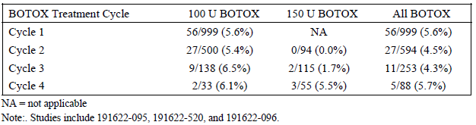

Procedural safety
The administration of intravesical Botox is invasive, requiring cystocopy and repeated injection at a poorly accessible, non-compressible site. This procedure carries some risk of causing bleeding, infection or pain, though AEs attributed to the procedure were self-limiting and generally were not classed as serious.
The table below lists AEs potentially related to the injection procedure. Note that, for this class of AEs, it is not relevant that such AEs also occurred in the placebo group, because placebo recipients also underwent the invasive procedure.
Table 101. Injection Procedure-Related Adverse Drug Reactions During First 12 Weeks and Full Treatment Cycle 1. (Placebo Controlled Pivotal Study Safety Population).
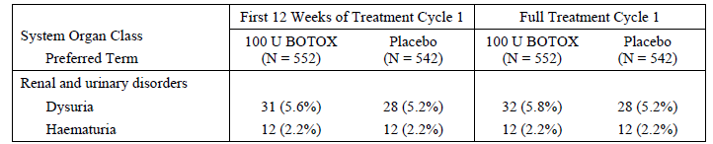

Potential distant spread of toxin
Botox is administered topically and should not, except by accident, reach the systemic circulation. Nonetheless, some authors have reported possible systemic effects of Botox following local use of Botox for a variety of conditions (Dutton JJ, 1996; Bhatia KP et al, 1999; Coban A et al, 2010). Systemic spread could occur if a clinician inadvertently placed a needle into a vascular space (although the clinician should check for this prior to injection). There is also potential for toxin to spread locally through, for instance, lymphatic channels or other extravascular spaces.
The sponsor checked the AE database for terms that might be consistent with distant spread of Botox, as listed below. Inappropriately, the sponsor included ‘urinary retention’ in these search terms (presumably because this AE can indicate spread to the bladder when Botox is injected elsewhere). In the current context, urinary retention is clearly a local effect of Botox and its inclusion in this analysis merely confuses the issue.
Table 102. MedDRA Preferred Terms Evaluated for Possible Distant Spread of Toxin
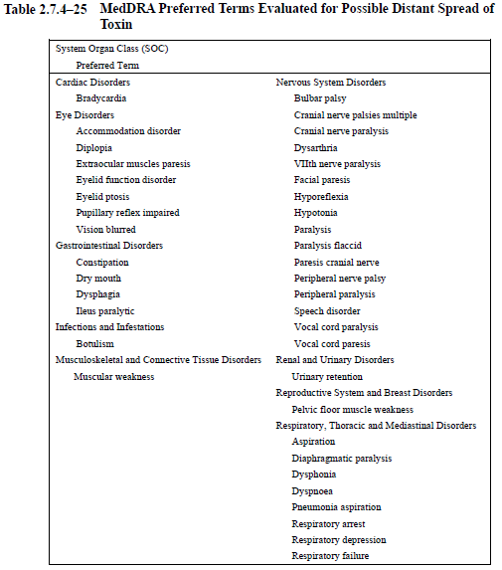
The table below shows the incidence of AEs potentially indicative of toxin spread that occurred within 12 weeks of treatment. Constipation was more common in Botox recipients, as was urinary retention. Constipation might be due to local spread from the bladder to the rectum, but the incidence was low overall (1.5% with 100 U and 0.7% with placebo) and the comparison with placebo was underpowered.
Table 103. All AEs Associated with Possible Distant Spread of Toxin by Primary System Organ Class. (Placebo Controlled Safety Population). AE start date <=84 Days from first injection.
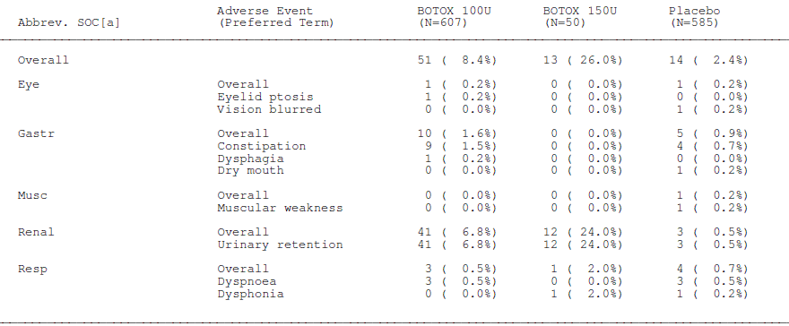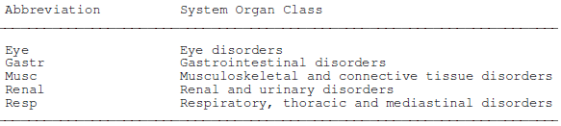
The subsequent table shows similar information but includes AEs at any time in Treatment Cycle 1 (upper section) or across all treatment cycles (lower section). Most AEs in this analysis were rare, apart from urinary retention and constipation. The overall incidence of constipation over multiple treatment cycles was 2.4%, but this is consistent with the background incidence of constipation in an elderly population and without a placebo group it cannot be determined whether Botox is likely to have played a causal role.
Table 104. Patients Reporting Possible Distant Spread of Toxin AEs
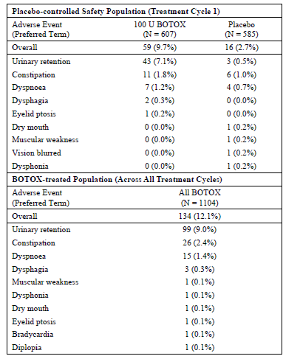
A similar analysis was performed in a previous submission (Botox for neurogenic detrusor overactivity), and the results are shown below. Note that the table shows AEs for the full duration of Treatment Cycle 1, which was not equal in the active and placebo groups. The results were summarised in the clinical evaluation report as follows:
“Constipation was also more common in active treatment groups, though this could potentially indicate local spread of toxin from the bladder to the nearby rectum, rather than true systemic spread. It was reported in 4.7%, 4.2% and 2.6%% of the 300U, 200U and placebo groups, respectively, over the course of the first treatment cycle. Time to onset was varied and ranged from 2 days to 365 days, but 65% reported an onset within 12 weeks of treatment. The excess was not simply due to the increased monitoring time in the active groups, because it was reported as an AE in 4.3%, 1.5% and 1.5% of the 300U, 200U and placebo groups, respectively, within the first 12 weeks of treatment.”
The risk associated with 100 U would be expected to be lower than with either of the doses assessed for the NDO indication, but the question of whether some subjects might develop constipation as a result of intravesical Botox remains unanswered.
Table 104. Patients Reporting AEs Potentially Associated with Effects Remote to the Site of Injection.
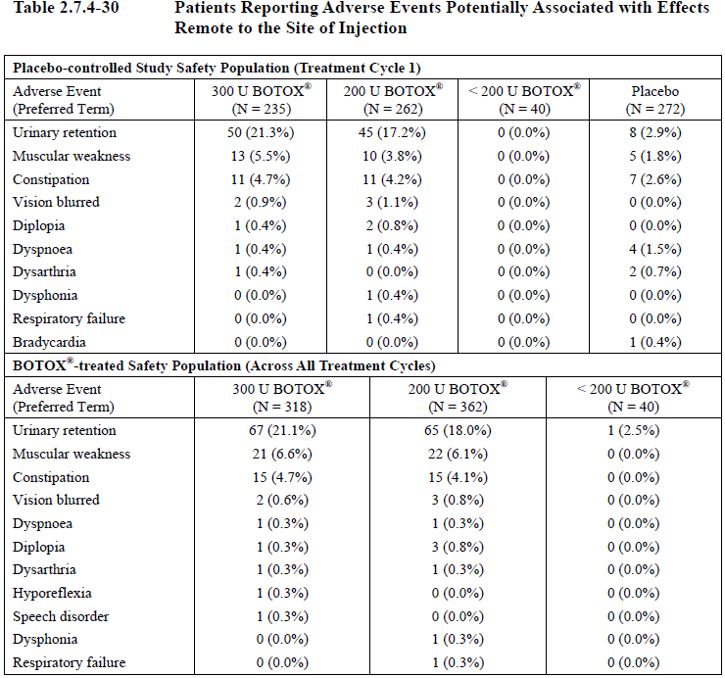
NOTE: This table refers to data in a previous, related submission.

Evaluator’s overall conclusions on clinical safety
The safety of intravesical Botox is acceptable, overall. A dose of 100 U, when administered to a population with OAB, causes an increased incidence of urinary tract infections (26.4% versus 10.1% with placebo), acute urinary retention (7.1% versus 0.5% with placebo) and increases in post-void residual urine volume. PVR volumes at Week 2 were increased by a mean of ~50 mL (48.2 mL, 95%CI 39.1 to 57.3 mL), though this improved to a mean of ~30 mL by Week 12. Increases were not uniform, and 29% of subjects showed an increase of >100 mL after Botox; this was relatively rare in placebo recipients (7%). Asymptomatic increases in PVR or episodes of frank urinary retention may both lead to some patients requiring catheterisation, and patients need to return 2 weeks post-treatment to have their PVR volume assessed, with additional monitoring as required. In the placebo-controlled pivotal study population, clean intermittent catheterisation (CIC) was initiated post-treatment in 48 of 552 Botox recipients (8.7%), compared to 9 of 542 placebo recipients (1.7%), as shown in the table below. The use of CIC was associated with an increased risk of UTI, particularly in Botox recipients. UTI was also increased markedly in those with more extreme increases of PVR volume, reaching 61.9% amongst the 21 Botox recipients who retained ≥ 350 mL.
Table 105. Proportion of Patients with UTI by PVR Category and Use of Clean Intermittent Catheterisation. (Placebo Controlled Pivotal Study Safety Population).
The procedure itself is also associated haematuria and bladder pain in a small proportion of subjects, and patients must take prophylactic antibiotics to reduced the risk of a procedure-related infection. For patients on anticoagulation or warfarin, there is likely to be some associated risk due to interruptions to these treatments.
Apart from these urological complications, the drug is well tolerated. There is a small theoretical risk of distant spread of toxin but so far, from the evidence of the submitted studies, there is only weak evidence that the rate of constipation might be increased.
A review of serious adverse events and deaths did not raise any new concerns.
The postmarketing experience with Botox has been extensive, and it is relatively unlikely that there unsuspected toxicities associated with its use. In most cases, safety issues reported with Botox relate directly to its mode of action.

First round benefit-risk assessment

First round assessment of benefits
The benefits of Botox in the proposed usage are:
- a reduction in the frequency of incontinence of ~2 episodes pr day in women, or 0.42 episodes in men, from a mean baseline incontinence of 5-6 episodes per day
- a small proportion of patients achieving the ‘dry’ state (27.1% of Botox recipients versus 8.4% of placebo recipients).
- a subjective positive response rate (that is, symptoms improved or greatly improved) of 64.3% in women, compared to 28.4% with placebo, consistent with an attributable response rate of 35.9%
- a subjective positive response rate of 40.7% in men, compared to 25.4% with placebo, consistent with an attributable response rate of 15.3%
- parallel improvements in other measures of urgency and frequency
- modest but significant improvements in quality of life

First round assessment of risks
The risks of Botox in the proposed usage are:
- on-going incontinence can be expected in the majority of patients
- an increased incidence of UTI, increased post-void residual urine volume, and increased incidence of acute urinary retention
- the need to return for measuring post-void residual urine volume
- patients may need to commence catheterisation after treatment
- most men can be expected to report no change or worsening of their symptoms

First round assessment of benefit-risk balance
The benefit-risk balance of Botox given the proposed usage, is favourable in women, provided they are prepared to undergo catheterisation if necessary. This balance is reflected in their positive responses on the Treatment Benefit Scale, which would be expected to incorporate the urological benefits and risks from a patient perspective.
The benefit-risk balance in men is largely negative, as evidenced by the fact that most reported their symptoms as unchanged or worse, and that the combined incidence of UTI and urinary retention in men was roughly equal to the attributable positive response rate on the TBS.

First round recommendation regarding authorisation
The application to register Botox 100 U for the treatment of idiopathic overactive bladder associated with incontinence that has failed a trial of anticholinergic agents (‘wet’ and refractory OAB) was recommended for approval in women.
Efficacy in men has not been adequately demonstrated and this is not simply a matter of not having an adequately powered subgroup analysis; the results were quantitatively unimpressive in men and a significant treatment-by-gender interaction was demonstrated. The majority of men (~60%) reported no change or a worsening of their symptoms after Botox treatment and only 15% had an attributable positive response to treatment.
The recommendation of this report is therefore to deny registration of Botox for OAB in men. An alternative approach, not recommended here but worthy of consideration, would be to approve Botox 100 U for ‘wet’ and refractory OAB in both genders, after changes to the proposed Product Information sheet. Those changes would need to include a clear discussion of the relatively poor benefit demonstrated in men with OAB. Approving Botox for treatment of OAB in both genders would potentially allow clinicians to treat the subset (~15%) of male patients who might benefit from treatment. The main problem with this approach, and the reason it is not recommended, is that the current evidence does not indicate how this small group of male responders could be identified. Approving Botox for treatment of OAB in men, even if accompanied by adequate warnings in the PI, would raise a number of concerns: it would allow a patient group to be treated that already has statistical evidence of a significantly worse outcome than women with OAB; it would disregard the fact that there is currently no robust statistical evidence that active treatment in men is superior to placebo; and it would ignore the results of the pivotal studies which suggested that the majority of men are non-responders. For all of these reasons, the approval of Botox for OAB in men is not recommended on the current evidence. This situation could change if future studies led to different conclusions but obviously such studies would have to be part of a new submission.

Clinical questions

Pharmacokinetics
No questions posed.

Pharmacodynamics
No questions posed.

Efficacy
What is the efficacy of Botox in men with OAB?
The efficacy of Botox in men with OAB remains poorly characterised but there is reasonably good evidence that the efficacy is inferior to that demonstrated in women. The efficacy in men should be further characterised but this is not a question that can be answered on the basis of the current evidence because too few men were recruited to the pivotal studies. Appropriately powered studies in men with OAB are required.
The proposed dose for idiopathic OAB (100 U) is half that registered for the NDO indication (200 U). Given the similarity between the two conditions, why are the doses so different? Would 100 U have been a more appropriate dose for the NDO indication?
In the selection of a dose for the pivotal NDO studies, the main doses being considered were 200 U and 300 U. In the context of that earlier submission, the dosage considerations were summarised in the evaluation report as follows:
‘In the pivotal [NDO] studies, most efficacy endpoints showed very similar results across the two active dose groups, as summarised in the table below. Given that AEs were higher in the 300 U group, as discussed in the Safety Section, the 200 U appears to offer a better risk-benefit balance. Doses lower than 200 U were considerably less effective in the dose-ranging study 518, with a duration of action that resembled placebo, but this study was underpowered. It did show a significant dose-trend across doses to 200 U, but did not specifically show a significant benefit of 200 U over 100 U. On balance, the efficacy evidence favours the proposed dose of 200 U.’
Table 106. Change from Study baseline in Select Efficacy Measures for treatment Cycle 1 in the 300 U and 200 U Botox Dose groups. (Placebo Controlled Pivotal Study ITT Population).
In retrospect, given that comparisons between 100 U and 200 U were underpowered in the dose-ranging study performed in NDO, it might have been worthwhile exploring the efficacy of 100 U for the NDO indication with additional studies. As the current evidence stands, adequate studies of 100 U in NDO have not been performed and there is no good case for changing the recommended dose in NDO. It is plausible that a higher dose might be needed for NDO than for idiopathic OAB and that the more substantial neurological lesions typical of NDO might lead to more pronounced bladder spasticity, but this has not been demonstrated. The new submission for OAB shows that 100 U can have efficacy in some cases of OAB and may be less risky than 200 U, so the potential role of the 100 U dose in NDO remains somewhat unclear.
Can the sponsor please confirm that bladder diaries in the pivotal studies were not censored during urinary tract infections?
In the previous (NDO) submission, patients were asked not to fill out their diaries while they had a urinary tract infection (UTI). UTIs were more common with Botox recipients than placebo recipients, and UTIs are usually associated with increased urgency, so the decision to censor diaries during UTIs appeared to bias the study design in such a way as to potentially hide once source of treatment-related increase in incontinence. A subsequent sensitivity analysis showed that this potential bias was not likely to be significant, even with pessimistic assumptions about how much incontinence had been censored. For the current (idiopathic OAB) submission, it is unclear what advice was given to patients about recording incontinence during UTIs, and whether similar censoring took place.

Safety
Could the sponsor please provide summary tables for abnormal laboratory values, abnormal vital signs, and ECG results in Botox recipients in comparison to placebo recipients?
As discussed in the Safety section, the sponsor’s Clinical Summary of Safety refers the reader to tables in the Integrated Summary of Safety that are not in a suitable format for assessing overall trends and differences between the active and placebo groups. Each parameter of interest appeared on a page of its own, as shown in the example for ‘Basophils’ below, so that checking this data for concerning safety signals was virtually impossible. Could the sponsor please produce standard summary tables, with all of the abnormal haematology results in a single page, all of the important biochemistry results in a single page, and so on? The primary parameters to report are the incidence of laboratory values above and below the reference range, and the incidence of shifts from normal to abnormal, in the active and placebo groups.
Table 107. Haematology: Summary of Clinical Laboratory Data for Treatment Cycle 1. Basophils (%).(Placebo Controlled Safety Population).
Could the sponsor also please explain the p-values in the tables that have already been provided, such as the one above? The footnote above refers to a Wilcoxon signed-rank test for each of the Botox dose group and placebo comparisons. What exactly is being compared with what? Does the sponsor really mean to imply that there was a highly significant difference (p<0.001) between placebo and Botox for basophils, as the above table seems to imply?

PI and CMI
For indications other than OAB, are placebo recipients included in the patient numbers cited in the PI purporting to be the number of patients tested for neutralising antibodies?
For OAB, it is already clear that the numbers cited do include placebo recipients, which is misleading as these subjects were not at risk of developing antibodies.

Second round evaluation of clinical data submitted in response to questions
The evaluator’s rationale behind each question was summarised briefly above.
The sponsor provided responses to the clinical questions.
For each question, the sponsor’s response has been considered in a separate sub-section below. In addition, the new safety data from the Safety Question has been integrated into the body of the report where appropriate.
In the evaluator’s opinion, the sponsor’s responses were satisfactory, with the exception of the discussion of efficacy of Botox in men with OAB.

Question 1. Efficacy of Botox in men with OAB
The submitted data strongly suggested that the efficacy of Botox in men with OAB is inferior to the efficacy in women, as has already been discussed. The sponsor was asked to comment on this and to estimate the efficacy of Botox in men with OAB.
The sponsor’s response was to characterise apparent gender differences as the result of an under-powered subgroup analysis and to claim that the target organ (the detrusor) is the same in both genders:
“The target organ of the detrusor muscle does not differ by sex. Since BOTOX® is injected directly into the detrusor muscle, it would therefore be expected to exhibit a similar treatment effect in both men and women. Indeed, even though fewer men than women were enrolled in the Allergan studies, important treatment benefits were demonstrated for men, though they were not necessarily statistically significant due to the small sample size.”
This response does not acknowledge the magnitude of the observed gender effect; nor does it acknowledge that the interaction between the detrusor and the sphincter, and the underlying pelvic anatomy, is radically different in the two genders.
The efficacy of Botox in men with OAB is not well defined and small sample sizes in men are part of the problem. No submitted study was specifically powered to address the efficacy of Botox in men with OAB, so until further studies are performed, the analysis is limited to underpowered, post-hoc subgroup analyses. The pooled analysis of Study 095 and Study 520 is the most useful of the available subgroup analyses, because it had better statistical power than that achieved in individual studies but only completely new studies in men would be able to resolve the issue.
The results of the pooled subgroup analysis of the pivotal studies are displayed in the tables below. In men, the placebo-subtracted reduction in urinary incontinence episodes achieved with Botox was 0.42 episodes per day, from a baseline of 5.61 episodes (baseline 4.33 in the placebo group). The estimated treatment effect (LS mean difference versus placebo, -0.42 episodes) was small compared to the placebo effect in men (-1.23 mean change, -1.44 LS mean change), and it was associated with a broad confidence interval that included the possibility of no effect or even a deleterious effect, increasing incontinence by more than one episode per day (95%CI -2.08 to +1.23).
Table 108. Daily Average Frequency of Urinary Incontinence Episodes for Treatment Cycle 1 by Sex: Study Baseline and Change from Study Baseline. (Studies 095/520 pooled. ITT population with LOCF Imputation).
Note that it is not merely the statistical uncertainty reflected in the confidence interval that makes this result unsatisfactory. The mean treatment effect in men, even if confirmed in a larger population, would be of dubious clinical utility: less than half an episode prevented per day. Also, note that the mean treatment effect in men (-0.42) is well outside the 95%CI for the treatment effect obtained in women (-2.37 to -1.62). This is not equivalent to finding a statistically significant gender difference, because the 95%CIs overlapped but it raises the strong possibility that further studies would confirm a gender difference.
Importantly, the sponsor’s original submission included an acknowledgement of a statistically significant treatment-by-gender interaction. In the sponsor’s Summary of Clinical Efficacy, the following statement appears:
“Assessment of the quantitative treatment-by-sex interaction showed a significant interaction between treatment and sex for daily frequency urinary incontinence episodes (p < 0.001; Module 5.3.5.3, ISE Table 3-5), suggesting that the magnitude of the treatment effect is modified by sex.” *
The other main efficacy variable, the Treatment Benefit Scale (TBS), also suggests that efficacy in men is inferior to that observed in women. The majority (59.3%) of men receiving Botox felt that their condition was ‘unchanged’ or ‘worse’ following treatment. The 95%CI for the odds ratio in men includes the possibility of no benefit relative to placebo and the p-value for the comparison between Botox and placebo, by the Cochran-Mantel-Haenszel test, merely shows a trend in favour of active treatment (p=0.06). To some extent, the sponsor is correct in observing that this reflects a lack of statistical power but it also appears to reflect poor efficacy in men.
Table 109. Proportion of Patients with a Positive Treatment Response on the Treatment Benefit Scale During Treatment Cycle 1 by Sex.( Studies 095/520 pooled, ITT population with LOCF Imputation).
Even if statistical power were improved, the available evidence suggests that the actual proportion of male subjects showing a positive TBS response is of marginal clinical value. Of the minority (40.7%) of men showing a positive response in the TBS, a large proportion of the responses could be attributed to a placebo effect, because positive responses were observed in many subjects receiving placebo (25.4%). The placebo-subtracted (attributable) proportion of male subjects with a positive response was only 15.3% (40.7% - 25.4%), which is less than half of the placebo-subtracted proportion of positive responses in women (64.3%-28.4% = 35.9%).
Given that there is a reasonable a priori case to be made that bladder function in men and women is different, coupled with the statistical finding of a significant treatment-by-gender interaction for incontinence episodes, and a majority of men reporting no benefit with treatment, the onus of proof is on the sponsor to show that that the poor response in men is merely due to a lack of statistical power. On the current evidence, it seems more likely than not that treatment in men is less effective than in women (though it is also likely that active treatment in men is, on average, slightly more effective than placebo).
In the sponsor’s response (to TGA’s consolidated request for information) to this issue, the sponsor has raised several points, which can be summarised as follows:
- The gender ratio in the submitted studies is typical of the target population and of other studies of OAB, such as several published studies of anticholinergics.
- The target organ, the detrusor, does not differ in the two genders.
- The demographic and baseline disease characteristics in the pivotal studies were similar in men and women.
- A positive treatment effect was demonstrated in men for both primary efficacy variables (incontinence frequency and TBS), but did not achieve significance because of poor statistical power.
- The Gail-Simon test did not show a significant qualitative difference between the two genders.
Most of these claims could be characterised as true, but irrelevant. They are considered in sequence, below.

a. The gender ratio in the submitted studies is typical of the target population and of other studies of OAB, such as several published studies of anticholinergics.
The sponsor begins their response with these paragraphs:
“The prevalence of overactive bladder (OAB) with urinary incontinence (‘wet’ OAB) is considerably higher in women than men; approximately 7% to 12% of all adult females are reported to have this condition compared to 3% of all adult males (Stewart et al, 2003; Irwin et al , 2006a; Herschorn et al, 2008; Lawrence et al, 2008). In addition, ‘wet’ OAB is predominantly a condition in females over 40 to 50 years of age. Given that 88.6% of patients enrolled into Allergan’s large multinational Phase 3 studies were female the demographic profile within this study programme is therefore consistent with the epidemiology of this condition (Module 2.7.4, Table 2.7.4-6).
The target population of Allergan’s BOTOX® clinical studies are those OAB patients who had not been adequately managed with prior anticholinergic therapy. Phase 3 studies demonstrating efficacy of approved anticholinergic drugs in the treatment of OAB (Chapple et al, 2005a; Cardozo et al, 2008; Chapple et al, 2007), predominantly enrolled female patients as this is the main population suffering from OAB. For example, in the registration trials for solifenacin and tolterodine the percentage of male patients ranged from 10.9% to 14.7% (Chapple et al, 2005a; Cardozo et al, 2008). This was only slightly less than the Phase 3 study for fesoterodine, where 20% of patients enrolled were male (Chapple et al, 2007).The percentage of male patients in the Allergan clinical studies (12.2%) is therefore comparable to the randomised Phase 3 studies of various anticholinergics used and approved in many countries for treatment of OAB.”
While these observations help to explain why the subgroup analysis in men was underpowered, they do not explain why the results in men were inferior to those obtained in women. Instead, these paragraphs actually undermine the sponsor’s claim that the target organ in men and women is equivalent. The gender imbalance that the sponsor notes in previous OAB studies merely adds to the evidence that men and women have different bladder physiology. Also, if it is already well known that studies of OAB tend to recruit substantially less men, then the lack of statistical power in this important subgroup was foreseeable and preventable.
The sponsor’s observation that ‘the demographic profile within this study programme is therefore consistent with the epidemiology of this condition’ (underlined above) is not relevant to the question of whether the treatment is effective in men. Clinicians may treat a mixed population of patients with OAB and that population is indeed likely to have a gender balance resembling that seen in the pivotal studies but clinicians make management decisions based on individual cases where the gender is known. For this condition, the results obtained in a mixed, primarily female population cannot be generalised to both genders.

b) The target organ, the detrusor, does not differ in the two genders.
The incidence of incontinence differs in the two genders at different ages and for different subtypes of incontinence. For OAB in particular, there is overwhelming evidence that ‘wet OAB’ is more common in women, which is why most studies of OAB have recruited relatively few men (as noted by the sponsor above). This gender imbalance proves that there are clinically relevant differences in bladder physiology between men and women and that these affect the incidence of OAB. But if gender-based physiological differences can affect the incidence of OAB, it is plausible that these or other differences could also affect the response of OAB to treatment. Indeed, common sense suggests that the sphincters of men and women are different and that the interaction between the detrusor and the sphincters must also be different.
The notion that the detrusor can be considered in isolation, without considering the rest of the pelvic anatomy, is not only simplistic, it is undermined by the sponsor’s own results. The sponsor’s analysis of the pooled pivotal studies showed that the treatment-by-gender interaction was highly significant (p<0.001), which refutes the claim that the target organ can be considered in a gender-blind fashion.

c) The demographic and baseline disease characteristics in the pivotal studies were similar in men and women.
The sponsor submitted several tables comparing the baseline demographic and disease features in men and women. There were no important differences. This merely suggests that gender itself, not some other confounding factor, is responsible for the observed differences in the results.

d) A positive treatment effect was demonstrated in men for both primary efficacy variables (incontinence frequency and TBS), but did not achieve significance because of poor statistical power.
Putting aside issues of statistical significance, the results in men were indeed numerically positive, but the effect was of borderline clinical utility. For incontinence frequency, the number of episodes prevented in men was 0.42 episodes per day, from a baseline of 5.61 episodes (baseline 4.33 in the placebo group). The majority of men receiving Botox indicated a treatment effect of ‘no change’ or ‘worse’ on the TBS, and the attributable percentage of favourable TBS responses was only 15.3% (40.7% - 25.4%), which is less than half of the placebo-subtracted proportion of positive TBS responses in women (64.3%-28.4% = 35.9%). Even if male patients and clinicians were prepared to accept this low chance of a positive response, they should at least be warned that the response to Botox treatment is likely to prove disappointing. The sponsor’s proposed PI did not provide enough information for male patients to make an informed decision.
If lack of statistical power were the only reason that a significant result was not obtained in men, the mean results in men might be expected to resemble those in women but be associated with broader confidence intervals; instead, the results were markedly inferior in men, with the mean treatment effect in men outside the 95% confidence interval for the treatment effect in women for the primary endpoint of incontinence frequency. In the absence of evidence to the contrary, it appears that the most likely result of increasing statistical power with larger, adequately powered studies in men would be to narrow the confidence limits around the existing mean result in men, eventually leading to a lack of overlap between the results in men and women.

e) The Gail-Simon test did not show a significant qualitative difference between the two genders.
In the original submission, the sponsor acknowledged that the treatment-by-gender interaction was highly statistically significant (p<0.001), but mentioned that the Gail-Simon test for a so-called ‘qualitative‘ subgroup difference was not significant (p=0.5). The Gail-Simon test was clearly presented as a test of secondary importance.
In the sponsor’s response to the question Efficacy of Botox in men with OAB, however, the sponsor has attempted to draw conclusions from the Gail-Simon test that cannot be justified, while omitting mention of the significant treatment-by-gender interaction.
In the sponsor’s Summary of Clinical Efficacy the sponsor wrote (emphasis added):
“Assessment of the quantitative treatment-by-sex interaction showed a significant interaction between treatment and sex for daily frequency urinary incontinence episodes (p < 0.001; Module 5.3.5.3, ISE Table 3-5), suggesting that the magnitude of the treatment effect is modified by sex. However, the results of the Gail-Simon test, which is considered an accepted statistical approach to assess the direction of treatment effect across subgroups, showed no qualitative treatment-by-sex interaction (p = 0.500; Module 5.3.5.3, ISE Table 3-5).”
In the sponsor’s response to the TGA’s consolidated request for information, there was a shift in the argument (emphasis added):
“To further investigate the treatment effect by sex, a Gail-Simon test (Gail and Simon, 1985) was performed, which is an accepted statistical approach to assess the direction of treatment effect across subgroups. The Gail-Simon test showed no qualitative treatment-by-sex interaction (p = 0.500; Module 5.3.5.3, ISE Table 3-5). These results therefore indicate that a positive BOTOX® treatment effect is present for both sexes even though a statistically significant difference compared to placebo was not reached for males.”
Note that, in the sponsor’s response to the question Efficacy of Botox in men with OAB, there is no mention of the significant treatment-by-gender interaction, a very serious omission. Instead of providing an open discussion of the statistical state of the evidence, the sponsor has emphasised a single test of limited relevance, the Gail-Simon test. The abstract of Gail and Simon’s paper is produced below. As indicated by the abstract and indirectly acknowledged by the sponsor (in their use of the underlined terms in the quotations above), the Gail-Simon test assesses situations in which the direction of the treatment effect appears to be different in different subgroups, and this test has no relevance to the question of whether the magnitude of the effect is weaker in one subgroup. Note that, in this context, ‘qualitative interaction’ has a specific meaning, somewhat different to conventional usage, and refers to situations where one treatment (such as Botox) is superior for some subset of patients and the alternative treatment (such as placebo) is superior for other subsets; this is sometimes referred to as a crossover interaction. The Gail-Simon test does not assess for the situation where there is variation in the magnitude, but not the direction, of the treatment effect among subgroups (quantitative or non-crossover interactions).
Gail M, Simon R. (1985). Testing for qualitative interactions between treatment effects and patient subsets. Biometrics 41(2):361-72. <http://www.ncbi.nlm.nih.gov/pubmed/4027319>
Evaluation of evidence that treatment efficacy varies substantially among different subsets of patients is an important feature of the analysis of large clinical trials. Qualitative or crossover interactions are said to occur when one treatment is superior for some subsets of patients and the alternative treatment is superior for other subsets. A non-crossover interaction arises when there is variation in the magnitude, but not in the direction, of treatment effects among subsets. Some authors use the term quantitative interaction to mean non-crossover interaction. Non-crossover interactions are usually of less clinical importance than qualitative interactions, which often have major therapeutic significance. A likelihood ratio test is developed to test for qualitative interactions. Exact critical values are determined and tabulated.
Given that the direction of the benefit in men was weakly in favour of active treatment, the results were not suggestive of a ‘crossover’ situation and the Gail-Simon test would not be expected to find statistical evidence of a crossover interaction. The lack of statistical significance for the Gail-Simon test, in this context, simply confirms what was already obvious from inspection of the results: the data provides no statistical evidence that the treatment effect for Botox is in a different direction in men and women (that is, that Botox is worse than placebo in men). The Gail-Simon test does not help to determine whether the magnitude of the benefit is different in men and women. In fact, in their original submission, the sponsor had already conceded that the magnitude of the effect is clearly different in the two genders (p<0.001), as evidenced by their finding of a ‘significant interaction between treatment and sex’ (see the quotation above). There does not appear to be any legitimate motivation for performing the Gail-Simon test in this setting, and its use obscures, rather than clarifies, the nature of the data.
Finally, even if an appropriate post-hoc statistical test had failed to show a significant difference between men and women, this would not provide any real reassurance that efficacy in men was equivalent to efficacy in women. Lack of statistical proof of a difference is not equivalent to statistical proof of a lack of a difference; ‘absence of proof’ is not ‘proof of absence’. Simple inspection of the results in the tables above shows that the mean result in men, for change in incontinence frequency, was outside the 95%CI for women, and this observation is worthy of further investigation. Until further evidence is provided, it seems more likely than not that the efficacy of Botox in men with OAB is inferior; possibly so inferior that adequately informed clinicians and patients would not pursue this form of treatment.
In conclusion, the sponsor’s response to this question does not alter the discussion.

Question 2. Would 100 U have been a more appropriate dose for the NDO indication?
For this question, the sponsor provided an adequate response, arguing that the more severe forms of bladder overactivity associated with NDO require higher doses than those required for idiopathic OAB. On balance, this seems likely to be correct.
Their response is reproduced here in full:
“Neurogenic detrusor overactivity (NDO) is not considered to be comparable to idiopathic overactive bladder (OAB). In NDO, there is a known neurological lesion (e.g. due to a spinal cord injury/SCI or Multiple Sclerosis) which leads to a definitive dysfunction in the neurological control of the bladder with resulting neurogenic detrusor overactivity. NDO patients not only have issues with the storage of urine leading to symptoms such as urinary incontinence, they also frequently have high intradetrusor pressures which put at risk the upper urinary tract, and may need to perform clean intermittent catheterisation to regularly empty their bladder. NDO patients, particularly those with SCI, also commonly have a thickened, trabeculated detrusor muscle.
These aspects are not applicable to patients with OAB, which is a symptom-based diagnosis in the absence of other known causes. Therefore, a higher dose is expected in NDO patients whose bladders are more dysfunctional; not only to control their symptoms, but also to reduce the elevated detrusor pressures. Based on the Phase 3 development programme, 200U is the adequate dose for NDO.”
The argument that the two conditions are different is reasonable. Dose selection was discussed in the original evaluation of the NDO submission, and 200 U did appear to be the most appropriate dose. In the absence of any better information, there is no reason to change the recommended dose for NDO, despite differences with the dosing recommendations for OAB.

Question 3. Please confirm that bladder diaries in the pivotal studies were not censored during urinary tract infections.
In response to this question, the sponsor conceded that bladder diaries had been censored during UTIs.
“Patients were asked not to fill out their diaries during symptomatic UTI’s, on the grounds that their incontinence frequency at this time was not reflective of their true underlying incontinence.”
Similar censoring was performed in the pivotal NDO studies, on the basis that incontinence during UTIs is due to factors beyond the baseline condition. The problem with such censoring is that Botox increases the risk of UTIs, so UTI-related incontinence was not necessarily random or irrelevant. All treatment-related changes in the patients’ incontinence are relevant to the efficacy of Botox, regardless of how they are mediated. If Botox caused an increase in UTIs, and the UTIs increased incontinence, this might offset some of the gains made by Botox in reducing non-UTI incontinence. By censoring the negative impacts of Botox on incontinence, this could produce a methodological bias in the studies inflating the apparent efficacy of the drug.
To address these concerns, the sponsor performed a sensitivity analysis, which was generally reassuring. Firstly, the number of subjects affected by censoring was low (n=3). Secondly, even with pessimistic imputation methods, the overall results were similar to the primary, censored analysis, as shown in Table 110 below. The imputation methods employed were those originally suggested during discussion of the sponsor’s earlier submission for the NDO indication. In the least pessimistic analysis, the missing data were simply replaced with baseline incontinence values. Subsequently, the data were replaced with incontinence values 50% worse than baseline, and then 100% worse than baseline.
Despite a high incidence of UTIs, most subjects completed a 3-day diary within the Week 12 analysis window. The sponsor writes:
“There were 76 patients who reported a UTI within the Week 12 analysis window (day 65 to day 106). Among these 76 patients, 73 had the full 3-day diary data, 1 patient had 2 or less days of diary data, and 2 patients had no diary data (source: Table Q3-2). Therefore a total of 3 patients’ data (3 patients from the 100 U group and 0 from the placebo group) were imputed and the results are summarised in Table 3.”
It is somewhat unclear why imputation only affected 3 patients when 76 patients reported a UTI. The diary was only completed for 3 days, whereas Week 12 obviously lasted for 7 days, but this does not appear to account for the large discrepancy. One possible explanation is that 73 subjects had asymptomatic UTIs (detected with urinalysis) and only 3 had symptomatic UTIs (censoring only applied to symptomatic UTIs). Another possibility is that many subjects had symptomatic UTIs that had become asymptomatic by the time of data collection. The sponsor should be asked to clarify this. Assuming that there is a satisfactory explanation of this point, the overall effect of diary-censoring appears to have been minimal.
Table 110. Daily Urinary Incontinence at Week 12 Including patients who had a UTI during Week 12 and Missing Diary Days with Imputation of baseline, 50% Increase from Baseline and 100% Increase from Baseline. (Pooled Data, Studies 095/520 pooled. ITT population).
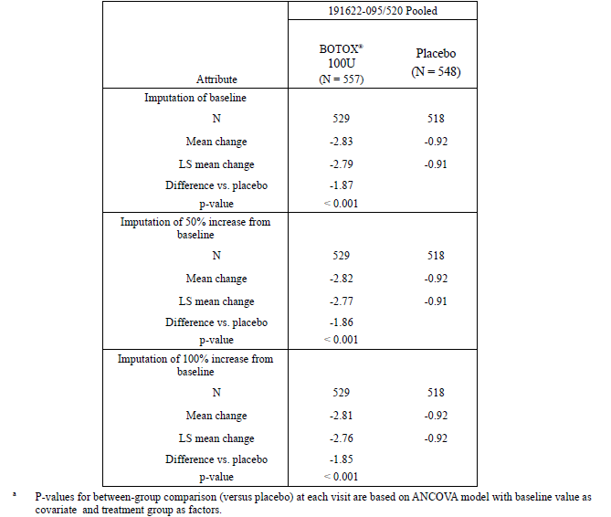

Question 4. Please provide summary tables for abnormal laboratory values, abnormal vital signs, and ECG results in Botox recipients in comparison to placebo recipients.
The sponsor has provided tables addressing the deficiencies in the original reporting of laboratory data, and these tables have now been incorporated into the body of this evaluation report. The sponsor did not perform routine ECG monitoring. Given that Botox has been used widely for a large number of indications, and significant cardiac safety concerns have not emerged, the lack of ECGs is acceptable. There is no reason to expect that injection of Botox into the bladder of OAB patients would produce new cardiac risks relative to the many existing indications for Botox.

Question 5. Please explain the p-values in the [laboratory] tables that [were provided in the original submission].
In the original submission, the sponsor did not present laboratory data in a convenient tabular format but instead referred readers to an appendix containing a separate table for each parameter of interest. For instance, ‘basophils’ were presented in one table, ‘haemoglobin’ in another, and so on, rather than summarising all haematological abnormalities; see the example below. These tables also included highly significant p-values, with no discussion of what was being compared with what.
Table 111. Haematology: Summary of Clinical Laboratory data for treatment Cycle 1. Basophils (%)>.(Placebo Controlled Safety Population).
The sponsor writes:
“The inclusion of the p<0.001 implies that there was statistical evidence that the median baseline basophils is not zero. For the change from baseline values, the p < 0.001 implies that there was statistical evidence that the median change from baseline in basophils is not zero.”
The sponsor’s explanation now indicates that the p-values were largely irrelevant. In fact, for each parameter, the first p-value in each column merely expressed the unremarkable fact that the laboratory values were non-zero. These p-values appear to have been the result of using automated data analysis without adapting the output for a human reader.
Now that adequate tables have been provided, this is not an important issue.

Question 6. For indications other than OAB, are placebo recipients included in the patient numbers purporting to be the number of patients tested for neutralising antibodies?
As noted in the discussion of the proposed PI, the sponsor included placebo recipients when citing the total number of patients tested for neutralising antibodies. The results in placebo recipients are largely irrelevant, so including them inflates the apparent immunological safety of Botox. The sponsor was asked to correct the PI and to confirm that a similar mistake had not been made for other indications.
The sponsor replied:
“The agency is correct that the number of OAB patients with analysed specimens cited in the PI includes both BOTOX® and placebo patients. This was an unintentional error, as we should only be reporting the number of patients who received BOTOX® injections (n=615) (ISS Table 3-86 in original submission). Other indications within the PI also report only the number of patients with analysed specimens who received BOTOX® injections. The PI has been corrected for the OAB indication to reflect the appropriate number of patients. The annotated PI is attached as Appendix 3.”
A review of the new proposed PI shows that the error has been corrected. In particular, the following sentence “In the pivotal studies, none of the 1023 overactive bladder patients with analysed specimens developed the presence of neutralizing antibodies” has been replaced with:
“In the pivotal studies, none of the 615 overactive bladder patients with analysed specimens developed the presence of neutralizing antibodies.”
No other corrections pertaining to this issue are needed.

Second round benefit-risk assessment
Overall, the new data provided do not change the benefit-risk assessment. The apparent finding of poor efficacy of Botox in men with OAB remains a substantial issue and the sponsor’s discussion of this problem did not address any of the original concerns.
The discrepancy between the doses recommended for NDO and idiopathic OAB has been satisfactorily justified.
The potential methodological bias introduced by censoring diaries during UTIs does not appear to have had any important impact on the overall results.
The provision of adequate laboratory tables confirms expectations that Botox is relatively unlikely to cause significant laboratory abnormalities.

Second round recommendation regarding authorisation
Botox should be approved for treatment of idiopathic OAB in women, following adequate correction of the PI along the lines indicated.
In particular, the proposed PI should be modified to highlight the lack of evidence of satisfactory efficacy in men.
Regulatory authorities have two options for dealing with the poor evidence of efficacy in men:
Option 1. Deny approval for use of Botox in men with OAB until adequate studies have been performed showing efficacy. This is the evaluator’s preferred option.
Option 2. Approve Botox for use in both genders, but modify the PI to highlight the state of the evidence in men with OAB so that patients and clinicians can make an adequately informed decision.
Regardless of whether treatment in men is approved or not, the PI needs to be modified to describe the results in men. The modifications would need to include mention of the following facts:
- No significant benefit has been found in men for incontinence frequency or Treatment Benefit Scale.
- A significant treatment-by-gender interaction exists (p<0.001; this acknowledgement should not be obfuscated by mention of the Gail-Simon test).
- A numerically favourable trend was noted in men for incontinence frequency, but the mean reduction in incontinence frequency was only 0.42 episodes per day in men, from a baseline of 5.61 episodes, and this mean was outside the 95%CI for reduction in incontinence in women.
- Most men (59.3%) reported that their condition was unchanged or worse after Botox.
- Only a small proportion of men (15.3%) had an attributable (placebo-subtracted) TBS response to Botox that was favourable.

References

References supplied by the sponsor
Abrams P, Cardozo L, Fall M, Griffiths D, Rosier P, Ulmsten U, et al. The standardisation of terminology of lower urinary tract function: Report from the Standardisation Sub-committee of the International Continence Society. Neurourol Urodyn. 2002;21:167-178.
Abrams P, Kelleher CJ, Kerr LA, Rogers RG. Overactive bladder significantly affects quality of life. Am J Manag Care. 2000;6(Suppl):S580-S590.
Apostolidis A, Popat R, Yiangou Y, Cockayne D, Ford AP, Davis JB, et al. Decreased sensory receptors P2X3 and TRPV1 in suburothelial nerve fibers following intradetrusor injections of botulinum toxin for human detrusor overactivity. J Urol. 2005;174:977-983.
Apostolidis A, Dasgupta P, Fowler CJ. Proposed mechanism for the efficacy of injected botulinum toxin in the treatment of human detrusor overactivity. Eur Urol. 2006;49:644-650.
Brown JS, Subak LL, Gras J, Brown BA, Kuppermann M, Posner SF. Urge incontinence: the patient’s perspective. J Womans Health. 1998;7:1263-1269.
Burgio K, Ives D, Locher J, Arena VC, Kuller LH. Treatment seeking for urinary incontinence in older adults. J Am Geriatr Soc. 1994;42:208-212.
Chancellor MB, Fowler CJ, Apostolidis A, de Groat WC, Smith CP, Somogyi GT, et al. Drug Insight: biological effects of botulinum toxin A in the lower urinary tract. Nat Clin Pract Urol. 2008;5: 319-328.
Chapple CR, Khullar V, Gabriel Z, Muston D, Bitoun CE, Weinstein D. The effects of antimuscarinic treatments in overactive bladder: an update of a systematic review and meta-analysis. Eur Urol. 2008;54:543-562.
Coelho A, Dinis P, Pinto R, Gorgal T, Silva C, Silva A, et al. Distribution of the high-affinity binding site and intracellular target of botulinum toxin type A in the human bladder. Eur Urol. 2010;57:884-890.
Colman S, Chapple C, Nitti V, Haag-Molkenteller C, Hastedt C, Massow U. Validation of treatment benefit scale for assessing subjective outcomes in treatment of overactive bladder. Urology. 2008;72:803–807.
Coyne KS, Payne C, Bhattacharyya SK, Revicki DA, Thompson C, Corey R, et al. The impact of urinary urgency and frequency on health-related quality of life in overactive bladder: results from a national community survey. Value Health. 2004;7:455–463.
DuBeau CE. Therapeutic/pharmacologic approaches to urinary incontinence in older adults. Clin Pharm Ther. 2009;85:98-102.
Du Moulin MFMT, Hamers JPH, Ambergen AW, Janssen MAP, Halfens RJG. Prevalence of urinary incontinence among community-dwelling adults receiving home care. Res Nurs Health. 2008;31:604-612.
Foxman B. Epidemiology of urinary tract infections: incidence, morbidity, and economic costs. Am J Med. 2002;113(1A):5S–13S.
Gopal M, Haynes K, Bellamy SL, Arya LA. Discontinuation rates of anticholinergic medications used for the treatment of lower urinary tract symptoms. Obstet Gynecol. 2008;112: 1311-1318.
Herschorn S, Gajewski J, Schulz J, Corcos J. A population-based study of urinary symptoms and incontinence: the Canadian Urinary Bladder Survey. BJU Int. 2008;101:52-58.
Hijaz A, Vasavada SP, Daneshgari F, Frinjari H, Goldman H, Rackley R. Complications and troubleshooting of two-stage sacral neuromodulation therapy: a single-institution experience. Urology. 2006;68:533-537.
Homma Y, Yamaguchi O, Hayashi K. An epidemiological survey of overactive bladder symptoms in Japan. BJU Int. 2005;96:1314-1318.
Irwin DE, Milsom I, Hunskaar S, Reilly K, Kopp Z, Herschorn S, et al. Population-based survey of urinary incontinence, overactive bladder, and other lower urinary tract symptoms in five countries: results of the EPIC study. Eur Urol. 2006a;50:1306-1315.
Irwin DE, Milsom I, Kopp Z, Abrams P, Cardozo L. Impact of overactive bladder symptoms on employment, social interactions and emotional well-being in six European countries. BJU Internat 2006b; 97:96-100.
Kelleher CJ, Cardozo LD, Khullar V, Salvatore S. A new questionnaire to assess the quality of life of urinary incontinent women. Br J Obstet Gynaecol. 1997;104:1374-1379.
Kreder K, Mayne C, Jonas U. Long-term safety, tolerability and efficacy of extended-release tolterodine in the treatment of overactive bladder. Eur Urol. 2002;41(6):588-595.
Lawrence M, Guay DR, Benson SR, Anderson MJ. Immediate-release oxybutynin versus tolterodine in detrusor overactivity: a population analysis. Pharmacotherapy. 2000;20:470-475.
Lawrence JM, Lukacz ES, Nager CW, Hsu JW, Luber KM. Prevalence and co-occurrence of pelvic floor disorders in community-dwelling women. Obstet Gynecol. 2008;111:678-685.
Liberman JN, Hunt TL, Stewart WF, Wein A, Zhou Z, Herzog AR et al. Health related quality of life among adults with symptoms of overactive bladder: results from a US community based survey. Urology. 2001;57:1044-1050.
MacDiarmid SA, Peters KM, Shobeiri SA, Wooldridge LS, Rovner ES, Leong FC, et al. Long-term durability of percutaneous tibial nerve stimulation for the treatment of overactive bladder. J Urol. 2010;183:234-240.
Milsom I, Abrams P, Cardozo L, Roberts RG, Thüroff J, Wein AJ. How widespread are the symptoms of an overactive bladder and how are they managed? A population-based prevalence study. BJU Int. 2001;87:760–766.
Nicolle LE. Urinary tract infections in the elderly. Clin Geriatr Med. 2009;25:423–436.
Notermans S, Nagel J. Assays for botulinum and tetanus toxins. In: Simpson LL, ed. Botulinum neurotoxin and tetanus toxin. San Diego, California: Academic Press, 1989:319-331.
O’Conor RM, Johannesson M, Hass SL, Kobelt-Nguyen G. Urge incontinence. Quality of life and patients’ valuation of symptom reduction. Pharmacoeconomics. 1998;14:531-539.
Papanicolaou S, Hunskaar S, Lose G, Sykes D. Assessment of bothersomeness and impact on quality of life of urinary incontinence in women in France, Germany, Spain and the UK. BJU Int. 2005;96:831-838.
Peters KM, Carrico DJ, Perez-Marrero RA, Khan AU, Wooldridge LS, Davis GL, et al. Randomized trial of percutaneous tibial nerve stimulation versus sham efficacy in the treatment of overactive bladder syndrome: results from the SUmiT trial. J Urol. 2010;183:1438-1443.
Starkman JS, Smith CP, Staskin DR. Surgical options for drug-refractory overactive bladder patients. Rev Urol. 2010;12:e97-e110.
Stewart WF, Van Rooyen JB, Cundiff GW, Abrams P, Herzog AR, Corey R, et al. Prevalence and burden of overactive bladder in the United States. World J Urol. 2003;20:327-336.
Teloken C, Caraver F, Weber FA, Teloken PE, Moraes JF, Sogari PR, et al. Overactive bladder: prevalence and implications in Brazil. Eur Urol. 2006;49:1087-1092.
Tubaro A. Defining overactive bladder: epidemiology and burden of disease. Urology. 2004; 64(Suppl 6A):2–6.
Rigby D. Urinary urge incontinence: causes and management strategies. Br J Community Nurs. 2005;10:172-178.
Yu HJ, Liu CY, Lee KL, Lee WC, Chen TH. Overactive bladder syndrome among community-dwelling adults in Taiwan: prevalence, correlates, perception, and treatment seeking. Urol Int. 2006;77(4):327-333.
Zorn BH, Montgomery H, Pieper K, Gray M, Steers WD. Urinary incontinence and depression. J Urol. 1999;162:82-84.

Additional references
Bhatia KP, Münchau A, Thompson PD, et al. J Neurol Neurosurg Psychiatry. 1999 Jul;67(1):90-3. Generalised muscular weakness after botulinum toxin injections for dystonia: a report of three cases.
Coban A, Matur Z, Hanagasi HA, Parman Y. Clin Neuropharmacol. 2010 May;33(3):158-60. Iatrogenic botulism after botulinum toxin type A injections.
Dutton JJ. Surv Ophthalmol. 1996 Jul-Aug;41(1):51-65. Botulinum-A toxin in the treatment of craniocervical muscle spasms: short- and long-term, local and systemic effects.
Gail M, Simon R. Biometrics. 1985 Jun;41(2):361-72. Testing for qualitative interactions between treatment effects and patient subsets.

Sponsor correction: local
Sponsor correction: locally
Sponsor correction: local
Kelleher et al (1997). A new questionnaire to assess the quality of life of urinary incontinent women. BJOG 104:1374-1379
Kelleher et al (2004). How much is enough and who says so? The case of the King's Health Questionnaire and overactive bladder. BJOG 111:605-612
* These standard urodynamic parameters are defined as follows. Volume at first involuntary detrusor contraction (IDC) = the bladder volume at the time the patient cannot prevent involuntary voiding; maximum detrusor pressure (MDP) during first IDC = the maximum pressure recorded in the bladder at the time of IDC; maximum cystometric capacity (MCC) = the maximum volume held by the bladder; end fill pressure (EFP) = the pressure measured when MCC was reached, or the pressure prior to terminal IDC if the patient voided involuntarily; detrusor compliance (DC) = the volume-pressure ratio, with low compliance indicating a stiff bladder and a high pressure for a given volume.
** The IQOL and KHQ have been described in the context of the pivotal studies. The EQ-5D Health Questionnaire is usually a five-domain questionnaire assessing health, but the sponsor only used a single VAS from the questionnaire, “capturing the current health status from the patient’s perspective”. The SF-36v2™ Health Survey is a previously validated multiple-question survey assessing 8 health domains from the patient’s perspective.
* The intensity of urgency was recorded with each entry into the patient bladder diary, according to a 4-point categorical scale (0 No urgency, 1 Mild urgency, 2 Moderate Urgency, 3 Severe Urgency) but the results were not discussed in the sponsor’s summaries or presented in a convenient summary table. Most urgency was rated as moderate or severe, and the frequency of urgency in each category broadly followed the overall frequency of urgency. For details, see p 1049 onwards in the study report pdf file.
Sponsor correction: 1.79
Sponsor correction: locally
Sponsor correction: local
Sponsor correction: locally
* Further discussion of the statistical significance of the treatment-by-sex interaction and the sponsor’s use of the Gail-Simon test, is found below.
Table referred to is reproduced below.

