October 2021

Australian Public Assessment Report for BNT162b2 (mRNA)
  - Proprietary Product Name: Comirnaty
  - Sponsor: Pfizer Australia Pty Ltd

About the Therapeutic Goods Administration (TGA)
- The Therapeutic Goods Administration (TGA) is part of the Australian Government Department of Health and is responsible for regulating medicines and medical devices.
- The TGA administers the Therapeutic Goods Act 1989 (the Act), applying a risk management approach designed to ensure therapeutic goods supplied in Australia meet acceptable standards of quality, safety and efficacy (performance) when necessary.
- The work of the TGA is based on applying scientific and clinical expertise to decision-making, to ensure that the benefits to consumers outweigh any risks associated with the use of medicines and medical devices.
- The TGA relies on the public, healthcare professionals and industry to report problems with medicines or medical devices. TGA investigates reports received by it to determine any necessary regulatory action.
- To report a problem with a medicine or medical device, please see the information on the TGA website <https://www.tga.gov.au>.

About AusPARs
- An Australian Public Assessment Report (AusPAR) provides information about the evaluation of a prescription medicine and the considerations that led the TGA to approve or not approve a prescription medicine submission.
- AusPARs are prepared and published by the TGA.
- An AusPAR is prepared for submissions that relate to new chemical entities, generic medicines, major variations and extensions of indications.
- An AusPAR is a static document; it provides information that relates to a submission at a particular point in time.
- A new AusPAR will be developed to reflect changes to indications and/or major variations to a prescription medicine subject to evaluation by the TGA.

Copyright
© Commonwealth of Australia 2021
This work is copyright. You may reproduce the whole or part of this work in unaltered form for your own personal use or, if you are part of an organisation, for internal use within your organisation, but only if you or your organisation do not use the reproduction for any commercial purpose and retain this copyright notice and all disclaimer notices as part of that reproduction. Apart from rights to use as permitted by the Copyright Act 1968 or allowed by this copyright notice, all other rights are reserved and you are not allowed to reproduce the whole or any part of this work in any way (electronic or otherwise) without first being given specific written permission from the Commonwealth to do so. Requests and inquiries concerning reproduction and rights are to be sent to the TGA Copyright Officer, Therapeutic Goods Administration, PO Box 100, Woden ACT 2606 or emailed to <tga.copyright@tga.gov.au>.

Contents
List of abbreviations 4
I. Introduction to product submission 6
Submission details 6
Product background 8
Regulatory status 10
Product Information 12
II. Registration timeline 12
III. Submission overview and risk/benefit assessment 13
Quality 13
Nonclinical 13
Clinical 13
Risk management plan 32
Risk-benefit analysis 34
Outcome 39
Attachment 1. Product Information 44

List of abbreviations
Abbreviation | Meaning
ACV | Advisory Committee on Vaccines
AE | Adverse event
AESI | Adverse event of special interest
ARGPM | Australian Regulatory Guidelines for Prescription Medicines
ATAGI | Australian Technical Advisory Group on Immunisation
ARTG | Australian Register of Therapeutic Goods
ASA | Australian specific annex
AusPAR | Australian Public Assessment Report
CDC | Centers for Disease Control and Prevention (United States of America)
CI | Confidence interval(s)
CMI | Consumer Medicines Information
COVID-19 | Coronavirus disease 2019
CPD | Certified Product Details
DLP | Data lock point
DP | Drug product
DS | Drug substance
EU | European Union
EUA | Emergency Use Authorization (United States of America)
FDA | Food and Drug Administration (United States of America)
GMFR | Geometric mean fold rise
GMT | Geometric mean titre
GMP | Good Manufacturing Practice
GMR | Geometric mean ratio
GVP | Good Pharmacovigilance Practice(s)
HIV | Human immunodeficiency virus
ICH | International Council for Harmonisation
LLOQ | Lower limit of quantification
MERS-CoV | Middle East respiratory syndrome coronavirus
mRNA | Messenger ribonucleic acid
NT₅₀ | 50% neutralising titre
OCABR | Official Control Authority Batch Release
PI | Product Information
PRM | Primary reference material
PSUR | Periodic safety update report
RMP | Risk management plan
RNA | Ribonucleic acid
SAE | Serious adverse event
SARS | Severe acute respiratory syndrome
SARS-CoV-2 | Severe acute respiratory syndrome coronavirus 2
SmPC | Summary of product characteristics (European Union)
TGA | Therapeutic Goods Administration
US(A) | United States (of America)
VOC | Variant of concern
VRBPAC | Vaccines and Related Biological Products Advisory Committee (United State of America)
WHO | World Health Organization
WRM | Working reference material

I. Introduction to product submission

Submission details
Type of submission: | Major variation (change of dose regimen); and variation to register entry resulting in a change of product information requiring evaluation of clinical, nonclinical, or bioequivalence data
Product name: | Comirnaty
Active ingredient: | BNT162b2 (mRNA)
Decision: | Approved for provisional registration
Date of decision: | 26 October 2021
Date of entry onto ARTG: | 27 October 2021
ARTG number: | 346290
Black Triangle Scheme: | Yes.  As a provisionally registered product, this medicine will remain in the Black Triangle Scheme for the duration of its provisional registration
Sponsor’s name and address: | Pfizer Australia Pty Ltd  Level 17, 151 Clarence Street  Sydney NSW 2000
Dose form: | Concentrated suspension for injection
Strength: | 30 µg/0.3 mL
Container: | Multi-dose vial
Pack size: | 195 vials
Approved therapeutic use: | The provisionally approved full indication for the new Comirnaty medicine is unchanged from that for the existing Comirnaty medicine. The full indications at this time were:  Comirnaty (BNT162b2(mRNA)) COVID-19 vaccine has provisional approval for the indication below:  Active immunisation to prevent coronavirus disease 2019 (COVID-19) caused by SARS-CoV-2, in individuals 12 years of age and older.  The use of this vaccine should be in accordance with official recommendations.  The decision has been made on the basis of short term efficacy and safety data. Continued approval depends on the evidence of longer term efficacy and safety from ongoing clinical trials and post-market assessment.
Route of administration: | Intramuscular
Dosage: | Individuals 12 years of age and older  Comirnaty is administered intramuscularly after dilution as a primary course of 2 doses at least 21 days apart. See dosing instructions below.  A booster dose (third dose) of Comirnaty may be administered intramuscularly at least 6 months after the completion of a COVID-19 vaccine primary series in individuals 18 years of age and older.  The decision when and for whom to implement a booster dose of Comirnaty should be made based on available vaccine safety and effectiveness data (see Sections 4.4 Special warnings and precautions for use and 5.1 Pharmacodynamic properties in the Product Information), in accordance with official recommendations.  There are limited data on the interchangeability of Comirnaty with other COVID-19 vaccines to complete the primary vaccination course or the booster dose (third dose).  Individuals who have received one dose of Comirnaty should preferably receive a second dose of Comirnaty to complete the primary vaccination course and for any additional doses.  Severely immunocompromised aged 12 years and older  In accordance with official recommendations, a booster dose (third dose) may be given at least 28 days after the second dose to individuals who are severely immunocompromised (see Section 4.4 Special warnings and precautions for use in the Product Information).  Elderly population  No dosage adjustment is required in elderly individuals 65 years of age and older.  For further information regarding dosage, refer to the Product Information.
Pregnancy category: | B1  Drugs which have been taken by only a limited number of pregnant women and women of childbearing age, without an increase in the frequency of malformation or other direct or indirect harmful effects on the human fetus having been observed.  Studies in animals have not shown evidence of an increased occurrence of fetal damage.  The use of any medicine during pregnancy requires careful consideration of both risks and benefits by the treating health professional. This must not be used as the sole basis of decision making in the use of medicines during pregnancy. The TGA does not provide advice on the use of medicines in pregnancy for specific cases. More information is available from obstetric drug information services in your State or Territory.

Product background
This AusPAR describes the application by Pfizer Australia Pty Ltd (the sponsor) to register Comirnaty (BNT162b2 (mRNA)) 30 µg/0.3 mL concentrated suspension for injection for the following changes to the dosage regimen and other major changes in the Product Information (PI):
- Dosage update to include a booster dose
A booster dose (third dose) of Comirnaty may be administered intramuscularly approximately 6 months after the second dose in individuals 16 years of age and older.
- Inclusion of the Study C4591001 6-month post-Dose 2 analysis (data cut-off of 13 March 2021)
Changes proposed in Sections 4.8 Adverse effects (undesirable effects); and 5.1 Pharmacodynamic properties in the PI.
Coronavirus disease 2019 (COVID-19) is an infectious disease caused by severe acute respiratory syndrome coronavirus 2 (SARS-CoV-2), a zoonotic virus that was first detected as a human pathogen in China and has rapidly spread around the world by human to human transmission.
In December 2019, a pneumonia outbreak of unknown cause occurred in Wuhan, China. In January 2020, it became clear that a novel coronavirus (named 2019-nCoV initially, later called SARS-CoV-2) was the underlying cause. In early January 2020, the genetic sequence of the 2019-nCoV became available to the World Health Organization (WHO) and the public, and the virus was categorised in the beta-coronavirus subfamily. By sequence analysis, the phylogenetic tree revealed a closer relationship to severe acute respiratory syndrome (SARS) virus isolates than to other coronaviruses that infect humans, including the Middle East respiratory syndrome coronavirus (MERS-CoV).
Coronavirus disease 2019 is predominantly a respiratory illness that can affect other organs. People with COVID-19 can present with a wide range of symptoms, from mild symptoms to severe illness. Following exposure to the virus, symptoms may appear within 2 to 14 days, and may include any or a combination of the following: fever or chills, cough, fatigue, shortness of breath, headache, muscle or body aches, sore throat, new loss of taste or smell, congestion or runny nose, nausea or vomiting, and diarrhoea.6
On 11 March 2020 the WHO characterised the COVID-19 outbreak as a pandemic. Since that announcement, the transmission of SARS-CoV-2 and resultant cases of COVID-19 disease has occurred globally, with cases reported by the vast majority of countries. As of 28 October 2021, there have been over 244 million globally confirmed COVID-19 cases and over 4.96 million deaths, with over 190 countries/regions affected. In Australia, as of 28 October 2021, there have been over 165,000 confirmed COVID-19 cases and 1696 deaths.
Immunisation with a safe and effective COVID-19 vaccine is a critical component of the public health strategy to reduce COVID-19 related illnesses, hospitalisations, and deaths, and to help restore societal functioning. At the time this submission was under consideration, there are currently 4 vaccines provisionally registered in Australia; to prevent COVID-19; these include Comirnaty (BNT162b2 messenger ribonucleic acid (mRNA)),,, COVID-19 Vaccine AstraZeneca (ChAdOx1-S),, COVID-19 Vaccine Janssen (Ad26.COV2.S),, and Spikevax (elasomeran),,.
The Pfizer-BioNTech COVID-19 vaccine, Comirnaty, is comprised of nucleoside-modified mRNA encoding a mutated form of the full-length viral spike glycoprotein of SARS-CoV-2. The ribonucleic acid (RNA) is encapsulated in lipid nanoparticles, which enables entry into host cells, expression of the spike glycoprotein, and elicitation of both antibody and cellular immune responses. The vaccine is supplied as a white to off-white sterile frozen liquid, packaged in a multi-dose clear glass 2 mL vial with a rubber stopper, stored in -60 to -90°C. The vials are packed in cartons containing 195 multi-dose vials, and are intended for use over a short time window (calculated from its first use) due to its preservative free composition.
The provisional determination for Comirnaty (BNT162b2 (mRNA)) was first granted by the TGA on 14 October 2020. This vaccine is indicated for active immunisation to prevent COVID-19 caused by SARS-CoV-2 virus, in individuals 12 years of age and older. In this submission the sponsor was seeking approval to amend Section 4.2 Dose and method of administration of the PI regarding the update to the dose regime with a booster dose and other amendments to the safety and immunogenicity data in the PI for the existing Comirnaty COVID-19 vaccine in the Australian Register of Therapeutic Goods (ARTG).

Regulatory status
The product received initial registration (provisional) on the ARTG;²² on 25 January 2021 for the prevention of COVID-19 in individuals 16 years of age and older. Subsequent applications have results in the approval for use in individuals 12 years of age and older.
As of 23 July 2021, the approved indications for Comirnaty were:
Comirnaty (BNT162b2(mRNA)) COVID-19 vaccine has provisional approval for the indication below:
Active immunisation to prevent coronavirus disease 2019 (COVID-19) caused by SARS-CoV-2, in individuals 12 years of age and older.
The use of this vaccine should be in accordance with official recommendations.
The decision has been made on the basis of short term efficacy and safety data. Continued approval depends on the evidence of longer term efficacy and safety from ongoing clinical trials and post-market assessment.
At the time the TGA considered this application, a similar application had been approved in the United States of America (USA) on 22 September 2021. Similar applications were under consideration in Canada, submitted on 1 October 2021; the European Union (EU), submitted on 2 September 2021; Switzerland, submitted on 9 September 2021; and Singapore, submitted on 29 September 2021.
Table 1: International regulatory status
Region | Submission date | Status | Approved indications
United States of America | 27 August 2021 | Approved (Emergency Use Authorization) on 22 September 2021 | For active immunisation to prevent COVID-19 in individuals 12 years of age and older.
Canada | 1 October 2021 | Under consideration | Comirnaty is indicated for active immunization to prevent coronavirus disease 2019 (COVID-19) caused by severe acute respiratory syndrome coronavirus 2 (SARS-CoV-2) in individuals 12 years of age and older.
European Union | 2 September 2021 | Approved 5 October 2021 | Comirnaty is indicated for active immunisation to prevent COVID-19 caused by SARS-CoV-2 virus, in individuals 12 years of age and older.
Switzerland | 9 September 2021 | Approved 26 October 2021 | Comirnaty is indicated for active immunisation to prevent COVID-19 caused by SARS-CoV-2 virus, in individuals 12 years of age and older.
Singapore | 29 September 2021 | Under consideration | Under consideration

Product Information
The Product Information (PI) approved with the submission which is described in this AusPAR can be found as Attachment 1. For the most recent PI, please refer to the TGA website at <https://www.tga.gov.au/product-information-pi>.

II. Registration timeline
The following table captures the key steps and dates for this application and which are detailed and discussed in this AusPAR.
Data was provided as a rolling submission. Under normal circumstances, the TGA's assessment (for both provisional and general registration) begins once all information to support registration is available. As part of the Department of Health's response to the pandemic, the TGA has agreed to accept rolling data for COVID-19 vaccines, to enable early evaluation of data as it comes to hand.
Table 2: Timeline for Submission PM-2021-04582-1-2
Description | Date
Positive Designation (Provisional)¹⁰ | 14 October 2020;  11 May 2021;
Submission dossier accepted and first round evaluation commenced | 15 October 2021
Evaluation completed | 18 October 2021
Delegate’s Overall benefit-risk assessment and request for Advisory Committee advice | 18 October 2021
Sponsor’s pre-Advisory Committee response | 21 October 2021
Advisory Committee meeting | 25 October 2021
Registration decision (Outcome) | 26 October 2021
Completion of administrative activities and registration on the ARTG | 27 October 2021
Number of working days from submission dossier acceptance to registration decision* | 8
*Statutory timeframe for standard applications is 255 working days

III. Submission overview and risk/benefit assessment
The submission was summarised in the following Delegate’s overview and recommendations.

Quality
There was no requirement for a quality evaluation in a submission of this type.

Nonclinical
There was no requirement for a nonclinical evaluation in a submission of this type.

Clinical
The clinical dossier consisted of the clinical study report for Study C4591001.

Efficacy
The sponsor’s approach to demonstrating efficacy of a booster dose (third dose) is to provide immunobridging data comparing responses one month after a booster dose (Dose 3) to those one month following the two dose primary vaccination course. There are no related clinical efficacy data.
Immunobridging data come from the Phase II/III study protocol in Study C4591001 and involve approximately 300 participants.
Table 3: Study C4591001 Study objective, estimands and endpoints
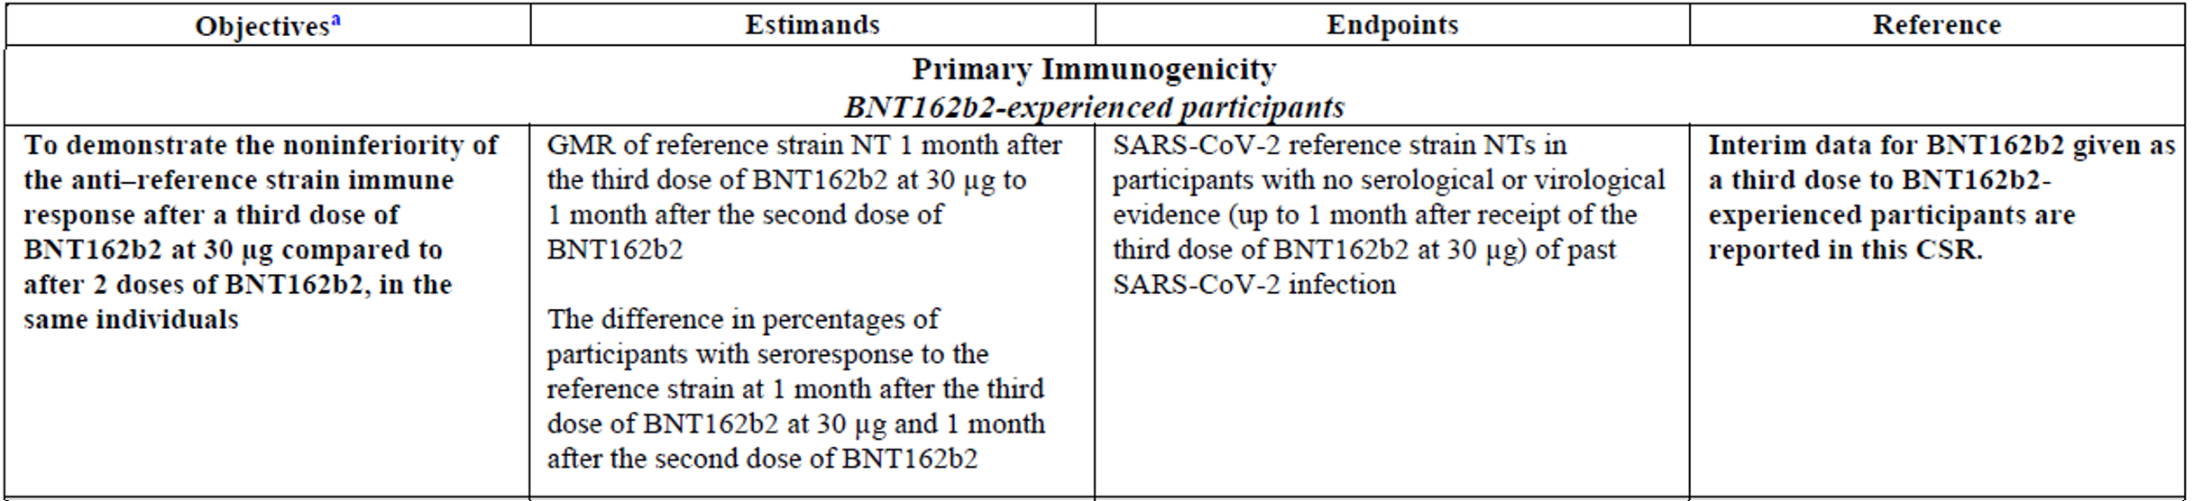
CSR = clinical study report; GMR = geometric mean ratio; NTs = neutralising titres; SARS-CoV-2 = severe acute respiratory syndrome coronavirus 2.
a) Human immunodeficiency virus (HIV) positive participants in Phase III were not included in analyses of the objectives, with the exception of the specific exploratory objective.
All the participants involved in the assessment of boostability (both the Phase II/III and Phase I sub-studies) are from sites in the USA.
In addition to continuing to meet the pre-specified inclusion and exclusion criteria for Study C4591001, additional inclusion criteria for re-randomisation into either the boostability or protection against variants of concern (VOCs) subsets in the Phase II/III sub-study included:
- male or female participants 18 to 55 years of age, inclusive, at re-randomisation
- had completed both doses of the primary course with BNT162b2 (30 µg)
- participants who provided a serum sample at Visit 3, with Visit 3 occurring within the protocol specified window.
Additional supporting data come from the Phase I study protocol in Study C4591001 and involve 23 participants. Data is presented from one month post-Dose 3 comparing neutralising titres against wild type SARS-CoV-2 with titres against the B.1.351 lineage (beta variant) and B.1.617.2 lineage (delta variant). Unique features of the design and conduct of the Phase I sub-studies, along with the results, were presented in the sponsor’s clinical study report.

Immunogenicity evaluations
Immunogenicity was evaluated with what the sponsor referred to as a ‘validated assay’ for the reference strain (also referred to as the original wild type strain).
Blood samples were planned for collection at the following timepoints:
- Visit 1 (before Dose 1)
- Visit 3 (one months after Dose 2)
- Visit 301 (before booster dose, Dose 3)
- Visit 302 (one week after Dose 3)
- Visit 303 (one month after Dose 3).
The sponsor estimated that, assuming a 20% non-evaluable rate, approximately 240 evaluable participants would be required for the immunogenicity evaluation to provide sufficient power for non-inferiority evaluations with appropriate multiplicity adjustment for Type I error control. Hence, they targeted enrolment of 300 participants into the Phase II/III boostability sub-study.
Booster dose effectiveness was inferred through immunobridging: demonstration of non-inferiority of immune responses (based on SARS-CoV-2 50% neutralising titres (NT₅₀)) between one month post-Dose 3 to one month post-Dose 2. At the latter timepoint, clinical vaccine efficacy was not examined.
Noninferiority was statistically assessed based on two measures:
- geometric mean ratio (GMR), calculated as the mean of the difference of logarithmically transformed titres for each participant (that is, later timepoint minus earlier timepoint) and exponentiating the mean. Noninferiority was declared based on a 1.5 fold margin (that is, if the lower bound of the 2 sided 97.5% confidence interval (CI) for the GMR was > 0.67) and the point estimate of the GMR was ≥ 0.8.
- seroresponse, based on the differences in percentages of participants with a seroresponse at the later minus earlier time point, using a 10% margin. Seroresponse was defined as a ≥ 4 fold rise from Baseline (or 4 x the lower limit of quantification (LLOQ) if the baseline measure was < LLOQ). Noninferiority was declared if the lower limit of the 2 sided 97.5% CI for the difference in percentages of participants with seroresponse was > -10%.
Descriptive measure of immunogenicity that were presented included:
- geometric mean titres (GMTs), calculated as the mean of the assay result after logarithmic transformation and then exponentiating the means to express results on the original scale. Two sided 95% CI were exponentiated similarly. Titres below LLOQ set to 0.5 x LLOQ.
- geometric mean fold rise (GMFRs), calculated by exponentiating the mean of the difference of logarithmically transformed assay results (later minus earlier timepoints); 95% CI calculated similarly.
Table 4: Study C4591001 Phase III BNT162b2-experienced subjects who were re-randomised to receive one booster dose of BNT162b2 (30 μg) (immunogenicity populations)
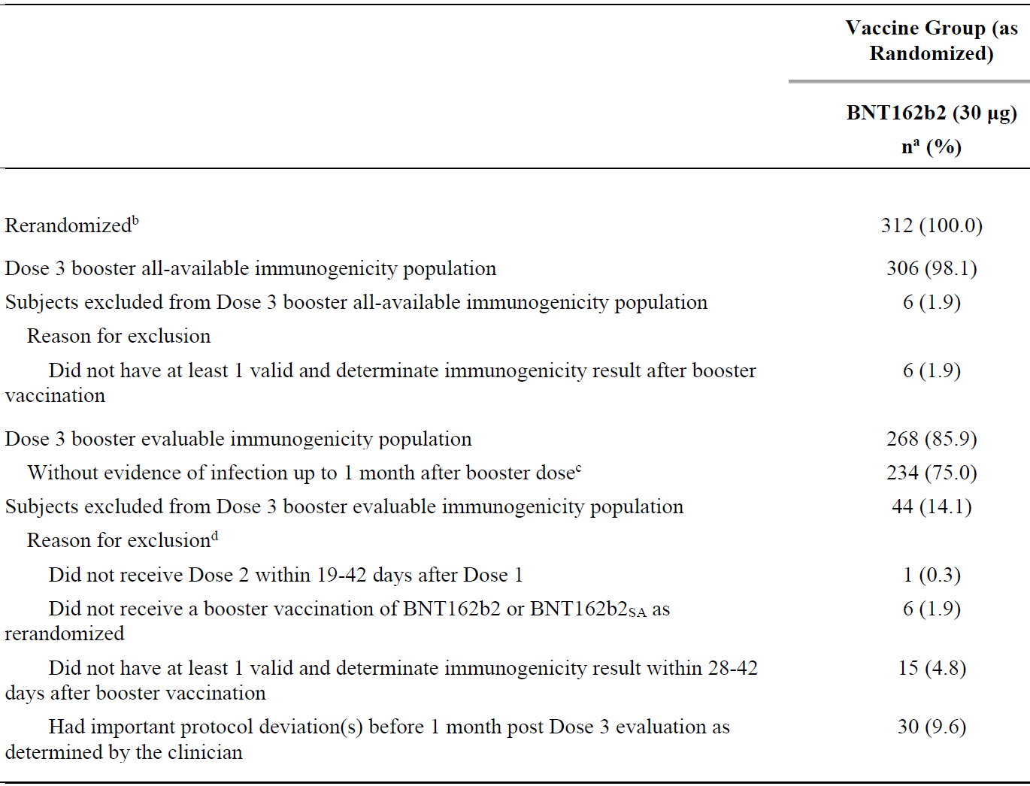
a) n = Number of subjects with the specified characteristic.
b) This value is the denominator for the percentage calculations.
c) Subjects who had no serological or virological evidence (up to one month after receipt of booster vaccination) of past severe acute respiratory syndrome coronavirus 2 (SARS-CoV-2) infection (that is, SARS-CoV-2 nucleoprotein binding antibody (serum) negative at Visit 1, 3, 301 and 303 and SARS-CoV-2 not detected by nucleic acid amplification test (NAAT) (nasal swab) at Visit 1, 2, and 301) and had a negative NAAT (nasal swab) at any unscheduled visit up to one month after booster vaccination.
d) Subjects may have been excluded for more than one reason.
Among the 312 participants who were re-randomised to receive a booster (Dose 3) of BNT162b2 30 μg, the Dose 3 booster evaluable immunogenicity population included 268 participants, and those without evidence of infection up to one month after Dose 3 included 234 participants (see Table 4). The most common reason for exclusion (30 (9.6%) participants) from the evaluable immunogenicity population was that they had important protocol deviation(s) as determined by the clinician. The majority of these protocol deviations included 16 (53.3%) participants with Visit 301 (booster (Dose 3) vaccination) conducted outside the protocol specified window.
The median duration between Dose 2 and Dose 3 was 6.8 months (range: 4.8 to 8.0 months) (see Table 5). 49.7% of participants who received a booster vaccination (Dose 3) received administration of Dose 3 between 6 and < 7 months after receiving Dose 2. Fewer than 10% of participants received Dose 3 at < 6 months following Dose 2. Dose 3 was administered ≥ 7 months after Dose 2 for 41.0% of participants; this included 16 participants who received Dose 3 outside of the protocol defined window (that is, < 150 days or > 210 days after Dose 2).
Table 5: Study C4591001 Phase III vaccine administration timing; BNT162b2-experienced subjects who were re-randomised to receive one booster dose of BNT162b2 (30 μg)
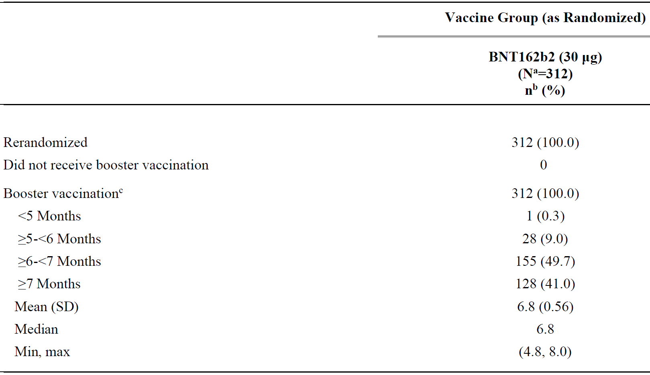
Min = minimum; max = maximum; SD = standard deviation.
a) N = number of subjects in the specified group. This value is the denominator for the percentage calculations.
b) n = number of subjects with the specified characteristic.
c) Months calculated since Dose 2.
Demographic characteristics of the Phase I and Phase II/III study participants who received a BNT162b2 (30 μg) booster dose are summarised in Table 6 below. Booster recipients were predominantly White. Phase I excluded individuals with comorbidities that confer risk for severe COVID-19 (that is, obesity, diabetes with or without complications, chronic pulmonary disease, cardiovascular conditions such as hypertension, congestive heart failure, ischemic heart disease, human immunodeficiency virus (HIV) infection). Approximately 20% of booster recipients in Phase II/III had such comorbidities.
Table 6: Study C4591001 Phase III demographic characteristics; BNT162b2-experienced subjects who were re-randomised to receive one booster dose of BNT162b2 (30 μg) (Dose 3 booster evaluable immunogenicity population)
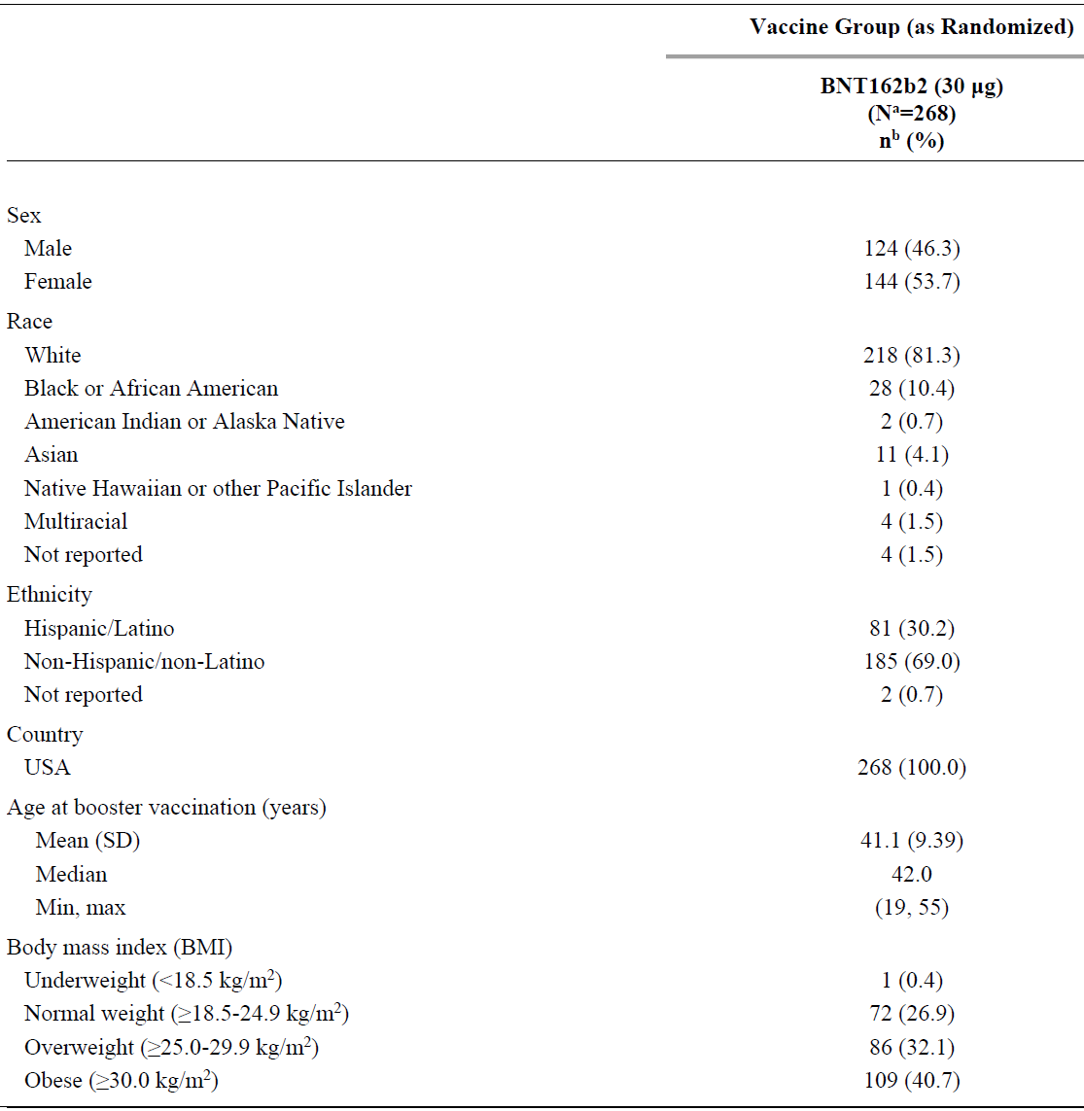
BMI = body mass index; SD = standard deviation; USA = United States of America.
a) N = number of subjects in the specified group. This value is the denominator for the percentage calculations.
b) n = number of subjects with the specified characteristic.

Results

Noninferiority of booster response to initial regimen response
Among participants without prior evidence of SARS-CoV-2 infection up to one month after the booster (Dose 3), the immune response to BNT162b2 30 μg at one month after the booster (Dose 3) was noninferior to that observed at one month after Dose 2 in the same participants, based on SARS-CoV-2 50% neutralising titre (NT₅₀) as shown in Table 7.
The SARS-CoV-2 neutralising GMT ratio of one month after Dose 3 to one month after Dose 2 was 3.29 (2 sided 97.5% CI: 2.76, 3.91), which meets the 1.5 fold noninferiority criterion (that is, lower bound of the 2 sided 97.5% CI for GMR >0.67) and point estimate of GMR ≥ 0.8.
The lower bound of the 2 sided 97.5% CI for the GMR is > 1, which indicates a statistically greater response following booster (Dose 3) administration than that observed following Dose 2.
The GMR result for the Dose 3 booster all available immunogenicity population was similar to those observed for the Dose 3 booster evaluable immunogenicity population.
Table 7: Study C4591001 Phase III geometric mean ratio, comparison of one month after booster dose to one month after Dose 2; BNT162b2-experienced subjects without evidence of infection up to one month after booster dose who were re-randomised to receive one booster dose of BNT162b2 (30 μg) (Dose 3 booster evaluable immunogenicity population)
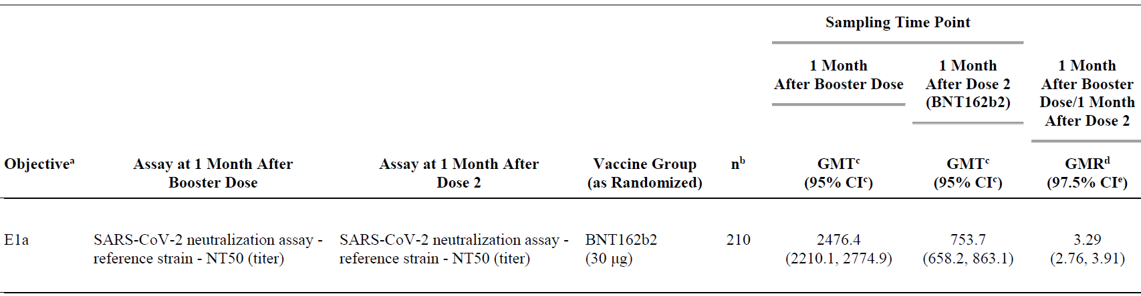
CI = confidence interval; GMR = geometric mean ratio; GMT = geometric mean titre; NT50 = 50% neutralising titre; SARS-CoV-2 = severe acute respiratory syndrome coronavirus 2.
Subjects who had no serological or virological evidence (up to one month after receipt of booster vaccination) of past SARS-CoV-2 infection (that is, SARS-CoV-2 nucleoprotein binding antibody (serum) negative at Visit 1, 3, 301, and 303 and SARS-CoV-2 not detected by nucleic acid amplification test (NAAT) (nasal swab0 at Visits 1, 2, and 301) and had a negative NAAT (nasal swab) at any unscheduled visit up to one month after booster vaccination were included in the analysis.
a) The first primary objective to be evaluated in Phase III booster portion of the study, where 'E' represents BNT162b2-experienced subjects and 'a' represents GMR estimands.
b) n = number of subjects with valid and determinate assay results for both the specified assays at the given dose/sampling time point within specified window.
c) Geometric mean titres and 2 sided 95% CIs were calculated by exponentiating the mean logarithm of the titres and the corresponding CIs (based on the Student t distribution). Assay results below the lower limit of quantitation (LLOQ) were set to 0.5 x LLOQ.
d) Geometric mean ratios and 2 sided 97.5% CIs were calculated by exponentiating the mean differences in the logarithms of the assay and the corresponding CIs (based on the Student t distribution).
e) Noninferiority is declared if the lower bound of the 2 sided 97.5% CI for the GMR is greater than 0.67 and the point estimate of the GMR is ≥ 0.8.
The GMTs were clearly superior after Dose 3 compared to after Dose 2, and the non-inferiority margins were clearly met. The seroresponse rates were very high after the second dose (98%), and as can be expected were high also after the booster dose (99.5%).
Clinical efficacy has previously been demonstrated after two doses, although the duration of protection is unknown. The role of persisting high antibody titres and the role of immunological memory are currently not characterised for protection against COVID-19.

Difference in seroresponse rate to reference strain
Among participants without prior evidence of SARS-CoV-2 infection up to one month after the booster (Dose 3), a high proportion of participants (99.5%) had seroresponse (defined as ≥ 4 fold rise from Baseline before Dose 1) at one month after Dose 3 compared with 98.0% at one month after Dose 2 (see Table 8).
The difference in proportions of participants with a seroresponse one month after the booster (Dose 3) and one month after Dose 2 (Dose 3 to Dose 2) was 1.5% (2 sided 97.5% CI: -0.7, 3.7%), which meets the 10% noninferiority margin (that is, lower bound of the 2 sided 97.5% CI was greater than -10%).
The seroresponse result for the Dose 3 booster all available immunogenicity population was similar to that observed for the Dose 3 booster evaluable immunogenicity population without prior evidence of SARS-CoV-2 infection.
Table 8: Study C4591001 Phase III percentage difference of subjects achieving seroresponse, comparison of one month after booster dose to one month after Dose 2; BNT162b2-experienced subjects without evidence of infection up to one month after booster dose who were re-randomised to receive one booster dose of BNT162b2 (30 μg) (Dose 3 booster evaluable immunogenicity population)
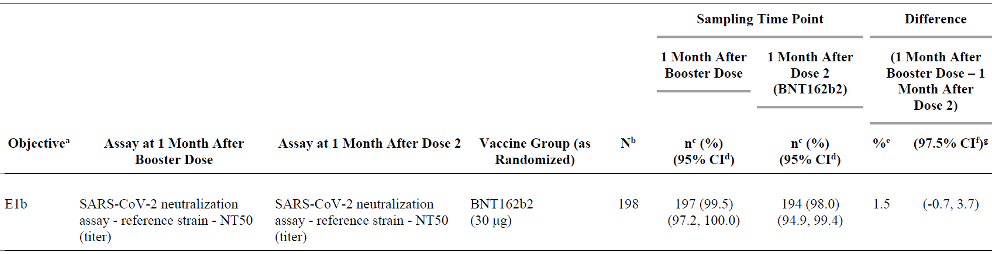
CI = confidence interval; NT50 = 50% neutralising titre; SARS-CoV-2 = severe acute respiratory syndrome coronavirus 2.
Seroresponse is defined as achieving a ≥ 4 fold rise from Baseline (before Dose 1). If the baseline measurement is below the lower limit of quantitation (LLOQ), a postvaccination assay result ≥ 4 x LLOQ is considered a seroresponse.
Subjects who had no serological or virological evidence (up to one month after receipt of booster vaccination) of past SARS-CoV-2 infection (that is, SARS-CoV-2 nucleoprotein binding antibody (serum) negative at Visit 1, 3, 301, and 303 and SARS-CoV-2 not detected by nucleic acid amplification test (NAAT) (nasal swab) at Visits 1, 2, and 301) and had a negative NAAT (nasal swab) at any unscheduled visit up to one month after booster vaccination were included in the analysis.
a) The first primary objective to be evaluated in Phase III booster portion of the study, where ‘E’ represents BNT162b2 experienced subjects and ‘b’ represents seroresponse rate estimands.
b) N = number of subjects with valid and determinate assay results for the specified assay at Baseline, one month after Dose 2 and one month after the booster dose within specified window. These values are the denominators for the percentage calculations.
c) n = number of subjects with seroresponse for the given assay at the given dose/sampling time point.
d) Exact 2 sided CI based on the Clopper and Pearson method.
e) Difference in proportions, expressed as a percentage (one month after booster dose - one month after Dose 2).
f) Adjusted Wald 2 sided CI for the difference in proportions, expressed as a percentage.
g) Noninferiority is declared if the lower bound of the 2 sided 97.5% CI for the percentage difference is greater than -10.

Geometric mean titres to reference strain
Among participants without prior evidence of SARS-CoV-2 infection up to one month after the booster (Dose 3), at one month after the booster (Dose 3) of BNT162b2 30 μg, SARS-CoV-2 50% neutralising GMTs increased substantially relative to GMTs observed just prior to receipt of Dose 3 (see Figure 1).
The median duration between receipt of Dose 2 and the booster with Dose 3 was 6.8 months. GMTs had declined by the time the booster (Dose 3) was administered. From Dose 2 up to the day of Dose 3 administration (before booster vaccination), GMTs were 136.2 (2 sided 95% CI: 121.5, 152.6), which represents a 5.59 fold reduction compared to that observed at one month after Dose 2.
Following booster (Dose 3) vaccination, GMTs were increased by 7 days post-Dose 3 to 1418.7 (95% CI: 1263.3, 1593.3). By one month after Dose 3, GMTs were further elevated to 2374.2 (95% CI: 2134.1, 2641.3), a level 17.4 fold that observed on the day of booster vaccination (prior to receipt of Dose 3).
Overall, among participants in the Dose 3 booster evaluable immunogenicity population, the neutralising GMTs at one month after Dose 3 were substantially greater than that observed at one month after Dose 2 (that is, 3 fold), showing a strong boost to the neutralising antibody response.
The SARS-CoV-2 50% neutralising GMTs for all participants in the Dose 3 booster evaluable immunogenicity population regardless of prior infection status and the Dose 3 booster all available immunogenicity population were similar to those observed for the Dose 3 booster evaluable immunogenicity population without evidence of SARS-CoV-2 infection up to one month after the booster (Dose 3).
Figure 1: Study C4591001 Phase III geometric mean titres and 95% confidence interval, reference strain SARS-CoV-2 neutralisation assay, 50% neutralising titres; BNT162b2-experienced subjects without evidence of infection up to one month after booster dose who were re-randomised to receive one booster dose of BNT162b2 (30 μg) (Dose 3 booster evaluable immunogenicity population)
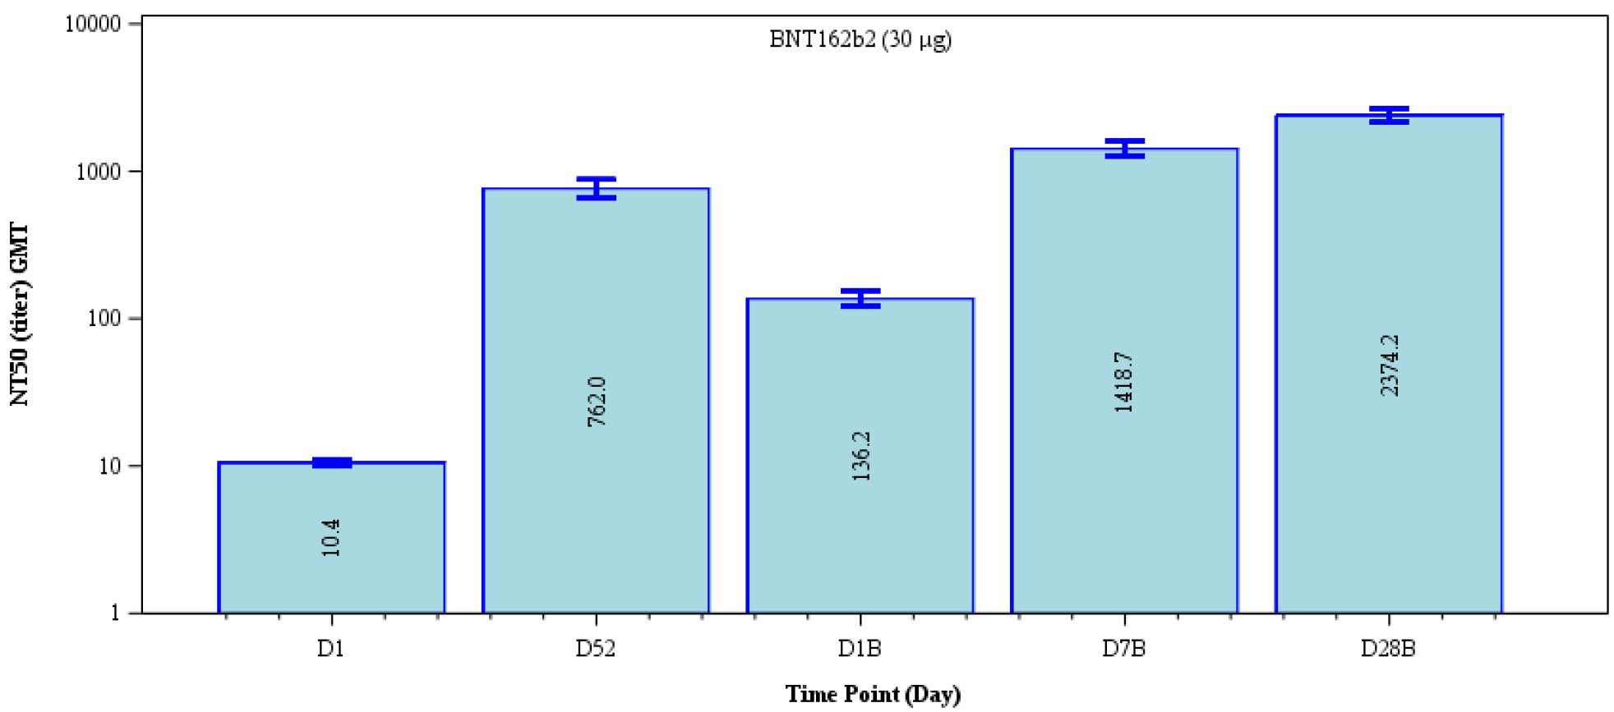
B = booster vaccination; D = day; GMT = geometric mean titre; NT50 = 50% neutralising titre.
Subjects who had no serological or virological evidence (up to one month after receipt of booster vaccination) of past severe acute respiratory syndrome coronavirus 2 (SARS-CoV-2) infection (that is, SARS-CoV-2 nucleoprotein binding antibody (serum) negative at Visit 1, 3, 301, and 303 and SARS-CoV-2 not detected by nucleic acid amplification test (NAAT) (nasal swab) at Visits 1, 2, and 301) and had a negative NAAT (nasal swab) at any unscheduled visit up to one month after booster vaccination were included in the analysis.
Number within each bar denotes GMT.

Geometric mean fold rise
Geometric mean fold rise from just prior to Dose 3 to 7 days and one month post-Dose 3 are shown for the various immunogenicity populations in Table 9.
Table 9: Study C4591001 Phase III geometric mean fold rise from immediately before booster dose to each subsequent time point; BNT162b2-experienced subjects who were re-randomised to receive one booster dose of BNT162b2 (30 μg) (immunogenicity populations as specified)
 | 7 days post-Dose 3 |  | 1 month post-Dose 3
Immunogenicity population | n | GMFR  (95% CI) | n | GMFR  (95% CI)
Dose 3 booster evaluable immunogenicity population without evidence of prior infection | 99 | 13.5  (11.3, 16.3) | 212 | 17.4  (15.2, 20.0)
Dose 3 booster evaluable immunogenicity population regardless of prior infection status | 111 | 13.0  (10.9, 15.5) | 239 | 16.1  (14.0, 18.4)
Dose 3 booster all available immunogenicity population | 132 | 13.6  (11.6, 16.0) | 266 | 16.1  (14.2, 18.3)
CI = confidence interval; GMFR = geometric mean fold rise; n = number of subjects with valid and determinate assay results for the specified assay at both before booster dose and the given dose/sampling timepoint.
Geometric mean fold rise and 2 sided 95% CI were calculated by exponentiating the mean logarithm of fold rises and the corresponding CI (based on the student t distribution). Assay results below the lower limit of quantification (LLOQ) were set to 0.5 × LLOQ in the analysis.
The GMT (Figure 1) and seroresponse rate (Table 10) results support the increased immune responses after a booster dose compared to one month after Dose 2, and before Dose 3. It is noted that about 20% of study population had become seronegative at the day for receiving the booster dose. It is unclear if these subjects had longest time period from the last dose or it is related to the demographic characteristics such as age and body mass index.
Table 10: Study C4591001 Phase III number (%) of subjects achieving seroresponse; BNT162b2-experienced subjects who were re-randomised to receive one booster dose of BNT162b2 (30 μg) (immunogenicity populations as specified)
 | 1 month  post-Dose 2 | Just prior to  Dose-3 | 7 days  post-Dose 3 | 1 month  post-Dose 3
Immunogenicity population | n/N  (%)  (95% CI) | n/N  (%)  (95% CI) | n/N  (%)  (95% CI) | n/N  (%)  (95% CI)
Dose 3 booster evaluable immunogenicity population without evidence of prior infection | 198/202  (98.0)  (95.0, 99.5) | 152/197  (77.2)  (70.7, 82.8) | 96/98  (98.0)  (92.8, 99.8) | 214/215  (99.5)  (97.4, 100.0)
Dose 3 booster evaluable immunogenicity population regardless of prior infection status | 226/231  (97.8)  (95.0, 99.3) | 171/222  (77.0)  (70.9, 82.4) | 108/110  (98.2)  (93.6, 99.8) | 244/246  (99.2)  (97.1, 99.9)
Dose 3 booster all available immunogenicity population | 259/264  (98.1)  (95.6, 99.4) | 188/250  (75.2)  (69.4, 80.4) | 135/137  (98.5)  (94.8, 99.8) | 275/278  (98.9)  (96.9, 99.8)
CI = confidence interval; n = number of subjects with seroresponse for the given assay at the given dose/sampling time point; N = number of subjects with valid and determinate assay results for the specified assay both before vaccination and at the given dose/sampling time point.
These values are the denominators for the percentage calculations. Seroresponse is defined as achieving a ≥ 4 fold rise from Baseline (before Dose 1). If the baseline measurement is below the lower limit of quantification (LLOQ), a postvaccination assay result ≥ 4 x LLOQ is considered a seroresponse.

Other supportive efficacy data

Phase I data
The sponsor has submitted preliminary results from a subset of younger (18 to 55 years of age) and older (65 to 85 years of age) participants in the Phase I part of Study C4591001 who completed the initial two dose series of BNT162b2 30 μg, given approximately 3 weeks apart, and then received a booster dose of BNT162b2 30 μg approximately 7 to 9 months after the second dose. Data were collected through the cut-off date of 13 May 2021.
The study was conducted at 2 sites in the USA. As of the data cut-off date (13 May 2021), 23/24 original Phase I participants who received 2 doses of BNT162b2 30 μg received a booster dose of BNT162b2 30 μg. One original participant declined to receive Dose 3.
Table 11: Study C4591001 Phase I booster - demographic characteristics - initial BNT162b2 (30 µg)
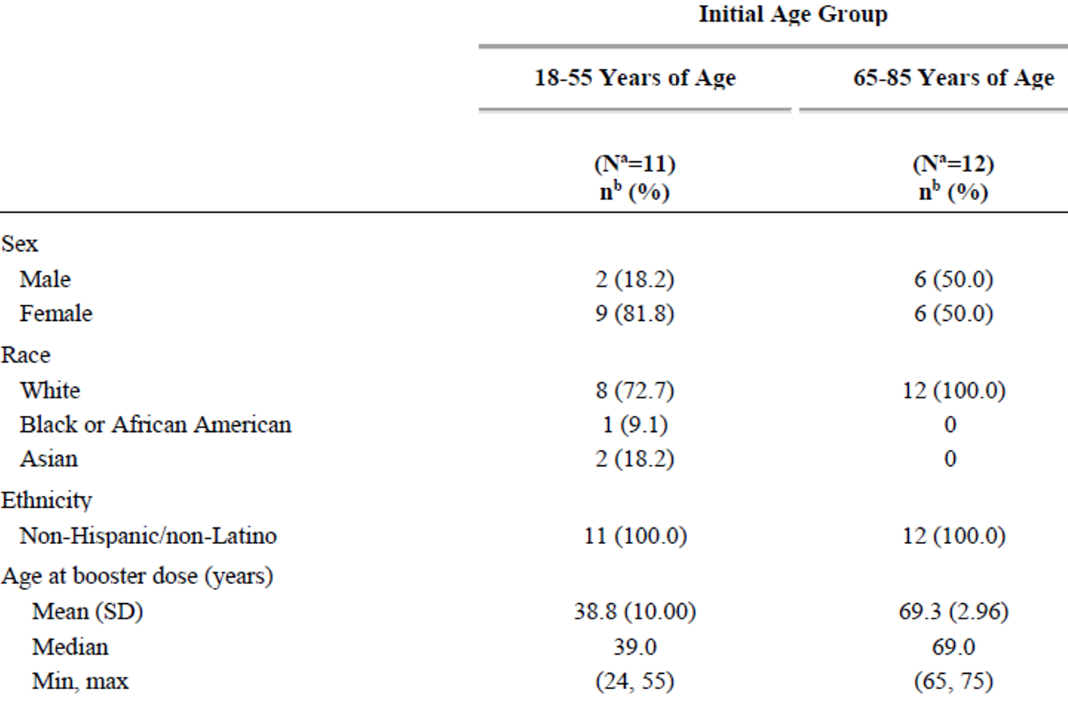
SD = standard deviation.
a) N = number of subjects in the specified group. This value is the denominator for the percentage calculations.
b) n = number of subjects with the specified characteristic.

Immunogenicity results for the Phase I study booster group

Reference strain and beta strain comparison
The Dose 3 all available immunogenicity population included all randomised participants who received 2 doses of BNT162b2 as initially randomised, received a BNT162b2 booster dose, and had at least one valid and determinate immunogenicity result after Dose 3. Valid neutralisation titres were obtained from all 23 participants.

Geometric mean titres
SARS-CoV-2 neutralisation GMTs against the wild type USA-WA1/2020 strain (a clinical strain isolated in January 2020) substantially increased after Dose 3. GMTs at one month after Dose 3 were 2119 (95% CI: 1229.1, 3653.4) for younger participants 18 to 55 years of age, and 2032 (95% CI: 1232.6, 3349.3) for older participants 65 to 85 years of age, which were > 5 fold and >7 fold, respectively, those of the GMTs observed at one month after Dose 2 (Figure 2).

Geometric mean fold rise
Geometric mean fold rise against the wild type strain from before Dose 3 to one month after Dose 3 were 25.7 (95% CI: 12.4, 53.3) for younger adults, and 49.4 (95% CI: 29.2, 83.3) for older adults (see Table 12).
A booster dose of BNT162b2 administered 7 to 9 months after the original two dose series also increased the neutralising titres against the B.1.351 SARS-CoV-2 recombinant virus (recombinant virus was based on the USA-WA1/2020 clinical strain and incorporated the complete spike gene from the B.1.351 variant 2). At one month after Dose 3, GMTs were 1546 (95% CI: 888.1, 2692.4) for younger participants, and 1567 (95% CI: 875.2, 2804.7) for older participants, which were > 15 fold and >20 fold, respectively, those of the GMTs observed at one month after Dose 2 (Figure 2).
Figure 2: Study C4591001 Phase I booster; geometric mean titres and 95% confidence interval: SARS-CoV-2 50% neutralising titres, initial BNT162b2 (30 μg) (Dose 3 booster all available immunogenicity population)
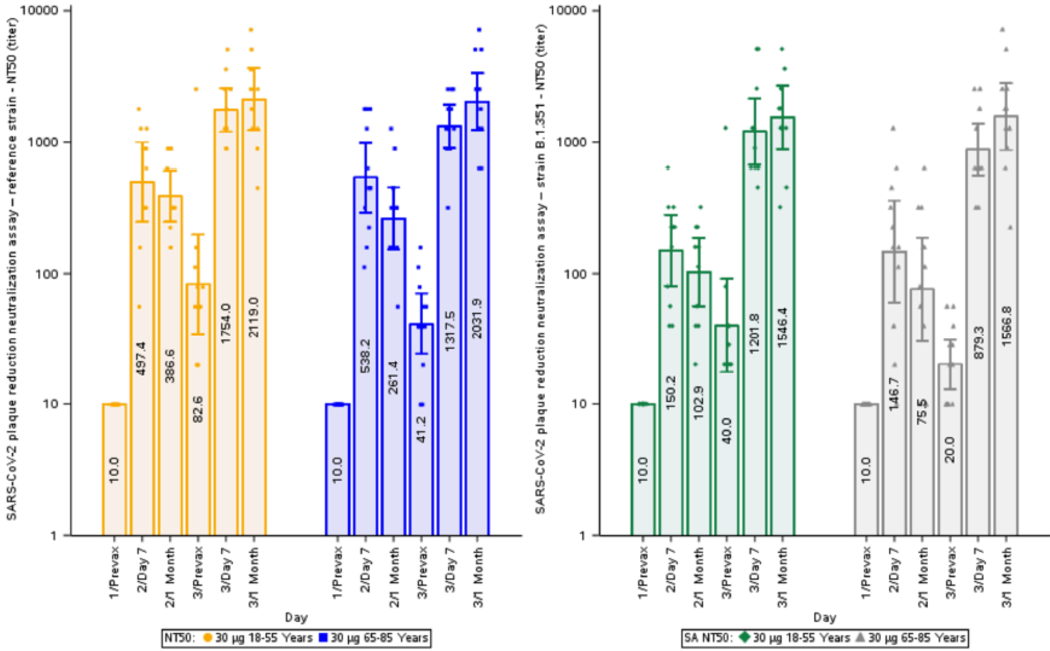
NT50 = 50% neutralising titre; SA = beta variant (B.1.351); SARS-CoV-2 = severe acute respiratory syndrome coronavirus 2.
Lower limit of quantitation (LLOQ) = 20.
Left panel = wild type or reference strain of SARS-CoV-2.
Right panel = beta variant (B.1.351).
Table 12: Study C4591001 Phase I booster; summary of geometric mean fold rises from before vaccination to each subsequent time point, initial BNT162b2 (30 μg) - (Dose 3 booster all available immunogenicity population)
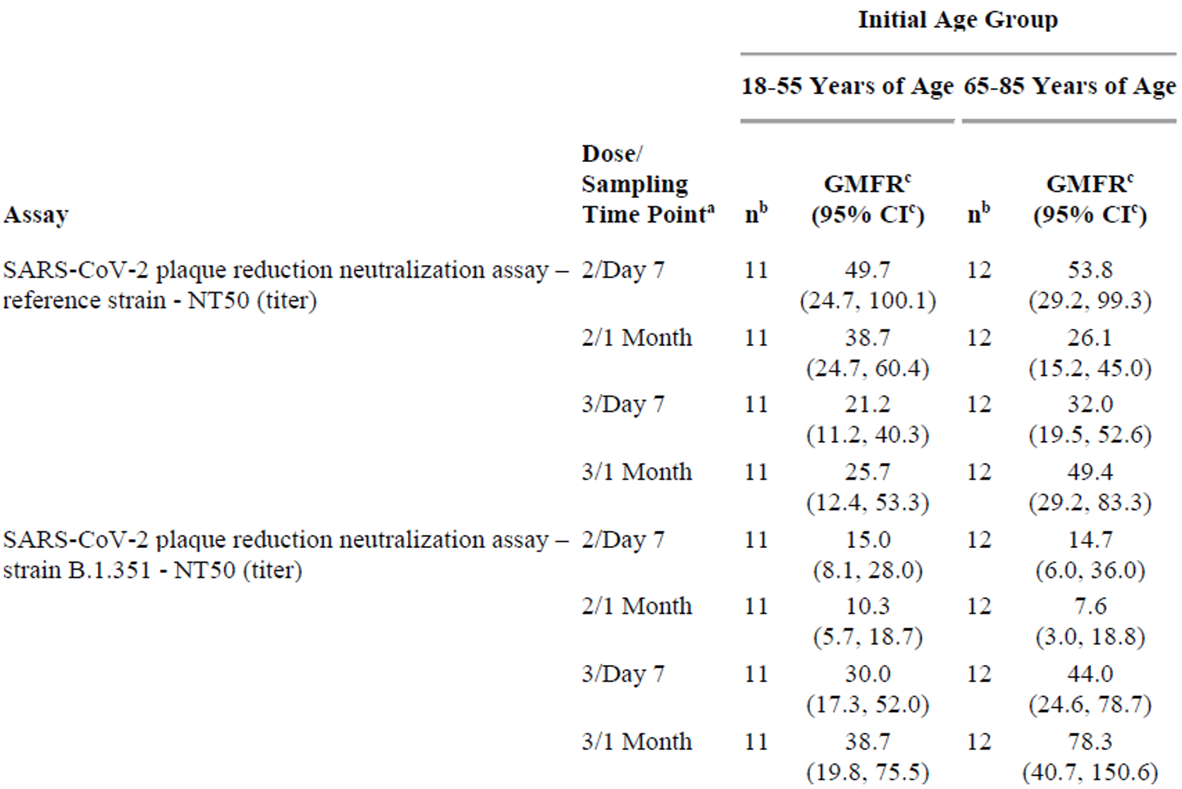
CI = confidence interval; GMFR = geometric mean fold rise; NT50 = 50% neutralising titre; SARS-CoV-2 = severe acute respiratory syndrome coronavirus 2.
Geometric mean fold rise for after booster dose is based on pre-booster dose visit. For all other visits GMFR is based on pre-Dose 1 visit.
a) Protocol specified timing for blood sample collection.
b) n = number of subjects with valid and determinate assay results for the specified assay at both before vaccination and at the given dose/sampling time point.
c) GMFRs and 2 sided 95% CIs were calculated by exponentiating the mean logarithm of fold rises and the corresponding CIs (based on the student t distribution). Assay results below the lower limit of quantitation (LLOQ) were set to 0.5 x LLOQ.

Reference strain (SARS-CoV-2 wild type) and delta strain comparison
Neutralising GMTs against recombinant virus with the delta variant spike on a wild type genetic background showed a similar pattern of higher, broader neutralising titres after Dose 3 as compared to after Dose 2 (Figure 3, Table 13).
Geometric mean titres against the wild type (reference) USA-WA1/2020 strain substantially increased after Dose 3 compared to GMTs obtained after Dose 2. GMTs at one month after Dose 3 were 1748.5 (95% CI: 1030.7, 2966.2) for younger participants, and 1595.9 (95% CI: 810.9, 3140.6) for older participants, which were approximately 5 fold and 8 fold, respectively, those of the GMTs observed at one month after Dose 2 (Figure 3, Table 13).
Figure 3: Study C4591001 Phase I booster, geometric mean titres and 95% confidence interval for SARS-CoV-2 plaque reduction neutralisation assay; 50% neutralising titres, initial BNT162b2 (30 μg) (Dose 3 booster evaluable immunogenicity population)
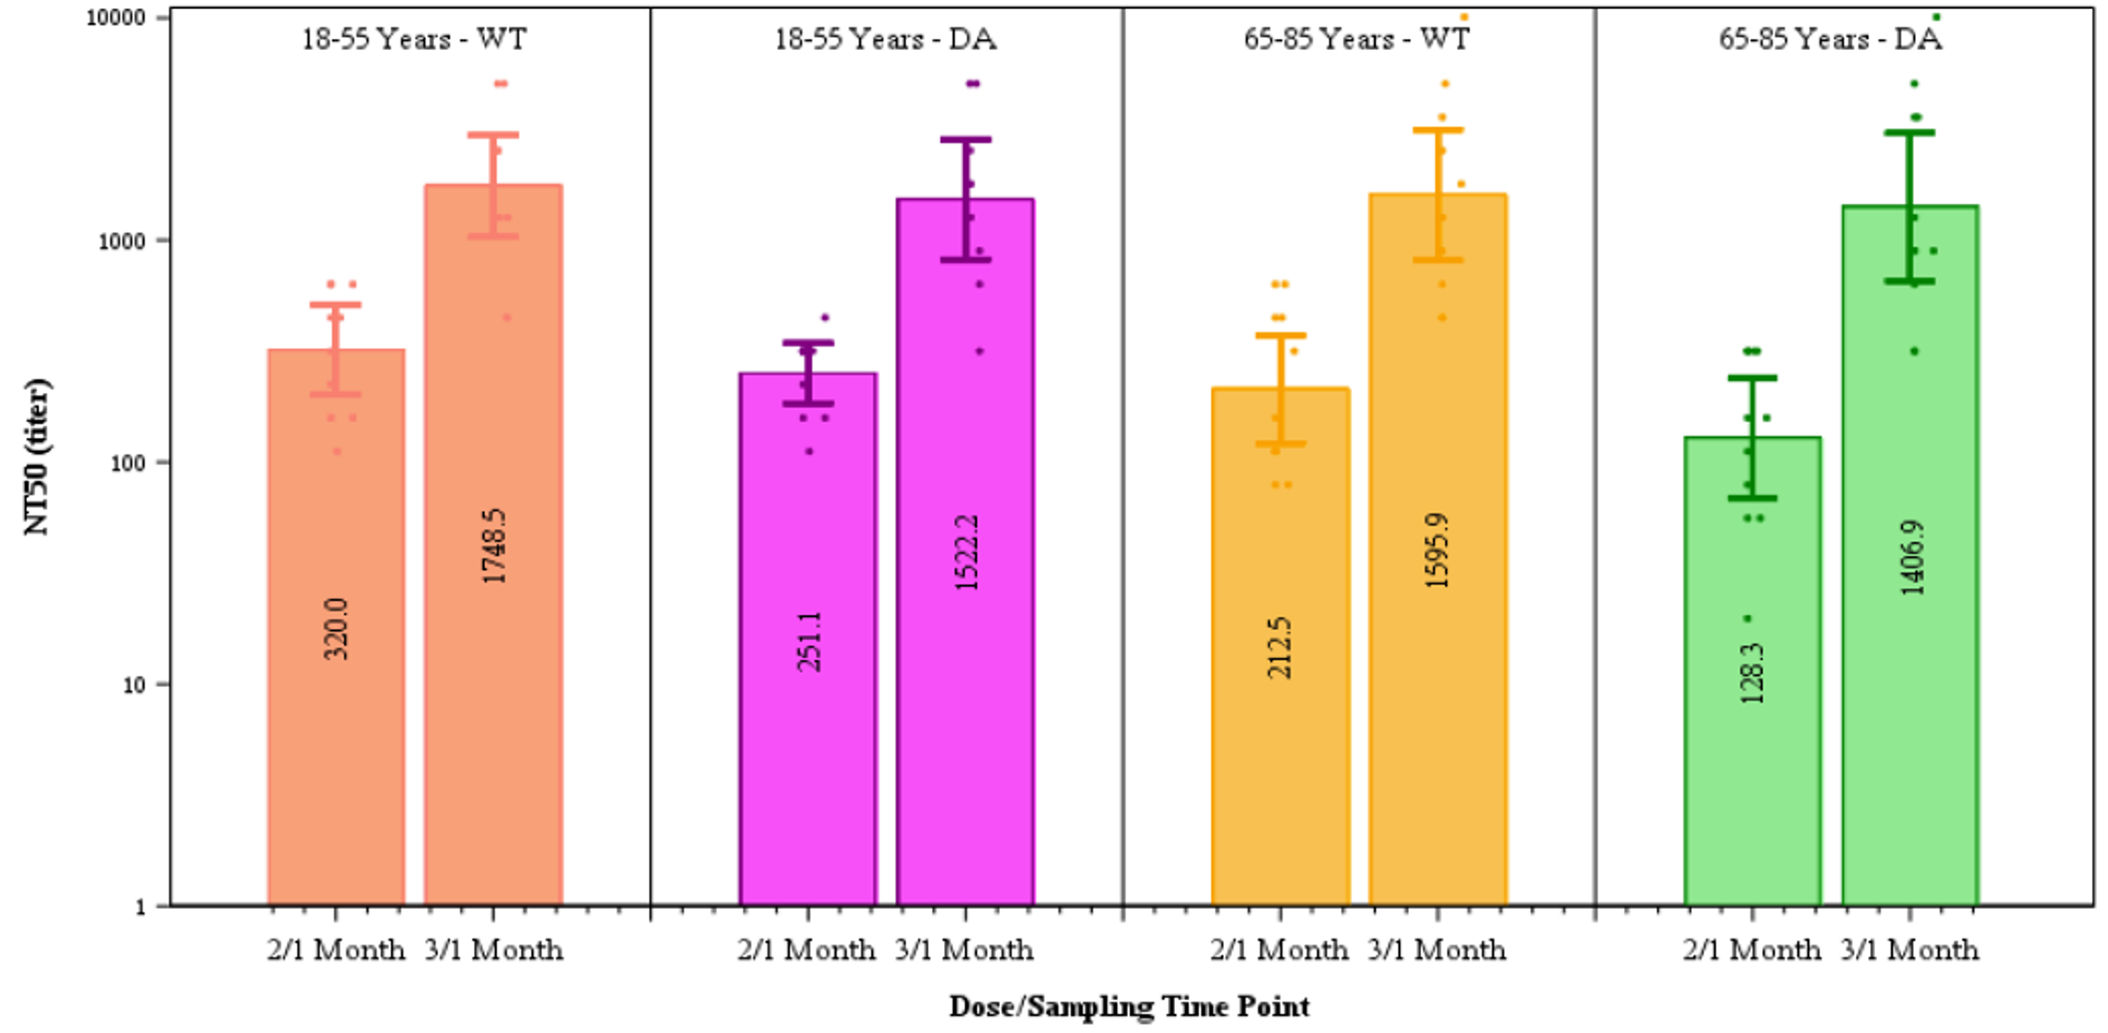
DA = delta variant; NT50 = 50% neutralising titre; WT = wildtype.
Dots represent individual antibody levels.
Number within each bar denotes geometric mean titre.
Table 13: Study C4591001 Phase I booster, summary of geometric mean titres; initial BNT162b2 (30 μg) (Dose 3 booster evaluable immunogenicity population)
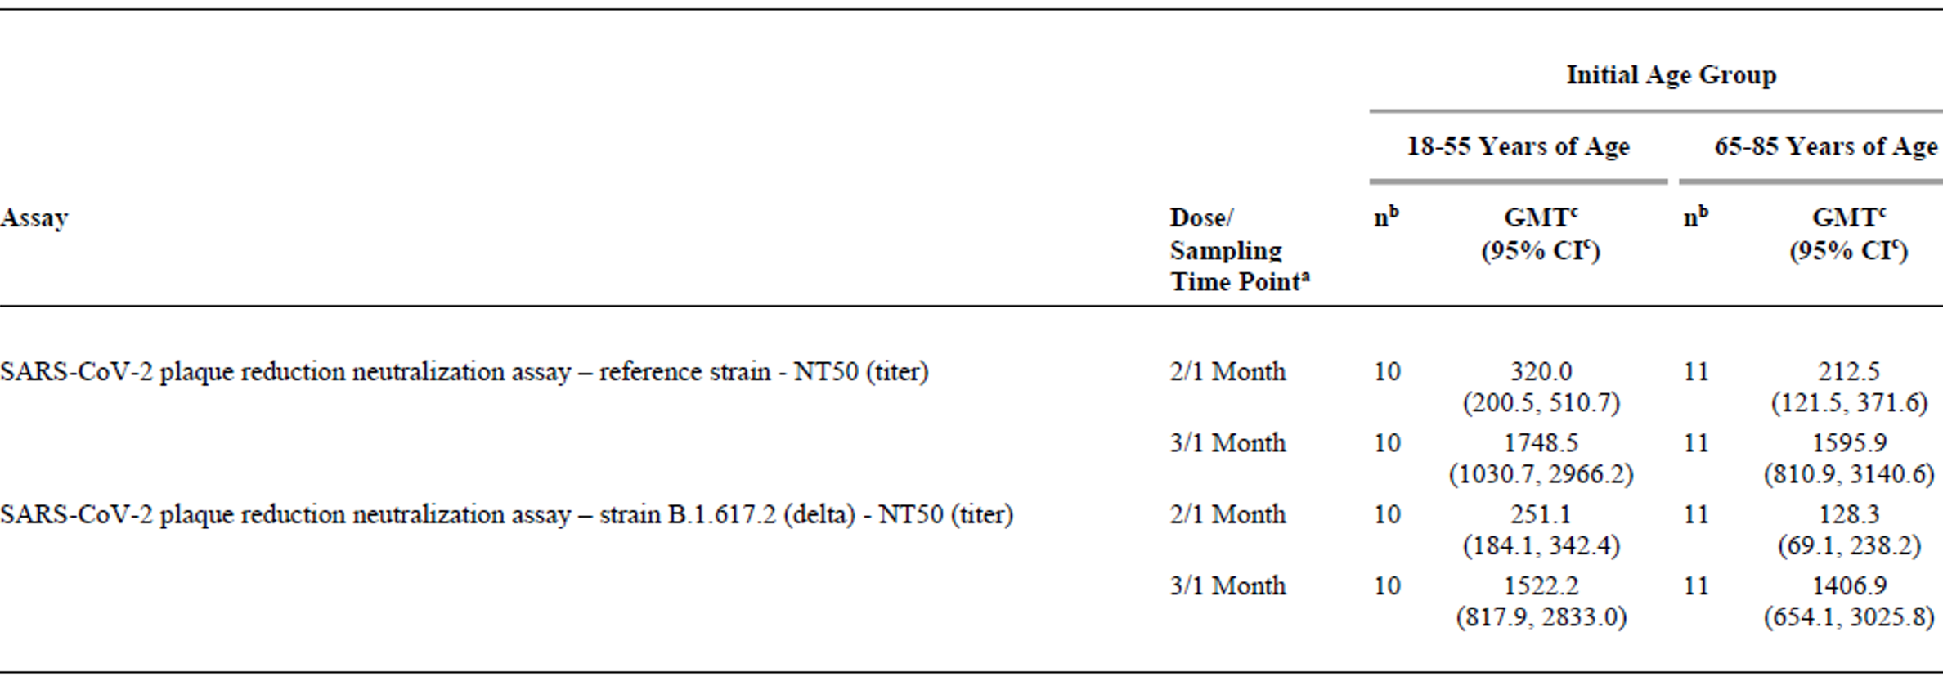
CI = confidence interval; GMT = geometric mean titre; SARS-CoV-2 = severe acute respiratory syndrome coronavirus 2.
a) Protocol specified timing for blood sample collection.
b) n = number of subjects with valid and determinate assay results for the specified assay at the given dose/sampling time point.
c) Geometric mean titres and 2 sided 95% CIs were calculated by exponentiating the mean logarithm of the titres and the corresponding CIs (based on the student t distribution). Assay results below the lower limit of quantitation (LLOQ) were set to 0.5 x LLOQ.

Safety

Phase II/III data
There were 306 Phase II/III participants 18 through 55 years of age in the booster (Dose 3) safety population. 289 (94.4%) recorded local and systemic solicited adverse reactions in an electronic diary within 7 days following vaccination (Table 14). Participant adherence with submission of electronic diary data was approximately 79% to 87% per day, with only 53.6% of participants submitting data on every intended day. Overall, reactogenicity frequencies and severities were similar to that following Dose 2 of the primary series. There were few severe reactions (mainly involving systemic rather than local reactogenicity) and no Grade 4 reactions. Almost half required anti-pyretic/pain medication.
Most treatment related adverse events represented ongoing reactogenicity events but there was an appreciable incidence of lymphadenopathy (5.2%) that was higher than that seen following Dose 2 (0.4%). One of those cases was severe (Grade 3) as it affected upper limb function; however, it still resolved within 5 days of onset and there were no sequalae. There was only one serious adverse event (SAE) (an unrelated myocardial infarction) but no immediate adverse events (AE), deaths or AEs leading to discontinuation.
There were no events leading to withdrawal reported through one month after booster dose administration. No study participants in this Phase II/III booster group died.
Table 14: Study C4591001 Phase III number (%) of subjects reporting at least one related adverse event from booster dose to one month after booster dose, by System Organ Class and Preferred Term; BNT162b2-experienced subjects who were re-randomised to receive one booster dose of BNT162b2 (30 μg) (booster safety population)
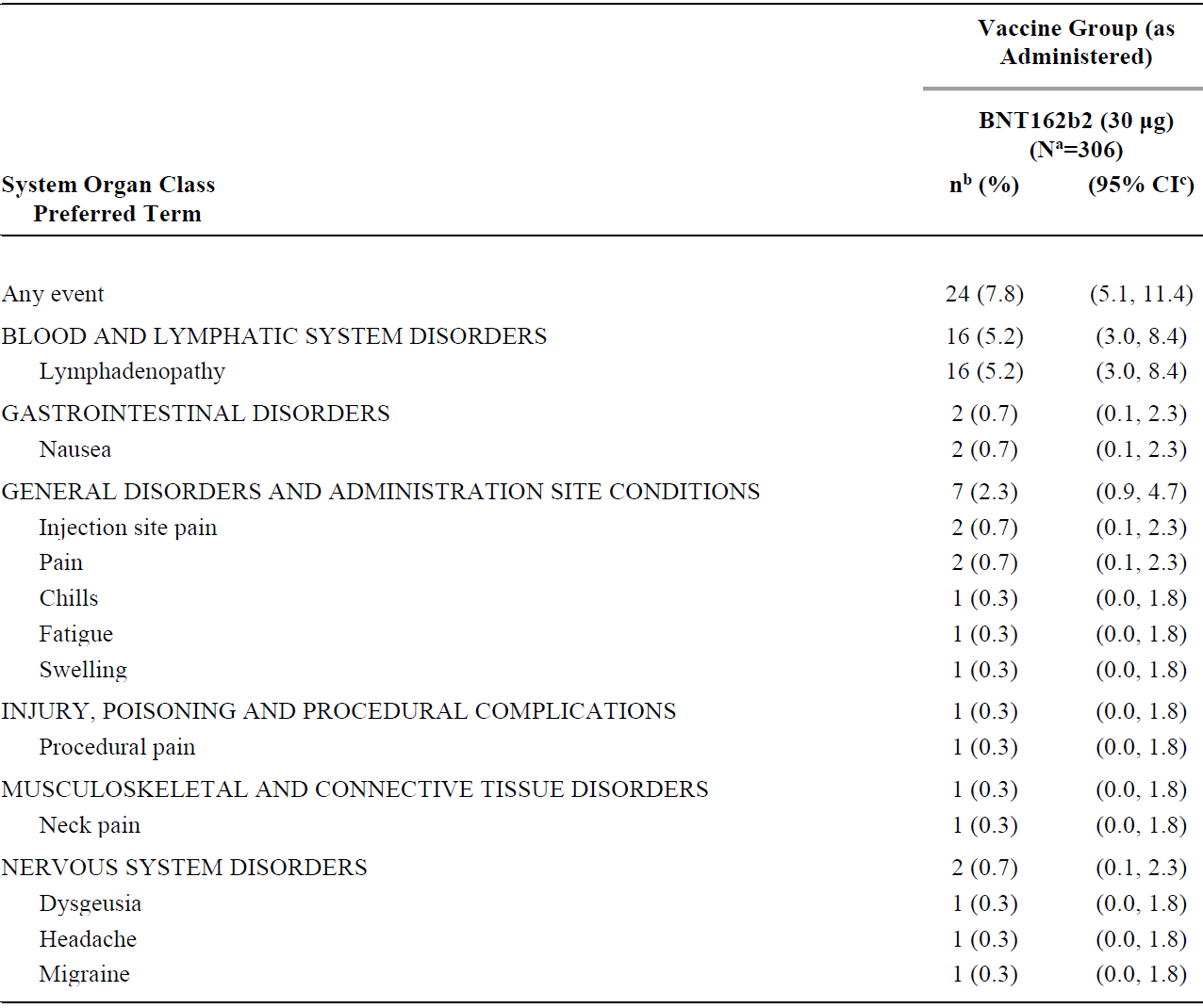
CI = confidence interval.
Medical Dictionary for Regulatory Activities (MedDRA) (v24.0) coding dictionary applied.
a) N = number of subjects in the specified group. This value is the denominator for the percentage calculations.
b) n = number of subjects reporting at least one occurrence of the specified event. For ‘any event’, n = number of subjects reporting at least one occurrence of any event.
c) Exact 2 sided CI based on the Clopper and Pearson method.
Figure 4: Study C4591001 Phase III participants reporting local reactions, by maximum severity, within 7 days after booster dose - BNT162b2 experienced subjects who were re-randomised to receive one booster dose of BNT162b2 (30 µg) (booster safety population)
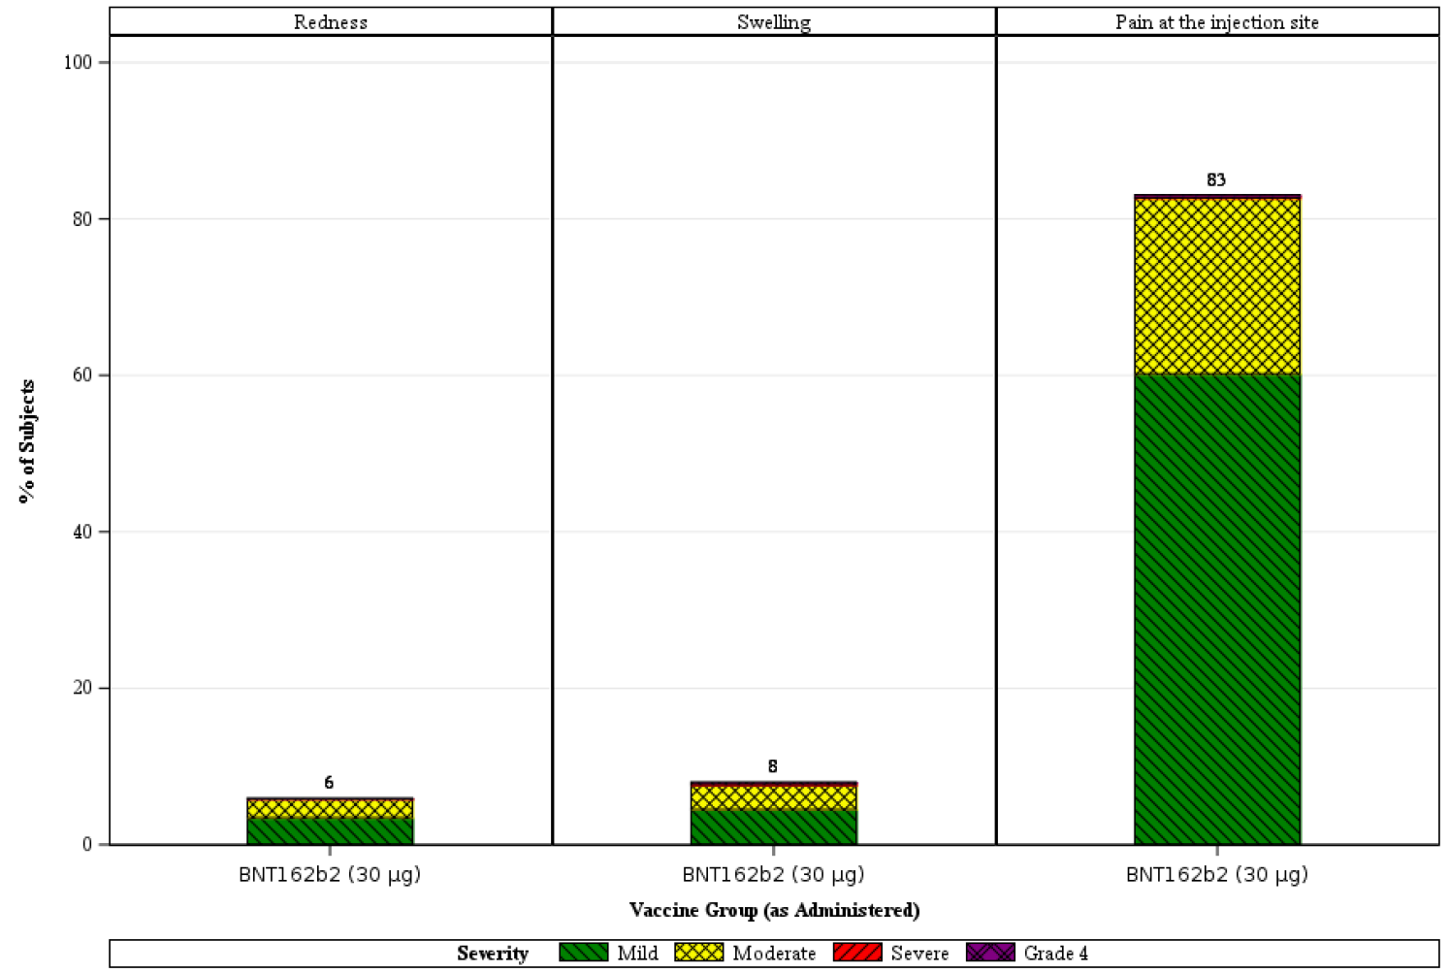
Number above each bar denotes percentage of subjects reporting the reaction with any severity.
Figure 5: Study C4591001 Phase III participants reporting systemic events, by maximum severity, within 7 days after booster dose; BNT162b2-experienced subjects who were re-randomised to receive one booster dose of BNT162b2 (30 µg) (booster safety population)
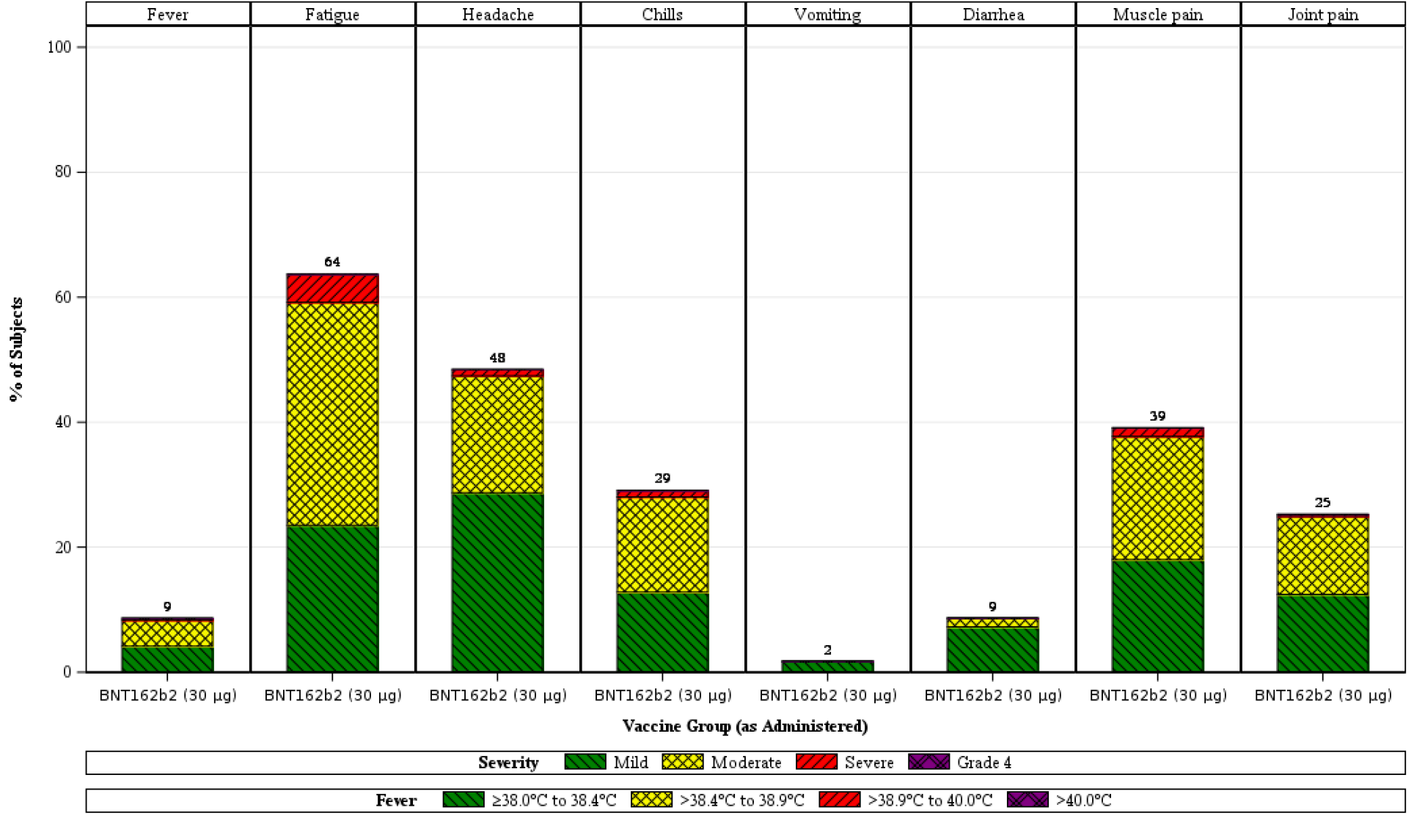
Number above each bar denotes percentage of subjects reporting the events with any severity.
There were no definite adverse events of special interest (AESIs) noted and no cases of COVID-19. There was an unusual case of dysgeusia to coffee (Grade 1 AE) that was resolved within 72 days, which was associated with nausea to coffee during the initial 7 days. There was one case of bilateral cheek swelling related to dermal fillers (Grade 1) that resolved within 2 days. There were no cases of myocarditis or pericarditis noted but the sub-study excluded part of the higher risk group (those aged 12 to 17).
There were no clear safety signals among the treatment-related AEs (other than two potentially treatment related cases above) but the population size was very small and likely insufficient to detect new signals or those of increased frequency.
Older participants that were excluded from the sub-study are unlikely to experience higher rates of reactogenicity although the opposite may be true of those < 18 years of age, given the general patterns observed in the earlier Phase II/III study. The Delegate agrees with the clinical evaluator that there doesn’t seem to be any potential SAEs that may occur more frequently in participants > 55 years of age but is unsure whether the risks of myocarditis and/or pericarditis may be higher than following the primary series in those < 18 years of age.

Phase I sub-studies of beta and delta variant
Of the 23 Phase I booster recipients (that is, 11 adults 18 to 55 years of age and 12 adults 65 to 85 years of age), 73.9% of participants reported any local reaction and 78.2% reported any systemic reaction. None of these 23 participants reported any AEs from booster to one month thereafter. There were no SAEs or AEs leading to withdrawal through one month after booster dose administration, and no deaths.

Post-marketing experience
The sponsor reviewed the safety database for post-market reports in the period 19 December 2020 (earliest conditional approval date) through 18 June 2021 that related to a booster dose of Comirnaty. The review of the cases included in the safety database did not reveal any safety issues apart from one fatal outcome, a 57 year old male with bilateral lung and liver transplant who had suffered a very recent episode of rejection. He received 3 doses of Comirnaty within 2 months and died unexpectedly 2 days following the booster dose.

Israel experience
Reference was made by the sponsor to material presented at the Food and Drug Administration (United States of America) (FDA)’s Vaccines and Related Biological Products Advisory Committee (VRBPAC) meeting on 17 September 2021 and the Delegate had access to the updated information presented on 14 October 2021 through the FDA website, ‘Booster protection against confirmed infections and severe disease - data from Israel’.²⁶ These presentations were reviewed by the clinical Delegate and the figures presented in relation to safety are reproduced in Figure 7 to Table 15 below.
Based on evidence for waning immunity evidenced by reduced vaccine effectiveness against the delta strain, a booster campaign was commenced in Israel on 30 July 2021, starting with the elderly. Eligibility began 5 months post-Dose 2 of the primary series and over half the eligible population had received a booster dose by the time of the VRBPAC meeting.
Following approximately 3.7 million booster doses (Figure 6), there were 2,394 non-serious reports and 44 serious reports. There were 17 myocarditis cases and 3 pericarditis cases (Table 15). Rates of local and systemic reactogenicity (likely to be under reported) are shown in Figure 7 and Figure 8 respectively.
Figure 6: Study C4591001 Booster dose, age distribution;
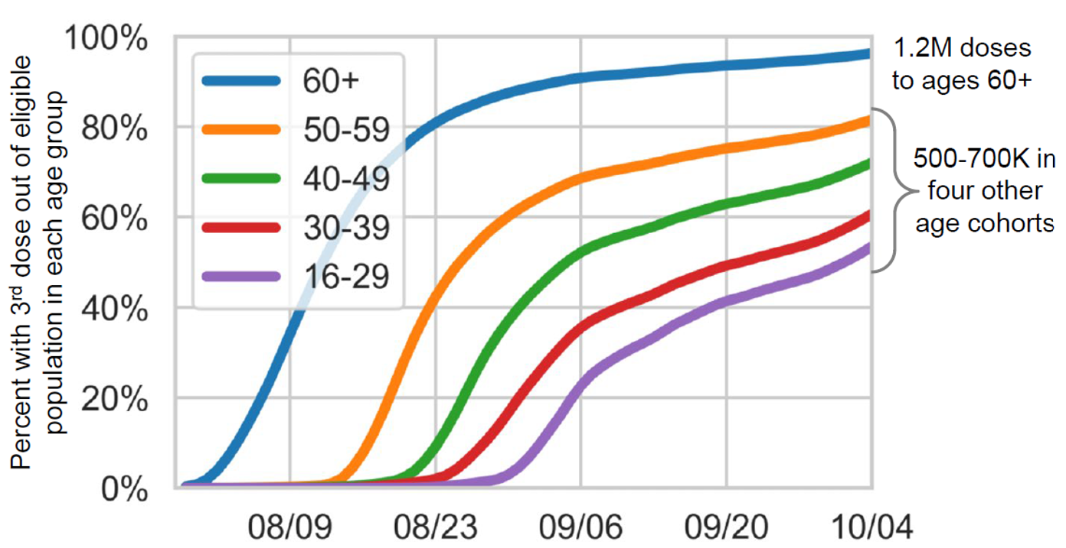
Overall 3.7 million booster doses to date
Booster campaign began on 30 July 2021
Figure 7: Study C4591001 Rate of local adverse events by dose (under reporting expected in all cases);²⁶
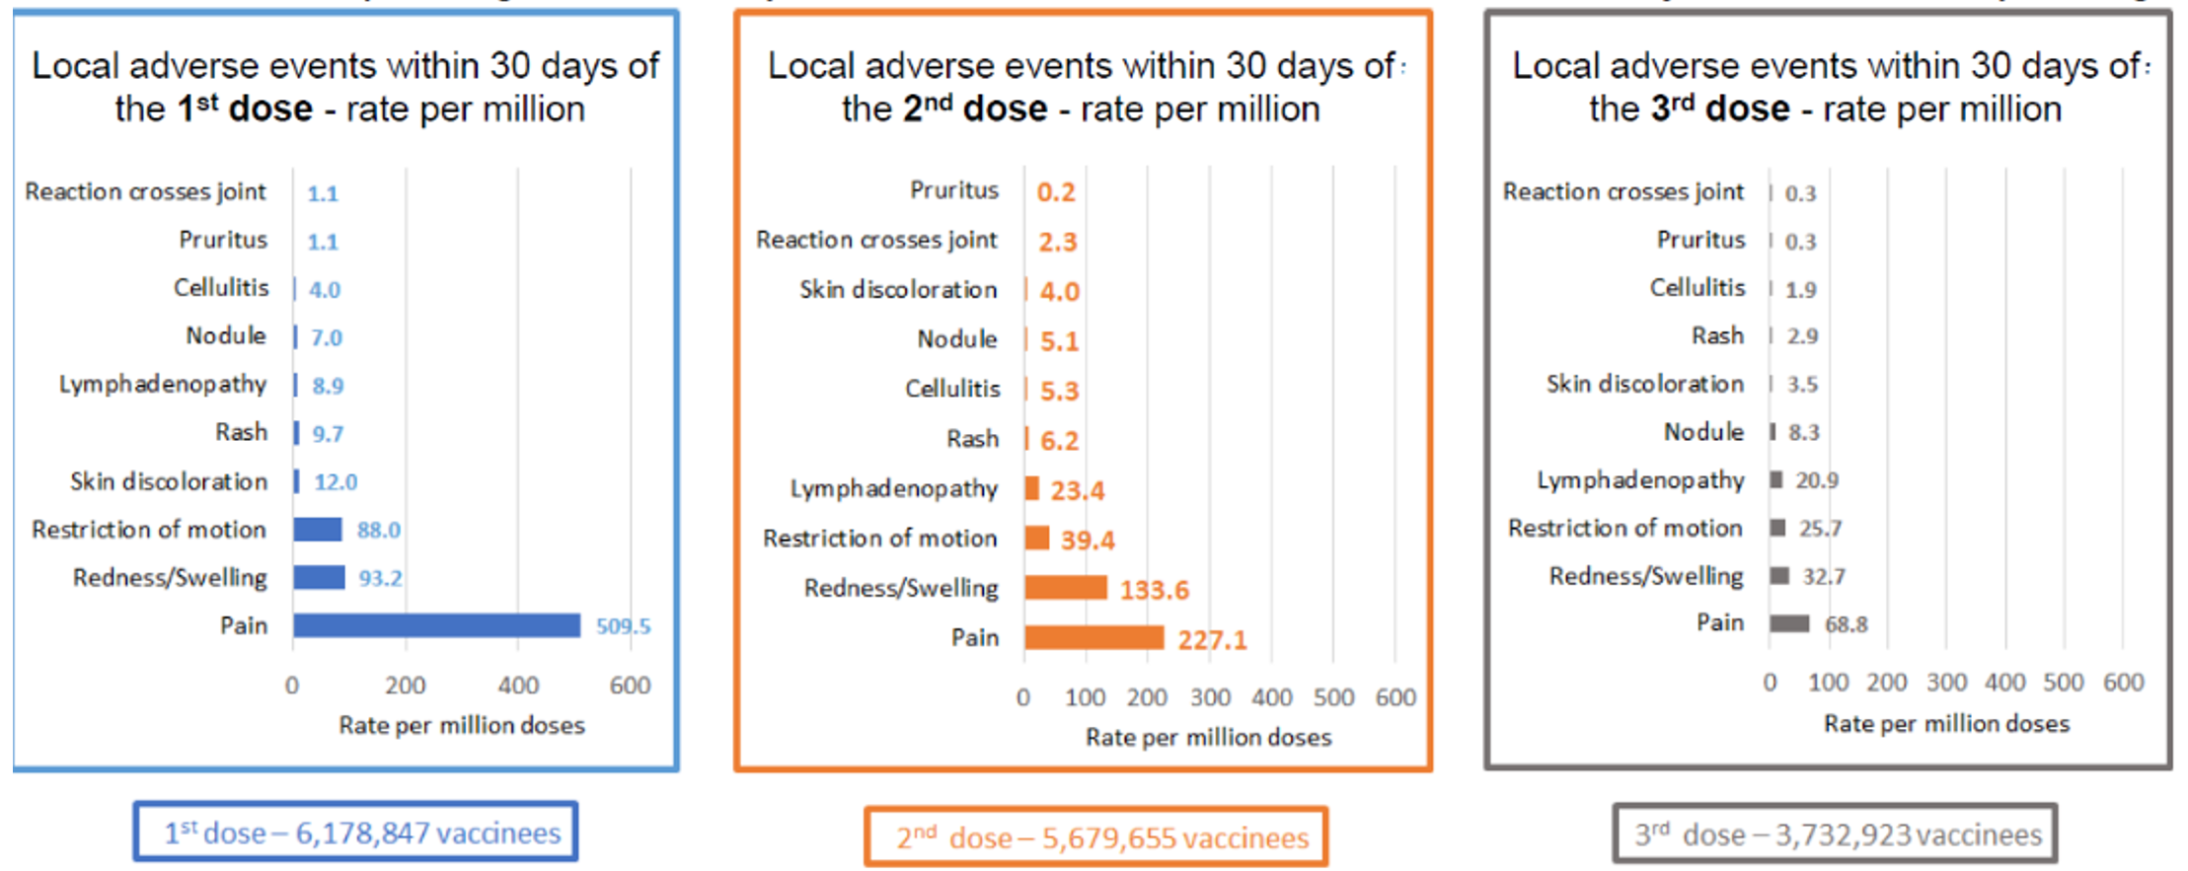
Limitation: reporting based on passive surveillance, and therefore subject to underreporting.
Data is based on adverse events reported to the State of Israel Ministry of Health (MoH). Individuals may report more than one adverse event. There is an estimated underreporting.
Figure 8: Study C4591001 Rate of systemic adverse events by dose (under reporting expected in all cases);²⁶
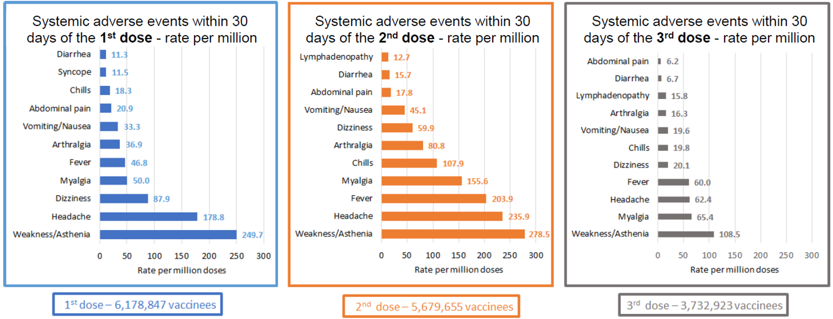
Limitation: reporting based on passive surveillance, and therefore subject to underreporting.
Data is based on adverse events reported to the State of Israel Ministry of Health (MoH). Individuals may report more than one adverse event. There is an estimated underreporting.
Table 15: Study C4591001 Myocarditis and perimyocarditis cases and number of vaccinees by age group and sex;²⁶
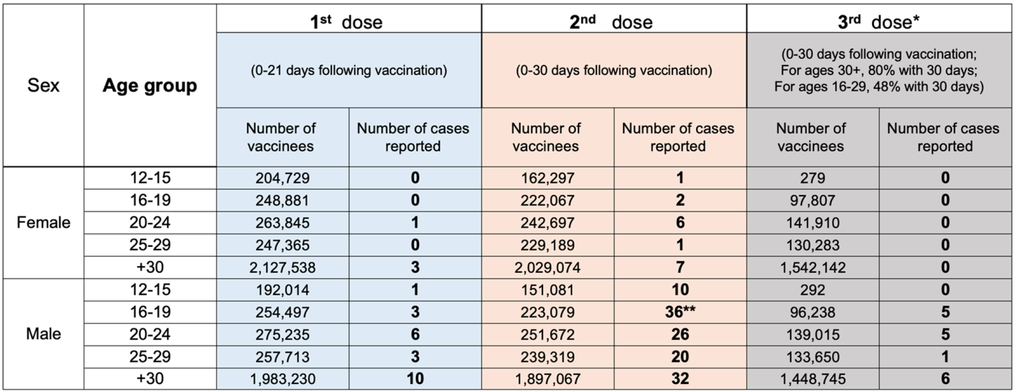
Proactive surveillance. All cases reported in Israel December 2020 to 10 October 2021.
* Two more cases are currently under diagnosis review. For 2548 individuals without gender information there were zero cases reported.
** One case - first dose Comirnaty (also known as the Pfizer COVID-19 vaccine), second dose Spikevax (also known as the Moderna COVID-19 vaccine).

The United States of America experience with an additional dose of Comirnaty
On 12 August 2021 the FDA amended their existing Emergency Use Authorization (EUA) to permit an additional dose after completion of the primary series to eligible persons with moderate to severe immunocompromising conditions.
The EUA has been amended further on 22 September 2021 to permit an additional dose for persons ≥ 65 years of age, and for those at high risk for severe COVID-19, or whose occupational or institutional exposure puts them at high risk for COVID-19; however, that occurred after the data cut-off date for this Morbidity and Mortality Weekly Report.
Safety data were submitted by vaccinees under the Centers for Disease Control and Prevention (United States of America) (CDC)’s V-safe;²⁸ program (a voluntary, smartphone based surveillance system). From 12 August 2021 through 19 September 2021 there were 22191 reports of receipt of a booster dose of a COVID-19 vaccine (not just Comirnaty) from among more than 2.21 million persons in the US who had received additional doses of a COVID-19 vaccine. The demographics of those reporting is shown in Table 16.
Data were available for local and systemic reactogenicity (shown in Table 17) but no AE data have been captured. Among those who received 3 doses of Comirnaty (n = 6308), local reactions were reported more frequently after Dose 3 than Dose 2 (74.1% versus 71.7% respectively). Systemic reactions were less frequent (69.2% versus 71.7% respectively).
The CDC concluded that the patterns of adverse reactions observed after Dose 3 of Comirnaty were consistent with previously described reactions after receipt of Dose 2. No unexpected patterns of AEs were detected and there were no new safety signals.
The CDC mentioned 4 caveats regarding interpretation of the data:
- Enrolment in V-safe is voluntary and likely not representative of the USA population.
- The current data were limited to people with immunocompromising conditions (note: time to booster could be < 6 months).
- Causal relationships cannot be established using V-safe data.
- Insufficient data were available to determine patterns of AEs.
Table 16: Study C4591001 Demographic characteristics of persons who received an additional dose of COVID-19 vaccine (N = 22,191) and completed at least one V-safe;²⁸ health check-in survey on Days 0 to 7 after vaccination, by primary vaccination series and manufacturer of subsequent dose received (United States of America, 12 August 2021 to 19 September 2021);
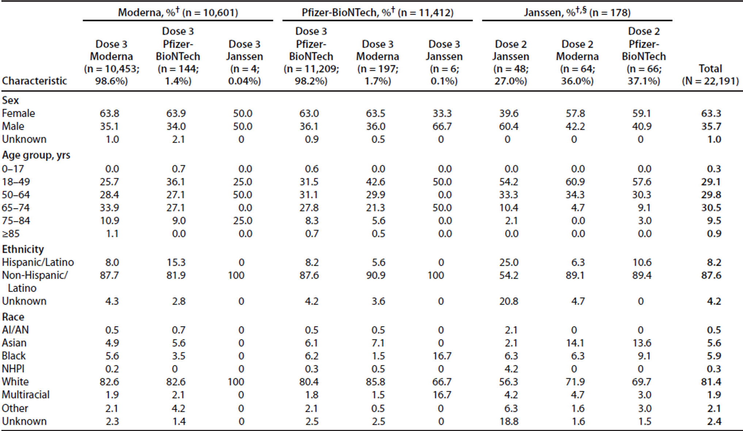
AI/AN = American Indian/Alaska Native; N = population size; n = sample size; NHPI = Native Hawaiian or the Pacific Islander; yrs = years.
* Percentage of registrants who completed at least one V-safe health check-in survey on Days 0 to 7 after vaccination.
† Primary vaccination series.
§ Includes persons who received a primary COVID-19 Vaccine Janssen single dose and one additional dose of vaccine from the listed manufacturers.
Table 17: Study C4591001 Adverse reactions reported by persons who received an additional dose of COVID-19 vaccine (N = 22,191) and completed at least one V-safe; health check-in survey on Days 0 to 7 after vaccination, by primary vaccination series and manufacturer of subsequent dose received (United States of America, 12 August 2021 to 19 September 2021);²⁷
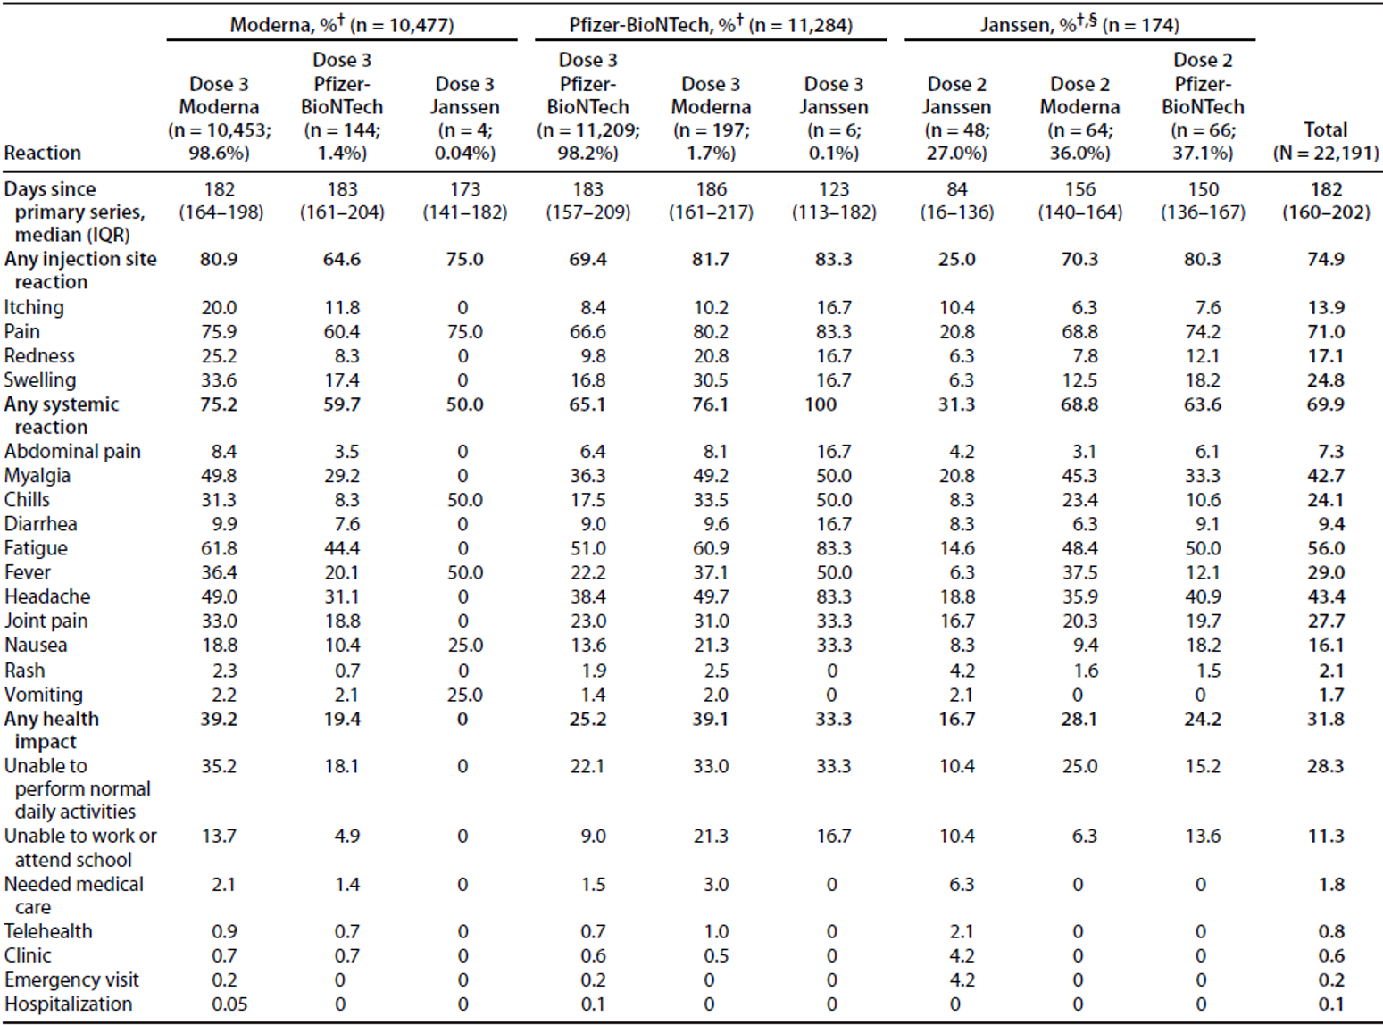
N = population size; n = sample size; IQR = interquartile range.
* Percentage of registrants who completed at least one V-safe health check-in survey on Days 0 to 7 after vaccination.
† Primary vaccination series.
§ Includes persons who received a primary COVID-19 Vaccine Janssen single dose and one additional dose of vaccine from the listed manufacturers.

Risk management plan
The sponsor has submitted EU-risk management plan (RMP) version 2.2 dated 15 July 2021; data lock point (DLP) 13 March 2021 (Pfizer clinical database), 28 February 2021 (Pfizer safety database, 12 to15 years), 23 October 2020 (BioNTech clinical database, ≥ 16 years), 28 February 2021 (Pfizer safety database and post-authorisation exposure). The sponsor informed the TGA that the Australian specific annex (ASA) version 0.3 (dated 11 June 2021) provided in support of the previous application PM-2021-02187-1-2 is applicable to this submission.
The most recently evaluated EU-RMP was version EU-RMP version 0.2 (dated 29 April 2021; DLP 28 February 2021 (safety database) 13 March 2021 (clinical database)) and ASA version 0.3 (dated 11 June 2021).
The summary of safety concerns and their associated risk monitoring and mitigation strategies are summarised in Table 18.
Table 18: Summary of safety concerns
Summary of safety concerns |  | Pharmacovigilance |  | Risk minimisation
 |  | Routine | Additional | Routine | Additional
Important identified risks | Anaphylaxis | † | * |  | –
Important potential risks | Vaccine-associated enhanced disease (VAED) including Vaccine-associated enhanced respiratory disease (VAERD) | † | * | – | –
Missing information | Use in pregnancy and while breast feeding |  | * |  | –
Missing information | Use in immunocompromised patients |  | * |  | –
Missing information | Use in frail patients with co-morbidities (e.g. chronic obstructive pulmonary disease (COPD), diabetes, chronic neurological disease, cardiovascular disorders) |  | * |  | –
Missing information | Use in patients with autoimmune or inflammatory disorders |  | * | – | –
Missing information | Interaction with other vaccines |  | * |  | –
Missing information | Long term safety data |  | * | – | –
†Data capture aid
*Clinical trials
- This summary of safety concerns is the same as that evaluated for the previous Submission PM-2021-02187-1-2. The introduction of a booster dose to be used in individuals who have completed their primary vaccination is not expected to change the safety summary from an RMP perspective.
- Routine and additional pharmacovigilance activities have been proposed to address all the safety concerns included in the safety summary. The pharmacovigilance plan was deemed acceptable during the previous evaluations and continues to be acceptable for the current submission.
- The sponsor is expected to make any updates that are required to the clinical study plan section of the Australian specific annex (ASA), to include details relevant to the current submission.
- Only routine risk minimisation measures have proposed. This approach is considered acceptable.

Risk-benefit analysis

Delegate’s considerations
The clinical data submitted in this application come from an ongoing Phase I/II/III study (Study C4591001), which is also the source of clinical data supporting the original approval of the 2-dose primary series for use in individuals 16 years of age and older. It is interim result for a booster dose of BNT162b2 given at approximately 6 months after Dose 2 to show that higher neutralising titres are obtained after the booster dose compared to the second dose.
In total, 312 subjects aged 18 to 55 years from the part of the Phase III study (Study C4591001) conducted in the USA, been included in a subset that received a booster dose of BNT162b2 at 30 μg ≥ 5 months after their second dose. Six individuals received a dose of BNT162b2SA (that is, another exploratory vaccine directed specifically against beta variant) by error instead of BNT162b2 30 μg, limiting the finally evaluated immunogenicity and safety population to 306 subjects.
For the primary endpoints in the Phase II/III sub-study, there is statistically significant evidence of non-inferiority between geometric mean neutralising titres (as measured by geometric mean ratios) and seroresponse to the reference ‘wild type’ strain of SARS-CoV-2 at one month post-Dose 3 (that is, following the booster) and one month post-Dose 2 (that is, following the primary 2 dose vaccination course). In addition, GMTs were significantly higher following the booster than the primary series. These data came from 306 HIV negative patients 18 to 55 years of age, all from the USA sites.
Exploratory studies of neutralising immune responses to the B.1.351 (beta) and B.1.617.2 (delta) variants were conducted in 23 participants recruited from the initial Phase I study, approximately half each from an 18 to 55 years of age cohort and a 65 to 85 years of age cohort. These showed similar general patterns in waning for the wild type and Beta variants of SARS-CoV-2 followed by boosting of responses (note: waning wasn’t studied for delta). Of note, initial responses following the primary series were attenuated in the older relative to younger cohort and in the beta variant relative to wild type strain (note: not assessed for delta variant). In both instances (age cohort and strain type), comparative differences were less following the booster dose than following the primary vaccination course. Statistical analyses were not performed for these Phase I sub-studies.
There were no data generated from participants < 18 years of age and the only data from participants > 55 years of age were from the 12 participants in the 65 to 85 years of age cohort in the Phase I study. Primary vaccinations (Dose 1 and Dose 2) were given very close to the intended schedule (3 weeks apart) in almost all participants and boosters between 150 to 210 days following Dose 2; the effect on GMTs of any variation beyond those parameters has not been established. This may be of some relevance in the Australian context where the dosing window for primary vaccination has been extended in some instances to facilitate more rapid rollout of a first-dose prioritised vaccination campaign.
The most commonly reported local reaction was pain at the injection site (83%), of which the majority were mild to moderate. No subjects reported Grade 4 local reaction. The most commonly systemic event was fatigue (64%) of which 40% were moderate or severe. Almost half of the study population (n = 135) used antipyretic or pain medication after the booster dose. These results are in line with the reported data after the second dose in the Phase II/III analysis of Study C4591001.
Among the 306 subjects, 44 (14%) reported any AEs up to one month after administration of the booster dose. Adverse events presented belonged specifically to the System Organ Classes blood and lymphatic system disorders (Preferred Term: lymphadenopathy), general disorders and administration site conditions (local and systemic reactogenicity) and musculoskeletal disorders. No events of death were reported. The incidence of lymphadenopathy was higher after the booster dose compared to what was observed after the second dose in the Phase II/III analysis of Study C4591001 (5.2% versus 0.4%). No deaths, vaccine related SAEs, or events of myocarditis, pericarditis, anaphylaxis, appendicitis, or Bell’s palsy were reported among study participants who received the BNT162b2 booster dose.
It can be concluded that the reactogenicity profile of the booster dose is in line with the data reported after administration of the second dose. However, the submitted data is limited in terms of the numbers of vaccinees included in the study and the duration of follow up does therefore not allow any firm conclusions regarding the pattern and incidence of uncommon or rare AEs/SAEs.
Recent evidence has raised concerns over the declining neutralising antibody titres or reduced effectiveness against symptomatic disease, which may significantly decline the effectiveness against severe disease. In addition, emergence of the highly transmissible delta variant of SARS-CoV-2 has resulted in a new wave of COVID-19 cases in many parts of the world including the recent wave in Australia. It has led to considerations for administration of booster doses to individuals who received primary series of vaccines in an effort to enhance immunity, and thus sustain protection from COVID-19.
Some observational studies have suggested declining efficacy of Comirnaty over time against symptomatic infection or against the delta variant, while others have not. However, overall, data indicate that currently authorised COVID-19 vaccines in Australia still afford protection against severe COVID-19 disease and death. There are many potentially relevant studies, but the TGA has not independently reviewed or verified the underlying data or their conclusions. Some of these studies, including data from the vaccination program in Israel, has been summarised during the recent VRBPAC meeting held on 17 September 2021.
The interim data submitted in this submission has shown that a booster dose of Comirnaty given 6 months after the primary vaccination series restored waning neutralising titres against wild type SARS-CoV-2 to significantly higher levels than seen following the primary vaccination course.
However, as there is no serological correlate of protection, the clinical relevance of restoring the waning titres is unknown. Therefore, while the immunogenicity and reactogenicity of a booster dose have been appropriately characterised, the utility of a booster dose has not been fully established. In addition, the risk of rarer and more serious side effects such as myocarditis remains uncharacterised. Hence, the decision to implement a booster dose of Comirnaty needs to be taken based on emerging epidemiological vaccine efficacy or effectiveness data in different age groups and given differing comorbidities, including immunosuppression.
The potential benefit in terms of increased duration of protection, and possibly increased protection against variants of concern has not been clearly demonstrated. However, it is likely that a booster dose will provide longer term protection based on experience with other vaccines, and the immunogenicity data available.

Proposed action
In summary, the benefit risk profile of a booster dose of Comirnaty in individuals aged 18 years and older appears positive, provided its implementation is guided by vaccine effectiveness data and considering limited safety data.
While a decision is yet to be made, at this stage the Delegate is inclined to approve the variation of the product pending Advisory Committee on Vaccines (ACV) deliberation.

Advisory Committee considerations
The Advisory Committee on Vaccines (ACV), having considered the evaluations and the Delegate’s overview, as well as the sponsor’s response to these documents, advised the following.

Specific advice to the Delegate
- Does the ACV agree that the immunogenicity and safety data support the administration of a booster dose?
The ACV agreed that the immunogenicity data supports the administration of a booster dose, that is, a booster dose of Comirnaty administered at least 6 months after the primary vaccination series, to restore waning neutralising antibody titres against wild type SARS-CoV-2 to significantly higher levels than seen after primary vaccination course.
The ACV was of the view that the Phase I and III data from the pivotal Study C4591001 demonstrated the induction of high levels of neutralising antibodies following the booster dose, and noted GMTs were significantly higher than those observed after Dose 2. The ACV commented that the data shows the booster dose substantially increased neutralising titres against variants of concern (beta and delta) one month after the booster dose, compared with one month after Dose 2 of the primary course.
The ACV noted the limited data for the 65 to 85 years age group (n = 12) is confined to Phase I participants. In this group the initial responses following primary course waned to a greater extent than in younger individuals, followed by commensurate boosting.
The ACV commented that the duration of the sustained antibody response remains unknown and that there is no known serological correlate of protection. Therefore, the clinical relevance of restoring waning titres is not yet known.
In regard to safety, the ACV commented that the safety data from the 306 Phase III booster recipients did not show any new safety concerns within one month of the booster dose and commented that these results are comparable with the reported data after Dose 2. There was no evidence of increased local or systemic reactogenicity relative to Dose 2. Most reactogenicity events after the booster dose were of mild to moderate severity and self-limited in duration. The rate of lymphadenopathy was increased following the booster dose (5.2%) compared to following Dose 2 (0.4%), with most cases resolving within 5 days of onset.
The ACV noted the small numbers in the safety population (n = 306), predominantly aged 18 to 55 years. Rare but significant AEs such as pericarditis/myocarditis were not observed but the power to detect these was very limited.
The ACV also reviewed data demonstrating Comirnaty booster safety and effectiveness from programs implemented in other countries, in particular the booster program in Israel, as presented to the FDA VRBPAC meeting on 15 October 2021 and available in peer reviewed published literature. This data provided reassurance on population level safety and effectiveness in a large number of vaccine booster dose recipients, in addition to the small number of participants in the trial presented by the sponsor.
- Advice on the qualifying statement on booster dosing in the PI.
- Option 1
A booster dose (third dose) of Comirnaty may be administered intramuscularly at least 6 months after the second dose in individuals 18 years of age and older. The decision when and for whom to implement a third dose of Comirnaty should be made based on available vaccine effectiveness data, taking into account limited safety data (see Sections 4.4 and 5.1).
- Option 2
A booster dose (third dose) of Comirnaty may be administered intramuscularly at least 6 months after the second dose in individuals 18 years of age and older when the potential benefits outweigh any potential risks.
The ACV advised that the qualifying statement on booster dosing in the PI should be worded as follows:
‘A booster dose (third dose) of Comirnaty may be administered intramuscularly at least 6 months after the completion of a COVID-19 vaccine primary series in individuals 18 years of age and older. The decision when and for whom to implement a third dose of Comirnaty should be made based on available safety and vaccine effectiveness data (see sections 4.4 and 5.1), in accordance with official recommendations.’
In providing this advice the ACV considered what primary course individuals will have received. While the ACV noted that the data in the submission are limited to booster dosing of Comirnaty following a primary course of Comirnaty, they agreed that adding 'the completion of a COVID-19 vaccine primary series' and 'in accordance with official recommendations' would provide flexibility for recommendations of the primary vaccination series to evolve as further data becomes available. The committee also noted considerable experience with mixed dose schedules in other countries, as well as in small studies.
Following on from this, the ACV advised the following clarifying wording should also be added to the PI, based on the current data:
‘There are limited data on the interchangeability of Comirnaty with other COVID 19 vaccines to complete the primary vaccination course or the booster dose (third dose). Individuals who have received 1 dose of Comirnaty should preferably receive a second dose of Comirnaty to complete the primary vaccination course and for any additional doses.’
- Does the ACV think that additional information should be provided in the PI in relation to a third dose for immunocompromised people at least 28 days after the primary series (similar to the US EUA PI and EU SmPC [Summary of product characteristics])?
The ACV acknowledged the ATAGI [Australian Technical Advisory Group on Immunisation] recommendation made on 7 October 2021 in regard to use of a third primary dose of COVID-19 vaccine in individuals who are severely immunocompromised.
The ACV was of the view that information on a third dose for immunocompromised people should be included in the PI and suggested the following wording:
‘In accordance with official recommendations, a third dose may be given at least 28 days after the second dose to individuals who are severely immunocompromised.’
The ACV emphasised that it should be made clear this is a third dose within the primary series rather than a booster dose.
- The Committee is also requested to provide advice on any other issues that it thinks may be relevant to a decision on whether or not to approve this application.
The ACV noted pending clinical trial data on immunogenicity and safety in the balance of the 600 subjects who received the beta variant vaccine construct in the Comirnaty booster dose study. The ACV also noted a recent press release detailing efficacy and safety in a trial (NCT04955626) of a booster dose of Comirnaty in more than 10,000 subjects that is yet to be published or formally reviewed.
The ACV suggested the following changes to the Comirnaty PI:
- Myocarditis and pericarditis
‘Very rare cases of myocarditis and pericarditis have been observed following vaccination with Comirnaty. These cases have primarily occurred within 14 days following vaccination, more often after the second vaccination, and more often in younger males’
Change ‘men’ to ‘males’, to use more inclusive wording for the younger age group.
- Duration of protection
‘The duration of protection afforded by Comirnaty is unknown as it is still being determined by ongoing clinical trials and observational studies.’
Add the text in bold to the sentence above.

Conclusion
The ACV recommended the approval of changes to the Product Information of Comirnaty to include a booster (third) dose for persons 18 years and older, and dosage for immunocompromised persons over 12 years.

Outcome
Based on a review of quality, safety and efficacy, the TGA approved the registration of Comirnaty (BNT162b2 (mRNA)) 30 µg/0.3 mL concentrated suspension for injection, multi-dose vial, change in dose regimen to:
‘Individuals 12 years of age and older
Comirnaty is administered intramuscularly after dilution as a primary course of 2 doses at least 21 days apart. See dosing instructions below.
A booster dose (third dose) of Comirnaty may be administered intramuscularly at least 6 months after the completion of a COVID-19 vaccine primary series in individuals 18 years of age and older.
The decision when and for whom to implement a booster (third dose) of Comirnaty should be made based on available vaccine safety and effectiveness data (see Sections 4.4 Special warnings and precautions for use and 5.1 Pharmacodynamic properties), in accordance with official recommendations.
There are limited data on the interchangeability of Comirnaty with other COVID-19 vaccines to complete the primary vaccination course or the booster dose (third dose).
Individuals who have received 1 dose of Comirnaty should preferably receive a second dose of Comirnaty to complete the primary vaccination course and for any additional doses.
Severely immunocompromised aged 12 years and older
In accordance with official recommendations, a third dose may be given at least 28 days after the second dose to individuals who are severely immunocompromised (see section 4.4 Special warnings and precautions for use).
Elderly population
No dosage adjustment is required in elderly individuals ≥ 65 years of age.’

Specific conditions of registration applying to these goods
- Comirnaty vaccine is to be included in the Black Triangle Scheme due to provisional approval. The PI and Consumer Medicines Information (CMI) for Comirnaty vaccine must include the black triangle symbol and mandatory accompanying text for the products entire period of provisional registration.
- Risk management plan
The Comirnaty EU-RMP (version 2.2, dated 15 July 2021, DLP 13 March 2021 (Pfizer clinical database), 28 February 2021 (Pfizer safety database, 12 to15 years), 23 October 2020 (BioNTech clinical database, ≥ 16 years), 28 February 2021 (Pfizer safety database and post-authorisation exposure)), with ASA (version 0.3, dated 11 June 2021), included with Submission PM-2021-04582-1-2, and any subsequent revisions, as agreed with the TGA will be implemented in Australia.
An obligatory component of RMP is routine pharmacovigilance. Routine pharmacovigilance includes the submission of periodic safety update reports (PSURs).
Unless agreed separately between the supplier who is the recipient of the approval and the TGA, the first report must be submitted to TGA no later than 15 calendar months after the date of the approval letter. The subsequent reports must be submitted no less frequently than annually from the date of the first submitted report until the period covered by such reports is not less than three years from the date of the approval letter, or the entire period of provisional registration, whichever is longer.
The reports are to at least meet the requirements for PSURs as described in the European Medicines Agency’s Guideline on Good Pharmacovigilance Practices (GVP) Module VII-periodic safety update report (Rev 1), Part VII.B Structures and processes. Note that submission of a PSUR does not constitute an application to vary the registration. Each report must have been prepared within ninety calendar days of the DLP for that report.
Additional to the routine submission of the routine PSURs, expedited monthly, Comirnaty safety summary reports (including safety data for patients in Australia) are to be provided for the first 6 months post-registration, and thereafter at intervals specified by the TGA
- Clinical
Data relating to booster dose
  - Submit the clinical study report of Study NCT04955626 to evaluate the safety and efficacy of a booster dose of BNT162b2 against COVID-19 in participants ≥16 years of age.
- Data relating to individuals 12 to 15 years old
  - Submit safety data for all adolescents 12 to 15 years of age in Study C4591001, 6 months post-Dose 2, when the data becomes available.
  - Submit study report of Study C4591001, including data up to 24 months after Dose 2 in adolescents 12 to 15 years of age, when the data becomes available.
Data relating to individuals 16 years and older
  - Submit safety data in relation to follow-up at 6 months post-Dose 2 for all original Comirnaty recipients and at 6 months post-Dose 4 for original placebo recipients subsequently vaccinated with Comirnaty (that is, 6 months following their second dose), when the analysis is available.
  - Submit final completed study report for Study C4591001, including data up to 24 months after Dose 2 for individuals 16 years and older, when the data becomes available.
  - Submit final study reports for Study BNT162-01 once completed, including data on healthy subjects.
When available, further data relating to vaccine efficacy against asymptomatic disease, vaccine efficacy in immunocompromised subjects, paediatric subjects, pregnant women, lactating mothers, and the information relating to post-market safety and effectiveness studies should be provided to the TGA, as separate submissions, to update the PI.
- Quality
Medicine labels
  - The new Comirnaty medicine must not be supplied with labels other than the labels:
    - at Attachments 5a and 5b; or
    - that is approved following a request to vary the entry in the Register under section 9D of the Act.
  - The sponsor will develop Australian specific labels for the product, that conform with all relevant Australian labelling requirements, and will take all reasonable steps to implement such labelling before the end of the provisional registration period referred to in Subsection 29(3) of the Act (being the period of 2 years starting on the day specified in the ARTG certificate of registration) (noting that, consistent with Paragraph 28(5)(aaa) of the Act, changes to such matters as labels that have been agreed to as part of an evaluation under section 25 of the Act may only occur following submission under section 9D of a 'variation' application and approval by the TGA).
  - The sponsor will provide information to the TGA on the proposed strategies and planned timelines for Australian dedicated supplies, as soon as possible, and no later than 24 January 2023.
- Batch release testing and compliance
It is a condition of registration that all independent manufacturing batches of Comirnaty (BNT162b2 (mRNA)) COVID-19 vaccine to be supplied in Australia are not released for supply by or on behalf of the sponsor until samples and the manufacturer’s release data have been assessed by, and you have received notification acknowledging authorisation to release from, the Laboratories Branch, TGA.
In complying with the above, the sponsor must supply the following for each independent batch of the product imported or proposed to be imported into Australia:
  - a completed Request for Release Form, available from vaccines@health.gov.au; and
  - complete summary protocols for manufacture and quality control, including all steps in production in the agreed format; and
  - if the manufacturing batch has been released in Europe or United Kingdom a copy of the EU Official Control Authority Batch Release (OCABR) certificate (or equivalent from the United Kingdom) must also be provided; and
  - any reagents, reference material and standards required to undertake testing as requested by Laboratories Branch, TGA.
The shipments (including reagents) to TGA are the responsibility of the Australian sponsor/Agent who will be required to facilitate the import and customs clearance process.
- Certified Product Details
An electronic copy of the Certified Product Details (CPD) as described in Guidance 7: Certified Product Details of the Australian Regulatory Guidelines for Prescription Medicines (ARGPM) https://www.tga.gov.au/guidance-7-certified-product-details should be provided upon registration of the therapeutic good. In addition, an updated CPD, for the above products incorporating the approved changes is to be provided within one month of the date of approval letter. A template for preparation of CPD for biological prescription medicines and Vaccines can be obtained from the TGA website https://www.tga.gov.au/form/certified-product-details-cpd-biological-prescription-medicines).
The CPD should be sent as a single bookmarked PDF document to vaccines@health.gov.au as soon as possible after registration/approval of the product or any subsequent changes as indicated above.
- Post-approval commitments
Section 3.2.S.2.1 and 3.2.P.3.1 Manufacturers/Section 3.2.A.1
The sponsor has submitted the list of manufacturing sites along with the responsibilities in the production of the Comirnaty (BNT162b2 (mRNA)) COVID-19 vaccine drug substance (DS) and drug product (DP) and specified functions.
The sponsor must maintain the validity of all manufacturer Good Manufacturing Practice (GMP) clearances for the duration of product supply to Australia and comply with any conditions of GMP clearance.
Section 3.2.S.5 Reference standards or materials:
The sponsor must:
  - Supply the data for the primary reference material (PRM) and working reference material (WRM) once generated and the Certificates of analysis of reference standards made available upon request.
  - Submit additional stability data (for a duration of 1 to 6 months and 12 to 60 months) for reference standards and materials as soon as it becomes available.
  - Provide a protocol for the establishment of replacement reference standards (WRMs) including acceptance criteria and verification data.
  - Notify the TGA of any change to the source of the lipid reference materials.
Section 3.2.S.7.2 Post-approval stability protocol:
Upon completion of the International Council for Harmonisation (ICH) stability protocols, a minimum of one batch of BNT162b2 DS manufactured will be rolled in the commercial stability program at the long term storage conditions of -20 ± 5°C for each year that DS is manufactured.
Additionally, a minimum of one batch will be placed in the commercial stability program at the long term storage condition of -90 to -60°C each year of DP manufacture.
Additional stability data (long term, accelerated and thermal stress study data for a duration of ≥ 6 months for a minimum of 2-3 clinical or commercial batches) must be submitted to the TGA as it becomes available. Once additional data have been submitted to the TGA for evaluation, an extended shelf life and/or change in storage conditions for the DS and/or DP may be considered.
Data and updated protocols for the currently ongoing thermal cycling studies must be submitted once available.
Any out of specification stability results for DS and/or DP should be submitted to the TGA as soon as they are generated.
The sponsor must inform the TGA of any temperature deviation during shipment and not supply product that has been exposed to a temperature excursion outside of the approved storage conditions of -90°C to -60°C.
Section 3.2.S.4.3 and 3.2.P.5.4 Batch analysis
The sponsor must provide to the TGA:
  - a quality risk assessment or investigation report to explain the reason for the deviation in trend (approximately 10 fold increase increase) observed for the final 3 batches of commercial scale material manufactured at Pfizer, Andover (20Y513C501 20Y513C601 20Y513C701). Any remediation work that may have been implemented should be outlined.
Commercial scale batches
The sponsor must:
  - Perform testing of future process-validation batches of the commercial scale finished product according to the comparability testing protocol/plan and provide results for assessment by the TGA when available.

Attachment 1. Product Information
The PI for Comirnaty approved with the submission which is described in this AusPAR is at Attachment 1. For the most recent PI, please refer to the TGA website at <https://www.tga.gov.au/product-information-pi>
Therapeutic Goods Administration
PO Box 100 Woden ACT 2606 Australia
Email: info@tga.gov.au Phone: 1800 020 653 Fax: 02 6232 8605
https://www.tga.gov.au

The TGA approved the sponsor’s application for a change in the name of the active ingredient, from BNT162b2 (mRNA), to tozinameran. This change applies to naming only, and not to the composition of the active ingredient in any way.
The Black Triangle Scheme provides a simple means for practitioners and patients to identify certain types of new prescription medicines, including those being used in new ways and to encourage the reporting of adverse events associated with their use. The Black Triangle does not denote that there are known safety problems, just that the TGA is encouraging adverse event reporting to help us build up the full picture of a medicine's safety profile.
A Product Information (PI) document provides health professionals with a summary of the scientific information relevant to the safe and effective use of a prescription medicine. The information in a product information document has been written by the pharmaceutical company responsible for the medicine and has been approved by the TGA. It provides objective information about the quality, safety and effectiveness of the medicine, as demonstrated in the data provided to the TGA by the pharmaceutical company. This information is intended to assist doctors, pharmacists and other health professionals in prescribing and dispensing medicines. In addition, this information can be used by health professionals in their consultations with patients, so that the patient can be better informed about their medicines.
Zhu, N. et al. A Novel Coronavirus from Patients with Pneumonia in China, 2019, N. Engl. J. Med, 2020; 382(8): 727-733.
McIntosh, K. Coronavirus Disease 2019 (COVID-19): Clinical Features, In: UpToDate, Waltham, MA (Accessed on 26 October 2021). Available from the UpToDate website.
National Center for Immunization and Respiratory Diseases (NCIRD), Division of Viral Diseases, Centers for Disease Control and Prevention (CDC; 2020). Symptoms of Coronavirus. Available from the CDC website.
World Health Organization (WHO; 2020) WHO Director-General Speeches: WHO Director-General's Opening Remarks at the Media Briefing on COVID-19 - 11 March 2020. Accessed 28 October 2021. Available from the WHO website.
World Health Organization (WHO), Coronavirus Disease (COVID-19) Dashboard. Accessed 28 October 2021. Available from the WHO website.
Australian Government, Department of Health (last updated 28 October 2021) Coronavirus (COVID-19) Case Numbers and Statistics. Accessed 28 October 2021. Available at: https://www.health.gov.au/news/health-alerts/novel-coronavirus-2019-ncov-health-alert/coronavirus-covid-19-case-numbers-and-statistics.
As part of the provisional approval pathway, the provisional registration process will allow certain medicines to be provisionally registered in the Australian Register of Therapeutic Goods (ARTG) for a limited duration. These medicines are registered on the basis of preliminary clinical data, where there is the potential for a substantial benefit to Australian patients. The TGA will re-assess risks related to the absence of evidence through data provided at a later stage, as part of the confirmatory data. Confirmatory data should confirm the relationship between outcomes predicted by the surrogate endpoint, or other preliminary data, and the clinical benefit as demonstrated by direct clinical outcomes. The sponsor may apply to transition to full registration at any time up until the provisional registration lapse date, once they have completed the obligations outlined for the provisional registration period and complete confirmatory data on safety and efficacy are available.
Comirnaty was first registered on the ARTG on 25 January 2021 (ARTG number: 346290).
AusPAR for Comirnaty (BNT162b2 (mRNA)) new biological entity, published on 25 January 2021. Available at: https://www.tga.gov.au/auspar/auspar-bnt162b2-mrna-comirnaty.
AusPAR for Comirnaty (BNT162b2 (mRNA)) extension of indications, published on 23 July 2021. Available at: https://www.tga.gov.au/auspar/auspar-bnt162b2-mrna.
COVID-19 Vaccine AstraZeneca was first registered on the ARTG on 16 February 2021 (ARTG number: 349072).
AusPAR for COVID-19 Vaccine AstraZeneca (ChAdOx1-S) new biological entity, published on 16 February 2021. Available at: https://www.tga.gov.au/auspar/auspar-chadox1-s.
COVID-19 Vaccine Janssen was first registered on the ARTG on 25 June 2021 (ARTG number: 350150).
AusPAR for COVID-19 Vaccine Janssen (Ad26.COV2.S) new biological entity, published on 25 June 2021. Available at: https://www.tga.gov.au/auspar/auspar-ad26cov2s.
Spikevax was first registered on the ARTG on 9 August 2021 (ARTG number: 370599).
AusPAR for Spikevax (elasomeran) new biological entity, adult indication, published on 9 August 2021. Available at: https://www.tga.gov.au/auspar/auspar-elasomeran.
AusPAR for Spikevax (elasomeran) new biological entity, paediatric indication, published on 4 September 2021. Available at: https://www.tga.gov.au/auspar/auspar-elasomeran-0.
Further information regarding mRNA technology in vaccines can be found at https://www.phgfoundation.org/documents/rna-vaccines-an-introduction-briefing-note.pdf.
Therapeutic goods must be entered in the Australian Register of Therapeutic Goods (ARTG) before they can be lawfully supplied in or exported from Australia, unless exempt from being entered in the ARTG, or otherwise authorised by the TGA. For further information visit: https://www.tga.gov.au/australian-register-therapeutic-goods.
The provisional determination for Comirnaty (BNT162b2 (mRNA)) new biological entity was granted by the TGA on 14 October 2020, for the vaccine to be used in individuals 16 years of age and older.
The provisional determination for Comirnaty (BNT162b2 (mRNA)) extension of indications was granted by the TGA on 11 May 2021, for the vaccine to be used in individuals 12 years of age and older.
Inclusion of this information is beyond the scope of the AusPAR.
Vaccines and Related Biological Products Advisory Committee (United State of America) (VRBPAC), Meeting Presentation, Booster protection against confirmed infections and severe disease - data from Israel, meeting held on 17 September 2021, updated information presented on 14 October 2021. Available from the Food and Drug Administration (United States of America) (FDA) website.
Hause, A. M. et al. Safety Monitoring of an Additional Dose of COVID-19 Vaccine — United States, August 12–September 19, 2021, Morbidity and Mortality Weekly Report. Available at: https://www.cdc.gov/mmwr/volumes/70/wr/pdfs/mm7039e4-H.pdf.
V-safe is an active surveillance program to monitor the safety of COVID-19 vaccines during the period when the vaccines are authorised for use under Food and Drug Administration (FDA) (United States of America) Emergency Use Authorization (EUA) and possibly early after vaccine licensure.
Routine risk minimisation activities may be limited to ensuring that suitable warnings are included in the product information or by careful use of labelling and packaging. Routine pharmacovigilance practices involve the following activities: All suspected adverse reactions that are reported to the personnel of the company are collected and collated in an accessible manner; - Reporting to regulatory authorities; Continuous monitoring of the safety profiles of approved products including signal detection and updating of labelling; Submission of PSURs; Meeting other local regulatory agency requirements.
The Advisory Committee on Vaccines (ACV) provides independent medical and scientific advice to the Minister for Health and the Therapeutic Goods Administration (TGA) on issues relating to the safety, quality and efficacy of vaccines supplied in Australia including issues relating to pre-market assessment, post-market monitoring and safe use in national immunisation programs. The Committee is established under Regulation 39F of the Therapeutic Goods Regulations 1990 and the members are appointed by the Minister for Health. The ACV was established in January 2017, following consolidation of previous functions of the Advisory Committee on the Safety of Vaccines (ACSOV) and the pre-market functions for vaccines of the Advisory Committee on Prescription Medicines (ACPM). Membership comprises professionals with expertise in specific scientific, medical or clinical fields, or consumer health issues.

