This vaccine is subject to additional monitoring in Australia. This will allow quick identification of new safety information. Healthcare professionals are asked to report any suspected adverse events at www.tga.gov.au/reporting-problems.
▼

AUSTRALIAN PRODUCT INFORMATION – COMIRNATY™ (BNT162b2 [mRNA]) COVID-19 VACCINE

1. NAME OF THE MEDICINE
BNT162b2 [mRNA]

2. QUALITATIVE AND QUANTITATIVE COMPOSITION
This is a multidose vial and must be diluted before use.
One vial (0.45 mL) contains 6 doses of 0.3 mL after dilution, see Sections 4.2 Dose and method of administration.
1 dose (0.3 mL) contains 30 micrograms of BNT162b2 [mRNA] (embedded in lipid nanoparticles).
The active ingredient is a single-stranded, 5’-capped messenger RNA (mRNA) produced using a cell-free in vitro transcription from the corresponding DNA templates, encoding the viral spike (S) protein of severe acute respiratory syndrome coronavirus 2 (SARS-CoV-2).
For the full list of excipients, see Section 6.1 List of excipients.

3. PHARMACEUTICAL FORM
Concentrated suspension for injection (sterile concentrate).
COMIRNATY is a white to off-white frozen suspension.

4. CLINICAL PARTICULARS

4.1 Therapeutic indications
COMIRNATY (BNT162b2[mRNA]) COVID-19 Vaccine has provisional approval for the indication below:
Active immunisation to prevent coronavirus disease 2019 (COVID-19) caused by SARS-CoV-2, in individuals 12 years of age and older.
The use of this vaccine should be in accordance with official recommendations.
The decision has been made on the basis of short term efficacy and safety data. Continued approval depends on the evidence of longer term efficacy and safety from ongoing clinical trials and post-market assessment.

4.2 Dose and method of administration

Dosage

Individuals 12 years of age and older
COMIRNATY is administered intramuscularly after dilution as a primary course of 2 doses at least 21 days apart. See dosing instructions below.
A booster dose (third dose) of COMIRNATY may be administered intramuscularly at least 6 months after the completion of a COVID-19 vaccine primary series in individuals 18 years of age and older.
The decision when and for whom to implement a booster (third dose) of COMIRNATY should be made based on available vaccine safety and effectiveness data (see sections 4.4 Special warnings and precautions for use and 5.1 Pharmacodynamic properties), in accordance with official recommendations.
There are limited data on the interchangeability of COMIRNATY with other COVID-19 vaccines to complete the primary vaccination course or the booster dose (third dose). Individuals who have received 1 dose of COMIRNATY should preferably receive a second dose of COMIRNATY to complete the primary vaccination course and for any additional doses.

Severely immunocompromised aged 12 years and older
In accordance with official recommendations, a third dose may be given at least 28 days after the second dose to individuals who are severely immunocompromised (see section 4.4 Special warnings and precautions for use).

Elderly population
No dosage adjustment is required in elderly individuals ≥ 65 years of age.

Method of administration
COMIRNATY should be administered intramuscularly after dilution (see Handling instructions).
After dilution, vials of COMIRNATY contain six doses of 0.3 mL of vaccine. In order to extract six doses from a single vial, low dead-volume syringes and/or needles should be used. The low dead-volume syringe and needle combination should have a dead volume of no more than 35 microlitres. If standard syringes and needles are used, there may not be sufficient volume to extract a sixth dose from a single vial. Irrespective of the type of syringe and needle:
- Each dose must contain 0.3 mL of vaccine.
- If the amount of vaccine remaining in the vial cannot provide a full dose of 0.3 mL, discard the vial and any excess volume.
- Do not pool excess vaccine from multiple vials.
The preferred site of administration is the deltoid muscle of the upper arm.
Do not inject COMIRNATY intravascularly, subcutaneously or intradermally.
COMIRNATY should not be mixed in the same syringe with any other vaccines or medicinal products.
For precautions to be taken before administering COMIRNATY, see Section 4.4 Special warnings and precautions for use.

Handling instructions
COMIRNATY should be prepared by a healthcare professional using aseptic technique to ensure the sterility of the prepared suspension.
THAWING PRIOR TO DILUTION
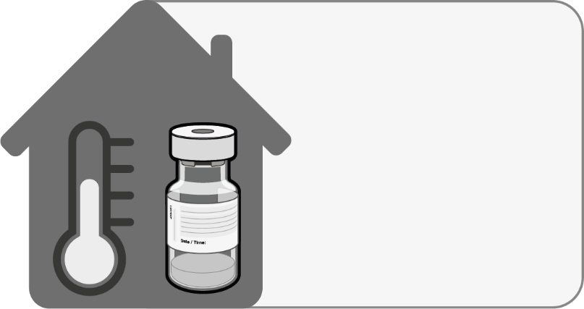  No more than 2 hours at room temperature  (up to 30°C) | - The multidose vial is stored frozen and must be thawed prior to dilution. Frozen vials should be transferred to an environment of 2°C to 8°C to thaw; a 195 vial pack may take 3 hours to thaw. Alternatively, frozen vials may also be thawed for 30 minutes at temperatures up to 30°C for immediate use.  - The unopened vial can be stored for up to 1 month at 2°C to 8°C. Within the 1-month shelf-life at 2°C to 8°C, up to 12 hours may be used for transportation.  - Allow the thawed vial to come to room temperature and gently invert it 10 times prior to dilution. Do not shake.  - Prior to dilution, the thawed suspension may contain white to off-white opaque amorphous particles.
DILUTION
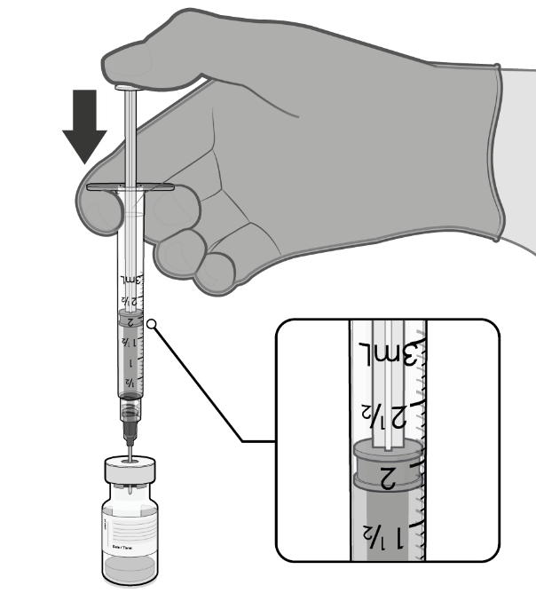  1.8 mL of 0.9% sodium chloride injection | - The thawed vaccine must be diluted in its original vial with 1.8 mL sodium chloride 9 mg/mL (0.9%) solution for injection, using a 21 gauge or narrower needle and aseptic techniques. Do not use any other diluent.
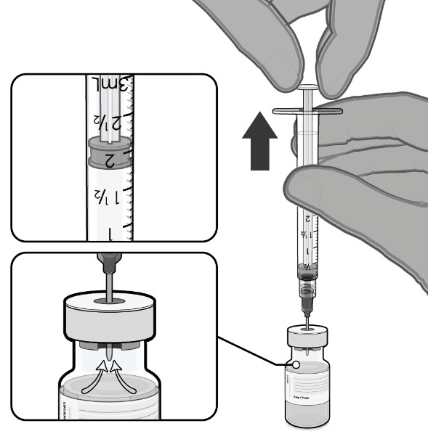  Pull back plunger to 1.8 mL to remove air from vial. | - Equalise vial pressure before removing the needle from the vial stopper by withdrawing 1.8 mL air into the empty diluent syringe.
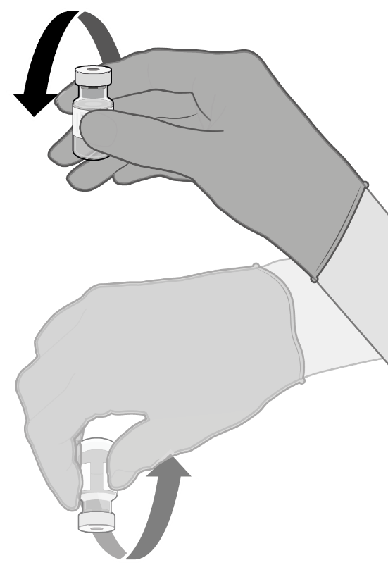  Gently × 10 | - Gently invert the diluted suspension 10 times. Do not shake.  - The diluted vaccine should present as an off-white suspension with no particulates visible. Discard the diluted vaccine if particulates or discolouration are present.
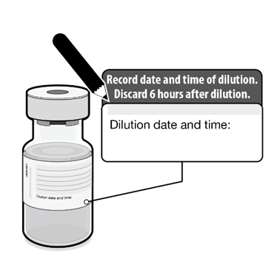 | - The diluted vials should be marked with the date and time of dilution.  - Do not freeze or shake the diluted suspension. If refrigerated, allow the diluted suspension to come to room temperature prior to use.
PREPARATION OF INDIVIDUAL 0.3 mL DOSES OF COMIRNATY
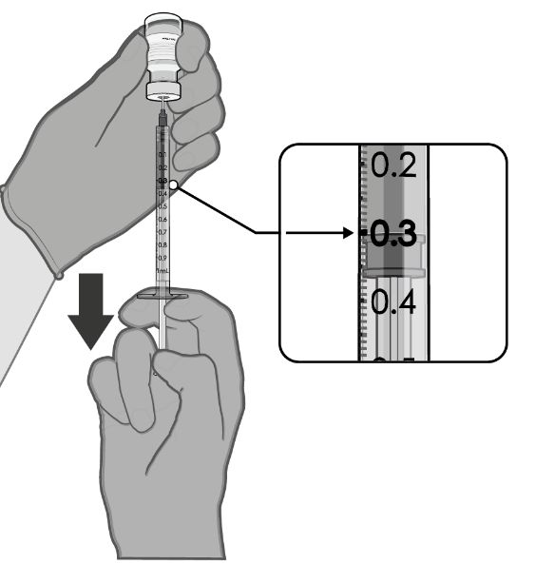  0.3 mL diluted vaccine | - After dilution, the vial contains 2.25 mL from which 6 doses of 0.3 mL can be extracted.  - Using aseptic technique, cleanse the vial stopper with a single-use antiseptic swab.  - Withdraw 0.3 mL of COMIRNATY.  Low dead-volume syringes and/or needles should be used in order to extract 6 doses from a single vial. The low dead-volume syringe and needle combination should have a dead volume of no more than 35 microlitres.  If standard syringes and needles are used, there may not be sufficient volume to extract a sixth dose from a single vial.  - Each dose must contain 0.3 mL of vaccine.  - If the amount of vaccine remaining in the vial cannot provide a full dose of 0.3 mL, discard the vial and any excess volume.  - Verify a final injection volume of 0.3 mL prior to administration.  - Discard syringe and needle after administration to a single patient.  - Use a new, sterile needle and syringe to draw up each new dose.  - Discard any unused vaccine 6 hours after dilution.

4.3 Contraindications
Hypersensitivity to the active substance or to any of the excipients listed in Section 6.1 List of excipients.

4.4 Special warnings and precautions for use

Traceability
In order to improve the traceability of biological medicinal products, the name and the batch number of the administered product should be recorded in the Australian Immunisation Register.

General recommendations

Hypersensitivity and anaphylaxis
Events of anaphylaxis have been reported. Appropriate medical treatment and supervision should always be readily available in case of an anaphylactic reaction following the administration of COMIRNATY.
The individual should be kept under close observation for at least 15 minutes following vaccination. A second dose of COMIRNATY should not be given to those who have experienced anaphylaxis to the first dose of COMIRNATY.

Myocarditis and pericarditis
Very rare cases of myocarditis and pericarditis have been observed following vaccination with COMIRNATY. These cases have primarily occurred within 14 days following vaccination, more often after the second vaccination, and more often in younger males. Available data suggest that the course of myocarditis and pericarditis following vaccination is not different from myocarditis or pericarditis in general.
Healthcare professionals should be alert to the signs and symptoms of myocarditis and pericarditis. Vaccinees should be instructed to seek immediate medical attention if they develop symptoms indicative of myocarditis or pericarditis such as (acute and persisting) chest pain, shortness of breath, or palpitations following vaccination. Healthcare professionals should consult guidance and/or specialists to diagnose and treat this condition.
For further details, please refer to the relevant clinical guidelines developed by the Australian Technical Advisory Group on Immunisation.

Anxiety-related reactions
Anxiety-related reactions, including vasovagal reactions (syncope), hyperventilation or stress‐related reactions may occur in association with vaccination as a psychogenic response to the needle injection. It is important that precautions are in place to avoid injury from fainting.
Some individuals may have stress-related responses associated with the process of vaccination itself. Stress-related responses are temporary and resolve on their own. They may include dizziness, fainting, palpitations, increases in heart rate, alterations in blood pressure, feeling short of breath, tingling sensations, sweating and/or anxiety. Individuals should be advised to bring symptoms to the attention of the vaccination provider for evaluation and precautions should be in place to avoid injury from fainting.

Syncope
Syncope (fainting) may occur in association with administration of injectable vaccines. Procedures should be in place to avoid injury from fainting.

Concurrent illness
Vaccination should be postponed in individuals suffering from acute severe febrile illness or acute infection. The presence of a minor infection and/or low grade fever should not delay vaccination.

Thrombocytopenia and coagulation disorders
As with other intramuscular injections, COMIRNATY should be given with caution in individuals receiving anticoagulant therapy or those with thrombocytopenia or any coagulation disorder (such as haemophilia) because bleeding or bruising may occur following an intramuscular administration in these individuals.

Immunocompromised individuals
The efficacy, safety and immunogenicity of COMIRNATY has not been assessed in immunocompromised individuals, including those receiving immunosuppressant therapy. The efficacy of COMIRNATY may be lower in immunosuppressed individuals.

Duration of protection
The duration of protection afforded by COMIRNATY is unknown as it is still being determined by ongoing clinical trials and observational studies.

Limitations of vaccine effectiveness
As with any vaccine, vaccination with COMIRNATY may not protect all vaccine recipients. Individuals may not be fully protected until 7 days after their second dose of COMIRNATY.

Use in the elderly
Clinical studies of COMIRNATY include participants 65 years of age and older and their data contributes to the overall assessment of safety and efficacy. See Section 5.1 Pharmacodynamic properties, Clinical trials, Efficacy against COVID-19. No dosage adjustment is required in elderly individuals ≥ 65 years of age.
The data for use in the frail elderly (>85 years) is limited. The potential benefits of vaccination versus the potential risk and clinical impact of even relatively mild systemic adverse events in the frail elderly should be carefully assessed on a case-by-case basis.
The safety and immunogenicity of a booster dose (third dose) of COMIRNATY in individuals 65 years of age and older is based on safety and immunogenicity data in adults 18 to 55 years of age.

Paediatric use
The safety and efficacy of COMIRNATY in children aged less than 12 years of age have not yet been established.

Effects on laboratory tests
No data available.

4.5 Interactions with other medicines and other forms of interactions
No interaction studies have been performed.
Concomitant administration of COMIRNATY with other vaccines has not been studied.

4.6 Fertility, pregnancy and lactation

Effects on fertility
In a combined fertility and developmental toxicity study, female rats were intramuscularly administered COMIRNATY prior to mating and during gestation (4 full human doses of 30 μg each, spanning between pre-mating day 21 and gestation day 20). SARS CoV-2 neutralising antibodies were present in maternal animals from prior to mating to the end of the study on postnatal day 21 as well as in fetuses and offspring. There were no vaccine related effects on female fertility and pregnancy rate.

Use in pregnancy - Pregnancy Category B1
There is limited experience with use of COMIRNATY in pregnant women. Animal studies do not indicate direct or indirect harmful effects with respect to pregnancy, embryo/fetal development, parturition or post-natal development (see Section 4.6 Fertility, pregnancy and lactation, Effects on fertility). Administration of COMIRNATY in pregnancy should only be considered when the potential benefits outweigh any potential risks for the mother and fetus.

Use in lactation
It is unknown whether BNT162b2 [mRNA] is excreted in human milk. A combined fertility and developmental toxicity study in rats did not show harmful effects on offspring development before weaning (see Section 4.6 Fertility, pregnancy and lactation, Effects on fertility).

4.7 Effects on ability to drive and use machines
COMIRNATY has no, or negligible, influence on the ability to drive and use machines. However, some of the effects mentioned under Section 4.8 Adverse effects (undesirable effects) may temporarily affect the ability to drive or use machines.

4.8 Adverse effects (undesirable effects)

Summary of safety profile
The safety of COMIRNATY was evaluated in participants 12 years of age and older in 2 clinical studies that included 23,205 participants (comprised of 22,074 participants 16 years of age and older and 1,131 adolescents 12 to 15 years of age) that have received at least one dose of COMIRNATY.
Additionally, 306 existing Phase 3 participants 18 to 55 years of age received a booster dose (third dose) of COMIRNATY approximately 6 months after the second dose. The overall safety profile for the booster dose (third dose) was similar to that seen after 2 doses.

Participants 16 years of age and older – after 2 doses
In Study C4591001, a total of 22,026 participants 16 years of age or older received at least 1 dose of COMIRNATY and a total of 22,021 participants 16 years of age or older received placebo(including 138 and 145 adolescents 16 and 17 years of age in the COMIRNATY and placebo groups, respectively). A total of 20,519 participants 16 years of age or older received 2 doses of COMIRNATY.
At the time of the analysis of Study C4591001 with a data cut-off of 13 March 2021 for the placebo-controlled blinded follow-up period up to the participants’ unblinding dates, a total of 25,651 (58.2%) participants (13,031 COMIRNATY and 12,620 placebo) 16 years of age and older were followed up for ≥4 months after the second dose. This included a total of 15,111 (7,704 COMIRNATY and 7,407 placebo) participants 16 to 55 years of age and a total of 10,540 (5,327 COMIRNATY and 5,213 placebo) participants 56 years and older.
The most frequent adverse reactions in participants 16 years of age and older that received 2 doses were injection site pain (>80%), fatigue (>60%), headache (>50%), myalgia (>40%), chills (>30%), arthralgia (>20%), pyrexia and injection site swelling (>10%) and were usually mild or moderate in intensity and resolved within a few days after vaccination. A slightly lower frequency of reactogenicity events was associated with greater age.
The safety profile in 545 subjects receiving COMIRNATY, that were seropositive for SARS-CoV-2 at baseline, was similar to that seen in the general population.
Study C4591001 also included 200 participants with confirmed stable human immunodeficiency virus (HIV) infection. The safety profile of the participants receiving COMIRNATY (n=100) in the individuals with stable HIV infection was similar to that seen in the general population.

Adolescents 12 to 15 years of age – after 2 doses
In an analysis of Study C4591001, based on data up to the cutoff date of 13 March 2021, 2,260 adolescents (1,131 COMIRNATY; 1,129 placebo) were 12 to 15 years of age. Of these, 1,308 adolescents (660 COMIRNATY and 648 placebo) have been followed for at least 2 months after the second dose of COMIRNATY. The safety evaluation in Study C4591001 is ongoing.
The most frequent adverse reactions in adolescents 12 to 15 years of age that received 2 doses were injection site pain (>90%), fatigue and headache (>70%), myalgia and chills (>40%), arthralgia and pyrexia (>20%).

Participants 18 years of age and older – after booster dose (third dose)
A subset from Study C4591001 Phase 2/3 participants of 306 adults 18 to 55 years of age who completed the original COMIRNATY 2-dose course, received a booster dose (third dose) of COMIRNATY approximately 6 months (range of 4.8 to 8.0 months) after receiving Dose 2.
The most frequent adverse reactions in participants 18 to 55 years of age were injection site pain (>80%), fatigue (>60%), headache (>40%), myalgia (>30%), chills and arthralgia (>20%).

Tabulated list of adverse reactions from clinical studies
Adverse reactions observed during clinical studies are listed below according to the following frequency categories:
Very common (≥1/10),
Common (≥1/100 to <1/10),
Uncommon (≥1/1,000 to <1/100),
Rare (≥1/10,000 to <1/1,000),
Very rare (<1/10,000),
Not known (cannot be estimated from the available data).
Table 1: Adverse reactions from COMIRNATY clinical trials
System Organ Class | Very common  (≥1/10) | Common  (≥1/100 to <1/10) | Uncommon  (≥1/1,000 to <1/100) | Rare  (≥1/10,000 to <1/1,000) | Not known (cannot be estimated from the available data)
Blood and lymphatic system disorders |  |  | Lymphadenopathyª
Psychiatric disorders |  |  | Insomnia
Metabolism and nutrition disorders |  |  | Decreased appetite
Nervous system disorders | Headache |  | Lethargy | Acute peripheral facial paralysis^{b}
Gastrointestinal disorders |  | Nausea
Skin and subcutaneous disorders |  |  | Hyperhidrosis  Night sweats
Musculoskeletal and connective tissue disorders | Arthralgia; Myalgia
General disorders and administration site conditions | Injection site pain; Fatigue; Chills; Pyrexia^{c}; Injection site swelling | Injection site redness | Asthenia  Malaise |  | Facial swelling^{d}
ª A higher frequency of lymphadenopathy (5.2% vs 0.4%) was observed in participants receiving a booster dose (third dose) compared to participants receiving 2 doses.
^{b} Through the clinical trial safety follow-up period to 14 November 2020, acute peripheral facial paralysis (or palsy) was reported by four participants in the COMIRNATY group. Onset was Day 37 after Dose 1 (participant did not receive Dose 2) and Days 3, 9, and 48 after Dose 2. No cases of acute peripheral facial paralysis (or palsy) were reported in the placebo group.
^{c} A higher frequency of pyrexia was observed after the second dose.
^{d} Facial swelling in vaccine recipients with a history of injection of dermatological fillers
The safety profile in 545 subjects receiving COMIRNATY, that were seropositive for SARS-CoV-2 at baseline, was similar to that seen in the general population.

Post-marketing experience
Although the events listed in Table 2 were not observed in the clinical trials, they are considered adverse drug reactions for COMIRNATY as they were reported in the post-marketing experience. As these reactions were derived from spontaneous reports, the frequencies could not be determined and are thus considered as not known.
Table 2: Adverse reactions from COMIRNATY post marketing experience

System Organ Class | Adverse Drug Reaction
Immune system disorders | Anaphylaxis  Hypersensitivity reactions (e.g. rash, pruritis, urticaria, angioedema)
Cardiac disorders | Myocarditis  Pericarditis
Gastrointestinal disorders | Diarrhoea  Vomiting
Musculoskeletal and connective tissue disorders | Pain in extremity (arm)
General disorders and administration site conditions | Extensive swelling of vaccinated limb

Reporting suspected adverse effects
Reporting suspected adverse reactions after registration of the medicinal product is important. It allows continued monitoring of the benefit-risk balance of the medicinal product. Healthcare professionals are asked to report any suspected adverse reactions at www.tga.gov.au/reporting-problems.

4.9 Overdose
Overdose data is available from 52 study participants included in the clinical trial that due to an error in dilution received 58 micrograms of COMIRNATY. The COMIRNATY recipients did not report an increase in reactogenicity or adverse reactions.
In the event of overdose, monitoring of vital functions and possible symptomatic treatment is recommended.
For information on the management of overdose, contact the Poisons Information Centre on 131126 (Australia).

5. PHARMACOLOGICAL PROPERTIES

5.1 Pharmacodynamic properties
Pharmacotherapeutic group: vaccines, other viral vaccines, ATC code: J07BX03

Mechanism of action
The nucleoside-modified messenger RNA in COMIRNATY is formulated in lipid nanoparticles, which enable delivery of the non-replicating RNA into host cells to direct transient expression of the SARS-CoV-2 spike (S) antigen. The mRNA codes for membrane-anchored, full-length S with two point mutations within the central helix. Mutation of these two amino acids to proline locks S in an antigenically preferred prefusion conformation. COMIRNATY elicits both neutralising antibody and cellular immune responses to the antigen, which may contribute to protection against COVID-19.

Clinical trials

Efficacy
Study C4591001 is a multicentre, multinational, Phase 1/2/3 randomised, placebo-controlled, observer-blind dose-finding, vaccine candidate selection and efficacy study in participants 12 years of age and older. Randomisation was stratified by age: 12 to 15 years of age, 16 to 55 years of age, or 56 years of age and older, with a minimum of 40% of participants in the ≥56-year stratum. The study excluded participants who were immunocompromised and those who had previous clinical or microbiological diagnosis of COVID-19. Participants with pre-existing stable disease, defined as disease not requiring significant change in therapy or hospitalisation for worsening disease during the 6 weeks before enrolment, were included as were participants with known stable infection with human immunodeficiency virus (HIV), hepatitis C virus (HCV) or hepatitis B virus (HBV).

Efficacy in participants 16 years of age and older – after 2 doses
In the Phase 2/3 portion of Study C4591001, based on data accrued through 14 November 2020, approximately 44,000 participants were randomised equally and were to receive 2 doses of COMIRNATY or placebo. The efficacy analyses included participants that received their second vaccination within 19 to 42 days after their first vaccination. The majority (93.1%) of vaccine recipients received the second dose 19 days to 23 days after Dose 1. Participants are planned to be followed for up to 24 months after Dose 2, for assessments of safety and efficacy against COVID-19. In the clinical study, participants were required to observe a minimum interval of 14 days before and after administration of an influenza vaccine in order to receive either placebo or COMIRNATY. In the clinical study, participants were required to observe a minimum interval of 60 days before or after receipt of blood/plasma products or immunoglobulins through to conclusion of the study in order to receive either placebo or COMIRNATY.
The population for the analysis of the primary efficacy endpoint included, 36,621 participants 12 years of age and older (18,242 in the COMIRNATY group and 18,379 in the placebo group) who did not have evidence of prior infection with SARS-CoV-2 through 7 days after the second dose. In addition, 134 participants were between the ages of 16 to 17 years of age (66 in the COMIRNATY group and 68 in the placebo group) and 1616 participants 75 years of age and older (804 in the COMIRNATY group and 812 in the placebo group).
At the time of the primary efficacy analysis, participants had been followed for symptomatic COVID-19 for in total 2,214 person-years for the COMIRNATY group and in total 2,222 person-years for the placebo group.
There were no meaningful clinical differences in overall vaccine efficacy in participants who were at risk of severe COVID-19 including those with 1 or more comorbidities that increase the risk of severe COVID-19 (e.g. asthma, body mass index (BMI) ≥ 30 kg/m², chronic pulmonary disease, diabetes mellitus, hypertension).
COMIRNATY efficacy information is presented in Table 3.
Table 3: Vaccine efficacy – First COVID-19 occurrence from 7 days after Dose 2, by age subgroup – participants without evidence of infection prior to 7 days after Dose 2 – evaluable efficacy (7 days) population
First COVID-19 occurrence from 7 days after Dose 2 in participants without evidence of prior SARS-CoV-2 infection*
Subgroup | COMIRNATY  Nª = 18,198  Cases  n1^{b}  Surveillance time^{c} (n2^{d}) | Placebo  Nª = 18,325  Cases  n1^{b}  Surveillance time^{c} (n2^{d}) | Vaccine efficacy % (95% CI)^{f}
All participants^{e} | 8  2.214 (17,411) | 162  2.222 (17,511) | 95.0  (90.0, 97.9)
16 to 64 years | 7  1.706 (13,549) | 143  1.710 (13,618) | 95.1  (89.6, 98.1)
65 years and older | 1  0.508 (3848) | 19  0.511 (3880) | 94.7  (66.7, 99.9)
65 to 74 years | 1  0.406 (3074) | 14  0.406 (3095) | 92.9  (53.1, 99.8)
75 years and older | 0  0.102 (774) | 5  0.106 (785) | 100.0  (-13.1, 100.0)
Note: Confirmed cases were determined by Reverse Transcription-Polymerase Chain Reaction (RT-PCR) and at least 1 symptom consistent with COVID-19 [*Case definition: (at least 1 of) fever, new or increased cough, new or increased shortness of breath, chills, new or increased muscle pain, new loss of taste or smell, sore throat, diarrhoea or vomiting.]
* Participants who had no serological or virological evidence (prior to 7 days after receipt of the last dose) of past SARS-CoV-2 infection (i.e., N-binding antibody [serum] negative at Visit 1 and SARS-CoV-2 not detected by nucleic acid amplification tests (NAAT) [nasal swab] at Visits 1 and 2), and had negative NAAT (nasal swab) at any unscheduled visit prior to 7 days after Dose 2 were included in the analysis.
a. N = number of participants in the specified group.
b. n1 = Number of participants meeting the endpoint definition.
c. Total surveillance time in 1000 person-years for the given endpoint across all participants within each group at risk for the endpoint. Time period for COVID-19 case accrual is from 7 days after Dose 2 to the end of the surveillance period.
d. n2 = Number of participants at risk for the endpoint.
e. No confirmed cases were identified in adolescents 12 to 15 years of age.
f. Two-sided confidence interval (CI) for vaccine efficacy (VE) is derived based on the Clopper and Pearson method adjusted to the surveillance time. CI not adjusted for multiplicity.
In the second primary analysis, efficacy of COMIRNATY in preventing first COVID-19 occurrence from 7 days after Dose 2 compared to placebo was 94.6% (95% credible interval of 89.9% to 97.3%) in participants 16 years of age and older with or without evidence of prior infection with SARS-CoV-2.
Additionally, subgroup analyses of the primary efficacy endpoint showed similar efficacy point estimates across genders, ethnic groups, and participants with medical comorbidities associated with high risk of severe COVID-19.
Updated efficacy analyses were performed with additional confirmed COVID-19 cases accrued during blinded placebo-controlled follow-up through 13 March 2021, representing up to 6 months of follow-up after Dose 2 for participants in the efficacy population.
The updated vaccine efficacy information is presented in Table 4.
Table 4: Vaccine efficacy – First COVID-19 occurrence from 7 days after Dose 2, by age subgroup – participants without evidence of infection prior to 7 days after Dose 2 – evaluable efficacy (7 days) population during the placebo-controlled follow-up period
First COVID-19 occurrence from 7 days after Dose 2 in participants without evidence of prior SARS-CoV-2 infection*
Subgroup | COMIRNATY  Nª=20,998  Cases  n1^{b}  Surveillance Time^{c} (n2^{d}) | Placebo  Nª=21,096  Cases  n1^{b}  Surveillance Time^{c} (n2^{d}) | Vaccine efficacy %  (95% CIe)
All participants^{f} | 77  6.247 (20,712) | 850  6.003 (20,713) | 91.3  (89.0, 93.2)
16 through 64 years | 70  4.859 (15,519) | 710  4.654 (15,515) | 90.6  (87.9, 92.7)
65 years and older | 7  1.233 (4192) | 124  1.202 (4226) | 94.5  (88.3, 97.8)
65 through 74 years | 6  0.994 (3350) | 98  0.966 (3379) | 94.1  (86.6, 97.9)
75 years and older | 1  0.239 (842) | 26  0.237 (847) | 96.2  (76.9, 99.9)
Note: Confirmed cases were determined by Reverse Transcription-Polymerase Chain Reaction (RT-PCR) and at least 1 symptom consistent with COVID-19 (symptoms included: fever; new or increased cough; new or increased shortness of breath; chills; new or increased muscle pain; new loss of taste or smell; sore throat; diarrhoea; vomiting).
* Participants who had no evidence of past SARS-CoV-2 infection (i.e., N-binding antibody [serum] negative at Visit 1 and SARS-CoV-2 not detected by NAAT [nasal swab] at Visits 1 and 2), and had negative NAAT (nasal swab) at any unscheduled visit prior to 7 days after Dose 2 were included in the analysis.
a. N = Number of participants in the specified group.
b. n1 = Number of participants meeting the endpoint definition.
c. Total surveillance time in 1000 person-years for the given endpoint across all participants within each group at risk for the endpoint. Time period for COVID-19 case accrual is from 7 days after Dose 2 to the end of the surveillance period.
d. n2 = Number of participants at risk for the endpoint.
e. Two-sided confidence interval (CI) for vaccine efficacy is derived based on the Clopper and Pearson method adjusted to the surveillance time.
f. Included confirmed cases in participants 12 through 15 years of age: 0 in the COMIRNATY group (both without and with or without evidence of prior SARS-CoV-2 infection); 16 and 18 in the placebo group (without and with or without evidence of prior SARS-CoV-2 infection, respectively).

Efficacy against severe COVID-19 in participants 12 years of age or older – after 2 doses
As of 13 March 2021, vaccine efficacy against severe COVID-19 is presented only for participants with or without prior SARS-CoV-2 infection (Table 5) as the COVID-19 case counts in participants without prior SARS-CoV-2 infection were the same as those in participants with or without prior SARS-CoV-2 infection in both the COMIRNATY and placebo groups.
Table 5. Vaccine Efficacy – First Severe COVID-19 Occurrence in Participants With or Without* Prior SARS-CoV-2 Infection Based on Food and Drug Administration (FDA)† Definition After Dose 1 or From 7 Days After Dose 2 in the Placebo-Controlled Follow-up
 | COMIRNATY  Cases  n1ª  Surveillance Time (n2^{b}) | Placebo  Cases  n1ª  Surveillance Time (n2^{b}) | Vaccine Efficacy %  (95% CI^{c})
After Dose 1^{d} | 1  8.439e (22,505) | 30  8.288e (22,435) | 96.7  (80.3, 99.9)
7 days after Dose 2^{f} | 1  6.522^{g} (21,649) | 21  6.404^{g} (21,730) | 95.3  (70.9, 99.9)
Note: Confirmed cases were determined by Reverse Transcription-Polymerase Chain Reaction (RT-PCR) and at least 1 symptom consistent with COVID-19 (symptoms included: fever; new or increased cough; new or increased shortness of breath; chills; new or increased muscle pain; new loss of taste or smell; sore throat; diarrhea; vomiting).
* Participants who had no evidence of past SARS-CoV-2 infection (i.e., N-binding antibody [serum] negative at Visit 1 and SARS-CoV-2 not detected by NAAT [nasal swab] at Visits 1 and 2), and had negative NAAT (nasal swab) at any unscheduled visit prior to 7 days after Dose 2 were included in the analysis.
† Severe illness from COVID-19 as defined by FDA is confirmed COVID-19 and presence of at least 1 of the following:
- Clinical signs at rest indicative of severe systemic illness (respiratory rate ≥30 breaths per minute, heart rate ≥125 beats per minute, saturation of oxygen ≤93% on room air at sea level, or ratio of arterial oxygen partial pressure to fractional inspired oxygen <300 mm Hg);
- Respiratory failure [defined as needing high-flow oxygen, noninvasive ventilation, mechanical ventilation or extracorporeal membrane oxygenation (ECMO)];
- Evidence of shock (systolic blood pressure <90 mm Hg, diastolic blood pressure <60 mm Hg, or requiring vasopressors);
- Significant acute renal, hepatic, or neurologic dysfunction;
- Admission to an Intensive Care Unit;
- Death.
a. n1 = Number of participants meeting the endpoint definition.
b. n2 = Number of participants at risk for the endpoint.
c. Two-side confidence interval (CI) for vaccine efficacy is derived based on the Clopper and Pearson method adjusted to the surveillance time.
d. Efficacy assessed based on the Dose 1 all available efficacy (modified intention-to-treat) population that included all randomised participants who received at least 1 dose of study intervention.
e. Total surveillance time in 1000 person-years for the given endpoint across all participants within each group at risk for the endpoint. Time period for COVID-19 case accrual is from Dose 1 to the end of the surveillance period.
f. Efficacy assessed based on the evaluable efficacy (7 Days) population that included all eligible randomised participants who receive all dose(s) of study intervention as randomised within the predefined window, have no other important protocol deviations as determined by the clinician
g. Total surveillance time in 1000 person-years for the given endpoint across all participants within each group at risk for the endpoint. Time period for COVID-19 case accrual is from 7 days after Dose 2 to the end of the surveillance period.

Efficacy and immunogenicity in adolescents 12 to 15 years of age – after 2 doses
An analysis of Study C4591001 has been performed in adolescents 12 to 15 years of age up to a data cutoff date of 13 March 2021.
In an analysis of Study C4591001 in adolescents 12 to 15 years of age without evidence of prior infection, there were no cases in 1005 participants who received the vaccine and 16 cases out of 978 who received placebo. The point estimate for efficacy is 100% (95% confidence interval 75.3, 100.0). In participants with or without evidence of prior infection there were 0 cases in the 1119 who received vaccine and 18 cases in 1110 participants who received placebo. This also indicates the point estimate for efficacy is 100% (95% confidence interval 78.1, 100.0). No cases of severe disease occurred in adolescents.
In Study C4591001, an analysis of SARS-CoV-2 neutralising titres in a randomly selected subset of participants was performed to demonstrate non-inferior immune responses (within 1.5-fold) comparing adolescents 12 to 15 years of age to participants 16 to 25 years of age who had no serological or virological evidence of past SARS-CoV-2 infection. The immune response to COMIRNATY in adolescents 12 to 15 years of age (n = 190) was non-inferior to the immune response in participants 16 to 25 years of age (n = 170), based on results for SARS-CoV-2 neutralising titres at 1 month after Dose 2. The geometric mean titres (GMT) ratio of the adolescents 12 to 15 years of age group to the participants 16 to 25 years of age group was 1.76, with a 2-sided 95% CI of 1.47 to 2.10, meeting the 1.5-fold non-inferiority criterion (the lower bound of the 2-sided 95% CI for the geometric mean ratio [GMR] > 0.67).

Immunogenicity in participants 18 years of age and older – after booster dose (third dose)
Effectiveness of a booster dose of COMIRNATY was based on an assessment of 50% neutralising titres (NT50) against SARS-CoV-2 (USA_WA1/2020). In Study C4591001, analyses of NT50 1 month after the booster dose compared to 1 month after the primary series in individuals 18 to 55 years of age who had no serological or virological evidence of past SARS-CoV-2 infection up to 1 month after the booster vaccination demonstrated noninferiority for both GMR and difference in seroresponse rates. Seroresponse for a participant was defined as achieving a ≥4-fold rise in NT50 from baseline (before Dose 1), These analyses are summarised in Table 6.
Table 6. SARS-CoV-2 neutralization assay - NT50 (titer)† (SARS-CoV-2 USA_WA1/2020) – GMT and seroresponse rate comparison of 1 month after booster dose to 1 month after primary series – participants 18 through 55 years of age without evidence of infection up to 1 month after booster dose* – booster dose evaluable immunogenicity population±
 | n | 1 month after booster dose  (95% CI) | 1 month after primary series  (95% CI) | 1 month after booster dose/- 1 month after primary series  (97.5% CI) | Met noninferiority objective  (Y/N)
Geometric mean 50% neutralizing titer (GMT^{b}) | 212ª | 2466.0^{b}  (2202.6, 2760.8) | 750.6^{b}  (656.2, 858.6) | 3.29^{c}  (2.77, 3.90) | Y^{d}
Seroresponse rate (%) for 50% neutralizing titer† | 200e | 199^{f}  99.5% (97.2%, 100.0%) | 196^{f}  98.0% (95.0%, 99.5%) | 1.5%^{g}  (-0.7%, 3.7%^{h}) | Y^{i}
Abbreviations: CI = confidence interval; GMR = geometric mean ratio; GMT = geometric mean titer; LLOQ = lower limit of quantitation; N-binding = SARS-CoV-2 nucleoprotein-binding; NAAT = nucleic acid amplification test; NT50 = 50% neutralizing titer; SARS-CoV-2 = severe acute respiratory syndrome coronavirus 2; Y/N = yes/no.
† SARS-CoV-2 NT50 were determined using the SARS-CoV-2 mNeonGreen Virus Microneutralization Assay. The assay uses a fluorescent reporter virus derived from the USA_WA1/2020 strain and virus neutralization is read on Vero cell monolayers. The sample NT50 is defined as the reciprocal serum dilution at which 50% of the virus is neutralized.
* Participants who had no serological or virological evidence (up to 1 month after receipt of a booster dose of Comirnaty) of past SARS-CoV-2 infection (i.e., N-binding antibody [serum] negative and SARS-CoV-2 not detected by NAAT [nasal swab]) and had a negative NAAT (nasal swab) at any unscheduled visit up to 1 month after the booster dose were included in the analysis.
± All eligible participants who had received 2 doses of Comirnaty as initially randomized, with Dose 2 received within the predefined window (within 19 to 42 days after Dose 1), received a booster dose of Comirnaty, had at least 1 valid and determinate immunogenicity result after booster dose from a blood collection within an appropriate window (within 28 to 42 days after the booster dose), and had no other important protocol deviations as determined by the clinician.
a. n = Number of participants with valid and determinate assay results at both sampling time points within specified window.
b. GMTs and 2-sided 95% CIs were calculated by exponentiating the mean logarithm of the titers and the corresponding CIs (based on the Student t distribution). Assay results below the LLOQ were set to 0.5 × LLOQ.
c. GMRs and 2-sided 97.5% CIs were calculated by exponentiating the mean differences in the logarithms of the assay and the corresponding CIs (based on the Student t distribution).
d. Noninferiority is declared if the lower bound of the 2-sided 97.5% CI for the GMR is > 0.67 and the point estimate of the GMR is ≥ 0.80.
e. n = Number of participants with valid and determinate assay results for the specified assay at baseline, 1 month after Dose 2 and 1 month after the booster dose within specified window. These values are the denominators for the percentage calculations.
f. Number of participants with seroresponse for the given assay at the given dose/sampling time point. Exact 2-sided CI based on the Clopper and Pearson method.
g. Difference in proportions, expressed as a percentage (1 month after booster dose – 1 month after Dose 2).
h. Adjusted Wald 2-sided CI for the difference in proportions, expressed as a percentage.
i. Noninferiority is declared if the lower bound of the 2-sided 97.5% CI for the percentage difference is > -10%.

5.2 Pharmacokinetic properties
Not applicable.

5.3 Preclinical safety data

Genotoxicity/Carcinogenicity
Neither genotoxicity nor carcinogenicity studies were performed. The components of COMIRNATY (lipids and mRNA) are not expected to have genotoxic potential.

6. PHARMACEUTICAL PARTICULARS

6.1 List of excipients
((4-hydroxybutyl)azanediyl)bis(hexane-6,1-diyl)bis(2-hexyldecanoate) (ALC-0315)
2-[(polyethylene glycol)-2000]-N,N-ditetradecylacetamide (ALC-0159)
Distearoylphosphatidylcholine (DSPC)
Cholesterol
Potassium chloride
Monobasic potassium phosphate
Sodium chloride
Dibasic sodium phosphate dihydrate
Sucrose
Water for injections
This vaccine contains less than 1 mmol potassium (39 mg) per dose, that is to say essentially ‘potassium-free’.
This vaccine contains less than 1 mmol sodium (23 mg) per dose, that is to say essentially ‘sodium‑free’.

6.2 Incompatibilities
This medicinal product must not be mixed with other medicinal products except those mentioned in Section 4.2 Dose and method of administration.

6.3 Shelf life
In Australia, information on the shelf life can be found on the public summary of the Australian Register of Therapeutic Goods (ARTG). The expiry date can be found on the packaging.

Unopened vial
9 months at -90°C to -60°C.
Unopened vials may be stored and transported at -25°C to -15°C for a total of 2 weeks and can be returned to -90ºC to -60°C.
Once removed from the freezer, the unopened vial can be stored for up to 1 month at 2°C to 8°C. Within the 1 month shelf-life at 2°C to 8°C, up to 12 hours may be used for transportation.
Prior to use, the unopened vial can be stored for up to 2 hours at temperatures up to 30°C.
Once thawed, COMIRNATY should not be re-frozen.

Diluted medicinal product
Chemical and physical in-use stability, including during transportation, has been demonstrated for 6 hours at 2ºC to 30ºC after dilution in sodium chloride 9 mg/mL (0.9%) solution for injection. From a microbiological point of view, the product should be used immediately. If not used immediately, in-use storage times and conditions are the responsibility of the user.

6.4 Special precautions for storage
Store in a freezer at -90°C to -60°C.
Store in the original package in order to protect from light.
During storage, minimise exposure to room light, and avoid exposure to direct sunlight and ultraviolet light.
Thawed vials can be handled in room light conditions.
When you are ready to thaw or use COMIRNATY:
Transfers of frozen vials stored at ultra-low temperature (<-60°C)
- Closed-lid vial trays containing 195 vials removed from ultra-low temperature frozen storage (<-60°C) may be at temperatures up to 25°C for up to 5 minutes for transfer between ultra-low-temperature environments.
- Open-lid vial trays, or vial trays containing less than 195 vials removed from ultra-low temperature frozen storage (<-60°C) may be at temperatures up to 25°C for up to 3 minutes to remove vials or for transfer between ultra-low-temperature environments.
- After vial trays are returned to ultra-low temperature frozen storage following temperature exposure up to 25°C, they must remain in ultra-low temperature frozen storage for at least 2 hours before they can be removed again.
Transfers of frozen vials stored at -25°C to -15°C
- Closed-lid vial trays containing 195 vials removed from frozen storage (-25°C to -15°C) may be at temperatures up to 25°C for up to 3 minutes.
- Open-lid vial trays, or vial trays containing less than 195 vials, removed from frozen storage (-25°C to -15°C) may be at temperatures up to 25°C for up to 1 minute.
Once a vial is removed from the vial tray, it should be thawed for use.

Transportation
If local redistribution of unopened vials is needed, and full trays containing vials cannot be transported at -90°C to -60°C, available data support physical and chemical stability during transportation of 1 or more thawed vials at 2°C to 8°C for up to 12 hours. Any hours used for transport of unopened vials at 2°C to 8°C count against the 1 month limit for storage at 2°C to 8°C.
If local redistribution of diluted medicinal product in vials or syringes is needed, available data support physical and chemical stability during transportation at 2°C to 30°C for up to 6 hours. Any hours used for transport of diluted medicinal product in vials or syringes at 2°C to 30°C count against the 6-hour limit for storage at 2°C to 30°C. Microbiological risks and package integrity, particularly for prepared dosing syringes, are the responsibility of the preparer during transportation of diluted medicinal product.
For storage conditions after thawing and dilution of the medicinal product, see Section 6.3 Shelf life.
For additional advice on storing COMIRNATY, contact Pfizer Australia on 1800 675 229.

6.5 Nature and contents of container
2 mL clear multidose vial (Type I glass) with a stopper (synthetic bromobutyl rubber) and a flip-off plastic cap with aluminium seal. Each vial contains 6 doses, see Section 4.2 Dose and method of administration.
Pack size: 195 vials

6.6 Special precautions for disposal
In Australia, any unused medicine or waste material should be disposed of in accordance with local requirements.

6.7 Physicochemical properties

CAS number
2417899-77-3

7. MEDICINE SCHEDULE (POISONS STANDARD)
S4 – Prescription Only Medicine.

8. SPONSOR
Pfizer Australia Pty Ltd
Level 17, 151 Clarence Street
Sydney NSW 2000
www.pfizer.com.au
Medical Information www.pfizermedinfo.com.au or Toll Free Number: 1800 675 229

9. DATE OF FIRST APPROVAL
25 January 2021

10. DATE OF REVISION
26 October 2021

Summary Table of Changes
Section changed | Summary of new information
2, 4.2, 4.6, 6.5 | Editorial changes
4.2 & 4.4 | Update to include booster dose information and a third dose for the immunocompromised patients
4.8 | Updated safety data from study C4591001, 6 months post-dose 2 and booster dose data
5.1 | Updated efficacy and immunogenicity analysis from study C4591001, 6 months post-dose 2 and booster dose data
5.1 | Added information regarding efficacy against severe COVID-19 from study C4591001, final analysis interim report [data cutoff 13 March 2021]

