January 2021

Australian Public Assessment Report for BNT162b2 (mRNA)
  - Proprietary Product Name: Comirnaty
  - Sponsor: Pfizer Australia Pty Ltd

About the Therapeutic Goods Administration (TGA)
- The Therapeutic Goods Administration (TGA) is part of the Australian Government Department of Health and is responsible for regulating medicines and medical devices.
- The TGA administers the Therapeutic Goods Act 1989 (the Act), applying a risk management approach designed to ensure therapeutic goods supplied in Australia meet acceptable standards of quality, safety and efficacy (performance) when necessary.
- The work of the TGA is based on applying scientific and clinical expertise to decision-making, to ensure that the benefits to consumers outweigh any risks associated with the use of medicines and medical devices.
- The TGA relies on the public, healthcare professionals and industry to report problems with medicines or medical devices. TGA investigates reports received by it to determine any necessary regulatory action.
- To report a problem with a medicine or medical device, please see the information on the TGA website <https://www.tga.gov.au>.

About AusPARs
- An Australian Public Assessment Report (AusPAR) provides information about the evaluation of a prescription medicine and the considerations that led the TGA to approve or not approve a prescription medicine submission.
- AusPARs are prepared and published by the TGA.
- An AusPAR is prepared for submissions that relate to new chemical entities, generic medicines, major variations and extensions of indications.
- An AusPAR is a static document; it provides information that relates to a submission at a particular point in time.
- A new AusPAR will be developed to reflect changes to indications and/or major variations to a prescription medicine subject to evaluation by the TGA.

Copyright
© Commonwealth of Australia 2021
This work is copyright. You may reproduce the whole or part of this work in unaltered form for your own personal use or, if you are part of an organisation, for internal use within your organisation, but only if you or your organisation do not use the reproduction for any commercial purpose and retain this copyright notice and all disclaimer notices as part of that reproduction. Apart from rights to use as permitted by the Copyright Act 1968 or allowed by this copyright notice, all other rights are reserved and you are not allowed to reproduce the whole or any part of this work in any way (electronic or otherwise) without first being given specific written permission from the Commonwealth to do so. Requests and inquiries concerning reproduction and rights are to be sent to the TGA Copyright Officer, Therapeutic Goods Administration, PO Box 100, Woden ACT 2606 or emailed to <tga.copyright@tga.gov.au>.

Contents
List of abbreviations 4
I. Introduction to product submission 7
Submission details 7
Product background 8
Regulatory status 9
Product Information 11
II. Registration timeline 11
III. Submission overview and risk/benefit assessment 12
Quality 12
Nonclinical 14
Clinical 15
Risk management plan 31
Risk-benefit analysis 33
Outcome 39
Attachment 1. Product Information 41

List of abbreviations
Abbreviation | Meaning
ACV | Advisory Committee on Vaccines
AE | Adverse event
AESI | Adverse event of special interest
ARGPM | Australian Regulatory Guidelines for Prescription Medicines
ARTG | Australian Register of Therapeutic Goods
ASA | Australian specific annex
AusPAR | Australian Public Assessment Report
CD | Cluster of differentiation
CDC | Centers for Disease Control and Prevention
CHMP | Committee for Medicinal Products for Human Use (European Medicines Agency)
CMI | Consumer Medicines Information
COPD | Chronic obstructive pulmonary disease
COVID-19 | Coronavirus disease 2019
CPD | Certified Product Details
DLP | Data lock point
DP | Drug product
DS | Drug substance
ELISpot | Enzyme-linked immune absorbent spot
EMA | European Medicines Agency (European Union)
EU | European Union
EUA | Emergency Use Authorization (United States)
FDA | Food and Drug Administration (United States)
FIH | First in human
GCP | Good Clinical Practice
GMFR | Geometric mean fold rise
GMT | Geometric mean titre
GMP | Good Manufacturing Practice
GVP | Good Pharmacovigilance Practice(s)
HIV | Human immunodeficiency virus
ICS | Intracellular cytokine staining
IFNγ | Interferon gamma
IgG | Immunoglobulin G
IL-2 | Interleukin 2
IL-4 | Interleukin 4
IM | Intramuscular
LNP | Lipid nanoparticle
MedDRA | Medical Dictionary for Regulatory Activities
modRNA | Modified messenger ribonucleic acid
mRNA | Messenger ribonucleic acid
NAAT | Nucleic acid amplification test
N-binding | Severe acute respiratory syndrome coronavirus 2 (SARS-CoV-2) nucleoprotein-binding
OCABR | Official Control Authority Batch Release
PBRER | Periodic benefit risk evaluation report
PCR | Polymerase chain reaction
PI | Product Information
Pr | Posterior probability
PSUR | Periodic safety update report
QC | Quality control
RBD | Receptor-binding domain
RMP | Risk management plan
RT-PCR | Reverse transcription-polymerase chain reaction
S | Spike glycoprotein of severe acute respiratory syndrome coronavirus 2/SARS-CoV-2
SAE | Serious adverse event
SARS-CoV-2 | Severe acute respiratory syndrome coronavirus 2
SIRVA | Shoulder injury related to vaccine administration
SOC | System Organ Class
TGA | Therapeutic Goods Administration
Th1 | T helper cell type 1
Th2 | T helper cell type 2
UK | United Kingdom
US | United States
VAED | Vaccine-associated enhanced disease
VAERD | Vaccine-associated enhanced respiratory disease
VE | Vaccine efficacy

I. Introduction to product submission

Submission details
Type of submission: | New biological entity
Product name: | Comirnaty
Active ingredient: | BNT162b2 (mRNA)
Decision: | Approved for provisional registration
Date of decision: | 24 January 2021
Date of entry onto ARTG: | 25 January 2021
ARTG number: | 346290
Black Triangle Scheme: | Yes  As a provisionally registered product, this medicine will remain in the Black Triangle Scheme for the duration of its provisional registration
Sponsor’s name and address: | Pfizer Australia Pty Ltd  Level 17, 151 Clarence Street  Sydney NSW 2000
Dose form: | Concentrated suspension for injection
Strength: | 30 µg/0.3 mL
Container: | Multi dose vial
Pack size: | 195
Approved therapeutic use: | Comirnaty (BNT162b2 (mRNA)) COVID-19 vaccine has provisional approval for the indication below:  Active immunisation to prevent coronavirus disease 2019 (COVID-19) caused by SARS-CoV-2, in individuals 16 years of age and older.  The use of this vaccine should be in accordance with official recommendations.  The decision has been made on the basis of short term efficacy and safety data. Continued approval depends on the evidence of longer term efficacy and safety from ongoing clinical trials and post-market assessment.
Route of administration: | Intramuscular
Dosage: | Individuals 16 years of age and older  Comirnaty is administered intramuscularly after dilution as a course of 2 doses at least 21 days apart.  For further information regarding dosage, refer to the Product Information.
Pregnancy category: | B1  Drugs which have been taken by only a limited number of pregnant women and women of childbearing age, without an increase in the frequency of malformation or other direct or indirect harmful effects on the human fetus having been observed.  Studies in animals have not shown evidence of an increased occurrence of fetal damage.  The use of any medicine during pregnancy requires careful consideration of both risks and benefits by the treating health professional. This must not be used as the sole basis of decision making in the use of medicines during pregnancy. The TGA does not provide advice on the use of medicines in pregnancy for specific cases. More information is available from obstetric drug information services in your State or Territory.

Product background
This AusPAR describes the application by Pfizer Australia Pty Ltd (the sponsor) to register Comirnaty (BNT162b2 messenger ribonucleic acid (mRNA)) 30 µg/0.3 mL concentrated suspension for injection for the following proposed indication:
Active immunisation against COVID-19 disease caused by SARS-CoV-2 virus in individuals aged 16 years and over.
Coronavirus disease 2019 (COVID-19) is an infectious disease caused by the novel coronavirus, severe acute respiratory syndrome coronavirus 2 (SARS-CoV-2), that was first identified in late 2019. It is predominantly a respiratory illness that can affect other organs. People infected with COVID-19 can present with a wide range of symptoms, from mild symptoms to severe illness. Following exposure to the virus, symptoms may appear within 2 to 14 days, and may include any or a combination of the following: fever or chills, cough, fatigue, shortness of breath, headache, muscle or body aches, sore throat, new loss of taste or smell, congestion or runny nose, nausea or vomiting, and diarrhoea.5 Infections caused by SARS-CoV-2, and the resulting disease, COVID-19, have spread globally. On 11 March 2020, the World Health Organization (WHO) declared the COVID-19 outbreak to be a pandemic. As of 24 January 2021, there have been more than 96 million confirmed cases of COVID-19, and over 2 million deaths globally since the pandemic began.
Immunisation with a safe and effective COVID-19 vaccine is a critical component of the public health strategy to reduce COVID-19-related illnesses, hospitalisations, and deaths, and to help restore societal functioning. At the time this submission was under consideration, there were no vaccines approved in Australia to prevent SARS-CoV-2 infections or COVID-19. There remains an urgent and unmet medical and public health need for a preventive vaccine.
The Pfizer-BioNTech COVID-19 vaccine, BNT162b2 mRNA (tradename Comirnaty), comprises a nucleoside-modified messenger RNA (modRNA) encoding the viral spike glycoprotein (S) of SARS-CoV-2. The RNA is encapsulated in lipid nanoparticles (LNPs), which enables entry into host cells, expression of the S protein, and elicitation of both antibody and cellular immune responses. The vaccine is supplied as a white to off white sterile frozen liquid, packaged in a multi dose clear glass 2 mL vial with a rubber stopper, stored in -60 to -90°C. The vials are packed in cartons containing 195 multi dose vials, and are intended for use over a short time window (calculated from its first use) due to its preservative free composition.
The evaluation of the Comirnaty vaccine was significantly expedited without compromising the TGA’s strict standards of safety, quality and efficacy. This was facilitated through rolling data submission, and through collaboration with international regulators.
The provisional determination for the Pfizer-BioNTech COVID-19 vaccine, BNT162b2 (mRNA) was granted by TGA on 14 October 2020. The provisional approval pathway allows sponsors to apply for provisional registration on the ARTG.

Regulatory status
This product is considered a new biological entity for Australian regulatory purposes.
At the time the TGA considered this application, a similar application was under consideration in the European Union (EU), Canada, Switzerland and New Zealand (all submitted in October 2020). Applications for temporary authorisation and Emergency Use Authorization (EUA) were also submitted in the United Kingdom (UK) and United States (US), respectively.
As of 13 January 2021, the following approvals and authorisations for the Pfizer-BioNTech COVID-19 vaccine, BNT162b2 (mRNA) had been issued in international jurisdictions (see Table 1).
Table 1: International regulatory status
Region | Submission date | Status | Approved indications
European Union (Centralised Procedure) | 5 October 2020 (first roll submitted) | Approved (conditional authorisation granted) 21 December 2020 | Comirnaty is indicated for active immunisation to prevent COVID-19 caused by SARS-CoV-2 virus, in individuals 16 years of age and older.
UK | 1 October 2020 | Approved (temporary authorisation) 2 December 2020 | Active immunisation to prevent COVID-19 caused by SARS-CoV-2 virus, in individuals 16 years of age and older. The use of COVID-19 mRNA Vaccine BNT162b2 should be in accordance with official guidance.
USA | 20 November 2020 (application for EUA submitted) | Approved (authorised for emergency use) 11 December 2020 | Pfizer-BioNTech COVID-19 Vaccine is authorized for use under an Emergency Use Authorization (EUA) for active immunization to prevent coronavirus disease 2019 (COVID-19) caused by severe acute respiratory syndrome coronavirus 2 (SARS-CoV-2) in individuals 16 years of age and older.
Canada | 9 October 2020 | Approved (interim order) 9 December 2020 | Pfizer-BioNTech COVID-19 Vaccine (COVID-19 mRNA Vaccine) is indicated for active immunization to prevent coronavirus disease 2019 (COVID-19) caused by severe acute respiratory syndrome coronavirus 2 (SARS-CoV-2) in individuals 16 years of age and older.
Switzerland | 16 October 2020 | Approved (conditional approval) 19 December 2020 | Comirnaty is indicated for active immunisation to prevent COVID-19 caused by SARS-CoV-2 virus, in individuals 16 years of age and older.
Singapore | 3 December 2020 | Approved (Pandemic Special Access Route) 14 December 2020 | Active immunization to prevent coronavirus disease 2019 (COVID-19) caused by severe acute respiratory syndrome coronavirus 2 (SARS-CoV-2) in individuals 16 years of age and older.
New Zealand | 21 October 2020 | Under consideration | Under consideration
UK = United Kingdom; USA = United States of America; EUA = Emergency Use Authorization

Product Information
The Product Information (PI) approved with the submission which is described in this AusPAR can be found as Attachment 1. For the most recent PI, please refer to the TGA website at <https://www.tga.gov.au/product-information-pi>.

II. Registration timeline
The following table captures the key steps and dates for this application and which are detailed and discussed in this AusPAR.
Data were provided as a rolling submission.9
Table 2: Timeline for Submission PM-2020-05461-1-2
Description | Date
Designation (Provisional) | 14 October 2020
Submission dossier accepted and first round evaluation commenced | 2 November 2020
Evaluation completed | 8 January 2021
Delegate’s Overall benefit-risk assessment and request for Advisory Committee advice | 11 January 2021
Sponsor’s pre-Advisory Committee response | 13 January 2021
Advisory Committee meeting | 15 January 2021
Registration decision (Outcome) | 24 January 2021
Completion of administrative activities and registration on the ARTG | 25 January 2021
Number of working days from submission dossier acceptance to registration decision* | 54
*Statutory timeframe for standard applications is 255 working days

III. Submission overview and risk/benefit assessment
The submission was summarised in the following Delegate’s overview and recommendations.
The Delegate referenced the following guidelines:
- European Medicines Agency (EMA) Guideline on Clinical Evaluation of New Vaccines.
- Access Consortium statement on COVID-19 vaccines evidence.

Quality
The quality evaluator states that there are no significant issues identified from the quality evaluation of the submitted data that would indicate the product should not be provisionally registered on the basis of quality, or safety-related issues arising from the quality of the product. The manufacturing quality information submitted by the sponsor support the provisional registration of COVID-19 vaccine BNT162b2 (mRNA) 30 µg/0.3 mL concentrated suspension for injection vial. However, it should be noted that there are some issues that need to be fully resolved before it is possible to provide assurances that the product is able to meet all of the requirements of the Therapeutics Goods Act 1989 and its associated instruments. There are specific conditions and obligations to be fulfilled post approval. The proposed quality conditions are shown below in ‘Proposed quality conditions of registration’. In terms of prior to product release to market, the batch release testing and compliance is required to be fulfilled, as well as the sponsor’s commitment not to supply any batches that have a temperature deviation during shipment. All other quality conditions are post-market conditions.
The sponsor has submitted a Section 14 exemption application for the use of the international label. This is considered acceptable due to the public health emergency. The multi-dose vial presentation is also considered acceptable in the pandemic situation.

Proposed quality conditions of registration
The sponsor has submitted the list of manufacturing sites along with the responsibilities in the production of the BNT162b2 drug substance (DS) and drug product (DP) and specified functions. Commitment is required from the sponsor that they maintain the validity of all manufacturer Good Manufacturing Practice (GMP) clearances for the duration of product supply to Australia. Additionally, that adherence to the conditions of GMP clearance approval is upheld.
Prior to the vaccine release to the market, the batch release testing and compliance is required to be fulfilled, as well as the sponsor’s commitment not to supply any batches that have a temperature deviation during shipment.
- Batch release testing and compliance
It is a condition of registration that all independent manufacturing batches of Comirnaty (BNT162b2 (mRNA)) COVID-19 vaccine to be supplied in Australia are not released for supply by or on behalf of the sponsor until samples and the manufacturer’s release data have been assessed by, and the sponsor has received notification acknowledging authorisation to release from, the Laboratories Branch, TGA.
In complying with the above, the sponsor must supply the following for each independent batch of the product imported or proposed to be imported into Australia:
  - A completed Request for Release Form, available from vaccines@health.gov.au ; and
  - complete summary protocols for manufacture and QC, including all steps in production in the agreed format; and
  - at least 20 (twenty) vials (samples) of each manufacturing batch of BNT162b2(mRNA) COVID-19 vaccine with the Australian labels, PI and packaging (unless an exemption to supply these has been granted) representative of all batches of product proposed to be distributed in Australia; and
  - if the manufacturing batch has been released in Europe or United Kingdom (UK) a copy of the EU Official Control Authority Batch Release (OCABR) certificate (or equivalent from the UK) must also be provided; and
  - any reagents, reference material and standards required to undertake testing as requested by Laboratories Branch, TGA.
- Certified Product Details
An electronic copy of the Certified Product Details (CPD) as described in Guidance 7: Certified Product Details of the Australian Regulatory Guidelines for Prescription Medicines (ARGPM) https://www.tga.gov.au/guidance-7-certified-product-details should be provided upon registration of the therapeutic good. In addition, an updated CPD, for the above products incorporating the approved changes is to be provided within one month of the date of approval letter. A template for preparation of CPD for biological prescription medicines and Vaccines can be obtained from the TGA website https://www.tga.gov.au/form/certified-product-details-cpd-biological-prescription-medicines]. The CPD should be sent as a single bookmarked PDF document to Vaccines@health.gov.au as soon as possible after registration/approval of the product or any subsequent changes as indicated above.
- Post approval commitments
As this medicine is being considered for provisional registration, extensive post-approval commitments will be required of the sponsor. The additional requested quality data and notifications to the TGA should be provided as post-approval commitments. This includes the following commitments:
  - Additional data should be provided in relation to the reference standards and materials.
  - Additional stability data should be submitted as it becomes available. Once additional data have been submitted to the TGA for evaluation, an extended shelf life and/or change in storage conditions for the DS and/or DP may be considered.
  - A commitment is required not to supply any batches that have a temperature deviation during shipment.
  - Additional information should be provided regarding batch analyses.
  - Additional data should be provided in relation to process validation of commercial scale batches.
  - Additional data should be provided for the proposed rapid sterility test.
  - The requested leachables study data should be provided.

Nonclinical
There are no nonclinical objections to the provisional registration of the vaccine. The summary and conclusions are presented below.
- Primary pharmacology studies indicate the vaccine elicits both neutralising antibody and cellular immune responses to the spike (S) antigen in mice and monkeys, and conferred some protection of monkeys from infection.
- Antibodies and T cells in monkeys declined quickly over 5 weeks after the second dose of BNT162b2 (V9), raising concerns over long term immunity, which will be assessed by clinical studies according to the sponsor.
- Repeat dose toxicity studies with the proposed vaccine and a variant, both in the LNP formulation, in rats raised no safety issues. Findings were consistent with immune stimulation and inflammation responses (injection site inflammation, increased body temperature, leucocytosis, increased large unstained cells, fibrinogen and acute phase proteins, and hypercellularity of lymphohaematopoietic tissues). Hepatocyte vacuolation (probably lipid vacuoles) was not associated with evidence of liver injury and was reversible.
- The toxicity of the LNP formulation and novel excipients ALC-0159 and ALC-0315 was assessed in one species as part of the repeat dose study with the vaccine. Neither the mRNA nor the lipid excipients of the LNP formulation are expected to have genotoxic potential. However, the potential of the LNP or the vaccine formulation for complement activation or stimulation of cytokine release was not adequately assessed in nonclinical studies. Further investigation (that is, analysis of complement activation and cytokine stimulation) is recommended unless this particular concern is addressed by clinical data. The absence of a repeat dose toxicity study in a second species and genotoxicity studies with the novel excipients was adequately justified by the sponsor.
- A combined reproductive and developmental study showed no adverse effects on female fertility, embryofetal development and post-natal development (up to weaning) in rats. Pregnancy category B1 is considered acceptable.
- Short term protection studies, lack of pharmacokinetic data for the S antigen-encoding mRNA (BNT162b2 V9), suboptimal dosing interval in the repeat dose study, lack of repeat dose toxicity studies in a second species and genotoxicity studies with the novel excipients, and lack of studies investigating potential for autoimmune diseases were noted. However, these deficiencies are either adequately justified by the sponsor or addressable by clinical data.
- There are no nonclinical objections to the provisional registration of the vaccine. Long term immunity and vaccine induced autoimmune diseases were not studied in the nonclinical program and should be addressed by clinical data post provisional registration. Nonclinical studies on complement activation and stimulation of cytokine release are recommended unless these issues are addressed by clinical data.

Clinical

Studies providing clinical data
The submission included study reports for Study BNT162-01 and Study C4591001. The following table presents the summary of the two clinical studies.
Table 3: Summary of the clinical studies
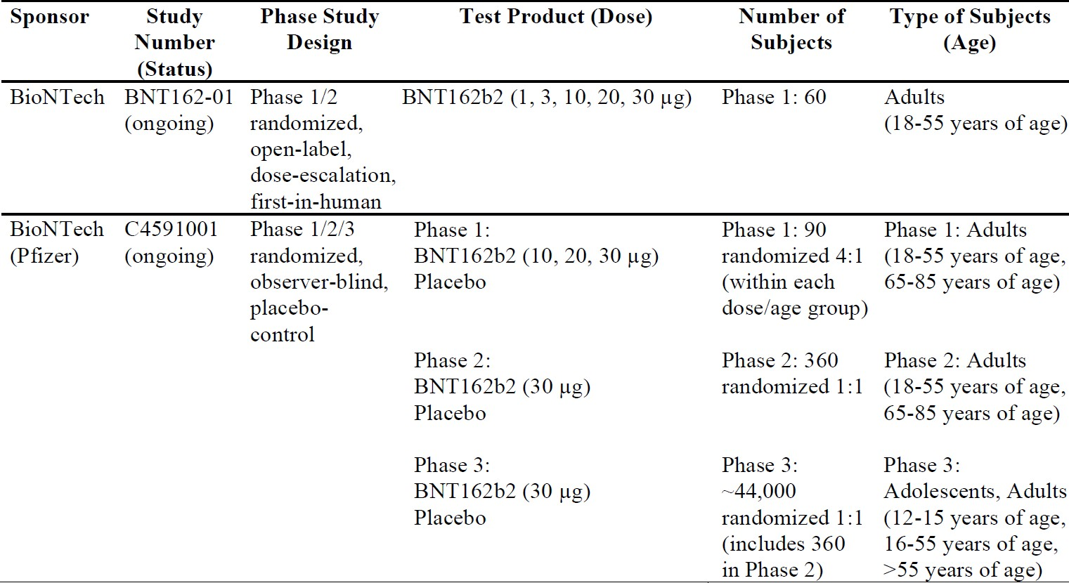

Study BNT162-01
Study BNT162-01 is a Phase I/II, first in human (FIH) study conducted in Germany, which explored various vaccine candidates and dose levels. Of note, cell mediated immunity data are available from this study in a limited number of subjects aged 18 to 55 years. Based on the enzyme-linked immune absorbent spot (ELISpot) and intracellular cytokine staining (ICS) assay results, BNT162b1 and BNT162b2 induced poly-functional and pro-inflammatory cluster of differentiation (CD)4+/CD8+ T cell responses in most study participants. Re-stimulation of peripheral blood mononuclear cells (PBMCs) with peptide pools representing the encoded antigens (receptor-binding domain (RBD) or full-length S protein) demonstrated a helper response characterised by a robust interferon gamma (IFNγ)/interleukin 2 (IL-2) response and only minor interleukin 4 (IL-4) production. This cytokine profile indicates a favourable T helper cell type 1 (Th1) response and only a minimal T helper cell type 2 (Th2) immune response.
This study contributed to the selection of vaccine candidate and the final dose. This study is not discussed in detail in this AusPAR.

Study C4591001
Study C4591001 is a global, Phase I/II/III, randomised, multinational, placebo controlled, observer blind study, conducted in healthy individuals. It began as a Phase I/II study in the USA, and was later amended and expanded to a global Phase II/III study, enrolling approximately 44,000 participants for immunogenicity, safety, and efficacy assessment. Adolescents 12 to 17 years of age were later added. There were many protocol amendments, but the amendments are considered justified and are unlikely to affect the study conclusion. The study consists of multiple phases, these are:
- Phase I (to identify preferred vaccine candidate and dose level).
- Phase II (safety and immunogenicity in the first 360 participants who entered Phase II/III).
- Phase II/III (efficacy and safety evaluation of the selected vaccine in a larger population).
The sponsor claimed that the clinical trials included in the application were performed in accordance with Good Clinical Practice (GCP).

Immunogenicity

Study C4591001 Phase I immunogenicity
The Phase I part evaluated the safety, tolerability, and immunogenicity of two vaccine candidates. Participants were randomised 4:1 to receive active vaccine or placebo. The following two vaccine candidates were administered by the intramuscular (IM) route in a two dose regimen:
- Vaccine candidate BNT162b1 (dose levels: 10, 20, 30, 100 µg), containing modRNA encoding SARS-CoV-2 receptor-binding domain.
- Vaccine candidate BNT162b2 (dose levels: 10, 20, 30 µg), containing modRNA encoding SARS-CoV-2 S protein (note, this is the vaccine candidate subsequently chosen as the proposed product).
For each of the 2 candidates evaluated, younger participants (18 to 55 years old) received escalating dose levels (N = 15 per dose level, 4:1 randomisation ratio between vaccine and placebo) with progression to subsequent dose levels, and the older age group (65 to 85 years old, N = 15 per dose level, 4:1 randomisation ratio between vaccine and placebo) when safety data for the preceding groups were deemed acceptable by the independent review committee.
A total of 90 subjects were involved in the Phase I assessment of BNT162b2 (mRNA).
SARS-CoV-2 neutralising titres and immunoglobulin G (IgG) antigen-binding levels (S1 binding IgG and RBD binding IgG) were measured on Days 7 and 21 after Dose 1 (pre-Dose 2); Days 7 and 14, and 1 month after Dose 2. The results of Phase I immunogenicity showed the following.
In the younger age group (18 to 55 years of age):
- At 7 days after Dose 2, SARS-CoV-2 50% neutralising geometric mean titres (GMTs) in the 20 µg and 30 µg dose groups were higher for BNT162b2 recipients than for BNT162b1 recipients. The GMTs were similar in the 10 µg dose group for both recipients. At 1 month after Dose 2 (Day 52), GMTs remained substantially higher than those at the earlier time points after Dose 1 for both BNT162b1 and BNT162b2 recipients.
- From before vaccination to 7 days post Dose 2, geometric mean fold rises (GMFRs) of SARS-CoV-2 50% neutralising titres were substantially high (compared to earlier time points after Dose 1) for BNT162b1 and BNT162b2 recipients at the 30 µg dose.
- From before vaccination to 7 days after Dose 2, all participants at the 30 µg dose level who received BNT162b1 or BNT162b2 achieved a ≥ 4 fold rise in SARS-CoV-2 50% neutralising titres.
In the older age group (65 to 85 years of age):
- At 7 days after Dose 2, SARS-CoV-2 50% neutralising GMTs in the 30 µg dose group were higher for BNT162b2 recipients than for BNT162b1 recipients. At 1 month after Dose 2 (Day 52), the SARS-CoV-2 50% neutralising GMTs in the 30 µg dose group were similar for both BNT162b1 and BNT162b2 recipients.
- From before vaccination to 7 days after Dose 2, the GMFR of SARS-CoV-2 50% neutralising titres were substantially high (compared to earlier time points after Dose 1) for BNT162b1 and BNT162b2 recipients at the 30 µg dose level.
- From before vaccination to 7 days after Dose 2, most participants who received BNT162b1 or BNT162b2 at the 30 µg dose level achieved a ≥ 4 fold rise in SARS-CoV-2 50% neutralising titres.
The immunogenicity results from the Phase I part demonstrated that BNT162b2 elicited robust SARS-CoV-2 neutralisation and S1-binding IgG antibody levels in both younger and older adults. Immune responses were generally stronger in the younger group than in the older group. The neutralising titre GMTs were higher than those observed in a healthy convalescent serum panel from people recovered from COVID-19. Responses were evident after the first dose and substantially boosted after the second dose. The results support the need for a 2 dose regimen. Safety and tolerability data of the Phase I part is described in the ‘Safety’ section, below. The safety data demonstrated that the reactogenicity profile of BNT162b2 is more favourable than BNT162b1 in both younger and older adults. BNT162b2 at the 30 µg dose level was therefore selected for the Phase II/III part of this study.

Study C4591001 Phase II immunogenicity
The Phase II part of Study C4591001 commenced with selected candidate BNT162b2 at the 30 µg dose level administered to participants who were randomised 1:1 to receive vaccine or placebo. The Phase II portion evaluated immunogenicity and reactogenicity for 360 participants enrolled into the study when the Phase II/III part commenced. Immunogenicity results from 360 participants demonstrated that BNT162b2 at 30 µg elicited robust SARS-CoV-2 neutralisation and S1-binding IgG antibody responses at 1 month after Dose 2, similar to those observed in Phase I part of the study. The neutralising titres and S1-binding geometric mean concentrations (GMCs) were higher in the younger age cohort compared with the older age cohort.

Efficacy

Study C4591001 Phase II/III objectives and endpoints
Phase II/III of Study C4591001 was designed to evaluate the safety and efficacy of BNT162b2 at the 30 µg dose level, given in 2 doses each given21 days apart, in a larger population.

Primary efficacy endpoints
The study objective and the two primary endpoints are described below in Table 4.
Table 4: Study C4591001 Phase II/III study objectives and primary efficacy endpoints
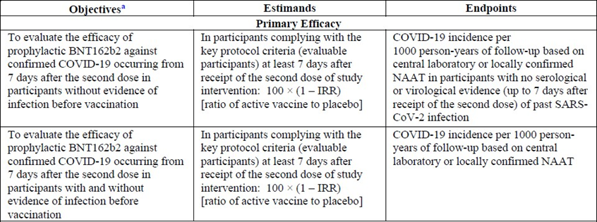
a. Human immunodeficiency virus (HIV)-positive participants in Phase III were not included in analyses of the objectives, with the exception of the specific exploratory objective. IRR = incidence rate ratio; NAAT = nucleic acid amplification test, a biochemical technique used to detect a virus or a bacterium.

Secondary efficacy endpoints
The secondary efficacy endpoints, which were based on different approaches to COVID-19 case evaluation criteria, are described below:
- COVID-19 confirmed at least 14 days after Dose 2: COVID-19 incidence per 1000 person years of follow up in participants either (1) without, or (2) with and without serological or virological evidence of past SARS-CoV-2 infection before and during vaccination regimen – cases confirmed ≥ 14 days after Dose 2.
- Severe COVID-19: incidence per 1000 person years of follow up in participants either (1) without, or (2) with and without evidence of past SARS-CoV-2 infection before and during vaccination regimen – cases confirmed either (1) ≥ 7 days after Dose 2, or (2) ≥ 14 days after Dose 2.
- Centers for Disease Control and Prevention (CDC)-defined COVID-19: incidence per 1000 person years of follow up in participants either (1) without, or (2) with and without evidence of past SARS-CoV-2 infection before and during vaccination regimen – cases confirmed either (1) ≥ 7 days after Dose 2, or (2) ≥ 14 days after Dose 2.

Entry criteria
Participant selection: initial selection was for adults 18 years and older. The protocol was later amended to include subjects 16 years and older, and then 12 years and older (participants older than 18 years of age began enrolment from 27 July 2020, 16 to 17 years of age began from 16 September 2020 and 12 to 15 years of age began enrolment from 15 October 2020). The sponsor does not seek indication for 12 to 15 years old, as the number of subjects is limited at the time of submission. Healthy participants with pre-existing stable disease, defined as disease not requiring significant change in therapy or hospitalisation for worsening disease during the 6 weeks before enrolment, could be included. Participants with known stable infection with HIV, hepatitis C virus or hepatitis B virus could be included. It is noted that people with the following conditions were excluded:
- Other medical or psychiatric conditions, including recent or active suicidal ideation/behaviour or laboratory abnormality that increased the risk of participation or, in the investigator’s judgment, made the participant inappropriate for the study.
- Immunocompromised individuals and individuals who received treatment with immunosuppressive therapy.
- Bleeding diathesis or condition associated with prolonged bleeding that would, in the opinion of the investigator, contraindicate IM injection.
- Participants who had previous clinical or microbiological diagnosis of COVID-19 disease.
- History of severe adverse reaction associated with a vaccine and/or severe allergic reaction to any component of the study intervention.
- Women who are pregnant or breastfeeding.
The Phase II/III part is designed as an adaptive, event-driven trial. The 95.0% credible interval for vaccine efficacy (VE) and the probability of VE greater than 30% were calculated with the use of a Bayesian beta-binomial model. The final analysis uses a success boundary of 98.6% for probability of vaccine efficacy greater than 30%, to compensate for the interim analysis and to control the overall Type 1 error rate at 2.5%.
Confirmed COVID-19 cases were determined by reverse transcription-polymerase chain reaction (RT-PCR) and required at least 1 symptom consistent with COVID-19 disease. The symptoms included: fever, new or increased cough, new or increased shortness of breath, chills, new or increased muscle pain, new loss of taste or smell, sore throat, diarrhoea or vomiting.
Approximately 44,000 participants were enrolled and randomised 1:1 to receive 2 doses of the vaccine or placebo, separated by 21 days. Randomisation was stratified by age: 16 through 55 years of age, or 56 years of age and older, with a minimum of 40% of participants in the ≥ 56 year of age stratum. Note that subjects 12 through 15 years of age were not included in the efficacy analysis.

Disposition and demographic characteristics of the study population
The proportions of all randomised participants (n = 43,651) included in the efficacy analysis were similar in the BNT162b2 and placebo groups. Most participants who were excluded from the evaluable efficacy population had not received all vaccinations as randomised or did not receive Dose 2 within the predefined window (that is, 19 to 42 days after Dose 1). The evaluable efficacy population includes 82.8% White, 8.9% Black or African American and 4.5% Asian. 26.8% of participants were of Hispanic/Latino ethnicity.. The median age was 52 years of age and participants were balanced for gender. The younger (16 to 55 years of age) and older (> 55 years of age) groups comprised 57.2% and 42.6% of participants, respectively. Obese participants made up around 35% of the population. Approximately 20% of participants had baseline comorbidities.

Results

Results of the first primary endpoint
The interim analysis (dated 4 November 2020) based on 94 COVID-19 cases successfully demonstrated high VE. This was followed by the second (and final) analysis, which was based on 170 accumulated COVID-19 cases. The final analysis was performed on 14 November 2020, by which time 43,651 participants had been randomised. The focus of this section will be the final efficacy analysis.
Results of the first primary endpoint (vaccine efficacy without prior evidence of SARS-CoV-2 infection, 7 days after Dose 2, final analysis) are shown in Table 5.
Among the 36,523 efficacy evaluable participants who had no evidence of existing or prior SARS-CoV-2 infection (18,198 in the vaccine group and 18,325 in the placebo groups), 8 cases of COVID-19 with onset at least 7 days after the second dose were observed among vaccine recipients and 162 among placebo recipients. The VE against confirmed COVID-19 occurring at least 7 days after Dose 2 was 95.0%. The 95% confidence interval (CI) was 90.3% to 97.6%, indicating that the true VE is at least 90.3% with a 97.5% probability given the observed data.
Table 5: Study C4591001 Phase II/III Vaccine efficacy, first COVID-19 occurrence from 7 days after Dose 2 in subjects without evidence of infection prior to 7 days after Dose 2 (efficacy evaluation (7 days) population)
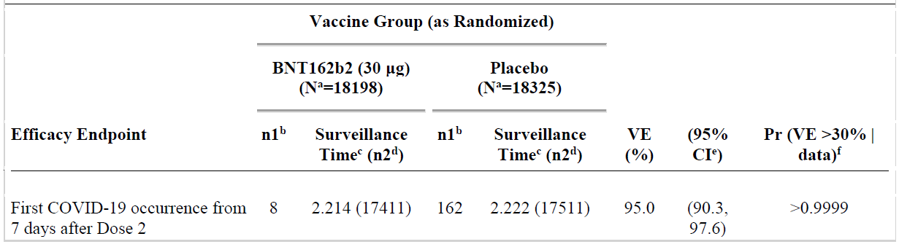
Abbreviations: Pr = posterior probability; VE = vaccine efficacy; CI = confidence intervals
Note: Subjects who had no serological or virological evidence (prior to 7 days after receipt of the last dose) of past SARS-CoV-2 infection (that is, SARS-CoV-2 nucleoprotein-binding (N-binding) antibody (serum) negative at Visit 1 and SARS-CoV-2 not detected by nucleic acid amplification test (NAAT) via nasal swab sample at Visits 1 and 2), and had negative NAAT (nasal swab) at any unscheduled visit prior to 7 days after Dose 2 were included in the analysis. Data cut-off date: 14 November 2020.
a. N = number of subjects in the specified group. b. n1 = Number of subjects meeting the endpoint definition. c. Total surveillance time in 1000 person-years for the given endpoint across all subjects within each group at risk for the endpoint. Time period for COVID-19 case accrual is from 7 days after Dose 2 to the end of the surveillance period. d. n2 = Number of subjects at risk for the endpoint. e. Credible interval for VE was calculated using a beta-binomial model with prior beta (0.700102, 1) adjusted for surveillance time. f. Pr was calculated using a beta-binomial model with prior beta (0.700102, 1) adjusted for surveillance time.

Results of the second primary efficacy endpoint
Table 6: Study C4591001 Phase II/III Vaccine efficacy, first COVID-19 occurrence from 7 days after Dose 2 in subjects with or without evidence of infection prior to 7 days after Dose 2 (efficacy evaluation (7 days) population)
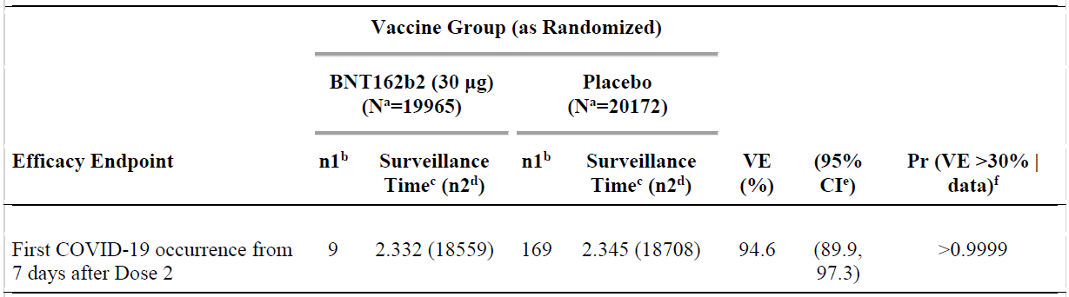
Data cut-off date: 14 November 2020.
a. N = number of subjects in the specified group. b. n1 = Number of subjects meeting the endpoint definition. c. Total surveillance time in 1000 person-years for the given endpoint across all subjects within each group at risk for the endpoint. Time period for COVID-19 case accrual is from 7 days after Dose 2 to the end of the surveillance period. d. n2 = Number of subjects at risk for the endpoint. e. Credible interval for VE was calculated using a beta-binomial model with prior beta (0.700102, 1) adjusted for surveillance time. f. Pr was calculated using a beta-binomial model with prior beta (0.700102, 1) adjusted for surveillance time.

Vaccine efficacy by subgroups
For the primary endpoints, VE was evaluated for subgroups by age, gender; race, ethnicity, and country. Among participants without prior evidence of SARS-CoV-2 infection, VE was > 93% in all subgroups, with the exception of the ‘All others’ race group (89.3%); and Brazil (87.7%). The VE was 94.7% (95% CI: 66.7%, 99.9%) in participants older than 65 years of age (1 case in the BNT162b2 group versus 19 cases in the placebo group). An additional analysis of age subgroups showed observed VE in those older than 75 years of age was 100 % (0 cases in the BNT162b2 group versus 5 cases in the placebo group (95% CI: -13.1%, 100.0%).
Among participants with or without prior evidence of SARS-CoV-2 infection, VE was > 93% in all subgroups, with the exception of the ‘All others’ race group (78.2%),21 Brazil (75.4%), and positive prior SARS-CoV-2 infection at Baseline (-7.1%, 1 case in each group).

Post hoc subgroup analyses by risk status
Post hoc analyses of efficacy based on risk status were performed. Among participants without prior evidence of SARS-CoV-2 infection before and during vaccination regimen, VE for at risk participants was 95.3%, as compared with 94.7% for those not at risk. VE for participants ≥ 65 years of age and at-risk was 91.7%, as compared with 100% for those ≥ 65 years of age and not at-risk. VE was similar in obese (95.4%) and non-obese (94.8%) participants.

Results for the secondary efficacy endpoints
The observed VE against confirmed COVID-19 occurring at least 14 days after Dose 2 in participants without evidence of SARS-CoV-2 infection before and during the vaccination regimen was 94.2%, with 8 and 139 cases in the BNT162b2 and placebo groups, respectively. The posterior probability of > 99.99% for the true VE > 30% met the pre-specified success criterion of > 98.6% for this endpoint. The 95% CI for the vaccine efficacy was 88.7% to 97.2%.
Among participants with or without evidence of SARS-CoV-2 infection before and during vaccination regimen, VE against confirmed COVID-19 occurring at least 14 days after Dose 2 was 94.4%, with 8 and 144 cases in the BNT162b2 and placebo groups, respectively. The posterior probability of > 99.99% for the true VE > 30% met the pre-specified success criterion of > 98.6% for this endpoint. The 95% CI for the vaccine efficacy was 89.1% to 97.3%.
Among participants without evidence of SARS-CoV-2 infection before and during the vaccination regimen, the observed VE of 66.3 % against severe COVID-19 occurring at least 7 days after Dose 2 did not meet the pre-specified success criterion of the posterior probability > 98.6%, due to the small numbers of severe cases (1 in the BNT162b2 group, and 3 in the placebo group) observed after Dose 2 in the study. Additional analysis conducted in all cases after Dose 1 (1 versus 9 cases, respectively) showed the evidence of an effect on severe cases (VE = 88.9% with a 95% CI of 20.1 to 99.7%).
The efficacy analyses using CDC-defined symptoms to identify a COVID-19 case gave similar efficacy results as the primary endpoints.

All confirmed cases of COVID-19 after Dose 1 (post-hoc analysis)
All reports of COVID-19 with onset at any time after Dose 1 are presented in the table below.
Table 7: Study C4591001 Phase II/III Vaccine efficacy, first COVID-19 occurrence after Dose 1 (Dose 1 all available efficacy population)
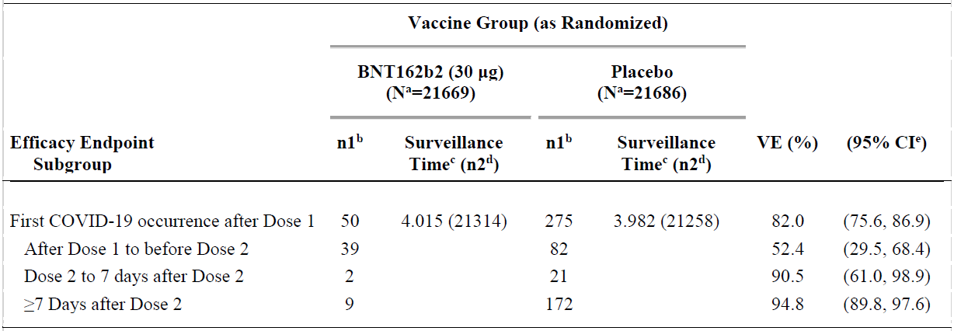
Data cut-off date: 14 November 2020.
a. N = number of subjects in the specified group. b. n1 = Number of subjects meeting the endpoint definition. c. Total surveillance time in 1000 person-years for the given endpoint across all subjects within each group at risk for the endpoint. Time period for COVID-19 case accrual is from Dose 1 to the end of the surveillance period. d. n2 = Number of subjects at risk for the endpoint. e. Confidence interval (CI) for VE is derived based on the Clopper and Pearson method (adjusted for surveillance time for overall row).
This provides a summary of cases for all participants in the Dose 1 all-available efficacy population, regardless of evidence of infection before or during the vaccination regimen. Among these participants, 50 cases of COVID-19 occurred after Dose 1 in the BNT162b2 group compared to 275 cases in the placebo group. The estimated VE against confirmed COVID-19 occurring after Dose 1 was 82% (95% CI: 75.6%, 86.9%), with an estimated VE of 52.4% (95% CI: 29.5%, 68.4%) against confirmed COVID-19 occurring after Dose 1 but before Dose 2.
The early onset of protection can be observed in the cumulative incidence for the first COVID-19 occurrence after Dose 1 among all vaccinated participants based on Dose 1 all-available efficacy population. Disease onset appears to track together for BNT162b2 and placebo until approximately 14 days after Dose 1, at which point the curves diverge, with cases steadily accumulating in the placebo group, while remaining virtually flat in the BNT162b2 group.

Safety
Safety was evaluated in Study BNT162-01 (FIH) and in three phases of Study C4591001. This following sections focus on the safety analysis of Study C4591001. The safety analyses are descriptive with no formal statistical hypothesis testing. The cut-off date for safety data is 14 November 2020.

Study C4591001 Phase I
The 10 µg, 20 µg, and 30 µg doses tested for the vaccine candidates BNT162b1 and BNT162b2 were well tolerated. The BNT162b1 candidate at 100 µg was discontinued after the first dose due to the reactogenicity profile. Reactogenicity was generally higher after Dose 2 than Dose 1. The frequency of local and systemic reactogenicity was generally lower for BNT162b2 compared to BNT162b1, especially after the second dose.
Reactogenicity events after administration of each dose for both vaccine candidates in older adults were milder and less frequent than those observed in younger adults. The majority of events were mild or moderate. There were no serious adverse events (SAEs) or discontinuations because of adverse events (AEs). Overall, fewer AEs were experienced by participants who received BNT162b2 compared with those who received BNT162b1, with the least number of participants experiencing AEs in the BNT162b2 older age group.
Clinical laboratory evaluations showed a transient decrease in lymphocytes that was observed in all age and dose groups after Dose 1, which resolved within a few days, and was not associated with any other clinical sequelae.
The report received by TGA on 10 December 2020 included additional follow-up from 1 month after Dose 2 (29 August 2020) to 4 months after Dose 2 (the data cut-off 14 November 2020): 1 severe SAE (neuritis; due to an antecubital fossa blood draw) was reported in the younger age group. No additional AEs were reported in the younger or older age group between 29 August 2020 to the data cut-off date of 14 November 2020.

Study C4591001 Phase II/III
The safety analysis has been done on all enrolled participants (n = 43,252); the reactogenicity subset (n = 8,183); participates with a follow up more than 2 months after Dose 2 (n = 19,037); and participants with a median follow up of 2 months after Dose 2. This section focuses on the safety analysis of the following:
- local and systemic reactogenicity in the reactogenicity subset of 8,183 subjects; and
- AE analysis in around 38,000 participants with a median of 2 months follow up post Dose 2.
The primary safety endpoints were solicited, specific local or systemic AEs and use of antipyretic or pain medication within 7 days after each dose of vaccine or placebo, as prompted by and recorded in an electronic diary in a subset of participants (reactogenicity subset), and unsolicited AEs (without prompts from the electronic diary) through 1 month after the second dose, and through 6 months after the second dose.
Demographic characteristics of the approximately 38,000 participants with a median of 2 months of follow up after Dose 2 were similar between BNT162b2 and placebo groups. There were no clinically meaningful differences by age, gender, race, ethnicity, or baseline SARS-CoV-2 status in the vaccine and placebo groups. Across the two groups, about 20.5% had any comorbidity. The most frequently reported comorbidities were diabetes (8.4%) and pulmonary disease (7.8%), which were reported at similar frequencies in each group.

Reactogenicity subset analysis
As of 14 November 2020, the reactogenicity subset was comprised of 8,183 participants (which included the 360 participants in Phase II).

Local reactions
In the BNT162b2 group, pain at the injection site was reported more frequently in the younger group (see Figure 1) than in the older group (see Figure 2) with similar frequency after Dose 1 and Dose 2 of BNT162b2 in the younger group (83.1% versus 77.8%) and older group (71.1% versus 66.1%).
In the BNT162b2 group, frequencies of redness and swelling were similar in the younger and older age group after Doses 1 and 2. Frequencies of redness were similar after Dose 1 and Dose 2 of BNT162b2 in the younger age group (4.5% versus 5.9%) and in the older age group (4.7% versus 7.2%). Frequencies of swelling were similar after Dose 1 and Dose 2 of BNT162b2 in the younger age group (5.8% versus 6.3%) and in the older age group (6.5% versus 7.5%). In the placebo group, redness and swelling were reported infrequently in the younger (≤ 1.1%) and older (≤ 1.2%) groups after Doses 1 and 2.
Across age groups, pain at the injection site did not increase after Dose 2, and redness and swelling were generally similar in frequency after Dose 1 and Dose 2. Most local reactions were mild or moderate. Few severe local reactions were reported after either dose. The frequency of any severe local reactions after Dose 1 and after Dose 2 was ≤ 0.7%. No Grade 4 reactions were reported. The local reactions for the BNT162b2 group after either dose had a median onset between Day 1 and Day 3, and ranges were similar in the younger and older age groups. The local reactions after either dose resolved with median durations between 1 to 2 days, which were similar in the younger and older age groups.
Figure 1: Study C4591001 Phase II/III Participants aged 16 to 55 years reporting local reactions, by maximum severity, within 7 days after each dose (reactogenicity subset, safety population)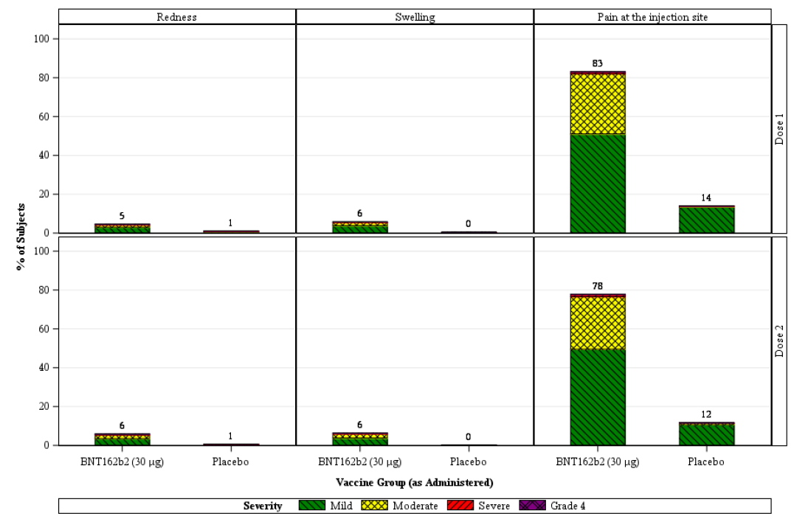
Note: the number above each bar denotes the percentage of subjects reporting the reaction with any severity.
Figure 2: Study C4591001 Phase II/III Participants aged > 55 years reporting local reactions, by maximum severity, within 7 days after each dose (reactogenicity subset, safety population)
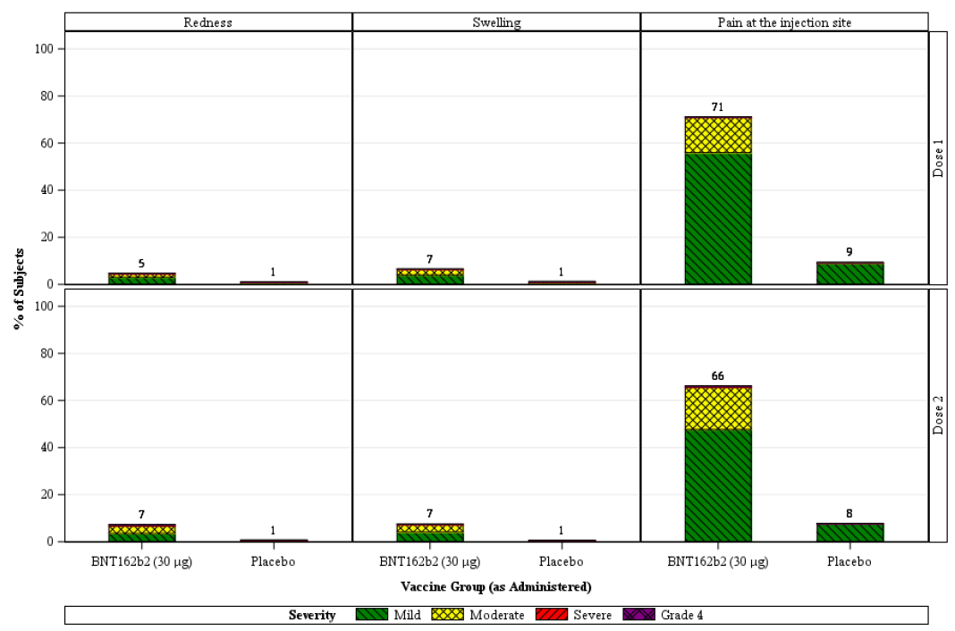
Note: the number above each bar denotes the percentage of subjects reporting the reaction with any severity.

Systemic reactions
Systemic events were generally increased in frequency and severity in the younger age group (see Figure 3) compared with the older age group (see Figure 4), with frequency and severity increasing with number of doses (Dose 1 versus Dose 2). Vomiting and diarrhoea were exceptions, with vomiting reported similarly infrequently in both age groups and diarrhoea reported at similar incidences after each dose. Systemic events were reported less frequently in the placebo group than in the BNT162b2 group, for both age groups and doses, with some exceptions. In the younger age group, vomiting and diarrhoea (after Dose 1 and Dose 2) were reported at similar frequencies in the placebo group and the BNT162b2 group (Figure 3). In the older age group, fever and joint pain (after Dose 1) and vomiting and diarrhoea (after Dose 1 and Dose 2) were reported at similar frequencies in the placebo group and the BNT162b2 group (Figure 4).
Figure 3: Study C4591001 Phase II/III Participants aged 16 to 55 years reporting systemic events, by maximum severity, within 7 days after each dose (reactogenicity subset, safety population)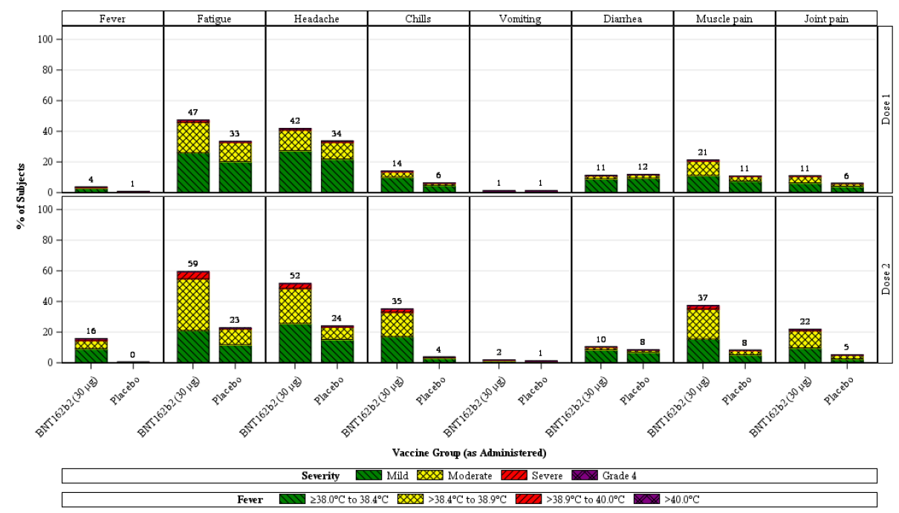
Note: the number above each bar denotes the percentage of subjects reporting the reaction with any severity.
Figure 4: Study C4591001 Phase II/III Participants aged > 55 years reporting systemic events, by maximum severity, within 7 days after each dose (reactogenicity subset, safety population)
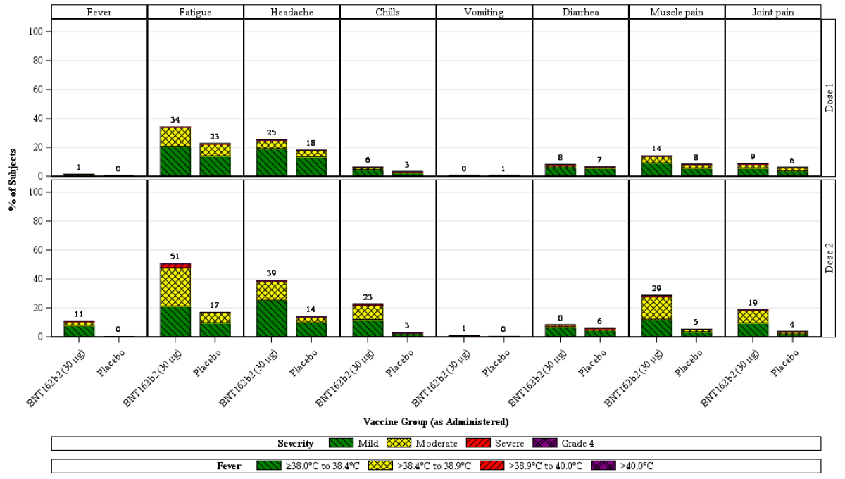
Note: the number above each bar denotes the percentage of subjects reporting the reaction with any severity.
In the BNT162b2 group, systemic events after Dose 1 were generally lower in frequency than after Dose 2 across age groups: fever (2.7% versus 13.6%), fatigue (41.5% versus 55.5%), headache (34.5% versus 46.1%), chills (10.6% versus 29.6%), muscle pain (18.0% versus 33.5%), and joint pain (9.9% versus 20.5%). Diarrhoea and vomiting frequencies were generally similar. Across age groups, the median onset day for all systemic events after either Dose 1 or 2 of BNT162b2 was Day 2 to Day 3, and ranges were similar in the younger and older age subgroups. All systemic events resolved with a median duration of 1 day, which was similar in the younger and older age subgroups. The median duration of either fever or chills from first to last day after Dose 1 and Dose 2 was 1 day, for both younger and older age subgroups. Other than fatigue and headache, most systemic events were infrequent in the placebo group.

Analysis of adverse events
A total of 37,707 participants who were randomised on or before 9 October 2020 were vaccinated with Dose 1. One of these participants did not sign an informed consent and is therefore not included in any analysis population. The remaining 37,706 participants had a median follow up time of 2 months after Dose 2. Of these, 19,067 (50.6%) had at least 2 months of follow up after Dose 2. HIV positive participants (n = 120) were included for counting purposes in demographic and disposition summaries; however, these participants were not included in the summary of safety or efficacy endpoint results. Therefore, 37,586 participants were included in the AE analyses presented here.
Among these 37,586 participants, the most frequent AEs reported up to 1 month after Dose 2 were reactogenicity events, in the System Organ Classes (SOCs) of:
- general disorders and administration site conditions (18.6% BNT162b2 versus 3.9% placebo)
- musculoskeletal and connective tissue disorders (7.3% BNT162b2 versus 2.0% placebo)
- nervous system disorders (6.1% BNT162b2 versus 2.4% placebo)
- infections and infestations (1.5% BNT162b2 versus 1.5% placebo)
- gastrointestinal disorders (2.9% BNT162b2 versus 1.9% placebo).
Comparing the younger (aged 16 to 55 years) versus older (aged > 55 years) BNT162b2 age subgroups, AE incidences in these SOCs were:
- general disorders and administration site conditions (21.1% versus 15.2%)
- musculoskeletal and connective tissue disorders (8.3% versus 5.9%)
- nervous system disorders (6.9% versus 4.9%)
- infections and infestations (1.5% versus 1.6%)
- gastrointestinal disorders (3.0% versus 2.8%).
The numbers of overall participants who reported at least one AE (27.0% versus 12.5%) were higher in the BNT162b2 group as compared with the placebo group and at least one related AE (20.8% versus 5.1%). The most frequent AEs in the BNT162b2 group were injection site pain (2,108 (11.2%)), pyrexia (1,144 (6.1%)), chills (998 (5.3%)), fatigue (1,026 (5.5%)), headache (966 (5.1%)), and myalgia (904 (4.8%)). During this time period from Dose 1 to 1 month after Dose 2, most of these AEs were reported during the electronic diary 7 day reporting period. The majority of these AEs were reported in the younger age group: injection site pain (1,358 (12.5%)), pyrexia (819 (7.6%)), chills (693 (6.4%)), fatigue (690 (6.4%)), headache (649 (6.0%)), and myalgia (628 (5.8%)).
This trend continued to be seen through the data cut-off date for all enrolled participants (n = 43,252 participants). The higher frequency of reported unsolicited non-serious AEs among BNT162b2 recipients compared to placebo recipients was primarily attributed to local and systemic AEs reported during the first 7 days following vaccination that are consistent with adverse reactions solicited among participants in the reactogenicity subset.

Adverse events by subgroups
No clinically meaningful differences in AE frequencies were observed amongst age, sex, race, ethnicity, or baseline SARS-CoV-2 status subgroups.

Adverse events of special interest
The CDC's list of adverse events of special interest (AESIs) for COVID-19, including the terms potentially indicative of severe COVID-19 or serious autoimmune and neuroinflammatory disorders, was considered in the review of reported AEs.
- Lymphadenopathy: in the BNT162b2 group, 64 participants (0.3%) reported an AE of lymphadenopathy (54 in the younger age group and 10 in the older age group), and 6 in the placebo group. In cases where location was specified, lymphadenopathy occurred in the arm and neck region. Most lymphadenopathy events were reported within 2 to 4 days after vaccination. The mean duration was 10 days and 12 events were ongoing at the time of the data cut-off date. A total of 47 out of these 64 lymphadenopathy events were judged by the investigator as related to study intervention.
- Hypersensitivity: in the younger age group, an AE of angioedema 13 days after Dose 1 (both eyes) and hypersensitivity (allergy attack; no additional information available at the time of this report) was reported in 1 participant each (both from the BNT162b2 group), and an AE of drug hypersensitivity (oral penicillin reaction) was reported in 1 participant who received placebo; all were assessed by the investigator as unrelated to study intervention. There were 6 participants that reported ‘Drug hypersensitivity’ in the vaccine group compared to 1 in placebo group. Post-market monitoring for hypersensitivity events should be conducted.
- Facial paralysis: there were 4 reports of facial paralysis (Bell’s palsy) in the vaccine group with none in the placebo group.

Serious adverse events
Among the 37,586 participants with a median of 2 months of follow up after Dose 2, from Dose 1 to 1 month after Dose 2, the proportions of participants who reported at least 1 SAE was similar in the BNT162b2 group (0.5%) and in the placebo group (0.4%). Three of the SAEs in the BNT162b2 group and none in the placebo group were assessed as related to study intervention: 1 SAE each of shoulder injury related to vaccine administration, ventricular arrhythmia, and lymphadenopathy.
A total of 12 participants had SAEs of appendicitis; 8 in the BNT162b2 group and 4 in the placebo group. None were assessed as related to study intervention. An observation of 12 appendicitis events across both treatment groups is not greater than expected based on background rates (estimated in a US Electronic Health Records database).
Up to cut-off date of 14 November 2020, the number of participants who reported SAEs was similar in the two groups (0.7% for the BNT162b2 group versus 0.5% for the placebo group). With the additional follow up time, another SAE assessed by the investigator as related to study intervention in the BNT162b2 younger age subgroup was reported: 1 event of lower back pain and bilateral lower extremity pain with radicular paraesthesia (onset Day 47 after Dose 2).
Severe AEs, SAEs, and AEs leading to withdrawal were few, and were reported by ≤ 1.2%, ≤ 0.5%, and ≤ 0.2% respectively, in both groups. Discontinuations due to related AEs were reported in 14 participants in the BNT162b2 group and 7 participants in the placebo group.

Deaths
There were 6 participants, all in Phase III part of the study, who died before the data cut-off date of 14 November 2020. There were 2 deaths in the BNT162b2 group (arteriosclerosis and cardiac arrest) and 4 deaths in the placebo group that were assessed as not related to study intervention.

Severe COVID-19 illness
The protocol had pre-specified stopping rules that included monitoring of severe COVID-19 cases, and these stopping criteria were not met. The confinement of the majority of severe cases to the placebo groups suggests no evidence for vaccine-associated enhanced disease (VAED), including vaccine-associated enhanced respiratory disease (VAERD).
The safety profile of all enrolled participants (n = 43,252 participants) who had variable follow up from Dose 1 to the data cut-off date (14 November 2020) is consistent with the safety profile in the participants who had at least 2 months of follow up after Dose 2.
The safety evaluation is still ongoing. Participants continue to be monitored for unsolicited AEs, including SAEs up to six months after the last vaccine dose.

Safety in special populations
- Pregnant women: at the time of the data cut-off (14 November 2020), a total of 23 participants had reported pregnancies in the safety database, including 9 participants who withdrew from the vaccination period of the study due to pregnancies. These participants continue to be followed for pregnancy outcomes. The data to support safety in pregnancy are inadequate at this stage.
- Paediatric population: there were only 100 participants between 12 to 15 years of age (n = 49 BNT162b2; n = 51 placebo) recruited in the Phase II/III study under protocol amendment 7. The safety and efficacy of BNT162b2 in participants < 16 years of age have not been established. The sponsor is not seeking indication for < 16 years old in the current submission, and will undertake further study in paediatric subjects to assess the vaccine response in the paediatric population.
- Immunocompromised individuals: immunocompromised individuals and individuals who received treatment with immunosuppressive therapy were excluded from the clinical trial. There were data for limited number of participants with stable HIV infection.

Post-marketing adverse event reports
There were a number of reports of anaphylaxis reactions to the sponsor’s COVID-19 vaccine in the UK and in the USA following the vaccine rollout. The two cases in the UK occurred on 8 December 2020. Both individuals in the UK had a history of severe allergic reactions and carried adrenaline auto injectors. They both were treated and have recovered.
Anaphylactic reaction is now included as an identified risk for this vaccine. The updated Australian PI has an included statement of ‘Close observation for at least 15 minutes is recommended following vaccination. A second dose of the vaccine should not be given to those who have experienced anaphylaxis to the first dose of Comirnaty’; and ‘Appropriate medical treatment and supervision should always be readily available in case of an anaphylactic reaction following the administration of the vaccine’. Hypersensitivity to the active substance or to any of the vaccine excipients have been included as Contraindication. The US Food and Drug Administration (FDA) document for Health Care Professionals include the statement of ‘Do not administer Pfizer-BioNTech COVID- 19 Vaccine to individuals with known history of a severe allergic reaction (e.g., anaphylaxis) to any component of the Pfizer-BioNTech COVID-19 Vaccine’.

Clinical evaluator’s recommendation
The product falls within the scope of provisional registration pathway (section 23AA of the Act),¹⁰ concerning provisional marketing authorisations, as Comirnaty is a new biological entity which aims at the prevention of a life-threatening disease and the preliminary clinical data demonstrating that the medicine is likely to provide a major therapeutic advance.
From clinical point of view, the relevant data is limited to a single pivotal clinical trial, Study C4591001, for which interim findings for a median follow up period of around 2 months only are available. Short follow up duration limits the conclusion on persistence of efficacy and late onset/rare adverse events. This study is planned to continue for a total of 24 months.
As comprehensive data on the product are not available, provisional registration is the most appropriate regulatory pathway.
The clinical evaluator’s recommendation is that Comirnaty can have provisional approval for:
Active immunisation to prevent coronavirus disease 2019 (COVID-19) caused by SARS-CoV-2, in individuals 16 years of age and older.
As Comirnaty is being recommended for a provisional registration, the following is the recommendation regarding confirmatory trial data, as conditions of registration:
- Submit the completed study report for Study C4591001 (Phase II/III) as soon it is available. The sponsor should also submit safety data at 6 month follow up time. Since this is a rolling submission, interim data can be submitted at any stage.
- Submit the interim analysis and final clinical study reports for Study BNT162-01 once completed, including data on healthy subjects.
- Submit monthly, expedited summary safety reports for the next 6 months (risk management plan (RMP) recommendation).
- Routine submission of periodic benefit risk evaluation reports (PBRERs; pharmacovigilance).
As and when available, further data related to vaccine efficacy in paediatric subjects, pregnant women, in immunocompromised subjects, the data relating to protection against asymptomatic disease and the information relating to post-market safety and effectiveness studies should be submitted as separate submissions to amend the current indications and to update the PI.

Risk management plan
On 10 December 2020, the sponsor submitted EU-RMP version 0.1 (date 29 November 2020; data lock point (DLP) 29 November 2020) in support of this application. On 29 December 2020, an updated version of the EU RMP, version 1.0 (dated 21 December 2020; DLP 17 December 2020) was provided. On 6 January 2021, the sponsor provided the Australian specific annex (ASA) version 0.1 (date 5 January 2021). On 18 January 2021, the sponsor provided the ASA version 0.2 (date 17 January 2021).
The summary of safety concerns and their associated risk monitoring and mitigation strategies are summarised in Table 8.
Table 8: Summary of safety concerns
Summary of safety concerns |  | Pharmacovigilance |  | Risk minimisation
 |  | Routine | Additional | Routine | Additional
Important identified risks | Anaphylaxis | † | * |  | –
Important potential risks | Vaccine-associated enhanced disease (VAED) including vaccine-associated enhanced respiratory disease (VAERD) | † | * | – | –
Missing information | Use in pregnancy and while breast feeding |  | * |  | –
Missing information | Use in immunocompromised patients |  | * |  | –
Missing information | Use in frail patients with co-morbidities (for example, chronic obstructive pulmonary disease (COPD), diabetes, chronic neurological disease, cardiovascular disorders) |  | * |  | –
Missing information | Use in patients with autoimmune or inflammatory disorders |  | * | – | –
Missing information | Interaction with other vaccines |  | * |  | –
Missing information | Long term safety data |  | * | – | –
†Data capture Aid. *Clinical trials.
The summary of the safety concerns above is considered acceptable.
With regards to additional pharmacovigilance activities, the sponsor has proposed the following 11 studies, of which one is global, three are in Europe only, two are in Europe and the US, and three are in the US only; the countries where two studies will be conducted are not available at this time. There are six interventional studies (Studies C4591001, C4591015, BNT162-01 Cohort 13, C4591018, one study in high risk adults and one study for vaccine interactions) and five non-interventional studies (four safety and one effectiveness).
Table 9: Planned studies that are considered additional pharmacovigilance activities
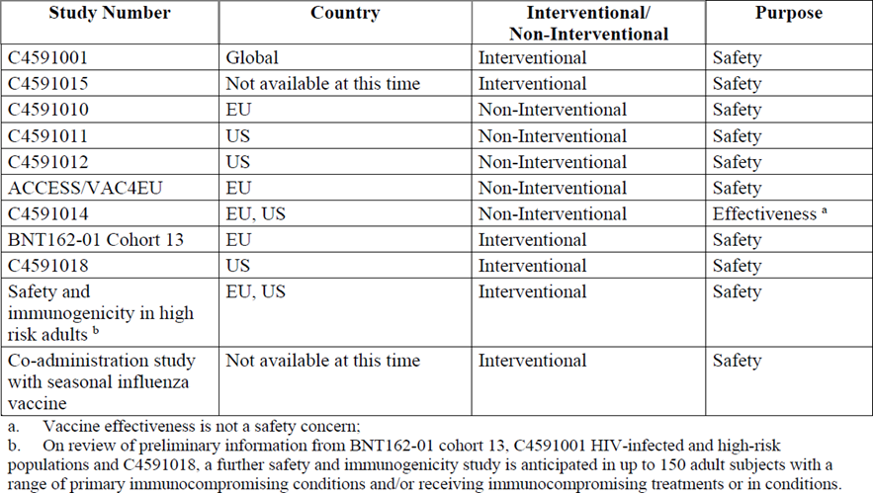
The results from these studies will help to address the missing information identified in the summary of safety concerns. The sponsor is also required to implement specific targeted data capture aids to monitor AESIs in Australia.
No Australian specific studies have been planned. The data from the studies planned to be conducted overseas are considered applicable to the Australian population.
As part of the conditions of registration outlined below, the sponsor is required to submit monthly safety summary reports for the first 6 months of registration, and thereafter at intervals specified by the TGA; and submit periodic safety updates reports (PSURs) six monthly for 3 years, or the period of provisional registration whichever is longer.

Proposed risk management conditions of registration
- The Comirnaty EU-RMP (version 1.0, dated 21 December 2020; DLP 17 December 2020), with Australian specific annex (version 0.2, dated 17 January 2021), included with submission PM-2020-05461-1-2, and any subsequent revisions, as agreed with the TGA will be implemented in Australia.
An obligatory component of risk management plans is routine pharmacovigilance. Routine pharmacovigilance includes the submission of PSURs.
Unless agreed separately between the supplier who is the recipient of the approval and the TGA, the first report must be submitted to TGA no later than six calendar months after the date of the approval letter. The subsequent reports must be submitted no less frequently than six monthly until the period covered by such reports is not less than three years from the date of the approval letter, or the entire period of provisional registration, whichever is longer.
The reports are to at least meet the requirements for PSURs as described in the European Medicines Agency’s Guideline on Good Pharmacovigilance Practices (GVP) Module VII-periodic safety update report (Rev 1), Part VII.B Structures and processes. Note that submission of a PSUR does not constitute an application to vary the registration. Each report must have been prepared within ninety calendar days of the data lock point for that report.
- Additional to the routine submission of the routine PSURs, expedited monthly, Comirnaty safety summary reports (including safety data for patients in Australia) are to be provided for the first 6 months post registration, and thereafter at intervals specified by the TGA.
- Comirnaty is to be included in the Black Triangle Scheme due to provisional approval.² The PI and Consumer Medicines Information (CMI) for Comirnaty must include the black triangle symbol and mandatory accompanying text for the products entire period of provisional registration.

Risk-benefit analysis

Delegate’s considerations

Unmet public health need
With respect to the incidence rate of COVID-19, Australia is currently in a better situation in comparison to some other countries. However, the situation is far from the normal life Australians led pre-COVID-19. The COVID-19 outbreaks have been occurring frequently, and the consequential travel restriction and border closure have been having a negative impact on our daily life. A safe and effective vaccine is one of the important tools in our fight against the COVID-19 pandemic. No COVID-19 vaccine is currently registered in Australia. There is an unmet need for safe and effective COVID-19 vaccines during the current public health emergency.

Short term efficacy and safety data for provisional registration
The sponsor has submitted the short-term results from the pivotal study to support the provisional registration of BNT162b2 (mRNA) COVID-19 vaccine. The submitted pivotal study has an overall good study design, including representative study population and acceptable statistical considerations. The results from this study have demonstrated that BNT162b2 (mRNA) at 30 µg administered as a 2 dose schedule (21 days apart) achieved a short term vaccine efficacy of 95% against polymerase chain reaction (PCR)-confirmed COVID-19 in subjects ≥ 16 years of age without prior evidence of SARS-CoV-2 infection. This was demonstrated in a larger randomised, placebo controlled Phase III trial, with many subjects being followed up for a median of 2 months post Dose 2. The VE was consistent across age, gender, race and ethnicity demographics. VE was also demonstrated in those with one or more comorbidities. The analysis of tolerability and safety of the vaccine detected short lived, mild to moderate local and systemic reactogenicity, a low incidence of severe or serious events, and no clinically significant safety concerns among participants who were followed for a median of 2 months after the second dose of the vaccine.
The submitted safety data is only short term at this stage, but the data have fulfilled the requirement as set out in the ‘Access Consortium statement on COVID-19 vaccines evidence’.14 The statement specified the minimum requirement that trial participants must be followed for a median of at least 2 months after receiving their final vaccine dose. It is acknowledged that most adverse reactions to vaccines occur within 4 to 6 weeks from vaccination. The EMA has stated that conditional marketing authorisation for a COVID-19 vaccine could be based on review of at least 6 weeks post vaccination safety data.
From the perspective of vaccine efficacy, a 2 month median follow up is considered as the shortest follow up period to achieve some confidence that any protection against COVID-19 is likely to be more than short lived. The duration of protection is not yet known and is to be assessed in the ongoing trial.

Data limitations
In addition to the unknown longer term safety and unknown duration of vaccine protection, there are other limitations with the submitted data. The following questions have not yet been addressed:
- Vaccine efficacy against asymptomatic infection and viral transmission.
- The concomitant use of this vaccine with other vaccines.
- Vaccine data in pregnant women and lactating mothers.
- Vaccine efficacy and safety in immunocompromised individuals.
- Vaccine efficacy and safety in paediatric subjects (< 16 years old).
- A correlate of protection has yet to be established. The vaccine immunogenicity cannot be considered and used as the surrogate for vaccine protective efficacy at this stage.
Although the vaccine efficacies against certain outcomes have been demonstrated in the pivotal study, the real world vaccine effectiveness when this vaccine is rolled out to a larger and more diverse population is not known. The vaccine efficacy in the Aboriginal and Torres Strait Islander population has not been studied. The sponsor has planned to conduct at least one post-authorisation effectiveness study, a non-interventional study (test negative design) of individuals presenting to the hospital or emergency room with symptoms of potential COVID-19 illness in a real world setting (Study C4591014).
The proposed post-market studies will help to address the limitation of the current information. Although no Australian specific studies have been planned, the data from the studies planned to be conducted overseas are considered applicable to the Australian population.

Pharmacovigilance and risk management plan
The sponsor has included the following as missing information in the updated EU-RMP (version 1.0):
- Use in pregnancy and while breast feeding.
- Use in immunocompromised patients.
- Use in frail patients with co-morbidities (for example, COPD, diabetes, chronic neurological disease, cardiovascular disorders).
- Use in patients with autoimmune or inflammatory disorders.
- Interaction with other vaccines.
- Long term safety data.
The sponsor has also included relevant statements in the PI to specify the populations where the vaccine efficacy and safety data is to be further assessed.
Anaphylactic reaction is now included as an identified risk for this vaccine. The updated PI has included statement of ‘Close observation for at least 15 minutes is recommended following vaccination. A second dose of the vaccine should not be given to those who have experienced anaphylaxis to the first dose of Comirnaty’;24 and ‘Appropriate medical treatment and supervision should always be readily available in case of an anaphylactic reaction following the administration of the vaccine’. Hypersensitivity to the active substance or to any of the vaccine excipients have been included as a Contraindication.
The sponsor has proposed the additional pharmacovigilance activities and post-market studies to assess the vaccine in immunocompromised subjects, in paediatric subjects, and in pregnant women. The Delegate is of the view that the proposed pharmacovigilance activities and study plan is adequate to identify and characterise the risks of the vaccine.
A national coordinated traceability plan that covers the release by the manufacturer, the entire distribution chain, prescription, dispensing and patient administration is to be implemented by the Australian COVID-19 vaccine taskforce.

Proposed conditions of registration
Proposed quality conditions of registration are outlined in section ‘Proposed quality conditions of registration’, above.
Proposed clinical conditions of registration are as follows:
- The following study reports of the two ongoing studies will have to be submitted before a definitive authorisation can be considered:
  - Submit safety analysis at 6 months post Dose 2 from Study C4591001 (Phase II/III) when the analysis is available.
  - Submit the final completed study report for Study C4591001 with 24 months follow up duration when it becomes available.
  - Submit final study reports for Study BNT162-01 once completed, including data on healthy subjects.
When available, further data relating to vaccine efficacy against asymptomatic disease, vaccine efficacy in immunocompromised subjects, paediatric subjects, pregnant women, lactating mother, and the information relating to post-market safety and effectiveness studies should be provided to the TGA to update the PI.
Proposed RMP conditions of registration are outlined in section ‘Proposed risk management conditions of registration’, above.

Proposed action
Taking into consideration of the unmet public health need and the very high short term efficacy with acceptable safety demonstrated in the submitted studies, the Delegate is of the view that provisional registration of BNT162b2 (mRNA) COVID-19 vaccine is appropriate for the use of this vaccine to prevent COVID-19 disease caused by SARS-CoV-2 virus in individuals 16 years of age and older. The pivotal study is ongoing for a total of 24 months. The longer-term efficacy and safety data are to be submitted to the TGA for evaluation before a full registration can be considered.
Since the use of BNT162b2 (mRNA) COVID-19 vaccine is evaluated through the provisional pathway, a clear statement should be included in the PI with regards to the nature of the registration. It should also be emphasised that the decision of provisional approval is made on the basis of short term efficacy and safety data, and the continued approval depends on the evidence of longer term efficacy and safety from the ongoing and post-market assessment.
The Delegate proposes the provisional approval of this vaccine for a revised indication, and the sponsor has been requested to revise the indication to the following:
Comirnaty (BNT162b2 (mRNA)) COVID-19 Vaccine has provisional approval for the indication below:
Active immunisation to prevent COVID-19 disease caused by SARS-CoV-2 virus in individuals 16 years of age and older.
The vaccine should be used in accordance with official guidance in an officially declared pandemic.
The decision has been made on the basis of short term efficacy and safety data. Continued approval depends on the evidence of longer term efficacy and safety from the ongoing and post-market assessment.
Following the Delegate’s request, the sponsor submitted the updated PI on the 5 January 2021, with the indications revised to below:
Comirnaty (BNT162b2 (mRNA)) COVID-19 Vaccine has provisional approval for the indication below:
Active immunisation to prevent coronavirus disease 2019 (COVID-19) caused by SARS-CoV- 2, in individuals 16 years of age and older.
The use of this vaccine should be in accordance with official recommendations.
The decision has been made on the basis of short term efficacy and safety data. Continued approval depends on the evidence of longer term efficacy and safety from ongoing clinical trials and post-market assessment.
The indication revised by the sponsor following TGA request was considered acceptable by the Delegate.
The advice of the Advisory Committee on Vaccines (ACV) was requested for a number of questions (see ‘Advisory Committee considerations’, below), including the advice and comments on the indication wording.

Advisory Committee considerations
The Advisory Committee on Vaccines (ACV), having considered the evaluations and the Delegate’s overview, as well as the sponsor’s response to these documents, advised the following.

Specific advice to the Delegate
The ACV advised the following in response to the Delegate’s specific requests for advice.
- Based on the evidence at this point in time, can the ACV advise whether the benefits-risks balance is positive for the use of Comirnaty COVID-19 vaccine in individuals 16 years of age and older in the Australian context to support the provisional registration?
The ACV advised that the efficacy and safety data were sufficient to support provisional registration of Comirnaty COVID-19 vaccine in individuals 16 years and older in the Australian context.
There is limited or no information regarding patients with autoimmune or inflammatory disorders, immunocompromised individuals, pregnant women and individuals with a history of anaphylaxis. Clinical guidance will be required to assist individuals with decision making.
- Can the ACV comment on the indication proposed by the Delegate and the indication revised by the sponsor?
The ACV supported the changes in product indication revised by the sponsor. The ACV recommended to remove the condition ‘in an officially declared pandemic’ from the indication and agreed on Comirnaty (BNT162b2 (mRNA)) COVID-19 vaccine has provisional approval for the indication below:
Active immunisation to prevent COVID-19 disease caused by SARS-CoV-2 virus in individuals 16 years of age and older.
The use of this vaccine should be in accordance with official recommendations.
The decision has been made on the basis of short term efficacy and safety data. Continued approval depends on the evidence of longer term efficacy and safety from ongoing clinical trials and post-market assessment.
- As the safety follow up is currently limited to a median of 2 months post Dose 2, can the ACV comment on the likelihood of vaccine-related adverse events occurring after more than 2 months post vaccination, particularly with the new mRNA vaccine?
The ACV advised that it is unlikely for vaccine-related adverse events to occur more than 2 months after vaccination based on available data. However, there is limited information on the use of mRNA vaccine in humans, which underpins the need for post market vaccine safety surveillance.
- Can the ACV comment on the proposed pharmacovigilance activities?
The ACV advised that the RMP is suitable with the addition of:
- earlier conduct of co-administration study during the 2021 Southern Hemisphere influenza vaccinations
- vaccination errors should be reported, whether they resulted in adverse event or not
  - there should be a systematic method to include and categorise error reports,
  - include an error surrogate as AESI, for example, shoulder injury related to vaccine administration (SIRVA)
- an AESI surveillance plan should address
  - standard definitions
  - background rates are critical for analysis and communication
  - for some AESI, general practice datasets may provide more data than hospital databases (for example, Bell’s Palsy)
- surveillance should include all settings in which vaccine may be delivered including aged care.
- The Committee is also requested to provide advice on any other issues that it thinks may be relevant.
Regarding the PI, the ACV advised:
- ‘Do not shake’ is critical to correct reconstitution of the vaccine. This warning needs prominence. As this is a change to common clinical practices, supportive education by other means is also needed.
- Reiterate the importance of batch recording in the Australian Immunisation Register.
- The minimum 15 minute observation period following administration should be mandatory, not merely recommended.
Regarding the label, the ACV advised:
- The expected labels refer to the FDA fact sheet, which currently permit the extraction of six doses from the vial of reconstituted vaccine, compared to the five doses stated on the label itself.
- The Australian position will need to be clearly communicated.
Regarding the Consumer Medicines Information (CMI), the ACV advised consideration be given to the following:
- Relevant consumer information, whether as a CMI or in other information formats, will be critical to informed consent in a campaign roll-out.
- Consumer information should be frequently updated as information matures. Consideration is required on how to ‘push’ updated information to consumers.
- Provision of information on the impact of deferring or not having the second dose.
- How and when to provide to consumers with information, especially regarding pregnancy.

Conclusion
The ACV considered Comirnaty to have an overall positive benefit-risk profile, and therefore supports provisional approval for the following:
Comirnaty (BNT162b2 (mRNA)) COVID-19 Vaccine has provisional approval for the indication below:
Active immunisation to prevent coronavirus disease 2019 (COVID-19) caused by SARS-CoV-2, in individuals 16 years of age and older.
The use of this vaccine should be in accordance with official recommendations.
The decision has been made on the basis of short term efficacy and safety data. Continued approval depends on the evidence of longer term efficacy and safety from ongoing clinical trials and post-market assessment.

Outcome
Based on a review of quality, safety and efficacy, the TGA approved the registration of Comirnaty (BNT162b2 (mRNA)) 30 µg/0.3 mL concentrated suspension for injection vial, indicated for:
Comirnaty (BNT162b2 (mRNA)) COVID-19 vaccine has provisional approval for the indication below:
Active immunisation to prevent coronavirus disease 2019 (COVID-19) caused by SARS-CoV-2, in individuals 16 years of age and older.
The use of this vaccine should be in accordance with official recommendations.
The decision has been made on the basis of short term efficacy and safety data. Continued approval depends on the evidence of longer term efficacy and safety from ongoing clinical trials and post-market assessment.

Specific conditions of registration applying to these goods
- Comirnaty vaccine is to be included in the Black Triangle Scheme due to provisional approval. The PI and CMI for Comirnaty vaccine must include the black triangle symbol and mandatory accompanying text for the products entire period of provisional registration.
- The Comirnaty EU-RMP (version 1.0, dated 21 December 2020; data lock point 17 December 2020), with Australian Specific Annex (version 0.2, dated 17 January 2021), included with submission PM-2020-05461-1-2, and any subsequent revisions, as agreed with the TGA will be implemented in Australia.
An obligatory component of risk management plans is routine pharmacovigilance. Routine pharmacovigilance includes the submission of PSURs.
Unless agreed separately between the supplier who is the recipient of the approval and the TGA, the first report must be submitted to TGA no later than six calendar months after the date of the approval letter. The subsequent reports must be submitted no less frequently than six monthly until the period covered by such reports is not less than three years from the date of the approval letter, or the entire period of provisional registration, whichever is longer.
The reports are to at least meet the requirements for PSURs as described in the European Medicines Agency’s Guideline on Good Pharmacovigilance Practices (GVP) Module VII-periodic safety update report (Rev 1), Part VII.B Structures and processes. Note that submission of a PSUR does not constitute an application to vary the registration. Each report must have been prepared within ninety calendar days of the data lock point for that report.
- Additional to the routine submission of the routine PSURs, expedited monthly, Comirnaty safety summary reports (including safety data for patients in Australia) are to be provided for the first 6 months post registration, and thereafter at intervals specified by the TGA.
- Clinical studies
The following study reports of the two ongoing studies will have to be submitted before a definitive authorisation can be considered:
  - Submit safety analysis at 6 months post Dose 2 from Study C4591001 (Phase II/III) when the analysis is available.
  - Submit the final completed study report for Study C4591001 with 24 months follow up duration when it becomes available.
  - Submit final study reports for Study BNT162-01 once completed, including data on healthy subjects.
When available, further data relating to vaccine efficacy against asymptomatic disease, vaccine efficacy in immunocompromised subjects, paediatric subjects, pregnant women, lactating mother, and the information relating to post-market safety and effectiveness studies should be provided to the TGA, as separate submissions, to update the PI.
- Medicine labels
  - Unless otherwise agreed to by the Secretary following an application under Section 9D of the Act, the product must only be supplied with the following labels:
    - The international label, referred to here as the ‘US emergency use – 5 doses labels’ as follows: A) carton label, B) vial label.
    - The international label, referred to here as the ‘US emergency use – 6 doses labels’ as follows: A) carton label, B) vial label.
    - The international label, referred to here as the ‘Comirnaty-branded – 5 doses labels’ as follows: A) carton label, B) vial label.
    - The international label, referred to here as the ‘Comirnaty-branded – 6 doses labels’ as follows: A) carton label, B) vial label.
  - The sponsor will develop Australian-specific labels for the product, that conform with all relevant Australian labelling requirements, and will take all reasonable steps to implement such labelling before the end of the provisional registration period referred to in subsection 29(3) of the Act (being the period of 2 years starting on the day specified in the ARTG certificate of registration) (noting that, consistent with paragraph 28(5)(aaa) of the Act, changes to such matters as labels that have been agreed to as part of an evaluation under section 25 of the Act may only occur following submission under section 9D of a 'variation' application and approval by the TGA).
  - The sponsor will provide information to the TGA on the proposed strategies and planned timelines for Australian dedicated supplies, as soon as possible. Australian specific labels will be implemented no later than 24 January 2023.
- Batch release testing and compliance
It is a condition of registration that all independent manufacturing batches of Comirnaty (BNT162b2 (mRNA)) COVID-19 vaccine to be supplied in Australia are not released for supply by or on behalf of the sponsor until samples and the manufacturer’s release data have been assessed by, and the sponsor has received notification acknowledging authorisation to release from, the Laboratories Branch, TGA.
In complying with the above, the sponsor must supply the following for each independent batch of the product imported or proposed to be imported into Australia:
  - A completed Request for Release Form, available from vaccines@health.gov.au ; and
  - complete summary protocols for manufacture and QC, including all steps in production in the agreed format; and
  - at least 20 (twenty) vials (samples) of each manufacturing batch of BNT162b2(mRNA) COVID-19 vaccine with the Australian labels, PI and packaging (unless an exemption to supply these has been granted) representative of all batches of product proposed to be distributed in Australia; and
  - if the manufacturing batch has been released in Europe or United Kingdom (UK) a copy of the EU Official Control Authority Batch Release (OCABR) certificate (or equivalent from the UK) must also be provided; and
  - any reagents, reference material and standards required to undertake testing as requested by Laboratories Branch, TGA.
- Certified Product Details
An electronic copy of the Certified Product Details (CPD) as described in Guidance 7: Certified Product Details of the Australian Regulatory Guidelines for Prescription Medicines (ARGPM) https://www.tga.gov.au/guidance-7-certified-product-details should be provided upon registration of the therapeutic good. In addition, an updated CPD, for the above products incorporating the approved changes is to be provided within one month of the date of approval letter. A template for preparation of CPD for biological prescription medicines and Vaccines can be obtained from the TGA website https://www.tga.gov.au/form/certified-product-details-cpd-biological-prescription-medicines . The CPD should be sent as a single bookmarked PDF document to Vaccines@health.gov.au as soon as possible after registration/approval of the product or any subsequent changes as indicated above.
- Post approval quality commitments
As a provisionally registered medicine, extensive post-approval commitments are required of the sponsor. The additional requested quality data and notifications to the TGA should be provided as post approval commitments. This includes the following commitments:
  - Commitment is required from the sponsor that they maintain the validity of all manufacturer Good Manufacturing Practice (GMP) clearances for the duration of product supply to Australia. Additionally, that adherence to the conditions of GMP clearance approval is upheld.
  - Additional data should be provided in relation to the reference standards and materials.
  - Additional stability data should be submitted as it becomes available. Once additional data have been submitted to the TGA for evaluation, an extended shelf life and/or change in storage conditions for the DS and/or DP may be considered.
  - The sponsor must inform the TGA of any temperature deviation during shipment and not supply product that has been exposed to a temperature excursion outside of the approved storage conditions of -90°C to -60°C.
  - Additional information should be provided regarding batch analyses.
  - Additional data should be provided in relation to process validation of commercial scale batches.
  - Additional data should be provided for the proposed rapid sterility test.
  - The requested leachables study data should be provided.17

Attachment 1. Product Information
The PI for Comirnaty approved with the submission which is described in this AusPAR is at Attachment 1. For the most recent PI, please refer to the TGA website at <https://www.tga.gov.au/product-information-pi>.

Therapeutic Goods Administration
PO Box 100 Woden ACT 2606 Australia
Email: info@tga.gov.au Phone: 1800 020 653 Fax: 02 6232 8605
https://www.tga.gov.au

Pending decision on the International Nonproprietary Name (INN) and the Australian Approved Name (AAN).
The Black Triangle Scheme provides a simple means for practitioners and patients to identify certain types of new prescription medicines, including those being used in new ways and to encourage the reporting of adverse events associated with their use. The Black Triangle does not denote that there are known safety problems, just that the TGA is encouraging adverse event reporting to help us build up the full picture of a medicine's safety profile.
Zhu, N. et al. A Novel Coronavirus from Patients with Pneumonia in China, 2019. The New England journal of medicine. 2020; 382(8): 727-733.
McIntosh, K. Coronavirus disease 2019 (COVID-19): Clinical features, In: UpToDate, Waltham, MA (Accessed on 12 January 2021). Available from the UpToDate website.
National Center for Immunization and Respiratory Diseases (NCIRD), Division of Viral Diseases, Centers for Disease Control and Prevention (CDC; 2020). Symptoms of Coronavirus. Last updated 22 December 2020. Available from the CDC website.
World Health Organization (2020) WHO Director-General speeches: WHO Director-General's opening remarks at the media briefing on COVID-19 - 11 March 2020. Available from the WHO website.
World Health Organization, Coronavirus disease (COVID-19) dashboard. Accessed 24 January 2021. Available from the WHO website at https://covid19.who.int/ .
Further information regarding mRNA technology in vaccines can be found at https://www.phgfoundation.org/documents/rna-vaccines-an-introduction-briefing-note.pdf
Under normal circumstances, TGA's assessment (for both provisional and general registration) begins once all information to support registration is available. As part of the Department of Health's response to the pandemic, the TGA has agreed to accept rolling data for COVID-19 vaccines, to enable early evaluation of data as it comes to hand.
As part of the provisional approval pathway, the provisional registration process will allow certain medicines to be provisionally registered in the Australian Register of Therapeutic Goods (ARTG) for a limited duration. These medicines are registered on the basis of preliminary clinical data, where there is the potential for a substantial benefit to Australian patients. The TGA will re-assess risks related to the absence of evidence through data provided at a later stage, as part of the confirmatory data. Confirmatory data should confirm the relationship between outcomes predicted by the surrogate endpoint, or other preliminary data, and the clinical benefit as demonstrated by direct clinical outcomes. The sponsor may apply to transition to full registration at any time up until the provisional registration lapse date, once they have completed the obligations outlined for the provisional registration period and complete confirmatory data on safety and efficacy are available.
Submission of rolling data for this application commenced on 23 October 2020.
EMA, Committee for Medicinal Products for Human Use (CHMP), Guideline on Clinical Evaluation of New Vaccines EMEA/CHMP/VMP/164653/2005, October 2006. Available from the EMA website.
Access Consortium statement on COVID-19 vaccines evidence (published on 4 December). Available from the TGA website at https://www.tga.gov.au/access-consortium-statement-covid-19-vaccines-evidence.
The Access Consortium is a medium-sized coalition, which was formed in 2007 by 'like-minded' regulatory authorities to promote greater regulatory collaboration and alignment of regulatory requirements. The consortium currently comprises the national regulatory authorities of Australia, Canada, Singapore, Switzerland and the UK. For further information visit: https://www.tga.gov.au/australia-canada-singapore-switzerland-united-kingdom-access-consortium.
Medicines and other therapeutic goods must comply with applicable standards to be supplied in Australia. Therapeutic Goods Order 91 (TGO91) sets out the standards required for labels of prescription and related medicines. Under the Therapeutic Goods Act 1989 prior consent must be given under Sections 14 and 14A of the Act to the import, export or supply of therapeutic goods that do not comply with an applicable standard. The Secretary can impose conditions on the consent under Section 15 of the Act. Section 14 consent decisions are listed on the TGA website at https://www.tga.gov.au/ws-s14-index.
Good Manufacturing Practice (GMP) is the minimum standard that a medicines manufacturer must meet in their production processes. Products must be of consistent high quality; be appropriate to their intended use; and meet the requirements of the marketing authorisation or product specification.
A leachables study examines the migration of mobile chemicals from components using in the manufacture and storage of a pharmaceutical product.
BNT162b2 (V9) is the sponsor’s final commercial candidate of the mRNAs encoding the S protein including BNT162b2, formulated in LNP; tradename Comirnaty.
Australian pregnancy category B1: Drugs which have been taken by only a limited number of pregnant women and women of childbearing age, without an increase in the frequency of malformation or other direct or indirect harmful effects on the human fetus having been observed. Studies in animals have not shown evidence of an increased occurrence of fetal damage.
The Guideline for Good Clinical Practice (GCP) is an internationally accepted standard for the designing, conducting, recording and reporting of clinical trials. The Guideline for Good Clinical Practice is incorporated by reference in the Therapeutic Goods Regulations 1990. Compliance with the Guideline is a condition of approval for the conduct of a clinical trial.
All others = American Indian or Alaska native, Asian, Native Hawaiian or other Pacific Islander, multiracial, and not reported race categories.
‘At risk’ is defined as having at least one of the Charlson Comorbidity Index category or obesity (body mass index ≥ 30 kg/m²).
The Medical Dictionary for Regulatory Activities (MedDRA) is an internationally used set of terms relating to medical conditions, medicines and medical devices. It was created to assist regulators with sharing information. It is also used by industry, academics, health professionals and other organisations that communicate medical information. The MedDRA System Organ Class (SOC) is defined as the highest level of the MedDRA terminology, distinguished by anatomical or physiological system, aetiology (disease origin) or purpose. Most of these describe disorders of a specific part of the body.
Sponsor clarification: following the Advisory Committee meeting (see ‘Advisory Committee considerations’ section, below), this text was updated in the draft PI to read ‘The individual should be kept under close observation for at least 15 minutes following vaccination. A second dose of Comirnaty should not be given to those who have experienced anaphylaxis to the first dose of Comirnaty.’
FDA, Fact Sheet for Healthcare Providers Administering Vaccine (Vaccination Providers) Emergency Use Authorization (EUA) of the Pfizer-BioNTech COVID-19 Vaccine to Prevent Coronavirus Disease 2019 (COVID-19), Last updated 6 January 2021. Available from the FDA website.
Routine risk minimisation activities may be limited to ensuring that suitable warnings are included in the product information or by careful use of labelling and packaging. Routine pharmacovigilance practices involve the following activities: - All suspected adverse reactions that are reported to the personnel of the company are collected and collated in an accessible manner; - Reporting to regulatory authorities; - Continuous monitoring of the safety profiles of approved products including signal detection and updating of labelling; - Submission of PSURs; - Meeting other local regulatory agency requirements.
European Medicines Agency (EMA), Committee for Medicinal Product for Human Use (CHMP); EMA Considerations on COVID-19 vaccine approval, EMA/592928/2020, 16 November 2020. Available from the EMA website.
The Advisory Committee on Vaccines (ACV) provides independent medical and scientific advice to the Minister for Health and the Therapeutic Goods Administration (TGA) on issues relating to the safety, quality and efficacy of vaccines supplied in Australia including issues relating to pre-market assessment, post-market monitoring and safe use in national immunisation programs. The Committee is established under Regulation 39F of the Therapeutic Goods Regulations 1990 and the members are appointed by the Minister for Health. The ACV was established in January 2017, following consolidation of previous functions of the Advisory Committee on the Safety of Vaccines (ACSOV) and the pre-market functions for vaccines of the Advisory Committee on Prescription Medicines (ACPM). Membership comprises professionals with expertise in specific scientific, medical or clinical fields, or consumer health issues.
Refer to the ACV meeting statement for Meeting 11, 5 December 2018. Available from the TGA website at https://www.tga.gov.au/committee-meeting-info/acv-meeting-statement-meeting-11-5-december-2018.

