▼This vaccine is subject to additional monitoring in Australia. This will allow quick
identification of new safety information. Healthcare professionals are asked to report any suspected adverse events at www.tga.gov.au/reporting-problems.

AUSTRALIAN | PRODUCT | INFORMATION –
COMIRNATY™ | (BNT162b2 | [mRNA]) COVID-19
VACCINE

NAME OF THE MEDICINE
BNT162b2 [mRNA]

QUALITATIVE AND QUANTITATIVE COMPOSITION
This is a multidose vial and must be diluted before use.

One vial (0.45 mL) contains 6 doses of 0.3 mL after dilution, see Sections 4.2 and 6.6.

- dose (0.3 mL) contains 30 micrograms of BNT162b2 [mRNA] (embedded in lipid nanoparticles).

The active ingredient is a single-stranded, 5’-capped messenger RNA (mRNA) produced using a cell-free in vitro transcription from the corresponding DNA templates, encoding the viral spike (S) protein of severe acute respiratory syndrome coronavirus 2 (SARS-CoV-2).

For the full list of excipients, see Section 6.1 List of excipients.

PHARMACEUTICAL FORM
Concentrated suspension for injection (sterile concentrate). COMIRNATY is a white to off-white frozen suspension.

CLINICAL PARTICULARS

  - Therapeutic indications
COMIRNATY (BNT162b2[mRNA]) COVID-19 Vaccine has provisional approval for the indication below:

Active immunisation to prevent coronavirus disease 2019 (COVID-19) caused by SARS-CoV- 2, in individuals 16 years of age and older.

The use of this vaccine should be in accordance with official recommendations.

The decision has been made on the basis of short term efficacy and safety data. Continued approval depends on the evidence of longer term efficacy and safety from ongoing clinical trials and post-market assessment.

Dose and method of administration

Dosage
Individuals 16 years of age and older
COMIRNATY is administered intramuscularly after dilution as a course of 2 doses at least 21 days apart. See dosing instructions below.

There are no data available on the interchangeability of COMIRNATY with other COVID-19 vaccines to complete the vaccination course. Individuals who have received 1 dose of COMIRNATY should receive a second dose of COMIRNATY to complete the vaccination course.

Paediatric population
The safety and efficacy of COMIRNATY in children and adolescents aged less than 16 years of age have not yet been established. Limited data are available in this age group.

Elderly population
No dosage adjustment is required in elderly individuals ≥ 65 years of age.

Method of administration
COMIRNATY should be administered intramuscularly after dilution (see Section 6.6).

After dilution, vials of COMIRNATY contain six doses of 0.3 mL of vaccine. In order to extract six doses from a single vial, low dead-volume syringes and/or needles should be used. The low dead-volume syringe and needle combination should have a dead volume of no more than 35 microlitres. If standard syringes and needles are used, there may not be sufficient volume to extract a sixth dose from a single vial. Irrespective of the type of syringe and needle:

    - Each dose must contain 0.3 mL of vaccine.

    - If the amount of vaccine remaining in the vial cannot provide a full dose of 0.3 mL, discard the vial and any excess volume.

    - Do not pool excess vaccine from multiple vials.

The preferred site of administration is the deltoid muscle of the upper arm.

Do not inject COMIRNATY intravascularly, subcutaneously or intradermally.

COMIRNATY should not be mixed in the same syringe with any other vaccines or medicinal products.

For precautions to be taken before administering COMIRNATY, see Section 4.4 Special warnings and precautions for use.

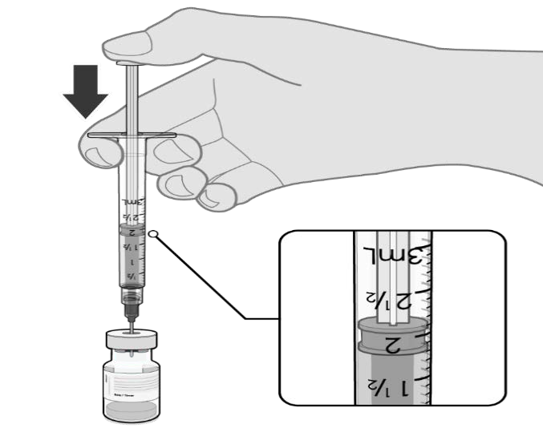

Handling instructions
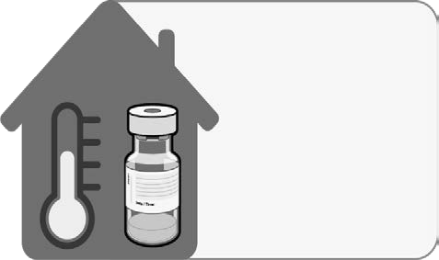

COMIRNATY should be prepared by a healthcare professional using aseptic technique to ensure the sterility of the prepared suspension.

THAWING PRIOR TO DILUTION
No more than 2 hours at room temperature  (up to 30°C) |  |  | - The multidose vial is stored frozen and must be thawed prior to dilution. Frozen vials should be transferred to an environment of  2 °C to 8 °C to thaw; a 195 vial pack may take 3 hours to thaw. Alternatively, frozen vials may also be thawed for 30 minutes at temperatures up to 30 °C for immediate use.  - Allow the thawed vial to come to room temperature and gently invert it 10 times prior to dilution. Do not shake.  - Prior to dilution, the thawed suspension may contain white to off-white opaque amorphous particles.
DILUTION
- The thawed vaccine must be diluted in its original vial with 1.8 mL sodium chloride 9 mg/mL (0.9%) solution for injection, using a
21 gauge or narrower needle and aseptic techniques. Do not use any other diluent.
1.8 mL of 0.9% sodium chloride injection


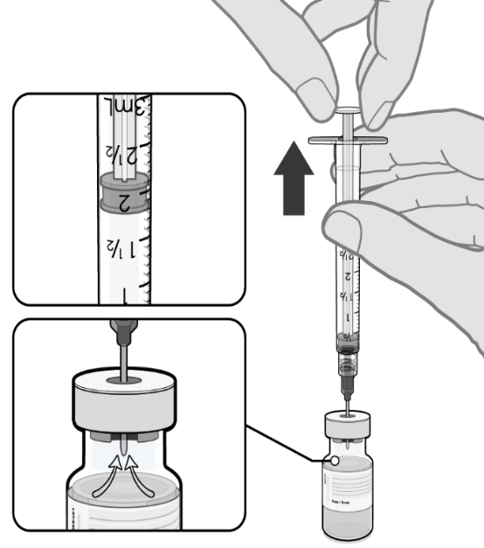
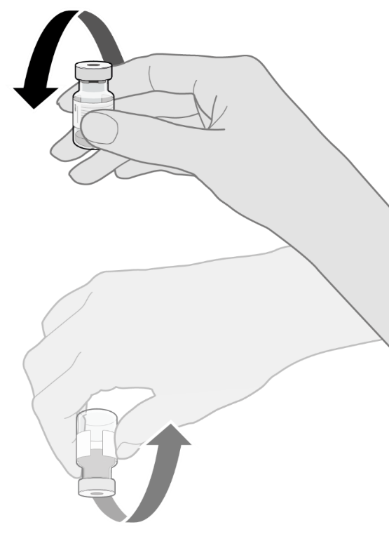

 |  |  | - Equalise vial pressure before removing the needle from the vial stopper by withdrawing 1.8 mL air into the empty diluent syringe.
Pull back plunger to 1.8 mL to remove air from vial
 | Gently x 10 |  | Gently invert the diluted suspension 10 times. Do not shake.  - The diluted vaccine should present as an off-white suspension with no particulates visible. Discard the diluted vaccine if particulates or discolouration are present.

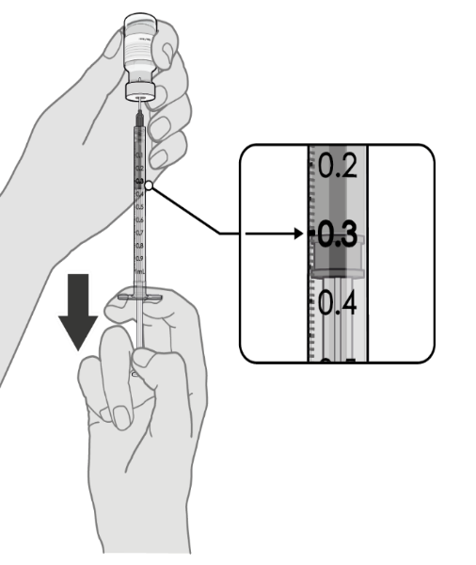

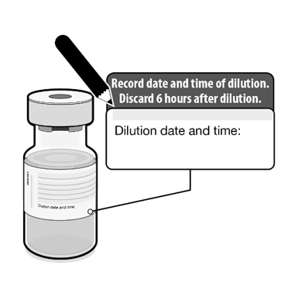 |  |  | - The diluted vials should be marked with the date and time of dilution.  - Do not freeze or shake the diluted suspension. If refrigerated, allow the diluted suspension to come to room temperature prior to use.
PREPARATION OF INDIVIDUAL 0.3 mL DOSES OF COMIRNATY
 | 0.3 mL diluted vaccine |  | - After dilution, the vial contains  2.25 mL from which 6 doses of  0.3 mL can be extracted.  - Using aseptic technique, cleanse the vial stopper with a single-use antiseptic swab.  - Withdraw 0.3 mL of COMIRNATY.  Low dead-volume syringes and/or needles should be used in order to extract 6 doses from a single vial. The low dead-volume syringe and needle combination should have a dead volume of no more than  35 microlitres.  If standard syringes and needles are used, there may not be sufficient volume to extract a sixth dose from a single vial.  - Each dose must contain 0.3 mL of vaccine.  - If the amount of vaccine remaining in the vial cannot provide a full dose of 0.3 mL, discard the vial and any excess volume.  - Verify a final injection volume of  0.3 mL prior to administration.  - Discard syringe and needle after administration to a single patient.  - Use a new, sterile needle and syringe to draw up each new dose.  - Discard any unused vaccine 6 hours after dilution.

Contraindications
Hypersensitivity to the active substance or to any of the excipients listed in Section 6.1 List of excipients.

Special warnings and precautions for use

Traceability
In order to improve the traceability of biological medicinal products, the name and the batch number of the administered product should be recorded in the Australian Immunisation Register.

General recommendations
Hypersensitivity and anaphylaxis
Events of anaphylaxis have been reported. Appropriate medical treatment and supervision should always be readily available in case of an anaphylactic reaction following the administration of COMIRNATY.

The individual should be kept under close observation for at least 15 minutes following vaccination. A second dose of COMIRNATY should not be given to those who have experienced anaphylaxis to the first dose of COMIRNATY.

Anxiety-related reactions
Anxiety-related reactions, including vasovagal reactions (syncope), hyperventilation or stress‐ related reactions may occur in association with vaccination as a psychogenic response to the needle injection. It is important that precautions are in place to avoid injury from fainting.

Concurrent illness
Vaccination should be postponed in individuals suffering from acute severe febrile illness or acute infection. The presence of a minor infection and/or low grade fever should not delay vaccination.

Thrombocytopenia and coagulation disorders
As with other intramuscular injections, COMIRNATY should be given with caution in individuals receiving anticoagulant therapy or those with thrombocytopenia or any coagulation disorder (such as haemophilia) because bleeding or bruising may occur following an intramuscular administration in these individuals.

Immunocompromised individuals
The efficacy, safety and immunogenicity of COMIRNATY has not been assessed in immunocompromised individuals, including those receiving immunosuppressant therapy. The efficacy of COMIRNATY may be lower in immunosuppressed individuals.

Duration of protection
The duration of protection afforded by COMIRNATY is unknown as it is still being determined by ongoing clinical trials.

Limitations of vaccine effectiveness
As with any vaccine, vaccination with COMIRNATY may not protect all vaccine recipients. Individuals may not be fully protected until 7 days after their second dose of COMIRNATY.

Use in the elderly
Clinical studies of COMIRNATY include participants 65 years of age and older and their data contributes to the overall assessment of safety and efficacy. See Section 5.1 Pharmacodynamic properties, Clinical trials, Efficacy against COVID-19. No dosage adjustment is required in elderly individuals ≥ 65 years of age.

The data for use in the frail elderly (>85 years) is limited. The potential benefits of vaccination versus the potential risk and clinical impact of even relatively mild systemic adverse events in the frail elderly should be carefully assessed on a case-by-case basis.

Paediatric use
The safety and efficacy of COMIRNATY in children and adolescents aged less than 16 years of age have not yet been established. Limited data are available.

Effects on laboratory tests
No data available.

Interactions with other medicines and other forms of interactions
No interaction studies have been performed.

Concomitant administration of COMIRNATY with other vaccines has not been studied.

Fertility, pregnancy and lactation

Effects on fertility
In a combined fertility and developmental toxicity study, female rats were intramuscularly administered COMIRNATY prior to mating and during gestation (4 full human doses of 30 μg each, spanning between pre-mating day 21 and gestation day 20). SARS CoV-2 neutralising antibodies were present in maternal animals from prior to mating to the end of the study on postnatal day 21 as well as in fetuses and offspring. There were no vaccine related effects on female fertility and pregnancy rate.

Use in pregnancy - Pregnancy Category B1
There is limited experience with use of COMIRNATY in pregnant women. Animal studies do not indicate direct or indirect harmful effects with respect to pregnancy, embryo/fetal development, parturition or post-natal development (see Effects on fertility). Administration of COMIRNATY in pregnancy should only be considered when the potential benefits outweigh any potential risks for the mother and fetus.

Use in lactation
It is unknown whether BNT162b2 [mRNA] is excreted in human milk. A combined fertility and developmental toxicity study in rats did not show harmful effects on offspring development before weaning (see Effects on fertility).

Effects on ability to drive and use machines
COMIRNATY has no, or negligible, influence on the ability to drive and use machines. However, some of the effects mentioned under Section 4.8 Adverse effects (undesirable effects) may temporarily affect the ability to drive or use machines.

Adverse effects (undesirable effects)

Summary of safety profile
The safety of COMIRNATY was evaluated in participants 16 years of age and older in 2 clinical studies that included 21,744 participants that have received at least one dose of COMIRNATY.

In Study C4591001, a total of 21,720 participants 16 years of age or older received at least 1 dose of COMIRNATY and a total of 21,728 participants 16 years of age or older received placebo (including 138 and 145 adolescents 16 and 17 years of age in the COMIRNATY and placebo groups, respectively). A total of 20,519 participants 16 years of age or older received 2 doses of COMIRNATY.

At the time of the analysis of Study C4591001, a total of 19,067 (9,531 COMIRNATY and 9,536 placebo) participants 16 years of age or older were evaluated for safety for at least 2 months after the second dose. This included a total of 10,727 (5,350 COMIRNATY and 5,377 placebo) participants 16 to 55 years of age and a total of 8,340 (4,181 COMIRNATY and 4,159 placebo) participants 56 years and older.

The most frequent adverse reactions in participants 16 years of age and older were injection site pain (>80%), fatigue (>60%), headache (>50%), myalgia and chills (>30%), arthralgia (>20%), pyrexia and injection site swelling (>10%) and were usually mild or moderate in intensity and resolved within a few days after vaccination. A slightly lower frequency of reactogenicity events was associated with greater age.

Tabulated list of adverse reactions from clinical studies
Adverse reactions observed during clinical studies are listed below according to the following frequency categories:

Very common (≥ 1/10), Common (≥ 1/100 to < 1/10),
Uncommon (≥ 1/1,000 to < 1/100), Rare (≥ 1/10,000 to < 1/1,000), Very rare (< 1/10,000),

Not known (cannot be estimated from the available data).

Table 1:Adverse reactions from COMIRNATY clinical trials
System Organ Class | Very common (≥ 1/10) | Common  (≥ 1/100 to  < 1/10) | Uncommon  (≥ 1/1,000 to  < 1/100) | Rare  (≥ 1/10,000 to < 1/1,000) | Not known (cannot be estimated from the available data)
Blood and lymphatic system disorders |  |  | Lymphadenopathy
Immune system disorders |  |  |  |  | Anaphylaxis; hypersensitivity
Psychiatric disorders |  |  | Insomnia
Nervous system disorders | Headache |  |  | Acute peripheral facial paralysis†
Gastrointestinal disorders |  | Nausea
Musculoskeletal and connective tissue disorders | Arthralgia; myalgia |  | Pain in extremity
General disorders and administration site conditions | Injection site pain; fatigue; chills; pyrexia*; injection site swelling | Injection site redness | Malaise; injection site pruritus
*A higher frequency of pyrexia was observed after the 2nd dose.
†Throughout the safety follow-up period to date, acute peripheral facial paralysis (or palsy) was reported by four participants in the COMIRNATY group. Onset was Day 37 after Dose 1 (participant did not receive Dose 2) and Days 3, 9, and 48 after Dose 2. No cases of acute peripheral facial paralysis (or palsy) were reported in the placebo group.

The safety profile in 545 subjects receiving COMIRNATY, that were seropositive for SARS- CoV-2 at baseline, was similar to that seen in the general population.

Reporting suspected adverse effects
Reporting suspected adverse reactions after registration of the medicinal product is important. It allows continued monitoring of the benefit-risk balance of the medicinal product. Healthcare professionals are asked to report any suspected adverse reactions at www.tga.gov.au/reporting- problems.

Overdose
Overdose data is available from 52 study participants included in the clinical trial that due to an error in dilution received 58 micrograms of COMIRNATY. The COMIRNATY recipients did not report an increase in reactogenicity or adverse reactions.

In the event of overdose, monitoring of vital functions and possible symptomatic treatment is recommended.

For information on the management of overdose, contact the Poisons Information Centre on 131126 (Australia).

PHARMACOLOGICAL PROPERTIES

  - Pharmacodynamic properties
Pharmacotherapeutic group: vaccines, other viral vaccines, ATC code: J07BX03

Mechanism of action
The nucleoside-modified messenger RNA in COMIRNATY is formulated in lipid nanoparticles, which enable delivery of the non-replicating RNA into host cells to direct transient expression of the SARS-CoV-2 spike (S) antigen. The mRNA codes for membrane- anchored, full-length S with two point mutations within the central helix. Mutation of these two amino acids to proline locks S in an antigenically preferred prefusion conformation. COMIRNATY elicits both neutralising antibody and cellular immune responses to the antigen, which may contribute to protection against COVID-19.

Clinical trials
Efficacy
Study C459001 is a multicentre, multinational, Phase 1/2/3 randomised, placebo-controlled, observer-blind dose-finding, vaccine candidate selection and efficacy study in participants 12 years of age and older. Randomisation was stratified by age: 12 through 15 years of age, 16 through 55 years of age, or 56 years of age and older, with a minimum of 40% of participants in the ≥ 56-year stratum. The study excluded participants who were immunocompromised and those who had previous clinical or microbiological diagnosis of COVID-19. Participants with pre-existing stable disease, defined as disease not requiring significant change in therapy or hospitalisation for worsening disease during the 6 weeks before enrolment, were included as were participants with known stable infection with human immunodeficiency virus (HIV), hepatitis C virus (HCV) or hepatitis B virus (HBV). At the time of the analysis of Study C459001, information presented is based on participants 16 years and older.

Efficacy in participants 16 years of age and older
In the Phase 2/3 portion, approximately 44,000 participants were randomised equally and were to receive 2 doses of COMIRNATY or placebo separated by 21 days. The efficacy analyses included participants that received their second vaccination within 19 to 42 days after their first vaccination. Participants are planned to be followed for up to 24 months after Dose 2, for assessments of safety and efficacy against COVID-19. In the clinical study, participants were required to observe a minimum interval of 14 days before and after administration of an

influenza vaccine in order to receive either placebo or COMIRNATY. In the clinical study, participants were required to observe a minimum interval of 60 days before or after receipt of blood/plasma products or immunoglobulins through to conclusion of the study in order to receive either placebo or COMIRNATY.

The population for the analysis of the primary efficacy endpoint included, 36,621 participants 12 years of age and older (18,242 in the COMIRNATY group and 18,379 in the placebo group) who did not have evidence of prior infection with SARS-CoV-2 through 7 days after the second dose. In addition, 134 participants were between the ages of 16 to 17 years of age (66 in the COMIRNATY group and 68 in the placebo group) and 1616 participants 75 years of age and older (804 in the COMIRNATY group and 812 in the placebo group).

Efficacy against COVID-19
At the time of the primary efficacy analysis, participants had been followed for symptomatic COVID19 for in total 2,214 person-years for the COMIRNATY group and in total 2,222 person-years for the placebo group.

There were no meaningful clinical differences in overall vaccine efficacy in participants who were at risk of severe COVID-19 including those with 1 or more comorbidities that increase the risk of severe COVID-19 (e.g. asthma, body mass index (BMI) ≥ 30 kg/m2, chronic pulmonary disease, diabetes mellitus, hypertension).

COMIRNATY efficacy information is presented in Table 2.

Table 2:Vaccine efficacy – First COVID-19 occurrence from 7 days after Dose 2, by age subgroup – participants without evidence of infection prior to 7 days after Dose 2 – evaluable efficacy (7 days) population
First COVID-19 occurrence from 7 days after Dose 2 in participants without evidence of prior SARS-CoV-2 infection*
Subgroup | COMIRNATY Na = 18,198  Cases  n1b Surveillance timec (n2d) | Placebo  Na = 18,325  Cases  n1b Surveillance timec  (n2d) | Vaccine efficacy  % (95% CI)f
All subjectse | 8  2.214 (17,411) | 162  2.222 (17,511) | 95.0 (90.0, 97.9)
16 to 64 years | 7  1.706 (13,549) | 143  1.710 (13,618) | 95.1 (89.6, 98.1)
65 years and older | 1  0.508 (3848) | 19  0.511 (3880) | 94.7 (66.7, 99.9)
65 to 74 years | 1  0.406 (3074) | 14  0.406 (3095) | 92.9 (53.1, 99.8)
75 years and older | 0  0.102 (774) | 5  0.106 (785) | 100.0 (-13.1, 100.0)
Note: Confirmed cases were determined by Reverse Transcription-Polymerase Chain Reaction (RT-PCR) and at least 1 symptom consistent with COVID-19 [*Case definition: (at least 1 of) fever, new or increased cough, new or increased shortness of breath, chills, new or increased muscle pain, new loss of taste or smell, sore throat, diarrhoea or vomiting.]
* Participants who had no serological or virological evidence (prior to 7 days after receipt of the last dose) of past SARS-CoV-2 infection (i.e., N-binding antibody [serum] negative at Visit 1 and SARS-CoV-2 not

detected by nucleic acid amplification tests (NAAT) [nasal swab] at Visits 1 and 2), and had negative NAAT (nasal swab) at any unscheduled visit prior to 7 days after Dose 2 were included in the analysis.
- N = number of participants in the specified group.
- n1 = Number of participants meeting the endpoint definition.
- Total surveillance time in 1000 person-years for the given endpoint across all subjects within each group at risk for the endpoint. Time period for COVID-19 case accrual is from 7 days after Dose 2 to the end of the surveillance period.
- n2 = Number of subjects at risk for the endpoint.
- No confirmed cases were identified in participants 12 to 15 years of age.
- Confidence interval (CI) for vaccine efficacy is derived based on the Clopper and Pearson method adjusted to the surveillance time. CI not adjusted for multiplicity.

In the second primary analysis, compared to placebo, efficacy of COMIRNATY in participants from first COVID-19 occurrence from 7 days after Dose 2 compared to participants with or without evidence of prior infection with SARS-CoV-2 was 94.6% (95% credible interval of 89.9% to 97.3%) in participants 16 years of age and older.

Additionally, subgroup analyses of the primary efficacy endpoint showed similar efficacy point estimates across genders, ethnic groups, and participants with medical comorbidities associated with high risk of severe COVID-19.

Pharmacokinetic properties
Not applicable.

Preclinical safety data

Genotoxicity/Carcinogenicity
Neither genotoxicity nor carcinogenicity studies were performed. The components of COMIRNATY (lipids and mRNA) are not expected to have genotoxic potential.

PHARMACEUTICAL PARTICULARS

  - List of excipients
((4-hydroxybutyl)azanediyl)bis(hexane-6,1-diyl)bis(2-hexyldecanoate) (ALC-0315) 2-[(polyethylene glycol)-2000]-N,N-ditetradecylacetamide (ALC-0159) Distearoylphosphatidylcholine (DSPC)
Cholesterol Potassium chloride
Monobasic potassium phosphate Sodium chloride

Dibasic sodium phosphate dihydrate Sucrose
Water for injections

This vaccine contains less than 1 mmol potassium (39 mg) per dose, that is to say essentially ‘potassium-free’.

This vaccine contains less than 1 mmol sodium (23 mg) per dose, that is to say essentially
‘sodium‑free’.

Incompatibilities
This medicinal product must not be mixed with other medicinal products except those mentioned in Section 4.2 Dose and method of administration.

Shelf life
In Australia, information on the shelf life can be found on the public summary of the Australian Register of Therapeutic Goods (ARTG). The expiry date can be found on the packaging.

Unopened vial
Once removed from the freezer, the unopened vaccine can be stored for up to 5 days at 2 °C to 8 °C, and up to 2 hours at temperatures up to 30 °C, prior to use.

Once thawed, COMIRNATY should not be re-frozen.

Closed-lid vial trays containing 195 vials removed from frozen storage (< -60 °C) may be at room temperature (< 25 °C) for up to 5 minutes for transfer between ultra-low-temperature environments. After vial trays are returned to frozen storage following room temperature exposure, they must remain in frozen storage for at least 2 hours before they can be removed again.

Diluted medicinal product
Chemical and physical in-use stability has been demonstrated for 6 hours at 2 ºC to 30 ºC after dilution in sodium chloride 9 mg/mL (0.9%) solution for injection. From a microbiological point of view, the product should be used immediately. If not used immediately, in-use storage times and conditions are the responsibility of the user.

Special precautions for storage
Store in a freezer at -90 °C to -60 °C.

Store in the original package in order to protect from light.

During storage, minimise exposure to room light, and avoid exposure to direct sunlight and ultraviolet light. Thawed vials can be handled in room light conditions.

When you are ready to thaw or use COMIRNATY

- Open-lid vial trays, or vial trays containing less than 195 vials removed from frozen storage (< -60 °C) may be at room temperature (< 25 °C) for up to 3 minutes to remove vials or for transfer between ultra-low-temperature environments.
- Once a vial is removed from the vial tray, it should be thawed for use.
- After vial trays are returned to frozen storage following room temperature exposure, they must remain in frozen storage for at least 2 hours before they can be removed again.

For storage conditions after thawing and dilution of the medicinal product, see Section 6.3 Shelf life.

For additional advice on storing COMIRNATY, contact Pfizer Australia on 1800 675 229.

Nature and contents of container
- mL clear multidose vial (Type I glass) with a stopper (synthetic bromobutyl rubber) and a flip-off plastic cap with aluminium seal. Each vial contains 6 doses, see Section 4.2

Pack size: 195 vials

Special precautions for disposal
In Australia, any unused medicine or waste material should be disposed of in accordance with local requirements.

Physicochemical properties

CAS number
2417899-77-3

MEDICINE SCHEDULE (POISONS STANDARD)
S4 – Prescription Only Medicine.

SPONSOR
Pfizer Australia Pty Ltd Level 17, 151 Clarence Street
Sydney NSW 2000 www.pfizer.com.au
Medical Information www.pfizermedinfo.com.au or Toll Free Number: 1800 675 229

DATE OF FIRST APPROVAL
DD Month YYYY

DATE OF REVISION
Not applicable.

