September 2019

Australian Public Assessment Report for blinatumomab
  - Proprietary Product Name: Blincyto
  - Sponsor: Amgen Australia Pty Ltd

About the Therapeutic Goods Administration (TGA)
- The Therapeutic Goods Administration (TGA) is part of the Australian Government Department of Health and is responsible for regulating medicines and medical devices.
- The TGA administers the Therapeutic Goods Act 1989 (the Act), applying a risk management approach designed to ensure therapeutic goods supplied in Australia meet acceptable standards of quality, safety and efficacy (performance) when necessary.
- The work of the TGA is based on applying scientific and clinical expertise to decision-making, to ensure that the benefits to consumers outweigh any risks associated with the use of medicines and medical devices.
- The TGA relies on the public, healthcare professionals and industry to report problems with medicines or medical devices. TGA investigates reports received by it to determine any necessary regulatory action.
- To report a problem with a medicine or medical device, please see the information on the TGA website <https://www.tga.gov.au>.
About AusPARs
- An Australian Public Assessment Report (AusPAR) provides information about the evaluation of a prescription medicine and the considerations that led the TGA to approve or not approve a prescription medicine submission.
- AusPARs are prepared and published by the TGA.
- An AusPAR is prepared for submissions that relate to new chemical entities, generic medicines, major variations and extensions of indications.
- An AusPAR is a static document; it provides information that relates to a submission at a particular point in time.
- A new AusPAR will be developed to reflect changes to indications and/or major variations to a prescription medicine subject to evaluation by the TGA.
Copyright
© Commonwealth of Australia 2019
This work is copyright. You may reproduce the whole or part of this work in unaltered form for your own personal use or, if you are part of an organisation, for internal use within your organisation, but only if you or your organisation do not use the reproduction for any commercial purpose and retain this copyright notice and all disclaimer notices as part of that reproduction. Apart from rights to use as permitted by the Copyright Act 1968 or allowed by this copyright notice, all other rights are reserved and you are not allowed to reproduce the whole or any part of this work in any way (electronic or otherwise) without first being given specific written permission from the Commonwealth to do so. Requests and inquiries concerning reproduction and rights are to be sent to the TGA Copyright Officer, Therapeutic Goods Administration, PO Box 100, Woden ACT 2606 or emailed to <tga.copyright@tga.gov.au>.

Contents
Common abbreviations 4
I. Introduction to product submission 7
Submission details 7
Product background 7
Regulatory status 8
Product Information 10
II. Registration time line 10
III. Quality findings 10
IV. Nonclinical findings 10
V. Clinical findings 11
Introduction 11
Pharmacokinetics 13
Pharmacodynamics 14
Dosage selection for the pivotal studies 15
Efficacy 15
Safety 18
First round benefit-risk assessment 27
First round recommendation regarding authorisation 29
Second round evaluation 29
Second round benefit-risk assessment 30
Second round recommendation regarding authorisation 30
VI. Pharmacovigilance findings 30
Risk management plan 30
VII. Overall conclusion and risk/benefit assessment 34
Quality 34
Nonclinical 34
Clinical 34
RMP evaluation 43
Risk-benefit analysis 43
Outcome 51
Attachment 1. Product Information 51
Attachment 2. Extract from the Clinical Evaluation Report 51

Common abbreviations
Abbreviation | Description
ADA | Antidrug antibodies
ADR | Adverse drug reaction
AE | Adverse event
ALL | Acute lymphoblastic leukaemia
BiTE | Biospecific T cell engager
BSA | Body surface area
CHMP | Committee for Medicinal Products for Human Use (EMA)
CI | Confidence interval
cIV | Continuous intravenous infusion
CL | Clearance
CLS | Capillary leak syndrome
CNS | Central nervous system
CR | Complete response/complete remission
CrCL | Creatinine clearance
CRh* | Complete remission with partial haematological recovery
CRi | Complete remission with incomplete haematological recovery
CRS | Cytokine release syndrome
CSR | Clinical Study Report
DMC | Data management committee
ECG | Electrocardiogram
ECOG | Eastern Cooperative Oncology Group
EMA | European Medicines Agency
EOI | Event of interest
EU | European Union
FAS | Full analysis set
FDA | Food and Drug Administration (USA)
HR | High risk
HSCT | Haematopoietic stem cell transplantation
ICH | International Conference on Harmonisation
ISAP | Integrated statistical analysis plan
ISE | Integrated summary of efficacy
ISS | Integrated summary of safety
KM | Kaplan Meier
MRD | Minimal residual disease
MT103 | Blinatumomab (drug development code name)
NCCN | National Comprehensive Cancer Network
NE/ne | Not estimable
OS | Overall survival
PCR | Polymerase chain reaction
PD | Pharmacodynamic(s)
PI | Product Information
PK | Pharmacokinetic(s)
PSUR | Periodic Safety Update Reports
R/R | Relapsed / refractory
RFS | Relapse free survival
RMP | Risk Management Plan
SD | Standard deviation
SOC | Standard of care
SmPC | Summary of Product Characteristics (EU)
T½ | Half life
TEAE | Treatment emergent adverse event
TCR | T cell receptor

I. Introduction to product submission

Submission details
Type of submission: | Extension of indications
Decision: | Approved
Date of decision: | 3 May 2018
Date of entry onto ARTG | 7 May 2018
ARTG number: | 232805
Active ingredient: | blinatumomab
Product name: | Blincyto
Sponsor’s name and address: | Amgen Australia Pty Ltd  Mezzanine Level 115 Cotham Road  KEW VIC 3101
Dose form: | Powder for injection with IV solution stabiliser
Strength: | 38.5 μg
Containers: | Vial with IV solution stabiliser vial
Pack size: | 1
Approved therapeutic use: | Blincyto is indicated for the treatment of relapsed or refractory B-cell precursor acute lymphoblastic leukaemia (ALL).  Blincyto is indicated for the treatment of minimal residual disease (MRD) positive B-cell precursor acute lymphoblastic leukaemia (ALL) in patients in complete haematological remission.  Note to indication: the indications in Philadelphia positive, MRD positive and paediatric patients were approved based on phase II, non-randomised evidence. An improvement in clinical outcomes by direct prospective comparison in a randomised setting relative to other standard-of-care salvage therapies has not been established.
Route of administration: | IV
 | Weight based micrograms per day as per protocol detail in Product Information (PI). For specialist use only.

Product background
This AusPAR describes the application by Amgen Australia Pty Ltd (the sponsor) to register Blincyto containing blinatumomab for the following extension of indication:
Initially proposed by sponsor:
- Blincyto is indicated for the treatment of relapsed or refractory B-cell precursor acute lymphoblastic leukaemia (ALL).
- Blincyto is indicated for the treatment of minimal residual disease (MRD) positive B-cell precursor acute lymphoblastic leukaemia (ALL).
Note to indication: the indications in Philadelphia positive, MRD positive and paediatric patients were approved based on phase II, non-randomised evidence. An improvement in clinical outcomes by direct prospective comparison in a randomised setting relative to other standard-of-care salvage therapies has not been established.
This submission contains data to amend the indications to include:
- Use in adults with relapsed or refractory Philadelphia positive B-precursor ALL
- Use in patients with relapsed or refractory B-precursor ALL who had a complete response or complete response with partial haematological recovery, but with persistent minimal residual disease
- Include confirmatory information to support the initial registration in adults with relapsed / refractory (R/R) pre-B ALL to fulfil the initial registration condition.
Minimal residual disease (MRD) is the presence of disease in individuals who have been assessed as having complete remission as assessed by conventional pathology analysis and is considered an intermediate trial end-point.
Presence of MRD has been associated with worse event-free survival and overall survival. MRD may be measured by multiparametric flow cytometry or by polymerase chain reaction of the IgHVDJ and/or T cell receptor (TCR) gene rearrangements, or of the appropriate leukaemia-specific marker.
MRD is a time-dependent variable, but with the relationship between efficacy being affected by the threshold at which negativity/positivity is defined, depth of response and duration of response.
For this submission where the sponsor is proposing to amend the indication to include treatment of MRD positive patients, the MRD level describing negativity/positivity is of critical importance, together with the requirement of later reporting of traditional efficacy end-points.

Regulatory status
Blinatumomab was first registered on the Australian Register of Therapeutic Goods (ARTG) on 9 November 2015 for use in adults with Philadelphia chromosome negative relapsed or refractory B-precursor ALL.
A subsequent extension of indications to include use in paediatric patients with Philadelphia chromosome negative relapsed or refractory B-precursor ALL was approved on 19 July 2017, subject to the sponsor providing confirmatory data to support this indication.
The overseas regulatory status is shown in the table below. Of note, the Oncologic Drugs Advisory Committee of the United States (US) Food and Drug Administration (FDA) is meeting on 7 March 2018 to discuss the use of blinatumomab for the treatment of minimal residual disease-positive B-cell precursor acute lymphoblastic leukaemia (as per the FDA website accessed 23 February 2018).
Table 1: Overseas regulatory status
Country/ region |  | Sub-mission date | Status | Indications (approved or requested) | Other relevant information
Extension of indications to include Philadelphia-chromosome positive (Ph+) ALL
USA | 13 February 2017 |  | Under evaluation | Blincyto is indicated for the treatment of relapsed or refractory B- cell precursor acute lymphoblastic leukaemia (ALL) | Also included Study 00103311 Clinical Study Report (CSR) to convert to full marketing approval
Canada | 27 March 2017 |  | Under evaluation | Blincyto is indicated for the treatment of adults with relapsed or refractory B precursor acute lymphoblastic leukaemia (ALL) | Study 00103311 CSR was submitted on 30 Nov 2016 to fulfil a marketing authorisation commitment and seek full marketing approval
Switzerland | NA |  | NA |  | Study 00103311 CSR was submitted to SwissMedic on 31 October 2016 as a Follow Up Measure (commitment) to their marketing authorisation, with approval on 25 January 2017. On 15 December 2016, an amendment to the Swiss PI was submitted to include details arising from Study 00103311.
Extension of indications to include minimal residual disease positive (MRD+) ALL
European Union (EU) (Centralised procedure) | 8 March 2017 |  | Under evaluation | Blincyto is indicated for the treatment of adults with minimal residual disease (MRD) positive B- precursor acute lymphoblastic leukaemia (ALL) | Study 00103311 CSR was submitted on 11 November 2016 to fulfil a marketing authorisation commitment and seek granting of a Marketing Authorisation no longer subject to Specific Obligations

Product Information
The Product Information (PI) approved with the submission which is described in this AusPAR can be found as Attachment 1. For the most recent PI, please refer to the TGA website at <https://www.tga.gov.au/product-information-pi>.

II. Registration time line
The following table captures the key steps and dates for this application and which are detailed and discussed in this AusPAR and Attachment 2.
Table 2: Registration timeline for Submission PM-2017-01431-1-4(CEU6)
Description | Date
Submission dossier accepted and first round evaluation commenced | 31 May 2017
First round evaluation completed | 2 November 2017
Sponsor provides responses on questions raised in first round evaluation | 19 December 2017
Second round evaluation completed | 22 February 2018
Delegate’s Overall benefit-risk assessment and request for Advisory Committee advice | 26 February 2018
Sponsor’s pre-Advisory Committee response | 13 March 2018
Advisory Committee meeting | 5 - 6 April 2018
Registration decision (Outcome) | 3 May 2018
Completion of administrative activities and registration on ARTG | 7 May 2018
Number of working days from submission dossier acceptance to registration decision* | 197
*Target timeframe for standard applications is 220 working days

III. Quality findings
There was no requirement for a quality evaluation in a submission of this type.

IV. Nonclinical findings
There was no requirement for a nonclinical evaluation in a submission of this type.

V. Clinical findings
A summary of the clinical findings is presented in this section. Further details of these clinical findings can be found in Attachment 2.

Introduction

Clinical rationale
For Philadelphia chromosome positive ALL agents with different mechanisms of action are needed to circumvent tyrosine kinase inhibitor (TKI) resistance and improve duration of remission. Blinatumomab is such an agent since it targets malignant B cells, rather than tyrosine kinases or other subcellular components that may be responsible for proliferation of these malignant cells.
The sponsor considers that there is an unmet need for treatments that can induce molecular complete remission (CR) in patients who are in haematologic CR, but still have MRD. The sponsor considers that haematologic remission with MRD negativity to be the most meaningful endpoint for predicting longer life in ALL patients, irrespective of Philadelphia chromosome status.
While MRD is not yet a validated surrogate endpoint, ongoing interactions between regulatory, academic, and industry stakeholders are moving towards validating MRD as a surrogate endpoint (FDA BEST, 2016).
In December 2015, the European Medicines Agency (EMA) Committee for Medicinal Products for Human Use (CHMP) published Appendix 4 to the guideline on the evaluation of anticancer medicinal products in man (EMA/CHMP/703715/2012, Rev 2), which stated that MRD may be used as an intermediate endpoint in patients with complete clinical remission of chronic lymphocytic leukaemia. While the sponsor acknowledges that this guidance is currently specific to the treatment of chronic lymphocytic leukaemia, the need for such guidance reflects a growing awareness and acceptance of the use of MRD within the clinical setting of haematologic malignancies.

Guidance
The TGA has adopted the following guidelines relevant to this application:
- Guideline on Reporting the Results of Population Pharmacokinetic Analysis. CHMP/EWP/185990/06. Effective from 27 January 2009.
- Guideline on the Evaluation of Anticancer Medicinal Products in Man. EMA/CHMP/205/95/Rev.4, Effective from 1 April 2014.
- Appendix 2 to the Guideline on the Evaluation of Anticancer Medicinal Products in Man (CPMP/EWP/205/95 Rev. 3) on Confirmatory Studies in Haematological Malignancies. EMA/CHMP/EWP/520088/2008. Effective from 17 December 2010.

Contents of the clinical dossier
The dossier documented a development program of pivotal and other clinical trials relating to the proposed extension of indications and amendments to the PI.
- Two Population pharmacokinetics (PopPK) analyses (Reports 122196 and 122625)
- 1 Pharmacodynamics (PD) study; Report 120391
- 1 Pivotal efficacy/safety study for indication 1 (Ph positive ALL); Study 20120216
- 2 Pivotal efficacy/safety studies for indication 2 (MRD); Studies MT103-202 and MT103-203: for Study MT103- 203 both the primary and secondary analysis reported were included in the submission. The primary analysis had been previously evaluated and therefore was not evaluated again.
- 1 Other efficacy/safety Study 20120148; retrospective analysis of Ph negative ALL and Propensity score analysis report
- 1 Pivotal study for indication 3 (update to PI); Study 00103311
- 1 other study for indication 3; Study MT103-211 which also provided PD data
- 1 integrated analyses across more than one study: Integrated summary of efficacy (ISE) (summary of studies MT103- 202 and MT103-203) for MRD indication
- 2 integrated analyses across more than one study
- 1 ISE; which is labelled ‘ISE appendix – OS' and consists of one page but no explanation for its inclusion is provided. It appears to relate to Study 00103311 but as this cannot be confirmed it has not been included in this report.
- 1 integrated summary of safety (ISS) (for R/R ALL indication); includes Studies 00103311, 20120216, MT103- 211, MT103-206, MT103-205 and 20130320 and also studies MT103-202 and MT103-203. This also includes the integrated statistical analysis plan (ISAP) for the Summary of Clinical Safety (R/R ALL)
- 1 ISE which is actually the ISAP - Statistical Analysis Plan (SAP) for the Summary of Clinical Safety (MRD)
- The submission also included literature references; 2 Clinical Overviews; one for MRD and one for R/R ALL; 2 Summaries of Clinical Pharmacology; 2 Summaries of Clinical Efficacy; and 2 Summaries of Clinical Safety

Paediatric data
The submission did not include paediatric data. A submission to extend the indication to include paediatric patients was approved during the course of this evaluation (Submission PM-2016-01898-1-4).

Good clinical practice
The sponsor states that all clinical studies were conducted under Good Clinical Practice (GCP) as described in International Conference on Harmonisation (ICH) E6, Guideline for GCP, under the principles of the Declaration of Helsinki, and in accordance with global, local, and regional regulations and guidance, including ICH E11 Guidance for Clinical Investigation of Medicinal Products in the Paediatric Population, FDA Guidance for Industry Clinical Trial Endpoints for the Approval of Cancer Drugs, and the European Medicines Agency (EMA) Guideline on the Evaluation of Anticancer Medicinal Products in Man.

Evaluator’s commentary on the clinical dossier
The clinical dossier is a composite of the submissions made in Europe and the USA. The sponsor has submitted multiple summaries to cover the indications requested. The data and presentation are adequate but the summaries do not include all the data included in the submission and this is not explained by the sponsor. The Summaries included data from multiple studies which had been submitted over three submissions in Australia. A list of the studies submitted in the different submissions would have been helpful. For example, no explanation is provided for the inclusion of the exposure response in the paediatric population, Study 120391 which is not discussed in the summaries. Study MT103-208 is discussed in the Summary of Clinical Pharmacology but not in the clinical or safety summaries. Study MT103-208 which relates to a different indication has been evaluated for safety only.
The Summaries of Clinical Safety and the ISS for the R/R ALL indication include different data sets making analysis and interpretation difficult.
The Clinical Overview (MRD) is not dated and it has included the results from the primary analysis of Study MT103-203, rather than the secondary analysis included in this submission. Again no explanation is provided by the sponsor.

Pharmacokinetics

Studies providing pharmacokinetic data
In the blinatumomab clinical program, there were no dedicated pharmacokinetic (PK) or pharmacodynamic (PD) clinical trials. The PK and PD properties of blinatumomab were assessed in conjunction with safety, tolerability, and efficacy studies.

Studies providing pharmacokinetic information
In this submission the sponsor provided PK data from one additional study, (Study MT103-203) and two PopPK studies, (Studies 122196 and 122625). The Summary of Clinical Pharmacology provides a general summary of blinatumomab based on available data from eight clinical studies (Studies MT103- 203, MT103-208, MT103-211, 20120216 and 00103311) which were included in this submission and Studies MT103-104, MT103-202 (primary analysis), and MT103-206 which were included in the initial submission.
Table 3: Submitted pharmacokinetic studies
PK topic | Subtopic | Study ID | Primary aim
PK in special populations | Target population§  multiple dose R/R ALL | MT103-211 | Efficacy and safety
PK in special populations |  | 00103311 | Efficacy and safety
PK in special populations |  | 20120216 | Efficacy and safety
PK in special populations | Target population§  multiple dose MRD | MT103-203 | Efficacy and safety
Population PK analyses | Target population  R/R ALL and MRD | 122196 | PopPK
§ Subjects who would be eligible to receive the drug if approved for the proposed indication; PopPK = population PK
None of the pharmacokinetic studies had deficiencies that excluded their results from consideration.

Evaluator’s conclusions on pharmacokinetics
The PK data submitted in this application appears to be consistent with the data previously submitted. Relevant to this submission there does not appear to be any effect of Philadelphia chromosome status on the PK of blinatumomab.

Pharmacodynamics
In the blinatumomab clinical program, there were no dedicated PK or PD clinical trials. The PK and PD properties of blinatumomab were assessed in conjunction with safety, tolerability, and efficacy in the clinical studies. The Summaries include data from the studies included in this submission combined with studies included in previously evaluated submissions.

Studies providing pharmacodynamic data
Study 120391 was included in the submission but is not discussed in either of the Summaries of Clinical Pharmacology or Clinical Overviews. This study was included in the module ‘Pharmacodynamic studies’ but is an exposure/response analysis of Study MT103-205 which is a paediatric study not relevant to this submission.
Table 4: Submitted pharmacodynamic studies
PD Topic | Subtopic | Study ID | Primary aim
Primary Pharmacology | Effect on PD parameter Effect on B and T cells | MT103-211 | Efficacy and safety
Population PD and PK-PD analyses | Target population§ | 120391 | PK/PD paediatric
Population PD and PK-PD analyses |  | 122625 | PK/PD
§ Subjects who would be eligible to receive the drug if approved for the proposed indication.
None of the pharmacodynamic studies had deficiencies that excluded their results from consideration.

Evaluator’s conclusions on pharmacodynamics
The sponsor provided one additional PopPK analysis and two studies analysing exposure safety responses from pooled groups of patients. The results support the recommended dosing regimens for the treatment of R/R ALL and MRD positive ALL. No dose adjustment appears necessary based on the covariates evaluated.
The exposure response analyses indicated blinatumomab exposure was not associated with probability of cytokine release syndrome (CRS), or neurologic events, and higher exposures were associated with higher probability of CR and longer duration of overall survival (OS), after accounting for blinatumomab treatment. Thus, the blinatumomab step-dosing regimen was appropriate in the management of CRS and neurologic events.

Dosage selection for the pivotal studies

Evaluator’s conclusions on dose finding for the pivotal studies
The dose regimen used in the new indication of Philadelphia chromosome positive R/R ALL is the same as approved for the existing indications.
The dose for MRD R/R ALL is consistent with the approved dose.

Efficacy

Indication 1: Philadelphia positive ALL

Studies providing evaluable efficacy data
The following clinical efficacy studies were submitted:

Indication 1 R/R Chromosome positive B-precursor ALL
- Pivotal studies
- Study 20120216 - A Phase II single arm, multicentre trial to evaluate the efficacy of the BiTE antibody blinatumomab in adult subjects with relapsed/refractory philadelphia positive B-precursor acute lymphoblastic leukaemia (also known as the Alcantara study)
- Other studies
- not applicable.
- Analyses performed across trials
- not applicable

Evaluator’s conclusions on efficacy – Indication 1
The data to support the requested indication of Philadelphia chromosome positive R/R ALL rests with one study of 45 patients in a Phase II, single arm, open label study (Study 20120216).
The study is ongoing. At the time of the data cut-off date on May 2015, 2 subjects continued to receive blinatumomab. The remaining 43 subjects have discontinued treatment; 23 (51.1%) subjects continue to be followed and 22 (48.9%) have died.
The result for the primary efficacy endpoint of the best CR/CRh* rate within the first 2 cycles of blinatumomab treatment was 35.6% (16/45; 95% confidence interval (CI): 21.9% to 51.2%); 14 subjects achieved a CR (31.1%), 2 subjects achieved a CRh* (4.4%). The results of the sensitivity analyses of the primary endpoint were consistent with the primary analysis. Subgroup analysis suggested differences amongst most subgroups, however the number of subjects in the individual subgroups were really too small to be reliable. Median OS was 7.1 months.
The efficacy results for the best CR/CRh* rate during the treatment period were consistent with the best CR/CRh* rate within the first 2 cycles of treatment. In the Full analysis set (FAS), 17 subjects (37.8%) achieved a CR/CRh* during the treatment period; 1 additional subject achieved a CR/CRh* during the treatment period. Two additional subjects converted to CR during subsequent cycles of blinatumomab: 1 subject with a CRh*; 1 subject with a complete remission with incomplete haematological recovery (Cri).
It is noted that the initial approval for Ph negative patients was based on two Phase II, open label studies; one pivotal, study (Study MT103-211) and a supportive study (Study MT103-206) with a total of 225 patients. In Study MT103-211, CR/CR* with durable remission after 2 cycles of treatment was 42.9% and median OS was 6.1 months, and in Study MT103-206, CR/CRh* with durable remission after 2 cycles of treatment was 69% and median OS was 9.8 months.

Indication 2; Minimal residual disease (MRD)

Studies providing evaluable efficacy data

Pivotal studies
- Study MT103-202: A confirmatory, multicentre, single-arm study to assess the efficacy, safety, and tolerability of the BiTE antibody blinatumomab in adult subjects with minimal residual disease (MRD) of B-precursor acute lymphoblastic leukaemia.
- Study MT103-203; An open-label, multicentre, Phase II study to investigate the efficacy, safety, and tolerability of the bi-specific T-cell engager (BiTE) MT103 in patients with minimal residual lymphoblastic leukaemia (ALL).

Other studies
- Study 20120148; A retrospective analysis of haematological relapse free survival and overall survival in adult patients with Philadelphia-negative B-precursor acute lymphoblastic leukaemia in complete haematological remission with minimal residual disease
- Analyses performed across trials

Evaluators conclusion of clinical efficacy; Indication 2
The sponsor has provided two pivotal studies (Studies MT103-202 and MT103-203) and results for the pooled population and one historical comparator study (Study 20120148) to support the efficacy of blinatumomab in patients with MRD positive ALL who are in haematological remission.
The primary analysis for both the pivotal studies were submitted and evaluated in the original submission. These studies appeared to be included in the original submission primarily to provide PK and PD data. The indication of MRD positive disease does not appear to have been requested at that time.
In this submission the secondary analysis for each study was submitted to support the request for the MRD positive R/R ALL as a separate indication.
The aim of the secondary analysis for Study MT103-202 was to provide longer term follow up to define the long term relapse free survival (RFS) and MRD results for eligible subjects.
The aim of the secondary analysis for Study MT103-203 was to evaluate the effect of blinatumomab on haematological relapse and on OS and 100 day mortality rate associated with allogeneic haematopoietic stem cell transplantation (HSCT).
The results for the primary and secondary analyses are presented below.

Primary analysis (from previous CER)
Study MT103-202: MRD response (incidence of MRD negativity within 4 cycles of treatment) was 80% (16/20 subjects, 95% CI: 56.3, 94.3) - all observed in Cycle 1.
Study MT103-203: MRD response (within the first cycle) was 77.9% (88/113, 95% CI: 69.1, 85.1). Two additional subjects responded during Cycle 2.

Secondary analysis (this application)
Study MT103-202: MRD relapse 5/16 responders; median duration of complete MRD response was 13.0 months (95%CI: 2.8, upper bound not estimable (NE)); median haematological RFS has not been reached after median of 1550 days (> 4 years). 10 subjects were relapse free after 5 years (range 1816 to 2138 days); final RFS estimate was 52.6% at Day 2138.
Study MT103-203: The 18 month Kaplan Meier (KM) estimate for RFS, censored at HSCT or post- blinatumomab chemotherapy, was 54% (95% CI, 33% to 70%); median RFS was not estimable. Without censoring for HSCT or post-blinatumomab chemotherapy, the KM estimated OS rate at 18 months was 65% (95% CI: 55, 73), with a median OS of 36.5 months (95% CI: 19.2, NE). Overall survival at 18 months with censoring for HSCT or post-blinatumomab chemotherapy was 83% (95% CI: 55, 94); the median OS was not estimable.
The results demonstrate that blinatumomab is effective in treating MRD positive disease in patients with MRD positive B-cell ALL and who were in complete haematological remission.
It is noted that in the Clinical Overview (MRD) which provides results for pooled data the complete MRD response is given as 78.2% (104 subjects). Subjects who had a complete MRD response after blinatumomab treatment were able to maintain a longer duration of RFS (29.6 months (17.7, NE) for subjects who had an MRD response versus 8.1 months (1.9, NE) for subjects without a response). Overall survival was only measured in Study MT103-203.

Indication 3; Amendment to the PI, clinical trial section

Pivotal studies
- Study 00103311 A Phase III, randomised, open label study investigating the efficacy of the BiTE antibody blinatumomab versus standard of care chemotherapy in adult subjects with relapsed/refractory B-precursor acute lymphoblastic leukaemia (ALL) (also known as the Tower study).
- Other studies
- not applicable.
- Analyses performed across trials
- not applicable.

Evaluators conclusions on efficacy; Indication 3
Study 00103311, was stopped early at the recommendation of the Data Monitoring Committee (DMC) for demonstrating superior efficacy for the primary endpoint of overall survival (OS) of blinatumomab compared with standard of care (SOC) chemotherapy. The external independent DMC conducted two formal interim analyses to assess OS when approximately 50% and 75% of the total number of deaths were observed. The critical p values corresponding were; 0.0031 for the first interim analysis, 0.0183 for the second interim analysis, and 0.044 for the final analysis if the interim analyses occurred precisely at 165 (50%) and 248 (75%) deaths.
At the discontinuation of the study 251 (76.1%) deaths had occurred.
The median overall survival rate for blinatumomab was 7.7 months compared to 4.0 months for SOC chemotherapy (p = 0.012). The hazard ratio was 0.71 (95% CI: 0.55, 0.93) between treatment arms indicating a 29% improvement in survival in the blinatumomab arm.
This study provides confirmation of the interim analysis of Study MT103-211 which was the basis of the initial approval.
The key secondary outcomes for Study MT103-211 were: relapse free survival = 6.8 months with nearly 40% who achieved CR/CRh* proceeding to transplant; MRD response = 82%.

Safety

Studies providing safety data
The summary safety data in this submission is contained in three documents:

Module (R/R ALL)
- Adult Philadelphia chromosome negative relapsed/refractory B-cell precursor ALL; pooled data from:
- Study 00103311; blinatumomab arm only, n = 271
- Study MT103-211; secondary analysis, n = 225
- Study MT103-206; n = 36.
- Paediatric and adolescent relapsed/refractory B-cell precursor ALL; pooled data from:
- Study MT103-205; n = 93
- Study 2012216; n = 40
- Adult Philadelphia chromosome-positive relapsed/refractory B-cell precursor ALL
- Study 20120216; n = 45
- Relapsed/refractory ALL pooled - Pooled data from above 6 studies; n = 710
- Adult MRD-positive ALL; pooled data from:
- Study MT103-20; n = 21
- Study MT103-203; n = 116
- Pooled data from all 8 studies; n = 847
- Module (MRD) contains the same studies as the module containing (Tower study) with the exception that for the paediatric and adolescent group it include Study MT103-205 (n = 93) and Study 20130320 (n = 20), in place of Study 2012216.
- Module Integrated Summary of Safety (R/R ALL); contains the same studies as (R/R ALL).
The evaluator commented that since the paediatric data is not directly relevant to this submission (no paediatric studies were included in this submission) the safety summary below is taken from the CSRs for the individual studies and the Summary of Clinical Safety (Tower study) for R/R ALL and for the pooled data for adults. Study MT103-208 is not discussed in any of the summaries and so is included here as study evaluated for safety only.

Pivotal studies that assessed safety as the sole primary outcome
Not applicable.

Pivotal and/or main efficacy studies
The safety data collected consisted of:
- General adverse events (AEs): were elicited by observation by the investigator or reported by the subject during study visits
- AEs of particular interest: were identified from preclinical and nonclinical investigations, similar drugs in class, and /or data from clinical trials and/or post- marketing experience. The pre-specified AEs of particular interest were: neurologic events, cytokine release syndrome (CRS), infections, elevated liver enzymes, infusion reactions, tumour lysis syndrome (TLS), capillary leak syndrome (CLS), medication errors, decreased immunoglobulins, embolic and thrombotic events (including disseminated intravascular coagulation (DIC)), leukoencephalopathy including progressive multifocal leukoencephalopathy (PML), neutropaenia and febrile neutropaenia, lymphopaenia, immunogenicity, and pancreatitis.
- Laboratory tests: standard haematology, clinical chemistry, and urinalysis testing was conducted a specified time points; usually each study visit). In addition, in coagulation tests (prothrombin time (PT) and international normalised ratio (INR)) and lymphocyte subsets and biomarkers were collected at protocol specified times (usually each study visit)
- Vital signs (heart rate, blood pressure, weight, body temperature and electrocardiogram (ECG) were recorded at protocol specified times.
Other studies
Other efficacy studies
Same as for pivotal studies.

Studies with evaluable safety data: dose finding and pharmacology
Not applicable; no independent pharmacology studies were conducted.

Studies evaluable for safety only
Study MT103-208. Safety data includes all 25 subjects in the FAS (up to cut-off date of 10 July 2014).

Studies that assessed safety as the sole primary outcome
Not applicable.

Patient exposure
Across all studies in these analyses (ALL pooled population), the incidence of treatment interruption due to a treatment emergent adverse event (TEAE) was approximately 30%, ranging from 18% for the paediatric relapsed/refractory ALL studies to approximately 36% for the adult Philadelphia chromosome-positive relapsed/refractory ALL studies, and the incidence of blinatumomab discontinuation due to a TEAE was 14.5%, ranging from 6.7% for the adult Philadelphia chromosome-positive relapsed/refractory ALL studies to 16.8% for the adult MRD- positive ALL studies.
In Study MT103-208 the treatment duration was up to 8 weeks in length for Cycle 1, up to 4 weeks for Cycle 2, and up to 8 weeks retreatment.
For Cycle 1, a total of 25 subjects (100%; 25/25) received at least 1 infusion of blinatumomab. Twenty-three subjects initiated the dose-escalation regimen of 9/28/112 µg/day blinatumomab (Cohorts 1 and 3) and 2 subjects initiated a constant dose regimen of 112 µg/day blinatumomab (Cohort 2). A total of 12 subjects (48%; 12/25) completed Cycle 1 (11 subjects in Cohorts 1 and 3; 1 subject in Cohort 2). For Cycle 2, 8 subjects (32%; 8/25) were treated with the dose escalation regimen of blinatumomab, and 5 subjects (20%; 5/25) completed this cycle.

Safety issues with the potential for major regulatory impact
Table 5, shown below, provides a summary of the AEs of special interest across studies included in this submission.
Table 5: Summary of AEs of special interest by study/indication for blinatumomab ALL studies (Safety analysis sets)
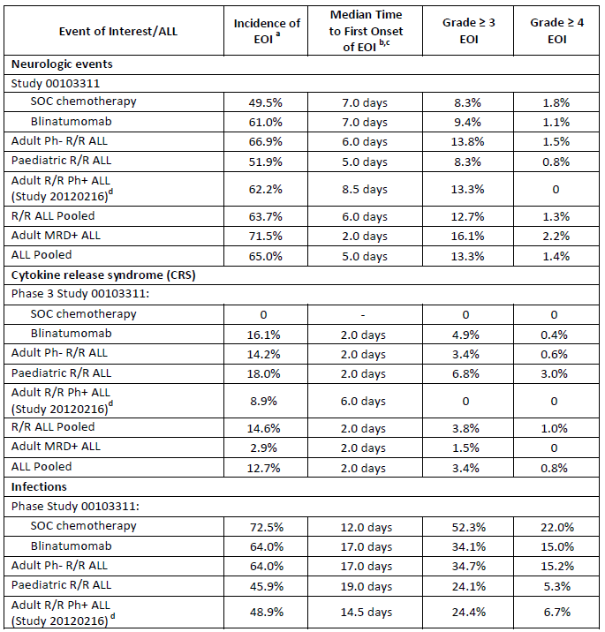
Table 5 (continued): Summary of AEs of special interest by study/indication for blinatumomab ALL studies (Safety analysis sets)
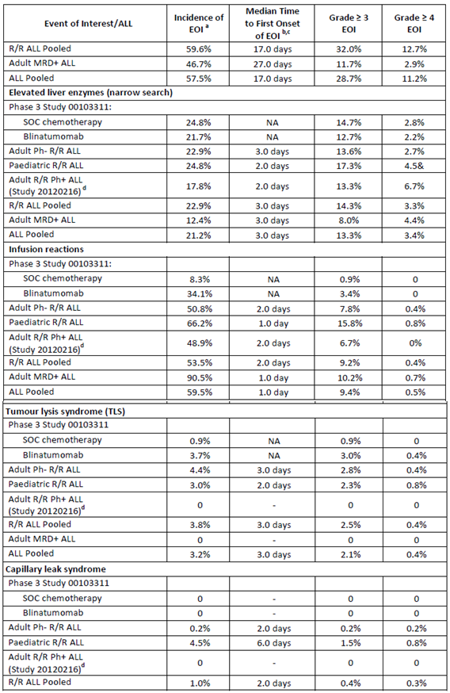
Table 5 (continued): Summary of AEs of special interest by study/indication for blinatumomab ALL studies (Safety analysis sets)
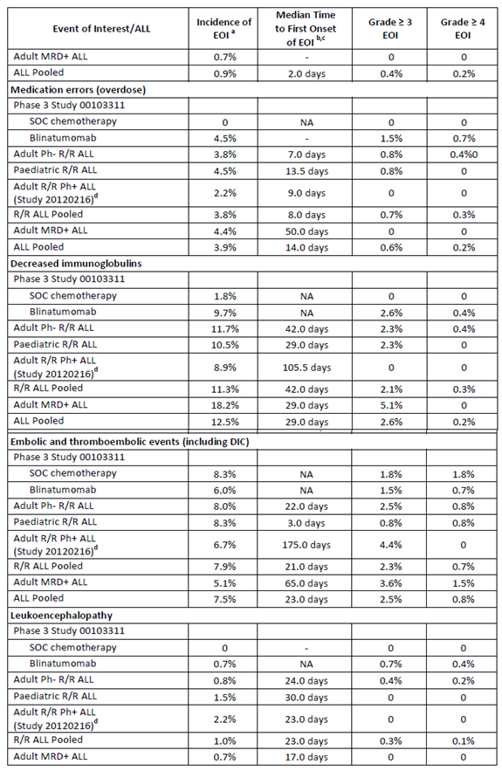
Table 5 (continued): Summary of AEs of special interest by study/indication for blinatumomab ALL studies (Safety analysis sets)
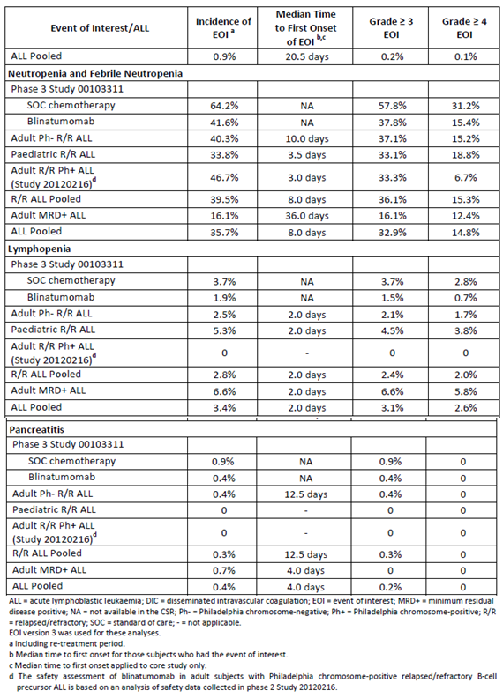

Evaluation of issues with possible regulatory impact

Liver function and liver toxicity
See Table 5 above.
In Study 00103311 the rates of elevated liver enzymes were similar between treatment arms (24.8% for subjects who received SOC chemotherapy and 21.7 for subjects who received blinatumomab); however, the exposure adjusted event rates per 100 subject years were approximately 3 times higher for subjects who received SOC chemotherapy compared with subjects who received blinatumomab (689.2 versus 197.8).
The types and frequencies of elevated liver enzyme events observed for adult subjects who received blinatumomab in Study 00103311 were consistent with those observed for adult subjects with Ph- R/R ALL, and those events reported in the original marketing application.
Subjects with Ph+ R/R ALL had a more than 5% lower rate of elevated liver enzyme events (17.8%) compared to subjects with Ph- R/R ALL (22.9%). There was no evidence to suggest that subjects with Ph+ ALL had a higher risk of experiencing events suggestive of elevated liver enzymes compared with subjects with Ph- R/R ALL.
For the adult MRD positive ALL population, hepatotoxicity events (drug-related hepatic disorders) were reported for 16.8% of subjects, which was lower than the subject incidence in the adult R/R Ph- ALL population (29.0%) and the total R/R ALL population (29.5%). Serious hepatotoxicity events (5.1% versus 2.1% and 2.1% of subjects) and grade ≥ 4 hepatotoxicity events (5.1% versus 3.0% and 3.8% of subjects) were similar between the MRD-positive ALL population and the adult R/R Ph- and total R/R ALL populations. No fatal hepatotoxicity events were reported in any ALL population.

Renal function and renal toxicity
No new safety signal was observed with respect to renal function. An analysis of nephrotoxicity revealed the types of events suggestive of potential nephrotoxicity observed across the blinatumomab ALL studies were consistent with those events reported in the original marketing application.
There was no evidence to suggest that adult subjects with Ph+ R/R ALL were at an increased risk of experiencing events suggestive of nephrotoxicity than adult subjects with Ph- R/R ALL, even though baseline renal function was worse for subjects with Ph+ R/R ALL.
There was no evidence of an increased risk of events suggestive of nephrotoxicity (acute renal failure) for the adult MRD positive ALL population compared with the adult R/R Ph- and total R/R ALL populations.

Immunogenicity and immunological events
To date, development of antidrug antibodies (ADAs) has been detected in 9 subjects across the blinatumomab ALL studies. Of these 9 subjects, 7 subjects were identified with ADAs that had in-vitro neutralising activity. Blinatumomab serum concentration levels in 2 out of 9 subjects were reduced. Among the 9 cases, 7 subjects achieved clinical response (CR/CRh*) as defined in the respective protocols.
The impact of immunogenicity on safety was evaluated through medical review and assessment of the type and severity of AEs, potential infusion reactions, and number of doses received while on study for blinatumomab treated antibody positive subjects. In those assessments, no evidence of an altered safety profile was observed for subjects who tested positive for anti- blinatumomab antibodies, which was consistent with the original marketing application.

Medication error
Given the blinatumomab preparation and administration as a continuous intravenous infusion (cIV) over four weeks and the possibility that errors may occur during these steps, medication errors that may lead to an overdose or underdose of blinatumomab are a possibility. Across the blinatumomab ALL studies, medication errors were reported for 3.9% of subjects, which was consistent with that reported in the original marketing application. The majority of medication errors involving blinatumomab did not result in other AEs.

Other safety parameters
No other new safety issues were identified.

Other safety issues

Safety in special populations
Summaries of adverse events were examined by pre-specified baseline factors, including demographic and disease related characteristics.
For all R/R ALL pooled population, subgroup analyses of AEs (including grade ≥ 3, serious, fatal, and those events leading to treatment discontinuation and interruption) were performed by age (≥ 18 to < 35 years, ≥ 35 to < 55 years, ≥ 55 to < 65 years, ≥ 65 years), gender, race, region, Eastern Cooperative Oncology Group (ECOG) performance status, baseline platelets, and baseline renal function (assessed by creatinine clearance (CrCL)). For these analyses, trends, when applicable, and differences were noted.

Age
By age, the types of AEs were consistent across the blinatumomab ALL studies. With the exception of subjects with Philadelphia chromosome-positive relapsed/refractory ALL, increasing rates of events leading to treatment interruption were observed by increasing age group across the blinatumomab ALL studies. Across the blinatumomab ALL studies, encephalopathy was reported at a higher rate for subjects who were ≥ 65 years of age compared with the other age groups analysed (10.8% versus 1.7% to 3.5%).
The rate of encephalopathy reported for subjects who were ≥ 65 years of age was consistent with the rate of 13.3% for this age group reported in the original marketing application. Higher incidence rates for subjects ≥ 65 years of age were also noted for other neurologic adverse events, including cognitive disorder (2.9% versus 0.3% to 2.0%), confusional state (8.8% versus 3.7% to 6.1%), and disorientation (6.9% versus 1.4% to 3.5%) and for some infections, including urinary tract infection (7.8% versus 2.7% to 4.5%) and device-related infection (8.8% versus 4.5% to 7.0%); however, none of these differences were more than 5% across the blinatumomab ALL studies.
By gender, race, and region, the types of AEs were consistent across the blinatumomab ALL studies.

Safety related to drug-drug interactions and other interactions
No new data were submitted.

Post marketing data
From the International Birth Date of 3 December 2014 to 2 December 2016 (data lock point for Periodic Benefit-risk Evaluation Report/Periodic Safety Update Report an estimated 2,236 patients had been exposed to blinatumomab in the marketed setting.
As of 2 December 2016, sponsor received, cumulatively, a total of 1,786 serious adverse drug reactions (ADRs) in the post marketing setting, from spontaneous and solicited sources. In addition, 808 non-serious ADRs were reported spontaneously.
Overall, among the 1,786 total serious ADRs reported from spontaneous and solicited sources, the most frequently reported adverse reactions (≥ 10%) were from the System Organ Classes of Nervous System Disorders (17.1%), General Disorders and Administrative Site Conditions (17.0%), and Investigations (11.0%). Serious adverse reactions with an event incidence ≥ 1% were pyrexia (5.5%); cytokine release syndrome (5.0%); neurotoxicity (4.5%); death (3.9%); ALL recurrent and neutropenia (2.4% each); blast cell count increased (1.9%); hospitalisation (1.7%); seizure and febrile neutropenia (1.5% each); ALL (1.4%); confusional state (1.3%); sepsis, disease progression, hypotension, and platelet count decreased (1.2% each); and headache (1.0%).
These events are consistent with the known safety profile of blinatumomab or representative of the underlying malignancy.

Evaluator’s conclusions on safety
No new safety issues were identified based on the safety analysis for the new studies or across all blinatumomab ALL studies. With the exception of pancreatitis that was identified after the original marketing application, the safety risks outlined in this submission are consistent with those identified in the original application.
The notably higher incidence of TEAEs and SAEs in the blinatumomab treatment arm as compared with the SOC chemotherapy treatment arm in Study 00103311 is consistent with the study design, which led to a longer duration of dosing for blinatumomab compared with SOC chemotherapy and therefore, the likelihood of observing AEs leading to treatment interruption was not balanced between the two treatment arms by the nature of study design.

First round benefit-risk assessment

First round assessment of benefits
Table 6, shown below, provides a summary of the assessment of benefits at the first round of Blincyto blinatumomab for the indications proposed in this submission.
Table 6: First round assessment of benefits
Benefits | Strengths and Uncertainties
Ph + R/R ALL (Study 20120216)  Primary outcome of best response during the first 2 cycles:  CR/CRh* = 35.6% (16/45) 95%CI: 21.9, 51.2  CR = 31.1% (14/45) 95%CI: 18.2, 46.6  CRh* = 4.4% (2/45) 95%CI: 0.5, 15.1  Cri (without CRh*) = 4.4% (2/45 95%CI: 0.5, 15.1)  Ph- R/R ALL (Study 00103311)  Median Overall Survival = 7.7 months (95%CI 5.6, 9.6) in the blinatumomab arm compared to 4.0 months (95%CI: 2.9, 5.3) in the SOC arm.  Hazard ratio = 0.71 (95%CI: 0.55, 0.93) = 29%  reduction in hazard rate (improved survival)  MRD + R/R ALL (studies MT103-203 and MT103-202)  Pooled data response:  Complete MRD response in Cycle 1 = 78.2% (104/133)  Study MT103-203:  RFS at 18 months KM estimate = 54% (95%CI: 33, 70)  OS at 18 month (with censoring HSCT and chemotherapy) = 83% (95%CI: 55, 94) | Single open label study  Not controlled or randomised  Small trial n = 45 patients  Study size = 405 total (271 blinatumomab, 135 SOC)  Primary outcome = overall survival  Study stopped when superiority was established  - Two studies with similar results  - Pooled data from both studies  - Total subjects = 133  Study is still ongoing and median OS not estimable

First round assessment of risks
Table 7, shown below, provides a summary of the assessment of risks at the first round of Blincyto blinatumomab for the indications proposed in this submission.
Table 7: First round assessment of risks
Risks | Strengths and Uncertainties
Key risks same as in original submission: neurological events, CRS and medication errors | Safety database increased with additional studies and longer term follow up.  Total safety database = 843 subjects No new safety issues identified

First round assessment of benefit-risk balance
The benefit-risk balance of Blincyto, given the proposed usage is favourable.

First round recommendation regarding authorisation

Ph + R/R ALL
The results for the primary efficacy outcome for Study 20120216 were best CR/CRh* = 35.6% (16/45 subjects). This was a single, small, open label study. It is known that the response rate for Ph+ ALL is generally around 10% lower than for Ph ALL. The result of Study 20120216 is consistent with that. Therefore, despite the single study and small numbers the results suggest sufficient evidence of efficacy to warrant approval. As the study is ongoing and one of the secondary endpoints is overall survival a condition of approval should be that the final report of the study must be submitted for evaluation.

Ph- R/R ALL
Study 0010311, which had overall survival as its primary outcome found that treatment with blinatumomab, provided a survival advantage over SOC chemotherapy. The median survival with blinatumomab was 7.7 months compared to 4.0 months for SOC.

MRD positive R/R ALL
There were two studies submitted to support the indication of treatment of MRD positive R/R ALL. These studies were submitted over two applications. In this submission the secondary analysis provided further information on MRD relapse and relapse free survival. The primary analysis (included in the original submission) demonstrated similar results for MRD complete response of around 80% during the first or second cycle. The median RFS has not been reached after median of over 4 years in Study MT103-202 and in the pooled data the median duration of MRD response was 22.3 months (15.0 to 44.3) as estimated with KM curves. While MRD is considered a surrogate (intermediate) endpoint in patients with complete clinical remission of chronic ALL, overall survival was measured in Study MT103-203 and was improved in subjects with a complete MRD response versus subjects without a response.
In both studies the entry criteria was patients with MRD positive B precursor ALL and were in complete haematological remission (defined as < 5% blasts in bone marrow after at least 3 intense chemotherapy blocks). This should be reflected in the indication.
Based on the clinical data submitted, approval of Blincyto is recommended for the following indication:
- Blincyto is indicated for the treatment of relapsed or refractory B cell precursor acute lymphoblastic leukaemia (ALL).
- Blincyto is indicated for the treatment of minimal residual disease (MRD) positive B cell precursor acute lymphoblastic leukaemia (ALL) in patients in complete haematological remission.
Note to indication: the indications in Philadelphia positive, MRD positive and paediatric patients were approved based on Phase II, non-randomised evidence. An improvement in clinical outcomes by direct prospective comparison in a randomised setting relative to other standard-of-care salvage therapies has not been established.
It should be a condition of approval that the sponsor submit the final CSRs for the studies which are still ongoing, that is Studies 20120216, 00103311, and MT103-203.

Second round evaluation
No clinical questions were asked and the sponsor has not submitted any new clinical information. The sponsor provided comments on the PI.

Second round benefit-risk assessment

Second round assessment of benefits
No new clinical information was submitted in response to the first round. Accordingly, the benefits of Blincyto are unchanged from those identified in the first round assessment of benefits, shown above.

Second round assessment of risks
No new clinical information was submitted in response to the first round. Accordingly, the risks of Blincyto are unchanged from those identified in the first round assessment of risks, shown above.

Second round assessment of benefit-risk balance
The second round assessment of the benefit-risk balance is favourable.

Second round recommendation regarding authorisation
The recommendation for approval is unchanged from the first round. Approval is recommended for the following indication:
- Blincyto is indicated for the treatment of relapsed or refractory B-cell precursor acute lymphoblastic leukaemia (ALL).
- Blincyto is indicated for the treatment of minimal residual disease (MRD) positive B-cell precursor acute lymphoblastic leukaemia (ALL) in patients in complete haematological remission.
Note to indication: the indications in Philadelphia positive, MRD positive and paediatric patients were approved based on phase II, non-randomised evidence. An improvement in clinical outcomes by direct prospective comparison in a randomised setting relative to other standard-of-care salvage therapies has not been established.

VI. Pharmacovigilance findings

Risk management plan

Summary of risk management plan evaluation
- In July 2017, Blincyto was approved by the TGA for use in paediatric patients with Philadelphia chromosome-negative relapsed or refractory B-cell precursor acute lymphoblastic leukaemia (ALL). The current indication, which includes the treatment of paediatric patients, is as follows:
Treatment of Philadelphia chromosome-negative relapsed or refractory B-cell precursor acute lymphoblastic leukaemia (ALL).
For the treatment of relapsed or refractory B-cell precursor ALL, Blincyto is administered by continuous intravenous infusion on days 1 to 28 with a 14 day treatment–free interval. Patients may receive 2 cycles of induction treatment followed by 3 additional cycles of Blincyto consolidation treatment. For adults the dosage is fixed dose and for patients less than 45 kg the dose is based on body surface area.
For the treatment of MRD positive B-cell precursor ALL, Blincyto is administered by continuous intravenous infusion for 28 days followed by a 14 days treatment-free interval. Patients may receive 1 cycle of induction treatment followed by 3 additional cycles of Blincyto consolidation treatment. The recommended dosage is 28 micrograms per day for patients greater or equal to 45 kg.
- The most recently evaluated EU- Risk Management Plan (RMP) was version 3.2 (dated 28 November 2016 DLP 22 February 2016) and ASA version 5.0 (dated 21 February 2017) for the application to extend the indication to include paediatric patients (PM-2016-2016-01898-1-4). In support of the current extension to indications (PM-2017-01431-1-4), the sponsor has submitted EU-RMP version 4.0 (dated 21 February 2017; DLP 2 December 2016) and ASA version 6.0 (dated 14 April 2017).
- In its response to questions, the sponsor has submitted ASA version 7.0 (dated 4 December 2017). The EU-RMP remains the same at version 4.0 (dated 21 February 2017; DLP 2 December 2016).
- The proposed Summary of Safety Concerns and their associated risk monitoring and mitigation strategies are summarised below:
Table 8: Summary of safety concerns
Summary of safety concerns |  | Pharmacovigilance |  | Risk Minimisation
 |  | Routine | Additional | Routine | Additional
Important identified risks | Neurologic events
Important identified risks | Infections |  |  |  | –
Important identified risks | Cytokine release syndrome
Important identified risks | Infusion reactions |  |  |  | –
Important identified risks | Tumor lysis syndrome |  |  |  | –
Important identified risks | Capillary leak syndrome |  |  |  | –
Important identified risks | Elevated liver enzymes |  |  |  | –
Important identified risks | Medication errors
Important identified risks | Febrile neutropenia and neutropenia |  |  |  | –
Important identified risks | Decreased immunoglobulin |  |  |  | –
Important identified risks | Pancreatitis
Important potential risks | Off-label use |  |  |  | –
Important potential risks | Leukoencephalopathy (including PML) |  |  |  | –
Important potential risks | Thromboembolic events (including disseminated intravascular coagulation) |  |  |  | –
Important potential risks | Immunogenicity |  |  |  | –
Important potential risks | Worsening of hepatic impairment in patients with hepatic impairment |  |  |  | –
Important potential risks | Use in patients with active or a history of high risk central nervous system pathology including patients with untreated ALL in CNS |  |  |  | –
Important potential risks | Haematological disorders in newborn exposed in utero to blinatumomab (particularly B-cell depletion and risk of infections in case of vaccination with live virus vaccines) |  | – |  | –
Missing information | Use in pregnancy and breastfeeding |  | – |  | –
Missing information | Use in paediatric and adolescent patients |  |  |  | –
Missing information | Use in elderly |  |  |  | –
Missing information | Use in patients with renal impairment |  |  |  | –
Missing information | Use in patients with ethnic differences |  | – |  | –
Missing information | Use in patients with active uncontrolled infections |  |  |  | –
Missing information | Use in patients with HIV positivity or chronic infection with hepatitis B virus or hepatitis C virus |  |  |  | –
Missing information | Use in patients after recent HSCT |  |  |  | –
Missing information | Recent or concomitant treatment with other anti-cancer therapies (including radiotherapy) |  |  |  | –
Missing information | Recent or concomitant treatment with other immunotherapy |  |  |  | –
Missing information | Effects on fertility |  | – |  | –
Missing information | Long-term safety |  |  |  | –
- There are additional pharmacovigilance activities for most safety concerns except the following: Effects on fertility, use in patients with ethnic differences, pregnancy and breastfeeding and haematological disorders in newborn exposed in utero to blinatumomab. No human studies have been conducted to evaluate the effects of Blincyto on fertility.
- There are additional risk minimisation activities for the Important Identified Risks identified in the table above. These activities include a Doctor Education Brochure, a Nurse Education Brochure, a Pharmacist Preparation Card, a Patient Safety Brochure and Patient Alert Card. A Dear Healthcare Professional (DHCP) letter has already been distributed for the safety concern ‘pancreatitis’.
- The additional pharmacovigilance and risk minimisation activities proposed are unchanged from those in previous submissions (PM-2014-03864-1-4 and PM-2016-01898-1-4) which sought to initially register blinatumomab and also extend the registration for blinatumomab to include use in the paediatric population with B-cell precursor ALL. The additional risk minimisation activities were considered acceptable from an RMP perspective by the TGA in 2015.
- The Doctor Education Brochure has been updated to incorporate the dosing for the extension to indication for application PM-2017-01431-1-4 (treatment of minimal residual disease (MRD) positive B-cell precursor ALL), and there have been corrections to spelling.
- The Nurse Education Brochure, the Patient Safety Brochure and Patient Alert Card are unchanged and include information regarding the paediatric indication where applicable. This is acceptable.

New and outstanding recommendations from second round evaluation
The first round recommendations have been satisfactorily addressed and the sponsor has committed to provide updated information as it becomes available.
There are no new recommendations.

Proposed wording for conditions of registration
The suggested wording is:
- The Blincyto EU-Risk Management Plan (RMP) (version 4.0, dated 21 February 2017, data lock point 2 December 2016), with Australian Specific Annex (version 7.0, dated 4 December 2017), included with submission PM-2017-01431-1-4, and any subsequent revisions, as agreed with the TGA will be implemented in Australia.
The following wording is recommended for the Periodic Safety Update Reports (PSUR) requirement:
An obligatory component of risk management plans is routine pharmacovigilance. Routine pharmacovigilance includes the submission of Periodic Safety Update Reports (PSURs).
Reports are to be provided in line with the current published list of EU reference dates and frequency of submission of PSURs until the period covered by such reports is not less than three years from the date of this approval letter.
The reports are to at least meet the requirements for PSURs as described in the European Medicines Agency’s Guideline on good pharmacovigilance practices (GVP) Module VII-Periodic Safety Update Report (Rev 1), Part VII.B Structures and processes. Note that submission of a PSUR does not constitute an application to vary the registration. Each report must have been prepared within ninety calendar days of the data lock point for that report.

VII. Overall conclusion and risk/benefit assessment
For this submission where the sponsor is proposing to amend the indication to include treatment of MRD positive patients, the MRD level describing negativity/positivity is of critical importance, together with the requirement of later reporting of traditional efficacy end-points.

Quality
There was no requirement for a quality evaluation in a submission of this type.

Nonclinical
There was no requirement for a nonclinical evaluation in a submission of this type.

Clinical
For this submission where the sponsor is proposing to amend the indication to include treatment of MRD positive patients, the MRD level describing negativity/positivity is of critical importance, together with the requirement of later reporting of traditional efficacy end-points.

Pharmacology
The separate population pharmacokinetic evaluation documented there is large variability yin the clearance of blinatumomab among MRD-positive patients, and consequent variability in exposure. However, the clinical evaluation concluded that the dosage regimen currently approved remains suitable for MRD-positive patients, with no significant PK effects of body weight, body surface area (BSA), age or sex.
A response from the sponsor to the second round popPK evaluation is awaited at the time of writing this overview.

Efficacy

Philadelphia positive relapsed/refractory B-precursor ALL

Study 20120216
This was a Phase II open-label un-randomised study assessing the efficacy and safety of blinatumomab in adult patients with relapsed refractory B-ALL (bone marrow blast count > 5%) who were relapsed or refractory to at least one of dasatinib, nilotinib, bosutinib, pontinib and intolerant or refractory to imatinib. Enrolled patients had to have ECOG status of ≤ 2.
The primary outcome was the proportion of subjects who achieved a CR or CRh* within 2 cycles of treatment.
The full exclusion criteria are described in Attachment 2. Of note, patients were precluded from study entry if they had received HSCT within the preceding 12 weeks, presence or treatment of graft-versus host disease and B-ALL central nervous system (CNS) deposit. Patients eligible for a HSCT at study entry were precluded.
Study treatment comprised two induction cycles of 6 weeks duration of blinatumomab following which the primary outcome of complete remission or complete remission (CR) with partial haematological response (CRh*) was assessed. Patients achieving a CR/CRh* or complete remission with incomplete haematological recovery (CRi) were then permitted to complete a further three 6 week cycles of blinatumomab.
This study was designed to demonstrate an effective response rate (CR/CRh*) of ≥ 30%, requiring 41 patients. An analysis of the primary outcome was performed to determine the progression of patients with CR/CRh*/CRi to receive consolidation therapy.
The 45 patients enrolled to the study with confirmed Ph+ B-ALL were all blinatumomab naïve, with mean age of 52.8 years (standard deviation (SD) 15). All patients had received between 1 and 4 prior lines of TKI therapy.

Primary endpoint
The primary end-point was met with 16/45 (35.6%) (95% CI 21.9, 51.2%) of the full analysis set (FAS) achieved a CR/CRh* after two cycles of blinatumomab. Among the responders, the majority achieved a CR n = 14 as compared to CRh*, n = 2. Among the 45 patients, 12 (26.7%) had no response after 2 cycles, and 4 (8.9%) had a partial response.

Secondary endpoints
Among the 16 patients with a CR/CRh*, 12/14 with CR and both patients with CRh* achieved MRD negativity.
The median time to haematological relapse in 14 subjects who achieved a CR was 6.7 months (95% CI: 4.1 months to not estimable (NE)), with a median observation time of 7.0 months. The median time to haematological relapse in the 2 subjects who achieved CRh* was not estimated with a median observation time of 9.0 months.
The median duration of overall survival was 7.1 months (95% CI: 5.6 to NE) in the FAS.
Cross-study comparisons are presented in the CER (please see Attachment 2).
The median duration of OS is consistent with the duration reported across Studies 00103311 and MT103-211. The proportion of patients achieving a CR/CRh* in the first two cycles of treatment is consistent with that seen in Study MT103-211.

Studies pertaining to the proposed indication for the treatment of minimal residual disease

Study MT103-202
This is a second report evaluated by the TGA for this study, this initial report having been evaluated for the initial registration submission.
This is an open-label Phase II multicentre study assessing the efficacy and safety and tolerability of blinatumomab in adults with complete haematological remission, but with ongoing minimal residual disease, positive B-precursor ALL following consolidation front line therapy.
The marker for MRD status for this study was:
- BCR/ABL and/or t(4;11) translocation at any detection level measured by RT-PCR.
- Individual rearrangements of immunoglobulin or T cell receptor genes measured by an assay with a sensitivity of minimum 10⁻⁴: at least 1 individual marker at a quantitative level ≥ 10⁻⁴.

Treatment
Patients were treated with blinatumomab 15 µg/m²/day over 4 weeks followed by a treatment-free period of 2 weeks.
Responders were permitted to receive 3 additional consolidation cycles of treatment with blinatumomab. Subjects who showed neither MRD progression nor response could receive up to 7 cycles.
Three patients had a dose escalation to 30 µg /m²/day as they did not achieve reduction in MRD level ≥ 1 log, (per data review committee decision).

Results
The median duration of relapse-free survival had not been reached after a median follow- up time of 1550 days. Sixteen patients were observed to have a MRD response.
Eight of the 20 patients (40%) had had a haematological relapse occurring between Day 99 and Day 1550. The risk of relapse was similar for those with and without prior HSCT.

Study MT103-203
This is an ongoing long-term follow-up Phase II single-arm study of the efficacy, safety and tolerability of blinatumomab in adults with Ph negative b-precursor ALL.
The primary objective of this study was to evaluate the efficacy of blinatumomab to induce a complete MRD response in adult patients with B-ALL.
Figure 1, shown below, summarises the study design of Study MT103-203.
Figure 1: Study design for Study MT103-203
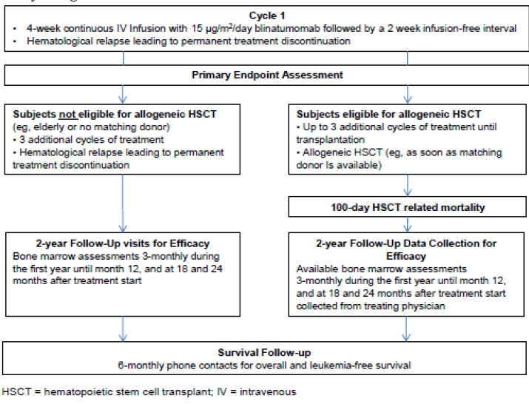
In contrast to Study MT102-202 above, the criteria for this study were:
MRD ≥ 10⁻³ (molecular failure or molecular relapse) in an assay with minimum sensitivity of 10⁻⁴ with at least 1 molecular marker based on individual rearrangement of immunoglobulin (Ig) or TCR-genes or a flow cytometric marker profile documented after an interval of at least 2 weeks from last systemic chemotherapy, and bone marrow function defined as absolute neutrophil count ≥ 1,000/µL, platelets ≥ 50,000/µL, and haemoglobin level ≥ 9 g/dL (transfusions permitted).
Secondary outcomes of the study were:
- Haematological relapse free survival
- Overall survival
- 100 day mortality after allogenic HSCT
- Time to haematological relapse
- Duration of complete MRD response
- Effect on MRD level
Of the 211 patients screened, 116 received ≥ 1 infusion of blinatumomab and comprised the full analysis set, 113/116 comprised the primary analysis set. 106 patients ended the core study, ten of whom were continuing the core study at data cut-off. The primary efficacy end-point was the evaluation of the ability of blinatumomab to induce complete MRD response.
The key secondary end-point was to assess the effect of blinatumomab on haematological response for patients with Philadelphia-negative ALL.The other secondary objectives did not include the assessment of overall survival, rather only the 100 day mortality rate.
The patient disposition at the second analysis point is shown in Figure 2.
Figure 2: Patient disposition at the second analysis point
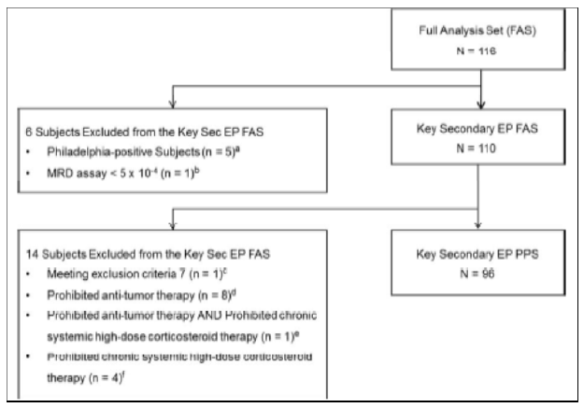
Among the 116 patients in the FAS, the majority were Philadelphia chromosome-negative (n = 111 (95.7%)), the remainder were Philadelphia chromosome positive.
The distribution of baseline level MRD is shown in Table 9.
Table 9: MRD level at Baseline by central laboratory
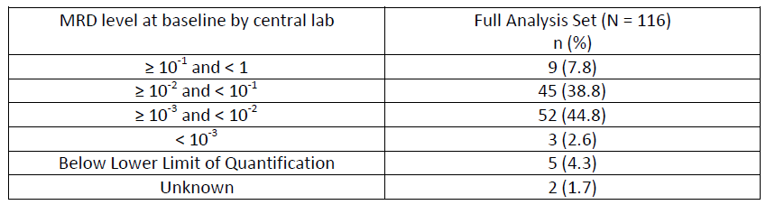
The results of the primary end-point show the proportion of patients who achieved a MRD response at the end of cycle was 88/113 (77.9%).
Full primary end-point results are shown below.
Table 10: Primary endpoint; MRD response within the first treatment cycle
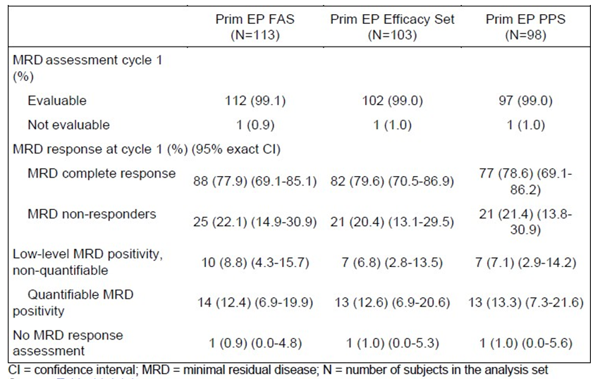
Table 11: MRD response (assessed centrally) has been described according to MRD level at Baseline
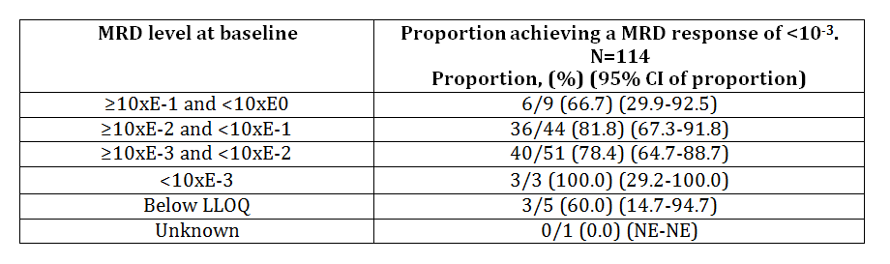
The data for the secondary outcome of haematological relapse-free survival rate is immature at this time-point. The study CSR states ‘Haematological relapse free survival will be reported in an updated analysis’.
The 100 day mortality data demonstrates that the majority of patients (90/116, 77.6%) underwent HSCT after blinatumomab; 63% of those receiving HSCT were MRD negative at the time of transplant. The OS rate at 100 days after transplant was 93% (95% CI: 85% to 97%). The 100 day mortality rate after allogeneic HSCT was 7% (95% CI: 3% to 15%).
Overall survival has been estimated according to MRD response with the median duration of OS in MRD responders being 38.9 months (95% CI 13.0, NE) as compared to that for MRD non-responders of 1.5 months (95% CI 3.8, NE). This data reflects not only the effect of blinatumomab, but also that of post-blinatumomab HSCT.

Data to support changes to the PI; pivotal Study 00103311 (Tower study)
Presentation of this study was a condition of the initial registration of blinatumomab.
This study was stopped early at the recommendation of the Data Safety Committee as a significant increase in overall survival (primary end-point) was demonstrated.
The inclusion criteria were male and female (non-childbearing potential) aged ≥ 18 years and diagnosed with Philadelphia negative B-cell precursor ALL with any of the following disease characteristics:
- Refractory to primary induction therapy or refractory to salvage therapy
- In untreated first relapse with first remission duration < 12 months
- In untreated second or greater relapse
- Relapse any time after alloHSCT
and had received intensive combination chemotherapy for treatment of ALL for initial treatment or subsequent salvage therapy; with greater than 5% blasts in bone marrow and ECOG performance status ≤ 2.
Patients were randomised to blinatumomab or 1 of 4 standard of care regimens.
Blinatumomab was administered as induction, consolidation and maintenance phases.
Efficacy of blinatumomab was assessed at a second interim analysis. Median OS was based on the trial FAS demonstrating a median duration of OS of 7.7 months (95% CI 5.6, 9.6) in the blinatumomab arm and 4.0 months (95 % CI 2.9, 5.3) in the SOC chemotherapy arm.
The hazard ration of OS was 0.71 (95%CI 0.55, 0.93) favouring blinatumomab. Point estimates of the hazard ration for pre-specified subgroups of age categorised at 35 years, receipt of prior salvage therapy and receipt of prior HSCT were consistent in favouring blinatumomab.

Safety
Pooled safety data for blinatumomab has been accumulated across studies for 843 adults and children with Philadelphia positive and negative ALL. TEAEs are reported for 837 of 843 patients (99.3%).
Table 12: Summary of TEAEs, drug interruptions and discontinuations; Pooled analyses (Safety analysis set)
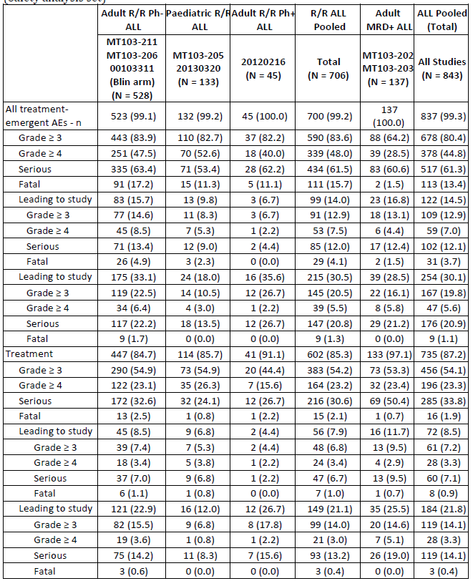
The safety data arising from the studies presented in the current submission are consistent with the adverse event profile documented in the currently approved product information. No new safety signals have been identified since the last update to the product information.
Table 13 presents the listing of TEAEs with an incidence of ≥10% across studies. While there are differences in incidence across categories of patient and disease type, there is a similarity between groups.
Table 13: Incidence of TEAEs in ≥ 10% of subjects in any ALL population by Preferred Term in descending frequency; Pooled analyses (Safety analysis set)
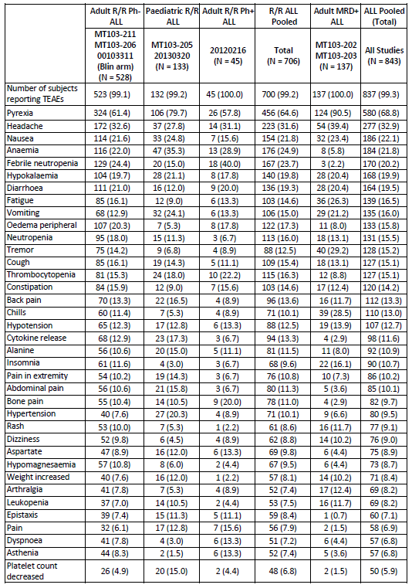
Table 13 (continued): Incidence of TEAEs in ≥ 10% of subjects in any ALL population by Preferred Term in descending frequency – Pooled analyses (Safety analysis set)
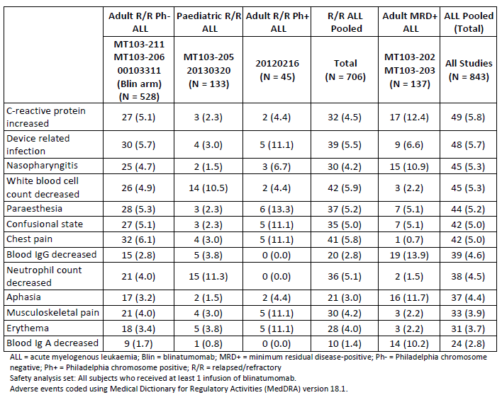

RMP evaluation
The RMP evaluation was supportive of registration, with no additional pharmacovigilance or risk minimisation activities required or outstanding issues.

Risk-benefit analysis

Efficacy

Philadelphia chromosome positive R/R ALL
The Delegate considers the data arising from Study 20120216 to be sufficient to remove the restriction of Philadelphia chromosome status from the currently approved indication. Given the data for this part of the indication arises from an open-label un-randomised Phase II study, the sponsor has proposed an additional statement in the indication reflecting this level of evidence. In the absence of a formal provisional approval mechanism, this is considered appropriate. Overall survival and 100 day mortality are secondary end-points of this study and should be reported in a Category 1 submission to the TGA when available.

MRD positive patients
For patients with ALL, MRD is an intermediate, time-dependent parameter. The effect of MRD negativity depends on the phase of treatment; that is, for a given patient population, the magnitude of survival benefit differs, for example, between the response to induction and consolidation treatment. Long-term survival also depends of the MRD cut-off designated at time of treatment; the degree of MRD considered in current clinical practice is 10⁻⁴ of 10^{-4.5.} The threshold of MRD of 10⁻³ utilised in Study MT103-203 is no longer considered the standard measure. In this study the majority of patients (83.6%) having values between ≥ 10⁻³ and < 10⁻¹. Of note, three patients had MRD of less than 10⁻³ at Baseline.
The achievement of ‘MRD negativity’ in this study was that below a value of 10⁻³ which is less stringent than achieving 10⁻⁴, which is the level defined in the currently approved blinatumomab PI for adult patients with ALL.
Despite this methodological limitation, the data demonstrates that treatment with blinatumomab enabled the majority of patients to proceed to HSCT. The OS data to date demonstrates the combined effect of blinatumomab and subsequent HSCT, yielding an approximately 18 month survival advantage for those who achieved MRD negativity.
Study MT103-202 employed a more stringent definition of MRD positivity, but recruited a far smaller number of patients than Study MT103-203.

Philadelphia chromosome negative R/R ALL
The overall survival data from Study 0010311 demonstrates a benefit of 3.7 months difference in favour of blinatumomab. This degree of improvement is considered sufficient to remove the ‘note to indication’ for this use.

Safety
The cumulative data to date has satisfactorily demonstrated the adverse events profile of blinatumomab for 843 patients.
The data presented in the current dossier has not yielded any additional adverse event signals.
The variation in incidence between treatment population sub-groups is likely due to the variation in exposure; the data has not been standardised for exposure.

RMP
The RMP evaluation did not identify any issues that would preclude registration. The recommended wording of the RMP condition of registration is:
- The Blincyto EU-Risk Management Plan (RMP) (version 4.0, dated 21 February 2017, data lock point 2 December 2016), with Australian Specific Annex (version 7.0, dated 4 December 2017), included with submission PM-2017-01431-1-4, and any subsequent revisions, as agreed with the TGA will be implemented in Australia.
The wording recommended for the PSUR requirement is:
An obligatory component of risk management plans is routine pharmacovigilance. Routine pharmacovigilance includes the submission of Periodic Safety Update Reports (PSURs).
Reports are to be provided in line with the current published list of EU reference dates and frequency of submission of PSURs until the period covered by such reports is not less than three years from the date of this approval letter.
The reports are to at least meet the requirements for PSURs as described in the European Medicines Agency’s Guideline on good pharmacovigilance practices (GVP) Module VII- Periodic Safety Update Report (Rev 1), Part VII.B Structures and processes. Note that submission of a PSUR does not constitute an application to vary the registration. Each report must have been prepared within ninety calendar days of the data lock point for that report.
Indication
The sponsor proposed the wording of the indication in their response to be:
Blincyto is indicated for the treatment of relapsed or refractory B-cell precursor acute lymphoblastic leukaemia (ALL).
Blincyto is indicated for the treatment of minimal residual disease (MRD) positive B-cell precursor acute lymphoblastic leukaemia (ALL) in patients in complete haematological remission.
Note to indication: the indications in Philadelphia positive, MRD positive and paediatric patients were approved based on phase II, non-randomised evidence. An improvement in clinical outcomes by direct prospective comparison in a randomised setting relative to other standard-of-care salvage therapies has not been established.
The Delegate awaits the advice of the Committee.

Conditions of registration
Should the Committee endorse the proposed changes to the indications, provision of confirmatory data to support the use in MRD positive patients and Philadelphia chromosome positive patients, the ‘note to the indication’ should remain until sufficient confirmatory data is presented to the TGA as Category 1 submissions.

Delegate’s considerations
The submission proposes to extend the indication to include the treatment of MRD positive pre-B ALL. The data to support this indication is immature. Of the two studies presented, that with the largest number of patients, Study MT103-203, is not primarily designed to demonstrate overall or progression-free survival.

Proposed action
The Delegate considers the data presented to satisfactorily extend the indication to include Philadelphia chromosome positive patients.

Request for ACM advice
- What is the opinion of the Committee in regards to the proposed extension of indication to include the treatment of minimal residual disease (MRD) positive B-cell precursor acute lymphoblastic leukaemia given the data presented in the two submitted studies, in regard to:
- The criteria used to determine MRD status
- The ability of the two studies to satisfactorily determine a longer-term efficacy benefit of blinatumomab
The Committee is requested to provide advice on any other issues the Committee consider appropriate.

Response from sponsor

Section A: Questions raised for the ACM
The Delegate has requested the ACM’s opinion on the proposal to extend the indication to include the treatment of minimal residual disease (MRD) positive pre-B ALL given the data presented in the submission, particularly the criteria used to determine MRD status and the ability of the two submitted studies to determine a longer-term efficacy benefit of blinatumomab.
ALL is a rare aggressive cancer of the bone marrow. Nearly 50% of adult patients and 25% of paediatric patients with B-cell ALL eventually experience relapse or are refractory to initial treatment. The presence of MRD after induction or consolidation chemotherapy is the most important risk factor for haematologic relapse in adult and paediatric patients with ALL. Allogeneic haematopoietic stem cell transplant (HSCT) is the only available treatment option for patients with MRD-positive ALL, but the outcome is far from optimal. Patients with MRD- positive disease may relapse while waiting for HSCT, and those who are MRD-positive prior to HSCT have worse outcomes compared to patients who are MRD-negative prior to HSCT.
The current submission demonstrates a complete MRD response was achieved rapidly within 1 cycle of blinatumomab treatment and improved rates of RFS and OS were observed for subjects after achieving a complete MRD response.
Blinatumomab treatment improved RFS and OS in subjects across all ages studied, regardless of remission status and Philadelphia chromosome status, and allowed eligible subjects time to receive an allogeneic HSCT while in remission from ALL. Thus, it is reasonably likely that patients with MRD, which is also a direct measure of disease burden, can achieve long-term benefits from a therapy such as blinatumomab that dramatically reduces their leukaemic tumour burden and converts them to a state of MRD negativity.
At the time of the initial protocol development for Study MT103-203 in 2010, MRD detection methods included flow cytometry with sensitivity estimated to be in the range of 10-³ to 10⁻⁴ and real-time quantitative polymerase chain reaction (PCR) with an assay detection limit of 10⁻⁴. In Study MT103-203, a conservative definition of MRD positivity, using a level of ≥ 1 x 10⁻³, was chosen as an enrolment criterion to account for the sensitivities of the available assays, and the cut-off of ≥ 10⁻³ ensured an adequate degree of tumour load reduction to reliably measure response (that is, at least 10 fold tumour load reduction from 10⁻³ to 10⁻⁴). Additionally, the literature supported that MRD at 10⁻³ identified patients with higher risk.
The current National Comprehensive Cancer Network (NCCN) guidelines do not define a specific threshold for MRD positivity but note that MRD positivity can be detected with flow cytometry or PCR methods with a minimum sensitivity of < 1 x 10⁻⁴. The definition of MRD positivity is continually evolving as assessment techniques become more sensitive. As noted by the Delegate, current clinical practice considers MRD positivity as 1 x 10⁻⁴. MRD at levels of 10⁻⁴ or higher is an indicator of poor prognosis that is supported by a strong body of medical evidence. Data available suggests that any level of MRD is associated with a poorer long-term outcome for ALL patients.
MRD positivity at > 1 x 10⁻⁴ is an appropriate cut-off for identifying an MRD- positive population at high risk for relapse based on the totality of the available data, published literature, current treatment guidelines, and availability of assays with a minimum sensitivity of < 1 x 10⁻⁴. Data derived using the ≥ 10⁻³ cut-off in Study MT103-203 are directly relevant for evaluation of patients today identified as MRD-positive using current MRD assays that have minimum sensitivity of < 1 x 10⁻⁴. The findings of Study MT103-203 can reasonably be extrapolated to patients who are classed as MRD positive but with MRD levels below 10⁻³. The results of Study MT103-202 and the historical comparator Study, 20120148, support this conclusion.
The primary endpoint in Study MT103-203 was a reduction in MRD level to undetectable using an assay with a minimum sensitivity of 10⁻⁴ after one cycle of treatment with blinatumomab (in the full analysis set, complete MRD response was achieved within the first cycle in 77.9% of subjects; response rate to blinatumomab did not vary significantly according to baseline MRD level). With the enrolment criterion of an MRD level of ≥ 10⁻³, this endpoint required reductions in MRD level in all responders of at least 10 fold (1 log). For patients with an MRD level of < 10⁻³, achieving the primary endpoint would have required reductions in MRD level less than 1 log; it is axiomatic that reducing tumour load to undetectable levels is a greater 'efficacy challenge' for blinatumomab in patients with higher levels of MRD than in those with lower levels. Consequently, unless there is some qualitative difference in the biology of the disease in patients with MRD at low levels, it is reasonable to extrapolate the efficacy observed in patients with MRD levels of ≥ 10⁻³ to those patients with lower MRD levels. The sponsor is not aware of any evidence for such a qualitative biological difference.
As all MRD-positive subjects are expected to respond equivalently to blinatumomab treatment, irrespective of the initial MRD level, the sponsor believes that exclusion of MRD-positive patients with detectable MRD below 10⁻³ did not skew the findings of Study MT103-203 in any significant way.
Although there were small numbers, in Study MT103-202, the response to blinatumomab treatment was similar in groups of patients with different initial MRD levels. Of the 20 patients treated in the study, 4 patients had initial MRD levels of < 10⁻³; 2 of these patients responded to the first cycle of blinatumomab treatment. In Study MT103-203, of the 113 patients in the full analysis set, 8 patients had initial MRD levels of < 10⁻³; 6 of these patients responded to the first cycle of blinatumomab treatment. Furthermore, most patients who are MRD- positive by a 10⁻⁴ assay are also MRD-positive using the 10⁻³ cut-off. Data from the historical comparator study (Study 20120148) show that in patients with MRD-positive ALL identified using the current 10⁻⁴ cut-off, approximately 70% also had MRD levels of at least 10⁻³.
Blinatumomab induced MRD negativity in a large proportion of subjects (up to 80%) with MRD-positive ALL in the pivotal Study MT102-203 and the supportive Study MT103-202. A median reduction of 750 fold among complete MRD responders from the baseline MRD level was observed in the pivotal study, with the greatest reduction of 30,000 fold (note, the calculation is conservative by inputting the lower limit of detection for complete MRD responders). As noted by the Delegate, ‘data from Study MT103-203 demonstrates that treatment with blinatumomab enabled the majority of patients to proceed to HSCT. The OS data to date demonstrates the combined effect of blinatumomab and subsequent HSCT, yielding an approximately 18 month survival advantage for those who achieved MRD negativity’. Furthermore, the clinical evaluator concluded that the ‘results demonstrate that blinatumomab is effective in treating MRD positive disease in patients with MRD positive B-cell ALL and who were in complete haematological remission.’
The sponsor notes the Delegate’s comments regarding the design of the pivotal study as relates to demonstration of long-term survival benefit. Amongst information on Study MT103-203, the Delegate included the comment: ‘the other secondary objectives did not include the assessment of overall survival, rather only the 100 day mortality rate’, although the Delegate noted earlier that overall survival was one of the secondary outcomes of the study. Amgen agrees with the Delegate that OS was one of the secondary efficacy endpoints, along with mortality rate within 100 days after allogeneic HSCT, time to haematologic relapse, and duration of complete MRD response. We also confirm that median OS (from day 45) was 28.4 months longer in subjects who achieved a complete MRD response compared to subjects who did not have a complete MRD response (38.9 months (95% CI: 33.7, NE) versus 10.5 months (95% CI: 3.8, NE), respectively. Survival follow-up continues at 6-monthly intervals until 5 years after treatment start for each subject. The final analysis will be carried out 5 years after the last subject enrolled into the study (expected early 2019).
Further evidence of the longer-term efficacy benefit of blinatumomab will be provided by three randomised, controlled, Phase III clinical studies currently underway which seek to confirm the benefit of blinatumomab in the consolidation setting compared with conventional chemotherapy for adult and paediatric patients in first relapse or first diagnosis with B-cell ALL. These studies have validated, well-defined clinical endpoints as well as post-transplant follow-up, and are intended to address the uncertainties of the blinatumomab indication:
- Study E1910, conducted by the Eastern Cooperative Oncology Group (ECOG) and sponsored by the National Cancer Institute (NCI): to assess the effect of blinatumomab in combination with induction chemotherapy compared with induction chemotherapy alone for adult patients (30 through 70 years of age) with newly diagnosed Philadelphia chromosome-negative B-cell ALL. Results expected 2023.
- Study AALL1331, conducted by the Children’s Oncology Group (COG) and sponsored by the NCI: to assess efficacy and safety of blinatumomab compared with standard combination chemotherapy in treating patients (≥ 1 to < 31 years) with B-cell ALL that has returned after a period of improvement (relapsed). Results expected 2022.
- Study 20120215, conducted by Amgen in cooperation with the International Berlin-Frankfurt-Munich (I-BFM) Study Group: to investigate the efficacy and safety of blinatumomab as consolidation therapy versus conventional consolidation therapy in paediatric subjects (> 28 days to < 18 years of age) with high risk (HR) first relapse B-cell precursor ALL. Results expected 2023.
Details regarding design and interim analyses were provided (but have not been included in the AusPAR).
Each of these 3 studies has the potential to address the uncertainties of treating MRD-positive ALL patients with blinatumomab compared with standard chemotherapeutic regimens. Overall survival is the primary endpoint in Study E1910, while OS is a secondary endpoint of Studies AALL1331 and 20120215. Thus, it will be possible to assess survival by MRD status. Subjects who receive an HSCT will be followed for at least 2.5 years. While all 3 studies have robust designs with validated endpoints, some limitations for each of the studies exist. Transplantation is not mandatory for Study E1910, and Studies AALL1331 and 20120215 are limited to patients less than or equal to 31 years of age and < 18 years of age, respectively. The patient populations for these studies differ compared with Study MT103-203. Although there are limitations, the sponsor believes any of these 3 clinical studies are sufficient to provide high quality and long-term efficacy and safety data to address the uncertainties in the MRD positive B-cell precursor ALL population.

Section B: Sponsor comment on other issues
At the end of evaluation, the pharmacometric evaluator requested the Pharmacokinetics section of the proposed PI be revised in terms of ‘exposure’ instead of ‘PK’, which was endorsed by the Population Pharmacokinetics Working Group. The sponsor agrees to make the requested change.
The sponsor agrees with the Delegate’s comment on of the Delegate’s Request for ACM Advice: ‘data arising from Study 20120216 to be sufficient to remove the restriction of Philadelphia chromosome (Ph) status from the currently approved indication’. Furthermore, the sponsor agrees with the Delegate’s assessment that the indication should be extended to include Ph positive patients.
The efficacy and safety of blinatumomab in adults with relapsed or refractory Ph negative B-ALL was confirmed in the pivotal Phase III Study 001103311. This study was stopped early at the recommendation of the Data Safety Committee as a significant overall survival benefit of 3.7 months difference in favour of blinatumomab was demonstrated. No additional safety signals were identified.
The sponsor agrees with the Delegate’s view that this improvement is sufficient to remove the ‘note to indication’ for this use.

Advisory Committee Considerations
The Advisory Committee on Medicines (ACM), taking into account the submitted evidence of efficacy, safety and quality, agreed with the Delegate and considered Blincyto powder for injection with intravenous solution stabiliser containing 38.5 µg of blinatumomab to have an overall positive benefit-risk profile for the Delegate’s amended indication:
Blincyto is indicated for the treatment of relapsed or refractory B-cell precursor acute lymphoblastic leukaemia (ALL).
Blincyto is indicated for the treatment of minimal residual disease (MRD) positive B cell precursor acute lymphoblastic leukaemia (ALL) in patients in complete haematological remission.
Note to indication: the indications in Philadelphia positive, MRD positive and paediatric patients were approved based on phase II, non-randomised evidence. An improvement in clinical outcomes by direct prospective comparison in a randomised setting relative to other standard-of-care salvage therapies has not been established.

Proposed conditions of registration
The ACM agreed with the Delegate on the proposed conditions of registration.
- Implementation of the Risk Management Plan version most recently approved by the TGA’s Pharmacovigilance and Special Access Branch.
- Submission of the final analysis of confirmatory data to support the use in MRD positive patients and Philadelphia chromosome positive patients, when available.
- Finalisation of the Product Information to the satisfaction of the TGA.

Proposed Product Information (PI)/ Consumer Medicine Information (CMI) amendments
The ACM agreed with the Delegate to the proposed amendments to the PI and CMI.
- Amendments to the PI and CMI as proposed in details by the Delegate and evaluators to be finalised in negotiations with the Delegate.

Specific advice
The ACM advised the following in response to the Delegate’s specific questions on the submission:
- What is the opinion of the Committee in regards to the proposed extension of indication to include the treatment of minimal residual disease (MRD) positive B-cell precursor acute lymphoblastic leukaemia given the data presented in the two submitted studies, in regard to:
- The criteria used to determine MRD status
The ACM noted the variability in the criteria used to define MRD status between Studies MT103202 and MT103203 and that used in Australian clinical practice. The committee considered that MRD positivity is well established to be an adverse prognostic feature regardless of the cut-off (10⁻³ or 10⁻⁴), and that the cut-off can be arbitrary dependent on disease and assay type. Current clinical practice treats patients with MRD in the absence of 5% morphological changes as this provides enhanced clinical outcomes. The committee was of the opinion that the high MRD cut off limit used in Study MT103202 strengthened support for the extension of indication.
- The ability of the two studies to satisfactorily determine a longer-term efficacy benefit of blinatumomab:
The ACM noted that the evidence provided by Studies MT103202 and MT103203 is based on early clinical end-points. These studies are not designed to determine long-term overall survival as primary outcomes; however, they did not identify any new safety concerns. The committee discussed that results from randomised studies should ideally be used to determine long-term efficacy and safety. The ACM noted that 3 non-randomised Phase III studies are being conducted to assess how blinatumomab affects longer-term survival in patients with MRD, and advised that the submission of these study results be a condition of registration
The ACM was supportive of the extension of indication based on the evidence provided and agreed that the ‘note to indication’ was appropriate at this time given the early end-points of the studies presented. Confirmatory long-term efficacy data should be presented for evaluation in order for the ‘note to the indication’ to be removed.
The committee considered there to be insufficient evidence to impose a further restriction based on MRD cut-off on this indication, as done by the FDA.
Any other issues the committee consider appropriate
- It was noted by the ACM that there was minimal data concerning blinatumomab use in pregnancy. However other treatment considerations may limit the applicability of this risk to this specific population.
- The committee recommended that the number of relapses should not be included in the indication for MRD positive B-precursor ALL as although there were few patients with more than two relapses included in the studies, a restriction would preclude patients who may benefit from blinatumomab.
The ACM advised that implementation by the sponsor of the recommendations outlined above to the satisfaction of the TGA, in addition to the evidence of efficacy and safety provided would support the safe and effective use of this product.

Outcome
Based on a review of quality, safety and efficacy, TGA approved the registration of: Blincyto blinatumomab 38.5 µg/g powder for injection vial with Intravenous (IV) solution stabiliser for the new indications:
Blincyto is indicated for the treatment of relapsed or refractory B-cell precursor acute lymphoblastic leukaemia (ALL).
Blincyto is indicated for the treatment of minimal residual disease (MRD) positive B-cell precursor acute lymphoblastic leukaemia (ALL) in patients in complete haematological remission.
Note to indication: the indications in Philadelphia positive, MRD positive and paediatric patients were approved based on phase II, non-randomised evidence. An improvement in clinical outcomes by direct prospective comparison in a randomised setting relative to other standard-of-care salvage therapies has not been established.

Specific conditions of registration applying to these goods
- The Blincyto blinatumomab EU Risk Management Plan (RMP), version 4.0, dated 21 February 2017 (data lock point 2 December 2016), with Australian Specific Annex, version 7.0, dated 4 December 2017, and any future updates, as agreed with the TGA will be implemented in Australia.
- The results of Trial AALL 1331 should be presented as a Category 1 submission to the TGA when available.

Attachment 1. Product Information
The PI for Blincyto approved with the submission which is described in this AusPAR is at Attachment 1. For the most recent PI, please refer to the TGA website at <https://www.tga.gov.au/product-information-pi>.

Attachment 2. Extract from the Clinical Evaluation Report

Therapeutic Goods Administration
PO Box 100 Woden ACT 2606 Australia
Email: info@tga.gov.au Phone: 1800 020 653 Fax: 02 6232 8605
https://www.tga.gov.au

Clarification: during the course of the evaluation the proposed indication was revised to: Blincyto is indicated for the treatment of relapsed or refractory B-cell precursor acute lymphoblastic leukaemia (ALL). Blincyto is indicated for the treatment of minimal residual disease (MRD) positive B-cell precursor acute lymphoblastic leukaemia (ALL) in patients in complete haematological remission. Note to indication: the indications in Philadelphia positive, MRD positive and paediatric patients were approved based on phase II, non-randomised evidence. An improvement in clinical outcomes by direct prospective comparison in a randomised setting relative to other standard-of-care salvage therapies has not been established.
FDA-NIH Biomarker Working Group. BEST (Biomarkers, Endpoints, and other Tools) Resource. Silver Spring, MD, USA: Food and Drug Administration (US); 2016-. Co-published by National Institutes of Health (US), Bethesda (MD, USA).
OS = overall survival
BiTE = Biospecific T cell engager
CRh* = complete remission with partial haematological recovery
Routine risk minimisation activities may be limited to ensuring that suitable warnings are included in the product information or by careful use of labelling and packaging. Routine pharmacovigilance practices involve the following activities: • All suspected adverse reactions that are reported to the personnel of the company are collected and collated in an accessible manner; • Reporting to regulatory authorities; • Continuous monitoring of the safety profiles of approved products including signal detection and updating of labeling; • Submission of PSURs; • Meeting other local regulatory agency requirements.
The ACM provides independent medical and scientific advice to the Minister for Health and the Therapeutic Goods Administration (TGA) on issues relating to the safety, quality and efficacy of medicines supplied in Australia including issues relating to pre-market and post-market functions for medicines. The Committee is established under Regulation 35 of the Therapeutic Goods Regulations 1990. Members are appointed by the Minister. The ACM was established in January 2017 replacing Advisory Committee on Prescription Medicines (ACPM) which was formed in January 2010. ACM encompass pre and post-market advice for medicines, following the consolidation of the previous functions of the Advisory Committee on Prescription Medicines (ACPM), the Advisory Committee on the Safety of Medicines (ACSOM) and the Advisory Committee on Non-Prescription Medicines (ACNM). Membership comprises of professionals with specific scientific, medical or clinical expertise, as well as appropriate consumer health issues relating to medicines.

