Date of first round report: 30 September 2017
Date of second round report: 21 January 2018

AusPAR Attachment 2

Extract from the Clinical Evaluation Report for blinatumomab
  - Proprietary Product Name: BLINCYTO
  - Sponsor: Amgen Australia Pty Ltd

About the Therapeutic Goods Administration (TGA)
- The Therapeutic Goods Administration (TGA) is part of the Australian Government Department of Health, and is responsible for regulating medicines and medical devices.
- The TGA administers the Therapeutic Goods Act 1989 (the Act), applying a risk management approach designed to ensure therapeutic goods supplied in Australia meet acceptable standards of quality, safety and efficacy (performance), when necessary.
- The work of the TGA is based on applying scientific and clinical expertise to decision-making, to ensure that the benefits to consumers outweigh any risks associated with the use of medicines and medical devices.
- The TGA relies on the public, healthcare professionals and industry to report problems with medicines or medical devices. TGA investigates reports received by it to determine any necessary regulatory action.
- To report a problem with a medicine or medical device, please see the information on the TGA website <https://www.tga.gov.au>.
About the Extract from the Clinical Evaluation Report
- This document provides a more detailed evaluation of the clinical findings, extracted from the Clinical Evaluation Report (CER) prepared by the TGA. This extract does not include sections from the CER regarding product documentation or post market activities.
- The words [Information redacted], where they appear in this document, indicate that confidential information has been deleted.
- For the most recent Product Information (PI), please refer to the TGA website <https://www.tga.gov.au/product-information-pi>.
Copyright
© Commonwealth of Australia 2019
This work is copyright. You may reproduce the whole or part of this work in unaltered form for your own personal use or, if you are part of an organisation, for internal use within your organisation, but only if you or your organisation do not use the reproduction for any commercial purpose and retain this copyright notice and all disclaimer notices as part of that reproduction. Apart from rights to use as permitted by the Copyright Act 1968 or allowed by this copyright notice, all other rights are reserved and you are not allowed to reproduce the whole or any part of this work in any way (electronic or otherwise) without first being given specific written permission from the Commonwealth to do so. Requests and inquiries concerning reproduction and rights are to be sent to the TGA Copyright Officer, Therapeutic Goods Administration, PO Box 100, Woden ACT 2606 or emailed to <tga.copyright@tga.gov.au>.

Contents
List of abbreviations 5
1. Introduction 8
1.1. Submission type 8
1.2. Drug class and therapeutic indication 8
2. Background 9
2.1. Information on the condition being treated 9
2.2. Current treatment options and clinical rationale 10
2.3. Clinical rationale 11
3. Contents of the clinical dossier 11
3.1. Scope of the clinical dossier 11
3.2. Paediatric data 12
3.3. Good clinical practice 12
3.4. Evaluator’s commentary on the clinical dossier 12
4. Pharmacokinetics 13
4.1. Studies providing pharmacokinetic information 13
4.2. Summary of pharmacokinetics 13
4.3. Evaluator’s overall conclusions on pharmacokinetics 16
5. Pharmacodynamics 16
5.1. Studies providing pharmacodynamic information 16
5.2. Summary of pharmacodynamics 17
5.1. Evaluator’s overall conclusions on pharmacodynamics 26
6. Dosage selection for the pivotal studies 26
6.1. Pharmacokinetics and pharmacodynamics: dose finding studies Clinical efficacy 26
6.2. Phase II dose finding studies 26
6.3. Phase III pivotal studies investigating more than one dose regimen 26
6.4. Evaluator’s conclusions on dose finding for the pivotal studies 26
7. Clinical efficacy 26
7.1. Studies providing evaluable efficacy data 26
7.2. Indication 1 - R/R chromosome positive B-precursor ALL pivotal or main efficacy study 27
7.3. Indication 2 – Minimal residual disease 42
7.4. Indication 3 Amendment to PI clinical trial section 87
8. Clinical safety 100
8.1. Studies providing evaluable safety data 100
8.2. Studies that assessed safety as the sole primary outcome 101
8.3. Patient exposure 102
8.4. Adverse events 103
8.5. Evaluation of issues with possible regulatory impact 118
8.6. Other safety issues 120
8.7. Post marketing experience 120
8.8. Evaluator’s overall conclusions on clinical safety 121
9. First round benefit-risk assessment 121
9.1. First round assessment of benefits 121
9.2. First round assessment of risks 122
9.3. First round assessment of benefit-risk balance 122
10. First round recommendation regarding authorisation 122
10.1. Ph + R/R ALL 122
10.2. Ph- R/R ALL 123
10.3. MRD positive R/R ALL 123
11. Clinical questions and Second round evaluation of clinical data submitted in response to questions 123
12. Second round benefit-risk assessment 123
12.1. Second round assessment of benefits 123
12.2. Second round assessment of risks 124
12.3. Second round assessment of benefit-risk balance 124
13. Second round recommendation regarding authorisation 124
14. References 124

List of abbreviations
Abbreviation | Meaning
ADA | Antidrug antibodies
ADR | Adverse drug reaction
AE | Adverse event
ALL | Acute lymphoblastic leukaemia
alloHSCT | Allogenic haematopoietic stem cell transplantation
ALT | Alanine aminotransferase
AST | Aspartate aminotransferase
BiTE | Biospecific T cell engager
Bcr-abl fusion gene | Philadelphia chromosome-positive ALL translocation
BSA | Body surface area
CCyR | Complete cytogenic response
CD | Cluster of Differentiation
CHMP | Committee for Medicinal Products for Human Use (EMA)
CI | Confidence interval
cIV | Continuous intravenous infusion
CL | clearance
CLS | Capillary leak syndrome
CNS | Central nervous system
CR | Complete response/complete remission
CR1/CR2 | First complete remission / second complete remission
CrCL | Creatinine clearance
CRh* | Complete remission with partial haematological recovery
CHR | Complete haematological remission
CRi | Complete remission with incomplete haematological recovery
CRS | Cytokine release syndrome
CSR | Clinical Study Report
C_{ss} | Steady state concentration
DLBCL | Diffuse large B-cell lymphoma
DMC | Data management committee
ECG | Electrocardiogram
ECOG | Eastern Cooperative Oncology Group
EFS | Event free survival
EMA | European Medicines Agency
EOI | Event of interest
EU | European Union
FAS | Full analysis set
FDA | Food and Drug Administration (USA)
FISH | Fluorescence in-situ hybridisation
HR | Hazard ratio
HSCT | Haematopoietic stem cell transplantation
ICH | International Conference on Harmonisation
IQR | Interquartile range
ISAP | Integrated statistical analysis plan
ISE | Integrated summary of efficacay
ISS | Integrated summary of safety
KM | Kaplan Meier
LLN | Lower limit of normal
LLOQ | Lower limit of quantification
mAbs | Monoclonal antibodies
MedDRA | Medical Dictionary for Regulatory Activities
MHC | Major histocompatibility complex
MRD | Minimal residual disease
MT103 | blinatumomab
NCCN | National Comprehensive Cancer Network
NE/ne | Not estimable
NHL | Non-Hodgkin’s lymphoma
OS | Overall survival
PBRER | Periodic Benefit Risk Evaluation Reports
PCR | Polymerase chain reaction
PD | Pharmacodynamics
PFS | Progression free survival
PI | Product information (Australia)
PI | Prescribing information (USA)
PK | Pharmacokinetics
PPS | Per protocol set
Protocol specified therapy | Blinatumomab or 1 of 4 SOC chemotherapy
PSUR | Periodic Safety Update Reports
QoL | Quality of life
R/R | Relapsed / refractory
REMS | Risk Evaluation and Mitigation Strategy
RFS | Relapse free survival
RMP | Risk Management Plan
RQ-PCR | Real time quantitative polymerase chain reaction
SD | Standard deviation
SOC | Standard of care
SmPC | Summary of Product Characteristics (EU)
SMQ | Standardised Medical Dictionary for Regulatory Activities query
T½ | Half life
TEAE | Treatment emergent adverse event
TCR | T cell receptor
ULN | Upper limit of normal
ULOQ | Upper limit of quantification
V/Vz | Volume of distribution / volume of distribution based on terminal phase
WBC | White blood cells

Introduction

Submission type
This is an abridged submission. This submission seeks to extend the indications for blinatumomab (Blincyto) to include the following:
- treatment of patients with Philadelphia chromosome positive relapsed or refractory B- cell precursor acute lymphoblastic leukaemia (ALL), thereby removing the restriction of the Philadelphia chromosome status from the current indication
- treatment of minimal residual disease (MRD) positive B-cell precursor ALL.
The submission also seeks to include additional information in the Clinical Trial Section of the Product Information (PI) from Study 00103311 (TOWER), the confirmatory Phase III study in adult patients with Philadelphia chromosome negative relapsed or refractory B-cell precursor ALL. Submission of this Phase III study report for evaluation of efficacy and safety was a specific condition of registration for the initial approval of Blincyto approved on 30 October 2015.

Drug class and therapeutic indication
Blinatumomab (Blincyto) is a novel single chain antibody construct of the bispecific T-cell engager (BiTE) class.
The approved indication is:
- Blincyto is indicated for the treatment of adults with Philadelphia chromosome-negative relapsed or refractory B-precursor acute lymphoblastic leukaemia (ALL).
  - Note to indication: this indication is approved based on phase II, non-randomised evidence. An improvement in clinical outcomes by direct prospective comparison in a randomised setting relative to other standard-of-care salvage therapies has not been established.
The proposed revised indication is:
- Blincyto is indicated for the treatment of relapsed or refractory B-cell precursor acute lymphoblastic leukaemia (ALL).
- Blincyto is indicated for the treatment of minimal residual disease (MRD) positive B-cell precursor acute lymphoblastic leukaemia (ALL).
  - Note to indication: the indication in Philadelphia positive, MRD positive and paediatric patients were approved based on phase II, non-randomised evidence. An improvement in clinical outcomes by direct prospective comparison in a randomised setting relative to other standard-of-care salvage therapies has not been established.

Background

Information on the condition being treated
Acute lymphoblastic leukaemia (ALL) is a rare aggressive cancer of the blood and bone marrow, with approximately 6,590 new cases diagnosed in the United States each year. Of these new diagnoses, approximately 2,400 occur among adults. In the European Union, more than 7,200 new cases are diagnosed annually with approximately 40% (roughly 3,000 diagnoses) occurring in adults.
The majority of ALL cases are B-lineage, Philadelphia chromosome-negative (Ph-) ALL. The complete prevalence (number of people alive at a given point in time who previously had a diagnosis of the disease) of ALL in the EU in 2008 was 27 per 100,000 persons, which is similar to an estimated prevalence of approximately 23 per 100,000 persons for the US in 2010.
Philadelphia chromosome-positive (Ph+) ALL is a genetically, biologically, and clinically distinct subtype of B-cell precursor ALL. The Philadelphia chromosome is characterised by a reciprocal translocation between the long arms of chromosome 9 and 22 [t(9;22) (q34:q11)] leading to the formation of the bcr-abl fusion gene. This translocation occurs in 3% to 5% of children and 20% to 30% of adults with B-cell precursor ALL and is associated with a poor prognosis. Philadelphia chromosome-positive ALL has historically been difficult to cure with traditional chemotherapy and allogeneic hematopoietic stem cell transplantation (HSCT) is recommended in first remission.
At the time of relapse, the strongest prognostic factors for overall survival (OS) are duration of initial remission and age. The reported 5-year OS rates in patients with early first relapse (< 1 or 2 years) are reported to be 1.8% to 5% versus 11% to 31% for patients relapsing after more than 2 years. Elderly patients have a significantly worse long-term prognosis than young patients due to increased prevalence of high-risk cytogenetic features, poor tolerance of full- dose chemotherapies, and reduced eligibility for HSCT.
Among patients with ALL in first remission, prognostic factors for relapse include baseline features such as cytogenetics (particularly the 9;22 translocation), white blood cell (WBC) count, and age. At the time of relapse, the strongest prognostic factors for overall survival (OS) are duration of initial remission and age. For patients achieving complete remission (CR), persistence of minimal residual disease (MRD) is the strongest prognostic feature for relapse after achieving complete response (CR) regardless of treatment choice or risk classification system.
Adults with Philadelphia chromosome-positive ALL differ from those without the translocation in being older, having more frequent lymphadenopathy and splenomegaly, and in demonstrating higher initial leukocyte counts and more peripheral blasts. As with Philadelphia chromosome-negative ALL, detection of minimum residual disease (MRD) in Philadelphia chromosome-positive ALL has prognostic significance, both after front line treatment as well as in the peri-transplant period. In patients with Philadelphia chromosome-positive ALL, MRD evaluation was performed before allogeneic HSCT in subjects who were in the first CR. Five years after transplantation, the risk of relapse was 8% in MRD-negative versus 39% for MRD- positive patients (p = 0.007).
Minimal residual disease refers to residual ALL present at frequencies below the sensitivity of standard microscopy in the bone marrow of patients who have met the criteria for haematologic CR. The presence of MRD is a continuous variable, and patients who are highly responsive to induction chemotherapy and achieve an MRD level below 1 x 10-4 (MRD-negative based on the sensitivity of the methodology) have a favourable prognosis. Typically, the presence of MRD represents disease that is insensitive to the multi-agent therapy used for induction and/or consolidation, and thus subsequent rounds of similar therapy may not be efficacious for eliminating MRD. Assessment of MRD is commonly used clinically to evaluate the depth of response, categorise the level of risk of relapse, and to aid in treatment decisions.
Minimal residual disease is evaluated by multiple methods, most commonly multichannel flow cytometry with immunophenotypic markers, real-time quantitative polymerase chain reaction (RQ-PCR) with oligonucleotide primers that are specific for an identified clonotypic rearrangement, or next-generation sequencing. Patients are considered to have MRD (that is, MRD- positive) if it is detectable above the lower limit of quantitation (LLOQ) of 1 x 10⁻⁴ (> 1 in 10,000) clonotypic sequences in the bone marrow. An MRD level > 1 x 10⁻³ is deemed MRD- positive and represents a very high-risk condition for relapse.

Current treatment options and clinical rationale
With current multi-agent chemotherapy treatment regimens, up to 90% of newly diagnosed patients with adult Philadelphia chromosome-negative ALL will achieve an initial complete remission (CR); however, up to 50% of patients will experience relapse and need a second line of therapy, also referred to as first salvage therapy. After first relapse, patients have a median overall survival (OS) of 8.4 months, and patients who relapse a second time have a median OS of no more than 3 months.
Among the available chemotherapy regimens, there is no clearly superior option. The choice of standard of care (SOC) chemotherapeutic agents depends on several factors, including response to previous treatments, duration of remission (that is early or late relapse), adverse event profile, patient comorbidities, performance status, regional practice pattern, and physician preference.
Historically, Philadelphia chromosome-positive ALL carries a worse prognosis due to a lower likelihood of first remission and a short duration of first response. Standard ALL chemotherapy treatment alone results in CR rates that are at least 10% lower for Philadelphia chromosome- positive ALL compared with Philadelphia chromosome-negative ALL, with a median survival of approximately 8 months. Since the introduction of tyrosine kinase inhibitors (TKIs), the objective response rates are similar between subjects with Philadelphia chromosome-negative ALL and subjects with Philadelphia chromosome-positive ALL; however, duration of response and relapse-free survival (RFS) have remained short.
The most common treatments to induce remission in adult patients with Philadelphia chromosome-negative (Ph-) ALL are typically comprised of blocks of multi-agent therapy regimens with different combinations or variations of cytotoxic, antineoplastic, and other agents. In addition, intrathecal chemotherapy, with or without radiation to the brain, forms part of the treatment regimen to treat or prevent central nervous system (CNS) relapse. Philadelphia chromosome-positive (Ph+) ALL is typically treated with similar agents with the addition of a tyrosine kinase inhibitor (TKI). The choice of initial chemotherapeutic agents depends on several factors, including the adverse event (AE) profile of therapeutic options, patient comorbidities, performance status, regional practice pattern, and physician preference. For treatment of relapse, response to previous treatments and duration of remission (that is, early or late relapse) are also considered.
TKIs approved in Australia for the treatment of Philadelphia chromosome positive ALL are imatinib mesyate (Gleevec ), dasatinib (Sprycel ) and ponatinib (Iclusig ).
If CR is achieved in the induction phase, patients can receive consolidation and/or intensification therapy in order to increase the chances of maintaining remission. Typically, agents that do not have cross-resistance with the remission-induction agents are used during consolidation/intensification in order to decrease the likelihood of disease resistance. After consolidation, maintenance therapy can be used to maintain remission and is typically administered for up to 2 years from diagnosis. Alternatively, eligible patients can receive haematopoietic stem cell transplantation (HSCT).
Despite the fact that treatment regimens for ALL can induce CR rates that approach 90%, a large proportion of subjects relapse. The presence of MRD after induction treatment identifies patients with a high risk for relapse among subjects achieving haematologic CR. While the literature has shown the clinical benefit of treating ALL patients in haematologic CR with MRD, there are no approved therapies for this indication.

Clinical rationale
For Philadelphia chromosome positive ALL agents with different mechanisms of action are needed to circumvent TKI resistance and improve duration of remission. Blinatumomab is such an agent since it targets malignant B cells, rather than tyrosine kinases or other subcellular components that may be responsible for proliferation of these malignant cells.
The sponsor considers that there is an unmet need for treatments that can induce molecular CR in patients who are in haematologic CR, but still have MRD. The sponsor considers that haematologic remission with MRD negativity to be the most meaningful endpoint for predicting longer life in ALL patients, irrespective of Philadelphia chromosome status.
While MRD is not yet a validated surrogate endpoint, ongoing interactions between regulatory, academic, and industry stakeholders are moving towards validating MRD as a surrogate endpoint (FDA - BEST, 2016).
In December 2015, the Committee for Medicinal Products for Human Use (CHMP) published to the guideline on the evaluation of anticancer medicinal products in man (EMA/CHMP/703715/2012, Rev 2), which stated that MRD may be used as an intermediate endpoint in patients with complete clinical remission of chronic lymphocytic leukaemia. While the sponsor acknowledges that this guidance is currently specific to the treatment of chronic lymphocytic leukaemia, the need for such guidance reflects a growing awareness and acceptance of the use of MRD within the clinical setting of haematologic malignancies.

Contents of the clinical dossier

Scope of the clinical dossier
The dossier documented a development program of pivotal and other clinical trials relating to the proposed extension of indications and amendments to the PI.
- 2 x Population PK (PopPK) analyses (Reports 122196 122625)
- 1 x PD study – Report 120391
- 1 x Pivotal efficacy/safety study for indication 1 (Ph positive ALL); Study 20120216
- 2 x Pivotal efficacy/safety studies for indication 2 (MRD): Studies MT103-202 and MT103-203; for Study MT103-203 both the primary and secondary analysis reported were included in the submission. The primary analysis had been previously evaluated and therefore was not evaluated again.
- 1 x Other efficacy/safety studies; Study 20120148; retrospective analysis of Ph negative ALL and Propensity score analysis report
- 1 x Pivotal study for Indication 3, (update to PI); Study 00103311
- 1 x other study for Indication 3, Study MT103-211 which also provided PD data
- 1 x integrated analyses across more than one study: ISE (summary of Studies MT103-202 and MT103-203) for MRD indication
- 2 x integrated analyses across more than one study
  - 1 x ISE, which is labelled “ISE appendix – OS” and consists of one page but no explanation for its inclusion is provided. It appears to relate to Study 00103311 but as this cannot be confirmed it has not been included in this report.
  - 1 x ISS (for R/R ALL indication) – includes Studies 00103311, 20120216, MT103-211, MT103-206, MT103-205 and 20130320 and also studies MT103-202 and MT103-203. This also includes the ISAP for the Summary of Clinical Safety (R/R ALL)
  - 1 x ISE which is actually the ISAP - Statistical Analysis Plan (SAP) for the Summary of Clinical Safety (MRD)
- Literature references

Paediatric data
The submission did not include paediatric data. A submission to extend the indication to include paediatric patients was approved during the course of this evaluation (PM-2016-01898-1-4).

Good clinical practice
The sponsor states that all clinical studies were conducted under Good Clinical Practices as described in International Conference on Harmonisation (ICH) E6, under the principles of the Declaration of Helsinki, and in accordance with global, local, and regional regulations and guidance, including ICH E11 Guidance for Clinical Investigation of Medicinal Products in the Paediatric Population, FDA Guidance for Industry Clinical Trial Endpoints for the Approval of Cancer Drugs, and the European Medicines Agency (EMA) Guideline on the Evaluation of Anticancer Medicinal Products in Man.

Evaluator’s commentary on the clinical dossier
The clinical dossier is a composite of the submissions made in Europe and the USA. The sponsor has submitted multiple summaries to cover the indications requested. The data and presentation are adequate but the summaries do not include all the data included in the submission and this is not explained by the sponsor. The Summaries included data from multiple studies which had been submitted over three submissions in Australia. A list of the studies submitted in the different submissions would have been helpful. For example, no explanation is provided for the inclusion of the exposure response in the paediatric population, Study 120391 which is not discussed in the summaries. Study MT103-208 is discussed in the Summary of Clinical Pharmacology but not in the clinical or safety summaries. Study MT103- 208 which relates to a different indication has been evaluated for safety only.
The Summaries of Clinical Safety and the ISS for the R/R ALL indication include different data sets making analysis and interpretation difficult.
The Clinical Overview (MRD) is not dated and it has included the results from the primary analysis of Study MT103-203, rather than the secondary analysis included in this submission. Again no explanation is provided by the sponsor.

Pharmacokinetics
In the blinatumomab clinical program, there were no dedicated PK or PD clinical trials. The PK and PD properties of blinatumomab were assessed in conjunction with safety, tolerability, and efficacy studies.

Studies providing pharmacokinetic information
In this submission the sponsor provided PK data from one additional Study MT103-203 and two PopPK Studies 122196 and 122625. The Summary of Clinical Pharmacology provides a general summary of blinatumomab based on available data from eight clinical studies; Studies MT103-203, MT103-208, MT103-211, 20120216 and 00103311 which were included in this submission and studies MT103-104, MT103-202 (primary analysis), and MT103-206 which were included in the initial submission.

Table 1: Submitted pharmacokinetic studies
PK topic | Subtopic | Study ID | Primary aim
PK in special populations | Target population§ - multiple dose R/R ALL | MT103-211 | E & S
PK in special populations |  | 00103311 | E & S
PK in special populations |  | 20120216 | E & S
PK in special populations | Target population§ - multiple dose MRD | MT103-203 | E & S
Population PK analyses | Target population – R/R ALL and MRD | 122196 | PopPK
§ Subjects who would be eligible to receive the drug if approved for the proposed indication. E & S S = efficacy and safety; PopPK = population PK

Summary of pharmacokinetics

Physicochemical characteristics of the active substance
Blinatumomab is a novel single chain antibody construct of the bispecific T-cell engager (BiTE) class. It is designed to target Cluster of Differentiation 19 (CD19) expressed on malignant B cells. It was developed by genetic engineering from two distinct parental murine monoclonal antibodies (mAbs): HD37, which recognises the pan-B-cell antigen CD19; and L2K-07, which specifically binds the T-cell receptor (TCR)-associated complex, CD3. The single-chain Fv regions of these antibodies are linked by a flexible linker consisting of glycine/serine amino acid residues to form one single non-glycosylated polypeptide chain of 504 amino acids with a molecular weight of approximately 54 kDa. The CD19-binding region of blinatumomab is positioned at the amino terminus, while the CD3-binding region is at the carboxy terminus.

Pharmacokinetics in healthy subjects
No new data from healthy subjects was included in the submission.

Pharmacokinetics in the target population
In the original submission and in the paediatric submission PK assessment was based on 4 clinical studies. In this submission the Summary of Clinical Pharmacology is based on 9 clinical studies (Studies MT103-104, MT103-202, MT103-203, MT103-205, MT103-206, MT103-208, MT103-211, 20120216, and 00103311).
Comment: Studies MT103-104, MT103-205, and MT103-206 were evaluated in the previous submissions.
The pharmacokinetics of blinatumomab was assessed in adult subjects with ALL or NHL in 8 studies. Either body surface area (BSA)-based or fixed doses were tested in these studies. With continuous intravenous (cIV) infusion, the estimated overall mean (SD) volume of distribution based on terminal phase (Vz) was 4.35 (2.45) L, mean (SD) systemic CL was 3.11 (2.98) L/hr, and the mean (SD) terminal elimination half-life (T1/2) was 2.10 (1.41) hours based on non- compartmental analysis.
The pharmacokinetics of blinatumomab was assessed in paediatric subjects with R/R ALL in one Study (MT103-205). Body surface area (BSA) based doses were tested. With cIV infusion the estimated overall mean (SD) Vz was 3.14 (2.97) L/m², mean (SD) systemic CL was 1.88 (1.90) L/hr/m², and the mean (SD) T½ was 2.04 (1.35) hours based on non-compartmental analysis.
Due to the fast clearance of blinatumomab, cIV infusion is required during the treatment to maintain therapeutic concentrations in the systemic circulation. The steady state concentration (Css) can be attained within a day and is stable over treatment cycles. Blinatumomab has been tested under both BSA based dosing and fixed dosing regimens. The pharmacokinetics were evaluated over a BSA based dose range from 5 to 90 µg/m²/day and over a fixed dose rage from 9 to 112 µg/day (approximately equivalent to 5 to 60 µg/m²/day). Mean Css values increased approximately dose proportionally over the dose range tested. Mean Css values were similar at an equivalent dose for a BSA-based dose and a fixed dose indicating either dosing paradigm was suitable. In addition, mean Css values at a given dose were similar in subjects with NHL, MRD- positive ALL, and R/R ALL as well as in Philadelphia chromosome positive and negative ALL.
At the clinical doses of 9 µg/day and 28 µg/day for the treatment of relapsed or refractory ALL, the mean (SD) Css for Studies MT103-211, 00103311, and 20120216 was 228 (356) pg/mL and 616 (537) pg/mL, respectively.
For the treatment of MRD-positive ALL, the clinical dose tested in Studies MT103-202 and MT103-203 was 15 µg/m²/day. The mean (SD) Css was from 696 (147) to 771 (312) pg/mL in these two studies which were in a similar range to that at 28 µg/day dose for the treatment of relapsed or refractory ALL. This finding suggested that the doses of 15 µg/m²/day and 28 µg/day were interchangeable for the treatment of ALL in adults.

Pharmacokinetics in special populations
No new data in special populations was included in the submission.

Population pharmacokinetics

PopPK analysis 122196
PopPK analysis Report 122196 was conducted to quantitatively characterise blinatumomab PK after cIV administration; to quantify its inter-individual variability and to evaluate the effects of patients’ demographic characteristics and other covariates on the PK parameters of blinatumomab.
Data from eight studies (included in this and previous submissions) including one study in adult patients with relapsed NHL (Study MT103-104), five studies in adult patients with ALL in complete haematological remission and MRD (Studies MT103-202 and MT103-203), or with relapsed/refractory ALL (Studies MT103-206 and MT103-211), or with relapsed/refractory Philadelphia chromosome-positive ALL (Study 20120216); one study in paediatric subjects with relapsed/refractory ALL (Study MT103-205); and one study in adult subjects with relapsed/refractory ALL (Study 00103311), were used in the blinatumomab PopPK analysis.
An open one-compartment linear PK model was suitable to describe the time course of blinatumomab concentrations after cIV administrations of different doses in patients with haematologic malignancies, including patients with relapsing NHL, MRD-positive B-lineage ALL, relapsed/refractory ALL (paediatric and adult), and relapsed/refractory Philadelphia chromosome-positive ALL.

Table 2: PopPK Report 122196: PopPK parameters of blinatumomab
Parameter (Units) | Typical Value | 95% CI
Volume of distribution (V, L) | 5.98 | 5.14 – 6.98
Clearance (CL, L/h/1.88 m²)ª | 2.22 | 2.08 – 2.35
Effect of BSA on CL (θ) | 0.62 | 0.46 – 0.76
Interindividual variability (CV%)
ωCL | 47.6 | 38.1 – 54.2
ωEPS | 64.3 | 55.0 – 73.0
Residual variability (CV%) | 55.9 | 52.6 – 61.5
BSA = body surface area; CI = confidence interval; CL = clearance; CrCL = creatinine clearance; CV = coefficient of variation. ª CLi = CL·(CrCL/90)
The typical value (geometric mean) of blinatumomab volume of distribution (V) was estimated to be 5.98 L which is very close to plasma volume and similar to the values reported for other therapeutic proteins. The typical CL value was 2.22 L/h. The correlation coefficient for all covariates against CL fell below 0.05 suggesting that no clinically relevant covariates existed. However, the examination of the goodness of fit plots showed that paediatric subjects were not well described by the model. The inclusion of BSA on CL led to significant improvement in the model fit for paediatric subjects. The smallest BSA of 0.37 m² in the paediatric population would be associated with a 63% reduction in blinatumomab systemic CL relative to a subject with the median BSA (1.88 m²). The smallest and largest BSA of 1.31 and 2.7 m² in adults would be associated with a 20% reduction and a 25% increase, respectively, in blinatumomab systemic CL relative to a subject with the median BSA (1.88 m²). However, the magnitude of this effect is relatively low compared to the 48% unexplained between-subject variability in CL, and the 56% residual variability that had a 64% between-subject variability in blinatumomab pharmacokinetics. Therefore, dose adjustments in adult patients based on BSA do not appear to be necessary.
On average, for a typical adult subject with a BSA of 0.37, 1.31, 1.88, and 2.7 m², the blinatumomab half-life was estimated to be 5.11, 2.34, 1.86, and 1.49 hours, respectively. Therefore, the vast majority of the subjects achieved Css within the first day of a 28-day cycle, regardless of BSA.
Other than BSA, none of the covariates (age, CrCL, sex, AST, ALT, total bilirubin, albumin, LDH, and haemoglobin) were correlated with the between-subject variability of blinatumomab CL. No meaningful relationship between study/patient population (NHL, R/R ALL, MRD ALL) and between-subject variability of blinatumomab CL was observed (r2<0.05).
The overall conclusions from the study were:
- The PK of blinatumomab is linear over the dose range examined. Serum concentration profiles increased approximately proportionally with increased dose ranging from 9 to 112 µg/day or from 5 to 90 µg/m²/day
- Steady state serum concentrations were achieved within a day and remained constant over period of cIV infusion
- Body weight, BSA, age, sex, disease type (that is, NHL, ALL), or Philadelphia chromosome status did not show clinically meaningful impact on the PK of blinatumomab. Dose adjustment is not recommended for subjects with mild or moderate renal impairment or with hepatic dysfunction. Antidrug antibodies may affect blinatumomab exposure.
- Based on the assessments of clinical PK, PD, efficacy, and safety, the recommended dose for the treatment of MRD+ ALL is a cIV infusion at 28 µg/day for 4 weeks followed by a 2 week treatment free period between cycles
Population PK analysis supports the recommended dosing regimens for the treatment of MRD-positive ALL. No dose adjustment is recommended based on the covariates evaluated.

Pharmacokinetic interactions
No new information submitted.

Evaluator’s overall conclusions on pharmacokinetics
The PK data submitted in this application appears to be consistent with the data previously submitted. Relevant to this submission there does not appear to be any effect of Philadelphia chromosome status on the PK of blinatumomab.

Pharmacodynamics
In the blinatumomab clinical program, there were no dedicated PK or PD clinical trials. The PK and PD properties of blinatumomab were assessed in conjunction with safety, tolerability, and efficacy in the clinical studies. The Summaries include data from the studies included in this submission combined with studies included in previously evaluated submissions.

Studies providing pharmacodynamic information
Study 120391 was included in the submission but is not discussed in either of the Summaries of Clinical Pharmacology or Clinical Overviews. This study was included in the “Pharmacodynamic studies” but is an exposure/response analysis of Study MT103-205 which is a paediatric study not relevant to this submission.

Table 3: Submitted pharmacodynamic studies
PD Topic | Subtopic | Study ID | Primary aim | Synopsis
Primary Pharmacology | Effect on PD parameter – Effect on B and T cells | MT103-211 | E & S | 160
Population PD and PK-PD analyses | Target population§ | 120391 | PK/PD paediatric | 151
Population PD and PK-PD analyses |  | 122625 | PK/PD | 174
§ Subjects who would be eligible to receive the drug if approved for the proposed indication.
None of the pharmacodynamic studies had deficiencies that excluded their results from consideration.

Summary of pharmacodynamics

Mechanism of action
Blinatumomab is bispecific T-cell engager (BiTE) antibody construct that directs CD3 positive effector memory T cells to CD19-positive target cells. The targeted CD19 antigen is constitutively expressed on normal B cells throughout a person’s lifetime and is highly conserved in B-cell malignancies. Blinatumomab’s mechanism of action utilises a patient’s own cytotoxic T cells to attack CD19-positive cells, including those found in B-cell malignancies. This feature of blinatumomab allows it to transiently connect malignant cells with T cells, thereby inducing T-cell mediated killing of the bound malignant cell.
Treatment with blinatumomab is associated with a rapid depletion of peripheral B-cells, accompanied by T-cell activation, and a transient increase in cytokines (peaking within 24 hours of the first dose, and declining rapidly within 48 hours in the first cycle).
Blinatumomab-mediated lysis closely resembles cytotoxic T lymphocyte activation. However, activity is independent of the regular T cell recognition requirements, such as major histocompatibility complex (MHC) class I molecules, specific target cell receptors (TCRs), and costimulatory proteins. As a result, major immune evasion mechanisms of tumour cells, such as the loss of MHC class I molecules, do not prevent the function of activated T cells. Although T cell activation is accompanied by the synthesis and release of pro-inflammatory cytokines, their release is not required for the cytotoxic effect of blinatumomab. However, these cytokines may induce T cell proliferation, which could amplify the effect of blinatumomab in the presence of an unfavourable effector: target cell ratio.
The cytotoxic T-cell subset, which is primarily responsible for mediating the selective toxicity of blinatumomab, is the activated (CD45RO/CD8+) subpopulation of “antigen-experienced” memory and effector T cells; antigen-naïve cells (CD45RA/CD8+) do not mediate significant lysis. Upon start of infusion (and any dose step increase), peripheral T cell counts drop rapidly within 6 to 12 hours and then return to baseline levels within 1 week and increase above baseline levels only in some patients. A large proportion of these T cells up-regulate the activation marker CD69.
Figure 1: T-cell mediated tumour cell lysis through formation of a cytolytic immunological synapse induced by blinatumomab
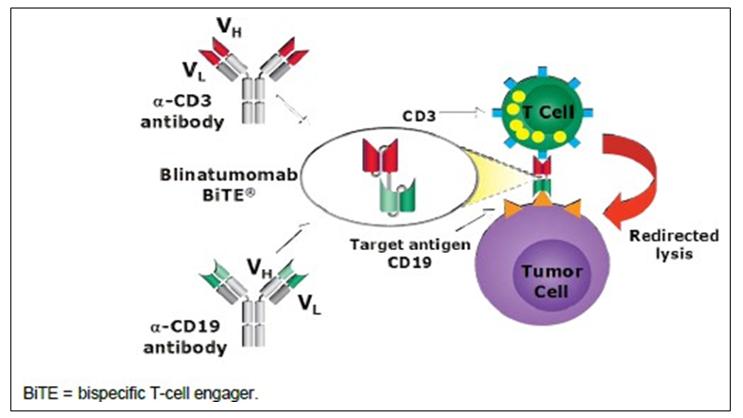

Pharmacodynamic effect

Primary pharmacodynamic effects
Blinatumomab utilises the patient’s own cytotoxic T cells to attack CD19-positive B cell including malignant cells. It transiently connects T cells and malignant B cells and induces T cell mediated killing of the bound malignant cell. The proximity induced by blinatumomab leads to the formation of a cytolytic synapse and triggers target cell-specific cytotoxicity which closely resembles a natural cytotoxic T-cell reaction.
Blinatumomab is associated with transient up regulation of cell adhesion molecules, production of cytolytic proteins, release of inflammatory cytokines and proliferation of T cells, and results in elimination of CD19+ cells. In clinical studies, PD measures included lymphocytes, lymphocyte subsets, and cytokines. Consistent PD profiles were observed across clinical trials in subjects with ALL or NHL following the cIV infusion regimen. The PD response to blinatumomab was characterised primarily by T-cell redistribution, activation, and expansion, B-cell depletion, and transient cytokine elevation.
Detailed PD data was presented in the original submission and little new information has resulted from the newer studies. The updated summary of PD effects is provided below.
Results showed that baseline peripheral T cell counts were variable among individuals and appeared to be similar across studies and cancer types examined.

Table 4: Mean (± SD) baseline peripheral T cell levels in subjects with NHL, MRD+ ALL and Relapsed/Refractory ALL
Study | Disease | N | CD3+ T Cells (10⁹/L)
MT103-104 | NHL | 76 | 0.470 ± 0.395
MT103-202 | MRD+ ALL | 21 | 0.499 ± 0.292
MT103-206 | R/R ALL | 31 | 0.486 ± 0.619
MT103-208 | NHL | 25 | 0.344 ± 0.229
MT103-211 | R/R ALL | 207 | 0.711 ± 0.714
ALL = acute lymphoblastic leukaemia; MRD+ = minimal residual disease; NHL = non-Hodgkin’s lymphoma; SD = standard deviation. Only studies with available data were summarised
There was no apparent association between T-cell levels and demographic factors examined.
Figure 2: Baseline peripheral T cells by age, sex, weight, and body surface area
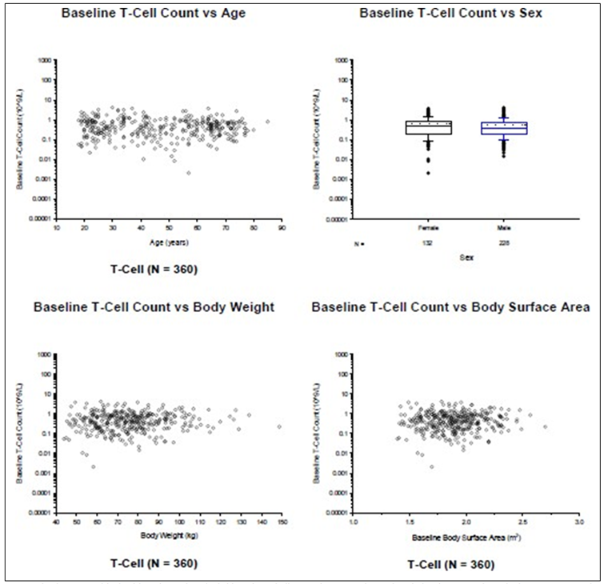
Boxes display mean (dashed lines), median (solid lines), 25th (bottom) percentile, and 75th (top) percentile. Whiskers represent the 10th (bottom) and 90th (top) percentiles.
Figure 3: Baseline peripheral T cells by race
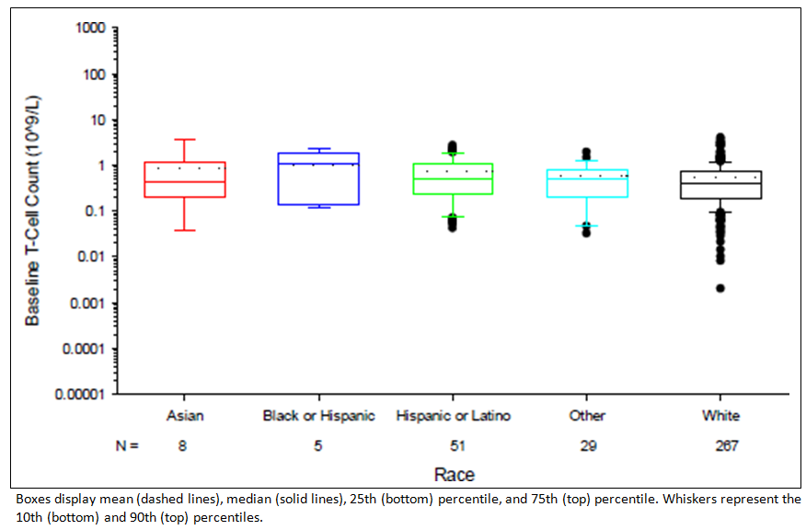
Large inter-subject variability was found in the baseline peripheral B-cell counts. Among the data available, the highest mean baseline counts was observed in Study MT103-211.

Table 5: Mean (± SD) baseline peripheral B-cell counts in subjects with NHL, MRD+ ALL and R/R ALL
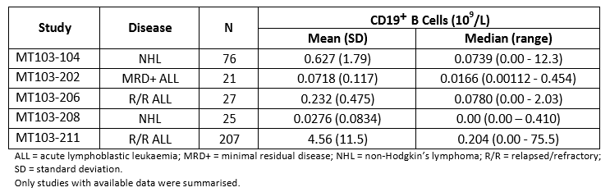
Baseline peripheral B-cell counts did not appear to be associated with any demographic factors tested
Figure 4: Baseline peripheral B-cells by age, sex, weight, and body surface area
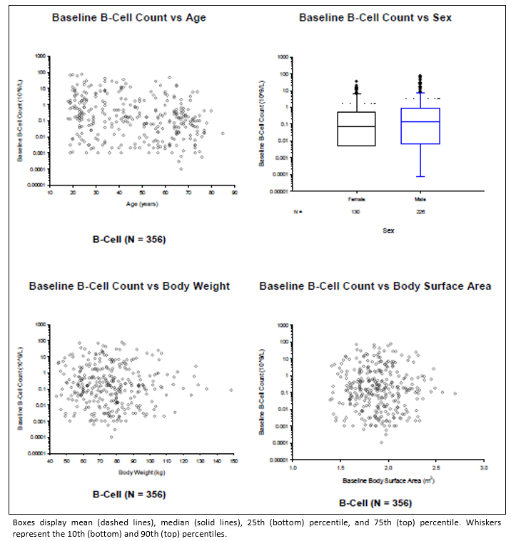
Figure 5: Baseline B-cell count by race
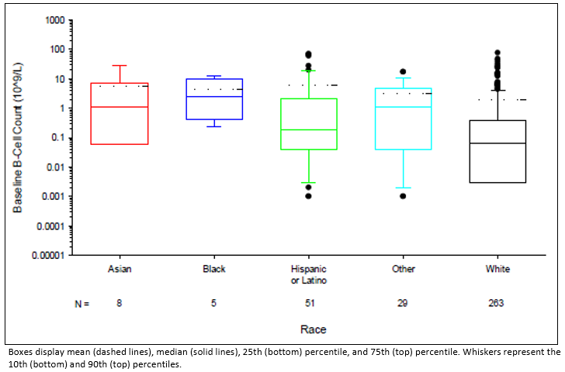
The peak cytokine levels after an initial dose of 5 µg/m²/day or 9 µg/day in patients with R/R ALL appeared to be similar. Cytokine peak levels varied significantly among individuals.

Table 6: Mean (SD) cytokine peak levels in Week 1 following continuous IV Infusion in subjects with R/R ALL
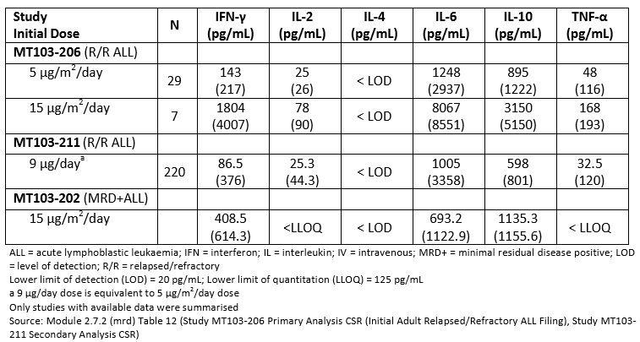

Relationship between drug concentration and pharmacodynamic effects

PopPK analysis 122196
The immune–pharmacodynamic responses were characterised by T-cell redistribution, expansion and activation, B-cell depletion, and transient cytokine release. The updated pharmacodynamic data were consistent with previous findings.

PopPK/PD analysis 122625
For the blinatumomab exposure-response analyses for efficacy and safety focused on evaluation of relationships between blinatumomab concentrations from the target dosing regimen at steady state (Css) and the occurrence of CR, duration of survival, occurrence of cytokine release syndrome (CRS) events in subjects diagnosed with relapsed/refractory ALL receiving blinatumomab or SOC chemotherapy from Studies MT103-211 (blinatumomab alone), 20120216 (blinatumomab alone), and 00103311 (blinatumomab or SOC).
Of the 646 subjects in the analysis, 537 received blinatumomab and 109 received SOC chemotherapy. Blinatumomab Css was available from 342 subjects receiving the 9 µg/day dose in Cycle 1 Week 1, from 407 subjects receiving the 28 µg/day dose in Cycle 1 Week 2, and from 122 subjects receiving the 28 µg/day dose in Cycle 2.
The exposure-efficacy (PK-CR) analysis indicated that higher blinatumomab Css following 28 µg/day dosing was associated with the probability of achieving CR and with longer duration of OS when compared to the OS of SOC chemotherapy, after accounting for treatment effect. The exposure-safety (PK-cytokine release syndrome [CRS]; PK-neurologic events) analysis indicated that the range of blinatumomab Css following the 9 µg/day or 28 µg/day dose was not associated with probability of CRS or neurologic events, after accounting for treatment effect. Thus, the blinatumomab step-dosing regimen was appropriate in the management of CRS and neurologic events.

PK/PD analysis 120391
Comment: The sponsor included Study 120391 (page 151) in the submission. It is not discussed in the Clinical Overviews or Summaries of Pharmacology or Clinical Efficacy. It is unclear why it was included in the submission. The PK results relate to adult and paediatric patients. Use in paediatric patients is not the subject of this submission. The results for the PK/PD analysis are included here for completeness.
The objective of Study 120391 relevant to this submission was to investigate the relationship between blinatumomab exposure and safety events. The exposure-safety relationship was explored using the available data from paediatric subjects with R/R ALL (Study MT103-205). As paediatric R/R ALL subjects with both exposure and safety data are limited (n=45 from Study MT103-205), exposure and safety data from adult R/R ALL subjects (n=254 from Studies MT103-206 and MT103-211) were also included in the analyses. Two adverse drug reactions (ADRs) were selected for the exposure-safety analyses. One ADR is CRS as this was the dose- limiting AE in paediatric Study MT103-205 and an identified risk of blinatumomab treatment. The other adverse drug reaction (ADR) was neurologic event as it was an identified risk of blinatumomab treatment. Other AEs were not analysed due to insufficient events for exposure- safety analysis or no apparent dose response relationship between exposure and CRS or neurologic events.

Exposure; CRS analysis
The occurrence of CRS was summarised by study, age group and dose, and is presented in the following table. The overall incidence of CRS was 13.7% (35 of 254 subjects had at least 1 CRS) in the analysis dataset.

Table 7: Study 120391: Occurrence of CRS by study, age, and dose cohort
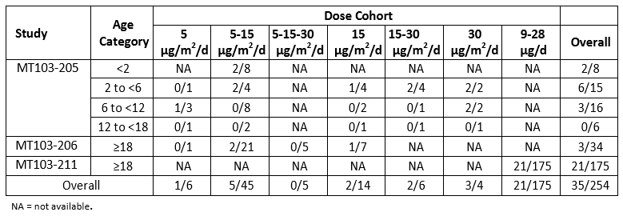
The results show a higher occurrence of CRS events in paediatric patients, however, the number of subjects in each age category is small. A graphical comparison of blinatumomab Css in week 1 by dose and occurrence of CRS showed no difference in blinatumomab Css or dose, for subjects who did or did not have CRS suggesting no relationship with Css (or dose) of blinatumomab and CRS in paediatric patients.
Univariate logistic regression analyses identified an association between a single age category (2 to < 6 compared to ≥ 18) (odds ratio: 5.00 (95%CI: 1.548 to 16.151; p = 0.0071)), and BSA (odds ratio: 0.429 [95%CI: 0.205 to 0.898 per m²; p = 0.0248]) with the occurrence of CRS); no association was found for blinatumomab Css, age (continuous or other age groups), or body weight and CRS. In the multivariate logistic regression analyses, associations between CRS and age categories (< 2 (odds ratio: 25.816, 95%CI: 1.699 to 392.173), 2 to < 6 (odds ratio: 17.799, 95%CI: 1.847 to 171.510), and 6 to < 12 (odds ratio: 8.379, 95%CI: 1.037 to 67.707)) were identified when included with blinatumomab Css and body weight suggesting a higher risk of CRS in paediatric subjects (< 2, 2 to < 6, and 6 to < 12) compared to adults after adjusting for blinatumomab Css and body weight. No other associations were found in the multivariate analysis between CRS and blinatumomab Css, age (continuous or categorised by age group), body weight, or BSA.
The occurrence of CRS in Studies MT103-205, MT103-206, and MT103-211 was primarily during the first week of the induction setting in subjects with high tumour load. No CRS was observed in subjects after achieving CR.

Exposure; neurologic event analysis
The occurrence of neurologic events was summarised by age group and dose, and presented in the following table. The overall incidence of neurologic events was 48.0% (122 of 254 subjects had at least one neurologic event in the analysis dataset).

Table 8: Study 120391: Occurrence of neurological events by study, age, and dose cohort
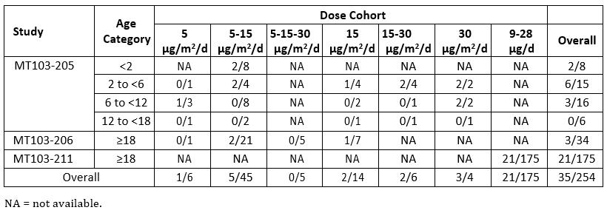
In general, it appears that a higher occurrence of neurologic events was observed in adults than in paediatrics, and the proportion increased with increasing age category in paediatrics. There was no consistent trend of neurologic events across the dose cohorts.
The graphical comparison of blinatumomab Css in Week 1 or Week 2 by dose and occurrence of neurologic events showed no difference in Css for subjects who did or did not have a neurologic event. Thus, no relationship with Css (or dose) of blinatumomab and neurologic events was evident in paediatric subjects.
For neurologic events occurring in Week 1, univariate analysis with the logistic regression model identified an association with blinatumomab Css (odds ratio: 1.549 (95%CI: 1.053 to 2.277 per log unit of blinatumomab Css; p = 0.0261)). No association with age (categorical or continuous), body weight, or BSA was found in week 1. Multivariate analysis also identified an association of blinatumomab Css with neurologic events in Week 1 (odds ratio: 1.601 (95%CI: 1.067 to 2.404 per log unit of blinatumomab Css; p = 0.0231)) after adjusting for age (categorised by age groups). The association between blinatumomab Css and neurologic events was also maintained after adjusting for age (continuous), body weight, or BSA, and after adjusting for age (continuous or categorised by age groups) and body weight or BSA.
For Week 2 and beyond, univariate analysis of the occurrence of neurologic events with the logistic regression model identified an association between blinatumomab Css and neurologic events (odds ratio: 1.660 (95%CI: 1.091 to 2.527) per log unit of blinatumomab Css; p =0.0180)) and age (continuous) (odds ratio: 1.029 (95%CI: 1.014 to 1.044) per year; p = 0.0002]). No association was found between neurologic events and body weight or BSA. Multivariate analysis identified an association of blinatumomab Css (odds ratio: 1.356 (95%CI: 1.071 to 1.717 per log unit of blinatumomab Css; p = 0.0114)) and age (continuous) (odds ratio: 1.014 (95%CI: 1.005 to 1.023) per year; p = 0.0021]) with neurologic events in Week 2 and beyond. This association was also maintained after also adjusting by body weight or BSA.
As both blinatumomab Css and age may be associated with the occurrence of neurologic events in Week 1 and Week 2 and beyond, the interaction between blinatumomab Css and age was evaluated for both datasets but was not found to be significant in either Week 1 or Week 2 and beyond. Therefore, there is no evidence to conclude that blinatumomab Css and age effects on occurrence of neurologic events are interdependent factors. However, the limited sample size and the lack of control group may prevent identification of a statistically significant interaction between blinatumomab Css and age in the current dataset.
For neurologic events occurring in Week 1 or Week 2 and beyond, higher blinatumomab Css was associated with a higher probability of neurologic events. Additionally, relative to adults, paediatric subjects were associated with a lower probability of neurologic events as increasing age was associated with a higher probability of neurologic events. The odds ratios from the multivariate analysis for the association of age (categorised by group) with neurologic events after adjusting for blinatumomab Css were less than 0.5 for all age groups in week 1 and for the 2 to < 6 and 6 to < 12 age groups in Week 2 and beyond (no neurologic events occurred in the < 2 group in Week 2 and beyond). Thus while increasing Css was associated with increasing risk of neurologic events, the risk in paediatric subjects appeared to be much lower compared to adults.

Evaluator’s overall conclusions on pharmacodynamics
The sponsor provided one additional PopPK analysis and two studies analysing exposure safety responses from pooled groups of patients. The results support the recommended dosing regimens for the treatment of R/R ALL and MRD positive ALL. No dose adjustment appears necessary based on the covariates evaluated.
The exposure response analyses indicated blinatumomab exposure was not associated with probability of CRS, or neurologic events and higher exposures were associated with higher probability of CR and longer duration of OS, after accounting for blinatumomab treatment. Thus, the blinatumomab step-dosing regimen was appropriate in the management of CRS and neurologic events.

Dosage selection for the pivotal studies

Pharmacokinetics and pharmacodynamics: dose finding studies Clinical efficacy
Not applicable.

Phase II dose finding studies
Not applicable.

Phase III pivotal studies investigating more than one dose regimen
Not applicable.

Evaluator’s conclusions on dose finding for the pivotal studies
The dose regimen used in the new indication of Philadelphia chromosome positive R/R ALL is the same as approved for the existing indications.
The dose for MRD R/R ALL is consistent with the approved dose.

Clinical efficacy

Studies providing evaluable efficacy data
The following clinical efficacy studies were submitted:
Indication 1: R/R Chromosome positive B-precursor ALL
- Pivotal studies
  - Study 20120216 - A Phase II Single Arm, Multicentre Trial to Evaluate the Efficacy of the BiTE Antibody Blinatumomab in Adult Subjects with Relapsed/Refractory Philadelphia Positive B-precursor Acute Lymphoblastic Leukaemia (Alcantara Study)
- Other studies – not applicable.
- Analyses performed across trials – not applicable
- Evaluator’s conclusions
Indication 2: Minimal residual disease (MRD)
- Pivotal studies
  - Study MT103-202 - Confirmatory, Multicentre, Single-arm Study to Assess the Efficacy, Safety, and Tolerability of the BiTE Antibody Blinatumomab in Adult Subjects with Minimal Residual Disease (MRD) of B-precursor Acute Lymphoblastic Leukaemia.
  - Study MT103-203 - An Open-label, Multicentre, Phase II Study to Investigate the Efficacy, Safety, and Tolerability of the Bi-specific T-cell Engager (BiTE) MT103 in Patients with Minimal Residual Lymphoblastic Leukaemia (ALL)
- Other studies
  - Study 20120148 - A Retrospective Analysis of Haematological Relapse Free Survival and Overall Survival in Adult Patients with Philadelphia-Negative B- Precursor Acute Lymphoblastic Leukaemia in Complete Haematological Remission with Minimal Residual Disease
- Analyses performed across trials
- Evaluator’s conclusions
Indication 3: Amendment to PI Clinical Trial section
- Pivotal studies
  - Study 00103311 A Phase III, Randomised, Open Label Study Investigating the Efficacy of the BiTE Antibody Blinatumomab Versus Standard of Care Chemotherapy in Adult Subjects with Relapsed/Refractory B-precursor Acute Lymphoblastic Leukaemia (ALL) (TOWER Study)
- other studies – not applicable
- Analyses performed across trials – not applicable
- Evaluator’s conclusions

Indication 1 - R/R chromosome positive B-precursor ALL pivotal or main efficacy study

Study 20120216
A Phase II Single Arm, Multicentre Trial to Evaluate the Efficacy of the BiTE Antibody Blinatumomab in Adult Subjects with Relapsed/Refractory Philadelphia Positive B- precursor Acute Lymphoblastic Leukaemia (Alcantara Study).
Comment: This is the primary analysis for this study. The study is ongoing.

Study design, objectives, locations and dates
This was an open label, single arm, multicentre, non-randomised study conducted at 19 sites in Europe and USA (France (3 sites), Germany (3), Italy (5), UK (1) and USA (7) from January 2014 to May 2015 (cut-off date). The trial is ongoing.

Primary objective
To evaluate the rate of complete remission (CR)/complete remission with partial haematological recovery (CRh*) in adult subjects with Ph+ relapsed/refractory B- precursor ALL.

Secondary objectives
To evaluate:
- The rate of MRD remission
- Other measures of efficacy of blinatumomab
- The safety of blinatumomab in adult subjects
- PK of blinatumomab in adult subjects with
- The efficacy of blinatumomab against specific bcr-abl mutations

Study design
The study comprised a screening period, an induction treatment period (2 cycles of blinatumomab), a consolidation treatment period (up to 3 additional cycles of blinatumomab for subjects who achieved a CR, CRh* or CRi within two induction cycles of treatment, and a safety follow-up visit 30 days after treatment. Following the safety follow up visit, subjects were followed for response duration and survival every 3 months for 18 months or death, whichever occurred first.
Subjects who did not achieve a CR/CRh*/CRi within the two induction cycles of blinatumomab treatment underwent the safety follow up visit and were followed in the long-term follow up. If subjects were eligible for allogeneic hematopoietic stem cell transplantation (HSCT) at any time following the first treatment cycle, blinatumomab was discontinued, and the subjects completed a safety follow-up visit before undergoing a transplant. These subjects continued to be followed in the long term follow up phase of the study.

Inclusion and exclusion criteria

Inclusion
Male and female (non-childbearing potential) age ≥ 18 years of age with Ph+ B- precursor ALL, with either: relapsed or refractory to at least one second generation TKI (dasatinib, nilotinib, bosutinib, pontinib) or intolerant to second generation TKI and intolerant or refractory to imatinib mesylate; and with > 5% blasts in bone marrow and Eastern Cooperative Oncology Group (ECOG) performance status ≤ 2.

Exclusion
History of malignancy other than ALL within 5 years before blinatumomab treatment, except for adequately treated selected cancers without evidence of disease; history of or current relevant central nervous system (CNS) pathology; isolated extra-medullary disease; current autoimmune disease or history of autoimmune disease with potential CNS involvement; allogeneic HSCT within 12 weeks before blinatumomab treatment; active acute or extensive chronic graft versus-host disease (GvHD) which included the administration of immunosuppressive agents to prevent or treat GvHD within 2 weeks before blinatumomab treatment; known or suspected CNS involvement; immediately previous cancer chemotherapy, radiotherapy, or immunotherapy; and eligibility for allogeneic HSCT at the time of enrolment.

Study treatments
All patients received the same treatment:
Induction phase: 2 induction cycles of blinatumomab. A single cycle of blinatumomab was defined as 6 weeks in duration, which included 4 weeks of continuous intravenous (cIV) infusion of blinatumomab followed by a 2-week treatment-free interval. The initial dose of blinatumomab was 9 µg/day cIV infusion for the first 7 days of treatment which was increased (dose step) to 28 µg/day starting on Day 8 (Week 2) through Day 29 (Week 4). For all subsequent cycles (beginning with the second induction cycle through 3 consolidation cycles for applicable subjects) the administered dose was 28 µg/day throughout 4 weeks of continuous treatment.
Consolidation phase: Subjects who achieved a CR/CRh*/CRi (complete remission with incomplete haematologic recovery) within 2 induction cycles of treatment were allowed to continue to receive up to 3 additional consolidation cycles of blinatumomab (up to a maximum of 5 total induction and consolidation cycles) under the same schedule outlined in the induction treatment phase above.
All patients received premedication with dexamethasone which is intended to prevent cytokine release syndrome (CRS) events. Within 1 week (+ 3 days) before blinatumomab initiation and following each treatment cycle (after bone marrow aspiration on day 29) a mandatory CNS prophylaxis consisting of an intrathecal regimen according to institutional or national guidelines was administered (for example methotrexate 12 to 15 mg, cytosine arabinoside 40 mg, and dexamethasone 4 mg or equivalent steroid dose) was performed.

Efficacy variables and outcomes
Subjects were evaluated for efficacy at the end of each treatment cycle via a central bone marrow aspiration and local peripheral blood counts. Subjects in remission continued to be evaluated for efficacy performed during the long-term follow-up period.
Primary efficacy outcome was the proportion of subjects who achieved a CR or CRh* within 2 cycles of treatment.
Secondary outcomes included:
- Rate of MRD remission within 2 cycles of treatment with blinatumomab
- Duration of CR or CRh*
- CR rate within 2 cycles of treatment with blinatumomab
- CRh* rate within 2 cycles of treatment with blinatumomab
- CR + CRh* + CRi rate within 2 cycles of treatment with blinatumomab
- Overall survival
- Allogeneic HSCT and 100-day mortality after allogeneic HSCT.

Randomisation and blinding methods
Patients were non-randomised and study was open label (not blinded).

Analysis populations
Full analysis set (FAS) = all subjects who received an infusion of blinatumomab.
Per protocol set (PPS) = all subjects who received an infusion of blinatumomab and who did not have any major protocol violations that affected the efficacy evaluation of the subject.

Sample size
Simon’s mini-max 2-stage design (Simon, 1989) was used with a sample size (23 subjects in stage 1, 41 evaluable subjects total) based on a 1-sided type 1 error of 0.025 and a power of 90% to detect the effective response rate assumption of ≥ 30% over an ineffective treatment rate of ≤ 10%. The study was planned to be stopped at stage 1 if fewer than 3 of 23 subjects were observed with CR or CRh* in stage 1. If at least 9 or more out of 41 subjects showed a CR or CRh* within 2 cycles of treatment with blinatumomab at the end of stage 2, the study’s ineffective treatment assumption was rejected.

Statistical methods
An interim analysis was performed after the first 23 subjects who were enrolled in stage 1 either discontinued treatment or completed their first 2 treatment cycles. The purpose of this interim analysis was to determine whether stage 2 of the protocol continued as described according to the study design. Two interim analyses were performed on 2 September 2014 and 24 March 2015. The decision to continue the study was made on 2 September 2014.
The general analytic approach was one of estimation. Continuous variables were summarised by the non-missing sample size (n), mean, standard deviation (SD), median, first and third quartiles, minimum, and maximum. Categorical variables were summarised by the n and percentage in each category. In general, missing data was treated as missing, unless otherwise specified. For time to event endpoints, the Kaplan-Meier (KM) method was used. The KM quartiles (when estimable) along with 95% 2-sided CIs, the number of subjects censored, and the number of events were provided. The KM estimates were also presented graphically. No adjustments for multiplicity were planned for the analyses of the efficacy endpoints.
The subgroups (prior HSCT status, baseline bcr-abl mutations, etcetera) were considered as covariates to explore the existence of association between the covariates and the primary efficacy outcome. More common covariates, such as age, gender and region, may also have been considered.

Table 9: Study 20120216: Summary of efficacy analyses
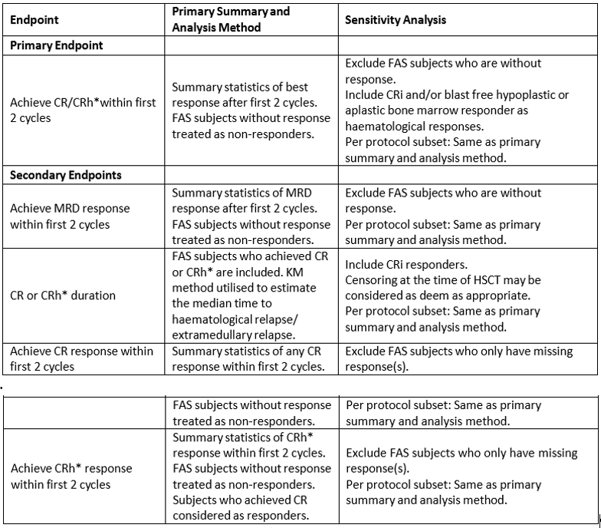

Participant flow
Forty-five subjects were enrolled and at the time of data cut off and 2 subjects continued to receive blinatumomab.

Table 10: Study 20120216: Study disposition (FAS)
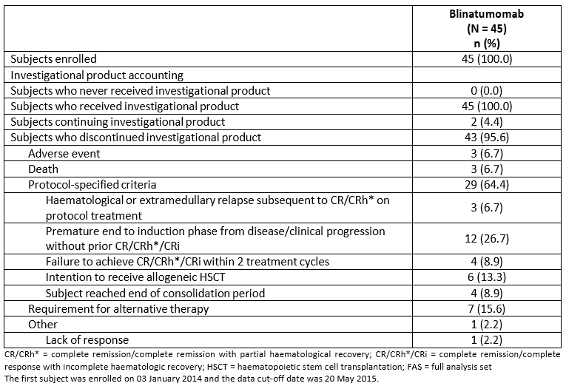

Major protocol violations/deviations
Thirteen subjects (28.9%) had protocol deviations. The most important was not meeting study entry criteria. These subjects (n = 3) were not included in the PPS. Minor deviations such as not using dexamethasone as required during pre-treatment (n = 1) and use of compromised IP (n = 6) did not result in exclusion from the PPS.

Baseline data
The summary of enrolment was that 24% of subjects came from the USA and 31% from Italy, 24% from France, 13% from Germany and 7% from UK.
The Philadelphia chromosome was detected in all 45 subjects (100%) by cytogenetics, metaphase spread, or fluorescence in-situ hybridisation, or PCR (bcr-abl marker).
The majority of subjects in this study were male (53.3%) and white (86.7%), without Hispanic or Latino ethnicity (95.6%), and an ECOG performance status between 0 and 2. The subject mean age (SD) was 52.8 years (15). Twelve subjects (26.7%) were elderly (≥ 65 years of age). All subjects received treatment with between 1 and 4 prior TKIs before enrolment in this study.

Results for the primary efficacy outcome
The primary efficacy endpoint of this study was CR/CRh* rate within the first 2 cycles of blinatumomab treatment.
In the FAS, 16 subjects (35.6%) achieved a CR/CRh* within the first 2 cycles of blinatumomab treatment; 14 achieved a CR (31.1%), 2 achieved a CRh* (4.4%). The 95% CI of the CR/CRh* rate excludes the ineffective treatment rate of 10% that was the basis of the null hypothesis. Therefore, the CR/CRh* rate was significantly higher than 10%. An additional 2 subjects achieved a CRi (4.4%), 2 subjects had a partial remission (4.4%), and 3 subjects had blast-free hypoplastic or aplastic bone marrow (6.7%, without CRi). The remainder of the subjects did not respond to treatment (12 subjects, 26.7%), had progressive disease (4 subjects, 8.9%), had data that was obtained but could not be evaluated (2 subjects, 4.4%), or no data were available (4 subjects, 8.9%).
In the 16 subjects who achieved CR/CRh*, 10 were males and 6 were females; all were at least 35 years of age and 3 were at least 65 years of age; 15 were enrolled at a site in EU; and 15 had a baseline ANC value < 5.0 x 10⁹/L.

Table 11: Study 20120216: Best response during the first 2 cycles of blinatumomab treatment (FAS and PPS)
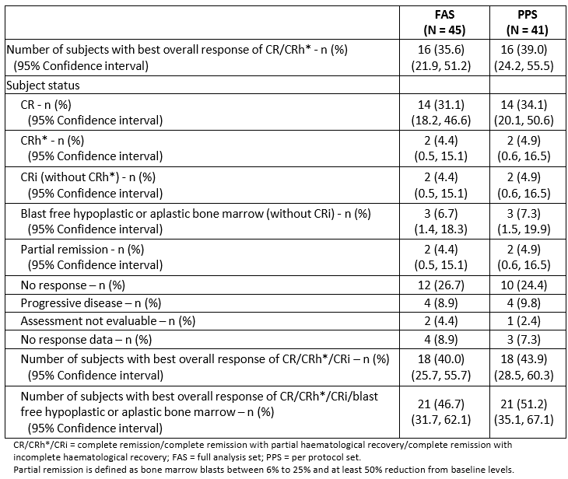

Results for other efficacy outcomes

Minimal residual disease within the first 2 cycles of treatment
Of the 16 subjects with a best response of CR/CRh* after 2 cycles, 12 subjects with a CR achieved an MRD complete response (85.7%, 12/14) and 2 subjects with a CRh* achieved an MRD complete response (100%, 2/2). The 2 remaining subjects did not have an MRD response.
Figure 6: Study 20120216: Minimal residual disease response in CR/CRh* responders in first 2 cycles by demographic groups (FAS)
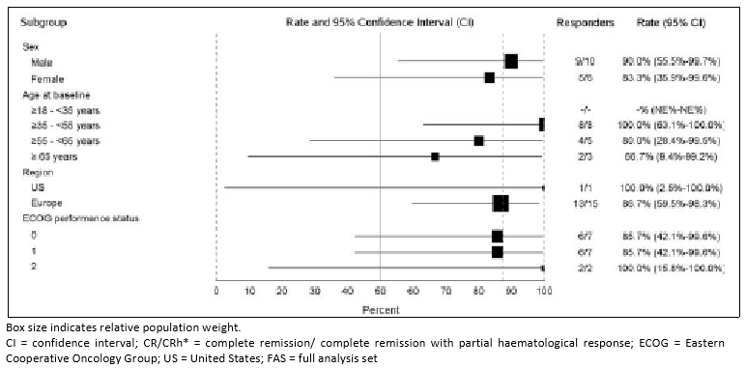

Relapse-free survival
Relapse-free survival (RFS) was assessed for subjects who achieved a CR/CRh*/Cri during the first 2 cycles of blinatumomab treatment and was measured from the time the subject first achieved remission until the first documented relapse or death from any cause. Subjects without a documented relapse (haematological or extra-medullary) or who did not die were censored at the time of their last bone marrow assessment or their last survival follow-up visit to confirm remission.
In the FAS, the median RFS in 16 subjects who achieved a CR/CRh* in the first 2 cycles of blinatumomab treatment was 6.7 months (95% CI: 4.4 to not estimable [ne]), with a median observation time of 9.0 months.
The median RFS for 18 subjects who achieved a CR/CRh*/CRi in the first 2 cycles of blinatumomab treatment was slightly shorter, 5.5 months (95% CI: 3.8 months to ne), with a median observation time of 9.0 months.
Nine subjects (56.3%; 9/16) who achieved CR/CRh* had an event; 8 relapsed and 1 died. The remaining 7 subjects (42.9%, 6/14), 4 males and 3 females, were censored.
Figure 7: Study 20120216: Relapse-free survival for subjects who achieved a best response of CR/CRH* in the first 2 cycles with and without censoring at the time of HSCT (FAS)
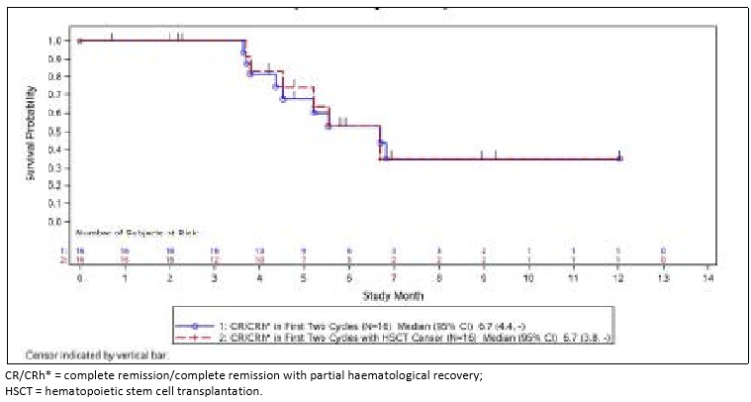
Relapse-free survival was analysed separately for subjects who achieved a best response of CR (n = 14) and those who achieved a best response of CRh*(n=2) in the first 2 cycles of blinatumomab treatment. The median RFS in 14 subjects who achieved a CR was 6.7 months (95% CI: 4.1 months to NE), with a median observation time of 7.0 months. The median RFS in 2 subjects who achieved CRh* was NE with a median observation time of 9.0 months.

Time to haematological relapse (duration of remission): subjects with CR/CRh*
Time to haematological relapse (duration of remission) was measured for subjects in remission (CR/CRh*/CRi), and was measured from the time the subject first achieved remission until first documented relapse or death from disease progression. Subjects without a documented relapse (haematological or extra-medullary) and who did not die were censored at the time of the last bone marrow assessment or the last survival follow-up visit to confirm remission. Subjects who died without having reported haematological relapse or without showing any clinical sign of disease progression were censored on their date of death.
During the first 2 cycles of treatment, the median time to haematological relapse for subjects with CR/CRh*/CRi was 4.5 months (95% CI: 1.7 to 6.7 months), with a median observation time of 6.7 months in the FAS. Of the subjects that achieved CR/CRh*/CRi, 9 subjects (50%) were censored.
Of the 18 subjects who achieved a CR/CRh*/CRi, the median time to haematologic relapse was also 4.5 months (95% CI: 1.7 to 5.5 months) when censored at the time those subjects who underwent an HSCT. The median time to haematological relapse for subjects with CR/CRh* was also 4.5 months (95% CI: 3.6 to 6.7 months), with a median observation time of 6.7 months in the FAS.

Overall survival
Overall survival was assessed for all subjects from the time the subject received the first treatment of blinatumomab until death from any cause or the date of the last follow-up. Subjects who did not die were censored.
In the FAS, the median OS was 7.1 months (95% CI: 5.6 to NE), regardless of whether censoring occurred. At the time of the last follow-up date, 51.1% (23/45) of subjects were alive (censored) and 48.9% (22/45) of subjects had died.

Table 12: Study 20120216: Summary of overall survival with and without censoring at the time of HSCT (FAS)
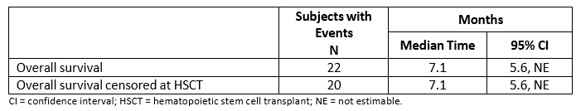
Figure 8: Study 20120216: Overall survival with and without censoring at the time of HSCT (FAS)
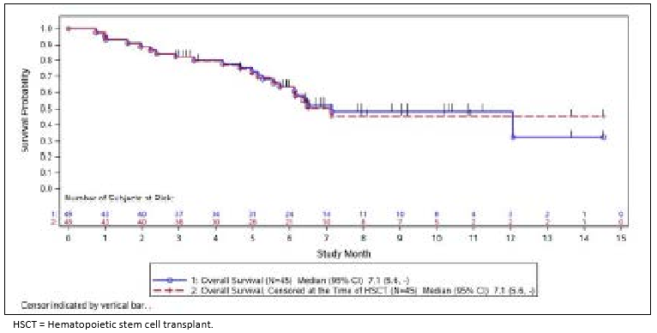

Proportion of subjects who received an allogeneic HSCT during blinatumomab induced remission
All subjects who achieved CR/CRh* were considered eligible for allogeneic HSCT for analysis purposes. Of the 16 subjects who achieved a CR/CRh*, 8 subjects (50.0%, 8/16) had an allogeneic HSCT during the study. All but 1 subject achieved CR/CRh* in the first 2 cycles and had an allogeneic HSCT (43.8%; 7/16). Four (25.0%, 4/16) with allogeneic HSCT were in remission with a CR/CRh* and received the transplant without receiving any additional antileukaemic medication. This subset of subjects was evaluated for 100-day mortality (25.0% rate [95% CI: 3.9% to 87.2%]). Four additional subjects had an allogenic HSCT: 1 subject (6.3%, 1/16) was in remission with a CR/CRh* after 2 cycles but also received antileukaemic medication, 1 subject (6.3%, 1/16) achieved CR/CRh* within the consolidation cycles, and 2 subjects (12.5%, 2/16) received allogenic HSCT outside of the remission period.

100-day mortality after allogeneic HSCT
The analysis of 100-day mortality rate after allogeneic HSCT was assessed in 4 subjects who received an allogeneic HSCT while in remission (CR/CRh*) after 2 cycles of blinatumomab treatment. The 100-day mortality rate after allogeneic HSCT was calculated relative to the date of allogeneic HSCT. The 100-day mortality rate for these subjects was 25.0% (95% CI: 3.9% to 87.2%). Thus, the survival rate was 75.0% at 100 days after transplant. Data from the PPS was the same as the FAS data.

Evaluator commentary
Blinatumomab at the target dose of 28 µg/day represents a targeted, single-agent option for subjects with relapsed/refractory Ph-positive ALL. The subjects in this study had relapsed after standard of care regimens, including allogeneic HSCT conditions and without the option of blinatumomab treatment would otherwise have been considered suitable only for palliative treatment.
As of the data cut-off date of 20 May 2015, a total of 45 subjects were enrolled: 2 subjects continued to receive blinatumomab, 21 subjects had discontinued treatment and continued to be followed, and 22 subjects had died.
The primary endpoint of the study was a CR/CRh* in subjects treated with 2 cycles of blinatumomab therapy. The CR/CRh* rate was 35.6% (16/45, 14 with CR and 2 with CRh*; 95% CI: 21.9% to 51.2%) which was significantly higher than the hypothesised ineffective treatment rate of 10%.
The primary endpoint was supported by the key secondary endpoints: MRD response, RFS, time to hematologic relapse, OS, and proportion of subjects who received an HSCT during blinatumomab-induced remission. Of the 16 subjects that achieved a CR/CRh*, an MRD complete response was also reported in 12 subjects who achieved a CR (85.7%, 12/14) and 2 subjects who achieved a CRh* (100%, 2/2).

Other efficacy studies
Not applicable.

Analyses performed across trials: pooled and meta analyses
The sponsor has provided comparisons of the results of Study 201201216 (Ph+) with Studies 00103311 and MT103-211 (Ph–).

Table 13: Summary of overall survival for Studies 00103311, MT103-211, and 20120216
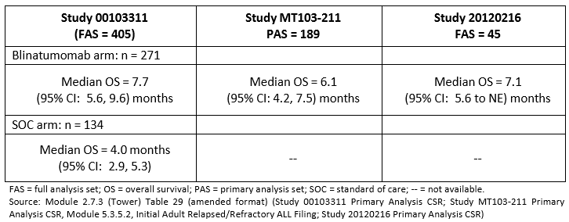
Comment: The result provided above for Study MT103-211 in the table above is taken from the primary analysis CSR which was evaluated in the previous submission. The results presented in the secondary analysis provided in this submission was median = 6.4 months; 95%CI 4.3 – 7.7 (Overall Survival for the PAS (n=189)).
It is also noted that the analysis sets are not the same – the PAS is reported for MT103- 211 and the FAS is reported for Studies 00103311 and 20120216. FAS data is not available from the secondary analysis CSR included in this submission.

Table 14: Summary of haematologic remission for Studies 00103311, MT103-211, and 20120216
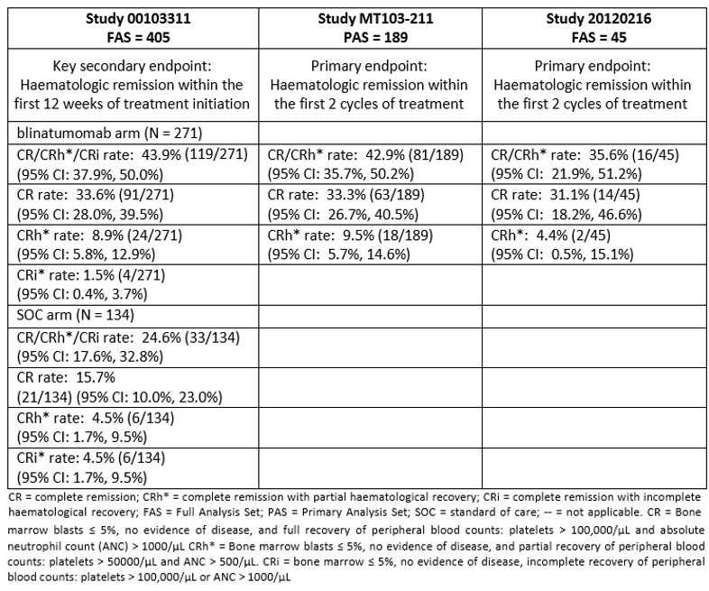

Table 15: Summary of RFS / Duration of remission for Studies 00103311, MT103-211, and 20120216
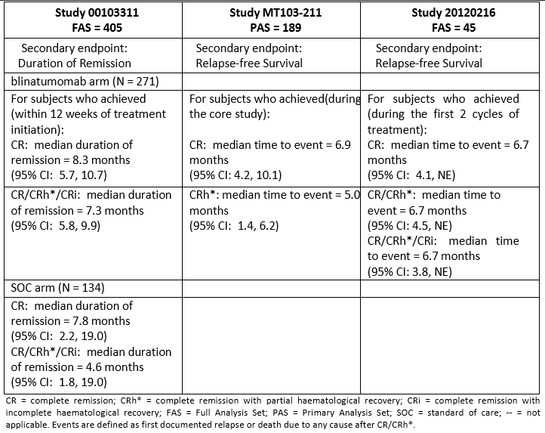

Table 16: Summary of MRD response rates for Studies 00103311, MT103-211, and 20120216
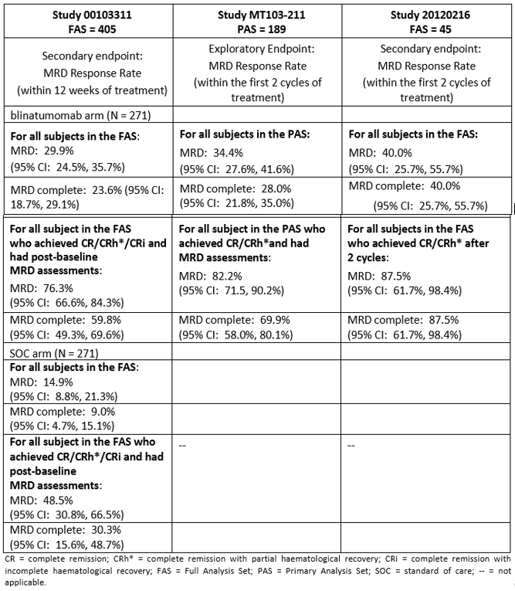

Table17: Summary of allogeneic HSCT after haematologic remission for Studies 00103311, MT103-211, and 20120216
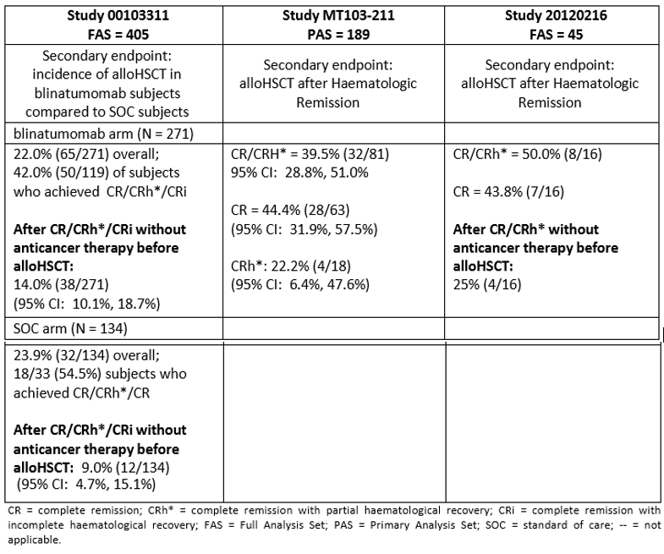

Evaluator’s conclusions on clinical efficacy – Indication 1
The data to support the requested indication of Philadelphia chromosome positive R/R ALL rests with one study of 45 patients in a Phase II, single arm, open label study (Study 20120216).
The study is ongoing. At the time of the data cut-off date on May 2015, 2 subjects continued to receive blinatumomab. The remaining 43 subjects have discontinued treatment – 23 (51.1%) subjects continue to be followed and 22 (48.9%) have died.
The result for the primary efficacy endpoint of the best CR/CRh* rate within the first 2 cycles of blinatumomab treatment was 35.6% (16/45; 95%CI: 21.9% to 51.2%); 14 subjects achieved a CR(31.1%), 2 subjects achieved a CRh* (4.4%). The results of the sensitivity analyses of the primary endpoint were consistent with the primary analysis. Subgroup analysis suggested differences amongst most subgroups, however the number of subjects in the individual subgroups were really too small to be reliable. Median OS was 7.1 months.
The efficacy results for the best CR/CRh* rate during the treatment period were consistent with the best CR/CRh* rate within the first 2 cycles of treatment. In the FAS, 17 subjects (37.8%) achieved a CR/CRh* during the treatment period; 1 additional subject achieved a CR/CRh* during the treatment period. Two additional subjects converted to CR during subsequent cycles of blinatumomab: 1 subject with a CRh*; 1 subject with a CRi.
It is noted that the initial approval for Ph negative patients was based on two Phase II, open label studies; one pivotal study (MT103-211 and a supportive study (MT103-206) with a total of 225 patients. In MT103-211, CR/CR* with durable remission after 2 cycles of treatment was 42.9% and median OS was 6.1 months, and in MT103-206, CR/CRh* with durable remission after 2 cycles of treatment was 69% and median OS was 9.8 months.

Indication 2 – Minimal residual disease

Pivotal or main studies

Study MT103-202 (long term follow up)
An Open-label, Multicentre Phase II Study to Investigate the Efficacy, Safety, and Tolerability of the Bi-specific T-cell Engager (BiTE ) MT103 in Patients with Minimal Residual Disease (MRD) of Positive B-precursor Acute Lymphoblastic Leukaemia (ALL).
Comment: This is the second CSR for this study. The primary analysis report was evaluated in the initial submission for Blincyto in which this was a supporting study. The CSR is an abbreviated report and this summary includes only the results of the long term follow up and MRD results.

Study design, objectives, locations and dates
An open label, multicentre, single arm, Phase II study conducted at 6 sites in Germany from January 2010 to November 2014 (last subject completed follow up).

Objectives
To describe the long term relapse free survival (RFS) and MRD results for eligible subjects.
Eligible subjects were followed at regular intervals until haematological relapse (defined as > 5% leukaemia cells in bone marrow) but not longer than 5 years after the subject finished the last treatment cycle with blinatumomab in a post study segment.

Inclusion and exclusion criteria
Adult patients with B-precursor ALL who were in complete haematological remission with molecular failure or molecular relapse starting any time after consolidation of front-line therapy with German Multicentre Study Group for Adult Acute Lymphoblastic Leukaemia (GMALL) standards, or any time outside GMALL standards, were eligible to participate. Subjects had to have a molecular marker for evaluation of MRD, which was either individual rearrangements of immunoglobulin/T-cell receptor (TCR) genes measured by polymerase chain reaction (PCR), or bcr/abl and/or t(4; 11) translocation at any detection level measured by real-time quantitative PCR.

Study treatments
Subjects received blinatumomab as continuous intravenous (cIV) infusion at a dose of 15 µg/m²/day over 4 weeks followed by a treatment-free period of 2 weeks.
Blinatumomab dose was escalated to 30 µg/m²/day in 3 subjects who did not achieve reduction in MRD level ≥ 1 log, (per data review committee decision). Responders were permitted to receive 3 additional consolidation cycles of treatment with blinatumomab. Subjects who showed neither MRD progression nor response could receive up to 7 cycles.

Efficacy variables and outcomes
The primary efficacy outcome was MRD response rate which was defined as the incidence of subjects with MRD negativity/response (bcr/abl and/or t[4;11] below detection limit and/or individual rearrangements of immunoglobulin or TCR genes below 10⁻⁴) within 4 cycles of treatment with blinatumomab. The results of the primary outcome were presented in the first CSR previously evaluated.

Other efficacy outcomes included
- Long term relapse free survival (RFS)
- Duration of MRD response
- Haematological relapse free survival both with and without censoring for HSCT or other anti-tumour therapies

Randomisation and blinding methods
This was an open label non randomised study.

Analysis populations
Full Analysis Set (FAS) = all subjects who completed at least the first treatment cycle and for whom at least one MRD response assessment was available.
Safety analysis set (SAF) = all patients who received any infusion of the study drug.

Sample size
Sample size was calculated for the primary outcome.

Statistical methods
Time-to-event endpoints were analysed using Kaplan-Meier methods. Additionally, endpoints were compared exploratory with historical control data, MRD response after any treatment cycle were analysed similar to the primary endpoint and was defined as the incidence of patients achieving MRD negativity at any time during the study.

Participant flow
A total of 21 subjects received ≥ 1 infusion of investigational product and were included in the SAF. One subject in the SAF completed < 1 cycle of blinatumomab treatment and did not have at least 1 MRD assessment, and thus was not included in the FAS.

Major protocol violations/deviations
Not discussed in CSR.

Baseline data
Full details were provided in the first CSR. Briefly, 60% of the subjects were women (12/20), all were Caucasian (20/20), and 45% (9/20) of subjects were > 60 years of age. Most subjects had only rearrangements of immunoglobulin/TCR genes (65%; 13/20). (Subjects with both translocations and rearrangements at baseline were analysed in the stratum of subjects with translocations.)

Results for the efficacy outcomes

Relapse free survival
Median RFS was not reached after a median follow-up time of 1,550 days (> 4 years). Ten subjects were relapse free after 5 years of follow-up.
Of the 20 subjects in the FAS, 10 completed the study in remission and were therefore censored on the day of their last available bone marrow aspiration/biopsy.
Nine subjects had an RFS event: 8 subjects had haematological relapse, and 1 subject died on day 377. The haematological relapse events occurred on days 99, 129, 155, 198, 582, 947, 1352, and 1550. Three of the 8 subjects who had haematological relapse had HSCT prior to haematological relapse. One subject was censored at day 43; for the 10 other subjects who did not experience haematological relapse, the duration of follow-up ranged from 1816 to 2138 days (≥ 5 years).
Of 16 subjects who had an MRD response, 8 had a haematological relapse (50%) compared with 1 of 4 subjects who did not have an MRD response (25%).
Figure 9: Study MT103-202: Haematological relapse-free survival – Kaplan-Meier estimate: All subjects (FAS)
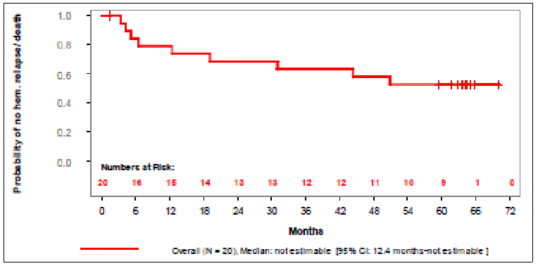
Figure 10: Study MT103-202: Haematological relapse-free survival – Kaplan-Meier estimate: with and without censoring of patients with HSCT (FAS)
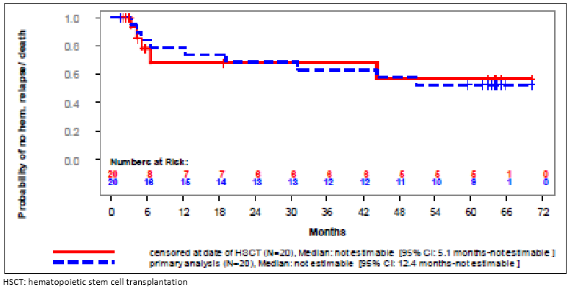

MRD progression
Seven of 20 subjects overall had MRD progression. The overall median time to MRD progression was 7.2 months (95% CI: 3.3, not estimable [ne]).
For 6 of the 17 subjects who received blinatumomab 15 µg/m²/day, MRD progression occurred at days 84, 99, 101, 170, 221, and 438; 1 subject of the 3 with dose increase had an MRD progression at day 206.
By baseline genetic alteration, 3 of 13 subjects with only rearrangements at baseline had an MRD progression at days 99, 170, and 438. Four of 7 subjects who had translocations at baseline had an MRD progression at days 84, 101, 206, and 221. For the 13 subjects who did not experience MRD progression, the duration of follow-up ranged from 15 to 1955 days (> 5 years).
Figure 11: Study MT103-202: MRD progression – Kaplan-Meier estimate: All subjects (FAS)
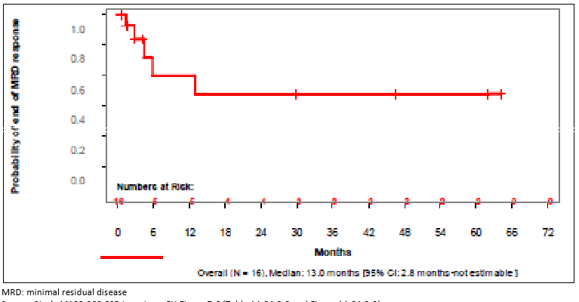
Figure 12: Study MT103-202: MRD progression – Kaplan-Meier estimate: Subjects with and without dose increase (FAS)
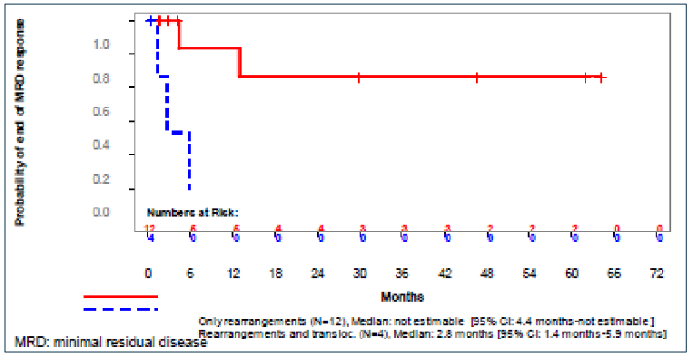
Figure 13: Study MT103-202: MRD progression – Kaplan-Meier estimate: Subjects with rearrangements of translocations at baseline (FAS)
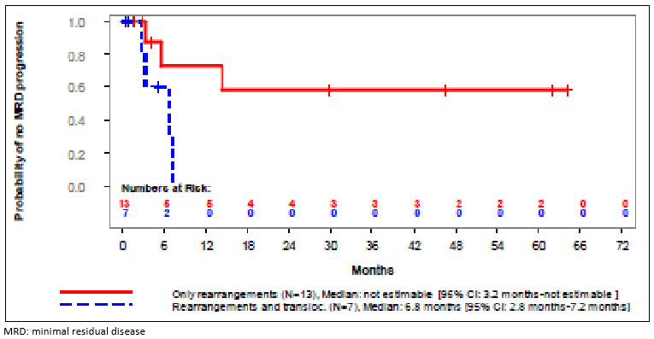

Duration of MRD response
The median duration of MRD response for the 16 subjects who had an MRD response in the FAS overall was 13.0 months (95% CI: 2.8, ne).
Five subjects had MRD relapse. All 5 subjects received blinatumomab 15 µg/m²/day.
By baseline genetic alteration, 2 of the 5 subjects had only rearrangements at baseline, and for these subjects relapse occurred on days 134 and 396. For the 3 subjects who had translocations at baseline, relapse occurred on days 42, 86, and 179. For the 11 subjects who did not experience MRD relapse, the duration of follow-up ranged from 15 to 1955 days (> 5 years).
Figure 14: Study MT103-202: Duration of MRD response as time to event variable; Kaplan-Meier estimate: All subjects (FAS)
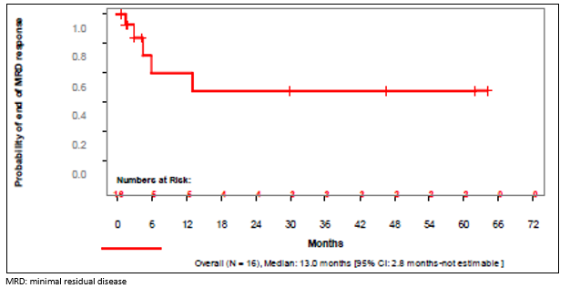
Figure 15: Study MT103-202: Duration of MRD response as time to event variable – Kaplan-Meier estimate: Subjects with rearrangements or translocations at baseline (FAS)
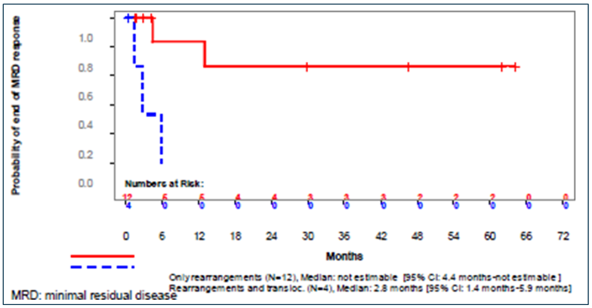

Study MT103-203 (long term follow up)
A Confirmatory Multicentre, Single-arm Study to Assess the Efficacy, Safety, and Tolerability of the BiTE Antibody Blinatumomab in Adult Subjects with Minimal Residual Disease (MRD) of B-precursor Acute Lymphoblastic Leukaemia.
Comment: This is the second CSR for this study. The first CSR was submitted and evaluated in the initial Blincyto application (PM-2014-03864-1-4). This CSR contains the key secondary endpoints for the study. The analyses were conducted after the last Ph-negative subject completed an 18 month follow up period with the data cut-off date of August 2015.
The study is ongoing and the final efficacy follow up analysis is planned after the last enrolled subject has been followed for 5 years.

Study design, objectives, locations and dates
An open label, confirmatory, multicentre, single arm study conducted at 46 sites in Austria (3), Belgium (2), Czech Republic (1), France (5), Germany (16), Italy (7), Netherlands (1), Romania (3), Russia (1), Spain (3) and the UK (4) from November 2010 to cut-off date for key secondary endpoint of August 2015.
Key secondary objective: to evaluate the effect of blinatumomab on haematological relapse for subjects with Ph-negative ALL.
The core study was defined as follows: completing the Day 29 visit of 4 cycles for subjects not proceeding to HSCT and completion of at least Day 29 of cycle 1 for those proceeding to HSCT.

Inclusion and exclusion criteria

Inclusion
Adult subjects were eligible for this study if they had a diagnosis of MRD-positive B- precursor ALL and were in complete haematologic remission (defined in the protocol as < 5% blasts in bone marrow after at least 3 intense chemotherapy blocks). Subjects must also have had MRD ≥ 10-3 (molecular failure or molecular relapse) in an assay with minimum sensitivity of 10-4 with at least 1 molecular marker based on individual rearrangement of immunoglobulin (Ig) or T-cell receptor (TCR)-genes or a flow cytometric marker profile documented after an interval of at least 2 weeks from last systemic chemotherapy and at least 4 weeks from prior radiotherapy, and bone marrow function defined as absolute neutrophil count ≥ 1,000/µL, platelets ≥ 50,000/µL, and haemoglobin level ≥ 9 g/dL (transfusions permitted).
Identification of MRD required that sufficient DNA was available from the subject’s primary diagnostic sample leukaemia cells prior to initiation of induction therapy in order to identify the clone specific individual Ig or TCR gene rearrangements. Therefore, subjects who were identified as potentially eligible based on clinical criteria only underwent screening procedures after the investigator verified that the pre-treatment sample was available and shipped to the central MRD lab.

Exclusion
The presence of circulating blasts or current extra-medullary involvement, a history of clinically relevant central nervous system pathology (for example, seizure, paresis, aphasia, cerebrovascular ischemia/haemorrhage, severe brain injuries, dementia, Parkinson’s disease, cerebellar disease, organic brain syndrome, psychosis, coordination or movement disorders), and prior allogeneic HSCT.

Study treatments
All subjects in the study were intended to receive at least 1 and up to a maximum of 4 cycles of treatment with blinatumomab. A cycle was defined as a cIV infusion at a constant dose of 15 µg/m²/day over 28 days over 4 weeks followed by an infusion-free period of 2 weeks.

Efficacy variables and outcomes
The primary efficacy outcome was the MRD response rate within 1 cycle of treatment with blinatumomab. The primary efficacy outcome was provided in the first CSR evaluated in the initial submission.
The key secondary outcomes were:
- Haematological relapse free survival
- Overall survival
- 100 day mortality after allogenic HSCT
- Time to haematological relapse
- Duration of complete MRD response
- Effect on MRD level.

Randomisation and blinding methods
This was an open label, non-randomised study.

Analysis populations
- Full analysis set (FAS): All subjects who received any infusion of blinatumomab. N=116 (100%).
- Primary endpoint full analysis set (Prim EP FAS): all subjects with an Ig or TCR PCR MRD assay with the minimum required sensitivity of 1 x 10-4 at central lab stablished at baseline. N=113 (97.4%).
- Key secondary endpoint full analysis set (Key Sec EP FAS): all subjects from the FAS; excluding Philadelphia-positive subjects; in haematological CR at treatment start. N=110 (94.8%).
- Key secondary endpoint per protocol set (Key Sec EP PPS): as Key Sec EP FAS above who did not have any major relevant protocol violation which could have an impact on the key secondary efficacy endpoint (late stage protocol violation). N=96 (82.8%).
- HSCT secondary endpoint full analysis set (HSCT Sec EP FAS): all subjects from FAS who underwent HSCT prior to relapse (haematological or extra-medullary) excluding Philadelphia- positive subjects. N=74 (63.8%).
- HSCT secondary endpoint per protocol set (HSCT Sec EP PPS): as HSCT Efficacy Set above who did not have any major relevant protocol violation which could have an impact on the key secondary efficacy endpoint (late stage protocol violations). N=66 (84.5%)

Sample size
Sample size was determined based on the primary efficacy outcome.
For the key secondary outcomes, the sample size determination was calculated based on assumptions of historical data. Currently available historical data of 80 patients show that 14 out of 80 patients (17.5%) are haematological relapse-free after one year. In a conservative manner this data was used for the estimates of the 18-month time point. A two-sided 95% confidence interval of this rate has an upper limit of 28%. Thus, it is considered clinically meaningful, if patients treated with blinatumomab have a probability of at least 28% to be haematological relapse-free after 18 months (ie if the lower limit of the 95% CI for the rate of haematological relapse-free patients observed in this study is at 28% or higher).

Statistical methods
The statistical concept for analysing the key secondary endpoint is based on the Kaplan-Meier estimates (product-limit estimator) of haematological relapse at 18 months from start of treatment with blinatumomab.

Table 18: Study MT103-203: Summary of efficacy analyses
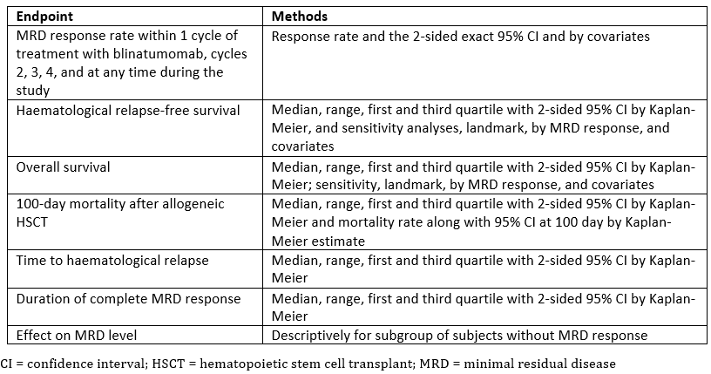

Participant flow
See data below
Figure 16: Study MT103-203: Subject disposition - Key secondary endpoint analysis sets
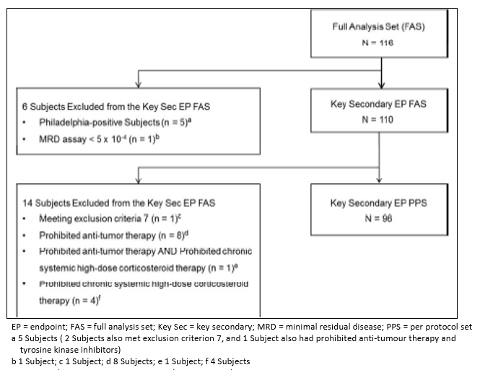

Table 19: Study MT103-203 Subject disposition
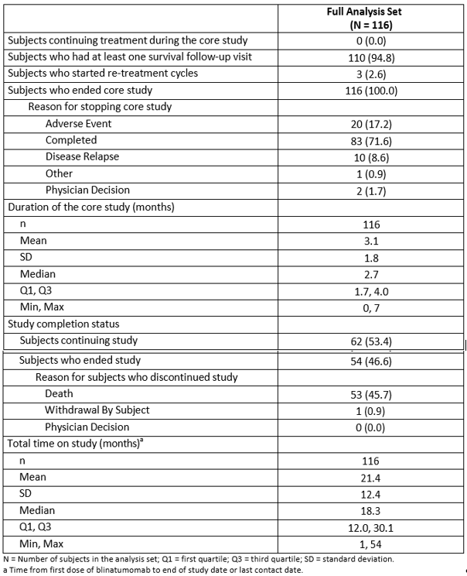

Major protocol violations/deviations
Overall, 46.6% (54/116) of subjects had at least 1 relevant protocol violation during enrolment. Six subjects had protocol violations that led to exclusion from the Prim EP PPS set: 3 subjects received systemic chemotherapy within 2 weeks prior to blinatumomab treatment; 2 subjects received a prohibited, chronic, systemic high-dose corticosteroid before an MRD assessment; 1 subject received a prohibited anti-tumour therapy before an MRD assessment.

Baseline data
In the FAS, more males (58.6%; 68/116) participated in this study than females (41.4%; 48/116). The majority of subjects (87.9%; 102/116) were White. The median age was 45.0 years (range: 18 to 76 years).
Most subjects (110 of 116) had MRD levels ≥ 10-3 at baseline as assessed by the central laboratory. More than half of all subjects (52.6%; 61/116) had a standard risk as assessed by local or national standards, while 31% (36/116) of subjects had high risk and 4.3% (5/116) of subjects had very high risk. The majority of subjects (67.2%; 78/116) had WBC counts at their first diagnosis of ≤ 30,000/mL. Five subjects (4.3%; 5/116) had Ph-positive ALL and 5 subjects (4.3%; 5/116) had confirmed t(4;11) translocation/MLL-AF4 fusion gene. Eight subjects (6.9%; 8/116) were chemo-resistant after the first week of prior chemotherapy. Thirty-eight subjects (32.8%, 38/116) needed a second induction course for complete haematological remission.

Results for the key secondary efficacy outcomes

Haematological relapse free survival rate
The key secondary endpoint was the haematological RFS rate in all Ph-negative subjects with ALL, censoring at either HSCT or post-blinatumomab chemotherapy following treatment with blinatumomab, assessed in subjects in the Key Sec EP FAS (N=110) and the Key Sec EP PPS (N=96). The timing of the secondary analysis was based on all patients having at least 18 months of follow-up for relapse-free survival (if they did not die or relapse prior to that point).
Of the 110 subjects in the Key Sec EP FAS, as of the data cut-off date, a total of 80.9% (89/110) were either in remission and censored at the time of their last haematological assessment, or censored for HSCT or post-blinatumomab chemotherapy following treatment with blinatumomab. A total of 19.1% (21/110) subjects had a haematologic RFS event: 16.4% (18/110) had a haematological relapse, 0.9% (1/110) had secondary leukaemia, and 1.8% (2/110) had died.
The 18-month KM estimate for haematological RFS, censored at HSCT or post-blinatumomab chemotherapy, was 54% (95% CI: 33% to 70%). The lower bound to this CI excluded the null hypothesis of 28% for the key secondary analysis; therefore, the null hypothesis relating to this key secondary endpoint can be rejected. The median RFS censored at HSCT or post- blinatumomab chemotherapy was not estimable (95% CI: 6.3 months to not estimable [ne]).

Table 20: Study MT103-203: Overview of haematological relapse-free survival rate (censored at HSCT or post blinatumomab chemotherapy)
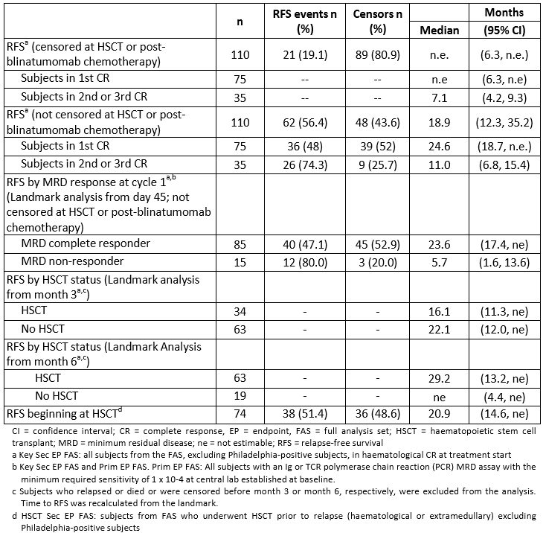

Table 21: Study MT103-203: Key secondary endpoint, Haematological relapse-free survival rate at 18 months censored at HSCT or post-blinatumomab chemotherapy
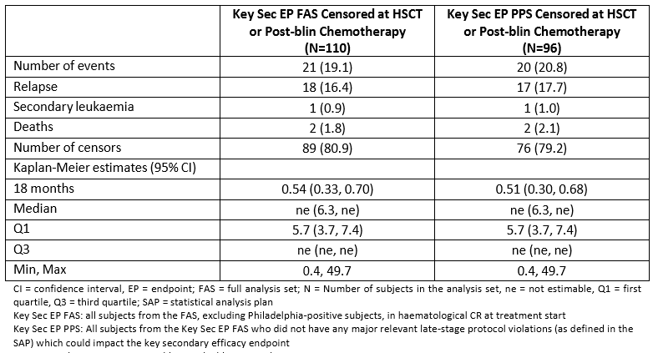
Figure 17: Study MT103-203: Haematological relapse-free survival, estimated by Kaplan- Meier method (Key Sec EP FAS)
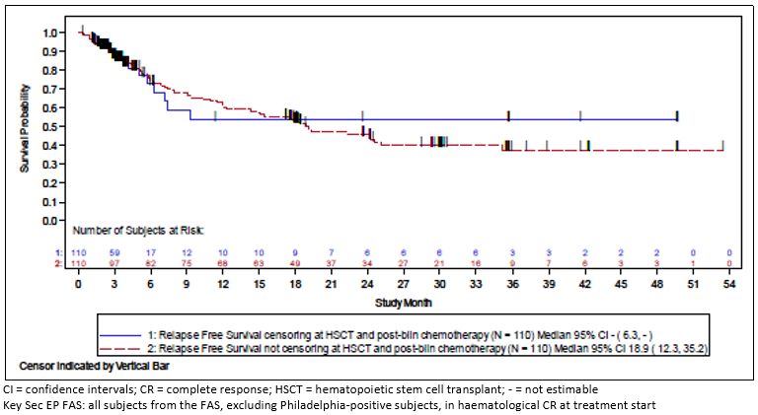
Subjects in first CR at the time of treatment with blinatumomab, censored at HSCT or post blinatumomab chemotherapy, had a noticeably longer RFS than those in second or third CR (not estimable [95% CI: 6.3 months to ne] versus 7.1 months [95% CI: 4.2 to 9.3 months], respectively). This was also the case when the censoring at HSCT or post blinatumomab chemotherapy was removed.
Figure 18: Study MT103-203: Relapse free survival censored at HSCT or post- blinatumomab chemotherapy: subjects in first CR versus second or third CR (Key Sec EP FAS)
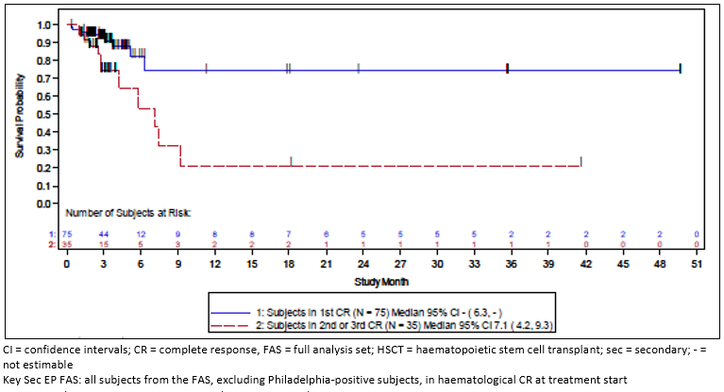
The 18-month KM estimate for RFS without censoring at HSCT or post-blinatumomab chemotherapy was 53% (95% CI: 44% to 62%) in the Key Sec EP FAS, and the median RFS without censoring at HSCT or post-blinatumomab chemotherapy was 18.9 months (95%: 12.3 to 35.2 months). Results in the Key Sec EP PPS set were comparable.

Landmark analysis (subjects who received HSCT compared to subjects without HSCT)
The subject incidence of HSCT after treatment with blinatumomab was 77.6% (90/116) in the FAS. Of the 90 subjects who had an HSCT, 76 (84.4%) subjects were in complete haematologic remission at the time of HSCT, with 19 (21.1%) subjects being MRD positive and 57 (63.3%) subjects being MRD negative, and 14 (15.6%) subjects had haematological relapse prior to HSCT.
To compare whether subjects with HSCT showed longer RFS times than those who did not have a transplant, two landmark analyses were performed on the Key Sec EP FAS, with the landmark defined at 3 months and 6 months after the first dose of blinatumomab. Cohorts of transplanted and non-transplanted subjects were defined as of the landmark time. At the 3-month landmark analysis, the median RFS from the landmark were 22.1 months (95% CI: 12.0 months to ne) for subjects without a transplant and 16.1 months (95% CI: 11.3 months to ne) for subjects who received HSCT; the KM curves were similar for both groups. At the 6 month landmark, the median RFS from the landmark of subjects without a transplant could not be estimated (95% CI:4.4 months to ne), and the RFS of subjects who received an HSCT was 29.2 months (95% CI:13.2 to ne); the differences in the KM curves in subjects were small.

Relapse-free survival beginning at HSCT
A total of 74 subjects comprised the HSCT Sec EP FAS. A total of 51.4% (38/74) of subjects had an RFS event, and 48.6% (36/74) were in remission or otherwise censored. The median RFS for subjects in the HSCT Sec EP FAS was 20.9 months (95% CI: 14.6 months to ne). The 18-month KM estimate was 55% (95% CI: 42% to 66%). Numbers were comparable in the HSCT Sec EP PPS. Not unexpectedly, RFS was longer in subjects with related rather than unrelated donors (median RFS not estimable (95% CI: 4.0 months to ne) versus 18.7 months (95% CI: 14.5 to 29.4 months)), and in subjects with matched versus mismatched donors (median RFS of 20.8 months [95% CI: 14.5 months to ne] versus 16.2 months [95% CI: 10.8 months to ne]).

Impact of MRD response on haematological relapse-free survival – Day 45 landmark analysis
The impact of MRD response on RFS was compared via a landmark analysis starting from day 45 in Prim EP FAS and Key Sec EP FAS subjects. The analysis excluded subjects who had an event or were censored before day 45, with a total of 107 subjects included in the analysis. A total of 52.9% (45/85) subjects with complete MRD response at cycle 1 were alive without relapse at the end of the follow-up period, compared with 20.0% (3/15) of subjects who were MRD non-responders.
The median RFS time was approximately 18 months longer for subjects with an MRD complete response at cycle 1 (23.6 months, 95% CI: 17.4 months to ne) compared with subjects who were MRD non-responders (5.7 months, 95% CI: 1.6 to 13.6 months). The 18-month KM estimate was 58% (95% CI: 46% to 68%) in subjects with MRD complete response compared with 20% (95% CI: 5% to 42%) in subjects who were MRD non-responders. These differences should not be interpreted as direct effects of achieving a complete MRD response since there could be underlying baseline characteristics that influence both the ability to achieve a complete MRD response and improvements in RFS.

Results of other secondary endpoints

Overall survival
Overall survival was measured for all subjects from the time the subject received the first treatment with blinatumomab until death due to any cause. Subjects who did not die were censored at their last contact date. A total of 53 deaths (45.7%, 53/116) were reported in the study as of the cut-off date.

Table 22: Study MT103-203: Overview of overall survival analyses
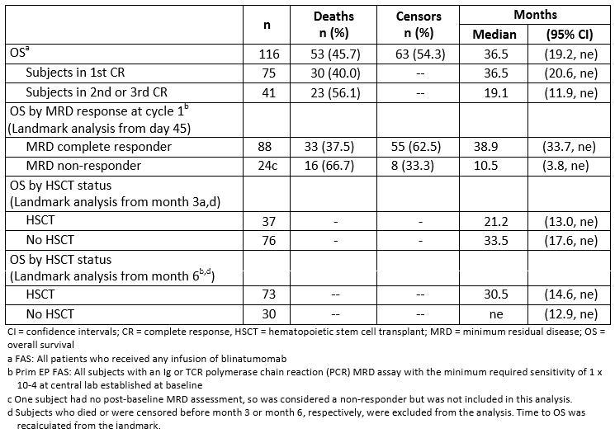

Table 23: Study MT103-203: Overall survival
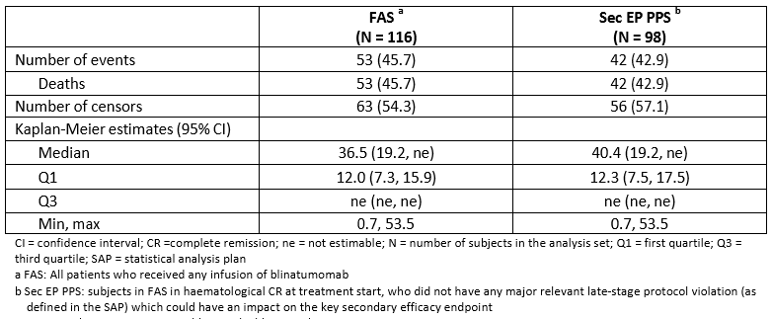
Figure 19: Study MT103-203: Overall survival, estimated by Kaplan-Meier Method (FAS)
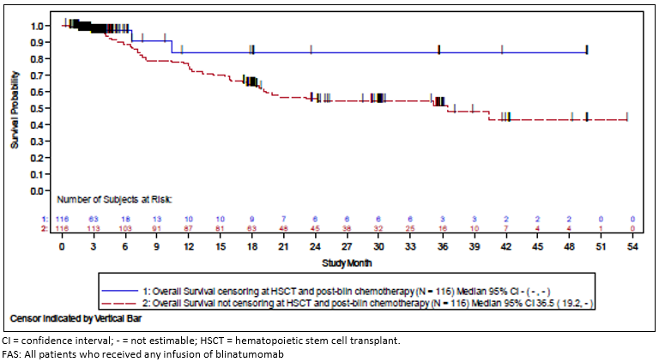
The 18-month KM estimate for OS with censoring at HSCT or post blinatumomab chemotherapy was 83% (95% CI: 55% to 94%) in the FAS group. The median OS with censoring at HSCT or post blinatumomab chemotherapy was not estimable. Results were comparable in the Sec EP PPS set.

Impact of HSCT on overall survival - landmark analyses at 3 and 6 Months
Landmark analyses were conducted to compare the OS in subjects who received HSCT and those who did not. Subjects who died before the landmark date were excluded from the analysis; otherwise subjects were stratified based on whether they received or did not receive HSCT at the landmark date. Landmarks included 3 months and 6 months after the first dose of blinatumomab.
Among subjects who were alive at 3 months, the median overall survival was 21.2 months (95% CI: 13.0 months to ne) in subjects who received HSCT on or before 3 months, and 33.5 months (95% CI: 17.6 months to ne) for those who did not receive HSCT. Among subjects who were alive at 6 months, the median OS was 30.5 months (95% CI: 14.6 months to ne) in subjects who received HSCT on or before 6 months, and not estimable (95% CI: 12.9 months to ne) in those who did not receive HSCT.

Impact of MRD response on overall survival; day 45 landmark analysis
The impact of MRD response on overall survival was compared via a landmark analysis starting from day 45 in Prim EP FAS subjects (N=112). The analysis excluded subjects who died or were censored before day 45. Nearly twice as many subjects who had an MRD complete response were alive as of the data cut-off date. A total of 62.5% (55/88) of subjects with complete MRD response at Cycle 1 were alive at day 45, compared with 33.3% (8/24) of subjects who were MRD non-responders in Cycle 1.
The median OS time was over 28 months longer for subjects who had an MRD complete response at cycle 1 (38.9 months, 95% CI: 33.7 months to ne) compared with subjects who were MRD non-responders (10.5 months, 95% CI: 3.8 months to ne). The 18-month KM for OS was 69% (95% CI: 58% to 78%) in subjects who had MRD complete response compared with 31% (95% CI: 14% to 51%) in subjects who were MRD non-responders.

100-day mortality rate associated with allogeneic hematopoietic stem cell transplant
Overall the subject incidence of HSCT after treatment with blinatumomab was 77.6% (90/116) in the FAS. Of the 90 subjects who had an HSCT, 76 (84.4%) subjects were in complete remission at the time of HSCT, with 19 (21.1%) subjects being MRD-positive and 57 (63.3%) subjects being MRD-negative at the end of cycle 1, and 14 (15.6%) subjects had haematological relapse prior to HSCT.
In the HSCT Sec EP FAS, 74 subjects from FAS received an allogeneic HSCT while in remission induced by blinatumomab treatment. Of these 74 subjects, 31 (41.9%) subjects died, with 5 (16.1%) deaths occurring during 100 days post-HSCT.
The OS rate at 100 days after transplant was 93% (95% CI: 85% to 97%). The 100-day mortality rate after allogeneic HSCT was 7% (95% CI: 3% to 15%). The OS rate for the HSCT Sec EP PPS was comparable.
The cumulative probability of mortality at 100 days of related donors was 5% (95% CI: 1% to 32%), and that of unrelated donors was 8% (95% CI: 3% to 19%). The cumulative probability of mortality at 100 days of matched donors was 5% (95% CI: 1% to 20%), and that of mismatched donors was 4% (95% CI: 1% to 25%).
Figure 20: Study MT103-203: Cumulative probability of mortality beginning at HSCT (HSCT Sec EP FAS)
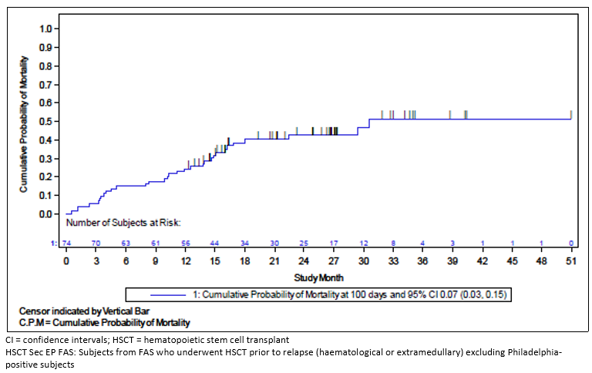

Time to haematological relapse
Time to haematological relapse (TTHR) was measured from the start of treatment with blinatumomab until the subject experienced haematological or extra-medullary relapse. Subjects who died or received HSCT or post blinatumomab chemotherapy after treatment with blinatumomab were censored at their last haematological assessment prior to death or HSCT or post-blinatumomab chemotherapy (whichever occurred first).
In the Key Sec EP FAS (N=110), the 18-month KM estimate for TTHR, censored at HSCT or post- blinatumomab chemotherapy, was 55% (95% CI: 34% to 72%); the median TTHR was not estimable (95% CI: 7.1 months to ne). A total of 82.7% (91/110) of subjects were censored as of the data cut-off, and a total of 17.3% (19/110) subjects had events: 16.4% (18/110) had a relapse and 0.9% (1/110) had secondary leukaemia. Results in the Key Sec EP PPS set were comparable.
The 18-month KM estimate for TTHR, not censored for HSCT or post blinatumomab chemotherapy, was 67% (95% CI: 57% to 76%), and the median TTHR was not estimable (95% CI: 24.3 months to ne).

Duration of complete MRD response
The median duration of MRD response was analysed as the time from onset of MRD negativity until MRD or haematological relapse or date of last confirmation of negative MRD status. Only the subjects with MRD CR at cycle 1 were included in this analysis. The results were analysed with and without censoring at the time of HSCT or post blinatumomab chemotherapy.
The median duration of MRD response for the Key Sec EP FAS and Prim EP FAS subjects who had complete MRD response at cycle 1 (N=85) was 17.3 months (95% CI: 12.6 to 23.3 months) uncensored and 45.0 months (95% CI: 6.5 to 45.0 months) when censored at the time of HSCT or post-blinatumomab chemotherapy The 18-month KM estimates were 46% (95% CI: 33% to 57%) and 51% (95% CI: 28% to 69%), respectively. Results were similar for the Key Sec EP PPS sets. Results in the Key Sec EP PPS and Prim EP FAS sets (censored for HSCT or post- blinatumomab chemotherapy and uncensored) were comparable to the Key Sec EP FAS/Prim EP FAS sets.

Table 24: Study MT103-203: Duration of MRD complete response
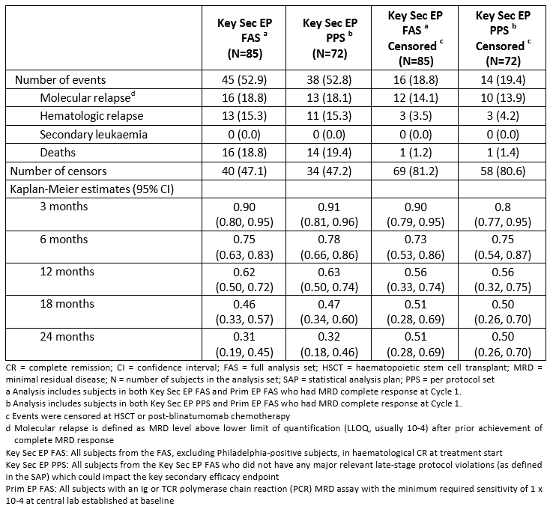

Effect on MRD level
As previously described in the primary efficacy endpoint, in the Prim EP FAS, 77.9% (88/113) of subjects achieved MRD complete response during Cycle 1. Some subjects achieved MRD complete responses as early as 5 days after initiation of treatment. Following Cycle 1, a total of 2 additional subjects in the Prim EP FAS achieved complete MRD, for a total of 90/113 (79.6%). Of the 2 subjects who reported MRD after the Cycle 1 assessment, the reported dates of MRD response were day 66 and day 71 respectively.
A majority of the subjects (14/22) categorised as non-MRD responders reported shifts to a lower MRD at the end of Cycle 1: 1 of 3 subjects with MRD of 10-1 had a shift to 10-5, 7 of 10 subjects with MRD of 10-3 had shifts to ≤ 10-4, and 6 out of 7 subjects with MRD of 10-2 had shifts to ≤ 10-3.

Conclusions
For the comparison of subjects who achieved a complete MRD response versus those who did not achieve a complete response:
- Higher KM estimated RFS at 18 months (from day 45): 58% (95% CI: 46, 68) versus 20% (95% CI: 5, 42), respectively
- Longer median RFS (from day 45): 23.6 months (95% CI: 17.4, ne) versus 5.7 months (95% CI: 1.6, 13.6), respectively, for a difference in RFS of 17.9 months
- Higher KM-estimated OS at 18 months (from day 45): 69% (95% CI: 58, 78) versus 31% (95% CI: 14, 51), respectively
- Longer median OS (from day 45): 38.9 months (95% CI: 33.7, ne) versus 10.5 months (95% CI: 3.8, not estimable), respectively, for a difference in OS of 28.4 months.

Other studies

Study 20120148
A retrospective analysis of haematological relapse free survival and overall survival in adult patients with Philadelphia-negative B-precursor acute lymphoblastic leukaemia in complete haematological remission with minimal residual disease.

Study design, objectives, locations and dates
Data from patients with Philadelphia-negative B-precursor ALL who had achieved complete haematological remission through receiving standard of care treatment according to national study protocols, and were found to be MRD positive.
Data was collected from databases of ALL study groups in Europe (Czech Republic, France, Germany, UK, Italy, Poland, Spain) and Russia which included MRD testing in their protocols. The report is dated 12 December 2014.
Study groups and sites across Europe and Russia entered existing data into a study specific electronic case report form (eCRF), allowing for standardised data collection across countries.

Primary objective
To estimate the haematological relapse free survival (RFS) in patients with characteristics that correspond to the characteristics of subjects in the primary analysis of haematological RFS in Study MT103-203; that is, ≥ 18 years of age and MRD detected by polymerase chain reaction (PCR) at a level of 1x10-3 or higher.

Secondary objectives
To estimate:
- haematological RFS in patients with more general characteristics:
  - 15 years of age or older
  - MRD-positive regardless of level or detection method
- OS in the 2 sets of patients described above
- haematological RFS and OS in patients who did not receive allogeneic hematopoietic stem cell transplant (alloHSCT)
- haematological RFS and OS in patients who received alloHSCT
- mortality rate (proportion) at 100 days following alloHSCT in patients who received an alloHSCT after MRD detection.

Study Population
The inclusion criteria for the historical study population were based on the literature which also defined the clinical characteristics of the patient population treated in Study MT103-203, to allow for indirect comparison of efficacy.
The study population, a pooled patient group of ALL patients with MRD-positive B-precursor ALL, was assembled from study groups who had measured MRD status at similar time periods and used comparable methodologies (PCR and flow cytometry), mostly in national reference laboratories.

Inclusion and exclusion criteria
Inclusion: Patients with Philadelphia-negative B–precursor ALL in complete haematological remission defined as < 5% blasts in bone marrow after at least 3 intensive chemotherapy blocks (that is any standard or investigational regimen according to adult protocols as long as 3 age appropriate intensive chemotherapy blocks were given, this also included relapse treatment); detection of minimal residual disease (molecular failure or molecular relapse) at a level of ≥10-4 by PCR or ≥ 10-3 by flow cytometry at a reference lab; age ≥ 15 years at time of initial diagnosis of ALL. For patients 15-17 years of age at diagnosis, patients were not allowed to be enrolled in a paediatric trial; initial diagnosis of ALL in the year 2000 or later; history of ALL treatment (including response to first therapy, number of prior relapses) was available; relapse status and disease follow-up after time point of MRD detection was available
Exclusion: Patients with extra-medullary disease at time point of MRD detection; use of blinatumomab within 18 months of MRD detection; alloHSCT prior to MRD detection at required level.

Study treatments
Not applicable; this was an observational study.

Efficacy outcomes
The primary endpoint was the time from the baseline MRD detection date until haematological relapse or death due to any cause.
The other endpoints included: Overall survival (time from baseline MRD detection date until death) and mortality rate (proportion) in patients who received an alloHSCT after MRD detection assessed at 100 days following HSCT, as well as later time points (3, 6, 9 and 12 months, and 6 monthly intervals until 36 months after alloHSCT).

Analysis sets
- Primary analysis set included patients with Philadelphia-negative B-precursor ALL in complete haematological remission; 18 years or older and with MRD detected by PCR at a level of 1 x 10-3 or higher. (n=133)
- Primary transplant analysis set included patients with Philadelphia-negative B-precursor ALL in complete haematological remission; 18 years or older, with MRD detected by PCR at a level of 1 x 10-3 or higher, and who received an alloHSCT after MRD detection and prior to any haematological relapse. (n=49)
- Primary non-transplant analysis set included patients with Philadelphia-negative B- precursor ALL in complete haematological remission; 18 years or older, with MRD detected by PCR at a level of 1x10-3 or higher, and who did not receive an alloHSCT after MRD detection unless it occurred after haematological relapse. (n = 84)
- Full analysis set included patients with Philadelphia-negative B-precursor ALL in complete haematological remission; 15 years or older and with MRD-positive level of at least 10-4 regardless of detection method. (n=287)
- Full transplant analysis set included patients with Philadelphia-negative B-precursor ALL in complete haematological remission with MRD; 15 years or older, with MRD level of at least 10-4 regardless of detection method, and who received an alloHSCT after MRD detection and prior to any haematological relapse. (n=110)
- Full non-transplant analysis set included patients with Philadelphia-negative B-precursor ALL in complete haematological remission with MRD; 15 years or older, with MRD level of at least 10-4 regardless of detection method, and who did not receive an alloHSCT after MRD detection unless it occurred after haematological relapse. (n=177)
- Direct comparison analysis set (DCAS), was defined post hoc as follows: 18 years or older and with MRD detected by PCR or flow cytometry at a level of 1x10-3 or higher (that is regardless of detection method); Time to relapse from the date of MRD detection greater than 14 days (the median time between MRD assessment and initiation of blinatumomab treatment in Study MT103-203) and in first relapse (CR1). (n=182)

Statistical methods
Based on estimates of data availability across the participating study group sites, it was anticipated approximately 300 patients to be analysable for the full analysis set. Assuming the formula 0.25/(sample size) represents a reasonable approximation for estimated variance of a Kaplan-Meier proportion at a given time point (a key summary statistic for the analysis of the historical control only) then the half-width of a 95% CI for the proportion is expected to be within 0.06.
RFS was summarised with KM curves, KM proportions at select time points, KM quartiles (when estimable), the number of subjects with events, the number of subjects censored and the pattern of censoring. Point estimates for RFS were accompanied by 2-sided 95% CIs. These summaries were repeated for the primary, direct comparison and full analysis sets.
Cox regressions were used to estimate the strength of the relationship between haematological RFS and the covariates both in univariate and multivariate models. For the multivariate models, covariates were included by forward selection with criteria for entry p-value < 0.10. A total of 7 variables could enter the model; age (15-34 years versus 35-54 years versus ≥ 55), sex, white blood cell count (WBC) at primary diagnosis (< 30,000/µL versus ≥ 30,000/µL), MRD level at baseline (grouped into the following categories: ≥ 1x10-1, ≥ 1x10-2 to < 10-1, ≥ 1x10-3 to < 10-2, ≥ 1x10-4 to < 10-3, missing), persistent versus relapsed MRD, calendar year of primary diagnosis (tested as a linear trend from 2000 to 2013) and whether or not translocation t(4;11)MLL-AF4 was present (yes versus no). These summaries were performed for the primary and full analysis sets.
The analysis methods described above for haematological RFS were also applied to OS.
The KM method was used to analyse OS from the date of transplant to assess the survival status at 100 days following alloHSCT.
The time from the baseline MRD detection to alloHSCT was summarised with descriptive statistics for the primary transplant analysis set and the full transplant analysis set.

Participant flow
Among the contributing study groups, all but Russia contributed data to the direct comparison analysis set. For Russian patients, MRD test results were qualitative only, with results > 10⁻⁴, but the actual MRD level was not quantified so it was not possible to assess whether patients qualified for the primary analysis sets. For Poland, Spain and one site from Italy, MRD levels were assessed by flow cytometry rather than PCR, therefore none of their patients were included in the primary analysis set, but there were patients from these countries in the direct comparison analysis set.
Figure 21: Study 20120148: Flow Diagram of Records and Patients
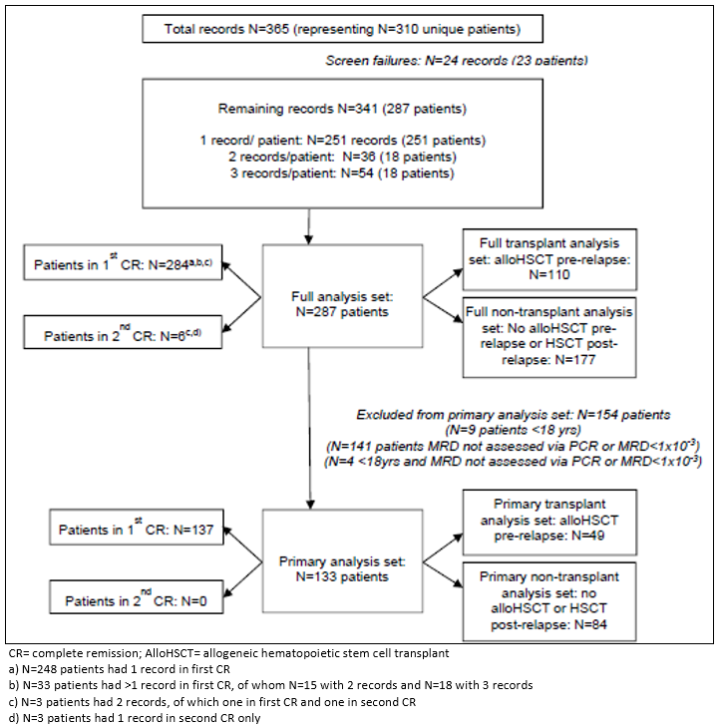

Baseline data
In the full analysis set, 59% of patients were male and the median age was 32 years (range, 15 to 65). Of note, patients in the full transplant analysis set were more frequently in the 15-34 age group (64%) compared to those in the non-transplant analysis set (53%) and depending on the respective analysis set, 80-90% of patients were below the age of 55.
The time from initial ALL diagnosis until the MRD detection date following complete remission after chemotherapy (that is until the baseline MRD status) was less than 6 months for over 80% of patients (median: 4.2 months; interquartile range [IQR], 3.5 to 5.3 months with a minimum of 1 month and maximum of 60 months).
Two-thirds of patients had their initial ALL diagnosis in 2005 or later, with 10% being diagnosed after 2010. Of note, patients who underwent alloHSCT were more frequently diagnosed between 2005 and 2010 (61%) compared to patients who did not undergo alloHSCT (51%). White blood cell count at diagnosis was elevated (≥ 30,000/µL) in 27% of patients and the vast majority (99%) were in first complete remission (CR) at the time of baseline MRD.
Again, differences were seen between the full transplant and non-transplant analysis sets, with non-transplanted patients more frequently having a lower WBC at diagnosis (75%) compared to those undergoing alloHSCT (67%). All patients received chemotherapy prior to their MRD detection date, using a variety of treatment protocols. One patient had received prior autologous HSCT and the majority of patients had received prior radiotherapy (59%), primarily to the brain. Baseline MRD levels were assessed by PCR in 80% of patients. The median baseline MRD level was 2.7 x 10-3 (IQR 7 x 10-4 – 1 x 10-2).
Tabulated data was provided.

Results for the primary efficacy outcome
Among patients aged 18 and older with a minimum MRD level of 1x10-3 as detected by PCR (that is the primary analysis set), the median duration of haematological RFS was 8.5 months (95% CI to 11.8 months) from the baseline MRD assessment. At 18 months, the haematological RFS was 38% (95% CI, 30% to 47%).
Figure 22: Study 20120148: Kaplan-Meier plot of haematological relapse free survival (RFS), primary analysis set
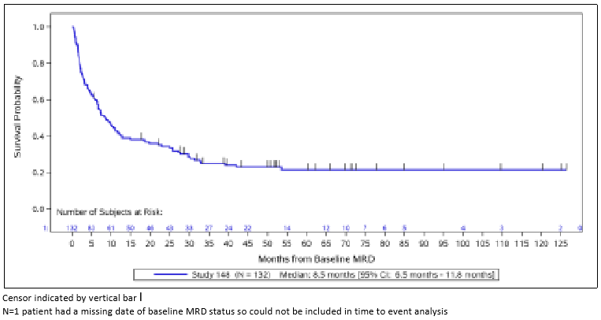

Table 25: Study 20120148: Haematological relapse-free survival analysis
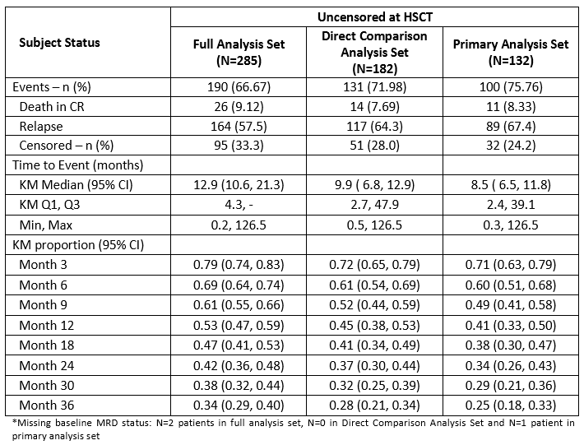
In a multivariate model, two factors were predictive of RFS in the primary analysis set: a white blood cell count at diagnosis ≥ 30,000/µl and having relapsed MRD were associated with a poorer RFS.

Table 26: Study 20120148: Predictors of haematological relapse-free survival (multivariate model, Primary analysis set)
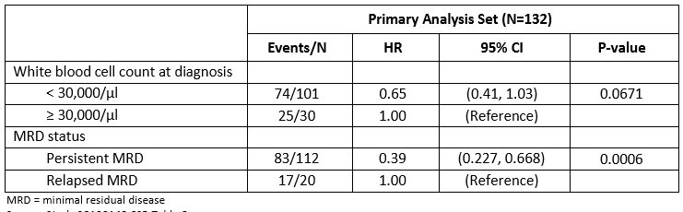

Results for other efficacy outcomes

Relapse free survival in the full analysis set
The median duration of haematological RFS among patients aged 15 and older with a minimum MRD level of 1x10-4 detected by PCR or flow cytometry (that is the full analysis set) was 12.9 months (95% CI, 10.6 to 21.3 months). At 18 months, the haematological RFS observed in the full analysis set was 47% (95%CI, 41% to 53%).
When visually inspecting the potential association of patient characteristics with duration of RFS, it appeared that younger age was associated with longer survival, and there was no clear association between sex and duration of RFS.
Patients with persistent MRD initially fared better than those with relapsed MRD but it appeared that this association reversed at approximately 2 years after the baseline MRD assessment (thereby violating the proportional hazards assumption), although the number of patients in the group of relapsed MRD patients was low.
There appeared to be a trend of longer survival with lower MRD level at baseline.
Figure 23: Study 20120148: Haematological relapse free survival KM plot by MRD level at baseline (full analysis set)
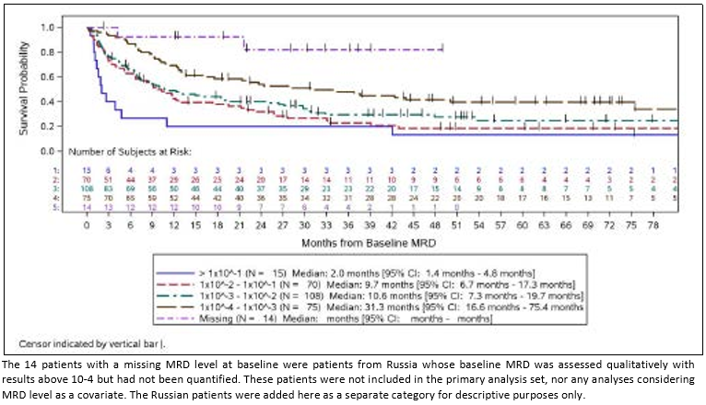
A clear association was seen for higher WBC count at primary diagnosis and shorter duration of RFS. Although the number of patients diagnosed in later years was small, there was a suggestion that they had a better RFS. No clear differences in RFS were seen between patients with and without chromosomal abnormality t(4;11)-AF4.

Table 27: Study 20120148: Predictors of relapse free survival (multivariate model; full analysis set)
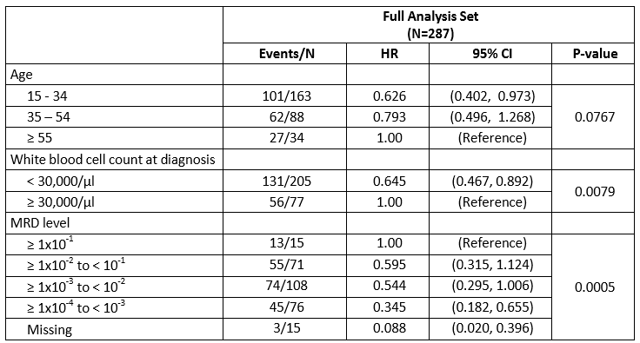

Duration of response in the primary analysis set
Of the 132 patients in the primary analysis set, 89 had a relapse with a median duration of response of 10.6 months (95%CI, 7.3 months to 18.8 months). At 18 months after baseline MRD assessment, 43% of patients remained in CR (95% CI: 35, 52). In a multivariate analysis, WBC at primary diagnosis, MRD level and MRD status fulfilled the criteria to enter the model, but only a statistically significant association was observed for MRD status, whereby patients with persistent MRD were more likely to remain in CR compared to patients who relapsed (HR = 0.38; 95% CI 0.22, 0.68).

Table 28: Study 20120148: Duration of response analysis
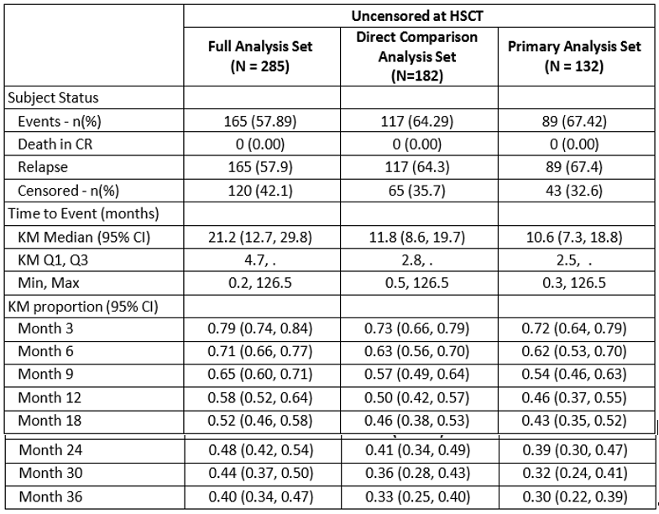

Table 29: Study 20120148: Predictors of duration of response (multivariate model; primary analysis set)
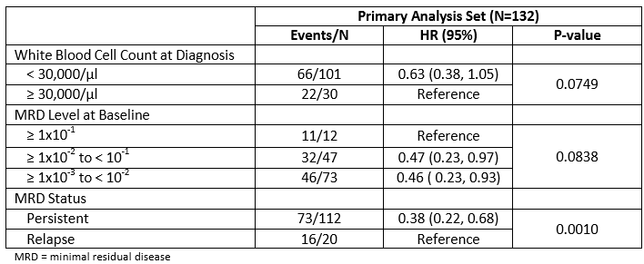

Duration of response in the full analysis set
Median duration of response was 21.2 months (95% CI 12.8 to 29.8 months) from the baseline MRD assessment. Univariate models of duration of response were similar to those shown for RFS. In a multivariate analysis, age group, white blood cell count and MRD level all fulfilled the criteria to enter the model, but only lower white blood cell count at primary diagnosis and lower MRD level at baseline were statistically significantly predictive of remaining in CR.

Table 30: Study 20120148: Predictors of duration of response (multivariate model; FAS)
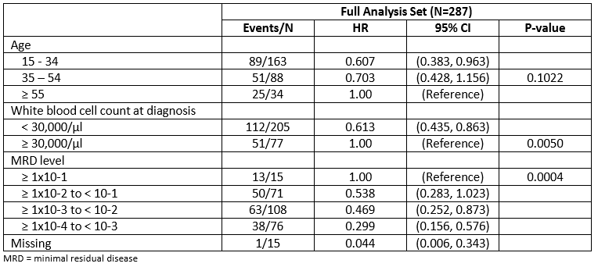

Overall survival in the primary analysis set
The median OS duration in the primary analysis set was 27.6 months (95% CI, 16.8 to 45.9 months) from the baseline MRD assessment, with 56% of patients alive at 18 months (95% CI: 48, 65).

Table 31: Study 20120148: Overall survival analysis
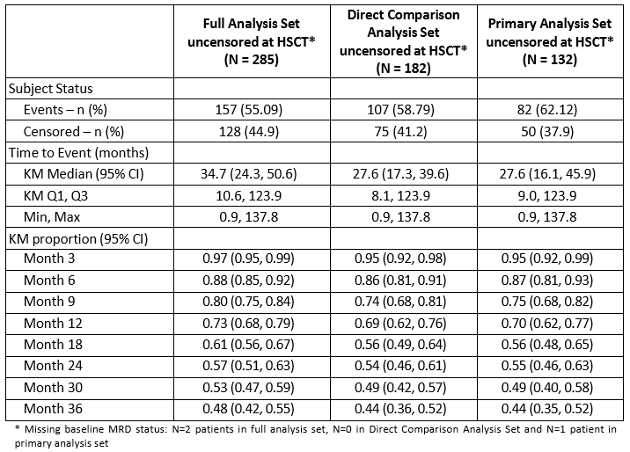
In a multivariate model, younger age and lower white blood cell count (WBC) at original diagnosis (< 30,000/µL) were associated with lower risk of death. In addition, there was an indication that later years of diagnosis may be advantageous for OS (p = 0.0860).

Table 32: Study 20120148: Predictors of overall survival (multivariate model; primary analysis set
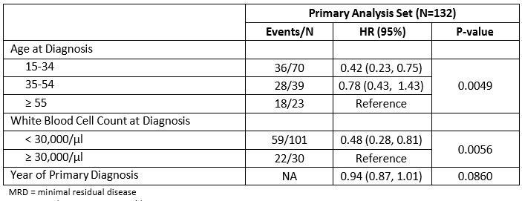

Overall survival in the full analysis set
In the full analysis set, the median OS duration from the baseline MRD assessment was again slightly longer (34.7 months; 95% CI, 24.5 to 50.6 months) than for the primary analysis set. At 18 months, 61% of patients were alive (95% CI: 56, 67).
Univariate models showed that duration of OS was generally shorter with older age, among women, among those with persistent MRD (compared to relapsed), those with higher MRD level at baseline, higher WBC at primary diagnosis, earlier year of diagnosis (2000 to 2004, compared to 2005 to 2010 and later than 2010) and the chromosomal abnormality t(4;11)-AF4 (compared to all other abnormalities).

Table 33: Study 20120148: Predictors of overall survival (multivariate model; full analysis set)
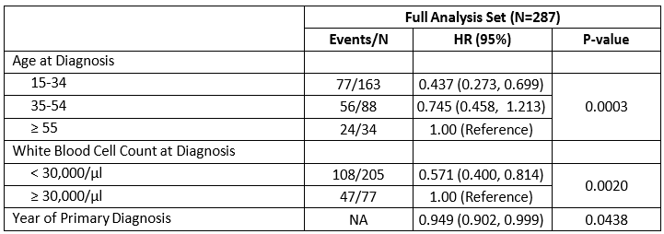
In a multivariate analysis, age group, WBC at diagnosis and calendar year of primary diagnosis were all statistically significant predictors for OS, with lower age (15 to 34 years) associated with 44% lower risk of death (95% CI 27% to 70%) compared to those aged 55 years and older; a lower WBC was associated with a 57% lower risk of death (95% CI 40% to 81%) compared to those with a WBC of ≥ 30,000/µL, and a trend of lower risk of death with later year of diagnosis (p = 0.0438).

Analysis of transplant analysis set
Median duration of haematological RFS in the primary transplant analysis set was 34.1 months from the date of alloHSCT (95% CI not estimable; [min – max]: 0.1 to 115.7 months) with 65% of patients being alive in continuous complete remission at 18 months (95% CI: 52, 78).
Median duration of response was not reached, with 73% of patients not having had a relapse at 18 months (95% CI, 60% to 86%). The results of duration of response from the date of alloHSCT must be taken with caution. Indeed, it assumes that if the patients who died after alloHSCT had lived longer, their time to relapse would have been the same as the patients who did not die. If the deaths post alloHSCT without relapse correspond to sicker patients, the results of this analysis are biased and overestimate the duration of CR post alloHSCT.

Table 34: Study 20120148: Haematological relapse free survival in the full and primary transplant analysis sets
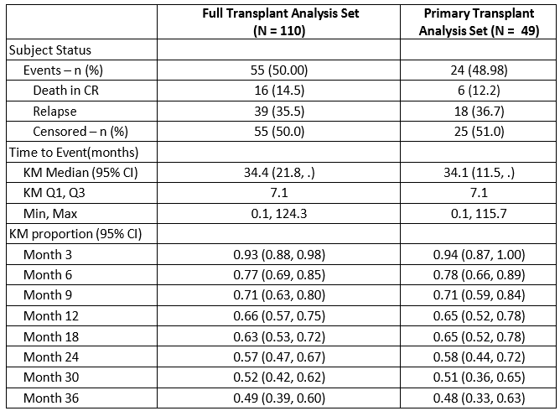
Median OS duration in this patient subgroup was 93.6 months from date of alloHSCT (95% CI not estimable; min – max: 0.1 to 115.7 months).

Table 35: Study 20120148: Overall survival in the full and primary transplant analysis sets
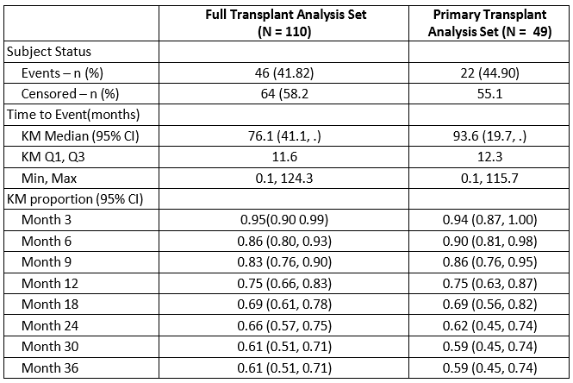
Mortality rate (KM method) at 100 days following alloHSCT was 8.2% (95% CI, 0.5% to 15.8%) in the primary transplant analysis set and 1 year after transplantation, 75% were still alive. Patients in the primary analysis set who received a transplant did so at a median of 3.8 months after their baseline MRD assessment (IQR, 2.3 – 7.0 months).

Table 36: Study 20120148: Hematopoietic stem cell transplantation
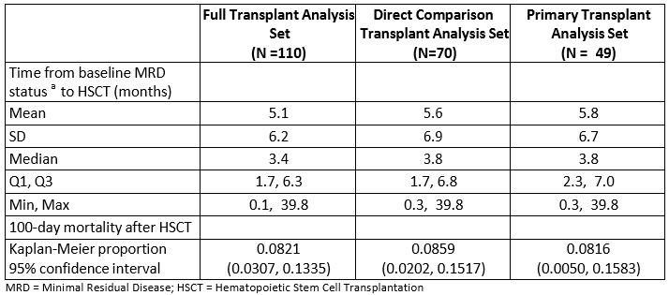

Table 37: Study 20120148: Overall survival analysis, censored at allogeneic haematopoietic stem cell transplant
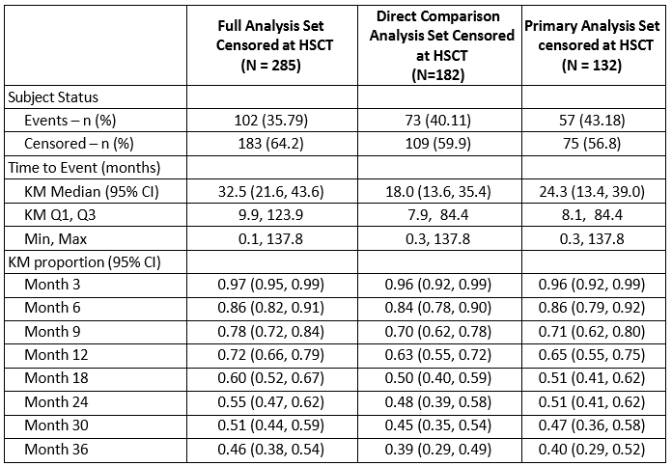

Outcomes in the direct comparison analysis set (DCAS)
The DCAS was defined post-hoc.

Relapse free survival in the direct comparison analysis set
When the analyses were not censored at HSCT, the median RFS was 9.9 months (95% CI: 6.8, 12.9) from the baseline MRD assessment, with 41% of subjects alive without relapse at 18 months (95% CI: 34, 49). In a multivariate model, 2 factors were statistically significantly predictive of improved RFS in the DCAS: younger age and WBC count at diagnosis < 30,000/µL.

Table 38: Study 20120148: Predictors of relapse free survival (Multivariate model; DCAS)
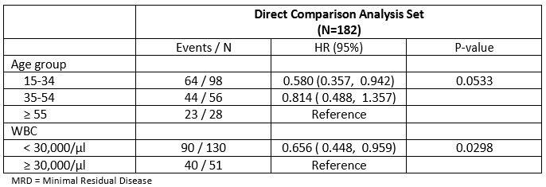

Overall Survival in the direct comparison analysis set
The median OS (95% CI) duration censored at HSCT in the DCAS was 18.0 months (95% CI: 13.6, 35.4), with 50% of subjects alive at 18 months (95% CI: 40, 59). When analyses were not censored at HSCT, the results were 27.6 months (17.3, 39.6) for median OS (95% CI) from the baseline MRD assessment, with 56% of subjects alive at 18 months (49, 64).
A multivariate analysis of the DCAS indicated that younger age and lower WBC at original ALL diagnosis (< 30,000/µL) were predictive factors for longer duration of OS.

Table 39: Study 20120148: Predictors of overall survival (Multivariate model; DCAS)
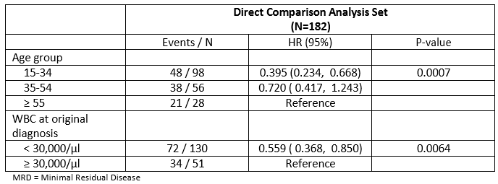

Mantel byar analysis of the direct comparison analysis set
The Mantel-Byar analysis indicated that HSCT was associated with a significantly longer duration of RFS (p = 0.0109, odds ratio=0.56, 95% CI: 0.36, 0.86) in the DCAS. For OS, the Mantel- Byar analysis indicated a survival benefit relating to HSCT for the DCAS (p = 0.0164, odds ratio=0.5796, 95% CI: 0.3727, 0.9015).

Time-dependent cox model of the direct comparison analysis set
In a time-dependent Cox model of the DCAS, in which HSCT incorporated at a time-varying covariate, HSCT was associated with a better RFS versus no transplant (unadjusted hazard rate, 0.29; 95% CI: 0.20, 0.43). In a multivariate time-dependent Cox model adjusting for baseline factors (age, WBC at diagnosis and year of diagnosis), allogeneic HSCT was associated with a greater RFS benefit (adjusted hazard ratio, 0.24; 95% CI: 0.158, 0.358). For OS, transplant was also statistically significantly associated with prolonged survival versus no transplant. In a multivariate model adjusted for age, WBC at diagnosis and year of diagnosis, the hazard rate and 95% CI were 0.41 (0.26, 0.63). Thus, when comparing the Mantel-Byar and Cox analyses, HSCT was consistently associated with an improved RFS and OS in the DCAS.

Table 40: Study 20120148: Hazard Ratio for the effect of HSCT on RFS and OS as assessed through Time-Dependent Cox Model (DCAS)
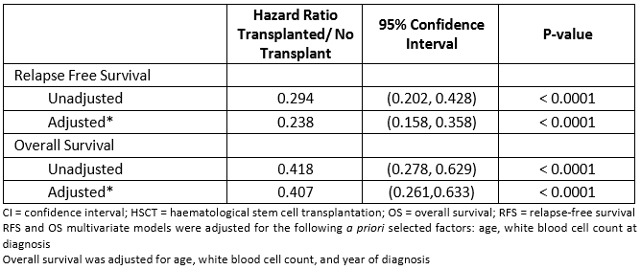

Cause of death by transplantation status
The majority of patients were reported to have died (62% in the primary analysis set and 55% in the full analysis set), with a minority of deaths occurring among patients in CR (8% of the primary analysis set and 9% of the full analysis set). When analysing deaths in CR by transplantation status, more transplanted patients die whilst in CR compared to non- transplanted patients (for example, in the primary analysis set, 12% of patients die in CR after alloHSCT versus 6% among patients without alloHSCT).

Table 41: Study 20120148: Cause of death by transplantation status (PAS and FAS)
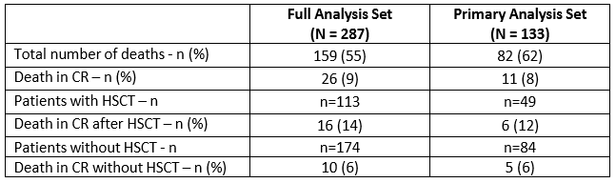

Summary of results
In the primary analysis set, a lower WBC at initial ALL diagnosis (< 30,000/µL) and persistent MRD status were predictors of better RFS compared to those with high WBC and/or relapsed MRD. Similarly, for duration of response the following covariates were predictors of a positive outcome: low WBC, lower MRD level at baseline and also persistent MRD status. For overall survival, age was an important predictor as were WBC and year of primary diagnosis. Landmark analyses of RFS, duration of response and overall survival indicated that the transplanted and non-transplanted groups had similar results. A Mantel-Byar analysis indicated that transplantation status impacted the duration of RFS and CR.
For the direct comparison analysis set, median hematologic RFS censored at HSCT was observed to be 8.5 months (95% CI: 5.6, 12.3) from the baseline MRD assessment. At 18 months, RFS was 37% (95% CI: 28, 46). Median OS in the DCAS censored at HSCT was 18.0 months (95% CI: 13.6, 35.4) from the baseline MRD assessment, with 50% of subjects alive at 18 months (95% CI: 40, 59). Elevated baseline white blood cell count and older age at diagnosis are associated with poorer RFS and OS. The various methods utilised to assess survival by HSCT showed improved RFS and OS among patients receiving HSCT. The Mantel-Byar and Cox models minimise potential biases by adjusting for time-dependent covariate data.

Table 42: Study 20120148: Summary of Main Results: RFS, DOR and OS by Analysis Set
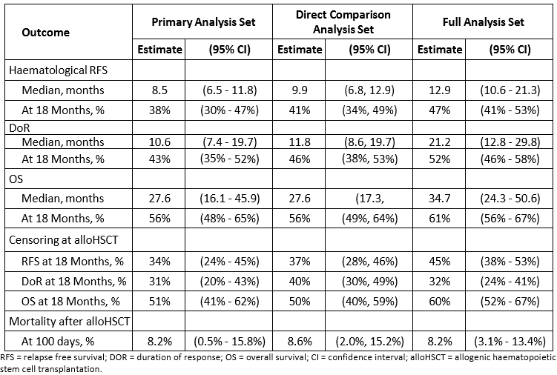

Analysis across studies

Propensity score analysis – Study MT103-203 and Study 20120148

Study design
This was a retrospective, post-hoc propensity score analysis of adult patients with MRD of B- precursor acute lymphoblastic leukaemia. The propensity score in this context was the propensity to be treated with blinatumomab.

Objectives
The objectives of the analysis was to compare blinatumomab patients from the Study MT103-203 with respect to RFS and OS after making adjustments for each study patient’s propensity score and controlling for HSCT.
- The Primary analysis set (PAS) included patients who adhered to the following criteria: Study MT103-203 criteria:
  - Received any infusion of blinatumomab
  - Philadelphia negative B–precursor ALL in complete haematological remission defined as
  - less than 5% blasts in bone marrow after at least three intensive chemotherapy blocks
  - MRD-positive at a level of > 1 x 10-3 (PCR only in Study MT103-203) but otherwise in complete haematological remission
  - At least 18 years old at the MRD baseline date
  - In their first remission (CR1 only).
- Study 20120148 criteria:
  - Philadelphia-negative B-precursor ALL in complete haematological remission
  - MRD-positive at a level of > 1 x 10-3 regardless detection method
  - At least 18 years old at the MRD baseline date
  - Time to relapse greater than 14 days from the date of MRD detection
  - In their first remission (CR1 only).

Statistical methods
The databases from the MT103-203 study and historical control Study 20120148 were merged programmatically and used for analysis. Data from the historical control Study 20120148 were filtered to match the key inclusion criteria from the MT103-203 study so that key study endpoints could be summarised to provide a historical context to the blinatumomab efficacy results from the MT103-203 study. Because the historical data mostly included patients in first remission, only that patient subgroup was analysed for the primary analysis. In addition to the primary analysis which included patients in their first remission with MRD > 1 x 10-3 detected at baseline by polymerase chain reaction (PCR) or flow cytometry, two additional analysis sets were defined: (1) restricting the data to only those with baseline MRD detected by PCR, and (2) including subjects in 2nd and 3rd remission. Separate propensity score analyses were performed for each analysis set.
Propensity scores were derived for each patient via a variable selection algorithm for logistic regression models that included age at primary diagnosis, sex, country, presence of t(4;11)MLL- AF4, time from primary diagnosis to MRD baseline, baseline MRD level, white blood cells at diagnosis, and the GMALL regimen as prior chemotherapy. The dependent variable for these models was whether or not the subject was treated with blinatumomab (that is came from the MT103-203 study). The propensity score-based weight formula chosen was that for average treatment effects (ATE), which estimates the average treatment effect from moving the entire population from untreated to treated. This approach mirrors the objective of a randomised study. For an exploratory sensitivity analysis, average treatment effect of the treated weights were also considered (ATT).
Inverse probability of treatment weights (IPTW) were derived from the scores for each subject according to their treatment status, and the balance between the two groups with respect to the baseline covariates, after weighting, was assessed primarily by evaluating standardised differences. To reduce the influence of extreme IPTW values, stabilised IPTW (sIPTW) were applied for the primary analysis. RFS and OS were then analysed using weighted Cox proportional hazard models with the treatment indicator as a baseline covariate and including a time-varying covariate for HSCT. A hazard ratio (HR) and 95% CI were calculated to measure the risk of RFS or death among blinatumomab-treated subjects relative to historical controls. Sensitivity analyses excluding the HSCT time-varying covariate were conducted in order to ascertain robustness. RFS and OS estimates at specific time-points could only be calculated from the models that did not adjust for HSCT.

Results
For the primary analysis, application of the sIPTW achieved sufficient balance between the two treatment groups, blinatumomab versus historical controls. Assessment of covariate balance after adjustment resulted in standard differences between these groups at less than 0.1 for 6 of 9 covariates and less than 0.2 for two of the remaining three. Prior to adjustment 7 out of 9 had standard difference greater than 0.1, five of which had standard differences greater than 0.2. The percent of propensity scores from the control group that were within the inner 95% of scores for blinatumomab subjects was 86.8%.
For the PAS, the RFS hazard ratio and 95% CI based on the Cox Proportional Hazard model with sIPTW and adjusting for HSCT was estimated at 0.50 (0.32, 0.78), suggesting a statistically significant 50% reduction in the risk of relapse or death associated with blinatumomab compared to historical controls. This result is robust and is supported across weighting methods and analysis sets as well as the exclusion of the HSCT time-varying covariate from the outcome model. All estimates maintained the same directional relationship with similar magnitude and confidence intervals that did not contain the equivalence value of 1.0.
The 18-month relapse-free survival (unadjusted for HCST) was estimated at 0.39 (95% CI = 0.33 to 0.48) for control and 0.67 (95% CI = 0.58 to 0.78) for blinatumomab, representing a 1.7 fold increase in 18-month relapse-free survival. Kaplan-Meier based median relapse-free survival (95% CI), unadjusted for HSCT, was estimated at 8.3 months (6.2, 11.8) for control and 35.2 months (24.2, NE) for blinatumomab representing a 26.9 month improvement in median RFS.

Table 43: Study 20120148 Propensity score analysis: Summary of endpoints analysis adjusted by propensity score method (PAS)
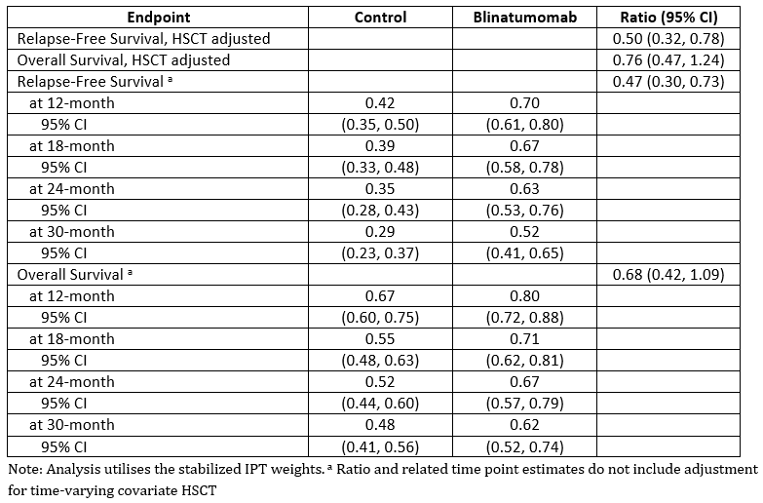
The Kaplan-Meier curves demonstrate a clear separation in relapse-free survival over time between the two treatment groups. These results demonstrate a statistically significant association between blinatumomab treatment and improvements in relapse free survival, relative to historical controls, in adult patients with MRD of B-precursor ALL that is robust against a number of sensitivity analyses.
Figure 24: Study 20120148 Propensity Score analysis: Kaplan Meier curve of relapse- free survival (PAS with stabilised IPTW)
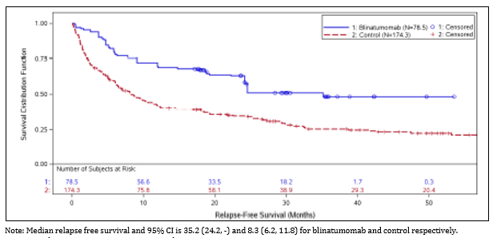
For the PAS, the OS hazard ratio and 95% CI based on the Cox proportional hazard model with sIPTW and adjusting for HSCT was estimated at 0.76 (0.47, 1.24), suggesting a directional, but not numerically significant, improvement associated with blinatumomab compared to historical controls. This result is consistent across weighting methods and analysis sets as well as the exclusion of the HSCT time-varying covariate from the outcome model. All estimates maintained the same directional relationship with similar magnitude and confidence intervals that contain the equivalence value of 1.0. The 18-month overall survival (unadjusted for HCST) was estimated at 0.55 (95% CI = 0.48 to 0.63) for control and 0.71 (95% CI = 0.62 to 0.81) for blinatumomab, representing a 1.3 fold increase in 18-month overall survival. Kaplan-Meier based median overall survival (95% CI), unadjusted for HSCT, was estimated at 27.2 months (16.4, 38.6) for control and 36.5 months (24.2, NE) for blinatumomab, representing a 9.3 month improvement in median OS. These results suggest a directional improvement in overall survival due to blinatumomab treatment compared to historical controls in adult patients with MRD of B-precursor ALL that is consistent across a number of sensitivity analyses.
Exploratory analyses of OS revealed evidence of a treatment-by-HSCT interaction (p = 0.0795); that is, the effect of blinatumomab relative to control was significantly different prior to or in the absence of HSCT than it was subsequent to HSCT. After accounting for this interaction (that is, when separate treatment effects in the pre- and post-HSCT setting were modelled), blinatumomab was associated with a meaningful improvement in OS prior to or in the absence of HSCT (HR=0.405, 95% CI = 0.165 to 0.995) but no difference in OS following HSCT (HR=1.03, 95% CI = 0.611 to 1.748).

Pooled data of Studies MT103-202 and MT103-203 analysis sets

Table 44: Summary of analysis sets: Pooled data Studies MT103-202 and MT103-203
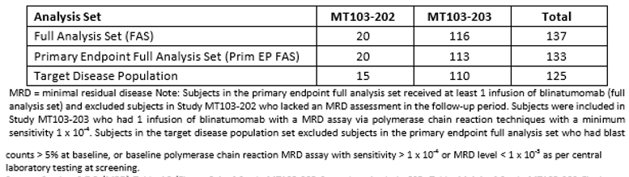

Minimal residual disease response rate and duration
The MRD response rates were similar for both studies. In the Prim EP FAS and the target disease population sets the MRD response rates in Study MT103-202 were 80.0% (16/20) and 86.7% (13/15) and in Study MT103-203 were 86.7% (98/113) and 86.4% (95/110), respectively.

Table 45: Pooled data Studies MT103-202 and MT103-203 MRD response rates in Cycle 1 (Prim EP FAS snd target disease population set)
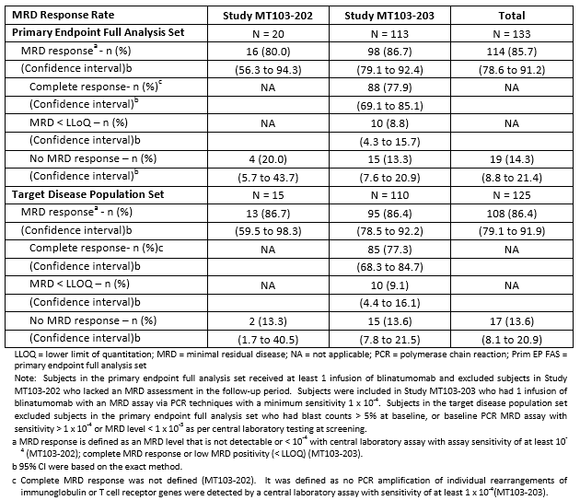
In the Prim EP FAS, 104 subjects had a complete MRD response in Cycle 1 and either had an event or were censored (50.0%; 52/104 each). Of the 52 subjects who had an event, 35 subjects (33.7%) had a relapse and 17 (16.3) died. The median (CI) time to an event was 16.6 months (11.3, 23.3) as estimated from KM curves. Of those subjects who were censored, 41 (39.4%) completed the study with a complete MRD response and the remaining 11 (10.6%) completed the study in haematologic remission. The median (CI) duration of MRD response was 16.6 months (11.3 to 23.3) as estimated with KM curves. The results were similar in the target disease population set.

Table 46: Pooled data Studies MT103-202 and MT103-203: Duration of MRD response (Prim EP FAS and target disease population set)
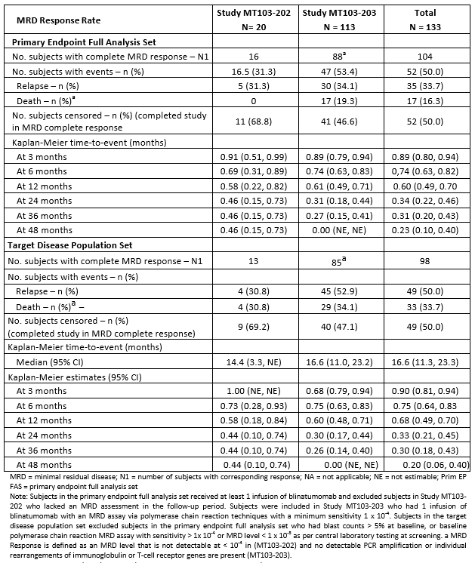

Relapse free survival
In the Prim EP FAS, 73 subjects (54.9%) had an event and 60 subjects (45.1%) remained free from relapse and were censored (45.1%; 60/133) in cycle 1 and completed the study in remission. Forty-seven subjects (35.3%) had a relapse, 25 (18.8%) died, and 1 (0.9%) had secondary leukaemia. The median (CI) duration of MRD response was 22.3 months (15.0 to 44.3) as estimated with KM curves. The results were similar in the target disease population set.

Table 47: Pooled data Studies MT103-202 and MT103-203 Summary of relapse-free survival: (Prim EP FAS & target disease population sets)
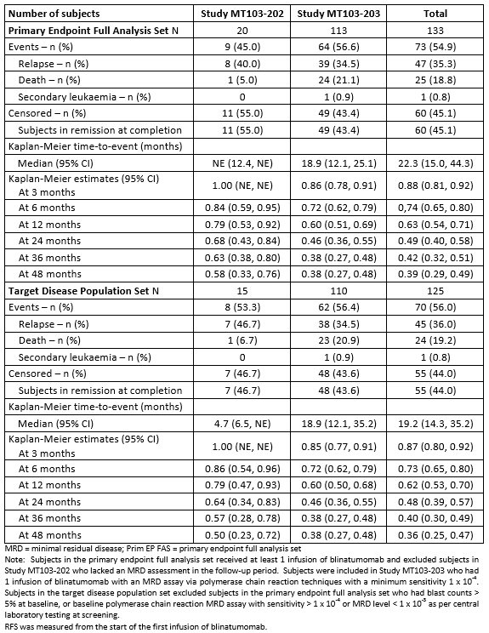
Figure 25: Pooled data Studies MT103-202 and Study MT103-203: Kaplan-Meier curves of relapse-free survival: (Primary endpoint full analysis set)
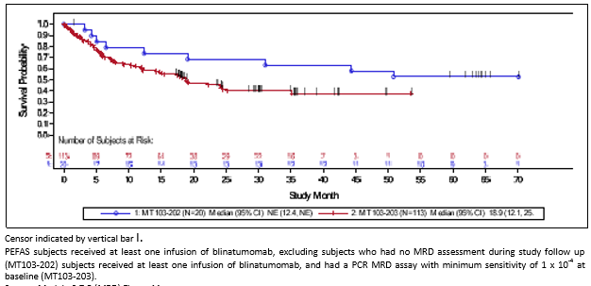
A landmark analysis of RFS at Day 45 in Study MT103-202 and Study MT103-203 and pooled data was conducted. In the Prim EP FAS, 103 subjects with an MRD response either had an event or were censored for RFS at day 45. Ten subjects died, relapsed, or were censored before day 45. Nearly half of the subjects (48.5%, 50 subjects) had an event and slightly more than half (51.5%, 53 subjects) remained relapse-free and were censored and completed the study in remission. Of the 50 subjects who had an event, 31 subjects (30.1%) had a relapse and 19 (18.4%) died. The median (CI) time to an event was 29.6 months (17.7, ne) versus 8.1 months (1.8, not estimable) in 20 subjects who did not have an MRD response (N=14 with an event (70%_; n=6 censored (30%)) as estimated with KM curves. The results were similar in the target disease population set.
The RFS censored at the time of HSCT or chemotherapy after blinatumomab treatment was determined in 103 subjects (77.4%): 77 subjects (57.9%) had an HSCT, 10 subjects (7.5%) had chemotherapy after blinatumomab, and 16 subjects (12.0%) completed the study in remission. Thirty subjects (22.6%) had an event and the median time (CI) to the event was 44.3 months (6.5, not estimable) as estimated with KM curves. The results were similar in the target disease population set.

Duration of haematologic remission
In the Prim EP FAS, 49 subjects (36.8%) had an event and 84 subjects (63.2%) were censored. Of the subjects with an event, 47 (35.3%) had a relapse, 1 (0.8%) had progressive disease and died, and 1 (0.8%) had secondary leukaemia. The median (CI) duration of haematologic remission was 50.8 months (25.1, not estimable) as estimated with KM curves. Of the 84 subjects who were censored, 60 (45.1%) completed the study in remission and 24 (18.0%) completed the study but were not in remission. The results were similar in the target disease population set.

Table 48: Pooled data Studies MT103-202 and MT103-203: Duration of haematologic remission: (Prim EP FAS and target disease population set)
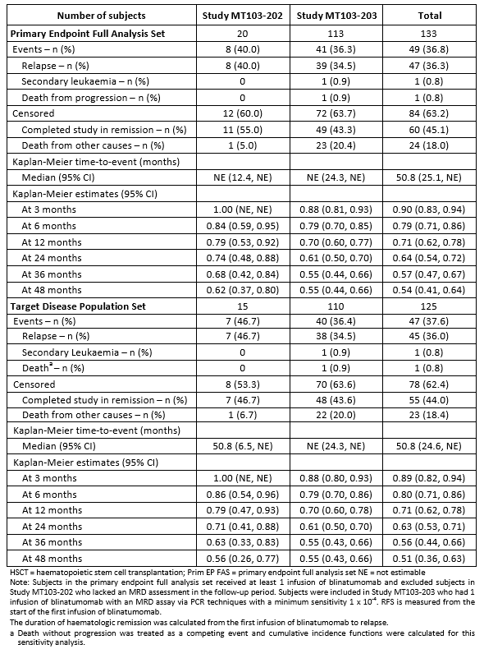
When HSCT or chemotherapy after blinatumomab treatment after haematologic remission were considered as competing events, 106 subjects (79.7%) who were censored: 77 (57.9%) had an HSCT and 10 (7.5%) had chemotherapy after blinatumomab, 16 (12.0%) who were censored completed the study in remission, and 3 died from other causes. Twenty-seven subjects (20.3%) had an event and the median time (CI) to the event was 44.3 months (7.1, not estimable) as estimated with KM curves. The results were similar in the target disease population set.

Minimum residual disease response rate by subpopulations
The MRD response rate by age, sex, Philadelphia chromosome status, and remission status in the Prim EP FAS was analysed. The MRD response rate by age was similar between the entire population and subpopulations. The MRD response rates were greatest in youngest (between 18 to < 35 years old) and oldest subjects (≥ 65 years old). The MRD response rate by gender and number of relapses were similar. Subjects who were Philadelphia chromosome-positive had slightly lower MRD response rates than subjects who were Philadelphia chromosome-negative.

Table 49: Pooled data Studies MT103-202 snf MT103-203: MRD response rates in Cycle 1 for subpopulations: (Prim EP FAS)
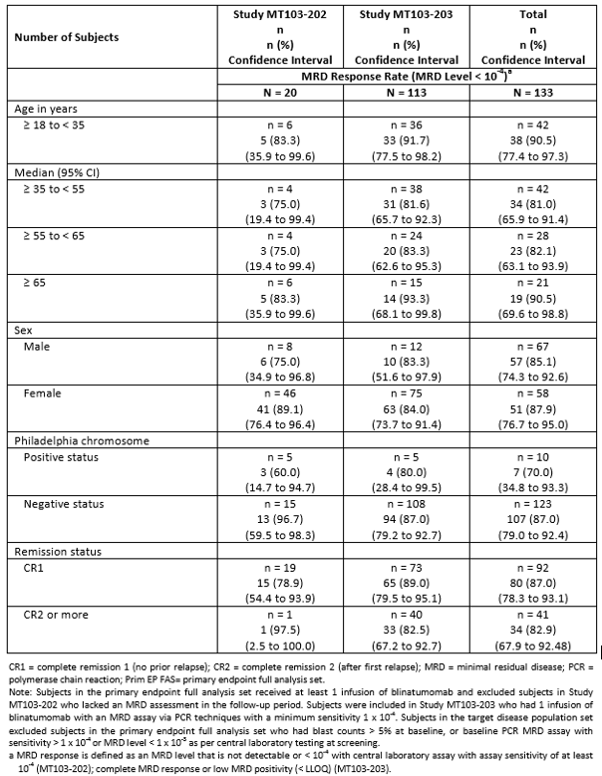

Duration of minimum residual disease response by subpopulation
Blinatumomab-induced a complete MRD response regardless of increasing age, sex, Philadelphia chromosome status, or remission status.
The median time (CI) to an event decreased with increasing age as follows: 23.8 months (18.2, ne) in subjects ≥ 18 years of age to < 35 years of age, 16.7 months (6.5, 45.0) in subjects ≥ 55 years of age to < 65 years of age, and 13.8 months (3.3, ne) in subjects ≥ 65 years of age. The median time to an event was not estimable for subjects ≥ 35 years of age to < 55 years of age.
Females had a longer median time to an event than males: 17.9 months (7.0, ne) versus 14.5 months (10.1, ne), respectively.
Subjects who were Philadelphia chromosome negative had a longer median time to an event than subjects who were Philadelphia chromosome positive: 17.9 months (13.3, 23.6) versus 14.5 months (10.1, 23.2), respectively. Subjects who were in CR1 had a longer median time to an event than subjects who were in CR2 or more: 18.3 months (13.8, 45.0 versus 11.3 months (5.3, 18.2), respectively.

Relapse-free survival by subpopulation
In subpopulations analysed, the median time (CI) to an RFS event was lowest in subjects ≥ 55 years of age to < 65 years of age (15.1 months [6.5, 35.2]), and increased in subjects ≥ 65 years of age (44.3 [5.1, ne]), and in subjects ≥ 35 years of age to < 55 years of age (119.1 [5.1, ne]). It was not estimable (50.8, ne) for subjects ≥ 18 years of age to < 35 years of age. Subjects who were Philadelphia chromosome negative had a longer median time to an event that subjects who were Philadelphia chromosome positive: 17.9 months (13.3, 23.6) versus 14.5 months (10.1, 23.2), respectively. Subjects who were in CR1 had a longer median time to an event than subjects who were in CR2 or more: 18.3 months (13.8, 45.0) versus 11.3 months (5.3, 18.2), respectively. The median time to an event was greater in males than females, in subjects with Philadelphia chromosome negative than Philadelphia chromosome-positive, and subjects in CR1 than CR2 or more.

Duration of haematologic remission by subpopulation
The median (CI) time to a haematologic relapse was not estimable for subjects in any subpopulation with the exception of subjects who were Philadelphia chromosome positive (44.3 months [2.1, ne]) and subjects who had a remission status of CR2 or more (12.0 months [7.1, ne]).

Evaluators conclusion of clinical efficacy – Indication 2
The sponsor has provided two pivotal studies (MT103-202 and MT103-203) and results for the pooled population and one historical comparator study (20120148) to support the efficacy of blinatumomab in patients with MRD positive ALL who are in haematological remission.
The primary analysis for both the pivotal studies were submitted and evaluated in the original submission. These studies appeared to be included in the original submission primarily to provide PK and PD data. The indication of MRD positive disease does not appear to have been requested at that time.
In this submission the secondary analysis for each study was submitted to support the request for the MRD positive R/R ALL as a separate indication.
The aim of the secondary analysis for Study MT103-202 was to provide longer term follow up to define the long term relapse free survival (RFS) and MRD results for eligible subjects.
The aim of the secondary analysis for Study MT103-203 was to evaluate the effect of blinatumomab on haematological relapse and on OS and 100 day mortality rate associated with allogeneic HSCT.
The results for the primary and secondary analyses were as follows.

Primary analysis (from previous CER)
Study MT103-202: MRD response (incidence of MRD negativity within 4 cycles of treatment) was 80% (16/20 subjects, 95% CI: 56.3, 94.3); all observed in Cycle 1.
Study MT103-203: MRD response (within the first cycle) was 77.9% (88/113, 95% CI: 69.1, 85.1). Two additional subjects responded during Cycle 2.

Secondary analysis (this application)
Study MT103-202; MRD relapse 5/16 responders; median duration of complete MRD response was 13.0 months (95%CI: 2.8, ne); median haematological RFS has not been reached after median of 1550 days (> 4 years). 10 subjects were relapse free after 5 years (range 1816 to 2138 days); final RFS estimate was 52.6% at day 2138.
Study MT103-203; The 18-month KM estimate for RFS, censored at HSCT or post- blinatumomab chemotherapy, was 54% (95% CI, 33% to 70%); median RFS was not estimable. Without censoring for HSCT or post-blinatumomab chemotherapy, the KM estimated OS rate at 18 months was 65% (95% CI: 55, 73), with a median OS of 36.5 months (95% CI: 19.2, ne). Overall survival at 18 months with censoring for HSCT or post-blinatumomab chemotherapy was 83% (95% CI: 55, 94); the median OS was not estimable.
The results demonstrate that blinatumomab is effective in treating MRD positive disease in patients with MRD positive B-cell ALL and who were in complete haematological remission.
It is noted that in the Clinical Overview (MRD) which provides results for pooled data the complete MRD response is given as 78.2% (104 subjects). Subjects who had a complete MRD response after blinatumomab treatment were able to maintain a longer duration of RFS (29.6 months [17.7, ne] for subjects who had an MRD response versus 8.1 months [1.9, ne] for subjects without a response). Overall survival was only measured in Study MT103-203.

Indication 3 Amendment to PI clinical trial section

Study 00103311
A Phase III, Randomised, Open Label Study Investigating the Efficacy of the BiTE Antibody Blinatumomab Versus Standard of Care Chemotherapy in Adult Subjects with Relapsed/Refractory B-precursor Acute Lymphoblastic Leukaemia (ALL) (TOWER Study)
Comment: This is an interim report, with a cut-off date of 4 January 2016. The final analysis is stated to be written at a later date when the subjects still being treated with blinatumomab discontinued or completed treatment. At the time of the data cut-off 22 subjects continued to be treated with protocol specified therapy.
This study was the post marketing requirement for the US December 2014 accelerated approval for blinatumomab and a specific obligation for the EU, with the primary efficacy endpoint of overall survival. It was also a specific condition of the initial approval of Blincyto in Australia.
The study was stopped early at the recommendation of the Data Monitoring Committee (DMC) for demonstrating superior OS of blinatumomab compared to SOC chemotherapy. The study was discontinued on 2 March 2016 and the data cut- off date was 4 January 2016

Study design, objectives, locations and dates
A Phase III, randomised, open label, study conducted at 101 sites in 21 countries in Asia (Israel [5], South Korea [4], Taiwan [3]), Australia (6), Europe (Austria [3], Belgium [5], Bulgaria [2], Czech Republic [3], France [7], Germany [12], Greece [4], Ireland [1], Italy [10], Poland [3], Russia [4], Spain [5], Turkey [5], UK [5]) and Latin (Mexico [2]) and North America (Canada [2], USA [10]) from January 2014 to March 2016 when the study was discontinued.
The study consisted of up to a 3-week screening and pre-phase period, a treatment period consisting of induction with 2 cycles of either blinatumomab or standard of care (SOC) chemotherapy (1 of 4 pre specified, investigator chosen regimens) a consolidation phase of up to 3 additional cycles of protocol-specified therapy, and a maintenance phase for up to an additional 12 months with protocol specified therapy. A safety follow-up visit 30 days after the last dose of protocol specified therapy and a long-term follow-up period were included.

Primary objective
To evaluate the effect of blinatumomab on OS when compared to SOC chemotherapy.

Secondary objectives
- To evaluate haematologic response induced by blinatumomab when compared to SOC chemotherapy
- To evaluate event-free survival (EFS) induced by blinatumomab when compared to SOC chemotherapy
- To evaluate MRD responses induced by blinatumomab when compared to SOC chemotherapy
- To estimate the effect of blinatumomab on patient reported outcomes (PROs), global health status/quality of life (QoL) using the European Organisation for Research and Treatment of Cancer Quality of Life Questionnaire (EORTC QLQ)-C30
- To evaluate the incidence of allogeneic haematopoietic stem cell transplantation (alloHSCT) and 100-day mortality following alloHSCT in blinatumomab-treated subjects when compared to SOC chemotherapy
- To evaluate the safety of blinatumomab when compared to SOC chemotherapy.

Inclusion and exclusion criteria

Inclusion criteria
Male and female (non-childbearing potential) aged ≥ 18 years and diagnosed with Ph-negative B-cell precursor ALL with any of the following disease characteristics:
- Refractory to primary induction therapy or refractory to salvage therapy
- In untreated first relapse with first remission duration < 12 months
- In untreated second or greater relapse
- Relapse any time after alloHSCT
and had received intensive combination chemotherapy for treatment of ALL for initial treatment or subsequent salvage therapy; with greater than 5% blasts in bone marrow and ECOG performance status ≤ 2.

Exclusion criteria
Malignancy other than ALL within 5 years; Burkitt’s leukaemia, HIV, HBV or HCV; autologous HSCT within 6 weeks or alloHSCT within 12 weeks before baseline; current relevant CNS pathology or known or suspected CNS involvement, current or history of autoimmune disease with potential CNS involvement; active acute Grade 2 to 4 GvHD that required systemic treatment 2 weeks before baseline; abnormal laboratory values (ALT or AST or ALP ≥ 5 x ULN, total bilirubin or creatinine ≥ 1.5 x ULN) or calculated creatinine clearance < 60 mL/min.

Study treatments
Subjects were randomised to treatment with either blinatumomab or 1 of 4 pre specified, investigator chosen, standard of care (SOC) chemotherapy regimens.

Blinatumomab treatment
- Induction phase: Two induction cycles of blinatumomab. A single cycle of blinatumomab was defined as 6 weeks in duration, which included 4 weeks of continuous intravenous (cIV) infusion of blinatumomab followed by a 2-week treatment-free interval.
- Consolidation phase: Subjects who achieved a bone marrow response (≤ 5% of bone marrow blasts) or CR/CRh*/CRi within 2 induction cycles of treatment were permitted to continue to receive up to 3 additional consolidation cycles of their assigned protocol-specified therapy
- Maintenance phase: Subjects who received 2 induction, and up to 3 consolidation cycles of protocol-specified therapy and continued to have a bone marrow response (≤ 5% of bone marrow blasts or CR/CRh*/CRi) were allowed to continue to receive their assigned protocol- specified therapy for an additional 12 months (4 cycles). One cycle was defined as 12 weeks in duration, 4 weeks of blinatumomab cIV followed by an 8 week treatment-free period. Subjects must have discontinued treatment earlier if 1 of the following conditions occurred: received alloHSCT, investigator decided to stop therapy, needed excluded medications, or toxicity or relapse were experienced.
The initial dose of blinatumomab was 9 µg/day cIV infusion for the first 7 days of treatment in cycle 1. The dose was increased (dose step) to 28 µg/day starting on day 8 (Week 2) through day 29 (Week 4). For all subsequent cycles (beginning with the second induction, through 3 consolidation cycles and the maintenance phase for applicable subjects), the administered dose was 28 µg/day throughout 4 weeks of continuous treatment.

Standard of Care Chemotherapy (SOC)
Subjects randomised to receive SOC chemotherapy were assigned to 1 of 4 pre specified, investigator-chosen regimens. Once started, the regimen was not changed except for safety reasons. Chemotherapy was administered as follows:
- FLAG (fludarabine, cytarabine arabinoside, and granulocyte colony-stimulating factor) ± anthracycline-based regimen (such as idarubicin 10 mg/m² days 1 and 3; fludarabine 30 mg/m² days 1 to 5; cytarabine arabinoside 2 g/m² days 1 to 5)
  - Subjects > 60 years of age: Idarubicin 5 mg/m² day 1 and 3; fludarabine 20 mg/m² day 1 to 5; cytarabine arabinoside 1 g/m² day 1 to 5
- HiDAC (high-dose cytarabine arabinoside); based regimen at least 1 g/m² or greater per day ± anthracycline and/or in combination with other drugs such as native Escherichia coli asparaginase, polyethylene glycol linked to asparaginase (PEG-asparaginase), vinca alkaloids, steroids, etoposide or alkylating agents
- High-dose methotrexate-based regimen (HDMTX; 500 mg/m² to 3 g/m² infused up to 24 hours) in combination with native Escherichia coli asparaginase, PEG-asparaginase), vinca alkaloids, steroids, etoposide or alkylating agents.
- Clofarabine as a single agent as recommended in the prescribing information or clofarabine based regimens with 20 mg/m²/day for up to 5 days.

Efficacy outcomes
The primary efficacy outcome was overall survival (OS).
The secondary outcomes were:
- Best response of CR within 12 weeks of treatment initiation
- Best response of CR/CRh*/CRi within 12 weeks of treatment initiation
- Event Free Survival (EFS) - was calculated from the time of randomisation until the date of disease assessment indicating a relapse after achieving a CR/CRh*/CRi or death, whichever occurred first. Subjects who failed to achieve a CR/CRh*/CRi within 12 weeks of treatment initiation were considered treatment failures and assigned an EFS duration of 1 day. Subjects still alive and relapse-free were censored on the last disease assessment date. If the last disease assessment date was after the date that triggered the analysis, the subject was censored at the analysis trigger date
- Duration of CR
- Duration of CR/CRh*/CRi
- MRD response (defined as MRD level below 10-4 by quantitative PCR or flow cytometry) within 12 weeks of treatment initiation
- Time to a 10 point decrease from baseline in global health status and QoL scale using EORTC QLQ C30, or EFS event
- AlloHSCT with or without blinatumomab treatment
Subjects were evaluated for efficacy at the end of each treatment cycle via a central bone marrow aspiration (morphological assessment at cycles 1 and 2; MRD at cycles 1, 2, and all remaining cycles) and local peripheral blood counts were performed to evaluate the efficacy of protocol-specified therapy. Subjects in remission continued to be evaluated for efficacy during the long-term follow-up period.

Randomisation and blinding methods
Subjects were randomised via an interactive voice response system (IVRS) in a 2:1 ratio to blinatumomab or SOC chemotherapy. The randomisation was stratified by age (< 35 years versus ≥ 35 years), prior salvage therapy (yes versus no), and prior alloHSCT (yes versus no).
The study was open label and so study drugs were not blinded.

Analysis populations
- Full Analysis Set (FAS) = all randomised subjects analysed according to their randomised treatment assignments, regardless of the treatment received.
- Interim Analysis Set = all subjects in the FAS who were randomised at the time of the database cut-off on 4 January 2016 which was triggered when 50% (165 deaths) and 75% (248 deaths) of the total of 330 deaths have been observed.

Sample size
In the FAS, if 330 deaths were observed, the study was powered at approximately 85% for a 2-sided log-rank test with an overall alpha of 0.05 with a 2:1 randomization ratio and an assumed hazard ratio of 0.70. Approximately 400 randomised subjects were needed to observe 330 deaths and assumed a control arm median of 4.2 months. If 300 deaths were observed in the study, the unconditional power decreased to approximately 80%.

Statistical methods
The primary analysis was performed on the FAS. A 2-sided stratified log-rank test, stratified by the randomisation factors, was used to determine if OS was superior in the blinatumomab arm compared to SOC chemotherapy arm. In addition, a hazard ratio with a 95% CI was estimated from a stratified Cox regression model. The KM summaries were performed by treatment arm. Sensitivity analyses were performed on a subset of subjects who received protocol-specified therapy. The KM summaries included KM curves, KM proportions at select time points, KM quartiles (when estimable), the number of subjects with events, the number of subjects censored, and the pattern of censoring. Two-sided 95% CIs were provided for the estimates of KM quartiles, KM proportions and binomial properties.
Key secondary efficacy endpoints of CR and CR/CRh*/CRi were analysed with a 2-sided Cochran-Mantel-Haenszel test, which adjusted for the stratification factors at randomisation, to assess whether the blinatumomab arm had a significantly higher CR or CR/CRh*/CRi rate within 12 weeks of treatment initiation compared to the SOC chemotherapy arm. In addition, the percentage of subjects in each treatment arm with a CR or CR/CRh*/CRi was summarised with an exact binomial 95% CI. Subjects missing post-baseline disease assessments were considered not to have achieved CR.
A 2-sided stratified log-rank test was used to determine whether EFS was superior in the blinatumomab arm compared to the SOC chemotherapy arm. Like OS, a hazard ratio and KM summaries were used to summarise EFS.

Major protocol violations/deviations
Overall, a lower incidence of important protocol deviations was observed in subjects randomised to SOC chemotherapy versus subjects randomised to blinatumomab, 9.0% (12 subjects) versus 18.5% (50 subjects), respectively. The most frequent deviations in both treatment arms were bone marrow aspirates and biopsies that were missing at the screening visit or after Cycle 2 (6% [8 subjects] in the SOC chemotherapy arm and 8.5% (23 subjects) in the blinatumomab arm); deviations in the bone marrow aspirates at screening (2.2% (3 subjects) in the SOC arm and 5.9% [16 subjects] in the blinatumomab arm); wrong treatment or incorrect dose (8.1% [22 subjects] all in the blinatumomab arm) due to delay in changing blinatumomab IV bags within specific schedule time window; overdose > 10% of blinatumomab (11 subjects) and dose not reduced after Grade 3 or greater event (1 subject).

Participant flow
The primary analysis was triggered by the positive, second interim analysis result when 75% (248 subjects) of the total number of deaths (330) were observed. On 28 January 2016, the DMC recommended that the study be stopped for benefit because the p-value = 0.011 was less than the pre specified threshold of 0.0183 for statistical significance testing for OS.

Table 50: Study 00103311: Subject disposition (FAS)
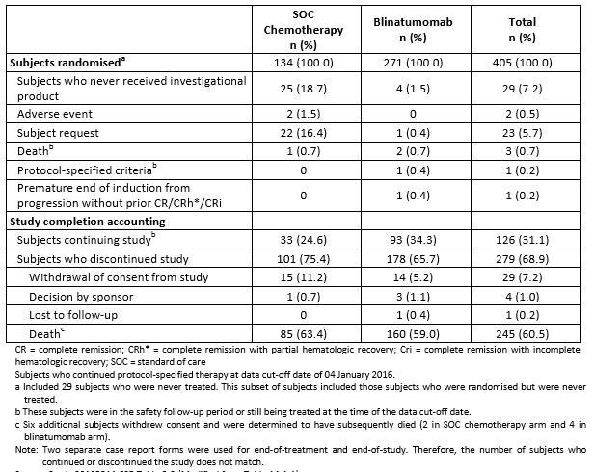

Baseline data
In the FAS, over half of the subjects were 35 years of age or older (54.8%), most had prior salvage therapy (60.2%) and did not have a previous alloHSCT (65.4%). Most subjects were male (59.0%), White (84.0%), and were not Hispanic or Latino in ethnicity (90.1%). The median age (range) was 37.0 years (18, 80), with subjects < 65 years representing 88.1% of the enrolled population and with subjects ≥ 75 years representing 3.0% of the population. The largest age group was younger than 35 years (184 subjects (45.4%)). The sex, race, ethnicity, and age demographics were well balanced between treatment arms.

Results for the primary efficacy outcome
The primary efficacy endpoint was OS, which was based on the FAS consistent with the intent- to-treat principle.
The median OS (95% CI) was 4.0 months (2.9, 5.3) in the SOC chemotherapy arm compared with 7.7 months (5.6, 9.6) in the blinatumomab arm with a p = 0.012 (stratified log-rank test). The hazard ratio (95% CI) was 0.71 (0.55, 0.93) between treatment arms indicated a 29% reduction in hazard rate (improved survival) in the blinatumomab arm.
In the snapshot of the primary analysis, 251 deaths were reported (that is 76.1% information time fraction, 251/330 planned deaths which was less than the critical p-value of 0.0194) resulting in a critical p value=0.0194 (that is the threshold for statistical significance) based on the O’Brien- Fleming-type alpha spending function.
Figure 26: Study 00103311: Kaplan-Meier curve of overall survival (FAS)
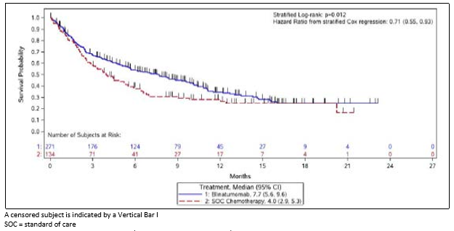
Of the 405 randomised subjects, 251 deaths from any cause were reported: 87 (64.9%) in the SOC chemotherapy arm and 164 (60.5%) in the blinatumomab arm. At the last follow-up visit, 126 subjects were still alive, 33 (24.6%) in the SOC chemotherapy arm and 93 (34.3%) in the blinatumomab arm. Of those 126 subjects, 22 continued to receive blinatumomab treatment, and 28 subjects (14 from each treatment arm) had discontinued from the study with unknown vital status. The median follow-up time was similar, 11.8 months in SOC chemotherapy am versus 11.7 months in the blinatumomab arm.

Table 51: Study 00103311: Overall Survival (PAS and Sensitivity Analyses)
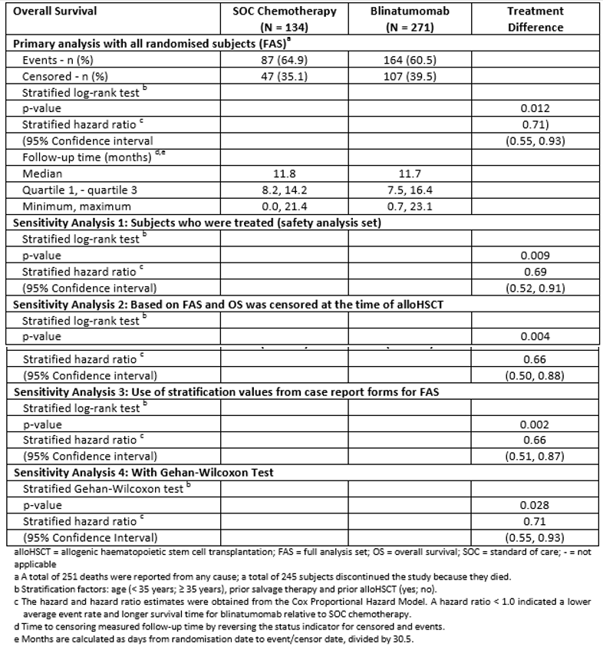
Subgroup analyses were performed to explore the consistency of OS in subgroups that tested treatment-by-subgroup interaction according to a Cox regression analysis (p-value<0.10 was suggestive of an inconsistent treatment effect). The hazard ratio for all subgroups was less than 1 indicating that it favoured blinatumomab treatment.

Figure 27: Study 00103311: Overall survival by subgroup analysis (FAS)
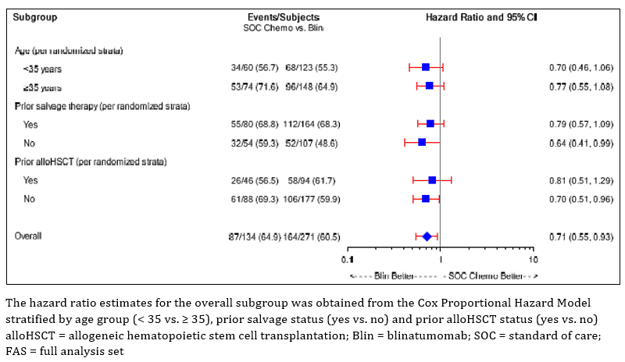

Table 52: Study 00103311: Overall survival by subgroup analysis (FAS)
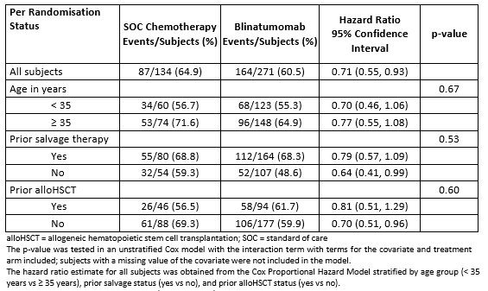

Results for other efficacy outcomes
Since the study was fully enrolled and all subjects had completed at least 12 weeks of treatment, the analysis of CR rates and CR/CRh*/CRi rates can be considered final (rather than interim) are presented. Since the results are final and the primary efficacy endpoint was statistically significant, hierarchical hypothesis testing of these endpoints (first CR, then CR/CRh*/CRi as predefined in the SAP) could be conducted with the overall Type I error rate controlled at 5%.

Best haematologic response within 12 weeks
In the FAS, subjects who were randomised to blinatumomab had a better response than subjects randomised to SOC chemotherapy: CR (33.6% versus 15.7%; p<0.001) and CR/CRh*/CRi (43.9% versus 24.6%; p < 0.001), respectively. The result of both these endpoints were considered statistically significant.
The results from the sensitivity analyses were consistent with the results from the FAS.

Subgroup analysis
Both the subgroup analysis for CR and CR/CRh*/CRi showed that subjects who had prior salvage therapy and prior alloHSCT had greater odds of response than subjects without prior salvage therapy and without prior alloHSCT. No other notable differences were demonstrated with other subgroup analyses.

Event free survival (EFS)
Among all the subjects randomised, 75.4% (101/134) subjects in the SOC arm and 56.1% (152/271) subjects in the blinatumomab arm did not achieve CR/CRh*/CRi and were assigned an EFS duration of 1 day. Hence, the median time to EFS was 1 day (rounded to 0 month) in both treatment arms.
The subject incidence of events (for example, no response, relapse, death due to any cause) was higher in the SOC chemotherapy arm (88.8%) versus the blinatumomab arm (77.1%). The EFS hazard ratio (95% CI) from stratified Cox regression model was 0.55 (0.43, 0.71) comparing blinatumomab to SOC chemotherapy. The stratified log rank test yielded a p=< 0.001. However, since more than half of the subjects in both treatment arms did not achieve CR/CRh*/CRi, the median time to EFS was 1 day (rounded to 0 month) in both treatment arms.
Figure 28: Study 00103311: Event-free survival (FAS)
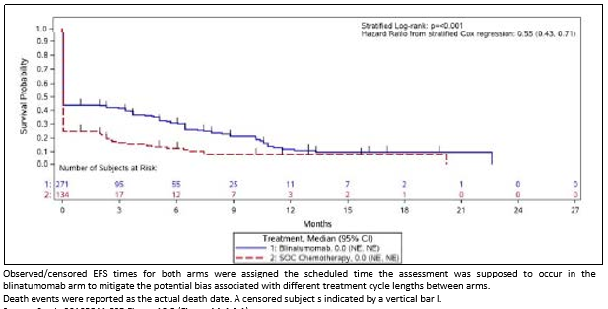

Table 53: Study 00103311: Event-free survival (FAS and sensitivity analyses)
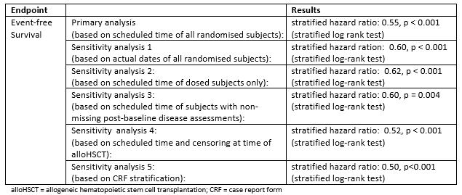

Subgroup analysis
In the subgroup analysis, no statistically significant treatment-by-subgroup interaction effects were observed for EFS with the exception of prior alloHSCT (p = 0.012).

Duration of haematologic response
Of the 112 subjects who had a best response of CR, 49 subjects had an event and 63 subjects were censored. The median time to an event was 7.8 months (95% CI: 2.2, 19.0) in theSOC chemotherapy arm compared with 8.3 months (95% CI: 5.7, 10.7) in the blinatumomab arm. All subjects who were censored were alive at the time of the data cut-off date of 04 January 2016.
Of the 152 subjects who had a best response of CR/CRh*/CRi, 75 subjects had an event and 77 subjects were censored. The median time to an event was 4.6 months (95% CI: 1.8, 19.0) in the SOC chemotherapy arm compared with 7.3 months (95% CI: 5.8, 9.9) in the blinatumomab arm. All subjects were alive at the time of the data cut-off date of 4 January 2016.

Table 54: Study 00103311: Duration of best response of CR and CR/CRh*/CRi (FAS)
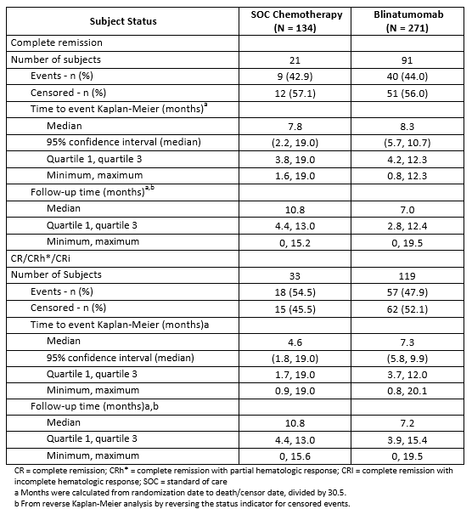

MRD response
An MRD response was defined as an MRD level < 10⁻⁴. A total of 235 subjects had an MRD assessment and an evaluable post baseline evaluation. Of those 235 subjects, 130 subjects also had a CR/CRh*/CRi (33 in the SOC chemotherapy arm versus 97 in the blinatumomab arm) and 90 subjects had an MRD response (16 [48.5%] in the SOC chemotherapy arm versus 74 [76.3%] in the blinatumomab arm) with a 27.8% treatment difference favouring blinatumomab (95% CI: 8.8%, 46.8%). A subset of 68 subjects had an MRD complete response (defined as MRD level below the level of detection), 10 subjects (30.3%) in the SOC chemotherapy arm and 58 subjects (59.8%) in the blinatumomab arm with a 29.5% treatment difference favouring blinatumomab (95% CI: 11.0%, 48.0%).
MRD response was assessed by 2 methods: quantitative PCR and flow cytometry. The method of PCR was used more commonly than flow cytometry; 194 subjects versus 41 subjects, respectively. With PCR, 10 subjects (41.7%) in the SOC chemotherapy arm and 61 subjects (74.4%) in the blinatumomab arm (evaluated by PCR) achieved an MRD response and a CR/CRh*/CRi with a treatment difference of 32.7% (95% CI: 10.9%, 54.6%). With flow cytometry, 6 subjects (66.7%) in the SOC chemotherapy arm and 13 subjects (86.7%) in the blinatumomab arm had an MRD complete response (all MRD responses were complete) with a treatment difference of 20.0% (95% CI: -15.3%, 55.3%).

Post baseline allogeneic haematopoietic stem cell transplantation
Overall, a similar incidence of post baseline alloHSCT was reported from both treatment arms: 32 subjects (23.9%) randomised to SOC chemotherapy and 65 subjects (24.0%) randomised to blinatumomab.

Survival status and 100-Day mortality rate after alloHSCT
Of the 152 subjects with a CR/CRh*/CRi, 18 subjects (54.5%; 18/33) randomised to SOC chemotherapy and 50 subjects (42.0%; 50/119) randomised to blinatumomab had an alloHSCT. The median time (95% CI) to alloHSCT was 3.6 months (2.3, 7.2) in the SOC chemotherapy arm and 11.3 months (5.2, not estimable) in the blinatumomab arm. The remainder of subjects did not have an alloHSCT and were censored; 15 subjects (45.5%) randomised to SOC chemotherapy and 69 subjects (58.0%) randomised to blinatumomab were censored after alloHSCT. The time (minimum, maximum) to censoring in months was 5.2 (0.9, 11.0) in the SOC chemotherapy arm and 7.8 (1.1, 19.8) in the blinatumomab arm.
In the SOC chemotherapy arm, the mortality rate at 100 days was 0 (not estimable). In the blinatumomab arm, the mortality rate at 100 days was 12.4% (4.8%, 29.9%).

Other efficacy studies
Summaries of the further analysis of studies in Ph negative ALL and DLBCL (initial CSRs submitted in previous submissions) are provided.

Study MT103-211
This was a Phase II, open-label, multicentre, single-arm, exploratory study that evaluated the efficacy, safety, and tolerability of blinatumomab in 225 adult subjects with Ph-negative B precursor R/R ALL with first remission duration ≤ 12 months or after first salvage therapy or within 12 months of alloHSCT receiving a cIV infusion of blinatumomab starting at 9 µg/day for 1 week and then increasing to 28 µg/day over 4 weeks followed by 2 weeks without treatment. Patients could receive up to 5 cycles. The primary endpoint was CR/CRh* rate within 2 cycles. The results for the primary endpoint were previously presented and evaluated in the initial application.
The key secondary endpoints presented in this application were: TTR, RFS, OS, incidence of alloHSCT after treatment and MRD response.
The results for the primary endpoints was: CR/Crh* = 43.9% (CR 33.3%, CRh* 10.6%).
The results for the key secondary endpoints were: relapse free survival = 6.8 months with nearly 40% who achieved CR/CRh* proceeding to transplant; MRD response = 82%.Remission rates were consistent across a wide range of demographic and baseline characteristic subgroups including the observation that subjects older than 65 years of age achieved the same response rate as subjects from 18 to 35 years of age and patients who failed prior allogeneic HSCT achieving the same response rates as those without prior allogeneic HSCT.

Study MT103-208
It is unclear why this study was included in this submission. No explanation is provided by the sponsor. It is assumed the main reason for the study was to provide additional safety data.
This was a Phase II exploratory, open label, multicentre, single arm study to evaluated the efficacy, and safety of blinatumomab in adult subjects with R/R DLBCL using two dose regimens (step dose 9/28/112 µg/day versus constant dose 112 µg/day). The primary endpoint of this study was objective response rate after the first treatment cycle = 42.9% 95% CI: 21.8% to 66.0%). Four subjects achieved a CR and 5 subjects achieved a partial response. The median duration of objective response was 11.6 months. At the time of this data analysis, the median progression- free survival was 3.7 months and the median overall survival was 7.7 months; however, these data are not mature as the study is ongoing.

Analysis preformed across trials: pooled studies
The sponsor provided the same comparison of the results of Study 00103311 to the previously evaluated primary analysis of Study MT103-211 (Ph-) and Study 201201216 (Ph+).

Evaluators conclusions on efficacy – Indication 3
Study 00103311, was stopped early at the recommendation of the Data Monitoring Committee (DMC) for demonstrating superior efficacy for the primary endpoint of overall survival (OS) of blinatumomab compared with SOC chemotherapy. The external independent DMC conducted two formal interim analyses to assess OS when approximately 50% and 75% of the total number of deaths were observed. The critical p-values corresponding were 0.0031 for the first interim analysis, 0.0183 for the second interim analysis, and 0.044 for the final analysis if the interim analyses occurred precisely at 165 (50%) and 248 (75%) deaths.
At the discontinuation of the study 251 (76.1%) deaths had occurred.
The median overall survival rate for blinatumomab was 7.7 months compared to 4.0 months for SOC chemotherapy (p = 0.012). The hazard ratio was 0.71 (95% CI: 0.55, 0.93) between treatment arms indicating a 29% improvement in survival in the blinatumomab arm.
This study provides confirmation of the interim analysis of Study MT103-211 which was the basis of the initial approval.
The key secondary outcomes for Study MT103-211 were: relapse free survival = 6.8 months
with nearly 40% who achieved CR/CRh* proceeding to transplant; MRD response = 82%.

Clinical safety

Studies providing evaluable safety data
The summary safety data in this submission is contained in three documents:
- (R/R ALL):
  - Adult Philadelphia Chromosome-negative Relapsed/Refractory B-cell precursor ALL – pooled data from:
    - Study 00103311 – blinatumomab arm only – n = 271
    - Study MT103-211 – secondary analysis - n = 225
    - Study MT103-206 – n = 36
  - Paediatric and adolescent Relapsed/Refractory B-cell precursor ALL – pooled data from:
    - Study MT103-205 – n = 93
    - Study 2012216 – n = 40
  - Adult Philadelphia Chromosome-positive Relapsed/Refractory B-cell precursor ALL
    - Study 20120216 – n = 45
  - Relapsed/Refractory ALL Pooled - Pooled data from above 6 studies – n = 710
  - Adult MRD-positive ALL – pooled data from:
    - Study MT103-202 – n = 21
    - Study MT103-203 – n = 116
  - Pooled data from all 8 studies – n = 847
- (MRD); contains the same studies as (tower) with the exception that for the paediatric and adolescent group it include Study MT103-205 (n=93) and Study 20130320 (n=20), in place of Study 2012216.
- The Integrated Summary of Safety (R/R ALL) - contains the same studies as (R/R ALL)
Comment: Since the paediatric data is not directly relevant to this submission (no paediatric studies were included in this submission) the safety summary below is taken from the CSRs for the individual studies and the Summary of Clinical Safety (tower) for R/R ALL and for the pooled data for adults.
Study MT103-208 is not discussed in any of the summaries and so is included here as study evaluated for safety only.

Pivotal studies that assessed safety as the sole primary outcome
Not applicable.

Pivotal and/or main efficacy studies
The safety data collected consisted of:
- General adverse events (AEs): were elicited by observation by the investigator or reported by the subject during study visits
- AEs of particular interest: were identified from preclinical and nonclinical investigations, similar drugs in class, and /or data from clinical trials and/or post- marketing experience. The pre-specified AEs of particular interest were: neurologic events, cytokine release syndrome (CRS), infections, elevated liver enzymes, infusion reactions, tumour lysis syndrome (TLS), capillary leak syndrome (CLS), medication errors, decreased immunoglobulins, embolic and thrombotic events (including disseminated intravascular coagulation (DIC)), leukoencephalopathy including progressive multifocal leukoencephalopathy (PML),neutropaenia andfebrile neutropaenia, lymphopaenia, immunogenicity, and pancreatitis.
- Laboratory tests: standard haematology, clinical chemistry, and urinalysis testing was conducted a specified time points – usually each study visit). In addition, in coagulation tests (PTT and INR) and lymphocyte subsets and biomarkers were collected at protocol specified times (usually each study visit)
- Vital signs (heart rate, blood pressure, weight, body temperature and ECG were recorded at protocol specified times

Other studies

Other efficacy studies
Same as for pivotal studies.

Studies with evaluable safety data: dose finding and pharmacology
Not applicable – no independent pharmacology studies were conducted.

Studies evaluable for safety only
Study MT103-208. Safety data includes all 25 subjects in the FAS (up to cut-off date of 10 July 2014).

Studies that assessed safety as the sole primary outcome
Not applicable.

Patient exposure
Blinatumomab exposure by study is provided in the table below.

Table 55: Blinatumomab dose regimen by study
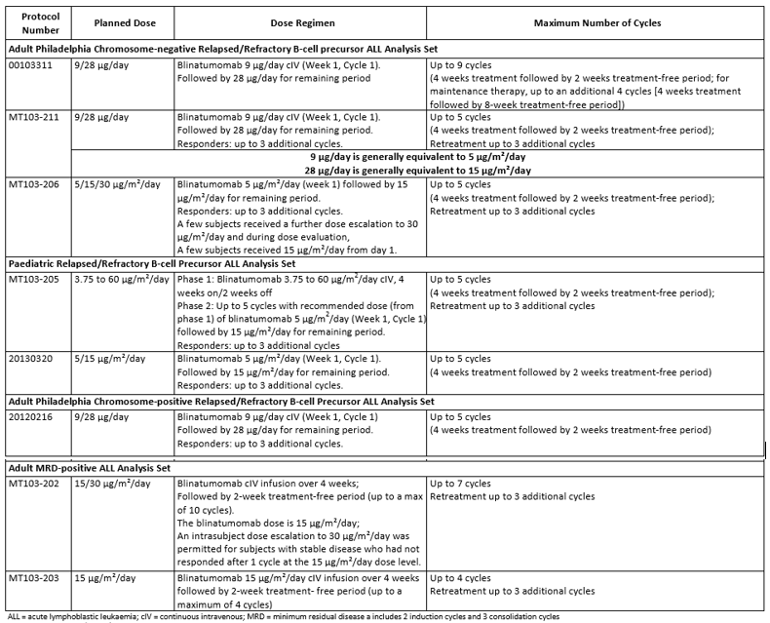

Table 56: Exposure duration and number of cycles of blinatumomab treatment
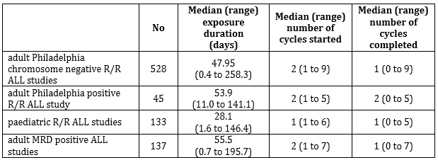
Across all studies in these analyses (ALL pooled population), the incidence of treatment interruption due to a treatment emergent adverse event (TEAE) was approximately 30%, ranging from 18% for the paediatric relapsed/refractory ALL studies to approximately 36% for the adult Philadelphia chromosome-positive relapsed/refractory ALL studies, and the incidence of blinatumomab discontinuation due to a TEAE was 14.5%, ranging from 6.7% for the adult Philadelphia chromosome-positive relapsed/refractory ALL studies to 16.8% for the adult MRD- positive ALL studies.
In Study MT103-208 the treatment duration was up to 8 weeks in length for Cycle 1, up to 4 weeks for Cycle 2, and up to 8 weeks retreatment.
For Cycle 1, a total of 25 subjects (100%; 25/25) received at least 1 infusion of blinatumomab. Twenty-three subjects initiated the dose-escalation regimen of 9/28/112 µg/day blinatumomab (Cohorts 1 and 3) and 2 subjects initiated a constant dose regimen of 112 µg/day blinatumomab (Cohort 2). A total of 12 subjects (48%; 12/25) completed cycle 1 (11 subjects in Cohorts 1 and 3; 1 subject in Cohort 2). For Cycle 2, 8 subjects (32%; 8/25) were treated with the dose- escalation regimen of blinatumomab, and 5 subjects (20%; 5/25) completed this cycle.

Table 57: Study MT103-208: Summary of blinatumomab exposure by cohorts (FAS)
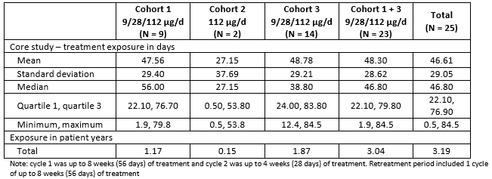

Adverse events

All adverse events (irrespective of relationship to study treatment)

Integrated safety analyses
At least 1 TEAE was reported for 837 of 843 subjects (99.3%) in the ALL pooled population and 700 of 706 subjects (99.2%) in the relapsed/refractory ALL pooled population and for all 137 subjects (100%) in the adult MRD-positive ALL studies in the Safety Analysis Set.
The common AE profiles are similar across all studies, and the types of common TEAEs among adult subjects with relapsed/refractory ALL are comparable regardless of Philadelphia chromosome status. The lower percentages of AEs in the adult MRD-positive subjects was not unexpected considering the comparatively lesser extent of illness and lower disease burden in these patients compared with patients with relapsed/refractory ALL.
Among the 706 subjects in the relapsed/refractory ALL pooled population, the most common TEAEs (≥ 10% subject incidence rate) were pyrexia (64.6%), headache (31.6%), nausea (21.8%), anaemia (24.9%), febrile neutropaenia (23.7%), hypokalaemia (19.8%), diarrhoea (19.3%), peripheral oedema (17.3%), thrombocytopaenia (16.3%), neutropaenia (16.0%), cough (15.4%), vomiting (15.0%), fatigue and constipation (14.6% for each), back pain (13.6%), CRS (13.3%), tremor and hypotension (12.5% for each), ALT increased (11.5%), abdominal pain (11.3%), bone pain (11.0%), pain in extremity (10.8%), and hypertension and chills (10.1% for each).
Regardless of Philadelphia chromosome status, the types of common TEAEs are similar among adult subjects with relapsed/refractory ALL. Among the most common TEAEs (≥ 10% incidence rate) in the adult Philadelphia chromosome-negative relapsed/refractory ALL studies, there were few events with a difference in incidence rate of ≥ 5% between the adult Philadelphia chromosome-negative and positive relapsed/refractory ALL studies.
Nausea (21.6% versus 15.6%), neutropaenia (18.0% versus 6.7%), cough (16.1% versus 11.1%), tremor (14.2% versus 8.9%), CRS (12.9% versus 6.7%), hypomagnesemia (10.8% versus 4.4%), and rash (10.0% versus 2.2%) occurred more frequently in the adult Philadelphia chromosome- negative relapsed/refractory ALL subjects compared with the adult Philadelphia chromosome- positive relapsed/refractory ALL subjects, respectively, while anaemia (28.9% versus 22.0%), febrile neutropaenia (40.0% versus 24.4%), thrombocytopaenia (22.2% versus 15.3%), and bone pain (20.0% versus 10.4%) occurred more frequently in the adult Philadelphia chromosome-positive relapsed/refractory ALL subjects compared with the adult Philadelphia chromosome-negative relapsed/refractory ALL subjects.

Table 58: Summary of TEAEs – Pooled analyses (Safety analysis set)
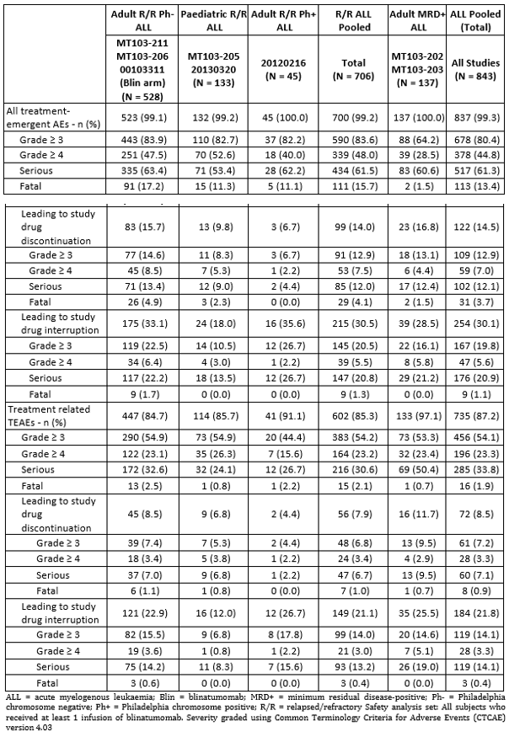
Among the 843 subjects in the ALL pooled population, the TEAEs with the highest subject incidence rates were pyrexia (68.8%), headache (32.9%), nausea (22.1%), anaemia (21.8%), and febrile neutropaenia (20.2%). The types of AEs in the ALL pooled population were comparable with those previously reported.

Table 59: Incidence of TEAEs in ≥ 10% of subjects in any ALL population by Preferred Term in descending frequency – Pooled analyses (Safety analysis set)
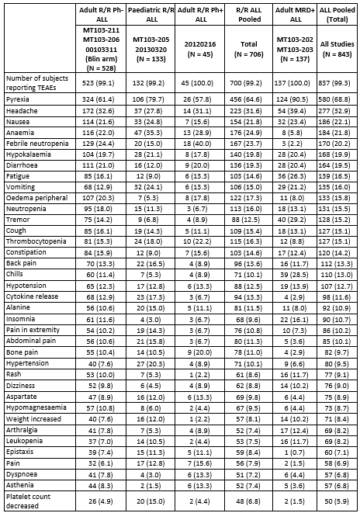

Table 59(continued): Incidence of TEAEs in ≥ 10% of subjects in any ALL population by Preferred Term in descending frequency – Pooled analyses (Safety analysis set)
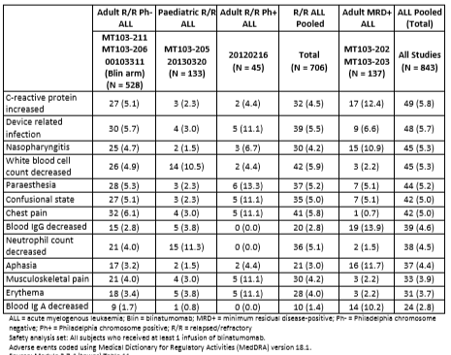

Main/pivotal studies that assessed safety as the sole primary outcome
Not applicable.

Pivotal and/or main efficacy studies

Study 20120216 (Ph+)
This study is ongoing. As of the cut-off date (20 May 2015) 45 subjects (100%) reported at least one TEAE. The TEAEs with the highest subject incidences were pyrexia (58%), febrile neutropaenia (40%) and headache (31%). Fatal TEAEs were reported for 5 subjects (11%).

Study 00103311 (Ph-)
At least 1 TEAE was reported for 108 subjects (99.1%) in the SOC chemotherapy treatment arm and 263 subjects (98.5%) in the blinatumomab treatment arm.
Fatal TEAEs were reported for 19 subjects (17.4%) in the SOC chemotherapy arm and 51 subjects (19.1%) in the blinatumomab arm.

MRD studies (Study MT103-202 and MT103-203)
In the pooled analysis of MRD positive ALL patients, the incidence of TEAE was 100% (137/137). The incidence of fatal AEs was low (2 subjects; 1.5%) in the adult MRD-positive ALL population when compared with the other populations. This finding is not unexpected, given that subjects in the adult MRD-positive ALL population entered the studies in hematologic remission and are generally considered to be healthier than subjects in the relapsed/refractory ALL population, who have high tumour burden, impaired bone marrow function, and compromised immunity from prior chemotherapy exposure and/or myeloablative HSCT The most frequently reported adverse event was pyrexia (90.5%). Other AEs (preferred terms) occurring at an incidence of ≥ 20% in the adult MRD positive ALL population and at a rate that is ≥ 5% higher than in the adult R/R Ph-negative ALL population and the R/R ALL population were headache (39.4% versus 32.6% and 31.6%, respectively), tremor (29.2% versus 14.2% and 12.5%, respectively); chills (28.5% versus 11.4% and 10.1%, respectively); fatigue (26.3% versus 16.1% and14.6%, respectively); and vomiting (21.2% versus 12.9% and 15.0%, respectively).
The full list of TEAEs occurring in ≥ 10% of MRD positive ALL population is shown in the table above.

Other studies
Other efficacy studies

Study MT103-211 (Ph-)
As of the cut-off date 99.6% (224/225) of subjects experienced at least one TEAE. The highest subject incidences (≥ 25% of subjects) of TEAEs were pyrexia (60.4%; 136/225), headache (34.7%; 78/225), and febrile neutropaenia (28.0%; 63/225).

Studies with evaluable safety data: dose finding and pharmacology
Not applicable.

Studies evaluable for safety only

Study MT103-208 (R/R DLBCL)
As of the data cut-off date, all subjects (100%; 25/25) experienced at least 1 TEAE. The incidence of TEAEs was similar among cohorts. The highest incidences of TEAEs were tremor (52%; 13/25), pyrexia (44%; 11/25), fatigue (28%; 7/25), and diarrhoea, oedema, and pneumonia (24%; 6/25 for each).

Table 60: Study MT103-208: Summary of incidence of TEAEs (FAS)
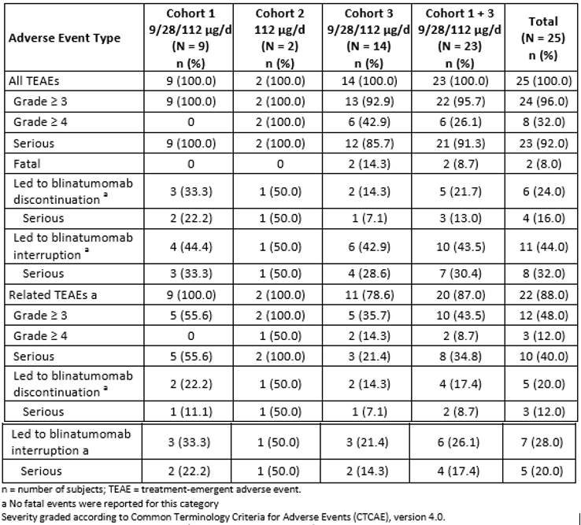

Table 61: Study MT103-208: TEAEs occurring in at least 5% of the patients by Preferred Term (FAS)

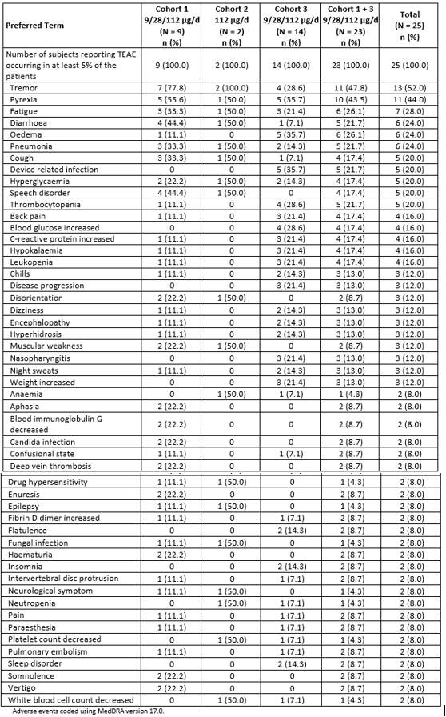

Treatment related adverse events (adverse drug reactions)

Integrated safety analyses
Among the 706 subjects in the relapsed/refractory ALL pooled population, the subject incidence rate of treatment-related treatment emergent adverse events was 85.3%.
The most common (subject incidence rate ≥ 10%) treatment-related AEs in the adult Philadelphia chromosome-negative relapsed/refractory ALL studies were pyrexia (43.0%), headache (14.2%), febrile neutropaenia (12.7%), CRS (12.5%), and neutropaenia and tremor (11.6% for each).
Only febrile neutropaenia was reported with a 5% higher subject incidence rate and only CRS and neutropaenia were reported with a 5% lower incidence for the adult Philadelphia chromosome-positive relapsed/refractory ALL subjects compared with the adult Philadelphia chromosome-negative relapsed/refractory ALL subjects. Regardless of Philadelphia chromosome status, the types of treatment-related treatment-emergent adverse events were similar among the relapsed/refractory ALL component studies and were also similar for the adult MRD-positive ALL studies.

Pivotal and/or main efficacy studies

Study 20120216 (Ph+)
The subject incidence of TEAEs considered related to blinatumomab was 91.1% (41/45). One fatal treatment emergent event of septic shock was considered related to blinatumomab. The most common (subject incidence rate ≥ 10%) grade ≥ 3 treatment-related TEAEs were febrile neutropaenia and ALT increased (11.1%, for each).

Study 00103311 (Ph-)
The subject incidence rate of treatment-related TEAE for SOC chemotherapy (84.4%) was similar to blinatumomab (80.1%).
There were 8 (7.3%) fatal TEAEs considered to be related to SOC chemotherapy and 8 (3.0%) fatal TEAEs considered as related to blinatumomab. The 8 related treatment-emergent fatal AEs in the blinatumomab arm included 2 events of sepsis and 1 event each of neutropenic sepsis, bronchopulmonary aspergillosis, respiratory failure, acute respiratory failure, bacterial infection, and sepsis syndrome. The 8 related treatment-emergent fatal adverse events in the SOC chemotherapy arm included 2 events of sepsis and 1 event each of pseudomonas infection, systemic candida, fungal pneumonia, enterococcal infection, bacteraemia, and acute kidney injury.

MRD Studies (Study MT103-202 and MT103-203)
Treatment related TEAEs were reported by 97.1% of adult MRD positive ALL population. Treatment-related adverse events with the highest subject incidences in the adult MRD-positive ALL population (≥ 20%) were pyrexia (86.1%), headache (27.7%), tremor (27.0%), chills (26.3%), and fatigue (21.2%).

Other studies

Study MT103-211 (Ph-)
Treatment related TEAEs were reported by 87.6% (197/225) subjects. The highest subject incidence (≥ 10% of subjects) of related TEAEs was pyrexia (43.1%; 97/225), followed by febrile neutropaenia (16.9%; 38/225), headache (14.7%; 33/225), and tremor (13.3%; 30/225), cytokine release syndrome and neutropaenia (12.9%. 27/225 for each), alanine aminotransferase (ALT) increased (10.7%; 24/225), and aspartate aminotransferase (AST) increased and nausea (10.2%; 23/225 for each).

Studies evaluable for safety only

Study MT103-208 (R/R DLBCL)
Overall, 88% (22/25) of subjects experienced treatment-related AEs. The incidence of treatment related AEs was similar across cohorts. The highest incidence of treatment-related AEs by SOC was Nervous System Disorders (68%; 17/25) and were tremor (52%; 13/25), pyrexia (24%; 6/25), and fatigue and speech disorder (20% for each; 5/25). No treatment related AEs resulted in death.

Deaths and other serious adverse events (SAEs)

Integrated safety analyses
Among the 843 subjects in the ALL pooled population, fatal TEAEs were reported for 113 subjects (13.4%) during the blinatumomab studies. Fatal TEAEs were reported for 111 of the 706 subjects (15.7%) in the relapsed/refractory ALL pooled population.
The subject incidence rate of treatment-emergent fatal events was more than 5% higher for the adult Philadelphia chromosome-negative relapsed/refractory ALL subjects (17.2%) compared with the adult Philadelphia chromosome-positive relapsed/refractory ALL subjects (11.1%) or the paediatric relapsed/refractory ALL subjects (11.3%).
Among the 706 subjects in the R/R ALL pooled population, the subject incidence rate of at least 1 treatment-emergent serious adverse event was 61.5%. The most frequently reported treatment emergent SAE (subject incidence ≥ 2%) in this population were febrile neutropaenia (8.2%), pyrexia (7.2%), sepsis (4.7%), pneumonia (4.0%), CRS (3.1%), device related infection (3.0%), overdose (2.7%), and encephalopathy and neutropaenia (2.0% for each).
Regardless of Philadelphia chromosome status, the types of treatment-emergent SAEs were similar among the R/R ALL component studies.

Pivotal and/or main efficacy studies

Study 20120216 (Ph+)
Up to the data cut-off date of 20 May 2015, 11.1% (5/45) of subjects had fatal TEAEs which included 1 event each of multi-organ failure, sepsis, septic shock, cerebral haemorrhage, and respiratory failure.
Treatment emergent SAEs regardless of relationship to blinatumomab were reported for 62.2% (28/45) of subjects. The SAEs with the highest subject incidence were febrile neutropaenia (8.9%; 4/45); and device related infection, sepsis, and tremor (6.7%; 3/45 each).

Study 00103311 (Ph-)
In Study 00103311, the primary endpoint was overall survival. For the primary analysis, 251 subjects died during the study for any reason: 87 of 134 subjects (64.9%) who were randomised to SOC chemotherapy; 164 of 271 subjects (60.5%) who were randomised to blinatumomab treatment. A total of 19 subjects (17.4%) in the SOC chemotherapy treatment arm and 51 subjects (19.1%) in the blinatumomab treatment arm had treatment-emergent fatal AEs. The most frequently reported fatal AE in both treatment arms was sepsis (SOC chemotherapy: 3.7%, 4/109; blinatumomab: 3.0%, 8/267).
Tabulated list of all fatal AEs is provided in the report.
Treatment-emergent SAEs regardless of relationship to study treatment were reported for 45.0% (49/109) of subjects receiving SOC chemotherapy and 61.8% (165/267) of subjects receiving blinatumomab. The most frequent treatment emergent SAEs in the SOC chemotherapy treatment arm were febrile neutropaenia (11.0%; 12/109), sepsis (6.4%; 7/109), and septic shock (2.8%; 3/109); whereas, in the blinatumomab arm they were febrile neutropaenia (8.6%; 23/267), pyrexia (6.0%; 16/267), and sepsis (4.9%; 13/267).

MRD Studies (Study MT103-202 and MT103-203)
Two (1.5%; 2/137) treatment emergent fatal AEs (atypical pneumonia and subdural haemorrhage) were reported for the adult MRD positive ALL subjects. Both deaths occurred in Study MT103-203. The pneumonia was considered related to blinatumomab.
SAEs were reported for 60.6% of subjects, which was consistent among all adult populations. The most frequently reported SAE was pyrexia (12.4%), which compares with 6.4% for the adult R/R Ph- ALL population and 7.2% for the total R/R ALL population. Other SAEs occurring at rates of > 2% in the adult MRD-positive ALL population were tremor (5.8%), encephalopathy, aphasia, lymphopaenia, (4.4%), overdose, neutropaenia (3.6%), device-related infection, seizure, C-reactive protein increased (2.9%), and Staphylococcal infection (2.2%).

Other efficacy studies

Study MT103-211 (Ph-)
Up to the data cut-off date, 17.3% (39/225) of subjects died as a result of an AE. Treatment- emergent adverse events led to death in 15.1% (34/225) of subjects. The most frequently reported fatal TEAE was sepsis (2.2%; 5/225).
Of the 39 subjects who died as a result of AEs, 6 subjects died while receiving a maximal dose of 9 µg blinatumomab and 33 subjects died while receiving a maximal dose of 28 µg blinatumomab. Thirty deaths occurred before initiating a second or later treatment cycle. Four subjects died as a result of TEAE considered as related to blinatumomab (Escherichia sepsis, sepsis, encephalopathy, and Candida infection). The events of encephalopathy and Candida infection were also attributed to protocol-mandated premedications. Up to the data cut-off date, treatment-emergent SAEs regardless of relationship to blinatumomab were reported for 64.4% (145/225) of subjects. Treatment-emergent SAEs with a subject incidence of ≥ 5% included febrile neutropaenia (9.3%; 21/225) and pyrexia (6.7%; 15/225).
Treatment related SAEs were reported in 36.0% (81/225) of subjects. Related SAEs with subject incidence of ≥ 2% included febrile neutropaenia (3.6%; 8/225), encephalopathy, neutropaenia, and overdose (2.7%; 6/225 for each), and pyrexia and tremor (2.2%; 5/225 for each).

Studies evaluable for safety only

Study MT103-208 (R/R DLBCL)
The study is ongoing. Up to the data cut-off date a total of 15 subject had died. Five subjects died during the core study (all due to disease progression) and 10 subjects died during the follow up (six due to disease progression and two due to AEs [pneumonia and disease progression]; one due to cardiogenic shock and one due to multiple organ failure after transplant). None of the deaths were considered study drug related.
SAEs were reported in 23 subjects (92%, 23/25). The incidence of treatment emergent SAEs was similar among the three cohorts. Treatment related SAEs were reported in 40% (10/25) of subjects. SAEs reported for > 1 subject included: aphasia (8% [2/25]; 2 subjects in Cohort 1); encephalopathy (8% [2/25]; 1 subject in Cohort 1 and 1 subject in Cohort 3); and neurological symptom and speech disorder (8% [2/25] for each; 1 subject in Cohort 1 and 1 subject in Cohort 2).

Table 62: Study MT103-208: Treatment emergent SAEs occurring in at least 5% of the patients by preferred term (FAS)
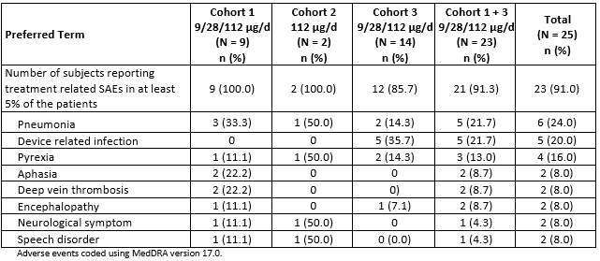

Discontinuations due to adverse events

Integrated safety analyses
Among the 843 subjects In the ALL pooled population, the incidence rate of at least 1 TEAE leading to treatment discontinuation was 14.5%. The overall subject incidence rate of TEAEs leading to treatment discontinuation was more than 5% lower for adult subjects with Philadelphia chromosome-positive relapsed/refractory ALL (6.7%) and paediatric subjects with relapsed/refractory ALL (9.8%) compared with adult subjects with Philadelphia chromosome- negative relapsed/refractory ALL (15.7%).
Incidence rates of SAEs leading to treatment discontinuation were 4.4%, 9.0%, and 13.4%, for Ph+ R/R ALL, paediatric R/R ALL and Ph- R/R ALL respectively; incidence rates of treatment- related TEAEs leading to treatment discontinuation were 4.4%, 6.8%, and 8.5%, respectively; and treatment-related SAEs leading to treatment discontinuation were 2.2%, 6.8%, and 7.0%, respectively.
Among the 706 subjects in the relapsed/refractory ALL pooled population, the subject incidence rate of at least 1 TEAE leading to treatment discontinuation was 14.0%. The most frequently reported TEAE (preferred terms) leading to treatment discontinuation in the relapsed/refractory ALL pooled population were cytokine release syndrome (where 5 of the 7 subjects were paediatric subjects and 2 were adult subjects with Philadelphia chromosome- negative relapsed/refractory ALL) and encephalopathy (where all 7 subjects were adult subjects with Philadelphia chromosome-negative relapsed/refractory ALL) (1.0% for each).

Pivotal and/or main efficacy studies

Study 20120216 (Ph+)
TEAEs leading to treatment discontinuation regardless of relationship to blinatumomab were reported in 6.7% (3/45) of subjects and included 1 event each of grade 4 neutropaenia, grade 3 acute graft versus host disease and grade 3 lung infection. SAEs of acute graft versus host disease and lung infection occurred within the induction phase of blinatumomab treatment. The event of neutropaenia occurred during the consolidation phase of blinatumomab treatment. Events of neutropaenia and acute graft versus host disease were considered related to blinatumomab.

Study 00103311 (Ph-)
TEAEs leading to treatment discontinuation regardless of relationship were reported in 8.3% (9/109) of subjects receiving SOC chemotherapy and 12.4% (33/267) of subjects receiving blinatumomab.
Treatment-emergent SAEs leading to treatment interruption in ≥ 3 subjects treated with blinatumomab were CRS (2.2%; 6/267) and pyrexia (1.1%; 3/267).

MRD studies (Studies MT103-202 and MT103-203)
TEAEs leading to treatment discontinuation were reported in 16.8% of the adult MRD positive ALL population, which was generally consistent with the adult R/R Ph- ALL (15.7%) and the total R/R ALL (14.0%) population. The most frequently reported AEs leading to permanent discontinuation of study drug (≥ 2%) were tremor (3.6%); seizure (2.9%); and encephalopathy and aphasia (2.2%), which were each reported for ≤ 1.3% of subjects in the adult R/R Ph- and total R/R ALL populations.
Treatment-related adverse events leading to permanent discontinuation of study drug were reported for 11.7% of subjects in the adult MRD-positive ALL population, 8.5% in the adult relapsed or refractory Philadelphia chromosome-negative ALL population and 7.9% in the total relapsed or refractory ALL population.

Other studies

Study MT103-211 (Ph-)
TEAEs leading to treatment discontinuation regardless of relationship to blinatumomab were reported for 17.8% (40/225) of subjects. TEAEs leading to treatment discontinuation in ≥ 1% of subjects were encephalopathy and sepsis (1.8%; 4/225 for each), and disorientation (1.3%; 3/225).

Studies evaluable for safety only

Study MT103-208 (R/R DLBCL)
Blinatumomab treatment was discontinued due to a TEAEs in 24% (6/25) of subjects. The incidences of subjects who discontinued treatment due to a TEAEs were higher in Cohort 1 (33.3%; 3/9) and Cohort 2 (50%; 1/2) compared with Cohort 3 (14.3%; 2/14). The highest incidence of TEAEs leading to treatment discontinuation by SOC was Nervous System Disorders (20%; 5/25): epilepsy (8%; 2/25) was reported for 1 subject in Cohort 1 and 1 in Cohort 2, somnolence (8%; 2/25) was reported for 2 subjects in Cohort 1, and encephalopathy (8%; 2/25) was reported for 2 subjects in Cohort 3.

AEs of special interest
Across the blinatumomab development program, the AE of special interest (event of interest, EOI) associated with blinatumomab include neurologic events, CRS, infections, elevated liver enzymes, infusion reactions, TLS, CLS, medication errors, decreased immunoglobulin, embolic and thrombotic events (including DIC), leukoencephalopathy (including PML, cytopaenias (including neutropaenia, febrile neutropaenia, and lymphopaenia), and pancreatitis.

Table 63: Summary of AEs of special interest by study/indication for blinatumomab ALL studies (Safety analysis sets)
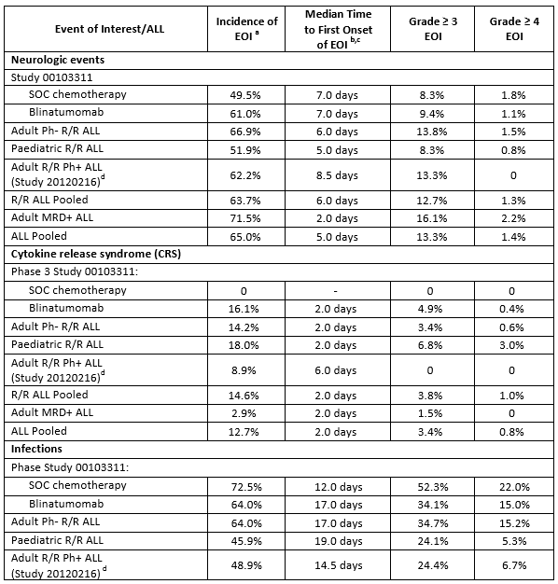

Table 63(continued) : Summary of AEs of special interest by study/indication for blinatumomab ALL studies (Safety analysis sets)
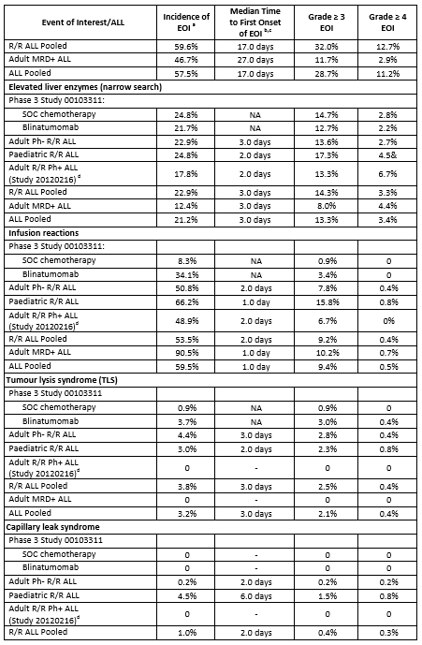

Table 63(continued): Summary of AEs of special interest by study/indication for blinatumomab ALL studies (Safety analysis sets)
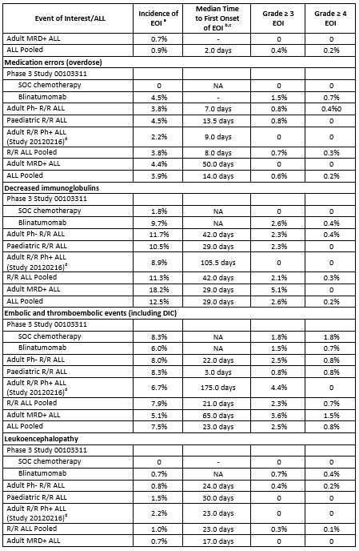

Table 63(continued): Summary of AEs of special interest by study/indication for blinatumomab ALL studies (Safety analysis sets)
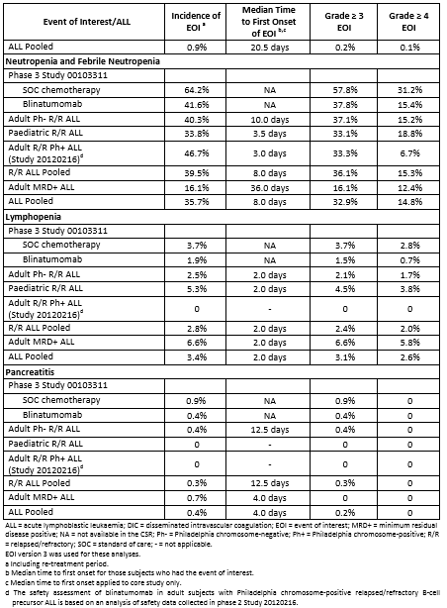

Evaluation of issues with possible regulatory impact

Liver function and liver toxicity
See table above.
In Study 00103311 the rates of elevated liver enzymes were similar between treatment arms (24.8% for subjects who received SOC chemotherapy and 21.7 for subjects who received blinatumomab); however, the exposure adjusted event rates per 100 subject years were approximately 3 times higher for subjects who received SOC chemotherapy compared with subjects who received blinatumomab (689.2 versus 197.8).
The types and frequencies of elevated liver enzyme events observed for adult subjects who received blinatumomab in Study 00103311 were consistent with those observed for adult subjects with Ph- R/R ALL, and those events reported in the original marketing application.
Subjects with Ph+ R/R ALL had a more than 5% lower rate of elevated liver enzyme events (17.8%) compared to subjects with Ph- R/R ALL (22.9%). There was no evidence to suggest that subjects with Ph+ ALL had a higher risk of experiencing events suggestive of elevated liver enzymes compared with subjects with Ph- R/R ALL.
For the adult MRD positive ALL population, hepatotoxicity events (drug-related hepatic disorders) were reported for 16.8% of subjects, which was lower than the subject incidence in the adult R/R Ph- ALL population (29.0%) and the total R/R ALL population (29.5%). Serious hepatotoxicity events (5.1% versus 2.1% and 2.1% of subjects) and grade ≥ 4 hepatotoxicity events (5.1% versus 3.0% and 3.8% of subjects) were similar between the MRD-positive ALL population and the adult R/R Ph- and total R/R ALL populations. No fatal hepatotoxicity events were reported in any ALL population.

Renal function and renal toxicity
No new safety signal was observed with respect to renal function. An analysis of nephrotoxicity revealed the types of events suggestive of potential nephrotoxicity observed across the blinatumomab ALL studies were consistent with those events reported in the original marketing application.
There was no evidence to suggest that adult subjects with Ph+ R/R ALL were at an increased risk of experiencing events suggestive of nephrotoxicity than adult subjects with Ph- R/R ALL, even though baseline renal function was worse for subjects with Ph+ R/R ALL.
There was no evidence of an increased risk of events suggestive of nephrotoxicity (acute renal failure) for the adult MRD positive ALL population compared with the adult R/R Ph- and total R/R ALL populations.

Immunogenicity and immunological events
To date, development of ADAs has been detected in 9 subjects across the blinatumomab ALL studies. Of these 9 subjects, 7 subjects were identified with ADAs that had in-vitro neutralising activity. Blinatumomab serum concentration levels in 2 out of 9 subjects were reduced. Among the 9 cases, 7 subjects achieved clinical response (CR/CRh*) as defined in the respective protocols.
The impact of immunogenicity on safety was evaluated through medical review and assessment of the type and severity of AEs, potential infusion reactions, and number of doses received while on study for blinatumomab treated antibody positive subjects. In those assessments, no evidence of an altered safety profile was observed for subjects who tested positive for anti- blinatumomab antibodies, which was consistent with the original marketing application.

Medication error
Given the blinatumomab preparation and administration as a cIV infusion over four weeks and the possibility that errors may occur during these steps, medication errors that may lead to an overdose or underdose of blinatumomab are a possibility. Across the blinatumomab ALL studies, medication errors were reported for 3.9% of subjects, which was consistent with that reported in the original marketing application. The majority of medication errors involving blinatumomab did not result in other AEs.

Other safety parameters
No other new safety issues were identified.

Other safety issues

Safety in special populations
Summaries of adverse events were examined by prespecified baseline factors, including demographic and disease related characteristics.
For all R/R ALL pooled population, subgroup analyses of AEs (including grade ≥ 3, serious, fatal, and those events leading to treatment discontinuation and interruption) were performed by age (≥ 18 to < 35 years, ≥ 35 to < 55 years, ≥ 55 to < 65 years, ≥ 65 years), gender, race, region, ECOG performance status, baseline platelets, and baseline renal function (assessed by creatinine clearance (CrCL)). For these analyses, trends, when applicable, and differences were noted.

Age
By age, the types of AEs were consistent across the blinatumomab ALL studies. With the exception of subjects with Philadelphia chromosome-positive relapsed/refractory ALL, increasing rates of events leading to treatment interruption were observed by increasing age group across the blinatumomab ALL studies. Across the blinatumomab ALL studies, encephalopathy was reported at a higher rate for subjects who were ≥ 65 years of age compared with the other age groups analysed (10.8% versus 1.7% to 3.5%).
The rate of encephalopathy reported for subjects who were ≥ 65 years of age was consistent with the rate of 13.3% for this age group reported in the original marketing application. Higher incidence rates for subjects ≥ 65 years of age were also noted for other neurologic adverse events, including cognitive disorder (2.9% versus 0.3% to 2.0%), confusional state (8.8% versus
3.7% to 6.1%), and disorientation (6.9% versus 1.4% to 3.5%) and for some infections,
including urinary tract infection (7.8% versus 2.7% to 4.5%) and device-related infection (8.8% versus 4.5% to 7.0%); however, none of these differences were more than 5% across the blinatumomab ALL studies.
By gender, race, and region, the types of AEs were consistent across the blinatumomab ALL studies.

Safety related to drug-drug interactions and other interactions
No new data submitted.

Post marketing experience
From the International Birth Date of 3 December 2014 to 2 December 2016 (data lock point for Periodic Benefit-risk Evaluation Report/Periodic Safety Update Report an estimated 2,236 patients had been exposed to blinatumomab in the marketed setting. As of 2 December 2016, sponsor received, cumulatively, a total of 1,786 serious adverse drug reactions (ADRs) in the post marketing setting, from spontaneous and solicited sources. In addition, 808 non-serious ADRs were reported spontaneously.
Overall, among the 1,786 total serious ADRs reported from spontaneous and solicited sources, the most frequently reported adverse reactions (≥ 10%) were from the system organ classes of Nervous System Disorders (17.1%), General Disorders and Administrative Site Conditions (17.0%), and Investigations (11.0%). Serious adverse reactions with an event incidence ≥ 1% were pyrexia (5.5%); cytokine release syndrome (5.0%); neurotoxicity (4.5%); death (3.9%); ALL recurrent and neutropaenia (2.4% each); blast cell count increased (1.9%); hospitalisation (1.7%); seizure and febrile neutropaenia (1.5% each); ALL (1.4%); confusional state (1.3%); sepsis, disease progression, hypotension, and platelet count decreased (1.2% each); and headache (1.0%).
These events are consistent with the known safety profile of blinatumomab or representative of the underlying malignancy.

Evaluator’s overall conclusions on clinical safety
No new safety issues were identified based on the safety analysis for the new studies or across all blinatumomab ALL studies. With the exception of pancreatitis that was identified after the original marketing application, the safety risks outlined in this submission are consistent with those identified in the original application.
The notably higher incidence of TEAEs and SAEs in the blinatumomab treatment arm as compared with the SOC chemotherapy treatment arm in Study 00103311 is consistent with the study design, which led to a longer duration of dosing for blinatumomab compared with SOC chemotherapy and therefore, the likelihood of observing AEs leading to treatment interruption was not balanced between the two treatment arms by the nature of study design.

First round benefit-risk assessment

First round assessment of benefits

Table 64: First round assessment of benefits
Indication
Benefits | Strengths and Uncertainties
Ph + R/R ALL (Study 20120216)  Primary outcome of best response during the first 2 cycles:  CR/CRh* = 35.6% (16/45) 95%CI: 21.9, 51.2  CR = 31.1% (14/45) 95%CI: 18.2, 46.6  CRh* = 4.4% (2/45) 95%CI: 0.5, 15.1  Cri (without CRh*) = 4.4% (2/45 95%CI: 0.5, 15.1  Ph- R/R ALL (Study 00103311)  Median Overall Survival = 7.7 months (95%CI 5.6, 9.6) in the blinatumomab arm compared to 4.0 months (95%CI: 2.9, 5.3) in the SOC arm.  Hazard ratio = 0.71 (95%CI: 0.55, 0.93) = 29%  reduction in hazard rate (improved survival)  MRD + R/R ALL (studies MT103-203 and MT103-202)  Pooled data response:  Complete MRD response in cycle 1 = 78.2% (104/133)  Study MT103-203:  RFS at 18 months KM estimate = 54% (95%CI: 33, 70)  OS at 18 month (with censoring HSCT and chemotherapy) = 83% (95%CI: 55, 94) | Single open label study  Not controlled or randomised  Small trial n = 45 patients  Study size = 405 total (271 blinatumomab, 135 SOC) Primary outcome = overall survival  Study stopped when superiority was established  Two studies with similar results  Pooled data from both studies  Total subjects = 133  Study is still ongoing and median OS not estimable.

First round assessment of risks

Table 65: Assessment of risks
Risks | Strengths and Uncertainties
Key risks same as in original submission: neurological events, CRS and medication errors | Safety database increased with additional studies and longer term follow up.  Total safety database = 843 subjects No new safety issues identified

First round assessment of benefit-risk balance
The benefit-risk balance of Blincyto, given the proposed usage is favourable

First round recommendation regarding authorisation

Ph + R/R ALL
The results for the primary efficacy outcome for Study 20120216 were best CR/CRh* = 35.6% (16/45 subjects). This was a single, small, open label study. It is known that the response rate for Ph+ ALL is generally ~10% lower than for Ph- ALL. The result of Study 20120216 is consistent with that. Therefore, despite the single study and small numbers the results suggest sufficient evidence of efficacy to warrant approval. As the study is ongoing and one of the secondary endpoints is overall survival a condition of approval should be that the final report of the study must be submitted for evaluation.

Ph- R/R ALL
Study 0010311, which had overall survival as its primary outcome found that treatment with blinatumomab provided a survival advantage over SOC chemotherapy. The median survival with blinatumomab was 7.7 months compared to 4.0 months for SOC.

MRD positive R/R ALL
There were two studies submitted to support the indication of treatment of MRD positive R/R ALL. These studies were submitted over two applications. In this submission the secondary analysis provided further information on MRD relapse and relapse free survival. The primary analysis (included in the original submission) demonstrated similar results for MRD complete response of ~80% during the first or second cycle. The median RFS has not been reached after median of over 4 years in Study MT103-202 and in the pooled data the median duration of MRD response was 22.3 months (15.0 to 44.3) as estimated with KM curves. While MRD is considered a surrogate (intermediate) endpoint in patients with complete clinical remission of chronic ALL, overall survival was measured in Study MT103-203 and was improved in subjects with a complete MRD response versus subjects without a response.
In both studies the entry criteria was patients with MRD positive B precursor ALL and were in complete haematological remission (defined as <5% blasts in bone marrow after at least 3 intense chemotherapy blocks). This should be reflected in the indication.
Based on the clinical data submitted approval of Blincyto is recommended for the following indication:
- Blincyto is indicated for the treatment of relapsed or refractory B-cell precursor acute lymphoblastic leukaemia (ALL).
- Blincyto is indicated for the treatment of minimal residual disease (MRD) positive B-cell precursor acute lymphoblastic leukaemia (ALL) in patients in complete haematological remission.
  - Note to indication: the indications in Philadelphia positive, MRD positive and paediatric patients were approved based on Phase II, non-randomised evidence. An improvement in clinical outcomes by direct prospective comparison in a randomised setting relative to other standard-of –care salvage therapies has not been established.
It should be a condition of approval that the sponsor submit the final CSRs for the studies which are still ongoing, that is, Studies 20120216, 00103311, and MT103-203.

Clinical questions and Second round evaluation of clinical data submitted in response to questions
No clinical questions were asked and the sponsor has not submitted any new clinical information. The sponsor provided comments on the PI.

Second round benefit-risk assessment

Second round assessment of benefits
No new clinical information was submitted in response to the first round. Accordingly, the benefits of Blincyto are unchanged identified in the previous section.

Second round assessment of risks
No new clinical information was submitted in response to the first round. Accordingly, the risks of Blincyto are unchanged from those identified in the previous section.

Second round assessment of benefit-risk balance
The second round assessment of the benefit-risk balance is favourable

Second round recommendation regarding authorisation
The recommendation for approval is unchanged from the first round. Approval is recommended for the following indications:
- Blincyto is indicated for the treatment of relapsed or refractory B-cell precursor acute lymphoblastic leukaemia (ALL).
- Blincyto is indicated for the treatment of minimal residual disease (MRD) positive B-cell precursor acute lymphoblastic leukaemia (ALL) in patients in complete haematological remission.
  - Note to indication: the indications in Philadelphia positive, MRD positive and paediatric patients were approved based on Phase II, non-randomised evidence. An improvement in clinical outcomes by direct prospective comparison in a randomised setting relative to other standard-of –care salvage therapies has not been established.

References
- Cheson BD, Pfistner B, Juweid ME, et al. Revised response criteria for malignant lymphoma. J Clin Oncol. 2007; 25: 579-586.
- Clopper CJ, Pearson ES. The use of confidence or fiducial limits illustrated in the case of the binomial. Biometrika. 1934; 26: 404-413.
- FDA. BEST (Biomarkers, Endpoints, and other Tools) Resource. FDA- NIH Biomarker Working Group. 28 April 2016.
- https://healthpolicy.duke.edu/events/minimal-residual-disease- surrogate-endpoint-hematologic-cancer-trials. Accessed 13 October 2016
- Kaplan EL, Meier P. Nonparametric estimation from incomplete observations. J Am Stat Assoc. 1958; 53: 457-481.
- Porcher R, Desseaux K. What inference for two-stage phase II trials? BMC medical research methodology. 2012: 12; 117.

Therapeutic Goods Administration
PO Box 100 Woden ACT 2606 Australia
Email: info@tga.gov.au Phone: 1800 020 653 Fax: 02 6232 8605
https://www.tga.gov.au

