June 2014
Updated August 2017

Australian Public Assessment Report for Bimatoprost
  - Proprietary Product Name: Latisse
  - Sponsor: Allergan Australia Pty Ltd

About the Therapeutic Goods Administration (TGA)
- The Therapeutic Goods Administration (TGA) is part of the Australian Government Department of Health and is responsible for regulating medicines and medical devices.
- The TGA administers the Therapeutic Goods Act 1989 (the Act), applying a risk management approach designed to ensure therapeutic goods supplied in Australia meet acceptable standards of quality, safety and efficacy (performance), when necessary.
- The work of the TGA is based on applying scientific and clinical expertise to decision-making, to ensure that the benefits to consumers outweigh any risks associated with the use of medicines and medical devices.
- The TGA relies on the public, healthcare professionals and industry to report problems with medicines or medical devices. TGA investigates reports received by it to determine any necessary regulatory action.
- To report a problem with a medicine or medical device, please see the information on the TGA website <http://www.tga.gov.au>.
About AusPARs
- An Australian Public Assessment Record (AusPAR) provides information about the evaluation of a prescription medicine and the considerations that led the TGA to approve or not approve a prescription medicine submission.
- AusPARs are prepared and published by the TGA.
- An AusPAR is prepared for submissions that relate to new chemical entities, generic medicines, major variations, and extensions of indications.
- An AusPAR is a static document, in that it will provide information that relates to a submission at a particular point in time.
- A new AusPAR will be developed to reflect changes to indications and/or major variations to a prescription medicine subject to evaluation by the TGA.
Copyright
© Commonwealth of Australia 2014
This work is copyright. You may reproduce the whole or part of this work in unaltered form for your own personal use or, if you are part of an organisation, for internal use within your organisation, but only if you or your organisation do not use the reproduction for any commercial purpose and retain this copyright notice and all disclaimer notices as part of that reproduction. Apart from rights to use as permitted by the Copyright Act 1968 or allowed by this copyright notice, all other rights are reserved and you are not allowed to reproduce the whole or any part of this work in any way (electronic or otherwise) without first being given specific written permission from the Commonwealth to do so. Requests and inquiries concerning reproduction and rights are to be sent to the TGA Copyright Officer, Therapeutic Goods Administration, PO Box 100, Woden ACT 2606 or emailed to <tga.copyright@tga.gov.au>.

Contents
List of commonly used abbreviations 5
I. Introduction to product submission 7
Submission details 7
Product background 7
Regulatory status 8
Product Information 8
This product is no longer registered on the Australian Register of Therapeutic Goods and therefore there is no Australian Product Information (PI) available.II. Quality findings 8
Introduction 8
Drug substance (active ingredient) 8
Drug product 9
Biopharmaceutics 9
Quality summary and conclusions 9
III. Nonclinical findings 9
Introduction 9
Pharmacology 9
Pharmacokinetics 10
Toxicology 11
Nonclinical summary and conclusions 11
IV. Clinical findings 12
Introduction 12
Pharmacokinetics 13
Pharmacodynamics 13
Dosage selection for the pivotal studies 14
Efficacy 14
Safety 16
First round recommendation regarding authorisation 22
Clinical Questions 23
Second round evaluation of clinical data submitted in response to questions 24
Second round recommendation regarding authorisation 34
V. Pharmacovigilance findings 34
Risk management plan 34
VI. Overall conclusion and risk/benefit assessment 39
Quality 39
Nonclinical 39
Clinical 40
Risk management plan 47
Risk-benefit analysis 47
Initial outcome 54
Attachment 1. Extract from the Clinical Evaluation Report 64

List of commonly used abbreviations
Abbreviation | Meaning
AE | Adverse Event
ALT | Alanine aminotransferase
AST | Aspartate aminotransferase
AOI | Area of interest: the specific region that includes all eyelashes for a given eye
BAK | Benzalkonium chloride
Bim | Bimatoprost
CER | Clinical evaluation report
CRF | Case report form
CSR | Clinical study report
DIA | Digital Image Analyses
ECOG | Eastern Cooperative Oncology Group
ESQ | Eyelash Satisfaction Questionnaire
FDA | Food and Drug Administration
GCP | Good clinical practice
GEA | Global eyelash assessment
GGT | Gamma glutamyl transpeptidase
hct | haematocrit
ICH | International Conference on Harmonisation
IEC | Institutional ethics committee
IOP | Intraocular pressure
IRB | Institutional Review Board
ITT | Intention to treat
IVRS | Interactive voice response system
IWRS | Interactive web response system
LDH | Lactate dehydrogenase
LOCF | Last observation carried forward
MedDRA | Medical Dictionary for Regulatory Activities
mm | millimetres
mmHg | millimetres of mercury
NOS | Not otherwise specified
OH | Ocular hypertension
OTC | Over the counter
OU | Each eye
Pbo | Placebo
PI | Product information
Pixel | the smallest discrete component of a digital image
PK | Pharmacokinetic
PP | Per protocol
PRO | Patient reported outcomes
PSUR | Periodic safety update report
QD | Daily
SAE | Serious Adverse Event
SD | Standard deviation
SOC | System organ class
SOP | Standard operating procedure
spline | a narrow area approximately 5 pixels wide, bisecting the AOI (area of interest)
TP1 | Treatment period 1 (0-6 months)
TP2 | Treatment period 2 (6-12 months)
US | United States
VA | Visual acuity
Veh | Vehicle

I. Introduction to product submission

Submission details
Type of submission: | Extension of indications; New trade name and new dosage form
Decision: | Rejected
Date of Initial TGA Decision: | 18 November 2013
Date of Final TGA Decision | 9 April 2014
AAT | Approved
Date of AAT decision: | 6 October 2015
Date of entry onto ARTG:  Date ARTG entry cancelled:  Active ingredient(s): | 14 July 2016  22 August 2017  Bimatoprost
Product name(s): | Latisse
Sponsor’s name and address: | Allergan Australia Pty Ltd.  Locked Bag 1514 Pymble NSW 2073
Dose form(s): | Solution 3 mL
Strength(s): | 300 µg/mL (0.03% weight/volume (w/v))
Container(s): | Low Density Polyethylene (LDPE) 3 mL bottle and Sterile Single use Disposable Applicators.
Pack size(s): | 1 x 3 mL bottle plus 60 sterile single use applicators (packaged as 6 blister trays, each containing 10 sterile applicators)
Approved therapeutic use: | Not applicable
Route(s) of administration: | Topical
Dosage: | Not applicable
ARTG number (s): | not applicable

Product background
This AusPAR describes the application by Allergan Pty Ltd to register Latisse (bimatoprost 0.3 mg/mL topical solution) for the following therapeutic indication:
For treatment of hypotrichosis of the eyelashes by increasing their growth, including length, thickness and darkness.
Bimatoprost is a synthetic prostamide (prostaglandin ethanolamide), structurally related to prostaglandin F_{2α} (PGF_{2α}).
When treating with Latisse, one drop of solution is to be applied to the upper eyelid margin at the base of the eyelashes per day using an applicator. A new sterile applicator is to be used for each eye. The lower eyelash line is not to be treated.
This application for registration of Latisse involves:
- A new route of administration and dosage form: 3 mL fill in 5 mL dropper bottle plus 60 sterile, single use, applicators. The package is classified as a medicinal kit (Section 7B Therapeutic Goods Act 1989).
- New indication.
- A new tradename (Latisse)
This is a re-submission the original application which was withdrawn by the sponsor prior to presentation to the TGA’s Advisory Committee on Prescription Medicines (ACPM).

Regulatory status
Latisse topical solution for treatment of hypotrichosis has been registered in the USA (2008) and Canada (2009). An application to the EU was withdrawn.

Product Information

This product is no longer registered on the Australian Register of Therapeutic Goods and therefore there is no Australian Product Information (PI) available.II. Quality findings

Introduction
The proposed product and the applicators are supplied together in one package, as a “medicinal kit”.
There are no British Pharmacopeia (BP)/European Pharmacopeia (Ph. Eur.)/or US Pharmacopeia (USP) monographs for bimatoprost or products containing it.

Drug substance (active ingredient)
The details of the drug substance have been evaluated by the TGA in a previous submission, including the manufacture sites of bimatoprost, apart from editorial updating of test method numbers (but not the methods themselves), which are the same independent of manufacturing site. These changes are acceptable.

Drug product
The differences in this application compared to the previous submission relate to the additional sites for manufacturing of filled bottles and additional sites for sterilisation of empty bottles, bottle caps and tips. These are acceptable, as additional evidence for Good Manufacturing Practice (GMP) pre-clearance for additional sites have been provided.
The differences between this submission and the previously approved submission have been accepted with respect to finished product specifications including justifications for impurities levels at release and expiry.
The stability data support the proposed shelf-life of 2 years stored below 25°C for the unopened product and 4 weeks in-use shelf-life for opened product.
The chemistry and quality control aspects of the draft PI have been finalised to the satisfactory of the quality evaluator; as well as the carton and bottle labels and the Provisional ARTG Records.

Biopharmaceutics
No bioavailability data are required as the proposed product is intended to act locally, without systemic absorption. The quality evaluator has not reviewed the pharmacokinetic section of the PI.

Quality summary and conclusions
All issues raised with regards to sterility aspects have been adequately addressed during Second Round evaluation.
Overall,
- There are no outstanding issues from quality or sterility perspective; hence approval can be recommended from chemistry, quality control and biopharmaceutics perspective.
- Given that this is a “new route of administration and dosage form” and an “extension of indication” no new issues were identified which required details of the product to be presented for consideration by the Pharmaceutical Subcommittee of ACPM (PSC).

III. Nonclinical findings

Introduction
Nonclinical data submitted in support of the extension of indication and new route of administration comprised pharmacology studies investigating the effect of bimatoprost on hair growth and pharmacokinetic studies on dermal absorption.

Pharmacology
Bimatoprost is a synthetic prostamide (prostaglandin ethanolamide), structurally related to prostaglandin F_{2α} (PGF_{2α}).
Topical ocular administration of the commercial / Latisse formulation (0.03% bimatoprost) once daily for two weeks significantly increased eyelash length, thickness and number in female C57BL/6 mice. The increase in eyelash number appeared related to an increased number of eyelash follicles containing two hairs, not an increase in the number of hair follicles. No signs of inflammation, hyperproliferation or other unwanted side effects were noted. While there is no validated animal model for eyelash hypotrichosis, the C57BL/6 mouse is a useful model for studying the biology of hair growth. Although the human hair cycle (a mosaic pattern) is different to that in mice (a synchronous pattern), it is noted that the structure of the hair follicles in the two species is almost the same.
Bimatoprost (≥10 nM) was shown to increase hair synthesis in vitro in cultured human scalp hair follicles in the growing (anagen) phase, acting via a prostamide receptor dependent mechanism.
Effects on hair growth are reported for other members of the class, as well as PGF_{2α}. Application of 100 µL of PGF_{2α}, latanoprost (Xalatan; 0.005%) or isopropyl unoprostone (Rescula; 0.12%) to the dorsal skin of C57BL/6 mice once daily for three weeks showed stimulatory effects on hair growth.² All three agents were shown to stimulate murine hair follicles and the follicular melanocytes in both the telogen and anagen phases. Similarly, latanoprost (0.5 mL) applied to the scalp of 5 to15 year old stump-tailed macaques with moderate to advanced degree of baldness for 5 out of 7 days/week for 4 months at 50 µg/mL with and without an additional 3 months dosing at 500 µg/mL, was associated with minimal and moderate to marked hair regrowth, respectively.

Pharmacokinetics
Limited skin penetration of bimatoprost was demonstrated in a study in mice. Skin and blood concentrations of bimatoprost increased in a dose-dependent manner following application of 0.1 mL of a 0.01 to 0.06% gel formulation to a 12 cm² area on the back (clipped of hair), with systemic bimatoprost exposure representing <0.1% of that for skin (based on area under the concentration time curve (AUC)). Bimatoprost appeared to accumulate in skin, but not blood, following repeated dosing at 30 or 60 µg/day for 21 days. Based on pharmacokinetic modelling, following multiple daily dermal applications of bimatoprost, skin exposure at steady state is not anticipated to be more than 3 times the exposure achieved following a single dose, with steady-state achieved in less than one week.
The limited dermal penetration of bimatoprost seen in mice stands in contrast with the significant scleral penetration of the drug observed in vitro in experiments with human eyeballs (Study PK-93-078; evaluated in the original application . The predictive value of the mouse study is diminished, though, by anticipated differences in permeability between dorsal and eyelid skin.
Human eyelid skin penetration of <1.5% is reported for fluticasone propionate, and comparable low penetration can be expected for bimatoprost given the similarity in molecular weight and lipophilicity (physicochemical properties that influence dermal absorption) between the two compounds (molecular weights of 415.58 for bimatoprost and 500.70 for fluticasone propionate; log P values of 3.41 and 3.70, respectively). Bioavailability of bimatoprost by the topical ocular route is considerably higher (56%). Lower systemic exposure with Latisse is further indicated by the smaller dose administered (that is, one drop applied to the applicator and then applied to the small area of skin compared to one drop direct to the eye).

Toxicology
No repeat-dose toxicity studies by the dermal route have been conducted. However, distribution studies in monkeys demonstrated considerable radioactivity in ocular tissues, including the eyelids, after both single and multiple topical ocular doses of radioactively labelled (³H)-bimatoprost (0.1%). The tissue concentrations were higher than those predicted by the sponsor’s skin absorption model in mice, and this is likely related to exposure of the mucosal surface of the eyelid after ocular instillation. Greater absorption into the eyelid is anticipated with topical ocular compared to topical dermal administration. Long-term studies involving topical ocular administration of bimatoprost to rabbits (up to 6 months duration) and monkeys (up to 12 months) produced adequate exposure of the eyelids without signs of histomorphological changes to skin. Skin hyperpigmentation, reported as an adverse event in Latisse trial participants in draft Product Information document, was not observed in previously evaluated nonclinical studies. Ocular effects seen in laboratory animal species (transient conjunctival hyperaemia, signs of ocular discomfort, increased iridial pigmentation and an increase in the prominence of the periocular sulci) are less likely in patients treated with Latisse given the different route and lower dose/exposure.
Systemic safety has been adequately established in previously evaluated repeat-dose toxicity studies conducted by the ocular, oral (PO) and/or intravenous (IV) routes in mice, rats and/or monkeys. Animal:human exposure margins at the No Observable Effect Levels (NOELs) were very large with respect to topical ocular administration, and will be larger still with respect to dermal administration.

Pregnancy classification
The sponsor proposes Pregnancy Category B3. This is considered appropriate.

Nonclinical summary and conclusions
- Nonclinical studies on pharmacology and pharmacokinetics were submitted in support of the application.
- An eyelash enhancing effect of bimatoprost was demonstrated in mice after topical ocular administration of the clinical formulation. Bimatoprost was also shown to increase the growth of human scalp hair follicles in vitro.
- Limited dermal penetration of bimatoprost was evident in mice following topical application to dorsal skin (systemic exposure, <0.1% of that in skin).
- With the different route of administration and the different means of application (dermal application of a drop applied to an applicator compared to direct administration of a drop to the eye), systemic exposure to bimatoprost with this product is expected to be lower. .
- No repeat-dose dermal toxicity studies were conducted, but existing toxicity studies conducted by the topical ocular, PO and IV routes, are sufficient to support the local (dermal) and systemic safety of the product. No histomorphological changes to eyelid skin were observed in rabbits or monkeys, with the drug shown to be absorbed into the eyelid after topical ocular dosing. Ocular effects seen in laboratory animal species (transient conjunctival hyperaemia, signs of ocular discomfort, increased iridial pigmentation and an increase in the prominence of the periocular sulci) are less likely in patients treated with Latisse given the different route and lower dose/exposure.
- There are no nonclinical objections to registration of Latisse.
- The nonclinical evaluator also recommended changes to the draft Product Information but these are beyond the scope of this AusPAR.

IV. Clinical findings
A summary of the clinical findings is presented in this section. Further details of these clinical findings can be found in Attachment 1.

Introduction

Clinical Rationale
The sponsor stated that eyelashes protect the eye from particles getting into it and so help prevent pain and possible infection. This occurs because particles hitting the eyelashes produce a blink reflex. There was also a claim that eyelash prominence can have a positive psychological effect on patients which can then result in a positive effect on quality of life. Hypotrichosis of the eyelashes was defined as ‘inadequate or not enough eyelashes’. The causes of this were listed as idiopathic, post alopecia-inducing medication such as chemotherapy and secondary to systemic conditions such as hypothyroidism or alopecia areata. As there are currently no approved products for hyopotrichosis of the eyelashes, the sponsor claims this is an area of unmet need.

Contents of the clinical dossier
The submission contained the following clinical information:
- two pivotal efficacy/safety studies (192024-0386 and 12 month reports and 192024-032).
- one phase IV efficacy/safety study (192024-039).
- one dose-finding phase II study (192024-051).
- one non-treatment study evaluating the efficacy assessment scale (192024-033).
- one study using human biomaterials (BIO-10-876).
- one stability study in human blood (PK-01-024).
- one efficacy/safety study in a different indication (192024-031) and a Patient Reported Outcome dossier (eyelash satisfaction questionnaire).
- one Periodic Safety Update Report (PSUR) (March 2011 to Feb 2012).
- Literature references and tables for the sponsor’s Integrated Summary of Efficacy and Integrated Summary of Safety.

Paediatric data
The submission did not include paediatric data

Good clinical practice
All clinical trials included in the dossier contained a statement that they were conducted according to Good Clinical Practice guidelines and local ethical and regulatory requirements.

Pharmacokinetics

Studies providing pharmacokinetic data
No additional clinical pharmacology studies were conducted. A justification for not providing biopharmaceutic studies was included in in the sponsor’s submission. The sponsor’s justification was based on the following points:
- “Latisse is administered with an applicator used to apply bimatoprost to the eyelid margins and is designed to deliver a fraction of a 1 drop bimatoprost dose. With this application method administration, absorption of bimatoprost is limited by the protective skin barrier and the small surface area upon which the dose is applied.
- After ocular administration, the systemic exposure of bimatoprost is very low with no accumulation over time.”
Comment: this appears to the same justification as discussed in the Clinical Evaluation Report for the initial submission and the evaluator agrees with the two latter points. Data were not presented in the clinical dossier on the actual amount of one drop that is administered via the use of the applicator.
The sponsor included a stability study of bimatoprost (AGN 192024) and its metabolite AGN191522 in human blood after storage at -20°C for 12 months (PK-01-024). , The study found both compounds were stable, as measured by concentrations within the 80 to 120% stability criteria, during 12 months storage.

Evaluator’s conclusions on pharmacokinetics
The route of administration at the eyelid margin rather than to the ocular surface is expected to result in an even lower systemic exposure. This may be assisted by the use of the specific applicator which the sponsor states delivers a dose of under one drop, although details of this information were not provided.

Pharmacodynamics

Studies providing pharmacodynamic data
There was only one study submitted with the clinical data which provided pharmacodynamic data (BIO-10-876). This was a nonclinical study on the mechanism of action of bimatoprost for hair growth. No other data were submitted and in vivo drug-drug interaction studies have not been conducted due to the low systemic absorption.

Evaluator’s conclusions on pharmacodynamics
Bimatoprost is a synthetic prostamide analogue, structurally related to prostaglandin F_{2α} (PGF_{2α}). The precise mechanism of action through which bimatoprost causes eyelash growth is currently unknown although it believed to be via a direct action on prostanoid receptors on the hair follicle.

Dosage selection for the pivotal studies
Study 192024-051 assessed the safety and efficacy of two lower doses, bimatoprost 0.005% and bimatoprost 0.015% (Bim 0.005% and Bim 0.015%), of a new formulation in increasing eyelash prominence (including length, thickness/fullness, darkness, and overall prominence) after 3 months of treatment in healthy female Caucasian subjects with hypotrichosis of the eyelashes.
Results showed efficacy of all three doses on the measures of eyelash length and thickness. A significantly greater response was found with Latisse (bimatoprost 0.03% compared to the lowest dose of bimatoprost 0.005%) on measures of eyelash length, thickness and prominence. Latisse was also statistically significantly better than bimatoprost 0.015% on improvement in eyelash length though not on eyelash thickening, darkness or prominence. A dose-response relationship was evident.
Comments:
- This was a Phase II pilot study conducted in 2010 after the pivotal trials and so was not used to select the dose for the pivotal trials. The sponsor provided no discussion on dose selection for the pivotal trials. The study provided retrospective evidence of a dose response with improved efficacy with Latisse over the lower doses.
- A minimum effective dose was not identified as efficacy was seen at the lowest dose.

Efficacy

Studies providing efficacy data
The following studies were provided:
- two pivotal efficacy/safety studies (192024-038(6 and 12 month reports) and 192024-032).
- one Phase IV efficacy/safety study (192024-039).
- one non-treatment study evaluating the efficacy assessment scale (192024-033).

Evaluator’s conclusions on efficacy
Following the finding of adverse events of eyelash growth during the development of bimatoprost as an ocular hypotensive, the sponsor has undertaken a clinical development program in the indication of “eyelash hypotrichosis”. This condition has been defined as “inadequate or not enough eyelashes” and eyelash prominence was objectively measured using the Global Eyelash Assessment (GEA scale) with photonumeric guide. This was a four point scale (1=minimal, 2=moderate, 3=marked, 4=very marked) and the validity of this score was assessed in Study 192024-033. This found the agreement within raters (intra-rater reliability) and agreement between raters (inter-rater reliability) was adequate and so is considered a reliable tool to grade eyelash prominence.
The clinical development program in eyelash hypotrichosis (GEA score of 1 or 2) was largely conducted in patients with idiopathic hypotrichosis and one trial also assessed a population post-chemotherapy. The trials were conducted in women who were predominantly Caucasian. There was a US post approval study conducted in African Americans.
The dose chosen for the clinical development in this indication was the same as the dose used in glaucoma and ocular hypertension (one drop daily per eye of the 0.03% solution). A dose-ranging study was included in the dossier which assessed lower doses (0.005% and 0.015%) of a different formulation. The study found a dose response and some improvement in efficacy with the proposed dose (0.03%) over the lower doses.
There were two pivotal trials (192024-032 and 038). Study 032 had been evaluated in the previous submission and used the GEA score for inclusion and the primary endpoint. Study 192024-038 used both the objective GEA score and a patient reported measure (the Eyelash Satisfaction Questionnaire (ESQ)) for inclusion and its composite primary endpoint. Both studies measured response rates after 4 months of treatment.
These two studies met their respective primary endpoints as after 4 months of treatment there was a statistically significant greater response rates with bimatoprost. In Study 038, approximately 40% of subjects with idiopathic hypotrichosis responded (as measured by the composite endpoint of at least 1 grade increase from baseline GEA score and at least 3 points increase from baseline score on the ESQ Domain 2 (which measured satisfaction with eyelash attributes relating to feelings of confidence, attractiveness, and professionalism) compared to 7% in the vehicle group. The effect difference was less marked in the post chemotherapy group (38% versus 18%) which may be due to the more severe hypotrichosis at baseline and the natural regrowth of eyelashes in this population. Results were robust with confirmation across secondary endpoints and analysis populations. Response was evident from Month 2 and was maintained over 12 months of treatment at levels achieved after 6 months of treatment. On cessation of bimatoprost, the response declined by 6 months.
In Study 192024-032, 4 months treatment with bimatoprost in healthy subjects with eyelash hypotrichosis resulted in a statistically significant improvement of at least 1 grade in the GEA score in 78.1% of subjects compared to 18.4% treated with vehicle.
In Study 192024-039, which included 89 African American/Black subjects with eyelash hypotrichosis, it was found that after 4 months treatment with bimatoprost there was a borderline statistically significant improvement of at least 1 grade in the GEA score in 69.6% of subjects compared to 48.8% treated with vehicle (p=0.046). There was no significant differences (apart from eyelash thickness) reported by subjects on the ESQ. The study had a high response rate to vehicle which was not explained by the sponsor and a question has been raised.
Data from Studies 192024-032 and 039 were retrospectively analysed using the same inclusion criteria and composite endpoint as used in Study 192024-038. The number of subjects in this subgroup for analysis was 214 in Study 192024-032 and 50 in 192024-039. The proportion of responders on the composite endpoint (bimatoprost versus vehicle) was 54.6% versus 5.7% (p<0.001) in Study 032 and 39.1% versus 25.9% (p=0.373) in Study 039 compared to 40.2% versus 6.8% (p<0.001) in the idiopathic group in Study 038 (Table 8).
Efficacy data were supported by findings on eyelash length, thickness and darkness which were assessed via digital image analysis. Efficacy was consistent across age subgroups and non-Caucasians. There were, however, very limited data in other ethnic groups such as Asians.
There were no paediatric data in this indication.

Safety

Studies providing safety data

Pivotal efficacy studies
In the pivotal efficacy Studies 192024-032 and 192024-038, the following safety data were collected:
- General adverse events (AEs) were assessed by questioning at study visits. AEs of special interest included conjunctival hyperaemia, iris hyperpigmentation, skin hyperpigmentation, decreased IOP, madarosis and enophthalmos.
- Eye-related assessments included ophthalmic examination which included dilated ophthalmoscopy, biomicroscopy, intraocular pressure (IOP) measurement, iris colour assessment and best-corrected visual acuity. IOP was measured twice in each eye at each designated visit (at least Months 1 and 4 as well as 6, 8 and 12 in 192024-038). A third measurement was taken if the difference was >2 mmHg between the first two measurements.
- Other assessments included physical examinations, vital signs, and urine pregnancy testing for females of childbearing potential
- Laboratory tests were not performed.

Pivotal studies that assessed safety as a primary outcome
There were no pivotal studies assessing safety as the primary outcome.

Dose-response and non-pivotal efficacy studies
The dose-response and non-pivotal efficacy studies provided safety data, as follows:
- Study 192024-051 provided data on adverse events, physical examinations, vital signs (blood pressure and pulse rate) and pregnancy testing.
- Study 192024-039 provided the same data as the pivotal studies as well as periocular dermal pigmentation examination.
Data from the three main Latisse studies (192024-032, 192024-038 and 192024-039) were pooled for the safety analysis. The treatment period was 4 months in Studies 192024-032 and 039 and 12 months in 192024-032. A primary analysis of safety data included the 4 month treatment period of Studies 192024-032 and 039 and the first 6 months of 038. A final analysis of safety data included Studies 192024-032 and 039 (4 month treatment period) and the 12 months of 038 and was used as the basis of the sponsor’s Summary of Clinical Safety (“pooled safety data”). Supportive safety data were derived from the 6 long term (≥1 year) studies with bimatoprost 0.03% in glaucoma.

Patient exposure
There were 733 subjects in the pooled safety database, 604 with idiopathic and 129 with post chemotherapy hypotrichosis (Table 1). Of these, 541 subjects received at least 1 dose of Latisse and 276 at least one dose of vehicle (and no prior treatment with bimatoprost). There were 413 subjects with idiopathic and 128 with post chemotherapy hypotrichosis who were treated with bimatoprost
In the overall pooled analysis population, the median treatment duration for bimatoprost was 182 days and for vehicle was 118 days due to the inclusion of data from Study 192024-038 where bimatoprost could be received for up to 12 months. For the 214 subjects in this group (Bim/Bim), the median and mean exposure was 364 days and 335 days, respectively. The number of subjects exposed to bimatoprost over time is shown in Table 2. There were 183 subjects who had at least 48 weeks treatment with bimatoprost, 97 with idiopathic and 86 with post chemotherapy hypotrichosis. In Study 192024-051, the mean treatment duration was approximately 88 days in the three bimatoprost groups.
In the safety database, the bimatoprost-treated subjects had a mean age of 49.6 years (range 22 to 77), 98.7% were females (there were only 7 males), 75.8% were Caucasian, 13.9% Black, 5.5% Asian, 3.9% Hispanic, 57.2% had light iris colour, 34.8% had a baseline GEA score of 1 (minimal) and 65.2% had a score of 2 (moderate).
Table 1. Total number of subjects in pooled analysis populations from the pooled Latisse studies
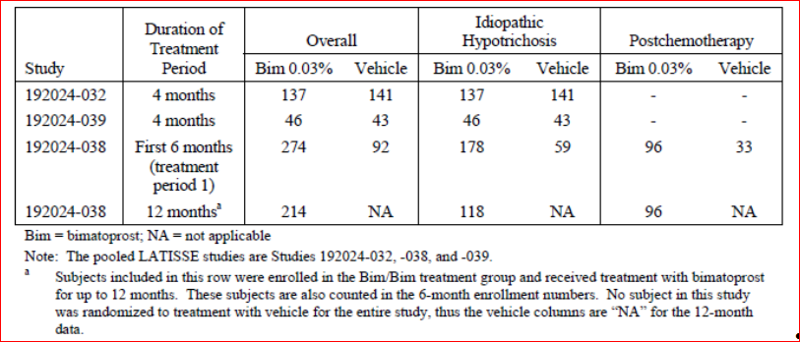
Table 2. Number (%) of subjects exposed to study treatment by cumulative time interval in the pooled Latisse studies (safety population)
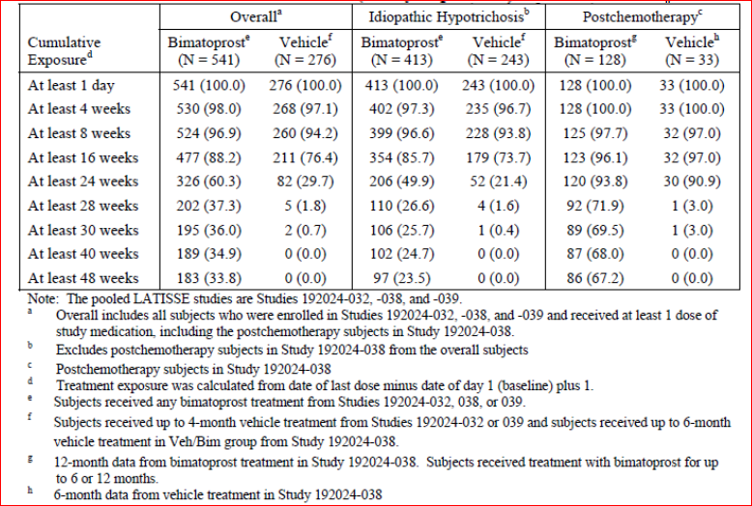

Safety issues with the potential for major regulatory impact
None.

Postmarketing data
Marketing of Latisse commenced in January 2009 and through to December 2011 the sponsor estimates 395,307 patient-years of exposure. During this time, there have been 3346 case reports (7253 adverse event terms), 1316 of which came from health care professionals. The most frequent events are listed in Table 3. Madarosis was the second most frequent event, after ocular hyperaemia. There were 5 reports of enophthalmos. There were also 19 serious, unlisted AEs, 12 of which were medically confirmed. These cases included keratitis, eye infections and an anaphylactic reaction.
Table 3. Most commonly reported postmarketing non serious adverse event preferred terms
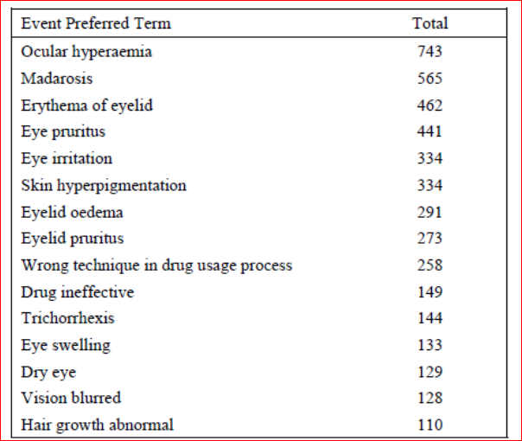
In addition a Periodic Safety Update Report (PSUR) for all the sponsor’s approved products containing bimatoprost including Latisse for the period 1 March 2011 to 29 February 2012 was included in the submission. This was the second PSUR for Latisse. During the period the sponsor estimated the patient exposure to Latisse was 628,930 patient years. During this period the core data sheet was updated and events of eye pain for eye drops and enophthalmos for Latisse were added. The PSUR contained 1,028 case reports, with 2,434 adverse event terms, that were related to Latisse. Of these, 292 cases were reported from health care professionals. There were was one serious case from a health care professional of optic nerve injury and increase in intraocular pressure (IOP). There was also a consumer report of bacterial infection of a premature neonate with a fatal outcome following the mother’s exposure during the first 2 weeks of pregnancy. Of the reported events, 47.6% were in the eye disorders System Organ Class SOC with a rate of 0.621 per 1000 units sold. The next most frequent SOC was skin and subcutaneous tissue disorders with an event reporting rate of 0.302 per 1,000 units sold. There were 197 reports of lack of efficacy and 311 cases involving misuse or medication error and 43 cases of off-label use. In cumulative analysis there have been 8 cases of enophthalmos which were considered ‘relevant’ by the sponsor, none was serious.

Evaluator’s conclusions on safety
The pooled safety database for bimatoprost included 733 subjects from 3 randomised controlled trials. Of these, 541 subjects received at least 1 dose of Latisse and 276 at least one dose of vehicle (and no prior treatment with bimatoprost). There were 413 subjects with idiopathic and 128 with post chemotherapy hypotrichosis who were treated with bimatoprost. The median treatment duration for bimatoprost was 182 days and for vehicle was 118 days. There were 183 subjects who had at least 48 weeks of treatment with bimatoprost, 97 of whom with idiopathic and 86 with post chemotherapy hypotrichosis.
The adverse event (AE) rate was higher with bimatoprost than vehicle (50% versus 32%) as was the rate of treatment-related AEs (23% and 9%). The most frequent AEs were eye disorders (28% versus 13%) with the majority classed as treatment related (19% versus 8%). The most common eye disorders were: conjunctival hyperaemia (7.2% versus 1.4%), punctate keratitis (3.1% versus 1.8%), eyelid pruritus (3.7% versus 2.9%), eyelid erythema (3.9% versus 1.1%), eye pruritus (2.6% versus 0.7%), dry eye (2.2% versus 0.7%) and blepharitis (1.3% versus 0.4). Skin pigmentation was the other main AE occurring at a higher rate with bimatoprost (3.9% versus 0.4%). Other AEs of note were madarosis (absence of eyelashes) (0.9% versus 0%) and enophthalmos (0.2% versus 0%).
There was one unrelated death in the clinical program from a presumed pulmonary embolism following breast reconstructive surgery. Serious AEs (SAEs) were more frequent with bimatoprost (5.2% versus 1.8%) particularly in the post chemotherapy group (see below). No SAE was considered treatment-related and there were no eye-related SAEs. The discontinuation rate due to AEs was 3.7% with bimatoprost compared to 2.9% with vehicle. The most frequent AEs leading to discontinuation were eye disorders (2.2%) and in particular conjunctival hyperaemia, erythema of the eyelid, dry eye and eye irritation.
The post chemotherapy group had a higher rate of AEs (68% versus 46%) than the healthy adults with idiopathic hypotrichosis (45% versus 31%). The rate of eye disorders was notably greater in the post chemotherapy group than the idiopathic group (36% versus 25%) and in particular conjunctival hyperaemia (14.8% versus 4.8%). In addition, this group had a higher rate of SAEs (13.3% versus 6.1% with vehicle) compared to the idiopathic group (2.7% versus 1.2%).
Comment: As none of the SAEs was an eye disorder or felt to be treatment related, it may be that the difference in SAE rates was due to the small sample size of the post chemotherapy patients treated with vehicle (n=33).
Over 12 months of treatment the AE rate was 63% with 31% having treatment-related AEs and the rate of SAEs was 8.4%. The rate of frequent eye disorders, apart from eyelid hyperaemia, did not generally increase in the second 6 months of treatment in either the idiopathic or post chemotherapy groups. There was not any notable rebound in events on treatment discontinuation.
There was no dose response evident on the rate of AEs in the dose-ranging study and the highest AE rate was with the middle concentration of 0.015%. As the study used different formulations with a higher level of BAK in the lower doses, this may be confounded results.
Detailed eye assessments were conducted during the studies. Intraocular pressure (IOP) measurements found a small decrease in mean IOP (-1.24 versus -0.55 mmHg). This is not felt to be clinically relevant. There were 2 AEs of low IOP (≤ 5 mmHg) which resulted in study discontinuation although one was in the vehicle group. Other cases of low IOP (≤ 7 mmHg) were not persistent and variation between visits was noted. Biomicroscopy and ophthalmoscopy noted the findings of conjuctival hyperaemia, eyelid erythema. Iris hyperpigmentation was assessed via a non-validated scale and findings were inconclusive. There was no notable change in best correct visual acuity.
Laboratory assessments were not undertaken due to the low systemic absorption of bimatoprost.
Postmarketing data noted events of ocular hyperaemia, madarosis, enophthalmos and serious events of keratitis, eye infections and anaphylactic reaction. In addition, the evaluator noted events of lack of efficacy, misuse or medication error and off-label use.
Safety findings were consistent across the age groups but Black subjects had a higher rate of skin pigmentation. There were too few males to draw conclusions and the number of Asians were low (n=30). There is a lack of data in pregnancy and lactation and the product should be avoided in these groups, particularly due to the embryofoetal risks of bimatoprost from nonclinical studies. Safety has not been established in the paediatric population.
Co-administration of Latisse with other prostaglandins is not recommended due a risk of reduced efficacy of the prostaglandins.

First round benefit-risk assessment

First round assessment of benefits
The benefits of bimatoprost 0.03% in the proposed usage are:
- A response rate of 39% (compared to 11% with vehicle) after 4 months of treatment on the composite endpoint which took into account physician and patient ratings of eyelash improvement
- Results were statistically significant and supported by secondary endpoints eyelash length, thickness/fullness and darkness. Results were also consistent with the other main controlled trial.
- Efficacy was seen in patients with idiopathic hypotrichosis and those with post chemotherapy hypotrichosis, although the benefit was less in this latter population which may have been a result of natural regrowth with time.
- The product was generally well tolerated with a low risk of serious AEs or adverse event-related treatment discontinuation.
- There is already an established safety database due to the product’s use in ocular hypertension.

First round assessment of risks
The risks of bimatoprost 0.03% in the proposed usage are:
- A notable risk of eye disorders (about one quarter of subjects after 4 months of treatment), in particular conjunctival hyperaemia, punctuate keratitis, eyelid and eye pruritus, eyelid erythema, dry eye and blepharitis. There were also less frequent eye disorders of enophthalmos and madarosis (loss of eyelashes).
- Eyelid skin hyperpigmentation, including an increased risk of this in Black patients and iris hyperpigmentation which may be permanent.
- Possible effects of decrease intraocular pressure, although clinically relevant reductions were not evident in the development program.
- A greater risk of adverse events, including the eye disorders of conjunctival hyperaemia and punctuate keratitis, in patients post-chemotherapy.
- The potential for misuse or off-label use such as application to the lower eyelid or eyebrows or use of an increased dose.
- No data on patients with ocular disease, in pregnancy or lactation and little data in males or Asians.

First round assessment of benefit-risk balance
The initial Latisse submission in 2009 was supported by one clinical trial, 192024-032 together with the study validating the primary endpoint scale (192024-033). After the first round evaluation, the sponsor submitted further clinical data of bimatoprost in a glaucoma population. After the second round evaluation, the evaluator summarised a number of deficiencies which included:
- Poorly understood pharmacodynamics in relation to human eyelash growth.
- No clinical trial establishing the dose.
- A lack of data on persistence of efficacy with long-term use and the effect on treatment cessation.
- A lack of efficacy and safety data in the Asian population which would be relevant in Australia.
- Safety data not meeting guideline requirements and a failure to assess on the effect on IOP.
In this re-submission the evaluator has found that the sponsor has addressed most of these data gaps. There is now more information on pharmacodynamics, although the precise mechanism of action had not been fully elucidated. A dose-ranging study (192024-051) was submitted which gave evidence of a dose response and the proposed dose having the greatest efficacy without a compromise in safety. The study, however, did not define the minimum effective dose, used a formulation with a higher concentration of BAK in the lower doses, and was conducted subsequent to the pivotal trials and so did not inform dose selection. The resubmission also included two further randomised controlled trials (192024-038 and 039), with the former assessing long persistence of efficacy to 12 months and the effect of treatment cessation after 6 months. The studies included detailed ocular safety assessments, including IOP measurements and the combined patient population from the three controlled trials now meets relevant guideline requirements.
Efficacy in the pivotal trial was assessed by a combination of physician rating of eyelash prominence and patient rating of satisfaction with eyelashes. In addition, secondary endpoints included assessment of eyelashes by digital photography. The two main controlled trials met their primary endpoints and were supported by objective measurements of eyelash length, thickness and darkness. Given the positive response across the three assessment areas, the evaluator is satisfied that the results are reliable. As the condition may be considered cosmetic in nature rather than one which necessitates clinical intervention, it was important to see positive results on the composite endpoint which took into account both the patient’s and physician’s assessment of efficacy.
In the patients with eyelash loss post-chemotherapy, efficacy with bimatoprost was less marked in terms of difference in response rates over vehicle. This is likely due to natural regrowth of the hairs with time. These subjects did not commence treatment until chemotherapy-related symptoms (apart from hair loss) had resolved. Despite this, they were found to be more sensitive to the adverse effects of bimatoprost, particularly eye-related events. There was also a higher rate of SAEs in this population when treated with bimatoprost compared to vehicle (although these events were not eye disorders or deemed treatment-related). This may be a factor of the small sample size in the vehicle group and the sponsor has been asked to further explain the finding. As there is a good chance the hypotrichosis in this population may resolve with the passage of time, these efficacy and safety issues need to be thoroughly covered in the PI so an informed decision regarding treatment can be made for this population. Nevertheless, the evaluator does not believe the moderate increase in AE rates completely outweigh the lower comparative efficacy.
The sponsor has proposed a broad indication of
hypotrichosis of the eyelashes by increasing their growth including length, thickness, and darkness.
The clinical development program only assessed adult subjects with idiopathic and post chemotherapy hypotrichosis. Subjects with hypotrichosis from other disorders, such as skin conditions, were excluded. The indication needs to be reworded to cover adults only and the two populations studied. In addition, as “hypotrichosis of the eyelashes” is not a commonly recognised medical condition, this should be defined.
Bimatoprost already has a significant safety database following 11 years of marketing and the resubmission included a moderately sized safety database with 541 subjects exposed, with 183 for at least 48 weeks. This is very relevant as the evaluator believes the proposed usage is more along the lines of a cosmetic for which a high level of safety would be expected. The dermal, compared to ocular, administration appeared to result in a lower rate of adverse events than for an eye drop containing bimatoprost and the low systemic absorption of the product following ocular administration is reassuring. The safety assessment of bimatoprost found that adverse events were largely confined to the eye, with no serious ocular events and a low treatment discontinuation rate due to adverse events. To confirm these findings, a summary of adverse events by severity and System Organ Class (SOC) has been requested as it was not found in the dossier.
The development program included very few males and this needs stating in the product information. Asian subjects were under represented and further information has been requested. There are a lack of data in pregnancy and lactation and, given the non-critical nature of this treatment, the evaluator has proposed stronger wording in the product information regarding the avoidance of treatment in these two groups. It is noted that a paediatric study is planned however, as there are no data in children, the indication needs to be limited to adults.
One potential risk is that there could be misuse or off-label use of the product. It is also uncertain if treating physicians will be aware of what constitutes “inadequate or not enough eyelashes”. The sponsor should define in the Risk Management Plan how these issues will be addressed and monitored.
In summary, this product is proposed in an indication which is not critical, and may in fact be felt by some to be cosmetic. In addition, despite the finding of benefit over vehicle, after four months of treatment a positive response was only found in approximately 40% of subjects. Nonetheless, efficacy over vehicle was convincingly demonstrated in the pivotal trials, the product was relatively safe, deficiencies in the initial submission have been largely addressed and it is a condition for which there are no other treatments available. Given this, the evaluator finds the benefit-risk balance of bimatoprost 0.03% in the treatment of eyelash hypotrichosis positive. This assumes the recommendations regarding the product indication and Consumer Medicines Information (CMI) are adopted and there are satisfactory answers to the questions below (see Clinical questions).

First round recommendation regarding authorisation
The evaluator recommends approval of authorisation of bimatoprost ophthalmic solution 0.03% in the treatment of eyelash hypotrichosis subject to:
• Satisfactory responses to questions (see below).
• Adoption of changes suggested for the product information and CMI.
The alteration of the indication to include a statement that the product is only to be used in adults and in those patient groups in which it has been studied (idiopathic and post-chemotherapy).

Clinical Questions

Pharmacokinetics
- It was claimed in the clinical dossier that the applicator used to apply Latisse to the eyelid margin delivers a fraction of one drop. The evaluator could not locate data to confirm this. Can the sponsor provide evidence that the dosage of Latisse delivered by the applicator is less than one drop? And explain if patients can apply more than one drop to the applicator.

Pharmacodynamics
Nil.

Efficacy
- The clinical development program included in the dossier includes relatively few Asian subjects. Discuss available efficacy data for Asian subjects and whether specific efficacy information relating to the Asian racial group should be included in the product information.
- In Study 192024-039 there was a notably high response rate on the primary efficacy outcome in African American subjects receiving vehicle (48.8%). The comparative rate in the vehicle group in study 192024-032 was 18.4%. Explain the reasons for this finding.

Safety
- Present and discuss rates of mild, moderate and severe AEs in the three main efficacy/safety studies (192024-032, 038 and 039). Include rates for all AEs together with a breakdown by SOC for the overall, idiopathic and post chemotherapy populations.
- The clinical development program included in the dossier includes relatively few Asian subjects. In addition it was noted that African Americans had a slightly different safety profile with a higher rate of skin pigmentation which suggests there may be varying safety findings in different racial groups. What safety data are available in Asian subjects? Discuss these findings. Discuss also whether specific safety information relating to the Asian racial group should be included in the PI.
- The rate of SAEs was notably higher in the post chemotherapy group treated with bimatoprost (13.3% versus 6.1%) compared to the idiopathic group (2.7% versus 1.2%). While it was explained that there were no eye-related SAEs nor treatment-related SAEs in post chemotherapy patients, this finding needs further explanation. Discuss the implication of the sample size on the finding.

Second round evaluation of clinical data submitted in response to questions

Second round benefit-risk assessment

Question 1.

Sponsor’s response
Two studies were conducted evaluating this issue. In the first, 36 subjects applied one drop of Latisse vehicle to the applicator and then applied the vehicle on the eyelid margin. The applicator was weighed before and after application. The mean (standard deviation (SD)) amount of solution applied was 2.1 (1.19) µL. The standard volume of an eye drop expelled from the Latisse bottle was reported at approximately 30 µL. Therefore, less than one drop is applied to the eyelid margin.
In the second study, eye drop application was compared to dermal application to the upper eyelid margin using dye. A supplied photo shows less green dye visible with the dermal application (Figure 1).
Figure 1. Comparison of exposure to solution applied as an eye drop compared to dermal application
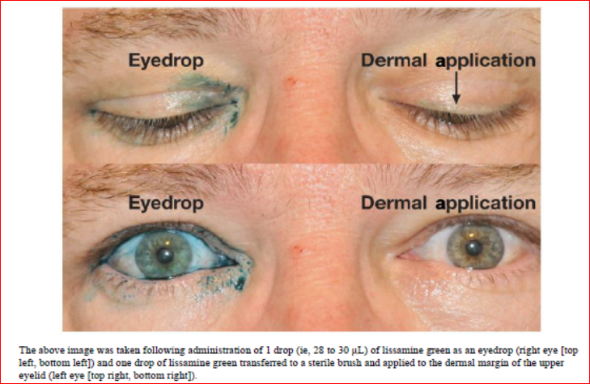
The sponsor stated that “although it is possible for a patient to try to apply more than a single drop of Latisse to the applicator, this practice would simply cause the product to be used faster. In the event that a patient applies too much solution to an applicator and excess solution is applied to the treatment area, the directions for use in the proposed product information (PI) and consumer medicine information (CMI) direct the patient to blot excess product after application. These directions are intended to provide for a targeted application of the appropriate dose to the treatment area.”

Evaluator’s comments
From this data it is seen that less than one drop is delivered, however it is still feasible that patients may overuse the product.

Question 2. Part A

Sponsor’s response
Because bimatoprost acts on the eyelash hair growth cycle, the efficacy of Latisse is therefore predicted to be similar across all populations. Approvals for Latisse have been granted in the following Asian countries without specific language in the label relating to efficacy in specific racial groups: Singapore, Korea, Hong Kong, Vietnam, Taiwan, Philippines, and Thailand.
Since the current submission on 28 September 2012, 2 safety and efficacy studies have been completed in Asian subjects: The clinical study reports for these two studies were included in the response.
Studies 192024-059 and -067 were multicentre, double-masked, randomised, parallel-group, 5 month, Phase III studies which evaluated the safety and efficacy of bimatoprost solution 0.03% compared with vehicle in increasing overall eyelash prominence following once daily topical application to the upper eyelid margins of adult, Japanese subjects. Study 192024-059 enrolled 173 (88 bimatoprost and 85 vehicle) subjects with idiopathic hypotrichosis of the eyelashes; 192024-067 enrolled 36 (18 in each of the bimatoprost and vehicle groups) adult subjects with hypotrichosis of the eyelashes post-chemotherapy. Both studies had the primary endpoint of ≥1 grade increase in the GEA scale after 4 months treatment.
In Study 192024-059 at Month 4, the proportion of subjects with at least 1 grade increase in the GEA score was 77.3% and 17.6% in the bimatoprost and vehicle groups, respectively (p<0.001). In the post chemotherapy Japanese subjects in 192024-067, the proportion who had at least one grade improvement on the GEA score was 88.9% in the bimatoprost and 27.8% in the vehicle group (p<0.001). In the idiopathic group, the proportion of subjects with at least a 2 grade increase in GEA was 36.4% versus 1.2% (p<0.001) (Table 4). However, in the post chemotherapy group, the rate of at least 2 grades increase in GEA score was not significantly different (27.8% versus 5.6% p=0.177) (Table 5).
The mean (192024-059) and median (192024-067) percentage change in eyelash length, thickness and darkness was significantly better with bimatoprost than vehicle in both the idiopathic population and the post chemotherapy groups (Tables 4 and 5).
The sponsor concluded by stating:
Although ethnically Japanese subjects may not be broadly representative of all Asian ethnicities, the mechanism of action of bimatoprost is predicted to be similar across populations and there is no reason to expect that other Asian populations would experience different efficacy or safety results. As such, Allergan does not believe there is a need to include wording within the Product Information that specifically addresses the Asian population.
Table 4. 192024-059 Summary of primary and secondary efficacy results at the primary timepoint for efficacy analyses, Month 4 (ITT population).
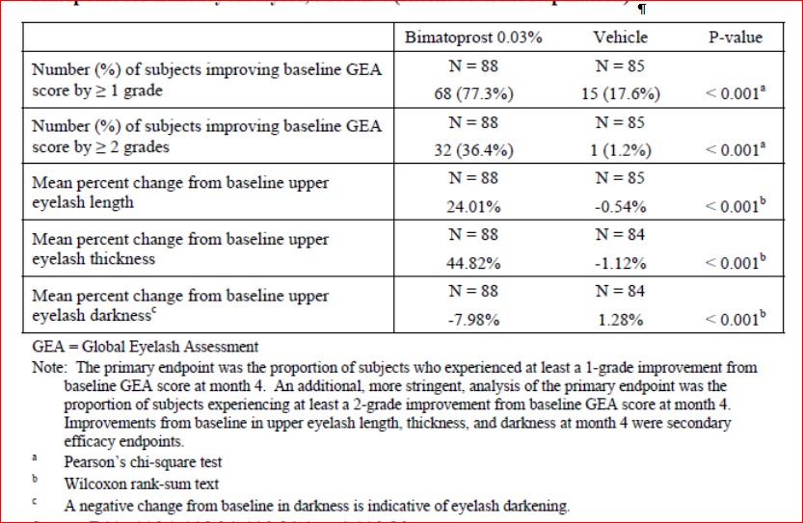
Table 5. 192024-067 Summary of primary and secondary efficacy results at the primary timepoint for efficacy analyses, Month 4 (ITT population).
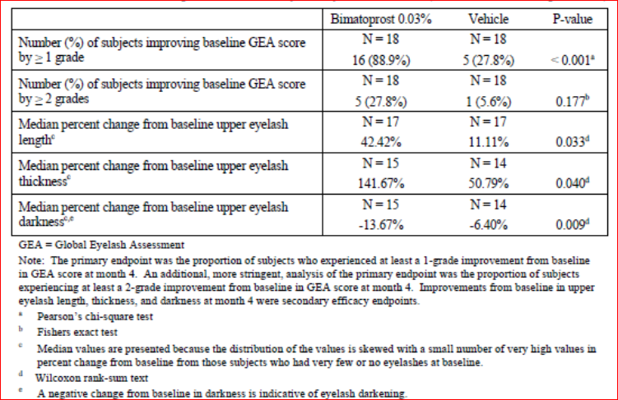

Evaluator’s comments
The new data presented from the two clinical trials in Japanese subjects with idiopathic and post chemotherapy hypotrichosis are consistent with the data evaluated in the first round. The evaluator agrees that there does not appear to be a difference in efficacy in Japanese subjects. It is agreed that specific wording in the PI for Asian subjects does not appear warranted.

Question 2 Part B

Sponsor’s response
The sponsor agreed that the vehicle response rate in Study 192024-039 was higher than in other studies but stated that this was not noted when assessing response of ≥2 grades on the GEA (Table 6). It was noted that in 2 of 5 clinical sites there was 100% vehicle response and so the Sponsor proposed that the result may have been due to investigator variability.
Table 6. Number (%) of subjects with idiopathic hypotrichosis achieving at least 1 grade and at least a 2 grade increase from baseline in GEA score at Month 4 (Studies 192024-32, -038, -039 and -059; ITT population).
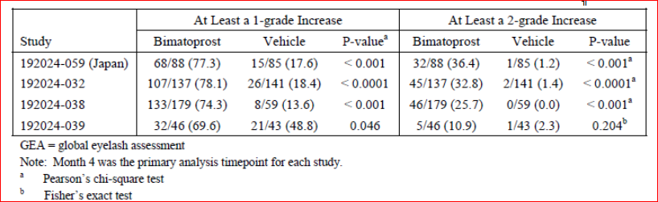

Evaluator’s comments
This proposal also suggests the GEA scale may not be reliable in the African American population.

Question 3 Part A.

Sponsor’s response
In the overall study population, the rate of mild AEs was 25.9% and 15.6% in the bimatoprost and vehicle groups, respectively. The rate of moderate AEs was 17.0% versus 12.3% and the rate of severe AEs was 6.8% versus 4.3% (Table 7). In the post chemotherapy group the rate of mild (33.6% versus 27.3%), moderate (23.4% versus 12.1%) and severe AEs (11.7% versus 6.1%) was consistently greater in those treated with bimatoprost (Table 22). The rate of moderate and severe AEs by SOC is presented in Table 8. Events in the SOC of Eye disorders and Injury/poisoning/procedural complications (both study populations) and Infections/infestations (for the post chemotherapy population) were noted to have occurred at higher rates in the bimatoprost groups.
Table 7. Number (%) of subjects reporting adverse events by maximum severity in the integrated Latisse studies (Safety population).
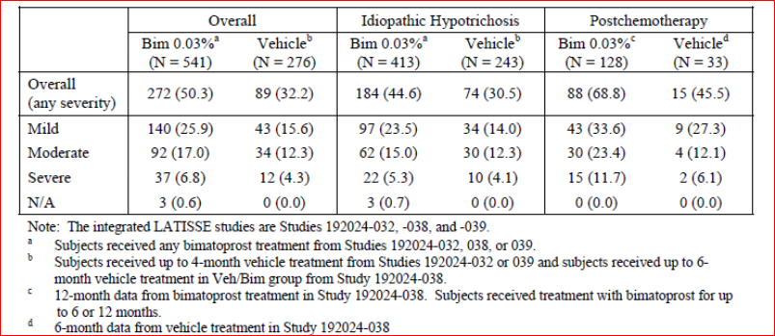
Table 8. Number (%) of subjects reporting adverse events of moderate or severe severity, by System organ Class (Studies 192024-32, -038, -039 Safety population).
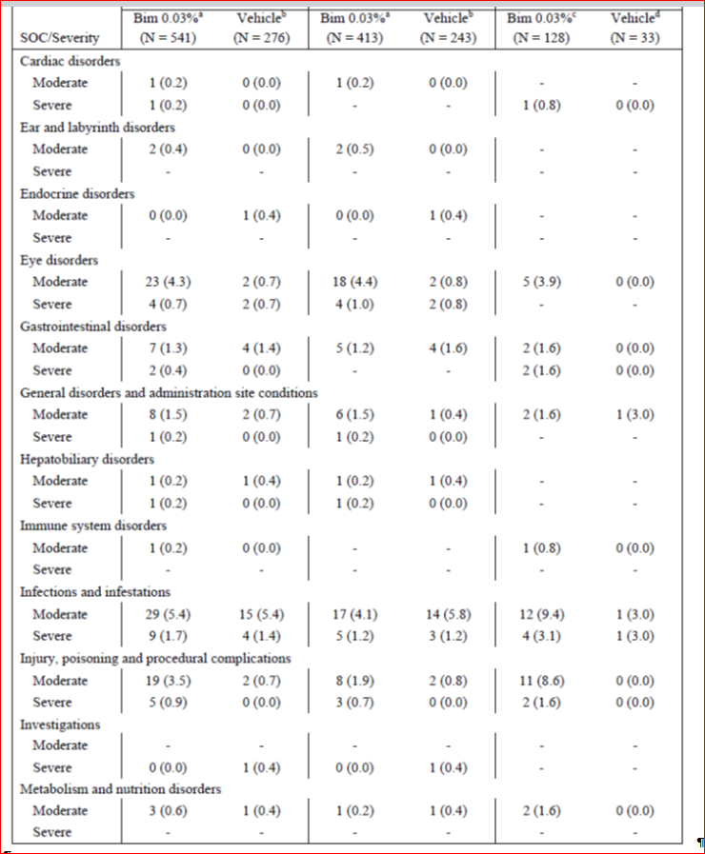
Table 8 continued. Number (%) of subjects reporting adverse events of moderate or severe severity, by System organ Class (Studies 192024-32, -038, -039).
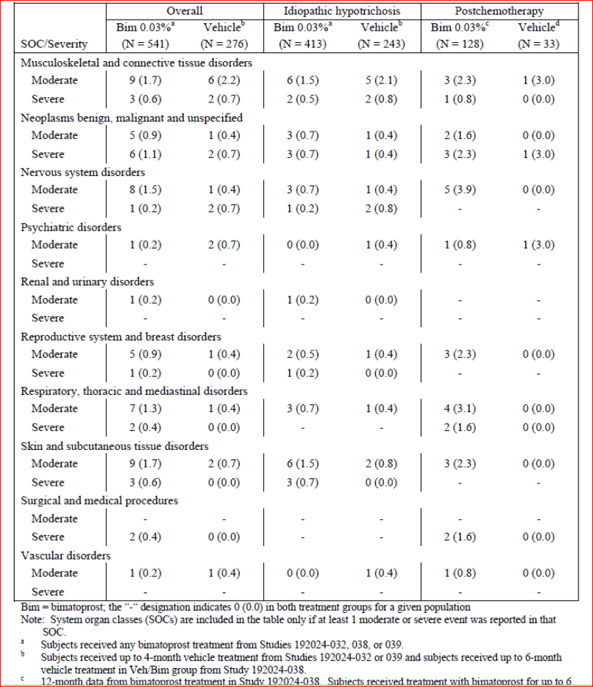
There were 4 bimatoprost-treated subjects (4/541; 0.7%) and 2 vehicle treated subjects (2/276; 0.7%) with severe adverse events in the eye disorders SOC; all 6 subjects were in the idiopathic hypotrichosis population. For the bimatoprost treated subjects, the severe events were: conjunctival hyperaemia, conjunctivitis allergic, and eyelid disorder and eye pruritus/eye irritation. The sponsor reported that the severe events in the post chemotherapy population were generally related to SAEs and the only severe events that were not SAEs were: device related infection, breast cellulitis, radiation skin injury, arthralgia and bronchospasm. It was concluded that
“the adverse events reported as severe by postchemotherapy subjects were systemic events, unrelated to the study treatment, and considered related to underlying cancer diagnosis or its treatment.”

Evaluator’s comments
The data presented on mild, moderate and severe AEs did not reveal any new safety issues. The data on the higher incidence of AEs and in particular eye disorders in the post chemotherapy population needs to be included in the PI and cover adverse events not adverse reactions (as discussed above).

Question 3 Part B.

Sponsor’s response
Studies 192024-032, -038, and -039 included 47 Asian subjects (6.4% of the overall safety population) Subgroup analyses of adverse events indicated no difference in overall adverse event reporting rate in Asian subjects (Table 9). Comparing data from the two Japanese studies (192042-059 and 192024-067) to the studies conducted in the US and EU, the adverse event rate was comparable in the Japanese population with idiopathic hypotrichosis (Table 10). The AE rate was higher in the Japanese post chemotherapy group however in this population the vehicle treated subjects had a higher AE rate than the bimatoprost group (72% versus 61%) (Table 10). The AE profile was similar between the Japanese study and the integrated safety database for the idiopathic population (Table 11). Data were presented for the post chemotherapy population however the numbers are too small to draw conclusions. The sponsor concludes that
“the safety profile of Latisse has been demonstrated to be similar in the populations of Studies 192024-059 (idiopathic hypotrichosis subjects) and 192024-067(postchemotherapy subjects) (in Japan) compared with the populations of the integrated studies of Latisse (192024-032, -038, and -039; in US and EU) presented in the current submission. Thus, Allergan believes that there is no need to include specific safety information relating to the Asian racial group in the product information.
Table 9. Number (%) of subjects with key adverse events in the integrated Latisse studies, Overall population and Asian subpopulation (Safety population).
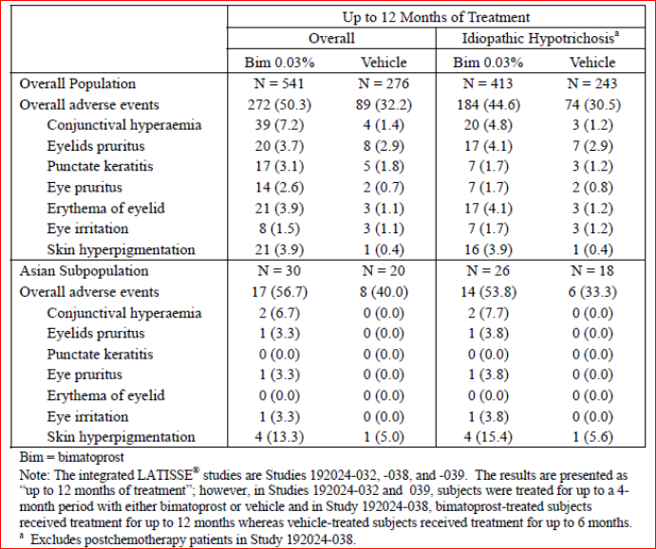
Table 10. Number (%) of subjects reporting adverse events through Month 4 of Studies 192024-032, -038, -039 (US and EU) and Studies 192024-059 and -067 (Japan) (Safety population).
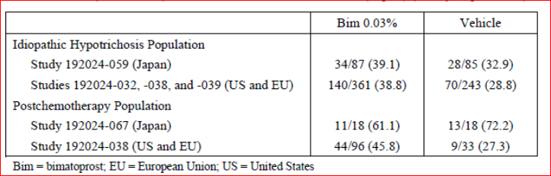
Table 11. Number of idiopathic hypotrichosis subjects in Study 192024-059 and the Integrated safety database reporting common (≥2% in either treatment group in either study/integrated database) adverse events through Month 4 of treatment (Safety population)
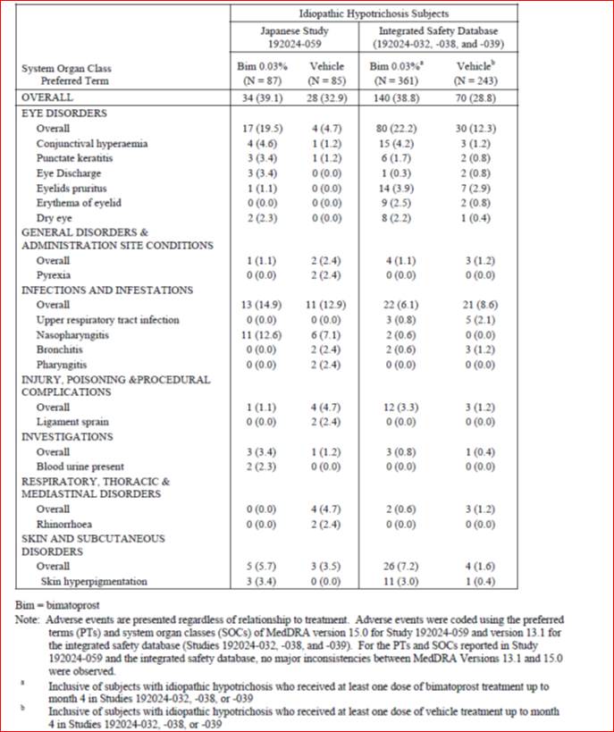

Evaluator’s comments
The evaluator agrees that there do not appear to be any specific safety issues in Asian subjects.

Question 3 Part C.

Sponsor’s response
The sponsor states the safety profile of bimatoprost is similar across racial groups, apart from the increased rate of skin hyperpigmentation in Black subjects (Table 12). It was stated that bimatoprost results in increased melanogenesis and transfer of melanosomes to basal keratinocytes in the absence of melanocyte proliferation and atypia. This is via a direct effect on the enzyme tyrosinase. Due to the increased melanin in dark skin, a higher incidence of skin pigmentation change is expected.
“In the Adverse Effects section of the proposed PI for Latisse, it is stated that “The incidence of peri-ocular skin pigmentation was higher in African-American patients compared with Caucasian patients (16.0% versus 1.0%).”
Table 12. Number (%) of subjects with key adverse events in the integrated Latisse studies by Race (Safety population)
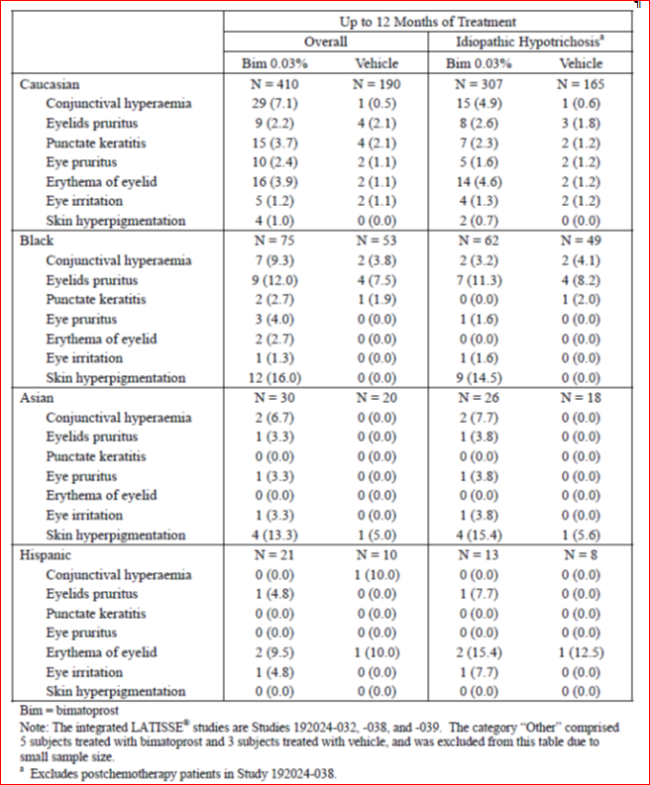

Evaluator’s comments
The evaluator accepts the reasoning for the skin pigmentation changes in African-American subjects.

Question 4

Sponsor’s response
There were 17 SAEs in bimatoprost-treated post chemotherapy subjects, 9 attributed to underlying cancer history and 8 related to medical history. None were considered related to Latisse. In addition, in the post chemotherapy group the rate of SAEs during the second 6 months of bimatoprost treatment was similar to the first 6 months (6.7% versus 8.6%).
The sponsor stated that “Allergan believes that the greater serious adverse event reporting rate in the postchemotherapy population in Study 192024-038 compared with idiopathic hypotrichosis population in Studies 192024-032, -038, and -039 is related to the underlying diagnosis of cancer as well as complications from its recurrence or treatment in the postchemotherapy subjects. All of serious adverse events reported in the bimatoprost-treated postchemotherapy subjects could be either directly attributed or considered as likely to be related to cancer or complications from its treatment. When serious adverse event reporting rates are compared in the postchemotherapy population using a 6-month treatment duration in the bimatoprost and vehicle groups, the reporting rates are similar (8.6% versus 6.1%), which further supports the assessment of no causal relationship between the serious adverse events and Latisse treatment.”

Evaluator’s comments
The evaluator agrees the SAEs in this population appear related to background medical history. This apparent differential in SAE rates in the post chemotherapy group between the bimatoprost and vehicle groups may be a factor of small sample size in the vehicle-treated subjects (n=33).

Second round benefit-risk assessment

Second round assessment of benefits
After consideration of the responses to clinical questions, the benefits of bimatoprost 0.03% in the proposed usage are unchanged from those identified in the First Round Evaluation.

Second round assessment of risks
After consideration of the responses to clinical questions, the risks of bimatoprost 0.03% in the proposed usage are unchanged from those identified in the First Round Evaluation with the exception that efficacy and safety data on bimatoprost use in Japanese subjects were submitted and found to be in line with overall pivotal studies’ population.

Second round assessment of benefit-risk balance
The second round of data included a review of AEs by severity and SOC. This did not reveal any new safety issues. The risk of eye disorders has been adequately defined in the draft PI. The severe events in the post chemotherapy population were examined and appeared related to the underlying medical condition. The data on the higher incidence of AEs, and in particular eye disorders, in the post chemotherapy population needs to be included in the PI.
The lack of data in Asian subjects was addressed by the submission of two clinical trials in Japanese subjects. These studies, one in the idiopathic and one in the post chemotherapy population, found similar efficacy and no additional safety signals as compared to the EU and US populations. The evaluator agrees that no additional wording is required in the PI in relation to Asian subjects.
Comments relating to the proposed indication (hypotrichosis of the eyelashes by increasing their growth including length, thickness, and darkness) have not yet been addressed as outlined in the comments on the PI in first round evaluation. The evaluator still recommends that, as subjects with hypotrichosis from other disorders, such as skin conditions, were excluded from the clinical development program, the indication needs to be clear that treatment is for adult subjects with idiopathic and post chemotherapy hypotrichosis only. This should be further covered in the specific section on Special Populations in the PI.
In addition, it is recommended that treatment should be limited to 12 months duration. This is due to clinical data being limited to 12 months, the fact that treatment is not intended to be an ongoing therapy and also to discourage potential excessive or continual use.
Taking into account these issues, the evaluator continues to find the benefit-risk balance of bimatoprost 0.03% in the treatment of eyelash hypotrichosis is positive. This assumes the recommendations outlined regarding the product information, including indication, and CMI are adopted.

Second round recommendation regarding authorisation
The evaluator recommends approval of authorisation of bimatoprost ophthalmic solution 0.03% in the treatment of eyelash hypotrichosis subject to:
- Adoption of changes suggested for the product information and consumer medicine information .
- Alteration of the indication to include that the product is only to be used in adults, in those patient groups in which it has been studied (idiopathic and post-chemotherapy) and that treatment duration be limited to 12 months.

V. Pharmacovigilance findings

Risk management plan
The sponsor submitted a Risk Management Plan, EU RMP version 1.3 dated 29 May 2012 [data lock point 31 December 2011] and an Australian-specific Annex (12 July 2012) which was reviewed by the TGA’s Office of Product Review (OPR).

Safety specification
The sponsor provided a summary of ongoing safety concerns which are shown at Table 13.
Table 13. Summary of Ongoing Safety Concerns
Summary of Ongoing Concerns: Latisse
Important identified risks | Iris hyperpigmentation  Enophthalmos (Deepened eyelid sulcus)  Periorbital Tissue Hyperpigmentation  Conjunctival hyperaemia  Eye irritation  Eye pruritus  Punctate keratitis
Important potential risk | Intraocular pressure decreased  Hypotony of eye
Important missing information | Paediatric Use  Use during Pregnancy & Lactation  Patients with Known Ocular Disease/Abnormality  Patients who have Ocular Surgery

OPR reviewer comment
The potential for off label use with Latisse is significant. It is the evaluator’s recommendation that off-label use should be listed as an important potential risk in the RMP and that monitoring and discussion of off-label use form a standard part of future PSUR for Latisse.

Pharmacovigilance plan
Routine pharmacovigilance activities are proposed by the sponsor to monitor the safety profile of Latisse. Additional pharmacovigilance activities are addressing the areas of missing information relating to paediatric exposure and use in Black patients.
The following additional pharmacovigilance activities (FDA post-marketing commitment) will address important missing information.
- Conduct a clinical study for the treatment of hypotrichosis in paediatric patients. This study (192024-040) began in 2010 and enrolled patients aged 5 to 17 years. Patient groups include: post chemotherapy, alopecia areata patients who have experienced eyelash hypotrichosis and eyelash hypotrichosis in healthy adolescents. The results of the study and CSR will be submitted by December 2012.
- Perform a randomised, controlled, comparative study of Latisse in at least 50 Black patients. This study (192024-039) was initiated in 2009 and completed in 2010. The clinical study report was submitted to FDA on 18 February 2011 and included in the resubmission of the Latisse application to the TGA Risk minimisation activities
The important identified risks discussed in the Latisse EU RMP are addressed in the Precautions and Adverse effects sections of the Australian PI. These routine risk minimisation activities are adequate to inform and educate physicians about the risks associated with Latisse.
No additional, enhanced risk minimisation activities as part of the RMP are currently being implemented for Latisse overseas.).

Reconciliation of issues outlined in the RMP report
The following is a summary of the OPR’s first round evaluation of the RMP, the sponsor’s responses to issues raised by the OPR and the OPR’s evaluation of the sponsor’s responses.

Recommendations in RMP evaluation report:

It is recommended to the Delegate that if Latisse was to gain registration as a therapeutic good for the listed indication, it would need to be solely indicated for individuals with a diagnosed medical disorder resulting in eyelash hypotrichosis/loss

Sponsor’s response
The RMP evaluator has suggested that if Latisse were to gain registration as a therapeutic good it would need to be solely indicated for individuals with a diagnosed medical disorder resulting in eyelash hypotrichosis. The basis for this appears to be a discussion concerning the different definitions of cosmetic versus therapeutic goods. The sponsor does not believe this argument to be relevant to Latisse. Latisse could not be classed as a cosmetic good in Australia. In general terms, anything that makes a therapeutic claim or has a physiological effect on the body is a therapeutic good. Additionally, any product containing a substance in Schedule 4 of the Standard for the Uniform Scheduling of Medicines and Poisons (for example, bimatoprost) would also. Indeed, in this regard there are products already available on the Australian market as therapeutic goods which affect a change in bodily appearance that results from no underlying medical disorder. For example, a product for a similar type of indication, Propecia for male pattern baldness, has been classified as a prescription only therapeutic good, even though there is no requirement for patients to have an underlying medical condition causing their baldness. Similarily, Vaniqa is a prescription product indicated for delaying the regrowth of unwanted facial hair, following depilation, in women. There is no restriction within the indication of this product that requires the unwanted facial hair to be caused by an underlying medical disorder.
However, it does not follow that a product must be indicated for a specific condition caused by an underlying medical disorder simply because a product is classed as a therapeutic good. The definition quoted by the RMP evaluator for a therapeutic use would include products that prevent or alleviate a defect. In the case of Latisse the defect is hypotrichosis of the eyelashes.
It would appear therefore that there are prior examples of products in related indications that have not been required to have a specific underlying medical disorder included in the indication.
The sponsor therefore believes that the indication for Latisse should not be restricted to hypotrichosis of the eyelashes caused by an underlying medical disorder. This is particularly so given that the Latisse clinical trial program enrolled subjects with diverse etiologies of hypotrichosis including dissatisfaction with eyelash length to post-chemotherapy induced hypotrichosis. This data demonstrates safety and efficacy in these widely varying patient populations, and therefore the indication should remain as hypotrichosis of the eyelashes. This indication is in line with the indications approved by regulatory agencies worldwide In addition, the safety profile of Latisse is acceptable for the indication requested. With the approved indications listed in Table 24, Latisse has accumulated over 4 years of postmarketing experience with approximately 2,145,340 patient-years exposure. The most commonly reported adverse events include ocular hyperemia, madarosis, eyelid erythema and eyelid pruritus. These local events resolve upon discontinuation of Latisse and would support an indication that is not limited to hypotrichosis caused only by a diagnosed medical condition. The sponsor also wished to comment upon the suggestion from the RMP evaluator in the RMP Evaluator Report, that the prescribing of Latisse be restricted to specialist physicians. Patients with hypotrichosis in a localised area such as the eyelashes would be able to easily self-diagnose the condition by visual examination. As such these patients are most likely, in the first instance, to seek the opinion of their general practitioner (GP) or to approach a cosmetic physician who works specifically in the area of aesthetic medicine. These healthcare professionals have the expertise to diagnose insufficient or inadequate eyelash growth, and as the first place a patient would seek advice, are best able to prescribe use of Latisse. Limiting prescribing of Latisse to a specialist area such as dermatology would cause patients additional time and expense in that they would need to visit their GP or cosmetic physician and then be referred to a specialist. This is unnecessary as the diagnosis of inadequate or insufficient eyelash growth can adequately be managed by non-specialist healthcare professionals. If indeed a specialist diagnosis was required in particular instances these healthcare professionals could refer patients to those other specialists as required.

OPR evaluator’s comment
It remains a concern that there is a high risk that Latisse would be used for cosmetic reasons including as stated by the sponsor “dissatisfaction with eyelash length”. Similarly it is of concern that the sponsor is relying on self-diagnosis by patients. The sponsor reports that “Patients with hypotrichosis in a localised area such as the eyelashes would be able to easily self-diagnose the condition by visual examination”. Both examples rely on subjective rather than clinical assessments.
Given the strong potential for significant off label use, it remains the recommendation of the evaluator that the prescribing of Latisse be restricted to specialist physicians.
- .It is recommended that the sponsor confirms if the results of the study (192024-040) are now available and these results be included in the PSUR and if needed the RMP updated based on the study results.

Sponsor’s response
Allergan confirms that the results of the study (192024-040, A Multicenter, Double-Masked, Randomized, Parallel-Group Study Assessing the Safety and Efficacy of Once Daily Application of Bimatoprost Solution 0.03% Compared to Vehicle When Applied to the Eyelid Margins of Pediatric Subjects) are now available and these results will be included in the PSUR.

OPR evaluator’s comment
This was considered acceptable.

Given the potential for paediatric off label use, it is recommended to the Delegate that the indication associated with Latisse be restricted to persons aged 18 years and older until such time that the results for the study (192024-040) become available. It is recommended that the sponsor confirms if these results (192024-040) are now available and that the results be included and discussed in the next PSUR and if needed the RMP updated based on the study results.

Sponsor’s response
The results of the 192024-040 paediatric study are now available and will be discussed in the next PSUR. The results of this study demonstrate that bimatoprost solution 0.03% applied once daily for 4 months to the upper eyelid margins is an effective treatment for hypotrichosis of the eyelashes for the overall study population of paediatric subjects 5 to 17 years of age. The results overall demonstrate that this regimen of bimatoprost is safe and well-tolerated in paediatric subjects 5 to 17 years of age. The safety profile in this study is consistent with the known safety profile observed in the completed adult studies of bimatoprost compared with vehicle for the treatment of hypotrichosis of the eyelashes. Allergan does not propose to develop or market Latisse for use in individuals under 18 years of age.

OPR evaluator’s comment
This was considered acceptable.

The potential for off label use with Latisse is significant. It is the evaluator's recommendation that off label use should be listed as an important potential risk in the RMP and that monitoring and discussion of off-label use form a standard part of future PSUR for Latisse.

Sponsor’s response
In compliance with current PSUR requirements, Allergan does monitor, analyse and report off label use. The company will discuss this as a potential risk in the RMP, if required.

OPR evaluator’s comment
It was recommended this be added as a potential risk in RMP. This is then acceptable.
- It is recommended to the Delegate that the sponsor should investigate and seek follow up for all reports of exposure in patients who become pregnant while on Latisse to determine the outcome of each event. Close monitoring of women who become pregnant is recommended. It is recommended that the Australian PI be updated to include the sentence "Administration of Latisse should cease following confirmation of a pregnancy".

Sponsor’s response
Allergan currently has a process for follow up in patients who report a pregnancy while on any Allergan product including Latisse. All pregnancies reported are captured in the Allergan Global Safety database which contains all postmarketing adverse event reports as well as serious adverse events from clinical trials. When a pregnancy is reported, the reporter is asked to provide an estimated date of conception and /or estimated due date. They are also asked to contact Allergan after delivery to report the outcome of the pregnancy. The estimated date of conception/due date is used to program a reminder to the case owner to follow up with the reporter and obtain an outcome to the pregnancy. The case owner makes three attempts at contacting the reporter once the estimated date of delivery is triggered. Allergan agrees with the recommendation to include the following language regarding pregnancy: "Latisse should not be used during pregnancy. Administration of Latisse should cease following confirmation of a pregnancy".

OPR evaluator’s comment
This was considered acceptable.

PI and CMI
The RMP evaluator also recommended changes to the draft PI and Coonsumer Medicine Information documents but these are beyond the scope of this AusPAR.

Summary of recommendations

Outstanding issues

Issues in relation to the RMP
Point 1: It is recommended to the Delegate that if Latisse is to gain registration as a therapeutic good for the listed indication, it would need to be solely indicated for individuals with a diagnosed medical disorder resulting in eyelash hypotrichosis/loss.
The sponsor has argued that prescription of Latisse would not be restricted to a diagnosed medical disorder and general practitioners and cosmetic physicians should be able to prescribe Latisse.
Evaluators comment: It remains a concern that there is a high risk that Latisse would be used for cosmetic reasons including as stated by the sponsor “dissatisfaction with eyelash length”. Similarly it is of concern that the sponsor is relying on self-diagnosis by patients. The sponsor reports that “Patients with hypotrichosis in a localised area such as the eyelashes would be able to easily self-diagnose the condition by visual examination”. Both examples rely on subjective rather than clinical assessments.
Given the strong potential for significant off-label use, it remains the recommendation of the evaluator that the prescribing of Latisse be restricted to specialist physicians.
Point 6: It is noted that Allergan has agreed to include eye irritation and eye pruritus in the patient information leaflet as these are commonly occurring adverse events.
It is suggested to the Delegate that the following sentence also be added. The wording is taken from the sponsor’s response. “These events resolve by discontinuing Latisse”.
Furthermore it is recommended that this information be included in the product information.

Advice from the Advisory Committee on the Safety of Medicines (ACSOM)
ACSOM advice was not sought for this submission.

Suggested wording for conditions of registration

RMP
Implement RMP EU RMP version 1.3 dated 29 May 2012 [data lock point 31 Dec 2011] and Australian-specific Annex (12 July 2012) and any future updates as a condition of registration.

VI. Overall conclusion and risk/benefit assessment
The submission was summarised in the following Delegate’s overview and recommendations:

Quality
There are no outstanding quality issues. Advice from PSC was not sought.
The stability data for Latisse support a shelf-life of 2 years below 25°C for the unopened product, and 4 weeks for the opened product.

Nonclinical
Bimatoprost is a synthetic prostamide (prostaglandin ethanol amide) and is structurally related to prostaglandin F_{2α} (PGF_{2α}).
The submission relies on nonclinical dossier submitted with the previous submission which was withdrawn by the sponsor.
There are no nonclinical objections to registration based on previously seen data including data relating to topical, ocular, oral and intravenous routes.
Bimatoprost (≥ 10nM) has been shown to increase hair synthesis in vitro in cultured human scalp hair follicles in the growing phase, acting via a prostamide receptor dependent mechanism. Effects on hair growth are reported for other members of the class, as well as PGF_{2α}. Limited dermal penetration of bimatoprost was evident in mice following topical application to dorsal skin (systemic exposure, < 0.1% of that in skin).
A Pregnancy Category B3 is proposed for Latisse.

Clinical

Background
The clinical evaluation report prepared for the previous submission concluded that there were a number of deficiencies including, among others, poorly understood mechanism of action, optimal dose not identified, persistence of efficacy beyond 4 months with or without treatment was not known, potential use in population groups that had not been adequately studied, insufficient safety data such as effect on IOP and the possible role of the excipient BAK had not been assessed. The report recommended rejection.
In response, supplementary data was submitted and a supplementary clinical evaluation prepared which concluded that the product has not been adequately characterised in terms of mode of action, efficacy, or safety in the proposed usage. The clinical evaluator was of the view that for a cosmetic product, a high standard of evidence should be required to support registration and recommended rejection. The submission was subsequently withdrawn by the sponsor prior to seeking advice from the ACPM.
The current clinical dossier contained additional data compared to the clinical dossier submitted with the previous submission. The clinical evaluator supports approval.
Studies 192024-033 (evaluation of GEA scale; see CER) and 192024-032 (4 months efficacy study) were included in the previous dossier. Additional studies now include 192024-038 (pivotal efficacy 12 months study), 192024-039 (Phase VI study in African-Americans) and 192024-051 (dose response). The Study 192024-031 in glaucoma is not relevant to this application.
For the Study 192024-039 (post-market study in 89 African Americans), Study 192024-033 (validation of GEA scale) and for pooled analysis of Studies 192024-32, -38 and -39, please see the accompanying clinical evaluation report (CER-Attachment 1).

Dose Finding

Study 192024-051
This study has been provided to support the proposed dosing although the results did not initially inform the planning of the Phase III clinical trial which the dose approved in the treatment of glaucoma was selected for testing in the new indication.
The study was randomised, double blind design. Two lower dose strengths of bimatoprost (0.005% and 0.015%) of a different formulation were compared to the proposed Latisse (bimatoprost 0.03for dose response with respect to increasing eyelash prominence (length, thickness, darkness, and overall prominence). The duration of treatment was 3 months of treatment. The participating population consisted of healthy adult female Caucasian subjects with hypotrichosis of the eyelashes (Global Eyelash Assessment (GEA) score of 1 or 2). The groups were comparable at baseline. The study drugs were applied bilaterally to upper eye lid margin once daily for 3 months.
A dose response, with respect to the primary efficacy outcome of eye lash length measured using digital image analysis, was evident as shown below (Table 14).
Table 14. Study 192024-051 Eyelash length in mm; baseline and change from baseline at each follow up visit (mITT population)
Visit Statistics | Bim 0.005%(n=36) | Bim 0.015% (n=34) | Latisse 0.03% (n=34) | P value
Day 1
N | 36 | 33 | 34 | 0.311
Mean | 5.65 | 5.68 | 5.95
SD | 0.763 | 0.613 | 0.744
Median | 5.80 | 5.60 | 6.00
Min | 4.1 | 4.6 | 4.4
Max | 6.9 | 6.8 | 8.3
Month 3
N | 36 | 33 | 34 | 0.010
Mean | 0.74 | 0.92 | 1.36
SD | 0.684 | 0.668 | 0.944
Median | 0.70 | 1.00 | 1.45
Min | -0.6 | -0.3 | -0.4
Max | 2.4 | 2.3 | 2.8
P value | <0.001 | <0.001 | <0.001
90% CI | (0.55, 0.90) | (0.70, 1.15) | (1.10, 1.70)
The results were similar with respect to eyelash thickening, darkening and overall prominence.

Clinical Efficacy
Two studies (-38 and -32) are discussed here.

Study 192024-038
For the purpose of this submission, this trial may be considered as the pivotal efficacy trial.
This was a Phase III, randomised, double blind (first 6 months) study to assess long term (12 months) efficacy and safety of once daily administration of bimatoprost (0.03%) compared to placebo (vehicle) in adult subjects with upper eyelash hypotrichosis (GEA score 1 or 2 and ‘disagree’ or ‘very much disagree’ response to each of the 3 questions from ESQ Domain 2). The aetiology included idiopathic or chemotherapy induced.
The subjects could receive different treatment in the first 6 months treatment period (TP1) and the second 6 months treatment period (TP2). At baseline, the subjects were randomised to 3 parallel groups: bimatoprost in both TP1/TP2 (bim/bim); vehicle in TP1 and bimatoprost in TP2 (veh/bim); or bimatoprost in TP1 and vehicle in TP2 (bim/veh). The subjects in idiopathic hypotrichosis subpopulation were randomised to all 3 treatment arms where the subjects in the post chemotherapy subpopulation were randomised to bim/bim or veh/bim groups. All subjects who received vehicle in TP1 received bimatoprost in TP2. The effect of treatment discontinuation was studied in bim/veh group with idiopathic hyoptrichosis (hair regrowth in post chemotherapy group could be expected to be naturally sustained).
Treatment was one drop of bimatoprost or vehicle applied to the upper eyelid margin of the eye once daily in the evening. A separate sterile applicator was used for each eye. The main efficacy variables were the GEA scale with photonumeric guide and the ESQ Domain 2. Other efficacy outcomes included upper eyelash length (mm), thickness (mm²) and darkness (intensity units measured using digital image analysis).
The primary efficacy outcome was the proportion of responders at Month 4 where responders were defined by a composite endpoint of least a 1 grade improvement from baseline in GEA score and at least a 3 point improvement from baseline in ESQ Domain 2.
At baseline, subjects were stratified by aetiology (idiopathic or post-chemotherapy) in a 2:1:1 ratio to the 3 treatment groups for idiopathic subjects (bim/bim; bim/veh; veh/bim) and 3:1 ratio for post chemotherapy subjects (bim/bim; veh/bim). A total of 368 subjects were randomised (275 and 93 in the bimatoprost and vehicle groups, respectively) of which 334 continued into the second 6 month treatment period.
At baseline, GEA score was 1 in 39.8% and 2 in 60.2% participants and the mean score on ESQ D2 was 4.1 ± 1.35. Most subjects (238/368 65%) had idiopathic hypotrichosis (179 bimatoprost; 59 vehicle), while 130/368 (35%) had chemotherapy-induced hypotrichosis (96 bimatoprost; 34 vehicle). The mean age was 49.8 years (range 20 to 76 years), majority were Caucasian (82.9%) and predominantly female (98.9%). The main results are presented below:
Table 15. Primary composite efficacy variable: Treatment responders by visit (ITT population)
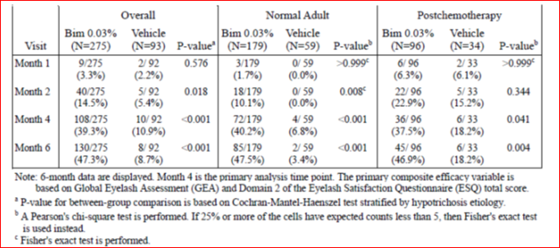

Overall at Month 4 with respect to the composite efficacy endpoint, there were 39.3% bimatoprost treated responders compared to 10.9% in the control group (treatment difference 28.4%, p < 0.001). The proportion of responders in idiopathic group (40.2% versus 6.8%) and post chemotherapy group (37.5% versus 18.2%) similarly favoured treatment with bimatoprost over control.
The discrimination between bimatoprost and control began showing at 2 months. At 6 months, the responders (bimatoprost versus control) were 47.3% versus 8.7%, 47.5% versus 3.4% and 46.9% versus 18.2% in overall, idiopathic and post chemotherapy groups respectively.
The treatment effect was of similar magnitude in idiopathic group and post chemotherapy groups, although higher response rate was noted in post chemotherapy control group (18%) relative to controls in idiopathic group (3.4%) presumably relating to natural hair growth after cessation of chemotherapy in the post chemotherapy group.
With continuing treatment, overall there were 55.3% responders (composite endpoint) at 12 months (50.4% in idiopathic group and 61.5% in post chemotherapy group). When treatment was discontinued at 6 months (idiopathic group), the response was maintained up to Month 8 (50.0%) and fell quickly over next 2 months with 11.7% responders remaining by Month 12.
Table 16. Number (%) of responders based on primary composite end point (ITT population)
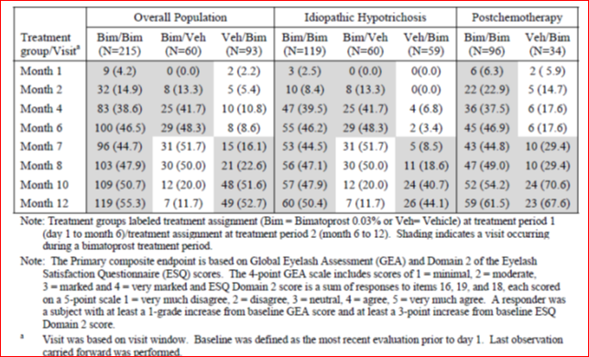
The response rate in post chemotherapy veh/bim group, that is, subjects vehicle for 6 months before switching to bimatoprost increased from 17.6% at 6 months to 67.6% at 12 months.
Individual components of the composite endpoint as well as other efficacy outcome at Months 6 and 12 are shown below indicating loss of effect attributable mostly to drop in GEA score/eyelash length:
Table 17. Summary of improvement from baseline at the end of each treatment period of Study 192024-038 (ITT population)
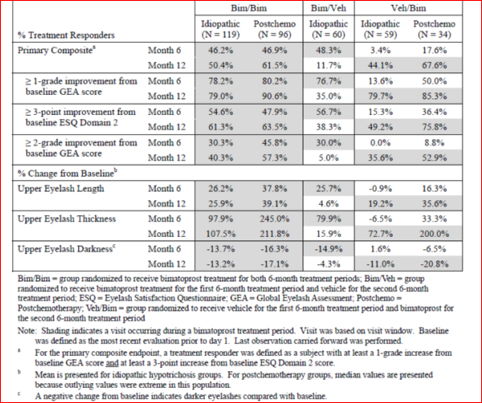

Study 192024-032
This study has been evaluated in the previous Latisse submission. This was a randomised, double blind study to evaluate efficacy and safety of bimatoprost 0.03% solution to increase overall eyelash prominence following application to the upper eyelid margins following treatment for 4 months. The participating population was similar to the Study 192024-038 except that post chemotherapy subjects were not included and the eligibility criteria did not include ESQ score. The primary outcome was the proportion of subjects with at least a one grade increase in the GEA score at Month 4. A total 278 randomised (137 and 141 to bimatoprost and vehicle groups respectively). The mean age of subjects was 49.8 years, 97.1% were female, 80.9% Caucasian and 12.2% Asian. The baseline GEA score was 1 in 20% and 2 in 80%. The primary results are shown below indicating earlier (at 4 weeks) and higher response (78% at 4 months) compared to that seen in the Study 1.
Figure 2. Percentage of subjects with at least a 1 grade increase from baseline in GEA for treatment and post treatment periods (ITT population)
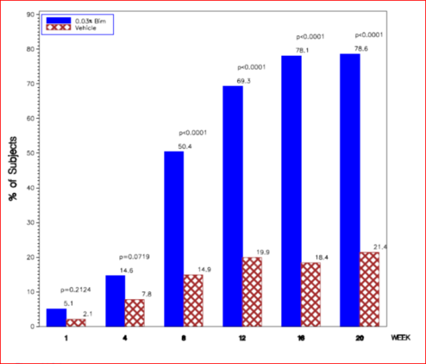

Clinical safety
There were 733 subjects in the pooled safety database, 604 with idiopathic and 129 with post chemotherapy hypotrichosis. A total of 541 subjects received at least 1 dose of Latisse (413 with idiopathic and 128 with post chemotherapy hypotrichosis).
In the pooled analysis, the median treatment duration with bimatoprost was 182 days. A total of 214 subjects in this group (Bim/Bim), the median and mean exposures were 364 days and 335 days respectively. A total of 183 subjects had at least 48 weeks treatment with bimatoprost (97 with idiopathic and 86 with post chemotherapy hypotrichosis).
The rate of adverse events (AE) was higher with bimatoprost than vehicle (50% versus 32%). The most frequent AEs were eye disorders (28% versus 13%). The most commonly reported AEs are shown in Table 18.
Table 18. Most common Adverse Events
AE | Bimatoprost | vehicle
Conjunctival hyperaemia | 7.2% | 1.4%
Punctate keratitis | 3.1% | 1.8%
Eyelid pruritus | 3.7% | 2.9%
Eyelid erythema | 3.9% | 1.1%
Eye pruritus | 2.6% | 0.7%
Dry eye | 2.2% | 0.7%
Blepharitis | 1.3% | 0.4%
Skin pigmentation | 3.9% | 0.4%
Madarosis (absence of eyelashes) | 0.9% | 0.0%
Enophthalmos | 0.2% | 0.0%
The most frequent AEs leading to discontinuation were conjunctival hyperaemia, erythema of the eyelid, dry eye and eye irritation.
In general, the post chemotherapy group had a higher rate of AEs than idiopathic aetiology hypotrichosis group. In addition, this group had a higher rate of SAEs (13.3% bimatoprost versus 6.1% vehicle) compared to idiopathic group (2.7% bimatoprost versus 1.2% vehicle).
Over 12 months of treatment the cumulative AE rate was 63% and the rate of SAEs was 8.4%. The rate of eye disorders, apart from eyelid hyperaemia, did not generally increase in the second six month period.
Eye assessments during the studies showed a small decrease in mean intraocular pressure (IOP) in the active group compared to the control (-1.24 versus -0.55 mmHg). There were 2 AEs of low IOP (≤ 5 mmHg) resulting in study discontinuation (one in vehicle group). Other cases of low IOP (≤ 7 mmHg) were not persistent. Biomicroscopy and ophthalmoscopy examinations noted conjunctival hyperaemia, eyelid erythema. Findings regarding iris hyperpigmentation (which may be permanent), assessed using a non-validated tool, were inconclusive. There was no notable change in best correct visual acuity.
Postmarketing data are also available noting adverse outcomes of ocular hyperaemia, madarosis, enophthalmos and serious events of keratitis, eye infections and anaphylactic reaction as well as events reported as lack of efficacy, misuse, medication error and off-label use.
Safety findings were consistent across the age groups. Higher rate of eyelid skin pigmentation were noted in Blacks. The number of males was too low to draw any gender related conclusions. The number of Asians were low (n=30). There are no data for use in pregnancy, lactation and children.

Further information from the sponsor
The sponsor was queried regarding the amount of volume/drug contained in one dermal application using the applicator and responded citing 2 studies in which these issues were examined. The mean volume of solution with the applicator was measured at 2.1 µL. The standard volume of a drop expelled from Latisse bottles was stated to be approximately 30 µL. Therefore, less than one drop is applied to the eyelid margin. Hence also the conclusion that the maximum applied dose (one drop each upper eyelid per day) is expected to be 15 µg per day.
The sponsor also stated that “although it is possible for a patient to try to apply more than a single drop of Latisse to the applicator, this practice would simply cause the product to be used faster. In the event that a patient applies too much solution to an applicator and excess solution is applied to the treatment area, the directions for use in the proposed product information (PI) and consumer medicine information (CMI) direct the patient to blot excess product after application. These directions are intended to provide for a targeted application of the appropriate dose to the treatment area.”
The sponsor also included clinical study reports for 2 additional studies in Japanese population. The clinical evaluator considered the results in these studies to be consistent with those seen otherwise in the Caucasian population.
The sponsor was also asked about the Study 192024-039 (post-market commitment in the US; see CER) regarding high response rate in African Americans receiving vehicle (48.8%). This finding was unexplained but the sponsor noted that high vehicle response was not found with ≥ 2 grade GEA and that in 2 of 5 clinical sites there was 100% vehicle response. The clinical evaluator opined that GEA scale may not be reliable in the African American population.

Risk management plan
Please see RMP evaluation above. ACSOM advice was not sought for this submission.
Implementation of EU RMP version 1.3 dated 29 May 2012 [data lock point 31 December 2011] and Australian specific Annex dated 12 July 2012 and any future updates is recommended as a condition of registration. A number of PI changes were negotiated with the sponsor during the preparation of Second Round evaluation reports. Among the outstanding issues is recommendation that if Latisse is granted registration, it should be for a diagnosed medical disorder which has resulted in eyelash loss. There is further recommendation that prescribing be restricted to specialist physicians.

Risk-benefit analysis

Delegate’s considerations
The off-target effects on eyelash growth (lengthening, darkening and thickening) and skin/iris pigmentation were noted in the clinical development of bimatoprost in glaucoma trials. These are also known class effects for these agents (prostamides or prostaglandin analogues).
In undertaking clinical trials in hypotrichosis, the condition was described as ‘inadequate or not enough eyelashes’. On the Global Eyelash Assessment (GEA) scale, developed and internally validated by the sponsor (Study 192024-033), this was defined as GEA scale 1 and 2.
A previous submission for this agent was prematurely withdrawn by the sponsor in 2011 upon receipt of adverse recommendation in the clinical evaluation report. The sponsor has sought to address those deficiencies in the current submission. This has principally been done by way of provision of a new 12 months duration trial in subjects with hypotrichosis of idiopathic or post chemotherapy aetiology. The study also investigated persistence of effect on withdrawal of treatment. In addition, further efficacy and safety data are now available including those in Japanese subjects and in African Americans. The studied population was almost all female including those in the post chemotherapy group.
A dose response study, comparing the proposed product with a different formulation (Study 192024-051) provides some evidence of dose response (dose related mean increase in upper eyelash length from 0.74 mm to 1.36 mm) after 3 months of treatment. This, however, did not represent investigation or selection of an optimal dose.
In this way, it is considered that more information/data have now been made available with respect to the deficiencies identified in the earlier submission.
The pivotal efficacy trial was the new Study 192024-038. This trial was well designed (randomised, controlled, blinded). Subjects with idiopathic and post chemotherapy hypotrichosis were studied with treatment for 12 months, including investigation of withdrawal of treatment at 6 months. The inclusion criteria were tightened (GEA score or 1 or 2 and ESQ Domain 2 response of ‘disagree’ or ‘very much disagree’) and a conservative composite endpoint was constructed (at least 1 grade improvement in GEA and at least 3 point improvement in ESQ D2).
After 6 months of treatment, the percentage of responders, in terms of composite endpoint, was 47% versus 9% in bimatoprost and control (vehicle) groups respectively using ITT population. The treatment difference was statistically significant. Similar response rate was seen in the stratified analysis (idiopathic or post chemotherapy aetiology) but the response rate was relatively higher in the control group in vehicle treated subjects likely representing natural hair growth after completion of chemotherapy.
Continuing treatment led to response rates of (composite endpoint) 50.4% in bimatoprost treated subjects with idiopathic aetiology and 61.5% in subjects with post chemotherapy aetiology at 12 months.
Withdrawal was studied only in the idiopathic aetiology group. Cessation of treatment at 6 months gradually led to loss of response by 12 months (responder rate 48.3%, 51.7%, 50.0%, 20.0% and 11.7% at 6, 7, 8, 10 and 12 months respectively).
As noted above, bimatoprost treatment is associated with a range of eye/skin related adverse effects as shown by the comparative, pooled safety data in Table 19.
Table 19. Comparative pooled safety data for bimatoprost
Adverse Event | Bimatoprost | vehicle
Conjunctival hyperaemia | 7.2% | 1.4%
Punctate keratitis | 3.1% | 1.8%
Eyelid pruritus | 3.7% | 2.9%
Eyelid erythema | 3.9% | 1.1%
Eye pruritus | 2.6% | 0.7%
Dry eye | 2.2% | 0.7%
Blepharitis | 1.3% | 0.4%
Skin pigmentation | 3.9% | 0.4%
Madarosis (absence of eyelashes) | 0.9% | 0.0%
Enophthalmos | 0.2% | 0.0%
In seeking advice from ACPM, the Delegate is of the view that the effect of bimatoprost on eyelash growth has been reliably established. However, this only occurs in association with considerable eye-related morbidity with its uncertain long term consequences. The following factors are noteworthy:
- Poorly defined and poorly recognised medical condition.
- Broadly defined population in the indication sought by the sponsor indicative of cosmetic utility rather than medical need.
- Non-response in over 50% treated patients.
- Non-sustained efficacy upon withdrawal of treatment.
- Need for either continuing (based on 12 months treatment data) or repeated (this has not been studied) treatment.
- Uncertain consequences if inappropriately used in unselected or supervised population outside the context of controlled clinical trials.
- Significant (type and frequency of events) and consistent adverse effects profile based on both hypotrichosis and glaucoma trials.
In view of these factors, the net risk-benefit does not support approval for general marketing for the proposed use of bimatoprost topical solution in hypotrichosis.

Proposed course of action
Pending advice from the ACPM, the sponsor is requested to provide updated PI (annotated copy incorporating recommendations from various areas of the TGA) using the PI at time of submission as the base document in their Pre ACPM response. Further negotiations may be required in the post ACPM phase before finalisation of this submission.

Request for ACPM advice
The Committee was requested to provide advice on the following issues:
- Advice on suitability of approval for general marketing given above issue.
- The Committee is also requested to provide advice on any other issues that it thinks may be relevant.

Response from Sponsor
Allergan Australia Pty Ltd. refers to the Clinical Evaluation Report (dated 22 May 2013), and agrees with the Clinical Evaluator’s recommendation for approval of Latisse based on a positive benefit-risk balance. Allergan disagrees with the recommendation of the Delegate to not approve Latisse for the treatment of hypotrichosis of the eyelashes. Allergan would like to take this opportunity to discuss the factors that were raised by the Delegate and for which the ACPM advice has been sought.

Indication and Benefits of Approval
Eyelashes serve a functional role by protecting sensitive eye structures against foreign particles damaging the ocular surface as well as contributing to appearance. Defined as inadequate or not enough eyelashes, hypotrichosis may be a consequence of aging or unknown etiology (that is, idiopathic hypotrichosis) or due to an underlying medical condition or consequence of treatment (such as alopecia or chemotherapy). Regardless of its etiology, hypotrichosis of the eyelashes is a self-evident state, easily recognised by patient and prescriber. Allergan therefore disagrees with the statement made by the Delegate that hypotrichosis of the eyelashes is a “poorly defined and poorly recognised medical condition.”
Further, the Delegate stated that the “broadly defined population in the indication sought by the sponsor[is] indicative of cosmetic utility rather than medical need.” There are no products approved in Australia for treating hypotrichosis of the eyelashes.
The clinical research and development program conducted by Allergan that forms the basis of this submission followed International Conference on Harmonisation (ICH) guidance and demonstrates the efficacy and safety of Latisse in the treatment of hypotrichosis of eyelashes. Allergan is therefore seeking approval of Latisse through the appropriate regulatory procedures in order to allow use of the product for the proposed therapeutic indication, which is not intended to be used as a cosmetic. Registration of bimatoprost solution 0.03% (Latisse) for hypotrichosis of the eyelashes as a pharmaceutical product allows for appropriate control of its manufacture, appropriate packaging and labelling with instructions for use that enhance its safety, supply of the product through a prescription, supervision by a physician, as well as ongoing safety reporting. These controls provide a high level of assurance of safe and appropriate use compared with unregulated products.

Efficacy of Latisse
Because of the broad population base for which this treatment may be utilised, Allergan prospectively evaluated the safety and efficacy of Latisse for patients with idiopathic hypotrichosis (Study 192024-032, -038, and -039) as well as post chemotherapy patients (Study 192024-038). The results of these clinical studies demonstrated excellent efficacy in both populations; as such, the Delegate states that “efficacy has been reliably established.”
Likewise, the Clinical Evaluator noted that “efficacy over vehicle was convincingly demonstrated in the pivotal trials.” However, in explaining his overall recommendation, the Delegate refers to “non-response in over 50% of patients.” Allergan wishes to provide clarification on this point, as this statement is based on only 1 of the studies (Study 192024-038), in which a composite endpoint, including the physician’s Global Eyelash Assessment (GEA) score and patient satisfaction data, was used (following a specific request from a European regulatory agency).
The GEA scale, as a stand-alone measure, is the best measure of efficacy because it is determined by the physician and represents the physical improvements on eyelash prominence elicited by the drug. It was the designated primary endpoint in the 5 Phase III and 4 studies conducted in the United States and Japan, as requested by the regulatory authorities in those respective countries, and it was the basis of approval in 23 countries (including New Zealand, United States, and Canada). Results on GEA score at the primary Month 4 timepoint show consistent results across studies, with response rates of 69.6% to 78.1% with bimatoprost treatment, which were statistically significantly better than the vehicle responses observed in each study (p ≤ 0.046). These results provide convincing evidence of the efficacy of Latisse, as agreed by the Delegate and Clinical Evaluator in their respective reports.
The Delegate also stated that there is “non-sustained efficacy upon withdrawal of treatment” and that there may be a “need for either continuing (based on 12 months treatment data) or repeated (this has not been studied) treatment.” Allergan does not agree that these would be grounds for not approving Latisse. Rather, Allergan contends that, for the majority of pharmacological products available in Australia, efficacy is dependent upon continued treatment and, as a consequence, efficacy would be non-sustained if the treatment was withdrawn.
Specific to treatments for hair loss, finasteride (Propecia) and minoxidil (Regaine), which are approved in Australia, do not produce sustained efficacy after the product is discontinued. For example, the consumer medicine information (CMI) for Propecia (2010) states that “If you stop taking the tablets your hair loss is likely to resume,” and the product information (PI; 2010) states that “Continued use is recommended to obtain maximum benefit.” Likewise, the PI for Regaine (2010) includes the statement: “Following discontinuation of medication, relapse to pretreatment appearance has been reported to occur within three to four months.”
Similar to these approved products, bimatoprost is not a permanent cure, because it does not affect a permanent change to the hair follicle itself; rather, it impacts a given hair-growth cycle. Once bimatoprost is discontinued, stimulation of the hair follicle naturally ceases and the improvements to eyelashes seen with treatment will diminish over a period of 4 to 6 months, to pre-treatment levels without sequelae (based on data from Study 192024-038). This may be perceived to be a benefit if the patient or physician deems that continued treatment is not appropriate. In addition, side effects noted by the patient (with the exception of iris hyperpigmentation) resolve with discontinuation. If a patient later chooses to restart treatment, there is no reason to expect, based on the established pharmacological profile of the drug that the known safety and efficacy profiles of Latisse would change.

Safety of Latisse
One of the Delegate’s reasons for recommending non-approval is stated as “uncertain consequences if inappropriately used in unselected or supervised population outside the context of controlled clinical trials.” This statement could apply to the majority of pharmaceutical products already marketed in Australia. When any newly approved pharmaceutical product is approved and placed on the market, there is always a possibility of inappropriate use, or use in patient populations that were not included in the clinical study data set. However, in the case of bimatoprost, Allergan has accrued more than 18 years of clinical experience and 12 years of postmarketing experience (12 years as bimatoprost eye drops in more than 80 countries [including data from Australia] and 4 years as Latisse in 23 countries). It is reassuring to have such a large database from which to characterise a drug’s safety profile prior to its approval.
The safety profile of bimatoprost 0.03%, has been well characterised and established in the treatment of hypotrichosis, as well as in the treatment of glaucoma and ocular hypertension (representing a substantially larger exposure than that of Latisse). The low incidence and mild severity of the adverse events reported in Phase III Latisse clinical studies and in the postmarketing database indicate that treatment with Latisse is well tolerated and is not associated with clinically significant systemic or eye related morbidities with short or long term use. The Clinical Evaluator commented that “…adverse events were largely confined to the eye, with no serious ocular events and a low treatment discontinuation rate due to adverse events.” Moreover, the postmarketing safety data do not indicate that consequences of use outside of the context of controlled clinical trials are uncertain or different compared with that experienced in controlled clinical trials.
The clinical trial and postmarketing safety data accrued for bimatoprost also support this position. The subjects evaluated in the Latisse clinical studies represent the full spectrum of patients that may be prescribed Latisse from healthy “idiopathic” to the more compromised “post chemotherapy” subjects, and thus represent and support the proposed indication. The results of Latisse clinical studies demonstrate a good safety profile for both idiopathic and post chemotherapy hypotrichosis subjects. The safety profile was generally similar across the populations, indicating no additional risk associated with bimatoprost use in the postchemotherapy population compared with the idiopathic hypotrichosis population. The higher incidence of some adverse events in the post chemotherapy subjects compared with that of idiopathic hypotrichosis subjects may be related to enduring effects of chemotherapy.
All of the adverse events in the Eye Disorders System Organ Class (SOC), including punctate keratitis and conjunctival hyperaemia, that were reported by post chemotherapy subjects during bimatoprost treatment were not serious, mild or moderate in severity, and did not lead to discontinuation from the study (except for 1 case of lacrimation increased, which was deemed unrelated to the treatment).
Allergan would like to further respond to the Delegate’s statement about “uncertain consequences if Latisse is inappropriately used in unselected or supervised populations outside the context of controlled clinical trials.” Because Latisse will be a prescription product, it is at the discretion of the prescriber to determine whether a patient is a good candidate for the treatment, based on his or her clinical expertise and guidance from the Latisse labelling. Thus, under the regulations for prescription products, patients will be neither unselected nor unsupervised. The CMI will further guide appropriate patient use once the Latisse prescription has been filled. In addition, Latisse approval in Australia as a regulated drug product will allow for monitoring and management of the product including an agreed Risk Management Plan to ensure appropriate use.
To address the Delegate’s statement about “eye-related morbidity with its uncertain long-term consequences,” Allergan would like to reference the long-term clinical and postmarketing data for Latisse. In accordance with ICH E1 guidelines, the long-term safety of Latisse was evaluated in a 12-month study (192024-038), in which a group of subjects (N =214) received treatment with bimatoprost over 2 discrete 6 month periods. No new safety signals emerged during the second 6 month treatment period compared to the safety profile observed in the first 6 months of treatment. The majority of adverse events (preferred terms) that were reported during the second 6 months of the study had been observed during the first 6 months of the study. In addition, the most commonly reported adverse events were in the Eye Disorders SOC (as expected, based on the site of application and the known safety profile) and were reported at a much lower incidence rate in the second 6 month period compared with the first, indicating that long-term use did not increase the risk of experiencing these common adverse events. Overall, the safety data from the group receiving up to 12 months of bimatoprost treatment indicate that continuous long-term treatment does not lead to an increased risk of eye-related morbidity.
Long-term use (> 365 days or longer) of Latisse in the postmarketing database is reviewed in the current Periodic Safety Update Report (1 March 2012 through 28 February 2013), and supports the findings from the clinical studies that Latisse is safe with long-term use.
Lastly, with regard to the Delegate’s statement regarding a “significant (type and frequency of events) and consistent adverse effects profile on both hypotrichosis and glaucoma trials,” Allergan would like to offer clarification. As summarised by the Delegate’s report, the most commonly reported adverse events among bimatoprost treated subjects (overall) in the Latisse clinical studies were conjunctival hyperaemia (7.2%), erythema of eyelid (3.9%), skin hyperpigmentation (3.9%), eyelids pruritus (3.7%) and punctate keratitis (3.1%). Eyelids pruritus was the adverse event that occurred most often in the integrated vehicle group (2.9%). Adverse events were mostly mild in severity and did not usually lead to discontinuation from the study. The types of events commonly reported in Latisse studies are consistent with the known pharmacology of bimatoprost and most are expected to resolve with cessation of treatment (with the exception of iris hyperpigmentation). Iris pigmentation is a cosmetic change with no associated safety issue. As such, the potential adverse events with Latisse do not represent significant or clinically meaningful eye-related morbidity.
With regard to the adverse event profile of bimatoprost across both hypotrichosis and glaucoma studies, clinical safety data from long-term (12 months duration or longer) bimatoprost studies compared with the integrated studies of Latisse demonstrates clearly that the types of commonly reported adverse events were similar across indications. This is reassuring, as these events are well understood through data collected over 18 years of clinical research and 12 years of postmarketing experience and in general, are related to the known pharmacology of the molecule and is not associated with clinically significant morbidity. However, the incidence of the adverse events reported with Latisse is reduced compared with that of bimatoprost used in glaucoma.. This is expected based on the considerably smaller dose of Latisse (applied to the eyelid margin) compared with bimatoprost use in glaucoma.

Benefit/risk assessment of Latisse
The overall benefit/risk assessment of Latisse is positive, based on the following.
- Hypotrichosis is self-evident condition that patients and physicians can readily observe. Since Latisse is a prescription product, it can only be prescribed by a physician who will determine whether Latisse is an appropriate treatment for each patient.
- Bimatoprost-treated subjects in Latisse clinical studies experienced substantial efficacy in eyelash prominence, length, thickness and darkness.
- Bimatoprost treated subjects expressed an overall satisfaction with their eyelashes, as well as satisfaction with the physical and subjective attributes of their eyelashes.
- The safety profile demonstrated in the integrated clinical studies of Latisse was favourable. Ocular adverse events occurred at a significantly lower rate compared to bimatoprost use in glaucoma The most common adverse events in Latisse studies were associated with the known pharmacology of bimatoprost and were not of clinical concern.
- There is no clinically significant eye related morbidity with Latisse. Adverse events in the integrated Latisse clinical studies occurred at a low frequency, were largely mild in severity and reversible and did not usually lead to discontinuation from the study.
- Latisse is currently approved in 23 countries (including New Zealand, United States, and Canada), and has postmarketing data over a period of more than 4 years. These data indicate an acceptable safety profile and no new safety signals. Allergan is committed to further assessing and verifying the safety profile of Latisse through pharmacovigilance activities.
- There is a substantial history of safe use of bimatoprost as an eye drop for the treatment of glaucoma in multiethnic populations around the world, with more than 18 years of clinical experience and 12 years of postmarketing experience at higher total drug exposures than when it is used topically for eyelash growth. The types of adverse events reported in bimatoprost glaucoma studies were similar to those reported with Latisse use; however, due to the considerably smaller exposure with Latisse, the incidence of adverse events was much lower in Latisse studies than in bimatoprost glaucoma studies.
- The registration of Latisse as a pharmaceutical product allows for appropriate control of labelling, instructions for use, and postmarketing safety reporting, which would ensure appropriate use of Latisse and avoid the risks associated with the use of misbranded eyelash enhancing products that are not regulated. The previous existence of unapproved products in Australia clearly indicates an unmet need for a regulated treatment for hypotrichosis of the eyelashes.

Conclusion
In conclusion, the sponsor disagrees with the Delegate’s recommendation. Allergan believes that adequate information on both efficacy and safety has been provided in the application and therefore agree with the recommendation of the Clinical Evaluator that Latisse be approved for the treatment of hypotrichosis, based on a positive benefit-risk assessment.
The indication was revised prior to ACPM deliberations to include ‘in adults’ and was
“Latisse is indicated to treat hypotrichosis of the eyelashes in adults by increasing their growth including length, thickness, and darkness.”

Advisory Committee Considerations
The Advisory Committee on Prescription Medicines (ACPM), having considered the evaluations and the Delegate’s overview, as well as the sponsor’s response to these documents, advised the following:
The submission seeks to register an extension of indications for a currently registered product. The current product (drug formulation) is proposed to be supplied in a new dosage form under a new tradename for the purposes of the proposed new indication.
The ACPM, taking into account the submitted evidence of, safety and efficacy agreed with the Delegate that Latisse solution containing 300 µg/mL of bimatoprost has an overall negative benefit-risk profile for the proposed indication.
In making this recommendation the ACPM;
- Noted the product is efficacious and the toxicity is known but the benefit-risk balance was different to that for the currently approved use in the treatment of glaucoma.
- Was of the view that the requested condition for the indication was not sufficiently defined or recognised,
Expressed concern that the morbidity burden was not sufficiently characterised in a recognised population

Initial outcome
Based on a review of quality, safety and efficacy, TGA rejected the registration of Latisse containing bimatoprost 300 µg/mL (0.3 mg/mL) topical solution for the proposed therapeutic indication 'to treat hypotrichosis of the eyelashes by increasing their growth including length, thickness and darkness'.

Delegate’s reasons for decision
The Delegate considered that efficacy has not been satisfactorily established in relation to the proposed use as the morbidity burden has not been characterised in a recognised population, nearly 50% participants were non-responders and the effect was not sustained in responders after completion of treatment.
The Delegate considered that safety has not been satisfactorily established in relation to the proposed use. Adverse effects were reported consistently more than in the control vehicle group. The adverse effects of particular concern include punctate keratitis, dry eye, blepharitis and madarosis (absence of eyelashes).
Consequently, the expected benefit relative to the identified ocular adverse effects in relation to the proposed use of this product in the treatment of 'hypotrichosis of eyelashes' ('inadequate or not enough eyelashes') in the studied population with minimal to moderate symptoms (GEA score 1 or 2) or dissatisfaction with eyelashes, is not favourable.
Following the initial decision described above, the sponsor sought a review under the provisions of Section 60 of the Therapeutics Goods Act. The Delegate of the Minister for the review noted that paragraph 25(1)(d) of the Therapeutic Goods Act, which requires the goods to be evaluated with regard to whether the quality, safety and efficacy of the goods for the purposes for which they are to be used have been satisfactorily established, is of particular relevance.
The following is an excerpt from the Delegate of the Minister for the review’s report:
Following an assessment of the quality, efficacy and safety of Latisse, the Delegate confirmed the original decision not to approve the registration for the proposed indication of Latisse (bimatoprost 0.3mg/ml or 0.03%) on the basis that the safety and efficacy of Latisse for the treatment of hypotrichosis of the eyelashes by increasing their growth including length, thickness, and darkness, has not been satisfactorily established.

Safety
The Delegate of the Minister for the review had very significant concerns about the safety profile of bimatoprost 0.03% for the proposed usage.
- There were significant treatment-related side effects such as enophthalmos (sunken eyes) and iris hyperpigmentation both of which may be irreversible. Other significantly concerning side effects included corneal erosions and punctate keratitis, both of which may cause visual impairment long term.
- Other unacceptable side effects in a population seeking to improve their physical appearance, aside from discomfort, include unsightly reddening of the eyes or eyelids and darkening of the periorbital skin.
- Overall the side effect rates were high, especially in the post chemotherapy population (rates of any eye disorders in this group were 35% in Study 192024-
Study -038 in the treatment arm including punctate keratitis (7.8%), conjunctival hyperaemia (14.8%) and eye pruritus (5.5%)), with the first of these having the potential to cause corneal scarring and visual loss. Patients who have received chemotherapy are at an increased risk of infections and keratitis, due to the immune dysfunction which persists for some time after finishing treatment. The natural history is for spontaneous recovery of this iatrogenic eyelash hypotrichosis without treatment, and the high risk of side effects do not justify the proposed usage in this population. The sponsor’s report, in the background information supplied about post-chemotherapy eyelash hypotrichosis, stated that some patients report not recovering their eyelashes fully but there is no evidence supplied in this population pertaining to this subset.
- Without prompt diagnosis and treatment (which would have been available with the close ophthalmological monitoring required in the trial setting), there is the potential for a delay in diagnosis and instigation of appropriate treatment and consequently, more harm. This raises concerns about potential prescribing of bimatoprost for the proposed usage by those not trained to diagnose and manage such disorders (for example punctate keratitis can be caused by chemical irritants or have an infectious aetiology and the treatment varies accordingly).
- The sponsor identified 8 cases of enophthalmos (retraction of the eyeball leading to the appearance of sunken eyes) in the bimatoprost Periodic Safety Update Report (PSUR, 01 March 2011 to 29 February 2012) and the severity of the cosmetic effect is best demonstrated by the description provided in the PSUR, "like the fat had been taken away on the upper eyelids, hollow and ghost eyes". The range of times to onset after commencing treatment for the 8 cases included "2 weeks", "3 weeks", "within 1 month", "a couple of months" to "2 years", and the sponsor reports recovery in 3 cases with the rest unknown. A review of the literature revealed a case of periocular muscle atrophy resulting in perorbital "hallowing" (sic), upper eyelid sulcus deepening and retraction, enophthalmos and upper eyelid ptosis, the last of these requiring corrective surgery. Another paper includes a case series of 7 glaucoma patients with "iatrogenic and orbital lipodystrophy" resulting in periorbital hollowing of the eyes following treatment with bimatoprost, warning specifically that this is a risk for Latisse, and that the condition can be irreversible. Other case reports report only partial reversibility with discontinuation of the treatment. 60% of patients were noted to have deepening of upper eyelid sulcus (another descriptive term for enophthalmos) after 3 months or 6 months of treatment with bimatoprost eye drops for glaucoma using an objective measure (photograph), and reported varying degrees of recovery after changing treatment. While many of these studies were conducted in Japanese subjects in whom such changes might be more evident, the PSUR rates are collated from a wide range of populations. These changes would be considered unacceptable in a population seeking to use the medication to improve their appearance.
- The sponsor stated that the risks with Latisse the proposed are lower than with bimatoprost use for glaucoma but the exact risk is unknown as it is not clear the extent to which this relates to exposure (dosage or time) to the drug. Other than nonclinical studies in mice, no pharmacokinetic data were submitted to demonstrate the levels of absorption from the eyelid and possibly the eye with the proposed usage. The nonclinical evaluator and the Delegate of the Minister for the review are in agreement that the predictive value of absorption in the mouse dorsal skin application submitted does not allow for differences between that and the target human eyelid skin, nor for any incidental ocular contact and absorption. The rapidity of onset noted in the PSUR of enophthalmos and in the literature, suggests that it is not necessarily dose-related. While the absolute side effect rates with topical eyelid use are lower than those reported for the ophthalmic usage, the spectrum of severity of the side effects is the same; the side effects also indicate some ocular absorption given the conjunctival hyperaemia, pruritus and punctate keratitis.
- The adverse event classification was inadequate for the proposed usage with a significant potential for under reporting significant side effects, including those that might be especially important to patients seeking to improve their physical appearance. In particular, it did not incorporate a formal assessment of vision. Given that this drug has been used widely for the treatment of glaucoma and ocular hypertension and with the known ocular adverse events, this classification should have included a formal assessment of vision with any ocular adverse event. Visual loss is a significant risk with some of the adverse events seen, and the adverse event classification does not require formal documentation of either the occurrence or recovery of any visual impairment for example with punctate keratitis.
- Equally, it does not capture the impact on the patient of relevant side effects for the proposed usage. Side effects such as enophthalmos or iris hyperpigmentation, can lead to potentially severe and irreversible cosmetic disfigurement. The adverse event classification does not appear to rate these events given that:
  - both of these are potentially irreversible
  - both are painless and are not disabling so may not lead to a complaint until profound changes occur and they become noticeable
  - neither would necessarily lead to hospitalisation or disability so it is not clear how they would be classified, and would not necessarily be considered 'serious' even though the patient may be distressed by them
The safety data from the pivotal trials compare the adverse events in the treatment and control population to establish the risk profile of the treatment; however, this is really a comparison of bimatoprost plus vehicle versus vehicle alone, and the vehicle appears to be responsible for some of the adverse effects. Indeed, the reported rates of events occurring in the vehicle arm suggest it is not without risk. In the postmarketing safety update report, the sponsor identified and analysed events which through safety signals and the request of regulatory authorities, that are considered potentially related to Benzalkonium chloride (BAK) toxicity including punctate keratitis, increased intraocular pressure, reactivation of cornea infiltrates, reactivation of ocular infection, choroidal effusion/ detachment, cataract, ulcerative keratitis, retinal vein occlusion, herpes simplex ophthalmic and endophthalmitis.
Given there is no other medical treatment for hypotrichosis, the best comparison for safety analysis would have been the inclusion a no-treatment placebo control arm with the same monitoring. The Delegate of the Minister for the review adopted the conservative approach and assumed that none of these eye symptoms would occur if there was no treatment at all, and that all are attributable to the therapy. Establishing an accurate baseline for comparing the risk of treatment is important for an agent where the proposed indication is for a healthy population electing to use a medication to improve their physical appearance, and also where no current alternative medical treatment exists.

Efficacy
There are several key deficiencies in the trial design and analysis which prevent satisfactory demonstration of efficacy in the proposed population(s). As the indication specifies inclusion of eyelash length, darkness and thickness as treatment effects, there must be a demonstrated efficacy of the treatment on these three factors/secondary endpoints in addition to growth. The fundamental problem with the trials is that they were not designed to do this, focussing instead on "eyelash prominence", with Study 102024-038 also including patient reported satisfaction with the outcome.
Thus the Delegate of the Minister for the review believes that efficacy has not been satisfactorily established for the reasons outlined below.
- The wording of the indication claims, and therefore requires demonstration of a statistically significant, improvement in eyelash length and thickness and darkness with bimatoprost. In both trials, these are secondary endpoints, and the statistical analysis plans (located in the Protocol sections of both dossiers) for Studies 192024-032 and 192024-038 it is stated that the power of the study was determined by the primary efficacy variable not the secondary variables and therefore it is not certain that any findings demonstrated in these secondary variables are confirmatory of a true treatment effect and not exploratory, occurring by chance.
- The Statistical Analysis Plan did not specify any undertaking to determine the percentage of patients who experienced an improvement in all three measurements (as is required to support the proposed indication). The Delegate of the Minister for the review could not determine from the data presented what proportion of patients had all three variables measured at the primary endpoint.
- The Statistical Analysis Plan did not specify what degree of change in eyelash lengthening, darkening or thickening was considered clinically meaningful and therefore this has not been defined satisfactorily.
- There were 32 sites in Study 192024-038 for this trial compared with 16 for Study 192024-032, and to ensure the inter and intra rater variability was not significantly different in these new sites, this should have been revalidated for this trial. Alternatively, a blinded, centralised reporting of the digital images used to assess the GEA score, would have been an acceptable means of validation but this was not done. In the Study 192024-033, which was designed to assess the reliability of results obtained with this method (see below) one of the seven clinicians assessed was identified as an 'outlier' due to lower intra and inter rater consistency. Thus, there is potential for variability and this has not been assessed in this study.
- The primary efficacy endpoint in Study 192024-038 was a composite score incorporating the investigator determined eyelash prominence G EA scale and the patient reported outcome of Eyelash Satisfaction Questionnaire.
  - This endpoint incorporates an aspect of growth (eyelash prominence, although other factors could influence this) but the composite score was designed to demonstrate the meaningfulness of any observed effect of treatment as it includes a patient reported outcome. It does not incorporate measurement of the three factors specified in the indication therefore any results for this score cannot satisfactorily demonstrate efficacy for the proposed indication.
  - The GEA score and ESQ were reported to be validated elsewhere (Study 192024-032) but no inter or intra rate validation of the G EA scoring was reported in this study.
- The Delegate of the Minister for the review could not determine the number of patients for whom there are no actual measurements of eyelash length, darkness and thickness at the 4 month primary endpoint time in Study 192024-032 as the Per Protocol population allowed the use of last observation to be carried forward to make up for missing data. This study included only subjects with idiopathic hypotrichosis and there is potential for bias when assuming the last measurement is a reasonable substitute for missing data (see point 7 below).
- The imputation of missing values by last observation carried forward (that is, the measurement taken at the last visit) may lead to bias in the intention to treat analysis as the values are not expected to remain constant over time. This is clearly demonstrated in the study of African American subjects (192024-039), where there was a much higher than predicted growth of the eyelashes in the vehicle control arm, and also in the post chemotherapy population where the natural history of spontaneous recovery means that this is not a valid method. It also takes no account of other reasons for missing data such as withdrawal or treatment failure.
- There are issues of generalisability of any findings across the broad population who might be classified as having 'idiopathic hypotrichosis', as evidenced by the study in African Americans who had a high spontaneous recovery in the vehicle control arm. It also raises the question as to whether the vehicle itself stimulates eyelash growth, and the inclusion of a placebo arm would be required to demonstrate this.
- Photo numeric methods for measuring the primary and secondary endpoints were used in Study 192024-032 but the measurement method used for primary analysis for the secondary endpoints (length, darkness and thickness) was not the same in this trial (pixels 192024-032 versus mm in 192024-038). There was no inter and intra rater validation and calculation of agreement level in the new study sites (32 sites in Study 192024-038 compared with 16 for Study 192024-032) nor blinded centralised review of these measurements.
  - The EMA Guidelines adopted by the TGA indicate that for a global assessment scale, there should be details regarding the validity and reliability of the scoring. Given this scale was developed by the sponsor to measure hypotrichosis for this indication, it is unlikely to be standard clinical practice to take such measurements and assessments. There were 32 sites in Study 192024-038 for this trial compared with 16 for Study 192024-032, and to ensure the inter and intra rate variability was not significantly different in these new sites, this should have been revalidated for this trial. Alternatively, a blinded, centralised reporting of the digital images used to assess the GEA score would have been an acceptable means of validation but this was not done. In the Study 192024-033, which was designed to assess the reliability of results obtained with this method (see below) one of the seven clinicians assessed was identified as an 'outlier' due to lower intra and inter rate consistency. Thus, there is potential for clinical investigator variability that has not been assessed in this study.
- Post chemotherapy patients (96% had breast cancer) should have been stratified and randomised according to the chemotherapy regimen they received, as this will have had an impact upon alopecia severity (that is, degree of iatrogenic hair follicular dysfunction), and consequently the natural recovery rates and likely responsiveness to treatment measures. As stated in a reference included in the Clinical Study Report for Study 192024-06 7,1 different chemotherapeutic agents cause differing degrees of alopecia, ranging from minimal or mild scalp alopecia with lower rates of loss of other body hair (for example, in the intravenous cyclophosphamide, methotrexate and fluorouracil regimen used to treat breast cancer) to potentially total loss of body hair including eyebrows and eyelashes (for example, with taxanes used to treat breast cancer). There is said to be a record of which chemotherapeutic agent(s) the patients received in List 16.2.4-7 for Study 192024-067 but the hyperlink was not functioning and the Delegate of the Minister for the review was unable to locate this in the appendices in the submission. This information was not collected according to the protocol for Study 192024-038. The Delegate of the Minister for the review was therefore not able to determine whether the subjects were distributed evenly across the treatment arms, and as this is likely to influence the responsiveness to treatment (or natural recovery rate) it represents a source of potential bias that cannot be evaluated.
- It is not possible to adequately identify the separate effects of natural post chemotherapy recovery from the effect of treatment. The range of trial entry from 4 to 16 weeks in Study 192024-038 and 4 to 24 weeks 192024-06 7 post-chemotherapy is significant in that the natural hair regrowth and recovery of the hair follicle (and therefore ability to regenerate and respond to any treatments) would be more established at 24 weeks than at either 16 weeks and even more so than at 4 weeks. The differing inclusion criteria of the trials limit the generalisability of any findings. It is not possible to determine whether the differing GEA scores for post chemotherapy patients at enrolment (GEA scores 1and 2 permitted at trial entry) indicate a degree of recovery with time (see point 2) or less severe impact of chemotherapy to start with.
- There was no baseline record of the length, darkness and thickness of the eyelashes of the patients prior to undergoing chemotherapy. These would naturally vary between patients and would influence the thickness, darkness and growth rates following chemotherapy. Therefore, it could not be determined whether the measured length, darkness and thickness was a return to the patient's pre chemotherapy baseline growth pattern or as a result of bimatoprost treatment. The method for ensuring there was no pre-chemotherapy hypotrichosis from information gathered by medical oncologists is not adequate especially if not gathered prospectively: information about the state of patient's eyelashes is not collected in a pre-chemotherapy consultation and discussion nor would examining the state of the patient's eyelashes constitute a relevant part of a pre chemotherapy clinical examination unless part of a systemic or significant illness causing alopecia. Figure 3 (Clinical Study Report, 192024-038 6M) highlights this as the patient on bimatoprost has regained both eyelashes and eyebrows (which suggests this is independent of trial drug treatment which is applied to the upper eyelids only, not the eyebrows) compared with the patient receiving the vehicle who has neither at 6 months.
Figure 3. Example of the effect of Bim 0.03% on eyelash growth compared to vehicle-post chemotherapy subpopulation
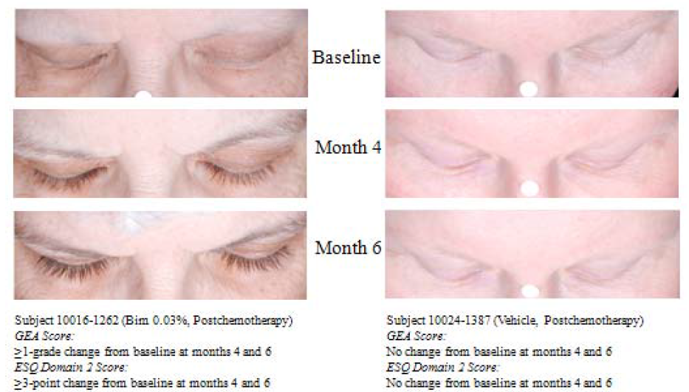
- The method of standardising the exposure/colour within the imaging is not evident in the images presented in Figure 4. The images presented Figures 3 and 4, 192024-038 6M to demonstrate the change in GEA score are markedly different in terms of exposure/colour-standardisation; the control image is bleached with a lighter colour scale which creates the impression of an increased response in the treatment arm. This is particularly so for Figure 3. The use of the white dot to standardise the exposure of the image, and allow the darkness to be assessed is not visible in the bimatoprost treated patient in the images on the left. The image quality is different from that presented in Figure 5 where the method of determining where measurements of length, thickness and darkness are taken is described. The accuracy and reproducibility of the apparently hand-drawn boundaries on the digital image are uncertain for those with very short or minimal eyelashes, especially the subset of post chemotherapy patients, who had GEA score 1 and fewer than 10 eyelashes. It is not stated that this method has been validated for measuring eyelash changes in the post­ chemotherapy population, as the reported validation was undertaken in a study without such patients (Study 192024-032).
Figure 4. Example of the effect of Bim 0.03% on eyelash growth compared to vehicle-Normal adult subpopulation
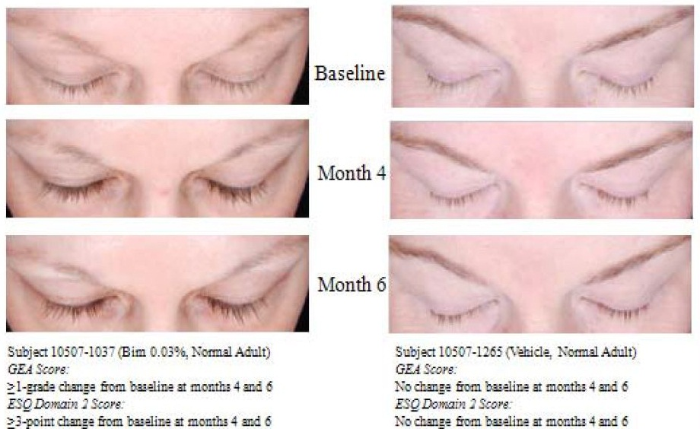
Figure 5. Definition of the area of interest and spline for the analysis of secondary efficacy variables
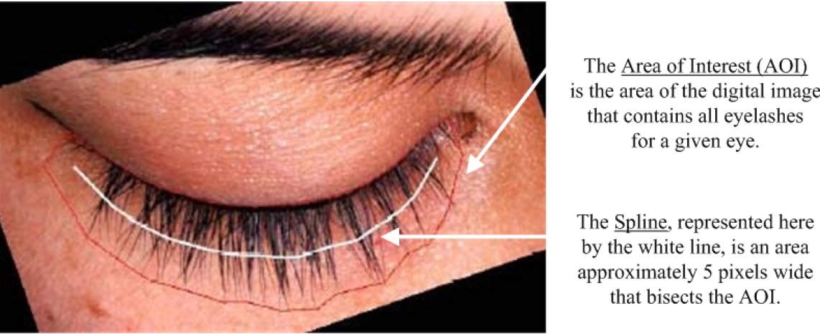
- The Per Protocol analysis which did not permit the last observation to be carried forward reveals that there are substantial data missing at the 4 month primary endpoint assessment in Study 102024-038. In the EMA Guideline adopted by the TGA on Points to consider on missing data this missing data can affect both the statistical power of the study and introduce bias. The latter is important and the missing data may affect the estimation of the treatment effect, the comparability of the treatment groups and the representativeness of the study sample in relation to the target population. As no comparison can be made against a control population for the post-chemotherapy group, this negates this group's inclusion in the whole group analysis and means that efficacy in the two of the three proposed indication's efficacy markers cannot been established in this population alone or the group as a whole. This precludes the study from demonstrating any efficacy effect.
- There is a differential loss of data across the three secondary endpoints as measured in Study 192024-038. It is unclear why such a differential exists as it is assumed that measurement of length would require the same photo numeric imaging as darkness and thickness. Indications that these were an issue at another time point may explain this (see point 7 in Findings of Fact) does not explain the different rates of missing data for two of the three endpoints at the primary efficacy endpoint time. If the reason for the missing data is the same, the Delegate of the Minister for the review was unclear as to how the images would be of sufficient quality to measure eyelash length accurately if they were not of sufficient quality to measure thickness and darkness. This raises uncertainty about the accuracy of the eyelash length measurements. This differential loss of follow-up for two of the factors specifically identified in the indication necessarily invalidates the claims of efficacy by the sponsor in this population.
- The primary efficacy endpoint at 4 months was the composite GEA scale and ESQ improvement. In the intention to treat population, this improved significantly for the idiopathic hypotrichosis group with active treatment from 40.2% versus 6.8% (p<0.001) in the control arm. For those post chemotherapy group, there was a significantly improved composite score of 35.4 % versus 14.3% in the control arm (p=0.041) but no significant improvement in composite score observed before that time point.
- In the Per Protocol analysis of the post-chemotherapy patients, the primary efficacy variable (composite score) appeared to demonstrate a significant difference with treatment while the individual components of the composite efficacy score were not significant. It is unclear why there is a difference in statistical significance between the composite score and its individual components in this population. It also suggests for those experiencing an improvement in their eyelash prominence (including more than half those in the control arm) that this is not necessarily accompanied by a psychological benefit related specifically to that. The data also confirm this as a largely self-limiting condition, with a high natural recovery rate without additional treatment in the control arm. There are no controlled data beyond 6 months in the post chemotherapy or idiopathic hypotrichosis groups to compare the use of ongoing treatment on efficacy in either group of patients.
- In Study 192024-038, the only evaluable change of the three factors included in the indication for both the post chemotherapy and idiopathic hypotrichosis group was eyelash length, although the accuracy of this is uncertain (see point 8 above) and the absolute change in length that would be clinically meaningful was not defined. Furthermore, any efficacy that might have been demonstrated is not sufficient to support the proposed indication.
- The median improvement in each of the two groups' ESQ from the pivotal study was from a baseline of 3 (= 3 scores for each component of 1, that is, 'very much disagree' to all questions) to a median score of 6. The permutations required to achieve a score of 6 require either 3 scores of for each component of 2 (that is, 'disagree'), or a single positive response with 2 very negative responses (that is, 4 ='agree' plus, 2 scores of 1 = 'very much disagree'). This does not support a meaningful benefit in the majority of patients. The mean score cannot be used as the responses are not normally distributed. A score >9 can only be achieved if the subject indicates a positive statement for each of the three variables (that is, not "very much disagree", "disagree' or "neutral") about attractiveness, confidence and/or professionalism. Across the combined idiopathic and post chemotherapy populations, after 4 months of treatment 12.4% in the treatment arm had a score >9, compared with 4.4% in the control group, that is, 8% reported an improvement with treatment that could potentially be attributed to bimatoprost. This indicates that 87.6% of patients did not rate the outcome in a positive light, and also suggests that the ≥3 improvement specified in the protocol was not sufficiently stringent to detect a positive outcome.

Conclusion
For the reasons referred to above, the Delegate of the Minister for the review had significant concerns about the safety profile of bimatoprost 0.03% with the proposed usage, and the Delegate of the Minister for the review was also of the view that efficacy has not been satisfactorily established. Therefore, the Delegate of the Minister for the review decided to confirm the decision not to approve the use of bimatoprost for the proposed indication: to treat hypotrichosis of the eyelashes by increasing their growth including length, thickness and darkness.

Final outcome
The Delegate of the Minister for the review decided to confirm the initial decision not to approve the registration of Latisse topical solution (bimatoprost 0.03%) because the Delegate was of the view that neither the safety nor the efficacy of Latisse for the purposes for which it is to be used has been satisfactorily established.
Subject to the Administrative Appeals Tribunal Act 1975, the sponsor appealed on the 30 April 2013 to the Tribunal for review of the Minister’s decision.
The TGA and the sponsor reached an agreement about the registration of Latisse topical solution (bimatoprost 0.03%) (Latisse) with regards to (inter alia) the risk management plan (including routine pharmacovigilance), consumer medicines information and educational material to be distributed to prescribers and dispensers and the Administrative Appeals Tribunal made a decision in accordance with this agreement. On 6 October 2015, the Tribunal set aside the decision not to register Latisse and substituted a decision to approve the registration of Latisse under subsection 25(3) of the Therapeutic Goods Act 1989 for the following indication:
‘Latisse is indicated to treat hypotrichosis of the eye lashes in adults by increasing their growth including, but not necessarily all of, length, thickness and darkness.’
Note: There are currently no safety and efficacy data for Latisse beyond 12 months from randomised clinical trials. Latisse should not be used beyond 12 months.
Latisse was entered on the ARTG on the 14 July 2016.
The following Specific conditions of registration apply to these goods:
- The Latisse bimatoprost EU Risk Management Plan (RMP), version 1.3, dated 29 May 2012 (data lock point 31 December 2011) with Australian Specific Annex dated July 2016, and any subsequent revisions, as agreed with the TGA will be implemented in Australia.
- The following specific conditions also apply to this therapeutic good.
- The Consumer Medicines Information must be included inside every pack of the product;
- The Consumer Medicines Information must include, at the top of the page, relevant text addressing the safety concerns associated with Latisse;
- The following statement must be printed on the pack of the product The Consumer Medicine Information must be provided to the patient
- You must comply with sections 1 to 3 and 13 of the Medicines Australia Code of Conduct as updated from time to time; and
- You must not supply Latisse to any persons identified by you or the Therapeutic Goods Administration, Department of Health as persisting in advertising the availability of the product after those persons have been alerted to the restriction in advertising of Latisse.
The sponsor has since decided to take this product off the ARTG (entry cancelled 22 August 2017) and Latisse (bimatoprost) is no longer registered in Australia.

Attachment 1. Extract from the Clinical Evaluation Report

Therapeutic Goods Administration
PO Box 100 Woden ACT 2606 Australia
Email: info@tga.gov.au Phone: 1800 020 653 Fax: 02 6232 8605
http://www.tga.gov.au

On the 30 April 2014 the sponsor appealed to the Administrative Appeals Tribunal for review of the TGA’s decision not to register Latisse. On 6 October 2015, the Tribunal set aside the decision not to register Latisse and substituted a decision to approve the registration of Latisse under subsection 25(3) of the Therapeutic Goods Act 1989.
The sponsor decided to take this product off the ARTG and Latisse is no longer registered in Australia.
Sasaki S., Hozumi Y. and Kondo S. (2005). Influence of prostaglandin F_{2α} and its analogues on hair regrowth and follicular melanogenesis in a murine model. Exp. Dermatol. 14: 323–328.
Uno H., Zimbric M. L., Albert D. M. and Stjernschantz J. (2002). Effect of latanoprost on hair growth in the bald scalp of the stump-tailed macaque: a pilot study. Acta Derm. Venereol. 82: 7–12
Tan M.H., Lebwohl M., Esser A.C. and Wei H. (2001) The penetration of 0.005% fluticasone propionate ointment in eyelid skin. J. Am. Acad. Dermatol. 45: 392–396.
Australian Pregnancy Category B3: Drugs which have been taken by only a limited number of pregnant women and women of childbearing age, without an increase in the frequency of malformation or other direct or indirect harmful effects on the human fetus having been observed. Studies in animals have shown evidence of an increased occurrence of fetal damage, the significance of which is considered uncertain in humans.
These data allow for the swapping of treatment in the second 6 months of study 192024-038.
Results fromPhase III Study 192024-032
European Union (EU). The Extent of Population Exposure to Assess Clinical Safety for Medicines Intended for Long-Term Treatment of Non-Life-Threatening Conditions. 1994. Document 3CC5a.
Global Eyelash Assessment scale with photonumeric guide- 4 categories of overall eyelash prominence 1 = minimal, 2 = moderate, 3 = marked, 4 = very marked
Eyelash Satisfaction Questionnaire – a patient reported measure
ICH E1 The extent of population exposure to assess clinical safety for drugs intended for long-term treatment of non-life-threatening conditions.
.Sira M., Verity D.H., Malhotra R. "Topical bimatoprost 0.03% and iatrogenic eyelid and orbital lipodystrophy. " Aesthetic Surgery Journal. 32 (7) (pp 822-824), 2012
Filippopoulos T., Paula J.S., Torun N., Hatton M.P., Pasquale L.R., Grosskreutz C.L. "Periorbital changes associated with topical bimatoprost." Ophthalmic Plastic and Reconstructive Surgery. 24 (4) (pp 302-307) 2008.
EMA Guideline adopted by the TGA on Points to consider on missing data

