First round report 9 January 2017

AusPAR Attachment 2

Extract from the Clinical Evaluation Report for Bezlotoxumab
  - Proprietary Product Name: Zinplava
  - Sponsor: Merck Sharp & Dohme Australia

About the Therapeutic Goods Administration (TGA)
- The Therapeutic Goods Administration (TGA) is part of the Australian Government Department of Health, and is responsible for regulating medicines and medical devices.
- The TGA administers the Therapeutic Goods Act 1989 (the Act), applying a risk management approach designed to ensure therapeutic goods supplied in Australia meet acceptable standards of quality, safety and efficacy (performance), when necessary.
- The work of the TGA is based on applying scientific and clinical expertise to decision-making, to ensure that the benefits to consumers outweigh any risks associated with the use of medicines and medical devices.
- The TGA relies on the public, healthcare professionals and industry to report problems with medicines or medical devices. TGA investigates reports received by it to determine any necessary regulatory action.
- To report a problem with a medicine or medical device, please see the information on the TGA website <https://www.tga.gov.au>.
About the Extract from the Clinical Evaluation Report
- This document provides a more detailed evaluation of the clinical findings, extracted from the Clinical Evaluation Report (CER) prepared by the TGA. This extract does not include sections from the CER regarding product documentation or post market activities.
- The words [Information redacted], where they appear in this document, indicate that confidential information has been deleted.
- For the most recent Product Information (PI), please refer to the TGA website <https://www.tga.gov.au/product-information-pi>.
Copyright
© Commonwealth of Australia 2018
This work is copyright. You may reproduce the whole or part of this work in unaltered form for your own personal use or, if you are part of an organisation, for internal use within your organisation, but only if you or your organisation do not use the reproduction for any commercial purpose and retain this copyright notice and all disclaimer notices as part of that reproduction. Apart from rights to use as permitted by the Copyright Act 1968 or allowed by this copyright notice, all other rights are reserved and you are not allowed to reproduce the whole or any part of this work in any way (electronic or otherwise) without first being given specific written permission from the Commonwealth to do so. Requests and inquiries concerning reproduction and rights are to be sent to the TGA Copyright Officer, Therapeutic Goods Administration, PO Box 100, Woden ACT 2606 or emailed to < tga.copyright@tga.gov.au> .

Contents
List of abbreviations 5
1. Introduction 9
1.1. Submission type 9
1.2. Drug class and therapeutic indication 9
1.3. Information on the condition being treated 9
2. Current treatment options and clinical rationale 10
2.1. Clinical rationale 11
3. Contents of the clinical dossier 12
3.1. Scope of the clinical dossier 12
3.2. Paediatric data 13
3.3. Good clinical practice 13
4. Pharmacokinetics 13
4.1. Studies providing pharmacokinetic information 13
4.2. Summary of pharmacokinetics 14
4.3. Evaluator’s overall conclusions on pharmacokinetics 16
5. Pharmacodynamics 16
5.1. Studies providing pharmacodynamic information 16
5.2. Summary of pharmacodynamics 16
5.3. Evaluator’s overall conclusions on pharmacodynamics 19
6. Dosage selection for the pivotal studies 19
6.1. Pharmacokinetics and pharmacodynamics: dose finding studies 19
6.2. Phase II dose finding studies 19
6.3. Phase III pivotal studies investigating more than one dose regimen 19
6.4. Evaluator’s conclusions on dose finding for the pivotal studies 19
7. Clinical efficacy 19
7.1. Studies providing evaluable efficacy data 19
7.2. Pivotal or main efficacy studies 20
7.3. Other pivotal efficacy studies 30
7.4. Analyses performed across trials: pooled and meta analyses 38
7.5. Evaluator’s conclusions on clinical efficacy 39
8. Clinical safety 40
8.1. Studies providing evaluable safety data 40
8.2. Studies that assessed safety as the sole primary outcome 41
8.3. Patient exposure 41
8.4. Adverse events 41
8.5. Evaluation of issues with possible regulatory impact 46
8.6. Other safety issues 48
8.7. Post marketing experience 50
8.8. Evaluator’s overall conclusions on clinical safety 50
9. First round benefit-risk assessment 51
9.1. First round assessment of benefits 51
9.2. First round assessment of risks 52
9.3. First round assessment of benefit-risk balance 52
10. First round recommendation regarding authorisation 53
11. Clinical questions 53
12. References 53

List of abbreviations
Abbreviation | Meaning
ADA | Anti-drug antibody(ies)
AE | Adverse event
AESIs | Adverse events of special interest
ASA | Australian-specific annex
AUC_{0-inf} | Area Under the Curve from zero to infinity
CDC | Centers for Disease Control and Prevention
CDI | Clostridium difficile infection
CDT | Clostridium Difficile toxin
CCF | Congestive cardiac failure
CHF | Congestive heart failure
CHMP (CPMP) | Committee for Medicinal Products for Human Use
CI | Confidence Interval
CSR | Clinical Study Report
DILI | Drug-induced liver injury
DTL | Drug Tolerance Limit of ADA assay
eCRF | electronic Case Report Form
ECI | Events of clinical interest
ECL | electrochemiluminescence
EIA | Enzyme Immunoassay
ELISA | Enzyme Linked Immunosorbent Assay
EMA | European Medicines Agency
EU | European Union
FAS | Full analysis set
FDA | Food and Drug Administration
FMT | Faecal microbiota for transplantation
GCP | Good Clinical Practice
gp | Group
hr(s) | hour(s)
IB | Investigator Brochure
ICH | International Conference on Harmonization
Ig | Immunoglobulin
ITT | Intention to treat
IV | intravenous
kg | Kilogram
KM | Kaplan Meier
MAA | Marketing Authorization Application
mAb | Monoclonal Antibody
MCB | Master Cell Bank
μg | Microgram
MEDRA | Medical Dictionary for Regulatory Activities
mL | millilitres
mth(s) | month(s)
NAb | Neutralising Anti-drug Antibody(ies)
NAP | North American Pulsed-Field
NOAEL | no-observed-adverse-effect-level
PCR | Polymerase Chain Reaction
PD | pharmacodynamics
PI | Prescribing Information
PK | pharmacokinetics
Pop’n | population
PP | Per protocol
PPF | Pre Submission Planning Form
PT | Preferred Term
REA | Restriction Endonuclease Analysis
RMP | Risk Management Plan
SAE | Serious Adverse Event
SOC | System Organ Class
SoC | Standard of Care
subgp(s) | subgroup(s)
TEAE | treatment emergent adverse event
TESAE | treatment emergent serious adverse event
TGA | Therapeutic Goods Administration
t1/2 | Apparent terminal half-life
T_{max} | Time (maximum concentration)
TMDD | Target-mediated drug disposition
TRAE | treatment related adverse event
ULN | Upper Limit of Normal
US | United States
UTI | urinary tract infection
Vc | Central volumes of distribution
Vd | Volume of distribution
Vp | Peripheral volumes of distribution
VT | ventricular tachyarrythmia
wk(s) | week(s)
WHO | World Health Organisation
yrs | years

Introduction

Submission type
Category 1 Application: New Biological Entity.

Drug class and therapeutic indication
Zinplava (bezlotoxumab) is indicated for the prevention of Clostridium difficile (C. difficile) infection (CDI) recurrence in patients 18 years or older receiving antibiotic therapy for CDI.
Zinplava (bezlotoxumab) is a specific fully human monoclonal antibody that binds with high affinity to C. difficile toxin B. Bezlotoxumab is an IgG1 immunoglobulin produced in Chinese hamster ovary cell by recombinant DNA technology.
Zinplava is a concentrated injection that requires dilution for intravenous (IV) infusion. The recommended dose of Bezlotoxumab is 10 mg/kg administered over 60 minutes as a single infusion.

Information on the condition being treated
Clostridium difficile, an anaerobic, spore forming, gram positive bacillus, produces two exotoxins, toxins A and B, which cause the symptoms of CDI (Carter 2012; Voth 2005). These toxins target gut epithelium, causing cellular morphological changes, depolarisation of the cells, leading to cell death, and disruption of the intestinal barrier function essential for normal gut function (Carter 2012; Rupnik 2009). Additionally, the toxins cause epithelial cells to release pro-inflammatory mediators such as IL-8, which attract neutrophils and monocytes, further exacerbating gut damage (Madan 2012; Shen 2012).
C. difficile colonises the colon without causing symptoms in approximately 1 to 3% of adults in the United States (US); the proportion is higher in patients in hospitals or chronic care settings (Kyne 2000; McFarland 1989; Samore 1994). Colonisation with C. difficile can cause disease when the integrity of the gut flora is disturbed, such as during exposure to antibiotics, during which the alterations in the normal microbiota in the gut allow C. difficile overgrowth. Presentation varies from mild symptoms including watery diarrhoea and mild abdominal cramping or tenderness, to severe symptoms necessitating hospitalisation (Jin 2014; CDC 2012). CDI symptoms can be exacerbated in the elderly and patients with co-morbidities (Leffler 2015; Jin 2014; CDC 2012).
CDI is one of the most commonly recognised causes of nosocomial diarrhoea in adults in the US and Europe (Aguayo 2015; Crobach 2009). Based on data from the US National Hospital Discharge Survey, the incidence of reported CDI in acute care hospitals nearly tripled between 1996 and 2005, from 31 per 100,000 population in 1996 to 84 per 100,000 population in 2005 (Kelly 2008; McDonald 2006). Consistent findings have been reported using data from the US Nationwide Inpatient Sample; the rate of CDI discharges more than tripled between 1993 (2.61 cases per 1,000 discharged patients) and 2008 (8.75 cases/1,000 discharged patients) though the rate began to plateau in 2009 with 8.53 cases/1,000 discharged patients in that year (Lessa 2012). In a 2015 publication, CDC reported the estimated number of CDI cases in the United States was 453,000 and the corresponding incidence rate was 147.2 per 100,000 persons. Of these cases, an estimated 293,000 cases were healthcare-associated (107,000 had hospital onset CDI, 104,400 had nursing home onset CDI and 81,300 had community onset, healthcare associated CDI), and there were an estimated 29,300 deaths (Lessa 2015). In Canada, the incidence in 2007 was 5.35 per 1000 admissions; the estimated number of cases in Canada was 38,000. In the UK, the annual incidence in 2014/2015 was 26.3 per 100,000 people, corresponding to 14,165 cases (Gerver 2015). In 2011 in Italy, the incidence of CDI was 2.3 per 10,000 patient-days (Di Bella 2013). In Australia the incidence of CDI in 2012 was 4.03 per 10,000 patient-days (Slimmings 2014). In the early 2000’s, a new strain of C. difficile was identified. This new strain, referred to as BI/NAP1/027 based on the 3 most common typing methods for C. difficile strains (Restriction Endonuclease Analysis [REA] type BI, North American Pulsed-Field [NAP] type 1, and Polymerase Chain Reaction [PCR] Ribotype 027), has been responsible for several notable outbreaks of disease in the US, Canada, and Europe (Loo 2005; McDonald 2005; Kuijper 2006). This strain is thought to be more virulent than other strains and is also resistant to some antibiotics (Kuijper 2006). The increasing incidence of CDI is partially attributed to this new strain (Goorhuis A 2008; Gravel 2009; Loo 2005; McDonald 2005; Pepin 2005), and this new strain has been associated with recurrent CDI.

Current treatment options and clinical rationale
Historically, treatment options for CDI were limited to two antimicrobial, metronidazole and oral vancomycin. In the treatment guideline authored jointly by the Society for Health Epidemiology of America and the Infectious Diseases Society of America in 2011, and in the 2014 European Society of Clinical Microbiology and Infectious Diseases treatment guidelines (Cohen 2010; Debast 2014) metronidazole is recommended as the first-line agent for initial CDI in mild or moderate cases. Vancomycin is recommended as the firstline agent for severe CDI and as treatment for recurrent CDI. Fidaxomicin, a narrow spectrum macrocyclic antibiotic (Louie 2011), available since 2010, is recommended in the updated European guidelines as treatment for severe CDI, for recurrent CDI, and in patients at risk for recurrent disease. While most cases of CDI resolve after withdrawal of the offending systemic antibiotic and treatment with vancomycin, metronidazole, or fidaxomicin, approximately 15% to 35% of adult patients will experience a recurrent episode of CDI after completing initial therapy (Aslam 2005; Kelly 2008; Zar 2007; Louie 2011). The severity of disease and associated complications increase dramatically for adult patients who have relapsed once, and these patients have a 50 to 60% chance of experiencing repeated CDI episodes that may continue over a period of years (McFarland 2002; McFarland 2009). Clinical risk factors for recurrent CDI include advanced age, severity of the underlying condition, and additional systemic antibiotic use after stopping initial CDI antibiotic therapy (Blossom 2007; McDonald 2007; Hu 2009; Kyne 2005). Patients with inadequate immune responses to toxins A and/or B at the time of their initial CDI diagnosis are more likely to develop recurrence (Aronsson 1985; Katchar 2007; Kyne 2001; Warny 1994). Data from a hospital based study in the US suggests that patients with recurrent CDI had 33% higher rate of death at 180 days compared with patients without recurrent CDI when adjusting for patient demographics, comorbidities and medications received during their index CDI hospitalisation (Olsen 2015).In the US, the most recent estimated incidence of recurrent community-acquired CDI was 7.0 per 100,000 persons with 21,600 cases of recurrent community-acquired CDI (Lessa 2015). The estimated incidence of recurrent hospital-acquired CDI in the US was 19.9 per 100,000 persons with an approximately 61,400 cases (Lessa 2015). Estimates of community-acquired CDI and healthcare acquired CDI recurrence were higher for older patients. Of the total estimated CDI cases, 18% (83,000) were recurrent cases. In 2011, there were an estimated 29,000 deaths, and the majority of these were in healthcare-acquired CDI cases and in patients ≥ 65 years of age (Lessa 2015). European studies report estimates of CDI recurrence consistent with the US that is 18% (Bauer 2011). There is a significant economic burden associated with CDI. In 2006, costs of managing CDI in Europe, was approximately € 300 million (Kuijper 2006). Recurrent CDI tends to have longer hospital stays than primary cases, and associated costs are even higher (Wiegand 2012).
Approaches to treatment of recurrent CDI include repeat courses of oral vancomycin or metronidazole, vancomycin followed by rifaximin, IV immunoglobulin, and therapy with other microorganisms including faecal microbiota for transplantation (FMT) (Kelly 2008). Large, randomised, controlled clinical trials are lacking for these therapies. Currently, there is no consistently effective and safe treatment approved for prevention of recurrent CDI, and the management of these patients often poses a difficult challenge.

Clinical rationale
Passive or active immunisation against these C. difficile toxins A and B protects against CDI in animals challenged with pathogenic strains of C. difficile (Libby 1982; Torres 1995; Kink 1998; Babcock 2006; Steele 2013). Neutralisation of both toxins appears necessary for full maximal protection in hamsters and mice, but neutralisation of toxin B alone appears sufficient in gnotobiotic piglets (Steele 2013). Kyne and co-workers showed that antitoxin mediated protection extends to clinical disease by demonstrating that a correlation exists between circulating neutralizing antibodies against toxin A and a lower rate of primary and recurrent CDI (Kyne 200, Kyne 2001); this observation was subsequently extended to anti-toxin B antibodies (Leav 2010). The concept that toxin neutralisation is protective against CDI recurrence offers a novel approach with important advantages over the antibiotic-based approach alone. An advantage of toxin neutralisation is there is no disruption of normal microbiota, it is not likely to be subject to the emergence of resistance and unlike FMT, anti-toxin antibodies can be administered to immunocompromised patients or who require continued antibiotics for other infections.
Actoxumab (also known as MK-3415, GS-CDA1, or CDA1) and bezlotoxumab (also known as MK-6072, MDX-1388, or CDB1) are fully human mAbs (IgG1/kappa isotype subclass) which bind with high affinity to C. difficile toxins A and B respectively and prevents toxin binding to host cells. MK-3415A is the combination of actoxumab and bezlotoxumab. The clinical development program included clinical trials evaluating each individual mAb (actoxumab or bezlotoxumab) or the combination of both mAbs for the prevention of CDI recurrence in subjects receiving oral standard of care (SoC) antibiotics for a primary or recurrent episode of CDI. Both actoxumab and bezlotoxumab neutralise the cytotoxic activities of toxins from a broad range of clinical isolates of C. difficile (ribotypes 001, 002, 003, 012, 014, 017, 018, 023, 027, 053, 063, 077, 078, 081, 087, 106, 198, and 369). Given that low titres of neutralising antibodies against toxins A and B are a significant risk factor for developing a recurrent infection in humans, it was hypothesised that administration of actoxumab + bezlotoxumab would reduce the risk for CDI recurrence by providing passive immunity against the toxins and prevent the toxins from damaging the gut epithelium. The preclinical data support a model wherein bezlotoxumab crosses the gut wall through paracellular transport, enhanced by toxin-induced disruption of the gut epithelium, to reach the site of infection in the lumen of the gut. Consistent with this concept, bezlotoxumab was detected in the stool samples from bezlotoxumab-treated patients in Study P002. In addition, toxin may leak into the subepithelial space of the gut wall through the same mechanism. Thus, neutralization of the toxin by bezlotoxumab may occur both on the luminal and systemic sides of the intestinal wall.

Formulation development

Pre-clinical
Actoxumab and bezlotoxumab bind with high affinity to TcdA and TcdB, respectively, and prevent toxin binding to target cells by partial occlusion of the receptor binding pockets present in the CROP domains of the toxins. This binding, blocks the intoxication cascade normally triggered by binding of TcdA and TcdB to gut epithelial cells and prevents the downstream effects of the toxins, including glucosylation of Rho-type GTPases, changes in cellular morphology/cell death, leading to disruption of the epithelial barrier function. Neutralisation of the cytopathic/cytotoxic and pro-inflammatory effects of TcdA and TcdB by actoxumab+bezlotoxumab translates into effective protection in mouse and hamster models of primary or recurrent CDI, and to gnotobiotic piglet primary CDI models, including increased survival, decreased morbidity and gross intestinal pathology and prevention of damage/ inflammation in the gut wall. However, actoxumab+ bezlotoxumab does not appear to reduce C. difficile burden in the gut. Animals that survive the early acute phase of CDI eventually clear the infection, with gut C. difficile burdens returning to undetectable levels by Days 14 to 28 following infectious challenge. In hamsters and mice, this decrease in C. difficile burden parallels a gradual recovery of the gut microbiota. This recovery is unaffected by actoxumab+ bezlotoxumab but significantly delayed by vancomycin treatment. Overall, these data support a model wherein actoxumab + bezlotoxumab prevents the manifestation of CDI symptoms, obviating the need for further antibiotics to fight the infection and allowing the gut microbiota to gradually recover and eventually eliminate the infection. In the context of recurrent CDI, when administered concurrently with SoC antibiotics during a primary infection, actoxumab+ bezlotoxumab (or bezlotoxumab alone in human and piglet disease) may prevent the symptoms of a recurrent infection, circumventing the need for additional courses of antibiotics throughout the period of susceptibility to recurrence, when the normal gut microbiota has not yet sufficiently recovered to prevent subsequent episodes. The relative biological importance of TcdA and TcdB in CDI is complex and appears species dependent. As described herein, administration of actoxumab or bezlotoxumab alone provided limited protection in mouse and hamster models of CDI. Conversely, in gnotobiotic piglets, bezlotoxumab alone provided a level of protection similar to that of the combination actoxumab+bezlotoxumab, mirroring the results of the Phase III clinical trials in humans.
The in vivo efficacy studies in rodents demonstrate actoxumab+bezlotoxumab is efficacious against several genetically distinct strains. In neutralisation studies with 81 distinct clinical isolates of C. difficile spanning 18 ribotypes and at least 7 toxinotypes, actoxumab and bezlotoxumab fully neutralised toxins of all strains tested, although with lower potencies against toxins from ribotype 027 and 078 strains. However, EC50 of actoxumab and bezlotoxumab for these 2 ribotypes were still below their plasma concentrations in patients with CDI up to 84 days following administration (Lowy 2010). These studies suggest the systemically administered antibodies localise to the subepithelial spaces of the gut tissue and leak into the lumen of the gut largely via toxin induced lesions, whereupon the antibodies can act directly upon luminal toxin and upon any toxin that may have leaked to the basolateral/ systemic side of the gut wall through those same lesions. The long half-life of antibodies in circulation allows for a constant and long-lasting source of neutralising activity on the basolateral/systemic side of the gut epithelium.
[Information redacted]
MK-6072 is a sterile, aqueous solution for IV infusion. Each vial contains a target deliverable dose of 40 mL MK-6072 at 25 mg/mL for a total of 1000 mg per vial. The product is supplied in a 50 mL Type I tubing glass vial with a 20 mm chlorobutyl rubber stopper. For administration, MK-6072 DP is diluted with either 0.9% (w/v) sodium chloride or 5% (w/v) dextrose, and the infusion solution is administered IV. Since there is no difference in composition between the MK-6072 DS and DP, the biological properties of these materials are the same.

Contents of the clinical dossier

Scope of the clinical dossier
The submission contained the following clinical information:
Four Phase I (two additional trials P018 and 19 of actoxumab only, were provided for background information only, not discussed further) are trials characterising the safety, PK, and immunogenicity of bezlotoxumab and actoxumab, each administered alone or in combination.
Population PK and exposure response analyses using pooled data from 3 Phase I trials (P004, P005 and P006) and the two Phase III trials (P001 and P002).
Efficacy and safety of bezlotoxumab administered alone or in combination with actoxumab has been evaluated in one Phase II trial (P017) and two pivotal Phase III trials (P001 and P002).

Paediatric data
Not applicable.

Good clinical practice
Approvals to undertake the clinical studies were obtained from appropriately constituted institutional ethics committees/independent research boards, in accordance with the relevant national guidelines and regulations applicable. The studies presented in this application were conducted in accordance with GCP.

Pharmacokinetics

Studies providing pharmacokinetic information

Table 1: Submitted pharmacokinetic studies
PK topic | Subtopic | Study ID
PK in healthy adults | General PK  Single dose | MK-3415A-005  MK-3415A-020
PK in healthy adults | Multi-dose | MK-3415A-004
PK in special populations | Target population § - Single dose | MK-3415A-017
PK in special populations | Other special population  (Japanese ethnicity) | MK-3415A-006
Population PK analyses | Healthy subjects | population PK analysis based on the data three Phase I (P004, P005, P006) and two Phase III (P001, P002) trials
Population PK analyses | Target population
§ Subjects who would be eligible to receive the drug if approved for the proposed indication.
Bioanalytical Assays: methods supporting bezlotoxumab clinical development were provided. In P020 and P017, bezlotoxumab concentration measurements and ADA assessments in serum performed using first generation assays at MBL, Boston, MA. For bezlotoxumab concentration measurements, ligand capture based ELISA used that measured endogenous anti-toxin B antibodies and bezlotoxumab. A bridging ELISA was used for ADA assessments. A neutralizing antibody (NAb) assay was not performed for these trials. Subsequent Phase I clinical trials (P004, P005, and P006) and the Phase III trials (P001 and P002) employed a second generation assay specific for serum concentrations of bezlotoxumab. For serum bezlotoxumab concentration measurements, a conventional sandwich electrochemiluminescence (ECL) immunoassay was used. Additionally, a conventional sandwich ECL method for the detection of bezlotoxumab in stool was developed, and used for samples in P002. Detection of ADA in serum used a second generation assay using a conventional bridging ECL immunoassay format. For the detection of NAb in serum, a first generation assay using a toxin sensitive cell line was used. For the Phase III trials (P001 and P002), two immunoassays were developed and characterised to measure two exploratory biomarkers, endogenous IgG to toxin A and toxin B.

Summary of pharmacokinetics

Physicochemical characteristics of the active substance
Bezlotoxumab (MK-6072) (CAS No.: 1246264-45-8; approximate molecular weight of 148.2 kDa) is a fully human monoclonal antibody (mAb) of the IgG1/kappa isotype subclass that binds with high affinity to CD toxin B (Kds = 19 and 370 pM in a two site binding model) to prevent binding of toxin B to its target cells.

Pharmacokinetics in healthy subjects

Absorption
Absorption, distribution, metabolism, and excretion (ADME) of bezlotoxumab are similar to other IV administered mAbs, with 100% bioavailability, limited extravascular distribution (Vdss approximately 7 L), and low clearance. Bezlotoxumab has been detected in the stool of patients, indicating it reaches the site of infection in the gut. Bezlotoxumab is eliminated by degradation through protein catabolism.

Bioavailability
Bioavailability trials not conducted. The drug is administered IV and is, 100% bioavailable.

Distribution
AUC_{0-inf} and C_{max} of bezlotoxumab in healthy subjects increase in an approximately dose proportional manner across the 0.3 to 20 mg/kg dose range. No dose ranging trials were conducted beyond Phase I, and no pharmacodynamic (PD) measures were evaluated in Phase I. The efficacy exposure response analysis was based on CDI recurrence and PK data from the two pivotal Phase III trials (P001, P002).

Metabolism
Based on the population PK analysis, geometric mean (%CV) clearance (CL) of bezlotoxumab is 0.317 L/day (40%), with a Vdss of 7.33 L (16%) and elimination half-life (t½) of approximately 19 days (28%). In subjects with CDI who received a single 10 mg/kg IV dose of bezlotoxumab, mean AUC_{0-inf} and C_{max} are 53,000 μg/hour/mL and 185 μg/mL, respectively. Bezlotoxumab has moderate PK variability (40% and 21% CV for AUC_{0-inf} and C_{max}).

Excretion
Bezlotoxumab was detected in the stool of subjects with CDI, indicating that it reaches the site of infection in the gut. Bezlotoxumab is eliminated by degradation through protein catabolism.

Intra and inter individual variability of pharmacokinetics
The AUC_{0-inf} and C_{max} of bezlotoxumab in healthy subjects increases in an approximately dose proportional manner across the 0.3 to 20 mg/kg dose range (using data from P020). Bezlotoxumab is intended to be administered as a single IV infusion, and thus time to steady state has not been assessed.

Pharmacokinetics in the target population
See Below under Section 4.2.5.1.

Pharmacokinetics in special populations

Pharmacokinetics in subjects with impaired hepatic function
See Below under Section 4.2.5.1.

Pharmacokinetics in subjects with impaired renal function
See Below under Section 4.2.5.1.

Pharmacokinetics according to age
See Below under Section 4.2.5.1.

Pharmacokinetics related to genetic factors
See Below under Section 4.2.5.1.

Pharmacokinetics in other special population / with other population characteristic
See Below under Section 4.2.5.1.

Population pharmacokinetics

PopPK analysis ID
As noted above, the characterisation of bezlotoxumab PK is supported by a population PK analysis based on data obtained from P004, P005, P006 and P001, P002. The population PK analysis dataset includes 72 healthy subjects who received bezlotoxumab alone or actoxumab + bezlotoxumab (P004, P005, P006), including 29 subjects who received a second dose of actoxumab + bezlotoxumab (P004). This dataset also includes 1515 patients in the Phase III program (P001, P002) who received a 10 mg/kg dose of bezlotoxumab alone or 10 mg/kg actoxumab + 10 mg/kg bezlotoxumab. In addition to the population PK analysis, the dataset was also used to assess exposure response relationships for efficacy and safety. The effects of body weight/BMI, albumin, gender, age, race/ethnicity, renal impairment, hepatic impairment, clinical comorbidities, and CDI severity on the exposure of bezlotoxumab were assessed with a population PK analysis of densely sampled serum concentrations. The effects of these covariates on the exposure of bezlotoxumab are within the clinical significance bounds of (0.6, 1.6) for bezlotoxumab. Subgroup analyses of the Phase III trials further support a lack of clinically significant effect on efficacy and safety for many of these subgroups and special populations. As such, the 10 mg/kg dose is the standard dose, without any dose adjustment, for age, liver or renal impairment.

Pharmacokinetic interactions
In agreement with a position paper from an international consortium on drug-drug interactions between therapeutic proteins and small molecule drugs, nonclinical in vitro and in vivo studies are not considered predictive of human PD drug interactions (Evers 2013). Concomitant medications are not anticipated to affect the PK of bezlotoxumab, as mAbs are not eliminated by metabolic or transporter pathways typically affected by concomitant medications. The effect of SoC antibiotic therapy for the treatment of CDI (that is metronidazole, vancomycin, fidaxomicin), as well as concomitant non-SoC systemic antibiotic use and proton pump inhibitor use, were evaluated in the population PK analysis. SoC therapies and concomitant use of non-SoC systemic antibiotics or PPIs did not have a meaningful effect on the PK of bezlotoxumab, and the effects on bezlotoxumab exposure are within the clinical significance bounds of (0.6, 1.6). Likewise, bezlotoxumab is not anticipated to affect the PK of concomitantly administered medications, as it is a highly specific mAb that targets a non-endogenous antigen (C. difficile toxin B).

Clinical implications of in vitro findings
Confirms potential use as a single infusion, with a long half-life and evidence that this IV administered monoclonal antibody does reach the gut.

Evaluator’s overall conclusions on pharmacokinetics
The findings are consistent with that expected for a fully human monoclonal antibody and the ADME of bezlotoxumab are similar to other IV administered mAbs. Subgroup analyses in the Phase III programme do not suggest any impact on efficacy and/or safety of the product based on intrinsic factors as described in Section 4.2.5 above. The potential for drug-drug interactions is low, as this is a therapeutic protein. The rationale for the following studies not being conducted that is in vitro-in vivo correlation studies, plasma protein binding studies, extrinsic factor trials, hepatic metabolism and drug interaction trials, bioavailability trials, comparative BA and BE trials, is justified by the nature of the product.

Pharmacodynamics

Studies providing pharmacodynamic information
No PD measures were evaluated in Phase I. Thus, the efficacy exposure response analysis was based on CDI recurrence and PK data from the two pivotal Phase III trials (P001, P002) and one Phase II study, P017.

Table 2: Submitted pharmacodynamic studies
PD Topic | Subtopic | Study ID
Primary Pharmacology | Effect on PD parameter A
Secondary Pharmacology | Effect on PD parameter C | development of ADA assessed in all studies of bezlotoxumab in healthy subjects and the target population
Population PD and PK-PD analyses | Target population | P017, P001 and P002

Summary of pharmacodynamics

Mechanism of action
See below.

Pharmacodynamic effects

Primary pharmacodynamic effects
How systemic IgG antibodies neutralise toxins in the gut lumen is not completely understood. Leakage of antibody into the gut lumen is thought to be at least partially responsible for the effect of bezlotoxumab in neutralising the effect of toxin released by intraluminal C. difficile.
Detection of bezlotoxumab in stool: assessed in P002 only. The assay for bezlotoxumab presence in human stool was developed, characterised and performed at Intertek, San Diego, CA. Following a single IV dose of 10 mg/kg of MK-6072 or MK-3415A, the highest % of samples with MK-6072 detected was from stool samples collected on Day 4, followed by stool samples collected at unscheduled visits, suggesting detection was more probable in the time frame close to either the initial CDI episode or subsequent episodes of diarrhoea. The reason for the higher proportion of MK-6072 detection in the MK-3415A treatment arm versus the MK-6072 treatment arm is unknown.

Table 3: MK-6072 Stool samples by Visit in P002
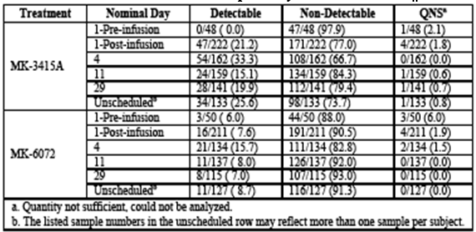
To assess the impact of the severity of the initial episode of CDI on the presence of MK-6072 in stool, the percentage of detectable post-dose samples at each time point was also summarised for subjects from both treatment arms stratified by presence or absence of clinically severe CDI at baseline (Zar score < 2 or Zar score ≥ 2). Subjects with a Zar score > 2 at the time of study entry had a higher frequency of stool samples with MK-6072 detected compared to subjects with a Zar score < 2 at the Day 4, Day 11, and Day 29 collection time points. Since a high Zar score represents more severe disease, this observation supports the concept that CDI induced damage to the colonic epithelium results in localisation of MK-6072 to the gut lumen and detection in stool.

Secondary pharmacodynamic effects
Bezlotoxumab ADAs were monitored in the first-in-human bezlotoxumab trial (P020), in P004, and in the Phase I trial of administration of actoxumab + bezlotoxumab in healthy Japanese subjects (P006). No anti-bezlotoxumab ADA positive subjects were observed in these trials out of the 96 subjects who received bezlotoxumab alone or actoxumab + bezlotoxumab. In the Phase III trials, no patients were treatment emergent positive for ADA; 9 of 1414 patients (0.6 %) were positive at baseline only (non-treatment emergent positive). In the patients enrolled in the Phase III program, bezlotoxumab concentrations at the last ADA sampling time point decreased below the drug were reported as negative and 392 of 1,414 patients (27.7%) were reported as inconclusive. In the patients that were baseline positive in the bezlotoxumab ADA assay (non-treatment emergent positive), there was no effect on bezlotoxumab AUC_{0-inf}.

Time course of pharmacodynamic effects
An efficacy exposure response analysis was conducted to investigate the relationship between bezlotoxumab exposure and CDI recurrence and to support the suitability of the 10 mg/kg dose from an efficacy standpoint. No dose ranging trials were conducted beyond Phase I and no PD measures evaluated in the Phase I trials. Based upon an assumption of dose-proportionality, supported by the Phase I dose ranging data, the range (10th to 90th percentiles) of exposures in the Phase III dataset correlate to median bezlotoxumab AUC_{0-inf} values for doses of approximately 6 to 16 mg/kg. Hence, the breadth of the exposures achieved in the Phase III trials provides insight into the effectiveness (and safety) of exposures expected with doses both below and above 10 mg/kg, within a range of 6 to 16 mg/kg.

Relationship between drug concentration and pharmacodynamic effects
The term ‘comparability bounds’ refers to a range of bezlotoxumab PK exposures, relative to those achieved from a single 10 mg/kg IV infusion of bezlotoxumab in P001, P002, that has been demonstrated to have clinical comparability with respect to the safety and efficacy of bezlotoxumab. AUC_{0-inf} was selected as the appropriate exposure measure from which to judge clinical relevance, as this reflects an integration of concentrations over the total time period in which patients are exposed to bezlotoxumab in the serum. Exposure-response evaluations indicate that AUC_{0-84d} and C_{max} are not more predictive than AUC_{0-inf} for CDI recurrence. The comparability bounds of (0.6, 1.6) for bezlotoxumab are based on the 10th and 90th percentiles of observed bezlotoxumab AUC_{0-inf} values following administration of a single 10 mg/kg IV infusion of bezlotoxumab alone or as actoxumab + bezlotoxumab in the Phase III trials. The lower bound is derived from the ratio of bezlotoxumab AUC_{0-inf} values at the 10th percentile (31,700 μg/hour/mL) relative to the median (54,700 μg/hour/mL) in a pooled population of patients from the Phase III trials. The upper bound is similarly derived from the ratio of bezlotoxumab AUC_{0-inf} values at the 90th percentile (85,600 μg/hour/mL) of the same population relative to the median AUC_{0-inf}. These bounds correspond to mean bezlotoxumab exposures anticipated at doses of 6 mg/kg and 16 mg/kg based on dose proportionality observed over the 0.3 to 20 mg/kg dose range, though no formal dose ranging studies were performed. These comparability bounds are supported by the robust reduction in CDI recurrence and lack of safety findings observed over the range of exposures achieved in the Phase III trials. Similarly, a robust reduction in CDI recurrence versus placebo was observed after treatment with bezlotoxumab alone (10 mg/kg) or with actoxumab + bezlotoxumab (10 mg/kg each) in demographic subgroups corresponding to exposures in the lower end of the Phase III exposure range for example weighing ≤ 70 kg or patients with clinical comorbidities (Charlson Comorbidity Index ≥ 3). The upper bound is based on the acceptable safety and tolerability over the range of exposures observed for 10 mg/kg in the Phase III trials. In a pooled analysis of the Phase III trials, there was no evidence of increasing incidence of any AE in the first 4 weeks post infusion or SAEs with increasing bezlotoxumab exposures across each decile of exposure (that is, SAEs decreased with increasing exposure).
While the Phase III trials evaluated 10 mg/kg bezlotoxumab, a higher dose (20 mg/kg) was also administered in some of the Phase I trials to a limited number of healthy subjects. No dose related toxicities were observed through the 20 mg/kg dose in healthy subjects, with exposures approximately double those achieved at 10 mg/kg in healthy subjects. It is important to note that the upper bound of 1.6 reflects the limit of current clinical experience with bezlotoxumab in CDI patients but does not reflect any known safety issues with a 1.6 fold higher exposure. Higher bezlotoxumab exposures may also be safe but have not been extensively studied.

Genetic, gender and age related differences in pharmacodynamic response
None revealed.

Pharmacodynamic interactions
None revealed between actoxumab + bezlotoxumab. As co-administration of actoxumab with bezlotoxumab did not influence the PK of bezlotoxumab or further contribute to efficacy relative to bezlotoxumab alone, investigation of the bezlotoxumab exposure response relationship was based on pooled data from patients receiving bezlotoxumab alone and actoxumab + bezlotoxumab. Further, as actoxumab alone did not demonstrate a reduction in CDI recurrence relative to placebo, patients treated with actoxumab were pooled with placebo treated patients in the exposure response evaluation.

Evaluator’s overall conclusions on pharmacodynamics
No dedicated studies of PD effects in patients were conducted. Bezlotoxumab is a highly specific mAb to C. difficile toxin B and biochemical or physiological effects are not anticipated. The efficacy exposure response analysis was based on CDI recurrence and PK data from the two pivotal Phase III trials (P001, P002) and 1 Phase II study, P017.

Dosage selection for the pivotal studies

Pharmacokinetics and pharmacodynamics: dose finding studies
The 10 mg/kg dose corresponded to approximately equivalent median serum levels of the two mAbs to those following doses of 50 mg/kg/day in hamsters, suggesting that at least 50% of human subjects would have serum concentrations exceeding those protective from CDI in the hamster model. Hence, a dose of 10 mg/kg was selected for evaluation in patients as part of the Phase II program. A single infusion of actoxumab + bezlotoxumab at 10 mg/kg each was evaluated in a P017, and as this dose demonstrated a robust reduction of CDI recurrence and was generally well tolerated, this was the dose taken forward into Phase III as a single infusion.

Phase II dose finding studies
Not applicable, none were conducted.

Phase III pivotal studies investigating more than one dose regimen
There were no Phase III studies that used different doses of bezlotoxumab.

Evaluator’s conclusions on dose finding for the pivotal studies
There were no Phase II dose finding studies, for the reasons discussed above, the commercial formulation was selected as 25 mg/mL MK-6072 in 20 mM sodium citrate, 150 mM sodium chloride, 20 μM DTPA, and 0.025% (w/v) polysorbate 80 (PS 80), pH 6.0 with weight based dosing of bezlotoxumab 10 mg/Kg given as a single IV infusion or given as the combination of actoxumab + bezlotoxumab at 10 mg/kg each.

Clinical efficacy

Studies providing evaluable efficacy data
Two Phase III studies are described below, and 1 Phase II (P017) study was provided.

Pivotal or main efficacy studies

Study ID: P001
P001 - A Phase III, randomised, double blind, placebo controlled, adaptive design study of the efficacy, safety, and tolerability of a single infusion of MK-3415 (human monoclonal antibody to Clostridium difficile toxin A), MK-6072 (human monoclonal antibody to C. difficile toxin B), and MK-3415A (human monoclonal antibodies to C. difficile toxin A and toxin B) in patients receiving antibiotic therapy for CDI (MODIFY I)

Study design, objectives, locations and dates

Study design
Randomised, double blind, placebo controlled, multicentre, Phase III study that evaluated efficacy, safety, and tolerability of monoclonal antibodies to C. difficile toxin A (MK-3415) and toxin B (MK-6072) compared to placebo in adults (aged ≥ 18 years) receiving SoC antibiotic therapy (metronidazole/vancomycin/fidaxomicin) for a primary or recurrent episode of CDI. Eligible subjects randomised 1:1:1:1 to 1 of 4 treatment groups: MK-3415, MK-6072, MK-3415A, or placebo. Randomisation stratified by oral SoC therapy (metronidazole, vancomycin, or fidaxomicin) and hospitalisation status at the time of randomisation. Adaptive design.

Locations
186 sites: USA (75), Mexico (1), Italy (13), Canada (11), UK (8), Australia (8), Czech republic (6), Spain (9), Germany (7), Portugal (7), Austria (3), New Zealand (4), Brazil (3), Colombia (4), Belgium (4), Chile (6), Demark (6), Israel (5), RSA (4).

Dates
1 November2011 to 9 December 2014
Figure 1: P001 study design
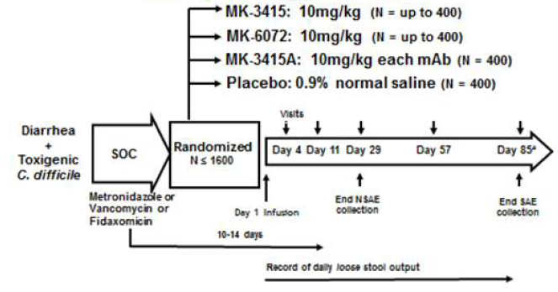

Objectives

Primary
- Determine if a single infusion of MK-3415A with SoC therapy decreases the proportion with CDI recurrence over a period of 12 weeks (weeks) versus a single infusion of MK-3415 or MK-6072 with SoC therapy
- Determine if a single infusion of MK-3415A with SoC therapy decreases the proportion with CDI recurrence over a period of 12 weeks versus a single infusion of placebo with SoC therapy
- Evaluate safety

Secondary
Focused on comparison of MK-3415A versus placebo. However, these objectives were also to include the individual monoclonal antibody treatment groups (MK-3415 or MK-6072) provided one or both of these regimens were not found to be different from MK-3415A AND demonstrate superiority versus placebo.
- Evaluate, in the subset of patients achieving clinical cure for the initial CDI episode, if treatment with a single infusion of MK-3415A with SoC therapy decreases the proportion with CDI recurrence over a period of 12 weeks versus a single infusion of placebo and SoC therapy
- To determine the proportion who achieve global cure in the treatment group receiving a single infusion of MK-3415A with SoC therapy versus a single placebo infusion with SoC therapy
- Evaluate if a single infusion of MK 3415A with SoC therapy decreases the proportion with CDI recurrence over a period of 12 weeks versus a single infusion of placebo and SoC therapy in the following subgroups:
- +/- CDI in the 6 months prior to enrolment;
- +/- BI/NAP1/027 strain;
- +/- an epidemic strain;
- +/- clinically severe CDI;
- < 65 years of age or ≥ 65 years of age at study entry;
- +/-compromised immunity at study entry.
- To assess infusion-specific reactions occurring within 24 hours of the start of the infusion in the treatment groups versus placebo infusion.

Inclusion and exclusion criteria
Key inclusions: written informed consent; ≥ 18 years of age; confirmed diagnosis of CDI as defined by 3 or more diarrhoea episodes in the prior 24 hours and a positive stool test for C. difficile toxin(s) within 7 days of enrolment, (ii) receiving SoC treatment for CDAD consisting of either metronidazole orally/IV or vancomycin orally or fidaxomicin orally or oral fidaxomicin with IV metronidazole or oral vancomycin with IV metronidazole (SoC antibiotics for CDI) and planned duration of treatment 10-14 days; non pregnant. Key exclusions: uncontrolled diarrhoea due to for example inflammatory bowel disease; planned surgery for CDI within 24 hours; pregnant or breastfeeding; receipt of immunoglobulin within the prior 6 months or planned receipt within next 12 weeks; more than 24 hours receipt or planned receipt of nitazoxanide or rifamixin; planned receipt of the probiotic Saccharomyces boulardii or faecal transplant; not expected to survive 72 hours; prior receipt of any of the study drugs.

Study treatments
MK-3415A A single IV infusion of MK-3415 at a dose of 10 mg/kg and MK-6072 at a dose of 10 mg/kg. N = 403 subjects
MK-3415 A single IV infusion at a dose of 10 mg/kg. N = 242 subjects (fewer patients as this arm was dropped after the interim analysis in 2013)
MK-6072 A single IV infusion at a dose of 10 mg/kg. N = 403 subjects
Placebo A single IV infusion of 0.9% sodium chloride. N = 404 subjects

Table 4: Lot numbers of the study drugs used in P001
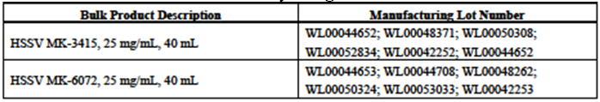

Efficacy variables and outcomes
The primary efficacy endpoint (CDI recurrence) is the proportion in the FAS population with CDI recurrence through Week 12 (Day 85 ± 5 days). CDI recurrence = new episode of diarrhoea associated with a positive local or central stool test for toxigenic C. difficile following clinical cure of the baseline CDI episode.

Secondary efficacy endpoints
Global cure = proportion of subjects with global cure (= sustained clinical response). Global cure = clinical cure of the baseline CDI episode and no CDI recurrence through Week 12.
CDI recurrence was assessed as a secondary efficacy endpoint in subgroups of the FAS population that is 1) subset of subjects with clinical cure of the baseline CDI episode and 2) other subgroups as defined in Secondary Objective #3 (as listed above).

Exploratory efficacy endpoints
Clinical cure = subject received ≤ 14 day regimen of SoC therapy and no diarrhoea (≤ 2 loose stools per 24 hours) for two consecutive days following completion of SoC therapy for the baseline CDI episode. Subjects requiring > 14 day regimen of SoC therapy for the baseline CDI episode were considered a failure for the clinical cure endpoint.
Diarrhoea recurrence = proportion of subjects with diarrhoea recurrence defined as the development of a new episode of diarrhoea (3 plus bowel movements with loose stools in 24 or fewer hours) whether or not a positive stool test for toxigenic C. difficile was available following clinical cure of the baseline CDI episode.
PK: Summary statistics for MK-3415 and MK-6072 serum concentrations over time.
Immunogenicity: ADA (negative, inconclusive, treatment emergent positive, non-treatment emergent positive).
Safety: safety and tolerability of MK-3415A, MK-3415, and MK-6072 assessed in the APaT population by a clinical evaluation of AEs and inspection of other study parameters including vital signs, lab assessments, and ECGs.

Randomisation and blinding methods
Randomisation: 1:1:1:1, stratified by SoC antibiotic therapy, hospitalisation status. After the interim analysis the MK-3415 arm was dropped (on the recommendation of the independent Data Monitoring Committee), and subsequent patients were randomised 1:1:1 into the remaining 3 arms that is MK-6072, MK-3415A, and placebo.
Blinding: Unblinded pharmacist at each centre prepared the product. Prepared product covered with an opaque sleeve to ensure no inadvertent unblinding of study staff as the antibody containing solutions are slightly opaque in colour compared to N-saline placebo.

Analysis populations
Full analysis set (FAS) population = all randomised subjects with subjects excluded for the following reasons:
- failure to receive infusion of study medication;
- lack of a positive local stool test for toxigenic C. difficile; or
- failure to receive protocol defined SoC therapy within a 1 day window of the infusion.
All Patients as Treated (APaT) population = all randomised patients who received an infusion of study medication.
Per protocol (PP) population = excluded subjects due to important protocol deviations that could substantially affect the primary efficacy results.

Sample size
Planned; 1,600 with 400 in each of the 4 groups.

Statistical methods
The FAS was the primary population for the efficacy analyses. Miettinen and Nurminen’s method for stratified data was used to compare treatment groups with respect to the proportion of subjects with CDI recurrence using the FAS population (primary objective). The strata the same as those used for randomisation. This same methodology was employed to compare treatment groups with respect to CDI recurrence in the predefined subgroups (secondary objective), the proportion with global cure between the treatment groups (secondary objective), and proportion with clinical cure (exploratory objective). The nonparametric Kaplan-Meier method used to estimate the time to CDI recurrence and time to resolution of baseline CDI episode distribution for each treatment group. To assess the impact of discontinuations on the rate of CDI recurrence, a sensitivity analysis was performed in which those discontinuing were imputed as failures for the primary endpoint. For the time to CDI recurrence analysis, subjects were censored at the date of last completed stool count. Both P001 and P002 had a planned sample size of 400 subjects per group. For P001, comparisons between monoclonal antibody treatment groups and the placebo group for the primary endpoint of CDI recurrence were performed at a 1-sided alpha level of 0.0125. This provided approximately 95% power to detect the following differences in incidence of CDI recurrence between monoclonal antibody therapy, π1, and placebo, π2: Comparisons between monoclonal antibody treatment groups and the placebo group for the secondary endpoint of global cure were performed at a 1-sided alpha level of 0.025. This provided approximately 90% power to detect a 10 percentage point difference in proportion of patients achieving global cure (80% for monoclonal antibody therapy versus 70% for placebo).
Interim analysis: planned for when 640 patients (approximately 40% total) enrolled and completed 12 weeks of follow-up. Data lock 8April 2013. See results in 7.1.2.12.

Participant flow

Table 5: Disposition of subjects in P001 - FAS Population
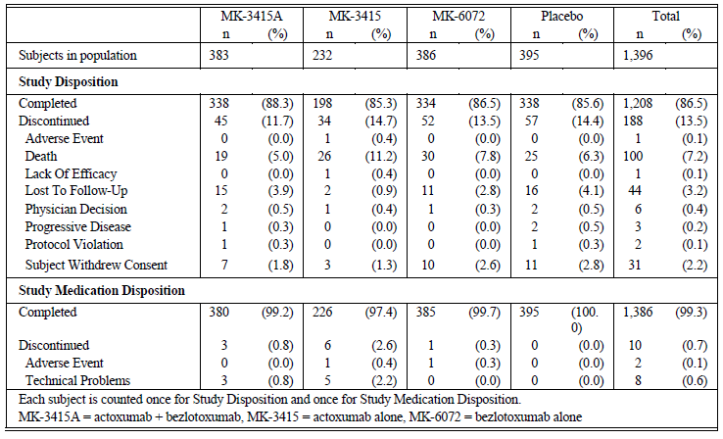

Major protocol violations/deviations
In P001, 1,452 were randomised, of these, 1,412 received study infusion (actoxumab + bezlotoxumab: 388; actoxumab alone: 235; bezlotoxumab alone: 392; placebo: 397). For the 40 randomised not treated subjects, the reasons were withdrawal of consent (n = 20), protocol violation (n = 7), technical problems (n = 6), physician decision (n = 5), AE (n = 1) and death (n = 1). Overall, 1,224 (86.7%) treated subjects completed the study through the end of the 12 week follow-up period, and 188 (13.3%) treated subjects discontinued before the Week 12 visit. Premature discontinuations were death (7.1%), lost to follow-up (3.1%), and withdrawal of consent (2.2%). Proportion of treated subjects prematurely discontinuing was similar across the treatment groups. The FAS population (n = 1396) and reasons for exclusion (n = 56) are summarised in Table 5.

Baseline data
56.8% of the trial population was female and 90.5% were white. Mean age = 62.5 years. In the FAS population, 51% were ≥ 65 years of age, 27% had at least one episode (9% had ≥ 2 episodes) of CDI in the 6 months prior to the episode under treatment at study entry, 16% had clinically severe CDI, 17% had a positive culture for ribotype 027, 22% were immunocompromised, and 38% received ≥ one dose of a systemic antibiotic during follow-up. Approximately 67% of the subjects in the FAS population were hospitalised at the time of study entry. Metronidazole was the SoC antibiotic for 45.6% of subjects, while 47.8% received vancomycin and only 3.6% received fidaxomicin. Baseline characteristics were balanced across the actoxumab + bezlotoxumab, bezlotoxumab, and placebo groups (Table 6).

Table 6: Subject characteristics in P001; FAS Population
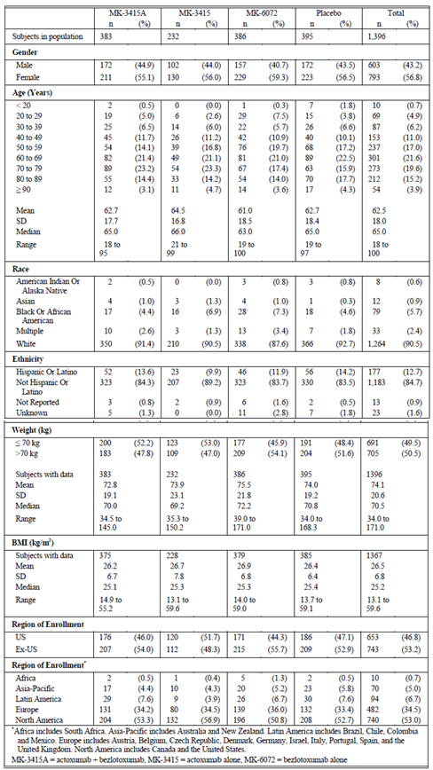

Results for the primary efficacy outcome
Among randomised subjects, 1,412 (97.2%) received study medication and were included in all safety analyses, 1,396 (96.1%) were included in the efficacy analyses, and 1,224 (84.3%) completed the study through the end of the 12 week follow-up period. The (planned) interim analysis report and the eDMC recommendation is included; 681 randomised subjects of whom 661 were treated. A total of 632 FAS subjects had data available for the primary endpoint. The eDMC recommended that enrolment in the actoxumab arm (242 enrolled) be stopped, because of low efficacy and an observed increase in the number of deaths and SAEs in the actoxumab arm versus placebo.
Figure 2: Summary of efficacy analyses for CDI recurrence, global cure, and clinical cure endpoints in P001 - FAS Population
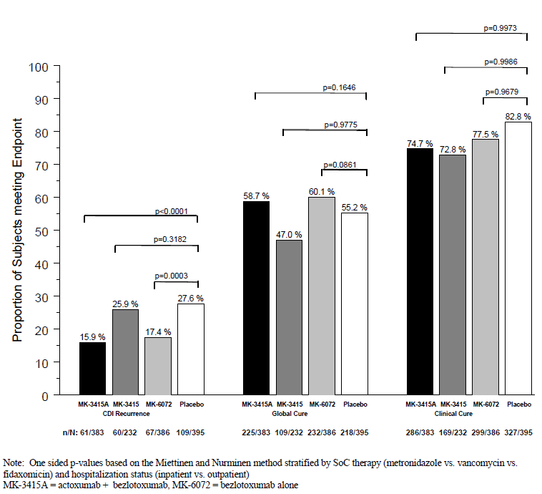
Figure 3: Summary of key endpoints in P001; FAS population
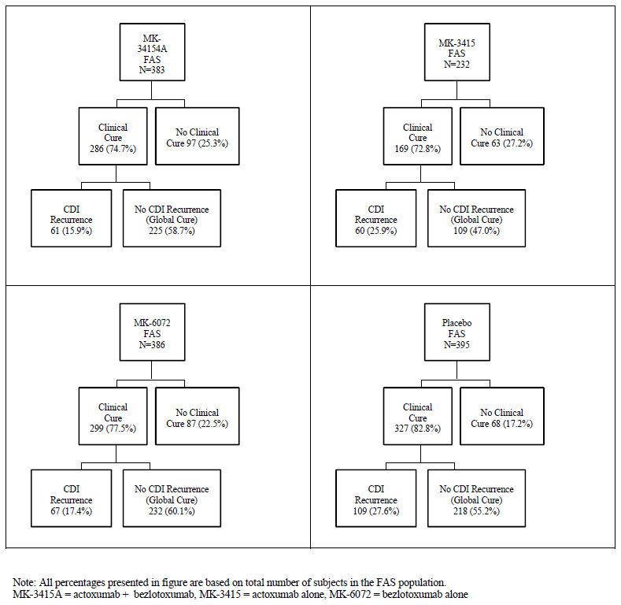

Table 7: Analysis of proportion with CDI recurrence in P001; FAS population
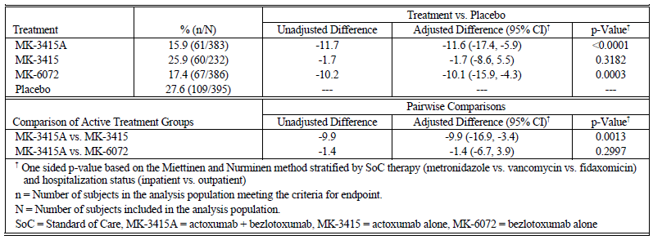

Table 8: Summary of efficacy analyses in P001; FAS Population
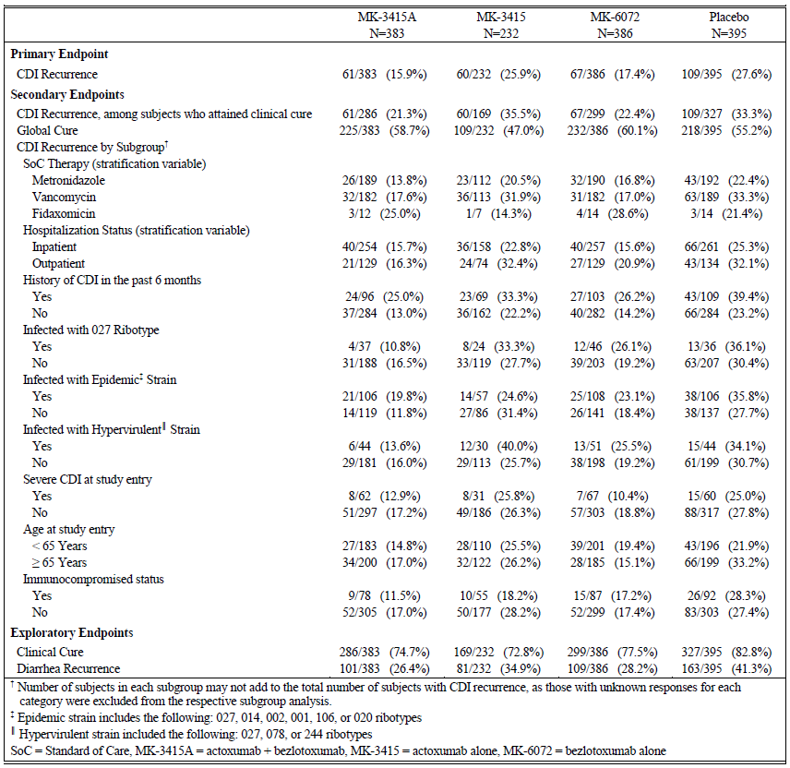

Results for other efficacy outcomes
See Figures 2 and 3 and Table 8.

Pharmacokinetics
PK (APaT population) MK-3415 and MK-6072 showed standard monoclonal antibody PK profiles consistent with IV dosing and slow elimination.

Immunogenicity (APaT population)
ADA were not found in post-baseline serum samples for any subjects following treatment with either MK-3415 or MK-6072.

Safety
No safety concerns were revealed in this Phase III study. A single IV 10 mg/kg dose of MK-3415 and MK-6072, given alone or in combination (MK-3415A), was generally well tolerated. The overall incidence of AEs in the monoclonal antibody groups was comparable to the placebo group. This was true also in subpopulations of subjects based on gender and age. There was no apparent trend for a higher incidence of AEs in subjects who received a higher mg dose of antibody (because of higher body weight). The incidence of discontinuations of the infusion was rare (1 event each in MK-3415 and MK-6072 groups), as was the incidence of SAEs considered as drug related (2 in the MK-3415A, 3 in the MK-3415, 4 in the MK-6072, and 1 in the placebo groups).

Evaluator commentary

CDI Recurrence
CDI recurrence rates were 17.4%, 15.9%, and 27.6% in the MK-6072, MK- 3415A, and placebo groups, respectively. Treatment with either MK-6072 or MK-3415A significantly decreased the proportion of subjects with CDI recurrence over a 12 week period versus placebo (one-sided p = 0.0003 and p < 0.0001, respectively). These results met (and surpassed) pre-specified statistical criteria for ‘success’. CDI recurrence rates among the subgroup of subjects achieving clinical cure were 22.4%, 21.3%, and 33.3% in the MK-6072, MK-3415A, and placebo groups, respectively. In this subgroup, treatment with either MK-6072 or MK- 3415A significantly decreased CDI recurrence over a 12 week period versus placebo (one-sided p = 0.0013 and p = 0.0006, respectively). CDI recurrence was assessed as a secondary efficacy endpoint in specific FAS subgroups. The proportion with CDI recurrence in the MK-3415A and MK-6072 treatment groups was consistently lower than placebo across all subgroups studied, including those defined by the stratification factors. Notably, in those at greatest risk of recurrence that is past history of CDI in the 6 months; infected with the 027 ribotype; severe CDI at baseline; ≥ 65 years of age, immunocompromised, had a reduction in CDI recurrence in the MK-3415A and MK-6072 groups versus those receiving placebo (Table 8).

Global cure
Global cure rates were 60.1%, 58.7%, and 55.2% in the MK-6072, MK-3415A, and placebo groups, respectively. The differences between the MK-3415A and MK-6072 groups versus the placebo group did not reach statistical significance (one sided p = 0.1646 and p = 0.0861, respectively). This lack of significance can be partially attributed to the lower than expected clinical cure rates for subjects in the MK-6072 and MK-3415 treatment groups (see below).
Clinical Cure: clinical cure was an exploratory endpoint. Clinical cure rates were 77.5%, 74.7%, and 82.8% in the MK-6072, MK-3415A, and placebo groups, respectively. A lower proportion of subjects achieved clinical cure of the baseline episode in the MK-3415A (74.7%) and MK-6072 (77.5%) treatment groups versus placebo (82.8%). Given the imbalance in the number of subjects achieving clinical cure in the MK-6072 and MK-3415A groups compared to placebo, fewer subjects were in the risk set for CDI recurrence in the MK-6072 and MK-3415A groups. However, other analyses (for example, CDI recurrence among the subgroup of subjects with clinical cure of the baseline CDI episode, several post-hoc sensitivity analyses using alternative definitions of clinical cure) provided strong supportive evidence that the effect of MK-6072 and MK-3415A on reducing recurrence of CDI is robust to the observed differences in clinical cure.

Comparison of MK-3415A to MK-6072
MK-3415A did not have an advantage over MK-6072 for any study endpoint. For the primary endpoint of CDI recurrence, the estimated risk difference (MK-3415A minus MK-6072), adjusted for stratification factors, was -1.4% (95% CI: -6.7% to 3.9%). This slight numerical difference favouring MK-3415A was not statistically significant (p = 0.2997, > 0.0066, the one-sided p value cut off for this comparison). For global cure, the estimated risk difference (MK-3415A minus MK-6072), adjusted for stratification factors, was -1.4% (95% CI: -8.3% to 5.5%). For this endpoint, the slight numerical difference favoured MK-6072.

Other pivotal efficacy studies

Study P002
A Phase III, randomised, double blind, placebo controlled study of the efficacy, safety and tolerability of a single infusion of MK- 6072 (human monoclonal antibody to C. difficile toxin B), and MK-3415A (human monoclonal antibodies to C. difficile toxin A and B) in patients receiving antibiotic therapy for C. difficile infection (MODIFY II).

Study design, objectives, locations and dates

Study design
Randomised, double blind, placebo controlled, multicentre, Phase III study that evaluated efficacy, safety, and tolerability of monoclonal antibodies to C. difficile toxin B (MK-6072), MK-3415A (human monoclonal antibodies to C. difficile toxin A and B) versus placebo in adults (≥ 18 years of age) receiving SoC antibiotic therapy (metronidazole, vancomycin, or fidaxomicin) for a primary or recurrent episode of CDI. Randomised 1:1:1 ratio to 1 of 3 treatment groups: MK-6072, MK-3415A, and placebo. Randomisation stratified by oral SoC therapy and hospitalisation status (inpatient or outpatient) at the time of randomisation.

Objectives

Primary
- Determine if treatment with a single infusion of monoclonal antibody therapy with SoC therapy (MK-3415A or MK-6072) decreases the proportion with CDI recurrence over a period of 12 weeks versus a single infusion of placebo with SoC therapy;
- To evaluate safety.

Secondary
- To evaluate, in the subset achieving a clinical cure for the initial CDI episode, if treatment with a single infusion of MK-3415A with SoC therapy decreases the proportion with CDI recurrence over a period of 12 weeks versus a single infusion of placebo and SoC therapy
- To determine the proportion achieving global cure in the treatment group receiving a single infusion of MK-3415A SoC therapy versus a single placebo infusion with SoC therapy
- To evaluate if a single infusion of MK-3415A with SoC therapy decreases the proportion with CDI recurrence over a period of 12 weeks versus single infusion of placebo and SoC therapy in the following subgroups: a. +/- history of CDI in the 6 months prior to enrolment; b. +/- BI/NAP1/027 strain; c. +/- an epidemic strain; d. +/-clinically severe CDI; e. Patients < 65 years of age or ≥ 65 years of age; f. +/- immunocompromised
- To determine if a single infusion of combined monoclonal antibody therapy (MK-3415A) with SoC therapy decreases the proportion with CDI recurrence over a period of 12 weeks versus a single infusion of MK-6072 with SoC therapy
- To assess infusion-specific reactions.
An extended follow-up period of 9 months was conducted in a subset of approximately300 subjects to assess for CDI recurrence through Month 12. Subjects who completed the 12 week main study were eligible to participate in the extension phase. For these subjects, any AE with an outcome of death was reported through the end of the 12 month follow-up period. Additionally, any SAE considered to be related to the study infusion was to be recorded at any time during the study.

Locations
n = 200: US (47); Japan (35); South Korea (15); Poland (14); France (11); Turkey (10); Argentina (9); Czech Republic (8); Spain (8); Taiwan (8); Germany (7); Russia (7); Canada (6); Sweden (6); Finland (5); Israel (3); and Switzerland (1).
Dates: 9 February 2012 to 22 May 2015.

Inclusion and exclusion criteria
As per Study P001.

Study treatments
MK-3415A A single IV infusion of MK-3415 at a dose of 10 mg/kg and MK-6072 at a dose of 10 mg/kg. N = 397 subjects.
MK-6072 A single IV infusion of MK-6072 at a dose of 10 mg/kg. N = 407 subjects.
Placebo A single IV infusion of placebo (0.9% sodium chloride). N = 399 subjects.

Table 9: Lots used in P002
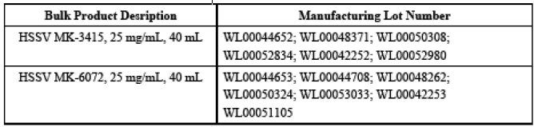

Efficacy variables and outcomes
As per 7.2.1.4 above.

Randomisation and blinding methods
Randomisation: 1:1:1, stratified by SoC antibiotics; hospitalisation. Blinding: as per P001.

Analysis populations
As above in P001.

Sample size
As above in P001, planned 400 patients per arm.

Statistical methods

Hypotheses
- Treatment with a single infusion of MK-3415A with SoC therapy will decrease the proportion with CDI recurrence over a period of 12 weeks versus placebo with SoC therapy;
- Treatment with a single infusion of MK-6072 with SoC therapy will decrease the proportion with CDI recurrence over a period of 12 weeks versus treatment with a single infusion of placebo with SoC therapy;
- Administration of a single infusion of MK-6072, or MK-3415A in subjects receiving SoC therapy for CDI will be generally well tolerated with a safety profile comparable to that seen in patients receiving a single placebo infusion with SoC therapy for CDI, as assessed by the accumulated safety data up to Week 4;
- In the subset of patients achieving clinical cure, treatment with a single infusion of MK-3415A with SoC therapy will decrease the proportion with CDI recurrence over a period of 12 weeks versus a single infusion of placebo with SoC therapy;
- The proportion who achieve global cure is greater following treatment with a single infusion of MK-3415A with SoC therapy than a single placebo infusion with SoC therapy.

Statistical analyses
See P001. Both P001 and P002 had a planned sample size of 400 subjects per group. The power calculations were based on a two group chi-square test for comparing independent proportions. Assumptions about incidence of CDI recurrence among subjects on MK-3415A were based on recent results from the Phase II clinical study P017. In P017, CDI recurrence was observed in 7% (7/101) of MK-3415A subjects. The incidence of CDI recurrence among subjects on SoC therapy was assumed to be between 20 and 25%. These estimates were based on:
- the Phase II clinical study of a single infusion of MK-3415A where 25% (25/99) of subjects taking SoC therapy had CDI recurrence
- recently reported pooled results from the vancomycin and fidaxomicin arms of two Phase III fidaxomicin trials (26% and 14.3%, respectively, based on 4 weeks of follow-up) and
- assumptions/limitations regarding the prevalence of fidaxomicin use in the trial (where 0% fidaxomicin use corresponds to an assumed 25% recurrence rate in the placebo/SoC therapy group while a 20% recurrence rate was expected in this group if fidaxomicin use was as prevalent as 15% in the trial.
Miettinen and Nurminen’s method for stratified data was used to make between group comparisons for binary endpoints (for example, the proportion of subjects with: CDI recurrence, global cure, clinical cure). Miettinen and Nurminen’s method without adjusting for stratification was used to calculate confidence intervals for subgroup analyses. The nonparametric Kaplan-Meier method was used to estimate the distribution of time to CDI recurrence for each treatment group. Treatment differences in time to CDI recurrence were assessed using the stratified log-rank test. The start date of CDI recurrence was the first date of the new episode of diarrhoea. For subjects who were lost to follow up prior to a CDI recurrence, time to event was right censored at the date of the last stool record. Patients who completed the 12 week study period without documented CDI recurrence were censored at the date of the last completed stool record. For subjects who failed to achieve a clinical cure for the baseline CDI episode, time to event was right censored at date of the infusion (Day 1).

Participant flow
1,203 subjects with a primary/recurrent CDI episode receiving antibiotics for CDI were randomised: 397 (33%) to the MK-3415A group, 407 (33.8%) to the MK-6072 group, and 399 (33.2%) to the placebo. Among randomised subjects, 1168 (97.1%) received study medication and were included in all safety analyses, 1163 (96.7%) were included in the efficacy analyses (FAS), and 970 (80.6%) completed the study through the end of the 12 week follow-up period.

Table 10: Disposition of subjects in P002 – FAS
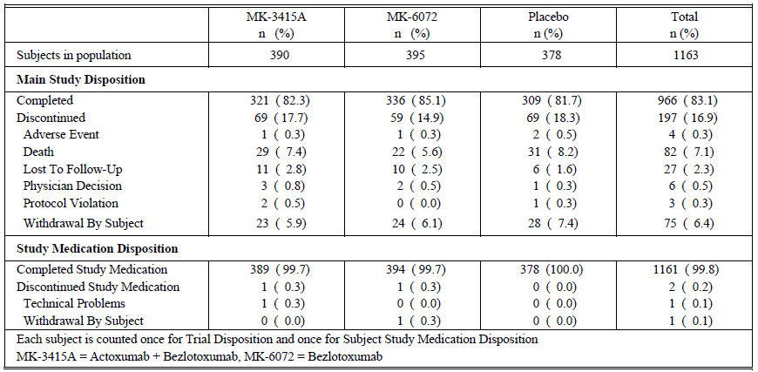

Major protocol violations/deviations
See Table 10 above.

Baseline data

Table 11: Subject characteristics in P002 - FAS Population
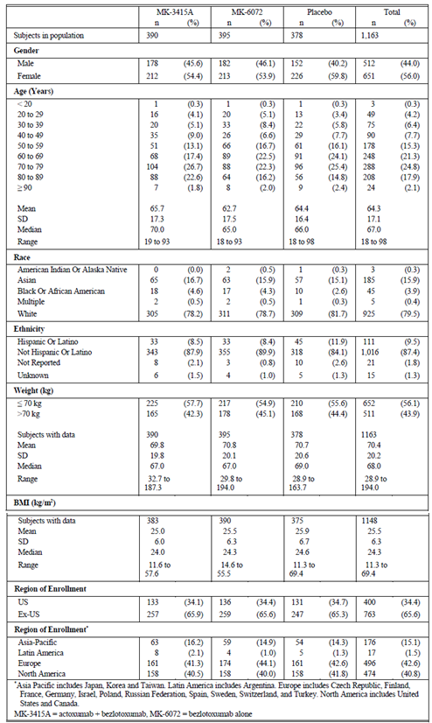
Treatment groups were comparable with respect to gender, race, and weight. Median age of the MK-3415A group was slightly higher (70years) versus MK-6072 and placebo arms (65 and 66years, respectively) predominantly accounted for by a higher proportion over 80 in the MK-3415A group (24.4%) versus MK-6072 group (18.2%) or placebo (17.2%) groups. Only 41 patients (3.4%) were on fidaxomicin.

Results for the primary efficacy outcome

CDI Recurrence
The primary efficacy endpoint was the proportion with CDI recurrence assessed through 12 weeks following infusion of study therapy. CDI recurrence rates were 15.7%, 14.9%, and 25.7% in the MK-6072, MK-3415A, and placebo groups, respectively. Treatment with either MK-6072 or MK-3415A significantly decreased the proportion of subjects with CDI recurrence over a 12 week period versus placebo (one-sided p = 0.0003 and p < 0.0001, respectively). These results met (and surpassed) pre-specified statistical criteria for ‘success’. CDI recurrence rates among the subgroup of subjects achieving clinical cure were 19.0%, 20.6%, 33.0% in the MK- 6072, MK-3415A, and placebo groups, respectively. In this subgroup, treatment with MK-6072 or MK- 3415A significantly decreased CDI recurrence over a 12 week period versus placebo (one-sided p < 0.0001 and p = 0.0006, respectively). Proportions with CDI recurrence in the MK-3415A and MK-6072 groups was consistently lower than the placebo group across all subgroups studied, including those defined by the stratification factors. Notably, a reduction in the proportion with CDI recurrence was observed in the MK- 3415A and MK-6072 groups versus placebo in important higher risk groups.

Results for other efficacy outcomes

Table 12: Summary of efficacy analyses FAS population in P002
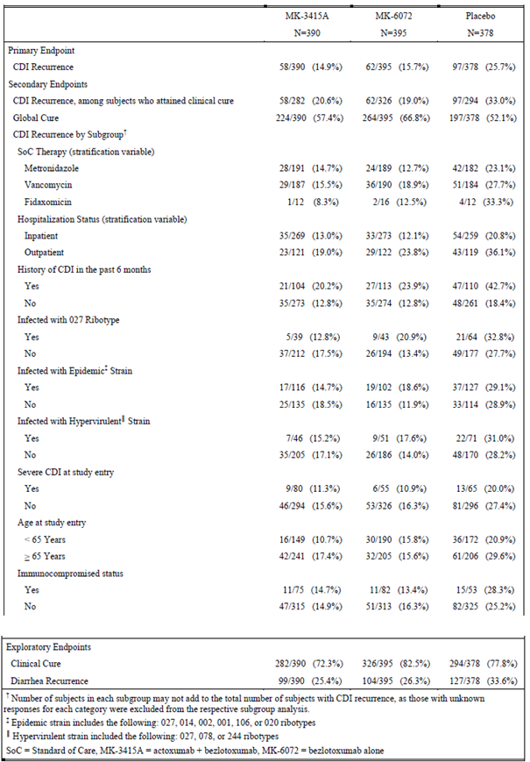
Figure 4: Summary of efficacy analyses for CDI recurrence, global cure, and clinical cure endpoints in P002 – FAS population
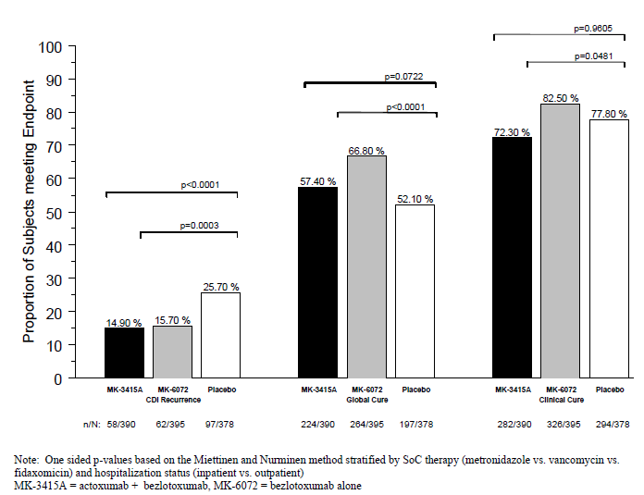

Global cure
66.8%, 57.4%, 52.1% in MK-6072, MK-3415A, and placebo groups, respectively. Superiority demonstrated for the comparison between MK-6072 group and placebo (one-sided p < 0.0001). In comparing MK-3415A to MK-6072 with respect to global cure, the CI did not include zero and the planned one-sided p-value designed to demonstrate MK-3415A is superior to MK-6072 was 0.9969. The one-sided p-value to evaluate if MK-6072 was superior to MK-3415A was 0.0031 that is MK-6072 was superior to MK-3415A for global cure.

Clinical cure
Clinical cure rates were 82.5%, 72.3%, and 77.8% in MK-6072, MK-3415A, placebo groups, respectively. A lower proportion in the MK-3415A group achieved clinical cure of the baseline episode versus placebo group. For the MK-6072 treatment group, the clinical cure rate was higher than placebo. Neither comparison reached statistical significance.

Comparison of MK-3415A to MK-6072
MK-3415A did not have an advantage over MK-6072 for any study endpoint. For CDI recurrence, the estimated risk difference (MK-3415A minus MK-6072), adjusted for stratification factors, was -0.8% (95% CI: -5.9% to 4.2%) (p = 0.3718). For global cure, the estimated risk difference (MK-3415A minus MK-6072), adjusted for stratification factors, was -9.4% (95% CI: -16.1% to -2.7%). In comparing MK-3415A to MK-6072 with respect to achieving global cure, the planned one-sided p-value designed to demonstrate MK- 3415A was superior to MK-6072 was 0.9969 and the one-sided p-value to evaluate if MK-6072 was superior to MK-3415A was 0.0031.

PK
MK-3415 and MK-6072 showed standard monoclonal antibody PK profiles consistent with IV dosing and slow elimination. MK-3415 and MK-6072 detected in post-infusion stool samples.

Immunogenicity
Anti-MK-6072 antibodies were not found in post-baseline serum samples for any subjects following treatment with either MK-3415A or MK-6072. Two subjects were treatment emergent positive for anti-MK-3415 antibodies, with samples test positive for ADA at Day 57 and Day 85.

Safety
See Section 8.0. No safety concerns raised. The overall incidence of AEs in the MK-3415A and MK-6072 groups was comparable to that of the placebo group, and a similar trend was also noted in age- and gender-based subpopulations of subjects in the placebo and active treatment groups. There was no apparent trend for a higher incidence of AEs in subjects who received a higher mg dose of antibody (that is due to higher body weight). The incidence of treatment related SAEs was rare (4 in the MK-3415A and 1 in the placebo groups).

Evaluator commentary
The results of P002 support the following conclusions:
- In subjects receiving standard of care antibiotics for CDI, treatment with MK-6072 is superior to placebo in prevention of CDI recurrence (primary endpoint) over a period of 12 weeks.
- MK-6072 was efficacious in the trial population overall, as well as, in all subgroups of subjects that are considered at high risk for CDI recurrence and/or CDI-related adverse outcomes.
- MK-6072 is superior to placebo with respect to the secondary endpoint of global cure.
- MK-6072 was well tolerated and had a safety profile which was generally similar to placebo.
- Anti-MK-6072 antibodies were not found in post-baseline serum samples for any subjects following treatment with either MK-3415A or MK-6072.
- Overall, MK-6072 has a favourable benefit/risk profile. There was no advantage of MK-3415A over MK-6072 in the overall PN002 population with respect to efficacy or safety. The results support selection of MK-6072 for marketing registration.

Evaluator commentary: other efficacy studies
See Section 16.1.2 for commentary on P017.

Analyses performed across trials: pooled and meta analyses
Population PK and exposure response analyses were conducted with pooled data from the Phase I (P004, P005, P006) and Phase III trials (P001and P002) that used a second generation assay specific for bezlotoxumab to quantify bezlotoxumab serum concentrations.

Table 13: Analysis of the proportion of subjects with CDI recurrence Phase III studies (P001, P002, and P001 + P002 Integrated); FAS population
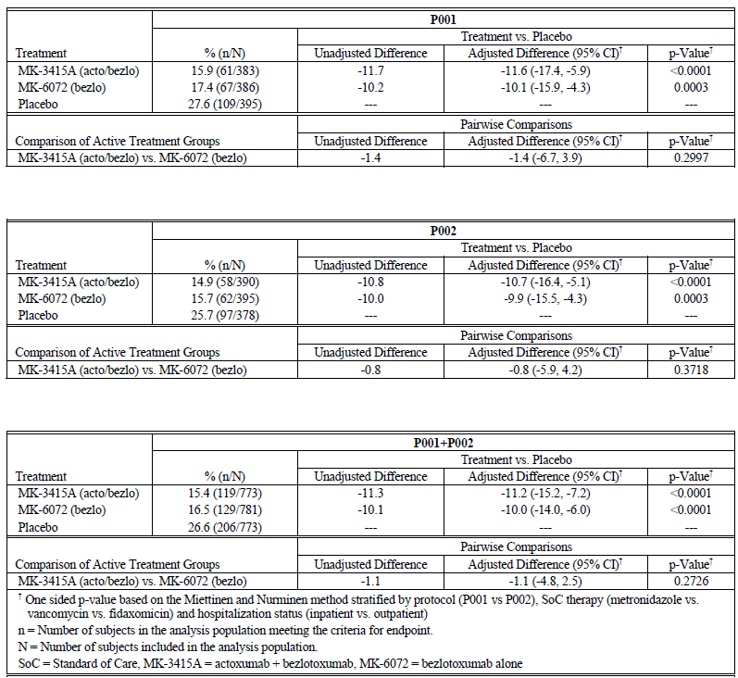

Evaluator’s conclusions on clinical efficacy
Both Phase III studies showed, that in subjects receiving SoC antibiotics for CDI predominantly metronidazole or oral vancomycin (very low use of fidaxomicin): a single IV infusion of weight based dosing (10 mg/kg) of bezlotoxumab is superior to placebo in the prevention of CDI recurrence through 12 weeks of follow-up. CDI recurrence rate differences between bezlotoxumab and placebo were consistent across both studies: P001: -10.1 (95% CI -15.9, -4.3), p = 0.0003; P002: -9.9 (95% CI -15.5, -4.3), p = 0.0003; P001+P002 (integrated): -10.0 (95% CI -14.0, -6.0), p< 0.0001. Bezlotoxumab is efficacious in key subpopulations at high risk for CDI recurrence and/or CDI related adverse outcomes. These high risk subpopulations are patients aged ≥ 65 years; a history of ≥ 1 CDI episodes in the past 6 months; immunocompromised; clinically severe CDI at study entry; infected with a hyper-virulent strain; infected with the BI/NAP1/027 strain. Bezlotoxumab is superior to placebo with respect to the secondary endpoint of global cure. But, bezlotoxumab was not superior to placebo with respect to the clinical cure endpoint; clinical cure rates were comparable for the bezlotoxumab and placebo groups in the Phase III trials. In the primary analysis of CDI recurrence, subjects must first reach clinical cure before they are at risk for a recurrence. As clinical cure is a post-randomisation event in the design of P001 and P002, differential clinical cure rates may impact on the primary analysis of CDI recurrence. Propensity score analyses were conducted to assess whether observed differences in clinical cure rates between the treatment groups had an impact on the interpretation of the CDI recurrence results.
Differential clinical cure rates between the treatment groups may be caused by an imbalance of baseline factors associated with the likelihood of achieving clinical cure. The propensity score is a model based estimate of the likelihood for achieving clinical cure derived from baseline factors predictive of clinical cure. The propensity of clinical cure was calculated from a logistic regression model predicting clinical cure from important baseline factors among all patients included in the FAS for each study. In P001, The bezlotoxumab treatment group had the highest percent of subjects (41.9%) in the low propensity score category and the placebo group had the lowest percentage (32.7%). CDI recurrence rates were lowest in the low propensity score category across all treatment groups, as expected given that subjects with a low propensity for clinical cure are those who will not achieve clinical cure and, by convention, are not in the risk set for recurrence. CDI recurrence rates in the bezlotoxumab and actoxumab + bezlotoxumab treatment groups were notably lower than in the placebo group for all three categories of propensity score. In P002, the actoxumab + bezlotoxumab treatment group had the highest percent of subjects (31.5%) in the low propensity score category and the placebo group had the lowest percent (25.4%). CDI recurrence rates were lowest in the low propensity score category for the bezlotoxumab and placebo treatment groups. CDI recurrence rates in the bezlotoxumab and actoxumab + bezlotoxumab treatment groups were notably lower than those in the placebo group for all three categories of propensity score. The results from this sensitivity analysis adjusting for the propensity of achieving clinical cure (low, medium, high) for P001 and P002, respectively are consistent with the primary analysis for CDI recurrence and demonstrate that the observed difference in clinical cure rates did not overly influence the primary study results for CDI recurrence. The combination of mAbs targeting CD toxin A and B that is, actoxumab and bezlotoxumab respectively, did not provide a meaningful efficacy benefit over bezlotoxumab alone.

Clinical safety

Studies providing evaluable safety data

Pivotal studies that assessed safety as the sole primary outcome
None.

Pivotal and/or main efficacy studies
The integrated Phase III population (P001 and P002) includes 786 bezlotoxumab treated subjects, 777 actoxumab + bezlotoxumab treated subjects, and 781 treated with placebo.

Other studies

Other efficacy studies
P017 included 101 actoxumab + bezlotoxumab treated and 99 placebo-treated subjects.

Studies with evaluable safety data: dose finding and pharmacology
The integrated Phase I trial population (P020, P005, P006, and P004) includes = 30 bezlotoxumab treated with, 96 actoxumab + bezlotoxumab treated, and 12 placebo treated subjects.

Studies that assessed safety as the sole primary outcome
P020, P005, and P006.

Patient exposure
Includes data from 1,790 subjects exposed to bezlotoxumab alone or in combination with actoxumab and includes data from 126 healthy subjects (of which 54 received a 2 hour IV infusion, and 72 subjects received a 1 hour infusion), and 1,664 subjects with CDI. Phase II studies = P017: Among the 200 enrolled, the drug product was infused over 2 hours in 84.5%.
Phase III studies (P001+P002); see Table 14.

Table 14: Treatment exposure in P001 + P002 Integrated APaT population
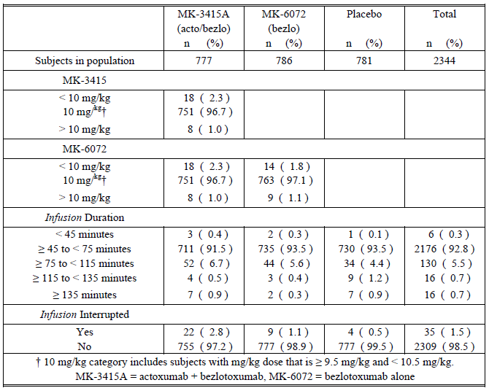

Adverse events

All adverse events (irrespective of relationship to study treatment)
Phase I: AEs reported though 84 days following infusion in P020; through 168 days following infusion in P006; and through 84 days following infusion in P005. In P004, a second dose of actoxumab + bezlotoxumab was given, and AEs monitored from the time the consent form was signed through 168 days following the second infusion. In the Phase II study (P017), AEs recorded from the time the consent form was signed through 84 days following infusion.
In the Phase III trials, non-serious AEs collected from the time of study medication infusion until Week 4 post-infusion. SAEs collected from infusion until the Week 12 post-infusion visit. In the 9 month extension (P002), deaths and treatment related SAEs were reported.

Integrated safety analyses Phase I
86 subjects (62.3%) reported ≥ 1 AE during the study; ≥ 1 AEs reported in 86.7% (bezlotoxumab alone), 54.2% (actoxumab + bezlotoxumab), and 41.7% (placebo). Five subjects (3.6%) reported an AE prior to treatment. The apparent difference in AE rates between drug treatment groups and placebo is largely driven by P020 which had a high rate of AEs overall (83.3%) and did not include a placebo group. No SAEs reported, and no discontinuations of infusion due to AE. 10.1% had a drug related AE, none of which was serious or led to therapy discontinuation. Common AEs (≥ 5%) in the bezlotoxumab group: headache (11 [36.7%]), fatigue (7 [23.3%]), nausea (2 [6.7%]), vomiting (2 [6.7%]), pain (2 [6.7%]), seasonal allergy (2 [6.7%]). The most common AEs in subjects receiving actoxumab + bezlotoxumab: headache (25 [26.0%]), oro-pharyngeal pain (8 [8.3%]), nasal congestion (6 [6.3%]), fatigue (7 [7.3%]), rhinorrhoea (5 [5.2%]). In P004, of the 29 subjects administered the second infusion, 14 had ≥ 1 AE. The most common AEs in this group, reported in ≥ 1 subject, were headache [6 (20.7%)], rhinorrhoea [3 (10.3%)], cough [2 (6.9%)], oropharyngeal pain [2 (6.9%)], and musculoskeletal pain [2 (6.9%)]. AEs after the second infusion generally similar to those observed after first infusion and consistent with AEs observed in the integrated analysis of all Phase I trials.

Main/pivotal studies that assessed safety as the sole primary outcome
Not applicable.

Pivotal and/or main efficacy studies
The majority reported ≥ 1 AEs (60.5% across all treatment groups) with similar % reported in the actoxumab + bezlotoxumab (58.6%), bezlotoxumab (61.7%), placebo (61.2%) treatment groups. Overall, 6.6% of subjects reported ≥ 1 drug related AE during the first 4 weeks of the follow-up period with similar % reported in the actoxumab + bezlotoxumab (6.4%), bezlotoxumab (7.5%), and placebo (5.9%) treatment groups. A total of 19.0% of subjects experienced an SAE, and 3.9% of subjects died during the first 4 weeks. A total of 11 (0.5%) subjects had an SAE considered by the investigators to be drug related: 0.6% subjects in the actoxumab + bezlotoxumab treatment arm, 0.5% subjects in the bezlotoxumab treatment arm, 0.3% in the placebo group. There was 1 report of early study infusion discontinuation due to an AE in the bezlotoxumab group in P001. A subject [information redacted]experienced ventricular tachyarrhythmia duration 2 minutes and considered serious and drug related. Individual study data from P001 and P002 are consistent with the integrated data. The proportions of subjects in the actoxumab + bezlotoxumab and bezlotoxumab treatment groups reporting ≥ 1 AE, drug related AE, or serious drug related AE were similar when compared to the placebo group during the first 4 weeks post-infusion. The proportions of subjects reporting deaths during this period were also similar when comparing the actoxumab + bezlotoxumab and bezlotoxumab groups to placebo. However, a lower proportion of subjects in the actoxumab + bezlotoxumab treatment group reported SAEs (15.8%) versus placebo group (21.4%, p = 0.005); the proportion in the bezlotoxumab group who reported SAEs was similar to placebo. Overall, the AE summary showed that the active treatment groups had a similar safety profile to placebo.
An analysis of the integrated data for the 12 week period shows the proportions of subjects reporting at ≥ 1 AE, ≥ 1 SAE or death are slightly higher compared to the first 4 week period. This is largely due to new SAEs and deaths that occurred during Weeks 5 through 12. During the 12 weeks post-infusion, 29.8% experienced an SAE, and 7.1% of subjects died, versus 19.0% and 3.9%, respectively, in the first 4 weeks following infusion. Almost all of the subjects reporting drug related AEs and drug related SAEs were identified during the first 4 weeks post-infusion. One subject in the actoxumab + bezlotoxumab group reported a drug related SAE after Week 4 (Day 34 diarrhoea mild intensity and resolved), and 1 subject in the bezlotoxumab group reported a non-serious drug related AE after Week 4 (Day 34 weakness of the abducens muscle right eye mild intensity and ongoing). Overall, the AE summary for the 12 week post infusion period is consistent with the comparisons made between the active treatment groups and the placebo group for the first 4 weeks following infusion.
In the integrated analysis, the incidence of AEs by SOC was generally similar across treatments. AEs most frequently reported (≥ 5% in P001, P002, or integrated data) during the 4 weeks post-infusion were: diarrhoea (5.9%), nausea (5.9%), abdominal pain (4.3%), CDI (4.2%), pyrexia (4.0%), headache (3.9%), vomiting (3.2%). During the first 4 weeks of the study, AEs in the Gastrointestinal Disorders SOC (22.5%) were the most commonly reported followed by Infections and Infestations SOC (20.3%). In the integrated analysis, the incidences of the nausea and diarrhoea were generally similar across treatment groups. In addition, diarrhoea, nausea, pyrexia, and headache were the most common AEs associated in the bezlotoxumab group (defined as occurring at an incidence of ≥ 4% in the bezlotoxumab group and at a higher rate than in the placebo group). A numerically higher proportion of subjects in the placebo group (6.1%) reported an AE of CDI during the first 4 weeks post-infusion compared to the mAb groups (3.5% for subjects receiving actoxumab +bezlotoxumab and 2.9% for subjects receiving bezlotoxumab). As seen in the integrated analysis during the first 4 weeks following infusion, the incidences of AEs by SOC and of specific AEs were generally similar across treatment groups during the 12 weeks post-infusion. AEs most frequently reported (≥ 5% in one or more treatment groups) during the 12 weeks post-infusion were: diarrhoea (8.7%), nausea (6.6%), CDI (5.9%), UTI (5.9%), abdominal pain (5.6%), pyrexia (4.9%), headache (4.4%), vomiting (4.0%). AEs in the Infections and Infestations SOC (28.5%) and Gastrointestinal Disorders SOC (27.6%) were the most commonly reported during the 12 week follow-up period. Overall, AEs reported were as expected considering the medical condition under study, baseline comorbidities, and the age of the population studied. In general, the incidence of AEs was similar across the treatment groups. When compared to placebo, the incidence of the following events favouring placebo versus active treatment groups: international normalised ratio increased (0.6% actoxumab + bezlotoxumab versus 0.0%), musculoskeletal pain (0.9% actoxumab + bezlotoxumab versus 0.0%), hypertension (1.2% actoxumab + bezlotoxumab, 1.1% bezlotoxumab versus 0%). Conversely, the incidence of the following AEs were different from placebo, favouring an active group: dehydration (bezlotoxumab 0.3% versus placebo 1.2%), mental status changes (bezlotoxumab 0% versus placebo 0.6%), CDI (actoxumab + bezlotoxumab 3.5% and bezlotoxumab 2.9% versus placebo 6.1%), and sepsis (actoxumab + bezlotoxumab 0.4% versus placebo 2.4%). These events occurred in ≤ 2% of subjects. CDI, as an AE, was reported at a frequency greater than 2%. CDI recurrence is an efficacy endpoint and CDI was only reported as an AE if the event met SAE criteria. CDI was recorded as an AE at a lower frequency in the bezlotoxumab (2.9%) and actoxumab +bezlotoxumab (3.5%) groups versus placebo (6.1%).

Other studies
P017 (information was provided).

Treatment related adverse events (adverse drug reactions)

Integrated safety analyses Phase I studies
14 subjects (10.1%) had AEs probably/possibly related to bezlotoxumab (4 after bezlotoxumab and 10 after actoxumab + bezlotoxumab). For bezlotoxumab alone, 2 reported headache (6.7%) and one subject each reported nausea, fatigue, and dizziness (each 3.3%) thought related. For the subjects receiving actoxumab + bezlotoxumab, 7 reported headache (7.3%) and 2 reported fatigue (2.1%) thought related to study drug; additionally, there was one subject each with: chills, infusion site extravasation, peripheral swelling, arthralgia, pain in extremity, tension headache, and dyspnoea (each 1.0%).

Pivotal and/or main efficacy studies integrated safety analyses
The proportion reporting ≥ 1 drug related AE was low (6.4% in actoxumab + bezlotoxumab group, 7.5% in bezlotoxumab group, and 5.9% in placebo group). Across all treatment groups, drug related AEs were reported most frequently for SOCs of general disorders and administration site conditions (1.8%), gastrointestinal disorders (1.6%) and nervous system disorders (1.6%). The most frequently reported drug related AEs were nausea (0.8%), fatigue (0.6%), headache (0.6%), and dizziness (0.6%). All of the 95% CIs comparing the active treatment groups with the placebo group for drug related AEs included zero.

Table 15: Drug related AEs during 4 weeks following infusion (incidence ≥ 4 subjects in one or more treatment groups) Phase III studies (P001 + P002 Integrated) APaT population
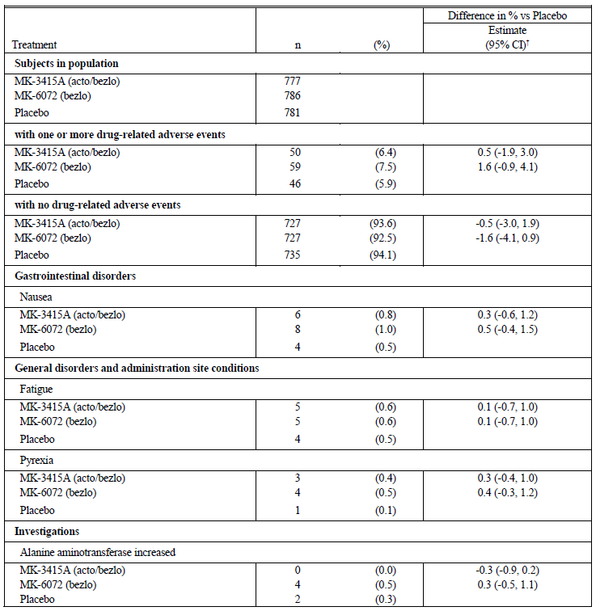

Other studies
P017 (information was provided).

Deaths and other serious adverse events

Integrated safety analyses Phase I
No deaths or SAEs.

Pivotal and/or main efficacy studies integrated safety analyses
During the 12 week post-infusion period, 166 (7.1%) subjects reported ≥ 1 AEs with a fatal outcome: 51 (6.6%) in the actoxumab + bezlotoxumab group, 56 (7.1%) in the bezlotoxumab group and 59 (7.6%) in the placebo group. Approximately half of these subjects (92, 3.9%) died during the first 4 weeks post-infusion: 28 in the actoxumab +bezlotoxumab group, 32 in the bezlotoxumab group, and 32 in the placebo group. The most frequently reported AEs with a fatal outcome were septic shock (15, 0.6%), sepsis (14, 0.6%), pneumonia (11, 0.5%), cardiac failure (10, 0.4%), respiratory failure (9, 0.4%). A higher proportion of subjects in the placebo group died of sepsis or septic shock versus other 2 treatment groups: 17 in the placebo group compared to 5 in the actoxumab + bezlotoxumab group and 7 in the bezlotoxumab group. There were 3 subjects who had AEs with a fatal outcome considered related to study medication. All of these events had an onset of ≤ 19 days from day of infusion. 2 of 3 were in the actoxumab + bezlotoxumab group and 1 in the bezlotoxumab group; these 3 events were associated with bacteraemia, sepsis, or septic shock and consistent with those expected in this study population.
P002 included an extension cohort of 295 subjects followed for ≤ 12 months post-infusion. 3.1% died during the 9 month extension phase: 2 (actoxumab + bezlotoxumab), 5 (bezlotoxumab), 2 (placebo). None of these AEs were deemed to be treatment related. Overall, the mortality rate reported during this extension was as expected for the population studied. 1 subject (bezlotoxumab group) had an SAE (osteoporotic fracture of femur) considered drug related.
Mortality rates through the 12 week follow-up period were evaluated using Kaplan Meier (KM) plots, and treatment differences assessed using the log rank test. The Week 12 KM event rates were 6.5% for the actoxumab + bezlotoxumab group, 7.1% for the bezlotoxumab group, and 7.9% for placebo. The placebo group had the highest mortality rate with visual separation from the actoxumab + bezlotoxumab and bezlotoxumab groups starting at approximately Week 6, but the treatment groups were not significantly different with respect to distribution of time to death.
In the integrated data across the two Phase III trials, 29.8% of subjects experienced an SAE during the 12 week follow-up period. SOCs with the highest number of SAEs reported were infections and infestations (14.3%) and gastrointestinal disorders (5.5%). The most frequently reported SAEs across all treatment groups were CDI (4.7%), pneumonia (2.0%), sepsis (1.8%), diarrhoea (1.6%), and UTI (1.5%). A numerically higher % reported SAEs of CDI, pneumonia, sepsis in the placebo group versus actoxumab + bezlotoxumab and bezlotoxumab groups. Incidence for other frequently reported SAEs generally similar across groups. The most frequently reported SAEs during the first 4 weeks post-infusion similar to those reported during 12 weeks post-infusion. There were 12 (0.5%) subjects reporting ≥ 1 serious and drug related AEs through Week 12 and at least one serious and drug related AE was reported in each treatment group: 6 (0.8%) in the actoxumab +bezlotoxumab group, 4 (0.5%) in the bezlotoxumab group, and 2 (0.3%) in the placebo group. Eleven of the 12 serious and drug related AEs were reported in the first 4 weeks following the infusion. Subject [information redacted] in the bezlotoxumab group reported diarrhoea at Day 34. Only sepsis was reported by more than one subject: 1 subject each in the actoxumab + bezlotoxumab and bezlotoxumab groups. There were 3 subjects with serious and drug related AEs resulting in death.

Other studies
P017 (information was provided).

Integrated safety analyses Phase I
Information was provided for an individual summary of safety for each Phase I study.

Pivotal and/or main efficacy studies integrated safety analyses
In the P001 and P002integrated data, 6 subjects reported AEs during the infusion that led to temporary interruption: actoxumab + bezlotoxumab group (n = 1), bezlotoxumab group (n = 2), placebo group (n = 3). All 6 subjects did receive a full dose. Both bezlotoxumab treated subjects, the 1 actoxumab + bezlotoxumab treated subject, and 2 of the 3 placebo-treated subjects reported local events at the infusion site (that is ‘extravasation’). Each of these AEs was deemed mild or moderate and resolved. The third subject (placebo group) reported an AE of pruritus with mild severity that resolved. Only 1 subject reported AEs resulting in infusion discontinuation. This subject, randomised to bezlotoxumab, experienced ventricular tachyarrhythmia (VT), chills, and dizziness with an onset approximately 36 minutes after start of the infusion. The subject was given fenistil, prednisolone, and ranitidine IV. The chills and VT resolved within 2 to 5 minutes, and dizziness within 90 minutes. These events were considered related to study medication; the VT was reported as an SAE.

Other studies
In P017, infusions interrupted in 7 subjects; reasons for interruptions not provided; however, none of the infusions were discontinued permanently. No AEs resulting in study medication discontinuation in the actoxumab + bezlotoxumab group or placebo group. 7.0% subjects experienced an AE during infusion, and 11 (5.0%) subjects experienced an AE within 2 hours after the end of the infusion. No significant differences between treatment groups.

Evaluation of issues with possible regulatory impact

Liver function and liver toxicity
In the Phase III studies, 8 subjects identified with liver function laboratory values meeting ≥ 1 of the potential DILI criteria at some point during the trial, including at the time of enrolment. Of these, 4, 1 and 3 received actoxumab + bezlotoxumab, bezlotoxumab, and placebo respectively. Based upon medical review of each of the 8 cases, none was considered suggestive of DILI.

Renal function and renal toxicity

Pivotal and/or main efficacy studies

Table 16: Subjects with chemistry labs findings that met predetermined criteria Phase III studies (P001 + P002 Integrated) APaT population
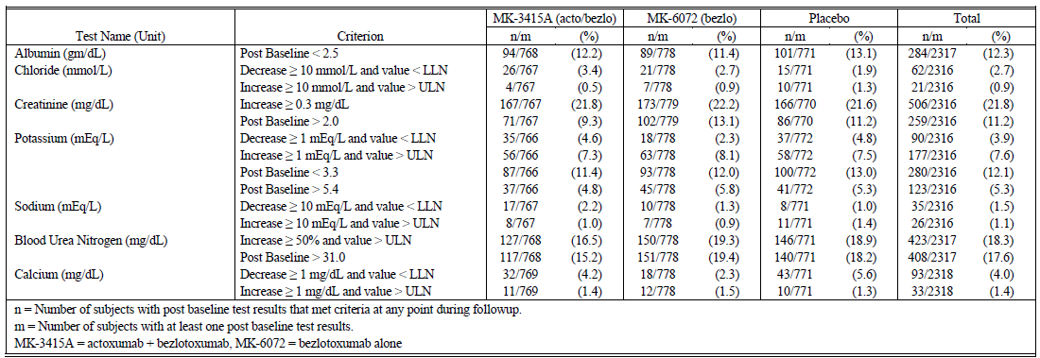

Other clinical chemistry

Pivotal and/or main efficacy studies
See Table 19 above. No safety signal revealed.

Haematology and haematological toxicity

Pivotal and/or main efficacy studies

Table 17: Subjects with haematology labs findings that met predetermined criteria Phase III studies (P001 + P002 Integrated) APaT population
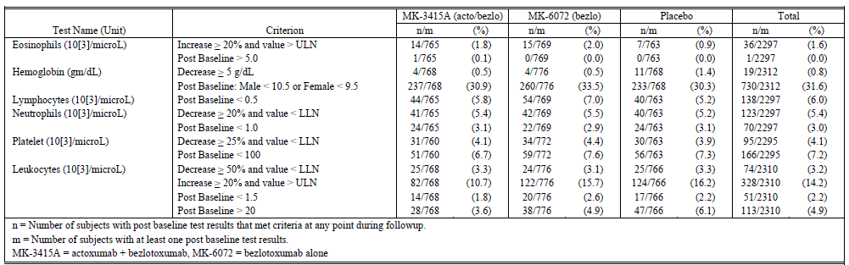

Electrocardiograph findings and cardiovascular safety

Pivotal and/or main efficacy studies
Per ICH guidelines, a clinical study of the effect of monoclonal antibodies on the QT interval is not required. ECGs (pre-infusion and within 120 mins post-infusion) were collected in P001, P002. The majority (93.7%) of subjects across all treatment groups had no increase in QTc-f or had a clinically insignificant QTc-f increase of ≤ 30 ms. Between 4 to 5.3% of the subjects in the three treatment groups experienced a QTc-f increase of > 30 and ≤ 60 ms from baseline and between 1.2% and 1.9% of subjects within the various treatment groups had a QTc-f increase of > 60 ms. The percentage of subjects with increases exceeding 30 ms was generally comparable across all treatment groups. An analysis of bezlotoxumab serum concentrations and QTc-f interval in subjects revealed no trends for QTc prolongation with increasing bezlotoxumab concentration.

Vital signs and clinical examination findings

Pivotal and/or main efficacy studies
In P001, P002, vital sign measurements were taken prior to infusion, at 30 minutes after the start of the study infusion, and at the end of the study infusion on Day 1. Additionally, vital sign measurements were taken at post infusion study visits Day 4 (± 1 day), Day 11 (± 2days), Day 29 (± 3 days), Day 57 (± 7 days), and Day 85 (± 5 days). There were no clinically meaningful changes in either diastolic or systolic blood pressure, heart rate, or respiratory rate between subjects who received active treatment and those who received placebo.

Immunogenicity and immunological events; ADA

Integrated safety analyses Phase I
Information was provided.

Pivotal and/or main efficacy studies
1,414 subjects were evaluable for the immunogenicity analysis. Following dosing with bezlotoxumab alone, there were 710 subjects evaluable for the immunogenicity analysis. No bezlotoxumab treatment emergent positive subjects were observed. However, 9 of 1,414 subjects (0.6%) had non-treatment emergent positive sample(s) (positive at baseline only), and 1 of these 9 was subsequently shown to be positive for NAb.

Other studies
Information was provided.

Serious skin reactions
None in any of the clinical studies.

Other safety parameters; hypersensitivity

Integrated safety analyses
None detected.

Pivotal and/or main efficacy studies
Subjects were evaluated during the infusion and for 24 hours post for infusion specific reactions. The proportion of infusion specific AEs was similar for the active groups and placebo with the exception of hypertension which occurred more frequently in the bezlotoxumab group
(n/N = 5/786, 0.6%) versus placebo (n/N = 0/781, difference 0.6%, 95% CI [0.1, 1.5]). It was generally mild to moderate and did not lead to treatment interruption. All episodes of hypertension resolved within 2 days (36 minutes to 2 days). Hypertension was also reported in 2 (0.3%) subjects in the actoxumab + bezlotoxumab treatment group.

Other safety issues

Safety in special populations
The ICH S6(R1) guidance Preclinical Safety Evaluation of Biotechnology-Derived Pharmaceuticals, 12-Jun-2011 states "For monoclonal antibodies and other related antibody products directed at foreign targets (that is, bacterial, viral targets etcetera), a short term safety study (see ICH S6 Guideline) in one species (choice of species to be justified by the sponsor) can be considered; no additional toxicity studies, including reproductive toxicity studies, are appropriate.’ and ‘For products that are directed at a foreign target such as bacteria and viruses, in general, no reproductive toxicity studies would be expected.’ Hence, genotoxicity; carcinogenicity; reproductive and developmental toxicity studies were not conducted.
Intrinsic Factors in Phase III Trials: the following categories were explored for age, gender, and race: young versus elderly (elderly presented as ≥ 65 years and separately as ≥ 75 years), male versus female , and White race versus all other races. To assess the impact of the mg dose on the safety profile, AEs are summarised by weight < 70 kg versus ≥ 70 kg.

AEs by age category
The proportions reporting ≥ 1 AE, ≥ 1 drug related AE, or deaths were generally comparable across treatment groups within each age subcategory. Similar to the overall population, the proportion of subjects reporting SAEs was lower in the actoxumab + bezlotoxumab treatment group versus the placebo group in both younger and older age subcategories.

AEs by gender
Of the 2344 subjects in the APaT population across the two Phase III studies, there were 1,017 (43.4%) males and 1327 (56.6%) females. In the integrated data across the two Phase III trials, the overall proportion reporting ≥ 1 AE during the 4 weeks following infusion was higher in female subjects (range 61.1% to 64.6%) versus male subjects (range 55.5% to 58.0%). In general, the AE profile was similar across treatment groups within each gender category with the exception of SAEs which were reported at a slightly lower rate in the actoxumab + bezlotoxumab group versus placebo group in both men and women.

AEs by race
Of the 2344 subjects in the APaT population across the two Phase III studies, there were 1992 (85.0%) White subjects and 352 (15.0%) subjects of a different race. The number of subjects was evenly distributed among the 2 active treatment groups and the placebo group. Among White subjects, a slightly lower proportion of SAEs were reported in the actoxumab + bezlotoxumab group (14.3%) compared to the bezlotoxumab (21.3%) and placebo (20.7%) groups. Among subjects of all other races, a slightly lower proportion of SAEs was reported in the bezlotoxumab group (12.7%) versus the actoxumab + bezlotoxumab (24.4%) and placebo (26.3%) groups. The incidence of deaths within the first 4 weeks following the study infusion among White subjects ranged from 3.5% in the actoxumab + bezlotoxumab group to 4.0% in the placebo group and 4.4% in the bezlotoxumab group and was similar to the incidence of deaths among subjects of All Other Races where the incidence ranged from 2.2% in the bezlotoxumab group to 4.2% in the actoxumab + bezlotoxumab group and 5.1% in the placebo group. The event profiles between subjects who were White and in All Other Races were generally similar.

AEs by weight
Doses of actoxumab + bezlotoxumab and bezlotoxumab were weight-based. Of the 2,344 subjects in the APaT population approximately half of the subjects were in each weight category 52.6% in the ≤ 70 kg group and 47.4% in the > 70 kg group. The proportion reporting AEs or drug related AEs during the 4 weeks following infusion was generally similar across treatment groups within each weight category.

AEs by renal and hepatic impairment
Of the 2,344 subjects in the APaT population, 2,310 and 2,296 had baseline laboratory data to allow for assessment of renal function and hepatic function, respectively. Overall, 333 of the 2,310 subjects (14.4%) had renal impairment (serum creatinine ≥ 1.5 mg/dL), and 150 of the 2296 subjects (6.5%) had hepatic impairment (two or more of the following: albumin ≤ 3.1 g/dL, ALT ≥ 2 x ULN, total bilirubin ≥ 1.3 x ULN, or mild, moderate or severe liver disease (Charlson Index CRF)). Overall, the AE profile across treatment groups within these impairment categories mirrored the profiles across all subjects.

AEs by history of underlying cardiac disease
The FDA has highlighted some concerns regarding cardiac failure that is ‘a higher number of SAEs related to heart failure were seen in the bezlotoxumab group (2.2%) versus placebo 0.9%. These SAEs were mainly observed in patients with baseline congestive cardiac failure (CCF). There were also more deaths in patients with baseline CCF in the bezlotoxumab group that is 19.5% (23/118) versus placebo arm, 12.5% (13/104).’
There was no specific analysis of safety according to underlying cardiac disease in this application, however, it is noteworthy that 42% in P001 and 42.1% in P002 were reported as having a underlying cardiac condition at study entry, perhaps unsurprising considered the advanced age of the enrolees (19% and 20% aged ≥ 80 years in P001 and P002 respectively). As described in Section 8.4.1.3, overall, the AE summary showed that the active treatment groups had a similar safety profile to placebo. As per Section 8.4.3.2, during the 12 week post-infusion period, 166 (7.1%) subjects in the integrated Phase III dataset across the 3 treatment groups reported ≥ 1 AEs with fatal outcome: 6.6% (actoxumab + bezlotoxumab group), 7.1% (bezlotoxumab group), 7.6% (placebo group). The most frequently reported AEs with a fatal outcome were septic shock (15, 0.6%), sepsis (14, 0.6%), pneumonia (11, 0.5%), cardiac failure (10, 0.4%), respiratory failure (9, 0.4%). Table 2.7.4:37 (in 2.7.4 in the summary of clinical safety) shows that 1 episode of cardiac failure was documented during the infusion in the P001/-002integrated safety analysis. In the analysis of AE during 12 weeks following infusion with incidence in 4 or more subjects, cardiac failure Table 2.7.4: 29 (in 2.7.4 summary of clinical safety), shows that in subjects with SAE during 12 Weeks following infusion (incidence ≥ 1% in one or more treatment groups) Phase III Studies (P001 + P002 Integrated) APaT population, in the category of ‘cardiac disorder’ there was a marginal difference in those receiving bezlotoxumab that is n = 24 (3.1%)(combined MAb arm), n = 36 (4 .6 %) in the bezlotoxumab group, and n = 27 (3.5 %) in the placebo group and overall n = 87 (3 .7% ). Within this category of cardiac disorder, congestive cardiac failure accounted for about a fifth of the reported SAEs in this category that is combined MAb n = 8 (1.0% ), bezlotoxumab group, n = 6 (0.8%), placebo group n = 2 (0.3% ), overall n = 16 (0 .7%).

Extrinsic factors
Those selected for assessment include geographic region, SoC antibiotics stratum, and hospitalisation stratum. In general, the AE profile across treatment groups within these categories remains consistent. No studies were conducted in the clinical development program for bezlotoxumab for the effects of extrinsic factors such as smoking, drug or alcohol consumption, or food on the safety profile of bezlotoxumab; food effect is not relevant as bezlotoxumab is administered IV.

Use in pregnancy and lactation
Pregnant females and/or lactating were excluded from enrolment. However, the 1 pregnancy in P002 resulted in a healthy child.

Safety related to drug-drug interactions and other interactions
Concomitant medications are not anticipated to affect the PK of bezlotoxumab, as mAbs are not eliminated by metabolic or transporter pathways typically affected by concomitant medications. Standard of care antibiotic therapy for the treatment of CDI (that is, metronidazole, vancomycin, and fidaxomicin), as well as concomitant non-standard of care systemic antibiotic use and PPI use, were evaluated in the population PK analysis. Thus, as bezlotoxumab is eliminated by protein catabolism and is not metabolised, nor is it renally eliminated, an effect on safety due to drug-drug interactions would not be expected for bezlotoxumab or on concomitantly administered medications based on the low potential of bezlotoxumab to be a perpetrator or victim of such interactions.

Post marketing experience
Not applicable.

Evaluator’s overall conclusions on clinical safety
The data presented in this Summary of Clinical Safety demonstrate that a single IV 10 mg/kg dose of bezlotoxumab given alone or in combination with actoxumab has a favourable safety profile in adults’ ≥ 18 years receiving antibiotic therapy for CDI. Bezlotoxumab was generally well tolerated in all trials, and the safety profile was consistent and similar to placebo across all studies. Safety data were integrated across P001 and P002, as the trials were nearly identical in design. In the Phase III program, 786 received bezlotoxumab, 777 received actoxumab + bezlotoxumab, and 781 received placebo. AEs were generally as expected considering underlying disease severity, baseline comorbidities, and age of the population studied. The overall incidence of AEs in the bezlotoxumab and actoxumab + bezlotoxumab groups was comparable to the placebo group. This was also true for subgroups based on intrinsic factors of interest (for example, age, gender, race, etcetera) and on extrinsic factors of interest (for example, region, choice of SoC antibiotics). All of the few SAEs assessed by the investigator as related to study medication were reported in the first 5 weeks. One additional subject in the bezlotoxumab group had an SAE (osteoporotic fracture) considered to be drug related during the P002 extension phase.
The overall incidence of AEs most frequently reported (≥ 5% in one or more treatment groups in P001, P002, or integrated data) during the 4 weeks post-infusion were: diarrhoea, nausea, abdominal pain, CDI, pyrexia, headache, vomiting. The incidence of these events was generally similar across treatment groups including the placebo group. Diarrhoea, nausea, pyrexia, and headache were the most common AEs associated in the bezlotoxumab group (incidence ≥ 4% in the bezlotoxumab group and at a higher rate than the placebo group). No association was detected between changes in haematology and chemistry laboratory values, vital signs, or QTc intervals. No reports of anaphylaxis/anaphylactoid AEs in any of the active treatment groups. The proportion of subjects in either the bezlotoxumab group or the actoxumab + bezlotoxumab group who reported one or more infusion-specific AEs was similar to placebo. The proportion of infusion specific AEs was similar for the active groups and placebo with the exception of hypertension (mild/moderate and short lived) which occurred more frequently in the bezlotoxumab group (0.6%) compared to placebo (n/N=0/781, difference 0.6%, 95% CI [0.1, 1.5]). There was no trend for higher incidence of AEs in subjects receiving a higher dose of antibody due to greater body weight. As described in Section 8.6.1, the FDA raised concerns re SAEs of cardiac failure including more fatal outcomes in those with an underlying history of cardiac failure. On reviewing these data, there is evidence of a marginal increased risk with the study drug, but this risk has to be taken into context that is the drug appears beneficial in the group with the greatest risk of poor outcome from CDI (aged 65 years and older) and it is this same group who also have the greatest risk for underlying cardiac conditions because of age alone.

First round benefit-risk assessment

First round assessment of benefits

Table 18: First round assessment of benefits
Benefits | Strengths and Uncertainties
Zinplava is an efficacious adjunctive (to SoC antibiotics) bacterial toxin targeted passive immunotherapy for the prevention of CDI recurrence;  There is no evidence that this adjunctive therapy comprises the activity of the SoC antibiotics for treatment;  Single infusion administration is an advantage compared to repeat dosing, has the potential to be given in an outpatient setting;  Safety profile which was generally similar to placebo did not result in the development of anti-bezlotoxumab antibodies in post-baseline serum samples.  Bezlotoxumab is efficacious in key subpopulations at high risk for CDI recurrence and/or CDI-related adverse outcomes, the greatest benefit is seen in those who are deemed at higher risk purely because of being aged ≥ 65 years;  Bezlotoxumab is superior to placebo with respect to the global cure endpoint (secondary endpoint). | Evidenced by the significantly lower CDI recurrence rate was in patients receiving bezlotoxumab with SoC antibiotics compared to placebo with SoC antibiotics in each of the Phase III trials (difference in rate relative to placebo shown):  - P001: -10.1 (95% CI -15.9, -4.3), p = 0.0003  - P002: -9.9 (95% CI -15.5, -4.3), p = 0.0003  Uncertainty, although the findings were stratified by SoC antibiotics that is, oral vancomycin versus metronidazole vs fidaxomicin, the use of the latter antibiotic was very small in the phase 3 programme for bezlotoxumab, and very small in the subgroup analyses of patients at higher risk of poorer outcomes from CDI. Louie et al (2011) showed that significantly fewer patients in the fidaxomicin group than in the vancomycin group had a recurrence of CDI, in both the modified ITT analysis (15.4% versus 25.3%, P = 0.005) and the per-protocol analysis (13.3% versus 24.0%, P = 0.004).It will be important to obtain more data on the efficacy of bezlotoxumab when given as adjunct with fidaxomicin for prevention of CDI recurrence.  No uncertainty, supported by the data from the Phase II and Phase III programme  A definite strength in terms of its potential utility in clinical practice  Well tolerated as evidenced by the integrated safety analyses of the Phase I programme and the integrated safety analyses in the Phase III programme  No uncertainty, supported by the data in the Phase III programme  No uncertainty, supported by the data in the Phase III programme

First round assessment of risks

Table 19: first round assessment of risks
Risks | Strengths and Uncertainties
Low risk, well tolerated single infusion therapy;  Paucity of data in those of non-White ethnicity, but analyses of the Phase III programme indicated no safety signals of concern;  No data for repeat dosing within a shorter time frame that 12 weeks apart, uncertain if repeated dosing within a shorter time frame would be efficacious and well tolerated and whether there would be an increased risk of developing ADA;  Marginal signal for increased risk of cardiac failure with the study drug, high percentage of enrolees (approximately 40%) have underlying cardiac conditions, most SAEs including fatal ones were not considered study drug related by the Investigator. | Strengths, evidenced by the integrated safety analyses in the Phase I and 3 programmes;  Very few patients of Black ethnicity enrolled, insufficient numbers in the Phase III programme to compare safety in those of White versus Asian versus Black ethnicity;  Possible that in clinical practice, patients might be given repeat dosing if they develop CDI recurrence or new CDI;  Uncertain if the study drug contributed to small excess of cardiac failure, no evidence from pre-clinical studies or the purported mechanism of action that this fully human monoclonal antibody has any direct cardiac toxicity, it seems unlikely.

First round assessment of benefit-risk balance
Benefits of Zinplava given as proposed for prevention of CDI recurrence outweigh risks (which are low). The evaluator noted that the FDA has authorised the drug for use in high risk populations only, however, on the basis of the efficacy and safety data, the evaluator believed that the benefit-risk balance is favourable for all patients aged 18 years and older to prevent recurrence of CDI. The reason the evaluator did not place any restriction on this being for ‘high risk populations only’ is that the evaluator did not think that there are safety concerns sufficient to restrict this to just ‘high risk’ individuals. The evaluator thought it is reasonable to put a caution around patients with underlying history of CCF, this would include ensuring that the clinician feels it is safe for the patient to receive the infusion over the recommended time of 1 hour.

First round recommendation regarding authorisation
Favourable. The evaluator favoured that the drug be approved as follows:
to reduce recurrence of Clostridium difficile infection in patients 18 years of age or older who are receiving antibacterial drug treatment for CDI.

Clinical questions
There were no clinical questions and no second round evaluation.

References
Aguayo C, et al. Rapid spread of Clostridium difficile NAP1/027/ST1 in Chile confirms the emergence of the epidemic strain in Latin America. Epidemiol Infect. 2015: 1-5. [Epub ahead of print).
Aronsson B, et al. Serum antibody response to clostridium difficile toxins in patients with clostridium difficile diarrhoea. Infection 1985; 13: 97-101.
Aslam S, et al. Treatment of CDAD: old therapies and new strategies. Lancet Infect Dis 2005; 5: 549-557.
Babcock GJ, et al. Human monoclonal antibodies directed against toxins A and B prevent Clostridium difficile-Induced mortality in hamsters. Infect Immun 2006; 74: 6339-4637.
Bauer MP, et al. Clostridium difficile infection in Europe: a hospital-based survey. Lancet 2011;377:63-73;
Blossom DB, McDonald LC. Emerging infections: The challenges posed by reemerging Clostridium difficile infection. Clin Infect Dis 2007; 45: 222-227.
Carter GP, et al. The role of toxin A and toxin B in the virulence of Clostridium difficile. Trends Microbiol. 2012; 20: 21-29.
Centers for Disease Control and Prevention. Severe Clostridium difficile--associated disease in populations previously at low risk ---four states, 2005. MMWR 2005; 54: 1201-1205.
Centers for Disease Control and Prevention (CDC). Frequently asked questions about Clostridium difficile for healthcare providers. Atlanta, GA: CDC; 2012. 6
Center for Disease Control and Prevention. Antibiotic resistance threats in the United States, 2013 [Internet]. Atlanta, GA: U.S. DHSS; 2013. Available from: www.cdc.gov/drugresistance/pdf/ar-threats-2013-508.pdf.
Cohen SH, et al. Clinical practice guidelines for Clostridium difficile infection in adults: 2010 update by the Society for Healthcare Epidemiology of America (SHEA) and the Infectious Diseases Society of America (IDSA). Infect Control Hosp Epidemiol 2010; 31: 431-455.
Crobach MJ, et al. European Society of Clinical Microbiology and Infectious Diseases (ESCMID): data review and recommendations for diagnosing CDI. Clin Microbiol Infect. 2009; 15: 1053-1066.
Debast SB, et al. European Society of Clinical Microbiology and Infectious Diseases: update of the treatment guidance document for Clostridium difficile infection. Clin Microbiol Infect. 2014; 20 Suppl 2:1-26.
Di Bella S, et al. Clostridium difficile infection in Italian urban hospitals: data from 2006 through 2011. BMC Infect Dis. 2013; 13: 146.
Evers R, et al. Critical review of preclinical approaches to investigate cytochrome P450-mediated therapeutic protein drug-drug interactions and recommendations for best practices: a white paper. Drug Metab Dispos 2013: 1-46.
Gerver S, et al. Annual epidemiological commentary: mandatory MRSA, MSSA and E. coli bacteraemia and C. difficile infection data, 2014/15 [Internet]. London: Public Health England; 2015. Available from: https://www.gov.uk/government/uploads/system/uploads/attachment_ data/file/442952/Annual_Epidemiological_Commentary_FY_2014_2 015.pdf;
Goorhuis A, et al. Emergence of Clostridium difficile infection due to a new hypervirulent strain, polymerase chain reaction ribotype 078. Clin Infect Dis 2008; 47:1162-1170.
Gravel D, et al. Health Care-associated Clostridium difficile infection in adults admitted to acute care hospitals in Canada: A Canadian nosocomial infection surveillance program study. Clin Infect Dis 2009; 48: 568-576.
Hu MY, et al. Prospective derivation and validation of a clinical prediction rule for recurrent Clostridium difficile infection. Gastroenterology 2009; 136: 1206-1214.
Jin J. JAMA patient page. Clostridium difficile infection. JAMA. 2014; 312: 1818.
Katchar K, et al. Association between IgG2 and IgG3 subclass responses to toxin A and recurrent clostridium difficile-associated disease. Clin Gastroenterol Hepatol 2007; 5: 707-713.
Kelly CP, LaMont JT. Clostridium difficile -- More difficult than ever. N Engl J Med 2008; 359: 1932-1940.
Kink JA, Williams JA. Antibodies to recombinant Clostridium difficile toxins A and B are an effective treatment and prevent relapse of C. difficile-associated disease in a hamster model of infection. Infect Immun 1998; 6: 2018-2025.
Kuijper EdJ, et al. Emergence of clostridium difficile-associated disease in Canada, the United States of America and Europe [Internet]. Stockholm: ECDC; 2006. Available from: http://ecdc.europa.eu/en/healthtopics/Documents/0603_Clostridium_Difficile_Emergence_of_associated_diseases.
Kuijper EJ, et al. Emergence of Clostridium difficile associated disease in North America and Europe. Clin Microbiol Infect 2006; 12(Suppl 6):2-18.
Kuntz JL, Polgreen PM. The importance of considering different healthcare settings when estimating the burden of Clostridium difficile. Clin Infect Dis. 2015; 60:831-836.
Kyne L, et al. Asymptomatic carriage of Clostridium difficile and serum levels of IgG antibody against toxin A. N Engl J Med 2000; 342: 390-397.
Kyne L, Kelly CP. Recurrent Clostridium difficile diarrhoea. Gut 2001; 49: 152-153.
Kyne L, et al. Association between antibody response to toxin A and protection against recurrent Clostridium difficile diarrhoea. Lancet 2001; 357: 189-193.
Leav BA, et al. Serum anti-toxin B antibody correlates with protection from recurrent Clostridium difficile infection (CDI). Vaccine 2010; 28:965-969.
Leffler DA, Lamont JT. Clostridium difficile infection. N Engl J Med. 2015; 372: 1539-1548.
Jin J. JAMA patient page. Clostridium difficile infection. JAMA. 2014; 312:1818.
Lessa FC, et al. A current status of clostridium difficile infection epidemiology. Clin Infect Dis 2012; 55(S2):S65- S70.
Lessa FC, et al. Burden of Clostridium difficile infection in the United States. NEJM. 2015; 372:825-834.
Libby JM, et al. Effects of the two toxins of Clostridium difficile in antibiotic-associated cecitis in hamsters. Infect Immun 1982; 36: 822-829.
Loo VG, et al. A predominantly clonal multi-institutional outbreak of clostridium difficile-associated diarrhea with high morbidity and mortality. NEJM 2005; 353: 2442-2449.
Louie TJ, et al. Fidaxomicin versus vancomycin for clostridium difficile infection. NEJM 2011; 364: 422-431.
Lowy I, et al. Treatment with monoclonal antibodies against Clostridium difficile toxins. NEJM 2010; 362: 197-205.
McDonald LC, et al. An epidemic, toxin gene-variant strain of Clostridium difficile. NEJM 2005; 353: 2433-2441.
McDonald LC, et al. Clostridium difficile infection in patients discharged from US short-stay hospitals, 1996- 2003. Emerg Infect Dis 2006; 12: 409-415.
McDonald L-C, et al. Recommendations for surveillance of Clostridium difficile associated disease. Infect Control Hosp Epidemiol 2007; 28: 140-145.
McFarland LV, et al. Nosocomial acquisition of Clostridium difficile infection. NEJM. 1989 Jan 26;320(4):204-10;
McFarland LV, et al. Breaking the cycle: treatment strategies for 163 cases of recurrent Clostridium difficile disease. Am J Gastroenterol 2002; 97: 1769-1775.
McFarland LV. Renewed interest in a difficult disease: Clostridium difficile infections-epidemiology and current treatment strategies. Curr Opin Gastroenterology. 2009; 25: 24-35.
Madan R, Petri WA Jr. Immune responses to Clostridium difficile infection. Trends Mol Med. 2012 Nov;18(11):658-66; Shen A. Clostridium difficile toxins: mediators of inflammation. J Innate Immun. 2012; 4:149-158.
Modena S, et al. Clostridium difficile among hospitalized patients receiving antibiotics: A casecontrol study. Infect Control Hosp Epidemiol 2005; 26: 685-690.
Muto CA, et al. A large outbreak of Clostridium difficile-associated disease with an unexpected proportion of deaths and colectomies at a teaching hospital following increased fluoroquinolone use. Infect Control Hosp Epidemiol 2005; 26: 273-280.
Olsen MA, et al. Recurrent Clostridium difficile infection is associated with increased mortality. Clin Microbiol Infect. 2015; 21: 164-170.
Pepin J, et al. Clostridium difficile-associated diarrhea in a region of Quebec from 1991 to 2003: a changing pattern of disease severity. CMAJ 2004; 171: 466-472.
Pepin J, et al. Increasing risk of relapse after treatment of Clostridium difficile colitis in Quebec, Canada. Clin Infect Dis 2005; 40: 1591-1597.
Pepin J, et al. Emergence of fluoroquinolones as the predominant risk factor for Clostridium difficile-associated diarrhea: a cohort study during an epidemic in Quebec. Clin Infect Dis. 2005; 41: 1254-1260.
Rupnik M, et al. Clostridium difficile infection: New developments in epidemiology and pathogenesis. Nat Rev Micro 2009; 7: 526-536.
Samore MH, et al. Clostridium difficile colonization and diarrhea at a tertiary care hospital. Clin Infect Dis. 1994; 18: 181-187.
Slimings C, et al. Increasing incidence of Clostridium difficile infection, Australia, 2011-2012. Med J Aust. 2014; 200: 272-276.
Steele J, et al. Antibody against TcdB, but not TcdA, prevents development of gastrointestinal and systemic clostridium difficile disease. J Infect Dis 2013; 207: 323-330.
Sunenshine RH, McDonald LC. Clostridium difficile-associated disease: new challenges from an established pathogen. Cleve Clin J Med 2006; 73: 187-197.
Torres JF, et al. Evaluation of formalin inactivated Clostridium difficile vaccines administered by parenteral and mucosal routes of immunization in hamsters. Infect Immun 1995; 63: 4619-4627.
Warny M, et al. Human antibody response to Clostridium difficle toxin A in relation to clinical course of infection. Infect Immun 1994; 62: 384-389.
Wiegand PN, et al. Clinical and economic burden of clostridium difficile infection in Europe: a systematic review of healthcare-facilityacquired infection. J Hosp Infect 2012; 81: 1-14.
Voth DE, Ballard JD. Clostridium difficile toxins: mechanism of action and role in disease. Clin Microbiol Rev 2005; 18: 247-263
Zar FA, et al. A comparison of vancomycin and metronidazole for the treatment of Clostridium difficile-associated diarrhea, stratified by disease severity. Clin Infect Dis 2007; 45: 302-307.

Therapeutic Goods Administration
PO Box 100 Woden ACT 2606 Australia
Email: info@tga.gov.au Phone: 1800 020 653 Fax: 02 6232 8605
https://www.tga.gov.au

