May 2017

Australian Public Assessment Report for: Bevacizumab (rch)
  - Proprietary Product Name: Avastin
  - Sponsor: Roche Products Pty Ltd

About the Therapeutic Goods Administration (TGA)
- The Therapeutic Goods Administration (TGA) is part of the Australian Government Department of Health and is responsible for regulating medicines and medical devices.
- The TGA administers the Therapeutic Goods Act 1989 (the Act), applying a risk management approach designed to ensure therapeutic goods supplied in Australia meet acceptable standards of quality, safety and efficacy (performance) when necessary.
- The work of the TGA is based on applying scientific and clinical expertise to decision-making, to ensure that the benefits to consumers outweigh any risks associated with the use of medicines and medical devices.
- The TGA relies on the public, healthcare professionals and industry to report problems with medicines or medical devices. TGA investigates reports received by it to determine any necessary regulatory action.
- To report a problem with a medicine or medical device, please see the information on the TGA website <https://www.tga.gov.au>.
About AusPARs
- An Australian Public Assessment Report (AusPAR) provides information about the evaluation of a prescription medicine and the considerations that led the TGA to approve or not approve a prescription medicine submission.
- AusPARs are prepared and published by the TGA.
- An AusPAR is prepared for submissions that relate to new chemical entities, generic medicines, major variations and extensions of indications.
- An AusPAR is a static document; it provides information that relates to a submission at a particular point in time.
- A new AusPAR will be developed to reflect changes to indications and/or major variations to a prescription medicine subject to evaluation by the TGA.
Copyright
© Commonwealth of Australia 2017
This work is copyright. You may reproduce the whole or part of this work in unaltered form for your own personal use or, if you are part of an organisation, for internal use within your organisation, but only if you or your organisation do not use the reproduction for any commercial purpose and retain this copyright notice and all disclaimer notices as part of that reproduction. Apart from rights to use as permitted by the Copyright Act 1968 or allowed by this copyright notice, all other rights are reserved and you are not allowed to reproduce the whole or any part of this work in any way (electronic or otherwise) without first being given specific written permission from the Commonwealth to do so. Requests and inquiries concerning reproduction and rights are to be sent to the TGA Copyright Officer, Therapeutic Goods Administration, PO Box 100, Woden ACT 2606 or emailed to <tga.copyright@tga.gov.au>.

Contents
Common abbreviations 4
I. Introduction to product submission 5
Submission details 5
Product background 5
Regulatory status 6
Orphan drug status 7
Product information 7
II. Quality findings 7
III. Nonclinical findings 7
IV. Clinical findings 8
Introduction 8
Pharmacokinetics 10
Pharmacodynamics 10
Dosage selection for the pivotal studies 10
Efficacy 12
Safety 14
First round benefit-risk assessment 18
First round recommendation regarding authorisation 19
Second round evaluation of clinical data submitted in response to questions 19
Second round benefit-risk assessment 19
V. Pharmacovigilance findings 20
Risk management plan 20
VI. Overall conclusion and risk/benefit assessment 24
Quality 24
Nonclinical 24
Clinical 24
RMP evaluation 28
Risk-benefit analysis 29
Response from sponsor 35
Outcome 48
Attachment 1. Product Information 49
Attachment 2. Extract from the Clinical Evaluation Report 49

Common abbreviations
Abbreviation | Meaning
ACPM | Advisory Committee on Prescription Medicines
AEs | Adverse events
ATEs | Arterial thromboembolic events
BPI | Brief Pain Inventory
Bv | Bevacizumab
CHF | Congestive heart failure
CI | Confidence interval
Cis | Cisplatin
CMI | Consumer medicines information
CRC | Colorectal cancer
CSR | Clinical study report
FACT-Cx | Functional Assessment of Cancer Therapy – Cervix
FACT-Ntx | Functional Assessment of Cancer Therapy – Neurotoxicity
GI | Gastrointestinal
GOG | Gynaecologic Oncology Group
HPV | Human papillomavirus
HR | Hazard ratio
IV | Intravenous
MedDRA | Medical Dictionary for Regulatory Activities
NSCLC | Non-small cell lung cancer
ORR | Objective response rate
OS | Overall survival
Pac | Paclitaxel
PFS | Progression-free survival
PI | Product information
PK | Pharmacokinetics
SAEs | Serious adverse events
Top | Topotecan
VEGF | Vascular endothelial growth factor
VTEs | Venous thromboembolic events

I. Introduction to product submission

Submission details
Type of submission: | Major variation (new indication)
Decision: | Approved
Date of decision: | 16 July 2015
Date of entry onto ARTG | 23 July 2015
Active ingredient(s): | Bevacizumab (rch)
Product name(s): | Avastin
Sponsor’s name and address: | Roche Products Pty Ltd  PO Box 255  4-10 Innman Road  Dee Why NSW 2099
Dose form: | Injection, concentrated
Strengths: | 100 mg/ 4 mL and 400 mg/ 16 mL
Container: | vial
Pack size: | 1 vial
Approved therapeutic use: | In combination with paclitaxel and cisplatin is indicated for the treatment of persistent, recurrent or metastatic carcinoma of the cervix. In combination with paclitaxel and topotecan is an acceptable alternative where cisplatin is not tolerated or not indicated.
Route of administration: | intravenous
Dosage: | AVASTIN is administered in combination with paclitaxel and cisplatin or, if cisplatin is not tolerated or not indicated, paclitaxel and topotecan (see the Product Information for further details on the chemotherapy regimens).  The recommended dose of AVASTIN is 15 mg/kg of body weight given once every 3 weeks as an intravenous (IV) infusion.
ARTG numbers: | 99756 and 99757

Product background
This AusPAR describes the application by the sponsor to register Avastin bevacizumab (rch) for the following indication:
AVASTIN (bevacizumab) in combination with paclitaxel and cisplatin or paclitaxel and topotecan is indicated for the treatment of persistent, recurrent or Stage IV carcinoma of the cervix.
In Australia cervical cancer is the twelfth most common cancer affecting women (excluding basal and squamous cell carcinoma of the skin), with 7 new cases diagnosed per 100,000 women in 2009. It is also the 19th most common cause of cancer-related death, with 2 deaths per 100,000 women in 2010.
The mainstay of primary treatment for advanced cervical cancer disease (stage II−IV) is combination radiation therapy and radiation sensitising platinum based chemotherapy. Up to 50% of patients with advanced disease will have a recurrence, which is generally considered incurable particularly if distant metastases have developed, and chemotherapy is usually recommended for these patients.
The current standard of care for patients with metastatic cervical cancer has evolved from single-agent chemotherapy regimens to doublet regimens (either platinum- or non-platinum based), the latter demonstrating efficacy and quality of life benefits. The addition of bevacizumab (Bv) to doublet regimens of chemotherapy is presented in this submission.
Staging of cervical carcinoma pertinent to the current submission:
- Stage IVA (T4, N0, M0): The cancer has spread to the bladder or rectum, which are organs close to the cervix (T4). It has not spread to nearby lymph nodes (N0) or distant sites (M0).
- Stage IVB (any T, any N, M1): The cancer has spread to distant organs beyond the pelvic area, such as the lungs or liver.
The prognosis for women with persistent, recurrent, or metastatic cervical cancer remains poor with median duration of overall survival of ≤ 12 months.
Bevacizumab is an antineoplastic agent, comprising a recombinant humanised monoclonal antibody that selectively binds to and neutralises the biologic activity of human vascular endothelial growth factor (VEGF). VEGF inhibition reduces the vascularisation of tumours, thereby inhibiting tumour growth.
The rationale for bevacizumab use is that angiogenesis plays an important role in locally advanced cervical cancer via an increase in VEGF. The evidence was also reported to suggest that combining an anti-angiogenic agent with either cytotoxic chemotherapy or radiation enhances anti-tumour activity. Additionally, nonclinical data have shown that bevacizumab may normalize tumour vasculature, thereby relieving tumour hypoxia and promoting drug delivery, which may account for an additive treatment effect. Therapeutic strategies incorporating the anti-VEGF antibody bevacizumab may be effective.

Regulatory status
The product received initial registration on the Australian Register of Therapeutic Goods (ARTG) on 24 February 2005.
At the time of this submission bevacizumab (rch) had been approved in Australia for the indications:
Metastatic colorectal cancer (CRC)
Avastin bevacizumab (rch) in combination with fluoropyrimidine-based chemotherapy, is indicated for treatment of patients with metastatic colorectal cancer
Locally recurrent or metastatic breast cancer
Avastin bevacizumab (rch) in combination with paclitaxel is indicated for the first-line treatment of metastatic breast cancer in patients in whom an anthracycline-based therapy is contraindicated
Advanced, metastatic or recurrent non-squamous non-small cell lung cancer (NSCLC)
Avastin bevacizumab (rch) in combination with carboplatin and paclitaxel, is indicated for first-line treatment of patients with unresectable advanced, metastatic or recurrent, non-squamous, non-small cell lung cancer
Advanced and/or metastatic renal cell cancer
Avastin bevacizumab (rch) in combination with interferon alfa-2a is indicated for treatment of patients with advanced and/or metastatic renal cell cancer
Grade IV glioma
Avastin bevacizumab (rch) as a single agent, is indicated for the treatment of patients with Grade IV glioma after relapse or disease progression after standard therapy, including chemotherapy
Epithelial ovarian, fallopian tube or primary peritoneal cancer
Avastin bevacizumab (rch) in combination with carboplatin and paclitaxel, is indicated for first-line treatment of patients with advanced (FIGO stages IIIB, IIIC and IV) epithelial ovarian, fallopian tube, or primary peritoneal cancer
Recurrent epithelial ovarian, fallopian tube or primary peritoneal cancer
Avastin bevacizumab (rch) in combination with carboplatin and gemcitabine, is indicated for the treatment of patients with recurrent, platinum-sensitive, epithelial ovarian, fallopian tube, or primary peritoneal cancer who have not received prior bevacizumab or other VEGF-targeted angiogenesis inhibitors
At the time the TGA considered this application, a similar application had been approved in European Union including in the UK (approved 30 March 2015); New Zealand (approved 16 April 2015); Switzerland (approved 10 December 2014) and USA (approved 14 August 2014) and was under consideration in Canada and Singapore. There had been no withdrawals, rejections or deferrals.

Orphan drug status
Orphan drug designation was sought and approved for this submission.

Product information
The Product Information (PI) approved with the submission which is described in this AusPAR can be found as Attachment 1. For the most recent PI, please refer to the TGA website at <https://www.tga.gov.au/product-information-pi>.

II. Quality findings
There was no requirement for a quality evaluation in a submission of this type.

III. Nonclinical findings
There was no requirement for a nonclinical evaluation in a submission of this type.

IV. Clinical findings
A summary of the clinical findings is presented in this section. Further details of these clinical findings can be found in Attachment 2.

Introduction

Clinical rationale
As discussed by the sponsor in the introduction for the clinical study report (CSR) of Study GOG-0240:
- Worldwide, cervical cancer is the fourth most common cancer in women and seventh most common cancer overall. In 2012, approximately 528,000 new cervical cancer cases were diagnosed globally. Cervical cancer accounted for 7.5% of all female cancer deaths with approximately 266,000 deaths; the majority (87%) of these deaths occurred in developing countries.
- In Australia cervical cancer is the twelfth most common cancer affecting women (excluding basal and squamous cell carcinoma of the skin), with 7 new cases diagnosed per 100,000 women in 2009. It is also the 19th most common cause of cancer-related death, with 2 deaths per 100,000 women in 2010.
- Cervical cancer incidence and mortality are higher in Aboriginal and Torres Strait Islander women, with incidence more than twice, and mortality 5 times, that of non-Indigenous women.
- Cervical cancer screening has been in place since 1991 and is thought to be the reason for the relatively low incidence and mortality rates observed for the disease in Australia compared with other countries.
- In Australia the National human papillomavirus (HPV) Vaccination Program was introduced in 2007. The HPV vaccine against HPV types 16 and 18, the cause of 70 to 80% of invasive cervical cancers. This therefore has the potential to reduce the incidence of cervical cancer below the already low levels that cervical screening has achieved in Australia. It is argued by the sponsor that this impact, however, will be seen many years into the future and for the present, cervical cancer remains a significant public health problem in Australia and around the world.
- The mainstay of primary treatment for advanced cervical cancer disease (stage II to IV) is combination radiation therapy and radiation sensitising platinum based chemotherapy. Up to 50% of patients with advanced disease will have a recurrence, which is generally considered incurable particularly if distant metastases have developed, and chemotherapy is usually recommended for these patients.
- In patients who present with distant metastasis (stage IVB) treatment is essentially palliative and usually chemotherapy. The optimal regimen for chemotherapy has not been defined in these recurrent and metastatic disease patients but cisplatin combination therapy is generally considered the standard of care. Cisplatin (Cis) use is recommended in Australia whilst topotecan is indicated, in combination with cisplatin.
- The prognosis for women with persistent, recurrent, or metastatic cervical cancer remains poor with median duration of overall survival of ≤ 12 months. The sponsor concluded that current treatment options provide limited clinical benefit and therefore there remains an unmet need for additional options.
- The rationale for bevacizumab use as indicated by the sponsor is evidence that angiogenesis plays an important role in locally advanced cervical cancer via an increase in VEGF. The evidence was also reported to suggest that combining an anti-angiogenic agent with either cytotoxic chemotherapy or radiation enhances anti-tumour activity. Additionally, nonclinical data have shown that bevacizumab may normalize tumour vasculature, thereby relieving tumour hypoxia and promoting drug delivery, which may account for an additive treatment effect. The sponsor concluded that therapeutic strategies incorporating the anti-VEGF antibody bevacizumab may be effective.
Comment: Although a global problem, the burden of cervical cancer disease in Australia is low, due to the National Cervical Screening Program which promotes routine screening with Pap smears every two years for women between the ages of 18 (or two years after first sexual intercourse, whichever is later) and 69 years. The burden of cervical cancer disease in Australia is likely to fall further due to the effect of the National HPV Vaccination Program in the coming years.
Despite this relatively low burden of disease, there remains an unmet need for additional treatment options for women with recurrent or metastatic cervical cancer disease who have a poor prognosis. There are also equity issues to consider with the relatively higher burden of disease in the Aboriginal and Torres Strait Islander population.
Therefore, it is agreed with the sponsor that there is a clinical rationale for this indication, despite the overall low disease burden.

Guidance
The Sponsor declared that the submission was in compliance with the pre-submission planning form and letter.
Pre-submission meetings were held with the EMA and FDA, and all recommendations from these meetings, particularly with respect to the factorial design of the pivotal study, were followed.
The single pivotal study was evaluated with reference to the relevant EMA guideline adopted by the TGA; CPMP/EWP/2330/99 ‘Points to consider on application with 1. Meta-analyses; 2. One pivotal study.’ (London 31 May 2001).

Contents of the clinical dossier
The clinical dossier contained a single pivotal trial in support of the proposed extension of indications, and also included 5 previously submitted population pharmacokinetic (PK) analyses.
The submission contained the following clinical information:
- 5 population pharmacokinetic analyses (BO17706, 03-0324-1751, 1025553, 1031796, 1025122).
- 1 pivotal efficacy/safety study (GOG-0240).
- Literature references.
The submission also contained Clinical Overview, Summary of Clinical Pharmacology, Summary of Clinical Efficacy, Summary of Clinical Safety and literature references.

Paediatric data
The submission did not include paediatric data. For the cervical cancer indication, a full Paediatric Study Plan (PSP) waiver is in place with the FDA. For all the other approved indications of Avastin, the sponsor either has a waiver or orphan designation in place thereby releasing from any paediatric obligation.

Good clinical practice
The sponsor stated that Study GOG-0240 was conducted according to the International Conference on Harmonization (ICH) E6 Guideline for Good Clinical Practice (GCP) and the Declaration of Helsinki in addition to any applicable national requirements. It was stated that the appropriate Ethics Committees and Institutional Review Boards reviewed and approved this study.

Pharmacokinetics

Studies providing pharmacokinetic data
The pharmacokinetics (PK) of bevacizumab was not assessed in pivotal trial GOG-0240 submitted with this application, and have not been characterised in patients with cervical cancer. Instead, the application contained several population PK analyses of pooled data across multiple clinical trials in patients with solid tumours (including colorectal, metastatic breast, hormone-refractory prostate, pancreatic, and non-small cell lung cancer) who received bevacizumab either as a single agent or in combination with chemotherapeutic agents.
Comment: The population PK analyses submitted with this application (BO17706, 03-0324-1751, 1025553, 1031796, 1025122) have previously been submitted multiple times to the TGA and were last evaluated in March 2013 (PM-2013-00709-1-4). Therefore, these analyses have not been re-evaluated.

Evaluator’s conclusions on pharmacokinetics
There has been sufficient demonstration of comparable bevacizumab PK across multiple studies and tumour types during the development program, that it can be expected that the PK of bevacizumab in patients with cervical cancer is similar, and specific PK studies of bevacizumab in subjects with cervical cancer are not required. Relevant to the proposed indication, it is noted that gender and weight are influential covariates for bevacizumab, with slower clearance in lighter and female patients. However it is considered that the current weight based dosing regimen and experience from use in the currently approved indications of metastatic breast cancer and ovarian/fallopian tube cancer represents a sufficient understanding of dosing within female populations to enable the inference of similar dosing schedules to the cervical cancer setting.
The lack of drug-drug interaction data for bevacizumab in combination with the chemotherapy agents used in Study GOG-0240 (topotecan, paclitaxel, or cisplatin) and suggested for use in the proposed indication for this application is a limitation, and close attention needs to be paid to possible adverse effects in the safety analysis.

Pharmacodynamics
No new pharmacodynamic data was provided with this submission.

Dosage selection for the pivotal studies
The dose of bevacizumab (Bv) selected for use in the pivotal Study GOG-0240 in combination with chemotherapy in patients with persistent, recurrent of stage IVB carcinoma of the cervix, was 15 mg/kg IV every 3 weeks. This dosage was based on the most commonly used dose of bevacizumab that has been shown to be effective and safe when added to chemotherapy regimens in solid tumours, and is used for currently registered indications. In addition the sponsor cited two earlier independent studies in patients with carcinoma of the cervix.

Study GOG-0227C
Study GOG-0227C was a Phase II trial (2009) to assess the efficacy and tolerability of single agent bevacizumab in patients with persistent or recurrent cervical cancer. Treatment consisted of bevacizumab 15 mg/kg IV every 21 days until disease progression or prohibitive toxicity. Primary endpoints were progression-free survival (PFS) at 6 months and toxicity. 46 patients were enrolled, all of whom had had prior cytotoxic regimens for recurrent disease and 38 (82.6%) had received prior radiation. It was assessed that bevacizumab was well tolerated and active in this group of patients.
A retrospective analysis (2006) of six women with recurrent cervical cancer treated with bevacizumab combination therapy (5-flurouracil in 5 patients and capecitabine in 1 patient). Bevacizumab was administered at a dose of 5 to 10 mg/kg IV at 2 weekly intervals in 5/6 subjects, and 15 mg/kg every 3 weeks in the other subject. This small analysis found that treatment was well tolerated and there was clinical benefit in 4 out of 6 subjects.
Comment: Literature references were provided for the above two studies in the submission. However, as the full CSRs for these studies were not provided, a full evaluation was not performed.
It is noted that the dose of bevacizumab used in Study GOG-0227C and ultimately selected for pivotal Study GOG-0240 of 15 mg/kg IV every 3 weeks is consistent with currently approved treatment regimens for other indications and for which the safety profile has been established, including in combination with other chemotherapy agents.
In contrast to the sponsor’s claim in the clinical overview regarding the 2006 retrospective analysis: ‘previous clinical trial experience in the metastatic cervical cancer setting demonstrated clinical activity and acceptable safety when bevacizumab was dosed at 15 mg/kg IV every 3 weeks in combination with cytotoxic chemotherapy’, it is noted that only 1 out of 6 subjects in this analysis had the above dose of bevacizumab, and the chemotherapy agents used did not include those selected for the pivotal trial. Furthermore, a retrospective analysis of 6 patients provides a low level of evidence. Therefore, it is the opinion of this evaluator that this retrospective study does not provide sufficient supportive evidence for the dosage selection for bevacizumab in the current indication. None the less, even excluding this study, there is sufficient evidence from the use of bevacizumab at the selected dosage in combination with other chemotherapy agents for other registered indications to support the overall dosage selection.
The chemotherapy combination cisplatin and paclitaxel was reported to be based on Study GOG-0204, where this combination showed favourable outcomes compared with other chemotherapy backbones. However, it is acknowledged by the sponsor that the regimens employing topotecan and paclitaxel are experimental, with resulting concerns about the toxicity of this regimen (particularly with respect to myelosuppression and its related events) in addition to concerns about increased rates of serious and local complications caused by bevacizumab. The sponsor’s response to these concerns was close monitoring of these factors every 6 months to assess the additional risk associated with these regimens, in addition to usual adverse event monitoring.
Comment: Overall, the clinical evaluator was satisfied regarding the rationale for the dose of bevacizumab selected for the pivotal trial. However, in light of the experimental nature of the chemotherapy backbones (particularly topotecan and paclitaxel) and their combination with bevacizumab, close attention will need to be paid to safety issues.

Efficacy
The clinical efficacy is assessed for persistent, recurrent of Stage IV carcinoma of the cervix.

Studies providing efficacy data
Pivotal efficacy Study GOG-0240.
For full details of the evaluation of the efficacy study please see Attachment 2, extract from the CER.

Evaluator’s conclusions on efficacy
Study GOG-0240 employed a 2 x 2 factorial design, and therefore simultaneously tested two different hypotheses:
- H₀₁: Whether bevacizumab in combination with chemotherapy (either Cis+ paclitaxel (Pac) or topotecan (Top)+Pac) improved overall survival (OS) (OS analysis by bevacizumab treatment) in patients with stage IVB, recurrent or persistent carcinoma of the cervix.
- H₀₂: Whether Top+Pac with or without bevacizumab improves OS in comparison to Cis+Pac with or without bevacizumab (OS analysis by chemotherapy backbone) in patients with stage IVB, recurrent or persistent carcinoma of the cervix.
As was noted earlier, the subjects included in this pivotal trial were for a narrower indication than is proposed in this submission (persistent, recurrent or Stage IV carcinoma of the cervix).
Subjects were randomised to one of four treatment arms, however a limitation of this study is that it was an open label study and treatment and assessment were not blinded.
At the time of data cut-off for the analysis presented in the CSR (12 December 2012), 288 of a planned 346 OS events had occurred. At this point it was assessed that the efficacy boundary for this primary endpoint had been reached with regards to the bevacizumab hypothesis (H₀₁), however it is the opinion of this evaluator that the chemotherapy backbone hypothesis (H₀₂) should still be considered interim, and a final analysis is required when the planned 346 OS events have occurred.

H₀₁: Clinical efficacy by bevacizumab treatment
In Study GOG-0240, the addition of bevacizumab to chemotherapy was found to demonstrate a statistically significant benefit in OS, with a hazard ratio (HR) of 0.74 (95% confidence interval (CI) 0.58-0.94, p = 0.0132). The Kaplan-Meier-estimated median time to event was 12.9 months in the Chemo alone group and 16.8 months in the Chemo+Bv group, an improvement in the median OS of 3.9 months. It is agreed that this improvement is clinically significant in a patient population with limited options.
Although this study was not powered to detect interaction, the effect of any potential interaction between bevacizumab and chemotherapy treatments will not affect the interpretation of the results for this hypothesis (H₀₁).
This improvement in OS was supported by the secondary endpoints of PFS and objective response rate (ORR). Median PFS was 8.3 months in the Chemo+Bv group compared to 6.0 months with Chemo alone (an improvement of 2.3 months), with a stratified HR of 0.66 (95% CI: 0.54, 0.81; log-rank p-value < 0.0001). ORR was 45.4% in the Chemo+Bv group compared to 33.8% in the Chemo alone group, with an absolute difference of 11.6% between the two groups (95% CI: 2.4, 20.8; p-value [chi-squared] = 0.0117).
HRQoL measures revealed a non-clinically significant small reduction in QoL in the Chemo+Bv group compared to the Chemo alone group. A similar increase in neurotoxicity was observed in both the Chemo+Bv groups and the Chemo alone groups, and brief pain inventory (BPI) Worst pain item mean scores decreased over time, and were slightly worse in the Chemo+Bv arm compared to the Chemo alone arm, potentially due to the greater proportion of patients surviving in this arm of the study.
However, overall it is concluded that the efficacy results of Study GOG-0240 support the addition of bevacizumab to chemotherapy treatment in the treatment of advanced cervical cancer.

H₀₂: Clinical efficacy by chemotherapy backbone
This evaluation has identified several unresolved issues that impact on the interpretation of the results for the analysis by chemotherapy backbone. These include:
- The efficacy boundary for this hypothesis had not been reached at the time of the data cut-off for this analysis, and therefore results should be considered interim.
- The interim results suggest there is a difference in efficacy between the two chemotherapy backbones Cis+Pac±Bv and Top+Pac±Bv. There is a non-significant difference between the two arms for the primary endpoint of OS, with a median duration of 15.5 months in the Cis+Pac±Bv group and 13.3 months in the Top+Pac±Bv group (difference of 2.2 months), with HR 1.15 (95% CI: 0.91, 1.46, log-rank p-value=0.2326).
- The primary OS results are complemented by statistically significant differences in the secondary endpoints of PFS and ORR between the chemotherapy backbone arms. The duration of PFS was 7.9 months in the Cis+Pac±Bv group compared with 5.8 months in the Top+Pac±Bv group (difference of 2.1 months) with a HR of 1.26 (95% CI: 1.02, 1.54; log-rank p-value = 0.0290). The ORR was 45.0% in the Cis+Pac±Bv group compared to 34.1% in the Top+Pac±Bv group, with a difference between the groups of 10.9% (95% CI: 1.7, 20.1; p-value [chi-squared] = 0.0179).
- Due to insufficient study power, the potential effect of interaction between bevacizumab and the chemotherapy backbone cannot be ruled out. Therefore, unaccounted for confounding could confound the effect of chemotherapy backbone on efficacy outcomes in either direction.
- There were differences in the baseline tumour histology between the two chemotherapy backbone treatments, with more squamous carcinoma in the Cis+Pac±Bv arm and more other tumour types in the Top+Pac±Bv arm. This may affect tumour response to treatment and bias the results.
- The fact that previous treatment with cisplatin was allowed, while prior treatment with paclitaxel or topotecan was excluded from the study may reduce the apparent efficacy of the Cis+Pac±Bv arm due to resistance, and therefore reduce the apparent benefit of this arm over the Top+Pac±Bv arm.
As a result, it is the opinion of this evaluator that it cannot be concluded from these interim results that treatment of patients with advanced cervical cancer is equivalent for the chemotherapy backbones Cis+Pac±Bv and Top+Pac±Bv. Rather the evidence suggests that efficacy outcomes may be improved in the Cis+Pac±Bv, which warrants further follow-up and analysis.
Therefore, overall it is the opinion of this evaluator that the interim efficacy results by chemotherapy backbone favour Cis+Pac over Top+Pac. This requires further evaluation of the final results at 346 OS events, and should be considered against the safety profile for the respective chemotherapy backbones.

Safety

Studies providing safety data
Study GOG-0240 assessed safety as a primary outcome in addition to efficacy.
For details of the evaluation of the clinical safety data please see Attachment 2, extract from the CER.

Patient exposure
In Study GOG-0240, 218 patients randomised to receive bevacizumab were exposed to bevacizumab for a median duration of 17.6 weeks (mean 21.1 weeks), for a median of 6 cycles (mean 7.25), and a median total dose of bevacizumab of 6534.5mg (mean 8271.3mg). See Tables 1 and 2 for further breakdown. Overall, the median duration of therapy, number of cycles and total dose of chemotherapy were similar between the Chemo alone and Chemo+Bv groups, being slightly greater for the Chemo+Bv arms.

Table 1: Exposure to bevacizumab and comparators in clinical studies
Study type/  Indication | Controlled studies |  | Total  Bevacizumab
Study type/  Indication | Bevacizumab | Chemo alone | Total  Bevacizumab
Advanced cervical cancer  Pivotal Study GOG-0240 | 218 | 222 | 218
TOTAL | 218 | 222 | 218

Table 2: Exposure to bevacizumab in clinical studies according to dose and duration (approximate based on number of cycles of treatment received)
Study type/  Indication | Proposed dose range = Proposed max dose
Study type/  Indication | ≥ 3 mo. | ≥ 6 mo. | ≥ 12 mo. | Any dur’n
Advanced cervical cancer  Active-controlled | 166 | 104 | 5 | 218
TOTAL | 166 | 104 | 5 | 218
Bevacizumab exposure was similar between the two chemotherapy backbone arms, although slightly higher in the Cis+Pac+Bv arm (median duration of Bv exposure 18.7 weeks, median 6 cycles, median total dose of Bv 6,840mg) compared to the Top+Pac+Bv arm (median duration of Bv exposure 16.3 weeks, median 6 cycles, median total dose of Bv 6,390mg).
Comment: The slightly higher exposure to bevacizumab in the Cis+Pac±Bv arm compared to the Top+Bac±Bv arm needs to be considered in the interpretation of the results, which may confound the efficacy and safety results when analysing by chemotherapy backbone.

Safety issues with the potential for major regulatory impact
No new issues identified.

Post-marketing data
In Australia and globally, bevacizumab has been approved for a variety of indications in combination with several different chemotherapy agents.
The total number of patients exposed to bevacizumab in the post-marketing setting from the International Birth Date (IBD) up to 9 January 2014 is estimated to be approximately 1,558,181 patients. During this period there were 101,432 adverse events (AEs) reported to the sponsor, including spontaneous notifications from health care professionals; serious adverse events (SAEs) from clinical studies; literature reports; and case reports from other sources (Table 3).
Comment: The broad categories of post-marketing AEs presented in the CSR prevent in-depth evaluation. However, the safety results of Study GOG-0240 are generally in keeping with the broad picture.

Table 3: Cumulative adverse events from post-marketing sources for bevacizumab
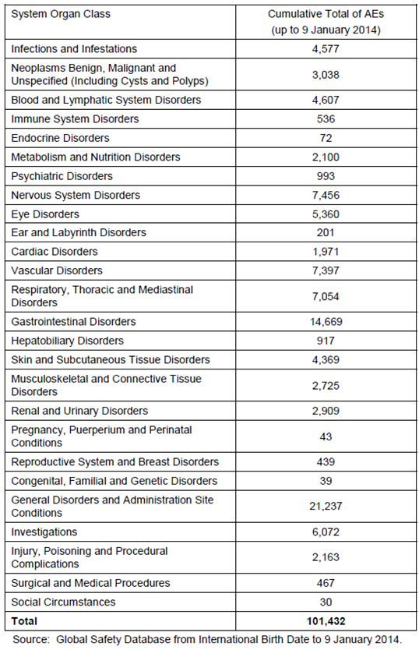

Evaluator’s conclusions on safety
Pivotal Study GOG-0240 assessed the efficacy and safety cisplatin plus paclitaxel (Cis+Pac) with and without bevacizumab (Bv) versus topotecan plus paclitaxel (Top+Pac), with and without bevacizumab, in stage IVB, recurrent or persistent carcinoma of the cervix. As a 2 x 2 factorial design was used for this study, the safety analysis was performed according to the two hypotheses for the study: H₀₁; according to bevacizumab treatment, and H₀₂; according to chemotherapy backbone.
It is noted that this analysis was the second analysis (data cut-off 12 December 2012) at 288 OS events, short of the planned final analysis at 346 OS events. Therefore, this safety analysis should be considered interim, and evaluation of the final study analysis is required.

H₀₁; safety conclusions by bevacizumab treatment
At least one AE was experienced by 98.6% of patients in the Chemo alone group and 99.1% patients in the Chemo+Bv group. The most common AEs were those typically associated with components of chemotherapy and had a similar incidence across the two groups, with the greatest difference in incidence between the Chemo alone group and the Chemo+Bv group being with hypertension (Chemo alone: 6.3% versus Chemo+Bv: 28.9% respectively); epistaxis (1.8% versus 17.0%); and weight decreased (6.8% versus 20.6%). In addition, this study identified a higher incidence of gastrointestinal (GI)-vaginal fistulae in the Chemo+Bv group (0.9% Chemo alone versus 8.2% Chemo+Bv) and a higher incidence of Grade ≥ 3 venous thromboembolic events (VTEs) (5.4% Chemo alone versus 10.6% Chemo+Bv).
There was a higher incidence of Grade 5 AEs in the Chemo+Bv group (2.3% Chemo alone versus 4.1% Chemo+Bv), however, this was offset by a lower incidence of deaths (65.3% Chemo alone versus 61.9% Chemo+Bv).
Overall more patients in the Chemo+Bv group (25.7%) discontinued study treatment due to AEs compared to the Chemo alone group (18.0%), due to fistula, general disorders and administrative site conditions, gastrointestinal disorders including nausea and vomiting, and blood and lymphatic system disorders including neutropenia.
Insufficient detail was provided in the CER to fully evaluate laboratory abnormalities, and this has been requested from the sponsor. Subgroup analysis by age, race and study treatment was not informative.
Overall this interim analysis suggests that the safety profile of bevacizumab is in keeping with that previously identified and as documented in the PI. New safety issues identified as a result of this study include an increased incidence of GI-vaginal fistulae and increased Grade ≥ 3 VTEs.

H₀₂; Safety conclusions by chemotherapy backbone
At least one AE was experienced by 99.1% of subjects in the Cis+Pac±Bv group and 98.6% of subjects in the Top+Pac±Bv group. There were some slight differences in the AE profiles of the two chemotherapy backbones.
AEs more common in the Cis+Pac±Bv group compared to the Top+Pac±Bv group included: GI disorders including nausea, vomiting, constipation and diarrhoea (89% Cis+Pac±Bv versus 83% Top+Pac±Bv), fatigue (82% Cis+Pac±Bv versus 73% Top+Pac±Bv), metabolism and nutrition disorders (59% Cis+Pac±Bv versus 53% Top+Pac±Bv), and hypertension (21% Cis+Pac±Bv versus 14% Top+Pac±Bv). There was also a higher incidence of Grade ≥ 3 peripheral sensory neuropathy (9% Cis+Pac±Bv versus 2% Top+Pac±Bv), VTEs (9% Cis+Pac±Bv versus 3% Top+Pac±Bv) and arterial thromboembolic events (ATEs) (4% Cis+Pac±Bv versus 2% Top+Pac±Bv) in the Cis+Pac±Bv group.
AEs more common in the Top+Pac±Bv group compared to the Cis+Pac±Bv group included infections and infestations (31% Cis+Pac±Bv versus 41% Top+Pac±Bv), and a slightly higher incidence of Grade ≥ 3 blood and lymphatic system disorders including neutropenia and febrile neutropenia (4% Cis+Pac±Bv versus 7% Top+Pac±Bv).
In keeping with the OS analysis, there were a higher number of deaths in the Top+Pac±Bv group (66.4%) compared to the Cis+Pac±Bv group (61.0%). There was also a higher frequency of Grade 5 AEs noted in the Top+Pac±Bv arm (4.6%) compared to the Cis+Pac±Bv arm (1.8%).
The incidence of SAEs was comparable between the two chemotherapy backbone arms, apart from thrombosis which was reported with a higher frequency in the Cis+Pac±Bv arm (8%) compared to the Top+Pac±Bv arm (2%).
More than twice as many patients in the Cis+Pac±Bv group discontinued study treatment due to AEs compared to the Top+Pac±Bv group (29.1% Cis+Pac±Bv versus14.3% Top+Pac±Bv). The most common reasons for treatment discontinuation that occurred more frequently in the Cis+Pac±Bv group included nervous system disorders including neuropathies, general and administration site conditions, gastrointestinal disorders, and toxicity/drug hypersensitivity.
Overall the interim analysis of safety by chemotherapy backbone presents a mixed picture. It appears that although the general incidence of AEs and AEs leading to treatment discontinuation are higher in the Cis+Pac±Bv arm, there is a higher incidence of deaths and Grade 5 AEs in the Top+Pac±Bv arm. Further evaluation of the final analysis at 346 OS events would be beneficial.

First round benefit-risk assessment

First round assessment of benefits
H₀₁: Based on Study GOG-0240, the benefits of bevacizumab in combination with chemotherapy compared to chemotherapy alone in patients with stage IVB, recurrent or persistent carcinoma of the cervix (analysis by bevacizumab treatment) are:
- A statistically and clinically significant improvement in the median OS of 3.9 months (12.9 months Chemo alone versus 16.8 months Chemo+Bv), HR: 0.74 (95% CI 0.58-0.94, p = 0.0132). This result is supported by the secondary endpoints of PFS and ORR.
- Exploratory subgroup analysis indicated potentially inferior efficacy of bevacizumab in patients with adenocarcinoma and adenosquamous carcinoma compared to squamous carcinoma histology.
H₀₂: The benefits of Cis+Pac±Bv compared to the Top+Pac±Bv in patients with stage IVB, recurrent or persistent carcinoma of the cervix (analysis by chemotherapy backbone):
- Appear to favour Cis+Pac±Bv over Top+Pac±Bv at interim analysis by a difference of 2.2 months (OS of 15.5 months Cis+Pac±Bv versus 13.3 months Top+Pac±Bv group,), HR 1.15 (95% CI: 0.91, 1.46, log-rank p-value=0.2326) at interim analysis. Secondary endpoints of PFS and ORR were statistically significant in favour of Cis+Pac±Bv.
It is noted that the pivotal study used narrower inclusion criteria than the indication for the proposed usage: ‘treatment of persistent, recurrent or Stage IV carcinoma of the cervix’. Specifically, the proposed usage also includes resectable Stage IVA disease (bladder or rectum extension), which were a group of patients who were excluded from the pivotal trial.

First round assessment of risks
Safety data presented for Study GOG-0240 have been interpreted as interim at this stage.
H₀₁: The risks of bevacizumab in the proposed usage (analysis by bevacizumab treatment) are:
- Generally in keeping with the known adverse event profile of bevacizumab, but with an increased incidence of GI-vaginal fistulae and increased Grade ≥ 3 VTEs.
H₀₂: The risks of Cis+Pac±Bv compared to the Top+Pac±Bv in the proposed usage (analysis by chemotherapy backbone) are:
- A higher incidence of AEs and AEs leading to treatment discontinuation with Cis+Pac±Bv, but a higher incidence of deaths and Grade 5 AEs with Top+Pac±Bv.
Generally these risks are in keeping with the known safety profile of bevacizumab.

First round assessment of benefit-risk balance
The benefit-risk balance of bevacizumab is unfavourable given the proposed usage, but would become favourable if the changes recommended below adopted.
In particular, the use of bevacizumab is recommended for a narrowed indication in keeping with the data provided in the pivotal trial, and taking into account the insufficient evidence of equivalence between the proposed chemotherapy backbone treatments.
Overall, the data presented indicates a survival advantage with bevacizumab treatment for patients with stage IVB, recurrent or persistent carcinoma of the cervix who otherwise have limited treatment options.

First round recommendation regarding authorisation
The sponsor has applied to register bevacizumab for the indication:
Cervical cancer – Avastin (bevacizumab) in combination with paclitaxel and cisplatin or paclitaxel and topotecan is indicated for the treatment of persistent, recurrent or Stage IV carcinoma of the cervix.
It is recommended that this indication be narrowed to reflect that used in the pivotal trial, and also to reflect the data which suggests an improved efficacy with the Cis+Pac chemotherapy backbone. A proposed amended indication would be:
Cervical cancer – Avastin (bevacizumab) in combination with paclitaxel and cisplatin is indicated for the treatment of persistent, recurrent or Stage IV carcinoma of the cervix that is not amenable to curative treatment with surgery and/or radiotherapy. Avastin (bevacizumab) in combination with paclitaxel and topotecan is an acceptable alternative where cisplatin is not tolerated or not indicated.

Second round evaluation of clinical data submitted in response to questions
For details of the questions raised by the clinical evaluator, sponsor’s responses and the evaluation of these responses please see Attachment 2, extract from the CER.

Second round benefit-risk assessment
For the second round benefit-risk assessment please see Attachment 2 extract from the CER.

Second round assessment of benefit-risk balance
The benefit-risk balance of bevacizumab is unfavourable given the proposed usage, but would become favourable if the changes recommended in Section 14 are adopted.

Second round recommendation regarding authorisation
The pivotal study population was heterogeneous. The sponsor has not provided compelling evidence of a benefit from bevacizumab exposure for patients with all histological sub-types of cervical carcinoma.
The evaluator recommends that authorisation not proceed pending the further advice of Advisory Committee on Prescription Medicines (ACPM).

V. Pharmacovigilance findings

Risk management plan
The sponsor submitted a Risk Management Plan EU-RMP Version 16.1 (dated 29 May 2014 DLP 25 April 2014) and Australian Specific Annex Version 5.0 (dated August 2014) was reviewed by the RMP evaluator.

Safety specification
The sponsor provided a summary of ongoing safety concerns which are shown at Table 4.

Table 4: Summary of ongoing safety concerns
Summary of ongoing safety concerns
Important identified risks | Bleeding / haemorrhage  Pulmonary haemorrhage  Proteinuria  Arterial thromboembolic events (ATE)  Hypertension  Congestive heart failure  Wound healing complications  Gastrointestinal perforations  Posterior reversible encephalopathy syndrome  Neutropenia  Venous thromboembolic events (VTE)  Fistula (other than gastrointestinal)  Thrombotic microangiopathy  Pulmonary hypertension  Ovarian failure  Hypersensitivity reactions / infusion reactions  Gall bladder perforation  Peripheral sensory neuropathy  Cardiac disorders (excluding congestive heart failure (CHF) and ATE)  Osteonecrosis of the jaw  Necrotizing fasciitis  Adverse events following off-label intravitreal use
Important potential risks | Embryo-fetal development disturbance  Physeal dysplasia
Missing information | Safety profile of the different treatment combinations in patients with non-squamous NSCLC  Long-term effects of bevacizumab when used in the paediatric population  Safety and efficacy in patients with renal impairment  Safety and efficacy in patients with hepatic impairment  Use in pregnancy and lactation

Pharmacovigilance plan
Routine pharmacovigilance is proposed for all safety concerns. Routine pharmacovigilance includes a guided questionnaire for adverse events relating to important identified risks ‘arterial thrombotic events’, ‘congestive heart failure’ and ‘venous thromboembolic events’. A follow-up checklist is also proposed for missing information ‘safety profile of the different treatment combinations in patients with non-squamous NSCLC’.
A number of ongoing and planned studies are proposed as additional pharmacovigilance as follows in Table 5

Table 5: Ongoing and planned studies
Additional activity | Assigned safety concern | Objectives | Planned submission of final data
Biomarker investigation (ongoing) | None | Identification and selection of a more targeted population of patients most likely to benefit from the combination of bevacizumab and paclitaxel in the treatment of first-line metastatic breast cancer. | Annually
BO17707 (ongoing ) | All safety concerns | Submission of results from the pre-specified final analysis for overall survival. | December 2013
BO20924 (ongoing) | Important potential risk: physeal dysplasia  Missing information: Long-term effects of bevacizumab when used in the paediatric population. | Assess safety and efficacy in paediatric patients. | CSR expected Q1 2017
MO18725 (ongoing) | Important identified risk: wound healing complications | To assess safety and resectability in patients treated with bevacizumab who have primarily unresectable liver metastases secondary to colorectal cancer and who are scheduled for first line chemotherapy. | CSR expected Q2 2014
Obtain long-term follow up information from studies in the paediatric population after patients complete their 5.5 years of follow up in Study BO20924 (planned) | Missing information: long-term effects of bevacizumab when used in the paediatric population. | Long-term effects of bevacizumab when used in the paediatric population | Protocol submission Q4 2017
A “safety monitoring plan” is also being implemented in all breast cancer studies for the important identified risk ‘congestive heart failure’. This includes regular left ventricle ejection fraction monitoring and cardiology input in data and safety monitoring boards.

Risk minimisation activities
Routine risk minimisation is proposed by the sponsor to mitigate all safety concerns. No additional risk minimisation activities are proposed.

Reconciliation of issues outlined in the RMP report
Table 6 summarises the first round evaluation of the RMP, the sponsor’s responses to issues raised and the RMP evaluator’s evaluation of the sponsor’s responses.

Table 6: Reconciliation of issues outlined in the RMP report
Recommendation in RMP evaluation report | Sponsor’s response (or summary of the response) | RMP evaluator’s comment
Safety considerations may be raised by the clinical evaluator through the TGA consolidated request for information and/or the CER respectively. It is important to ensure that the information provided in response to these includes a consideration of the relevance for the RMP, and any specific information needed to address this issue in the RMP. For any safety considerations so raised, the sponsor should provide information that is relevant and necessary to address the issue in the RMP. | The sponsor acknowledges this requirement. No new risks are required to be added to the RMP as a consequence of the additional information provided in this response. | The sponsor’s response is noted.
The EU-RMP also includes a follow-up questionnaire for adverse events relating to important identified risk ‘osteonecrosis of the jaw’ which is not proposed in the ASA. The sponsor should confirm that this activity is also undertaken in Australia, and if so, the pharmacovigilance section of the ASA should be amended to reflect this. | The sponsor confirms the follow-up questionnaire for ‘osteonecrosis of the jaw’ is undertaken in Australia. The sponsor provides the assurance that the ASA will be amended to reflect this. | The sponsor’s assurance is noted.
The evaluator has no objection to the additional pharmacovigilance studies proposed. However it appears that several milestones of the ongoing studies listed in the pharmacovigilance section of the EU-RMP and ASA have passed. These tables should be updated to reflect the completed studies. | The sponsor provides the assurance that in the next version of these documents submitted to TGA the ongoing studies tables in the EU-RMP and ASA will be updated to reflect those studies that have since been completed. | The sponsor’s assurance is noted.

Summary of recommendations

Issues in relation to the RMP
The clinical evaluator has recommended that the safety specification should be revised to include data from Study GOG-0240. This recommendation is endorsed by the RMP evaluator.

Advice from the Advisory Committee on the Safety of Medicines (ACSOM)
ACSOM advice was not sought for this submission.

Suggested wording for conditions of registration
RMP
Any changes to which the sponsor agreed become part of the risk management system, whether they are included in the currently available version of the RMP document, or not included, inadvertently or otherwise.
The suggested wording is:
Implement EU-RMP Version 16.1 (dated 29 May 2014 DLP 25 April 2014) and Australian Specific Annex Version 5.0 (dated August 2014) revised as agreed with the TGA and any future updates as a condition of registration

VI. Overall conclusion and risk/benefit assessment
The submission was summarised in the following Delegate’s overview and recommendations:

Quality
There was no requirement for a quality evaluation in a submission of this type.

Nonclinical
There was no requirement for a nonclinical evaluation in a submission of this type.

Clinical
Study GOG-0240 was a randomised, open label, Phase III, multi-centre study to assess the effects on overall survival and safety of cisplatin plus paclitaxel (Cis+Pac) with and without bevacizumab (Bv) versus the non-platinum doublet, topotecan plus paclitaxel (Top+Pac), with and without bevacizumab, in stage IVB, recurrent or persistent carcinoma of the cervix. This study was conducted across 159 sites in the United States and 6 sites in Spain. An interim analysis of this study was published in the New England Journal of Medicine.
The pivotal study for this submission recruited patients that were assigned recurrent or persistent disease plus those with stage IVB. The study specifically excluded women that had cerebral metastases; this exclusion criterion is documented in the clinical trials section of the PI. The study design of GOG-0240 is shown below in Figure 1.
Figure 1: Design of Study GOG-0240
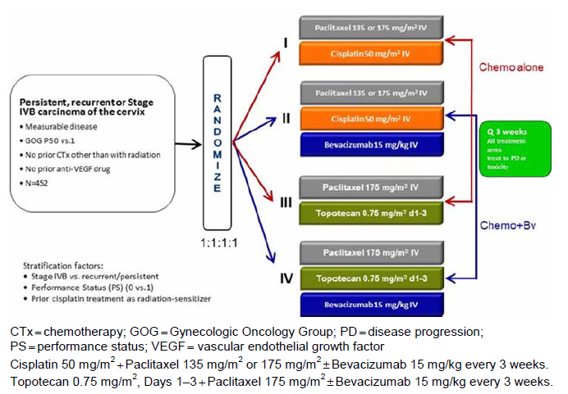

Pharmacology
The evaluators’ conclusions on pharmacokinetics included “experience from use in the currently approved indications of metastatic breast cancer and ovarian/fallopian tube cancer represents a sufficient understanding of dosing within female populations to enable the inference of similar dosing schedules to the cervical cancer setting”.
The evaluator did not make comment on the difference in dosage regimen for patients with ovarian/fallopian tube cancer who have evidence of platinum resistance. The proportion of patients with known platinum resistance was not reported for patients in GOG-0240.
The sponsor should therefore justify in their pre-ACPM response the reasons for not recommending a different dosing regimen for patients with cervical cancer who have confirmed platinum resistance, which is inconsistent with the dosing regimen for ovarian/fallopian tube or peritoneal cancer.

Efficacy
A single pivotal study of efficacy and safety was presented for evaluation.
The pivotal study treatment arms comprised 225 patients in the chemotherapy alone arm and 227 in the bevacizumab + chemotherapy arm. The chemotherapy agents: cisplatin, paclitaxel and topotecan were administered according to approved dosing regimens (for description of the dosing regimens used see Attachment 2). Study treatment continued until disease progression or unacceptable toxicities.
The demographic and baseline disease characteristics and histological sub-types were balanced between these two treatment arms. Patients were required to have disease which was not amenable to curative treatment with surgery and/or radiotherapy.
Patients with either adenocarcinoma or adenosquamous disease comprised approximately 29% of each treatment arm, the majority of the remainder having squamous disease (see Table 7 below). The distribution of histological variants and disease stage is consistent with that seen in clinical practice.

Table 7: Baseline histology, staging and prior surgery. Study GOG-0240
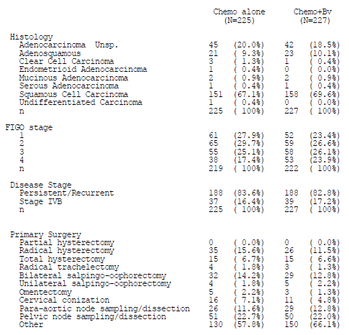
In both treatment arms, patients predominately were classified as persistent/recurrent (approximately 83%) or with stage IVB (approximately 17%), with all fulfilling the wording of the proposed indication. Patients were not permitted to enter the study if they had cerebral metastases.
Patients who had received prior platinum therapy were permitted trial entry, with a similar proportion included in each treatment arm. However, the proportion of patients in each treatment arm with platinum resistance was not reported.
In the sub-group analysis presented in the dossier (Figure 2), the hazard ratio of OS was similar for patients who had received either: prior chemotherapy, radiation or platinum therapy; the apparent independent effect of bevacizumab is consistent with the different mechanisms of action.
Figure 2: Forrest plot of overall survival by bevacizumab treatment and subgroup in Study GOG-0240
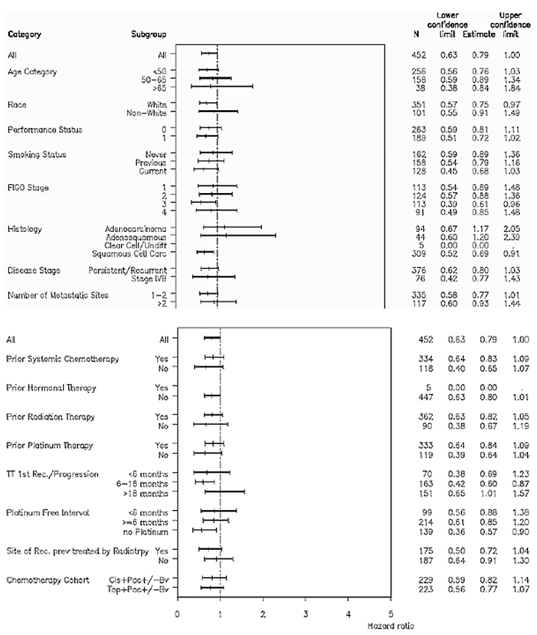

Efficacy outcomes
The primary outcome of GOG-0240 of overall survival (OS), assessed from randomisation to death from any cause, as initially presented in the dossier was met, with a hazard ratio of 0.74 (95% CI 0.58, 0.94), p=0.01. A follow-up analysis of more mature data presented in the sponsor’s response to questions was consistent with the initially presented data; OS HR 0.76 (95% CI 0.62, 0.94), p=0.01.
In the dossier, the median duration of OS was reported as 12.9 months (95% CI 10.9, 15.0) in the placebo arm as compared to 16.8 months (95% CI 14.1, 19.0); of note, the 95% confidence intervals of the median estimates overlap.
The median duration of OS was consistent between the initially presented and follow-up data for each treatment arm; 12.9 and 13.3 months for the placebo arm and 16.8 months for the bevacizumab arm (at both time-points) respectively.
The median duration of PFS was 6.0 months (95% CI 5.2, 6.9) and 8.3 months (95% CI 7.1, 9.7) for the placebo and bevacizumab arms respectively, HR 0.66 (95% CI 0.54, 0.81).
The overall response rate (complete or partial response) was 45.5% (95% CI 38.8, 52.1) and 33.8% (95% CI 27.6, 40.4) of the bevacizumab and placebo arms respectively.
Quality of life assessments were undertaken throughout the study. However, with the increasing study duration, there were an increasingly large proportion of subjects that did not complete them, which precludes a meaningful analysis of this end-point.
No efficacy data, other than the estimate of hazard ratio of OS has been presented for sub-groups of patients with differing histological diagnoses (see below in risk benefit analysis).

Safety
The safety profile of bevacizumab, in the currently approved indications, is described in the PI.
In Study GOG-0240, general adverse events and adverse events of special interest were recorded. The results of laboratory tests at baseline and at each treatment cycle were recorded, but only presented according to incidence of adverse events, not the incidence of events over time. The incidence of grade 3-5 adverse events was 75.7% in the bevacizumab arm as compared to 57.2% with placebo; a higher proportion of subjects discontinued bevacizumab than placebo.
The evaluator commented that the common adverse events occurring in GOG-0204 were consistent with the adverse event profile reported in other indications. There was a higher incidence of grade 3-5: hypertension, thrombosis, infection fatigue and pelvic pain in the bevacizumab exposed patients.

Adverse events of special interest
The incidence of GI perforation events, fistula or abscess was assessed at the first round evaluation to be 10.1% in the bevacizumab arm as compared to 0.5% in the placebo arm. The sponsor provided an additional analysis of the incidence of such events in the response to TGA questions. This analysis yielded the incidence in the bevacizumab and placebo arms respectively of: GI perforation to be 3.2% versus 0%, GI-vaginal fistulae to be 8.2% versus. 0.9% and non-GI abscess/fistula to be 1.8% versus 1.4%.
Grade ≥ 3 bleeding events were observed in a similar proportion of each treatment arm, with specific sites of haemorrhage affecting small numbers of patients. The incidence of febrile neutropenia was similar between treatment arms (5.9% placebo versus 5.5% bevacizumab).
The incidence of grade ≥ 3 hypertension was 0.5% in the placebo arm versus 11.0% in the bevacizumab arm. The incidence of grade ≥ 3 proteinuria was 1.8% of patients in the bevacizumab arm as compared no patients in the placebo arm. The evaluation of laboratory adverse events did not reveal any new safety concerns over and above those already documented in the PI.

RMP evaluation
The RMP evaluation was “generally consistent with that accepted in a previous evaluation of an earlier version of the RMP/ASA”, with no specific activities required in the proposed indication. There were no outstanding issues identified in the second round RMP evaluation report.

Risk-benefit analysis

Discussion
The currently approved PI for topotecan has an indication for use in cervical cancer based on Study GOG-0179. Of note, the currently approved PIs for paclitaxel and cisplatin do not contain a specific indication for use in cervical carcinoma. Prior to the Study GOG-0240, the accepted best treatment for patients with persistent, recurrent of metastatic cervical carcinoma was chemotherapy. The chemotherapy regimens of Top+Pac and Cis+Pac have a demonstration of OS benefit seen in published literature, with incorporation into oncology clinical practice guidelines.
The analysis of outcomes according to chemotherapy regimen in GOG-0240, demonstrated no significant difference between the patients that received Cis+Pac as compared those that received Top+Pac. The estimated median duration of OS from GOG-0240 was 15.5 months for Cis+Pac versus 13.3 months for Top+Pac (HR 1.15 (95% CI 0.91, 1.46)).
This finding is consistent with the outcomes of a study of 434 women receiving one of four cisplatin containing doublet combinations, in a study population similar to that in GOG-0240^{.1} This publication reported the median survival of patients in the Cis+Pac arm was 12.87 months whereas that for Cis +Top was 10.25 months (HR 1.26 (95% CI 0.91, 1.92).
The single pivotal study was evaluated with reference to the relevant EMA guideline adopted by the TGA.
The pertinent sections of the guideline for this submission states:
- Internal validity; there should be no indications of a potential bias
There were a similar proportion of patients who had received prior platinum based therapy in each study arm. The evaluator could not identify the proportion of patients in GOG-0240 study arms that had evidence of platinum resistance which is a potential source of bias. The sponsor was requested to provide this data, and justify the same dosing regimen in platinum sensitive and platinum-resistant patients with cervical cancer.
- External validity; the study population should be suitable for extrapolation to the population to be treated
The majority of the study population were classified as having persistent or recurrent cervical cancer at baseline, balanced between treatment arms. A small proportion of the study population was classified as having stage IVB disease; these study patients did not have cerebral metastases at trial entry.
The sponsor, in their response to TGA questions, proposed an amended indication, removing specific reference to “stage IV carcinoma of the cervix”, replacing it with the more general term “metastatic carcinoma of the cervix”:
“Avastin (bevacizumab) in combination with paclitaxel and cisplatin is indicated for the treatment of persistent, recurrent or metastatic carcinoma of the cervix. Avastin (bevacizumab) in combination with paclitaxel and topotecan is an acceptable alternative where cisplatin is not tolerated or not indicated.”
In regard to the acceptability of this amended indication, the Delegate has considered the following:
Are the study population of patients with stage IVB disease and without cerebral metastases representative of all patients with stage IVB disease?
The Delegate considers there is no biologically plausible mechanism why a distant metastasis at a site other than the brain should respond in a different manner to treatment from one which is situated in the brain. Although the pivotal study excluded patients with cerebral metastases, such patients are likely to represent a small sub-group of all patients that fulfil the proposed indication definition. Pragmatically, given the rarity of the patients with metastatic cervical cancer disease and cerebral metastases (from a total population which fulfil the orphan criteria), it is unlikely that a study with sufficient power to demonstrate any difference in outcome could be readily performed.
Are patients with stage IVB disease and without cerebral metastases representative of patients with stage IVA disease?
The Delegate considers that the site of metastasis does not necessarily confer a difference in treatment effect, but may confer a difference in adverse events, such as fistula formation in association with disease involvement of the mucosa of bladder or bowel. Thus these two populations may be plausibly considered sufficiently similar.
Thus, stages IVB and IVA may be considered sufficiently represented by those patients recruited into the pivotal study. Furthermore, these two categories define the population of all those with metastatic disease. The wording of the proposed, amended, indication is therefore considered satisfactory, and fulfils the guideline requirement.
The patients that were categorised as having persistent or recurrent cervical carcinoma are directly represented by the wording of the indication.
Is the study population representative of the wider population of patients with cervical cancer?
Yes. Study GOG-0240 recruited patients with an appropriately categorised stage of disease and also a population with known histological variants representative of that expected in clinical practice.
- Clinical relevance; the estimated size of treatment benefit must be large enough to be clinically valuable
For the whole study population, the addition of bevacizumab to chemotherapy was observed to increase the duration of overall survival to a median of 16.9 months as compared to a median of 12.9 months for chemotherapy alone.
A systematic review, comprising 1,181 patients, comparing cisplatin and carboplatin plus paclitaxel based chemotherapy in recurrent or metastatic cervical cancer reported a (weighted) median estimate of overall survival of 10 months. The observed median duration of OS for the whole GOG-0240 study population is better than that reported in this systematic review.
The 4 month difference in median overall survival observed in the whole GOG-0204 study population satisfies the requirement that the estimated size of treatment benefit is clinically valuable. The observed benefit in overall survival was determined in population of patients with the most commonly reported stages and histological sub-types of cervical cancer.
However, there is inconsistency of the observed estimated treatment effect across histological sub-groups –see point 4 (internal consistency) below. The 95% confidence interval of the estimate of OS hazard ratio for patients with adenocarcinoma and adenosquamous crosses the line of unity, with a point estimate favouring placebo. The sponsor has not documented a benefit from bevacizumab in patients with non-squamous disease in regard to duration of overall survival, progression free survival or overall response rate. In the absence of such information, a recommendation for registration in this sub-group of patients cannot be recommended.
- Internal consistency - Similar effects demonstrated in different pre-specified sub-populations. All important endpoints showing similar findings
Patients with non-squamous disease represent approximately 30% of the GOG-0240 study population. Patients with squamous and non-squamous cervical cancer are seen to have dissimilar efficacy responses in other therapeutic settings., , ,
The sponsor presented two Forest plots of hazard of OS, in the dossier and in the response to TGA consolidated questions. Furthermore, a Forest plot is presented in the NEJM article reporting the outcomes of GOG-0240 (Figures 3, 4 and 5). Each of the three Forest plots, representing a progressively longer duration of study duration, does not unequivocally demonstrate a benefit for patients with adenocarcinoma or adenosquamous disease, with a point estimate of hazard of OS favouring placebo in the last two plots reporting the longest period of follow-up.
Figure 3: The Forest plot of OS by treatment sub-group from the NEJM article by Tewari et al at an interim data cut-off of 12 December 2012, after 271 OS events
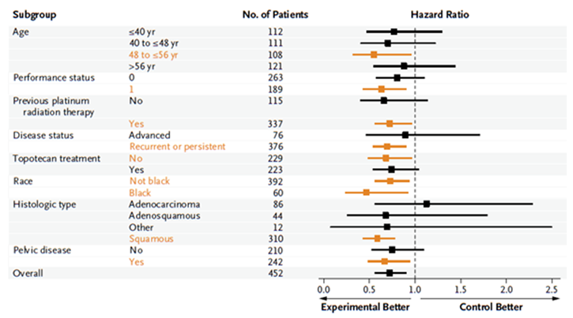
Figure 4: Forest plot of OS by sub-group, from the initial data supplied in the dossier after 288 OS events
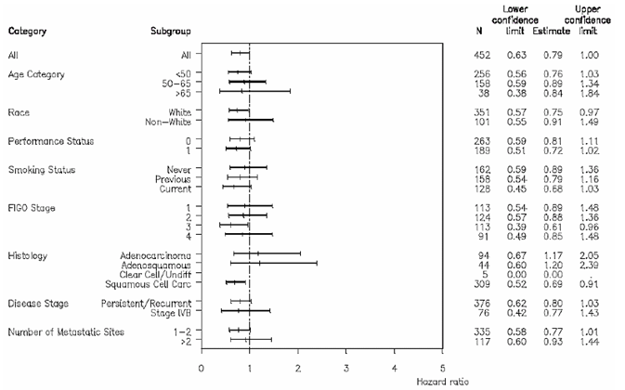
Figure 5: Forest plot of OS by treatment subgroup from the updated CSR provided with the sponsor’s response, performed after 350 OS events
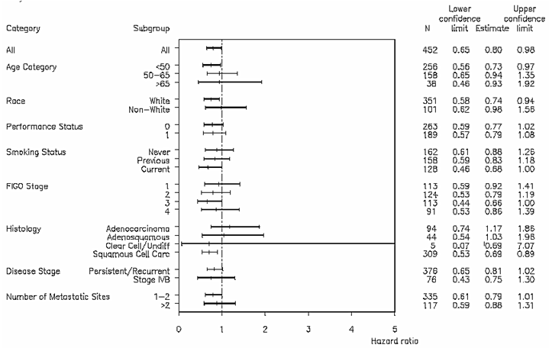
Despite this difference in hazard of OS according to histology sub-type, the sponsor did not present other efficacy data (duration of OS, duration of PFS and ORR) according to histological sub-type.
The lack of provision of data on estimated duration of overall survival and overall response rate precludes the Delegate from establishing the estimate of treatment effect in patients with non-squamous disease and therefore would preclude clinicians from being able to satisfactorily consent patients to treatment. Furthermore, for bevacizumab to have a positive risk-benefit assessment in patients with non-squamous disease, the safety profile in these patients would necessarily have to be more favourable than for those with squamous disease.
The sponsor has also presented a sub-group analysis of efficacy by chemotherapy backbone, which demonstrates a dissimilar response according to histology sub-group, consistent with published literature (Figure 2).
The sponsor has not presented “all important end points” according to histological subgroups. The estimated hazard ratio of OS is dissimilar between histological subgroups, with that for non-squamous disease plausibly favouring placebo.
It is biologically plausible that a difference in bevacizumab effect may be observed according to cervical cancer histological diagnosis. VEGF expression has been shown to be significantly different between squamous and non-squamous histologies, being lower in patients with non-squamous sub-types., Furthermore, in the setting of gastric adenocarcinoma, a beneficial treatment response to ramucirumab (acting via VEGF-2R) has been observed, but was not from bevacizumab.,
Proposed regulatory action and indication
While the study has met its primary end point, sub-groups of patients with histological variants have not been demonstrated to have similar outcomes contrary to the TGA adopted EMA guidance on single pivotal studies.
The results of the whole study population cannot reliably be used to inform clinicians or individual patients with non-squamous histological sub-type. Given that an efficacy benefit has not been satisfactorily demonstrated for patients with non-squamous disease, the risks from treatment naturally predominate.
The sponsor has not satisfactorily demonstrated that administration of bevacizumab in patients with non-squamous disease is sufficient for registration.
The Delegate therefore considers that the indication which could be considered for registration is:
“AVASTIN (bevacizumab) in combination with paclitaxel and cisplatin or paclitaxel and topotecan is indicated for the treatment of persistent, recurrent or metastatic squamous cell carcinoma of the cervix.
AVASTIN (bevacizumab) in combination with paclitaxel and topotecan is an acceptable alternative where cisplatin is not tolerated or not indicated.”
The sponsor has satisfactorily documented the additional risks observed in the study population of hypertension, venous thromboembolism, GI-fistulae and non-GI fistulae in the PI.
Outstanding questions for the sponsor
- The sponsor should present the data regarding the proportion of patients in the bevacizumab and placebo arms of GOG-0240 that had confirmed platinum resistance.
- The sponsor should justify why patients with cervical cancer and confirmed platinum resistance do not warrant a separate dosing regimen from those without platinum resistance.
- The sponsor should present top-line efficacy (duration of OS, duration of PFS and ORR) and safety data according to histological sub-type of cervical cancer.

Delegate’s considerations
A single Phase III study was presented for evaluation – the relevant EMA guidance for a single pivotal study applies.
The study showed an improvement in hazard of death and PFS for the whole heterogeneous study population.
No improvement in the hazard of OS was observed for patients with adenocarcinoma or adenosquamous disease sub-types, but was seen for squamous disease.
In the overall analysis, the 95% confidence intervals for the estimated duration of OS in bevacizumab and placebo arms overlap.
Patients with cerebral metastases were excluded; therefore no benefit has been demonstrated for these patients.
In addition to the known risks of bevacizumab administration, the risk of GI perforation and fistula formation was higher with bevacizumab than placebo. Plus, there was an increased risk of grade 3-5 venous thromboembolism and hypertension with bevacizumab as compared to placebo.

Proposed action
The Delegate had no reason to say, at this time, that the application for bevacizumab should not be approved for registration.

Request for ACPM advice
The committee is requested to provide advice on the following specific issues:
- In which histological sub-population(s) of patients with advanced, recurrent or metastatic cervical cancer has bevacizumab satisfactorily been demonstrated to confer an efficacy benefit over placebo?
- In which histological sub-populations(s) of patients with advanced, recurrent or metastatic cervical cancer has bevacizumab satisfactorily been demonstrated to have a positive risk-benefit assessment for the purposes of (i) delivering informed consent and (ii) product registration?
- What does the Committee consider the appropriate wording of the proposed indication in cervical cancer?
The committee is also requested to provide advice on any other issues that it thinks may be relevant to a decision on whether or not to approve this application.

Response from sponsor
Worldwide, cervical cancer is the fourth most common cancer in women and the seventh most common cancer overall. In Australia, cervical cancer is the twelfth most common cancer affecting women (excluding basal and squamous cell carcinoma of the skin), with 7 new cases diagnosed per 100,000 women in 2009. Up to 50% of patients with bulky primary or advanced disease will have a recurrence, which is generally considered incurable, particularly if distant metastases have developed. Treatment in the recurrent setting is considered palliative, and for many patients, best supportive care is frequently recommended as current treatment options provide little clinical benefit.
Improving overall survival (OS) has remained the primary endpoint for clinical trials in advanced cervical cancer, as the prognosis for women with persistent, recurrent, or stage IVB cervical cancer remains poor with median durations of OS ≤ 12 months. To date, no clinical trials in recurrent or metastatic cervical cancer over the last decade have resulted in a significant increase in OS and there remains a high unmet medical need.

Comment on the delegate’s proposed action
The sponsor notes the Delegate’s summary of issues and requests for ACPM advice in relation to:
- In which histological sub-population(s) of patients with advanced, recurrent or metastatic cervical cancer has bevacizumab satisfactorily been demonstrated to confer an efficacy benefit over placebo?
- In which histological sub-populations(s) of patients with advanced, recurrent or metastatic cervical cancer has bevacizumab satisfactorily been demonstrated to have a positive risk-benefit assessment for the purposes of (i) delivering informed consent and (ii) product registration?
- What does the Committee consider the appropriate wording of the proposed indication in cervical cancer?
- The committee is also requested to provide advice on any other issues that it thinks may be relevant to a decision on whether or not to approve this application.
Based on the above summary of issues, the Delegate has proposed the following modified indication
“Avastin (bevacizumab) in combination with paclitaxel and cisplatin or paclitaxel and topotecan is indicated for the treatment of persistent, recurrent or metastatic squamous cell carcinoma of the cervix.
Avastin (bevacizumab) in combination with paclitaxel and topotecan is an acceptable alternative where cisplatin is not tolerated or not indicated”
The sponsor wishes to respond to the Delegate’s request for ACPM advice as follows:
Roche believes the data submitted in support of this application demonstrates a positive risk-benefit for bevacizumab for the purposes of delivering informed consent and registration in patients with persistent, recurrent or metastatic cervical cancer, regardless of histological sub-population.
The pivotal study included in this application, Study GOG-0240, was designed to answer two important questions for persistent, recurrent and metastatic cervical cancer. Given the limited patient population with this disease and the urgent medical need for novel therapies, two different hypotheses were simultaneously tested:
H₀₁: whether bevacizumab in combination with chemotherapy improved OS (either Cisplatin + Paclitaxel or Topetecan+ Paclitaxel)
H₀₂: whether Topetecan+ Paclitaxel with or without bevacizumab improves OS in comparison to Cisplatin + Paclitaxel with or without bevacizumab
given that not all patients would be ideal candidates for platinum-based chemotherapy.
The primary analysis of OS from Study GOG-0240 demonstrated statistically significant, clinically meaningful, and robust results and supports the use of bevacizumab in combination with paclitaxel and cisplatin or paclitaxel and topotecan for treatment of patients with persistent, recurrent, or metastatic carcinoma of the cervix. The addition of bevacizumab to paclitaxel based chemotherapy resulted in an improvement in median OS of 3.9 months from 12.9 months with chemotherapy alone to 16.8 months with bevacizumab in combination with chemotherapy (HR= 0.74; 95% CI: 0.58, 0.94; p = 0.0132). This is the first time that OS has been increased to well over 12 months in this disease setting.
Study GOG-0240 included an exploratory subgroup analysis for OS for histology subgroups. The results from the primary analysis reported hazard ratios that were greater than 1 in all sub groups other than squamous-cell carcinoma that is, adenocarcinoma [HR = 1.17] and adenosquamous [HR = 1.20] (Figure 2)).
Considering the relatively small numbers of patients in the histology subgroups “adenocarcinoma” (AC), n = 94 and “adenosquamous carcinoma” (AS), n = 44, there is no statistical rationale to conclude that these subgroups behave differently from the entire patient population, and the most reliable estimate for the treatment effect is the one derived from the analysis of all patients. Moreover, the wide confidence intervals (CIs) in both the AC and AS subgroups, as shown in (Figure 2)⁵ and in the analysis provided in response to Question 3 (Tables 8 and 9; also refer to Tables 10 and 11); suggest that no definitive conclusions should be derived. Adverse event frequencies in the AC and AS histological subtypes were consistent with the overall safety population. Given the known limitations of subgroup analyses, caution needs to be taken when interpreting the results.

Table 8: Summary of Overall Efficacy for Patients with Adenosquamous (AS) Histology**
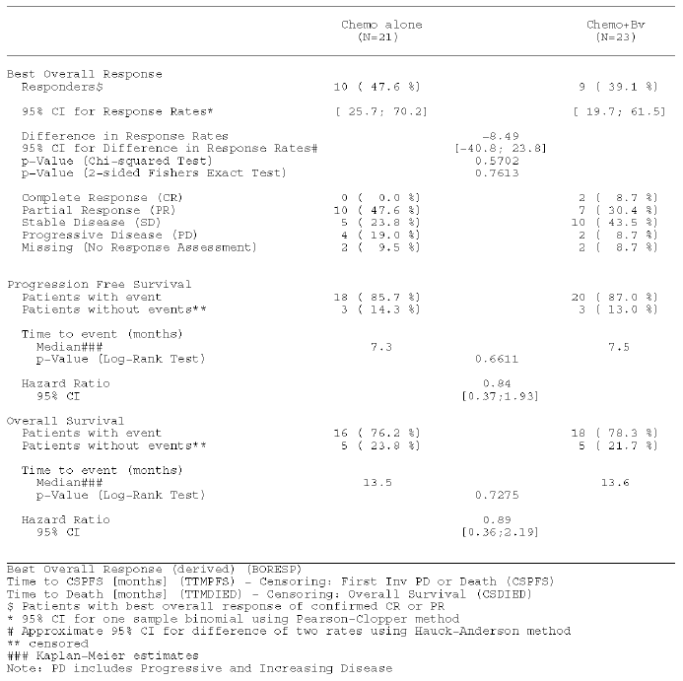
** For the analysis of Progression Free Survival and Overall Survival, chemotherapy backbone has been used as a covariate; and performance status, tumour stage and previous platinum treatment used as stratification factors

Table 9: Summary of Overall Efficacy for Patients with Adenocarcinoma (AC) Histology**
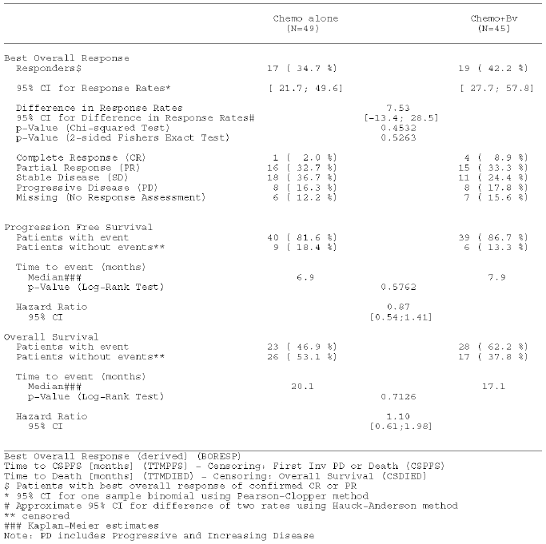
** For the analysis of Progression Free Survival and Overall Survival, chemotherapy backbone has been used as a covariate; and performance status, tumour stage and previous platinum treatment used as stratification factors

Table 10: Summary of Overall Efficacy for Patients with Adenosquamous (AS) Histology (Unstratified data)
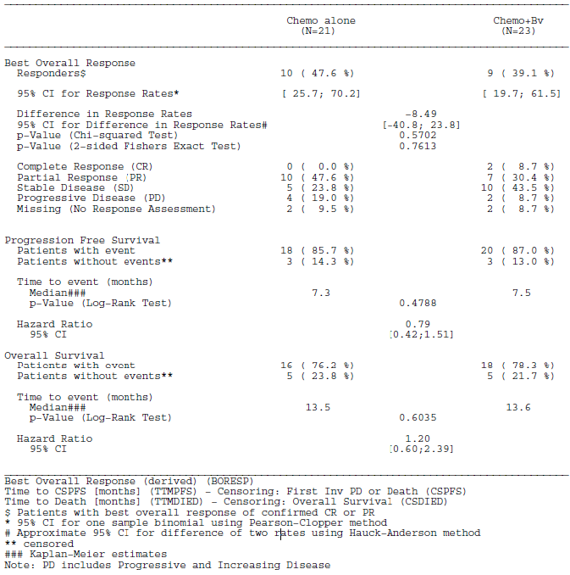

Table 11: Summary of Overall Efficacy for Patients with Adenocarcinoma (AC) Histology (Unstratified data)
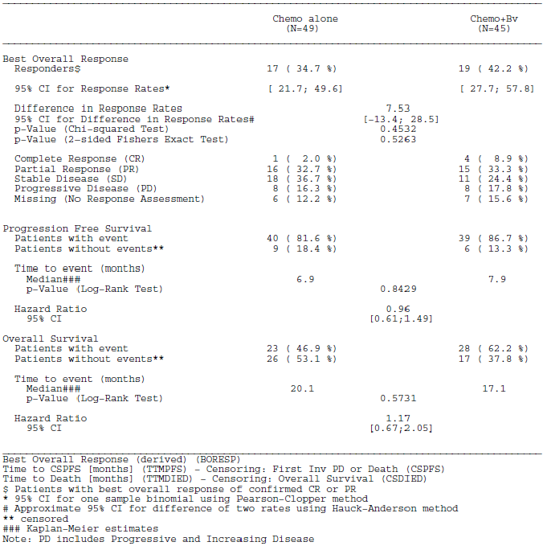
Furthermore, there is no clinical rationale to treat subgroups of patients with AC and AS differently from patients with SCCA of the cervix. This has been addressed in an analysis done by Seamon et al. (2014) which showed that Study GOG-0240 was not sufficiently powered for AC or AS to draw any conclusions regarding the efficacy of incorporation of anti-angiogenesis therapy in these uncommon histologies. The results of the analysis (see response to Question 3 below for details) are consistent with the hypothesis that the AC or AS carcinoma histologic subtypes are not significantly different in their biologic response to systemic therapy in the recurrent/metastatic setting, and this supports the use of bevacizumab plus chemotherapy in patients with advanced cervical cancer regardless of histologic subtype.
Globally, the standard of care is that non-squamous and squamous cell carcinomas are treated in the same manner. The median duration of OS in patients with metastatic carcinoma of the cervix is ≤ 12 months, with current treatment options providing limited clinical benefit. In addition, patients with adenocarcinoma histology subtypes may have a poorer prognosis than patients with squamous cell carcinomas. There is currently no evidence for patients with these histology subtypes to be treated differently to patients with squamous cell carcinoma and as such the potential benefit on improved OS should not be withheld from patients with cervical AC or AS carcinoma due to the high unmet need in this group of patients.
Given the relevant statistical and clinical rationale described above, the sponsor does not concur with the Delegate’s recommendation to restrict the indication to patients with metastatic squamous cell carcinoma only. The sponsor maintains that the indication proposed by Roche is appropriate for registration:
“Avastin (bevacizumab) in combination with paclitaxel and cisplatin or paclitaxel and topotecan is indicated for the treatment of persistent, recurrent or metastatic carcinoma of the cervix.
Avastin (bevacizumab) in combination with paclitaxel and topotecan is an acceptable alternative where cisplatin is not tolerated or not indicated”

Response to outstanding questions for the sponsor (from the second round clinical evaluation)
- The sponsor should present the data regarding the proportion of patients in the bevacizumab and placebo arms of GOG0240 that had confirmed platinum resistance.
As requested, the top-line efficacy results, including OS, PFS, and ORR, are presented by chemotherapy backbone for the patients who had received prior platinum therapy and thus may have platinum resistance in the Chemo alone (non-bevacizumab) and Chemo + Bv (bevacizumab) arms, respectively, in Study GOG-0240 (see Table 12 and Table 13).

Table 12: Summary of Overall Efficacy for Bevacizumab Patients Who Received Prior Platinum Therapy by Chemotherapy Backbone
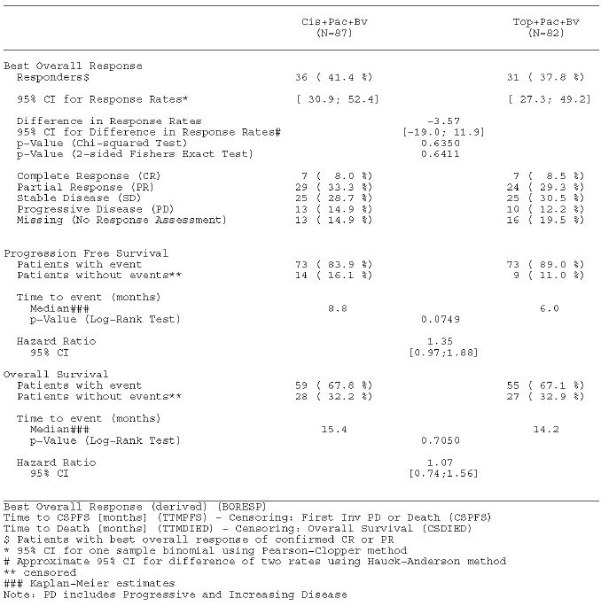

Table 13: Summary of Overall Efficacy for Non−Bevacizumab Patients who received prior Platinum Therapy by Chemotherapy Backbone
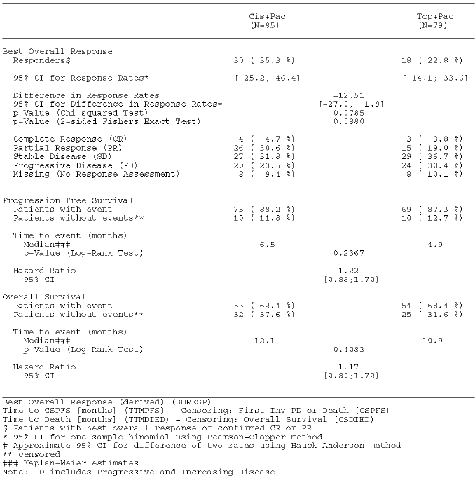
A total of 169 patients in the Chemo+Bv arm had received prior platinum therapy and may have platinum resistance; 87 patients in the Cis+Pac+Bv)arm and 82 patients in the Top+Pac+Bv arm. A total of 164 patients in the Chemo alone arm had received prior platinum therapy and may have platinum resistance; 85 patients in the Cis+Pac arm and 79 patients in the Top+Pac arm.
In the analysis of OS in bevacizumab patients who received prior platinum therapy, the hazard ratio (HR) comparing the Top+Pac+Bv versus Cis+Pac+Bv arms was estimated to be 1.07 (95% CI: 0.74, 1.56; log-rank p-value = 0.7050), with a median duration of OS of 15.4 months in the Cis+Pac+Bv arm and 14.2 months in the Top+Pac+Bv arm. In the analysis of PFS, the HR was 1.35 (95% CI: 0.97, 1.88; log-rank p-value = 0.0749) and showed a median time to progression or death of 8.8 months in the Cis+Pac+Bv arm and 6.0 months in the Top+Pac+Bv arm. An analysis of ORR by chemotherapy backbone in bevacizumab patients who received prior platinum therapy showed that the proportion of responders in the Cis+Pac+Bv arm was 41.4% (36 of 87) and 37.8% in the Top+Pac+Bv arm (31 of 82).
In the analysis of OS in non-bevacizumab patients (that is, chemotherapy alone arm) who received prior platinum therapy, the HR comparing the Top+Pac versus Cis+Pac arms was estimated to be 1.17 (95% CI: 0.80, 1.72; log-rank p-value = 0.4083), with a median duration of OS of 12.1 months in the Cis+Pac arm and 10.9 months in the Top+Pac arm. In the analysis of PFS, the HR was 1.22 (95% CI: 0.88, 1.70; log-rank p-value = 0.2367) and showed a median time to progression or death of 6.5 months in the Cis+Pac arm and 4.9 months in the Top+Pac arm. An analysis of ORR by chemotherapy backbone in non-bevacizumab (that is, chemotherapy alone arm) patients who received prior platinum therapy showed that the proportion of responders in the Cis+Pac arm was 35.3% (30 of 85) and 22.8% in the Top+Pac arm (18 of 79).
Caution needs to be taken when interpreting the results of subgroup analyses, nevertheless patients receiving bevacizumab and having received prior platinum therapy seem to have a longer median OS, longer median PFS, and a better response than those receiving chemotherapy alone and having received prior platinum therapy.
- The sponsor should justify why patients with cervical cancer and confirmed platinum resistance do not warrant a separate dosing regimen from those without platinum resistance (which is inconsistent with the dosing regimen for ovarian/fallopian tube or peritoneal cancer).
Platinum resistance has been defined in several retrospective analyses of patients treated with platinum in multiple lines for recurrent ovarian cancer (that is, epithelial, fallopian tube, and primary peritoneal cancers), but not in cervical cancer. There is no evidence for “confirmed platinum” resistance in Study GOG-0240. In ovarian cancer, recurrent disease is classified as platinum resistant or platinum sensitive, depending on whether the disease recurs < 6 or ≥ 6 months following previous platinum therapy. This classification is highly prognostic in recurrent ovarian cancer and is important in determining subsequent treatment options; however there are several differences with regard to cervical cancer. The previous platinum treatment in cervical cancer (and in the GOG-0240 trial) refers to the use of cisplatin as a radio-sensitizer in patients who received radiation therapy for locally advanced disease, and for which the dose administered is low at 40 mg/m² every week for 6 weeks. This is not comparable to the standard platinum dose administered in the treatment of ovarian cancer (carboplatin at target AUC 5 or 6) or to the dose of cisplatin in GOG-0240 given every 3 weeks until disease progression. Moreover, in cervical cancer, there is no definitive definition of “platinum resistance” compared with the established definition used in ovarian cancer, thus there is no standard treatment based on the patient’s previously demonstrated sensitivity to a platinum based chemotherapy in this disease setting.
The GOG-0240 trial specifically evaluated whether the non-platinum doublet of topotecan plus paclitaxel may be suitable for study in this population of potentially platinum resistant patients. The results showed that a non-platinum doublet is not superior to a platinum containing regimen in a population of potentially platinum-resistant cervical cancer patients (see response to Question 1 above). In fact, this trial has shown that cervical cancer patients, who received previous platinum as a radio-sensitizer, benefit with a subsequent cisplatin containing regimen given at the standard dose. To date, there is no definitive clinical trial data or published literature in cervical cancer supporting that patients who are considered potentially platinum-resistant should be given a different dosing regimen.
- The sponsor should provide top-line efficacy (duration of OS, duration of PFS and ORR) and safety data according to histological sub-type of cervical cancer.
As requested, the top-line efficacy and safety results, including OS, PFS, and ORR, for patients with AS and AC histology, of which the majority are non-squamous histological subtypes, are presented in this section.
The top-line efficacy results, including OS, PFS, and ORR, for the patients with AS histology is presented in Table 8 above. As expected, given the small number in the non-randomized subgroup of patients in the Chemo alone arm (n = 21) and the Chemo+Bv arm (n = 23), the results are not considered to be reliable and informative. The OS HR = 0.89 (95% confidence interval [CI]: 0.36, 2.19) has very wide CIs that include 1. No definitive conclusions should be derived. Given the known limitations of retrospective subgroup analyses, caution needs to be taken when interpreting the results.
The top-line efficacy results, including OS, PFS, and ORR, for the patients with AC histology are presented in Table 9. Again as expected, given the small number in the non-randomised subgroup of patients with AC histology in the Chemo alone arm (n = 49) and Chemo+Bv arm (n = 45), respectively, the results are not reliable and informative. The OS HR = 1.10 (95% CI: 0.61, 1.98) has very wide CI’s that include 1. No definitive conclusions should be derived. Given the known limitations of retrospective subgroup analyses, caution needs to be taken when interpreting the results.
A top-line safety summary for patients with AS and AC histology in Study GOG-0240, which represent the main non-squamous histological subtypes, is presented in Table 14. Analysis by these histological subtypes is limited by the disproportionately low patient populations in the AC (Chemo alone: [n = 48] versus Chemo+Bv: [n = 44]) and AS (Chemo alone: [n = 21] versus Chemo+Bv: [n = 22]) histological subgroups, relative to the overall safety population in Study GOG-0240. Overall across both histological subgroups, the frequencies of adverse events (AEs) (including all grade, Grade ≥ 3, and Grade 5) and AEs of special interest were similar. Irrespective of histological subgroup, the frequencies of Grade ≥ 3AEs, serious AEs (SAEs), AEs of special interest , and AEs leading to discontinuation were consistently higher in the Chemo+Bv arm versus the Chemo alone arm. The differences in frequencies between the two treatment arms were also similar across both histological subgroups and consistent with the overall safety population in Study GOG-0240.

Table 14: Summary of Overall Safety by Histology and Bevacizumab Treatment
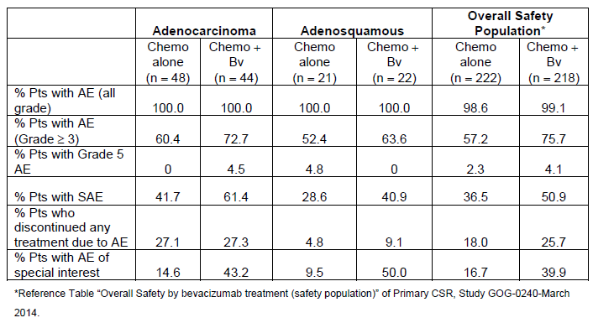
The frequencies of SAEs in patients treated with Chemo+Bv in the AC and AS histological subgroups were 61.4% and 40.9 % respectively. Although the frequencies of AEs across these histological subgroups were different, the most commonly reported SAEs in both histological subgroups were within the system organ class (SOC) “gastrointestinal disorders” and this is also consistent with the overall safety population.
The frequencies of AEs leading to treatment discontinuation in the AC and AS histological subgroups treated with Chemo+Bv were 27.3% and 9.1% respectively. The relatively low AE rate leading to treatment discontinuation in the AS histological subgroup must be interpreted with caution and may be due to small patient numbers.
Given the known limitations of retrospective subgroup analyses, caution needs to be taken when interpreting the safety results by histological subtypes. Overall the safety results in both of these histological subgroups remained consistent with the know safety profile of bevacizumab.
In summary, all the analyses performed as requested by the TGA have been provided and described above. Given the small numbers and the limitations of retrospective subgroup analyses, no definitive conclusion can be derived. However the results do not support excluding adenocarcinoma and adenosquamous subgroups when treating cervical cancer patients with bevacizumab. It is for these reasons that limiting the indication to patients with squamous cell carcinoma of the cervix would not be appropriate.

Advisory committee considerations
The Advisory Committee on Prescription Medicines (ACPM), having considered the evaluations and the Delegate’s overview, as well as the sponsor’s response to these documents, advised the following:
The ACPM resolved to recommend to the TGA Delegate of the Minister and Secretary that:
The ACPM, taking into account the submitted evidence of efficacy, safety and quality, agreed with the Delegate and considered Avastin solution for injection containing 100 mg/4 mL and 400 mg /16 mL of bevacizumab to have an overall positive benefit–risk profile for the amended indication;
AVASTIN (bevacizumab) in combination with paclitaxel and cisplatin is indicated for the treatment of persistent, recurrent or metastatic carcinoma of the cervix.
AVASTIN (bevacizumab) in combination with paclitaxel and topotecan is an acceptable alternative where cisplatin is not tolerated or not indicated.
In making this recommendation the ACPM was of the view that the histological sub-populations should not be included in the indication.

Proposed conditions of registration
The ACPM agreed with the Delegate on the proposed conditions of registration.

Proposed product information (PI)/consumer medicine information (CMI) amendments
The ACPM agreed with the Delegate to the proposed amendments to the Product Information (PI) and Consumer Medicine Information (CMI) and specifically advised on the inclusion of the following:
- Include more information in the PI and CMI on the risk of fistula formation with use of bevacizumab to raise awareness of this serious adverse event for both clinicians and consumers.
- Ensure that the limitation of the data for the treatment of AC (adenocarcinoma)/AS (adenosquamous carcinoma) of the cervix is clear.
- Clearly state in the PI that patients with brain metastases were not included in the clinical trials.

Specific advice
The ACPM advised the following in response to the Delegate’s specific questions on this submission:
- In which histological sub-population(s) of patients with advanced, recurrent or metastatic cervical cancer has bevacizumab satisfactorily been demonstrated to confer an efficacy benefit over placebo?
The ACPM noted that a benefit from bevacizumab in patients with non-squamous disease had not been documented with regard to duration of overall survival, progression-free survival or overall response rate. However, the ACPM did not consider that AC /AS subtypes should be excluded from the indication as the analysis was not pre-planned and not powered to detect a difference in these subtypes. The ACPM noted that the EU and US do not specify histological subtype in the indication. Further, although AC/AS subtypes have a worse prognosis, they are treated with the same chemotherapy regimens as patients with squamous cell carcinoma of the cervix and may benefit from treatment with bevacizumab and should not be excluded from the indication. The ACPM advised that future data on AC/ASC subtypes and treatment with bevacizumab should be collected and requested from sponsor.
- In which histological sub-populations(s) of patients with advanced, recurrent or metastatic cervical cancer has bevacizumab satisfactorily been demonstrated to have a positive risk-benefit assessment for the purposes of (i) delivering informed consent and (ii) product registration?
The ACPM agreed that the risk-benefit discussion is limited by the data in AC/AS histological subtypes, but there are precedents in other cancers, e.g. lobular carcinoma of the breast and clear cell carcinoma of the ovary, where prognosis may be poor or response to chemotherapy potentially less but treatment is still a consideration. The ACPM agreed that the best evidence is for squamous cell carcinoma of the cervix and that the data regarding AC/AS are limited by small numbers and are difficult to interpret. However, currently SCC/AC/AS subgroups are all treated same. The ACPM advised that limitations in data need to be made clear in PI.
- What does the Committee consider the appropriate wording of the proposed indication in cervical cancer?
The ACPM advised that the indication proposed by the sponsor is acceptable and that the indication should not be limited to squamous cell carcinoma of the cervix.
- The committee is also requested to provide advice on any other issues that it thinks may be relevant to a decision on whether or not to approve this application.
The ACPM noted that the standard of care in Australia to treat cervix cancer is carboplatin and paclitaxel but the indication specifies use with cisplatin, not carboplatin, and paclitaxel. The ACPM noted that two studies, JGOG0505 (Journal of Clinical Oncology March 2015) ⁶and GOG-158 have both shown non-inferiority of carboplatin/paclitaxel and cisplatin/paclitaxel. However, the ACPM accepted that the indication reflected the data presented in the application.
The ACPM advised that the term ‘metastatic’ is appropriate. The term ‘persistent/recurrent’ will incorporate Stage IVA and the next stage is IVB, which is inoperable.
The ACPM advised that brain metastases should not be an explicit exclusion in the indication. The ACPM noted that this is a very rare occurrence in cervix cancer and a powered study is unlikely to be done. Use of bevacizumab in patients with brain metastases should be weighed up for each individual patient, but the ACPM advised that the PI should clearly state that these patients were NOT included in the study.
With regards to selection of dose, the ACPM noted that dose selection in different indications did not seem to be based on any data surrounding differential affect with dose and that the dose selected is somewhat arbitrary. The ACPM noted that platinum sensitivity/resistance in ovarian cancer is a very specific situation based on retrospective review of outcomes in patient groups with varying progression-free interval.
The ACPM advised that cisplatin resistance in cervix cancer is not possible to assess in this context as most people only received first-line cisplatin as a radio-sensitiser during primary chemo-radiation. There is also no defined time for definition of platinum resistance that has proven clinical utility in cervix cancer. The ACPM noted that the percentage of patients who had prior cisplatin was similar in both groups, removing potential bias.
The ACPM advised that implementation by the sponsor of the recommendations outlined above to the satisfaction of the TGA, in addition to the evidence of efficacy and safety provided would support the safe and effective use of these products.

Outcome
Based on a review of quality, safety and efficacy, TGA approved the registration of Avastin bevacizumab (rch) 400 mg/16 mL and 100 mg /4 ml concentrated injection vial indicated for:
In combination with paclitaxel and cisplatin is indicated for the treatment of persistent, recurrent or metastatic carcinoma of the cervix. In combination with paclitaxel and topotecan is an acceptable alternative where cisplatin is not tolerated or not indicated.

Specific conditions of registration applying to these goods
The Avastin EU-RMP Version16.1 (dated 29 May 2014 DLP 25 April 2014) and Australian Specific Annex Version 5.0 (dated August 2014) revised as agreed with the TGA and any future updates, as agreed with the TGA will be implemented in Australia.

Attachment 1. Product Information
The PI for AVASTIN approved with the submission which is described in this AusPAR is at Attachment 1. For the most recent PI, please refer to the TGA website at <https://www.tga.gov.au/product-information-pi>.

Attachment 2. Extract from the Clinical Evaluation Report

Therapeutic Goods Administration
PO Box 100 Woden ACT 2606 Australia
Email: info@tga.gov.au Phone: 1800 020 653 Fax: 02 6232 8605
https://www.tga.gov.au

Monk BJ, et al. Phase II trial of bevacizumab in the treatment of persistent or recurrent squamous cell carcinoma of the cervix: a gynecologic oncology group study. J Clin Oncol 2009; 27: 1069-1074
Wright JD, et al. Bevacizumab combination therapy in heavily pretreated, recurrent cervical cancer. Gynecol Oncol 2006; 103: 489-493
Krishnansu S.et al. Improved Survival with Bevacizumab in Advanced Cervical Cancer N Engl J Med 2014; 370: 734-743.
CPMP/EWP/2330/99 Points to consider on application with 1. Meta-analyses; 2. One pivotal study (31 May 2001)
Lorusso, D. et al. A systematic review comparing cisplatin and carboplatin plus paclitaxel-based chemotherapy for recurrent or metastatic cervical cancer. Gynaecologic Oncology. 2014; 133: 117-123
Kitagawa, R. et al. Paclitaxel plus carboplatin versus paclitaxel plus cisplatin in metastatic or recurrent cervical cancer: the open label phase III trial JCOG0505. Journal of Clinical Oncology 2015; 19: 2129-2135
Moore, K. et al. A comparison of cisplatin/paclitaxel and carboplatin/paclitaxel in stage IVB, recurrent or persistent cervical cancer. Gynaecologic Oncology 2007; 105: 299-303
Rose, P. et al. Locally advanced adenocarcinoma and adenosquamous carcinomas of the cervix compared to squamous cell carcinomas of the cervix in Gynaecologic Oncology Group trials of cisplatin-based chemoradiation. Gynaecologic Oncology. 2014; 135: 208-212
Moore, D. et al. Phase III study of cisplatin with or without paclitaxel in stage IVB, recurrent, or persistent squamous cell carcinoma of the cervix: a Gynaecologic Oncology Group Study. JCO 2004; 22: 3113-3119
Tjalma, W. et al. The association between vascular endothelial growth factor, microvessel density and clinicopathological features in invasive cervical cancer. European Journal of Obstetrics & Gynaecology and Reproductive Biology. 200; 92: 251-257
El Sabaa, B. et al. VEGF expression and microvasculature density in relation to high-risk HPV infectionin cervical carcinoma – An immunohistochemical study. Alexandria Journal of Medicine. 2012; 48: 47-57
Fuchs, T. et al. Ramucirumab monotherapy for previously treated advanced gastric or gastro-oesophageal junction adenocarcinoma (REGARD): an international, randomised, multicentre, placebo-controlled, phase 3 trial. Lancet 2014; 383: 31-39
Ohtsu, A. et al. Bevacizumab in combination with chemotherapy ad first-line therapy in advanced gastric cancer: a randomized, double-blind, placebo-controlled Phase III study. Journal of Clinical Oncology. 2011; 29: 3968-3976
Ferlay J et al. GLOBOCAN 2012 v1.0, Cancer Incidence and Mortality Worldwide: IARC Cancer Base No. 11 [Internet]. Lyon, France: International Agency for Research on Cancer; 2013. Available from: http://globocan.iarc.fr/
Primary Clinical Study Report – GOG-0240 – A randomized Phase III trial of cisplatin plus paclitaxel with and without NCI-supplied bevacizumab (NSC #704865, IND #113912) versus the non-platinum doublet, topotecan plus paclitaxel, with and without NCI-supplied bevacizumab, in stage IVB, recurrent or persistent carcinoma of the cervix – Report No. 1058089. March 2014
Seamon LG et al. Prognostic impact of histology in recurrent and metastatic cervical carcinoma: A Gynecologic Oncology Group Study (publication in preparation for International Gynecologic Cancer Society [ICGS] Meeting in 2014; oral presentation).
Data in Tables 8 and 9 has been presented using chemotherapy backbone as a covariate; and performance status, tumour stage and previous platinum treatment used as stratification factors. Unstratified data is presented in Tables 10 and 11.

