First round report 22 October 2014
Second round report 31 March 2015

AusPAR Attachment 2

Extract from the Clinical Evaluation Report for Bevacizumab(rch)
  - Proprietary Product Name: Avastin
  - Sponsor: Roche

About the Therapeutic Goods Administration (TGA)
- The Therapeutic Goods Administration (TGA) is part of the Australian Government Department of Health, and is responsible for regulating medicines and medical devices.
- The TGA administers the Therapeutic Goods Act 1989 (the Act), applying a risk management approach designed to ensure therapeutic goods supplied in Australia meet acceptable standards of quality, safety and efficacy (performance), when necessary.
- The work of the TGA is based on applying scientific and clinical expertise to decision-making, to ensure that the benefits to consumers outweigh any risks associated with the use of medicines and medical devices.
- The TGA relies on the public, healthcare professionals and industry to report problems with medicines or medical devices. TGA investigates reports received by it to determine any necessary regulatory action.
- To report a problem with a medicine or medical device, please see the information on the TGA website < https://www.tga.gov.au>.
About the Extract from the Clinical Evaluation Report
- This document provides a more detailed evaluation of the clinical findings, extracted from the Clinical Evaluation Report (CER) prepared by the TGA. This extract does not include sections from the CER regarding product documentation or post market activities.
- The words [Information redacted], where they appear in this document, indicate that confidential information has been deleted.
- For the most recent Product Information (PI), please refer to the TGA website < https://www.tga.gov.au/product-information-pi>.
Copyright
© Commonwealth of Australia 2017
This work is copyright. You may reproduce the whole or part of this work in unaltered form for your own personal use or, if you are part of an organisation, for internal use within your organisation, but only if you or your organisation do not use the reproduction for any commercial purpose and retain this copyright notice and all disclaimer notices as part of that reproduction. Apart from rights to use as permitted by the Copyright Act 1968 or allowed by this copyright notice, all other rights are reserved and you are not allowed to reproduce the whole or any part of this work in any way (electronic or otherwise) without first being given specific written permission from the Commonwealth to do so. Requests and inquiries concerning reproduction and rights are to be sent to the TGA Copyright Officer, Therapeutic Goods Administration, PO Box 100, Woden ACT 2606 or emailed to < tga.copyright@tga.gov.au>.

Contents
List of abbreviations 5
1. Introduction 7
1.1. Drug class and therapeutic indication 7
1.2. Dosage forms and strengths 7
1.3. Dosage and administration 8
1.4. Other proposed changes to the PI 8
2. Clinical rationale 8
3. Contents of the clinical dossier 9
3.1. Scope of the clinical dossier 9
3.2. Paediatric data 10
3.3. Good clinical practice 10
4. Pharmacokinetics 10
4.1. Studies providing pharmacokinetic data 10
4.2. Summary of pharmacokinetics 11
4.3. Evaluator’s overall conclusions on pharmacokinetics 13
5. Pharmacodynamics 13
6. Dosage selection for the pivotal studies 13
6.1. Study GOG-0227C 13
7. Clinical efficacy 15
7.1. Pivotal efficacy Study GOG-0240 (also known by Study ML01230) 15
7.2. Other efficacy studies 39
7.3. Analyses performed across trials (pooled analyses and meta-analyses) 39
7.4. Evaluator’s conclusions on clinical efficacy for persistent, recurrent of Stage IV carcinoma of the cervix 40
8. Clinical safety 41
8.1. Studies providing evaluable safety data 41
8.2. Pivotal studies that assessed safety as a primary outcome 42
8.3. Patient exposure 42
8.4. Adverse events 43
8.5. Deaths and other serious adverse events 52
8.6. Discontinuation due to adverse events 55
8.7. Laboratory tests 56
8.8. Post-marketing experience 56
8.9. Safety issues with the potential for major regulatory impact 57
8.10. Other safety issues 58
8.11. Evaluator’s overall conclusions on clinical safety 58
9. First round benefit-risk assessment 60
9.1. First round assessment of benefits 60
9.2. First round assessment of risks 60
9.3. First round assessment of benefit-risk balance 60
10. First round recommendation regarding authorisation 61
11. Clinical questions 61
11.1. Pharmacokinetics 61
11.2. Pharmacodynamics 61
11.3. Efficacy 61
11.4. Safety 62
12. Second round evaluation of clinical data submitted in response to questions 62
12.1. Efficacy 62
12.2. Safety 82
13. Second round benefit-risk assessment 84
13.1. Second round questions 84
13.2. Second round assessment of benefits 85
13.3. Second round assessment of risks 85
13.4. Second round assessment of benefit-risk balance 86
14. Second round recommendation regarding authorisation 86
15. References 86

List of abbreviations
Abbreviation | Meaning
ACPM | Advisory Committee on Prescription Medicines
AEs | Adverse events
AESIs | Adverse events of special interest
ARDS | Acute respiratory distress syndrome
ATEs | Arterial thromboembolic events
BPI | Brief Pain Inventory
Bv | Bevacizumab
CHF | Congestive heart failure
CI | Confidence interval
Cis | Cisplatin
CL | Clearance
CMI | Consumer medicines information
CR | Complete response
CRC | Colorectal cancer
CSR | Clinical study report
DDI | Drug-drug interactions
DSMB | Data Safety Monitoring Board
FACT-Cx | Functional Assessment of Cancer Therapy – Cervix
FACT-Ntx | Functional Assessment of Cancer Therapy – Neurotoxicity
GI | Gastrointestinal
GOG | Gynaecologic Oncology Group
HPV | Human papillomavirus
HR | Hazard ratio
ITT | Intention-to-treat
IV | Intravenous
LVSD | Left ventricular systolic dysfunction
MedDRA | Medical Dictionary for Regulatory Activities
MID | Minimum important difference
NCI CTCAE | National Cancer Institute Common Terminology Criteria Adverse Event
NSCLC | Non-small cell lung cancer
ORR | Objective response rate
OS | Overall survival
Pac | Paclitaxel
PD | Progressive disease
PFS | Progression-free survival
PI | Product information
PK | Pharmacokinetics
PRES | Posterior reversible encephalopathic syndrome
RPLS | Reversible posterior leukoencephalopathy syndrome
SAEs | Serious adverse events
TOI | Trial Outcome Index
Top | Topotecan
Vc | Central volume
VEGF | Vascular endothelial growth factor
VTEs | Venous thromboembolic events
WBC | White blood cell

Introduction
This is a Category 1 submission to extend the indications of Avastin (bevacizumab(rch)).

Drug class and therapeutic indication
Bevacizumab is an antineoplastic agent, comprising a recombinant humanised monoclonal antibody that selectively binds to and neutralises the biologic activity of human vascular endothelial growth factor (VEGF). VEGF inhibition reduces the vascularisation of tumours, thereby inhibiting tumour growth.
The approved indications are:
- Metastatic colorectal cancer (CRC) – in combination with fluoropyrimidine-based chemotherapy, is indicated for treatment of patients with metastatic colorectal cancer
- Locally recurrent or metastatic breast cancer – in combination with paclitaxel is indicated for the first-line treatment of metastatic breast cancer in patients in whom an anthracycline-based therapy is contraindicated
- Advanced, metastatic or recurrent non-squamous Non-Small Cell Lung Cancer (NSCLC) – in combination with carboplatin and paclitaxel, is indicated for first-line treatment of patients with unresectable advanced, metastatic or recurrent, non-squamous, non-small cell lung cancer
- Advanced and/or metastatic renal cell cancer – in combination with interferon alfa-2a is indicated for treatment of patients with advanced and/or metastatic renal cell cancer
- Grade IV glioma – as a single agent, is indicated for the treatment of patients with Grade IV glioma after relapse or disease progression after standard therapy, including chemotherapy
- Epithelial ovarian, fallopian tube or primary peritoneal cancer – in combination with carboplatin and paclitaxel, is indicated for first-line treatment of patients with advanced (FIGO stages IIIB, IIIC and IV) epithelial ovarian, fallopian tube, or primary peritoneal cancer
- Recurrent epithelial ovarian, fallopian tube or primary peritoneal cancer – in combination with carboplatin and gemcitabine, is indicated for the treatment of patients with recurrent, platinum-sensitive, epithelial ovarian, fallopian tube, or primary peritoneal cancer who have not received prior bevacizumab or other VEGF-targeted angiogenesis inhibitors
The proposed additional indication is:
- Cervical cancer – Avastin (bevacizumab) in combination with paclitaxel and cisplatin or paclitaxel and topotecan is indicated for the treatment of persistent, recurrent or Stage IV carcinoma of the cervix

Dosage forms and strengths
The following dosage forms and strengths are currently registered:
- 100mg/4mL vials for injection [AUST R 99755]
- 400mg/16mL vials for injection [AUST R 99757]
No new dosage forms or strengths are proposed.

Dosage and administration
The proposed administration of bevacizumab for cervical cancer is in combination with one of the chemotherapy regimens: paclitaxel and cisplatin, or paclitaxel and topotecan.
The proposed recommended dose of bevacizumab is 15 mg/kg body weight given once every 3 weeks as an IV infusion.
The proposed recommendation is that bevacizumab treatment be continued until progression of the underlying disease.
Comment: The proposed dose of bevacizumab is in line with currently approved regimens for second-line treatment of metastatic CRC; locally recurrent or metastatic breast cancer; advanced, metastatic or recurrent non-squamous NSCLC; Grade IV glioma; and epithelial ovarian, fallopian tube or primary peritoneal cancer.

Other proposed changes to the PI
In addition to updating the indications and dosage and administration sections of the PI, it is also proposed that the clinical trials, precautions, and adverse effects sections be updated in line with data from the pivotal trial submitted with this application (GOG-0240).

Clinical rationale
As discussed by the sponsor in the introduction for the clinical study report (CSR) of Study GOG-0240:
- Worldwide, cervical cancer is the fourth most common cancer in women and seventh most common cancer overall. In 2012, approximately 528,000 new cervical cancer cases were diagnosed globally. Cervical cancer accounted for 7.5% of all female cancer deaths with approximately 266,000 deaths; the majority (87%) of these deaths occurred in developing countries.
- In Australia cervical cancer is the twelfth most common cancer affecting women (excluding basal and squamous cell carcinoma of the skin), with 7 new cases diagnosed per 100,000 women in 2009. It is also the 19th most common cause of cancer-related death, with 2 deaths per 100,000 women in 2010.
- Cervical cancer incidence and mortality are higher in Aboriginal and Torres Strait Islander women, with incidence more than twice, and mortality 5 times, that of non-Indigenous women.
- Cervical cancer screening has been in place since 1991 and is thought to be the reason for the relatively low incidence and mortality rates observed for the disease in Australia compared with other countries.
- In Australia the National human papillomavirus (HPV) Vaccination Program was introduced in 2007. The HPV vaccine vaccines against HPV types 16 and 18, the cause of 70 to 80% of invasive cervical cancers. This therefore has the potential to reduce the incidence of cervical cancer below the already low levels that cervical screening has achieved in Australia. It is argued by the sponsor that this impact, however, will be seen many years into the future and for the present, cervical cancer remains a significant public health problem in Australia and around the world.
- The mainstay of primary treatment for advanced cervical cancer disease (stage II to IV) is combination radiation therapy and radiation sensitising platinum based chemotherapy. Up to 50% of patients with advanced disease will have a recurrence, which is generally considered incurable particularly if distant metastases have developed, and chemotherapy is usually recommended for these patients.
- In patients who present with distant metastasis (stage IVB) treatment is essentially palliative and usually chemotherapy. The optimal regimen for chemotherapy has not been defined in these recurrent and metastatic disease patients but cisplatin combination therapy is generally considered the standard of care. Cisplatin use is recommended in Australia whilst topotecan is indicated, in combination with cisplatin.
- The prognosis for women with persistent, recurrent, or metastatic cervical cancer remains poor with median duration of overall survival of ≤ 12 months. The sponsor concluded that current treatment options provide limited clinical benefit and therefore there remains an unmet need for additional options.
- The rationale for bevacizumab use as indicated by the sponsor is evidence that angiogenesis plays an important role in locally advanced cervical cancer via an increase in VEGF. The evidence was also reported to suggest that combining an anti-angiogenic agent with either cytotoxic chemotherapy or radiation enhances anti-tumour activity. Additionally, nonclinical data have shown that bevacizumab may normalize tumour vasculature, thereby relieving tumour hypoxia and promoting drug delivery, which may account for an additive treatment effect. The sponsor concluded that therapeutic strategies incorporating the anti-VEGF antibody bevacizumab may be effective.
Comment: Although a global problem, the burden of cervical cancer disease in Australia is low, due to the National Cervical Screening Program which promotes routine screening with Pap smears every two years for women between the ages of 18 (or two years after first sexual intercourse, whichever is later) and 69 years. The burden of cervical cancer disease in Australia is likely to fall further due to the effect of the National HPV Vaccination Program in the coming years.
Despite this relatively low burden of disease, there remains an unmet need for additional treatment options for women with recurrent or metastatic cervical cancer disease who have a poor prognosis. There are also equity issues to consider with the relatively higher burden of disease in the Aboriginal and Torres Strait Islander population.
Therefore, it is agreed with the sponsor that there is a clinical rationale for this indication, despite the overall low disease burden.

Contents of the clinical dossier

Scope of the clinical dossier
The clinical dossier contained a single pivotal trial in support of the proposed extension of indications, and also included 5 previously submitted population pharmacokinetic (PK) analyses.
The submission contained the following clinical information:
- 5 population pharmacokinetic analyses (BO17706, 03-0324-1751, 1025553, 1031796, 1025122).
- 1 pivotal efficacy/safety study (GOG-0240).
- Literature references.
The submission also contained Clinical Overview, Summary of Clinical Pharmacology, Summary of Clinical Efficacy, Summary of Clinical Safety and literature references.

Paediatric data
The submission did not include paediatric data. For the cervical cancer indication, a full Paediatric Study Plan (PSP) waiver is in place with the FDA. For all the other approved indications of Avastin, the sponsor either has a waiver or orphan designation in place thereby releasing from any paediatric obligation.

Good clinical practice
The sponsor stated that Study GOG-0240 was conducted according to the International Conference on Harmonization (ICH) E6 Guideline for Good Clinical Practice (GCP) and the Declaration of Helsinki in addition to any applicable national requirements. It was stated that the appropriate Ethics Committees and Institutional Review Boards reviewed and approved this study.

Pharmacokinetics

Studies providing pharmacokinetic data
The pharmacokinetics (PK) of bevacizumab was not assessed in pivotal trial GOG-0240 submitted with this application, and have not been characterised in patients with cervical cancer. Instead, the application contained several population PK analyses of pooled data across multiple clinical trials in patients with solid tumours (including colorectal, metastatic breast, hormone-refractory prostate, pancreatic, and non-small cell lung cancer) who received bevacizumab either as a single agent or in combination with chemotherapeutic agents. Table 1 shows the studies relating to each pharmacokinetic topic and the location of each study summary.

Table 1: Submitted pharmacokinetic studies
PK topic | Subtopic | Study ID | Summary page
Population PK analyses | Healthy subjects
Population PK analyses | Target population
Population PK analyses | Other | 03-0324-1751  BO17706  1025553  1031796  1025122 | All studies previously evaluated in PM-2013-00709-1-4
Comment: The population PK analyses submitted with this application (BO17706, 03-0324-1751, 1025553, 1031796, 1025122) have previously been submitted multiple times to the TGA and were last evaluated in March 2013 (PM-2013-00709-1-4, TRIM R13/622979). Therefore, these analyses have not been re-evaluated in this CER. Key points are only summarised in the following section.

Summary of pharmacokinetics

Pharmacokinetics in the target population
The population PK studies submitted with this application were previously evaluated (PM-2013-00709-1-4) and have not been revaluated in this CER.
In summary, a base population PK model was developed (03-0324-1751) using modelling from eight (Phase I-III) clinical trials in solid tumours, colorectal cancer (CRC), non-small cell lung cancer (NSCLC), metastatic breast cancer (MBC), and hormone-refractory prostate cancer (HRPC). This analysis was found to demonstrate population PK parameters of bevacizumab similar to that estimated for other IgG antibodies, with weight and gender the most influential covariates on clearance (CL) and central volume (V_{c}).
This base (reference) population PK model was then subsequently compared to the results of other studies in patients with NSCLC (BO17704), metastatic pancreatic cancer (BO17706), metastatic clear cell renal cell carcinoma (1025122) and various other tumour types (1031796). These were reported to find individual parameter estimates for these populations to be similar to those obtained for the reference population.
The sponsor stated that since tumour type has not been shown to alter the pharmacokinetics of bevacizumab, the pharmacokinetics of bevacizumab in patients with cervical cancer are expected to be consistent with the PK observed to date across tumour types.
Comment: It is agreed with the sponsor that the PK of bevacizumab in cervical cancer could reasonably be expected to be comparable to that demonstrated in previous studies, and further PK studies specific to cervical cancer are not required for this submission.

Distribution
As described in the PI: ‘The typical value for central volume (V_{c}) was 2.73 L and 3.28 L for female and male patients, respectively, which is in the range that has been described for IgGs and other monoclonal antibodies. After correcting for body weight, male patients had a larger V_{c} (+20%) than female patients.’

Metabolism
As described in the PI: ‘Assessment of bevacizumab metabolism in rabbits following a single IV dose of 125I-bevacizumab suggested that its metabolic profile was similar to that expected for a native IgG molecule which does not bind VEGF.’

Excretion
As described in the PI: ‘The pharmacokinetics of bevacizumab are linear at doses ranging from 1.5 to 10 mg/kg/wk. The value for clearance is, on average, equal to 0.188 and 0.220 L/day for female and male patients, respectively. After correcting for body weight, male patients had a higher bevacizumab clearance (+ 17%) than females. According to the two compartmental model, the elimination half-life is 18 days for a typical female patient and 20 days for a typical male patient.’

Pharmacokinetics in other special populations

Pharmacokinetics in subjects with impaired hepatic function
It is stated in the PI that: ‘No studies have been conducted to investigate the pharmacokinetics of bevacizumab in patients with hepatic impairment since the liver is not a major organ for bevacizumab metabolism or excretion.’

Pharmacokinetics in subjects with impaired renal function
It is stated in the PI that: ‘No studies have been conducted to investigate the pharmacokinetics of bevacizumab in renally impaired patients since the kidneys are not a major organ for bevacizumab metabolism or excretion.’

Pharmacokinetics according to age
In the PI, it is documented that in the population PK analysis there was no significant difference in the PK of bevacizumab in relation to age.

Pharmacokinetics according to other population characteristics
It was reported in the Clinical Overview that the final Reference Population PK Model (03-0324-1751) suggested that body weight, sex, and albumin levels were important covariates for explaining 40% of inter-patient variance for clearance of bevacizumab. In particular:
Bevacizumab clearance (CL) for patients at the 95th percentile for body weight (114 kg) was approximately 30% faster than that for patients at the 5th percentile for body weight (49 kg).
After correction for body weight, male patients had a 26% faster bevacizumab CL than female patients.
In patients with low serum albumin levels (< 29 g/L, 5th percentile), bevacizumab CL was approximately 20% faster than in the typical patient with a median value (37 g/L).
The PI states that: ‘Bevacizumab clearance was approximately 30% faster in patients with low levels of serum albumin and 7% faster in subjects with higher tumour burden when compared with the typical patient with median values of albumin and tumour burden.’

Pharmacokinetic interactions
It was stated by the sponsor that:
‘PK-DDI (drug-drug interactions) between bevacizumab and the chemotherapy agents used in combination with bevacizumab in Study GOG-0240 (topotecan, paclitaxel, or cisplatin) were not specifically assessed. There are no PK-DDI results available between bevacizumab and topotecan. In Study AVF0757g, in a limited number of patients with non-small cell lung cancer, bevacizumab does not appear to alter the disposition of paclitaxel. In Study BO17704, bevacizumab does not appear to alter the disposition of cisplatin. Furthermore, bevacizumab is not a cytokine modulator; therefore, it is not expected that there would be any indirect or direct effect of bevacizumab on cytochrome P450 enzyme levels that would lead to alterations of the exposure of chemotherapy agents.
A population PK assessment for the influence of combination therapy on bevacizumab disposition has been reported for various chemotherapies and other anti-cancer agents (for example, erlotinib, trastuzumab, and rituximab). Results show that there were no differences in clearance observed between patients treated with single agent bevacizumab and patients treated with bevacizumab co-administered with chemotherapies (including paclitaxel and cisplatin) or other anti-cancer agents, suggesting that chemotherapies and anti-cancer agents do not alter bevacizumab PK when co-administered with bevacizumab.
Overall, the cumulative PK-DDI data to date for bevacizumab given in combination with various chemotherapies or other anti-cancer agents across tumour types do not suggest a potential for a PK-DDI between bevacizumab and chemotherapy or anti-cancer agents. In addition, given the lack of PK-DDI, no dose modifications for the chemotherapies or other anti-cancer agents are required when administered in combination with bevacizumab.’
Comment: The lack of PK-DDI data for bevacizumab and the chemotherapy agents used in pivotal Study GOG-0240 is a limitation. Although, as documented in the PI, there is no current evidence for an effect of other chemotherapy drugs on the PK of bevacizumab, and bevacizumab has not been found to impact on the PK of other antineoplastic agents such as irinotecan, oxaliplatin and IFN alfa-2a, it cannot definitively be concluded that there is no interaction between bevacizumab and the chemotherapy agents used in the pivotal study. Moreover, it is documented in the PI that micro-angiopathic haemolytic anaemia has been observed with bevacizumab in combination with sunitinib, and that increased rates of severe neutropenia, febrile neutropenia and infection with severe neutropenia have been observed in patients treated with some myelotoxic (for example, platinum or taxane based) chemotherapy regimens compared to chemotherapy alone. Therefore, it will be important that the safety of the combination therapies in the pivotal trial is carefully assessed in this evaluation.

Evaluator’s overall conclusions on pharmacokinetics
It is agreed with the sponsor that there has been sufficient demonstration of comparable bevacizumab PK across multiple studies and tumour types during the development program, that it can be expected that the PK of bevacizumab in patients with cervical cancer is similar, and specific PK studies of bevacizumab in subjects with cervical cancer are not required. Relevant to the proposed indication, it is noted that gender and weight are influential covariates for bevacizumab, with slower clearance in lighter and female patients. However it is considered that the current weight based dosing regimen and experience from use in the currently approved indications of metastatic breast cancer and ovarian/fallopian tube cancer represents a sufficient understanding of dosing within female populations to enable the inference of similar dosing schedules to the cervical cancer setting.
The lack of drug-drug interaction data for bevacizumab in combination with the chemotherapy agents used in Study GOG-0240 (topotecan, paclitaxel, or cisplatin) and suggested for use in the proposed indication for this application is a limitation, and close attention needs to be paid to possible adverse effects in the safety analysis.

Pharmacodynamics
No new pharmacodynamic data was provided with this submission.

Dosage selection for the pivotal studies
The dose of bevacizumab selected for use in the pivotal Study GOG-0240 in combination with chemotherapy in patients with persistent, recurrent of stage IVB carcinoma of the cervix, was 15 mg/kg IV every 3 weeks. This dosage was based on the most commonly used dose of bevacizumab that has been shown to be effective and safe when added to chemotherapy regimens in solid tumours, and is used for currently registered indications. In addition the sponsor cited two earlier independent studies in patients with carcinoma of the cervix.

Study GOG-0227C
Study GOG-0227C; this was a Phase II trial (2009) to assess the efficacy and tolerability of single agent bevacizumab in patients with persistent or recurrent cervical cancer. Treatment consisted of bevacizumab 15 mg/kg IV every 21 days until disease progression or prohibitive toxicity. Primary endpoints were progression-free survival (PFS) at 6 months and toxicity. 46 patients were enrolled, all of whom had had prior cytotoxic regimens for recurrent disease and 38 (82.6%) had received prior radiation. It was assessed that bevacizumab was well tolerated and active in this group of patients.
A retrospective analysis (2006) of six women with recurrent cervical cancer treated with bevacizumab combination therapy (5-flurouracil in 5 patients and capecitabine in 1 patient). Bevacizumab was administered at a dose of 5 to 10 mg/kg IV at 2 weekly intervals in 5/6 subjects, and 15 mg/kg every 3 weeks in the other subject. This small analysis found that treatment was well tolerated and there was clinical benefit in 4/6 subjects.
Comment: Literature references were provided for the above two studies in the submission. However, as the full CSRs for these studies were not provided, a full evaluation was not performed.
It is noted that the dose of bevacizumab used in Study GOG-0227C and ultimately selected for pivotal Study GOG-0240 of 15 mg/kg IV every 3 weeks is consistent with currently approved treatment regimens for other indications and for which the safety profile has been established, including in combination with other chemotherapy agents.
In contrast to the sponsor’s claim in the Clinical Overview regarding the 2006 retrospective analysis: ‘previous clinical trial experience in the metastatic cervical cancer setting demonstrated clinical activity and acceptable safety when bevacizumab was dosed at 15 mg/kg IV q3w in combination with cytotoxic chemotherapy’, it is noted that only 1/6 subjects in this analysis had the above dose of bevacizumab, and the chemotherapy agents used did not include those selected for the pivotal trial. Furthermore, a retrospective analysis of 6 patients provides a low level of evidence. Therefore, it is the opinion of this evaluator that this retrospective study does not provide sufficient supportive evidence for the dosage selection for bevacizumab in the current indication. None the less, even excluding this study, there is sufficient evidence from the use of bevacizumab at the selected dosage in combination with other chemotherapy agents for other registered indications to support the overall dosage selection.
The chemotherapy combination cisplatin and paclitaxel was reported to be based on Study GOG-0204, where this combination showed favourable outcomes compared with other chemotherapy backbones. However, it is acknowledged by the sponsor that the regimens employing topotecan and paclitaxel are experimental, with resulting concerns about the toxicity of this regimen (particularly with respect to myelosuppression and its related events) in addition to concerns about increased rates of serious and local complications caused by bevacizumab. The sponsor’s response to these concerns was close monitoring of these factors every 6 months to assess the additional risk associated with these regimens, in addition to usual adverse event monitoring.
Comment: Overall, this evaluator is satisfied regarding the rationale for the dose of bevacizumab selected for the pivotal trial. However, in light of the experimental nature of the chemotherapy backbones (particularly topotecan and paclitaxel) and their combination with bevacizumab, close attention will need to be paid to safety issues. This is discussed further in the Safety section of this CER.

Clinical efficacy
The clinical efficacy is assessed for persistent, recurrent of Stage IV carcinoma of the cervix.

Pivotal efficacy Study GOG-0240 (also known by Study ML01230)

Study design, objectives, locations and dates
Study GOG-0240 was a randomised, open label Phase III, multi-centre study to assess the effects on overall survival and safety of cisplatin plus paclitaxel (Cis+Pac) with and without bevacizumab (Bv) versus the non-platinum doublet, topotecan plus paclitaxel (Top+Pac), with and without bevacizumab, in stage IVB, recurrent or persistent carcinoma of the cervix. This study was conducted across 159 sites in the United States and 6 sites in Spain.

Primary objectives
A 2 x 2 factorial design was used to simultaneously test two different hypotheses in a limited patient population (Figure 1):
H₀₁: Whether bevacizumab in combination with chemotherapy (either Cis+Pac or Top+Pac) improved overall survival (OS) (OS analysis by bevacizumab treatment)
H₀₂: Whether Top+Pac with or without bevacizumab improves OS in comparison to Cis+Pac with or without bevacizumab (OS analysis by chemotherapy backbone)
A third primary objective was to determine and compare the frequency and severity of adverse events for the regimens administered in the study.
Comment: It is noted that the inclusion criterion for pivotal Study GOG-0240 was:
‘Primary persistent, recurrent or stage IVB squamous cell carcinoma, adenosquamous carcinoma, or adenocarcinoma of the cervix which was not amenable to curative treatment with surgery and/or radiation therapy’.
Therefore, there is some disjuncture between the proposed indication (persistent, recurrent or Stage IV carcinoma of the cervix) and that used in the pivotal trial (primary persistent, recurrent or stage IVB carcinoma of the cervix not amenable to curative treatment with surgery and/or radiation therapy). The proposed indication is broader than that of the pivotal trial, as it includes the subset of patients with stage IVA carcinoma of the cervix (bladder or rectum extension), who may have been excluded from the pivotal trial due to being amenable to curative treatment with surgery and/or radiation therapy. As no other data has been submitted in support of the proposed indication, justification for the broader indication has been sought from the sponsor.
In addition, it is not clear from the CSR or protocol what is meant by ‘persistent’ carcinoma of the cervix. This has also been posed as a question to the sponsor.
Figure 1: Study GOG-0240 study design
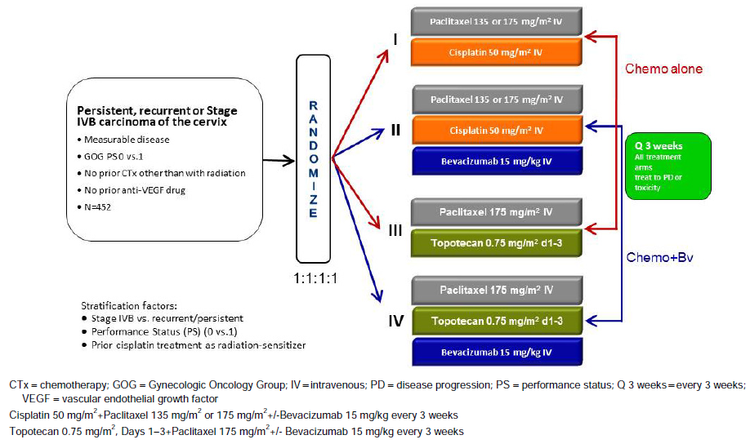
In the clinical overview, the sponsor claimed that the rationale behind ‘selecting a 2 x 2 factorial design is the ability to consider the effects of more than one factor at the same time. As clinical trials in cervical cancer may typically occur over many years and may require large numbers of patients in a population with limited numbers of patients, this study design approach allows study of important clinical questions with fewer patients in a shorter period of time.’
Comment: It is accepted that the rates of advanced cervical cancer are low in countries such as the US and Australia where cervical screening is in place. However, the burden of cervical cancer is much higher in other countries that do not have such preventive measures. Inclusion of study centres from higher prevalence countries may have been beneficial in terms of ease of recruitment of participants, and the ability to evaluate effectiveness in these settings with potential for greater overall benefit.
The sponsor also discussed that: ‘The efficiency and validity of the 2 x 2 factorial design depends upon the absence of interaction between two factors or treatments being studied so that the effects of both factors on the primary efficacy variables follow an additive model… Study GOG-0240 was designed with the assumption that there was no interaction between bevacizumab and the selected chemotherapy backbones (cisplatin, topotecan, and paclitaxel) since bevacizumab and these chemotherapeutic agents do not have related mechanisms of action.’ The sponsor stated that this assumption of no interaction was confirmed with an interaction test.
Comment: A limitation of this study design is that, in the opinion of this evaluator, Study GOG-0240 has not been adequately powered to meaningfully detect an interaction between bevacizumab and the chemotherapy backbone treatments. Therefore, the assumption of no interaction cannot be adequately confirmed with an interaction test as claimed by the sponsor above. In light of this limitation, further a priori justification for the assumption that there is no interaction would be of benefit. For example what other supporting evidence can be provided for the assumption of no interaction other than the statement that the agents do not have a related mechanism of action? This has been posed as a question to the sponsor. Discussion of the implications for the results is provided later in this report.
The first patient was randomised on 4 April 2009, and the last patient was enrolled on 3 January 2012 with the required 452 patients, approximately 33 months after trial activation. The data presented in the CSR was for the revised second (final) efficacy analysis with data cut-off 12 December 2012. At this point, 288 Overall Survival (OS) events (deaths) had been reached, and it was assessed by the independent Data Safety Monitoring Board (DSMB) that the efficacy boundary for this primary endpoint had been reached with regards to the bevacizumab hypothesis (addition of bevacizumab to chemotherapy improved OS). This analysis has therefore been considered the final efficacy analysis for OS, although a follow-up analysis of OS with safety update is planned when 346 OS events have occurred, as was originally planned for the final analysis in the study protocol.
Comment: Although the final efficacy endpoint was reached for the first hypothesis of efficacy according to bevacizumab treatment, it is noted that at the time of this second analysis the efficacy endpoint had not been considered reached for the second hypothesis of efficacy according to chemotherapy backbone or for the safety analysis. Therefore, these latter analyses have been considered interim only for the purposes of this evaluation and it will be important that the final data from Study GOG-0240 be submitted for evaluation once the planned 346 OS events have been reached. This has been posed as a question to the sponsor.
The sponsor stated in the CSR for Study GOG-0240 that: ‘to support filing of the dossier in the treatment of patients with persistent, recurrent, or stage IVB [carcinoma of the cervix], Hypothesis 1 to assess the efficacy of bevacizumab is of main interest. Additional results pertaining to Hypothesis 2 that compared the chemotherapy backbones with or without bevacizumab are provided to support the robustness of the data and to support the indication that bevacizumab in combination with either cisplatin plus paclitaxel or topotecan plus paclitaxel improves OS.’
Comment: Although it is agreed that the first hypothesis to assess the efficacy of bevacizumab treatment is of primary interest, the second hypothesis of this study is also of importance to the proposed indication – bevacizumab treatment in combination with either paclitaxel and cisplatin or paclitaxel and topotecan. Inclusion of both chemotherapy backbone regimens in the indication requires that the benefit-risk assessment of the two chemotherapy backbones is equivalent.

Inclusion and exclusion criteria

Inclusion criteria
The full inclusion criteria for Study GOG-0240 were provided. The main inclusion criteria were:
- Women ≥ 18 years of age.
- Primary persistent, recurrent or stage IVB squamous cell carcinoma, adenosquamous carcinoma, or adenocarcinoma of the cervix which was not amenable to curative treatment with surgery and/or radiation therapy.
- All patients had measurable disease defined as at least one lesion that could be accurately measured in at least one dimension (longest dimension to be recorded). It is noted in the CSR that patients treated in Study GOG-0240 could be defined as stage IVB based on metastatic disease noted on imaging modalities other than chest X-ray (for example,, computed tomography [CT]/magnetic resonance imaging [MRI]) and did not, therefore, fall strictly within the FIGO staging criteria.
- Adequate haematologic, renal, hepatic and coagulation parameters.
- GOG Performance Status of 0 or 1.

Exclusion criteria
The full exclusion criteria for Study GOG-0240 were provided. Important exclusion criteria included:
- Patients previously treated with chemotherapy except when used concurrently with radiation therapy.
- Patients who had used concurrent paclitaxel and/or concurrent topotecan with radiation therapy were ineligible.
Comment: It is noted that patients with prior treatment with paclitaxel or topotecan (with or without radiation therapy) were excluded from the study; however patients with prior treatment with cisplatin were not excluded. This creates a bias in that there is the potential for patients previously treated with cisplatin to have developed resistance to this drug, and therefore for the Cis+Pac arm to have a reduced efficacy compared to the Top+Pac arm, the latter having no prior exposure (and thus potential for development of resistance). This has implications when comparing the efficacy of the two chemotherapy backbones, and this is discussed further.
- Patients with craniospinal metastases.
- Patients with concomitant or prior invasive malignancy within the previous 5 years.
- Patients with clinically significant cardiovascular disease.
Comment: The exclusion of subjects with craniospinal metastases means that results of Study GOG-0240 cannot be generalised to this patient population. This has been posed as a question to the sponsor.

Study treatments
Per the 2 x 2 factorial design of the study, eligible patients were assigned in a 1:1:1:1 ratio to receive one of four treatment arms (Figure 1):
- Regimen I: Cisplatin plus paclitaxel without bevacizumab (Cis+Pac)
At the discretion of the investigator, patients received one of 3 options:
  - Pac 135 mg/m² IV over 24 hours on Day 1 and Cis 50 mg/m² IV on Day 2 every 3 weeks
  - Pac 175 mg/m² IV over 3 hours on Day 1 and Cis 50 mg/m² IV on Day 2 every 3 weeks
  - Pac 175 mg/m² IV over 3 hours on Day 1 and Cis 50 mg/m² IV on Day 1 every 3 weeks.
- Regimen II: Cisplatin plus paclitaxel with bevacizumab (Cis+Pac+Bv)
At the discretion of the investigator, patients received one of 3 options:
  - Pac 135 mg/m² IV over 24 hours on Day 1 and Cis 50 mg/m² IV on Day 2 plus Bv 15 mg/kg IV on Day 2 every 3 weeks
  - Pac 175 mg/m² IV over 3 hours on Day 1 and Cis 50 mg/m² IV on Day 2 plus Bv 15 mg/kg IV on Day 2 every 3 weeks
  - Pac 175 mg/m² IV over 3 hours on Day 1 and Cis 50 mg/m² IV on Day 1 and Bv 15 mg/kg IV on Day 1 every 3 weeks.
- Regimen III: Topotecan plus paclitaxel without bevacizumab (Top+Pac)
Pac 175 mg/m² over 3 hours on Day 1 and Top 0.75 mg/m² over 30 minutes on Days 1 to 3 every 3 weeks.
- Regimen IV: Topotecan plus paclitaxel with bevacizumab (Top+Pac+Bv)
Pac 175 mg/m² over 3 hours on Day 1 and Top 0.75 mg/m² over 30 minutes on Days 1 to 3 plus Bv 15 mg/kg IV on Day 1 every 3 weeks.
Regimens I and III were designated the chemotherapy alone (Chemo alone) group, and Regimens II and IV were designated the chemotherapy + bevacizumab (Chemo + Bv) group.
All cycles were repeated every 3 weeks, and patients continued on-study treatment until disease progression or unacceptable toxicities prohibited further therapy. If patients experienced a complete response (CR) on study they could receive an additional 2–3 cycles of therapy at their physician’s discretion and then discontinue study therapy. Patients were followed until death, and even if the patient was taken off protocol therapy, all therapies and toxicities were reported until progression was documented.
No modification of bevacizumab dose was permitted during the study; however, if a patient’s weight changed by ≥ 10%, the dose of bevacizumab was recalculated.
For the components of chemotherapy, the following dose modifications were permitted in cases of tolerability or toxicity, although once a dose was reduced, no dose re-escalation was allowed:
- Cisplatin at an initial dose of 50 mg/m² was reduced to 37.5 mg/m², and then, if required, to 25 mg/m².
- Paclitaxel at an initial dose of 135 mg/m² (24 hour infusion schedule) was reduced to 110 mg/m², and then, if required, to 90 mg/m².
- Paclitaxel at an initial dose of 175 mg/m² (3-hour infusion schedule) was reduced to 140 mg/m², and then, if required, to 105 mg/m².
- Topotecan at an initial dose of 0.75 mg/m² was reduced to 0.6 mg/m², and then, if required, to 0.45 mg/m².
If a patient was unable to proceed with therapy despite two dose reductions as outlined, the patient was removed from the study.

Efficacy variables and outcomes
Study assessments were made as per the Study assessment table provided.

The main (primary) efficacy variables in Study GOG-0240
- Overall survival (OS) defined as the time from randomisation until death from any cause. For patients who had not died by the time of analysis, data were censored as of the last date at which the patient was known to be alive.
  - To determine whether the addition of bevacizumab to chemotherapy improves OS in patients with persistent, recurrent, or stage IVB carcinoma of the cervix (Chemo alone versus Chemo + Bv).
  - To determine whether the regimen of paclitaxel and topotecan (non-platinum) improves OS in comparison with the standard cisplatin and paclitaxel regimen in patients with persistent, recurrent, or stage IVB carcinoma of the cervix.
- Adverse events (AEs); To determine and compare the frequency and severity of AEs as assessed by National Cancer Institute Common Terminology Criteria for Adverse Events, Version 3.0 (NCI CTCAE v3.0) for the regimens administered in this study.
For the purposes of this submission and the proposed indication, the CSR focused on the primary efficacy outcome of OS in the Chemo alone group compared to Chemo + Bv.
Comment: The primary outcome of OS is appropriate and clinically relevant for this population.

Other (secondary) efficacy outcomes
- Progression-free survival (PFS); Defined as the time between the date of randomisation and the date of first documented disease progression or death, whichever occurred first. Tumour assessments and response evaluations were determined on the basis of investigator assessment using GOG RECIST criteria, as outlined.
- Objective tumour response (GOG RECIST); Defined as a complete or partial overall response determined on two consecutive investigator assessments ≥ 4 weeks apart in patients with measurable disease at baseline. Objective response rate (ORR) was defined as the percentage of patients who had an objective response.
- Health-related quality of life (HRQoL); as measured by the FACT-Cx (overall quality of life), the FACT/GOG-Ntx4 subscale (Neurotoxicity), and as measured by the BPI ‘worst pain’ single item.
Comment: It is noted that the secondary endpoints of PFS and ORR were based in investigator assessments and were not independent assessments. Justification of the omission of independent assessment has been posed as a question to the sponsor.

Randomisation and blinding methods
Subjects were randomly assigned 1:1:1:1 to one of the four treatment arms. Randomisation was performed using a permuted block randomisation algorithm and was stratified by the following criteria:
- Disease stage (persistent/recurrent versus stage IVB).
- Performance Status (0 versus 1).
- Prior platinum therapy (yes versus no).
The study was open label and not blinded.
Comment: The open label and un-blinded nature of this study is a limitation that needs to be considered in the interpretation of the results.

Analysis populations
- The intention-to-treat (ITT) population comprised all patients randomised to study treatment, grouped according to the treatment they were randomised to.
- As described in the CSR, the assumption of no interaction between chemotherapy and bevacizumab treatment allowed for pooling and comparison of the data from the chemotherapy and bevacizumab arms (Chemo + Bv; Regimens II and IV) versus the chemotherapy alone arms (Chemo alone; Regimens I and III), as well as pooling and comparison of the data from the platinum containing arms (Regimens I and II) versus the non-platinum containing arms (Regimens III and IV) for the primary OS analysis.
- The safety analysis population comprised all patients who received at least one full or partial dose of any component of the study treatment (bevacizumab or chemotherapy) during the study period. Patients were grouped according to treatment actually received.

Sample size
As described in the CSR for Study GOG-0240:
‘The two primary hypotheses to be tested were (H₀₁) whether the addition of bevacizumab (Factor A) improves survival, and (H₀₂) whether combining paclitaxel with topotecan (Factor B) instead of cisplatin improves survival.
This study was designed to detect a 30% reduction in death associated with addition of either factor, corresponding to a hazard ratio (HR) of 0.7. In order to detect such a difference with 90% power (under the assumption of no interaction), it was required that at least 346 deaths were observed in the two levels for the factor being tested. The total planned patient accrual was up to 450 patients. Assuming the median survival time for the Cis+Pac group was approximately 10 months, the estimated time of data maturity would be between 49 and 53 months from initiating accrual (based on simulation studies).’
Comment: It is noted that this study has been powered only to detect the main effects of Chemo +Bv over Chemo alone, or Top+Pac versus Cis+Pac. As the sample size is based only on the number of events required to meet the objectives of the two hypotheses, any interaction factor will need to be at least twice as large (that is 60%) to be detected with the same power. As an interaction of this magnitude between bevacizumab and the chemotherapy backbones is unlikely, therefore this study has not been adequately powered to detect the effect of interaction between the individual treatment arms; to do so would require a larger sample size. As a result, the initial assumption that there is no interaction between bevacizumab and the selected chemotherapy backbones (cisplatin, topotecan, and paclitaxel) cannot be reliably investigated. The implications of this limitation are discussed further in the results section, and a question was posed to the sponsor.

Statistical methods

Timing of efficacy analyses
As was stated by the sponsor:
‘There was one efficacy analysis planned to be conducted after (but as close as possible to) the observation of 173 deaths (50% of events required for the final analysis) in the entire study… The goal was to close either experimental level (that is, the addition of bevacizumab or the administration of topotecan) or the entire study, whichever was appropriate, for futility. Alternatively, if there was an indication of a dramatic improvement in survival in the experimental level of only one factor, then the non-experimental level of that factor may have been dropped while continuing to assess the other factor. If the experimental levels of both factors showed a dramatic improvement, then consideration was given for closing the study for early reporting of results.’
‘A first efficacy analysis, with a data cut-off in February 2012’, occurred as pre-specified in the protocol when approximately 50% of the events (deaths) required for full information had been observed. This first pre-specified efficacy analysis was performed when 174 OS events had occurred across the four treatment arms (38% of patients had died). (Based on the results of this analysis) the DSMB recommended a second efficacy analysis to be performed at the end of 2012, which was not pre-specified in the protocol.
A second efficacy analysis, with a data cut-off of 12 December 2012, was conducted, and included 78% of the death events required for full information. 271 OS events (or when 60% of patients had died). Because the OS results crossed the pre-specified boundary and the DSMB decided to release the results of the bevacizumab comparison, this second efficacy analysis is considered the final analysis by the sponsor who was made aware of the results after release. The sponsor used the same clinical cut-off date of 12 December 2012 for the final analysis, but at the time the database was transferred from GOG to the sponsor, the number of deaths had increased from 271 events to 288 events. Hence, the alpha spending function was recalculated, which resulted in a one-sided significance level of 0.0140 for the second efficacy analysis and 0.0173 for the final analysis of OS at 346 events. Following the recalculation, the boundary at the second efficacy analysis was crossed and therefore this analysis is now considered the final analysis, and no further formal testing of OS will be performed.
A follow-up OS analysis will be performed when 346 events have been observed, corresponding to the full information required for the final OS analysis pre-specified in the GOG-0240 protocol, in order to provide an update on OS and safety analyses.’
Comment: As the efficacy boundary for the second hypothesis according to chemotherapy backbone and for the safety analysis has not been reached, this analysis is considered interim only for these endpoints, and further evaluation of the final analysis will be required.

Primary endpoint: Overall survival (OS)
As was stated by the sponsor:
‘The primary analysis of OS assumed no treatment interaction between chemotherapy and Bv treatment. For each of the hypotheses, the comparison of OS between treatment arms was based on a two-sided stratified log-rank test at the 0.05 (equivalent to one-sided at the 0.025), level of significance. The stratification factors were disease stage (persistent/recurrent versus stage IVB), Performance Status (0 versus 1), prior platinum therapy (yes versus no), and the level of the other treatment assignment (experimental versus reference). Results from an unstratified log-rank test were also presented. Kaplan-Meier methodology was used to estimate median OS for both treatment arms, and the 95% confidence intervals (CIs) for median OS were computed using Greenwood’s formula. Kaplan-Meier curves were constructed to provide a visual depiction of the difference between the treatment arms. Estimates of the treatment effect were expressed as hazard ratios (HRs) with use of a stratified Cox model, including the 95% CIs.’
‘To evaluate the robustness of the treatment effect observed in the primary efficacy analysis, subgroup analyses were performed, with the subgroups defined by demographic and baseline prognostic characteristics.’
Test for interaction
The sponsor reported that a test for interaction between bevacizumab and chemotherapy treatment was conducted at the 10% level of significance against a two-sided alternative with a score test for interaction using a Cox proportional hazards model.
Comment: The sample size of Study GOG-0240 does not appear to be sufficient to meaningfully detect an interaction between bevacizumab and the chemotherapy backbone. As a result, testing for an interaction is likely to be in favour of the null (or no interaction being detected) due to insufficient power. Further comment on this has been sought as a question to the sponsor. The implications of this lack of power to detect interaction on the interpretation of results are discussed in this report.

Secondary endpoints
The CSR detailed that: ‘The secondary endpoints were tested at a two-sided 5% level of significance with use of a gatekeeping strategy to adjust for multiplicity.’
- PFS: A stratified log-rank test was used to compare the duration of PFS between treatment arms. The Kaplan-Meier method was used to estimate median PFS for both treatment arms, and the 95% CI for median PFS was computed using Greenwood’s formula. Kaplan-Meier curves were constructed to provide a visual depiction of the difference between the treatment arms. HRs were estimated using the stratified Cox proportional hazards regression model. For all stratified analyses, the same stratification factors as for the primary efficacy analysis were used. The unstratified log-rank test p-value and unstratified HR were provided as well.
- Subgroup analysis for PFS was also performed, along with a sensitivity analysis of PFS by prior platinum chemotherapy by chemotherapy backbone.
- ORR: ORR was compared between the two treatment arms using the Mantel-Haenszel χ² test, stratified by the same factors used in the primary efficacy analysis. Fisher’s exact test was also performed. For both treatment arms, an estimate of the ORR and its 95% CI was determined; the 95% CI was constructed using the normal approximation to the binomial distribution. CIs for the difference in ORRs between Arms A and B were also determined using the normal approximation to the binomial distribution.
- HRQoL: Descriptive analysis (mean, standard deviation, median and range) of absolute scores for the FACT-Cx subscales, FACT-G, FACT/GOG-Ntx4, and BPI single item score and their changes from baseline were summarised.

Participant flow
452 patients who fulfilled the study entry criteria were randomly assigned to one of the four treatment arms (ITT population). Of these patients, 225 were assigned to chemotherapy alone (114 Cis+Pac, and 111 Top+Pac), and 227 were assigned to chemotherapy + bevacizumab (115 Cis+Pac+Bv and 112 Top+Pac+Bv).
Comment: It is noted that there were more patients randomised to Cis+Pac+/-Bv (129) compared to Top+Pac+/-Bv (123). None the less, the numbers of subjects in each of the 4 groups were roughly equivalent in size.
12 patients (5 in the Chemo alone group and 7 in the Chemo + Bv group) did not receive any protocol study treatment, and were excluded from the safety population. Therefore, 440 patients were included in the safety analysis.
At the time of the clinical cut-off date (12 December 2012), 217 patients (96.4%) in the Chemo alone group and 206 patients (90.7%) in the Chemo+Bv group had discontinued study treatment. The majority of patients in both groups discontinued study treatment because of progressive disease (PD) during active treatment (51.6% Chemo alone versus 38.3% Chemo+Bv).
Additional details on patient distribution according to bevacizumab treatment are shown in Figure 2.
Figure 2: Patient disposition by bevacizumab treatment and patient status at clinical cut-off by bevacizumab treatment
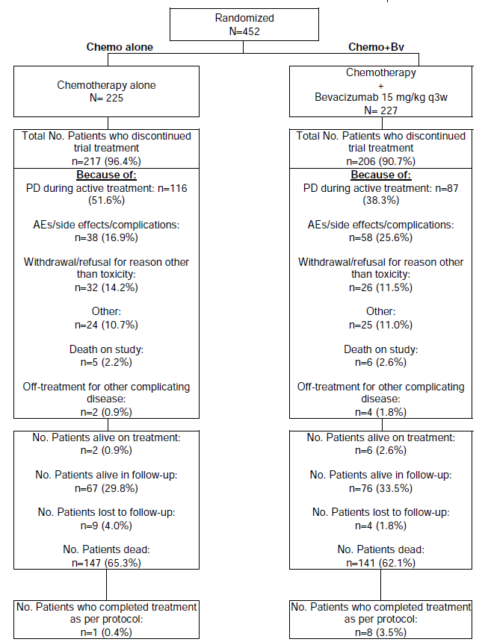

Major protocol violations/deviations
The only major change to the protocol involved the inclusion of a second efficacy analysis.
A total of 21 major protocol violations were recorded: 11 (4.9%) in the Chemo alone group and 10 (4.4%) in the Chemo+Bv group. There were some differences in the types of violations between the two groups including: Incorrect assessment of progression (4 in Chemo alone versus 0 in Chemo+Bv); Incorrect dose/drug (1 Chemo alone versus 6 Chemo+Bv); and Violation of inclusion/exclusion criteria (6 Chemo alone versus 3 Chemo+Bv).
A total of 15 patients (6.7%) and 13 patients (5.7%) in the Chemo alone and Chemo+Bv groups, respectively, were deemed to be violations based on pathology committee review. These included 20 due to inadequate pathology, 5 due to wrong primary, and one each due to wrong cell type, wrong stage, and second primary.
Comment: Generally the proportion of total major violations is similar between the two groups. However, there are some differences in the types of major violations between the groups and it would be beneficial to know more details about these to assist assessing the impact of these violations. This has been posed as a question to the sponsor.

Baseline data
Comment: Baseline demographics and disease characteristics were only presented in the CSR by bevacizumab treatment (H₀₁). Baseline data was not presented by chemotherapy backbone (H₀₂). Baseline data is of importance in the interpretation of results particularly in light of the differences in exposure to bevacizumab treatment between the chemotherapy backbone arms. Therefore, baseline demographic and disease characteristics data by chemotherapy backbone was requested from the sponsor. The following discussion refers to baseline data by bevacizumab only).

Baseline demographic characteristics
The baseline patient demographics were provided. The median age of patients was 46.0 years in the Chemo alone group and 48.0 years in the Chemo+Bv group. There was a slightly greater proportion of White patients in the Chemo alone group compared to the Chemo+Bv group (80.0% versus 75.3%) and a slightly lower proportion of Black patients (10.7% versus 15.9%). Height, weight, performance status, country and smoking status were similar between the two groups. Most patients in both groups (> 95%) did not have a previous diagnosis of cancer.

Baseline disease characteristics
The baseline disease characteristics were provided. Most histology was squamous cell carcinoma (67.1% in the Chemo alone group and 69.6% in the Chemo+Bv group), while there were also proportions with adenocarcinoma (20.0% Chemo alone and 18.5% Chemo+Bv) and adenosquamous carcinoma (9.3% Chemo alone and 10.1% Chemo+Bv). Most patients had persistent/recurrent disease stage (83.6% Chemo alone versus 82.8% Chemo+Bv).
In the summary of histology by trial treatment (Table 2), it was noted that there was a lower proportion of patients with squamous cell carcinoma in the Top+Pac backbones (63.1% Top+Pac and 67.9% Top+Pac+Bv) compared to in the Cis+Pac backbones (71.1% Cis+Pac and 71.3% Cis+Pac+Bv). Although overall the proportions of patients with adenocarcinoma or adenosquamous carcinoma were comparable across the groups, most of the ‘other’ tumour types (including clear cell carcinoma, endometrioid adenocarcinoma, mucinous adenocarcinoma, serous adenocarcinoma and undifferentiated carcinoma) were allocated to the Top+Pac±Bv arm (11/223 or 4.9%) compared to the Cis+Pac±Bv arm (1/229 or 0.4%).

Table 2: Histology of cervical cancer by trial treatment in Study GOG-0240
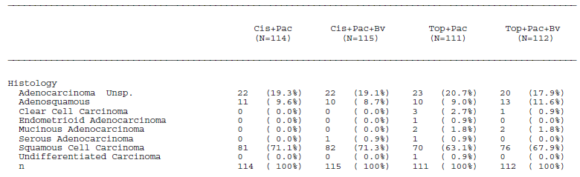
Based on the results of the pathology committee review of patient eligibility for protocol and tumour grade, across all treatment groups, the most common tumour grades were 207 moderately differentiated (Chemo alone: 43.6% and Chemo+Bv: 48.0%) and 177 poorly differentiated (Chemo alone: 38.7% and Chemo+Bv: 39.6%).
Comment: Overall baseline demographic and disease characteristics are similar between the Chemo alone and Chemo+Bv groups. However, there are some differences in the histology between the chemotherapy backbone groups, with more squamous carcinoma in the Cis+Pac±Bv group, and more of the other tumour types in the Top+Pac±Bv group. This may result in more favourable results for the Cis+Pac backbone group compared to Top+Pac if tumour types other than squamous carcinoma are less responsive to therapy.

Prior and concurrent cancer treatments
The majority of patients in both the Chemo alone and Chemo+Bv groups had received prior systemic chemotherapy (73.3% versus 74.4% respectively) and prior radiation therapy (80.4% versus 79.7%). Most had not received prior hormonal therapy (0.4% versus 1.8%), and none had received any prior non-protocol biologic response modifiers.
Nine patients (4.0%) in the Chemo alone group and 10 patients (4.4%) in the Chemo+Bv group received at least one non-protocol specified anticancer therapy prior to PD. Following PD, 48.0% in the Chemo alone group and 38.8% in the Chemo+Bv group received subsequent anticancer therapy. Most of these patients received platinum-based or other chemotherapy, with only 6.7% in the Chemo alone group and 3.1% in the Chemo+Bv group receiving post-progression bevacizumab.

Results for the primary efficacy outcome
The primary efficacy analysis was based on the ITT population. At the time of this analysis, the study had met one of its primary endpoints by demonstrating improved OS in patients treated with bevacizumab in combination with chemotherapy compared with chemotherapy alone. This was therefore considered the primary outcome for this analysis. Analysis of OS by chemotherapy backbone (Cis+Pac±Bv versus Top+Pac±Bv) was considered an interim analysis at this stage.
Comment: The second efficacy analysis presented in this CSR was considered the final efficacy analysis for the first hypothesis (H₀₁), of whether bevacizumab in combination with chemotherapy (Cis+Pac or Top+Pac) improved OS. However, at this analysis, the efficacy boundary for the second hypothesis (H₀₂) of whether Top+Pac with or without bevacizumab improves OS in comparison to Cis+Pac with or without bevacizumab (OS analysis by chemotherapy backbone) had not been reached, and therefore the results for this second hypothesis presented in the CSR are not final, but are interim only. In this CER, discussion of results has been separated according to the two different hypotheses to assist evaluation and interpretation.

Analysis of overall survival by bevacizumab treatment (H₀₁)
At the time of clinical cut-off (12 December 2012) a total of 147 patients (65.3%) in the Chemo alone group and 141 patients (62.1%) in the Chemo+Bv group had died. Overall efficacy results for the analysis by bevacizumab treatment (H₀₁) are presented in Table 3. The addition of bevacizumab to chemotherapy was found to demonstrate a statistically significant benefit on OS, with a HR of 0.74 (95% CI 0.58-0.94, p = 0.0132). Using a Cox model without stratification, the HR was estimated to be 0.79 (95% CI: 0.63, 1.00; log-rank p-value = 0.0471). The Kaplan-Meier estimated median time to event was 12.9 months in the Chemo alone group and 16.8 months in the Chemo+Bv group (an improvement in the median OS of 3.9 months)(Figure 3).

Table 3: Overall efficacy by bevacizumab treatment: ITT population, Study GOG-0240
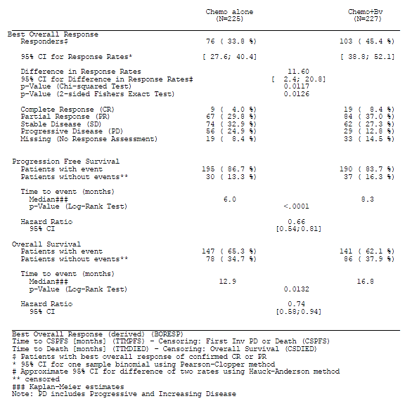
Figure 3: Kaplan-Meier curve of overall survival by bevacizumab treatment in Study GOG-0240
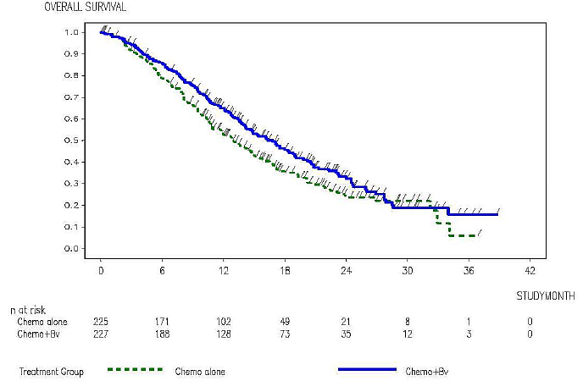
Comment: The primary outcome from Study GOG-0240 found a statistically significant improvement in OS with the addition of bevacizumab to chemotherapy compared to chemotherapy alone in the treatment of advanced cervical cancer. It is agreed with the sponsor that this improvement is clinically significant in a patient population with limited options.
The sponsor reported that there was no evidence of interaction, with the p-value for the interaction of treatment effect between the chemotherapy backbones and bevacizumab being 0.9286. In addition, the HRs were comparable within the treatment comparisons Cis+Pac+Bv versus Top+Pac+Bv and Cis+Pac versus Top+Pac (1.15 versus 1.13), as well as Top+Pac+Bv versus Top+Pac and Cis+Pac+Bv versus Cis+Pac (0.76 versus 0.72), which according to the sponsor shows the HR of interest does not appear to depend on the level of the other factor, thus suggesting that there is no evidence of treatment interaction.
Comment: It is the opinion of this evaluator that Study GOG-0240 has not been adequately powered (due to insufficient sample size) to detect the effect of any interaction between the arms of the study. Therefore, the lack of evidence for interaction determined above could be due to insufficient power rather than no interaction per se. Clarification of this issue and its implications was sought from the sponsor.
The comparable HRs within the treatment comparisons is reassuring, although exploratory in nature, regarding the lack of an interactive effect. In addition the presence or absence of interaction does not affect the substantive interpretation of the primary outcome of this study; namely the benefit of bevacizumab over no bevacizumab in the treatment of advanced cervical cancer. However, the presence of an interaction could adversely affect the interpretation of the second hypothesis (H₀₂) regarding chemotherapy backbone, where an interaction between bevacizumab and one backbone (Cis+Pac or Top+Pac) over the other may bias interpretation of the overall results in favour of that treatment.

Analysis of overall survival by chemotherapy backbone (H₀₂)
An overview of the results of the primary and secondary efficacy endpoints by chemotherapy backbone (Cis+Pac±Bv versus Top+Pac±Bv) is shown below in Table 4.
Comment: The efficacy boundary for this second hypothesis had not been reached at the time of this analysis. Therefore, these results have been considered interim for the purposes of this CER, and it will be important that the final results are presented for this hypothesis at the end of the study period. This was posed as a question to the sponsor.

Table 4: Overall efficacy by chemotherapy backbone: ITT population in Study GOG-0240
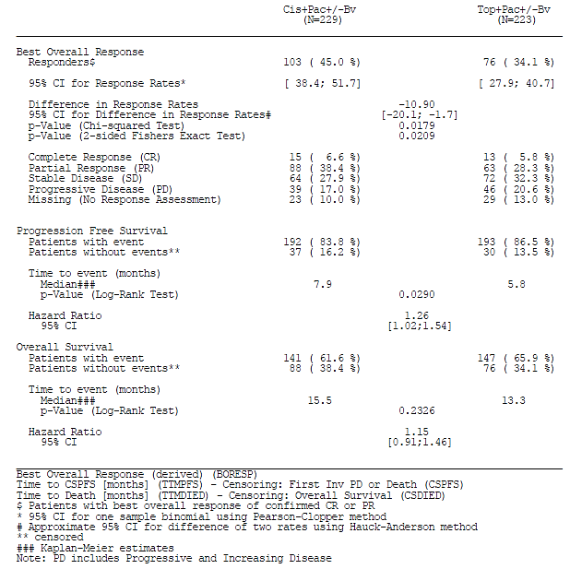
The analysis of OS with pooling of data comparing the Cis+Pac±Bv group versus Top+Pac±Bv group found, using a Cox model with stratification, the HR to be 1.15 (95% CI: 0.91, 1.46, log-rank p-value=0.2326). The median duration of OS was 15.5 months in the Cis+Pac±Bv group and 13.3 months in the Top+Pac±Bv group. The Kaplan-Meier curve of OS by chemotherapy backbone is shown below in Figure 4.
Figure 4: Kaplan-Meier curve of overall survival by chemotherapy backbone in Study GOG-0240
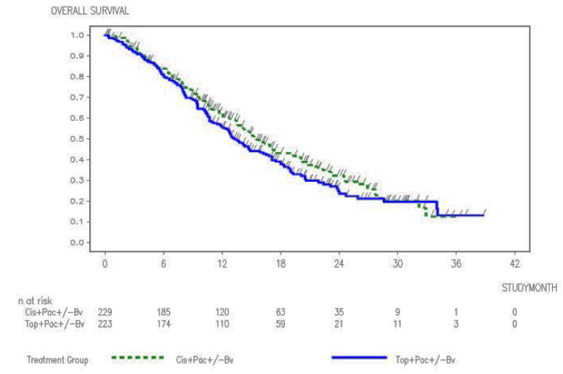
Comment: The sponsor claimed that these results showed no statistically significant evidence of a difference in efficacy between the two chemotherapy regimens, despite the numerical difference of 2.2 months between the groups. These results have been used by the sponsor to conclude that there are no differences in efficacy outcomes between the chemotherapy backbones.
However, this evaluator does not agree with this assessment of the strength of the evidence presented for this second hypothesis, and therefore does not agree with the conclusion drawn by the sponsor for the following reasons:
- The efficacy boundary for H₀₂ assessing OS by chemotherapy backbone has not been reached, and therefore these are interim results only. The results of the final analysis at 364 OS events will provide more definitive data.
- The interim results that are available suggest there is a difference in efficacy between the two chemotherapy backbones Cis+Pac±Bv and Top+Pac±Bv (Table 4). There is a non-significant numerical difference for OS of 2.2 months (although interim only), and statistically significant differences for PFS of 2.1 months (p = 0.03) and ORR of 11.9% (p = 0.02) in favour of the Cis+Pac±Bv arm. Moreover, there appears to be an improved survival advantage of Cis+Pac±Bv over Top+Pac±Bv as seen in the Kaplan-Meier curve in Figure 4.
- Due to insufficient study power, the potential effect of interaction between bevacizumab and the chemotherapy backbone cannot be ruled out. Therefore, unaccounted for confounding could confound the effect of chemotherapy backbone on efficacy outcomes in either direction.
- There are differences in the baseline tumour histology between the two chemotherapy backbone treatments, with more squamous carcinoma in the Cis+Pac±Bv arm and more other tumour types in the Top+Pac±Bv arm. This may affect tumour response to treatment and bias the results.
- Previous treatment with cisplatin was allowed, while prior treatment with paclitaxel or topotecan was excluded from the study. This differential in allowance for previous treatments by chemotherapy backbone may reduce the apparent efficacy of the Cis+Pac±Bv arm due to resistance, and therefore reduce the apparent benefit of this arm over the Top+Pac±Bv arm. It would be of use to assess any differences in outcome in the Cis+Pac±Bv arm by prior platinum therapy (yes/no). This was posed as a question to the sponsor.
As a result of the above points, it is the opinion of this evaluator that it cannot be concluded from these interim results that the efficacy of treating patients with advanced cervical cancer is equivalent for the chemotherapy backbones Cis+Pac±Bv and Top+Pac±Bv. Rather the evidence suggests that efficacy outcomes may be improved in the Cis+Pac±Bv, which warrants further follow-up and analysis.

Overall survival by trial treatment
A subgroup analysis was performed, to analyse OS by individual trial treatment. The results of this are presented in Table 5.

Table 5: Overall survival stratified analysis by trial treatment in Study GOG-0240
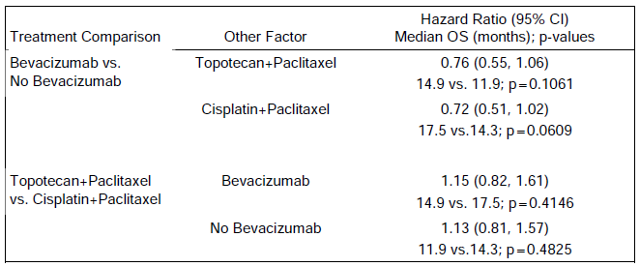
Comparing the individual chemotherapy backbones with and without bevacizumab found OS for the Top+Pac+Bv arm was 14.9 months compared to 11.9 months for the Top+Pac arm, with a HR of 0.76 (95% CI: 0.55, 1.06, p = 0.1061), and the OS for the Cis+Pac+Bv arm was 17.5 months compared to 14.3 months for the Cis+Pac arm with a HR of 0.72 (95% CI: 0.51, 1.02, p = 0.0609). The sponsor concluded that: ‘The improvement in OS for each comparison did not reach statistical significance, however the study was not powered for these comparisons and the HRs for Cis+Pac versus Cis+Pac+Bv arms and Top+Pac versus Top+Pac+Bv arms indicate that the addition of bevacizumab had a similar magnitude of benefit when added to either one of the chemotherapy backbones’.
Comment: It is agreed with the sponsor’s conclusions above that there is a similar magnitude of benefit when bevacizumab is added to either chemotherapy backbone, although this is an exploratory outcome only. It is also noted that the OS for the Top+Pac+Bv arm (14.9 months) is similar to the OS for the Cis+Pac arm (14.3 months), and this may indicate that the difference in OS between chemotherapy backbones may be of a similar magnitude to the difference in OS with and without bevacizumab.
Comparing the groups with or without bevacizumab treatment by chemotherapy backbone found, with bevacizumab, the HR for OS for Cis+Pac+Bv versus Top+Pac+Bv to be 1.15 (95% CI: 0.82, 1.61; p = 0.4146), while without bevacizumab the HR for OS for Cis+Pac versus Top+Pac was 1.13 (95% CI: 0.81, 1.57; p = 0.4825). The sponsor concluded that: ‘Although the median OS was numerically higher in the platinum containing chemotherapy group compared with the non-platinum containing chemotherapy group for both comparisons (with and without the addition of bevacizumab), the log-rank p-values were not statistically significant for either comparison, indicating that the topotecan-containing chemotherapy backbone was not superior to the platinum containing backbone.’ It was concluded in the Clinical Summary that: ‘The study showed that topotecan in combination with paclitaxel and bevacizumab provided a clinically meaningful benefit and is an acceptable alternative to cisplatin chemotherapy.’
Comment: The study has not been powered to detect a difference between individual study arms, and therefore the lack of statistically significant comparisons above is not sufficient to conclude that there is no clinically significant difference in the efficacy between chemotherapy backbones. Although the data suggest at similar magnitude of benefit with the addition of bevacizumab with either chemotherapy backbone, there is also a suggestion that treatment with Cis+Pac may be superior to Top+Pac, and it is not agreed with the sponsor’s assessment that: ‘topotecan in combination with paclitaxel and bevacizumab … is an acceptable alternative to cisplatin chemotherapy.’

Exploratory subgroup analyses of overall survival
The OS results were examined across subgroups defined by patient demographic and baseline disease characteristics. The results of these subgroup analyses were generally consistent with the overall analyses, although their exploratory nature is noted.
Forest Plots for OS by bevacizumab treatment (H₀₁) are provided in Figure 5. All HRs were less than 1, indicating a benefit in OS for the Chemo+Bv group in comparison with the Chemo alone group, except for histology subgroups (that is, adenocarcinoma [HR = 1.17] and adenosquamous [HR = 1.20], as well as the subgroup with time to first recurrence/progression > 18months [HR = 1.01]). It is noted that the confidence intervals for these subgroups is wide, and the results are not statistically significant.
Figure 5: Forrest plot of overall survival by bevacizumab treatment and subgroup in Study GOG-0240
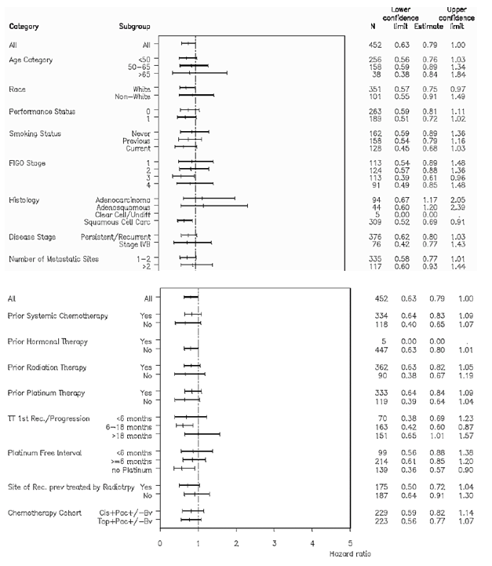
Comment: The subgroup analysis of OS by bevacizumab treatment is consistent with the overall analysis. There is some indication that bevacizumab may have differential efficacy in subjects with histology subgroups other than squamous cell carcinoma. However, it is acknowledged that this subgroup analysis was exploratory only, and the results are not statistically significant with wide confidence intervals. It is noted that this result was not replicated in the subgroup analysis of PFS, with similar results seen between the adenocarcinoma, adenosquamous carcinoma and squamous carcinoma subtypes. It is also acknowledged that there remain limited treatment options in this patient group, and there are unlikely to be additional studies investigating treatments for cervical cancer histology subgroups. A discussion of this issue was requested as a question to the sponsor.
Forest Plots for OS by chemotherapy backbone (H₀₂) are in Figure 6. These results are consistent with the overall analysis, in that generally there is superior efficacy across subgroups for patients treated with the Cis+Pac backbone compared to Top+Pac, with statistical significance reached for some subgroups (for example, performance status 0, previous smoking status, site previously treated by radiotherapy).
Comment: These subgroup analyses are consistent with the primary analysis that there is potential benefit of Cis+Pac±Bv over Top+Pac±Bv.
Figure 6: Forrest plot of overall survival by chemotherapy backbone and subgroup in Study GOG-0240
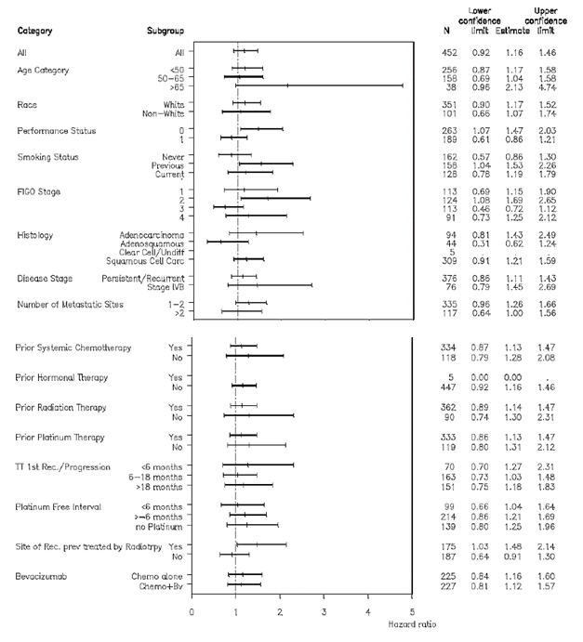

Results for other efficacy outcomes

Analysis of secondary outcomes by bevacizumab treatment (H₀₁)

Progression free survival by bevacizumab treatment
At the time of the clinical cut-off date (12 December 2012), 195 PFS events (86.7%) had occurred in the Chemo alone group and 190 events (83.7%) in the Chemo+Bv group (Table 3). Median PFS was 8.3 months in the Chemo+Bv group compared to 6.0 months with Chemo alone (an improvement of 2.3 months), with a stratified HR of 0.66 (95% CI: 0.54, 0.81; log-rank p value < 0.0001). The Kaplan-Meier plot of PFS by bevacizumab treatment is shown below in Figure 7.
Figure 7: Kaplan-Meier curve of progression-free survival by bevacizumab treatment in Study GOG-0240
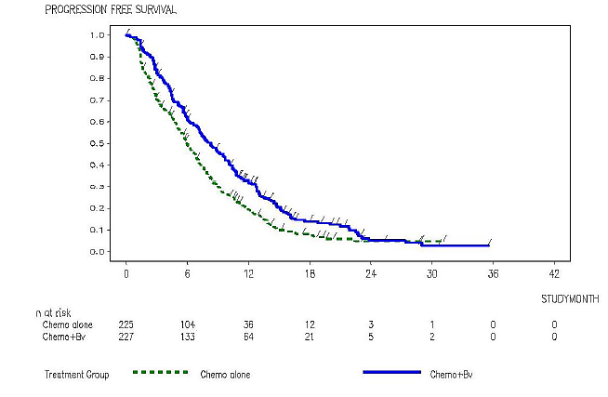
Comment: The results for the secondary efficacy outcome of PFS support the primary OS analysis for H₀₁ – the benefit of Chemo+Bv over Chemo alone in the treatment of advanced cervical cancer.

Overall response rate by bevacizumab treatment
103/227 (45.4%) of patients in the Chemo+Bv group had a complete or partial response compared to 76/225 (33.8%) of patients in the Chemo alone group (Table 3, above). The absolute difference in response rates was 11.6% (95% CI: 2.4, 20.8; p-value [chi-squared] = 0.0117).
Comment: These results show a statistically significant improvement in ORR in the Chemo+Bv group compared to the Chemo alone group, which supports the results of the primary analysis for OS indicating a benefit of Chemo+Bv over Chemo alone in the treatment of advanced cervical cancer.

Health-related quality of life by bevacizumab treatment
HRQoL was assessed by the following instruments: FACT-Cx, FACT/GOG-Ntx4, and the single worst pain item from the BPI. HRQoL assessments were performed at five time points: (1) baseline (prior to Cycle 1), (2) prior to Cycle 2 (3 weeks after Cycle 1), (3) prior to Cycle 5 (12 weeks after Cycle 1), (4) 6 months after Cycle 1, and (5) 9 months after Cycle 1. The baseline assessment was conducted prior to randomisation and HRQoL was collected for 9 months (after Cycle 1 was initiated), regardless of progression.
- FACT-Cx; The baseline mean scores for the FACT-Cx Trial Outcomes Index (TOI) were similar between the Chemo alone and Chemo+Bv groups, and decreased in both arms over treatment cycles, with a greater decline from baseline in the Chemo+Bv group compared to the Chemo alone group (Figure 8). A repeated measure mixed-effect model analysis (including patients as random effect) by Bv treatment was performed. After adjustment for baseline score, time, treatment group, and treatment-by-time interaction, the overall estimated difference between the Chemo alone and Chemo+Bv groups was − 1.84 (95% CI: −3.53, −0.16; p-value = 0.0322). Overall, differences were not considered clinically meaningful, based on the Minimum Important Difference (MID) benchmark.
Figure 8: Plot of change from baseline in FACT-Cx TOI Score by visit, by bevacizumab treatment in Study GOG-0240
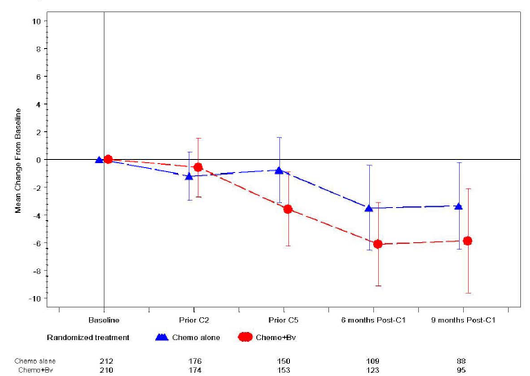
Comment: It is agreed with the sponsor that the small reduction in FACT-Cx TOI score seen in the Chemo+Bv group compared to the Chemo alone group is unlikely to be clinically meaningful.
However, the number of subjects who provided QoL data appears suboptimal. At 6 months post Cycle 1, 109 patients in the Chemo alone group and 123 patients in the Chemo+Bv group had FACT-Cx data available, which represented 109/171 (63.7%) and 123/188 (65.4%) of patients alive at 6 months. It is acknowledged that the 6 months post Cycle 1 was later in the study than the 6 month time point (and hence further deaths would have occurred during this period), so the actual proportion of patients in the study who had quality of life data available may be higher than this. The actual proportions and comment was sought from the sponsor.
- FACT-GOG Ntx4; Mean scores were similar in the two groups at baseline, and decreased at a similar magnitude throughout the study, indicating higher neurotoxicity. The changes over time in both treatment groups were clinically meaningful based on the MID for the FACT-GOG Ntx. A repeated measure mixed-effect model analysis (including patients as random effect) by Bv treatment was performed for the FACT−GOG Ntx4 scores. After adjustment for baseline score, time, treatment group, and treatment-by-time interaction, the estimated overall difference between the Chemo alone and Chemo+Bv groups was 0.12 (95% CI: − 0.38, 0.61; p-value = 0.6448), indicating no significant difference between the groups.
Comment: A similar increase in neurotoxicity was observed in both the Chemo+Bv groups and the Chemo alone groups in this study.
- BPI Worst pain item: These scores were similar between the two groups at baseline. Mean scores decreased over time, and were slightly worse in the Chemo+Bv arm compared to the Chemo alone arm.
Comment: Over treatment visits in both arms, mean scores decreased overall, but for those remaining there was minimal change from baseline (that is those with higher pain scores were not represented in later visits, presumably due to deaths). The higher pain scores observed in the Chemo+Bv arm could be due to the higher proportion of patients in this group surviving to the later period, and therefore having an overall greater severity of disease.

Analysis of secondary outcomes by chemotherapy backbone (H₀₂)

Progression free survival by chemotherapy backbone
For the stratified analysis of PFS comparing outcomes by chemotherapy backbone, a total of 192 (83.8%) and 193 (86.5%) PFS events had occurred in Cis+Pac±Bv and Top+Pac±Bv groups respectively (Table 4). The duration of PFS was 7.9 months in the Cis+Pac±Bv group compared with 5.8 months in the Top+Pac±Bv group with a HR of 1.26 (95% CI: 1.02, 1.54; log-rank p-value = 0.0290). The Kaplan-Meier plot of PFS by chemotherapy backbone is shown below in Figure 9.
Figure 9: Kaplan-Meier curve of progression-free survival by chemotherapy backbone in Study GOG-0240
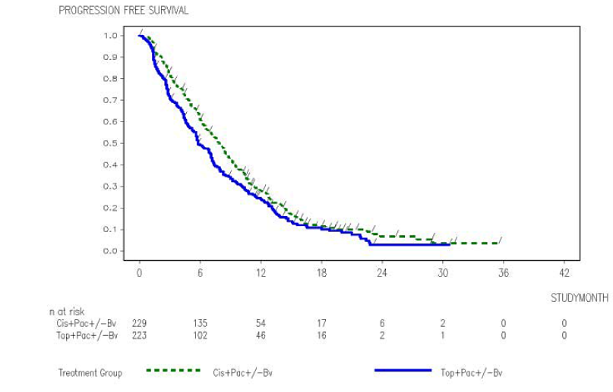
Comment: The above results show a statistically significant improvement in PFS with Cis+Pac±Bv over Top+Pac±Bv of 2.1 months. This adds weight to the suggestion of improved OS with Cis+Pac±Bv compared to Top+Pac±Bv in advanced cervical cancer.

Overall response rate by chemotherapy backbone
The ORR for patients in the Cis+Pac±Bv group was 103 out of 229 (45.0%) compared to 76 out of 223 (34.1%) in the Top+Pac±Bv group (Table 4). The difference between the two groups was 10.9% (95% CI: 1.7, 20.1; p-value [chi-squared] = 0.0179).
Comment: Again the results show a statistically significant improvement in ORR in the Cis+Pac±Bv group compared to the Top+Pac±Bv group, which supports the observed improved OS with Cis+Pac±Bv compared to Top+Pac±Bv in advanced cervical cancer.

Health related quality of life by chemotherapy backbone
- FACT-Cx: At baseline the mean FACT-Cx TOI scores were similar between the Cis+Pac±Bv and Top+Pac±Bv groups, and decreased in both arms over treatment cycles, with a slightly greater decline from baseline in the Cis+Pac±Bv group compared to the Top+Pac±Bv group, although the scores were comparable between the two groups at 9 months post Cycle 1.
Comment: There is no clinically relevant difference in the FACT-Cx TOI scores according to chemotherapy backbone.
- FACT-GOG Ntx4: As with the analysis by bevacizumab treatment, for analysis by chemotherapy backbone the mean scores were similar in the two groups at baseline, and decreased at a similar magnitude throughout the study, indicating higher neurotoxicity. The changes over time in both treatment groups were clinically meaningful based on the MID for the FACT-GOG Ntx.
- BPI Worst pain item: As with H₀₁, these scores were similar between the two chemotherapy backbone groups at baseline. Mean scores decreased over time, and were slightly worse in the Cis+Pac±Bv group compared to the Top+Pac±Bv group.

Exploratory subgroup analyses of other efficacy outcomes

Progression free survival
An un-stratified analysis of PFS for patients who did or did not receive prior platinum chemotherapy was performed by chemotherapy backbone to evaluate the impact of potential platinum resistance on outcome. As patients were stratified by prior platinum therapy at randomisation, this was a non-randomised analysis. In general, those patients who had received prior platinum therapy had a shorter median time to event than those who had not received prior platinum therapy, irrespective of chemotherapy backbone. This could imply that prior platinum therapy could increase the likelihood of general treatment resistance rather than resistance specific to platinum therapy. If this is the case, then this is less likely to bias the results in favour of the Top+Pac±Bv group over the Cis+Pac±Bv group, as would occur if there were selective resistance to Cis therapy.
Comment: This exploratory analysis indicates that the exclusion of patients with previous treatment Top and Pac but allowing patients with previous treatment with Cis may not significantly impact on producing greater treatment resistance in one arm of the study or biasing the results.
Subgroup analysis of PFS by bevacizumab treatment was generally consistent with the primary analysis. Of note, in the subgroup analysis, there was no indication of differential PFS outcome according to cancer histology. Subgroup analysis of PFS by chemotherapy backbone was again consistent with the overall analysis.

Other efficacy studies
Not applicable.

Analyses performed across trials (pooled analyses and meta-analyses)
Not applicable.

Evaluator’s conclusions on clinical efficacy for persistent, recurrent of Stage IV carcinoma of the cervix
Study GOG-0240 employed a 2 x 2 factorial design, and therefore simultaneously tested two different hypotheses:
- H₀₁: Whether bevacizumab in combination with chemotherapy (either Cis+Pac or Top+Pac) improved overall survival (OS) (OS analysis by bevacizumab treatment) in patients with stage IVB, recurrent or persistent carcinoma of the cervix.
- H₀₂: Whether Top+Pac with or without bevacizumab improves OS in comparison to Cis+Pac with or without bevacizumab (OS analysis by chemotherapy backbone) in patients with stage IVB, recurrent or persistent carcinoma of the cervix.
As was noted earlier, the subjects included in this pivotal trial were for a narrower indication than is proposed in this submission (persistent, recurrent or Stage IV carcinoma of the cervix).
Subjects were randomised to one of four treatment arms, however a limitation of this study is that it was an open label study and treatment and assessment were not blinded.
At the time of data cut-off for the analysis presented in the CSR (12 December 2012), 288 of a planned 346 OS events had occurred. At this point it was assessed that the efficacy boundary for this primary endpoint had been reached with regards to the bevacizumab hypothesis (H₀₁), however it is the opinion of this evaluator that the chemotherapy backbone hypothesis (H₀₂) should still be considered interim, and a final analysis is required when the planned 346 OS events have occurred.

H₀₁: Clinical efficacy by bevacizumab treatment
In Study GOG-0240, the addition of bevacizumab to chemotherapy was found to demonstrate a statistically significant benefit in OS, with a HR of 0.74 (95% CI 0.58-0.94, p = 0.0132). The Kaplan-Meier-estimated median time to event was 12.9 months in the Chemo alone group and 16.8 months in the Chemo+Bv group, an improvement in the median OS of 3.9 months. It is agreed that this improvement is clinically significant in a patient population with limited options.
Although this study was not powered to detect interaction, the effect of any potential interaction between bevacizumab and chemotherapy treatments will not affect the interpretation of the results for this hypothesis (H₀₁).
This improvement in OS was supported by the secondary endpoints of PFS and ORR. Median PFS was 8.3 months in the Chemo+Bv group compared to 6.0 months with Chemo alone (an improvement of 2.3 months), with a stratified HR of 0.66 (95% CI: 0.54, 0.81; log-rank p-value < 0.0001). ORR was 45.4% in the Chemo+Bv group compared to 33.8% in the Chemo alone group, with an absolute difference of 11.6% between the two groups (95% CI: 2.4, 20.8; p-value [chi-squared] = 0.0117).
HRQoL measures revealed a non-clinically significant small reduction in QoL in the Chemo+Bv group compared to the Chemo alone group. A similar increase in neurotoxicity was observed in both the Chemo+Bv groups and the Chemo alone groups, and BPI Worst pain item mean scores decreased over time, and were slightly worse in the Chemo+Bv arm compared to the Chemo alone arm, potentially due to the greater proportion of patients surviving in this arm of the study.
However, overall it is concluded that the efficacy results of Study GOG-0240 support the addition of bevacizumab to chemotherapy treatment in the treatment of advanced cervical cancer.

H₀₂: Clinical efficacy by chemotherapy backbone
This evaluation has identified several unresolved issues that impact on the interpretation of the results for the analysis by chemotherapy backbone. These include:
- The efficacy boundary for this hypothesis had not been reached at the time of the data cut-off for this analysis, and therefore results should be considered interim.
- The interim results suggest there is a difference in efficacy between the two chemotherapy backbones Cis+Pac±Bv and Top+Pac±Bv. There is a non-significant difference between the two arms for the primary endpoint of OS, with a median duration of 15.5 months in the Cis+Pac±Bv group and 13.3 months in the Top+Pac±Bv group (difference of 2.2 months), with HR 1.15 (95% CI: 0.91, 1.46, log-rank p-value=0.2326).
- The primary OS results are complemented by statistically significant differences in the secondary endpoints of PFS and ORR between the chemotherapy backbone arms. The duration of PFS was 7.9 months in the Cis+Pac±Bv group compared with 5.8 months in the Top+Pac±Bv group (difference of 2.1 months) with a HR of 1.26 (95% CI: 1.02, 1.54; log-rank p-value = 0.0290). The ORR was 45.0% in the Cis+Pac±Bv group compared to 34.1% in the Top+Pac±Bv group, with a difference between the groups of 10.9% (95% CI: 1.7, 20.1; p-value [chi-squared] = 0.0179).
- Due to insufficient study power, the potential effect of interaction between bevacizumab and the chemotherapy backbone cannot be ruled out. Therefore, unaccounted for confounding could confound the effect of chemotherapy backbone on efficacy outcomes in either direction.
- There were differences in the baseline tumour histology between the two chemotherapy backbone treatments, with more squamous carcinoma in the Cis+Pac±Bv arm and more other tumour types in the Top+Pac±Bv arm. This may affect tumour response to treatment and bias the results.
- The fact that previous treatment with cisplatin was allowed, while prior treatment with paclitaxel or topotecan was excluded from the study may reduce the apparent efficacy of the Cis+Pac±Bv arm due to resistance, and therefore reduce the apparent benefit of this arm over the Top+Pac±Bv arm.
As a result, it is the opinion of this evaluator that it cannot be concluded from these interim results that treatment of patients with advanced cervical cancer is equivalent for the chemotherapy backbones Cis+Pac±Bv and Top+Pac±Bv. Rather the evidence suggests that efficacy outcomes may be improved in the Cis+Pac±Bv, which warrants further follow-up and analysis.
Therefore, overall it is the opinion of this evaluator that the interim efficacy results by chemotherapy backbone favour Cis+Pac over Top+Pac. This requires further evaluation of the final results at 346 OS events, and should be considered against the safety profile for the respective chemotherapy backbones.

Clinical safety

Studies providing evaluable safety data
The following study provided evaluable safety data:

Pivotal efficacy study
In the pivotal efficacy Study (GOG-0240), the following safety data were collected:
- General adverse events (AEs) were assessed by history and physical examination at each treatment cycle, and a Common Toxicology Form was completed. All AEs collected within 30 days of a treatment cycle were coded according to MedDRA v16.0 and reported by the GOG investigators using NCI CTCAE v3.0 terms.
- Events of gastrointestinal (GI) perforation, non-GI fistula and abscess, arterial thromboembolic events (ATEs) and venous thromboembolic events (VTEs) AE group terms were medically reviewed in more detail by the sponsor because of the different clinical significance of GI perforation compared to rectovaginal fistula and of pulmonary emboli compared to arterial thromboembolic events. Following medical review, some AEs were reclassified by the sponsor to more accurately reflect the underlying medical condition, although both assessments were reported in the CER.
- AEs of special interest (AESIs), including ATEs (any grade); bleeding (Grade ≥ 3); congestive heart failure (CHF)/left ventricular systolic dysfunction (LVSD) (Grade ≥ 3); febrile neutropenia (Grade ≥ 3); fistula/abscess, non-GI (any grade); GI perforation, including fistula/abscess (any grade); hypertension (Grade ≥ 3); proteinuria (Grade ≥ 3); reversible posterior leukoencephalopathy syndrome (RPLS) or posterior reversible encephalopathic syndrome (PRES) (any grade); VTEs (Grade ≥ 3); and wound healing complications (Grade ≥ 3), were assessed.
- Laboratory tests, including haematology and clinical chemistry, were performed prior to study entry, and prior to each treatment cycle.
Safety data was assessed according to the two hypotheses contained within the 2 x 2 factorial design:
- H₀₁ :The safety of chemotherapy treatment alone (Chemo alone) compared to chemotherapy with bevacizumab (Chemo+Bv) (analysis by bevacizumab treatment).
- H₀₂: The safety of Top+Pac with or without bevacizumab compared to Cis+Pac with or without bevacizumab (analysis by chemotherapy backbone).
It is noted that this analysis was performed as the second analysis (data cut-off 12 December 2012) at 288 OS events, short of the planned final analysis at 346 OS events. Therefore, this safety analysis should be considered interim, and evaluation of the final analysis is required. Request for the final data analysis was posed as a question to the sponsor.

Pivotal studies that assessed safety as a primary outcome
Study GOG-0240 assessed safety as a primary outcome in addition to efficacy. The methods for this study were described above.

Dose-response and non-pivotal efficacy studies
No new data presented in this submission.

Other studies evaluable for safety only
Not applicable.

Pivotal studies that assessed safety as a primary outcome
Please refer to above for a discussion of the methods for Study GOG-0240.

Patient exposure
In Study GOG-0240, 218 patients randomised to receive bevacizumab were exposed to bevacizumab for a median duration of 17.6 weeks (mean 21.1 weeks), for a median of 6 cycles (mean 7.25), and a median total dose of bevacizumab of 6534.5mg (mean 8271.3mg). See Tables 6 and 7 for further breakdown. Overall, the median duration of therapy, number of cycles and total dose of chemotherapy were similar between the Chemo alone and Chemo+Bv groups, being slightly greater for the Chemo+Bv arms.

Table 6: Exposure to bevacizumab and comparators in clinical studies
Study type/  Indication | Controlled studies |  | Total  Bevacizumab
Study type/  Indication | Bevacizumab | Chemo alone | Total  Bevacizumab
Advanced cervical cancer Pivotal Study GOG-0240 | 218 | 222 | 218
TOTAL | 218 | 222 | 218

Table 7: Exposure to bevacizumab in clinical studies according to dose and duration (approximate based on number of cycles of treatment received)
Study type/  Indication | Proposed dose range = Proposed max dose
Study type/  Indication | ≥ 3 mo. | ≥ 6 mo. | ≥ 12 mo. | Any dur’n
Advanced cervical cancer Active-controlled | 166 | 104 | 5 | 218
TOTAL | 166 | 104 | 5 | 218
Bevacizumab exposure was similar between the two chemotherapy backbone arms, although slightly higher in the Cis+Pac+Bv arm (median duration of Bv exposure 18.7 weeks, median 6 cycles, median total dose of Bv 6840mg) compared to the Top+Pac+Bv arm (median duration of Bv exposure 16.3 weeks, median 6 cycles, median total dose of Bv 6390mg).
Comment: The slightly higher exposure to bevacizumab in the Cis+Pac±Bv arm compared to the Top+Bac±Bv arm needs to be considered in the interpretation of the results, which may confound the efficacy and safety results when analysing by chemotherapy backbone.

Adverse events

All adverse events (irrespective of relationship to study treatment)

Pivotal Study GOG-0240: H₀₁ All AEs by bevacizumab treatment
In Study GOG-0240, 219/222 (98.6%) of patients in the Chemo alone group and 216/218 (99.1%) patients in the Chemo+Bv group experienced at least one AE (Table 8).

Table 8: Overall safety by bevacizumab treatment in Study GOG-0240
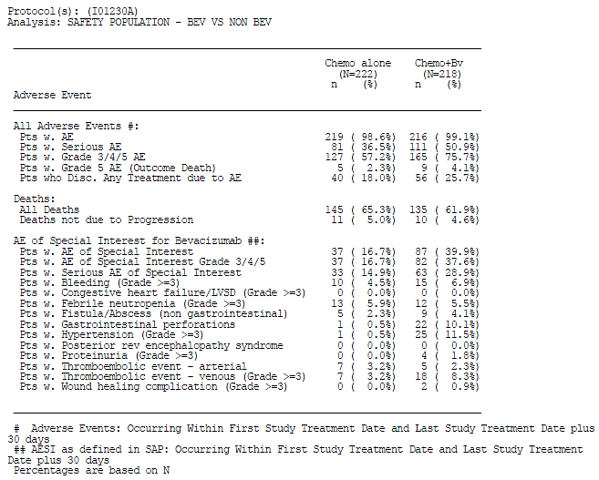
The most common AEs were those typically associated with components of chemotherapy and had a similar incidence across the two groups (Chemo alone versus Chemo+Bv), including fatigue (Chemo alone: 75% versus Chemo+Bv: 80% respectively), nausea (61% versus 63%), alopecia (62% versus 62%), peripheral sensory neuropathy (63% versus 61%) and constipation (50% versus 49%).
The AEs with the greatest difference in incidence between the Chemo alone group and the Chemo+Bv group included hypertension (Chemo alone: 6.3% versus Chemo+Bv: 28.9% respectively); epistaxis (1.8% versus 17.0%); and weight decreased (6.8% versus 20.6%)(Table 9).
Comment: It is agreed with the sponsor that most of the common AEs observed in Study GOG-0240 are in keeping with the known AE profile of bevacizumab as documented in the PI. Particularly relevant to the proposed indication, it is noted in Table 9 that there is a proportionally high incidence of anal fistula in the Chemo+Bv group compared to the Chemo alone group (6.0% versus 0% respectively). This is discussed further below. Weight loss was also occurred more frequently in the Chemo+Bv group.

Table 9: Adverse events with an incidence difference of ≥ 5% between treatment arms by bevacizumab treatment in Study GOG-0240
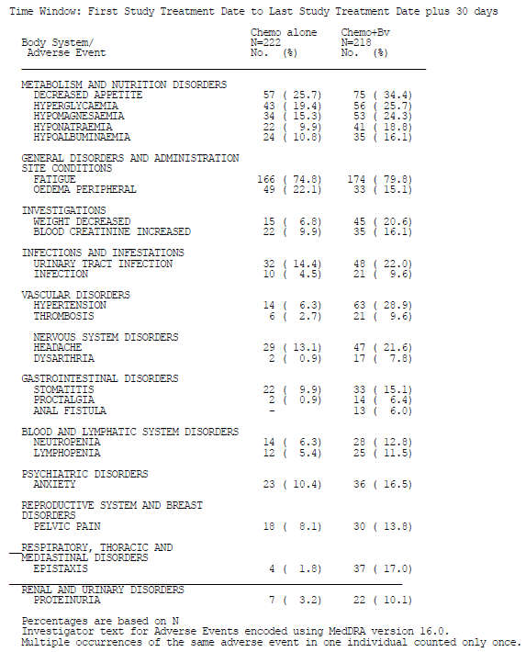
In addition, there was a greater proportion of subjects in the Chemo+Bv group (165 out of 218, 76%) compared to the Chemo alone group (127 out of 222, 57%) that experienced at least one Grade≥ 3 AE (Table 10). The Grade 3-5 AEs with a higher incidence in the Chemo+Bv group included: hypertension (Chemo alone 0.5% versus Chemo+Bv: 11.5%), thrombosis (2.7% versus 8.3%), infection (1.8% versus 6.4%), fatigue (9.9% versus 14.2%), pelvic pain (1.4% versus 5.5%), and anal fistula (0% versus 3.7%).
Comment: It is noted from Table 10 that the total number of Grade3-5 AEs was 61% higher in the Chemo+Bv group (539) compared to the Chemo alone group (334). Therefore, the proportional increase in Grade ≥ 3 AEs is higher than that indicated by examining the number of patients who experienced these events alone.

Table 10: Grade 3-4 adverse events by bevacizumab treatment occurring in ≥ 5% of patients in either treatment group in Study GOG-0240
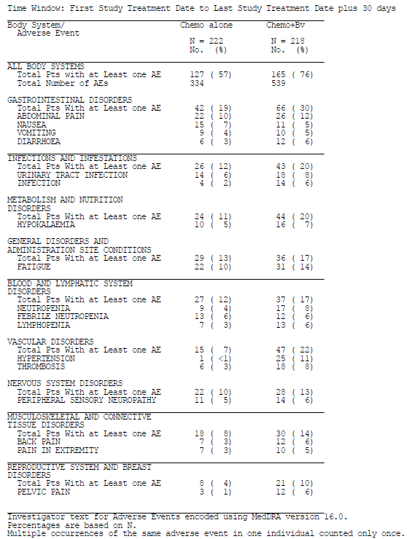

Pivotal Study GOG-0240: H₀₂ all AEs by chemotherapy backbone
In Study GOG-0240, 221/223 (99.1%) of subjects in the Cis+Pac±Bv group experienced at least one AE, compared to 214/217 (98.6%) subjects in the Top+Pac±Bv group (Table 11).

Table 11: Overall safety by chemotherapy backbone in Study GOG-0240
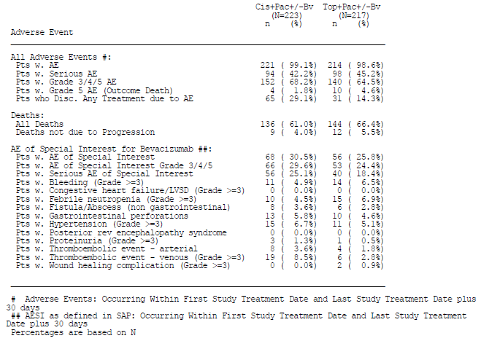
The most frequently reported AEs by chemotherapy backbone included: fatigue (Cis+Pac±Bv: 82% versus Top+Pac±Bv: 73% respectively), nausea (68% versus 55%), peripheral sensory neuropathy (63% versus 62%), alopecia (60% versus 65%), and constipation (52% versus 46%).
Comment: There appear to be slight differences in the AE profiles of the two chemotherapy backbones. AEs more common in the Cis+Pac±Bv group included: GI disorders including nausea, vomiting, constipation and diarrhoea (89% Cis+Pac±Bv versus 83% Top+Pac±Bv); fatigue (82% versus 73%); metabolism and nutrition disorders (59% versus 53%); and hypertension (21% versus 14%). AEs more common in the Top+Pac±Bv group included: infections and infestations (31% Cis+Pac±Bv versus 41% Top+Pac±Bv).
Grade ≥ 3 adverse events occurred in 152 out of 223 (68.2%) patients in the Cis+Pac±Bv group compared to 140 out of 217 (64.5%) patients in the Top+Pac±Bv group.
Comment: The pattern of Grade ≥ 3 AEs was generally similar to overall AEs as described above. The incidence of Grade ≥ 3 blood and lymphatic system disorders including neutropenia and febrile neutropenia were slightly higher in the Top+Pac±Bv group (13% Cis+Pac±Bv versus 16% Top+Pac±Bv), and Grade ≥ 3 peripheral sensory neuropathy was higher in the Cis+Pac±Bv group (9% Cis+Pac±Bv versus 2% Top+Pac±Bv).

Pivotal Study GOG-0240: All AEs by trial treatment
An overview of AEs by trial treatment was presented in the CSR (Table 12).
Comment: AEs by trial treatment were not a primary outcome of the study, and the study was not powered for this analysis. Therefore, these results have not been fully evaluated in this CER. From Table 20, several AE categories occur more frequently in the Cis+Pac+Bv and Top+Pac+Bv arms compared to the Cis+Pac and Top+Pac arms, but is the opinion of this evaluator that this information does not substantially improve understanding of safety issues beyond that determined in the analysis of AEs by bevacizumab treatment.

Table 12: Overall safety by trial treatment in Study GOG-0240
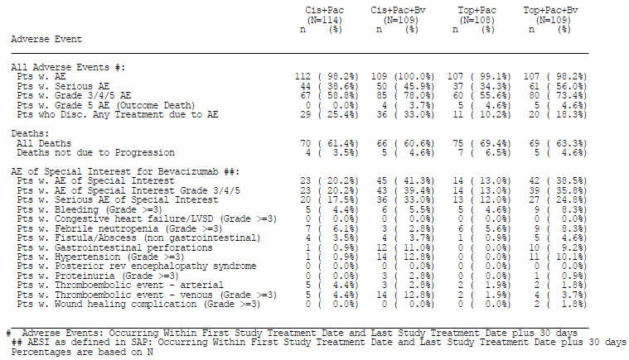

Treatment related adverse events (adverse drug reactions)

Pivotal Study GOG-0240: H₀₁ treatment related AEs by bevacizumab treatment
Treatment related adverse events were not presented for Study GOG-0240.

Adverse events of special interest
AEs that were previously seen to have a higher incidence during bevacizumab treatment were subjected to a separate analysis as AESIs. This analysis found a higher number of patients with an AESI in the Chemo+Bv group (87 out of 218, 39.9%) compared to the Chemo alone group (37 out of 222, 16.7%). In particular:
- Per GOG standard reporting, ATEs of any grade were observed in 7 out of 222 (3.2%) in the Chemo alone group compared to 5 out of 218 (2.3%) in the Chemo+Bv group. Upon medical review, all but 1 patient (from the Chemo alone group) had their event reclassified as pulmonary emboli, and therefore a VTE. Therefore, medical review classified ATEs of any grade as occurring in 1 out of 222 (0.5%) in the Chemo alone group and 0 out of 218 (0%) in the Chemo+Bv group.
- Grade ≥ 3 bleeding events were observed in 10 out of 222 (4.5%) patients in the Chemo alone group and in 15 out of 218 (6.9%) patients in the Chemo+Bv group. The most frequently reported bleeding events included haemorrhage urinary tract (Chemo alone: 3 patients versus Chemo+Bv: 5 patients), rectal haemorrhage (3 patients versus 3 patients), and vaginal haemorrhage (1 patient versus 5 patients). 4 patients in the Chemo+Bv group experienced multiple bleeding events.
- No patient in either the Chemo alone or Chemo+Bv groups experienced CHF/LVSD.
- Grade ≥ 3 febrile neutropenia was observed in 13 out of 222 (5.9%) subjects in the Chemo alone arm and 12 out of 218 (5.5%) subjects in the Chemo+Bv arm.
- Any grade Fistula/abscess (non-GI) were observed in 5/222 (2.3%) patients in the Chemo alone group and 9/218 (4.1%) patients in the Chemo+Bv group. Of these, 4 in the Chemo alone group and 6 in the Chemo+Bv group had vaginal fistula, 1 patient in each group had a female genital tract fistula, and 2 patients in the Chemo+Bv group had vesical fistula. Medical review of non-GI fistula and abscess events identified 2/5 events in the Chemo alone group and 5/9 events in the Chemo+Bv groups as GI-vaginal fistulae.
- GI perforation events (any grade) including fistula/abscess were observed in 1/222 (0.5%) in the Chemo alone group and 22/218 (10.1%) in the Chemo+Bv group. Of the events in the Chemo+Bv group, 13 were anal fistulae, 2 were ileal fistulae, 2 were rectal perforation, and there was 1 event each for colonic fistula, ileal perforation, large intestine perforation, peritonitis, and small intestinal perforation. The single event in the Chemo alone group was a GI anastomotic leak. On medical review, 1/222 subjects in the Chemo alone group and 16/218 subjects in the Chemo+Bv group were found to have a GI fistula or anastomotic leak. Of those identified in the Chemo+Bv group, 15 out of 16 were found to be GI-vaginal fistulae. Amalgamating the results for the GI-vaginal fistulae reported as GI fistulae and vaginal fistulae brings the total on medical review to 2/222 (0.9%) in the Chemo alone group and 18/218 (8.2%) in the Chemo+Bv group.
- Grade ≥ 3 hypertension was reported in 1/222 (0.5%) in the Chemo alone arm compared to 25/218 (11%) in the Chemo+Bv arm.
- No patient in either the Chemo alone or Chemo+Bv groups could be reported as PRES/RPLS, as neither PRES nor RPLS are AE terms available in NCI CTCAE v.3. However, medical review of one symptomatic leukoencephalopathy case in the Chemo+Bv group revealed MRI findings consistent with PRES/RPLS. This patient was a 68 year old female with metastatic cervical cancer who received 5 cycles of Cis+Pac+Bv prior to onset of Grade 1 leukoencephalopathy, which resolved spontaneously.
- Grade ≥ 3 proteinuria was reported in no patients in the Chemo alone group and in 4/218 (1.8%) patients in the Chemo+Bv group.
- Grade ≥ 3 VTEs were reported in 7/222 (3.2%) patients in the Chemo alone group, and 18/218 (8.3%) patients in the Chemo+Bv group. After medical review, 11 cases of pulmonary embolism that were reported as emboli initially classified under the ATE category were reclassified in the Grade ≥ 3 VTE category, although one of these patients had already been included under VTE. Therefore, an additional 10 patients (5 Chemo alone and 5 Chemo+BV) were included in the VTE category, to bring the total number of VTE events to be 12/222 (5.4%) in the Chemo alone group and 23/218(10.6%) in the Chemo+Bv group.
- Grade ≥ 3 wound healing complications were reported in no patients in the Chemo alone group and 2/218 (0.9%) patients in the Chemo+Bv group.
Comment: All AESIs were selected as an AE known to have a higher incidence with bevacizumab treatment. Therefore, the higher incidence of total AESIs in the Chemo+Bv group was not unexpected (Chemo alone: 16.7% versus Chemo+Bv: 39.9%). AESIs found to be more common in the Chemo+Bv group included: Grade ≥ 3 bleeding events (Chemo alone: 4.5% versus Chemo+Bv: 6.9% respectively); any grade Fistula/abscess (non-GI) (2.3% versus 4.1%); GI perforation events (any grade) including fistula/abscess (0.5% versus 10.1%); Grade ≥ 3 hypertension (0.5% versus 11%); Grade ≥ 3 proteinuria (0% versus 1.8%); Grade ≥ 3 VTEs (3.2% versus 8.3%); and Grade ≥ 3 wound healing complications (0% versus 0.9%).
On medical review, the total incidence of GI-vaginal fistulae was found to be 0.9% in the Chemo alone group compared to 8.2% in the Chemo+Bv group. This is a new AE finding resulting from this study. In addition, Grade ≥ 3 VTEs were found on medical review to be 5.4% in the Chemo alone group and 10.6% in the Chemo+Bv group, which is higher than that previously documented. Other than these, there were no new safety signals that arose from analysis of these AESIs, and all are already documented within the PI.

Pivotal Study GOG-0240: H₀₂ treatment related AEs by chemotherapy backbone
As mentioned in the previous section, treatment related adverse events were not presented for Study GOG-0240.

Adverse events of special interest
Comment: AESIs were selected as AEs that were previously seen to have a higher incidence during bevacizumab treatment. Therefore, analysis of AESI has less relevance by chemotherapy backbone, where bevacizumab treatment is spread evenly between the groups. Results are therefore only briefly discussed here.
The incidence of AESIs was 68/223 (30.5%) in the Cis+Pac±Bv group compared to 56/217 (25.8%) in the Top+Pac±Bv group (Table 13).
Comment: Generally the distribution of the AESIs shown in Table 13 was similar between the groups, apart from febrile neutropenia which was reported more frequently in the Top+Pac±Bv arm (4% Cis+Pac±Bv versus 7% Top+Pac±Bv), and VTEs (9% Cis+Pac±Bv versus 3% Top+Pac±Bv) and ATEs (4% versus 2%) which were reported more frequently in the Cis+Pac±Bv arm.

Table 13: Adverse events of special interest by chemotherapy backbone in Study GOG-0240
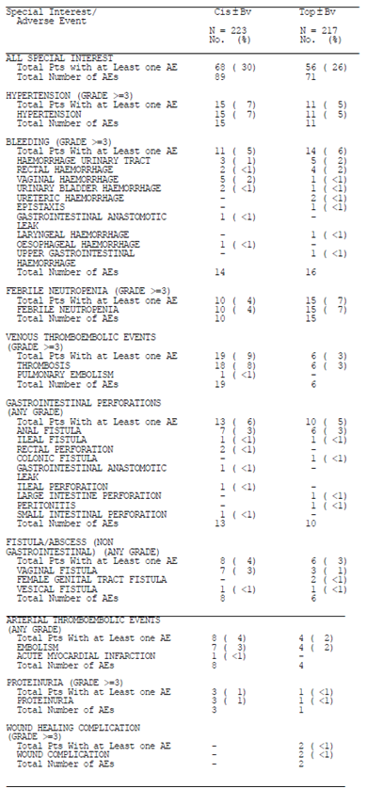

Deaths and other serious adverse events

Pivotal Study GOG-0240: H₀₁ deaths and other SAEs by bevacizumab treatment

Deaths
As of the clinical cut-off date (12 December 2012), a total of 145/222 patients (65.3%) in the Chemo alone group and 135/218 patients (61.9%) in the Chemo+Bv group had died. The majority of deaths were due to cervical cancer, with 130/222 patients (58.6%) in the Chemo alone group and 119/218 patients (54.6%) in the Chemo+Bv group.
In addition to those deaths classified as Grade 5 AEs (below), deaths in the Chemo+Bv arm that were considered due to causes other than disease progression included:
- 1 patient, a 47 year old female with metastatic cervical cancer, who died from exanguination on Day 281, 91 days post her last of 10 cycles of study treatment that was ceased due to disease progression. This event was considered secondary to cervical cancer.
- 1 patient, an 80 year old female with metastatic cervical cancer, who died from spontaneous bacterial peritonitis on Day 244, 129 days post her last of 5 cycles of study treatment that was ceased due to disease progression. This event was considered secondary to metastatic cervical cancer.
Comment: The higher number of deaths in the Chemo alone group compared to the Chemo+Bv group is in keeping with the results from the OS analysis. It is agreed that the two cases listed above do not appear to be related to bevacizumab treatment.

Grade 5 AEs
5/222 patients (2.3%) in the Chemo alone group and 9/218 patients (4.1%) in the Chemo+Bv group experienced Grade 5 AEs (AE with outcome death and onset or reporting date within 30 days after the last study treatment).
From the Chemo alone groups of the study, no patients in the Cis+Pac arm experienced a Grade 5 AE, and 5 patients in the Top+Pac arm experienced Grade 5 AEs (death, epistaxis, lung disorder, febrile neutropenia, and pelvic infection).
From the Chemo+Bv group, 9 patients experienced a total of 11 Grade 5 AEs, of which 4 patients were in the Cis+Pac+Bv arm and 5 patients were in the Top+Pac+Bv arm.
Comment: The narratives of the 9 patients who experienced Grade 5 AEs with bevacizumab treatment were reviewed and are commented on below.
In the Cis+Pac+Bv arm:
- 1 patient, a 69 year old female with metastatic cervical cancer, experienced multi-organ failure likely due to disease progression, and died on Day 95 after receiving 3 cycles of study treatment. This was considered unlikely related to study treatment by the investigator.
- 1 patient, a 60 year old female with metastatic cervical cancer, experienced disease progression on Day 29, after receiving 1 cycle of study treatment. This was considered unrelated to study treatment by the investigator.
- 1 patient, a 44 year old female with metastatic cervical cancer, experienced ileal perforation after receiving 2 cycles of treatment, and died on Day 65. The investigator assessed this event was possibly related to bevacizumab.
- 1 patient, a 65 year old female with extensive metastatic cervical cancer, experienced dyspnoea and died of sudden respiratory arrest on Day 29 after 1 cycle of study treatment. This was assessed as unrelated to study treatment by the investigator, although no autopsy was performed to determine the underlying cause of the respiratory arrest.
In the Top+Pac+Bv arm:
- 1 patient, a 56 year old female with metastatic cervical cancer, experienced 2 Grade 5 AEs of neutropenia and cellulits and died on Day 62 due to sepsis after 3 cycles of study treatment. This event was assessed as possibly related to study treatment by the investigator.
- 1 patient, a 47 year old female with recurrent cervical cancer and a history of chronic obstructive airways disease, experienced 2 Grade 5 AEs of neutropenia and pneumonia and died of sepsis on Day 9 after 1 cycle of study treatment. This patient experienced sudden deterioration following first dose of study treatment which included diarrhoea, vomiting, urinary infection, pneumonia and pancytopenia. The investigator assessed the pneumonia as unlikely related to bevacizumab, and possibly related to topotecan and paclitaxel, and the neutropenia as possibly related to study treatment.
- 1 patient, a 59 year old female with metastatic cervical cancer, experienced large intestine perforation and died on Day 28 after 1 cycle of study treatment. This event was assessed by the investigator as probably related to bevacizumab treatment.
- 1 patient, a 60 year old female with metastatic cervical cancer, experienced acute respiratory distress syndrome (ARDS) and died on Day 53 after 2 cycles of study treatment. This patient suffered a sudden deterioration with loss of consciousness and seizure activity. No cause for the episode was identified, although sepsis was suspected. The event was assessed as possibly related to study treatment by the investigator.
- 1 patient, a 43 year old female with metastatic cervical cancer, experienced sudden death and was found dead in her bed on Day 78 after 4 cycles of study treatment. No underlying cause was determined, and the event was assessed as unlikely related to study treatment by the investigator.
Comment: Overall it is noted that there was a higher incidence of deaths in the Chemo alone group compared to the Chemo+Bv group over the study period to data cut-off (65.3% versus 61.9% respectively). Most of the deaths were due to disease progression. Conversely, there was a higher incidence of Grade 5 AEs in the Chemo+Bv group during the study period (2.3% Chemo alone versus 4.1% Chemo+Bv).
With regards to the Grade 5 AEs, it is generally agreed with the investigator’s assessments regarding relation to study treatment, however it is noted that that in the Chemo+Bv arm, there were three Grade 5 events of sudden respiratory arrest/sudden death and two episodes each of intestinal perforation and neutropenia and sepsis. These are all known adverse events of bevacizumab.

Serious adverse events (SAEs)
A total of 81/222 patients (36.5%) in the Chemo alone group and 111/218 patients (50.9%) in the Chemo+Bv group experienced SAEs (Table 8). The more important SAEs with a difference between the Chemo alone and the Chemo+Bv arms included: fatigue (< 1% versus 8% respectively); thrombosis (3% versus 7%); infection (1% versus 6%); anal fistula (0% versus 5%); and vaginal haemorrhage (< 1% versus 3%) (Table 14).

Table 14: Serious adverse events by bevacizumab treatment occurring in ≥ 5% patients in either treatment group in Study GOG-0240
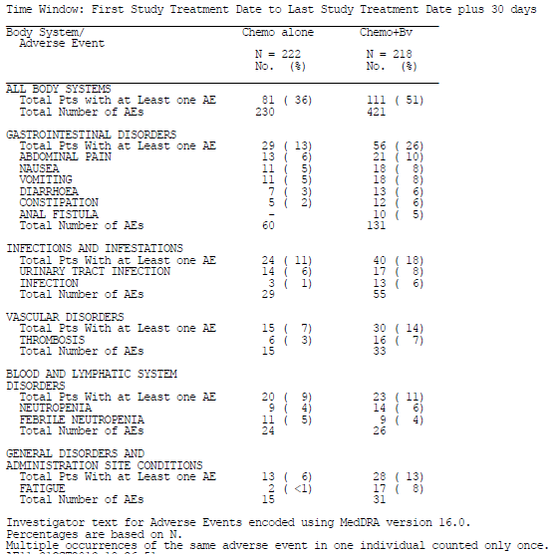
Comment: There was a higher incidence of SAEs in the Chemo+Bv group compared to the Chemo alone group across most body systems. The conditions identified above are known adverse effects of bevacizumab as listed in the PI, with the exception of vaginal haemorrhage (CSR p1676). A recommendation was made for inclusion of this AE in the PI.

Pivotal Study GOG-0240: H₀₂ Deaths and other SAEs by chemotherapy backbone

Deaths
As of the clinical cut-off date (12 December 2012), a total of 136/223 patients (61.0%) in the Cis+Pac±Bv group and 144/217 patients (66.4%) in the Top+Pac±Bv group had died (Table 15). Most deaths were due to the disease of cervical cancer (54.3% Cis+Pac±Bv versus 59.0% Top+Pac±Bv).
Comment: In keeping with the OS analysis, there are a higher number of deaths in the Top+Pac±Bv group compared to the Cis+Pac±Bv group.

Table 15: Deaths and primary cause of death by chemotherapy backbone in Study GOG-0240
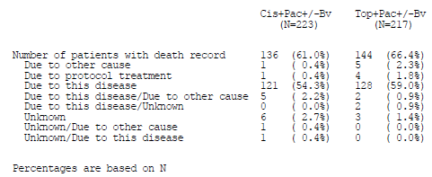

Grade 5 AEs
By chemotherapy backbone, 4/223 patients (1.8%) in the Cis+Pac±Bv group and 10/217 patients (4.6%) in the Top+Pac±Bv group experienced Grade 5 AEs (AE with outcome death and onset or reporting date within 30 days after the last study treatment). Summaries of these cases were described above.
The 4 patients from the Cis+Pac±Bv group had Grade 5 events of: disease progression, multi-organ failure, dyspnoea, and ileal perforation.
The 10 patients from the Top+Pac±Bv group had Grade 5 events of: neutropenia and cellulitis, neutropenia and pneumonia, death, sudden death, ARDS, epistaxis, lung disorder, febrile neutropenia, pelvic infection, and large intestine perforation.
Comment: The higher frequency of Grade 5 events in the Top+Pac±Bv arm compared to the Cis+Pac±Bv arm is noted, and is in keeping with the overall incidence of deaths in that group. The clinical significance of this difference is uncertain.

Serious adverse events (SAEs)
The incidence of SAEs was 94/223 (42.2%) in the Cis+Pac±Bv arm compared to 98/217 (45.2%) in the Top+Pac±Bv arm.
Comment: The incidence of SAEs is comparable between the two chemotherapy backbone arms, apart from thrombosis which was reported with a higher frequency in the Cis+Pac±Bv arm (17/223 or 8%) compared to the Top+Pac±Bv arm (5/217or 2%).

Discontinuation due to adverse events

Pivotal Study GOG-0240: H₀₁ discontinuation due to AEs by bevacizumab treatment
A total of 40/222 patients (18.0%) in the Chemo alone group and 56/218 patients (25.7%) in the Chemo+Bv group experienced AEs leading to discontinuation of study treatment regimen.
Comment: Overall more patients in the Chemo+Bv group discontinued study treatment due to AEs compared to the Chemo alone group by a factor of 43%. It is noted that 5 subjects in the Chemo+Bv arm discontinued study treatment due to fistula, compared to none in the Chemo alone arm. Other AEs leading to treatment discontinuation that occurred more frequently in the Chemo+Bv arm included: general disorders and administrative site conditions (4% Chemo alone versus 8% Chemo+Bv), gastrointestinal disorders including nausea and vomiting (< 1% versus 4%), and blood and lymphatic system disorders including neutropenia (< 1% versus 2%).

Pivotal Study GOG-0240: H₀₂ discontinuation due to AEs by chemotherapy backbone
A total of 65/223 patients (29.1%) and 31/217 patients (14.3%) in the Cis+Pac±Bv and the Top+Pac±Bv groups, respectively, experienced AEs leading to discontinuation of study treatment regimen (Table 11).
Comment: More than twice as many patients in the Cis+Pac±Bv group discontinued study treatment due to AEs compared to the Top+Pac±Bv group. The most common reasons for treatment discontinuation that occurred more frequently in the Cis+Pac±Bv group included nervous system disorders including neuropathies (8% Cis+Pac±Bv versus 4% Top+Pac±Bv), general and administration site conditions (9% versus 3%), gastrointestinal disorders (3% versus 1%) and toxicity/drug hypersensitivity (4% versus < 1%).

Laboratory tests
Comment: Apart from some haematology results, other laboratory tests were not reported in the CSR for Study GOG-0240. Further detail was sought as a question to the sponsor.

Liver function

Pivotal studies
The results of liver function tests were not reported in the CSR for Study GOG-0240.
Comment: Provision of data on liver function was requested from the sponsor.

Kidney function

Pivotal studies
The results of renal function tests were not reported in the CSR for Study GOG-0240.
Comment: Provision of data on renal function was requested from the sponsor.

Haematology

Pivotal studies
In Study GOG-0240, AEs related to haemoglobin, peripheral ANC/granulocytes count, peripheral platelet count, and peripheral White blood cell (WBC) count were reported by bevacizumab treatment.
Comment: It is seen from that although overall the proportion of patients in both the Chemo alone group and the Chemo+Bv group that experienced any grade haematological AE was similar, there was a higher incidence of Grade 4 AEs in the Chemo+Bv group (39.9%) compared to the Chemo alone group (26.6%). This was due to a higher proportion of patients in the Chemo+Bv group experiencing Grade 4 peripheral ANC/granulocytes count and peripheral WBC count AEs.

Post-marketing experience
In Australia and globally, bevacizumab has been approved for a variety of indications in combination with several different chemotherapy agents.
The total number of patients exposed to bevacizumab in the post-marketing setting from the International Birth Date (IBD) up to 9 January 2014 is estimated to be approximately 1,558,181 patients. During this period there were 101,432 AEs reported to the sponsor, including spontaneous notifications from health care professionals; SAEs from clinical studies; literature reports; and case reports from other sources (Table 16).
Comment: The broad categories of post-marketing AEs presented in the CSR prevent in-depth evaluation. However, the safety results of Study GOG-0240 are generally in keeping with the broad picture.

Table 16: Cumulative adverse events from post-marketing sources for bevacizumab
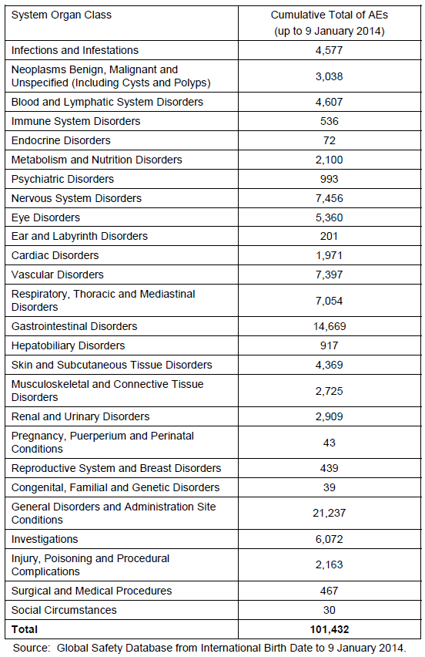

Safety issues with the potential for major regulatory impact
No new issues identified.

Other safety issues

Safety in special populations

AEs by age group
In Study GOG-0240, AEs were evaluated by age groups < 65 years and ≥ 65 years. However overall numbers in the older age groups were low, with 22 out of 222 (9.9%) patients in the Chemo alone group and 19 out of 218 (8.7%) patients in the Chemo+Bv group aged ≥ 65 years.
Comment: Overall low numbers of patients in the ≥ 65 years age group limited the ability to evaluate this subgroup analysis, and no meaningful conclusions could be drawn regarding the effect of patient age.

AEs by race
Study GOG-0240 also contained a subgroup analysis by patient race. In the Chemo alone group, there were 177 White and 45 non-White patients, while in the Chemo+Bv group there were 164 White and 54 non-White patients.
Comment: Once again, overall low numbers of patients in the non-White groups limit the ability to draw definitive conclusions from this subgroup analysis.

Safety related to drug-drug interactions and other interactions
Comment: Based on the analysis of safety according to treatment arm (Table 12), there was no indication of significantly increased numbers of adverse events in any particular arm indicative of drug-drug interactions between bevacizumab and the chemotherapy backbones in Study GOG-0240.

Evaluator’s overall conclusions on clinical safety
Pivotal Study GOG-0240 assessed the efficacy and safety cisplatin plus paclitaxel (Cis+Pac) with and without bevacizumab (Bv) versus topotecan plus paclitaxel (Top+Pac), with and without bevacizumab, in stage IVB, recurrent or persistent carcinoma of the cervix. As a 2 x 2 factorial design was used for this study, the safety analysis was performed according to the two hypotheses for the study: H₀₁; according to bevacizumab treatment, and H₀₂; according to chemotherapy backbone.
It is noted that this analysis was the second analysis (data cut-off 12 December 2012) at 288 OS events, short of the planned final analysis at 346 OS events. Therefore, this safety analysis should be considered interim, and evaluation of the final study analysis is required.

H₀₁; safety conclusions by bevacizumab treatment
At least one AE was experienced by 98.6% of patients in the Chemo alone group and 99.1% patients in the Chemo+Bv group. The most common AEs were those typically associated with components of chemotherapy and had a similar incidence across the two groups, with the greatest difference in incidence between the Chemo alone group and the Chemo+Bv group being with hypertension (Chemo alone: 6.3% versus Chemo+Bv: 28.9% respectively); epistaxis (1.8% versus 17.0%); and weight decreased (6.8% versus 20.6%). In addition, this study identified a higher incidence of GI-vaginal fistulae in the Chemo+Bv group (0.9% Chemo alone versus 8.2% Chemo+Bv) and a higher incidence of Grade ≥ 3 VTEs (5.4% Chemo alone versus 10.6% Chemo+Bv).
There was a higher incidence of Grade 5 AEs in the Chemo+Bv group (2.3% Chemo alone versus 4.1% Chemo+Bv), however, this was offset by a lower incidence of deaths (65.3% Chemo alone versus 61.9% Chemo+Bv).
Overall more patients in the Chemo+Bv group (25.7%) discontinued study treatment due to AEs compared to the Chemo alone group (18.0%), due to fistula, general disorders and administrative site conditions, gastrointestinal disorders including nausea and vomiting, and blood and lymphatic system disorders including neutropenia.
Insufficient detail was provided in the CER to fully evaluate laboratory abnormalities, and this has been requested from the sponsor. Subgroup analysis by age, race and study treatment was not informative.
Overall this interim analysis suggests that the safety profile of bevacizumab is in keeping with that previously identified and as documented in the PI. New safety issues identified as a result of this study include an increased incidence of GI-vaginal fistulae and increased Grade ≥ 3 VTEs.

H₀₂; Safety conclusions by chemotherapy backbone
At least one AE was experienced by 99.1% of subjects in the Cis+Pac±Bv group and 98.6% of subjects in the Top+Pac±Bv group. There were some slight differences in the AE profiles of the two chemotherapy backbones.
AEs more common in the Cis+Pac±Bv group compared to the Top+Pac±Bv group included: GI disorders including nausea, vomiting, constipation and diarrhoea (89% Cis+Pac±Bv versus 83% Top+Pac±Bv), fatigue (82% Cis+Pac±Bv versus 73% Top+Pac±Bv), metabolism and nutrition disorders (59% Cis+Pac±Bv versus 53% Top+Pac±Bv), and hypertension (21% Cis+Pac±Bv versus 14% Top+Pac±Bv). There was also a higher incidence of Grade ≥ 3 peripheral sensory neuropathy (9% Cis+Pac±Bv versus 2% Top+Pac±Bv), VTEs (9% Cis+Pac±Bv versus 3% Top+Pac±Bv) and ATEs (4% Cis+Pac±Bv versus 2% Top+Pac±Bv) in the Cis+Pac±Bv group.
AEs more common in the Top+Pac±Bv group compared to the Cis+Pac±Bv group included infections and infestations (31% Cis+Pac±Bv versus 41% Top+Pac±Bv), and a slightly higher incidence of Grade ≥ 3 blood and lymphatic system disorders including neutropenia and febrile neutropenia (4% Cis+Pac±Bv versus 7% Top+Pac±Bv).
In keeping with the OS analysis, there were a higher number of deaths in the Top+Pac±Bv group (66.4%) compared to the Cis+Pac±Bv group (61.0%). There was also a higher frequency of Grade 5 AEs noted in the Top+Pac±Bv arm (4.6%) compared to the Cis+Pac±Bv arm (1.8%).
The incidence of SAEs was comparable between the two chemotherapy backbone arms, apart from thrombosis which was reported with a higher frequency in the Cis+Pac±Bv arm (8%) compared to the Top+Pac±Bv arm (2%).
More than twice as many patients in the Cis+Pac±Bv group discontinued study treatment due to AEs compared to the Top+Pac±Bv group (29.1% Cis+Pac±Bv versus14.3% Top+Pac±Bv). The most common reasons for treatment discontinuation that occurred more frequently in the Cis+Pac±Bv group included nervous system disorders including neuropathies, general and administration site conditions, gastrointestinal disorders, and toxicity/drug hypersensitivity.
Overall the interim analysis of safety by chemotherapy backbone presents a mixed picture. It appears that although the general incidence of AEs and AEs leading to treatment discontinuation are higher in the Cis+Pac±Bv arm, there is a higher incidence of deaths and Grade 5 AEs in the Top+Pac±Bv arm. Further evaluation of the final analysis at 346 OS events would be beneficial.

First round benefit-risk assessment

First round assessment of benefits
H₀₁: Based on Study GOG-0240, the benefits of bevacizumab in combination with chemotherapy compared to chemotherapy alone in patients with stage IVB, recurrent or persistent carcinoma of the cervix (analysis by bevacizumab treatment) are:
- A statistically and clinically significant improvement in the median OS of 3.9 months (12.9 months Chemo alone versus 16.8 months Chemo+Bv), HR: 0.74 (95% CI 0.58-0.94, p = 0.0132). This result is supported by the secondary endpoints of PFS and ORR.
- Exploratory subgroup analysis indicated potentially inferior efficacy of bevacizumab in patients with adenocarcinoma and adenosquamous carcinoma compared to squamous carcinoma histology.
H₀₂: The benefits of Cis+Pac±Bv compared to the Top+Pac±Bv in patients with stage IVB, recurrent or persistent carcinoma of the cervix (analysis by chemotherapy backbone):
- Appear to favour Cis+Pac±Bv over Top+Pac±Bv at interim analysis by a difference of 2.2 months (OS of 15.5 months Cis+Pac±Bv versus 13.3 months Top+Pac±Bv group,), HR 1.15 (95% CI: 0.91, 1.46, log-rank p-value=0.2326) at interim analysis. Secondary endpoints of PFS and ORR were statistically significant in favour of Cis+Pac±Bv.
It is noted that the pivotal study used narrower inclusion criteria than the indication for the proposed usage: ‘treatment of persistent, recurrent or Stage IV carcinoma of the cervix’. Specifically, the proposed usage also includes resectable Stage IVA disease (bladder or rectum extension), which were a group of patients who were excluded from the pivotal trial.

First round assessment of risks
Safety data presented for Study GOG-0240 have been interpreted as interim at this stage.
H₀₁: The risks of bevacizumab in the proposed usage (analysis by bevacizumab treatment) are:
- Generally in keeping with the known adverse event profile of bevacizumab, but with an increased incidence of GI-vaginal fistulae and increased Grade ≥ 3 VTEs.
H₀₂: The risks of Cis+Pac±Bv compared to the Top+Pac±Bv in the proposed usage (analysis by chemotherapy backbone) are:
- A higher incidence of AEs and AEs leading to treatment discontinuation with Cis+Pac±Bv, but a higher incidence of deaths and Grade 5 AEs with Top+Pac±Bv.
Generally these risks are in keeping with the known safety profile of bevacizumab.

First round assessment of benefit-risk balance
The benefit-risk balance of bevacizumab is unfavourable given the proposed usage, but would become favourable if the changes recommended below adopted.
In particular, the use of bevacizumab is recommended for a narrowed indication in keeping with the data provided in the pivotal trial, and taking into account the insufficient evidence of equivalence between the proposed chemotherapy backbone treatments.
Overall, the data presented indicates a survival advantage with bevacizumab treatment for patients with stage IVB, recurrent or persistent carcinoma of the cervix who otherwise have limited treatment options.

First round recommendation regarding authorisation
The sponsor has applied to register bevacizumab for the indication:
Cervical cancer – Avastin (bevacizumab) in combination with paclitaxel and cisplatin or paclitaxel and topotecan is indicated for the treatment of persistent, recurrent or Stage IV carcinoma of the cervix
It is recommended that this indication be narrowed to reflect that used in the pivotal trial, and also to reflect the data which suggests an improved efficacy with the Cis+Pac chemotherapy backbone. A proposed amended indication would be:
Cervical cancer – Avastin (bevacizumab) in combination with paclitaxel and cisplatin is indicated for the treatment of persistent, recurrent or Stage IV carcinoma of the cervix that is not amenable to curative treatment with surgery and/or radiotherapy. Avastin (bevacizumab) in combination with paclitaxel and topotecan is an acceptable alternative where cisplatin is not tolerated or not indicated.

Clinical questions

Pharmacokinetics
No questions.

Pharmacodynamics
No questions.

Efficacy
- Can the sponsor please provide justification for the proposed indication which includes Stage IV carcinoma of the cervix, when the pivotal Study GOG-0240 only included Stage IVB disease? In particular, resectable Stage IVA disease (bladder or rectum extension) was excluded from the pivotal study but would be included under the proposed indication.
- Can the sponsor please describe the definition of what is meant by ‘persistent’ carcinoma of the cervix? How was it ensured that a consistent application of this definition was used across the study sites?
- It would seem that the sample size for Study GOG-0240 is not large enough to meaningfully detect any interaction between bevacizumab and the chemotherapy backbones (Cis+Pac or Top+Pac). Can the sponsor please comment on the ability for the test of interaction performed in the CSR to be able to detect any interaction effect? Is it appropriate that the lack of interaction identified by the test be taken as evidence of no interaction, but rather should it instead be acknowledged that the study may not be powered to detect such an interaction? If it is agreed that the study is not adequately powered to detect an interaction, can the sponsor please provide further justification for the a priori assumption of no interaction between bevacizumab and the chemotherapy backbones? In addition, can the sponsor please discuss the potential impacts should an interaction between the agents be present that was not able to be detected in the study?
- Can the sponsor please discuss the impact of excluding patients with craniospinal metastases from Study GOG-0240, and the impact of this on the generalisability of the results to this patient group?
- Can the sponsor please provide further details of the major violations that occurred in Study GOG-0240 by treatment group? In particular it would be beneficial to know what incorrect assessments of progression were made, what incorrect dose/drug was given, and what were the major violations of inclusion/exclusion criteria that occurred in the 21 patients who had major violations recorded (Table 8, p90 of CSR).
- Can the sponsor please provide baseline demographic, baseline disease characteristics and baseline treatment data separated according to chemotherapy backbone treatment (H₀₂: Cis+Pac±Bv versus Top+Pac±Bv)?
- Can the sponsor please commit to submitting to the TGA, when available, the full analysis of primary and secondary efficacy endpoints for Study GOG-0240 for the second hypothesis of efficacy according to chemotherapy backbone (H₀₂: Cis+Pac±Bv versus Top+Pac±Bv), as per the planned final analysis at 346 OS events?
- Can the sponsor please justify why independent assessment was not undertaken for the secondary efficacy endpoints of PFS and ORR?
- Can the sponsor please comment on the potential for different efficacy outcomes in patients with cervical cancer histology other than squamous cell carcinoma who are treated with bevacizumab compared to chemotherapy alone? Are further studies or monitoring to determine any potential differential effects planned or in progress? If not, can this please be discussed and justified? Can the sponsor please provide pooled efficacy data (including OS, PFS and ORR) for patients with non-squamous carcinoma (including adenocarcinoma and adenosquamous carcinoma) as a single category?
- Can the sponsor please provide information on the number of patients alive at the time of the QoL assessments, and therefore comment on the proportion of subjects for whom this data is available, and implications for the interpretation of results?
- Can the sponsor please provide a breakdown of the efficacy results in the Cis+Pac±Bv according to prior platinum therapy (yes/no) in order to assess the potential impact of platinum resistance on the magnitude of the results?

Safety
- Can the sponsor please commit to submitting the planned final safety data for Study GOG-0240 to the TGA for evaluation following 346 OS events?
- Can the sponsor please provide test results for clinical chemistry including liver and kidney function monitoring over time from Study GOG-0240, by bevacizumab treatment group and by chemotherapy backbone, for evaluation?
- Can the sponsor please provide the references upon which the association of palmar-plantar erythrodysaesthesia syndrome with pegylated liposomal doxorubicin is based on page 27 of the proposed PI?

Second round evaluation of clinical data submitted in response to questions

Efficacy

Question 1
Can the sponsor please provide justification for the proposed indication which includes Stage IV carcinoma of the cervix, when the pivotal Study GOG‐0240 only included Stage IVB disease? In particular, resectable Stage IVA disease (bladder or rectum extension) was excluded from the pivotal study but would be included under the proposed indication.
Sponsor response:
The sponsor acknowledges that Study GOG-0240 included patients with persistent, recurrent, or stage IVB carcinoma of the cervix. While stage IVA (invasion of bladder or rectum) was not explicitly stated as an inclusion criterion, the sponsor discusses below the rationale for why these patients should not be excluded from treatment, and that as a consequence the term “metastatic” rather than “Stage IV” is a more appropriate description for the population accrued in this trial. Furthermore, inclusion of “metastatic” in the indication means the additional statement proposed by the clinical evaluator for the indication, namely, “…that is not amenable to curative treatment with surgery and/or radiation therapy,” should not be necessary since this conditional statement is understandably referring to the treatment of early stage disease, a population not included in this study. The sponsor considers it more appropriate to include this information in the clinical trial section of the PI.
The Féderation Internationale de Gynécologie et d’Obstétrique (FIGO) cervical cancer staging is assigned at the time of initial diagnosis. The FIGO stage for cervical cancer is detailed in Appendix I of the GOG-0240 Protocol. This staging is based on clinical data (clinical examination and colposcopy), chest X-rays, intravenous pyelography (IVP), biopsy, and dilation and curettage (D and C). While cystoscopy and sigmoidoscopy may be used for clinical stage (examination of the bladder and/or rectal mucosa), it is of note that other procedures such as lymph angiogram, computed tomography (CT) scan, magnetic resonance imaging (MRI), laparoscopy, and laparotomy cannot be used for clinical staging. Per FIGO, the only imaging modality allowed is chest Xray, which is not the current standard of care, where more accurate imaging techniques including CT scans and MRI are used to determine the presence of metastatic disease in the liver and para-aortic nodes, and this was the case for Study GOG-0240. However, these sites of disease and these imaging modalities are not incorporated into the FIGO definition of Stage IVB and, hence, a more appropriate definition of the patients included on study are patients with metastatic disease. It is for these reasons that the sponsor proposes that, instead of the term “Stage IV,” the term “metastatic” is a more appropriate description of the population accrued in this trial.
The sponsor therefore proposes the following indication statement:
“Avastin (bevacizumab) in combination with paclitaxel and cisplatin is indicated for the treatment of persistent, recurrent metastatic carcinoma of the cervix. Avastin (bevacizumab) in combination with paclitaxel and topotecan is an acceptable alternative where cisplatin is not tolerated or not indicated.”
Evaluation of response:
The change in wording of the indication to include the term ‘metastatic’ rather than ‘Stage IV’ disease is more appropriate; it does not preclude surgery or radiotherapy in addition to bevacizumab. The amendment to the indication, seen above, sufficiently excludes patients with cisplatin resistance.
However, the change in wording will include the small proportion of patients with cerebral metastases. Patients with cerebral metastases were excluded from the current submission pivotal trial, and thus the benefit/risk of bevacizumab in treating them has been not satisfactorily demonstrated. The exclusion criterion of patients with cervical cancer and cerebral metastases from entry into Study GOG-0240 has now been stated in the PI in the clinical trials section, the indication should be expanded to reflect the lack of efficacy and safety of bevacizumab in such patients.
Suggested wording is:
“Avastin (bevacizumab) in combination with paclitaxel and cisplatin or paclitaxel and topotecan is indicated for the treatment of persistent, recurrent or Stage IV metastatic carcinoma of the cervix without cerebral metastases. Avastin (bevacizumab) in combination with paclitaxel and topotecan is an acceptable alternative where cisplatin is not tolerated or not indicated.”

Question 2
Can the sponsor please describe the definition of what is meant by ‘persistent’ carcinoma of the cervix? How was it ensured that a consistent application of this definition was used across the study sites?
Sponsor response:
Persistent carcinoma of the cervix denotes that, following the completion of primary therapy, the disease continues/persists that is, the patient did not have a complete response to treatment or was never considered to be disease free, or was not considered in remission following primary therapy. This term is well understood in the clinical community that treats cervical cancer patients. Thus, it is typical that “persistent carcinoma of the cervix” is simply stated without further description in various cervical cancer trials. The concept of persistent disease in cervical cancer is consistent and unlikely to be subject to misinterpretation across study sites.
Evaluation of response:
This explanation of the definition of ‘persistent carcinoma of the cervix’ is satisfactory.

Question 3
It would seem that the sample size for Study GOG‐0240 is not large enough to meaningfully detect any interaction between bevacizumab and the chemotherapy backbones (Cis+Pac or Top+Pac). Can the sponsor please comment on the ability for the test of interaction performed in the CSR to be able to detect any interaction effect? Is it appropriate that the lack of interaction identified by the test be taken as evidence of no interaction, but rather should it instead be acknowledged that the study may not be powered to detect such an interaction? If it is agreed that the study is not adequately powered to detect an interaction, can the sponsor please provide further justification for the a priori assumption of no interaction between bevacizumab and the chemotherapy backbones? In addition, can the sponsor please discuss the potential impacts should an interaction between the agents be present that was not able to be detected in the study?
Sponsor response:
The 2 x 2 factorial design was powered only for the pooled analyses. The pooling strategy was pre-defined in line with the protocol objectives as described in Section 1 of Protocol GOG-0240, and the statistical considerations as described in Section 11 of the Protocol:
- Study GOG-0240 Protocol, Section 1: To determine whether the addition of bevacizumab to chemotherapy improves overall survival (OS). Also to determine if a regimen involving paclitaxel and topotecan improves OS in comparison to a regimen involving cisplatin and paclitaxel. These regimens are to be evaluated in patients with stage IVB, recurrent, or persistent carcinoma of the cervix.
- Study GOG-0240 Protocol, Section 11: Study Design: This study is a randomized open label Phase III trial utilizing a 2 x 2 factorial design to investigate the impact of bevacizumab (Factor A: therapy with versus without bevacizumab) and a regimen containing topotecan instead of cisplatin (Factor B: therapy with topotecan versus cisplatin) in combination with paclitaxel chemotherapy on OS.
As stated in the EMA Guidance and FDA Guidance, the efficacy and the validity of the 2 x 2 factorial design depend on the absence of interaction between two factors or treatments being studied so that the effects of both factors on the primary efficacy variables follow an additive model. Hence, the effect of one factor is virtually identical whether or not it is additional to the effect of the other factor. Study GOG-0240 was designed with the assumption that there was no interaction between bevacizumab and the selected chemotherapy backbones (cisplatin, topotecan, and paclitaxel) since bevacizumab and these chemotherapeutic agents do not have related mechanisms of action. The mode of action of bevacizumab (anti-angiogenic) is different from that of the selected chemotherapy backbones: cisplatin interacts with DNA, culminating in the activation of apoptosis; topotecan disrupts DNA duplication, ultimately leading to cell death and paclitaxel blocks cell division. Thus, the a priori assumption of no interaction between bevacizumab and the chemotherapy backbones is sufficiently justified. Moreover, as discussed extensively in the summary of clinical pharmacology in general, small molecule drugs (that is, chemotherapy agents) and monoclonal antibodies (such as bevacizumab) do not share clearance pathways. Thus, it would not be expected that chemotherapy agents would have any potential interactions with or direct alterations of the exposure of monoclonal antibodies, and vice versa. Furthermore, bevacizumab is not a cytokine modulator and is not expected to have indirect or direct effect on cytochrome P450 (CYP-450) enzyme levels that would lead to alterations of the exposure of chemotherapy agents. PK drug-drug interactions (PK-DDIs) between bevacizumab and the chemotherapy agents used in combination with bevacizumab in Study GOG-0240 (cisplatin + paclitaxel or topotecan + paclitaxel) were not specifically assessed. However, the cumulative PK-DDI data to date for bevacizumab given in combination with various chemotherapy agents (including cisplatin and paclitaxel) across tumour types do not suggest a potential for a PK-DDI between bevacizumab and chemotherapy agents.
The assumption of no interaction between chemotherapy and bevacizumab treatment allowed for pooling and comparison of the data from the chemotherapy and bevacizumab arms (Chemo + Bv) versus the chemotherapy alone arms (Chemo alone), as well as pooling and comparison of the data from the platinum containing arms (Regimens I and II) versus the non-platinum containing arms (Regimens III and IV) for the primary OS analysis.
Despite the fact that the study was not powered to detect an interaction as such, there was no evidence of a treatment interaction between bevacizumab and chemotherapy. The estimated hazard ratios (HRs) were approximately equal within each treatment comparison (for example, 1.13 approximately 1.15 for regimens including topotecan versus cisplatin and 0.76 approximately 0.72 for regimens including bevacizumab versus no bevacizumab), indicating that the HR of interest does not depend on the level of the other treatment factor (Table 17). The ratio of HRs comparing bevacizumab versus no bevacizumab in the two chemotherapy arms was 0.94 (95% CI: 0.583, 1.525).

Table 17: Overall survival by treatment regimens (final OS analysis)
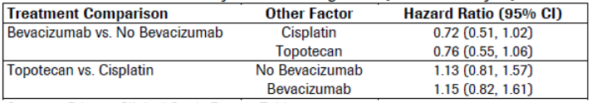
Furthermore, the follow-up chemotherapy backbones HRs for OS are consistent with the primary pooled analysis HR (Table 18) and with the HR used for the sample size calculation (HR of 0.7). This is not only a clinically meaningful and statistically significant benefit with an unprecedented improvement in OS when bevacizumab was added to chemotherapy in this patient population, but also a clear evidence that bevacizumab in combination with either chemotherapy backbone provides a clinically meaningful improvement in OS.

Table 18: Overall survival in Study GOG-0240
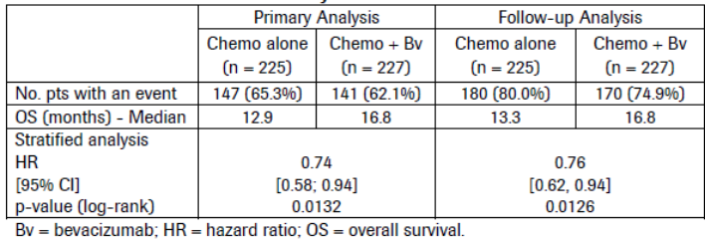
Theoretically, if there was an interaction between bevacizumab and the other chemotherapy backbones that was not detected in the study, the differences on one factor would depend on the level of the other factor and the effects of both factors on the primary efficacy variables would not follow an additive model. In other words, one factor would not be virtually identical whether or not it is additional to the effect of the other factor and the effect of bevacizumab on OS would depend on the presence/absence of cisplatin/topotecan as well as the effect of topotecan versus cisplatin would depend on the presence/absence of bevacizumab in Table 17.
In conclusion, because of the statistically robust 2 x 2 factorial design applied in Study GOG-0240, the strength of evidence for the effect of bevacizumab in this pooled analysis is sufficient to support an indication statement for either of the two applied background regimens and justifies the lack of evidence of a treatment interaction between bevacizumab and chemotherapy. The design does not confound the reliability and confidence in the results of the pooled analysis, which demonstrate statistically persuasive evidence of clinical benefit in a patient population with extremely few treatment options. These data represent a landmark improvement in outcomes for women with this disease whose median OS has been 12 months or less, to date.
References
European Medicines Agency Guidance: Note for Guidance on Statistical Principles for Clinical Trials (CPMP/ICH/363/96) 1998.
Food and Drug Administration Guidance for Industry E9 Statistical Principles for Clinical Trials 1998. Cited 11 February 2014. Available from: http://www.fda.gov/downloads/Drugs/GuidanceComplianceRegulatoryInformation/Guidances/ucm 073137.pdf
Primary Clinical Study Report GOG-0240. A randomized Phase III trial of cisplatin plus paclitaxel with and without NCI-supplied bevacizumab (NSC #704865, IND #113912) versus the non-platinum doublet, topotecan plus paclitaxel, with and without NCI-supplied bevacizumab, in stage IVB, recurrent or persistent carcinoma of the cervix. Report No. 1058089. March 2014, submitted with our initial application on 27 May 2014.
Evaluation of response:
The above explanation is satisfactory. There is similarity of magnitude of HR for each treatment comparison, but these results are not valid to be tested statistically due to multiplicity. Furthermore, there is a similar magnitude of HR for the comparison of bevacizumab versus placebo over time, but these results are not statistically tested for similarity.

Question 4
Can the sponsor please discuss the impact of excluding patients with craniospinal metastases from Study GOG‐0240, and the impact of this on the generalisability of the results to this patient group?
Sponsor response:
In patients with cervical cancer, metastasis to the brain is extremely rare, only occurring in 0.4% to 1.2% patients (Cormio et al. 1996; Ikeda et al. 1998; Chura et al. 2007; Setoodeh et al. 2012). Given the very low incidence, the exclusion of these patients in Study GOG-0240 is not considered to have an impact on the results of the study. Cervical cancer patients with brain metastases have a poor prognosis, and the standard treatment is surgical resection and brain irradiation (Chura et al. 2007). For multiple brain metastases, brain irradiation followed by chemotherapy is recommended for symptom palliation (Chura et al. 2007). The safety and efficacy of bevacizumab have been evaluated in a large Phase III randomized, double blind, placebo controlled study of bevacizumab in combination with radiotherapy and temozolomide in patients with newly diagnosed glioblastoma, which is a primary tumour of the brain (CNS) (see the BO21990 Update Clinical Study Report, dated September 2013, submitted for application PM-2013-00709-1-4). The study results showed a statistically significant and clinically meaningful improvement in progression free survival (PFS). In addition, the observed safety data in the study was consistent with the well-established safety profile of bevacizumab, with no new adverse events identified. While caution should be used in extrapolating the results of the above study to cervical patients with brain metastasis, the sponsor is of the opinion that, given the poor prognosis and the limited treatment options, physicians should be given the option of assessing on a case by case basis whether a cervical patient with brain metastasis may benefit from treatment with bevacizumab plus chemotherapy.
References
Chura JC, Shukla K, Argenta PA. Brain metastasis from cervical carcinoma. Int J Gynecol Cancer 2007; 17: 141-146.
Cormio G, Pellegrino A, Landoni F, et al. Brain metastases from cervical carcinoma. Tumori 1996; 82: 394-396.
Ikeda S, Yamada T, Katsumata N, et al. Cerebral metastasis in patients with uterine cervical cancer. Jpn J Clin Oncol 1998;28: 27-29.
Setoodeh R, Hakam A, Shan Y. Cerebral metastasis of cervical cancer, report of two cases and review of the literature. Int J Clin Exp Pathol 2012;5: 710-714.
Update Clinical Study Report BO21990. A randomized, double blind, placebo controlled, multicenter Phase III trial of bevacizumab, temozolomide and radiotherapy, followed by bevacizumab and temozolomide versus placebo, temozolomide and radiotherapy followed by placebo and temozolomide in patients with newly diagnosed glioblastoma. Report No. 1056094. September 2013. (Previously submitted for application PM-2013-00709-1-4.)
Evaluation of response:
The sponsor has not demonstrated a benefit from bevacizumab in patients with cerebral metastases originating from cervical carcinoma. In the current submission, the sponsor has not reported the proportion of patients that were screened for study entry, but excluded due to presence of cerebral metastases.
The submission to extend the indications of bevacizumab to include treatment of primary glioblastoma was rejected by the TGA. The sponsor is proposing that the biological characteristics, treatment, and outcomes from primary glioblastoma are sufficiently similar to metastatic cervical carcinoma to warrant bevacizumab administration; the sponsor has provided no data to justify their assumptions.
The proposed extrapolation of this rejected submission to the usage in patients with cervical carcinoma and cerebral metastases is specious.
The Delegate is recommended to consider the amended wording of the indication proposed in the response to efficacy Question 1. Furthermore, should the Delegate accept the amendment of the wording to the proposed indication to include ‘metastatic’, this could not be viewed as an endorsement of the effect of bevacizumab for the treatment of cerebral metastases originating from other primary cancers, or the treatment of primary glioblastoma.

Question 5
Can the sponsor please provide further details of the major violations that occurred in Study GOG-0240 by treatment group? In particular it would be beneficial to know what incorrect assessments of progression were made, what incorrect dose/drug was given, and what were the major violations of inclusion/exclusion criteria that occurred in the 21 patients who had major violations recorded (Table 8, p90 of CSR).
Sponsor response:
As requested, the sponsor has provided the details of the 21 major violations recorded in Study GOG-0240; see Table 19. To summarize, in the Chemo alone group, 4 major violations of incorrect assessments of progression were recorded; 3 of these did not meet the criteria for progressive disease per Response Evaluation Criteria in Solid Tumours (RECIST) and 1 was related to incomplete or inconsistent tumour evaluation. There were no major violations pertaining to incorrect assessments of progression in the Chemo + Bv group. Regarding incorrect dose/drugs, 6 major violations were recorded in the Chemo + Bv group; 3 because of incorrect or missed dose of bevacizumab, 1 because of incorrect dose of cisplatin, 1 because of missed dose of topotecan, and 1 because of wrong regimen at Cycle 1. In the Chemo alone group, 1 case of dose reduction was not per protocol. Concerning the major violations of inclusion/exclusion criteria, 6 occurred in the Chemo alone group; of these, 5 baseline tumour measurements did not meet inclusion criteria and lacked biopsy, and 1 was a case of lung cancer. In the Chemo + Bv group, 3 major violations were recorded: 2 patients received prior chemotherapy and 1 patient was lacking documentation of primary cervical cancer. As pointed out by the reviewers, the proportion of the total major violations is similar between the treatment groups. Given the small number and the nature of these violations, it is unlikely that these would have impacted the primary results of the trial.

Table 19: Details of major violations in Study GOG-0240
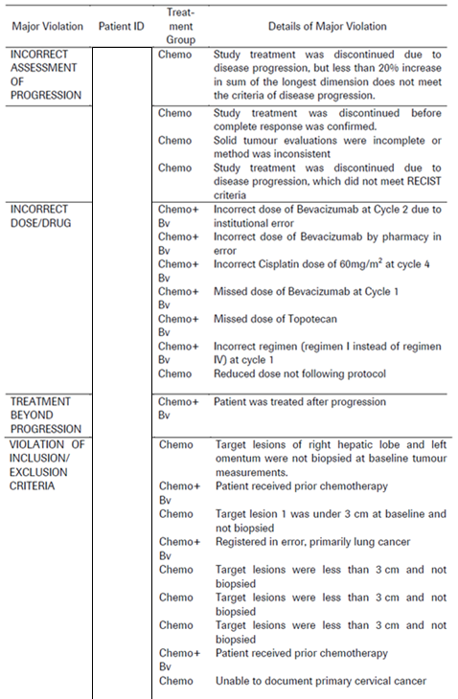
Evaluation of response:
The overall proportion of subjects with major protocol violations was small. The reported major violations do not represent a systematic failure of the trial process that would negatively impact upon the primary efficacy outcome.

Question 6
Can the sponsor please provide baseline demographic, baseline disease characteristics and baseline treatment data separated according to chemotherapy backbone treatment (H₀₂: Cis+Pac±Bv versus Top+Pac±Bv)?
Sponsor response:
As requested, baseline demographic characteristics, baseline disease characteristics, and baseline treatment data by chemotherapy backbone are summarised below.
Baseline Demographic Characteristics
Baseline patient demographic characteristics were well balanced between the Cis + Pac ± Bv and Top + Pac ± Bv groups (see Table 20), and were similar to those reported for the bevacizumab versus non-bevacizumab groups. The majority of patients were White (Cis + Pac ± Bv: 78.2% versus Top + Pac ± Bv: 77.1%) or Black (Cis + Pac ± Bv: 13.1% versus Top + Pac ± Bv: 13.5%).
The median age was 46.0 years (range: 20 to 85) in the Cis + Pac ± Bv group and 48.0 years (range: 22 to 82) in the Top + Pac ± Bv group, with fewer patients overall who were > 65 years (Cis + Pac ± Bv: 10.0% versus Top + Pac ± Bv: 6.7%) compared with patients who were ≤ 65 years (Cis + Pac ± Bv: 90.0% versus Top + Pac ± Bv: 93.3%).
The majority of patients in both treatment groups had a Performance Score of 0 (Cis + Pac ± Bv: 57.2% versus Top + Pac ± Bv: 59.2%).
Among the 3 smoking categories (current, never, and previous), in both the Cis + Pac ± Bv and Top + Pac ± Bv groups, approximately one-third of patients were distributed in each category. The majority of patients in each group did not have any previous diagnosis of other cancer.

Table 20: Demographic and baseline characteristics by chemotherapy backbone
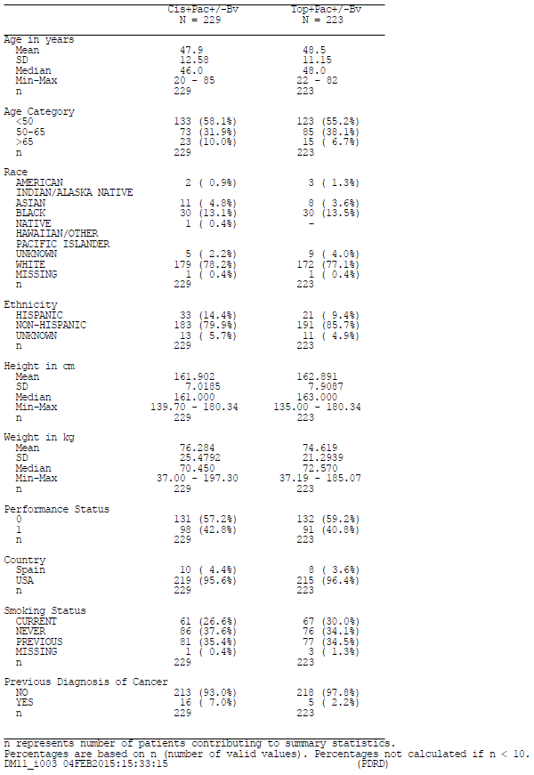
Baseline disease characteristics
Overall, baseline disease characteristics for the 2 treatment groups (Cis + Pac ± Bv and Top + Pac ± Bv) (see Table 21) were balanced. The majority of patients in both groups had squamous cell carcinoma histology (Cis + Pac ± Bv: 71.2% versus Top + Pac ± Bv: 65.5%) and were persistent/recurrent disease stage (Cis + Pac ± Bv: 83.8% versus Top + Pac ± Bv: 82.5%). The majority of patients had a platinum-free interval ≥ 6 months (Cis + Pac ± Bv: 65.8% versus Top + Pac ± Bv: 71.0%).

Table 21: History of Cervical Cancer by Chemotherapy Backbone
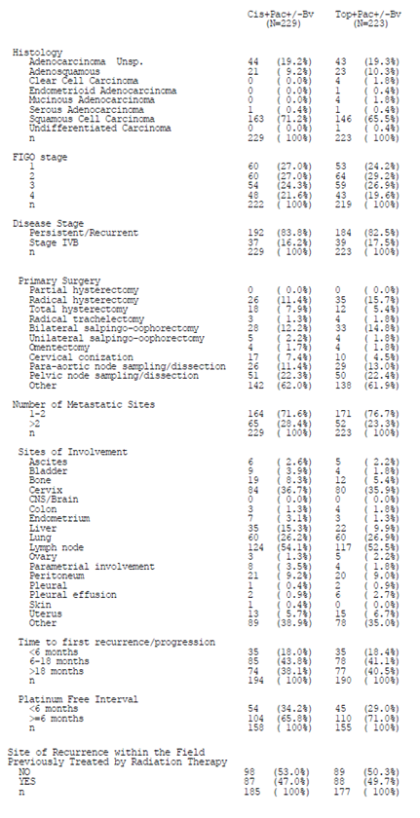
Prior cancer treatment for cervical cancer
As shown in Table 22, the majority of patients in the Cis + Pac ± Bv and Top + Pac ± Bv groups had received prior systemic chemotherapy (only prior radiation-sensitizing chemotherapy was allowed) and had not received prior hormonal therapy. Also, the majority of patients (approximately 80% in each group) had received prior radiation therapy, and no patient had received prior non-protocol biologic response modifiers.

Table 22: Summary of prior cancer treatment for cervical cancer by chemotherapy backbone
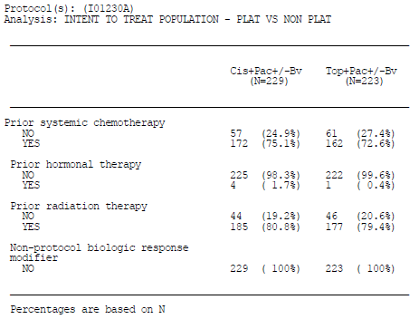
Evaluation of response:
The randomisation process led to generally balanced demographic, baseline disease characteristics and prior cancer treatment.

Question 7
Can the sponsor please commit to submitting to the TGA, when available, the full analysis of primary and secondary efficacy endpoints for Study GOG‐0240 for the second hypothesis of efficacy according to chemotherapy backbone (H₀₂: Cis+Pac±Bv versus Top+Pac±Bv), as per the planned final analysis at 346 OS events?
Sponsor response:
The Primary Clinical Study Report (CSR) for Study GOG-0240 is considered by the sponsor to be the full analysis of primary and secondary endpoints for Study GOG-0240 based on a clinical data cut-off date of 12 December 2012. The Update CSR for Study GOG-0240 is provided with the sponsor’s responses to questions. The purpose of this Update CSR was to provide a descriptive follow-up overall survival (OS) analysis, and updated safety analyses and safety narratives based on a clinical data cut-off date of 7 March 2014, after 350 OS events were observed in the intent-to-treat (ITT) population.
As specified in Section 1 of the Statistical Analysis Plan, a first interim analysis (IA), with a data cut-off in February 2012, occurred as pre-specified in the protocol when approximately 50% of the events (deaths) required for full information had been observed. No results on bevacizumab were released despite the fact that the results crossed the pre-specified boundaries in favour of the bevacizumab containing regimen as clinically and statistically significant. Nevertheless, a second IA was requested by the Data Safety Monitoring Board (DSMB) in order to ensure that the benefit of bevacizumab was sustained, which occurred with a data cut-off of 12 December 2012. This second not-prespecified IA included 78% of the death events required for full information and led to the DSMB’s decision to release the bevacizumab results since the OS boundary was crossed for the second time and there was a significant improvement in OS with the addition of bevacizumab to chemotherapy. Roche/Genentech was made aware of the results after this second IA. At the time of the first and second IA, the efficacy boundaries for OS were crossed; therefore, this second IA on the clinical data cut-off date of 12 December 2012 represents the final analysis, which was reported in the Primary CSR.
The descriptive follow-up OS results continue to demonstrate a significant and clinically meaningful benefit with an unprecedented improvement in OS when bevacizumab was added to chemotherapy in patients with persistent, recurrent, or metastatic carcinoma of the cervix, which is consistent with the final OS results. The stratified HR is 0.76 (95% CI: 0.62, 0.94; p = 0.0126) with an improvement in the median OS of 3.5 months (from 13.3 months with Chemo alone to 16.8 months with Chemo + Bv).
While a descriptive follow-up OS analysis is customarily done in oncology clinical trials, progression-free-survival (PFS) and overall rate response (ORR) analyses are performed only at the time of final analysis. Accordingly, in Study GOG-0240, following the final analysis, only OS and safety data have continued to be collected (that is, the data required for an updated analysis of PFS and ORR are not available).
The HR for the comparison of the two chemotherapy backbones (Cis + Pac ± Bv group versus Top + Pac ± Bv group) was 1.16 (95% CI: 0.94, 1.43; log-rank p-value = 0.1927), with a median duration of OS of 16.3 months in the Cis + Pac ± Bv group and 13.8 months in the Top + Pac ± Bv group, indicating that there is no significant evidence of a difference in efficacy between the two chemotherapy regimens.
In summary, the improvement in OS was consistently seen and noted to be sustained at the first IA, at the subsequent analysis (final OS data 12 December 2012), and the follow-up OS data (07 March 2014) when 350 events occurred, corresponding to the full information required for the final OS analysis pre-specified in the GOG-0240 protocol in order to provide an update on OS and safety assessment.
Evaluation of response:
The analysis of overall survival documented in the updated clinical study report of July 2014 (clinical cut off 7 March 2014) is consistent with that seen in the original data presented in that a significant reduction in the hazard of death was observed in the bevacizumab + chemotherapy arm as compared to chemotherapy alone HR = 0.79 [95% CI: 0.59, 1.07]. The increase in median overall survival of 3.5 months with the addition of bevacizumab, and a lack of difference in efficacy outcomes between the chemotherapy backbones, is also consistent with the original analysis.

Question 8
Can the sponsor please justify why independent assessment was not undertaken for the secondary efficacy endpoints of PFS and ORR?
Sponsor response:
From a methodological perspective, Study GOG-0240 meets international regulatory guidelines despite the open label design and the absence of central Independent Review Committee (IRC)/independent assessment (Guideline EMA 2012; Guidance for Industry FDA 2007). The primary endpoint in Study GOG-0240 was overall survival (OS). OS is considered to be a precise and direct measure of benefit in randomised studies, and is not subject to bias. In this trial, the improvement in OS with bevacizumab in combination with chemotherapy was statistically significant and clinically meaningful in a patient population with poor prognosis and limited treatment options.
Endpoints usually considered for IRC review, such as progression-free survival (PFS) and objective response rate (ORR), were all secondary endpoints of Study GOG-0240 and are in support of the OS data. An IRC review was not deemed necessary in the protocol, nor is a retrospective IRC planned. There are inherent limitations to conducting a retrospective IRC in this trial. The GOG-0240 protocol does not allow for a new evaluation of the data based on an IRC, and the Study GOG-0240 informed consent form does not allow for the possibility of a retrospective IRC. Since the majority of patients have died (n = 350 [77%] as of 7 March 2014 [that is, the data cut-off date for the follow-up OS analysis)]), the potential to re-consent patients would be limited.
In summary, the GOG-0240 trial design meets international regulatory guidelines, and the primary endpoint of OS is a precise and direct measure of benefit in randomised studies and is not subject to bias. The results demonstrated a statistically significant and clinically meaningful OS benefit in a patient population with a high unmet medical need. For these reasons, the sponsor considers that an IRC review for this trial is not essential.
References
Guidance for Industry- Clinical Trial Endpoint for the Approval of Cancer Drugs and Biologics. U.S. Department of health and Human Services. Food and Drug Administration (May 2007).
Guideline on the Evaluation of Anticancer Medicinal Products in Man. European Medicines Agency EMA/CHMP/205/95/Rev.4 (Dec 2012).
Evaluation of response:
In light of the observed improvement in overall survival with bevacizumab for the overall population, this response is acceptable.

Question 9
Can the sponsor please comment on the potential for different efficacy outcomes in patients with cervical cancer histology other than squamous cell carcinoma who are treated with bevacizumab compared to chemotherapy alone? Are further studies or monitoring to determine any potential differential effects planned or in progress? If not, can this please be discussed and justified? Can the sponsor please provide pooled efficacy data (including OS, PFS and ORR) for patients with non-squamous carcinoma (including adenocarcinoma and adenosquamous carcinoma) as a single category?
Sponsor response:
In Study GOG-0240, the exploratory subgroup analysis for OS showed hazard ratios (HRs) for histology subgroups other than squamous cell carcinoma that were greater than 1 (that is, adenocarcinoma [HR = 1.17] and adenosquamous [HR = 1.20]. Considering the relatively small numbers of patients in the histology subgroups “adenocarcinoma” (AC), n = 94 and “adenosquamous carcinoma” (AS) n = 44, there is no statistical rationale to conclude that these subgroups behave differently from the entire patient population, and the most reliable estimate for the treatment effect is the one derived from the analysis of all patients.
Moreover, the wide confidence intervals (CIs) in both the AC and AS subgroups, suggest that no definitive conclusions should be derived. Given the known limitations of subgroup analyses, caution needs to be taken when interpreting the results.
In an analysis performed to determine a potential interaction between treatment and histological subgroups, the p-value for the interaction between treatment (bevacizumab versus non-bevacizumab) and histological classification as patients with squamous cell carcinoma (SCCA) versus adenocarcinoma + adenosquamous carcinoma is provided in Table 23. This p-value (p = 0.0760) is not significant.

Table 23: Likelihood ratio test for interaction terms for overall survival: histological classification by bevacizumab treatment (ITT population— bevacizumab versus non-bevacizumab)
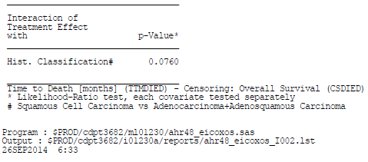
Furthermore, there is no clinical rationale to treat subgroups of patients with AC and AS differently from patients with SCCA of the cervix. In fact, an analysis done by Seamon et al. (2014) addressed the concern raised that there seems to be no benefit of adding bevacizumab to chemotherapy in patients with AC or AS compared with those with SCCA of the cervix. This analysis showed that Study GOG-0240 was not sufficiently powered for AC or AS to draw any conclusions regarding the efficacy of incorporation of anti-angiogenesis therapy in these uncommon histologies. In this analysis, cases of AC/AS from three Phase III GOG trials (GOG-0179, GOG-0204, and GOG-0240) of systemic therapy in advanced cervical cancer were pooled to increase the sample size. A total of 994 eligible patients were evaluated, of whom 25% (n = 246) had AC/AS and 75% (n = 748) had SCCA. There were no significant differences in response rates and time to response between histologic subgroups. The hazard of progression and death for AC + AS versus SCCA was 1.13 (95% CI: 0.97, 1.33; p = 0.119) and 0.97 (95% CI: 0.82, 1.15; p = 0.747), respectively. The hazard of progression and death for AC versus SCCA + AS was 1.01 (95% CI: 0.84, 1.23; p = 0.893) and 0.89 (95% CI: 0.73, 1.10; p = 0.277), respectively. These results are consistent with the hypothesis that the adenocarcinoma or adenosquamous carcinoma histologic subtypes are not significantly different in their biologic response to systemic therapy in the recurrent/metastatic setting, and this supports the use of bevacizumab plus chemotherapy in patients with advanced cervical cancer regardless of histologic subtype. Given all the relevant statistical and clinical data described above, the sponsor does not deem it necessary to provide pooled efficacy data (including OS, PFS and ORR) for patients with non‐squamous carcinoma (including adenocarcinoma and adenosquamous carcinoma) as a single category.
To date, the standard of care is that adenocarcinoma and squamous cell carcinoma are treated in the same manner. Until there is any clear evidence that they should be treated differently, the potential benefit on improved OS should not be withheld from patients with cervical adenocarcinoma or adenosquamous carcinoma.
References
Primary Clinical Study Report GOG-0240. A randomized Phase III trial of cisplatin plus paclitaxel with and without NCI-supplied bevacizumab (NSC #704865, IND #113912) versus the non-platinum doublet, topotecan plus paclitaxel, with and without NCI-supplied bevacizumab, in stage IVB, recurrent or persistent carcinoma of the cervix. Report No. 1058089. March 2014, submitted with our initial application on 27 May 2014.
Seamon LG, Java JJ, Monk BJ, et al. Prognostic impact of histology in recurrent and metastatic cervical carcinoma: A Gynecologic Oncology Group Study (publication in preparation for International Gynecologic Cancer Society [ICGS] Meeting in 2014-oral presentation).
Evaluation of response:
The sponsor has not demonstrated a benefit to bevacizumab exposure in patients with adenosquamous or adenocarcinoma. The evaluator notes the sponsors’ response that for patients with AS and AC “no definitive conclusions should be derived”, with only a “potential benefit” being described.
The evaluator concurs that the current standard of care for patients with advanced cervical carcinoma is to treat patients with squamous and non-squamous disease in the same manner, as occurred in the pivotal study. This does not mean that studies enrolling patients with cervical cancer should not pre-specify that stratification, according to disease sub-type, should occur in order to confirm or refute this prior assumption. There is evidence that histological sub-types of cervical cancer have dissimilar biological and clinical characteristics at earlier stages of disease., ,
Of note, the sponsor interprets the finding of the estimate of overall survival according to chemotherapy backbone (HR 1.16 (95% CI 0.94, 1.43)) as demonstrating no difference between regimens. Using a consistent statistical approach, the evaluation of the estimate of OS for adenocarcinoma (HR 1.17 (95% CI 0.74, 1.86)) and adenosquamous disease (HR 1.03 (95% CI 0.54, 1.96)) also demonstrates no difference between bevacizumab and placebo.
The publication of the interim results of GOG-0240 in the New England Journal of Medicine included a sub-group analysis. Only the squamous sub-group having an OS hazard ratio point estimate and 95% CI not crossing the line of unity. The article states:
The treatment benefit with bevacizumab was also observed in subgroup analyses of age, performance status, race, squamous histologic type, status with respect to prior platinum exposure, recurrent or persistent disease, and pelvic location of the target lesion.
It is notable that the authors are silent on whether there is a benefit from bevacizumab in histological groups other than squamous disease.
Sub-group analyses at multiple time-points have consistently failed to demonstrate definitive evidence of benefit in histological groups other than those with squamous disease. Indeed with increasing OS events over time, the point estimate for the adenosquamous group has crossed the line of no-effect to favour placebo.
The Forest plot of OS by treatment sub-group from the NEJM article by Tewari et al. at an interim data cut-off of 12 December 2012, after 271 OS events, is shown in Figure 10.
Figure 10: The Forest plot of OS by treatment sub-group from the NEJM article by Tewari et al. at an interim data cut-off of 12 December 2012, after 271 OS events
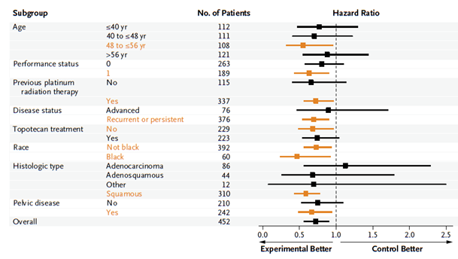
The Forest plot of OS by sub-group, from the initial data supplied in the dossier after 288 OS events is shown in Figure 11.
Figure 11: Forest plot of OS by sub-group, from the initial data supplied in the dossier after 288 OS events
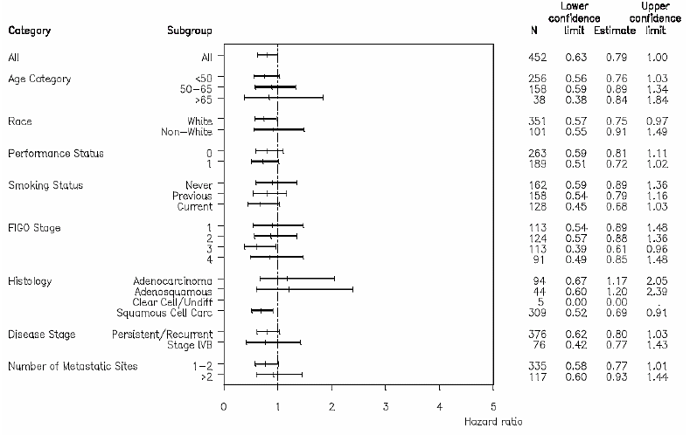
The Forest plot of OS by treatment subgroup from the updated CSR provided with the sponsor’s response, performed after 350 OS events, is shown below:
Figure 12: Forest plot of OS by treatment subgroup from the updated CSR provided with the sponsor’s response, performed after 350 OS events
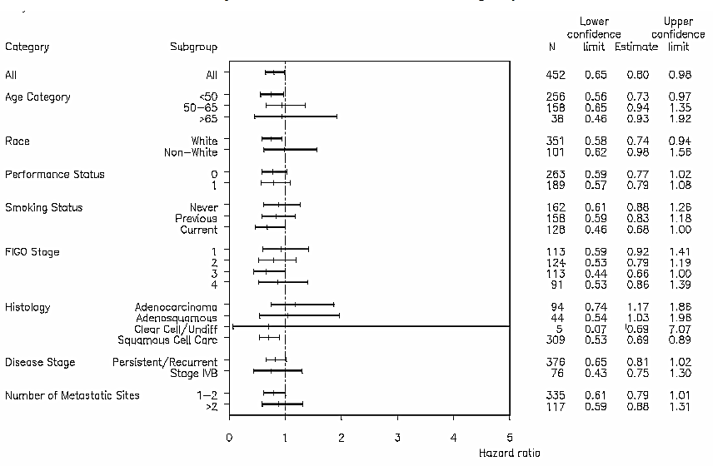
Given the population estimate of median OS for patients with AC and AS favours placebo, it is plausible that an individual patient will obtain no efficacy benefit from bevacizumab exposure, but still experience adverse events if exposed; representing an unfavourable risk-benefit. This finding poses not just a regulatory challenge for registration, but also a practical clinical one: is a clinician able to satisfactorily determine the magnitude of survival duration from bevacizumab observed from a heterogeneous population to facilitate consent for treatment of an individual patient with cervical adenocarcinoma, or adenosquamous disease from the observed data?
The TGA adopted EU guideline on “Points to consider in application with 1. Meta-analyses; 2. One pivotal study”, states that “In the exceptional event of a submission with only one pivotal study, this has to be particularly compelling with respect to internal and external validity, clinical relevance, statistical significance, data quality, and internal consistency”, with ‘similar effects demonstrated in different pre-specified sub-populations’, and with ‘all-important end-points showing similar findings’.
Since the sponsor has chosen to not present the magnitude of efficacy (OS, PFS or ORR) in patients with non-squamous disease as requested, the Evaluator cannot be satisfied that the efficacy and safety of bevacizumab for such patients has been demonstrated. However, the sponsor has provided some sub-group efficacy data, as seen in the Forest plot of overall survival above – this approach is inconsistent. The sponsor pre-specified that the sub-populations with different histological diagnoses were to be treated in the same manner. However, their outcomes have not been demonstrated to be the same, or similar.
The evaluator re-iterates the request to the sponsor that the efficacy outcomes of OR duration, PFS duration and ORR (with their respective confidence intervals) for the patients with adenocarcinoma and adenosquamous disease in each treatment arm be presented for evaluation, in order to show compliance with the advice in the relevant guideline.
Safety data has not been presented according to disease sub-type. Given the uncertainty of efficacy, the relative safety profile would have to be more compelling for patients with AS and AC than in squamous disease to recommend registration.
In the abstract of Seamon et al quoted by the sponsor, the methodology is not sufficiently detailed for the evaluator to draw any conclusions from the results. The abstract conclusion states “these pooled data support the hypothesis that these histologic subtypes are not significantly different in their biologic response”; that is it does not provide a confirmation of similarity. Neither GOG-0179 nor GOG-0204 had a treatment arm incorporating bevacizumab. Furthermore, the abstract provides no evidence that the safety profile, or quality of life, in the pooled population is comparable between histological sub-types of disease. Overall, this single abstract is not supportive of bevacizumab registration for the proposed indication.
Given the totality of the efficacy data available, the evaluator recommends to the Delegate that the advice of ACPM be sought regarding whether registration of bevacizumab for treatment of metastatic non-squamous cervical cancer should proceed.

Question 10
Can the sponsor please provide information on the number of patients alive at the time of the QoL assessments, and therefore comment on the proportion of subjects for whom this data is available, and implications for the interpretation of results?
Sponsor response:
Table 24 presents compliance rates for patients who were alive at the pre-specified assessment periods over the course of the study. The compliance rate was high in both treatment groups prior to Cycle 1 (96.9% in the Chemo group and 96.0% in the Chemo + Bv group). Rates slowly decreased over time in a comparable way in both treatment groups until 9 months after Cycle 1. Because compliance was balanced between treatment groups in patients who were still alive at the time of assessment, it had no impact on the interpretation of the Quality of Life (QoL) data between treatment groups. The balance of the compliance between treatment groups has been confirmed in an independent analysis (Penson et al 2015). Compliance rates over time were also slightly higher compared with a previous clinical trial conducted in the same population (Cella et al. 2010).

Table 24: Fast fact quality of life assessment, compliance by visit and trial treatment (exclude only patients who died)
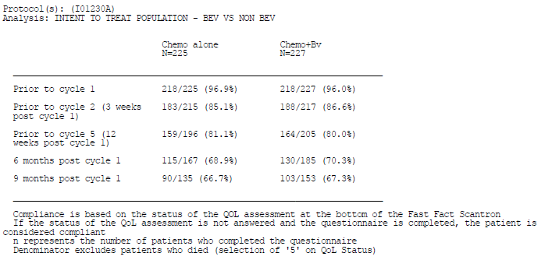
References
Cella D, Huang HQ, Monk BJ, et al. Health-related quality of life outcomes associated with four cisplatin-based doublet chemotherapy regimens for stage IVB recurrent or persistent cervical cancer: A Gynecologic Oncology Group study. Gynecol Oncol. 2010;119:531-7.
Penson RT, Huang HQ, Wenzel LB, et al. Bevacizumab for advanced cervical cancer: patient reported outcomes of a randomised, Phase 3 trial (NRG Oncology-Gynecologic Oncology Group protocol 240). Lancet Oncol. (Published online Jan 29, 2015; www.thelancet.com/oncology)
Evaluation of response:
The proportion of eligible patients completing quality of life assessments beyond Cycle 5 falls to below 80% in each treatment arm. The significant proportion of missing data in evaluable subjects precludes a meaningful assessment of the effect of bevacizumab in the proposed indication on quality of life beyond this period.
The sponsor is not proposing to include any quality of life data in the PI for the current submission.

Question 11
Can the sponsor please provide a breakdown of the efficacy results in the Cis+Pac±Bv according to prior platinum therapy (yes/no) in order to assess the potential impact of platinum resistance on the magnitude of the results?
Sponsor response:
As shown in Table 25, the numbers of patients receiving prior platinum therapy was 85 (74.6%) versus 29 (25.4%) patients who did not receive prior platinum therapy in the Cis + Pac arm and 87 (75.7%) versus 28 (24.3%) in the Cis + Pac + Bv arm. The numbers of patients who did and did not have prior platinum therapy are therefore considered too small to provide any meaningful results and to impact the primary analysis.

Table 25 Summary of stratification factors at randomization by trial treatment
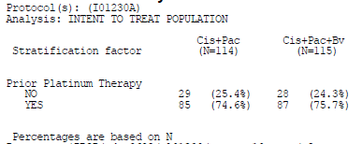
Evaluation of response:
The proportion of patients that had received prior platinum therapy was similar for each treatment arm.
The sponsor appears to have misunderstood the question; it is the proportion of patients with prior platinum therapy exposure that may have developed resistance that is of interest, not the unexposed proportion, which is of interest in order to assess the potential bias of the effect of platinum resistance on the overall outcome.
The sponsor is requested to provide the proportion of patients with prior platinum exposure and who developed platinum resistance, for each treatment arm.

Safety

Question 12
Can the sponsor please commit to submitting the planned final safety data for Study GOG‐0240 to the TGA for evaluation following 346 OS events?
Sponsor response:
The sponsor provides with this response to questions the Update Clinical Study Report with the final safety analyses for Study GOG-0240.
Evaluation of response:
This response is noted.

Question 13
Can the sponsor please provide test results for clinical chemistry including liver and kidney function monitoring over time from Study GOG‐0240, by bevacizumab treatment group and by chemotherapy backbone, for evaluation?
Sponsor response:
In addition to standard haematology laboratory tests, Study GOG 0240 required the collection of the following relevant laboratory chemistry values prior to each treatment cycle: blood urea nitrogen (BUN), creatinine, creatinine clearance, SGOT, bilirubin, and alkaline phosphatase. To provide a meaningful summary of laboratory result changes in liver and kidney function monitoring over time would require shift tables, which need National Cancer Institute Common Terminology Criteria for Adverse Events (NCI CTCAE) grading information.
However, the tests performed in Study GOG-0240 were processed at local laboratories using local laboratory ranges, and the results were provided to site investigators for review and follow-up as required. Therefore, it is challenging to map the grading of these results across multiple study sites using different laboratories with different laboratory ranges.
Abnormal laboratory test results that required intervention or were considered clinically significant by the investigator were reported as adverse events. Therefore, such adverse events provide more meaningful and clinically relevant interpretation of both renal and hepatic function of patients on study. Adverse events (both all grade and Grade ≥ 3 in severity) for laboratory abnormalities reflective of hepatic and renal functional parameters reported in the study are provided in Table 26 and Table 27, respectively.

Table 26: Summary of any-grade kidney and liver laboratory parameters reported as adverse events by trial treatment
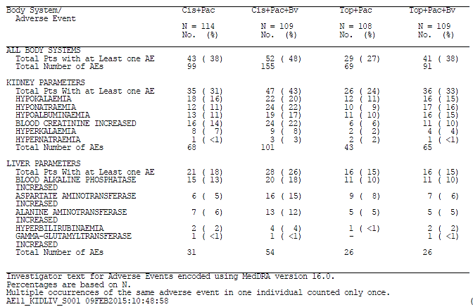

Table 27: Summary of grade 3-5 kidney and liver laboratory parameters reported as adverse events by trial treatment
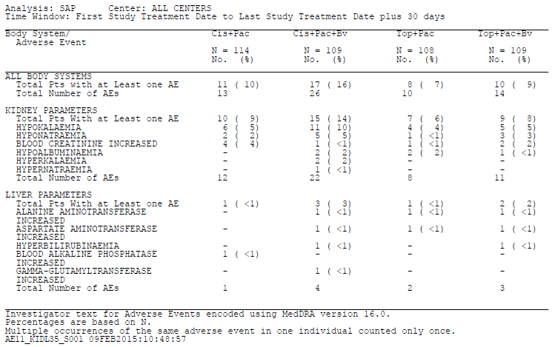
Evaluation of response:
From the tables presented above, the incidence of AEs for patients exposed to bevacizumab and placebo can be determined. There is no significant difference in the proportion of patients that experienced a grade 3-5 kidney or liver adverse events between the bevacizumab and placebo arms.
The amalgamated data does not lead to the identification of any risks additional to those already known and described in the product information.

Question 14
Can the sponsor please provide the references upon which the association of palmar-plantar erythrodysaesthesia syndrome with pegylated liposomal doxorubicin is based on page 27 of the proposed PI?
Sponsor response:
The association of palmar-plantar erythrodysaethesia syndrome with pegylated liposomal doxorubicin is related to the filing and approval of Avastin in combination with chemotherapy for platinum-resistant recurrent epithelial ovarian, fallopian tube, or primary peritoneal cancer based on Study MO22224 (application PM-2013-03227-1-4). In this study, a higher incidence of Grade 3-5 palmar-plantar erythrodysaethesia syndrome adverse events was reported in the chemotherapy + Bv arm as compared with the chemotherapy alone arm. Pegylated liposomal doxorubicin (PLD) was one of the three approved chemotherapeutic agents used in combination with bevacizumab in the study, and palmar-plantar erythrodysaethesia syndrome is a well-known toxicity associated with PLD.
Evaluation of response:
This explanation is satisfactory

Evaluation of research report 1062100 – addendum clinical study report (and erratum)
This stated purpose of this addendum is to “provide clarity on the reporting of incidence rates for gastrointestinal (GI) perforation, GI-vaginal fistula, and non-GI abscess/fistula”.
The summary of events is reported as:
When comparing Chemo + Bv versus Chemo alone groups, the rates of GI perforation SMQ defined events are 3.2% versus 0%, GI-vaginal fistulae are 8.2% versus 0.9%, and non-GI abscess/fistula are 1.8% versus 1.4%.
Thus the risk of fistula formation in association with bevacizumab is approximately nine times that with placebo. The incidence of non-GI abscess/fistula is similar between treatment arms. Isolated perforation was not observed in the placebo arm, yet was common in the bevacizumab arm.

Second round benefit-risk assessment

Second round questions
- The sponsor is re-requested to provide the OS duration (plus 95% CI), PFS duration (plus 95% CI) and ORR data according to histology sub-type for each the bevacizumab and placebo treatment arms.
- The sponsor is requested to report the proportion of patients in the bevacizumab and placebo treatment arms that had received prior platinum therapy and had evidence of platinum resistance.
- What is the estimated incidence, or prevalence, of patients with metastatic cervical cancer and cerebral metastases in Australia?

Second round assessment of benefits
After consideration of the responses to clinical questions, the benefits of bevacizumab in the proposed usage are:
- The updated pivotal study report demonstrated a statistically significant reduction in the hazard of death in favour of bevacizumab over placebo; HR 0.76 (95% CI 0.62, 0.94).
- In the population studied, there was no difference in overall survival between patients exposed to cisplatin + paclitaxel versus topotecan + paclitaxel.
- For the overall study population, the duration of PFS was longer in the bevacizumab arm (median 8.3 months (95% CI 7.1, 9.7) as compared to placebo (6.0 months (95% CI 5.2, 6.9).

Second round assessment of risks
After consideration of the responses to clinical questions, the risks of bevacizumab in the proposed usage are:
- In the intent to treat analysis of the updated pivotal study report, the 95% confidence interval of the estimated duration of overall survival for bevacizumab crosses the 95% confidence interval for placebo (OS bevacizumab 16.8 months (95% CI 14.8, 19.0) versus placebo OS 13.3 months (95% CI 10.9, 15.8)).
- No benefit from bevacizumab exposure has been established in women with cervical cancer that has metastasised to the brain.
- The sponsor has not compellingly demonstrated a benefit from bevacizumab exposure in patients with cervical adenocarcinoma or adenosquamous disease.
- The estimated duration of either: overall survival, progression-free survival or overall response rate for patients with adenocarcinoma or adenosquamous disease has not been presented for evaluation, as was requested. No benefit can be assumed given the lack of data.
- In the pivotal study population, women with metastatic cervical cancer were at nine-times higher risk of developing GI-vaginal fistula than with placebo - incidence 18/218 (8.2%) versus 2/222 (0.9%) respectively.
- The risk of peritonitis or isolated intestinal perforation (that is without fistula formation) was common in the bevacizumab arm (7/218 (3.2%)) as compared to unreported in the placebo arm (0/222 (0%)).
- Grade 3 or higher venous thrombosis occurred in 8.3% of bevacizumab-exposed patients compared to 3.2% of those receiving placebo.
- The progressively increasing proportion of patients that did not complete quality of life assessment over time precludes the study from establishing any quality of life benefit to bevacizumab exposure.

Second round assessment of benefit-risk balance
The benefit-risk balance of bevacizumab is unfavourable given the proposed usage, but would become favourable if the changes recommended in Section 14 are adopted.

Second round recommendation regarding authorisation
The pivotal study population was heterogeneous. The sponsor has not provided compelling evidence of a benefit from bevacizumab exposure for patients with all histological sub-types of cervical carcinoma.
The evaluator recommends that authorisation not proceed pending the further advice of ACPM.

References
- Monk BJ, et al. Phase II trial of bevacizumab in the treatment of persistent or recurrent squamous cell carcinoma of the cervix: a gynecologic oncology group study. J Clin Oncol 2009;27:1069-1074
- Wright JD, et al. Bevacizumab combination therapy in heavily pretreated, recurrent cervical cancer. Gynecol Oncol 2006;103:489-493
- Montgomery AA, et al. Design, analysis and presentation of factorial randomised controlled trials. BMC Medical Research Methodology, 2003; 3:26
- Up to Date’ website. Available at: http://www.uptodate.com/contents/invasive-cervical-adenocarcinoma?source=search_result&search=adenocarcinoma+cervix&selectedTitle=1%7E150 Accessed 13 October 2014
- Kidd, E. et al. Cervical cancer histology and tumor differentiation affect 18F-fluorodeoxyglucose uptake. Cancer 2009;115:3548-54
- Look, K. eta l. An analysis of cell type in patients with surgically staged IB carcinoma of the cervix: a Gynaecologic Oncology Group Study. Gynecol Oncol 1996;63(3):304
- Lea, J. et al. Adenosquamous histology predicts poor outcome in low-risk stage IB1 cervical adenocarcinoma. Gynecol Oncol 2003;91(3):558
- Tewari, K. et al. Improved survival with bevacizumab in advanced cervical cancer. NEJM 2014;370:734-43

Therapeutic Goods Administration
PO Box 100 Woden ACT 2606 Australia
Email: info@tga.gov.au Phone: 1800 020 653 Fax: 02 6232 8605
https://www.tga.gov.au

Monk BJ, et al. Phase II trial of bevacizumab in the treatment of persistent or recurrent squamous cell carcinoma of the cervix: a gynecologic oncology group study. J Clin Oncol 2009; 27: 1069-1074
Wright JD, et al. Bevacizumab combination therapy in heavily pretreated, recurrent cervical cancer. Gynecol Oncol 2006; 103: 489-493
Montgomery AA, et al. Design, analysis and presentation of factorial randomised controlled trials. BMC Medical Research Methodology, 2003; 3:26
Up to Date’ website. Available at: http://www.uptodate.com/contents/invasive-cervical-adenocarcinoma?source=search_result&search=adenocarcinoma+cervix&selectedTitle=1%7E150 Accessed 13 October 2014
Kidd, E. et al. Cervical cancer histology and tumor differentiation affect ¹⁸F-fluorodeoxyglucose uptake. Cancer 2009; 115: 3548-3554
Look, K. eta l. An analysis of cell type in patients with surgically staged IB carcinoma of the cervix: a Gynaecologic Oncology Group Study. Gynecol Oncol 1996; 63: 304
Lea, J. et al. Adenosquamous histology predicts poor outcome in low-risk stage IB1 cervical adenocarcinoma. Gynecol Oncol 2003; 91: 558
Tewari, K. et al. Improved survival with bevacizumab in advanced cervical cancer. NEJM 2014; 370: 734-743

