November 2020

Australian Public Assessment Report for Bevacizumab
  - Proprietary Product Name: Mvasi
  - Sponsor: Amgen Australia Pty Ltd

About the Therapeutic Goods Administration (TGA)
- The Therapeutic Goods Administration (TGA) is part of the Australian Government Department of Health and is responsible for regulating medicines and medical devices.
- The TGA administers the Therapeutic Goods Act 1989 (the Act), applying a risk management approach designed to ensure therapeutic goods supplied in Australia meet acceptable standards of quality, safety and efficacy (performance) when necessary.
- The work of the TGA is based on applying scientific and clinical expertise to decision-making, to ensure that the benefits to consumers outweigh any risks associated with the use of medicines and medical devices.
- The TGA relies on the public, healthcare professionals and industry to report problems with medicines or medical devices. TGA investigates reports received by it to determine any necessary regulatory action.
- To report a problem with a medicine or medical device, please see the information on the TGA website <https://www.tga.gov.au>.

About AusPARs
- An Australian Public Assessment Report (AusPAR) provides information about the evaluation of a prescription medicine and the considerations that led the TGA to approve or not approve a prescription medicine submission.
- AusPARs are prepared and published by the TGA.
- An AusPAR is prepared for submissions that relate to new chemical entities, generic medicines, major variations and extensions of indications.
- An AusPAR is a static document; it provides information that relates to a submission at a particular point in time.
- A new AusPAR will be developed to reflect changes to indications and/or major variations to a prescription medicine subject to evaluation by the TGA.

Copyright
© Commonwealth of Australia 2020
This work is copyright. You may reproduce the whole or part of this work in unaltered form for your own personal use or, if you are part of an organisation, for internal use within your organisation, but only if you or your organisation do not use the reproduction for any commercial purpose and retain this copyright notice and all disclaimer notices as part of that reproduction. Apart from rights to use as permitted by the Copyright Act 1968 or allowed by this copyright notice, all other rights are reserved and you are not allowed to reproduce the whole or any part of this work in any way (electronic or otherwise) without first being given specific written permission from the Commonwealth to do so. Requests and inquiries concerning reproduction and rights are to be sent to the TGA Copyright Officer, Therapeutic Goods Administration, PO Box 100, Woden ACT 2606 or emailed to <tga.copyright@tga.gov.au>.

Contents
Common abbreviations 4
I. Introduction to product submission 6
Submission details 6
Product background 8
Regulatory status 9
Product Information 10
II. Registration timeline 10
III. Submission overview and risk/benefit assessment 11
Quality 11
Nonclinical 12
Clinical 12
Risk management plan 25
Risk-benefit analysis 28
Outcome 30
Attachment 1. Product Information 32

Common abbreviations
Abbreviation | Meaning
ABP 215 | Drug development code for Mvasi
ACM | Advisory Committee on Medicines
ADA | Antidrug antibody
AESI | Adverse event of special interest
ALK | Anaplastic lymphoma kinase
ARTG | Australian Register of Therapeutic Goods
ASA | Australian specific annex
AUC | Area under the curve
AUC_{inf} | Area under the concentration-time curve from time zero to infinity
AUC_{last} | Area under the concentration-time curve from time zero to time of last measurable concentration
CHMP | Committee for Medicinal Products for Human Use (European Medicines Agency; European Union)
CI | Confidence interval
C_{max} | Maximum (peak) serum concentration
CT | Computerised tomography
C_{trough} | Trough serum concentration
DOR | Duration of response
EGFR | Epidermal growth factor receptor
EMA | European Medicines Agency (European Union)
EU | European Union
FDA | Food and Drug Administration (United States)
FIGO | International Federation of Gynaecologists and Obstetricians; French: Fédération Internationale de Gynécologie et d’Obstétrique
GVP | Good pharmacovigilance practices
IgG | Immunoglobulin G
IP | Investigational product
ITT | Intention to treat
IV | Intravenous
LS | Least squares
MRI | Magnetic resonance imaging
NSCLC | Non-small cell lung cancer
ORR | Overall response rate
PBS | Pharmaceutical Benefits Scheme
PD | Pharmacodynamics
PFS | Progression-free survival
PI | Product Information
PK | Pharmacokinetics
PP | Per protocol
PPS | Per protocol population
PSUR | Periodic safety update report
Q3W | Every three weeks
RECIST | Response evaluation criteria in solid tumours
RMP | Risk management plan
RR | Risk ratio
SAF | Safety analysis population
TEAE | Treatment emergent adverse event
US(A) | United States (of America)
VEGF | Vascular endothelial growth factor

I. Introduction to product submission

Submission details
Type of submission: | New biosimilar medicine
Product name: | Mvasi
Active ingredient: | Bevacizumab
Decision: | Approved
Date of decision: | 16 January 2019
Date of entry onto ARTG: | 30 June 2020
ARTG numbers: | 297455, 297456
Black Triangle Scheme: | No

Sponsor’s name and address: | Amgen Australia Pty Ltd  Level 7, 123 Epping Road,  North Ryde, NSW 2113
Dose form: | Concentrated injection
Strengths: | 100 mg/4 mL, 400 mg/16 mL
Container: | Vial
Pack size: | One vial
Approved therapeutic use: | Metastatic colorectal cancer  Mvasi (bevacizumab) in combination with fluoropyrimidine-based chemotherapy is indicated for the treatment of patients with metastatic colorectal cancer.  Locally recurrent or metastatic breast cancer  Mvasi (bevacizumab) in combination with paclitaxel is indicated for the first-line treatment of metastatic breast cancer in patients in whom an anthracycline-based therapy is contraindicated. (see section 5.1 Pharmacodynamic properties, Clinical trials).  Advanced, metastatic or recurrent non-squamous non-small cell lung cancer (NSCLC)  Mvasi (bevacizumab), in combination with carboplatin and paclitaxel, is indicated for first-line treatment of patients with unresectable advanced, metastatic or recurrent, non-squamous, non-small cell lung cancer.  Advanced and/or metastatic renal cell cancer  Mvasi (bevacizumab) in combination with interferon alfa-2a is indicated for treatment of patients with advanced and/or metastatic renal cell cancer.  Grade IV glioma  Mvasi (bevacizumab) as a single agent, is indicated for the treatment of patients with Grade IV glioma after relapse or disease progression after standard therapy, including chemotherapy.  Epithelial ovarian, fallopian tube or primary peritoneal cancer  Mvasi (bevacizumab) in combination with carboplatin and paclitaxel, is indicated for first-line treatment of patients with advanced (FIGO stages IIIB, IIIC and IV) epithelial ovarian, fallopian tube, or primary peritoneal cancer.  Recurrent epithelial ovarian, fallopian tube or primary peritoneal cancer  Mvasi (bevacizumab), in combination with carboplatin and paclitaxel or in combination with carboplatin and gemcitabine, is indicated for the treatment of patients with first recurrence of platinum-sensitive, epithelial ovarian, fallopian tube, or primary peritoneal cancer who have not received prior bevacizumab or other VEGF-targeted angiogenesis inhibitors.  Mvasi (bevacizumab) in combination with paclitaxel, topotecan or pegylated liposomal doxorubicin is indicated for the treatment of patients with recurrent, platinum-resistant epithelial ovarian, fallopian tube, or primary peritoneal cancer who have received no more than two prior chemotherapy regimens, and have not received any prior anti-angiogenic therapy including bevacizumab.  Cervical cancer  Mvasi (bevacizumab) in combination with paclitaxel and cisplatin is indicated for the treatment of persistent, recurrent or metastatic carcinoma of the cervix. Mvasi (bevacizumab) in combination with paclitaxel and topotecan is an acceptable alternative where cisplatin is not tolerated or not indicated.
Route of administration: | Intravenous infusion
Dosage: | In order to improve traceability of biological medicinal products, the trade name and the batch number of the administered product should be clearly recorded in the patient dispensing record.  Mvasi should be administered under the supervision of a physician experienced in the use of anti-neoplastic medicinal products.  Dosage of Mvasi is based on multiple factors, including the type of cancer and the body weight of the patient.  For further information regarding dosage, refer to the Product Information.
Pregnancy category: | D  Drugs which have caused, are suspected to have caused or may be expected to cause, an increased incidence of human foetal malformations or irreversible damage. These drugs may also have adverse pharmacological effects. Accompanying texts should be consulted for further details.  The use of any medicine during pregnancy requires careful consideration of both risks and benefits by the treating health professional. This must not be used as the sole basis of decision making in the use of medicines during pregnancy. The TGA does not provide advice on the use of medicines in pregnancy for specific cases. More information is available from obstetric drug information services in your State or Territory.

Product background
This AusPAR describes the application by Amgen Australia Pty Ltd (the sponsor) to register Mvasi (bevacizumab) 100 mg/4 mL and 400 mg/16 mL concentrated injection for the following proposed indications:
Metastatic colorectal cancer
Mvasi (bevacizumab) in combination with fluoropyrimidine-based chemotherapy is indicated for the treatment of patients with metastatic colorectal cancer.
Locally recurrent or metastatic breast cancer
Mvasi (bevacizumab) in combination with paclitaxel is indicated for the first-line treatment of metastatic breast cancer in patients in whom an anthracycline-based therapy is contraindicated. (see section 5.1 Pharmacodynamic properties, Clinical trials).
Advanced, metastatic or recurrent non-squamous non-small cell lung cancer (NSCLC)
Mvasi (bevacizumab), in combination with carboplatin and paclitaxel, is indicated for first-line treatment of patients with unresectable advanced, metastatic or recurrent, non-squamous, non-small cell lung cancer.
Advanced and/or metastatic renal cell cancer
Mvasi (bevacizumab) in combination with interferon alfa-2a is indicated for treatment of patients with advanced and/or metastatic renal cell cancer.
Grade IV glioma
Mvasi (bevacizumab) as a single agent, is indicated for the treatment of patients with Grade IV glioma after relapse or disease progression after standard therapy, including chemotherapy.
Epithelial ovarian, fallopian tube or primary peritoneal cancer
Mvasi (bevacizumab) in combination with carboplatin and paclitaxel, is indicated for first-line treatment of patients with advanced (FIGO stages IIIB, IIIC and IV) epithelial ovarian, fallopian tube, or primary peritoneal cancer.
Recurrent epithelial ovarian, fallopian tube or primary peritoneal cancer
Mvasi (bevacizumab), in combination with carboplatin and paclitaxel or in combination with carboplatin and gemcitabine, is indicated for the treatment of patients with first recurrence of platinum-sensitive, epithelial ovarian, fallopian tube, or primary peritoneal cancer who have not received prior bevacizumab or other VEGF-targeted angiogenesis inhibitors.
Mvasi (bevacizumab) in combination with paclitaxel, topotecan or pegylated liposomal doxorubicin is indicated for the treatment of patients with recurrent, platinum-resistant epithelial ovarian, fallopian tube, or primary peritoneal cancer who have received no more than two prior chemotherapy regimens, and have not received any prior anti-angiogenic therapy including bevacizumab.
Cervical cancer
Mvasi (bevacizumab) in combination with paclitaxel and cisplatin is indicated for the treatment of persistent, recurrent or metastatic carcinoma of the cervix. Mvasi (bevacizumab) in combination with paclitaxel and topotecan is an acceptable alternative where cisplatin is not tolerated or not indicated.
Mvasi (also called by the drug development name, ABP 215) has been developed as a biosimilar of Avastin (bevacizumab). The indications applied for are the same as for the originator product Avastin is registered for in Australia.
Bevacizumab is a humanised recombinant immunoglobulin G1 (IgG) monoclonal antibody that targets vascular endothelial growth factor (VEGF) and inhibits binding of VEGF to cell receptors on the surface of endothelial cells. Binding VEGF inhibits angiogenesis, which is required for the growth and persistence of solid tumours and their metastases, inhibits VEGF-induced cellular proliferation and vascular permeability, normalising the vasculature and potentially promoting the delivery of cytotoxic chemotherapy.

Regulatory status
This product is considered a new biosimilar medicine for Australian regulatory purposes.
At the time the TGA considered this application, similar applications had been approved in the United States of America (USA), European Union (EU) and Canada.
Table 1: International regulatory status
Region | Submission date | Status | Summary of approved indications
United States of America | 14 November 2016 | Approved on 14 September 2017 | metastatic colorectal cancer, non-squamous non-small cell lung cancer, glioblastoma, metastatic renal cancer and cervical cancer.
European Union (Centralised Procedure) | 1 December 2016 | Approved on 15 January 2018 | metastatic carcinoma of the colon or rectum, metastatic breast cancer, metastatic or recurrent non-squamous non-small cell lung cancer, advanced and/or metastatic renal cell cancer, epithelial ovarian, fallopian tube or primary peritoneal cancer, metastatic carcinoma of the cervix
Canada | 21 December 2016 | approved on 30 April 2018 | metastatic colorectal cancer and locally advanced, metastatic or recurrent non-squamous non-small cell lung cancer

Product Information
The Product Information (PI) approved with the submission which is described in this AusPAR can be found as Attachment 1. For the most recent PI, please refer to the TGA website at <https://www.tga.gov.au/product-information-pi>.

II. Registration timeline
The following table captures the key steps and dates for this application and which are detailed and discussed in this AusPAR.
Table 2: Timeline for Submission PM-2017-04616-1-4
Description | Date
Submission dossier accepted and first round evaluation commenced | 1 February 2018
First round evaluation completed | 29 June 2018
Sponsor provides responses on questions raised in first round evaluation | 3 September 2018
Second round evaluation completed | 9 October 2018
Delegate's overall benefit-risk assessment | 12 November 2018
Sponsor's pre-Advisory Committee response | Not applicable
Advisory Committee meeting | Not applicable
Registration decision (Outcome) | 16 January 2019
Completion of administrative activities and registration on the ARTG | 30 June 2020
Number of working days from submission dossier acceptance to registration decision* | 187
*Statutory timeframe for standard applications is 255 working days.

III. Submission overview and risk/benefit assessment
The submission was summarised in the following Delegate’s overview and recommendations.

Quality
The following was summarised in the quality evaluation report:
- The ABP 215 biosimilar studies used non-Australian reference products (bevacizumab (EU sourced) and bevacizumab (US sourced)). Therefore, a two step approach was used to evaluate analytical similarity between ABP 215 and US, EU, and Australian sourced bevacizumab. This included the following:
  - Comparability analytical similarity assessment was performed between ABP 215, bevacizumab (US), and bevacizumab (EU) as follows:
    - analytical similarity between ABP 215 and bevacizumab (US)
    - analytical similarity between ABP 215 and bevacizumab (EU)
    - reference product bridging between bevacizumab (US) and bevacizumab (EU).
  - An Australian confirmatory bridging assessment was performed between bevacizumab (Australian), bevacizumab (EU), and bevacizumab (US)
- The results of the studies showed that ABP 215 is generally similar to bevacizumab US and EU for the quality attributes tested, including the same amino acid sequence, post-translational modifications, disulphide structure and degradation profiles at 50°C (forced degradation), 40°C (stressed degradation) and 25°C (accelerated degradation). However, due to the different cell line and manufacturing process used to produce ABP 215 and bevacizumab, there will be inevitable differences in the physicochemical characteristics and biological activity between the two products.
The evaluator then described the minor differences noted, and concluded by stating:
- Overall, the differences in the quality attributes between ABP 215 and bevacizumab (Avastin) appear to be minor. Nevertheless, the differences described above should be considered in conjunction with nonclinical and clinical studies to determine whether there is any impact on safety and efficacy.
The Delegate commented with the following:
- No details were included in the report about the Australian confirmatory bridging study. On 23 October 2018, the quality evaluator advised that there were no significant differences between bevacizumab (Australian), bevacizumab (EU) and bevacizumab (US) in the Australian bridging study.
- In addition, there were no novel excipients as noted in the report. The excipients meet the current United States Pharmacopeia, National Formulary, or European Pharmacopoeia acceptance limits.
In summary, all issues in relation to quality have been resolved. There is no objection to registration of Mvasi on quality grounds.

Nonclinical
The following conclusions and recommendations were made in the nonclinical evaluation:
- The nonclinical dossier contained comparative studies on pharmacology, pharmacokinetics and repeat-dose toxicity. The scope of the nonclinical program is adequate under the relevant EU guideline. Nonclinical studies were conducted using US-sourced Avastin as the comparator reference product. Studies outlining comparability of the US-sourced Avastin to the Australian product were provided in the quality information.
- No meaningful differences between Mvasi and Avastin were observed in the comparative pharmacology, pharmacokinetic and toxicity studies.
- The ability of the nonclinical studies to support comparability to Australian Avastin depends on the conclusion of the quality evaluator regarding the identity of Avastin products across jurisdictions (see ‘Quality’ section, above). Provided that the quality evaluator finds US-sourced Avastin used in nonclinical investigations to be highly comparable to the Australian product and the nonclinical batch is comparable to the batch to be distributed for marketing, there are no nonclinical objections to the registration of Mvasi.
- Statements in the draft PI of Mvasi that pertain to nonclinical data are consistent with those for the approved Australian PI for Avastin and are therefore acceptable from a nonclinical perspective.

Clinical
The clinical studies included:
- Study 20110216 (also called Study 216) is a randomised, single blind, single dose, three arm, parallel group study to determine the pharmacokinetics (PK) of ABP 215 and Avastin in healthy male subjects. 68 subjects received ABP 215, 67 received Avastin (US-sourced) and 67 received Avastin (EU-sourced).
- Study 20120265 (also called Study 265) is a randomised, double blind, Phase III study assessing for immunogenicity and checking the efficacy and safety of ABP 215 compared with Avastin in subjects with advanced non-small cell lung cancer in conjunction with first line chemotherapy. 324 subjects received at least one dose of ABP 215 and 309 subjects received at least one dose of Avastin.

Pharmacology

Pharmacokinetics
Studies 216 and 265 both included data about PK.
In Study 216, the main PK study, the primary objective was to demonstrate bioequivalence as assessed by the area under the concentration-time curve (AUC) and the maximum observed serum concentration (C_{max}) following a 3 mg/kg intravenous infusion.
The adjusted least squares (LS) geometric mean for C_{max} for ABP 215 was 87.2 µg/mL, for Avastin (US-sourced) was 88.0 µg/mL and Avastin (EU-sourced) was 85.8 µg/mL. The ratios of the adjusted LS geometric means were within the 90% confidence intervals, as demonstrated in Table 3.
In addition, the area under the concentration-time curve from time 0 to infinity (AUC_{inf}) and the area under the concentration-time curve from time 0 to the time of last quantifiable concentration (AUC_{last}) were assessed. The ratios of the adjusted LS geometric means of the AUC_{inf} for ABP 215 versus Avastin (US) was 0.97, ABP 215 versus Avastin (EU) was 0.98 and Avastin (US) versus Avastin (EU) was 1.01, all within the 90% confidence interval. The results of the adjusted LS geometric means ratios of the AUC_{last} were very similar to those of the AUC_{inf}, also falling within the 90% confidence intervals. Table 3 summarises the results of Study 216.
Table 3: Study 216 Pharmacokinetic results summary
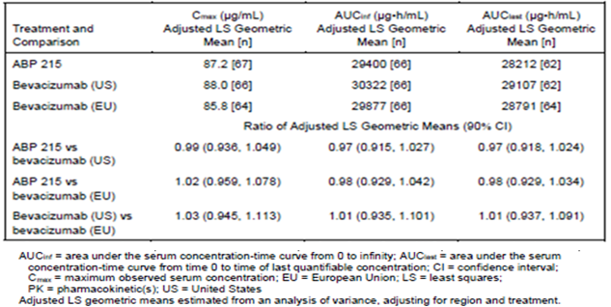
In Study 265, the geometric mean trough serum concentration (C_{trough} ) (ng/ml) was measured at Weeks 4, 7, 13 and 19 in patients receiving Avastin or ABP 215. The adjusted LS geometric mean C_{trough} was comparable at each time point. In summary, the results of these studies suggest no clinically meaningful differences in the pharmacokinetics of Avastin (US-sourced), Avastin (EU-sourced) and Mvasi (ABP 215).

Population pharmacokinetics data
The sponsor applied a previously published population PK model of expected bevacizumab concentrations. Based on this model, the sponsor reported that the prediction corrected observed data for ABP 215 and Avastin were adequately contained within the 95% prediction corrected intervals, and concluded that PK similarity between ABP 215 and Avastin could be expected to hold in different types of cancer.

Pharmacodynamics
This is not relevant as there is no established pharmacodynamics (PD) endpoint for bevacizumab in oncology.

Efficacy

Randomised clinical comparability study: Study 265
There was one study (Study 265) providing comparative clinical data for ABP 215 which is summarised in Table 4. This study will be summarised first then the results will be discussed.
Table 4: Study 265 Study outline and summary
Study 265 | A randomised, double-blind, Phase III study evaluating the efficacy and safety of ABP 215 compared with bevacizumab in subjects with advanced non-small cell lung cancer
Patients  n = 642 | Stage 4 or recurrent metastatic non small cell lung cancer (NSCLC), histologically or cytologically confirmed.  Also refer to ‘Brief summary of inclusion criteria’ and ‘Brief summary of exclusion criteria’, below.
ABP 215 arm  n = 328 | ABP 215 15 mg/kg intravenously (IV), and carboplatin AUC 6 mg/mL/min IV, and paclitaxel 200 mg/m² IV, every 3 weeks for a total of 6 cycles.
Avastin arm  n = 314 | Avastin (EU-sourced) 215 15 mg/kg IV, and carboplatin AUC 6 mg/mL/min IV, and paclitaxel 200 mg/m² IV, every 3 weeks for a total of 6 cycles.
Endpoints | Primary efficacy endpoint:  - Risk ratio (RR) of the overall response rate (ORR) of ABP 215 compared to Avastin.  - The ORR was assessed by the RECIST;1.1 guidelines by blinded independent central review.  - Note: primary analysis of this endpoint used the intention to treat (ITT) population and the secondary analysis of the same endpoint used the per protocol (PP) population.  Secondary efficacy endpoints:  - Risk difference for the ORR  - Duration of response (DOR)  - Progression-free survival (PFS)
AUC carboplatin dosing refers to pharmacokinetically individualised dosing based on the desired area under the concentration-time curve (AUC) as calculated by Calvert’s formula: total dose (mg) = target AUC (mg/mL x min) x (glomerular filtration rate (ml/min) + 25, with 25 representing the relatively constant nonrenal contribution to carboplatin clearance at 25 mL/min.
Note: the numbers included in this table are from the ITT population, consistent with the primary analysis of the primary efficacy endpoint. The PP population constituted approximately 86% of the ITT population.

Design
This was a randomised, double-blind, active-controlled study in adult subjects with non-squamous NSCLC receiving first-line chemotherapy with carboplatin and paclitaxel. Approximately 620 subjects (310 per treatment group) were randomised (1:1) to receive investigational product (Investigational Product (IP): ABP 215 or Avastin) at a dose of 15 mg/kg administered as an intravenous (IV) infusion every three weeks (Q3W) for six cycles. In addition, all subjects were to receive carboplatin (15 mg/kg IV) and paclitaxel (200 mg/m²) chemotherapy Q3W for at least four and not more than six cycles.
This is summarised in Figure 1. Note the treatment phase of 18 weeks includes 6 cycles of ABP 215 or Avastin.
Figure 1: Study 265 Study schema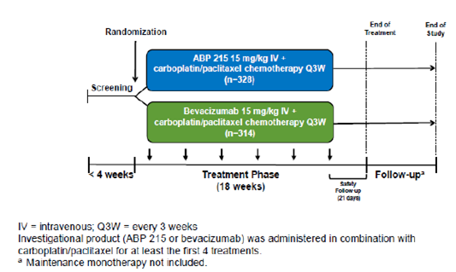

Locations
The Phase III Study 265 was conducted at 101 sites. A list of these sites was noted in on page 50 of the EMA report; and is summarised below:
- 14 sites in the USA
- 11 in Russia
- 10 in Australia
- 9 in Germany
- 8 in Poland
- 7 in Hungary
- 7 in Romania
- 6 in Italy
- 6 in Spain
- 5 in Bulgaria
- 5 in Greece
- 3 in the Czech Republic
- 3 in Mexico
- 3 in Taiwan
- 2 in the Netherlands
- 1 in Canada
- 1 in Hong Kong
The sites were grouped into geographic regions which included Eastern Europe, Western Europe, Asia Pacific/ Other and North America. The results were stratified by region and are summarised in Table 5.
Table 5: Study 265 Participants stratified by geographical region
Geographic Region  [n(%)] | ABP 215 arm  (N = 328) | Bevacizumab arm  (N = 314) | Total  (N = 642)
Eastern Europe | 189 (57.6) | 186 (59.2) | 375 (58.4)
Western Europe | 78 (23.8) | 76 (24.2) | 154 (24.0)
North America | 31 (9.5) | 26 (8.3) | 57 (8.9)
Asia Pacific/Other | 30 (9.1) | 26 (8.3) | 56 (8.7)
Source: EPAR for Mvasi.5
The first subject in Study 265 was enrolled on 11 November 2013, and last subject completed the study on 2 July 2015.

Brief summary of inclusion criteria
- Age ≥ 18 years and < 80 years
- Stage 4 or recurrent metastatic NSCLC (histologically or cytologically confirmed) with measurable disease according to modified RECIST;⁴ version 1.1
- If recurrent, at least 12 months since completing adjuvant chemotherapy
- Receiving first-line carboplatin/paclitaxel
- Baseline scan (computerised tomography (CT) or magnetic resonance imaging (MRI)) of chest and abdomen ≤ 28 days prior enrolling in study
- Commencing chemotherapy within 8 days of randomisation
- Must receive at least 4 cycles of chemotherapy

Brief summary of exclusion criteria
- Any non-study cancer treatment
- Commercial bevacizumab treatment
- Any other clinical trial (experimental) therapy.

Efficacy endpoints
Table 6: Efficacy endpoints
Efficacy endpoint | Details
Primary efficacy endpoint | Risk ratio (RR) of the overall response rate (ORR), as assessed by blinded independent central review of ABP 215 compared to Avastin  - Note: ORR was defined by the incidence rates of complete response and partial response using RECIST;⁴ v1.1  - The pre-specified equivalence margin was 0.67 to 1.5  - The primary analysis of the ORR was based on the ITT population  - The secondary analysis of the ORR was based on the PP population
Secondary efficacy endpoints | - Risk difference for the ORR:  - The sponsor included data regarding the risk difference in the ITT population, in the PP population and the tumour response set  - The pre-specified equivalence margin was -12.5% to 12.5%  - Duration of response (DOR)  - Progression-free survival (PFS)
Note about the pre-specified equivalence margin: 0.67 to 1.5 appears to be a wide equivalence margin for the estimated risk ratio for the ORR. To consider this further, the US Food and Drug Association (FDA)summary report for Mvasi; was reviewed:
- The FDA initially provided advice about the non-inferiority margin in 2011.
- In 2014, the FDA issued the sponsor with further advice regarding an acceptable approach to the determination of the similarity margin based on a meta-analysis.
- In 2015, a meeting was held between the sponsor and the FDA. The sponsor advised that they were unable to use the FDA’s proposed non-inferiority margin as Study 265 had completed enrolment. Following this meeting, the FDA advised that ‘the applicant’s margins for Study 265 would be considered in the context of the totality of the evidence.’
- It is stated that the similarity margins were 0.67to1.5 (proposed by the sponsor) and 0.73 to1.36 (proposed by the FDA).

Analysis populations
The following information about populations is sourced from page 53 of the EMA report.⁵
Intent to treat (ITT) population: all subjects randomised to ABP 215 (n = 328) or Avastin (n = 314) (total, n = 642).
Per protocol (PP) population: all subjects who completed the treatment period (six cycles of the IP and at least four cycles of chemotherapy) or who discontinue prior to completing the treatment period due to reasons allowed per protocol, and did not experience a protocol deviation that affected the evaluation: ABP 215 (n = 281), Avastin (n = 274).
Tumour response set: all randomised subjects who were treated with the IP and had measurable disease at screening: ABP 215 (n = 317), Avastin (n = 305).
Safety analysis (SAF) population: all randomised subjects who received at least one cycle of the IP: ABP 215 (n = 324), Avastin (n = 309) (total, n = 633).
All the randomised subjects were included in the ITT population. Of the randomised subjects, 633 subjects (98.6%; 324 (98.8%) and 309 subjects (98.4%) on ABP 215 and bevacizumab reference, respectively) received at least one dose of bevacizumab and were included in the safety analysis set. The PP population constituted approximately 86% of the ITT population.
A summary;⁶ of the subject populations is presented in Table 7.
Table 7: Study 256 Subject populations
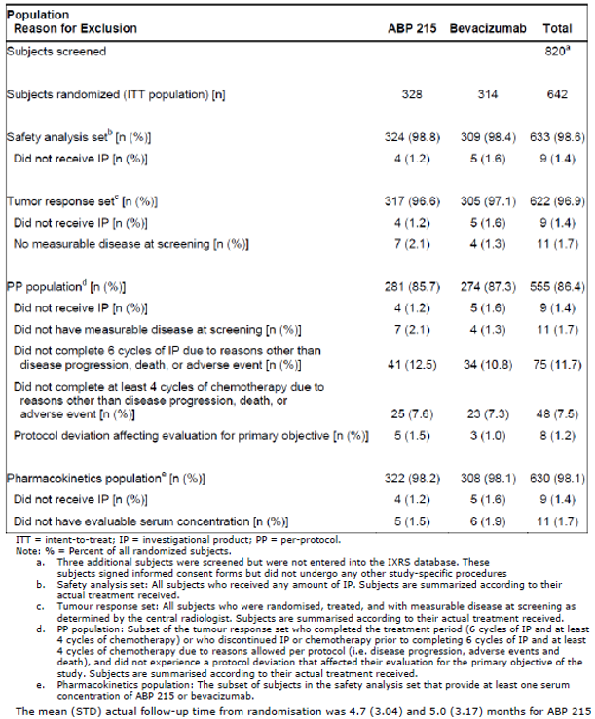

Baseline characteristics
There is a comprehensive 3 page table documenting the baseline characteristics of the subjects in Study 265 on page 51 to 53 of the EMA report.⁵ In summary, the baseline characteristics were approximately similar across the two treatment groups. Epidermal growth factor receptor (EGFR) and anaplastic lymphoma kinase (ALK) status was not required at Baseline for this Phase III study, although it was done in approximately 25% of patients. The EMA report notes that there has been recent clinical development of targeted drugs which has changed the treatment of NSCLC. However, the advice from the EMA’s Committee for Medicinal Products for Human Use (CHMP) in 2011 did not discuss the subject (as it was still novel) and the chosen strategy of not requiring EGFR and ALK status at enrolment was considered acceptable by the EMA in this context.

Results for the primary efficacy endpoint
The main focus will be on the primary endpoint. The primary endpoint is the risk ratio of the ORR, with the ORR assessed by the RECIST;⁴ version 1.1 guidelines by blinded independent central review. The primary analysis of this endpoint was done in the ITT population with a secondary analysis done in the PP population.
In the ITT population, the ORR in the ABP 215 group was 39% and was 41.7% in the Avastin. These results are consistent with the FDA’s predicted ORR of approximately 38% based on a meta-analysis. ⁶
The risk ratio of the ORR in the ITT population was 0.93 (95% CI: 0.77 to 1.12) which was within the pre-specified equivalence margin (0.67 to 1.5). This risk ratio is also within the FDA-proposed similarity margin of 0.73 to 1.36.
Table 8 summarises the efficacy data from the ITT population- this includes information about the risk ratio (primary endpoint) and the risk difference (a secondary endpoint).
Table 8: Study 265 Primary efficacy endpoint; summary of objective response rate (Intent to treat population)
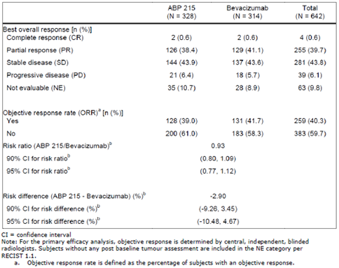
Source: Page 55 of the Mvasi EPAR.⁵
In addition, the sponsor performed a secondary analysis of the risk ratio of the ORR in the PP population. The ORR in the ABP 215 group was 43.1% and 45.6% in the Avastin group, both ORRs slightly higher than in the ITT population. The risk ratio was 0.94 (95% CI: 0.78 to 1.13).

Results for the secondary efficacy endpoints
There were also several secondary efficacy endpoints in Study 265 which were:
- Risk difference for the ORR (in the ITT population, in the PP population and the tumour response set):
  - in the ITT population, this was -2.90% (95% CI: -10.48% to 4.67%) which was within the pre-specified equivalence margin;
  - in the PP population, this was-2.82% (95% CI: -11.06% to 5.42%) which was also within the pre-specified equivalence margin.
- Duration of response (DOR) (median):
  - ABP 215: 5.8 months (95% CI: 4.9-7.7 months);
  - Avastin: 5.6 months (95% CI: 5.1 to 6.3 months).
- Progression-free survival (PFS) (median):
  - ABP 215: 6.6 months (95% CI: 6.3 to 7.9 months);
  - Avastin: 7.9 months (95% CI: 6.6 to 8.2 months).
To conclude, the results of the primary and secondary endpoints indicate the two treatment arms were similar in both the ITT population and the PP population. This is supportive of ABP 215 and Avastin being biosimilar.

Subgroup analysis
The primary endpoint, the risk ratio for the ORR, was also considered in subgroup analyses. The forest plot in Figure 2: Study 265 Forest plot of risk ratio of overall response rate by study subgroup (Intent to treat population) demonstrates the risk ratio of ORR by subgroup in the ITT population.
In summary, the means of the subgroup analyses are approximately clustered around a risk ratio of 1 which is consistent with the primary endpoint result indicating no significant difference between ABP 215 and Avastin.
Figure 2: Study 265 Forest plot of risk ratio of overall response rate by study subgroup (Intent to treat population)
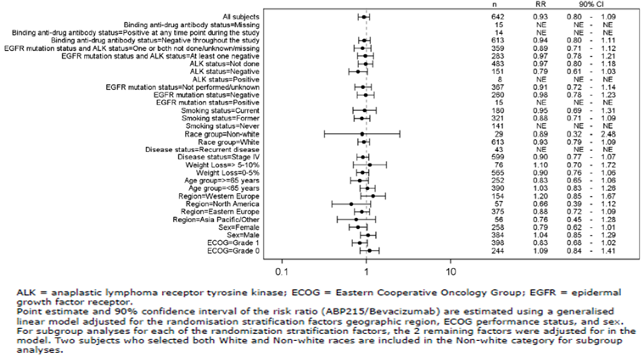

Safety
The safety profile of Avastin is well characterised given it has been on the market for over 10 years. The data presented by the sponsor relates to Study 265 (the Phase III trial in patients with metastatic NSCLC) and Study 216 (the Phase I single dose pharmacokinetic study in healthy male volunteers). A total of 835 subjects received at least one dose of ABP 215 or bevacizumab (US- or EU-sourced)
The focus in this overview will be on the data from Study 265 (pages 11 to12 of the EMA assessment report.)⁵ 324 subjects in this study received at least one dose of ABP 215.

Exposure
Table 9 summarises the subject exposure to ABP 215 and Avastin. This is based on the safety analysis population, the 633 subjects who received at least one dose of ABP 215 or Avastin. It is slightly smaller than the ITT population of 642 subjects.
Table 9: Study 265 Subject exposure to ABP 215 and Avastin
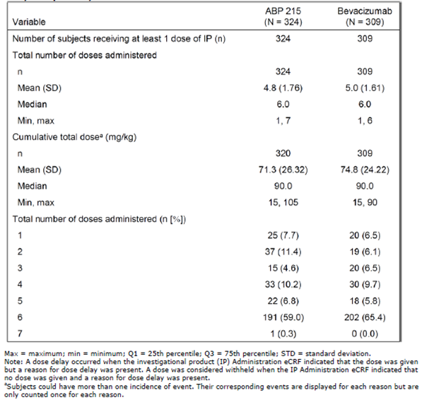
Source: Pages 11 to 12 of the Mvasi EPAR.⁵
The duration of treatment was 18 weeks in Study 265. However, only 59.3% of the subjects receiving ABP 215 and 65.4% of the subjects receiving Avastin completed treatment.

Treatment-emergent adverse events and discontinuations
Treatment-emergent adverse events (TEAEs) were common, with 95.1% of the subjects in the ABP 215 group reporting a TEAE and 93.5% of the Avastin group reporting a TEAE. Table 10 summarises TEAEs which is detailed in page 68 of the EMA summary.⁵
Table 10: Study 265 Summary of treatment emergent adverse events(Safety analysis population)
Category | ABP 215  (N = 324)  N (%) | Bevacizumab  (N = 309)  N (%) | Total  (N = 633)  N (%)
Any TEAE | 308 (95.1) | 289 (93.5) | 597 (94.3)
Any Grade ≥ 3 TEAE | 139 (42.9) | 137 (44.3) | 276 (43.6)
Any fatal TEAE | 13 (4.0) | 11 (3.6) | 24 (3.8)
Any serious TEAE | 85 (26.2) | 71 (23.0) | 156 (24.6)
TEAE leading to discontinuation of IP | 61 (18.8) | 53 (17.2) | 114 (18.0)
TEAE leading to discontinuation of any component of chemotherapy | 68 (21.0) | 52 (16.8) | 120 (19.0)
Note: Only TEAEs are summarised. For each category, subjects are included only once, even if they experienced multiple events in that category.
18.8% of TEAEs led to the discontinuation of ABP 215 and 17.2% of TEAEs led to the discontinuation of bevacizumab. 42.9% of the TEAEs in the ABP 215 group were of a grade higher than or equal to 3; and 44.3% of the TEAEs in the bevacizumab group were of a grade higher than or equal to 3. Common treatment-emergent adverse events (experienced by more than 5% of subjects) are summarised in page 69 of the EMA assessment report (Table 11).
Table 11: Study 265 Common treatment emergent adverse events experienced by 5% or greater of subjects
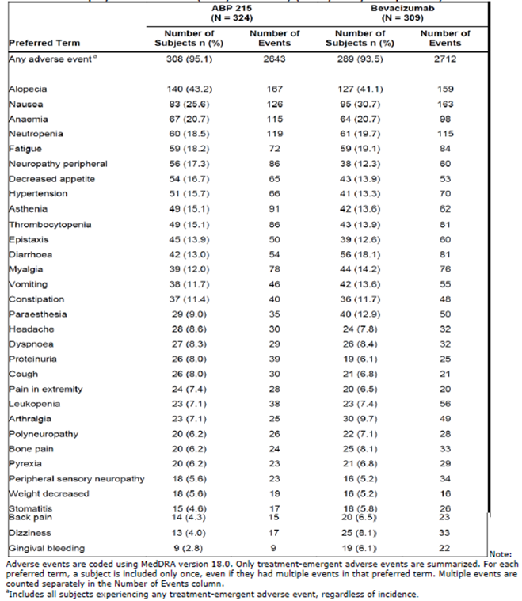
Source: EPAR for Mvasi.5
In addition, the US label for Mvasi was reviewed to consider post-market data from Avastin prescribing. According to this, the most common adverse reactions (with an incidence of at least 10% and at least twice the control arm rate) to Mvasi are: epistaxis, headache, hypertension, rhinitis, proteinuria, taste alteration, dry skin, rectal haemorrhage, lacrimation disorder, back pain and exfoliative dermatitis.
Supporting the above, the FDA has the following boxed warning for Mvasi regarding gastrointestinal perforations, surgery and wound healing complications and haemorrhage:
‘WARNING: GASTROINTESTINAL PERFORATIONS, SURGERY AND WOUND HEALING COMPLICATIONS, and HEMORRHAGE
See full prescribing information for complete boxed warning.
- Gastrointestinal Perforation: Occurs in up to 3.2% of bevacizumab product-treated patients. Discontinue Mvasi for gastrointestinal perforation. (5.1)
- Surgery and Wound Healing Complications: Discontinue in patients with wound dehiscence. Discontinue at least 28 days prior to elective surgery. Do not initiate Mvasi for at least 28 days after surgery and until the surgical wound is fully healed. (5.3)
- Hemorrhage: Severe or fatal hemorrhage, hemoptysis, gastrointestinal bleeding, CNS hemorrhage, and vaginal bleeding are increased in bevacizumab product-treated patients. Do not administer Mvasi to patients with serious hemorrhage or recent hemoptysis. (5.4)’

Grade 5 treatment-emergent adverse events
There were 24 deaths in total in Study 265. The EMA evaluator considered the case narratives and summarised their findings in page 74 of the EMA assessment report:⁵
- 4 fatal TEAEs were reported as related to the investigational product (IP) - 2 in the ABP 215 group (Intestinal perforation and Rectal Haemorrhage) and 2 in the bevacizumab group (Haemoptysis and Bronchial fistula)
- 2 fatal TEAEs were reported as related to the IP, paclitaxel and carboplatin – 2 in the ABP 215 group (Rectal haemorrhage and Ischaemic cerebral infarction)
- 1 fatal TEAE was reported as related to paclitaxel and carboplatin in the ABP 215 treatment group (thrombocytopenia)
- The remaining 17 fatal TEAEs were reported as not related to the IP, paclitaxel or carboplatin adverse events of special interest.
The EMA report listed several adverse events of special interest (AESI) in pages 70 to 72.⁵ These were identified based on the mechanism of action and the clinical data available in prescribing information for Avastin.Table 12 summarises the incidence of AESIs. It includes data based on the safety analysis population, the 633 subjects who received at least one dose of ABP 215 or Avastin. It is slightly smaller than the ITT population of 642 subjects.
Table 12: Summary of adverse events of special interest from EMA Report of Mvasi
Adverse event of special interest | Incidence of event in the safety analysis population exposed to Mvasi  N = 324 | Incidence of event in the safety analysis population exposed to Avastin  N = 309
Infusion reaction adverse events | 133 (41%) | 125 (40.5%)
Peripheral sensory neuropathy adverse events | 97 (29.9%) | 78 (25.2%)
Neutropaenia and infection adverse events | 84 (25.9%) | 80 (25.9%)
Thrombotic microangiopathy adverse events | 76 (23.4%) | 59 (19.1%)
Haemorrhage adverse events | 72 (22.2%) | 66 (21.4%)
Pulmonary haemorrhage adverse events | 14 (4.3%) | 10 (3.2%)
Reversible posterior leukoencephalopathy syndrome adverse events | 16 (4.9%) | 9 (2.9%)
Arterial thromboembolic adverse events | 6 (1.9%) | 9 (2.9%)
Gastrointestinal perforation adverse events | 3 (0.9%) | 4 (1.3%)
Congestive heart failure adverse events | 2 (0.6%) | 1 (0.3%)
Non-gastrointestinal fistula formation adverse events | 2 (0.6%) | 2 (0.6%)
In summary, there was no clinically meaningful or relevant difference in AESIs between Mvasi and Avastin.

Immunogenicity
Study 265 assessed the incidence of immunogenicity which was found to be similar across the two groups. Patients were sampled for antidrug antibodies (ADAs) at Baseline, Week 7, Week 13 and Week 19 using a validated, two tiered immunoassay approach (screening assay and specificity assay).
There were no preexisting ADAs at Baseline in either group. In the ABP 215 group, 1.4% developed treatment-emergent ADAs. In the Avastin group, 2.5% developed treatment emergent ADAs. There was no apparent impact of ADAs on safety, activity or PK endpoints detected.
This is further evidence that there are no clinically meaningful differences berween ABP 215 and Avastin.

Risk management plan
The sponsor has submitted EU-risk management plan (RMP) version 0.3 (dated 29 September 2017; data lock point (DLP) 10 September 2015) and Australian specific Annex (ASA) version 2.0 (dated 8 December 2017) in support of this application. In response to TGA questions, the sponsor submitted an updated ASA (Version 3.0; dated 16 August 2018).
The summary of safety concerns and their associated risk monitoring and mitigation strategies; are summarised in Table 13.
Table 13: Summary of safety concerns
Summary of safety concerns |  | Pharmacovigilance |  | Risk minimisation
 |  | Routine | Additional | Routine | Additional
Important identified risks | Bleeding/haemorrhage |  | – |  | –
Important identified risks | Pulmonary haemorrhage |  | – |  | –
Important identified risks | Proteinuria |  | – |  | –
Important identified risks | Arterial thromboembolic events | * | – |  | –
Important identified risks | Hypertension |  | – |  | –
Important identified risks | Congestive heart failure | * | – |  | –
Important identified risks | Wound healing complications |  | – |  | –
Important identified risks | Gastrointestinal perforations |  | – |  | –
Important identified risks | Reversible posterior leukoencephalopathy syndrome |  | – |  | –
Important identified risks | Neutropaenia |  | – |  | –
Important identified risks | Venous thromboembolic events |  | – |  | –
Important identified risks | Fistula (other than gastrointestinal) |  | – |  | –
Important identified risks | Thrombotic microangiopathy |  | – |  | –
Important identified risks | Pulmonary hypertension |  | – |  | –
Important identified risks | Ovarian failure |  | – |  | –
Important identified risks | Hypersensitivity reactions/infusion reactions |  | – |  | –
Important identified risks | Gall bladder perforation |  | – |  | –
Important identified risks | Peripheral sensory neuropathy |  | – |  | –
Important identified risks | Cardiac disorders (excluding congestive heart failure and arterial thromboembolic events) |  | – |  | –
Important identified risks | Osteonecrosis of the jaw | * | – |  | –
Important identified risks | Necrotising fasciitis |  | – |  | –
Important identified risks | Adverse events following off-label intravitreal use |  | – |  | –
Important identified risks | Embryo-fetal development disturbance |  | – |  | –
Important identified risks | Osteonecrosis in children |  | – |  | –
Important potential risks | None |  | – |  | –
Missing information | Safety profile of the different treatment combinations in patients with non-squamous non-small cell lung cancer |  | – |  | –
Missing information | Long-term effects of Mvasi when used in the paediatric population |  | – |  | –
Missing information | Safety and efficacy in patients with renal impairment |  | – |  | –
Missing information | Safety and efficacy in patients with hepatic impairment |  | – |  | –
Missing information | Use in lactating women | * | – |  | –
* With targeted follow up questionnaire.
This summary of safety concerns is similar although not identical to the most recent one for Avastin which was completed in 2017 by TGA.⁹
In addition, the RMP evaluator states that:
- No additional pharmacovigilance activities are proposed. However, the innovator has an ongoing biomarker investigation (reported on a yearly basis), the objective of which is identification and selection of a more targeted population of patients most likely to benefit from the combination of bevacizumab and paclitaxel in the treatment of first-line metastatic breast cancer. In addition there is a long term study which will provide safety information regarding use of bevacizumab in the paediatric population after patients complete 5.5 years of follow up in Study BO20924.
- It is acceptable that no additional pharmacovigilance activities are proposed, as any results of the innovator’s studies above will flow onto Mvasi if the results lead to changes to the PI.
- No additional risk minimisation activities are proposed which is consistent with that of the innovator.
- The innovator Avastin PI does have not a Black Triangle symbol as bevacizumab was approved before the scheme was introduced. Therefore, the generic version does not need to be included in the Black Triangle Scheme.

Risk-benefit analysis

Delegate’s considerations

Extrapolation of indications for Mvasi
Avastin is currently registered for 10 indications. The clinical comparability study (Study 265) was performed in patients with NSCLC. Avastin is licensed for this indication in Australia (although not funded via the PBS).
Guidelines from the EMA; and FDA allow for the possibility that a biosimilar could be approved for one or more of the indications for the reference biological medicine, given sufficient scientific justification, using a ‘totality-of-evidence approach’. The guidelines discuss:
- Mechanism of action
- PK and distribution
- Dose, route-of-administration
- Immunogenicity
- Toxicity.
For Mvasi, the mechanism of action of bevacizumab is the same in all the indications. It is a monoclonal antibody that inhibits the binding of vascular endothelial growth factor to cell receptors on endothelial cells. Studies on the reference biological medicine (Avastin) show that the PK is the same for all indications. The dosage is the same for all the indications and it is administered by the same route (IV) in all indications. Data for the reference biological medicine (Avastin) show that bevacizumab has low immunogenicity across all indications. The available safety information for the reference biological medicine does not indicate that there are any significant differences in expected toxicities for each condition of use and patient population.
Given this information, extrapolation of indications for Mvasi to all the indications of Avastin in Australia is appropriate.

Proposed action
At present, the proposed regulatory action is approval. Mvasi has already been approved in the USA, Europe and Canada as a biosimilar to Avastin. The similarity of ABP 215 to the bevacizumab reference product has been demonstrated through comparability studies at the quality, nonclinical and clinical levels. The benefit–risk balance for Mvasi follows the benefit-risk balance for the reference product Avastin and is positive.

Questions for sponsor
- Mvasi has been approved for marketing in the USA, Europe and Canada. Has it been marketed yet in any country?
Mvasi has not been marketed in the USA, Europe and Canada.
- Is there any post-market safety data available for Mvasi?
In accordance with the approved Bevacizumab (Mvasi) periodic benefit risk evaluation report (PBRER) #1, dated 19 April 2018, ‘Bevacizumab (Mvasi) has not been marketed or distributed in any country, and therefore, there was no interval or cumulative postauthorization exposure during the reporting period of this PBRER/PSUR’ (that is, until 25 February 2018) Confirmation has been received from the Global Safety Officer on 22 November 2018 of no post-marketing exposure (no sales) in the United States of America. Queries currently pending regarding presence of post-marketing safety data reports for Mvasi and any post-marketing exposure data in other territories (data anticipated in week ending 30 November 2018).
- Why was the ITT population used for the primary analysis of the primary endpoint instead of the PP population?
The intent-to-treat (ITT) population consisting of all randomised subjects was used for the primary analysis for Study 20120265 (Study 265) based on a regulatory agency request due to concerns about missing data issue associated with the per-protocol population. The pre-protocol population was used for a sensitivity analysis to support the results from the primary analysis for Study 20120265.
- In Canada, Mvasi was approved for some but not all the indications that Avastin is approved for. Why was this?
The sponsor did not seek approval for certain indications for patent reasons.
- Mvasi is not approved in the USA for the treatment of ovarian, fallopian tube, or primary peritoneal cancer as this indication for Avastin is under an ‘orphan drug exclusivity’ arrangement. Could you please explain a bit more about what this means?
Orphan drug exclusivity (effective for seven years) is granted to drugs designated and approved to treat diseases or conditions affecting fewer than 200,000 in the US (or more than 200,000 and no hope of recovering costs). Orphan drug exclusivity for Avastin expires in following years:
- 13 June 2025: In combination with carboplatin and paclitaxel, followed by Avastin as a single agent, is indicated for the treatment of patients with Stage III or IV epithelial ovarian, fallopian tube, or primary peritoneal cancer following initial surgical resection.
- 14 November 2021: In combination with paclitaxel, pegylated liposomal doxorubicin, or topotecan for treatment of patients with platinum-resistant, recurrent epithelial ovarian, fallopian tube, or primary peritoneal cancer who have received no more than two prior chemotherapy regimens.
- 6 December 2023: Either in combination with carboplatin and paclitaxel or in combination with carboplatin and gemcitabine, followed by Avastin as a single agent, is indicated for the treatment of patients with platinum-sensitive recurrent epithelial ovarian, fallopian tube, or primary peritoneal cancer.

Outcome
Based on a review of quality, safety and efficacy, the TGA approved the registration of Mvasi (bevacizumab), 100 mg/4 mL injection concentrated vial and 400 mg/16 mL injection concentrated vial, indicated for:
Metastatic colorectal cancer
Mvasi (bevacizumab) in combination with fluoropyrimidine-based chemotherapy is indicated for the treatment of patients with metastatic colorectal cancer.
Locally recurrent or metastatic breast cancer
Mvasi (bevacizumab) in combination with paclitaxel is indicated for the first-line treatment of metastatic breast cancer in patients in whom an anthracycline-based therapy is contraindicated. (see section 5.1 Pharmacodynamic properties, Clinical trials).
Advanced, metastatic or recurrent non-squamous non-small cell lung cancer (NSCLC)
Mvasi (bevacizumab), in combination with carboplatin and paclitaxel, is indicated for first-line treatment of patients with unresectable advanced, metastatic or recurrent, non-squamous, non-small cell lung cancer.
Advanced and/or metastatic renal cell cancer
Mvasi (bevacizumab) in combination with interferon alfa-2a is indicated for treatment of patients with advanced and/or metastatic renal cell cancer.
Grade IV glioma
Mvasi (bevacizumab) as a single agent, is indicated for the treatment of patients with Grade IV glioma after relapse or disease progression after standard therapy, including chemotherapy.
Epithelial ovarian, fallopian tube or primary peritoneal cancer
Mvasi (bevacizumab) in combination with carboplatin and paclitaxel, is indicated for first-line treatment of patients with advanced (FIGO stages IIIB, IIIC and IV) epithelial ovarian, fallopian tube, or primary peritoneal cancer.
Recurrent epithelial ovarian, fallopian tube or primary peritoneal cancer
Mvasi (bevacizumab), in combination with carboplatin and paclitaxel or in combination with carboplatin and gemcitabine, is indicated for the treatment of patients with first recurrence of platinum-sensitive, epithelial ovarian, fallopian tube, or primary peritoneal cancer who have not received prior bevacizumab or other VEGF-targeted angiogenesis inhibitors.
Mvasi (bevacizumab) in combination with paclitaxel, topotecan or pegylated liposomal doxorubicin is indicated for the treatment of patients with recurrent, platinum-resistant epithelial ovarian, fallopian tube, or primary peritoneal cancer who have received no more than two prior chemotherapy regimens, and have not received any prior anti-angiogenic therapy including bevacizumab.
Cervical cancer
Mvasi (bevacizumab) in combination with paclitaxel and cisplatin is indicated for the treatment of persistent, recurrent or metastatic carcinoma of the cervix. Mvasi (bevacizumab) in combination with paclitaxel and topotecan is an acceptable alternative where cisplatin is not tolerated or not indicated.’’

Specific conditions of registration applying to these goods
- The ABP 215 (bevacizumab biosimilar) European Union-Risk Management Plan (EU-RMP) (Version 0.3; dated 29 September 2017; DLP 10 September 2015), with Mvasi ASA (Version 3.0; dated 16 August 2018), included with submission PM-2017-04616-1-4, and any subsequent revisions, as agreed with the TGA will be implemented in Australia.
An obligatory component of risk management plans is routine pharmacovigilance. Routine pharmacovigilance includes the submission of periodic safety update reports (PSURs).
Reports are to be provided in line with the current published list of EU reference dates and frequency of submission of PSURs until the period covered by such reports is not less than three years from the date of the approval letter.
The reports are to at least meet the requirements for PSURs as described in the European Medicines Agency’s Guideline on Good Pharmacovigilance Practices (GVP) Module VII Periodic Safety Update Report (Rev 1), Part VII.B Structures and processes. Note that submission of a PSUR does not constitute an application to vary the registration. Each report must have been prepared within ninety calendar days of the data lock point for that report.
- Batch release testing and compliance with Certified Product Details (CPD);
  - It is a condition of registration that all batches of Mvasi (bevacizumab) imported into/manufactured in Australia must comply with the product details and specifications approved during evaluation and detailed in the CPD.
  - It is a condition of registration that each batch of Mvasi (bevacizumab) imported into Australia is not released for sale until samples and/or the manufacturer’s release data have been assessed and endorsed for release by the TGA Laboratories branch. Outcomes of laboratory testing are published biannually in the TGA database of laboratory testing results http://www.tga.gov.au/ws-labs-index.
  - The sponsor should be prepared to provide product samples, reference materials and documentary evidence as defined by the TGA Laboratories branch. The sponsor must contact Biochemistry.Testing@health.gov.au for specific material requirements related to the batch release testing/assessment of the product. More information on TGA testing of biological medicines is available at https://www.tga.gov.au/publication/testingbiological-medicines.
This batch release condition will be reviewed and may be modified on the basis of actual batch quality and consistency. This condition remains in place until the sponsor is notified in writing of any variation.
- Certified Product Details
The CPD, as described in Guidance 7: Certified Product Details of the Australian Regulatory Guidelines for Prescription Medicines (ARGPM) (http://www.tga.gov.au/industry/pm-argpm-guidance-7.htm), in PDF format, for the above products should be provided upon registration of these therapeutic goods. In addition, an updated CPD should be provided when changes to finished product specifications and test methods are approved in a Category 3 application or notified through a self-assessable change.
- For all injectable products the Product Information (PI) must be included with the product as a package insert.

Attachment 1. Product Information
The PI for Mvasi approved with the submission which is described in this AusPAR is at Attachment 1. For the most recent PI, please refer to the TGA website at <https://www.tga.gov.au/product-information-pi>
Therapeutic Goods Administration
PO Box 100 Woden ACT 2606 Australia
Email: info@tga.gov.au Phone: 1800 020 653 Fax: 02 6232 8605
https://www.tga.gov.au

The Black Triangle Scheme provides a simple means for practitioners and patients to identify certain types of new prescription medicines, including those being used in new ways and to encourage the reporting of adverse events associated with their use. The Black Triangle does not denote that there are known safety problems, just that the TGA is encouraging adverse event reporting to help us build up the full picture of a medicine's safety profile.
Avastin (bevacizumab) 100 mg/4 mL and 400 mg/16 mL injection was first registered on the ARTG on 24 February 2005 (AUST R 99755 and 99757).
Goel, S. et al. Normalization of the vasculature for treatment of cancer and other diseases. Physiol Rev. 2011; 91: 1071-1121.
RECIST is ‘Response evaluation criteria in solid tumours’ - a set of published rules that define when tumours in cancer patients improve (‘respond’), stay the same (‘stabilise’), or worsen (‘progress’) during treatment.
EMA, European Public Assessment Report (EPAR), Mvasi (bevacizumab), EMA/798844/2017, 9 November 2017. Available from the EMA website.
FDA, Center for Drug Evaluation and Research, summary review, Mvasi (bevacizumab-awwb), 14 September 2017. Available from the FDA website.
FDA Highlights of prescribing information for Mvasi(bevacizumab-awwb), solution for intravenous infusion, first approval 2017. Available from the FDA website.
Routine risk minimisation activities may be limited to ensuring that suitable warnings are included in the product information or by careful use of labelling and packaging. Routine pharmacovigilance practices involve the following activities: - All suspected adverse reactions that are reported to the personnel of the company are collected and collated in an accessible manner; - Reporting to regulatory authorities; - Continuous monitoring of the safety profiles of approved products including signal detection and updating of labelling; - Submission of PSURs; - Meeting other local regulatory agency requirements.
Australian Public Assessment report (AusPAR) for bevacizumab (Avastin), May 2017, Available from the TGA website.
European Medicines Agency (EMA), Scientific guideline on biosimilar medicinal products, CHMP/437/04 Rev.1, April 2015
These batch testing conditions are those imposed at the time of approval, and have since been amended on 10 August 2020 to the following: Laboratory testing and compliance with Certified Product Details (CPD) - All batches of ‘the Product/s’ supplied in Australia must comply with the product details and specifications approved during evaluation and detailed in the Certified Product Details (CPD). - When requested by the TGA, the sponsor should be prepared to provide product samples, specified reference materials and documentary evidence to enable the TGA to conduct laboratory testing on the Product. Outcomes of laboratory testing are published biannually in the TGA Database of Laboratory Testing Results http://www.tga.gov.au/ws-labs index and periodically in testing reports on the TGA website.

