February 2014

Australian Public Assessment Report for besifloxacin hydrochloride
  - Proprietary Product Name: Besivance
  - Sponsor: Bausch & Lomb (Australia) Pty Ltd
About the Therapeutic Goods Administration (TGA)
- The Therapeutic Goods Administration (TGA) is part of the Australian Government Department of Health, and is responsible for regulating medicines and medical devices.
- The TGA administers the Therapeutic Goods Act 1989 (the Act), applying a risk management approach designed to ensure therapeutic goods supplied in Australia meet acceptable standards of quality, safety and efficacy (performance), when necessary.
- The work of the TGA is based on applying scientific and clinical expertise to decision-making, to ensure that the benefits to consumers outweigh any risks associated with the use of medicines and medical devices.
- The TGA relies on the public, healthcare professionals and industry to report problems with medicines or medical devices. TGA investigates reports received by it to determine any necessary regulatory action.
- To report a problem with a medicine or medical device, please see the information on the TGA website <http://www.tga.gov.au>.
About AusPARs
- An Australian Public Assessment Record (AusPAR) provides information about the evaluation of a prescription medicine and the considerations that led the TGA to approve or not approve a prescription medicine submission.
- AusPARs are prepared and published by the TGA.
- An AusPAR is prepared for submissions that relate to new chemical entities, generic medicines, major variations, and extensions of indications.
- An AusPAR is a static document, in that it will provide information that relates to a submission at a particular point in time.
- A new AusPAR will be developed to reflect changes to indications and/or major variations to a prescription medicine subject to evaluation by the TGA.
Copyright
© Commonwealth of Australia 2014
This work is copyright. You may reproduce the whole or part of this work in unaltered form for your own personal use or, if you are part of an organisation, for internal use within your organisation, but only if you or your organisation do not use the reproduction for any commercial purpose and retain this copyright notice and all disclaimer notices as part of that reproduction. Apart from rights to use as permitted by the Copyright Act 1968 or allowed by this copyright notice, all other rights are reserved and you are not allowed to reproduce the whole or any part of this work in any way (electronic or otherwise) without first being given specific written permission from the Commonwealth to do so. Requests and inquiries concerning reproduction and rights are to be sent to the TGA Copyright Officer, Therapeutic Goods Administration, PO Box 100, Woden ACT 2606 or emailed to <tga.copyright@tga.gov.au>.

Contents
I. Introduction to product submission 4
Submission details 4
Product background 4
Regulatory status 5
Product Information 5
II. Quality findings 5
Drug substance (active ingredient) 5
Drug product 6
Biopharmaceutics 7
Quality summary and conclusions 7
III. Nonclinical findings 7
Introduction 7
Pharmacology 8
Pharmacokinetics 11
Toxicology 12
Nonclinical summary and conclusions 16
IV. Clinical findings 18
Introduction 18
Pharmacokinetics 19
Pharmacodynamics 19
Efficacy 19
Safety 19
Clinical summary and conclusions 20
List of questions 21
V. Pharmacovigilance findings 21
Risk management plan 21
VI. Overall conclusion and risk/benefit assessment 28
Quality 28
Nonclinical 28
Clinical 29
Risk management plan 33
Risk-benefit analysis 33
Outcome 43
Attachment 1. Product Information 44
Attachment 2. Extract from the Clinical Evaluation Report 44

I. Introduction to product submission

Submission details
Type of submission: | New Chemical Entity
Decision: | Approved
Date of decision: | 29 October 2013
Active ingredient: | Besifloxacin hydrochloride
Product name: | Besivance
Sponsor’s name and address: | Bausch & Lomb (Australia) Pty Ltd  16 Giffnock Avenue  Macquarie Park NSW 2113
Dose form: | Suspension eye drops
Strength: | 0.6% w/v
Container: | Polyethylene bottle
Pack sizes: | 2 mL and 5 mL
Approved therapeutic use: | Besivance is indicated for the treatment of severe, confirmed bacterial conjunctivitis caused by besifloxacin sensitive bacteria.  Besivance is indicated for adults and children 12 months and older.
Route of administration: | Ophthalmic
Dosage: | One drop in the affected eye three times daily
ARTG number: | 201509

Product background
This AusPAR describes a submission by the sponsor, Bausch & Lomb (Australia) Pty Ltd, to register a new chemical entity, Besivance, besifloxacin hydrochloride 0.6% ophthalmic suspension. The proposed indication is:
for the treatment of bacterial conjunctivitis caused by susceptible isolates of the following bacteria: CDC Coryneform group G, Corynebacterium pseudodiphtheriticum*, Corynebacterium striatum*, Haemophilus influenzae, Moraxella lacunata*, Staphylococcus aureus, Staphylococcus epidermidis, Staphylococcus hominis*, Staphylococcus lugdunesis*, Streptococcus mitis group, Streptococcus oralis, Streptococcus pneumoniae, Streptococcus salivarius*.
* Efficacy for this organism was studied in fewer than 10 infections.
Besifloxacin hydrochloride is an 8-chloro-fluoroquinolone antibiotic suspension for topical ophthalmic use. Other fluoroquinolones (FQs) registered in Australia include ciprofloxacin, moxifloxacin, norfloxacin and ofloxacin, with ciprofloxacin and ofloxacin registered for topical treatment of bacterial conjunctivitis.
Besifloxacin imparts its action by inhibiting bacterial DNA gyrase and topoisomerase IV. DNA gyrase is an essential enzyme required for replication, transcription and repair of bacterial DNA. Topoisomerase IV is an essential enzyme required for portioning of chromosomal DNA during bacterial cell division. Besifloxacin has an N-1 cyclopropyl group, which provides broad spectrum activity against common aerobic, Gram positive (+ve) and Gram negative (-ve) bacteria causing conjunctivitis. The activity is enhanced by a chloride substitution at the C-8 position.
Besivance has been developed with the Durasite delivery system which is intended to increase residence time of the active ingredient on the ocular surface, to allow less frequent dosing than other topical agents used for treatment of bacterial conjunctivitis.
Besifloxacin hydrochloride is proposed for treatment of bacterial conjunctivitis. Clinical resolution of bacterial conjunctivitis can occur without any treatment in 7 days. The rationale for antibacterial treatment is to shorten duration of disease and reduce this risk of contagious spread.

Regulatory status
Besifloxacin HCl Ophthalmic Suspension 0.6% is approved for use in the USA (28 May 2009), Canada (23 October 2009), Argentina (18 March 2010), South Korea (31 May 2010), Brazil (27 January 2011), Hong Kong (21 February 2011), Taiwan (23 June 2011), Singapore (23 September 2011), Malaysia (19 January 2012), Thailand (10 May 2012), India (12 June 2012), Vietnam (22 June 2012), and Mexico (8 January 2013).
The approved indications in the USA are:
Besivance (besifloxacin ophthalmic suspension) 0.6%, is a quinolone antimicrobial indicated for the treatment of bacterial conjunctivitis caused by susceptible isolates of the following bacteria: Aerococcus viridans*, CDC coryneform group G, Corynebacterium pseudodiphtheriticum*, Corynebacterium striatum*, Haemophilus influenzae, Moraxella catarrhalis*, Moraxella lacunata*, Pseudomonas aeruginosa*, Staphylococcus aureus, Staphylococcus epidermidis, Staphylococcus hominis*, Staphylococcus lugdunensis*, Staphylococcus warneri*, Streptococcus mitis group, Streptococcus oralis, Streptococcus pneumoniae, Streptococcus salivarius*.
* Efficacy for this organism was studied in fewer than 10 infections.

Product Information
The approved Product Information (PI) current at the time this AusPAR was prepared can be found as Attachment 1.

II. Quality findings

Drug substance (active ingredient)
The chemical structure of the drug substance, besifloxacin hydrochloride, is shown in Figure 1.
Figure 1: Chemical structure of besifloxacin hydrochloride.
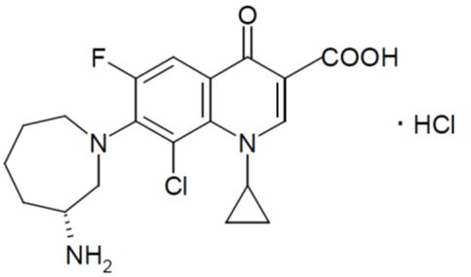
Besifloxacin hydrochloride is manufactured by a seven step chemical synthesis starting with D-amino caprolactam and ‘Q-acid’ containing the FQ moiety.
Besifloxacin hydrochloride is a white to pale yellowish/white powder. No polymorphs of besifloxacin hydrochloride are known.
The drug substance has one chiral center at the C-3’ position and is the R-enantiomer. Interconversion between enantiomers has not been observed.
Besifloxacin hydrochloride is sparingly soluble in water. The solubility profile of the drug substance in solutions at various pHs is consistent with the pKas of 5.6 (carboxylic acid) and 9.91 (primary amine). The observed partition coefficients (in octanol:buffer pH 2.0 – 12.0 solutions) range from -0.47 to -1.84.
The drug substance is micronised and the particle size is controlled to: volume mean diameter No More Than (NMT) 6 µm and Dv90 NMT 9 µm.
The proposed limit for the S-enantiomer, NMT 0.5%, was considered adequately qualified by the non-clinical evaluation section. The proposed drug substance specifications were acceptable.
The drug substance exhibits good stability when stored at 25°C over 36 months.

Drug product
Besivance eye drop suspension is a pale yellowish/white, opaque liquid containing 0.6% w/v of besifloxacin.
The eye drop suspension is sterile and contains an antimicrobial preservative. The liquid phase is a DuraSite delivery system containing polycarbophil, edetate disodium, sodium chloride, water and sodium hydroxide for pH adjustment together with benzalkonium chloride, mannitol and poloxamer. The evaluator calculated that approximately 1.5% of the drug substance is in solution in the drug product.
The Phase III clinical trial batches were manufactured to the same formulation as proposed for the commercial product.
The eye drop suspension is packaged into polyethylene bottles containing 2 mL or 5 mL with a controlled drop delivery tip.
During the manufacture of the suspension eyedrops, the drug substance is fully dissolved before precipitation at pH 6.5 to form the zwitterion active.
Data was provided to show that the particle size of the active does not increase over the shelf life of the product and only the zwitterion besifloxacin (not besifloxacin hydrochloride) was observed in dried aged batches.
The proposed release and shelf life specifications were adequately justified. The specifications include adequate control of the particle size of the active.
Stability data was generated under stressed, accelerated and long term storage conditions. The data supports the proposed shelf lives when the bottles are stored below 25°C.
In use stability data was also provided to support the proposed statement “discard after 4 weeks of opening”.

Biopharmaceutics
Bioavailability data are not required for this locally acting product. Data on the extent of systemic absorption of the drug will be evaluated by the clinical evaluator.

Quality summary and conclusions
The submission was not required to be considered by the Pharmaceutical Sub Committee (PSC) of the Advisory Committee on Prescription Medicines (ACPM).
All issues raised by the pharmaceutical chemistry section have been satisfactorily resolved by the company and approval can be recommended from a pharmaceutical chemistry perspective.

III. Nonclinical findings

Introduction
Bausch & Lomb (Australia) Pty Ltd has applied to register besifloxacin hydrochloride 0.6% ophthalmic solution (Besivance) as a new prescription medicine. Besivance is proposed for the treatment of bacterial conjunctivitis arising from the following strains of bacteria:
- CDC coryneform group G
- Corynebacterium pseudodiphtheriticum
- Corynebacterium striatum
- Haemophilus influenzae
- Moraxella lacunata
- Staphylococcus aureus
- Staphylococcus epidermidis
- Staphylococcus hominis
- Staphylococcus lugdunensis
- Streptococcus mitis group
- Streptococcus oralis
- Streptococcus pneumoniae
- Streptococcus salivarius
The Besivance dose regimen for patients over 1 year of age is 1 drop of a 0.6% besifloxacin solution, 3 times a day (TID; ter in die), 4-12 h apart, for 7 days to the affected eye.

General comments
Besifloxacin is a fifth generation FQ; a well established class of anti bacterial agent. The nonclinical module of the dossier was composed of primary (microbiology), secondary and safety pharmacology, absorption and plasma pharmacokinetic, single and repeat dose toxicity, genotoxicity, reproductive and development, photoallergenic, phototoxicity and chronic ocular toxicity studies. An Australian Antibiotic Resistance Risk Assessment was provided. Pivotal toxicity studies were Good Laboratory Practice (GLP) compliant and toxicokinetic data were provided for relevant studies.

Pharmacology
An Australian antibiotic risk assessment was submitted. The nonclinical microbiology studies are reported as summarised by the sponsor.

In vitro studies

Mechanism of action
Based on studies examining catalytic inhibition and cleavable complex stimulation with DNA gyrase and topoisomerase IV (Study PHA-005), and DNA decatenation and relaxation by human topoisomerase IIα (Study PHA-006), it was proposed that besifloxacin inhibits DNA gyrase and topoisomerase IV. The inhibition hinders bacterial DNA replication and partitioning. The tests were performed using Streptococcus pneumoniae, S. aureus, and Escherichia coli (Study PHA-005). With the exception of S. aureus, DNA gyrase and topoisomerase IV were noted as the primary and secondary targets, respectively. In S. aureus, besifloxacin is likely to simultaneously target DNA gyrase and topoisomerase IV.
Besifloxacin inhibition of human topoisomerase IIα was several orders of magnitude higher than S. pneumonia, and thus, unlikely to affect human cells at clinical doses (compared to IC₅₀ [50% inhibitory concentration]; 1000 µM and 5 µM in human and bacteria, respectively (Study PHA-006)). The besifloxacin (+)enantiomer was found to be more active than the (-)enantiomer in S. aureus, Sarcina lutea, Enterococcus faecalis, E. faecalis, Micrococcus lysodeikticus and Bacillus subtilise (compared to the minimal inhibitory concentration [MIC] 0.012-0.2 µg/ml and 0.012-0.39 µg/ml for (+) and (-) besifloxacin, respectively; Study SS734PRE-003).

Resistance and cross resistance
In vitro resistance to besifloxacin developed slowly at low frequencies in S. aureus, S. pneumoniae and E. coli. The mutant prevention concentration (MPC) for the three strains was 0.12, 0.50 and 4 µg/ml, respectively. The relative proportions for each strain at x4 MIC were; < 3.3 x 10⁻¹⁰: S. aureus < 7 x 10⁻¹⁰: S. Pneumoniae < 3.8 x 10⁻⁸ E. coli (Study PHA-005). The concentration of besifloxacin in tear fluid was calculated to exceed the MIC for S. aureus and S. pneumoniae. To this end, human toxicokinetic studies in tears revealed a Single instillation was sufficiently in excess of the MIC₉₀ values of 1 μg/mL for Staphylococcus aureus and ≤ 0.06μg/mL for Haemophilus influenzae, suggesting therapeutic levels of the test article up to 24 h post instillation. The dual sites of action are proposed to contribute to the low proportion of resistant mutants.
Besifloxacin resistance was associated with mutations in gyrA or gyrB. In E. coli, areas other than quinolone resistance determining regions (QRDRs) appeared to be involved in resistance. Resistance mechanisms in this instance were speculative and included possibilities such as decreased permeability, increased efflux, or mutations outside QRDRs. In addition to mutations in the gyrase gene, the relatively high MIC in S. aureus also suggested yet uncharacterised mechanisms of resistance. The observed results are consistent with other FQ inhibitors ciprofloxacin, levofloxacin, gatifloxacin and moxifloxacin. Besifloxacin, ciprofloxacin, norfloxacin, ofloxacin and moxifloxacin also showed cross resistance; significant increases in MIC for one drug were correlated with remaining antibacterial agents (Study PHA-005 and MBC99K3020B). No cross resistance was noted in strains susceptible to azithromycin, tobramycin, oxacillin and penicillin. S. aureus and coagulase negative staphylococci strains resistant to ciprofloxacin, norfloxacin and ofloxacin were also mildly resistant to besifloxacin (16 fold less MIC). Strains resistant to ofloxacin and gentamicin also showed slightly elevated MIC for besifloxacin, though cross-resistance for gentamicin may have evolved independent of the FQ resistance pathway.
The outcomes of three clinical studies (Study M373, M433, and M434) are in agreement with the general cross reactivity findings of the in vitro studies. No cross reaction was noted with besifloxacin and other antibacterial classes, such as, macrolides, amino glycosides, tetracyclines, glycopeptides, or β-lactams. While some multi drug resistant (different drug classes) strains were noted, the mechanism of resistance is proposed as independent evolution and not cross resistance, which is acceptable (Study CMI06-15RB, CMI07-12R2B and 500421).

Antibacterial activity
The antimicrobial activity of besifloxacin was assessed against isolates of Gram +ve, Gram -ve, aerobic and anaerobic bacteria from eight in vitro studies and the MIC compared to that of ciprofloxacin, ofloxacin, levofloxacin, moxifloxacin, gatifloxacin and azithromycin, tobramycin, oxacillin and penicillin (Study BL-MIC-001B, BL-MIC-002B, CMI06-15RB, CMI07-12R2B, 500421and 500510). The MIC₅₀ and MIC₉₀ for besifloxacin ranged between 0.06-2.0 µg/ml for Staphylococcus pneumoniae, S. aureus, Corynebacterium and Propionibacterium (Gram +ve) strains and 0.06-4.0 µg/ml for H. influenzae, Moraxella, N. gonorrhoeae and P. aeruginosa (Gram -ve) strains (Study MBC99K3020B). Broadly comparable MIC₅₀ and MIC₉₀ ranges were also noted in other studies for different strains (Study 500421, 50010, and 07-MIC-392). Based on MIC₅₀ and MIC₉₀ values from these studies, the following hierarchy of FQ activity was proposed for Gram +ve cocci strains: besifloxacin > moxifloxacin > gatifloxacin > levofloxacin > ciprofloxacin (Study 500421). Against Gram -ve isolates ciprofloxacin and levofloxacin were generally the most active (except against M. morganii and L. pneumophilia). Similar hierarchical distribution was noted for the methicillin resistant and methicillin and tetracycline resistant S. aureus strains (Study 07-MIC-392).
The besifloxacin antimicrobial activity was comparable to ofloxacin and moxifloxacin in Gram -ve and anaerobic isolates (Study BL-MIC-001B, Study BL-MIC-002B and Study 500421). Comparable activity to gatifloxacin and moxifloxacin was noted in H. Influenza, N. gonorrhoeae and Neisseria strains. Besifloxacin was least effective against the E. cloacae strain compared to other FQs (MIC₅₀/MIC₉₀; 0.25/4.0 µg/ml; Study CMI06-15RB and Study CMI07-12R2).
In Study 500510, 100% of the S. aureus isolates had minimum bactericidal concentrations (MBCs) ≤ x8 the MIC of besifloxacin. The test article resulted in the greatest number of isolates with MBC:MIC ratios ≤2 (compared to 80%) compared to gatifloxacin (73%), moxifloxacin (67%) and ciprofloxacin (50%). In S. epidermidis 100% of the isolates had MBCs ≤ x4. Of the S. epidermidis isolates, 93% had MBC:MIC ratios ≤2 followed by 67% with gatifloxacin, 73% with moxifloxacin, and 60% with ciprofloxacin. In S. pneumoniae and H. influenza >90% of isolates had MBC:MIC ratios ≤2 in all FQs tested.

In vivo studies

Mouse systemic exposure studies
Mouse models using lethal systemic S. pneumoniae infections demonstrated improved mean survival times when treated with a 12.5, 25 and 50 mg/kg oral doses of besifloxacin immediately after bacterial inoculation when compared to the placebo (compared to 1.6 days versus >6 days for control and besifloxacin respectively, Study SS734PRE-001). The increased survival time was comparable to that of tosufloxacin at 12.5g, 25 and 50 mg/kg.

Rabbit ocular exposure studies
The in vivo efficacy of besifloxacin (0.6% suspension) against S. aureus was benchmarked against three other antibacterial agents (0.3% gatifloxacin, 0.5% levofloxacin and 0.5% moxifloxacin) in a rabbit model of endophthalamitis (Study BL07001, PH06164). The overall ophthalmic scores favoured besifloxacin over the comparator agents as follows: besifloxacin > gatifloxacin ~ levofloxacin ~ moxifloxacin ~ Saline ~ untreated. No conjunctival discharge was reported in all eyes treated with besifloxacin; discharge was noted in all other groups. No viable bacteria were isolated from aqueous humor of besifloxacin, gatifloxacin or moxifloxacin treated rabbits. Overall, outcomes from the in vivo studies appear to support findings of the in vitro studies.

Secondary pharmacodynamics and safety pharmacology
- Secondary pharmacodynamic pharmacology studies revealed besifloxacin mediated inhibition of lipopolysaccharide (LPS) and IL-1β induced cytokine production in vitro.
- Specialised safety pharmacology studies covered the cardiovascular, respiratory and renal systems; besifloxacin related effects were noted in the cardiovascular and renal systems.

Secondary pharmacodynamics
The anti inflammatory properties of besifloxacin were investigated and compared to the fourth generation FQ, moxifloxacin. In three separate studies, besifloxacin inhibited LPS and IL-1β-induced cytokine production in THP-1 monocyte and HCEpiC assays. The inhibitory potencies were comparable to or higher than that of moxifloxacin. Cytokines, IL-1β, IL-8, IP-10 and MIP-1 were inhibited with comparable potency, and IL-6, GM-CSF, MCP-1, TGF-α and TNF-α were inhibited with comparable or higher potency to moxifloxacin at concentrations between 1.0-30 µg/ml.

Safety pharmacology
No safety pharmacology studies were performed on the central nervous system (CNS). While the test article was detected in the brain following ocular administration in rabbit studies (studies B16F0205 and B06U0106), the levels detected were minimal. Based on low systemic exposure and minimal effects observed in general toxicity studies the absence of CNS specific studies is acceptable.
Three cardiovascular safety studies were performed using the beagle model. A dose dependent increase in QT interval corrected for heart rate (QTc) duration (ventricular repolarisation) was noted from doses over 30 mg/kg PO. At 100 mg/kg (high dose), animal:human exposure ratios exceeding 16800 were noted for both sexes. No toxicokinetic data was available for 10 and 30 mg/kg doses. Thus, exposure ratios at the No Observed Effect Level (NOEL) (30 mg/kg) were calculated based on body surface area (BSA) (~180 at clinical exposure). At 3.9 µg/ml concentrations (1 x 10⁻⁵ M), non reverse use dependent increases in the action potential duration (ADP) ADP₅₀, ADP₇₀ and ADP₉₀ (the latter statistically significant) were noted using canine purkinje fibres. The test article also yielded a proarrhythmic score of 3%, resulting in a low torsadogenic risk category (TDPScreen). At 3.9 µg/ml (1 x 10⁻⁵ M), an inhibitory effect of 13.1% was noted in the HERG tail current of stably transfected HEK-293 cells. The changes to QTc duration and HERG tail current inhibition are a known, documented effect of FQs.
Renal function studies in rats revealed decreased initial and increased final urinary flow rates in 100 and 300 mg/kg doses, respectively. At 1000 mg/kg PO (per os; oral administration), decreased initial and final flow rates and glomerular filtration rates were noted. Collectively, these observations indicate anti diuretic and kaliuretic properties for besifloxacin.
No significant safety pharmacological observations were noted in the rat respiratory system at an oral dose up to 1000 mg/kg.

Pharmacokinetics
Absorption of besifloxacin in oral studies was generally rapid (Time to reach peak plasma concentration following drug administration [T_{max}] ≤ 1h). Overall, peak plasma drug concentration (C_{max}) and area under the plasma concentration-time curve (AUC) values were approximately dose proportional, particularly between low and mid doses. Dose proportionality was slightly variable between mid and high doses. The half life of besifloxacin was < 12h in all but one treatment group.
Plasma protein binding of besifloxacin was comparable between rat and human (compared to 30-34% and 39-44%, respectively). When administered as an ocular instillation, besifloxacin was promptly absorbed in most ocular tissue (≤1 h). The C_{max} and AUC for ocular tissue of the treated eyes broadly followed the hierarchy: tears > conjunctiva > cornea > aqueous or vitreous humor ≥ retina > plasma. The test article was also detected in urinary bladder, skin, large intestine, kidney, ileum, jejunum and duodenum. While besifloxacin was also detected in the brain, cerebellum, spinal cord, heart, lungs, liver, pancreas, mesenteric lymph node and spleen, the amounts were extremely low. A summary of exposure based on ¹⁴C-besifloxacin distribution in tissues following one single or repeat dose study are provided in Table 1.
Table 1: Tissue distribution of ¹⁴C-besibloxacin following one single or repeat dose study.
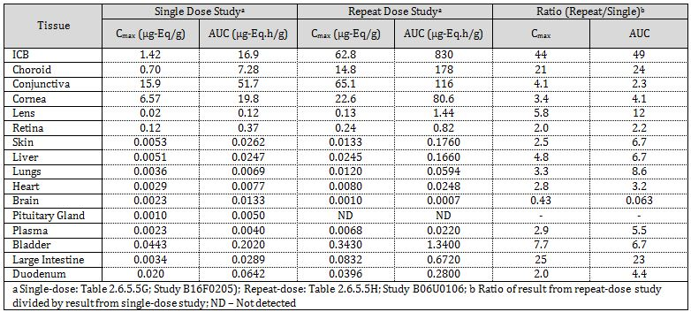
While C_{max} and AUC values were higher in repeat dose studies compared to single dose, the changes were within the 2-6 fold range. Collectively, the distribution studies suggested minimal accumulation.
In vitro studies indicated eight metabolites, potentially generated though dechlorination, oxidative deamination, oxidation/hydroxylation and N-cyclopropyl elimination and ring opening. No definite structures were determined owing to low levels of metabolites. No metabolic or chiral inter conversion was observed. In general, higher level of metabolism was noted in dog compared to mouse, rat and rabbit. The metabolites observed in human, were also detected in mouse, rat, rabbit and/or dog. In vivo oral studies (at 40 mg/kg) demonstrated less than 10% (unidentified) metabolites in urine, faeces and plasma of rats. Overall, >95% of besifloxacin excretions were noted in urine and faeces combined, which is consistent with findings of the non ocular tissue distribution data.
Taken together, comparable protein binding profiles, metabolite profiles and pharmacokinetics of the animal models used was adequate to assess the potential toxicity of besifloxacin in humans.

Toxicology

Acute toxicity
A single intravenous and oral rat acute toxicity was submitted. Besifloxacin related loss of body weight was noted at 2000 mg/kg. Depletion of femoral and humeral bone marrow and decreased lymphoid cells and increased granulocyte cells were noted at 1000 mg/kg PO BID (bis in die; 2 times daily).

Repeat dose toxicity
Repeat dose toxicity studies included 14-28 day studies in rats, rabbits and dogs, which is acceptable for intended clinical dosing period for besifloxacin. The rat and dog studies used oral administration, where as rabbit and dog studies used ocular instillation at a slightly higher dose regimen compared to clinical application (compared to x4/day compared to x3/day). Overall, the repeat dose toxicity pivotal studies were conducted in accordance to the International Conference on Harmonisation (ICH) guidelines.

Relative exposure
Exposure ratios were calculated based on animal:human plasma AUC_{0-24 h} (area under the plasma concentration-time curve within the first 24 h following administration) values on the last study day in repeat dose toxicity studies. Rat and dog studies performed with oral administration demonstrated very high relative systemic exposure margins (compared to ≥2092 at No Observed Adverse Effect Level [NOAEL]) with minimal clinical signs. A dog study using ocular instillation at the clinical dose demonstrated low relative exposure (compared to 30 and 25 for male and female, respectively); no significant clinical signs noted (Table 2).
Table 2: Relative systemic exposure in repeat dose toxicity studies.
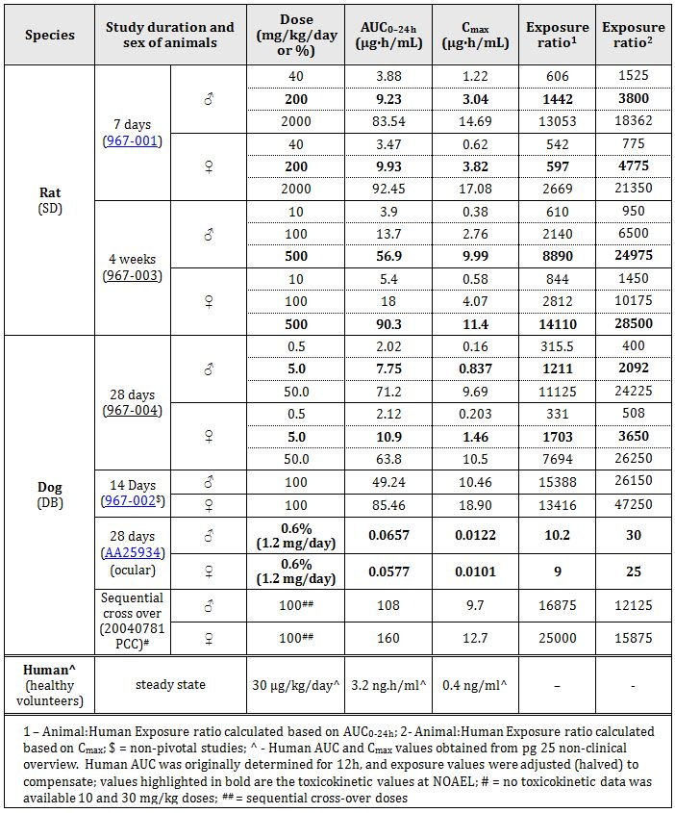

Major toxicities
No major toxicities were noted when besifloxacin was administered via ocular instillation. When administered orally, slight but reversible weight loss and reductions in relative organ weights (such as liver) were noted in some studies. No corresponding histopathological findings were however noted.

Genotoxicity
The standard battery of bacterial reverse mutation, in vivo and in vitro chromosomal aberration and unscheduled DNA synthesis assays were performed. A photo sensitive reverse mutation assay was also performed to determine the effects of products generated through photo degradation. All studies were GLP compliant and utilised appropriate bacterial and mammalian cell lines and in vivo animal models. The highest concentrations and doses utilised were in accordance with the ICH guidelines.
The bacterial reverse mutation, in vivo chromosomal aberration and unscheduled DNA synthesis did not demonstrate notable genotoxic effects. The solar simulated light mutagenesis assay did not indicate an increase in bacterial revertants as a result of photo degradation; however, higher numbers of TA102 and WP2(pKM101) revertants were noted at concentrations ≥0.333 µg/plate in the non exposed controls. This observation is in contrast to the other S. tymphimurium and E. coli strains used in Study 7281-106, where no revertants were noted.
In a range finding oral study using the (-) enantiomer (99%) in CD-1 mice, at the highest dose (2000 mg/ml) clastogenicity was noted, accompanied by high cytotoxicity levels. The pivotal in vivo chromosomal aberration study in ICR mice showed no clastogenic potential up to 500 mg/kg with intraperitoneal administration of the racemate.
While the positive results noted in the bacterial reverse mutation studies may be attributed to the mechanisms of action and enzymatic target of FQs, collectively, no significant genotoxicity risk is associated with besifloxacin.

Carcinogenicity
No carcinogenicity studies were performed based on low systemic exposure following ocular administration, low genotoxic risk, short time frame of clinical dose regimen and knowledge base of FQs class of antibacterial agents. This is congruent with published guidelines.

Reproductive toxicity
Pivotal studies encompassing fertility, early embryonic development, embryofoetal development and pre and postnatal development were performed in rats and rabbits. All pivotal studies were GLP compliant, included appropriate numbers of animals administered within appropriate time periods. The reproductive studies used oral administration, which resulted in higher relative exposure values compared to clinical, ocular instillation. Toxicokinetic data was gathered from one rat and one rabbit embryofoetal study (Table 3).
Table 3: Relative exposure calculated from toxicokinetic data from embryofetal studies in rat and rabbit.
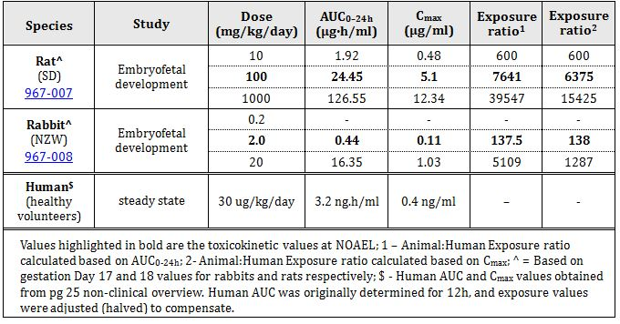
Based on C_{max} and AUC values in the rabbit and rat embryofoetal studies, satisfactory relative exposure margins were achieved.
The rat fertility study noted increase salivation in both males and females at 500 mg/kg/day. Weight loss was noted in both males and females in the 100 and 500 mg/kg/day dose groups. No besifloxacin related impairment of fertility was noted at the tested doses.
In the rat embryofoetal development studies, reduced body weight (≥100 mg/kg/day), sparse hair (all dose groups), salivation and reduced gravid uterine weights (1000 mg/kg/day PO) were noted in pregnant dams. Increased post implantation loss was noted at 1000 mg/kg/day and reduced foetal body weights were noted across all dose groups. An increased number of foetal skeletal variations (decreased ossification) were noted at 1000 mg/kg/day.
The rabbit embryofoetal study demonstrated reduced gestation body weights, reduced gravid uterine weight and sparse hair and faeces at 20 mg/kg/day PO. Increased post implantation loss, increased early and late resorptions and reduced viable foetuses were noted at 20 mg/kg/day. The maternal observations were accompanied by besifloxacin-related reduced foetal weight in the high dose. No clear test article related visceral or skeletal malformations were noted in the rabbit study. However, delayed foetal development was noted owing to the poor maternal toxicity; a known response in rabbits to antibiotics. Thus, the findings of the embryofoetal study were not included in the PI.
In the rat pre and postnatal development study maternal weight loss (all doses), salivation and sparse hair (at 1000 mg/kg/day) were noted. A statistically significant increase in still born pups was noted at the 1000 mg/kg/day dose. Test article related development deficits, such as weight loss, delayed pinna detachment, eyelid opening and delayed sexual maturation was observed at 1000 mg/kg/day. Taken together, these observations suggest strong likelihood of placental transfer and/or excretion via milk for besifloxacin.

Pregnancy classification
The sponsor has proposed Pregnancy Category B3, which is acceptable.

Local tolerance
Multiple distribution studies longer than the clinical treatment regimen did not indicate any local irritation associated with ocular instillation of besifloxacin.

Impurities
The proposed specifications for impurities/degradants in the drug substance/product have been adequately qualified.

Paediatric use
Besifloxacin is not indicated for children under the age of 12 months. No specific juvenile nonclinical studies were performed. Previous peer reviewed studies have noted arthrotoxicity and reversible musculoskeletal events associated with systemic use of FQs. Given the low systemic exposure associate with ocular instillations, the absence of developmental defects at NOAEL in pre and postnatal development studies, and the short treatment periods, the absence of specific juvenile nonclinical studies is acceptable.

Other toxicity studies
One photoallergenicity (guinea pig) and two phototoxicity (guinea pig and mouse) studies revealed no photoallergenicity or phototoxicity effect for the test article. In addition, the effect of the delivery vehicle (DuraSite) with the novel excipient, polycarbophil, was investigated in two rabbit studies of 52 and 2 weeks, respectively. No long term excipient related effects were noted.

Comments on the safety specification of the risk management plan
Results and conclusions drawn from the nonclinical program for besifloxacin detailed in the sponsor’s draft Risk Management Plan (RMP) are in general concordance with those of the nonclinical evaluator.

Nonclinical summary and conclusions

Summary
- Bausch & Lomb (Australia) Pty Ltd has applied to register besifloxacin hydrochloride 0.6% ophthalmic solution (Besivance) for treatment of bacterial conjunctivitis. Besivance is recommended for patients over one year of age and is applied as a single ocular instillation three times a day (4-12 h apart) for 7 days to the affected eye. Besifloxacin is a fifth generation FQ, a well documented class of antibacterial agent.
- The sponsor submitted studies on primary (microbiology), secondary and safety pharmacology, absorption and plasma pharmacokinetic, single and repeat dose toxicity, genotoxicity, reproductive and development, photoallergenic, phototoxicity and chronic ocular toxicity studies. Acute toxicity studies were performed using only one species, contrary to ICH guidelines. However, as several ICH compliant repeat dose toxicity studies with accompanying toxicokinetic data were provided, a satisfactory toxicity assessment was performed. The remaining pivotal toxicity studies were GLP compliant and met relevant ICH guidelines.
- Besifloxacin is proposed to be effective against conjunctivitis arising from: CDC coryneform group G, Corynebacterium pseudodiphtheriticum, Corynebacterium striatum, Haemophilus influenza, Moraxella lacunata, Staphylococcus aureus, S. epidermidis, S. hominis, S. lugdunensis, Streptococcus mitis group, S. oralis, S. pneumoniae and S. salivarius.
- Besifloxacin imparts antibacterial function by inhibiting DNA gyrase and topoisomerase IV activity. As besifloxacin mediated inhibition of human topoisomerase IIα is several orders of magnitude higher than bacterial enzymes, limited human risk is anticipated (compared with IC₅₀: 1000 µM and 5 µM in human and S. pneumonia, respectively).
- The overall MIC₅₀/MIC₉₀ for besifloxacin for Gram +ve and Gram -ve bacterial strains were 0.06/0.25 and 0.03/0.5 µg/ml, respectively. Slow resistance to besifloxacin was noted for S. aureus, S. pneumoniae and E. coli (compared to MPCs for the three strains were 0.12, 0.50 and 4 µg/ml, respectively). While cross reactivity was noted with other strains susceptible to FQs, no cross reactivity was observed with strains susceptible to azithromycin, tobramycin, oxacillin and penicillin.
- Secondary pharmacodynamics studies demonstrated inhibition of LPS and IL-1β induced cytokine production by besifloxacin in vitro. The extent of cytokine (IL-1β, IL-8, IP-10, MIP-1, IL-6, GM-CSF, MCP-1, TGF-α and TNF-α) inhibition was comparable or higher in potency than the fourth generation FQ, moxifloxacin.
- No CNS safety pharmacological studies were performed. No test article related effect was noted in the respiratory system. Safety pharmacology studies did however reveal a dose dependent increase in the HERG current inhibition in vitro, and in vivo an increase in QTc duration in the dog cardiovascular system. While no toxicokinetic data was available at the NOAEL for the cardiac safety (compared to 10 mg/kg), exposure ratios calculated based on BSA for the study are high (~180 clinical exposure). Given the high exposure and known cardiac effects of FQs, minimal risk to humans is anticipated at clinical doses. In rat safety studies, besifloxacin demonstrated anti diuretic, anti natriuretic and anti kaliuretic effects at concentrations greater than 100 mg/kg. No NOAEL was established for renal studies.
- Besifloxacin demonstrated rapid absorption in all studies (≤ 1h in oral studies and ~5m in ocular tissue following instillation). Besifloxacin binding to plasma protein was low and comparable between rat and human (compared to 30%-34% and 39%-44%, respectively). Clearance was high and distribution studies demonstrated low or limited accumulation. The C_{max} and AUC for treated ocular tissue broadly followed the hierarchy: Tears > Conjunctiva > Cornea > Aqueous or Vitreous Humor ≥ Retina > Plasma. With the exception of the bladder and gastro intestinal tract components, distribution to non ocular tissue was significantly lower (compared to Table 2). Consistent with this observation, >95% of besifloxacin related excretions were noted in urine and faeces.
- In vitro studies indicated 8 metabolites, potentially generated though dechlorination, oxidative deamination, oxidation/hydroxylation and N-cyclopropyl elimination and ring opening. No definite structures were determined due to low levels of metabolites.
- In the rat acute toxicity study, loss of body weight was noted at 2000 mg/kg. Depletion of femoral and humeral bone marrow and decreased lymphoid cells and increased granulocyte cells were noted at 1000 mg/kg.
- Repeat dose toxicity studies of 14-28 days were performed in rats, rabbits and dogs using oral or ocular administration. High systemic exposure ratios were obtained at the NOAEL following oral administration (compared to ≥2092 based on C_{max}, Table 3). Systemic exposure ratios were lower for ocular instillation at x1.3 the clinical dose regimen (compared to 14-25, Table 3), but adequate nonetheless. No clinical signs were noted for ocular instillation.
- Besifloxacin was negative for the standard battery of genotoxicity tests. In a solar light simulated bacterial mutagenesis assay, increased revertants were noted in E. coli and S. tymphimurium strains (WP2(pKM101) and TA102) of the control and treated groups; however, no difference was observed between the control and treatment group. No carcinogenicity studies were performed based on low systemic exposure following ocular administration, low genotoxic risk, and short time of clinical dose regimen; which is acceptable.
- No impact on fertility was noted up to 500 mg/kg/day PO (paternal and maternal toxicities were noted at 2 and 100 mg/kg/day) in rats. Delayed foetal development highlighted by altered ossification events occurred at doses greater than or equal to maternotoxic doses (2 and 100 mg/kg/day in rabbit and rat, respectively) and exposure ratios greater than 275. Delayed foetal development in rabbits was likely due to their heightened sensitivity to antibiotics, resulting in poor food consumption leading to maternal toxicity. Post natal development studies in rats revealed delayed pinna detachment, eyelid opening and delayed sexual maturation at 1000 mg/kg/day doses indicating likely placental transfer and/or excretion via milk.
- No photoallergenic or phototoxic effect for besifloxacin was noted. No effect of the delivery vehicle (DuraSite) excipient, polycarbophil, was noted in long and short term rabbit studies.

Conclusions and recommendation
- No major deficiency was noted.
- The overall MIC₅₀/MIC90 for besifloxacin with 1324 isolates of Gram +ve and Gram -ve bacteria was 0.06/0.25 and 0.03/0.5 µg/ml, respectively. The C_{max}/MIC₉₀ and AUC/MIC₉₀ ratios for besifloxacin were >10 and >125; above the target range recommended for FQs. At 0.6%, the ophthalmic suspension demonstrated besifloxacin levels > MIC90 for a minimum of 24h post administration. Systemic and ocular exposure studies in mouse and rabbit, using S. pneumoniae and S. aureus strains revealed in vivo efficacy comparable to or better than other FQs.
- Secondary pharmacodynamics studies revealed in vitro inhibition of LPS- and IL-1β induced IL-1β, IL-8, IP-10, MIP-1, IL-6, GM-CSF, MCP-1, TGF-α and TNF-α production at potencies comparable or higher than moxifloxacin. No in vivo secondary pharmacodynamics analyses were performed. Safety pharmacology studies demonstrated known FQ class effects, such as HERG current inhibition and QT prolongation at exposures > ~180. In rat safety studies, besifloxacin demonstrated anti diuretic, anti natriuretic and anti kaliuretuc effects at concentrations also greater than the clinical administration.
- Repeat dose toxicity studies of 14-28 days were performed in rats, rabbits and dogs following oral or ocular administration. Animal:human exposure ratios were low for ocular administration (compared to 14-25). However, high systemic exposure ratios were obtained at NOAEL following oral administration (compared to ≥2092 based on C_{max}) with minimal clinical signs, such as reversible body and organ weight loss. Low risk of systemic toxicity is anticipated following human ocular instillation.
- Reproductive toxicity studies conducted via oral administration demonstrated adequate systemic exposure ratios. Notable observations arising from maternal toxicity, suggestive of delayed development included incidence of altered ossification events, delayed pinna detachment, eyelid opening and delayed sexual maturation. The proposed Pregnancy Category of B3 is acceptable.
- There are no overall nonclinical objections to registration of besifloxacin hydrochloride 0.6% ophthalmic solution (Besivance) for treatment of bacterial conjunctivitis.
- The draft PI document should be amended as directed.

IV. Clinical findings
A summary of the clinical findings is presented in this section. Further details of these clinical findings can be found in Attachment 2.

Introduction
The clinical dosser documented a full clinical development program of pharmacology, efficacy and safety studies.
The clinical submission consisted of 67 double sided volumes, comprising 8 clinical pharmacology studies including 2 providing pharmacokinetic data (1 ocular and 1 systemic PK studies), 3 pivotal efficacy/safety studies, 3 other safety studies, and relevant publications.

Pharmacokinetics
Clinical investigation of besifloxacin hydrochloride ophthalmic suspension pharmacokinetics in humans has included two pivotal pharmacokinetic studies. Both these studies explored besifloxacin hydrochloride ophthalmic suspension, 0.6% as base in the healthy and inflamed eyes, showing high besifloxacin levels with very low systemic exposure. These data coupled with the safety of the 0.6% suspension (Study C-02-403-001) resulted in the 0.6% formulation moving forward into further clinical development.
No bioavailability study was included in the application. This product is for ocular use and is intended to act without systemic absorption. As both pharmacokinetics studies included in this application in the healthy eye and in the inflamed eye demonstrate minimal systemic absorption, the clinical evaluator feels the lack of specific bioavailability studies is justified.

Pharmacodynamics
The clinical evaluator thinks there is adequate pharmacodynamics data and strongly supports the ongoing systematic collection of isolates obtained from ophthalmological infections in the US. The US results are likely applicable to Australia. Prospective surveillance (and preferably at the local level) of this nature is really the only means by which we can monitor patterns of micro organisms and their antibiotic resistance profiles under increasing selection pressure from the widespread use/misuse of antibiotics in clinical and vet practice.

Efficacy
The 0.6% concentration of besifloxacin hydrochloride and TID dosing is supported by pharmacokinetic/pharmacodynamic relationship analysis and data from the submitted preclinical studies and clinical trials. The pivotal studies confirm the efficacy and safety of Besivance versus placebo (Vehicle) and in a head to head study with an appropriate comparator, that is, the topical ophthalmic formulation of moxifloxacin (same class of antibiotic and approved for this indication). It is important to note, however, that topical moxifloxacin for ophthalmological use is not approved in Australia. Other alternative topical antibimicrobial agents approved in Australia for bacterial conjunctivitis include are: chloramphenicol, sulfacetamide sodium, tobramycin (aminoglycoside), gentamicin (aminoglycoside), framycetin sulphate (aminoglycoside), ciprofloxacin and ofloxacin (both quinolones).

Safety
Treatment with besifloxacin ophthalmic suspension resulted in no serious adverse events (SAEs) related to study drug. Overall, rates of non ocular and ocular adverse events (AEs) were low. The majority of non ocular AEs were unrelated to study drug; the most prevalent ocular AEs were consistent with study treatment and/or underlying ocular disease being studied. Importantly, the main treatment emergent ocular AEs, that is, conjunctivitis, vision blurred, eye irritation and eye pain can all be associated with the underlying disorder and all occurred with lower frequency than when bacterial conjunctivitis was treated with besifloxacin compared to treatment with vehicle alone. A potential risk with any anti infective is the development of antibiotic resistance and this is discussed in detail in the clinical evaluation report.

Clinical summary and conclusions

First round benefit-risk assessment
Bacterial conjunctivitis is characterised by marked hyperaemia or redness of the eye and mild to moderate purulent conjunctival discharge. Symptoms often include watery eyes, itching, and vague ocular irritation. The disease is generally self limiting and usually does not cause permanent loss of vision or structural damage. Intervention with use of a topical broad spectrum ocular anti infective is the standard of care in the management.

First round assessment of benefits
The benefits of Besivance in the proposed usage are:
- Well tolerated topical agent of proven efficacy against the common forms of bacterial conjunctivitis, that is, superior to placebo and equivalent to a comparator topical ocular quinolone agent;
- TID dosing means adherence to the scheduled dosing is more likely;
- High ocular levels well above the MIC for the common bacteria causing conjunctivitis;
- Nil meaningful systemic absorption therefore the risk of inducing potential quinolone resistance is low, coupled with the fact that resistance to besifloxacin probably requires at least two steps.

First round assessment of risks
The risks of Besivance in the proposed usage are:
- Use for conjunctivitis that is not bacterial in aetiology;
- Inappropriate use for deeper (more than conjuctival) bacterial infections of the eye;
- Development of microbial resistance at the local level or treatment failure because patterns of global antibiotic resistance are changing rapidly, such that organisms currently sensitive to this agent are no longer similarly sensitive in the future. Some of these issues may be compounded by the fact that a swab for bacterial and viral culture may not be routine in clinical practice, that is, the diagnosis is made clinically and swabs are only performed if there is a clinical failure to empiric antimicrobial therapy.
However, these risks are not unique to Besivance, they apply equally to this product and all currently approved topical antibiotics for ocular use in this setting.

First round assessment of benefit-risk balance
The benefit-risk balance of 0.6% Besifloxacin hydrochloride ophthalmic (Besivance), given the proposed usage, is favourable for the following reasons: equivalent clinical and microbiological efficacy to a licensed topical antibiotic to all common bacterial (Gram +ve and Gram -ve) causes of conjunctivitis with minimal safety concerns revealed through the development programme. Potential for enhanced adherence as Besivance administered TID (as opposed to more frequently). The clinical evaluator agrees that the recommended course should be 7 days of treatment even though the clinical trials of this agent used 5 day dosing. The rationale is that the drug is clearly very safe and this additional two days of treatment will ensure the “later” responders are adequately treated. Moreover, microbial resistance did not emerge during the efficacy studies of besifloxacin or its comparator, moxifloxacin. However, this will need to be monitored as part of post marketing surveillance. A key strategy in minimising antibiotic resistance is to minimise inappropriate use (that is, for viral conjunctivitis), perform microscopy, culture and sensitivity (M, C & S) test of purulent material, switch rapidly to another antibiotic if resistance is detected, ensure patients understand exactly how to administer the agent and adhere fully with the dosing schedule (TID for 7 days) and last, ensure exposure is not extended beyond 7 days.

First round recommendation regarding authorisation
The clinical evaluator recommends approval of this drug for the indication listed in the PI as it stands.

List of questions
None; the clinical evaluator is satisfied with the scope of this clinical application as submitted.

V. Pharmacovigilance findings

Risk management plan
The sponsor submitted a Risk Management Plan which was reviewed by the TGA’s Office of Product Review (OPR).

Safety specification
The sponsor provided a summary of Ongoing Safety Concerns, which are shown at Table 4.
Table 4: Ongoing Safety Concerns for Besivance.
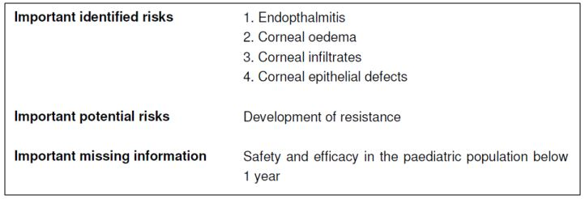

OPR reviewer comment
Notwithstanding the evaluation of the nonclinical and clinical aspects of the Safety Specification, this is considered acceptable.

Pharmacovigilance plan
The sponsor proposes routine pharmacovigilance activities for important identified and potential risks and missing information (as stated above). Furthermore, additional activities are planned for all of the risks. These activities are summarised in Table 5.
Table 5: Activities additional to routine planned by the sponsor regarding the identified safety concerns.
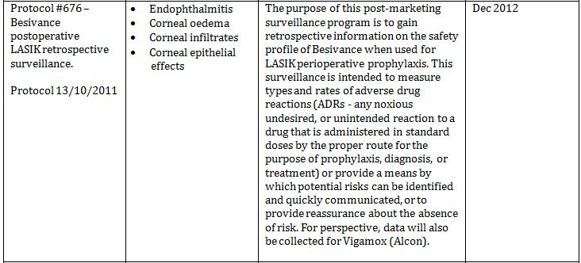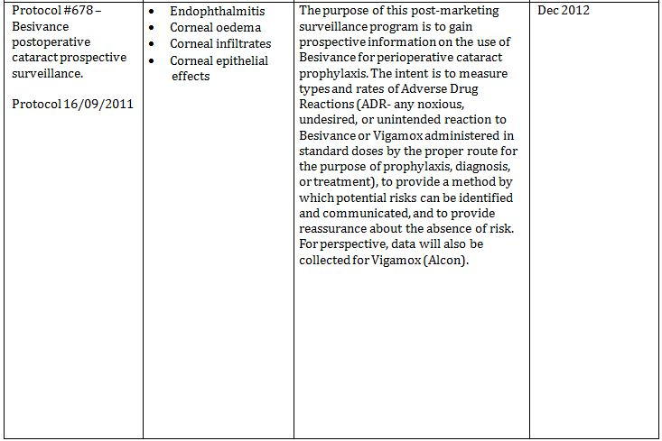
Table 5 (continued): Activities additional to routine planned by the sponsor regarding the identified safety concerns.
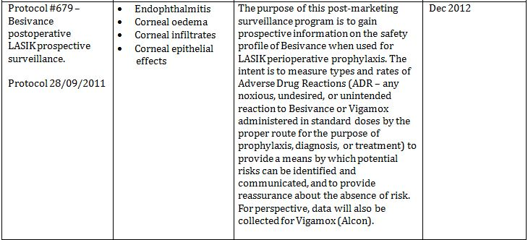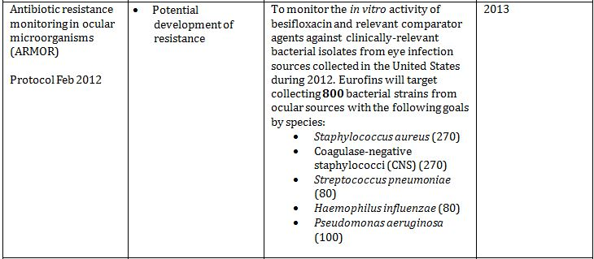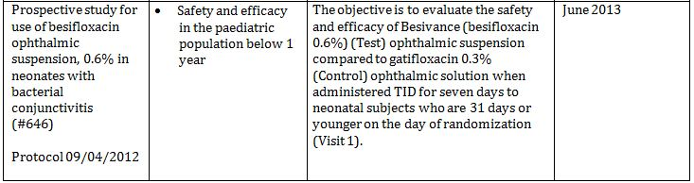

OPR reviewer’s comments in regard to the pharmacovigilance plan (PP) and the appropriateness of milestones
The sponsor mainly plans routine and additional pharmacovigilance activities. All safety concerns have been assigned an additional activity.
The sponsor’s proposed pharmacovigilance activities and milestones are considered acceptable. The study protocols submitted are considered acceptable in regard to the assigned safety concerns for RMP purposes.
Considering that the sponsor proposed to have completed Studies #676, #678, and #679 by December 2012, the sponsor should submit the study results and make relevant RMP and Product Information/Consumer Medicine Information (PI/CMI) changes, where necessary.

Risk minimisation activities

Sponsor’s conclusion in regard to the need for risk minimisation activities
The sponsor states that no additional risk minimisation activities are necessary.

OPR reviewer comment
The sponsor’s conclusion is acceptable.

Potential for medication errors
The sponsor states the following:
The potential for medication errors is sufficiently covered by the actions for off-label use.

OPR reviewer comment
For the purposes of this RMP evaluation different types of medication errors, as suggested by Ferner and Aronson, have been considered.
The sponsor’s statement that the “potential for medication errors is sufficiently covered by the actions for off-label use” is not adequate. Off-label use is only one subset of medication errors.
The main type of medication errors in the use of this medicine would be knowledge based or rule based errors, where patients or their carers are unable to apply the eye drops correctly. Correct usage is an important aspect of minimising antibiotic resistance. As a result, the CMI that contains instructions with illustrations on how to administer the medicine should be included as a pack insert.

Antibiotic resistance
In line with the first round clinical report, the recommended course of treatment with besifloxacin is 7 days. This information is already contained in the PI and CMI. Furthermore, the PI and CMI need to state that besifloxacin in only indicated for short-term use.

Potential for overdose
The risk for topical overdose is low. The PI should be amended to include information about the management of topical overdose. The risk for systemic overdose is low.

Potential for off-label use
In the proposed PI, the indication is clearly stated.
Off-label use may occur for bacterial keratitis or antibiotic prophylaxis (pre or post surgery or otherwise). It is noted that the sponsor is undertaking (Studies #676, #678 and # 679 for prophylaxis) or has undertaken (Study #677 for keratitis) additional studies to investigate the use of Besivance in these scenarios.

Potential for paediatric off-label use (children up to 12 months of age)
There may be potential off-label use in neonates born to mothers with gonorrhoea. The sponsor recognises that Besivance is only indicated for patients above 12 months of age. This is reflected in the proposed PI. It is noted the sponsor is undertaking a study to investigate the use of Besivance in patients under 12 months of age. This is considered acceptable.

Potential for transmission of infectious disease
There is a potential for transmission of infectious disease. The applicator tip could be potentially contaminated when not used correctly. The correct use has been adequately described in the PI and CMI. The PI and CMI should state that the same bottle of eye drops is not to be shared with other patients.

Summary of recommendations
The OPR provides these recommendations in the context that the submitted RMP (EU-RMP Version 1.0 (dated 02/10/2012, DLP 31/05/2012) with Australia specific annex [attached to EU-RMP in Annex 9]) is supportive to the application; the implementation of a RMP satisfactory to the TGA is imposed as a condition of registration; the submitted EU-RMP is applicable without modification in Australia unless so qualified; and the draft product information and consumer medicine information documents should not be revised until the Delegate’s Overview has been received.

Further safety considerations
- Safety considerations may be raised by the nonclinical and clinical evaluators through the consolidated section 31 request and/or the nonclinical and clinical evaluation reports respectively. It is important to ensure that the information provided in response to these includes a consideration of the relevance for the RMP, and any specific information needed to address this issue in the RMP. For any safety considerations so raised, please provide information that is relevant and necessary to address the issue in the RMP.
Unless the sponsor can provide compelling justification against any of the following recommendations, the following should be considered:

Recommendations in regard to pharmacovigilance activities
- Considering that the sponsor proposed to have completed Studies #676, #678, and #679 by December 2012, the sponsor should submit the study results and make relevant RMP and PI/CMI changes, where necessary.

Recommendations in regard to medication errors
- The CMI that contains instructions with illustrations on how to administer the medicine should be included as a pack insert.

Recommendations in regard to risk minimisation activities
- In regard to the proposed routine risk minimisation activities, it is recommended to the Delegate that the draft PI document be revised as follows:
  - The results of the Studies #676, #678, and #679 should be used to update the proposed Australian PI document where necessary.
  - In the ‘Precautions’ section, the PI should include a statement that Besivance is not indicated for long term use and that administration of this drug should not exceed the recommended 7 day course (or a statement to that effect).
  - In the ‘Overdose’ section, the PI should include a statement in regard to a topical overdose of Besivance and management, that is, flushing with warm water (or a statement to that effect).
  - In the ‘Dosage and administration’ section, the sponsor should include a statement that Besivance eye drops are not to be shared between patients to ensure minimisation of possible cross contamination (or a statement to that effect).
- In regard to the proposed routine risk minimisation activities, it is recommended to the Delegate that the draft CMI document be revised as follows:
  - In the ‘While you are using Besivance’ section, the sponsor should include a statement that Besivance eye drops are not to be shared between patients additionally to the existing statement ‘Do not give Besivance Eye Drops to anyone else, even if they have the same condition as you’ (or a statement to that effect).

Second round evaluation of the sponsor’s response to the RMP evaluation
Reconciliation of issues outlined in the RMP report is as follows.

Recommendation in RMP evaluation report:
- Safety considerations may be raised by the nonclinical and clinical evaluators through the consolidated section 31 request and/or the nonclinical and clinical evaluation reports respectively. It is important to ensure that the information provided in response to these includes a consideration of the relevance for the RMP, and any specific information needed to address this issue in the RMP. For any safety considerations so raised, please provide information that is relevant and necessary to address the issue in the RMP.

Sponsor’s response (or summary of the response):
There were no questions raised by nonclinical and clinical evaluators in the Consolidated Section 31 request.

OPR evaluator’s comment:
None.

Recommendation in RMP evaluation report:
- Considering that the sponsor proposed to have completed studies #676, #678, and #679 by December 2012, the sponsor should submit the study results and make relevant RMP and PI/CMI changes, where necessary.

Sponsor’s response (or summary of the response):
Caused by a delay in the study procedures, only study #676 is available so far. In this retrospective safety study on the use of Besivance for laser-assisted in situ keratomileusis (LASIK) perioperative prophylaxis, no adverse drug reactions were reported. The rate of adverse drug reactions was the primary endpoint. The RMP will be updated accordingly.
The sponsor has provided a summary of study #676.

OPR evaluator’s comment:
The sponsor is advised to submit summaries of the results for studies #678, and #679, as part of their PSUR updates.

Recommendation in RMP evaluation report:
- The Consumer Medicine Information (CMI) that contains instructions with illustrations on how to administer the medicine should be included as a pack insert.

Sponsor’s response (or summary of the response):
The sponsor acknowledges the evaluator’s comment and understands the importance of providing the instructions with illustration. However, as it is not mandatory to include the CMI in the pack for prescription medicines, the sponsor proposes not to include the CMI in the pack. Upon approval, the CMI will be made available through electronic distribution, in accordance with the current practice in Australia. Instead, and for that reason, the sponsor proposes to add the following statement on the carton: For Consumer Medicine Information, speak to your doctor or pharmacist.

OPR evaluator’s comment:
This is considered acceptable.

Outstanding issues

Issues in relation to the RMP
The sponsor is advised to submit summaries of the results for Studies #678, and #679, as part of their Periodic Safety Update Reports (PSURs).

Advice from the Advisory Committee on the Safety of Medicines (ACSOM)
The advice received from ACSOM is summarised below:
- Confirmation of bacteria susceptibility would be impractical for bacterial conjunctivitis.
- The Antibiotic Resistance Monitoring in Ocular micRoorganisms (ARMOR) study is sufficient to monitor resistance internationally and already established local reporting and analysis will be adequate for Australian surveillance.
- The planned routine risk minimisation activities are sufficient for the proposed indication. However, ACSOM advised that antimicrobial stewardship (AMS) programs may not be available in private eye clinics and suggested seeking advice from the Antimicrobial Stewardship Advisory Committee.

OPR reviewer comment
The sponsor is advised that this product may be referred to the Antimicrobial Stewardship Advisory Committee after approval to seek advice regarding AMS programs in private eye clinics.

Comments on the safety specification of the RMP

OMA clinical evaluation report
The clinical evaluator made the following summary first round comment in regard to safety specifications in the draft RMP:
The Safety Specification in the draft Risk Management Plan is satisfactory.
No second round comment was made.

OSE nonclinical evaluation report
The non-clinical evaluator made the following summary comment in regard to safety specifications in the draft RMP:
“Results and conclusions drawn from the nonclinical program for besifloxacin detailed in the sponsor’s draft Risk Management Plan are in general concordance with those of the Nonclinical Evaluator.”

Key changes to the updated RMP
Not applicable.

Suggested wording for conditions of registration

RMP
Implement EU-RMP Version 1.0 (dated 02/10/2012, DLP 31/05/2012) with Australia specific annex (attached to EU-RMP in Annex 9), and any future updates as a condition of registration.

PSUR
OMA to provide new wording when finalised.

VI. Overall conclusion and risk/benefit assessment
The submission was summarised in the following Delegate’s overview and recommendations:

Quality
Besifloxacin hydrochloride is manufactured by chemical synthesis. All issues raised by the pharmaceutical chemistry section have been satisfactorily resolved. The submission was not required to be considered by the PSC of the ACPM.

Nonclinical
The nonclinical module of the dossier was composed of primary (microbiology), secondary and safety pharmacology, absorption and plasma pharmacokinetic, single and repeat dose toxicity, genotoxicity, reproductive and development, photoallergenic, phototoxicity and chronic ocular toxicity studies. An Australian Antibiotic Resistance Risk Assessment was provided. Pivotal toxicity studies were GLP compliant and toxicokinetic data were provided for relevant studies. There are no overall nonclinical objections to registration of besifloxacin hydrochloride 0.6% ophthalmic solution (Besivance) for treatment of bacterial conjunctivitis. The main conclusions of the nonclinical evaluations follow.
The overall MIC₅₀/MIC₉₀ for besifloxacin with 1324 isolates of Gram +ve and -ve bacteria was 0.06/0.25 and 0.03/0.5 µg/ml, respectively. The C_{max}/MIC₉₀ and AUC/MIC₉₀ ratios for besifloxacin were >10 and >125; above the target range recommended for FQs. At 0.6%, the ophthalmic suspension demonstrated besifloxacin levels > MIC₉₀ for a minimum of 24 h post administration. Systemic and ocular exposure studies in mouse and rabbit, using S. pneumoniae and S. aureus strains revealed in vivo efficacy comparable to or better than other FQs.
Secondary pharmacodynamics studies revealed in vitro inhibition of LPS and IL-1β induced IL-1β, IL-8, IP-10, MIP-1, IL-6, GM-CSF, MCP-1, TGF-α and TNF-α production at potencies comparable or higher than moxifloxacin.
Repeat dose toxicity studies of 14-28 days were performed in rats, rabbits and dogs following oral or ocular administration. Low risk of systemic toxicity is anticipated following human ocular instillation.
Reproductive toxicity studies conducted via oral administration demonstrated adequate systemic exposure ratios. Notable observations arising from maternal toxicity, suggestive of delayed development included incidence of altered ossification events, delayed pinna detachment, eyelid opening and delayed sexual maturation. The proposed Pregnancy Category of B3 is acceptable.
The nonclinical evaluation report includes some discussion of the function of excipients and the drug delivery system.

Clinical

Pharmacology
A total of 8 clinical pharmacology studies were submitted, which included 1 ocular pharmacokinetic study and 1 systemic pharmacokinetic study in healthy volunteers. The in vitro antibacterial spectrum of besifloxacin was evaluated against a variety of clinical isolates in nine studies conducted in the USA and Japan. The pharmacokinetic/pharmacodynamic relationship was assessed using results from the ocular PK study and in vitro MIC₉₀ for bacterial pathogens from patients with bacterial conjunctivitis.
Study 424 was a Phase I ocular pharmacokinetic study in healthy volunteers. A single dose of besifloxacin 0.6% suspension resulted in mean C_{max} of 610 ± 540 μg/g in tears. The concentration in tears at 24 h was on average 1.6 ± 2.28 µg/g. The exposure in tears was AUC_{0-24h} of 1232 μg*h/g. Based on the observed elimination rate from tears besifloxacin concentrations in tears were predicted to decrease below the Lower Limit of Quantification (LLOQ) (0.2 µg/g) ~34 h after the dose.
Study C-02-403-001 assessed systemic pharmacokinetics in healthy volunteers who received bilateral ocular besifloxacin suspension (0.3% or 0.6%) QID (quater in die; 4 times daily) for 7 days. Plasma besifloxacin levels observed were on average <0.35 ng/mL and C_{max} <0.5 ng/mL. Distribution (other than to tear fluid and plasma protein binding), metabolism and excretion were not assessed in this or other clinical studies. In animal models after oral administration, besifloxacin is largely excreted unchanged in urine and faeces.
Study 478 measured plasma besifloxacin concentrations in adults with suspected bacterial conjunctivitis who received 0.6% suspension bilaterally TID for 5 days. Plasma besifloxacin concentrations measured after first and last dose showed high variability. Maximum plasma besifloxacin concentration in each patient was <1.3 ng/mL.
The mean C_{max} of besifloxacin was 0.37 ng/mL on Day 1 and 0.43 ng/mL on Day 6, indicating only a slight accumulation of besifloxacin.
Pharmacokinetic/pharmacodynamic ratios have been modelled for C_{max}/MIC₉₀ and AUC_{24h}/MIC₉₀ based on single dose human tear pharmacokinetic results and simulated besifloxacin AUC₂₄ with TID dosing and MIC₉₀ values for prevalent bacterial pathogens from patients with bacterial conjunctivitis (S. aureus, S. pneumoniae, S. epidermis and H. influenzae). C_{max}/MIC₉₀ ratios of 732 to 10167, and AUC_{24h}/MIC₉₀ ratios of 4561 to 63350 were obtained. These pharmacokinetic/pharmacodynamic ratios are higher than the published target values associated with bacterial eradication in plasma for FQs (that is, C_{max}/MIC₉₀ ratio of >10 and AUC/MIC₉₀ ratio of >100-125), regardless whether total of or unbound to protein concentrations are considered.
The pharmacokinetic/pharmacodynamic ratio is accepted in the clinical evaluation report as adequate support for the 0.6% formulation and TID dosing used in pivotal clinical studies.
The clinical evaluation report summarises MIC₅₀ values for isolates from patients with bacterial conjunctivitis in Studies 373, 433 and 434 against besifloxacin and other agents. Antimicrobial activity is discussed further in the clinical evaluation report. A total of 1324 isolates were recovered from subjects at baseline (Visit 1) in the modified intention to treat mITT population as treated population species specific study eye across all treatment groups. Overall, MIC₅₀/MIC₉₀ values for the 1324 isolates of all species were 0.06/0.25 μg/mL for besifloxacin. Of the 1324 bacterial isolates, 886 (66.9%) were Gram +ve, while the remaining 438 (33.1%) were Gram -ve. The besifloxacin MIC₅₀/MIC₉₀ values were 0.06/0.25 μg/mL for Gram +ve bacteria and 0.03/0.5 μg/mL for Gram -ve bacteria.
Mutations in the genes that encode DNA gyrase and topoisomerase IV is the primary cause of development of clinically relevant levels of resistance to FQs. High level resistance occurs through multistep mutations, where organisms acquire mutations in genes encoding both principal target enzymes. Multistep mutations are more likely when bacteria are repeatedly exposed to low levels of antibiotic or with intermittent or tapered dosing over long periods.
The clinical evaluation report has considered the sponsor’s Risk Assessment of Microbial Resistance. Besifloxacin ophthalmic suspension is considered unlikely to contribute to FQ resistance development for the following reason:
- High ocular besifloxacin concentrations with high bacterial eradication, even among bacteria considered resistant by in vitro assessments;
- Systemic exposure very low compared to orally administered quinolones;
- Risk of overgrowth of non susceptible organisms resulting from prolonged use unlikely with restriction of the labelled use to 7 days;
- No systemic counterparts, theoretically eliminating the contribution of systemic use to the emergence of resistance although cross resistance amongst quinolones is well recognised.
The sponsor of this drug has undertaken, since 2009, annual prospective surveillance of antibiotic resistance of ocular isolates, that is, ARMOR in the USA. MIC values of besifloxacin during ARMOR 2009 and ARMOR 2010 remained stable. The only organism with significant resistance was Pseudomonas aeruginosa (PA). This application does not seek to use Besivance for this organism.

Efficacy
There are three pivotal efficacy studies: 373 (Phase II), 433 (Phase III) and 434 (Phase III).
The studies all had a multicentre, randomised, double masked, parallel group design. In Study 373 and 433 besifloxacin was compared to its vehicle with a superiority analysis. In Study 434 besifloxacin was compared to moxifloxacin ophthalmic solution with a non inferiority analysis. The primary objectives of these studies were to assess clinical resolution and microbiological eradication of baseline bacterial infection, in adults and children one year of age and older with clinical evidence of bacterial conjunctivitis in at least 1 eye.
The primary efficacy analyses were undertaken in patients who were randomised to treatment, received at least 1 drop of study drug and had culture confirmed bacterial conjunctivitis.
In Study 373, a total of 270 subjects were randomised and a total of 118 were included in the ITT population. Baseline demographics, ocular history and medical history were similar between treatment groups. 82.5% were Caucasian and 60.2% female and mean age 34.2 years. The clinical evaluation report states that bacterial eradication occurred in 88.3% (53/60) of patients in the besifloxacin group versus 60.3% (35/58) of vehicle treated subjects (p<0.001)(at Visit 3 on Day 8). Clinical resolution at Visit 3 (Day 8) was reported in 73.3% (44/60) of besifloxacin treated subjects with culture confirmed conjunctivitis versus 43.1 % (25/58) of vehicle subjects (p < 0.001). At Visit 2 (Day 4 ± 1 day), rates of clinical resolution between besifloxacin and vehicle groups were not statistically significant, with some differences in timing and criteria for clinical resolution compared to the other two studies.
In Study 433, a total of 957 subjects were randomised. The mITT population was all subjects in ITT population who culture confirmed bacterial conjunctivitis which included 199 subjects who received besifloxacin and 191 who received vehicle. Demographics were generally similar between treatment groups. The majority of the ITT population were white (65.7%) and females (63.6%) with a mean age of 27.3 years. Children less than 2 years of age comprised 4.3% (n = 20). The clinical evaluation report states bacterial eradication occurred in 91.5% (182/199) of patients in the besifloxacin group versus 59.7% (114/191) of vehicle treated patients (p < 0.0001) (at Visit 2, Day 5) . Clinical resolution occurred in 45.2% (90/199) of besifloxacin treated patients with culture confirmed conjunctivitis versus 33.0% (63/191) of patients receiving vehicle (p = 0.0084) at Visit 3 Day 8. Results for secondary clinical and microbial endpoints are included in the clinical evaluation report.
In Study 434, a total of 1161 subjects were randomised. The mITT population included all subjects in ITT population who culture confirmed bacterial conjunctivitis which included 255 subjects who received besifloxacin and 278 who received moxifloxacin. Demographics were generally similar between treatment groups. The majority of the ITT population were white (67%) and females (57%) with a mean age of 35.1 years. Children less than 2 years of age comprised 3.2% (n = 37). Children aged 2 to 9 years comprised 15.6% (n = 181) and the 10 to 19 year comprised 13.4% (n = 156). The clinical evaluation report states clinical resolution at the primary analysis visit (Day 5) occurred in 58.3% and 59.4% of patients (besifloxacin and moxifloxacin, respectively; p = 0.652; 95% CI, -9.48% to 7.29%), and bacterial eradication occurred in 93.3% and 91.1% (besifloxacin and moxifloxacin, respectively; p = 0.1238; 95% CI, - 2.44% to 6.74%). The non inferiority margin was 15% and non inferiority of besifloxacin to moxifloxacin for bacterial conjunctivitis was confirmed for both the clinical and bacterial eradication endpoints. Results for secondary clinical endpoints are included in the clinical evaluation report.
There were 699 isolates from species specific study eyes from the 533 culture confirmed subjects. Of these 699 isolates, 86.4% were from U.S. subjects and 13.6% from Asian subjects. Most frequent organisms were: Haemophilus influenzae seen in 169 isolates (24.2%), Streptococcus pneumoniae (122, 17.5%), Staphylococcus aureus (115, 16.5%), Staphylococcus epidermidis (70, 10.0%) and Streptococcus mitis group (25, 3.6%). Overall, the sensitivity of the pathogens obtained from subjects in the besifloxacin treatment group was similar to those obtained from subject in the moxifloxacin treatment group. In analysis of microbiological failures, none of the concordant isolate pairs showed an increase in MIC for besifloxacin or moxifloxacin greater than one 2 fold dilution. An attachment “M434 Summary of Outcomes and MICs for Key Organisms in Besifloxacin and Moxifloxacin Treatment Groups” has been added as it is relevant to consideration of the bacterial species proposed for inclusion in ‘Indications’.
Efficacy in subpopulations is discussed in the clinical evaluation report. Clinical resolution rates in males tended to be lower than for females.

Safety
Study C-02-403-001, 507, ROC2-05-070, 373, 433 and 434 provided evaluable safety data. C-02-403-001, 507 and ROC2-05-070 assessed safety as a primary outcome.
Overall, 1445 subjects received besifloxacin (0.3% or 0.6%), 644 subjects received Vehicle, and 598 subjects received the comparator drug moxifloxacin. Of the 1445 subjects receiving besifloxacin ophthalmic suspension, 1433 received the 0.6% concentration. Duration of dosing for those receiving the proposed concentration ranged from one day (one drop) to 7 days.
An integrated analysis of safety was presented for Studies 373, 433 and 434. For Treatment emergent, non ocular AEs, headache was the most common AE in all treatment groups. There were 21/1192 (1.8%) subjects treated with besifloxacin ophthalmic suspension that reported headaches. A total of 11 of the 616 (1.8%) subjects treated with vehicle reported headaches. A total of 9 of the 579 (1.6%) subjects in the moxifloxacin treatment group reported headaches. The majority of headaches were mild and assessed as unrelated or unlikely related to study drug.
Treatment emergent, ocular AEs are summarised in the clinical evaluation report. A total of 13.8 % (249/1810) of eyes in the besifloxacin group had at least 1 ocular AE, 19.8% (190/961) of eyes in the vehicle treatment group and, 14.0% (120/855) of eyes in the moxifloxacin treatment group each experienced at least 1 ocular AE.
The most prevalent ocular AEs were consistent with the underlying ocular disease being studied, that is, bacterial conjuctivitis. Five ocular AEs, were reported at statistically different rates between the besifloxacin and vehicle treatment groups:
- Conjunctivitis and blurred vision were reported at lower rates in the eyes treated with besifloxacin versus vehicle, p = 0.0223 and p = 0.0035, respectively;
- Eye irritation and increased lacrimation were reported at lower rates in eyes treated with besifloxacin versus vehicle, p = 0.0187 and p = 0.0085, respectively;
- Viral conjunctivitis was reported in eyes treated with besifloxacin ophthalmic suspension whereas it was not reported for vehicle treated eyes (p = 0.0185).
In Study ROC2-05-070 (besifloxacin ophthalmic suspension versus moxifloxacin), besifloxacin ophthalmic suspension drop resulted in statistically significant worse high contrast/high illumination visual acuity immediately after drop instillation and a longer recovery time to baseline visual acuity (58 seconds) compared to eyes that received moxifloxacin (21 seconds). In the larger safety and efficacy studies, blurred vision was reported at a rate of 2.1% for subjects in the besifloxacin group, and the majority of the events were mild.
In the Phase I study, Study C-02-403-001, no AEs were reported in the 0.3% besifloxacin group, 6 subjects in the vehicle group reported a total of 10 AEs. A total of 2 subjects in the 0.6% besifloxacin group each reported a single AE.
The clinical evaluation report discusses discontinuations due to AEs in pivotal studies. In Study 373, 1 discontinuation in vehicle group was considered unrelated to study drug. In Study 433, 4 subjects in besifloxacin and 5 subject in vehicle group discontinued due to AEs. In the besifloxacin group these were worsening conjunctivitis, upper respiratory tract infection (URTI), skin rash, and fellow eye conjunctivitis. In Study 434, 11 (1.9%) subjects in besifloxacin group and 5 (0.9%) subjects in moxifloxacin group discontinued due to AE.
No deaths were reported in pivotal studies. There were 4 SAEs reported. All SAE were considered unrelated to study drug.
Laboratory parameters (haematology, blood chemistry, urinalysis, electrocardiogram) were only measured in Phase I Study C-0204030001 with no treatment emergent findings.
Post marketing experience was not discussed in the clinical evaluation report.
The clinical evaluator’s concluded that the pivotal studies confirm the efficacy and safety of Besivance versus vehicle and in a head to head study with an appropriate comparator, that is, the topical ophthalmic formulation of moxifloxacin (same class of antibiotic and approved for this indication). It is important to note, however, that topical moxifloxacin for ophthalmological use is not approved in Australia.
Treatment with besifloxacin ophthalmic suspension resulted in no SAEs related to study drug. Overall, rates of non ocular and ocular AEs were low. The majority of non ocular AEs were unrelated to study drug; the most prevalent ocular AEs were consistent with study treatment and/or underlying ocular disease being studied. Importantly, the main treatment emergent ocular AEs, that is, conjunctivitis, vision blurred, eye irritation and eye pain can all be associated with the underlying disorder and all occurred with lower frequency than when bacterial conjunctivitis was treated with besifloxacin compared to treatment with vehicle alone.

Risk management plan
The RMP has been referred to ACSOM. The following issues are outstanding. The sponsor is advised to submit summaries of the results for Studies #678, and #679, as part of their PSUR updates.
The advice received from ACSOM is summarised below:
- Confirmation of bacteria susceptibility would be impractical for bacterial conjunctivitis.
- The ARMOR study is sufficient to monitor resistance internationally and already established local reporting and analysis will be adequate for Australian surveillance.
- The planned routine risk minimisation activities are sufficient for the proposed indication. However, ACSOM advised that antimicrobial stewardship (AMS) programs may not be available in private eye clinics and suggested seeking advice from the Antimicrobial Stewardship Advisory Committee.

Risk-benefit analysis

Delegate considerations

Clinical evaluator’s benefit-risk assessment
The benefits of Besivance in the proposed usage are:
- Well tolerated topical agent of proven efficacy against the common forms of bacterial conjunctivitis, that is, superior to placebo and equivalent to a comparator topical ocular quinolone agent;
- TID dosing means adherence to the scheduled dosing is more likely;
- High ocular levels well above the MIC for the common bacteria causing conjunctivitis;
- Nil meaningful systemic absorption therefore the risk of inducing potential quinolone resistance is low, coupled with the fact that resistance to besifloxacin probably requires at least two steps.
The risks of Besivance in the proposed usage are:
- Use for conjunctivitis that is not bacterial in aetiology;
- Inappropriate use for deeper (more than conjuctival) bacterial infections of the eye;
- Development of microbial resistance at the local level or treatment failure because patterns of global antibiotic resistance are changing rapidly, such that organisms currently sensitive to this agent are no longer similarly sensitive in the future. Some of these issues may be compounded by the fact that a swab for bacterial and viral culture may not be routine in clinical practice, that is, the diagnosis is made clinically and swabs are only performed if there is a clinical failure to empiric antimicrobial therapy.
However, these risks are not unique to Besivance, they apply equally to this product and all currently approved topical antibiotics for ocular use in this setting.
The clinical evaluator considered the benefit-risk balance of 0.6% Besifloxacin hydrochloride ophthalmic (Besivance), given the proposed usage, is favourable. As revealed through the development programme, equivalent clinical and microbiological efficacy to a licensed topical antibiotic to all common bacterial (Gram +ve and Gram -ve) causes of conjunctivitis with minimal safety concerns. There is also potential for enhanced adherence as Besivance administered TID (as opposed to more frequently). The clinical evaluator agreed that the recommended course should be 7 days of treatment even though the clinical trials of this agent used 5 day dosing. The rationale is that the drug is clearly very safe and this additional two days of treatment will ensure the “later” responders are adequately treated. Moreover, microbial resistance did not emerge during the efficacy studies of besifloxacin or its comparator, moxifloxacin. However, this will need to be monitored as part of post-marketing surveillance. A key strategy in minimising antibiotic resistance is to minimise inappropriate use (that is, for viral conjunctivitis), perform M, C & S of purulent material, switch rapidly to another antibiotic if resistance is detected, ensure patients understand exactly how to administer the agent and adhere fully with the dosing schedule (TID for 7 days) and last, ensure exposure is not extended beyond 7 days.

Discussion
The JETACAR Report and Commonwealth Government Response to JETACAR recommend that the TGA implement the inclusion of microbial resistance safety data, including the propensity for promoting resistance and cross resistance, as a basic requirement for assessment of all new antibiotics by the TGA, with adoption of similar data requirements to those required in the registration of veterinary medicines. The sponsor has submitted a Resistance Assessment of Microbial Resistance for besifloxacin eye drops which has been taken into account in the nonclinical and clinical evaluations. High ocular levels well above the MIC are associated with high bacterial eradication rates for the common bacteria causing conjunctivitis.
Besifloxacin will pass in tears through the nasolacrimal duct to nasopharynx and subsequently to gastrointestinal tract. The Delegate considers the low level exposure of bacteria in nasopharynx and gastrointestinal tract is the setting for which risk of emergence of resistance to besifloxacin and related FQs is highest. Structural modifications of newer FQs including besifloxacin, results in targetting of both DNA gyrase and Topoisomerase IV enzymes with resultant greater activity against Gram +ve bacteria and reduced risk of resistance. If high levels of resistance were to emerge to besifloxacin these would be expected to result in cross resistance to the structurally similar agent, moxifloxacin. Moxifloxacin and other newer FQs are used in the treatment of systemic infections. Moxifloxacin and other FQs are classified by the World Health Organisation as critically important antimicrobials for human medicine (therapy for Campylobacter spp., invasive disease due to Salmonella spp. and MDR Shigella spp. infections). The Delegate accepts the sponsor’s risk category for exposure is low. The Delegate considers the Risk Category for impact is high, for besifloxacin and for other FQs which are used in treatment of systemic bacterial infections. The reference in JETACAR recommendation to requirements in the registration of veterinary medicines supports the approach of the precautionary principle in the context of uncertainty in the risk for resistance and cross resistance to result from registration of besifloxacin eye drops. The Delegate considers registration of besifloxacin eye drops for treatment of bacterial conjunctivitis is associated with potential for development of resistance to besifloxacin and cross resistance to moxifloxacin which has high impact. Bacterial conjunctivitis can resolve without treatment. The benefits to patients treated with topical antibiotics are shortened duration of disease and benefit specific to besifloxacin is TID dosing schedule.
If the ACPM supports registration of besifloxacin eye drops despite this Delegate’s concerns about resistance and cross resistance risk, the following issues remain.
Moxifloxicin eye drops are the active comparator for with non inferiority was demonstrated in a pivotal clinical study. Moxifoxacin eye drops are not registered in Australia. FQ eye drops are not recommended for treatment of bacterial conjunctivitis in Australian Therapeutic Guidelines for Antibiotics. Risk and benefit has not been demonstrated for besifloxacin as compared with appropriate recognised therapies for bacterial conjunctivitis in Australia.
Currently proposed indications are:
for the treatment of bacterial conjunctivitis caused by susceptible isolates of the following bacteria: CDC Coryneform group G, Corynebacterium pseudodiphtheriticum*, Corynebacterium striatum*, Haemophilus influenzae, Moraxella lacunata*, Staphylococcus aureus, Staphylococcus epidermidis, Staphylococcus hominis*, Staphylococcus lugdunesis*, Streptococcus mitis group, Streptococcus oralis, Streptococcus pneumoniae, Streptococcus salivarius*.
* Efficacy for this organism was studied in fewer than 10 infections.
The proposed indication infers susceptibility testing should be undertaken before antibacterial therapy is commenced. The clinical evaluation report notes that susceptibility testing may not be routine in treatment of bacterial conjunctivitis. The ACSOM committee has advised that it would be impractical in the case of bacterial conjunctivitis to require confirmation of bacteria susceptibility. The Delegate considers that the listing of the specific organisms may be inappropriate given the ACSOM advice. If specific organisms are to be listed in ‘Indications’, it is appropriate to further consider the organisms with marked with an asterix. Description of microbiological eradication and clinical outcomes for key organisms are provided an attachment. Although microbiological eradications rates were high for the organisms studied in fewer than 10 infections, clinical resolution rates much lower (for example, for Moraxella lacunata 1 in 4 isolates had clinical resolution) raising doubt as to whether the organism is pathogenic. The ACPM is requested to comment on whether the listed organisms are appropriate.
The proposed indication is for use in adults and children 12 months. The pivotal clinical studies enrolled children to one year of age, but numbers of children less than 2 years were small (n = 20 in Study 433 and n = 37 in Study 434). Considerably higher numbers children 2 to 9 years and adolescents were included in Study 434. The clinical evaluation report has not included any subgroup analyses of efficacy and safety by age. Does the ACPM consider study results provide adequate support for across the proposed age range?

Summary of issues
The TGA is required to assess the propensity for promoting resistance and cross resistance in the evaluation of all new antibiotics. The Delegate considers the resistance risk assessment submitted by the sponsor has not taken account of exposure of bacteria in the nasopharynx and gastrointestinal tract to low concentrations of besifloxacin after administration of the eye drops. If high levels of resistance were to emerge to besifloxacin these would be expected to result in cross resistance to the structurally similar agent, moxifloxacin. Moxifloxacin and other newer FQs are used in the treatment of systemic infections and have critical importance for human medicine in a WHO classification.
The Delegate considers registration of besifloxacin eye drops for treatment of bacterial conjunctivitis is associated with potential for development of resistance to besifloxacin and cross resistance to moxifloxacin which has high impact. Bacterial conjunctivitis can resolve without treatment. The benefits to patients treated with topical antibiotics are shortened duration of disease and benefit specific to besifloxacin is the TID dosing schedule.
Moxifloxicin eye drops are the active comparator for with non inferiority was demonstrated in a pivotal clinical study. Moxifoxacin eye drops are not registered in Australia. FQ eye drops are not recommended for treatment of bacterial conjunctivitis in Australian Therapeutic Guidelines for Antibiotics. Risks and benefits have not been demonstrated for besifloxacin as compared with appropriate recognised therapies for bacterial conjunctivitis in Australia.
The proposed indication infers susceptibility testing should be undertaken before antibacterial therapy is commenced. The clinical evaluation report notes that susceptibility testing may not be routine in treatment of bacterial conjunctivitis. The ACSOM committee has advised that it would be impractical in the case of bacterial conjunctivitis to require confirmation of bacteria susceptibility. The Delegate considers that the listing of the specific organisms may be inappropriate given the ACSOM advice.
The clinical studies submitted included low numbers of children between 12 and 24 months of age. The clinical evaluation report has not presented any sub analyses of efficacy and safety by age.

Request to ACPM
The Delegate thanks the ACPM for discussing and providing advice on the following issues:
- Whether registration of besifloxacin eye drops for treatment of bacterial conjunctivitis is associated with potential for development of resistance to besifloxacin and cross resistance to moxifloxacin which has high impact and is a reason for rejection of this application?
- Have risks and benefits been adequately supported compared with appropriate recognised therapies for bacterial conjunctivitis?
If the ACPM supports registration of besifloxacin eye drops despite this Delegate’s concerns about resistance and cross resistance risk, provide advice on the issues:
- Is the proposed listing of specific organisms in ‘Indications’ is appropriate?
- Is the proposed listing of organisms studied in fewer than 10 infections in ‘Indications’ appropriate?
- Is there adequate support for efficacy and safety in children from 12 months of age?
The committee is (also) requested to provide advice on any other issues that it thinks may be relevant to a decision on whether or not to approve this application.

Pre ACPM preliminary assessment
The Delegate is not in a position to say, at this time, that the application for Besivance should be approved for registration.

Response from sponsor

Evaluation reports
The sponsor agrees with all comments and recommendations provided in evaluation reports.

Request for ACPM’s advice
The sponsor would like to address the following issues raised by the Delegate.

1. Development of resistance to besifloxacin and cross resistance to moxifloxacin

Mechanisms of resistance
Development of resistance to FQs can be the result of single step or multistep mutations. Single step mutations mainly occur within genes that encode for one of the two principal target enzymes or in the genes involved in efflux pumps or membrane permeability proteins. These mutations, in most cases, produce low level antibiotic resistance. Multistep mutations, where organisms acquire mutations in genes encoding both principal target enzymes, are more likely to occur when bacteria are repeatedly exposed to low levels of antibiotic or with use of intermittent or tapered dosing over long periods. Acquisition of such high level FQ resistance is likely a serial process of chromosomal mutations and not related to gene transfer.

Risk of developing resistance to besifloxacin
Development of resistance to FQs is related to their mechanism of action. The primary targets of this class of antibiotics in susceptible species are the bacterial DNA gyrase and topoisomerase IV. Ciprofloxacin and ofloxacin preferentially target one replication enzyme over the other. Structural modifications of the newer FQs help provide more balanced binding to both enzymes. As a result, newer FQs such as besifloxacin are more active than older ones against Gram +ve bacteria associated with bacterial conjunctivitis, including staphylococci and streptococci strains that are not susceptible to other antibiotics.
Since besifloxacin is a relatively new FQ with the first marketing authorisation granted in May 2009 in the USA, the data on development of resistance are not as extensive as those for other FQs. However, the combination of the balanced dual targeting mechanism of action and the high potency of besifloxacin suggest that the development of drug resistance due to besifloxacin treatment will be of a lesser concern than it is for comparator antimicrobial agents.
In vitro studies have shown that resistance to besifloxacin develops via multiple step mutations, which is likely to occur when bacteria are repeatedly exposed to low levels of antibiotic or with use of intermittent or tapered dosing over long periods. However, neither is likely to occur with the proposed use of Besivance.
Analyses of the antibacterial susceptibility data from the three pivotal safety and efficacy besifloxacin clinical trials showed that in no case did baseline strains develop resistance to besifloxacin during the treatment period.
The risk of overgrowth of non-susceptible organisms that may result from prolonged use is sufficiently addressed with the restriction of labelled use to 7 days. Additionally, besifloxacin does not have systemic counterparts, theoretically eliminating the contribution of systemic use to the emergence of resistance.

Risk of developing cross resistance to moxifloxacin
Cross resistance is common among all FQs. The risk of developing moxifloxacin resistance due to ophthalmic use of besifloxacin should be no different or lower than the risk of developing moxifloxacin resistance resulting from ophthalmic use of the currently approved ciprofloxacin and ofloxacin eye drops.The dose of besifloxacin delivered (~0.6-1.3 mg/day) is small in comparison with the systemic doses for other FQs (~400-500 mg/day). Besifloxacin also has less selective pressure for resistance development because of the lack of a systemic counterpart, and as stated previously, the balanced dual targeting mechanism of action and the high potency of besifloxacin suggest that the development of drug resistance due to besifloxacin treatment will be of a lesser concern than it is for comparator antimicrobial agents.

Risk mitigation and monitoring
The antibiotic resistance has been monitored with the following studies:
- The ARMOR surveillance study is an annual, prospective surveillance initiative that the sponsor began in 2009. The purpose of the ARMOR study is to establish the activity profile of besifloxacin and comparator compounds against ocular clinical isolates collected across the USA and to monitor changes in activity of these agents going forward.
- An ocular surveillance study was also performed in Europe (France, Germany, Italy, Poland, Spain, Slovak Republic, and UK) in 2010/2011 and showed results similar to the ARMOR study in the USA.
FQs are not expected to be the first line treatment for bacterial conjunctivitis; however, we believe that effective therapy such as besifloxacin should be available as a treatment option to the prescribers.

2. Have risks and benefits been adequately supported as compared with appropriate recognised therapies for bacterial conjunctivitis?
The appropriate therapies for bacterial conjuctivitis recommended by Australian Therapeutic Guidelines are:
- Propamidine isethionate;
- Chloramphenicol; and
- Framycetin sulfate.
Other approved anti infective eye drops are:
- Sulfacetamide sodium;
- Aminosides (tobramycin, gentamicin, tetracycline hydrochloride); and
- Quinolones (ciprofloxacin, ofloxacin).
Besifloxacin is a new FQ, specifically a chloro-fluoroquinolone developed exclusively for topical ophthalmic use. Comparion of besifloxacin to other non quinolone groups of available medicines in clinical trials is not appropriate as it belongs to a different class of antibiotics and has different mode of action. Non quinolone antibiotics have limitations, mainly because of lower efficacy, increased bacterial resistances and/or safety concerns: sulfacetamide has diminished efficacy, with high resistances. Aminoglycosides are less active against Streptococci and require frequent instillations. Chloramphenicol is limited by its potential hematologic toxicity and increasing bacterial resistance rates. Furthermore, Chlorsig (chloramphenicol) is dosed as frequently as 8 times per day initially and then tapered to 4 times daily for the remainder of the treatment period.
The quinolones ciprofloxacin and ofloxacin are currently approved in Australia for ophthalmic use. Both are second generation FQs. The fourth and fifth generation FQs such as moxifloxacin and besifloxacin have low potential for resistances development and exhibit greater activity than the older quinolones against Gram +ve bacteria while retaining potent activity against Gram -ve bacteria.
In the current application, besifloxacin was not compared to ciprofloxacin or ofloxacin. However, the pivotal safety and efficacy study showed that besifloxacin is not inferior when compared to moxifloxacin. In turn, moxifloxacin ophthalmic solution has been successfully assessed in several independent, randomized, double-masked, parallel clinical studies in adults and children: either versus vehicle, or versus another antibiotic such as ofloxacin which is an approved quinolone in Australia in the indication of severe bacterial conjunctivitis. In comparison to ofloxacin, patients treated with moxifloxacin dropped out less frequently (OR = 1.92 [1.28-2.89; p = 0.02]) and had less treatment failures (OR = 2.53 [1.41-4.56 ; p = 0.002]). Moxifloxacin safety profile is satisfactory: a meta analysis evaluated 1978 paediatric (3 days - 17 years of age) and non paediatric patients (18-93 years) from the Phase II and III studies using vehicle or ofloxacin and ciprofloxacin eye drops as a comparator. Moxifloxacin ophthalmic solution was safe and well tolerated in the overall population.

Comparison with no treatment
Although bacterial conjunctivitis generally resolves without treatment in approximately 7 days, treatment with topical antibiotics results in more rapid resolution of symptoms and microbial eradication, reduced risk of serious, vision threatening complications, and decreased likelihood of contagion spread. Besifloxacin’s broad spectrum, rapid bactericidal activity and potency against organisms that are resistant to other agents make it a good candidate for empiric treatment when required. In cases where antibiotic treatment is required, besifloxacin is a superior alternative to ciprofloxacin and ofloxacin eye drops considering its potency against staphylococci that are resistant to second generation quinolones. Furthermore, Besivance TID dosing for seven days can potentially improve patient’s compliance with treatment when compared to other antibiotic eye drops.
For all these reasons, we believe that the benefit-risk ratio of Besivance is adequately supported.

3. Is there adequate support for efficacy and safety in children from 12 months of age?
Bacterial conjunctivitis is a common external ocular infection that is frequently observed among infants, schoolchildren, and the elderly. Conjunctivitis is contagious and can readily spread within a family, childcare centre, or eldercare facility. Children with conjunctivitis may be required to stay home from school or day care to prevent contagious spread or until they receive treatment for the disease, thus placing a socioeconomic burden on families.
Generally, the disease is self limiting and does not cause permanent loss of vision or structural damage; however, treatment with topical ocular anti infective agents is standard of care for providing rapid symptomatic relief, reducing the rate of re-infection, possibly preventing the spread of the infection to others, and most importantly, improving the rate of early clinical remission and overall microbial eradication.

Efficacy data in children one year of age and older
Two vehicle controlled trials (Phase II Study 373 and Phase III Study 433) and a single reference therapy controlled Phase III trial (Study 434) demonstrated the efficacy and safety of Besivance 0.6% w/v Eye drops, Suspension in the treatment of bacterial conjunctivitis in children one year of age and older as well as in adults. Treatment regimen was one drop TID for 5 days.
Paediatric results from combined analysis of the vehicle controlled Studies 373 and 433 are presented in Tables 7 and 8. Patients with positive bacterial cultures at baseline are included into this analysis (Subjects with Non Missing Data).
Table 7: Clinical resolution: Besivance 0.6% w/v Eye drops, Suspension versus vehicle stratified according to ICH age groups (evaluated on baseline designated study eye).
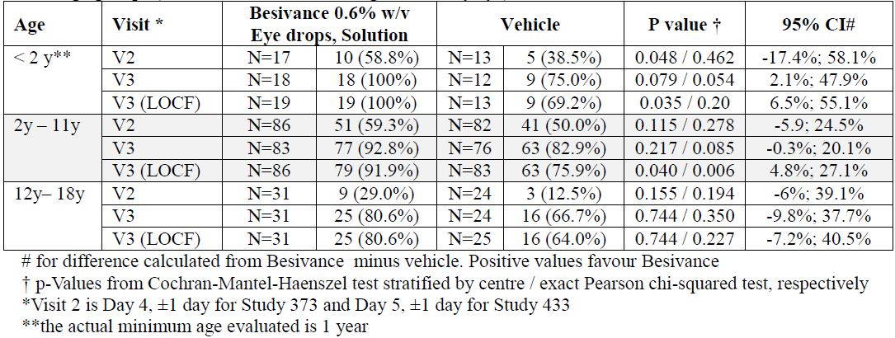
Table 8: Microbial eradication: Besivance 0.6% w/v Eye drops, Suspension versus vehicle stratified according to ICH age groups (evaluated on baseline designated study eye).
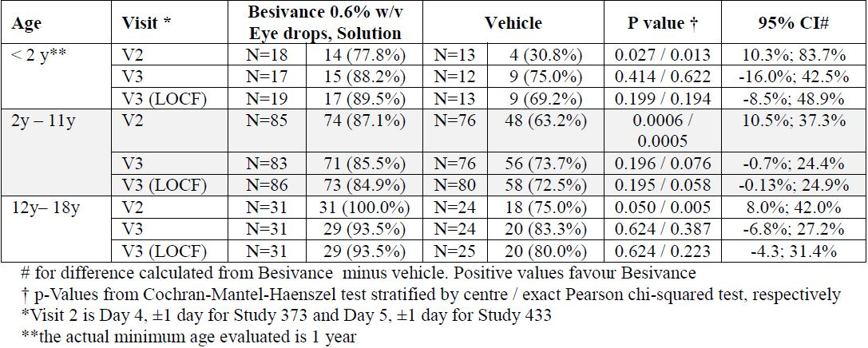
Both data sets (clinical resolution and microbial eradication), clearly show that Besivance 0.6% w/v Eye drops, Suspension is superior to vehicle in the different paediatric age groups. In particular significant microbial eradication was achieved as early as Visit 2. In addition, data from active comparator controlled Study 434 is presented in Tables 9 and 10. Patients with positive bacterial cultures at baseline are included into this analysis (Subjects with Non Missing Data). The study was a non inferiority trial using Vigamox (0.5% moxifloxacin eye drops) as comparator.
Table 9: Clinical resolution: Besivance 0.6% w/v Eye drops, Suspension versus Vigamox (moxifloxacin) stratified according to ICH age groups (evaluated on baseline designated study eye).
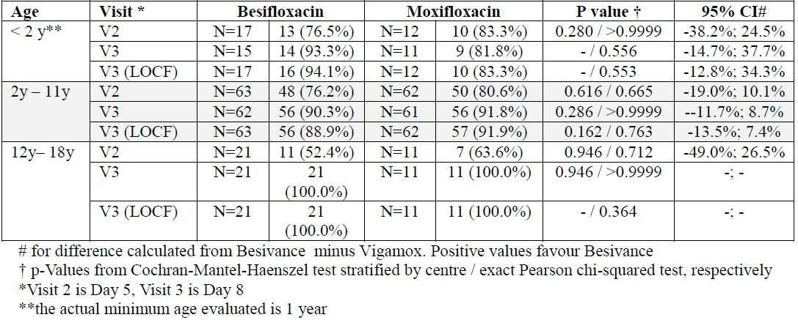
Table 10: Microbial eradication: Besivance 0.6% w/v Eye drops, Suspension vs Vigamox (moxifloxacin) stratified according to ICH age groups (evaluated on baseline designated study eye).
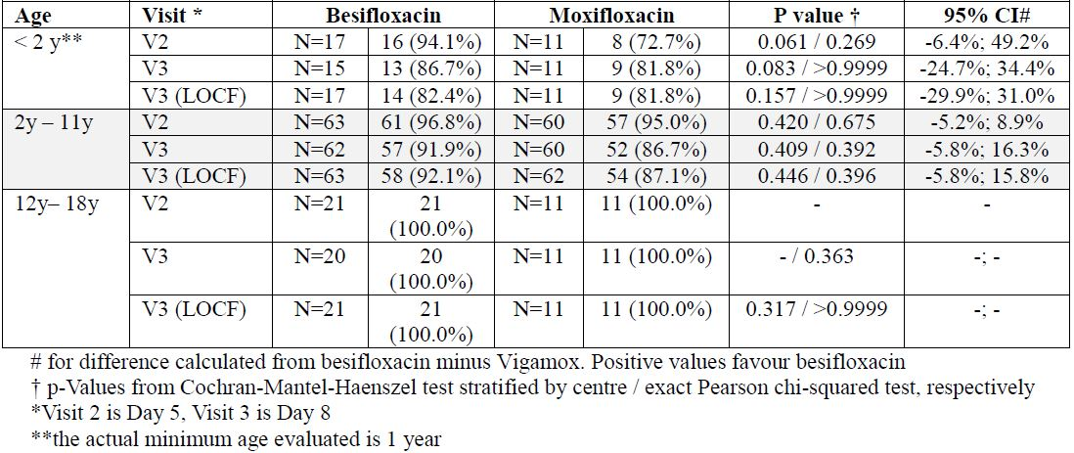
As it is obvious from the data presented in Tables 9 and 10 there is no indication that Besivance 0.6% w/v Eye drops, Suspension might be inferior to moxifloxacin eye drops for any paediatric subgroup if used in the treatment of bacterial conjunctivitis. This is true for both clinical resolution and microbial eradication. Similar results were obtained for the total population.

Safety data in children one year of age and older
When considering the whole paediatric population aged 1-17 from Studies 373, 433 and 434, 815 subjects were included (447 with culture confirmed bacterial conjunctivitis). Besifloxacin was well tolerated, with similar incidences of AEs in the besifloxacin, vehicle and moxifloxacin groups. The nature and incidence of ocular treatment emergent AEs in patients less than 18 years old in the pooled analysis of Studies 373, 433, and 434 were consistent with those of the overall population. One or more ocular treatment emergent adverse events were reported for 11.0% of eyes treated in the besifloxacin group (n = 662), 14.2% in the vehicle group (n = 401) and 10.6% in the Vigamox group (n = 246). The most frequently reported ocular treatment emergent adverse events (≥1%) in this patient set were conjunctivitis (2.9% for Besivance 0.6% w/v Eye drops, 5.4% for vehicle, versus 5.7% for Vigamox); conjunctivitis bacterial (2.1%, 2.5% and 2.4%, respectively); and eye pain (1.8%, 0.5% and 0%, respectively).
There were no deaths reported for any of the studies conducted during the clinical development program and no SAEs occurred in the paediatric population.

Advisory committee considerations
The ACPM, taking into account the submitted evidence of efficacy, safety and quality, considered Besivance suspension for eye drops containing 0.6% w/v of besifloxacin to have an overall positive benefit-risk profile for the amended indication:
Besivance is indicated for the treatment of severe, confirmed bacterial conjunctivitis caused by besifloxacin sensitive bacteria.
Besivance is indicated for adults and children 12 months and older.
In making this recommendation the ACPM:
- Noted the difficulty in distinguishing virally caused conjunctivitis (initially unilateral, watery discharge) compared to bacterially caused conjunctivitis (usually unilaterial, purulent discharge) compared to allergic (itchy, bilateral) reactions,
- Expressed concern that there seemed to be a significant amount of data that have not been evaluated, including placebo controlled trials #603 (completed October 2010) and #631 (completed December 2011),
- Was of the view that evaluated trials demonstrate efficacy against placebo, albeit for a self limiting condition,
- Noted Therapeutic Guidelines recommend a delayed prescription policy given spontaneous recovery with treatment recommendations, and
- Noted the possibility of improved compliance due to three times daily regimen compared to every 2 h for alternatives.
The committee was requested to provide advice on the following specific issues:
- Whether registration of besifloxacin eye drops for treatment of bacterial conjunctivitis is associated with potential for development of resistance to besifloxacin and cross resistance to moxifloxacin which has high impact and whether this is a reason for rejection of this application?
  - The committee considered there is a concern that gram positive organisms may become resistant. FQ resistance in staphylococcus is clinically significant. However, adults rarely carry pneumococci compared with children. One proposed reason for the relatively low rate of FQ resistance is the relatively low use in children. The population use of this product is unlikely to sufficient to impact on resistance in the community, but acquired resistance may be a significant issue for individual patients using this product. FQ are rated as of importance to human health and there are deliberate policies in humans and animals to control use.
  - The ACPM noted:
    - The very low systemic exposure levels compared to orally administered FQ; and
    - The sponsor’s argument that the risk of overgrowth of non susceptible organisms resulting from prolonged use is unlikely with restriction of the labelled use to 7 days.
- Have risks and benefits been adequately supported compared with existing recognised therapies for bacterial conjunctivitis?
  - Besifloxacin has been shown to have greater efficacy compared to placebo in the trials evaluated (albeit with high placebo response rates) but similar efficacy when compared to moxifloxacin. Based on the mechanism of action, it would be expected to have similar efficacy to currently available FQ.
- If the ACPM supports registration of besifloxacin eye drops despite the Delegate’s concerns about resistance and cross resistance risk, provide advice on the issues:
  - Is the proposed listing of specific organisms in the ‘Indications’ appropriate?
    - No. Conjunctivitis is generally treated syndromically. Many of the listed bacteria probably are not pathogens.
  - Is the proposed listing of organisms studied in fewer than 10 infections in the ‘Indications’ appropriate?
    - No. It strongly suggests that there may be insufficient data to support its use for infections with those organisms specifically.
  - Is there adequate support for efficacy and safety in children from 12 months of age?
  - Evidence suggests that conjunctivitis is more often viral in children. The submitted studies suggest borderline effectiveness. There were 236 children in besifloxacin arm in the studies. However, resistance may be more likely in this population due to behavioural factors.

Proposed conditions of registration:
The ACPM specifically advised the inclusion of the following in the conditions of registration:
- Subject to satisfactory negotiation of the RMP most recently approved by the TGA,
- Negotiation of PI and CMI to the satisfaction of the TGA.
The ACPM advised that the implementation by the sponsor of the recommendations outlined above to the satisfaction of the TGA, in addition to the evidence of efficacy and safety provided would support the safe and effective use of these products.

Outcome
Based on a review of quality, safety and efficacy, TGA approved the registration of Besivance eye drops containing besifloxacin 0.6% w/v suspension, indicated for:
Besivance is indicated for the treatment of severe, confirmed bacterial conjunctivitis caused by besifloxacin sensitive bacteria.
Besivance is indicated for adults and children 12 months and older.

Specific conditions of registration applying to these therapeutic goods
- The Besivance besifloxacin 0.6% w/v suspension eye drops RMP, EU-RMP Version 1.0 (dated 02/10/2012, DLP 31/05/2012) with Australia specific annex (attached to EU-RMP in Annex 9), included with the submission and any subsequent revisions, as agreed with the TGA will be implemented in Australia.

Attachment 1. Product Information
The Product Information approved at the time this AusPAR was published is at Attachment 1. For the most recent Product Information please refer to the TGA website at <http://www.tga.gov.au/hp/information-medicines-pi.htm>.

Attachment 2. Extract from the Clinical Evaluation Report

Assumes a 70 kg individual receiving 30 µg/kg/day.
European Medicines Agency, “ICH guideline M3(R2) on non-clinical safety studies for the conduct of human clinical trials and marketing authorisation for pharmaceuticals (EMA/CPMP/ICH/286/1995)”, December 2009, Web, accessed 14 January 2014 <www.ema.europa.eu/docs/en_GB/document_library/Scientific_guideline/2009/09/WC500002720.pdf>.
European Medicines Agency, “ICH Topic S1B Carcinogenicity: Testing for Carcinogenicity of Pharmaceuticals Step 5: Note for Guidance on Carcinogenicity: Testing for Carcinogenicity of Pharmaceuticals (CPMP/ICH/299/95)”, March 1998, Web, accessed 14 January 2014 <www.ema.europa.eu/docs/en_GB/document_library/Scientific_guideline/2009/09/WC500002735.pdf>.
Committee on Infectious Diseases (2006) The use of systemic fluoroquinolones. Pediatrics 118: 1287-1192.
Assumes a 70 kg individual receiving 30 µg/kg/day.
Ferner RE, Aronson JK (2006) Clarification of terminology in medication errors: definitions and classification. Drug Saf 29: 1011-1022.
Karpecki P, Paterno MR, Comstock TL. (2010) Limitations of current antibiotics for the treatment of bacterial conjunctivitis. Optom Vis Sci. 87: 908-919.
Sanfilippo CM, Hesje CK, Haas W, et al. (2011) Toposomerase Mutations that are associated with high-level resistance to earlier fluoroquinolones in Staphylococcus aureus have less effect on the antibacterial activity of Besifloxacin. Chemotherapy 57: 363-371.
Cambau E, Matrat S, Pan XS, et al. (2009) Target specificity of the new fluoroquinolone besifloxacin in Streptococcus pneumoniae, Staphylococcus aureus and Escherichia coli. J Antimicrob Chemother. 63: 443-450.
Karpecki P, Paterno MR, Comstock TL. (2010) Limitations of current antibiotics for the treatment of bacterial conjunctivitis. Optom Vis Sci. 87: 908-919.
Alfonso E, Crider J. (2005) Ophthalmic infections and their anti-infective challenges. Surv Ophthalmol. 50 Suppl 1: S1-6; McDonald M, Blondeau JM. (2010) Emerging antibiotic resistance in ocular infections and the role of fluoroquinolones. J Cataract Refract Surg. 36: 1588-1598.
Kodjikian L, Lafuma A, Khoshnood B et al. (2010) Efficacy of moxifloxacin in treating bacterial conjunctivitis. J F Ophtalmol. 33: 227-233.
Silver LH, Woodside AM, Montgomery DB. (2005) Clinical safety of moxifloxacin ophthalmic solution 0.5% (VIGAMOX) in pediatric and nonpediatric patients with bacterial conjunctivitis. Surv Ophthalmol. 50 Suppl 1: S55-S63.
Sheikh A, Hurwitz B, van Schayck CP, et al. (2012) Antibiotics versus placebo for acute bacterial conjunctivitis. Cochrane Database Syst Rev. 9: CD001211.
Karpecki P, Paterno MR, Comstock TL. (2010) Limitations of current antibiotics for the treatment of bacterial conjunctivitis. Optom Vis Sci. 87: 908-919.
Comstock TL, Paterno MR, Usner DW, et al. (2010) Efficacy and safety of besifloxacin ophthalmic suspension 0.6% in children and adolescents with bacterial conjunctivitis: a post hoc, subgroup analysis of three randomized, double-masked, parallel-group, multicenter clinical trials. Paediatr Drugs 12: 105-112.

