February 2019

Australian Public Assessment Report for Benralizumab
  - Proprietary Product Name: Fasenra
  - Sponsor: AstraZeneca Pty Ltd

About the Therapeutic Goods Administration (TGA)
- The Therapeutic Goods Administration (TGA) is part of the Australian Government Department of Health and is responsible for regulating medicines and medical devices.
- The TGA administers the Therapeutic Goods Act 1989 (the Act), applying a risk management approach designed to ensure therapeutic goods supplied in Australia meet acceptable standards of quality, safety and efficacy (performance) when necessary.
- The work of the TGA is based on applying scientific and clinical expertise to decision-making, to ensure that the benefits to consumers outweigh any risks associated with the use of medicines and medical devices.
- The TGA relies on the public, healthcare professionals and industry to report problems with medicines or medical devices. TGA investigates reports received by it to determine any necessary regulatory action.
- To report a problem with a medicine or medical device, please see the information on the TGA website < https://www.tga.gov.au> .
About AusPARs
- An Australian Public Assessment Report (AusPAR) provides information about the evaluation of a prescription medicine and the considerations that led the TGA to approve or not approve a prescription medicine submission.
- AusPARs are prepared and published by the TGA.
- An AusPAR is prepared for submissions that relate to new chemical entities, generic medicines, major variations and extensions of indications.
- An AusPAR is a static document; it provides information that relates to a submission at a particular point in time.
- A new AusPAR will be developed to reflect changes to indications and/or major variations to a prescription medicine subject to evaluation by the TGA.
Copyright
© Commonwealth of Australia 2019
This work is copyright. You may reproduce the whole or part of this work in unaltered form for your own personal use or, if you are part of an organisation, for internal use within your organisation, but only if you or your organisation do not use the reproduction for any commercial purpose and retain this copyright notice and all disclaimer notices as part of that reproduction. Apart from rights to use as permitted by the Copyright Act 1968 or allowed by this copyright notice, all other rights are reserved and you are not allowed to reproduce the whole or any part of this work in any way (electronic or otherwise) without first being given specific written permission from the Commonwealth to do so. Requests and inquiries concerning reproduction and rights are to be sent to the TGA Copyright Officer, Therapeutic Goods Administration, PO Box 100, Woden ACT 2606 or emailed to < tga.copyright@tga.gov.au> .

Contents
Common abbreviations 5
I. Introduction to product submission 8
Submission details 8
Product background 9
Regulatory status 9
Product Information 10
II. Registration time line 10
III. Quality findings 11
Drug substance (active ingredient) 11
Drug product 12
Quality summary and conclusions 13
IV. Nonclinical findings 13
Introduction 13
Pharmacology 13
Pharmacokinetics 15
Toxicology 15
Nonclinical summary and conclusions 18
V. Clinical findings 19
Introduction 19
Pharmacokinetics 22
Pharmacodynamics 22
Dosage selection for the pivotal studies 23
Efficacy 23
Safety 28
First Round Benefit-Risk Assessment 35
First Round Recommendation Regarding Authorisation 37
Clinical Questions and Second Round Evaluation 37
Second Round Benefit-Risk Assessment 42
VI. Pharmacovigilance findings 44
Risk management plan 44
VII. Overall conclusion and risk/benefit assessment 46
Background 46
Quality 48
Nonclinical 48
Clinical 49
Risk-benefit analysis 63
Post ACM negotiations 84
Outcome 90
Attachment 1. Product Information 91

Common abbreviations
Abbreviation | Meaning
ACQ-6 | Asthma Control Questionnaire-6
ADA | Anti-drug antibodies
ADCC | Antibody dependent cell mediated cytotoxicity
AE | Adverse event
ALT | Alanine aminotransferase
ANC | Absolute neutrophil count
APFS | Accessorised pre filled syringe
AQLQ | Asthma Quality of Life Questionnaire
ASA | Australian Specific Annex
AST | Aspartate aminotransferase
ATS/ERS | American Thoracic Society / European Respiratory Society
AUC | Area under the plasma concentration time curve
BMI | Body Mass Index
CDC | Complement dependent cytotoxicity
CI | Confidence Interval
COPD | Chronic obstructive pulmonary disease
C_{max} | Maximum plasma concentration
CNS | Central nervous system
CSR | Clinical study report
C_{trough} | Trough plasma concentration
DSMB | Data Safety Monitoring Board
EC₅₀ | Half-maximal effective concentration
ECG | Electrocardiogram
ED | Effective dose
EOT | End of treatment
ER | Emergency room
FAS | Full analysis set
FEV1 | Forced expiratory volume in 1 second
GCP | Good Clinical Practice
GINA | Global Initiative for Asthma
GLP | Good Laboratory Practice
IC₅₀ | Half maximal inhibitory concentration
ICH | International Council for Harmonisation
ICS | Inhaled corticosteroid(s)
IL-5 | Interleukin-5
IL-5Rα | Interleukin-5 receptor alpha subunit
ITT | Intention to treat
IV | Intravenous
K_{D} | Dissociation constant
LABA | Long-acting beta 2 (β₂) agonist(s)
LAMA | Long-acting anti-muscarinic(s)
LS | Least squares
LTRA | Leukotriene receptor antagonist(s)
mAb | Monoclonal antibody
MACE | Major adverse cardiac event
MCID | Minimally clinically important difference
MedDRA | Medical Dictionary for Regulatory Activities
MMRM | Mixed-effect model for repeated measures
MOA | Mechanism of action
NNT | Numbers needed to treat
NOAEL | No observed adverse effect level
OCS | Oral corticosteroid(s)
PD | Pharmacodynamic(s)
PEF | Peak expiratory flow
ppFEV1 | Percent predicted forced expiratory volume in 1 second (FEV1)
PI | Product Information
PK | Pharmacokinetic(s)
Q2W | Every 2 weeks
Q4W | Every 4 weeks
Q8W | Every 8 weeks
SABA | Short-acting beta 2 (β₂) agonist(s)
SAE | Serious adverse event
SC | Subcutaneous
SEAC | Safety Endpoint Adjudication Committee
SOC | System Order Class
TEAE | Treatment-emergent adverse event
T_{max} | Time to maximum plasma concentration
ULN | Upper limit of normal
WCC | White cell count

I. Introduction to product submission

Submission details
Type of submission: | New biological entity
Decision: | Approved
Date of decision: | 29 March 2018
Date of entry onto ARTG: | 2 April 2018
ARTG number: | 286718
Black Triangle Scheme | Yes  This product will remain in the scheme for 5 years, starting on the date the product is first supplied in Australia
Active ingredient: | Benralizumab
Product name: | Fasenra
Sponsor’s name and address: | AstraZeneca Pty Ltd  PO Box 131  North Ryde NSW 1670
Dose form: | Solution for injection
Strength: | 30 mg in1 mL
Container: | Prefilled syringe
Pack size: | 1
Approved therapeutic use: | Fasenra is indicated as add-on therapy in patients aged 12 years and over with severe eosinophilic asthma (blood eosinophil count ≥ 300 cells/μL or ≥ 150 cells/μL if on oral corticosteroid treatment) (see Section 5.1 [Clinical Trials]).
Route of administration: | Subcutaneous
Dosage: | Fasenra should be prescribed by a health care professional in consultation with a specialist physician experienced in the diagnosis and treatment of severe asthma.  The recommended dose is 30 mg of Fasenra by subcutaneous injection every 4 weeks for the first 3 doses, and then every 8 weeks thereafter. For further details please see the Product Information.

Product background
This AusPAR describes the application by AstraZeneca Pty Ltd (the sponsor) to register Fasenra benralizumab 30 mg in1 mL solution for injection prefilled syringe for the following indication:
Fasenra is indicated as an add-on maintenance treatment for severe asthma in patients with an eosinophilic phenotype.
Benralizumab is an anti-eosinophil, monoclonal antibody (mAb), (specifically an immunoglobulin G1 kappa subtype IgG1κ) that binds to the alpha subunit of the human interleukin-5 receptor (IL-5Rα) with high affinity (16 pM) and specificity. The interleukin-5 receptor is specifically expressed on the surface of eosinophils and basophils. The high affinity of benralizumab for FcɣRIII receptors on immune effector cells such as natural killer (NK) cells leads to apoptosis of eosinophils and basophils through enhanced antibody dependent cell mediated cytotoxicity (ADCC).
The term ‘eosinophilic asthma’ refers to asthma with elevated eosinophils in bronchial biopsy specimens, induced sputum, or peripheral blood, with or without concomitant therapy with inhaled corticosteroids (ICS).
Patients with severe eosinophilic asthma who remain uncontrolled with current standard of care treatment continue to suffer symptoms, frequent exacerbations, and compromised quality of life. Exacerbations typically require treatment with high doses of systemic corticosteroids and may also require hospitalisation. There is a lack of treatment options for this patient population, so provision of new medications is needed.
Eosinophils release granule derived basic proteins, lipid mediators, cytokines, and chemokines that potentiate airway inflammation, contribute to lung tissue remodelling, and are associated with severe asthma exacerbations do. Eosinophilic inflammation is an important component in the pathogenesis of asthma. Benralizumab, by enhanced ADCC, reduces eosinophilic inflammation.

Regulatory status
The product received initial registration on the Australian Register of Therapeutic Goods (ARTG) on 2 April 2018.
At the time the TGA considered this application, a similar application had been approved in USA, the European Union (EU) and Canada as shown in Table 1, and was under consideration in Switzerland.
The Clinical Dossier submitted in Australia is the same as that submitted in the other countries.
Table 1: Overseas regulatory status of benralizumab
Country | Status | Indication
US FDA | Approved 14 November 2017 | Fasenra is indicated for the add-on maintenance treatment of patients with severe asthma aged 12 years and older, and with an eosinophilic phenotype [see Clinical Studies (14)].
EU CHMP Centralised Procedure | Approved 10 January 2018 | Fasenra is indicated as an add-on maintenance treatment in adult patients with severe eosinophilic asthma inadequately controlled despite high dose inhaled corticosteroids plus long-acting β-agonists (see section 5.1)
Canada | Approved 22 February 2018 | Fasenra (benralizumab injection) is indicated as an add-on maintenance treatment of adult patients with severe eosinophilic asthma.
Japan | Approved 19 January 2018 | Bronchial asthma (limited to refractory patients whose asthmatic symptoms cannot be controlled by currently available treatment)
US FDA = United States Food and Drug Administration; EU CHMP = European Union Committee for Medicinal Products for Human Use

Product Information
The Product Information (PI) approved with the submission which is described in this AusPAR can be found as Attachment 1. For the most recent PI, please refer to the TGA website at < https://www.tga.gov.au/product-information-pi> .

II. Registration time line
Table 2 captures the key steps and dates for this application and which are detailed and discussed in this AusPAR.
Table 2: Timeline for Submission PM-2016-04636-1-5
Description | Date
Submission dossier accepted and first round evaluation commenced | 31 March 2017
First round evaluation completed | 11 September 2017
Sponsor provides responses on questions raised in first round evaluation | 31 October 2017
Delegate’s Overall benefit-risk assessment and request for Advisory Committee advice | 22 December 2017
Second round evaluation completed | 5 January 2018
Sponsor’s pre-Advisory Committee response | 16 January 2018
Advisory Committee meeting | 1-2 February 2018
Registration decision (Outcome) | 29 March 2018
Completion of administrative activities and registration on ARTG | 2 April 2018
Number of working days from submission dossier acceptance to registration decision* | 215
*Statutory timeframe for standard applications is 255 working days
Evaluations included under Quality findings and Nonclinical findings incorporate both the first and second round evaluations.

III. Quality findings

Drug substance (active ingredient)

Structure
Benralizumab is a recombinant humanised afucosylated IgG1κ monoclonal antibody directed against the human interleukin (IL)-5 receptor alpha subunit expressed on eosinophils and basophils. Benralizumab depletes eosinophils via a mechanism of antibody dependent cellular cytotoxicity (ADCC). Benralizumab is comprised of two heavy chains and two light chains with an overall molecular weight of approximately 150 kDa.

Physical and chemical properties
The physicochemical properties of benralizumab are summarised in Table 3.
Table 3: Physicochemical properties of benralizumab drug substance
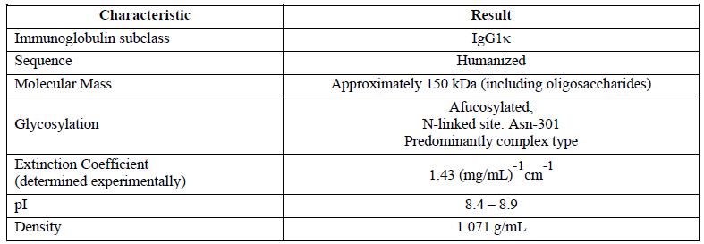
Drug substance manufacture
The cell culture steps of the benralizumab drug substance manufacturing process consist of working cell bank vial thaw, inoculum expansion in seed bioreactors, benralizumab production in a bioreactor, and harvest. After the harvest step, the clarified conditioned medium containing benralizumab is further processed through a series of purification steps which consists of three chromatography steps and two dedicated virus clearance steps. At the end of the purification process, the drug substance is frozen and stored at -45℃ to -35℃.
All manufacturing steps have been validated.

Drug product
The drug substance is thawed and followed by final formulation, mixing, filtration and filling into ready to fill primary containers. The primary containers are accessorised, labelled and packaged as the finished product.
All drug product manufacturing steps have been validated.
Final drug substance and drug product specifications were provided.
Specification for release and stability of the drug product has been tightened.
All analytical procedures are validated.

Stability
Stability data have been generated under stressed and real time conditions to characterise the stability profile of the product. The product is protected from light by its packaging.
The shelf-life of 36 months when stored at 2°C to 8°C is supported by the stability data. Temperature excursion of up to 25°C for a cumulative period of ≤ 24 hours is permitted.
There are no objections to the registration of this product from sterility; endotoxin, container safety and viral safety related aspects.
Overall, sufficient evidence has been provided to demonstrate that the risks related to the manufacturing quality of Fasenra have been controlled to an acceptable level.
With respect to quality matters, the product information (PI), consumer medicine information (CMI) and labels are acceptable.

Quality summary and conclusions
All quality issues have been resolved. There is no objection on quality grounds to the approval of Fasenra.

Proposed conditions of registration
Batch release testing and compliance with Certified Product Details (CPD)
- It is a condition of registration that all batches of Fasenra benralizumab imported into Australia must comply with the product details and specifications approved during evaluation and detailed in the Certified Product Details (CPD).
- It is a condition of registration that each batch of Fasenra benralizumab imported into Australia is not released for sale until samples and/or the manufacturer’s release data have been assessed and endorsed for release by the TGA Laboratories Branch.

IV. Nonclinical findings

Introduction
The overall quality of the nonclinical dossier was good and in general accordance with relevant TGA adopted guidelines, including International Council for Harmonisation (ICH) ICH S6 (R1). All pivotal safety related studies were conducted according to Good Laboratory Practice (GLP).

Pharmacology

Primary pharmacology
IL-5Rα, the target for benralizumab, is expressed on eosinophils and (less strongly) basophils, key effectors of allergic inflammation. By binding to IL-5Rα, benralizumab is intended to induce apoptosis of eosinophils via ADCC, alleviating eosinophilic asthma.
Benralizumab was shown to bind to recombinant human IL-5Rα with picomolar affinity (dissociation constant (K_{D}), 16 pM), to bind to human eosinophils, inhibit IL-5R signalling (as inhibition of Interleukin-5 (IL-5) induced proliferation of cells transfected with the human IL-5 receptor; half maximal inhibitory concentration (IC₅₀), of approximately 0.3 nM), and induce ADCC of human eosinophils and basophils (half maximal effective concentration (EC₅₀) values, 0.9 and 0.5 pM, respectively). Benralizumab induced apoptosis of eosinophils was not accompanied by eosinophil degranulation.
Benralizumab is afucosylated; engineered so that oligosaccharides of the Fc region of the antibody lack fucose units. This modification enhances affinity for the FcγRIII receptor (K_{D}, 45.5 nM) and ADCC activity; the fucosylated form of the antibody did not induce eosinophil apoptosis at concentrations 1000 times higher than the EC₅₀ for benralizumab, despite comparable recognition of IL-5Rα.
Benralizumab targets a site on IL-5Rα that is conserved between humans and the cynomolgus monkey. The antibody showed broadly comparable but somewhat weaker affinity for the monkey form of the receptor compared with human (K_{D} for binding to recombinant monkey IL-5Rα, 42 pM). Benralizumab does not recognise mouse IL-5Rα. This was shown to be due to a single amino acid difference at the binding site; the amino acid as this position is also different compared with human in the rat, rabbit and dog.
In vivo, subcutaneous (SC) or intravenous (IV) administration of benralizumab (0.1 to 30 mg/kg) caused pronounced reductions in circulating eosinophils in cynomolgus monkeys. This occurred within days of dosing and was long lasting. In monkey models of eosinophilia, single dose administration of an antibody similar to benralizumab (same sequence and equivalent affinity and in vitro activity, but produced from a different cell culture system) reduced peak peripheral eosinophils induced by repeated treatment with IL-5 (at 0.3 mg/kg IV, and less consistently at 0.01 mg/kg IV), and significantly attenuated infiltration of airway eosinophils and airway hyper-responsiveness induced by allergen challenge (at 1 mg/kg IV).

Secondary pharmacodynamics and cross reactivity
Benralizumab is an IgG1κ antibody. High specificity for binding is evident from pharmacology studies showing modification of a single amino acid in IL-5Rα is sufficient to abolish target recognition. The molecule was shown to not induce complement dependent cytotoxicity (CDC) of human eosinophils.
Immunohistochemical studies examining cross reactivity; involving a suitably comprehensive panel of human tissues; revealed a relatively limited pattern of staining for benralizumab. In addition to staining intravascular protein in many tissues (interpreted to represent staining of soluble IL-5R), staining of mononuclear cells in the spleen and of striated skeletal myocytes was seen. Benralizumab produced this same staining pattern in cynomolgus monkey tissues, and additionally stained bone marrow eosinophil precursors (consistent with IL-5Rα expression) and cardiac myocytes. Staining that is not associated with known expression of IL-5Rα was mostly cytoplasmic. As a large molecular weight protein, benralizumab is not expected to access the cytoplasm, so the finding is not of particular concern. Together with primary pharmacology data, the highly similar tissue staining pattern of benralizumab in cynomolgus monkey and human tissues supports the use of this species as an appropriate animal model in toxicity studies.

Safety pharmacology
No specialised safety pharmacology studies with benralizumab were conducted; examination of safety pharmacology endpoints covering the cardiovascular and respiratory systems was incorporated into the general repeat dose toxicity program instead. Electrocardiogram (ECG) and blood pressure were unaffected in monkeys at doses up to 30 mg/kg IV and SC; and respiration rate and blood gases were unaffected at up to 30 mg/kg IV. Serum drug levels at the time of monitoring are seen to be more than two orders of magnitude higher than clinical maximum plasma concentration (C_{max}). Functional indices to investigate potential effects on central nervous system (CNS) function were not measured; this is not in accordance with ICH S6 (R1);³ and ICH S7A. However, while the extent of the examination was not ideal, there were no clinical signs observed in treated monkeys to indicate adverse effects on CNS function, and no such effect is expected based on knowledge of the physiological role of the target.

Pharmacokinetics
Exposure to benralizumab after SC and IV administration was dose proportional in cynomolgus monkeys, and approximately so in humans. Half-life was long and similar in monkeys and humans (approximately 13 days and 15 days in the respective species). Repeat fortnightly dosing in monkeys was accompanied by accumulation (approximately 2 fold). Bioavailability by the SC route was highly similar in monkeys (approximately 55%) and humans (approximately 58%). As expected for an IgG antibody, volume of distribution was low (70 mL/kg in monkeys), consistent with minimal extravascular distribution.
No distribution, metabolism, excretion or pharmacokinetic interaction studies were submitted; this is acceptable given the protein nature of the drug in accordance with ICH S6 (R1).³ It is expected benralizumab will be eliminated by normal protein degradation pathways for IgG molecules.
The pharmacokinetic characteristics of benralizumab in cynomolgus monkeys were shown to be sufficiently similar to those in humans to allow this species to serve as an appropriate model for the assessment of benralizumab toxicity.

Toxicology

Acute toxicity
A dedicated single dose toxicity study by the SC route in monkeys, together with information from the repeat dose toxicity program (SC and IV administration in monkeys), establish a low order of acute toxicity for benralizumab. There were no deaths, treatment related effects on body weight, or acute clinical signs observed up to the highest dose levels tested (30 mg/kg IV and SC).

Repeat dose toxicity
The pivotal repeat dose toxicity study was of 9 months duration in cynomolgus monkeys, and involved fortnightly SC or IV administration. The study was appropriately designed and conducted in terms of species and dose selection, group size, duration and endpoints examined. Two shorter studies were also submitted, involving IV administration every 3 weeks for 9 weeks and SC administration twice weekly for 15 weeks. Due to the species specificity of the drug, rodent species are not suitable for toxicity studies with benralizumab.

Relative exposure
Animal: human exposure multiples achieved in the pivotal study are calculated below based on comparison of serum area under the plasma concentration time curve (AUC) values for benralizumab, adjusted for differences in dosing frequency (that is, animal values are multiplied by 4 to account for fortnightly dosing compared with administration once every 8 weeks in patients) (see Table 4). Very high multiples of the human exposure were achieved.
Table 4: Relative exposure in the pivotal repeat dose toxicity study
Species | Study duration [Study no.] | Dose (mg/kg); route |  | Dosing frequency | AUC_{0–t} (µg∙d/mL) | Exposure ratio#
Monkey (cynomolgus) | 9 months  [Study AAO00095] | 10 | IV | Q2W | 2320 | 153
Monkey (cynomolgus) | 9 months  [Study AAO00095] | 25 | IV | Q2W | 6100 | 402
Monkey (cynomolgus) | 9 months  [Study AAO00095] | 30 | SC | Q2W | 4110 | 271
Human (asthma patients) | Population PK analysis | [30 mg] | SC | Q8W | 60.72 | –
^ = animal data are for the sexes combined, measured at the last sampling occasion; # = animal: human serum AUC_{0–t} x animal: human dosing frequency PK: Pharmacokinetic Q2W: Every 2 weeks; Q8W: Every 8 weeks
Anti benralizumab antibodies developed in some animals in the studies, with high titres associated with decreased drug exposure. This was not so prevalent as to affect the validity of the studies. Of particular note, only 2/36 benralizumab treated monkeys in the pivotal study were found to have developed anti-drug antibodies; these were from either IV dose group and not from the group treated with benralizumab SC.

Major findings
Benralizumab was well tolerated in monkeys. The sole major finding across studies was marked reduction in circulating eosinophils, with bone marrow smears revealing decreased eosinophilic precursors, consistent with the primary pharmacology of benralizumab. The pivotal study establishes a no observed adverse effect level (NOAEL) of 30 mg/kg every 2 weeks (Q2W) by the clinical route (SC), associated with an exposure multiple of 271.
While IL-5Rα is also expressed on basophils, benralizumab did not lower basophil counts in treated monkeys. As well, skeletal and cardiac muscle, found to be stained by benralizumab in immunohistochemical studies, showed no treatment-related lesions.
One monkey treated at 25 mg/kg IV in the pivotal 9 month study showed an adverse reaction following administration of the fourth dose of benralizumab that included petechiae, ecchymosis, decreased platelet count, and decreased erythrocyte indices. The animal recovered after a dosing holiday (next fortnightly dose withheld) and showed no further reactions for the remainder of the study (involving administration of 15 subsequent doses). No similar reaction was observed in any other benralizumab treated animal.

Genotoxicity
No genotoxicity studies were conducted with benralizumab. This is in accordance with ICH S6 (R1);³ with a large protein like benralizumab not expected to interact with DNA or other chromosomal material.

Carcinogenicity
Carcinogenicity studies were not conducted. This is acceptable under ICH S6 (R1) given the absence of cause for concern from the general repeat dose toxicity studies (for example, proliferative lesions) and from consideration of the physiological role of the target.

Reproductive toxicity
The reproductive toxicity of benralizumab was examined in an enhanced pre/postnatal development study in monkeys, and from surrogate endpoints relating to fertility included in the 9 month general repeat dose toxicity study (conventional fertility studies are not feasible in monkeys). The studies were appropriately designed and conducted in terms of species and dose selection, group size, the timing and duration of treatment, and the endpoints examined. The enhanced pre/postnatal development study involved IV dosing rather than administration by the clinical route (SC), but this does not affect the validity of the study.
Surrogate fertility endpoints; sperm parameters, testicular volume, menstrual cycling, serum sex hormones, organ weights (epididymides, testes, seminal vesicle, prostate, ovaries and uterus), and histopathology of reproductive tissues (epididymides, testes, seminal vesicles, prostate, ovaries, oviducts, uterus, cervix and vagina); were unaffected by treatment with benralizumab in monkeys at fortnightly doses up to 25 mg/kg IV and 30 mg/kg/day SC (relative exposure based on AUC; ≤ 402).
The enhanced pre/postnatal development study involved fortnightly administration to monkeys commencing from detection of pregnancy (Day 20 to 22 of gestation) to 1 month postpartum, with postnatal monitoring of the offspring to 6.5 months of age. High multiples of the human AUC were obtained in the pregnant animals (see Table 5).
Table 5: Relative exposure in the reproductive toxicity study
Species | Study | Dose (mg/kg); route |  | Dosing frequency | AUC_{0–t} (µg∙d/mL) | Exposure ratio#
Monkey (cynomolgus) | Enhanced pre/ postnatal development [Study AAO00036] | 10 | IV | Q2W | 1710 | 113
Monkey (cynomolgus) | Enhanced pre/ postnatal development [Study AAO00036] | 30 | IV | Q2W | 4760 | 314
Human (asthma patients) | Population PK analysis | 30 mg | SC | Q8W | 60.72 | –
^ = animal data are for the sexes combined, measured at the last sampling occasion; # = animal:human serum AUC_{0–t} x animal:human dosing frequency
Benralizumab was detected in the offspring of treated monkeys. Serum benralizumab levels in infants were 66% of the maternal level at postnatal Day 7 (the first time point examined) and slowly declined over time (for example, to 10% of the maternal level 3 months after birth). This is consistent with placental transfer of the IgG antibody, with only limited additional exposure via consumption of maternal milk.
No adverse effects on pre or postnatal survival, growth or development were observed up to the highest dose tested (30 mg/kg IV, once fortnightly), associated with an exposure multiple in excess of 300. Peripheral blood eosinophils were decreased in infants exposed to benralizumab in utero (pharmacological effect of benralizumab); the effect was reversible but long lasting (most animals showed recovery by 6 months of age) and is pharmacologically mediated. Limited examination of immune function in the offspring; humoral immune response to immunisation (anti keyhole limpet haemocyanin (anti KLH) IgM and IgG antibodies) and levels of serum IgM, IgG and IgA; showed no effect of treatment. The effect on the immune response to parasitic infection was not studied.

Pregnancy classification
The sponsor has proposed Pregnancy Category B1.
Consideration has been given to assignment to Pregnancy Category C instead. Although treatment of pregnant monkeys with benralizumab did not cause malformations, affect survival, or produce other adverse effects on fetal/postnatal development, it did cause significant and long-lasting eosinophil depletion. This is mediated pharmacologically. Category C is for:
‘Drugs which, owing to their pharmacological effects, have caused or may be suspected of causing, harmful effects on the human fetus or neonate without causing malformations. These effects may be reversible.’
While there is some concern regarding the potential for impaired immunity to parasites and other pathogens in the newborn, eosinophil depletion is not of such serious concern as to be regarded as harmful within the definition given above. In light of this, Pregnancy Category B1; is considered to be acceptable. This matches the pregnancy category for mepolizumab (Nucala), an antibody against IL-5 (that is, the ligand compared with receptor here), which also depletes eosinophils.

Local tolerance
SC injection of benralizumab was well tolerated locally in monkeys at the clinical strength in the general 9 month repeat dose toxicity study (30 mg/mL) and in a dedicated study in rabbits at a higher strength (50 mg/mL benralizumab). The formulations tested in animals contained the same excipients as in the product proposed for registration, but with minor quantitative differences (lower concentrations of trehalose and polysorbate 20) that are not considered to notably affect study applicability.

Comments on the nonclinical safety specification of the risk management plan
Results and conclusions drawn from the nonclinical program for benralizumab detailed in the sponsor’s draft Risk Management Plan are in general concordance with those of the nonclinical evaluator.

Nonclinical summary and conclusions
- The nonclinical module contained an adequate set of studies investigating pharmacology, pharmacokinetics and toxicity, conducted in general accordance with the relevant TGA adopted guideline applicable to biotechnology derived pharmaceuticals.³ The overall quality of the nonclinical dossier was good. All pivotal safety related studies were GLP compliant.
- In vitro studies established that benralizumab binds to human IL-5Rα with high affinity (K_{D}, 16 pM), and recognises the monkey form of the target in a similar fashion. The antibody inhibits IL-5 receptor signalling, and induces antibody dependent cell-mediated cytotoxicity (ADCC) of human eosinophils and basophils (the cell types that express IL-5Rα). In vivo, benralizumab depleted blood and bone marrow eosinophils in cynomolgus monkeys. Attenuation of allergic pulmonary eosinophilia and airway hyper-responsiveness was demonstrated in monkeys treated with an antibody analogous to benralizumab. These studies offer support for the utility of benralizumab for the proposed indication.
- High specificity for binding is evident. Substitution of a single amino acid in human IL-5Rα is sufficient to abolish target recognition. The benralizumab binding site is conserved in human and monkey IL-5Rα, but not in other common laboratory animal species (mouse, rat, rabbit and dog).
- Examination of safety pharmacology in cynomolgus monkeys identified no effects on cardiovascular, respiratory or CNS function.
- Pharmacokinetic studies with benralizumab revealed a long serum half-life in monkeys (approximately 2 weeks) and a low volume of distribution, as in humans.
- The cynomolgus monkey is seen to be an appropriate model for benralizumab toxicity on pharmacodynamic and pharmacokinetic grounds.
- Benralizumab had a low order of acute SC and IV toxicity in cynomolgus monkeys.
- Repeat dose toxicity studies by the intravenous and subcutaneous routes were conducted in cynomolgus monkeys (up to 9 months duration). Benralizumab was well tolerated at doses yielding very high multiples of the clinical AUC, with decreased eosinophils in blood and bone marrow (resulting from primary pharmacology) the sole major finding.
- No genotoxicity or carcinogenicity studies were conducted, in line with the guideline.³
- Examination of surrogate endpoints in monkeys indicated no impairment of fertility.
- While benralizumab did not adversely affect pre or postnatal survival, growth or development in monkeys, maternal treatment did result in significant and long lasting eosinophil depletion in the offspring, consistent with extensive placental transfer of the antibody in the later stages of pregnancy. Pregnancy Category B1, as proposed by the sponsor, is considered to be acceptable.
- There are no nonclinical objections to the registration of Fasenra for the proposed indication.
The nonclinical evaluator also made recommendations for changes to the PI but these are beyond the scope of the AusPAR.

V. Clinical findings
A summary of the clinical findings is presented in this section.

Introduction

Background

Information on the condition being treated
Asthma is a chronic inflammatory condition of the airways, associated with episodes of wheezing breathlessness and chest tightness. The clinical presentation is due to widespread narrowing of the airways. The prevalence of asthma in Australia is 9.8%, which translates to 2 million people. Poorly controlled asthma decreases quality of life and can result in hospital admission. There were 36,703 separations of people admitted to hospital with a principal diagnosis of asthma in 2008 to 2009 in Australia, which was 0.45% of all hospital separations during that period. In 2009, there were 411 deaths attributed to asthma as the underlying cause in Australia. This represented a mortality rate of 1.60 per 100,000 people and 0.29% of all deaths in Australia that year.
Asthma has been classified according to severity, and more recently in terms of ‘phenotypic’ groups, that is, groups of patients who share common clinical, pathological or physiological features.¹¹ The ultimate aim of identifying such groups is to improve prevention and disease management strategies by allowing more appropriate targeting of interventions. In hospitalised patients with asthma, 43% had > 3% eosinophils in their sputum and these patients had a more severe presentation. The community prevalence of eosinophilic phenotype asthma in Australia is unknown, but in other populations ranges from 36% to 67% of corticosteroid naïve subjects and 17% to 39% of patients treated with inhaled corticosteroids.
Eosinophilic asthma is a biomarker based phenotype. The term ‘eosinophilic asthma’ refers to asthma with elevated eosinophils in bronchial biopsy specimens, induced sputum, or peripheral blood, with or without concomitant therapy with inhaled corticosteroids (ICS).¹³ In subjects who were corticosteroid naive, eosinophilic asthma is defined as the presence of ≥ 2% eosinophils of the total white blood cell count in induced sputum, whereas, with subjects on high dose inhaled corticosteroid treatment, thresholds from 2% to 4% are used to identify this phenotype.

Current treatment options
Management of asthma involves assessing control of symptoms, identifying other clinically relevant issues (such as smoking, environmental factors, exercise and allergic triggers), adjusting pharmacological treatment and completing an asthma action plan. The pharmacologic treatments are:
- Bronchodilators: these include short acting beta 2 (β₂) agonists (SABA), long acting β₂ agonists (LABA) and antimuscarinic bronchodilators and theophyllines.
- Inhaled corticosteroids: fluticasone, beclomethasone, budesonide.
- Leukotriene receptor antagonists: montelukast.
- Phosphoesterase type-4 inhibitors: roflumilast.
- Chromoglycate.
- Omalizumab (a recombinant DNA derived humanised monoclonal antibody that selectively binds to human immunoglobulin E (IgE)).
- Oral corticosteroids: in patients with severe asthma unresponsive to other treatments.
Treatments currently available specifically for eosinophilic asthma are:
- Anti-interleukin 5 treatments:
  - Reslizumab: humanised monoclonal antibody against IL-5 (approved in the US for eosinophilic asthma, but not approved for this indication in Australia.
  - Mepolizumab: humanised monoclonal antibody against IL-5.
Most patients with asthma will be well controlled with conventional treatments such as β₂ agonists and inhaled corticosteroids. Other treatments would be used in patients who do not have adequate symptom control with these treatments.

Clinical rationale
The clinical rationale provided by the sponsor is ‘patients with severe asthma who remain uncontrolled with current standard of care treatment continue to suffer symptoms, frequent exacerbations, and compromised quality of life. Exacerbations typically require treatment with high doses of systemic corticosteroids and may also require hospitalisation. Therefore, the primary treatment goals are reduction of exacerbations, improvement of lung function, and alleviation of symptoms. There is a lack of treatment options for this patient population, so development and provision of new medications remains a significant unmet need.’
The sponsor expands upon this and discusses omalizumab, mepolizumab and reslizumab. The sponsor differentiates benralizumab from these medicines with the argument: ‘The data in this dossier show that benralizumab offers a different mechanism of action that delivers rapid, direct, and nearly complete eosinophil depletion, early and sustained efficacy responses, and an overall favourable benefit-risk profile, thus addressing an important gap in currently available therapies for severe asthma with an eosinophilic phenotype.’

Guidance
The following guidance applies to the present application:
- CHMP/EWP/2922/01 Rev.1 Committee for Medicinal Products for Human Use (CHMP) Guideline on the clinical investigation of medicinal products for the treatment of asthma.
- CHMP/EWP/185990/06. Guideline on reporting the results of Population Pharmacokinetic Analysis.
- CPMP/ICH/375/95. Note For Guidance On Population Exposure: The Extent Of Population Exposure To Assess Clinical Safety.

Evaluator’s commentary on the background information
The present application for benralizumab represents a new drug application for a novel class of drugs. Experience of drugs with the same mode of action is limited. Hence the prediction of term safety is not possible from currently approved, similar medicines. It will be important for the sponsor to provide long term safety data.

Contents of the clinical dossier
The clinical dossier included:
- One Phase I pharmacokinetic (PK) study
- One Phase I pharmacodynamic (PD) study
- One population pharmacokinetic (PopPK) study
- Three Phase II studies
- Three pivotal, Phase III studies
- Two other efficacy studies
- An Integrated Summary of Efficacy, Integrated Summary of Safety and a pharmacokinetic (PK), pharmacodynamics (PD) Modelling study.
The sponsor is conducting two long term safety studies but the final results were not available at the time of the evaluation.

Paediatric data
Data for patients age 12 to < 18 years were included in the submission.

Good clinical practice
The studies included in the submission are stated to have been, and appear to have, conducted according to Good Clinical Practice (GCP).

Pharmacokinetics

Studies providing pharmacokinetic data
Table 6: Submitted pharmacokinetic studies
PK topic | Subtopic | Study ID
PK in special populations | Target population §; Single dose | Study MI-CP158
PK in special populations | Target population; Multi-dose | Study MI-CP166
Population PK analyses | Target population | Benralizumab Population Pharmacokinetic Analysis
§ Subjects who would be eligible to receive the drug if approved for the proposed indication.

Evaluator’s conclusions on pharmacokinetics
The sponsor has examined the PK of benralizumab in each of the studies submitted and summarised / analysed these data using a population PK model. The model is consistent with the known PK of antibody based drugs. The data are sufficient to support the PK information in the product information. The sponsor has adequately characterised the PK of benralizumab.

Pharmacodynamics

Studies providing pharmacodynamic data
Table 7: Submitted pharmacodynamic studies
PD Topic | Subtopic | Study ID
Primary Pharmacology | Effect on eosinophils | Study MI-CP158
Primary Pharmacology |  | Study MI-CP166

Evaluator’s conclusions on pharmacodynamics
The sponsor has adequately characterised the PD of benralizumab including the concentration response relationship. The data support the PD information in the proposed PI document.

Dosage selection for the pivotal studies

Pharmacokinetics and pharmacodynamics: dose finding studies
The Phase I PK and PD studies examined IV doses up to 3 mg/kg and SC doses up to 200 mg. The effects on eosinophil count over time and upon other biomarkers were described and used to inform the Phase II studies.

Phase II dose finding studies
The Phase II studies examined 1 mg/kg and 2 mg/kg IV doses and SC doses in the range 2 mg to 200 mg. Study MI-CP220 examined 2, 20, and 100 mg SC once every 8 weeks (Q8W) regimens and following this study the 30 mg SC once every four weeks (Q4W) and Q8W regimens were used in the pivotal studies.

Phase III pivotal studies investigating more than one dose regimen
The pivotal studies investigated two SC dosing regimens:
- 30 mg Q4W
- 30 mg Q4W for three doses then Q8W
There was no significant difference between the dose levels in efficacy.
The sponsor also performed PK/PD modelling of the concentration response relationship which confirmed the Q8W dosing regimen would provide the optimal exposure.

Efficacy

Studies providing efficacy data
The submission contained three pivotal studies:
- Study D3250C00017 (SIROCCO trial)
- Study D3250C00018 (CALIMA trial)
- Study D3250C00020 (ZONDA trial)
The submission also contained six other efficacy studies:
- Study MI-CP186
- Study MI-CP197
- Study MI-CP220
- Study D3250C00016
- Study D3250C00032
- Study D3250C00032.

Evaluator’s conclusions on efficacy
Benralizumab 30 mg Q8W reduces the rate of exacerbations by 40%, improves forced expiratory volume in 1 second (FEV1) by 0.16 L and improves asthma symptoms in patients with severe asthma with frequent exacerbations and/or oral corticosteroid (OCS) use. Study D3250C00017 (SIROCCO trial) and Study D3250C00018 (CALIMA trial) demonstrated the decrease in the rate of asthma exacerbations in patients with severe asthma (requiring maximum ICS and LABA) with frequent exacerbations (≥ 2 per year) and/or OCS use, and eosinophils ≥ 300 /µL. Efficacy was demonstrated for both the Q4W and Q8W regimens, with no significant differences between these groups. There were modest improvements in morning and evening peak expiratory flow (PEF) in the benralizumab groups compared to placebo. Improvement in asthma symptoms, as measured by asthma scores, was demonstrated for the Q8W regimen. Improvement in quality of life measures was demonstrated for the Q8W regimen. There may be some decrease in healthcare utilisation but no hypothesis tests were provided to demonstrate this.
The decrease in exacerbations of 40% is clinically significant. The improvement in FEV1 represents a 10% improvement from baseline, which is likely to be noticed by patients, and is therefore, in the opinion of the evaluator, clinically significant. The improvement in asthma scores are also 10% on baseline, and in the opinion of the evaluator would be unlikely to be noticed by patients, and therefore not clinically significant.
Benefit was not demonstrated for patents with eosinophilia < 300 /µL. Subgroup analysis suggested lack of efficacy in the 12 to < 18 years age group and in Black or African Americans.
Benralizumab 30 mg Q8W decreases the OCS dose in patients with severe asthma who are OCS dependent. Study D3250C00020 (ZONDA trial) demonstrated a decrease in OCS dose, and a decreased rate of exacerbations, in patients who were steroid dependent and on maximum anti-asthma treatment. These patients represent the most severe group of patients with asthma. The improvements were clinically and statistically significant. However, no significant differences were demonstrated in measures of lung function, asthma symptom scores or quality of life measures.
The results were inconsistent between the Q4W and Q8W for lung function and asthma symptoms. The Q8W regiment demonstrated improvement but this was not convincingly demonstrated for Q4W. These results are inconsistent because it would be expected that the more frequent dosing would have equal or greater efficacy.
Benralizumab did not result in significant improvement in patients with mild or moderate asthma. Study D3250C00032 was conducted in patients with mild to moderate persistent asthma and although there was an 80 mL improvement in FEV1 the secondary efficacy outcome measures did not demonstrate benefit. This amount of benefit would not be clinically significant in this patient group.
The statistical analysis for some of the outcome measures (lung function and asthma scores) was mixed-effect model for repeated measures (MMRM) which is an extremely powerful statistical technique. All of the measures taken during the study period would have been included in the analysis, resulting in much greater power than using measures from a single time-point. Hence, the precision of some the estimates, as measured by 95% confidence interval (CI) and p values, should be interpreted with caution. This can be illustrated by comparing the results of the 95% CIs at each study visit with the results of the MMRM analysis as in Study D3250C00017 (SIROCCO trial) with Figure 1 and Figure 2; and Study D3250C00018 (CALIMA trial) with Figure 3 and Figure 4.
Figure 1: Change from Baseline in pre-bronchodilator FEV1 (L) by time point (Full analysis set, baseline blood eosinophils ≥ 300/µL) (Study D3250C00017 (SIROCCO trial))
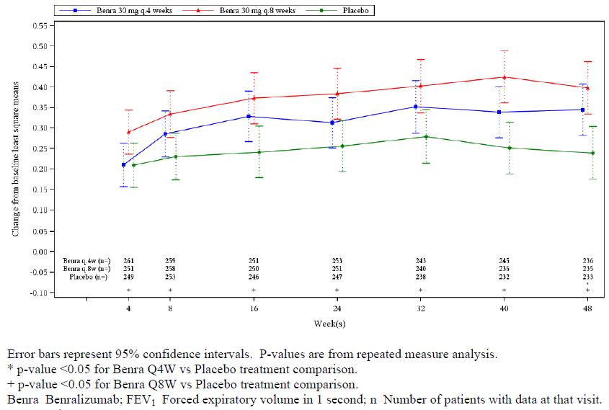
Figure 2: Change from Baseline in total asthma symptom score by time point (Full analysis set, baseline blood eosinophils ≥ 300/µL) (Study D3250C00017 (SIROCCO trial))
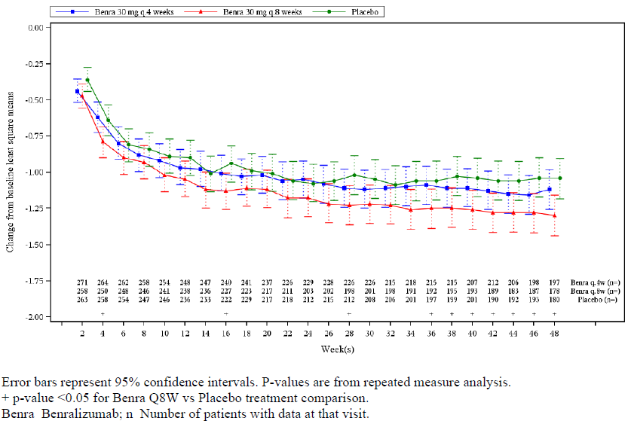
Figure 3: Change from Baseline in pre-bronchodilator FEV1 (L) by time point (Full analysis set, baseline blood eosinophils ≥ 300/µL, high dose ICS) (Study D3250C00018 (CALIMA))
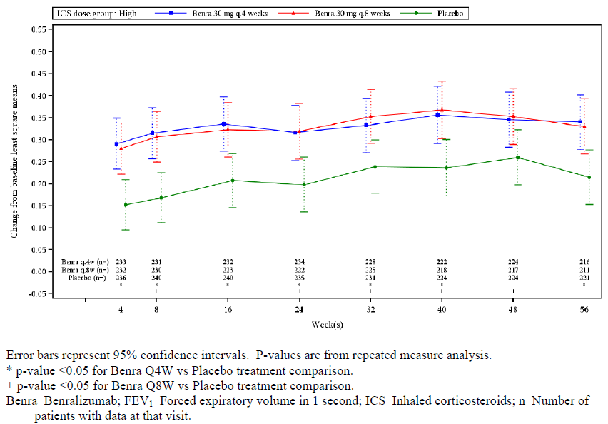
Figure 4: Change from Baseline in total asthma symptom score by time point (Full analysis set, baseline blood eosinophils ≥ 300/µL, high dose ICS) (Study D3250C00018 (CALIMA))
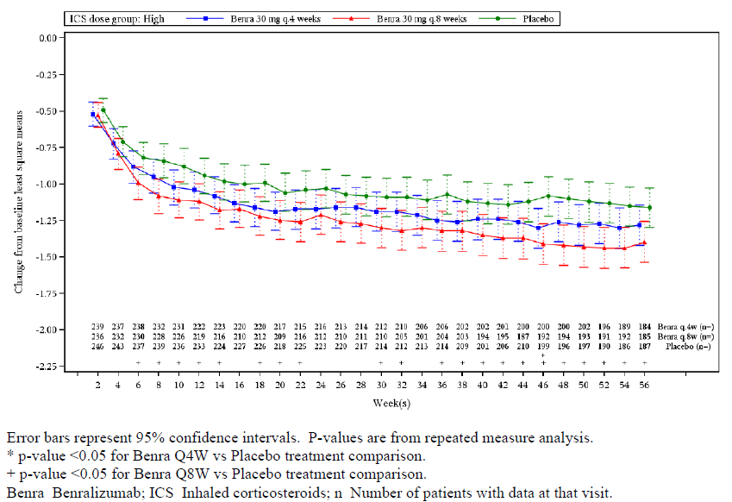
The pivotal studies were double blind, but investigators may have been alerted to treatment group by a decrease in eosinophil count in the benralizumab treated patients. It is not clear how investigators could have been prevented from unblinding patients using eosinophil counts.
The proposed therapeutic indication does not fully reflect the patient group for whom efficacy has been demonstrated. The proposed therapeutic indication is:
Fasenra is indicated as an add-on maintenance treatment for severe asthma in patients with an eosinophilic phenotype.
This does not adequately describe the patient groups where efficacy has been demonstrated, which were: patients who had ≥ 2 exacerbations per year and/or were OCS dependent.
The proposed dosing recommendations are the same as those demonstrated to be effective in the pivotal studies. The proposed dosing recommendations are:
‘Adults (18 years and over)
The recommended dose is 30 mg of Fasenra by subcutaneous injection every 4 weeks for the first 3 doses, and then every 8 weeks thereafter.
Fasenra (benralizumab) is intended to be administered as a subcutaneous injection by a healthcare professional into the upper arm, thighs or abdomen.’
This dosing recommendation is the same as that used for the Q8W regimen in the pivotal studies. Study D3250C00029 confirmed the useability of the accessorised pre filled syringe (APFS) device.
The pivotal studies were conducted in accordance with the Guideline. Specifically, the choice of patient population, stratification of randomisation and choice of outcome measures are in accordance with the guideline.

Safety

Studies providing safety data

Pivotal and/or main efficacy studies
The pivotal studies included data on adverse events (AEs), AEs of special interest (infection, hypersensitivity, malignancy and cardiovascular), laboratory tests, ECGs and vital signs. The pivotal studies were:
- Study D3250C00017 (SIROCCO trial)
- Study D3250C00018 (CALIMA trial)
- Study D3250C00020 (ZONDA trial).

Other studies

Other efficacy studies
The other efficacy studies included data on AEs, laboratory tests, ECGs and vital signs. The other efficacy studies were:
- Study MI-CP186
- Study MI-CP197
- Study MI-CP220
- Study D3250C00016
- Study D3250C00029
- Study D3250C00032.

Studies with evaluable safety data: dose finding and pharmacology
The Phase I studies included data on AEs, laboratory tests, ECGs and vital signs. Phase I studies were:
- Study MI-CP158
- Study MI-CP166.

Studies evaluable for safety only
There were no completed studies evaluable for safety only. There are two ongoing long term safety studies.

Patient exposure
In the RMP analysis the sponsor included three Phase II studies and six Phase III studies. The two Phase I studies were excluded. Overall there were 2,398 patients exposed to benralizumab, with 2,025 exposed for 6 months and 786 for 12 months. There were 1,138 patients exposed to 30 mg Q4W and 900 to 30 mg Q8W. There were 62 patients in the 12 to < 18 year age group. There were 278 aged ≥ 65 years and nine aged ≥ 75 years. There were 19 patients with renal impairment, 37 with hepatic impairment and 140 with cardiac impairment.
- In Study MI-CP158 there were 44 volunteers exposed to benralizumab.
- In Study MI-CP166 there were 27 patients exposed to benralizumab.
- In Study MI-CP186 there were 36 patients exposed to a single dose of benralizumab 0.3 mg/kg, 36 to 1.0 mg/kg and 38 to placebo.
- In Study MI-CP197 there were seven patients exposed to benralizumab 25 mg SC, six to 100 mg SC and six to 200 mg SC for up to three doses. Six patients were exposed to placebo.
- In Study MI-CP220 there were 81 patients exposed to benralizumab 2 mg, 81 to 20 mg and 223 to 100 mg for up to 7 doses over 1 year, and 221 to placebo.
- In Study D3250C00016 (PAMPERO) eight patients were exposed to at least one dose of benralizumab 30 mg SC.
- In Study D3250C00017 (SIROCCO) there were 403 patients exposed to benralizumab 30 mg Q4W, 394 to 30 mg Q8W and 407 to placebo. Treatment duration was 48 weeks.
- In Study D3250C00018 (CALIMA) there were 438 patients exposed to benralizumab 30 mg Q4W, 428 to 30 mg Q8W and 440 to placebo. Treatment duration was 48 weeks.
- In Study D3250C00020 (ZONDA) there were 72 patients exposed to benralizumab 30 mg Q4W, 73 to Q4W for three doses then Q8W and 75 to placebo for up to 28 weeks.
- In Study D3250C00032 106 patients were exposed to three doses of 30 mg benralizumab over 12 weeks and 105 to placebo.
- In Study D3250C00029 116 patients were exposed to 30 mg benralizumab Q4W over 16 weeks (4 doses).

Safety issues with the potential for major regulatory impact

Liver function and liver toxicity

Pivotal and/or main efficacy studies
In Study D3250C00017 (SIROCCO trial) elevated alanine aminotransferase (ALT) was reported for one (0.2%) patients in the benralizumab 30 mg Q4W group, three (0.8%) in the 30 mg Q8W and two (0.5%) in the placebo. Elevated aspartate aminotransferase (AST) was reported for one (0.2%) patients in the benralizumab 30 mg Q4W group, two (0.5%) in the 30 mg Q8W and two (0.5%) in the placebo.
In Study D3250C00018 (CALIMA) elevated ALT was reported for two (0.5%) patients in the benralizumab 30 mg Q4W group, two (0.5%) in the 30 mg Q8W and two (0.5%) in the placebo. Elevated AST was reported for one (0.2%) patients in the benralizumab 30 mg Q4W group, five (1.2%) in the 30 mg Q8W and none in the placebo.
In Study D3250C00020 (ZONDA) there were no reports of elevated ALT or AST.

Other efficacy studies
In Study MI-CP186 and Study MI-CP197 there were no clinically significant abnormalities in hepatic function.
In Study MI-CP220 no patients met the criteria for Hy’s Law.
In Study D3250C00032 and Study D3250C00029 no patient had ALT > 3 x upper limit of normal (ULN) and no patient fulfilled the criteria of Hy’s Law.

Renal function and renal toxicity

Pivotal and/or main efficacy studies
In Study D3250C00017 (SIROCCO) elevated plasma creatinine was reported for one (0.2%) patients in the benralizumab 30 mg Q4W group, none in the 30 mg Q8W and three (0.7%) in the placebo.
In Study D3250C00018 (CALIMA) elevated plasma creatinine was reported for one (0.2%) patients in the benralizumab 30 mg Q4W group, none in the 30 mg Q8W and one (0.2%) in the placebo. There were no patients who met the criteria for Hy’s Law.
In Study D3250C00020 (ZONDA) elevated plasma creatinine was reported for one (1.4%) patient in the Q8W group.

Other efficacy studies
In Study MI-CP186, Study MI-CP197, Study MI-CP220 and Study D3250C00029 there were no clinically significant abnormalities in renal function.

Other clinical chemistry

Pivotal and/or main efficacy studies
In Study D3250C00017 (SIROCCO), Study D3250C00018 (CALIMA) and Study D3250C00020 (ZONDA) there were no clinically significant abnormalities in other clinical chemistry.

Haematology and haematological toxicity

Pivotal and/or main efficacy studies
In Study D3250C00017 (SIROCCO) mean basophil count was reduced by approximately one third in the benralizumab groups. There was no significant change in overall mean white cell count (WCC). One patient in the Q8W group developed neutropenia that resolved on treatment.
In Study D3250C00018 (CALIMA) mean basophil count was reduced by approximately one third in the benralizumab groups. There was no significant change in overall mean WCC. Decreased WCC was reported as a treatment-emergent adverse event (TEAE) for one (0.2%) patient in the Q4W group.
In Study D3250C00020 (ZONDA) basophil count was reduced by approximately one half in the benralizumab groups. Mean WCC decreased by approximately one quarter in the benralizumab groups. There was no consistent change in neutrophil counts. There were no haematology related TEAEs in the benralizumab groups.

Other efficacy studies
In Study MI-CP186 absolute neutrophil count (ANC) < 1.5 x 10³/µL was reported in eight (22.2%) patients in the 0.3 mg/kg group, one (2.8%) in the 1.0 mg/kg and none in the placebo.
In Study MI-CP197 ANC < 1.5 x 10³/μL was reported in two (28.6%) patients in the 25 mg group, two (33.3%) in the 100 mg, none in the 200 mg and two (33.3%) in the placebo.
In Study MI-CP220 Grade 3/4 haematology laboratory abnormalities were reported in 16 (7.2%) patients in the placebo group and 31 (8.1%) in the benralizumab.
In Study D3250C00032 one patient in the Q4W group had pancytopenia as a serious adverse event (SAE) resulting in death.
In Study D3250C00029 there were no TEAEs relating to haematological abnormalities.

Other laboratory tests
Not Applicable.

Electrocardiograph findings and cardiovascular safety

Pivotal and/or main efficacy studies
In Study D3250C00017 (SIROCCO) QT prolongation was reported for one (0.2%) patient in the benralizumab 30 mg Q4W group.
In Study D3250C00018 (CALIMA) QT prolongation was reported for one (0.2%) patient in the benralizumab 30 mg Q8W group.
In Study D3250C00020 (ZONDA) there were no clinically significant ECG abnormalities.

Other efficacy studies
In Study MI-CP197, Study MI-CP220 and Study D3250C00032 there were no clinically significant changes in ECGs.

Vital signs and clinical examination findings

Pivotal and/or main efficacy studies
In Study D3250C00017 (SIROCCO), Study D3250C00018 (CALIMA) and Study D3250C00020 (ZONDA) there were no significant trends in vital signs.

Other efficacy studies
In Study MI-CP186 pyrexia was reported in two patients in the 0.3 mg/kg group, three in the 1.0 mg/kg and one in the placebo.
In Study MI-CP197 pyrexia was reported in one patient in the 200 mg group.
In Study MI-CP220 TEAEs of abnormalities in vital signs were reported in 11 (5.0%) patients in the placebo group and 41 (10.6%) in the benralizumab.
In Study D3250C00029 there were no clinically significant changes in vital signs.

Immunogenicity and immunological events

Pivotal and/or main efficacy studies
In Study D3250C00017 (SIROCCO) hypersensitivity TEAEs were reported in 13 (3.2%) patients in the benralizumab 30 mg Q4W group, 11 (2.8%) in the 30 mg Q8W and 11 (2.7%) in the placebo. Anti-drug antibodies (ADAs) were reported in 47 (11.7%) patients in the benralizumab 30 mg Q4W group, 58 (14.8%) in the 30 mg Q8W and 21 (5.2%) in the placebo. Neutralising antibodies were reported in 31 (7.7%) patients in the benralizumab 30 mg Q4W group, 49 (12.5%) in the 30 mg Q8W and 11 (2.7%) in the placebo. ADA did not appear to effect efficacy.
In Study D3250C00018 (CALIMA) hypersensitivity TEAEs were reported for 13 (3.0%) patients in the benralizumab 30 mg Q4W group, 13 (3.0%) in the 30 mg Q8W and 17 (3.9%) in the placebo.
In Study D3250C00020 (ZONDA) hypersensitivity TEAEs were reported for one (1.4%) patients in the benralizumab 30 mg Q4W group, two (2.7%) in the 30 mg Q8W and one (1.3%) in the placebo. Post-baseline ADAs were detected in five (7.0%) patients in the Q4W group, six (8.6%) in the Q8W and three (4.0%) in the placebo. Neutralising ADAs were detected in four (5.6%) patients in the Q4W group, six (8.2%) in the Q8W and three (4.0%) in the placebo.

Other efficacy studies
In Study MI-CP186 in patients treated with 0.3 mg/kg or 1.0 mg/kg single dose IV, six (9.2%) subjects had positive ADA on Day 84.
In Study MI-CP197 four (21.1%) patients treated with benralizumab had quantifiable ADA during the study.
In Study MI-CP220 the rate of ADA increased with dose over 1 year. The rate of ADA was 42.0% at the 2 mg dose, 30.9% at the 20 mg and 25.6% at the 100 mg (see Table 8). Anaphylactic reactions were reported in one (0.5%) subject in the placebo group and two (0.5%) in the benralizumab.
In Study D3250C00032 ADA were recorded in 14 (13.2%) patients in the benralizumab group. Hypersensitivity events were reported for one (0.9%) patients in the Q4W group and two (1.9%) in the placebo.
In Study D3250C00029 ADA were recorded in 17 (14.7%) patients, and neutralising antibodies in 15 (12.9%). Two patients were reported with urticaria.
Table 8: Incidence of ADA positive in randomised subjects by protocol-defined eosinophil phenotype, mITT Population (Study MI-CP220)
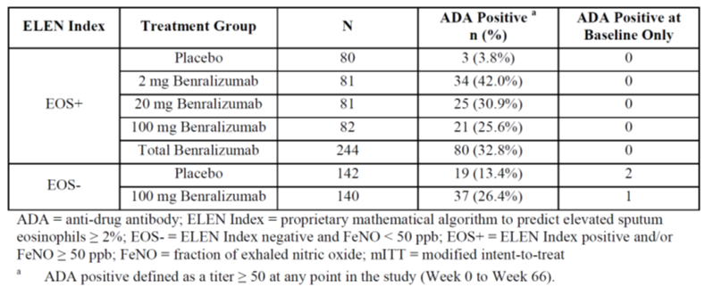

Serious skin reactions
There were few serious skin reactions. In Study MI-CP166 ADA were detected post-dose in two (25%) patients in the benralizumab 1 mg/kg IV group and one (11.1%) in the 200 mg SC group.

Infections and infestations

Integrated safety analyses
In the Phase III studies infections and infestations were reported in 445 (52.9%) patients in the benralizumab 30 mg Q4W group, 412 (50.1%) in the Q8W and 466 (55.0%) in the placebo.

Pivotal and/or main efficacy studies
In Study D3250C00017 (SIROCCO) infections and infestations as SAEs were reported in six (1.5%) patients in the benralizumab 30 mg Q4W group, ten (2.5%) in the 30 mg Q8W and eight (2.0%) in the placebo.
In Study D3250C00018 (CALIMA) infections and infestations as SAEs reported for six (1.4%) patients in the benralizumab 30 mg Q4W group, eight (1.9%) in the 30 mg Q8W and 11 (2.5%) in the placebo. One patient in the Q4W group had herpes zoster affecting the face that was attributed to treatment.
In Study D3250C00020 (ZONDA) infections and infestations as SAEs reported for two (2.8%) patients in the benralizumab 30 mg Q4W group, two (2.7%) in the 30 mg Q8W and eight (10.7%) in the placebo.

Other efficacy studies
In Study MI-CP220 infections and infestations were reported in a greater proportion of benralizumab treated patients: 38 (46.9%) patients in the 2 mg group, 33 (40.7%) in the 20 mg group, 99 (44.4%) in the 100 mg group and 87 (39.4%) in the placebo. Two patients in the benralizumab group had strongyloidiasis.
In Study D3250C00029 one patient had a SAE of diverticulitis.

Neoplasia
Overall, adjudicated cases of new neoplasia were reported in three (0.4%) patients treated with benralizumab 30 mg Q4W, one (0.1%) with Q8W and one (0.1%) with placebo (Table 9).
In Study D3250C00017 (SIROCCO) one patient in the Q4W group was diagnosed with a new malignancy: ovarian epithelial cancer.
In Study D3250C00018 (CALIMA) new malignancy was reported for two (0.5%) patients in the Q4W group (gallbladder cancer, gastric cancer) and one (0.2%) in the placebo (breast cancer).
In Study MI-CP220 one patient in the benralizumab 100 mg group was diagnosed with malignant melanoma.
In Study D3250C00029 one patient was diagnosed with papillary thyroid carcinoma.
Table 9: Adjudicated malignancies as determined by the Safety Endpoint Adjudication Committee (SEAC) reported during the on-study period (Safety analysis set) (Summary of Clinical Safety)
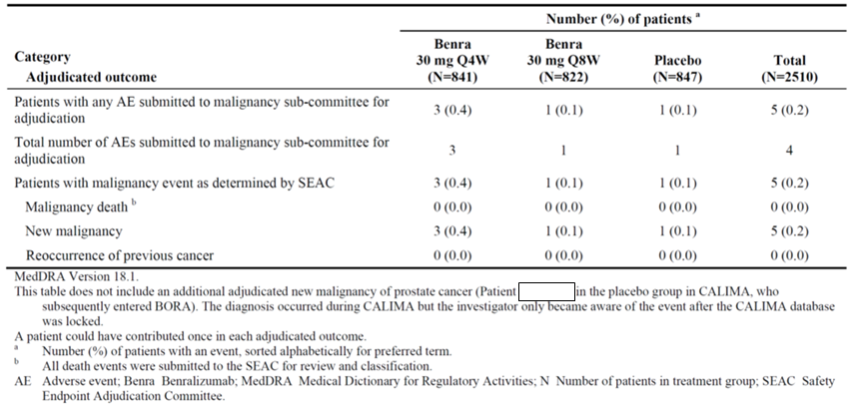

Major adverse cardiovascular events
In the Integrated Summary of Safety a total of 11 (0.4%) patients had major adverse cardiac event (MACE) as determined by the Safety Endpoint Adjudication Committee (SEAC); three (0.4%) in the benralizumab 30 mg Q4W group, four (0.5%) in the Q8W, and four (0.5%) in the placebo.

Post-marketing data
No post-marketing data were included in the dossier.

Evaluator’s conclusions on safety
The overall rate and patterns of TEAEs were similar for benralizumab and for placebo. The commonest TEAEs were upper respiratory tract infections and these were not reported more frequently with benralizumab than placebo.
In the pivotal studies, there were more deaths in the benralizumab groups compared with placebo: five with Q4W, six with Q8W and three with placebo. Two of the deaths in the Q8W group were from causes that are of interest with benralizumab: colon carcinoma and pneumonia. There was one death in Study D3250C00032 in the Q4W group due to pancytopaenia. This was attributed to amiodarone rather than benralizumab. Aplastic anaemia is a listed adverse drug reaction for amiodarone, but would also be of interest with benralizumab.
The mode of action of benralizumab is to deplete circulating eosinophils. The normal functions of eosinophils; include the following:
- Host defence against parasites: eosinophils can mediate ADCC against helminths.
- Defence against single-stranded RNA viruses via ribonuclease activity; viruses including rhinovirus, respiratory syncytial virus, and parainfluenza virus.
- Innate immune response during bacterial sepsis originating from an intestinal source.
- Interaction with various innate immune cells for example mast cells, myeloid-derived dendritic cells and adaptive immune cells (primarily T cells).
- Antitumor cytotoxic responses.
The safety data do not indicate an increased risk of parasitic infections. The rate of respiratory tract infections was not increased with benralizumab. Bacterial infections did not appear to be increased with benralizumab.
There appears to be more reports of neoplasia with benralizumab compared to placebo. Overall, adjudicated cases of new neoplasia were reported in three (0.4%) patients treated with benralizumab 30 mg Q4W, one (0.1%) with Q8W and one (0.1%) with placebo (Table 9). However, the lead time required for development of neoplasia complicates the interpretation of this issue. The long term safety data may help clarify whether benralizumab results in a greater risk of neoplasia.
The rate of major adverse cardiovascular events was similar for benralizumab and placebo.
Benralizumab was not associated with hepatic or renal injury.
Benralizumab resulted in a decrease in basophil count.
Benralizumab was not associated with ECG changes or abnormalities in vital signs.
There is a high rate of ADA with benralizumab with the majority of patients with ADA having neutralising antibodies. However, presence of ADA did not decrease efficacy. Hypersensitivity reactions did not occur more frequently with benralizumab than with placebo.
The submission did not contain any long term safety data. The number of patients treated for ≥ 1 year was not reported.

First round benefit-risk assessment

First round assessment of benefits
Table 10 summarises the assessment of benefits of Fasenra benralizumab for the proposed indication, along with strengths and uncertainties of these benefits at the first round.
Table 10: First round assessment of benefits
Benefits | Strengths and Uncertainties
Benralizumab 30 mg Q8W reduces the rate of exacerbations by 40%, improves FEV1 by 0.16 L and improves asthma symptoms in patients with severe asthma with frequent exacerbations.  Improvement in asthma symptoms, as measured by asthma scores and improvement in quality of life measures was demonstrated for the Q8W regimen but not for the Q4W regimen.  Benralizumab 30 mg Q8W decreases the OCS dose in patients with severe asthma who are OCS dependent.  The patient groups where efficacy has been demonstrated were patients with severe asthma who had ≥ 2 exacerbations per year and/or were OCS dependent. | The efficacy findings were demonstrated in appropriately conducted randomised controlled trials conducted over either 48 or 28 weeks.  The improvements in FEV1 and asthma scores were of uncertain statistical and clinical significance. These improvements were 10% from baseline and were statistically significant using MMRM but not on confidence interval analysis.  Efficacy was not demonstrated for mild or moderate asthma.  The subgroup analysis suggested lack of efficacy in patients aged 12 to < 18 years and in Black or African Americans.  The studies were designed as double blind but patients treated with benralizumab could potentially be unblinded by their eosinophil count.

First round assessment of risks
Table 11 summarises the assessment of risks of Fasenra benralizumab for the proposed indication, along with strengths and uncertainties of these benefits at the first round.
Table 11: First round assessment of risks
Risks | Strengths and Uncertainties
The overall rate and patterns of TEAEs were similar for benralizumab and for placebo. The commonest TEAEs were upper respiratory tract infections and these were not reported more frequently with benralizumab than placebo.  In the pivotal studies there were more deaths in the benralizumab groups compared with placebo.  The safety data do not indicate an increased risk of parasitic infections. The rate of respiratory tract infections was not increased with benralizumab. Bacterial infections did not appear to be increased with benralizumab.  There appears to be more reports of malignancy with benralizumab compared to placebo.  There is a high rate of ADA with benralizumab with the majority of patients with ADA having neutralising antibodies. Hypersensitivity reactions did not occur more frequently with benralizumab than with placebo. | The submission did not contain any long term safety data. The number of patients treated for ≥ 1 year was not reported.  The long term safety data, such as 2 year exposure data in > 100 patients, may help to clarify whether there is an increased risk of malignancy with benralizumab.

First round assessment of benefit-risk balance
The benefit-risk for benralizumab 30 mg in 1 mL solution for injection prefilled syringe is unfavourable. While benralizumab, in patients with severe asthma, decreases the rate of exacerbations and decreases the dose of OCS, there may be an increased risk of malignancy and an overall greater mortality.
The decrease in exacerbations of 40% is clinically significant. The improvement in FEV1 represents a 10% improvement from baseline, which is likely to be noticed by patients, and is therefore, in the opinion of the evaluator, clinically significant. The improvement in asthma scores are also 10% on baseline, and in the opinion of the evaluator would be unlikely to be noticed by patients, and therefore not clinically significant. In patients who are OCS dependent, the resulting decrease in OCS dose is clinically significant.
However, the potential for increased malignancy requires further investigation with long term safety studies in order to clarify the benefit-risk balance.

First round recommendation regarding authorisation
The application for approval of benralizumab 30 mg in 1 mL solution for injection prefilled syringe should be rejected because of an unfavourable benefit-risk balance. While benralizumab, in patients with severe asthma, decreases the rate of exacerbations and decreases the dose of OCS, there may be an increased risk of malignancy and an overall greater mortality.
In addition, the proposed therapeutic indication does not fully reflect the patient group for whom efficacy has been demonstrated. The proposed therapeutic indication is:
Fasenra is indicated as an add-on maintenance treatment for severe asthma in patients with an eosinophilic phenotype.
This does not adequately describe the patient groups where efficacy has been demonstrated, which were: patients with severe asthma with an eosinophilic phenotype, who had ≥ 2 exacerbations per year and/or were OCS dependent.

Clinical questions and second round evaluation
The following provides details of the main clinical questions and responses.

Pharmacokinetics

Question 1
In the population pharmacokinetic data, was there any evidence of accumulation with either the Q4W and/or the Q8W dosing regimens?

Sponsor’s response
The accumulation ratio for the Q4W dosing regimen was 1.47 and for the Q8W regimen was 1.1.

Evaluator’s comment
The sponsor’s response is satisfactory. There is no significant accumulation with the proposed dosing regimen.

Efficacy

Question 2
Can the sponsor provide a full explanation as to why Study D3250C00016 (PAMPERO trial) was terminated early?

Sponsor’s response
Study D3250C00016 (PAMPERO trial) was terminated early because of poor recruitment, a screen failure rate of 90% and the sponsor deciding to focus on patients with high dose ICS.

Evaluator’s comment
The sponsor’s response is satisfactory. Study D3250C00016 (PAMPERO trial ) was not terminated because of safety concerns.

Question 3
In Study D3250C00020 (ZONDA trial) how were missing data imputed?

Sponsor’s response
The sponsor states ‘Derivation of the primary endpoint, percentage change in the final OCS dose, incorporated imputation for missing data (for patients who prematurely discontinued), as outlined in the Statistical Analysis Plan. Percent reduction from baseline in final OCS dose was derived based on the OCS dose at baseline and at Week 28 (Visit 14). If a patient discontinued from the study during a given dose reduction period prior to Visit 14, then the patient’s final OCS dose was imputed as 1 dose level higher than the dose at which the discontinuation occurred. For example, if a patient had completed a previous dose reduction phase while receiving 10 mg daily and was in a subsequent dose reduction period receiving 5 mg daily, but withdrew before completing that period, the patient’s final dose would be imputed as 10 mg daily because the patient had not completed the period in which 5 mg was used. If a patient experienced an asthma exacerbation or AE treated with OCS immediately prior to discontinuation, the final OCS dose was imputed as 1 dose level higher than the dose at which the exacerbation or AE started.
There was no imputation for missing data in the negative binomial analyses of annual exacerbation rate. The logarithm of the patient’s corresponding follow-up time was used as an offset variable in the model to adjust for patients having different follow-up time (for example, due to premature discontinuation from the trial).
No implicit imputation was done for missing data on continuous secondary endpoints. Repeated measures endpoints were analysed using a mixed model for repeated measures (MMRM) analysis (including the analysis of FEV1, Asthma Control Questionnaire-6 (ACQ-6), total asthma symptom score, and Asthma Quality of Life Questionnaire (AQLQ)). The MMRM analysis accounts for the missing data under the assumption that data are missing at random. All patients with a baseline value and at least 1 post baseline value were included in the analysis, regardless of whether they discontinued early or had missing observations during the study.
For daily diary endpoints such as asthma symptom scores, the post randomisation bi-weekly means were calculated as the sum of all non missing daily measures/scores over the 14 day window divided by the number of non missing daily measures/scores. This approach assumes that the average from the observed days during any period is representative of what the average would have been over the entire bi-weekly time interval. If more than 7 daily measures/scores (> 50%) within that window were missing, then the mean daily measure/score for that period was set to missing.
For responder endpoints, such as ACQ-6 responders at Week 28, patients with missing or non-evaluable score at Week 28 were imputed as non-responders for analysis.’

Evaluator’s comment
The sponsor’s response is not satisfactory. The sponsor used complex methods to impute missing data. The sponsor did not test the assumptions in the imputation methods by reanalysing the data without imputation and/or by using worst case scenarios.
However, the imputation methods used for the primary efficacy outcome measures were appropriate and the evaluator’s conclusions with regard to benefits are not altered by the sponsor’s response.

Question 4
In Study D3250C00020 (ZONDA trial) how was multiplicity addressed for the secondary efficacy outcome variables?

Sponsor’s response
The sponsor did not address multiplicity in the analysis of the secondary efficacy outcome variables.

Evaluator’s response
In the opinion of the evaluator, the failure to address multiplicity was a design flaw. With regard the results of the secondary efficacy outcome variables, most of the findings were highly significant, and the difference between benralizumab and placebo were clinically significant. Hence, the failure to address multiplicity does not alter the evaluator’s conclusions with regard to benefits.

Question 5
Can the sponsor please provide summary tabulations for the results of the following analyses from Study D3250C00020 (ZONDA):
- The time to first exacerbation requiring hospitalisation
- Mean number of days with OCS taken for exacerbations?

Sponsor’s response
In the ZONDA trial there were few patients with exacerbations associated with hospitalisation: three in the Q4W group, one in the Q8W group and six in the placebo. The sponsor has also provided a Kaplan-Meier plot for time to first exacerbation requiring hospitalisation (Figure 5).
The mean (SD) number of days with asthma exacerbations was 13.789 (9.992) in the Q4W group, 17.588 (19.726) in the Q8W and 22.447 (22.915) in the placebo.
Figure 5: Time to first asthma exacerbation requiring hospitalisation, Kaplan-Meier cumulative incidence curve (ZONDA trial, Full analysis set)

Evaluator’s comments
The sponsor’s response is satisfactory. The additional data to not change the conclusions with regard to benefits.

Question 6
In the pivotal studies, how were investigators prevented from unblinding patients using eosinophil counts?

Sponsor’s response
The sponsor states the following steps were taken to maintain blinding:
‘Except for the Visit 1 screening eosinophil count (local laboratory), per protocol haematology was run by the central laboratory with eosinophil and basophil counts redacted from the laboratory report (other than the Visit 1 laboratory report). Because complete knowledge of the remaining cell types could have permitted deduction of the ‘eosinophil + basophil’ compartment, monocyte counts were also redacted from the report, and as such were not made available to the site or sponsor.
If the Investigator ordered any local safety laboratory assessments, the requested tests were to be restricted to the question at hand. For example, if haemoglobin was desired, the Investigator was to avoid ordering a complete blood cell count with differential.
Handling of labs obtained during the treatment period but ordered outside of the clinical trial: Centre staff who were directly involved in the patient’s management were to remain blinded to any eosinophil, basophil, and monocyte results included as part of outside lab reports. To help ensure this, each investigational centre designated an individual (for example, administrator or another ancillary person) not directly involved in patient management, to receive and blind any eosinophil, basophil, and monocyte results prior to the report being handed over to the centre staff involved in the patient’s management and prior to filing as a source document. Similarly, eosinophil and basophil results were redacted from all communications with the sponsor.
In cases where the Investigator required an eosinophil, basophil, or monocyte count for managing safety issues, he or she was allowed to order these tests, but AstraZeneca was to be notified of the reason, while remaining blind to the test results.’

Evaluator’s comments
The sponsor’s response is satisfactory. The evaluator is satisfied that the sponsor took all reasonable steps to avoid unintentionally breaking the blinding through eosinophil counts. However, the evaluator also notes that the blinding could have been broken intentionally by the patient or their medical practitioner by obtaining an eosinophil count outside of the study. The evaluator also notes that the participant flow data do not indicate an increased rate of dropout in the placebo groups. The evaluator concludes that unblinding was unlikely and does not appear to have affected the results.

Safety

Question 7
How many patients have been exposed to benralizumab for one year or more?

Sponsor’s response
The sponsor has provided updated summary data on exposure to benralizumab. There have been 709 patients exposed to benralizumab Q8W for ≥ 52 weeks and 368 for ≥ 104 weeks. In addition, there have been 739 patients exposed to benralizumab Q4W for ≥ 52 weeks and 363 for ≥ 104 weeks (Table 12).
Table 12: Duration of exposure to active benralizumab by treatment arm in the predecessor study (Safety analysis set)

Evaluator’s comments
The sponsor’s response is satisfactory. There have been sufficient numbers of patients exposed to benralizumab to satisfy the usual regulatory requirement for long term safety. However, in the opinion of the evaluator, the issue of malignancy requires special consideration.

Question 8
Does the sponsor have long term safety data that address the risks of malignancy and/or mortality?

Sponsor’s response
The sponsor considers that the usual definition of long term safety should apply, which is exposure ≥ 52 weeks. The sponsor states that an additional case of prostatic cancer was disclosed during the long term extension BORA trial that was considered to have originated during placebo treatment in CALIMA. This additional case would adjust the numbers (proportions) of patients with malignancy to four (0.24%) with benralizumab and two (0.24%) with placebo.
The narrative for this case in the CALIMA CSR Addendum states: ‘The prostatic cancer was confirmed in the patient’s medical record from a urologist’s report on 7 April 2015. The pathological report indicated that the Gleason score was 3+3, with 2 mm cancer of 147 mm biopsy and palpable tumour of stage T1C. The patient is being followed with active surveillance of PSA value every 3 months. The patient’s PSA value in March 2015 was 7.7 ng/mL and 9 ng/mL in August 2016.’
The sponsor is currently exploring how to monitor the risk of malignancy in post-marketing studies, in consultation with the EU Pharmacovigilance Risk Assessment Committee (PRAC).
The sponsor also states: ‘The sponsor considers malignancy as an Important Potential Risk and will continue to review and monitor the data from the ongoing studies BORA and MELTEMI and from routine pharmacovigilance. The sponsor is committed to developing a post-authorisation measure to further characterise the risk of malignancy.’
In addition to the 14 deaths already noted in the development program there are an additional six deaths recorded during BORA. The pattern of deaths does not indicate any new issues with benralizumab.

Evaluator’s comments
The sponsor’s response with regard to malignancy is satisfactory. The additional case of prostatic cancer was reported during the long term extension study BORA, and after the patient had been exposed to benralizumab, but the sponsor has provided a patient summary for this case. This patient summary states there is documentation that the prostatic cancer was diagnosed during CALIMA.
With regard mortality, the evaluator’s comments are unchanged. In the pivotal studies, there was a greater number of deaths in the benralizumab groups compared with placebo: five with Q4W, six with Q8W and three with placebo. Two of the deaths in the Q8W group were from causes that are of interest with benralizumab: colon carcinoma and pneumonia. There was one death in Study D3250C00032 in the Q4W group due to pancytopenia. This was attributed to amiodarone rather than benralizumab. Aplastic anaemia is a listed adverse drug reaction for amiodarone, but would also be of interest with benralizumab.

Question 9
Study D3250C00029 demonstrated that the APFS can be used by patients and carers. Why does the dosing and administration section of the PI state that benralizumab 30 mg in 1 mL solution for injection prefilled syringe should be administered by a health professional?

Sponsor’s response
The sponsor states ‘While [the sponsor] has not had direct interaction with any Health Authority on this topic, it is considered that regulatory expectations regarding the kinds of data necessary to support self-administration tend to vary from region to region. [The sponsor] anticipates being able to respond to these global expectations comprehensively in the near future, but at this time [the sponsor] is not seeking a labelled indication for benralizumab to be self-administered by patients or administered by carers.’

Evaluator’s comment
The sponsor’s response is satisfactory.

Second round benefit-risk assessment

Second round assessment of benefits
Table 13 summarises the assessment of benefits of Fasenra benralizumab for the proposed indication, along with strengths and uncertainties of these benefits at the second round.
Table 13: Second round assessment of benefits
Benefits | Strengths and Uncertainties
Benralizumab 30 mg Q8W reduces the rate of exacerbations by 40%, improves FEV1 by 0.16 L and improves asthma symptoms in patients with severe asthma with frequent exacerbations.  Improvement in asthma symptoms, as measured by asthma scores and improvement in quality of life measures was demonstrated for the Q8W regimen but not for the Q4W regimen.  Benralizumab 30 mg Q8W decreases the OCS dose in patients with severe asthma who are OCS dependent.  The patient groups where efficacy has been demonstrated were patients with severe asthma who had ≥ 2 exacerbations per year and/or were OCS dependent. | The efficacy findings were demonstrated in appropriately conducted randomised controlled trials conducted over either 48 or 28 weeks.  The improvements in FEV1 and asthma scores were of uncertain statistical and clinical significance. These improvements were 10% from baseline and were statistically significant using MMRM but not on confidence interval analysis.  Efficacy was not demonstrated for mild or moderate asthma.  The subgroup analysis suggested lack of efficacy in patients aged 12 to < 18 years and in Black or African Americans.

Second round assessment of risks
Table 14 summarises the assessment of risks of Fasenra benralizumab for the proposed indication, along with strengths and uncertainties of these benefits at the second round.
Table 14: Second round assessment of risks
Risks | Strengths and Uncertainties
The overall rate and patterns of TEAEs were similar for benralizumab and for placebo. The commonest TEAEs were upper respiratory tract infections and these were not reported more frequently with benralizumab than placebo.  In the pivotal studies there was a greater number of deaths in the benralizumab groups compared with placebo.  The safety data do not indicate an increased risk of parasitic infections. The rate of respiratory tract infections was not increased with benralizumab. Bacterial infections did not appear to be increased with benralizumab.  There is a high rate of ADA with benralizumab with the majority of patients with ADA having neutralising antibodies. Hypersensitivity reactions did not occur more frequently with benralizumab than with placebo. | There are insufficient data to determine whether the rate of malignancy is increased with benralizumab.  There are insufficient data to determine whether there is an increased mortality rate with benralizumab.

Second round assessment of benefit-risk balance
The benefit-risk for benralizumab 30 mg in 1 mL solution for injection prefilled syringe is favourable. Benralizumab, in patients with severe asthma, decreases the rate of exacerbations and decreases the dose of OCS. While there are concerns regarding an increased risk of malignancy and an overall greater mortality the available data do not confirm these risks.
The decrease in exacerbations of 40% is clinically significant. The improvement in FEV1 represents a 10% improvement from baseline, which is likely to be noticed by patients, and is therefore, in the opinion of the evaluator, clinically significant. The improvement in asthma scores are also 10% on baseline, and in the opinion of the evaluator would be unlikely to be noticed by patients, and therefore not clinically significant. In patients who are OCS dependent, the resulting decrease in OCS dose is clinically significant.
The potential for increased malignancy requires ongoing monitoring.

Second round recommendation regarding authorisation
The application for approval of Fasenra (benralizumab) 30 mg in 1 mL solution for injection prefilled syringe should be rejected because the proposed therapeutic indication does not fully reflect the patient group for whom efficacy has been demonstrated. The proposed therapeutic indication is:
Fasenra is indicated as an add-on maintenance treatment for severe asthma in patients with an eosinophilic phenotype (see Clinical Trials).
This does not adequately describe the patient groups where efficacy has been demonstrated, which were: patients with severe asthma with an eosinophilic phenotype, who had ≥ 2 exacerbations per year and/or were OCS dependent.
A suitable alternative indication is:
Fasenra is indicated as an add-on maintenance treatment for severe asthma in patients with an eosinophilic phenotype, with two or more exacerbations per year and who are inadequately controlled despite high dose inhaled corticosteroids plus long acting β-agonists (see Clinical Trials).

VI. Pharmacovigilance findings

Risk management plan

Summary of RMP evaluation
- The sponsor has submitted EU-RMP version 1.0 (dated 10 November 2016; data lock point (DLP) 29 September 2016) and Australian Specific Annex (ASA) version 1.0 (dated 15 February 2017) in support of this application. In its post-first round response, the sponsor has submitted EU-RMP version 1.0 Edition Number 3.0 (dated 28 September 2017; DLP 29 September 2016) and ASA version 2.0 (dated 15 October 2017) in support of this application.
- Following the ACM meeting, the sponsor submitted EU-RMP version 1.0 edition 4.0 (dated 14 November 2017; DLP 29 September 2016.) and ASA version 3.0 (dated 8 March 2018).
- The proposed Summary of Safety Concerns and their associated risk monitoring and mitigation strategies are summarised below in Table 15.
Table 15: Summary of Safety Concerns and their associated risk monitoring and mitigation strategies
Summary of safety concerns |  | Pharmacovigilance |  | Risk Minimisation
 |  | Routine | Additional | Routine | Additional
Important identified risks | None | – | – | – | –
Important potential risks | Serious infections |  | – | – | –
Important potential risks | Helminth infections |  | – |  | –
Important potential risks | Serious hypersensitivity reactions including anaphylaxis/anaphylactic reactions |  | –
Important potential risks | Malignancies |  |  | – | –
Missing information | Safety profile in pregnant and lactating women |  |  |  | –
Missing information | Safety profile of long term use of benralizumab 30 mg SC |  |  |  | –
- Additional pharmacovigilance activities include two ongoing clinical trials (BORA and MELTEMI) which will provide information regarding the safety profile of long term use of benralizumab and a planned Post-Marketing Surveillance Study (VAMPSS) which will study safety in pregnant and lactating women.
- At the second round, there is an additional pharmacovigilance activity, a planned post approval measure, which aims to characterise the risk of malignancy in a real world setting. A protocol by end Q2/2018 is expected for PRAC/CHMP agreement.
- There are no additional risk minimisation activities. This is consistent with the risk minimisation requirements for similar products. Routine risk minimisation is not proposed for the potential risks of serious infections and malignancies.

New and outstanding recommendations from second round evaluation
The recommendations made in the first round evaluation, along with consideration of the sponsor response, was provided.

Proposed wording for conditions of registration
Any changes to which the sponsor has agreed should be included in a revised RMP and ASA. However, irrespective of whether or not they are included in the currently available version of the RMP document, the agreed changes become part of the risk management system.
The suggested wording is:
The Fasenra EU-Risk Management Plan (RMP) (version 1.0 Edition 4.0, dated 14 November 2017, data lock point 29 September 2016), with Australian Specific Annex (version 3.0, dated 8 March 2018), included with submission PM-2016-04636-1-5, and any subsequent revisions, as agreed with the TGA will be implemented in Australia.
The following wording is recommended for the PSUR requirement:
An obligatory component of risk management plans is routine pharmacovigilance. Routine pharmacovigilance includes the submission of Periodic Safety Update Reports (PSURs).
Reports are to be provided in line with the current published list of EU reference dates and frequency of submission of PSURs until the period covered by such reports is not less than three years from the date of this approval letter.
The reports are to at least meet the requirements for PSURs as described in the European Medicines Agency’s Guideline on good pharmacovigilance practices (GVP) Module VII-Periodic Safety Update Report (Rev 1), Part VII.B Structures and processes. Note that submission of a PSUR does not constitute an application to vary the registration. Each report must have been prepared within ninety calendar days of the data lock point for that report.
As Fasenra is new biological entity it should be included in the Black Triangle Scheme as a condition of registration. The following wording is recommended for the condition of registration:
Fasenra (benralizumab) is to be included in the Black Triangle Scheme. The PI and CMI for Fasenra must include the black triangle symbol and mandatory accompanying text for five years, which starts from the date that the sponsor notifies the TGA of supply of the product.

VII. Overall conclusion and risk/benefit assessment
The submission was summarised in the following Delegate’s overview and recommendations:

Background
Benralizumab is a fully humanised afucosylated IgG1κ mAb that binds to an epitope on IL-5Rα. This is in close proximity to the IL-5 binding site and thus inhibits IL-5R signalling, independent of ligand. Afucosylation enhances the interaction of benralizumab with its binding site. Interleukin-5 (IL-5) is predominantly a T-cell derived cytokine. IL-5 is known to play a pivotal role in promoting the growth, differentiation, and maturation of eosinophils in bone marrow and the recruitment, activation, and survival of this cell type in tissues. Accumulation of eosinophils in the airway is a well-defined feature in asthmatics. Around 50% of asthmatics have an eosinophilic phenotype. They release granule derived basic proteins, lipid mediators, cytokines, and chemokines that potentiate airway inflammation, contribute to lung tissue remodelling, and are associated with severe asthma exacerbations.
When a diagnosis of asthma is confirmed and comorbidities have been addressed, severe asthma is defined as ‘‘asthma which requires treatment with high dose inhaled corticosteroids (ICS) plus a second controller (and/or systemic corticosteroids) to prevent it from becoming ‘uncontrolled’ or which remains ‘uncontrolled’ despite this therapy’. In Australia, 1 in 10 individuals are estimated to have asthma. Globally, 10% of asthmatics are estimated to have severe asthma. Current treatment regimen for severe asthma consists of high dose ICS, oral corticosteroids (OCS), short and long acting beta-2 agonists, slow release theophylline, leukotriene pathway modifiers and long acting muscarinic agonists. In the absence of validated surrogate markers to differentiate endotypes, achieving optimal response to treatment is a challenge. Moreover, treating this patient cohort with high dose ICS/OCS for extended period of time to attain asthma control exposes them to a multitude of steroid related side effects.
Emerging evidence to suggest an association between increased blood eosinophil level in asthma and future exacerbations, decline in lung function, and asthma control; has led to use of blood eosinophil level as one of the first and readily available biomarkers in the treatment of severe asthma.
Table 16: TGA approved anti-IL 5 monoclonal antibodies
 | Regulatory status | Mechanism of action | Indication | Dosage and administration
Mepolizumab (Nucala) humanised anti-IL5 monoclonal antibody | ARTG ID: 232028. Approved on 02/2016 | Mepolizumab binds to IL-5 ligand with high affinity and specificity and inhibits its bioactivity, thereby inhibiting IL-5 signalling and reducing the production and survival of eosinophils. | Nucala is Indicated as an add – on treatment for severe refractory eosinophilic asthma in patients aged 12 years and over | Nucala is a sterile lyophilised powder for injection in a single – use vial. Each vial contains mepolizumab 100 mg (100 mg/ml after reconstitution). Nucala should be reconstituted to 1ml solution and administered by a health care professional. The recommended dose is 100 mg of Nucala administered by SC injection once every 4 weeks.
Reslizumab (Cinqair and Cinqaero) Humanised anti-IL5 monoclonal antibody. | ARTG ID: 277278 (Cinqair) and 277279 (Cinqaero) Approved on 07/2017 | Reslizumab binds specifically to IL-5 and blocks its biological function, thereby reducing the survival and activity of eosinophils | Cinqaero/Cinqair is indicated as add-on therapy in adult patients with severe eosinophilic asthma (blood eosinophil count greater than or equal to 400 cells/μL) | Cinqair/Cinqaero is a concentrated solution in a vial and administered as an intravenous infusion after mixing with 50 mL sodium chloride 9 mg/mL. The recommended dose is 3.0 mg/kg, once every 4 weeks.

Quality
There were outstanding issues with pharmaceutical chemistry and the evaluator has made the following recommendations:
- . Temperature excursion during shipping to Australia is not allowed due to the lack of supporting data, as per TGA guideline. Hence, any shipment exposed to temperatures outside of the long term storage condition of 2°C to 8°C will have to be referred to TGA for endorsement to supply via a variation application. This condition need not preclude approval of the product.
- Potency specification for the drug product will have to be tightened as the proposed limit has not been clinically qualified. This condition need not delay the registration process and can be resolved prior to the issue of the approval letter.
It is expected that these issues will be resolved and should not prevent registration.

Formulation
Fasenra is a clear to opalescent and colourless to yellow solution for injection in a prefilled syringe and administered as a subcutaneous injection. Each prefilled syringe contains 30 mg benralizumab in 1 mL (30 mg/mL). Fasenra also contains the excipients histidine, histidine hydrochloride monohydrate, trehalose, polysorbate 20 and water for injections. The pivotal clinical study used the formulation proposed for marketing. The drug is administered by health care professional.

Nonclinical
The nonclinical evaluator has recommended approval, conditional to the suggested changes in the PI.
- In vitro studies established that benralizumab binds to human IL-5Rα with high affinity (K_{D}, 16 pM). The findings that the monoclonal antibody inhibits IL-5 receptor signalling, and induces antibody dependent cell-mediated cytotoxicity (ADCC) of human eosinophils and basophils (the cell types that express IL-5Rα), reaffirms the mechanism of action of benralizumab.
- Animal models demonstrated the high specificity for binding. PK studies in monkeys revealed similar results to that of humans: long half-life of approximately 2 weeks and low volume in distribution. The reduction of circulating eosinophils following SC or IV administration of benralizumab was marked and long-lasting. In monkey models of eosinophilia, single dose administration of an antibody similar to benralizumab (same sequence and equivalent affinity and in vitro activity, but produced from a different cell culture system) reduced peak peripheral eosinophils induced by repeated treatment with IL-5 (at 0.3 mg/kg IV) and significantly attenuated infiltration of airway eosinophils and airway hyper-responsiveness induced by allergen challenge (at 1 mg/kg IV).
- Repeat dose toxicity was examined in monkeys, which demonstrated good tolerance and marked reduction in circulating eosinophils. The pivotal repeat dose study was of 9 months duration. IV and SC routes of administration were employed with doses much higher (10 and 25 mg/kg IV and 30 mg/kg SC in monkeys versus 30 mg SC in human) than in human studies and subsequently achieved high multiples of human exposure.
- No genotoxicity or carcinogenicity studies were conducted with benralizumab and as per ICH S6 (R1) guideline;³ this was considered acceptable by the evaluator. The evaluator considers that the lack of proliferative lesions in monkeys in repeat dose toxicity studies, the non-proliferative nature of the active drug and the inhibition of eosinophil activation that was not expected to initiate altered bone marrow response were adequate to substantiate the lack of carcinogenicity studies.
- Pregnancy classification: The evaluator considers that there is a potential for impaired immunity to parasites and other pathogens in the newborn. However, eosinophil depletion is not of such a serious concern as to be regarded as harmful. Pregnancy classification B1;⁸ proposed by the sponsor was considered as adequate by the evaluator. Mepolizumab and reslizumab are allocated with pregnancy classification category B1.
The PI amendments recommended by the evaluator have been incorporated by the sponsor.

Clinical

Pharmacology
The clinical pharmacology programme consisted of 10 completed clinical studies (two Phase I, three Phase II and five Phase III studies). Benralizumab demonstrated a dose proportional PK, with a wide range of doses across studies (0.03 to 3.0 mg/kg IV and 25 to 200 mg SC) and exhibited linear PK characteristics.

Absorption
In healthy subjects, sub cutaneous absorption was consistent with first order absorption kinetics. Time to maximum plasma concentration (T_{max}) was 7 days with SC administration. Site of administration did not affect absorption. Following SC administration, the relative bioavailability for Benralizumab was 57.9%, with an absorption half-life of 3.59 days.

Distribution
In a two-compartment model, for a 70 kg individual, the peripheral and central volumes of distribution were 2.5L and 3.2 respectively. The lower peripheral volume of distribution indicate relatively lower extravascular/tissue concentration. This observation is similar to that reported with previous anti IL-5 monoclonal antibodies. Half-life ranged from 7.3 to 18.6 days. In the SIROCCO trial, the steady state trough concentration (C_{trough}) was higher for Q4W (1024 to 967 ng/mL), compared to Q8W (251 to 157 ng/mL).

Elimination
Benralizumab exhibited linear pharmacokinetics and CL ranged from 3.63 to 6.68 mL/kg/day. Following SC administration, the elimination half-life was approximately 15 days.

Drug-drug interaction studies
No formal drug-drug interaction studies were performed. From population studies, there were no apparent signals to suggest potential interaction with common classes of drugs used by this patient population. Mechanistically, benralizumab is targeted only at IL-5Rα receptor and hence no effects on other cells and/or tissues are anticipated.

Population pharmacokinetics
Body weight and anti-drug antibodies (ADA) were identified as determinants of PK covariates for benralizumab. Body weight had an inverse relationship with CL, V_{c} and V_{p}. Presence of ADA increased benralizumab CL by 121%. However, based on population modelling, these variables were not found to have effect on asthma exacerbation and pre-bronchodilator FEV1 response.
PK characteristics in adolescents aged 12 to 17 years were consistent with adults.

PK-PD correlation
A dose dependent effect on depletion of peripheral blood eosinophils was demonstrated with IV doses ranging from 0.0003 to 3.0 mg/kg and sub-cutaneous dose ranging from 2 to 100 mg.

30 mg Q8W and 30 mg Q4W regimens
Pooled asthma exacerbation rate and FEV1 data from the SIROCCO and CALIMA trials did not show any difference in these outcomes. However, in the exposure response study (Post-hoc analysis of data from pivotal studies: SIROCCO and CALIMA) the estimated 90% effective concentration (EC₉₀) was 927 ng/mL which was close to the typical C_{average} 1066 ng/mL with the proposed dosing regimen: 30 mg SC Q8W. A flat exposure response relationship for FEV1 suggested that the efficacy plateau was reached at 30 mg Q8W.

Pharmacodynamics
Data related to PD endpoints were largely from Phase I and II studies conducted in patients with mild moderate asthma or with history of asthma. A Phase IIb study was conducted in patients with severe asthma.

Blood eosinophil count
Across all PD studies, there was > 95% reduction in blood eosinophil count by Day 7 and persisted for up to Day80 and Day 120 following IV and SC administration respectively. The blood eosinophil count recovered (≥ 20% of baseline) by 6 months in around 75% of patients and in all patients by around 240 days. A decrease in segmented eosinophils was observed in the bone marrow at Day 28. No other cell types seem to be affected.
In the SIROCCO trial, asthmatics with a baseline blood eosinophil level ≥ 300/µL, achieved ≥ 90% depletion of blood eosinophils at Week 4 of treatment period and was sustained until Week 48.

Sputum eosinophil count
A 75%, 87.5% and 64.8% reduction in sputum eosinophils was observed in a Phase I study in asthmatics following benralizumab 100 mg and 200 mg SC administration and in placebo respectively. However, this was not associated with significant changes in spirometry or peak flow measures. There was a decrease in exhaled nitric oxide measure in benralizumab 100 mg SC group, suggestive of decreased airway inflammation; but not with other groups.

Efficacy
Figure 6: Submitted benralizumab Phase III studies
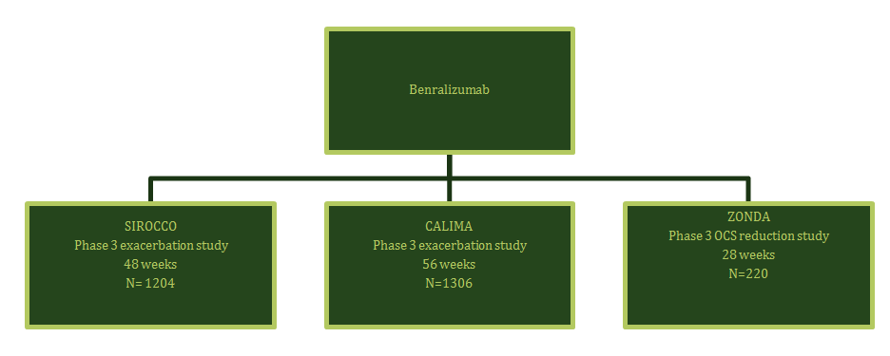

Rationale for the proposed dose

Dose ranging studies
Study MI-CP220 (Phase II) examined 2, 20 and 100 mg SC Q8W regimens in adult patients with uncontrolled asthma and treated with medium high dose ICS-LABA and having blood eosinophil > 300/µL. 100 mg SC Q8W group achieved a 41% reduction in exacerbation rate, compared to placebo; however it was not statistically significant. Meanwhile, patients on 20 mg SC Q8W achieved a statistically significant and greater (57%) reduction in exacerbation rate, compared to placebo. The 30 mg SC dose chosen in pivotal study was based on this observation.
In the SIROCCO and CALIMA trials, there was no inclusion criteria based on blood eosinophil count. Patients were stratified as those with < 300 cells/µL and > 300cells/µL. The intention to treat (ITT) population was patients on high dose ICS and with blood eosinophil count > 300 cells/µL. Benralizumab was administered as Q4W and Q8W regimens and treatment outcomes were compared across treatment groups.
Q8W is the proposed dose for marketing and hence efficacy and safety parameters are discussed for patients included in this regimen.

Pivotal Study D3250C00017 (SIROCCO trial)

Study design
This was a multicentre, randomised, double blind, parallel group, placebo controlled study.
Figure 7: Study D3250C00017 (SIROCCO trial) design
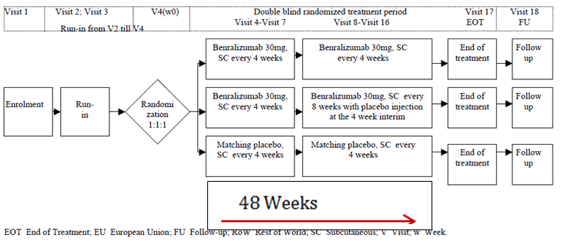

Primary objective
To evaluate the effect of 2 dosing regimens of benralizumab on asthma exacerbations in patients on high dose ICS-LABA with uncontrolled asthma

Key secondary objectives
To assess the effect of 2 dosing regimens of benralizumab on:
- pulmonary function
- asthma exacerbations
- asthma-related and general quality of life
- hospital visits due to asthma

Key inclusion criteria
- Age: 12 years to 75 years
- History of physician diagnosed asthma requiring treatment with medium to high dose ICS (> 250μg fluticasone dry powder formulation equivalents total daily dose) and a LABA, for at least 12 months prior to Visit 1.
- Pre-bronchodilator FEV1 of < 80% predicted. However, FEV1< 90% predicted was the cut-off for patients 12 to 17 years of age, which might have included asthmatics with milder disease severity.
- Two or more documented asthma exacerbations in the 12 months prior to enrolment in to the study that required use of a systemic corticosteroid or a temporary increase from the patient’s usual maintenance dose of OCS.

Key exclusion criteria
- Pulmonary or systemic disease, other than asthma, that was associated with elevated peripheral eosinophil counts (for example, allergic bronchopulmonary aspergillosis/mycosis, Churg-Strauss syndrome, hypereosinophilic syndrome).
- History of cancer: Patients with history of cancer were eligible, provided they were in remission and curative therapy was completed at least 5 years prior to recruitment.
- Positive hepatitis B surface antigen, or hepatitis C virus antibody serology, or a positive medical history for hepatitis B or C.
- A helminth parasitic infection diagnosed within 24 weeks prior to the date informed consent and had been not treated with or has failed to respond to treatment.

Patient population
A total of 1,069 (88.7%) patients completed treatment with study drug. The proportion of patients who discontinued treatment was similar across the groups, and due to AE was around 2% across treatment arms.

Baseline characteristics
The patient population of interest was the sub-group with baseline blood eosinophil ≥ 300µL and on benralizumab 30 mgQ8W. The mean age of asthmatics was around 45 years Mean ACQ of 2.8 reflected uncontrolled asthma. The mean percent predicted FEV1 (ppFEV1) of 55.5 indicates poor lung function. However, bronchodilator reversibility, which is a characteristic feature of asthma was only observed in around 27% of patients, which suggests that majority had either well controlled asthma or fixed airway obstruction due to airway remodeling. The mean baseline blood eosinophil count was 620cells/µL. The annual rate of exacerbations in the year prior to randomisation was 2.8. 73% of patients did not require hospitalisation for asthma exacerbation in the previous year of randomisation. Also, only 16.4% (one hospital admission) and 6.9% (two hospital admissions) of patients had ‘uncontrolled asthma’, as per American Thoracic Society / the European Respiratory Society (ATS/ERS) guidelines.⁵⁰ The mean ICS total daily dose of around 900 µg is below the lower threshold for high dose ICS in severe asthma (ATS/ERS guidelines). These baseline characteristics suggest well controlled disease status in this patient cohort

Statistics
These were described in the clinical evaluation report.

Primary efficacy endpoint
A 51% reduction in annualised exacerbation rate was achieved for patients in benralizumab arm 30 mg Q8W, compared to placebo arm (Table 17). At Week 48, the treatment difference when compared to placebo was statistically significant. The Delegate has calculated the absolute risk reduction as 0.78 exacerbation/year, relative risk reduction of 0.57 and NNT as 1.28.

Key secondary efficacy endpoints
A statistically significant least squares (LS) mean change in pre-bronchodilator FEV1 was observed for the benralizumab 30 mg Q8W (0.159 L), compared to placebo.
The improvement in LS mean change in asthma symptom score across treatment arms was -1.3 and -1.04 units for benralizumab and placebo arms respectively. There was a statistically significant treatment difference in asthma symptom score for patients in benralizumab arms, compared to placebo (Figure 8). However, absence of minimally clinically important difference (MCID) limits the ability to assess clinical significance
Table 17: Key efficacy results (Full analysis set, baseline blood eosinophils ≥ 300/µL)
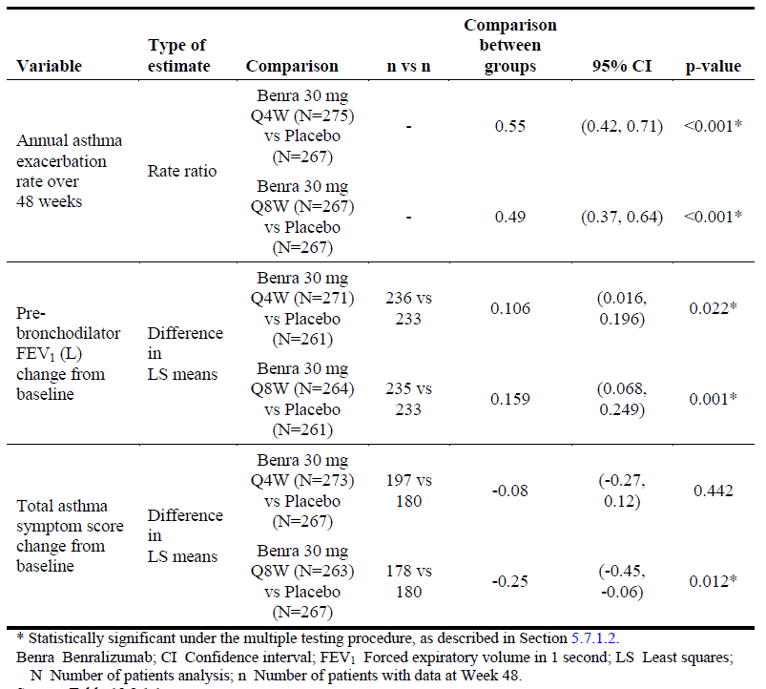
Figure 8: FEV1 change from baseline in pre-bronchodilator FEV1 (L) by time point (Full analysis set, baseline blood eosinophils ≥ 300/µL)
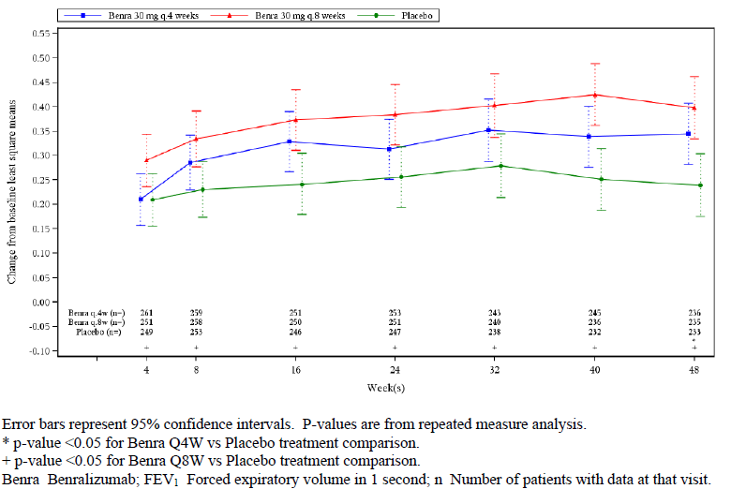

Other efficacy outcomes
- A statistically significant reduction was noted in annual rate of exacerbations that required hospitalisation and/or emergency room (ER) visits for patients in benralizumab arm, compared to placebo.
- Patients in benralizumab arm achieved a statistically significant improvement in ACQ-6 and health related quality of life. MCID for ACQ (0.5 points) was achieved.
- There was a reduction in the use of rescue medication across benralizumab treatment arms and placebo.

Sub group efficacy analysis
- Decreased treatment response with < 18 years age group of asthmatics and in individuals with body mass index (BMI) < 35 kg/m²
- Increased response with patients who had 3 to > 4 exacerbations in the previous year and with raised IgE.
Figure 9: Annual asthma exacerbation rate ratio over 48 weeks by subgroup, benralizumab 30 mg Q8W versus placebo; Forest plot (Full analysis set, baseline blood eosinophils ≥ 300/µL)
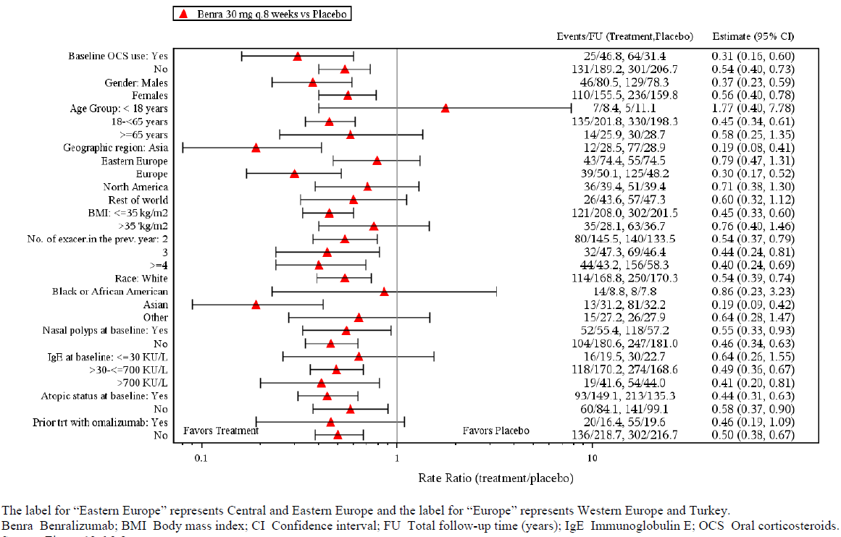

Study D3250C00018 (CALIMA trial)

Study design
This was a multicentre, randomised, double blind, parallel group, placebo controlled trial.
Figure 10: Study D3250C00018 (CALIMA trial) design
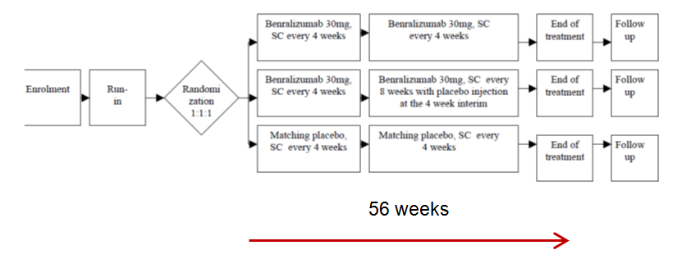
The study objectives, inclusion and exclusion criteria were identical to the SIROCCO trial.

Study population

Disposition
1,306 patients were randomised to receive treatment with benralizumab 30 mg Q4W, Q8W, or placebo. The proportion of patients who discontinued treatment was similar across groups and around 2%, which is similar to that of the SIROCCO trial. Baseline characteristics of the patient group on high ICS+ benralizumab 30 mg Q8W were largely comparable to the corresponding patient population in SIROCCO. The mean exacerbation rate was 2.8/year and the total daily ICS dose was 1002 µg of fluticasone equivalent, which is within the high dose ICS cut-off as per ATS/ERS guidelines.

Statistics
The analysis was identical to the SIROCCO trial.

Primary efficacy endpoint
Annual rate of asthma exacerbations.
A 28% reduction in exacerbations in the benralizumab arm was observed, which is approximately half of that achieved in the SIROCCO trial. The annualised rate of exacerbations (95% CI) was 0.66 (0.54 to 0.82) in the benralizumab arm and 0.93 in the placebo arm (0.77 to 1.12)).
Table 18: Annual rate of exacerbations over 56 weeks of treatment period;CALIMA trial
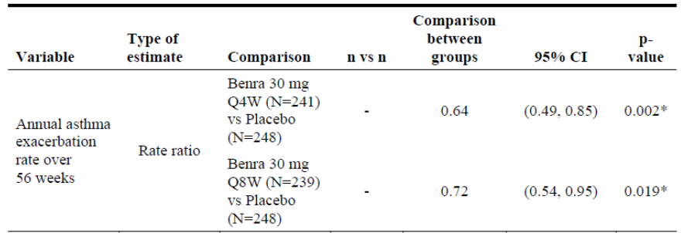

Key secondary efficacy endpoints
- At Week 56, a statistically significant mean change from baseline in FEV1 was observed for benralizumab arm. However, in spite of the longer duration of treatment, the improvement in FEV1 was less than that observed in the SIROCCO trial.
- The improvement in asthma symptom score across treatment arms was -1.4 and -1.16 for benralizumab arm and placebo respectively. Absence of MCID limits the ability to assess clinical significance.
Table 19: Key secondary endpoints (CALIMA trial)
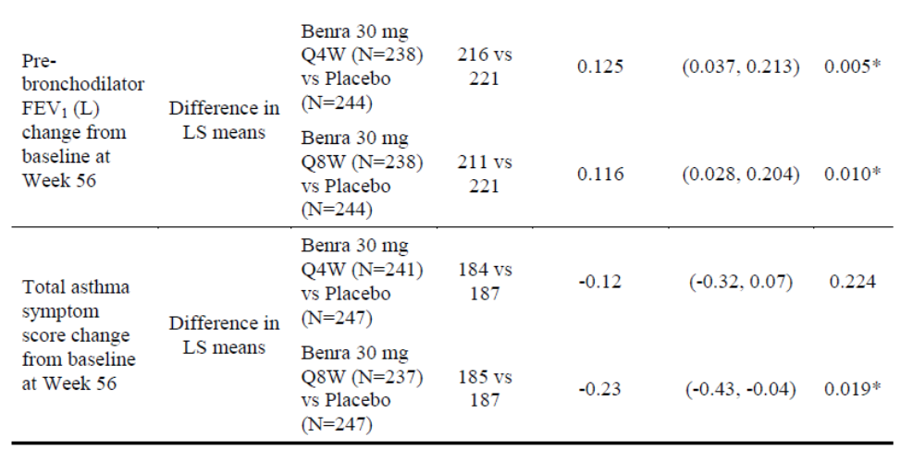
Figure 11: Change from Baseline in pre-bronchodilator FEV1 (L) by time-point (Full analysis set, baseline blood eosinophils ≥ 300/µL, high dose ICS)
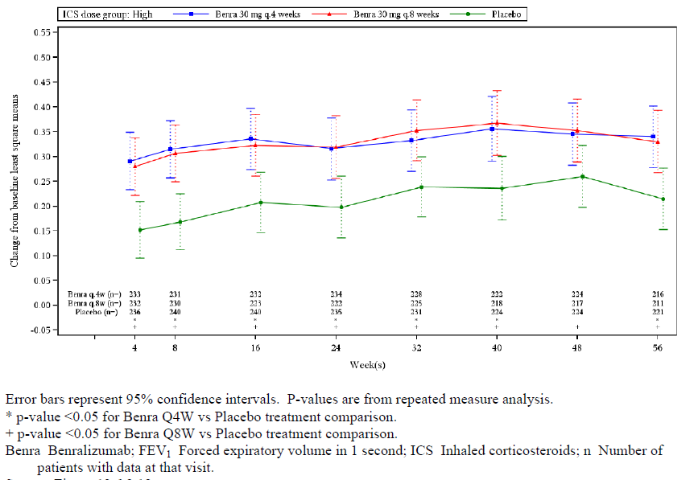

Other efficacy endpoints
- At Week 56, there was no significant difference in the change from baseline in asthma rescue medication use between benralizumab arm and placebo at -2.85 and -2.13 respectively. Asthma exacerbations that required ER visits were comparable for patients in both benralizumab and placebo arms.
- A greater LS mean difference (95% CI) for ACQ-6 was observed with benralizumab arm, compared to placebo. A MCID of 0.5 points was achieved. However, this finding is in contrast to the increased hospitalisations due to exacerbations reported in this study.
In spite of the longer treatment duration, it is unclear why this study was less efficacious than the SIROCCO trial.

Study D3250C00020 (ZONDA trial)

Study design
A randomised, double blind, parallel group, and placebo controlled trial of two dosing regimens of benralizumab in patients with severe asthma: uncontrolled despite high dose ICS, LABA and chronic oral corticosteroids.
Figure 12: Study design Study D3250C00020 (ZONDA trial)
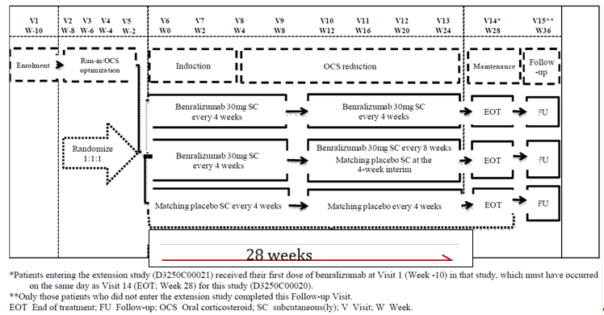
After enrolment and initial confirmation of entry criteria at Week -10, patients entered up to an 8-week run-in/OCS optimisation period (from Week -8 to Week 0), during which time the patient’s dose of OCS was titrated to the minimum effective dose without losing asthma control.
The treatment period was divided into 3 phases:
- Induction (from Week 0 to Week 4; patients remained on the optimised OCS dose).
- Reduction (from Week 4 to Week 24, inclusive; OCS dose reduction was initiated at Week 4 with dose reduction following at 4-week intervals).
- Maintenance (after Week 24 to Week 28; the dose of OCS reached at Week 24 or complete elimination of OCS was maintained).

Inclusion criteria
Inclusion criteria were largely similar to the SIROCCO and CALIMA trials except:
- Blood eosinophil count of ≥ 150 cells/µL and annual exacerbation rate of ≥ 1 episode, which are lower than the corresponding inclusion criteria for the SIROCCO and CALIMA trials.
- Chronic OCS therapy for at least 6 continuous months directly preceding Visit 1.

Primary objective
To compare the effect of 2 dosing regimens of benralizumab on percentage reduction of oral corticosteroid (OCS) dose in adult patients with uncontrolled asthma.

Key secondary objectives
To assess the effect of 2 dosing regimens of benralizumab on baseline OCS dose and parameters associated with asthma exacerbations, pulmonary function and asthma control.

Study population
220 patients were randomised into three treatment groups. Patients were randomised 1:1:1 and stratified by blood eosinophil count: ≥ 150 /µL to < 300/µL and ≥ 300 /µL. About 94% of patients across treatment arms completed the study.
A high proportion of patients were reported to have protocol deviations across benralizumab arm (16.4%) and placebo (36%). This is almost 50% higher than that observed in the SIROCCO and ZONDA trials. It is important to note that the most prevalent protocol deviation was related to down titration criteria for OCS, which could have impacted the final OCS dose and hence the study outcome.

Primary efficacy endpoint
A statistically significant reduction in OCS was achieved in both benralizumab groups compared to placebo. Around 55% reduction in baseline OCS dose was noted in the benralizumab group, compared to 20% in placebo. The median reduction in daily OCS dose was 5 mg, which is considered as clinically meaningful by CHMP. At Week 28, 37% of patients in benralizumab arm achieved 90 to 100% OCS dose reduction compared to 12% in placebo.
Table 20: Percent reduction in daily OCS dose at Week 28 (Full analysis set)
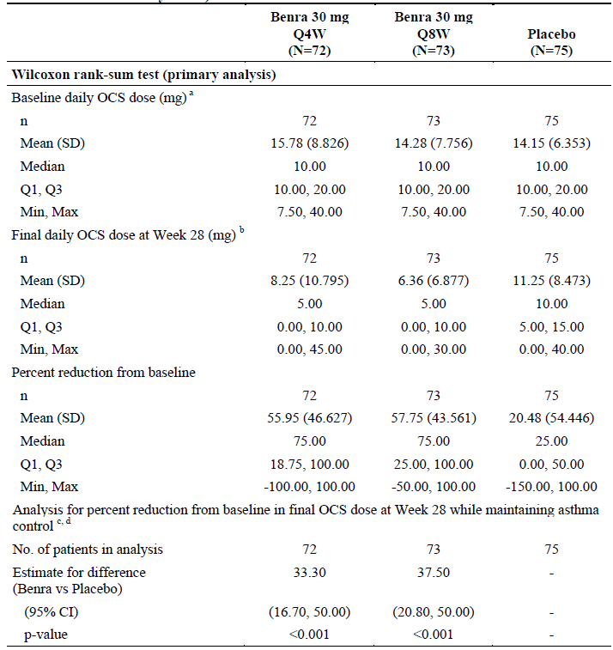

Secondary efficacy outcomes
- The rate ratio (95% CI) for annual exacerbations between benralizumab and placebo was 0.45 (0.27 to 0.76), p = 0.003, for Q4W and 0.30 (0.17 to 0.53), p < 0.001, for benralizumab arm.
- The mean (SD) change from baseline in pre-bronchodilator FEV1 was greater than that observed in the SIROCCO and CALIMA trials at 0.255 (0.508) L for benralizumab arm and 0.114 (0.401) L for placebo. The LS mean (95% CI) difference between benralizumab arm and placebo was not statistically significant at 0.112 (-0.033 to 0.258) L, p = 0.129.
- There was an improvement in asthma symptom score (total, daytime, and night time) and PEF, however the LS mean change from baseline was not statistically significant.

Safety
Safety outcomes were largely assessed based on data from the following:
- Study D3250C00017 (SIROCCO trial)
- Study D3250C00018 (CALIMA trial)
- Study D3250C00020 (ZONDA trial)

Patient exposure
In the clinical development programme, there were 900 patients exposed to benralizumab 30 mg Q8W. The number of patients in the 12 to 18 year age group was low, with 62 patients (%). There were 278 patients aged ≥ 65 years and nine patients aged ≥ 75 years. There were 19 patients with renal impairment, 37 with hepatic impairment and 140 with cardiac impairment.
Across Phase III studies, the mean (SD) on treatment durations were 339.7 (82.7), and 343.1 (77.1) days in the benralizumab 30 mg Q8W and placebo groups respectively, equating to a mean treatment period of less than a year.

Adverse events
In the SIROCCO and CALIMA trials, the pattern of TEAEs was comparable across treatment groups. The commonest AEs were asthma and respiratory infections, which were mild in intensity.
TEAEs that led to treatment discontinuation were higher in benralizumab arm at around 2 to 4%, compared to placebo at 0.7 to 2.7%. No clear pattern of TEAEs that led to treatment discontinuation was noted.

Deaths and Serious adverse events
In the three Phase III studies six and three cases of deaths were reported in benralizumab Q8W and placebo arms, respectively. One fatal case (53 year old male) of pneumonia as TEAE was reported in benralizumab arm in the ZONDA trial, which was determined by PI as related to study drug. No clear pattern of events that led to death was noted.
Overall, the incidence of SAE was comparable across treatment arms with 95 (11.6%) and 119 (14%) events reported in benralizumab arm and placebo arms respectively. In the SIROCCO, CALIMA and ZONDA trials, the incidence and types of SAEs were comparable across treatment arms (Table 21) and generally, lower than placebo. The most common SAEs were asthma and pneumonia.
Table 21: Most common SAEs (PT frequency of ≥ patients in any group) during the on-treatment period by System Order Class (SOC) and Preferred Term (PT) (Safety analysis set)
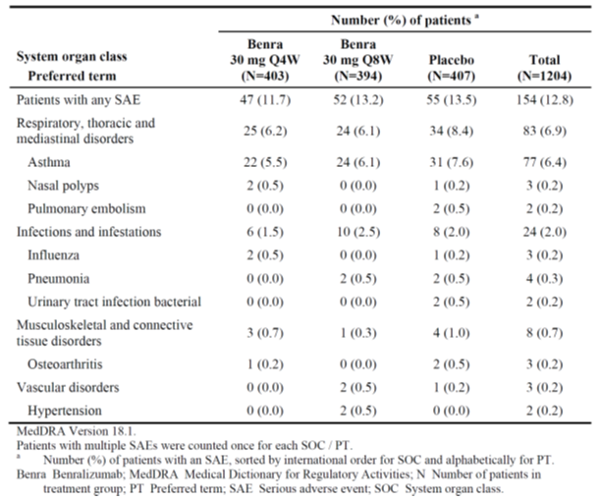
There were two and one new cases of malignancies in benralizumab arm and placebo arms respectively. There was no increased incidence of any one type of malignancy, as previously observed (skin cancer) in studies with reslizumab. New cases of malignancies were reported in benralizumab arm, one case each of meningioma and colon neoplasm was reported in the SIROCCO and CALIMA trials respectively. In the CALIMA trial, an event of breast cancer was reported in placebo arm. These events led to treatment discontinuation. The duration of studies is not considered adequate to examine whether these events are related to benralizumab. It is also important to note that a malignancy with < 5 years of remission was an exclusion criterion in these studies.
Table 22: Overview of safety outcomes in the SIROCCO and CALIMA trials (Integrated safety analysis)
AE category | Benralizumab Q8W  (N = 822) | Placebo  (N = 847)
AEs | 601 (73.1%) | 653 (77.1%)
SAEs | 95 (11.6%) | 119 (14.0%)
Deaths | 4 (0.5%) | 3 (0.4%)

Infections and infestations
The overall incidence of infections was comparable across treatment arms and placebo at around 50% patients. There was a low incidence of infections and infestations (around 2%) that were reported as SAEs across treatment arms, compared to placebo in Phase III studies. In the SIROCCO trial (0.4% versus 0.7%) and the CALIMA trial (0 versus 0.7), the percentage of patients with bacterial pneumonia was lower with when compared to placebo. One case of herpes zoster was reported in the benralizumab herpes zoster infections have been reported in previous studies with anti-IL5. Helminth infestations were not reported. However, patients with history of helminth infections were excluded from these studies.

Laboratory tests
A 30 to 50% reduction in basophil count was noted in benralizumab arms across Phase III studies. In the ZONDA trial, white cell count was also reduced by 25% in benralizumab groups.

Immunogenicity
Across Phase III studies, incidence of hypersensitivity was similar with benralizumab to placebo. Injection site reactions were reported in around 3% of patients. Overall incidence of ADAs and neutralising antibodies were reported in around 10% patients in benralizumab arm, which is comparable to previously approved anti IL-5 monoclonal antibodies (mAbs). No cases of anaphylaxis were reported.

Risk-benefit analysis

Delegate’s considerations

Efficacy
The studies submitted demonstrated benefits of benralizumab in the treatment of asthmatics with moderate-severe disease severity and a blood eosinophil count of ≥ 300 cells/µL for the following outcomes:
- Asthmatics with moderate-severe disease severity were able to achieve 30 to 50% reduction in exacerbations across the studies. This is comparable to the reduction in rate of exacerbations observed in studies with mepolizumab and reslizumab. In the SIROCCO trial, there was a 50% reduction in ‘serious exacerbations’ that required hospitalisation.
Table 23: Comparison of annual exacerbation rate across efficacy studies/trials
Patient group | SIROCCO  (48 weeks) | CALIMA  (56 weeks) | ZONDA  (24 weeks)
Q8W | 0.66 | 0.6 | 0.54
Placebo | 1.53 | 0.9 | 1.8
- A consistent improvement in ppFEV1 was observed across studies (Table 24). Treatment difference achieved statistical significance, when compared to placebo.
Table 24: Change from Baseline in pre-bronchodilator FEV1
Study/trial | LS mean change in FEV1
SIROCCO (48 weeks) | 0.159 L
CALIMA (56 weeks) | 0.116 L
ZONDA | 0.255L
A reduction in rescue medication use and OCS dose was observed in patients in benralizumab arms across studies. Improvement in asthma symptom score from baseline for benralizumab arm was comparable across the SIROCCO and CALIMA trials and the treatment difference, when compared to placebo was statistically significant. Absence of MCID limits the ability to ascertain clinical significance. A statistically significant and clinically relevant improvement in the Asthma Control Questionnaire (ACQ) score was observed for patients in benralizumab arm, when compared to placebo across all studies.
Increased treatment response for asthmatics with ≥ 3 exacerbations in the previous year of randomisation, raised IgE and high dose OCS at baseline suggest severe asthmatics as the potential targeted patient population for treatment with benralizumab. The ZONDA trial demonstrated a reduction in the need for oral corticosteroids. This is an important outcome as chronic use of oral steroids can have significant long term adverse effects.
Table 24: Comparison of primary efficacy outcomes across anti-IL-5 mAbs
Primary efficacy parameters | Benralizumab | Mepolizumab | Reslizumab
Reduction in Exacerbations | 30 to 50% | 50 to 60% | 50 to 60%
LS mean change in FEV1 | 0.176 L | 0.125 L | 0.113 L
Median reduction in daily OCS dose | 5 mg | 5 mg

Limitations
Bronchodilator reversibility, which is a characteristic feature of asthma was demonstrated in only around 25% of patients, suggestive of either well-controlled asthma at baseline or fixed obstruction due to airway remodelling. In clinical practice, benralizumab is indicated only for asthmatics with increased disease severity, which is not in accordance with the majority of study participants. Similarly, in the SIROCCO and CALIMA trials, a higher ppFEV1 (90%) was chosen as inclusion criteria for patients < 18 years of age that might have included asthmatics with milder disease severity. These factors limit the ability to extrapolate the efficacy outcomes from the clinical trial to the real world setting.
The clinical development program did not adequately address:
- Follow-up data on rebound/absence of exacerbations after cessation of benralizumab injections.
- The duration of treatment that is required to maintain optimal asthma control.
- It is unclear if patients will be able to stop benralizumab after a period of good control, and if not, the long term efficacy. The post approval long term study is expected to provide evidence in this aspect.

Safety
Majority of the types of AEs and TEAEs reported are similar to the disease manifestations of severe asthmatics and milder in intensity. TEAEs that led to discontinuation of treatment were higher with benralizumab. The low number, diverse nature, and short study duration make it difficult to determine if these were treatment related. A 30 to 50% reduction in basophils and 25% reduction in WCC in the ZONDA trial were noted. The reduction in basophil count was not observed with current anti-IL-5 therapeutic options. Patients with severe asthma are also often treated with high dose ICS and OCS, which can also compromise immunity. The incidence of infection was comparable across benralizumab and placebo at around 50%, thus despite the tendency to reduce basophils and WBC, there is no firm clinical evidence of an increased risk of infection. This risk however requires ongoing vigilance.
The evaluator had concerns over a potential association between benralizumab, malignancy and death as there was an increased number of these events in benralizumab arm, compared to placebo. The types of malignancies and causes of death were common in the general adult population. The impact of lowering eosinophils with an anti-IL5 active substance on the development of malignancies is not known. Increased rate of malignancy was also seen with another agent of this class (reslizumab, but not with mepolizumab). Based on pre-clinical study findings, no mechanistic reason for malignancy could be elucidated. There were no specific types of malignancies noted that would suggest an immunosuppressive mechanism. Taking these aspects in to consideration, together with the limited duration of studies, the Delegate considers that there is not enough evidence to suggest an association between benralizumab, events of malignancies and death reported in these studies. However, there is a need to monitor the long term incidence of malignancy, as there is a concern of potential immunomodulatory role for benralizumab. In this aspect, recommendations are made for changes to PI and RMP.

Limitations
There is lack of long term safety data with the mean treatment exposure for less than one year across Phase III studies. A lower proportion of patients were recruited in < 18 years of age group (62 patients) and > 65 years of age group (278 patients), affecting the applicability of findings in this age group. The Delegate has noted that malignancy has been included as an important potential risk in the RMP. However, exclusion criteria related to malignancy adopted in Phase III studies warrants a precautionary statement in the PI. Long term effects of near complete depletion of eosinophils and around 50% reduction in basophils on immune function is unknown. It needs to be addressed in the PI and the RMP. As per EMA guidelines, the duration of study was adequate to demonstrate efficacy in terms of reduction in exacerbations, however, not adequate to assess safety issues. The long term safety study (the BORA trial) currently conducted by sponsor has patients who are rolled over from the SIROCCO and CALIMA trials; which could address long term safety aspects of benralizumab.

Use in adolescents
1 in 10 young Australians (12 to 25 years) suffer from asthma, of which 63% have poorly controlled asthma. Approval of benralizumab would benefit those with increased disease severity, who may otherwise be treated with off-label use of benralizumab. Currently, in Australia, mepolizumab is approved for severe asthmatics > 12 years. Meanwhile, reslizumab is approved for adults with severe asthma.
A decreased treatment response to benralizumab was observed in sub-group analysis (12 to 18 years) of Phase III studies. However, the study was not powered for this analysis. There were no specific safety signals that were noted in this age group. The Delegate has concerns regarding the increased relative risk of malignancies in this age group, who will be exposed to the active drug for longer time due to early commencement of treatment.

Indications
The sponsor’s proposed indication:
Fasenra is indicated as an add-on maintenance treatment for severe asthma in patients with an eosinophilic phenotype
is inadequate in the following aspects:
- The clinical studies have consistently shown an increased benefit for patients with:
  - blood eosinophil level > 300 cells/µL; and
  - > 2 exacerbations in the year prior to randomisation.
Hence, the Delegate recommends a modified indication:
Fasenra is indicated as an add-on maintenance treatment in patients aged > 12 years with severe asthma, > 2 exacerbations/year and with blood eosinophil count of > 300 cells/µL.
The Delegate is satisfied that quality has been established, and benralizumab is efficacious in lowering annual rate of asthma exacerbations, improving lung function and quality of life measures. The safety appears to be adequate for regulatory approval. However, the Delegate is concerned about the long term safety of benralizumab in the treatment of severe asthma and considers that data from follow-up study (the BORA trial) will enable to examine the long term safety aspects. The committee is requested to comment on the long term safety aspect, particularly in the 12 to 18 year age group.

Recommended changes to the PI, CMI and RMP
The Delegate recommended various changes to the PI, CMI and RMP however these are beyond the scope of this AusPAR.

Questions for the sponsor
- In Australia, what is the prevalence of eosinophilic phenotype of severe asthma in the 12 to 17, and 18 to 75 year age groups of asthmatics?
- Please explain the rationale for choosing the cut-off for blood eosinophil level as 300 cells/µL for the patient population of interest in pivotal studies.
- In the SIROCCO trial, ppFEV1 was ≤ 90% as lower limit for 12 to 17 years, which was different from ≤ 80% for 18 to 75 years. What was the rationale for this approach?
- The range of ICS dose (> 500 to 1000 µg/day) considered as high in the recruitment of patient to efficacy studies SIROCCO and CALIMA trials is not in line with > 1000 µg/ day as the lower limit of threshold for high dose ICS as per ATS/ERS guidelines. Please clarify.
- Are there studies to examine optimal treatment duration or to examine implications of weaning-off treatment in severe asthmatics?
- The inflammatory profile of airway may change in asthmatics, when they become obese or become affected with chronic obstructive pulmonary disease (COPD). Is there any evidence for corresponding changes in blood eosinophils, which would indicate change in treatment that was initially based on blood level of eosinophils?
- Why is it stated in the PI, under Dosage and Administration as no dosing recommendation can be made in 12 to 17 year old patients, while the proposed indication was for all patients with severe asthma?
- In spite of the fewer injections, there was an increased efficacy observed with benralizumab Q8W regimen, compared with that of Q4W regimen, please explain.

Conclusion
- Benralizumab is an anti-IL5 mAb for the treatment of severe asthma with an eosinophilic phenotype.
- It differs from mepolizumab and reslizumab, as it has greater affinity for binding to IL-5Rα and greater efficacy in depletion of eosinophils in blood.
- The clinical development program demonstrated efficacy on the following endpoints
  - Rate of exacerbations
  - FEV1
  - Reduction in oral corticosteroid use.
- Phase III studies included patients aged 12 to 75. In the subgroup analysis, for the 12 to 18 age group, efficacy was less than that observed in adults. However, the study was not powered for this analysis. The safety in adolescents was consistent with that of adults.
- There were no major safety concerns. However safety data was limited to study duration of 1 year.
- Considering the immunomodulatory effect, role of benralizumab in the cases of malignancies cannot be ruled out. However, no specific pattern or safety signals in toxicology or clinical data were noted.

Proposed action
The Delegate had no reason to say, at this time, that the application for Fasenra for the treatment of severe asthma with eosinophilic phenotype should not be approved for registration.

Request for ACM advice
The committee is requested to provide advice on:
- Please comment on the potential impact of long term near complete depletion of eosinophils on immune system, particularly in severe asthmatics.
- Please comment on the proposed age restriction of > 12 years

Response from sponsor

Sponsor’s response to Delegate’s request for ACM advice
AstraZeneca (the sponsor) welcomes the Delegate’s preliminary assessment that there are no reasons that Fasenra (benralizumab) 30 mg in 1 mL solution for injection prefilled syringes should not be approved for use in patients with severe eosinophilic asthma. This is consistent with the US FDA approval received in November 2017 and the EU EMA approval received in January 2018. The sponsor also welcomes the opportunity to provide comments below in relation to the advice sought from the ACM and specific issues for the sponsor. Please note where the advice sought and issues for the sponsor overlap, the discussion has been consolidated to reduce redundancy.

Proposed indication
The sponsor’s proposed indication modified as part of the response to the first round evaluation was:
Fasenra is indicated as an add-on maintenance treatment for severe asthma in patients with an eosinophilic phenotype (see Clinical Trials).
The reference to ‘see Clinical Trials’ was added in the response to the first round evaluation, in response to the clinical evaluator’s comment that the indication did not fully reflect the patient population studied. This proposal was in line with that approved for Nucala (mepolizumab) in Australia, as well as Fasenra (benralizumab) approved in the US and the EU where the clinical trial sections provide the Health Care Professional (HCP) with further detail on the specific patient populations assessed. The Delegate has subsequently proposed to modify this further to:
Fasenra is indicated as an add-on maintenance treatment in patients aged > 12 years with severe asthma, > 2 exacerbations/year and with blood eosinophil count of > 300 cells/µL.
Based on feedback from the Delegate, the sponsor has revised the proposed indication to include reference to the age of patients studied. Further clarification of the target population disease severity has also been added. The sponsor’s proposed modified indication is as follows (changes shown as underlined text) and is consistent with that approved for Nucala (mepolizumab) in Australia:
Fasenra is indicated as an add-on maintenance treatment for severe refractory asthma in patients aged 12 years and over with an eosinophilic phenotype (see Clinical Trials).
This indication, for Fasenra (benralizumab) at the recommended dose (30 mg dosed every 4 weeks for the first 3 doses, then every 8 weeks thereafter) is fully supported by the comprehensive Fasenra clinical trial program including 2 pivotal asthma exacerbation trials (SIROCCO and CALIMA) in patients with 2 or more prior exacerbations in the previous year enrolling patients across the entire range of baseline blood eosinophils and an OCS sparing trial (ZONDA), conducted in patients with 1 or more prior exacerbations in the previous year with baseline blood eosinophils ≥ 150 cells/µL. The sponsor ensured that the population in the pivotal studies was representative of severe refractory asthmatics by including patients who were treated with high dose ICS (> 500 µg of fluticasone propionate or equivalent daily, according to GINA guideline; plus LABA plus any additional controller medication that had been stable for at least 30 days prior to enrolment. Use of systemic steroids was also allowed. Patients were uncontrolled based on an ACQ score greater than 1.5. An additional criterion to address severity in the SIROCCO and CALIMA trials was a history of 2 or more exacerbations in the year prior to randomisation. In the ZONDA trial, severity was ascertained by including only those patients who required systemic steroids. These patient populations are fully described within the clinical trials section of the proposed PI.
Key results supporting the indication are as follows:
- The SIROCCO and CALIMA trials demonstrated statistically significant improvements for Fasenra Q8W compared to placebo in exacerbation rate (51% and 28% reduction), lung function (0.159 L and 0.116 L improvement in FEV1) and improvements in symptoms in the primary analysis population (patients with baseline eosinophils ≥ 300 cells/µL with 2 or more exacerbations on high dose inhaled corticosteroids) (see Tables 17 and 18).
- The ZONDA trial demonstrated improvements in OCS reduction (median 75% reduction on Fasenra Q8W compared to 25% reduction on placebo) in patients with baseline eosinophils ≥ 150 cells/µL with 1 or more exacerbation in the previous year (see Table 19). The improvements in OCS were achieved in parallel with a 70% reduction in annual exacerbation rate (nominal p < 0.001) and a 93% reduction in the rate of exacerbations associated with hospitalisation/ER visit (nominal p < 0.018).
- Safety data demonstrate that Fasenra is well tolerated and has a favourable safety profile, that is, a safety profile comparable to standard of care in completed studies of up to 56 weeks in duration.
- The safety and PD effect in adolescents was consistent with that of adults. Adolescents had a lower rate of treatment emergent adverse events and serious adverse events than adults, although efficacy results in adolescents were equivocal. As noted by the Delegate, these studies were not powered for this sub-group analysis. The sponsor finds no scientific or biological rationale to expect that an adolescent severe asthma patient with eosinophilic driven disease would not potentially benefit from treatment with Fasenra. Based on the recommendation of the Delegate, and consistent with the recent approval of Fasenra in the US, the sponsor has agreed to revise the indication to include adolescents; see also ‘Use in Adolescents (12 to 17 years)’ below.
Identification of the eosinophilic phenotype remains a clinical diagnosis with no single definition of a baseline blood eosinophil level to characterise these patients. Sponsors have utilised different thresholds in clinical trials for Fasenra (benralizumab), Nucala (mepolizumab) and Cinqair (reslizumab). Unlike programs for previously approved biological medicines targeting this phenotype, the benralizumab program enrolled patients across the entire range of baseline blood eosinophils. Relevant datasets summarised by eosinophil level at baseline and/or prior exacerbation history are discussed in more detail below. Analyses of the integrated data as well as results in patients with baseline eosinophils < 300 cells/µL, that were studied but not included in the SIROCCO/CALIMA trials primary analysis population described above, indicate:
- Efficacy of Fasenra across the range of blood eosinophils with enhanced efficacy observed with increasing baseline blood eosinophil levels, most clearly seen for FEV1. There is no specific baseline eosinophil count below which there is no efficacy; results are in favour of treatment with Fasenra over placebo at < 300 cells/µL in both the SIROCCO and CALIMA trials (see Table 26), and at all cut-offs evaluated in the integrated analysis set (< 150, 150 to 299, 300 to 449 and ≥ 450 cells/µL; see Figures 13 and 14).
- Evidence of enhanced response for asthmatics with greater numbers of prior exacerbations, as noted by the Delegate:
  - While the SIROCCO/CALIMA trials were not powered to assess efficacy within prior exacerbation subgroups, the sponsor notes that although efficacy results in patients with 2 exacerbations in the previous year were equivocal in the CALIMA trial, the SIROCCO trial demonstrated a 45% reduction in exacerbations compared to placebo (nominal p = 0.002) for these patients (see Table 30).
  - The ZONDA trial recruited 60% of patients with 1 or more prior exacerbations in the previous year. In this study, all subgroups showed reductions in OCS usage from baseline regardless of prior exacerbations (median decrease from baseline of 62.5%, 83.3% and 75% in patients with 1, 2 or ≥ 3 prior exacerbations).
Table 30: Absolute and percent change from baseline in blood eosinophil counts at Baseline, Week 4, and end of trial (SIROCCO and CALIMA trials; Full analysis set, baseline blood eosinophils ≥300/µL, high-dose ICS)
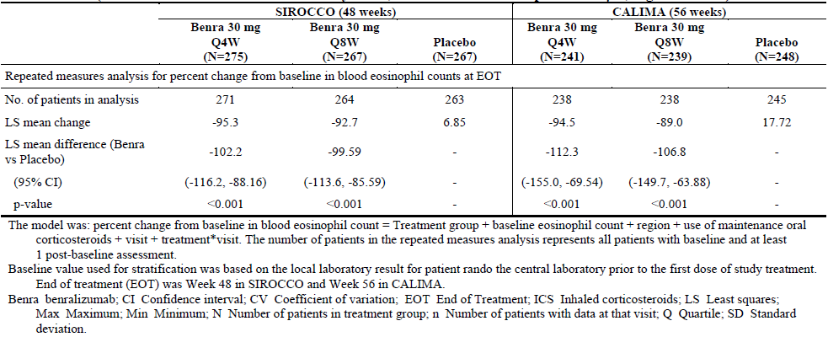
The approach to simplification of indication statements whereby reference is made to the Clinical Trials section for specific details of the assessed patient populations (including subgroups representing predictors of enhanced response) rather than inclusion as part of the Indication is consistent with that adopted by the TGA for Nucala (mepolizumab) as well as AstraZeneca products in other therapeutic areas (for example, oral diabetes products). The background and benefit of this approach has been described in the Nucala AusPAR where it is explained that presenting the information in this way ensures that the full prescribing information is considered in its entirety by the prescriber to inform the appropriate prescribing decision for the patient.

Comments on ACM advice sought by the delegate
The Delegate seeks the committee’s advice on two issues:
- The potential impact of long term near complete depletion of eosinophils on the immune system particularly in severe asthmatics
- The proposed age restriction of > 12 years old (that is, use in adolescents).
The sponsor’s comments on both aspects are provided below:
- Extent of long term exposure and risk management approach
The sponsor considers that the exposure underpinning the evaluation of safety is adequate to support the proposed indication, including treatment of adolescents and long term use. Based upon the SIROCCO and CALIMA trials, which formed the basis of the pooled data for the Integrated Summary of Safety in the original submission, 762 patients were treated with Fasenra for at least 1 year (≥ 52 weeks of on treatment follow-up), 396 and 366 in the Fasenra Q4W and Q8W treatment groups respectively. The 4 month safety update (4MSU; data cut off 21 October 2016) submitted to the TGA in our response (to first round questions) provided further support to the adequacy of the dataset supporting the indication. Upon completion of the SIROCCO, CALIMA, and ZONDA trials, eligible patients were offered the opportunity to roll into the long term extension study (the BORA trial), in which all patients received Fasenra treatment. Patients who received Fasenra in the predecessor studies continued on the same regimen in the BORA trial, while those patients who previously received placebo were randomised to 1 of the 2 Fasenra regimens. Three-hundred forty-five (345) patients have also rolled over from the BORA trial to continue the same Fasenra treatment regimen in the MELTEMI trial, a second long term extension study. As such, both the total number of patients exposed to Fasenra, as well as the total duration of exposure to Fasenra has increased since the Phase III pivotal studies completed. As noted in the submitted 4MSU, the total number of unique patients exposed to Fasenra for at least 52 weeks was 1,819 (1,708 from the SIROCCO/CALIMA trials and 111 patients from the ZONDA trial) including 693 and 662 patients who received Fasenra 30 mg Q4W and Q8W, respectively, in the predecessor studies, more than double the number of patients exposed for at least a year in the original submission pooled dataset. The interim long term safety analysis in the 4MSU demonstrated that the safety data were consistent in the exposure adjusted rates over time for potential risks when compared with those reported for the BORA and MELTEMI trials. Hence, there were no changes in the interpretation of the safety data relative to that described in the initial submission. In addition, it is noted that the independent Data Safety Monitoring Board (DSMB) which regularly monitored and reviewed safety during the SIROCCO/CALIMA trials continues to oversee safety in the subsequent ongoing BORA trial. To date, no safety concerns have been raised by the DSMB.
In terms of risk management, ‘Safety profile of the long term use of benralizumab 30 mg SC’ is also documented as an element of missing information in the RMP for Fasenra. In addition to routine pharmacovigilance, the BORA and MELTEMI trial will enable further characterisation of the long term safety profile of Fasenra at the recommended dose. Even though not confirmed by available current safety data from the Phase III studies and long term extension studies, the most commonly known risk factors (class effects) for biological medicines including IL-5 receptor blockers (that is malignancy, serious hypersensitivity, serious infections, helminth parasitic infection) are included within the EU-RMP submitted to the TGA. The analysis of the data from the BORA/MELTEMI trials along with post-marketing data will enable the sponsor to further characterise these potential risks.
- Safety profile including long term safety considerations
Fasenra has a well characterised safety profile that is comparable to placebo, with few adverse drug reactions (ADRs), and these ADRs are of a nature and severity that are not expected to have a clinically meaningful impact on individual patients or at a population level. In addition, there are few important potential risks which may be associated with use of Fasenra including clinically important potential risks based on mechanism of action (MOA) (serious infection, malignancies, and helminth infection) and risks common to any mAb (hypersensitivity). Specifically, the literature evidence relating to the potential risk of malignancy associated with long term eosinophil depletion is conflicting. However, there has been no evidence of a risk of malignancy from the Fasenra clinical development programme and preclinical models of carcinogenicity are not available to inform this risk. The topic will continue to be evaluated and is considered as a potential risk. The overall adjudicated malignant neoplasm rate in the SIROCCO/CALIMA trials was balanced across treatment groups (0.24% (4/1663) in the Fasenra treatment arms versus 0.24% (2/847) in the placebo treatment arm) (as per 4MSU provided in the response to first round evaluation). In agreement with sponsor’s view, the Delegate concluded that there is currently insufficient evidence to support a causal association between malignancy and treatment with Fasenra based on the available data. In addition, the sponsor acknowledges that there are still limited numbers of subjects who have been exposed for longer time durations (refer to 4MSU exposures detailed above).
Although the potential risk of malignancy is considered to be low, the sponsor continues to develop a robust risk management strategy to further characterise this important potential risk. The sponsor has committed to a post authorisation safety measure (as per EU-RMP submitted to TGA) and is currently exploring potential methodologies including a large International Severe Asthma Registry study of about 10,000 patients from approximately 14 countries for data collection and analysis, and also how to best study the potential risk of malignancies associated with Fasenra and other biologics in a real-world setting. The details of this EU post approval commitment are currently being developed with the EMA with target submission in the EU due by the end of Q2 2018. Lastly, it is noted that the exclusion of patients with malignancies from the pivotal Fasenra studies is consistent with industry practice for non-oncology trials. Exclusions were in place to ensure the safety of patients during the studies and to ensure that unstable medical conditions or concomitant therapy for such conditions did not confound the assessment of Fasenra safety. Together with information provided above there is no justification for such trial exclusion criteria to lead to precautionary statements in the PI.
In summary, based on the number of malignancies seen in the SIROCCO and CALIMA trials, the additional pharmacovigilance activities planned to monitor the risk of malignancy and the commitment for post approval safety measure for malignancy risk in the real world setting, the sponsor considers that the Delegate’s recommended Precautionary Statement is not required at this point in time, and does not propose to add a malignancy precaution to the Australian PI and accompanying CMI.
- Use in adolescents (12 to 17 years)
The sponsor accepts the Delegate’s proposal to include an age range within the proposed indication. Inclusion of patients 12 years and older is consistent with the indication recently approved in the US and is supported by the evaluation of available data as summarised below.
PK assessments of Fasenra were found to be broadly comparable between adults and adolescents. The PD measure of Fasenra as determined by eosinophil depletion was consistent between adults and adolescents. Although baseline eosinophil levels were similar between adolescent and adult patients, the adolescent subgroup exhibited lower baseline disease severity across multiple measures; including baseline lung function, ACQ-6, and prior exacerbations. The adolescent population enrolled in the asthma exacerbation rate reduction trials showed substantial improvement compared with baseline in exacerbations, lung function, and symptoms in all treatment groups, including placebo. The large improvements observed in the placebo arm precluded drawing definitive conclusions on efficacy. The adverse event profile in the 108 adolescent patients studied was generally similar to the overall population as noted by the Delegate. Adolescents had lower incidences of treatment-emergent adverse events and serious adverse events compared with patients overall (adults and adolescents). The preferred terms that were reported at higher incidences in adolescent patients compared with patients overall in either Fasenra group were sinusitis, bronchitis, and pharyngitis. The incidence of asthma (reported as an adverse event) was lower in adolescents in all treatment groups compared with the overall patient population. There were no deaths or hypersensitivity treatment-emergent adverse events reported in adolescent patients. Lastly, a literature review showed that, in general, salient clinical features of eosinophilic asthma are similar between paediatric and adult patients. (Refer to AstraZeneca Response to Questions from FDA August 2017; provided).
Based on PK, PD, and clinical manifestation, it is plausible to expect that adolescents with severe asthma of an eosinophilic phenotype would respond similarly to Fasenra 30 mg Q8W as adults. As such, the sponsor considers that the inclusion of patients 12 years of age and older in the indicated population is appropriate based upon extrapolation of the available PK/PD data and agrees with the Delegate’s recommendation to include the age range of ‘12 years and above’ within the proposed indication, consistent with the indication recently approved by the FDA. Amendments to the proposed PI ‘Dosage and administration’ and ‘Precautions’ sections relating to adolescent patients have also been made.

Sponsor’s overall conclusions
The overall positive benefit-risk profile of Fasenra 30 mg Q8W has been demonstrated in severe refractory asthma patients aged 12 years and over with an eosinophilic phenotype, based on reduction in annual (annualised) asthma exacerbation rate, improvement in lung function, and asthma symptoms, reduction in chronic OCS use while maintaining asthma control and a well characterised and acceptable safety profile that is comparable to placebo. Data from both the SIROCCO and CALIMA trials showed efficacy across a range of baseline blood eosinophil levels and number of asthma exacerbations in the previous year. Both prior exacerbation history and baseline blood eosinophil count were individual clinically relevant predictors of improved treatment benefit. When considered alone or in combination, these factors can further identify patients who may achieve greater benefits from Fasenra treatment, thus, the sponsor proposes to include these factors in the Clinical Trial section of the PI rather than the indication, consistent with the labelling of other approved drugs. Longer term safety data continue to be generated and evaluated in ongoing studies and are complemented by pharmacovigilance activities to monitor potential risks and future studies in the real world setting. The benefit-risk for adolescent patients is considered to be acceptable, supporting inclusion in the indication. In conclusion, Fasenra offers a different mechanism of action that delivers rapid, direct, and nearly complete eosinophil depletion, early and sustained efficacy responses, and an acceptable safety profile, which makes for an overall favourable benefit-risk profile, thus addressing an important gap in currently available therapies for severe asthma with an eosinophilic phenotype.

Sponsor’s response to questions from delegate
- In Australia, what is the prevalence of eosinophilic phenotype of severe asthma in the 12 to 17, and 18 to 75 year age groups of asthmatics?
There is no formal Australian prevalence data for severe asthmatic patients with an eosinophilic phenotype. The sponsor has utilised Australian data relating to population size; and the overall asthma prevalence; to estimate a crude prevalence for adolescents and adults. The overall asthma prevalence rates in Australia for the age groups 12 to 17 years and over 18 years are estimated to be 22% and 10.8% respectively (comprising an estimated 393,690 and 2,126,273 subjects). Taking into account the requirements for severe asthmatics (patients on ICS/LABA, patients on high dose ICS, exacerbations over the last 12 months including those prescribed OCS) and an estimate that approximately 39% of severe asthmatics have an eosinophilic phenotype (same for both age ranges), the crude Australian prevalence is approximately 1,380 adolescents and 7,487 adults.
- Please explain the rationale for choosing the cut-off for blood eosinophil level as 300 cells/µL for the patient population of interest in pivotal studies.
(Please also refer to the Proposed indication section in the Sponsor’s response to Delegate’s request for ACM advice above.)
The Phase III exacerbation studies, the SIROCCO and CALIMA trials for use of benralizumab in severe asthma had a primary analysis patient population of patients on high dose ICS with a blood eosinophil count of ≥ 300 cells/µL. The justification for this threshold was based on a limited data set from the Phase IIb study (Study MI-CP220). In this limited dataset from the Phase IIb study an evaluation of efficacy was made at different baseline blood eosinophil thresholds of ≥ 200 and < 200 cells/µL, ≥ 300 and < 300 cells/µL and ≥ 400 and < 400 cells/µL. By these thresholds, benralizumab showed increasing efficacy with increased eosinophil levels on exacerbation rate, change from baseline in FEV1 and on ACQ-6 score (Study MI-CP220 study report).
At a threshold of ≥ 300 cells/µL in MI-CP220, benralizumab showed statistically significant and clinically meaningful reduction in exacerbation rate and improvement in FEV1 at the end of treatment in both the 20 mg and 100 mg dose groups (see Table 25). The effect on these endpoints was of a lower magnitude in the < 300 cells/µL subgroup, although it must be stressed that the n numbers in the < 300 subgroup for the 20 mg dose group were too small to make meaningful conclusions. However, at a threshold of ≥ 200 cells/µL there was evidence of an effect to reduce exacerbations, although not achieving statistical significance, and an improvement in FEV1 which did achieve statistical significance (threshold for significance versus. placebo set at p < 0.2) with both the benralizumab 20 mg and 100 mg treatment arms suggesting there was also evidence of efficacy at lower blood eosinophil thresholds than ≥ 300 cells/µL which warranted further evaluation in the Phase III pivotal studies.
Based on the analysis of the Phase IIb data by blood eosinophil thresholds, a baseline blood eosinophil threshold of ≥ 300 cells/µL was proposed for the primary analysis population in the Phase III program exacerbation studies (SIROCCO/CALIMA trials). However, it was recognised that this threshold was somewhat arbitrary, based on limited data and the blood eosinophil level below which Fasenra was not effective remained unclear. Therefore, patients with baseline blood eosinophils < 300 cells/µL were also recruited (in a ratio of 2:1 ≥ 300 cells/µL to < 300 cells/µL) so that the efficacy of Fasenra could be evaluated across the range of baseline blood eosinophil counts in an attempt to further determine efficacy across the full range.
Table 25: Effect of treatment with benralizumab by different blood eosinophil thresholds on exacerbation rate reduction and change from Baseline in FEV1 (Study MI-CP220)
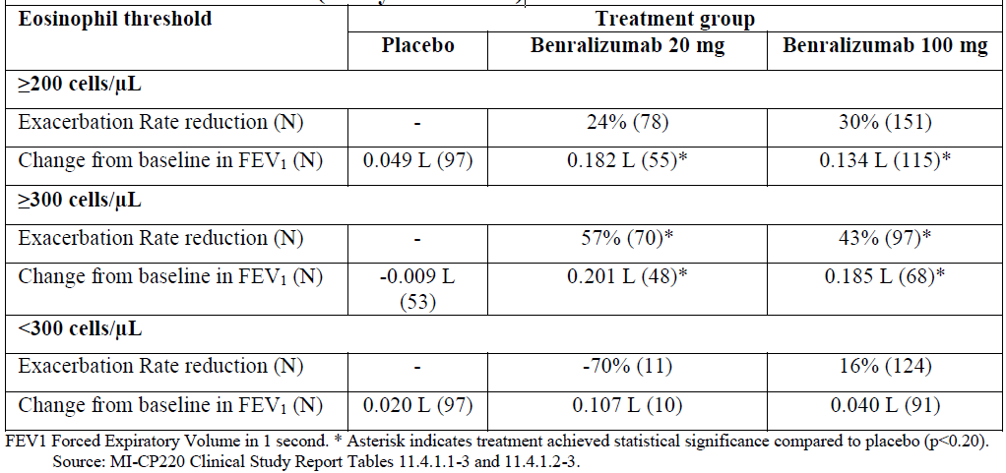
In SIROCCO/CALIMA trial, Fasenra demonstrated statistically significant effects on exacerbation rate reduction, improvement in FEV1, and improvement in total asthma symptom score (in the Q8W treatment group) in the primary analysis population of severe asthma patients on high dose ICS and baseline blood eosinophils of ≥ 300 cells/μL. However, in a pooled analysis of SIROCCO/CALIMA trial efficacy of Fasenra was also evaluated across the range of blood eosinophils (see Figure 13 and Figure 14). Efficacy data for patients with baseline blood eosinophils of < 300 cells/µL in SIROCCO/CALIMA trials, separately, are also presented for illustration (Table 26).
Table 26: Fasenra efficacy in patients with baseline blood eosinophil counts less than 300 cells/µL on high dose ICS (SIROCCO and CALIMA trials)
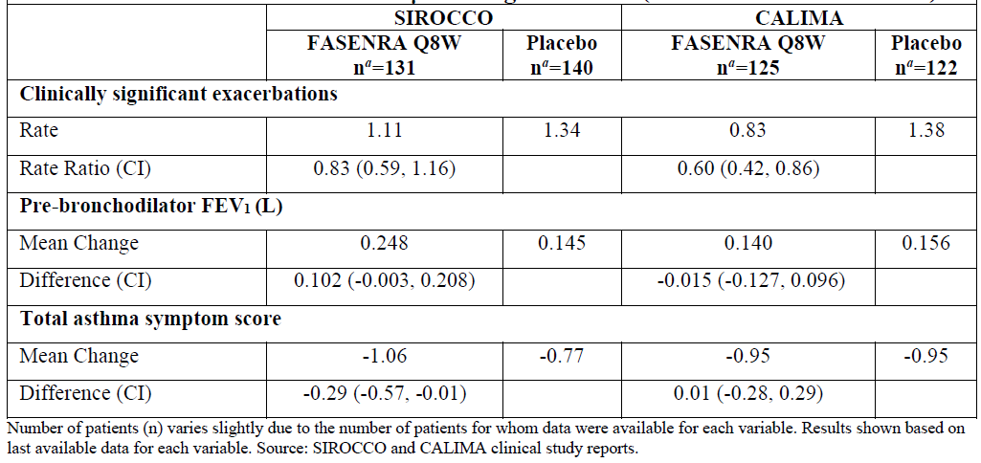
Figure 13: Annual asthma exacerbation rate ratio comparison by baseline blood eosinophil count category, negative binomial model - forest plot (Integrated SIROCCO/CALIMA trials; Full analysis set, high dose ICS)
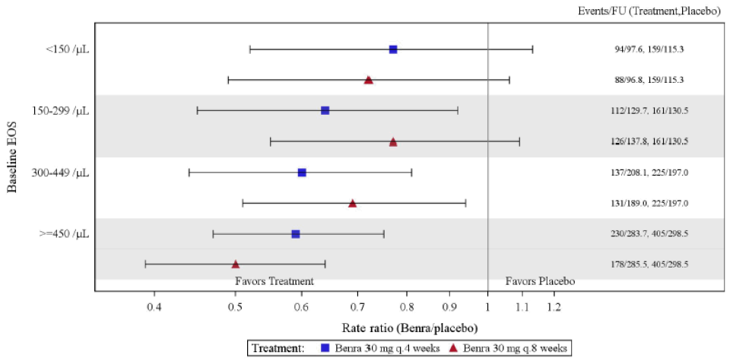
Figure 14: Change from Baseline in pre-bronchodilator FEV1 (L) at Week 48 by baseline blood eosinophil count category, repeated measures analysis; forest plot (Integrated SIROCCO/CALIMA trials; Full analysis set, high dose ICS)
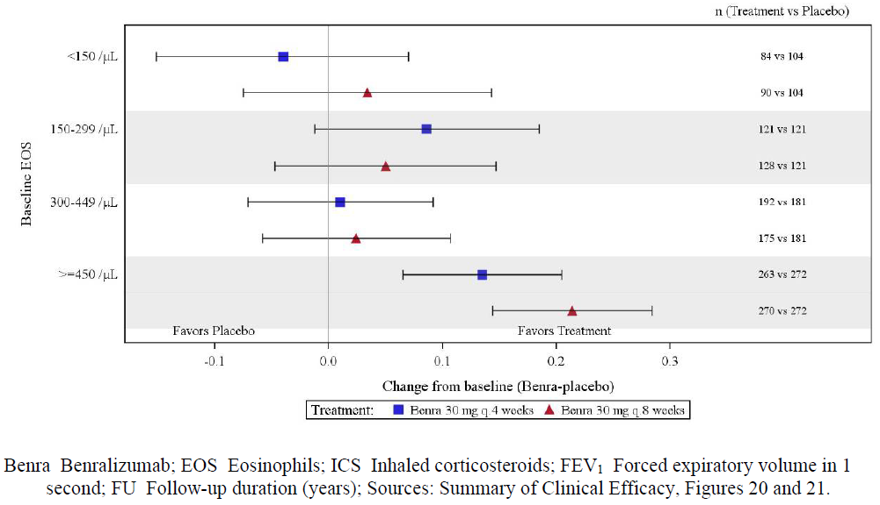
The integrated analysis of the studies showed efficacy of Fasenra across the range of blood eosinophils and that efficacy increased with increasing baseline blood eosinophil levels. This effect was most clearly demonstrated on improvement in FEV1. Furthermore, a post hoc analysis of SIROCCO and CALIMA evaluated efficacy of Fasenra by a blood eosinophil threshold of ≥ 150 cells/µL and < 150 cells/µL. This analysis showed that in patients with blood eosinophils greater than or equal to 150 cells/uL, treatment with Fasenra 30 mg Q8W reduced annual exacerbation rate (42% and 36% for SIROCCO and CALIMA trials, respectively, nominal p < 0.001) and improved FEV1 (163 mL and 116 mL above placebo for SIROCCO and CALIMA trials, respectively, nominal p < 0.001). Finally, the ZONDA trialrecruited severe asthma patients taking OCS with a blood eosinophil count of ≥ 150 cells/µL. In this patient population, Fasenra demonstrated efficacy in significantly (both clinically and statistically) reducing OCS dosage and exacerbation rate compared with placebo treatment (ZONDA trial study report).
Based on these analyses of Phase III study data, since Fasenra has efficacy across the range of baseline blood eosinophils, it is clear there is no specific baseline eosinophil count below which there is no efficacy.
Eosinophilic asthma has been characterised by the presence of increased numbers of eosinophils in the airways of asthmatic patients; and increased sputum eosinophil numbers in asthma are associated with poor lung function, risk of exacerbations, and disease severity.,, However, the assessment of airway eosinophil numbers is restricted to research groups and is not practicable for use in the majority of asthma clinics. Blood eosinophil counts can provide a readily available means of a surrogate for monitoring airway eosinophils.
Increased blood eosinophils in asthma also show associations with disease severity, greater risk of exacerbations, decreased lung function, and mortality;^{31,,,,,} and in general, there is a relationship of blood eosinophils with sputum eosinophils.,,,, However, the relationship of blood with sputum eosinophil can be weak, and a systematic analysis of the literature conducted by Korevaar et al, exemplified specific examples of this.
Mukherjee and Nair; reported that the relationship between sputum and blood eosinophils becomes weaker with increasing asthma severity and patients with normal blood eosinophil counts but raised sputum eosinophils have lower lung function, greater airway responsiveness and poorer asthma control. Therefore, the efficacy of benralizumab across the range of blood eosinophils and the lack of a clear eosinophil threshold below which there is no efficacy is likely a consequence of these findings in the literature that there are some patients with airway eosinophilia but who have a low blood eosinophil count.
- In the SIROCCO trial, ppFEV1 was ≤ 90% as lower limit for 12 to 17 years, which was different from ≤ 80% for 18 to 75 years. What was the rationale for this approach?
(Please also refer to the Use in adolescents (12 to 17 years) section in the Sponsor’s response to Delegate’s request for ACM advice above).
Children and adolescents with persistent asthma have relatively normal lung function during symptom free periods with abnormal pulmonary function only during acute exacerbations., Lung function as measured by FEV1 does not correlate well with the magnitude of asthma symptoms in this population, which is differentiated by ongoing symptoms and airway inflammation despite treatment with high doses of ICS and other controller medications. By including a higher FEV1 cut-off while preserving the same symptom and exacerbation criteria as in adults, the sponsor sought to include a representative sample of the 12 to 17 year old population. The sponsor was also aware of the mepolizumab program taking a similar approach with regards to the adolescent FEV1 inclusion criteria.
- The range of ICS dose (> 500 to 1000 µg/day) considered as high in the recruitment of patient to efficacy trials SIROCCO and CALIMA is not in line with > 1000 µg/ day as the lower limit of threshold for high dose ICS as per ATS/ERS guidelines. Please clarify.
(Please also refer to the Proposed indication section in the Sponsor’s response to Delegate’s request for ACM advice above).
The range of ICS doses considered high were taken directly from the Global Initiative for Asthma (GINA) guidelines; on clinical comparability of different ICS with fluticasone proprionate > 500 µg serving as the index steroid and dose for high dose ICS, and guidance included in the clinical study protocols. The range of ICS doses considered high is also consistent with the Australian Management Handbook v1.3.
At the time of clinical study protocol development for the SIROCCO and CALIMA trials, ATS/ERS guidelines had not been published. ATS/ERS guidelines recognise that it is key that patients exhibit lack of control of asthma symptoms, or a history of previous exacerbations despite treatment with ICS in addition to another controller medication. A dose of ICS lower than 1000 µg could be the result of treatment failure or use of other controller medications. In the SIROCCO trial, for example, between 14 and 22% of patients were on systemic steroids, close to 10% were on a long-acting anti-muscarinic (LAMA) and 30% or more were using a leukotriene receptor antagonists (LTRA). By having inclusion criteria that made ICS + LABA mandatory, while allowing additional controller medications and OCS, the sponsor ensured patients with severe asthma were enrolled, particularly considering that additional aspects, such as previous exacerbations, lack of asthma symptom control and allowance of OCS use were also key protocol criteria.
- Are there studies to examine optimal treatment duration or to examine implications of weaning-off treatment in severe asthmatics?
When assessing optimal treatment duration and consequences of weaning it is important to consider several aspects. In eosinophil driven severe asthma, decreasing the number and/or activity of the effector cells is a key aim of therapy and its cessation will result in a return of symptoms and exacerbations. This is evident from studies in prednisone dependent asthma, which have shown that a reduction in prednisone dose is followed by an increase in both sputum and blood eosinophils and a subsequent increment in asthma symptoms and exacerbations. In the benralizumab Phase IIb study (MI-CP220), patients were followed for approximately 6 months following the last dose of benralizumab. Nearly 90% of patients had absolute peripheral blood eosinophil recovery to ≥ 50 cells/µL or ≥ 20% of baseline absolute peripheral blood eosinophil level irrespective of the dose used. Therefore, it is likely that following cessation of treatment with Fasenra a gradual return of blood eosinophils followed by symptom worsening and potentially exacerbations will ensue. Taking this into consideration, it is proposed that Fasenra will be administered as a chronic treatment and weaning seems to be counterintuitive.
The effects on longer term dosing and dosing cessation will be further evaluated in the BORA trial. Finally, it is expected that as part of routine medical practice, physicians will assess patients on a periodic basis (for example annually) to determine whether a patient continues to benefit from Fasenra and will make decisions whether to continue treatment or wean based on these evaluations.
- The inflammatory profile of airway may change in asthmatics, when they become obese or become affected with COPD. Is there any evidence for corresponding changes in blood eosinophil, which would indicate change in treatment that was initially based on blood level of eosinophils
It is important to note that the Fasenra asthma program included patients with asthma and various degrees of obesity. Obesity and eosinophilic inflammation are not mutually exclusive; there are obese patients with asthma who may have severe asthma that is driven by eosinophils and obese patients with asthma who will have asthma driven by other inflammatory cells such as neutrophils. The PD effects of benralizumab are consistent in obese and non-obese patients with almost complete eosinophil depletion. The Fasenra program has shown efficacy in obese patients with eosinophilic asthma in terms of lung function and exacerbations (refer to results of the descriptive analyses provided in the Summary of Clinical Efficacy).
There are limited data regarding eosinophilic disease in patients with asthma who progress to COPD or have COPD as comorbidity. The sponsor agrees that this is an important question and this is being addressed in the Fasenra COPD program which has enrolled patients who have COPD and a history of asthma. The Fasenra COPD programme, which is ongoing will randomise about 4,000 patients and will read out at the end of 2018 with an indication extension dossier planned at a later date.
- Why is it stated in the PI under Dosage and Administration as no dosing recommendation can be made in 12 to 17 year old patients, while the proposed indication was for all patients with severe asthma.
(Please also refer to the Proposed indication and Use in adolescents (12 to 17 years) sections in the Sponsor’s response to Delegate’s request for ACM advice above).
Many of the sponsor’s products do not include the age ranges within the ‘Indication’ text, but instead these are defined within the PI ‘Dosage and administration’ section. This includes the majority of the sponsor’s respiratory products, as well as a recently registered influenza vaccine where this was queried by the Delegate at the time and then later accepted. The intent was that the asthma patients suitable for Fasenra treatment would be defined by the prescriber on consideration of the ‘Indication’ in combination with the ‘Dosage and Administration’ section and also the ‘Clinical Trials’ section of the PI. However, as discussed above, we now accept the Delegate’s recommendation to include the age range of ‘12 years and above’ within the proposed indication. This approach is consistent with the benralizumab indication recently approved by the FDA.
- In spite of the fewer injections, there was an increased efficacy observed with benralizumab Q8W regimen, compared with that of Q4W regimen, please explain.
There is no plausible biological explanation for the numerical treatment differences between the Q4W and Q8W dosing regimens that both show similar efficacy. The population exposure response modelling of AER data confirmed that the 30 mg Q8W was the dose associated with 90% maximum drug treatment effect (ED₉₀) of Fasenra for severe asthma treatment, as previously identified from Phase IIb data analysis (Study MI-CP220). There was also a flat exposure response relationship for FEV1, suggesting the efficacy plateau was reached at 30 mg Q8W. Both treatment groups also had similar effects on depletion of blood eosinophils.
In the SIROCCO/CALIMA trials, both the Q4W and Q8W dosing regimens showed similar efficacy on the primary endpoint of annual exacerbation rate in the primary patient population of patients on high dose ICS with baseline blood eosinophils of ≥ 300 cells/µL. In the SIROCCO trial, the exacerbation rate ratios for the Q4W and Q8W were 0.55 (95% CI: 0.42, 0.71) and 0.49 (95% CI: 0.37, 0.64) respectively and in CALIMA were 0.64 (95% CI: 0.49, 0.85) and 0.72 (0.54, 0.95) respectively. The exacerbation rate ratios for the Q4W and Q8W dosing regimens were also similar in the pooled analyses 0.59 (95% CI: 0.49, 0.72) and 0.58 (95% CI: 0.48, 0.70) respectively. The efficacy of Fasenra by Q4W and Q8W dosing was also similar on a number of other secondary endpoint analyses including pre-bronchodilator FEV1.
Furthermore, there was similar efficacy between the Q4W and Q8W dosing regimens on OCS reduction and change from baseline in FEV1 in the ZONDA trial.
- Estimate for difference in percent reduction from baseline in daily OCS dose at Week 28 was 33.30% (95% CI: 16.70, 50.00) and 37.50 (95% CI: 20.80, 50.00) for the Q4W and Q8W dosing regimens respectively.
- Difference from placebo in change from Baseline in pre-bronchodilator FEV1 at Week 28 was 0.105 L (95% CI: -0.040, 0.251) and 0.112 L (95% CI: -0.033, 0.258) for the Q4W and Q8W dosing regimens respectively.
There were apparent differences in the efficacy between the Q4W and Q8W dosing regimens on patient reported outcomes such as total asthma symptom score, ACQ-6, and AQLQ-12 where the Q8W dosing regimens consistently demonstrated statistically significant effects by end of treatment (EOT) on each of these endpoints in each of the individual exacerbation studies (the SIROCCO/CALIMA trials), the pooled analyses (see Table 27), and in the ZONDA trial (see Table 28).
Table 27: Annual asthma exacerbation rate ratio (Integrated SIROCCO/CALIMA trials; Full analysis set, adolescent patients)
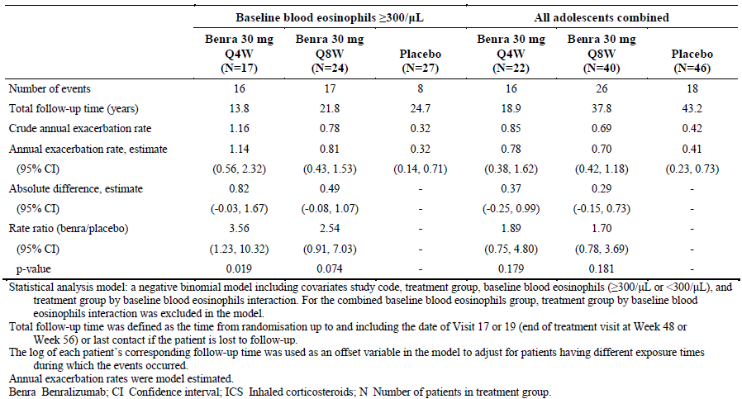
Table 28: Proportion of patients with reductions from Baseline in final OCS dose at Week 28 (EOT), while maintaining asthma control (ZONDA trial; Full analysis set)
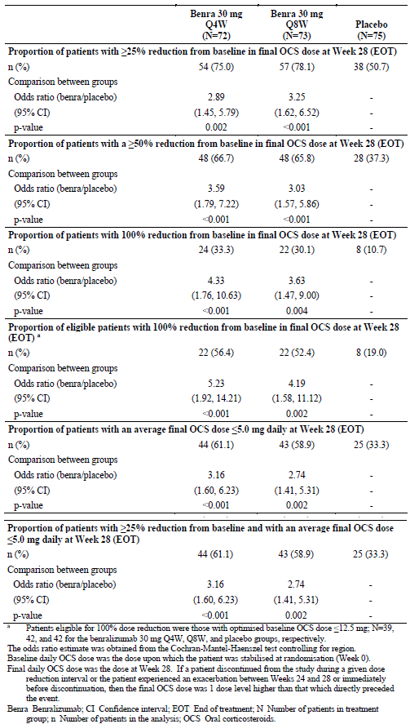
It should be noted that the pivotal Phase III studies (the SIROCCO, CALIMA and ZONDA trials) were powered to detect treatment differences between the Fasenra treatment groups and placebo and were not powered to detect treatment differences between each of the Fasenra treatment groups, so the differences in each of the Fasenra treatment groups of these PRO measures are numerical trends. Furthermore, there is a correlation between each of the total asthma symptom score, ACQ-6 and AQLQ-12 variables and so any difference in effect in 1 patient reported outcome variable will be reflected in the others, as shown in pooled data from the SIROCCO and CALIMA trials (Table 29).
Table 29: Spearman’s rank correlations between pairs of patient reported outcome instruments (Full analysis set (FAS), baseline EOS ≥ 300/µL, high dose ICS; SIROCCO/CALIMA trial pooled data)
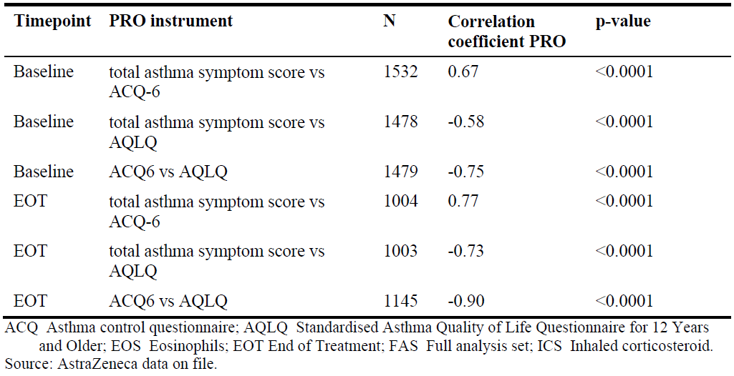
In conclusion, the efficacy between the Q4W and Q8W dosing regimens was similar on all non-PRO efficacy endpoints measured in the Phase III exacerbation studies and the OCS sparing study. Numeric trends of a greater separation from placebo for the Fasenra Q8W treatment group compared with the Fasenra Q4W treated group were observed in the PRO endpoints, although it is noted that these endpoints are highly correlated with each other. There was a similar AE profile between each dosing regimens. In the absence of evidence suggesting that greater efficacy or improved tolerability could be achieved with more frequent dosing, the Q8W dosing regimen was selected as the recommended dose.

Advisory Committee Considerations
The Advisory Committee on Medicines (ACM), having considered the evaluations and the Delegate’s overview, as well as the sponsor’s response to these documents, advised the following:
The ACM taking into account the submitted evidence of efficacy and safety, agreed with the Delegate and considered Fasenra containing 30 mg in 1 mL solution of benralizumab to have an overall positive benefit-risk profile for the indication:
Fasenra is indicated as an add-on maintenance treatment in patients aged > 12 years with severe asthma, ≥ 2 exacerbations/ year, and with blood eosinophil count of ≥ 300 cells/µL.
(that is, the Delegate’s amended indication).
In providing this advice, the ACM:
- noted that Fasenra significantly reduces exacerbations, thereby increasing the quality of life of patients.
- noted that the reduction in exacerbations did not correlate with the improvement in FEV1.
- noted that the amended indication more accurately reflects the design, conduct and analysis of the pivotal studies.
- noted that ‘there are no data for use in patients under 12 years’.
- Pregnancy Category should be Pregnancy Category C (not Pregnancy Category B1).^{8,9}
- that the sponsor should be asked to do ongoing pharmacovigilance in the age subgroup 12 to 18 years; and particularly in relation to the risk of malignancy. RMP should include this recommendation.
- that the sponsor has been asked to provide additional information for the 12 to 18 year old subgroup, and indicated that the RMP should include the proactive monitoring in this subgroup.
- noted that the reduction in eosinophil count can last up to 4 months, hence ACM questioned the need for 8 week dosing intervals, especially when 4 week dosing regimen appears comparable.
- noted that patients in the pivotal studies with history of cancer and who were in remission for a period of time that satisfied entry criteria might have been monitored more closely during study period than real world clinical practice.

Proposed conditions of registration
The ACM agreed with the Delegate on the proposed conditions of registration and advised on the inclusion of the following:
- negotiation of more active pharmacovigilance in 12 to 18 year olds; and
- negotiation of the PI and CMI to the satisfaction of the TGA.

Proposed PI/ CMI amendments
The ACM agreed with the Delegate to the proposed amendments to the PI and CMI and specifically advised on the inclusion of the following:
- Specifying that the following patients were excluded from pivotal trials:
  - Patients who were on treatment for basal cell carcinoma, localised squamous cell carcinoma of the skin or in situ carcinoma of cervix and not in remission in previous 1 year.
  - Patients with other malignancies who were not in remission and with ongoing treatment in the previous 5 years.
- Baseline characteristics of subjects in the 3 pivotal trials should be presented.
- The eosinophil count stratifications should be clear when subgroup analyses are presented that is, above or below 300 cells/µL in the exacerbation studies, 150 to 300 or > 300 in the OCS reduction study (other attempts to relate outcomes to eosinophil levels are post hoc analyses).
- Clarify the description in the ZONDA trial of eligibility for attempted oral corticosteroid withdrawal.
- Proposed indication:
Fasenra is indicated as an add-on maintenance treatment for severe asthma in patients with an eosinophilic phenotype (see Clinical Trials)’
should be replaced with:
Fasenra is indicated as an add-on maintenance treatment in patients aged > 12 years with severe asthma, ≥ 2 exacerbations/ year, and with blood eosinophil count of ≥ 300 cells/µL.
to accurately reflect the design, conduct and analysis of the pivotal studies.
- The words ‘there are no data for use in patients under 12 years’ should be included.
- History of malignancy should be obtained before Fasenra is prescribed.
- The expertise of prescribers should be specified.
- That the drug is not for self-administration should be clearly stated.
- A reference to pinworms in the CMI.

Specific advice
The ACM advised the following in response to the Delegate’s specific questions on the submission:
- Please comment on the potential impact of long term near-complete depletion of eosinophils on immune system, particularly in severe asthmatics.
The ACM discussed that eosinopaenia is a feature of systemic corticosteroid use and it seems likely the effects of benralizumab on reduction of eosinophil levels would be less hazardous than the effects of systemic steroids used by patients suffering from severe asthma.
- Please comment on the proposed age restriction of > 12 years.
The ACM supported inclusion of > 12 years in the proposed indication. The ACM noted the small number of adolescents included in the trials and concluded that it was too small to allow meaningful subgroup analyses. However, the ACM noted that while children with eosinophilic asthma may be less likely to have peripheral eosinophilia, there are no grounds, at this stage, to assume that benralizumab would have effects in adolescents different to those seen in adults with similar baseline changes. The ACM commented on the greater need for treatment options in the 12 to 18 year age group with severe asthma.

Post ACM negotiations
On 21 February 2018 the sponsor and the Delegate liaised regarding issues raised in the ACM meeting including the wording of the indications.

Delegate’s issues raised in post ACM discussion
On 23 February 2018 the Delegate provided the sponsor an outline of the issues raised in the teleconference of 21 February 2018 (‘Delegate’s post-ACM note of 23 February 2018’).

Indication
The Delegate considered the sponsor’s proposed indication in pre ACM response:
Fasenra is indicated as an add-on maintenance treatment for severe refractory asthma in patients aged 12 years and over with an eosinophilic phenotype (see Clinical Trials)..
- A statistically significant and clinically meaningful reduction in rate of exacerbations (primary outcome) and improvement in ppFEV1 (secondary outcome), was demonstrated in patients in both pivotal studies with blood eosinophil count ≥ 300 cells/µL. In the SIROCCO trial and in the pooled data (SIROCCO + CALIMA trials), the primary and secondary study endpoints were not statistically significant for patients with blood eosinophil count < 300 cells/µL. Moreover, forest plots (Figures 13 and 14) indicates a greater treatment response with increasing blood eosinophil count.
- The ZONDA trial had an ITT patient population with blood eosinophil count ≥ 150 cells/μµL. However, the primary outcome of this study was OCS reduction and not rate of exacerbations. Moreover, the duration of treatment period (24 weeks) does not meet EMA guidelines to demonstrate reduction in rate of exacerbations.
- The Delegate has considered the primary outcome of the ZONDA trial which indicates that severe asthmatics on chronic oral corticosteroids (OCS) with blood eosinophil count ≥ 150 cells/µL and received benralizumab achieved a 55% reduction in OCS dose. High dose /chronic OCS sparing options are important in the management of severe asthma and will provide greater treatment outcome. This has been considered while recommending the indication below.
- Anti-IL5 mAbs are found to be having effect on blood eosinophils at various cut-off levels. Cinqair (reslizumab) was found to have a greater treatment benefit in patients with blood eosinophil level ≥ 400cell/µL; hence the cut-off level has been included in its indication. It is important to mention eosinophil levels in the indication so that clinicians will be able to make an informed decision about patient selection, based on their blood eosinophil level.
- ERS/ATS definition identifies severe asthmatics as those requiring high dose ICS, second controller medication and/or systemic corticosteroids (OCS) to prevent it from uncontrolled, which means that they may have < 2 annual exacerbations, being on high dose ICS and/or OCS, but still fulfilling criteria to be termed as having severe asthma. Hence, the Delegate has reconsidered their previous recommendation regarding inclusion of number of exacerbation in the indication.
- In view of these facts, the Delegate recommended the following wording for indication:
Fasenra is indicated as an add-on maintenance treatment in patients aged ≥ 12 years of age, with severe eosinophilic asthma (with blood eosinophil count of ≥ 300cells/µL or ≥ 150 if on chronic OCS treatment).
- At the teleconference held on 21 February 2018, the sponsor mentioned their concern with regards to comparability of Fasenra’s indication to other drugs in similar class. The TGA explained the rationale for our recommendations.
The sponsor was also informed regarding addition of changes to the PI (however these are beyond the scope of the AusPAR and are not detailed here).

Sponsor’s response to Delegate’s post-ACM issues dated 6 March 2018
On 6 March 2018 the sponsor provided a formal response to the Delegate regarding the post ACM issues outlined in the Delegate’s post-ACM note of 23 February 2018:

Indication
We appreciate the Delegate’s further considerations regarding inclusion of a prior exacerbation limit within the indication, as well as the acceptance of the ZONDA trial data in support of Fasenra as a valuable treatment option for patients with severe asthma taking high dose/chronic OCS. However, while we agree that it is important that physicians are provided with sufficient information within the PI to enable them to make an informed decision based on their patient’s blood eosinophil level, we remain concerned regarding the proposal to include a blood eosinophil limit within the indication.
Identification of the eosinophilic phenotype remains a clinical diagnosis with no single definition of a baseline blood eosinophil level to characterise these patients. The proposed indication appears to convey an accepted definition for severe eosinophilic asthma, whereas in fact the thresholds stated reference those used in the clinical trial programme for the primary analysis populations. This could result in confusion for prescribing physicians as currently stated. The sponsor’s position, based on the totality of the data, is to avoid a specific threshold in the indication statement, referencing the patients studied in the clinical trials section instead.
Sponsors have utilised different blood eosinophil thresholds in clinical trials for Fasenra, Nucala (mepolizumab) and Cinqair (reslizumab) primary analysis populations. In the Nucala severe asthma development programme, patients were only included if they had a baseline eosinophil count of ≥ 150 cells/µL or a count of ≥ 300 cells/µL in the 12 months prior to entry into the studies. Despite these inclusion thresholds, the Nucala indication does not include an eosinophil cut-off. On the other hand, the Cinqair indication states ‘severe eosinophilic asthma (blood eosinophil count ≥ 400cells/µL)’ which can be misinterpreted as this threshold being the accepted definition of ‘severe eosinophilic asthma’. As discussed above, there is no accepted definition. Furthermore, the Delegate stated that a greater treatment benefit was found in patients with this threshold; however the Cinqair programme used this as the inclusion threshold at initiation of treatment in their Phase III exacerbation studies. Consequently, this threshold defined their Phase III patient population rather than a subgroup which was identified to have a greater treatment benefit.
Unlike the Nucala and Cinqair Phase III programmes, the Fasenra Phase III programme enrolled patients across the entire range of baseline blood eosinophils including patients less than < 150 cells/µL. Inclusion of an eosinophil threshold as part of the Fasenra indication would adversely, and inappropriately, differentiate Fasenra in comparison to Nucala which has no threshold in its indication, creating an inference in the minds of prescribers that Fasenra is a second line treatment after Nucala. Such a positioning of Fasenra is incorrect given the broader body of evidence from the Fasenra development programme compared with that of Nucala.
As discussed within our Pre-ACM response (including response to Question 2) and our recent post-ACM teleconference, we consider that the totality of the evidence within the Fasenra clinical programme supports efficacy of Fasenra 30 mg Q8W across the range of baseline blood eosinophils and that an eosinophil cut-off within the wording of the Indication is not warranted. This was discussed further in ‘Evidence supporting the efficacy of Fasenra across the eosinophil range” section provided as part of the Sponsor’s response [Information redacted]’.
Consistent with the suggestion of the TGA Delegate, the sponsor proposes to expand the Clinical Trials text within the Fasenra PI to further clarify the pre-specified CALIMA/SIROCCO trial analyses for
- patients with eosinophils < 300 cells/µL; and
- the full analysis set (FAS) for predefined eosinophil cut-off ranges.
This approach, together with the reference in the indication to the Clinical Trials section of the PI provides physicians with sufficient detail on the efficacy of Fasenra for severe asthma patients with varying eosinophil levels to allow them to make informed prescribing decisions.
Taking the above into consideration, we propose the following indication:
Fasenra is indicated as an add-on maintenance treatment for patients aged 12 years and over with severe eosinophilic asthma (see Section 5.1 [Clinical Trials]).
The sponsor included a detailed section on the evidence supporting the efficacy of Fasenra across the eosinophil range (not included as part of this AusPAR).
Based on the outcomes from the three pivotal Phase III study studies, including the CALIMA/SIROCCO trials pre-specified analyses across the range of baseline blood eosinophils and supportive post hoc analysis, we consider efficacy has been demonstrated for Fasenra across the range of baseline blood eosinophils. It is also clear there is no specific baseline eosinophil count below which there is no efficacy, however enhanced efficacy has been observed with increasing baseline blood eosinophil levels.
Furthermore, as discussed within our Pre-ACM response blood eosinophil levels are a surrogate marker for sputum eosinophils, and generally the relationship is strong with an increase seen in both with increasing asthma severity. However, there have been findings in the literature of uncontrolled patients with normal blood eosinophil counts but raised sputum eosinophils indicating that some patients with lower blood eosinophil counts will benefit from treatment.
We therefore consider that it is appropriate to not include an eosinophil cut-off limit within the indication, but instead include sufficient detail within the clinical trials section of the PI to guide the prescribing physician in making an informed decision. This includes details on the inclusion criteria of each of the studies and the assessed patient populations, and enhanced information on the additional pre-specified analyses from the exacerbation studies for patients with eosinophil levels below that of the enriched ITT population (< 300 cells/µL) and the FAS analysis of pre-specified eosinophil cut-off ranges. Further amendments to the Clinical trials section were proposed and discussed as part of this Indication response, however these have not been included within this AusPAR..
Overseas regulatory status
As previously provided in our PreACM response, neither the US, EU nor Canadian approved indications for Fasenra (refer to Table 1) include an eosinophil cut-off. The US and EU indications are in line with those approved for Nucala, however in Canada the Nucala indiction is the one which includes an eosinophil cut-off.

Delegates response to sponsor comments dated 16 March2018
The Delegate considered the sponsor’s response (dated 6 March 2018) to the post ACM Delegate file note and had the following comments. The following are the recommended changes to PI and CMI before this application can be approved.

Indication

Sponsor proposed text
Fasenra is indicated as an add-on maintenance treatment for patients aged 12 years and over with severe eosinophilic asthma (see Section 5.1 [Clinical Trials]).

Delegate proposed text
Fasenra is indicated as an add-on maintenance treatment for severe asthma in patients aged 12 years and over with an eosinophilic phenotype.
Note to the indication:
In clinical trials, eosinophilic phenotype was defined as blood eosinophil count ≥ 300 cells/µL or ≥ 150 cells/µL if on chronic OCS treatment.

Rationale
The Delegate considered the sponsor’s response to post ACM file note. The statement that ‘eosinophilic phenotype remains a clinical diagnosis’ is not a valid argument. There is evidence to suggest that blood eosinophil count is one of the objective inflammatory markers used to identify asthmatics with eosinophilic phenotype. The Delegate agreed that evidence to indicate a definitive baseline blood eosinophil level to characterise these patients is still evolving. However, the PI is considered as a product specific document and need to reflect the basis of regulatory decision made under TGA Act 1989, Section 25 (3). This is based on efficacy and safety of the product to be registered. The evidence based on the primary and secondary endpoints of the SIROCCO, CALIMA and ZONDA trials suggest that patients with blood eosinophil count ≥ 300 cells/µL or 150 cells/µL if on chronic OCS treatment and potentially treated with Fasenra would achieve clinically meaningful treatment benefits. Hence, having the eosinophil cut-offs as a note to the indication for Fasenra will facilitate clinicians to make an informed decision.

Malignancy
The Delegate considered the sponsor’s response to post ACM file note and accepted the sponsor’s argument that the risk of malignancy is somewhat theoretical, and that a statement under precautions is not required. However, the Delegate was of the opinion that prescribers need to be informed of the potential risk as there are yet no long term studies neither for this medicine or others in the class. The effect of near-complete eosinophil depletion on tumour defence is unknown. Thus, the Delegate proposed to include the following statement; in line with the FDA approved PI:
Carcinogenicity/Risk for malignancy
Carcinogenicity studies have not been conducted with benralizumab.
Long-term animal studies have not been performed to evaluate the carcinogenic potential of benralizumab. Published literature using animal models suggests that IL-5 and eosinophils are part of an early inflammatory reaction at the site of tumorigenesis and can promote tumour rejection. However, other reports indicate that eosinophil infiltration into tumours can promote tumour growth. Therefore, the malignancy risk in humans from an antibody that binds to IL-5Rα such as benralizumab is unknown.

Use in pregnancy
The Delegate considered the sponsor’s response to post ACM file note and accepted the sponsor’s argument that even though there is evidence of eosinophil depletion in off spring, the impact of that on the infant’s immune system is unknown. The Australian categorisation system is based upon level of evidence. A B1 category;⁸ does not imply greater safety than a C category;⁹ and also, human data is lacking for drugs in the B1, B2 and B3 categories.
Taking all these aspects in to consideration and to be consistent with other agents in this class, the Delegate accepted the sponsor’s proposed category B1 for pregnancy.

Other issues
Further comments were made by the Delegate with regard to PI and CMI amendments but these are beyond the scope of the AusPAR.

Further communication from sponsor dated 20 March 2018

Indication and associate note for clarification
- The sponsor accepted the modifications to the first sentence of the indication, however the sponsor proposed amendments to the new ‘Note to indication’ text requested by the Delegate.
- As discussed, the sponsor had concerns with the term “defined” within the Delegate’s proposed text. This implies that a set definition for eosinophilic asthma was used within our clinical trials, rather than an arbitrary threshold used in the case of the SIROCCO/CALIMA trials to enrich the primary analysis populations with patients more likely to have an eosinophilic phenotype. It also implies that patients below this threshold did not have severe asthma with an eosinophilic phenotype, which is also incorrect as patients below 300 do show an efficacy benefit with Fasenra (as per PI Figure 2, FAS population eosinophil ranges forest plot for primary endpoint). However, the sponsor acknowledged that higher baseline eosinophil counts are a potential predictor of improved treatment response. This is why the sponsor has stated this quite clearly within the clinical trials section in the text accompanying Figure 2.
- The sponsor therefore proposed to modify the text to make it clear that these were the thresholds used for the primary analyses within out trials (not the FAS) and that other analyses were also conducted. The sponsor wishes to retain a cross‐reference to the later clinical trials section with a hyperlink to facilitate ease of access to a physician who may prefer additional information in order to make the best decision for their patients. The following text is proposed:
In clinical trials, primary analyses were conducted on patients with a blood eosinophil count threshold of ≥300 cells/µL or ≥150 cells/µL if on oral corticosteroid treatment; additional analyses were conducted with other blood eosinophil count thresholds. See Section 5.1 [Clinical Trials].

Product information
- Section 5.3 ‐ Preclinical safety data/Carcinogenicity/Risk for malignancy: inclusion of the US malignancy class labelling text was accepted by the sponsor as an imposition.
- Further comments were made by the sponsor with regard to changing text in the PI/CMI but these are beyond the scope of the AusPAR.

Further communication from delegate dated 26 March 2018
The TGA reconsidered the indication based on the sponsor’s communication of the 20 March 2018. The TGA was of the view that the indication needs to be specific and after further internal consultation the ‘note to indication’ may be seen as ambiguous in the definition of eosinophilic asthma.
The TGA consulted a respiratory specialist who has informed us that the diagnosis of eosinophilic asthma was based on reversible airway obstruction and eosinophilia, and that in general a cut-off of 300 cells/µL was used. The specialist considered that it was important to include a cut off level in the indication. This would be consistent with the most recently approved drug of this class reslizumab.
The TGA would prefer to avoid the word ‘phenotype’ as it is a term used to define the clinical features of a genotype, which is not appropriate for this condition.
The revised proposed wording for the indication is:
Fasenra is indicated as add-on therapy in patients aged 12 years and over with severe eosinophilic asthma (blood eosinophil count ≥ 300 cells/µL or ≥ 150 cells/µL if on oral corticosteroid treatment) (see Section 5.1 [Clinical Trials]).
Further comments were made by the TGA with regard to changing text in the PI/CMI but these are beyond the scope of the AusPAR.

Sponsor response dated 27 March 2018
The sponsor, in communication to the TGA, accepted the Delegate’s revised recommended indication.

Outcome
Based on a review of quality, safety and efficacy, TGA approved the registration of Fasenra benralizumab 30 mg in 1 mL solution for injection prefilled syringe, indicated for:
Fasenra is indicated as add-on therapy in patients aged 12 years and over with severe eosinophilic asthma (blood eosinophil count ≥ 300 cells/µL or ≥ 150 cells/µL if on oral corticosteroid treatment) (see Section 5.1 [Clinical Trials]).

Specific conditions of registration applying to these goods
- Fasenra benralizumab is to be included in the Black Triangle Scheme. The PI and CMI for Fasenra must include the black triangle symbol and mandatory accompanying text for five years, which starts from the date that the sponsor notifies the TGA of supply of the product.
- The Fasenra benralizumab EU-Risk Management Plan (EU-RMP), version 1.0, Edition 4.0, dated 14 November 2017 (data lock point 29 September 2016), with Australian Specific Annex, version 3.0, dated 8 March 2018, and any subsequent revisions, as agreed with the TGA will be implemented in Australia. An obligatory component of risk management plans is routine pharmacovigilance. Routine pharmacovigilance includes the submission of Periodic Safety Update Reports (PSURs).
- Submit data from BORA and MELTEMI studies when available.
- Batch release testing and compliance with Certified Product Details
  - All batches of Fasenra benralizumab imported into Australia must comply with the product details and specifications approved during evaluation and detailed in the Certified Product Details (CPD).
  - Each batch of Fasenra benralizumab imported into Australia is not released for sale until samples and/or the manufacturer’s release data have been assessed and endorsed for release by the TGA Laboratories Branch.

Attachment 1. Product Information
The PI for Fasenra approved with the submission which is described in this AusPAR is at Attachment 1. For the most recent PI, please refer to the TGA website at < https://www.tga.gov.au/product-information-pi> .

Therapeutic Goods Administration
PO Box 100 Woden ACT 2606 Australia
Email: info@tga.gov.au Phone: 1800 020 653 Fax: 02 6232 8605
https://www.tga.gov.au

Hekking PP, Bel EH. Developing and emerging clinical asthma phenotypes. J Allergy Clin Immunol Pract 2014; 2: 671–680
Bjerregaard, A., et al., Clinical characteristics of eosinophilic asthma exacerbations. Respirology, 2017; 22: 295-300.
ICH S6 (R1) [Preclinical Safety Evaluation of Biotechnology-Derived Pharmaceuticals]
Stone K.D., et al. (2010) IgE, mast cells, basophils, and eosinophils. J. Allergy Clin. Immunol. 2010; 125 (2 Suppl 2): S73–S80.
Rabbit and dog IL-5Rα sequence alignment against human IL-5Rα was performed by the Nonclinical Evaluator.
EMA/CHMP/BWP/532517/2008; Guideline on development, production, characterisation and specification for monoclonal antibodies and related products.
ICH S7A Note for Guidance on Safety Pharmacology Studies for Human Pharmaceuticals
Pregnancy Category B1 is described as: Drugs which have been taken by only a limited number of pregnant women and women of childbearing age, without an increase in the frequency of malformation or other direct or indirect harmful effects on the human fetus having been observed. Studies in animals have not shown evidence of an increased occurrence of fetal damage.
Pregnancy Category C is defined as: Drugs which, owing to their pharmacological effects, have caused or may be suspected of causing, harmful effects on the human fetus or neonate without causing malformations. These effects may be reversible. Accompanying texts should be consulted for further details.
Australian Centre for Asthma Monitoring 2011. Asthma in Australia 2011. AIHW Asthma Series no. 4. Cat. no. ACM 22. Canberra: AIHW.
Bjerregaard A,et al. Clinical Characteristics Of Eosinophilic Asthma Exacerbations. Respirology. 2017; 22: 295-300.
Hekking PP, Bel EH. .Developing and emerging clinical asthma phenotypes. J Allergy Clin Immunol Pract 2014; 2: 671–680
Clarification: Rezulimab was not approved at the time of the clinical evaluation, however it was on the ARTG on the 25 July 2017 (prior to the consideration of this submission)
CHMP/EWP/2922/01 Rev.1 Committee for Medicinal Products for Human Use (CHMP) Guideline on the clinical investigation of medicinal products for the treatment of asthma.
Davis BP, Rothenberg ME. Eosinophils and Cancer. Cancer Immunology Research 2014; 2; 1–8
Routine risk minimisation activities may be limited to ensuring that suitable warnings are included in the product information or by careful use of labelling and packaging. Routine pharmacovigilance practices involve the following activities: - All suspected adverse reactions that are reported to the personnel of the company are collected and collated in an accessible manner; - Reporting to regulatory authorities; - Continuous monitoring of the safety profiles of approved products including signal detection and updating of labeling; - Submission of PSURs; - Meeting other local regulatory agency requirements.
Matera, M.G., et al., Pharmacokinetic/pharmacodynamic drug evaluation of benralizumab for the treatment of asthma. Expert Opin Drug Metab Toxicol 2017; 13: 1007-1013.
Hilvering, B., et al. Evidence for the efficacy and safety of anti-interleukin-5 treatment in the management of refractory eosinophilic asthma. Ther Adv Respir Dis 2015; 9: 135-145.
Bjerregaard, A., et al. Clinical characteristics of eosinophilic asthma exacerbations. Respirology 2017; 22: 295-300.
Chung, K.F., et al. International ERS/ATS guidelines on definition, evaluation and treatment of severe asthma. Eur Respir J 2014; 43: 343-373.
Price, D.B., et al. Blood eosinophil count and prospective annual asthma disease burden: a UK cohort study. Lancet Respir Med 2015; 3: 849-858.
These issues have been resolved.
www.asthmaaustralia.org accessed November 2017
GINA 2011 Global Strategy for Asthma Management and Prevention, Global Initiative for Asthma (GINA) Updated 2011. Available from: URL: http://ginasthma.org. Accessed May 2011.
Summary of the adolescent data provided in the US Fasenra dossier, which is in line with that submitted in AU
Australian Bureau of Statistics (ABS), Population projections, By age and sex, Australia - Series B catalogue 3222.0. Website. Available at: http://www.abs.gov.au/websitedbs/D3310114.nsf/home/Home
Bettering the Evaluation and Care of Health (BEACH-SAND report), Management of asthma and COPD in Australian general practice patients – 2015, Block 173B
Goldman M et al. 2017 The association between blood eosinophil count and benralizumab efficacy for patients with severe, uncontrolled asthma: sub analyses of the Phase III SIROCCO and CALIMA studies. Curr Med Res and Opinion (2017):1473-4877.
Coumou H, Bel EH. 2016 Improving the diagnosis of eosinophilic asthma. Expert Rev Respir Med. 2016; 10: 1093-1103
Louis R et al 2000 The relationship between airways inflammation and asthma severity. Am J Respir Crit Care Med 2000; 161: 9-16
Jatakanon A et al 2000 Changes in sputum eosinophils predict loss of asthma control. Am J Respir Crit Care Med. 2000; 161: 64-72
Woodruff PG et al 2001 Relationship between airway inflammation, hyperresponsiveness, and obstruction in asthma. J Allergy Clin Immunol. 2001; 108: 753-758.
Bousquet et al Eosinophilic inflammation in asthma. N Engl J Med 1990; 323:1033-1039.
HospersJJ et al 2000. Eosinophilia is associated with increased all-cause mortality after a follow-up of 30 years in a general population sample. Epidemiology. 2000; 11: 261-268
Price D et al 2016 Predicting frequent asthma exacerbations using blood eosinophil count and other patient data routinely available in clinical practice. J Asthma Allergy. 2016; 9: 1-12
Talini D et al 2015. Sputum eosinophilia is a determinant of FEV1 decline in occupational asthma: Results of an observational study. BMJ Open. 2015; 5: e005748
Zeiger RS et al 2014. High blood eosinophil count is a risk factor for future asthma exacerbations in adult persistent asthma. J Allergy Clin Immunol Pract. 2014; 2: 741-750
Fowler SJ et al 2015. High blood eosinophil counts predict sputum eosinophilia in patients with severe asthma. J Allergy Clin Immunol. 2015; 135 :822-824.
Schleich FN et al 2014. Importance of concomitant local and systemic eosinophilia in uncontrolled asthma. Eur Respir J. 2014; 44: 97-108.
Wagener AH et al 2015. External validation of blood eosinophils, FE(NO) and serum periostin as surrogates for sputum eosinophils in asthma. Thorax. 2015; 70: 115-120
Westerhof GA et al 2015. Biomarkers to identify sputum eosinophilia in different adult asthma phenotypes. Eur Respir J 2015; 46: 688-696
Zhang X-Y et al 2014. Full blood count parameters for the detection of asthma inflammatory phenotypes. Clin Exp Allergy. 2014; 44: 1137-1145.
Hastie AT et al 2013. Biomarker surrogates do not accurately predict sputum eosinophil and neutrophil percentages in asthmatic subjects. J Allergy Clin Immunol 2013; 132: 72-80
Korevaar DA et al 2015 Diagnostic accuracy of minimally invasive markers for detection of airway eosinophilia in asthma: a systematic review and meta-analysis. Lancet Respir Med. 2015; 3: 290-300
Mukherjee M, Nair P. 2015 Blood or sputum eosinophils to guide asthma therapy? Lancet Respir Med. 2015; 3: 824-825.
Spahn JD et al 2004 Is forced expiratory volume in one second the best measure of severity in childhood asthma? Am J Respir Crit Care Med. 2004; 169:784–786
Bacharier et al 2004 Classifying asthma severity in children: Mismatch between symptoms, medication use, and lung function. Am J Respir Crit Care Med. 2004; 170: 426–432.
Fitzpatrick AM et al 2011 Heterogeneity of severe asthma in childhood: Confirmation by cluster analysis of children in the National Institutes of Health/National Heart, Lung and Blood Institute Severe Asthma Research Program. J Allergy Clin Immunol. 2011; 127: 382-389.
Global Strategy for Asthma Management and Prevention, Global Initiative for Asthma (GINA) Updated 2011. Available from: URL: http://ginasthma.org. Accessed May 2011
National Asthma Council Australia. Australian Asthma Handbook, Version 1.3. National Asthma Council Australia, Melbourne, 2017. Website. Available from: http://www.asthmahandbook.org.au
Chung et al 2014. International ERS/ATS guidelines on definition, evaluation and treatment of severe asthma. Eur Respir J 2014; 43: 343-373
Pizzichini MMM et al 1999 Prednisone-dependent asthma: inflammatory indices in induced sputum. Eur Respir J 1999; 13: 15-21
The ACM provides independent medical and scientific advice to the Minister for Health and the Therapeutic Goods Administration (TGA) on issues relating to the safety, quality and efficacy of medicines supplied in Australia including issues relating to pre-market and post-market functions for medicines. The Committee is established under Regulation 35 of the Therapeutic Goods Regulations 1990. Members are appointed by the Minister. The ACM was established in January 2017 replacing Advisory Committee on Prescription Medicines (ACPM) which was formed in January 2010. ACM encompass pre and post-market advice for medicines, following the consolidation of the previous functions of the Advisory Committee on Prescription Medicines (ACPM), the Advisory Committee on the Safety of Medicines (ACSOM) and the Advisory Committee on Non-Prescription Medicines (ACNM). Membership comprises of professionals with specific scientific, medical or clinical expertise, as well as appropriate consumer health issues relating to medicines.
The Delegate’s record of the discussion is TRIM D18-10165404
Yancey SW, et al, 2017Biomarkers for severe eosinophilic asthma. J Allergy and Clinical Immunology 2017; 140: 1509-1518
Katz LE et al, 2014 Blood eosinophil count is a useful biomarker to identify patients with severe eosinophilic asthma. Ann Am Thorac Soc. 2014;11: 531-536
, Hastie AT et al, 2013 Biomarker surrogates do not accurately predict sputum eosinophil and neutrophil percentages in asthmatic subjects. J Allergy and Clinical Immunology 2013; 132: 72-80
Nair P, 2013 What is an ‘eosinophilic phenotype’ of asthma? J Allergy and Clinical Immunology 2013;132: 81-83

