May 2022

Australian Public Assessment Report for belumosudil
  - Proprietary Product Name: Rholistiq
  - Sponsor: Kadmon Oceania Pty Ltd

About the Therapeutic Goods Administration (TGA)
- The Therapeutic Goods Administration (TGA) is part of the Australian Government Department of Health and is responsible for regulating medicines and medical devices.
- The TGA administers the Therapeutic Goods Act 1989 (the Act), applying a risk management approach designed to ensure therapeutic goods supplied in Australia meet acceptable standards of quality, safety and efficacy (performance) when necessary.
- The work of the TGA is based on applying scientific and clinical expertise to decision-making, to ensure that the benefits to consumers outweigh any risks associated with the use of medicines and medical devices.
- The TGA relies on the public, healthcare professionals and industry to report problems with medicines or medical devices. TGA investigates reports received by it to determine any necessary regulatory action.
- To report a problem with a medicine or medical device, please see the information on the TGA website <https://www.tga.gov.au>.

About AusPARs
- An Australian Public Assessment Report (AusPAR) provides information about the evaluation of a prescription medicine and the considerations that led the TGA to approve or not approve a prescription medicine submission.
- AusPARs are prepared and published by the TGA.
- An AusPAR is prepared for submissions that relate to new chemical entities, generic medicines, major variations and extensions of indications.
- An AusPAR is a static document; it provides information that relates to a submission at a particular point in time.
- A new AusPAR will be developed to reflect changes to indications and/or major variations to a prescription medicine subject to evaluation by the TGA.

Copyright
© Commonwealth of Australia 2022
This work is copyright. You may reproduce the whole or part of this work in unaltered form for your own personal use or, if you are part of an organisation, for internal use within your organisation, but only if you or your organisation do not use the reproduction for any commercial purpose and retain this copyright notice and all disclaimer notices as part of that reproduction. Apart from rights to use as permitted by the Copyright Act 1968 or allowed by this copyright notice, all other rights are reserved and you are not allowed to reproduce the whole or any part of this work in any way (electronic or otherwise) without first being given specific written permission from the Commonwealth to do so. Requests and inquiries concerning reproduction and rights are to be sent to the TGA Copyright Officer, Therapeutic Goods Administration, PO Box 100, Woden ACT 2606 or emailed to <tga.copyright@tga.gov.au>.

Contents
List of abbreviations 4
I. Introduction to product submission 7
Submission details 7
Product background 8
Regulatory status 9
Product Information 10
II. Registration timeline 10
III. Submission overview and risk/benefit assessment 11
Quality 11
Nonclinical 12
Clinical 13
Risk management plan 38
Risk-benefit analysis 41
Outcome 45
Attachment 1. Product Information 47

List of abbreviations
Abbreviation | Meaning
ACM | Advisory Committee on Medicines
AE | Adverse event
ALT | Alanine aminotransferase
ARTG | Australian Register of Therapeutic Goods
ASA | Australian specific annex
AST | Aspartate transaminase
AUC | Area under the concentration time curve
AUC_{0-24h} | Area under the concentration time curve from time zero to 24 hours
AUC_{inf} | Area under the concentration time curve from time zero extrapolated to infinity
AusPAR | Australian Public Assessment Report
BCRP | Breast cancer resistance protein
C1D1 | Cycle 1 Day 1
C7D1 | Cycle 7 Day1
cGVHD | Chronic graft versus host disease
CI | Confidence interval
CL/F | Oral clearance
C_{max} | Maximum concentration
CMI | Consumer Medicines Information
CNI | Calcineurin inhibitor
CR | Complete response
CV | Coefficient of variation
DDI | Drug-drug interaction
DLP | Data lock point
DOR | Duration of response
EU | European Union
FDA | Food and Drug Administration, United States of America
FFS | Failure free survival
GMR | Geometric mean ratio
GSR | Global severity rating
hAME | Human absorption, metabolism, and excretion
HC | Health Canada
HCT | Haematopoietic cell transplantation
IC₅₀ | 50% (half-maximal) inhibitory concentration
IL | Interleukin
IPF | Idiopathic pulmonary fibrosis
KARA | Kadmon Algorithmic Response Assessment
KPS | Karnofsky Performance Scale
LSS | Lee Symptom Scale
mITT | Modified intent to treat
NIH | National Institutes of Health, United States of America
OCE | Oncology Center of Excellence, United States of America
ORR | Overall response rate
P-gp | P-glycoprotein
PI | Product Information
PK | Pharmacokinetic(s)
popPK | Population pharmacokinetic(s)
PPI | Proton pump inhibition
PR | Partial response
RMP | Risk management plan
ROCK-2 | Rho-associated protein kinase-2
t_{1/2} | Half life
TEAE | Treatment-emergent adverse event
Tfh | T follicular helper cells
TGA | Therapeutic Goods Administration
Th17 | T helper 17 cells
T_{max} | Time to maximum concentration
Treg | Regulatory T cells
TTR | Time to response
UK | United Kingdom
ULN | Upper limit of normal
US(A) | United States of America
Vz/F | Apparent volume of distribution during terminal phase

I. Introduction to product submission

Submission details
Type of submission: | New chemical entity
Product name: | Rholistic
Active ingredient: | Belumosudil (as mesylate)
Decision: | Approved
Date of decision: | 11 November 2021
Date of entry onto ARTG: | 12 November 2021
ARTG number: | 346583
Black Triangle Scheme: | Yes  This product will remain in the scheme for 5 years, starting on the date the product is first supplied in Australia

Sponsor’s name and address: | Kadmon Oceania Pty Ltd  Level 13, 77 Castlereagh St,  Sydney, NSW, 2000
Dose form: | Film coated tablet
Strength: | 200 mg (equivalent to 242.5 mg belumosudil mesylate)
Container: | Bottle
Pack size: | 30
Approved therapeutic use: | Rholistiq is indicated for the treatment of patients with chronic graft-versus-host disease (chronic GVHD) aged 12 years and older who have an inadequate response to corticosteroids.
Route of administration: | Oral
Dosage: | The recommended dose of Rholistiq is 200 mg given orally once daily.  For further information regarding dosage, refer to the Product Information.
Pregnancy category: | D  Drugs which have caused, are suspected to have caused or may be expected to cause, an increased incidence of human fetal malformations or irreversible damage. These drugs may also have adverse pharmacological effects. Accompanying texts should be consulted for further details.  The use of any medicine during pregnancy requires careful consideration of both risks and benefits by the treating health professional. This must not be used as the sole basis of decision making in the use of medicines during pregnancy. The TGA does not provide advice on the use of medicines in pregnancy for specific cases. More information is available from obstetric drug information services in your State or Territory.

Product background
This AusPAR describes the application by Kadmon Oceania Pty Ltd (the sponsor) to register Rholistiq (belumosudil) 200mg, film coated tablet for the following proposed indication:
The treatment of patients 12 years and older with chronic graft-versus-host disease (cGVHD) after failure of at least one prior line of systemic therapy.
Haematopoietic cell transplantation, occurring in approximately 30% to 55% of transplant recipients and involving multiple organs. The pathophysiology of chronic graft versus host disease (cGVHD) involves inflammation, humoral immunity, cell mediated immunity, and fibrosis.
Chronic graft versus host disease pathology involves both T- and B-cells and is characterised by overproduction of pro-inflammatory cytokines interleukin (IL)-21 and IL-17 and over activation of pro-inflammatory T follicular helper cells (Tfh) and B-cells, leading to overproduction of antibodies. In addition, cGVHD is associated with fibrotic change in multiple organs. The pathogenesis is thought to evolve from an acute inflammatory response to tissue injury early post-transplant which evolves into chronic inflammation and dysregulation of both T- and B-cells with subsequent aberrant tissue repair and fibrotic reaction.
Manifestations may be systemic, involving multiple organs, with profound impact upon quality of life and nonrelapse mortality. Patients who develop cGVHD after an allogeneic haematopoietic cell transplantation (HCT) face a multifaceted burden, including physical, functional, and psychosocial deficits, which negatively influence quality of life. The presence of fibrotic skin, joint/fascia, and/or lung involvement have the greatest effect on function and quality of life. cGVHD is usually diagnosed within 6 months post-transplant and can last approximately 2 to 5 years. Survival of up to five years in patients with high-risk disease and who fail corticosteroids is 30 to 40%. Alternatively, survival of up to 5 years is 70 to 80% for cGVHD patients with lower risk cGVHD and those responding to treatment with corticosteroids.
Clinical features resemble autoimmune diseases like progressive systemic sclerosis, systemic lupus erythematosis and Sjögren’s syndrome. It has been described as a syndrome of variable clinical features resembling autoimmune and other immunologic disorders such as scleroderma, primary biliary cirrhosis, wasting syndrome, bronchiolitis obliterans, immune cytopenias, and chronic immunodeficiency.
The pathophysiology of cGVHD syndrome may involve inflammation, cell-mediated immunity, humoral immunity, and fibrosis. Manifestations of cGVHD may be restricted to a single organ or site or may be widespread, with profound impact on quality of life. Treatment of cGVHD is intended to reduce symptom burden, control objective manifestations of disease activity, and prevent damage and disability, without disproportionate toxicity related to the treatments themselves.
Treatment of chronic graft versus host disease is intended to produce a sustainable benefit by reducing symptom burden, controlling objective manifestations of disease activity, preventing damage and impairment, and improving overall survival without causing disproportionate harms related to the treatment itself. Successful management can control the disease until systemic treatment is no longer needed. The complexity of the disease, the extended duration of follow-up needed to observe disease resolution and withdrawal of immunosuppressive treatment, and the lack of fully developed shorter term endpoints impede progress in the field.
Systemic therapy is indicated for patients with moderate or severe cGVHD according to the United States (US) National Institutes of Health (NIH) consensus criteria: involvement of three or more organs, moderate or severe organ involvement in any organ, or any lung involvement.
First line therapy for the treatment of cGVHD has relied on corticosteroids with or without a calcineurin inhibitor (CNI). It is estimated that approximately 50 to 75% of patients with cGVHD will require at least second line treatment. Indications for second line treatment include worsening manifestations of cGVHD in a previously affected organ, development of cGVHD in a previously unaffected organ, absence of improvement, and inability to taper corticosteroids or significant treatment-related toxicity.
In the USA, ibrutinib is approved for the treatment of cGVHD after failure of one or more lines of systemic therapy. Ibrutinib was not approved for this indication in Australia at the time of submission. Other therapies commonly used to treat steroid refractory cGVHD include: mycophenolate mofetil, methotrexate, rituximab, sirolimus, tacrolimus, cyclosporin, pentostatin, thalidomide, imatinib, and extracorporeal photopheresis. The efficacy of these second line agents is limited with response rates of about 30% regardless of the agent.
This evaluation was facilitated through Project Orbis, an initiative of the US Food and Drug Administration (FDA) Oncology Center of Excellence (OCE). Under this project, the FDA, Health Canada (HC) and the TGA collaboratively reviewed the application. This innovative evaluation process provided a framework for process alignment and management of evaluation issues in real-time across jurisdictions.
Each regulator agency maintained its regulatory process to make independent decisions about the approval (market authorisation).

Regulatory status
This product is considered a new chemical entity for Australian regulatory purposes.
At the time the TGA considered this application, a similar application had been approved in USA on the 16 July 2021 and was under consideration in Switzerland, Canada and United Kingdom (UK).
Table 1: International regulatory status
Region | Submission date | Status | Approved indications
USA | 30 September 2020 | Approved on 16 July 2021 | Rezurock is a kinase inhibitor indicated for the treatment of adult and pediatric patients 12 years and older with chronic graft-versus-host disease (chronic GVHD) after failure of at least two prior lines of systemic therapy.
Switzerland | 30 October 2020 | Under consideration | Under consideration
Canada | 27 October 2020 | Under consideration | Under consideration
United Kingdom | 26 November 2020 | Under consideration | Under consideration

Product Information
The Product Information (PI) approved with the submission which is described in this AusPAR can be found as Attachment 1. For the most recent PI, please refer to the TGA website at <https://www.tga.gov.au/product-information-pi>.

II. Registration timeline
The following table captures the key steps and dates for this application and which are detailed and discussed in this AusPAR.
Table 2: Timeline for Submission PM-2020-05433-1-6
Description | Date
Positive Designation (Orphan) | 4 September 2020
Submission dossier accepted and first round evaluation commenced | 18 November 2020
Evaluation completed | 2 September 2021
Delegate’s Overall benefit-risk assessment and request for Advisory Committee advice | 2 September 2021
Sponsor’s pre-Advisory Committee response | 15 September 2021
Advisory Committee meeting | 30 September and 1 October 2021
Registration decision (Outcome) | 11 November 2021
Completion of administrative activities and registration on the ARTG | 12 November 2021
Number of working days from submission dossier acceptance to registration decision* | 160
*Target timeframe for priority applications is 150 working days from acceptance for evaluation to the decision.

III. Submission overview and risk/benefit assessment
This section is a TGA summary of wording used in TGA’s evaluation report, which discussed numerous aspects of overseas evaluation reports and included some information that was commercial in confidence.
Guidance used:
- There is no specific regulatory guidance for assessment of medicinal products for treatment of cGVHD.
- The National Institutes of Health Consensus Development Project on Criteria for Clinical Trials in Chronic Graft-versus-Host Disease:1. The 2014 Diagnosis and Staging Working Group Report.2

Quality
Belumosudil (see structure below in Figure 1) is a rho-associated protein kinase-2 (ROCK-2) inhibitor that potentially down regulates immune mediators (such as IL-17, IL-21 and IL-23) by binding to and inhibiting the serine/threonine kinase activity of ROCK-2. Belumosudil is a quinazoline substituted with 5-aminoindazole and a phenoxyacetamide component on the 4 and 2 positions, respectively. It is chemically synthesised as the mesilate salt.
Figure 1: Chemical structure of belumosudil (as mesilate)
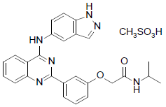
The approved dissolution limit is considered sufficient as an interim limit only. There was a lack of data to show that the method was sufficiently optimal for quality control testing of future batches.
Each Rholistiq tablet contains 200 mg belumosudil (as belumosudil mesilate) as the active ingredient. Rholistiq film coated tablets are pale yellow oblong tablets debossed with ‘KDM’ on one side and ‘200’ on the reverse side.
Rholistiq tablets should be stored below 25°C and store in a cool dry place away from moisture, heat or sunlight.

Recommendation and proposed conditions of registration
Approval is recommended from a quality and biopharmaceutics perspective.
The quality and biopharmaceutical chemistry evaluator has recommended the following:
Develop and validate an optimal and discriminating dissolution method for quality control testing of belumosudil (as mesilate) 200 mg tablets and submit this to the TGA within 18 months of registration of the tablets. The development should be based on data generated from the unexpired clinical and registration batches, and available commercial batches.

Nonclinical
Belumosudil is a ROCK-2 inhibitor, representing a novel pharmacological class. Belumosudil was shown to inhibit human ROCK-2 with nanomolar potency, and display very high selectivity for it over Rho-associated protein kinase 1, the other member of the Rho-associated, coiled coil containing protein kinase family. In vitro, belumosudil was shown to suppress release of pro-inflammatory cytokines from human peripheral blood mononuclear cells, and to shift human T cells away from the pro-inflammatory T-cell phenotype (Th17) that is a feature of cGVHD towards the regulatory T-cell (Treg) phenotype. Anti-fibrotic activity by belumosudil was also evident in vitro in cultured human lung fibroblasts. In vivo efficacy was demonstrated in mouse models of cGVHD, with belumosudil treatment found to improve pulmonary dysfunction, reduce pulmonary collagen and immunoglobulin G (IgG) deposition, and attenuate pathological changes in the lung, liver, colon and spleen. These studies offer support for the utility of belumosudil in the proposed indication.
Screening assays identified no clinically relevant secondary pharmacological activity for belumosudil.
Belumosudil is a substrate of P glycoprotein (p-gp). In vitro experiments examining the potential for pharmacokinetic drug interactions revealed inhibition of multiple enzymes (CYP;2C8, CYP2C9, CYP2C19, CYP3A4, UGT1A1 and UGT1A9) and transporters (P-gp, BCRP, OATP1B1, MATE1 and MATE2-K) by belumosudil at clinically relevant concentrations. Slight induction of CYP1A2, 2B6 and 3A4 by belumosudil was seen in cultured human hepatocytes, this is unlikely to be clinically significant.
Safety pharmacology studies revealed no clinically relevant effects on central nervous system function or on electrocardiogram, no consistent effect on respiration, and potential for slight lowering of blood pressure.
The major targets for belumosudil toxicity in rats and dogs were the liver, kidneys and male reproductive tract. Effects on the spleen, thymus, adrenals, red blood cell indices and platelets, the gastrointestinal tract, body weight and the thyroid were also seen.

Recommendation and proposed conditions of registration
There are no nonclinical objections to the registration of Rholistiq for the proposed indication. The conduct and timely submission of mouse and rat carcinogenicity studies with belumosudil should be included as a condition of registration.

Clinical
The clinical dossier consisted of ten Phase I, and then Phase II trials.

Pharmacology

Pharmacokinetics
Belumosudil is an orally available ROCK-2 selective inhibitor. Rho GTPase-mediated signalling pathways play a central role in coordinating and balancing T cell-mediated immune responses and impacts fibrotic pathways. ROCK signalling plays a role in a number of conditions, including cGVHD.
The clinical pharmacology program to support the use of belumosudil in cGVHD consisted of 12 clinical studies (ten Phase I trials and two Phase II trials), with ten having been completed and two are ongoing. An additional two clinical studies have been completed in subjects with psoriasis. Fourteen in vitro studies using human biomaterials have also been completed.
The belumosudil clinical studies include single and multiple dose administration of belumosudil at doses ranging from 20 to 1000 mg; healthy subjects and subjects with cGVHD and psoriasis; evaluation of food effect; metabolism, distribution, and excretion studies; pharmacokinetics (PK) in subjects with hepatic impairment; characterisation/evaluation of victim and perpetrator drug-drug interactions; and population pharmacokinetic (popPK) and exposure-response analyses. A study to determine effect of hepatic impairment on the PK, safety, and tolerability of single oral doses of belumosudil in subjects with normal hepatic function and mild, moderate, or severe hepatic impairment is ongoing. A QT study; is also ongoing.
Patients with cGVHD were included only in the Phase II studies which also assessed safety and efficacy. The Phase I PK studies were conducted in healthy subjects. A popPK analysis utilising data from five Phase I studies (including a controlled drug-drug interaction (DDI) study and a controlled food effect study) and the two studies in subjects with cGVHD was developed to describe the PK of belumosudil.
Two Phase I metabolites of belumosudil have been identified based on in vitro studies in liver microsomes/hepatocytes and measured in clinical studies: KD025m1 (minor metabolite) and KD025m2 (major metabolite). In vitro tests indicated that KD025m1, but not KD025m2, inhibits ROCK-2 at clinically relevant concentrations. Belumosudil inhibition constant (K_{i}) for ROCK-2 = 40 nM; KD025m1 K_{i} for ROCK-2 = 55 nM and KD025m2 K_{i} for ROCK-2 = 338 nM. Belumosudil, KD025m2 and KD025m1were assayed in all of the completed clinical studies.
Additional Phase I metabolites identified in plasma in the course of a human absorption, metabolism, and excretion (hAME) study were below 10% of total drug related exposure, measured as area under the curve at steady state and were not assayed in other belumosudil clinical trials. Two Phase II metabolites (O-dealkylated belumosudil sulfate and belumosudil glucuronide) were also identified in the hAME study and were not assayed in other belumosudil clinical trials.
Capsule and tablet formulations were used in the belumosudil development program. The tablet formulation is the formulation intended for marketing and was given in the Studies KD025-106; KD025-107; KD025-108; KD025-109a; KD025-110a; KD025-207; KD025-208b; KD025-209; KD025-211; and KD025-213b. A relative bioavailability study (Study KD025-106) demonstrated that there was no statistically significant difference in terms of exposure when subjects were administered belumosudil tablets or belumosudil capsules. The area under the concentration time curve from time zero extrapolated to infinity (AUC_{inf}, h*ng/mL) was 10400 (n = 17) for the tablet compared with 8760 (n = 19) for the capsule, adjusted geometric mean ratio (GMR) 118.43% (90% confidence interval (CI) 97.16, 144.36).
Each tablet contains belumosudil mesilate equivalent to 200 mg of belumosudil free base along with the following inactive ingredients: microcrystalline cellulose, hypromellose, croscarmellose sodium, colloidal silicon dioxide, and magnesium stearate. Belumosudil is a Biopharmaceutical Classification System Class IV compound (that is, low permeability, low solubility).

Absorption
Geometric mean absolute bioavailability based on AUC_{inf} is 64%. Time to maximum concentration (T_{max}) for belumosudil and both metabolites (KD025m1 and KD025m2) generally ranges from 2 to 4 hours.
Exposure to belumosudil is slightly greater than dose proportional up to doses of 500 mg in healthy subjects. After 500 mg, increase in exposure is less than dose proportional in healthy subjects. Doses of 200 and 400 mg are approximately dose proportional in cGVHD subjects.
Food decreases the rate and increases the extent of belumosudil absorption. Exposure (area under the concentration time curve (AUC) and maximum concentration (C_{max})) in the fed state is about 2 to 3 times that in the fasted state, and T_{max} is delayed 0.5 to 2 hours.

Distribution
Belumosudil and metabolites KD025m1 and KD025m2 are extensively bound to proteins in human plasma (> 99% bound).
Belumosudil distributes into tissues and geometric mean (% coefficient of variation (CV)) apparent volume of distribution during terminal phase (Vz/F) ranged from 184 to 251 L (51.3% to 67.6%) following 200 mg tablet administration. The popPK estimate for the central compartment volume was 29.7 L and for the peripheral compartment volume was 78.8 L.

Elimination
The hAME study, Study KD025-108 demonstrated that 85% total radioactivity was recovered in faeces with < 5% recovered in urine. This indicates minimal renal elimination and that the predominant route of clearance of (¹⁴C)-KD025 and associated metabolites is biliary and/or intestinal.
Hepatic P450 CYP3A4 was the predominant CYP isoform responsible for the metabolism of belumosudil (41.9%), although CYP2D6 (21.7%), CYP2C8 (14.2%), CYP1A2 (< 5%), CYP2C19 (< 5%), and UGT1A9 contributed to a lesser extent.
The major metabolite, KD025m2, has a C_{max} value approximately 20% of the parent and an AUC value approximately 15% of the parent. The minor metabolite, KD025m1, has C_{max} and AUC values < 5% of the parent.
Belumosudil half life (t½) was estimated as 19 hours in subjects with cGVHD using popPK analysis. Following 200 mg belumosudil tablet administration, the geometric mean (%CV) oral clearance (CL/F) ranges from 367 to 402 (33.3 to 40.2%) mL/min. CYP3A4 induction (rifampicin) decreased belumosudil C_{max} by 59% and AUC by 72%. CYP3A4 inhibition (itraconazole) does not notably affect belumosudil PK (about 20% increase in C_{max} and 25% increase in AUC_{inf}).
A strong proton pump inhibition (PPI) (rabeprazole) decreased belumosudil exposure by 87% (C_{max}) and 80% (AUC). A weaker PPI (omeprazole) reduced exposure by 68% (C_{max}) and 47% (AUC).
Belumosudil is not an inducer of CYP1A2, CYP2B6, or CYP3A4. Belumosudil was an inhibitor of breast cancer resistance protein (BCRP) (R value > 10), OATP1B1 (R value = 2.3), and P-gp (R value > 10). Belumosudil was an in vitro inhibitor for MATE but did not meet the threshold for clinical significance (R value < 0.1; assumes fraction unbound of 0.12%), and MATE2K (R value < 0.1; assumes fraction unbound of 0.12%). Compared to healthy subjects, those with cGHVD have a ~53% reduction in CL/F (9.83 L/h) based on popPK analysis.
The major PK issues are listed below:
- The decrease in belumosudil exposure in the presence of concomitant PPIs or a strong CYP3A inducer is likely to be clinically significant. Due to this reduction in exposure dose adjustment to belumosudil 200 mg twice a day in the presence of concomitant strong CYP3A inducers and PPIs is recommended.
- The results from the 50% (half-maximal) inhibitory concentration (IC₅₀) shift assay showed that belumosudil was a mechanism based inhibitor of CYP1A2, CYP2C19 and CYP2D6. A potential risk of belumosudil to increase the concentration of concomitant substrate drugs that are used in this patient population has not been estimated.
- In vitro studies showed belumosudil inhibits P-gp, BCRP and OATP1B1 transporters. This inhibitory effect indicates a potential risk of increasing the concentration of concomitant substrate drugs, that are used in this patient population, to toxic levels.
- In vitro studies showed belumosudil inhibits the UGT1A1 enzyme. This inhibitory effect indicates a potential risk of increasing the concentration of concomitant substrate drugs, that are used in this patient population, to toxic levels.
- Higher exposures to belumosudil were observed in patients with moderate hepatic impairment and no data are available in patients with severe hepatic impairment. A safe and appropriate dose of belumosudil in subjects with moderate, and severe hepatic impairment has not been determined.
- Based on the limited data, differences in belumosudil exposure were observed between healthy subjects of Black and White race, with a higher number safety events in patients of Black race.

Pharmacodynamics
A thorough QT study is ongoing. At the time of submission there was no evidence for an increased risk of QT interval prolongation based on preclinical data, concentration-QT analysis, and review of clinical safety data.
An exposure-response analysis was performed using the post hoc parameter estimates for subjects in the two cGVHD trials (Studies KD025-208 and KD025-213) receiving 200 mg once daily, 200 mg twice daily, and 400 mg once daily of belumosudil. Exploratory plots were generated for efficacy (overall response, duration of response, and response by organ) and safety (headache, nausea, diarrhoea, abnormal liver function, and fatigue) endpoints. That analysis indicated a flat relationship between both exposure and efficacy and exposure and safety over a range of C_{max} values from 143 to 5780 ng/mL and area under the concentration time curve from time zero to 24 hour (AUC_{0-24h}) at steady state values from 2780 to 83800 h*ng/mL.
Figure 2: Exposure (area under the concentration curve from time zero to 24 hours at steady state) and efficacy relationship
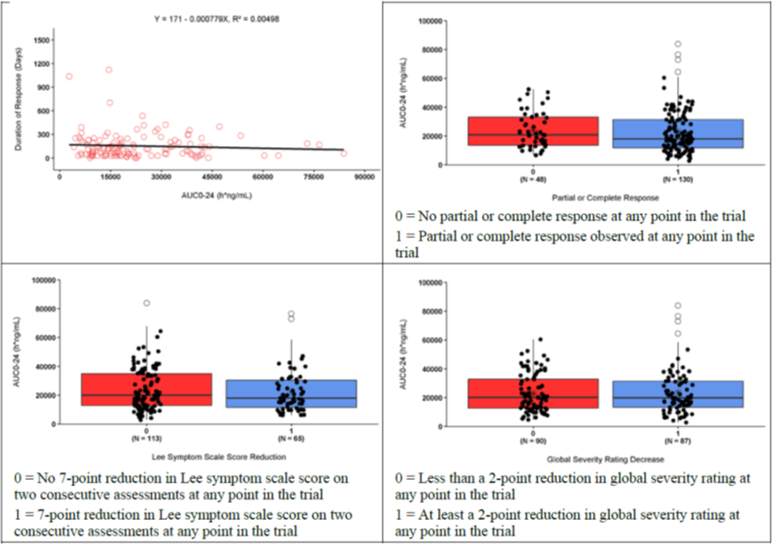
Box plots: Soild line = Median; Box = 25% and 75% quartiles (interquartile range, IQR); Whisker = lowest/highest values within 1.5*IQR of the lower/upper quartiles; Circles = observations beyond whiskers; * = Mean; Points = individual values; N = number of observations.

Efficacy
Studies KD025-208 and KD025-213 assessed the efficacy of belumosudil in the treatment of cGVHD. An integrated efficacy analysis was also performed. The data cut off date for the primary analysis of both these studies was 19 February 2020. Additional efficacy data was received at data cut off 19 August 2020. The latter efficacy results are presented in the study descriptions below.
Additional efficacy analyses using alternative efficacy endpoints were performed by clinical reviewers. The sponsor used the investigator's assessment of response for the primary analysis. The sponsor also used an algorithmic response assessment (the Kadmon Algorithmic Response Assessment, KARA) to assess response. KARA did not include the clinician-reported global severity score. Reviewer’s reviewed responses using raw data for the organ criteria with manual adjudication for discrepancies with the sponsor's results.
The major differences in approach between the sponsor’s and reviewer’s assessment were in the definitions of overall response rate (ORR) and duration of response (DOR). In these studies ORR was defined as the proportion of subjects with a best response meeting the overall response criteria assessment of complete response (CR) or partial response (PR) at any post-baseline response assessment.
The 2014 NIH consensus criteria;2 were used to assess ORR. The reviewer assessment of ORR limited response to within the time period through to Cycle 7 Day 1 (C7D1) (that is the first 6 x 28 day cycles) as the 6 month window was considered to have allowed sufficient time for development of a response without continuing a treatment that poses risks without efficacy.
The sponsor’s primary assessment of DOR was defined as the time from first documentation of response to the time of first documentation of deterioration from best ORR, initiation of new systemic therapy for cGVHD, or death. The reviewer’s primary assessment of DOR was defined as the interval from first response by C7D1 (that is after 6 months of treatment) to progression in any organ, death, or new systemic therapies for cGVHD. These differences in the primary definition of DOR resulted in marked differences in the reported primary DOR.
Additional definitions of DOR were also considered. The secondary definition of DOR was the time from first documentation of response to the time of first documentation of lack of response. The tertiary definition of DOR was the time from first documentation of response to the time of initiation of new systemic cGVHD therapy (which was reviewed and confirmed by a clinical team review). The quaternary definition of DOR was the time from first documentation of response to the time of first documentation of lack of response (as the secondary definition) but with duration summed for multiple response/lack of response episodes. Table 3 tabulates the various differences in endpoint definitions between the sponsor and the reviewer.
Table 3: Differences between sponsor and reviewer endpoint definitions
 | Applicant’s SAP | Clinical Reviewer’s Assessment
Primary endpoint | ORR at any time on study | ORR starting by C7D1
Analysis set | All patients who received at least one dose of study drug | All patients with active disease at Baseline who received at least one dose of study drug
Adjudication | Primary – Investigator  Additional – Algorithmic | Algorithmic with manual adjudication for discrepancies with the Applicant’s results
Definition - ORR | 2014 NIH consensus criteria based on organ response criteria and clinician overall severity score | 2014 NIH consensus criteria based on organ response criteria and occurring by C7D1
Definition – Duration of response (DOR) | Time from first documentation of response to the time of first documentation of deterioration from best ORR, initiation of new systemic therapy for cGVHD, or death | Interval from first response by C7D1 to progression in any organ, death, or new systemic therapies for cGVHD
Definition – Alternate measure of durability | Time from first documentation of response to the time of initiation of new systemic cGVHD therapy or death | Interval from first response by C7D1 to death or new systemic therapies for cGVHD
Definition – PRO response (using LSS) | Summary score and domain scores by visit  Change from Baseline by visit  Number and percent of subjects with a ≥7-point reduction from Baseline  Number and percent of subjects with a ≥7-point reduction from Baseline on 2 consecutive assessments | ≥ 7-point reduction from Baseline by C7D1.

Study KD025-208
Study KD025-208 is an ongoing Phase IIa, open label, dose escalation study of belumosudil in subjects with cGVHD who have received one to 3 prior lines of systemic cGVHD therapy. The study was conducted at seven sites in the USA and commenced in September 2016. Enrolment was completed in March 2018, with 54 subjects enrolled. As of the data cut-off date 19 August 2020, the median duration of follow up was 41.3 months for the 200 mg once daily cohort, 39.1 for the 200 mg twice daily cohort, and 34.4 months overall.
Study KD025-208 was developed as an exploratory dose finding study without a specific hypothesis to be tested. Belumosudil doses were selected based on preliminary data from Study KD025-206 in patients with psoriasis. In that study belumosudil was considered tolerable at doses up to 400 mg daily. To assess the effect of split dosing belumosudil doses of 200 mg once daily, 200 mg twice daily, and 400 mg daily once were chosen.

Study objectives
The primary objectives were:
- To evaluate the activity of belumosudil in subjects with active, steroid dependent cGVHD in terms of PR and CR as defined by the 2014 NIH consensus development project on clinical trials in cGVHD;2 and
- To evaluate the safety and tolerability of belumosudil in subjects with cGVHD.

Methodology
Belumosudil was supplied as 100 mg capsules or 200 mg tablets. The study was initiated using belumosudil capsules and later transitioned to belumosudil tablets (intended commercial formulation). Belumosudil was administered at doses of 200 mg once daily (Cohort 1), 200 mg twice daily (Cohort 2), and 400 mg once daily (Cohort 3). Study drug was administered with food, in 28 day cycles until disease progression or unacceptable toxicity occurred.
The primary efficacy endpoint was overall response rate (ORR), per the 2014 NIH response criteria.2 The overall response is assessed using the global scores from ten systems (Skin, Eyes, Mouth, Oesophagus, Upper GI, Lower GI, Liver, Lungs, Joints and Fascia and Global Severity Rating). The overall response at each assessment time point was categorised as CR, PR, or lack of response, where lack of response includes the response status of unchanged, mixed, or progression as defined below.
Table 4:Chronic graft versus host disease response definitions
Response | Definition
Complete response (CR) | Resolution of all manifestations of chronic graft versus host disease in each organ or site
Partial response (PR) | Improvement in at least one organ or site without progression in any other organ or site
Lack of response*, mixed response | Complete or partial response in at least one organ accompanied by progression in another organ*
Unchanged | Outcomes that do not meet the criteria for complete response, partial response, progression or mixed response
Progression | Progression in at least one organ or site without a response in any other organ or site
* Considered progression for purposes of analysis
The secondary endpoints included: duration of response (DOR); time to response (TTR); response by organ system; changes in symptom burden using the Lee Symptom Scale (LSS), changes in corticosteroid and calcineurin inhibitor (CNI) dose; failure free survival (FFS); overall survival; patient reported changes in symptom activity; changes in cGVHD severity using the clinician reported global activity assessment; and PK assessment of belumosudil.
Primary and secondary efficacy endpoints were assessed in the modified intent to treat (mITT) population, which included all subjects who received at least one dose of study drug. The responder population included subjects in the mITT population who achieved a response of PR or CR at any post-baseline response assessment.
The primary efficacy endpoint of ORR was defined as the proportion of subjects who achieve a PR or CR as their best overall response, as assessed by the investigator. A two sided 95% CI is estimated using the Clopper-Pearson method. The secondary endpoints of DOR, FFS, TTNT, and overall survival were estimated and summarised using the Kaplan-Meier method. Median values were estimated from the fiftieth percentile of the corresponding Kaplan-Meier estimates.
Subgroup analyses for the endpoints of ORR and DOR were conducted for the following subgroups: number of prior line therapies; number of organs involved at Baseline; baseline disease severity; concomitant medication with a PPI taken on Cycle 1, Day 1 (C1D1) (yes/no); and refractory to most recent line of therapy prior to enrolment (yes/no). In recognition of the importance of DOR this endpoint was presented according to four methodologies:
- Primary DOR: The time from first documentation of response to the time of first documentation of deterioration from best response (for example, CR to PR, or PR to lack of response).
- Secondary DOR: The time from first documentation of response to the time of first documentation of lack of response.
- Tertiary DOR: The time from first documentation of response to the time of initiation of new systemic cGVHD therapy.
- Quaternary DOR: The time from first documentation of response to the time of first documentation of lack of response (as the secondary definition), but with durations summed for multiple response/lack of response episodes.
These analyses were performed to provide a comprehensive analysis of durability of response to treatment with belumosudil.
The main inclusion criteria were:
- adult male or female subjects who were at least 18 years of age;
- who had an allogeneic bone marrow transplant or haematopoietic cell transplantation; were receiving glucocorticoid therapy and calcineurin therapy or glucocorticoid therapy alone for cGVHD at study entry;
- had persistent active cGVHD manifestations after at least two months of steroid therapy;
- had 1 to 3 prior lines of systemic treatment for cGVHD (extracorporeal photopheresis was not counted as prior systemic therapy);
- had a Karnofsky Performance Scale (KPS); score of > 40 (consistent with functional activity of at least being unable to work; able to live at home and care for most personal needs; varying amount of assistance needed);
- had adequate organ and bone marrow function; and had adequate safety laboratory values.

Results
The results reported here are for the most recent efficacy update (19 August 2020). Overall, 64 subjects were screened, and 54 subjects were included in the mITT population (all subjects who received at least one dose of study drug): 17 subjects in Cohort 1, 16 subjects in Cohort 2, and 21 subjects in Cohort 3.
Among subjects in the 200 mg once daily and twice daily cohorts, the median age was 50 years (range, 20 to 63) and 55 years (range, 30 to 75), respectively. Subjects in the 200 mg once daily cohort were predominantly male (13, 76.5%) and White (15, 88.2%). Over 50% of subjects in the 200 mg twice daily cohort were male (9, 56.3%) and most were White (14, 87.5%). In the 200 mg once daily cohort, most subjects had a KPS;9 of 80 (7 subjects, 41.2%), followed by 90 (6, 35.3%), while in the 200 mg twice daily cohort, subjects had a KPS of 80 or 90 (6 subjects each, 37.5%), followed by 70 (4 subjects, 25.0%).
All subjects had undergone allogeneic HCT. Among subjects in the 200 mg once daily and twice daily cohorts, median time from most recent transplant to cGVHD diagnosis was 9.8 and 7.3 months, respectively, while median time from cGVHD diagnosis to study enrolment was 26.4 and 18 months, respectively. Median number of prior lines of systemic cGVHD therapy was 3 and 2, respectively, and 11 subjects (73.3%) and 9 subjects (69.2%), respectively were refractory to their prior line of therapy in the 200 mg once daily and twice daily cohorts. A line of therapy was defined as a regimen of systemic therapies indicated for the treatment of cGVHD (not intended as prophylaxis) with the same start date. A line of therapy may have included more than one drug if started at the same time. In general, when a new systemic therapy was added to the treatment that was not by itself effective, it was a new line. Organ specific therapies such as inhaled fluticasone, azithromycin, and montelukast, extracorporeal photopheresis, and topical treatments were not considered cGVHD systemic therapies and therefore did not contribute to prior lines of systemic therapy.
The median number of organs involved at Baseline in the 200 mg once daily and twice daily cohorts was 3 and 4, respectively; 8 subjects (47.1%) and 10 subjects (62.5%), respectively, had four or more organ systems involved at Baseline. Chronic GVHD severity was severe in 70.6% and 87.5% of subjects in the 200 mg and twice daily cohorts, respectively.
The ORR calculated using both the sponsor’s definition (ORR during treatment ) and reviewer’s definition (ORR during first 6 months of treatment) is shown in Table 5 and Table 6 below.
Table 5: Study KD025-208, Overall response rate (modified intent to treat population)
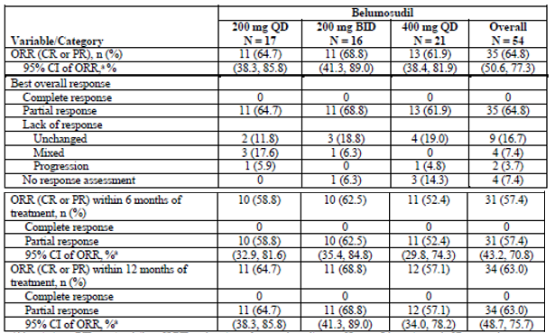
Abbreviations: BID = twice daily; cGVHD = chronic graft versus host disease; CI = confidence interval; CR = complete response; ECP = extracorporeal photopheresis; MITT = modified intent to treat; ORR = overall response rate; PR = partial response; QD = once daily.
Note : the data cutoff date was 19 August 2020
a The 95% CI (two sided) were calculated using the Clopper Pearson exact method
Table 6: Study KD025-208 Clinical evaluator’s assessment of overall response rate during the first 6 months of treatment
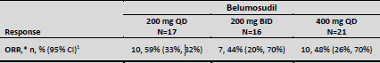
*All were PR
¹ 95% confidence interval, estimated using the Clopper-Pearson method
Subgroup analyses did not show meaningful differences between groups in ORR by dose, age, severity of cGVHD at Baseline, duration of cGVHD, number of organs involved, number of prior lines of therapy and intake of PPIs at C1D1 of treatment.
Secondary endpoint results are shown in Table 7.
Table 7: Study KD025-208 Secondary endpoints analysis (modified intent to treat)
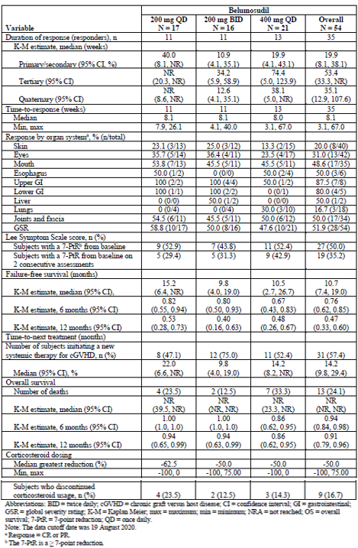
Abbreviations: BID = twice daily; cGVHD = chronic graft versus host disease; CI = confidence interval; GI = gastrointestinal; GSR = global severity rating; K-M = Kaplan Meier; max = maximum; min = minimum; NRA = not reached; OS = overall survival; 7-PtR = 7 point reduction; QD = once daily.
Note: The data cutoff date was 19 August 2020
a Response = CR or PR
b The 7-PtR is a ≥ 7 point reduction
The reviewers’ primary definition of response showed much shorter DOR as indicated in Table 8.
Table 8: Study KD025-208 Clinical reviewer’s primary definition of primary duration of response
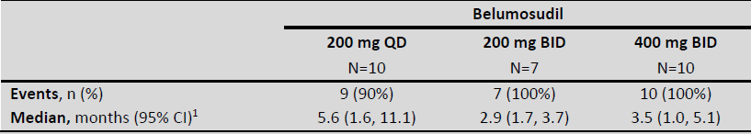
Abbreviations: BID = twice daily; CI = confidence intervals; QD = once daily/
¹ Median as estimated per Kaplan-Meier methodology, confidence interval estimated using the Brookmeyer and Crowley method.

Study KD025-213 (ROCKstar study)
Study KD025-213 (also known as the ROCKstar study) is an ongoing, Phase II, randomised, open label study in subjects with active cGVHD who receive belumosudil after at least two prior lines of systemic therapy. It is the pivotal study for the proposed indication. This study is being conducted at 33 sites in the USA and commenced in October 2018.

Study objectives
The primary objective was to evaluate the efficacy and safety of belumosudil, at dose levels of 200 mg once daily and 200 mg twice daily, in subjects with cGVHD who had previously been treated with at least two prior lines of systemic therapy.
Secondary objectives included evaluation of: percentage of subjects with a best response of PR and of CR; DOR; TTR; response by organ system; changes in disease severity; changes in symptom burden, FFS; TTNT; overall survival; changes in corticosteroid use, change in CNI dose, changes in symptom activity by patient self-report and PK of belumosudil.

Methodology
Subjects were randomised to receive 200 mg once daily or 200 mg twice daily of belumosudil. Randomisation was stratified according to prior cGVHD treatment with ibrutinib (yes/no) and severe cGVHD (yes/no). Belumosudil doses were selected based on the safety and efficacy of belumosudil in Study KD025-208. Only the tablet formulation of belumosudil was supplied.
Figure 3: Study KD025-213 Study schema
Abberviation: BID = twice daily; cGVHD = chronic graft versus host disease; DOR = duration of response; FFS = failure-free survival; HCT = hematopoietic cell transplantation; IA = interim analysis; ORR = overall response rate; PA = primary analysis; PK = pharmacokinetics; QD = once daily; R = randomisation; Y/N = yes/no.
The primary population for efficacy analyses was a mITT population defined as all randomised subjects who receive at least one dose of study medication. The ORR was defined as the proportion of subjects with a best response meeting the overall response criteria assessment of CR or PR at any post-baseline response assessment. The overall response determination was based on the cGVHD response assessment performed by Investigators. Where possible, the same assessor at the site should perform response assessments for a given subject.
The overall response was assessed using scores from nine individual organ systems (skin, eyes, mouth, oesophagus, upper gastrointestinal, lower gastrointestinal, liver, lungs, and joints and fascia) and the investigator’s global severity rating (GSR). Response was assessed with respect to the baseline (C1D1) cGVHD assessment. The overall response at each assessment time point was categorised as CR, PR, or lack of response, where lack of response included the response status of unchanged, mixed, or progression. Response was assessed on Day 1 of Cycle 2 through to Cycle 5, then on Day 1 of every other cycle thereafter and at the end of treatment visit. The definitions of overall response (CR, PR and lack of response) were the same as those that applied in KD025-Study 208. If a treated subject was lost to follow up without a response assessment, the subject was counted as a non-responder.
Duration of response was assessed using four methods as in Study KD025-208 and by the TGA reviewer using the definition: the interval from first response by Cycle 7 Day 1 to progression in any organ, death, or new systemic therapies for cGVHD.
Changes in the Lee Symptom Score Scale;8 were the main assessment of patient reported symptom activity and was a secondary endpoint following DOR. Lee Symptom Scale questionnaire consists 30 items of 7 domains: skin, eyes and mouth, breathing, eating and digestion, muscles and joints, energy, and mental and emotional. Each question is scored 0, 1, 2, 3 or 4. A domain score will be calculated for each domain by taking the mean of all items completed if more than 50% were answered and normalising to a 0 to 100 scale. A summary score will be calculated as average of all non-missing domain scores if more than 50% of them are non-missing. A higher score indicated more bothersome symptoms. Seven points difference on the summary score of cGVHD symptom scale was found to be clinically meaningful.
Failure free survival was defined as the absence of cGVHD treatment change, non-relapse mortality and recurrent malignancy.
Sample size was based on the primary efficacy endpoint of ORR, with one planned interim analysis (0.0025, one sided alpha spending) and a true ORR of 55%. The Hochberg procedure was used for multiplicity adjustment for the primary endpoint. Secondary endpoints were as outlined in the secondary objectives for this study. Only descriptive statistics were provided for all secondary and exploratory endpoints, without multiplicity adjustment.
Point estimates, CIs (Clopper-Pearson exact method), and unadjusted and Hochberg adjusted p-values corresponding to the null hypothesis of ORR ≤ 30% versus the alternative hypothesis of ORR > 30% by treatment arms are reported.
The major inclusion criteria were:
- age ≥ 12 years;
- had undergone allogeneic hematopoietic cell transplantation;
- had previously received at least two prior lines of systemic therapy for cGVHD;
- had received glucocorticoid therapy with a stable dose for at least two weeks prior to screening; and
- had persistent cGVHD manifestations and for whom systemic therapy for cGVHD was indicated.
Concomitant treatment with GVHD prophylaxis and standard care systemic chronic GVHD therapies was permitted as long as the subject has been on a stable dose for at least two weeks prior to study. Initiation of new systemic cGVHD therapy while on study was not permitted. There were also exclusions based on laboratory criteria. Patients were excluded from the studies if: platelets were < 50 × 10⁹/L; absolute neutrophil count < 1.5 × 10⁹/L; aspartate transaminase (AST) or alanine aminotransferase (ALT) > 3 × upper limit of normal (ULN); total bilirubin > 1.5 × ULN; correct QT interval (by Fridericia’s formula; QTcF) > 480 ms; estimated glomerular filtration rate (eGFR) < 30 mL/min/1.73 m²; or FEV1 ≤ 39%.

Results
Overall, 221 subjects were screened for the study and 132 subjects were included in the mITT population: 66 subjects each in the 200 mg once daily and 200 mg twice daily arms (see Table 9).
As of the data cut-off of 19 August 2020, 23 subjects (34.8%) in the 200 mg once daily arm and 26 subjects (39.4%) in the 200 mg twice daily arm remained on treatment with belumosudil. Of the 43 subjects (65.2%) in the 200 mg once daily arm who discontinued from treatment, 30 were still being followed for FFS and survival. Median duration of follow up was 13.4 months (range, 0.6 to 21.9). Of the 40 subjects (60.9%) in the 200 mg twice daily arm who discontinued from treatment, 32 were still being followed for FFS and survival; median duration of follow up was 13.7 months (range, 0.9 to 21.3).
The most common reasons for treatment discontinuation were: cGVHD disease progression (nine subjects, 13.6% in the 200 mg once daily arm and 12 subjects, 18.2% in the 200 mg twice daily arm); adverse event (AE) (eight subjects each arm, 12.1%); withdrawal by subject (six subjects, 9.1% in the 200 mg once daily arm and seven subjects, 10.6% in the 200 mg twice daily arm); and physician decision (seven subjects, 10.6% in the 200 mg once daily arm and four subjects, 6.1% in the 200 mg twice arm).
Table 9: Study KD025-213, Demographic and disease characteristics (modified intent to treat population)
Abbreviations: BID = twice daily; cGVHD= chronic graft versus host disease; CR = complete response; ECP = extracorporeal photopheresis; GI = gastrointestinal; GSR = global severity rating; max = maximum; min = minimum; mITT = modified intent to treat; MMF = mycophenolate mofetil NIH = National Insitutes of Health; PD = progressive disease; PR = partial response; QD = once daily; SD = stable disease; WHO = World Health Organization.
Note = The data cutoff date was 19 February 2020.
a Time from most recent transplant to cGVHD diagnosis (months) = (date of cGVHD diagnosis – date of most recent transplant + 1)/365.25*12
b Includes prior therapy with ruxolitinib and ruxolitinib phosphate.
c Formula for calculation of the percentages of subjects who were refractory: (PD+SD)/(PD+SD+CR+PR)
d Time from cGVHD diagnosis to enrolment (months) = (date of informed consent – date of cGVHD diagnosis + 1)/365.25*12. Subjects with missing or unknown status were excluded.
Table 9: Study KD025-213, Demographic and disease characteristics (modified intent to treat population), continued
Abbreviations: BID = twice daily; cGVHD= chronic graft versus host disease; CR = complete response; ECP = extracorporeal photopheresis; GI = gastrointestinal; GSR = global severity rating; max = maximum; min = minimum; mITT = modified intent to treat; MMF = mycophenolate mofetil NIH = National Insitutes of Health; PD = progressive disease; PR = partial response; QD = once daily; SD = stable disease; WHO = World Health Organization.
Note = The data cutoff date was 19 February 2020.
e Severe was defined as at least 1 organ with a National Institutes of Health Activity Assessment score of 3 or a lung score of *2 at Baseline.
f Medications were coded using WHO Drug Dictionary, version March 207, B2 Format.
g A subject with multiple medications within a medication type or preferred term was counted only once for that medication type or preferred term.
h ECP was coded as ‘photopheresis’
Table 10: Study KD025-213, Concomitant therapies (≥ 5% subjects) (modified intent to treat population)
a ECP was coded as ‘photopheresis’
Medications were coded using WHO Drug Dictionary, version March 2012, B 2 format
A subject with multiple medications within a medication type or preferred term was counted only once for that medication type or preferred term.
The table is sorted in descending order of frequency in the overall column by medication type and by preferred term within each Anatomical Therapeutical Chemical (ATC) class.
The results presented are based on the data cutoff date of 19 February 2020
Abbreviation: ATC = Anatomical Therapeutic Chemical; BID = twice daily; cGVHD = chronic graft versus host disease; ECP = extracorporeal photopheresis; mITT = modified intent to treat; MMF = mycophenolate mofetil; QD = once daily; WHO = World Health Organization.
In the sponsor’s primary analysis (February 2020), the ORR in the 200 mg once daily and 200 mg twice daily groups was 72.7% and 74.2% of each cohort respectively. CR in the 200 mg once daily and 200 mg twice daily groups was achieved in 4.5% and 1.5% of each cohort respectively. Disease was unchanged in 21.2% and 15.2% of the 200 mg once daily and 200 mg twice daily groups respectively and disease progression occurred in 1.5% (n = 1) and 3% (n = 2) of the 200 mg once daily and 200 mg twice daily groups respectively. In this follow up analysis (19 August 2021) ORR calculated by response at any time during treatment is shown in Table 11.
Table 11: Study KD025-213, Overall response rate follow up analysis (modified intent to treat population)
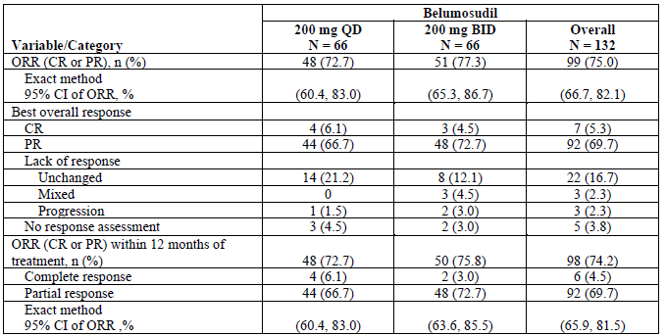
Abbreviations: BID = twice daily; CI = confidence interval; CR = complete response; mITT = modified intent to treat; ORR = overall response rate; PR = partial response; QD = once daily.
Note: two-sided, exact CI was calculated using the Clopper Pearson method. The data cutoff date was 19 August 2020.
Subgroup analyses were performed for ORR. These were exploratory, results are summarised in Figure 4.
Figure 4: Study KD025-213, Forest plot of overall response rate by subgroup (all subjects, modified intent to treat population)
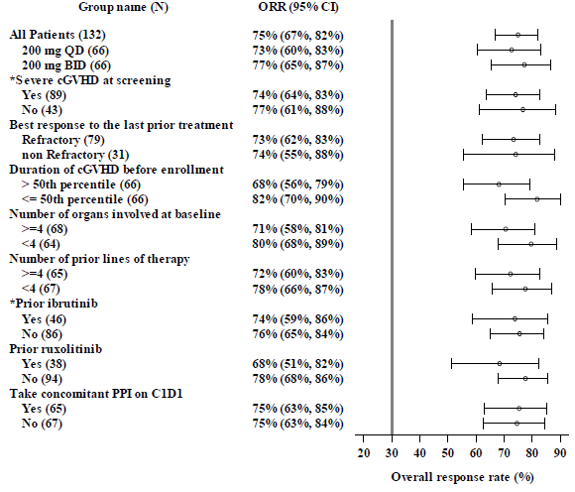
Abbreviation: BID = twice daily; C1D1 = Cycle 1 Day 1; CI = confidence interval; mITT = modified intent to treat; ORR = overall response rate; PPI = proton pump inhibitor; QD = once daily.
Notes: CIs were calculated using the Clopper-Pearson interval (exact) method. The vertical bar references 30% which was considered clinically meaningful in unmet need population. The ‘*’ indicates stratification factors. Response assessment performed on or after initiation of new systemic therapy for cGVHD are excluded from the analysis. The data cutoff date was 19 August 2020.
Secondary endpoints are shown in Table 12.
Table 12: Study KD025-213, Secondary endpoints efficacy update (19 August 2020)
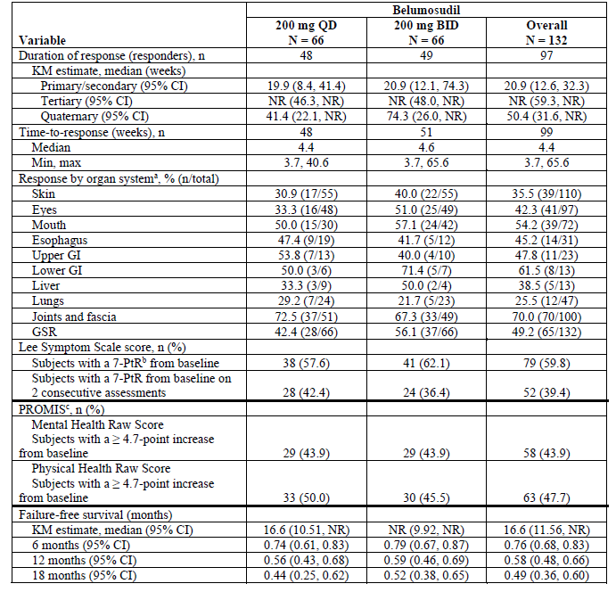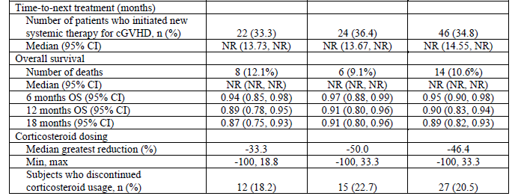
Abbreviations: 4.7-PtR = 4.7 point reduction; 7-PtR =7 point reduction; BID = twice daily; cGVHD = chronic graft versus host disease; CI = confidence interval; GI = gastrointestinal; GSR = global severity rating; max = maximum; min = minimum; NR = not reached; OS = overall survival; PROMIS = patient reported outcomes measurement information system; QD = once daily.
Note: The data cutoff date was 19 August 2020
a Response = CR or PR
b The 7-PtRis a ≥ 7 point reduction
c Change from Baseline in PROMIS Global Health subscore was an exploratory efficacy endpoint.
Post hoc analyses were performed using the KARA. When these results were compared with the investigator assessments of ORR the results were similar. Subgroup analyses showed that less severity of disease, shorter duration of cGVHD, fewer prior lines of therapy, and fewer organs involved at Baseline were all associated with higher CR results and a small increase in ORR. The largest difference in ORRs was for duration of cGVHD. The fiftieth percentile of patients in the shortest duration of cGVHD at Baseline had an ORR of 80.3% whereas the fiftieth percentile of patients with the longest duration of cGVHD at Baseline had an ORR of 68.2%.
Table 13: Study KD025-213, Descriptive Kaplan-Meier and landmark statistics for duration of response (secondary) by Kadmon Algorithmic Response Assessment (KARA) (responder population)
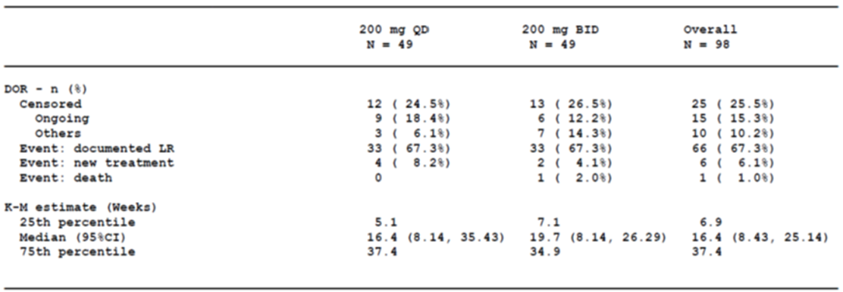
Note:
- This responder population is defined based on response status of KARA
- The percentage are calculated based on the number of responder population
- CI = confidence intervatl, CI is calculated using Kaplan-Meier method
- KARA = Kadmon algorithmic response assessments.
- * = Number and percentage are based on using landmark analysis without adjustment for censoring
- New systemic cGVHD treatment and death are considered loss of response if occurring within two cycles (56 days) after last assessment.
- Others include treatment discontinued.

Clinical reviewer analysis of Study KD025-213 overall response rate and duration of response
The clinical reviewers applied alternative definitions for the primary endpoint, the primary analysis set, method of adjudication, definition of ORR, DOR and of alternate measures of durability. These are tabulated and compared with those of the sponsor in Table 3. The major differences were in the assessment of ORR and DOR as discussed in the introduction to efficacy. The reviewers considered that one patient did not have active cGVHD at Baseline and excluded that patient from its analyses. The definition of ORR was the same as in the study report except that response was required within the first six months of treatment.
Table 14: Study KD025-213, Overall response rate by Cycle 7 Day 1 per Clinical Reviewer’s adjudication by dose group
Response | 200 mg once daily  N = 65 | 200 mg twice daily  N = 66
ORR | 49/65, 75% (63,85) | 46/66, 70% (57,80)
CR | 4/65, 6% (2,15) | 1/66, 2% (0,8)
PR | 45/65, 69% (57, 80) | 45/66, 68% (56, 79)
Abbreviation: ORR = overall response rate; CR = complete response; PR = partial response
The clinical reviewer’s primary definition of DOR was the interval from first response by C7D1 to progression in any organ, death, or new systemic therapies for cGVHD For responses that began through C7D1, the median time to first response in the responders was 1.8 months (95% CI: 1, 1.9). Median duration of response is 1.9 (95% CI: 1.2, 2.9) months in 200 mg once daily group.
Table 15: Study KD025-213, Duration of response (primary definition) per clinical reviewer adjudication
 | Belumosudil
 | 200 mg once daily  N = 49 | 200 mg twice daily  N = 46
Events, n (%) | 41 (84%) | 35 (76%)
Median, months (95%CI) | 1.9 (1.2, 2.9) | 1.8 (1.0, 4.6)
Abbreviation: CI = confidence interval
For responses that began through C7D1, DOR assessed as time from response to new systemic therapy or death, whichever occurs first showed median DOR is non-estimable in the 200 mg once daily group. Durability of response was longer than six months in 79% (95% CI: 64%, 88%) and longer than 12 months in 62% (95% CI: 46%, 74%) of patients in the 200 mg once daily group. The Kaplan Meier plot of durability of response by the alternate definition is shown in Figure 5.
Figure 5: Durability of response (clinical reviewer’s adjudication, alternate definition of duration of response)
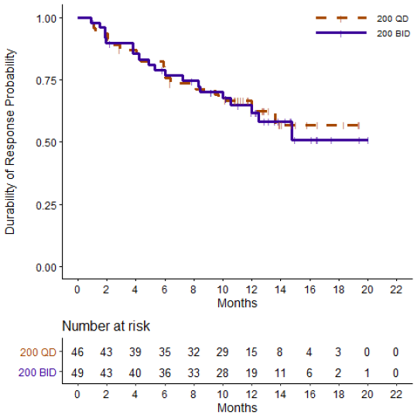
The DOR (clinical reviewer primary definition) and the median TTR for responders in the combined Phase II analysis group that is Studies 208 and 213 was 7.9 weeks (range, 3.7 to 40.6) among subjects in the 200 mg once daily group. By 10 weeks, 50 subjects (84.7%) in the 200 mg once daily group had achieved a response. The median time to new therapy for patients in the mITT-Phase II analysis group population in the 200 mg once daily group was not reached (95% CI: 15.18, not reached). Among patients in the 200 mg once daily group, 22 subjects (26.5%) received a new systemic therapy for cGVHD.
At Baseline, over 20% of subjects had received prior treatment with ruxolitinib, while more than 25% had received prior treatment with ibrutinib. The reviewers noted that investigators elected to continue subjects even those who had not received ruxolitinib or ibrutinib, on belumosudil, suggesting that investigators saw some clinical benefit in continued belumosudil dosing despite other available options.
The reviewers also performed an analysis of ORR by subgroup however there was insufficient information on patients in each treatment group to determine if subgroup outcomes differ.
The Lee Symptom Scale assessment;8 was considered exploratory. At least a 7 point decrease in the Lee Symptom Scale summary score through C7D1 was reported by 52% (95% CI: 40, 65) of the patients in the 200 mg once daily group.
Secondary and exploratory endpoint analyses supported the primary analysis. Corticosteroid dose reductions and discontinuations were demonstrated among both responders and non-responders.

Safety
The following analyses are based on data cumulative through the safety update report submitted 25 November 2020 and revised integrated summary of safety datasets submitted through 5 March 2021.
The overall clinical development program for belumosudil includes 15 Phase I and II studies in healthy volunteers and adults in three indications: cGVHD, idiopathic pulmonary fibrosis (IPF), and psoriasis. Eight Phase I trials that have been conducted with belumosudil in normal healthy subjects (Studies 2119-09-01, KD025-101, KD025-102, KD025-103, KD025-105, KD025-106, KD025-107, and KD025-108) to support dose-finding, safety, pharmacokinetics, and pharmacodynamics; one Phase I study conducted in subjects with hepatic impairment is ongoing (Study KD025-109). The Phase II studies (Studies KD025-208 and KD025-213) include patients with cGVHD. Phase II studies in other indications include: Study KD025-207 in subjects with IPF, and Studies KD025-205, KD025-206, and KD025-211 in subjects with psoriasis. All 15 belumosudil clinical studies were conducted in accordance with Good Clinical Practices and under International Conference on Harmonisation guidelines.
Based on the mechanism of action and secondary pharmacology studies the following safety issues were anticipated:
- The mechanism of action involves fibrotic pathways and Th17 cells, so impaired wound healing and infections were anticipated.
- In secondary pharmacology studies, belumosudil also inhibited the mTOR pathway. Therefore, specific safety analyses have been performed for subjects who received mTOR inhibitors as concomitant systemic cGVHD therapies.
- Belumosudil also inhibited UGT1A1 at concentrations that could be achieved clinically, so transient isolated hyperbilirubinemia was also anticipated.
There were no clinical holds for safety during the development program. The main emerging toxicity during clinical development was elevations of liver transaminases.
In the cGVHD program 186 patients were exposed to belumosudil with a median duration of exposure of 0.4 months (range 0.4 to 44.7). There were 83 patients given the proposed 200 mg once daily dose and median duration of exposure for these patients was 9.2 months (range 0.5 to 44.7), with 34 patients having received ≥ 12 months of treatment. A further 231 patients have received belumosudil in studies for other indications (IPF and psoriasis).
Adding to this number, from clinical trials with belumosudil in other diseases 34 additional patients have been treated for one year or longer (33 patients with IPF at 400 mg once daily, and 1 patient with psoriasis) bringing the total number of patients across the belumosudil safety population treated for ≥ 12 months, at or above the to be marketed dose, to 115 patients.
In the 83 patients who received the proposed belumosudil dose of 200 mg once daily dose interruptions occurred in 24 (28.9%) patients with the most frequent association being infection. Three patients in the proposed dose group had dose reductions. The adverse events which resulted in permanent discontinuation of belumosudil in > 3% of patients included nausea (4%). The adverse events leading to dose interruption in ≥ 2% were infections (11%), diarrhea (4%), and asthenia, dyspnoea, haemorrhage, hypotension, liver function test abnormal, nausea, pyrexia, oedema, and renal failure with (2% each).
In the planned safety population, there were total of 46 AEs that resulted in deaths of 26 subjects: including 43 AEs that resulted in death of 23 subjects within 30 days from the last dose of belumosudil. Four of these deaths were considered by the FDA as possibly related to study drug: three were sudden unexplained deaths and one was gastrointestinal toxicity and multiorgan failure. One of these deaths occurred in the belumosudil 200 mg once daily dose group with cGVHD.
In that 200 mg once daily cGVHD dose group the most frequent treatment emergent adverse events (TEAE) included infection, asthenia, nausea, diarrhoea, dyspnoea, cough, oedema, liver function test abnormal, haemorrhage, abdominal pain, musculoskeletal pain and headache. Common TEAEs are shown in Table 16.
Table 16: Non-laboratory treatment emergent adverse event in greater than 10% patients with chronic graft versus host disease treated with belumosudil 200 mg once daily
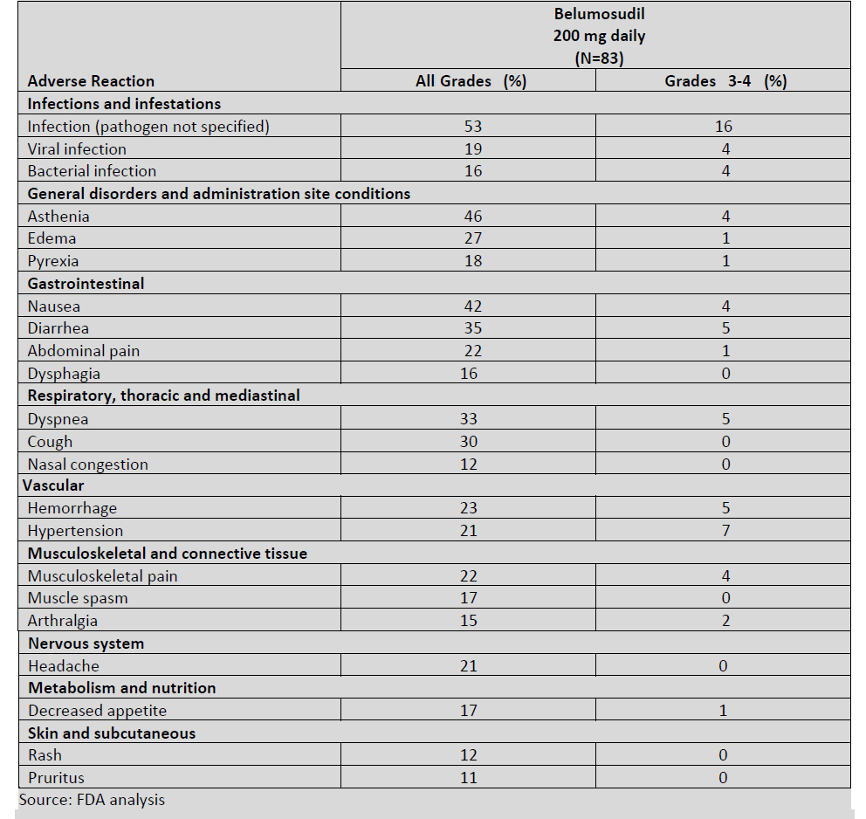
Laboratory abnormalities are summarised in Table 17.
Table 17: Selected laboratory abnormalities in patients with chronic graft versus host disease treated with belumosudil
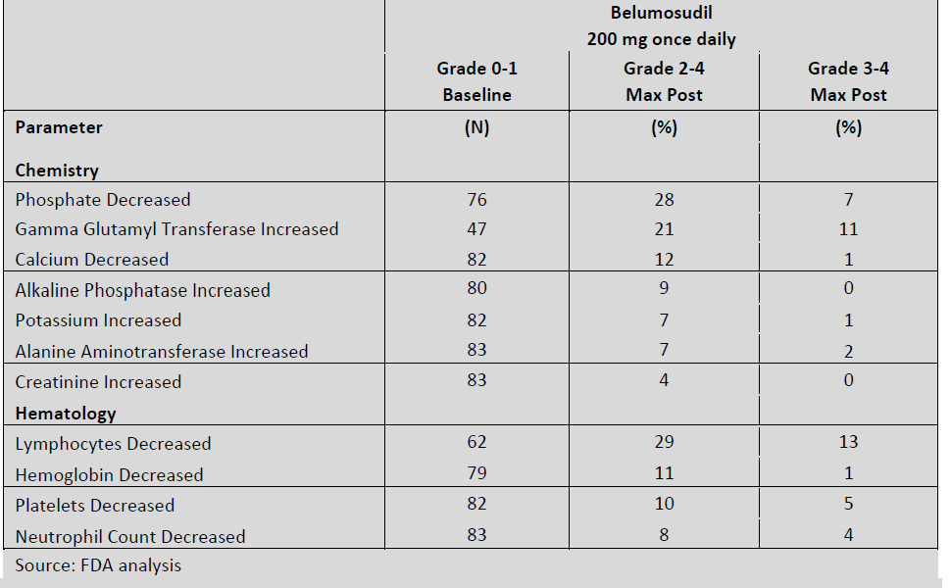
Table 18: Adverse events of special interest, chronic graft versus host diseases safety population
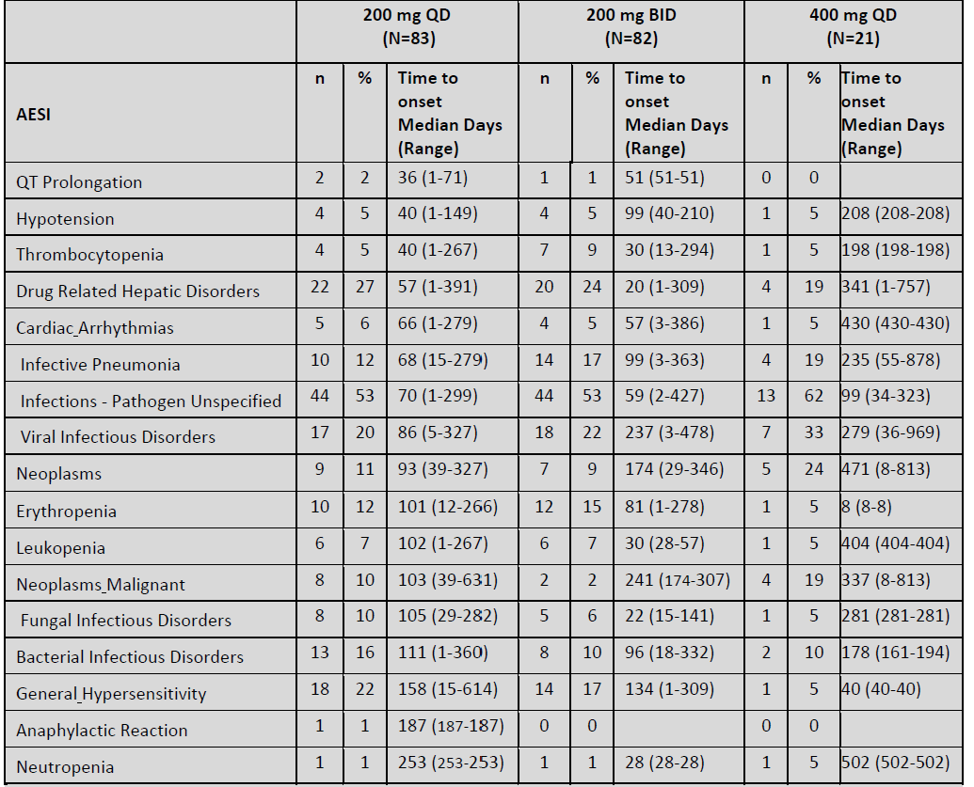
Abbreviations: QD = once daily; BID = twice daily; AESI = adverse events of special interest; CAR ARR = cardiac arrhythmias; CAR QT = cardiac torsade de pointes/QT prolongation; G ANAPH = general anaphylactic reaction; G HYPER= general hypersensitivity; G HYPOT = general hypotension; HEM CYT = haematopoietic cytopenia; HEM NEU = haematological neutropenia; HEM THR = haematological thrombocytopenia; HEP HEP = hepatic drug related disorder; INF BAC = infection bacterial infectious disorder; INF FUN = infection fungal infectious disorder; INF PAT = infection infections pathogen unspecified; INF PNE = infection infective pneumonia; INF VIR = infection viral infectious disorder; NEO MAL = neoplasma malignant or unspecific tumours; NEO NEO = neoplasms benign, malignant and unspecified.
There were no Grade 3 or 4 bilirubin elevations and no Hy's Law; cases.
Table 19: Chronic graft versus host disease safety population, Preferred Terms for hepatic events
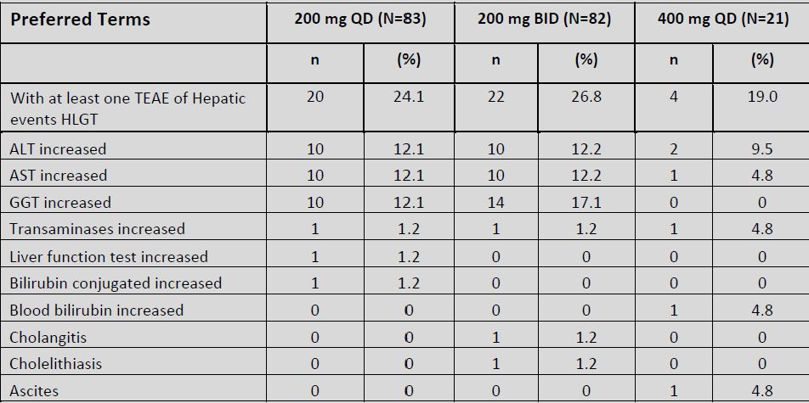
Abbreviations: QD = once daily, BID = twice daily; HLGT = high level group term; TEAE = treatment emergent adverse events; ALT = alanine aminotransferase; AST = asparate aminotransferase; GGT = gamma-glutamyl transferase.

Risk management plan
Rholistiq received TGA orphan designation on 2 September 2020.
The sponsor submitted US-risk management plan (RMP) version 1.0 (25 September 2020; data lock point (DLP) 19 February 2020) and Australian specific annex (ASA) version 1.0 (22 October 2020) in support of this application.
In response to the TGA rolling questions sent 5 January 2021, the sponsor has submitted ASA version 1.1 (dated 5 January 2021). The sponsor has also provided TGA with the European Union (EU)-RMP version 1.0 (dated 13 November 2020; DLP 19 February 2020) which was submitted to the UK Medicines and Healthcare products Regulatory Agency on 26 November 2020. In response to the TGA rolling questions sent 6 May 2021, the sponsor has submitted ASA version 1.2 (dated 20 May 2021) in support of the application. In its response to TGA questions, the sponsor has submitted ASA version 1.3 (dated 13 September 2021) in support of the application.
In response to TGA rolling question sent 3 February 2021, the sponsor has submitted a revised Consumer Medicines Information (CMI) which has been amended appropriately.
The summary of safety concerns and their associated risk monitoring and mitigation strategies are summarised in Table 20.
Table 20: Summary of safety concerns and their associated risk monitoring and mitigation strategies
Summary of safety concerns |  | Pharmacovigilance |  | Risk Minimisation
 |  | Routine | Additional | Routine | Additional
Important identified risks | None | – | – | – | –
Important potential risks | Drug-induced liver injury | §, | **†† |  | –
Important potential risks | Infections |  | **††, |  | –
Important potential risks | Malignancy (secondary neoplasm and relapse of underlying malignancy) | §, | **†† |  | –
Important potential risks | Embryofetal toxicity and teratogenicity | § | – |  | –
Missing information | Use in patients with severe hepatic impairment |  | * |  | –
Missing information | Effects on QTc interval at high exposure multiples of the clinical exposure |  | † |  | –
Missing information | Long term safety |  | †† | – | –
* Study KD025-109
† Study KD025-110
†† Study KD025-217
§ Follow up questionnaires
‘Long term safety’ has been added as missing information. The summary of safety concerns is acceptable.
Routine pharmacovigilance activities have been proposed for the all the identified safety concerns. Additional pharmacovigilance activities are proposed only for the two missing information concerns. This is acceptable and the two pharmacokinetic studies which are underway will provide further clarity regarding the missing information. However, the FDA has recommended ten post marketing requirements based on the data available to date. The trials as agreed with the FDA have been included in the ASA as additional pharmacovigilance and cross referenced to the summary of safety concerns. The sponsor has also added targeted follow-up questionnaires as routine pharmacovigilance in the ASA for the following safety concerns: Drug-induced liver damage; Malignancy; Embryonic and foetal toxicity and teratogenicity.
Only routine risk minimisation activities have been proposed. The CMI and Production Information (PI) provide adequate information with regards to prevention of pregnancy that additional risk minimisation activities are not required.
The sponsor has committed to the following:
- A revised RMP if any additional safety concerns are identified by the clinical/nonclinical evaluators.
- Advising the TGA of the reporting frequency and schedule for PSUR submissions when available.
- Submitting the completed study outcomes to the TGA for review once available.
- Implementation of targeted follow up questionnaires for drug-induced liver damage, malignancy and embryonic and foetal toxicity and teratogenicity (pregnancy). The questionnaires will be the same as those to be implemented in Switzerland and will be added to the next version of the EU-RMP and submitted to the TGA.
There are no outstanding issues.

Proposed wording for conditions of registration.
Any changes to which the sponsor has agreed should be included in a revised RMP and ASA. However, irrespective of whether or not they are included in the currently available version of the RMP document, the agreed changes become part of the risk management system.
The suggested wording is:
The Rholistiq EU-Risk Management Plan version 1.0 (dated 13 November 2020; DLP 19 February 2020) with Australian Specific Annex (version 1.3, dated 13 September 2021), included with submission PM-2020-05433-1-6, and any subsequent revisions, as agreed with the TGA will be implemented in Australia.
The following wording is recommended for the PSUR requirement:
An obligatory component of risk management plans is routine pharmacovigilance. Routine pharmacovigilance includes the submission of periodic safety update reports (PSURs).
Unless agreed separately between the supplier who is the recipient of the approval and the TGA, the first report must be submitted to TGA no later than 15 calendar months after the date of this approval letter. The subsequent reports must be submitted no less frequently than annually from the date of the first submitted report until the period covered by such reports is not less than three years from the date of this approval letter. The annual submission may be made up of two PSURs each covering six months. If the sponsor wishes, the six monthly reports may be submitted separately as they become available.
If the product is approved in the EU during the three years period, reports can be provided in line with the published list of EU reference dates no less frequently than annually from the date of the first submitted report until the period covered by such reports is not less than three years from the date of this approval letter.
The reports are to at least meet the requirements for PSURs as described in the European Medicines Agency’s Guideline on good pharmacovigilance practices (GVP) Module VII-periodic safety update report (Rev 1), Part VII.B Structures and processes. Note that submission of a PSUR does not constitute an application to vary the registration. Each report must have been prepared within ninety calendar days of the data lock point for that report.
As Rholistiq is a new chemical entity it should be included in the Black Triangle Scheme as a condition of registration. The following wording is recommended for the condition of registration:
Rholistiq (belumosudil) is to be included in the Black Triangle Scheme. The PI and CMI for Rholistiq must include the black triangle symbol and mandatory accompanying text for five years, which starts from the date that the sponsor notifies the TGA of supply of the product.

Risk-benefit analysis

Delegate’s considerations

Pharmacology
No dose response to belumosudil has been demonstrated, with a flat dose response in in both clinical trials and in the exposure-response pharmacodynamic/PK analysis. It is therefore not clear whether dose adjustments will result in changes in efficacy. Age and body size were not demonstrated to affect efficacy or safety and no dose adjustments have been proposed based on these parameters. The efficacy and safety studies enrolled only adults however the sponsor proposed that belumosudil be indicated in patients 12 years and older. This is acceptable, given the flat relationship between body weight, efficacy, and safety. The weight range included in the popPK analysis was 38.6 to 143 kg, and no body weight effect was identified on the clearance of belumosudil.
There are significant changes in the PK of belumosudil in response to strong CYP3A4 induction (rifampicin), which reduced belumosudil exposure by 72% and PPIs similarly reduced belumosudil exposure by up to 80%, depending on the strength of the PPI. Dose increases to 200 mg twice daily are recommended in the US Prescribing Information but had not been proposed by the sponsor for either the strong CYP3A inducers and for co-administration with proton pump inhibitors.
No dose modifications have been proposed for patients with mild to moderate hepatic or renal impairment. Belumosudil has not been studied in patients with severe renal or hepatic impairment.

Efficacy
There were two studies which investigated efficacy and safety of belumosudil in cGVHD. These were both small, uncontrolled Phase II studies with a relatively short duration of assessment to date. The primary analysis was by investigator. This is of particular concern given these were uncontrolled studies, disease symptoms are multi-system, highly variable and fluctuate over time. Additionally, the response could occur at any time during the study. The reviewers chose alternative efficacy endpoints and performed an adjudication of cases.
The demographics and baseline disease characteristics in the study population were representative of the patients with cGVHD that has not adequately responded to current treatment however there were no subjects in the pivotal study who had failed only one line of therapy. The median was six lines of prior therapy. It is not known whether belumosudil would be more or less efficacious if given earlier in the course of cGVHD or if given to patients with less severe disease or less experience with other lines of therapy. Given the population in which efficacy and safety have been examined the Delegate considers that the indication should be limited to patients who’ve experienced failure of at least two prior lines of therapy.
The sponsor assessed the ORR in accordance with the 2014 NIH criteria;2 but there were differences in the ORR definition between the sponsor and the reviewers in the ORR definition in both the dose finding study and the pivotal study. These are described in Table 3. There was little difference between the sponsor and reviewers in reported ORR. In the pivotal study, for patients given the proposed dose regimen of belumosudil, the ORR was 75% with a CR in 6% of patients as assessed by the reviewer compared with an ORR of 72.7% and CR in 4.5% with the sponsor’s analysis.
There were differences in time to onset of response between the reviewers and sponsor analyses but in both analyses over 90% of patients who were going to respond had responded within the first six months of treatment that is by C7D1. Given the safety concerns with use of belumosudil it should not be continued in patients who haven’t responded within the first six months of treatment. Given that limitation, it is not clear how the ORR would be best described in the PI. At this time, the Delegate’s preference is for the ORR in subjects who responded within the first six months of treatment.
The clinical reviewers’ primary definition of DOR is quite restrictive in that any deterioration in any organ is included as a loss of response, though the subject concerned may have experienced ongoing improvement in multiple other organs at the same time. The extremely short median DOR of 1.9 months which was calculated using that definition is, in my opinion, not sufficiently indicative of the clinical significance of a response and could potentially misrepresent the duration of clinical improvement. For this reason, at this time, the Delegate’s preference is to highlight the reviewer’s alternate definition of DOR that is interval from first response by C7D1 to death or new systemic therapies from cGVHD. For the 200 mg once daily group in Study KD025-213 the reviewer’s median DOR according to the alternative DOR definition was could not be calculated. Durability of response was longer than six months in 79% (95% CI: 64%, 88%) and longer than 12 months in 62% (95% CI:46%, 74%) of patients in the 200 mg once daily group. was 1.9 months (about 8 weeks) and the sponsor’s median DOR was 21.1 weeks.
The definition of response applied by the reviewers restricted response to within the first six months of treatment. This difference does not allow for mixing and matching of sponsor and reviewer results. This is particularly so for assessment of DOR since to compare DOR the criteria to assess initial response must be the same. The selection of time to interval from first response by C7D1 to death or new systemic therapies for cGVHD is an indirect method for assessing DOR but is the most appropriate available from the pivotal study. That definition is similar to the sponsor’s FFS method of assessment.
While there is no approved treatment for cGVHD in Australia, ibrutinib is approved in other jurisdictions. The study supporting the cGVHD indication for ibrutinib is described in the US Prescribing Information for ibrutinib. This was an open, single arm study of 42 patients. Patients in that study had a median of two prior lines of therapy, ORR was assessed according to NIH 2014 criteria;2 and was 28 out of 42 (67%). Response was maintained for at least 20 weeks in 20 out of 28 (71%) patients who initially responded. While it is not possible to make conclusions regarding a comparison of ORR and DOR between ibrutinib and belumosudil, it is reassuring that vast differences in these measures across these studies are not apparent.
Further reassurance of the extent and durability of response is provided by comparing the sponsor’s and reviewers’ assessments of the proportion of subjects in Study KD025-213 who did not receive a new treatment for cGVHD after commencing belumosudil. The FFS rate at six months was 79% according to the reviewers and 74% according to the sponsor.
Stabilisation of disease progression was included as part of the assessment of patients who did not have an overall response of PR or CR. Duration of lack of progression was not assessed.
A post hoc reassessment of efficacy using KARA was performed as an exploratory analysis and is results were consistent with the primary analyses of ORR.

Safety
The major safety issues apparent to date are those that would be anticipated in an immunosuppressive agent given to a highly medicated and already immune suppressed population. Surveillance of patients for adverse effects will be necessary.
Neither the safety nor efficacy profile are fully established. Safety and pharmacokinetics, particularly drug-drug interactions are to be further elucidated as post-market requirements.

Proposed indication by the Delegate
Treatment of patients 12 years and older with chronic graft-versus-host disease (cGVHD) after failure of at least two prior lines of systemic therapy.

Proposed conditions of registration
In addition to the conditions of approval recommended by the chemistry and RMP evaluators the following conditions of registration are proposed:
- Conduct a pharmacokinetics trial to compare the relative bioavailability of belumosudil paediatric formulation to belumosudil tablets and develop an age-appropriate paediatric formulation of belumosudil.
- Conduct a clinical trial to determine the appropriate dose of belumosudil and to assess the safety, efficacy, and pharmacokinetics of belumosudil in paediatric patients with chronic graft-versus-host disease. Include at least 20 adolescents aged 12 to < 17 years old, 4 children aged 2 to < 12 years old, and 2 infants aged ≥ 3 months to < 2 years old.
- Conduct an integrated safety analysis using data obtained from clinical trials to further characterise the safety of long-term treatment with belumosudil and determine the rate of infections, hypertension and other adverse events. The integrated safety analysis should include all adverse events, major safety events, dose-reductions, dose interruptions, withdrawals, and efficacy when all patients have completed at least three years of treatment with belumosudil or withdrew earlier.
- Conduct a clinical pharmacokinetic trial evaluating the effect of repeat doses of belumosudil on the single-dose pharmacokinetics of a UGT1A1 substrate to assess the potential for excessive drug toxicity.
- Conduct a clinical pharmacokinetic trial evaluating the effect of repeat doses of belumosudil on the single-dose pharmacokinetics of sensitive substrates (P-gp, BCRP and OATP1B1) to assess the potential for excessive drug toxicity.
- Conduct a clinical pharmacokinetic trial to determine a safe and appropriate dose of belumosudil in subjects with mild, moderate, and severe hepatic impairment. The final report should include assessment of subjects with mild, moderate and severe hepatic impairment.
- Conduct a thorough QT/QTc trial to evaluate the effect of repeat doses of belumosudil on the QT/QTc interval to address the potential for excessive drug toxicity.
- Conduct a rodent carcinogenicity study in mice to evaluate the potential for carcinogenicity.
- Conduct a rodent carcinogenicity study in rats to evaluate the potential for carcinogenicity.
- Conduct an in vitro mechanism-based inhibition study (such as the two-step dilution method) estimating the inactivation parameters (kinact and KI) of CYP1A2, CYP2C19 and CYP2D6 enzymes and measuring nonspecific binding of belumosudil to assess the potential of drug interaction with belumosudil on these enzymes.

Proposed action
The Delegate proposes to approve Rholistiq (belumosudil as mesylate) for:
Treatment of patients 12 years and older with chronic graft-versus-host disease (cGVHD) after failure of at least two prior lines of systemic therapy.
Approval is subject to successful negotiation of the PI and other conditions of registration, including the RMP.

Advisory Committee considerations
The Advisory Committee on Medicines (ACM), having considered the evaluations and the Delegate’s overview, as well as the sponsor’s response to these documents, advised the following.

Specific advice to the Delegate
- Does the Committee have concerns regarding the inclusion of children aged from 12 years in the indication for Rholistiq?
The ACM noted the similar pathophysiology of cGVHD in adolescents and adults, and the lack of known drug safety issues specific to adolescents with belumosudil (such as an impact on growth plates).
While the ACM noted that the youngest participants included in the trials were 21 years of age, they were of the view that it is not unreasonable to extrapolate from adults to adolescents ≥ 12 years. The ACM emphasised that cGVHD can be a life-threatening condition and often has a significant impact on quality of life.
Overall, the ACM were of the view that the inclusion of children aged from 12 years and above was appropriate.
- Does the Committee consider it appropriate that the reviewers’ assessment of the efficacy criteria overall response rate (ORR) and the alternative definition of duration of response (DOR) be presented as the primary measures of efficacy in the description of the pivotal trial for cGVHD in the PI in preference to those of the sponsor?
The ACM highlighted the complex nature of cGVHD and associated difficulties assessing response. The ACM advised that both ORR and DOR are equally important measures of efficacy within cGVHD and supported both being included as primary measures of efficacy within the PI.
The ACM discussed both the sponsor’s and reviewer’s assessment of ORR and DOR and noted that both reflect the clinically meaningful benefit achieved with belumosudil 200 mg daily. The ACM were supportive of utilising the Reviewer’s assessment of the efficacy criteria ORR and the alternative definition of DOR within the PI.
- Does the Committee have concerns with the approach taken by the reviewers?
The ACM noted the reviewer’s definition of DOR was the ‘Interval from first response by Cycle 7 Day 1 (C7D1) to progression in any organ, death, or new systemic therapies for cGVHD’, with the ORR being calculated using the definition of 2014 NIH consensus criteria based on organ response criteria and requiring a response within 6 months. The ACM considered this approach to be prudent and conservative, but again highlighted the challenges assessing responses to cGVHD treatment.
- Does the Committee consider that a clinically meaningful benefit is achieved with belumosudil when given at the proposed dose to the proposed population?
The ACM were of the view that a clinically meaningful benefit was demonstrated within the clinical trials for patients on 200 mg belumosudil daily who continued treatment for greater than one year. The ACM agreed that the ORR (using either the sponsor or reviewer’s definition) supports a conclusion of clinical efficacy for belumosudil. Additionally, the ACM agreed that there was some evidence of symptomatic improvement for patients, as demonstrated via the improvements (reductions) in the Lee Symptom Scale scores within Study KD025-213.
Although the ACM did express some concern about the relatively short DOR, they agreed that this is a difficult group of patients to treat and there are limited treatment options currently available.
The ACM discussed the place in therapy for this drug, noting that there are no approved second line therapies for cGVHD in Australia, and were supportive of its use following one prior line of systemic therapy.
- Does the Committee consider that additional information should be requested from the sponsor regarding the efficacy or safety of belumosudil in the treatment of cGVHD? If so, what information should be requested?
The ACM indicated that subset analysis and correlative laboratory (biomarker) data to investigate the individual organ effects would be useful, however, given the small sample size they acknowledged that this is unlikely to be interpretable in a clinically meaningful way.

Conclusion
The ACM considered this product to have an overall positive benefit-risk profile for the indication:
Treatment of patients 12 years and older with chronic graft-versus-host disease (cGVHD) after failure of at least one prior line of systemic therapy.

Outcome
Based on a review of quality, safety and efficacy, the TGA approved the registration of Rholistiq (belumosudil) 200mg, film coated tablet, bottle, indicated for:
Rholistiq is indicated for the treatment of patients with chronic graft-versus-host disease (chronic GVHD) aged 12 years and older who have an inadequate response to corticosteroids.

Specific conditions of registration applying to these goods
- Rholistiq (belumosudil mesilate) is to be included in the Black Triangle Scheme. The PI and CMI for Rholistiq must include the black triangle symbol and mandatory accompanying text for five years, which starts from the date that the s,ponsor notifies the TGA of supply of the product.
- The Rholistiq EU-RMP version 1.0 (dated 13 November 2020; DLP 19 February 2020) with ASA (version 1.3, dated 13 September 2021), included with Submission PM-2020-05433-1-6, and any subsequent revisions, as agreed with the TGA will be implemented in Australia.
An obligatory component of risk management plans is routine pharmacovigilance. Routine pharmacovigilance includes the submission of periodic safety update reports (PSURs).
Unless agreed separately between the supplier who is the recipient of the approval and the TGA, the first report must be submitted to TGA no later than 15 calendar months after the date of the approval letter. The subsequent reports must be submitted no less frequently than annually from the date of the first submitted report until the period covered by such reports is not less than three years from the date of the approval letter. The annual submission may be made up of two PSURs each covering six months. If the sponsor wishes, the six monthly reports may be submitted separately as they become available.
If the product is approved in the EU during the three years period, reports can be provided in line with the published list of EU reference dates no less frequently than annually from the date of the first submitted report until the period covered by such reports is not less than three years from the date of the approval letter.
The reports are to at least meet the requirements for PSURs as described in the European Medicines Agency’s guideline on Good Pharmacovigilance Practices (GVP) module VII-periodic safety update report (Rev 1), part VII.B structures and processes. Note that submission of a PSUR does not constitute an application to vary the registration. Each report must have been prepared within 90 calendar days of the DLP for that report.
- The sponsor to conduct a pharmacokinetics trial to compare the relative bioavailability of belumosudil paediatric formulation to belumosudil tablets and develop an age appropriate paediatric formulation of belumosudil.
- The sponsor to conduct a clinical trial to determine the appropriate dose of belumosudil and to assess the safety, efficacy, and pharmacokinetics of belumosudil in paediatric patients with chronic graft versus host disease. Include at least 20 adolescents 12 to less than 17 years old, 4 children 2 to less than 12 years old, and 2 infants 3 months and older to less than 2 years old. Proposed regulatory action.
- The sponsor to conduct an integrated safety analysis using data obtained from clinical trials to further characterise the safety of long term treatment with belumosudil and determine the rate of infections, hypertension and other adverse events. The integrated safety analysis should include all adverse events, major safety events, dose reductions, dose interruptions, withdrawals, and efficacy when all patients have completed at least three years of treatment with belumosudil or withdrew earlier.
- The sponsor to conduct a clinical pharmacokinetic trial evaluating the effect of repeat doses of belumosudil on the single dose pharmacokinetics of a UGT1A1 substrate to assess the potential for excessive drug toxicity.
- The sponsor to conduct a clinical pharmacokinetic trial evaluating the effect of repeat doses of belumosudil on the single dose pharmacokinetics of sensitive substrates P-gp, BCRP and OATP1B1 to assess the potential for excessive drug toxicity.
- The sponsor to conduct a clinical pharmacokinetic trial to determine a safe and appropriate dose of belumosudil in subjects with mild, moderate, and severe hepatic impairment. The final report should include assessment of subjects with mild, moderate and severe hepatic impairment.
- The sponsor to conduct a thorough QT interval (QT)/corrected QT interval (QTc) trial to evaluate the effect of repeat doses of belumosudil on the QT/QTc interval to address the potential for excessive drug toxicity.
- The sponsor to conduct a rodent carcinogenicity study in mice to evaluate the potential for carcinogenicity.
- The sponsor to conduct a rodent carcinogenicity study in rats to evaluate the potential for carcinogenicity.
- The sponsor to conduct an in vitro mechanism based inhibition study (such as the two step dilution method) estimating the inactivation parameters (the rate of enzyme inactivation (k_{inact}) and the inhibitor constant (K_{I})) of cytochrome 450 (CYP)1A2, CYP2C19 and CYP2D6 enzymes and measuring nonspecific binding of belumosudil to assess the potential of drug interaction with belumosudil on these enzymes.

Attachment 1. Product Information
The PI for Rholistiq approved with the submission which is described in this AusPAR is at Attachment 1. For the most recent PI, please refer to the TGA website at <https://www.tga.gov.au/product-information-pi>.

Therapeutic Goods Administration
PO Box 100 Woden ACT 2606 Australia
Email: info@tga.gov.au Phone: 1800 020 653 Fax: 02 6232 8605
https://www.tga.gov.au

The Black Triangle Scheme provides a simple means for practitioners and patients to identify certain types of new prescription medicines, including those being used in new ways and to encourage the reporting of adverse events associated with their use. The Black Triangle does not denote that there are known safety problems, just that the TGA is encouraging adverse event reporting to help us build up the full picture of a medicine's safety profile.
Shulman et al. NIH Consensus Development Project on Criteria for Clinical Trials in Chronic Graft-versus-Host Disease: II. The 2014 Pathology Working Group Report. Biology of Blood and Marrow Transplantation, 2015 (21); 589-603
Baird, et al. National Institutes of Health chronic graft-versus-host disease staging in severely affected patients: organ and global scoring correlate with established indicators of disease severity and prognosis. Biology of blood and marrow transplantation : journal of the American Society for Blood and Marrow Transplantation 2013 (19): 632-639
Rezurock is the USA specific tradename for belumosudil.
An orphan drug is a therapeutic good developed to treat, prevent or diagnose a rare medical condition, that due to low prevalence and/or financial unviability, it would not be financially viable for a sponsor to market that good in Australia. A sponsor may apply for orphan drug designation preceding the main evaluation submission, and should the application meet the specified criteria and designation be granted, the TGA will waive the normal application and evaluation fees, thereby facilitating bring the therapeutic good to the Australian market.
Cytochrome P450 (CYP) enzymes: CYPs are the major enzymes involved in drug metabolism, accounting for large part of the total metabolism. Most drugs undergo deactivation by CYPs, either directly or by facilitated excretion from the body. Also, many substances are bioactivated by CYPs to form their active compounds. Many drugs may increase or decrease the activity of various CYP isozymes either by inducing the biosynthesis of an isozyme (enzyme induction) or by directly inhibiting the activity of the CYP (enzyme inhibition). This is a major source of adverse drug interactions, since changes in CYP enzyme activity may affect the metabolism and clearance of various drugs. Such drug interactions are especially important to take into account when using drugs of vital importance to the patient, drugs with important side-effects and drugs with small therapeutic windows, but any drug may be subject to an altered plasma concentration due to altered drug metabolism
The QT interval is the time from the start of the QRS wave complex to the end of the corresponding T wave. It approximates to the time taken for ventricular depolarisation and repolarisation, that is to say, the period of ventricular systole from ventricular isovolumetric contraction to isovolumetric relaxation
Lee Sk, Cook EF, Soiffer R, Antin JH. Development and validation of a scale to measure symptoms of chronic graft-versus-host disease. Biol Blood Marrow Transplant. 2002;8(8):444-452.
Karnofsky Performance Status is a standard way of measuring the ability of cancer patients to perform ordinary tasks. The Karnofsky Performance Status scores range from 0 to 100. A higher score means the patient is better able to carry out daily activities. Karnofsky Performance Status may be used to determine a patient's prognosis, to measure changes in a patient’s ability to function, or to decide if a patient could be included in a clinical trial.
Hy’s Law: Evidence of hepatocellular injury with a rise in alanine aminotransferase (ALT) and/or aspartate aminotransferase (AST) > 3 x the upper limit of normal (ULN) and total bilirubin > 2 x ULN, and no other reason to explain rise in aminotransferases and total bilirubin. Hy's law is a rule of thumb that a patient is at high risk of a fatal drug-induced liver injury if given a medication that causes hepatocellular injury with jaundice.
Routine risk minimisation activities may be limited to ensuring that suitable warnings are included in the product information or by careful use of labelling and packaging. Routine pharmacovigilance practices involve the following activities: - All suspected adverse reactions that are reported to the personnel of the company are collected and collated in an accessible manner; - Reporting to regulatory authorities; - Continuous monitoring of the safety profiles of approved products including signal detection and updating of labelling; - Submission of PSURs; - Meeting other local regulatory agency requirements.
The ACM provides independent medical and scientific advice to the Minister for Health and the TGA on issues relating to the safety, quality and efficacy of medicines supplied in Australia including issues relating to pre market and post-market functions for medicines. Further information can be found here: https://www.tga.gov.au/committee/advisory-committee-medicines-acm.

