July 2020

Australian Public Assessment Report for Beclometasone dipropionate/formoterol (eformoterol) fumarate dihydrate
  - Proprietary Product Name: Fostair
  - Sponsor: Chiesi Australia Pty Ltd

About the Therapeutic Goods Administration (TGA)
- The Therapeutic Goods Administration (TGA) is part of the Australian Government Department of Health and is responsible for regulating medicines and medical devices.
- The TGA administers the Therapeutic Goods Act 1989 (the Act), applying a risk management approach designed to ensure therapeutic goods supplied in Australia meet acceptable standards of quality, safety and efficacy (performance) when necessary.
- The work of the TGA is based on applying scientific and clinical expertise to decision-making, to ensure that the benefits to consumers outweigh any risks associated with the use of medicines and medical devices.
- The TGA relies on the public, healthcare professionals and industry to report problems with medicines or medical devices. TGA investigates reports received by it to determine any necessary regulatory action.
- To report a problem with a medicine or medical device, please see the information on the TGA website <https://www.tga.gov.au>.

About AusPARs
- An Australian Public Assessment Report (AusPAR) provides information about the evaluation of a prescription medicine and the considerations that led the TGA to approve or not approve a prescription medicine submission.
- AusPARs are prepared and published by the TGA.
- An AusPAR is prepared for submissions that relate to new chemical entities, generic medicines, major variations and extensions of indications.
- An AusPAR is a static document; it provides information that relates to a submission at a particular point in time.
- A new AusPAR will be developed to reflect changes to indications and/or major variations to a prescription medicine subject to evaluation by the TGA.

Copyright
© Commonwealth of Australia 2020
This work is copyright. You may reproduce the whole or part of this work in unaltered form for your own personal use or, if you are part of an organisation, for internal use within your organisation, but only if you or your organisation do not use the reproduction for any commercial purpose and retain this copyright notice and all disclaimer notices as part of that reproduction. Apart from rights to use as permitted by the Copyright Act 1968 or allowed by this copyright notice, all other rights are reserved and you are not allowed to reproduce the whole or any part of this work in any way (electronic or otherwise) without first being given specific written permission from the Commonwealth to do so. Requests and inquiries concerning reproduction and rights are to be sent to the TGA Copyright Officer, Therapeutic Goods Administration, PO Box 100, Woden ACT 2606 or emailed to <tga.copyright@tga.gov.au>.

Contents
Common abbreviations 4
I. Introduction to product submission 6
Submission details 6
Product background 7
Regulatory status 9
Product Information 9
II. Registration timeline 10
III. Submission overview and risk/benefit assessment 10
Quality 10
Nonclinical 12
Clinical 13
Risk management plan 22
Risk-benefit analysis 23
Outcome 24
Attachment 1. Product Information 25

Common abbreviations
Abbreviation | Meaning
ACM | Advisory Committee on Medicines
ACTH | Adrenocorticotropic hormone; adrenocorticotropin
AE | Adverse event
AI | Adrenal insufficiency
ANCOVA | Analysis of covariance
ANOVA | Analysis of variance
ARTG | Australian Register of Therapeutic Goods
AUC | Area under the plasma concentration time curve
β₂ | Beta 2 (adrenergic receptor)
BDP | Beclomethasone dipropionate
BD | Twice daily; Latin: bis in die
CHF 1535 | Fostair product development name
CI | Confidence interval
C_{max} | Maximum plasma concentration
CNS | Central nervous system
COPD | Chronic obstructive pulmonary disease
CV | Coefficient of variation
CYP | Cytochrome P450
DPI | Dry powder inhaler
EMA | European Medicines Agency (European Union)
EU | European Union
FDC | Fixed dose combination
FEV₁ | Forced expiratory volume in one second
FF | Formoterol fumarate
GINA | Global Initiative for Asthma
GOLD | Global Initiative for Chronic Obstructive Lung Disease
HFA | Hydrofluoroalkane
HPA | Hypothalamic pituitary axis
ICS | Inhaled corticosteroid
ITT | Intent to treat
LABA | Long acting beta₂ (β₂) agonist
MART | Maintenance and reliever therapy
MDI | Metered dose inhaler
PD | Pharmacodynamic(s)
PEF | Peak expiratory flow
pMDI | Pressurised metered dose inhaler
PK | Pharmacokinetic(s)
pp FEV₁ | Percent predicted forced expiratory volume in one second
PRN | As needed; Latin: Pro re nata
RCT | Randomised controlled trial
RMP | Risk management plan
SABA | Short acting beta₂ (β₂) agonist
SD | Standard deviation
SE | Standard error
SGRQ | St George’s Respiratory Questionnaire

I. Introduction to product submission

Submission details
Type of submission: | New fixed dose combination of previously approved ingredients
Decision: | Approved
Date of decision: | 20 January 2020
Date of entry onto ARTG: | 12 February 2020
ARTG number: | 310360
Black Triangle Scheme | No
Active ingredients: | Beclometasone dipropionate/formoterol (eformoterol) fumarate dihydrate
Product name: | Fostair
Sponsor’s name and address: | Chiesi Australia Pty Ltd  Suite 3 22 Gillman Street  Hawthorn East VIC 3123
Dose form: | Pressurised inhalation solution
Strength: | Fixed dose combination of 100 µg beclometasone dipropionate and 6 µg formoterol (eformoterol) fumarate dihydrate
Container: | Pressurised container with metered dose actuator
Pack size: | One (120 actuations)
Approved therapeutic use: | Asthma  Fostair is indicated in adults (18 years and older) in the regular treatment of asthma where use of a combination product (inhaled corticosteroid and long-acting beta 2-agonist) is appropriate:  - patients not adequately controlled with inhaled corticosteroids (ICS) and 'as needed' inhaled rapid-acting beta 2-agonist or  - patients already adequately controlled on both ICS and long-acting beta 2-agonists (LABA).  COPD  Symptomatic treatment of adults with severe COPD (FEV₁ < 50% predicted normal) and a history of repeated exacerbations, who have significant symptoms despite regular therapy with long-acting bronchodilators.
Route of administration: | Inhalation
Dosage: | Asthma (adults 18 years and above)  A. Maintenance therapy  One or two inhalations twice daily.  The maximum daily dose is 4 inhalations.  B. Maintenance and reliever therapy  The recommended maintenance dose is 1 inhalation twice daily (one inhalation in the morning and one inhalation in the evening).  Patients should take 1 additional inhalation as needed in response to symptoms. If symptoms persist after a few minutes, an additional inhalation should be taken. Patients should not take more than 6 inhalations on any single occasion.  The maximum daily dose is 8 inhalations.  COPD (adults 18 years and above)  Two inhalations twice daily.  For further information on dosage, refer to the Product Information.

Product background
This AusPAR describes the application by Chiesi Australia Pty Ltd (the sponsor) to register Fostair (delivering 100 µg beclometasone dipropionate and 6 µg formoterol (eformoterol) fumarate dihydrate per actuation) pressurised inhalation solution for the following proposed indication:
Asthma
Fostair is indicated in the regular treatment of asthma where use of a combination product (inhaled corticosteroid and long-acting beta2-agonist) is appropriate:
- patients not adequately controlled with inhaled corticosteroids and 'as needed' inhaled rapid-acting beta2-agonist or
- patients already adequately controlled on both inhaled corticosteroids and long-acting beta2-agonists.
COPD
Symptomatic treatment of patients with severe COPD (FEV₁ < 50% predicted normal) and a history of repeated exacerbations, who have significant symptoms despite regular therapy with long-acting bronchodilators.
Chronic obstructive pulmonary disease (COPD) and asthma affect an estimated 251; and 235 million; individuals worldwide, respectively. In 2015, mortality from COPD exceeded 3 million deaths, while mortality from asthma included approximately 400,000 deaths. One in nine Australians are estimated to be diagnosed with asthma (2.7 million). One in twenty Australians aged 45 and above are reported to be diagnosed with COPD, and COPD was considered as the fifth leading cause of death in Australia in 2017.
Pathophysiology of asthma and COPD is primarily caused and maintained by inflammatory processes.
The Global Initiative for Asthma (GINA); encourages patients with asthma to engage in regular physical activity for its general health benefit. Pharmacological management remains the foundation of asthma care, which is based on main goals, such as preventing asthma symptoms, maintaining nearly normal pulmonary function and activity levels, preventing asthmatic exacerbations. Smoking cessation is the most important intervention for COPD. Prevention of exacerbations is the key objective of COPD management through pharmacological treatments.
Combination therapy with an inhaled corticosteroid (ICS) and long acting beta agonist (LABA) is a recognised part of the treatment regimen for both asthma and COPD.
Formoterol fumarate dihydrate is both a rapid and long acting beta-2 (β₂) agonist widely used clinically as a bronchodilator and it is contained many inhalation products. It is used in single active products and in combination with glycopyronium, budesonide, aclidinium and fluticasone in various dry powder and pressurised metered dose inhaler dosage forms (3 to 12 µg per actuation).
Beclometasone dipropionate is a glucocorticoid with anti-inflammatory activity. In Australia, it is only registered in the single active registered products Beconase nasal spray (50 µg per actuation) and iNova’s Qvar pressurised inhalation aerosol cans (50 µg and 100 µg per actuation). There are no combination products registered in Australia containing beclometasone dipropionate.
Fostair is a pressurised metered dose inhaler (pMDI) containing a fixed dose combination (FDC) of beclometasone dipropionate (100 µg/actuation) and formoterol fumarate dihydrate (6 µg/actuation) in acidic ethanolic solution propelled by hydrofluoroalkane (HFA)-134a (norflurane).

Regulatory status
This product is considered a new combination of previously registered ingredients for Australian regulatory purposes.
Beclometasone dipropionate has been registered on the Australian Register of Therapeutic Goods (ARTG), as various presentations, since the late 1990’s. Formoterol fumarate dihydrate has also been registered on the ARTG, as various presentations, since the late 1990’s.
At the time the TGA considered this application, a similar application, under the tradenames Foster/Kantos/Kantos Master/Inuvair, had been approved by the Mutual Recognition procedure in Europe in 2006 for use in asthma. There have been two variations to the registration in Europe, one to include use of a spacer and the other for use in COPD. At the time the submission discussed in this AusPAR was under consideration, the European (European Union; EU) indications were:
Asthma
Regular treatment of asthma where use of a combination product (inhaled corticosteroid and long-acting beta2-agonist) is appropriate:
- patients not adequately controlled with inhaled corticosteroids and 'as needed' inhaled short-acting beta2-agonist or
- patients already adequately controlled on both inhaled corticosteroids and long-acting beta2-agonists.
COPD
Symptomatic treatment of patients with severe COPD (FEV₁ < 50% predicted normal) and a history of repeated exacerbations, who have significant symptoms despite regular therapy with long-acting bronchodilators.
The same data package to support registration in Europe is used to support the current application.
At the time the submission was under consideration, 100 µg beclometasone dipropionate/6 µg formoterol fumarate dihydrate pressurised inhalation solution had been approved for use in asthma in close to 80 countries worldwide, and for COPD in almost 60 of these countries.

Product Information
The Product Information (PI) approved with the submission which is described in this AusPAR can be found as Attachment 1. For the most recent PI, please refer to the TGA website at <https://www.tga.gov.au/product-information-pi>.

II. Registration timeline
The following table captures the key steps and dates for this application and which are detailed and discussed in this AusPAR.
Table 1: Timeline for Submission PM-2018-03998-1-5
Description | Date
Submission dossier accepted and first round evaluation commenced | 31 October 2018
First round evaluation completed | 31 May 2019
Sponsor provides responses on questions raised in first round evaluation | 31 October 2019
Second round evaluation completed | 25 November 2019
Delegate’s Overall benefit-risk assessment | 20 December 2019
Sponsor’s pre-Advisory Committee response | Not applicable
Advisory Committee meeting | Not applicable
Registration decision (Outcome) | 20 January 2020
Completion of administrative activities and registration on ARTG | 12 February 2020
Number of working days from submission dossier acceptance to registration decision* | 194
*Statutory timeframe for standard applications is 255 working days

III. Submission overview and risk/benefit assessment
The submission was summarised in the following Delegate’s overview and recommendations.

Quality
The structures of beclometasone dipropionate and formoterol (eformoterol) fumarate dihydrate are shown below
Figure 1: Structure of beclometasone dipropionate
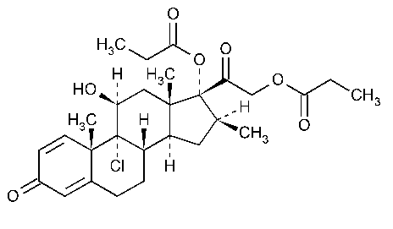
Figure 2: Structure of formoterol (eformoterol) fumarate dihydrate
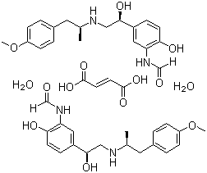
This product is a HFA based pMDI. The use of hydroflurocarbon as a propellant, rather than chlorofluorocarbon (CFC), allows the beclomethasone to be dispersed as a solution with a finer particle size than used when CFC is the propellant.
The metered doses for beclometasone dipropionate and formoterol fumarate are 100 µg and 6 µg, respectively, and which correspond to delivered doses of 84.6 µg and 5 µg, respectively.
There was a relatively high amount of alcohol in this solution relative to other inhaled medicines.

Shelf life
Seventeen months when stored between 2 to 8˚C (refrigerate, do not freeze), including a maximum of 2 months in use period when stored below 30°C from the date of dispensing, that is, 15 months refrigerated and 2 months in use.
There were no concerns about quality aspects of the individual components or of the drug product.

Pharmacokinetic results
Beclomethasone is rapidly converted to beclomethasone-17-propionate in the lungs and liver. Thus, most bioequivalence studies have used beclomethasone-17-propionate as the main analyte measured.

Study CP02
In most subjects, unchanged beclomethasone dipropionate plasma concentrations were only quantifiable up to 45 minutes after administration, therefore the terminal half-life and area under the plasma concentration time curve (AUC) could not be established. On average, the concentration at the first post-dose sampling time and AUC of beclomethasone were higher after administration with Fostair than with the CFC combination. This confirmed the better lung deposition of the extra fine formulation, despite a lower dose of the beclomethasone (400 μg) compared to the reference formulation (1000 μg). The analysis of variance (ANOVA) model led to a 151% estimate of the test versus reference ratio for observed maximum plasma concentration (C_{max}). The difference was not statistically significant due to the high intra-subject variability (coefficient of variation (CV) = 69.7%), and the wide 90% confidence interval (94.1 to 241.2%).
Overall, systemic exposure to beclometasone-17-propionate (C_{max} and AUC) were lower after administration of the proposed fixed dose (Fostair) product at a dose of 400 µg beclomethasone and 24 µg formoterol as compared to a free combination treatment of Becotide Forte (CFC) at a dose of 1000 µg and extra fine formoterol HFA at a dose of 24 µg.

Study CP07
Study CP07 compared a single dose of 400µg beclomethasone/24 µg formoterol to single doses of beclomethasone dipropionate HFA pMDI (Qvar) and formoterol fumarate HFA pMDI (Atimos) using 4 doses of a 100 µg strength product and 4 doses of a 6 µg product. These results are not entirely relevant to this submission due to a different dose FDC.

Device
The actuator is coupled with a dose counter.
The aerodynamic performance size distribution comparison of Australian and overseas sourced inhalation reference products was performed.
The chemistry evaluator concluded that the appearances of the Australian and overseas products were the same. The comparison did not completely fulfil the TGA guidance requirements for evidence that the overseas and Australian reference products are identical. However, in this instance, the tomographic data provided was considered more applicable in determining the same valve is in use.

Nonclinical
The nonclinical evaluator recommended approval after the sponsor made the required changes to the PI.
The following points were summarised from the nonclinical evaluation:
- Synergistic bronchodilatory and pulmonary anti-inflammatory activity was shown with beclometasone dipropionate and formoterol fumarate dihydrate in combination in animals, offering support for utility of the product for the proposed indications.
- Safety pharmacology studies conducted with the combination revealed some effects on central nervous system (CNS), cardiovascular, respiratory and gastrointestinal function, but at doses that are significantly higher than the maximum recommended dose in patients. These are seen to be principally attributable to the formoterol component.
- The metabolic pathways for beclometasone dipropionate and formoterol in humans are distinct, with beclometasone dipropionate metabolised by esterases and cytochrome P450 (CYP) enzymes, and formoterol primarily by direct glucuronidation. No pharmacokinetic interaction between beclometasone dipropionate and formoterol fumarate dihydrate is expected. Pharmacokinetic (PK) interactions were not investigated in laboratory animal species.
- Repeat dose toxicity studies by the inhalational route of up to 13 weeks duration in rats and dogs revealed no novel or obvious exacerbated toxicity with beclometasone dipropionate and formoterol fumarate dihydrate in combination (at the clinical dose ratio). Findings represented known class effects of corticosteroids and β2-adrenoceptor agonists. Target organs included the thymus, adrenal gland, epidermis, gall bladder and heart.
- Beclometasone dipropionate and formoterol fumarate dihydrate, tested in combination, were not genotoxic. Carcinogenicity studies were not performed with the combination and are not required.
- Disruption of oestrus cycling, increased duration of gestation, dystocia, increased litter loss, decreased fetal and pup weight, increased fetal visceral variations (but not malformations), impaired fetal ossification, decreased perinatal survival of pups, and impaired reproductive function of the female offspring were seen with the combination in rats. The tocolytic effect of formoterol is well known and described in the PI. Pregnancy Category B3, as the sponsor proposes, is appropriate.

Clinical
The following pivotal efficacy/safety studies were included in the clinical dossier:
- Asthma indication: Study CT07 and Study CCD-0605-PR-0021 (severe asthma study).
- COPD indication: Study CT01 and Study CT02.

Pharmacology
The Fostair pMDI has an extra fine particle size (< 1.1 µm) fractions for beclometasone dipropionate and formoterol which allows more drug to be delivered to the lungs, and less delivered to the oropharynx, than the CFC formulation. The extra fine formulation was designed to be equipotent to the CFC formulation in a 1:2.5 ratio, that is, 100 µg beclometasone dipropionate HFA equal to 250 µg beclometasone dipropionate CFC.
Beclomethasone dipropionate has high pulmonary absorption, low first past metabolism. This makes it more likely to be systemically absorbed than other inhaled steroids. It is metabolised to beclometasone-17-dipropionate in the lung and liver, which is also active and higher receptor binding than beclometasone dipropionate. The systemic availability of the active metabolite arises from lung and from gastrointestinal absorption of the swallowed dose. The bioavailability of swallowed beclomethasone dipropionate is negligible; however, pre-systemic conversion to beclometasone-17-monopropionate results in 41% of the dose being absorbed as the active metabolite. There is an approximately linear increase in systemic exposure with increasing inhaled dose. The absolute bioavailability following inhalation is approximately 2% and 62% of the nominal dose for unchanged beclometasone dipropionate and beclometasone-17-monopropionate respectively. The terminal elimination half-lives are 0.5 hours and 2.7 hours for beclomethasone dipropionate and beclometasone-17-monopropionate, respectively.
Beclomethasone dipropionate is ranked second to fluticasone (by 3 fold) and above budesonide (by 100 fold) in terms of lipophilicity. High lipophilicity is associated with increased deposition in lung tissue, slow release from the lung lipid compartment, increased affinity for the glucocorticoid receptor, and prolonged glucocorticoid receptor occupancy.
Following inhalation, formoterol is absorbed both from the lung and from the gastrointestinal tract. The fraction of an inhaled dose that is swallowed after administration with a metered dose inhaler (MDI) may range between 60% and 90%. Peak plasma concentrations of unchanged drug occur within 0.5 to 1 hours after oral administration. The elimination half-life determined after oral administration is 2 to 3 hours. Absorption of formoterol is linear following inhalation of 12 to 96 μg of formoterol fumarate. It is widely metabolised in the liver. The data on the terminal elimination half-life (2 to 10 hours) and renal excretion (6 to 67%) is variable according to route of administration or dose.
Six PK/pharmacodynamic (PD) studies were submitted; in summary:
- Study CP02: this study compared the systemic absorption and PD effect of Fostair versus separately administered Becotide (CFC) and formoterol. There was a greater C_{max} and AUC for beclometasone dipropionate with Fostair (despite the lower dose) than CFC beclometasone dipropionate. This is consistent with the greater pulmonary deposition and subsequent absorption of the HFA formulation.
- Study CP04: this study showed similar exposure to becomethasone dipropionate with or without charcoal block, indicating low oral absorption and high pulmonary absorption. Absorption was greatly increased by the spacer.
- Study CP01: this study showed no evidence of PK interaction between monocomponents and FDC.
- Study CP06: examined lung deposition in health volunteers, patients with moderate to severe asthma and stable COPD. There was slightly more distribution of the drugs in the central airways of those with asthma and COPD than there was for healthy volunteers.

Doses
The dose of beclomethasone was based upon similar doses to other ICS taking into account the local deposition, relative potency of the steroid.
The dose of formoterol is similar to that in other formoterol inhaled medicines. The sponsor submitted a number of PD studies examining the dose effect of formoterol to demonstrate a dose dependent effect. The Delegate agrees with the evaluator that above a total daily dose of 12 µg there is large variability in response, and a lot of cross over in confidence intervals between the 12, 24 and 48 µg dose.

Efficacy

Asthma

Study CT07
Study design: Study CT07 was a 48 week, Phase III, double blind, randomised, 2 arm parallel group study in asthmatic patients not fully controlled on ICS (with or without LABA). The study was designed to show superiority of Fostair as maintenance plus reliever therapy compared to Fostair as maintenance and salbutamol as reliever therapy. The primary efficacy endpoint was time to first severe asthma exacerbation.
Active treatment: Fostair, 1 inhalation twice daily plus Fostair as needed (up to 6 inhalations daily), maintenance and reliever therapy (MART) regimen.
Comparator: Fostair, 1 inhalation twice daily plus salbutamol as needed (PRN).
Patients were included if they had asthma for > 6 months, forced expiratory volume in one second (FEV₁) > 60% of predicted, at least one exacerbation per year, and were on ICS +/- LABA.

Results
Baseline FEV₁ was 74%, suggestive of mild airway obstruction. The mean ICS dose was 1100 µg/day (high dose range).
Fostair given as preventer and reliever medication significantly prolonged the time to first severe asthma exacerbation compared to Fostair as preventer and Ventolin (salbutamol) as reliever (p < 0.001 between groups). The hazard ratio between Fostair and Ventolin was 0.636 (95% confidence interval (CI) 0.494 to 0.820). The rate ratio for severe exacerbations was 0.66 (0.546 to 0.796) favouring the MART treatment. There was an improvement of around 110 ml in FEV₁ in both treatment groups. There was no significant difference in the amount of reliever medication used in treatment groups.

Study CCD-0605-PR-0021
Study design: Phase III, 3 arm parallel group randomised controlled trial (RCT) in patients with severe persistent symptomatic asthma. The study was performed between 2008 and 2009. This study was included in the dossier to support safety, as the dose of beclomethasone used was more than that proposed to be marketed.
At Visit 1 (screening visit), patients with severe persistent symptomatic asthma in need of a step up in therapy were selected. It was followed by a 2 week run in period when all patients received beclomethasone HFA inhaler 250 µg 2 inhalations twice daily (BD).
Treatment groups were:
- Beclometasone dipropionate 200 µg/formoterol 6 µg, 2 puffs BD (this higher strength puffer is licenced in Europe [Information redacted]) using pMDI.
- Beclomethasone 2000 µg/day HFA.
- Seretide (fluticasone propionate/salmeterol xinafoate) 500/50 BD via Accuhaler.
Patients were treated for 24 weeks.
The study was designed as a non-inferiority study between beclometasone dipropionate/formoterol fumarate dihydrate and Seretide for change in FEV₁, and a superiority study of beclometasone dipropionate/formoterol fumarate dihydrate versus beclometasone dipropionate for symptom scores. It was estimated that a sample size of 191 patients per treatment group was required to assure a power of 90% for the non-inferiority testing of beclometasone dipropionate/formoterol fumarate dihydrate versus Seretide for pre-dose FEV₁. In addition, this sample size was able to provide 90% power for superiority testing of beclometasone dipropionate/formoterol fumarate dihydrate versus beclometasone dipropionate monotherapy, assuming a 10% difference in scores.

Results
Of 721 patients who were randomised, 603 completed the study and 118 withdrew. At screening, 35% were on ICS/LABA, 56% were on ICS.
Superiority to beclometasone dipropionate: there was no clinically or statistically significant difference in FEV₁ or % change in symptom score between beclometasone dipropionate/formoterol fumarate dihydrate and beclometasone dipropionate. Thus, the criteria for superiority was not met.
Non-inferiority: there was no significant difference in FEV₁ between beclometasone dipropionate/formoterol fumarate dihydrate and Seretide. The criteria for non-inferiority was met (although at a higher dose of beclometasone dipropionate than is proposed in Fostair).
Secondary endpoints: There was a greater improvement in morning and evening peak expiratory flow (PEF) and rescue medication use in the beclometasone dipropionate/formoterol fumarate dihydrate and Seretide group compared to the beclometasone dipropionate group.
There was no significant difference in asthma symptom score or asthma exacerbations between the beclometasone dipropionate/formoterol fumarate dihydrate group, beclometasone dipropionate group or Seretide group.
The Delegate noted that the results of this study are difficult to interpret. The lack of superiority is not consistent with known greater efficacy of ICS/LABA for other inhaled steroids. Possible reasons for lack of effect include that study may have been underpowered, or that at a higher dose of beclomethasone there was no additional effect of LABA.

Study CT03
Study CT03 was a RCT comparing Fostair (2 puffs BD) to beclometasone dipropionate (250 µg 2 puffs BD, as dry powder inhaler (DPI)) and formoterol fumarate dihydrate (12µg 1 puff BD), given separately, tested for non-inferiority and beclometasone dipropionate alone tested for superiority. There was a 2 week wash out period followed by a 24 week treatment period. The patient population had moderate to severe asthma and were on ICS +/- LABA. The primary efficacy endpoint was morning PEF. Other variables were evening PEF, daily PEF variability, pulmonary function tests, and symptoms.

Results
A total of 645 patients were randomised. Non inferiority to beclomethasone and formoterol was established. Superiority to beclometasone dipropionate alone was also established, the difference in PEF was around 30 mL (10%). The data was supported by a number of secondary measures including pulmonary function test from home monitoring (Spirotel), percentage of days, nights and complete days free of asthma symptoms and short acting beta₂ agonist (SABA) consumption (puffs/day). The percentage of patients with one or more than one asthma exacerbation was similar across the CHF 1535 (Fostair product development name) and beclometasone dipropionate + formoterol fumarate dihydrate treatment groups and higher in the beclometasone dipropionate alone treatment group.
Table 2: Study CT03 Non-inferiority analysis of CHF 1535 (Fostair) versus beclometasone dipropionate + formoterol fumarate dihydrate for morning peak expiratory flow (L/min)
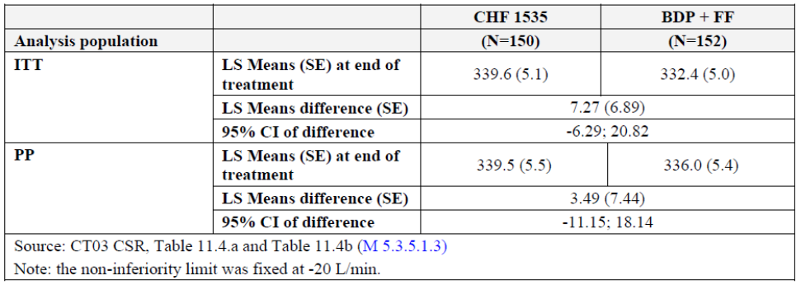
BDP = beclometasone dipropionate, CI = confidence interval, FF = formoterol fumarate dihydrate, ITT = intent to treat, LS = least squares, PP = per protocol, SE = standard error.
Table 3: Study CT03 Superiority analysis of CHF-1535 (Fostair) versus beclometasone dipropionate monotherapy for morning peak expiratory flow (L/min)
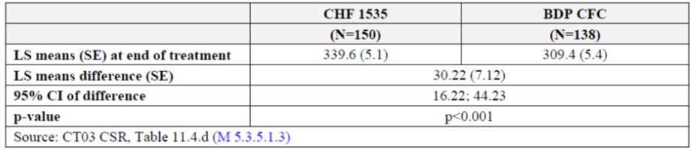

Study CT04
Study CT04 was a comparative study of Fostair (1 puff BD) and beclometasone dipropionate (2 puffs 250 µg CFC pMDI twice daily). There was a 2 week run in period followed by a 12 week treatment period. Patients had mild to moderate asthma.

Results
A total of 397 patients were randomised. There was an improvement in PEF of over 300 L/min in both groups. The increase in PEF of Fostair over beclomethasone was 22.8 L/min and statistically significant. There was no major difference in asthma symptom scores between groups. There were less exacerbations in the Fostair than the beclomethasone treatment group. It is important to note in this study that the dose of beclomethasone used in Fostair was relatively lower than that in the beclometasone dipropionate group.
Table 4: Study CT04 Morning peak expiratory flow at endpoint, main analysis (intent to treat population)
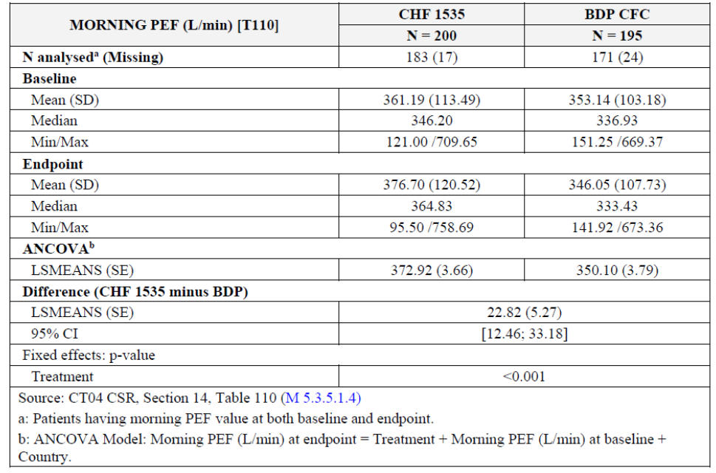
ANCOVA = analysis of covariance, SD = standard deviation; CHF 1535 = Fostair treated population

Supportive studies
Study CT01 showed equivalent efficacy in FEV₁ between beclometasone dipropionate HFA 400µg and beclometasone dipropionate 1000µg CFC. There was also no significant difference in FEV₁, symptom scores or rescue medication use.
Table 5: Study CT01 Morning peak expiratory volume, results of analysis of equivalence
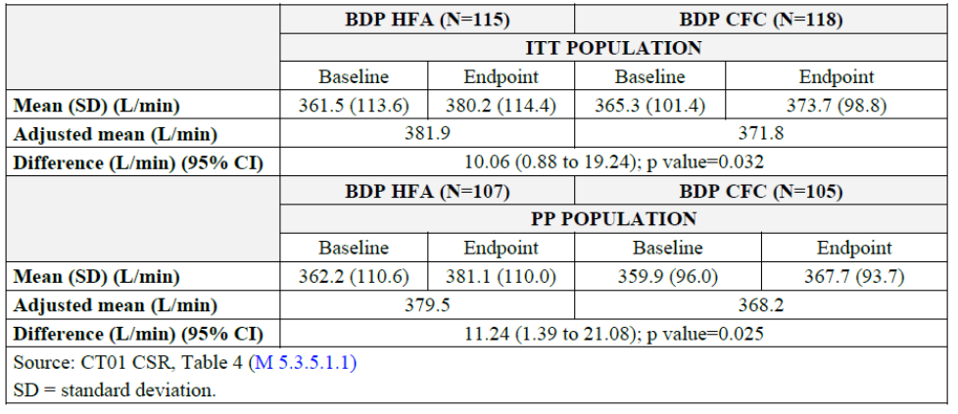
Study CT02 showed equivalent efficacy between formoterol fumarate HFA 6 µg 2 puffs and formoterol fumarate DPI 12 µg 1 puff. Study CT06 showed equivalence in efficacy between Foster and Seretide (fluticasone 125 µg/salmeterol 25µg pMDI).
Study CT05-spacer was a 12 week randomised, double blind, double dummy, 3 arm parallel group study comparing the efficacy and safety of Fostair (administered usual way or in a spacer) to beclometasone dipropionate HFA pMDI 250 µg 2 puffs BD in adolescent patients with moderate to severe asthma. The primary efficacy variable was PEF, measured by an electronic meter at home. 448 patients were randomised. The data on the PEF was found to be of poor quality therefore not used in the analysis of results. There was no difference in lung function parameters or symptoms when Fostair was used with or without a spacer, but it was not clear if this was a comparison of the same patients using spacer or not, or a different group of patients in each group.

Chronic obstructive pulmonary disease

Study CT01-COPD
This was a 48 week, 3 arm, parallel group RCT of Fostair versus budesonide plus formoterol DPI (Symbicort) versus formoterol DPI in patients with stable severe COPD. The study was performed in 2006 to 2008.
The primary objective was to demonstrate that Fostair was non-inferior to Symbicort (endpoint: change in pre-dose FEV₁ at Baseline to 48 weeks) and superior to formoterol monotherapy (endpoint: number of COPD exacerbations). Secondary objectives included changes in St George’s Respiratory Questionnaire (SGRQ), COPD symptoms, pulmonary function parameters, use of rescue medication, number of moderate and severe exacerbations
The treatment period was 48 weeks. The treatment period was preceded by a 4 week run in period, during which patients discontinued all COPD treatments and were treated with the combination ipratropium 20 µg/salbutamol 100 µg, two puffs three times daily and ‘rescue’ salbutamol given on an as needed basis.
The patient population had moderate to severe COPD (percent predicted forced expiratory volume in one second (pp FEV₁) 30 to 50%, at least one exacerbation in the past 12 months).
The sample size was based on the criteria for superiority and non-inferiority. Using a more conservative logistic regression approach and a binary variable, the study had a power of at least 86% for exacerbations. The study had a power of more than 80% to show non-inferiority for FEV₁ using a non-inferiority margin of 100 mL.

Results
There were 703 patients randomised. At Baseline, the mean age was 63 years, 62% were ex-smokers and 37% were current smokers. Inhaled SABA and LABA, given as single agents, were used at Baseline by around 75% of subjects. ICS given as single agents or in free combination with bronchodilators were used by around 40%, inhaled short and long acting anticholinergics given as single agents were used in around 50%.
Fostair was non-inferior to Symbicort for FEV₁.
Table 6: Study CT01-COPD Primary efficacy outcomes, change in pre-dose morning forced expiratory volume in one second
BUD/FORM = budesonide plus formoterol DPI (Symbicort), FORM = formoterol; CHF 1535 = Fostair treated population
Fostair was not superior to formoterol alone in terms of exacerbations. However, the reduction in exacerbations was much less than anticipated in the power calculations, thus it is likely that the study was underpowered for this outcome.
Table 7: Study CT01-COPD Results of COPD exacerbations in the intent to treat and per protocol population
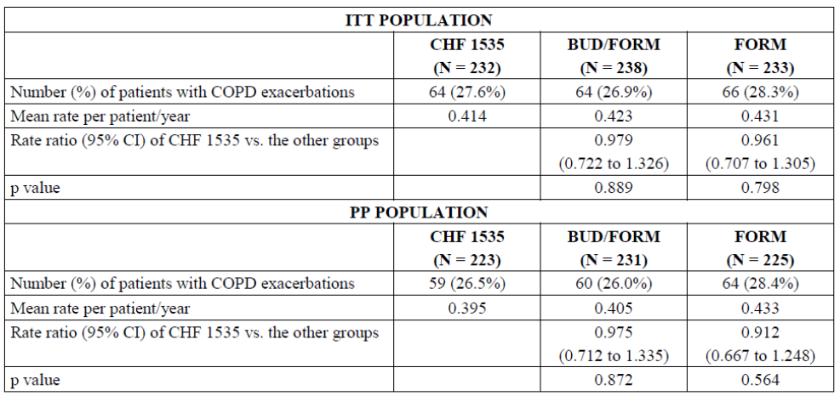
CHF 1535 = Fostair treated population
The number of patients with COPD exacerbations leading to hospitalisation was 13 (5.6%) in the CHF 1535 (Fostair) group, 7 (2.9%) in the budesonide plus formoterol group and 8 (3.4%) in the formoterol group. The mean rate per patient/year was 0.074 in the CHF 1535 (Fostair) group, 0.033 in the budesonide plus formoterol group and 0.040 in the formoterol group.
There was an increase in pre-dose FEV₁ in all treatment groups, more in the CHF 1535 (Fostair) and budesonide plus formoterol groups than formoterol group.
Figure 3: Study CT01-COPD Mean changes in forced expiratory volume in one second across treatment groups
There was an improvement in SGRQ in all treatment groups, with no significant difference between groups. The BODE index, dyspnoea score, and use of rescue medication decreased more in the Fostair and Symbicort groups.

Study CT02-COPD
This was a 48 week, double blind, 2 arm, randomised controlled parallel group study. The study was performed between 2009 and 2012. The study was designed to show that Fostair was superior to formoterol in terms of COPD exacerbation rate and pulmonary function.
This study included a pre-screening visit, a 2 week run in phase and a 48 week treatment phase. During the 2 week run in phase, all patients discontinued their usual COPD treatments (except tiotropium and oral theophylline, which could be continued) and began treatment with formoterol (12 μg), one puff, twice daily. At the end of the run-in phase patients were randomised to either continue formoterol or changed to Fostair.
The patient population was similar as in Study CT01-COPD. However, more patients were enrolled to give the study a power of 82.6% to detect a 0.16 improvement in the rate of exacerbations between Fostair and formoterol, and a 50 mL difference in pre-dose morning FEV₁.
At Baseline, around 60% of patients were on ICS/LABA combination. The majority of patients (around 70%) required SABA as reliever. Around 50% of patients in both arms were on tiotropium and they continued treatment during study period.

Results: co-primary endpoints
COPD exacerbations: patients treated with Fostair had significantly lower rate of COPD exacerbations, compared to formoterol group (rate ratio= 0.719 (95% CI: 0.619, 0.837), p < 0.001). However, the exacerbations tended to be more severe and require emergency treatment or hospitalisation in the dual therapy treatment group, but more likely to require antibiotics or steroids in the formoterol group.
The mean FEV₁ change from Baseline was higher in the Fostair than in the formoterol group (0.085 ± 0.229 L versus 0.014 ± 0.216 L). The treatment difference was less than 100 mL but statistically significant for (0.069 L, 95% CI: 0.043, 0.095, p < 0.001). There was an improvement in SGRQ in the Fostair group but not formoterol group.

Safety

Asthma
The adverse events (AEs) noted were consistent with the known AE profile of ICS and LABA.

Cortisol from Study CCD-0605-PR-0021
The mean and median values of morning serum cortisol of the beclomethasone monotherapy group decreased slightly from Baseline while those of the Fostair and Seretide groups increased slightly from Baseline at all time points. However, the difference was small and the range large.
Only 13% of patients had data available from adrenocorticotropic hormone (ACTH) stimulation tests. The data in the dossier is very difficult to interpret. The most important outcome is how many patients failed to have the predetermined increase in serum cortisol after ACTH. In the dossier, a mean pre and post stimulation cortisol is reported. It is also not entirely clear if patients stopped ICS prior to the test or if the tests were all performed in the morning. Furthermore, as many patients were on inhaled steroids for months prior to the study, and adrenal suppression can persist for > 3 months after stopping the ICS, it would be difficult to determine if any adrenal suppression seen was from the study drug or previous treatment.

COPD
The risk of pneumonia associated with ICS when used for COPD is well known.
In Study CT01, pneumonia was reported in relatively more patients (2.1%) in the Fostair group and in the budesonide plus formoterol group (2.9%) than in the formoterol group (0.4%).
In Study CT02, an increased proportion of patients in the Fostair group developed pneumonia, compared to the formoterol fumarate group (23 patients (3.8%) versus 11 patients (1.8%)). An increased incidence of oral candidiasis (18 patients (3.0%) versus 4 patients (0.7%)), lower respiratory tract infection (9 patients (1.5%) versus 4 patients (0.7%)) and atrial fibrillation (7 patients (1.2%) versus 2 patients (0.3%)) was also reported in the Fostair groups compared to formoterol fumarate groups.

Risk management plan
During the application the risk management plan (RMP) was submitted, however it was not required as the application was for a new combination of previously registered products. The combination therapy is standard clinical practice, and no additional risk mitigation measures would be required.

Risk-benefit analysis

Delegate’s considerations
Treatment of moderate/severe asthma with ICS/LABA is well established, and there are a number of different combinations of ICS/LABA registered for this indication.
That being said, it is not possible to directly compare the different ICS due to a number of factors that affect efficacy and safety of the drug. These include type of corticosteroid, PK properties of the drug, type of inhaled device (DPI or pMDI), properties of the device, and size of particles in the lungs. In addition, ICS have a flat dose response curve for PK and efficacy. Added to this is the high variability in absorption of the drug and the variable nature of symptoms in both asthma and COPD. The registration of an ICS/LABA combination cannot be justified on the basis of other ICS/LABA being used for this indication without clear understanding of the pharmacology, efficacy and safety of the proposed drug and device.
The clinical trials have demonstrated that Fostair (at a total daily dose of 400 µg beclomethasone/24 µg formoterol) has similar efficacy to other ICS/LABA such as Symbicort (1000 µg budesonide/24 µg formoterol) and Seretide (fluticasone 500 µg/salmeterol 50µg). The Delegate is satisfied with the data submitted that show the international reference products were similar to those in Australia.
In addition, there is evidence that Fostair is more efficacious than the same dose of beclomethasone alone for asthma, and Fostair is more efficacious than formoterol alone for COPD.
The sponsor has proposed that a dose of 200µg beclomethasone/12 µg formoterol daily would be indicated for mild asthma, and 400 µg beclomethasone/24µg formoterol for moderate asthma, and that treatment should be stepped up if patients do not respond. Most clinical trials used the higher dose for moderate to severe asthma, only one study (Study CT05) used the lower dose in mild to moderate asthma. [Information redacted] Overall, the dosing recommendations appear reasonable. However, it is noted that there is only one strength available; thus, the ability of patients to titrate the doses is limited.
There is a range of recognised endocrine safety issues related to long term steroid use. Hypothalamic pituitary axis (HPA) suppression from use of high dose, long term systemic and inhaled steroids and adrenal insufficiency (AI) on cessation of steroids is well described in the clinical community. The data submitted in relation to HPA in this submission is limited and difficult to interpret. The sponsor has measured morning cortisol, which is a helpful screen, however, what is of most value are those levels < 100 nmol/L which is strongly predictive of adrenal insufficiency or > 500 nmol/L which excludes it. Fostair has a high potential risk of AI due to high pulmonary absorption of beclomethasone and relative lipophilicity.13 Levels of 400µg daily are listed as having high risk of AI. It is important that the potential risk of adrenal insufficiency be included in the PI.
The clinical trials submitted were performed some time ago, and are considerably smaller and with less sensitive efficacy variables than more recent applications. The Delegate disagreed with the evaluator that PEF is an unacceptable measure of efficacy; it is accepted in the European Medicines Agency (EMA) guidelines. The literature is contradictory as to its correlation with FEV₁. On the other hand, there is much more variability in this measure, thus to establish a consistent difference in this is more difficult than to find a difference in FEV₁.,

Proposed action
After reviewing the data from the submission, the Delegate recommends approval of the registration of the FDC of beclomethasone and formoterol for the proposed indications. The final approval is subject to the recommended amendments to the PI.

Advisory Committee Considerations
The Delegate did not refer this application to the Advisory Committee on Medicines (ACM) for advice.

Outcome
Based on a review of quality, safety and efficacy, the TGA approved the registration of Fostair (100 µg beclometasone dipropionate and 6 µg formoterol (eformoterol) fumarate dihydrate per actuation) pressurised inhalation solution, indicated for:
Asthma
Fostair is indicated in adults (18 years and older) in the regular treatment of asthma where use of a combination product (inhaled corticosteroid and long-acting beta2-agonist) is appropriate:
- patients not adequately controlled with inhaled corticosteroids (ICS) and 'as needed' inhaled rapid-acting beta2-agonist or
- patients already adequately controlled on both ICS and long-acting beta2-agonists (LABA).
COPD
Symptomatic treatment of adults with severe COPD (FEV1 < 50% predicted normal) and a history of repeated exacerbations, who have significant symptoms despite regular therapy with long-acting bronchodilators.

Specific conditions of registration applying to these goods
This approval does not impose any requirement for the submission of Periodic Safety Update reports. The sponsor should note that it is a requirement that all existing requirements for the submission of PSURs as a consequence of the initial registration or subsequent changes must be completed.

Attachment 1. Product Information
The PI for Fostair approved with the submission which is described in this AusPAR is at Attachment 1. For the most recent PI, please refer to the TGA website at <https://www.tga.gov.au/product-information-pi>.

Therapeutic Goods Administration
PO Box 100 Woden ACT 2606 Australia
Email: info@tga.gov.au Phone: 1800 020 653 Fax: 02 6232 8605
https://www.tga.gov.au

World Health Organization, Fact sheet on COPD. Available from the WHO website. Last updated 1 December 2017
World Health Organization, Fact sheet on Asthma. Available from the WHO website. Last updated 31 August 2017
Australian Institute of Health and Welfare 2019. Asthma. Cat. no. ACM 33. Canberra: AIHW.
Australian Institute of Health and Welfare 2019. Chronic obstructive pulmonary disease (COPD). Cat. no. ACM 35. Canberra: AIHW.
Papi, A., et al., Asthma. Lancet, 2018. 391(10122): 783-800.
Global Initiative for Asthma (GINA). Global Strategy for Asthma Management and Prevention, 2018. Available from: ginaasthma.org. The Global Initiative for Asthma (GINA) was established by the World Health Organization and the National Heart Lung and Blood Institute (USA) in 1993, to increase awareness about asthma among health professionals, public health authorities and the community, and to improve asthma prevention and management through a coordinated worldwide effort. GINA prepares scientific reports on asthma, encourages dissemination and implementation of the recommendations, and promotes international collaboration on asthma research.
Global Initiative for Chronic Obstructive Lung Disease (GOLD), Pocket Guide to COPD Diagnosis, Management, And Prevention: A Guide for Health Care Professionals, 2017. Available from goldcopd.org. The Global Initiative for Chronic Obstructive Lung Disease (GOLD) was launched in 1997 in collaboration with the National Heart, Lung, and Blood Institute, National Institutes of Health (USA) and the World Health Organization. GOLD’s program is determined and its guidelines for COPD care are shaped by committees made up of leading experts from around the world. GOLD prepares scientific reports on COPD, encourages dissemination and implementation of the recommendations, and promotes international collaboration on COPD research.
Global Initiative for Chronic Obstructive Lung Disease. Global Strategy for the Diagnosis, Management and Prevention of COPD. 2018 . Available from goldcopd.org.
Lung Foundation of Australia. The COPD-X plan. Australian and New Zealand Guidelines for the Management of COPD. 2018. Available from copdx.org.au.
Global Initiative for Asthma. Pocket Guide for Asthma Management and Prevention. 2019. Available from ginaasthma.org.
TGA guidance on Inhalation and nasal spray registered medicines, Application pathways and data requirements for registration of new generic medicines and variations to existing medicines. Available from the TGA website.
Australian Pregnancy Category B3: Drugs which have been taken by only a limited number of pregnant women and women of childbearing age, without an increase in the frequency of malformation or other direct or indirect harmful effects on the human fetus having been observed. Studies in animals have shown evidence of an increased occurrence of fetal damage, the significance of which is considered uncertain in humans.
Johnson, M. Pharmacodynamics and pharmacokinetics of inhaled glucocorticoids. J Allergy Clin Immunol; 1996; 97: 169-176.
St George's Respiratory Questionnaire (SGRQ) is a disease specific quality of life assessment tool used in both COPD and asthma. The questionnaire contains 50 items and scores range from 0 to 100, with higher scores indicating more limitations.
Sponsor clarification: the number of exacerbations during the study was lower than expected.
Body-mass index, airflow Obstruction, Dyspnea, and Exercise (BODE) index. A tool for survival prediction in patients with COPD. Scores range from 0 to 10 points, with higher scores indicating a greater risk of death.
The sponsor must still comply with routine product vigilance and risk minimisation requirements.
Ahmet, A; Mokashi, A; Adrenal suppression from gluococorticoids: preventing an iatrogenic cause of morbidity and mortality in children. BMJ Paediatrics Open, 2019;3:e000569. doi:10.1136/bmjpo-2019-000569
Sponsor clarification: AI is a class effect of ICS and this issue was ultimately resolved and downgraded in the final approved PI.
European Medicines Agency (EMA), Committee for Medicinal Products for Human Use (CHMP) Guideline on the clinical investigation of medicinal products for the treatment of asthma, CHMP/EWP/2922/01 Rev.1, 22 October 2015.
Giannini, D; Paggiario, PL; et al. Comparison between peak expiratory flow and forced expiratory volume in one second (FEV1) during bronchoconstriction induced by different stimuli. Journal of Asthma. 1997. 34(2): 105-111.
Pino, JM; Garcia-Rio, F; et al. Value of the peak expiratory flow in bronchodynamic tests. Allergol Immunopathol (Madr) 1996; 24 (2): 54-57.
The ACM provides independent medical and scientific advice to the Minister for Health and the Therapeutic Goods Administration (TGA) on issues relating to the safety, quality and efficacy of medicines supplied in Australia including issues relating to pre-market and post-market functions for medicines. The Committee is established under Regulation 35 of the Therapeutic Goods Regulations 1990. Members are appointed by the Minister. The ACM was established in January 2017 replacing Advisory Committee on Prescription Medicines (ACPM) which was formed in January 2010. ACM encompass pre and post-market advice for medicines, following the consolidation of the previous functions of the Advisory Committee on Prescription Medicines (ACPM), the Advisory Committee on the Safety of Medicines (ACSOM) and the Advisory Committee on Non-Prescription Medicines (ACNM). Membership comprises of professionals with specific scientific, medical or clinical expertise, as well as appropriate consumer health issues relating to medicines.

