May 2021

Australian Public Assessment Report for Baricitinib
  - Proprietary Product Name: Olumiant
  - Sponsor: Eli Lilly Australia Pty Ltd

About the Therapeutic Goods Administration (TGA)
- The Therapeutic Goods Administration (TGA) is part of the Australian Government Department of Health and is responsible for regulating medicines and medical devices.
- The TGA administers the Therapeutic Goods Act 1989 (the Act), applying a risk management approach designed to ensure therapeutic goods supplied in Australia meet acceptable standards of quality, safety and efficacy (performance) when necessary.
- The work of the TGA is based on applying scientific and clinical expertise to decision-making, to ensure that the benefits to consumers outweigh any risks associated with the use of medicines and medical devices.
- The TGA relies on the public, healthcare professionals and industry to report problems with medicines or medical devices. TGA investigates reports received by it to determine any necessary regulatory action.
- To report a problem with a medicine or medical device, please see the information on the TGA website <https://www.tga.gov.au>.

About AusPARs
- An Australian Public Assessment Report (AusPAR) provides information about the evaluation of a prescription medicine and the considerations that led the TGA to approve or not approve a prescription medicine submission.
- AusPARs are prepared and published by the TGA.
- An AusPAR is prepared for submissions that relate to new chemical entities, generic medicines, major variations and extensions of indications.
- An AusPAR is a static document; it provides information that relates to a submission at a particular point in time.
- A new AusPAR will be developed to reflect changes to indications and/or major variations to a prescription medicine subject to evaluation by the TGA.

Copyright
© Commonwealth of Australia 2021
This work is copyright. You may reproduce the whole or part of this work in unaltered form for your own personal use or, if you are part of an organisation, for internal use within your organisation, but only if you or your organisation do not use the reproduction for any commercial purpose and retain this copyright notice and all disclaimer notices as part of that reproduction. Apart from rights to use as permitted by the Copyright Act 1968 or allowed by this copyright notice, all other rights are reserved and you are not allowed to reproduce the whole or any part of this work in any way (electronic or otherwise) without first being given specific written permission from the Commonwealth to do so. Requests and inquiries concerning reproduction and rights are to be sent to the TGA Copyright Officer, Therapeutic Goods Administration, PO Box 100, Woden ACT 2606 or emailed to <tga.copyright@tga.gov.au>.

Contents
List of abbreviations 4
I. Introduction to product submission 6
Submission details 6
Product background 7
Regulatory status 8
Product Information 9
II. Registration timeline 9
III. Submission overview and risk/benefit assessment 10
Quality 10
Nonclinical 10
Clinical 10
Risk management plan 40
Risk-benefit analysis 42
Outcome 50
Attachment 1. Product Information 51

List of abbreviations
Abbreviation | Meaning
ACM | Advisory Committee on Medicines
ADSS | Atopic Dermatitis Sleep Scale
AE | Adverse event
ARTG | Australian Register of Therapeutic Goods
ASA | Australian-specific annex
DLQI | Dermatology Life Quality Index
EASI | Eczema Area and Severity Index
EASI50 | 50% improvement in Eczema Area and Severity Index score
EMA | European Medicines Agency (European Union)
EU | European Union
GFR | Glomerular filtration rate
HADS | Hospital Anxiety and Depression Scale
IGA | Investigator’s Global Assessment
JAK1 | Janus kinase 1
JAK2 | Janus kinase 2
LDL | Low density lipoproteins
MACE | Major adverse cardiovascular event
NRS | Numerical rating scale
PD | Pharmacodynamic(s)
PI | Product Information
PK | Pharmacokinetic(s)
POEM | Patient Oriented Eczema Measure
PSTAT3 | Phosphorylated signal transducer and activator of transcription 3
SCORAD | Scoring Atopic Dermatitis (index)
SCORAD75 | 75% improvement in Scoring Atopic Dermatitis Index score
STAT3 | Signal transducer and activator of transcription 3
TEAE | Treatment-emergent adverse event
US(A) | United States (of America)
vIGA-AD | Validated Investigator Global Assessment for Atopic Dermatitis

I. Introduction to product submission

Submission details
Type of submission: | Extension of indications
Product name: | Olumiant
Active ingredient: | Baricitinib
Decision: | Approved
Date of decision: | 11 February 2021
Date of entry onto ARTG: | 11 February 2021
ARTG numbers: | 227905, 277917
Black Triangle Scheme: | Yes  This product will remain in the scheme for 5 years, starting on the date the new indication was approved
Sponsor’s name and address: | Eli Lilly Australia Pty Ltd  112 Wharf Road,  West Ryde, NSW, 2114
Dose form: | Tablet, film-coated
Strengths: | 2 mg, 4 mg
Containers: | Blister packs
Pack sizes: | 7 and 28 tablets
Approved therapeutic use: | Atopic Dermatitis  Olumiant is indicated for the treatment of moderate to severe atopic dermatitis in adult patients who are candidates for systemic therapy.
Route of administration: | Oral
Dosage: | Atopic Dermatitis  Therapy with Olumiant should be initiated and supervised by a dermatologist or physician with expertise in the management of atopic dermatitis.  The recommended dose of Olumiant is 2 mg once daily (see Product Information, Section 5 Pharmacological Properties/ Pharmacodynamic Properties: Clinical trials on atopic dermatitis; and Section 4.4 Special Warnings And Precautions: Use in hepatic impairment, Use in renal impairment, and Effects on laboratory tests).  A dose of 4 mg once daily may also be considered for patients who have not achieved sustained control of disease activity with 2 mg once daily. Dose tapering to 2 mg once daily should be considered once the patient has achieved sustained control of disease with 4 mg once daily.  Treatment should be discontinued in patients who show no evidence of therapeutic benefit after 8 weeks of treatment with 4 mg.  Olumiant may be used as monotherapy or in combination with topical corticosteroids. Topical calcineurin inhibitors may be used.  Combination with biologic immunomodulators, other Janus kinase (JAK) inhibitors, ciclosporin or other potent immunosuppressants has not been studied in patients with atopic dermatitis and is not recommended.  Olumiant is given orally with or without food.  For further information regarding dosage, refer to the Product Information.
Pregnancy category: | Pregnancy category D  Drugs which have caused, are suspected to have caused or may be expected to cause, an increased incidence of human fetal malformations or irreversible damage. These drugs may also have adverse pharmacological effects. Accompanying texts should be consulted for further details.  The use of any medicine during pregnancy requires careful consideration of both risks and benefits by the treating health professional. This must not be used as the sole basis of decision making in the use of medicines during pregnancy. The TGA does not provide advice on the use of medicines in pregnancy for specific cases. More information is available from obstetric drug information services in your State or Territory.

Product background
This AusPAR describes the application by Eli Lilly Australia Pty Ltd (the sponsor) to register Olumiant (baricitinib) 2 mg and 4 mg film-coated tablets for the following proposed extension of indications:
Olumiant is indicated for the treatment of moderate to severe atopic dermatitis in adult patients who are candidates for systemic therapy.
Atopic dermatitis is a common, chronic, inflammatory skin disease caused by skin barrier defects, immune dysregulation and genetic predisposition. Patients with moderate to severe atopic dermatitis suffer from multiple, intense and debilitating signs and symptoms that could affect their quality of life, such as skin inflammation, itch, sleep disturbance due to itch and skin pain.
Patients with mild atopic dermatitis are managed with emollients and mild- to moderate-potency topical corticosteroids. Topical calcineurin inhibitors are considered as an alternative or adjunct treatment to topical corticosteroids, especially when treatment with topical corticosteroids is neither advisable nor possible and when steroid-sparing treatment is needed in sensitive areas, such as face and skin folds.
Patients with moderate to severe atopic dermatitis require additional therapies to control their skin inflammation and alleviate symptoms. These additional therapies include phototherapy, high potency topical corticosteroids, and eventually when topical options fail to control the disease, systemic treatments. According to the sponsor, there are currently only two systemic drugs approved to treat moderate-to-severe atopic dermatitis: ciclosporin (an oral systemic agent approved only for severe atopic dermatitis), and dupilumab (an injectable (subcutaneous) systemic drug approved to treat moderate-to-severe atopic dermatitis). Both drugs have limitations in their usage. Ciclosporin can lead to irreversible renal toxicity, hypertension, and haematopoietic adverse events and is therefore not intended for long-term use. Dupilumab has limitations relating to the mode of administration of subcutaneous injection, such as patient anxiety and injection site reactions.
Due to the impact of the symptoms of moderate-to-severe atopic dermatitis on patients’ quality of life and the limited treatment options for these patients, there is an unmet need for novel treatments that can rapidly improve the symptoms while maintaining an overall long-term favourable benefit-risk profile. It is considered that the availability of an additional oral therapeutic option that can improve symptoms within days to weeks would address this need.
Baricitinib is a selective and reversible inhibitor of Janus kinase 1 (JAK1) and Janus kinase 2 (JAK2). Janus kinases are enzymes that transduce intracellular signals from cell surface receptors for a number of cytokines and growth factors involved in haematopoiesis, inflammation and immune function. Within the intracellular signalling pathway, JAKs phosphorylate and activate signal transducers and activators of transcription (STATs), which activate gene expression within the cell. Baricitinib modulates these signalling pathways by partially inhibiting JAK1 and JAK2 enzymatic activity, thereby reducing the phosphorylation and activation of STATs. The JAK-STAT pathway has been found to be a major signal transduction pathway for numerous pro-inflammatory cytokines involved in atopic dermatitis pathogenesis.

Regulatory status
Olumiant (baricitinib) received initial registration on the Australian Register of Therapeutic Goods (ARTG) on the 23 January 2018; for the following indication:
Olumiant is indicated for the treatment of moderate to severe active rheumatoid arthritis (RA) in adult patients who have responded inadequately, or who are intolerant, to one or more DMARDs.
Olumiant can be taken as monotherapy or in combination with cDMARDs, including methotrexate (MTX).
At the time the TGA considered this application, a similar application had been approved in the European Union (EU), and applications were under consideration in Switzerland (submitted in December 2019), the United States of America (USA; submitted on 14 June 2020).
For the EU, the similar application (submitted on 25 November 2019) was approved (via the EU’s Centralised Procedure) on 19 October 2020 for the following indication:
Atopic Dermatitis
Olumiant is indicated for the treatment of moderate to severe atopic dermatitis in adult patients who are candidates for systemic therapy.

Product Information
The Product Information (PI) approved with the submission which is described in this AusPAR can be found as Attachment 1. For the most recent PI, please refer to the TGA website at <https://www.tga.gov.au/product-information-pi>.

II. Registration timeline
The following table captures the key steps and dates for this application and which are detailed and discussed in this AusPAR.
Table 1: Timeline for Submission PM-2019-05319-1-1
Description | Date
Submission dossier accepted and first round evaluation commenced | 2 January 2020
First round evaluation completed | 10 June 2020
Sponsor provides responses on questions raised in first round evaluation | 7 August 2020
Second round evaluation completed | 11 September 2020
Delegate’s Overall benefit-risk assessment and request for Advisory Committee advice | 5 November 2020
Sponsor’s pre-Advisory Committee response | 12 November 2020
Advisory Committee meeting | 3 and 4 December 2020
Registration decision (Outcome) | 11 February 2021
Completion of administrative activities and registration on the ARTG | 11 February 2021
Number of working days from submission dossier acceptance to registration decision* | 216 days
*Statutory timeframe for standard applications is 255 working days

III. Submission overview and risk/benefit assessment
The submission was summarised in the following Delegate’s overview and recommendations.

Quality
There was no requirement for a quality evaluation in a submission of this type.

Nonclinical

Nonclinical summary
The nonclinical evaluation was summarised as follows:
Baricitinib reduced cytokine-induced progression of atopic dermatitis-like histopathology with reduced keratinocyte pSTAT3 levels; as a result of JAK1 and JAK2 inhibition, in a human neonatal foreskin cell model. No adverse findings were evident (for example, there was no evidence of epidermal thickening).
A juvenile rat toxicity study was submitted and evaluated for this submission even though the sponsor is not seeking juvenile use. Toxicity findings of clinical relevance in the juvenile animal study included immune effects: decreases in lymphocyte subsets and a reduction in T cell-dependent antibody responses. The target organs identified were lymphohaematopoietic tissues: bone marrow, mandibular and mesenteric lymph nodes, spleen and thymus (findings of minimal to mild reduced cellularity). Both targets have previously been identified in adult rats. There was evidence of degeneration/atrophy of the femoral head/neck, associated with degenerative joint disease at 25 mg/kg.

Conclusion and recommendation
Investigations into the mechanism of action of baricitinib in a three dimensional human skin model of atopic dermatitis lend support to the use of Olumiant in atopic dermatitis.
There were no significant findings of overt toxicity in juvenile rats to indicate any additional toxicity concerns for Olumiant. Overall, juvenile animals do not appear to be more prone to baricitinib toxicity than adults. However, it should be noted that there is little to no safety margin (animal: human area under the concentration-time curve at the maximum clinical dose) at the no observable adverse effect level in juvenile animals.
There are no objections on nonclinical grounds to the proposed extension of indications of Olumiant for the use in patients with atopic dermatitis.
The new nonclinical aspects of the draft PI are acceptable.

Clinical
The submission comprised of the following studies:
- One Phase II study:
  - Study JAHG: a multicentre, randomised, double-blind, placebo-controlled study to evaluate the safety and efficacy of baricitinib 2 mg, and 4 mg, once daily, in adult patients with moderate-to-severe atopic dermatitis.
- Four Phase III studies:
  - Study JAHL (also known as the BREEZE-AD1 trial): a multicentre, randomised, double-blind, placebo-controlled, Phase III study to evaluate the efficacy and safety of baricitinib in adult patients with moderate-to-severe atopic dermatitis.
  - Study JAHM (also known as the BREEZE-AD2 trial): a multicentre, randomised, double-blind, placebo-controlled, Phase III study to evaluate the efficacy and safety of baricitinib in patients with moderate to severe atopic dermatitis.
  - Study JAIY (also known as the BREEZE-AD7 trial): a multicentre, randomised, double-blind, placebo-controlled, Phase III study to evaluate the efficacy and safety of baricitinib in combination with topical corticosteroids in adult patients with moderate to severe atopic dermatitis.
  - Study JAHN (also known as the BREEZE-AD3 trial): a Phase III multicentre, double-blind study to evaluate the long-term safety and efficacy of baricitinib in adult patients with atopic dermatitis.
    - Study JAHN was comprised of adult patients with atopic dermatitis who had completed Studies JAHL, JAHM, or JAIY. A substudy/cohort was added to evaluate efficacy and safety of baricitinib 2 mg open-label in adult patients with moderate to severe atopic dermatitis who had not completed one of the three aforementioned studies.

Pharmacology

Pharmacokinetics
Validated spectrometric methods that had been developed for the previously approved rheumatoid arthritis indication was used to measure baricitinib in plasma samples from patients with atopic dermatitis. Pharmacokinetic (PK) data from patients with atopic dermatitis was only obtained through sparse sampling from one Phase II and two Phase III studies.
A single population PK/pharmacodynamics (PD) study was submitted in support of the current application for registration for a new indication. The population pharmacokinetic (PopPK) model used to describe baricitinib PK data in patients with atopic dermatitis was the same 2-compartment PK model with zero-order absorption and linear elimination as that used to characterise the PKs of baricitinib in patients with RA. The developed PopPK model was suitable to predict the PK in healthy subjects and patients with rheumatoid arthritis. In addition, the model is suitable to predict the effect of renal function, hepatic function, race, age, weight, gender and baseline erythrocyte sedimentation rate on the PK of baricitinib.
The sponsor included subjects with moderate renal impairment (estimated glomerular filtration rate (GFR) < 60 mL/min/1.73 m²) and normal renal function in the estimation of the PK parameters from Studies JAHG, JAHL and JAHM. Although only six subjects with moderate renal impairment were included (< 1% of the total population) and thereby impact of these few subjects was too limited to affect the calculated PK parameters. Renal function has a clinically significant effect on the PK, and for both patient groups (rheumatoid arthritis and atopic dermatitis), a dose reduction is advised if a patient has a moderate renal function (GFR between 30 and 60 mL/min/1.73m²) in line with the existing recommendation for rheumatoid arthritis in Section 4.2 of the Olumiant PI. As for rheumatoid arthritis, baricitinib is not recommended for use in patients with creatinine clearance < 30 mL/min (as per Section 4.4 of the Olumiant PI); the sponsor has suggested a similar recommendation and the Delegate accepts this proposal.
For weight, the modelling indicated that there were substantial overlaps between evaluated lower and upper extremes of the weight and the median weight, suggesting that the effects of weight may not be clinically relevant.
Other potential covariates including age, gender, ethnic origin and time on treatment were found not to be significant predictors of baricitinib PK in atopic dermatitis patients.
Maximum drug concentrations at steady state, and the area under the time-concentration curve over the dosing interval at steady state, were observed to be lower in patients with atopic dermatitis compared to patients with rheumatoid arthritis (by a factor of 0.8). The Delegate agrees with the relevant wording included for patients with atopic dermatitis in Section 5.2 of the Olumiant PI.
Similar to rheumatoid arthritis patients, food is not expected to significantly affect the PK of baricitinib in patients with atopic dermatitis.
The volume of distribution in patients with rheumatoid arthritis (137 L) is smaller than that in patients with atopic dermatitis. The elimination half-life of baricitinib is approximately 10 h in healthy volunteers and 12.5 h in patients with rheumatoid arthritis and 12.9 h in patients with atopic dermatitis based on PopPK modelling. Baricitinib increases dose-proportional over the clinical dose range of 2 to 4 mg. Following once-daily dosing, steady state is reached between the second and third dose and accumulation is negligible. Data in atopic dermatitis patients confirm the dose proportionality shown in healthy subjects and patients with rheumatoid arthritis.
No drug-drug interactions are expected with frequently concomitant medication in patients with atopic dermatitis.
Other than the revised format and the new details included regarding dosing and efficacy in atopic dermatitis patients, the information contained in the proposed PI is consistent with the existing approved Olumiant PI for baricitinib in patients with rheumatoid arthritis.

Pharmacodynamics
Baricitinib inhibits JAK1 and JAK2 kinase activity thereby interfering with the cytokine-mediated signalling through JAK1 and JAK2 phosphorylation, leading to an inhibition of pSTAT3 and subsequent inactivation of the pSTAT3 pathway. Similar to rheumatoid arthritis, the JAK-STAT pathway is also implicated as a major signal transduction pathway for numerous pro-inflammatory cytokines involved in atopic dermatitis pathogenesis, such as thymic stromal lymphopoietin; interleukins -4, -5, -13, -22, and -31; and elevated levels of pSTAT3 are found in keratinocytes from lesional atopic dermatitis skin and in cytokine-treated keratinocytes monolayer cultures.
An ex vivo study, which utilised a three dimensional skin model to simulate atopic dermatitis indicated that when baricitinib was administered alone it appeared to increase filaggrin expression compared with media alone. Moreover, treatment with baricitinib prevented a cytokine-induced reduction in filaggrin expression. In addition, baricitinib reduced pSTAT3 expression both when administered alone and in combination with a cytokine cocktail.
Exposure-response analysis indicated that an ordered categorical model coupled with indirect response modelling adequately described the effects of baricitinib and placebo on the proportions of Investigator’s Global Assessment (IGA) scores of 0 or 1; EASI50/75/90 responses;, change in Itch NRS responses; and topical corticosteroid rescue results over 16 weeks of treatment.
Approximate linear relationships were identified between the key efficacy endpoints and baricitinib exposure based on the primary censoring rule within the dose range of 1 to 4 mg once-daily. Consistent with the observed data, the estimated time course profiles indicated that the 4 mg dose demonstrated the fastest speed of onset and highest response over the 16 week treatment period.
Covariate analyses identified the effects of baricitinib are not appreciably affected by age, gender, weight, or baseline disease severity, whereas, non-Japanese patients had higher proportions of IGA scores of 0 or 1 in response to baricitinib treatment compared to Japanese patients.
New details contained in the proposed PI relating to baricitinib PD accurately represent the findings of the ex vivo study and the population PK/PD analyses in patients with atopic dermatitis.

Dose selection

Study JAHG
The sponsor performed a single Phase II dose-finding and proof-of-concept study, Study JAHG. This was a multicentre, randomised, double-blind, placebo-controlled study to evaluate the safety and efficacy of baricitinib 2 mg once-daily and 4 mg once-daily in adult patients with moderate to severe atopic dermatitis. Figure 1, shown below, provides a brief visual overview of the design and timeline for Study JAHG.
Figure 1: Study JAHG Study design and timeline
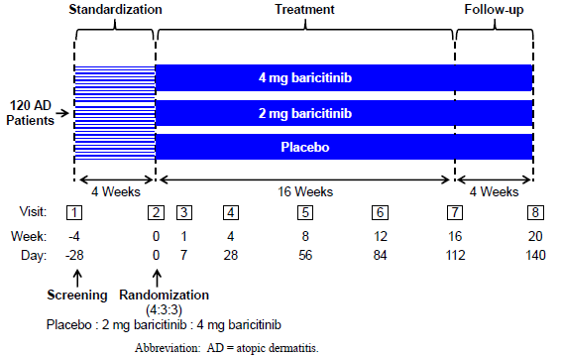
AD = (patients with) atopic dermatitis.
A topical corticosteroid (triamcinolone 0.1%) was provided at the beginning of the standardisation period (Visit 1) and was allowed throughout the study.
Eligible subjects were male and female adults (≥ 18 years old) with moderate-to-severe atopic dermatitis (defined by having an EASI score of at least 12 at screening (Visit 1) and at Baseline (Visit 2), and body surface area involvement of at least 10% at screening and at Baseline). Patients were required to have a diagnosis of atopic dermatitis at least 2 years prior to screening, with a history of inadequate clinical response after at least 4 weeks to at least one of three categories of atopic dermatitis treatments, and for whom a systemic treatment such as baricitinib may be appropriate.
The study endpoints were:
- The primary endpoint was the proportion of patients achieving an EASI50 response at Week 16.
- Secondary endpoints were absolute and percent change in EASI scores; mean change from Baseline in the IGA score; mean change from Baseline of SCORAD; quality of life based on DLQI; itch based on Itch NRS.
A total of 124 patients were randomised: 49 to placebo, 37 to baricitinib 2 mg, and 38 to baricitinib 4 mg. Baseline demographic and disease characteristics were generally comparable among treatment groups. The median age was 32.5 to 42.0 years old across the treatment groups.
Analyses of the primary efficacy endpoint showed that the proportion of baricitinib 4 mg patients who achieved an EASI50 response at Week 16 was statistically significantly greater than the proportion in the placebo group (61% versus 37%; p = 0.027). The proportion of baricitinib 2 mg patients who achieved an EASI50 response at Week 16 was not statistically significantly greater than the proportion in the placebo group (57% versus 37%; p = 0.065).
Figure 2: Study JAHG Analyses of the primary efficacy endpoint
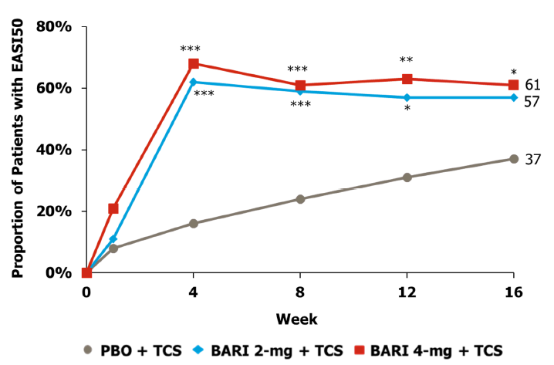
Primary endpoint was the proportion of patients achieving a 50% improvement from Baseline in Eczema Area and Severity Index score (EASI50) response at Week 16.
BARI = baricitinib; PBO = placebo; TCS = topical corticosteroids.
*p-value for baracitinib versus placebo ≤ 0.05; **p-value for baracitinib versus placebo ≤ 0.01; ***p-value for baracitinib versus placebo ≤ 0.001.
Analysis of the percentage change in EASI from Baseline showed a statistically significant improvement over placebo of 18.31% (p = 0.025) with baricitinib 2 mg and of 18.81% (p = 0.022) with baricitinib 4 mg. Time profile analyses of percent change in EASI from Baseline showed that results between the baricitinib 2 mg and 4 mg treatment groups were similar. The time profiles decreased from Baseline to Week 4 and then stayed relatively flat.
Analyses of mean change from Baseline in the IGA showed that at Week 16, there were larger numerical improvements in the IGA score for both baricitinib-treated groups compared to placebo, but these improvements were not statistically significant. In addition, at Week 16, the percentage of patients achieving an IGA score of 0 or 1, with a 2-point decrease in IGA score, was 22% with baricitinib 2 mg and 21% with baricitinib 4 mg versus 8% with placebo. Neither comparison relative to placebo was statistically significant (baricitinib 4 mg versus placebo: p = 0.118; baricitinib 2 mg versus placebo, p = 0.952).
Analysis of mean change in SCORAD scores from Baseline showed a statistically significant improvement over placebo of 11.98 (p = 0.003) with baricitinib 2 mg and of 14.65 (p < 0.001) with baricitinib 4 mg. At Week 16, the proportion of patients achieving SCORAD75 (≥ 75% improvement from Baseline in total SCORAD score) was statistically significantly higher with baricitinib 2 mg (11%) and 4 mg (11%) versus placebo (0%) (p = 0.031 and p = 0.033, respectively)
Analysis of mean change from Baseline in Itch NRS at Week 16 did not show any statistically significant difference between baricitinib and placebo (change from Baseline of -2.61 with baricitinib 2 mg and -2.22 with baricitinib 4 mg versus -1.72 with placebo; baricitinib 2 mg versus placebo: p = 0.145; baricitinib 4 mg versus placebo: p = 0.409).
The percentage of patients achieving DLQI of 0 or 1 was statistically significantly higher with baricitinib 2 mg (32%) and 4 mg (18%) versus placebo (4%) (p < 0.001 and p = 0.029, respectively).
In summary, both the 2 mg and 4 mg doses showed benefit on the main efficacy endpoints as compared to placebo, and both doses had an acceptable safety profile at Week 16. However, the 4 mg dose appeared to demonstrate a more rapid benefit (at 4 weeks) on the more stringent efficacy endpoints compared to 2 mg dose.
A similar trend between the baricitinib 4 mg and 2 mg doses was observed in patients with rheumatoid arthritis. Based on these available data, 3 doses were included in the Phase III studies, including a 1 mg dose in Studies JAHL and JAHM, to cover the range of doses where clinical responses could be anticipated and to confirm the lowest effective dose.

Efficacy

Overview of efficacy studies
Table 2 summarises the studies providing efficacy data for this submission.
Table 2: Summary of efficacy studies
Phase, Study | Treatment periods^{(a)} |  |  | Purpose | Study treatments
Phase II  JAHG | 16 weeks¹ |  |  | Proof of concept | Placebo; Baricitinib 2 mg and 4 mg
Phase III  JAHL | 16 weeks¹ | Continued to Study JAHN |  | Monotherapy | Placebo; Baricitinib 1 mg, 2 mg and 4 mg
Phase III  JAHM | 16 weeks¹ | Continued to Study JAHN |  | Monotherapy | Placebo; Baricitinib 2 mg and 4 mg
Phase III  JAIY | 16 weeks¹ | Continued to Study JAHN |  | Topical corticosteroid combination | Placebo; Baricitinib 1 mg, 2 mg and 4 mg
Phase III  JAHN | JAHL JAHM | 52 week LTE with uptitration² | 52 week down-titration and withdrawal substudy³ | Long-term safety, up- and down-titration, randomised withdrawal | Placebo; Baricitinib: 4 mg
Phase III  JAHN | JAIY | 52 week LTE with uptitration³ | 52 week down-titration and withdrawal substudy³ |  | Placebo; Baricitinib: 4 mg
Phase III  JAHN |  | 52 week open-label addendum² | 52 week down-titration and withdrawal substudy³ | Long term safety | Placebo; Baricitinib: 4 mg
For the indicated study or substudy, the submission includes the following data: 1) All efficacy data; 2) Efficacy data up to Week 36 (overall treatment Week 52); 3) No efficacy data; a) All double-blind unless otherwise indicated; b) The downtitration and withdrawal substudy included a placebo comparator and baricitinib 1 mg.
Table 3 provides an overview of the clinical trial design for the efficacy studies in this submission.
Table 3: Overview of efficacy studies; clinical trial design
 | Study JAHG | Study JAHL | Study JAHM | Study JAIY | Study JAHN
N | 124 | 624 | 615 | 329 | 1081, (plus 211)
Phase | II | III | III | III | III
Treatment | Placebo (N = 49) BARI 2 mg (N = 37) BARI 4 mg (N = 38) | Placebo (N = 249) BARI 1 mg (N = 127) BARI 2 mg (N = 123) BARI 4 mg (N = 125) | Placebo (N = 244) BARI 1 mg (N = 125) BARI 2 mg (N = 123) BARI 4 mg (N = 123) | Placebo (N = 109) BARI 2 mg (N = 109) BARI 4 mg (N = 111) | Placebo (N = 52) BARI 1 mg (N = 45) BARI 2 mg (N = 616ª) BARI 4 mg (N = 579)
Baseline Randomisation Ratio | 4:3:3 | 2:1:1:1 | 2:1:1:1 | 1:1:1 | 1:1^{b}
Background TCS | Moderate-potency: Triamcinolone 0.1% | No | No | Moderate- and low- potency^{c} | Moderate- and low- potency provided; higher potency TCS permitted
AD Treatment History | IR to TCS | IR or IT to moderate- or higher potency TCS | IR or IT to moderate- or higher potency TCS | IR to moderate- or higher potency TCS | IR or IT to moderate- or higher potency TCS
Treatment Duration | 16 weeks | 16 weeks | 16 weeks | 16 weeks | 104 weeks
Primary Endpoint | Proportion of patients achieving EASI50 at Week 16 | Proportion of patients achieving IGA of 0 or 1 with a >2-point improvement at Week 16 | Proportion of patients achieving IGA of 0 or 1 with a >2-point improvement at Week 16 | Proportion of patients achieving IGA of 0 or 1 with a >2-point improvement at Week 16 | Proportion of patients achieving IGA of 0 or 1 assessed at Weeks 16, 36 and 52
LTE | NA | JAHN | JAHN | JAHN | NA
Status | Complete | Complete | Complete | Complete | Ongoing
Location of Study | US and Japan | EU, Japan, ROW | EU, Japan, ROW | EU, Japan, ROW | EU, Japan, ROW
Data lock or cut-off date | 14 March 2017 | 17 January 2017 | 24 January 2019 | 13 August 2019 | 2 July 2019
Abbreviations: BARI = baricitinib; EASI50 = 50% improvement from baseline in Eczema Area and Severity Index; IGA = Investigator's Global Assessment; IR = inadequate response; IT = intolerance; LTE = long-term extension; N = number of patients randomised in the study, or for whom data were available as of the data cut-off date; NA = not applicable; ROW = Rest of World; TCI = topical calcineurin inhibitor; TCS = topical corticosteroids.
a Includes patients in the 2 mg open-label addendum. b Nonresponders who received placebo, baricitinib 1 mg, or baricitinib 2 mg in the originating study were randomised 1:1 to baricitinib 2 mg or baricitinib 4 mg. TCIs such as tacrolimus and pimecrolimus, or the topical PDE-4 inhibitor crisaborole, where approved, were or are permitted in place of TCS on areas where application of TCS is considered inappropriate by the investigator. Use was limited to problem areas such as the face, neck, skin folds, and genital areas.

Studies JAHL, JAHM and JAIY

Study design and objectives

Studies JAHL and JAHM
Studies JAHL and JAHM were identically designed, 16-week, multicentre, randomised, double blind, placebo-controlled, parallel group, outpatient studies. They both evaluated the efficacy and safety of baricitinib 1 mg once-daily, 2 mg once-daily, and 4 mg once-daily as compared to placebo (in a 1:1:1:2 ratio) in adult patients with moderate to severe atopic dermatitis and a history of inadequate response or intolerance to available topical atopic dermatitis therapies.
Figure 3, shown below, summarises the trial design and timelines for Studies JAHL and JAHM.
Figure 3: Studies JAHL and JAHM; study design and timeline
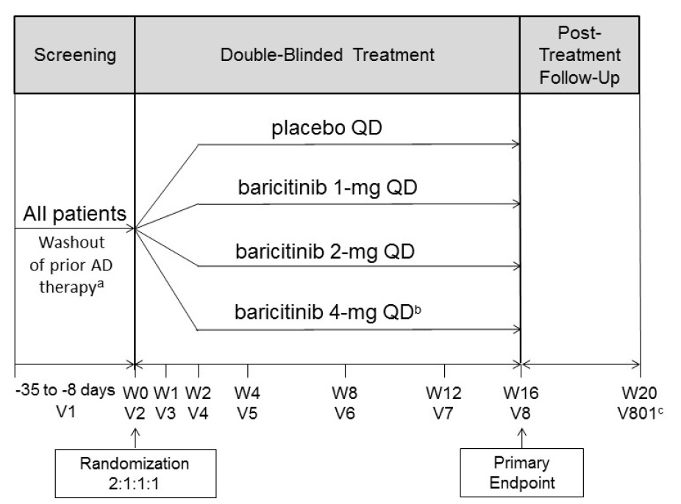
AD = atopic dermatitis; eGFR = estimated glomerular filtration rate; LTE = long-term extension; QD = once-daily, V = visit, W = week.
a) Applicable to patients taking topical or systemic treatments for AD at the time of screening, except for emollients.
b) For patients randomised to the 4 mg once daily dose who have renal impairment, defined as eGFR < 60 mL/min/1.73 m², the baricitinib dose was 2 mg once-daily.
c) Occurred approximately 28 days after the last dose of investigational product. Not required for those patients entering the LTE Study JAHN.
The primary objective was to test the hypothesis that baricitinib 4 mg once daily or baricitinib 2 mg once daily is superior to placebo in the treatment of patients with moderate to severe atopic dermatitis. The primary endpoint was the proportion of patients achieving an IGA score of 0 or 1 with a 2 or more point improvement at Week 16. A key secondary objective was to test the hypothesis that baricitinib 1 mg once daily is superior to placebo in the treatment of patients with moderate to severe atopic dermatitis.

Study JAIY
Study JAIY was a 16-week multicentre, randomised, double-blind, placebo-controlled, parallel-group, outpatient study evaluating the efficacy and safety of baricitinib 2 mg once-daily plus topical corticosteroids, and 4 mg once-daily plus topical corticosteroids as compared to placebo plus topical corticosteroids (in a 1:1:1 ratio) in adult patients with moderate to severe atopic dermatitis and a history of inadequate response to available topical therapies.
Figure 4, shown below, summaries the trial design and timeline for Study JAIY.
Figure 4: Study JAIY; study design and timeline
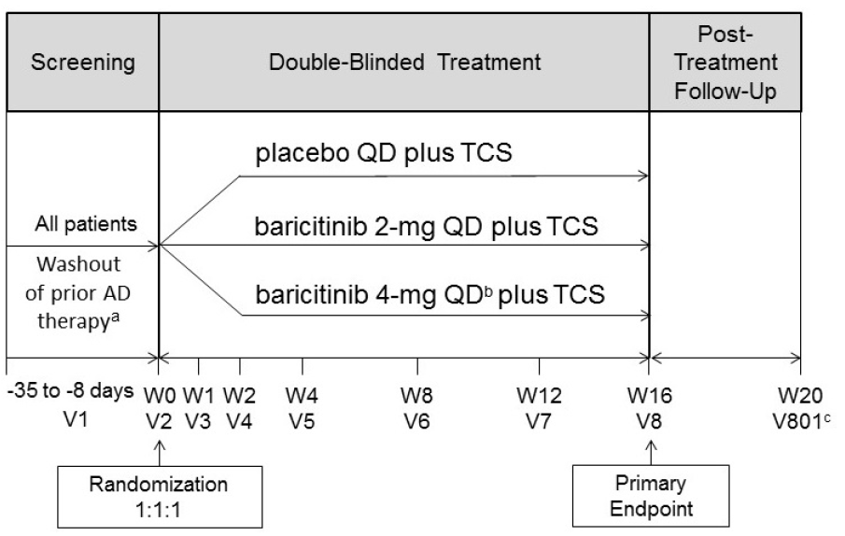
AD = atopic dermatitis; eGFR = estimated glomerular filtration rate; LTE = long-term extension; QD = once-daily; TCS = topical corticosteroids; V = visit, W = week.
a) Applicable to patients taking topical or systemic treatments for AD at the time of screening, except for emollients.
b) For patients randomised to the 4 mg once daily dose who have renal impairment, defined as eGFR < 60 mL/min/1.73 m², the baricitinib dose was 2 mg once-daily.
c) Occurred approximately 28 days after the last dose of investigational product. Not required for those patients entering the LTE Study JAHN.
The primary objective of Study JAIY was to test the hypothesis that baricitinib 4 mg once daily plus topical corticosteroids, or baricitinib 2 mg once daily plus topical corticosteroids are superior to placebo plus topical corticosteroids in the treatment of patients with moderate to severe atopic dermatitis. The primary endpoint was the proportion of patients achieving IGA score of 0 or 1 with a 2 or more point improvement at Week 16.

Inclusion and exclusion criteria
Studies JAHL and JAHM had identical inclusion and exclusion criteria, aiming at an adult population with moderate to severe atopic dermatitis and a recent history of inadequate response/intolerance to topical atopic dermatitis therapies. The inclusion and exclusion criteria for Study JAIY were very similar, with the exception that patients with intolerance to topical corticosteroids were excluded while topical corticosteroids were to be used concomitantly.
Key inclusion criteria were:
- Age of 18 years or older with a diagnosis of atopic dermatitis; for at least 12 months prior to screening.
- Moderate to severe atopic dermatitis with an EASI score ≥ 16, an IGA score ≥ 3 and a body surface area involvement ≥ 10%.
- Have a history of inadequate response to/intolerance to topical atopic dermatitis therapies within 6 months prior to screening, defined by at least 1 of the following:
  - Not having achieved at least mild disease with topical corticosteroids of at least moderate potency for at least 4 weeks.
  - Failure of systemic atopic dermatitis therapies, such as: ciclosporin, methotrexate, azathioprine, or mycophenolate mofetil.
  - Clinically significant adverse reactions with the use of topical corticosteroids, such as: skin atrophy, allergic reactions, or systemic effects (Studies JAHL and JAHM).
Key exclusion criteria were:
- Previous or concomitant conditions that may have confounded efficacy and safety assessments or increased the risks to patients. This included: psoriasis, systemic lupus erythematosus, active skin infection, history of eczema herpeticum, recurrent or recent venous thromboembolism, current or recent serous infection.
Blinding was maintained using double dummies. Patient compliance with investigational treatment was assessed by pill count at each visit. If a patient at his/her own intention had missed more than 20% of doses of study drug, or had taken more than 20% of study drug, he/she was considered significantly noncompliant.
Other atopic dermatitis treatments were to be stopped between 2 or 4 weeks before randomisation: topical therapies except emollients, systemic therapies, phototherapy and sedating antihistamines. In the 2 weeks prior to randomisation, patients had to use emollients daily and continue this use throughout the study (but not on the day of a study visit).
In combination Study JAIY, patients were instructed to start with the use of a moderate-potency topical corticosteroids (such as triamcinolone 0.1% cream) once daily until lesions were clear or almost clear. Then, patients should switch to a low potency topical corticosteroid (hydrocortisone 2.5% ointment) and treat previously affected areas for another 7 days and then stop. If lesions reappeared, treatment with the moderate- or low-potency topical corticosteroids was to be resumed. In addition, the use of topical calcineurin inhibitors (or crisaborole, a topical phosphodiesterase-4 inhibitor) was permitted to treat areas with sensitive skin (such as the face, neck, skin folds, and genital areas).
Rescue treatment was allowed for patients who were experiencing unacceptable or worsening atopic dermatitis symptoms at any time (Studies JAHL and JAHM) or after 2 weeks from Baseline (Study JAIY).
In Studies JAHL and JAHM, first-line rescue treatment was topical treatment with a moderate-potency topical corticosteroids (triamcinolone 0.1% cream) and/or a low-potency topical corticosteroids (hydrocortisone 2.5%). If patients did not improve sufficiently after 7 days of use, they could switch to a higher potency topical corticosteroids.
In combination Study JAIY, high- or ultra-high potency topical corticosteroids could be used as first-line rescue treatment.
In all three studies, second-line rescue treatment was oral systemic treatment, such as oral corticosteroids or ciclosporin. Then, investigational treatment was discontinued for the remainder of the study (but patients remained eligible for the long term extension Study JAHN).
The primary outcome for the three 16-week Phase III studies (Studies JAHL, JAHM, and JAIY) was the proportion of patients achieving an IGA score of 0 or 1, with at least a 2-point improvement from Baseline at Week 16. The IGA assesses the clinician’s impression of overall disease severity at a single time point. It does not specifically measure the extent of atopic dermatitis, although for patients to be considered severe, they must have widespread disease. An IGA score of 0 or 1 equates to skin that is ‘clear’ or ‘almost clear’ from atopic dermatitis signs. For the Phase III trials, a common validated version was used (vIGA-AD;⁴ International Eczema Council 2017) and all investigators underwent training and certification with this version.
The key secondary outcomes were: EASI; Itch NRS; Atopic Dermatitis Sleep Scale (ADSS); Skin pain NRS; and SCORAD. Additional secondary outcomes were amongst others: DLQI; body surface area affected; Patient Oriented Eczema Measure (POEM); and Hospital Anxiety and Depression Scale (HADS).
Unless otherwise specified, efficacy analyses in Studies JAHL, JAHM and JAHY were conducted on the intent to treat population, which includes all patients who were randomised. A per protocol sensitivity analysis was also performed.
Table 4: Studies JAHL, JAHM and JAIY; Patient disposition
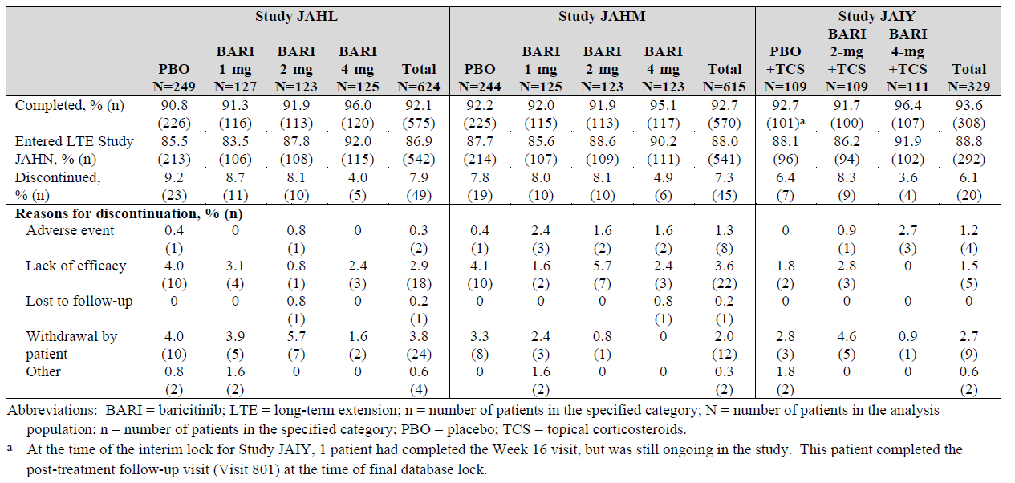
BARI = baricitinib; LTE = long-term extension; n = number of patients in the specified category; N = number of patients in analysis populations; PBO = placebo; TCS = topical steroid.
a) At the time of the interim lock for Study JAIY, 1 patient had completed the Week 16 visit, but was still ongoing in the study. This patient completed the post-treatment follow-up visit (Visit 801) at the time of final database lock.
Patient flow was similar in Studies JAHL, JAHM, and JAIY, as shown in Table 4, above. In all three studies, more than 90% of patients completed the 16-week studies, about 88% of the patients continued in the long-term follow-up Study JAHN. Discontinuations were lowest in the baricitinib 4 mg treated groups and were similar in the other treatment groups. In the placebo groups, the most frequent reasons for discontinuation were ‘lack of efficacy’ and ‘withdrawal by patient’. Few patients discontinued due to adverse events, usually from the baricitinib treated groups.
Baseline demographical data (age, sex, weight, race) were similar across trials and treatment groups, as summarised in Table 5, below.
Table 5: Study JAHL, JAHM and JAIY; Baseline demographics
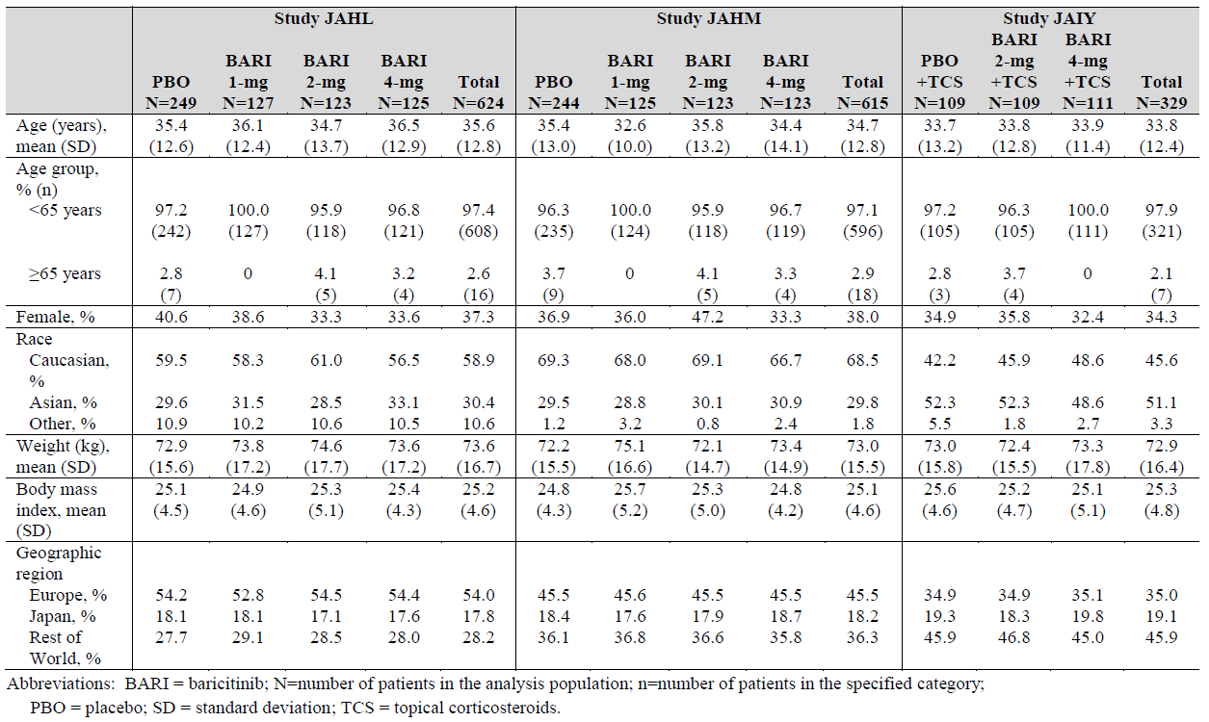
BARI = bariticinib; N = number of patients in the analysis population; n = number of patients in the specified category; PBO = placebo; SD = standard deviation; TCS = topical corticosteroids
Baseline disease characteristics were similar across trials and treatment groups, as shown in Table 6, below.
Table 6: Study JAHL, JAHM and JAIY Baseline disease characteristics
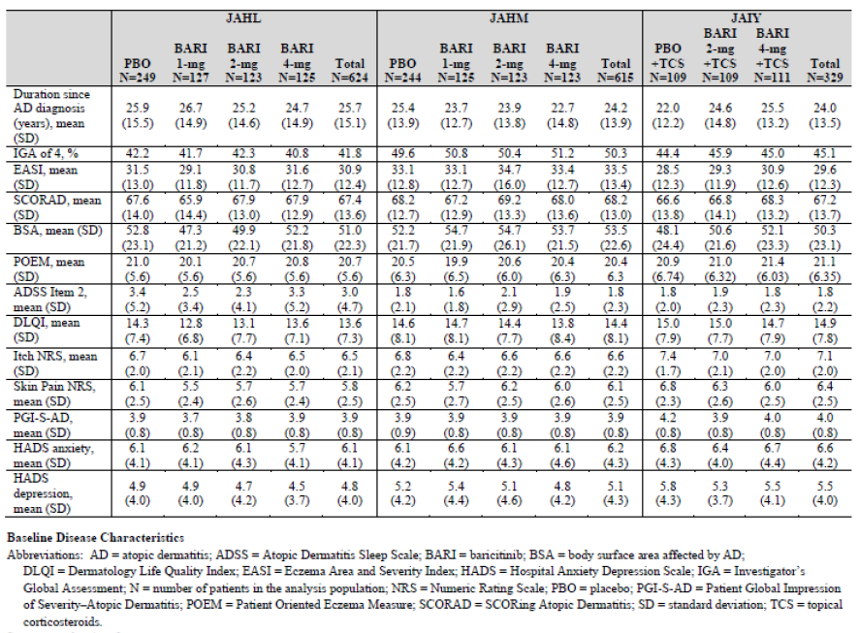
All patients who were included in the three studies reported prior use of TCS and/or systemic therapies (Table 7).
Table 7: Study JAHL, JAHM and JAIY Prior treatment for atopic dermatitis
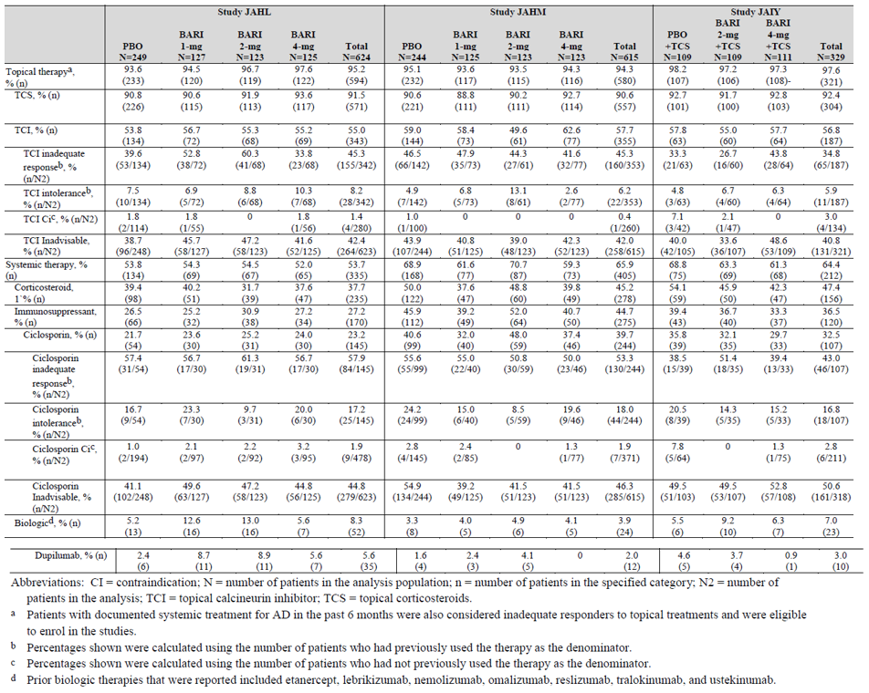

Compliance and rescue
In Studies JAHL and JAHM, 56% and 69% of the patients received rescue treatment. The largest proportions of patients needing rescue treatment were in the placebo groups and the smallest proportions were in the baricitinib 4 mg treated groups. In the 4 mg treated groups, 41% and 59% of patients needed rescue during the 16 weeks of study, with few exceptions always topical corticosteroids. In the placebo and 1 mg and 2 mg groups, rescue treatment with topical corticosteroids was more frequently used as compared to the 4 mg group. Topical calcineurin inhibitors and systemic treatments were not frequently used as rescue treatment, whether in the placebo, 1 mg and 2 mg groups (with few exceptions). Rescue treatment was initiated earlier in the placebo and lower-dose groups as compared to the baricitinib 4 mg treated group.
In add-on Study JAIY, study treatment was added to existing treatment with low- or moderate potency topical corticosteroids. In total, 6% of the patients received rescue treatment, most frequently in the placebo group (9%) and less (5%) in the baricitinib treated groups. Rescue treatment usually was a high-potency topical corticosteroid (study drug was continued) and less frequently systemic treatment (study drug discontinued).

Results

Investigator’s Global Assessment score of 0 or 1 (primary outcome)
In all three studies (Studies JAHL, JAHM and JAIY), baricitinib 4 mg was statistically significantly more effective than placebo in reaching an IGA score of 0 or 1 at Week 16 (with a ≥ 2 points improvement from baseline), while adjusting for multiplicity (as shown in Table 8, and Figures 5 to 7, below). Baricitinib 2 mg was more effective than placebo in reaching an IGA score of 0 or 1 at Week 16 in Studies JAHL and JAHM, but not in Study JAIY. The 1 mg dose was not more effective than placebo.
Table 8: Study JAHL, JAHM and JAIY Proportion of patients achieving an Investigator’s Global Assessment score of 0 or 1 at Week 16 (intent to treat population)
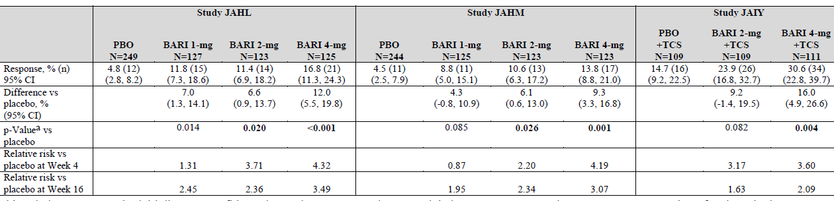
BARI = baricitinib; CI = confidence interval; IGA = Investigator’s Global Assessment; ITT = intent to treat; N = number of patients in the analysis population; n = number of patients in the specified category; PBO = placebo; TCS = topical corticosteroids.
Odds ratio p-value from logistic regression.
Note results in bold were statistically significant after adjustment for multiplicity.
Figure 5: Study JAHL Effect of baricitinib 4 mg and 2 mg on Investigator’s Global Assessment scores of 0 or 1
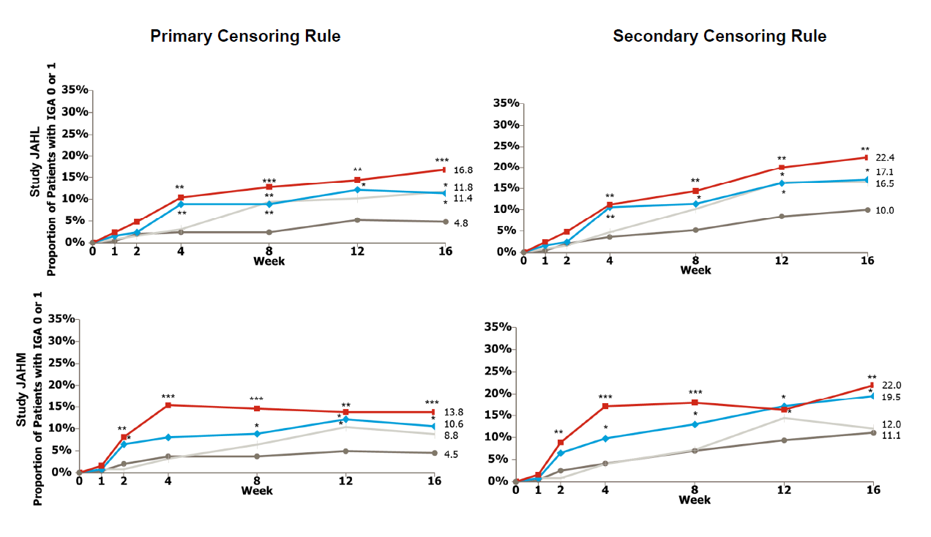
Primary censoring rule (left); seconary primary rule (right).
BARI = baricitinib; IGA = Investigator’s Global Assessment; ITT = intent to treat; PBO = placebo.
*p-value for baracitinib versus placebo ≤ 0.05; **p-value for baracitinib versus placebo ≤ 0.01; ***p-value for baracitinib versus placebo ≤ 0.001.
Figure 6: Study JAHM Effect of baricitinib 4 mg and 2 mg on Investigator’s Global Assessment scores of 0 or 1
Primary censoring rule (left); seconary primary rule (right).
BARI = baricitinib; IGA = Investigator’s Global Assessment; ITT = intent to treat; PBO = placebo.
*p-value for baracitinib versus placebo ≤ 0.05; **p-value for baracitinib versus placebo ≤ 0.01; ***p-value for baracitinib versus placebo ≤ 0.001.
Figure 7: Study JAIY Effect of baricitinib 4 mg and 2 mg on Investigator’s Global Assessment scores of 0 or 1
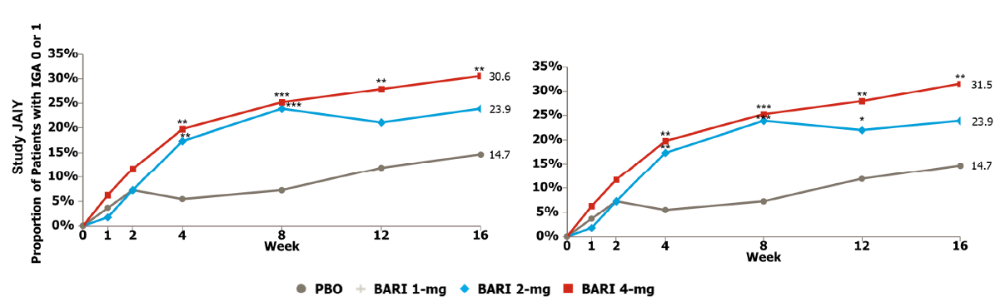
Primary censoring rule (left); seconary primary rule (right).
BARI = baricitinib; IGA = Investigator’s Global Assessment; ITT = intent to treat; PBO = placebo.
*p-value for baracitinib versus placebo ≤ 0.05; **p-value for baracitinib versus placebo ≤ 0.01; ***p-value for baracitinib versus placebo ≤ 0.001.

Eczema Area and Severity Index (EASI)
For baricitinib 4 mg, the percentage of patients with EASI75 response at Week 16 was statistically significant larger as compared to placebo, in all three studies. For baricitinib 2 mg, this was reached in Studies JAHL and JAHM, but not in Study JAIY. Results for these studies are shown in Figure 8, below.
Figure 8: Studies JAHL, JAHM and JAIY Effect of baricitinib 4 mg and 2 mg on Ezcema Area and Severity Index 75% improvement from Baseline after 2 to 4 weeks of treatment
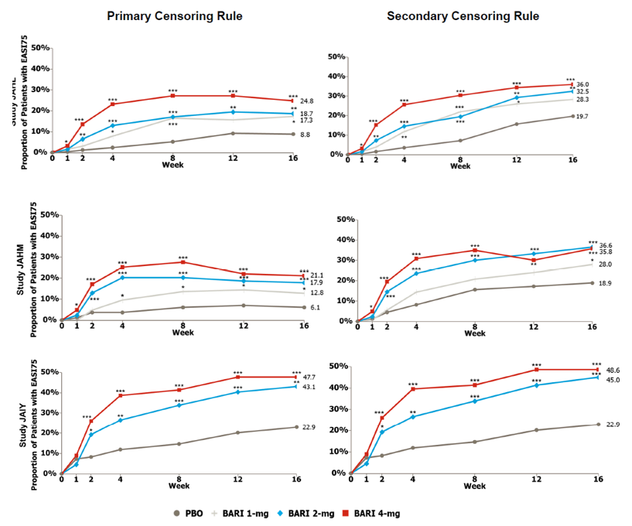
Primary censoring rule (left); seconary primary rule (right).
BARI = baricitinib; EASI75 = 75% improvement in Eczema Area and Severity Index; ITT = intent to treat; PBO = placebo.
*p-value for baracitinib versus placebo ≤ 0.05; **p-value for baracitinib versus placebo ≤ 0.01; ***p-value for baracitinib versus placebo ≤ 0.001.

Itch numerical rating scale
For baricitinib 4 mg, the percentage of patients with an improvement ≥4 points in the Itch NRS at Week 16 was statistically significant larger as compared to placebo, in all three studies (see Figure 9, and Tables 9 to 11, below). For baricitinib 2 mg, this was reached in Study JAHM, but not in Studies JAHL and JAIY.
Figure 9: Studies JAHL, JAHM and JAIY Proportions of patients with an improvement in itch score of ≥ 4 points over time
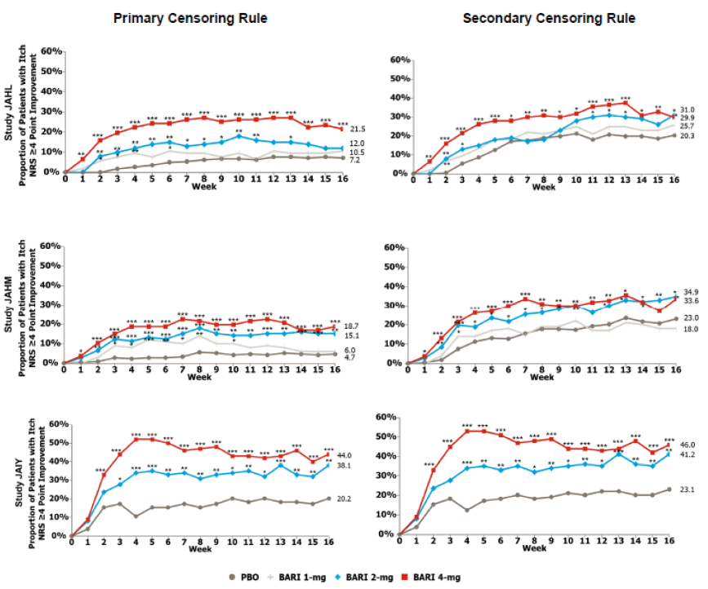
Primary censoring rule (right), secondary censoring rule (left). Itch score rated according to the Itch Numerical Rating Scale.
NRS = numerical rating scale; ITT = intent to treat; PBO = placebo.
*p-value for baricitinib versus placebo ≤ 0.05; **p-value for baricitinib versus placebo ≤ 0.01; ***p-value for baricitinib versus placebo ≤ 0.001.

Atopic Dermatitis Sleep Scale
ADSS sleep item 2 concerns the number of times a patient woke up at night. For baricitinib 4 mg, the change in this item at Week 16 was statistically significant larger as compared to placebo, in Studies JAHL and JAHM, but not in Study JAIY (see Figure 10 and Tables 9 to 11, below). For baricitinib 2 mg, the change in the ADSS sleep item 2 was statistically significant in Study JAHM, but not in Studies JAHL and JAIY.
Figure 10: Studies JAHL, JAHM and JAIY Proportion of nights from Week 0 to 16 with no night time awakenings in patients with baseline Atopic Dermatitis Sleep Scale Item 2 rating of > 1 (Intent to treat population)
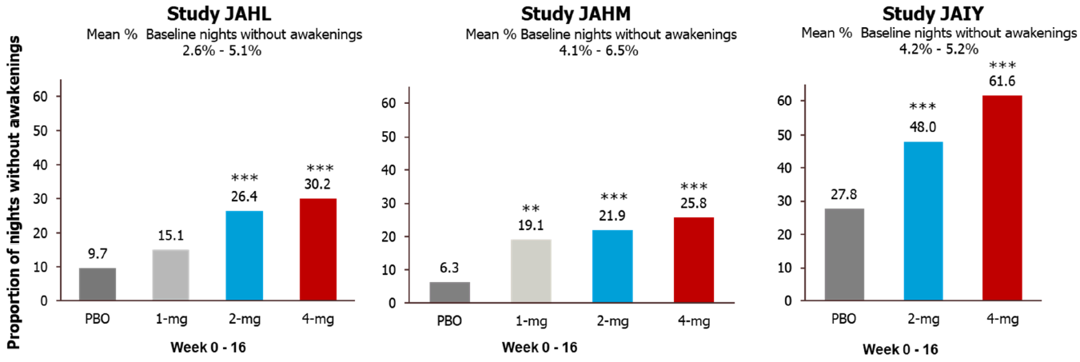
The Atopic Dermatitis Sleep Scale (ADSS) is a 3-item, participant-administered questionnaire developed to assess the impact of itch on sleep including difficulty falling asleep, frequency of waking, and difficulty getting back to sleep last night. Item 2, frequency of waking last night, is reported by selecting the number of times a patient wakes up each night, ranging from 0 to 29 times.
ADSS = Atopic Dermatitis Sleep Scale; ITT = intent to treat; PBO = placebo.
*p-value for baricitinib versus placebo ≤ 0.05; **p-value for baricitinib versus placebo ≤ 0.01; ***p-value for baricitinib versus placebo ≤ 0.001.

Scoring Atopic Dermatitis Index
For baricitinib 4 mg, the percentage of patients having reached SCORAD75 at Week 16 was statistically significant larger as compared to placebo, in Studies JAHL and JAHM, but not in Study JAIY (see Tables 9 to Table 11). For baricitinib 2 mg, this was reached in Study JAHM, but not in Studies JAHL and JAIY.

Skin pain numerical rating scale
For baricitinib 4 mg, the change in the Skin Pain NRS at Week 16 was statistically significantly larger as compared to placebo, in Studies JAHL and JAHM, but not in Study JAIY (see Tables 9 to Table 11). For baricitinib 2 mg, the change in Skin Pain NRS was statistically significant in Study JAHM, but not in Studies JAHL and JAIY.

Dermatology Life Quality Index
For baricitinib 4 mg and 2 mg, the change in the DLQI at Week 16 was larger (p < 0.05, without adjustment for multiplicity) as compared to placebo, in Studies JAHL, JAHM and JAIY. The response of the 4 mg dose was numerically better than the response of the 2 mg dose group. Similar results for the two doses were found with improvement in DLQI ≥ 4 points (considered to be the minimal clinical important difference) as outcome.

Patient Oriented Eczema Measure
For baricitinib 4 mg and 2 mg, the change in the POEM at Week 16 was larger (p < 0.05, without adjustment for multiplicity) as compared to placebo, in Studies JAHL, JAHM and JAIY. The response of the 4 mg dose was numerically better than the response of the 2 mg dose group. Similar results for the two doses were found with improvement in POEM ≥ 4 points (larger than the minimal clinical important difference) as outcome.

Hospital Anxiety and Depression Scale
For baricitinib 4 mg, the change in the HADS total score at Week 16 was larger (p < 0.05, without adjustment for multiplicity) as compared to placebo, in Studies JAHL, JAHM and JAIY. For baricitinib 2 mg this was the case in Studies JAHL and JAIY, but not in JAHM. The response of the 4 mg dose was numerically better than the response of the 2 mg dose group. For HADS anxiety score < 8 points and HADS depression score < 8 points results were less clear.

Sensitivity analyses
Analysis of the per protocol set population in Studies JAHL, JAHM and JAIY, gave comparable results and the same conclusions as the intent to treat population for the primary and key secondary endpoints, notably for IGA score of 0 or 1, EASI75 response and Itch NRS score ≥ 4.
Table 9: Study JAHL Results for primary and key secondary outcomes (intent to treat population)
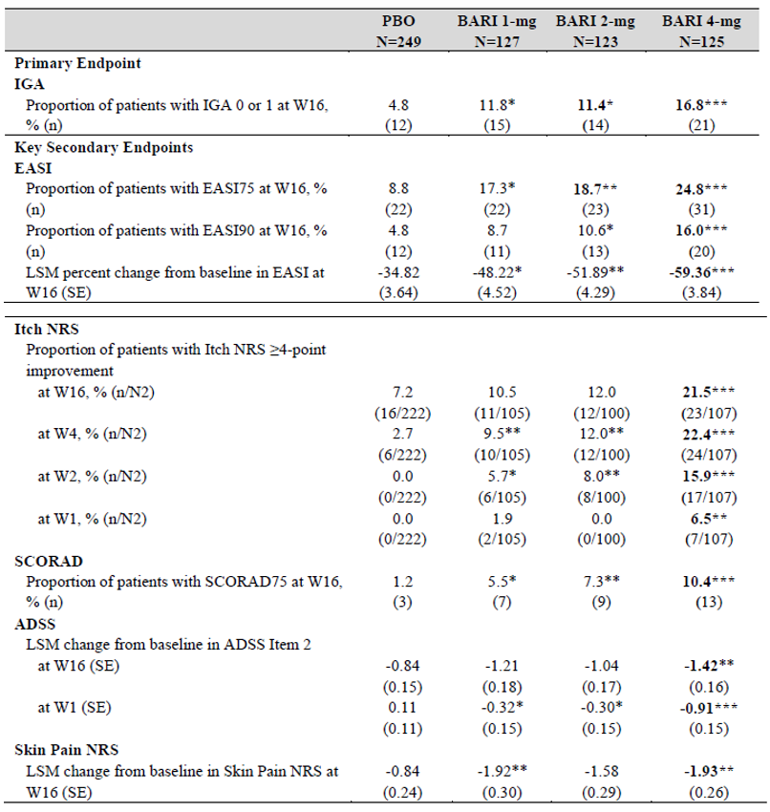
Abbreviations: ADSS = Atopic Dermatitis Sleep Scale; BARI = baricitinib; EASI75/90 = 75%-90% improvement from Baseline in Eczema Area and Severity Index; IGA = Investigator's Global Assessment; ITT = mtent-to-treat; LSM = least squares mean; N = number of patients in the analysis population; n = number of patients in the specified category, N2 = number of eligible patients for categorical assessment. For Itch NRS improvement, only patients with baseline severity of 4 or more points were included in the analysis; NRS = Numeric Rating Scale; PBO = placebo; SCORAD75 = 75% improvement in SCORing Atopic Dermatitis; SE = standard error; W = week.
Note: Results in bold were statistically significant after adjustment for multiplicity. Other results designated with asterisks were statistically significant, without adjustment for multiplicity.
*p-value for baricitinib versus placebo ≤ 0.05; **p-value for baricitinib versus placebo ≤ 0.01; ***p-value for baricitinib versus placebo ≤ 0.001.
Table 10: Study JAHM Results for primary and key secondary outcomes (intent to treat population)
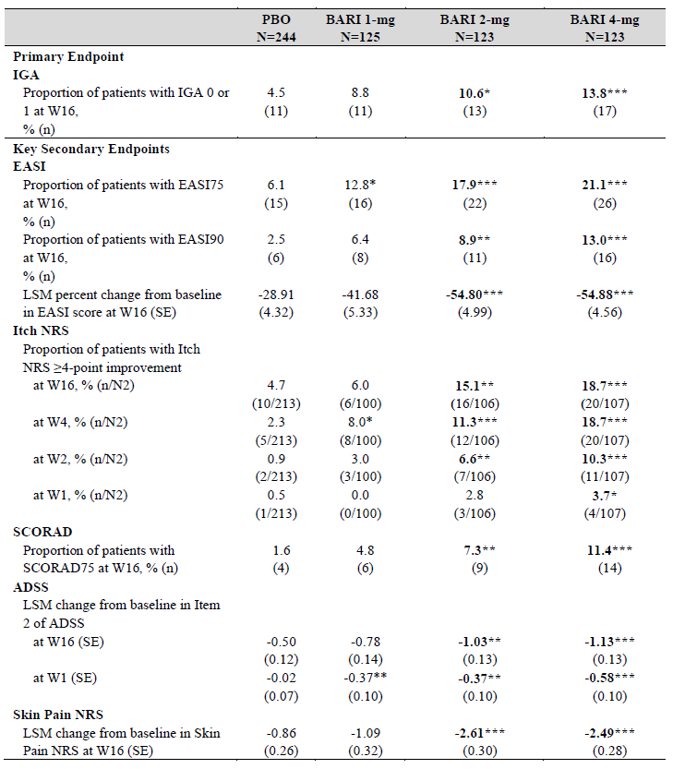
Abbreviations: ADSS = Atopic Dermatitis Sleep Scale; BARI = baricitinib; EASI75/90 = 75%-90% improvement from Baseline in Eczema Area and Severity Index; IGA = Investigator's Global Assessment; ITT = mtent-to-treat; LSM = least squares mean; N = number of patients in the analysis population; n = number of patients in the specified category, N2 = number of eligible patients for categorical assessment. For Itch NRS improvement, only patients with baseline severity of 4 or more points were included in the analysis; NRS = Numeric Rating Scale; PBO = placebo; SCORAD75 = 75% improvement in SCORing Atopic Dermatitis; SE = standard error; W = week.
Note: Results in bold were statistically significant after adjustment for multiplicity. Other results designated with asterisks were statistically significant, without adjustment for multiplicity.
*p-value for baricitinib versus placebo ≤ 0.05; **p-value for baricitinib versus placebo ≤ 0.01; ***p-value for baricitinib versus placebo ≤ 0.001.
Table 11: Study JAIY Results for primary and key secondary outcomes (intent to treat population)
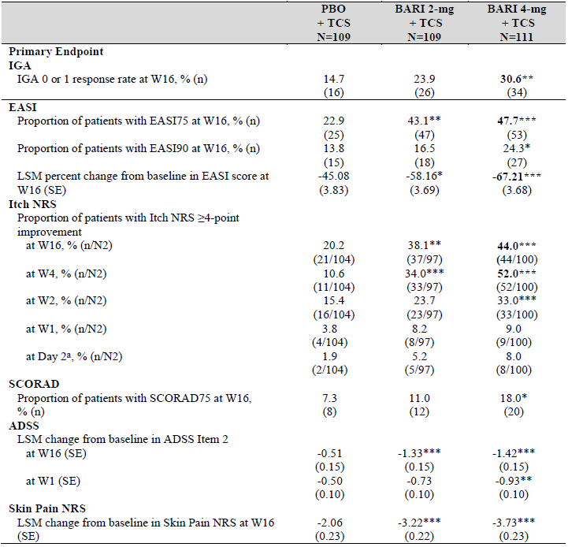
Abbreviations: ADSS = Atopic Dermatitis Sleep Scale; BARI = baricitinib; EASI75/90 = 75%-90% improvement from Baseline in Eczema Area and Severity Index; IGA = Investigator's Global Assessment; ITT = mtent-to-treat; LSM = least squares mean; N = number of patients in the analysis population; n = number of patients in the specified category, N2 = number of eligible patients for categorical assessment. For Itch NRS improvement, only patients with baseline severity of 4 or more points were included in the analysis; NRS = Numeric Rating Scale; PBO = placebo; SCORAD75 = 75% improvement in SCORing Atopic Dermatitis; SE = standard error; W = week.
Note: Results in bold were statistically significant after adjustment for multiplicity. Other results designated with asterisks were statistically significant, without adjustment for multiplicity.
*p-value for baricitinib versus placebo ≤ 0.05; **p-value for baricitinib versus placebo ≤ 0.01; ***p-value for baricitinib versus placebo ≤ 0.001.
a) Itch NRS score at Day 2 is defined as the score collected on Day 2 only.

Study JAHN
Study JAHN is a Phase III, multicentre, double-blind study to evaluate the long-term safety and efficacy of baricitinib 1 mg, 2 mg, and 4 mg once daily (QD) in adult patients with atopic dermatitis who had completed Studies JAHL, JAHM, or JAIY. A substudy/cohort was added to evaluate efficacy and safety of baricitinib 2 mg open-label in adult patients with moderate to severe atopic dermatitis who had not completed an originating study. In ‘maintenance and up-titration’ treatment period 1 (Weeks 0 to 52): patients who were responders or partial responders at Week 16 of the originating study and have not had rescue treatment, continued their treatment assigned. Nonresponders on baricitinib 4 mg continued on the same dose. Nonresponders on placebo, 1 mg or 2 mg were re-randomised (1:1) to baricitinib 2 mg or 4 mg.
- If patients had an IGA of 0 or 1 and they were not rescued in the originating study, then they were classified as responders.
- If patients had an IGA of 2 and they were not rescued in the originating study, then they were classified as partial responders
- If patients had an IGA of 3 or 4; or, they were rescued in the originating study, then they were classified as nonresponders.
In ‘withdrawal and down-titration’ treatment period 2 (Weeks 52 to 104): patients who are responders or partial responders on 2 mg or 4 mg at Week 52 and are otherwise eligible will be re-randomised (1:1:1 ratio) to dose continuation, the next lower dose (1 mg or 2 mg), or placebo. Ineligible patients will continue the dose assigned in treatment period 1.
The primary objective was to estimate the effect of long-term therapy with baricitinib on responders and partial responders at entry of Study JAHN. A secondary objective was to evaluate the efficacy of increasing baricitinib dose in non-responders, and to evaluate safety of long term treatment with baricitinib.
Figure 11: Study JAHN study design and timeline
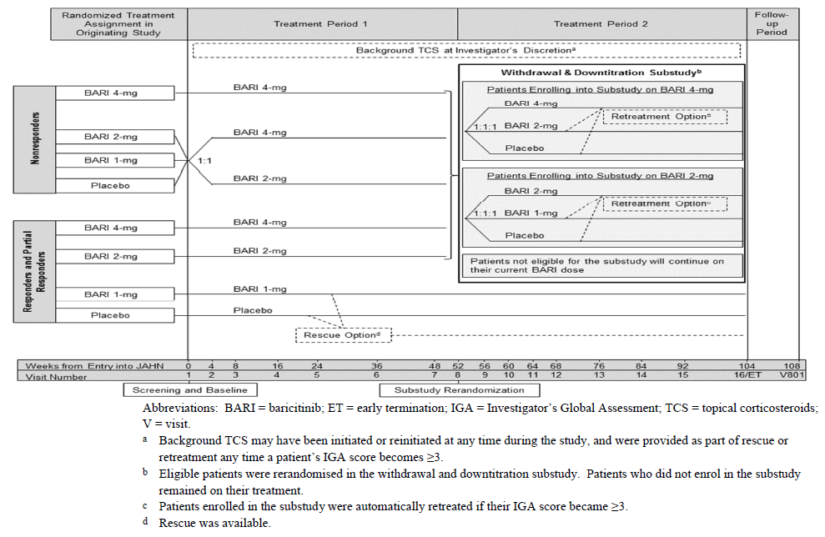
BARI = baricitinib; ET = early termination; IGA = Investigator’s Global Assessment; TCS = topical corticosteroids; V = visit.
a) background TCS may have been initiated or reinstated at any time during the study, and were provided as part of rescue or retreatment any time a patient’s IGA score became 3 or more.
b) Eligible patients were re-randomised in the withdrawal and downtitration substudy. Patients who did not enrol in the substudy remained on their treatment.
c) Patients enrolled in the substudy were automatically retreated if their IGA score became 3 or more.
d) Rescue available.
The primary efficacy outcome was an IGA score of 0 or 1 at Week 16 (Week 32 overall), Week 36 (Week 52 overall) and Week 52 (Week 68 overall) for baricitinib 2 mg and 4 mg.
Key secondary outcome was EASI75 at Week 16. The other main efficacy outcomes were similar as in the originating studies and included: IGA 0 or 1 over time, EASI75, Itch NRS ≥4 points improvement, SCORAD75, skin pain NRS, ADSS item 2. Patient reported outcomes that were assessed with an electronic diary, such as Itch NRS and Skin pain NRS, were assessed up to Week 32 (Week 16 of Study JAHN).

Patient disposition
This study was ongoing at the time of this TGA submission and interim results were submitted for this application (interim data cut-off date of 2 July 2019). This TGA submission included efficacy data from Week 0 to Week 36 of Study JAHN for patients originating from Studies JAHL and JAHM (this represented a total of 52 weeks of continuous treatment from randomisation in the originating studies, that is, overall treatment Week 52). The submitted report also summarised efficacy data for patients enrolled in the baricitinib 2 mg open-label addendum up to Week 24 of Study JAHN.
From Studies JAHL, JAHM, and JAIY, 1375 patients entered Study JAHN and 1373 were included (see Figure 12, below). 371 patients who were responder or partial responders in the originating study continued their treatment. 1002 patients were non-responders and accordingly, 807 of them were re-randomised to baricitinib 2 mg or 4 mg while 195 nonresponders to baricitinib 4 mg continued their dose (see Figure 13, below).
Of the 1081 included patients from Studies JAHM and JAHL, all patients had reached Week 52 or had discontinued. Of the 292 patients included from Study JAIY, all patients had reached Week 16 and 54% had reached Week 24.
Of the 133 responders and partial responders on baricitinib 4 mg, 32 (24%) discontinued and 101 (76%) were ongoing. Of the 107 responders and partial responders on baricitinib 2 mg, 17 (16%) discontinued and 90 (84%) were ongoing.
Of the 195 nonresponders on baricitinib 4 mg who thus continued the 4 mg dose, 63 (32%) discontinued, usually (n = 45) due to a lack of efficacy; 132 (68%) were ongoing in Study JAHN.
There were 247 patients included in the baricitinib 2 mg open label cohort. All patients reached Week 16, 85% had reached Week 24 and 39% had reached Week 36.
Figure 12: Study JAHN Patient disposition, responders and partial responders at study entry
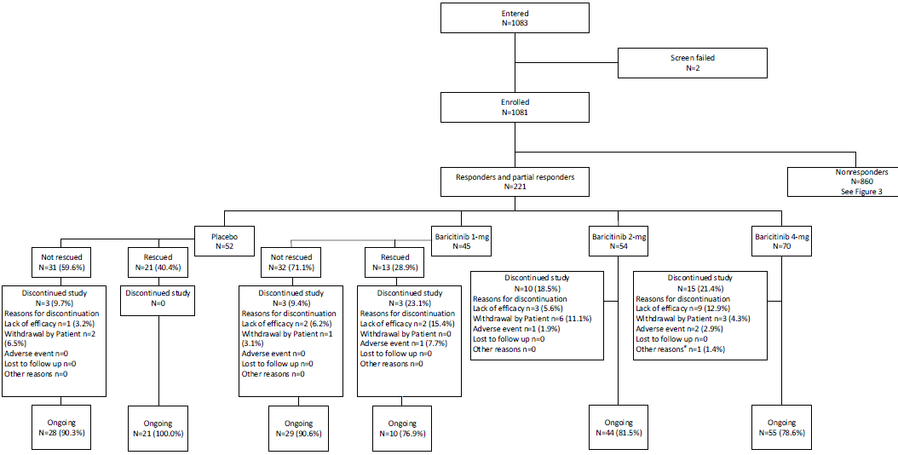
N = number of patients in group; n = number of patients in subgroup.
a) for baricitinib 4 mg, other reason was investigator decision due to patients work commitments.
Figure 13: Study JAHN Patient disposition, nonresponders at study entry
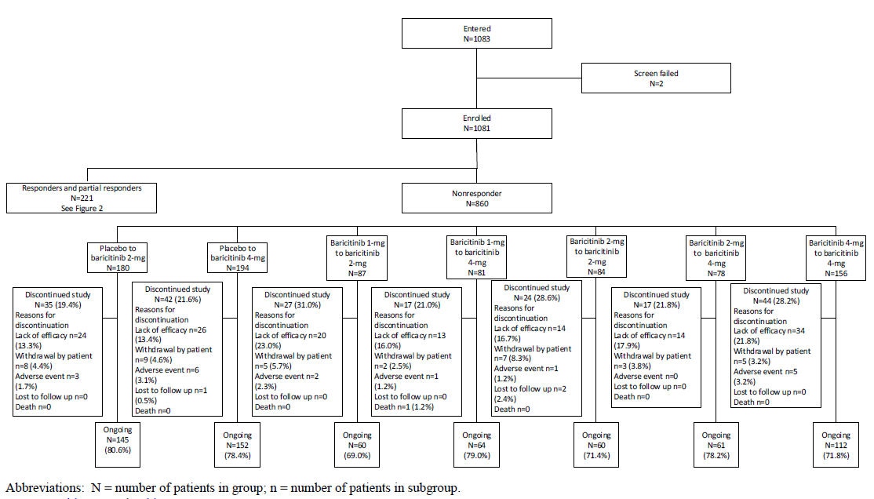
N = number of patients in group; n = number of patients in subgroup.

Results
Analyses on the maintenance of efficacy results among Responders and Partial Responders (patients who had an IGA of 0, 1, or 2 at baseline of Study JAHN) showed that Responders and Partial Responders in both the baricitinib 4 mg and 2 mg groups generally achieved or maintained an IGA score of 0 or 1, EASI75 response and Itch NRS score of 4 or more point improvement response through Week 36 of Study JAHN (overall treatment Week 52).
Efficacy analyses on Non-responders showed that placebo Non-responders re-randomised to baricitinib 2 mg or 4 mg in Study JAHN experienced increased response for IGA score of 0 or 1, EASI75 response, and Itch NRS 4 score or more points improvement during Study JAHN. At Week 16 of Study JAHN (overall treatment Week 32), patients in both treatment groups achieved a generally similar response for these 3 measures as patients in the baricitinib 4 mg and 2 mg groups of the topical corticosteroids combination Study JAIY at Week 16.
Placebo Nonresponders who were re-randomised to baricitinib 4 mg achieved higher responses for IGA scores of 0 or 1 and EASI75 responses between Weeks 4 to 16 of Study JAHN (overall treatment Week 20 to Week 32) than placebo Nonresponders who were re-randomised to baricitinib 2 mg. However, both treatment groups achieved a similar EASI75 response at Week 36 of Study JAHN (overall treatment Week 52). Both treatment groups also achieved a similar response for Itch NRS scores of 4 or more at Week 16 of Study JAHN (overall treatment Week 32).
Baricitinib 1mg Nonresponders up titrated to baricitinib 4 mg resulted in numerically greater improvements for IGA scores of 0 or 1 and EASI75 responses in the first 16 weeks of Study JAHN compared to uptitration to 2 mg. However, both treatment groups achieved a similar response for both endpoints at Week 36 of Study JAHN (overall treatment Week 52). Uptitration of 1mg Non-responders to baricitinib 4 mg resulted in higher Itch NRS scores of 4 or more point improvement response at Week 16 of Study JAHN (overall treatment Week 32) compared to uptitration to 2 mg.
Baricitinib 2 mg Non-responders who remained on baricitinib 2 mg in Study JAHN generally maintained their response for IGA scores of 0 or 1, EASI75 responses, and DLQI 4 or more point improvement through Week 36 (overall treatment Week 52).
Up titration of 2 mg Non-responders to baricitinib 4 mg generally resulted in numerically greater improvements for IGA 0 or 1, EASI75 and Itch NRS 4 from Week 16 (overall treatment Week 32) onward compared to those remaining on baricitinib 2 mg.
Efficacy results of the Study JAHN open-label addendum (patients enrolled directly into the study, and therefore received baricitinib 2 mg for the first time at Week 0 of Study JAHN) showed that the IGA 0 or 1 response of baricitinib 2 mg increased from Week 0 to Week 24. The EASI75 response increased through Week 16, and was then maintained through Week 24. The Itch NRS response of baricitinib 2 mg increased through Week 11, and was then maintained through Week 16.
Patients in the 2 mg open-label addendum achieved a similar IGA score of 0 or 1 response at Week 16 (24.4%) compared to patients in Study JAIY who received baricitinib 2 mg plus background topical corticosteroids (23.9%). The EASI75 response and Itch NRS score of 4 or more point improvement response of baricitinib 2 mg were slightly lower at Week 16 of the Study JAHN open-label addendum (EASI75 response rate of 38.2%; Itch NRS response rate of 30.6%) compared to patients in Study JAIY who received baricitinib 2 mg plus background topical corticosteroids (EASI75 response rate of 43.1%; Itch NRS response rate of 38.1%).
Figure 14: Study JAHN Proportion of 2 mg Responders and Partial Responders achieving Investigator Global Assessment scores of 0 or 1; Eczema Area and Severity Index 75% response; and Itch numeric rating scale scores of 4 or more points improvement through Week 36 (overall treatment Week 52)
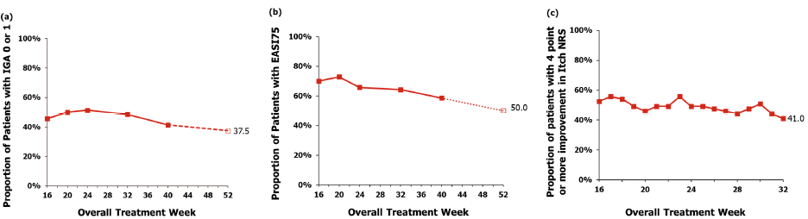
Proportion of patients with: a) Investigator Global Assessment (IGA) scores of 0 or 1; b) Eczema Area and Severity Index 75% (EASI75%) improvement response from Baseline; and c) Itch numeric rating scale (NRS) improvement of 4 or more points.
mITT = modified intent to treat; NRI = nonresponder imputation.
Note: The solid line shows NRI in the mITT population. The dashed line shows NRI in the Week 36 efficacy evaluable population. NRI was applied to patients who discontinued Study JAHN, but would have reached the Week 36 visit (overall treatment Week 52) had they continued in the study. Data for Itch NRS are only shown up to Week 16 of Study JAHN (overall treatment Week 32) as data from daily diaries were only collected up to this tie point.
Figure 15: Study JAHN Proportion of 2 mg Responders and Partial Responders achieving Investigator Global Assessment scores of 0 or 1; Eczema Area and Severity Index 75% response; and Itch numeric rating scale scores of 4 or more points improvement through Week 36 (overall treatment Week 52)
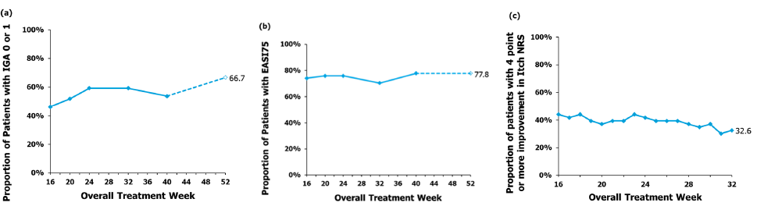
Proportion of patients with: a) Investigator Global Assessment (IGA) scores of 0 or 1; b) Eczema Area and Severity Index 75% (EASI75%) improvement response from Baseline; and c) Itch numeric rating scale (NRS) improvement of 4 or more points.
mITT = modified intent to treat; NRI = nonresponder imputation.
Note: The solid line shows NRI in the mITT population. The dashed line shows NRI in the Week 36 efficacy evaluable population. NRI was applied to patients who discontinued Study JAHN, but would have reached the Week 36 visit (overall treatment Week 52) had they continued in the study. Data for Itch NRS are only shown up to Week 16 of Study JAHN (overall treatment Week 32) as data from daily diaries were only collected up to this tie point.

Safety
Overall, the study drug exposure is adequate to assess the safety profile of baricitinib in treatment of patients with moderate to severe atopic dermatitis. In the 16-week placebo-controlled period dataset the mean days of exposure were 104.9, 107.1 and 109.9 in the placebo, baricitinib 2 mg and baricitinib 4 mg groups, respectively. In the 2 mg and 4 mg, atopic dermatitis dataset the mean days of exposure were 201.3 and 260.5 in the baricitinib 2 mg and baricitinib 4 mg groups, respectively.
The clinical evaluator concluded that the safety data showed a safety profile consistent with the known adverse effects of baricitinib and did not raise any new major safety concerns.
However, the clinical Delegate is concerned with the recent reports of venous thromboembolism and numerical imbalances of adverse events (AEs) between 4 mg and 2 mg dose over time.
In the four 16-week placebo-controlled studies, the pooled incidence of treatment-emergent adverse events (TEAEs) was comparable between baricitinib and placebo (57.7% with baricitinib 4 mg, 56.9% with baricitinib 2 mg and 51.5% with placebo). The pooled incidence of serious adverse events was lower with baricitinib 4 mg (1.8%) and baricitinib 2 mg (1.6%) compared to placebo (2.9%).
In the integrated analysis of these four studies, the most commonly reported TEAEs with baricitinib 4 mg were nasopharyngitis (10.2% versus 10.7% with baricitinib 2 mg and 11.0% with placebo), headache (7.5% versus 7.4% with baricitinib 2 mg and 3.3% with placebo) and blood creatine phosphokinase increased (4.2% versus 1.3% with baricitinib 2 mg and 0.6% with placebo).
In the extended period analysis, the most commonly reported TEAEs with baricitinib 4 mg were nasopharyngitis (18.2% versus 16.9% with baricitinib 2 mg), headache (9.3% versus 8.3%) and upper respiratory tract infection (6.2% versus 4.6%). Overall, these results are consistent with the known safety profile of baricitinib as described in the currently approved Australian Olumiant PI. The majority of these TEAES were mild to moderate in severity (in the 16-week placebo-controlled period, the percentage of subjects with severe TEAEs was 2.5% with baricitinib 4 mg, 3.5% with baricitinib 2 mg and 2.9% with placebo).
One death occurred, in a patient originally randomised to baricitinib 1 mg, who was re-randomised to 4 mg in Study JAHN but received 2 mg because of a GFR < 60 mL/min/1.73 m². The cause of death was a gastrointestinal bleed, more than 12 months after start of baricitinib and while being on 2 mg for 9 months. The patient had no known risk factors for gastrointestinal bleeding, but had a low haematocrit and a low erythrocyte count at Baseline, which may point to a possible earlier bleed.
Known adverse drug reactions of concern with baricitinib use in rheumatoid arthritis included infections, changes in laboratory parameters (neutropaenia, thrombocytosis, liver enzyme elevations, elevations in lipids and raised creatine phosphokinase), and venous thromboembolism. Analysis of these safety parameters in the atopic dermatitis studies did not raise additional safety concerns apart from recent reports of venous thromboembolism.
Although the incidence of treatment emergent infections was higher with baricitinib compared to placebo in the 16-week placebo-controlled period (34.0% with baricitinib 4 mg and 34.3% with baricitinib 2 mg versus 28.6% with placebo), most of these infections were mild to moderate in severity.
The incidence of severe infections was low in the 16-week placebo-controlled period (0.6% with baricitinib 4 mg, 0.7% with baricitinib 2 mg and 0.3% with placebo) and remained low in the extended phase (2.4% with baricitinib 4 mg and 1.0% with baricitinib 2 mg).
The proportion of patients with infection SAEs was also low in both the 16-week placebo-controlled period (0.3% with baricitinib 4 mg, 0.4% with baricitinib 2 mg and 0.7% with placebo) and the extended period (2.1% with baricitinib 4 mg and 0.4% with baricitinib 2 mg). The most commonly reported TEAEs in the System Organ Class of infections and infestations with baricitinib 4 mg were nasopharyngitis in the 16-week placebo-controlled period (10.8% with baricitinib 4 mg and 10.5% with baricitinib 2 mg versus 10.9% with placebo) and in the extended period (17.6% with baricitinib 4 mg and 15.8% with baricitinib 2 mg). The incidence of opportunistic infection was low (across the atopic dermatitis studies, there was only one reported opportunistic infection (in the placebo group), and no events of tuberculosis or viral hepatitis were reported).
Although, there were only three cases of venous thromboembolism reported across the atopic dermatitis studies (2 cases of pulmonary embolism with baricitinib 4 mg and one case of deep vein thrombosis with baricitinib 2 mg), in the clinical trial setting it is difficult to identify rare but life-threatening events like venous thromboembolism. The Delegate would like to know the incidence of venous thromboembolism in the USA where low dose (2 mg) is approved as compared to in the EU where 4 mg is approved (see ‘Questions for the sponsor’ section, below).
The risk for venous thromboembolism remains a concern for JAK inhibitors such as baricitinib. Pulmonary embolism/deep vein thrombosis is listed as adverse drug reaction and the Australian Olumiant PI includes such precautions (Section 4.4 of the PI). The Delegate would also like to know how this information on venous thromboembolism will be communicated to the prescriber as well as patient. A post-authorisation study has been proposed in EU to further assess the long-term safety profile in atopic dermatitis, including the risk of venous thromboembolism (endorsed by the EU/European Medicines Agency (EMA) Pharmacovigilance Risk Assessment Committee/Committee on Medicinal Products for Human Use. The TGA would like to see the results after its completion, which should be included as one of the risk management plan (RMP) measures.
Evaluation of laboratory parameters did not trigger any major safety concerns. In the 16-week placebo-controlled period, the proportion of patients experiencing ≥ 3 x the upper limit of normal for alanine transaminase or aspartate transaminase values was low in all treatment groups and remained low in the extended analysis.
Increases from Baseline in lipid profiles with baricitinib 4 mg were small (mean change from Baseline at 12 weeks of 0.3 mmol/L in total cholesterol and 0.07 mmol/L in low density lipoproteins; LDL). Although in the extended period mean values for total cholesterol and LDL continued to increase through Week 52, the increases remained low (mean changes from Baseline of 0.5 mmol/L for total cholesterol and 0.32 mmol/L for LDL with baricitinib 4 mg). Evaluation of major adverse cardiovascular events (MACE) as an outcome of hyperlipidaemia showed that there was no positively adjudicated MACE in both the 16-week placebo-controlled period and the extended period.
In both the baricitinib 4 mg and 2 mg groups, mean elevations of creatine phosphokinase were typically observed at 4 to 8 weeks and remained stable at a higher value than baseline thereafter, including in the extended period. The proportion of patients with any grade shifts in creatine phosphokinase was higher with baricitinib 4 mg and 2 mg versus placebo in the 16-week placebo-controlled period (24.2%, 20.1% and 10.1%, respectively). However, the proportion of patients with Grade 4 changes was low in the 16-week placebo-controlled period (1.8% with baricitinib 4 mg, 1.0% with baricitinib 2 mg and 1.1% with placebo) and remained low in the extended period (2.3% with baricitinib 4 mg and 1.3% with baricitinib 2 mg). In addition, the incidence of TEAEs potentially related to muscle symptoms was low in the 16-week placebo-controlled period (0.8% with baricitinib 4 mg, 0% with baricitinib 2 mg and 0.3% with placebo) and remained low in the extended period (1.3% with baricitinib 4 mg and 0% with baricitinib 2 mg). These TEAEs were all of muscle spasms and myalgia.
In the 16-week placebo-controlled period, the proportion of patients with low neutrophil and high platelets were higher in the baricitinib 4 mg and 2 mg groups compared to placebo (low neutrophil: 10.8% with baricitinib 4 mg and 8.2% with baricitinib 2 mg versus 5.0% with placebo; high platelets: 5.3 with baricitinib 4 mg and 4.3% with baricitinib 2 mg versus 1.8% with placebo).
Analysis of change from Baseline in platelet count over time showed increases in platelet count (mean change from Baseline at Week 16 was 25.2 x 10 ⁹ cells/L in the baricitinib 4 mg group and 16.0 x 10⁹ cells/L in the baricitinib 2 mg group; mean change from Baseline at Week 68 was 33.3 x 10 ⁹ cells/L in the baricitinib 4 mg group and -10.7 x 10⁹ cells/L in the baricitinib 2 mg group). However, the proportion of patients with a change from less than 600 x 10 ⁹ cells/L to greater than 600 x 10 ⁹ cells/L was low in the 16-week placebo-controlled period (0.3% with baricitinib 4 mg and 1.6% with baricitinib 2 mg versus 0% with placebo), and remained low in the extended period (0.5% with baricitinib 4 mg and 2.1% with baricitinib 2 mg). None of the three patients with a venous thromboembolism event had a platelet count of 400 x 10⁹ cells/L or greater at any time before the event.
Safety results also did not raise any major safety concerns in the safety profile of baricitinib when used with or without concomitant topical corticosteroid use.
Overall, the clinical evaluator suggests that the safety results did not show any consistent dose-related differences between baricitinib 4 mg and 2 mg. However, the clinical Delegate has observed that over time, the occurrence of adverse events of all kinds appears to be slightly higher with the 4 mg dose as compared to the 2 mg dose. Even though the sponsor has suggested that down titration to 2 mg is an option, the Delegate is of the opinion that the starting dose of 2 mg will be better suited for atopic dermatitis indication (non-life threatening) and 4 mg should be used as a short-term therapy for nonresponders.

Risk management plan
The most recently evaluated EU-risk management plan (RMP) was EU-RMP version 2.0 (dated 7 June 2017, data lock point 1 January 2016) and Australian-specific annex (ASA) version 0.5 (dated 13 August 2019). In support of the extended indications, the sponsor has submitted EU-RMP version 8.1 (dated 5 November 2019; data lock point 6 September 2019) and ASA version 1.1 (dated 15 November 2019). With the sponsor’s post first round responses, the sponsor provided an updated ASA version 1.2 (dated 30 June 2020).
As the TGA has previously evaluated RMPs for this product, the focus of this evaluation is on the differences between the RMP versions that could have an impact on the safety profile, and any new safety related information relevant to this submission.
The proposed summary of safety concerns and their associated risk monitoring and mitigation strategies are summarised below in Table 12.
Table 12: Summary of safety concerns
Summary of safety concerns |  | Pharmacovigilance |  | Risk minimisation
 |  | Routine | Additional | Routine | Additional
Important identified risks | Herpes zoster | * |  |  | †
Important potential risks | Malignancies (including lymphoma and typically virus-induced malignancies such as cervical and many oropharyngeal cancers) | * |  |  | –
Important potential risks | Serious and opportunistic infections (including tuberculosis, Candida infections, PML) | * |  |  | †
Important potential risks | Myelosuppression (agranulocytosis) | * |  |  | –
Important potential risks | Myopathy including rhabdomyolysis | * |  |  | –
Important potential risks | Potential for drug-induced liver injury | * |  |  | –
Important potential risks | Gastrointestinal perforation | * |  | – | –
Important potential risks | MACE as an outcome of hyperlipidaemia | * |  |  | –
Important potential risks | Foetal malformation following exposure in utero | * |  |  | †
Important potential risks | Venous thromboembolic event | * |  |  | †
Missing information | Long-term safety | * |  |  | –
Missing information | Use in very elderly (≥ 75years) |  |  |  | –
Missing information | Use in patients with evidence of hepatitis B or hepatitis C infection | * | – |  | –
Missing information | Use in patients with a history of or current lymphoproliferative disease |  | – |  | –
Missing information | Use in patients with active or recent primary or recurrent malignant disease |  | – |  | –
Missing information | Use in paediatric patients |  |  |  | –
*Follow up questionnaires †HCP educational material and patient alert card
In summary:
- The summary of safety concerns is acceptable from RMP perspective.
- The proposed pharmacovigilance activities are acceptable.
- The risk minimisation activities continue to be acceptable.

Risk-benefit analysis

Delegate’s considerations
Baricitinib (Olumiant) is a second-in-class, reversible Janus kinase inhibitor proposed for the treatment of adult patients with moderate to severe atopic dermatitis.
In patients with atopic dermatitis, the maximum concentration and area under the concentration-time curve at steady state are 124 nM and 1117 nM x h, respectively, at the proposed dose of 4 mg. The maximum concentration and area under the concentration-time curve between dosing intervals at steady state tend to be lower in patients with atopic dermatitis compared to patients with rheumatoid arthritis (by a factor 0.8) at the proposed dose of 4 mg. No drug-drug interactions are expected with frequently concomitant medication in patients with atopic dermatitis. However, combination with ciclosporin or other potent immunosuppressant has not been studied and is not recommended. This is adequately reflected in the Section 4.2 of the Olumiant PI.
In an in-vitro three dimensional human skin model treated with pro-inflammatory cytokines (such as interleukins 4, 13, and 31), baricitinib reduced epidermal keratinocyte pSTAT3 expression, and increased the expression of filaggrin, a protein that plays a role in skin barrier function and in the pathogenesis of atopic dermatitis. Section 5.1 of the product information has been updated accordingly.
In the monotherapy studies (Studies JAHL and JAHM), both baricitinib 2 mg and 4 mg were statistically significant than placebo in reaching an IGA score of 0 or 1 at Week 16 (with a ≥ 2 point improvement from Baseline), while adjusting for multiplicity. In the combination therapy study, baricitinib 4 mg was more effective than placebo in reaching an IGA score of 0 or 1 at Week 16 in the combination therapy study than baricitinib 2 mg, which did not reach statistical significance. The 1 mg dose was not more effective than placebo. The results were supported by sensitivity analyses.
A significantly larger proportion of patients randomised to baricitinib 2 mg or 4 mg achieved an EASI75 response, or an improvement of ≥ 4 points on the Itch NRS compared to placebo at Week 16. Treatment effects in subgroups (weight, age, gender, race, disease severity, and previous treatment, including immunosuppressants) were consistent with the results in the overall study population.
The effect after 16 weeks appears to be largely maintained over 52 weeks, similar in the patients continuing 2 mg and 4 mg, whether on monotherapy or on combination therapy.
Overall, the clinical delegate considers that both the baricitinib doses (2 mg and 4 mg) are effective doses. To mitigate the concerns over the dose, because maintenance of effects in (partial) responders on 4 mg are well maintained with the 2 mg dose, the sponsor has suggested to include the wording the PI with regards to lowering the dose to 2 mg if a desirable target level of atopic dermatitis is reached. Additional information suggested by the sponsor to be included in the PI treatment is that baricitinib 4 mg should be discontinued if no response is reached by Week 8. Even though more information will be available upon completion of the down-titration/stop sub study in period 2 of Study JAHN, 2 mg dose seems the lowest effective dose for adult patients suffering from moderate to severe atopic dermatitis. It is also evident to the Delegate by the dose ranging study (Study JAHG) wherein both the 2 mg and 4 mg doses showed benefit on the main efficacy endpoints as compared to placebo, and both doses had an acceptable safety profile at Week 16.
In addition, to support the 2 mg as lowest effective dose the Delegate would like to point out the efficacy results of the Study JAHN open-label addendum (patients enrolled directly into the study, and therefore received baricitinib 2 mg for the first time at Week 0 of Study JAHN). It showed that the IGA score of 0 or 1 response of baricitinib 2 mg increased from Week 0 to Week 24. The EASI75 response increased through Week 16, and was then maintained through Week 24. The Itch NRS response of baricitinib 2 mg also increased through Week 11, and was then maintained through Week 16.
Overall safety data is adequate and it showed a safety profile consistent with the known adverse effects of baricitinib in the rheumatoid arthritis population. The most commonly reported TEAEs with baricitinib 4 mg were nasopharyngitis in both the 16-week placebo-controlled period (10.2% versus 11.0% with placebo) and the extended period (18.2%). The majority of the TEAES were mild to moderate in severity.
There were no clear clinically relevant differences in the safety profile of baricitinib either taken as monotherapy or used in combination with topical corticosteroids, despite differences in serious AEs and discontinuations. However, the clinical delegate is concerned with the recent reports of venous thromboembolism associated with baricitinib and consistent numerical imbalances of AEs between the 4 mg and 2 mg doses. Additionally, there were 2 reports of pulmonary embolism with baricitinib 4 mg and none with 2 mg.
Currently, there are only two approved systemic pharmacological treatments in moderate to severe atopic dermatitis: ciclosporin (oral) and dupilumab (subcutaneous injection). Both drugs have limitations in their usage. Ciclosporin can lead to irreversible renal toxicity, hypertension, and hematopoietic adverse events and is therefore not intended for long-term use. Dupilumab has limitations relating to the mode of administration of injection, such as patient anxiety and injection site reactions. Baricitinib therefore has potential benefit as an alternative pharmacological option in this patient population with an oral once-daily dose regimen.
While the two proposed doses of baricitinib (2 mg and 4 mg) are clearly effective for the treatment of atopic dermatitis, there are significant concerns on the overall risk/benefit is favourable for baricitinib 4 mg given the unique safety risk of thrombosis/venous thromboembolism) and the other known safety risks, such as malignancy and severe infections. The safety finding of thrombosis/venous thromboembolism has not been seen with other development programs for atopic dermatitis. While the number of cases are limited, there were serious and fatal cases. Baricitinib-associated platelet elevation also raises the concern for a possible underlying mechanism of increased thrombotic risk.
One of the objectives of benefit-risk assessment is to extrapolate what was seen in the controlled clinical trials to real world experience where a broader range of patients will be exposed to baricitinib post-approval with disease severity and safety risk that was not assessed in the clinical program. From the efficacy side for baricitinib, for some patients under some circumstances the 4 mg dose may provide some benefit over the 2 mg dose. From the safety side for baricitinib, based on numerical imbalance between the two dose and recent increase reporting of venous thromboembolism, the Delegate considers it is likely that 4 mg dose would carry a higher risk of harm compared to the 2 mg dose.
To summarise, ongoing concerns regarding deep vein thromboses and pulmonary embolisms with baricitinib are self-evident to the Delegate. As a result, the Delegate agrees with clinical evaluator views on the overall benefit-risk balance for the proposed treatment of a non-life-threatening condition (atopic dermatitis) and would recommend that the proposed dosage regimen for the treatment of atopic dermatitis be to start with baricitinib 2 mg and increasing to baricitinib 4 mg only if there is no evidence of efficacy for short duration.

Conditions of registration
Any changes to which the sponsor has agreed should be included in a revised RMP and ASA. However, irrespective of whether or not they are included in the currently available version of the RMP document, the agreed changes become part of the risk management system.
The suggested wording is:
The Olumiant EU-Risk Management Plan (RMP) (version 8.1, dated 5 November 2019; data lock point 6 September 2019), with Australian Specific Annex (version 1.2, dated 30 June 2020), included with submission PM-2019-05319-1-1, and any subsequent revisions, as agreed with the TGA will be implemented in Australia.
An obligatory component of risk management plans is routine pharmacovigilance. Routine pharmacovigilance includes the submission of periodic safety update reports (PSURs).
Reports are to be provided in line with the current published list of EU reference dates and frequency of submission of PSURs until the period covered by such reports is not less than three years from the date of the approval letter.
The reports are to at least meet the requirements for PSURs as described in the European Medicines Agency’s Guideline on good pharmacovigilance practices (GVP) Module VII-periodic safety update report (Rev 1), Part VII.B Structures and processes. Note that submission of a PSUR does not constitute an application to vary the registration.

Outstanding issues
- Should the starting dose be 2 mg or 4 mg?
- Should the maintenance dose be 2 mg or 4 mg?
- Characterisation of risk of venous thromboembolism, malignancy and serious infections.

Proposed action
Overall, baricitinib is approvable as the quality, nonclinical and clinical evaluators (pending dose change) have all recommended approval. The Delegate considers that sufficient data and justification have been provided to support the registration of baricitinib on quality, safety and efficacy grounds for the treatment of moderate to severe atopic dermatitis in adult patients who are candidates for systemic therapy (subjected to Advisory Committee (ACM) deliberations over the dose and PI changes).

Questions for the sponsor
The sponsor provided the following response to questions from the Delegate.

Question 1
Can you provide the incidence of venous thromboembolism by geographical location; more importantly US versus EU data to ascertain the dose dependency of venous thromboembolism (4 mg versus 2 mg)?

Incidence rate of venous thromboembolism in different regions from rheumatoid arthritis clinical trials
This section summarises venous thromboembolism data from the extended period of the rheumatoid arthritis studies through 1 September 2019, that is, 50 months after the data cutoff for the initial baricitinib rheumatoid arthritis global submission. This is the most recent data cut for the rheumatoid arthritis clinical trial database. No additional data on the placebo-controlled periods in rheumatoid arthritis are available compared with the initial rheumatoid arthritis submission.
As treatment randomisation in the rheumatoid arthritis studies was stratified by region, doses are expected to be well balanced across the various regions (see Table 13, below).
Data from the 50-month update showed that the incident rate of venous thromboembolism in the rheumatoid arthritis clinical trials was higher in the US and Canada than the EU.
Table 13: Venous thromboembolism data in different regions from All Baricitinib rheumatoid arthritis analysis set (including all patients receiving baricitinib at any dose)
 | Asia (excluding Japan) | Central/South America + Mexico | European Union | Japan | United States and Canada | Rest of World
N(%) | 445 (11.8) | 760 (20.2) | 783 (20.8) | 514 (13.6) | 840 (22.3) | 428 (11.4)
PYE | 1520 | 3207 | 3094 | 1642 | 2362 | 1463
n | 1 | 6 | 18 | 5 | 18 | 12
IR | 0.07 | 0.19 | 0.58 | 0.30 | 0.76 | 0.82
Abbreviations: IR = incidence rate per 100 PYE; N = number of patients at risk; n = number of patients in the specified category; PYE = patient-years of exposure; RA = rheumatoid arthritis; VTE = venous thromboembolism.
Percentages are based on the total number of patients in All BARI RA (N = 3770); IR is 100 times the number of patients experiencing the adverse event divided by the event-specific exposure to treatment (exposure time up to the event for patients with the event and exposure time up to the end of the period for patients without the event), in years.
Data as of 1 September 2019.

Incidence rate of venous thromboembolism per dose group from rheumatoid arthritis clinical trials
Across all regions, including the EU and US, there was no evidence of a dose-response relationship for venous thromboembolism in the 50-month update. In the extended 2 mg versus 4 mg rheumatoid arthritis analysis set, which included 479 patients on baricitinib 4 mg (patient years of exposure = 796.3) and 479 patients on 2 mg (patient years of exposure = 789.3):
- incident rates for venous thromboembolism and pulmonary embolism did not differ between 4 mg and 2 mg, and
- the incident rate for deep vein thrombosis was numerically higher for 2 mg compared with 4 mg (see Table 14, below).
Table 14: Dose comparison of incidence rates of venous thromboembolic events in the extended 2 mg versus 4 mg analysis set
 | 2 mg dose | 4 mg dose
Number of patients in the safety analysis set | 479 | 479
Patient years of exposure | 789.3 | 796.3
Venous thromboembolic events; incident rate (n) | 0.63 (5) | 0.50 (4)
Pulmonary embolism, incident rate (n) | 0.25 (2) | 0.25 (2)
Deep vein thrombosis, incident rate (n) | 0.51 (4) | 0.25 (2)
n = number of patients in the specified category
Data as of 1 September 2019.
Note: Percentages are based on the number of patients in each treatment group; incident rate is 100 times the number of patients experiencing the adverse event divided by the event-specific exposure to treatment (exposure time up to the event for patients with the event and exposure time up to the end of the period for patients without the event, up to rescue), in years.

Incidence rate of venous thromboembolic events in different regions from postmarketing data
As of 31 July 2020, a total of 222,700 patients with rheumatoid arthritis are estimated to have been exposed to baricitinib, post-approval. Approximately 75% of these patients were exposed to baricitinib 4 mg, while approximately 25% were exposed to 2 mg. Therefore, more events are likely to be reported by patients treated with baricitinib 4 mg than 2 mg. Approximately 69% of the patients who received baricitinib post-approval resided in Europe, 14% in Japan, 4% in the US, and 13% in other regions. Only baricitinib 2 mg is available in the US and Canada, whereas 4 mg is available in the EU.
As of 13 August 2020, 206 cases of venous thromboembolism (reporting rate of 0.09%) have been reported in the postmarketing setting. Doses were not reported in 19% of these cases. Among the 166 venous thromboembolism cases containing information on baricitinib dose, 73% (n = 121) were reported in the 4-mg dose and 27% (n = 45) in the 2 mg dose. This is in line with the overall proportion of patients exposed to each dose. Therefore, there is no evidence of a dose-response relationship for venous thromboembolism from postmarketing data.
As of 13 August 2020, the overall reporting rate of venous thromboembolism events in patients treated with baricitinib in the post marketing setting was 0.21 per 100 patient years of exposure This is lower than the background incidences of 0.3 to 0.8 per 100 patient years of exposure reported in real-world studies of the rheumatoid arthritis population., Where information was available, most of the patients who developed venous thromboembolism had risk factors such as:
- age over 50 years
- previous history of venous thromboembolism
- lack of mobility
- obesity
- hypertension, or
- use of methotrexate, corticosteroids, nonsteroidal anti-inflammatory drugs, or oestrogen.
The reporting rate per 100 patient years of exposure was higher in the US than Europe or other regions (see Table 15, below).
The differences in reporting rate of venous thromboembolism reflect differences in the prevalence of the risk factors for venous thromboembolism, in particular higher body mass index.
Table 15: Post-marketing venous thromboembolic event reporting rates in different regions for patients treated with any dose of baricitinib
 | United States | European Union | Japan | Other regions
Venous thromboembolic event reporting rate per 100 patient years | 0.47 | 0.21 | 0.10 | 0.23

Question 2
What is the status of the US Food and Drug Administration submission for atopic dermatitis?
The sponsor submitted a supplemental New Drug Application for atopic dermatitis to the US Food and Drug Administration on 14 June 2020. This supplemental New Drug Application is only for baricitinib 2 mg, as only the 2 mg dose was tested in US atopic dermatitis clinical trials and is approved for rheumatoid arthritis in the USA. The application is currently under review. In the Day 60 letter, the FDA confirmed that they had not identified any potential review issues. The Prescription Drug User Fee Act date is 15 April 2021.
An approval was granted by EMA for the treatment of moderate-to-severe atopic dermatitis in October 2020. The approved posology is:
‘The recommended dose of Olumiant is 4 mg once daily. A dose of 2 mg once daily is appropriate for patients such as those aged ≥ 75 years and may be appropriate for patients with a history of chronic or recurrent infections. A dose of 2 mg once daily should be considered for patients who have achieved sustained control of disease activity with 4 mg once daily and are eligible for dose tapering.
Olumiant can be used with or without topical corticosteroids. The efficacy of Olumiant can be enhanced when given with topical corticosteroids (see section 5.1). Topical calcineurin inhibitors may be used, but should be reserved for sensitive areas only, such as the face, neck, intertriginous and genital areas.
Consideration should be given to discontinuing treatment in patients who show no evidence of therapeutic benefit after 8 weeks of treatment’.

Question 3
The Breeze AD4 clinical trial was not submitted in the dossier. Please explain the rationale for the omission.
Study JAIN (BREEZE AD4 trial) was primarily designed to address a request from EU health technology assessment bodies and support pricing and reimbursement dossiers. It was not included in the registration dossier as data were not available at time of submission.
Interim data from Study JAIN are now available and do not impact the benefit/risk profile of baricitinib. An interim clinical study report for Study JAIN is now available and can be provided upon request.
Interim data for Study JAIN show that baricitinib 4 mg met the primary endpoint of the study, that is, EASI75 at Week 16, and offered significant improvements compared to placebo for measures of:
- skin inflammation
- itch
- skin pain, and
- sleep disturbance due to itch.
Baricitinib 2 mg did not meet the primary endpoint, but offered significant improvements compared with placebo for EASI percent change from Baseline, itch, skin pain, and SCORAD75.
No new safety findings were detected in Study JAIN. The safety data have been integrated with other studies and were incorporated into the revised prescribing information in the post-first round response.
In summary, the data from Study JAIN do not impact the benefit/risk profile of baricitinib.

Advisory Committee considerations
The Advisory Committee on Medicines (ACM), having considered the evaluations and the Delegate’s overview, as well as the sponsor’s response to these documents, advised the following.

Specific advice to the Delegate
The ACM advised the following in response to the Delegate’s specific request for advice.
- What are ACM’s views on the efficacy and to what extent is there sufficient clinical trial evidence to support the proposed indication for the treatment of moderate to severe atopic dermatitis in adult patients who are candidate for systemic therapy?
- Do the clinical trial data provide substantial evidence of the efficacy of baricitinib 2 mg for the treatment of adult patients with moderate to severe atopic dermatitis who are eligible for systemic therapy?
The ACM agrees that there is sufficient evidence of efficacy for baricitinib 2 mg for AD, as efficacy for 2 mg was robustly demonstrated in 2 of 3 pivotal studies, and strongly supported in the third.
- Do the clinical trial data provide substantial evidence of the efficacy of baricitinib 4 mg for the treatment of adult patients with moderate to severe atopic dermatitis who are eligible for systemic therapy?
The ACM agrees that there is sufficient evidence of efficacy for baricitinib 4 mg for atopic dermatitis, as efficacy was robustly demonstrated in all 3 pivotal trials.
- Do the available efficacy data on atopic dermatitis support one dose over the other?
The ACM discussed the use of a 2 mg dose versus a 4 mg dose. They noted that the 4 mg dose has been shown to be more efficacious in some lower-order secondary endpoints within the trials but any differences between the two strengths were not able to be generalised to clinical meaningfulness, given the significance of the efficacy findings for the primary endpoints of both mono-therapy pivotal studies. They noted that the difference in efficacy between the 2 mg and 4 mg doses decreases in significance approaching 16 weeks and beyond. Efficacy is durable for both strengths from the long term extension data currently available.
Given that quality-use principles support use of the lowest effective commencement dose and that a very small number of venous thromboembolism events were seen with the 4 mg dose and not the 2 mg dose, the ACM suggests that the 2 mg should be the recommended starting dose for moderate to severe disease, then increased to 4 mg if an inadequate clinical response is achieved after 3 weeks or longer on 2 mg ± combination systemic therapy ± optimised topical therapy.
- Does the ACM consider safety data adequate to support the approval of baricitinib 2 mg for the treatment of adult patients with of moderate to severe atopic dermatitis?
The ACM agrees that there is adequate safety evidence for baricitinib 2 mg for atopic dermatitis, noting it was consistent with the known safety prolife and that no new signals appeared apparent.
- Does the ACM consider safety data adequate to support the approval of baricitinib 4 mg for the treatment of adult patients with of moderate to severe atopic dermatitis?
The ACM agrees that there is adequate safety evidence for baricitinib 4 mg for atopic dermatitis.
The ACM noted that a very small number of venous thromboembolism events were seen within the 4 mg dose but not the 2 mg, and advised that 2 mg should be the recommended starting dose, as outlined in the advice to Question 1c, above.
- Does the ACM consider that the safety of baricitinib in the proposed indication is sufficiently well characterised and communicated in the PI?
There has been recent reports in the post market setting (rheumatoid arthritis) in the imbalance of venous thromboembolism (As of 1 July 2019, 114 venous thromboembolic events have been reported in 102 cases from post-marketing reports, per EU Pharmacovigilance Risk Assessment Committee report).
The ACM noted that venous thromboembolism is a serious adverse effect and the risk of VTE should be more clearly communicated within the PI.
A patient alert card was also discussed by the ACM, particularly considering some uncertainties around venous thromboembolism and the safety profile. This may also assist with gathering further post-market data to better understand the safety profile.
The ACM also discussed additional measures such as stopping combined oral contraceptives, undergoing screening, stopping smoking. The ACM was of the view that a boxed warning is not required.
- Is the benefit-risk profile adequate to support approval of baricitinib 2 mg for the proposed indication of the treatment of adult patients with moderate to severe atopic dermatitis who are eligible for systemic therapy?
The ACM agrees that the benefit-risk profile is adequate to support the approval of 2 mg baricitinib.
- Is the benefit-risk profile adequate to support approval of baricitinib 4 mg for the proposed indication of the treatment of adult patients with moderate to severe atopic dermatitis who are eligible for systemic therapy?
The ACM agrees that the benefit-risk profile is adequate to support the approval of 4 mg baricitinib for those who have inadequate response to 2 mg.
- The Committee is also requested to provide advice on any other issues that it thinks may be relevant to a decision on whether or not to approve this application.
The ACM noted that baricitinib can be considered at the same time as a first line oral therapy in the treatment of atopic dermatitis, and that stronger treatment initiation (monotherapy) is now the norm in clinical practice, particularly for younger patients.

Conclusion
The ACM considered this product to have an overall positive benefit-risk profile for the indication:
Olumiant is indicated for the treatment of moderate to severe atopic dermatitis in adult patients who are candidates for systemic therapy.
Recommended dose of Olumiant is 2 mg or 4 mg once daily, as monotherapy or in combination with topical corticosteroids.
Olumiant is given orally with or without food.

Outcome
Based on a review of quality, safety and efficacy, the TGA approved the registration of Olumiant (baricitinib) 2 mg and 4 mg film coated tablets, indicated for the following extension of indications:
Atopic Dermatitis
Olumiant is indicated for the treatment of moderate to severe atopic dermatitis in adult patients who are candidates for systemic therapy.
As such, the full indications at this time were:
Rheumatoid Arthritis
Olumiant is indicated for the treatment of moderate to severe active rheumatoid arthritis (RA) in adult patients who have responded inadequately, or who are intolerant, to one or more DMARDs.
Olumiant can be taken as monotherapy or in combination with cDMARDs, including methotrexate (MTX).
Atopic Dermatitis
Olumiant is indicated for the treatment of moderate to severe atopic dermatitis in adult patients who are candidates for systemic therapy.

Specific conditions of registration applying to these goods
The Olumiant EU-Risk Management Plan (RMP) (version 8.1, dated 5 November 2019; data lock point 6 September 2019), with ASA (version 1.2, dated 30 June 2020), included with submission PM-2019-05319-1-1, and any subsequent revisions, as agreed with the TGA will be implemented in Australia.
An obligatory component of risk management plans is routine pharmacovigilance. Routine pharmacovigilance includes the submission of periodic safety update reports (PSURs). Reports are to be provided in line with the current published list of EU reference dates and frequency of submission of PSURs until the period covered by such reports is not less than three years from the date of the approval letter.
The reports are to at least meet the requirements for PSURs as described in the European Medicines Agency’s Guideline on Good Pharmacovigilance Practices (GVP) Module VII-periodic safety update report (Rev 1), Part VII.B Structures and processes. Note that submission of a PSUR does not constitute an application to vary the registration.

Attachment 1. Product Information
The PI for Olumiant approved with the submission which is described in this AusPAR is at Attachment 1. For the most recent PI, please refer to the TGA website at <https://www.tga.gov.au/product-information-pi>.

Therapeutic Goods Administration
PO Box 100 Woden ACT 2606 Australia
Email: info@tga.gov.au Phone: 1800 020 653 Fax: 02 6232 8605
https://www.tga.gov.au

The Black Triangle Scheme provides a simple means for practitioners and patients to identify certain types of new prescription medicines, including those being used in new ways and to encourage the reporting of adverse events associated with their use. The Black Triangle does not denote that there are known safety problems, just that the TGA is encouraging adverse event reporting to help us build up the full picture of a medicine's safety profile.
AusPAR Olumiant baricitinib Eli Lilly Australia Pty Ltd PM-2016-01468-1-3; publication date: 17 July 2019. Available at: https://www.tga.gov.au/auspar/auspar-baricitinib
pSTAT3 = phosphorylated signal transducer and activator of transcription 3.
The Validated Investigator Global Assessment for Atopic Dermatitis (vIGA-AD) is a validated 5-point scale used by clinicians in the determination and scoring of the severity of a patient’s atopic dermatitis at a specific moment in time. The vIGA-AD scores are as follows: Score 0 = Clear: No inflammatory signs of atopic dermatitis (no erythema, no induration/papulation, no lichenification, no oozing/crusting). Post-inflammatory hyperpigmentation and/or hypopigmentation may be present. Score 1 = Almost clear: Barely perceptible erythema, barely perceptible induration/papulation, and/or minimal lichenification. No oozing or crusting. Score 2 = Mild: Slight but definite erythema (pink), slight but definite induration/papulation, and/or slight but definite lichenification. No oozing or crusting. Score 3 = Moderate: Clearly perceptible erythema (dull red), clearly perceptible induration/papulation, and/or clearly perceptible lichenification. Oozing and crusting may be present. Score 4 = Severe: Marked erythema (deep or bright red), marked induration/papulation, and/or marked lichenification. Disease is widespread in extent. Oozing or crusting may be present. Simpson E et al. The Validated Investigator Global Assessment for Atopic Dermatitis (vIGA- AD): The development and reliability testing of a novel clinical outcome measurement instrument for the severity of atopic dermatitis. J Am Acad Dermatol. 2020 Sep;83(3):839-846.
The Eczema Area and Severity Index (EASI) is a validated scoring system that grades the physical signs of atopic dermatitis/eczema. EASI is a core outcome for measuring the clinical signs of eczema in clinical trials. The EASI scoring system uses a defined process to grade the severity of the signs of eczema and the extent affected. Each of the following regions is considered separately: head and neck; trunk (including the genital area); upper extremities; and lower extremities (including the buttocks). Each region is given a region score from 0 to 6 depending on the degree of involvement; no involvement = 0, 100% involvement = 6. Next, each region is scored from 0 to 4 according to the severity of four different signs: erythema; oedema/papulation; excoriation; and lichenification. 0 denotes none/absent, 4 = severe. The final EASI score is the sum of the 4 region scores. The final EASI score ranges from 0 to 72.
The Eczema Area and Severity Index (EASI) 50, EASI70 and EASI90 response score denotes either a patient achieving a 50, 70 or 90% improvement in EASI score from Baseline, or the proportion/percentage of patients achieve that response.
The Itch NRS is comprised of one item and represents the numbers 0 (‘no itch’) to 10 (‘worst imaginable itch’). Subjects are asked to rate the intensity of their itch using this scale: patients are asked to respond to the following questions: ‘how was your itch, on average in the last 24 hours?’ and ‘how was your worst itch in last 24 hours’. Responses can It can be interpreted as follows: NRS = 0, no pruritus; NRS < 3, mild pruritus; NRS > 3< 7, moderate pruritus; NRS > 7< 9, severe pruritus; NRS > 9, very severe pruritus.
10 sites in the United States of America and 3 sites in Japan
SCORing Atopic Dermatitis or SCORAD is a clinical tool used to assess the extent and severity of eczema.Dermatologists may use this tool before and after treatment to determine whether the treatment has been effective.
The Dermatology life Quality Index (DLQI) is a ten-question questionnaire used to measure the impact of skin disease on the quality of life of an affected person. It is designed for people aged 16 years and above. There are 10 questions, covering the following topics: symptoms, embarrassment, shopping and home care, clothes, social and leisure, sport, work or study, close relationships, sex, treatment. Each question refers to the impact of the skin disease on the patient’s life over the previous week. Each question is scored from 0 to 3, giving a possible score range from 0 (meaning no impact of skin disease on quality of life) to 30 (meaning maximum impact on quality of life). A series of validated band descriptors were described in 2005 to give meaning to the scores of the DLQI. These bands are as follows: 0-1 = No effect on patient’s life, 2-5 = Small effect, 6-10 = Moderate effect, 11-20 = Very large effect, 21-30 = Extremely large effect.
Eichenfield L et al. Guidelines of care for the management of atopic dermatitis: section 1. Diagnosis and assessment of atopic dermatitis. J Am Acad Dermatol. 2014 Feb;70(2):338-51.
At the time of interim database lock, Treatment Period 1 of Study JAHN was still ongoing. All patients from originating studies JAHL and JAHM had reached the Week 16 (overall treatment week 32) endpoint. Efficacy data at Week 36 (overall treatment week 52) were available for 85% of patients and were included in this report (available safety data up to Week 52 (overall treatment week 68) were also included in the submitted interim study report). Patients from Study JAIY were not included in the submitted interim report as few were expected to reach the 16-week endpoint at the time of the data cut-off date).
Major adverse cardiovascular event (MACE) is a composite clinical endpoint frequently used as an outcome in the evaluation of clinical trials in cardiology research; or may be used elsewhere as a safety outcome measure in clinical trials. The definitions of MACE can differ; the ‘classical 3-point MACE’ is defined as a composite of nonfatal stroke, nonfatal myocardial infarction, and cardiovascular death. Other definitions may include cardiovascular disease events, including ischemic cardiovascular events or heart failure leading to hospital admission.
Routine risk minimisation activities may be limited to ensuring that suitable warnings are included in the product information or by careful use of labelling and packaging. Routine pharmacovigilance practices involve the following activities: - All suspected adverse reactions that are reported to the personnel of the company are collected and collated in an accessible manner; - Reporting to regulatory authorities; - Continuous monitoring of the safety profiles of approved products including signal detection and updating of labelling; - Submission of PSURs; - Meeting other local regulatory agency requirements.
Kim S, et al., Risk of venous thromboembolism in patients with rheumatoid arthritis. Arthritis Care Res (Hoboken). 2013;65(10):1600–1607.
Ogdie A, Kay McGill N, Shin DB, et al. Risk of venous thromboembolism in patients with psoriatic arthritis, psoriasis and rheumatoid arthritis: a general population-based cohort study. Eur Heart J. 2018;39(39):3608–3614.
The ACM provides independent medical and scientific advice to the Minister for Health and the Therapeutic Goods Administration (TGA) on issues relating to the safety, quality and efficacy of medicines supplied in Australia including issues relating to pre-market and post-market functions for medicines. The Committee is established under Regulation 35 of the Therapeutic Goods Regulations 1990. Members are appointed by the Minister. The ACM was established in January 2017 replacing Advisory Committee on Prescription Medicines (ACPM) which was formed in January 2010. ACM encompass pre and post-market advice for medicines, following the consolidation of the previous functions of the Advisory Committee on Prescription Medicines (ACPM), the Advisory Committee on the Safety of Medicines (ACSOM) and the Advisory Committee on Non-Prescription Medicines (ACNM). Membership comprises of professionals with specific scientific, medical or clinical expertise, as well as appropriate consumer health issues relating to medicines.

