June 2020

Australian Public Assessment Report for Atezolizumab
  - Proprietary Product Name: Tecentriq
  - Sponsor: Roche Products Pty Ltd

About the Therapeutic Goods Administration (TGA)
- The Therapeutic Goods Administration (TGA) is part of the Australian Government Department of Health and is responsible for regulating medicines and medical devices.
- The TGA administers the Therapeutic Goods Act 1989 (the Act), applying a risk management approach designed to ensure therapeutic goods supplied in Australia meet acceptable standards of quality, safety and efficacy (performance) when necessary.
- The work of the TGA is based on applying scientific and clinical expertise to decision-making, to ensure that the benefits to consumers outweigh any risks associated with the use of medicines and medical devices.
- The TGA relies on the public, healthcare professionals and industry to report problems with medicines or medical devices. TGA investigates reports received by it to determine any necessary regulatory action.
- To report a problem with a medicine or medical device, please see the information on the TGA website <https://www.tga.gov.au>.

About AusPARs
- An Australian Public Assessment Report (AusPAR) provides information about the evaluation of a prescription medicine and the considerations that led the TGA to approve or not approve a prescription medicine submission.
- AusPARs are prepared and published by the TGA.
- An AusPAR is prepared for submissions that relate to new chemical entities, generic medicines, major variations and extensions of indications.
- An AusPAR is a static document; it provides information that relates to a submission at a particular point in time.
- A new AusPAR will be developed to reflect changes to indications and/or major variations to a prescription medicine subject to evaluation by the TGA.

Copyright
© Commonwealth of Australia 2020
This work is copyright. You may reproduce the whole or part of this work in unaltered form for your own personal use or, if you are part of an organisation, for internal use within your organisation, but only if you or your organisation do not use the reproduction for any commercial purpose and retain this copyright notice and all disclaimer notices as part of that reproduction. Apart from rights to use as permitted by the Copyright Act 1968 or allowed by this copyright notice, all other rights are reserved and you are not allowed to reproduce the whole or any part of this work in any way (electronic or otherwise) without first being given specific written permission from the Commonwealth to do so. Requests and inquiries concerning reproduction and rights are to be sent to the TGA Copyright Officer, Therapeutic Goods Administration, PO Box 100, Woden ACT 2606 or emailed to <tga.copyright@tga.gov.au>.

Contents
Common abbreviations 4
I. Introduction to product submission 6
Submission details 6
Product background 7
Regulatory status 8
Product Information 8
II. Registration time line 8
III. Overall conclusion and risk/benefit assessment 9
Quality 9
Nonclinical 9
Clinical 9
Risk management plan 23
Risk-benefit analysis 23
Outcome 25
Attachment 1. Product Information 25

Common abbreviations
Abbreviation | Meaning
IL | First line treatment
2L | Second line treatment
2L + | ≥ second line treatment
3L | Third line treatment
3L + | ≥ third line treatment
AE | Adverse event
AESI | Adverse event of special interest
ALK | Anaplastic lymphoma kinase (also known as ALK tyrosine kinase)
Atezo+CnP | Atezolizumab in combination with carboplatin and nab-paclitaxel
CER | Clinical evaluation report
CI | Confidence interval
CL | Clearance
CnP | Carboplatin in combination with nab-paclitaxel
CNS | Central nervous system
CR | Complete response
CSR | Clinical study report
ECOG | Eastern Cooperative Oncology Group
EGFR | Epidermal growth factor receptor
EMA | European Medicines Agency (European Union)
EPAR | European Public Assessment Report (EMA/EU)
EU | European Union
FDA | (United States) Food and Drug Administration
HR | Hazard ratio
IC | Tumour infiltrating immune cell
INR | International normalised ratio
IV | Intravenous
NSCLC | Non-small cell lung cancer
ORR | Objective response rate
OS | Overall survival
PD-1 | Programmed death-1
PD-L1 | Programmed death-1 ligand
PFS | Progression free survival
PI | Product Information
PR | Partial response
RECIST | Response evaluation criteria in solid tumours
SCLC | Small cell lung cancer
SOC | System Organ Class
TC | Tumour cell
ULN | Upper limit of normal
VEGF | Vascular endothelial growth factor
VEGFR | Vascular endothelial growth factor receptor

I. Introduction to product submission

Submission details
Type of submission: | Extension of indications
Decision: | Approved
Date of decision: | 13 February 2020
Date of entry onto ARTG: | 19 February 2020
ARTG numbers: | 277120 and 310681
Black Triangle Scheme | No
Active ingredient: | Atezolizumab
Product name: | Tecentriq
Sponsor’s name and address: | Roche Products Pty Limited30-34 Hickson Road, Sydney NSW 2000
Dose form: | Injection, concentrated
Strengths: | 1200 mg/20 mL and 840 mg/14 mL
Container: | Vial
Pack size: | 1
Approved therapeutic use: | Tecentriq, in combination with nab-paclitaxel and carboplatin, is indicated for first line treatment of patients with metastatic non-squamous NSCLC who do not have tumour EGFR or ALK genomic aberrations.
Route of administration: | Intravenous (IV)
Dosage: | Tecentriq in combination with nab-paclitaxel and carboplatin  During the induction phase, the recommended dose of Tecentriq is 1200 mg administered by IV infusion, followed by nab-paclitaxel and carboplatin every 3 weeks for four or six cycles. For each 21-day cycle, Tecentriq, nab-paclitaxel and carboplatin is administered on Day 1. In addition, nab-paclitaxel is administered on Days 8 and 15.  The induction phase is followed by a maintenance phase without chemotherapy in which the recommended dosage of Tecentriq is either;  840 mg administered by IV infusion every 2 weeks; or  1200 mg administered by IV infusion every 3 weeks; or  1680 mg administered by IV infusion every 4 weeks.  For further information please the Product Information (PI) (available as Attachment 1).

Product background
This AusPAR describes the application by Roche Products Pty Ltd (the sponsor) to extend the indications for Tecentriq (atezolizumab) to include the following:
Tecentriq, in combination with nab-paclitaxel and carboplatin is indicated for the first line treatment of patients with metastatic non-squamous NSCLC who do not have tumour EGFR or ALK genomic aberrations.
In Australia, lung cancer is the leading cause of cancer related mortality and the fifth most common malignancy. It has been estimated that there were 12,741 new cases of lung cancer diagnosed in Australia in 2018, representing 9.2% of all new cancers diagnosed in that year. It has been estimated that there were 9,198 deaths from lung cancer in Australia in 2018, representing 18.9% of all estimated deaths from cancer in that year. In Australia, over the period from 2009 to 2013 the chance of a patient with lung cancer surviving 5 years was 16%.
Non-small cell lung cancer (NSCLC) is the predominant lung cancer subtype, and accounts for approximately 85% of all cases of lung cancer. NSCLC can be divided into two major histological types, comprising non-squamous and squamous cell carcinoma. Non-squamous cell carcinoma accounts for more than half of all NSCLC, whereas squamous cell carcinoma accounts for approximately 30%.
Platinum-based chemotherapy, with or without maintenance treatment, has become the standard of care for those patients without a targetable driver mutation yielding a median survival of approximately 1 year.
However, the combination of immunotherapy with standard of care chemotherapy in patients with NSCLC without a targetable driver mutation has the potential to improve overall survival compared with chemotherapy.
Atezolizumab is a genetically engineered, humanised, monoclonal antibody. It targets human programmed death-ligand 1 (PD-L1) on tumour-infiltrating immune cells (ICs) and tumour cells (TCs), and inhibits the interaction of the ligand with its receptors, the programmed death-1 (PD-1) and B7.1 receptors, both of which can provide inhibitory signals to T cells.
Tecentriq is presented as a 1200 mg/mL injection concentrated vial. Since the submission of this application, a variation to register an 840 mg/14 mL vial for Tecentriq has been approved, AUST R 310681. The sponsor requests that the new indication also be approved for the 840 mg/ 14 mL vial. The sponsor has proposed the following Dosing and Administration instructions:
During the induction phase, the recommended dose of Tecentriq is 1200 mg administered by IV infusion, followed by nab-paclitaxel and carboplatin every three weeks for four or six cycles. For each 21-day cycle, Tecentriq, nab-paclitaxel and carboplatin are administered on Day 1. In addition, nab-paclitaxel is administered on Days 8 and 15.
The induction phase is followed by a maintenance phase without chemotherapy in which 1200 mg Tecentriq is administered by IV infusion every three weeks.

Regulatory status
Tecentriq was first registered in Australia in July 2017 as monotherapy for the 2L treatment of patients with locally advanced or metastatic NSCLC (2L+ NSCLC).
The following combination therapy indication in NSCLC has subsequently been approved:
Tecentriq, in combination with bevacizumab, paclitaxel and carboplatin, is indicated for the first line treatment of adult patients with metastatic non-squamous non-small cell lung cancer (NSCLC). In patients with EGFR mutant or ALK-positive NSCLC, Tecentriq, in combination with bevacizumab, paclitaxel and carboplatin, is indicated only after failure of appropriate targeted therapies.
The United States (US) Food and Drug Administration (FDA) approved the submission for the extension of indication for Tecentriq in combination with carboplatin and nab-paclitaxel for the 1L treatment of metastatic non-squamous NSCLC on 3 December 2019.
In Europe, on 25 July 2019 the Committee for Medicinal Products for Human Use (CHMP) made a positive recommendation for the extension of indication for Tecentriq:
Tecentriq, in combination with nab paclitaxel and carboplatin, is indicated for the first line treatment of adult patients with metastatic non-squamous NSCLC who do not have EGFR mutant or ALK positive NSCLC.
The European Union (EU) adopted this recommendation in September 2019 and an European Public Assessment Report (EPAR) has been published.

Product Information
The Product Information (PI) approved with the submission, which is described in this AusPAR, can be found as Attachment 1. For the most recent PI, please refer to the TGA website at <https://www.tga.gov.au/product-information-pi>.

II. Registration time line
The following table captures the key steps and dates for this application, which are detailed and discussed in this AusPAR.
Table 1: Timeline for Submission PM-2019-00505-1-4
Description | Date
Submission dossier accepted and first round evaluation commenced | 1 April 2019
First round evaluation completed | 30 August 2019
Sponsor provides responses on questions raised in first round evaluation | 1 October 2019
Second round evaluation completed | 22 October 2019
Delegate’s Overall benefit-risk assessment and request for Advisory Committee advice | 4 February 2020
Sponsor’s pre-Advisory Committee response | Not applicable
Advisory Committee meeting | Not applicable
Registration decision (Outcome) | 13 February 2020
Completion of administrative activities and registration on the ARTG | 19 February 2020
Number of working days from submission dossier acceptance to registration decision* | 194
*Statutory timeframe for standard applications is 255 working days

III. Overall conclusion and risk/benefit assessment
The submission was summarised in the following Delegate’s overview and recommendations:

Quality
There was no requirement for a quality evaluation in a submission of this type.

Nonclinical
There was no requirement for a nonclinical evaluation in a submission of this type.

Clinical
The evidence to support this submission was derived from the pivotal Phase III Study IMpower130 (also referred to as Study GO29537).

Study IMpower130

Title
A Phase III, multicentre, randomised, open-label study evaluating the efficacy and safety of atezolizumab (MPDL3280A, anti−PD-L1 antibody) in combination with carboplatin +nab-paclitaxel for chemotherapy-naïve patients with Stage IV non-squamous non-small cell lung cancer.

Study design
Study IMpower130 was a multicentre, randomised, open label, Phase III study done in 131 academic medical centres and community oncology practices in North America (Canada and the USA), western Europe (Belgium, France, Germany, Italy and Spain) and Israel.
The study included an induction phase of four or six 21 day cycles comparing the two treatment arms, with the number of induction cycles being at the discretion of the investigator and selected and documented prior to randomisation.
Patients were eligible for enrolment irrespective of PD-L1 status. Tumour specimens were prospectively tested for PD-L1 expression by a central laboratory with the Ventana PD-L1 (SP142) assay.
Eligible patients were stratified by sex, presence of liver metastases at Baseline, and PD-L1 tumour expression. However, per the Statistical Evaluation Plan (SAP, version 4), liver metastases were excluded from the final stratification factors as the incidence of both progression free survival (PFS) and overall survival (OS) events in patients with liver metastases was low. Therefore, the final set of stratification factors used in all stratified analyses included sex (male versus female) and PD-L1 expression by immunohistochemistry (IHC) (‘TC3 and any IC’ versus ‘TC0/1/2 and IC2/3’ versus ‘TC0/1/2 and IC0/1’).
Tumour assessments occurred every 6 weeks for the first 48 weeks following Cycle 1 Day 1 (C1D1) and every 9 weeks thereafter. Patients underwent tumour assessments until radiographic disease progression according to Response Evaluation Criteria in Solid Tumours version 1.1 (RECIST v1.1); loss of clinical benefit as determined by the investigator for patients in the atezolizumab in combination with carboplatin and nab-paclitaxel (Atezo+CnP) arm who had continued treatment with atezolizumab after radiographic disease progression according to RECIST v1.1 had been identified, withdrawal of consent, study termination by sponsor, or death, whichever occurs first.

Suitability of comparator
From a regulatory viewpoint and taking into account when Study IMpower130 was designed and conducted, the chemotherapy arm (carboplatin plus nab-paclitaxel) is considered acceptable.
Pembrolizumab has first line indications, in combination with platinum-doublet chemotherapy, in squamous and non-squamous NSCLC.
Atezolizumab also has first line indications, in combination with bevacizumab and platinum-doublet chemotherapy, in non-squamous NSCLC.

Key inclusion criteria
- Patients were aged 18 years or older.
- Histologically or cytologically confirmed Stage IV non-squamous non-small-cell lung cancer.
- Eastern Cooperative Oncology Group performance status of 0 or 1.
- Received no previous chemotherapy for Stage IV non-squamous NSCLC.
- Patients with a sensitising mutation in the epidermal growth factor receptor (EGFR) gene or anaplastic lymphoma kinase (ALK) fusion oncogene must have had disease progression (during or after treatment) based on RECIST v1.1, or intolerance to treatment with at least one tyrosine kinase inhibitor (discontinued > 7 days before randomisation). Patients with unknown EGFR or ALK status were required to have had locally or centrally assessed testing at screening.
- Patients were required to have known PD-L1 tumour status, determined by centrally assessed immunohistochemistry either on archival tumour tissue or tissue obtained at screening.
- Patients with treated asymptomatic central nervous system (CNS) metastases were also eligible, but those with active or untreated CNS metastases, spinal cord compression, or leptomeningeal disease were ineligible.
- Eligible patients were required to have adequate haematological and end-organ function, which was defined as:
  - an absolute neutrophil count of 1500 cells per µL or more without granulocyte colony-stimulating factor support;
  - a lymphocyte count of 500 cells per µL or more;
  - a platelet count of 100 000 per µL or more without transfusion;
  - haemoglobin concentration of 9·0 g/dL or more (patients could be transfused to meet this criterion);
  - aspartate aminotransferase, alanine aminotransferase, and alkaline phosphatase 2.5 x upper limit of normal (ULN) or less (with the following exceptions: aspartate aminotransferase or alanine aminotransferase ≤ 5 x ULN in patients with documented liver metastases; alkaline phosphatase ≤ 5 x ULN in patients with documented liver or bone metastases);
  - serum bilirubin 1.25 x ULN or less (patients with known Gilbert disease who had serum bilirubin level ≤ 3 x ULN could be enrolled); and serum creatinine 1.5 x ULN or less.

Key exclusion criteria
- Patients were ineligible if they had autoimmune disease.
- Patients with malignancies other than NSCLC within the 5 years before randomisation were excluded.
- Patients with a history of interstitial lung disease (including idiopathic pulmonary fibrosis, organising pneumonia, drug induced pneumonitis, idiopathic pneumonitis, or evidence of active pneumonitis at screening).
- Previous treatment with CD137 agonists or immune checkpoint blockade therapies, anti-PD-1 therapeutic antibodies, and anti-PD-L1 therapeutic antibodies was not permitted.

Recruitment
First patient was randomised on 16 April 2015. Last patient was randomised on 13 February 2017. The data cut-off date was 15 March 2018.

Protocol amendments
The first version (v1) of the protocol was issued on 21 November 2014 and amended (v2) on 29 March 2015, prior to the first patient randomised (16 April 2015). The protocol was subsequently amended five times (v3 to v7). The key changes to the protocol are summarised below (Table 2).
Table 2: Comparison of key features in study protocol versions 1 to7
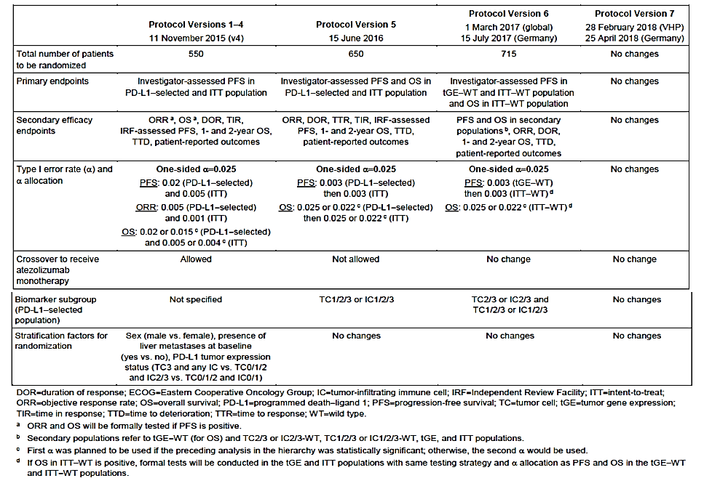

Efficacy endpoints

Primary efficacy endpoints (co-primary)
The co-primary endpoints were PFS, as assessed by the investigator according to RECIST v1.1 (investigator (INV) assessed per RECIST v1.1) and OS in the Intent-to-Treat wild type (ITT-WT) population.

The secondary efficacy endpoints
- PFS (INV-assessed per RECIST v1.1) and OS in the ITT population.
- PFS (INV-assessed per RECIST v1.1) and OS in both the PD-L1 expression ITT population and WT population for the ‘TC1/2/3 or IC1/2/3’ subgroup. OS and PFS in other PD-LI expression subgroups were analysed as exploratory efficacy endpoints.
- Objective Response Rate (ORR = complete response (CR) + partial response (PR) was defined as the proportion of patients with either a CR or PR, INV-assessed per RECIST v1.1, in the ITT-WT population; confirmation was not required.
- Duration of Response (DOR) was defined as the time from first documented objective response (CR or PR) to documented progressive disease (PD), as determined by the investigator using RECIST v1.1, or death from any cause, whichever occurred first; confirmation was not required.
- OS rates at the 1 year and 2 year landmark time-points in the ITT-WT population.
- Patient reported outcomes (PROs) as specified in the Statistical Analysis Plan (SAP).

ITT population
Patient disposition in the ITT population is summarised below in Table 3.
A total of 724 patients were randomised in a 2:1 ratio to the Atezo+CnP arm (484 patients) or the CnP arm (240 patients). One patient had been randomised in the former, but had died prior to the randomisation date and was excluded from the ITT population. Therefore, the ITT population included 723 patients, consisting of 483 patients in the Atezo+CnP arm and 240 patients in the CnP arm.
As of the clinical cut-off date (CCOD) of 15 March 2018, 473 (97.9%) patients in the Atezo+CnP arm had received study treatment compared with 232 (96.7%) patients in the CnP arm. The 18 untreated patients had discontinued due to death (4 patients), withdrawal by subject (2 patients), physician decision (1 patient) or other reasons (11 patients).
The ITT-WT population refers to randomised patients who did not have an activating EGFR mutation or ALK translocation. The ITT population refers to all randomised patients.
Table 3: Study IMpower130, patient disposition, ITT population
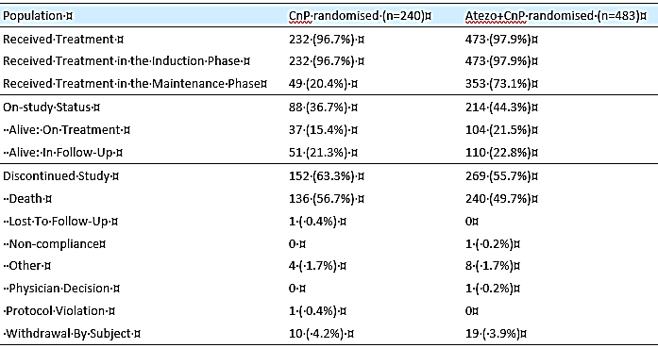

Baseline characteristics
Baseline characteristics were generally balanced between treatment groups, including in the PD-L1 diagnostic subgroups (see Table 4). Of note, use of corticosteroids (including all use, irrespective of reason) was similar in both groups at around 80%.
Table 4: Baseline characteristics
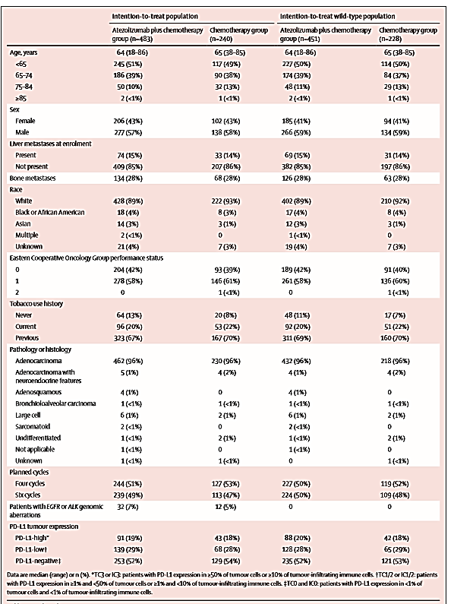
Extract from Lancet Oncology

Efficacy results
The primary clinical study report (CSR) described the efficacy results for the final PFS analysis (545 events) and the interim OS analysis (357 events).
In the original ITT-WT population, the overall median duration of survival was 18.6 months (95% CI: 16.0, 21.2 months) in the Atezo+CnP arm versus 13.9 months (95% CI: 12.0, 18.7 months) in the CnP arm (p= 0.0331), hazard ratio (HR) 0.79 (95% CI: 0.64, 0.98).
The results for the two co-primary efficacy endpoints in the original ITT-WT population at the CCOD of 15 March 2018 and database snapshot date of 18 May 2018 are summarised below in Table 5, and the Kaplan-Meier (KM) plots are provided below in Figure 1 (OS) and Figure 2 (PFS).
Table 5: Study IMpower130, primary analysis of PFS (INV-assessed per RECIST v1.1; unconfirmed) and interim analysis of OS, stratified analyses in the original ITT-WT population
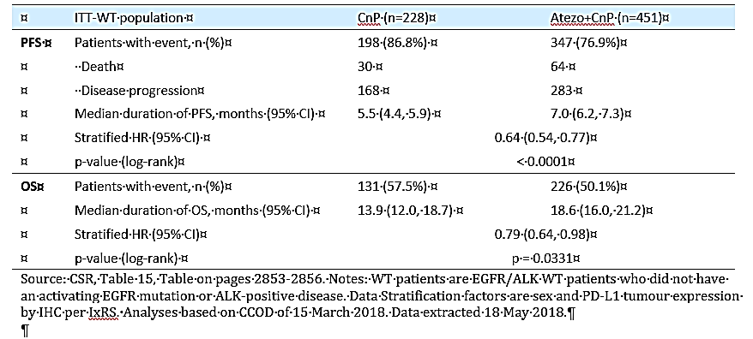
Figure 1. Study IMpower130, Kaplan-Meier plot of OS with stratified analysis, original ITT-WT population (March 2018 data cut-off)
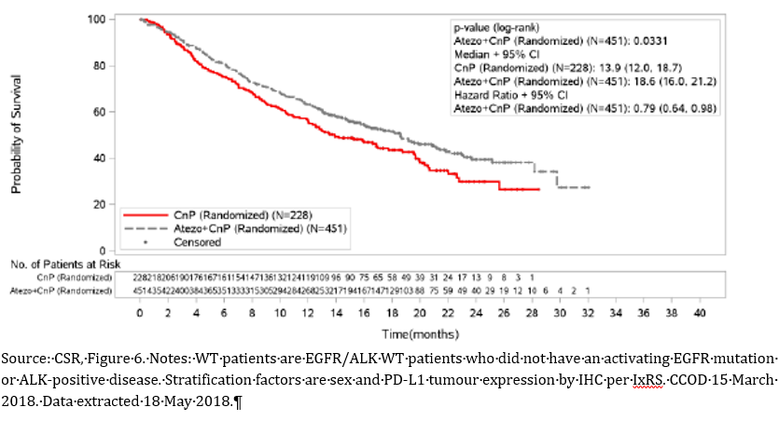
Figure 2. Study IMpower130, Kaplan-Meier plot of investigator assessed PFS with stratified analysis, original ITT-WT population
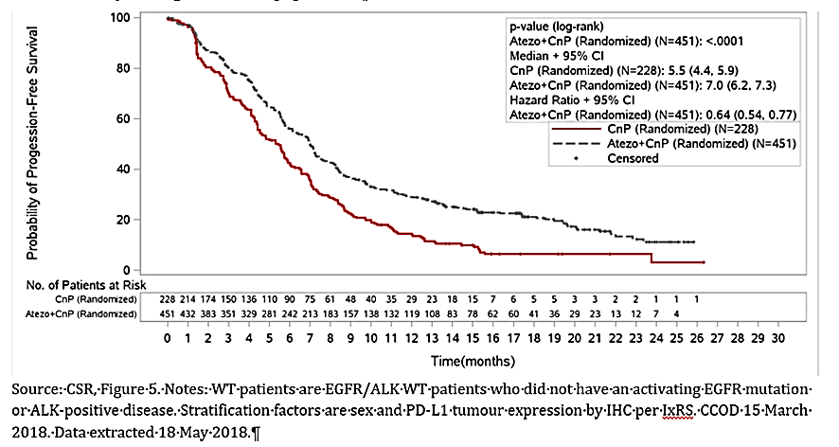
Note: In response to a request for further information from the TGA, the sponsor, updated OS analyses have been performed with an additional six months’ follow-up (CCOD 4 September 2018). At that time, 422 deaths had occurred in the ITT-WT population (both arms combined). The stratified HR was 0.82 (95% confidence interval (CI): 0.67, 1.01; see Figure 3 (below)). The median OS was 18.1 months (95% CI: 15.1, 20.8) in the Atezo+CnP arm and 13.5 months (95% CI: 11.9, 17.7) in the CnP arm.
Sponsor stated ‘Results are consistent with those observed at the time of interim analysis’. Although p value was 0.0568; compared to 0.033 previously.
Figure 3. OS in ITT-WT population (September 2018 data cut-off)
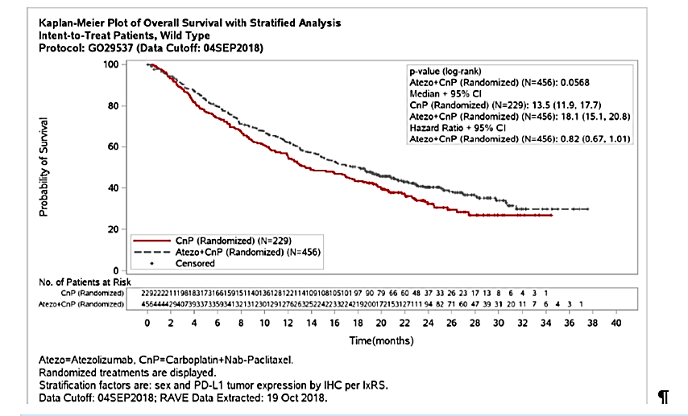

Efficacy summary
Median overall survival was 18.6 months (95% CI: 16.0, 21·2) in the atezolizumab plus chemotherapy group and 13·9 months (95% CI: 12.0, 18·7) in the chemotherapy group (HR =0.79 (95% CI: 0.64, 0.98); p = 0.033, an improvement in median OS of 4.7 months.
An overall survival advantage was observed, however crossover to at least one subsequent line of immunotherapy by almost 60% of patients in the chemotherapy group (see Table 6).
Table 6: Non-protocol follow-up cancer therapies and crossover (ITT-WT)
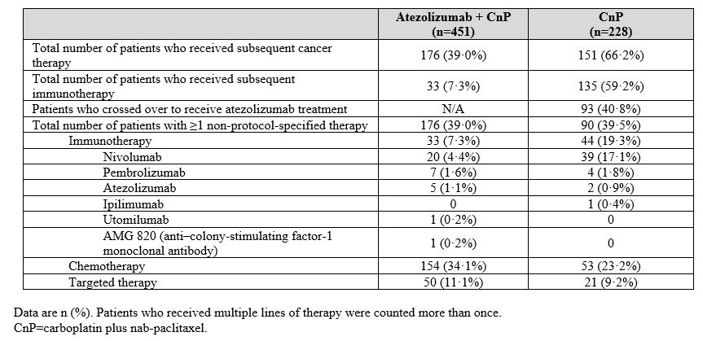
Median investigator-assessed PFS was 7.0 months (95% CI: 6.2, 7.3) in the atezolizumab plus chemotherapy group and 5.5 months (95% CI: 4.4, 5.9) in the chemotherapy group (HR=0.64 (95% CI: 0.54, 0.77); p < 0·0001).
Subgroup analyses showed consistent OS and PFS (see Tables 7 and 8) benefit with atezolizumab across the majority of clinical subgroups, except for patients with liver metastases, in whom atezolizumab plus chemotherapy did not show improved overall survival versus chemotherapy alone.
Table 7: Forest plot of hazard ratios for OS in the ITT-WT population according to patient characteristics at baseline
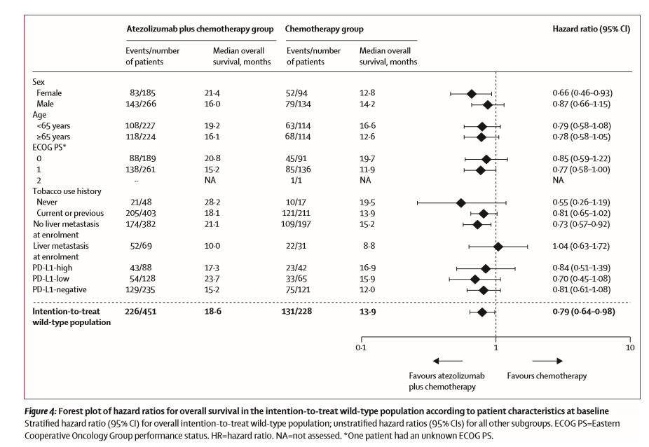
Table 8: PFS in the ITT-WT population according to patient characteristics at baseline
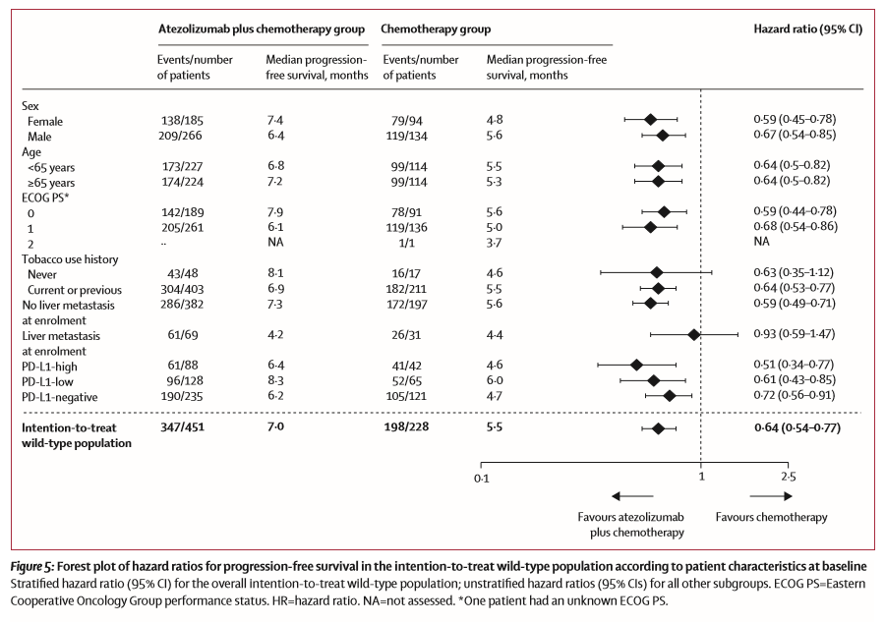
With respect to the PD-L1 subgroups, treatment benefit was observed in terms of OS and PFS in the ITT and ITT-WT populations, regardless of PD-L1 expression (see Table 9).
Table 9: PFS and OS by Baseline PD-L1 expression (ITT-WT population)
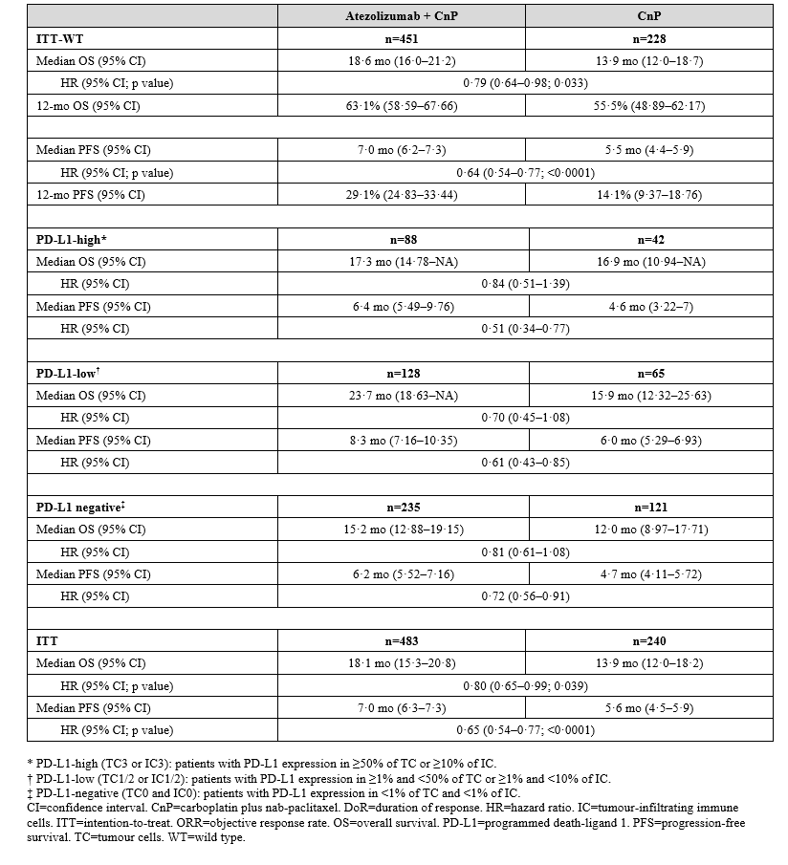
Although patient numbers were low, OS and PFS benefits were not observed in patients with EGFR or ALK genomic alterations (see Figure 4).
Figure 4: Kaplan-Meier plots for (A) PFS and (B) OS in the subgroup with EGFR or ALK genomic alterations
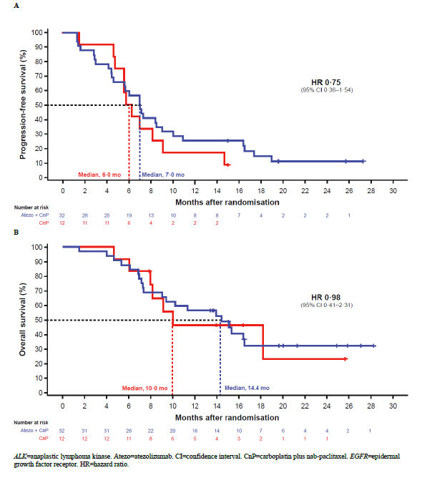
Note: The only PD-1 or PD-L1 plus chemotherapy combination that has demonstrated benefit in patients with EGFR or ALK genomic alterations was in IMpower150 (atezolizumab plus bevacizumab and carboplatin and paclitaxel versus bevacizumab plus carboplatin and paclitaxel in chemotherapy-naive patients with metastatic non squamous-NSCLC); addition of bevacizumab to atezolizumab might confer activity to PD-L1 inhibition in this patient population.,
In the ITT-WT population, the proportion of patients (who had measurable disease at Baseline) with a confirmed objective response was higher in the atezolizumab plus chemotherapy group (220 (49.2%, 95% CI: 44.5, 54.0) of 447 patients) than in the chemotherapy group (72 (31·9%, 25.8, 38.4) of 226 patients (see Table 10).
Table 10: Confirmed objective response rate and duration of response in the ITT-WT population
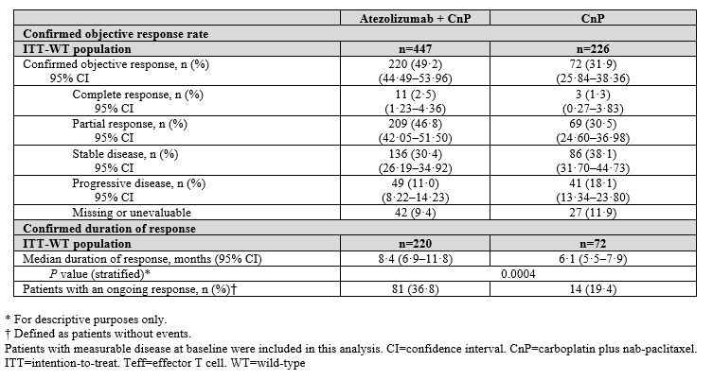

Immunogenicity
Approximately 22% of patients who received atezolizumab had post-baseline anti-drug antibodies (ADAs).
The potential impact of ADAs on efficacy is the subject of ongoing analyses across studies by the sponsor and will be reviewed separately to this submission.

Safety
The safety population included all treated patients, defined as randomised patients who received any amount of any component of study treatment, according to actual treatment received. There were 473 patients treated with Atezo+CnP and 232 patients treated with CnP.

Exposure to atezolizumab
In the Atezo+CnP arm, the median duration of exposure to first line atezolizumab therapy was 6.9 months (range: 0, 32 months), the median dose intensity was 94.9% (range: 60, 102%). Treatment duration in the Atezo+CnP arm was 0 to ≤ 3 months in 120 (25.4%) patients, > 3 months to ≤ 6 months in 94 (19.9%) patients, > 6 months to ≤ 12 months in 96 (20.3%) patients and > 12 months in 163 (34.5%) patients.
Per Protocol v1-v4, patients randomised to the CnP arm were permitted to crossover to receive atezolizumab monotherapy following progressive disease. There were 96 patients randomised to the CnP arm who crossed-over to receive atezolizumab monotherapy, and in these patients, atezolizumab monotherapy was administered as second-line rather than first line therapy. In the 96 patients who crossed over, the median treatment duration with second-line atezolizumab monotherapy was 2.8 months (range: 0, 19 months).
The duration of treatment with atezolizumab monotherapy was 0 to ≤ 3 months in 49 (51.0%) patients, > 3 months to ≤ 6 months in 14 (14.6%) patients, > 6 months to ≤ 12 months in 20 (20.8%) patients and > 12 months in 13 (13.5%) patients.

Adverse events
The high-level safety profile of the two treatment arms from Study IMpower130 are summarised below in Table 11.
Table 11: Study IMpower130, high-level overview of safety in the two treatment arms, safety evaluable population
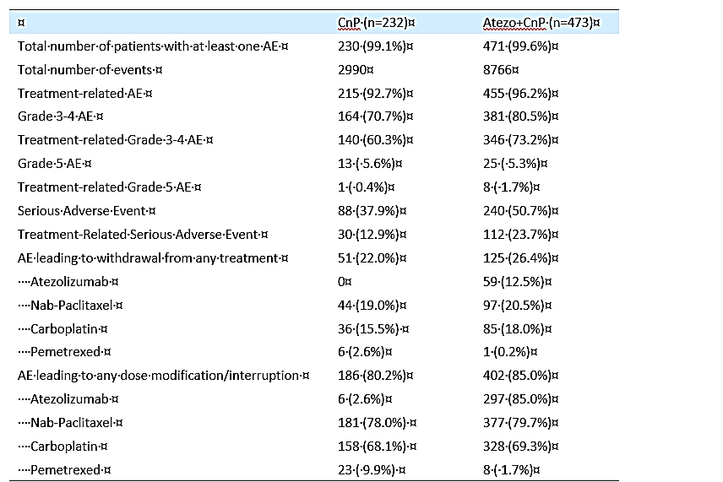
Only events reported in the AE form are included. Investigator text for AEs encoded using MeDRA v21.0. Multiple occurrences of the same AE in one individual are counted only once except ‘total number of events row in which multiple occurrences of the same AEs are counted separately. Counts in ‘Grade 3-4 AE’ are the number of patients whose highest grades of AE are 3 or 4. Data cut off 15 March 2018, data extracted 18 May 2018.
Adverse events reported in ≥ 20% of patients in either treatment arm by decreasing order of frequency in the Atezo+CnP arm are summarised below in Table 12.
Table 12: Study IMpower130, adverse events (AEs) by Preferred-Term (PT) in ≥ 20% of patients in either treatment arm, safety evaluable patients
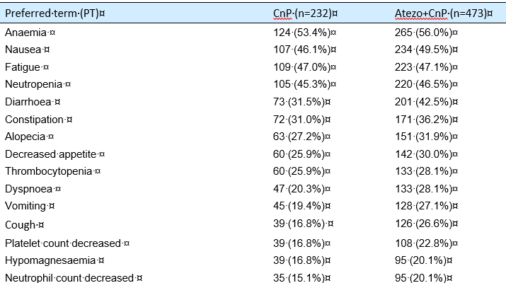
Grade 3 or 4 adverse events (AEs) were reported in a higher proportion of patients in the Atezo+CnP arm than in the CnP arm (80.5% versus 70.7%). Grade 3 or 4 AEs reported in ≥ 5% of patients in either treatment arm by descending order of frequency in the Atezo+CnP arm are summarised below in Table 13.
Table 13: Study IMpower130, Grade 3 or 4 adverse events (Preferred-Term) reported in in ≥ 5% of patients in either treatment arm, safety-evaluable patients
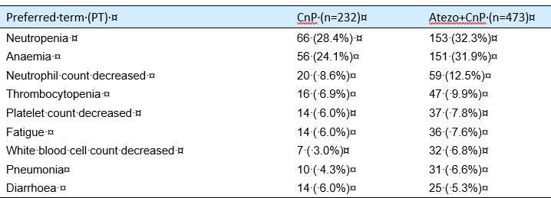

Safety summary
The safety profile in the Atezo+Chemo combo population was consistent with the safety profile in the Atezo+CnP arm (Study IMpower130), and no new or unexpected findings were observed in the total pooled Atezo+Chemo combo population.
There was a notably increased incidence (≥ 10% difference) in patients in the Atezo+CnP arm (Study IMpower130) compared with the Atezo+Chemo combo population of Grade 3 or 4 AEs (80.5% versus 66.1%), treatment-related Grade 3 AEs (73.2% versus 57.0%), and AEs leading to treatment modification/interruption (85.0% versus 66.4%).
The difference in the incidence of Grade 3 or4 AEs in patients in the two groups was primarily driven by the increased incidence of Blood and Lymphatic System Disorders (System Organ Class (SOC)) in the Atezo+CnP arm (Study IMpower130) compared with the Atezo+Chemo Combo population (57.1% versus 36.3%), which was primarily due to the higher incidence of neutropaenia (32.3% versus 17.1%, respectively) and anaemia (31.9% versus 17.1%, respectively).

Risk management plan
This extension of indications submission was planned to include Risk Management Plan (EU), Version 9.0, data lock point 11 September 2018, however the sponsor has had an agreement with the TGA, to not include this updated version of the Risk Management Plan for Tecentriq (Version 9.0). Email correspondence from the sponsor to the TGA (Pre-submission details) states that Version 9.0 of the RMP (submitted to the EU in October 2018) does not introduce any new risks to the safety specification.

Risk-benefit analysis

Delegate’s considerations

Extract from European Public Assessment Report (EPAR)
‘The MAH amended the protocol seven times. The majority of the protocol amendments are not controversial, however with protocol amendment 4 (version 5) the co-primary endpoint OS was added. This was, according to the MAH, motivated by the fact that emerging and accumulating knowledge about immune checkpoint inhibitors showed that PFS may not be as sensitive endpoint as OS. Patients were allowed to cross over after the addition of OS as co-primary endpoint. Analyses showed that those patients that crossed over prior to the amendment had little effect on the final results.
As a consequence of the addition of OS as co-primary endpoint the SAP was accordingly amended. Also, the testing of PFS in ITT-WT Teff-high was removed from the primary testing and listed as an exploratory analysis. The final set of stratification factors were amended ‘due to the potential risk of over-stratification’. According to the guideline on adjustment for baseline covariates in clinical trials (EMA/CHMP/295050/2013;)’, the factors that are the basis of stratification should normally be included as covariates or stratification variables in the primary outcome model, except where stratification was done purely for an administrative reason.
Overall, no major concerns have been identified with regards to design and conduct of the study.’
The primary analysis was conducted in all patients, excluding those with EGFR mutations or ALK rearrangements, defined as ITT-WT population (n = 679).
Patients had a median survival follow up time of 18.6 months.
The study met its co-primary endpoints. PFS in ITT-WT showed a HR of 0.64 (95% CI: 0.54, 0.77; p<0.0001). The median duration of PFS was 7.0 months in the Atezo+CnP arm compared to 5.5 months in the CnP arm.
Based on the March 2018 data cut-off, in ITT-WT population, median OS was 18.6 months (95% CI 16.0, 21.2) in the Atezo+CnP versus 13.9 months (95% CI: 12.0, 18.7) in the comparator arm (CnP) (HR = 0.79 (95% CI: 0.64, 0.98); p=0·033), an improvement of median survival of 4.7 months.
The OS advantage was observed, despite crossover to at least one subsequent line of immunotherapy by almost 60% of patients in the chemotherapy group (see Table 6).
Subgroup analyses showed consistent OS and PFS (see Tables 7 and 8) benefit with atezolizumab across the majority of clinical subgroups, except for patients with liver metastases, in whom atezolizumab plus chemotherapy did not show improved OS versus chemotherapy alone.
With respect to the PD-L1 subgroups, treatment benefit was observed in terms of OS and PFS in the ITT-WT populations, regardless of PD-L1 expression.
Overall, the safety profile of atezolizumab in combination with CnP is considered acceptable. However, there are more Overall AEs and Grade 3 and 4 AEs in the Atezo+CnP arm, but no new safety concerns were identified.

Benefit/risk balance
The benefit/risk balance of Tecentriq in combination with nab-paclitaxel and carboplatin, for the first line treatment of adult patients with metastatic non-squamous NSCLC who do not have EGFR mutant or ALK positive NSCLC is considered positive.

Expert advice

Question for clinical experts
The study met its co-primary endpoints for the first line treatment of patients with Stage IV non-squamous NSCLC and no ALK or EGFR mutations.
PFS in ITT-WT showed a HR of 0.64 (95%CI: 0.54, 0.77; p < 0.0001). The median duration of PFS was 7.0 months in the Atezo+CnP arm compared to 5.5 months in the CnP arm.
In ITT-WT population, median OS was 18.6 months (95% CI: 16.0 to 21.2) in the Atezo+CnP versus 13.9 months (95% CI: 12.0, 18.7) in the comparator arm (HR = 0.79 (95% CI: 0.64, 0.98); p = 0·033), an improvement of median survival of 4.7 months.
Do you think that the observed differences in OS and PFS for Tecentriq used in combination with nab-paclitaxel and carboplatin, for the first line treatment of adult patients with metastatic non-squamous NSCLC observed in Study IMpower130 are clinically meaningful?

Clinical experts response
The clinical experts confirmed that the observed differences in OS and PFS in Study IMpower130 are clinically meaningful.

Delegate’s proposed action
The extension of indication should be approved.

Request for ACM advice
The Delegate did not refer this application to the Advisory Committee on Medicines (ACM) for advice.

Outcome
Based on a review of quality, safety and efficacy, TGA approved the extension of indications for the registrations of Tecentriq atezolizumab (rch) 1200 mg/20 mL injection concentrated vial and Tecentriq atezolizumab (rch) 840 mg/14 mL injection concentrated vial for intravenous infusion, indicated for:
Tecentriq, in combination with nab-paclitaxel and carboplatin, is indicated for first line treatment of patients with metastatic non-squamous NSCLC who do not have tumour EGFR or ALK genomic aberrations.

Specific conditions of registration applying to these goods
- This approval does not impose any requirement for the submission of Periodic Safety Update reports. You should note that it is a requirement that all existing requirements for the submission of PSURs as a consequence of the initial registration or subsequent changes must be completed.

Attachment 1. Product Information
The PI for Tecentriq approved with the submission which is described in this AusPAR is at Attachment 1. For the most recent PI, please refer to the TGA website at <https://www.tga.gov.au/product-information-pi>.

Therapeutic Goods Administration
PO Box 100 Woden ACT 2606 Australia
Email: info@tga.gov.au Phone: 1800 020 653 Fax: 02 6232 8605
https://www.tga.gov.au

AUST R 310681 is the Australian registration number for the Tecentriq 840 mg/14 mL vial variant, as listed on the Australian Register of Therapeutic Goods (ARTG).
European Public Assessment Report (EPAR) for Tecentriq; European Medicines Agency,. Available at: https://www.ema.europa.eu/en/medicines/human/EPAR/tecentriq
PD-L1 expression scored by immunohistochemistry (SP142 assay) in tumour cells (as percentage of PD-L1-expressing tumour cells ≥ 50%, TC3; ≥ 5% and < 50%, TC2; ≥ 1% and < 5%, TC1 and < 1%, TC0) and tumour-infiltrating immune cells (as percentage of tumour area:≥10%, IC3; ≥5% and < 10%, IC2; ≥1% and < 5%, IC1; and < 1%, IC0).
Response evaluation criteria in solid tumours (RECIST) is a set of published rules that define when tumours in cancer patients improve (‘respond’), stay the same (‘stabilise’), or worsen (‘progress’) during treatment.
The ECOG Scale of Performance Status describes a patient's level of functioning in terms of their ability to care for themself, daily activity, and physical ability (walking, working, and so on).
Sponsor clarification: Descriptive because the update analysis is exploratory.
Sponsor comment: This potentially confounded the OS effect estimated.
West, H. et al. Atezolizumab in combination with carboplatin plus nab-paclitaxel chemotherapy compared with chemotherapy alone as first line treatment for metastatic non-squamous non-small-cell lung cancer (IMpower130): a multicentre, randomised, open-label, phase 3 trial. Lancet Oncology. May 2019.
Socinski MA et al. Atezolizumab for First line Treatment of Metastatic Non-squamous NSCLC. NEJM 378;24 June 14, 2018.
Teff=effector T-cell
EMA/CHMP/295050/2013 Guideline on adjustment for baseline covariates in clinical trials
The ACM provides independent medical and scientific advice to the Minister for Health and the Therapeutic Goods Administration (TGA) on issues relating to the safety, quality and efficacy of medicines supplied in Australia including issues relating to pre-market and post-market functions for medicines. The Committee is established under Regulation 35 of the Therapeutic Goods Regulations 1990. Members are appointed by the Minister. The ACM was established in January 2017 replacing Advisory Committee on Prescription Medicines (ACPM) which was formed in January 2010. ACM encompass pre and post-market advice for medicines, following the consolidation of the previous functions of the Advisory Committee on Prescription Medicines (ACPM), the Advisory Committee on the Safety of Medicines (ACSOM) and the Advisory Committee on Non-Prescription Medicines (ACNM). Membership comprises of professionals with specific scientific, medical or clinical expertise, as well as appropriate consumer health issues relating to medicines.

