This medicinal product is subject to additional monitoring in Australia due to provisional approval of an extension of indications. This will allow quick identification of new safety information. Healthcare professionals are asked to report any suspected adverse events at
▼
www.tga.gov.au/reporting-problems.

AUSTRALIAN PRODUCT INFORMATION – Tecentriq® (atezolizumab)

1 NAME OF THE MEDICINE
Atezolizumab

2 QUALITATIVE AND QUANTITATIVE COMPOSITION
Tecentriq 840 mg/14 mL concentrated injection
Each vial of 14 mL contains 840 mg of atezolizumab at a concentration of 60 mg/mL.

Tecentriq 1200 mg/20 mL concentrated injection
Each vial of 20 mL contains 1200 mg of atezolizumab at a concentration of 60 mg/mL.

For the full list of excipients, see section 6.1 List of excipients.

3 PHARMACEUTICAL FORM
Concentrated injection for intravenous infusion. Tecentriq is supplied as a single-use vial containing either 14 mL or 20 mL preservative-free, colourless to slightly yellow solution, at a concentration of 60 mg/mL.

4 CLINICAL PARTICULARS

4.1 Therapeutic indications

Non-small cell lung cancer
Tecentriq, in combination with bevacizumab, paclitaxel and carboplatin, is indicated for the first-line treatment of adult patients with metastatic non-squamous non-small cell lung cancer (NSCLC). In patients with EGFR mutant or ALK-positive NSCLC, Tecentriq, in combination with bevacizumab, paclitaxel and carboplatin, is indicated only after failure of appropriate targeted therapies.

Tecentriq, in combination with nab-paclitaxel and carboplatin, is indicated for first-line treatment of patients with metastatic non-squamous NSCLC who do not have tumour EGFR or ALK genomic aberrations.

Tecentriq as monotherapy is indicated for the treatment of adult patients with locally advanced or metastatic NSCLC after prior chemotherapy. Patients with EGFR mutant or ALK-positive NSCLC should also have received targeted therapies before receiving Tecentriq.

Small cell lung cancer
Tecentriq, in combination with carboplatin and etoposide, is indicated for the first-line treatment of patients with extensive-stage small cell lung cancer (ES-SCLC).

Urothelial carcinoma
Tecentriq is indicated for the treatment of patients with locally advanced or metastatic urothelial carcinoma who
- are considered cisplatin ineligible and whose tumours express PD-L1 (PD-L1 stained tumour-infiltrating immune cells [IC] covering ≥ 5% of the tumour area), as determined by a validated test, or
- are considered ineligible for any other platinum-containing chemotherapy regardless of the level of tumour PD-L1 expression.
This indication is approved based on overall response rate and duration of response in a single-arm study. Improvements in overall survival, progression-free survival, or health-related quality of life have not been established.

Triple-negative breast cancer
Tecentriq, in combination with paclitaxel protein-bound, is indicated for the treatment of adult patients with unresectable locally advanced or metastatic triple-negative breast cancer (TNBC) whose tumours express PD-L1 (PD-L1 stained tumor-infiltrating immune cells [IC] of any intensity covering ≥ 1% of the tumour), as determined by a validated test and who have not received prior chemotherapy for metastatic disease.
This indication is approved under provisional approval based on progression free survival. Continued approval for this indication depends on verification and description of clinical benefit in a confirmatory trial(s).

4.2 Dose and method of administration

General
Tecentriq must be initiated and supervised by physicians experienced in the treatment of cancer.

Tecentriq must be administered as an intravenous (IV) infusion. Do not administer as an IV push or bolus.

The initial dose of Tecentriq must be administered over 60 minutes. If the first infusion is tolerated all subsequent infusions may be administered over 30 minutes.

Do not co-administer other medicinal products through the same infusion line.

In order to improve the traceability of biological medicinal products, the trade name and the batch number of the administered product should be clearly recorded in the patient medical record.

Patient selection for urothelial carcinoma
Select cisplatin-ineligible patients with previously untreated locally advanced or metastatic urothelial carcinoma for treatment with Tecentriq based on the PD-L1 expression on tumour infiltrating immune cells confirmed by a validated test (see section 5.1 Pharmacodynamic properties, Clinical Trials).

Dose

Tecentriq monotherapy

2L NSCLC and urothelial carcinoma
The recommended dosage is either;
- 840 mg administered by IV infusion every 2 weeks,
- 1200 mg administered by IV infusion every 3 weeks or
- 1680 mg administered by IV infusion every 4 weeks.

Tecentriq in combination therapy
Please also refer to the Product Information for the combination products.

1L non-squamous NSCLC

Tecentriq in combination with bevacizumab, paclitaxel, and carboplatin
During the induction phase, the recommended dose of Tecentriq is 1200 mg administered by IV infusion, followed by bevacizumab, then paclitaxel and carboplatin every 3 weeks for four or six cycles.

The induction phase is followed by a maintenance phase without chemotherapy in which the recommended dose is 1200 mg Tecentriq, followed by bevacizumab, administered by IV infusion every 3 weeks.

During the maintenance phase and if bevacizumab is discontinued, the recommended dosage of Tecentriq is either;
- 840 mg administered by IV infusion every 2 weeks,
- 1200 mg administered by IV infusion every 3 weeks or
- 1680 mg administered by IV infusion every 4 weeks.

Tecentriq in combination with nab-paclitaxel and carboplatin
During the induction phase, the recommended dose of Tecentriq is 1200 mg administered by IV infusion, followed by nab-paclitaxel and carboplatin every 3 weeks for four or six cycles. For each 21-day cycle, Tecentriq, nab-paclitaxel and carboplatin is administered on day 1. In addition, nab-paclitaxel is administered on days 8 and 15.
The induction phase is followed by a maintenance phase without chemotherapy in which the recommended dosage of Tecentriq is either;
- 840 mg administered by IV infusion every 2 weeks,
- 1200 mg administered by IV infusion every 3 weeks or
- 1680 mg administered by IV infusion every 4 weeks.

1L extensive-stage small cell lung cancer
During the induction phase, the recommended dose of Tecentriq is 1200 mg administered by IV infusion followed by carboplatin, and then etoposide administered by IV infusion on day 1. Etoposide is administered by IV infusion on days 2 and 3. This regimen is administered every 3 weeks for 4 cycles.

The induction phase is followed by a maintenance phase without chemotherapy in which the recommended dosage of Tecentriq is either;
- 840 mg administered by IV infusion every 2 weeks,
- 1200 mg administered by IV infusion every 3 weeks or
- 1680 mg administered by IV infusion every 4 weeks.

Tecentriq in combination with nab-paclitaxel in 1L mTNBC
The recommended dose of Tecentriq is 840 mg administered by IV infusion, followed by 100 mg/m² nab-paclitaxel (nanoparticle albumin-bound paclitaxel). For each 28-day cycle Tecentriq is administered on days 1 and 15, and nab-paclitaxel is administered on days 1, 8 and 15.

Patients treated for 1L TNBC should be selected for treatment based on the tumour expression of PD-L1 confirmed by a validated test (see section 5.1 Pharmacodynamic properties).

Duration of treatment
It is recommended that patients are treated with Tecentriq until loss of clinical benefit (see section 5.1 Pharmacodynamic properties) or unmanageable toxicity.
For TNBC, it is recommended that patients are treated with Tecentriq until disease progression or unacceptable toxicity (see section 5.1 Pharmacodynamic properties).

Delayed or missed doses
If a planned dose of Tecentriq is missed, it should be administered as soon as possible. The schedule of administration must be adjusted to maintain a the appropriate interval between doses.

Dose modifications
Dose reductions of Tecentriq are not recommended.

Dose delay or discontinuation
See also sections 4.4 Special warnings and precautions for use and 4.8 Adverse effects (Undesirable effects).

Table 1. Dose modification advice for Tecentriq
Adverse reaction | Severity | Treatment modification
Immune-related pneumonitis | Grade 2 | Withhold Tecentriq  Treatment may be resumed when the event improves to Grade 0 or Grade 1 within 12 weeks, and corticosteroids have been reduced to ≤ 10 mg prednisone or equivalent per day
Immune-related pneumonitis | Grade 3 or 4 | Permanently discontinue Tecentriq
Immune-related hepatitis | Grade 2: (ALT or AST > 3 to 5 x ULN  or  blood bilirubin > 1.5 to 3 x ULN) | Withhold Tecentriq  Treatment may be resumed when the event improves to Grade 0 or Grade 1 within 12 weeks and corticosteroids have been reduced to ≤ 10 mg prednisone or equivalent per day
Immune-related hepatitis | Grade 3 or 4: (ALT or AST > 5 x ULN  or  blood bilirubin > 3 x ULN) | Permanently discontinue Tecentriq.
Immune-related colitis | Grade 2 or 3 diarrhoea (increase of ≥ 4 stools/day over baseline)  or  symptomatic colitis | Withhold Tecentriq  Treatment may be resumed when the event improves to Grade 0 or Grade 1 within 12 weeks and corticosteroids have been reduced to ≤ 10 mg prednisone or equivalent per day
Immune-related colitis | Grade 4 diarrhoea or colitis (life threatening; urgent intervention indicated) | Permanently discontinue Tecentriq
Immune-related hypothyroidism or hyperthyroidism | Symptomatic | Withhold Tecentriq  Hypothyroidism:  Treatment may be resumed when symptoms are controlled by thyroid replacement therapy and TSH levels are decreasing  Hyperthyroidism:  Treatment may be resumed when symptoms are controlled by anti-thyroid medicinal product and thyroid function is improving
Immune-related adrenal insufficiency | Symptomatic | Withhold Tecentriq  Treatment may be resumed when the symptoms improve to Grade 0 or Grade 1 within 12 weeks and corticosteroids have been reduced to ≤ 10 mg prednisone or equivalent per day and the patient is stable on replacement therapy
Immune-related hypophysitis | Grade 2 or 3 | Withhold Tecentriq  Treatment may be resumed when the symptoms improve to Grade 0 or Grade 1 within 12 weeks and corticosteroids have been reduced to ≤ 10 mg prednisone or equivalent per day and the patient is stable on replacement therapy
Immune-related hypophysitis | Grade 4 | Permanently discontinue Tecentriq.
Immune-related Type 1 diabetes mellitus | Grade 3 or 4 hyperglycaemia (fasting glucose greater than 13.9 mmol/L) | Withhold Tecentriq  Treatment may be resumed when metabolic control is achieved on insulin replacement therapy
Immune-related myasthenic syndrome/myasthenia gravis, Guillain-Barré syndrome and meningoencephalitis | All grades | Permanently discontinue Tecentriq
Immune-related myocarditis | Grade 2 | Withhold Tecentriq  Treatment may be resumed when the symptoms improve to Grade 0 or Grade 1 within 12 weeks and corticosteroids have been reduced to ≤ 10 mg prednisone or equivalent per day
Immune-related myocarditis | Grade 3 or 4 | Permanently discontinue Tecentriq
Immune-related myositis | Grade 2 or 3 | Withhold Tecentriq  Treatment may be resumed when the symptoms improve to Grade 0 or Grade 1 within 12 weeks and corticosteroids have been reduced to ≤ 10 mg prednisone or equivalent per day
Immune-related myositis | Grade 4 or grade 3 recurrent myositis | Permanently discontinue Tecentriq
Immune-related nephritis | Grade 2: (creatinine level > 1.5 to 3.0 x baseline or > 1.5 - 3.0 x ULN) | Withhold Tecentriq  Treatment may be resumed when the event improves to Grade 0 or Grade 1 within 12 weeks and corticosteroids have been reduced to ≤ 10 mg prednisone or equivalent per day
Immune-related nephritis | Grade 3 or 4: (creatinine level > 3.0 x baseline or > 3.0 x ULN) | Permanently discontinue Tecentriq
Immune-related pancreatitis | Grade 3 or 4 serum amylase or lipase levels increased (> 2.0 x ULN)  or Grade 2 or 3 pancreatitis | Withhold Tecentriq  Treatment may be resumed when serum amylase and lipase levels improve to Grade 0 or Grade 1 within 12 weeks, or symptoms of pancreatitis have resolved, and corticosteroids have been reduced to ≤ 10 mg prednisone or equivalent per day
Immune-related pancreatitis | Grade 4 or any grade of recurrent pancreatitis | Permanently discontinue Tecentriq
Infusion-related reactions | Grade 1 or 2 | Reduce infusion rate or interrupt. Treatment may be resumed when the event is resolved.
Infusion-related reactions | Grade 3 or 4 | Permanently discontinue Tecentriq.
Rash | Grade 3 | Withhold Tecentriq  Treatment may be resumed when rash is resolved and corticosteroids have been reduced to ≤ 10 mg prednisone or equivalent per day
Rash | Grade 4 | Permanently discontinue Tecentriq
Other immune-related adverse reactions | Grade 2 or Grade 3 | Withhold Tecentriq until adverse reactions recovers to Grade 0-1 within 12 weeks, and corticosteroids have been reduced to ≤ 10 mg prednisone or equivalent per day.
Other immune-related adverse reactions | Grade 4 or recurrent Grade 3 | Permanently discontinue Tecentriq (except endocrinopathies controlled with replacement hormones)
Note: Toxicity grades are in accordance with National Cancer Institute Common Terminology Criteria for Adverse Event Version 4.0 (NCI-CTCAE v.4.).

Patients treated with Tecentriq must be given the Patient Alert Card and be informed about the risks of Tecentriq.

Special Dosage Instructions

Paediatric use
The safety and efficacy of Tecentriq in children and adolescents below 18 years of age have not been established. No data are available.

Use in the elderly
Based on a population pharmacokinetic analysis, no dose adjustment of Tecentriq is required in patients ≥ 65 years of age (see sections 4.4 Special warnings and precautions for use and 5.2 Pharmacokinetic properties).

Use in Asian patients
Due to increased haematologic toxicities observed in Asian patients in study GO29436 (IMpower150), it is recommended that the starting dose of paclitaxel should be 175 mg/m² every three weeks.

Renal Impairment
Based on a population pharmacokinetic analysis, no dose adjustment is required in patients with mild or moderate renal impairment (see sections 4.4 Special warnings and precautions for use and 5.2 Pharmacokinetic properties). Data from patients with severe renal impairment are too limited to draw conclusions on this population.

Hepatic impairment
Based on a population pharmacokinetic analysis, no dose adjustment is required for patients with mild hepatic impairment. Tecentriq has not been studied in patients with moderate or severe hepatic impairment (see sections 4.4 Special warnings and precautions for use and 5.2 Pharmacokinetic properties).

Eastern Cooperative Oncology Group (ECOG) performance status ≥ 2
Patients with ECOG performance status ≥ 2 were excluded from the clinical trials in NSCLC and ES-SCLC, and TNBC. (see sections 4.4 Special warnings and precautions for use and 5.1 Pharmacodynamic properties).

Instructions for dilution
Tecentriq does not contain any antimicrobial preservative and should be prepared by a healthcare professional using aseptic technique.

Withdraw the required volume of Tecentriq concentrate from the vial and dilute into a 250 mL PVC, polyethylene (PE) or polyolefin infusion bag containing sodium chloride 9 mg/mL (0.9%) solution for injection. After dilution, the solution should contain atezolizumab at a concentration of approximately 3.2 mg/mL (840 mg/264 mL), 4.4 mg/mL (1200 mg/270 mL) or 6.0 mg/mL (1680 mg/278 mL). The bag should be gently inverted to mix the solution in order to avoid foaming.

Tecentriq must not be mixed with other medicinal products.

Instructions for administration
Parenteral medicinal products should be inspected visually for particulates and discolouration prior to administration. If particulates or discoloration are observed, the solution should not be used.

The product is for single use in one patient only. Discard any residue.

Tecentriq must not be mixed with other medicinal products.

Do not co-administer other medicinal products through the same infusion line.

4.3 Contraindications
Tecentriq is contraindicated in patients with a known hypersensitivity to atezolizumab or any of the excipients.

4.4 Special warnings and precautions for use

Assessment of PD-L1 status
When assessing the PD-L1 status of the tumour, it is important that a well-validated and robust methodology is chosen to minimise false negative or false positive determinations.

Immune-mediated Adverse Reactions
Most immune-related adverse reactions occurring during treatment with Tecentriq were reversible with interruptions of Tecentriq and initiation of corticosteroids and/or supportive care. Immune-related adverse reactions affecting more than one body system have been observed. Immune-related adverse reactions with Tecentriq may occur after the last dose of Tecentriq. For suspected immune-related adverse reactions, a thorough evaluation to confirm aetiology or exclude other causes should be performed. Based on the severity of the adverse reaction, Tecentriq should be withheld and corticosteroids administered. Upon improvement to Grade ≤ 1, corticosteroids should be tapered over ≥ 1 month. Based on limited data from clinical studies in patients whose immune-related adverse reactions could not be controlled with systemic corticosteroid use, administration of other systemic immunosuppressants may be considered.

Tecentriq must be permanently discontinued for any Grade 3 immune-related adverse reaction that recurs and for any Grade 4 immune-related adverse reactions, except for endocrinopathies that are controlled with replacement hormones (se sections 4.2 Dose and method of administration and 4.8 Adverse effects (Undesirable effects)).

Immune-related pneumonitis
Cases of pneumonitis, including fatal cases, have been observed in clinical trials with Tecentriq (see section 4.8 Adverse effects (Undesirable effects)). Patients should be monitored for signs and symptoms of pneumonitis.

Treatment with Tecentriq should be withheld for Grade 2 pneumonitis, and 1 to 2 mg/kg prednisone or equivalent per day should be started. If symptoms improve to ≤ Grade 1, taper corticosteroids over ≥ 1 month. Treatment with Tecentriq may be resumed if the event improves to ≤ Grade 1 within 12 weeks, and corticosteroids have been reduced to ≤ 10 mg prednisone or equivalent per day. Treatment with Tecentriq must be permanently discontinued for Grade 3 or 4 pneumonitis.

Immune-related hepatitis
Cases of hepatitis, some leading to fatal outcomes, have been observed in clinical trials with Tecentriq (see section 4.8 Adverse effects (Undesirable effects)). Patients should be monitored for signs and symptoms of hepatitis. Monitor aspartate aminotransferase (AST), alanine aminotransferase (ALT) and bilirubin prior to and periodically during treatment with Tecentriq. Appropriate management of patients with abnormal liver function tests (LFTs) at baseline should be considered.

Treatment with Tecentriq should be withheld if Grade 2 (ALT or AST > 3 to 5 x ULN or blood bilirubin > 1.5 to 3.0 x ULN) persists for more than 5 to 7 days, and 1 to 2 mg/kg prednisone or equivalent per day should be started. If the event improves to ≤ Grade 1, taper corticosteroids over ≥ 1 month.

Treatment with Tecentriq may be resumed if the event improves to ≤ Grade 1 within 12 weeks, and corticosteroids have been reduced to ≤ 10 mg oral prednisone or equivalent per day. Treatment with Tecentriq must be permanently discontinued for Grade 3 or Grade 4 events (ALT or AST > 5.0 x ULN or blood bilirubin > 3 x ULN).

Immune-related colitis
Cases of diarrhoea or colitis have been observed in clinical trials with Tecentriq (see section 4.8 Adverse effects (Undesirable effects)). Patients should be monitored for signs and symptoms of colitis.

Treatment with Tecentriq should be withheld for Grade 2 or 3 diarrhoea (increase of ≥ 4 stools/day over baseline) or colitis (symptomatic). For Grade 2 diarrhoea or colitis, if symptoms persist > 5 days or recur, start 1 - 2 mg/kg prednisone or equivalent per day. Treat Grade 3 diarrhoea or colitis with IV corticosteroids (1 to 2 mg/kg/day methylprednisolone or equivalent). Once symptoms improve, treatment with 1 to 2 mg/kg/day of prednisone or equivalent should be started. If symptoms improve to ≤ Grade 1, taper corticosteroids over ≥ 1 month. Treatment with Tecentriq may be resumed if the event improves to ≤ Grade 1 within 12 weeks and corticosteroids have been reduced to ≤ 10 mg oral prednisone or equivalent per day. Treatment with Tecentriq must be permanently discontinued for Grade 4 (life threatening; urgent intervention indicated) diarrhoea or colitis.

Immune-related endocrinopathies
Hypothyroidism, hyperthyroidism, adrenal insufficiency, hypophysitis and type 1 diabetes mellitus, including diabetic ketoacidosis, have been observed in clinical trials with Tecentriq (see section 4.8 Adverse effects (Undesirable effects)).

Patients should be monitored for clinical signs and symptoms of endocrinopathies and for changes in thyroid function (at the start of treatment, periodically during treatment and as indicated based on clinical evaluation). Patients may present with the following: fatigue, headache, mental status changes, heat or cold intolerance, tachycardia or bradycardia, unusual bowel habits, weight change, polyuria/polydipsia, blurred vision. Unless an alternate aetiology has been identified, signs and symptoms of endocrinopathies should be conservatively considered immune-related. Appropriate management of patients with abnormal thyroid function tests at baseline should be considered.

Asymptomatic patients with abnormal thyroid function tests can receive Tecentriq. For symptomatic hypothyroidism, Tecentriq should be withheld and thyroid hormone replacement should be initiated as needed. Isolated hypothyroidism may be managed with replacement therapy and without corticosteroids. For symptomatic hyperthyroidism, Tecentriq should be withheld and an anti-thyroid drug should be initiated as needed. Treatment with a beta blocker may also be considered. Treatment with Tecentriq may be resumed when symptoms are controlled and thyroid function is improving.

For symptomatic adrenal insufficiency, Tecentriq should be withheld and treatment with intravenous corticosteroids (1 to 2 mg/kg per day of methylprednisolone or equivalent) should be started. Once symptoms improve, follow with 1 to 2 mg/kg per day of prednisone or equivalent. If symptoms improve to ≤ Grade 1, taper corticosteroids over ≥ 1 month. Treatment may be resumed if the event improves to ≤ Grade 1 within 12 weeks and corticosteroids have been reduced to the equivalent of ≤ 10 mg prednisone or equivalent per day and the patient is stable on replacement therapy (if required).

Treatment with Tecentriq should be withheld for Grade 2 or Grade 3 hypophysitis. Treatment with intravenous corticosteroids (1 to 2 mg/kg per day IV methylprednisolone or equivalent) should be started, and hormone replacement should be initiated as needed. Once symptoms improve, treatment with 1 to 2 mg/kg per day of prednisone or equivalent should follow. If symptoms improve to ≤ Grade 1, corticosteroids should be tapered over ≥ 1 month. Treatment may be resumed if the event improves to ≤ Grade 1 within 12 weeks and corticosteroids have been reduced to ≤ 10 mg per day prednisone or equivalent and the patient is stable on replacement therapy (if required). Treatment with Tecentriq should be permanently discontinued for Grade 4 hypophysitis.

Treatment with insulin should be initiated for type 1 diabetes mellitus. For ≥ Grade 3 hyperglycaemia (fasting glucose greater than 13.9 mmol/L), Tecentriq should be withheld. Treatment with Tecentriq may be resumed if metabolic control is achieved on insulin replacement therapy.

Immune-related meningoencephalitis
Meningoencephalitis has been observed in clinical trials with Tecentriq (see section 4.8 Adverse effects (Undesirable effects)). Patients should be monitored for clinical signs and symptoms of meningitis or encephalitis.

Treatment with Tecentriq must be permanently discontinued for any grade of meningitis or encephalitis. Treatment with intravenous corticosteroids (1 to 2 mg/kg IV methylprednisolone or equivalent per day) should be started. Once symptoms improve, treatment with 1 to 2 mg/kg oral prednisone or equivalent per day should follow.

Immune-related neuropathies
Myasthenic syndrome/myasthenia gravis or Guillain-Barré syndrome, which may be life-threatening, were observed in patients receiving Tecentriq (see section 4.8 Adverse effects (Undesirable effects)). Patients should be monitored for symptoms of motor and sensory neuropathy.

Treatment with Tecentriq must be permanently discontinued for any grade of myasthenic syndrome/myasthenia gravis or Guillain-Barré syndrome. Consider initiation of systemic corticosteroids at a dose of 1 to 2 mg/kg oral prednisone or equivalent per day.

Immune-related pancreatitis
Pancreatitis, including increases in serum amylase and lipase levels, has been observed in clinical trials with Tecentriq (see section 4.8 Adverse effects (Undesirable effects)). Patients should be closely monitored for signs and symptoms that are suggestive of acute pancreatitis.

Treatment with Tecentriq should be withheld for ≥ Grade 3 serum amylase or lipase levels increased (> 2.0 ULN), or Grade 2 or 3 pancreatitis, and treatment with intravenous corticosteroids (1 to 2 mg/kg methylprednisolone or equivalent per day), should be started. Once symptoms improve, follow with 1 to 2 mg/kg oral prednisone or equivalent per day. Treatment with Tecentriq may be resumed when serum amylase and lipase levels improve to ≤ Grade 1 within 12 weeks, or symptoms of pancreatitis have resolved, and corticosteroids have been reduced to ≤ 10 mg prednisone or equivalent per day. Treatment with Tecentriq should be permanently discontinued for Grade 4, or any grade of recurrent pancreatitis.

Immune-related myocarditis
Myocarditis has been observed in clinical trials with Tecentriq (see section 4.8 Adverse effects (Undesirable effects)). Patients should be monitored for signs and symptoms of myocarditis.

Treatment with Tecentriq should be withheld for Grade 2 myocarditis and treatment with systemic corticosteroids at a dose of 1 to 2 mg/kg/day of prednisone or equivalent should be started. Treatment with Tecentriq may be resumed if the event improves to ≤ Grade 1 within 12 weeks, and corticosteroids have been reduced to ≤ 10 mg prednisone or equivalent per day. Treatment with Tecentriq must be permanently discontinued for Grade 3 or 4 myocarditis.

Immune-related myositis
Cases of myositis, including fatal cases, have been observed in clinical trials with Tecentriq (see section 4.8 Adverse effects (Undesirable effects)). Patients should be monitored for signs and symptoms of myositis.

Treatment with Tecentriq should be withheld for Grade 2 or 3 myositis and corticosteroid therapy (1 to 2 mg/kg/day prednisone or equivalent) should be initiated. If symptoms improve to ≤ Grade 1, taper corticosteroids as clinically indicated. Treatment with Tecentriq may be resumed if the event improves to ≤ Grade 1 within 12 weeks, and corticosteroids have been reduced to ≤ 10 mg prednisone or equivalent per day. Treatment with Tecentriq should be permanently discontinued for Grade 4 or Grade 3 recurrent myositis.

Immune-related nephritis
Nephritis has been observed in clinical trials with Tecentriq (see section 4.8 Adverse effects (Undesirable effects)). Patients should be monitored for changes in renal function.

Treatment with Tecentriq should be withheld for Grade 2 nephritis. Treatment with systemic corticosteroids (1 to 2 mg/kg/day prednisone or equivalent) should be initiated. Treatment with Tecentriq may be resumed when the symptoms improve to Grade 0 or Grade 1 within 12 weeks and corticosteroids have been reduced to the equivalent of ≤ 10 mg prednisone or equivalent per day. Tecentriq must be permanently discontinued for Grade 3 or 4 nephritis.

Infusion-related reactions
Infusion-related reactions (IRRs), including hypersensitivity and anaphylaxis, have been observed in clinical trials with Tecentriq (see section 4.8 Adverse effects (Undesirable effects)).

The rate of infusion should be reduced or treatment should be interrupted in patients with Grade 1 or 2 infusion related reactions. Tecentriq should be permanently discontinued in patients with Grade 3 or 4 infusion-related reactions. Patients with Grade 1 or 2 infusion-related reactions may continue to receive Tecentriq with close monitoring; premedication with an antipyretic and antihistamines may be considered.

Disease-specific precautions

Patients excluded from clinical trials
Patients with the following conditions were excluded from clinical trials: a history of autoimmune disease, history of pneumonitis, active brain metastasis, HIV, hepatitis B or hepatitis C infection. Patients who were administered a live, attenuated vaccine within 28 days prior to enrolment; systemic immunostimulatory agents within 4 weeks or systemic immunosuppressive medicinal products within 2 weeks prior to study entry were excluded from clinical trials.

Patients with a baseline performance status ≥ 2 were excluded (apart from Study GO29293 [IMvigor210] Cohort 1 that enrolled patients with cisplatin-ineligible urothelial carcinoma and allowed a baseline performance status ≥ 2) (see section 5.1 Pharmacodynamic properties).

Use of Tecentriq in combination with bevacizumab, paclitaxel and carboplatin in metastatic non-squamous non small cell lung cancer
Physicians should carefully consider the combined risks of the four-drug regimen of Tecentriq, bevacizumab, paclitaxel, and carboplatin before initiating treatment (see section 4.8 Adverse effects (Undesirable effects)).

Use of Tecentriq in combination with bevacizumab, paclitaxel and carboplatin
Patients with NSCLC that had clear tumour infiltration into the thoracic great vessels or clear cavitation of pulmonary lesions, as seen on imaging, were excluded from the pivotal clinical study IMpower150 after several cases of fatal pulmonary haemorrhage were observed, which is a known risk factor of treatment with bevacizumab. In the absence of data, Tecentriq should be used with caution in these populations after careful evaluation of the balance of benefits and risks for the patient.

Use of Tecentriq in urothelial carcinoma for previously untreated patients who are considered cisplatin ineligible
The baseline and prognostic disease characteristics of the IMvigor210 Cohort 1 study population were overall comparable to patients in the clinic who would be considered cisplatin ineligible but would be eligible for a carboplatin based combination chemotherapy. There are insufficient data for the subgroup of patients that would be unfit for any chemotherapy; therefore Tecentriq should be used with caution in these patients, after careful consideration of the potential balance of risks and benefits on an individual basis.

Use of atezolizumab in combination with nab-paclitaxel in metastatic triple negative breast cancer

Neutropenia and peripheral neuropathies occurring during treatment with atezolizumab and nab-paclitaxel may be reversible with interruptions of atezolizumab and/or nab-paclitaxel. Physicians should consult the nab-paclitaxel product information for specific precautions and contraindications of this medicine.

Use in hepatic impairment
Based on a population pharmacokinetic analysis, no dose adjustment is required for patients with mild hepatic impairment (see sections 4.2 Dose and method of administration and 5.2 Pharmacokinetic properties). There are no data in patients with moderate or severe hepatic impairment.

Use in renal impairment
Based on a population pharmacokinetic analysis, no dose adjustment is required in patients with mild or moderate renal impairment (see sections 4.2 Dose and method of administration and 5.2 Pharmacokinetic properties). Data from patients with severe renal impairment are too limited to draw conclusions on this population.

Use in the elderly
No overall differences in safety or efficacy were observed between patients ≥ 65 years of age and younger patients (see sections 4.2 Dose and method of administration and 5.2 Pharmacokinetic properties).

Paediatric use
The safety and efficacy of Tecentriq in children and adolescents below 18 years of age has not been established.

Effects on laboratory tests
No data available.

4.5 Interactions with other medicines and other forms of interactions
No formal pharmacokinetic drug-drug interaction studies have been conducted with Tecentriq. Since Tecentriq is cleared from the circulation through catabolism, no metabolic drug-drug interactions are expected.

The use of systemic corticosteroids or immunosuppressants before starting atezolizumab should be avoided because of their potential interference with the pharmacodynamic activity and efficacy of atezolizumab. However, systemic corticosteroids or other immunosuppressants can be used to treat immune-related adverse reactions after starting atezolizumab.

4.6 Fertility, pregnancy and lactation

Effects on fertility
No fertility studies have been conducted with atezolizumab; however assessment of the cynomolgus monkey male and female reproductive organs was included in the chronic toxicity study. Atezolizumab had an effect on menstrual cycles in all female monkeys in the 50 mg/kg/week dose group characterised by an irregular cycle pattern during the dosing phase and correlated with the lack of fresh corpora lutea in the ovaries at the terminal necropsy; this effect was reversible during the dose-free recovery period. The AUC at the no effect level (15mg/kg/week) was approximately 3.5 times that anticipated in patients at the clinical dose yielding the highest exposure. There was no effect on the male reproductive organs.

Use in pregnancy - Category D
Based on the mechanism of action, the use of Tecentriq may cause foetal harm. Administration of Tecentriq is expected to have an adverse effect on pregnancy and poses a risk to the human foetus, including embryofoetal lethality. Animal studies have demonstrated that inhibition of the PD-L1/PD-1 pathway can lead to an increased risk of immune-related rejection of the developing foetus resulting in foetal death.

No dedicated reproductive or teratogenicity studies in animals have been conducted with atezolizumab.

There are no clinical studies of Tecentriq in pregnant women. Tecentriq is not recommended during pregnancy unless the potential benefit for the mother outweighs the potential risk to the foetus. Pregnant women should be advised of the potential risk to the foetus.

Women of childbearing potential should use highly effective contraception during treatment with Tecentriq and for 5 months after the last dose.

The safety of Tecentriq during labor and delivery has not been established.

Use in lactation
It is not known whether atezolizumab is excreted in human breast milk. No studies have been conducted to assess the impact of atezolizumab on milk production or its presence in breast milk. As the potential for harm to the nursing infant is unknown, a decision must be made to either discontinue breast-feeding or discontinue Tecentriq therapy.

4.7 Effects on ability to drive and use machines
No studies on the effects on the ability to drive and to use machines have been performed.
Tecentriq has minor influence on the ability to drive and use machines. Patients experiencing fatigue should be advised not to drive and use machines until symptoms abate.

4.8 Adverse effects (Undesirable effects)
The following categories of frequency have been used: very common (≥1/10), common (≥1/100 to <1/10), uncommon (≥1/1,000 to <1/100), rare (≥1/10,000 to <1/1000), very rare (<1/10,000).

Tecentriq monotherapy
The safety of Tecentriq as a monotherapy is based on pooled data in 3075 patients across multiple tumour types with supporting data from the estimated cumulative exposure in > 13,000 patients across all clinical trials. The most common adverse reactions (> 10%) were fatigue (35.5%), decreased appetite (26.0%), nausea (23.7%), cough (20.7%), dyspnoea (20.7%), pyrexia (19.9%), diarrhoea (19.8%), rash (19.2%), back pain (15.3%), vomiting (15.3%), asthenia (14.8%), arthralgia (13.9%), pruritus (12.5%) and urinary tract infection (11.7%).

Table 2 summarises the adverse drug reactions (ADRs) that have been reported in association with the use of Tecentriq monotherapy.

Table 2. Summary of ADRs occurring in patients treated with Tecentriq monotherapy in clinical trials
System Organ Class/ADR (MedDRA preferred term) | Tecentriq (n = 3075)
System Organ Class/ADR (MedDRA preferred term) | All Grades (%) | Grade 3 - 4 (%) | Grade 5  (%) | Frequency (All Grades)
Blood and Lymphatic System Disorders
Thrombocytopenia ^{n} | 113 (3.7%) | 27 (0.9%) | 0 (0%) | Common
Cardiac Disorders
Myocarditis ª | - | - | - | Rare
Endocrine Disorders
Hypothyroidism ^{b} | 149 (4.8%) | 6 (0.2%) | 0 (0%) | Common
Hyperthyroidism ^{c} | 28 (0.9%) | 1 (< 0.1%) | 0 (0%) | Uncommon
Adrenal insufficiency ^{d} | 12 (0.4%) | 2 (< 0.1%) | 0 (0%) | Uncommon
Hypophysitis | 1 (< 0.1%) | 0 (0%) | 0 (0%) | Rare
Diabetes mellitus ^{e} | 10 (0.3%) | 6 (0.2%) | 0 (0%) | Uncommon
Gastrointestinal Disorders
Diarrhoea º | 609 (19.8%) | 36 (1.2%) | 0 (0%) | Very Common
Dysphagia | 82 (2.7%) | 16 (0.5%) | 0 (0%) | Common
Colitis ^{f} | 34 (1.1%) | 18 (0.6%) | 0 (0%) | Common
Nausea | 728 (23.7%) | 35 (1.1%) | 0 (0%) | Very Common
Vomiting | 471 (15.3%) | 24 (0.8%) | 0 (0%) | Very Common
Abdominal pain | 261 (8.5%) | 33 (1.1%) | 0 (0%) | Common
Pancreatitis ^{g} | 16 (0.5%) | 12 (0.4%) | 0 (0%) | Uncommon
Oropharyngeal pain ^{r, s} | - | - | - | Common
General Disorders and Administration
Chills | 199 (6.5%) | 2 (< 0.1%) | 0 (0%) | Common
Fatigue | 1093 (35.5%) | 108 (3.5%) | 0 (0%) | Very Common
Asthenia | 454 (14.8%) | 61 (2.0%) | 0 (0%) | Very Common
Influenza like illness | 180 (5.9%) | 1 (< 0.1%) | 0 (0%) | Common
Pyrexia | 613 (19.9%) | 16 (0.5%) | 0 (0%) | Very Common
Infusion related reaction ^{h} | 30 (1.0%) | 4 (0.1%) | 0 (0%) | Common
Hepatobiliary Disorders
ALT increased | 160 (5.2%) | 44 (1.4%) | 0 (0%) | Common
AST increased | 173 (5.6%) | 44 (1.4%) | 0 (0%) | Common
Hepatitis ^{i} | 62 (2.0%) | 25 (0.8%) | 1 (< 0.1%) | Common
Immune System Disorders
Hypersensitivity | 35 (1.1%) | 3 (< 0.1%) | 0 (0%) | Common
Infections and Infestations
Urinary tract infection ^{p} | 360 (11.7%) | 84 (2.7%) | 0 (0%) | Very Common
Metabolism and Nutrition Disorders
Decreased appetite | 799 (26.0%) | 35 (1.1%) | 0 (0%) | Very Common
Hypokalemia | 137 (4.5%) | 32 (1.0%) | 0 (0%) | Common
Hyponatremia | 163 (5.3%) | 94 (3.1%) | 0 (0%) | Common
Hyperglycaemia ^{s} | - | - | - | Common
Musculoskeletal and Connective Tissue Disorders
Arthralgia | 428 (13.9%) | 23 (0.7%) | 0 (0%) | Very Common
Back pain | 471 (15.3%) | 52 (1.7%) | 0 (0%) | Very Common
Musculoskeletal pain | 233 (7.6%) | 12 (0.4%) | 0 (0%) | Common
Myositis ^{u, v} | 12 (0.4%) | 5 (0.2%) | 0 (0%) | Uncommon
Nervous System Disorders
Guillain-Barré syndrome ^{j} | 5 (0.2%) | 4 (0.1%) | 0 (0%) | Uncommon
Meningoencephalitis ^{k} | 12 (0.4%) | 6 (0.2%) | 0 (0%) | Uncommon
Myasthenic syndrome | 1 (< 0.1%) | 0 (0%) | 0 (0%) | Rare
Renal and Urinary Disorders
Nephritis ^{t} | - | - | - | Rare
Respiratory, Thoracic, and Mediastinal Disorders
Cough | 637 (20.7%) | 9 (0.3%) | 0 (0%) | Very Common
Dyspnoea | 635 (20.7%) | 115 (3.7%) | 1 (< 0.1%) | Very Common
Hypoxia | 72 (2.3%) | 35 (1.1%) | 0 (0%) | Common
Nasal congestion | 92 (3.0%) | 0 (0%) | 0 (0%) | Common
Pneumonitis ^{l} | 86 (2.8%) | 27 (0.9%) | 1 (< 0.1%) | Common
Nasopharyngitis ^{s} | - | - | - | Common
Skin and Subcutaneous Tissue Disorders
Rash ^{m} | 590 (19.2%) | 33 (1.1%) | 1 (< 0.1%) | Very Common
Pruritus | 385 (12.5%) | 7 (0.2%) | 0 (0%) | Very Common
Vascular Disorders
Hypotension | 102 (3.3%) | 20 (0.7%) | 0 (0%) | Common
- Reported in studies outside the pooled dataset. The frequency is based on the program-wide exposure.
- Includes reports of hypothyroidism, blood thyroid stimulating hormone increased, thyroiditis, blood thyroid stimulating hormone decreased, myxoedema, thyroid function test abnormal, thyroiditis acute, thyroxine decreased, autoimmune hypothyroidism, euthyroid sick syndrome
- Includes reports of hyperthyroidism, endocrine ophthalmopathy, exophthalmus
- Includes reports of adrenal insufficiency, primary adrenal insufficiency
- Includes reports of diabetes mellitus, type 1 diabetes mellitus, diabetic ketoacidosis and ketoacidosis
- Includes reports of colitis, autoimmune colitis, colitis ischaemic, colitis microscopic, colitis ulcerative
- Includes reports of pancreatitis, pancreatitis acute, lipase increased, amylase increased
- includes infusion related reaction, cytokine release syndrome
- Includes reports of ascites, autoimmune hepatitis, hepatocellular injury, hepatitis, hepatitis acute, hepatotoxicity, liver disorder, drug-induced liver injury, hepatic failure, hepatic steatosis, hepatic lesion, oesophageal varices haemorrhage, varices oesophageal
- Includes reports of Guillain-Barré syndrome, demyelinating polyneuropathy
- Includes reports of encephalitis, meningitis, photophobia
- Includes reports of pneumonitis, lung infiltration, bronchiolitis, interstitial lung disease, radiation pneumonitis.
- Includes reports of rash, rash maculo-papular, erythema, rash pruritic, dermatitis acneiform, eczema, dermatitis, rash erythematous, rash macular, rash popular, skin ulcer, folliculitis, skin exfoliation, erythema multiforme, rash pustular, dermatitis bullous, acne, furuncle, palmar-plantar erythrodysaesthesia syndrome, seborrhoeic dermatitis, dermatitis allergic, drug eruption, rash generalised, erythema of eyelid, skin toxicity, toxic epidermal necrolysis, toxic skin eruption, dermatitis exfoliative, exfoliative rash, eyelid rash, generalised erythema, rash papulosquamous, rash vesicular
- Includes reports of thrombocytopenia and platelet count decreased
- Includes reports of diarrhoea, frequent bowel movements, and gastrointestinal hypermotility
- Includes reports of urinary tract infection, cystitis, pyelonephritis, Escherichia urinary tract infection, urinary tract infection bacterial, kidney infection, pyelonephritis acute, urinary tract infection fungal, urinary tract infection pseudomonal
^{r.} Includes reports of oropharyngeal pain, oropharyngeal discomfort, throat irritation
^{s.} The frequency is based on a larger pooled dataset.
^{t.} Includes reports of nephritis, Henoch-Scholein Purpura nephritis. The frequency is based on a larger pooled dataset.
^{u.} Includes reports of myositis, rhabdomyolysis, polymyalgia rheumatica, dermatomyositis, and myoglobin urine present.
^{v.} Fatal cases have been reported in studies outside the pooled dataset

Tecentriq combination therapy

1L non-squamous NSCLC
The safety of Tecentriq in combination with paclitaxel and carboplatin, with or without bevacizumab, is based on 793 patients with metastatic non-squamous NSCLC in study GO29436 (IMpower150). Table 3 summarises the additional ADRs associated with the use of Tecentriq in combination with paclitaxel and carboplatin, with or without bevacizumab. ADRs with a clinically relevant difference when compared to monotherapy (refer to Table 2) are also presented.

Table 3. Summary of adverse reactions occurring in patients treated with Tecentriq in combination with paclitaxel and carboplatin, with or without bevacizumab, in a clinical trial
System Organ Class/ADR (MedDRA preferred term) | Tecentriq + bevacizumab + paclitaxel + carboplatin  (n = 393) |  | Frequency  (all grades) | Tecentriq + paclitaxel + carboplatin  (n = 400) |  | Frequency  (all grades)
 | All Grades (%) | Grade 3-4 (%) |  | All Grades (%) | Grade 3-4 (%)
Blood and Lymphatic System Disorders
Anaemia∗ | 112 (28.5%) | 28 (7.1%) | Very common | 144 (36.0%) | 40 (10.0%) | Very common
Febrile neutropenia^{∗,+} | 40 (10.2%) | 35 (8.9%) | Very common | 29 (7.3%) | 26 (6.5%) | Common
Neutropenia^{∗,+,a} | 145 (36.9%) | 112 (28.5%) | Very common | 113 (28.3%) | 80 (20.0%) | Very common
Thrombocytopenia^{∗,‡, b} | 103 (26.2%) | 36 (9.2%) | Very common | 87 (21.8%) | 21 (5.3%) | Very common
Endocrine Disorders
Hypothyroidism^{∗,‡, c} | 50 (12.7%) | 1 (0.3%) | Very common | 30 (7.5%) | 1 (0.3%) | Common
Hyperthyroidism‡ | 16 (4.1%) | 1 (0.3%) | Common | 11 (2.8%) | 0 (0%) | Common
Hypophysitis‡ | 3 (0.8%) | 1 (0.3%) | Uncommon | 0 (0%) | 0 (0%) | -
Gastrointestinal Disorders
Constipation∗ | 111 (28.2%) | 0 (0%) | Very common | 97 (24.3%) | 2 (0.5%) | Very common
Stomatitis∗ | 50 (12.7%) | 4 (1.0%) | Very common | 22 (5.5%) | 1 (0.3%) | Common
Pancreatitis^{‡,e} | 5 (1.3%) | 2 (0.5%) | Common | 2 (0.5%) | 2 (0.5%) | Uncommon
Metabolism and Nutrition Disorders
Hypomagnesemia∗ | 51 (13.0%) | 1 (0.3%) | Very common | 35 (8.8%) | 1 (0.3%) | Common
Musculoskeletal and Connective Tissue Disorders
Musculoskeletal pain‡ | 41 (10.4%) | 1 (0.3%) | Very common | 30 (7.5%) | 4 (1.0%) | Common
Nervous System Disorders
Peripheral neuropathy∗,^{d} | 170 (43.3%) | 14 (3.6%) | Very common | 166 (41.5%) | 11 (2.8%) | Very common
* ADR occurring at a frequency ≥ 5% (All grades) or ≥ 2% (Grades 3 - 4) compared to the control arm (bevacizumab, paclitaxel and carboplatin
⁺ Fatal cases of febrile neutropenia have been observed when Tecentriq is given in combination with bevacizumab, paclitaxel and carboplatin
‡ Observed rate in the combination represents a clinically relevant difference in comparison to Tecentriq monotherapy
a. Includes reports of neutropenia, neutrophil count decreased, febrile neutropenia, neutropenic sepsis
b. Includes reports of thrombocytopenia and platelet count decreased
c. Includes reports of hypothyroidism, blood thyroid stimulating hormone increased, blood thyroid stimulating hormone decreased, autoimmune thyroiditis, goitre, thyroiditis, thyroxine free decreased, tri−iodothyronine free decreased
d. Includes reports of neuropathy peripheral, peripheral sensory neuropathy, polyneuropathy, herpes zoster, peripheral motor neuropathy, neuralgic amyotrophy, peripheral sensorimotor neuropathy, toxic neuropathy
e. Includes reports of pancreatitis, pancreatitis acute, lipase increased and amylase increased

In GO29436, an overall higher frequency of adverse events was observed in the four-drug regimen of Tecentriq, bevacizumab, paclitaxel, and carboplatin compared to Tecentriq, paclitaxel and carboplatin, including Grade 3 and 4 events (63.6% compared to 57.5%), Grade 5 events (6.1% compared to 2.5%), adverse events of special interest to Tecentriq (52.4% compared to 48.0%), as well as adverse events leading to withdrawal of any study treatment (33.8% compared to 13.3%). Nausea, diarrhoea, stomatitis, fatigue, pyrexia, mucosal inflammation, decreased appetite, weight decreased, hypertension and proteinuria were reported higher (≥ 5% difference) in patients receiving Tecentriq in combination with bevacizumab, paclitaxel and carboplatin. Other clinically significant adverse events which were observed more frequently in the Tecentriq, bevacizumab, paclitaxel, and carboplatin arm were epistaxis, haemoptysis, cerebrovascular accident, including fatal events.

1L non-squamous NSCLC
Table 4 summarises the additional ADRs associated with the use of Tecentriq in combination with carboplatin and nab-paclitaxel. ADRs with a clinically relevant difference when compared to monotherapy (refer to Table 2) are also presented.

Table 4. Summary of adverse reactions occurring in patients treated with Tecentriq in combination with carboplatin and nab-paclitaxel in GO29537 (IMpower130)
System Order Class/  ADR (MedDRA Preferred Term) | Tecentriq (n = 473)
System Order Class/  ADR (MedDRA Preferred Term) | All Grades (%) |  | Grade 3 - 4 (%) | Grade 5 (%) | Frequency (All Grades)
Blood and Lymphatic System Disorders
Thrombocytopenia ^{a ‡} | 227 (48.0%) |  | 82 (17.3%) | 0 (0%) | Very common
Endocrine Disorders
Hypophysitis ‡ | 2 (0.4%) |  | 0 (0%) | 0 (0%) | Uncommon
Hypothyroidism ^{b ‡} | 70 (14.8%) |  | 3 (0.6%) | 0 (0%) | Very common
Adrenal insufficiency ^{c ‡} | 7 (1.5%) |  | 0 (0%) | 0 (0%) | Common
Gastrointestinal disorders
Abdominal pain ‡ | 53 (11.2%) |  | 5 (1.1%) | 0 (0%) | Very common
Colitis ^{d} | 5 (1.1%) |  | 5 (1.1%) | 0 (0%) | Common
Infections and Infestations
Lung infection ^{e} | 95 (20.1%) |  | 43 (9.1%) | 0 (0%) | Very common
Urinary tract infection ^{f} | 69 (14.6%) |  | 8 (1.7%) | 0 (0%) | Very common
Metabolism and Nutrition Disorders
Hypokalemia ‡ | 74 (15.6%) |  | 22 (4.7%) | 0 (0%) | Very common
Musculoskeletal and Connective Tissue Disorders
Back pain | 82 (17.3%) | 8 (1.7%) |  | 0 (0%) | Very common
Nervous System Disorders
Dizziness* | 76 (16.1%) | 1 (0.2%) |  | 0 (0%) | Very common
Dysgeusia* | 57 (12.1%) | 0 (0%) |  | 0 (0%) | Very common
Syncope* | 13 (2.7%) | 13 (2.7%) |  | 0 (0%) | Common
Noninfective encephalitis ^{g ‡} | 1 (0.2%) | 1 (0.2%) |  | 0 (0%) | Uncommon
* ADR occurring at a frequency ≥ 5% (all grades) or ≥ 2% (grades 3-4) compared to the control arm.
‡ Observed rate in the combination represents a clinically relevant difference in comparison to Tecentriq monotherapy.
ª Includes reports of thrombocytopenia and platelet count decreased.
^{b} Includes reports of hypothyroidism, blood thyroid stimulating hormone decreased, blood thyroid stimulating hormone increased, thyroxine free increased, autoimmune thyroiditis, blood thyroid stimulating hormone abnormal, goitre, thyroiditis, thyroxine increased, tri-iodothyronone abnormal, tri-iodothyronine free increased.
^{c} Includes reports of adrenal insufficiency, ACTH stimulation test abnormal, adrenalitis.
^{d} Includes colitis, autoimmune colitis
^{e} Includes pneumonia, bronchitis, lung infection, atypical pneumonia, infectious pleural effusion, lower respiratory tract infection
^{f} Includes urinary tract infection, cystitis, urinary tract infection bacterial, urinary tract infection enterococcal
^{g} Includes reports of encephalitis.

1L extensive-stage small cell lung cancer
Table 5 summarises the additional ADRs associated with the use of Tecentriq in combination with carboplatin and etoposide in study GO30081 (IMpower133). ADRs with a clinically relevant difference when compared to monotherapy (refer to Table 2) are also presented.

Table 5. Summary of adverse reactions occurring in patients treated with Tecentriq in combination with carboplatin and etoposide in a clinical trial
System Order Class/  ADR (MedDRA Preferred Term) | Tecentriq (n = 198)
System Order Class/  ADR (MedDRA Preferred Term) | All Grades (%) | Grade 3 - 4 (%) | Grade 5 (%) | Frequency (All Grades)
Blood and Lymphatic System Disorders
Anaemia* | 86 (43.4%) | 31 (15.7%) | 0 (0%) | Very common
Thrombocytopenia^{‡, a} | 56 (28.3%) | 27 (13.6%) | 0 (0%) | Very common
Endocrine Disorders
Hypothyroidism^{*, ‡, b} | 25 (12.6%) | 0 (0%) | 0 (0%) | Very common
Hypophysitis^{‡, c} | 1 ( 0.5%) | 0 (0%) | 0 (0%) | Uncommon
* ADR occurring at a frequency ≥ 5% (All grades) or ≥ 2% (Grades 3-4) compared to the control arm.
‡ Observed rate in the combination represents a clinically relevant difference in comparison to Tecentriq monotherapy.
ª Includes reports of thrombocytopenia and platelet count decreased.
^{b} Includes reports of hypothyroidism, blood thyroid stimulating hormone increased, blood thyroid stimulating, hormone decreased, autoimmune thyroiditis, thyroiditis, thyroxine free increased, tri−iodothyronine free increased.
^{c} Includes report of temperature regulation disorder

One patient in the Tecentriq combination arm experienced Grade 3 anaphylaxis and discontinued Tecentriq treatment.

1L TNBC
Table 6 summarises the additional ADRs associated with the use of Tecentriq in patients with TNBC in combination with nab-paclitaxel in study WO29522 (IMpassion130)

Table 6: Summary of adverse reactions occurring in patients treated with Tecentriq in combination with nab-paclitaxel

System Organ Class/ ADR (MedDRA Preferred Term) | Tecentriq (n = 452)
System Organ Class/ ADR (MedDRA Preferred Term) | All Grades (%) | Grade 3 - 4 (%) | Grade 5 (%) | Frequency (All Grades)
Blood and Lymphatic System Disorders  Neutropenia*a 145 (32.1%) |  | 60 (13.3%) | 0 (0%) | Very Common
Endocrine Disorders
Hypothyroidism‡c | 78 (17.3%) | 0 (0%) | 0 (0%) | Very Common
Gastrointestinal Disorders
Abdominal pain‡ | 46 (10.2%) | 2 (0.4%) | 0 (0%) | Very Common
Colitis‡e | 5 (1.1%) | 1 (0.2%) | 0 (0%) | Common
Amylase increased‡ | 1 (0.2%) | 0 (0%) | 0 (0%) | Uncommon
Hepatobiliary Disorders
ALT increased‡ | 47 (10.4%) | 8 (1.8%) | 0 (0%) | Very Common
Hepatitisd | 10 (2.2%) | 6 (1.3%) | 1 (0.2%) | Common
Nervous System Disorders  Photophobia‡F Peripheral neuropathy*b | 5 (1.1%)  192 (42.5%) | 0 (0%)  42 (9.3%) | 0 (0%)  0 (0%) | Common Very Common
Respiratory, Thoracic, and Mediastinal Disorders  Cough 112 (24.8%) 0 (0%) |  |  | 0 (0%) | Very Common
Skin and Subcutaneous Tissue Disorders  Pruritis‡ 62 (13.7%) 0 (0%) |  |  | 0 (0%) | Very Common
* ADR occurring at a frequency ≥ 5% (All grades) or ≥ 2% (Grades 3-4) compared to the control arm
‡ Observed rate in the combination represents a clinically relevant difference in comparison to Tecentriq monotherapy
a Includes reports of neutrophil count decreased, febrile neutropenia, neutropenic sepsis
b Includes reports of peripheral sensory neuropathy, polyneuropathy, herpes zoster, peripheral motor neuropathy, toxic neuropathy
c Includes reports of blood thyroid stimulating hormone increased, autoimmune thyroiditis, thyroiditis, blood thyroid stimulating hormone decreased, goitre, thyroid function test abnormal, thyroxine decreased, thyroxine free increased
d Includes reports of autoimmune hepatitis, hepatotoxicity, hepatic failure, hepatitis toxic and immune mediated hepatitis
e Includes colitis ulcerative
f Non-infective meningitis SMQ (narrow) identified only reports of photophobia

Other clinical trials of Tecentriq in combination therapy
The following list includes additional ADRs identified in other clinical trials associated with the use of Tecentriq in combination therapy and not reported in monotherapy trials:
Blood and Lymphatic System Disorders: lymphopenia (common), leucopenia (very common)
General Disorders and Administration: headache (very common)
Investigations: blood alkaline phosphatase increased (common), blood creatinine increased (common)
Renal and Urinary Disorders: proteinuria (common)
Respiratory, Thoracic and Mediastinal Disorders: dysphonia (common)
Skin and Subcutaneous Tissue Disorders: alopecia (very common)

Additional information for selected adverse reactions
The data below reflect information for significant adverse reactions for Tecentriq monotherapy. Details for the significant adverse reactions for Tecentriq when given in combination are presented if clinically relevant differences were noted in comparison to Tecentriq monotherapy. See sections 4.2 Dose and method of administration and 4.4 Special warnings and precautions for use for management of the following:

Immune-related pneumonitis
Pneumonitis occurred in 2.8% (86/3075) of patients who received Tecentriq monotherapy. Of the 86 patients, one event was fatal. The median time to onset was 3.4 months (range: 3 days to 20.5 months). The median duration was 1.4 months (range 1 day to 21.2⁺ months; ⁺ denotes a censored value). Pneumonitis led to discontinuation of Tecentriq in 12 (0.4%) patients. Pneumonitis requiring the use of corticosteroids occurred in 1.5% (45/3075) of patients receiving Tecentriq.

Immune-related hepatitis
Hepatitis occurred in 2.0% (62/3075) of patients who received Tecentriq monotherapy. Of the 62 patients, two events were fatal. The median time to onset was 1.5 months (range 6 days to 18.8 months). The median duration was 2.1 months (range 2 days to 22.0+ months; + denotes a censored value). Hepatitis led to discontinuation of Tecentriq in 6 (0.2%) patients. Hepatitis requiring the use of corticosteroids occurred in 0.4% (12/3075) of patients receiving Tecentriq.

Immune-related colitis
Colitis occurred in 1.1% (34/3075) of patients who received Tecentriq. The median time to onset was 4.7 months (range 15 days to 17.2 months). The median duration was 1.2 months (range: 3 days to 17.8⁺ months; ⁺ denotes a censored value). Colitis led to discontinuation of Tecentriq in 8 (0.3%) patients. Colitis requiring the use of corticosteroids occurred in 0.6% (19/3075) of patients receiving Tecentriq.

Immune-related endocrinopathies

Thyroid disorders
Hypothyroidism occurred in 4.8% (149/3075) of patients who received Tecentriq monotherapy. The median time to onset was 4.9 months (range 3 days to 31.3 months). Hyperthyroidism occurred in 0.9% (28/3075) of patients who received Tecentriq monotherapy. The median time to onset was 2.1 months (range 21 days to 15.7 months).

Hyperthyroidism occurred in 4.9% (23/473) of patients who received Tecentriq in combination with carboplatin and nab-paclitaxel. Hyperthyroidism led to discontinuation in 1 (0.2%) patient.

Adrenal insufficiency
Adrenal insufficiency occurred in 0.4% (12/3075) of patients who received Tecentriq monotherapy. The median time to onset was 5.5 months (range: 3 days to 19 months). The median duration was 16.8 months (range: 1 day to 16.8 months). Adrenal insufficiency requiring the use of corticosteroids occurred in 0.3% (10/3075) of patients receiving Tecentriq.

Adrenal insufficiency occurred in 1.5% (7/473) of patients who received Tecentriq in combination with carboplatin and nab-paclitaxel. Adrenal insufficiency requiring the use of corticosteroids occurred in 0.8% (4/473) of patients receiving Tecentriq in combination with carboplatin and nab-paclitaxel.

Hypophysitis
Hypophysitis occurred in < 0.1% (1/3075) of patients who received Tecentriq monotherapy. The time to onset for this patient was 13.7 months and the patient required the use of corticosteroids. Hypophysitis occurred in 0.8% (3/393) of patients who received Tecentriq with bevacizumab, paclitaxel, and carboplatin. The median time to onset was 7.7 months (range: 5.0 to 8.8 months). All three patients required the use of corticosteroids.

Diabetes mellitus
Diabetes mellitus occurred in 0.3% (10/3075) of patients who received Tecentriq monotherapy. The median time to onset was 3.6 months (range 3 days to 9.9 months). Diabetes mellitus led to the discontinuation of Tecentriq in 3 (< 0.1%) patients.

Immune-related meningoencephalitis
Meningoencephalitis occurred in 0.4% (12/3075) of patients who received Tecentriq monotherapy. The median time to onset was 15 days (range 1 day to 12.5 months). The median duration was 26 days (range 6 days to 14.5+ months; + denotes a censored value). Meningoencephalitis requiring the use of corticosteroids occurred in 0.1% (4/3075) of patients receiving Tecentriq and all four patients discontinued Tecentriq.

Immune-related neuropathies
Neuropathies, including Guillain-Barré syndrome and demyelinating polyneuropathy, occurred in 0.2% (5/3075) of patients who received Tecentriq monotherapy. The median time to onset was 7 months (range: 18 days to 8.1 months). The median duration was 8.0 months (18 days to 8.3+ months; + denotes a censored value). Guillain-Barré syndrome led to the discontinuation of Tecentriq in 1 (< 0.1%) patient. Guillain-Barré syndrome requiring the use of corticosteroids occurred in < 0.1% (2/3075) of patients receiving Tecentriq.

Immune-related pancreatitis
Pancreatitis, including amylase increased and lipase increased, occurred in 0.5% (16/3075) of patients who received Tecentriq monotherapy. The median time to onset was 5.5 months (range: 9 days to 16.9 months). The median duration was 28 days (range 3 days to 12.0+ months; + denotes a censored value). Pancreatitis requiring the use of corticosteroids occurred in < 0.1% (3/3075) of patients receiving Tecentriq.

Immune-related myocarditis

Myocarditis occurred in < 0.1% (2/8000) of patients across all Tecentriq clinical trials in multiple tumour types and treatment combinations. The time to onset was 18 and 33 days. Both patients required corticosteroids and discontinued Tecentriq.

Immune-related myositis
Myositis occurred in 0.4% (12/3075) of patients who received Tecentriq monotherapy. The median time to onset was 5.4 months (range: 0.7 to 11.0 months). The median duration was 3.5 months (range 0.1 to 22.6+ months, + denotes a censored value). Myositis led to discontinuation of Tecentriq in 1 (< 0.1%) patient. Seven (0.2%) patients required the use of corticosteroids.

Immune-related nephritis
Nephritis occurred in < 0.1% of patients who received Tecentriq monotherapy. The median time to onset was 13.1 months (range: 9.0 to 17.5 months). The median duration was 2.8 days (range 0.5 to 9.5+ months, + denotes a censored value). Nephritis led to discontinuation of Tecentriq in < 0.1% of patients. One patient required the use of corticosteroids. (Note: These reported frequencies are based on a larger pooled dataset).

Immunogenicity
As with all therapeutic proteins, there is a potential for immunogenicity. The detection of antibody formation is highly dependent on the sensitivity and specificity of the assay. Additionally, the observed incidence of antibody (including neutralising antibody) positivity in an assay may be influenced by several factors including assay methodology, sample handling, timing of sample collection, concomitant medications, and underlying disease. For these reasons, comparison of the incidence of antibodies to atezolizumab in the studies described below with the incidence of antibodies in other studies or to other products may be misleading.

GO29436 (IMpower150)
Among 364 ADA-evaluable patients with NSCLC who received Tecentriq with bevacizumab, paclitaxel and carboplatin in IMpower150, 36% (n = 132) tested positive for treatment-emergent ADA at one or more post-dose time points and 83% of these 132 patients tested ADA positive prior to receiving the second dose of Tecentriq. The ability of these binding ADA to neutralise atezolizumab is unknown. Patients who tested positive for treatment-emergent ADA had lower systemic atezolizumab exposure as compared to patients who were ADA negative. The presence of ADA did not increase the incidence or severity of adverse reactions.

GO28915 (OAK)
Among 565 patients with NSCLC in OAK, 30% tested positive for treatment-emergent anti-drug antibodies (ADA) at one or more post-dose time points. The median onset time to ADA formation was 3 weeks. The ability of these binding ADA to neutralise atezolizumab is unknown. Patients who tested positive for treatment-emergent ADA also had decreased systemic atezolizumab exposure. Exploratory analyses showed that the subset of patients who were ADA positive by week 4 (21%; 118/560) appeared to have less efficacy (effect on overall survival) as compared to patients who tested negative for treatment-emergent ADA by week 4. The presence of ADA did not have a clinically significant effect on the incidence or severity of adverse reactions.

GO29293 (IMvigor210)
Among 275 patients with urothelial carcinoma in IMvigor210 (Cohort 2), 42% tested positive for treatment-emergent ADA at one or more post-dose time points. Among 111 patients in IMvigor210 (Cohort 1), 48% tested positive for treatment-emergent ADA at one or more post dose time points. Patients who tested positive for treatment-emergent ADA also had decreased systemic atezolizumab exposures. The presence of ADA did not have a clinically significant effect on the incidence or severity of adverse reactions.

WO29522 IMpassion130
Among 434 patients with TNBC in IMpassion130, 13% tested positive for treatment-emergent ADA at one or more post-dose time points. Among 178 patients in PD-L1 positive subgroup with TNBC in IMpassion130, 12% tested positive for treatment-emergent ADA at one or more post-dose time points. Patients who tested positive for treatment-emergent ADA had decreased systemic atezolizumab exposure. There are insufficient numbers of patients in the PD-L1 positive subgroup with ADA to determine whether ADA alters the efficacy of atezolizumab. The presence of ADA did not have a clinically significant effect on the incidence or severity of adverse reactions.

Laboratory abnormalities
All identified laboratory abnormalities were reported as ADRs. See sections Immune-related hepatitis and Immune-related endocrinopathies for management of the following:
- AST, ALT, bilirubin
- thyroid function.

Postmarketing experience
No new adverse drug reactions have been identified from postmarketing experience.

Reporting of suspected adverse reactions
Reporting suspected adverse reactions after registration of the medicinal product is important. It allows continued monitoring of the benefit-risk balance of the medicinal product. Healthcare professionals are asked to report any suspected adverse reactions at www.tga.gov.au/reporting-problems.

4.9 Overdose
There is no information on overdose with Tecentriq.

For information on the management of overdose, contact the Poison Information Centre on 131126 (Australia).

5 PHARMACOLOGICAL PROPERTIES

5.1 Pharmacodynamic properties

Mechanism of action
Binding of PD-L1 to the PD-1 and B7.1 receptors found on T cells suppresses cytotoxic T-cell activity through the inhibition of T-cell proliferation and cytokine production. PD-L1 may be expressed on tumour cells and tumour-infiltrating immune cells, and can contribute to the inhibition of the anti-tumour immune response in the microenvironment.

Atezolizumab is an Fc-engineered humanised immunoglobulin G1 (IgG1) monoclonal antibody that directly binds to PD-L1 and blocks interactions with the PD-1 and B7.1 receptors, releasing PD-L1/PD-1 pathway-mediated inhibition of the immune response, including reactivating the anti-tumour immune response. Atezolizumab leaves the PD-L2/PD-1 interaction intact, allowing PD-L2/PD-1 mediated inhibitory signals to persist. In syngeneic mouse tumour models, blocking PD-L1 activity resulted in decreased tumour growth.

Clinical trials

Non-small cell lung cancer

GO29436
A phase III, open-label, multicenter, international, randomised study, GO29436 (IMpower150), was conducted to evaluate the efficacy and safety of Tecentriq in combination with paclitaxel and carboplatin, with or without bevacizumab, in chemotherapy-naïve patients with metastatic non-squamous NSCLC.

Patients were excluded if they had history of autoimmune disease, administration of a live, attenuated vaccine within 28 days prior to randomisation, administration of systemic immunostimulatory agents within 4 weeks or systemic immunosuppressive medications within 2 weeks prior to randomisation, active or untreated CNS metastases, clear tumour infiltration into the thoracic great vessels or clear cavitation of pulmonary lesions, as seen on imaging. Tumour assessments were conducted every 6 weeks for the first 48 weeks following Cycle 1, Day 1 and then every 9 weeks thereafter. Tumour specimens were evaluated for PD-L1 expression on tumour cells (TC) and tumour-infiltrating immune cells (IC) using the VENTANA PD-L1 (SP142) Assay and the results were used to define the PD-L1 expression subgroups for the analyses described below.

A total of 1202 patients were enrolled and were randomised (1:1:1) to receive one of the treatment regimens described in Table 7. Randomisation was stratified by sex, presence of liver metastases and PD-L1 tumour expression on TC and IC.

Table 7. Intravenous treatment regimens (IMpower150)
Treatment regimen | Induction  (Four or Six 21-day cycles) | Maintenance  (21-day cycles)
A | Tecentriqª (1200 mg) + paclitaxel (200 mg/m²)^{b,c} + carboplatin^{c} (AUC 6) | Tecentriqª (1,200 mg)
B | Tecentriqª (1200 mg) + bevacizumab^{d} (15 mg/kg) + paclitaxel (200 mg/m²)^{b,c} + carboplatin^{c} (AUC 6) | Tecentriqª (1,200 mg) + bevacizumab^{d} (15 mg/kg)
C | Bevacizumab^{d} (15 mg/kg) + paclitaxel (200 mg/m²)^{b,c} + carboplatin^{c} (AUC 6) | Bevacizumab^{d} (15 mg/kg)
ª Tecentriq is administered until loss of clinical benefit as assessed by the investigator
^{b} The paclitaxel starting dose for patients of Asian race/ethnicity was 175 mg/m² due to higher overall level of haematologic toxicities in patients from Asian countries compared with those from non-Asian countries
^{c} Paclitaxel and carboplatin are administered until completion of 4 or 6 cycles, or progressive disease, or unacceptable toxicity whichever occurs first
^{d.} Bevacizumab is administered until progressive disease or unacceptable toxicity

The demographics and baseline disease characteristics of the study population were well balanced between the treatment arms. The median age was 63 years (range: 31 to 90), and 60% of patients were male. The majority of patients were white (82%). Approximately 10% of patients had known EGFR mutation, 4% had known ALK rearrangements, 14% had liver metastasis at baseline, and most patients were current or previous smokers (80%). Baseline ECOG performance status was 0 (43%) or 1 (57%). 51% of patients’ tumours had PD-L1 expression of ≥ 1% TC or ≥ 1% IC and 49% of patients’ tumours had PD-L1 expression of < 1% TC and < 1% IC.

At the time of the final analysis for PFS, patients had a median follow up time of 15.3 months. The ITT population, including patients with EGFR mutations or ALK rearrangements who should have been previously treated with tyrosine kinase inhibitors, demonstrated clinically meaningful PFS improvement in Arm B as compared to Arm C (HR of 0.61, 95% CI: 0.52, 0.72; median PFS 8.3 vs. 6.8 months).

At the time of the interim OS analysis, patients had a median follow-up of 19.7 months. The key results from this analysis as well as from the updated PFS analysis in the ITT population are summarised in Tables 8 and 9. The Kaplan-Meier curve for OS in the ITT population is presented in Figure 1. Figure 2 summarises the results of OS in the ITT and PD-L1 subgroups. Updated PFS results are also presented in Figures 3 and 4.

Table 8. Summary of updated efficacy in the ITT population (IMpower150)
Efficacy endpoint | Arm A  (Tecentriq + Paclitaxel + Carboplatin) | Arm B  (Tecentriq + Bevacizumab + Paclitaxel + Carboplatin) |  |  | Arm C  (Bevacizumab + Paclitaxel + Carboplatin)
Secondary Endpoints#
Investigator-assessed PFS (RECIST v1.1)* | n = 402 | n = 400 |  |  | n = 400
No. of events (%) | 330 (82.1%) | 291 (72.8%) |  |  | 355 (88.8%)
Median duration of PFS (months) | 6.7 | 8.4 |  |  | 6.8
95% CI | (5.7, 6.9) | (8.0, 9.9) |  |  | (6.0, 7.0)
Stratified hazard ratio‡^ (95% CI)  p-value^{1,2} | 0.91 (0.78, 1.06)  0.2194 |  | 0.59 (0.50, 0.69)  < 0.0001 | ---
12-month PFS (%) | 24 | 38 |  |  | 20
OS interim analysis* | n = 402 | n = 400 |  |  | n = 400
No. of deaths (%)  Median time to events (months)  95% CI | 206 (51.2%)  19.5  (16.3, 21.3) | 192 (48.0%)  19.8  (17.4, 24.2) |  |  | 230 (57.5%)  14.9  (13.4, 17.1)
Stratified hazard ratio‡^ (95% CI)  p-value^{1,2} | 0.85 (0.71, 1.03)  0.0983 | 0.76 (0.63, 0.93)  0.006 |  |  | ---
6-month OS (%) | 84 | 85 |  |  | 81
12-month OS (%) | 66 | 68 |  |  | 61
Investigator-assessed Overall Best Response³* (RECIST 1.1) | n = 401 | n = 397 |  |  | n = 393
No. of responders (%) | 163 (40.6%) | 224 (56.4%) |  |  | 158 (40.2%)
95% CI | (35.8, 45.6) | (51.4, 61.4) |  |  | (35.3, 45.2)
No. of complete response (%) | 8 (2.0%) | 11 (2.8%) |  |  | 3 (0.8%)
No. of partial response (%) | 155 (38.7%) | 213 (53.7%) |  |  | 155 (39.4%)
Investigator-assessed DOR* (RECIST v1.1) | n = 163 | n = 224 |  |  | n = 158
Median in months | 8.3 | 11.5 |  |  | 6.0
95% CI | (7.1, 11.8) | (8.9, 15.7) |  |  | (5.5, 6.9)
# Primary efficacy endpoints were PFS and OS and they were analysed in the ITT-wild-type (WT) population, i.e. excluding patients with EGFR mutations or ALK rearrangements.
¹ Based on the stratified log-rank test
² For informational purposes; in the ITT population, comparisons between Arm B and Arm C as well as between Arm A and Arm C were not formally tested yet as per the pre-specified analysis hierarchy
³ Overall best response for complete response and partial response
‡ Stratified by sex, presence of liver metastases and PD-L1 tumour expression on TC and IC
^ The Arm C is the comparison group for all hazard ratios
* Updated PFS analysis and interim OS analysis at clinical cut-off 22 January 2018
PFS = progression-free survival; RECIST = Response Evaluation Criteria in Solid Tumours v1.1. CI = confidence interval; DOR = duration of response; OS = overall survival.

Table 9. Summary of updated efficacy for Arm A vs Arm B in the ITT population (IMpower150)
Efficacy endpoint | Arm A  (Tecentriq + paclitaxel + carboplatin) | Arm B  (Tecentriq + bevacizumab + paclitaxel + carboplatin)
Investigator-assessed PFS (RECIST v1.1)* | n = 402 | n = 400
No. of events (%) | 330 (82.1%) | 291 (72.8%)
Median duration of PFS (months) | 6.7 | 8.4
95% CI | (5.7, 6.9) | (8.0, 9.9)
Stratified hazard ratio‡^ (95% CI)  p-value^{1,2} | 0.67 (0.57, 0.79)  < 0.0001
OS interim analysis* | n = 402 | n = 400
No. of deaths (%)  Median time to events (months)  95% CI | 206 (51.2%)  19.5  (16.3, 21.3) | 192 (48.0%)  19.8  (17.4, 24.2)
Stratified hazard ratio‡^ (95% CI)  p-value^{1,2} | 0.90 (0.74, 1.10)  0.3000
¹ Based on the stratified log-rank test
² For informational purposes; in the ITT population, comparisons between Arm A and Arm B were not included in the pre-specified analysis hierarchy
‡ Stratified by sex, presence of liver metastases and PD-L1 expression on TC and IC
* Updated PFS analysis and interim OS analysis at clinical cut-off 22 January 2018
^ The Arm A is the comparison group for all hazard ratios

Figure 1. Kaplan-Meier curve for overall survival in the ITT population (IMpower150)

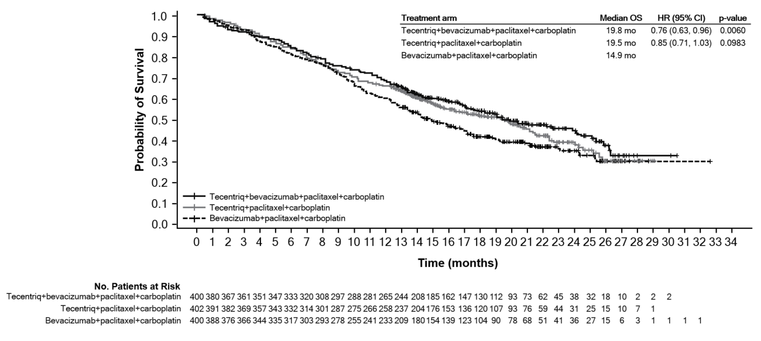

Figure 2. Forest plot of overall survival by PD-L1 expression in the ITT population, Arm B vs C (IMpower150)

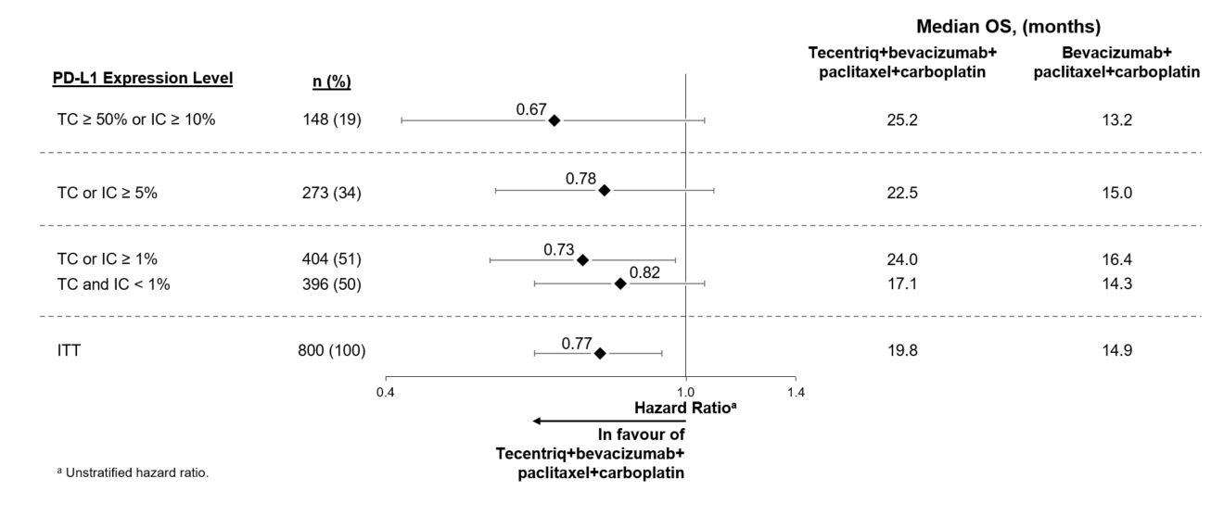

Figure 3. Kaplan-Meier curve for PFS in the ITT population (IMpower150)

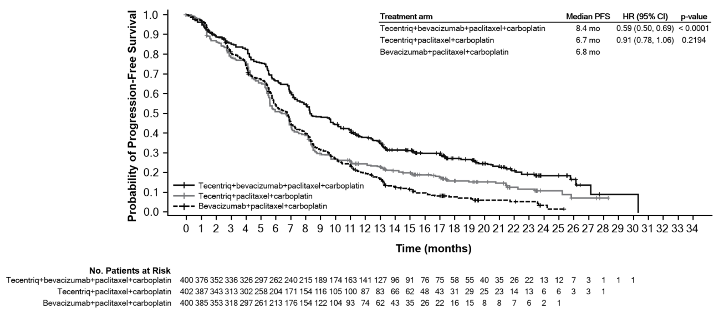

Figure 4. Forest plot of progression free survival by PD-L1 expression in the ITT population, Arm B vs C (IMpower150)

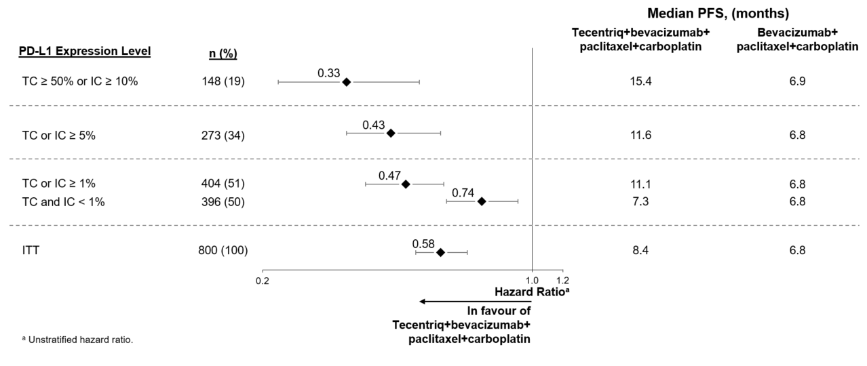

In Arm B as compared to Arm C, pre-specified subgroup analyses from the interim OS analysis showed an OS improvement for patients with EGFR mutations or ALK rearrangements (hazard ratio [HR] of 0.54, 95% CI: 0.29, 1.03; median OS not reached vs. 17.5 months), and liver metastases (HR of 0.52, 95% CI: 0.33, 0.82; median OS 13.3 vs 9.4 months). PFS improvements were also shown in patients with EGFR mutations or ALK rearrangements (HR of 0.55, 95% CI: 0.35, 0.87; median PFS 10.0 vs. 6.1 months) and liver metastases (HR of 0.41, 95% CI: 0.26, 0.62; median PFS 8.2 vs. 5.4 months). OS results were similar for patients aged < 65 and ≥ 65 subgroups, respectively. Data for patients ≥ 75 years of age are too limited to draw conclusions on this population. For all subgroup analyses, formal statistical testing was not planned.

1L non-squamous NSCLC
GO29537
A Phase III, open-label, randomised study, GO29537 (IMpower130) was conducted to evaluate the efficacy and safety of Tecentriq in combination with nab-paclitaxel and carboplatin, in chemotherapy-naïve patients with metastatic non-squamous NSCLC. Patients including those with EGFR or ALK genomic tumour aberrations, were enrolled and were randomised in a 2:1 ratio to receive one of the treatment regimens described in Table 10. Randomisation was stratified by sex, presence of liver metastases and PD-L1 tumour expression on tumour cells (TC) and tumour infiltrating cells (IC). Patients in treatment regimen B were able to crossover and receive Tecentriq monotherapy following disease progression.

Table 10. Intravenous treatment regimens in IMpower130
Treatment  Regimen |  | Induction  (four or six 21-Day Cycles) | Maintenance  (21-Day Cycles)
A | Tecentriq (1200mg) ª + nab-paclitaxel (100mg/m²) ^{b,c} + carboplatin (AUC 6)^{c} |  | Tecentriq (1200mg) ª
B | Nab-paclitaxel (100mg/m²) ^{b} + Carboplatin (AUC 6) ^{c} |  | Best supportive care or pemetrexed
ª Tecentriq is administered until loss of clinical benefit as assessed by investigator
^{b} Nab-paclitaxel is administered on days 1, 8, and 15 of each cycle
^{c} Nab-paclitaxel and carboplatin and is administered until completion of 4 - 6 cycles, or progressive disease or unacceptable toxicity whichever occurs first

Patients were excluded if they had history of autoimmune disease, administration of live, attenuated vaccine within 28 days prior to randomisation, administration of immunostimulatory agents within 4 weeks or systemic immunosuppressive medications within 2 weeks prior to randomisation, and active or untreated CNS metastases. Tumour assessments were conducted every 6 weeks for the first 48 weeks following Cycle 1, then every 9 weeks thereafter.

The demographics and baseline disease characteristics of the study population (n = 723) were well balanced between the treatment arms. The median age was 64 years (range 18 to 86). The majority of the patients were, male (57%), white (90%). 14.8% of patients had liver metastases at baseline, and most patients were current or previous smokers (88%). The majority of patients had ECOG performance status of 0 or 1, with the latter group representing 58.6% of the patients.

The primary analysis was conducted in all patients, excluding those with EGFR or ALK genomic tumour aberrations (n = 679). Patients had a median survival follow up time of 18.6 months. Improvements in OS and PFS were demonstrated with Tecentriq + nab-paclitaxel + carboplatin compared to the control. The key results are summarized in Table 11 and Kaplan-Meier curves for OS and PFS are presented in Figures 5 and 7, respectively.

All PD-L1 subgroups, regardless of expression, derived benefit in terms of OS and PFS; the results are summarised in Figure 6 and 8. Consistent OS and PFS benefit was demonstrated in all other pre-specified subgroups, with the exception of patients with liver metastases who did not show improved OS with Tecentriq, nab-paclitaxel and carboplatin, compared to nab-paclitaxel and carboplatin (HR of 1.04, 95% CI: 0.63,1.72).

Approximately 66% of patients in the nab-paclitaxel and carboplatin arm received any anti-cancer therapy after disease progression compared to 39% in the Tecentriq, nab-paclitaxel and carboplatin arm. These included, approximately 59% of patients in the nab-paclitaxel and carboplatin arm received any cancer immunotherapy after disease progression, which includes Tecentriq as crossover (41% of all patients), compared to 7.3% in the Tecentriq, nab-paclitaxel and carboplatin arm.

Table 11. Summary of efficacy from IMpower130 in the primary analysis population
Key efficacy endpoints | Tecentriq +  nab-paclitaxel  + carboplatin | nab-paclitaxel  + carboplatin
Co-primary Endpoints
OS | n = 451 | n = 228
No. of deaths (%) | 226 (50.1%) | 131 (57.5%)
Median time to events (months) | 18.6 | 13.9
95% CI | (16.0, 21.2) | (12.0, 18.7)
Stratified hazard ratio‡ (95% CI) | 0.79 (0.64, 0.98)
p-value | 0.033
12-month OS (%) | 63 | 55
Investigator-assessed PFS (RECIST v1.1) | n = 451 | n = 228
No. of events (%) | 347 (76.9) | 198 (86.8)
Median duration of PFS (months) | 7.0 | 5.5
95% CI | (6.2, 7.3) | (4.4, 5.9)
Stratified hazard ratio‡ (95% CI) | 0.64 (0.54, 0.77)
p-value | < 0.0001
12-month PFS (%) | 29 |  | 14
Other Endpoints
Investigator-assessed ORR (RECIST 1.1) | n = 447 | n = 226
No. of confirmed responders (%) | 220 (49.2%) | 72 (31.9%)
95% CI | (44.5, 54.0) | (25.8, 38.4)
No. of complete response (%) | 11 (2.5%) | 3 (1.3%)
No. of partial response (%) | 209 (46.8%) | 69 (30.5%)
Investigator-assessed confirmed DOR (RECIST 1.1) | n = 220 | n = 72
Median in months | 8.4 | 6.1
95% CI | (6.9, 11.8) | (5.5, 7.9)
‡ Stratified by sex and PD-L1 tumour expression on TC and IC
PFS = progression-free survival; RECIST = Response Evaluation Criteria in Solid Tumours v1.1.; CI = confidence interval; ORR = objective response rate; DOR = duration of response; OS = overall survival

Figure 5. Kaplan-Meier Plot for Overall Survival (IMpower130)
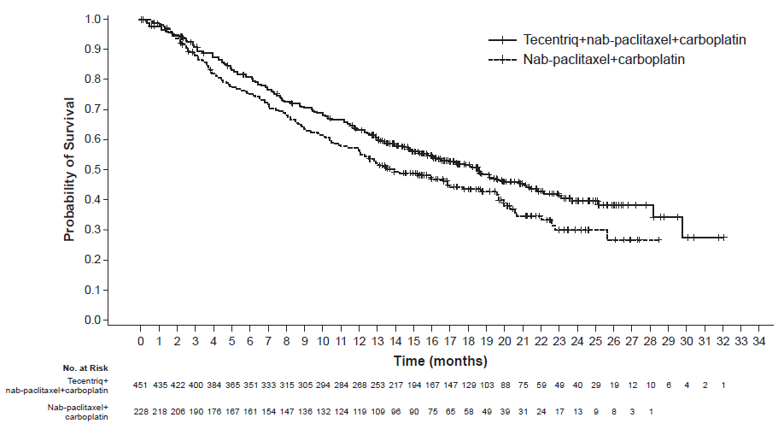

Figure 6. Forest Plot of Overall Survival by PD-L1 expression (IMpower130)
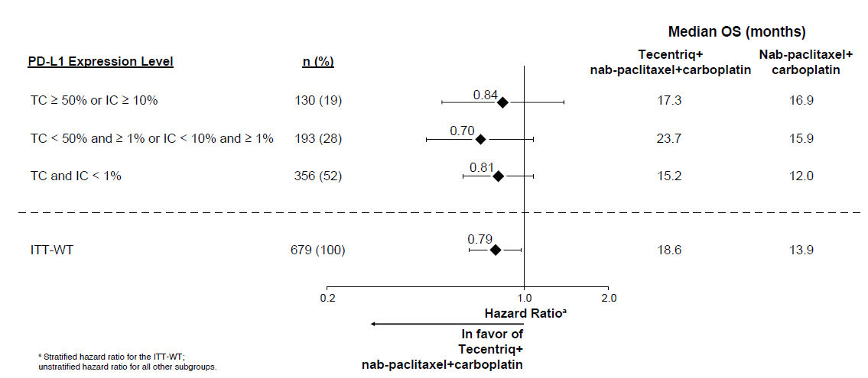

Figure 7. Kaplan-Meier Plot for Progression Free Survival (IMpower130)

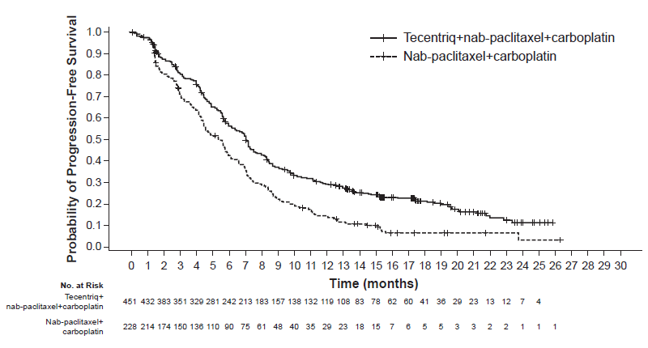

Figure 8. Forest Plot of Progression Free Survival by PD-L1 expression (IMpower130)
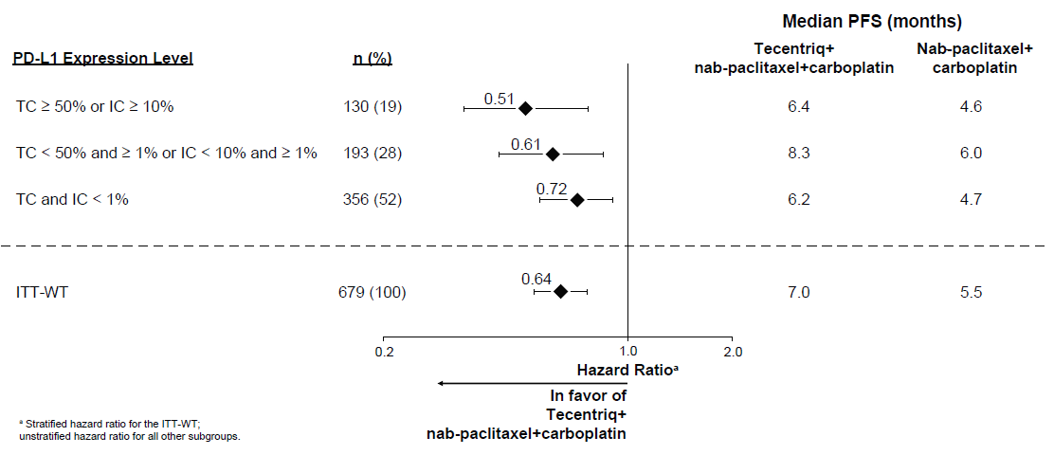

The study also evaluated Physical Function and Patient Reported Treatment-Related Symptoms using the EORTC QLQ-C30 and EORTC QLQ-LC13 measures. On average, patients who received Tecentriq with nab-paclitaxel and carboplatin reported high functioning and no clinically meaningful worsening in treatment-related symptoms. There was no difference in delay of lung-related symptoms (dyspnea, cough and chest pain) however patients receiving Tecentriq, nab-paclitaxel and carboplatin reported less worsening of these symptoms over time.

2L NSCLC

GO28915
A phase III, open-label, multicentre, international, randomised study, GO28915 (OAK), was conducted to evaluate the efficacy and safety of Tecentriq compared with docetaxel in patients with locally advanced or metastatic NSCLC who have progressed during or following a platinum-containing regimen. A total of 1225 patients were enrolled, with the primary analysis population consisting of the first 850 randomised patients. Eligible patients were stratified by PD-L1 expression status in tumour-infiltrating immune cells (IC), by the number of prior chemotherapy regimens, and by histology. Patients were randomised (1:1) to receive either Tecentriq or docetaxel. This study excluded patients who had a history of autoimmune disease, active or corticosteroid-dependent brain metastases, administration of a live, attenuated vaccine within 28 days prior to enrollment, administration of systemic immunostimulatory agents within 4 weeks or systemic immunosuppressive medications within 2 weeks prior to enrollment. Tumour assessments were conducted every 6 weeks for the first 36 weeks, and every 9 weeks thereafter.

The demographic and baseline disease characteristics of the primary analysis population were well balanced between the treatment arms. The median age was 64 years (range: 33 to 85), and 61% of patients were male. The majority of patients were white (70%). Approximately three-quarters of patients had non-squamous disease (74%), 10% had known EGFR mutation, 0.2% had known ALK rearrangements, 10% had CNS metastases at baseline, and most patients were current or previous smokers (82%). Baseline ECOG performance status was 0 (37%) or 1 (63%). Seventy five percent of patients received only one prior platinum-based therapeutic regimen.

Tecentriq was administered as a fixed dose of 1200 mg by IV infusion every 3 weeks. No dose reduction was allowed. Patients were treated until loss of clinical benefit as assessed by the investigator. Docetaxel was administered at 75 mg/m² by IV infusion on day 1 of each 21 day cycle until disease progression. For all treated patients, the median duration of treatment was 2.1 months for the docetaxel arm and 3.4 months for the Tecentriq arm.

The primary efficacy endpoint was OS. The key results of this study with a median survival follow-up of 21 months are summarised in Table 12. Kaplan-Meier curves for OS in the ITT population are presented in Figure 9. Figure 10 summarises the results of OS in the ITT and PD-L1 subgroups, demonstrating OS benefit with Tecentriq in all subgroups, including the TC0/IC0 subgroup (PD-L1 expression < 1% in TC and IC).

Table 12. Summary of Efficacy in the Primary Analysis Population (GO28915)
Efficacy endpoints | Tecentriq | Docetaxel
Primary Efficacy Endpoint
OS
All comers* | n = 425 | n = 425
No. of deaths (%) | 271 (64%) | 298 (70%)
Median time to events (months) | 13.8 | 9.6
95% CI | (11.8, 15.7) | (8.6, 11.2)
Stratified# hazard ratio (95% CI) | 0.73 (0.62, 0.87)
p-value** | 0.0003
12-month OS (%) | 218 (55%) | 151 (41%)
18-month OS (%) | 157 (40%) | 98 (27%)
TC1/2/3 or IC1/2/3 | n = 241 | n = 222
No. of deaths (%) | 151 (63%) | 149 (67%)
Median time to events (months) | 15.7 | 10.3
95% CI | (12.6, 18.0) | (8.8, 12.0)
Stratified# hazard ratio (95% CI) | 0.74 (0.58, 0.93)
p-value** | 0.0102
12-month OS (%) | 58% | 43%
18-month OS (%) | 44% | 29%
Secondary Endpoints
Investigator-assessed PFS (RECIST v1.1)
All comers* | n = 425 | n = 425
No. of events (%) | 380 (89%) | 375 (88%)
Median duration of PFS (months) | 2.8 | 4.0
95% CI | (2.6, 3.0) | (3.3, 4.2)
Stratified# hazard ratio (95% CI) | 0.95 (0.82, 1.10)
Investigator-assessed ORR (RECIST v1.1)
All comers* | n = 425 | n = 425
No. of responders (%) | 58 (14%) | 57 (13%)
95% CI | (10.5, 17.3) | (10.3, 17.0)
Investigator-assessed DOR (RECIST v1.1)
All comers* | n = 58 | n = 57
Median in months | 16.3 | 6.2
95% CI | (10.0, NE) | (4.9, 7.6)
CI = confidence interval; DOR = duration of objective response; IC = tumour-infiltrating immune cells; NE = not estimable; ORR = objective response rate; OS = overall survival; PFS = progression-free survival; RECIST = Response Evaluation Criteria in Solid Tumours v1.1; TC = tumour cells.
* All comers refers to the primary analysis population consisting of the first 850 randomised patients
# Stratified by PD-L1 expression in ICs, the number of prior chemotherapy regimens, and histology
** Based on the stratified log-rank test

Figure 9. Kaplan-Meier Plot for Overall Survival in the Primary Analysis Population (all comers) (GO28915)
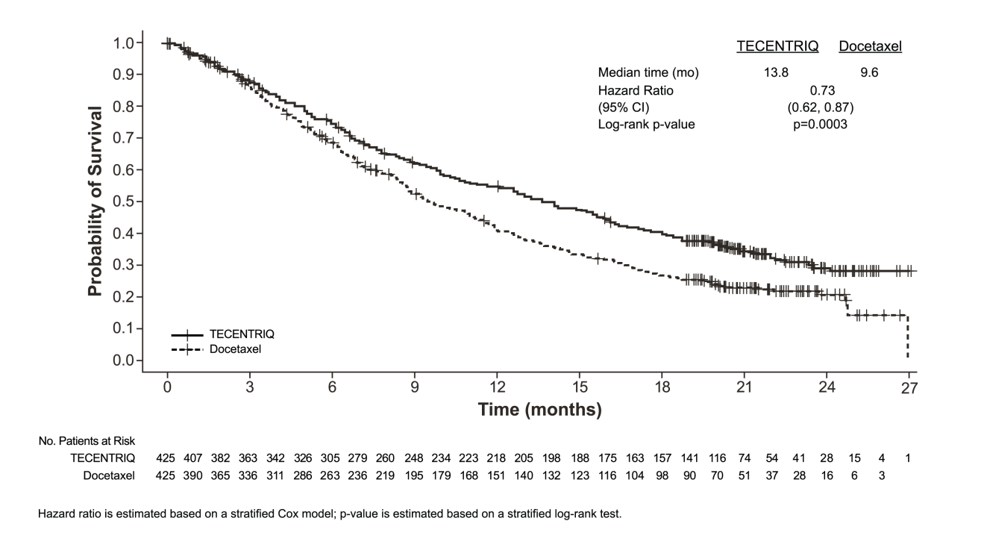

Figure 10. Forest Plot of Overall Survival by PD-L1 Expression in the Primary Analysis Population (GO28915)
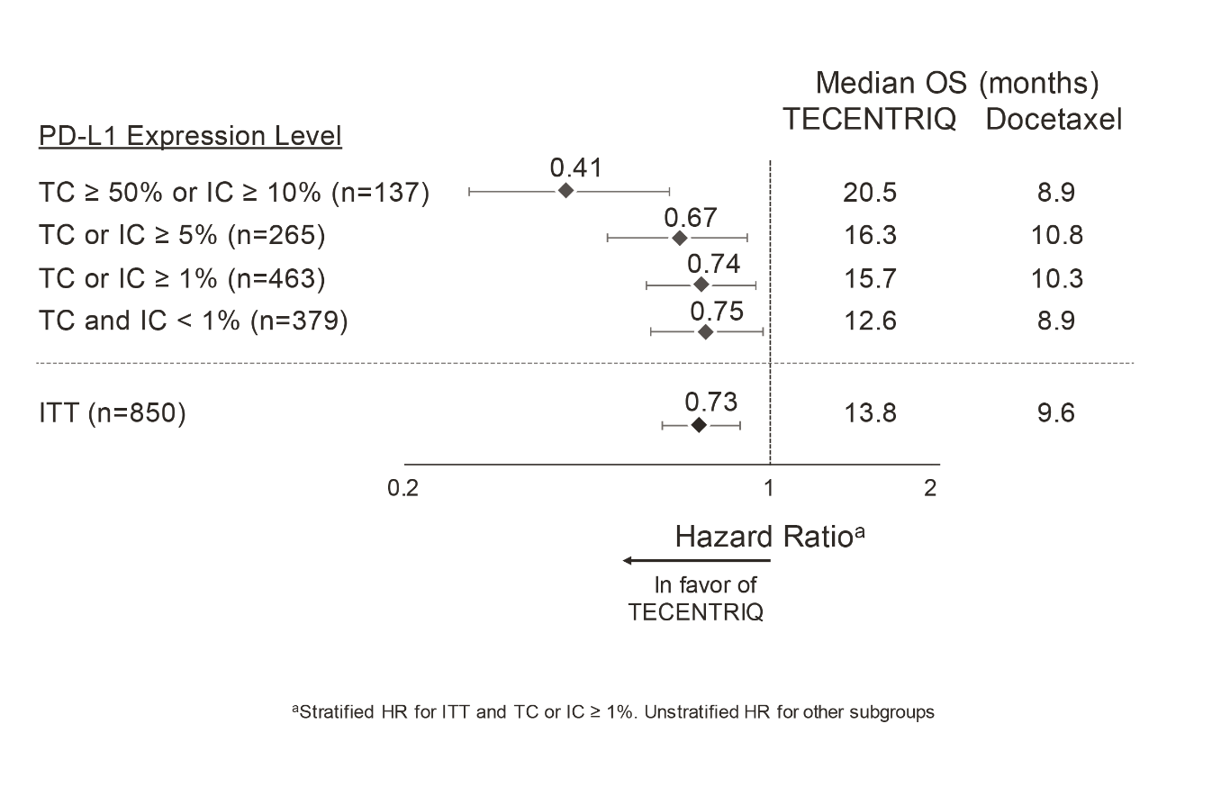
An improvement in OS was observed with Tecentriq compared to docetaxel in both non-squamous NSCLC patients (hazard ratio [HR] of 0.73, 95% CI: 0.60, 0.89; median OS of 15.6 vs. 11.2 months for Tecentriq and docetaxel, respectively) and squamous NSCLC patients (HR of 0.73, 95% CI: 0.54, 0.98; median OS of 8.9 vs. 7.7 months for Tecentriq and docetaxel, respectively). The observed OS improvement was consistently demonstrated across subgroups of patients including those with brain metastases at baseline (HR of 0.54, 95% CI: 0.31, 0.94; median OS of 20.1 vs. 11.9 months for Tecentriq and docetaxel respectively) and patients who were never smokers (HR of 0.71, 95% CI: 0.47, 1.08; median OS of 16.3 vs. 12.6 months for Tecentriq and docetaxel, respectively). However, patients with EGFR mutations did not show improved OS with Tecentriq compared to docetaxel (HR of 1.24, 95% CI: 0.71, 2.18; median OS of 10.5 vs. 16.2 months for Tecentriq and docetaxel respectively).

Prolonged time to deterioration of patient-reported pain in chest as measured by the EORTC QLQ-LC13 was observed with Tecentriq compared with docetaxel (HR 0.71, 95% CI: 0.49, 1.05; median not reached in either arm). The time to deterioration in other lung cancer symptoms (i.e. cough, dyspnoea, and arm/shoulder pain) as measured by the EORTC QLQ-LC13 was similar between Tecentriq and docetaxel. The average global health status and functioning scores (i.e. physical, role, social, emotional, and cognitive) as measured by the EORTC QLQ-C30 did not show clinically meaningful deterioration over time for both treatment groups, suggesting maintained health-related quality of life and patient-reported functioning for patients remaining on treatment.

GO28753
A phase II, multicentre, international, randomised, open-label, controlled study, GO28753 (POPLAR) was conducted in patients with locally advanced or metastatic NSCLC who progressed during or following a platinum containing regimen, regardless of PD-L1 expression. The primary efficacy outcome was overall survival. A total of 287 patients were randomised 1:1 to receive either Tecentriq (1200 mg by intravenous infusion every 3 weeks until loss of clinical benefit) or docetaxel (75 mg/m² by intravenous infusion on day 1 of each 3 week cycle until disease progression). Randomisation was stratified by PD-L1 expression status on IC, by the number of prior chemotherapy regimens and by histology. An updated analysis with a total of 200 deaths observed and a median survival follow up of 22 months showed a median OS of 12.6 months in patients treated with Tecentriq, vs. 9.7 months in patients treated with docetaxel (HR of 0.69, 95% CI: 0.52, 0.92). ORR was 15.3% vs. 14.7% and median DOR was 18.6 months vs. 7.2 months for Tecentriq vs. docetaxel, respectively.

Small cell lung cancer

GO30081
A Phase I/III, randomised, multicenter, double-blind, placebo controlled study, GO30081 (IMpower133), was conducted to evaluate the efficacy and safety of Tecentriq in combination with carboplatin and etoposide in patients with chemotherapy-naïve ES-SCLC. A total of 403 patients were randomised (1:1) to receive one of the treatment regimens described in Table 13. Randomisation was stratified by sex, ECOG performance status, and presence of brain metastases.

This study excluded patients who had active or untreated CNS metastases; history of autoimmune disease; administration of live, attenuated vaccine within 4 weeks prior to randomisation; administration of systemic immunosuppressive medications within 1 week prior to randomisation. Tumour assessments were conducted every 6 weeks for the first 48 weeks following Cycle 1, Day 1 and then every 9 weeks thereafter. Patients treated beyond disease progression had tumour assessment conducted every 6 weeks until treatment discontinuation.

Table 13. Intravenous treatment regimen in study GO30081
Treatment regimen | Induction  (four 21-day cycles) | Maintenance  (21-day cycles)
A | Tecentriq (1200 mg)ª + carboplatin (AUC 5)^{b} + etoposide (100 mg/m²)^{b,c} | Tecentriq (1200 mg) ª
B | placebo + carboplatin (AUC 5)^{b} + etoposide (100 mg/m²)^{b,c} | placebo
ª Tecentriq is administered until loss of clinical benefit as assessed by investigator
^{b} Carboplatin and etoposide is administered until completion of 4 cycles, or progressive disease or unacceptable toxicity whichever occurs first
^{c} Etoposide is administered on day 1, 2 and 3 of each cycle

The demographic and baseline disease characteristics of the primary analysis population were well balanced between the treatment arms. The median age was 64 years (range: 26 to 90 years). The majority of patients were male (65%), white (80%), and 9% had brain metastases and most patients were current or previous smokers (97%). Baseline ECOG performance status was 0 (35%) or 1 (65%).

At the time of the primary analysis, patients had a median survival follow up time of 13.9 months. The key results are summarised in Table 14. Kaplan-Meier curves for OS and PFS are presented in Figure 11 and 12.

Table 14. Summary of efficacy from GO30081
Key efficacy endpoints | Arm A  (Tecentriq + carboplatin + etoposide) | Arm B  (placebo + carboplatin + etoposide)
Co-primary endpoints
OS analysis | n = 201 | n = 202
No. of deaths (%) | 104 (51.7%) | 134 (66.3%)
Median time to events (months) | 12.3 | 10.3
95% CI | (10.8, 15.9) | (9.3, 11.3)
Stratified hazard ratio‡ (95% CI) | 0.70 (0.54, 0.91)
p-value | 0.0069
12-month OS (%) | 51.7 | 38.2
Investigator-assessed PFS (RECIST v1.1) | n = 201 | n = 202
No. of events (%) | 171 (85.1%) | 189 (93.6%)
Median duration of PFS (months) | 5.2 | 4.3
95% CI | (4.4, 5.6) | (4.2, 4.5)
Stratified hazard ratio‡ (95% CI) | 0.77 (0.62, 0.96)
p-value | 0.0170
6-month PFS (%)  12-month PFS (%) | 30.9  12.6 |  | 22.4  5.4
Secondary endpoints
Investigator-assessed ORR (RECIST 1.1) | n = 201 | n = 202
No. of responders (%) | 121 (60.2%) | 130 (64.4%)
95% CI | (53.1, 67.0) | (57.3, 71.0.)
No. of complete response (%) | 5 (2.5%) | 2 (1.0%)
No. of partial response (%) | 116 (57.7%) | 128 (63.4%)
Investigator-assessed DOR (RECIST 1.1) | n = 121 | n = 130
Median in months | 4.2 | 3.9
95% CI | (4.1, 4.5) | (3.1, 4.2)
PFS = progression-free survival; RECIST = Response Evaluation Criteria in Solid Tumours v1.1.; CI = confidence interval; ORR = objective response rate; DOR = duration of response; OS = overall survival
‡ Stratified by sex and ECOG performance status

Figure 11. Kaplan-Meier plot of overall survival (GO30081)

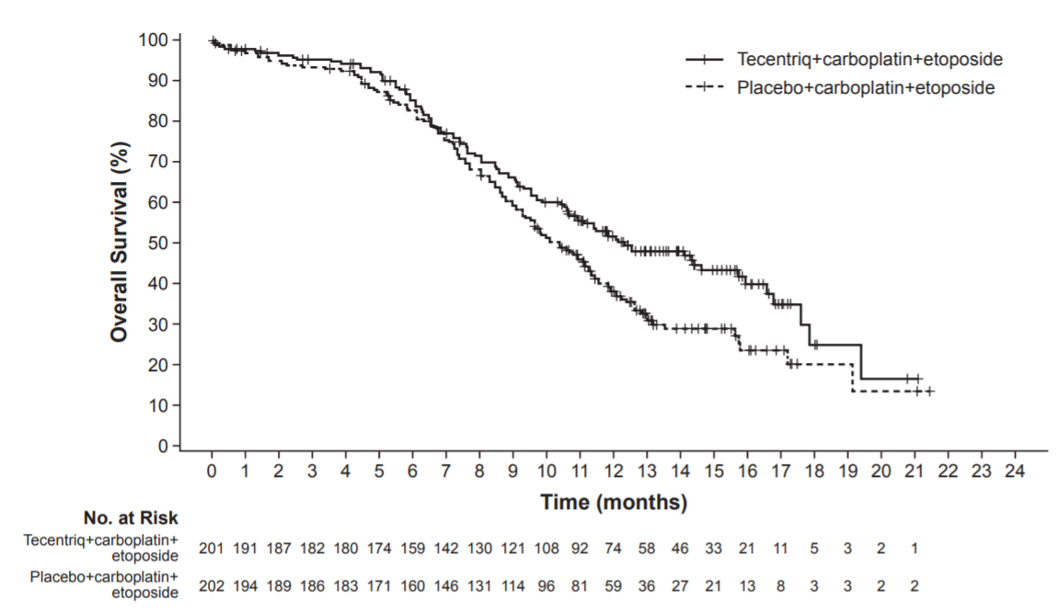

Figure 12. Kaplan-Meier plot of progression-free survival (GO30081)

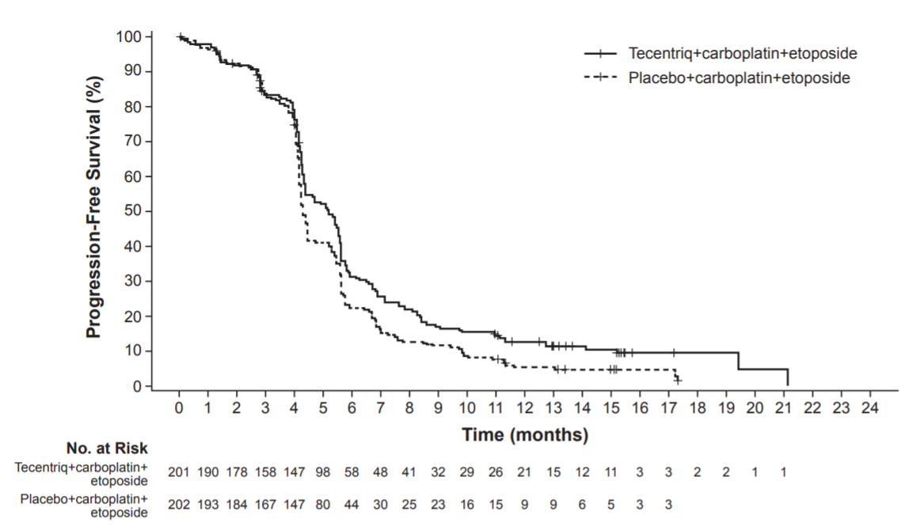

Urothelial carcinoma

GO29293
The efficacy of Tecentriq was investigated in IMvigor210 (Cohort 1) (GO29293), a multicentre, open-label, single-arm trial that included 119 patients with locally advanced or metastatic urothelial carcinoma who were ineligible for cisplatin-containing chemotherapy and were either previously untreated or had disease progression at least 12 months after neoadjuvant or adjuvant chemotherapy. Patients were considered cisplatin-ineligible if they met any one of the following criteria at study entry: impaired renal function [creatinine clearance (CLcr) of 30 to 59 mL/min], Eastern Cooperative Oncology Group (ECOG) performance status (PS) of 2, hearing loss of ≥ 25 decibels (dB) at two contiguous frequencies, or Grades 2 to 4 peripheral neuropathy. This study excluded patients who had: a history of autoimmune disease; active or corticosteroid-dependent brain metastases; administration of a live, attenuated vaccine within 28 days prior to enrollment; or administration of systemic immunostimulatory agents within 6 weeks or systemic immunosuppressive medications within 2 weeks prior to enrollment.

Patients received Tecentriq 1200 mg as an intravenous infusion every 3 weeks until unacceptable toxicity or disease progression. Tumour response assessments were conducted every 9 weeks for the first 54 weeks and every 12 weeks thereafter. Major efficacy outcome measures included confirmed overall response rate (ORR) as assessed by independent review facility (IRF) using Response Evaluation Criteria in Solid Tumours (RECIST v1.1), duration of response (DoR) and overall survival (OS).

In this study, the median age was 73 years, 81% were male, and 91% were White. Thirty-five percent of patients had non-bladder urothelial carcinoma and 66% had visceral metastases. Eighty percent of patients had an ECOG PS of 0 or 1. Reasons for ineligibility for cisplatin containing chemotherapy were: 70% had impaired renal function, 20% had an ECOG PS of 2, 14% had a hearing loss of ≥ 25dB, and 6% had Grades 2 to 4 peripheral neuropathy at baseline. Twenty percent of patients had disease progression following prior platinum-containing neoadjuvant or adjuvant chemotherapy.

Tumour specimens were evaluated prospectively using the VENTANA PD-L1 (SP142) Assay at a central laboratory, and the results were used to define subgroups for pre-specified analyses. Of the 119 patients, 27% were classified as having PD-L1 expression of ≥ 5% (defined as PD-L1 stained tumour-infiltrating immune cells [IC] covering ≥ 5% of the tumour area, IC2/3). The remaining 73% of patients were classified as having PD-L1 expression of < 5% (PD-L1 stained tumour infiltrating IC covering < 5% of the tumour area, IC0/1).

Among the 32 patients with PD-L1 expression of ≥ 5%, median age was 67 years, 81% were male, 19% female, and 88% were White. Twenty-eight percent of patients had non-bladder urothelial carcinoma and 56% had visceral metastases. Seventy-two percent of patients had an ECOG PS of 0 or 1. Reasons for ineligibility for cisplatin-containing chemotherapy were: 66% had impaired renal function, 28% had an ECOG PS of 2, 16% had a hearing loss ≥ 25 dB, and 9% had Grades 2 - 4 peripheral neuropathy at baseline. Thirty-one percent of patients had disease progression following prior platinum-containing neoadjuvant or adjuvant chemotherapy.

Confirmed ORR in all patients and the two PD-L1 subgroups are summarised in Table 15. The median follow-up time for this study was 14.4 months. In 24 patients with disease progression following neoadjuvant or adjuvant therapy, the ORR was 33% (95% CI: 16%, 55%).

Table 15. Efficacy results from GO29293 Cohort 1
 | All patients | PD-L1 expression subgroups
 |  | PD-L1 expression of < 5% in ICs¹ | PD-L1 expression of ≥ 5% in ICs¹
 | n = 119 | n = 87 | n = 32
Number of IRF-assessed confirmed responders | 28 | 19 | 9
ORR% (95% CI) | 23.5% (16.2, 32.2) | 21.8% (13.7, 32) | 28.1% (13.8, 46.8)
Complete response (CR) (%) | 6.7% | 6.9% | 6.3%
Partial response (PR) (%) | 16.8% | 14.9% | 21.9%
Median DoR, months (range) | NR  (3.7, 16.6+) | NR  (3.7, 16.6+) | NR  (8.1, 15.6+)
NR = not reached
+ Denotes a censored value
¹ PD-L1 expression in tumour-infiltrating immune cells (ICs)

WO30070
IMvigor130 (WO30070) is an ongoing multicentre, randomised study in previously untreated patients with metastatic urothelial carcinoma who are eligible for platinum-containing chemotherapy. The study contains three arms: Tecentriq monotherapy, Tecentriq with platinum-based chemotherapy (i.e., cisplatin or carboplatin with gemcitabine), and platinum-based chemotherapy alone (comparator). Both cisplatin-eligible and cisplatin-ineligible patients are included in the study. Tumour specimens were evaluated prospectively using the VENTANA PD-L1 (SP142) Assay at a central laboratory.

The independent Data Monitoring Committee (iDMC) for the study conducted a review of early data and found that patients classified as having PD-L1 expression of < 5% (IC0/1) when treated with Tecentriq monotherapy had decreased survival compared to those who received platinum-based chemotherapy. The iDMC recommended closure of the monotherapy arm to further accrual of patients with low PD-L1 expression, however, no other changes were recommended for the study, including any change of therapy for patients who had already been randomized to and were receiving treatment in the monotherapy arm.

1L triple-negative breast cancer WO29522
A phase III, double-blind, two-arm, randomised, placebo-controlled study, WO29522(IMpassion130), was conducted to evaluate the efficacy and safety of Tecentriq in combination with nab-paclitaxel, in patients with unresectable locally advanced or metastatic TNBC who had not received prior chemotherapy for metastatic disease. A total of 902 patients were enrolled and stratified by presence of liver metastases, prior taxane treatment, and by PD-L1 expression status in tumour-infiltrating immune cells (IC) ) (PD-L1 stained tumour-infiltrating immune cells [IC] <1% of tumour area vs. ≥ 1% of the tumour area) assessed by the VENTANA PD-L1 (SP142) Assay. Patients were randomised to receive Tecentriq (840 mg) or placebo IV infusions on Days 1 and 15 of every 28-day cycle, plus nab- paclitaxel (100 mg/m2) administered via IV infusion on Days 1, 8 and 15 of every 28-day cycle. Patients received treatment until radiographic disease progression per RECIST v1.1, or unacceptable toxicity.

Patients were excluded if they had a history of autoimmune disease; administration of a live, attenuated vaccine within 4 weeks prior to randomisation; administration of systemic immunostimulatory agents within 4 weeks or systemic immunosuppressive medications within 2 weeks prior to randomisation; untreated or corticosteroid-dependent brain metastases. Tumour assessments were performed every 8 weeks (± 1 week) for the first 12 months after Cycle 1, day 1 and every 12 weeks (± 1 week) thereafter.
The demographic and baseline disease characteristics of the study population were well balanced between the treatment arms. Most patients were women (99.6%). Sixty-seven percent of patients were white (67.5%), 17.8% were Asian, 6.5% were Black or African American, and 4.4% were American Indian or Alaskan Native. The median age was 55 years (range: 20-86). Baseline ECOG performance status was 0 (58.4%) or 1 (41.3%). Overall, 41% of enrolled patients had PD-L1 expression ≥1%, 27% had liver metastases and 7% brain metastases at baseline. Approximately half the patients had received a taxane (51%) or anthracycline (54%) in the (neo)adjuvant setting. Patient demographics and baseline tumour disease in the PD-L1 expression ≥1% population were generally representative of the broader study population.

The co-primary efficacy endpoints included investigator-assessed progression free survival (PFS) in the ITT population and in patients with PD-L1 expression ≥ 1% per RECIST v1.1 as well as overall survival (OS) in the ITT population and in patients with PD-L1 expression ≥ 1%. Secondary efficacy endpoints included objective response rate (ORR) and duration of response (DOR) per RECIST v1.1

PFS, ORR and DOR results for patients with PD-L1 expression ≥1% with a median survival follow up of 13 months are summarized in Table 16 and Figure 13.

An updated OS analysis was performed with a median follow-up of 18 months at a clinical cut off date of January 2nd 2019. OS results are presented in Table 16 and Figure 14.

Table 16. Summary of efficacy in patients with PD-L1 expression ≥1% from WO29522

Key efficacy endpoints | Tecentriq + nab- Placebo + nab- paclitaxel paclitaxel
Co-primary endpoints
Investigator-assessed PFS (RECIST v1.1)³ | n = 185 | n = 184
No. of events (%) | 138 (74.6%) | 157 (85.3%)
Median duration of PFS (months) | 7.5 | 5.0
95% CI | (6.7, 9.2) | (3.8, 5.6)
Stratified hazard ratio‡ (95% CI) | 0.62 (0.49, 0.78)
p-value1 | <0.0001
12-month PFS (%) | 29.1 | 16.4
OS interim analysis⁴ | n = 185 | n = 184
No. of deaths (%) | 94 (50.8%) | 110 (59.8%)
Median time to events (months) | 25.0 | 18.0
95% CI | (19.6, 30.7) | 13.6, 20.1)
Stratified hazard ratio‡ (95% CI) | 0.71 (0.54, 0.93)
Secondary endpoints
Investigator-assessed ORR (RECIST 1.1) ³ | n = 185 | n = 183
No. of responders (%) | 109 (58.9%) | 78 (42.6%)
95% CI | (51.5, 66.1) | (35.4, 50.1)
No. of complete response (%) | 19 (10.3%) | 2 (1.1%)
No. of partial response (%) | 90 (48.6%) | 76 (41.5%)
No. of stable disease | 38 (20.5%) | 49 (26.8%)
Investigator-assessed DOR³ | n = 109 | n = 78
Median in months | 8.5 | 5.5
95% CI | (7.3, 9.7) | (3.7, 7.1)
Unstratified hazard ratio (95% CI) | 0.60 (0.43, 0.86)
1. Based on the stratified log-rank test
2. OS comparisons between treatment arms in patients with PD-L1 expression ≥1% were not formally tested, as per the pre-specified analysis hierarchy.
³Per final analysis for PFS, ORR, DOR and first interim analysis for OS at clinical cut off 17th April 2018
⁴ Per second interim analysis for OS at clinical cut off January 2nd 2019
‡ Stratified by presence of liver metastases, and by prior taxane treatment
PFS = progression-free survival; RECIST = Response Evaluation Criteria in Solid Tumors v1.1.; CI = confidence interval; ORR=objective response rate; DOR = duration of response; OS = overall survival, NE = not estimable

Figure 13: Kaplan-Meier Plot for Progression Free Survival in patients with PD-L1 expression ≥1% (WO29522)
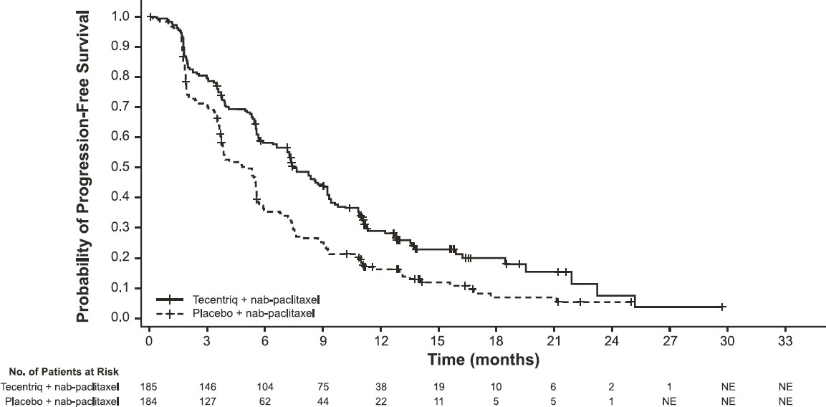

Figure 14: Kaplan-Meier Plot for Overall Survival in patients with PD-L1 expression ≥1% (WO29522)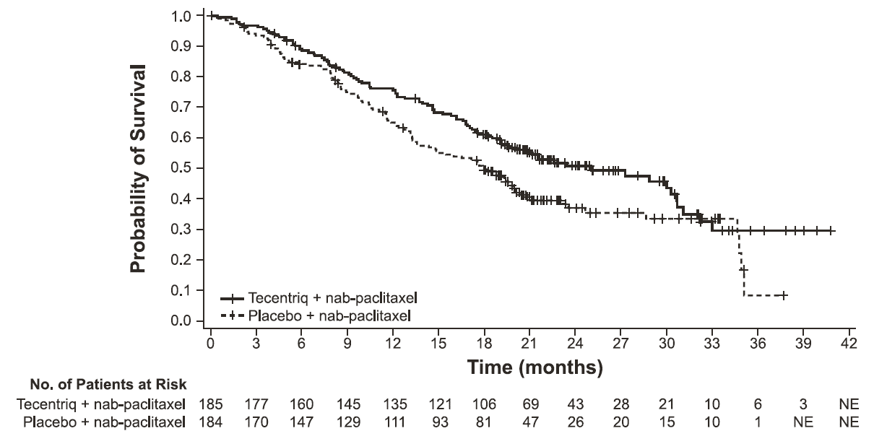

The time to deterioration (a sustained ≥ 10-point decline from baseline score) of patient-reported global health status/health-related quality of life as measured by the EORTC QLQ-C30 was similar in each treatment group indicating that all patients maintained their baseline HRQoL for a comparable duration of time.

PD-L1 expression by immunohistochemistry
The VENTANA PD-L1 (SP142) Assay has been validated to detect PD-L1 expression in tumour-infiltrating immune cells (IC) and tumour cells (TC).

The test detects the presence of any discernible PD-L1 staining of any intensity.

Scoring for tumour cells was defined as TC0 (< 1%), TC1 (≥ 1% and < 5%), TC2 (≥ 5% and < 50%), and TC3 (≥ 50%). Scoring for tumour-infiltrating immune cells was defined as IC0 (< 1%), IC1 (≥ 1% and < 5%), IC2 (≥ 5% and < 10%) and IC3 (≥ 10%).

Immunogenicity

GO29436 (IMpower150)
Exploratory analyses showed that the subset of patients in the four drug regimen arm who were ADA positive by week 4 (30%) appeared to have similar efficacy (effect on overall survival) as compared to patients who tested negative for treatment-emergent ADA by week 4 (70%). In an exploratory analysis, propensity score matching was conducted to compare ADA positive patients in the Tecentriq, bevacizumab, paclitaxel, and carboplatin arm with a matched population in the bevacizumab, paclitaxel, and carboplatin arm. Similarly ADA negative patients in the Tecentriq, bevacizumab, paclitaxel, and carboplatin arm were compared with a matched population in the bevacizumab, paclitaxel, and carboplatin arm. Propensity score matching factors were: baseline sum of longest tumour size (BSLD), baseline ECOG, baseline albumin, baseline LDH, sex, tobacco history, metastatic site, TC level, and IC level. The hazard ratio comparing the ADA-positive subgroup with its matched control was 0.69 (95% CI: 0.44, 1.07). The hazard ratio comparing the ADA-negative subgroup with its matched control was 0.64 (95% CI: 0.46, 0.90).

GO28915 (OAK)
Exploratory analyses showed that the subset of patients who were ADA positive by week 4 (21%; 118/560) appeared to have less efficacy (effect on overall survival) as compared to patients who tested negative for treatment-emergent ADA by week 4 (79%). ADA positive patients by week 4 appeared to have similar OS compared to docetaxel-treated patients. In an exploratory analysis, propensity score matching was conducted to compare ADA positive patients in the Tecentriq arm with a matched population in the docetaxel arm and ADA negative patients in the Tecentriq arm with a matched population in the docetaxel arm. Propensity score matching factors were: baseline sum of longest tumour size (BSLD), baseline ECOG, histology (squamous vs. non-squamous), baseline albumin, baseline LDH, gender, tobacco history, metastases status (advanced or local), metastatic site, TC level, and IC level. The hazard ratio comparing the ADA positive subgroup with its matched control was 0.89 (95% CI: 0.61, 1.3). The hazard ratio comparing the ADA negative subgroup with its matched control was 0.68 (95% CI: 0.55, 0.83).

5.2 Pharmacokinetic properties
The pharmacokinetics of atezolizumab have been characterised in patients in multiple clinical trials at doses 0.01 mg/kg to 20 mg/kg every 3 weeks including the fixed dose of 1200 mg. Exposure to atezolizumab increased dose proportionally over the dose range of 1 mg/kg to 20 mg/kg. A population analysis that included 472 patients described atezolizumab pharmacokinetics for the dose range 1 - 20 mg/kg with a linear two-compartment disposition model with first-order elimination. The pharmacokinetic properties of atezolizumab 840 mg administered every 2 weeks and 1200 mg administered every 3 weeks, are comparable.A population pharmacokinetic analysis suggests that steady-state is obtained after multiple doses. The maximum systemic accumulation in area under the curve (AUC), maximum concentration (C_{max}) and trough concentration (C_{min}) are 2.54, 1.84 and 3.05-fold, respectively.

Based on analyses of population pharmacokinetics and exposure-safety and -efficacy relationships, the following factors have no clinically relevant effect: age (21 - 89 years), body weight, gender, albumin levels, tumour burden, region or ethnicity, renal impairment, mild hepatic impairment, level of PD-L1 expression, or Eastern Cooperative Oncology Group (ECOG) status. No dose adjustments are recommended.

Absorption
Tecentriq is administered as an intravenous (IV) infusion. There have been no studies performed with other routes of administration.

Distribution
A population pharmacokinetic analysis indicates that central compartment volume of distribution (V₁) is 3.28 L and volume at steady-state (V_{ss}) is 6.91 L in the typical patient.

Metabolism
The metabolism of atezolizumab has not been directly studied. Antibodies are cleared principally by catabolism.

Excretion
A population pharmacokinetic analysis indicates that the clearance of atezolizumab is 0.200 L/day and the typical terminal elimination half-life (t_{1/2}) is 27 days.

Pharmacokinetics in Special Populations

Hepatic impairment
No dedicated studies of Tecentriq have been conducted in patients with hepatic impairment. In the population pharmacokinetic analysis, there were no clinically important differences in the clearance of atezolizumab between patients with mild hepatic impairment (bilirubin ≤ ULN and AST > ULN or bilirubin > 1.0 to 1.5 X ULN and any AST, n = 71) and normal hepatic function (bilirubin and AST ≤ ULN, n = 401). No data are available in patients with either moderate (bilirubin > 1.5 to 3.0 × ULN and any AST) or severe (bilirubin > 3.0 × ULN and any AST) hepatic impairment. Hepatic impairment was defined by the National Cancer Institute (NCI) criteria of hepatic dysfunction (see section 4.2 Dose and method of administration).). The effect of moderate or severe hepatic impairment (bilirubin > 1.5 × to 3 × ULN and any AST or bilirubin > 3 × ULN and any AST) on the pharmacokinetics of atezolizumab is unknown.

Renal impairment
No dedicated studies of Tecentriq have been conducted in patients with renal impairment. In the population pharmacokinetic analysis, no clinically important differences in the clearance of atezolizumab were found in patients with mild (eGFR 60 to 89 mL/min/1.73 m²; n = 208) or moderate (eGFR 30 to 59 mL/min/1.73 m2; n = 116) renal impairment compared to patients with normal (eGFR greater than or equal to 90 mL/min/1.73 m²; n = 140) renal function. Only a few patients had severe renal impairment (eGFR 15 to 29 mL/min/1.73 m²; n = 8) (see section 4.2 Dose and method of a administration). The effect of severe renal impairment on the pharmacokinetics of atezolizumab is unknown.

Elderly
No dedicated studies of Tecentriq have been conducted in elderly patients. The effect of age on the pharmacokinetics of atezolizumab was assessed in a population pharmacokinetic analysis. Age was not identified as a significant covariate influencing atezolizumab pharmacokinetics based on patients of age range of 21 - 89 years (n = 472), and median of 62 years of age. No clinically important difference was observed in the pharmacokinetics of atezolizumab among patients < 65 years (n = 274), patients between 65 - 75 years (n = 152) and patients > 75 years (n = 46) (see section 4.2 Dose and method of administration).

Children
No studies have been conducted to investigate the pharmacokinetics of Tecentriq in children.

5.3 PRECLINICAL SAFETY DATA

Genotoxicity
No genotoxicity studies have been conducted with atezolizumab.

Carcinogenicity
No carcinogenicity studies have been conducted with atezolizumab.

Fertility
No fertility studies have been conducted with atezolizumab; however assessment of the cynomolgus monkey male and female reproductive organs was included in the chronic toxicity study. Atezolizumab had an effect on menstrual cycles in all female monkeys in the 50 mg/kg dose group characterised by an irregular cycle pattern during the dosing phase and correlated with the lack of fresh corpora lutea in the ovaries at the terminal necropsy; this effect was reversible during the dose-free recovery period. The AUC at the no effect level was approximately 5 times that anticipated in patients. There was no effect on the male reproductive organs.

6 PHARMACEUTICAL PARTICULARS

6.1 List of excipients
Histidine, glacial acetic acid, sucrose, polysorbate 20 and water for injections.

6.2 Incompatibilities
No incompatibilities have been observed between Tecentriq and IV bags with product-contacting surfaces of polyvinyl chloride (PVC), polyethylene (PE) or polyolefin. In addition, no incompatibilities have been observed with in-line filter membranes composed of polyethersulfone or polysulfone, and infusion sets and other infusion aids composed of PVC, PE, polybutadiene, or polyetherurethane.

6.3 Shelf life
In Australia, information on the shelf life can be found on the public summary of the Australian Register of Therapeutic Goods (ARTG). The expiry date can be found on the packaging.

The diluted solution for infusion should be used immediately. If the solution is not used immediately, it can be stored for up to 24 hours at 2 °C to 8 °C, or 8 hours at ambient temperature (≤ 25 °C).

6.4 Special precautions for storage
Store the vials at 2 °C to 8 °C. Do not freeze.

Tecentriq should be protected from light. Do not shake.

This medicine should not be used after the expiry date (EXP) shown on the pack.

6.5 Nature and contents of container
Tecentriq is available in a single-use glass vial containing 14 mL or 20 mL solution in a pack size of 1 vial.

6.6 Special precautions for disposal
The release of medicines into the environment should be minimised. Medicines should not be disposed of via wastewater and disposal through household waste should be avoided. Unused or expired medicine should be returned to a pharmacy for disposal.

6.7 Physicochemical properties

Chemical structure
Tecentriq is an engineered, humanised, monoclonal antibody that directly binds to PD-L1 and blocks interactions with the PD-1 and B7.1 receptors. Tecentriq is a non-glycosylated IgG1 immunoglobulin that has a calculated molecular mass of 145 kDa.

CAS number
1380723-44-3

7 MEDICINE SCHEDULE (POISONS STANDARD)
Schedule 4 – Prescription Only Medicine.

8 SPONSOR
Roche Products Pty Limited
ABN 70 000 132 865
Level 8, 30 – 34 Hickson Road
Sydney NSW 2000
AUSTRALIA

Medical enquiries: 1800 233 950

9 DATE OF FIRST APPROVAL
27 July 2017

10 DATE OF REVISION
19 February 2020

SUMMARY TABLE OF CHANGES
Section Changed | Summary of new information
4.1 Therapeutic indications | Addition of new indication in the treatment of first-line metastatic non-squamous NSCLC
4.2 Dose and method of  administration | Addition of dosage instructions for first-line metastatic non-squamous NSCLC
4.8 Adverse effects  (Undesirable effects) | Addition of combination therapy table based on GO29537 (IMpower130)
5.1 Pharmacodynamic  properties | Addition of updated information from study GO29537 (IMpower130)

