First round report: November 2016
Second round report: March 2017

AusPAR Attachment 2

Extract from the Clinical Evaluation Report for Atezolizumab
  - Proprietary Product Name: Tecentriq
  - Sponsor: Roche Products Pty Ltd

About the Therapeutic Goods Administration (TGA)
- The Therapeutic Goods Administration (TGA) is part of the Australian Government Department of Health, and is responsible for regulating medicines and medical devices.
- The TGA administers the Therapeutic Goods Act 1989 (the Act), applying a risk management approach designed to ensure therapeutic goods supplied in Australia meet acceptable standards of quality, safety and efficacy (performance), when necessary.
- The work of the TGA is based on applying scientific and clinical expertise to decision-making, to ensure that the benefits to consumers outweigh any risks associated with the use of medicines and medical devices.
- The TGA relies on the public, healthcare professionals and industry to report problems with medicines or medical devices. TGA investigates reports received by it to determine any necessary regulatory action.
- To report a problem with a medicine or medical device, please see the information on the TGA website <https://www.tga.gov.au>.
About the Extract from the Clinical Evaluation Report
- This document provides a more detailed evaluation of the clinical findings, extracted from the Clinical Evaluation Report (CER) prepared by the TGA. This extract does not include sections from the CER regarding product documentation or post market activities.
- The words [Information redacted], where they appear in this document, indicate that confidential information has been deleted.
- For the most recent Product Information (PI), please refer to the TGA website <https://www.tga.gov.au/product-information-pi>.
Copyright
© Commonwealth of Australia 2018
This work is copyright. You may reproduce the whole or part of this work in unaltered form for your own personal use or, if you are part of an organisation, for internal use within your organisation, but only if you or your organisation do not use the reproduction for any commercial purpose and retain this copyright notice and all disclaimer notices as part of that reproduction. Apart from rights to use as permitted by the Copyright Act 1968 or allowed by this copyright notice, all other rights are reserved and you are not allowed to reproduce the whole or any part of this work in any way (electronic or otherwise) without first being given specific written permission from the Commonwealth to do so. Requests and inquiries concerning reproduction and rights are to be sent to the TGA Copyright Officer, Therapeutic Goods Administration, PO Box 100, Woden ACT 2606 or emailed to <tga.copyright@tga.gov.au>.

Contents
List of abbreviations 5
1. Introduction 10
1.1. Information on the condition being treated 10
1.2. Current treatment options 10
2. Clinical rationale 11
2.1. Guidance 11
3. Contents of the clinical dossier 11
3.1. Scope of the clinical dossier 11
3.2. Paediatric data 12
3.3. Good clinical practice 12
4. Pharmacokinetics 12
4.1. Studies providing pharmacokinetic data 12
4.2. Summary of pharmacokinetics 14
4.3. Evaluator’s conclusions on pharmacokinetics 37
5. Pharmacodynamics 39
5.1. Studies providing pharmacodynamic data 39
5.2. Summary of pharmacodynamics 40
5.3. Evaluator’s conclusions on pharmacodynamics 55
6. Dosage selection for the pivotal studies 56
7. Clinical efficacy 57
7.1. UC 57
7.2. NSCLC 93
8. Clinical safety 141
8.1. Studies providing safety data 141
8.2. All Patients population – atezolizumab-treated patients 143
8.3. IMvigor 210 – Cohort 2 – urothelial cancer (UC) 157
8.4. POPLAR – NSCLC 167
8.5. Post-marketing data 177
8.6. Evaluator’s conclusions on safety 177
9. First round benefit-risk assessment 181
9.1. First round assessment of benefits 181
9.2. First round assessment of risks 187
9.3. First round assessment of benefit-risk balance 195
10. First round recommendation regarding authorisation 195
10.1. UC 195
10.2. NSCLC 196
11. Clinical questions 198
11.1. Pharmacokinetics 198
11.2. Pharmacodynamics 198
11.3. Efficacy 198
11.4. Safety 198
12. Second round evaluation of clinical data 199
12.1. Introduction 199
12.2. Sponsor’s response to first round clinical questions 200
12.3. OAK (study GO28915) – Evaluation of the Efficacy Results 210
12.4. OAK (GO28915) – Evaluation of the safety results 238
13. Second round benefit-risk assessment 258
13.1. Second round assessment of benefits 258
13.2. Second round assessment of risks 262
13.3. Second round assessment of benefit-risk balance 267
14. Second round recommendation regarding authorisation 267
14.1. UC 267
14.2. NSCLC 268
15. References 268

List of abbreviations
Abbreviation | Meaning
IL | First line treatment
2L | Second line treatment
2L + | ≥ Second line treatment
3L | Third line treatment
3L + | ≥ Third line treatment
ACM | Advisory Committee on Medicines
AE | Adverse Event
AESI | Adverse Event of Special Interest
ALK | Anaplastic Lymphoma Kinase (also known as ALK tyrosine kinase)
ALT | Alanine Transaminase
ARTG | Australian Register of Therapeutic Goods
AST | Aspartate Transaminase
ATA | Anti-therapeutic antibody
ATP | Adenosine triphosphate
AUC | Area under the plasma concentration time curve
AUC_{0-∞} | Area under the plasma concentration time curve from time zero to infinity
AUC₀₋₂₄ | Area under the curve for 24 hours
AUC₀₋₁₂ | Area under the curve for 12 hours
BCG | Bacillus Calmette-Guerin
BD | Twice daily
BOR | Best overall response
BSC | Best supportive care
BUN | Plasma blood urea nitrogen
CER | Clinical evaluation report
CI | Confidence interval
CL | Clearance
C_{max} | Maximum plasma (serum) concentration
CMI | Consumer Medicines Information
C_{min} | Minimum plasma (serum) concentration
CNS | Central nervous system
CR | Complete response
CSR | Clinical study report
CT | X-Ray Computed Tomography
CTCAE | Common terminology criteria for adverse events
CV | Coefficient of variation
CYP | Cytochrome P450
DCR | Disease control rate
DILI | Drug-induced liver injury
EC₅₀ | Half/50% of maximal dose
ECG | Electrocardiograph
ECOG | Eastern Cooperative Oncology Group
EGFR | Epidermal growth factor receptor
EMA | European Medicines Agency
EORTC | European Organisation for Research and Treatment of Cancer
ER | Exposure-response
ERAUC | Exposure ratio based on AUC
ESMO | European Society of Medical Oncology
FDA | US Food and Drug Administration
GIT | Gastro intestinal tract
GLP | Good laboratory practice
hERG K | Human ether-a-go-go Related Gene potassium channel
HR | Hazard ratio
HRCT | High Resolution CT scan
IASLC | International Association for the Study of Lung Cancer
IC₅₀ | Half maximal inhibitory concentration
IC | Tumour-infiltrating immune cell
ICH | International Conference on Harmonisation
Ig | Immunoglobulin
ICH | Immunohistochemistry
INR | International normalised ratio
IPF | Idiopathic Pulmonary Fibrosis
IRF | Independent review facility
IUO | Investigational use only
IV | Intravenous
LFTs | Liver function tests
LOQ | Limit of quantification
MedDRA | Medical dictionary for regulatory activities
MRI | Magnetic Resonance Imaging
MTD | Maximum Tolerated Dose
NCI | National Cancer Institute
NOAELs | No observable effect levels
NSCLC | Non-Small Cell Lung Cancer
ORR | Objective response rate
OS | Overall Survival
PD | Pharmacodynamics
PD-1 | Programmed death-1
PD-L1 | Programmed death-1 ligand
PFS | Progression free survival
P-gp | P-glycoprotein
PI | Product information
PK | Pharmacokinetics
PR | Partial response
PS | Performance status
q3w | Every 3 weeks
QoL | Quality of Life
QT | QT interval (in heart rate)
RCC | Renal cell carcinoma
RECIST | Response evaluation criteria in solid tumours
RMP | Risk management plan
RTKs | Receptor tyrosine kinases
SAE | Serious adverse event
SCE | Summary of Clinical Efficacy
SCLC | Small cell lung cancer
SCP | Summary of Clinical Pharmacology
SCS | Summary of Clinical Safety
SD | Stable disease
SJS | Stevens-Johnson syndrome
SMQ | Standardised MedDRA Queries
SOC | System organ class
TCC | Transitional cell carcinoma
TEN | Toxic epidermal necrolysis
TIR | Time in response
TTOR | Time to onset of response
t_{½} | Half life
T_{max} | Time after administration when maximum plasma concentration is reached
UC | Urothelial cancer
UIP | Usual interstitial pneumonia
ULN | Upper limit of normal
VEGF | Vascular endothelial growth factor
VEGFR | Vascular endothelial growth factor receptor
V1 | Central volume of distribution
V2 | Peripheral volume of distribution
Vss | Volume of distribution at steady state

Introduction

Information on the condition being treated

Urothelial cancer (UC)
Urothelial carcinoma (also known as urothelial cell carcinoma, transitional cell carcinoma of the urinary tract, or urothelial bladder cancer) is one of the most commonly occurring genitourinary malignancies. Globally, there were an estimated 429,793 new cases of bladder cancer and 165,084 deaths in 2012. In Australia in 2014, bladder cancer (ICD-10 code C67) was estimated to be the 8th most commonly diagnosed cancer in men, and the 18th most commonly diagnosed malignancy in women with 2,060 and 675 cases respectively. Bladder cancer was estimated to have caused 1115 deaths in Australia in 2014, the majority of which occurred in men. The overall 5-year survival rate for patients diagnosed with metastatic urothelial carcinoma is approximately 5.5%.

Non-small cell lung cancer (NSCLC)
NSCLC is the leading cause of cancer-related mortality worldwide and represents a major health problem. Lung cancer is the fifth most commonly diagnosed invasive cancer in Australia and causes more deaths than any other cancer in both males and females. Its high mortality rate results from both a high incidence rate and a very low survival rate. The poor survival outcome is due, at least partly, to the relatively high proportion of cases diagnosed at an advanced stage. In 2013 there were 8,217 deaths from lung cancer in Australia, and 10,926 new cases were diagnosed in 2012.

Current treatment options

Urothelial Cancer (UC)
Australian guidelines for the treatment of advanced or metastatic urothelial carcinomas include carboplatin in combination with gemcitabine and vinflunine. TGA has approved vinflunine for the treatment of advanced or metastatic transitional cell carcinoma of the urothelial tract after failure of a prior platinum containing regimen. The sponsor comments that while several chemotherapeutic agents have been studied in the second line setting over the last three decades the low response rates are not durable and treatment is associated with considerable toxicity. Therefore, the sponsor considers that effective and tolerable novel therapeutic options with durable responses are urgently needed for these patients where little to no therapeutic advancement has been observed for more than 30 years.

Non-small cell lung cancer (NSCLC)
The sponsor states, that in the first-line setting, patients who do not harbour driver mutations such as activated EGFR or ALK rearrangement (which confer sensitivity to targeted agents) are typically treated with platinum-based chemotherapy. However, despite longer survival times and reduced disease related symptoms, nearly all patients experience disease progression. The use of second line treatment options are restricted by both limited survival gains and significant toxicities such as myelosuppression and neuropathy (docetaxel), diarrhoea (pemetrexed, erlotinib), and rash (erlotinib). TGA have recently approved nivolumab, the first PD-1 immune checkpoint inhibitor, for use as a second line treatment of metastatic NSCLC. As outcomes are poor for patients with previously treated, advanced or metastatic NSCLC additional effective and tolerable treatment options are needed.

Clinical rationale
The sponsor provided a clinical rationale for the submission. In summary, the sponsor’s clinical rationale is based on the need to for additional effective and tolerable novel options for the second line treatment of UC and NSCLC. The sponsor considers that ‘the efficacy profile [for atezolizumab] observed across studies, combined with the distinct and favourable safety profile [of the medicine] compared to standard chemotherapy, supports a favourable benefit-risk profile in 2L+ NSCLC patients, regardless of PD-L1 expression. Similarly, with regard to the UC indication, the totality of the data demonstrates a [favourable] benefit-risk for the use of atezolizumab in patients with locally advanced or metastatic UC after prior chemotherapy regardless of their level of PD-L1 expression and therefore supports an indication in these patient populations’. The sponsor’s clinical rational for the submission is considered satisfactory. The sponsor’s comment regarding the favourable benefit-risk balance for atezolizumab for the proposed indications is considered in this clinical evaluation report (CER).

Guidance
Information indicated that a pre-submission meeting was held between the TGA and the sponsor. The agreed minutes indicate that the meeting focused on presenting the clinical development program and Phase II trial results to TGA, and seeking TGA comment on the proposed submission on the basis of the Phase I/II data. It is considered that all significant clinical issues raised in the Record of discussions have been discussed in this clinical evaluation report. The sponsor states that submission is consistent with the lodged pre-submission planning form.

Contents of the clinical dossier

Scope of the clinical dossier
The clinical dossier provided the results of a limited development program for the registration of atezolizumab (a new biological entity) for the treatment of locally advanced or metastatic UC or NSCLC in previously treated patients.
- Two patient PK and initial tolerability studies: PCD4989g (GO27831), a Phase I, open-label, dose-escalation study of the safety and PK of atezolizumab in patients with locally advanced or metastatic solid tumours or haematological malignancies (including UC and NSCLC subgroups); and JO28994, a Phase I, open-label, dose-escalation study of the safety, tolerability and PK of atezolizumab in Japanese patients with advanced solid tumours.
- Three population PK reports: 1066935 (based on the Phase I studies PCD4989g and JO28944); 1067934 (based on the Phase II study IMvigor 210 in patients with UC); and 1067735 (based on the Phase II studies BIRCH, FIR and POPLAR in patients with NSCLC).
- Four exposure-response (E-R) analysis reports: 1067242 (E-R analysis in patients with UC); 1068446 (E-R analysis in patients with previously untreated metastatic UC); 1068603 (E-R analysis in patients with NSCLC); 1068477 (E-R analysis in patients with NSCLC from POPLAR, a pivotal Phase II study).
- One human PK/PD report: 1066934, a modelling and simulation analysis report providing a concentration-QTc analysis for atezolizumab based on data from the Phase I study PCD4989g.
- Two studies providing uncontrolled data supporting registration of atezolizumab for UC: IMvigor 210, a Phase II study nominated by the sponsor as being the pivotal UC study, with addendum, study update and supplemental results reports; PCD4989g, a Phase I study including a subset of patients with UC.
- One pivotal Phase II study providing controlled data supporting registration of atezolizumab for NSCLC: POPLAR (GO28754), plus an addendum and a supplemental results report.
- Three Phase I/II studies providing uncontrolled data supporting registration of atezolizumab for the treatment of NSCLC: BIRCH (GO28754), Phase II study plus a supplemental results report; FIR (GO28625), a Phase II study; and PCD4989g, a Phase I study including a subset of patients with NSCLC.
- Literature references.

Paediatric data
No paediatric data were submitted. The sponsor states that no paediatric data have been submitted to the EU and that it has an agreed Paediatric Investigation Plan (PIP) with that jurisdiction. The sponsor states that no paediatric data have been submitted to the US FDA. The sponsor states that it has full waivers from the FDA for obligations relating to the submission of paediatric studies with atezolizumab in NSCLC (11 December 2014) and urothelial bladder cancer (30 July 2015) on the basis of ‘extremely limited applicability in paediatric patients’.

Good clinical practice
The submitted Phase I/II studies were undertaken in compliance with the principles of Good Clinical Practice.

Pharmacokinetics

Studies providing pharmacokinetic data
The submission included no dedicated clinical pharmacology studies. There were no clinical pharmacology studies in healthy subjects. Clinical pharmacology information (including PK and PD data) were provided in subjects with advanced or metastatic malignancies, including subjects with NSCLC and UC. The absence of clinical pharmacology data in healthy subjects is considered to be acceptable for a medicine proposed for treatment of locally advanced or metastatic NSCLC or UC after prior chemotherapy.
Pharmacokinetic (PK) and exposure response (E-R) data were provided in the six clinical studies listed below.
- Study PCD4989g (GO27831), a Phase Ia, open-label, dose-escalation study of the safety, tolerability, and PK of atezolizumab in patients with locally advanced or metastatic solid tumours or haematologic malignancies, including a UC cohort and an NSCLC cohort.
- Study JO28944, a Phase I, open-label, multicentre, dose-escalation study of the safety, tolerability, and PK of atezolizumab in Japanese patients with locally advanced or metastatic solid malignancies. This study did not include efficacy data.
- Study GO29293 (hereafter referred to as IMvigor 210), a Phase II, global, multicentre, single-arm study designed to evaluate the efficacy and safety of atezolizumab in patients with locally advanced or metastatic UC.
- Study GO28754 (hereafter referred to as ‘BIRCH’), a Phase II, global, multicentre, single-arm study designed to evaluate the efficacy and safety of atezolizumab in patients with PD-L1 selected, locally advanced or metastatic NSCLC.
- Study GO28753 (hereafter referred to as ‘POPLAR’), a Phase II, global, multicentre, open-label, randomised, controlled study designed to evaluate the efficacy and safety of atezolizumab compared to docetaxel in patients with locally advanced or metastatic NSCLC who have progressed during or following a platinum-containing regimen.
- Study GO28625 (hereafter referred to as ‘FIR’), a Phase II, global, multicentre, single-arm study designed to evaluate the efficacy and safety of atezolizumab in patients with PD-L1 selected, locally advanced or metastatic NSCLC.
Cumulatively, the studies investigated and characterised the single- and multiple-dose PK of atezolizumab, the potential effect of atezolizumab serum concentration on change from baseline in QTc interval (QTcF), and the immunogenicity of atezolizumab.
Non-compartmental (NCA) and population pharmacokinetic (popPK) analyses were conducted to quantitatively describe the PK of atezolizumab and to evaluate the effects of relevant covariates (e.g. demographics, laboratory baseline values, disease status) that may contribute to variability in atezolizumab exposure in individual patients. The popPK of atezolizumab was first assessed based on Phase I data from the two clinical studies PCD4989g and JO28944 and resulted in the ‘Phase I popPK Model’ being developed. The ‘Phase I popPK Model’ subsequently underwent external validation for each indication separately, using PK data collected in the Phase II clinical study IMvigor 210 for UC, and in BIRCH, POPLAR, and FIR for NSCLC.
E-R analyses were conducted to assess possible relationships between selected clinical efficacy and safety endpoints and atezolizumab exposure for patient populations in each indication separately. The E-R analyses for UC were based on data from PCD4989g and IMvigor 210, and the E-R analyses for NSCLC were based on data from PCD4989g, BIRCH, POPLAR, and FIR.
Analyses of the immunogenicity of atezolizumab (incidence of anti-therapeutic antibodies [ATA]) and the effect of these ATAs on atezolizumab PK and efficacy were also conducted.

Biopharmaceutic and bioavailability studies
No dedicated clinical biopharmaceutic or bioavailability studies for atezolizumab were undertaken. This issue is discussed below in the Bioavailability section of this CER.

Bioanalysis
Serum samples were analysed for atezolizumab with the use of an enzyme-linked immunosorbent assay (ELISA). This assay was validated and run at two sites (Genentech and ICON). The validation performance parameters of the ELISA from the two sites are summarised below.
Table 1: Validation performance parameters for pharmacokinetic assays.
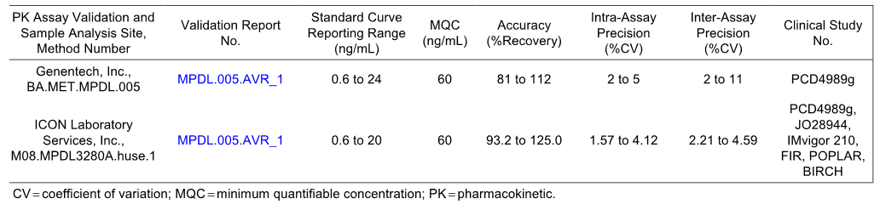

Summary of pharmacokinetics

Physicochemical characteristics of the active substance
The physicochemical properties of atezolizumab are listed below.
Table 2: Physicochemical properties of atezolizumab.
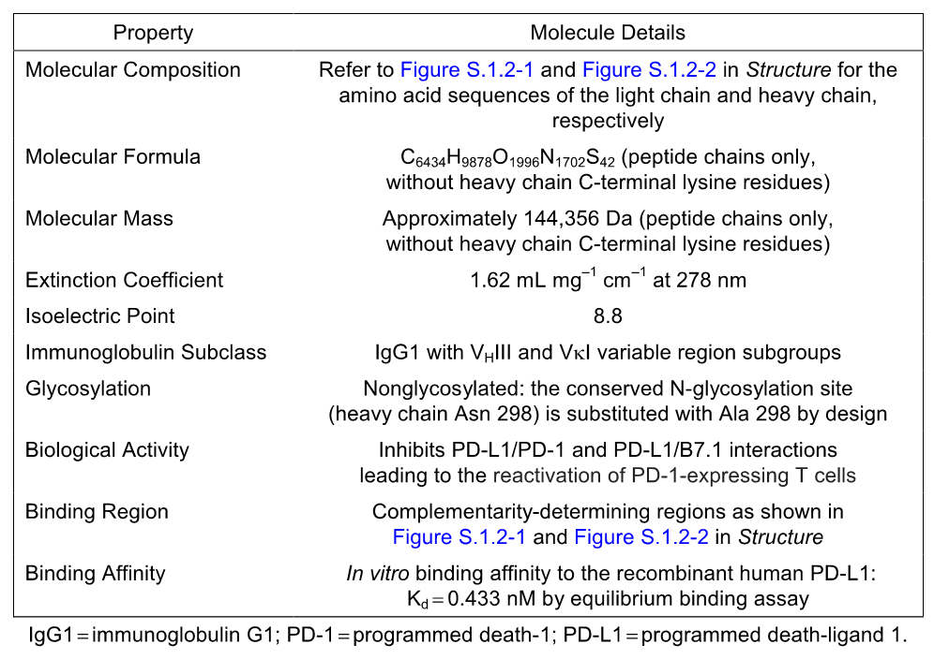

Pharmacokinetics in patients with cancer

Absorption

Sites and mechanism of absorption
Not applicable. Atezolizumab is administered by IV infusion.

Bioavailability

Absolute bioavailability
Not applicable. The formulation is a solution for IV infusion. Therefore, by definition bioavailability is 100%.

Bioavailability relative to an oral solution or micronised suspension
Not applicable.

Bioequivalence of clinical trial and market formulations
Two formulations, identified as F01 and F03, were used during development. The commercial Drug Product formulation (F03) is the same as that used for the pivotal clinical trials (F03). The F03 formulation was developed to deliver a nominal amount (net quantity) of 1200 mg of atezolizumab per vial. The F01 formulation was used for nonclinical toxicology studies and the early Phase I and Phase II clinical studies.
The sponsor reports that comparability assessment for the Drug Product used in the clinical trials and the commercial Drug Product included a comparison of batch release data, extended characterisation, and stress stability studies. Comparability between batches used in clinical trials to the final commercial configuration was assessed by first comparing historical Drug Product manufactured at SSF CPMF and the RDG Mannheim Drug Product validation batches. A subsequent comparison was made between the RDG Mannheim Drug Product validation batches and the batches manufactured at RDG Mannheim using Drug Substance from Basel B95. The sponsor reports that these assessments support the conclusion of comparability between Drug Product used in clinical trials and the commercial Drug Product.
The sponsor stated that bioactivity data from a PD-L1/PD-1 binding assay and a cell-based assay were obtained for three v1.0 (F01) validation batches and fourteen v0.3 (F03) batches. The results from these assays were reported to demonstrate that the bioactivity of v1.0 (F01) and v0.3 (F03) Drug Substance material was comparable (see below). In addition, the sponsor stated that a comparison of the physicochemical characteristics between multiple batches of atezolizumab was performed using a combination of analytical methods and demonstrates consistency of manufacture of atezolizumab.
Table 3: Bioactivities of drug substance batches by PD-L1/PD-1 binding and cell-based assays.
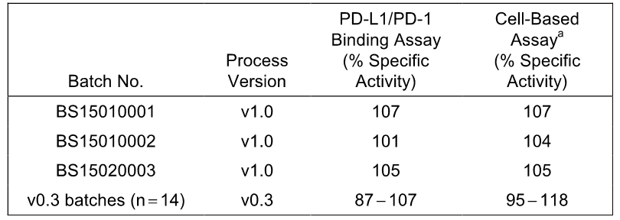
PD-1 = programmed death-1; PD-L1 = programmed death-ligand 1. ª Potency is expressed in Units/mg but has been converted to percent specific activity to facilitate comparison.
Comment: The sponsor reports that physicochemical and biological testing was undertaken in vitro to demonstrate comparability of the drug materials. Since comparability was demonstrated in vitro, the sponsor considers that nonclinical and/or clinical PK comparability studies were considered not necessary and were therefore not conducted. Based on the in vitro data the sponsor’s decision not to undertake clinical PK comparability studies appears to be acceptable. However, this is primarily a matter for the evaluator. The sponsor commented that a population pharmacokinetic (popPK) covariate analysis showed that formulation had no clinically significant effects on the PK atezolizumab.

Bioequivalence of different dosage forms and strengths
Not applicable. Only one dosage form and strength is being proposed for registration.

Bioequivalence to relevant registered products
Not applicable.

Influence of food
Not applicable.

Dose proportionality
In study PCD4989g, geometric mean dose-normalised exposure parameters (Cmax, Cmin, AUC0-21) in Cycle 1 were similar over the dose range 1-20 mg/kg in patients with cancer, indicating linear or dose proportional PK. The results are summarised below.
Table 4: PCD4989g – Summary statistics for serum atezolizumab PK parameters in Cycle 1 following a single-dose of atezolizumab on Day 1, PK-evaluable population.
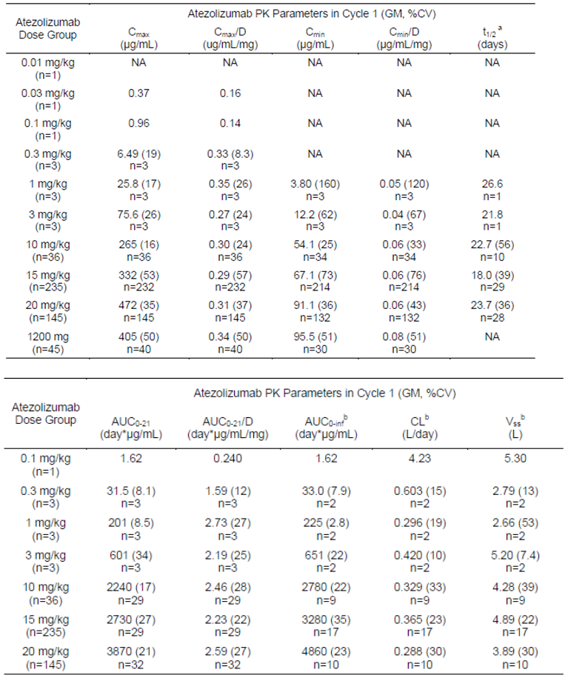
AUC0-21 = AUC from Day 1 to Day 21; AUC0-21/D = dose-normalised AUC from Day 1 to Day 21; AUC0-inf = AUC from time zero to infinity; CL = clearance; Vss =volume at steady-state; CV (%) = (percent) coefficient of variation; NA = PK parameter is not available due to insufficient data; GM = geometric mean; PK = pharmacokinetic. Note: PK parameters were not calculated for the 0.01 mg/kg, 0.03 mg/kg, and 1200 mg dose groups due to insufficient data. ª The terminal half-life (t1/2) was only calculated for patients with 3 or more consecutive end-of treatment samples and reported as harmonic mean pseudo SD. ^{b} Given the 18.0-26.6 day t1/2 and the fact that AUC0-inf was calculated using Cycle 1 data only, AUC0-inf, CL and Vss estimates are considered to be approximate in nature.

Bioavailability during multiple-dosing
The popPK model estimated geometric mean accumulation ratios for Cmin, Cmax, and AUC were 2.75, 1.46, and 1.91-fold, respectively, following multiple dose administration of atezolizumab q3w (report 106693). Based on simulations, the popPK model estimated that 90% of steady-state is attained after the following median (range) number of cycles: 3 cycles (1-6), 2 cycles (1-4), and 3 cycles (1-5) for Cmin, Cmax and AUC, respectively (report 106693).
The geometric mean accumulation ratios for Cmin and Cmax, by cycle, following multiple dose administration of atezolizumab q3w for patients in study PCD4989g receiving 1 mg/kg and higher dose levels of atezolizumab are summarised below. Accumulation ratios for Cmin and Cmax both appear to increase over successive cycles until the 4th and 5th cycle, respectively. For cycles 4 to 8, the geometric mean accumulation ratio for Cmin ranged from 2.07 to 2.39 and for Cmax ranged from 1.21 to 1.41. The observed geometric mean accumulation ratios for Cmin and Cmax estimated by non-compartmental analysis in study PCD4989g were in agreement with those predicted based on the popPK model. Steady state for atezolizumab in study PCD4989g was achieved approximately by Cycle 4, which is consistent with that expected for a drug with a terminal half-life ranging from 18.0 to 26.6 days dosed q3w.
Table 5: PCD4989g – Atezolizumab accumulation ratio based on Cmin and Cmax at each treatment cycle, patients receiving 1 mg/kg or higher.
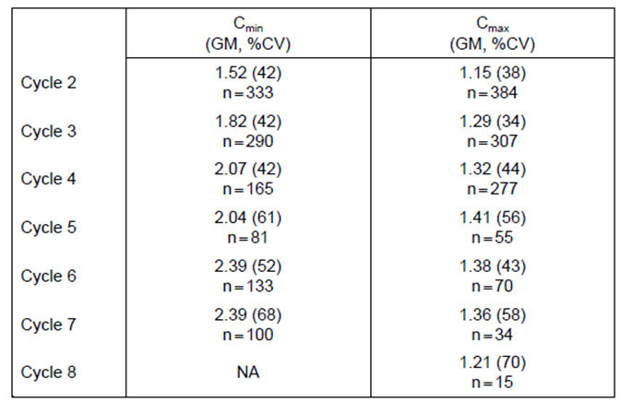
Cmax = maximum serum concentration; Cmin = trough or minimum serum concentration; CV = coefficient of variation; GM = geometric mean. NA = pharmacokinetic data at the end of cycle 8 is not available. The reference concentration for Cmin is Cycle 1, Day 21 (pre-dose for Cycle 2). The reference concentration for Cmax is Cycle 1, Day 1, 30-minute post-dose time-point.
Target serum atezolizumab concentration
The serum atezolizumab concentration of 6 µg/mL was set as the target serum concentration based on the nonclinical tissue distribution data in tumour-bearing mice and receptor occupancy in the tumour. In the Phase I study PCD4989g, PK data suggested that while a subset of anti-therapeutic antibody positive (ATA-positive) patients receiving 0.3 to 3 mg/kg atezolizumab q3w experienced a reduction of Cmin to below the limit of quantification (LOQ) of 0.06 µg/mL, patients receiving 10 to 20 mg/kg atezolizumab, including the fixed-dose of 1200 mg, maintained geometric mean Cmin values in excess of both the LOQ and the target serum concentration. In the Phase II studies IMvigor, POPLAR, BIRCH and FIR, the mean Cmin serum concentrations were well above the target concentration of 6 µg/mL in all cycles with data, irrespective of ATA status.
Pharmacokinetic variability
In the final popPK model (report 106693), body weight, albumin, tumour burden, and ATA were statistically significant covariates for clearance (CL); body weight, and albumin were statistically significant covariates for the central volume of distribution (V1); and gender was statistically significant for both the central volume of distribution (V1) and the peripheral volume of distribution (V2). The results from the popPK analysis suggest that the unexplained inter-individual (IIV) is moderate for CL (29%), V1 (18%), and V2 (34%). There were no data in the submission relating to intra-subject PK variability.

Distribution

Volume of distribution
The popPK model (report 106693) estimates that that the volume of distribution at steady state (Vss) in a typical patient is 6.91 L. The volume of distribution is small, which is a typical finding for monoclonal antibodies.

Plasma protein binding
Not applicable. Atezolizumab is a non-glycosylated immunoglobulin G1 (IgG1) monoclonal antibody with a large molecular mass of approximately 144,356 Da (peptide chains only, without heavy chain C-terminal lysine residues). Consequently, the drug would not be expected to bind to plasma proteins.

Erythrocyte distribution
No data.

Tissue distribution
No data.

Metabolism

Interconversion between enantiomers
Not applicable.

Sites of metabolism and mechanisms / enzyme systems involved
No data on metabolism. Monoclonal antibodies are broken down into small peptides by proteolytic degradation. The metabolism of atezolizumab is unlikely to differ from that of endogenous IgG proteins.

Non-renal clearance
Monoclonal antibodies are eliminated mainly via intracellular lysosomal proteolytic degradation, which occurs throughout the entire body.

Metabolites identified in humans: active and other
No data. Monoclonal antibodies are broken down into small peptides by proteolytic degradation.

Pharmacokinetics of metabolites
No data.

Consequences of genetic polymorphism
Not applicable.

Excretion

Routes and mechanisms of excretion
The popPK model (report 106693) estimates that the typical clearance (CL) of atezolizumab is 0.200 L/day and the typical terminal half-life (t1/2) is 27 days.

Mass balance studies
Not applicable. For therapeutic proteins, mass balance studies are ‘not useful for determining the excretion pattern of the drug and drug related material’ (Guidelines on the Clinical Investigation of the Pharmacokinetics of Therapeutic Proteins CHMP/EWP/89249/2004).

Renal clearance
There were no data on renal clearance. However, as atezolizumab has a large molecular weight (approximately 144 kDa) it can be reasonably inferred that it will not be cleared by renal excretion. In general, molecules with a molecular weight above 50 kDa do not undergo renal elimination due to their inability to cross the renal glomerular membrane due to size.

Pharmacokinetics in the target population

All patients with malignant disease
The Cmax and Cmin values at Cycle 1 Day 1 following the proposed atezolizumab dose of 1200 mg administered by IV infusion to patients with advanced malignant disease was consistent across the 5 clinical studies with PK data.
Table 6: Summary of geometric mean (% CV) Cmax and Cmin values in Cycle 1 following atezolizumab 1200 mg by IV infusion in subjects with malignant disease, PK evaluable populations.
Parameter | PCD498g | IMvigor 210 | BIRCH | POPLAR | FIR
Malignancies | Solid or haematologic | Urothelial | NSCLC PD-L1 selected | NSCLC | NSCLC
Cmax (µg/mL) | 405 (50); n = 40 | 360 (23.2); n = 406 | 397 (67.2); n = 624 | 326 (25.1); n = 139 | 405 (31.7); n = 135
Cmin (µg/mL) | 95.5 (51); n = 30 | 68.0 (53.6); n = 366 | 78.9 (55.8); n = 596 | 58.8 (67.1); n = 128 | 68.8 (55.3); n = 125
Cmax = maximum observed serum concentration; Cmin = trough or minimum serum concentration; CV = coefficient of variation; PK = pharmacokinetic. Note: Data cut-off date of 2 December 2014 for PCD4989g; 7 January 2015 for FIR; May 5 for IMvigor210; 8 May 2015 for POPLAR; and 28 May 2015 for BIRCH.

Patients with urothelial carcinoma

1. IMvigor 210
PK data in patients with locally advanced or metastatic urothelial bladder cancer were provided in IMvigor 210 for data cut-off dates of 5 May 2015 (Primary CSR) and 14 September 2015 (Study Update Report). The PK data from IMvigor 210 reviewed in this CER are based on the data for the cut-off date of 14 September 2015 (Study Update report). The PK data from IMvigor 210 provided in the SCP are from the Primary CSR with the earlier cut-off date of 5 May 2015. The PK data from the Primary CSR and the Study Update Report are similar.
The study was a global, multicentre Phase II clinical trial designed to evaluate the efficacy and safety of atezolizumab in patients with locally advanced or metastatic UC. The primary objective was the assessment of efficacy and secondary objectives included the characterisation of the PK of atezolizumab. A total of 438 patients were enrolled into two separate cohorts, and 429 patients were treated with atezolizumab. Cohort 1 consisted of 118 patients with advanced disease who were treatment-naïve (for metastatic disease) and cisplatin-ineligible. Cohort 2 consisted of 311 patients who had experienced disease progression during or following a prior platinum-based chemotherapy regimen for advanced disease. Patients in both cohorts received atezolizumab at a fixed dose of 1200 mg IV on Day 1 of each 21-day cycle.
The PK-evaluable population was defined as patients who received any dose of atezolizumab and had PK data at sufficient time-points to determine PK parameters. Of the 429 patients treated with atezolizumab, all provided PK data. Blood samples for PK assessment were collected at Cycle 1 Day 1 (C1D1) pre-dose and post-dose at 30 minutes (± 10 minutes), pre-dose on Day 1 (± 2 days) at C2, C3, C4, and C8, at the treatment discontinuation visit and at the visit 120 days (± 30 days) after the last dose. PK parameters were maximum serum concentration Cmax (Cycle 1 only) and Cmin (pre-dose for Cycles 1, 2, 3, 4, 8).

Cmax and Cmin data
A summary of the available Cmax data for C1D1 and Cmin (pre-dose) data for atezolizumab following single- and multiple-doses (1200 mg q3w) is shown below. For all patients (Cohorts 1 and 2 combined), the geometric mean Cmax at C1D1 was 330 μg/mL, and the geometric mean Cmin at C1D21 (or pre-dose Cycle 2) was 66.8 μg/mL. The geometric Cmin at C7D21 (or pre-dose Cycle 8) was 160 μg/mL. Three of 420 patients with available C1D1 pre-dose samples had atezolizumab serum concentration greater than the LLOQ of 0.060 μg/mL.
Table 7: IMvigor 210 - Summary statistics for atezolizumab Cmax and Cmin following single- and multiple-doses of atezolizumab 1200 mg q3w, all patients at data cut-off of 14 September 2015.
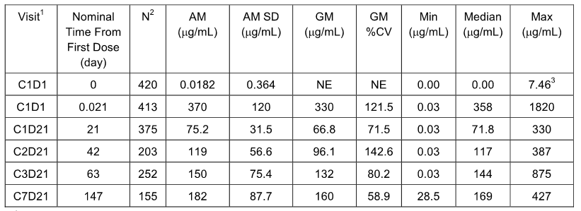
AM = Arithmetic Mean; SD = standard deviation; CV = coefficient of variation; GM = Geometric Mean; BLQ = below the limit of quantitation; LLOQ = lower limit of quantitation, defined as 0.06 μg/mL. ¹ Visit is denoted by Cycle abbreviated by ‘C’ and Day abbreviated by ‘D’. ² N = number used to calculate statistics. 3 Of N = 420 patients with C1D1 pre-dose samples, ³ patients had samples above the LLOQ.
The available mean serum atezolizumab concentration-time profiles following multiple doses of 1200 mg atezolizumab q3w from all 429 treated patients for the data cut-off date of 5 May 2015 is shown below in Figure 1.
Figure 1: Mean (SD) plot of atezolizumab concentrations versus time following multiple iv doses of atezolizumab 1200 mg q3w, all patients at data cut-off at 5 May 2015.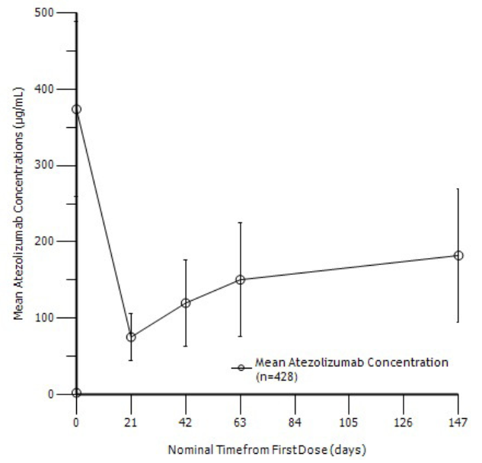

ATA status and Cmax and Cmin
A summary of the Cmax and Cmin of atezolizumab following single- and multiple-doses of atezolizumab 1200 mg q3w by ATA positivity is shown below. The geometric Cmax estimates at C1D1 were 332 µg/mL and 335 µg/mL in ATA-positive and ATA-negative patients, respectively. The geometric mean Cmin estimates were lower in ATA-positive patients compared to ATA-negative patients. The geometric mean Cmin estimates for C1D21 (or pre-dose Cycle 8) were 134 μg/mL and 184 μg/mL for ATA-positive and ATA-negative patients.
Table 8: IMvigor - Summary statistics for atezolizumab Cmax and Cmin following single- and multiple-doses atezolizumab 1200 mg q3w by ATA status, all cohorts.
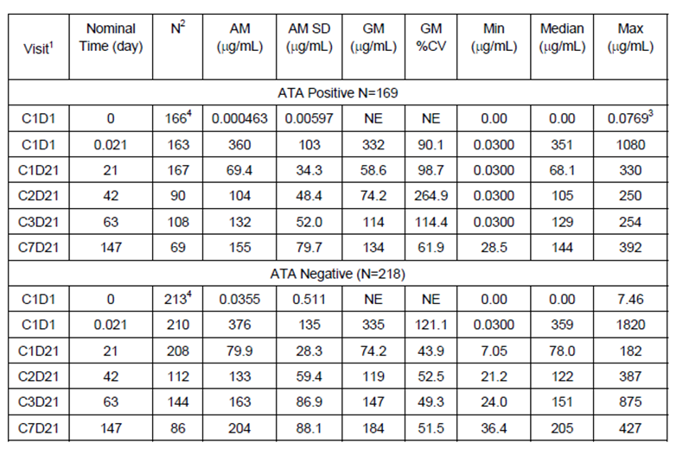
AM = Arithmetic Mean; SD = standard deviation; CV = coefficient of variation; GM = Geometric Mean; BLQ = below the limit of quantitation; LLOQ = lower limit of quantitation, defined as 0.06 μg/mL. ¹ Visit is denoted by Cycle abbreviated by ‘C’ and Day abbreviated by ‘D’. ² N = number used to calculate statistics. ³ At C1D1, pre-dose samples, 1 patient in the ATA-positive group and 2 patients in the ATA-negative group were above the LLOQ. ⁴ 43 patients did not have a post-dose ATA sample.

Population PK analysis for urothelial cancer (Report 1067394)
The submission included a population PK analysis of the data from IMvigor 210 undertaken in order to validate the population PK (popPK) model based on the two Phase I clinical studies (PCD4989g and JO28944), and to derive atezolizumab exposure metrics for a subsequent exploratory exposure-response analysis. The popPK analysis was performed using a non-linear mixed-effects modelling approach with NONMEM, Version 7.3. The analysis included PK-evaluable data from 423 patients with a total of 1251 samples (Cohort 1, n = 117, 330 samples; Cohort 2, n = 306, 921 samples).
The individual exposure metrics at C1 and at steady-state for each Cohort based on the Phase 1 popPK Model for use in a subsequent exposure-response analysis are summarised below. The geometric mean accumulation ratio based for AUC was close to 1.9 fold across Cohorts, for model-based steady-state estimates at 10 cycles. Overall, Cmin and Cmax accumulated 2.2 and 1.4 fold, respectively. The model-based estimates of steady state atezolizumab exposure (i.e. Cmax,ss, Cmin,ss, and AUCss) were lower in patients in Cohort 2 than in patients in Cohort 1. The sponsor comments that the differences were ‘relatively slight (i.e. within 10%)’ and postulates that the differences ‘may possibly be due to larger baseline tumor burden in Cohort 2’.
Table 9: Summary statistics, geometric mean (geometric mean CV%) of popPK predicted atezolizumab exposure metrics at Cycle 1 by Cohort.
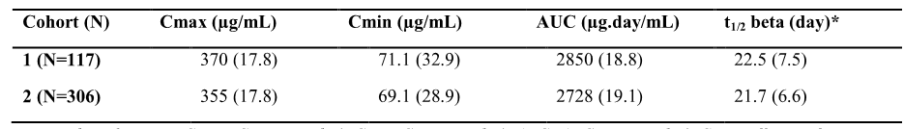
N = Number of patients; Cmax,=Cmax at cycle 1; Cmin = Cmin at cycle 1; AUC=AUC(0-21) at cycle 1; CV=coefficient of variation *t1/2 beta is the terminal half-life based on post-hoc parameter estimates for this parameter harmonic mean and pseudo- standard deviation are reported.
Table 10: Summary statistics, geometric mean (geometric mean CV%) of popPK predicted atezolizumab exposure metrics at steady state by Cohort.
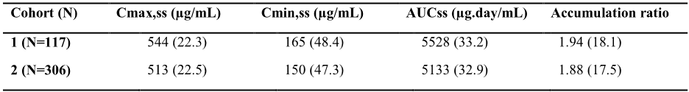
N = Number of patients; Cmax,ss = Cmax at steady state; Cmin,ss = Cmin at steady state; AUCss =AUC at steady state; Accumulation ratio is derived as the ration between AUC at cycle 1 and AUCss; CV=coefficient of variation.
Exploratory analyses of the relationships between individual CL, V1 and V2 patient-level random effects estimated with the ‘Phase 1 popPK Model’ and covariates (including body weight, albumin, tumour burden, gender, and ATA) indicated that the covariate effects observed in IMvigor 210 were consistent with those identified in the ‘Phase 1 popPK Model’. This indicates that the ‘Phase 1 popPK Model’ adequately described the relationships between PK parameters and covariates in patients with UC. No new or unexpected covariate effects were identified in the ‘Phase 1 popPK Model’. In particular, no relationship was seen between the number of metastatic sites and the PK of atezolizumab.

Patients with non-small cell lung cancer (NSCLC)

POPLAR
POPLAR is a Phase II, global, multicentre, open-label, randomised, controlled (docetaxel) study designed to evaluate the efficacy, safety, tolerability, PK, and immunogenicity of atezolizumab in patients with locally advanced or metastatic NSCLC who have progressed during or following a platinum-containing regimen. Eligible patients were stratified by PD-L1 IC status (four categories of PD-L1 expression, referred to as IC0, IC1, IC2, and IC3), by the number of prior chemotherapy regimens (1 versus 2), and by histology (non-squamous versus squamous) and then randomised 1:1 to receive either atezolizumab or docetaxel arm.
Atezolizumab was administered IV on Day 1 of each 21-day cycle at a fixed dose of 1200 mg. Atezolizumab treatment could be continued as long as patients were experiencing clinical benefit as assessed by the investigator. Docetaxel 75 mg/m² was administered IV on Day 1 of each 21-day cycle until disease progression or unacceptable toxicity.
The PK-evaluable population was defined as patients who received atezolizumab and had PK data at sufficient time-points to determine PK parameters. Blood samples were collected for PK analysis at CID1 pre-dose and post-dose 30 minutes (± 10 minutes) after the end of the infusion, pre-dose on D1 at C2, C3 and C4, pre-dose on D1 at C8, 16 and every 8 cycles thereafter, at the treatment discontinuation visit and then 120 days (± 30 days) after the last dose of atezolizumab.
For the PK-evaluable population, atezolizumab serum concentration data (Cmin and Cmax) were tabulated and summarised for each cycle with data. Concentrations below the LLOQ of the assay of 0.060 μg/mL were imputed to 0 for pre-dose samples and LLOQ/2 for post-dose samples for the purposes of calculating descriptive statistics.
A total of 287 patients were randomised (143 patients to the docetaxel arm and 144 patients to the atezolizumab arm). The PK-evaluable population included 142 patients.

Cmax and Cmin data
Cmax (30 minutes following the end of the infusion in Cycle 1 or 0.0625 days) and Cmin (pre-dose) data for atezolizumab following single- and multiple-doses of atezolizumab 1200 mg are summarised below. For all patients (n = 139), the geometric mean Cmax for C1D1 was 326 µg/mL and the geometric mean Cmin concentration for C1 (or pre- dose C2) was 58.8 µg/mL. Three of the 139 patients with available C1D1 pre-dose samples (Nominal Time= 0) provided quantifiable serum concentrations, which were much greater than the LLOQ of 0.060 µg/mL for unknown reasons. The geometric mean Cmin at C7D21 for the 63 patients with data was 161 µg/mL.
Table 11: POPLAR – Summary of Cmax and Cmin following single- and multiple doses of atezolizumab 1200 mg q3w.
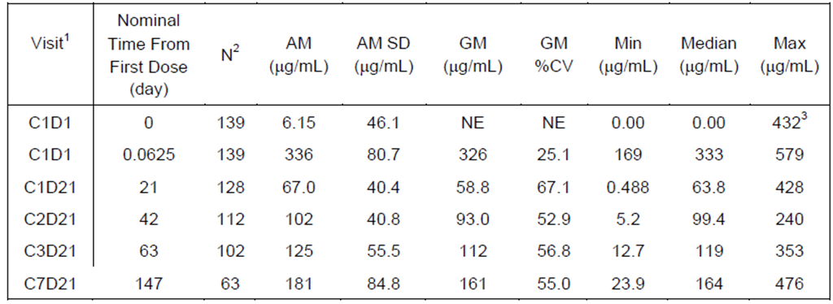
AM = arithmetic mean; Cmax = maximum observed serum concentration; Cmin = trough or minimum serum concentration; CV = coefficient of variation; GM = geometric mean; IV = intravenous; LLOQ = lower limit of quantitation, defined as 0.06 µg/mL; NE = not estimated; SD = standard deviation. ¹ Visit is denoted by Cycle abbreviated by ‘C’ and Day abbreviated by ‘D’. For example, C1D1 corresponds to Cycle 1, Day 1, etc. Pre-dose Cycle 1 is C1D1 0 days. Cmax is C1D1 30 minutes post end of infusion. Pre-dose Cycle 2 is C1D21, pre=dose Cycle 3 is C2D21 etc. ² N: number used to calculate statistics; 3 Of N = 139 Cycle 1, Day 1 pre-dose (Nominal Time = 0) samples, three samples were above the LLOQ, defined as 0.06 µg/mL.
The mean (SD) serum atezolizumab concentration-time profiles following multiple doses of 1200 mg atezolizumab q3w from all 142 treated patients is shown below. Cmin levels appeared to increase over time following multiple q3w dosing with steady-state being approached between 4-8 cycles of dosing.
Figure 2: POLAR - Mean (SD) plot of atezolizumab concentrations versus time following multiple iv doses of atezolizumab 1200 mg q3w.
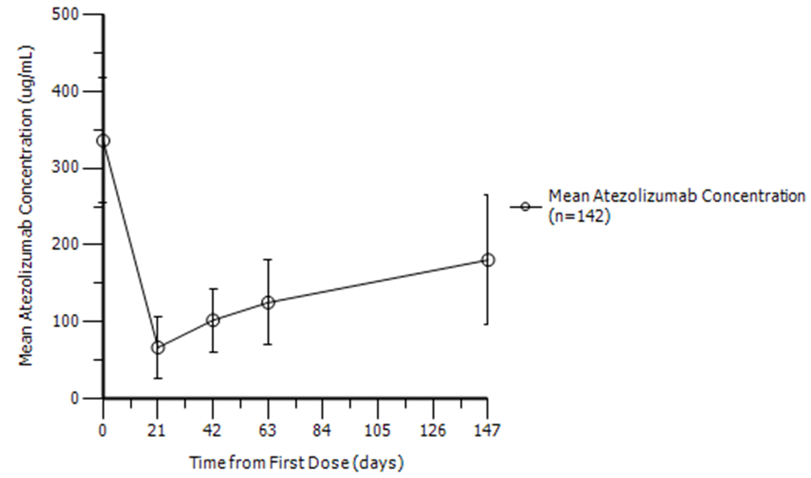

ATA status and Cmax and Cmin
A summary of the Cmax and Cmin of atezolizumab following multiple doses of atezolizumab 1200 mg q3w by ATA positivity is shown below. Geometric mean Cmax concentrations at C1D1 were lower in ATA-positive compared to ATA-negative patients (307 vs 347 µg/mL, respectively). Cmin concentrations were consistently lower in ATA-positive patients compared to ATA-negative patients, but geometric mean levels were well above the target concentration of 6 µg/mL in both patient groups. The geometric mean Cmin at C7D21 (i.e. pre-dose C8) was 138 µg/mL in ATA-positive patients and 203 µg/mL in ATA-negative patients.
Table 12: POPLAR - Summary statistics for atezolizumab Cmax and Cmin following single- and multiple-doses of atezolizumab 1200 mg q3w by ATA status, all cohorts.
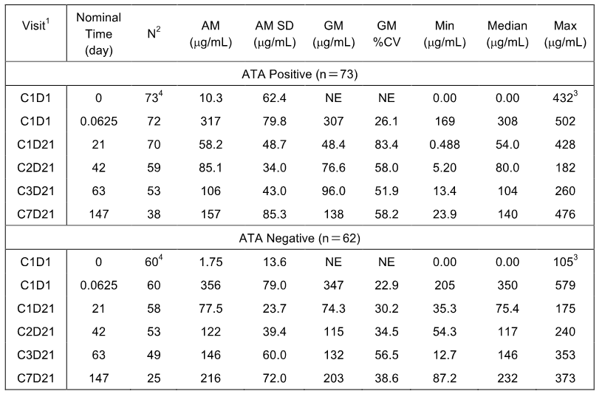
AM = Arithmetic Mean; SD = standard deviation; CV = coefficient of variation; GM = Geometric Mean; BLQ = below the limit of quantitation; LLOQ = lower limit of quantitation, defined as 0.06 μg/mL. ¹ Visit is denoted by Cycle abbreviated by ‘C’ and Day abbreviated by ‘D’. ² N = number used to calculate statistics. ³ At C1D1, pre-dose samples, 1 patient in the ATA-negative group and 2 patients in the ATA-positive group were above the LLOQ. ⁴ For 7 patients their ATA status was unknown.

BIRCH
BIRCH is an ongoing Phase II, global, multicentre, single-arm study designed to evaluate the efficacy, safety, tolerability, PK, and immunogenicity of atezolizumab as a single agent in patients with locally advanced or metastatic NSCLC who are PD-L1-selected. The study enrolled patients whose PD-L1 status was TC2/3 or IC2/3 based on an immunohistochemistry assay. The study has three cohorts; Cohort 1 enrolled patients who had not received any prior chemotherapy as treatment for advanced disease (1L atezolizumab treatment group), Cohort 2 enrolled patients who experienced disease progression during or after treatment with a platinum-based chemotherapy regimen administered for advanced disease (2L atezolizumab treatment group), and Cohort 3 enrolled patients who experienced disease progression during or after treatment with a platinum-based chemotherapy regimen and during or after at least one additional treatment regimen (3L+ atezolizumab treatment group). Patients in all three cohorts received a fixed dose of 1200 mg atezolizumab by IV infusion on Day 1 of each 21-day cycle.
The PK-evaluable population was defined as patients who received atezolizumab treatment and had PK data at sufficient time-points to determine PK parameters. For the PK-evaluable population, atezolizumab serum concentration data (Cmin and Cmax) were reported for each cycle at which PK was to be assessed (Cmax was reported for C1D1 only; Cmin was reported pre-dose on D1 for C1, C2, C3, C4, C8, every eight cycles thereafter and at treatment termination). The first 40 patients in the study had additional PK sampling in Cycle 1 at 1, 3, 7, and 14 days after dose administration. Concentrations below the LLOQ of the assay of 0.060 μg/mL were imputed to 0 for pre-dose samples and LLOQ/2 for post-dose samples for the purposes of calculating descriptive statistics. The treated population included 659 patients (139 in Cohort 1, 267 in Cohort 2, and 253 in Cohort 3). The PK evaluable population comprised 654 patients.

Cmax and Cmin results
A summary of the serum concentrations of atezolizumab up to Cycle 8 following multiple doses of atezolizumab 1200 mg q3w from all 654 patients with evaluable PK data is shown below. For all patients, the geometric mean Cmax at C1D was 397 µg/mL; the geometric mean Cmin concentration at C1D21 (or pre-dose C2) was 78.9 µg/mL. Eight of 646 patients with available C1D1 pre-dose samples serum concentrations greater than the LLOQ of 0.060 µg/mL.
Table 13: BIRCH - Summary statistics for atezolizumab Cmax and Cmin following single- and multiple-doses of atezolizumab 1200 mg given every 3 weeks, all cohorts.
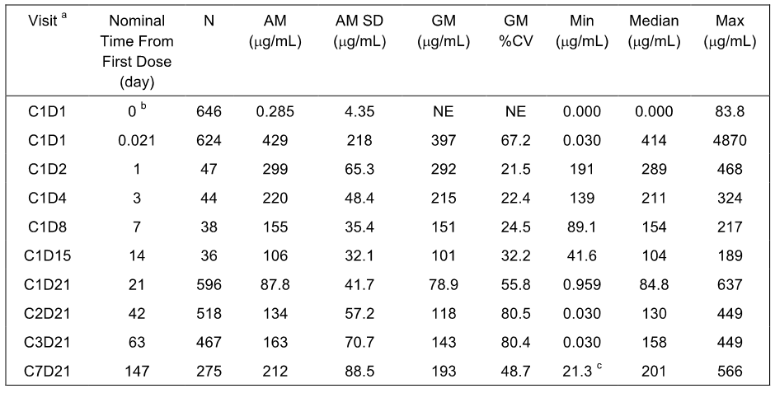
ª Visit is denoted by Cycle abbreviated by ‘C’ and Day abbreviated by ‘D’. ^{b} Of N = 646, C1D1 pre-dose samples, 8 samples were above the LLOQ.
The mean (SD) serum atezolizumab concentration-time profiles following multiple doses of 1200 mg atezolizumab q3w from all 654 treated patients is shown below in Figure 3. Cmin increased following multiple q3w dosing and approached steady-state between 4-8 cycles.
Figure 3: BIRCH - Mean (SD) plot of atezolizumab concentrations versus time following multiple doses of atezolizumab 1200 mg q3w, all cohorts.
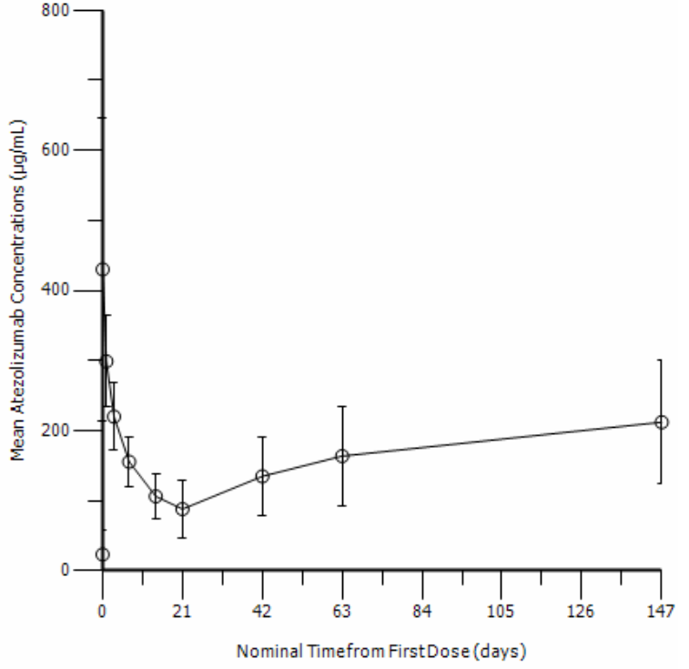

ATA status and Cmax and Cmin
A summary of the Cmax and Cmin of atezolizumab following single- and multiple-doses of atezolizumab 1200 mg q3w by ATA positivity is shown below. The geometric mean Cmax values at C1D1 were comparable in patients who were ATA-positive and ATA-negative (398 and 394 µg/mL, respectively). In general, geometric mean Cmin values were marginally lower in ATA-positive patients compared to ATA-negative patients. The geometric mean Cmin values at C7D21 (i.e. pre-dose C8) were 168 µg/mL and 208 µg/mL following multiple doses of atezolizumab 1200 mg q3w for ATA-positive and ATA-negative patients, respectively. The mean geometric Cmin concentrations observed in ATA-positive and ATA-negative patients were well in excess of the target serum concentration 6 µg/mL and suggest that the minor impact of ATA positivity on atezolizumab concentrations would be unlikely to result in meaningful differences in target engagement at the studied dose.
Table 14: BIRCH - Summary statistics for atezolizumab Cmax and Cmin following single- and multiple-doses of atezolizumab 1200 mg q3w by ATA status, all cohorts.
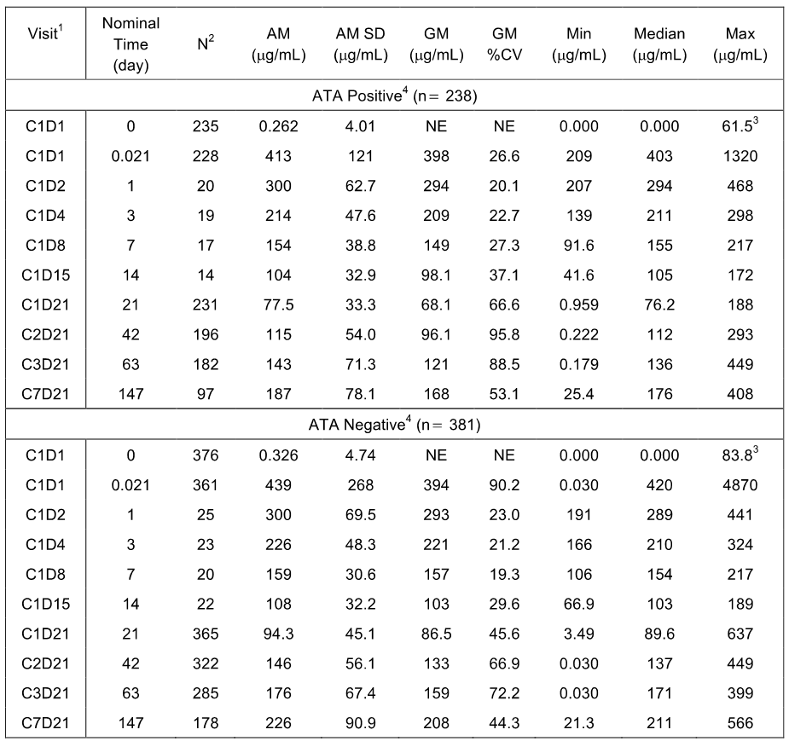
AM = Arithmetic Mean; SD = standard deviation; CV = coefficient of variation; GM = Geometric Mean; BLQ = below the limit of quantitation; LLOQ = lower limit of quantitation, defined as 0.06 μg/mL. ¹ Visit is denoted by Cycle abbreviated by ‘C’ and Day abbreviated by ‘D’. ² N = number used to calculate statistics. ³ At C1D1, pre-dose samples, 6 patients in the ATA-negative group and 2 patients in the ATA-positive group were above the LLOQ. ⁴ For 35 patients their ATA status was unknown.

FIR
FIR is an ongoing Phase II, global, multicentre, single-arm trial designed to evaluate the efficacy, safety, tolerability, pharmacokinetics, and immunogenicity of atezolizumab in PD-L1 selected patients with locally advanced or metastatic NSCLC. The study enrolled patients whose PD-L1 status was TC2/3 or IC2/3 based on an immunohistochemistry assay. The study has three cohorts; Cohort 1 enrolled patients who had not received prior chemotherapy for advanced disease (1L atezolizumab treated patients); Cohort 2 enrolled patients who had progressed during or chemotherapy regimen without restriction to the maximum number of prior therapies (i.e. 2L+ atezolizumab treated patients): and Cohort 3 enrolled 2L+ patients with previously treated brain metastases. Patients received atezolizumab IV as a fixed dose of 1200 mg on Day 1 of each 21-day cycle until disease progression for 1L patients and loss of clinical benefit for 2L+ patients.
The PK-evaluable population was defined as patients who received atezolizumab treatment and had PK data at sufficient time-points to determine PK parameters. For the PK-evaluable population atezolizumab serum concentration data (Cmin and Cmax) were reported for each cycle at which PK was to be assessed. Blood samples were collected for PK analysis at C1D1 pre-dose and post-dose at 30 minutes (± 10 minutes) after the end of the infusion, pre-dose on D1 (± 2 days) at C2, C3, C4 and C8 and D1 of every 8 cycles thereafter, at the treatment discontinuation visit and at the post-treatment visit (i.e. > 90 days after the last dose of treatment [optional]). The treated population included 137 patients (31 in Cohort 1, 93 in Cohort 2, and 13 in Cohort 3), and the PK evaluable population included all 137 treated patients.

Cmax and Cmin results
A summary of the available Cmax (30 minutes following the end of the infusion at C1D1 or 0.0625 days) and Cmin (pre-dose) of atezolizumab following multiple doses of atezolizumab 1200 mg q3w from all 137 patients who were treated in the study is shown below. The geometric mean Cmax at C1D1 (n = 135) was 405 µg/mL and the geometric mean Cmin concentration at C1D21 (n = 125) was 68.8 µg/mL. Two of the 134 patients with available C1D1 pre-dose samples provided quantifiable serum concentrations above the LLOQ. The geometric Cmin at C7D21 (n = 206) was 206 µg/mL.
Table 15: FIR - Summary statistics for atezolizumab Cmax and Cmin following single- and multiple-doses of atezolizumab 1200 mg given every 3 weeks, all cohorts.
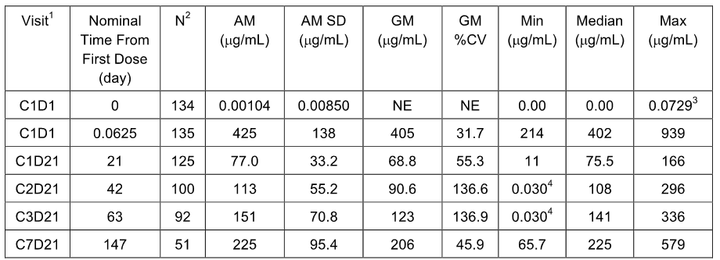
AM: Arithmetic Mean; SD=standard deviation; CV = coefficient of variation; GM: Geometric Mean; BLQ: below the limit of quantitation; LLOQ: lower limit of quantitation, defined as 0.06 ug/mL. ¹ Visit is denoted by Cycle abbreviated by ‘C’ and Day abbreviated by ‘D’. ² N: number used to calculate statistics. ³ Of N = 134 at C1D1 pre-dose samples, 2 were above the LLOQ. 4 LLOQ/2 was substituted for one subject who reported BLQ at C3D1 and C4D1.
The available mean (SD) serum atezolizumab concentration-time profiles following multiple doses of 1200 mg atezolizumab q3w from all 137 patients in the PK-evaluable population shown below. Cmin levels increased following multiple q3w dosing and approached steady state between 4-8 cycles of dosing.
Figure 4: FIR - Mean (SD) plot of atezolizumab concentrations versus time following multiple IV doses of atezolizumab 1200 mg q3w, all cohorts.
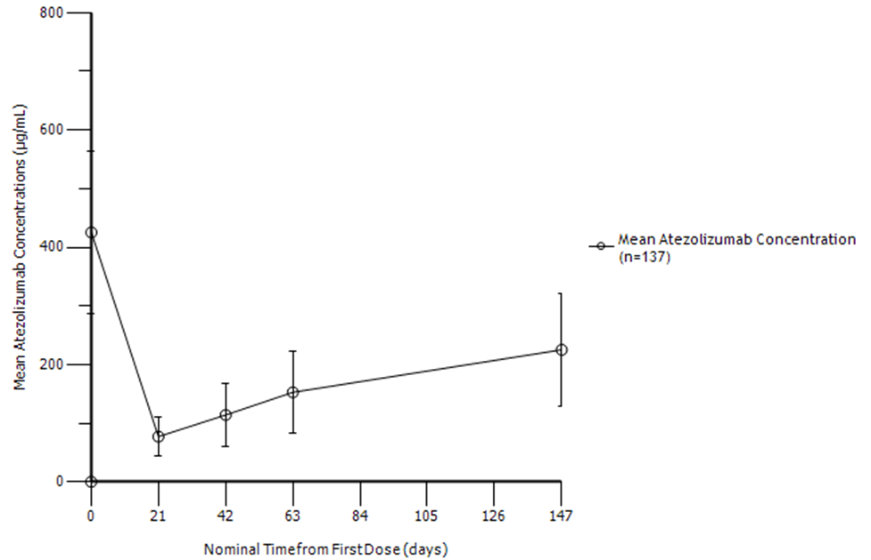
Note: Cmin from only 1 patient is available for C15D21 and this time-point is not depicted the summary profile.
ATA status and Cmax and Cmin
A summary of the Cmax and Cmin of atezolizumab following single- and multiple-doses of atezolizumab 1200 mg q3w by ATA positivity is shown below. The geometric mean Cmax values at C1D1 were comparable in patients who were ATA-positive and ATA-negative (393 µg/mL and 415 µg/mL, respectively). Geometric mean Cmin values were lower in ATA-positive patients compared to ATA-negative patients. The geometric mean Cmin levels at C7D21 (or pre-dose C8) were 191 µg/mL and 220 µg/mL for ATA-positive and ATA-negative patients, respectively. The mean geometric Cmin concentrations observed in ATA-positive and ATA-negative patients were well in excess of the target serum concentration 6 µg/mL and suggest that the minor impact of ATA positivity on atezolizumab concentrations would be unlikely to result in meaningful differences in target engagement at the studied dose.
Table 16: FIR - Summary statistics for atezolizumab Cmax and Cmin following single- and multiple-doses of atezolizumab 1200 mg q3w by ATA status, all cohorts.
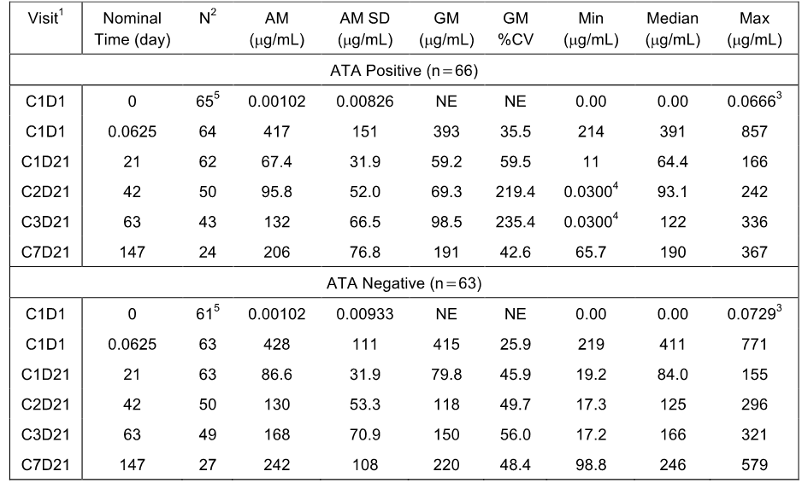
AM = Arithmetic Mean; SD = standard deviation; CV = coefficient of variation; GM = Geometric Mean; BLQ = below the limit of quantitation; LLOQ = lower limit of quantitation, defined as 0.06 μg/mL. ¹ Visit is denoted by Cycle abbreviated by ‘C’ and Day abbreviated by ‘D’. ² N = number used to calculate statistics. ³ At C1D1, pre-dose samples, 1 patient in the ATA-negative group and 1 patient in the ATA-positive group were above the LLOQ. ⁴ For 8 patients their ATA status was unknown.

Population PK analysis NSCLC (Report 1067735)
The submission included a population PK analysis (Report 1067735) based on the PK data from the three Phase 2 clinical studies in patients with NSCLC (POPLAR, BIRCH and FIR). The objectives of the analysis were: (1) to assess the PK of atezolizumab in patients with NSCLC in the three Phase 2 clinical studies through external validation of the ‘Phase 1 popPK Model’; and (2) to derive atezolizumab exposure metrics for a subsequent exploratory exposure-response analysis of atezolizumab in NSCLC.
The ‘Phase 1 popPK Model’ was used to derive the individual PK parameter estimates based on atezolizumab observed concentration-time profiles in BIRCH, FIR and POPLAR. A nonlinear mixed effects modelling approach was used with the Bayesian post-hoc estimation in NONMEM 7, version 7.3 (ICON, Maryland). A prediction-corrected visual predictive check (pcVPC) was performed based on the ‘Phase 1 popPK Model’, which involved observed peak (Cmax) and trough (Cmin) concentrations in BIRCH, FIR, and POPLAR being compared to corresponding predictive distributions (external validation). Individual estimates of patient-level random effects were obtained and plotted vs baseline covariates to assess whether the ‘Phase 1 popPK Model’ adequately captured the covariate effects in patients in BIRCH, FIR, and POPLAR. These analyses were conducted in the overall data across studies, by study and also by Cohort for BIRCH. The exposure metrics for atezolizumab were derived by simulations based on the individual PK parameters obtained from the ‘Phase 1 popPK Model’.

Results
The PK of atezolizumab in serum was evaluated in 920 patients (out of 938 treated, 98.1%) with 3891 samples from BIRCH (N = 652), FIR (N = 128) and POPLAR (N = 140). For each study and Cohort, the number of evaluable PK concentrations is presented below.
Table 17: PopPK Report (NSCLC) – Number of PK samples and patients included in the atezolizumab analysis.
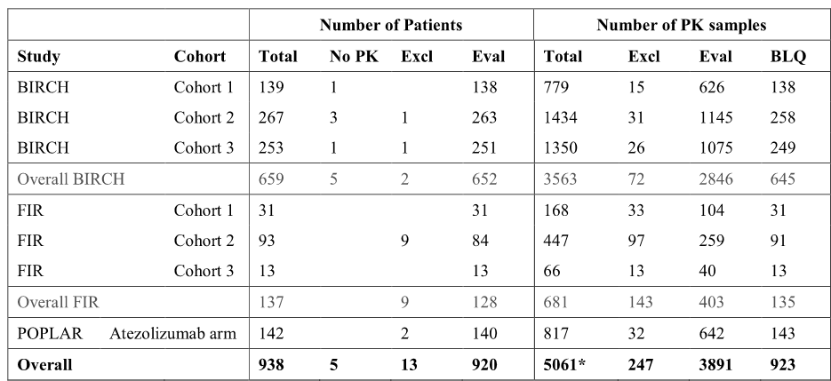
Eval=patient or sample evaluable; Excl=patient or sample excluded (observed concentration pre-dose greater than 0); No PK=Patients without PK sample, BLQ=number of BLQ concentrations, not used for the analysis. * This corresponds to samples which were flagged as BLQ (n = 923) or observed concentration pre-dose greater than 0 (n = 4138).
The ability of the ‘Phase 1 popPK Model’ to describe atezolizumab PK in NSCLC patients was evaluated by external pcVPC based on atezolizumab concentration data from a total of 920 patients. The pcVPC for all patients (three studies combined) suggested that the median, 95th and 5th percentiles of observed Cmax and Cmin for all cycles were generally well captured by the model. There did not appear to be a consistent trend toward over- or under-prediction of atezolizumab exposure data following multiple dosing. The pcVPC (all patients, semi-log scale) is summarised below.
Figure 5: PopPK Report (NSCLC) – Prediction–corrected visual predictive check of peaks and troughs of atezolizumab, all patients semi-log scale.
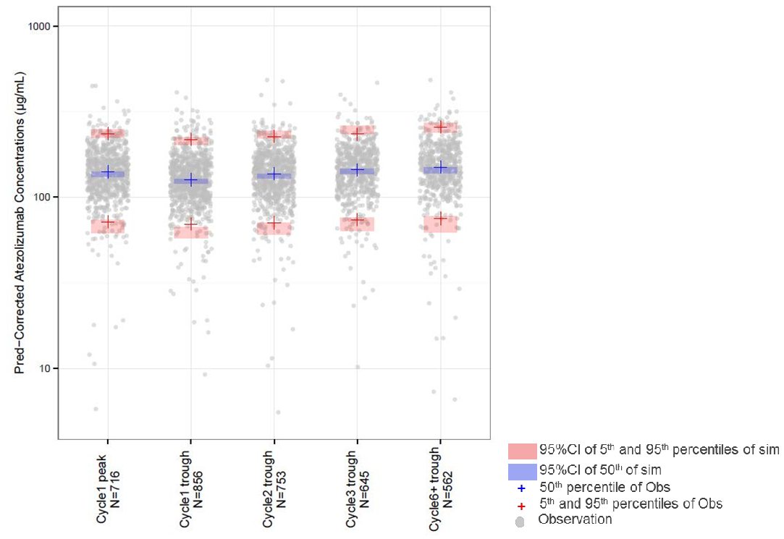
The pcVPC by study suggested that the ‘Phase 1 popPK Model’ was adequate to predict atezolizumab PK data in BIRCH (all Cohorts) as well as in FIR (all Cohorts). Patients from POPLAR appeared to have lower concentrations than predicted by the ‘Phase 1 popPK Model’.
The ‘Phase 1 popPK Model’ was used to derive the patient-level PK parameter random effect estimates based on concentration-time profiles in BIRCH, FIR and POPLAR. The goodness-of fit plots (overall and by study) suggested that the model was able to describe the PK profiles from BIRCH, FIR and POPLAR well without re-estimating the ‘Phase 1 popPK model’ population PK parameters. A trend to negative population-level predictions and residuals was observed for POPLAR, consistent with the over-prediction in the pcVPC. However, this trend was resolved in individual predictions and residuals for POPLAR, indicating that the ‘Phase 1 popPK Model’ allowed reliable estimates of individual parameters in all studies.
Individual CL, V1 and V2 patient-level random effects estimated with the Phase 1 popPK Model did not suggest any trend by cohort in BIRCH and FIR, respectively. In POPLAR, there was trend towards faster CL and greater V1, which was consistent with the over-prediction suggested by the pcVPC. The sponsor commented that the reasons for this study effect were not immediately obvious, but may possibly be related to a larger baseline tumour burden and a higher proportion of ATA positive patients in POPLAR, although those effects were accounted for in the ‘Phase 1 popPK Model’. Though model-based estimates of atezolizumab exposure (i.e. Cmax,ss, Cmin,ss and AUCss) were lower on average in POPLAR compared to BIRCH and FIR, these differences appeared to be relatively moderate (i.e. generally within 20%).
Exploratory analyses of the relationships between individual CL, V1 and V2 patient-level random effects and covariates (including body weight, albumin, tumor burden, gender, and ATA) indicated that covariate effects in BIRCH, FIR and POPLAR data were generally consistent with those identified in the ‘Phase 1 popPK Model’. However, the relationship between random effect of CL and body weight was characterised with a negative correlation coefficient, suggesting that this relationship in NSCLC patients may be not as steep as suggested by the ‘Phase 1 popPK model’. The exploratory analyses did not identify new or unexpected covariate effects in BIRCH, FIR and POPLAR, which had not been identified in the Phase 1 popPK analysis.
Exposure metrics at C1D1 and at steady-state for each study based on the ‘Phase 1 popPK Model’ for use in a subsequent exposure-response analysis are presented below. Steady-state exposure was estimated at 10 cycles in order to calculate accumulation ratios. The geometric mean accumulation ratio based on AUC was close to 1.9 fold across studies, while based on the geometric means across studies the Cmin and Cmax accumulated 2.2-fold and 1.4-fold, respectively.
Table 18: PopPK Report (NSCLC) – Summary statistics of popPK predicted atezolizumab exposure metrics at C1D1 by study.
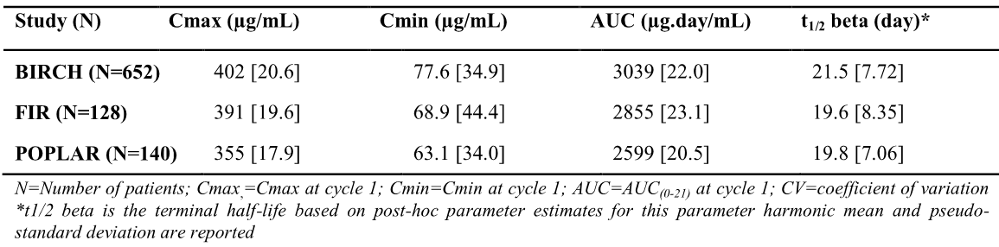
Table 19: PopPK Report (NSCLC) – Summary statistics of popPK predicted atezolizumab exposure metrics at steady state by study.
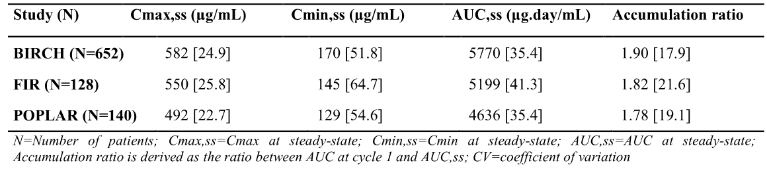

Pharmacokinetics in special populations

Pharmacokinetics in subjects with impaired hepatic function
There were no dedicated PK studies in patients with impaired hepatic function. However, based on the popPK analysis, there was no clinically important difference in the CL of atezolizumab between patients with mild hepatic impairment (i.e. bilirubin ≤ ULN and AST > ULN or bilirubin < 1.0 to 1.5 x ULN and any AST; n = 71) and patients with normal hepatic function (i.e. bilirubin and AST less than or equal to ULN; n = 401) (Report 1066935). The cut offs for ULN were 34 U/L for AST and 1.9 mg/dL for bilirubin. The comparison of atezolizumab CL normalised on other significant covariates identified in the popPK model for patients with normal hepatic function and mild hepatic impairment are summarised below. Based on the popPK estimates, no dose adjustment in patients with mild hepatic function impairment is required. No data were available in patients with either moderate or severe hepatic impairment.
Table 20: PopPK Report 1066935 - Comparison of Bayesian post-hoc atezolizumab covariate-normalised CL for hepatic function categories, mean (90% CI of the mean)
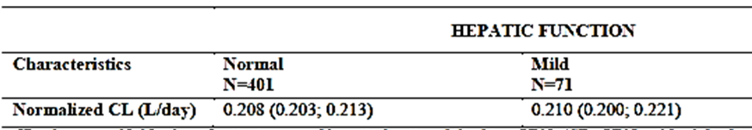

Pharmacokinetics in subjects with impaired renal function
There were no dedicated PK studies in patients with impaired renal function. However, creatinine clearance (CRCL) and eGFR were tested as potential continuous covariates in the popPK model, and the results showed that neither were statistically significant covariates on atezolizumab CL (Report 1066935). The effect of renal impairment on atezolizumab CL was further assessed in the popPK model by grouping patients with renal impairment into 4 categories based on their estimated eGFR (normal = eGFR ≥ 90 mL/min/1.73 m²; mild = eGFR ≥ 60 and < 90 mL/min/1.73 m²; moderate = eGFR ≥ 30 and <60 mL/min/1.73 m²; and severe: eGFR <30 mL/min/1.73 m²). In total, 140 patients (29.7%) had normal renal function, 208 patients (44.1%) had mild renal impairment, 116 patients (24.6%) had moderate renal impairment, and 8 patients (1.7%) had severe renal impairment. The comparison of atezolizumab CL in patients with renal function normalised on other covariates significant in the popPK model is summarised below. No clinically important differences in the CL of atezolizumab were found between patients with renal impairment and patients with normal renal function. Based on the popPK estimates, no dose adjustment based on covariates related to renal function is required. However, the number of patients in the analysis with severe renal impairment was small (n = 8).
Table 21: PopPK 1066935 - Comparison of Bayesian post-hoc atezolizumab covariate-normalised CL for real function categories, mean (90% CI of the mean).
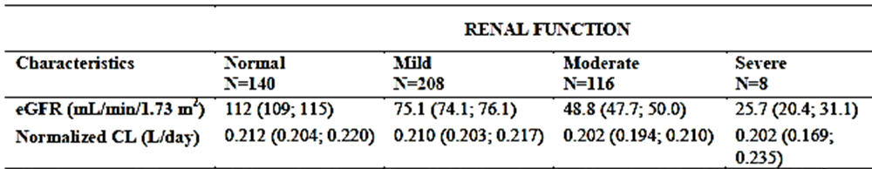

Pharmacokinetics according to age
There were no dedicated PK studies in an elderly population. However, in the popPK analysis age was not identified as a significant covariate influencing atezolizumab PK based on patients aged 21 to 89 years (n = 472), with a median of 62 years of age (Report 1066935). No clinically important differences were observed in the PK of atezolizumab among patients aged < 65 years
(n = 274), patients aged between 65 and 75 years (n = 152), and patients aged > 75 years (n = 46). Bayesian post-hoc CL normalised on covariates in the final popPK model was compared across the three age groups and the results are summarised below. The normalised CL decreased with age, with the difference being approximately 5% between patients aged < 65 years and 65 to 75 years and approximately 8% between patients aged < 65 years and > 75 years. Based on the results of the popPK estimates, no dose adjustment based on age is required.
Table 22: PopPK 1066935 - Comparison of Bayesian post-hoc atezolizumab covariate-normalised CL for different age groups, mean (90% CI of the mean).
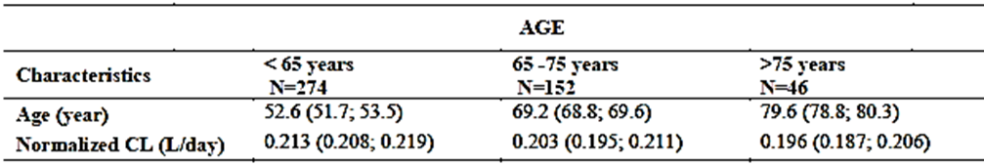

Pharmacokinetics according to gender
There were no dedicated PK studies based on gender. However, in the popPK analysis gender was identified as a statistically significant covariate on both V1 and V2, but not on CL based on a dataset including 276 men (58.5%) and 196 women (41.5%) (Report 1066935). In females, V1 and V2 were estimated to be 13% and 27% lower, respectively, than in males. For a typical female patient (weighing 77 kg), there would be a maximum 8% increase in AUC,ss, Cmax,ss or Cmin,ss. Based on the popPK estimates, no dose adjustment based on age is required.

Pharmacokinetics according to disease type and severity
Based on the popPK analysis, ECOG and metastases (number of sites, brain, liver, or visceral metastases) were found not to effect the PK of atezolizumab (Report 1066935). Serum albumin and tumour burden were identified as statistically significant covariates on CL. None of the covariates resulted in more than 30% change in AUCss, Cmax,ss, or Cmin,ss from the typical patient when evaluated at extreme values of the distribution of these covariates (i.e. 10th and 90th percentiles). After adjusting for covariate effects in the final popPK model, PD-L1 expression in either ICs or TCs had no significant effect on the PK of atezolizumab. The PK of atezolizumab in patients with UC and NSCLC did not differ from the PK of atezolizumab in patients with other tumour types.

Population pharmacokinetics

PopPK analysis – Report 1066935
The population PK (popPK) of atezolizumab was first assessed based on Phase I data from two clinical studies (PCD4989g and JO28944), and the results of this analysis were presented in Report 1066935. The ‘Phase I popPK Model’ was subsequently subjected to external validation for each indication separately using PK data collected in the NSCLC Phase II Studies BIRCH, POPLAR, and FIR (Report 1067735) and the UC Phase II Study IMvigor 210 (Report 1067394). The relevant data from the population PK reports have been referred to in appropriate sections of this CER. The key findings in the popPK report based on data from the two Phase I studies are summarised below.
For the ‘Phase I popPK Model’, the serum PK of atezolizumab across the two Phase I studies PCD4989g and JO28944 was described by a linear two-compartment disposition model with first-order elimination (dose range: 1-20 mg/kg q3w, including the fixed 1200 mg dose of atezolizumab q3w). The model is described schematically below in Figure 6.
Figure 6: Schematic diagram atezolizumab population PK model.
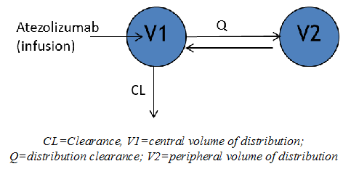
Based on the ‘Phase I popPK model’, the typical population clearance (CL) and central volume of distribution (V1) were estimated to be 0.200 L/day and 3.28 L, respectively, and the typical volume of distribution at steady-state (Vss) and terminal half-life (t1/2) were estimated to be 6.91 L and 27 days, respectively. The typical patient was a male without positive ATA, weighing 77 kg, with a serum albumin concentration of 40 g/L and a tumour burden of 63 mm.
Based on simulations, 90% of steady-state for Cmin, Cmax, and AUC was attained after the following median (range) number of cycles, respectively, 3 cycles (1-6), 2 cycles (1-4), and 3 cycles (1-5) The Cmin, Cmax, and AUC accumulation ratios were 2.75, 1.46, and 1.91-fold following q3w repeated dosing, respectively, based on geometric mean values.
In the final ‘Phase 1 popPK model’, body weight, albumin, tumour burden, and the presence of ATAs were statistically significant covariates for CL; body weight and albumin were statistically significant covariates for V1; and gender was a statistically significant covariate for both V1 and V2. The covariate effects (evaluated for the 10th and 90th percentile of covariate distributions) on atezolizumab PK parameters (CL, V1 and V2) referenced to the typical male patient are summarised below. No covariate induced more than 27% change from typical values when evaluated at extreme values (i.e. 10th and 90th percentile).
Table 23: Effect of baseline covariates on atezolizumab PK parameters.
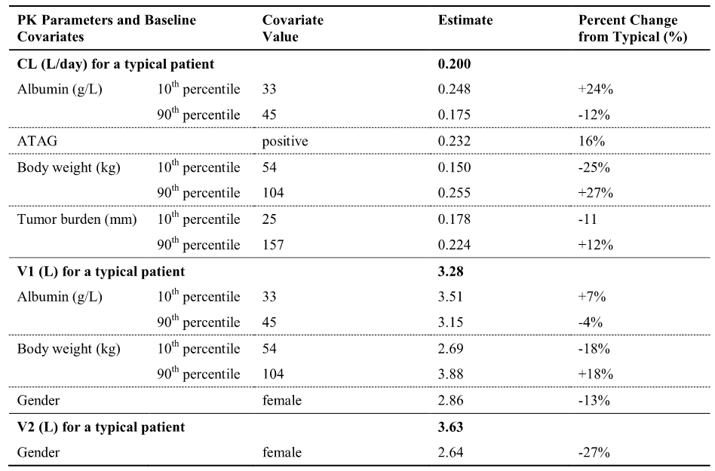
Body weight was identified as a statistically significant covariate on both CL and V1 but not on V2, based on a dataset including patients weighing 36.5 to 168 kg with a median weight of 77 kg. The AUCss, Cmax,ss or Cmin,ss would be up to a 32%, 28% and 40% higher, respectively, when evaluated for a patient at the lowest extreme values of weight (i.e. 10th percentile [54 kg]) compared to the typical patient.
Gender was identified as a statistically significant covariate on both V1 and V2, but not on CL based on a dataset including 276 men (58.5%) and 196 women (41.5%). For a typical female patient (weighing 77 kg), there would be a maximum 8% increase in AUCss, Cmax,ss or Cmin,ss compared to atypical male patient (weighing 77 kg).
Positive ATAG (ATA) was identified as statistically significant covariate on CL. However, positive ATAG (ATA) did not result in more than a 19% lower AUCss, Cmax,ss or Cmin,ss compared to the typical patient.
Serum albumin and tumour burden were also identified as statistically significant covariates on CL. However, neither of these covariates resulted in more than a 28% change in AUCss, Cmax,ss or Cmin,ss, when evaluated at extreme values (i.e. 10th and 90th percentile) compared to the typical patient. Serum albumin was identified as a statistically significant covariate on V1. Patients with low albumin tend to have a lower exposure with a larger effect on Cmin,ss.
Age was not identified as a significant covariate influencing atezolizumab PK based on patients of age range of 21-89 years of age (n = 472), and median of 62 years of age. No clinically important difference was observed in atezolizumab PK among patients aged <65 years (n = 274), patients aged between 65-75 years (n = 152) and patients aged >75 years (n = 46). No dose adjustment based on age is required.
No clinically important differences in atezolizumab CL were found in patients with mild renal impairment (eGFR 60 to 89 mL/min/1.73 m²; n = 208), moderate renal impairment (eGFR 30 to 59 mL/min/1.73 m²; n = 116) or severe renal impairment (eGFR < 30 mL/min/1.73 m²; n = 8) compared to patients with normal renal function (eGFR ≥ 90 mL/min/1.73 m²; n = 140). No dose adjustment in patients with renal impairment is required. However, there were only a small number of patients (n = 8) with severe renal impairment in the popPK analysis.
There was no clinically important differences in atezolizumab CL between patients with mild hepatic impairment (bilirubin ≤ upper limit of normal (ULN) and AST > ULN or bilirubin < 1.0 to 1.5 x ULN and any AST; N = 71) and patients with normal hepatic function (bilirubin and AST ≤ ULN; n = 401). No dose adjustment in patients with mild hepatic function impairment is required. No data were available in patients with either moderate of severe hepatic impairment.
Neither ECOG status nor metastases (number of sites, brain, liver or visceral metastases) significantly affected the PK of atezolizumab.
After adjusting for significant covariate effects in the final model, the following factors were found not to have affected the PK of atezolizumab: race; region; formulation; and PD-L1 expression on either ICs or TCs.
Atezolizumab PK data obtained in patients with NSCLC from BIRCH, POPLAR, and FIR, and with UC from IMvigor 210 are consistent with the ‘Phase I popPK Model’ estimates, suggesting consistent PK characteristics in patients with NSCLC and UC.

Pharmacokinetic interactions
No drug-drug interactions studies were submitted.

Evaluator’s conclusions on pharmacokinetics
- The PK of atezolizumab have been adequately characterised in two Phase 1 studies in patients with advanced malignancy, four Phase II studies in patients with UC or NSCLC, and a popPK analysis based on data from the two Phase 1 studies. The popPK model based on the two Phase I studies was validated using the PK data from the Phase II study in patients with UC (IMvigor 210) and the three Phase II studies in patients with NSCLC (POPLAR, BIRCH, FIR). Therefore, the data from the popPK analysis report 106693 can be extrapolated to patients with UC and NSCLC. There were no studies exploring the PK of atezolizumab in healthy subjects. All PK data were based on studies in patients with cancer.
- Atezolizumab is a genetically engineered, humanised, monoclonal antibody that binds to PD-L1 and blocks interactions with both PD-1 and B7.1 receptors. It is a non-glycosylated IgG1 kappa immunoglobulin that has a calculated molecular mass of approximately 144 kDa. It is composed of two light chains consisting of 214 amino acid residues and two heavy chains consisting of 448 amino acid residues.
- The popPK analysis established that a linear two-compartment disposition model with first-order elimination adequately described atezolizumab concentration-time data following administration of 1 to 20 mg/kg of atezolizumab q3w, or the 1200 mg fixed-dose q3w [report 106693].
- In patients with advanced malignancies, atezolizumab demonstrated linear PK over the dose range 1-20 mg/kg based on dose normalised Cmax, Cmin, and AUC0-21 [PCD4989g]. The popPK model estimated geometric mean accumulation ratios for Cmin, Cmax, and AUC were 2.75, 1.46, and 1.91-fold, respectively, following multiple dose administration of atezolizumab q3w [report 106693]. Based on simulations, the popPK model estimates that 90% of steady-state is reached after 2 to 3 cycles of repeated q3w dosing (i.e. 6 to 9 weeks).
- Based on popPK modelling for atezolizumab for a typical patient, the Vss is 6.91 L, the CL is 0.2 L/day, and the t1/2 is 27 days [report 106693]. The volume of distribution is small and less than the volume of total body water of approximately 42 L.
- In the final popPK model [report 106693], body weight, albumin, tumour burden, and ATA were statistically significant covariates for CL, body weight and albumin were statistically significant covariates for V1, and gender was a statistically significant covariate for both V1 and V2. However, the effects of these covariates on the PK of atezolizumab are considered to be clinically insignificant and no dose adjustments based on the covariates are required. The results from the popPK analysis suggest the unexplained inter-individual (IIV) is moderate for CL (i.e. 29%), V1 (i.e. 18%), and V2 (i.e. 34%). There were no data relating to intra-subject PK variability.
- There were no data on the metabolism of atezolizumab. However, as the drug is a monoclonal antibody (IgG) it can be reasonably inferred that it will undergo catabolism via proteolytic degradation in a similar manner to endogenous IgG. Atezolizumab is unlikely to be a substrate for CYP450 enzymes. There were no data on renal elimination. However, as the molecular weight of atezolizumab is large (approximately 144 kDa) it can be predicted that it will not undergo renal clearance. There were no mass balance studies, but such studies are considered to be not necessary for therapeutic proteins.
- The Cmax and Cmin values in Cycle 1 following the proposed atezolizumab dose of 1200 mg q3w administered by IV infusion to patients with advanced malignant disease were consistent across the 5 Phase I/II clinical studies. In particular, the Cmax and Cmin values were consistent in the Phase II clinical studies in patients with UC (IMvigor 210) and NSCLC (POLAR, BIRCH, FIR).
- In the clinical studies, exposure parameters (Cmax, Cmin) were lower in patients who were positive for ATA compared to patients who were negative for ATA. However, in the Phase 1 study, patients who received ≥ 10 mg/kg atezolizumab (including fixed-dose 1200 mg) maintained geometric mean steady-state trough serum concentrations above the target level of 6 μg/mL, irrespective of ATA status [PCD4989g]. Similarly, in the Phase II studies in patients with UC and NSCLC treated with 1200 mg q3w, steady-state trough serum concentrations were consistently above the target level of 6 μg/mg in all patients, irrespective of ATA status. The popPK analysis (report 1066935) predicted that CL would be 16% greater in ATA-positive patients compared to ATA-negative patients, but steady state exposure parameters would be no greater than 19% lower in a typical ATA-positive patient compared to a typical ATA-negative patient.
- There were no dedicated PK studies assessing the effects of age, renal impairment, hepatic impairment or gender on the PK of atezolizumab. However, the popPK post-hoc analyses indicates that there are no significant difference in atezolizumab CL normalised on other significant covariates based on age (< 65, 65-75, ≥ 75 years), renal impairment (normal renal function, mild, moderate, severe renal impairment) or hepatic impairment (normal hepatic function, mild hepatic impairment). There were no popPK data in patients with moderate or severe hepatic impairment, while popPK data in patients with severe renal impairment were limited (n = 8). Based on the popPK analysis, no atezolizumab dose adjustment appears to be indicated based on age, gender, mild or moderate renal impairment, or mild hepatic impairment.
- In summary, the popPK analysis showed that age, body weight, gender, positive ATA status, serum albumin levels, tumour burden, region or race, mild, moderate or severe renal impairment, mild hepatic impairment, level of PD-L1 expression on ICs and TCs, or ECOG status had no clinically significant effects on the PK of atezolizumab.
- There were no data assessing drug-drug interactions (DDIs) involving atezolizumab. In general, PK DDIs between therapeutic monoclonal antibodies and conventional small-molecule drugs are not expected, since these drugs are primarily eliminated by catabolism. In addition, monoclonal antibodies are unlikely to be substrates for CYP450 enzymes or protein transporter systems that can be modified by small-molecule drugs.

Pharmacodynamics

Studies providing pharmacodynamic data
The submission included the following studies with pharmacodynamic information.

Exposure-Efficacy Relationships
- UC [IMvigor 210]: Exposure-efficacy analyses were conducted with data from patients with urothelial carcinoma enrolled in IMvigor 210. The objectives of these analyses were: (1) to explore exposure-response (ER) relationships with objective response rate (ORR) as assessed by an independent review facility (IRF) using RECIST v1.1 following atezolizumab 1200 mg q3w; and (2) to evaluate the need for dose adjustment in patient subgroups.
- NSCLC: Exposure-efficacy analyses were conducted with data from patients with NSCLC enrolled in BIRCH and POPLAR. The objectives of these analyses were: (1) to explore ER relationships with ORR as assessed by an IRF [BIRCH] and investigator [POPLAR] using RECIST v1.1 and OS [POPLAR] following atezolizumab 1200 mg q3w; and (2) to evaluate the need for dose adjustment in patient subgroups.

Exposure-Safety Relationships
- UC [IMvigor 210]: Exposure-safety analyses were conducted with data from patients with urothelial carcinoma enrolled in IMvigor 210. The objectives of the these analyses were: (1) to explore exposure-safety relationships for adverse events Grade 3 to 5 (AEG35) and adverse events of special interest (AESI) following atezolizumab 15 mg/kg and 1200 mg q3w; and (2) to evaluate the need for dose adjustment in patient subgroups.
- NSCLC [PCD4989g, BIRCH, POPLAR, FIR]: Exposure-safety analyses were conducted with data from atezolizumab treated patients with NSCLC enrolled in studies PCD4989g, BIRCH, POPLAR and FIR. The objectives of these analyses were: (1) to explore exposure-safety relationships for AEG35 and AESI following atezolizumab 15 mg/kg and 1200 mg q3w; and (2) to evaluate the need for dose adjustment in patient subgroups. An integrated exposure-safety analysis was performed in all atezolizumab-treated patients from the four Phase II studies [report 1068603].

QTc Assessment
- No dedicated thorough QT/QTc study was undertaken. However, in study PCD4989g a concentration-QTc (C-QTc) analysis was conducted using triplicate ECGs collected from patients (n = 417) receiving atezolizumab 10, 15, 20 mg/kg, and 1200 mg, under controlled conditions during the dose expansion phase of the study, to construct a quantitative model describing the relationship between observed atezolizumab concentrations and the change from baseline QTc interval (Δ QTc).

Immunogenicity
- The immunogenicity of atezolizumab was investigated in six Phase I/II studies [PCD4989g, JO28944, IMvigor 210, BIRCH, POPLAR, and FIR].

Summary of pharmacodynamics

Exposure-efficacy relationships

Urothelial carcinoma (UC)

Phase II study IMvigor 210

Overview
ORR, as assessed by an independent review facility (IRF) per RECIST v1.1 from IMvigor 210 for Cohorts 1 and 2, was used in the exposure-efficacy assessment (primary efficacy analysis data cut-off for Cohort 2 of 5 May 2015, and primary efficacy analysis data cut-off for Cohort 1 of 14 September 2015). The ORR was the primary efficacy endpoint in IMvigor 210. The results for the ER analysis of ORR were characterised by frequency (Yes/No). The ORR frequencies (with 95% CI) were computed for intervals of exposure with an equivalent number of patients (e.g. quartiles). For each correlation between exposure and response, a logistic regression was performed and the Wald test p-value for the exposure effect in the logistic regression was reported.
The ER relationship was described as p(ORR) ~ Exposure, where p(ORR) is the probability of the objective response and exposure is an atezolizumab exposure metric. The atezolizumab exposure metrics were calculated from popPK modelling (i.e. AUC, Cmin and Cmax at Cycle 1, and AUCss [dose/CL]).

Results
In Cohort 1, the ER analysis was performed using data collected in patients with previously untreated or locally advanced metastatic urothelial carcinoma who are cisplatin-ineligible. The data set comprised all 119 patients (100%) with exposure data in Cohort 1. All patients received atezolizumab 1200 mg q3w. The ORR (CR + PR) assessed by IRF per RECIST v1.1 in the analysis population was 19.3% (23/119). There were no statistically-significant relationships between the probability of response and atezolizumab exposure with any of the assessed exposure metrics.
Table 24: IMvigor 210 - Summary of logistic regression for the probability of response vs exposure in Cohort 1.
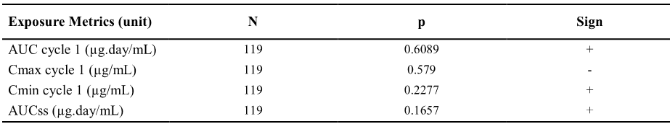
N = number of patients; p value of exposure metrics parameter estimate using Wald test; Sign = Sign of exposure metrics parameter estimate in logistic regression: negative sign = probability of response tends to decrease with exposure; positive sign = response probability of response tends to increase with exposure.
In Cohort 2, the ER analysis was performed using data collected from patients who had experienced disease progression during or following a prior based platinum-based chemotherapy regimen for advanced disease. The data set comprised 306 patients with exposure data (out of 311 included in Cohort 2 [98.4%]). All patients received atezolizumab 1200 mg q3w. The proportion of responders (CR + PR) assessed by IRF per RECIST v1.1 in the analysis population was 15.4% (47/306). There were no statistically-significant relationships between the probability of response and atezolizumab exposure with any of the assessed exposure metrics (see below).
Table 25: IMvigor 210 - Summary of logistic regression for the probability of response vs exposure in Cohort 2.
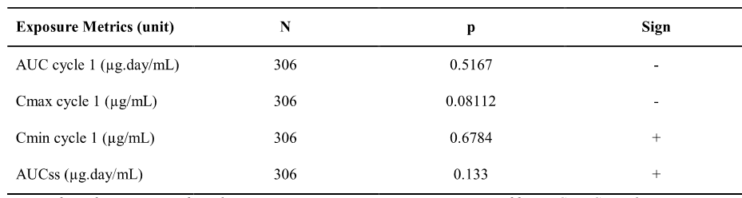
N = number of patients; p value of exposure metrics parameter estimate using Wald test; Sign = Sign of exposure metrics parameter estimate in logistic regression: negative sign = probability of response tends to decrease with exposure; positive sign = response probability of response tends to increase with exposure.

NSCLC

BIRCH

Overview
BIRCH was a Phase 2, global, multicentre, single-arm trial designed to evaluate the efficacy and safety of atezolizumab in PD-L1-selected patients with locally advanced or metastatic NSCLC. In this study atezolizumab was administered as a single agent by IV infusion of 1200 mg q3w in the three following cohorts: Cohort 1 (1L atezolizumab treatment) included patients who had not received prior chemotherapy for advanced NSCLC (n = 139); Cohort 2 (2L atezolizumab treatment) included patients who had received one platinum-based chemotherapy regimen for advanced NSCLC (n = 267); and Cohort 3 (3L+ atezolizumab treatment) included patients who had received at least one platinum-based chemotherapy and one additional regimen for advanced NSCLC (n = 253).
The ORR was the response criterion for the ER assessment in the ITT population in Cohorts 2 and 3 (n = 514). The ORR (CR and PR) was assessed by an IRF using RECIST v1.1. The ORR in patients with NSCLC included in the analysis population was 17.5% (90/514). The ER relationship was determined using the same methodology as that applied in IMvigor 210. The atezolizumab exposure metrics were calculated from popPK modelling (i.e. AUC, Cmin and Cmax at Cycle 1, and AUCss [dose/CL]).

Results
The ER analysis showed a statistically significant response between AUCss and ORR. The results are summarised below.
Table 26: BIRCH - Summary of logistic regression for the probability of response vs exposure in Cohorts 2 and 3.
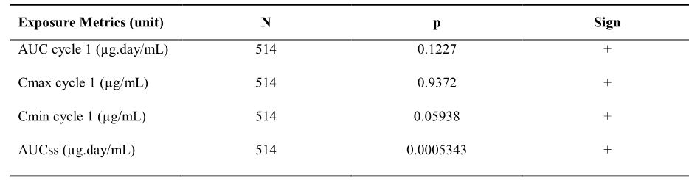
N = number of patients; p value of exposure metrics parameter estimate using Wald test; Sign = Sign of exposure metrics parameter estimate in logistic regression: negative sign = probability of response tends to decrease with exposure; positive sign = response probability of response tends to increase with exposure.
The probability of a response (CR + PR) increased with AUCss (see Figure 7, below).
Figure 7: BIRCH – ORR vs atezolizumab AUCss in patients with NSCLC from Cohorts 2 plus 3.
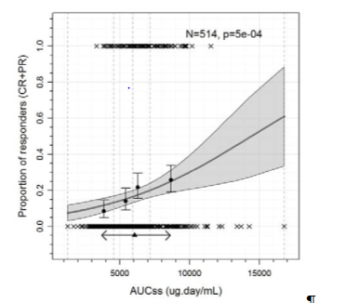
AUCss=AUC at steady-state; CR=complete response; PR=partial response; N = number of patients; p = p value of Wald test in logistic regression of ORR vs exposure. The grey solid line and shaded area represent the logistic regression slope model and 95% prediction interval. The filled circles and error bar represent ORR in exposure quartiles and 95% CI. The vertical lines are the limits of the exposure quartiles. The crosses are the response events (0: no, 1: yes). The triangle and two-headed arrow represent the mean exposure and exposure interval between the 10th and the 90th percentile for patients receiving 1200 mg atezolizumab, respectively.
The parameter estimates for the logistic regression model for the AUCss are provided below.
Table 27: BIRCH – Logistic regression model parameter estimates for the objective response rate vs AUCss for patients with NSCLC from Cohorts 2 plus 3.
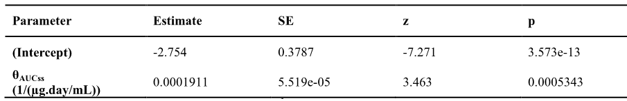
SE = standard error; z = Wald test statistic; p Wald test (Chi squared); θAUCss = regression parameter for AUCss effect.
The logistic regression model was simulated to estimate the expected ORR for extreme values of AUCss (10th to 90th percentile), and the expected odds ratios calculated for these AUCss values relative to the median AUCss. The estimated expected ORR ranged from 11% to 25% for the AUCss at the 10th and 90th percentiles, with an ORR of 16% at the median AUCss. The logistic regression model was also simulated to estimate the expected ORR for a 21% decrease in AUCss when evaluated at the highest extreme value of weight compared to the typical patient (i.e. 90th percentile [104 kg] compared to a typical patient [77 kg]), which was the strongest covariate effect estimated to decrease AUCss identified in the ‘Phase 1 popPK model’. This simulation showed that the predicted ORR was 13% for a 21% decrease in AUCss, which is similar to the predicted ORR of 16% at the median AUCss (OR = 0.79 [95% CI: 0.69, 0.90]). The ER results based on logistic regression modelling are summarised below.
Table 28: BIRCH – Simulations of expected ORR vs AUCss in patients with NSCLC from Cohorts 2 plus 3 using atezolizumab flat dose of 1200 mg.
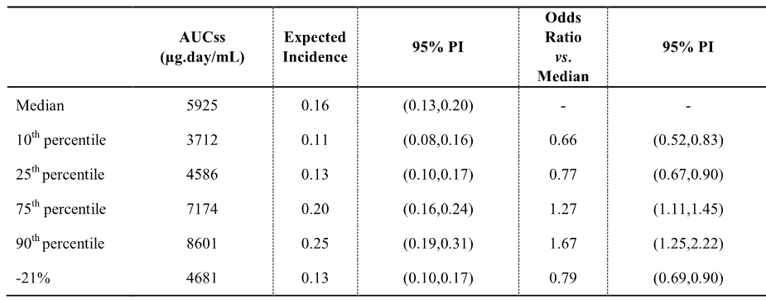
PI=prediction interval; AUCss=AUC at steady-state.
The ER report for BIRCH also included simulations of expected ORR for AUCss levels in patients with NSCLC from Cohorts 2 plus 3 based on dosing by weight (i.e. 15 mg/kg). The results were consistent with the ER simulations based on fixed-dose (1200 mg) and support the proposed fixed-dose regimen. The simulations for the weight based regimen are summarised below.
Table 29: BIRCH – Simulations of expected ORR vs AUCss in patients with NSCLC from Cohorts 2 plus 3 using atezolizumab weight-based dosing regimen of 15 mg/kg.
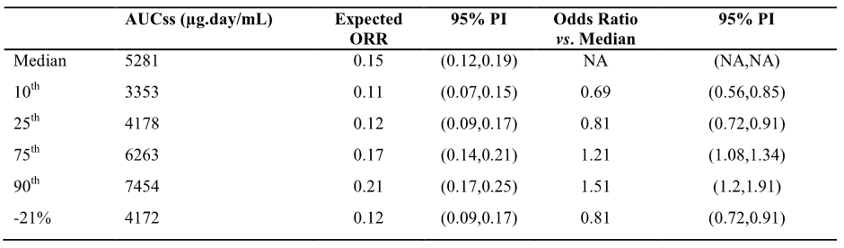
NA = not applicable; ORR = objective response rate; PI=prediction interval; AUCss=AUC at steady-state.

POPLAR

Overview
POPLAR was a Phase II, global, multicentre, open-label, randomised, controlled study designed to evaluate the efficacy and safety of atezolizumab in patients with locally advanced or metastatic NSCLC who had progressed during or following a platinum-containing regimen. Eligible patients were stratified by PD-L1 immunohistochemistry (IHC) status (IC0, IC1, IC2, and IC3), by the number of prior chemotherapy regimens (1 vs 2), and by histology (non-squamous vs squamous) and then randomised 1:1 to receive either atezolizumab 1200 mg administered by IV infusion or docetaxel 75 mg/m² administered by IV infusion.
The atezolizumab ER analysis was performed in the all-comers NSCLC population (i.e. irrespective of IC status) in the atezolizumab 1200 mg q3w arm (n = 140). All patients in the analysis received atezolizumab as 2L or 3L treatment for NSCLC. The ORR (CR and PR) was assessed by an IRF using RECIST v1.1. The ORR in patients with NSCLC included in the analysis population was 15.0% (21/140).

Results – exposure-response (ORR)
The exposure-response (ORR) analysis was undertaken using the same methods as those used in studies IMvigor and BIRCH. The only exposure-response (ORR) relationship resulting in statistically significant result was Cmax (p = 0.03987). However, the ER relationship was the opposite of that expected with response declining with increased Cmax. The results are summarised below.
Table 30: POPLAR - Summary of logistic regression for the probability of response vs exposure in all-comers NSCLC patients.
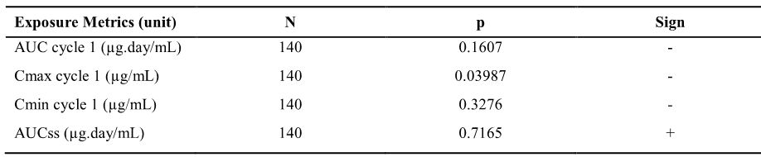
N = number of patients; p value of exposure metrics parameter estimate using Wald test; Sign = Sign of exposure metrics parameter estimate in logistic regression: negative sign = probability of response tends to decrease with exposure; positive sign = response probability of response tends to increase with exposure.
The results for the relationship between AUCss and the proportion of responders are summarised below. The proportion of responders (CR + PR) remained unchanged over the range of AUCss values simulated, indicating that there was no clinically meaningful ER relationship between ORR and systemic exposure to atezolizumab at steady state in POPLAR.
Figure 8: POPLAR – Objective response rate vs atezolizumab in all-comers NSCLC patients.
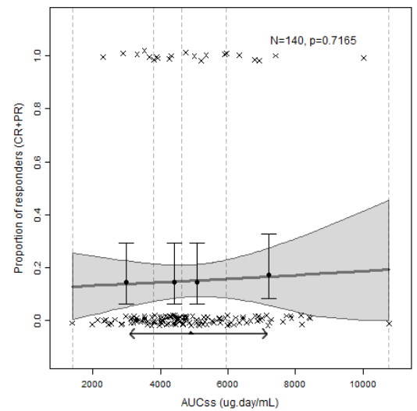
AUCss=AUC at steady-state; CR=complete response; PR=partial response; N = number of patients; p = p value of Wald test in logistic regression of ORR vs. exposure. The grey solid line and shaded area represent the logistic regression slope model and 95% prediction interval. The filled circles and error bar represent ORR in exposure quartiles and 95% CI. The vertical lines are the limits of the exposure quartiles. The crosses are the response events (0: no, 1: yes). The triangle and two-headed arrow represent the mean exposure and exposure interval between the 10th and 90th percentile for patients receiving 1200 mg atezolizumab, respectively.

Results – overall survival (OS)
Overall survival (OS) from the atezolizumab arm was also analysed in the exposure-efficacy assessment. The primary population comprised NSCLC (all-comers) patients (n = 140) treated with atezolizumab (2L or 3L). Median OS was 403 days (95% CI: 305 days, not reached). OS probability increased with atezolizumab exposure (AUC and Cmin in Cycle 1, and AUCss; p <0.001 by Cox regression analysis). There was a trend towards increased OS survival with Cmax (Cycle 1), but the relationship was not statistically significant.
To mitigate confounding between prognostic factors and atezolizumab clearance and exposure, a multivariate model for OS was developed based on baseline prognostic factors and tumour growth inhibition (TGI) metrics. A total of 252 patients (all-comers) out of the 277 treated patients (91.0%) in the atezolizumab and docetaxel arms were evaluable in the TGI-OS analysis. The TGI model was reported to provide a good fit of the data and parameter estimates with good precision.
The estimate of the tumour growth rate constant KG was slower in the atezolizumab arm than in the docetaxel arm. Individual estimates of Log(KG) were strong predictors of OS together with the number of metastatic sites and albumin level at baseline. Treatment arm and AUCss were eliminated from the model during the backward selection. The OS model was qualified to simulate OS distribution in the two treatment arms as well as the atezolizumab to docetaxel hazard ratio.
Simulation of the OS model after correcting for the imbalance of prognostic factors (number of metastatic sites and albumin level) across simulated atezolizumab AUCss tertiles and docetaxel groups showed that all patients with NSCLC would benefit from atezolizumab treatment due to increase in OS with atezolizumab exposure. The HR (95% prediction interval) varied from 0.86 (0.82, 0.91) in low atezolizumab exposure patients (1st tertile) to 0.61 (0.56, 0.68) in high atezolizumab exposure patients (3rd tertile). The results for the analysis are summarised below.
Figure 9: POPLAR - Simulation of the overall survival model in the 2L/3L all-comers NSCLC patients to assess exposure-response on atezolizumab to docetaxel Hazard Ratio, balanced prognostic factors.
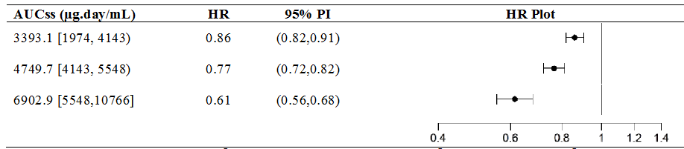
AUCss tertiles=median, interval, [a, b) interval notation, a is included and b is excluded, (a ≤ x < b); HR=Hazard ratio distribution over 1000 replicates; 95%PI=95% prediction interval.

Exposure-safety relationships

Urothelial carcinoma (UC)

Pooled data [PCD4989g, IMvigor 210] – Report 1067242

Data set
The atezolizumab exposure-safety analysis was performed on all treated patients with UC in studies PCD4989g and IMvigor 210. The data set comprised 513 patients with exposure data (out of 521 included in the two studies, 98.5%) who had been treated with atezolizumab 15 mg/kg q3w (N = 85) or 1200 mg q3w (N = 428). The two adverse event (AE) categories investigated were Grade ≥ 3 AEs and AEs of special interest (AESI), with respective patient incidences of 12.9% (n = 66) and 16.6% (n = 85).

Safety endpoints, exposure metrics, and analytical methods
The AEs evaluated were: (i) adverse events grade 3 to 5 (AEG35); and (ii) AESI. In the total all UC population (n = 521), Grade 3 or 4 AEs in the safety evaluable population occurring in > 2% of patients were anaemia (6.3% [n = 33]), fatigue (4.6% [n = 24]), dyspnoea (2.5% [n = 13]), hyponatraemia (2.3% [n = 12]), pneumonia (1.0% [n = 5]), while Grade 5 AEs were reported in 2.1% (n = 11) of patients. AESI (any grade) were reported in 25.7% (n = 134) of patients in the total all UC safety evaluable population (n = 521), with AESI Grade 3 or 4 events being reported in 4.8% (n = 25) of patients and AESI Grade 5 events being reported in no patients.
The exposure metrics were the same as those explored in the exposure-efficacy analyses and were derived from popPK simulations (i.e. AUC, Cmax, and Cmin at Cycle 1, and AUCss). The analytical methodology was consistent with that used for assessment of the exposure-efficacy relationships. The safety endpoints were characterised by frequency (Yes/No). The proportions and 95% CIs were computed for intervals of exposure with an equivalent number of patients (e.g. quartiles). For each such correlation, a logistic regression was performed and the Wald test p-value for exposure effect in the logistic regression was reported. The relationship was described by p(AE) ~ Exposure, where, p(AE)) is the probability of an AE and ‘Exposure’ is an atezolizumab exposure metric. Multivariate analysis was also conducted including covariates that were identified as statistically significant during model building.

Results
The analysis of the incidence of AEG35 did not show any statistically significant exposure-response relationship for any of the exposure metrics investigated. The exposure-response curve for AEG35 vs atezolizumab AUCss was flat across the AUCss range. The analysis of the incidence of AESI did not show any statistically significant exposure-response relationship for any of the exposure metrics investigated.

NSCLC

Pooled analysis (PCD498g, BIRCH, FIR, POPLAR) – Report 1068603

Data set
The atezolizumab exposure-safety analysis was performed on all atezolizumab treated NSCLC patients in PCD4989g NSCLC cohort and in BIRCH, FIR and POPLAR. The data set comprised a total of 1007 patients with exposure data (out of 1026 treated patients in the four studies, 98.1%). These 1007 patients received atezolizumab at weight-based doses of 1, 10, 15 or 20 mg/kg q3w (n = 87), or at a fixed-dose of 1200 mg q3w (n = 920, 91.4%). The two main AE categories investigated were Grade ≥ 3 AEs and AESI, with respective patient incidences of 12.5% (n = 123) and 18.6% (n = 187).

Safety endpoints, exposure metrics, and analytical methods
The AEs evaluated were: (i) AEs grade 3 to 5 (AEG35); and (ii) AESI. In the total all NSCLC population (n = 1026), Grade 3 or 4 AEs occurring in > 2% of patients were dyspnoea (4.7% [n = 48]), pneumonia (3.1% [n = 32]), hyponatraemia (2.9% [n = 30]), anaemia (2.5% [n = 26]), and fatigue (2.3% [2.3%]), and Grade 5 AEs were reported in 4.1% (n = 42) of patients. AESI (any grade) were reported in 26.4% (n = 271) of patients in the total all NSCLC safety evaluable population (n = 1026), with AESI Grade 3 or 4 events being reported in 4.8% (n = 49) of patients and AESI Grade 5 events being reported in < 0.1% (n = 1) of patients. The exposure metrics and analytical methods used to explore exposure-safety relationships were the same as those described above for the pooled UC data.

Results
The analysis of the incidence of AEG35 did not show any statistically significant increasing exposure-response relationship for any of the exposure metrics investigated. There were statistically significant relationships between decreasing exposure for each of the four exposure metrics tested and AEG35. The results for the relationship between AUCss and AEG35 are provided below in Figure 10 in order to illustrate the negative relationship between the two variables.
Figure 10: Report 1068603 (pooled NSCLC data) – Incidence of AEG35 vs atezolizumab in patients with NSCLC and exposure data.
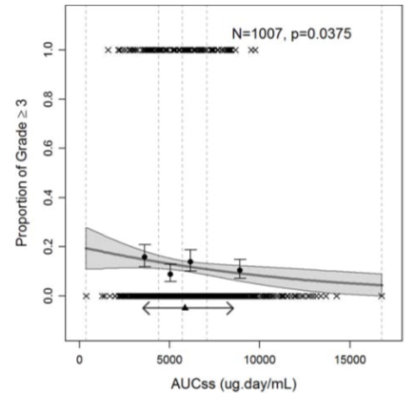
AUCss=AUC at steady-state; N = number of patients; p = p value of Wald test in logistic regression of incidence vs. exposure. The thick solid line and shaded area represent the logistic regression slope model and 95% prediction interval. The filled circles and error bar represent the incidence in exposure quartiles and 95% CI. The vertical lines are the limits of the exposure quartiles. The crosses are the events (0: no, 1: yes). The triangle and two-headed arrow represent the mean exposure and exposure interval between the 10th and the 90th percentile for patients receiving 1200 mg atezolizumab, respectively.
The incidence of AESI tended to increase with exposure, with the relationship between exposure and incidence of AESI being statistically significant for Cmin and AUCss.
Table 31: Report 1068603 – Summary of logistic regression results for the incidence of AESI vs exposure.
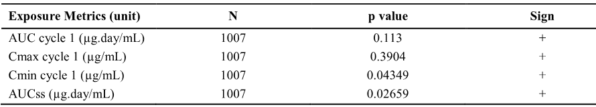
N = number of patients; p value of exposure metrics parameter estimate, Wald test Sign = Sign of exposure metrics parameter estimate in logistic regression, negative sign = probability of response tends to decrease with exposure, positive sign = response probability of response tends to increase with exposure.
The relationship between the incidence of AESI and AUCss is summarised below in Figure 11.
Figure 11: Report 1068603 (pooled NSCL data) – Incidence of AESI vs atezolizumab in patients with NSCLC and exposure data.
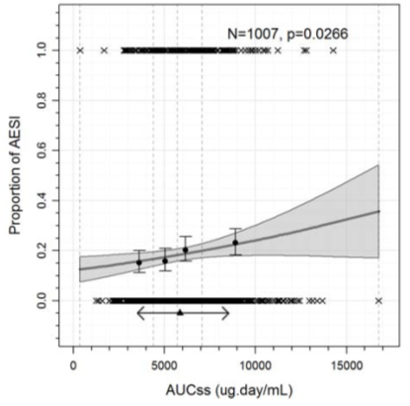
AUCss=AUC at steady-state; AESI=adverse event of special interest, of any grade; N = number of patients; p = p value of Wald test in logistic regression of incidence vs. exposure. The thick solid line and shaded area represent the logistic regression slope model and 95% prediction interval. The filled circles and error bar represent the incidence in exposure quartiles and 95% CI. The vertical lines are the limits of the exposure quartiles. The crosses are the events (0: no, 1: yes). The triangle and two-headed arrow represent the mean exposure and exposure interval between the 10th and the 90th percentile for patients receiving 1200 mg atezolizumab, respectively.
AESI included a number of different events, and the most frequent AESIs observed in ≥ 15 patients are summarised below. There were no statistically significant relationships between exposure and incidence for any of the most frequently occurring AESIs.
Table 32: Report 1068603 – Most frequently reported AESIs (≥ 15 patients) vs atezolizumab exposure.
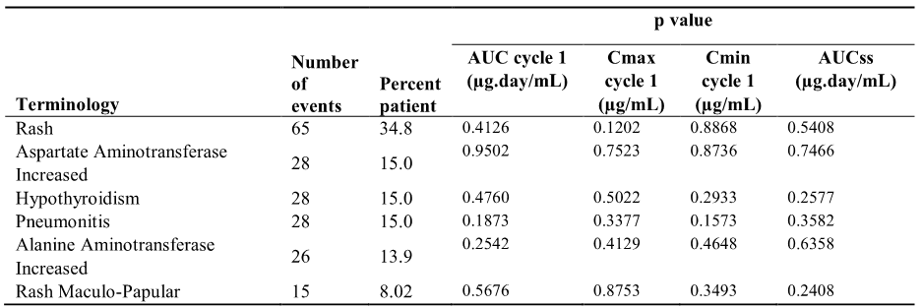
The parameter estimates of the logistic regression model for AUCss are given below.
Table 33: Report 1068603 (pooled NSCLC data) – Logistic regression model parameter estimates for incidence of AESI vs AUCss.
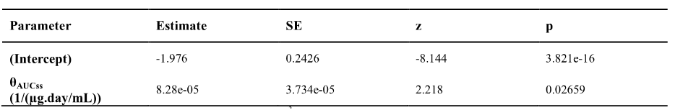
SE = standard error; z = Wald test statistic; p Wald test (Chi squared); θAUCss = regression parameter for AUCss effect.
The logistic regression model was simulated to estimate the expected incidence of AESI for extreme values of AUCss (10th and 90th percentile) and the odds ratio compared to median AUCss (see below). These simulations indicate that the incidence of AESIs increases with increasing exposure (AUCss). However, the point estimates for the odds ratios and the 95% prediction intervals for these estimates suggest that the increased risks of AESI with increased exposure are unlikely to be clinically significant.
Table 34: Report 1068603 – Simulation of expected incidence of AESI vs AUCss.
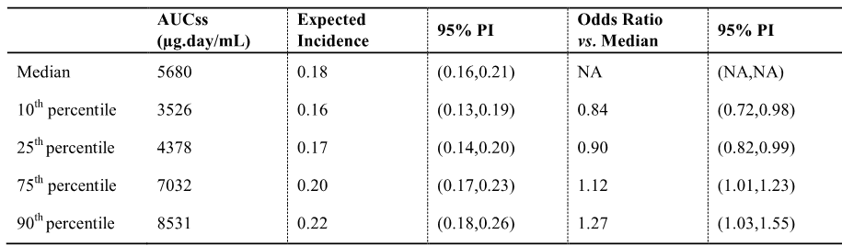
NA=not applicable; PI=prediction interval; AUCss=AUC at steady-state.
Of the statistically significant covariates identified by the ‘Phase 1 popPK Model’, simulations suggest that the largest positive estimated change in atezolizumab AUCss was +32% and was associated with the lowest extreme of weight (i.e. 10th percentile [54 kg]). Since no single effect in the Phase 1 popPK Model was associated with greater than a 32% change in AUCss, none of the changes in AUCss associated with the statistically significant covariates identified by the popPK model would be expected to exceed the modest change at the 90th percentile of AUCss. Simulation of the logistic regression model for AUCss suggests a small increase in the probability of AESI (estimate [95% prediction interval)]) from 0.18 (0.16, 0.21) to 0.22 (0.18, 0.26) for patients with the median and 90th percentile of AUCss, respectively. This increase in AESI is considered not to be clinically meaningful.

QTc interval analysis
In Study PCD4989g, a concentration-QTc (C-QTc) analysis was conducted using triplicate ECGs collected from patients (n = 417) receiving atezolizumab doses 10, 15, 20 mg/kg, and 1200 mg under controlled conditions during the dose expansion cohorts. The objective of the analysis was to construct a quantitative model describing the relationship between observed atezolizumab concentrations and the change from baseline QTc interval (ΔQTc). The results were reported in the ‘Modeling and Simulation Analysis Report’ [Report 1066934].
Digitized 12-lead ECGs were collected in triplicate for patients enrolled in the dose-expansion cohorts at screening, 30±15 minutes before and after the end of the infusion on Day 1 of Cycle 1, 30±15 minutes before and after the end of the infusion on Day 1 of Cycle 4, and at the treatment discontinuation visit not more than 30 days after the last atezolizumab dose was administered. Concurrent PK samples for the assessment of atezolizumab serum concentrations were obtained at the same nominal time-points (except for the screening assessment) that the ECG data were collected. An analysis set was created that contained baseline ECG observations and time-matched PK-QT observations post-baseline, with baseline defined as the pre-dose ECG recorded at 30±15 minutes before the first atezolizumab infusion (Day 1 Cycle 1).
The Fridericia and Bazett correction methods were evaluated for the adequate removal of heart rate effect on QT interval by a linear regression line fit to time-matched QTc-RR observations at baseline, with QTc=QTcF (Fridericia) or QTc=QTcB (Bazett) as dependent variable and RR as independent variable. The analyses were performed on the QTcF rather than the QTcB, because the Fridericia correction minimised the effect of heart rate on the estimation of QTc interval prolongation.
A linear mixed effects model was developed describing ΔQTc as a function of atezolizumab concentration. In this model, intercept and slope were modelled as population mean with additive random IIV. A bivariate normal distribution of the IIVs for the intercept and slope was assumed in the analysis. Reduced linear mixed effect models were also explored, including a linear model with intercept as a random variable and concentration as a fixed-effect variable, and a linear model with intercept fixed to 0 (with IIV) and concentration as a fixed-effect variable.
The models were evaluated on the primary analysis set, which contained all time-matched PK-ΔQTc observations with or without a concurrent reported RR value. The models were subsequently applied to the smaller secondary analysis set, which contained time-matched PK-ΔQTc observations for patients with available RR measurements, as a sensitivity analysis to assure similar results for this dataset. Model selection was based on the Akaike Information Criterion (AIC) and the precision of the parameter estimates.
The final linear mixed effects model was used to predict the expected ΔQTc and associated 2-sided 90% CI over the range of administered doses (10, 15, 20 mg/kg) at the geometric mean Cmax measured 30 minutes after end of atezolizumab infusion in Cycle 4.

Results
A total of 811 ΔQTcF, 858 ΔQTcB and 593 ΔRR observations with time-matched PK samples from 417 patients exposed to atezolizumab were included in the analysis set. The mean (± SD) age of the 417 patients was 60.7 ± 12.2 years (range: 21-89 years), the mean (± SD) weight was 78.7 ± 20 kg (range: 37, 168 kg), 41.0% were female, 59.0% were male, and the majority were ‘White’ (79.1%).
Based on the primary analysis set (i.e. 811 time-matched PK-ΔQTcF observations), the linear mixed effects model (with intercept as a random variable and concentration as a fixed-effect variable) estimated the intercept to be -1.49 ms (90% CI: -3.99, 1.02) and the slope to be 0.0056 (90% CI: -0.0006, 0.0118) ms/μg·mL. These estimates were not statistically significantly different from zero (p = 0.33 and p = 0.14 for intercept and slope, respectively). The model-estimated intercept and slope for the secondary analysis set (i.e. 593 time-matched PK-ΔQTcF observations) were also not statistically significantly different from zero.
The final linear mixed effects model was used to predict the expected ΔQTc and associated 2-sided 90% CI over the range of administered doses (10 mg/kg, 15 mg/kg, and 20 mg/kg) at the geometric mean Cmax at 30 minutes after end of atezolizumab infusion in Cycle 4. The observed geometric mean Cmax values 30 minutes after the end of infusion in Cycle 4 were 374 μg/mL (n = 15), 430 μg/mL (n = 27) and 625 μg/mL (n = 17) for the 10, 15 and 20 mg/kg dose cohorts, respectively. Though no time-matched PK-ΔQTcF observations were available for the 1200 mg dose cohort at 30 minutes after end of infusion in Cycle 4, the 1200 mg dose level is the fixed-dose equivalent of 15 mg/kg. The predicted ΔQTcF (2-sided 90% CI) at the observed geometric mean Cmax values were 0.71 ms (-0.36, 1.75 ms) for the 10 mg/kg dose cohort, 1.14 ms (-0.09, 2.33 ms) for the 15 mg/kg dose cohort and 2.57 ms (0.51, 4.68 ms) for the 20 mg/kg dose cohort. The predicted ΔQTcF and associated 90% CI for the entire concentration range using the final model is presented below.
Figure 12: Report 1066934 – Scatter plot of observed ΔQTcF vs serum concentration of atezolizumab with the predicted population mean (solid line) and associated 90% CI (orange shaded area) based on the final model
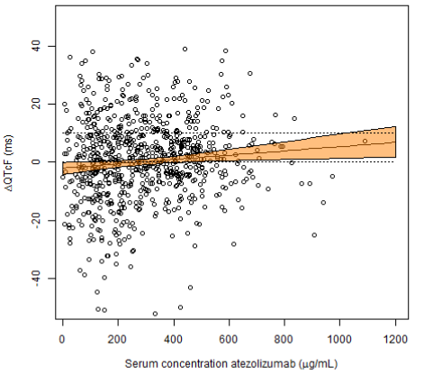
The dotted horizontal lines are reference lines at 0 and 10 milliseconds. Note that one time-matched observation (concentration, ΔQTcF = 2850 μg/mL, 13.2 ms) was outside the plotted concentration range of 0-1200 μg/mL and has not been plotted in this figure.
Comment: The predicted geometric mean ΔQTcF and the upper bound of the 2-sided, 90% CI of the predicted ΔQTcF were both less than 5 ms for the 10 mg/kg, 15 mg/kg and 20 mg/kg q3w dosing cohorts at steady state (Cycle 4). The relationship between atezolizumab concentration and ΔQTcF suggests no clinically meaningful change in ΔQTcF (i.e. ΔQTcF less than 10 milliseconds) at atezolizumab concentrations up to the geometric mean Cmax (625 μg/mL) following 4 doses of atezolizumab 20 mg/kg IV q3w. There were no data for the proposed 1200 mg q3w dose (i.e. equivalent to 15 mg/kg). However, the available Cmax concentration data at Cycle 4 obtained for the 20 mg/kg dose is expected to be greater than the Cmax concentration data at Cycle 4 following administration of 1200 mg atezolizumab (i.e. equivalent to 15 mg/kg). The C-QTc study suggests that clinically meaningful changes in the QTcF interval are unlikely at the proposed dose in patients with UC or NSCLC.

Immunogenicity

Overview
The immunogenicity of atezolizumab was investigated in the six Phase I/II studies [PCD4989g, JO28944, IMvigor 210, BIRCH, POPLAR, and FIR]. The objectives of the immunogenicity analyses were:
- to determine the prevalence of baseline ATA and incidence of treatment-emergent and transient ATA responses;
- to determine whether ATA positivity was associated with differences in exposure or response (ORR) between patients;
- to determine whether ATA positivity was associated with differences in AESIs between patients; and
- to determine whether ATA positivity was associated with hypersensitivity reactions that precluded further administration of atezolizumab.
A risk-based approach was used to design the immunogenicity testing strategy for atezolizumab. All samples for anti-therapeutic (ATA) analysis were run in an ATA screening assay that used a bridging ELISA format to detect ATA responses to atezolizumab in human serum. This assay was reported to have adequate sensitivity and robustness even in the presence of up to 200 µg/mL of atezolizumab, which is higher than the typical trough concentrations of atezolizumab. Positive samples in the screening assay were then run in a confirmatory assay, and the titres of the verified positive samples were subsequently determined. ATA data were available from all six Phase I/II studies. The validation performance data for the ATA assays are summarised below.
Table 35: Validation performance for anti-therapeutic antibody assays.
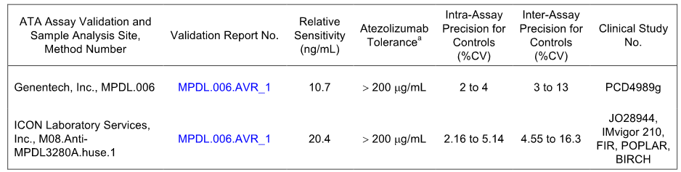
ª Atezolizumab tolerance concentration of atezolizumab present in sample where 500 ng/mL anti-atezolizumab positive control antibody can still be detected.
A neutralising antibody (NAb) assay was developed, validated, and used to determine whether ATAs present in confirmed ATA-positive samples were able to block the action of atezolizumab in an in-vitro ligand-binding assay. NAb was tested in five of the Phase I/II studies, with the excluded study being JO28944. The validation performance data for the NAb assay are summarised below.
Table 36: Validation performance for neutralising anti-therapeutic antibody assay
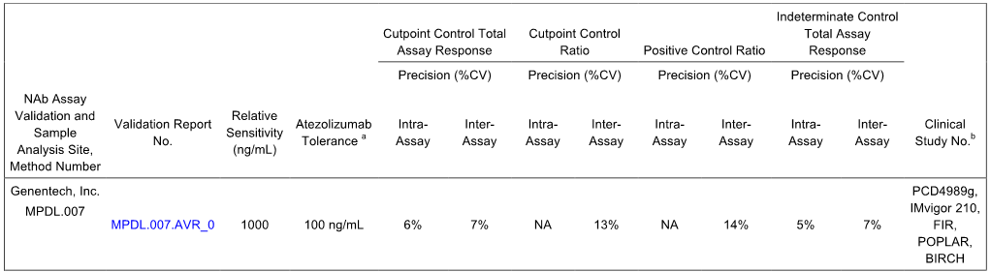ª Atezolizumab tolerance concentration of atezolizumab present in sample where 1000 ng/mL anti-atezolizumab positive control antibody can still be detected. ^{b} Neutralising anti-therapeutic assay was not done for samples from Study JO28944.

Results - ATA
The immunogenicity of atezolizumab was evaluated in Studies PCD4989g, JO28944, IMvigor 210, BIRCH, POPLAR, and FIR. The overall treatment-emergent incidence of ATA ranged from 16.7% to 54.5%. The overall baseline prevalence of ATA ranged from 0% to 7.9%.
The popPK analysis estimated that patients who were ATA-positive had an atezolizumab clearance that was approximately 16% higher than ATA-negative patients. This accounts for the trend observed across the studies for lower atezolizumab exposure metrics (i.e. Cmax, Cmin, AUC) in ATA-positive patients compared to ATA-negative patients. However, in all studies in which atezolizumab was administered at doses ≥ 10 mg/kg, serum atezolizumab concentrations remained well above the target concentration of 6 µg/mL in both ATA-positive and ATA-negative patients.
ATA status had no consistent effects on efficacy based on ORR assessment in patients with UC or NSCLC. Overall, the results were inconsistent across studies and across cohorts within studies.
ATA status had no clinically meaningful impact on the safety of atezolizumab. In the safety evaluable patients with available post-treatment ATA status, the incidence of all grade AEs, Grade 5 AEs, AEs leading to treatment withdrawal, AEs leading to dose interruption, and AESIs was similar irrespective of post-baseline ATA status in all patients (n = 1272), all UC patients (n = 384), and all NSCLC patients (n = 888).
Some numerical differences based on ATA status were observed for Grade 3-4 AEs (38.4% in ATA-negative vs 44.3% in ATA-positive patients in the all patients population). This difference was mainly driven by the higher incidence of AEs reported in the gastrointestinal disorders SOC in ATA-positive patients compared to ATA-negative patients (5.7% vs 8.5%, respectively), but no individual preferred term could be identified to explain this difference. The incidence of SAEs in the all patients population was higher in ATA-positive patients compared to ATA-negative patients (40.2% vs 33.5%, respectively), but this difference was not driven by any specific SOC or individual AE preferred term.
In the All patients population, the incidence of both hypersensitivity and infusion related reactions (MedDRA AE PTs) was low and similar for ATA-positive and ATA-negative patients. Hypersensitivity events were reported in 18 (1.4%) patients, comprising 8 (1.1%) ATA-negative patients and 10 (1.9%) ATA-positive patients. Infusion-related reactions occurred in 20 patients (1.6%), comprising 11 (1.5%) ATA-negative patients and 9 (1.7%) ATA-positive patients.

Results – neutralising antibodies
ATA positive samples were further tested in a validated NAb assay. However, due to the high number of post-treatment ATA positive samples that were indeterminate in the NAb assay, no conclusions can be drawn about the effect of NAbs. The results for the four Phase II studies are summarised below.
Table 37: Post-treatment number and percentage of NAb positive or negative samples.
 | IMvigor 210 | BIRCH | POPLAR | FIR
Total number of ATA positive samples tested | 56 | 506 | 182 | 127
Number of NAb positive samples | 0 | 0 | 0 | 1
Number of NAb negative samples | 6 | 28 | 11 | 2
Number of NAb indeterminate samples | 50 | 478 | 171 | 124
Number of NAb positive of negative samples that were from post-treatment visits | 0 | 0 | 0 | 2
% of NAb positive or negative samples that were from post-treatment visits | 0% | 0% | 0% | 1.6%

Evaluator’s conclusions on pharmacodynamics
- The exposure-efficacy (ORR) data showed no relationship in patients with UC, while in patients with NSCLC the data were inconsistent. Overall, it is considered that no firm conclusions can be made about the exposure-efficacy relationship in the submitted data. The key results for the assessment of the atezolizumab exposure-efficacy relationships were as follows: (a) in patients with UC [IMvigor 210], there was no statistically significant relationship between the probability of response and AUC, Cmax and Cmin in Cycle 1 and AUCss; (b) in patients with NSCLC [BIRCH], there was a statistically significant (p = 0.0005) positive relationship between the proportion of patients with a response (CR + PR) and the AUCss, but not with AUC, Cmax, or Cmin in Cycle 1; (c) in patients with NSCLC [BIRCH], the simulations of expected ORRs vs AUCss in patients from Cohorts 2 plus 3 were similar using fixed-dose 1200 mg and weight-based dose 15 mg/kg, supporting the proposed fixed-dose treatment regimen; (d) in patients with NSCLC [POPLAR], there were no statistically significant positive relationships between the proportion of responders (CR + PR) and AUC, Cmax and Cmin in Cycle 1 and AUCss; (e) in patients with NSCLC [POPLAR], OS probability increased with exposure based on AUC Cycle 1, Cmin Cycle 1, and AUCss; p <0.001 by Cox regression analysis; and (f) in patients with NSCLC [POPLAR], OS in patients treated with atezolizumab relative to OS in patients treated docetaxel improved with increasing exposure (AUCss) to atezolizumab.
- The exposure-safety (AEG35, AESI) response data suggested no clinically significant relationships for patients with UC and NSCLC. The key results for the assessment of the atezolizumab exposure-safety relationships were as follows: (a) in patients with UC (pooled analysis, report 1067242), there were no statistically significant relationships between exposure (AUC, Cmax, Cmin in Cycle 1, and AUCss) and safety outcomes of AEG35 or AESI; (b) in patients with NSCLC (pooled analysis, report 1068603), there were no statistically significant relationships between increasing exposure (AUC, Cmax, Cmin in Cycle 1, and AUCss) and the incidence of AEG35; (c) in patients with NSCLC (pooled analysis, report 1068603), there was a statistically significant relationship between both Cmin (Cycle 1) and AUCss and the incidence of AESI; and (d) in the patients with NSCLC (pooled analysis, report 1068603), there were no statistically significant relationships between exposure (AUC, Cmax, and Cmin in Cycle 1, and AUCss) and the most commonly reported AESI occurring in ≥ 15 patients (i.e. rash, AST increased, hypothyroidism, pneumonitis, ALT increased, maculo-papular rash).
- The atezolizumab C-QTc analysis in patients with advanced cancers from study PCD4989g suggests that clinically meaningful changes in the QTcF interval are unlikely at the proposed dose of atezolizumab (1200 mg q3w) in patients with UC or NSCLC [Report 1066934].
- The overall incidence of treatment-emergent ATAs was high in the six Phase I/II studies, with rates ranging from 16.7% to 54.5%. The popPK analysis determined that ATA-positive patients had an atezolizumab clearance that was approximately 16% higher than ATA-negative patients. This difference accounts for the trend observed across the studies for lower atezolizumab exposure metrics (Cmax, Cmin, AUC) in ATA-positive patients compared to ATA-negative patients. However, in all studies in which atezolizumab was administered at doses ≥ 10 mg/kg serum atezolizumab concentrations remained well above the target concentration of 6 µg/mL irrespective of ATA-status. ATA-status had no clinically meaningful impact on efficacy based on ORR assessment in patients with UC or NSCLC. ATA status had no clinically meaningful impact on safety in patients with UC or NSCLC. However, the incidence of Grade 3-4 AEs and SAEs was higher in ATA-positive patients compared to ATA-negative patients in the total population treated with atezolizumab. In the all patients population, the incidence of hypersensitivity and infusion related reactions (MedDRA AE PTs) was low and was similar for ATA-positive and ATA-negative patients.
- No conclusions can be drawn about the incidence of NAbs in ATA-positive patients treated with atezolizumab, due to the high number of post-treatment ATA positive samples that were indeterminate in the NAb assay. The sponsor is requested to comment on the reasons for the large number of indeterminate results.

Dosage selection for the pivotal studies
Study PCD4989g (Phase I) was the first-in-human study. The primary objectives of this study were to: (1) evaluate the safety and tolerability of atezolizumab administered by IV infusion q3w to patients with locally advanced or metastatic solid tumours or haematological malignancies; (2) determine the maximum tolerated dose (MTD) and to evaluate the dose-limiting toxicities (DLTs) of atezolizumab when administered as a single agent to patients by IV infusion q3w; and (3) identify a recommended Phase II dose of atezolizumab.
The clinical starting dose and the associated safety factor for PCD4989g were based on the results from the 8-week toxicology study in cynomolgus monkeys, which supported a no observed adverse effect level (NOAEL) of 5 mg/kg [study 08-1148]. Based on a NOAEL of 5 mg/kg and an estimated human CL value of 1.98 mL/day/kg projected from the cynomolgus monkey data, the exposure (AUC) based safety factor was 268-fold. The single-dose, body weight-normalised, dose-based safety factor calculated on body surface (BSA) at the proposed Phase I starting dose of 0.01 mg/kg was 500-fold.
The escalating dose levels of atezolizumab in the Phase I formulation tested in PCD4989g included 0.01, 0.03, 0.1, 0.3, 1, 3, 10, and 20 mg/kg administered by IV infusion q3w (21 ± 2 days). Additional intermediate dose levels and/or different schedules of atezolizumab could be tested on the basis of new nonclinical efficacy, clinical safety, and clinical pharmacokinetic data available at the time, and after discussion with the investigators.
The atezolizumab target trough concentration (Ctrough) was projected to be 6 µg/mL based on several assumptions, including a tumour-interstitial concentration to plasma ratio of 0.30 derived from tissue distribution data in tumour bearing mice, target-receptor tumour occupancy data indicating that 95% tumour-receptor saturation is needed for efficacy, and the observed atezolizumab interim PK results in humans from the dose escalation phase of PCD4989g.
In PCD4989g, no DLTs were observed at any levels during the dose escalation phase and no MTD was established. PK data from PCD4989g suggested that, while a subset of ATA-positive patients receiving 0.3 to 3 mg/kg atezolizumab q3w experienced a reduction of Cmin to below limit of quantification (LOQ), patients receiving 10 to 20 mg/kg atezolizumab maintained geometric mean Cmin levels that was in excess of both the LOQ of 0.06 µg/mL and the target serum concentration of 6 µg/mL. These data suggested that the 15 mg/kg atezolizumab q3w regimen (or fixed-dose equivalent of 1200 mg q3w) would be sufficient to maintain Cmin levels at or above the target level of 6 μg/mL, irrespective of ATA-status.
The 15 mg/kg atezolizumab q3w regimen (or fixed-dose equivalent) was considered appropriate to safeguard against both inter-patient variability and the possibility that development of ATAs could lead to sub-therapeutic levels of atezolizumab relative to the 10 mg/kg atezolizumab q3w regimen (or fixed-dose equivalent). Subsequent PK simulations using a preliminary popPK model based on PK data obtained in PCD4989g did not suggest any clinically meaningful differences in exposure following fixed-dose or weight-based regimens. On the basis of this initial preliminary analysis, a fixed-dose regimen of 1200 mg q3w (equivalent to an average body weight-based dose of 15 mg/kg) was selected for the Phase II and III studies, the Phase II study in patients with UC.
Comment: The rational for the dose selection in the pivotal and supportive Phase II studies is acceptable.

Clinical efficacy

UC

Studies providing efficacy data
The evaluable data provided to support the application to register atezolizumab for the treatment of UC were:
- IMvigor 210 (nominated by the sponsor as a pivotal study): This was a Phase II, global, multicentre, single-arm study designed to evaluate the efficacy and safety of atezolizumab in patients with locally advanced or metastatic UC. A total of 438 patients were enrolled into two separate cohorts (Cohort 1 [n = 122] and Cohort 2 [n = 316]). Cohort 1 (n = 118 treated patients) included 1L atezolizumab-treated patients with locally advanced or metastatic UC who were treatment naive for inoperable locally advanced or metastatic or recurrent UC and cisplatin-ineligible (1L cis-ineligible UC population). For patients in Cohort 1 who had received prior adjuvant/neoadjuvant chemotherapy for UC, a treatment-free interval of greater than 12 months between the last treatment administration and the date of recurrence was required in order to be considered treatment-naïve in the metastatic setting. Prior local intravesical chemotherapy or immunotherapy was allowed if completed at least 4 weeks prior to initiation of study treatment. Cohort 2 (n = 311 treated patients) included 2L+ atezolizumab-treated patients with locally advanced or metastatic UC who had progressed on prior platinum-containing chemotherapy regimens in the metastatic setting or who had progressed within 12 months of treatment with a platinum-containing adjuvant/neoadjuvant regimen (2L+ UC population). The efficacy data from Cohort 2, involving patients who received second line or beyond treatment with atezolizumab are considered to be the population directly relevant to the proposed indication. The results for Cohort 2 from IMvigor 210 have recently been published in the Lancet.
- PCD4989g UC Cohort (nominated by the sponsor as a supportive study): This was a Phase Ia, multicentre, first-in-human, open-label, dose-escalation study of the safety and PK of atezolizumab administered IV as a single agent to patients with locally advanced or metastatic solid tumors or haematological malignancies, including 93 patients with UC (2L+ UC cohort) who were OR-evaluable with at least a 24-week follow-up as of the 7 August 2015 clinical cutoff date. Efficacy was a secondary objective of this study.
- Pooled efficacy data by PD-L1 IC status including patients with UC (n = 378) administered atezolizumab as second line or beyond treatment (2L+ UC patients) from PCD4989g UC Cohort (clinical cut-off of 2 December 2014) and IMvigor 210 Cohort 2 (primary analysis clinical cut-off of 5 May 2015). No pooled analyses were performed for 1L cisplatin-ineligible UC patients since study IMvigor 210 was the only study with atezolizumab in this patient population.

Pivotal or main efficacy study – IMvigor 210

Study design, objectives, locations and dates

Design
IMvigor 210 - A phase II, multicenter, single-arm study of MPDL3280A in patients with locally advanced or metastatic urothelial bladder cancer.

Objectives
The primary objective was to evaluate the efficacy of atezolizumab in patients with locally advanced or metastatic urothelial carcinoma (UC), as measured by: (a) independent review facility (IRF) assessed ORR according to the Response Evaluation Criteria in Solid Tumours (RECIST) v1.1; and (b) investigator-assessed ORR according to modified RECIST (applicable only to Cohort 2).
The secondary objectives were: (a) to evaluate progression free survival (PFS) and duration of response (DOR) according to RECIST v1.1 as assessed by an IRF; (b) to evaluate PFS and DOR according to modified RECIST as assessed by the investigator (applicable only to Cohort 2); (c) to evaluate ORR, DOR, and PFS according to RECIST v1.1 as assessed by the investigator; (d) to evaluate overall survival (OS) and 1-year OS; (e) to evaluate the safety and tolerability of atezolizumab; (f) to characterise the PK of atezolizumab; and (g) to evaluate the incidence and titres of ATAs against atezolizumab and to explore the potential relationship of this immune response with PK, safety, and efficacy.
The exploratory objectives were: (a) to further evaluate anti-tumor activity by immunohistochemistry (IHC) categories; (b) to evaluate the relationship between tumor biomarkers (including but not limited to PD-L1, PD-1, and others), as defined by IHC and efficacy; (c) to assess predictive, prognostic, and PD exploratory biomarkers in archival and/or fresh tumor tissue and blood and their association with disease status and/or response to study treatment; (d) to evaluate the utility of biopsy at the time of apparent disease progression to distinguish apparent increases in tumour volume related to the immunomodulatory activity of atezolizumab (i.e. pseudoprogression/tumour immune infiltration) from true disease progression; (e) to evaluate investigator-assessed time in response (TIR) per RECIST v1.1; (f) to evaluate investigator-assessed TIR per modified RECIST; and (g) to evaluate disease control rate (DCR).
Comment: The primary efficacy objective in this study was the ORR. This primary objective is inconsistent with the primary efficacy endpoints for confirmatory oncological trials of ‘cure rate, OS and PFS/DFS’ outlined in the relevant EU guidelines adopted by the TGA (Guideline on the evaluation of anticancer medicinal products in man. EMA/CHMP/205/95/Rev 4). The guidelines state that ‘convincingly demonstrated favourable effects on survival are, from both a clinical and methodological perspective, the most persuasive outcome of a clinical trial. Prolonged PFS/DFS as such, however, is considered to be of benefit to the patient. Under the heading of ‘Secondary endpoints and exploratory analyses’ the guidelines state that ‘irrespective of the choice of primary endpoint OS or PFS, ORR and rate of tumour stabilisation ....should be reported’.

Design
IMvigor 210 was a global, multicentre, Phase II single-arm trial designed to evaluate the efficacy and safety of atezolizumab in patients with locally advanced or metastatic urothelial carcinoma. The study enrolled patients with the primary tumour site in the bladder, renal pelvis, ureter or urethra. A total of 438 patients were enrolled into two separate cohorts. Patients received a fixed-dose of 1200 mg IV atezolizumab on Day 1 of each 21-day cycle (i.e. 1200 mg IV q3W),
Cohort 1 consisted of 122 patients with UC who were treatment-naive for advanced disease and cisplatin ineligible as defined by consensus criteria pre-specified in the inclusion criteria. These consensus criteria required one or more of the following: (a) impaired renal function (GFR > 30 but < 60 mL/min); (b) a hearing loss (measured by audiometry) of 25 dB at two contiguous frequencies; (c) Grade ≥ 2 peripheral neuropathy (i.e. sensory alteration or paraesthesias; including tingling); and (d) ECOG performance score of 2.
Cohort 2 consisted of 316 patients who had metastatic disease and were defined as: (a) subjects who had disease progression during or following treatment with at least one platinum-containing chemotherapy regimen in the metastatic setting; (b) subjects who had disease progression within 12 months of treatment with a platinum-containing neoadjuvant or adjuvant chemotherapy regimen; and (c) subjects who were intolerant to a platinum-containing chemotherapy regimen.
The study design is summarised below.
Figure 13: IMvigor 210 – Study design.
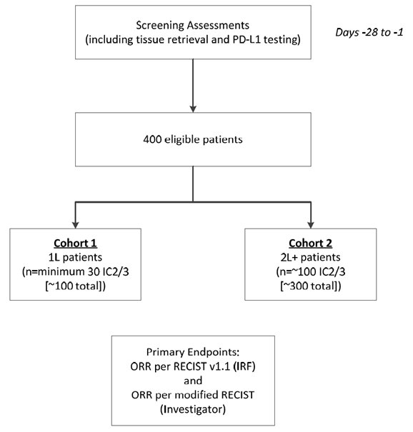
1L = first-line; 2L = second-line; IC2/3 = patients with an ICH score of 2/3; IRF = Independent Review Facility; ORR = objective response rate; RECIST = Response Evaluation Criteria in Solid Tumors. Note: ORR per modified RECIST was performed only in Cohort 2.
Approximately 400 patients in total were planned to be enrolled into two separate cohorts: in Cohort 1 (1L patients), approximately 100 patients (minimum of 30 patients with IC2/3) with advanced disease who were treatment-naïve in the metastatic setting and cisplatin-ineligible; and in Cohort 2 (2L+ patients), approximately 300 patients (approximately 100 patients with IC2/3) who had progressed during or following a prior platinum-based chemotherapy regimen (containing either cisplatin or carboplatin) for advanced disease.
Patients enrolled in Cohort 1 had to discontinue atezolizumab treatment at the first occurrence of unequivocal radiographic progression per RECIST v1.1. However, patients enrolled in Cohort 2 with confirmed radiographic disease progression could be considered for continued study treatment with atezolizumab, at the discretion of the investigator, if they continued to meet the following criteria: (a) evidence of clinical benefit (defined as the stabilisation or improvement of disease-related symptoms) as assessed by the investigator; (b) absence of symptoms and signs indicating unequivocal progression of disease (including worsening of laboratory values); (c) no decline in Eastern Cooperative Oncology Group (ECOG) performance status that could be attributed to disease progression; and (d) absence of tumour progression at critical anatomical sites (e.g. leptomeningeal disease) that could not be managed by protocol-allowed medical interventions.
In IMvigor 210, only those patients whose tumours had sufficient amounts of viable tumour tissue were enrolled. Specimens were prospectively tested for PD-L1 expression using an immunohistochemical (IHC) assay undertaken by a central laboratory. Patients, site staff, and investigators were blinded to PD-L1 expression status at the time of enrolment. The sponsor was blinded to individual patient IHC scores, but had access to aggregated level IHC data in order to monitor PD-L1 prevalence. Patients underwent tumour assessment at baseline and every 9 weeks thereafter for the first 12 months following Cycle 1, Day 1. After 12 months, patients underwent tumour assessments every 12 weeks until confirmed disease progression, withdrawal of consent, or death, whichever occurred first.
Patients who discontinued study treatment with atezolizumab for reasons other than disease progression (e.g. toxicity) continued with the scheduled tumour assessments until disease progression, withdrawal of consent, or death, whichever came first. Patients who started a new anti-cancer therapy in the absence of disease progression were followed according to the protocol until there was confirmed disease progression, withdrawal of consent, or death, whichever occurred first.
If clinically feasible (as assessed by the investigator), patients underwent mandatory tumour biopsy sample collection at the first evidence of radiographic disease progression. These data were used to confirm that radiographic findings were consistent with the presence of tumour. In addition, these data were analysed for the association between changes in tumour tissue and clinical outcome to further understand the potential mechanisms of resistance to atezolizumab.
Post-progression, all patients were followed for survival and subsequent anti-cancer therapy approximately every 3 months until death, loss to follow-up, or withdrawal of consent, whichever occurred first.
The end of study was defined as the date of the last follow-up visit of the last patient enrolled, which was expected to occur approximately 12 months after the last patient enrolled in the study. Follow-up for survival will continue until all patients have died or are lost to follow-up, or the sponsor decides to end the trial, whichever occurs first.
Prior to the final efficacy analyses, an independent review of the responses of all patients was also conducted. This review included a blinded review of computed tomography (CT) and/or magnetic resonance imaging (MRI) scans. To enable IRF analysis, all primary imaging was sent to a central site for reading. Rules and guidelines on IRF tumour assessments were outlined separately in an IRF Charter.

Assessment of PD-L1 expression levels
PD-L1 expression was assessed by an Investigational Use Only (IUO) IHC assay, which utilises an anti-PD-L1 rabbit monoclonal antibody to recognise the PD-L1 protein in tumour cells (TCs) and tumour immune-infiltrating cells (ICs) in formalin-fixed, paraffin-embedded (FFPE) tumour tissue stained with a BenchMark IHC/ISH automated staining instrument. The assay was co-developed by Roche/Ventana Medical Systems, Inc. and Roche/Genentech in order to identify patients with locally advanced or metastatic UC who are most likely to respond to treatment with atezolizumab. The level of analytical and clinical validation and use of the assay was commensurate with US FDA Center for Devices and Radiological Health guidance for pre-market devices, as labelled for IUO. The assay, which is referred to as the VENTANA PD-LI (SPI142) IHC Assay, was subsequently evaluated by the FDA as an in vitro device (IVD) and is commercially available in the USA. It is understood that the assay will be evaluated and regulated by the TGA as an in vitro device (IVD).
In patients with UC, the primary assessment of PD-L1 was on ICs while in NSCLC the primary assessment of PD-L1 was on both ICs and TCs In the report of the pre-submission meeting between the sponsor and the TGA, it is stated that the sponsor explained that the patterns of PD-L1 expression in NSCLC and UC are different. In NSCLC, unique TC and IC sub-populations are found at each expression level while in UC, IC and TC largely overlap and tumours that express PD-L1 on IC also express PD-L1 on TC. Therefore, PD-L1 expression in UC is based on IC only.
ICs are present in the intratumoural and contiguous peritumoural stroma and include lymphocytes, macrophages, and cells with dendritic or reticular morphology. ICs are scored as the proportion of tumour area covered with ICs showing PD-L1 staining of any intensity, and the score is provided as a percentage. The IHC scoring system used in IMvigor 210 to assess PD-L1 expression in ICs is summarised below.
Table 38: IHC scoring system for PD-LI diagnostic assessment for ICs.
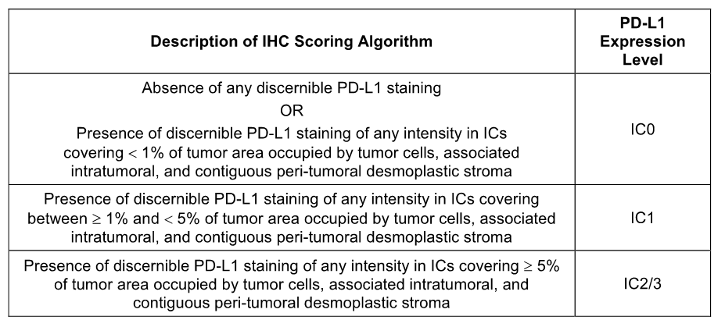
Comment: IMvigor 210 was Phase II, open-label and uncontrolled. Therefore, the study is subject to the well known biases associated with studies that are not randomised, double-blind or controlled. The proposed indication is for the treatment of patients with locally advanced or metastatic UC after prior chemotherapy. However, patients in Cohort 1 (1L patients) were required to have been treatment-naïve for locally advanced or metastatic UC and to be ineligible (‘unfit’) for cisplatin-based chemotherapy. Furthermore, these patients underwent first-line treatment with atezolizumab. Consequently, patients in Cohort 1 do not meet the proposed indication criteria. The European Society for Medical Oncology (ESMO) suggest that patients with advanced or metastatic disease who are unfit for first-line treatment with cisplatin may be palliated with a carboplatin-based regimen or single-agent taxane or gemcitabine. The Australian eviQ guidelines suggest that a carboplatin and gemcitabine combination regimen might be appropriate for these patients. It is considered that a best supportive care arm would have been an appropriate comparator for atezolizumab in Cohort 1 patients.
In contrast to Cohort 1, Cohort 2 (2L+ patients) included patients who had progressed during or following a prior platinum-based chemotherapy regimen (containing either cisplatin or carboplatin) for advanced disease. Therefore, patients in Cohort 2 meet the proposed indication criteria. Patients in Cohort 2 underwent second line of beyond treatment with atezolizumab. In Australia, the patients in Cohort 2 patients would be eligible for treatment with vinflunine, which is approved for the treatment of adult patients with advanced or metastatic transitional cell carcinoma of the urothelial tract after failure of a prior platinum-containing regimen. It appears that at the time of protocol development for IMvigor 210 vinflunine was approved in the EU as monotherapy for the treatment of adult patients with advanced or metastatic transitional cell carcinoma of the urothelial tract after failure of a prior platinum-containing regimen. Therefore, vinflunine would have been an appropriate control treatment for atezolizumab in IMvigor 210, although it is noted that the drug has not been approved in the USA.

Location and dates
The principal investigator was located in the USA. The study was undertaken in the USA (43 centres), Canada (7 centres), Spain (7 centres), France (3 centres), Great Britain (3 centres), Germany (3 centres), Italy (2 centres), and the Netherlands (1 centre). The first patient entered the study on 13 March 2014 and the last patient entered on 30 March 2015.
The submission included two IMvigor 210 clinical study reports (CSRs), the Primary CSR included data at the cut-off date of 5 May 2015 and the Update CSR included data at the cut-off date of 14 September 2015. The sponsor was F.Hoffmann-La Roche Ltd. The study was undertaken in compliance with the principles of GCP.
Comment: The Primary Analysis CSR reported the primary analysis of Cohort 2 performed approximately 24 weeks after the last patient in Cohort 2 had been enrolled (data cut-off date 5 May 2015) and an interim analysis of Cohort 1. The Update CSR reported the primary analysis of Cohort 1 performed approximately 24 weeks after the last patient in Cohort 1 had been enrolled (data cut-off date 14 September 2015, median follow-up of 8.5 months), and an updated analysis of Cohort 2 performed when all patients enrolled had a minimum of 43 weeks of follow-up (data cut-off date 14 September 2015, median follow-up of 11.7 months). In this CER, the evaluation of the efficacy data focuses primarily on patients in Cohort 2, as these are considered the patients of interest as regards the proposed indication for atezolizumab. The efficacy results for IL patients in Cohort 1 have been provided for completeness, but these treatment naïve patients in the metastatic setting do not meet the criteria for the proposed indication for atezolizumab. It is noted that in its covering letter outlining the efficacy data supporting the registration of atezolizumab for the second line treatment of locally advanced or metastatic UC, the sponsor refers to the Cohort 2 data from the Phase II study IMvigor 210 supported by relevant data from the Phase I study PCD4989g. No reference in the covering letter is made to the efficacy data from Cohort 1 in IMvigor 210.
In addition to the Primary Analysis CSR and the Update CSR, the submission also included a Supplemental Results Report for IMvigor 210 dated February 2016 with a data cut-off date of 27 November 2015. The purpose of the report was to provide updated efficacy data for Cohort 2 with a minimum of 1 year of follow-up after initiation of treatment with atezolizumab (14.4 months of median follow-up).

Inclusion and exclusion criteria
Patients eligible for this study were required to have locally advanced or metastatic UC and be aged > 18 years. The inclusion criteria included general and cohort specific criteria, and the exclusion criteria included study specific criteria in addition to general medical and medication-related exclusion criteria.
The key shared inclusion and exclusion criteria for efficacy in patients in Cohorts 1 and 2 included: (a) inclusion of patients with histologically or cytologically documented locally advanced or metastatic TCC (also termed UCC) of the urothelium (including renal pelvis, ureters, urinary bladder, urethra); (b) inclusion of PD-L1 unselected patients with tumour specimens evaluable for PD-L1 expression by IHC; (c) inclusion of patients with adequate haematological and end-organ function, calculated creatinine clearance ≥ 30 mL/min; (d) inclusion of patients with measurable disease at baseline by RECIST v1.1; (d) exclusion of patients with active or untreated CNS metastases during screening and prior radiographic assessments; (e) exclusion of patients with prior autoimmune disease; and (f) exclusion of patients with prior treatment with CD137 antagonists or immune checkpoint blockade therapies, systemic corticosteroids or other systemic immunosuppressive medications.
The key additional inclusion and exclusion relevant for efficacy in patients in Cohort 1 included: (a) no prior chemotherapy for inoperable locally advanced or metastatic or recurrent UC; for patients who had received prior adjuvant/neoadjuvant chemotherapy or chemoradiation for UC, a treatment-free interval of greater than 12 months between the last treatment administration and the date of recurrence was required in order to be considered treatment-naive in the metastatic setting; prior local intravesical chemotherapy or immunotherapy was allowed if completed at least 4 weeks prior to the initiation of study treatment; (b) ineligible (‘unfit’) for cisplatin-based chemotherapy defined by any of the following criteria, impaired renal unction (GFR > 30 but < 60 mL/min), hearing loss of 25dB at two contiguous frequencies, grade ≥ 2 peripheral neuropathy, ECOG PS of 2; and (c) ECOG PS of 0, 1 or 2.
The key additional inclusion and exclusion relevant for efficacy in patients in Cohort 2 included: (a) disease progression during or following treatment with at least one platinum containing regimen for inoperable locally advanced of metastatic UC or disease recurrence, discontinued due to Grade 4 haematological toxicity or Grade 3 or 4 non-haematological toxicity (defined as intolerance to platinum-containing regimen), had disease progression with 12-months of treatment with platinum-containing neoadjuvant or adjuvant chemotherapy, the maximum number of prior therapies in Cohort 2 was unrestricted; and (b) ECOG PS of 0 or 1.

Study treatments

Atezolizumab
Patients were administered 1200 mg atezolizumab by IV infusion every 3 weeks (q3w) by trained medical staff at the clinical site. The initial dose of atezolizumab was delivered over 60 ± 15 minutes. If the first infusion was tolerated without infusion-associated AEs, the second infusion could be delivered over 30 ± 10 minutes. If the 30-minute infusion was well tolerated, all subsequent infusions could be delivered over 30 ± 10 minutes.
For the first infusion, vital signs (heart rate, respiratory rate, blood pressure, and temperature) were determined within 60 minutes before, during (every 15 ± 5 minutes), and 30 ± 10 minutes after the infusion. For subsequent infusions, vital signs were collected within 60 minutes before infusion and at the end of the infusion. Patients were informed about the possibility of delayed post-infusion symptoms and instructed to contact their study physician if they developed such symptoms.
Any overdose or incorrect administration of study drug was noted on the Study Drug Administration electronic Case Report Form (eCRF). AEs associated with an overdose or with incorrect administration of study drug were recorded on the AE eCRF.

Atezolizumab dose modification
No atezolizumab dose reductions were planned in this study. Patients could temporarily suspend study treatment if they experienced toxicity considered to be related to study drug and required a dose to be held. If atezolizumab was held because of related AEs for > 42 days beyond when the next dose would have been given, then the patient was discontinued from atezolizumab and was followed for safety and efficacy. If, in the judgment of the investigator, the patient was likely to derive clinical benefit from resuming atezolizumab after a hold > 42 days, the study drug could be restarted with the approval of the Medical Monitor. If patients had to be tapered off steroids used to treat AEs, study treatment could be held for > 42 days. The acceptable length of interruption depended on agreement between the investigator and the Medical Monitor. Dose interruptions for reasons other than toxicity, such as surgical procedures, could be allowed with Medical Monitor approval. The acceptable length of interruption depended on agreement between the investigator and the Medical Monitor.
Methods for management of hepatitis/transaminitis, colitis, rash, hypothyroidism, and other toxicities were provided in the study protocol. These events were observed during the study and are potentially immune-related. Guidelines for the management of infusion-related reactions and precautions against anaphylaxis were also provided in the study protocol.

Concomitant therapy
Concomitant therapy included any prescription medications or over-the-counter preparations used by a patient between the 7 days preceding the screening evaluation and the treatment discontinuation visit. Systemic corticosteroids and TNF-α inhibitors may attenuate potential beneficial immunologic effects of treatment with atezolizumab, but could be administered at the discretion of the treating physician after consultation with the Medical Monitor. If feasible, alternatives to corticosteroids were to be considered. The use of inhaled corticosteroids and mineralocorticoids for patients with orthostatic hypotension or adrenocortical insufficiency was allowed. Megestrol administered as an appetite stimulant was acceptable while the patient was enrolled in the study.
No premedication was allowed for the first dose of atezolizumab. Premedication could be administered for Cycles ≥ 2 at the discretion of the treating physician after consultation with the Medical Monitor. The management of infusion-related reactions was based on standard local practice.
Influenza vaccination could be given during the influenza season only. Patients could not receive live, attenuated influenza vaccine within 4 weeks prior to Cycle 1, Day 1 or at any time during the study but could receive inactivated vaccines. Patients who used maintenance hormonal therapy with gonadotropin-releasing hormone agonists or antagonists for prostate cancer, oral contraceptives, hormone-replacement therapy, prophylactic or therapeutic anticoagulation therapy, or other allowed maintenance therapies could continue their use. Males and females of reproductive potential had to use highly effective means of contraception.

Excluded medications
The study prohibited concomitant therapy intended for the treatment of cancer, whether health authority-approved or experimental. These therapies included chemotherapy, hormonal therapy, immunotherapy, radiotherapy, investigational agents, or herbal therapy (except for maintenance therapies as specifically outlined in the Protocol). Initiation or increased doses of granulocyte colony-stimulating factors were strongly discouraged. Patients were not allowed to receive immunostimulatory agents during the study as these agents, in combination with atezolizumab, could potentially increase the risk for autoimmune conditions. Patients could not receive immunosuppressive medications, as these agents could potentially alter the activity and the safety of atezolizumab. In addition, all patients (including those who prematurely withdrew from the study) could not receive other immunostimulatory agents for 10 weeks after the last dose of atezolizumab.

Withdrawal from the study
Patients had the right to voluntarily withdraw from the study at any time for any reason. In addition, the investigator had the right to withdraw a patient from the study at any time.

Study treatment discontinuation
Patients had to discontinue study treatment if they experienced any of the following: symptomatic deterioration attributed to disease progression as determined by the investigator intolerable toxicity related to atezolizumab; any medical condition that could jeopardise the patient’s safety; use of another non-protocol anti-cancer therapy; and pregnancy.
As discussed above, patients in Cohort 2 were permitted to continue study treatment after radiologically confirmed disease progression per RECIST v1.1 if they met pre-specified criteria allowing continued treatment. Patients in Cohort 1 had to discontinue study treatment if they experienced disease progression per RECIST v1.1.

Efficacy variables and outcomes

Co-primary efficacy endpoints were:
- IRF-assessed objective response rate (ORR) according to RECIST v1.1.
- Investigator-assessed ORR according to modified RECIST (Cohort 2 only).
The ORR was defined as the proportion of patients with a confirmed best overall response (OR) of either a partial response (PR) or a complete response (CR).
Comment: The ORR as the primary efficacy endpoint is inconsistent with the relevant EU TGA adopted guideline (Guideline on the evaluation of anticancer medicinal products in man. EMA/CHMP/205/95/Rev 4). Based on these guidelines, it is considered that acceptable primary endpoints for this study could have included OS and/or PFS. The relevant guidelines note that ‘convincingly demonstrated favourable effects on survival are, from both a clinical and methodological perspective, the most persuasive outcome of a clinical trial. Prolonged PFS/DFS as such, however, is considered to be of benefit to the patient’. The guidelines also state that ‘if PFS/DFS is the selected primary endpoint, OS should be reported as a secondary and vice versa’.
Based on the relevant guidelines, it is considered that the ORR should be considered to be a secondary efficacy endpoint for a confirmatory therapeutic Phase III study. Furthermore, where the ORR is defined as the primary efficacy endpoint in a Phase II study without a control arm it is considered that it is more appropriately considered to be a supportive rather than a confirmatory endpoint.
The RECIST v1.1 criteria are standard methods for assessing solid tumour outcomes in clinical trials of chemotherapeutic agents for the treatment of cancer. From a regulatory perspective, these criteria are well understood and have been extensively used for the evaluation of the efficacy of medicines used to treat cancer. The RECIST v1.1 criteria were provided by the sponsor in the study documentation.
The sponsor states that conventional response criteria may not be adequate to characterise the anti-tumour activity of immunotherapeutic agents like atezolizumab, which can produce delayed responses that may be preceded by initial apparent radiological progression, including the appearance of new lesions. Therefore, modified response criteria (mRECIST) were developed to account for the possible appearance of new lesions and allow radiological progression to be confirmed at a subsequent assessment. In this study, patients in Cohort 2 were permitted to continue study treatment even after mRECIST criteria for progressive disease were met if the risk/benefit ratio was judged to be favourable. Modified RECIST is derived from RECIST v1.1 conventions, and immune-related response criteria (irRC). Brief extracts from the modified RECIST criteria, which were provided in full in the study. The main differences between the RECIST v1.1 and mRECIST criteria are presented below.
Table 39: Key differences between RECIST v1.1 criteria and modified RECIST.
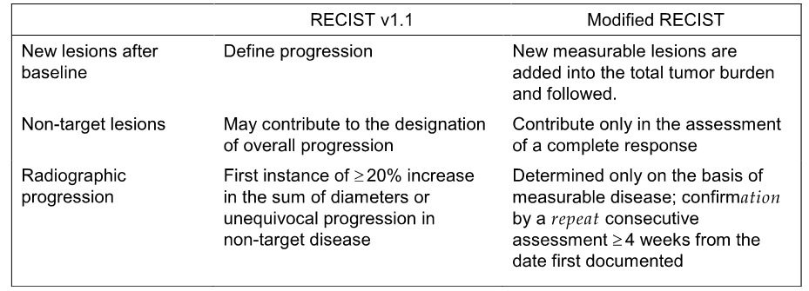

Secondary efficacy endpoints were:
- IRF-assessed duration of response (DOR) per RECIST v1.1, defined as the time from the first occurrence of a documented PR or CR (whichever occurs first) to the time of first radiographic progression as determined by the IRF per RECIST v1.1 or death due to any cause on study, whichever occurs first.
- Investigator-assessed DOR per RECIST v1.1, defined as the time from the first occurrence of a documented PR or CR (whichever occurs first) to the time of first radiographic progression as assessed by the investigator per RECIST v1.1 or death due to any cause on study, whichever occurs first.
- Investigator-assessed DOR per modified RECIST, defined as the time from the first occurrence of a documented PR or CR (whichever occurs first) to the time of first confirmed radiographic progression as assessed by investigator per modified RECIST or death due to any cause on study, whichever occurs first (applicable only to Cohort 2).
- IRF-assessed progression-free survival (PFS) per RECIST v1.1, defined as the time from the first dose of atezolizumab to the time of first radiographic progression as determined by the IRF per RECIST v1.1 or death from any cause on study.
- Investigator-assessed PFS per RECIST v1.1, defined as the time from the first dose of atezolizumab to the time of first radiographic progression as determined by the investigator per RECIST v1.1 or death from any cause on study.
- Investigator-assessed PFS per modified RECIST (applicable only to Cohort 2), defined as the time from the first dose of atezolizumab to disease progression as determined by the investigator per modified RECIST or death from any cause, whichever occurs first. A patient is considered to have disease progression by modified RECIST if either of the following conditions is met: (a) modified RECIST criteria for progression were met at a tumour assessment and no subsequent tumour assessment was performed; or (b) modified RECIST criteria for progression were met at a tumour assessment and at the subsequent tumour assessment the criteria for confirmed progression by modified RECIST were also met. For patients who meet criterion (a), the date of progression is the date of the tumour assessment that met the criteria for modified RECIST. For patients who meet criterion (b), the date of progression is the date of the tumour assessment at which the modified RECIST criteria for progression were first met. Patients who do not meet either criteria (a) or (b) are not considered to have had disease progression by modified RECIST.
- Investigator-assessed ORR per RECIST v1.1 is defined as the proportion of patients whose overall response is either confirmed PR or CR assessed by the investigator according to RECIST v1.1.
- Overall survival (OS), defined as the time from the first dose of atezolizumab to the time of death from any cause on study.
- Landmark outcome: 1-year OS.

Randomisation and blinding methods
This was an open-label, single-arm study. Enrolment of patients into the study was
through an Interactive Voice or Web Response System (IxRS). Following successful
screening evaluations and evaluation of eligibility, the ‘investigator contacted the IxRS, which then assigned atezolizumab to the patient. The patients, site staff, and investigators were blinded to PD-L1 expression status at the time of enrolment. The sponsor was blinded to individual patient IHC scores, but had access to aggregated level IHC data in order to monitor PD-L1 prevalence.
Patients underwent tumour assessment at baseline and every 9 weeks thereafter for the first 12 months following Cycle 1, Day 1. After 12 months, patients underwent tumour assessments every 12 weeks until confirmed disease progression, withdrawal of consent, or death, whichever occurred first. Prior to the final efficacy analyses, an independent review of the responses of all patients was also conducted. This included a blinded review of computed tomography (CT) and/or magnetic resonance imaging (MRI) scans.

Analysis populations
The intent-to-treat (ITT) population included all treated patients, defined as enrolled patients who received any amount of study drug. The primary efficacy analyses, the ORR analyses, were performed on the objective response-evaluable population, which was defined as ITT patients who had measureable disease per RECIST v1.1 at baseline. TIR analyses were also performed on the objective response-evaluable population. DOR and TTOR were performed on the subset of patients who achieved an objective response. OS and PFS analyses were performed on the ITT population regardless of whether they had measurable disease per RECIST v1.1.
The safety analyses were based on all treated patients, defined as enrolled patients who received any amount of study drug. Patients who were enrolled into the study but who do not receive any study drug were not included in the safety population.
The PK-evaluable population was defined as patients who received any dose of atezolizumab treatment and had PK data at time-points that were sufficient to determine PK parameters.

Sample size
Enrolment of approximately 100 patients (minimum of 30 patients with IC2/3) was planned for Cohort 1 of this study. With 30 IC2/3 patients dosed in Cohort 1, the 95% CI using the Clopper-Pearson method for an observed ORR of 40% would be 22.7% to 59.4%, and the study would have 98% power to detect a 30% increase in ORR from 10% to 40%.
Enrolment of approximately 300 patients was planned for Cohort 2 of this study. The prevalence of IC2/3 was assumed to be approximately 30% in the overall locally advanced or metastatic urothelial carcinoma population. With 100 IC2/3 patients dosed in Cohort 2, the 95% CI using the Clopper-Pearson method for an observed ORR of 40% would be 30.3% to 50.3%, and the study would have 100% power to detect a 30% increase in ORR from 10% to 40%.

Statistical methods

Primary efficacy endpoint analyses - ORR
Comparisons with respect to ORR between atezolizumab treatment and historical controls were tested for three patient populations and separately for Cohorts 1 and 2 using a hierarchical fixed-sequence procedure. Each test was performed at a two-sided alpha of 0.5, with subsequent testing in the sequence being performed if the preceding test was statistically significant. This testing procedure controlled the overall significance level for the three pairwise comparisons at an alpha of 0.5.
The three populations were: (1) objective response-valuable patients with IC2/3; (2) objective response-valuable patients with IC1/2/3l and (3) all objective response-evaluable patients. The three hierarchical tests of Cohort 1 are summarised below.
Table 40: IMvigor 210 – Three hierarchical tests of Cohort 1.
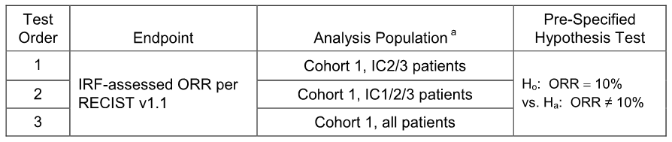
C = tumour-infiltrating immune cell; IRF = Independent Review Facility; ORR = objective response rate; RECIST = Response Evaluation Criteria in Solid Tumors. Note: The tests were to be performed in a sequential order, i.e. the subsequent hypothesis will not be performed if the preceding test is not rejected. Each test is performed at a two-sided α of 0.05 significance level. ª Objective response-evaluable population.
For Cohort 2, the hypotheses tests on the three populations were sequentially performed on the basis of IRF-assessed ORR according to RECIST v1.1 and the investigator-assessed ORR according to modified RECIST at two-sided alpha of 0.05 for each test. This testing procedure controlled the overall significance level for the six pairwise comparisons at an alpha of 0.5. The six hierarchical fixed-sequence testing procedure of Cohort 2 is summarised below.
Table 41: IMvigor 210 – Six hierarchical tests of Cohort 2.
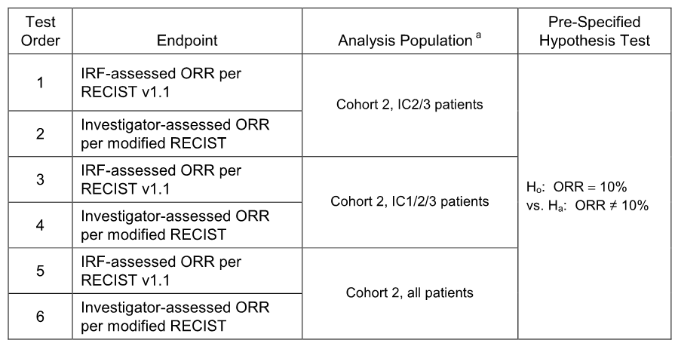
C = tumour-infiltrating immune cell; IRF = Independent Review Facility; ORR = objective response rate; RECIST = Response Evaluation Criteria in Solid Tumors. Note: The tests were to be performed in a sequential order, i.e. the subsequent hypothesis will not be performed if the preceding test is not rejected. Each test is performed at a two-sided α of 0.05 significance level. ª Objective response−evaluable population.
If a hypothesis test produced a two-sided p-value that was statistically significant at the pre-specified significance level with an estimated ORR larger than the ORR specified under the null hypothesis, it was concluded that atezolizumab monotherapy resulted in a statistically significant increase in the corresponding ORR compared to the historical control in the corresponding patient population, if the preceding hypothesis in the hierarchy was statistically significant.
The exact 95% CIs using the Clopper-Pearson method for ORR were provided. The exact binomial test was used to evaluate whether atezolizumab treatment resulted in a statistically significant difference in ORR between the observed ORR and the historical control ORR.
There were no plans to perform a formal statistical comparison of the response rates between Cohorts 1 and 2.
Comment: The historical control ORR set by the sponsor for hypothesis testing was 10%. In determining this historical ORR the sponsor referred to published data that have identified modest response rates of 10-20% in some Phase II trials of chemotherapeutic drugs for second-line systemic therapy for UC. The sponsor provided a tabulated summary of the endpoint data for randomised Phase II trials (see below), which was adapted from Sonpavde et al., 2010. In Sonpavde et al., 2010, it is stated that ‘many chemotherapy drugs and targeted agents show poor or no activity in phase 2 trials in the second-line setting, and a few yield modest response rates of 10-20%, median [PFS] of 2-3 months and median [OS] of 6-9 months’. It is noted that data in the Australia PI for vinflunine show that the drug achieved an ORR (CR+PR) of 8.6% compared to 0% in the best supportive care (BSC) arm (Δ = 8.6% [95% CI: 5.0, 13.7]). The vinflunine PI also indicates that median PFS was 3.0 months in the vinflunine arm vs 1.5 months in the BSC arm (p = 0.0012; ITT population) and median OS was 6.9 vs 4.6 months, respectively, HR = 0.77 [95% CI: 0.61, 0.98], adjusted.
Overall, the published data show marked variability in the ORR for agents used for second line treatment. The ORR ranged from 0% to 28%, and based on the data a modest historical control rate of 10-20% for second line treatment appears to be reasonable. However, the cross-study comparisons of response rates need to be interpreted cautiously because of inherent biases associated with different patient populations and varying study designs. It is considered that in the context of the current study, a comparison of the ORR for atezolizumab with a historical control rate is more appropriately considered to be a supportive rather than a pivotal efficacy analysis.
Table 42: Randomised Phase II trials of second-line therapy.
Second-Line Therapy Regimen | RR (%) | PFS (Months) | OS (months)
Weekly paclitaxel (n = 31) | 10 | 2.2 | 7.2
Nab-paclitaxel (n = 47) | 28 | 6.0 | 10.8
Irinotecan (n = 40) | 5 | 2.1 | 5.4
Ixabepilone (n = 42) | 11.9 | 2.7 | 8.0
Bortezomib (n = 25) | 0 | 1.4 | 5.7
Pemetrexed (n = 47) | 27.7 | 2.9 | 9.6
Oxaliplatin (n = 18) | 6 | 1.5 | 7.0
Ifosfamide (n = 56) | 20 | 2.4 | 5.5
Lapatinib (n = 59) | 3 | 2 | 4.5
Pemetrexed (n = 12) | 8 | ⎯ | ⎯
Docetaxel (n = 30) | 13 | ⎯ | 9.0
Gemcitabine (n = 35) | 11 | 4.9 | 8.7
Gemcitabine (n = 44) | 22.5 | ⎯ | 5.0
Topotecan (n = 44) | 9.1 | 1.5 | 6.3
Ifosfamide + Gemcitabine (n = 34) | 21 | 4.0 | 9.0
Carboplatin + Paclitaxel (n = 44) | 16 | 4.0 | 6.0
Vinflunine (n = 51) | 18 | 3.0 | 6.6
Vinflunine (n = 253) | 8.6 | 3.0 | 6.9
Gefitinib (n = 31) | 3 | ⎯ | 3.0
Sorafenib (n = 27) | 0 | ⎯ | 6.8
Sunitinib (n = 45) | 7 | 2.4 | 6.9
Pazopanib (n = 41) | 17.1 | 2.6 | 4.7

Secondary efficacy endpoint analyses
The statistical methods for the secondary efficacy outcomes were provided in detail in the Statistical Analysis Plan (SAP). No formal hypothesis testing was performed on the secondary efficacy analysis endpoints. The statistical methods used for the secondary efficacy endpoint analyses are considered to be satisfactory.

Changes in planned analyses
There were a number of changes to the planned analyses of the study. The changes have been examined and are considered to be unremarkable.

Participant flow

Primary analysis
The CSR (Primary Analysis) reported the primary efficacy analysis for Cohort 2 and the interim efficacy analysis for Cohort 1. The data cut-off dated for the primary analysis was 5 May 2015. A total of 438 patients were enrolled, including 316 in Cohort 2 and 122 in Cohort 1. Of the 438 enrolled patients, a total of 429 were treated with atezolizumab, including 311 in Cohort 2 and 118 in Cohort 1. Patient disposition at the data cut-off of 5 May 2105 is summarised below.
Figure 14: IMvigor 210 – Patient disposition, cut-off date 5 May 2015.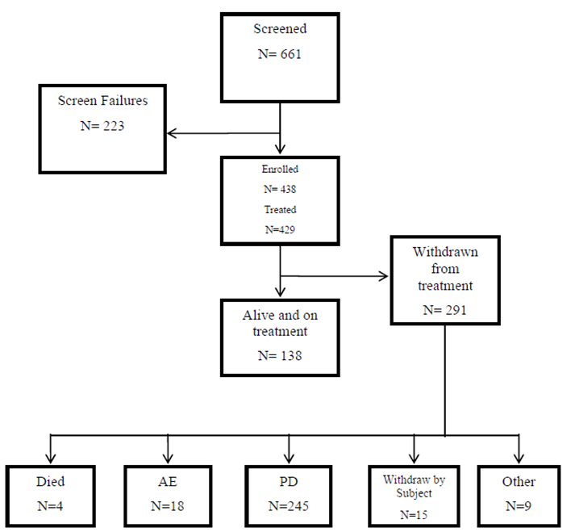

CSR (updated report)
The CSR (Update) included the primary analysis for Cohort 1 and an updated analysis for Cohort 2. The data cut-off date for the analyses was 14 September 2015. Of the 438 enrolled patients, a total of 429 were treated with atezolizumab, including 119 in Cohort 1 and 310 in Cohort 2. In the primary analysis of Cohort 2 (data cut-off 5 May 2015), there were 311 patients in the total patient group (all-comer group). As a result of updated data for cohort eligibility, 2 patients initially assigned to Cohort 2 (1 in the IC0 subgroup and 1 in the IC1 subgroup) and 1 patient initially assigned to Cohort 1 (in the IC0 subgroup) as of the 5 May 2015 cut-off were re-assigned to the alternate cohort as of the 14 September 2015 cut-off. Therefore, there were 310 patients in the all-comer group of Cohort 2 and 119 patients in the all comer group of Cohort 1, as of the 14 September 2015 cut-off. Patient disposition at the data cut-off of 14 September 2015 is summarised below.
Figure 15: IMvigor 210 – Patient disposition, cut-off date 14 September 2015.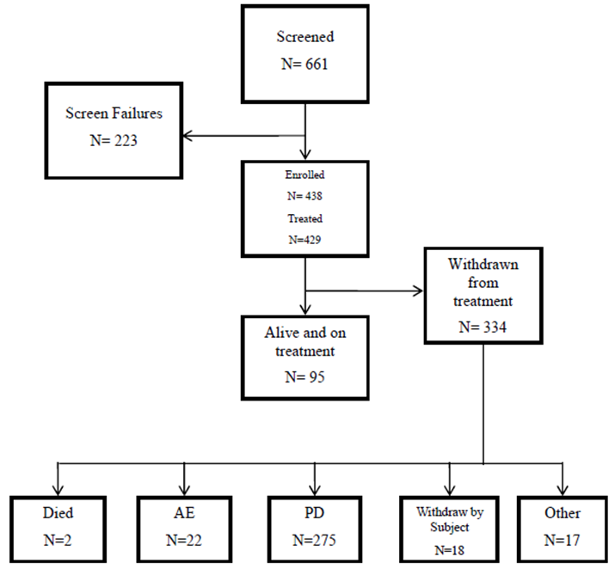
Overall, 77.9% of all patients in the safety evaluable population (334/429) discontinued from study treatment as of the 14 September 2015 clinical data cut-off date (Cohort 1: 72.3% [86/119]; Cohort 2: 80.0% [248/310]). The reasons for atezolizumab treatment discontinuation (Cohort 1 vs Cohort 2) in decreasing order of frequency in the total population were disease progression (53.8% vs 68.1%), adverse event (7.6% vs 4.2%), withdrawal by subject (7.6% vs 2.9%), other (2.5% vs 1.6%), physician decision (0.8% vs 1.9%), death (0% vs 0.6%), and non-compliance (0% vs 0.6%).
Overall, 59.2% of all patients (254/429) in the ITT population discontinued from the study as of the 14 September 2015 clinical data cut-off date (Cohort 1: 43.7% [52/119]; Cohort 2: 65.2% [202/310]). The reasons for discontinuation from the study (Cohort 1 vs Cohort 2) in decreasing order of frequency in the total population were death (38.7% vs 62.3%), withdrawal by subject (5.0% vs 2.6%), and other (0% vs 0.3%).

Major protocol violations/deviations
At the date of the updated data cut-off (14 September 2015), a total of 89 patients (89/438, 20.3%) had at least one major protocol deviation. These 89 patients included 14 patients who did not meet the study eligibility criteria, 2 patients who continued treatment beyond discontinuation criteria, 5 patients who received prohibited medication, and 71 patients who had other procedural deviations significant for safety and/or efficacy.
Fourteen (14) enrolled and treated patients did not meet baseline eligibility criteria, including 9 in Cohort 1 and 5 in Cohort 2. Five (5) patients in Cohort 1 and 1 patient in Cohort 2 did not meet inclusion criteria due to laboratory values being outside the pre-specified inclusion criteria. The inclusion criteria required additional tissue if the initial tissue came from a transurethral resection of bladder tumour (TUBRT), and 5 patients in Cohort 1 and 3 patients in Cohort 2 did not have an additional samples. One (1) patient in Cohort 2 received treatment with prohibited medication (dexamethasone) within the excluded window related to enrolment.
During the study, 2 patients in Cohort 1 developed PD defined by RECIST v1.1 and should have been withdrawn from the study but were kept on for another cycle, and 4 patients in Cohort 2 were treated with a prohibited medication (3 x denosumab, 1 x hydrocortisone).
None of the protocol deviations were considered by the sponsor to have affected the integrity of the study.

Baseline data
The baseline data are described for Cohort 2 only, as this cohort is considered to include the patients of interest for the proposed indication.

Demographics and baseline characteristics
The median age of patients in Cohort 2 was 66 years (range: 32, 91 years) with the majority (51.3%) being aged between 65 and 80 years. Overall, 91.0% of the study population was ‘White’ and 54.2% were previous tobacco users. A higher proportion of males (77.7%) were enrolled compared to females (22.3%).
The site of the primary tumour was the bladder in 74.2% of patients, renal pelvis in 13.5% of patients, ureter in 7.4% of patients, and urethra in 1.6% of patients. These percentages were generally consistent across the IC groups.
Baseline characteristics were representative of patients with poor prognostic factors. For the all-comers group, 62.3% had an ECOG PS of 1, 78.4% had visceral metastases at study entry, 31% had liver metastases at study entry; 22.3% had haemoglobin ≤ 10 g/dL, and 39.0% had time from prior chemotherapy < 3 months.
The distribution of Bellmunt risk factors in all-comers group was 0 (26.8%), 1 (37.7%), 2 (28.7%), and 3 (6.8%). The three Bellmunt baseline risk factors are ECOG ≥ 1, liver metastases, and haemoglobin < 10 g/dL. Additionally, there was representation of heavily pretreated patients in Cohort 2, with 40.9% of patients having received ≥ 2 regimens in the metastatic setting and 52.6% having received ≥ 2 prior lines of therapy, including neoadjuvant/adjuvant therapy. Prior therapy with Bacillus Calmette-Guérin (BCG) was higher in the IC0/1 subgroup (27.6%) than in the IC2/3 subgroup) (15.0%).
In general, the demographic and other baseline characteristics were consistent across the three pre-defined populations of interest (IC2/3, IC1/2/3, and all-comers).

Baseline IHC IC prevalence
PD-L1 expression was determined prospectively in tumour-infiltrating immune cells (ICs). Tumour tissue was collected at screening, however, only patients with sufficient amounts of viable tumor were enrolled. Patients who submitted TURBT tissue sample for screening were requested to submit a non-TURBT sample. If two or more screening tissue samples were submitted, then the highest PD-L1 score among samples assayed on or prior to first study drug administration was used for analysis. The baseline prevalence of ICs in patients in Cohort 2 is summarised below.
Table 43: IMvigor 210 – Baseline prevalence of ICs in Cohort 2.
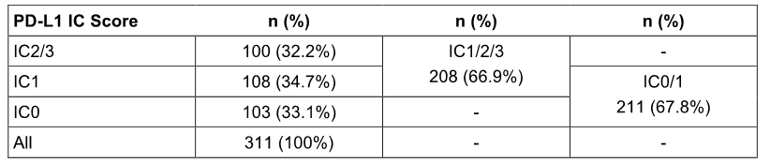
IC = tumour-infiltrating immune cells. The algorithm for the IC scores uses the maximum score among multiple IC scores assayed on or prior to the first treatment data.

Prior treatment for urothelial cancer
At the time of enrolment, 310 patients (99.7%) in Cohort 2 had received prior chemotherapy and 99 patients (31.8%) had received prior radiotherapy. Prior systemic therapy data was not available for one patient at the time of the clinical cut-off.
Heavily pre-treated patients were represented in Cohort 2, with 60.8% of all-comers having received ≥ 2 systemic regimens in any setting and 39.5% of all-comers having received ≥ 2 prior systemic regimens in the metastatic setting. A total of 161 (51.8%) patients had ≥ 2 prior lines of therapy. Results were generally similar across the pre-specified IC subgroups.
The most common prior platinum-based regimens were cisplatin-based (227 patients, 73.5%) and carboplatin-based (80 patients, 25.9%). Two (2) patients did not have a record of previous platinum-based regimen.
A total of 243 (78.1%) Cohort 2 all comer patients had a platinum-containing chemotherapy regimen in the metastatic setting, 65 (20.9%) had a platinum-containing adjuvant or neoadjuvant regimen with the first PD occurring within 12 months, 2 (0.6%) patients had a platinum-containing adjuvant or neoadjuvant regimen with the first PD occurring beyond 12 months, and 1 (0.3%) patient had no prior regimen reported.
Prior therapy with BCG was reported in 23.5% of Cohort 2 patients, and was higher in the IC0/1 subgroup (27.5%) compared to the IC2/3 subgroup (15.0%). Prior cystectomy was reported in 44.0% of the IC2/3 subgroup, 39.9% of the IC1/2/3 subgroup, and 37.6% of the all-comers group.

Previous and concurrent disease
Previous medical conditions were reported in 44.4% of patients in Cohort 2. The most common previous medical conditions were reported in the SOCs of gastrointestinal disorders (11.3%), infections and infestations (10.3%) and neoplasms benign, malignant and unspecified (incl cysts and polyps) (10.3%).
Concurrent medical conditions were reported in all patients in Cohort 2. The majority reflected the expected comorbidities of the study population, including patients with chronic kidney disease (8.0%) and peripheral neuropathy (17.7%). The most frequently reported SOCs in Cohort 2 (≥ 50% patients) included vascular disorders 59.2% (including hypertension 54.7%); gastrointestinal disorders 57.2% (including constipation 28.6%, gastro-oesophageal reflux disease 18.0%, nausea 16.7%, and abdominal pain 10.3%); and metabolism and nutrition disorders 52.4% (including hyperlipidemia 15.8%, hypercholesterolemia 12.9%, decreased appetite 10.6%, and type 2 diabetes mellitus 8.0%).

Previous/concomitant treatments
A total of 298 patients (95.8%) in Cohort 2 had at least one previous/concomitant treatment. The most commonly reported concomitant treatments were vitamins and minerals (32.2%), opioid analgesics (31.5%), analgesics (30.2%), proton pump inhibitors (28.6%), statins (25.7%), laxatives and stool softeners (24.8%), and beta-adrenoceptor blocking agents (23.5%).

Results for Cohort 1
The efficacy results for Cohort 1 are from the primary analysis based on data with a clinical cut-off date of 14 September 2015, allowing for at least 24 weeks of follow-up after the last enrolled patient. At the cut-off date of 14 September 2015, the median duration of survival follow-up in the all-comers group (n = 119) in the ITT population was 8.5 months (range: 0.2, 14.3 months). The median duration of exposure in the all-comers group (n = 119) in the safety evaluable population was 15.0 weeks (range: 0, 60 weeks). The patients included in Cohort 1 do not reflect the patient group proposed for treatment with atezolizumab.
The results for the primary efficacy endpoint analysis for the ORR (IRF-assessed; RECIST v1.1) are summarised below. The ORR for the IC2/3 subgroup was 21.9%, but this percentage was not statistically significant compared to the historical control of 10% (p = 0.0717). Therefore, due to the pre-specified hierarchical testing procedure, statistical testing of the ORR outcomes of the IC1/2/3 subgroup and the all-comers group against the 10% historical control cannot be formally conducted. Consequently, the p-values for the ORR comparisons between the IC1/2/3 subgroup and the 10% historical control (p = 0.0247) and the all-comers group and the 10% historical control (p = 0.0031) were provided for descriptive purposes only. The key results for the primary and secondary efficacy parameters in Cohort 1 for IC2/3, IC1/2/3 and all-comers group populations are provided.
Table 44: IMvigor 210 – Cohort primary efficacy endpoint, primary analysis at data cut-off of 14 September 2015.
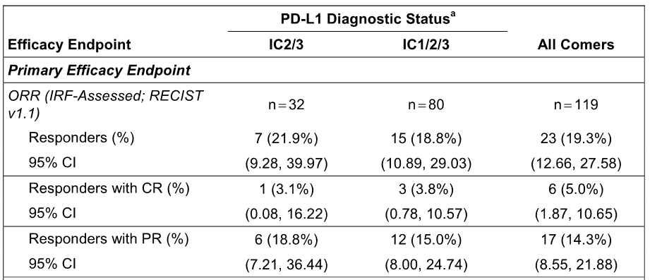
* = censored value; CI=confidence interval; CR = complete response; DOR=duration of objective response; IC= tumour-infiltrating immune cells; IRF= independent review facility; NE=not evaluable; ORR=objective response rate; OS=overall survival; PFS=progression-free survival; PR = partial response; RECIST=Response Evaluation Criteria in Solid Tumors v1.1. ª IC subgroups are diagnostic subgroups supported by the Premarket Approval (PMA) submitted to US FDA.

Cohort 2 - results for the primary efficacy outcome – primary analysis
The efficacy results for Cohort 2 are the results of primary interest for the proposed indication. The data cut-off date of 5 May 2015 (primary analysis) allowed for at least 24 weeks of follow-up for the last enrolled patient, with a median duration of survival follow-up in the all-comers group (n = 311) of 7.1 months (range: 0.2, 10.6 months) in the ITT population. In the all-comers group, the median time on study treatment was 12.3 weeks (range: 0, 46 weeks) in the safety-evaluable population. The three pre-defined populations of interest were the IC2/3 and IC1/2/3 subgroups and the all-comers group (irrespective of PD-L1 status). The results for the co-primary efficacy endpoint analyses in the three pre-defined populations of interest are summarised below.
Table 45: IMvigor 210 – Cohort 2 co-primary efficacy endpoints, primary analysis at a data cut-off of 5 May 2015.
Co-primary efficacy endpoints | IC 2/3 | IC 1/2/3 | All-Comers
ORR (IFR-assessed, RECIST v1.1) | n = 100 | n = 208 | n = 311
Responders (%) | 27 (27.0%) | 38 (18.3%) | 47 (15.1%)
95% CI | (18.6, 36.8) | (13.3, 24.2) | (11.3, 19.6)
p vs historical control of 10 % | p < 0.0001 | p < 0.0004 | p = 0.0058
ORR (investigator-assessed, modified RECIST) | n = 100 | n = 208 | n = 311
Responders (%) | 26 (26.0%) | 44 (21.2%) | 57 (18.3%)
95% CI | (17.7, 35.7) | (15.8, 27.3) | (14.2, 23.1)
p vs historical control of 10 % | p < 0.0001 | p < 0.0001 | p < 0.0001
Notes: ORR = Objective Response Rate; HC of 10% = historical response rate of 10%.
Comment: The primary analysis showed that atezolizumab met both co-primary efficacy endpoints relating to the ORR in the three pre-defined populations, with the ORR in each of the three populations being significantly greater than the historical response rate of 10%. However, the ORR in the IC2/3 subgroup was notably greater than in the IC1/2/3 subgroup, which suggests that patients in the IC2/3 subgroup with PD-L1 expression ≥ 5% in ICs are the optimal treatment population. There were no separate data for patients with IC2 or IC3 as PD-L1 score ≥ 5% was allocated to IC2/IC3.

Best Objective Response – IC subgroup analysis
The subgroup analyses of best objective response based on PD-L1 expression at the cut-off date of 5 May 2015 are summarised. The key findings were: (1) ORR in patients with IC0, IC1, and IC 0/1 were low, with the respective percentages being 8.7%, 10.2%, and 9.5%. The IC0 and IC1 were pre-specified exploratory subgroups. The subgroup with the highest ORR was IC 2/3 (27.0%). (2) In all subgroups, the contribution of patients with PR to the ORR (CR +PR) was notably greater than the contribution of patients with CR. (3) The most common objective response in all subgroups was progressive disease, which varied between 43.0% and 56.5% across the subgroups. The results for the subgroup analyses of best objective response assessed by investigator per modified RECIST were consistent with the corresponding results assessed by IRF per RECIST v1.1, although response rates were generally higher as assessed by the investigator per modified RECIST.
Comment: The exploratory analysis showed that patients in the IC0 and IC1 subgroups had ORRs (IRF-assessed; RECIST v1.1) of 8.7% and 10.2%, respectively, suggesting tumour responsiveness to atezolizumab. The IC0 subgroup was defined by the absence of any discernible PD-L1 staining in ICs or ICs with < 1% PD-L1 staining, while the IC1 subgroup was defined by ICs with ≥ 1% to <5% PD-L1 staining. The ORR in the IC0/IC1 sub group (< 5% PDL-1 staining) was 9.5% compared to 27.0% in the IC2/3 sub group (≥ 5% PD-L1 staining). The results suggest that tumour responsiveness is directly related to PD-L1 expression in ICs.

Multivariate logistic model – IC subgroup comparison
Based on the results from the multivariate logistic regression model when Bellmunt risk was controlled, the odds ratio of the ORR (IRF-assessed, RECIST v1.1) for the comparison between the IC2/3 and IC0 subgroups was 3.98 (95% CI: 1.72, 9.17), and for the comparison between the IC1 and IC0 subgroups was 1.21 (95% CI: 0.47, 3.10). The three Bellmunt risk factors are ECOG PS ≥ 1, having liver metastases (Yes), and haemoglobin < 10g/dL. The results are summarised below.
Table 46: IMvigor 210 – Multivariate logistic regression model for ORR by IRF per RECIST v1.1, data cut-off date 5 May 2015.
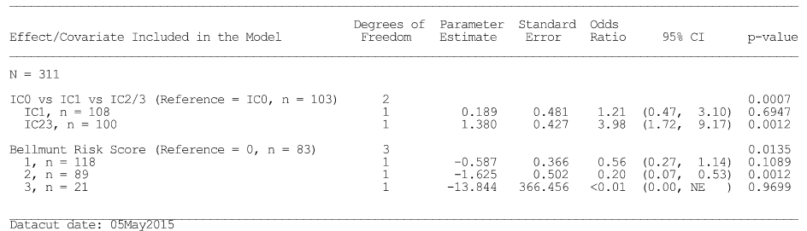

ORR in key subgroups based on demographic and other baseline characteristics
The ORR estimates in key subgroups defined by demographic (e.g. age, sex, and race/ethnicity) and other baseline characteristics (e.g. PD-L1 IHC status, number of Bellmunt risk factors, liver metastasis, visceral metastasis, ECOG PS, prior treatment and smoking history) were assessed. The majority of the subgroups with ≥ 25 patients had ORRs ≥ 10% (IRF-assessed; RECIST v1.1.).
ORRs ≥ 10% assessed by IRF per RECIST v1.1 reported in subgroups with ≥ 25 patients were: TC0 (14.9%); TC2 (17.9%); males (16.9%); age < 65 years (14.3%); age ≥ 65 years (15.7%); ECOG PS0 (23.9%); primary site bladder (17.3%); no liver metastases (19.1%); no visceral metastases (33.8%); haemoglobin ≥ 10 g/dL (16.9%); baseline creatinine clearance < 60 mL/min (14.0%); baseline creatinine clearance ≥ 60 mL/min (14.7%); no Bellmunt risk factors (26.5%); 1 Bellmunt risk factor (16.1%); transitional cell carcinoma (15.8%); prior systemic treatment (15.2%); prior cisplatin based regimen (15.4%); prior carboplatin regimen and no other platinum (15.0%); no prior systemic regimens in the metastatic setting (20.6%); 1 prior systemic regimen in the prior setting (11.7%); 2 prior systemic regimens in the metastatic setting (17.7%); 3 prior regimens in the metastatic setting (15.8%); prior systemic regimen setting adjuvant or neoadjuvant having first PD within 12 months (20.0%); prior systemic regimen administered in the metastatic setting (13.6%); one line of prior therapy (14.3%); two lines of prior therapy (17.1%); three lines of prior therapy (17.0%); ≤ 3 months from prior therapy (11.6%); ≥ 3 months from prior therapy (11.6%); no prior BCG (16.8%); biopsy type resection (18.6%); and biopsy type TURBT (13.8%).
ORRs < 10% assessed by IRF per RECIST v1.1 reported in subgroups with ≥ 25 patients were: female (8.7%); ECOG PS1 (9.8%); primary located in the renal pelvis (9.8%); liver metastases (6.3%); visceral metastases (9.9%); haemoglobin < 10 g/dL (8.7%); 2 Bellmunt risk factors (6.7%); transitional cell carcinoma with mixed histology (7.4%); ≥ four lines of prior therapy (9.4%); prior BCG treatment (9.6%); and biopsy type tumour biopsy (4.7%).

Cohort 2 - results for the secondary efficacy outcomes
The results for the four key secondary efficacy endpoints in Cohort 2 (three pre-defined populations) are summarised below. The DOR and the PFS results summarised below focus on the IRF-assessments per RECIST v1.1 criteria, which tended to be the most conservative assessments. The clinical cut-off date for the analyses was 5 May 2015, which allowed for at least 24 weeks of follow-up for the last enrolled patient. The median length of follow up was 7.1 months.
Table 47: IMvigor 210 – Cohort 2 secondary efficacy endpoints, primary analysis at data cut-off 5 May 2015.
Secondary efficacy endpoints | IC 2/3 | IC 1/2/3 | All-Comers
DOR (IRF-Assessed; RECIST v1.1) | n = 27 | n = 38 | n = 47
Patients with Event n (%) | 4 (14.8%) | 4 (10.5%) | 4 (8.5%)
Patients without event n (%) | 23 (85.2%) | 34 (89.5%) | 43 (91.5%)
Median months (range) | NE (2.1*, 8.3*) | NE (2.1*, 8.3*) | NE (2.1*, 8.3*)
PFS (IRF-Assessed; RECIST v1.1) | n = 100 | n = 208 | n = 311
Patients with Event n (%) | 74 (74.0%) | 163 (78.4%) | 241 (77.5%)
Median months (95% CI) | 2.14 (2.10, 4.14) | 2.10 (2.07, 2.14) | 2.10 (2.07, 2.14)
OS | n = 100 | n = 208 | n = 311
Patients with Event n (%) | 35 (35.0%) | 93 (44.7%) | 141 (45.3%)
Median months (95% CI) | NE (7.62, NE) | 7.95 (6.70, NE) | 7.89 (6.70, NE)
1-year OS ** | n = 100 | n = 208 | n = 311
Patients at risk - OS Rate | NE | NE | NE
CI=confidence interval; DOR=duration of objective response; IC= tumour-infiltrating immune cells; IRF= independent review facility; NE=not evaluable; ORR=objective response rate; OS=overall survival; PFS=progression-free survival; RECIST=Response Evaluation Criteria in Solid Tumors v1.1. * IC2/3 and IC1/2/3 are diagnostic sub-groups supported by the PMA. ** 1-year OS landmark was not evaluable because it was not yet reached for a median follow up of 7.1 months.
The KM curves for PFS by IRF per RECIST v1.1 for the IC0, IC1 and IC2/3 subgroups are summarised below in Figure 16. The KM curves showed that median PFS survival was the same for the three subgroups, but that PFS appeared to be better in the IC2/3 subgroup than in the IC0 and IC1 subgroups.
Figure 16: KM curved for PFS by IRF per RECIST v1.1 in the IC0, IC1, and IC2/3 subgroup in Cohort 2, ITT population 5 May 2015 cut-off.
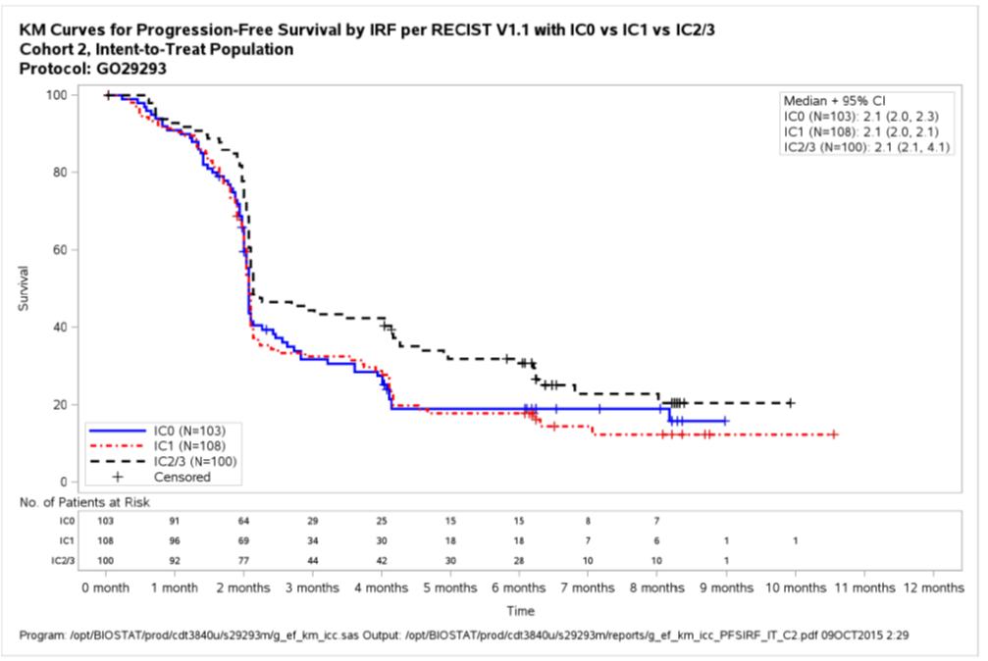
The KM curves for OS by IRF per RECIST v1.1 for the IC0, IC1 and IC2/3 subgroups are summarised below. The OS curves showed that the survival for the IC2/3 subgroup appeared to be better than that for the IC0 and IC1 subgroups.
Figure 17: KM curved for OS by IRF per RECIST v1.1 in the IC0, IC1, and IC2/3 subgroup in Cohort 2, ITT population 5 May 2015 cut-off.
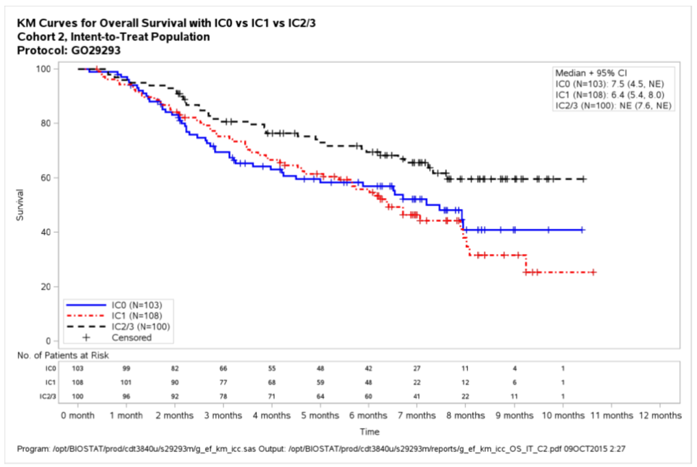
Comment: The median DOR (IRF-assessed; RECIST v1.1) had not been reached in any of the three pre-defined populations at the data cut-off date of 5 May 2015. The majority of responders in each of the three pre-defined populations were still responsive at the data cut-off date. As of the clinical data cut-off date of 5 May 2015, 4 of the 27 responders (14.8%) in the IC2/3 subgroup had progressed (2 due to new lesion and 2 due to non-target lesion PD), none of the 4 PD patients had target lesion percent change in sum of longest diameters (SLD) increase of more than 20% compared to nadir. The DOR assessed by investigators using RECIST v1.1 and mRECIST criteria also showed that the majority of responders in each of the three pre-defined populations were still responsive at the data cut-off date.
The median PFS (IRS-assessed; RECIST v1.1) was similar for the IC2/3 and IC1/2/3 subgroups and the all-comers group, and ranged from 2.10 to 2.14 months. In the all-comers group (n = 311), 241 (77.5%) patients had an IRF-assessed event of disease progression per RECIST v1.1 or death. In the all-comers group (n = 311), 170 (54.7%) patients were alive at the time of the 5 May 2015 data cut-off date. Median OS had not been reached in the IC2/3 subgroup, but was 8.0 months in the IC1/2/3 subgroup and 7.9 months in the all-comers group. As of the 5 May 2015, the 1-year OS rate had not been reached in the IC2/3 or IC1/2/3/ subgroups or the all-comers group.

Cohort 2 – updated results based on 14 September 2015 cut-off date.
Efficacy results for Cohort 2 were updated in the CSR (Study Update) with a data cut-off date of 14 September 2015. The median length of follow-up was 11.7 months. The results were consistent with the primary analysis based on the 5 May 2105 data cut-off date. The updated results for patients in Cohort 2 for the three pre-specified IC populations at the data cut-off date of 14 September 2105 are provided; the key updated results are summarised below.
- ORR (IRF-Assessed, RECIST v1.1) (co-primary efficacy endpoint) – The ORR was 26% (26/100), 17.9% (37/207) and 14.5% (45/310) in the IC2/3, IC1/2/3 and all-comers populations, respectively. The majority of responders in each of the populations were partial responders rather than complete responders.
- ORR (IRF-Assessed, modified RECIST) (co-primary efficacy endpoint) - The ORR was 27% (27/100), 21.7% (45/207) and 18.7% (58/310) in the IC2/3, IC1/2/3 and all-comers populations, respectively. The majority of responders in each of the populations were partial responders rather than complete responders.
- Median DOR (IRF-Assessed; RECIST v.1.1) (secondary efficacy endpoint) - Median DOR had not been reached in any of the three populations. Responses were durable, with ongoing responses at the data cut-off date being observed in 22 of the 26 responders (84.6%) in the IC2/3 subgroup, 32 of the 37 responders (86.5%) in the IC1/2/3 subgroup, and 38 of the 45 responders (84.4%) in the all-comers group. At the clinical data cut-off date, 4 of the 26 responders (15.4%) in the IC2/3 subgroup had progressed (2 due to new lesion and 2 due to non-target lesion PD) and none of the 4 PD patients had target lesion SLD increase of more than 20% compared to nadir. The estimated 1-year landmark DOR event-free rate was 84.3%, 85.5%, and 83.6% for the IC2/3, IC1/2/3 and all-comers populations, respectively.
- OS (secondary efficacy endpoint) - Of the 310 patients in Cohort 2, 117 (37.7%) were alive at the time of the 14 September 2015 data cut-off date for the updated analysis. The OS median was 11.40 months (95% CI: 9.00, NE) in the IC2/3 subgroup, 8.84 months (95% CI: 7.06, 10.55) in the IC1/2/3 subgroup, and 7.92 months (95% CI: 6.60, 9.26) in the all-comers group. For the updated analysis, the 1-year OS rate was 48.0% (95% CI: 37.57, 58.42) in the IC2/3 subgroup, 38.6% (95% CI: 31.50, 45.76) in the IC1/2/3 subgroup, and 35.6% (95% CI: 29.87, 41.32) in the all-comers group.

Cohort 2 – results from supplementary report 27 February 2016 cut-off date
The submission included a supplementary report dated February 2016 for patients in Cohort 2, with a data cut-off date of 27 November 2015 and a minimum of 1 year follow-up after the last patient was included in the study. The median survival follow-up for the Cohort 2 all-comers group (n = 310) was 14.4 months, and the median survival follow-ups for the IC2/3 and IC1/2/3 subgroups groups were 14.6 months and 14.4 months, respectively. The results are summarised below.
Table 48: IMvigor 210 Cohort 2 – Updated efficacy data, data cut-off 27 November 2015.
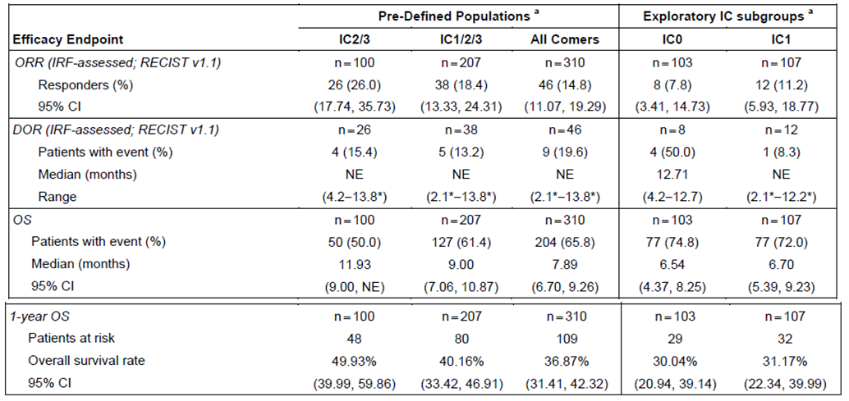
DOR = duration of response; IC = tumour-infiltrating immune cells; IRF = independent review facility; NE = not estimable; ORR = objective response; RECIST = Response Evaluation Criteria in Solid Tumors. * denotes a censored value ª As a result of ongoing data cleaning of cohort eligibility, two patients (one within the IC0 and one within the IC1 subgroups) assigned to Cohort 2 and one patient (within the IC0 subgroup) assigned to Cohort 1 as of the primary analysis (5 May 2015) were re-assigned to the alternate cohort as of 14 September 2015. As a result, there are 310 patients in the all-comer group of Cohort 2. No additional patients switched cohorts as of 27 November 2015.
A higher number of complete responses were observed at the 27 November 2015 cut-off compared to the primary analysis, which could be a result of longer follow-up (see below).
Table 49: IMvigor 210 Cohort 2 – confirmed complete response rates.
Group | Primary Analysis 5 May 2015 | Data cut 27 November 2015
IC2/3 | 8.0% (8/100 patients) | 12.0% (12/100 patients)
IC1/2/3 | 5.3% (11/208 patients) | 6.8% (14/207 patients)
All-comer | 3.9% (12/311 patients) | 5.5% (17/310 patients)
IC1 | 2.8% (3/108 patients) | 1.9% (2/107 patients)
IC0 | 1.0% (1/103 patients) | 2.9% (3/103 patients)

Comment: In Cohort 2, the ORR (IRF-assessed; RECIST v1.1) results for the primary analysis (5 May 2015 cut-off) and the supplementary analysis (27 November 2015 cut-odd) were consistent in each of the three pre-defined populations. The relevant ORR results (primary vs supplementary) were 15.1% vs 14.8% for the all-comers group, 27.0% vs 26.0% for the IC2/3 subgroup and 18.3% vs 18.4% for the IC1/2/3 subgroup. In both the primary and supplementary analyses, median DOR (IRF-assessed; RECIST v1.1) had not been reached in the three pre-defined populations. In the all-comers group (n = 310), the DOR (IRF-assessed; RECIST v1.1) analyses showed that 37 of 46 responders (80.4%) in the supplementary analysis had an ongoing response, indicating that response remained durable in the majority of patients despite the longer duration of follow-up. At the data cut-off of 27 November 2015, the percentage of patients remaining on treatment was 76.1% for the all-comers group, 76.9% for the IC2/3 subgroup and 76.3% for the IC1/2/3 subgroup. In the supplementary analysis, the median OS was reached in all three pre-defined populations, with the values being 11.9 months in the IC2/3 subgroup, 9.0 months in the IC1/2/3 subgroup, and 7.9 months in the all-comers group. The 1 year survival rates for the IC2/3, IC1/2/3 and all-comers populations were 49.9%, 40.2% and 36.9% respectively.

Supportive study – PCD4989g
Study PCD4989g was nominated by the sponsor as the supportive study for atezolizumab for the treatment of UC. PCD4989g was Phase Ia, multicentre, first-in-human, open-label, dose-escalation study of the safety and PK of atezolizumab administered IV as a single agent to patients with locally advanced or metastatic solid tumours or haematologic malignancies, including a UC cohort (2L+ UC). The secondary objectives included a preliminary assessment of the anti-tumour activity of atezolizumab and the exploratory objectives included evaluation of overall survival. The submission included data for the UC cohort as of the clinical cut-off dates of 2 December 2014 (minimum follow-up 12 weeks; median follow-up 10.9 months) and 7 August 2015 (minimum follow-up 24 weeks; median follow-up 20.0 months).
Both IMvigor 210 Cohort 2 and PCD4989g UC Cohort enrolled patients with locally advanced and metastatic or recurrent UC, with measurable disease at baseline assessed per RECIST v1.1 and ECOG PS of 0 or 1. A key difference between the two study cohorts was that IMvigor 210 Cohort 2 enrolled patients based on an all-comers basis (i.e. irrespective of PDL1 status) whereas the PCD4989g UC Cohort selectively enrolled patients based on PD-L1 status.
In PCD4989g UC Cohort, a prototype PD-L1 IHC assay was initially used to prospectively evaluate PD-L1 expression in tumour tissue. Later in the study, this assay was developed into an IUO assay (VENTANA PD-L1 [SP142] IHC assay) and used to prospectively assess patients. In addition, the IUO assay was used to retrospectively assess PD-L1 expression status in patients with remaining tumour tissue who were screened with the prototype assay. The scoring algorithm for PD-L1 staining used in PCD4989g was consistent with that used in IMvigor.

Results - primary efficacy based on data at the cut-off date of 2 December 2014
The primary efficacy endpoint analyses for UC in PD4989g were ORR and DOR per IRF-RECIST and confirmed ORR assessed by investigator (INV)-RECIST v1.1 and by independent review facility (IRF) RECIST v1.1. Secondary endpoints comprised best response recorded from the start of the study treatment period until the end of treatment (BOR, unconfirmed), DOR, 6-month PFS, 1-year PFS per RECIST v1.1, and 1-year OS. Exploratory endpoints comprised PFS, TIR, and PFS in responders, and TTOR, per RECIST v1.1, and OS.
As of the data cut-off of 2 December 2014, a total of 92 patients were enrolled and treated with atezolizumab in the UC Cohort. The selected dose for the UC cohort was 15 mg/kg, which was later converted to an equivalent fixed-dose of 1200 mg. Overall, 86 patients received weight-based dosing of 15 mg/kg and 6 patients were dosed with the fixed-dose of 1200 mg.
In the analysis based on the clinical data cut-off of 2 December 2014, 87 patients in the UC cohort had a minimum 12-week follow-up and were included in the OR-evaluable population. The OR-evaluable population comprises patients in the UC efficacy-evaluable population with measurable disease at baseline who were followed up for a minimum of 12 weeks (clinical data cut-off 2 December 2014) following the first dose of atezolizumab. At the clinical data cut-off data of 2 December 2014, the number of patients in the IC populations were 19 in the IC2/3 subgroup, 30 in the IC1 subgroup and 18 in the IC0 subgroup, with IC status being unknown in 20 patients. The key efficacy findings, based on the IHC diagnostic criteria using the IUO assay, are summarised below.
Table 50: PCD4989g – Key endpoints of interest based on IHC criteria using IUO-labelled assay at data cut-off date of 2 December 2014.
Endpoint | IC2/3 | IC1 | IC0
ORR (IRF-RECIST v1.1); | 36.8% (7/19) | 23.3% (7/30) | 11.1% (2/18)
confirmed; OR-evaluable pop. | 95% CI: 16.3, 61.6 | 95% CI: 9.9, 42.3 | 95% CI: 1.4, 34.7
ORR (INV-RECIST v1.1); | 42.1% (8/19) | 26.7% (8/30) | 16.7% (3/18)
confirmed; OR-evaluable pop. | 95% CI: 20.3, 66.5 | 95% CI: 12.3, 45.9) | 95% CI: 3.6, 41.4
BOR (IRF-RECIST v1.1) | 42.1% (8/19) | 26.7% (8/30) | 16.7% (3/18)
unconfirmed; OR-evaluable pop. | 95% CI: 20.3, 66.5 | 95% CI: 12.3, 45.9 | 95% CI: 3.6, 41.4
DOR (IRF-RECIST v1.1) | Responders (7/19) | Responders (7/30) | Responders (2/18)
Median duration months) | NE (range: 5.8*, 14.7*) | NE (range: 2.9, 15.9*) | NE (range: 7.4*, 15.2*)
PFS (IRF-RECIST v1.1) | 5.5 months | 4.2 months | 1.8 months
OS (median duration months) | NE (range: 0.7, 17.5*) | 13.1 (range: 0.7*, 17.5*) | 6.9 (range: 1.5, 16.6*)
1 year survival rate | 53.7% (95% CI: 30.0, 77.4) | 50.6% (95% CI: 31.1, 70.2) | 35.6% (95% CI: 5.4, 65.7)
* = censored value; ORR = objective response rate based on OR evaluable population; DOR = duration of response based on OR evaluable population; PFS = progression free survival based on OR evaluable population; OS = overall survival based on efficacy evaluable population.

Results – supplementary analysis based on data at the cut-off date of 7 August 2015
The supplementary analysis provided an efficacy update on OR-evaluable patients with a minimum 24-week follow-up, from a clinical data cut-off date of 7 August 2015. This represents an additional 8 months of follow-up data since the clinical data cut-off of 2 December 2014. The updated efficacy endpoints included ORR, BOR and DOR by IRF-RECIST v1.1. The updated efficacy analyses are considered exploratory analyses, and were not pre-specified in the statistical analysis plan (SAP).
In the analysis based on the clinical data cut-off date of 2 December 2014, 87 patients in the UC cohort had a minimum 12-week follow-up and were included in the OR-evaluable population. In the updated analysis based on the clinical data cut-off of 7 August 2015, 93 patients in the UC cohort had a minimum of 24-week follow-up and were included in the OR-evaluable population.
At the time of the 7 August 2015 clinical data cut-off for the updated efficacy analysis, 80.6% of the patients in the UC cohort (75/93 patients) were no longer receiving atezolizumab, compared with 75.0% (69/92 patients) at the 2 December 2014 clinical data cut-off. The primary reason for discontinuation from treatment in the updated analysis was still disease progression (64.5% [60/93 patients] compared to 53.3% [49/92 patients] at the 2 December 2014 clinical data cut-off).
The median duration of survival follow-up in the updated analysis for the UC cohort was 20.0 months (range: 0.7*, 27.6 months) at the 7 August 2015 clinical data cut-off compared to 10.9 months (range: 0.7*, 19.7 months) at the 2 December 2014 clinical data cut-off, where * denotes a censored value. The updated median survival follow-up times across the IC2/3, IC1, and IC0 subgroups were 23.3 months, 21.2 months, and 19.1 months, respectively.
The confirmed complete response rates in the UC cohort at the two clinical data cut-off time-points are summarised below.
Table 51: PCD4989g – Confirmed complete response rates per IRF-RECIST v1.1 in the UC cohort, OR-evaluable population.
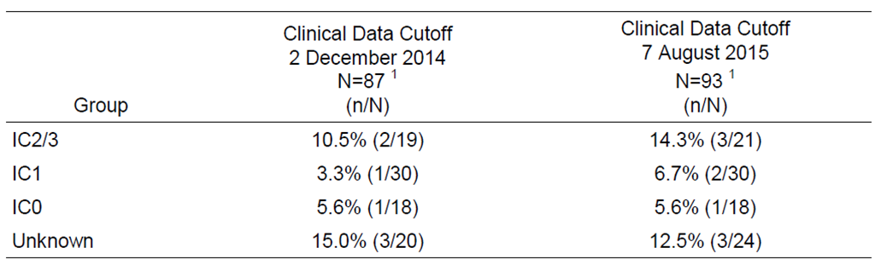
¹ The OR-evaluable population comprises patients in the UC-efficacy population with measurable disease at baseline who were followed up for a minimum of 12 weeks (clinical data cut-off 2 December 2014 [n = 24]) or 24 weeks (clinical data cut-off 7 August 2015 [n = 93]) following the first dose of atezolizumab.
The updated efficacy results provided in the supplemental report for three endpoints summarised below.
Table 52: PCD4989g – Updated efficacy data in the UC cohort at the data cut-off date of 7 August 2015, OR evaluable population.
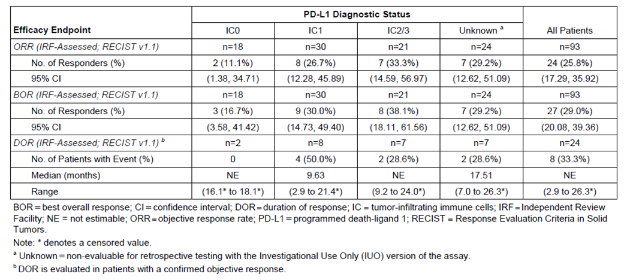

Analyses performed across trials: pooled and meta-analyses
No meta-analyses were submitted. The Summary of Clinical Efficacy compared the efficacy data from the primary analyses of IMvigor 210 Cohort 2 (data cut-off 5 May 2015) and PCD4989g UC Cohort (data cut-off 2 December 2014). The comparative analysis included side-by-side comparisons of the two studies and an analysis of pooled efficacy data for the ORR, BOR and DOR efficacy endpoints in the IC0, IC1 and IC2/3 subgroups. The results of the data from the pooled analysis are reviewed below.
The pooled OR response evaluable efficacy population included a total of 378 patients, comprising 311 (82.3%) patients from IMvigor 210 Cohort 2 and 67 (17.7%) patients from PCD4989g UC Cohort. In the pooled OR response evaluable efficacy population (n = 378), 32.0% (n = 121) of patients had IC0 (IMvigor, n = 103; PCD4989g, n = 18), 36.5% (n = 138) had IC1 (IMvigor, n = 108; PCD4989g, n = 30), and 31.5% (n = 119) had IC2/3 (IMvigor, n = 100; PCD4989g, n = 19). The distribution of patients in IMvigor 210 Cohort 2 and PCD4989g UC Cohort by IC subgroup is shown below.
Table 53: Pooled efficacy population, number of patients by study.
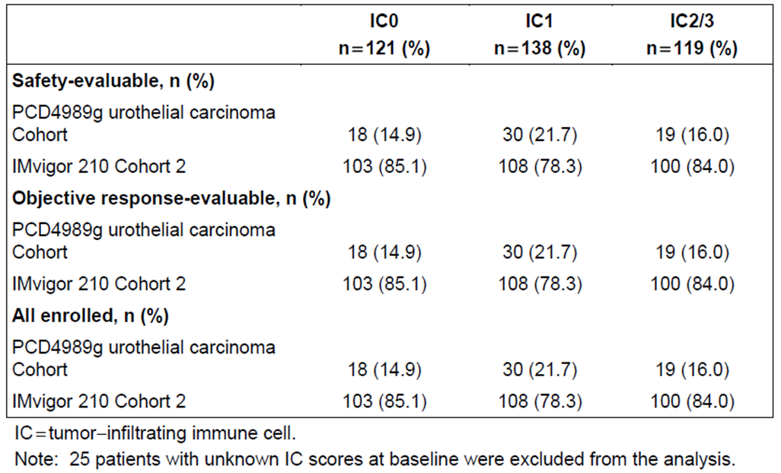
Both IMvigor 210 Cohort 2 and PCD4989g UC Cohort enrolled patients with locally advanced and metastatic or recurrent UC. Across the two study cohorts, patients had similar demographic and baseline disease characteristics. The demographic and baseline disease characteristics in the pooled efficacy population were generally similar to those in IMvigor 210 Cohort 2, which is unsurprising as this study contributed the majority of patients to the pooled efficacy population. IMvigor 210 Cohort 2 enrolled less heavily-pretreated patients (≥ 2 systemic therapy in the metastatic setting) compared to PCD4989g UC Cohort (39.5% vs 71.7%). The difference can be explained by the PCD4989g UC Cohort being an earlier phase study enrolling patients with incurable disease, whereas the IMvigor 210 Cohort 2 was designed to enroll patients post-progression on platinum-containing therapy.
The following similarities in baseline disease characteristics were (IMvigor 210 Cohort 2 vs PCD4989g UC Cohort): the majority of patients had ECOG PS of 1 (62.1% vs 59.8%); the majority of patients had bladder as the site of the primary tumour (74.3% vs 79.3%); approximately one-third of patients had liver metastases (30.9% vs 37.0%); and the majority of patients had visceral metastases (78.1% vs 81.5%).
In the pooled efficacy population, the demographic and baseline disease characteristics were generally balanced across the IC0, IC1, and IC2/3 subgroups. In the pooled efficacy population, the median age of the population in the IC0, IC1 and IC2/3 groups was 65 years (range: 36, 88), 67 years (range: 32, 91), and 66 years (41, 89), respectively, and the majority of patients in each of the subgroups was ≥ 65 years (55.4%, 61.6%, and 58.8%, respectively). The majority of patients in the IC0, IC1 and IC2/3 subgroups were male (78.5%, 73.9%, 79.0%, respectively) and ‘White’ (90.9%, 87.0%, 88.2%, respectively).

Results
The sponsor undertook exploratory pooled efficacy analyses on ORR, BOR and DOR endpoints. Pooling of the data for these endpoints was acceptable as key components of the study designs were similar, including the atezolizumab treatment regimens, the patient populations in terms of baseline risk factors and disease status, same assay (IUO) used to assess the PD-L1 IC, and the efficacy endpoints ORR and DOR. No pooled efficacy data were analysed for other endpoints. The results for the pooled efficacy data were consistent with the results for IMvigor Cohort 2, which is not unexpected given that the majority of patients are from this study.
The patient disposition in the two studies and in the pooled efficacy population are summarised below. In the pooled efficacy population, patient disposition was generally consistent across the IC subgroups. The most common reason for discontinuation from the study in the pooled efficacy population was death.
Table 54: Patient disposition across the studies.
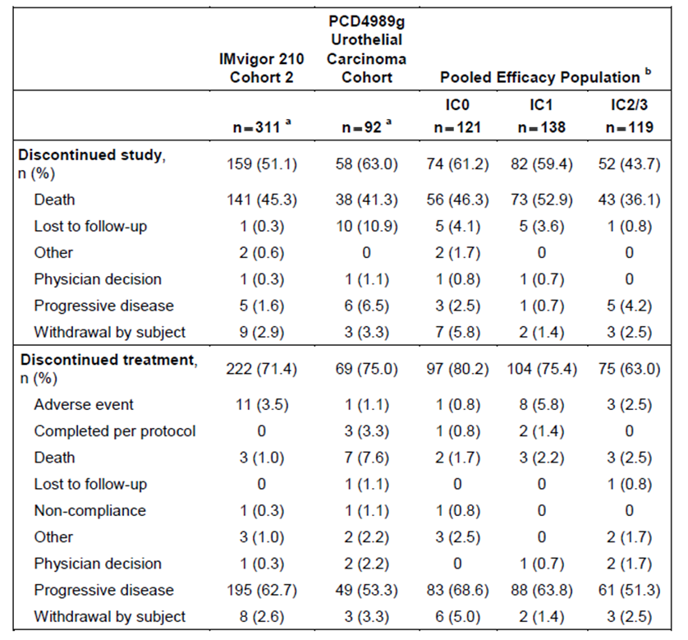
ª Safety-evaluable population. ^{b} 25 patients with unknown IC scores at baseline from PCD4989g were excluded from the pooled efficacy population.
In the pooled efficacy population, the median duration of follow-up in the IC0 (n = 121), IC1 (n = 138), and IC2/3 (n = 119) subgroups was 6.97 months (range: 0.2*, 16.6), 7.62 months (range: 0.4, 17.5), and 7.66 months (range: 0.6*, 17.4), respectively, where * is a censored value.
The ORR by IRF per RECIST 1.1 in the pooled efficacy population for the three pre-specified subgroups based on IC status are summarised below.
Table 55: UC (pooled efficacy population) – Objective response rate by IRF per RECIST v1.1, OR response evaluable patients from IMvigor Cohort 2 and PCD4989g UC Cohort.
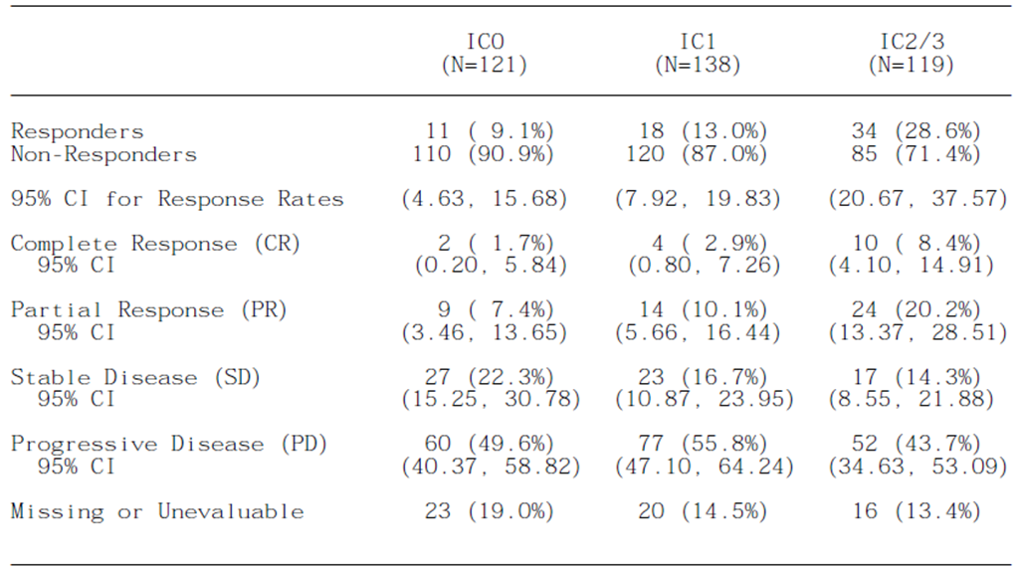
Notes: 95% CIs for response rates were calculated using Clopper-Pearson method. Patients were classified as missing or unevaluable if no post-baseline response assessments were available or all post-baseline response assessments were unevaluable.
The DOR (pooled data) based on IRF assessment per RECIST v1.1 for the three pre-defined IC subgroups are summarised below. The median DOR had not been reached in any of the three pre-defined subgroups at the clinical data cut-off time-point. At the time of the clinical cut-off, 55 of 63 responders (87.3%) as assessed by the IRF per RECIST v1.1 were still responsive.
Table 56: UC (pooled data) – duration of response (IRF-assessed; RECIST v1.1) for responders, OR evaluable population.
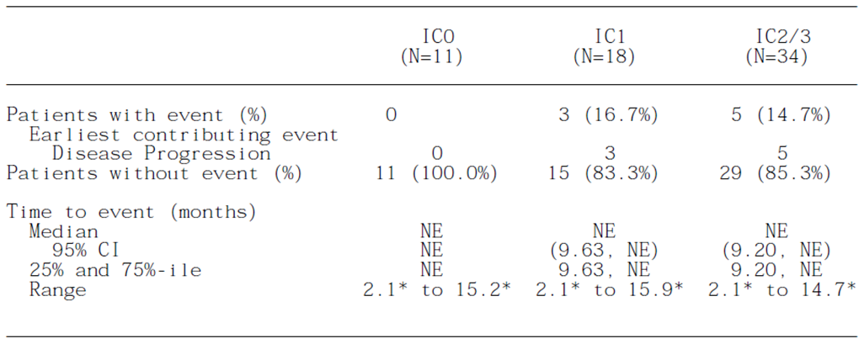
Notes: * = censored value; summaries of duration were estimated from Kaplan-Meier curves; 95% CIs for duration of response were computed using Brookmeyer and Crowley method.

Evaluator’s conclusions on efficacy
The efficacy data for atezolizumab 1200 mg q3w for the treatment of locally advanced or metastatic UC after prior chemotherapy are derived from one Phase II study nominated by the sponsor as being pivotal (IMvigor 210 Cohort 2 [2L+ UC]) and one Phase I study in the UC Cohort (2L+ UC) nominated by the sponsor as being supportive (PCD4989g).
IMvigor 210 also included patients (Cohort 1) with locally advanced or metastatic UC who were treatment naive and ineligible for treatment with cisplatin who received first-line treatment with atezolizumab. However, the patients in Cohort 1 are unrepresentative of the proposed treatment group for the UC indication. Consequently, the data from this cohort have not been reviewed in this section.
The efficacy data from each study were provided separately and pooled efficacy data were submitted for selected endpoints (i.e. ORR, BOR, and DOR in the IC0, IC1, and IC2/3 subgroups). The results for the pooled efficacy analysis were consistent with the separate efficacy analysis from IMvigor 210. This finding is not unexpected, given that the majority of patients in the pooled efficacy population were derived from IMvigor 210 (i.e. 82.3% [311/378] from IMvigor 210 Cohort 2 and 17.7% [67/378] from PCD4989g UC Cohort).
Both IMvigor 210 and PCD4989g were open-label and uncontrolled studies, with the primary efficacy endpoint being ORR. While both studies included PFS and OS data neither of these two endpoints was pre-specified as a primary efficacy endpoint, which is considered to be inconsistent with the TGA adopted EMA guidelines relating to the evaluation of medicines for the treatment of cancer (CHMP/EWP/205/95/Rev.4/Corr).
The sponsor compared the ORR outcome in the IMvigor 201 Cohort 2 with a historical response rate of 10% derived from published literature relating to second-line systemic treatments for patients with advanced transitional-cell carcinoma of the urothelium. However, this comparison is considered to be supportive rather than confirmatory, due to the biases associated with cross-study comparisons.
There were no data comparing atezolizumab with vinflunine, which is approved in Australia for the treatment of adult patients with advanced or metastatic transitional cell carcinoma of the urothelial tract after failure of prior platinum therapy. The absence of comparative efficacy data from a controlled treatment arm is a significant deficiency in the submission and is considered to preclude adequate assessment of the efficacy of atezolizumab for the proposed UC indication.

IMvigor 210 Cohort 2 – primary efficacy analysis
Efficacy data for IMvigor 210 Cohort 2 were provided for three cut-off dates, which were 5 May 2015 (primary analysis), 14 September 2015 (updated analysis) and 27 November 2015 (supplementary analysis).
The efficacy results for Cohort 2 at the data cut-off date of 5 May 2015 were the protocol-defined primary analysis for this cohort. The data at this cut-off date allowed for at least 24 weeks of follow-up for the last enrolled patient, and the median length of follow-up for the enrolled patients was 7.1 months. Tumour specimens from all enrolled patients were prospectively tested for PD-LI expression by a central laboratory. The three pre-defined treatment populations of interest were the IC2/3 subgroup (PD-L1 staining of tumour-infiltrating immune cells ≥ 5%), the IC1/2/3 subgroup (PD-L1 staining of tumour-infiltrating immune cells ≥ 1%) and the all-comers group (irrespective of PD-LI staining).
There were two co-primary efficacy endpoints comprising the ORR (IRF-assessed; RECIST v1.1.) and the ORR (INV-assessed; mRECIST). The pre-specified statistical analysis method for the efficacy endpoints was based on a hierarchical fixed-sequence testing procedure in which the first test in the hierarchy for Cohort 2 compared ORR (IRF-assessed; RECIST v1.1) in the IC2/3 subgroup with a historical control rate of 10%. Formal testing of subsequent comparisons in the hierarchy was dependent on statistical significance being demonstrated for the preceding test. The study met its co-primary endpoints in all pre-specified treatment groups (i.e. IC2/3, IC1/2/3, all-comers), and demonstrated statistically significant ORRs by IRF-assessed RECIST v1.1 and by INV-assessed mRECIST compared to a historical control response rate of 10%. In general, ORRs assessed by INV per mRECIST were higher than ORRs assessed by IRF per RECIST v1.1, but the results of the two assessments were consistent. The following discussion of the results from Cohort 2 will focus on the primary and secondary efficacy endpoints determined by IRF per RECIST v1.1. The IRF assessment per RECIST v1.1 method is considered to be a more conservative assessment method than INV assessment per mRECIST or RECIST v1.1, and represents the general approach for regulatory assessment of medicines used to treat cancer.
In the IC2/3 subgroup (n = 100), the ORR (IRF-assessed; RECIST v1.1) was 27.0%, which was statistically significantly greater than the 10% historical control response rate (p<0.0001). In the IC1/2/3 subgroup (n = 208), the ORR (IRF-assessed; RECIST v1.1) was 18.3%, which was statistically significantly greater than the 10% historical control response rate (p<0.0004). In the all-comers group (n = 311), the ORR (IRF-assessed; RECIST v1.1) was 15.1%, which was statistically significantly greater than the 10% historical control response rate (p<0.0058).
Two exploratory subgroups of particular interest included the IC0 subgroup (no discernible PD-L1 staining or < 1% PD-LI staining) and the IC1 subgroup (PD-LI staining ≥ 1% to < 5%). The ORR (IRF-assessed; RECIST v1.1) was 8.7% in the IC0 subgroup (n = 103) and 10.2% in the IC1 (n = 108) subgroup. The ORRs in the IC0 and IC1 subgroups were not notably different from the 10% historical control response rate. Based on the multivariate logistic regression model, the odds ratio of having a confirmed response by IRF per RECIST V1.1 was 3.98 (95% CI: 1.72, 9.17) for the IC2/3 group compared to the IC0 group, and 1.21 (95% CI: 0.47, 3.10) for the IC1 group compared to IC0 group, when Bellmunt risk score is controlled. The logistic regression results for the IC0, IC1, and IC1/2/3 subgroups were consistent with the results for the ORR subgroup analyses. The results demonstrate that the ORR increases with increasing PD-L1 expression on ICs.
The 10% historical control response rate was based on published literature relating to second-line systemic treatments for patients with advanced transitional-cell carcinoma of the urothelium. In the relevant publication, the authors comment that:
many chemotherapy drugs and target agents show poor or no activity in phase 2 trials in the second-line setting, and few yield modest responses rates of 10-20%, median [PFS] of 2-3 months; and median [OS] 6-9 months.
In relation to the results for vinflunine, although the ITT analysis in the key registration study did not show a significant overall survival advantage compared to best supportive care (6.9 months [vinflunine] vs 4.6 months [BSC]; HR = 0.88 [95% CI: 0.69, 1.12]), there was a significant improvement in the ORR (8.6% [vinflunine] vs 0% [BSC], Δ = 8.6% 95% CI: 5.0, 13.7]) and median PFS (3.0 months [vinflunine] vs 1.5 months [BSC], p = 0.0012). Overall, it is considered that the historical control response rate of 10% (which is the lower boundary of the modest 10% to 20% response range suggested by the literature) is of limited utility for regulatory purposes. In the regulatory context, the comparisons between the ORRs for atezolizumab and the historical control response rate are considered to be supportive rather than confirmatory and cannot replace comparison between atezolizumab and a randomised controlled treatment arm.
The key secondary efficacy endpoints at the data cut-off of 5 May 2015 are considered to be DOR, PFS, and OS. The median DOR (IRF-assessed; RECIST v1.1) in the OR response evaluable population had not been reached in the IC2/3 or IC1/2/3 subgroups or in the all-comers group. The proportion of responders who were still in response at the cut-off date was 85.2% (n = 23), 89.5% (n = 34) and 91.5% (n = 43) in the IC2/3, IC1/2/3 and all-comers treatment groups, respectively. The median PFS (IRF-assessed; RECIST v1.1) in the ITT population had not been reached in the IC2/3 or IC1/2/3 subgroups or in the all-comers group. The median OS (IRF-assessed; RECIST v1.1) in the ITT population had not been reached in the IC2/3 or IC1/2/3 subgroups or in the all-comers group. The OS data were too immature to calculate the land-mark 1-year survival rate.
In the subgroup analyses, the majority showed ORRs ≥ 10%, based on IRF-assessment per RECIST v1.1. In particular, the ORR was ≥ 10% in patients aged < 65 years and ≥ 65 years; male patients (but not female patients); patients with ECOG PS 0 (but not patients with ECOG PS 1); patients with primary bladder tumour (but not patients with primary sites in the renal pelvis, ureter, or urethra); patients with no liver metastases (but not patients with liver metastases); patients with no visceral metastases (but not patients with visceral metastases); patients with haemoglobin ≥ 10 g/dL (but not patients with haemoglobin < 10 g/dL); patients with baseline creatinine clearance < 60 mL/min and ≥ 60 mL/min; patients with Bellmunt risk factors 0 and 1 (but not patients with Bellmunt risk factors 2 or 3); patients with initial transitional cell carcinoma (but not patients with initial transitional cell carcinoma with mixed histology); patients with prior systemic treatment, prior carboplatin based regimens, or ≤ 3 prior systemic regimens in the metastatic setting (but not patients with ≥ 4 regimens); patients with prior systemic regimen settings including adjuvant or neoadjuvant with first PD beyond or within 12 months and patients in the metastatic setting; patients with ≤ 3 lines of prior therapy (but not patients with ≥ 4 lines of prior therapy); patients with > 3 months and with ≤ 3 months from prior chemotherapy; patients with no prior BCG therapy (but not patients with prior BCG therapy); and patients with diagnosis based on resection or TURBT (but not patients with diagnosis based on biopsy).

IMvigor 210 – updated and supplementary efficacy analyses
The updated efficacy data for IMvigor 210 Cohort 2 at the cut-off of 14 September 2015 (median duration of follow-up of 11.7 months), was consistent with primary analysis of the efficacy data at the earlier cut-off of 5 May 2015, based on a median duration of follow-up of 7.1 months.
The supplementary report provided efficacy data for IMvigor Cohort 2 at the cut-off of 27 November 2015, with a minimum follow-up of 1 year for the last enrolled patient and a median duration of follow-up of 14.4 months for all enrolled patients. The ORR (IRF-assessed; RECIST v1.1) was 26.0% (26/100), 18.4% (38/207) and 14.8% (46/310) in the IC2/3, IC1/2/3 and all-comers populations, respectively. The ORR results were notably greater than the historical control response rate of 10% for the IC2/3 and the IC1/2/3 subgroups. However, it appears that the results for the IC1/2/3 subgroup were primarily driven by the results for the IC2/3 subgroup.
The median DOR (IRF-assessed; RECIST v1.1) at the data cut-off of 27 November 2015 had not yet been reached for the IC2/3, IC1/2/3 and all-comers populations. The proportions of patients who were on-going responders were 84.6% (22/26), 86.8% (33/38) and 80.4% (37/46) in the IC2/3, IC1/2/3 and all-comers populations, respectively. The estimated land-mark 1 year DOR (IRF-assessed; RECIST v1.1) event-free rates were 84.6%, 86.2%, and 81.7% for the IC2/3, IC1/2/3 and all-comers populations, respectively. The percentage of responders remaining on treatment was 76.9% (20/26), 76.3% (29/38) and 76.1% (35/46) in the IC2/3, IC1/2/3 and all-comers populations, respectively.
The median OS in the ITT population was 11.9, 9.0 and 7.9 months in the IC2/3 (n = 100), IC1/2/3 (n = 207), and all-comers (n = 310) populations, respectively. The estimated rates for the land-mark 1 year survival analysis were 49.9%, 40.2% and 36.9% in the IC2/3, IC1/2/3 and all-comers populations, respectively. The OS survival results in the ITT population were notably superior in the IC2/3 subgroup compared to the IC1/2/3 subgroup, suggesting a positive relationship between PD-L1 expression and survival.
The sponsor commented (covering letter) that the survival outcomes conferred by atezolizumab in the updated analysis (data cut-off of 27 November 2015) are ‘clinically meaningful’ when compared to published data for vinflunine (median OS of 6.9 months), docetaxel (median OS of 7.0 months) and pemetrexed (median OS of 6.7 months). However, it is considered that meaningful clinical interpretation of the OS data from IMvigor 210 Cohort 2 is limited due to the absence of a control arm. Comparing overall survival data across studies should be interpreted cautiously due to the likelihood of bias. It is considered that, for regulatory purposes, the descriptive cross-study comparisons of OS referred to by the sponsor should be considered to be supportive rather than confirmatory.
The sponsor also commented (covering letter) that atezolizumab provided sustained and durable responses, which were observed across all IC subgroups and represent clinical benefit compared to vinflunine with a median DOR of 7.4 months (range 4.5 to 17.0 months), docetaxel with a reported median DOR of 4 months (range 3.0 to 8.0 months) and pemetrexed with a median DOR of 8 months (range 6.0 to 18.0 months). As noted above, the median DOR (IRF-assessed; RECIST v1.1) at the data cut-off date of 27 November 2015 had not yet been reached for the IC2/3, IC1/2/3 and all-comers populations, with a median duration of follow-up of 14.4 months. Comparing median DOR across studies should be interpreted cautiously due to the likelihood of bias. It is considered that, for regulatory purposes, the descriptive cross-study comparisons of median DOR referred to by the sponsor should be considered to be supportive rather than confirmatory.

Study PCD4989g UC Cohort (2L+ UC)
In the supportive study (PCD4989g UC cohort), the confirmed ORR (IRF-assessed; RECIST v1.1) in the primary analysis at the cut-off of 2 December 2014 was 36.8% (7/19), 18.8% (11/48), 23.3% (7/30), and 11.1% (2/18) in the IC2/3, IC0/1, IC1, and IC0 subgroups respectively. The primary analysis included 87 OR evaluable patients with poor prognostic factors and a minimum of 12 weeks of follow-up.
The submission included a supplemental report for PCD4989g, which provided updated efficacy data for the OR-evaluable patients (n = 93) with a minimum of 24 weeks of follow-up. The updated data with a cut-off date of 7 August 2015 represents an additional 8 months of follow-up beyond the earlier cut-off date of 2 December 2014 for the primary analysis. The median duration of survival follow-up at the 7 August 2015 cut-off was 20.0 months.
At the 7 August 2015 cut-off date, 80.6% of the patients in the UC cohort (75/93) were no longer receiving atezolizumab, compared to 75.0% (69/92) of patients at the earlier cut-off date of 2 December 2014. The primary reason for discontinuation from treatment in the updated analysis was progression of disease (64.5% [60/93] at the 7 August 2015 cut-off compared to 53.3% [49/92] at the 2 December 2014 cut-off).
In the updated analysis at the 7 August 2015 cut-off, the ORRs (IRF-assessed; RECIST v1.1) were 33.3% (7/21), 20.8% (10/48), 26.7% (8/30) and 11.1% (2/18) for the IC2/3, IC0/1, IC1, and IC0 subgroups, respectively. The updated ORR results for these four subgroups were consistent with the ORR results in the primary analysis. In the updated analysis, the median DOR (IRF-assessed; RECIST v1.1) had not been yet been reached in the IC2/3 or IC0 subgroups and was 9.63 months in the IC1 subgroup. The numbers of responders without events at 7 August 2015 for the updated data were 5/7 (71.4%), 4/8 (50.0%), and 2/2 (100%) in the IC2/3, IC1, and IC0 subgroups, respectively. Supplementary DOR data for the IC0/1 subgroup were not provided.
Overall, it is considered that the Phase 1 efficacy data from PCD4989g are exploratory for atezolizumab for the treatment of UC.

ORR comparison between IMvigor 210 and PCD4989g
The results for the ORR (primary analyses) assessed by the IRF per RECIST v1.1 for the OR-evaluable population in IMvigor 210 Cohort 2, PCD4989g UC Cohort and the pooled population for the IC0, IC1 and IC2/3 subgroups are summarised below. The IRF-assessed ORR per RECIST v1.1 was one of the co-primary endpoints in IMvigor 210 Cohort 2 and a co-primary efficacy endpoint in PCD4989g UC Cohort. Of particular note is the higher ORR in PCD4989g compared to IMvigor 210 in each of the IC subgroups. This is an unexpected finding as it could be predicted that the generally more heavily pre-treated patients with more advanced disease in PCD4989g would be less likely to respond to treatment than the generally less heavily pre-treated patients with less advanced disease in IMvigor 210. The sponsor is requested to comment on this finding.
Figure 18: Objective response rate by IER-assessment per RECIST v1.1, OR-evaluable population.
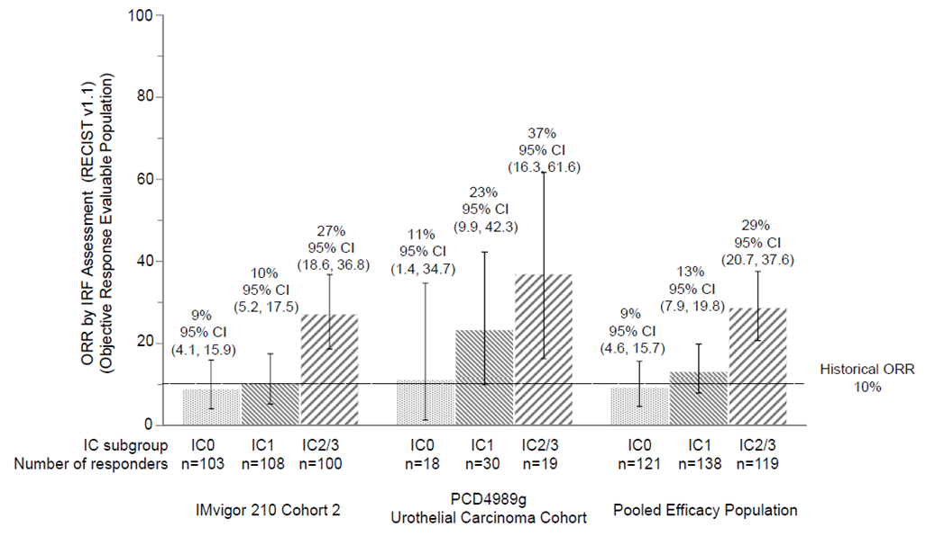

NSCLC

Studies providing efficacy data
Efficacy data supporting the submission to register atezolizumab for the treatment of NSCLC are derived from two studies nominated by the sponsor as being pivotal (BIRCH and POPLAR)and two studies nominated by the sponsor as being supportive (FIR and PCD4989g). Most of the patients in these studies with locally advanced or metastatic NSCLC were treated with atezolizumab in the second-line or beyond setting (i.e. 2L+) and had varying levels of PD-L1 expression on both tumour cells (TCs) and tumour-infiltrating immune cells (ICs). The four studies are outlined below.
- Study GO28753 (POPLAR) was a randomised Phase II, global, multicentre, open-label clinical trial designed to compare the overall survival (OS) benefit of atezolizumab against standard of care chemotherapy (docetaxel) in patients with locally advanced or metastatic NSCLC who had progressed during or following a platinum-containing regimen regardless of their PD-L1 expression level. This study has been recently published in the Lancet.
- Study GO28754 (BIRCH) was a Phase II, global, multicentre, single-arm clinical trial of atezolizumab across multiples lines of therapy in patients with locally advanced or metastatic NSCLC who were selected by PD-L1 status (TC2/3 or IC2/3), and who were evaluated according to pre-specified analyses compared to historical controls as measured by the objective response rate (ORR).
- Study GO28625 (FIR) was a Phase II, global, multicentre, single-arm clinical study designed to evaluate the efficacy and safety of atezolizumab as a single agent in patients with locally advanced or metastatic NSCLC who had PD-L1 expression level of TC2/3 or IC2/3.
- Study PCD4989g is an ongoing Phase Ia, multicentre, first-in-human, open-label, dose-escalation clinical trial of the safety and PK of atezolizumab administered IV as a single agent to patients with locally advanced or metastatic solid tumours or haematologic malignancies, including NSCLC (PCD4989g NSCLC Cohort). The secondary objectives of this study included a preliminary assessment of the anti-tumour activity of atezolizumab and the exploratory objectives included an evaluation of overall survival (OS).

Pivotal efficacy study (NSCLC) – POPLAR

Study design, objectives, locations and dates

Title
Primary Clinical Study Report - Protocol GO28753 - A Phase II, open-label, multicenter, randomized study to investigate the efficacy and safety of MPDL3280A (anti-PD-L1 antibody) compared with docetaxel in patients with non-small cell lung cancer after platinum failure. Report No. 1065672 - December 2015

Objectives

Efficacy objectives
The primary efficacy objective was to estimate the efficacy of atezolizumab compared to docetaxel as measured by overall survival (OS).
The secondary efficacy objectives were: (1) to evaluate the efficacy of atezolizumab compared to docetaxel with respect to anti-tumour effects measured by overall response (ORR), duration of response (DOR), and progression free survival (PFS) per RECIST v1.1 as assessed by the investigator; and (2) to evaluate the efficacy of atezolizumab with respect to anti-tumour effects measured by overall response, DOR, and PFS per modified RECIST as assessed by the investigator.
Comment: The choice of OS as the primary efficacy objective is considered to be appropriate and is consistent with relevant TGA adopted EMA guidelines for the assessment of medicines to treatment cancer. The secondary efficacy objectives are also considered to be appropriate and are consistent with the relevant guidelines.

Safety objectives
The safety objectives were: (1) to evaluate the safety and tolerability of atezolizumab compared to docetaxel; and (2) to evaluate the incidence of anti-therapeutic antibodies (ATAs) against atezolizumab and to explore the potential relationship of the immunogenicity response with PK, safety, and efficacy

Pharmacokinetic (PK) objectives
The PK objectives were to characterise the PK of atezolizumab

Patient Reported Outcome (PROs) Objectives
PROs were used to evaluate and compare lung cancer symptoms, patient functioning, and health-related quality of life (HRQoL) between the two treatment arms. The instruments were the European Organization for Research and Treatment of Cancer (EORTC) Quality-of-Life Questionnaire Core 30 (QLQ-C30) and its Lung Cancer Module (LC13).

Exploratory objectives
The exploratory objectives were: (1) to evaluate the relationship between tumour tissue PD-L1 expression and measures of efficacy; (2) to assess predictive and prognostic exploratory biomarkers in archival and/or fresh tumour tissue and blood and their association with disease status and/or response to study treatment (not reported in the CSR); and (3) to evaluate exploratory pharmacodynamic biomarkers in tumour tissue and blood and their association with disease status and/or response to study treatment (including pseudoprogression/tumour immune infiltration) (not reported in the CSR).

Design
POPLAR was a Phase II, global, multicentre, open-label, randomised, controlled clinical trial designed to evaluate the efficacy and safety of atezolizumab in patients with locally advanced or metastatic NSCLC who had progressed during or following a platinum-containing regimen. The study design is illustrated below.
Figure 19: POPLAR – Overview of study design.
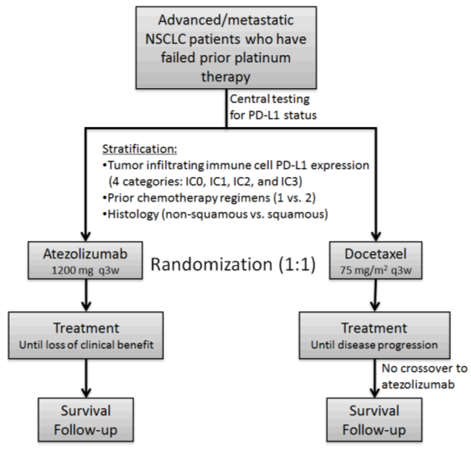
Male and female patients aged ≥ 18 years with ECOG PS of 0 or 1 with histologically or cytologically proven locally advanced or metastatic NSCLC who experienced disease progression during or following treatment for advanced disease consisting of platinum-based therapy were eligible for enrolment into this study.
Tumour specimens from eligible patients were prospectively tested for PD-L1 expression by a central laboratory using the VENTANA PD-L1 (SP142) IHC assay. The study enrolled all patients whose tissue was evaluable for expression testing, regardless of PD-L1 expression status. The PD-L1 IHC scoring system was developed to measure PD-L1-specific signals on tumour-infiltrating immune cells (ICs) and on tumour cells (TCs). Four levels of IC expression were determined during the screening stage (IC0, IC1, IC2, and IC3) and were used to stratify patients at randomisation. TC expression levels (TC0, TC1, TC2, and TC3) were derived from raw percentage staining scores determined at enrolment. The PD-LI expression criteria used in this study are summarised.
Table 57: POPLAR – Criteria for PD-L1 assessment.
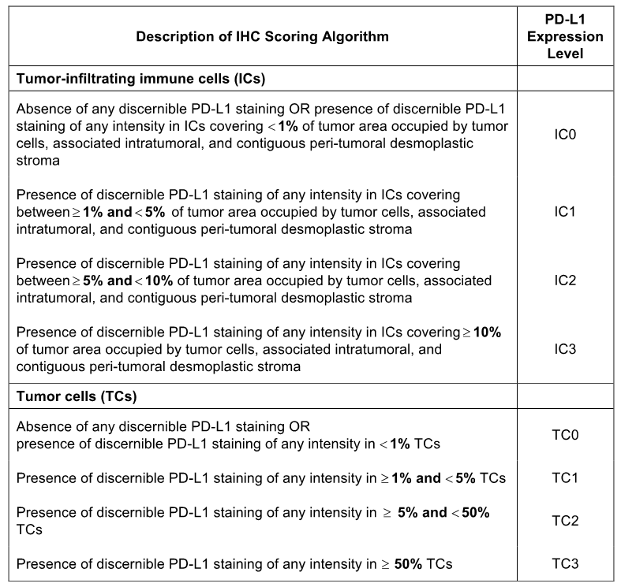
Eligible patients were stratified by PD-L1 IC status (IC0, IC1, IC2, and IC3), by the number of prior chemotherapy regimens (1 vs 2), and by tumour histology (non-squamous vs squamous). Patients were then randomised 1:1 to receive either atezolizumab or docetaxel. The study was designed to recruit patients until a minimum of approximately 54 patients with PD-L1 status IC2 or IC3 were enrolled. If the prevalence of IC2 or IC3 patients was lower than 18%, then up to a maximum of approximately 300 patients could be enrolled.
Docetaxel 75 mg/m² was administered IV on Day 1 of each 21-day cycle until disease progression per standard RECIST v1.1 or unacceptable toxicity occurred, as assessed by the investigator.
Atezolizumab was administered IV on Day 1 of each 21-day cycle at a fixed-dose of 1200 mg. Atezolizumab treatment could be continued as long as patients were experiencing clinical benefit as assessed by the investigator (i.e. no unacceptable toxicity or symptomatic deterioration attributed to disease progression after an integrated assessment of radiographic data, available biopsy results, and clinical status). Patients randomised to atezolizumab who met all of the following criteria were permitted to continue treatment with the drug after progressive disease (PD) based on RECIST v1.1 criteria, as assessed by the investigator: (1) evidence of clinical benefit; (2) absence of symptoms and signs (including worsening of laboratory values) indicating unequivocal progression of disease; (3) no decline in ECOG performance status that could be attributed to disease progression; and (4) absence of tumour progression at critical anatomical sites that could not be managed by protocol-allowed medical interventions.
Assessment of tumour response by RECIST v1.1, as assessed by the investigator, occurred every 6 weeks for the first 36 weeks and every 9 weeks thereafter. For patients randomised to docetaxel, assessments continued until disease progression per RECIST v1.1, as assessed by the investigator, regardless of whether treatment was discontinued. Patients randomised to atezolizumab underwent assessments until disease progression per modified (m) RECIST, as assessed by the investigator, or until treatment discontinuation for patients who continued to receive atezolizumab following disease progression. In the absence of disease progression, tumour assessments continued regardless of whether patients started new anti-cancer therapy, until consent was withdrawn, death, or study termination by sponsor, whichever occurred first. Follow-up data capture, including subsequent anti-cancer therapies, continued for each patient until death, loss of follow-up, withdrawal of consent, or study termination by sponsor, whichever occurred first. An Internal Monitoring Committee (IMC) monitored safety and efficacy data on an ongoing basis during conduct of the study.
Central facilities were used for study assessments throughout the study (e.g. specified laboratory tests, PD-L1 IHC testing and PK analyses). Accredited local laboratories were used for routine monitoring, and local laboratory ranges were collected.
Comment: The study was randomised and controlled, although not double-blinded. Therefore, the study is subject to the well known biases associated with unblinded designs. The control treatment in this study was docetaxel 75 mg/m² IV q3w. This is an acceptable comparator as docetaxel (75 to 100 mg/m² IV q3w) is approved in Australia for the treatment of patients with locally advanced or metastatic NSCLC, including those who have failed platinum-based chemotherapy. RECIST v1.1 and mRECIST were assessed by the investigator rather than by a centralised reference facility. This introduces potential bias into the assessment of tumour response to treatment due to subjective interpretation of the RECIST v1.1 and mRECIST criteria among investigators.

Location and dates
The principal investigator was located in the USA. The study was undertaken in 61 centres in 13 countries (centres), including USA (26), Poland (4), Germany (4), Spain (4), France (5), Korea (3), Thailand (3), Great Britain (4), Belgium (1), Turkey (2), Canada (2), Italy (2), and Sweden (1). The first patient was randomised on 5 August 2013 and the last patient was randomised on 31 March 2014. The data included in the CSR was the primary analysis (data cut-off date of 8 May 2015) and the third interim analysis (data cut-off date of 30 January 2015). The submitted data for POPLAR also included an updated efficacy report with a data cut-off date of 1 December 2015. The study was sponsored by Hoffman-La Roche Ltd. The study was undertaken in accordance with the principles of GCP.

Inclusion and exclusion criteria
The study enrolled patients aged ≥ 18 years, with histologically or cytologically documented locally advanced or metastatic NSCLC and a life expectancy of ≥ 12 weeks. Patients were required to have experienced disease progression during or following treatment with a prior platinum-containing regimen for locally advanced, unresectable/inoperable or metastatic NSCLC or have experienced disease recurrence within 6 months of treatment with a platinum-based adjuvant/neoadjuvant regimen. Tumour tissue for determination of PD-L1 expression had to be of good quality based on total and viable tumour content. Patients were required to have measurable disease as defined by RECIST v1.1, ECOG PS of 0 or 1 and adequate haematological and end-organ function.
The key cancer-specific exclusion criteria included CNS metastases, spinal cord compression, leptomeningeal disease, uncontrolled pleural effusion, pericardial effusion, ascites requiring drainage, uncontrolled tumour related pain, uncontrolled hypercalcaemia, and other malignancies within 5 years prior to randomisation (unless specifically permitted). There were a number of general medical exclusions including history of autoimmune disease and history of idiopathic pulmonary fibrosis.
The study also included specific exclusion criteria relating to docetaxel, including prior treatment with the drug, history of hypersensitivity to drugs formulated with polysorbate 80, grade ≥ 2 neuropathy, and inability to discontinue strong CYP3A4 inhibitors. The study also included specific exclusion criteria relating to atezolizumab, including prior treatment with CD137 agonists, anti-cytotoxic T-lymphocyte-associated protein 4 (CTLA-4), anti-PD-1, or anti-PD-L1 therapeutic antibody or pathway-targeting agents, treatment with systemic immunostimulatory agents within 4 weeks or 5 half-lives of the drug, whichever was shorter, prior to randomisation, and treatment with systemic immunosuppressive medications within 2 weeks prior to randomisation. The exclusion criteria are provided.

Study treatments

Atezolizumab
Atezolizumab was administered by IV infusion at a dose of 1200 mg IV q3w (21 ± 2 days). The guidelines for administration were consistent with those previously described for IMvigor 210. No dose reductions were allowed for atezolizumab. However, patients could temporarily suspend study treatment for up to 105 days from the last dose if they experienced AEs that required a dose to be held. If atezolizumab was withheld because of AEs for more than 105 days beyond the last dose, then the patient was discontinued from atezolizumab treatment and was followed for safety and efficacy. If a patient had to be tapered off steroids used to treat AEs, atezolizumab could be withheld for additional time beyond 105 days from the last dose until steroids were discontinued or reduced to a prednisone dose (or dose equivalent) of ≤ 10 mg/day. Dose interruptions for reasons other than AEs, such as surgical procedures, were permitted with prior approval from the Medical Monitor.

Docetaxel
The starting dose of docetaxel was 75 mg/m² q3w. Docetaxel administration was according to locally approved prescribing information. All patients randomised to receive docetaxel had to be pre-medicated with corticosteroids according to local practice. Anti-emetic prophylaxis could be administered according to local practice. Treatment with docetaxel continued until disease progression, unacceptable toxicity, or death. Dose modifications were allowed according to the locally prescribing information.

Discontinuation from treatment
Patients discontinued from the study drug if they experienced any of the following: (1) intolerable toxicity related to study treatment; (2) any medical condition that could jeopardise safety; (3) use of other prohibited anti-cancer therapy; (4) pregnancy; (5) symptomatic deterioration attributed to disease progression as determined by the investigator after integrated assessment of radiographic data, biopsy results, and clinical status; and (6) radiographic disease progression per RECIST v1.1, but patients randomised to atezolizumab were permitted to continue study treatment after disease progression provided pre-specified criteria were met.

Concomitant medications
Concomitant therapy included any prescription medications or over-the-counter preparations used by a patient between the 7 days preceding the screening evaluation and the treatment discontinuation visit.
Patients who experienced infusion-associated symptoms could be treated symptomatically as per standard practice. Serious infusion-associated events were managed with appropriate supportive therapy. Systemic corticosteroids and TNF-alpha inhibitors could be administered at the discretion of the treating physician. For patients randomised to atezolizumab, alternatives to corticosteroids could be considered if feasible, but premedication could be administered for Cycle 2 and beyond. Megestrol administered as an appetite stimulant was acceptable while the patient was enrolled in the study.
Patients who used hormonal therapy such as oral contraceptives, hormone-replacement therapy, or prophylactic or therapeutic anticoagulation therapy, or other specified allowed ongoing therapies or medications could continue their use. Males and females of reproductive potential had to use a highly effective means of contraception.
Any concomitant therapy intended for the treatment of cancer was prohibited. Such therapy included but was not limited to chemotherapy, hormonal therapy, immunotherapy, radiotherapy, investigational agents or herbal products. After Cycle 1, Day 14 certain forms of palliative radiotherapy were permitted.

Excluded and cautionary therapy
- Atezolizumab: Immune modulatory agents and immunosuppressive agents were excluded for patients being treated with atezolizumab. Influenza vaccinations (inactive forms) could be given in the influenza season. No live vaccines of any type were to be given at any time during the study. Initiation or increased dose of granulocyte colony-stimulating factors was prohibited. Systemic corticosteroids and anti-TNF-alpha agents could be administered at the discretion of the treating physician. If feasible, alternatives to these agents were to be considered. Patients being treated with atezolizumab were not to receive other immunomodulatory agents for 10 weeks after study treatment discontinuation.
- Docetaxel: Patients being treated with docetaxel were to avoid using concomitant strong CYP3A4 inhibitors, while CYP3A4 inducers were to be used with caution. Treatment with granulocyte colony-stimulating factors was permitted. Anti-emetics, anti-allergic measures, and other treatments for concomitant docetaxel toxicities could be used at the discretion of the investigator, taking into account precautions included in the local prescribing information.

Efficacy variables and outcomes

Primary efficacy endpoint
The primary efficacy endpoint was overall survival (OS) measured from the date of randomisation to the date of death from any cause. Censoring was the date the patient was last known to be alive or at the date of randomisation plus 1 day for patients without post baseline information.
For the primary endpoint OS analysis in the ITT population, the main analysis was a stratified log-rank test based on PD-L1 status on ICs, the number of prior lines of therapy, and tumour histology. An unstratified analysis was also performed. Given the expected small sample sizes in the subsets defined on the basis of TC and IC levels, analyses in the PD-L1 expression subgroups were based on an unstratified log-rank test.

Secondary efficacy endpoints
- Progression free survival (PFS) defined as the interval between the date of randomisation and the date of first documented PD per RECIST v1.1, as assessed by the investigator, or death. Censoring was at the date of the last tumour assessment for patients without PD and alive or at the date of randomisation plus 1 day for patients with-out post baseline assessments.
- Objective Response Rate (ORR) defined as the proportion of patients achieving best response of CR or PR per RECIST v1.1, as assessed by the investigator. Patients not meeting these criteria, including those without any post-baseline tumour assessments, were considered non-responders. The analysis population for ORR was the ITT population.
- Duration of Response (DOR) defined as the interval between the first documented objective response (CR or PR) and first documented PD, as assessed by the investigator, or death. The DOR was assessed in patients who had experienced an objective response (CR or PR) during the study, as assessed by the investigator.
- ORR (CR or PR), PFS, and DOR as assessed by the investigator per mRECIST, in the atezolizumab arm only with no comparison with the docetaxel arm.

Exploratory endpoints
Exploratory endpoints included disease control rate (DCR), time in response (TIR), time to onset of response (TTOR), and changes in the sum of longest diameter (SLD) (i.e. an assessment of tumour burden). The exploratory endpoints have been mentioned here for completeness. For regulatory purposes, the evaluation of efficacy in this study in this CER focuses on the primary and secondary efficacy endpoints supplemented by subgroup analyses of OS.

Tumour response evaluations
Tumor response was evaluated by radiologic imaging (CT scans or MRI) according to RECIST v1.1 and mRECIST. The preferred method of imaging was CT, with MRI performed only for patients unable to receive CT. An objective response was to be confirmed by repeat assessment ≥ 4 weeks after initial documentation. The same radiographic procedure was to be used to assess disease sites at screening and throughout the study. CT/MRI scans were mandatory for chest, abdomen and pelvis. In addition, a CT or MRI scan of the head was to be done at screening and as clinically indicated. Bone scans and CT scans of the neck were also performed as clinically indicated. FDG-PET/CT imaging scans were acquired at baseline, at the time of first tumour assessment, and at the first evidence of radiographic disease progression to assess whether apparent increases in tumour volume related to immunomodulatory activity of atezolizumab (pseudoprogression/ tumour immune infiltration) may be distinguished from true disease progression. PET/CT scans at other time-points were optional.

Randomisation and blinding methods
The study was open-label. Randomisation was conducted using an Interactive Web Response System (IWRS). After written informed consent was obtained and eligibility was established (including determination of tumour PD-L1 status by central testing), the study site entered demographic and baseline characteristics in the IWRS which issued the patient’s randomisation number and treatment assignment. Randomisation to one of the two treatment arms occurred in a 1:1 ratio. Permuted-block randomisation was applied to ensure a balanced assignment to each treatment arm. Randomisation was stratified by the following factors: (1) tumour tissue PD-L1 expression on tumour-infiltrating immune cells (IC0, IC1, IC2, and IC3); (2) number of prior lines of chemotherapy (1 vs 2); and (3) tumour histology (non-squamous vs squamous) Patients received their first dose of study treatment on the day of randomisation if possible. If this was not possible, the first dose had to be given no later than 3 business days after randomisation.

Analysis populations

Intention to treat population
The intention to treat (ITT) population included all randomised patients, regardless of whether they received any study drug. The ITT population was the primary population for analysis of efficacy. The ITT population included 287 patients, comprising 143 in the docetaxel arm and 144 in the atezolizumab arm.

PD-L1 subgroups for analysis
The PD-L1 subgroups for analysis were determined based on PD-L1 expression in TCs and ICs, with a score being given for both cell types giving a combined TC and IC expression profile. The PD-L1 expression profiles for each subgroup are summarised below.
Table 58: POPLAR – Summary of PD-L1 expression profiles for PD-L1 subsets and mutually exclusive subgroups.
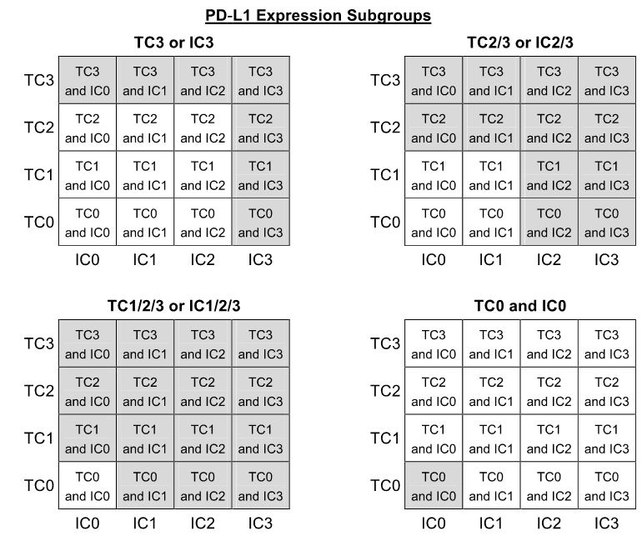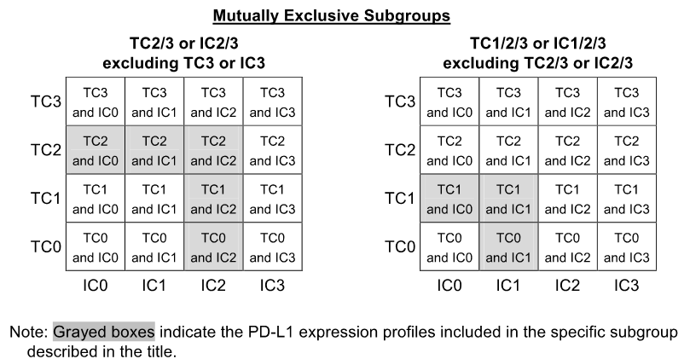

Safety population
The safety population included all randomised patients who received any dose of study drug during the study period, with patients group according to whether any atezolizumab treatment was received. For the safety analysis, patients who received any dose of atezolizumab were assigned to the atezolizumab arm even if atezolizumab was given in error. Patients who were randomised to the study but who did not receive any study drug were not included in the safety population.

PK-evaluable population
The PK-evaluable population was defined as patients who received atezolizumab and had PK data at sufficient time-points to determine PK parameters.

Sample size
The study was designed to provide an assessment of the efficacy and safety of atezolizumab and the primary purpose was the estimation of the OS and PFS hazard ratios in the PD-L1 expression subgroups and in the ITT population.
The study was designed to enroll a minimum of approximately 54 PD-L1 patients who were IC2 or IC3. It was estimated that 54 PD-L1 (IC2/IC3) patients were required to assess efficacy in this subgroup, based on the assumptions outlined below. If the prevalence of PD-LI (IC3/IC3) patients was lower than 18%, then up to a maximum of 300 total patients could be enrolled. Recruitment into the study was expected to take place over approximately 8 months. The study was expected to enroll a total of 285 patients, including 55 PD-L1 (IC2/IC3) positive patients.
The power and 95% CIs for OS and PFS in the PD-L1 (IC2/IC3) subgroup were based on the following assumptions: (1) event times are exponentially distributed; (2) median PFS in the control arm is 3 months; (3) median OS in the control arm is 8 months; and (4) patients are enrolled over 8 months.
The power and 95% CIs for OS and PFS in the ITT population are based on the following assumptions: (1) event times are exponentially distributed; (2) median PFS in the control arm is 3 months; (3) median OS in the control arm is 8 months; and (4) patients are enrolled over 8 months. Patients were followed until approximately 180 patient deaths in the ITT population occurred.
At the time of the OS analysis, it was projected that approximately 29 events will be observed for the TC3 or IC3 subgroup, 65 events for the TC2/3 or IC2/3 subgroup and 122 events for the TC1/2/3 or IC1/2/3 subgroup. Assuming a target HR of 0.35 for the TC3 or IC3 subgroup, 0.5 for TC2/3 or IC2/3 subgroup and of 0.6 for TC1/2/3 or IC1/2/3, all tests would have 80% power, with a minimum detectable HR of 0.480 for TC3 or IC3, 0.616 for TC2/3 or IC2/3 and 0.699 for TC1/2/3 or IC1/2/3.

Statistical methods

Primary efficacy endpoint
The primary efficacy endpoint was duration (in months) of OS. The null and alternative hypotheses for the OS analysis were phrased in terms of the survival functions in Arm A (atezolizumab) and Arm B (docetaxel). The null hypothesis (H₀) defined the survival functions in the two treatment arms as equal, and the alternate hypothesis (H₁) defined the survival functions in the two treatment arms as not equal.
Kaplan-Meier methodology was used to estimate the median OS for each treatment arm and to construct survival curves for the visual description of the difference between the treatment arms. The Brookmeyer-Crowley methodology was used to construct the 95% CI for the median OS for each treatment arm.
The hazard ratio (with 95% CI) was estimated in the ITT population using a stratified Cox regression model with the same stratification variables used in the stratified log-rank test. The stratification factors have been described above and include PD-L1 expression levels based on IC, the number of prior lines of therapy, and tumour histology. An unstratified hazard ratio was also estimated for the ITT population, and the PD-L selected subgroups (given the expected small sample sizes in the subsets defined by TC and IC PD-L1 expression levels).
Three interim OS analyses were conducted when approximately 30, 100, and 150 events in the ITT population occurred. A small alpha of 0.0001, 0.0001, and 0.001 was spent for the first, second, and third planned interim analysis of OS, respectively.
The primary OS analysis was conducted at the 4.88% level of significance when approximately 180 events had been observed in the ITT population. The testing hierarchy for OS started with the TC2/3 or IC2/3 subgroup at the two-sided alpha level of 4.88%, and in the event the null hypothesis was rejected, the test continued to the next subgroup at the same 4.88% level of significance (see below).
Table 59: POPLAR – Hierarchical testing procedure for primary endpoint (OS), primary analysis only.
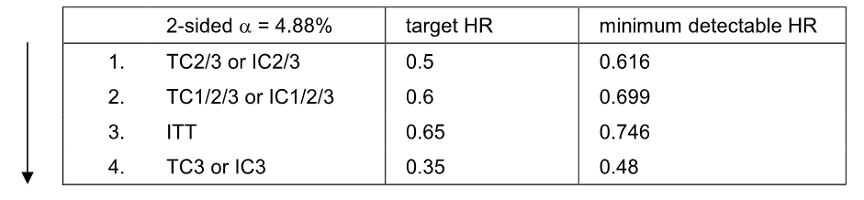
The OS was also examined in pre-specified subgroups based on the ITT population. The subgroups were defined by baseline demographic factors (e.g. age and sex) and baseline prognostic characteristics (e.g. PD-L1 expression, ECOG performance status, prior lines of chemotherapy, tumour histology, smoking history). In addition to efficacy endpoints, including OS, PFS, and ORR, being evaluated in the PD-L1 expression subgroups, the endpoints were also evaluated in the PD-L1 mutually exclusive subgroups.
Comment: The statistical methods used to analyse the OS are considered to be appropriate.

Secondary endpoints
The PFS was assessed using similar methodology to those described above for the OS. ORR per RECIST v1.1 was assessed using Clopper-Pearson methods for 95% CI, and the Mantel-Haenszel test for the difference in rates. The ORR per mRECIST (atezolizumab arm only) used Clopper-Pearson methods for the 95%CI of response rates. The DOR was analysed using Kaplan-Meier methodology.
Comment: The statistical methods used to analyse the secondary efficacy endpoints are considered to be appropriate.

Changes to the planned statistical analyses or conduct of the study
The planned analyses for this study were described in the Statistical Analysis Plan (SAP), dated 14 July 2015. There were a small number of planned analyses that were not undertaken (i.e. weighted log-rank analysis of efficacy outcomes; data summarised by the PROs). The changes to the SAP are not considered to be significant and do not invalidate the analyses that were undertaken.
The first version of the protocol was issued on 30 April 2013 and was amended 5 times. The key changes have been examined and are considered not to have compromised the internal validity of the study.

Participant flow
A total of 527 patients were screened, 287 patients from 61 centres in 13 countries were randomised and 240 patients failed screening. The most common reasons for screen failure were known active or untreated CNS metastases (56 patients) or inability to provide tumour specimens in paraffin blocks or at least 15 unstained slides (47 patients). A total of 287 patients were randomised, including 143 patients to the docetaxel arm and 144 patients to the atezolizumab arm. Overall, 10 patients did not receive any study treatment (8 in the docetaxel arm and 2 in the atezolizumab arm).
At the time of the primary analysis, the median duration of follow up was similar across the two treatment arms in the ITT population: i.e. 15.7 months in the docetaxel arm (range: 0.1, 18.7 months) and 14.8 months in the atezolizumab arm (range: 0.2, 19.6 months). The minimum follow-up time at the time of the clinical cut-off date was 13.3 months.
At the time of the primary analysis, 1 patient (0.7%) in the docetaxel arm and 24 patients (16.7%) in the atezolizumab arm were still on treatment. A further 36 patients (25.2%) in the docetaxel arm and 36 patients (25.0%) in the atezolizumab arm were alive and in the survival follow-up period. Death had been reported in 93 patients (65.0%) in the docetaxel arm and 78 patients (54.2%) in the atezolizumab arm. Study discontinuation reasons other than death were reported in 13 patients (9.1%) in the docetaxel arm (1 lost to follow-up [0.7%]; 12 [8.4%] withdrawals by subject) and 6 patients (4.2%) in the atezolizumab arm (1 [0.7%] lost to follow-up; 5 withdrawals by subject [3.5%]). The patient disposition at the time of the primary analysis (ITT population) is summarised below in Figure 20.
Figure 20: POPLAR – Patient disposition at the time of the primary analysis in the ITT population, 8 May 2015.
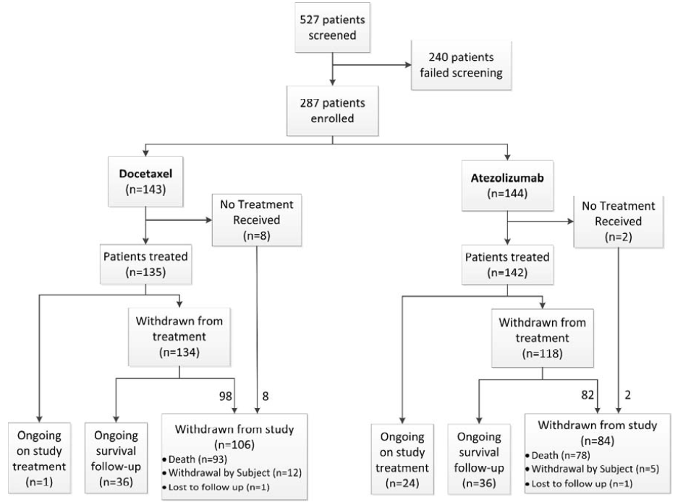

Major protocol violations/deviations
Protocol deviations were reported in relation to the inclusion/exclusion criteria, and on-study procedures and assessments (including medication violations). Overall, the incidence of protocol deviations was similar between the arms (i.e. 20 patients [14.0%] in the docetaxel arm reported at least one major protocol deviation vs 17 patients [11.8%] in the atezolizumab arm). All these patients were included in the safety and efficacy analyses presented in the CSR.
The proportion of patients with at least one major inclusion and/or exclusion criteria deviation at study entry was 4.9% (7 patients) in both arms. Study eligibility criteria not being met reported in at least 2 patients in either of the two treatment arms (docetaxel vs atezolizumab) were ‘untreated and/or excluded CNS metastases’ (n = 3 [2.1%] vs n = 1 [0.7%]), excluded ‘concurrent illness’ (n = 2 [1.4%] vs n = 1 [0.7%]), ‘did not meet laboratory requirements’ (n = 1 [0.7%] vs n = 2 [1.4%]), and ‘treatment with prohibited medication within excluded window relevant to randomisation’ (n = 0 vs n = 3 [2.1%]).
At least one major on-study deviation from study procedures was reported in 9.1% (n = 13) of patients in the docetaxel arm (14 events) and 7.6% (n = 7.6%) of patients in the atezolizumab arm (12 events). The most common on-study protocol deviation was ‘other procedural deviation significant for safety and/or efficacy’ (i.e. not related to prohibited medication or incorrect dose received), with a similar incidence in the two treatment arms (8.4% [n = 12], docetaxel; 6.9% [n = 10], atezolizumab). In addition, 2 patients in the atezolizumab arm received a prohibited concomitant therapy and 1 patient in the docetaxel arm received expired drug (categorised as ‘an incorrect treatment or wrong dose’).
Comment: The major protocol deviations are considered not to have invalidated the reported efficacy and safety outcomes of the study.

Baseline data

Demographics characteristics
The baseline demographic characteristics of the ITT population (n = 287) are summarised. The mean ± SD age of the ITT population was 61.6 ± 9.3 years (range: 36, 84 years), with the majority being < 65 years (60.6%), male (58.9%), and ‘White’ (78.7%). The mean ± SD weight of the ITT population was 74.9 ± 18.4 kg (range: 41.2, 154 kg). Of the total population, 16.0% were currently using tobacco, 64.5% had used tobacco previously and 19.5% had never used tobacco. The majority of the population had an ECOG PS of 1 (68.0%), with the remainder having an ECOG PS of 0 (32.0%).

NSCLC history
The NSCLC history of the two treatment arms is summarised. The majority of patients in the total ITT population (n = 287) had non-squamous cell tumours (66.2%), had received 1 prior therapy rather than 2 prior therapies (65.9% vs 34.1%, respectively), and had metastatic rather than locally advanced disease (95.5% vs 4.5%, respectively). The median time from initial diagnosis of NSCLC to randomisation in the total population was 12.9 months, the median number of metastatic sites at enrolment was 3 (range: 1, 8), the majority of patients at enrolment had no liver (77.0%), bone (71.8%) or brain (92.0%) metastases. The majority of patients had lung metastases (89.5%) at enrolment, but not pleural effusion metastases (76.3%). Most patients with data were EGFR, EML4-ALK and KRAS mutation negative at enrolment. However, baseline testing for these mutations was not required and not all patients were tested.
Overall, the NSCLC history was similar for the two treatment arms. However, a higher proportion of patients in the atezolizumab arm had pleural effusions compared to the docetaxel arm (28.5% vs 18.9%, respectively), and a higher proportion of patients in the docetaxel arm had brain metastases compared to the atezolizumab arm (10.5% vs 5.6%, respectively).
PD-L1 expression status at baseline
PD-L1 expression status was evaluated prospectively by a central laboratory and patients were recruited regardless of PD-L1 expression. The baseline PD-L1 expression is summarised. The proportion and number of patients for the PD-L1 expression subgroups of primary interest are summarised below.
Table 60: POPLAR – PD-L1 expression subgroups of interest.
Subgroup | Docetaxel (n = 144) | Atezolizumab (n = 144) | All Patients (n = 287)
TC3 or IC3 | 16.1% (n = 23) | 16.7% (n = 24) | 16.4% (n = 47)
TC2/3 or IC2/3 | 38.5% (n = 55) | 34.7% (n = 50) | 36.6% (n = 105)
TC1/2/3 or IC1/2/3 | 71.3% (n = 102) | 64.6% (n = 93) | 67.9% (n = 195)
TC0 and TC0 | 28.7% (n = 41) | 35.4% (n = 51) | 32.1% (n = 92)

Previous and ongoing medical history
Previous and ongoing medical conditions reported for patients treated in the study reflected the expected comorbidities of a population of patients with advanced NSCLC, and were generally well balanced with regard to SOCs and individual medical history conditions.
The most frequently reported (≥ 50% overall incidence in any arm) system organ classes (SOCs) for previous medical conditions (either resolved or ongoing at baseline) were respiratory, thoracic and mediastinal disorders, vascular disorders, and musculoskeletal and connective tissue disorders.
A total of 94.4% of patients reported at least one ongoing medical condition at baseline unrelated to NSCLC: 90.9% in the docetaxel arm vs 97.9% in the atezolizumab arm. The most frequently reported SOCs (≥ 30% overall incidence in any arm) in which concurrent conditions were reported (docetaxel vs atezolizumab) included: (1) respiratory, thoracic and mediastinal disorders, including cough (31.5% vs 30.6%), dyspnoea (25.9% vs 25.7%) and chronic obstructive pulmonary disease (21.0% vs. 18.8%); (2) vascular disorders, including hypertension (39.9% vs 42.4%) and deep vein thrombosis (3.5% in both arms); (3) musculoskeletal and connective tissue disorders, including back pain (10.5% vs 16.0%), arthralgia (4.2% vs 9.7%) and osteoarthritis (6.3% vs 4.9%); (4) metabolism and nutrition disorders, including hypercholesterolaemia (12.6% vs 10.4%), hyperlipidaemia (5.6% vs 11.1%) and decreased appetite (9.1% vs 4.9%); (5) gastrointestinal disorders, including constipation (18.2% vs 14.6%), gastro-oesophageal reflux disease (12.6% vs 17.4%) and nausea (16.1% vs. 8.3%); (6) general disorders and administration site conditions, including fatigue (18.9% vs 18.1%), pain (9.8% vs 4.9%) and chest pain (7.7% vs 6.3%); and (7) psychiatric disorders, including anxiety (16.1% vs 14.6%), insomnia (13.3% vs 16.0%) and depression (11.2% vs 11.8%).
Conditions within the most common SOCs (respiratory, thoracic and mediastinal disorders and vascular disorders) were well balanced (< 5 %difference). Across other SOCs, the ongoing conditions at baseline with a ≥ 5% imbalance between the arms (docetaxel vs atezolizumab) were back pain (10.5% vs 16.0%), arthralgia (4.2% vs 9.7%), hyperlipidaemia (5.6% vs. 11.1%), nausea (16.1% vs. 8.3%) and peripheral neuropathy (13.3% vs 7.6%).

Previous anti-cancer therapy for NSCLC
At the time of enrolment, all patients had received at least one prior anti-cancer therapy, including 440 treatments in the docetaxel arm and 433 treatments in the atezolizumab arm. The proportion of randomised patients who had received prior therapy for underlying disease in the metastatic setting was 79.7% in the docetaxel arm (312 treatments) and 90.3% in the atezolizumab arm (336 treatments). The proportion of patients who had received prior anti-cancer therapy in the adjuvant setting was 21.0% in the docetaxel arm (63 treatments) and 16.7% in the atezolizumab arm (49 treatments), and in the neo-adjuvant setting 12.6% (41 treatments) and 7.6% (22 treatments), respectively.
A total of 48.8% of patients had received prior radiotherapy (54.5% docetaxel [112 treatments] vs 43.1% atezolizumab [84 treatments]), most frequently administered to treat metastatic disease (35.0% docetaxel vs 25.7% atezolizumab).

Results for the primary efficacy outcome

Primary analysis – 8 May 2015
The clinical cut-off date for the primary analysis was 8 May 2015, at which time 173 deaths had occurred (95 [66.4%] in the docetaxel arm vs 78 [54.2%] in the atezolizumab arm), with a 60% event/patient ratio (173/287). At the time of the cut-off for the primary analysis, the median survival follow-up time in the ITT population was 15.7 months (range: 0.1, 18.7 months) in the docetaxel arm (n = 139) and 14.8 months (range: 0.2 [censored], 19.6 months) in the atezolizumab arm (n = 144). In the safety population, the median duration of exposure in the docetaxel arm (n = 135) was 2.1 months (range: 0, 17 months) and 3.7 months (range: 0, 19 months) in the atezolizumab arm (n = 142). The OS results are summarised below, and the KM plots for are provided below.
Table 61: POPLAR – OS for the primary analysis, ITT population.
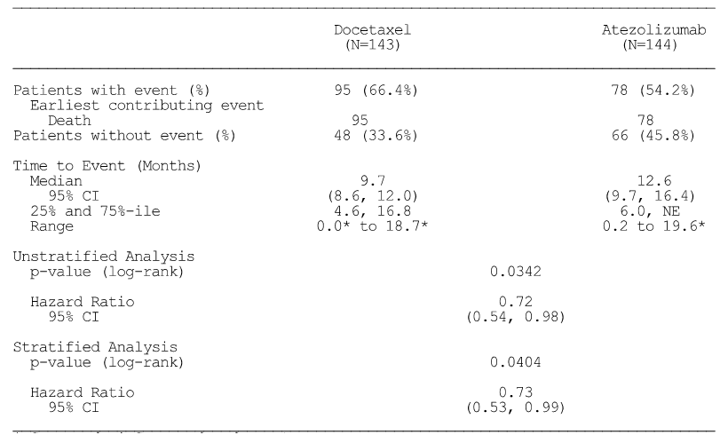
* = censored. Summaries of time to event (median, percentiles) are Kaplan-Meier estimates; 95% for median was computed using the method of Brookmeyer and Crowley; hazard ratios were estimated by Cox regression.
Figure 21: POPLAR – KM plots for OS for the primary analysis, ITT population.
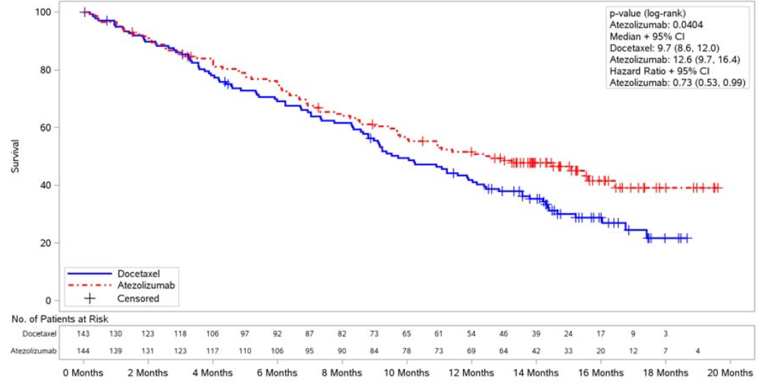
PD-L1 expression subgroup analysis showed a consistent OS benefit in favour of atezolizumab for patients expressing PD-L1 at the TC3 or IC3 level, the TC2/3 or IC2/3 level, and the TC1/2/3 or IC1/2/3 level. The Forest plots of the HR for OS for the PD-L1 subgroups of interest and the total ITT population are provided below.
Figure 22: POPLAR – Forest plots for OS by PD-L1 subgroups of interest and the ITT population, primary analysis.
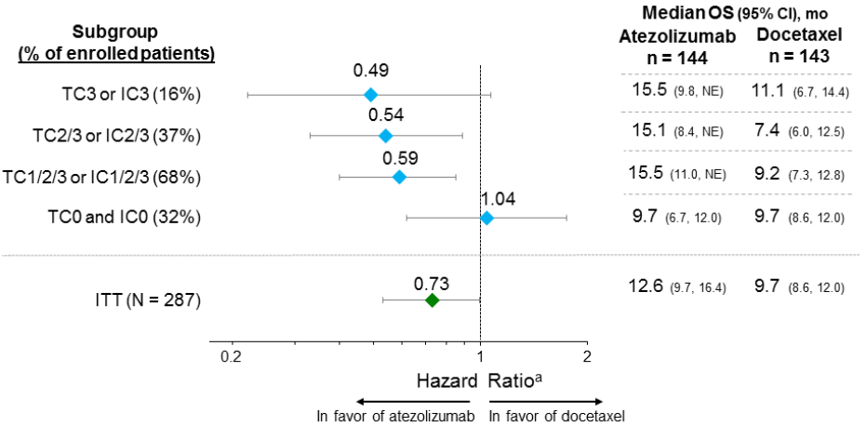
Note: ª Hazard ratio unstratified for subgroups and stratified by ITT population.
As described above under Statistical Methods, a hierarchical statistical testing procedure in pre-specified groups was used to compare OS in the docetaxel and atezolizumab arms. The pre-specified p-value for statistical significance was 0.0488 (2-sided) for the pairwise comparisons.
The first comparison in the hierarchy was in the TC2/3 or IC2/3 subgroup, and the null hypothesis was rejected as the unstratified p-value was 0.0146, which was less than the pre-specified p-value for significance of 0.0488. Therefore, the second comparison in the hierarchy in the TC1/2/3 or IC1/2/3 subgroup was tested and the null hypothesis was rejected as the unstratified p-value was 0.005, which was less than the pre-specified value for significance of 0.0488. Therefore, the third comparison in the hierarchy in the ITT population was tested, and the null hypothesis was rejected as the stratified p-value was 0.0404, which was less that the pre-specified stratified p-value for significance of 0.0488. Therefore, the fourth and last comparison in the hierarchy in the TC3 or IC3 or subgroup was tested and the null hypothesis was not rejected as the unstratified p-value was 0.0684, which was greater than the pre-specified p-value for significance of 0.0488.
Comment: The study met its primary endpoint, with median OS survival being 2.9 months longer in the atezolizumab arm than in the docetaxel arm (12.6 vs 9.7 months, respectively, p = 0.040, stratified log-rank analysis). The difference between the two treatment arms was statistically significant, as the p value (0.0404) was less that the pre-specified p value of 0.0488. The HR (stratified analysis) indicates that the relative risk of death was 27% lower in the atezolizumab arm compared to the docetaxel arm. The KM curves of OS began to separate in favour of atezolizumab at about 4 months and continued to separate throughout the remainder of the observation period. Overall, the absolute increase in OS of 2.9 months in the atezolizumab arm compared to the docetaxel arm is modest, but is considered to be clinically meaningful in the context of NSCLC in which 95% of patients had metastatic disease and all patients had received one or more prior therapies.
The pre-specified hierarchical statistical testing procedure showed that the OS significantly favoured the atezolizumab arm relative to the docetaxel arm not only for the total ITT group but also for the TC2/3 or IC2/3 subgroup and the TC1/2/3 or IC1/2/3 subgroup. However, in the TC3 or IC3 subgroup although the median duration of OS was 4.4 months longer in the atezolizumab arm than in the docetaxel arm the difference was not statistically significant (p = 0.0684). This might be due to the small number of patients in the atezolizumab and docetaxel treatment arms (24 vs 23, respectively). Of note, OS in favour of atezolizumab compared to docetaxel increased with increasing PD-LI expression (i.e. HR = 0.49 for the TC3 or IC3 subgroup; HR = 0.54 for the TC2/3 or IC2/3 subgroup; HR = 0.59 for the TC1/2/3 or IC1/2/3 subgroup; and HR = 1.04 for the TC0 or IC0 subgroup). KM plots showed a clear separation from 6 months onwards for the TC3 or IC3 subgroup, from the beginning of the treatment period for the TC2/3 or IC2/3 subgroup, and from 1 month onwards for the TC1/2/3 or IC1/2/3 subgroup. No meaningful interpretation of the KM plots for the two treatment arms in the TC0 and IC0 subgroup can be made due to the survival curves crossing over at approximately 9 months and the highly variable relationship between the two curves. Crossing KM survival curves violates the assumption of proportional-hazards on which the analysis is based.

Updated analysis of OS – 1 December 2015
The sponsor provided an updated analysis of OS with a clinical cut-off of 1 December 2015, providing an additional 7 months of follow-up and a total minimum follow-up of 20 months, with an increased event/patient ratio (from 60% in the primary analysis to 70% in the updated analysis). With longer follow-up, 200 patients had died in the 287 randomised patients. Improvement in OS benefit and continued clear separation in KM survival curves were observed for atezolizumab relative to docetaxel for the ITT population (HR = 0.69 [95% CI: 0.52, 0.92]). The median overall survival in the ITT population was 9.7 months (95% CI: 8.6, 12.0) in the docetaxel arm (n = 143), and 12.6 months (95% CI: 9.7, 16.0) in the atezolizumab arm (n = 144). The KM survival curves are provided below.
Figure 23: KM curves for OS, stratified analysis in the ITT population, data cut-off date 1 December 2015.
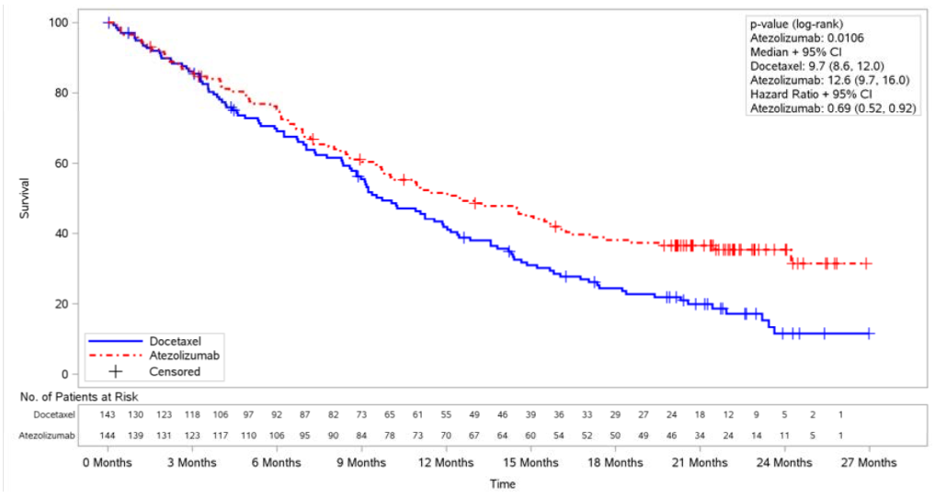
Further improvement in OS benefit was also seen across PD-L1 expression subgroups and histology subgroups.
Table 62: POPLAR – Updated OS survival at the cut-off date of 1 December 2015.
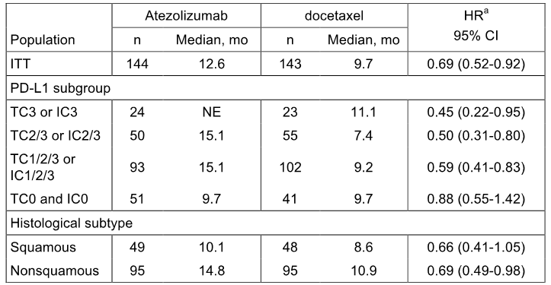
The sponsor drew attention to the improvement in the OS observed in the TC0 and IC0 subgroup in the updated analysis relative to the primary analysis, with the HR changing from 1.04 (95% CI: [0.62, 1.75]) at the primary analysis to 0.88 (95% CI: [0.55,1.42]) at the updated analysis. The sponsor notes that the KM survival curves still showed cross-over, with survival in the docetaxel arm being better than in the atezolizumab arm prior to the median survival point and better in the atezolizumab arm than in the docetaxel arm better after the median survival point. However, it is considered that cross-over precludes meaningful interpretation of the KM curves in the TC0 and IC0 subgroup. Cross-over of the KM survival curves were not observed for the total ITT population or the TC3 or IC3, TC2/3 or IC2/3, or TC1/2/3 or IC1/2/3 subgroups.

Results for the secondary efficacy analyses

Progression free survival (PFS) investigator assessed per RECIST v1.1
There was no statistically significant difference in PFS (investigator assessed; RECIST v1.1) between the two treatment arms in the ITT population. The median duration of PFS was similar in the two treatment arms: i.e. 3.0 months (95% CI: 2.8, 4.1) in the docetaxel arm and 2.7 months (95% CI: 2.0, 4.1) in the atezolizumab arm; HR = 0.94 (95%CI: 0.72, 1.23), p = 0.6450, stratified log-rank test. The proportion of patients with PFS events was 84.6% in the docetaxel arm (121 events [29 deaths, 92 PD]) and 86.1% in the atezolizumab arm (124 events [15 deaths, 109 PD]).
No clinically meaningful difference in PFS between the two treatment arms were identified from the KM plots. Furthermore, the PFS data from the KM plots are unreliable as the plots crossed-over at about 6 months, which violates the proportional-hazards assumption.
There were no statistically significant differences in PFS between the two treatment arms in the TC3 or IC3, TC2/3 or IC2/3, TC1/2/3 or IC1/2/3, or TC0 and IC0 subgroups.

Objective response rate (ORR) investigator-assessed per RECIST v1.1
There was no statistically significant difference in the ORR (investigator assessed; RECIST v1.1) between the two treatment arms in the ITT population. The ORR was similar in the two treatment arms: 14.7% (95% CI: 9.3, 21.6) in the docetaxel arm and 14.6% (95% CI: 9.3, 21.4) in the atezolizumab arm (Δ = -0.01% [95% CI: -8.28, 8.08], p = 0.9805, Chi-square test). One patient in the atezolizumab arm achieved a complete response, and a similar proportion of patients in both treatment arms had a partial response (14.7%, docetaxel vs 13.9%, atezolizumab) or stable disease (35.0%, docetaxel vs 37.5%, atezolizumab). Of note, a higher proportion of patients had missing or unevaluable data in the docetaxel arm (15.4%) than in the atezolizumab arm (6.9%).
Based on the 95% CIs for the odds ratios, there were no statistically significant differences in the ORR between the two treatment arms in the TC3 or IC3, TC2/3 or IC2/3, and TC1/2/3 or IC1/2/3 subgroups. In the TC3 or IC3 subgroup, the ORR was 13.0% in the docetaxel arm and 37.5% in the atezolizumab arm, and all responses were PRs. In the TC2/3 or IC2/3 subgroup, the ORR was 14.5% in the docetaxel arm and 22.0% in the atezolizumab arm, and all responses were PRs. In the TC1/2/3 or IC1/2/3 subgroup, the ORR was 16.7% in the docetaxel arm and 18.3% in the atezolizumab arm, including 1 complete response in the atezolizumab arm.

Duration of response in patients with an objective response (CR or PR)
In responders, the median DOR was significantly longer in the atezolizumab arm than in the docetaxel arm (14.3 vs 7.2 months, respectively), and the unstratified HR was 0.41 (95%CI: 0.18, 0.96), p-value = 0.0339. The unstratified analysis was the primary method of analysis due to the small number of patients in the two treatment arms (21 patients in each treatment arm). The KM plots showed a clear separation in favour of atezolizumab at approximately 6 months and separation continued over the remainder of the observation period.
The number of patients achieving a response was too low in the TC3 or IC3 and TC2/3 or IC2/3 subgroups to draw any conclusions relating to DOR for these patients. In the TC1/2/3 or IC1/2/3 subgroup, the median DOR was 7.2 months in the docetaxel arm (n = 17) and 11.9 months in the atezolizumab arm (n = 17).
The sponsor provided an updated analysis of DOR based on a data cut-off date of 1 December 2015. Among responders, the median DOR was notably longer in the atezolizumab arm (18.6 months [95% CI: 11.6, NE]) than in the docetaxel arm (7.2 months [95% CI: 5.6, 12.5]) in the ITT population, with 11 of 22 (50%) of the atezolizumab responders ongoing compared to 3 of the 21 (14%) docetaxel responders. Overall, the updated results showed an increase in the DOR in the atezolizumab arm while DOR remained unchanged in the docetaxel arm.

ORR, PFS, DOR investigator assessed per modified (m) RECIST in the atezolizumab only
ORR, PFS, and DOR analyses investigator assessed per modified RECIST were analysed in the atezolizumab arm only. The CSR summarised the results for mRECIST in the atezolizumab arm and compared the results with RECIST v1.1. For the ORR, the results were similar for mRECIST and RECIST v1.1 in the atezolizumab arm in the ITT population and the PD-LI expression subgroups of interest. For PFS, the results for mRECIST were numerically superior to the results for RECIST v1.1 in the atezolizumab arm for the ITT population group and the PD-LI expression subgroups of interest. For the DOR, the results for mRECIST and RECIST v1.1 were similar in the atezolizumab arm for the ITT population, and numerically superior in the PD-LI expression subgroups of interest. However, the patient numbers in the PD-LI expression subgroups of interest in the DOR were small.

Results for selected subgroup analyses of OS

OS by PD-LI mutually exclusive subgroups
In order to evaluate the impact of patients with TC3 or IC3 on OS in the TC2/3 or IC2/3 subgroup, the sponsor compared OS in ‘mutually exclusive’ subgroups (i.e. TC2/3 or IC2/3 vs TC2/3 or IC2/3 excluding TC3 or IC3). In order to evaluate the impact of patients with TC2/3 or IC2/3 on OS in the TC1/2/3 or IC1/2/3 subgroup, the sponsor compared OS in ‘mutually exclusive’ subgroups (i.e. TC1/2/3 or IC21/2/3 vs TC1/2/3 or IC1/2/3 excluding TC2/3 or IC2/3). The results of the OS analyses in the ‘mutually exclusive’ subgroups are summarised below.
Table 63: POPLAR – Duration of OS in PD-L1 mutually exclusive subgroups, primary analysis ITT population
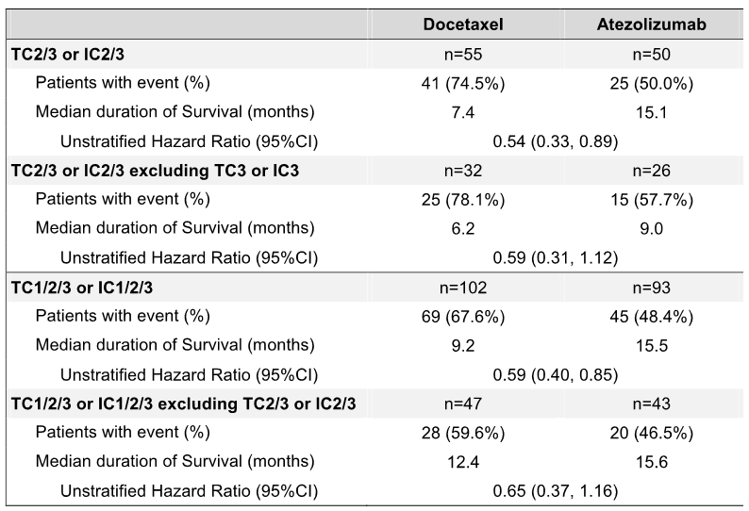
Comment: The difference in median OS survival between the two treatment arms in favour of atezolizumab was notably greater in the TC2/3 or IC2/3 subgroup compared to the TC2/3 or IC2/3 excluding TC3 or IC3 subgroup (Δ = 7.7 months [HR=0.54, 95% CI: 0.33, 0.89] vs Δ = 2.8 months [HR = 0.59, 95% CI: 0.31, 1.12]). The difference in median OS survival between the two treatment arms in favour of atezolizumab was notably greater in the TC1/2/3 or IC1/2/3 subgroup compared to the TC1/2/3 or IC1/2/3 excluding TC2/3 or IC2/3 subgroup (Δ = 6.3 months [HR=0.59, 95% CI: 0.48, 0.85] vs Δ = 3.2 months [HR = 0.65, 95% CI: 0.37, 1.16]). Overall, the results suggest that OS survival in patients treated with atezolizumab increases when patients with increased TC and IC PD-L1 expression are included in the treatment group.

Independent TC versus IC contributions to OS
The sponsor undertook an analysis of OS by TC selected (1/2/3) and IC0 patients as well as TC0 and IC selected (1/2/3) patients in order to evaluate the independent contributions of PD-L1 expression on TC versus IC. The results are described below.
- The TC1/2/3 and IC0 subgroup included TC1 and IC0, TC2 and IC0, and TC3 and IC0 patients. This subgroup was evaluated to identify whether patients expressing PD-L1 on TC at the 1% level or higher (defined as TC1/2/3) were driving the benefit in OS results in the PD-L1 expression subgroups. In the TC1/2/3 and IC0 subgroup, the median duration of survival was 11.2 months (95% CI: 6.7, 16.0) in the docetaxel arm but was not reached in the atezolizumab arm (HR = 0.37, 95% CI: 0.12, 1.13). The KM curves showed a clear separation in favour of the atezolizumab arm emerging at 4 to 6 months.
- The TC0 and IC1/2/3 included TC0 and IC1, TC0 and IC2, and TC0 and IC3 patients. This subgroup was evaluated to identify whether patients expressing PD-L1 on IC at the 1% level or higher (defined as IC1/2/3) were driving the benefit in OS results in the PD-L1 expression subgroups. In the TC0 and IC1/2/3 subgroup, the median duration of OS was 12.2 months (95% CI: 8.6, 14.2) in the docetaxel arm versus 15.6 months (95% CI: 9.7, NE) in the atezolizumab arm (HR = 0.63, 95% CI: 0.36, 1.12). The KM curves showed a clear separation in favour of the atezolizumab arm emerging shortly after initiation of treatment.
Comment: The results showed that both TC at the 1% level or higher (defined as TC1/2/3) and IC at the 1% level or higher (defined as IC1/2/3) have independent effects on OS. The results for the HR suggest that patients with PD-L1 expression on TCs might have a greater survival benefit than patients with PD-L1 expression on ICs.

Individual contribution of TC and IC to OS
In order to evaluate the individual contribution of TC and IC PD-L1 expression to enrichment for OS, the sponsor undertook an analysis of individual TC or IC PD-L1 expression levels, with the caveat that multiple levels of TC are included in individual IC subgroups, and vice versa. The lowest OS HR observed was 0.36 (95%CI: 0.13, 1.00) for the TC3 subgroup. The sample size was small in the subgroups with higher levels of PD-L1 expression. The results are summarised below.
Figure 24: POPLAR – Forest plot of duration of OS in ITT patients, 8 May 2015 cut-off.
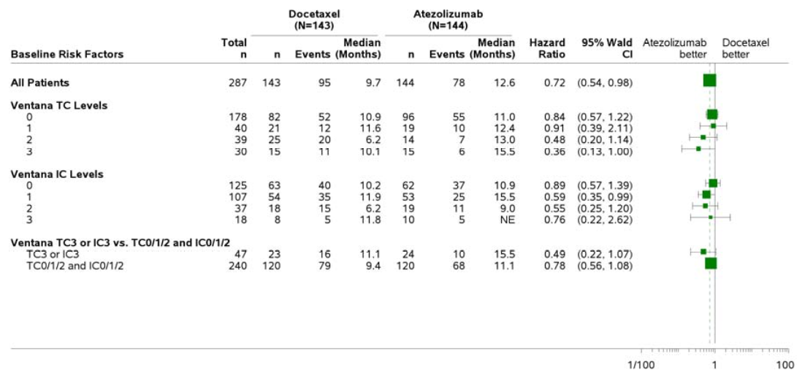
NE = non-estimable; median survival was estimated from Kaplan-Meier methods. Unstratified HR relative to docetaxel and 95% CI for HR estimated using Cox regression. The vertical dashed line indicates the HT for all patients. The diameter of a square is proportional to the total number of events.
Comment: It is difficult to interpret the OS results due to the small number of patients and events at the higher PD-LI expression levels. Overall, the results suggest that increased survival is associated with TC2/3 and IC2/3 levels.

OS by demographic and baseline characteristics
The sponsor investigated the generalisability of the observed benefit of therapy with atezolizumab compared to docetaxel on OS by estimating the treatment effect in pre-defined subgroups based on stratification factors (number of prior lines of chemotherapy, tumour histologic type), key baseline demographics (gender, age category, race, smoking history) and disease characteristics (ECOG performance status, liver metastases, bone metastases, KRAS, EGFR and ALK mutation status). In almost all of the subgroups analysed, the risk of death was reduced in the atezolizumab arm compared to the docetaxel arm. The only exceptions were in some races, and in the EGFR and KRAS mutation subgroups (where the number of patients was small due to lack of mandatory testing), as well as in patients who had received two lines of prior chemotherapy in the metastatic setting. In all other subgroups, the point estimates of the HRs for OS ranged from 0.42 to 0.83.

OS by squamous versus non-squamous histology
At randomisation, patients were stratified by histology (squamous, n = 97 versus non-squamous, n = 190). In the primary and updated analyses, improvement in OS was seen irrespective of histologic type (see below).
Table 64: POPLAR – OS by histological subtype, primary and updated analyses in the ITT population.
 |  | Atezolizumab |  | Docetaxel
Analysis | Histology | n | median |  | n | median |  | HR ª |  | 95% CI
Primary | Squamous | 49 | 10.1 months |  | 48 | 8.6 months |  | 0.80 |  | (0.49, 1.30)
8 May 2015 | Non-squamous | 95 | 15.5 months |  | 95 | 10.9 months |  | 0.69 |  | (0.47, 1.01)
Updated | Squamous | 49 | 10.1 months |  | 48 | 8.6 months |  | 0.66 |  | (0.41, 1.05)
1 December 2015 | Non-squamous | 95 | 14.8 months |  | 95 | 10.9 months |  | 0.69 |  | (0.49, 0.98)
ª = unstratified analysis.

Patient reported outcomes (PROs)

EORTC QLQ-C30 and EORTC QLQ-LC13
Global health status/quality of life, functioning, and lung cancer symptoms (cough, dyspnoea, chest pain, arm/shoulder pain) were assessed by the EORTC QLQ-C30 and LC13. The QLQ-C30 and LC13 were completed at baseline and Day 1 of each cycle. The sponsor noted that, based on published literature, a 10-point change in the score is perceived by patients as clinically meaningful. A higher score on the global health and functioning subscales is indicative of better HRQoL and functioning, whereas a lower score on the symptom subscales is indicative of a lower symptom burden (i.e. improvement in symptoms).
No clinically meaningful change (improvement or decline) from baseline was observed for patients in the atezolizumab arm during the study period in global health status, functioning (physical, role, emotional, cognitive, and social) or any of the symptom subscales. The sponsor comments that these results indicate that atezolizumab does not have a detrimental impact on HRQoL. Patients in the docetaxel arm did not show clinically meaningful change (improvement or decline) from baseline during the study period in global health status, functioning (physical, role, emotional, cognitive, and social) or the lung cancer symptom subscales, but reported a meaningful increase in alopecia.

Time to deterioration (TTD) of lung cancer symptoms
Time to deterioration is defined as a ≥ 10-point increase above baseline. Inspection of the KM plots showed no difference between the atezolizumab and docetaxel treatment arms in TTD of lung cancer symptoms (cough, dyspnoea, chest pain, or arm/shoulder pain). The median time to deterioration of cough was 3.8 months in the docetaxel arm and 3.7 months in the atezolizumab arm; the median time to deterioration of dyspnoea was 2.2 months in the docetaxel arm and 2.1 months in the atezolizumab arm; the median time to deterioration in arm or shoulder pain was 7.5 months in the docetaxel arm and 10.4 months in the atezolizumab arm; and the median time to deterioration of pain in the chest was 7.5 months in the docetaxel arm and 10.5 months in the atezolizumab arm.

Treatment beyond initial progression
The Summary of Clinical Efficacy (NSCLC) included the results of an exploratory analysis of delayed response following disease progression (PD) identified by radiological findings per RECIST v.1.1. In the atezolizumab arm, treatment could continue beyond radiographic progression for as long as patients continued to demonstrate clinical benefit, as assessed by the investigator. The sponsor stated that conventional response criteria may not adequately assess the activity of immunotherapeutic agents, because PD (by initial radiographic evaluation) does not necessarily reflect therapeutic failure due to the possibility of delayed response.
Based on the data for the primary analysis (clinical cut-off date of 8 May 2015), the median duration of treatment after progression per RECIST v1.1, for the 57 patients in the atezolizumab arm who received at least one dose of atezolizumab post-progression, was 2.1 months (range: 0, 12.9 months). The majority of atezolizumab patients treated beyond progression (64.9%) received ≤ 3 months of additional atezolizumab treatment. One patient (1.8%) received atezolizumab for more than 12 months after initial progression (12.9 months). The median number of doses received post-progression was 3 (range: 1, 19).
Among patients who received treatment beyond radiographic progression per RECIST v1.1, changes in target lesions post-progression (sum of long diameter [SLD]) were analysed (INV-assessed; RECIST v1.1) relative to the original baseline measurements. The results are summarised below. The results showed that in the majority of patients in the three treatment arms progression had either improved or remained stable beyond radiographic progression.
Table 65: POPLAR – Best percent change in SLD from baseline for tumour assessments post-progression by investigator in the 2L+ treatment population of atezolizumab treated patients, data cut-off 8 May 2015.
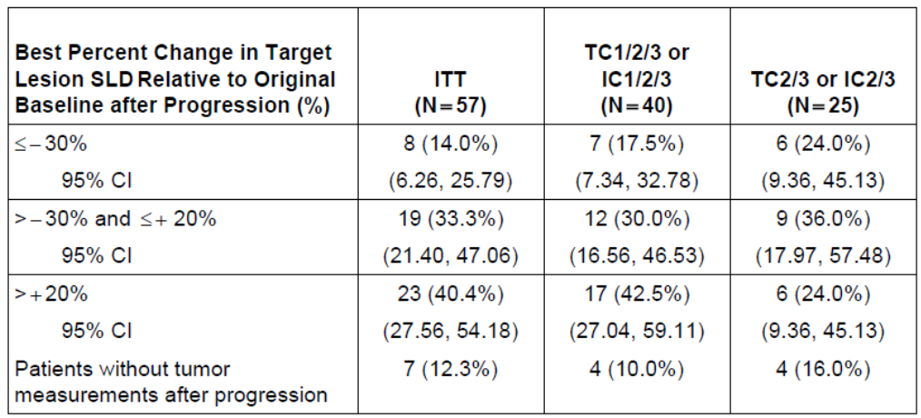

Other anti-cancer treatment after PD
For patients who experienced PD per RECIST v1.1, median OS from the time of PD was 6.9 months (95% CI: 5.7, 9.6) for 109 patients in the atezolizumab arm and 6.0 months (95% CI: 4.6, 8.3) for 92 patients in the docetaxel arm. Among these patients, a subgroup analysis was also performed to evaluate OS according to subsequent anti-cancer treatment after PD. Median OS from the time of first RECIST PD was numerically longer in the atezolizumab arm (n = 57) for patients continuing atezolizumab post PD than in either the atezolizumab (n = 39) arm or the docetaxel (n = 46) arm for patients receiving an anti-cancer therapy other than atezolizumab post PD (11.1 [atezolizumab continued post PD for patients in the atezolizumab arm] vs 8.3 [other anti-cancer treatment post PD for patient initially randomised to atezolizumab] vs 9.6 months [other anti-cancer treatment post PF for patients initially randomised to docetaxel]).

BIRCH – sponsor nominated pivotal study (NSCLC)

Study design, objectives, locations and dates

Title
Primary Clinical Study Report – Protocol GO28754 – A Phase II, Multicenter, Single-Arm Study of MPDL3280A in Patients with PD-L1-Positive Locally Advanced or Metastatic Non-Small Cell Lung Cancer. Report 1066811 - December 2015

Objectives
The primary objective was to evaluate the efficacy of atezolizumab in patients with PD-L1 selected locally advanced or metastatic NSCLC based on the ORR as assessed by an IRF per RECIST v1.1.
The secondary objectives were: (1) to evaluate PFS, DOR and TIR as assessed by an IRF per RECIST v1.1 and as assessed by the INV per mRECIST; (2) to evaluate ORR, DOR, TIR, and PFS as assessed by the INV per RECIST v1.1; (3) to evaluate ORR as assessed by the INV per mRECIST; (4) to evaluate OS and 1-year OS; (5) to evaluate 1-year PFS as assessed by an IRF per RECIST v1.1 and 1-year PFS as assessed by the INV per both RECIST v1.1 and mRECIST; (6) to evaluate the safety and tolerability of atezolizumab; (7) to characterise the PK of atezolizumab; (7) to evaluate the incidence and titres of ATAs against atezolizumab and to explore the potential relationship of the immunogenicity response with PK, safety, and efficacy.
The study included a number of tertiary objectives relating to additional efficacy outcomes, the relationship between biomarkers and efficacy, and PROs of lung cancer symptoms, patient functioning, and health related quality of care.

Design
BIRCH is an ongoing Phase II, global, multicentre, single-arm clinical trial designed to evaluate the efficacy and safety of atezolizumab in patients with PD-L1 selected expression levels TC2/3 and/or IC2/3 and locally advanced or metastatic NSCLC. Tumour specimens from patients meeting eligibility criteria were prospectively tested for PD-L1 expression by IHC using the IUO VENTANA PD-L1 (SP142) assay in a certified central laboratory. Approximately 635 PD-L1 selected patients were to be enrolled in 1 of 3 cohorts. The three cohorts were:
- Cohort 1 (1L atezolizumab treatment cohort) included patients who had not received prior chemotherapy for advanced NSCLC (planned n = 127 patients).
- Cohort 2 (2L+ atezolizumab treatment cohort) included patients who had progressed during or following a prior platinum-based chemotherapy regimen for advanced NSCLC (planned n = approximately 254 patients). The proportion of patients in Cohorts 1 and 2 could be adjusted during the course of the study but was not to exceed 50% of the planned study enrolment (320 patients) in either cohort.
- Cohort 3 (3L+ atezolizumab treatment cohort) included patients who had progressed during or following a platinum-based chemotherapy regimen and progressed during or following at least one additional regimen for advanced NSCLC (planned n = at least 254 patients). The maximum number of prior therapies for patients in Cohort 3 was unrestricted. Approximately 100 patients with PD-L1 TC3 or IC3 status were to be enrolled into Cohort 3.
The study design is outlined below in Figure 25. The schedule of study assessments has been examined and is considered to be appropriate. The schedule included a screening period (Day -1 to -28), an assessment period (Day 1 ± 2 days for all cycles ≥ 2), and a treatment discontinuation period ≤ 30 days after the last dose and follow-up.
Figure 25: BIRCH – Outline of study design.
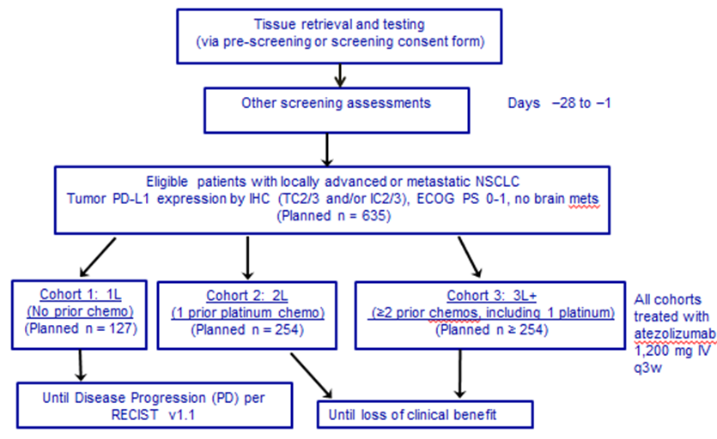
Atezolizumab (fixed-dose 1200 mg) was administered IV on Day 1 of 21-day cycles. Patients in Cohort 1 were treated with atezolizumab until disease progression. In Cohorts 2 and 3, atezolizumab treatment continued as long as patients demonstrated clinical benefit, as assessed by the investigator, after radiographic documentation of disease progression per RECIST v1.1 provided pre-specified criteria were met. The pre-specified clinical benefit criteria were: (1) evidence of clinical benefit as assessed by the investigator; (2) absence of symptoms and signs indicating unequivocal progression of disease; (3) no ECOG PS that could be attributed to disease progression; and (3) absence of tumour progression at critical anatomical sites that could not be managed by protocol-allowed medical intervention.
Screening assessments included CT scans (with oral/IV contrast, unless contraindicated) or MRI of the chest, abdomen, and pelvis. A spiral CT scan of the chest could be obtained but was not a requirement. A CT (with contrast if not contraindicated) or MRI scan of the head was done at screening to exclude CNS metastases. Patients with CNS metastases were excluded from the study. If a CT scan for tumour assessment was performed in a PET/CT scanner, the CT acquisition must have been consistent with the standards for a full-contrast diagnostic CT scan. Bone scans and CT scans of the neck were to be performed if clinically indicated. At the investigator’s discretion, other methods of assessment of measurable disease per RECIST v1.1 could have been used. The same radiographic procedure used to assess disease sites at screening was used throughout the study. All known sites of disease were documented at screening and reassessed at each subsequent tumour evaluation. Response was assessed using RECIST v1.1 and mRECIST criteria.
Tumour assessments occurred every 6 weeks for 12 months following Cycle 1, Day 1 and then every 9 weeks thereafter, regardless of treatment delays, until disease progression (Cohort 1), loss of clinical benefit (Cohorts 2 and 3), withdrawal of consent, death, or study termination by the sponsor, whichever occurred first. All patients were followed for survival and subsequent anti-cancer therapy approximately every 3 months from study treatment discontinuation until death, loss to follow-up, withdrawal of consent, or study termination by the sponsor, whichever occurred first.
The PD-LI IHC scoring criteria formulated to represent PD-LI expression on TCs and ICs were the same as those previously described for POPLAR.
Comment: The cohorts of primary interest in BIRCH are Cohorts 2 and 3, which include patients treated with atezolizumab in the second line and beyond setting. Treatment of NSCLC in these patients is consistent with proposed indication. Therefore, the evaluation of BIRCH in this CER focuses on Cohorts 2+3 (i.e. 2L+ treatment group). In contrast to POPLAR, the study population in BIRCH included patients with prospectively selected PD-LI expression levels whereas in in POPLAR the study population included all-comers (i.e. irrespective of PD-LI expression) with PD-L1 levels being determined retrospectively.
The study was open-label and single-arm in design. Therefore, the study is subject to the well known biases associated with clinical trials that are not randomised and double-blind in design. It is considered that the inclusion of three cohorts at different stages of NSCLC would have required three different comparator arms. While this would have added to the complexity of the study it would have aided interpretation of the efficacy data. The use of efficacy data from an uncontrolled treatment arm in a clinical trial is considered to significantly limit the interpretation of the study for regulatory purposes, irrespective of comparisons of the data with efficacy outcomes from historical controls, and raises uncertainties about the clinical significance of the findings. In BIRCH, an independent blinded review of CT scans was performed at an IRF, prior to the primary efficacy analyses, which would have had the effect of at least mitigating bias associated with subjective review of the scans by site specific investigators.
The sponsor stated that at the time of writing the initial protocol, there were three approved agents used in the second-line setting for the treatment of NSCLC: docetaxel, pemetrexed, and erlotinib. The response rates in the second-line setting with these agents ranged from 6% to 11%. The sponsor stated that data in patients with a good performance status in second-line trials has demonstrated median survival durations of approximately 8 to 9 months.¹⁴ In addition, the sponsor commented that both objective tumour response rates and DCR decrease substantially with each line of therapy, with ORRs as low as 2% in the third-line setting with DCR ranging from 30% to 36%.^{15,16}

Location and dates
Patients in the study were enrolled from 106 sites in 19 countries globally. The countries (investigators/centres) were: Australia (5), Belgium (4), Bosnia and Herzegovina (3), Bulgaria (2), Canada (5), France (8), Georgia (4), Germany (4), Hong Kong (3), Italy (2), Japan (11), Netherlands (3), Singapore (2), Slovenia (1), Spain (3), Switzerland (4), Turkey (3), the UK (2), and the USA (34). The primary investigator was located in France. The first patient was enrolled on 22 January 2014, the last patient was enrolled on 4 December 2014 and the clinical data cut-off date was 28 May 2015. The sponsor was F.Hoffmann-La Roche Ltd. The study was conducted in compliance with GCP.

Inclusion and exclusion criteria
The study plan was to enroll approximately 635 patients with histologically or cytologically proven locally advanced or metastatic NSCLC who were either treatment-naïve in the metastatic setting (Cohort 1) or who had experienced disease progression during or following treatment with one platinum-based regimen (Cohort 2) or more than 2 regimens (Cohort 3), one of which had to have been a platinum-containing regimen for advanced disease. Patients who met all of the inclusion criteria and none of the exclusion criteria were eligible for enrolment into the study.
Comment: The inclusion and exclusion criteria were extensive. In general, the criteria were consistent with those for the pivotal NSCLC study (POPLAR).

Study treatments
Atezolizumab 1200 mg was administered every 3 weeks (q3w) by IV infusion. No dose reductions were allowed. Treatment could be temporarily suspended for up to 105 days after the last dose for the same reasons as those outlined in the review of POPLAR. The reasons for study treatment were consistent with those outlined in the review of POPLAR.
As described above, patients in Cohort 1 discontinued study treatment if they experienced disease progression per RECIST v1.1, while patients in Cohorts 2 and 3 were permitted to continue study treatment after RECIST v1.1 criteria for radiographic progressive disease were met, provided that they satisfied the pre-specified clinical benefit criteria. Every effort was made to obtain information on patients who withdraw from the study. The primary reason for withdrawal from the study was to be documented. Patients were not followed after consent was withdrawn. Patients who withdrew from the study were not replaced.
Permitted concomitant therapies were consistent with those previously outlined in the review of POPLAR. Excluded therapies were specified in the exclusion criteria and were consistent with those previously outlined in the review of POPLAR. Permitted and excluded therapies are considered to be appropriate.

Efficacy variables and outcomes
The primary efficacy endpoint was the ORR (IRF-assessed; RECIST v1.1). The ORR represented the proportion of patients achieving confirmed best response of CR or CR.
The secondary efficacy endpoints included: (1) ORR (INV-assessed; RECIST v1.1 or INV-assessed; mRECIST); (2) DOR (IRF-assessed; RECIST v1.1 or INV-assessed; RECIST v1.1 or INV-assessed; mRECIST); (3) OS; (4) PFS rate at 6 months or 1 year; (5) OS rate at 1 year; and (6) TIR (IRF-assessed; RECIST v1.1 or INV-assessed; mRECIST).
The exploratory efficacy endpoints included change in SLD over time to assess tumour burden, DCR (CR or PR as the best confirmed response of SD maintained for ≥ 24 weeks), TTOR (date of first dose to first occurrence of CR or PR, whichever occurs first).
Subgroup and sensitivity analyses were also undertaken.
Comment: The primary efficacy endpoint (ORR) is inconsistent with the TGA adopted guideline relating to the assessment of medicines to treat cancer. The adopted guidelines indicate that OS or PFS should be the primary efficacy endpoint for confirmatory Phase III clinical trials investigating the efficacy of anti-cancer medicines. BIRCH is a single-arm Phase II study, with ORR being the primary efficacy endpoint, and as such is considered to be a supportive rather than a pivotal confirmatory study. The definition of the efficacy endpoints in BIRCH are consistent with those previously described for POPLAR.

Randomisation and blinding methods
The study is an on-going open-label, single-arm clinical trial. Therefore, randomisation was not relevant. Neither patients nor investigators were blinded to study treatment. To avoid potential bias, a Data Access Control Plan was implemented to ensure that the sponsor remained blinded to the individual patient’s TC and IC status, and individuals making decisions on the potential modification of this study would be blinded to the study efficacy data until the planned primary analysis.

Analysis populations
All efficacy and safety analyses were conducted using the cohort information captured on the baseline eCRFs. There were four pre-specified analysis populations described below and summarised below.
- Efficacy evaluable population: The analyses of ORR were performed on all treated patients, i.e. all enrolled patients who received any dose of the study drug (atezolizumab) during the study treatment period. PFS, OS, TIR, and DCR were analysed for all treated patients. DOR and TTOR were assessed in treated patients whose confirmed best overall response was CR or PR. Change in SLD from baseline analysis was performed on patients who had both a non-missing baseline assessment and at least one non-missing post-baseline assessment.
- Safety evaluable population: The primary safety analyses was based on safety-evaluable patients, defined as all enrolled patients who received any dose of study drug (atezolizumab) during the study treatment period. Patients who were enrolled in the study but who did not receive any study drug were not included in the safety population. The safety population is the same as the treated patient population used for the analysis of efficacy.
- PK evaluable population: The PK population was defined as patients who received any dose of atezolizumab treatment and had PK data at time-points that were sufficient to determine PK parameters.
- PRO evaluable population: The PRO-evaluable population was defined as treated patients who had a baseline PRO assessment and at least one post-baseline PRO assessment.
Table 66: BIRCH – Summary of analysis populations.
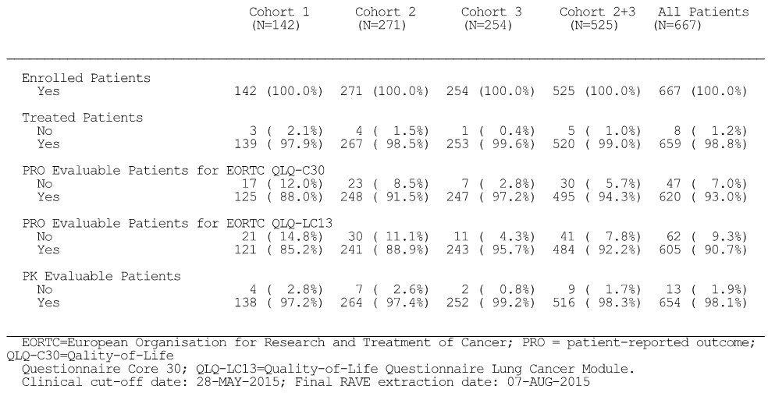

Sample size
The study was designed to evaluate ORR in a non-randomised single-arm setting. Therefore, the sponsor used historical control response rates as comparators to assess clinical benefit using the primary efficacy endpoint (i.e. IRF-assessed ORR per RECIST v1.1).
At least 635 patients were planned to be enrolled. Based on approximately 100 enrolled patients with PD-L1 TC3 or IC3 in Cohort 3, for an observed ORR of 30% the 95% CI is 21% to 39%. Additionally, 100 patients with PD-L1 TC3 or IC3 in Cohort 3 would provide > 99% power to detect a 25% increase in ORR from a historical control rate of 5% to 30% at the 5% two-sided significance level.
Patients were enrolled without restriction to their maximum number of lines of prior therapies. Patients were planned to be enrolled until there were approximately 127 patients in Cohort 1, 254 patients in Cohort 2, and 254 patients in Cohort 3.

Statistical methods
The efficacy analysis presented in the CSR included efficacy results from the primary analysis, with a data cut-off date of 28 May 2015. The efficacy analysis of the primary efficacy outcome measure, comparison of ORRs to historical control rates (per data in 2013), followed a hierarchical fixed-sequence procedure in seven sub-populations. The IRF-assessed ORR according to RECIST v1.1 was sequentially tested at an alpha of 0.05. The overall type I error rate was controlled at a two-sided alpha of 0.05. The protocol specified hierarchical fixed-sequence testing procedure is summarised below in Figure 26.
Figure 26: BIRCH – Protocol specified hierarchical fixed-sequence testing procedure.
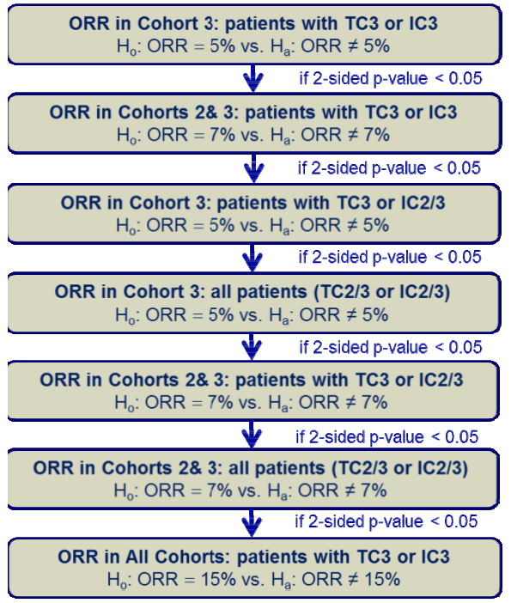
The statistical methods used to analyse the efficacy endpoints were appropriate and consistent with those previously described for POPLAR. The statistical methods used for analysis of the efficacy endpoints are summarised. Study results were shown by cohort for treated patients in two PD-L1 expression subgroups, TC3 or IC3 and TC3 or IC2/3, as well as for the entire study population (TC2/3 or IC2/3).

Participant flow
A total of 3914 patients were screened, and 27 patients were screened twice. Of all patients screened, 3410 had evaluable tumour samples and 667 patients were enrolled. Among the patients who failed screening, the most common reasons were PD-L1 status not confirmed by the central laboratory, physician decision, death, and other (details not collected).
Among the 667 enrolled patients (142 in Cohort 1, 271 in Cohort 2, and 254 in Cohort 3), 659 patients were treated (139 in Cohort 1, 267 in Cohort 2 and 253 in Cohort 3). At the time of the clinical data cut-off of 28 May 2015, 197 patients were still receiving treatment (43 in Cohort 1, 81 in Cohort 2, 73 in Cohort 3), 202 patients had discontinued treatment but were in still being followed (46 in Cohort 1, 83 in Cohort 2, 73 in Cohort 3), and 260 patients had discontinued the study (50 in Cohort 1, 103 in Cohort 2, and 107 in Cohort 3).
At the time of data cut-off, 70.1% of patients had discontinued study treatment with the leading cause being progressive disease. Treatment discontinuation due to AEs occurred in 5.6% of patients. Rates of treatment discontinuation were generally similar across cohorts except for a lower incidence of discontinuations due to disease progression in Cohort 1. The treatment discontinuation status is summarised below.
Table 67: BIRCH – Treatment discontinuation status, treated patients at data cut-off of 28 May 2015.
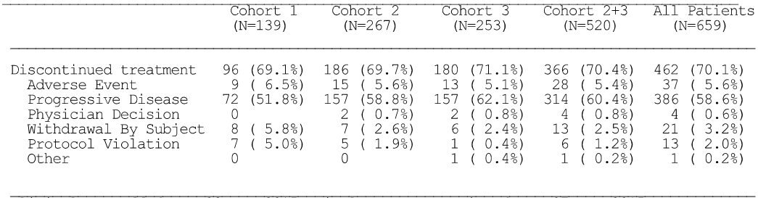
At the time of data cut-off, 40% of the overall enrolled population had withdrawn from study, with the most common reason being death (33.7% of enrolled patients). Study discontinuation due to death occurred at a higher incidence in Cohort 3 compared to the other cohorts, most likely reflecting more advanced disease in these patients. The median duration of follow up was 8.5 months in all treated patients and was similar across the cohorts. The minimum follow-up time at the time of the clinical cut-off date was 6 months (duration from clinical cutoff date to last patient enrolled date). The withdrawals from the study are summarised below.
Table 68: BIRCH – Study discontinuation status, treated patients at data cut-off of 28 May 2015.
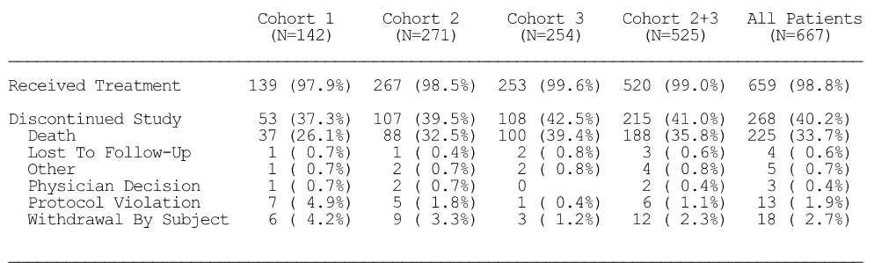

Major protocol violations
Overall, 25.6% (171/667) of enrolled patients had at least one major protocol violation. Patients could have violated more than one inclusion/exclusion criteria or protocol criteria during the study. Overall, there were a total of 260 major protocol deviations, the majority of which occurred during the conduct of the study (81.2%; 211/260).
Overall, 6.4% (43/667) of all enrolled patients had at least one major protocol violation at study entry, with the most common reasons (≥ 1% of patients) being non-measurable disease at baseline as assessed by investigator per RECIST v1.1 (2.1% [14/260]), receiving prohibited medication within the excluded time window from enrolment (1.6% [11/260]), and not meeting the laboratory requirements (1.3% [9/260]).
Overall, 22.2% (148/667) of all enrolled patients had at least one major protocol violation at study entry, with most of the violations being categorised as ‘other procedural deviation significant for safety and/or efficacy’ (21.1%; 141/667). The category of ‘other procedure deviation significant for safety and/or efficacy’ (i.e. not related to prohibited medication or incorrect dose received), included incomplete laboratory assessment during study treatment, tumour assessment done outside of window, delay in obtaining signature for informed consent form amendment or to allow continuation of treatment after PD.

Baseline data

Baseline demographics and patient characteristics
In the total treated population (n = 659), the mean ± SD age was 63.7 ± 10 years (range: 28, 88 years), with 49.8% of patients being aged ≥ 65 years, 58.9% being male, and 83.3% being categorised as white. Of the total population, 72.2% had been previous tobacco smokers, 17.1% had never been tobacco smokers, and 10.6% were current tobacco smokers. The histology type was predominantly non-squamous (71.9%), rather than squamous (28.1%). The most common baseline ECOG PS status in the total population was PS 1 (63.9%), followed by PS 0 (34.9%) and PS 2 (1.2%). PD-LI status TC3 or IC3 was present in 45.8% of the total population. The majority of patients were negative for KRAS, EGFR, and EML4-ALK rearrangement mutations.

Lung cancer history
At the time of enrolment, 95% (627/659) of patients had metastatic NSCLC (see below). Overall, the results were generally consistent across the cohorts except for fewer patients (68%) in Cohort 1 having involvement of at least one visceral metastatic site compared to patients in Cohort 2 or 3 (76% and 75%, respectively).
Table 69: BIRCH – Lung cancer status, treated patients.
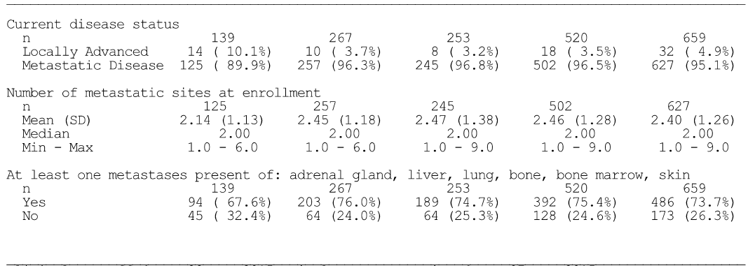

Prior cancer chemotherapy
Treated patients in Cohorts 2 and 3 had at least one prior cancer treatment, as per protocol, with the exception of 2 patients in Cohort 2 (1 patient received adjuvant treatment and progressed in less than 6 months, and information on regimen was missing for 1 patient). The proportion of patients who had adjuvant or neo-adjuvant treatment was 27% in Cohort 2 and 31% in Cohort 3. The most common regimen for adjuvant or neo-adjuvant therapy was cisplatin, used by 20% and 21% of patients in Cohorts 2 and 3, respectively. Maintenance therapy was used by 15% and 19% of patients in Cohorts 2 and 3, respectively, with the most commonly used agent being pemetrexed. Prior treatment in the metastatic setting was used in 81% and 97% of patients in Cohorts 2 and 3, respectively, with carboplatin, pemetrexed, and cisplatin, being the most commonly used agents.
Among treated patients in Cohort 1, 34% had received at least one prior cancer treatment. This included 29% of patients who had at least one adjuvant or neo-adjuvant therapy, as well as 7% of the who had received targeted treatment in the front-line locally advanced or metastatic setting (e.g. EGFR or ALK inhibitors). The most common regimen for adjuvant or neo-adjuvant therapy was cisplatin, which was received by 21% of patients in Cohort 1.

Prior surgery and radiotherapy
In the overall treated population, 66% of patients had received prior surgery for cancer, with lobectomy (31%) being the most commonly reported procedure. Lobectomies were more common in patients in Cohort 1 (36%) compared with Cohort 2 (31%) or Cohort 3 (29%). Other pulmonary surgical procedures were reported in 24% of patients, in equal proportions across cohorts. Prior cancer radiotherapy was reported by 45% of treated patients and was mainly given in the metastatic setting. Prior radiotherapy was more common in patients in Cohort 3 (54%) compared to Cohort 1 (37%) and Cohort 2 (40%).

Previous and concurrent medical conditions
The medical conditions reported for patients treated in the study reflect the expected comorbidities of a population with advanced NSCLC. Almost all patients (94% to 97% across the 3 cohorts) had at least one previous or ongoing medical condition. The most commonly reported previous or ongoing medical conditions based on the MedDRA System Organ Class (SOC) and the proportion of patients with at least one of the conditions in that SOC were: ‘respiratory, thoracic and mediastinal disorders’ (69%); ‘vascular disorders’ (51%); ‘metabolism and nutrition disorders’ (49%); ‘musculoskeletal and connective tissue disorders’ (48%); ‘gastrointestinal disorders’ (47%); and ‘general disorders and administration site conditions’ (45%).
Overall, 94% of treated patients had at least one concurrent or ongoing medical condition. The most commonly reported ongoing medical conditions based on the MedDRA SOCs and the preferred terms (PTs) of the conditions within each of those SOCs that occurred in ≥ 10% of treated patients were: ‘respiratory, thoracic and mediastinal disorders’ (64%), most commonly cough (30%), dyspnea (27%), and chronic obstructive pulmonary disease (17%); ‘vascular disorders’ (48%), most commonly hypertension (41%); ‘metabolism and nutrition disorders’ (45%), most commonly hyperlipidaemia (11%), decreased appetite (10%), and hypercholesterolaemia (10%); ‘musculoskeletal and connective tissue disorders’ (44%), most commonly back pain (12%); ‘gastrointestinal disorders’ (42%), most commonly gastro-oesophageal reflux disease (17%), constipation (16%), and nausea (10%); and ‘general disorders and administration site conditions’ (41%), most commonly fatigue (24%).

Concomitant medications
The majority of treated patients (94% to 98% across the cohorts) were receiving at least one concomitant medication at baseline or during the course of the study. The most common medications across all three cohorts were analgesics (54%), proton pump inhibitors (46%), opioid analgesics (40%), steroids (38%), non-steroidal anti-inflammatories (37%), and bronchodilators and anti-asthmatics (30%).

Results for the primary efficacy outcome

Data cut-off date of 28 May 2015
The primary analysis was performed approximately 6 months after the last patient was enrolled. The median duration of exposure to study treatment (all patients) was 4.2 months (range: 0, 15 months) and the median number of doses administered was 7 (range: 1, 12). In Cohorts 2+3 (2L+ treatment), the median duration of treatment was 4.8 months (range: 0, 15 months), the median number of doses administered was 7 (range: 1, 21), and the median duration of follow-up was 9.7 months (95% CI: 8.1, 12. 6 months).
For the primary efficacy endpoint, IRF-assessed ORR per RECIST v1.1, treatment with atezolizumab resulted in a statistically significant increase in ORR compared to historical control rates in each of the seven pre-specified subgroups (p < 0.0001). The ORR ranged from 17.3% in the TC2/3 or IC2/3 subgroup patients from Cohorts 2+3 (2L+) to 27.0% in the TC3 or IC3 subgroup patients from Cohort 3 (3L+). The majority of objective responses (approximately 94.8% [73/77] of responders) in the all patients in the TC3 or IC3 subgroup were PRs, with CRs accounting for only 4 of the responses.
Table 70: BIRCH – Primary outcome IRF-assessed ORR per RECIST v1.1 compared to the historical control rate in seven pre-specified subpopulations of treated patients.
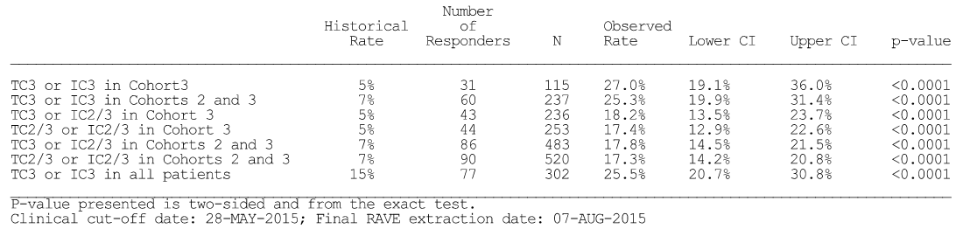
Comment: The primary efficacy endpoint of ORR (IRF-assessed; RECIST v1.1) was statistically significantly higher than the historical control response rate in all seven pre-specified subpopulations. In Cohorts 2+3 (2L+ treatment), the ORR in the TC3 or IC3 subgroup was 27.0% and in the TC2/3 or IC2/3 subgroup was 17.4%. Overall, the results indicate that increased PD-L1 expression on TCs and ICs results in higher ORRs in patients treated with atezolizumab.
The historical control response rates used for comparison with the atezolizumab for six of the pre-specified subgroups were modest (5% to 7%). The sponsor refers to three published studies which were used to obtain the historical control response rates (see below). The historical control response rates are heterogeneous in the published studies used by the sponsor to determine the rate used for statistical comparison with atezolizumab in the pre-specified subgroups. Furthermore, the historical control rates of 5% to 7% used by the sponsor appear to be on the low side of the rates identified in the published studies. This has the effect of increasing the statistical significance of the comparison between the ORRs in the PD-L1 subgroups and the historical response rates in favour of atezolizumab in these six pre-specified pairwise comparisons. The relevant data from the published studies are briefly reviewed below.
In Stinchcombe et al., 2008, the authors reviewed the results of four selected Phase III randomised trials involving docetaxel, erlotinib, pemetrexed, vinorelbine, ifosfamide, and best supportive care (BSC) in the second-line treatment of NSCLC. The authors found that the response rate for docetaxel, erlotinib, and pemetrexed ranged from 7.1% to 10.8%, the median survival time ranged from 5.6 to 8.3 months compared to BSC of 4.5 to 4.7 month, and the 1-year survival rate from 19% to 32% compared to BSC of 11% to 22%
In Masarelli et al., 2003, the authors undertook a retrospective analysis of data from 43 out of more than 700 patients with advanced NSCLC who had received third or fourth-line chemotherapy after two prior chemotherapy regimens that included platinum and docetaxel given sequentially. Patients had received platinum-based therapy as first-line (62.8%) or second-line treatment (32.6%), and docetaxel-based therapy as first-line (39.5%) or second-line treatment (60.5%). Third- and fourth-line therapies varied and most commonly included gemcitabine (24.6%), vinorelbine (14.0%), platinum-based therapy (17.5%) or a methotrexate/5-fluorouracil/adriamycin / mitomycin combination (15.8%). Objective tumour response rates for the patients in this analysis decreased substantially with each line of treatment. The disease control rate (response plus stable disease) also decreased from first- to fourth-line treatment, although it was higher for second-line treatment (74.4%) than for first-line treatment (62.8%). Response rates decreased with each line of treatment (i.e. first line, 20.9%; second line, 16.3%; third line, 2.3%; and fourth line, 0%). The median overall survival time from diagnosis was 16.4 months. The median overall survival time from the start of the last treatment (either third or fourth line) was 4 months.
In Girard et al., 2009, the authors undertook a retrospective analysis of data from 173 patients with advanced NSCLC who had received at least three lines of systemic antineoplastic treatment (cytotoxic chemotherapy in 131 patients; epidermal growth factor (EGFR) tyrosine kinase inhibitors in 42 patients). Chemotherapy consisted of a single agent for 125 patients (72%). Most frequently administered drugs were gemcitabine (62 patients), docetaxel (30 patients), and pemetrexed (20 patients). The disease control rate after third-line treatment was 36%, which was significantly lower than after first-line treatment or second-line treatment (77% and 44%, respectively; p < 0.001). Disease control after third-line treatment was significantly associated with disease control after second-line treatment (HR=2.51 [95% CI: 1.32, 4.65, p < 0.006), but not after first-line treatment (HR=1.83 [95% CI: 0.81–4.13], p = 0.135).

Updated efficacy results for ORR at 1 October 2015
The submission included an updated analysis of the ORR and DOR in the key patient group (Cohorts 2+3 [2L+ treatment]) at the clinical cut-off date of 1 October 2015. With an additional 4 months of follow-up from the clinical cut-off date for the primary analysis (28 May 2015), the ORR remained largely unchanged in the TC3 or IC3 subgroup and TC2/3 or IC2/3 subgroup, while the median DOR increased in the TC2/3 or IC2/3 subgroup from 8.4 months to 11.3 months. The results are summarised below.
Table 71: BIRCH – ORR and DOR IRF-assessed per RECIST v1.1 in the primary and updated analyses in Cohorts 2 and 3 (2L+) in the TC3 or IC3 subgroup and the TC2/3 or IC2/3 subgroup.
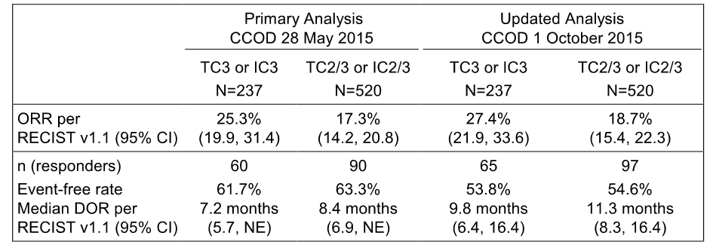

Results for the secondary efficacy outcome endpoints
The results for the key primary and secondary efficacy outcome endpoints are summarised below.
Table 72: BIRCH – Key primary and secondary efficacy endpoints (primary analysis), treated patients.
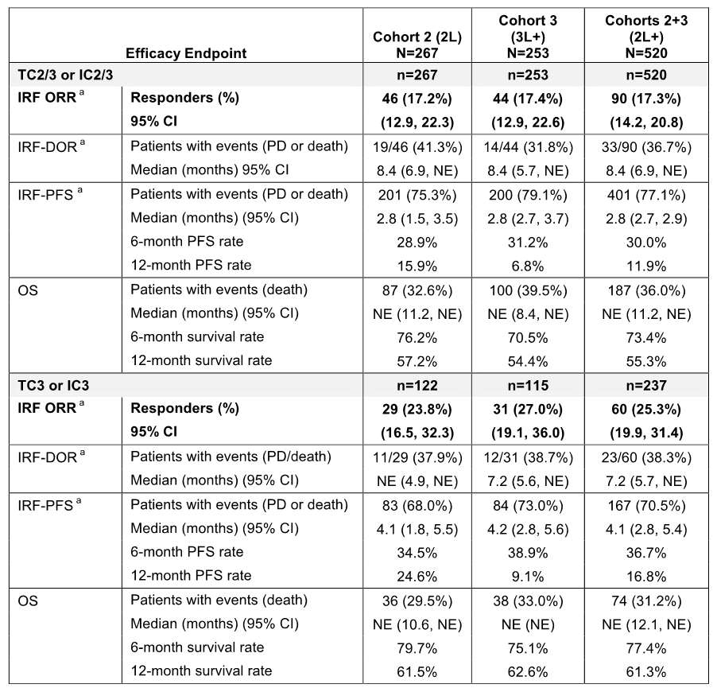
DOR = Duration of Response; INV= Investigator; IRF = Independent Review Facility; NE = not estimable; PFS = Progression-Free Survival; ª RR/DOR/PFS IRF-assessed per RECIST v1.1.
Higher PD-L1 expression was associated with a higher ORR in Cohorts 2+3 (2L+ treatment): 25.3% in the TC3 or IC3 subgroup vs 17.3% in TC2/3 or IC2/3 subgroup. The majority of objective responses were PRs rather than CRs at each PD-L1 expression level.
The majority of responders in Cohorts 2+3 (2L+ treatment) in the TC2/3 or IC2/3 and TC3 or IC3 subgroups had an ongoing response (i.e. no death or PD), assessed by IRF per RECIST v1.1 at the time of the clinical cut-off date of 28 May 2015 (i.e. 63.3% and 61.7%, respectively). In Cohorts 2+3 (2L+ treatment), the median DOR (IRF-assessed; RECIST v1.1) was 8.4 months (95% CI: 6.9, NE) in the TC2/3 or IC2/3 subgroup and 7.2 months (5.7, NE) in the TC3 or IC3 subgroup.
In Cohorts 2+3 (2L+ treatment), better PFS (IRF-assessed; RECIST v1.1) parameters (median duration, 6-months PFS rate and 1-year PFS rate) were associated with higher PD-L1 expression on TCs and ICs (i.e. TC3 vs IC3 subgroup compared to TC2/3 or IC2/3 subgroup). In Cohorts 2+3 (2L+ treatment), the OS data were too immature in both the TC3 or IC3 subgroup and the TC2/3 or IC2/3 subgroup to estimate the median duration of survival.
In Cohorts 2+3 (2L+ treatment), the ORR was similar for IRF-assessed per RECIST v1.1, INV-assessed per RECIST v1.1 and INV-assessed per mRECIST. The rate of PD/death in responders at the data cut-off date of 28 May 2015 was notably higher based on IRF-assessed per RECIST v1.1 than on INV-assessed per RECIST v1.1 or mRECIST. The results for the radiographic endpoints for ORR, DOR and PFS by the three assessment methods are summarised below.
Table 73: BIRCH – Comparison of radiographic endpoints assessed by IRF and INV per RECIST v1.1 and INV per mRECIST in Cohort 2+3 (2L+ patients).
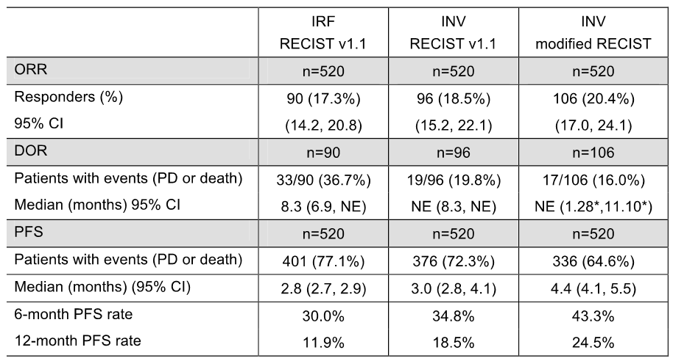

Results for other selected efficacy endpoints

Mutually exclusive ORR subgroup analysis
The results for the ORR (IRF-assessed; RECIST v1.1) analysis in Cohorts 2+3 (2L+ treatment) are summarised below. The results suggest that the TC3 or IC3 subsets makes a significant contribution to the ORR observed for the TC2/3 and IC2/3 subgroup, and that other TC and IC subsets in the subgroup also contribute to the ORR independently of the TC3 and IC3 subset. The results also indicate that the ORR increases with increased PD-LI expression on TCs and ICs. Similar results were also observed for Cohorts 1, 2, and 3. Overall, the data suggest that in each cohort the ORR in the TC2/3 or IC2/3 subgroup is driven by the TC3 or IC3 subset.
Table 74: BIRCH – Mutually exclusive ORR (IRF-assessed; RECIST v1.1) analysis in Cohort 2+3 (2L+).
Cohorts 2+3 (2L+ patients) | ORR | n/N | 95% CI UL | 95% CI LL
TC3 or IC3 subgroup | 25.3% | 60/237 | 19.9 | 31.4
Mutually exclusive analysis:
TC2/3 or IC2/3 subgroup vs | 17.3% | 90/520 | 14.2 | 20.8
TC2/3 or I2/3 subgroup excluding TC3 or IC3 subset | 10.6% | 30/238 | 7.3 | 14.8

Mutually exclusive analysis individual subgroups
The results for the mutually exclusive ORR analysis in Cohort 2+3 (2L+ treatment) for the TC3 and IC3 subgroup is summarised below. The results showed that both TC3 and IC3 contributed to the ORR, with the TC3 subset contributing to a greater extent than the IC3 subset. Similar results were observed in Cohorts 1, 2 and 3.
Table 75: BIRCH – Mutually exclusive ORR (IRF-assessed; RECIST v1.1) analysis on T3 or IC3 subgroup in Cohorts 2+3 (2L+)
Cohorts 2+3 (2L+ patients) | ORR | n/N | 95% CI UL | 95% CI LL
TC3 excluding IC3 subset | 29.0% | 31/107 | 20.6 | 38.5
IC3 excluding TC3 subset | 15.3% | 15/98 | 8.8 | 24.0
TC3 and IC3 subset | 43.8% | 14/32 | 26.4 | 62.3

Subgroup analyses
The results for the subgroup analyses of the ORR (IRF-assessed; RECIST v1.1) for Cohort 2+3 (2L+ patients) are provided. In the TC3 or IC3 subgroup, the ORR was similar for patients aged <65 and ≥65 and for males and females, while the ORR was greater in ‘White’ compared to Asian patients (although there was a marked imbalance in patient numbers), patients with ECOG PS 0 compared to ECOG PS 1, patients with non-squamous histology compared to squamous histology, patients who were current/previous smokers compared to patients who had never smoked. The ORR pattern in the TC2/3 or IC2/3 subgroup was similar to that in the TC3 or IC3 subgroup, with the ORRs being higher in the TC3 or IC3 subgroup.

Patient reported outcomes (PROs)
Quality of Life and functioning were maintained throughout the course of treatment, as measured by the EORTC QLQ-C30 and the EORTC QLQ-LC13. For the EORTC QLQ-C30, from Cycle 1, Day 1 to Cycle 17, Day 1 (approximately 1 year), and the completion rates ranged from 87.2% to 94.3%. For the EORTC QLQ-LC13, from Cycle 1, Day 1 to Cycle 17, Day 1, and the completion rates ranged from 84.7% to 91.8%.
Global health status/quality of life, functioning, and lung cancer symptoms (cough, dyspnoea, chest pain, arm/shoulder pain) were assessed by the EORTC QLQ-C30 and LC13. The QLQ-C30 and LC13 were completed at baseline and Day 1 of each cycle. The sponsor comments that a 10-point change in score is perceived by patients as being clinically meaningful. A higher score on the global health and functioning subscales is indicative of better HRQoL and functioning, while a lower score on the symptom subscales is indicative of a lower symptom burden (i.e. improvement in symptoms).
There was no change from baseline in any of the domains of the EORTC QLQ-C30 and QLQ-LC13. No clinically meaningful change (improvement or decline) from baseline was observed for patients treated with atezolizumab in global health status, functioning (physical, role, emotional, cognitive, and social) or any of the symptom subscales. In Cohorts 2+3 (2L+ treatment), the median time to meaningful deterioration of physical function (≥ 10 point decrease) for treated patients (n = 520) was 4.4 months.

Treatment beyond initial progression
The Summary of Clinical Efficacy (NSCLC) included the results of an exploratory analysis of delayed response following disease progression (PD) identified by radiological findings per RECIST v.1.1. In Cohorts 2 and 3, atezolizumab treatment could continue after radiographic disease progression for as long as patients demonstrated clinical benefit, as assessed by the investigator. The sponsor stated that conventional response criteria may not adequately assess the activity of immunotherapeutic agents, because PD (by initial radiographic evaluation) does not necessarily reflect therapeutic failure due to the possibility of delayed response.
Based on data from the Primary analysis (clinical cut-off date of 28 May 2015), in Cohorts 2+3 (2L+ treatment), the median treatment duration after investigator-assessed radiographic progression per RECIST v1.1, for the 180 patients who received at least one dose of atezolizumab post-progression was 1.4 months (range: 0, 12 months). The majority of these patients (73.3%) received ≤ 3 months of treatment post progression. One patient (0.6%) was treated for longer than 12 months. The median number of doses received post-progression was 3 (range: 1, 19).
Among patients who received treatment beyond radiographic progression per RECIST v1.1, changes in target lesions post-progression (sum of long diameter [SLD]) were analysed relative to the original baseline measurements. In Cohorts 2+3 (2L+ treatment), in the TC2/3 or IC2/3 subgroup approximately 40% treated beyond progression had a change in the target lesions suggesting decreased or stable progression relative to original baseline, approximately 35% of patients had a change suggesting increased progression relative to original baseline, and approximately 24% of patients had no tumour measurements after progression. A caveat in interpreting these results is that the analysis did not take into account new lesions or non-target lesion progression. The results are summarised below.
Table 76: BIRCH – Best percent change in SLD from original baseline for tumour assessments post progression in 2L+ TC2/3 or IC2/3 population of atezolizumab treated patients, data cut-off 5 May 2015.
CI=confidence interval; SLD=sum of longest diameters.
Comment: It is difficult to interpret the best change in SLD data following disease progression without a control group. In addition, there was no information relating to the development of new lesions or non-target lesion progression following continued treatment with atezolizumab beyond radiological progression of the disease. The sponsor states that the best change in SLD results ‘suggest that a substantial proportion of patients treated post-progression had target lesions that either remained stable or decreased relative to baseline’. However, it is considered that the data should be interpreted cautiously, given the limitations.

FIR – supportive study (NSCLC)
FIR is an ongoing a Phase II, global, multicentre, single-arm study designed to evaluate the efficacy and safety of atezolizumab as a single agent in patients with locally advanced or metastatic NSCLC with a PD-L1 expression level of TC2/3 or IC2/3. The study is being undertaken in five countries across 28 sites, including the USA (22 centres), United Kingdom (3 centres), Belgium (1 centre), Netherlands (1 centre), France (1 centre). The first patient was screened on 14 May 2013, the last patient was enrolled on 27 June 2014, and the clinical data cut-off for the analysis was 7 January 2015. The study was sponsored by Genetech Inc. The study was undertaken in compliance with GCP.

Key efficacy endpoints
The key efficacy endpoints were investigator assessed ORR per modified (m) RECIST (primary efficacy endpoint), ORR (INV-assessed; RECIST v1.1), DOR (INV-assessed; RECIST v1.1), TTOR (INV-assessed; RECIST v 1.1), PFS (INV-assessed; RECIST v1.1) and OS. The definitions of the efficacy endpoints were the same as those for POPLAR and BIRCH. There were no RECIST v1.1 or mRECIST assessments by an IRF.

Treatment
Treatment was single-arm atezolizumab 1200 mg administered IV q3w.

Methods
Eligible patients received atezolizumab IV as a fixed-dose of 1200 mg on Day 1 of each 21-day cycle until no longer deemed to be experiencing clinical benefit as assessed by the investigator. Tumour assessments were performed at baseline, and Day 1 of Cycle 1, and continued every 6 weeks for the first 12 months and then every 9 weeks thereafter until disease progression per RECIST or beyond (for patients who continued treatment beyond radiographic progression, withdrawal of consent, death, or study termination by the Sponsor, whichever occurred first). Tumour response was assessed by radiologic imaging (CT scans or MRI).

Statistical analysis and sample size
No formal statistical hypothesis testing was undertaken. With 130 patients planned to be treated in a total of three cohorts subject to a combined analysis, the ORR was estimated using 95% CI with maximum width (with the assumption of an observed rate of 50%) of 17.2% (± 8.6%). With 130 patients, there was a 91% power to reject the null hypothesis of an ORR rate of 26% or lower against an alternative of 40%, with the assumption of a single-proportion, two-sided test at the 5% level of significance.

Key characteristics of the study population
Tumour specimens from 138 patients meeting eligibility criteria were prospectively tested for PD-L1 expression by a central laboratory. PD-LI testing of both TCs and ICs was by the Genentech/Roche PD-L1 SP142 IHC assay. The PD-LI testing system was the same as that used in POPLAR and BIRCH. The criteria for PD-LI expression for TCs and ICs were the same as that used in POPLAR and BIRCH.
The study included 31 patients who had not received prior chemotherapy for advanced disease (Cohort 1), 94 patients who had progressed during or following a prior platinum-based chemotherapy regimen without restriction to the maximum number of prior therapies (Cohort 2), and 13 selected 2L+ patients with previously treated brain metastases (Cohort 3).
Cohort 2 (2L+) is considered to be the key treatment cohort as it is representative of the patient population included in the proposed indication. Patients in Cohort 2 were treated with atezolizumab in the second line or beyond setting (2L+) for advanced or metastatic NSCLC following progression during or after a prior platinum-based chemotherapy regimen without restriction to the maximum number of prior therapies. In Cohort 2, 51.6% (n = 48) of patients had received 1L of previous chemotherapy, 29.0% (n = 27) had received 2L, 18.3% (n = 17) had received 3+L, and 1.1% (n = 1) had not received prior chemotherapy.
The efficacy related key eligibility criteria for FIR, compared to the two pivotal and other supportive NSCLC studies, are summarised. The key eligibility criteria were similar to those of POPLAR and BIRCH. Of note, patients with brain metastases were not excluded from enrolment into FIR, but were included in a separate cohort (Cohort 3).
The median age of the 93 patients in Cohort 2 (2L+ treatment) was 60.5 years (range: 44, 85), with the majority being male (63.4%) ‘White’ (88.2%) and current or previous smokers (83.9%). Baseline ECOG PS 0 was present in 26.1% of the 93 patients and ECOG PS 1 was present in 73.9%. The majority of the 93 patients had non-squamous cell tumours rather than squamous cell (72.0% vs 28.0%, respectively). Of the 93 patients, 97.8% had metastatic disease and 2.2% had locally advanced disease. Of the 93 patients (all TC2/ or IC2/3), 38 (30%) were in the TC3 or IC3 subgroup.

Efficacy results
As planned, the primary analysis was performed 6 months after the last patient was enrolled. In Cohort 2 (2L+), the median duration of treatment was 2.5 months (range 0, 19 months) and the mean number of doses was 7.7. At the time of the data cut-off, 43.0% of patients in Cohort 2 (2L+) had received at least 3 months of study treatment and 32.3% had received at least 6 months of study treatment. The median duration of survival follow-up in Cohort 2 in all patients (n = 93) was 9.7 months, and in the TC3 or IC3 subgroup (n = 38) the median duration of survival follow-up was also 9.7 months. The key efficacy results for Cohort 2 (2L+) are summarised below.
Table 77: FIR – Cohort 2 (2L+) by PD-LI expression subgroups, treated patients at clinical data cut-off of 7 January 2015.
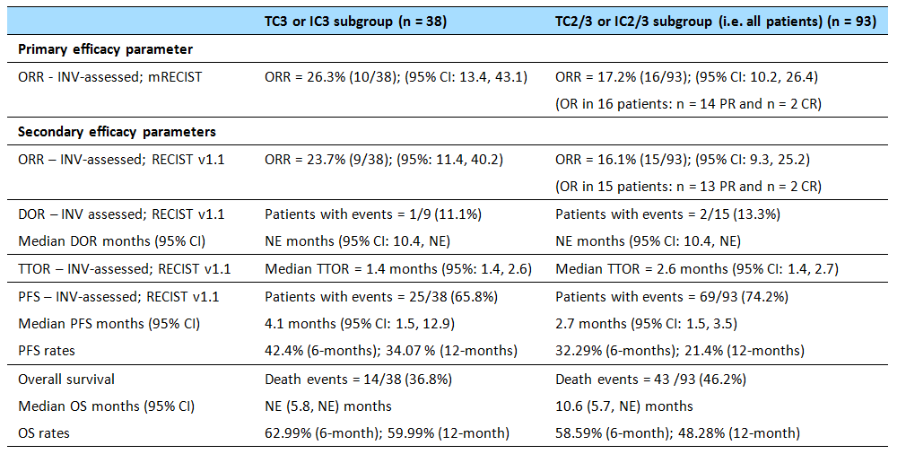
In Cohort 2, in the 27 patients with 2L of prior treatment the ORR (INV-assessed; mRECIST) was 14.8% (n = 4), in the 17 patients with 3+L of prior treatment the ORR (INV-assessed; mRECIST) was 17.6% (n = 3), and in the pooled 47 patients with 2L+ of prior treatment the ORR (INV-assessed; mRECIST) was 15.9% (n = 7).
Patient Reported Outcomes (PROs) assessing Global health status/quality of life, functioning, and lung cancer symptoms (cough, dyspnea, chest pain, arm/shoulder pain) were measured by the EORTC QLQ-C30 and LC13. The QLQ-C30 and LC13 were completed at baseline and Day 1 of each cycle. The sponsor comments that a ≥ 10-point change in the score is perceived by patients as being clinically meaningful. An increase on the global health and functioning subscales is indicative of an improvement, while a decrease on the symptom subscales is indicative of an improvement.
A total of 86 out of 93 (92.5%) patients completed the EORTC QLQ-C30 and LC13 at baseline. Patients did not display clinically meaningful change (improvement or decline) from baseline during the study period in global health status, functioning (physical, role, emotional, cognitive, and social) or lung cancer symptom (cough, dyspnea, chest pain, arm/shoulder pain) subscales during the study.
Comment: No historical control response rates were provided for comparison with the observed ORRs. However, the ORRs (INV-assessed; RECIST v1.1) in Cohort 2 (2L+) FIR and Cohorts 2+3 (2L+) in BIRCH were similar (16.1% [95% CI: 9.3, 25.2] vs 17.3% [95% CI: 14.2, 20.8], respectively). The ORRs INV-assessed per mRECIST in both subgroups were consistent with the ORRs INV-assessed per RECIST v1.1. The efficacy outcomes were consistently better in the TC3 or IC3 subgroup than the TC2/3 or IC2/3 subgroup, suggesting that greater PD-L1 expression is associated with a greater response to treatment with atezolizumab.

PCD4989 – sponsor-nominated supportive study (NSCLC)
PCD4989g is a Phase Ia, multicentre, first-in-human, open-label, dose-escalation study of the safety and PK of atezolizumab administered IV as a single agent to patients with locally advanced or metastatic solid tumours or haematologic malignancies, including an NSCLC cohort. The patients were recruited from 20 centres in 4 countries including the USA (15 centres), France (3 centres), Great Britain (1 centre), and Spain (1 centre). The first patient was enrolled on 21 June 2011 and enrolment was still ongoing at the clinical data cut-off of 2 December 2014. The sponsors were F.Hoffmann-La Roche (all sites excluding the USA) and Genetech (a member of the Roche group) in the USA. The study was conducted in compliance with GCP.

Efficacy endpoints
The primary efficacy endpoint was ORR INV-assessed per RECIST v1.1. Other efficacy endpoints for the NSCLC cohort were: DOR, BOR, 6-month PFS, and 1-year PFS by INV-RECIST v1.1 (primary analyses) and by INV-irRC (sensitivity analyses); 1-year OS (primary), median OS (exploratory); PFS by INV-RECIST v1.1 (exploratory); PFS in responders by INV-RECIST v1.1 (exploratory); TIR per RECIST v1.1 (exploratory); TTOR per RECIST v1.1 (exploratory); and ORR per INV-RECIST v1.1 by subgroup (exploratory). No independent radiology review by an IRF per either RECIST v1.1 or mRECIST was undertaken in patients with NSCLC. There were no assessments using mRECIST in NSCLC patients.

Treatment
In the NSCLC cohort, weight-based atezolizumab dose-escalation (1, 10, 15, and 20 mg/kg) was administered IV q3w beyond Cycle 1 for up to 16 cycles or 1 year (which ever occurred first) or loss of clinical benefit. The escalating, weight-based, IV q3w dosing regimen used in the NSCLC cohort was different from the fixed-dose 1200 mg IVq3w dosing regimen used in the three dedicated NSCLC studies (POLAR, BIRCH, and FIR).

Method
The CSR was an interim report presenting the analysis of the study data collected from the date of first patient enrolled (21 June 2011) to the clinical data cut-off of 2 December 2014. The selected cut-off date ensured that an adequate number of patients had completed at least 12 weeks of follow-up. In the dose-escalation cohorts, approximately 8 dose levels were investigated to determine the MTD or MAD. The patients in the dose-escalation cohorts were a PD-L1 unselected population. The dose-expansion cohorts included additional patients enrolled and treated following the determination of the MTD and MAD in order to further assess the effects of atezolizumab in different cancer types. The patients in the NSCLC cohort were selectively enrolled on the basis of PD-LI expression.
Tumour assessment was every 6 weeks from weeks 0-24, and every 12 weeks thereafter. All patients were followed for survival approximately every 3 months from study treatment discontinuation until death, loss to follow-up, withdrawal of consent, or study termination by the sponsor, whichever occurred first.

Statistical analysis and sample size
No statistical hypothesis testing or inferential statistical analyses were undertaken in this study. Efficacy results were summarised separately for each tumour type (including NSCLC) with more than 10 patients enrolled by the clinical data cut-off date. The primary population for analysis in the NSCLC Cohort was the efficacy-evaluable population, which comprised all enrolled patients who received any amount of atezolizumab (n = 88). The NSCLC Cohort efficacy data were summarised by the TC3 or IC3, TC2/3 or IC2/3, and TC0/1 and IC0/1 subgroups and by all patients.
ORR and BOR were estimated and 95% CIs for the estimated rates were constructed using the Clopper-Pearson method. Median DOR and OS were estimated by Kaplan-Meier methodology for the individual tumour types, with the 95% CI constructed using the method of Brookmeyer and Crowley. PFS and 1-year OS were estimated using Kaplan-Meier methodology, together with 95% CIs calculated using Greenwood’s formula.
The sponsor commented that it may be difficult to interpret the efficacy results in the ‘All Patients’ categories for the separate indications (including NSCLC), because enrolment included patients irrespective of PD-L1 expression. Due to potential enrichment with patients with moderate to high PD-L1 expression, the prevalence of PD-L1 scores in the study population may differ from the natural prevalence in the general population of patients with the relevant indications (including NSCLC).
The sample size for the dose-escalation stage of the study was based on pre-specified dose escalation rules. In light of emerging clinical and PD data, enrolment of patients into the RCC, NSCLC, melanoma, and UBC cohorts was expanded beyond the planned sample size to further understand the safety, tolerability, efficacy, and PK of atezolizumab in these indications and in PD-L1 diagnostic patient subgroups.

Key characteristics of the study population
The median age of the patients (n = 88) in the PCD4989g NSCLC cohort (all-comers, irrespective of PD-L1 expression) was 60.5 years (range: 24, 84 years), and the majority were male (56.8%), ‘White’ (79.5%) and previous or current smokers (81%). The majority of the population had ECOG PS 1 at baseline rather than ECOG PS 0 (71.6% vs 28.4%), and the majority of patients had non-squamous cell tumours rather than squamous cell (76.1% vs 23.9%). Of those patients tested, EGFR mutations were documented in 10 of 64 patients, KRAS mutations in 14 of 51 patients, and EML4-ALK translocations in 2 of 46 patients.
The majority of patients (98%) had received ≥ 2 prior systemic therapies (neo- adjuvant / adjuvant/metastatic). The most commonly received prior systemic therapies (≥ 10% of patients) were chemotherapy (95.5%), platinum-based chemotherapy (94.3%), carboplatin-based chemotherapy (68.2%), taxane (67.0%), tyrosine kinase inhibitor (TKI; 48.9%), cisplatin-based chemotherapy (43.2%), antiangiogenic (42.0%), erlotinib (42.0%), immunotherapy (40.9%), and bevacizumab (36.4%). The prior systemic therapy categories are not mutually exclusive.

Efficacy results in the NSCLC cohort
The NSCLC cohort was a heavily pre-treated population that was initially enrolled as an all-comer population (i.e. irrespective of PD-L1 expression), followed by selective enrolment on the basis of PD-L1 expression. The percentage of patients in the NSCLC cohort with TC3, IC3, TC2, and IC2 IHC PD-L1 status was 11.4%, 14.8%, 20.5%, and 27.3%, respectively.
The median duration of study drug exposure in the NSCLC cohort was 3.5 months (range: 0, 32 months). The median duration of survival follow-up in the NSCLC cohort was 22.5 months. The efficacy results are summarised below and represents efficacy endpoints in patients pooled across dose levels of 1-20 mg/kg.
Table 78: PCD4989g – Summary of efficacy results in all lines of therapy (1L, 2L and 3L+) by PD-L1 expression subgroups, treated patients.
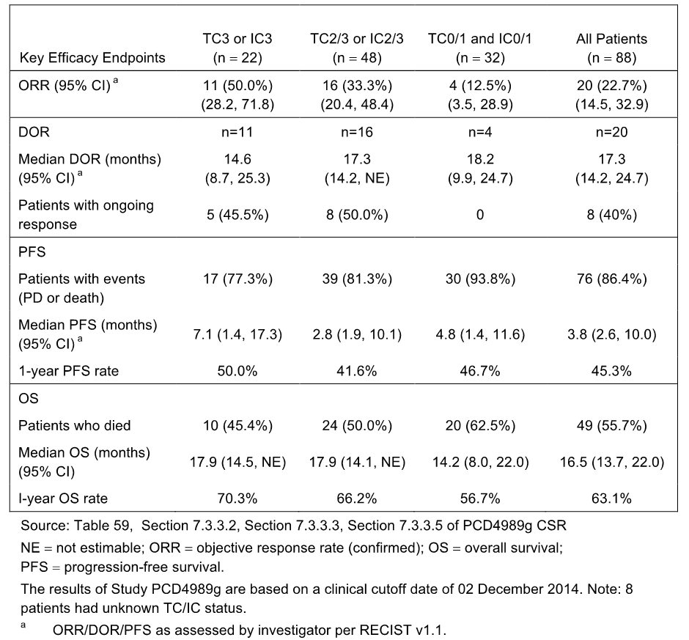
Comment: In heavily pre-treated patients with incurable or metastatic advanced NSCLC that had progressed since their last anti-tumour therapy, treatment with atezolizumab demonstrated a confirmed ORR of 50.0% (11/22) for the highest PD-L1 expression level (TC3 or IC3 subgroup), per INV-RECIST v1.1. Response was durable with median DOR of 14.6 months in the TC3 or IC3 subgroup. The results per INV-irRC (not shown) were identical to the results assessed per INV RECIST v1.1. Confirmed ORR per INV-RECIST v1.1 showed a response gradient from high PD-L1 expression level to low PD-L1 expression level. The sponsor commented that median PFS per INV-RECIST v1.1 compared favourably to historical data, while median OS and the 1-year OS rate in the all patients category compared favourably to historical data.

Analyses performed across trials: pooled meta analyses (NSCLC)
There were no meta analyses using pooled NSCLC efficacy data.

Evaluator’s conclusions on efficacy
The submission included four studies nominated by the sponsor as supporting the application to register atezolizumab for the treatment of patients with locally advanced or metastatic NSCLC after prior chemotherapy. The sponsor nominated two studies as pivotal (POPLAR [Phase II] and BIRCH [Phase II]) and two studies as supportive [FIR [Phase II] and PCD4989g [Phase I]). The patient population in the submitted studies are considered to be representative of an Australian population with locally advanced or metastatic NSCLC with prior treatment.
Overall, it is considered that data from the four submitted studies provide promising evidence supporting the efficacy of atezolizumab for the proposed indication in patients with NSCL. However, the major limitation of the submitted efficacy data relates to the absence of a confirmatory Phase III study establishing that atezolizumab can meaningfully increase OS and/or PFS or reduce tumour burden in the proposed NSCLC patient population. Therefore, it is considered that the submission does not meet the TGA adopted EMA clinical guidelines relating to the evaluation of anticancer medications (EMA/CHMP/205 /95/Rev.4). While compliance with the guidelines is not mandatory, it is considered that the requirement in the guidelines relating to the need for a confirmatory Phase III study should not be waived, based on the limitations of the submitted Phase I/II efficacy data.
There is currently an ongoing Phase III study open-label study (OAK) comparing atezolizumab to docetaxel in 2L and 3L patients with OS as the primary endpoints. The primary analysis of this study was recently reported at the European Society for Medical Oncology (ESMO) Congress in October 2016, and the efficacy data from the study have been included in the recently updated US label for atezolizumab. The sponsor is requested to provide the available efficacy and safety data to the TGA for evaluation as part of its s31 Response to the first round clinical evaluation report. The efficacy data from this Phase III study might address the limitations of the submitted efficacy data from the Phase I/II studies relating to patients with the proposed NSCLC indication treated with atezolizumab in the 2L+ setting.

POPLAR
POPLAR was nominated by the sponsor as the pivotal study supporting the registration of atezolizumab for the treatment of NSCLC. It is considered that, while this relatively small Phase II study can be considered to be a pivotal study, the efficacy results from the study require confirmation by a larger pivotal Phase III study (e.g. OAK).
The pivotal Phase II study (POPLAR) included open-label, efficacy data comparing atezolizumab (1200 mg q3w IV) with docetaxel (75 mg/m² q3w) until disease progression or unacceptable toxicity in PD-L1 selected patients with locally advanced or metastatic NSCLC who had progressed during or following a platinum-containing regimen. Patients were stratified on the basis of PD-L1 expression (IC0, IC1, IC2, and IC3), prior chemotherapy regimens (1 vs 2) and tumour histology (squamous vs non-squamous) and then randomised 1:1 to either atezolizumab or docetaxel. Efficacy was assessed in the total ITT population, which included all patients irrespective of PD-L1 expression, and in subgroups based on PD-LI expression (TCs and ICs).
OS in the ITT (all-comers) population was the primary efficacy endpoint. The submitted data included a primary analysis undertaken when 173 deaths had occurred (i.e. 60% event/patient ratio) at the clinical cut-off date of 8 May 2015 and an updated analysis undertaken when 200 deaths had occurred (i.e. 70% event/patient ratio) at the clinical cut-off date of 1 December 2015. The key secondary efficacy endpoints were PFS, ORR, and DOR in the ITT population (INV-assessed; RECIST v1.1). At the time of the clinical cut-off date for the primary analysis, the median duration of follow-up was approximately 15 months in both treatment arms.
There was a clinically meaningful and statistically significant improvement in OS of 2.9 months observed in the primary analysis for patients in the ITT population in the atezolizumab arm (n = 143) compared to the docetaxel arm (n = 144): median OS 12.6 vs 9.7 months, respectively; stratified HR = 0.73 (95% CI: 0.53, 0.99), p = 0.0404, stratified log-rank test. The number of deaths was 78 (54.2%) in the atezolizumab arm and 95 (66.4%) in the docetaxel arm.
In the updated post-hoc OS analysis, which provided an additional 7 months of follow-up, the median duration of OS in the ITT population remained 2.9 months longer in the atezolizumab arm (n = 144) compared to the docetaxel arm (n = 143): median OS 12.6 vs 9.7 months, respectively; stratified HR = 0.69 (95% CI: 0.52, 0.92), p = 0.0106 (provided for descriptive purposes).
The median duration of PFS (INV-assessed; RECIST v1.1) in the ITT population was similar in both treatment arms, with the majority of patients in both arms experiencing an event. In the atezolizumab and docetaxel arms, the median duration of PFS was 2.7 and 3.0 months, respectively (stratified HR = 0.94 [0.72, 1.23]), and the proportion of patients with an event (death or PD) was 86.1% (124/144) and 84.6% (121/143), respectively.
The ORR (INV-assessed; RECIST v1.1) in the ITT population was modest and numerically similar in both treatment arms, being 14.6% (21/144) in the atezolizumab arm and 14.7% (21/143) in the docetaxel arm. The median DOR (INV-assessed; RECIST v1.1) was notably longer in the atezolizumab arm than in the docetaxel arm (14.3 vs 7.2 months, respectively), with a stratified HR of 0.41 (95% CI: 0.18, 0.96). The median DOR (INV-assessed; RECIST v1.1) in the updated analysis continued to favour atezolizumab compared to docetaxel (18.6 vs 7.2 months, respectively), and showed an increase in the median DOR in the atezolizumab arm of 4.3 months compared to the primary analysis.
Efficacy was also assessed in POPLAR in PD-L1 TC and IC subgroups. The total patient numbers in the TC/IC subgroups were 47 in the TC3 or IC3 subgroup, 105 in the TC2/3 or IC2/3 subgroup, 195 in the TC1/2/3 or IC1/2/3 subgroup, and 92 in the TC0 and IC0 subgroup. Patient numbers for the atezolizumab and docetaxel arms were well balanced in each of the subgroups.
PD-L1 expression subgroup analysis showed a consistent OS benefit in favour of atezolizumab compared to docetaxel for patients with PD-L1 expression on TCs and ICs of ≥ 1% (i.e. TC3 or IC3, TC2/3 or IC2/3, or TC1/2/3 or IC1/2/3 subgroups), while no difference in OS between the two treatment arms was observed in patients with PD-L1 expression on TCs and ICs of < 1% (i.e. TC0 and TC0 subgroup). The results for the PD-L1 expression subgroup analyses on PFS (INV-assessed; RECIST v.1.1) and ORR (INV-assessed; RECIST v1.1) were consistent with the results for the OS analysis. The results for OS, PFS and ORR showed that higher levels of PD-L1 expression on TCs or ICs increased the benefits in atezolizumab treated patients.
In a mutually exclusive subgroup analysis of OS (TC2/3 or IC2/3 vs TC2/3 or IC2/3 excluding TC3 or IC3), the exclusion of TC3 or IC3 marginally increased the HR from 0.54 to 0.59. In a mutually exclusive subgroup analysis of OS (TC1/2/3 or IC1/2/3 vs TC1/2/3 or IC1/2/3 excluding TC2/3 or IC2/3), the exclusion of TC2/3 or IC2/3 increased the HR from 0.59 to 0.65. The results suggest that each PD-LI expression level contributes independently to OS in atezolizumab treated patients.
In the analysis of OS in the TC1/2/3 and IC0 subgroup, the median duration of survival was 11.2 months in the docetaxel arm and had not been reached in the atezolizumab arm (HR = 0.37 [95% CI: 0.12, 1.13]). In the analysis of OS in the IC1/2/3 and TC0 subgroup, the median duration of OS was 12.2 months in the docetaxel arm versus 15.6 months in the atezolizumab arm (HR = 0.63 [95% CI: 0.36, 1.12]). The analyses indicate that PD-L1 expression on both TCs and ICs independently contribute to increased OS in the atezolizumab arm compared to the docetaxel arm.
In general, the results of the subgroup analysis of OS in the ITT population based on baseline demographics and other characteristics were consistent with the primary analysis of OS. The median duration of OS was longer in the atezolizumab arm than in the docetaxel arm for both stratification factors relating to tumour histology (i.e. non-squamous cell HR = 0.69 [95% CI: 0.47, 1.01]; 15.5 vs 10.9 months) vs squamous cell HR = 0.80 [95% CI: 0.49, 1.30]; 10.1 vs 8.6 months). The median duration of OS based on the stratification factor of number of prior therapies (1 vs 2) was longer in the atezolizumab arm than in the docetaxel arm for patients receiving 1 prior therapy (HR = 0.62 [0.42, 0.91]; 16.4 vs 9.5 months), and similar in the two treatment arms for patients receiving 2 prior therapies (HR = 0.98 [95% CI: 0.60, 1.61]; 9.8 vs 9.7 months).
Exploratory PRO data relating to global health status/quality of life, functioning, and lung cancer symptoms (cough, dyspnoea, chest pain, arm/shoulder pain) were assessed during the study by the EORTC QLQ-C30 and LC13. No clinically meaningful change (improvement or decline) from baseline was observed for patients in the atezolizumab arm during the study period in global health status, functioning (physical, role, emotional, cognitive, and social) or any of the symptom subscales, indicating that atezolizumab did not have a detrimental impact on health related quality of life (HRQoL).The PRO results for docetaxel were consistent with those for atezolizumab, apart from an increase in alopecia reported in the docetaxel arm. Time to deterioration (TTD) was defined as a ≥ 10-point increase above baseline. There was no difference between the two arms in TTD of lung cancer symptoms (cough, dyspnea, chest pain, or arm/shoulder pain).
Overall, it is considered that POPLAR provides promising evidence for the efficacy of atezolizumab at the proposed dose for the proposed indication. The primary strengths of the study relate to the use of docetaxel as an active control and OS as the primary efficacy endpoint. The main limitations of the study relate to the modest improvement in overall survival in the atezolizumab arm compared to the docetaxel arm, the relatively small number of patients in both treatment arms, and the use of investigator assessed RECIST v1.1 rather than centrally (IRF) assessed RECIST v1.1 to determine best response.

BIRCH
BIRCH was nominated by the sponsor as a pivotal study supporting the registration of atezolizumab for the treatment of NSCLC. However, it is considered that this study is more appropriately considered to be supportive rather than pivotal for the following reasons. The study was a Phase II, single-arm study, with a primary efficacy endpoint of ORR (rather than OS or PFS) assessed using historical response rates which appear to be at the lower end of wide response spectrum. The absence of a randomised control arm limits the interpretation of the efficacy results.
BIRCH was a single-arm Phase II study assessing the efficacy of atezolizumab (1200 mg IV q3w) in patients with locally advanced or metastatic NSCLC based on PD-L1 expression on TCs and ICs. The study evaluated atezolizumab as first-line, second-line and third-line and beyond treatment.
The primary efficacy endpoint was ORR (IRF-assessed; RECIST v1.1) in seven pre-specified subgroups based on PD-L1 expression levels on TCs and ICs compared to historical response rates. The primary analysis was at the clinical cut-off date of 28 May 2015. The study met is primary objective of demonstrating a statistically significant and clinically meaningful improvement in ORR (IRF-assessed; RECIST v1.1) in the seven pre-specified subgroups compared to historical controls, following a hierarchical fixed-sequence testing procedure (p<0.0001).
The ORRs (IRF-assessed; RECIST v.1.1) ranged from 27.0% (31/115) in the TC3 or IC3 subgroup in Cohort 3 (3L+) to 17.3% (90/520) in the TC2/3 or IC2/3 subgroup in Cohorts 2+3 (2L+), with the respective historical control rates being 5% and 7%.
Cohorts 2+3 (2L+) were of key regulatory interest, as patients in these two pooled cohorts (n = 520) received atezolizumab as second line or beyond (2L+) treatment for locally advanced or metastatic NSCLC. In Cohorts 2+3 (2L+), higher PD-L1 expression levels (25% [60/237] in the TC3 or IC3 subgroup) was associated with higher ORR assessed by IRF per RECIST v1.1 compared to lower PD-L1 expression levels (17.3% [90/520] in the TC2/3 or IC2/3 subgroup).
The key secondary efficacy endpoints are considered to be OS, PFS (IRF-assessed; RECIST v1.1) and DOR (IRF-assessed; RECIST v1.1) in Cohorts 2+3 (2L+) in the TC3 or IC3 subgroup and the TC2/3 or IC2/3 subgroup. In Cohorts 2+3 (2L+) the key secondary efficacy endpoint results were:
- In the TC2/3 or IC2/3 subgroup, the median DOR was 8.4 months (95% CI: 6.9, NE), with 36.7% of responders (33/90) experiencing PD or death. In the TC3 or IC3 subgroup, the median DOR was 7.2 months (95% CI: 5.7, NE), with 38.3% of responders (23/60) experiencing PD or death.
- In the TC2/3 or IC2/3 subgroup, median PFS was 2.8 months (95% CI: 2.7, 2.9), with 77.1% (401/520) of patients experiencing PD or death. The 6-month and 12-month estimated PFS rates were 30.0% and 11.9%, respectively. In the TC3 or IC3 subgroup, median PFS was 4.1 months (95% CI: 2.8, 5.4), with 70.5% (167/237) of patients experiencing PD or death. The 6-month and 12-month estimated PFS rates were 36.7% and 16.8%, respectively
- In the TC2/3 or IC2/3 subgroup, the data were too immature to satisfactorily characterise OS, with the median duration of survival not being reached. At the time of analysis, 36.0% (187/520) of patients in the TC2/3 or IC2/3 subgroup had died, and the 6-month and 12-month estimated OS rates were 73.4% and 55.3%, respectively. In the TC3 or IC3 subgroup, the data were also too immature to satisfactorily characterise OS, with the median duration of survival not being reached. At the time of analysis, 31.2% (74/237) of patients in the TC3 or IC3 subgroup had died, and the 6-month and 12-month estimated OS rates were 77.4% and 61.3%, respectively.
- Updated data at the clinical cut-off date of 1 October 2015 were provided for the ORR and DOR in patients in Cohorts 2+3 (2L+). The updated analysis data represented an addition 4 months of follow-up from the primary analysis data. The ORR (IRF-assessed; RECIST v1.1) was 27.4% in the TC3 orIC3 subgroup and 18.7% in the TC2/3 or IC2/3 subgroup. These updated results were consistent with the corresponding results at the clinical cut-off date of 28 May 2015. The median DOR (IRF-assessed; RECIST v1.1) was 9.8 months in the TC3 or IC3 subgroup and 11.3 months in the TC2/3 or IC2/3 subgroup, which were 2.6 and 2.9 months longer, respectively, than the corresponding results at the clinical cut-off date of 28 May 2015.
- Exploratory PRO data, based on EORTC QLQ-C30 and LC13, showed no evidence of negative effects of atezolizumab on health-related quality of life or functioning. There was no meaningful change from baseline in any of the domains of the EORTC QLQ-C30 and QLQ-LC13. Among treated patients (TC2/3 or IC2/3), the median time to meaningful deterioration of physical function (≥ 10 point decrease) in both Cohorts 2 and 3 occurred at 4.4 months, while the median PFS for both of these cohorts was 2.8 months.

FIR
FIR was a Phase II study nominated by the sponsor as a supporting study for the application to registered atezolizumab for the treatment of NSCLC. It is agreed that this a supporting study. In FIR, the key study cohort for regulatory purposes was Cohort 2 (2L+), which included patients with locally advanced or metastatic NSCLC with PD-L1 expression levels of TC2/3 or IC2/3 treated with atezolizumab as second-line and beyond therapy.
The primary efficacy endpoint for this study was investigator-assessed ORR per mRECIST in the efficacy-evaluable population. In Cohort 2 (2L+), the ORR (INV-assessed; mRECIST) was 17.2% (16/93) (95% CI: 10.17, 26.43) in the TC2/3 or IC2/3 subgroup, and 26.3% (10/38) (95% CI: 13.4, 43.1) in the TC3 or IC3 subgroup. The ORR results in the two subgroups INV-assessed per mRECIST were consistent with the ORR results INV-assessed per RECIST v1.1. No historical control response rates were defined for FIR, but the observed ORRs for both the TC2/3 or IC2/3 and TC3 or IC3 subgroups were greater than the historical control response rates provided in BIRCH. There were no response data in FIR assessed by an IRF using either RECIST v1.1 or mRECIST.
The key secondary efficacy endpoints in Cohort (2L+) are considered to be ORR (INV-assessed; RECIST v1.1), DOR (INV-assessed; RECIST v1.1), PFS (INV-assessed; RECIST v1.1), and OS. The results for the key efficacy endpoints in Cohort 2 (2L+) subgroups TC3 or IC3 and TC2/3 or IC2/3 are reviewed below:
- The ORR (INV-assessed; RECIST v1.1) was 16.1% (15/93) in the TC2/3 or IC2/3 subgroup and 23.7% (9/38) in the TC3 or IC3 subgroup. The results in both subgroups were consistent with the results for the ORR investigator-assessed per mRECIST.
- The DOR (INV-assessed; RECIST v1.1) data were immature at the clinical cut-off date, with the median DOR not being reached in either the TC2/3 or IC2/3 or the TC3 or IC3 subgroup.
- The median PFS (INV-assessed; RECIST v1.1) was 2.7 months in the TC2/3 or IC2/3 subgroup and 4.1 months in the TC3 or IC3 subgroup, with 74.2% (69/69/93) and 65.8% (25/38) experiencing an event (PD or death) in the two subgroups, respectively. In the TC2/3 or IC2/3 subgroup, the estimated 6-month and 12-month PFS rates were 32.3% and 21.5%, respectively. In the TC3 or IC3 subgroup, the estimated 6-month and 12-month PFS rates were 42.4% and 34.1%, respectively
- The median duration of OS was 10.6 months (95% CI: 5.7, NE) in the TC2/3 or IC2/3 subgroup (46.2% [43/93] patients with an event), and had not been reached in the TC3 or IC3 subgroup. In the TC2/3 or IC2/3 subgroup, the estimated 6-month and 12-month OS rates were 58.6% and 48.3%, respectively. In the TC3 or IC3 subgroup, the estimated 6-month and 12-month OS rates were 63.0% and 60.0%, respectively
Exploratory PRO data, based on EORTC QLQ-C30 and LC13, showed no evidence of negative effects of atezolizumab on health-related quality of life or functioning.
Overall, FIR is considered to provide supportive data for atezolizumab for the proposed indication. The limitations of the data include the absence of a control arm, the primary efficacy endpoint being ORR (INV-assessed; mRECIST) rather than OS or PFS, and no independent assessment of tumour response data based on RECIST criteria.

Study PCD4989g
Study PCD49889g was nominated by the sponsor as a supportive efficacy study. However, the study is considered to provide exploratory rather than supportive efficacy data for the following reasons. The study was a Phase I, first-in humans, dose-escalation study in patients with locally advanced or metastatic solid tumours or haematological malignancies, including a small cohort of heavily pretreated patients with NSCLC (n = 88) administered atezolizumab at doses of 1, 10, 15, and 20 mg/kg q3w, rather than the proposed fixed-dose 1200 mg q3w. The primary objectives of the study related to evaluation of safety and tolerability, determination of MTD and DLTs, and recommendation of Phase II dose rather than efficacy. The secondary objectives included a preliminary assessment of anti-tumour activity based on ORR, while evaluation of OS was only an exploratory objective.

Clinical safety

Studies providing safety data
The submission included safety data on 1547 patients, including 521 (33.7%) patients with UC and 1026 (66.3%) patients with NSCLC. Each of the five submitted clinical studies included atezolizumab-treated patients with safety data.
- IMvigor 210, the sponsor-nominated pivotal Phase II study in patients with UC, included safety data at the time of the primary efficacy analysis (clinical cut-off date of 5 May 2015) for 429 atezolizumab-treated patients. These 429 patients included, primary efficacy safety data for 311 patients (Cohort 2) who failed a prior platinum-containing chemotherapy regimen or progressed within 12 months of a platinum-based treatment administered in the adjuvant/neo-adjuvant setting, and interim safety data for 118 patients (Cohort 1) who were cisplatin-ineligible patients. Updated safety data Cohort 1 were provided at the clinical cut-off date of 14 September 2015 (primary analysis for Cohort 1).
- BIRCH, a sponsor-nominated pivotal Phase II study in patients with NSCLC, included safety data for 659 atezolizumab-treated patients at the time of the primary efficacy analysis (clinical cut-off date of 28 May 2015).
- POPLAR, a sponsor-nominated pivotal Phase II study in patients with NSCLC, included safety data for 142 atezolizumab-treated patients and 135 docetaxel-treated at the time of the primary efficacy analysis (clinical cut-off date of 8 May 2015).
- FIR, a sponsor-nominated supporting Phase II study in patients with NSCLC, included safety data for 137 atezolizumab-treated patients at the time of the primary analysis (clinical cut-off date of 7 January 2015).
- PCD4989g, a sponsor-nominated supporting Phase I study for patients with UC and NSCLC, included safety data for 481 atezolizumab-treated patients with solid tumours or haematological malignancies, including 92 patients with UC and 88 patients with NSCLC at the clinical cut-off date of 2 December 2014.

Summary of clinical safety
The Summary of Clinical Safety (SCS) included analyses based on the safety-evaluable population (i.e. any patient who received any dose of atezolizumab) from IMvigor 210, BIRCH, POPLAR, FIR, and PCD4989g (patients from UC and NSCLC cohorts only). The SCS defined three main pooled safety populations for atezolizumab-treated patients (All Patients, All UC, and All NSCLC). It should be noted that the pooled populations included no comparative data for atezolizumab-treated patients. The only study in the submission with comparative safety data (atezolizumab vs docetaxel) was POPLAR (NSCLC). The three pooled populations are outlined below.
- The All Patients population (n = 1547), included all patients with UC or NSCLC and comprised all safety evaluable patients enrolled in IMvigor 210 (both Cohorts 1 and 2), BIRCH, POPLAR (atezolizumab-treated patients only), FIR and the UC and NSCLC Cohorts of PCD4989g. The pooled population was the focus of the safety analysis in the SCS.
- The All UC Population (n = 521), included all safety-evaluable patients with UC and comprised patients enrolled in IMvigor 210 (both Cohorts 1 and 2), and the UC Cohort of PCD4989g. An analysis was also undertaken in the 2L+UC Subpopulation (n = 403), which was based on all atezolizumab treated 2L+ UC patients and included patients from Cohort 2 of IMvigor 210, and the UC Cohort of PCD4989g. Safety analyses on patients from Cohort 1 of IMvigor 210 were reviewed separately in the SCS.
- The All NSCLC population (n = 1026), included all NSCLC safety-evaluable patients from BIRCH, POPLAR (atezolizumab-treated patients only), FIR, and the NSCLC Cohort of PCD4989g. In this population, analyses were also undertaken in a 2L+ NSCLC subpopulation (n = 840) based on all treated 2L+ NSCLC patients, which included patients from BIRCH (Cohorts 2 and 3 only), POPLAR (atezolizumab arm only), FIR (Cohorts 2 and 3 only) and the NSCLC Cohort (2L+ only) of PCD4989g.

Approach adopted to evaluation of safety in this CER
The approach adopted to the evaluation of safety in the CER has been to provide three separate reviews of the safety data, including evaluation of the data from the All Patients, UC and NSCLC populations based on the SCS, evaluation of the data from IMvigor Cohort 2 primarily based on the CSR, and evaluation of the comparative data for atezolizumab and docetaxel from POPLAR primarily based on the CSR. This approach involved evaluation of overlapping safety data, but is considered to provide a review of all relevant safety data provided in the submission relating to atezolizumab-treated patients, together with targeted reviews of the safety data specifically relevant to the proposed indications from the two key pivotal studies (IMvigor 210 Cohort 2 [UC] and POPLAR [NSCLC]).

All Patients population – atezolizumab-treated patients

High-level safety profiles
The high-level safety profiles for the pooled populations and each of the studies contributing data to the pooled populations are summarised below.
Table 79: High-level safety profiles in atezolizumab-treated safety-evaluable patients.
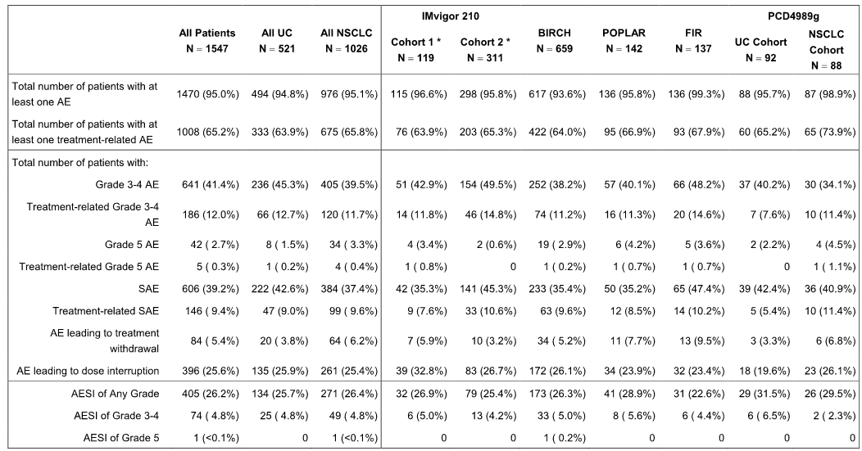
* IMvigor 210 data are based on the 14 September 2015 cut-off for Cohort 1 and the 5 May 2015 cut-off for Cohort 2.
The median duration of safety follow-up was 4.5 months (range: 0.5, 32.9 months) in the All Patients population (n = 1547), 3.6 months (range: 0.7, 19.7 months) in the All UC population (n = 521) and 5.1 months (range: 0.5, 32.9 months) in the All NSCLC population (n = 1026). The high-level safety profiles relating to atezolizumab-treated patients are similar for the All Patients, All UC and All NSCLC populations. All AEs collected after first treatment dose and within 30 days from last treatment dose, start of a non-protocol cancer therapy, or discontinuation from study are included, except for adverse events of special interest (AESIs) and treatment-related serious adverse events (SAEs) where no 30 day-time window was applied.
Comment: Nearly all atezolizumab-treated patients in the All Patients population experienced at least one AE (95.0%; [1470/1547]), and the majority of these AEs were considered by investigators to be treatment-related (65.2%; [1008/1547]). The safety profiles in the All UC and All NSCLC populations were similar, and the only two high-level AE categories in which there was a ≥ 5% difference in patient incidence between the All UC and All NSCLC populations were Grade 3-4 AEs (45.3% vs 39.5%, respectively), and treatment-related SAEs (42.6% vs 37.4%, respectively).

Exposure
In the All Patients population, 88.8% (1373/1547) of patients received atezolizumab at a fixed-dose of 1200 mg q3w (i.e. all patients in IMvigor 210, BIRCH, POPLAR and FIR, and 6 patients in the UC cohort of PCD4989g). The remaining 174 patients (86 from the UC and 88 from the NSCLC Cohorts of PCD4989g) received atezolizumab at doses of 1, 10, 15 or 20 mg/kg q3w.
At the fixed-dose of 1200 mg q3w, the median duration of exposure to atezolizumab in the All Patients population was 3.5 months (range 0.0, 19.4 months). In this population, 54.3% of patients received more than 3 months of atezolizumab treatment, 35.7% received more than 6 months of treatment, and 4.7% (all with NSCLC) received more than 12 months of treatment. The median number of treatment cycles received in the All Patients population was 6 (range: 1, 28). The exposure data for patients treated with atezolizumab 1200 mg q3w are summarised below.
Table 80: Exposure to atezolizumab 1200 mg q3w.
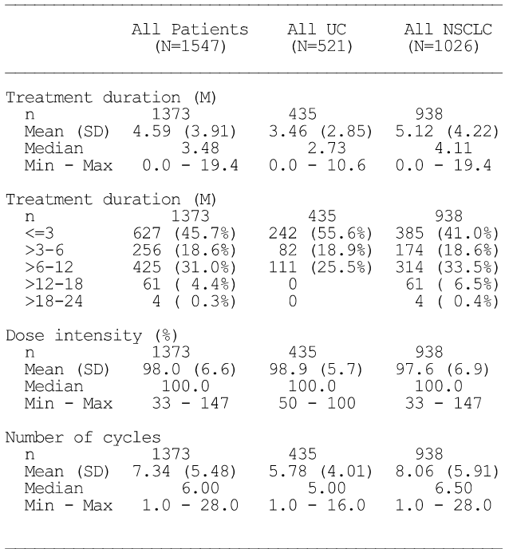

Adverse events

Commonly reported adverse events – irrespective of relationship to treatment
Most patients in the All Patients population experienced at least one AE of any grade (95.0%). The most common SOCs (≥ 20% of patients) and PTs (≥ 10% of patients) reported in the All Patients population were: (1) general disorders and administration site conditions (64.3%), most commonly fatigue, pyrexia, and asthenia; (2) gastrointestinal disorders (56.0%), most commonly nausea, diarrhoea, constipation, and vomiting; (3) respiratory, thoracic and mediastinal disorders (48.2%), most commonly dyspnoea and cough; (4) musculoskeletal and connective tissue disorders (43.7%), most commonly back pain and arthralgia; (5) metabolism and nutrition disorders (38.3%), most commonly decreased appetite; (6) infections and infestations (37.7%); (7) skin and subcutaneous tissue disorders (31.7%), most commonly pruritus; (7) nervous system disorders (26.6%); and (8) investigations (23.1%). AEs reported in ≥ 10% patients in the All Patients, All UC and All NSCLC populations are summarised below.

Table 81: AEs reported in ≥ 10% of patients in the All Patients, All UC and/or the All NSCLC populations, atezolizumab-treated safety-evaluable patients.
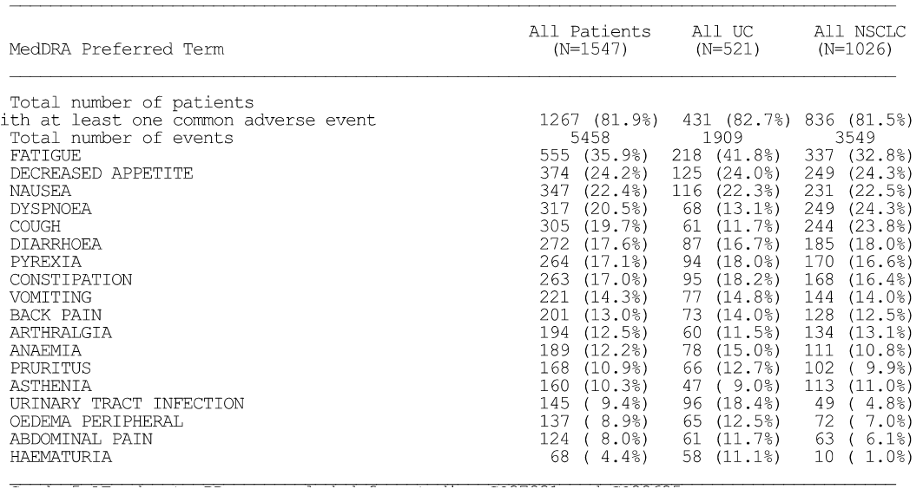
Grade 5 AEs due to PD are excluded for studies #GO27831 and GO28625. Investigator text for AEs encoded using MedDRA v18.0. Percentages are based on N in the column headings. For frequency counts by PT, multiple occurrences of the same AE in an individual are counted only once. For frequency counts of ‘Total number of events’ rows, the multiple occurrences of the same AE in an individual are counted separately. AEs collected after first treatment dose and within 30 days from last treatment dose are included unless the AE occurred after the start of a non-protocol cancer therapy after last treatment within the 30 day post-treatment period.
Comment: AEs of Grade 1 or 2 maximum intensity were experienced by 50.9% of patients in the All Patients population, and Grade 3 or Grade 4 AEs (maximum intensity) by 41.4% of patients. Commonly occurring AEs (PTs) reported in ≥ 5% more patients in the All UC population than in the All NSCLC population were fatigue, UTI, oedema peripheral, abdominal pain and haematuria. Commonly occurring AEs (PTs) reported in ≥ 5% more patients in the All NSCLC population than in the All UC population were dyspnoea and cough.

Treatment-related adverse events
Overall, 65.2% (1008/1547) of patients in the All Patients population had at least one AE that was considered by investigators to be related to atezolizumab treatment. The majority of patients with treatment-related AEs experienced events with Grade 1 or 2 maximum intensity (81.1%; [817/1008]). Treatment-related AEs reported in ≥ 5% of patients in the All Patients population, in decreasing order of frequency, were fatigue (21.4%), nausea (11.2%), decreased appetite (10.5%), diarrhoea (8.7%), pruritus (8.4%), pyrexia (7.6%), rash (6.5%), asthenia (5.8%), and arthralgia (5.1%),
In the All UC population, 63.9% (333/521) of patients had at least one AE that was considered by investigators to be related to atezolizumab treatment. The majority of patients with treatment-related AEs experienced events with Grade 1 or 2 maximum intensity (79.9%; [266/333]). Treatment-related AEs reported in ≥ 5% of patients in the All UC population, in decreasing order of frequency, were fatigue (25.5%), nausea (10.7%), decreased appetite (10.2%), pruritus (9.6%), diarrhoea (7.9%), pyrexia (7.5%), rash (6.5%), and vomiting (5.0%).
In the All NSCLC population, 65.8% (675/1026) of patients had at least one AE that was considered by investigators to be related to atezolizumab treatment. The majority of patients with treatment-related AEs experienced events with Grade 1 or 2 maximum intensity (81.6%; [551/675]). Treatment-related AEs reported in ≥ 5% of patients in the All NSCLC population were fatigue (19.3%), nausea (11.5%), decreased appetite (10.6%), pruritus (7.8%), diarrhoea (9.1%), pyrexia (7.6%), asthenia and rash (both 6.4%), and arthralgia (5.3%).
Comment: AEs considered by investigators to be related to treatment with atezolizumab were similar in the All Patients, All UC and All NSCLC populations. The most commonly occurring treatment-related AEs by SOCs (≥ 10% of patients in at least one of the three safety populations, PTs ≥ 5% in at least one of the three safety populations) were general disorders and administrative site conditions (fatigue, pyrexia, and asthenia), gastrointestinal disorders (nausea, diarrhoea, and vomiting), skin and subcutaneous tissue disorders (pruritus and rash), metabolism and nutrition disorders (decreased appetite), musculoskeletal and connective tissue disorders (arthralgia), and respiratory, thoracic and mediastinal disorders.

AEs by intensity (NCI CTCAE Grades)
Grade 1 or 2 AEs were experienced by 50.9% of patients in the All Patients population, and Grade 3 or 4 AEs by 41.4% of patients. Grade 5 AEs occurring within 30 days after last dose of study treatment or prior to initiation of non-protocol anti-cancer therapy were reported in 2.7% (42/1547) of patients in the All Patients population. Grade 3 or 4 AEs reported in > 2% of patients in the All Patients, All UC and All NSCLC populations are summarised below.
Table 82: Grade 3 or 4 AEs occurring in > 2% of patients in the All Patients, All UC and All NSCLC populations, safety-evaluable patients.
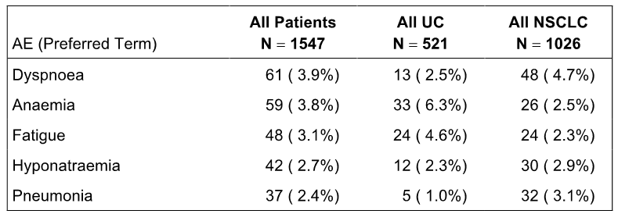

Deaths, other serious adverse events (SAEs) and other significant AEs

Deaths
At the time of data cut-off dates for each study, a total of 615 (39.8%) patients had died in the All Patients population, comprising 207 (39.7%) patients from the All UC population and 408 (39.7%) patients from the All NSCLC population. The majority of deaths occurred beyond 30 days after last dose (73.7%; [453/615]), with the results for the All UC and All NSCLC populations being similar (71.5%; [148/207] and 74.8% [305/408], respectively). The most common reason for death was progression of the underlying disease, which accounted for 82.4% (507/615) of all deaths in the All Patients population. Overall, 54 deaths were attributed to AEs (42 of which occurred within 30 days of last dose or prior to initiation of non-protocol anti-cancer therapy). An additional 55 deaths were attributed to the cause of ‘other’. Of these, 50 deaths were categorised as ‘death during follow-up’, all from study PCD4989g (reasons for deaths occurring beyond 30 days were not collected in this study unless the reason for death was an AE). The 5 remaining deaths due to cause of ‘other’ were ‘death due to intracranial bleed’ (related to a previous cerebrovascular accident), ‘death due to euthanasia’, and in three cases the cause death was unknown. Deaths are summarised below.
Table 83: Summary of deaths and primary cause of death, safety evaluable population.
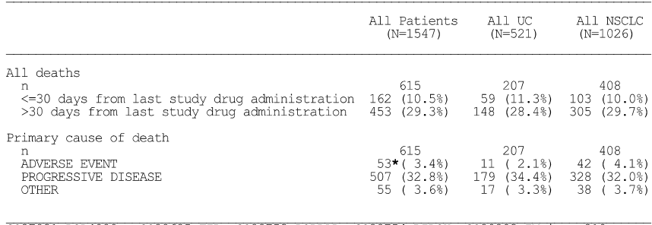
Grade 5 AEs (i.e. death attributed to AE) occurring within 30 days after the last dose of study treatment or prior to initiation of non-protocol therapy were reported in 42 (2.7%) patients in the All Patients population, comprising 8 (1.5%) patients from the All UC population and 34 (3.3%) patients from the All NSCLC population. Grade 5 AEs were reported in a variety of SOCs and the AE preferred terms reported for more than 1 patient were pneumonia (5 patients), cardiac arrest (3 patients), sudden death (3 patients), respiratory failure (2 patients), and cardiac tamponade (2 patients).
Of the 42 Grade 5 AEs occurring within 30 days after the last dose of study treatment or prior to initiation of non-protocol therapy, 5 events were considered by the investigator to be treatment-related. The five treatment-related Grade 5 AEs were cardio-respiratory arrest (1 patient in PCD4989g, NSCLC cohort), constrictive pericarditis (1 patient in FIR, NSCLC), cardiac failure (1 patient in BIRCH, NSCLC), pneumonia (1 patient in BIRCH, NSCLC), and sepsis (1 patient in IMvigor 201, UC).
Grade 5 AEs occurring beyond 30 days after the of last dose or after initiation of non-protocol anti-cancer therapy were reported in 12 (0.8%) patients in the All Patients population, including 3 (0.6%) patients from the All UC population (1 each upper gastrointestinal haemorrhage, respiratory distress and death), and 9 (0.9%) patients from the All NSCLC population (3 x pneumonia, 1 each for gastric perforation, large intestine perforation, respiratory failure, cardiac arrest, jugular vein thrombosis, and death). The one treatment-related Grade 5 AE occurring beyond 30 days after the last dose or after initiation of non-protocol anti-cancer therapy was respiratory failure in a patient in the All NSCLC population (onset of AE occurred 52 days after last study drug administration).

Other serious adverse events (SAEs)
The proportion of patients reporting at least one SAE of any grade was 39.2% (606/1547) in the All Patients population, 42.6% (222/521) in the All UC population, and 37.4% (384/1026) in the All NSCLC population. SAEs occurring in ≥ 1% of patients in the All patients, All UC or All NSCLC populations are summarised below.
Table 84: SAEs by PT occurring in ≥ 1% of patients in the All patients, All UC or All NSCLC populations.
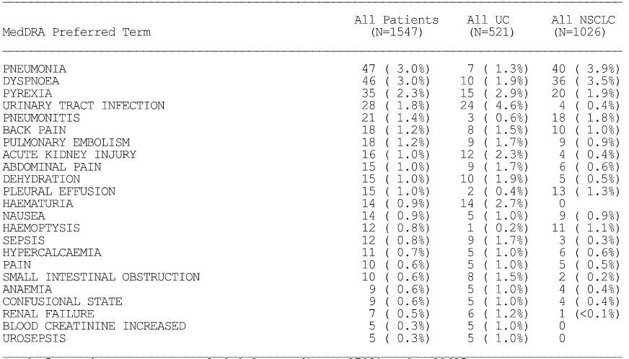
Treatment-related SAEs were reported in 9.4% (146/1547) of patients in the All Patients population, including 9.0% (47/1547) of patients in the All UC population and 9.6% (99/1026) of patients in the All NSCLC population. Treatment-related SAEs reported in ≥ 4 patients (≥ 0.3%) were pneumonitis (1.0%), pyrexia (0.8%), diarrhoea (0.6%), colitis, nausea, and AST increased (0.4% each), and pneumonia, ALT increased, hypothyroidism and muscular weakness (0.3% each).
Treatment-related SAEs were reported in 9.0% (47/1547) of patients in the All UC population, and events reported in ≥ 2 patients (≥ 0.4%) were pyrexia (1.0%), pneumonitis and diarrhoea (0.6% each), and sepsis, blood bilirubin increased, colitis, leucocytosis and confusional state (0.4% each). Treatment-related SAEs were reported in 9.6% (99/1026) of patients in the All NSCLC population, and events reported in ≥ 3 patients (≥ 0.3%) were pneumonitis (1.3%), pyrexia (0.8%), diarrhoea (0.7%), nausea (0.6%), AST increased (0.5%), pneumonia and colitis (0.4% each), and muscle weakness, hypothyroidism, ALT increased, hypoxia and dyspnoea (0.3% each).

AEs resulting in withdrawal of study treatment
In the All Patients population, 84 (5.4%) patients experienced an AE that resulted in withdrawal of study treatment, and events reported in ≥ 3 patients (≥ 0.2%) were pneumonia, pneumonitis, and dyspnoea (0.3% each), and sudden death and pneumonia aspiration (0.2% each).
In the All UC population, 20 (3.8%) patients experienced an AE that resulted in withdrawal of study treatment, and the only event resulting in withdrawal reported in ≥ 2 patients (≥ 0.4%) was sepsis (0.4%).
In the All NSCLC population, 64 (6.2%) patients experienced an AE that resulted in withdrawal of study treatment, and events reported in ≥ 2 patients (≥ 0.2%) were pneumonia, pneumonitis, and dyspnoea (0.4% each), sudden death and pneumonia aspiration (0.3% each), and hypercalcaemia, thrombocytopenia, weight decreased, cerebrovascular accident, fatigue, and septic shock (0.2% each).

AEs leading to dose interruption
In the All Patients population, 396 (25.6%) patients experienced an AE that resulted in dose interruption, and events reported in ≥ 1% of patients were dyspnoea (2.0%), pneumonitis (1.7%), fatigue (1.6%), pneumonia (1.3%), and diarrhoea (1.0%).
In the All UC population, 135 (25.9%) patients experienced an AE that resulted in dose interruption, and events reported in ≥ 1% of patients were urinary tract infection (1.9%), fatigue (1.5%), diarrhoea (1.5%), confusional state and pyrexia (1.3% each), and dyspnoea, AST increased and infusion related reaction (1.2% each).
In the All NSCLC population, 261 (25.4%) patients experienced an AE that resulted in dose interruption, and events reported in ≥ 1% of patients were dyspnoea (2.4%), pneumonitis (2.1%), pneumonia (1.8%), and fatigue (1.7%).

Adverse Events of special interest (AESI)
Adverse events of special interest (AESIs) were pre-defined in the study protocols for the purposes of expedited reporting and were based on the known mechanism of action of atezolizumab and safety concerns reported with other immune modulating agents. Subsequently, AESIs were identified for analysis based on sponsor-defined AE Grouped Terms (AEGTs), which was considered a more conservative approach to capturing such events. AESIs included dermatologic, hepatic, endocrine, and respiratory events as well as events of elevated liver function tests and influenza-like illness. AESIs were summarised by MedDRA SOC and PTs.
In the All Patients population, AESIs were reported in 405 (26.2%) of patients. AESI (PTs) reported in ≥ 1% of patients were rash (9.3%), AST increased (4.3%), ALT increased (4.0%), hypothyroidism (3.2%), pneumonitis (2.7%), peripheral neuropathy (2.4%), rash maculopapular (1.9%), blood bilirubin increased (1.1%) and rash pruritic (1.0%).
In the All UC population, AESIs were reported in 134 (25.7%) of patients. AESI (PTs) reported in ≥ 1% of patients were rash (9.0%), AST increased (5.6%), ALT increased (5.2%), peripheral neuropathy (3.1%), hypothyroidism (2.3%), blood bilirubin increased (2.1%), rash maculopapular (1.9%), pneumonitis and rash pruritic (1.2% each).
In the All NSCLC population, AESI were reported in 271 (26.4%) of patients. AESI (PTs) reported in ≥ 1% of patients were rash (9.5%), hypothyroidism (3.7%), AST increased (3.6%), pneumonitis and ALT increased (3.4% each), neuropathy peripheral (2.0%), rash maculopapular (1.9%), and colitis (1.1%).

Adverse drug reactions (ADRs)
In the All Patients population, 82.2% (n = 1271) of patients were identified as having an ADR. ADRs identified in ≥ 2% of patients were fatigue (35.9%), decreased appetite (24.2%), nausea (22.4%), dyspnoea (20.5%), diarrhoea (17.6%), pyrexia (17.1%), rash (16.4%), vomiting (14.3%), arthralgia (12.5%), pruritus (10.9%), asthenia (10.3%), abdominal pain (8.0%), musculoskeletal pain (6.3%), chills (6.1%), influenza-like illness (5.3%), hyponatraemia and hypokalaemia (4.6% each), AST increased (4.2%), ALT increased (3.9%), hypothyroidism and hypotension (3.5% each), pneumonitis (3.0%), diabetes (3.1%), dysphagia (2.7%), nasal congestion and hypoxia (2.5% each), and thrombocytopenia (2.4%).
In the All UC population, 81.6% (n = 425) of patients were identified as having an ADR. ADRs identified in ≥ 2% of patients were fatigue (41.8%), decreased appetite (24.0%), nausea (23.3%), pyrexia (18.0%), diarrhoea (16.7%), vomiting (14.8%), rash (14.4%), dyspnoea (13.1%), pruritus (12.7%), abdominal pain (11.7%), arthralgia (11.5%), asthenia (9.0%), chills (7.9%), AST increased (5.6%), ALT increased (5.0%), hyponatraemia (4.8%), influenza like illness (4.6%), hypotension and diabetes (3.6%), hypokalaemia (3.5%), musculoskeletal pain (2.9%), thrombocytopenia (2.7%), hypothyroidism (2.5%) and nasal congestion (2.3%).
In the All NSCLC population, 82.5% (n = 846) of patients were identified as having an ADR. ADRs identified in ≥ 2% of patients were fatigue (32.8%), dyspnoea and decreased appetite (24.3%), nausea (22.5%), diarrhoea (18.0%), rash (17.4%), pyrexia (16.6%), vomiting (14.0%), arthralgia (13.1%), asthenia (11.0%), pruritus (9.9%), musculoskeletal pain (8.0%), abdominal pain (6.1%), influenza like illness (5.7%), hypokalaemia and chills (5.2% each), hyponatraemia (4.5%), pneumonitis and hypothyroidism (4.0% each), AST increased (3.6%), dysphagia (3.5%), hypotension and ALT increased (3.4% each), hypoxia (3.1%), diabetes (2.8%), nasal congestion (2.5%), and thrombocytopenia (2.2%).

Important ADRs
The sponsor identified a subset of important immune-related events ADRs of particular clinical relevance (termed important ADRs), which included pneumonitis, hepatitis, colitis, hypothyroidism, hyperthyroidism, adrenal insufficiency, meningitis (non-infectious), encephalitis (non-infectious), myasthenic syndrome, Guillain-Barré syndrome, diabetes mellitus and pancreatitis. The list of important ADRs were identified using Standard MedDRA Query (SMQs) High Level Terms (HLTs), and a sponsor-defined search basket, which were considered more inclusive and standardised than the AEGTs approach used for the AESI analysis.
In the All Patients population, 11.4% (n = 177) of patients experienced an important ADR, the majority (72.9% [129/177]) of these being Grade 1-2 maximum intensity. Forty-seven of 177 patients (26.6%) with an important ADR had a Grade 3-4 event, and one patient had a Grade 5 event (pneumonitis). The most commonly identified important ADRs (≥ 1% of patients) were immune-related hypothyroidism (3.6%), immune related diabetes mellitus (3.2%), immune-related pneumonitis (3.0%), and immune-related colitis (1.0%). Systemic corticosteroid treatment was administered to 38 (21.5%) of the 177 patients with important ADRs, atezolizumab treatment was discontinued in 11 patients (0.7%), and 52 patients (3.4%) had a dose interruption due to an important ADR. In the All UC population, 9.2% (n = 48) of patients had an important ADR compared to 12.6% (n = 129) of patients in the All NSCLC. The important ADRs in the three safety populations are reviewed below. The safety data relating to important immune related ADRs in the All Patients population are summarised below.
Table 85: Summary of safety information for important ADRs (immune-related events of particular clinical relevance).
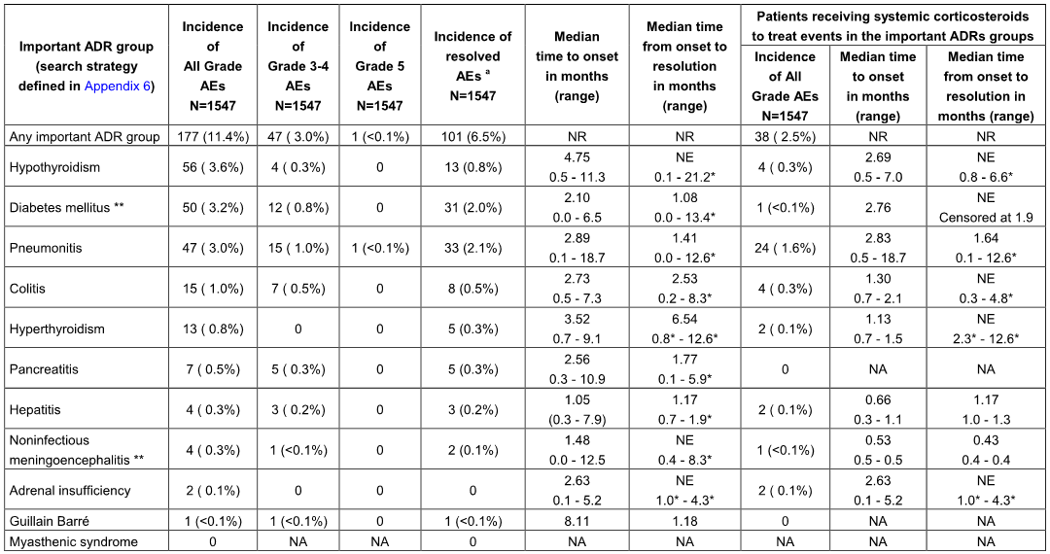
Note: * Censored value, NE = Not Estimable, NA = Not Applicable, NR = Not Reported. ** Incidence reflects events included in the respective SMQs as defined by the search strategy. ª Only the first event within each Important ADR group occurring for each patient is counted for resolution. Important ADRs groups are ordered by incidence of all grade events. Median time to onset and median time from onset to resolution are provided for all Grade AEs only.

Immune-related hypothyroidism
Overall, 56 patients (3.6%) in the All Patients population experienced an immune-related hypothyroidism event (SMQ), comprising 12 patients (2.5%) in the All UC population and 43 patients (4.2%) in the All NSCLC population. Nearly all events in the three safety populations were Grade 1-2 in maximum intensity. Of the 56 patients in the All Patients population, 4 patients (Grade 1 or 2 events) required treatment with systemic corticosteroids for the event, including 3 patients with hypothyroidism and 1 patient with increased thyroid stimulating hormone. Immune-related hypothyroidism events are summarised below.
Table 86: Immune-related hypothyroidism, safety-evaluable population.
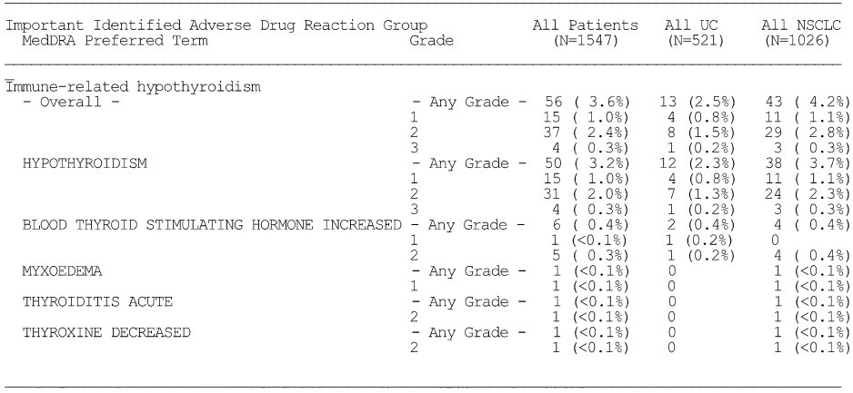

Immune-related diabetes mellitus
In the All Patients population, 50 (3.2%) patients reported an event in the Hyperglycemia/New onset of diabetes mellitus SMQ, comprising 21 (4.0%) patients in the All UC population, and 29 (2.8%) patients in the All NSCLC population. The majority of events in the three safety populations were Grade 1-2 in maximum intensity. One patient with hyperglycaemia received systemic corticosteroid treatment.
After medical review of the data in the Hyperglycaemia/New onset of diabetes mellitus SMQ, ‘diabetes mellitus’ and ‘type 1 diabetes mellitus’ preferred terms were considered as the PTs defining the important ADR of immune-related diabetes mellitus associated with atezolizumab. Of the 50 patients experiencing events in the Hyperglycaemia/New onset of diabetes mellitus SMQ, 5 patients (0.3%) experienced a ‘diabetes mellitus’ or ‘type 1 diabetes mellitus’ (MedDRA PT) event, including 2 patients (0.4%) in the All UC population, and 3 patients (0.3%) in the All NSCLC population. One patient (< 0.1%) discontinued atezolizumab due to Grade 3 diabetes mellitus, and one patient had a dose interruption due to type 1 diabetes mellitus (Grade 3 event). Immune-related diabetes events are summarised below.
Table 87: Immune-related diabetes mellitus, safety-evaluable population.
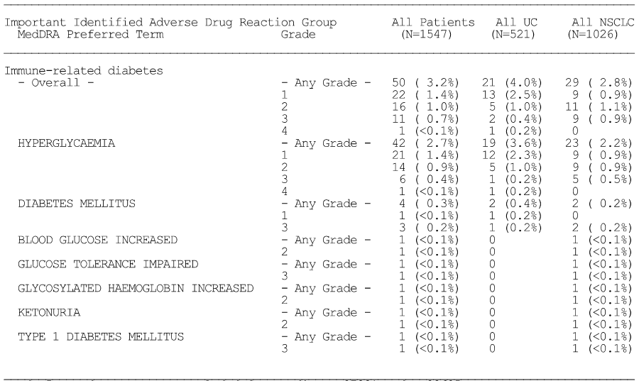

Immune-related pneumonitis
In the All Patients population, a total of 47 (3.0%) patients experienced an immune-related pneumonitis event (SMQ), comprising 6 (1.2%) patients in the All UC population and 41 (4.0%) patients in the NSCLC population. The majority of events in the three populations were Grade 1-2 in intensity. There was one Grade 5 event in a patient in the All NSCLC population. Six patients (0.4%) with immune-related pneumonitis discontinued atezolizumab (1 patient with UC, and 5 patients with NSCLC), and 28 patients (1.8%) had dose interruption (4 patients with UC, and 24 patients with NSCLC). Overall, 24 patients (1.6%) received systemic corticosteroid treatment for these events, including 23 patients with pneumonitis (PT) and 1 patient with interstitial lung disease (PT). The results are summarised below.
Table 88: Immune-related pneumonitis, safety-evaluable population.
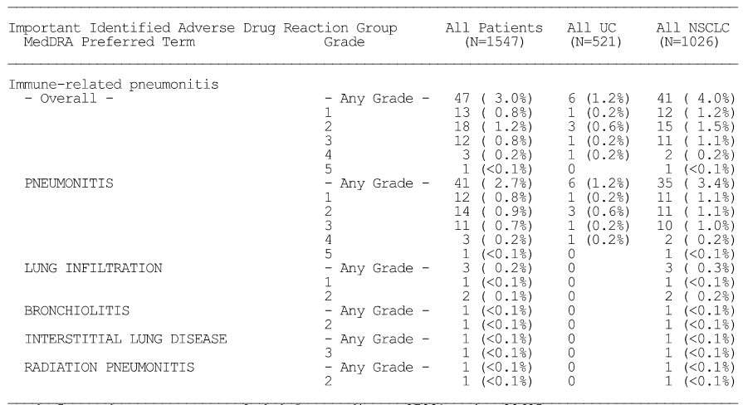

Immune-related colitis
In the All Patients Population, 15 (1.0%) patients experienced an immune-related colitis event, including 14 patients with colitis and 1 patient with microscopic colitis. In the All UC group, 4 (0.8%) patients experienced immune-related colitis (3 colitis events, 1 microscopic colitis event). In the All NSCLC group, 11 (1.1%) patients experienced immune-related colitis (all colitis events). There were no Grade 4 or 5 immune-related colitis events. Three patients (0.2%) discontinued atezolizumab (1 patient with UC, and 2 patients with NSCLC), and 7 patients had a dose interruption (2 patients with UC, and 5 patients with NSCLC) due to colitis events (PT). Four patients with a colitis event required systemic corticosteroid treatment.

Immune-related hyperthyroidism
In the All Patients population, immune-related hyperthyroidism events (SMQ) were reported in 13 patients (0.8%), including TSH increased in 6 patients, hyperthyroidism in 6 patients, thyroiditis acute in 1 patient, and thyroxine decreased in 1 patient. In the All UC population, 3 (0.6%) patients experienced immune-related hyperthyroidism events (SMQ), including 2 patients with TSH increased and 1 patient with hypothyroidism. In the All NSCLC population, immune-related hyperthyroidism events (SMQ) were reported in 10 patients (1.0%), including TSH increased in 4 patients, hyperthyroidism in 5 patients, thyroiditis acute in 1 patient, and thyroxine decreased in 1 patient. All of the events in the three safety populations were Grade 1-2 maximum intensity. No patients discontinued atezolizumab, and 2 patients with NSCLC had a dose interruption due to immune-related hyperthyroidism events (SMQ). Two patients with NSCLC received treatment with systemic corticosteroids for these events.

Immune-related pancreatitis
In the All Patients population, immune-related pancreatitis events (AEGT) were reported in 7 (0.5%) patients, including lipase increased in 3 patients, amylase increased in 2 patients, and pancreatitis and acute pancreatitis in 1 patient each. In the All UC population, immune-related pancreatitis events (AEGT) were reported in 2 (0.4%) patients, including lipase increased and amylase increased in 1 patient each. In the All NSCLC population, immune-related pancreatitis events (AEGT) were reported in 5 (0.5%) patients, including lipase increased in 2 patients and amylase increased, pancreatitis and acute pancreatitis in 1 patient each. Two patients (0.1%) had a dose interruption, and no patients discontinued atezolizumab or required systemic corticosteroid treatment due to pancreatitis events.

Immune-related hepatitis
In the All Patients population, 4 (0.3%) patients experienced immune-related hepatitis events (SMQ), including autoimmune hepatitis and hepatitis in 2 patients each. In the All UC population, 2 (0.4%) patients experienced immune-related hepatitis events (SMQ), including autoimmune hepatitis and hepatitis in 1 patient each. In the All NSCLC population, 2 (0.2%) patients experienced immune-related hepatitis events (SMQ), including autoimmune hepatitis and hepatitis in 1 patient each. In the All Patients group, 1 patient had a Grade 1 event, 1 patient had a Grade 3 event and 2 patients had a Grade 4 event. No patients discontinued atezolizumab, and 3 patients (2 with UC and 1 with NSCLC) had a dose interruption due to immune-related hepatitis events (SMQ). Two patients experienced an event that required systemic corticosteroid treatment, 1 with a Grade 3 autoimmune hepatitis event and 1 with a Grade 4 hepatitis event.

Immune related non-infectious meningoencephalitis
In the All Patients population, 4 (0.3%) patients reported an event in the Non-infectious encephalitis and Non-infectious meningitis SMQs (1 and 3 events, respectively). Of the 4 patients with an event, all were from the All NSCLC patient population (0.4%), with 1 patient experiencing encephalitis and 3 patients experiencing photophobia. Three of these 4 patients experienced a Grade 1 or 2 event (photophobia), and 1 patient had a Grade 3 event. None of these events led to atezolizumab discontinuation. The patient experiencing the encephalitis event (PT) had a dose interruption due to the event and received treatment with systemic corticosteroids. No patients in the All UC population experienced an event in this grouping. The sponsor stated that, after medical review of the data in the Non-infectious encephalitis and in the Non-infectious meningitis SMQs, only the ‘Encephalitis’ preferred term was considered as the PT currently defining the important ADR of immune-related non-infectious meningoencephalitis associated with atezolizumab.

Immune-related adrenal insufficiency
Two patients experienced immune-related adrenal insufficiency events, both from the All NSCLC population (0.2%). Both events were of Grade 1 or 2 intensity, and required systemic corticosteroid treatment. The Grade 2 event led to dose interruption, and none of the events led to atezolizumab discontinuation.

Immune-related Guillain-Barré syndrome
One patient from the All NSCLC population experienced a Grade 3 Guillain-Barré syndrome event. This SAE was considered related to study drug by the investigator and led to atezolizumab discontinuation. The event did not require systemic corticosteroid treatment, and had resolved after 36 days.

Clinical laboratory tests
There was no pooling of the clinical laboratory data in the SCS. Overall, in all five studies there were no clinically meaningful changes observed in any of the laboratory safety parameters (haematology and blood chemistry) during treatment with atezolizumab. Although small fluctuations in median values were observed, the median values for the parameters remained within the normal range during the entire treatment period. Of note, median values for haematocrit, haemoglobin and red blood cell counts at baseline were below or at the lower limit of the standard reference range in all studies, and did not decrease further during treatment with atezolizumab.
Few patients experienced clinically relevant (worst grade of Grade 3 or 4) laboratory abnormalities during treatment with atezolizumab. The most frequently reported clinically relevant laboratory abnormalities (greater than 5% of patients in at least one study) were Grade 3 low haemoglobin levels, low lymphocyte counts, low sodium levels, and low phosphorus levels. Post-baseline clinically relevant (worst Grade 3 or 4) laboratory abnormalities are summarised.

Hy’s law for drug induced liver injury
Overall, 6 patients across the 5 studies fulfilled the laboratory criteria for Hy’s Law: i.e. AST and/or ALT greater than 3 x ULN concurrent (within 7 days) with total bilirubin greater than 2 x ULN. The studies with the relevant patients were FIR (NSCLC) 1 patient (0.7%), BIRCH (NSCLC) 1 patient (0.2%) and IMvigor 210 (UC) 4 patients (0.9%). The submitted narrative descriptions for the 6 patients have been examined and are considered to show confounding factors in each patient. Therefore, the 6 cases do not satisfy the clinical criteria for Hy’s law.

Clinical relevant laboratory evaluations reported as AEs
Clinically relevant haematology laboratory abnormalities reported as AEs (i.e. Grade 3 or 4 AEs), occurred at a low incidence with the most commonly observed abnormalities (≥ 2% of patients in any study) being anaemia, and thrombocytopenia. Of note, the incidence of Grade 3 or 4 anaemia was higher in the 2L+ UC population of IMvigor 210 (7.4%) and UC Cohort of PCD4989g (5.4%) than in Cohort 1 of IMvigor 210 (4.2%) and the NSCLC population in BIRCH, POPLAR, FIR and the NSCLC Cohort of PCD4989g, which ranged from 0.7% to 3.6%.
Clinically relevant clinical chemistry laboratory abnormalities reported as AEs (i.e. Grade 3 or 4 AEs), occurred at a low incidence with the most common events being hyponatraemia (1.6% to 4.4%), hypokalaemia (0% to 3.6%), ALT increased (0% to 2.5%) and AST increased (0% to 3.3%). Chemistry laboratory results were consistent across the 5 studies.

Vital signs
There was no pooling of vital sign data across the studies. Overall, no clinically meaningful changes were observed in median values over time for any vital sign parameters (systolic and diastolic blood pressure, pulse rate or respiratory rate) in the five clinical studies.

ECG
In the two clinical studies with relevant data (PCD4989g and FIR), no clinically relevant changes from baseline were observed in the median values of any ECG parameter (heart rate, PR duration, QRS duration, QRS axis, QT duration, QTcB [Bazett’s Correction], QTcF [Fridericia’s Correction], and RR duration).

Other safety issues

Safety in special populations

Age
The high-level safety profile in the three safety populations are summarised below. Overall, it is considered that there are no clinically meaningful differences in the high-level safety profiles between patients aged < 65 years and aged ≥ 65 years.
Table 89: High-level safety profiles in patients aged < 65 and ≥ 65 years.
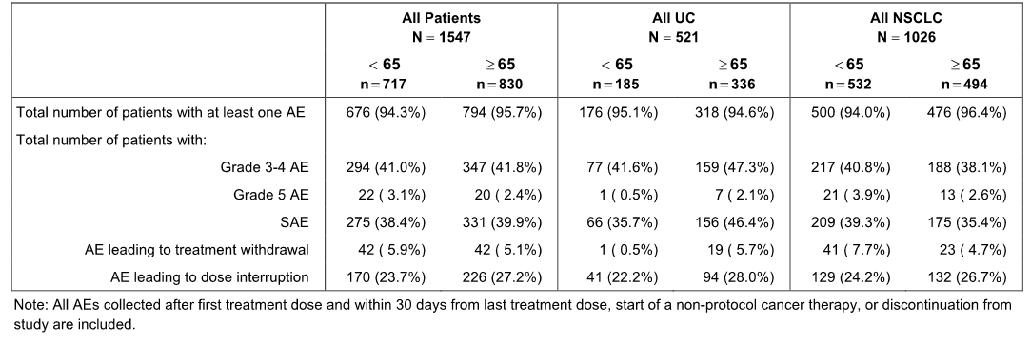
In the All Patients population, nearly all patients aged < 65 years and ≥ 65 years experienced at least one AE (94.3% vs 95.7%, respectively). The only SOC (MedDRA) with AEs (PTs) reported in ≥ 5% more patients in one age group compared to the other age group was investigations (< 65, 20.4% vs ≥ 65, 25.4%), and no AEs in this SOC were reported in ≥ 10% of patients in either of the two age groups.
In the All Patients population, SAEs were reported in a similar proportion of patients aged < 65 and ≥ 65 years (38.4% vs 39.9%, respectively). SAEs reported in ≥ 2% of patients in either of the two age groups (< 65 vs ≥ 65, respectively) were pneumonia (2.9% vs 3.1%), dyspnoea (2.9% vs 3.0%), pyrexia (2.1% vs 2.4%), and urinary tract infection (1.5% vs 2.0%).

Gender
The high-level safety profile in the three safety populations based on gender are summarised below. Overall, it is considered that there were no clinically meaningful differences in the high-level safety profiles between male and female patients.
Table 90: High-level safety profiles in males and females.
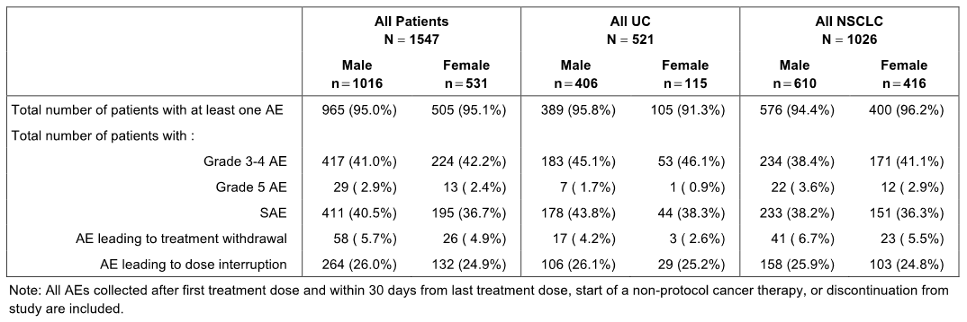
In the All Patients population, nearly all male and female patients experienced at least one AE (95.0% vs 95.1%, respectively). The SOCs (MedDRA) with AEs (PTs) reported in ≥ 5% more patients in one gender compared to the other were: (1) gastro-intestinal disorders (males, 52.5% vs females, 62.7%), and AEs reported in ≥ 10% of patients in either of the two genders (males vs females) were nausea (19.2% vs 28.6%), constipation (16.8% vs 17.3%), diarrhoea (16.4% vs 19.8%), and vomiting (10.9% vs 20.7%); (2) respiratory, thoracic and mediastinal disorders (males, 46.1% vs females, 52.2%), and AEs reported in ≥ 10% of patients in either of the two genders (males vs females) were dyspnoea (18.4% vs 24.5%) and cough (18.1% vs 22.8%); (3) nervous system disorders (males, 24.6% vs females, 30.3%), no AEs reported in ≥ 10% of patients in either of the two genders; (4) renal and urinary disorders (males, 14.7% vs females, 9.2%), no AEs reported in ≥ 10% of patients in either of the two genders.
In the All Patients population, SAEs were reported in a similar proportion of male and female patients (40.5% vs 36.7%, respectively). SAEs reported in ≥ 2% of patients in either gender (males vs females, respectively) were pneumonia (3.1% vs 2.8%), pyrexia (2.8% vs 1.3%), dyspnoea (2.2% vs 4.5%), and urinary tract infection (2.1% vs 1.3%).

Race
No meaningful conclusions can be drawn from safety comparisons based on race, due to the imbalance in patient numbers (e.g. Caucasians accounted for 84.8% of the All Patients population).

Extrinsic factors
No information was available on safety based on differences in intrinsic factors (e.g. renal impairment, hepatic impairment).

Drug interactions
No formal drug-drug interaction studies were included in the submission. There was no specific information on safety relating to concomitant administration of atezolizumab with other drugs.

Use in pregnancy and lactation
There were no clinical studies assessing the safety of atezolizumab in pregnancy. It is unknown whether atezolizumab is excreted in human milk.

Overdose
There were no data on overdose.

Withdrawal and rebound
There were no data on withdrawal and rebound.

Effects of ability to drive or operated machinery or impairment of mental ability
No studies on the effects of atezolizumab to drive or operate machinery have been undertaken.

Post-marketing data
There were no post-marketing data in the submission.

IMvigor 210 – Cohort 2 – urothelial cancer (UC)

High-level overview of safety
Cohort 2 is the patient population of direct relevance to the proposed indication of atezolizumab for second-line and beyond therapy of previously treated patients with locally advanced or metastatic UC. The cohort consists of 311 patients who failed a prior platinum-containing chemotherapy regimen or progressed within 12 months of a platinum-based treatment administered in the adjuvant/neo-adjuvant setting and were treated with atezolizumab in the 2L+ setting.
The safety results for Cohort 2 are based on data with a clinical cut-off date of 5 May 2015 (median length of follow up of 7.1 months). Almost all patients in Cohort 2 experienced at least one AE during the course of study treatment. The high-level AE safety profile of atezolizumab was similar in the IC2/3 and IC1/2/3 subgroups and in the all-comers group (i.e. irrespective of PD-LI expression). Adverse events occurring after initiation of study drug were reported until 30 days after the last dose of study treatment or until initiation of another anti-cancer therapy, whichever occurred first. After this period, investigators reported any deaths, serious adverse events, or other adverse events of concern that were believed to be related to prior treatment with study drug. The high-level safety profile for Cohort 2 is summarised below.
Table 91: IMvigor 210 – Cohort 2 high-level overview of adverse events, safety evaluable population.
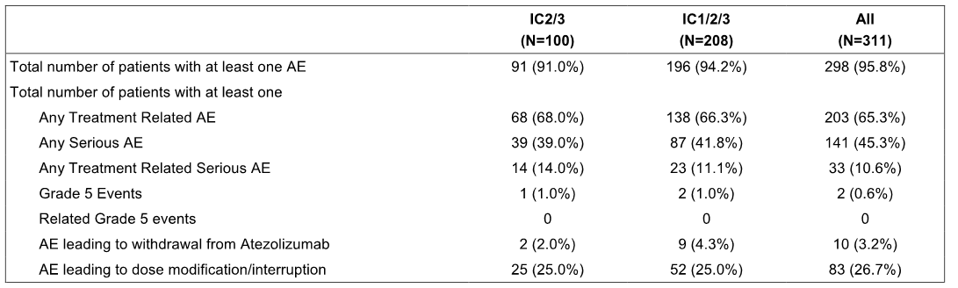
AE = adverse event; IC=tumour-infiltrating immune cell. Investigator text for AEs encoded using MedDRA v18.0. Percentages are based on N in the column heading. Multiple occurrence of the same AE in one individual are counted only once except for 'Total number of AEs’ row in which multiple occurrences of the same AE are counted separately.

Exposure to atezolizumab
Patients in Cohort 2 (n = 311, all-comers) received atezolizumab over a median duration of 12.3 weeks (range: 0, 46 weeks). Treatment duration was ≤ 13 weeks for 51.8% of patients; > 13 to 26 weeks for 16.7% of patients; > 26 to 39 weeks for 26.0% of patients; and > 39 to 52 weeks for 5.5% of patients. The median number of atezolizumab doses was 5.0 (range: 1, 16) and the median cumulative dose was 7200 mg (range: 1200, 19200).

Adverse events irrespective of relationship to study treatment
The majority of the patients in the IC2/3 subgroup (91.0%, 91/100), the IC1/2/3 subgroup (94.2%, 196/208), and the all-comers group (95.8%, 298/311) experienced at least one AE.
In the all-comers group (n = 311), SOCs including ≥ 10% of patients with AEs were general disorders and administration site conditions (60.1%), gastrointestinal disorders (51.4%), musculoskeletal and connective tissue disorders (26.4%), metabolism and nutrition disorders (25.4%), respiratory, thoracic and mediastinal disorders (22.8%), infections and infestations (19.0%), blood and lymphatic system disorders (13.8%), renal and urinary disorders (13.5%), and skin and subcutaneous tissue disorders (12.5%).
In the all-comers group (n = 311), the most commonly reported AEs (≥ 10% patients), in decreasing order of frequency, were: fatigue (46.3%), decreased appetite (25.4%), nausea (23.8%), pyrexia and constipation (20.3% each), urinary tract infection (19.0%), diarrhoea (18.0%), vomiting (16.4%), dyspnoea (14.8%), back pain (14.5%), arthralgia (14.1%), anaemia (13.8%), haematuria (13.5%), pruritus (12.5%), abdominal pain and cough (12.2% each), and oedema peripheral (11.9%). Overall, the percentages of AEs in patients in the IC2/3 and IC1/2/3 subgroups were consistent with the all-comers group.

Treatment-related adverse events
In the all-comers group (n = 311), AEs considered by investigators to be related to treatment with atezolizumab were reported in 65.3% (n = 203) of patients. SOCs including ≥ 10% of patients with treatment-related AEs were general disorders and administration site conditions (39.5%), gastrointestinal disorders (24.1%), skin and subcutaneous tissue disorders (19.3%), metabolism and nutrition disorders (14.1%), and nervous system disorders (10.6%).
In the-all comers group (n = 311), the most commonly reported treatment-related AEs (≥ 5% patients) were fatigue (28.3%), nausea (12.9%), decreased appetite (10.9%), pruritus (10.0%), pyrexia (8.7%), diarrhoea (7.7%), rash (6.8%), arthralgia and vomiting (both 5.8%), and chills (5.1%).

Deaths, other SAEs and other significant adverse events

Deaths
In the all-comers group (n = 311), a total of 141 (45.3%) deaths had occurred as of the clinical cut-off date of 5 May 2015. Of the 141 deaths, 34 (10.9%) occurred within 30 days of the last study treatment administration and 107 (34.4%) occurred beyond 30 days. The most common reason for death was disease progression (44.1%, [137/311]). In the four patients whose deaths were attributed to Grade 5 AEs, 1 was due to pulmonary sepsis, 1 was due to subileus, 1 was due to intracranial bleed (related to a previous cerebrovascular accident) and 1 was due to unknown cause. None of the four deaths reported to be due to Grade 5 AEs were considered to be treatment related.

SAEs
In the all-comers group (n = 311), 45.3% (n = 141) of patients reported at least one SAE. The SOCs with ≥ 5% of patients were infections and infestations (14.5%, n = 45) renal and urinary disorders (9%, n = 28), gastrointestinal disorders (7.7%, n = 24), respiratory, thoracic and mediastinal disorders (6.8%, n = 21), and general disorders and administration site conditions (5.5%, n = 17).
SAEs reported in ≥ 3 patients (≥ 1.0%), in decreasing order of frequency were urinary tract infection (6.1%), haematuria (3.2%), pyrexia (2.6%), dyspnoea and acute kidney injury (2.3% each), dehydration, abdominal pain, pulmonary embolism, back pain and sepsis (1.9% each), small intestinal obstruction, and pneumonia (1.6% each), hypercalcaemia, nausea and hydronephrosis (1.3% each), and hyponatraemia, pain, fatigue, pneumonitis, urosepsis, deep vein thrombosis, confusional state and pyelonephritis (1.0% each).
Treatment-related SAEs were reported in 10.6% (33/311) of patients, and treatment-related AEs reported in more than 1 patient were pneumonitis (3 [1.0%] patients) and pyrexia (2 [0.6%]) patients.

Adverse events leading to withdrawal of study treatment
In the all-comers group (n = 311), 3.2% (n = 10) of patients were withdrawn from study treatment due to AEs. No AEs leading to study drug withdrawal were reported in more than 1 patient. AEs leading to withdrawal from the study were one each for retroperitoneal haemorrhage, subileus, pulmonary sepsis, sepsis, toxicity to various agents, posterior reversible encephalopathy syndrome (PRES), acute kidney injury, pneumonitis, pruritus, and no coding. Three of the AEs were considered by the investigator to be related to treatment with atezolizumab (sepsis [resolved], acute kidney injury [resolved] and pneumonitis [death]).
Comment: An AE of acute kidney injury leading to withdrawal was considered by the investigator to be related to treatment with atezolizumab. Review of the case narrative indicated that acute kidney injury was the PT with the actual event being described as renal insufficiency, with not enough information provided to determine the cause. There was one case of posterior reversible encephalopathy syndrome (PRES) leading to withdrawal of study treatment. PRES has been associated with autoimmune diseases and with immunosuppressive drugs (e.g. tacrolimus, cyclosporine, chemotherapy). The case narrative indicates that the event developed on Day 15 of the study following initiation of treatment with atezolizumab. The investigator considered the event to be unrelated to treatment with atezolizumab. However, the sponsor is requested to comment on the possibility that PRES in this patient was related to treatment with atezolizumab.

Adverse events leading to dose interruption
No dose reductions for atezolizumab were specified in this study. However, study treatment could be temporarily interrupted for up to 42 days beyond the scheduled date of infusion in the event of study drug-related toxicity. In the all-comers group (n = 311), 26.7% (n = 83) of patients experienced at least one AE requiring dose interruption. AEs leading to dose interruption in the all-comers group and reported in ≥ 3 patients (≥ 1.0%) were urinary tract infection in 8 (2.6%) patients, diarrhoea in 6 (1.9%) patients, fatigue and confusional state in 5 (1.8%) patients each, and pyrexia, dyspnoea, pneumonitis, and blood bilirubin increased in 4 (1.3%) patients each (1.3%), and AST increased and hypotension in 3 (1.0%) patients each

Adverse events of special interest
AEs of special interest (AESIs) were stated to have been closely monitored as they represent identified and potential risks for atezolizumab. AESIs were derived from sponsor-defined AE group terms (AEGTs) based on the mechanism of action of atezolizumab.
In the all-comers group (n = 311), 25.4% (n = 79) of patients reported at least one AESI during the study. Most patients with an AESI had a Grade 1- 2 event (83.5%; [66/79]), with the most common AESIs being reported in the SOC of skin and subcutaneous tissue disorders (14.5%, n = 45).
AESIs reported in ≥ 1% (≥ 3 patients) of patients by PT, in decreasing order of frequency, were rash (10%, n = 31), increased AST (4.2%, n = 13), increased ALT (3.9%, n = 12), peripheral neuropathy (2.6%, n = 8), increased bilirubin (2.3%, n = 7 ), rash maculopapular (2.3%, n = 7), pneumonitis and hypothyroidism (1.9%, n = 6; each), rash pruritic (1.3%, n = 4), and transaminases increased (1.0%, n = 3).

Hepatic events reported as AESIs
Hepatic events reported as AESIs in the all-comers group were increased AST (4.2%, n = 13), increased ALT (3.9%, n = 12), increased blood bilirubin (2.3%, n = 7), increased transaminases (1.0%, n = 3), autoimmune hepatitis (0.3%, n = 1), and hepatitis (0.3%, n = 1).
Grade 3 or 4 hepatic AESIs were reported in 7 patients: 1 patient with hepatitis (Grade 4, related to study treatment); 1 patient with autoimmune hepatitis and increased transaminases (both Grade 3, both related to study treatment); 1 patient with increased ALT (Grade 3, related to treatment); 1 patient with increased ALT, AST, and bilirubin (all Grade 3, all related to study treatment); 1 patient with increased ALT (Grade 3, unrelated to study treatment);1 patient with increased bilirubin (Grade 3, unrelated to treatment); and 1 patient with increased AST (Grade 3, unrelated to treatment). The case narratives for the 7 patients with hepatic adverse events are summarised below.
- A [information redacted] patient experienced Grade 4 hepatitis on Day 32 of the study. The investigator reported the event as serious and considered it to be related to study treatment. The patient was treated with prednisone and methylprednisolone. Study drug was interrupted and the event resolved after 40 days.
- A [information redacted] patient experienced Grade 3 autoimmune hepatitis on Day 8 of the study and Grade 3 transaminase increases on Day 16 of the study. The patient was treated with prednisone for the transaminitis. The investigator reported both events as not serious and considered them both to be related to study treatment. Study drug was interrupted and autoimmune hepatitis resolved after 31 days. Study drug was not changed for the transaminase increases, which resolved after 23 days.
- A [information redacted] patient experienced a Grade 3 increase in ALT on Day 29 of the study. The investigator reported the event as not serious and considered it to be related to study treatment. No action was taken and the event resolved after 15 days.
- A [information redacted] patient experienced Grade 3 increases in ALT, AST, and blood bilirubin on Day 164 of the study. The investigator reported all events as serious and considered them all to be related to study treatment. The patient was treated with prednisone. No other action was taken for these events, which were ongoing at the time of the cut-off for the analysis.
- A [information redacted] patient experienced a Grade 3 increase in ALT on Day 204 of the study. The investigator reported the event as not serious and considered it to be unrelated to study treatment. The dose of study drug was not interrupted and the event resolved after 18 days.
- A [information redacted] patient experienced a Grade 3 increase in blood bilirubin on Day 9 of the study. The investigator reported the event as not serious and considered it to be unrelated to study treatment. No action was taken and the event resolved after 9 days.
- A [information redacted] patient experienced a Grade 3 increase in AST on Day 22 of the study. The investigator reported the event as serious and considered it to be unrelated to study treatment. Study drug was interrupted and the event was ongoing at the time of the data cut-off.

Dermatological reactions reported as AESI
Dermatological reactions reported as AESI were included in the SOC of skin and subcutaneous disorders and were reported in 14.5% (n = 45) of patients in the all-comers group. The most commonly reported AEs (≥ 1% of patients) were rash (10.0%), maculopapular rash (2.3%), and pruritic rash (1.3%). One patient experienced a Grade 3 rash considered to be related to study treatment. The rash was treated with corticosteroids. Study treatment was interrupted and subsequently discontinued due to the rash. There were no Grade 4 or 5 AEs related to dermatological disorders, and no dermatological AESIs were reported as SAEs. No cases of Stevens-Johnson syndrome or toxic epidermal necrolysis were reported.

Endocrine events reported as AESI
In the all-comers group, 6 (1.9%) patients were reported with hypothyroidism and 2 (0.6%) patients were reported with blood TSH increased. Two events were Grade 1 severity, 5 events were Grade 2 severity, and 1 event was Grade 3 severity. The one Grade 3 event was hypothyroidism, which was considered to be related to study treatment and was ongoing at the date of the data cut-off.

Neurological events reported as AESIs
In the all-comers group, 8 (2.6%) patients were reported with peripheral neuropathy (all Grade 1-2).

Gastrointestinal events reported as AESIs
In the all-comers group, 1 (0.3%) patient was reported with colitis of Grade 3 intensity considered to be related to study treatment.

Pulmonary events reported as AESIs
In the all-comers group, 6 (1.9%) patients were reported with pneumonitis during the study. All events were Grade 1-4, and one Grade 3 and one Grade 4 event in two separate patients were considered to be related to study treatment.

Systemic immune events reported as AESI
In the all-comers group, 1 (0.3%) patient experienced cytokine release syndrome of Grade 4 intensity considered to be related to study treatment. The event occurred on Day 13 of the study. No action was taken and the event resolved on Day 23 of the study.

Immune-mediated adverse events (imAEs)
In addition to the AESI analysis, patients who required the use of systemic corticosteroids were assessed for the occurrence of immune-mediated AEs (imAEs) requiring the use of systemic corticosteroids with no clear alternate etiology. Since there was no specific CRF designed to directly capture an imAE based on this definition, data collected in the Concomitant Medication CRF and Adverse Event CRF were both used to identify imAEs through manual clinical review performed by the sponsor.
In the all-comers group (n = 311), 57 (18.3%) patients who experienced an AE within 30 days prior to initiation of systemic corticosteroid therapy (excluding AEs with a resolution date), were included in the Systemic Corticosteroid Dataset. Grade 1 or 2 AEs (worst grade) were reported in 18 patients (5.8%) and Grade 3 or 4 AEs (worst grade) were reported in 38 patients (12.2%). Grade 5 AE (worst grade) was reported in 1 patient (0.3%) who died from subileus.
Of the 57 patients in the Systemic Corticosteroid Dataset, the sponsor identified 20 patients who experienced an imAE (i.e. 6.4% of the 311 patients in the all-comers group). Seven patients (2.3%) experienced a Grade 1 or 2 imAE and 13 patients (4.2%) experienced a Grade 3 or 4 imAE. Immune-mediated AEs are summarised below.
- Dermatological imAEs: One patient experienced a Grade 3 rash assessed as an imAE. This event was captured as an AEIS.
- Hepatic imAEs: Three patients experienced hepatic imAEs, including 1 patient with Grade 3 increases in ALT, AST, and blood bilirubin (captured as AESIs), 1 patient with Grade 4 hepatitis (captured as an AESI), and 1 patient with Grade 3 autoimmune hepatitis (captured as an AESI.
- Neurological imAEs: One patient with Grade 3 paraplegia considered by the investigator to be serious and related to treatment with atezolizumab. Treatment with atezolizumab was not interrupted and the paraplegia was unresolved at the time of the analysis.
- Gastrointestinal imAEs: Two patients experienced gastrointestinal imAEs, including 1 patient with Grade 3 diarrhoea considered the investigator to be serious and related to treatment with atezolizumab, and 1 patient with Grade 3 colitis (captured as an AESI).
- Pulmonary imAEs: Four patients experienced pulmonary imAEs, including 2 patients with Grade 3 dyspnoea considered by investigators to be serious and unrelated to treatment with atezolizumab, and 2 patients with pneumonitis (Grade 3 and 4, one each) captured as AESIs.
- Other immune events assesses as imAEs: Two patients experienced other immune events assessed as imAEs, including 1 patient with Grade 4 cytokine release (captured as an AESI) and 1 patient with a Grade 3 pericardial effusion considered by the investigator to be serious and related to treatment with atezolizumab.
There were a total of 5 additional patients in Cohort 2 identified as receiving a systemic corticosteroid where the ‘Systemic Corticosteroid Indication’ was suggestive of an immune-mediated event and where a corresponding AE was missing from the Corticosteroid Dataset. These events included skin irritation in 1 patient, nausea and vomiting in 1 patient, adrenal insufficiency in 1 patient, ‘worsening condition’ in 1 patient, and sciatic nerve leg pain in 1 patient.

Clinical laboratory tests

Overview
Samples for haematology, serum chemistry, coagulation, urinalysis, pregnancy test, thyroid function test, HBV and HCV serology, and HIV tests were analysed at local laboratories associated with the individual study sites. All laboratory data were classified according to NCI CTCAE v4.0. Laboratory data during study treatment and for 30 days after the last dose of study drug and values outside of the normal ranges was summarised. Additionally, selected laboratory data was summarised by the safety analysis population and grade. Normal ranges were provided for common laboratory safety parameters.

Haematological laboratory tests
No clinically meaningful changes were observed in the mean and median values for the haematological parameters over time following atezolizumab treatment. While decreases in some of the parameters were observed, the results generally remained within normal limits. Haemoglobin and platelet counts decreased after Baseline, but tended to increase toward the normal range during treatment.
In Cohort 2, clinically relevant Grade 3 or 4 post-baseline abnormalities were reported for lymphocytes (low absolute levels), haemoglobin (low levels) and platelets (low levels), and are summarised below.
Table 92: IMvigor 201 - Summary of post-baseline clinical relevant (Grade 3 or 4) laboratory abnormalities, treated patients.
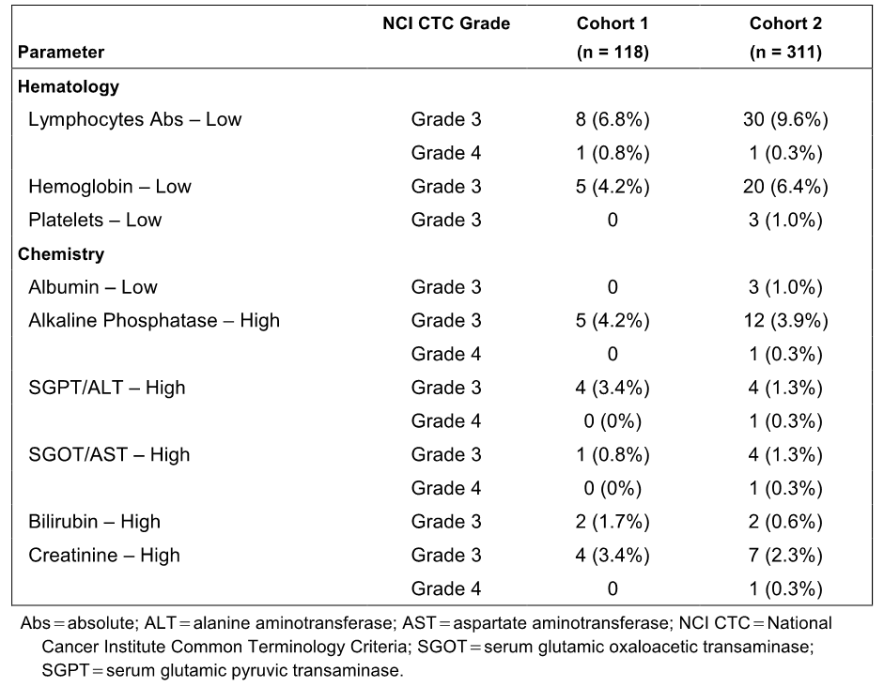
Haematological abnormalities reported as Grade 3 or 4 events are summarised below. In Cohort 2 (all-comers), the only haematological Grade 3 or 4 AE reported in ≥ 1% of patients was anaemia (7.4%, n = 23).
Table 93: IMvigor – Haematological abnormalities reported as Grade 3 or 4 events, treated patients.
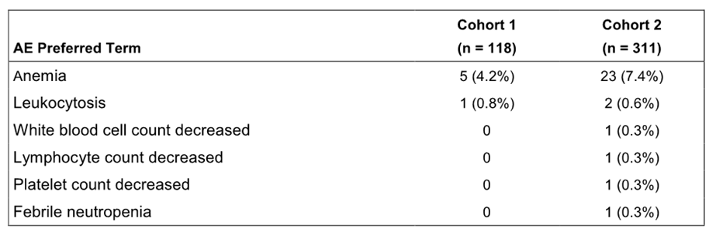

Clinical chemistry
No clinically meaningful changes were observed in the mean and median blood chemistry results following atezolizumab treatment administration. While decreases in some of the parameters were observed, the results generally remained within normal limits.
Clinically relevant (Grade 3 or 4) clinical chemistry laboratory abnormalities are summarised above. In Cohort 2 (all-comers), the only clinically relevant (Grade 3 or 4) clinical chemistry laboratory abnormalities reported in ≥ 1% of patients were high alkaline phosphatase Grade 3 (3.9%), high creatinine Grade 3, high ALT (2.3%), high ALT and high AST all Grade 3 (1.3% each), and low albumin Grade 3 (1.0%).
Clinical chemistry laboratory abnormalities reported as Grade 3 or 4 AEs are summarised below. In Cohort 2 (all comers), the clinical chemistry laboratory abnormalities reported as Grade 3 or 4 AEs were hypercalcaemia and hyponatraemia (1.6% each), alkaline phosphatase increased (1.3%), ALT increased and hypokalaemia (1.0% each).
Table 94: IMvigor – Clinical chemistry abnormalities reported as Grade 3 or 4 events, treated patients.
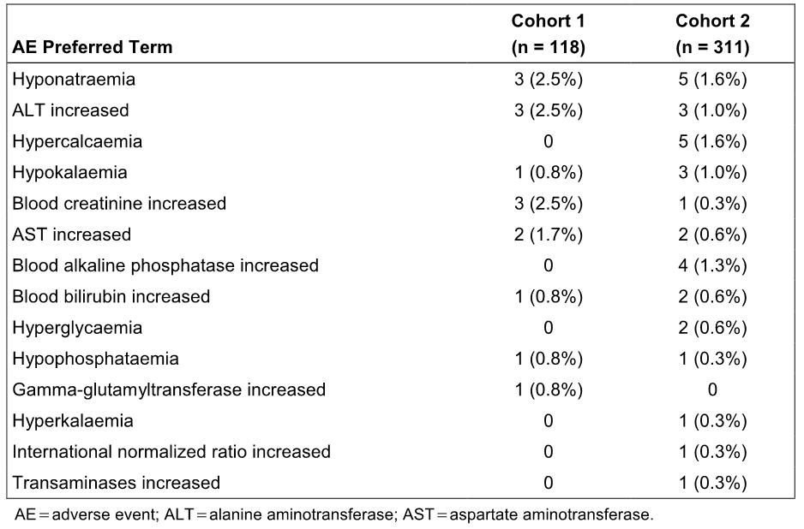

Vital signs and ECG changes
In the all comers-group (n = 311), no clinically meaningful changes in systolic and diastolic BP, pulse rate or respiratory rate were observed from pre-dose to post-dose. Both systolic and diastolic BP showed small median decreases in comparison with baseline, which tended to increase toward the baseline value throughout the study. The maximum median decrease from baseline of 3.5 mmHg for diastolic BP was observed at the Cycle 12, Day 1 visit and of 5.0 mmHg for systolic BP was observed at the End of Treatment visit.
A total of 12 (3.9%) patients in the-all comers group (n = 311) had an AE of hypotension reported during the study. The majority of these events were Grade 1 (7 patients [2.3%]) or Grade 2 (2 patients [0.6%]), while Grade 3 events were reported in 3 (1.0%) patients. Two of the Grade 3 hypotension events were reported as SAEs and one of these Grade 3 events was considered related to study treatment.
A total of 11 (3.5%) patients in the-all comers group (n = 311) had an AE of hypertension reported during the study. Grade 1, 2, and 3 events were reported in 2 (0.6%) patients, 3 (1.0%) patients, and 6 (1.9%) patients, respectively. None of the Grade 3 events were reported as SAEs.
There was no central ECG collection. Local ECGs were performed at screening and as medically necessary.

Immunogenicity
In the total IMvigor 210 patient population (Cohorts 1 and 2), the baseline prevalence of ATAs was 3.8% (n = 16) in the evaluable study population (n = 423). Post-baseline, 161 of 384 (41.9%) patients treated with atezolizumab had treatment-emergent ATAs (the sum of treatment-induced and treatment-enhanced ATA). Of these patients, 157 had ‘treatment-induced’ ATA response (i.e. ATA negative at baseline or missing a baseline sample for ATA analysis). Four patients had ‘treatment-enhanced’ ATA response (i.e. ATA increased ≥ 0.6 titre units from baseline). The results are summarised below.
Table 95: IMvigor – Baseline prevalence and post-baseline incidence of ATA, safety-evaluable patients.
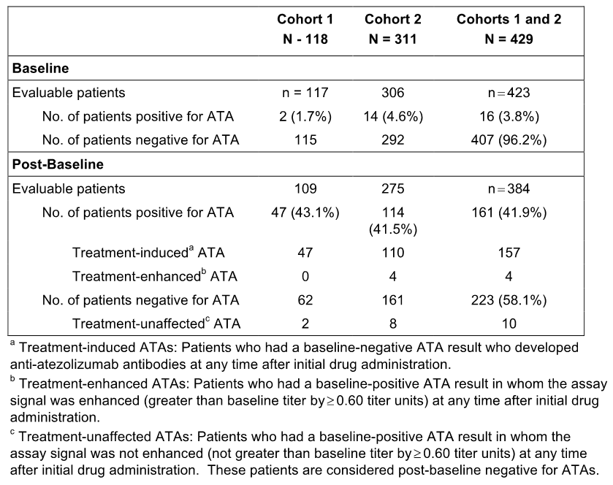
In Cohort 2 (all-comers), exposure to atezolizumab was similar in ATA-negative and ATA-positive patients, with a median of 6 cycles being administered in each ATA group. In Cohort 2 (all-comers), the percentage of patients experiencing AESIs was similar in ATA-positive and ATA-negative patients (30.7%, [35/114] vs 26.1%, [42/161], respectively). The only AESI reported in at least 10 patients in either of the ATA groups in Cohort 2 (all comers) was rash, which was reported in 20 (12.4%) ATA-negative patients and 11 (9.6%) ATA-positive patients. In Cohort 1 (all comers), the percentage of patients experiencing AESIs was similar in ATA-positive and ATA-negative patients (25.5%, [12/47] vs 21.0%, [13/62], respectively).

Safety in UC subgroups (IC2/3 and IC1/2/3) in Cohort 2
The majority of the patients in the IC2/3 subgroup and the IC1/2/3 subgroup experienced at least one AE (91.0%, [91/100] vs 94.2%, [196/208], respectively). The most commonly reported AEs (≥10%), irrespective of relationship to treatment, in the IC2/3 subgroup or the IC1/2/3 subgroup (respectively) were fatigue (42.0% vs 44.7%), pyrexia (27.0% vs 20.2%), nausea (24.0% vs 23.1%), decreased appetite (21.0% vs 23.1%), constipation (17.0% vs 17.8%), pruritus (17.0% vs 13.5%), urinary tract infection (16.0% vs 18.8%), peripheral oedema (16.0% vs 11.5%), diarrhoea (15.0% vs 18.3%), rash (14.0% vs 11.1%), cough (14.0% vs 13.5%), dyspnoea (14.0% vs 15.4%), haematuria (13.0% vs 15.4%), vomiting (12.0% vs 13.9%), arthralgia (12.0% vs 12.0%), muscular weakness (10.0% vs <10%), abdominal pain (<10% vs 11.5%), back pain (<10% vs 11.5%).
Treatment-related AEs were reported in 68.0% (68/100) of patients in the IC2/3 subgroup and 66.3% (138/208) of patients in the IC1/2/3 subgroup. In the IC2/3 subgroup, the most commonly reported treatment-related AEs (≥ 10% of patients) were fatigue (24.0%), nausea, pruritus, and pyrexia (14.0% each), and decreased appetite (13.0%). In the IC1/2/3 subgroup, the most commonly reported treatment-related AEs (≥ 10% of patients) were fatigue (26.0%), nausea (13.9%), decreased appetite (11.5%), and pruritus (10.6%).
In the IC2/3 subgroup, AEs were assessed as Grade 1 or Grade 2 intensity in 49.0% (49/100) of patients, Grade 3 or Grade 4 intensity in 41.0% (41/100) of patients, and Grade 5 intensity in 1.0% (1/100) of patients. In the IC1/2/3 subgroup, AEs were assessed as Grade 1 or Grade 2 intensity in 49.5% (103/208) of patients, Grade 3 or Grade 4 intensity in 43.8% (91/208) of patients, and Grade 5 intensity in 1.0% (2/208) of patients
In the IC2/3 subgroup, Grade 3-4 AEs reported in ≥ 3% of patients were anaemia (9.0%), urinary tract infection (6.0%), fatigue (5.0%), hypertension (5.0%), dyspnoea (4.0%), pulmonary embolism (3.0%), hydronephrosis (3.0%), acute kidney injury (3.0%), and muscular weakness (3.0%). In the IC1/2/3 subgroup, Grade 3-4 AEs reported in ≥ 3% of patients were urinary tract infection (7.2%), anaemia (6.7%), fatigue (5.3%), dyspnoea, dehydration, and haematuria (3.4% each).
Comment: The AEs profiles of patients in the IC2/3 and IC1/2/3 subgroups were similar. The observed differences in AEs between the two IC subgroups are unlikely to be clinically meaningful.

Safety in special groups
There were no safety data in IMvigor 210 specifically comparing safety based on age. However, the safety analysis in the All UC population (IMvigor 210 plus UC cohort PCD4989g) included a comparison of safety between patients aged < 65 (n = 185) years and ≥ 65 years (n = 336). In this comparison, AEs occurred in a similar proportion of patients aged < 65 years and ≥ 65 years (95.1% vs 94.6%, respectively), as did Grade 5 AEs (0.5% vs 2.1%, respectively). However, other high-level AE categories occurred in ≥ 5% more patients aged ≥ 65 years than in patients aged < 65 years: i.e. Grade 3-4 AEs (47.3% vs 41.6%), SAEs (46.4% vs 35.7%), AEs leading to treatment withdrawal (5.7% vs 0.5%) and AEs leading to dose interruption (22.2% vs 28.0%). Overall, the observed differences suggest that no atezolizumab dose adjustment based on safety is required for patients aged ≥ 65 years compared to patients aged < 65 years.
There were no safety data in IMvigor 210 specifically comparing safety in male and female patients. However, the safety analysis in All UC population (IMvigor 210 plus UC cohort PCD4989g) included a comparison of safety between male patients (n = 406) and female patients (n = 115). In this comparison, the incidence of patients with at least one AE was similar in male and female patients (95.8% vs 91.3%, respectively), as was the incidence of Grade 3-4 AEs (45.1% vs 46.0%), Grade 5 AEs (1.7% vs 0.9%), AEs leading to treatment discontinuation (4.2% vs 2.6%) and AEs leading to dose interruption (26.1% vs 25.2%). The only high-level AE category in which the difference between the two genders was ≥ 5% was SAEs, with the incidence in males being higher than in females (43.8% vs 38.3%). Overall, the observed differences between males and females are unlikely to be clinically significant.
There were no safety data in IMvigor 210 specifically comparing safety based on race, while the safety analysis in All UC population (IMvigor 210 plus UC cohort PCD4989g) included a comparison of safety for patients in different racial groups. However, no meaningful conclusions can be drawn from the All UC population analysis due to the imbalance in patient numbers across the groups, with Caucasians accounting for 94.6% of the population.

POPLAR – NSCLC

High-level safety profiles
POPLAR included a total of 271 safety-evaluable patients, including 135 patients in the docetaxel arm and 142 patients in the atezolizumab arm. Nearly all patients in both treatment arms experienced at least one AE (96.3%, docetaxel [1325 events]; 95.8%, atezolizumab [1354 events]). AEs (treatment-emergent AEs) were defined as occurring on or after the first dose of study drug until the earliest of 30 days after the last administration of study drug, initiation of another non-protocol anti-cancer therapy after the last administration of study drug, or clinical cut-off date. However, for treatment-related SAEs, AESIs and imAEs all events up the data cut-off date were included. The high-level safety profile is summarised below.
Table 96: POPLAR – High-level safety profile, safety-evaluable population.
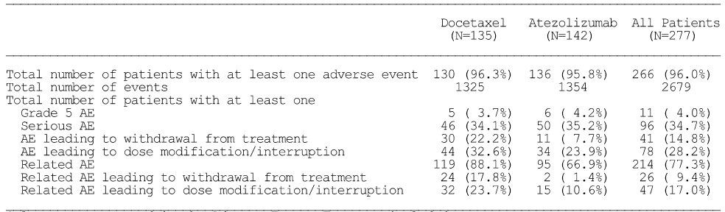
Only events reported in the AEs form are included. Multiple occurrences of the same AE in one individual are counted only once except for the ‘Total number of AEs’ row in which multiple occurrences of the same AE are counted separately. AEs collected after first treatment dose and within 30 days from last treatment dose are included unless the AE occurred after the start of a non-protocol cancer therapy within the 30 day post-treatment period. The data cut-off date was 8 May 2015.
Comment: There were some notable differences between the high-level safety profiles of the two treatments, with AEs leading to withdrawal from treatment, AEs leading to dose modification/interruption, treatment-related AEs, treatment-related AEs leading to withdrawal from treatment and treatment-related AEs leading to dose modification/interruption all occurring more frequently in the docetaxel arm than in the atezolizumab arm.

Exposure
In the docetaxel arm, the median duration of treatment was 2.1 months (range: 0, 17 months), and the median number of cycles was 4.0 (range: 1, 26). In the atezolizumab arm, the median duration of treatment was 3.7 months (range: 0, 19 months), and the median number of cycles was 6.0 (range: 1, 28). Notably more patients in the atezolizumab arm received at least 6 months of treatment compared to patients in the docetaxel arm (40.1%, n = 57 vs 15.6%, 21) and ≥ 12 months of treatment (21.1%, n = 30 vs 3.7%, n = 5). The median dose intensity was 97.7% for both study treatments.
Per protocol, patients were allowed to continue atezolizumab treatment after radiological PD, provided pre-specified criteria were met. A total of 57 patients (40.1%) received atezolizumab after experiencing PD, with a median duration of post-PD treatment of 2.1 months and a median number of cycles of 3.0 (range 1,19). Three patients in the docetaxel arm continued treatment with docetaxel after PD for a median duration of 3.5 months with the median number of cycles of 6.0.
Exposure for both treatment arms is summarised in below.
Table 97: POPLAR – Exposure, safety-evaluable population.
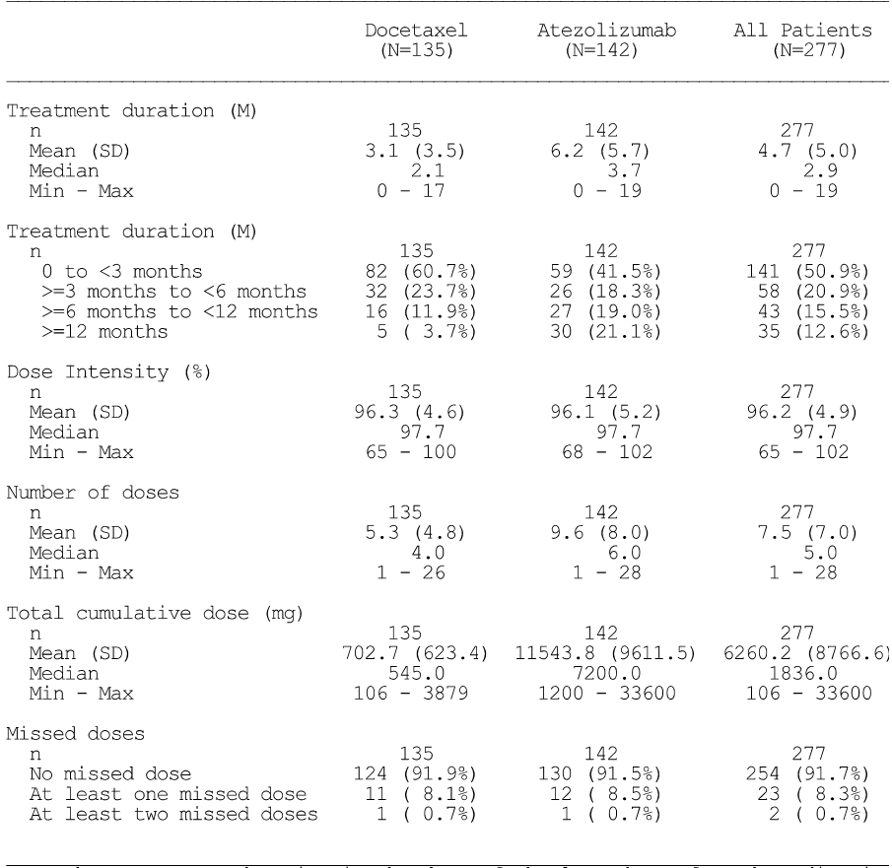
Treatment duration is the date of the last dose of study medication minus the data of the first dose plus one day. Dose intensity is the number of actual doses received divided by the expected number of doses. The data cut-off date was 8 May 2015.

Adverse events (irrespective of relationship to study drug)
The most commonly reported SOCs in which AEs occurred in ≥ 20% of patients in either treatment arm (docetaxel vs atezolizumab) were: (1) gastrointestinal disorders (68.1% vs 60.6%); (2) general disorders and administration site conditions (66.7% vs 64.8%); (3) skin and subcutaneous tissue disorders (52.6% vs 32.4%); (4) respiratory, thoracic and mediastinal disorders (51.9% vs 59.9%); (5) musculoskeletal and connective tissue disorders (48.1% vs 47.2%); (6) nervous system disorders (40.0% vs. 19.7%); (7) blood and lymphatic system disorders (36.3% vs 22.5%); (8) metabolism and nutrition disorders (34.1% vs 48.6%); (9) infections and infestations (32.6% vs 42.3%); (10) investigations (21.5% vs 26.1%); and (11) psychiatric disorders (13.3% vs 21.1%).
AEs reported in ≥ 10% of patients in either the docetaxel or atezolizumab arm are summarised below.
Table 98: POPLAR – Adverse events reported in ≥ 10% of patients in any of the treatment arms, safety-evaluable population.
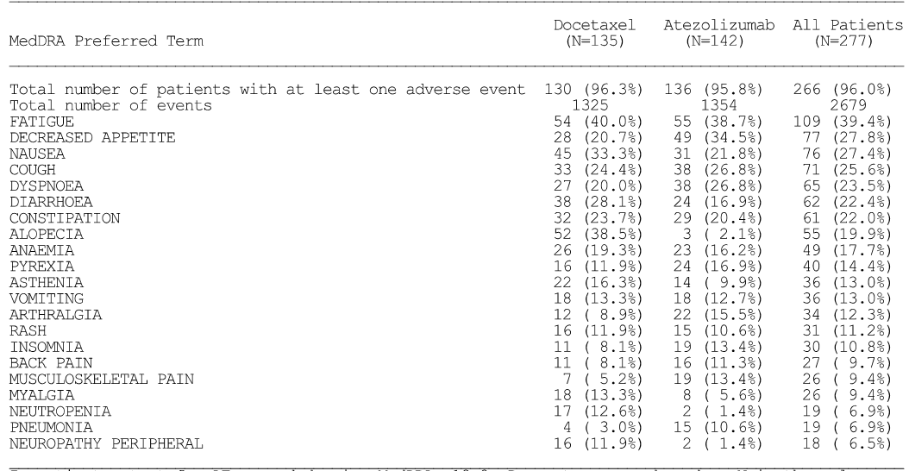
AEs with a higher incidence (≥ 5% more patients) in the atezolizumab arm vs the docetaxel arm were decreased appetite (20.7% vs 34.5%), dyspnoea (20.0% vs 26.8%), pyrexia (16.9% vs 11.9%), arthralgia (15.5% vs 8.9%), insomnia (13.4% vs 8.1%), musculoskeletal pain (13.4% vs 5.2%), and pneumonia (10.6% vs 3.0%).
AEs with a higher incidence (≥ 5% more patients) in the docetaxel arm vs the atezolizumab arm were alopecia (38.5% vs 2.1%), nausea (33.3% vs 21.8%), diarrhoea (28.1% vs 16.9%), asthenia (16.3% vs 9.9%), myalgia (13.3% vs 5.6%), neutropenia (12.6% vs 1.4%), peripheral neuropathy (11.9% vs 1.4%), peripheral sensory neuropathy (8.9% vs 1.4%), febrile neutropenia (8.1% vs 0.0%), dry skin (7.4% vs 2.1%), and nail disorder (6.7% vs 0.7%).
Patients were treated with atezolizumab longer than patients treated with docetaxel (median of 3.7 vs 2.1 months). Therefore, in order to explore whether events reported in a higher proportion of patients (≥ 5%) in the atezolizumab arm than in the docetaxel arm were associated with longer duration of exposure, analyses adjusted for patient-years at risk were undertaken for decreased appetite, dyspnoea, pyrexia, arthralgia, insomnia, musculoskeletal pain, and pneumonia. The results showed that the AE rate per 100 patient years was higher in the atezolizumab arm than in the docetaxel arm for musculoskeletal pain and pneumonia. The results are summarised below.
Table 99: POPLAR – Adverse event rates adjusted for patient-years at risk for AEs with higher incidence in the atezolizumab arm than in the docetaxel arm, safety-evaluable population.
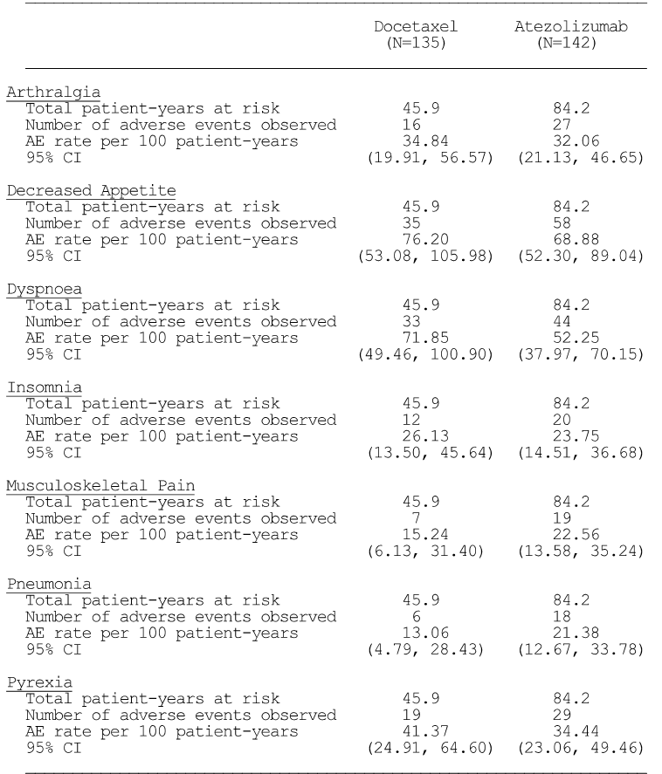

Adverse events – treatment-related
Treatment-related AEs were reported more frequently in patients in the docetaxel arm than in the atezolizumab arm (88.1% vs 66.9%). AEs reported in ≥ 10% of patients in either the docetaxel arm or the atezolizumab (respectively) were: alopecia (37.8% vs 1.4%); fatigue (34.8% vs 20.4%); nausea (27.4% vs 12.0%); diarrhoea (22.2% vs 7.0%); anaemia (16.3% vs 5.6%); decreased appetite (15.6% vs 17.6%); asthenia (13.3% vs 6.3%); vomiting (11.9% vs 5.6%); constipation (11.9% vs 4.9%); peripheral neuropathy (11.1% vs 0.7%); and neutropenia (11.1% vs. 0.7%).

Adverse events by intensity
Grade 3, 4 or 5 AEs were reported more frequently in the docetaxel arm than in the atezolizumab arm (56.3%, 165 events vs 44.4%, 138 events). Grade 3-4 AEs reported in ≥ 5% of patients in either the docetaxel arm or the atezolizumab arm (respectively) were neutropenia (11.% vs 0%), febrile neutropenia (8.1% vs 0%, fatigue (7.4% vs 2.1%), dyspnoea (1.5% vs 7.0%), and pneumonia (1.5% vs 5.6%).

Deaths and serious adverse events

Deaths
At the time of the clinical cut-off for the primary analysis (8 May 2015), a higher proportion of patients had died in the docetaxel arm (68.1%, [92/135]) than in the atezolizumab arm (53.5%, [76/142]). The majority of deaths in both treatment arms were due to disease progression (63.0%, n = 85, docetaxel vs 46.5%, n = 66, atezolizumab).
AEs leading to death occurring ≤ 30 days after the last dose of study drug or prior to initiation of non-protocol therapy were reported in 11 patients, including 6 (4.2%) in the atezolizumab arm and 5 (3.7%) in the docetaxel arm. In the atezolizumab arm, the 6 Grade 5 AEs were treatment-related cardiac failure, and treatment-unrelated pulmonary embolism, pneumonia, embolism, ulcer haemorrhage, and pneumothorax. In the docetaxel arm, the 5 Grade 5 AEs were treatment-related acute respiratory syndrome, sepsis, and death, and treatment unrelated death and sepsis.
AEs leading to death occurring > 30 days after the last dose of study treatment or after initiation of non-protocol therapy were reported in 6 patients, including 4 (2.8%) in the atezolizumab arm and 2 (1.5%) in the docetaxel arm. In the atezolizumab arm, the 4 Grade 5 AEs were death, cardiac arrest, pneumonia and large intestine perforation, all of which were considered to be unrelated to treatment. In the docetaxel arm, the 2 Grade 5 AEs were sepsis and death, both of which were considered to be unrelated to treatment.

Serious adverse events
SAEs were reported in 34.1% (n = 45) of patients in the docetaxel arm and 35.2% (n = 50) of patients in the atezolizumab arm. SAEs reported in ≥ 2% of patients in either the docetaxel arm or the atezolizumab arm (respectively), in decreasing order of frequency in the docetaxel arm, were febrile neutropenia (5.2% vs 0%), pulmonary embolism (4.4% vs 1.4%), haemoptysis (2.2% vs 0.7%), pneumonia (2.2% vs 5.6%), sepsis (2.2% vs 0%), dyspnoea (0.7% vs 4.9%), pyrexia (0.7% vs 2.1%), and pleural effusion (0% vs 2.8%).
SAEs reported in ≥ 2% more patients in the atezolizumab arm than in the docetaxel arm were pneumonia (2.2% vs 5.6%), dyspnoea (0.7% vs 4.9%) and pleural effusion (0% vs 2.8%). SAEs reported in ≥ 2% more patients in the docetaxel arm than in the atezolizumab arm were febrile neutropenia (5.2% vs 0%), pulmonary embolism (4.4% vs. 1.4%), and sepsis (2.2% vs 0%).
Treatment-related SAEs were reported in 17.0% (n = 23) of patients in the docetaxel arm and 8.5% (n = 12) of patients in the atezolizumab arm. Treatment related SAEs reported in ≥ 2 patients in either the docetaxel arm or the atezolizumab arm (respectively), in decreasing order of frequency in the docetaxel arm were febrile neutropenia (5.2% vs 0%), neutropenia (1.5% vs 0%), pneumonia (1.5% vs 2.1%), sepsis (1.5% vs 0%), pyrexia (0.7% vs 2.1%), AST increased (0% vs 1.4%), and rash (0.0% vs 1.4%).

Other significant adverse events

AEs leading to discontinuation of the study drug
AEs leading to study drug discontinuation were reported in 22.2% (n = 30) of patients in the docetaxel arm and 7.7% (n = 11) of patients in the atezolizumab arm. AEs leading to study drug discontinuations reported in ≥ 1.0% patients in either the docetaxel arm or the atezolizumab arm (respectively) in decreasing order of frequency in the docetaxel arm were fatigue (3.0% vs 0%), peripheral sensory neuropathy (3.0% vs 0%), sepsis (2.2% vs 0%), death (1.5% vs 0%), peripheral neuropathy (1.5% vs 0%), and dyspnoea (0% vs 1.4%).

AEs leading to dose modification
Dose modification was defined as: (1) dose reduction (for docetaxel only, no dose reductions were allowed for patients receiving atezolizumab); (2) dose delay (dose outside of the protocol window) or skipped cycles; or (3) infusion interruption. AEs leading to dose modification were reported in 32.6% (n = 44) of patients in the docetaxel arm and 23.9% (n = 34) of patients in the atezolizumab arm. Dose modifications reported in ≥ 2% of patients in either the docetaxel arm or the atezolizumab arm, in decreasing order of frequency in the docetaxel arm, were fatigue (6.7% vs 0.7%), febrile neutropenia (3.7% vs 0%), peripheral sensory neuropathy (3.0% vs 0%), and pneumonia (0% vs 2.1%).

Adverse events of special interest (AESI)
AESIs were derived from sponsor-defined AE group terms (AEGTs) based on the mechanism of action of atezolizumab. The protocol-defined AESIs were the same as those defined for IMvigor 210. Overall, AESIs were reported in 29.6% (n = 40) of patients in the docetaxel arm (Grade 1, n = 24, 17.8%; Grade 2, n = 12, 8.9%; Grade 3, n = 4, 3.0%; Grade 4, n = 0), and 28.9% (n = 41) of patients in the atezolizumab arm (Grade 1, n = 18, 12.8%; Grade 2, n = 15, 10.6%; Grade 3, n = 7, 4.9%; Grade 4, n = 1, 0.7%).

Dermatological AESIs
The incidence of dermatological AESIs was 14.8% (n = 20) in the docetaxel arm and 16.2% (n = 23) in the atezolizumab arm, with the most common of these events being rash (11.9% vs 10.6%, respectively). Of the total number of patients with dermatological AESIs, there were only 3 patients with Grade 3 events, including 1 patient in the docetaxel arm with rash and 2 patients in the atezolizumab arm with rash. There were no cases of SJS or TEN. The dermatological AESI are summarised below.
Table 100: POPLAR – Summary of dermatological AESI, safety evaluable population.
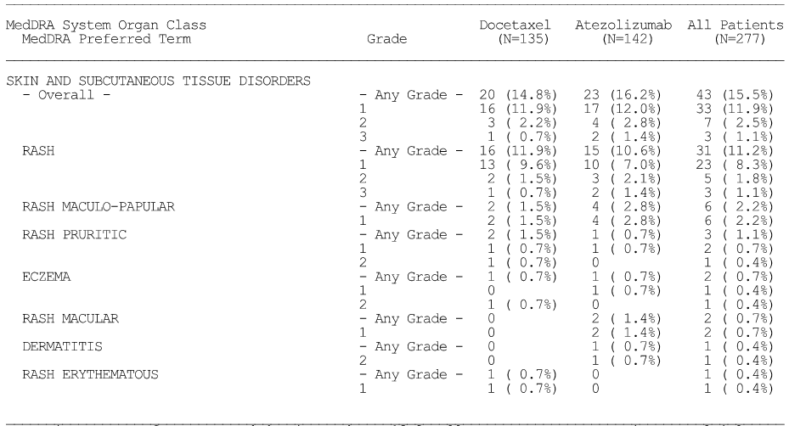

Neurological AESIs
Neurological AESIs were experienced by 13.3% (n = 18) of patients in the docetaxel arm and 2.1% (n = 3) of patients in the atezolizumab arm. Peripheral neuropathy was the most commonly reported neurological AESI in both treatment arms (11.9%, docetaxel vs 1.4%, atezolizumab). Neurological AESI are summarised below.
Table 101: POPLAR – Summary of neurological AESI, safety evaluable population.
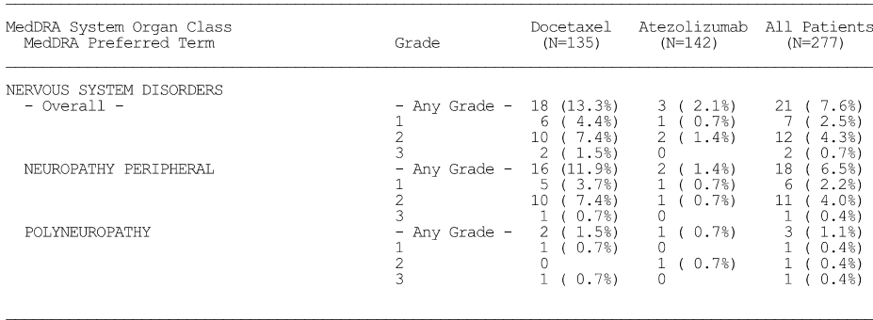

Hepatic AESIs
Hepatic AESIs were reported in 1.5% (n = 2) of patients in the docetaxel arm and 5.6% (n = 8) of patients in the atezolizumab arm. The most commonly reported events in the atezolizumab arms (vs the docetaxel arm) were AST increased (4.2% vs 0.7%) and ALT increased (4.2% vs 0%). Four Grade 3 or 4 hepatic AESIs were reported, all occurring in the atezolizumab arm (2 patients with Grade 3 increased AST; 2 patients with Grade 3 increased AST and ALT). Hepatic AESIs are summarised below.
Table 102: POPLAR – Summary of hepatic AESI, safety evaluable population.
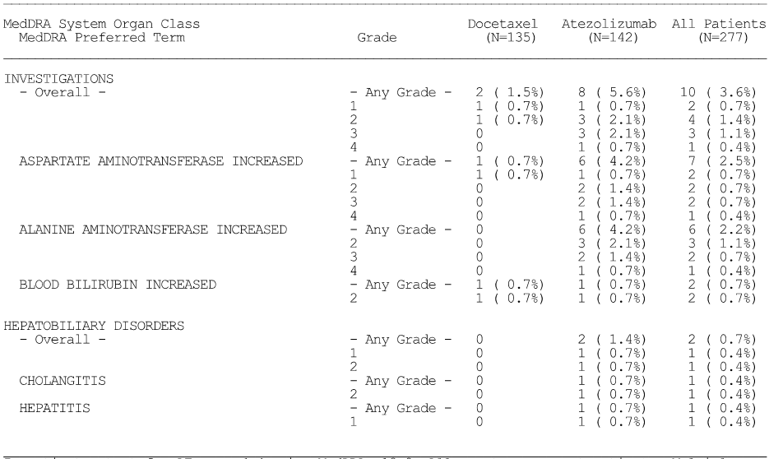

Endocrine AESIs
Endocrine AESIs were reported in 6.3% (n = 9) of patients in the atezolizumab arm (hypothyroidism x 8; hyperthyroidism x 1) and 0.7% (n = 1) of patients in the docetaxel arm (hypothyroidism x 1). There was one Grade 3 event of hypothyroidism in the atezolizumab arm, with all other endocrine AESIs in both treatment arms being Grade 1 or 2.

Gastrointestinal AESIs
Gastrointestinal AESIs were reported in 0.7% (n = 1) of patients in the docetaxel arm (colitis x 1) and 1.4% (n = 2) of patients in the atezolizumab arm (including 1 Grade 3 event).

Musculoskeletal AESIs
One patient in the atezolizumab arm experienced a musculoskeletal AESI (Grade 2 autoimmune arthritis). This patient also experienced Grade 3 hypothyroidism.

Pulmonary AESIs
Pulmonary AESIs were reported by 1 (0.7%) patient in the docetaxel arm and 4 (2.8%) patients in the atezolizumab arm. All patients in this AESI category experienced pneumonitis, with Grade 3 events being reported by 1 patient in each of the two study arms.

Cardiac, haematological, ocular, renal and non-specific immune AESIs
No cardiac, haematological, ocular, renal or non-specific immune AESIs were reported during the study.

Immune-mediated AEs (imAEs)
Immune-mediated AEs (imAEs) were identified using the same methodology as previously described for IMvigor 210. A total of 89 (32.1%) patients experienced an AE within 30 days prior to initiation of systemic corticosteroid therapy and were included in the systemic corticosteroid dataset (42.2% in the docetaxel arm, and 22.5% in the atezolizumab arm). Grade 1 or 2 AEs were identified in 27.4% of patients in the docetaxel arm and 9.9% of patients in the atezolizumab arm, and Grade 3 or 4 AEs were identified in 14.8% of patients in the docetaxel arm and 12.7% of patients in the atezolizumab arm. No Grade 5 AEs were identified in either of the two treatment arms.
Of the 89 patients in the systemic corticosteroid dataset, 21 patients were identified as experiencing an imAE (7.4%, [10/135] in the docetaxel arm and 7.7%, [11/42] in the atezolizumab arm). Immune-mediated AEs reported in ≥ 1% of patients in either the docetaxel arm or the atezolizumab arm (respectively) were neuropathy peripheral (2.2% vs 0.7%), diarrhoea (1.5% vs 0.7%), rash (1.2% vs 2.1%), pneumonitis (0.7% vs 1.4%), colitis (0% vs 1.4%), and hypoxia (0% vs 1.4%).

Immunogenicity
Out of the 140 evaluable patients in POPLAR with valid ATA baseline data the prevalence of ATAs was 7.9% in the atezolizumab arm. Post-baseline, 54.5% (73/134) of patients treated with atezolizumab had treatment-emergent ATAs. Of these 73 ATA-positive patients, 70 patients had ‘treatment-induced’ ATA responses and 3 patients had ‘treatment-enhanced’ ATA responses. Overall, the exposure to atezolizumab was shorter in ATA-negative patients compared to ATA-positive patients (median number of cycles 6 vs 8 and median duration of treatment 3.5 vs 4.8 months). The median dose intensity was comparable irrespective of ATA status (98.0% ATA-negative vs 97.7% ATA- positive).
The AESI rates for ATA-negative and ATA-positive patients appeared to be comparable. Of the 41 patients who experienced AESIs in the atezolizumab arm, 19 patients (30.6%) were negative for ATA and 22 patients (30.1%) were positive for ATA. Of the ATA-negative patients, 1 patient experienced a hypersensitivity reaction and 1 patient experienced an infusion-related reaction. No patients with positive ATAs experienced a hypersensitivity or infusion-related reaction.
The frequency of AESIs (PTs) was similar in ATA-positive and ATA-negative patients, with the exception of hypothyroidism and pneumonitis which were both reported more commonly in ATA-negative patients. The AESIs (PTs) reported in at least 2 patients who were either ATA-positive or ATA-negative (respectively) were rash (11.3% vs 11.0%), maculopapular rash (3.2% vs 2.7%), hypothyroidism (1.6% vs 9.6%), ALT increased (4.8% vs 4.1%), AST increased (3.2% vs 5.5%), and pneumonitis (6.5% vs 0.0%).

Clinical laboratory tests
No clinically relevant changes in median values for haematology or blood chemistry laboratory parameters were observed during the study. The majority of patients did not demonstrate clinically relevant increases in AE Grade in any laboratory test parameters. However, the proportion of patients with Grade 3 decreases in the absolute lymphocyte count was notably greater in the docetaxel arm than in the atezolizumab arm (21.9% vs 6.9%), as were the proportions of patients with Grade 4 decreases in the absolute neutrophil count (17.2% vs 0.8%), Grade 3 decreases in the absolute white blood count (7.8% vs 0.8%) and Grade 4 decreases in the absolute white blood cell count (7.8% vs 0.8%). There were no marked differences between the two treatment arms in the proportion of patients with Grade 3 or 4 changes in clinical chemistry parameters. The results for patients with highest post-baseline Grade 3 or 4 laboratory test parameters in the two treatment arms are provided below.
Table 103: POPLAR – Summary of patients with highest post-baseline Grade 3 or 4 laboratory test parameters, treated patients.
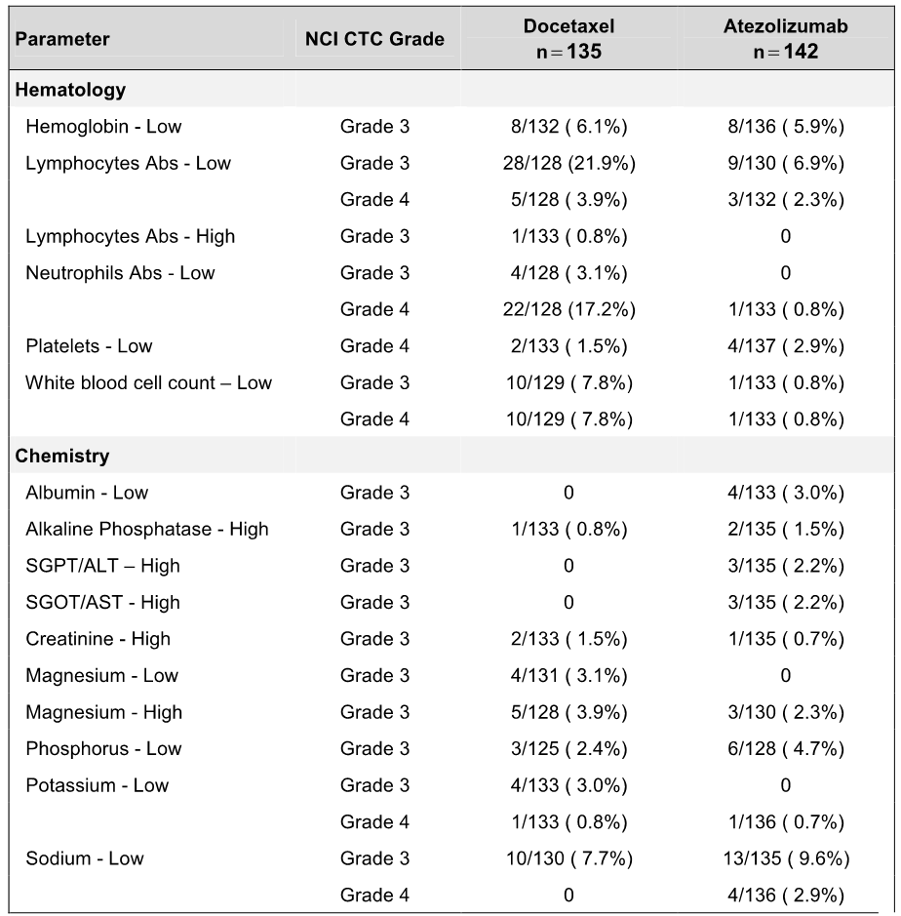
The most frequently reported haematology abnormalities reported as AEs based on pre-specified criteria in the docetaxel vs atezolizumab arm (respectively) were decreases in haemoglobin (preferred terms of anemia [19.3% vs 16.2%]; haemoglobin decreased [1.5% vs 0.7%]; iron deficiency anemia [1.4% vs 0.7%]; and anaemia of malignant disease [0.7% vs 0.4%]), and neutrophil count decreased (12.6% vs 1.4%). Haematology abnormalities (Grade 3 or 4) reported as AEs based on pre-specified criteria in the docetaxel and atezolizumab arms (respectively) were anaemia Grade 3 (3.7% vs 2.8%), thrombocytopenia Grade 4 (0% vs 1.4%), haemoglobin decreased Grade 3 ( 0% vs 0.7%), lymphocyte count decreased Grade 3 (0% vs 0.7%), iron deficiency anemia Grade 3 (0% vs 0.7%) and anaemia of malignant disease Grade 3 (0% vs 0.7%). The results are summarised below.
Table 104: POPLAR – Haematology abnormalities reported as adverse events, safety-evaluable population.
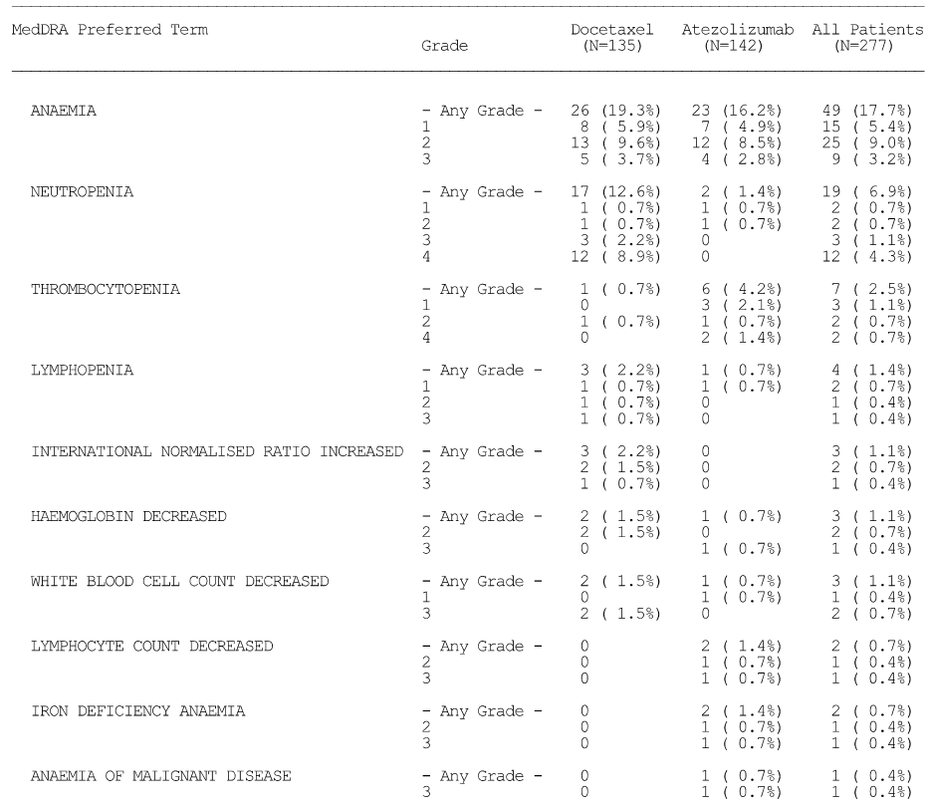
The most frequently reported clinical chemistry abnormalities reported as AEs, based on pre-specified criteria, in the docetaxel vs atezolizumab arm (respectively) were hypokalaemia (3.0% vs 6.3%), hyponatraemia (2.2% vs 5.6%), hypomagnaesemia (3.7% vs 4.9%), AST increased (0.7% vs 4.2%), and ALT increased (0.0% vs 4.2%). Grade 3 AEs reported in the docetaxel vs atezolizumab arm were hypokalaemia (0.7% vs 0%), hyponatraemia (1.5% vs 3.5%), AST increased (0% vs 2.1%), ALT increased (0% vs 2.1%), hypoalbuminaemia (0% vs 1.4%), increased alkaline phosphatase (0% vs 0.7%), and hypophosphataemia (1.5% vs 0%).

Vital signs
Overall, atezolizumab had no clinically meaningful effects on vital signs during the study. Both systolic and diastolic blood pressure showed small median decreases or increases in comparison with baseline for patients receiving atezolizumab. A total of 13 patients (4 in the docetaxel arm and 9 in the atezolizumab arm) had an AE of hypotension reported during the study. However, in the atezolizumab arm, these events were all Grade 1 or 2 in severity, only 2 were considered related to atezolizumab by the investigator and none were reported as serious. No hypotension AEs were reported as infusion related reactions. One patient was noted to have hypotension associated with an infusion at Cycle 2, but this event was reported pre-infusion. A second patient developed hypotension 30 minutes after the infusion was completed, but no treatment was given and blood pressure returned to pre-infusion values.

ECG
Overall, patients receiving atezolizumab developed no clinically relevant ECG abnormalities during the study. At screening, 47.2% (67/142) of patients in the docetaxel arm and 47.6% (68/143) of patients in the atezolizumab arm with ECG data had abnormalities considered to be not clinically significant, 52.1% (n = 74/142) and 52.4% (75/143) of patients in the two arms, respectively, had normal ECGs, and 1 patient in the docetaxel arm had a clinically significant ECG abnormality. At Cycle 1 Day 1, the proportion of patients with non-clinically significant ECG abnormalities was similar in the docetaxel and atezolizumab arms pre-infusion (48.9% [64/131] vs 48.2% [67/139], respectively) and post-infusion (51.6% [65/126] vs 48.6% [67/138], respectively). All other patients in the two treatment arms had normal ECG findings pre- and post-infusion at Cycle 1 Day 1. At Cycle 4 Day 1, the proportion of patients with a non-clinically significant ECG abnormality was similar in the docetaxel and atezolizumab arms both pre-infusion (34.8% [8/23] vs 30.8% [8/26], respectively) and post-infusion (38.1% [24/63] vs 44.9% [40/90], respectively). At Cycle 4 Day 1, one patient in the docetaxel arm had a clinically significant ECG abnormality both pre- and post-infusion.

Safety in special populations
Overall, the safety profile of atezolizumab was comparable across the PD-L1 expression subgroups. The high-level safety summaries for the TC3 or IC3 subgroup, TC2/3 or IC2/3 subgroup, and TC1/2/3 or IC1/2/3 subgroup are provided.
There were no formal safety data assessing differences between the docetaxel and atezolizumab arms based on age, gender, race, hepatic impairment, or renal impairment.

Post-marketing data
Not applicable.

Evaluator’s conclusions on safety
Safety data from the All Patients population, IMvigor Cohort 2 (UC) and POPLAR (NSCLC) have been evaluated. The only study providing comparative data for atezolizumab-treated patients (atezolizumab vs docetaxel) was POPLAR (NSCLC).
Conclusions relating to the safety data from the All Patients population for all atezolizumab-treated patients are provided below, while conclusions relating to the safety data for atezolizumab-treated patients from IMvigor 210 Cohort 2 (UC) and the comparative safety data for atezolizumab vs docetaxel from POPLAR (NSCLC) are presented in the First Round assessment of risks section.

Patient characteristics
The All Patients population included safety data on 1547 atezolizumab-treated patients, including 521 (33.7%) patients with UC (All UC population) and 1026 (66.3%) patients with NSCLC (All NSCLC population). Based on the ‘rule of threes’ it can be reasonably predicted that a population of 1547 atezolizumab treated patients is sufficient to detect adverse drug reactions associated with atezolizumab occurring with an incidence of at least 0.2%. The baseline demographic and disease characteristics of the UC and NSCLC safety populations are considered to representative of patients in Australian clinical practice with locally advanced or metastatic UC or NSCLC disease.
The All UC population included 521 patients, comprising 118 patients in the IL cisplatin ineligible population (all comers) and 403 patients in the 2L+ (all-comers). In the All UC population (n = 521), the median age of the safety evaluable population was 67 years (range: 32, 92 years), with 64.5% (n = 326) being aged ≥ 65 years and 23.2% (n = 121) being aged ≥ 75 years. The majority of patients were male (77.9%, n = 406), and ‘White’ (88.9%, n = 463). The primary tumour site in the majority of patients was the bladder (73.1%, n = 381). The majority of patients had not received prior treatment with intravesical therapy of any kind (69.5%, n = 298) and in particular prior intravesical treatment with BCG (70.7%, n = 323). The histology of the tumour was predominantly transitional cell carcinoma (91.7%, n = 478). All patients had received prior chemotherapy, with 7.1% (n = 24) having received 1 line, 45.3% (n = 153) having received 2 lines and 47.6% (n = 161) having received ≥ 3 lines. The majority of patients had visceral metastases at baseline (75.4%, n = 393), while in contrast the majority of patients had no liver metastases at baseline (70.4%, n = 367).
In the All NSCLC population (n = 1026), the median age of the safety evaluable population was 64 years (range: 24, 88 years), with 48.1% (n = 494) being aged > 65 years and 14.9% (n = 153) being aged ≥ 75 years. The majority of patients were male (59.5%, n = 610), and ‘White’ (82.7%, n = 849). The majority of tumours were non-squamous cell (71.4%, n = 733). The majority of patients (81.9%, n = 840) had received prior chemotherapy, with similar proportions of patients having received 1 line (42.3%; n = 434) or ≥ 2 lines (39.6%, n = 406). The majority of patients had a history of previous tobacco used (70.9%, n = 727) and 12.0% (n = 123) of patients were current tobacco users. Overall, 892 of 1026 NSCLC patients (86.9%) had PD-L1 expression levels of TC2/3 or IC2/3 (BIRCH, POPLAR, FIR and NSCLC Cohort of PCD4989g), while 153 of 230 patients (66.5%) from POPLAR and the NSCLC Cohort of PCD4989g had PD-L1 expression levels of TC1/2/3 or IC1/2/3.

Exposure
The median duration of safety follow-up in the All Patients population (n = 1547) was 4.5 months (range: 0.5, 32.9 months). The majority of patients in the All Patients population received atezolizumab at a fixed-dose of 1200 mg q3w (88.8%; [1373/1547]), and the remaining 174 patients received atezolizumab at weight-based doses of 1-20 mg/kg q3w. The median duration of exposure to atezolizumab in the All Patients population was 3.5 months (range: 0, 19.4 months), with 45.7% (n = 625) of patients being exposed for ≤ 3 months, 18.6% (n = 256) for > 3 to 6 months, 31.0% (n = 425) for > 6 to 12 months, and 4.7% (n = 65) for >12 to 24 months. The median number of 21-day treatment cycles received by patients in the All Patients population was 6 (range: 1, 28). The median number of 21-day atezolizumab treatment cycles is relatively small as is the number of patients treated with atezolizumab for > 12 months.
The main limitation of the exposure data related to the small number of patients exposed to atezolizumab for > 12 months. The absence of long-term safety data is a deficiency in the submitted clinical dossier, given that the sponsor proposes that atezolizumab be administered for as long as it continues to demonstrate clinical benefit or until toxicity occurs. Adequate long-term safety data for atezolizumab is only likely to emerge during routine post-marketing surveillance.
In the All Patients population (n = 1547), 72.9% (n = 1128) of patients discontinued study treatment, with the most common reasons being disease progression (59.1%, n = 915) and AEs (4.8%, n = 75). In the All Patients population (n = 1547), at the time of data cut-off for each study contributing data, 47.5% (n = 735) of patients had withdrawn from the study, and this percentage was similar in the All UC and All NSCLC populations (48.0% and 47.3%, respectively). The most common reasons for study withdrawal were death (39.8%, n = 615), withdrawal by subject (3.0%, n = 47), lost-to-follow up (1.7%, n = 26) and progressive disease (1.2%, n = 18).

Commonly reported adverse events
AEs in atezolizumab-treated patients (irrespective of relationship to treatments) reported in ≥ 10% of patients in the All Patients population (n = 1547), in decreasing order of frequency, were fatigue (35.9%), decreased appetite (24.2%), nausea (22.4%), dyspnoea (20.5%), cough (19.7%), diarrhoea (17.6%), pyrexia (17.1%), constipation (17.0%), vomiting (14.3%), back pain (13.0%), arthralgia (12,5%), anaemia (12.2%), pruritus (10.9%), and asthenia (10.3%). The majority of AEs were Grade 1 or 2 in maximum intensity (81.1%; [817/1008]).
AEs considered to be related to treatment with atezolizumab reported in ≥ 10% of patients in the All Patients population (n = 1547), in decreasing order of frequency, were fatigue (21.4%), nausea (11.2%) and decreased appetite (10.2%). The majority of treatment-related AEs were Grade 1 or 2 in maximum intensity (79.9%; [266/333]).

Deaths
At the time of data cut-off dates for each study, a total of 615 (39.8%) patients had died in the All Patients population, comprising 207 (39.7%) patients in the All UC population and 408 (39.7%) patients in the All NSCLC population. The majority of deaths in the All Patients population occurred > 30 days after the last dose of atezolizumab (73.7%, [453/615]), with similar results being observed for the All UC and All NSCLC populations (71.5%, [148/207] and 74.8%, [305/408], respectively). The most common reason for death in these patients was disease progression, which accounted for 82.4% (507/615) of all deaths in the All Patients population.
Overall, 54 deaths were attributed to AEs (42 of which occurred ≤ 30 days after the last dose of atezolizumab or prior to initiation of non-protocol anti-cancer therapy). An additional 55 deaths were attributed to the cause of ‘other’. Grade 5 AEs (i.e. death attributed to AE) occurring ≤ 30 days after the last dose of atezolizumab or prior to initiation of non-protocol therapy were reported in 42 (2.7%) patients in the All Patients population, comprising 8 (1.5%) patients from the All UC population and 34 (3.3%) patients from the All NSCLC population. The 42 Grade 5 AEs were reported in a variety of SOCs and the PTs reported for more than 1 patient were pneumonia (5 patients), cardiac arrest (3 patients), sudden death (3 patients), respiratory failure (2 patients), and cardiac tamponade (2 patients). Of the 42 Grade 5 AEs, 5 were considered by the investigator to be treatment-related, including cardio-respiratory arrest (1 patient in PCD4989g, NSCLC cohort), constrictive pericarditis (1 patient in FIR, NSCLC), cardiac failure (1 patient in BIRCH, NSCLC), pneumonia (1 patient in BIRCH, NSCLC), and sepsis (1 patient in IMvigor 201, UC).
Grade 5 AEs occurring > 30 days after the last dose of atezolizumab or after initiation of non-protocol anti-cancer therapy were reported in 12 (0.8%) patients in the All Patients population, comprising 3 (0.8%) patients in the All UC population (1 each upper gastrointestinal haemorrhage, respiratory distress and death), and 9 patients in the All NSCL population (3 x pneumonia, 1 each gastric perforation, large intestine perforation, respiratory failure, cardiac arrest, jugular vein thrombosis, and death). Of the 12 Grade 5 AEs, 1 was considered to be treatment-related (respiratory failure in 1 patient in the All NSCLC population with onset 52 days after last dose of atezolizumab).

Other serious adverse events
In the All Patients population (n = 1547), 39.2% (n = 606) of patients reported at least one SAE. SAEs in the All Patients population reported in ≥ 1% of patients in decreasing order of frequency were pneumonia and dyspnoea (3.0% each), pyrexia (2.3%), urinary tract infection (1.8%), pneumonitis (1.4%), back pain and pulmonary embolism (1.2% each), and acute kidney injury, abdominal pain and dehydration (1% each). Treatment-related SAEs were reported in 9.4% (n = 146) of patients in the All Patients population, and the only treatment-related SAE reported in ≥ 1% of patients was pneumonitis (1.0%).

Other significant adverse events
In the All Patients population (n = 1547), 5.4% (n = 85) of patients experienced an AE resulting in withdrawal of study treatment. AEs resulting in withdrawal reported in ≥ 3 patients (≥ 0.2%) were pneumonia, pneumonitis, and dyspnoea (0.3% each), and sudden death and pneumonia aspiration (0.2% each).
In the All Patients population (n = 1547), 25.6% (n = 396) of patients experienced an AE resulting in dose interruption. AEs resulting in dose interruption reported in ≥ 1% of patients were dyspnoea (2.0%), pneumonitis (1.7%), fatigue (1.6%), pneumonia (1.3%), and diarrhoea (1.0%).
Given that nearly all patients experienced at least one AE, the data indicate the majority of AEs were manageable by temporary dose interruption and/or symptomatic treatment rather than discontinuation from the study.

Adverse events of special interest (AESI)
AESIs included potential dermatologic, hepatic, endocrine, and respiratory events as well as events of elevated liver function tests and influenza-like illness. In the All Patients population (n = 1547), AESIs were reported in 26.2% (n = 405) of patients. AESI (PTs) reported in ≥ 1% of patients were rash (9.3%), AST increased (4.3%), ALT increase (4.0%), hypothyroidism (3.2%), pneumonitis (2.7%), peripheral neuropathy (2.4%), maculopapular rash (1.9%), blood bilirubin increased (1.1%), and pruritic rash (1.0%).

Adverse drug reactions (ADRs) associated with atezolizumab
After review of all AEs (including AESIs) in the atezolizumab clinical development program, the sponsor defined ADRs currently considered to be associated with atezolizumab using pre-specified medical review methodology based on the frequency of AEs, all grades and Grade 3 or 4. In the All Patients population (n = 1547), 82.2% (n = 1271) of patients were identified as having an ADR. ADRs identified in ≥ 10% of patients were fatigue (35.9%), decreased appetite (24.2%), nausea (22.4%), dyspnoea (20.5%), diarrhoea (17.6%), pyrexia (17.1%), rash (16.4%), vomiting (14.3%), arthralgia (12.5%), pruritus (10.9%), asthenia (10.3%),

Important adverse drug reactions (ADRs) – immune-related ADRs
Of the summarised ADRs, the sponsor identified a subset of immune-related events of particular clinical relevance (termed important ADRs), which included pneumonitis, hepatitis, colitis, hypothyroidism, hyperthyroidism, adrenal insufficiency, meningitis (non-infectious), encephalitis (non-infectious), myasthenic syndrome, Guillain-Barré syndrome, diabetes mellitus and pancreatitis. The list of important ADRs were identified using Standard MedDRA Query (SMQs) High Level Terms (HLTs) and a sponsor-defined search basket, which were considered more inclusive and standardised than the AEGTs approach used for the AESI analysis.
In the All Patients population (n = 1547), 11.4% (n = 177) of patients experienced an important ADR, the majority (72.9% [129/177]) of which were Grade 1-2. The most commonly identified important ADRs (≥ 1% of patients) were hypothyroidism (3.6%), diabetes mellitus (3.2%), pneumonitis (3.0%), and colitis (1.0%). Other important ADRs reported in < 1% of patients were hyperthyroidism (0.8%), pancreatitis (0.5%), hepatitis and noninfectious meningoencephalitis (0.3% each), adrenal insufficiency (0.1%) and Guillain-Barre syndrome (<0.1%). There were no cases of myasthenic syndrome in the All Patients population. In the All Patients population (n = 1547), 2.5% (n = 38) received systemic corticosteroids to treat important ADRs, with the majority of treatments being for pneumonitis (24/38).

Clinical laboratory tests, vital signs and ECG results
There were no clinically significant changes in clinical laboratory tests or vital signs over the course of treatment with atezolizumab in any of the studies. ECG data from studies PCD4989g and FIR, demonstrated no clinically relevant changes from baseline in the median values of any ECG parameter (heart rate, PR duration, QRS duration, QRS axis, QT duration, QTcB, QTcF, and RR duration). In PCD4989g, a concentration-QTc analysis (n = 417) was conducted using triplicate ECGs collected from patients receiving atezolizumab doses of 10, 15, 20 mg/kg under controlled conditions in the dose expansion cohorts. It can be reasonably inferred from the results of this analysis that clinically meaningful changes in QTcF are unlikely to occur with the proposed atezolizumab 1200 mg fixed-dose q3w dosing regimen for the proposed indications.

Anti-therapeutic antibodies (ATAs)
The post-baseline incidence of treatment emergent ATAs (treatment induced and enhanced) was 42.5% (540/1272) in the All Patients population, with similar percentages being observed in the All UC population (41.9% [161/384]) and the All NSCLC population (42.7% [379/888]). The incidence of all grade AEs, Grade 5 AEs, AEs leading to treatment withdrawal, AEs leading to dose interruption, and AESIs was similar irrespective of post-baseline ATAs status (negative or positive). However, the incidence of Grade 3-4 AEs was higher in the ATA-positive group compared to the ATA-negative group (44.3% vs 38.4%), as was the incidence of SAEs (40.2% vs 33.5%). The higher incidence Grade 3-4 AEs in the ATA-positive group compared to the ATA-negative group was mainly driven by AEs reported in the SOC of gastrointestinal disorders (8.5% vs 5.7%, respectively), but no individual preferred term could be identified to explain this difference. The higher incidence of SAEs in the ATA-positive group compared to the ATA-negative was not driven by any individual SOC or PT.
In the All Patients population, the incidence of hypersensitivity and infusion-related reactions was low and did not significantly differ between ATA-negative and ATA-positive patients. Hypersensitivity events were reported in 18 patients (1.4%) in the All Patients population: 8 in ATA-negative patients (1.1%) and 10 in ATA-positive patients (1.9%) patients. Infusion related reactions were reported in 20 patients (1.6%) in the All Patients population: 11 in ATA-negative patients (1.5%) and 9 in ATA-positive patients (1.7%).

Special populations
Safety in the All Patients population was assessed based on age (< 65 and ≥ 65 years) and gender. While there some differences in the safety profile between the two age groups and the two genders were observed, these differences are not considered to warrant variations to the dosing regimen based on age or gender. Due to the imbalance in racial groups in the All Patients population (84.4% Caucasian) no meaningful conclusions can be drawn about safety based on race. There were no safety data in patients with hepatic or renal impairment. There were no formal safety data relating to drug-drug interactions. There were no safety data relating to the effects of atezolizumab on the ability to drive or operate machinery. There were no clinical studies assessing the safety of atezolizumab in pregnancy. It is unknown whether atezolizumab is excreted in human milk.

First round benefit-risk assessment

First round assessment of benefits

UC
It is difficult to interpret the benefits of atezolizumab for the treatment of patients with locally advanced or metastatic urothelial carcinoma after prior chemotherapy due to the absence of controlled efficacy data. The supportive Phase II study (IMvigor 210 Cohort 2) and the exploratory Phase I study (PCD4989g UC cohort) were both open-label, uncontrolled studies.
The potential benefits of treatment with atezolizumab based on the analyses from IMvigor 210 Cohort 2 are summarised below. The description of the results provided below focuses on best objective response as determined by IRF-assessment per RECIST v1.1, as this is considered to be the most conservative assessment and is the standard approach used to evaluate tumour response in cancer clinical trials.
In IMvigor 210 Cohort 2, the ORRs (IRF-assessed; RECIST v1.1) in the primary analysis (data cut-off 5 May 2015) for the three pre-defined treatment groups were 27.0% (27/100) in the IC2/3 subgroup, 18.3% (38/208) in the IC1/2/3 subgroup, and 15.1% (47/311) in the all-comers group. The ORR in each of the three pre-defined treatment groups was statistically significantly greater than the historical control response rate of 10%. The ORR results in the three pre-defined treatment groups based on IRF-assessment per RECIST v1.1 were consistent with the ORR results based on INV-assessment per mRECIST, which were 26.0%, 21.2%, and 18.3%, respectively for the IC2/3, IC1/2/3 and all-comers treatment groups.
In IMvigor 210 Cohort 2, the ORR (IRF-assessed; RECIST v1.1) in the primary analysis (data cut-off 5 May 2015) for the two exploratory treatment groups of IC0 and IC1 were 8.7% (9/103) and 10.2% (11/108), respectively. The ORRs in these two exploratory treatment groups were not notably different from the historical control response rate of 10%.
In IMvigor 210 Cohort 2, in the primary analysis (data cut-off data 5 May 2015), the median DOR (IRF-assessed per RECIST v1.1) had not been reached in the IC2/3, IC1/2/3 or all-comers group treatment groups. The median duration of PFS (IRF-assessed; RECIST v1.1) was similar in the three treatment groups, being 2.14, 2.10 and 2.10 months, respectively, in the IC2/3, IC1/2/3, and all-comers group treatment groups. The median OS had not been reached in the IC2/3 subgroup, and was 8.0 months in the IC1/2/3 subgroup and 7.89 in the all-comers group.
In IMvigor 210 Cohort 2, the efficacy results for atezolizumab for the primary analysis (data cut-off date 5 May 2015) with a median duration of follow-up of 7.1 months for all-enrolled patients were consistent with the updated efficacy results for atezolizumab (data cut-off 14 September 2015) with a median duration of follow-up of 11.7 months for all-enrolled patients.
In IMvigor 210 Cohort 2, the supplementary analysis at the latest cut-off date of 27 November 2015 provided efficacy data for at least 1 year of follow-up for the last enrolled patient and a median duration of follow-up of 14.4 months for all-enrolled patients. The ORR (IRF-assessed; RECIST v1.1) was 26.0% (26/100), 18.4% (38/207) and 14.8% (46/310) in the IC2/3, IC1/2/3 and all-comers treatment groups, respectively. The ORR (IRF-assessed; RECIST v1.1) was 7.8% (8/103) and 11.2% (12/107) in the IC0 and IC1 treatment groups, respectively. The results suggest that ORR increases with increasing PD-L1 expression on ICs.
In IMvigor 210 Cohort 2, in the supplementary analysis at the latest cut-off date of 27 November 2015 the median DOR (IRF-assessed; RECIST v1.1) had not yet been reached for the IC1, IC2/3, IC1/2/3 or all-comers treatment groups, and was 12.7 months in the IC0 treatment group. The proportion of patients who were on-going responders was 50.0% (4/8), 91.7% (11/12), 84.6% (22/26), 86.8% (33/38), and 80.4% (37/46) in the IC0, IC1, IC2/3, IC1/2/3 and all-comers treatment groups, respectively. The sponsor considers that atezolizumab provided sustained and durable responses over the course of treatment, which represented clinical benefit when compared to published data for vinflunine (median DOR 7.4 months [range 4.5, 17.0 months]), docetaxel (median DOR of 4 months [range: 3.0, 8.0 months) and pemetrexed (median DOR of 8 months [range: 6.0, 18.0 months]).
In IMvigor 210 Cohort 2, in the supplementary analysis at the latest cut-off date of 27 November 2015 the median OS in the ITT population was 6.5, 6.7, 11.9, 9.0 and 7.9 months in the IC0 (n = 103), IC1 (n = 107), IC2/3 (n = 100), IC1/2/3 (n = 207), and all-comers (n = 310) treatment groups, respectively. The estimated OS rates for the land-mark 1 year analysis were 30/0%, 31.2%, 49.9%, 40.2% and 36.9% in the IC0, IC1, IC2/3, IC1/2/3 and all-comers treatment groups, respectively. The sponsor commented that the survival outcomes observed with atezolizumab were clinically meaningful when compared to published data for vinflunine (median OS of 6.9 months), docetaxel (median OS of 7.0 months) and pemetrexed (median OS of 6.7 months).

NSCLC
In this submission, the benefits of atezolizumab for the proposed indication are derived from one pivotal Phase II, randomised, open-label, controlled study (POPLAR), and two supportive Phase II single-arm open-label studies (BIRCH and FIR). The data from PCD4989g NSCLC Cohort are considered to be exploratory.
There were no Phase III studies in patients with previously treated locally advanced or metastatic NSCLC confirming the modest OS benefit of 2.9 months in favour of atezolizumab (median OS = 12.6 months) compared to docetaxel (median OS = 9.7 months) observed in POPLAR. This is a significant deficiency in the submission, given that POPLAR is the only study which provides randomised controlled efficacy data for atezolizumab relevant to the proposed NSCLC indication.
PFS and ORR data from POPLAR demonstrated similar results for patients in the atezolizumab and docetaxel arms, while the median DOR was approximately 2-fold longer in the atezolizumab arm compared to the docetaxel arm (14.3 vs 7.2 months, respectively). In POPLAR, median PFS was 2.7 months in the atezolizumab arm and 3.0 months in the docetaxel arm and the ORR was 14.6% in the atezolizumab arm and 14.7% in the docetaxel arm.
In both BIRCH and FIR, the Phase II efficacy data in atezolizumab-treated patients were single-arm, with the primary efficacy endpoint (ORR) in BIRCH being compared to response in historical controls. In BIRCH and FIR, the ORR (which was the primary efficacy endpoint in both studies) was 17.3% and 16.1%, respectively, in atezolizumab treated patients. The ORRs in these two single-arm studies are similar to the ORR of 14.7% in the atezolizumab arm of POPLAR. The survival data in BIRCH were too immature to define the median OS and the survival data in FIR were too immature to adequately define the upper 95% CI of the median OS of 10.6 months. Median PFS was similar in atezolizumab-treated patients in BIRCH, FIR and POPLAR, being 2.8, 2.7 and 2.7 months, respectively. The median DOR in atezolizumab-treated patients in BIRCH was notably shorter than in the atezolizumab arm in POPLAR (8.4 vs 14.3 months) and similar in duration to the docetaxel arm in POPLAR (8.4 vs 7.2 months). The response data in BIRCH were too immature to determine the median DOR.
Overall, it is considered that the cross-study comparisons of key efficacy data in atezolizumab-treated patients from BIRCH and FIR provide support for the pivotal efficacy data observed in POPLAR. However, adequate interpretation of the single-arm efficacy data from BIRCH and FIR is limited due to the absence of comparative data from randomised control arms. Overall, it is considered that benefits of atezolizumab for the proposed indication in patients with NSCLC from POPLAR, BIRCH and FIR are promising, but should be confirmed with Phase III randomised, controlled data in the relevant patient population. The benefits of atezolizumab observed in the submitted studies relating to the key efficacy endpoints of OS, PFS, ORR and DOR in the patient population directly relevant to the proposed indication are discussed below.

Overall survival (OS)
The results for OS for the pivotal study (primary analyses) and the two supportive studies are summarised below. The median duration of survival follow-up was 15.7 months (95% CI: 14.6, 16.3) in the docetaxel arm and 14.8 months (95% CI: 14.0, 15.7) in the atezolizumab arm in POPLAR, 8.4 months (95% CI: 8.2, 8.7) in the atezolizumab arm in BIRCH and 9.7 months (95% CI: 8.1, 12.6) in the atezolizumab arm in FIR.
Table 105: OS (primary analysis) in the pivotal study (POPLAR) and the two supportive studies (BIRCH, FIR).
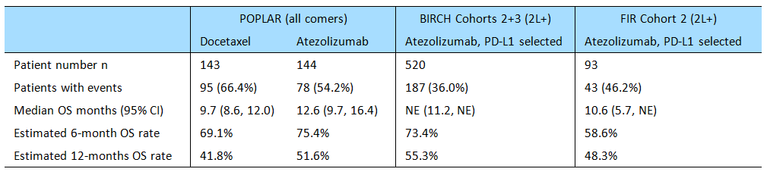
In POPLAR, OS in the ITT population (irrespective of PD-LI status) was the primary efficacy endpoint. In the primary analysis, at the clinical cut-off date of 8 May 2015 when 173 deaths had occurred, there was a clinically meaningful and statistically significant improvement in OS of 2.9 months in patients randomised to atezolizumab 1200 mg q3w (n = 143) compared to patients randomised to docetaxel 75 mg/m² q3w (n = 144): median OS = 12.6 vs 9.7 months, respectively; stratified HR = 0.73 (95% CI: 0.53, 0.99), p = 0.0404. The number of deaths was 78 (54.2%) in the atezolizumab arm and 95 (66.4%) in the docetaxel arm, and the event/patient ratio was 60%.
In POPLAR, an updated post-hoc OS analysis in the ITT population (irrespective of PD-LI status), at the clinical cut-off date of 1 December 2015 when 200 deaths had occurred, continued to show a clinically meaningful survival benefit of 2.9 months in favour of atezolizumab compared to docetaxel: median OS = 12.6 vs 9.7 months, respectively; stratified HR = 0.69 (95% CI: 0.52, 0.92), p = 0.0106 for descriptive purposes only. The event/patient ratio was 70%.
In POPLAR, increasing clinical benefit in OS was seen with increasing PD-L1 expression. There was an OS benefit in favour of atezolizumab compared to docetaxel in the TC3 or IC3 subgroup (HR = 0.49 [95% CI: 0.22, 1.07]), the TC2/3 or IC2/3 subgroup (HR=0.54 [95% CI: 0.33, 0.89]), and the TC1/2/3 or IC1/2/3 subgroup (HR = 0.59 [95% CI: 0.40, 0.85]). In the TC0 and IC0 subgroup, OS was similar in both treatment groups (HR = 1.04 [95% CI: 0.62, 1.75]). The results for OS by PD-L1 expression in the updated analysis were consistent with the results for the primary analysis.
In POPLAR, the results of the subgroup analysis of OS in the ITT population based on baseline demographics and other characteristics were consistent with the primary analysis of OS in the total ITT population. The median duration of OS was longer in the atezolizumab arm than in the docetaxel arm for both tumour subtypes (i.e. non-squamous cell HR = 0.69 [95% CI: 0.47, 1.01]; 15.5 vs 10.9 months) vs squamous cell HR = 0.80 [95% CI: 0.49, 1.30]; 10.1 vs 8.6 months). These results were consistent with the results for the updated tumour subtype analysis. The median duration of OS based on the number of prior therapies (1 vs 2) was longer in the atezolizumab arm than in the docetaxel arm for patients receiving 1 prior therapy (HR = 0.62 [0.42, 0.91]; 16.4 vs 9.5 months), and similar in the two treatment arms for patients receiving 2 prior therapies (HR = 0.98 [95% CI: 0.60, 1.61]]; 9.8 vs 9.7 months).
In both supportive studies (BIRCH and FIR), OS was a secondary efficacy endpoint. In BIRCH, key efficacy data of regulatory interest were provided by Cohorts 2+3 (2L+). In the both the TC2/3 or IC2/3 and the TC3 or IC3 subgroups in Cohorts 2+3 (2L+), the survival data were immature with the median survival duration not being reached in either of the subgroups. At the time of analysis, 36.0% (187/520) of patients had died in the TC2/3 or IC2/3 subgroup and 31.2% (74/237) of patients had died in the TC3 or IC3 subgroup. In FIR, key data of key efficacy data of regulatory interest were provided by Cohort 2 (2L+). In this cohort, the survival data were immature in the TC3 or IC3 subgroup with the median duration of OS not being reached, while in the TC2/3 or IC2/3 subgroup median OS was 10.6 months (95% CI: 5.7, NE). At the time of analysis, 46.2% (43/93) of patients had died in the TC2/3 or IC2/3 subgroup and 36.8% (14/338) of patients had died in the TC3 or IC3 subgroup.

ORR, DOR, and PFS – other key efficacy endpoints
The results for the analyses of ORR, DOR and PFS are summarised below.
Table 106: ORR, DOR, and PFS in the pivotal study (POPLAR) and the two supportive studies (BIRCH, FIR).
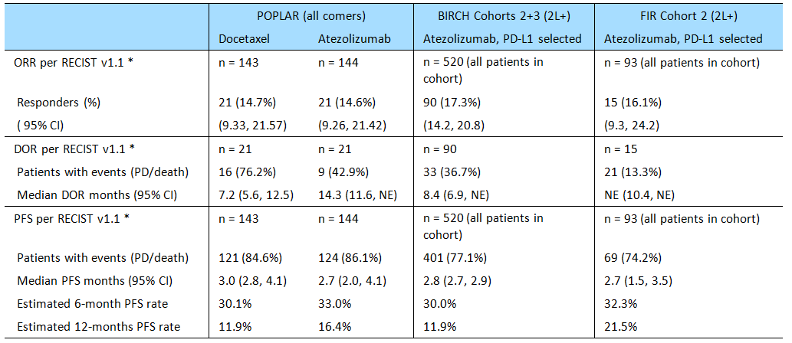
* ORR, DOR and PFS were IRF-assessed for BIRCH, and INV-assessed for POPLAR and FIR.

ORR and DOR
In POPLAR, the ORR (INV-assessed; RECIST v1.1) and the DOR (INV-assessed; RECIST v1.1) were secondary efficacy endpoints. The ORR in the ITT population (clinical cut-off date 8 May 2015) was modest and numerically similar in both treatment arms (14.6% [21/144], atezolizumab arm vs 14.7% [21/143], docetaxel arm). However, the median DOR was notably longer in the atezolizumab arm than in the docetaxel arm (14.3 vs 7.2 months, respectively; stratified HR = 0.41 [95% CI: 0.18, 0.96]). The median DOR (INV-assessed; RECIST v1.1) in the updated analysis (1 December 2015) continued to favour atezolizumab compared to docetaxel (18.6 vs 7.2 months, respectively).
In POPLAR, the ORR (INV-assessed; RECIST v1.1) was higher in the atezolizumab arm than in the docetaxel arm in the TC3 or IC3 subgroup (37.5% vs 13.0%), the TC2/3 or IC2/3 subgroup (22.0% vs 14.5%), and the TC1/2/3 or IC1/2/3 subgroup (18.3% vs 16.7%). However, the median DOR (INV-assessed; RECIST v1.1) was longer in the atezolizumab arm compared to the docetaxel arm only in the TC1/2/3 subgroup. In the TC0 and IC0 group, the ORR (INV-assessed; RECIST v1.1) was higher in the docetaxel arm than in the atezolizumab arm (9.8% vs 7.8%), with the median DOR (INV-assessed; RECIST v1.1) being 7.9 months in the docetaxel arm and not yet reached in the atezolizumab arm.
In BIRCH, the ORR (IRF-assessed; RECIST v1.1) was the primary efficacy endpoint. In Cohorts 2+3 (2+L), higher PD-L1 expression in the TC3 or IC3 subgroup was associated with higher ORR assessed by IRF per RECIST v1.1 compared to lower PD-L1 expression in the TC2/3 or TC2/3 subgroup (25.3% [60/237] vs 17.3% [90/520], respectively). In the TC2/3 or IC2/3 subgroup, the median DOR was 8.4 months (95% CI: 6.9, NE), with 36.7% of responders (33/90) experiencing an event (PD or death). In the TC3 or IC3 subgroup, the median DOR was 7.2 months (95% CI: 5.7, NE), with 38.3% of responders (23/60) experiencing an event (PD or death).
In FIR, the ORR (INV-assessed; RECIST v1.1) was the primary efficacy endpoint. In Cohort 2 (2L+), higher PD-L1 expression in TC3 or IC3 subgroup was associated with higher ORR assessed by INV per RECIST v1.1 compared to lower PD-L1 expression in the TC2/3 or TC2/3 subgroup (23.7% [9/38] vs 16.1% [15/93], respectively). The DOR (INV-assessed; RECIST v1.1) data were immature at the clinical cut-off date, with the median DOR not being reached in either the TC2/3 or IC2/3 subgroup or the TC3 or IC3 subgroup.

PFS
In POPLAR, the median PFS (INV-assessed; RECIST v1.1) in the ITT population was similar in the atezolizumab and docetaxel arms (2.7 vs 3.0 months, respectively; stratified HR = 0.94 [95% CI: 0.72, 1.23]). The proportion of patients with an event (death or PD) was 86.1% (124/144) in the atezolizumab arm and 84.6% (121/143) in the docetaxel arm. Median PFS was numerically greater in the atezolizumab arm compared to the docetaxel arm in the TC3 or IC3 subgroup (7.8 vs 3.9 months, respectively) and the TC2/3 or IC 2/3 subgroup (7.8 vs 3.9 months, respectively), but not in the TC1/2/3 or IC1/2/3 subgroup (2.8 vs 3.0 months, respectively).
In BIRCH, in Cohorts 2+3 (2L+) the median PFS (IRF-assessed; RECIST v1.1) was 2.8 months in the TC2/3 or IC2/3 subgroup, with 77.1% (401/520) of patients experiencing and event (PD or death). In the TC3 or IC3 subgroup (n = 237), the median PFS (IRF-assessed; RECIST v1.1) was 4.1 months in the TC2/3 or IC2/3 subgroup, with 70.5% (167/237) of patients experiencing an event (PD or death). The data showed that the median duration of PFS increased with higher PD-L1 expression.
In FIR, in Cohort 2 (2L+), the median PFS (IRF-assessed; RECIST v1.1) was 2.7 months in the TC2/3 or IC2/3 subgroup, with 74.2% (69/93) of patients experiencing and event (PD or death). In the TC3 or IC3 subgroup, the median PFS (IRF-assessed; RECIST v1.1) was 4.1 months, with 65.8% (25/38) of patients experiencing and event (PD or death). The data showed that the median duration of PFS increased with higher PD-L1 expression.

Patient reported outcomes (PRO)
Patient reported outcome data, including EORTC QLQ-C30 and QLQ-LC13, were collected in BIRCH, FIR, and POPLAR. In patients in the atezolizumab arm in the three studies, no clinically meaningful change (improvement or decline) from baseline during the study period was observed in mean or median values in global health status, functioning (physical, role, emotional, cognitive, and social) or any of the symptom subscales. The results from the three studies indicate that atezolizumab does not have a detrimental impact on HRQoL.
In POPLAR, patients in the docetaxel arm also showed no clinically meaningful change (improvement or decline) from baseline during the study period in global health status, functioning (physical, role, emotional, cognitive, and social) or the lung cancer symptom subscales, but reported a clinically meaningful increase in alopecia.
In POPLAR, there was no difference in time to deterioration (defined as a ≥ 10 point increase above baseline) between the atezolizumab and docetaxel arms for lung cancer symptoms (cough, dyspnea, chest pain, or arm/shoulder pain).

PD-L1 unselected and selected patients
The sponsor is proposing that atezolizumab be approved in patients with NSCLC irrespective of PD-L1 expression on TCs or ICs. The main evidence for this proposal comes from the controlled efficacy data from POPLAR. In this study, the median duration of OS was statistically significantly longer in the atezolizumab arm compared to the docetaxel arm in the ITT population (all comers irrespective of PD-L1 expression), and the modest difference of 2.9 months between the two treatment arms is considered to be clinically meaningful (12.6 vs 9.7 months, respectively). The ORR (INV-assessed; RECIST v1.1) was modest in both treatment groups but numerically similar (14.6%, atezolizumab; 14.7%, docetaxel), while the median DOR (INV-assessed; RECIST v1.1) was approximately 2-fold longer in the atezolizumab arm than in the docetaxel arm (14.3 vs 7.2 months, respectively). Median PFS in the two treatment arms was similar (2.7 months, atezolizumab; 3.0 months, docetaxel), as was the percentage of patients experiencing PD or death (86.1% vs 84.6%), Overall, it is considered that the data from POPLAR provides promising support for the benefits of atezolizumab in patients with NSCLC irrespective of PD-L1 expression.

PD-L1 expression
The data from POPLAR indicate that OS improvement with atezolizumab is associated with increasing PD-L1 expression, with the greatest improvement seen in patients with the highest PD-L1 expression (TC3 or IC3 group). However, mutually exclusive subgroup analyses showed that all individual PD-L1 expression levels ≥ 1% on TCs or ICs were independent contributors to the OS improvement seen with atezolizumab compared to docetaxel. The results indicate that the improvements in OS seen with atezolizumab in the TC2/3 or IC2/3 and TC1/2/3 or IC1/2/3 subgroups are not being driven solely by patients with the highest PD-L1 expression levels (TC3 or IC3). Patients in the TC2/3 or IC2/3 and TC1/2/3 or IC1/2/3 subgroups treated with atezolizumab also experienced a PFS benefit compared to patients treated with docetaxel. However, median OS and PFS results for patients in the TC0 or IC0 subgroup (i.e. < 1% PD-L1 expression levels on TC0 or IC0) were similar in the atezolizumab and docetaxel arms.
In BIRCH, higher PD-L1 expression (TC3 or IC3) was associated with higher ORR and longer median PFS than lower PD-L1 expression (TC2/3 or IC2/3). In FIR, higher PD-L1 expression (TC3 or IC3) was associated with higher ORR than lower PD-L1 expression (TC2/3 or IC2/3).
In view of the association between higher PD-L1 expression and increased efficacy in patients with NSCLC treated with atezolizumab, it is recommended that all NSCLC patients to be treated with the drug have their PD-L1 expression levels determined. It is considered that this information will provide important prognostic information.

First round assessment of risks

UC
The IMvigor 201, Cohort 2 (n = 311, all-comers [irrespective of IC status]) population is considered to be the key patient group in the submission for assessing the risks of atezolizumab as second line or beyond treatment for locally advanced or metastatic UC in previously treated patients. The cohort consisted of 311 patients who had failed a prior platinum-containing chemotherapy regimen or progressed within 12 months of a platinum-based treatment administered in the adjuvant/neo-adjuvant setting and were treated with atezolizumab in the 2L+ setting. Interpretation of the safety is limited due to the absence of a controlled arm.
Patients in Cohort 2 (n = 311, all-comers) received atezolizumab 1200 mg q3w over a median period of 12.3 weeks (range: 0, 46 weeks). Treatment duration was ≤ 13 weeks for 51.8% of patients, > 13 to 26 weeks for 16.7% of patients, > 26 to 39 weeks for 26.0% of patients, and > 39 to 52 weeks for 5.5% of patients. The duration of exposure in Cohort 2 (all-comers) was short, with no patients in the cohort being exposed to atezolizumab for longer than 12 months. The absence of pivotal safety data beyond 12 months treatment with atezolizumab is a significant limitation of the safety data for this cohort.

Risk of experiencing an AE (irrespective of relationship to treatment)
AEs were reported in most patients in Cohort 2 (all-comers), with 95.8% (298/311) of patients experiencing at least one AE. The most commonly reported AEs (≥ 10% of patients), in decreasing order of frequency, were fatigue (46.3%), decreased appetite (25.4%), nausea (23.8%), pyrexia and constipation (20.3% each), urinary tract infection (19.0%), diarrhoea (18.0%), vomiting (16.4%), dyspnoea (14.8%), back pain (14.5%), arthralgia (14.1%), anaemia (13.8%), haematuria (13.5%), pruritus (12.5%), abdominal pain and cough (12.2% each), and peripheral oedema (11.9%).

Risk of experiencing an AE related to treatment with atezolizumab
AEs considered by investigators to be related to treatment with atezolizumab were reported in the majority of patients in Cohort 2 (all-comers), with 65.3% (203/311) of patients experiencing at least one AE. The most commonly reported treatment-related AEs (≥ 5% of patients), in decreasing order of frequency, were fatigue (28.3%), nausea (12.9%), decreased appetite (10.9%), pruritus (10.0%), pyrexia (8.7%), diarrhoea (7.7%), rash (6.8%), arthralgia and vomiting (5.8% each), and chills (5.1%).

Risk of death
In Cohort 2 (all-comers), the risk of death occurring within 30 days of the last dose of atezolizumab due to an AE was small (1.3%, [4/311]). In Cohort 2 (all-comers), a total of 141 (45.3%, [141/311]) deaths were reported as of the clinical cut-off date of 5 May 2015. Of the 141 deaths, 34 (10.9%) occurred within 30 days of the last dose of atezolizumab and 107 (34.4%) deaths occurred beyond 30 days after the last dose of atezolizumab. The most common reason for death within 30 days of the last dose of atezolizumab was disease progression (44.1%, [137/311]). The other deaths in the 4 remaining patients due to Grade 5 AEs were reported in 1 patient each and included pulmonary sepsis, subileus, intracranial bleed (related to a previous cerebrovascular accident), and unknown cause. None of the Grade 5 AEs were considered to be treatment related.

Risk of experiencing SAEs other than death
In Cohort 2 (all-comers), the risk of experiencing at least one SAE was high (45.3%, [141/311]). SAEs reported in ≥ 3 patients (≥ 1.0%), in decreasing order of frequency, were urinary tract infection (n = 19, 6.1%), haematuria (n = 10, 3.2%), pyrexia (n = 8, 2.6%), dyspnoea and acute kidney injury (2.3% each), dehydration, abdominal pain, pulmonary embolism, back pain and sepsis (n = 6, 1.9% each), small intestinal obstruction and pneumonia (n = 5, 1.6% each), hypercalcaemia, nausea and hydronephrosis (n = 4, 1.3% each), and hyponatraemia, pain, fatigue, pneumonitis, urosepsis, deep vein thrombosis, confusional state and pyelonephritis (n = 3, 1.0% each).
In Cohort 2 (all comers), 10.6% (33/311) of patients experienced at least one SAE considered to be related to treatment with atezolizumab. Treatment-related SAEs reported in more than 1 patient were pneumonitis (n = 3, 1.0%) and pyrexia (n = 2, 0.6%).

Risk of experiencing AEs leading to withdrawal
In Cohort 2 (all-comers), the risk of experiencing an AE leading to withdrawal from the study was small (3.2%, [10/311]). The data suggest that the majority of AEs reported in the cohort were manageable by temporary dose interruptions and/or symptomatic treatment. The AEs leading to withdrawal from the study were one each for retroperitoneal haemorrhage, subileus, pulmonary sepsis, sepsis, toxicity to various agents, posterior reversible encephalopathy syndrome (PRES), acute kidney injury, pneumonitis, pruritus, and no coding. Three of the AEs leading to withdrawal were considered by the investigator to be related to treatment (sepsis [resolved], acute kidney injury [resolved] and pneumonitis [death]). The case of PRES was not considered by the investigator to be related to treatment, but is of concern given that atezolizumab is associated with a risk of immune-mediated AEs.

Risk or experiencing AEs resulting in temporary interruption of dosing
In Cohort 2 (all-comers), the risk of experiencing at least one AE resulting in temporary interruption of the dosing regimen was commonly reported (26.7%, [83/311]). AEs leading to dose interruption and reported in ≥ 3 patients (≥ 1.0%) were urinary tract infection (n = 8, 2.6%), diarrhoea (n = 6, 1.9%), fatigue and confusional state (n = 5, 1.6% each), pyrexia, dyspnoea, pneumonitis and blood bilirubin increased (n = 4, 1.3% each), and AST increased (n = 3, 1.0% each).

Risk of experiencing AESIs
There is a risk of experiencing AESI associated with treatment with atezolizumab, including dermatological reactions, hepatic events, gastrointestinal events, neurological events, endocrine events, pulmonary events, and systemic immune events. In Cohort 2 (all-comers), 25.4% (79/311) of patients reported at least one AESI during the study and most patients with an AESI had a Grade 1 or 2 event (83.5%, [66/79]). AESIs in Cohort 2 (all-comers) reported in ≥ 3 patients (≥ 1%) by PT in decreasing order of frequency were rash (n = 31, 10%), increased AST (n = 13, 4.2%), increased ALT (n = 12, 3.9%), peripheral neuropathy (n = 8, 2.6%), increased bilirubin (n = 7, 2.3%), maculopapular rash (n = 7, 2.3%), pneumonitis and hypothyroidism (n = 6, 1.9% each), pruritic rash (n = 4, 1.3% ), and transaminases increased (n = 3, 1.0%).
The most commonly reported AESIs were dermatological reactions, which were reported in 14.5% (n = 45) of patients. The most commonly reported dermatological reactions by PT (≥ 1% of patients) were rash in 31 (10.0%) patients, maculopapular rash in 7 (2.3%) patients, and pruritic rash in 4 (1.3%) patients. No cases of SJS or TEN were reported in the cohort.
Hepatic events reported as AESI were increased AST in 13 (4.2%) patients, increased ALT in 12 (3.9%) patients, increased blood bilirubin in 7 (2.3%) patient, increased transaminases in 3 (1.0%) patients, and autoimmune hepatitis and hepatitis in 1 (0.3%) patient each. Endocrine events reported as AESI were hypothyroidism in 6 (1.9%) patients and TSH increased in 2 (0.6%) patients. Neurological events reported as AESIs were peripheral neuropathy in 8 (2.6%) patients. Gastrointestinal events reported as AESI were colitis in 1 (0.3%) patient. Pulmonary events reported as AESI were pneumonitis in 6 (1.9%) patients. Systemic immune events reported as AESI were cytokine release syndrome in 1 (0.3%) patient.

Risk of immune-mediated AEs (imAEs)
There is a risk of experiencing imAEs associated with atezolizumab treatment. In Cohort 2 (all-comers), the risk of experiencing an imAE was 6.4% (20/311). In these 20 patients, imAEs of Grade 3 or 4 severity were reported in 13 patients (4.2%, [13/311]) and imAEs of Grade 1 or 2 severity were reported in 7 patients (2.3%, [7/311]). There was an overlap between AESI and imAEs for some events.
The most commonly reported imAEs were pulmonary events, which were reported in 4 patients (1.3%, [4/311]). These events included dyspnoea in 2 patients (Grade 3 in each patient) and pneumonitis in 2 patients (Grade 3 and 4, one each). Hepatic imAEs were reported in 3 patients (1.0%, [3/311]), including 1 patient with Grade 3 increases in ALT, AST, and blood bilirubin, 1 patient with Grade 4 hepatitis, and 1 patient with Grade 3 autoimmune hepatitis.
Gastrointestinal imAEs were reported in 2 patients, including 1 patient with Grade 3 diarrhoea and 1 patient with Grade 3 colitis. Dermatological imAEs were reported in 1 patient (Grade 3 rash). Neurological imAEs were reported in 1 patient (Grade 3 paraplegia). Other imAEs were reported in 2 patients (Grade 4 cytokine release in 1 patient; Grade 3 pericardial effusion in 1 patient).

Risk or ATAs
In IMvigor 210, 41.9% (161/384) of all patients treated with atezolizumab (Cohorts 1 and 2) had treatment-emergent ATAs. In Cohort 2 (all-comers), the percentage of patients experiencing AESIs was similar in ATA-positive and ATA-negative patients (30.7%, [35/114] vs 26.1%, [42/161], respectively). The only AESI reported in at least 10 patients in either of the ATA groups in Cohort 2 (all-comers) was rash: 20 (12.4%) ATA-negative patients and 11 (9.6%) ATA-positive patients. In Cohort 1 (all-comers), the percentage of patients experiencing AESIs was similar in ATA-positive and ATA-negative patients (25.5%, [12/47] vs 21.0%, [13/62], respectively). Overall, the risk of developing ATAs is high, but the presence of ATAs does not appear to significantly worsen the safety profile of atezolizumab.

Other risks
No clinically meaningful increased risks of laboratory abnormalities (haematological or clinical chemistry), or abnormal vital signs were identified. There were no data on ECG changes in IMvigor 201, but the totality of the ECG data presented in the submission does not give rise to concern. In particular, there is no evidence in the submitted data that atezolizumab is associated with QTc interval prolongation.

Risks in special groups
The pooled safety data from the All UC group indicate that no dose adjustments based on age or gender are required. There are no adequate safety data based on race, due to the imbalance in patient numbers across the different racial groups. Nearly all patients in the submission with UC were Caucasian. There were no data on the effect of hepatic impairment or renal impairment on the safety of atezolizumab.

NSCLC

General comments
The key study for the assessment of the risks of atezolizumab for the proposed usage in patients with NSCLC is POPLAR. This was Phase II, open-label, active-controlled study which included 271 safety-evaluable patients, comprising 135 patients in the docetaxel arm and 142 patients in the atezolizumab arm. In the docetaxel arm, the median duration of treatment was 2.1 months (range: 0, 17 months) and the median number of treatment cycles was 4.0 (range: 1, 26). In the atezolizumab arm, the median duration of treatment was 3.7 months (range: 0, 19 months) and the median number of treatment cycles was 6.0 (range: 1, 28). The median dose intensity was 97.7% in both studies. Notably more patients in the atezolizumab arm received at least 6 months of treatment compared to patients in the docetaxel arm (40.1%, n = 57 vs 15.6%, n = 21), and 21.1% (n = 30) of patients in the atezolizumab arm received treatment for ≥ 12 months compared to 3.7% ( n = 5) of patients in the docetaxel arm.
The safety profile of atezolizumab was qualitatively different from that of docetaxel, with lower risks for AEs in the atezolizumab arm known to be associated with docetaxel such as alopecia, nausea, diarrhoea, neutropenia, febrile neutropenia, and peripheral neuropathy. On the other hand, musculoskeletal pain and pneumonia were associated with a greater risk in patients treated with atezolizumab compared to patients treated with docetaxel.
In general, atezolizumab appeared to be better tolerated than docetaxel with notably lower patient incidences in the atezolizumab arm of AEs leading to withdrawal of treatment, AEs leading to dose modification/interruption, treatment-related AEs, treatment-related AEs leading to withdrawal of treatment, and treatment-related AEs leading to dose modification/interruption.
The major limitation relating to the assessment of the risks of treatment with atezolizumab based on the POPLAR data relates to the relatively small number of patients in the two treatment arms, and in particular the small number of patients treated for ≥ 12 months. It is noted that the primary analysis of OAK (Phase III), presented at the recent 2016 ESMO, includes safety data on 609 patients treated with atezolizumab and 578 patients treated with docetaxel. The reported safety dataset for the confirmatory Phase III study (OAK) provides a substantially larger number of patients on which to base firm conclusion relating to the comparative safety of atezolizumab and docetaxel than that provided by the Phase II study (POPLAR).
However, reassurance relating to the safety of atezolizumab for the proposed usage in NSCLC patients is provided by the All NSCLC data in a total of 1026 atezolizumab-treated patients from POPLAR, BIRCH, FIR, and PCD4989g, including 840 2L+NSCLC patients. In the 938 safety-evaluable patients in the All NSCLC population who were treated with atezolizumab 1200 mg q3w, the median duration of follow-up was 5.1 months (range: 0.5, 32.9 months), the median duration of exposure was 4.1 months (range: 0, 19.4 months), the median number of cycles was 6.5 (range: 1.0, 28.0), and the median dose intensity was 100% (range: 33, 147). Of the 938 safety-evaluable patients in the All NSCLC population treated with atezolizumab 1200 mg q3w, 59.6% (n = 559) were treated for 6 months and 6.9% (n = 65) were treated for > 12 months. The high-level safety profile of atezolizumab-treated patients in the All NSCLC group and the atezolizumab arm in POPLAR were similar (see below).
Table 107: High-level safety profiles of atezolizumab-treated patients from the All NSCLC group and POPLAR, and of docetaxel-treated patients from POPLAR.
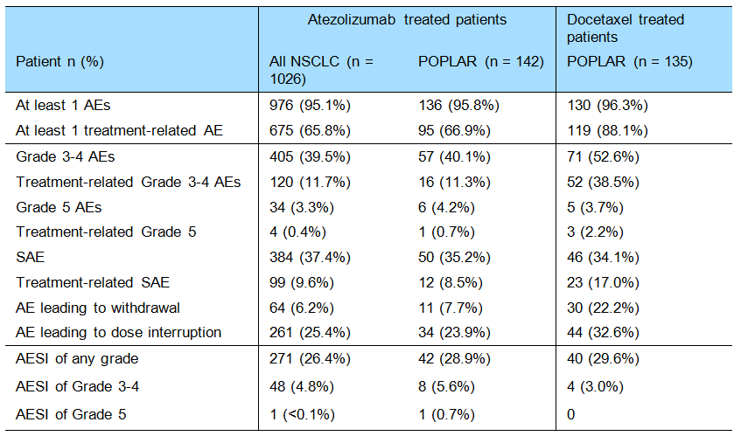

Risks of adverse events irrespective of study drug treatment
In POPLAR, nearly all patients in both the docetaxel and atezolizumab arms experienced at least one AE (96.3% [130/135], 1325 events vs 95.8% [136/142], 1354 events, respectively). The most commonly reported AEs occurring in ≥ 20% of patients in either the docetaxel arm or the atezolizumab arm (respectively), in decreasing order of frequency in the docetaxel arm, were fatigue (40.0% vs 38.7%), alopecia (38.5% vs 2.1%), nausea (33.3% vs 21.8%), diarrhoea (28.1% vs 16.9%), cough (24.4% vs 26.8%), constipation (23.7% vs 20.4%), decreased appetite (20.7% vs 34.5%), and dyspnoea (20.0% vs 26.8%).
AEs with a higher incidence (≥ 5% more patients) in the atezolizumab arm than in the docetaxel arm were decreased appetite (34.5% vs 20.7%), dyspnoea (26.8% vs 20.0%), pyrexia (16.9% vs 11.9%), arthralgia (15.5% vs 8.9%), insomnia (13.4% vs 8.1%), musculoskeletal pain (13.4% vs 5.2%), and pneumonia (10.6% vs 3.0%).
AEs with a higher incidence (≥ 5% more patients) in the docetaxel arm than in the atezolizumab arm were alopecia (38.5% vs 2.1%), nausea (33.3% vs 21.8%), diarrhoea (28.1% vs 16.9%), asthenia (16.3% vs 9.9%), myalgia (13.3% vs 5.6%), neutropenia (12.6% vs 1.4%), peripheral neuropathy (11.9% vs 1.4%), peripheral sensory neuropathy (8.9% vs 1.4%), febrile neutropenia (8.1% vs 0.0%), dry skin (7.4% vs 2.1%), and nail disorder (6.7% vs 0.7%).
The duration of treatment was longer in patients treated with atezolizumab compared to patients treated with docetaxel (median of 3.7 months vs median of 2.1 months). Therefore, in order to explore whether the AEs reported in a higher proportion of patients (≥ 5% more patients) in the atezolizumab arm than in the docetaxel arm were associated with longer duration of exposure, analyses adjusted for the patient-years at risk were performed for decreased appetite, dyspnoea, pyrexia, arthralgia, insomnia, musculoskeletal pain, and pneumonia. The results showed that the AE rate per 100 patient years was higher in the atezolizumab arm than in the docetaxel arm for musculoskeletal pain and pneumonia, but not for arthralgia, decreased appetite, dyspnoea, insomnia or pyrexia. The results suggest that the increased risk of at least some of the AEs observed with atezolizumab compared to docetaxel might be due to the longer duration of exposure in patients treated with atezolizumab compared to patients treated with docetaxel.

Risks of treatment-related adverse events
In POPLAR, the risk of experiencing at least one treatment-related AE was notably greater in patients in the docetaxel arm than in the atezolizumab arm (88.1% [119/135] vs 66.9% [95/142]). Treatment-related AEs reported in ≥ 10% of patients in either the docetaxel arm or the atezolizumab (respectively), with decreasing order of frequency in the docetaxel arm, were alopecia (37.8% vs 1.4%), fatigue (34.8% vs 20.4%), nausea (27.4% vs 12.0%), diarrhoea (22.2% vs 7.0%), anaemia (16.3% vs 5.6%), decreased appetite (15.6% vs 17.6%), asthenia (13.3% vs 6.3%), vomiting (11.9% vs 5.6%), constipation (11.9% vs 4.9%), peripheral neuropathy (11.1% vs 0.7%), and neutropenia (11.1% vs. 0.7%).

Risks of Grade 3-4 adverse events
In POPLAR, the risk of experiencing at least one Grade 3-4 AE was notably greater in the docetaxel arm than in the atezolizumab arm (52.6%, [71/135] vs 40.1%, [57/142]). Of note, Grade 3-4 neutropenia, febrile neutropenia, and fatigue all occurred notably more commonly in the docetaxel arm than in the placebo arm, while dyspnoea and pneumonia occurred notably more frequently in the atezolizumab arm. Grade 3-4 AEs reported in ≥ 5% of patients in either the docetaxel arm or the atezolizumab arm (respectively) were neutropenia (11.% vs 0%), febrile neutropenia (8.1% vs 0%), fatigue (7.4% vs 2.1%), dyspnoea (1.5% vs 7.0%), and pneumonia (1.5% vs 5.6%).

Risk of death
In POPLAR, AEs leading to death occurring ≤ 30 days of the last dose or prior to initiation of non-protocol anti-cancer therapy were reported in 11 patients, including 6 (4.2%) in the atezolizumab arm and 5 (3.7%) in the docetaxel arm. In the atezolizumab arm, the six Grade 5 AEs were cardiac failure (treatment-related), pulmonary embolism, pneumonia, embolism, ulcer haemorrhage, and pneumothorax. In the docetaxel arm, the five Grade 5 AEs were acute respiratory syndrome (treatment-related), sepsis (treatment-related), death (treatment-related), death and sepsis.
AEs leading to deaths occurring > 30 days after the last dose of study treatment or prior to initiation of non-protocol anti-cancer therapy were reported in 6 patients, including 4 (2.8%) in the atezolizumab arm and 2 (1.5%) in the docetaxel arm. In the atezolizumab arm, the four Grade 5 AEs were death, cardiac arrest, pneumonia and large intestine perforation, all of which were considered to be unrelated to treatment. In the docetaxel arm, the two Grade 5 AEs were sepsis and death, both of which were considered to be unrelated to treatment.

Risk of SAEs
In POPLAR, the risk of experiencing a SAE was similar in the docetaxel and atezolizumab arms (34.1% vs 35.2%, respectively). SAEs reported in ≥ 2% of patients in either the docetaxel arm or the atezolizumab arm (respectively), in decreasing order of frequency in the docetaxel arm, were febrile neutropenia (5.2% vs 0%), pulmonary embolism (4.4% vs 1.4%), haemoptysis (2.2% vs 0.7%), pneumonia (2.2% vs 5.6%), sepsis (2.2% vs 0%), dyspnoea (0.7% vs 4.9%), pyrexia (0.7% vs 2.1%), and pleural effusion (0% vs 2.8%).
SAEs reported in ≥ 2% more patients in the atezolizumab arm than in the docetaxel arm were pneumonia (5.6% vs 2.2%), dyspnoea (4.9% vs 0.7%) and pleural effusion (2.8% vs 0%). SAEs reported in ≥ 2% more patients in the docetaxel arm than in the atezolizumab arm were febrile neutropenia (5.2% vs 0%), pulmonary embolism (4.4% vs 1.4%), and sepsis (2.2% vs 0%).
In POPLAR, the risk of experiencing a treatment-related SAE was notably greater in the docetaxel arm than in the atezolizumab arm (17.0% vs 8.5%). Treatment related SAEs reported in ≥ 2 patients in either the docetaxel arm or the atezolizumab arm (respectively) were febrile neutropenia (5.2% vs 0%), neutropenia (1.5% vs 0%), pyrexia (0.7% vs 2.1%), pneumonia (1.5% vs 2.1%), sepsis (1.5% vs 0%), AST increased (0% vs 1.4%), and rash (0.0% vs 1.4%).

Risk of experiencing AEs leading to discontinuation of the study drug
In POPLAR, the risk of experiencing an AE leading to discontinuation of the study drug was significantly greater in the docetaxel arm than in the atezolizumab arm (22.2% vs 7.7%). AEs leading to study drug discontinuations reported in ≥ 1.0% patients in either the docetaxel arm or the atezolizumab arm (respectively), in decreasing order of frequency in the docetaxel arm, were fatigue (3.0% vs 0%), peripheral sensory neuropathy (3.0% vs 0%), sepsis (2.2% vs 0%), death (1.5% vs 0%), peripheral neuropathy (1.5% vs 0%), and dyspnoea (0% vs 1.4%).

Risk of experiencing an AE leading to dose modification
In POPLAR, the risk of experiencing an AE leading to dose modification was greater in the docetaxel arm than in the atezolizumab arm (32.6% vs 23.9%). Dose modifications reported in ≥ 2% of patients in either the docetaxel arm or the atezolizumab arm, in decreasing order of frequency in the docetaxel arm, were fatigue (6.7% vs 0.7%), febrile neutropenia (3.7% vs 0%), peripheral sensory neuropathy (3.0% vs 0%), and pneumonia (0% vs 2.1%).
Overall, the POPLAR AE data suggest that the majority of AEs observed in the atezolizumab arm were manageable by dose interruption and/or symptomatic treatment rather than discontinuation of the study drug.

Risk of experiencing an AESI
In POPLAR, the risk of experience an AESI was similar in the docetaxel and atezolizumab arms (29.6% vs 28.9%, respectively). In both treatment arms, dermatological reactions were the most commonly reported AESIs and were observed in a similar percentage of patients in the docetaxel and atezolizumab arms (14.8% vs 16.2%, respectively). The most commonly reported dermatological AESI was rash, which was reported in 11.9% of patients in the docetaxel arm and 10.6% of patients in the atezolizumab arm. Grade 3 dermatological AESIs were reported in 1 patient in the docetaxel arm (rash) and 2 patients in the atezolizumab arm (both rash). There were no cases of SJS or TENs observed in either of the two treatment arms.
The risk of experiencing a neurological AESI was notably greater in the docetaxel arm than in the atezolizumab arm (13.3% vs 2.1%), with peripheral neuropathy being the most commonly reported neurological AESI in both treatment arms (11.9% vs 1.4%, respectively). Grade 3 neurological AESIs were reported in 2 patients in the docetaxel arm (neuropathy peripheral x 1, polyneuropathy x 1).
The risk of experiencing a hepatic AESI was greater in the atezolizumab arm than in the docetaxel arm (5.6% vs 1.5%). The most commonly reported hepatic AESIs in the atezolizumab arm (vs the docetaxel arm) were AST increased (4.2% vs 0.7%) and ALT increased (4.2% vs 0%). Grade 3 or 4 hepatic AESIs were reported in 5 patients in the atezolizumab arm (2 patients with Grade 3 increased AST; 2 patients with Grade 3 increased AST and ALT).
The risk of experiencing an endocrine AESI was notably greater in the atezolizumab arm than in the docetaxel arm (6.3% vs 0.7%). The endocrine AESIs in the atezolizumab arm were hypothyroidism (x 8) and hyperthyroidism (x 1), and in the docetaxel arm the one event was hyperthyroidism (x1). There was one Grade 3 event of hypothyroidism in the atezolizumab arm, with all other endocrine AESIs in both treatment arms being Grade 1 or 2.
Gastrointestinal AESIs were reported in 0.7% of patients in the docetaxel arm (colitis x 1) and 1.4% of patients in the atezolizumab arm (colitis x 2, including 1 Grade 3 event). One patient in the atezolizumab arm experienced a musculoskeletal AESI (Grade 2 autoimmune arthritis). Pulmonary AESIs were reported in 0.7% of patients in the docetaxel arm and 2.8% of patients in the atezolizumab arm. All pulmonary AESIs were categorised as pneumonitis, with Grade 3 events being reported by 1 patient in each of the two treatment arms.
No cardiac, haematological, ocular, renal or non-specific immune AESIs were reported during the study.

Risk of experiencing and immune-mediated adverse event (imAE)
In POPLAR, the risk of experiencing an imAE was similar in the docetaxel and atezolizumab arms (7.4% vs 7.7%, respectively). Immune-mediated AEs reported in ≥ 1% of patients in either the docetaxel arm or the atezolizumab arm (respectively) were peripheral neuropathy (2.2% vs 0.7%), diarrhoea (1.5% vs 0.7%), rash (1.2% vs 2.1%), pneumonitis (0.7% vs 1.4%), colitis (0% vs 1.4%), and hypoxia (0% vs 1.4%).

Risk of developing anti-therapeutic antibodies (ATAs)
In POPLAR, 54.5% (73/134) of patients in the atezolizumab arm developed protocol-defined ATAs, including 70 patients with ‘treatment-induced’ ATA responses and 3 patients with ‘treatment-enhanced’ ATA responses. Overall, the risks of atezolizumab treatment in ATA-positive and ATA-negative patients did not markedly differ between the two patient groups. The incidence of AESIs was similar in ATA-positive and ATA-negative patients (30.1% vs 30.6%, respectively). The development of ATAs did not appear to be associated with hypersensitivity or infusion related reactions. Of the ATA-negative patients, one experienced a hypersensitivity AE and one experience an infusion-related reaction. No ATA-positive patients experienced a hypersensitivity AE or an infusion-related reaction.

Risk of developing clinical chemistry abnormalities
No clinically relevant changes in median values for haematology and clinical chemistry laboratory parameters occurred during the study. The majority of patients did not experience a clinically relevant increase in AE Grade in any haematological or clinical chemistry laboratory parameters during the study. However, the proportion of patients with Grade 3 decreases in the absolute lymphocyte count at any time during the study was notably greater in the docetaxel arm than in the atezolizumab arm (21.9% vs 6.9%), as was the proportion of patients with Grade 4 decreases in the absolute neutrophil count (17.2% vs 0.8%), Grade 3 decreases in the absolute white blood cell count (7.8% vs 0.8%) and Grade 4 decreases in the absolute white blood cell count (7.8% vs 0.8%). There were no marked differences between the two treatment arms in the proportion of patients with Grade 3 or 4 changes in clinical chemistry parameters, with nearly all changes being reported in ≤ 5% of patients in both treatment arms.
Haematology laboratory abnormalities reported as AEs during the study occurring in ≥ 2% of patients in either treatment arm (docetaxel vs atezolizumab) were anaemia (19.3% vs 16.2%), neutropenia (12.6% vs 1.4%), thrombocytopenia (0.7% vs 4.2%), lymphopenia (2.2% vs 0.7%), and INR increased (2.2% vs 0%).
Clinical chemistry laboratory abnormalities reported as AEs during the study occurring in ≥ 2% of patients in either treatment arm (docetaxel vs atezolizumab) were hypokalaemia (3.0% vs 6.3%), hyponatraemia (2.2% vs 5.6%), hypomagnaesemia (3.7% vs 4.9%), AST increased (0.7% vs 4.2%), ALT increased (0.0% vs 4.2%), and hypoalbuminaemia (3.0% vs 2.8%), alkaline phosphatase increased (0% vs 2.8%), and creatinine increased (0% vs 2.1%).

Risks of developing clinically significant changes in vital signs or ECG findings
In POPLAR, the risks of developing clinically significant changes in vital signs or clinically abnormal ECG findings during the study in either of the two treatment arms were negligible.

Risk of experiencing AEs in special populations
Overall, the safety profile of atezolizumab in POPLAR was comparable across the PD-L1 expression subgroups (TC3 or IC3 subgroup, TC2/3 or IC2/3 subgroup, and TC1/2/3 or IC1/2/3 subgroup).
In POPLAR, there were no formal safety data assessing differences between the docetaxel and the atezolizumab arms based on age, gender, race, hepatic impairment, or renal impairment.
In the All NSCLC population, the high-level AE profile in atezolizumab-treated patients was similar in the patients aged < 65 years (n = 532) and patients aged ≥ 65 years (n = 494). In the All NSCLC population, the high-level AE profile in atezolizumab-treated patients was similar in males (n = 610) and females (n = 416). In the All NSCLC population, no meaningful interpretation of safety data in atezolizumab-treated patients based on race can be made due to the imbalance in patient numbers across the groups (n = 849, 82.8%, Caucasian; n = 108, 10.5%, Asian; n = 24, 2.3%, black; and n = 43, 4.2%, other).

First round assessment of benefit-risk balance

UC
The submitted efficacy data are considered to be too limited to allow adequate characterisation of the benefits of atezolizumab for the proposed indication (UC). Based on the totality of the safety data (UC plus NSCL) it is considered that the risks of atezolizumab for the proposed indication (UC) are acceptable. However, treatment with atezolizumab is not without risks. Therefore, in the absence of adequate data satisfactorily establishing the benefits of treatment with atezolizumab for the proposed usage in patients with UC it is considered that the benefit-risk balance for this usage is unfavourable.

NSCLC
The benefits of atezolizumab for the proposed usage in patients with NSCLC are considered to be promising, but require confirmation with efficacy data from a Phase III study. Based on both the totality the safety data (NSCLC plus UC) and the safety data relating specifically to NSCLC it is considered that the identified risks of atezolizumab for the proposed indication (NSCLC) are acceptable. However, treatment with atezolizumab is not without risks. Therefore, in the absence of confirmatory data satisfactorily establishing the benefits of treatment with atezolizumab for the proposed usage in patients with NSCLC it is considered that the benefit-risk balance for this usage is unfavourable. However, the benefit-risk balance for the proposed usage in patients with NSCLC might become favourable if the promising benefits of atezolizumab observed in the pivotal Phase II study (POPLAR) and the two supportive Phase II studies (BIRCH and FIR) are confirmed by the Phase III study (OAK).

First round recommendation regarding authorisation

UC
It is recommended that the application to register atezolizumab for the treatment of patients with locally advanced or metastatic urothelial carcinoma after prior chemotherapy be rejected on the grounds of inadequate demonstration of efficacy for the proposed indication. The reasons for rejection are summarised below.
The submission included no confirmatory Phase III studies establishing the efficacy or safety of atezolizumab for the proposed indication compared to control treatment. In particular, there were no confirmatory data establishing that atezolizumab provides an OS or PFS benefit compared to control treatment with vinflunine, a chemotherapeutic agent approved in Australia for a similar indication to that proposed for atezolizumab. The TGA adopted EMA guideline relating to the evaluation of cancer medicines indicates that in determining the efficacy of single-agent experimental medicines in Phase III confirmatory studies the agent should be compared to the ‘best available’ comparator (CHMP/EWP/205/95/Rev.4/Corr). It is considered that there is no reason to deviate from the TGA adopted guideline in the current submission, given that there is an appropriate registered comparator (vinflunine) for the indication of interest. In addition, based on the sponsor’s covering letter it appears that the sponsor considers that vinflunine, docetaxel and pemetrexed all are appropriate comparators for the treatment of UC.
Neither the Phase II pivotal study nor the Phase I supportive study pre-specified either OS or PFS as a primary efficacy endpoint. The relevant TGA adopted EMA guideline for the evaluation of cancer medicines state that OS or PFS/DFS should be a primary efficacy endpoint for confirmatory Phase III oncology trials (CHMP/EWP/205/95/Rev.4/Corr). It is considered that there is no reason to deviate from adopted guideline in the current submission, given that there is an appropriate registered comparator (vinflunine) for the indication of interest. In addition, based on the sponsor’s covering letter it appears that the sponsor considers that vinflunine, docetaxel and pemetrexed are appropriate comparators for the treatment of UC.
IMvigor 210, the supportive Phase II study was open-label and single-arm. The ORRs observed for atezolizumab in the IC2/3, IC12/3 and all-comers treatment groups at the data cut-off of 5 May 2015 were formally compared to a historical control response rate of 10% determined from the published literature. The results showed that the co-primary ORR efficacy endpoints, IRF-assessed by RECIST v1.1 and INV-assessed per mRECIST, were statistically significantly higher than the historical control response rate. However, for regulatory purposes, the comparisons are considered to be supportive rather than confirmatory due to the biases associated with cross-study comparisons (e.g. different study designs, different patient characteristics, and different lengths of exposure).
The DOR and OS for atezolizumab appeared to be longer when compared to published data for vinflunine, docetaxel and pemetrexed. However, for regulatory purposes, the cross-study comparisons are considered to be supportive rather than confirmatory. The interpretation of DOR, PFS, and OS data are problematic without data from a formal comparative treatment arm from a randomised controlled study.
It is noted that the sponsor’s developmental plan includes a Phase III study (IMvigor 211) aimed at evaluating the efficacy of atezolizumab compared to chemotherapy with respect to OS in patients with locally advanced or metastatic urothelial bladder cancer after failure with platinum containing chemotherapy. It is recommended that the application to register atezolizumab for the treatment of UC be re-submitted when the results of this study become available.

NSCLC
It is recommended that the application to register atezolizumab for the treatment of patients with locally advanced or metastatic NSCLC after prior chemotherapy be rejected on the grounds of inadequate demonstration of efficacy for the proposed indication. The reasons for rejection are summarised below.
The submission included no confirmatory Phase III study establishing the efficacy of atezolizumab compared to relevant control treatment (e.g. docetaxel) for the proposed indication. The pivotal Phase II study (POPLAR) demonstrated a modest statistically significant and clinically meaningful survival benefit of 2.9 months in patients treated with atezolizumab (n = 144) compared to patients treated with docetaxel (n = 143) in the primary analysis; median OS = 12.6 vs 9.7, respectively; stratified HR = 0.73 (95% CI: 0.53, 0.99), p = 0.0404. The updated OS analysis continued to show a 2.9 month survival benefit in favour of atezolizumab compared to docetaxel. The survival benefit for atezolizumab from POPLAR is promising, but is modest and the patient numbers in both treatment arms are relatively small. Furthermore, there were no other randomised, controlled studies in the submission comparing OS in atezolizumab-treated patients with a control treatment (e.g. docetaxel). Survival data for atezolizumab from the supportive, single-arm, Phase II study (BIRCH) are too immature to define the median OS. In addition, the survival data for atezolizumab, from the supportive, single-arm, Phase II study (BIRCH) are too immature to fully characterise OS, with the upper 95% CI for OS being not estimable.
The PFS data (median duration) from POPLAR are similar in the atezolizumab and docetaxel arms (2.7 vs 3.0 months, respectively) as are the ORR data (14.6% vs 14.7%, respectively), while the median DOR is approximately 2-fold longer in the atezolizumab arm compared to the docetaxel arm (14.3 vs 7.2 months). The ORR in BIRCH (17.3%) and FIR (16.1%) in atezolizumab-treated patients was similar to the ORR in the atezolizumab arm in POPLAR (14.6%). The median duration of PFS was similar in atezolizumab-treated patients in BIRCH, FIR, and POPLAR (i.e. 2.8, 2.7 and 2.7 months, respectively). The median DOR was notably longer in atezolizumab-treated patients in POPLAR compared to BIRCH (i.e. 14.3 vs 8.4 months), and was not estimable in the atezolizumab arm in FIR due to immaturity of the data. Overall, the single-arm efficacy data from BIRCH and FIR in atezolizumab-treated patients are considered to provide support for the efficacy data for atezolizumab observed in POPLAR. However, interpretation of the single-arm data from BIRCH and FIR in atezolizumab-treated patients is limited due to the lack of a control arm in both studies. In particular, it is difficult to make clinically meaningful conclusions relating to DOR, PFS and OS from BIRCH and FIR in the absence of controlled data.

Additional comment
It is noted that efficacy and safety data from the primary analysis of the Phase III study (OAK) comparing atezolizumab (1200 mg q3w) to docetaxel (75 mg/m² q3w) in previously treated patients with locally advanced or metastatic NSCLC have been recently reported, and that the OS data from this analysis have been included in the currently approved US label for atezolizumab. The design of this Phase III study (OAK) appears to be similar to that of the submitted Phase II study (POPLAR), but includes a substantially larger number of enrolled patients (n = 1,225). The efficacy data provided in the US label report that the median OS in the atezolizumab arm (n = 425) was 13.8 months compared to 9.6 months in the docetaxel arm (n = 425): stratified HR = 0.74 (0.63, 0.87), p = 0.0004 (stratified log-rank test). Data in the public domain summarising the results of the study presented at the ESMO conference in October 2016 report that an OS benefit in favour of atezolizumab was seen regardless of PD-L1 expression levels, with an unstratified HR of 0.75 (0.59, 0.96) in the TC0 and IC0 subgroup and an unstratified HR of 0.41 (95% CI: 0.27, 0.64) in the TC3 or IC3 subgroup. As part of its Section 31 Response to the first round clinical evaluation report, the sponsor is requested to provide the efficacy and safety data from the primary analysis.

Clinical questions

Pharmacokinetics
- The popPK analysis (report 1066935) estimated that the CL of atezolizumab would be 16% higher in ATA-positive patients compared to ATA-negative patients. Please comment on the possible reasons for the estimated difference in CL based on ATA status.

Pharmacodynamics
- No conclusions can be drawn about the incidence of neutralising antibodies (NAbs) in ATA-positive patients treated with atezolizumab due to the high number of post-treatment ATA positive samples that were indeterminate in the NAb assay. Please comment on the reasons for the large number of indeterminate NAb results in the assay. Is the sponsor developing an assay that can reliably detect NAbs? Please provide any updated data on the incidence of NAbs in patients treated with atezolizumab, including any clinical effects (efficacy and safety) that have been identified in patients with NAbs.

Efficacy
- In IMvigor 210 (UC), in the exploratory IC0 subgroup analyses (Cohorts 1 and 2) an ORR was demonstrated (e.g. in Cohort 2 ORR [IRF-assessed; RECIST v1.1] = 8.7%). Please comment on the possible reasons for patients categorised as IC0 responding to atezolizumab, given that PD-LI expression was limited in these patients (i.e. PD-L1 staining < 1%).
- The cross-study comparison in patients with UC between IMvigor 210 Cohort 2 and PCD4989g UC Cohort for the primary analysis data showed that ORR (IRF-assessed; RECIST v1,1) was notably greater in PCD4989g than in IMvigor 210 for each of the three IC subgroups. Patients in PCD4989g had more advanced disease and had been more heavily pretreated than patients in IMvigor 210. Please comment on the reasons for the difference in the ORR between the two studies.
- In POPLAR (NSCLC), at the cut-off date of 1 December 2015 the hazard ratios (HRs) for OS showed a relationship with PD-L1 expression, with HRs decreasing in favour of atezolizumab with increasing PD-L1 expression. The HR for the TC0 and IC0 subgroup was 0.88 (95% CI: 0.55, 1.42), with median OS of 9.7 months in both the atezolizumab and docetaxel arms. The results suggest that the TC0 and IC0 subgroup has a similar survival benefit in the two treatment arms. Please comment on the reasons that patients in the TC0 and IC0 subgroup treated with atezolizumab might show a survival benefit, given that PD-L1 staining of TC or IC was < 1% (i.e. low PD-L1 expression).
- The current US label for TECENTRIQ includes efficacy data from the Phase III study (OAK) in patients with NSCLC. Why was this data submitted to the FDA but not to the TGA? Please provide the efficacy and safety data from the primary analysis of OAK presented at the October ESMO Conference.

Safety
- In IMvigor 210, in Cohort 2 there was one case of posterior reversible encephalopathy syndrome (PRES) leading to withdrawal of study treatment. PRES has been associated with autoimmune diseases and with immunosuppressive drugs (e.g. tacrolimus, cyclosporine, chemotherapy). The case narrative indicates that the event developed on Day 15 of the study following initiation of treatment with atezolizumab. The investigator considered the event to be unrelated to treatment with atezolizumab. Please comment on the possibility that PRES in this patient was causally related to treatment with atezolizumab.
- Please summarise the clinical laboratory urinalysis data for patients in IMvigor 210 (Cohort 2) in patients with UC and for patients in the docetaxel and atezolizumab arms in POPLAR in patients with NSCLC. Please include summaries of abnormal urinalysis results reported as treatment emergent AEs for the identified patient populations from the two studies. Please comment on any abnormalities observed in the requested urinalysis results.

Second round evaluation of clinical data

Introduction
The approach adopted to the second round clinical evaluation is summarised below:
• sponsor’s response to first round clinical questions and evaluator’s comments;
• evaluation of the efficacy data from the pivotal Phase III efficacy and safety study (OAK) provided in the sponsor’s S31 Response;
• evaluation of the safety data from the pivotal Phase III efficacy and safety study (OAK) provided in the sponsor’s S31 Response; and
• additional tables and figures from the second round clinical evaluation report.
In addition, the updated Clinical Overview submitted with the sponsor’s S31 Response included an updated safety analysis based on a total of 2160 safety evaluable patients (i.e. any patient who received any dose of atezolizumab) from studies PCD4989g (NSCLC and UC Cohorts), IMvigor 210 (Cohorts 1 and 2), OAK, POPLAR, BIRCH, and FIR. Three main pooled safety populations were defined for the analysis: All Patient population (n = 2160); All UC population (n = 524, 24.3%); and All NSCLC population (n = 1636, 75.7%). The median duration of safety follow-up in the All Patient population was 4.5 months (range: 0.5, 53.0 months), 3.9 months in the All UC population and 4.5 months in the All NSCLC population.
The updated safety analysis included data on an additional 613 patients treated with atezolizumab in the All Patient population compared to the corresponding safety analysis in the initial data (i.e. 1547 patients in the initial All Patient population). The 613 additional patients in the updated All Patient population consisted almost entirely of NSCLC patients (n = 610) from OAK, resulting in 1636 patients in the updated All NSCLC population compared to 1026 patients in the initial All NSCLC population. The number of patients in the updated All UC population was consistent with the number of patients in the initial All UC population (524 and 521 patients, respectively). Updated safety data were also provided for IMvigor 210, BIRCH, POPLAR, and PCD4989g at later cut-off time points than in the initial data. No new safety signals emerged from the updated safety analysis.
The sponsor used the data from the updated safety analysis in the All Patient population (n = 2160) to update the safety information in the amended PI submitted with the S31 Response. In the second round CER the evaluation of safety focuses on the data from OAK. However, the safety data in the amended PI (Summary of ADRs occurring in patients treated with TECENTRIQ in clinical trials), which is based on the updated safety analysis for the updated All Patient population, have been cross-checked for consistency with the data provided in the S31 Response. The S31 Response included a set of tables provided in response to the recommendation in the first round CER to amend the Adverse Effects section of the PI, which included the data in the PI. In addition, the safety data in the paragraphs in the amended PI relating to Additional information for selected adverse reactions have been cross-checked for consistency with the information provided by the sponsor in the S31 Response and the updated Summary of Clinical Safety (SCS) provided by the sponsor following a request from the TGA during the course of the second round evaluation.

Sponsor’s response to first round clinical questions

Pharmacokinetics
- (Q1) The popPK analysis (report 1066935) estimated that the CL of atezolizumab would be 16% higher in ATA-positive patients compared to ATA-negative patients. Please comment on the possible reasons for the estimated difference in CL based on ATA status.
Sponsor’s response
Immune complexes formed by anti-therapeutic antibody (ATA) binding to drug can have increased clearance compared with drug not in a complex. In addition, because the drug concentration assay uses a ligand binding format, the detection of drug may be reduced if the ATA is specific for the ligand binding site on the drug and interferes with the binding of drug to the ligand. The level of potential ATA interference will depend on the affinity and concentration of the anti-therapeutic antibodies, and these are expected to be different for every patient sample with ATA.
The pharmacokinetic (PK) assay design for atezolizumab included several factors to reduce the potential for this interference. The ligand binding format of the PK assay uses a minimum sample dilution of 1/100 and a 2-hour sample incubation in the well, which may help disrupt ATA:drug complexes and allow drug detection. In addition, only one arm of atezolizumab needs to be unoccupied to allow binding to the PD-L1-Fc capture. It is expected that these factors would help mitigate ATA interference; however, very high ATA levels may cause some reduction in measured drug levels.
Evaluator’s comment:
The sponsor’s response is satisfactory.

Pharmacodynamics
- (Q2) No conclusions can be drawn about the incidence of neutralising antibodies (NAbs) in ATA-positive patients treated with atezolizumab due to the high number of post-treatment ATA positive samples that were indeterminate in the NAb assay. Please comment on the reasons for the large number of indeterminate NAb results in the assay. Is the Sponsor developing an assay that can reliably detect NAbs? Please provide any updated data on the incidence of NAbs in patients treated with atezolizumab, including any clinical effects (efficacy and safety) that have been identified in patients with NAbs.
Sponsor’s response:
The Sponsor acknowledges that the current neutralising antibody assay (NAb) results do not allow for a meaningful interpretation of the impact of neutralising antibody on clinical effects. The first-generation assay had very low tolerance to drug in the samples, and almost all of the tested samples had drug concentrations above the drug tolerance limit of the assay. The Sponsor is currently developing a more drug-tolerant NAb assay that is planned to be available by May 2018. This work is currently in progress.
Evaluator’s response:
The sponsor’s response is satisfactory.

Efficacy
- (Q3) In IMvigor 210 (UC), in the exploratory IC0 subgroup analyses (Cohorts 1 and 2), an ORR was demonstrated (e.g. in Cohort 2 ORR [IRF-assessed; RECIST v1.1] = 8.7%). Please comment on the possible reasons for patients categorized as IC0 responding to atezolizumab, given that PD-LI expression was limited in these patients (i.e. PD-L1 staining <1%).
Sponsor’s response
The Sponsor believes that the data from IMvigor210 Cohort 2, based on the strength of clinical efficacy as assessed by objective response rates, complete responses, duration of response, and overall survival in the context of a tolerable safety profile distinct from chemotherapy, support a positive benefit-risk profile in an all-comer patient population, irrespective of programmed death−ligand 1 (PD-L1) expression. Although an association between PD-L1 status as determined by the SP-142 immunohistochemical (IHC) assay and clinical benefit with PD-L1/PD-1 pathway inhibition has been demonstrated in patients with metastatic urothelial carcinoma (UC) in the PCD4989g and IMvigor210 (Cohort 2) studies of atezolizumab monotherapy, patients with low levels of PD-L1 expression (tumor-infiltrating immune cell [IC] 0/1) have also been shown to derive benefit from atezolizumab. Several hypotheses about interpreting these observations have been proposed (a summary is provided below); however, the Sponsor recognizes that the predictive and prognostic utility of the SP-142 assay assessing PD-L1 expression has not yet been conclusively established in metastatic UC.
It is postulated that patient and tumor-specific differences may affect PD-L1 expression levels and may account for responses being detected in patients with low PD-L1 IC status. Specifically, intratumoral heterogeneity could provide an explanation, since PD-L1 is not uniformly expressed throughout a tumor mass. Incomplete sampling and variation in biopsy techniques (e.g. angle of a needle biopsy) could yield positive, intermediate, or negative results from a single tumor sample. In addition, discordance between disparate tumor deposits within a patient (intertumoral heterogeneity), as well as discordance between the primary tumor and distant metastases, has been reported for renal cell carcinoma and may have a role in UC.
Moreover, the interaction of the PD-1 receptor with the PD-L1 ligand generally occurs in the tumor-draining lymph nodes. However, such samples have infrequently been included in PD-L1 expression analyses. Furthermore, PD-L1 expression is modulated by the cytokine milieu, whereby PD-L1 levels can vacillate as a result of dynamic changes in the tumor microenvironment over time. Taken together, these observations highlight that the role of tumor heterogeneity, inclusion of lymph node samples, and the predictive and prognostic utility of the SP-142 PD-L1 IHC assay will need further assessment.
Additional studies, including results from the ongoing randomized Phase III study IMvigor211, will help further delineate the role of the SP-142 assay assessing PD-L1 expression as a predictive or prognostic biomarker. Overall, the Sponsor believes that the totality of the data presented support the registration of atezolizumab as a clinically significant innovative therapeutic option, irrespective of PD-L1 status, in the treatment of locally advanced or metastatic UC, given the high unmet need in this patient population.
Evaluator’s comment:
The clinical significance of the observed ORR in the exploratory analysis in the IC0 subgroup (Cohorts 1 and 2) remains unclear. This matter might be clarified by the results from the ongoing Phase III study IMvigor 211. The sponsor acknowledges that ‘the predictive and prognostic utility of the SP-142 assay assessing PD-L1 expression has not yet been conclusively established in metastatic UC’. The sponsor’s discussion relating to how patient and tumour-specific differences may affect PD-L1 expression levels is satisfactory. It is considered that the efficacy data for atezolizumab for the treatment of UC remains promising rather than confirmatory despite the sponsor’s belief that ‘the totality of the data presented support the registration of atezolizumab as a clinically significant innovative therapeutic option, irrespective of PD-L1 status, in the treatment of locally advanced or metastatic UC, given the high unmet need in this patient population’.
- (Q4) The cross-study comparison in patients with UC between IMvigor 210 Cohort 2 and PCD4989g UC Cohort for the primary analysis data showed that ORR (IRF-assessed; RECIST v1,1) was notably greater in PCD4989g than in IMvigor 210 for each of the three IC subgroups. Patients in PCD4989g had more advanced disease and had been more heavily pretreated than patients in IMvigor 210. Please comment on the reasons for the difference in the ORR between the two studies.
Sponsor’s response:
The Sponsor acknowledges that numerical differences in the objective response rates (ORRs) were observed when comparing the results of PCD4989g and IMvigor210 Cohort 2 populations. However, overall, the Sponsor believes that the efficacy outcomes from both studies are consistent and demonstrate a favourable benefit-risk profile in all patients, irrespective of programmed death−ligand 1 (PD-L1) tumor-infiltrating immune cell (IC) status.
The Summary of Clinical Efficacy document … provides side-by-side comparison as well as pooled analysis of ORR and duration of response (DOR) for PCD4989g urothelial carcinoma (UC) cohort and Cohort 2 of IMvigor210. The two studies share key similarities. These include comparable atezolizumab treatment regimens (1200-mg flat dosing in Study IMvigor210 is equivalent to an average body weight−based dose of 15 mg/kg), analogous patient populations in terms of baseline risk factors and disease status, the same assay (IUO-labeled) used to assess the PD-L1 IC status of UC patients, and definition and assessment criteria used for the assessment of ORR and DOR. The individual and pooled results for ORR and DOR in the tumor-infiltrating immune cell (IC) 0/1 and IC2/3 subgroups were comparable across the PCD4989g and IMvigor210 studies.
Even though both studies enrolled overlapping patient populations, the Sponsor has conducted limited comparisons between these two patient cohorts given distinctions in eligibility between the two protocols as well as differences in sample size and enrolment periods. In particular, variations are noted in protocol and enrolment processes between the PCD4989g Phase Ia and IMvigor210 Phase II studies, which include but are not limited to study follow-up, eligibility assessment (e.g. prospective, internally reviewed enrolment packages in PCD4989g but not IMvigor210), a PD-L1−enriched and smaller patient population in PCD4989g with potential differences in baseline characteristics such as tumor burden or stage of disease (lymph node−only disease vs. visceral metastases), and divergent recruitment periods. Furthermore, the small sample size of the IC subsets as well as the non-randomized nature of the studies limit comparison and complicate characterizing distinctions between the two studies (see below). Despite the limitations noted, both studies demonstrate that patients with metastatic UC in the second-line (2L) and later obtain significant clinical benefit from atezolizumab.
Table 108: Demographics and baseline characteristics across UC studies.
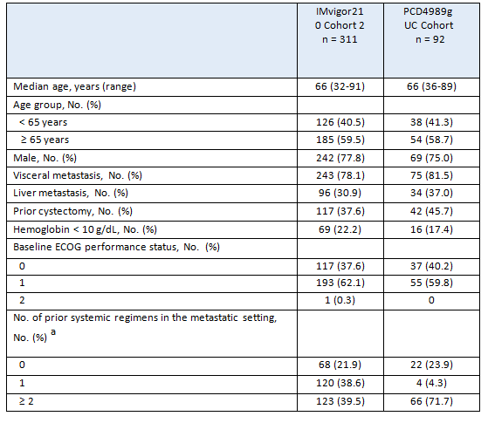
ECOG=Eastern Cooperative Oncology Group; UC= urothelial carcinoma. Note: IMvigor210 data cutoff is 5 May 2015. PCD4989g data cutoff is 2 December 2014. ª Prior systemic therapy is defined slightly differently for Studies IMvigor 210 and PCD4989g.
The Sponsor has provided an updated Clinical Overview with these responses to questions, which contains updated analyses of IMvigor210 and PCD4989g data. In general, with the updated analyses, ORRs observed in the Study PCD4989g UC cohort were consistent with those observed in Study IMvigor210 Cohort 2 across the IC2/3 and IC0/1 subgroups, with overlapping confidence intervals.
The most recent analysis of IMvigor210 Cohort 2 (data cutoff date of 4 July 2016), with a median survival follow-up of 21.1 months, continues to show clinically meaningful and durable responses across all pre-defined IC subgroups. The confirmed Independent Review Facility (IRF)-assessed ORR per Response Evaluation Criteria in Solid Tumors Version 1.1 (RECIST v1.1) in the IC2/3 subgroup was 28.0% (95% CI: 19.48%, 37.87%) and 10.0% (95% CI: 6.3%, 14.9%) in the IC0/1 subgroup.
Additional responses were observed with longer follow-up compared with the primary analysis. Responses, including complete responses (CRs), were observed in all IC subgroups, including IC0 and IC1. By comparison, no CRs were observed in patients treated with vinflunine in the randomized Phase III study comparing vinflunine with best supportive care (BSC) (Bellmunt et al. 2009). In the updated analysis, the median DOR per IRF-assessed RECIST was still not yet reached in the IC2/3, IC1/2/3, and IC1 subgroups and all comers. Median DOR was 13.3 months in the IC0 subgroup. The updated DOR showed that 32 of 49 responders (65.3%) among all-comers demonstrated ongoing responses.
Furthermore, in the updated analysis of Study PCD4989g with a clinical cutoff date of 31 March 2016 and an overall median follow-up of 29.2 months, the ORR was 31.8% (95% CI: 13.9%, 54.9%) for IC2/3 patients and 18.8% (95% CI: 9.0%, 32.6%) for the IC0/1 subgroup. In the IC0 subgroup, the updated ORR was 11.1% (95% CI: 1.38%, 34.71%). Similarly, the median IRF-assessed DOR per RECIST v1.1 was not reached overall or in the IC2/3 or IC0 subgroups and was 27.6 months (range, 2.9−32.7 months; 32.7 is a censored value) in the IC1 subgroup. The majority of responders (16 of 24 patients [66.7%]) still had an ongoing response at the updated data cutoff. The Sponsor has updated the Product Information with this data because it represents the longest follow-up.
With acknowledgment of the limitations of cross-trial comparisons, the IMvigor210 data for atezolizumab compares favourably with that of vinflunine, which is currently approved in Australia for 2L UC. The approval of vinflunine was based on data from a single randomized Phase III study that compared vinflunine plus BSC with BSC alone in 370 patients with advanced UC progressing after a platinum containing therapy. In this trial, patients were only permitted one prior therapy for metastatic disease (2L patients only). Comparatively, in the IMvigor210 study, 39% of the patients had only one prior line of therapy in the metastatic setting (2L), and 43% of the patients were considered 3L+, having received two or more prior lines of therapy in the metastatic setting. The benefit conferred with vinflunine was modest. The intent-to-treat analysis showed an improvement in response rate (8.6% vs. 0%) with median DOR of 7.4 months (95% CI: 4.5, 17.0) for the vinflunine plus BSC arm but did not show a statistically significant overall survival benefit for vinflunine plus BSC compared with BSC alone (6.9 vs. 4.6 months; HR= 0.88; 95% CI: 0.69, 1.12). Key toxicities included Grade 3 or 4 neutropenia (50%), anaemia (19%), fatigue (19%), constipation (16%), nausea (2%), and vomiting (3%) (Bellmunt et al. 2009), with 21% of patients discontinuing therapy due to treatment-related adverse events. Vinflunine is TGA-registered but is not Pharmaceutical Benefits Scheme−listed, so it is not a well-established standard of care in Australia. In addition, the DOR with atezolizumab was also favourable when contrasting to historical median DOR rates of 4−9.1 months with vinflunine, taxanes, and pemetrexed.
The totality of the data from two independent studies, PCD4989g and IMvigor210, clearly demonstrate a consistent and meaningful clinical benefit in atezolizumab-treated patients with 2L+ UC irrespective of PD-L1 expression, compared to standard of care chemotherapy. Although the limitations of cross-trial comparisons between Phase I and Phase II studies are noted, the ORR and DOR of the IC0/1 and IC2/3 subgroups were comparable across the PCD4989g and IMvigor210 studies. Moreover, benefit was observed regardless of PD-L1 expression. Given the limited therapeutic development that has occurred in metastatic UC over the last 30 years, a high unmet medical need exists for patients with locally advanced or metastatic UC. A large proportion of patients do not receive any treatment in the first-line setting, and those who receive chemotherapy experience have limited efficacy and significant toxicity. This highlights the need for efficacious and well-tolerated therapies in a patient population characterized by advanced age, impaired Eastern Cooperative Oncology Group performance status, and multiple comorbidities. Results from the ongoing randomized Phase III Study IMvigor211 will serve to confirm the observed responses in Studies PCD4989g and IMvigor210. The IMvigor211 primary analysis results are planned to be available in May 2017, and the Clinical Study Report is expected in the third quarter of 2017.
Evaluator’s comment:
The updated Clinical Overview provided updated efficacy data for the studies IMvigor 210 and PCD4989g. The results are reviewed below. The updated efficacy analysis for IMvigor 210 (Cohort 2) was based on data with a clinical cutoff date of 4 July 2016 with a median duration of follow-up of 21 months. The updated efficacy analysis for PCD4989g (UC Cohort) was based on data with a clinical cutoff date of 31 March 2016 with a median duration of follow-up of 29.2 months. The updated efficacy data have been reviewed and the results discussed below. The ORR and DOR results for the primary and updated analyses for studies IMvigor 210 and PCD4989g are summarised below.
Table 109: Efficacy results (OR and DOR) for IMvigor (Cohort 2) and PCD4989g (UC Cohort).
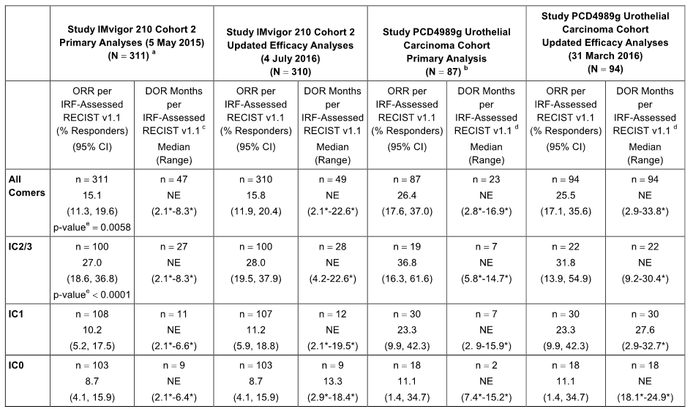
DOR = duration of response; IC = tumour-infiltrating immune cell; IRF = independent research facility; NA = not applicable; NE = not estimable; ORR = overall response rate; RECIST = Response Evaluation Criteria in Solid Tumors. [a] For the final analysis of Cohort 2 of study IMvigor 210, the data cutoff date was 5 May 2015, with a minimum follow-up time of 24 weeks (the median follow-up time was 7.1 months). [b] For the UBC Cohort of Study PCD4989g, the data cutoff date was 2 December 2014, with a minimum follow-up time of 12 weeks (OR-evaluable population n = 87). [c] In the primary analysis for Cohort 2, median DOR was not reached in any IC subgroup. The DOR is calculated based on responders. [d] The DOR is calculated based on responders. *Censored value.
Study IMvigor 210
For IMvigor 210 (Cohort 2), the ORR and DOR results were consistent for the primary and updated analyses for the all comers, IC2/3 and IC1 groups, while the median DOR was 13.3 months for the updated analysis in the IC0 group. The median DOR had not yet been reached in the all comers, IC2/3 and IC1 groups. For both analyses, the lower bound 95% CI for the ORR was greater than the 10% historical control in the All Comers and IC2/3 groups, but not for the IC1 and IC0 groups. The results demonstrate a dose-response relationship between ORR and PD-L1 expression on tumour-infiltrating immune cells (IC), based on the SP-142 IHC assay. The updated DOR showed that 32 of 49 responders (65.3%) in the all comer analysis demonstrated ongoing responses.
With longer follow-up, 7 additional CRs were observed in all comers (19/310; 95% CI: 3.7, 9.4) compared to the primary analysis (12/311; 95% CI: 2.0, 6.6). The ORR (IRF-assessed) was 25.9% (95% CI: 15.0, 39.7) in all comers who had disease progression beyond 12 months after their last dose of treatment with a platinum-containing neoadjuvant or adjuvant chemotherapy regimen (14/54 patients). In Cohort 2, an ongoing response at the clinical cutoff date was observed in 32 of 49 responders (65.3%). The estimated 1-year landmark DOR event-free rate was 65.3% in all comers, and within each IC subgroup the majority of patients had ongoing responses.
In the primary analysis of Cohort 2 (data cutoff 5 May 2015), OS was immature with a median follow-up of 7.1 months in all comers, while in the updated analysis (data cutoff 4 July 2016) the median duration of OS was 7.9 months with a median follow-up of 21 months. The 1-year OS rate was 36.9% in all comers in the updated analysis (data cutoff 4 July 2016).
Study PCD4989g
In the updated analysis of study PCD4989g UC Cohort (clinical cutoff date of 31 March 2016) in 95 patients the median duration of follow-up was 29.2 months (range: 0.7, 35.52 months; 0.7 is a censored value) compared to 10.9 months (range: 0.7, 19.7 months; 0.7 is a censored value) as of 2 December 2014.
The results of the updated ORR (IRF-assessed) analyses at the clinical cutoff date 31 March 2016 were consistent with the initial ORR (IRF-assessed) analyses at the clinical cutoff date of 2 December 2014 for the all comers, IC 2/3, IC1, and IC0 groups. The median DOR had not been reached for the all comers, IC 2/3 and IC0 groups at either of the two clinical cutoff dates (2 December 2014 and 31 March 2016). However, while the median DOR had not been reached in the IC1 group at the time of the initial analysis it was 27.6 months at the time of the updated analysis.
In the updated analysis, the median PFS (IRF-assessed) was 1.8 months (95% CI: 1.4, 3.3) in the all comers group, with 81.1% (77/95) of patients experiencing an event (disease progression in 61 patients and death in 16 deaths). The median PFS was longer in the IC2/3 group (2.7 months) than in the IC0 group (2.0 months) and the IC1 group (1.4 months), but the differences among the three IC groups are not considered to be clinically significant. The 1-year PFS survival rate was 22.1% (21/95) in the all comers group (95% CI: 13.8%, 30.5%).
In the updated analysis, median OS was 10.1 months (95% CI: 7.3, 17.0) in the all comers group, with death being reported in 66.3% (63/95) of patients. Median OS was longer in the IC2/3 and IC1 groups (9.1 and 10.6 months, respectively) than in the IC0 group (6.9 months). In the all comers group, the 1-year OS rate was 45.6% (95% CI: 35.0%, 56.1%) and the 2-year survival rate was 30.3% (95% CI: 20.3, 40.3). The 1-year OS rates were 42.4%, 46.9%, and 40.9% for the IC0, IC1, and IC2/3 groups, respectively, and the 2-year OS rates were 21.2%, 32.5%, and 29.2% for the IC0, IC1, and IC2/3 subgroups, respectively.
Overall
It is considered that the updated analysis of ORR and DOR provided in the S31 Response for study IMvigor 210 (the key efficacy study of patients with UC) are consistent with the results from the primary analysis. The updated efficacy analyses for study PCD4989g are considered to provide supportive data for the updated efficacy analyses for study IMvigor 210. The efficacy data for atezolizumab for the treatment of UC in patients remain promising, particularly for patients with higher levels of PD-L1 expression on tumour-infiltrating immune cells (i.e. IC2/3). However, it is considered that the promising efficacy results in patients with UC observed in the two, atezolizumab single-arm studies should be confirmed by data from the ongoing Phase III study in this patient population (i.e. IMvigor 211).
- (Q5) In POPLAR (NSCLC), at the cut-off date of 1 December 2015 the hazard ratios (HRs) for OS showed a relationship with PD-L1 expression, with HRs decreasing in favour of atezolizumab with increasing PD-L1 expression. The HR for the TC0 and IC0 subgroup was 0.88 (95% CI: 0.55, 1.42), with median OS of 9.7 months in both the atezolizumab and docetaxel arms. The results suggest that the TC0 and IC0 subgroup has a similar survival benefit in the two treatment arms. Please comment on the reasons that patients in the TC0 and IC0 subgroup treated with atezolizumab might show a survival benefit, given that PD-L1 staining of TC or IC was < 1% (i.e. low PD-L1 expression).
Sponsor’s response:
The key features of the sponsor’s response are summarised below.
Supporting data for the overall survival (OS) benefit seen in TC0 and IC0 patients by immunohistochemistry are based on OS data in PD-LI subgroups in both POPLAR and OAK. Notably, a similar OS benefit was seen in OAK in patients with low PD-L1 expression by gene expression analysis (HR= 0.74 [95% CI: 0.58, 0.96]). In contrast to OS, progression-free survival (PFS) and objective response rate (ORR) seem to be enriched among the patients with higher PD-L1 expression, which is also consistent with what has been reported for anti−PD-1 inhibitors and in previous atezolizumab studies.
Low PD-L1 expression is associated with weak or no pre-existing immunity (Fehrenbacher et al. 2016). Therefore, this observed survival benefit associated with atezolizumab in patients who are PD-L1 negative warrants additional investigation to better understand the mechanisms of response to therapy in this patient population. These include the biological hypothesis that atezolizumab increases anticancer immunity through enhanced priming of new anticancer immune responses. In addition to PD-1, PD-L1 may also mediate an immunosuppressive function through its interaction with other proteins, including B7.1. This blocks its ability to activate T cells through binding to CD28, a co-stimulatory molecule, further dampening the generation of an immune response; it is reasonable to hypothesise that low or no interaction of PD-L1 with B7.1 in patients with low PD-L1 expression may result in a T-cell stimulatory effect. Furthermore, it is plausible that PD-L1 expressed in lymph nodes may generate new immunity via binding with atezolizumab.
Overall, the OS data from both the POPLAR and OAK studies provide strong evidence of a positive benefit-risk profile from atezolizumab treatment in this patient population. In particular, the improved OS with atezolizumab seen in the Phase III OAK study, along with the favourable atezolizumab safety profile seen in both the OAK and POPLAR studies for the TC0 and IC0 subgroup, contribute to this conclusion.
Evaluator’s comment:
The sponsor’s response is satisfactory.
- (Q6) The current US label for TECENTRIQ includes efficacy data from the Phase III study (OAK) in patients with NSCLC. Why was this data submitted to the FDA but not to the TGA? Please provide the efficacy and safety data from the primary analysis of OAK presented at the October ESMO Conference.
Sponsor’s response:
The data maturity, and consequently study read-out, on Study GO28915 (hereinafter OAK) was driven by the number of overall survival events. At the time of submission of the filing application in Australia (28 June 2016) and in the United States (19 February 2016), OAK had still not yet read out. In the United States, the OAK topline efficacy data from the primary analysis (clinical cutoff date of 7 July 2016) were submitted for inclusion into the label during the review 1 month prior to the Food and Drug Administration action date, 19 October 2016. Full approval was granted on 18 October 2016.
A summary of the OAK efficacy and safety data from the primary analysis is provided. The primary analysis results are also summarised together with existing data in the updated Clinical Overview. A clinical study report from the primary analysis of OAK is available and can be provided on request.
The Sponsor has updated the Clinical Trials section of the Product Information with a summary of the efficacy results from OAK. In addition, the Sponsor has updated the safety information in the Adverse Effects section based on the inclusion of OAK in the pooled analysis of patients across patients with urothelial carcinoma and non−small cell lung cancer
Evaluator’s comment:
The sponsor’s response is considered to be satisfactory. The sponsor was requested to provide the clinical study report (CSR) for OAK referred to in its response. The clinical efficacy and safety data from the CSR for OAK have been evaluated as part of this second round clinical evaluation report. It is noted that there results from OAK have been recently published, and that the published results were accompanied by a Comment relating to the role of the treatment of NSCLC with antibodies that target the PD-LI and the PD-1 pathway.

Safety
- (Q7) In IMvigor210, in Cohort 2 there was one case of posterior reversible encephalopathy syndrome (PRES) leading to withdrawal of study treatment. PRES has been associated with autoimmune diseases and with immunosuppressive drugs (e.g. tacrolimus, cyclosporine, chemotherapy). The case narrative indicates that the event developed on Day 15 of the study following initiation of treatment with atezolizumab. The investigator considered the event to be unrelated to treatment with atezolizumab. Please comment on the possibility that PRES in this patient was causally related to treatment with atezolizumab.
Sponsor’s response:
The key features of the sponsor’s response are summarised below.
After database lock, the event of posterior encephalopathy syndrome (PRES) was updated to sepsis by the study investigator based on additional case information. Case details for this patient and a review of PRES were provided by the sponsor. The MRI findings for the patient were reported to be not characteristic for PRES and instead were considered to be possible brain metastases (i.e. two punctiform lesions in the left frontal and temporal cortical areas). In addition, the patient did not have clinical features linked to PRES (i.e. no history of visual changes or loss or headache, no focal deficits, and no history of elevated or uncontrolled blood pressure). The patient had a medical history that included meningitis and loss of memory for a period of about 8 year. After database lock, the event of PRES was updated to sepsis by the investigator. The investigator assessed the reported events as not related to atezolizumab but related to the concurrent UTI leading to sepsis and altered mental status, with recovery after treatment with antibiotics. The sponsor agreed with the investigator’s assessment.
Evaluator’s comment:
The sponsor’s response is satisfactory.
- (Q8) Please summarise the clinical laboratory urinalysis data for patients in IMvigor210 (Cohort 2) in patients with UC and for patients in the docetaxel and atezolizumab arms in POPLAR in patients with NSCLC. Please include summaries of abnormal urinalysis results reported as treatment emergent AEs for the identified patient populations from the two studies. Please comment on any abnormalities observed in the requested urinalysis results.
Sponsor’s response:
The key features of the sponsor’s response are summarised below.
The Sponsor reviewed the reported adverse events under the MedDRA High-Level Term (HLT) of Urinalysis NEC (not elsewhere classified) for Studies IMvigor210 (Cohort 2) and GO28753 (POPLAR). The randomised Phase III Study GO28915 (OAK) has also been included in the analysis. In addition, urinalysis shift tables through 35 cycles were reviewed for potential changes in levels of specific gravity, urine pH, glucose, protein, blood, and ketones. As the number of patients decreased over time, the Sponsor focused on Cycles 1 through 15 to allow for a meaningful review. No changes in urinalysis parameters or adverse events representative of abnormal urinalysis values were observed in IMvigor210, POPLAR, or OAK.
In IMvigor 210 (Cohort 2), there were no Preferred Terms (PTs) identified in the HLT of Urinalysis NEC. Urinalysis was conducted as part of study assessments through local laboratories every other cycle for the presence of glucose, protein, blood, and ketones. For routinely collected samples, the majority of patients had normal urinalysis (i.e. absent [0]) through Cycle 15 for glucose (≥ 90%) and ketones (≥ 95%). There was variation in the percentage of patients with normal urinalysis for protein and blood. Protein and blood were normal for ≥ 45% and ≥ 37% of patients overtime, respectively. Trace(+1) protein and blood were reported for ≥ 29% and ≥ 25% of patients, respectively. Few patients reported positive (+ 2) and strong positive (+ 3 or + 4) for either protein or blood on urinalysis. There was no change in levels of specific gravity or urine pH. The finding of blood in a urinalysis is consistent with the underlying cancer. Malignancy is also associated with proteinuria.
In POPLAR, there were no PTs identified in the HLT of Urinalysis NEC. Urinalysis was conducted as part of study assessments through local laboratories every cycle for the presence of glucose, protein, blood, and ketones for both docetaxel and atezolizumab arms. For routinely collected samples, the majority of patients had normal urinalysis through Cycle 15 for glucose (docetaxel ≥ 89%, atezolizumab ≥ 88%), ketones (docetaxel ≥ 78%, atezolizumab ≥ 88%), and blood (docetaxel ≥ 57%, atezolizumab ≥ 81%). There was variation in the percentage of patients with normal urinalysis for protein (docetaxel ≥ 67%, atezolizumab ≥ 60%) overtime. Trace(+1) values were as follows: protein (docetaxel ≥ 11%, atezolizumab ≥ 15%) and blood (docetaxel ≥ 8%, atezolizumab ≥ 8%). Overall, few patients reported positive(+2) and strong positive (+ 3 or + 4) for either protein or blood on urinalysis in both treatment arms. There was no difference observed in urinalysis findings between treatment arms. There was no change in levels of specific gravity or urine pH for atezolizumab or docetaxel.
In OAK, there were two PTs identified in the HLT of Urinalysis NEC. In the docetaxel arm, Glucose Urine and Glucose Urine Present were reported in one patient each. In the atezolizumab arm, Glucose Urine was reported for one patient. Urinalysis was conducted as part of study assessments through local laboratories in every cycle for the presence of glucose, protein, blood, and ketones for both the docetaxel and atezolizumab arms. For routinely collected samples, the majority of patients had normal urinalysis through Cycle 15 for glucose (docetaxel ≥ 91%, atezolizumab ≥ 95%), ketones (docetaxel ≥ 90%, atezolizumab ≥ 95%), protein (docetaxel ≥ 74%, atezolizumab ≥ 78%), and blood (docetaxel ≥ 78%, atezolizumab ≥ 73%) overtime. Trace (+1) values were as follows: protein (docetaxel ≥ 7%, atezolizumab ≥ 8%) and blood(docetaxel ≥ 4%,atezolizumab ≥ 11%). Overall, few patients reported positive (+ 2) and strong positive (+ 3 or + 4) for either protein or blood on urinalysis in both treatment arms. There was no change in levels of specific gravity or urine pH for atezolizumab or docetaxel. There was no difference in urinalysis parameters between treatment arms.
Evaluator’s comment:
The sponsor’s response is satisfactory.

OAK (study GO28915) – Evaluation of the Efficacy Results

Study title, locations and dates, objectives, design and methods

Title
A Phase III, open-label multicentre, randomised study to investigate the efficacy and safety of atezolizumab (anti−PD-L1 antibody) compared to docetaxel in patients with non−small cell lung cancer after failure with platinum-containing chemotherapy (Report No. 1070445 − December 2016).

Locations and dates
The first patient was randomised on 11 March 2014 and the last patient in the primary population (intention-to-treat [ITT], n = 850) was randomised on 29 April 2015. The data cut-off date for the submitted CSR was 7 July 2016 and the study report provided the results at the primary analysis time (PAT).
The study was conducted in 31 countries in 194 centres, including United States (55), France (20), Spain (10), Japan (16), Germany (9), Korea (6), Italy (12), Poland (5), United Kingdom (8), Turkey (2), Hungary (4), Chile (3), New Zealand (3), Thailand (3), Norway (1), Canada (4), Taiwan (4), Switzerland (3), Portugal (3), Finland (3), Netherlands (3), Ukraine (3), Greece (2), Austria (3), Russia (2), Serbia (2), Brazil (1), Guatemala (1), Argentina (1), Panama (1), Sweden (1). The study was sponsored by Hoffman-La Roche Ltd and was stated to have been conducted in accordance with the principles of Good Clinical Practice (GCP).

Objectives
The primary objective of the study was to determine if atezolizumab treatment results in improved overall survival (OS) compared to docetaxel treatment in patients with locally advanced or metastatic NSCLC who have progressed during or following a platinum-containing regimen
The secondary efficacy objectives of the study were: (i) to evaluate the efficacy of atezolizumab compared to docetaxel with respect to anti-tumour effects as measured by progression-free survival (PFS) per investigator using RECIST v1.1; (ii) to evaluate the efficacy of atezolizumab compared to docetaxel with respect to anti-tumour effects as measured by the objective response rate (ORR) per investigator using RECIST v1.1; and (iii) to evaluate the efficacy of atezolizumab compared to docetaxel with respect to anti-tumour effects as measured by duration of response (DOR) per RECIST v1.1 for responding patients.
The study included additional objectives related to safety, pharmacokinetics and patient reported outcomes (some of which will be reported separately). It also included a number of exploratory objectives and exploratory biomarkers analyses (to be reported separately).
Comment: In this second round CER the evaluation of efficacy focuses on the primary and secondary objectives and the additional objectives relating to PROs.

Study design and methods
OAK is a Phase III, open-label, multicentre, randomised study designed to investigate the efficacy and safety of atezolizumab compared to docetaxel in patients with NSCLC after treatment failure with platinum-containing chemotherapy. The study design is outlined below.
Figure 27: OAK – Overview of the study design.
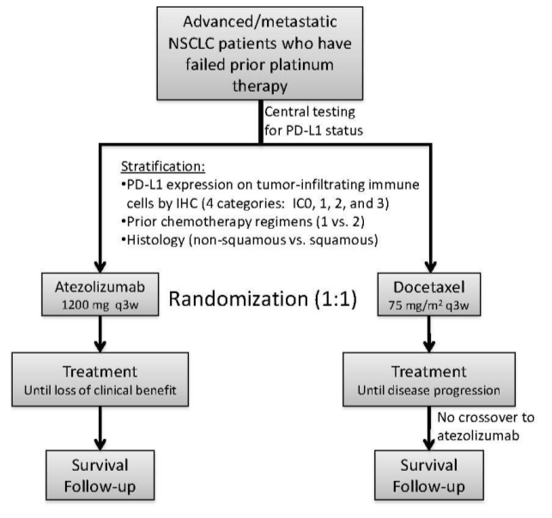
IHC = immunohistochemistry; IC = tumour-infiltrating immune cell; NSCLC = non-small cell lung cancer; PD-L1 = programmed death-ligand 1; q3w = every 3 weeks.
The study included male and female patients aged ≥ 18 years with ECOG PS scores of 0 or 1 with histologically or cytologically proven locally advanced or metastatic NSCLC who had experienced disease progression during or following treatment for advanced disease consisting of platinum-based chemotherapy. A total of 1225 patients were enrolled, with the primary analysis population consisting of the first 850 randomised intent-to-treat (ITT) patients.
Tumour specimens from eligible patients were prospectively tested for PD-L1 expression by a central laboratory using the IHC VENTANA PD-L1 (SP142) assay. Both patients and investigators were blinded to the PD-L1 expression status. The study enrolled all patients whose tissue was evaluable for expression testing, regardless of PD-L1 expression status. The PD-L1 IHC scoring system was developed to measure PD-L1 specific signals on tumour-infiltrating immune cells (ICs) and on tumour cells (TCs).
At the time of study initiation, available data from the Phase I study PCD4989g indicated that radiographic response was associated with expression of PD-L1 on IC and not TC. Therefore, patients were stratified at randomisation based on four levels of IC expression determined during the screening stage (i.e. IC0, IC1, IC2, and IC3). Later, additional data from study PCD4989g, FIR, and POPLAR showed that PD-L1 expression on TC was also predictive for efficacy of atezolizumab in patients with NSCLC. Based on these emerging data, PD-L1 expression levels for analyses were modified to be defined by combined TC and IC levels. Combined TC and IC scores (TC1/2/3 or IC1/2/3, TC2/3 or IC2/3, TC3 or IC3, and TC0 and IC0) were determined from centrally undertaken re-reads of PD-L1 stained tumour sections prior to database lock for the primary analysis, using the same previously PD-L1 stained tumour sections from enrolment.
The stepwise re-reads PD-L1 stained tumour sections were performed by pathologists who were trained to assess the percentages of membrane staining at three different cut-off levels (TC1 or IC1, TC2 or IC2, TC3 or IC3) for TC and IC. The pathologists had no access to clinical data, original IC and TC expression data obtained prior to randomisation, or reads at other cut-off levels that they did not score. The three sets of re-reads for PD-L1 expression subgroups of interest (TC1/2/3 or IC1/2/3, TC2/3 or IC2/3, TC3 or IC3) were performed at separate time-points and labelled TC1IC1 re-read, TC2IC2 re-read, and TC3IC3 re-read, respectively. When multiple samples were available for a patient, the maximum PD-L1 expression read for a specific cut-off was used for data analyses.
The sponsor stated that rereads were performed at validated cut-offs, which provided for ‘robust definition of PD-L1 expression subgroups’. However, the centrally undertaken rereads for PD-L1 expression were undertaken by two laboratories (QLabs and HistoGeneX). Consequently, there is potential for inconsistencies between the two laboratories relating to the interpretation of the cut-off points for PD-L1 IC and TC subgroups.
Eligible patients were stratified by PD-L1 IC status (i.e. IC0, IC1, IC2, or IC3), by the number of prior chemotherapy regimens (i.e. 1 vs 2), and by histology (i.e. non-squamous vs squamous) and then randomised 1:1 to receive either atezolizumab or docetaxel. Patients were enrolled until at least 220 patients with TC3 or IC3, approximately 330 patients with TC3 or IC2/3, and approximately 1100 (up to a maximum of 1300) total patients were randomised.
Atezolizumab at a fixed dose of 1200 mg IV was administered on Day 1 of each 21-day cycle. Patients who met RECIST v1.1 criteria for progressive disease (PD), or in whom radiographic disease progression was confirmed at a subsequent tumour assessment, were permitted to continue atezolizumab treatment at the discretion of the investigator if they met all of the following criteria: (i) evidence of clinical benefit as assessed by the investigator; (ii) absence of symptoms and signs, including worsening of laboratory values, indicating unequivocal progression of disease; (iii) no decline in ECOG performance status attributable to disease progression; (iv) absence of tumour progression at critical anatomical sites (e.g. leptomeningeal disease) that could not be managed by protocol-allowed medical interventions; and (v) patients for whom approved therapies exist provided written consent to acknowledge deferring these treatment options in favour of continuing study treatment at the time of initial progression. A tumour biopsy at the time of first radiographic progression on atezolizumab treatment, if clinically feasible, was encouraged in order to distinguish pseudoprogression / tumour immune infiltration from true disease progression.
Docetaxel 75 mg/m² IV was administered on Day 1 of each 21-day cycle until disease progression per standard RECIST v1.1 or unacceptable toxicity. The sponsor stated that the study was open-label because of identifiable toxicities associated with docetaxel (i.e. alopecia, neutropenia, febrile neutropenia) and identifiable pre-medications required for docetaxel treatment (i.e. steroid, anti-emetics, and potentially growth factor support). No crossover was allowed from the control arm (docetaxel) to the experimental arm (atezolizumab).
Tumour assessments were conducted every 6 weeks for the first 36 weeks, and every 9 (± 1) weeks thereafter. For patients randomised to docetaxel, assessments continued until disease progression per RECIST v1.1, regardless of whether treatment was discontinued. For patients randomised to atezolizumab, assessments continued until disease progression per RECIST v1.1 (for patients who discontinued treatment) or until treatment discontinuation (for patients who continued to receive atezolizumab following disease progression). Tumour assessments continued regardless of whether patients started new anti-cancer therapy in the absence of disease progression until withdrawal of consent, death, or study termination by the sponsor, whichever occurred first. Follow-up, including survival status and subsequent anti-cancer therapies, continued for each patient until death, loss of follow-up, withdrawal of consent, or study termination by the sponsor, whichever occurred first.
Screening assessments included CT scans (with oral/IV contrast unless contraindicated) or MRI of the chest, abdomen, and pelvis. MRIs of the chest, abdomen, and pelvis with a non-contrast CT scan of the chest could be used in patients for whom CT scans with contrast were contraindicated. The same radiographic procedure used to assess disease sites at screening was used throughout the study.
For subsequent tumour assessments, procedures were performed as clinically indicated. All known sites of disease were documented at screening and re-assessed at each subsequent tumour evaluation. Response was assessed by the investigator using RECIST v1.1 (for all patients) and modified RECIST criteria (for patients randomised to atezolizumab).
An Independent Data Monitoring Committee (iDMC) evaluated the safety data on a periodic basis during the study at approximately every 6 months from the point of first patient included in the study until the clinical database was locked and the study was unblinded for the primary efficacy analysis. There was no review of efficacy data by the iDMC. Members of the iDMC were external to the sponsor and followed a charter that outlined their roles and responsibilities.
The first version of the protocol was issued on 7 November 2013 and was amended five times. The amendments have been examined and are considered not to affect the validity of the study results reported in the CSR.
Comment: The study design is satisfactory. However, the absence of double-blinding results in the study being subject to the well-known biases associated with open-label designs. The sponsor considers that blinding was inappropriate given the recognisable well known toxicities associated with docetaxel treatment and the need for identifiable pre-medication with this drug. These reasons are considered to be acceptable. The biases associated with the open-label design of OAK are mitigated due to the unequivocal objectively determined primary objective (i.e. overall survival).
The secondary efficacy objectives of PFS, ORR, and DOR are based on disease progression assessed by the investigator using RECIST v1.1 (i.e. standard criteria for oncology trials in solid tumours). It is considered that it would have been preferable to have assessed disease progression per RECIST v1.1 using a centralised facility. The use of a centralised assessment facility would have reduced potential subjective differences in interpretation of disease progression among the numerous investigators involved in the study. Nevertheless, the open-label design of the study is considered adequate to assess the efficacy of atezolizumab compared to docetaxel.
The study allowed patients in the atezolizumab arm to continue treatment after disease progression provided pre-specified criteria were met. The sponsor commented that conventional response criteria may not adequately assess the activity of immunotherapeutic agents because PD (by initial radiographic evaluation) may not necessarily reflect therapeutic failure. Therefore, because of the potential for pseudoprogression/tumour immune infiltration the study allowed patients randomised to atezolizumab to remain on study treatment after apparent radiographic progression, provided the benefit-risk ratio was judged to be favourable. This is considered to be acceptable.

Inclusion and exclusion criteria
The study included patients who were at least 18 years of age with squamous or non-squamous NSCLC and measurable disease per RECIST v1.1, and ECOG PS score of 0 or 1. Patients were required to have received 1-2 previous cytotoxic chemotherapy regimens (≥ 1 platinum based combination therapy) for stage IIIB or IV NSCLC. Patients with EGFR mutations or an ALK fusion oncogene were also required to have received previous tyrosine kinase inhibitor therapy. Patients with treated asymptomatic supratentorial CNS metastases were eligible for enrolment. Prior to study entry patients were required to have representative formalin-fixed paraffin-embedded (FFPE) tumour specimens in paraffin blocks (preferred) or at least 15 unstained slides, with an associated pathology report, which were determined to be evaluable for tumour PD-L1 expression by centralised re-reading following randomisation at a later time point in the study. Patients with fewer than 15 unstained slides available at baseline (but no fewer than 10) could be eligible following discussion with the Medical Monitor.
The study excluded patients who had a history of autoimmune disease, active or corticosteroid-dependent brain metastases, administration of a live, attenuated vaccine within 28 days prior to enrolment, administration of systemic immunostimulatory agents within 4 weeks, or systemic immunosuppressive medications within 2 weeks prior to enrolment. Patients who had been previously treated with docetaxel were also excluded.

Study treatments

Atezolizumab
Atezolizumab was administered at a dose of 1200 mg by IV infusion q3w (21 ± 3 days) until loss of clinical benefit or unacceptable toxicity. No premedication was allowed for the first dose of atezolizumab. Premedication could be administered for Cycles ≥ 2 at the discretion of the treating physician. The atezolizumab fixed dose of 1200 mg was selected on the basis of both non-clinical studies and available clinical data from study PCD4989g.
Guidelines were provided for dosage modification, treatment interruption, or discontinuation. However, dose reductions were not allowed for atezolizumab. Patients could temporarily suspend atezolizumab for up to 105 days from the last dose if they experienced AEs that required withholding a dose. If atezolizumab was withheld because of AEs for > 105 days after the last dose, then the patient was discontinued from atezolizumab treatment and was followed for safety and efficacy. If, in the judgment of the investigator, the patient was likely to derive clinical benefit from atezolizumab after a hold of > 105 days, then the study drug could be restarted with the approval of the Medical Monitor. If a patient had to be tapered off steroids used to treat AEs, atezolizumab could be withheld for > 105 days from the last dose until steroids were discontinued or reduced to prednisone dose (or dose equivalent) of ≤ 10 mg/day. The acceptable length of interruption depended on an agreement between the investigator and the Medical Monitor. Dose interruptions for reasons other than AEs, such as surgical procedures, were allowed with Medical Monitor approval. The acceptable length of interruption depended on agreement between the investigator and the Medical Monitor. Management of atezolizumab specific AEs were specified in the protocol.

Docetaxel
Docetaxel was administered according to the locally approved prescribing information document. Pre-treatment with corticosteroids was required, and guidelines for pre-medication and supportive measures for docetaxel treatment were provided in the protocol. The starting dose of docetaxel was 75 mg/m² q3w. Dose modifications were performed according to the protocol. Treatment continued until disease progression or unacceptable toxicity.

Concomitant medications
Concomitant therapy included any prescription medications or over-the-counter preparations used by a patient between the 7 days preceding the screening evaluation and the treatment discontinuation visit. Permitted concomitant medications were specified in the protocol as were excluded therapies.
Any concomitant therapy intended for the treatment of cancer, whether health authority-approved or experimental, was prohibited. The following medications were excluded while the atezolizumab treated patients were receiving study treatment: traditional herbal medicines, RANKL inhibitor, immunomodulatory agents, and immunosuppressive medications. Initiation or increasing the dose of granulocyte colony stimulating factors were also prohibited. In addition, patients treated with atezolizumab were not to receive other immunomodulatory agents for 10 weeks after study treatment discontinuation.
Patients randomised to docetaxel had to avoid using concomitant strong CYP3A4 inhibitors, as docetaxel is a CYP3A4 substrate. In addition, concomitant treatment with CYP3A4 inducers may decrease plasma concentrations of docetaxel. Therefore, concomitant medications that are CYP3A4 inducers were to be used with caution. Granulocyte colony stimulating factor treatment was permitted for patients in the docetaxel arm. Anti-emetics, anti-allergic measures, and other treatments for concomitant docetaxel toxicities could be used at the discretion of the investigator.

Efficacy endpoints
The primary efficacy endpoint was overall survival (OS) in months, defined as the time from the date of randomisation to the date of death from any cause.
The secondary efficacy endpoints were: (i) progression free survival (PFS) in months defined as the interval between the date of randomisation and the date of first documented disease progression (PD) determined by the investigator per RECIST v1.1 or death; (ii) overall response rate (ORR) defined as the proportion of patients achieving confirmed best response of complete response (CR) or partial response (PR) determined by the investigator per RECIST v1.1; and (iii) duration of response (DOR) in months, defined as the interval between the first documented objective response (CR or PR) and first documented PD or death.
Comment: The primary endpoint of OS is consistent with the TGA adopted EU guideline relating specifically to NSCLC (i.e. Appendix 4 to the guideline on the evaluation of anticancer medicinal products in man. Condition specific guidelines. EMA/CHMP/703715/2012). These guidelines state that ‘[i]improving survival remains the principal objective for patients with NSCLC and in many cases OS should be selected as the primary endpoint for confirmatory studies. If, however, the experimental regimen is likely to be well tolerated, PFS benefit might enable a proper benefit – risk assessment, especially if supported by data on HRQoL/PRO’. The choice of OS as a primary endpoint and PFS as a secondary endpoint is also consistent with the TGA adopted EU guideline (Guideline on the evaluation of anticancer medicinal products in man. EMA/CHMP/205/95/Rev.4) This guideline states that ‘[a]cceptable primary endpoints for confirmatory Phase III trials include cure rate, OS and PFS/DFS’.

Randomisation and blinding methods
After written informed consent was obtained and eligibility was established (including determination of tumour PD-L1 status by central testing), the study site entered demographic and baseline characteristics in the interactive voice/web response system (IxRS) and obtained the patient’s randomisation number and treatment assignment. Randomisation to one of the two treatment arms occurred in a 1:1 ratio. Permuted-block randomisation was applied to ensure a balanced assignment to each treatment arm.
As mentioned above, randomisation was stratified by the following factors: (i) PD-L1 expression on ICs by IHC (IC0, IC1, IC2, and IC3); (ii) number of prior chemotherapy regimens (1, 2); and (iii) histology (non-squamous, squamous). If possible, patients received their first dose of study treatment on the day of randomisation. If this was not possible, the first dose was administered no later than 3 business days after randomisation.
The study was open-label.

Analysis populations

Primary population (ITT)
The Primary Population (PP) includes the first 850 randomised ITT patients regardless of whether they received any study drug. Primary efficacy analyses reported in the CSR were conducted on this population. The PP patients were analysed according to the treatment assigned at randomisation by the IxRS. Within the primary population of 850 randomised patients, four PD-L1 expression subgroups of TC1/2/3 or IC1/2/3, TC2/3 or IC2/3, TC3 or IC3, and TC0 and IC0 were defined based on the centralised re-reads of the slides previously stained for PD-L1 at the time of enrolment.

Secondary population
The Secondary Population (SP) includes all 1225 randomised ITT patients regardless of whether they received any study drug. The efficacy analysis in this population will be reported at a later date.

Safety evaluable population
The safety analyses reported in the CSR are based on all randomised patients who received any dose of study drug during the study treatment period at the time of the primary analysis. Patients who received any dose of atezolizumab were analysed as part of the atezolizumab arm even if atezolizumab was given in error. Patients who were randomised to the study but who did not receive any study drug were not included in the Safety Evaluable population.

Pharmacokinetic (PK) evaluable population
The PK Evaluable population is defined as patients who received atezolizumab treatment and have at least one measureable PK concentration.

Summary
The OAK analysis sets are summarised below.
Table 110: OAK – summary of the analysis sets.
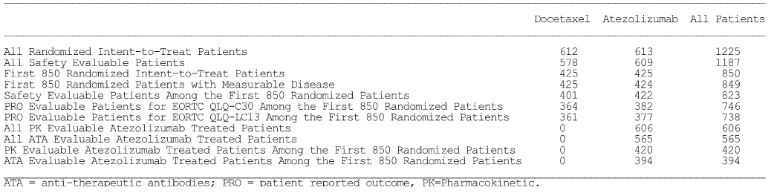

Sample size
At the time OAK was initially designed it was powered for IC2/3 patients with a sample size of 850 (255 IC2/3 patients and 425 IC1/2/3 patients). Emerging data from other atezolizumab NSCLC studies (POPLAR, PCD4989g [NSCLC cohort] and FIR) demonstrated that TC3 or IC3 patients with NSCLC showed the strongest treatment benefit for OS, PFS, and ORR. As a result, the study was resized to fully power for testing OS benefit in the TC3 or IC3 subgroup (1100 patients, up to a maximum of 1300), assuming a 20% prevalence of the TC3 or IC3 subgroup. The final enrolment in OAK was 1225 randomised patients.
Subsequently, the primary analysis of POPLAR showed that the OS treatment benefit extended beyond the TC3 or IC3 subgroup to broader subgroups. Study design assumptions in OAK based on these results led to a fully powered study for OS evaluation in an ITT population with fewer than 1225 patients. Therefore, as outlined in the study protocol and prior to unblinding of the data, the planned primary OS analysis in OAK was modified to be conducted on the Primary Population (PP) of the first randomised 850 ITT patients at the Primary Analyses Time (PAT). The secondary OS analysis for the Secondary Population of all 1225 randomised ITT patients will be conducted at the Secondary Analyses Time (SAT).
To control the type I error rate in the evaluation of OS in the primary and secondary populations, alpha was first split between the ITT population and the TC1/2/3 or IC1/2/3 subgroup of the primary population. OS testing in the primary population started with a 3% alpha (two-sided) in the ITT population and a 2% alpha (two-sided) in the TC1/2/3 or IC1/2/3 subgroup of the primary population (i.e. first 855 randomised ITT patients). The sponsor stated that if either of these two hypotheses was rejected (i.e. presumably null hypotheses rejected), then the remaining alpha would be split between the ITT population and the TC1/2/3 or IC1/2/3 subgroup of the secondary population first, and subsequently, the further remaining alpha would be spent on the TC2/3 or IC2/3 subgroup in the secondary population of the 1225 ITT patients, and lastly, passed down to the TC3 or IC3 subgroup in the secondary population of the 1225 ITT patients. The type 1 error control plan (two-sided) is summarised below.
Figure 28: OAK – Type 1 error control plan (two sided).
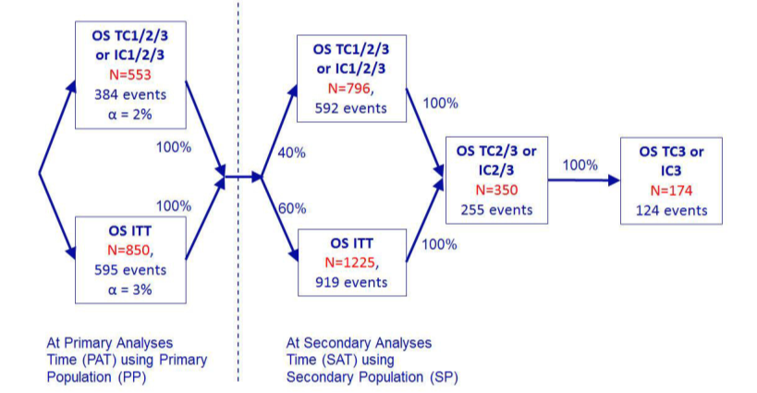
Estimates of the number of events required to demonstrate efficacy with regard to OS were based on the following assumptions: (i) event times exponentially distributed; (ii) a 7.5% 24-month dropout rate for both treatment arms; (iii) > 95% power for the primary analyses of OS and > 80% power for the secondary analyses of OS; (iv) median survival of 10 months in the docetaxel arm for the ITT and PD-L1 expression subgroups; and (v) 65% prevalence rate for TC1/2/3 or IC1/2/3.
With these assumptions, the estimated number of events and the minimum detectable difference (MDD) of hazard ratios (HRs) in the primary population (ITT) and the TC1/2/3 or IC1/2/3 subgroup for the first 850 randomised ITT patients in the primary population are presented below.
Table 111: OAK – Power and MDD for the proposed design of the primary population for overall survival at the primary analyses time.
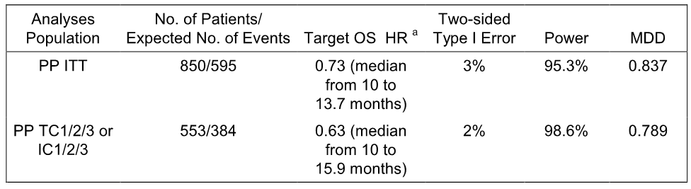
HR = hazard ratio; IC = tumour-infiltrating immune cell; ITT = intent-to-treat; MDD = minimum detectable difference; OS = overall survival; PAT= Primary Analyses Time; PP = Primary Population; TC = tumour cell. [a] The lower median applies to the docetaxel arm and the higher median to the atezolizumab arm.

Statistical methods

Primary analyses time (PAT)
For the primary analyses time, the clinical data cut-off date was when approximately 595 deaths had occurred in the primary population of the first 850 randomised ITT patients. The date when approximately 595 deaths in this population was expected to occur depended on the event rate and was expected to be approximately 29 months after the first patient was enrolled. On the basis of the assumptions listed above, it was estimated that at the primary analyses time for OS in the first 850 randomized ITT patients, approximately 384 deaths would have been observed in the TC1/2/3 or IC1/2/3 subgroup.

OS (primary efficacy end point)
The primary efficacy endpoint was the duration of OS (in months), which was defined as the difference in time from the date of randomisation to the date of death due to any cause. Data for patients who were not reported as having died at the time of analysis were censored at the date they were last known to be alive. Patients who did not have post-baseline information were censored at the date of randomisation plus 1 day. The OS analyses were performed for the primary population at the time of the primary analyses and results were presented in the submitted CSR. OS analyses will be performed for the secondary population at the secondary analyses times and results will be presented in a separate report.
For the primary population of the first 850 randomised ITT patients, the two treatment comparisons with respect to OS in the primary population (ITT) and the TC1/2/3 or IC1/2/3 subgroup were based on a stratified log-rank test at the two-sided level of significance, which was determined from the testing procedure described above. The stratification factors were those used during randomisation (i.e. tumour PD-L1 status [four categories of PD-L1 IC expression] per IxRS, the number of prior lines of therapy [1, 2] per IxRS, and histology [non-squamous, squamous] per eCRFs). An unstratified analysis was performed on the TC2/3 or IC2/3, TC3 or IC3, and TC0 and IC0 subgroups, as they are not part of the primary testing hierarchy of efficacy.
The null (H₀) and alternative (H₁) hypotheses for the OS analysis in the ITT population, as well as in the TC1/2/3 or IC1/2/3 subgroup, were phrased in terms of the survival functions SA(t) in the atezolizumab arm (Arm A) and SB(t) in docetaxel arm (Arm B):
H₀: SA(t) = SB(t) versus H₁: SA(t) ≠ SB(t)
Kaplan-Meier methodology was used to estimate the median OS for each treatment arm and to construct survival curves for the difference between the treatment arms. The Brookmeyer-Crowley methodology was used to construct the 95% CI for the median OS for each treatment arm.
The HR (i.e. hazard of death in Arm A [atezolizumab] relative to the hazard of death in Arm B [docetaxel]) was estimated using a stratified Cox regression model, with the same stratification variables used in the stratified log-rank test, and the associated 95% CI was calculated.

Secondary efficacy endpoints
- PFS was the interval between the date of randomisation and the date of first documented PD (investigator-assessed per RECIST v1.1) or death. Censoring took place at the time of the last tumour assessment for those patients without PD and alive or at the date of randomisation plus 1 day for those patients without a post-baseline assessment. The data were analysed using same methodology as used to analyse OS.
- ORR was the proportion of patients achieving a confirmed best response of CR or PR, investigator assessed per RECIST v1.1. The Cochran-Mantel-Haenszel test was used to compare the ORRs, and the 95% CI of the response rates was estimated using the Clopper-Pearson method.
- The DOR was the interval between the first documented objective response (CR or PR) and first documented PD or death. Patients without PD or death were censored at the data of the last tumour assessment. The data were analysed using same methodology as used to analyse OS and PFS.

Subgroup analyses
The consistency of OS results in important subgroups was examined based on the primary population (ITT). The subgroups were defined by demographic (e.g. age and sex) and baseline prognostic characteristics (e.g. PD-L1 expression subgroups, ECOG performance status, prior lines of chemotherapy, histology, smoking history).
An analysis of OS and PFS by the best overall response was also performed.
Efficacy, including OS, PFS, ORR, and DOR, was evaluated in the PD-L1 mutually exclusive subgroups.
In subgroup analyses, summaries of OS, including the unstratified HR estimated from a Cox proportional hazards model and Kaplan-Meier estimates of median survival time, were produced separately for each level of the categorical variables and displayed on a Forest plot. Additionally, estimates of median OS and survival curves were constructed for PD-L1 expression subgroups using Kaplan-Meier methodology. Similar analyses were conducted for PFS and DOR. Summaries of ORR by subgroups were also provided.

Changes to the planned analyses
The changes to the planned analyses were described in the CSR. These changes have been examined and are considered not to have affected the validity of the analyses reported in the CSR.

Participant flow
A total of 1379 patients were screened, and 850 patients from 177 centres in 28 countries were randomised. A total of 529 patients failed screening based on information collected on the IxRS. The most common reasons for screen failure were lack of suitable tumour specimen (113 patients) and the presence of active or untreated CNS metastases (86 patients).
A total of 850 patients were randomised (425 patients to the docetaxel arm and 425 patients to the atezolizumab arm). Overall, 3.2% of patients did not receive any study treatment (5.4% in the docetaxel arm vs 0.9% in the atezolizumab arm). The most common reason for not receiving any study treatment was patient withdrew consent (4.5%) in the docetaxel arm and death (0.5%) in the atezolizumab arm.
At the clinical data cut-off date of 7 July 2016, more patients in the atezolizumab arm (29.9%) were alive and on-study compared to the docetaxel arm (18.4%), and included a higher proportion of patients still receiving atezolizumab treatment (13.6%) compared to docetaxel (0.7%). A similar proportion of patients in both arms were alive in the survival follow-up period (17.6% docetaxel vs 16.2% atezolizumab). More deaths had occurred in the docetaxel arm (69.9%) than in the atezolizumab arm (63.5%). The patient disposition (primary population) is summarised below.
Figure 29: OAK – Patient disposition (primary population).
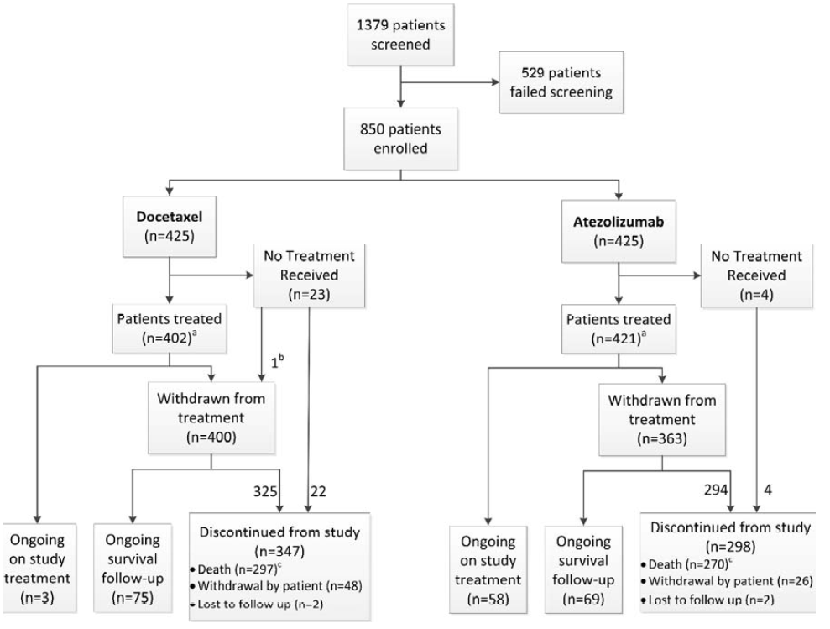
[a] One patient randomized to docetaxel received atezolizumab. [b] One patient withdrew from treatment before receiving any dose of study drug, but did not withdraw from the study at the time of the clinical cutoff date. [c] Two additional deaths (1 docetaxel, 1 atezolizumab) were collected from public record for a total of 298 deaths in the docetaxel arm and 271 deaths in the atezolizumab arm. These 2 patients are captured in the study discontinuation eCRF as ‘withdrawal by patient’, but were included as deaths (i.e. not censored) in the efficacy analyses.

Major protocol violations/deviations
In the primary population, the incidence of major protocol deviations was similar in the two treatment arms (20.2% docetaxel vs 22.2% atezolizumab). All patients with protocol deviations were included in the efficacy analyses presented in this CSR.
The proportion of patients with at least one major inclusion and/or exclusion criteria deviation at study entry was similar in the two treatment arms (4.9% docetaxel vs 4.7% atezolizumab). The most frequent study eligibility violation in both treatment arms (1.4%) was ‘does not meet prior NSCLC therapy requirements’. In addition, 1.4% of patients in the atezolizumab arm did not meet the study entry criterion for laboratory parameters.
A similar proportion of patients in the treatment arms had a major on-study protocol violation (16.5% docetaxel vs 19.8% atezolizumab). The most common on-study protocol deviation was ‘other procedural deviation significant for safety and/or efficacy’ (i.e. not related to prohibited medication or incorrect dose received), with a similar incidence in the treatment arms (15.5% docetaxel vs 16.5% atezolizumab). The category of ‘other procedural deviation significant for safety and/or efficacy’ specifically included missing lab or tumour assessment, tumour assessment performed out of window, failure to report SAE within 24 hours, delay in obtaining signature for informed consent form amendment or to allow continuation of treatment after disease progression.
In addition, 3 (0.7%) patients in the docetaxel arm and 19 (4.5%) patients in the atezolizumab arm received ‘treatment beyond discontinuation criteria’, 2 (0.5%) patients in the docetaxel arm and 1 (0.2%) patient in the atezolizumab arm received a prohibited concomitant medication, 2 (0.5%) patients in the docetaxel arm had deviations in the category of ‘incorrect study treatment or wrong dose’ and of 1 of these patients received atezolizumab rather than docetaxel.
Comment: In the primary population, major protocol deviations occurred commonly and with a similar incidence in both treatment arms. However, it is considered unlikely that the major protocol deviations observed in the primary population significantly affect the validity of the efficacy results reported in the CSR. The major protocol deviations for the secondary population were also provided in the CSR, and the incidence of major protocol deviations was similar in the two treatment arms (19.0% [116/612] docetaxel vs 21.0% [129/613] atezolizumab). The pattern of major protocol violations/deviations reported in the secondary population was similar to that observed in the primary population. All treated patients with protocol deviations were included in the safety analyses presented in the CSR. It is considered unlikely that the major protocol deviations observed in the secondary population significantly affect the validity of the safety results reported in the CSR.

Baseline data and concomitant treatments

Demographics
The baseline demographics in ITT population (n = 850) were well balanced between the two treatment groups. In the total population (n = 850), the median age was 64.0 years (range: 33, 85 years), 53.3% were aged < 65 years and 46.7% were aged ≥ 65 years, 61.2% were male and 38.8% were female, 70.4% were White, 21.2% were Asian and the remainder were from various other racial groups. The majority of patients in the total population had an ECOG PS score of 1 (62.9%), with the remainder having an ECOG PS score of 0 (37.1%). There were no patients with an ECOG PS score of 2, which was consistent with the inclusion criterion relating to PS. The majority of patients in the total population had been previous smokers (66.8%), while 14.8% were current smokers and 18.4% had never smoked.
Demographic characteristics in the TC3 or IC3, TC2/3 or IC2/3, TC1/2/3 or IC1/2/3, and TC0 and IC0 subgroups were generally consistent with total primary population (ITT). Within each of the PD-L1 expression subgroups, demographics were generally well balanced between treatment arms.
The demographics of the 1225 patients in the secondary population were consistent with the demographics of the 850 patients in the primary population.

NSCLC characteristics
NSCLC history was comparable between the two treatment arms. With respect to the two NSCLC baseline stratification factors (prior chemotherapy regimens and histology), the majority of patients in the primary population had received one prior chemotherapy regimen in the locally advanced or metastatic setting (75.3% in each treatment arm) and the majority of patients had non-squamous disease per eCRF (74.1% docetaxel vs 73.6% atezolizumab). Similar percentages to those observed in the primary population were reported in the TC1/2/3 or IC1/2/3 subgroup.
With regard to other NSCLC characteristics in the primary population, the median time from initial NSCLC diagnosis to randomisation was similar in the treatment arms (13.0 months docetaxel vs 14.0 months atezolizumab). The majority of patients had metastatic disease (95.5% docetaxel vs 93.2% atezolizumab). Overall, 59.3% of patients were diagnosed with stage IV NSCLC cancer at initial diagnosis per the UICC/AJCC staging system (60.5% docetaxel vs 58.1% atezolizumab). The median number of metastatic sites at enrolment was 3 sites in both treatment arms, with the range being 1 to 8 in both arms. Similar proportions of patients in each treatment arm had a history of other site-specific metastasis at study enrolment, including brain metastases in 11.1% of patients in the docetaxel arm and 8.9% of patients in the atezolizumab arm. Similar percentages for NSCLC characteristics to those observed in the primary population were reported in the TC1/2/3 or IC1/2/3 subgroup.
In the primary population, positive mutation status was observed for EGFR in 10.0% of patients (10.1% docetaxel vs 9.9% atezolizumab), EML4-ALK in 0.2% of patients (0% docetaxel vs 0.5% atezolizumab), and KRAS in 6.9% of patients (7.8% docetaxel vs 6.1% atezolizumab). Of all patients with known status (positive or negative), the proportion of positive mutation status increased to 11.9% (85/713) for EGFR, 0.5% (2/426) for EML4-ALK, and 22.5% (59/262) for KRAS. Similar percentages for EGFR, EMLALK and KRAS mutation status to those observed in the primary population were reported in the TC1/2/3 or IC1/2/3 subgroup.

PD-LI expression status at baseline
The prevalence of the PD-L1 expression subgroups in the primary population was 16% for TC3 or IC3, 31% for TC2/3 or IC2/3, and 54% for TC1/2/3 or IC1/2/3. IC levels (based on the TC1IC1 stepwise re-read) were balanced between treatment arms across all expression levels, which was expected given that PD-L1 expression IC was a stratification factor at randomisation. The majority of patients in both treatment arms were IC0 (51.5% docetaxel vs 49.4% atezolizumab) or IC1 (33.4% docetaxel vs 37.2% atezolizumab). TC levels were also balanced between treatment arms across all expression levels with the majority of patients in both treatment arms being TC0 (69.6% docetaxel vs 69.2% atezolizumab). The combination of TC and IC PD-L1 expression levels (TC/IC four incremental subgroups) showed that all subgroups were reasonable well balanced between treatment arms, with the percentage of patients in the two treatment arms in all four groups not differing by ≥ 6%.

Previous and concurrent medical conditions
Previous and ongoing medical conditions reported in the primary population reflect the expected comorbidities of a population of patients with advanced NSCLC, and were generally well balanced with regard to system organ classes (SOCs) and individual medical history conditions.
In the primary population, the most frequently reported (≥ 50% overall incidence in any arm) SOCs for medical conditions at baseline (either resolved or ongoing at baseline) were respiratory, thoracic and mediastinal disorders, and vascular disorders. Medical conditions at baseline were reported to be similar in the TC1/2/3 or IC1/2/3 subgroup and in the secondary population to those observed in the primary population.
At baseline, 94.5% of patients in the primary population reported at least one ongoing condition unrelated to NSCLC (95.3% docetaxel vs 93.6%). The most frequently reported SOCs (≥ 30% overall incidence in any arm) in which concurrent conditions were reported (docetaxel vs atezolizumab) included: (i) Respiratory, Thoracic and Mediastinal Disorders, including cough (23.1% vs 25.6%), dyspnoea (17.4% vs 20.0%), chronic obstructive pulmonary disease (18.4% vs 16.7%); (ii) Vascular Disorders, including hypertension (41.4% vs 41.1%), deep vein thrombosis (1.2% vs 2.8%); (iii) Metabolism and Nutrition Disorders, including hypercholesterolaemia (8.7% vs 10.8%), hyperlipidaemia (8.0% vs 8.9%), decreased appetite (8.7% vs 7.3%); (v) Musculoskeletal and Connective Tissue Disorders, including back pain (12.5% vs 11.3%), osteoarthritis (5.4% vs 6.4%); (vi) Gastrointestinal Disorders, including constipation (12.7% vs. 12.0%), gastroesophageal reflux disease (11.5% vs 10.1%), nausea (8.9% vs 9.4%); and (vii) General Disorders and Administration Site Conditions, including fatigue (14.8% in each arm), chest pain (7.5% vs 7.1%), pain (4.7% vs 5.9%).

Previous treatment for NSCLC
At the time of enrolment, all patients in the primary population except one in the docetaxel arm had received at least one prior anti-cancer therapy. Similar proportions of patients in the docetaxel and atezolizumab arms had received prior therapy for their underlying disease in the metastatic setting (87.1% vs 90.6%, respectively) and in the neo-adjuvant or adjuvant setting (24.2% vs 22.8%, respectively). The majority of patients had received standard chemotherapy treatment for their metastatic disease (carboplatin, pemetrexed, cisplatin, paclitaxel, gemcitabine). The most common prior cancer therapies received (≥10% of patients in either treatment arm) are shown below. Similar findings were reported for the TC1/2/3 or IC1/2/3 subgroup.
Table 112: OAK – Prior cancer therapies reported by ≥ 10% of patients in either treatment arm, primary population.
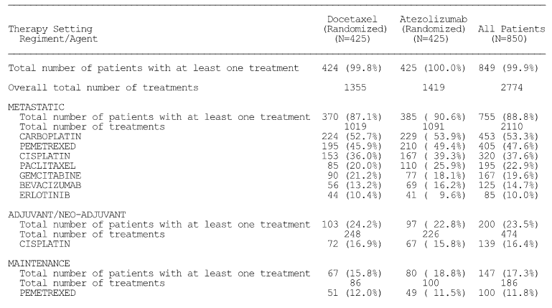
Multiple uses of a specific medication for a patient were counted once in frequency for the medication. Likewise, multiple uses within a specific medication class for a patient were counted once in frequency for the medication class.
A total of 44% of patients in the primary population had received prior surgery for cancer, with lobectomy (16.0% docetaxel vs 16.7% atezolizumab) being the most commonly reported procedure. Other surgical procedures to the lung were reported for 15.5% of patients (12.9% docetaxel vs 18.1% atezolizumab). Similar findings were reported in the TC1/2/3 or IC1/2/3 subgroup.
A total of 47.4% of patients in the primary population had received prior radiotherapy (47.5% docetaxel vs 47.3% atezolizumab), most frequently administered to treat metastatic disease (28.5% docetaxel vs 32.2% atezolizumab). Similar findings were reported in the TC1/2/3 or IC1/2/3 subgroup.

Concomitant treatments not for cancer
Nearly all patients (94.2%) received at least one concomitant medication initiated on or after the first dose of study treatment, and this parameter was well balanced between the treatment arms (92.2% docetaxel vs 96.2% atezolizumab). The most commonly used classes of medication (≥ 25% of patients in either arm, docetaxel vs atezolizumab) were: (i) steroids (75.1% vs 40.0%), the sponsor commented that ‘given that steroids are standard pre-medication for docetaxel, this imbalance is not unexpected’; (ii) analgesics (36.2% vs 39.3%); (iii) opioid analgesics (24.9% vs 33.2%); and (iv) quinolone antibiotics (30.1% vs 27.3%).

Results for the primary efficacy outcome of overall survival (OS)

OS results for the co-primary endpoints
The study met its co-primary endpoints of demonstrating a statistically significant and clinically meaningful improvement in OS with atezolizumab compared to docetaxel in the primary population as well as the TC1/2/3 or IC1/2/3 subgroup (see below).
In the primary population, median OS was 4.2 months longer in the atezolizumab arm than in the docetaxel arm. The stratified HR was 0.73 (95% CI: 0.62, 0.87), which represents a 27% increase in survival in the atezolizumab arm relative to the docetaxel arm.
In the TC1/2/3 or IC1/2/3 subgroup, median OS was 5.4 months longer in the atezolizumab arm than in the docetaxel arm. The stratified HR was 0.74 (95% CI: 0.58, 0.93), which represents a 26% increase in survival in the atezolizumab arm relative to the docetaxel arm.
In the ITT population, the median duration of survival follow-up at the data cut-off date of 7 July was similar for the two treatment arms (21.3 months in the docetaxel arm [range: 0.0+, 26.9+; + denotes a censored value] and 21.4 months in the atezolizumab arm [range: 0.1 to 27.1]). The minimum follow-up time at the time of the clinical cut-off date was 19 months (duration from last patient randomisation date to clinical cut-off date).
Table 113: OAK – Overall survival in the primary population (ITT).
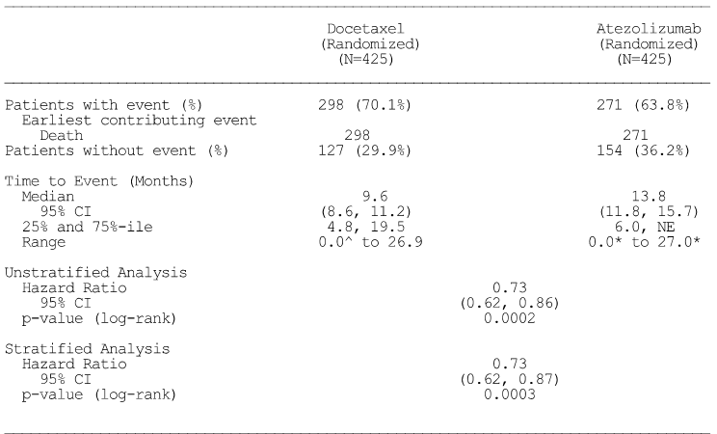
* Censored, ^ Censored and event, NE = Not estimable. Summaries of Time-to-Event (median, percentiles) are Kaplan-Meier estimates. 95% CI for median was computed using the method of Brookmeyer and Crowley. Hazard ratios were estimated by Cox regression. Strata are: IC levels per IxRS, the number of prior chemotherapy regimens per IxRS, and histology per eCRF.
Table 114: OAK – Overall survival in the TC1/2/3 or IC1/2/3 subgroup.
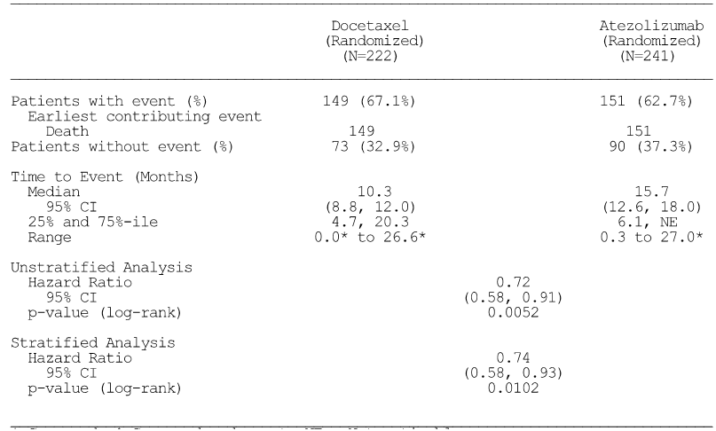
* Censored, ^ Censored and event, NE = Not estimable. Summaries of Time-to-Event (median, percentiles) are Kaplan-Meier estimates. 95% CI for median was computed using the method of Brookmeyer and Crowley. Hazard ratios were estimated by Cox regression. Strata are: IC levels per IxRS, the number of prior chemotherapy regimens per IxRS, and histology per eCRF.
The Kaplan-Meier plots of OS in the primary population and the TC1/2/3 or IC1/2/3 subgroup are provided below. Both Kaplan-Meier plots showed separation of the survival curves in favour of atezolizumab compared to docetaxel from about 3 months after randomisation and separation was maintained over the remainder of the observation period.
Figure 30: OAK – Kaplan-Meier plot of OS in the primary population.
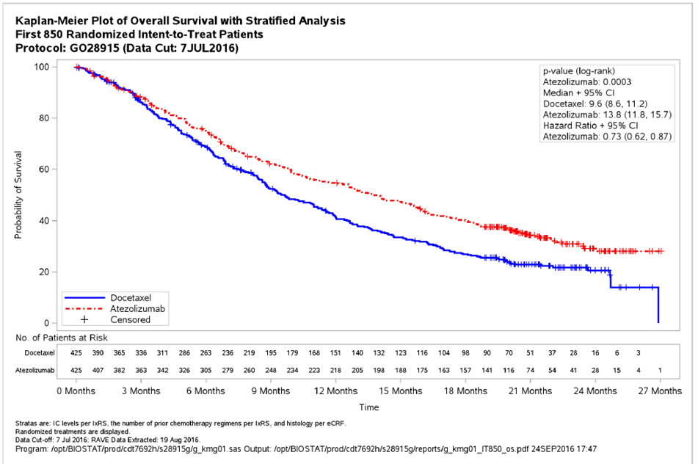

Figure 31: OAK – Kaplan-Meier plot of OS in the TC1/2/3 or IC1/2/3 subgroup.
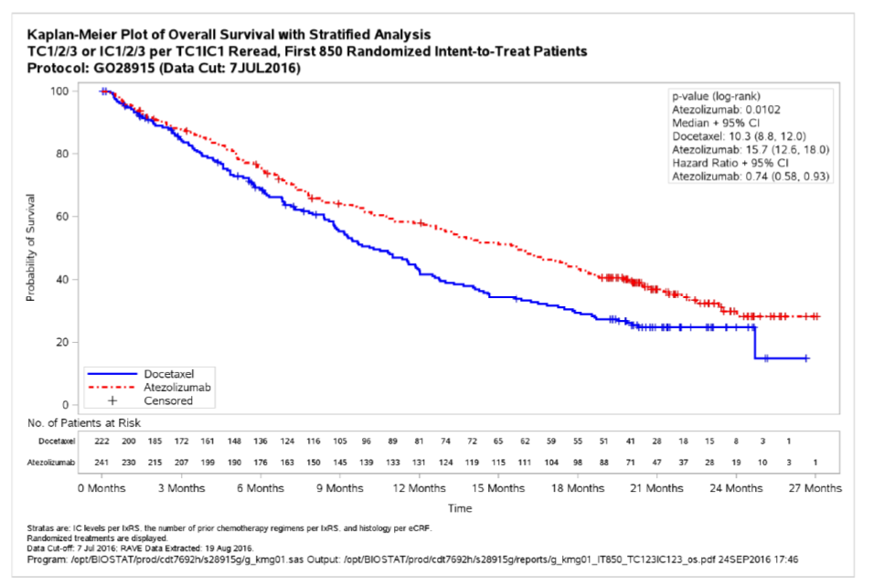
Overall survival in the additional PD-L1 expression subgroups of TC3 or IC3, TC2/3 or IC2/3, and TC0 and IC0 are summarised below. The results showed a clinically meaningful survival benefit in patients treated with atezolizumab compared to docetaxel for each of the three additional PD-LI subgroups. Of note, the median OS in the TC0 and IC0 subgroup was 3.7 months longer in the atezolizumab arm than in the docetaxel arm (unstratified HR = 0.75 [95% CI: 0.59, 0.96]; p = 0.0215). The Kaplan-Meier plot for the TC0 and IC0 subgroup showed that the survival curves began to separate at 3 months after randomisation in favour of atezolizumab compared to docetaxel with the separation being maintained over the remainder of the observation period.
Table 115: OAK – Overall survival in additional PD-L1 expression subgroups of the primary population.
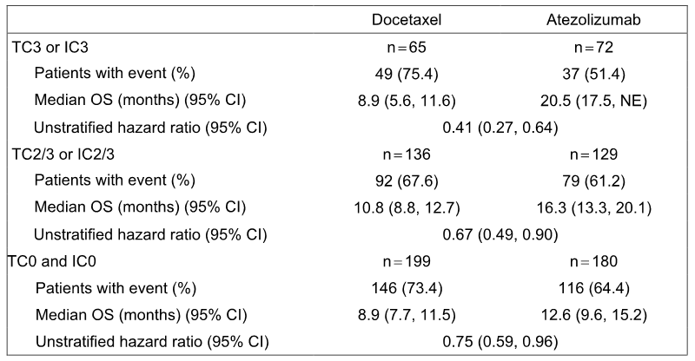
IC = tumour-infiltrating cell; TC = tumour cell; ITT = intent-to-treat; OS = overall survival; NE = not estimable; PD-L1 = programmed deaths ligand-1.
The forest plot of OS by PD-L1 expression subgroups (TC3 or IC3, TC2/3 or IC2/3, TC1/2/3 or IC1/2/3, TC0 and IC0) and primary population (ITT) is summarised below.
Figure 32: OAK – Forest plot of OS by PD-L1 expression subgroups and the primary population (ITT).
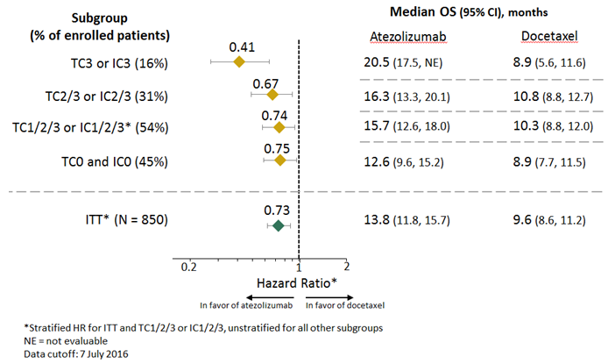

OS in PD-L1 mutually exclusive subgroups
To evaluate the contribution of the TC3 or IC3 subgroups to the OS result in the TC2/3 or IC2/3 patients and of the TC2/3 or IC2/3 subgroup on the results in the TC1/2/3 or IC1/2/3 patients, the following ‘mutually exclusive’ subgroups were evaluated:
- TC2/3 or IC2/3 excluding TC3 or IC3: composed of TC0 and IC2, TC1 and IC2, TC2 and IC0, TC2 and IC1, TC2 and IC2 patients.
- TC1/2/3 or IC1/2/3 excluding TC2/3 or IC2/3: composed of TC0 and IC1, TC1 and IC0, TC1 and IC1 patients.
The results suggest that patients with TC3 or IC3 treated with atezolizumab make a marked contribution to the survival benefit observed in the TC2/3 or IC2/3 subgroup treated with atezolizumab. The results suggest that patients with TC2/3 or IC2/3 treated with atezolizumab make a modest contribution to the survival benefit observed in the TC1/2/3 or IC1/2/3 subgroup. The results for OS in the PD-L1 mutually exclusive subgroups are summarised below.
Table 116: OAK – OS in PD-L1 mutually exclusive subgroups.
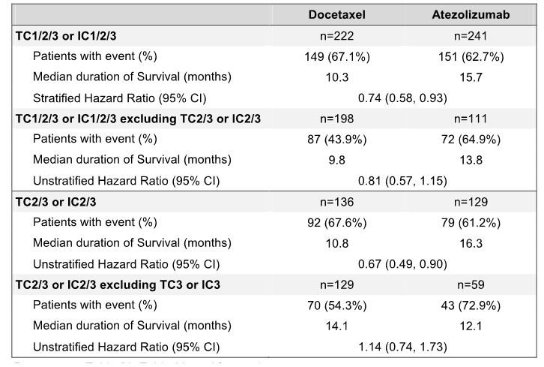
Figure 33: OAK – Forest plot if OS by PD-L1 expression mutually exclusive subgroups.
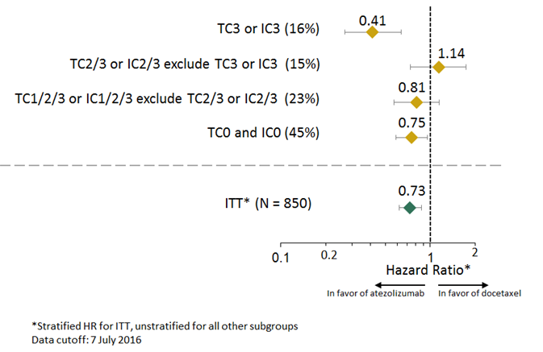

Independent TC vs IC contributions to OS
To more specifically evaluate the independent contributions of PD-L1 expression on TC versus IC, analysis of OS improvement in the subgroup of TC selected (1/2/3) and IC0 patients, and conversely, the subgroup of TC0 and IC selected (1/2/3) patients was performed. These subgroups are further defined and described below:
- TC1/2/3 and IC0 subgroup: composed of TC1 and IC0, TC2 and IC0, and TC3 and IC0 patients. This subgroup was evaluated to identify whether patients expressing PD-L1 on TC at the 1% level or higher (defined as TC1/2/3) were driving the OS benefit observed in the PD-L1 expression subgroup TC1/2/3 or IC1/2/3.
- TC0 and IC1/2/3 subgroup: composed of TC0 and IC1, TC0 and IC2, TC0 and IC3. This subgroup was evaluated to identify whether patients expressing PD-L1 on IC at the 1% level or higher (defined as IC1/2/3) were driving the OS benefit observed in the PD L1 expression subgroup TC1/2/3 or IC1/2/3.
In the TC1/2/3 and IC0 subgroup, the median survival was 12.0 months (95% CI: 3.7, 14.7) in the docetaxel arm versus 13.2 months (95% CI: 7.8, 20.5) in the atezolizumab arm (unstratified HR = 0.72 [95% CI: 0.36, 1.45]).
In the TC0 and IC1/2/3 subgroup, the median duration of survival was 9.8 months (95% CI: 7.3, 13.7) in the docetaxel arm versus 14.3 months (95% CI: 10.6, 18.4) in the atezolizumab arm (unstratified HR = 0.73 [95% CI: 0.52, 1.02])
This analysis demonstrated that both TC and IC independently contributed to the survival improvement seen with atezolizumab versus docetaxel, as shown by the similar unstratified HRs in the TC1/2/3 and IC0 vs TC0 and IC1/2/3 subgroups, (0.72 and 0.73, respective), both of which were consistent with the unstratified HR in primary population (ITT) of 0.73.

OS in individual TC or IC expression levels
To evaluate the individual contribution of TC PD-LI expression and IC PD-L1 expression to the OS benefit, the individual TC PD-L1 or IC PD-L1 expression levels were analysed with the caveat that multiple levels of TC are included in individual IC subgroups, and vice versa. The lowest HR observed was 0.40 (95% CI: 0.22, 0.74) for the TC3 subgroup, which compared with a HR of 0.58 (95% CI: 0.25, 1.36) for the IC3 subgroup. Overall, the results suggest that PD-L1 expression on both TCs and ICs contribute to the OS benefit observed in patients treated with atezolizumab, with PD-L1 expression on neither of the two cell types predominating over the other. The results are summarised below.
Figure 34: OAK – Subgroup analysis of OS by individual TC or IC expression levels, primary population.
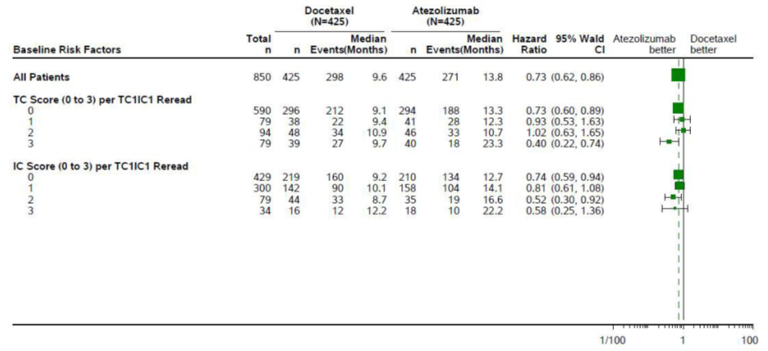

OS by histology (non-squamous vs squamous)
The OS benefit was greater in the atezolizumab arm than in the docetaxel arm for both non-squamous and squamous cell NSCLC, with the numerical difference in median OS between the two treatment arms being greater for patients with non-squamous histology compared to patient with squamous histology. However, the unstratified HRs were similar for the histological subgroups. The KM plots for both histological subgroups demonstrated that the relationship between the atezolizumab and docetaxel survival curves are similar for both subgroups. Overall, the results demonstrated that atezolizumab has a survival benefit in patients with non-squamous and squamous NSCLC. The results are summarised below.
Table 117: OAK – Overall survival by histology in the primary population.
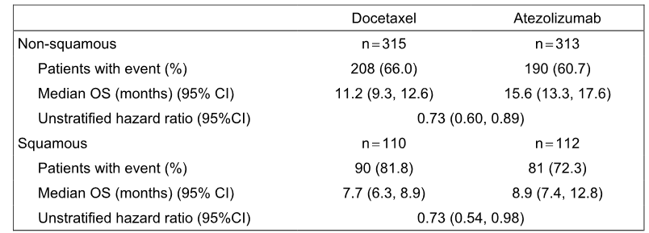
ITT = intent-to-treat; OS = overall survival.

OS by demographics and baseline characteristics
OS was investigated in pre-defined subgroups based on stratification factors (number of prior lines of chemotherapy, histologic type), key baseline demographics (gender, age category, race, smoking history) and disease characteristics (ECOG performance status, brain metastases, liver metastases, bone metastases, KRAS, EGFR and EML4-ALK mutation status).
In almost all of the subgroups analysed, the risk of death was numerically reduced in the atezolizumab arm compared to the docetaxel arm. The only exceptions were in some races (where the number of patients was small) and in the EGFR mutation positive subgroup. In all other subgroups, the HRs for OS ranged from 0.63 to 0.83. Notably, the survival improvement with atezolizumab treatment was also seen in patients who reported never using tobacco and patients with brain metastases. However, in some subgroups small sample size and wide 95% CIs precluded reliable conclusions being made about the consistency of the treatment effect.

Results for other efficacy outcomes

Progression free survival (PFS) investigator assessed – secondary efficacy endpoint
The results for PFS are summarised below.
Table 118: OAK – PFS in the primary population (ITT) and its TC1/2/3 or IC1/2/3 subgroup.
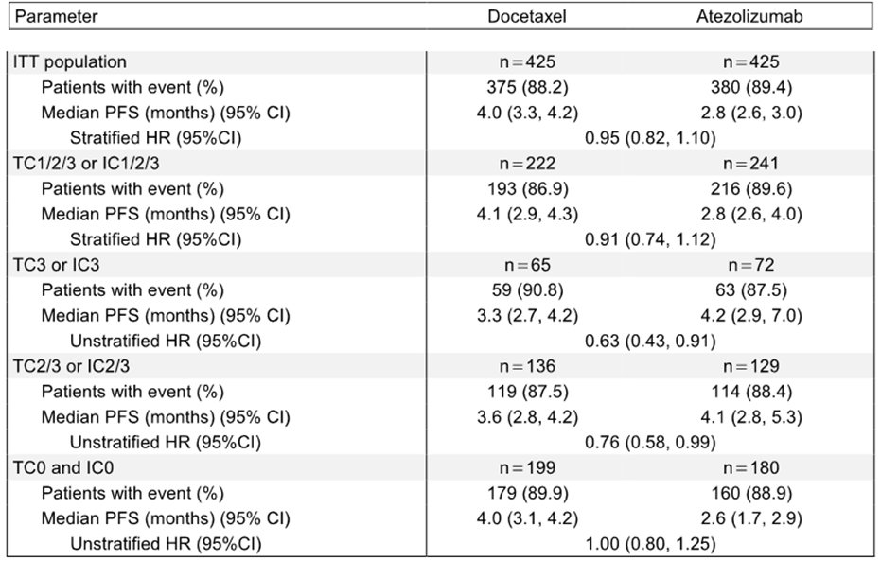
IC = tumour-infiltrating cell; TC = tumour cell; ITT = intent-to-treat; PFS = progression free survival.
Patients who were alive and had not experienced disease progression at the time of the analysis were censored at the time of the last tumour assessment and patients with no post-baseline tumour assessments were censored at the randomisation date plus 1 day. The CSR also included a second analysis in which data for patients with a PFS event who missed two or more scheduled assessments immediately prior to the PFS event were censored at the last tumour assessment prior to the missed visits. The results for this second analysis were consistent with those for the first analysis for both the primary population and the TC1/2/3 or IC1/2/3 subgroup.
In the primary population the median duration of PFS was 1.2 months longer in the docetaxel arm than in the atezolizumab arm, but the hazard ratio suggests that the difference between the two treatment arms is not significant. Of the 375 events reported in the docetaxel arm, death accounted for 85 events and disease progression accounted for 290 events. Of the 380 events reported in the atezolizumab arm, death accounted for 48 and disease progression accounted for 332 events.
The PFS results for the TC1/2/3 or IC1/2/3 subgroup were similar to the PFS results for the primary population. The median duration of PFS was 1.3 months longer in the docetaxel arm than in the atezolizumab arm, but the hazard ratio suggests that the difference between the two treatment arms is not significant. Of the 193 events reported in the docetaxel arm, death accounted for 44 events and disease progression accounted for 149 events. Of the 380 events reported in the atezolizumab arm, death accounted for 27 events and disease progression accounted for 189 events.
There were numerical differences in median PFS between the two treatment groups for the TC3 or IC3, TC2/3 or IC2/3 and TC0 or IC0 subgroups, but the differences are considered to be not clinically meaningful.

Objective response rate (ORR) investigator assessed per RECIST v1.1 – secondary efficacy endpoint
The results for ORR are summarised below.
Table 119: OAK – ORR in the primary population (ITT) and its TC1/2/3 or IC1/2/3 subgroup.
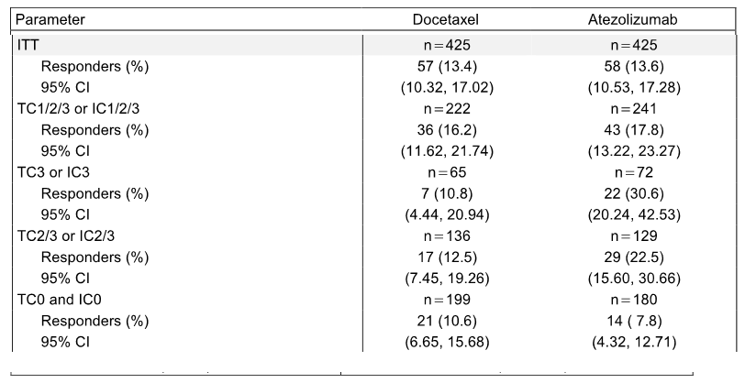
IC = tumour-infiltrating cell; TC = tumour cell; ITT = intent-to-treat; ORR = objective response rate.
In the primary population there was no notable difference in the ORR between the two treatment arms, with the difference between the two arms being 0.24% (95% CI: -4.36, 4.83) in favour of atezolizumab compared to docetaxel, p = 0.9202 (CMH test). However, the number of complete responders was numerically greater in the atezolizumab arm than in the docetaxel arm (6 [1.4%] vs 1 [0.2%], respectively), while partial responders were reported 52 (12.2%) and 56 (13.2%) patients in the two arms, respectively. The number of patients with stable disease was 177 (41.6%) in the docetaxel arm and 150 (35.3%) in the atezolizumab arm and the number of patients with progressive disease was 117 (27.5%) and 187 (44.0%), respectively.
The ORR results for the TC1/2/3 or IC1/2/3 subgroup were consistent with the ORR results for the primary population, with the difference between the two treatment arms being 1.63% (95% CI: -5.22, 8.47) in favour of atezolizumab compared to docetaxel, p = 0.6425(CMH test). The number of complete responders was numerically greater in the atezolizumab arm than in the docetaxel arm (5 [2.1%] vs 1 [0.5%], respectively) and the number of partial responders was similar in the two arms (38 [15.8%] vs 35 [15.8%], respectively).
The ORR in the TC3 or IC3 subgroup and the TC2/3 or IC2/3 subgroup was notably greater in the atezolizumab arm than in the docetaxel arm, while the ORR in the TC0 and IC0 subgroup was numerically greater in the atezolizumab arm than in the docetaxel arm.

Duration of response (DOR) – secondary efficacy endpoint
The results for DOR are summarised below. In the primary population the median DOR was significantly longer in the atezolizumab arm than in the docetaxel arm (16.3 vs 6.2 months, respectively; unstratified HR = 0.34 [95% CI: 0.21, 0.55]; p < 0.0001, log-rank), with 51.7% (n = 30) of patients in the atezolizumab arm being event-free at the time of the analysis compared to 17.5% (n = 10) of patients in the docetaxel arm. The DOR results for the TC1/2/3 or IC1/2/3 subgroup were similar to the DOR results for the primary population, with the unstratified HR being 0.38 [95% CI: 0.22, 0.65]; p = 0.0003, log-rank), with 46.5% (n = 20) of patients in the atezolizumab group being event-free at the time of the analysis compared to 11.1% (n = 4) of patients in the docetaxel group. The median DOR in both the TC3 or IC3 subgroup and the TC2/3 or IC2/3 subgroup was numerically longer in the atezolizumab arm than in the docetaxel arm, while the median DOR in the TC0 and IC0 subgroup had not been reached in the atezolizumab arm.
Table 120: OAK – DOR in the primary population (ITT) and its TC1/2/3 or IC1/2/3 subgroup.
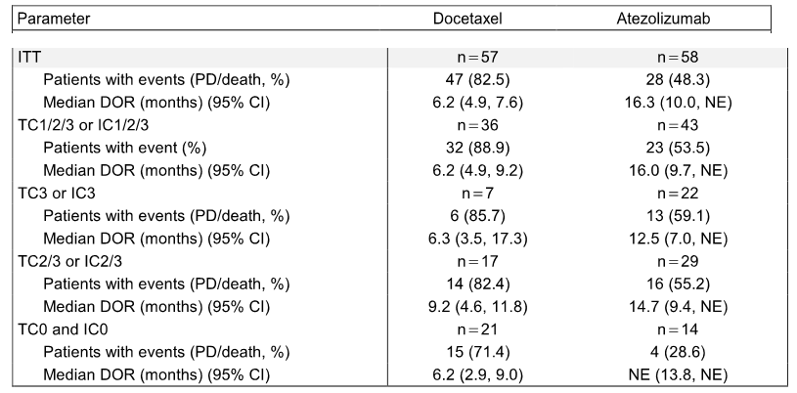

Treatment beyond disease progression
To evaluate radiographic changes in tumour burden after disease progression in patients who continued atezolizumab beyond disease progression, an analysis of best change in target lesions relative to the time of disease progression per RECIST v1.1 was conducted. Over a third (35.1%) of the 168 atezolizumab patients in the primary analysis population treated on or after the first progression of disease had subsequent scans showing stable or decreased tumour sum of longest diameters (SLD) after disease progression relative to the time of disease progression. The results are summarised below.
Table 121: OAK – Best percent change in SLD from first disease progression for tumour assessment post progression per investigator per RECIST v1.1 in the primary population, atezolizumab treated patients with reported disease progression.
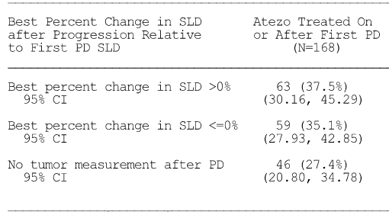
SLD = sum of longest diameters; PD = progression of disease; CI = confidence interval (95% CIs were computed using Clopper-Pearson Method); Data cut-off date 7 July 2016.
Overall survival from the time of disease progression was also evaluated for patients who experienced progression per RECIST v1.1, according to treatment received following PD (n = 332). The median duration of OS from the time of disease progression, for patients who received at least one dose of atezolizumab post-progression (n = 168), was 12.7 months (95% CI: 9.3, 14.9) compared to 8.8 months (95% CI: 6.0, 12.1) for patients receiving other anti-cancer therapies excluding atezolizumab post-progression (n = 94) and 2.2 months (95% CI: 1.9, 3.4) for patients who received no treatment post-progression (n = 70). The results of the analysis are summarised below.
Table 122: OAK – OS on or after first disease progression in the primary population, atezolizumab treated patients with reported disease progression.
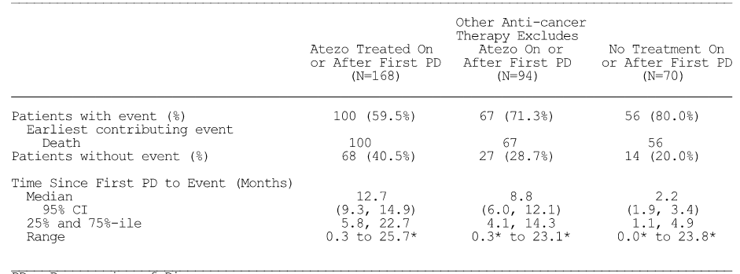
PD = Progression of Disease. * Censored, ^ Censored and event, NE = Not estimable. Summaries of Time-to-Event (median, percentiles) are Kaplan-Meier estimates. 95% CI for median was computed using the method of Brookmeyer and Crowley.
The KM survival curves showed longer post-progression OS for patients who received at least one dose of atezolizumab post-progression compared to patients who went on to receive other non-protocol anti-cancer therapy and to patients who did not receive anti-cancer therapy post-progression. However, these results should be interpreted with caution given the non-randomised nature of the comparison. In addition, the protocol-defined criteria for continuation of atezolizumab treatment after progression included factors that are prognostic for OS (e.g. a lack of decline in performance status and no signs and symptoms of unequivocal post-disease progression). Since these did not apply to initiation of subsequent non-protocol therapy (e.g. other anti-cancer treatments), this represents a potential confounding factor in the analysis.

Patient reported outcomes – secondary objectives

Background
The secondary objectives of the study included assessment of patient reported outcomes (PROs). These included time to deterioration (TTD) in patient-reported lung cancer symptoms of cough, dyspnoea (single-item and multi-item subscales), chest pain, or arm/shoulder pain as measured by the European Organization for the Research and Treatment of Cancer (EORTC) Quality-of-Life Questionnaire-Core (QLQ-C30) and the supplemental lung cancer module (QLQ-LC13). In addition, the PROs included lung cancer symptoms, patient functioning, and health-related quality of life (HRQoL) as measured by the EORTC QLQ-C30 and the EORTC QLQ-LC13.
High completion rates were demonstrated for both treatment arms throughout the course of treatment. At baseline, 96.5% (n = 388) of patients in the docetaxel arm and 98.1% (n = 413) of patients in the atezolizumab arm completed the EORTC QLQ-C30 while 95.8% (n = 385) of patients in the docetaxel arm and 96.7% (n = 407) of patients in the atezolizumab arm completed the LC13 at baseline.
In the atezolizumab arm, completion rates remained above 80% for all cycles through Cycle 27, with most cycles reporting ≥ 90% completion. Rates of completion for the docetaxel arm were also high, with all cycles through Cycle 23 having a completion rate of at least 80% including many cycles reporting ≥ 90%. The latest cycle with approximately 25% of the original population remaining to complete the PRO assessment is Cycle 6 in the docetaxel arm and Cycle 16 in the atezolizumab arm.

EORTC QLQ-C30 AND EORTC QLQ-LC13
Patients in both treatment arms reported moderate to high functioning at baseline (mean of 70.9 to 85.2 across function scales and HRQoL [mean Global Health Status] of approximately 61). Similarly, patients in both treatment arms reported generally minimal lung-cancer symptom burden at baseline (i.e. cough, dyspnea, arm/shoulder pain, chest pain), with most mean scores below 30 points on a scale of 0 to 100 where higher scores indicate greater symptom burden.
Across all functioning domains (cognitive, emotional, social, role, and physical) and the global health status scale, patients in the atezolizumab and docetaxel treatment arms reported similar scores at all or most of the post-baseline time-points evaluated. However, the differences from baseline in function and global health status did not constitute a clinically meaningful change (≥ 10 point increase or decrease from baseline) in either treatment arm, indicating comparable functioning and HRQoL by treatment arm.
Patients in both the atezolizumab arm and the docetaxel did not show clinically meaningful worsening in commonly reported cancer treatment-related symptoms (i.e. fatigue, nausea/ vomiting, diarrhoea, constipation, and sore mouth) as measured by the EORTC QLQ-C30 and LC13. However, while patients in the atezolizumab arm also showed no meaningful worsening in treatment-related alopecia or peripheral neuropathy, patients in the docetaxel arm reported clinically meaningful worsening in both of these symptoms throughout the course of treatment (mean change from baseline ≥ 10 point worsening in alopecia from Cycle 2 through Cycle 16 and ≥10 point worsening in peripheral neuropathy from Cycle 4 through Cycle 14).
No clinically meaningful mean change (improvement or decline) from baseline was observed in either treatment arm for lung cancer-specific symptoms (e.g. cough, dyspnoea, chest pain, arm/shoulder pain).

TTD of lung cancer symptoms
In the primary population, patients in the atezolizumab arm demonstrated prolonged TTD of patient-reported chest pain by an additional 9.7 months compared to patients in the docetaxel arm as measured by EORTC QLQ-LC13: stratified HR = 0.72 (95% CI: 0.55, 0.93); p = 0.0111, log-rank. The median TTD in chest pain was 8.3 months (95% CI: 4.6, 12.5) in the docetaxel arm compared to 18.0 months (95% CI: 11.0. NE) in the atezolizumab arm. There was no difference between the two treatment arms in TTD of cough, dyspnoea (multi-item), or arm/shoulder pain as measured by EORTC QLQ-LC13.
Supportive analyses were conducted on the PRO-evaluable population to summarise the severity and change of chest pain at multiple time points to further understand the observed TTD benefit of atezolizumab in the chest pain symptom score. The results of the analyses were reported descriptively and are summarised below.
Patients in both arms experienced minimal chest pain at baseline, with 60.6% of patients in the docetaxel arm and 57.7% of patients in the atezolizumab arm reporting no chest pain at baseline, with similar proportions in each of the other categories (i.e. not at all, a little, quite a bit, very much). At the time of radiographic PD per RECIST v1.1, the proportion of asymptomatic patients (i.e. with severity level of ‘not at all’) in the docetaxel arm decreased to 54.2%, while the proportion of asymptomatic patients in the atezolizumab arm increased to 66.4%. At both the time of the last dose as well as at the time of the treatment discontinuation visit, the proportion of asymptomatic patients in the atezolizumab arm decreased to 62.6% and 54.5%, respectively, suggesting that chest pain severity in the atezolizumab arm may have worsened at time-points characteristically later than disease progression compared to docetaxel.
A total of 11.4% of patients in the atezolizumab arm experienced clinically meaningful worsening in chest pain severity (≥ 10 point increase from baseline) at the time of radiographic PD per RECIST criteria v1.1 compared to 25.4% of patients in the docetaxel arm. The proportion of patients in the atezolizumab arm who experienced clinically meaningful worsening in chest pain appeared to increase at the date of the last dose (14.9%) with further worsening being observed at the date of the treatment discontinuation visit (17.5%).

Pharmacokinetic (PK) results
One of the objectives of the study was to characterise the PK of atezolizumab in patients with NSCLC. PK samples were collected from all patients who received at least one dose of atezolizumab. Serum samples for PK analysis were obtained at baseline (before dosing), at post-dose (Cmax or 30 minutes after the end of the atezolizumab infusion at Cycle 1), and at the following time-points, pre-dose at Cycles 2, 3, 4, 8, 16, at termination, and at follow-up after termination. In addition, starting from study protocol v3, samples were collected every 8 cycles after Cycle 16. A validated ELISA was used to quantify atezolizumab in human serum. The lower limit of quantitation (LLOQ) was 60.0 ng/mL in human serum.
The PK evaluable population was defined as patients who received atezolizumab treatment and has at least one measurable PK concentration, and included 606 patients. A summary of the available Cmax (30 minutes following the end of the infusion in Cycle 1 or 0.0625 days) and Cmin (pre-dose) atezolizumab concentrations up to Cycle 7 Day 21 (or pre-dose Cycle 8) from PK-evaluable patients in the secondary population (PK evaluable patients) is provided below.
Table 123: OAK – summary statistics for atezolizumab Cmax and Cmin following multiple IV of atezolizumab (1200 mg Q3W), secondary population PK evaluable patients.
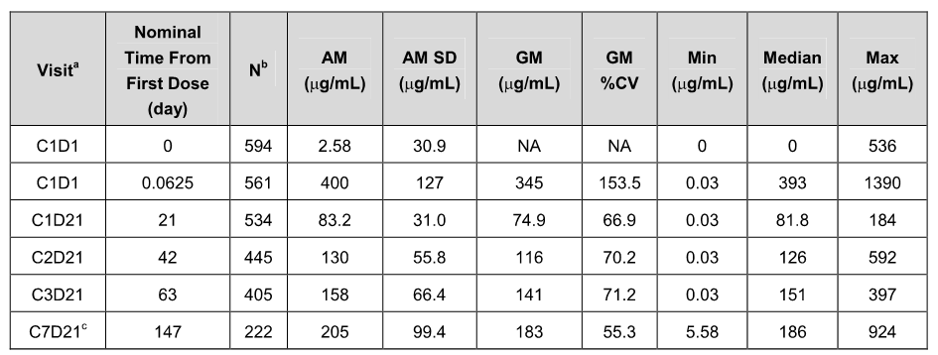
AM = Arithmetic Mean; BLQ = below the limit of quantitation; CV = coefficient of variation; GM = Geometric Mean; LLOQ = lower limit of quantitation, defined as 60 ng/mL; NA= Not Available; SD = standard deviation. [a] Visit is denoted by Cycle abbreviated by ‘C’ and Day abbreviated by ‘D’; [b] N is the number used to calculate statistics; [c] PK data are summarised up to Cycle 7 Day 21 (or pre-dose Cycle 8).
The geometric mean Cmax for Cycle 1 was 345 µg/mL and the geometric mean Cmin for Cycle 1 Day 21 (or pre-dose Cycle 2) was 74.9 µg/mL. Eight of 594 patients with available Cycle 1, Day 1 pre-dose samples (Nominal Time = 0) provided quantifiable serum concentrations, which were much greater than the lower limit of quantitation (LLOQ) of 60 ng/mL. The reason for measurable atezolizumab concentrations in the 8 patients at Cycle 1 Day 1 pre-dose is unknown. The mean serum atezolizumab concentrations over time are shown below.
Figure 35: OAK – Mean (SD) plot of atezolizumab concentration vs time following multiple IV of atezolizumab (1200 mg Q3W), secondary population PK evaluable patients.
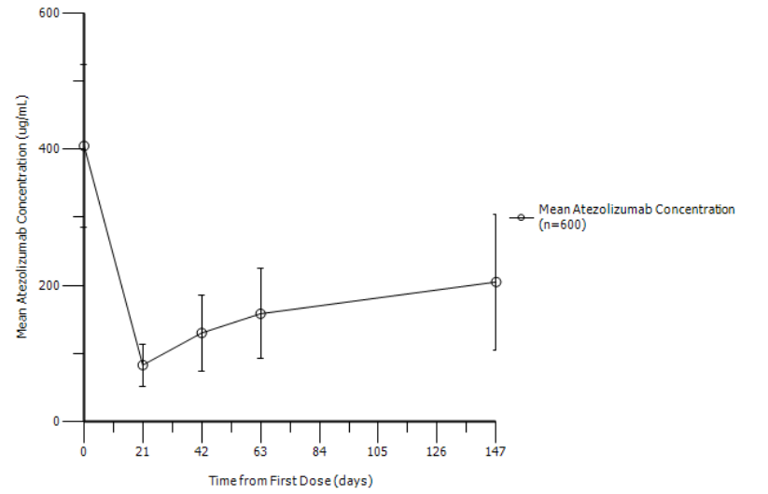
Comment: The results observed in OAK are consistent with known PK of atezolizumab. Average atezolizumab Cmin appeared to approach a plateau between 4 and 8 cycles of q3w dosing. The geometric mean Cmin increased from 74.9 µg/mL to 183 µg/mL from Cycle 1 to Cycle 8, respectively. A serum concentration target Cmin of 6 μg/mL was proposed as part of the rationale for the 1200 mg q3w dosage selection for this study. There was a trend for lower Cmin concentrations in ATA-positive patients (58.2 µg/mL at Cycle 1) compared to ATA-negative patients (83.9 µg/mL at Cycle 1) and for all following cycles. However, the Cmin concentrations for both ATA-positive and ATA-negative patients were in excess of the target serum concentration of 6 µg/mL.
Does the sponsor intend including the PK results from OAK into an updated PopPK analysis? The sponsor is requested to inform the TGA Delegate of its intention regarding this matter.

Evaluator commentary
OAK was a high quality pivotal Phase III study. The efficacy results confirmed the promising efficacy results previously observed in the supportive Phase III studies POPLAR, BIRCH, and FIR. It is considered that data from the pivotal Phase III study (OAK) and the three, supportive Phase II studies (POPLAR, BIRCH, and FIR) have satisfactorily established the efficacy of atezolizumab for the proposed usage in patients with locally advanced or metastatic NSCLC after prior chemotherapy.
The study met its co-primary endpoints of demonstrating a statistically significant and clinically meaningful improvement in OS in patients treated with atezolizumab compared to patients treated with docetaxel in both the primary population and the TC1/2/3 or IC1/2/3 subgroup. In the primary population the median OS was 4.2 months longer in the atezolizumab arm than in the docetaxel arm, and in the TC1/2/3 or IC1/2/3 subgroup the median OS was 5.4 months longer in the atezolizumab arm than in the docetaxel arm.
Clinically meaningful OS benefits were observed with atezolizumab in all PD-L1 expression subgroups (including the TC0 and IC0 and subgroup), with the most pronounced benefits being seen in the TC3 or IC3 subgroup.
Improved OS in the atezolizumab arm compared to docetaxel was also observed in the majority of clinically relevant subgroups including age, sex, race, ECOG status, number of prior therapies, brain metastases, tobacco use history, and patients with both squamous and non-squamous NSCLC. The exceptions were patients with EGFR mutations and some racial groups with small patient numbers. However, in some subgroups small sample size and/or wide 95% CIs precluded reliable conclusions being made about the consistency of the treatment effect.
In both the primary population and the TC1/2/3 or IC1/2/3 subgroup the secondary efficacy endpoints of PFS (investigator-assessed; RECIST v1.1) and ORR (investigator-assessed RECIST v1.1) were similar in the atezolizumab and docetaxel treatment arms, while the secondary efficacy endpoint of DOR was notably longer in the atezolizumab arm compared to the docetaxel arm.

OAK (GO28915) – Evaluation of the safety results

Patient exposure
Safety data were provided for the safety evaluable population at the time of the clinical cut-off date of 7 July 2016. The safety evaluable population included a total of 1187 patients (578 docetaxel, 609 atezolizumab). In this population, the median duration of treatment was longer in the atezolizumab arm than in the docetaxel arm (3.4 vs 2.1 months, respectively), as was the median number of cycles (6 vs 4 , respectively). The median dose intensity was identical in both treatment arms (97.7%). A notably higher proportion of patients in the atezolizumab arm than in the docetaxel arm received at least 6 months of treatment (33.2% vs 11.2% respectively) and at least 12 months of treatment (20.5% vs 2.4%, respectively). The exposure parameters are summarised below.
Table 124: OAK – Study drug exposure, safety evaluable population.
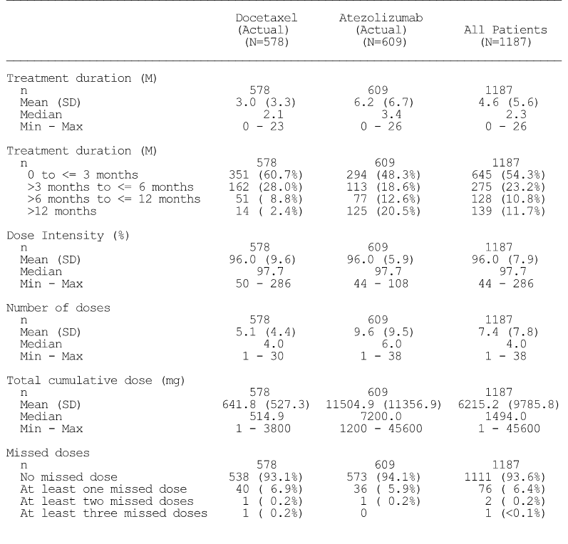
Treatment duration is the date of the last dose of study medication minus the date of the first dose plus 1. Dose intensity is number of doses received divide by the expected number of doses.

Adverse events

Overview of adverse events
The proportion of patients with at least one AE was similar in both the docetaxel and the atezolizumab arms, with nearly all patients in both treatment arms experiencing at least one AE (96.0% docetaxel vs 94.1% atezolizumab, respectively). Most AE categories occurred less frequently in the atezolizumab arm than in the docetaxel arm, and the differences were particularly marked for treatment related AEs, Grade 3-4 AEs, treatment related Grade 3-4 AEs, AEs leading to withdrawal from treatment and AEs leading to dose modification. Overall, the results indicate that atezolizumab was better tolerated than docetaxel. The overview of AEs is summarised below.
Table 125: OAK – Overview of adverse events within 30-day window, safety evaluable population.
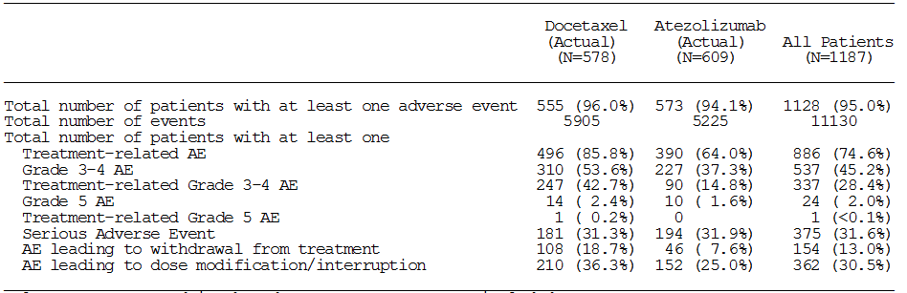
Only events reported in the Adverse Events Form are included. Investigator text for AEs encoded using MedDRA v19.0. Percentages are based on N in the column headings. Multiple occurrences of the same AE in one individual are counted only once except for ‘Total number of events’ row in which multiple occurrences of the same AE are counted separately. AEs collected after first treatment dose and within 30 days from last treatment dose are included unless the AE occurred after the start of a non-protocol cancer therapy within the 30 day post-treatment period.

Commonly reported adverse events

Introduction
In the following sections, AEs are summarised based on a reporting window from initiation of study treatment to 30 days after the last dose of study treatment or up to initiation of non-protocol therapy or up to the clinical data cut-off date. Exceptions are treatment-related SAEs, AESIs, and imAEs, for which no time window was used and all events up the data cut-off date were included.

Adverse events by SOC - irrespective of relationship to treatment
The most commonly reported SOCs occurring in ≥ 20% of patients in either treatment arm (docetaxel vs atezolizumab) were: (i) General Disorders and Administration Site Conditions (70.8% vs 67.0%); (ii) Gastrointestinal Disorders (56.1% vs 49.3%); (iii) Skin and Subcutaneous Tissue Disorders (47.4% vs 28.9%); (iv) Respiratory, Thoracic and Mediastinal Disorders ; (v) Blood and Lymphatic System Disorders (46.7% vs 51.4%); (vi) Infections and Infestations (42.4% vs 38.6%); (vi) Musculoskeletal and Connective Tissue Disorders (42.0% vs 43.8%); (vi) Nervous System Disorders (42.0% vs 32.8%); (vii) Metabolism and Nutrition Disorders (38.6% vs 36.8%) ; and (viii) Investigations (23.7% vs 26.1%).
SOCs in which AEs were reported in ≥ 20% of patients in either treatment arm and ≥ 5% more frequently in the docetaxel arm than in the atezolizumab were Gastrointestinal Disorders (56.1% vs 49.3%), Skin and Subcutaneous Tissue Disorders (47.4% vs 28.9%), Blood and Lymphatic System Disorders (42.7% vs 15.6%), and Nervous System Disorders (42.0% vs 32.8%). There were no SOCs in which AEs were reported in ≥ 20% of patients in either treatment arm and ≥ 5% more frequently in the atezolizumab arm than in the docetaxel arm.

Adverse events by preferred term – irrespective of relationship to treatment
AEs by preferred term (irrespective of relationship to treatment) were reported in nearly all patients in both the docetaxel arm and the atezolizumab arm (96.0%, 555 patients, 5905 events vs 94.1%, 573 patients, 5225 events). AEs reported in ≥ 10% of patients in either arm (docetaxel vs atezolizumab), in decreasing order of frequency in the docetaxel arm, were: fatigue (35.5% vs 26.8%); alopecia (34.9% vs 0.5%); diarrhoea (24.4% vs 15.4%); anaemia (23.5% vs 11.5%); decreased appetite (23.5% vs 23.5%); nausea (22.7% vs 17.7%); asthenia (19.7% vs 19.0%); dyspnoea (19.4% vs 19.4%); cough (18.2% vs 23.2%); myalgia (15.7% vs 6.4%); neutropenia (15.6% vs 1.6%); constipation (14.2% vs 17.6%); pyrexia (13.1% vs 17.7%); peripheral oedema (14.2% vs 8.9%); peripheral neuropathy (11.2% vs 3.9%); stomatitis (10.9% vs 3.1%); vomiting (10.7% vs 12.2%); febrile neutropenia (10.7% vs 0.2%); arthralgia (10.0% vs 12.0%); dysgeusia (10.0% vs 3.0%); back pain (7.3% vs 11.0%); and musculoskeletal pain (4.3% vs 10.5%)
AEs reported in ≥ 5% more patients in the docetaxel arm than in the atezolizumab arm were: fatigue (35.5% vs 26.8%); alopecia (34.9% vs 0.5%); diarrhoea (24.4% vs 15.4%); anaemia (23.5% vs 11.5%); nausea (22.7% vs 17.7%); myalgia (15.7% vs. 6.4%); neutropenia (15.6% vs 1.6%); oedema peripheral (14.2% vs 8.9%); neuropathy peripheral (11.2% vs 3.9%); stomatitis (10.9% vs 3.1%); febrile neutropenia (10.7% vs 0.2%); dysgeusia (10.0% vs 3.0%); neutrophil count decreased (9.5% vs 0.3%); peripheral sensory neuropathy (7.4% vs 1.0%); mucosal inflammation (7.1% vs 1.5%); and nail disorder (5.2% vs 0%).
AEs reported in ≥ 5% more patients in the atezolizumab arm than in the docetaxel arm were cough (23.2% vs 18.2%) musculoskeletal pain (10.5% vs 4.3%) and pruritus (8.2% vs 3.1%). For the AEs of musculoskeletal pain and pruritus, both of which occurred in > 5% more patients in the atezolizumab arm than in the docetaxel arm, the sponsor provided an estimate of the AE rates adjusted for patient years at risk. The adjusted rates indicated that both events occurred more frequently in the atezolizumab arm than in the docetaxel arm. The sponsor states that musculoskeletal pain and pruritus are recognised as adverse drug reactions for atezolizumab. The sponsor did not provide a corresponding calculation for the AE of cough, which occurred in 5% more patients in the atezolizumab arm than in the docetaxel arm.
Table 126: OAK – Adverse event rates adjusted for patient years at risk for AEs with a higher incidence in the atezolizumab arm, safety evaluable population.
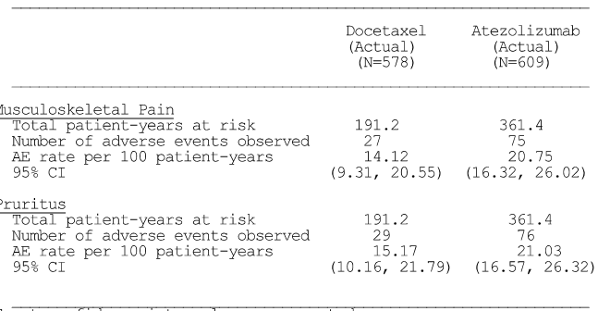
Exact confidence intervals are presented. Adverse Events started prior to first treatment and missing an end date are not included. AEs collected after first treatment dose and within 30 days from last treatment dose are included unless the AE occurred after the start of a non-protocol cancer therapy within the 30 day post-treatment period.

Treatment-related adverse events
The proportion of patients who reported at least one treatment-related AE (any grade) was higher in the docetaxel arm (85.8% [496/578]) than in the atezolizumab arm (64.0% [390/609]). The most common treatment-related AEs reported in ≥ 10% of patients in either treatment arm are presented below.
Table 127: OAK – Treatment related adverse vents reported in ≥ 10% of patients in either treatment arm, safety evaluable population.
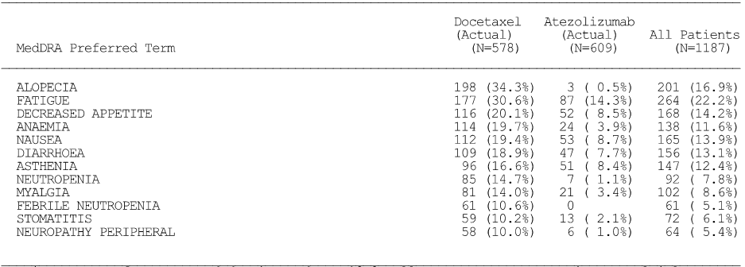
Investigator text for AEs encoded using MedDRA v19.0. All counts represent patients. Multiple occurrences of the same AE in one individual are counted once at the highest grade for this patient. To the SOC Overall row counts, a patient contributes only with the AE occurring with the highest grade within the SOC. Percentages are based on N in the column headings. AEs collected after first treatment dose and within 30 days from last treatment dose are included unless the AE occurred after the start of a non-protocol cancer therapy within the 30 day post-treatment period.

Adverse events by intensity (irrespective of relationship to treatment)
The proportion of patients with Grade ≥ 3 AEs (irrespective of relationship to treatment) was greater in patients in the docetaxel arm than in the atezolizumab arm (56.1% [324/578] vs 38.9% [237/609]). The difference between the two arms was primarily due to the higher incidence of Grade 3 or 4 AEs in the docetaxel arm than in the atezolizumab arm (53.6% [310/578 ] vs 37.3% [227/609], respectively). Grade 5 AEs were reported in a comparable proportion of patients in both treatment arms (2.4% [14/578] docetaxel vs 1.6% [10/609] atezolizumab). Grade ≥ 3 AEs reported in ≥ 5% of patients in either treatment arm are summarised below. All five Grade ≥ 3 AEs reported in ≥ 5% of patients in either treatment arm were reported more frequently in the docetaxel arm than in the atezolizumab arm.
Table 128: OAK – Grade ≥ 5 AEs reported in ≥ 5% of patients in either treatment arm, safety evaluable population.
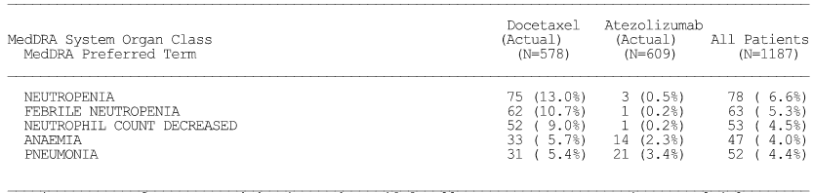
Investigator text for AEs encoded using MedDRA v19.0. All counts represent patients. Multiple occurrences of the same AE in one individual are counted once at the highest grade for this patient. To the SOC Overall row counts, a patient contributes only with the AE occurring with the highest grade within the SOC. Percentages are based on N in the column headings. AEs collected after first treatment dose and within 30 days from last treatment dose are included unless the AE occurred after the start of a non-protocol cancer therapy within the 30 day post-treatment period.

Treatment-related AEs by intensity
A higher proportion of patients in the docetaxel arm experienced treatment-related Grade 3 or 4 AEs compared to patients in the atezolizumab arm (42.7% [247/578] vs 14.8% [90/609]), while treatment-related Grade 5 AEs were reported in 1 patient in the docetaxel arm and no patients in the atezolizumab arm.

Deaths and SAEs

Deaths

All deaths
At the data cut-off date, a higher proportion of patients in the docetaxel arm had died than in the atezolizumab arm (69.6% [402/578] vs 62.9% [383/609], respectively). In both treatment arms, the majority of deaths occurred more than 30 days after the last dose of study drug (89.6% [360/402], docetaxel vs 83.8% [321/383], atezolizumab).
Regardless of the time-window (i.e. ≤ 30 days from last study drug administration or > 30 days after last study drug administration) the most common cause of death in both treatment arms was disease progression. In the ≤ 30 days from the last study drug administration time-window, disease progression accounted for 66.7% (28/42) of deaths in the docetaxel arm and 82.3% (51/62) of deaths in the atezolizumab arm. In the > 30 days after the last study drug administration time-window, disease progression accounted for 96.7% (348/360) of deaths in the docetaxel arm and 95.3% (306/321) of deaths in the atezolizumab arm.
AEs accounted for death in 23.1% (24/104) of all patients in the ≤ 30 days from last study drug administration time-window (33.3% [14/42], docetaxel vs 16.1% [10/62], atezolizumab), and 3.7% (25/681) of all patients in > 30 days from last study drug time-window (2.8% [10/360], docetaxel vs 4.7% [15/321], atezolizumab).

Grade 5 AEs occurring within 30 days of the last dose
AEs leading to death within 30 days of the last dose of study drug or prior to initiation of non-protocol therapy were reported in 14 (2.4%) patients in the docetaxel arm and 10 (1.6%) of patients in the atezolizumab arm. The most common causes of death due to AEs were reported in the SOCs of Infections and Infestations (0.9%, docetaxel vs 0.7%, atezolizumab) and Respiratory, Thoracic and Mediastinal Disorders (1.0%, docetaxel vs 0.3%, atezolizumab).
In the 14 AEs leading to death in the docetaxel arm, events reported in ≥ 2 patients were pneumonia (2 patients) and sudden death (2 patients). In the 10 deaths leading to death in the docetaxel arm, the one event reported in ≥ 2 patients was sepsis (2 patients). The only Grade 5 AE reported in either of the two treatment arms considered by the investigator to be treatment-related was a respiratory tract infection in 1 patient in the docetaxel arm.
Table 129: OAK – Grade 5 AEs reported within 30 days of the last dose.
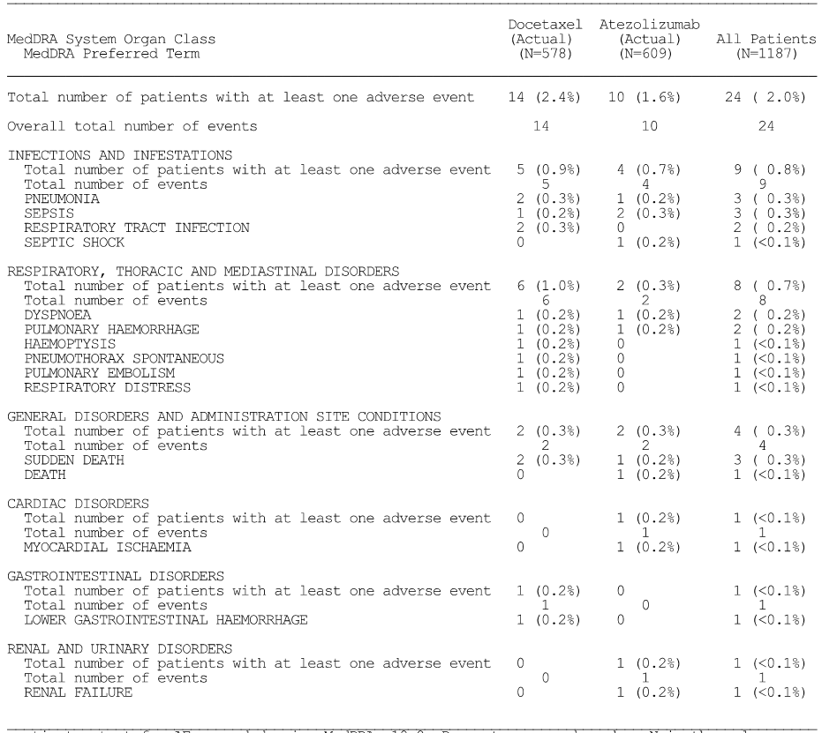
Investigator text for AEs encoded using MedDRA v19.0. All counts represent patients. Multiple occurrences of the same AE in one individual are counted once at the highest grade for this patient. To the SOC Overall row counts, a patient contributes only with the AE occurring with the highest grade within the SOC. Percentages are based on N in the column headings. AEs collected after first treatment dose and within 30 days from last treatment dose are included unless the AE occurred after the start of a non-protocol cancer therapy within the 30 day post-treatment period.

Grade 5 AEs occurring more than 30 days after the last dose
Among the Grade 5 AEs leading to death more than 30 days after the last dose, events reported in ≥ 0.5% of patients in either treatment arm (docetaxel vs atezolizumab) occurred in the SOCs of General Disorders and Administration Site Conditions (0.5% vs 1.0%, respectively) and Infections and Infestations (0.5% vs 0.8%, respectively).
AEs leading to death more than 30 days after the last dose in the 10 (1.7%) patients in the docetaxel arm were: death (3 patients) and 1 patient each for pneumonia, sepsis, infection, myocardial infarction, cardiac arrest, pleural effusion, and pulmonary embolism. No patient experienced a fatal AE that was considered by the investigator to be related to docetaxel treatment.
AEs leading to death more than 30 days after the last dose in 15 (2.5%) patients in the atezolizumab arm were: death (5 patients), sepsis (2 patients), and 1 patient each for euthanasia, pneumonia, pulmonary sepsis, septic shock, myocardial infarction, pneumonia aspiration, cerebral artery embolism, and cerebrovascular accident. No patient experienced a fatal AE that was considered by the investigator to be related to atezolizumab treatment.

SAEs
In the 30-day treatment window, SAEs (irrespective of relationship to treatment) were reported in a similar proportion of patients in both treatment arms (31.3% [181/578] docetaxel vs 31.9% [194/609] atezolizumab). There were four SAEs reported in ≥ 2% of patients in either treatment arm (docetaxel vs atezolizumab) and in decreasing order of frequency in the docetaxel arm these events were: febrile neutropenia (6.4% vs 0%); pneumonia (5.4% vs 3.3%); dyspnoea (1.4% vs 2.0% ); and pleural effusion (1.0% vs 0%).
Up to the data cut-off date, the proportion of patients experiencing SAEs considered by the investigator to be treatment-related was higher in the docetaxel arm than in the atezolizumab (17.6% [102/578] vs 10.3% [63/609], respectively). Treatment-related SAEs reported in ≥ 1% of patients in either treatment arm (docetaxel vs atezolizumab) were: febrile pneumonia (6.2% vs 0%); pneumonia (1.9% vs 0.3%); diarrhoea (1.0% vs 0%); and pneumonitis (0% vs 1.0%). The most commonly reported SAEs (≥ 2 patients in either treatment arm) in the time-period up to the data cut-off date are summarised below.
Table 130: OAK – Treatment-related SAEs reported in ≥ 2 patients in either treatment arm up to the data cut-off date.
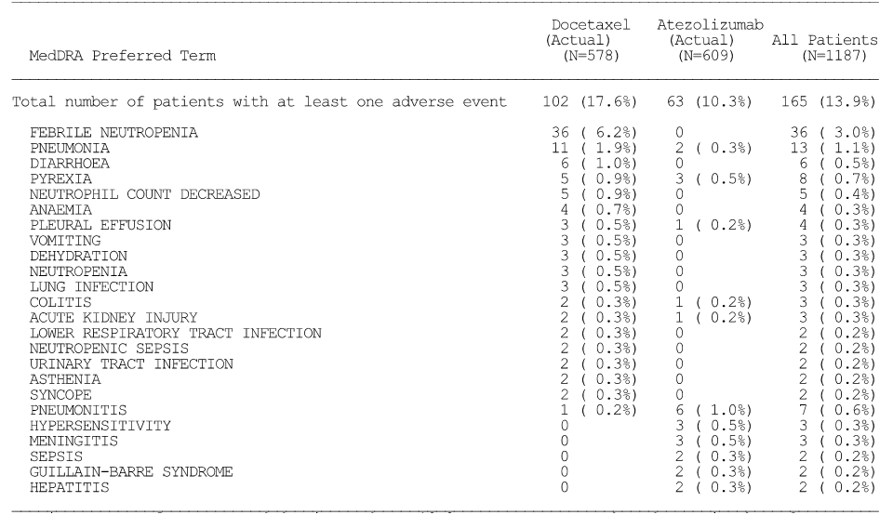
Investigator text for AEs encoded using MedDRA v19.0. Percentages are based on N in the column headings. For frequency counts by preferred term, multiple occurrences of the same AE in an individual are counted only once. For frequency counts of ‘Total number of events’ rows, the multiple occurrences of the same AE in an individual are counted separately. AEs collected after first treatment dose are included.

Adverse events leading to withdrawal of study treatment
AEs resulting in withdrawal from treatment within the 30-day time-window occurred in a notably greater proportion of patients in the docetaxel arm than in the atezolizumab arm (18.7% [108/578] vs 7.6% [46/609]). AEs resulting in withdrawal from treatment reported in ≥ 1% of patients in either treatment arm (docetaxel vs atezolizumab), in descending order of frequency in the docetaxel arm, were: fatigue (2.6% vs 0.2%); paraesthesia (1.9% vs 0%); neuropathy peripheral (1.7% vs 0%); asthenia (1.7% vs 0%); pneumonia (1.2% vs 0.5%); dyspnoea (1.0% vs 0.2%); and oedema peripheral (1.0% vs 0%).

Adverse leading to dose modification
Dose modification was defined as: (i) dose reduction (for docetaxel only); no dose reductions were allowed for atezolizumab; (ii) dose delay (dose outside of the protocol window) or skipped cycles; and (iii) infusion interruption.
AEs resulting in dose modification were reported in a greater proportion of patients in the docetaxel arm than in the atezolizumab arm (36.3% [210/578] vs 25.0% [152/609]). AEs resulting in dose modification reported in ≥ 1% of patients in either treatment arm (docetaxel vs atezolizumab), in descending order of frequency in the docetaxel arm, were: febrile neutropenia (6.2% vs 0%), neutropenia (4.2% vs 0.2%); fatigue (3.1% vs 1.1%); neutrophil count decreased (2.9% vs 0.2%); asthenia (2.1% vs 0.8%); diarrhoea (1.9% vs 0.8%); pneumonia (1.7% vs 2.1%); anaemia (1.6% vs 0.3%); respiratory tract infection (1.4% vs 1.0%); leukopenia (1.2% vs 0%); neuropathy peripheral (1.2% vs 0.2%); peripheral sensory neuropathy (1.2% vs 0%); pyrexia (1.0% vs 1.0%); oedema peripheral (1.0% vs 0.2%); dyspnoea (1.0% v 1.6%); decreased appetite (1.0% vs 0.2%); and back pain (0% vs 1.3%). AEs leading to dose modification reported in ≥ 2 patients in either treatment arm are summarised.

Adverse events of special interest (AESI)

Overview
Events of special interest for the purposes of expedited reporting were pre-defined in the protocol based on the known mechanism of action of atezolizumab and concerns reported with other immune modulating agents.
For the purposes of analysis, AESIs, which are conditions suggestive of an autoimmune disorder, were derived from Sponsor-defined AE Grouped Terms (AEGTs). AEGTs included a broader set of PT terms irrespective of grade and was a conservative approach for capturing such events. AESIs were summarised using sponsor-defined grouping (medical concepts) of Preferred Terms and High Level Grouped Terms from the standard MedDRA, v19.0.
Overall, AESIs of any grade up to the data cut-off date were reported more frequently in patients in the atezolizumab arm than in the docetaxel arm (30.2% vs 22.8%). AESIs were observed in a greater proportion of patients in the atezolizumab arm than in the docetaxel arm for dermatologic, hepatic, and endocrine events, which is consistent with atezolizumab mechanism of action. In the docetaxel arm, neurologic AESIs were observed in a greater proportion of patients than in the atezolizumab arm, with the most frequently reported event being peripheral neuropathy. In the total safety evaluable population (n = 1187) the majority of patients with AESIs experienced events of Grade 1 or 2 severity (14.2% vs 8.6%, respectively), 3.5% had a Grade 3 AESI, 0.3% had a Grade 4 AESI, and no patient reported a Grade 5 AESI. AESI of special interest without the 30-day window are summarised below.
Table 131: OAK – Adverse events of special interest (AESI) up to the data cut-off date in descending of order of frequency in the atezolizumab arm, safety evaluable population.
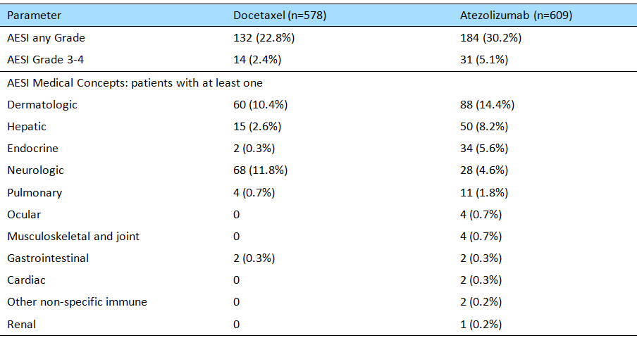

Dermatologic reactions
Overall, 10.4% of patients in the docetaxel arm and 14.4% of patients in the atezolizumab arm experienced a dermatologic reaction with the most common event being rash. The majority of events were Grade 1 or 2 in severity and no patient in the docetaxel arm and 4 (0.7%) patients in the atezolizumab arm experienced a Grade 3 dermatologic reaction. Three of the 4 patients with Grade 3 rash received treatment for their AE. At the data cut-off date, all events had resolved.
Overall, no patient in the docetaxel arm and 0.3% of patients in the atezolizumab arm experienced dermatologic reactions that were reported as serious. Dermatologic reactions resulted in treatment modification or interruption in 1 (0.2%) patient in the docetaxel arm and 6 (1.0%) patients in the atezolizumab arms. No patients in the docetaxel arm discontinued study treatment due to dermatological reactions compared to 1 (0.2%) patient in the atezolizumab arm.
Table 132: OAK – Dermatologic reactions AESI by highest NCI CTCAE Grade at the data cut-off date, safety evaluable population.
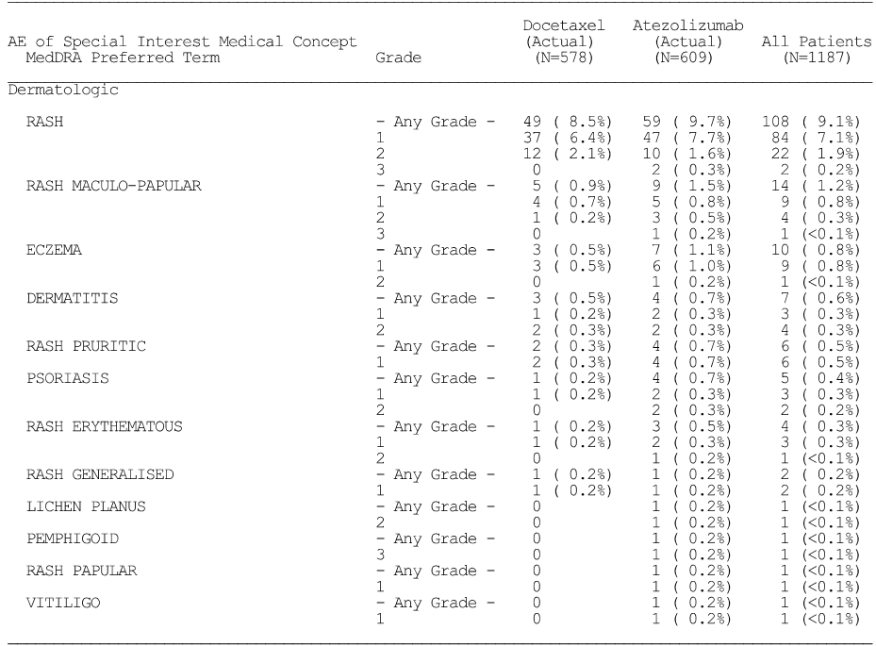
Investigator text for AEs encoded using MedDRA v19.0. All counts represent patients. Multiple occurrences of the same AE in one individual are counted once at the highest grade for this patient. To the Overall row counts, a patient contributes only with the AE occurring with the highest grade within the group. Percentages are based on N in the column headings. AEs collected after first treatment dose are included.

Hepatic events
Overall, 2.6% of patients in the docetaxel arm and 8.2% of patients in the atezolizumab arm experienced hepatic AESIs, with the most common events being AST increased and ALT increased. The majority of events were Grade 1 or 2 in severity. With respect to AST increased, 2 (0.3%) patients in the docetaxel arm and 5 (0.8%) patients in the atezolizumab arm experienced a Grade 3 event. Neither of the 2 patients in the docetaxel arm was treated for the event and both events resolved. Of the 5 patients in the atezolizumab arm with AST increased, 2 were treated for the event and 3 had events that had resolved or were resolving at the data cut-off date.
With respect to ALT increased, 2 (0.3%) patients in the docetaxel arm and 6 (1.0%) patients in the atezolizumab arm experienced a Grade 3 event. Neither of the 2 patients in the docetaxel arm was treated for the event and both events resolved. Of the 6 patients in the atezolizumab arm with Grade 3 ALT increased, 2 were treated for the event and all events had resolved at data cut-off date.
No patient in the docetaxel arm and 3 (0.5%) patients in the atezolizumab arm experienced hepatic AESIs reported as serious. Hepatic AESIs leading to treatment modification or interruption were reported in 2 (0.3%) patients in the docetaxel arm and 8 (1.3%) patients in the atezolizumab arms. No patients in the docetaxel arm discontinued study treatment due to hepatic events compared to 4 (0.7%) patient in the atezolizumab arm.
Table 133: OAK – Hepatic AESI by highest NCI CTCAE Grade at the data cut-off date, safety evaluable population.
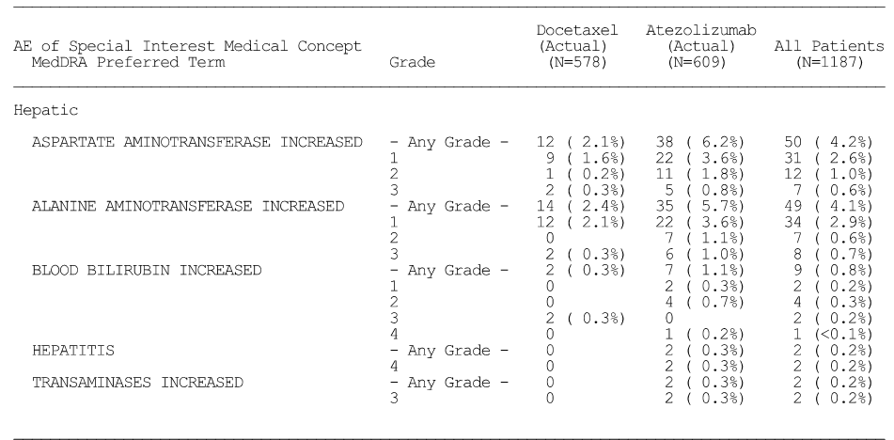
Investigator text for AEs encoded using MedDRA v19.0. All counts represent patients. Multiple occurrences of the same AE in one individual are counted once at the highest grade for this patient. To the Overall row counts, a patient contributes only with the AE occurring with the highest grade within the group. Percentages are based on N in the column headings. AEs collected after first treatment dose are included.

Endocrine AESIs
Overall, 0.3% of patients in the docetaxel arm and 5.6% of patients in the atezolizumab arm experienced an endocrine AESI, with the most common event overall being hypothyroidism. All events except one were Grade 1 or 2 in severity, with 1 patient in the atezolizumab arm experiencing serious Grade 3 pancreatitis. In this patient, the study drug was interrupted and the patient recovered after being treated for the event.
Other than the one event of pancreatitis, no patient in either treatment arm experienced endocrine AESIs that were reported as serious. Endocrine AESIs leading to treatment modification or interruption were reported in docetaxel patients in the docetaxel arm and 5 (0.8%) patients in the atezolizumab arm. No patients in the docetaxel arm discontinued study treatment due to endocrine AESI compared to 1 (0.2%) patient in the atezolizumab arm.
Table 134: OAK – Endocrine AESI by highest NCI CTCAE Grade at the data cut-off date, safety evaluable population.
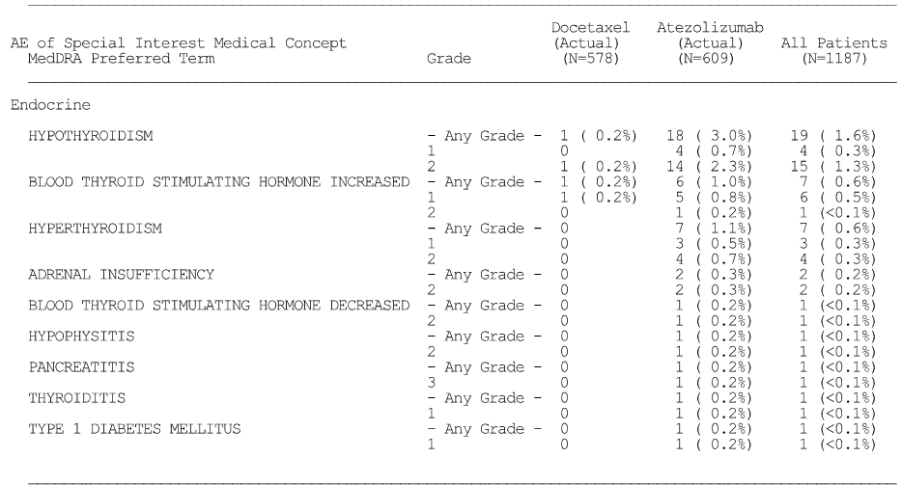
Investigator text for AEs encoded using MedDRA v19.0. All counts represent patients. Multiple occurrences of the same AE in one individual are counted once at the highest grade for this patient. To the Overall row counts, a patient contributes only with the AE occurring with the highest grade within the group. Percentages are based on N in the column headings. AEs collected after first treatment dose are included.

Neurologic AESIs
Overall, 11.8% of patients in the docetaxel arm and 4.6% of patients in the atezolizumab arm experienced a neurologic AESI, with the most common event being peripheral neuropathy (see below). The majority of events were Grade 1 or 2 in severity, while 7 (1.2%) patients in the docetaxel arm experienced Grade 3 peripheral neuropathy and 3 (0.5%) patients in the atezolizumab arm experienced Grade 3 Guillain-Barre syndrome. One patient in the docetaxel arm and 2 patients in the atezolizumab arm received treatment for the neurologic AESI. At data cut-off date, events were resolved or resolving in 3 docetaxel treated patients and resolved in 2 atezolizumab treated patients.
Overall, no patient in the docetaxel arm and 2 (0.3%) patients in the atezolizumab arm experienced neurologic AESIs reported as serious. Neurologic reactions led to treatment modification or interruption in 7 (1.2%) patients in the docetaxel arm and 2 (0.3%) patients in the atezolizumab arm. Ten (1.7%) patients in the docetaxel arm discontinued study treatment due to neurologic reactions compared to no patients in the atezolizumab arm.
Table 135: OAK – Neurologic AESI by highest NCI CTCAE Grade at the data cut-off date, safety evaluable population.
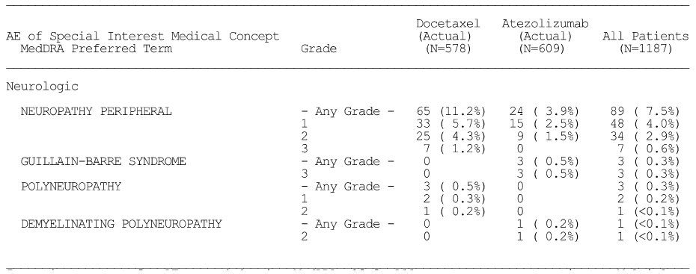
Investigator text for AEs encoded using MedDRA v19.0. All counts represent patients. Multiple occurrences of the same AE in one individual are counted once at the highest grade for this patient. To the Overall row counts, a patient contributes only with the AE occurring with the highest grade within the group. Percentages are based on N in the column headings. AEs collected after first treatment dose are included.

Pulmonary AESIs
Overall, 0.7% of patients in the docetaxel arm and 1.8% of patients in the atezolizumab arm experienced a pulmonary AESI. The three events (any Grade) in the two treatment arms (docetaxel vs atezolizumab) were: pneumonitis (0.7%, n = 4 vs 1.0%, n = 6); interstitial lung disease (0%, n = 0 vs 0.5%, n = 3); and organising pneumonia (0%, n = 0 vs 0.3%, n = 2). There were 7 patients in the total population who experienced Grade 3 pulmonary AESI: pneumonitis = 2 (0.3%) docetaxel vs 4 (0.7%) atezolizumab; organising pneumonia = 1 [0.2%] atezolizumab). All 7 patients who experienced Grade 3 pulmonary AESIs received treatment for the event, and at the data cut-off date, all but 2 events had resolved.
One (0.2%) patient in the docetaxel arm and 8 (1.3%) patients in the atezolizumab arm experienced a pulmonary AESI that was reported as serious. Pulmonary AESIs leading to treatment modification or interruption were reported in 1 patient (0.2%) in the docetaxel arm and 3 (0.5%) patients in the atezolizumab arm. Pulmonary AESIs leading to study treatment discontinuation were reported in 1 (0.2%) patient in the docetaxel arm and 2 (0.3%) patients in the atezolizumab arm.

Ocular AESIs
Overall, no patient in the docetaxel arm and 4 (0.7%) patients in the atezolizumab arm experienced an ocular AESI. Ocular AESIs (any Grade) reported in the 4 patients in the atezolizumab arm were optic neuritis (n = 2, 0.3%), endocrine ophthalmology (n = 1, 0.2%) and uveitis (n = 1, 0.3%). The only ocular Grade 3 AESI was optic neuritis (n = 2, 0.3%), and 1 patient with Grade 3 optic neuritis received treatment. At data cut-off date, one Grade 3 optic neuritis event was resolving and the other Grade 3 optic neuritis event had resolved.
One (< 0.1%) patient in the atezolizumab arm experienced an ocular AESI (optic neuritis) that was reported as serious. Two (0.3%) patients in the atezolizumab arm had ocular AESIs leading to dose modification or interruption and 2 (0.3%) patients had ocular AESIs (optic neuritis) leading to study treatment discontinuation.

Musculoskeletal and joint AESIs
Overall, no patient in the docetaxel arm and 4 (0.7%) patients in the atezolizumab arm experienced musculoskeletal and joint AESIs. The musculoskeletal and joint AESIs reported in the 4 patients in the atezolizumab arm were rheumatoid arthritis Grade 2 AE (0.5%, n = 2) and polymyalgia rheumatica Grade 2 AE (0.2%, n = 1). No patient experienced musculoskeletal and joint AESIs that were reported as serious or resulted in study treatment discontinuation. Musculoskeletal and joint AESIs leading to dose modification or interruption were reported in 1 (0.2%) patient in the atezolizumab arm.

Gastrointestinal AESIs
Overall, 0.3% of patients in each treatment arm experienced a gastrointestinal AESI, with colitis being the only event reported. Two (0.3%) patients in the docetaxel arm experienced Grade 3 colitis and 2 (0.3%) patients in the atezolizumab arm experienced Grade 2 colitis. Both patients in the docetaxel arm with Grade 3 events were treated and the events had resolved by the data cut-off date.
Overall, 2 (0.3%) patients in the docetaxel arm and 2 (0.2%) patients in the atezolizumab arm experienced gastrointestinal AESIs reported as serious. Gastrointestinal AESIs leading to treatment modification or interruption were reported in 2 (0.3%) patients in the docetaxel arm and 1 (0.2%) patient in the atezolizumab arms. No patients in either treatment arm discontinued study treatment because of gastrointestinal AESIs.

Cardiac AESIs
Overall, no patient in the docetaxel arm and 2 (0.3%) patients in the atezolizumab arm experienced cardiac AESIs, with pericarditis being the only AE preferred term reported. One (0.2%) patient experienced a Grade 3 pericarditis event which was reported as serious and not related to study drug. This event was treated and resolved. Neither pericarditis event lead to treatment modification or interruption or to study treatment discontinuation.

Other non-specific immune AESIs
Overall, no patient in the docetaxel arm and 2 (0.3%) patients in the atezolizumab arm experienced non-specific immune AESIs, with systemic inflammatory response syndrome being the only AE preferred term reported. Of the 2 patients in the atezolizumab experiencing a systemic inflammatory response, 1 (0.2%) experienced a Grade 1 event and 1 experienced a serious Grade 3 event, which was treated and resolved. Neither of the two non-specific immune AESIs resulted in treatment modification or interruption. One (0.2%) patient had an event that led to study treatment discontinuation.

Renal AESIs
Overall, no patient in the docetaxel arm and 1 (0.2%) patient in the atezolizumab arm experienced a renal AESI, with Henoch-Schonlein purpura nephritis being the only event reported. This Grade 3 event was reported as serious and was treated and reported as resolving at data cut-off date. The event led to study treatment discontinuation.

Haematologic AESIs
No haematologic AESIs were reported during the study.

Immune-mediated AEs (imAEs) requiring the use of systemic corticosteroids
In the safety evaluable population (n = 1187), imAEs requiring the use of systemic corticosteroids up to the data cut-off date were reported in a total of 132 (11.1%) patients, comprising 55 (9.5%) patients in the docetaxel arm and 77 (12.6%) patients in the atezolizumab arm. ImAEs requiring the use of systemic corticosteroids reported in ≥ 1% of patients in either treatment arm (docetaxel vs atezolizumab), in descending order of frequency in the docetaxel arm, were: neuropathy peripheral (4.3%, n = 25 vs 0%, n = 0); rash (3.6%, n = 21 vs 1.3%, n = 8); ALT increased (0.9%, n = 5 vs 1.0%, n = 6); pneumonitis (0.7%, n = 4 vs 1.0%, n = 6); and dyspnoea (0.2%, n = 1 vs 1.1%, n = 7).

Subgroup analyses of safety

PD-L1 expression subgroups
The extent of exposure to study treatment among the safety evaluable patients in each of the PD-L1 expression subgroups was consistent with exposure in the overall safety evaluable population. The sample size of the TC3 or IC3 subgroup is small compared to the other PD-L1 expression subgroups and, consequently, differences relative to the overall safety evaluable population are more difficult to interpret in this subgroup. However, patients in the TC3 or IC3 subgroup reported similar incidences (within 5% difference) to the overall safety evaluable population for Grade 3 or 4 AEs, SAEs, AEs leading to treatment withdrawal, and AEs leading to dose modification/interruption, but numerically higher incidences of AESIs.
Overall, the AE profile of atezolizumab was comparable across the PD-L1 expression subgroups and favourable compared to docetaxel. AEs that occurred with a higher incidence in the docetaxel arm compared to the atezolizumab arm in the overall safety evaluable population were generally also observed at a higher incidence in patients in the docetaxel arm compared to the atezolizumab within each PD-L1 expression subgroup (e.g. neutropenia, peripheral neuropathy, anaemia).
Among patients who received atezolizumab, some variations across PD-L1 expression subgroups were observed:
- SAEs were reported by fewer patients in the TC3 or IC3 subgroup (24.7%) compared to the other PD-L1 subgroups (range: 27.5% to 34.8%).
- AEs leading to dose modification/interruption were reported by fewer patients in the TC0 and IC0 subgroup (18.6%) compared to the other PD-L1 subgroups (range: 29.9% to 30.4%).
- AESIs were reported by fewer patients in the TC0 and IC0 subgroup (27.5%) compared to the other PD-L1 subgroups (range: 32.5% to 39.3%).
The safety profile of atezolizumab for AESIs was generally consistent across the PD-L1 subgroups, with the majority of events being Grade 1 or 2 severity. The incidence of each AESI in each of the PD-L1 subgroups was higher in the atezolizumab arm than in the docetaxel arm, except for neurologic AESIs which were reported more frequently with docetaxel than with atezolizumab in each of the PD-L1 subgroups.

Histology
The extent of exposure to study treatment among the safety evaluable patients in the non-squamous and squamous subgroups was consistent with that in the overall safety evaluable population.
The comparative safety results should be interpreted cautiously due to the imbalance in patient numbers between the two histologic subgroups, with 835 (70.3%) patients in the total safety evaluable population (n = 1187) being in the non-squamous subgroup compared to 295 (24.9%) patients in the squamous subgroup. Overall, the AE profile of atezolizumab was comparable in the non-squamous and squamous subgroups and favourable compared to docetaxel. In addition, the AE profile of atezolizumab in each of the histology subgroups was consistent with that in the overall safety evaluable population.
Some variations in the AE profile between the histology subgroups were observed:
- Among patients receiving atezolizumab, treatment-related AE were reported by fewer patients with squamous disease (56.9%) than non-squamous disease (66.6%).
- In both the docetaxel and atezolizumab arms, SAEs were reported by fewer patients with non-squamous disease (28.4% vs 29.8%, respectively) than squamous disease (39.1% vs 37.5%, respectively).
The safety profile of atezolizumab in terms of AESIs was generally consistent in the non-squamous and squamous histology subgroups. However, fewer patients in the atezolizumab arm with squamous disease than non-squamous disease reported hepatic AESIs, although results are based on small patient numbers (3.8% [6 patients] vs 9.8% [44 patients]). Similar to the observations in the overall safety evaluable population, a higher proportion of patients in the atezolizumab arm than in the docetaxel arm experienced AESIs in each of the histology subgroups.

Adverse disease profile before and after disease progression
The AE profile for atezolizumab was evaluated pre-PD and post-PD for the 168 patients in the primary population who received at least one dose of atezolizumab on or after the first disease progression. In these patients, the overall incidence of AEs was lower post-PD compared to pre-PD (76.2% [n = 128] vs 90.5% [n = 152]), as was the incidence of treatment-related AEs (36.3% [n = 61] vs 58.9% [n = 99]). In contrast, the incidence of SAEs was higher post-PD compared to pre-PD (17.3% [n = 29] vs 8.9% [n = 15]). The incidence of Grade 3 or 4 AEs (any cause and regardless of relationship to study drug), treatment-related SAEs, and AESIs was similar (within 5%) post-PD versus pre-PD.

Laboratory parameters
There were no clinically relevant changes in mean and median values for haematology and blood chemistry laboratory safety parameters during the study. Clinically relevant shifts in laboratory parameters were defined as shifts from Grade 0, 1, or 2 at baseline to Grade 3 or 4 post-baseline. The majority of patients did not exhibit clinically relevant shifts in any laboratory test parameter during the study. Most shifts were sporadic events occurring in a small number of patients and in a similar proportion of patients in the docetaxel and atezolizumab arms.
Clinically relevant shifts of note in laboratory parameters were:
- Total absolute neutrophil count shifts to low levels were observed more frequently in patients in the docetaxel arm than in the atezolizumab arm (27.6% vs 1.6%, respectively).
- WBC shifts to low levels were observed more frequently in patients in the docetaxel arm than in the atezolizumab arm (23.8% vs 1.4%, respectively).
- Total absolute lymphocyte count shifts to low levels were observed more frequently in patients in the docetaxel arm than in the atezolizumab arm (19.8% vs 11.8%, respectively).
The sponsor undertook a Hy’s law analysis on the hepatic function results. Hy’s law cases were defined as elevated ALT or AST (> 3 x ULN) in combination with either an elevated total bilirubin (> 2 x ULN) or clinical jaundice in the absence of cholestasis or other causes of hyperbilirubinemia. A total of 11 patients (2 docetaxel and 9 atezolizumab) were identified as potential Hy’s law cases. The sponsor stated that after detailed review, 10 of the cases did not qualify as true Hy’s law cases. The 10 patients included 6 patients (2 docetaxel and 4 atezolizumab) with liver function abnormalities that were temporally associated with disease progression, 2 patients (in the atezolizumab arm) received corticosteroids for treatment of hepatitis and liver function abnormalities resolved, and 2 patients (in the atezolizumab arm) with liver function abnormalities resumed atezolizumab after treatment interruption (i.e. negative re-challenge). One patient in the atezolizumab arm) was identified as a Hy’s law case. The patient developed changes in liver function tests after 4 cycles for which no alternate aetiology was identified. Due to the lack of alternate aetiology, this patient met the criteria for true Hy’s law.

ECG changes
In patients with ECG data at screening, 37.6% of patients in the docetaxel arm and 37.0% of patients in the atezolizumab arm had non-clinically significant ECG abnormalities. One patient in the docetaxel arm and 3 patients in the atezolizumab arm had a clinically significant ECG abnormality.
Post-baseline, 1 patient in the atezolizumab arm had a clinically significant ECG abnormality, which was a Grade 2 non-serious AE of ‘electrocardiogram QT prolonged’ on Day 128, after 6 doses of atezolizumab. The patient had a non-clinically significant ECG abnormality at baseline, together with atrial fibrillation and hypertension as part of her past medical history. The investigator considered the AE to be unrelated to study treatment and related to concurrent illness. Study treatment was interrupted and the event resolved after 2 days. The patient had a non-clinically significant abnormal ECG on Day 387, but did not experience any other ECG-related AEs.

Vital sign changes
Overall, atezolizumab treatment had no clinically meaningful effect on vital signs.
Both systolic and diastolic blood pressure showed small median decreases or increases in comparison to baseline for patients receiving atezolizumab. A total of 40 patients (23 in the docetaxel arm and 17 in the atezolizumab arm) had an AE of hypotension reported during the study. In the atezolizumab arm, all hypotension events were non-serious, Grade 1 or 2 in severity, and considered unrelated to treatment, with the following exceptions: 1 patient had treatment-related, non-serious hypotension (Grade 1) that resolved; and 3 patients experienced SAEs of hypotension of Grade 2, 3, or 4 severity that were all considered unrelated to study treatment. The Grade 2 and 3 hypotension events resolved, and the Grade 4 event was unresolved.
Two patients reported non-serious events of hypotension during infusion: 1 patient in the docetaxel arm experienced a Grade 3 event and 1 patient in the atezolizumab arm experienced a Grade 1 event during Cycle 2 and received two subsequent doses of study drug without reporting any AEs.
Four patients in the atezolizumab arm reported hypotension within 24 hours of infusion; 2 patients experienced Grade 1 events and 2 patients experienced Grade 2 events, one of which reported on Day 2 was serious (resolved on Day 4) and was accompanied by weakness resulting in hospitalisation and was considered to be disease progression unrelated to treatment.

Immunogenicity
The baseline prevalence of ATAs was 3.5% (n = 21) in all atezolizumab randomised patients (secondary population) with an evaluable baseline ATA sample (n = 593). Post-baseline, 30.4% (172/565) of treated patients had treatment-emergent ATAs (i.e. ATA positive = the sum of treatment-induced ATA and treatment-enhanced ATA). Of these 172 ATA-positive patients, 171 (99.4%) had a ‘treatment-induced’ ATA response and 1 (0.6%) had a ‘treatment-enhanced’ ATA response. Of the 171 patients with a treatment-induced response, 98 (57.3%) had a transient ATA response while 73 (42.7%) had a persistent ATA response.
Overall, no clinically relevant differences in efficacy outcomes were observed between ATA-positive and ATA-negative patients (i.e. OS, PFS, ORR and DOR). Although the median OS, landmark OS rates and median PFS were numerically higher in ATA-negative patients than in ATA-positive patients, the 95% CIs of these outcome measures overlapped. The ORR was similar between the ATA-negative and the ATA-positive subgroups (14.4% vs 15.4%, respectively). The median DOR for ATA-negative patients was not reached, while the median DOR for ATA-positive patients was 16.3 months. The results are summarised below.
Table 136: OAK – Efficacy outcomes by ATA status in patients treated with atezolizumab, primary population ATA evaluable patients.
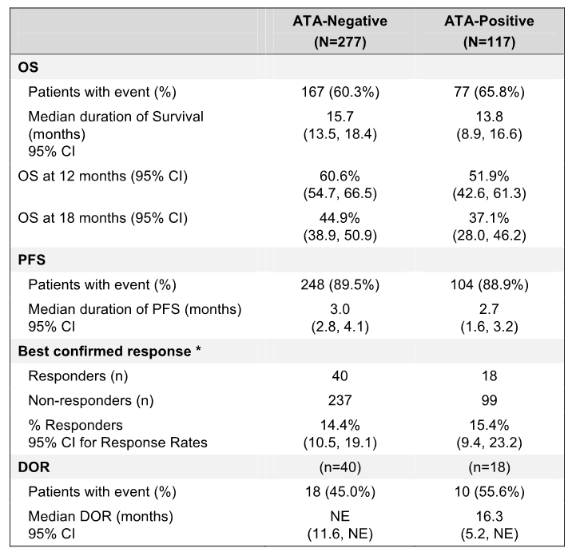
Among ATA-evaluable patients in the secondary population (all randomised patients), ATA-negative and ATA-positive patients each received a median number of 6.0 cycles of atezolizumab. The safety profile of atezolizumab was similar in the two ATA subgroups, although there was a small numerical imbalance in the patient incidence of most adverse event categories, with percentages in the ATA-positive subgroup being higher than in the ATA-negative subgroup. The adverse event profiles within the 30-day reporting window for the two subgroups are summarised below.
Table 137: OAK – Overview of adverse event reported within the 30-day reporting window by ATA status, atezolizumab treated patients in the secondary population ATA evaluable patients.
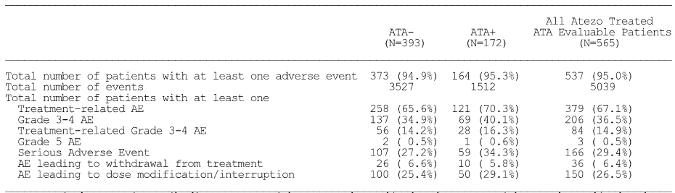
ATA = Anti-Therapeutic Antibodies; ATA- = Without TX Enhanced/Induced; ATA+ = With TX Enhanced/Induced. Only events reported in the Adverse Events Form are included. Investigator text for AEs encoded using MedDRA v19.0. Percentages are based on N in the column headings. Multiple occurrences of the same AE in one individual are counted only once except for ‘Total number of events’ row in which multiple occurrences of the same AE are counted separately. AEs collected after first treatment dose and within 30 days from last treatment dose are included unless the AE occurred after the start of a non-protocol cancer therapy within the 30 day post-treatment period.
In the secondary population, the proportion of patients with SAEs (treatment related) and AESIs reported up to the data cut-off date was similar in the ATA-negative and ATA-positive subgroups. The observed numerical differences between the two ATA subgroups are considered to be not clinically significant. The results are summarised below.
Table 138: OAK – SAEs (treatment-related) and AESIs up to the date of the data cut-off by ATA status, atezolizumab treated patients in the secondary population ATA evaluable patients.
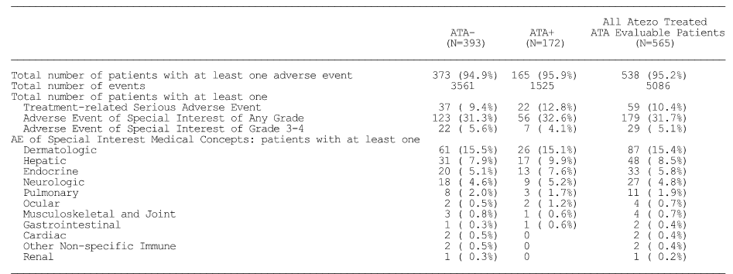
ATA = Anti-Therapeutic Antibodies; ATA- = Without TX Enhanced/Induced; ATA+ = With TX Enhanced/Induced. Only events reported in the Adverse Events Form are included. Investigator text for AEs encoded using MedDRA v19.0. Percentages are based on N in the column headings. Multiple occurrences of the same AE in one individual are counted only once except for ‘Total number of events’ row in which multiple occurrences of the same AE are counted separately. AEs collected after first treatment dose are included.

Clinical evaluator’s commentary on safety
The safety profile of atezolizumab has been well characterised in OAK (safety evaluable population [n = 1187]). The safety profile of atezolizumab in NSCLC observed in OAK was consistent with that reported in the round 1 evaluation for POPLAR, FIR, BIRCH, and PCD4989g). No new safety signals were identified in OAK.
In OAK, nearly all patients in both treatment arms experienced at least one AE (96.0% docetaxel vs 94.1% atezolizumab). However, the overall safety profile in patients in the atezolizumab arm is considered to be more favourable than that in patients in the docetaxel arm. The adverse event profiles of atezolizumab and docetaxel differ due to the different mechanisms of action of the two treatments. The risks of the two treatments in patients with NSCLC are reviewed in this CER.
The main limitation of the safety data was the short exposure duration in the safety evaluable population (n = 1187) in both treatment arms, with a median duration of exposure of 2.1 months (range: 0, 23 months) in the docetaxel arm and 3.4 months (range: 0, 26 months) in the atezolizumab arm. The safety data should be interpreted having regard to the longer duration of exposure in the atezolizumab arm than in the docetaxel arm (361.4 vs 191.2 patient-years at risk, respectively). Notably more patients in the atezolizumab arm than in the docetaxel arm received at least 6 months of treatment (33.2%, n = 202 vs 11.2%, n = 65, respectively) and at least 12 months of treatment (20.5%, n = 125 vs 2.4%, n = 14, respectively).
Other limitations in the CSR related to the absence of comparative subgroup safety data based on age, gender or race.

Second round benefit-risk assessment

Second round assessment of benefits

UC
After consideration of the sponsor’s responses to the clinical questions the conclusions relating to the benefits of atezolizumab for the treatment of patients with locally advanced or metastatic urothelial carcinoma after prior chemotherapy remain unchanged from those provided earlier. The benefits of atezolizumab for the treatment of UC are promising but are considered to require confirmation by data from a randomised, controlled Phase III study (e.g. IMvigor 211).
The sponsor’s Section 31 Response included updated efficacy data (ORR and DOR) for the supportive Phase II study (IMvigor 210 Cohort 2) and the exploratory Phase I study (PCD4989g UC cohort). In IMvigor Cohort 2, the updated ORR at the 4 July 2016 cut-off (median duration of follow-up 21. 1 months) and the primary analysis of the ORR at the 5 May 2015 cut-off (median duration of follow-up 7.1 months) were consistent in the all-comers, IC2/3, IC1 and IC0 treatment groups. The ORR at both time-points was IRF-assessed per RECIST v1.1. The results from IMvigor Cohort 2 indicate that the ORR is durable over time. In IMvigor 210 Cohort 2, at the time of the primary analysis the median DOR had not been reached in the all-comers, IC2/3, IC1 and IC0 treatment groups, while in the updated analysis a median DOR of 13.3 months was observed in the IC0 group. At the time of the updated analysis, the median DOR had still not been reached in the all-comers, IC2/3 and IC1 treatment groups.
In IMvigor cohort 2, the updated ORR results (4 July 2016 cut-off) continued to demonstrate a response relationship between PD-LI status (as determined by the SP-142 IHC assay) and the ORR. The updated ORRs were 28.0% (28/100) (95% CI: 19.5, 37.9), 11.2% (12/107) (95% CI: 5.9%, 18.8%) and 8.7% (9/103) (95% CI: 4.1, 15.9) in the IC2/3, IC1 and IC0 treatment groups, respectively. The results showed that increased PD-LI expression on tumour-infiltrating immune cells resulted in higher ORRs. The updated ORR in the all-comers treatment group was 15.8% (49/310) (95% CI: 11.9, 20.4).
In IMvigor Cohort 2, the updated ORR results (4 July 2016 cut-off) showed that the lower 95% CI for the response excluded 10% (historical control response rate) for the all-comers and IC2/3 treatment groups, but not for the IC1 and IC0 treatment groups. The results for the updated ORR analysis (4 July 2016 cut-off) were consistent with the results for the primary analysis of the ORR (5 May 2015 cut-off). The results raise doubts about the benefits of atezolizumab treatment in patients with UC who do not express PD-LI on tumour-infiltrating immune cells (i.e. IC0) or with low levels of PD-LI expression (i.e. IC1). While the all-comers treatment group (i.e. patients included irrespective of PD-L1 expression) demonstrated an ORR benefit compared to historical control the results appear to be driven primarily by patients with IC2/3 expression.
The updated efficacy data (ORR and DOR) from the exploratory study PCD4989 (UC cohort) at the 31 March 2016 cut-off date (n = 94) were consistent with the data from the primary analysis at the 2 December 2014 data cut-off with a minimum follow-up of 12 weeks (n = 87, OR-evaluable population).

NSCLC
After consideration of the responses to the clinical questions it is considered that the benefits of atezolizumab for the proposed usage in patients with NSCLC are favourable.
The data from the pivotal Phase III study (OAK) submitted with the sponsor’s S31 Response confirmed the promising benefits associated with atezolizumab observed in the supportive Phase II studies POPLAR, BIRCH and FIR. The data from OAK support the benefits of atezolizumab for the treatment of patients with 2L+ NSCLC regardless of PD-L1 expression on immune-infiltrating cells or tumour-cells. The benefits of treatment with atezolizumab compared to docetaxel observed in OAK are summarised below.

Overall survival (OS) – primary efficacy endpoint
The two co-primary endpoints of OS in the primary population and the TC1/2/3 or IC1/2/3 subgroup both showed statistically significant and clinically meaningful improvements in survival in the atezolizumab arm compared to the docetaxel arm,
In the primary population (ITT), median OS was 4.2 months longer in the atezolizumab arm than in the docetaxel arm, and the difference between the two treatment arms was both statistically significant and clinically meaningful. The median OS was 13.8 months (95% CI: 11.8, 15.7) in the atezolizumab arm and 9.6 months (95% CI: 8.6, 11.2) in the docetaxel arm, with death being reported in 63.8% (271/425) and 70.1% (298/425) of patients in the two treatment arms, respectively. The stratified HR was 0.73 (95% CI: 0.62, 0.87; p = 0.0003, log-rank), which represents a 27% relative reduction in the risk of death in the atezolizumab arm compared to the docetaxel arm. The 12-month OS rate was 54.7% in the atezolizumab arm and 41.1% in the docetaxel arm, and the 24-month OS rates were 29.2% and 20.6% in the two treatment arms, respectively. The Kaplan-Meier plot showed clear separation of the survival curves from approximately 3 months onwards in favour of atezolizumab compared to docetaxel.
In the TC1/2/3 or IC1/2/3 subgroup, median OS was 5.4 months longer in the atezolizumab arm than in the docetaxel arm, and the difference between the two treatment arms was both statistically significant and clinically meaningful. The median OS was 15.7 months (95% CI: 12.6, 18.0) in the atezolizumab arm and 10.3 months (95% CI: 8.8, 12.0) in the docetaxel arm, with death being reported in 62.7% (151/241) and 67.1% (149/222) of patients in the two treatment arms, respectively. The stratified HR was 0.74 (95% CI: 0.58, 0.93; p = 0.0102, log-rank), which represents a 26% relative reduction in the risk of death in the atezolizumab arm compared to the docetaxel arm. The 12-month OS rate was 58.0% in the atezolizumab arm and 42.8% in the docetaxel arm, and the 24-month OS rates were 29.8% and 24.8% in the two treatment arms, respectively. The Kaplan-Meier plot showed clear separation of the survival curves from approximately 3 months onwards in favour of atezolizumab compared to docetaxel.
The median OS was longer in the atezolizumab arm than in the docetaxel arm in the PD-L1 expression subgroups TC3 or IC3, TC2/3 or IC2/3 and TC0 and IC0, and the differences between the two treatment arms were considered to be clinically meaningful in each of these subgroups. The OS benefit associated with atezolizumab was positively related to PD-L1 expression, with the greatest survival benefit being observed in patients with the highest PD-L1 expression (TC3 or IC3 subgroup).
Of particular note, in patients with no or low PD-L1 expression (TC0 and IC0 subgroup) the median OS was 3.7 months longer in the atezolizumab arm than in the docetaxel arm. The median OS was 12.6 months (95% CI: 9.6, 15.2) in the atezolizumab arm and 8.9 months (95% CI: 7.7, 11.5) in the docetaxel arm, with death being reported in 64.4% (116/180) and 73.4% (146/199) of patients in the two treatment arms, respectively. The unstratified HR was 0.75 (95% CI: 0.59, 0.96; p = 0.0215, log-rank), which represents a 25% relative reduction in the risk of death in the atezolizumab arm compared to the docetaxel arm. The 12-month OS rate was 51.0% in the atezolizumab arm and 40.1% in the docetaxel arm, and the 24-month OS rates were 29.8% and 17.2% in the two treatment arms, respectively.
The OS results for the TC0 and IC0 subgroup support approval of atezolizumab for the proposed usage irrespective of PD-L1 expression status, although a greater survival benefit can be anticipated in patients expressing higher PD-L1 expression.
The OS benefit was greater in the atezolizumab arm than in the docetaxel arm for both non-squamous and squamous cell NSCL. The unstratified HR was similar for the two histological subgroups, but the numerical difference in median OS between the two treatment arms was greater for patients with non-squamous histology compared to patient with squamous histology. In patients with non-squamous NSLC, the median OS was 11.2 months (95% CI: 9.3, 12.6) in the docetaxel arm and 15.6 months (95% CI: 13.3, 17.6) in the atezolizumab arm (unstratified HR = 0.73 [95% CI: 0.60, 0.89]). In patients with squamous NSLC, the median OS was 7.7 months (95% CI: 6.3, 8.9) in the docetaxel arm and 8.9 months (95% CI: 7.4, 12.8) in the atezolizumab arm (unstratified HR = 0.73 [95% CI: 0.54, 0.98]).
In addition to the histology subgroups, an OS survival benefit for atezolizumab relative to docetaxel was seen in the majority of other clinically relevant subgroups, including age, sex, race, ECOG status, number of prior therapies, brain metastases, and tobacco use history. However, patients with EGFR mutation-positive disease or KRAS mutation-positive disease treated with atezolizumab did not experience improvement in OS compared to docetaxel.
While an OS benefit was observed with atezolizumab in the majority of subgroups the results in some of the subgroups should be interpreted cautiously due to small patient numbers and/or wide 95% CIs for the hazard ratios.

Progression free survival (PFS) - secondary efficacy endpoint
In contrast to OS, the median duration of PFS was shorter in the atezolizumab arm than in the docetaxel arm for both the primary population (ITT) and the TC1/2/3 or IC1/2/3 subgroup. However, the differences in PFS between the two treatment arms in both patient populations were not statistically significant or clinically meaningful. The reason for the OS benefit in the atezolizumab arm compared to docetaxel not translating into a similar PFS benefit is unknown, but appears to be related to a higher incidence of disease progression in the atezolizumab arm than in the docetaxel arm.
In the primary population (ITT), the median duration of PFS (investigator-assessed; RECIST v1.1) was 1.2 months longer in the docetaxel arm than in the atezolizumab arm (4.0 months [95% CI: 3.3, 4.2] vs 2.8 months [95% CI: 2.6, 3.0]). However, the difference between the two treatment arms was not statistically significant (stratified HR = 0.95 [95% CI: 0.82, 1.10]); p = 0.4928, log-rank), and is considered not to be clinically meaningful. The percentage of patients with a PFS event was 89.4% (380/425) in the atezolizumab arm (n = 48 death; n = 332 disease progression) and 88.2% (375/425) in the docetaxel arm (n = 85 death; n = 290 disease progression). The PFS event free rate at 12 months was 18.2% in the atezolizumab arm and 10.7% in the docetaxel arm, and the 24-month PFS event free rates were 8.5% and 1.9% in the two treatment arms, respectively.
In the TC1/2/3 or IC1/2/3 subgroup, the median duration of PFS (investigator-assessed; RECIST v1.1) was 1.3 months longer in the docetaxel arm than in the atezolizumab arm (4.1 months [95% CI: 2.9, 4.3] vs 2.8 months [95% CI: 2.6, 4.0]). However, the difference between the two treatment arms was not statistically significant (stratified HR = 0.91 [95% CI: 0.74, 1.12]); p = 0.3806, log-rank), and is considered not to be clinically meaningful. The percentage of patients with a PFS event was 89.6% (216/241) in the atezolizumab arm (n = 27 death; n = 189 disease progression) and 86.9% (193/222) in the docetaxel arm (n = 44 death; n = 149 disease progression). The PFS event free rate at 12 months was 19.0% in the atezolizumab arm and 12.4% in the docetaxel arm, and the 24-month PFS event free rates were 8.2% and 2.3% in the two treatment arms, respectively.

Objective response rate (ORR) – secondary efficacy endpoints
In contrast to OS, the ORR did not significantly differ between the atezolizumab and the docetaxel treatment arms in either the primary population (ITT) or the TC1/2/3 or IC1/2/3 subgroup.
In the primary population (ITT), the ORR (investigator-assessed; RECIST v1.1) was similar in the atezolizumab and docetaxel arms (13.6% [58/425] vs 13.4% [57/425], respectively, p = 0.9209, CMH). Of the 58 responders in the atezolizumab arm, 6 were complete responders and 52 were partial responders and of the 57 responders in the docetaxel arm, 1 was a complete responder and 56 were partial responders. The number of patients with missing values was notably higher in the docetaxel arm than in the atezolizumab arm (n = 74 [17.4%] vs n = 30 [7.1%], respectively).
In the TC1/2/3 or IC1/2/3 subgroup, the ORR (investigator-assessed; RECIST v1.1) was similar in the atezolizumab and docetaxel arms (17.8% [43/241] vs 16.2% [36/222], respectively, p = 0.6425, CMH). Of the 43 responders in the atezolizumab arm, 5 were complete responders and 38 were partial responders and of the 36 responders in the docetaxel arm, 1 was a complete responder and 35 were partial responders. The number of patients with missing values was notably higher in the docetaxel arm than in the atezolizumab arm (n = 42 [18.9%] vs n = 17 [7.1%], respectively.

Duration of response (DOR) – secondary efficacy endpoint
Although the ORR did not significantly differ between the atezolizumab and docetaxel treatment arms in either the primary population (ITT) or the TC1/2/3 or IC1/2/3 subgroup, the median DOR was notably longer in the atezolizumab arm than in the docetaxel arm in both patient populations.
In the primary population (ITT), the median DOR (investigator-assessed; RECIST v1.1) was 10.1 months longer in the atezolizumab arm than in the docetaxel arm. The median DOR was 16.3 months (95% CI: 10.1, NE) in the atezolizumab arm and 6.2 months (95% CI: 4.9, 7.6) in the docetaxel arm (stratified HR = 0.31 [95% CI: 0.18, 0.55]; p < 0.0001, log-rank). At the time of the clinical cut-off date, 51.7% of atezolizumab responders were ongoing compared to 17.5% of docetaxel responders. Examination of the Kaplan-Meier plot showed clear separation of the curves in favour of atezolizumab compared to docetaxel from approximately 3 months onwards
In the TC1/2/3 or IC1/2/3 subgroup the median DOR (investigator-assessed; RECIST v1.1) was 9.8 months longer in the atezolizumab arm than in the docetaxel arm. The median DOR was 16.0 months (95% CI: 9.7, NE) in the atezolizumab arm and 6.2 months (95% CI: 4.9, 9.2) in the docetaxel arm (stratified HR = 0.31 [95% CI: 0.15, 0.62]; p = 0.0006, log-rank). At the time of the clinical cut-off date, 46.5% of atezolizumab responders were ongoing compared to 11.1% of docetaxel responders. Examination of the Kaplan-Meier plot showed clear separation of the curves in favour of atezolizumab compared to docetaxel from approximately 4 months onwards.

Patient reported outcomes (PROs) – secondary objectives
Completion rates for PRO assessment instruments in both arms were consistently high over the course of treatment. The average global health status and functioning scores (i.e. physical, role, social, emotional, and cognitive) as measured by the EORTC QLQ-C30 did not show clinically meaningful deterioration over time in either of the two treatment arms, suggesting maintained HRQoL and patient-reported functioning for patients remaining on treatment.
Patients in both the atezolizumab and docetaxel arms did not show clinically meaningful worsening in commonly reported cancer treatment-related symptoms of fatigue, nausea/vomiting, diarrhoea, constipation and sore mouth. However, patients in the docetaxel arm demonstrated clinically meaningful worsening in alopecia and peripheral neuropathy throughout treatment, while no clinically worsening of these two outcomes were observed in patients in the atezolizumab arm.
Patients in the atezolizumab arm demonstrated prolonged time until the deterioration of patient-reported chest pain compared to patients in the docetaxel arm (stratified HR = 0.72 [95% CI: 0.55, 0.93]). The median time to clinically meaningful deterioration in chest pain severity was 8.3 months in the docetaxel arm compared to 18.0 months in the atezolizumab arm. These findings are consistent with the supportive analyses relating to chest pain which suggest that patients in the atezolizumab arm were experiencing less chest pain severity at the time of radiographic disease progression per RECIST v1.1 compared to patients in the docetaxel arm.

Second round assessment of risks

UC
After consideration of the additional safety data in the Section 31 Response, the risks of atezolizumab for the proposed usage in patients with UC are unchanged from those identified in this CER. It is considered that the risks of atezolizumab for the proposed usage in patients with UC are satisfactory.

NSCLC
After consideration of the responses to the clinical questions it is considered that the risks of atezolizumab for the proposed usage in patients with NSCLC are satisfactory and are consistent with the risks described in the first round assessment.
The risks of treatment with atezolizumab in patients with NSCLC have been updated by the safety data from OAK in 1187 patients, including 609 patients in the atezolizumab arm and 578 patients in the docetaxel arm. In addition, a total of 1636 patients have been exposed to at least one dose of atezolizumab in the NSCLC clinical trial program, based on the safety data in atezolizumab-treated patients from the Phase III study OAK (n = 609), the Phase II studies BIRCH (n = 659), POPLAR (n = 142) and FIR (n = 137) and the NSCLC cohort of the Phase I study PCD4989g (n = 89). Overall, it is considered that the risks of treatment with atezolizumab for the proposed usage in patients with NSCLC are acceptable, and that the safety profile of the atezolizumab for the proposed usage is favourable compared to docetaxel.
In OAK, the median short duration of exposure in both treatment arms is a limitation of the safety data and precludes assessment of the long-term risks associated with atezolizumab (3.4 months, atezolizumab vs 2.1 months, docetaxel). The median number of treatment doses administered in the study was smaller in the docetaxel arm than in the atezolizumab arm (4.0 vs 6.0, respectively), as was the number of patients treated for at least 6 months (n = 65, 11.2% vs n = 202, 33.2%) and for at least 12 months (n = 14, 2.4% vs n = 125, 20.5%). Overall, the short duration of exposure to treatment, the relatively small number of doses administered, and the small number of patients exposed for at least 6 and 12 months is not unexpected in patients with locally advanced or metastatic NSCLC who have progressed during or following a platinum-containing regimen.

OAK – risk assessment
The comparative risks of treatment with docetaxel or atezolizumab for the proposed usage in patients with NSCLC based on the safety data from OAK are outlined below. The comparative risks of the two treatments should be interpreted with regard to the longer median duration of exposure in the atezolizumab arm compared to the docetaxel arm (3.4 vs 2.1 months, respectively).

Adverse events irrespective of relationship to treatment
Nearly all patients in both the docetaxel arm and the atezolizumab arm experienced at least one AE (96.0% [555/578], 5905 events vs 94.1% [573/609], 5225 events, respectively). The most commonly reported AEs reported in ≥ 5% of patients in either treatment arm (docetaxel vs atezolizumab), in descending order of frequency in the docetaxel arm, were: fatigue (35.5% vs 26.8%); alopecia (34.9% vs 0.5%); diarrhoea (24.4% vs 15.4%); anaemia (23.5% vs 11.5%); decreased appetite (23.5% vs 23.5%); nausea (22.7% vs 17.7%), and cough (18.2% vs 23.2%).
AEs reported in ≥ 5% more patients in the docetaxel arm than in the atezolizumab arm were: fatigue (35.5% vs 26.8%); alopecia (34.9% vs 0.5%); diarrhoea (24.4% vs 15.4%); anaemia (23.5% vs 11.5%); nausea (22.7% vs 17.7%); myalgia (15.7% vs. 6.4%); neutropenia (15.6% vs 1.6%); oedema peripheral (14.2% vs 8.9%); neuropathy peripheral (11.2% vs 3.9%); stomatitis (10.9% vs 3.1%); febrile neutropenia (10.7% vs 0.2%); dysgeusia (10.0% vs 3.0%); neutrophil count decreased (9.5% vs 0.3%); peripheral sensory neuropathy (7.4% vs 1.0%); mucosal inflammation (7.1% vs 1.5%); and nail disorder (5.2% vs 0%).
AEs reported in ≥ 5% more patients in the atezolizumab arm than in the docetaxel arm were cough (23.2% vs 18.2%) musculoskeletal pain (10.5% vs 4.3%) and pruritus (8.2% vs 3.1%). The adjusted rates for patient-years at risk in the docetaxel arm and the atezolizumab arm for musculoskeletal pain were 14.12 and 20.75 events per 100 patient-years at risk, respectively, and for pruritus were 15.17 and 21.03 events per 100 patient-years, respectively.

Treatment-related adverse events
The risk of experiencing at least one treatment-related AEs was notably greater in the docetaxel arm than in the atezolizumab arm (85.8% [496/578] vs 64.0% [390/609]). The most commonly reported treatment-related AEs reported in ≥ 10% of patients in either of the two treatment arms (docetaxel vs atezolizumab), in descending order of frequency in the docetaxel arm, were: alopecia (34.3% vs 0.5%); fatigue (30.6% vs 14.3%); decreased appetite (20.1% vs 8.5%); anaemia (19.7% vs 3.9%); nausea (19.4% vs 8.7%); diarrhoea (18.9% vs 7.7%); asthenia (16.6% vs 8.4%); neutropenia (14.7% vs 1.1%); myalgia (14.0% vs 3.4%); febrile neutropenia (10.6% vs 0%); stomatitis (10.2% vs 2.1%); and neuropathy peripheral (10.0% vs 1.0%). Each of the 12 treatment-related AEs reported in ≥ 10% of patients in either of two treatment arms was reported more frequently in the docetaxel arm than in the atezolizumab arm.

Risk of Grade ≥ 3 adverse events
The risk of experiencing at least one Grade ≥ 3 AEs, irrespective of relationship to treatment, was greater in the docetaxel arm than in the atezolizumab arm (56.1% [324/578] vs 38.9% [237/609], respectively). The difference was primarily due to the higher incidence of Grade 3 or 4 AEs in the docetaxel arm than in the atezolizumab arm (53.6% [310/578] vs 37.3% [227/609], respectively). Grade 5 AEs were reported in a comparable proportion of patients in both treatment arms (2.4% [14/578] docetaxel vs 1.6% [10/609] atezolizumab).
Grade ≥ 3 AEs, irrespective of relationship to treatment reported in ≥ 5% of patients in either treatment arm (docetaxel vs atezolizumab), in descending order of frequency in the docetaxel arm, were: neutropenia (13.0% vs 0.5%); febrile neutropenia (10.7% vs 0.2%); neutrophil count decreased (9.0% vs 0.2%); anaemia (5.7% vs 3.4%); and pneumonia (5.4% vs 3.4%). Each of the 5 Grade ≥ 3 AEs reported in ≥ 5% of patients in each treatment arm were reported more frequently in the docetaxel arm than in the atezolizumab arm.

Risk of death
The risk of death due to an AE within 30 days of the last dose of the study drug was comparable in the two treatment arms (2.4% [14/578] docetaxel vs 1.6% [10/609] atezolizumab). Grade 5 AEs reported in at least 2 patients in either treatment arm (docetaxel vs atezolizumab) were pneumonia (2 vs 1), sepsis (1 vs 2), respiratory tract infection (2 vs 0), and sudden death (2 vs 1). No Grade 5 AE was reported in 3 or more patients in either treatment arm. One patient in the docetaxel arm experienced a Grade 5 respiratory tract infection, which was considered by the investigator to be treatment-related.
The risk of death due to an AE occurring more than 30 days after the last dose of the study drug was comparable in the two treatment arms (1.7% [10/578] docetaxel vs 2.5% [15/609] atezolizumab). Grade 5 AEs reported in at least 2 patients in either treatment arm (docetaxel vs atezolizumab) were death (3 vs 5) and sepsis (1 vs 2). No patient in either treatment arm experienced a fatal AE that was considered by the investigator to be related to treatment.

Risk of SAEs
The risk of experiencing at least one SAE, within the 30-day treatment window and irrespective of relationship to treatment, was similar in the two treatment arms (31.3% [181/378] docetaxel vs 31.9% [194/609] atezolizumab). SAEs reported in ≥ 2% of patients in either treatment arm (docetaxel vs atezolizumab), in descending order of frequency in the docetaxel arm, were: febrile neutropenia (6.4% vs 0%); pneumonia (5.4% vs 3.3%); dyspnoea (1.4% vs 2.0%); and pleural effusion (1.0% vs 0%).
The risk of experiencing at least one treatment-related SAE up to the data cut-off date was greater in the docetaxel arm than in the atezolizumab arm (17.6% [102/578] vs 10.3% [63/609], respectively). Treatment-related SAEs reported in ≥ 1% of patients in either treatment arm (docetaxel vs atezolizumab) were: febrile pneumonia (6.2% vs 0%); pneumonia (1.9% vs 0.3%); diarrhoea (1.0% vs 0%); and pneumonitis (0% vs 1.0%).

Risk of experiencing an AE leading to withdrawal of study treatment
The risk of withdrawing from study treatment due to AEs was notably greater in the docetaxel arm than in the atezolizumab arm (18.7% [108/578] vs 7.6% [46.609], respectively). AEs resulting in withdrawal from treatment reported in ≥ 1% of patients in either treatment arm (docetaxel vs atezolizumab), in descending order of frequency in the docetaxel arm, were: fatigue (2.6% vs 0.2%); paraesthesia (1.9% vs 0%); neuropathy peripheral (1.7% vs 0%); asthenia (1.7% vs 0%); pneumonia (1.2% vs 0.5%); dyspnoea (1.0% vs 0.2%); and oedema peripheral (1.0% vs 0%). Each of the 7 most commonly reported AEs leading to treatment withdrawal occurred more frequently in patients in the docetaxel arm than in the atezolizumab arm.

Risk of AEs leading to dose modification
In both treatment arms, the risk of AEs leading to dose modification was notably higher than the risk of AEs resulting in withdrawal from treatment. This finding suggest that AEs were generally manageable by dose modification rather than treatment discontinuation. In OAK, dose reductions for management of AEs were allowed for docetaxel but not for atezolizumab, while dose delays, skipped cycles and infusion interruptions for AEs were allowed in both treatment arms.
The risk of AEs leading to dose modification was notably greater in patients in the docetaxel arm than in the atezolizumab arm (36.3% [210/578] vs 25.0% [152/609], respectively). AEs resulting in dose modification reported in ≥ 1% of patients in either treatment arm (docetaxel vs atezolizumab), in descending order of frequency in the docetaxel arm, were: febrile neutropenia (6.2% vs 0%), neutropenia (4.2% vs 0.2%); fatigue (3.1% vs 1.1%); neutrophil count decreased (2.9% vs 0.2%); asthenia (2.1% vs 0.8%); diarrhoea (1.9% vs 0.8%); pneumonia (1.7% vs 2.1%); anaemia (1.6% vs 0.3%); respiratory tract infection (1.4% vs 1.0%); leukopenia (1.2% vs 0%); neuropathy peripheral (1.2% vs 0.2%); peripheral sensory neuropathy (1.2% vs 0%); pyrexia (1.0% vs 1.0%); oedema peripheral (1.0% vs 0.2%); dyspnoea (1.0% v 1.6%); decreased appetite (1.0% vs 0.2%); and back pain (0% vs 1.3%).

Risk of experiencing AESIs
The risk of experiencing an AESI up to the data cut-off date was greater in the atezolizumab arm than in the docetaxel arm (30.2% [184/609] vs 22.8% [132/578], respectively). AESIs reported in ≥1% of patients in either treatment arm (docetaxel vs atezolizumab) and in descending order of frequency in the docetaxel arm were: neurologic reactions (11.8% vs 4.6%); dermatologic reactions (10.4% vs 14.4%); hepatic reactions (2.6% vs 8.2%); pulmonary reactions (0.7% vs 1.8%); and endocrine reactions (0.3% vs 5.6%). Of note, neurologic reactions were reported more frequently in the docetaxel arm than in the atezolizumab arm, while dermatologic, hepatic, endocrine, and pulmonary reactions were all reported more frequently in the atezolizumab arm than in the docetaxel arm. Ocular, musculoskeletal and joint, gastrointestinal, cardiac, renal, haematologic and other non-specific immune reactions categorised as AESIs were reported in ≤ 1% of patients in either of the two treatment arms and in a similar proportion of patients in the two arms. The risk of experiencing dermatologic, hepatic, endocrine, pulmonary and neurologic reactions of special interest are reviewed in more detail below.
Dermatologic reactions were reported less frequently in patients in the docetaxel arm than in the atezolizumab arm (10.4% vs 14.4%). The majority of dermatologic reactions were Grade 1 or 2 in severity, with no patients in the docetaxel arm experiencing a Grade 3 event and 4 (0.7%) patients in the atezolizumab arm experiencing a Grade 3 event (rash x 2, maculopapular rash x 1, and pemphigoid x 1). Dermatologic reactions (MedDRA PT, any Grade) reported in ≥ 1% of patients in either treatment arm (docetaxel vs atezolizumab) were: rash (8.5% vs 9.7%); rash maculopapular (0.9% vs 1.0%); and eczema (0.5% vs 1.1%).
Hepatic reactions were reported less frequently in patients in the docetaxel arm than in the atezolizumab arm (2.6% vs 8.2%). The majority of hepatic reactions were Grade 1 or 2 in severity, and Grade ≥ 3 AEs were reported in 3 (0.5%) patients in the docetaxel arm and 13 (2.1%) patients in the atezolizumab arm. The Grade ≥ 3 AEs reported in the docetaxel arm were AST increased (2x Grade 3), ALT increased (2x Grade 3) and bilirubin increased (2x Grade 3). The Grade ≥ 3 AEs reported in the atezolizumab arm were AST increased (5x Grade 3), ALT increase (6x Grade 3), bilirubin increased (1x Grade 4), and hepatitis (1x Grade 4). Hepatic reactions (MedDRA PT AEs [any grade]) reported in ≥ 1% of patients in either treatment arm (docetaxel vs atezolizumab) were AST increased (2.1% vs 6.2%), ALT increased (2.4% vs 5.7%), and bilirubin increased (0.3% vs 1.1%).
Endocrine reactions were reported less frequently in the docetaxel arm than in the atezolizumab arm (0.3% vs 5.6%). All endocrine reactions except one were Grade 1 or 2 in severity, with the exception being pancreatitis (Grade 3) in one patient in the atezolizumab arm. Endocrine reactions (MedDRA PT AEs [any grade]) reported in ≥ 1% of patients in either treatment arm (docetaxel vs atezolizumab) were hypothyroidism (0.2% vs 3.0%), TSH increased (0.2% vs 1.0%), and hyperthyroidism (0% vs 1.1%).
Pulmonary reactions were reported less frequently in the docetaxel arm than in the atezolizumab arm (0.7% vs 1.8%). In both treatment arms, pulmonary reactions were mainly Grade 1 or 2 in severity, with Grade 3 AEs being reported in 2 (0.3%) patients in the docetaxel arm (2x pneumonitis) and 5 (0.8%) patients in the atezolizumab arm (4 x pneumonitis, and 1x organising pneumonia). The only pulmonary reaction (MedDRA PT AEs [any grade]) reported in ≥ 1% of patients in either treatment arm (docetaxel vs atezolizumab) was pneumonitis (0.7% vs 1.0%).
Neurologic reactions were reported more frequently in the docetaxel arm than in the atezolizumab arm (11.8% vs 4.6%). The majority of neurologic reactions in both treatment arms were Grade 1 or 2 in severity, with Grade 3 AEs being reported in 7 (1.2%) patients in the docetaxel arm (7x peripheral neuropathy) and 3 (0.5%) patients in the atezolizumab arm (3x Guillain-Barre syndrome). The only neurologic reaction (MedDRA PT AEs [any grade]) reported in ≥ 1% of patients in either treatment arm (docetaxel vs atezolizumab) was neuropathy peripheral (11.2% vs 3.9%).

Risk of experiencing imAEs
The risk of experiencing an immune-mediated AE requiring the use of systemic corticosteroids (imAE) up to the data cut-off date was greater in the atezolizumab arm than in the docetaxel arm (12.6% [77/609] vs 9.5% [77/609], respectively). ImAEs reported in ≥ 1% of patients in either treatment arm (docetaxel vs atezolizumab), in descending order of frequency in the docetaxel arm, were: neuropathy peripheral (4.3% vs 0%); rash (3.6% vs 1.3%); ALT increased (0.9%, vs 1.0%); pneumonitis (0.7% vs 1.0%); and dyspnoea (0.2% vs 1.1%). In the docetaxel arm, imAEs Grade 3-4 in severity were reported in 6 (1.1%) patients and in the atezolizumab arm imAEs Grade 3-4 in severity were reported in 38 (6.2%) of patients.
Approximately three-quarters of patients with imAEs were captured in the AESI analysis, with 101 of the 132 patients with imAEs (76.5%) being described as having AESIs. Of the 101 patients captured in both AE categories (55 docetaxel-treated patients and 46 atezolizumab-treated patients), 79.2% experienced Grade 1 or 2 events and 20.8% experienced Grade 3 or 4 events.
Among all safety evaluable patients, 5 (0.9%) patients in the docetaxel arm and 16 (2.6%) patients in the atezolizumab arm experienced Grade 3 or 4 events that were reported in both the AESIs and imAEs analyses. The following Grade 3 or 4 events were reported in no docetaxel-treated patients and 1-2 (0.2%-0.3%) atezolizumab-treated patients: rash, pemphigoid, Guillain-Barre syndrome, optic neuritis, transaminases increased, hepatitis, systemic inflammatory response syndrome, and Henoch-Schonlein purpura nephritis. In addition, Grade 3 or 4 pneumonitis was reported in 2 (0.3%) patients in the docetaxel arm and 4 (0.7%) patients in the atezolizumab arm. Grade 3 or 4 events reported in more docetaxel-treated patients than atezolizumab-treated patients (greater by 1 patient) were peripheral neuropathy, ALT increased, AST increased, and blood bilirubin increased.
Among the Grade 3 or 4 imAEs that were not captured in the AESI analysis, the following events were reported in no docetaxel-treated patients and 1-2 (0.2%-0.3%) atezolizumab-treated patients: hypoxia, acute respiratory failure, pruritus, dermatitis bullous, drug eruption, erythema multiforme, meningitis, encephalitis, pneumonia, diarrhoea, drug-induced liver injury, hepatic function abnormal, hepatitis acute, hypersensitivity, myalgia, neuralgia, retinopathy, and hyperglycaemia. In addition, Grade 3 or 4 dyspnoea was reported in 1 patient (0.2%) in the docetaxel arm and 2 patients (0.3%) in the atezolizumab arm. Only the event of respiratory failure was reported in more docetaxel-treated patients than atezolizumab-treated patients (1 patient and 0 patients, respectively).

Risk of developing immune disorder (MedDRA, SOC)
The risk of developing an immune disorder (MedDRA, SOC), irrespective of relationship to the study drug, was 2.8% (16/578) in the docetaxel arm and 1.6% (10/609) in the atezolizumab arm. The AEs (MedDRA PT) of clinical interest in the treatment arms (docetaxel vs atezolizumab) were: hypersensitivity (1.9% vs 1.0%); drug hypersensitivity (0.5% vs 0.5%); and anaphylactic reaction (0.3% vs 0%).

Risk of developing laboratory test abnormalities
There were no clinically relevant changes in mean and median values for haematology and blood chemistry laboratory safety parameters during the study. Clinically relevant shifts in laboratory parameters were defined as shifts from Grade 0, 1, or 2 at baseline to Grade 3 or 4 post baseline. Clinically relevant shifts in haematology parameters to low absolute total neutrophil count, low white blood cell count and low absolute lymphocyte count occurred notably more frequently in the docetaxel arm than in the atezolizumab arm. No notable differences between the two treatment arms were reported for clinical chemistry shifts.

Risk of developing ATAs
The baseline prevalence of ATAs was 3.5% (21/593) in all atezolizumab-treated patients. Post-baseline, 30.4% (172/565) of atezolizumab-treated patients had treatment-emergent ATAs (i.e. ATA positive, the sum of treatment-induced ATA and treatment-enhanced ATA). Of these 172 ATA-positive patients, 171 (99.4%) had ‘treatment-induced’ ATA responses and 1 (0.6%) had a ‘treatment-enhanced’ ATA response. Of the 171 patients with ‘treatment-induced’ ATA responses, 98 (57.3%) had transient ATA responses and 73 (42.7%) had a persistent response. There were no clinically meaningful differences in efficacy or safety outcomes between ATA-positive and ATA-negative patients.

Risk of developing clinically significant changes in vital signs or ECG findings
In Oak, ECG recordings were obtained during screening and when clinically indicated. No systematic assessment of ECG changes were undertaken during the course of the study. At screening, 1 patient in the docetaxel arm and 3 patients in the atezolizumab arm were reported to have a clinically significant ECG abnormality. Post-baseline, one patient in the atezolizumab arm had a clinically significant ECG abnormality on Day 128 after 6 doses of atezolizumab (Grade 2 non-serious AE ‘electrocardiogram QT prolonged’). The patient had a non-clinically significant ECG abnormality at baseline, together with atrial fibrillation and hypertension as part of her past medical history. The investigator considered the AE to be unrelated to study treatment and related to concurrent illness. Study treatment was interrupted and the event resolved after 2 days. The patient had a non-clinically significant abnormal ECG on Day 387, but did not experience any other ECG-related AEs.
Vital signs included heart rate, respiratory rate, blood pressure, and temperature. At all infusions, vital signs (heart rate, respiratory rate, blood pressures, and temperature) were determined within 60 minutes before and 30 ± 10 minutes after the infusion. Vital signs were also collected during the first infusion (every 15 ± 5 minutes). During subsequent infusions, vital signs were collected if clinically indicated. Overall, atezolizumab treatment had no clinically meaningful effect on vital signs. Both systolic and diastolic blood pressure showed small median decreases or increases in comparison with baseline for patients receiving atezolizumab.

Risks in special populations
Overall, the safety profiles of the docetaxel and atezolizumab arms were similar across the PD-L1 expression subgroups and between histology subgroups (squamous and non-squamous).
There were no comparative subgroup safety data based on age, gender or race.

Second round assessment of benefit-risk balance

UC
After consideration of the additional efficacy data for atezolizumab for the proposed usage in patients with UC and the totality of the safety data for atezolizumab in patients with UC and NSCLC, the benefit-risk balance for atezolizumab for the proposed usage in patients with UC remains unfavourable. The promising benefits of atezolizumab for the proposed usage in patients with UC demonstrated in the single-arm Phase II study IMvigor (Cohort 2) require confirmation in a pivotal Phase III study comparing the efficacy and safety of atezolizumab with an appropriately justified control in the target UC population.

NSCLC
After consideration of the additional efficacy and safety data from the pivotal, confirmatory Phase III study (OAK) for atezolizumab for the proposed usage in patients with NSCLC and the totality of the safety data for atezolizumab in patients with UC and NSCLC, the benefit-risk balance for atezolizumab for the proposed usage in patients with UC is favourable.

Second round recommendation regarding authorisation

UC
Approval of atezolizumab is not recommended for the treatment of patients with locally advanced or metastatic urothelial carcinoma after prior chemotherapy. The reasons for this recommendation are provided the first round assessment.

NSCLC
Approval of atezolizumab is recommended for the treatment of patients with locally advanced or metastatic NSCLC with progression on or after prior chemotherapy.
The proposed wording of the indication differs from that being proposed by the sponsor, but is considered to more closely reflect the relevant NSCLC population in the relevant Phase III and Phase II studies supporting approval in this patient population.

References
1. Cancer incidence projections Australia, 2011 to 2020. AIHW Cancer Series No.66.
2. AIHW ACIM book for lung cancer (ICD10 C33-C34) 2016.
3. Canadian Cancer Survivor Network. GLOBOCAN Bladder Cancer 2012.
4. Australian Institute of Health and Welfare 2014. Cancer in Australia: an overview 2014. Cancer series No 90. Cat. no. CAN 88. Canberra: AIHW.
5. SEER. Stat Fact Sheets: Bladder Cancer
6. eviQ Cancer Treatments Online, Cancer Institute NSW.
7. Bellmunt J, Orsola A, Leow JJ et al. on behalf of the ESMO guidelines working group. Bladder cancer: ESMO practice guidelines for diagnosis, treatment and follow-up. Annals of Oncology 2014; 25 (Supplement 3): iii40-8.
8. Eisenhhauer et al., Eur J Cancer 2009; 45: 228-47
9. Toplian et al., N Engl J Med 2012; 366:2443-54.
10. Wolchok et al., Clin Can Res 2009; 15:7412-20
11. Rosenberg JE, Hofmann-Censits J, Powles T, et al. Atezolizumab in patients with locally advanced and metastatic urothelial carcinoma who have progressed following treatment with platinum-based chemotherapy; a single-arm, multicentre, Phase 2-trial. Lancet 2016;387:1909-20
12. Sonpavde G, Sternberg CN, Rosenberg JE, et al. Second-line systemic therapy and emerging drugs for metastatic transitional cell carcinoma of the urothelium. Lancet Oncol 2010;11:861-70.
13. Fehrenbacher L et al. Atezolizumab versus docetaxel for patients with previously treated non-small-cell lung cancer (POPLAR): a multicentre, open-label, phase 2 randomised controlled trial. Lancet 2016;387:1837-46.
14. Stinchcombe TE, Socinski MA, Lee CB, et al. Considerations for second-line therapy of non-small cell lung cancer. Oncologist 2008;13:128-36.
15. Massarelli E, Andre F, Liu DD, et al. A retrospective analysis of the outcome of patients who have received two prior chemotherapy regimens including platinum and docetaxel for recurrent non-small-cell lung cancer. Lung Cancer 2003:39:55-61.
16. Girard N, Jacoulet P, Gainet M, et al. Third-line chemotherapy in advanced non-small cell lung cancer: identifying the candidates for routine practice. J Thorac Oncol 2009;12:1544-9.
17. Barlesi et al. Primary Analysis from OAK, a randomised Phase III study comparing atezolizumab with docetaxel in advanced NSCLC. Presidential Symposium 2, Main Auditorium, Sunday 9 October 2016. Accessed from the Roche.com website on 21 October 2016.

Therapeutic Goods Administration
PO Box 100 Woden ACT 2606 Australia
Email: info@tga.gov.au Phone: 1800 020 653 Fax: 02 6232 8605
https://www.tga.gov.au

Rosenberg JE, Hofmann-Censits J, Powles T, et al. Atezolizumab in patients with locally advanced and metastatic urothelial carcinoma who have progressed following treatment with platinum-based chemotherapy; a single-arm, multicentre, Phase 2-trial. Lancet 2016; 387: 1909-20.
Sonpavde G, Sternberg CN, Rosenberg JE, et al. Second-line systemic therapy and emerging drugs for metastatic transitional cell carcinoma of the urothelium. Lancet Oncol 2010; 11: 861-70.
Sonpavde G, Sternberg CN, Rosenberg JE, et al. Second-line systemic therapy and emerging drugs for metastatic transitional cell carcinoma of the urothelium. Lancet Oncol 2010; 11: 861-70.
Fehrenbacher L et al. Atezolizumab versus docetaxel for patients with previously treated non-small-cell lung cancer (POPLAR): a multicentre, open-label, phase 2 randomised controlled trial. Lancet 2016; 387: 1837-46.
Guideline on the evaluation of anticancer medicinal products in man.
Guideline on the evaluation of anticancer medicinal products in man.
Barlesi et al. Primary Analysis from OAK, a randomised Phase III study comparing atezolizumab with docetaxel in advanced NSCLC. Presidential Symposium 2, Main Auditorium, Sunday 9 October 2016. Accessed from the Roche.com website on 21 October 2016.
Vugmeyster Y, Xu X, Theil FP, et al. Pharmacokinetics and toxicology of therapeutic proteins: advances and challenges. World J Biol Chem 2012;3:73−92
Callea M, Albiges L, Gupta M, et al. Differential expression of PD-L1 between primary and metastatic sites in clear-cell renal cell carcinoma. Cancer Immunol Res 2015;3:1158−64. Drake CG, Bivalacqua TJ, Hahn NM. Programmed cell death ligand-1 blockade in urothelial bladder cancer: to select or not to select. J Clin Oncol 2016;34:3115−6.
Australian Public Assessment Report for Vinflunine ditartrate. Australian Government, Department of Health and Ageing, Therapeutic Goods Administration April 2011.
Bellmunt J, Thedore C, Demkov T, et al. Phase III trial of vinflunine plus best supportive care compared with best supportive care alone after a platinum-containing regimen in patients with advanced transitional cell carcinoma of the urothelial tract. J Clin Oncol 2009;27:4454-61. Choueiri TK, Ross RW, Jacobus S, et al. Double-blind, randomized trial of docetaxel plus vandetanib versus docetaxel plus placebo in platinum-pretreated metastatic urothelial cancer. J Clin Oncol 2012;30:507-12. Culine S, Theodore C, De Santis M, et al. A phase II study of vinflunine in bladder cancer patients progressing after first-line platinum-containing regimen. Brit J Cancer 2006;94:1395-401. McCaffrey JA, Hilton S, Mazumdar M, et al. Phase II trial of docetaxel in patients with advanced or metastatic transitional-cell carcinoma. J Clin Oncol 1997;15:1853-7. Petrylak DP, Tagawa ST, Kohli M, et al. Docetaxel as monotherapy or combined with ramucirumab or icrucumab in second-line treatment for locally advanced or metastatic urothelial carcinoma: an open-label, three-arm, randomized controlled phase II trial. J Clin Oncol 2016;34:1500-9.
Borghaei H, Paz-Ares L, Horn L, et al. Nivolumab versus docetaxel in advanced nonsquamous non-small cell lung cancer. N Engl J Med 2015;373:1627-39. Fehrenbacher L, Spira A, Ballinger M, et al. Atezolizumab versus docetaxel for patients with previously treated non-small-cell lung cancer (POPLAR): a multicentre, open-label, phase 2 randomised controlled trial. Lancet 2016;387:1837-46. Rittmeyer A, Barlesi F, Waterkamp D, et al; for the OAK Study Group. Atezolizumab versus docetaxel in patients with previously treated non-small-cell lung cancer (OAK): a phase 3, open-label, multicentre randomised controlled trial. Lancet 2017;389:255-65.
Rittmeyer A, Barlesi F, Waterkamp D, et al; for the OAK Study Group. Atezolizumab versus docetaxel in patients with previously treated non-small-cell lung cancer (OAK): a phase 3, open-label, multicentre randomised controlled trial. Lancet 2017;389:255-65.
Butte MJ, Keir ME, Phamduy TB, et al. PD-L1 interacts specifically with B7-1 to inhibit T cell proliferation. Immunity 2007;27:111-22.
Chen DS, Irving BA, Hodi FS. Molecular pathways: next-generation immunotherapy: inhibiting programmed death-ligand 1 and programmed death-1. Clin Cancer Res 2012;18:6580-7.
Rittmeyer A, Barlesi F, Waterkamp D, et al. Atezolizumab versus docetaxel in patients with previously treated non-small-cell lung cancer (OAK): a phase 3, open-label, multicentre, randomised controlled trial. Lancet. 2017 Jan 21;389(10066):255-265
Leduc C and Quoix E. Comment: Programmed death of chemotherapy in non-small-cell lung cancer. Lancet. 2017 Jan 21;389(10066):227-228

