October 2013

Australian Public Assessment Report for Atazanavir
  - Proprietary Product Name: Reyataz
  - Sponsor: Bristol-Myers Squibb Australian Pty Ltd

About the Therapeutic Goods Administration (TGA)
- The Therapeutic Goods Administration (TGA) is part of the Australian Government Department of Health and is responsible for regulating medicines and medical devices.
- The TGA administers the Therapeutic Goods Act 1989 (the Act), applying a risk management approach designed to ensure therapeutic goods supplied in Australia meet acceptable standards of quality, safety and efficacy (performance), when necessary.
- The work of the TGA is based on applying scientific and clinical expertise to decision-making, to ensure that the benefits to consumers outweigh any risks associated with the use of medicines and medical devices.
- The TGA relies on the public, healthcare professionals and industry to report problems with medicines or medical devices. TGA investigates reports received by it to determine any necessary regulatory action.
- To report a problem with a medicine or medical device, please see the information on the TGA website <http://www.tga.gov.au>.
About AusPARs
- An Australian Public Assessment Record (AusPAR) provides information about the evaluation of a prescription medicine and the considerations that led the TGA to approve or not approve a prescription medicine submission.
- AusPARs are prepared and published by the TGA.
- An AusPAR is prepared for submissions that relate to new chemical entities, generic medicines, major variations, and extensions of indications.
- An AusPAR is a static document, in that it will provide information that relates to a submission at a particular point in time.
- A new AusPAR will be developed to reflect changes to indications and/or major variations to a prescription medicine subject to evaluation by the TGA.
Copyright
© Commonwealth of Australia 2013
This work is copyright. You may reproduce the whole or part of this work in unaltered form for your own personal use or, if you are part of an organisation, for internal use within your organisation, but only if you or your organisation do not use the reproduction for any commercial purpose and retain this copyright notice and all disclaimer notices as part of that reproduction. Apart from rights to use as permitted by the Copyright Act 1968 or allowed by this copyright notice, all other rights are reserved and you are not allowed to reproduce the whole or any part of this work in any way (electronic or otherwise) without first being given specific written permission from the Commonwealth to do so. Requests and inquiries concerning reproduction and rights are to be sent to the TGA Copyright Officer, Therapeutic Goods Administration, PO Box 100, Woden ACT 2606 or emailed to <tga.copyright@tga.gov.au>.

Contents
List of abbreviations 4
I. Introduction to product submission 8
Submission details 8
Product background 8
Regulatory status 9
Product Information 10
II. Quality findings 10
III. Nonclinical findings 10
IV. Clinical findings 10
Introduction 10
Pharmacokinetics 13
Pharmacodynamics 16
Efficacy 16
Safety 17
List of questions 17
Pharmacodynamics 25
Clinical summary and conclusions (clinical evaluator) 29
Recommendation regarding authorisation (clinical evaluator) 30
V. Pharmacovigilance findings 31
Risk management plan 31
VI. Overall conclusion and risk/benefit assessment 34
Introduction 34
Quality 34
Nonclinical 34
Clinical 35
Risk management plan 42
Risk-benefit analysis 42
Attachment 1. Product Information 47
Attachment 2. Extract from the Clinical Evaluation Report 47

List of abbreviations
Abbreviation | Meaning
AIC | Akaike’s information criteria
ALB | Albumin
ALBn | Normalised albumin
ALP | Alkaline phosphatase
ALPn | Normalised alkaline phosphatase
ALT | Alanine amino transferase
ART | Anti-retroviral treatment
AST | Aspartate amino transferase
ATV | Atazanavir
AUC | Area Under the Concentration-time curve
BIC | Bayesian Information Criteria
BILI | Total bilirubin
BLQ | Below the limit of quantification
BWT | Birth weight
C₀ | Plasma concentration at time 0
C₂₄ | Plasma concentration at 24 hours
CI | Confidence Interval
CL | Clearance
CLCR | Creatinine Clearance
C_{max} | Maximum plasma concentration (concentration at the end of infusion)
C_{min} | Minimum plasma concentration (trough)
COMD | co-medication
CSR | Clinical Study Report
Ctrough | Concentration of free drug at the end of the first cycle
CV | Coefficient of variation
CWRES | Weighted Residuals evaluated at individual conditional estimates
DV | Dependent variable
EC50 | Plasma concentration at 50% maximal effect
ELISA | Enzyme Linked ImmunoSorbent Assay
Emax | Maximum effect
ETA | Random effect describing the deviation of the individual empirical Bayes estimate of the parameter from the typical population parameter estimate
F | Bioavailability
F_{rel} | Relative bioavailability
FOCE | First order conditional estimation
FORM | Formulation
GCP | Good clinical research practice
GOF | Goodness of fit plots
HT | Height
HIV | Human immunodeficiency virus
i.v. | Intravenous
IIV | Inter-Individual variability
INTER | Interaction
IOV | Inter-occasion variability
IPRED | Model predictions for the individual subject
IRES | Residuals based on individual prediction
IWRES | Weighted residuals based on individual prediction
k_{el} | Elimination rate constant
k_{int} | Bound drug internalization rate constant
K_{i} | Inhibitory rate constant
k_{m} | Concentration of drug corresponding to half of maximum binding capacity
k_{pt} | Plasma to tissue rate constant
k_{tp} | Tissue to plasma rate constant
LLOQ | Lower limit of quantification
LOCF | last observation carried frowards
LOQ | Limit of quantification
NM-TRAN | NONMEM translator
NONMEM | Nonlinear mixed effects model
NPDE | Normalized Prediction Distribution Errors
PK | Pharmacokinetics
PK/PD | Pharmacokinetics/pharmacodynamics
PRED | Predicted Data based on population parameter estimates
PREDPP | Prediction for population pharmacokinetics
Q | Inter-compartmental clearance
QQ | Quantile-quantile
REGN | Region
RES | Residuals based on population prediction
RSE | Relative standard error
RTV | Ritonavir
SAEM | Stochastic Approximation Expectation Maximization
TAD | Time After Dose
t1/2λ1 | Distribution half-life for free drug
t1/2λz | Terminal half-life for free drug
tmax | Time to reach maximum concentration (end of infusion)
TP | Total protein
TPn | Normalised total protein
VEGF | Vascular Endothelial Growth Factor
V1 | Distribution volume for central compartment of free drug
V2 | Distribution volume for peripheral compartment of free drug
V3 | Distribution volume of bound drug (Vb)
Vb | Volume of distribution of bound drug
Vmax | Maximum binding capacity
Vp | Central volume of distribution of free drug (L),
Vt | Peripheral volume of distribution of free drug
Vs | Versus
VSS | Steady state volume of distribution
WAM | Wald’s approximation method
WRES | Weighted residuals
WT | Weight
ε | Residual random effect
η | Inter-individual random effect
θ | Population mean value of the parameter
κ | Inter-occasion random effect
σ² | Variance of ε
φ² | Variance of κ

I. Introduction to product submission

Submission details
Type of Submission |  | Major variation (Change in paediatric dosage regimen and PI updates)
Decision: |  | Approved
Date of Decision: |  | 17 July 2013
Active ingredient(s): | Atazanavir
Product Name(s): | Reyataz
Sponsor’s Name and Address: | Bristol-Myers Squibb Australian Pty Ltd  PO Box 1080, Mt Waverley VIC 3149
Dose form(s): | Capsules
Strength(s): | 100, 150, 200 and 300 mg
Container(s): | Bottle
Pack size(s): | 60’s (100, 150, 200 mg) and 30’s (300 mg)
Approved Therapeutic use: | Reyataz is indicated for the treatment of HIV 1 infection, in combination with other antiretroviral agents.  This indication is based on analyses of plasma HIV-1 RNA levels and CD4 cell counts from controlled studies (see Clinical Trials).
Route(s) of administration: | Oral (PO)
Dosage: | See Product Information (PI) Attachment 1.
ARTG Number (s) | 99054, 99055, 99056 and 134967

Product background
Atazanavir (ATV) is an azapeptide Human Immunodeficiency Virus 1 (HIV-1) protease inhibitor that selectively inhibits the virus-specific processing of viral gag-pol proteins in HIV-1 infected cells, thus preventing formation of mature virions and infection of other cells. It has been approved in Australia for use in combination with other antiretroviral agents for the treatment of HIV infection since early 2004. In mid 2009 dosage recommendations for paediatric patients aged 8 to <18 years were added to the product information (PI).
This AusPAR describes the application by Bristol-Myers Squibb Australia Pty Ltd to
- vary the dosing recommendations for the use of Reyataz (atazanavir) in HIV-infected paediatric patients,
- lower the age limit from 8 years to 6 years,
- lower weight restriction from 20 kg to 15 kg and
- revise dosage recommendations for children weighing between 20 and 40 kg.
The sponsor wishes to simplify the paediatric dosage recommendations because the current body weight dosing bands are less than ideal and limited to weights ≥20kg. Furthermore, a 250 mg dose (which is currently recommended for patients with body weights from 32 to <39kg) requires the administration of two different strength capsules, which adds pill load and potentially increases the likelihood of dosage errors and non-compliance. A simplified regimen, with removal of a dose change at 32 kg is considered easier to manage in clinical practice. The proposed dosage changes have been approved in the EU, the USA, Canada and Switzerland (see below).
In addition, revision of the PI to include 96 week data from paediatric Study AI424020 was proposed. The revised dosage recommendations are based on population pharmacokinetic modelling and simulations analysis of data from adult and paediatric studies.
There was no proposal to amend the currently in Australia approved indication:
Reyataz is indicated for the treatment of HIV 1 infection, in combination with other antiretroviral agents.
This indication is based on analyses of plasma HIV-1 RNA levels and CD4 cell counts from controlled studies (see Clinical Trials).

Regulatory status
The product received initial ARTG Registration on 8 January 2004.
The following table summarises the international regulatory history of this product.
Table 1. International approval status of Reyataz (atazanavir). Paediatric dosing amendment
Country/ Region | Approval Date | Details Indication
European Union Centralised Procedure | 5 July 2010 | Reyataz capsules, co-administered with low dose ritonavir, are indicated for the treatment of hiv-1 infected adults and paediatric patients 6 years of age and older in combination with other antiretroviral medicinal products.
USA | 17 October 2011 | Reyataz (atazanavir sulfate) is indicated in combination with other antiretroviral agents for the treatment of hiv-1 infection.
Canada | 17 January 2013 | Reyataz (atazanavir sulfate) is indicated in combination with other antiretroviral agents for the treatment of hiv-1 infection.
Switzerland | 3 February 2012 | Reyataz is indicated in combination with other antiretroviral substances for the treatment of hiv-1 infected antiretroviral treatment-naive and treatment-experienced adults and pediatric patients 6 years of age and older.

Product Information
The approved Product Information (PI) current at the time this AusPAR was prepared can be found as Attachment 1.

II. Quality findings
There was no requirement for a quality evaluation in a submission of this type.

III. Nonclinical findings
There was no requirement for a nonclinical evaluation in a submission of this type.

IV. Clinical findings
A summary of the clinical findings is presented in this section. Further details of these clinical findings can be found in Attachments 2 and 3.
There were 2 separate evaluations of the sponsor’s population pharmacokinetics (POPPK) modelling and simulation analyses. One evaluation was undertaken by an expert on POPPKs who was asked to compare the sponsor’s POPPK study report with requirements of the TGA adopted EU Guideline on Reporting the Results of Population Pharmacokinetic Analyses CHMP/EWP/185990/06. A second evaluation was undertaken by another clinical evaluator who also evaluated the updated efficacy, safety and PK data from Study AI424020.

Introduction
Table 2 below summarises the scope of the sponsor’s clinical submission.
Study AI424020 is an ongoing paediatric multicenter, open-label, uncontrolled study to determine the safety, pharmacokinetics, and optimal dose of atazanavir powder and capsules, with or without ritonavir. HIV-infected patients aged between 19 days and 21 years were assigned to treatment groups stratified by age, atazanavir formulation and co-administration of ritonavir. The study was conducted in the US and South Africa and commenced in November 2000.
Assurance was given that paediatric Study AI424020 study was conducted in accordance with the ethical principles originating in the Declaration of Helsinki and according to Good Clinical Practice as defined by the International Conference on Harmonization, and in accordance with the ethical principles underlying European Union Directive 2001/20/EC and the US Code of Federal Regulations, Title 21, Part 50 (21CFR50), while adhering to the laws and regulatory requirements of all participating countries. The protocol, amendments, and the informed consent forms were approved by the relevant Institutional Review Board/Institutional Ethics Committees prior to initiation of study at the site.
The current submission focused on results for those patients from 6 to 18 years treated with the capsule formulation of atazanavir with or without ritonavir (the ATV Capsule Cohort). Treatment naive and treatment experienced patients were included. Participants had protocol mandated qualifying plasma HIV RNA of ≥ 5000 c/mL. Of the 150 patients, 52% were female and 64% were Black/Mixed and 23% were White.
A subset of seven participant in the weight categories relevant to the proposed change to the dosage and administration section of the PI, was examined, that is, children in the range 15 to <20 kg treated with ATV/RTV ≥150/ 100 mg, and in the range 20 to 25 kg treated with ATV/RTV ≥200/100 mg for at least 24 weeks (Capsule Recommended Dose Cohort). All seven of these participants were treatment naive, black South African children.

Table 2. Tabular listing of clinical studies submitted.
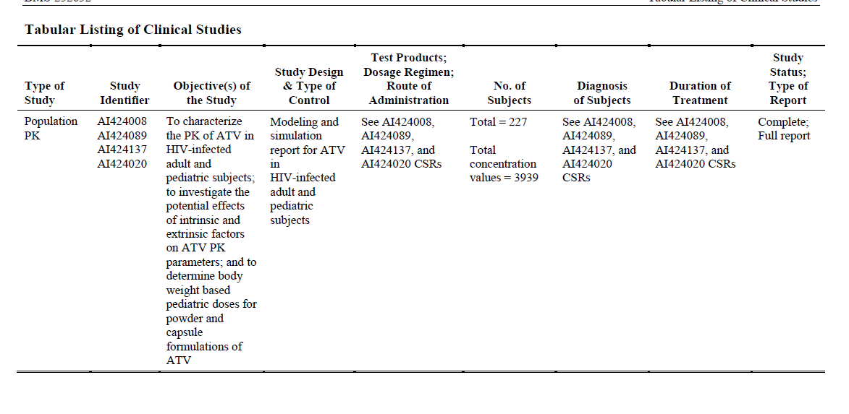

Pharmacokinetics

Clinical evaluator

Population pharmacokinetic modelling
The revised dosage recommendations are based on population pharmacokinetic modelling and simulations analysis of data from three adult studies and one paediatric Study AI424020. The paediatric study included data from 176 patients.
Adult data included full 24 hour pharmacokinetic steady-state results from 13 patients receiving 400 mg once daily ATV plus lamivudine and stavudine (Study AI424008), 27 patients receiving ATV 400 mg (15) or ATV/RTV 300/100 mg (12) in combination with lamivudine and stavudine (Study AI424089) and 11 patients treated with ATV/RTV 300/100 mg and two nucleoside reverse transcriptase inhibitors (Study AI4241374). The overall dataset included 277 participants with usable pharmacokinetic data.
A nonlinear mixed-effects compartmental model was developed to characterise the pharmacokinetics of ATV and investigate the covariate effects on ATV steady state C24, C_{max} and AUC. The intrinsic covariates: body weight, age, sex, race and antiretroviral treatment naive or experience, plus the extrinsic covariates, formulation, RTV co-medication and study region were investigated. A bridging strategy was employed to determine weight-based dosing recommendations on the assumption that efficacy can be extrapolated from adults to paediatric patients using the pharmacokinetic data alone.
The model included 620 observations from adult studies and 3,319 observations from the paediatric study. Overall, 13.2% of available observations were excluded including 11.7% of the paediatric observations. The applicant considered that the exclusions would not bias the results. No observations were flagged as outliers.
In the final model, the following covariate effects were considered clinically relevant: body weight of V/F and CL/F, RTV co-medication on CL/F and F_{rel} and formulation on F_{rel}. Region, sex and treatment experience were not considered to have clinically significant effects.
Age effect was an important determinant for ka with increasing ka in younger patients resulting in a higher C_{max} with decreasing age. C_{max} appeared to sharply increase for patients less than 10 years of age. The relationship between baseline age and body weight was found to be linear in the weight range relevant to this submission.
Discrepancy in agreement between observed and predicted values was noted for the group aged 2 – 13 years for C_{max} and AUC at Week 56. Discrepancy in agreement for the group aged 13–18 years for C_{max} at Week 1 and C_{min} at Week 56 was also noted. While these age groupings are in keeping with those suggested in the TGA adopted European Union Note for Guidance on Clinical Investigation of Medicinal Products in the Paediatric Population, it seems possible that the age range 2–13 year encompasses a time at which ATV and RTV metabolic handling transitions from immature to mature and it is unclear just when that may happen.
Bioequivalence in terms of C24 with conventional limits 80% to 125% was not possible. Exposures were considered similar if, for more than 75% of children, the geometric mean (GM) C24 was greater than 75% of geometric mean of adult C24 (500 ng/mL) and if, contingent on meeting the C24 criteria, the GM C_{max} was < 150% of adult C_{max} and paediatric AUC was within 80%–125% of adult AUC for > 75% of paediatric patients. The dosing scenarios meeting these adult similarity criteria are those proposed for the PI; however it is noted that the previously approved dose of 250 mg fitted the scenario well for children between 30 to 40 kg.
The applicant stated that based on the model predictions, at ATV doses with geometric mean C24 levels > 500 ng/mL (75% adult geometric mean C24), > 90% of patients taking the proposed doses are predicted to be able to achieve C24 > 130 ng/mL. This concentration is higher than the lower bound of C24 seen in both the lowest exposure quartile in Study AI424138, where 87% of participants achieved HIV RNA < 50 c/mL; and the second exposure quartile in Study AI424089, where 91% of patients achieved a HIV RNA < 400 c/mL and 75% achieved HIV RNA < 50 c/mL
Evaluation of ritonavir dose in the population pharmacokinetic report was summary. The final model included RTV as a simple dichotomous effect, not taking into account the actual dose. An apparent trend between ATV clearance versus RTV dose was shown, although it was not possible to tell whether the trend was fully explained by correlation between RTV dose and body weight as dosage had been based on body surface area.
The population pharmacokinetic report included clearly stated objectives, hypothesis and assumptions and the steps taken, the sequence of models tested including validation. However, population pharmacokinetic is by nature, post-hoc and exploratory, and the results are predictions or forecasts. If for some reason, the sample population results are biased, predictions may be unreliable, and in view of the small numbers of patients included in sampling, (inadvertent) bias cannot necessarily be excluded. In addition, as accepted bioequivalence levels were not possible, the applicant unilaterally revised criteria.
The reliability of the analysis results was checked by examination of predicted versus observed results and there have been discrepancies as illustrated in Figures 11-13 and Figure 15 (see Attachment 2).
The importance of including covariate effects in influencing ATV exposure and informing the weight-based dose recommendations is agreed. It was determined that while age impacted clearance and distribution, weight impacted absorption. The age at which ka transitions from being a clinically relevant covariate has not been discussed but is felt to be important in view of the proposal to include children 6 to 8 years in the Dosage and Administration section of the PI. While age and weight correlated linearly in the sample population between 15 and 60 kg, it was noted that age 6 to 8 correlated best with weight 20 to 25 kg and weight 15 kg appeared to correlate with age 5 years in that specific population.
In the situation where a C_{min} is relatively low, while a C_{max} is relatively high, the proposition that administration of a lower dose, more often may be beneficial bears contemplation. The belief that once daily administration improves compliance; however this is not necessarily true as reported in a systematic review showing no significant difference between once and twice daily dosing. As atazanavir has established dose related adverse effects, and the result of under dosing, particularly, with respect to C_{min}, may result in lack of efficacy, it is suggested that twice daily dosing would lead to better clinical outcomes for young children and that complicated post-hoc manipulation of data, to provide rational dosing, does not necessarily result in the safest and most efficacious dosage recommendations. It appears that the problems inherent with the current dose recommendations are due to current formulation strengths.
Variability in pharmacodynamics or pharmacokinetics is considered a threat to successful drug treatment and variability is decidedly a feature of the reported pharmacokinetic results. The limited number of children contributing to observed data is considered to impede dosage verification.
The applicant has not comprehensively addressed the specific age range 6 to < 8 years, the ages not currently represented in the Dosage and Administration section of the PI. Concern was raised previously about the apparently unpredictable clearance/kg by age demonstrated in children less than 8 years of age. The evaluator at that time concluded that the dosage recommendation based on body weight for these young children is unlikely to result in a predictable plasma level, a matter considered potentially hazardous in view of both the non-linear kinetics and the possibility of ineffective C_{min} values due to the high peak to trough ratios. The information included in the submission does not appear to support a differing opinion.
With respect to ritonavir, the chosen dose based on the clinical judgment mentioned in the application appears to be pragmatic in that 100 mg is the smallest dose available in capsule form and the capsule formulation is considered more palatable.

Study AI424020 pharmacokinetics
The pharmacokinetic component of Study AI424020 presented in the clinical study report included individual intensive pharmacokinetic data for the 7 participants who received the proposed, revised dose or higher. Two patients provided one set of results, four patients provided 2 sets and one patient provided 3 sets of intensive pharmacokinetic sampling results.
Five patients weighing 15–25 kg on the proposed weight based regime provided data. No individual data was presented for the proposed lower dose for the weight range 25 kg to < 39 kg. Three patients aged between 6.5 to 7.1 years, weighing between 16.1 and 17.5 kg provided 4 sets of results while on the proposed dose of for children between 15 and 20 kg of ATV/RTV 150/100. One participant aged 6.7 years, weighing 18 kg was treated with ATV/RTV 250/100 after dose adjustment. The C_{min} results for these children ranged between 141 ng/mL and 800 ng/mL.
In the 20 to < 25 kg weight range, two patients aged 8.9 and 9.8 years, weighing between 21.3 kg and 24.7 kg provided three sets of data while taking the proposed dose of ATV/RTV 200/100 mg, three patients between 6.9 and 7.8 years, weighing between 22 kg and 24 kg treated with previously approved dose of ATV/RTV 250/100 mg provided four sets of data and one patient aged 7.1 years weighing 22.5 kg provided one set of data while on ATV/RTV 400/100 mg with resultant C_{min} 658 ng/mL; this patient had previously contributed data while on ATV/RTV 250/100 mg at which time the C_{min} was 255 ng/mL.
The results presented for ritonavir in the group of seven patients demonstrated a tendency to achieve lower C_{min}, higher C_{max} and AUC results with C_{min} than seen in adults. Although the results were presented for weight they suggest the possibility that aged based metabolic processes similar to atazanavir may be in play.
The evaluator considers that the PI should inform readers that failure of treatment may be due to insufficient dosage, not necessarily due to non-compliance, and that the high degree of PK variability has been demonstrated in clinical studies.

POPPK evaluator

Overall conclusions on the population pharmacokinetic analysis
The modelling process was conducted and reported in accordance with the Guideline on Reporting the Results of population Pharmacokinetic Analyses CHMP/EWP/185990/06.
The base structural model was consistent with the known pharmacokinetic characteristics of atazanavir. The error model was appropriate to the data and consistent with the expected distribution of the pharmacokinetic parameters. The goodness of fit plots were supportive of the base model.
The covariate model was developed using all the available covariate data. The covariate model building process was rigorous. The final model was supported by the goodness of fit plots and the PPC. The covariates that remained in the final model were consistent with the known pharmacokinetic characteristics of atazanavir.
The simulations were performed using the model developed in the population pharmacokinetic analysis. The age groups and doses studied were appropriate. The acceptance criteria for the dosing regimen were rigorous.
The modelling and simulation process supports the proposed new dosing regimen. The current dosing regimen also passed the acceptance criteria, but the new dosing regimen performed slightly better and can also be applied to a lower body weight and age grouping.
Although the population pharmacokinetic study is acceptable and supportive of the application, the Sponsor could have extended the population pharmacokinetic model to a population PKPD model. Suitable pharmacodynamic endpoints were obtained in the paediatric study (e.g. HIV RNA and CD4 cell counts). A population PKPD study would have provided further support for a rational dosing regimen.

Pharmacodynamics
No new data submitted.

Efficacy
The number discontinuing prior to or at Week 96 was 44/105 (42%), the most common reasons being protocol non-compliance, completion of treatment or toxicity.
In accordance with results of adult studies, virologic response at Week 96 was greater in the treatment-naive patients than the treatment-experienced patients. For patients treated with ATV with or without RTV, the overall proportions of antiretroviral naive and experienced participants with HIV RNA < 400 copies/mL at Week 96 were 21/43 (49%) and 21/62 (34%), respectively. The overall proportions with HIV RNA < 50 copies/mL at Week 96 were 20/43 (47%) and 15/62 (24%), respectively.
A similar pattern but better results were seen for virologic response-observed cases as would be expected with the smaller denominators. Proportions with HIV RNA < 400 copies/mL at Week 96 were 78% (21/27) and 66% (21/32), respectively. The overall proportions with HIV RNA < 50 copies/mL at Week 96 were 74% (20/27) and 47% (15/32), respectively. The response for treatment experience patients of 24% at Week 48 was lower than that reported in adults while the response of 32 % at Week 96 was roughly the same, acknowledging that numbers in the paediatric study were small and study designs were different.
The median increases from baseline in absolute CD4 count at 96 weeks of therapy were 335 cells/mm³ in the treatment naive patients and 220 cells/mm³ in the treatment experienced patients.

Safety
Adverse events were reported by all participants. The most common related to raised unconjugated bilirubin/jaundice, cough, rash and pyrexia. Two patients died before Week 48; neither death was attributed to study drug. Serious adverse events were reported by 65% of participants, the majority of which were related to hyperbilirubinaemia. The highest reported unconjugated SBR was 9.9 mg/dL (169 µmol/L). Cardiac disorders were reported as SAEs by 8% of participants. Discontinuation due to adverse event was reported for 17% of participants, the most common reasons being unconjugated hyperbilirubinaemia, cardiac related events and rash. The six participants discontinuing due to cardiac related event were all treated with high dose unboosted ATV. AIDS related events were reported by 17 (16%) of patients, the most common being oral candidiasis.
ECG abnormalities were reported for the majority of participants. The most common being first degree AV blocks and other ST/T morphological abnormalities. The only patient noted to have QTcB prolongation > 480 ms had a prolonged QTcB interval at screening which was a protocol deviation.
The pattern of adverse events appears similar to that of the adult treated population although frequency of hyperbilirubinemia and ECG changes appears greater. High ritonavir C_{max} and AUC in comparison to adults treated with 100 mg ritonavir may theoretically increase the incidence of ECG PR interval prolongations. The external validity with respect to cardiac safety may have been limited by the extensive list of protocol mandated exclusions relating to pre existing cardiac disorders.
The highest reported unconjugated SBR was 9.9 mg/dL, (NR 0.1 – 1.1 mg/dL). Unconjugated SBR is neurotoxic. Human immunodeficiency virus type 1 (HIV) invades the CNS early after primary infection and disruption of blood brain barrier integrity has been reported. The level of bilirubin, duration of exposure, respiratory acidosis, and metabolic acidosis, infection, drug displacement of bilirubin from binding to albumin for example, with sulphonamides, down regulation of P-glycoprotein which can result from drug use, hyperosmolality, hypoxia, ethnic and genetic variability may all act to increase the likelihood of bilirubin toxicity. Each of these factors may act singly or together in a child with HIV infection. Despite the fact that many factors that might enhance neurotoxicity of unconjugated bilirubin may be relevant at times for a child with HIV, the levels reported in this study are well below those documented to cause kernicterus in full term newborns.

List of questions
The majority of figures and tables referred to in these questions are those discussed and included in the Extract from the CER, Attachment 2.

Population pharmacokinetics

Clinical evaluator
- It was requested that the applicant supply figures illustrating information for age ranges 6 to <8 years, 8 to < 13 years and 13 to 18 years. It is also requested that the applicant supplies the numerical values for the medians, 5th and 95th percentile ranges for these figures.
Applicant response: The tables, medians and percentile ranges have not been provided for the additional requested subsets by age. At Week 1, there were only 2 individuals who were <6 years of age with observed ATV C24, C_{max} and AUC; a majority of the subjects in Group 7 (2 to < 3 years of age) were between the ages of 6 and 13 years. Sub-setting into smaller age groups results in a limited number of observations for subjects 6 to < 8 years of age, which may not allow for meaningful PPC assessment. For children 6 to < 8 years of age, ≤ 6 individuals had observed ATV C24, C_{max}, or AUC at Week 1, while the number of observations for subjects 8 to 13 years of age was considerably larger (N = 18 to 20 at Week 1), resulting in an unbalanced comparison of these two age group subsets.
As requested, Tables 3-8 provide the observed and predicted medians, as well as and 5th and 95th percentile ranges for Group 7 (2 to < 13 years), Group 8 (13-18 years).
Table 3. Observed and Predictive Distribution of the Geometric Mean C24 (ng/mL) in Paediatric (Week 1) and Adult Patients
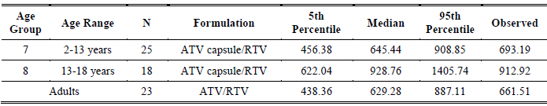
Table 4. Observed and Predictive Distribution of the Geometric Mean C24 (ng/mL) in Paediatric (Week 56) and Adult Patients
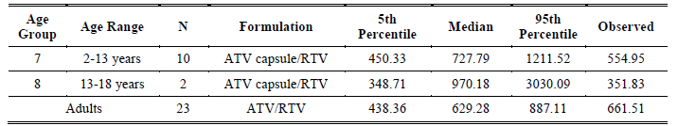
Table 5. Observed and Predictive Distribution of the Geometric Mean Cmax (ng/mL) in Paediatric (Week 1) and Adult Patients
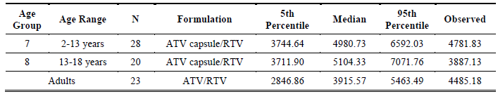
Table 6. Observed and Predictive Distribution of the Geometric Mean Cmax (ng/mL) in Paediatric (Week 56) and Adult Patients
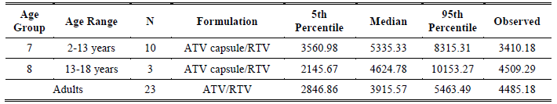
Table 7. Observed and Predictive Distribution of the Geometric Mean AUC (ng.hr/mL) in Paediatric (Week 1) and Adult Patients
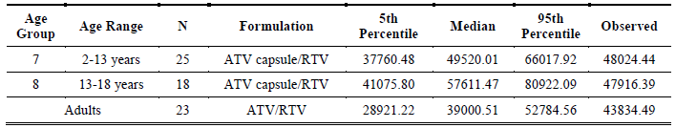
Table 8. Observed and Predictive Distribution of the Geometric Mean AUC (ng.hr/mL) in Paediatric (Week 56) and Adult Patients
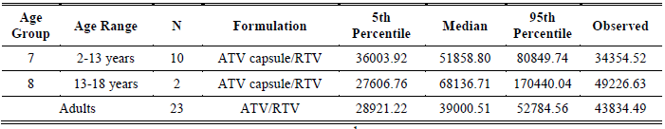
Evaluator comment: The tables compare Week 1 and Week 56 results for children with Day 29 results for adults. The paediatric age range depicted does not correspond to age ranges included in the PI. Children less than six years of age were treated with a different formulation than the older children.
There were some discrepancies between observed and predicted median results. The observed C_{min} of 351.83 ng/mL at Week 56 for patients aged 13 to 18 years was just on the predicted 5th percentile and was well below 500 ng/mL. The observed C_{max} at Week 1 for those aged 13 to 18 years was close to the predicted 5th percentile. The observed C_{max} at Week 56 for those aged 2 to 13 years was below the predicted 5th percentile. The observed AUC at Week 56 for those age 2 to 13 years was below the predicted 5th percentile.
It is uncertain why participants dropped out of the PK component of the study. The large numbers of drop-outs may have biased results. As the numbers participating was small, particularly so for the Week 56 results for the age group 13 to 18, it is hard to generalise about the relevance of post-hoc exploratory analysis to the real population for any individual being treated, and therein lies a problem with external validity.
- Regarding Figure 17, it was requested that the y-axis intervals are increased to spread the data and that there are regular interval markings included on both the x- and y-axes. It is requested that the added markings on the x-axis specifically include 15 kg and 20 kg. The applicant is requested to comment on the possibility that correlation of age and weight may not be so reliable in the study population in the weight range 15 to 20 kg, and that this may potentially be problematic when using the 15 – 20 kg range in formulating dosage recommendations for the age group 6 to 8 years.
Applicant’s response: the observed relationship between age and body weight for patients weighing 15 to < 20 kg fits well with the linear regression.
Figure 1. Relationship between Baseline Age and Body Weight for Pediatric Patients in Study AI424020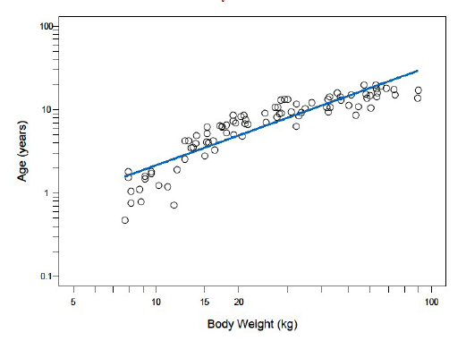
Evaluator comment: The applicant’s conclusion is agreed. The linear relationship appears to hold from about 15–60 kg, the weight range applicable to the application but is less obvious below 15 kg and above 60 kg and the slope may have been different if the results had not been included.
- The previous evaluator considered that the clearance by age and weight below the age of 8 became too unpredictable to warrant approval of dosage instructions for children of that age as illustrated in Figure 2 below. Can the applicant state with certainty the time point at which age becomes less of a determinant of PK results?
Figure 2. Oral clearance per kilogram versus Age for ATV capsule with RTV
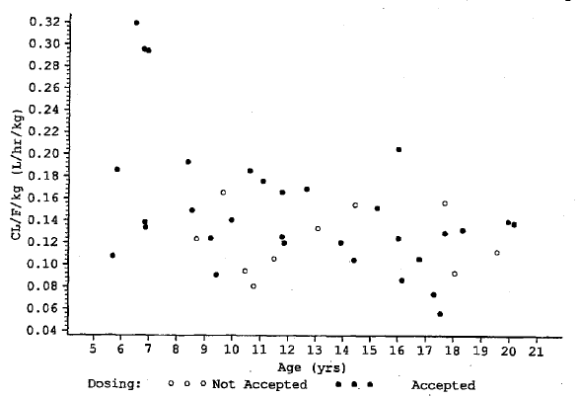
Applicant’s response: There was no response.
Evaluator comment: The response was not satisfactory. Subsequent numbering in the sponsor’s responses versus the TGA question document reflects the absence of the applicant’s mention of this question.
- Figures 18-20. Please give actual values for the medians, interquartile range and 5th and 95% percentiles and for adults, the 10th, 50th and 90th percentiles and indicate whether the adult parameters are based on observations or simulation.
Applicant response: Simulation results ATV C24, C_{max}, and AUCs are provided in Table 9-11. These tables correspond to Figures 18-20, respectively (in Attachment 2). Adult exposures described below are simulated as well; however, a posterior predictive check that was performed using the final PPK model demonstrated that predicted adult exposures treated with ATV/RTV agreed very well with observed ATV exposures.
Table 9. Simulation Results for ATV C24 (ng/mL) at the Proposed Capsule Doses for Pediatric Patients Receiving ATV/RTV
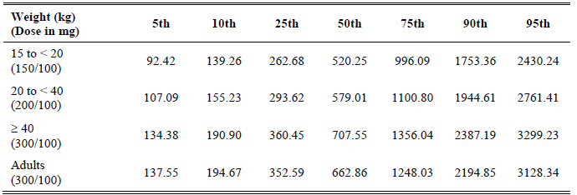
Table 10. Simulation Results for ATV C_{max} (ng/mL) at the Proposed Capsule Doses for Paediatric Patients Receiving ATV/RTV
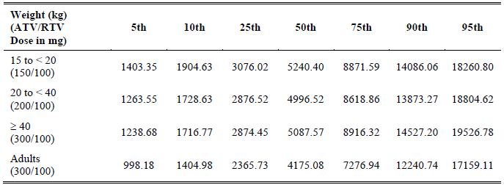
Table 11. Simulation Results for ATV AUCs (ng/mL.h) at the Proposed Capsule Doses for Paediatric Patients Receiving ATV/RTV
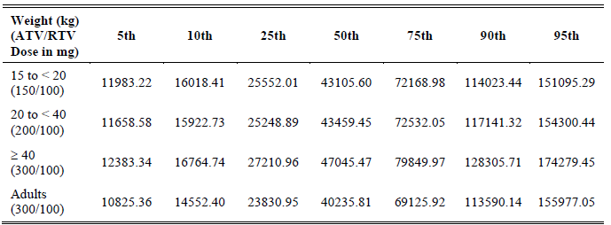
Evaluator comment: In the sponsor’s submission it is stated that the “refined weight band separation allows patients in both weight bands to achieve ATV geometric mean C24 levels > 500 ng/mL, and thus can be recommended for both treatment-naive and -experienced paediatric patients.” For children less than 15 kg to < 20, the 10th percentile is less than the minimum suggested target trough concentration of 150 ng/mL according to the Guidelines for the Use of Antiretroviral Agents in Pediatric HIV Infection. For children 20 to < 40 kg, the 10th percentile is just on this value. As C_{min} is considered and important efficacy parameter, these predicted values are considered to be a potential problem for some children even in the absence of non-compliance. The simulated C_{max} values for the paediatric patients are higher than for the adults with potential for toxicity at highest percentiles.
- Figure 21 is hard to see and prints poorly. The sponsor is requested to supply the figure in a form in which a printed, black and white version is clear and in which there are bigger intervals on the y-axis which only needs to include values to about 150%.
Evaluator comment: The revised figure provided by the sponsor in their response has been included in the CER (Figure 21 Attachment 2).
- Figures 23 and 24. It is requested that similar figures are provided with the RTV dose of 100 mg included to the y-axis. An explanation is requested as to why are there so few values for what appears to be in proximity to the 100 mg dose. Can the applicant state with certainty that the results for 100 mg are not biased by lack of data at the proposed dose of 100 mg?
Applicant’s response: There are few values at RTV dose of 100 mg in the figures, because a majority of these subjects had a body surface area (BSA) < 1, resulting in a RTV dose < 100 mg. The revised figures showing the 100 mg dose are included in Figures 3-5 below.
There were no apparent trends observed for the ATV C0 and F_{rel} parameters with regard to RTV dose. However, there does appear to be a trend between RTV dose and ATV CL/F. Upon further investigation of this relationship, the final CL/F sub-model was expanded to include RTV dose effect. The results suggest that RTV dose explains little of the RTV co medication effect after adjusting for the other covariate effects, such as body weight and dichotomous RTV co medication effect (that is, presence or absence of RTV). Taken together, the dose of RTV does not impact exposure to ATV.
Figure 3. Individual Predictions of ATV C0 versus RTV Dose in Pediatric Patients Receiving ATV/RTV
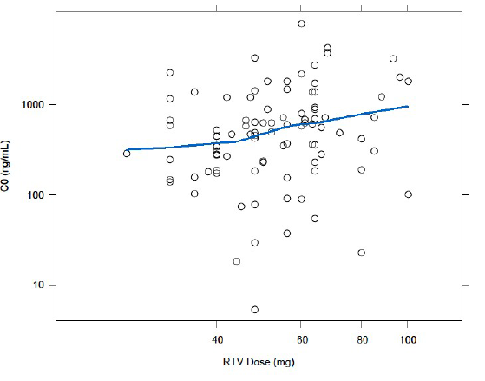
Figure 4. Individual Predictions of ATV Frel versus RTV Dose in Pediatric Patients Receiving ATV/RTV
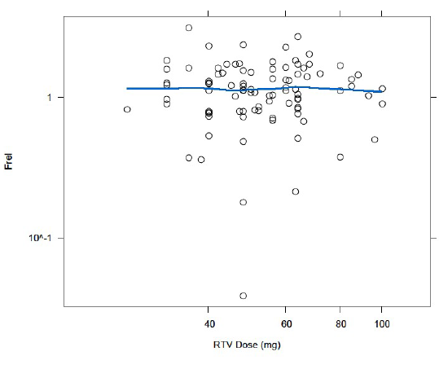

Figure 5. Individual Predictions of ATV CL/F versus RTV Dose in Pediatric Patients Receiving ATV/RTV
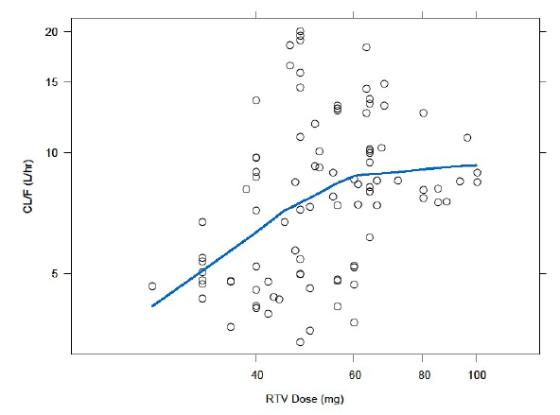
Evaluator comment: The argument is accepted as being relevant to the data analysed. The data for 100 mg is very limited. The majority of results are for doses less than 80 mg. The data analysed are not particularly relevant to the proposed dosage which will be a uniform 100 mg for children weighing as little as 15 kg. It cannot be considered certain that if patients had actually been treated with RTV 100 mg, the dichotomous effect would have been the same. Figures 31-33 inform the reader that the doses of RTV were 100 mg. This appears not be to so.

Pharmacokinetics study AI424020
7. Please provide C_{max}, C_{min} and AUC data for patients weighing 32-40 kg administered the proposed ATV/RTV dose of 200/100 mg, including figures similar to Figures 27 and 28.
Applicant’s response: ATV PK parameters (C_{max}, AUC, and C24) for patients weighing ≥ 32 to <40 kg that received ATV/RTV of 200/100 mg or higher are provided in Table 12. A comparison of ATV C24 from subjects who received ATV/RTV 200/100 mg or higher for at least 24 weeks relative to the projected C24 is provided in Figure 6. Figure 7 depicts a scatter plot of ATV C_{max} in subjects with body weights 32 kg to < 40 kg treated with ATV/RTV 200/100 or higher for at least 24 weeks.
Table 12. Atazanavir PK Parameters for Subjects 32 to < 40 kg that Received ATV/RTV 200/100 mg or Higher
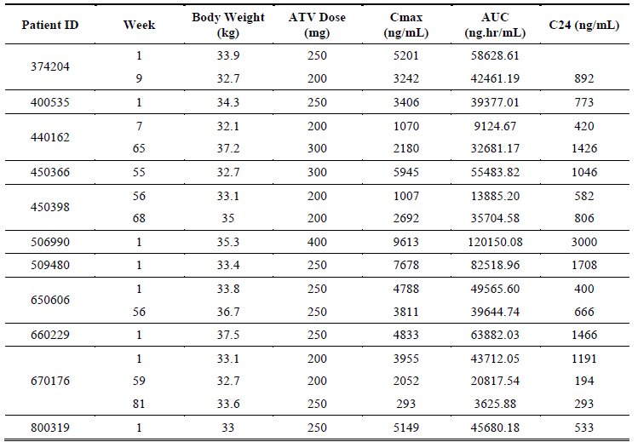
Figure 6. ATV C24 from Subjects on ATV/RTV ≥200/100 mg for ≥t 24 Weeks Relative to the Projected C24
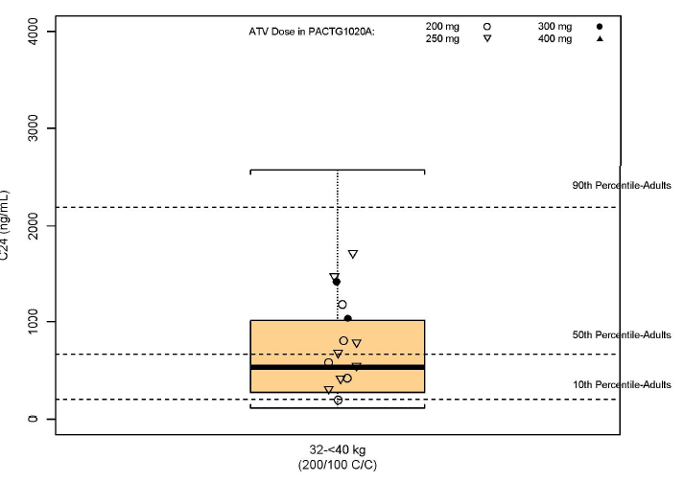

Figure 7. ATV C_{max} for participants 32 kg to <40 kg Treated with ATV/RTV 200/100 for at Least 24 Weeks
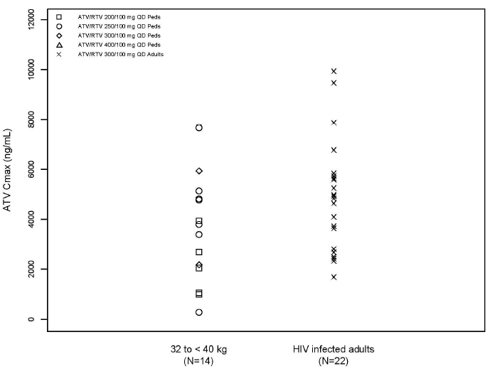
Evaluator comment: The results for the proposed dose were requested, that is, 200 mg and not greater than 200 mg. From Table 24 it is evident that only 2 of the 11 participants appeared to have PK levels on dose 200 mg that were acceptable to the investigators. The other participants needed higher doses while remaining in the same weight category. Looking at Figure 6 and Figure 7, the results appear lower than for adults and these results are preponderantly for participants on doses higher than the proposed dose. However, PK results for children weighing 25 to < 32 kg may be higher than those depicted for the range 32 to 40 kg. The results support the proposition that children between 32 and 40 kg may require ATV doses higher than 200 mg.

POPPK evaluator question
Has the Sponsor performed a population PKPD study using the data from the analysis evaluated in the present report and pharmacodynamic endpoints such as HIV RNA and CD4 cell counts?

Pharmacodynamics
No questions listed.

Efficacy

Clinical evaluator

Study AI424020
- What is the definition of “completion of treatment” as used in Table 7? Was there a protocol defined time at which treatment was considered complete?
Applicant’s response: The table referenced is a disposition table that was based upon the reason for discontinuation reported by the study investigator on the case report form (CRF). The protocol specifies that the treatment duration is intended to be up to 96 weeks after the last subject is enrolled. However, since the reporting of ‘completed treatment’ was determined by the study investigator, it is possible that a study investigator may have chosen ‘completed treatment,’ as long as the individual subject reached 96 weeks.
In the US, per protocol version 6, Section 6.41, once the last accrued subject reached 96 weeks of treatment in Step I, all subjects successfully remaining on study were considered to have completed treatment, if they were taking the ATV capsule, and then came off study. If they were taking ATV powder, which is not yet available off study, then they continued on study and did not complete treatment. Additionally, and as allowed per protocol, eligible subjects in the US who switched from powder to capsule formulation after reaching at least 96 weeks of treatment were also considered as completed treatment and came off study.
Subjects in South Africa did not complete treatment per protocol and continued on study, since ATV was not yet available outside of study treatment in South Africa.
Evaluator comment: Response accepted.
- With respect to Table 12: Why was the VR greater at Week 96 than at Week 48 for ATV/RTV treated ARV-experienced patients? Was this likely to have been because of change of background therapy with resultant possibility of confounding?
Applicant response: Any changes in NRTI use would not have likely contributed to any differences in efficacy. Protocol Section 5.1.2 states: “Subjects will remain on the chosen NRTIs for the duration of the study, with the exception of NRTI-related toxicity. If a subject is experiencing toxicity believed to be related to one of the NRTIs, but not the study drug, and has completed at least 52 weeks on study, and is virologically suppressed, the site may contact the team about substituting an alternative NRTI.”
The protocol specified that subjects who met the criteria for treatment failure could have remained in the study if the protocol chairperson, investigator, and subject (or parent/legal guardian) agreed that it was in the subject’s best interest to remain on his/her current treatment. This approach allowed patients experiencing viral rebounds due to adherence issues to stay on study while the investigator worked on improving the patient adherence issue.
According to the US Department of Health and Human Services 2011 guidelines, inadequate adherence is the most common cause of antiretroviral treatment (ART) failure. Not all instances of treatment failure require an immediate change in therapy; careful assessment, especially of adherence, is required to evaluate the aetiology of the treatment failure and determine an appropriate management strategy. If poor adherence was the cause of treatment failure and circumstances leading to poor adherence have not been adequately addressed, changing the ARV regimen may not be advisable.
Many subjects in this study had considerable prior treatment experience and compromised NRTI activity leading to slower decay in HIV RNA and increased potential for viral blips, as seen at Week 48. All subjects who were not suppressed at Week 48 but showed viral suppression at Week 96 had been virologically suppressed before Week 48 and subsequently experienced a virologic blip or rebound around Week 48 followed by re-suppression:
For ATV/RTV treated ARV-experienced subjects regarding:

VL < 400 c/mL:
- Eight had HIV RNA < 400 c/mL at Week 48; all of them had HIV RNA < 400 c/mL at Week 96.
- In addition, 2 more subjects had HIV RNA > 400 c/mL at Week 48 but suppressed to < 400 c/mL at Week 96.
- One was suppressed < 50 c/mL at Day 294 and had a blip (1,446 c/mL) at Week 48, followed by VL < 50 c/mL at the next visit.
- One was suppressed < 50 c/mL at Day 111 and experienced a rebound at Day 295 (203 c/mL); the subject re-suppressed to < 400 c/mL at Day 449 (85 c/mL) and to < 50 c/mL at Day 505.
- None of the 10 subjects had background therapy changes.

< 50 c/mL:
- Six subjects had HIV RNA < 50 c/mL at Week 48, 5 of them were also < 50 c/mL at Week 96 was no longer < 50 c/mL at Week 96.
- In addition, 3 subjects who were not < 50 c/mL at Week 48 became < 50 c/mL at Week 96, which results in 8 subjects who suppressed to < 50 c/mL at Week 96.
  - One was suppressed < 50 c/mL at Day 57 and experienced blips to 1,801 c/mL at Day 301 and 134 c/mL at Week 48; he re-suppressed to < 50 c/mL at the next visit.
  - One was suppressed < 50 c/mL at Day 113 and experienced a rebound at Day 225 (132 c/mL). His viral load at Week 48 was 327 c/mL. He re-suppressed to < 50 c/mL at Day 503.
  - One participant was suppressed < 50 c/mL at Day 111 and experienced a rebound at Day 295 (203 c/mL); the subject re-suppressed to < 400 c/mL at Day 449 (85 c/mL) and to < 50 c/mL at Day 505.
- None of the subjects had background therapy change.
Evaluator comment: Response accepted.
- To what extent did the lack of accurate recording of concomitant therapy affect the assessment of confounding?
Applicant response: The statement in the CSR regarding concomitant therapy was only meant to explain that, in some cases, ARV medications that were part of the backbone therapy or were used as prior therapy (that is, not taken on study) were recorded in the concomitant therapy section erroneously. It was determined that these were errors but they could not be corrected in time for the database lock for the CSR. However, it was confirmed with the PACTG (IMPAACT) at the time, that the ARVs reported as concomitant medications should have been deleted from that part of the CRF. All other concomitant medications were required to be, and to the best of the sponsor’s knowledge were, recorded in the CRF, and are included in the CSR. An analysis of an individual subject’s efficacy results versus concomitant medications was not performed, and is not typically performed. However, the majority of concomitant medications reported to be taken most often during the study were medications that were allowed by protocol and those that do not have an interaction with ARVs (such as antibiotics) such that efficacy would be impacted. Therefore, the efficacy assessment is not considered to have been confounded in any way by the concomitant therapies.
Evaluator comment: Response accepted
- To what extent were efficacy results dependent on dose modification following intensive and random PK assessments over the course of 96 weeks of treatment? Does the applicant consider that PK results leading to alteration in dosage may have maximised efficacy in the study population? Would external validity be limited if therapeutic drug monitoring is not undertaken in the non-study population, particularly in view of the documented large CV% results?
Applicant response: Study AI424020 was a PK dose-finding and safety study. The sample size was not calculated statistically for an efficacy endpoint, so the efficacy results are descriptive only. The efficacy results were not at all dependent on dose modification. Instead, efficacy is correlated with exposure. The dose was individually adjusted for each subject until the subject achieved ATV exposures within the range of targeted exposures with the overall goal of maintaining the target exposure. An individual dose would not subsequently be adjusted randomly throughout the trial or due to PK variability but instead would only be modified again if, for example, a subject’s increase in BSA was enough to warrant a modification. The overall goal of the study was to find the optimal dose for use in the broader population so that individual dose adjustments would not be necessary.
This study was started prior to the knowledge that ATV required RTV ‘boosting’ when used in treatment-experienced patients. The original PK targets (for Groups 1 through 4) were based on observed PK data of unboosted ATV in adults, which are lower than those achieved with ATV boosted with RTV. The study was modified before the completion of enrolment of Groups 1-4 and before the inclusion of the boosted Groups 5-8 to raise the PK targets to those more comparable to ATV/RTV in adults.
Therefore, the efficacy data are not considered to be maximised by the individual dose modifications either due to missing the PK target or due to a change in BSA. Again, in the study, once a subject achieved the target PK, the dose was maintained until a BSA change so that the target PK exposures were sustained.
It is also important to note that the study actually included the use of unboosted ATV in treatment experienced subjects and enrolled a more treatment experienced patient population than patients who would be currently indicated for ATV/RTV treatment. For example, treatment experienced patients may have virologically failed multiple protease inhibitor regimens prior to entering the study. In current practice, boosted Reyataz is commonly used in treatment naive patients and those with less treatment experience than in the past. Thus, exposures are usually adequate with little or no need for individual drug level monitoring.
The use of therapeutic drug monitoring (TDM) in the broader population is not feasible, and is unnecessary, particularly in this patient population, for the reasons already described. The dose-finding study, along with very robust modelling and simulation analyses, provide recommended doses by weight bands to ensure that the exposures expected would be those in the range that have already demonstrated efficacy in adults.
Evaluator comment: It is understood that efficacy is related to exposure. Exposure is related to dose and the dose in the dose finding study was tailored to result in exposure in the range expected to be therapeutic based on adult studies. It is not accepted that the efficacy data are not unequivocally maximised by the individual dose modification.
TDM is feasible for the paediatric patients in Australia. The ultimate purpose of registration of a drug product is of treatment of individuals avoiding under dosing and excessive dosing. Mean PK results and the results of exploratory analysis such as modelling based on sparse data, may not apply to an individual, especially in the presence of large PK coefficients of variation. The data presented for evaluation is considered to confirm that it is not possible to find the optimal uniform dose for use in the broader population.
While it may not be necessary to have the advice to undertake TDM included in the PI; such advice is included in ARV Guidelines which reference Guidelines for Use of Antiretroviral Agents in Pediatric HIV infection and it is recommended that the reader of the PI is referred to the ARV guidelines in both the Precautions section and the Dosage and Administration section.

Safety

Clinical evaluator
- In the Safety Narratives for Deaths, SAEs and AEs Leading to Study Discontinuation, why were the following events considered “life threatening”?
  - 410179 unconjugated SBR maximum SBR 6.6 mg/dL
  - 450366 unconjugated SBR maximum SBR 8.7 mg/dL
  - 450377 unconjugated SBR maximum SBR 7.6 mg/dL
  - 502836 unconjugated SBR maximum SBR 8.3 mg/dL
Applicant response: The intensity of these events was either reported based on the grade of the laboratory abnormality or at the discretion of the investigator. All 4 of these subjects with indirect hyperbilirubinemia reported by the investigator as either ‘very severe/life-threatening’ or ‘life-threatening’ were either dose adjusted and/or had medications interrupted. None of these subjects were hospitalised, discontinued due to the event, nor had any sequelae from the indirect hyperbilirubinemia.
Evaluator comment: Response accepted.

Clinical summary and conclusions (clinical evaluator)

Benefit-risk assessment

Benefits
Before the advent of antiretroviral treatment, HIV infection was almost invariably fatal and disease progression causes marked suffering. The need for registration of suitable antiretroviral agents for use in children is without doubt.
Atazanavir has been studied in adults and efficacy has been shown to be related to pharmacokinetic parameters, in particular, C_{min}. It is accepted that, in the presence of pharmacokinetic parameters in the accepted adult ranges efficacy would most likely be similar in children and adults.
Atazanavir has pharmacokinetic profile in adults consistent with once daily dosage which may theoretically improve compliance.
The simplified dosage regimen removing a dose change at 32 kg is considered to be easier to manage in clinical practice.
Removal of the requirement to use two different tablet strengths for the 250 mg dose may make administration errors less likely. However, no administration errors relating were reported in the Periodic Safety Update Report (PSUR) for the period 20 June 2011 to 19 June 2012.
Atazanavir has a well studied safety profile in adults.

Risks
Atazanavir exhibits non-linear kinetics and considerable pharmacokinetic variability. Age and weight have been shown to be clinically relevant covariates; younger children tend to have lower C_{min} and higher C_{max} and AUCs than older children and adults. It is not clear to the evaluator just when the metabolic process becomes less sensitive to age. The numbers studied between 6 and 8 years are very limited, however, the data presented appear to suggest that maturity occurs later than the proposed 6 years.
As C_{min} results tend to be lower in young children than adults, for any individual child it is not possible to guarantee adequate blood levels on the proposed doses as demonstrated by observed values for the seven patients included in the submitted CSR. Along with the risk of sub therapeutic dosing, there is a theoretical increased risk of development of viral resistance early in the child’s life if sufficient levels are not maintained. In addition, because there was no data provided for children between 32 and 40 kg on the proposed lower dose there was no confirmation that the predictions were reliable and it is considered that under dosing is a distinct possibility in that weight range.
As C_{max} and AUC values tend to be higher in young children than in adults, and as adverse events such as hyperbilirubinemia and cardiac effects on PR interval are linked to higher pharmacokinetic values, young children are at potentially at greater risk. The study protocol specifically excluded children with pre existing ECG abnormalities affecting external validity of cardiac safety.
Ritonavir levels in young children appear to follow similar patterns to ATV, with a tendency to lower C_{min} and much higher C_{max} and AUC than for adults. RTV also has potential effect on ECG PR interval and combined with ATV the effect theoretically may be compounded.

Balance
The risk/benefit balance for atazanavir overall was considered to remain on the side of benefit providing therapeutic levels of the drug are assured.

Conclusions
While the results of population pharmacokinetic evaluation are in keeping with generally adequate blood levels in the proposed weight categories, the results from actual patients have not proved conclusively supportive. The metabolic handling of atazanavir in the age range 6–8 years has not been sufficiently argued to allow revision of the previous opinion regarding this age group. The revised lower dose in the weight range 32–39 kg range has also not been supported with results from actual patients, and for this group, roughly corresponding to age 8 to 14 years, under dosing is seen as a possibility, particularly for the older patients.
The proposed increase in ritonavir dose for patients from 15 to 25 kg has also not been persuasively argued. For a child weighing 15 kg, on a mg/kg basis, the proposed dose approaches the therapeutic dose of 600 mg for an adult weighing 70 kg.
The revised doses cannot be recommended unless it is made clear in the Precautions and Dosage and Administration sections of the PI that young children have wide variability in metabolic handling of both atazanavir and ritonavir, and that they are at particular risk of lower C_{min} and higher C_{max}. To this effect it is recommended that at the minimum, the advice is included in the PI to refer to Australian Commentary to the USA Guidelines for the use of Antiretroviral Agents in HIV-1 Infected Adults and Adolescents which in turn, links to Guidelines for the Use of Antiretroviral Agents in Pediatric HIV Infection. The most appropriate advice, however, is considered to be to instigate treatment with the aid of therapeutic dose monitoring and to repeat TDM at each dose change. This is highly recommended as HIV infection is potentially life threatening, and because young children will have to manage this disease life-long. Thus, it is essential to maximise compliance by limiting side effects and maximise efficacy and reduce resistance by ensuring adequate exposure.

Recommendation regarding authorisation (clinical evaluator)
The proposed changes are recommended with qualifications regarding the results included in the draft PI.

V. Pharmacovigilance findings

Risk management plan
The sponsor submitted a Risk Management Plan which was reviewed by the TGA’s Office of Product Review (OPR).

Safety specification
The sponsor provided a summary of Ongoing Safety Concerns which are shown at Table 13.
Table 13. Summary of Ongoing Safety Concerns.
Summary of Ongoing Safety Concerns
Important identified risks | Cardiac conduction abnormalities for both adults and children (PR interval prolongation)  Nephrolithiasis  Hyperbilirubinemia
Important potential risks | QT prolongation  Kernicterus  Severe skin reactions
Important missing information | Pregnancy and lactation  Renal impairment  Hepatic impairment  Limited safety data in paediatric patients 6-18 years  Paediatric patients < 6 years old (<15kg)

OPR evaluator comment
In version 4 of the RMP the sponsor added ‘severe skin reactions’ as an Important potential risk. Otherwise the specified safety concerns are consistent with those previously accepted by the European Medicines Agency (EMA) (RMP version 2.2).
Notwithstanding the evaluation of the clinical aspects of the Safety Specification, the summary of Ongoing Safety Concerns was considered acceptable.

Pharmacovigilance plan
Routine pharmacovigilance is proposed by the sponsor to monitor the important identified risks, important potential risks and missing information associated with atazanavir. The pharmacovigilance plan is consistent with the activities described in the EU-RMP previously approved by the European Medicines Agency (EMA) for a similar submission and this was considered to be acceptable.
The routine pharmacovigilance activities described are consistent with 3.1.2 Routine pharmacovigilance practices, Note for Guidance on Planning Pharmacovigilance Activities (CPMP/ICH/5716/03) and this was considered acceptable.
Table 45 Action Plan for Safety Concerns (EU-RMP p116) and Table 1 Action Plan for Safety Concerns (ASA p2) includes “The Antiretroviral Pregnancy Registry” as additional pharmacovigilance for Important missing information ‘Pregnancy and lactation’ and “The collaborative epidemiologic D:A:D study” as additional pharmacovigilance for Important missing information ‘hepatic impairment’. It appears that both of these activities are ongoing but nevertheless further information about these activities (including projected milestones and reporting dates) should be provided in an update to the pharmacovigilance plan section of the RMP. Interim data for these studies should also be provided to the TGA if available.
Table 10 Epidemiologic Study Exposure (EU-RMP p32) lists Study AI424450, a prospective cohort study of children exposed to atazanavir. It appears that this study is a sponsor’s post-approval commitment to the EMA however it is not included in the pharmacovigilance plan. The sponsor should provide more information about this study including how it applies to the pharmacovigilance plan. Interim data should be provided if available. For completeness, details of this study should also be included in an update to the pharmacovigilance plan section of the RMP.

Risk minimisation activities
Routine risk minimisation (that is, product labelling) was proposed by the sponsor to mitigate all of the safety concerns associated with atazanavir. This is consistent with the activities described in the EU-RMP previously approved by the European medicines Agency (EMA) for a similar submission and was considered to be acceptable¹.
In regard to the proposed routine risk minimisation activities, it was recommended to the Delegate that the draft PI document is revised as follows:
The approved EU Summary of Product Characteristics (SmPC) contains the following statement regarding ‘QT prolongation’ in Section 4.4 Special Warnings and Precautions for Use: “Particular caution should be used when prescribing REYATAZ in association with medicinal products which have the potential to increase the QT interval and/or in patients with pre-existing risk factors (bradycardia, long congenital QT, electrolyte imbalances (see sections 4.8 and 5.3)”. It was recommended that the sponsor should include a similar precaution in the Australian PI or provide a compelling justification for its exclusion. Inclusion of such a precaution would be considered part of routine risk minimisation for the Important potential risk ‘QT prolongation’.
The approved EU SmPC precaution regarding the Important potential risk ‘severe skin reactions’ includes the following additional statement: “Patients should be advised of the signs and symptoms and monitored closely for skin reactions”. It was the evaluator’s view that a similar statement should be included in the corresponding Precaution in the Australian PI to strengthen the warning about the possibility of severe skin reactions.
In regard to the proposed risk minimisation activities, it was recommended to the Delegate that the draft Consumer Medicine Information document be revised to appropriately reflect the changes made to the PI as a result of the above recommendations.
The sponsor’s response to the TGA’s consolidated request for further information adequately addressed all of the issues identified in the RMP evaluation report (see above).

Summary of recommendations
There were no outstanding issues in relation to the RMP for this submission.
ACSOM advice was not sought for this submission.

Key changes to the updated RMP
In their response to the TGA’s consolidated requests for further information the sponsor provided an updated RMP (version 5, dated 6 July 2012). Key changes from the version evaluated above are summarised below (Table 14).
Table 14. Key RMP changes
Section | Change
Safety specification | Updated pregnancy and post-marketing exposure data  Additional drug-drug interactions with famotidine, voriconazole, boceprevir and statins.  Renal impairment has been added as a separate subsection under relevant co-morbidities
Pharmacovigilance activities | Nil significant
Risk minimisation activities | Nil significant
The evaluator had no objection to the above changes and recommended to the Delegate that the updated version was implemented (see below).

Suggested wording for conditions of registration
- Implement RMP (version 5, dated 6 July 2012) with Australian Specific Annex (version 2, dated 20 November 2012) and any future updates as a condition of registration.
- The Reyataz containing atazanavir Risk Management Plan (RMP), version 5, dated 6 July 2012 with Australian Specific Annex (version 2, dated 20 November 2012), included with submission PM-2012-01034-3-2, and any subsequent revisions, as agreed with the TGA will be implemented in Australia.
An obligatory component of Risk Management Plans is Routine Pharmacovigilance. Routine Pharmacovigilance includes the submission of Periodic Safety Update Reports (PSURs). Reports are to be provided annually until the period covered by such reports is not less than three years from the date of this approval letter. No fewer than three annual reports are required. The reports are to at least meet the requirements for Periodic Safety Update Reports (PSURs) as described in the European Medicines Agency’s Guideline on Good Pharmacovigilance Practices (GVP) Module VII-Periodic Safety Update Report, Part VII.B. "Structures and processes". Note that submission of a PSUR does not constitute an application to vary the registration. Each report must have been prepared within ninety calendar days of the data lock point for that report.
Unless agreed separately between the supplier who is the recipient of the approval and the TGA, the first report must be submitted to TGA no later than 15 calendar months after the date of this approval letter. The subsequent reports must be submitted no less frequently than annually from the date of the first submitted report until the period covered by such reports is not less than three years from the date of this approval letter.
The annual submission may be made up of two Periodic Safety Update Reports each covering six months. If the sponsor wishes, the six monthly reports may be submitted separately as they become available.

VI. Overall conclusion and risk/benefit assessment
The submission was summarised in the following Delegate’s overview and recommendations:

Introduction
The submission comprised POPPK modelling and simulation analyses of data from 4 clinical studies (AI424008, AI424089, AI424137 and AI424020) to support the proposed dosage changes, as well as updated paediatric safety data and efficacy data (through 96 weeks) from Study AI424020. The company study report for AI424020 included in the current submission focused on data from subjects aged 6 to < 18 years treated with ATV capsules, with or without RTV (ATV Capsule Cohort; n=105) and a subgroup of subjects in this cohort treated with the newly proposed ATV/RTV capsule doses (ATV/RTV Capsule Recommended Dose Cohort; n=7).
The approved ATV/RTV dosage regimen in paediatric patients was based on the results of Study AI424020, an ongoing multicentre, open-label study undertaken to determine the safety, PKs and optimal dose of ATV powder and capsules, administered with or without RTV, in treatment naive or treatment experienced HIV-infected patients aged 91 days to 21 years. A dosage of ATV 205 mg/m² + RTV 100 mg/m² up to a maximum dose of 100 mg RTV produced area under the concentration-time curves (AUC) and 24 hour trough concentration (C₂₄) values comparable that observed for adults receiving once daily ATV 300 mg + RTV 100 mg. From this, efficacy and safety comparable to that seen in adults could be reasonably extrapolated, supported by non-comparative efficacy and safety data to 24 weeks that showed virologic and immunologic efficacy with ATV/RTV in treatment-naive and treatment-experienced patents and no new safety signals (consistent with the TGA-adopted EU Guideline on the Clinical Development of Medicinal Products for the Treatment of HIV Infection EMEA/CPMP/EWP/633/02).
The sponsor wishes to simplify the paediatric dosage recommendations because the current body weight dosing bands are less than ideal and limited to weights ≥20kg. Furthermore, a 250 mg dose (which is currently recommended for patients with body weights from 32 to <39kg) requires the administration of two different strength capsules, which adds pill load and potentially increases the likelihood of dosage errors and non-compliance. A simplified regimen, with removal of a dose change at 32 kg is considered easier to manage in clinical practice. The proposed dosage changes have been approved in the EU, the USA, Canada and Switzerland (see below).

Quality
There was no requirement for a quality evaluation in a submission of this type.

Nonclinical
There was no requirement for a nonclinical evaluation in a submission of this type.

Clinical

Population pharmacokinetic (POPKK) analyses
There have been 2 separate evaluations of the sponsor’s POPPK modelling and simulation analyses. One evaluation was undertaken by an expert on POPPKs who was asked to compare the sponsor’s POPPK study report with requirements of the TGA adopted EU Guideline on Reporting the Results of Population Pharmacokinetic Analyses CHMP/EWP/185990/06. A second evaluation was undertaken by another clinical evaluator who also evaluated the updated efficacy, safety and PK data from Study AI424020. Both the POPPK evaluator and the clinical evaluator concluded that the POPPK modelling supported the proposed changes to the paediatric dosage regimen. However, the clinical evaluator expressed a number of reservations about limitations of the data.
The submission was also referred to the Pharmaceutical Sub Committee (PSC) of the Advisory Committee on Prescription Medicines (ACPM) on 25 March 2013 During the course of the PSC’s deliberations, members of the committee with expertise in POPPK modelling noted some very unusual practices had been used in the analysis. These issues had not been highlighted in either of the evaluation reports and the PSC was concerned there was considerable uncertainty as to the impact of different factors on the main pharmacokinetic endpoints of interest. The PSC’s concerns and the sponsor’s response are summarised in a separate section below.

The POPPK analysis
The pharmacometric analysis was performed using FOCE in NONMEM Version V, installed using NMQual (Version 6.2.0) and g77 (Version 3.4.5) Fortran compiler. The model-based simulation to support pediatric dosage recommendation was implemented in the SAS software (Version 9).
The data used in the pharmacometric analysis were extracted from four studies as follows:
- 120 ATV levels at steady state (Day 29) obtained from 13 adults treated with ATV 400 mg once daily plus lamivudine and stavudine in Study AI424008;
- 346 ATV levels at steady state (Day 29) obtained from 27 adults treated with either ATV 400 mg once daily (n=15) or ATV 300 mg + RTV 100 mg once daily (n=12) in combination with lamivudine and stavudine in Study AI424089;
- 154 ATV levels at steady state (Day 10) obtained from 11 adults treated with ATV 300 mg in combination with RTV 100 mg once daily and two non-nucleoside reverse transcriptase inhibitors in Study AI424137; and
- 3757 ATZ levels at steady state (week 1 and week 56; and 2 weeks after dose adjustments) obtained from 176 children in Study AI424020.
In the final model, co-medication with RTV decreased ATV clearance by 60% and increased ATV bioavailability by 150%. Gender, African region and formulation had less marked effects on these parameters (Note: some children received a powder formulation). Body weight had major effects on clearance and volume of distribution, and age had a major effect on k_{a}.
Scenarios were constructed for children in the weight range 15 kg to 70 kg using 10,000 hypothetical individuals in each simulation. Paediatric ATV exposure following ATV + RTV co-administration was considered similar to that in adults if each of the following was met:
- geometric mean C₂₄ was > 75% of the adult geometric mean C₂₄ and the percentage of simulated subjects with C₂₄ within the 10th and 90th percentiles of the adult C₂₄ was >75%;
- geometric mean C_{max} was <150% of the adult geometric mean C_{max} and the percentage of simulated subjects with C_{max} within the 10th and 90th percentiles of the adult C_{max} was >75%;
- the geometric mean AUC was within 80% to 125% of the adult geometric mean AUC and the percentage of simulated subjects with C_{max} within the 10th and 90th percentiles of the adult AUC was >75%.

Evaluation findings
The population pharmacokinetics evaluator concluded that the POPPK study was acceptable and supportive of the application. In particular, the:
- modelling process was conducted and reported in accordance with the EU guideline;
- age groups and doses studied were appropriate;
- base structural model was consistent with the known PK characteristics of ATV;
- covariate model building process was rigorous and the covariates that remained in the final model were consistent with the known PK characteristics of ATV;
- final model was supported by goodness of fit plots and posterior predictive checks; and
- the acceptance criteria for the dosing regimen were rigorous.
The POPPK evaluator noted the current dosing regimen also passed the acceptance criteria but the new dosing regimen performed slightly better and could also be applied to a lower body weight and age grouping. The evaluator questioned whether a population PD/PK study had been performed using the HIV RNA and CD4 counts from the paediatric study (AI424020) to provide further support for the proposed dosing regimen. The sponsor subsequently advised that such an analysis had not been performed.
The clinical evaluator’s key points of note with respect to the POPPK model were:
- marked inter-individual variation in the ATV concentration-time data used for the modelling;
- the final model included RTV as a simple dichotomous effect, not taking into account the actual dose. An apparent trend between ATV clearance and RTV dose was shown, although it was not possible to tell whether the trend was fully explained by correlation between RTV dose and body weight, as dosage had been based on body surface area. (The sponsor noted that the RTV dose administered in the paediatric study did not appear to explain additional variation in ATV exposure beyond a simple dichotomous effect);
- the final model predicted that younger children and infants have an increased apparent rate of ATV absorption resulting in a higher C_{max} compared to adolescents and adults, especially with co-administration of RTV, with C_{max} sharply increasing for paediatric patients < 10 years of age. The model also predicted increases in apparent volume of distribution and apparent clearance with increasing body weight; and
- discrepancies between observed and model-predicted C_{max} and AUC values for the group aged 2 – 13 years for at Week 56 and for C_{max} at Week 1 and C_{min} at Week 56 for the group aged 13 – 18 years. It was noted by the evaluator that while the analysis groups were in keeping with those suggested in the European Union Note for Guidance on Clinical Investigation of Medicinal Products in the Paediatric Population (CPMP/ICH/2711-99), it was possible that the age range 2–13 year encompasses a time at which ATV and RTV metabolic handling transitions from immature to mature and it was unclear just when that may occur.
The clinical evaluator noted that the deviation of the simulated paediatric ATV C_{min} values from the adult values tended to be greatest at the lower percentiles of the C_{min} distributions; the simulated C_{max} distributions were generally greater than the corresponding observed adult distributions; and the simulated AUC values tended to be lower than the observed adult values at the lower percentiles of the distribution, and higher than the observed adult values at the higher percentiles. These findings were considered to underline the need for therapeutic drug monitoring to ensure optimal ATV levels and exposure are achieved on an individual patient basis.
The clinical evaluator noted the RTV dose recommendations were chosen on the basis of the clinical judgment consistent with the ATV/RTV dose ratios used in Study AI424020 and accepted this as a pragmatic approach in that 100 mg is the smallest dose available in capsule form and the capsule formulation is considered more palatable.
Overall, the clinical evaluator concluded the results from the POPPK study were consistent with adequate blood levels of ATV in the proposed weight bands but noted that results from actual patients were not conclusively supportive. This is discussed further under ‘Clinical Evaluation - Pharmacokinetics’, below.

PSC review of the POPPK modelling
The PSC was particularly concerned that the base pharmacokinetic model used in the POPPK analysis was developed using k and volume of distribution (V) rather than clearance (CL) and V. This was considered to be most unusual because in order to investigate the impact of covariates on major pharmacokinetic pathways the modelling approach needed to parameterise the pharmacokinetic model in terms of CL and V, where k is a secondary parameter determined by CL and V. However, in the modelling submitted to the TGA, CL was referred to as a secondary parameter. As the base pharmacokinetic model had population parameter variability (PPV) on k, this random effect was confounded by the random effects in CL and V. The process for developing the final (that is, covariate) model then re-parameterised the relationship so that CL was a primary parameter determining k. However, the model (much like the base model) still included PPV on k, whereas the PPV should have been on CL and V. The PSC considered that k should never have been employed in this way in the modelling, especially in the covariate model.
The PSC members felt that the unusual parameterisation could have resulted in the disparity of the "actual" results in the seven patients highlighted by the clinical evaluator: the PPV may be poorly described, resulting in poor predictive performance and giving rise to considerable uncertainty as to the impact of different factors on the main pharmacokinetic endpoints of interest.
Further to this, it was noted that the well established field of allometry includes published models of the maturation of hepatic function/clearance via specific enzymes, and renal function. These changes are most marked in the ages groups studied. Consequently it questioned why published information was not used to allow scaling in this case and, alternatively, whether the present model would scale to predict results in adults that are in good agreement with actual results.
In response to these concerns the sponsor acknowledged that population estimates and random effects in the (CL,V) parameterisation is preferred from the standpoint of pharmacologic interpretation. The sponsor explained that the (k,V) parameterisation was adopted during base model development because estimation of the model in the (CL,V) parameterisation was found to be “ill-conditioned” and therefore was unable to ensure stable estimation of ATV levels. Model stability was one of criteria used for base model selection in order to enable robust estimation of covariate effects.
The sponsor has run additional models to show the (k, V)-parameterisation is mathematically equivalent to the (CL, V)-parameterisation of the model as follows:
- goodness-of-fit obtained with the (CL,V) parameterisation of the base model is equivalent to that obtained by the (k,V)-parameterisation of the model;
- base model parameter values determined with (k,V)-parameterisation are equivalent to the corresponding parameter values obtained by (CL,V) parameterisation; and
- final model predictions obtained with the (k,V)-parameterisation are equivalent to those obtained by the (CL,V)-parameterised model.
Indeed key parameter estimates from the re-fitted final model using (CL,V) parameterisation are very similar to those from the original model using (k,V) parameterisation (back-transformed to obtain the estimate for CL),for example, CL/F [34 versus 34.6 L/hr, (CL,V) versus (k,V)-parameterisation], V/F (263 versus 266 L) and Ka (2.05 versus 2.04 1/hr). Also, plots of the predicted ATV concentrations at Weeks 1 and 56 with the (CL, V)-parameterised model were virtually identical to the (k, V)-parameterised model. The Week 1 plots are shown in Figures 8 and 9 below.
Figure 8. Observed and Final (CL, V) parameterised Model Predicted ATV Concentration-Time profiles at Week 1

Figure 9. Observed and Final (K, V) parameterised Model Predicted ATV Concentration-Time profiles at Week 1
The sponsor also explained that published data were not used for scaling of body weight by age on the basis that the data may not be representative of the paediatric HIV-infected population where there are long lasting effects of HIV on growth and development throughout infancy and childhood. Of note, differences in growth patterns, in particular weight-for-age, between HIV-infected and uninfected patients become apparent by 3 to 4 months of age, persist and perhaps increase with time, into and beyond adolescent ages. Moreover, information on how maturation of key physiological functions related to drug disposition such as hepatic function and renal function differs between the two populations is currently lacking. The available data were therefore considered to be appropriate and adequate for establishing the relationship between age and ATV exposure over the age range studied. This seems reasonable.
Overall, the Delegate considered the sponsor’s response to be acceptable and the POPPK modelling data can be used in support of the proposed changes to the dosage regimen.

Clinical evaluation pharmacokinetics
PK data were presented for a limited number of participants in the Capsule Recommended Dose Cohort from Study AI424020 as follows:
- children weighing 15 kg to < 20 kg treated with ATV at a nominal dose of 150 mg once daily or higher (capsule formulation) boosted with RTV 100 mg once daily for ≥ 24 weeks (n=3); and
- children weighing 20 kg to < 25 kg treated with ATV at a nominal dose of 200 mg once daily or higher (capsule formulation) boosted with RTV 100 mg once daily for ≥ 24 weeks (n=5).
In this study dose the ATV dose was individually adjusted for each subject until the subject achieved ATV exposure within the target range. An individual dose would not subsequently be adjusted randomly throughout the trial or due to PK variability, unless there was an increase in body weight of ≥25%. (Note: 1 patient moved from the lower to higher weight group during the study and therefore contributed data to both groups).
Full 24 hour pharmacokinetic profiles were determined at the end of Week 1 and Week 56 as well as two weeks following any dose adjustment based on the pre specified ATV exposure criteria. Plasma samples were assayed for ATV and RTV levels using liquid chromatography-mass spectrometry.
ATV and RTV PK parameters and individual results are discussed in the CER (Attachment 2). Of note:
- In the 15 to <20kg body weight range, two patients received the proposed ATV/RTV dosage of 150/100 mg, whilst the third patient required a dose increase to 250/100 mg. In these patients, the ATV C_{max} ranged from 1854 to 7682 ng/mL, the ATV AUCτ ranged from 12598 to 63794 ng.hr/mL, and C_{min} ranged from 123 to 800 ng/mL. In comparison, the ranges for PK parameters in adult HIV-infected patients treated with ATV/RTV 300/100 mg once daily were C_{max} 1694–9950 ng/mL, AUCτ 23,152-141,825 ng.h/mL, C_{min} 158-3,081 ng/mL for treatment-experienced patients; and C_{max} 2,426-6,792 ng/mL, AUCτ 26,113-83,210 ng.h/mL and C_{min} 184-2,064 ng/mL for treatment naive adults. If one excludes the Wk56 results for one patient because of non-compliance, the PK parameters were generally consistent with the range of values obtained in adult patients.
- In the 20 to <25kg group, 2 of 5 patients received the proposed ATV/RTV dosage of 200/100 mg, 2 patients received a ATV/RTV dose of 250/100 mg and the remaining patient also received a dose of 250/100 mg which was subsequently increased to 400/100 mg. Once again, the range of PK parameter values observed in this cohort were generally within the range of values observed in adults receiving an ATV/RTV regimen of 300/100 mg once daily.
The evaluator commented that the proposed doses for the 15 to <20kg and 20 to <25kg groups resulted in actual ATV C_{min} results that were relatively low in comparison to adult results. A more accurate description of the results, shown in the CER (Attachment 2), would be that the C_{min} values achieved in those groups were at the lower end of the range of values observed in adults. Of note, one patient in the 15 to < 20 kg group required ATV/RTV 250/100 mg while one participant in the 20 to < 25 kg group required ATV/RTV 400/100 mg to register pharmacokinetic values comparable to those of the other participants in the weight bands. One participant in the weight band 15 to < 20 kg recorded a C_{min} below the Australasian Society for HIV Medicine (ASHM) recommended trough concentration of 150 ng/mL. With regard to RTV administered at doses of 100 mg once daily, children weighing 15 to <20kg and 20 to <25kg tended to have higher C_{max} and AUC values than adults.
There were no actual data for the proposed lower ATV dosing in the 32 to 39kg weight band.

Efficacy
Efficacy endpoints for Study AI424020 were the percentage of participants who achieved virologic response (VR) or virologic response-observed cases (VR-OC) with HIV RNA < 50 or < 400 c/mL at Week 96, as well as CD4 counts and changes from baseline through Week 96. For the VR-OC analysis, the denominator was based on participants with available viral load measurements. These endpoints were evaluated for the ATV Capsule Cohort only and presented by treatment regimen and ARV-experience. No tests of statistical significance were performed because was a dose-finding and safety study and sample size not based on an efficacy endpoint. Key findings were:
- in the ATV Capsule Cohort, the virologic response rates at 48 and 96 weeks were greater for treatment naive participants than treatment experienced participants;
- the percentage of participants who achieved VR or VR-OC was greater in the ATV/RTV group than in the ATV alone group irrespective of whether the participants were antiretroviral-naive or experienced;
- in the ATV Capsule Cohort, subjects in both the ATV and ATV/RTV groups experienced CD4 cell count increases on study therapy irrespective of whether the subjects were ARV naive or experienced, with a higher median increase amongst treatment naive patients; and
- the 24% response (that is, HIV RNA < 50 copies/mL) for treatment experienced patients at Week 48 was lower than that reported in adults while the response of 32 % at Week 96 was roughly the same, albeit that numbers in the paediatric study were small and study designs different.
No analyses were presented for the ATV Recommended Dose Cohort because it comprised too few patients (n=7) to conduct any meaningful analysis and because the cohort was biased, since in order to be included in the cohort, the subject had to have reached 24 weeks or longer in the study. Furthermore all 7 patients were treatment naïve at study start and all received ATV/RTV on study. In contrast, the majority of treated subjects in the ATV Capsule Cohort (59%) had received ARV therapy prior to study. This constituted a heavily pre-treated paediatric population and included subjects with prior protease inhibitor experience. These factors limited the usefulness of any comparison with the ATV Capsule Cohort in terms of efficacy.

Safety
Safety endpoints for Study AI424020 included the frequencies of adverse events (AEs), serious adverse events (SAEs), deaths, discontinuations related to AEs, AIDS-related events, ECGs and laboratory abnormalities. Key findings were:
- all patients in both the ATV Capsule and ATV/RTV Capsule Recommended Dose Cohorts reported adverse events. The most common of these were related to laboratory abnormalities (blood bilirubin increased, blood bilirubin unconjugated increased, AST and ALT increased, bilirubin unconjugated increased, blood glucose decreased and blood sodium decreased);
- the reported AEs and laboratory abnormalities were consistent between the 2 cohorts;
- hyperbilirubinemia was the most frequently reported clinical SAE, AE, Grade 2-4 AE and clinical laboratory abnormality in both the ATV Capsule Cohort and the ATV/RTV Capsule Recommended Dose Cohort;
- 2 deaths occurred at less than 48 weeks, both treated with ATV alone. They occurred after discontinuation of study therapy and both were considered unrelated to study drug;
- cardiac disorders were reported as SAEs by 8% of participants. A total of 5 subjects in the ATV Capsule Cohort experienced Grade 2-4 Cardiac Disorders; 2 subjects had first degree AV block and 1 subject each had second degree AV block, bradycardia, congestive cardiac failure, and cardiomyopathy. None of the 7 subjects in the ATV/RTV Capsule Recommended Dose Cohort had Grade 2-4 cardiac disorders reported as AEs; and
- ECG abnormalities were reported for the majority of participants, most commonly first degree AV blocks and ST/T morphological abnormalities. The only patient noted to have QTcB prolongation > 480 ms had a prolonged QTcB interval at screening which was a protocol deviation.
Overall, the clinical evaluator concluded the pattern of adverse events appeared similar to that observed in adult patients although the frequency of hyperbilirubinemia was higher. ECG changes also appeared more frequently in children. Of concern was the observation that the high ritonavir C_{max} and AUC observed in children compared to adults may theoretically increase the incidence of ECG PR interval prolongations. The evaluator noted the external validity with respect to cardiac safety may have been limited by the extensive list of protocol mandated exclusions relating to pre-existing cardiac disorders. However, such exclusions were appropriate given the current precautions in relation to the use of ATV in patients with pre-existing conduction system disease. The sponsor has agreed to include an additional precautionary statement about the cardiac effects of ATV in the PI in response to comments made by the RMP evaluator. Such changes will refer to co-prescription of medications that have potential to increase the QT interval and patients with pre-existing factors for QT prolongation (including electrolyte imbalances).

Risk management plan
The TGA’s Office of Product Review required that an RMP also be included in the current submission because the sponsor had proposed to lower the age range for recommended dosing which would expose a younger paediatric population to the drug. There are no outstanding issues in relation to the RMP for this submission and, consequently, this is not discussed further.

Risk-benefit analysis

Delegate considerations
Based on the further information provided by the sponsor, it can be accepted that the (k, V) and (CL, V) parameterisations of the POPPK model are mathematically equivalent, yielding virtually identical predicted ATV concentration-time plots at Weeks 1 and 56 in paediatric patients. From this, it can be accepted that the apparent disparity between the observed and model-predicted concentration-time data cannot be attributed to the parameterisation of the model and consequently the POPPK modelling data can be used in support of the proposed changes to the dosage regimen.
It also means is that the disparity between the observed and model-predicted concentration-time data is probably due to the very small numbers of patients that comprise some of the age groups. This was a particular concern of the clinical evaluator who was also concerned that:
- half the patients with actual data required increases above the proposed doses in order to achieve the target ATV exposures; and
- the sponsor has not comprehensively addressed the specific age range 6 to < 8 years, the ages not currently represented in the Dosage and Administration section of the PI. It was noted that in the submission that gave rise to the current approved ATV/RTV dosage regimen in paediatric patients, concern was raised about the apparently unpredictable clearance/kg by age demonstrated in children less than 8 years of age. The evaluator at that time concluded that the dosage recommendation based on body weight for these young children is unlikely to result in a predictable plasma level, a matter considered potentially hazardous in view of both the non-linear kinetics and the possibility of ineffective C_{min} values due to the high peak to trough ratios.
Accordingly, it was recommended that the Precautions and Dosage and administration sections of the PI should contain statements to the effect that young children have wide variability in metabolic handling of both atazanavir and ritonavir which places them at particular risk of lower ATV C_{min} and higher ATV C_{max}. The clinical evaluator also recommended that therapeutic drug monitoring (TDM) should be instigated at the commencement of treatment and repeated with each dose change or, at least as a minimum, there should be a reference to the ASHM’s Australian Commentary to the USA Guidelines for the use of Antiretroviral Agents in HIV-1 Infected Adults and Adolescents.
It was felt that TDM may be particularly important for treatment-experienced patients for whom the relationship between C_{min} and efficacy may be more critical. Situations in which TDM is most useful include (among others) where there is marked pharmacokinetic variability; presence of a relationship between drug concentration and therapeutic effect; and existence of a defined (target) concentration. These criteria are satisfied with respect to the use of ATZ in HIV in that the inter-patient variability in ATV exposure among patients taking the same dose is high and protease inhibitors have the strongest relationship between drug concentrations and anti-HIV effects and, in some cases, toxicities.
However, there is also the consideration as to whether ATV therapy could be more simply guided by regular monitoring of clinical status by checking treatment compliance, efficacy (by way of HIV viral load and CD4 counts), and symptoms and signs of toxicity (that is, monitoring of laboratory parameters such as haematology, serum electrolytes and creatinine and LFTs). The practicality of TDM may also be limited somewhat by issues such as the coordination (and appropriateness) of sample collection times for determination of true C_{min} or AUC; time taken for laboratory processing; limited availability of certified laboratories providing TDM services (according to the Australasian Society for HIV medicine (ASHM) there are only two laboratories in Australia and only one of these undertakes TDM for ATV); and the potential for high intra-patient variability from single drug concentration measurements, with no guarantee that single trough measurements within the target range will ensure consistent adequacy of drug exposure or therapeutic success. Indeed, TDM is not recommended for routine use of antiretroviral agents in adults in current HIV treatment guidelines but may be considered potentially useful for special patients such as children, particularly where there is treatment failure. These issues ought to be well known to HIV specialists and the decision to include TDM in their management of a patient would be on an individual patient basis, taking into account the particular clinical status of the patient as well as family and logistical factors.
Another issue is how paediatric PK data should be presented within the PI. The sponsor proposes to replace the table comprising actual steady state PK parameters in paediatric patients with predictions based on the POPPK modelling (see page 4, annotated PI Reyataz V9 29 November 2012). The POPPK evaluator (who is also a clinician) gave tacit approval for such a change. In contrast, the other clinical evaluator did not support the change as the observed data were not considered to fully conform to the predictions.

Delegate’s proposed action
Based on the information the Delegate had assessed to date, the Delegate considered the risk/benefit for the change of dosage regimen for atazanavir in paediatric patients to be favourable. The Delegate was satisfied that the POPPK model was able to reasonably characterise the ATV PK profile in paediatric patients and thus supports the proposed changes to the dosage regimen. The proposed changes offer a simpler dosage regimen that would be easier to manage in clinical practice and able to accommodate both ATV/RTV in treatment-naive and treatment-experienced patents.
In reaching this conclusion it is acknowledged that there is disparity between the observed and model-predicted concentration-time data, which is probably due to the very small numbers of patients that comprise some of the age groups combined with high inter-individual variability in the PKs of ATV. Thus, the inclusion of a precautionary statement regarding the high inter-individual variability in the PKs of ATV, particularly in younger children as proposed by the clinical evaluator was supported by this Delegate. If additional advice is required beyond this a simple statement that treatment and monitoring of treatment should be in accordance with current ASHM guidelines was favoured.

Request for ACPM advice
- The views of the ACPM are requested on whether the proposed changes to the paediatric dosage regimen are supported by the POPPK modelling.
- The ACPM’s advice was requested on how the paediatric PK data should be presented in the PI.
- Should the PI contain statements to the effect that young children have wide variability in metabolic handling of both atazanavir and ritonavir which places them at particular risk of lower ATV Cmin and higher ATV Cmax? In answering this question, it would be appreciated if the ACPM could also discuss the role of TDM in the management of patients with HIV and whether the PI should include advice about TDM. Should there be a reference to the ASHM guidelines?
The committee was also requested to provide advice on any other issues that it thinks may be relevant to a decision on whether or not to approve this application.

Response from sponsor
Bristol-Myers Squibb Australia Pty Ltd acknowledge the recommendation of the Delegates’ proposed action to approve the application to amend the paediatric dosing recommendation proposed by the sponsor.
The sponsor made the following amendment to the proposed prescribing information in response to the Delegates request for advice from the ACPM:
- Addition of a precaution under ‘Use in Children’ in the proposed prescribing information which reads: “Due to potential for inter-patient variability in atazanavir exposures, close monitoring of clinical status for efficacy (HIV RNA viral load and CD4 counts) and signs and symptoms of toxicity is recommended”.
- A footnote to Table 2 which reads: ‘Atazanavir exposures were predicted based on observed data in 167 paediatric patients and 60 adult patients treated with atazanavir with or without ritonavir. See PRECAUTIONS regarding inter-patient variability in atazanavir exposure parameters’.
The sponsor acknowledged the Delegates request for advice of 7 May 2013 and the recommendation to approve the sponsor’s proposed amendments to the Reyataz (atazanavir) Prescribing Information.
The sponsor also acknowledged the Delegates comment that the recommendation to approve the change in the atazanavir dosage regimen for paediatric patients has been assessed to be of a favourable risk/benefit.
The sponsor agreed with the Delegate that the proposed amendments offer a simple dosage regimen that would be easier to manage in clinical practice and accommodate both ATV/RTV treatment-naïve and treatment experienced paediatric patients.
In support of these changes the sponsor provided POPPK modelling as part of this submission. The totality of data submitted with the initial application and the subsequent response by the sponsor addressing the PSC comments supports the Delegates view that the POPPK model is acceptable in supporting a simpler atazanavir dosage regimen in managing paediatric patients with HIV.
The sponsor’s response to the PSC comments demonstrated that the (k, V) – and (CL, V)-parameterisation of the POPPK model were mathematically equivalent, yielding virtually identical predicted ATV concentration-time plots at Week 1 and 56 in paediatric patients thereby supporting the POPPK model as acceptable in support the proposed changes and allaying any concerns raised by the PSC.
While there is an apparent disparity between observed and predicted concentrations, it is likely due to the small number of subjects that comprised some of the age groups assessed. Based on the robustness of the model and the good correlation between observed and predicted concentrations in the cohorts with larger numbers, it is expected that the recommended doses will result in exposures that are efficacious for most patients. Nonetheless, careful clinical management is an extremely important component of treatment success. The sponsor shares the Delegates view that the practicality of TDM in the clinical setting is limited for many reasons and that the appropriateness of TDM in this setting is best managed on an individual basis rather than as a broad ranging recommendation captured in the prescribing information. The sponsor also welcomed the ACPMs comments on this.
As an alternative approach to TDM, the sponsor also agreed with the Delegate that regular monitoring of clinical status by checking efficacy (by way of HIV viral load and CD4 counts) and symptoms and signs of toxicity (that is, monitoring laboratory parameters such as haematology, serum electrolytes, creatinine and liver function tests (LFTs)) is appropriate and accepted the Delegate’s advice to include a precautionary statement within the prescribing information to this effect.
The sponsor proposed to add the following precautionary statement to the “Use in Children” section of the PI:
“Due to potential for inter-patient variability in atazanavir exposures, close monitoring of clinical status for efficacy (HIV RNA viral load and CD4 counts) and signs and symptoms of toxicity is recommended.”
Based on available pharmacokinetic data from paediatric Study AI424020, a population pharmacokinetic model was developed. The model dataset also included pooled plasma concentration data from 3 adult patient studies. The model investigated the effects of clinically relevant covariates, including body weight, age, gender, race, antiretroviral history, formulation, RTV co-medication, and region. Using the final population pharmacokinetic model, simulations were conducted to determine doses of atazanavir boosted with ritonavir that provided atazanavir exposures that were similar to those observed in HIV-infected adults. Doses of 150 mg, 200 mg, and 300 mg atazanavir, boosted with 100 mg ritonavir in paediatric patients weighing 15 kg to < 20 kg, 20 kg to < 40 kg, and ≥ 40 kg, respectively, are predicted to provide exposures to atazanavir comparable to adults treated with the currently recommended dose of 300 mg given with 100 mg ritonavir that has been demonstrated to be safe and efficacious.
It is noted that the disparity between the observed concentrations and model-predicted concentrations may be due to the small number of subjects (1-3 subjects) in some of the age groups assessed. However, the doses described above are predicted to provide exposures to atazanavir, when boosted with ritonavir, that are efficacious. As stated above, the sponsor agreed with the Delegate that careful clinical monitoring of efficacy (HIV viral load and CD4 cell count) is appropriate and represents the best approach to ensure response to treatment is adequate.
The sponsor proposes to add the following footnote to Table 2 of the PI:
“Atazanavir exposures were predicted based on observed data in 167 paediatric patients and 60 adult patients treated with atazanavir with or without ritonavir. See Precautions regarding inter-patient variability in atazanavir exposure parameters.”
In conclusion the sponsor acknowledged that the current body weight dosing bands are less than ideal and limited to weights ≤ 20kg. The current 250 mg dose (currently recommended for patients with body weight 32 to <39 kg) requires the administration of two different strength capsules, which adds pill load and potentially increases the likelihood of dosage error and non-compliance. Data submitted with this application support the proposed amendments to simplify the dosage regimen, mitigate inherent compliance and pill burden factors in the current paediatric dosage regimen and improve management of paediatric patients with HIV for whom atazanavir is appropriate.

Advisory committee considerations
The ACPM, taking into account the submitted evidence of efficacy and safety, agreed with the delegate and considered the proposed change to the paediatric dosage regimen for Reyataz (containing atazanavir sulfate) to have an overall positive benefit–risk profile for the current indications.

Proposed conditions of registration
The ACPM agreed with the Delegate on the proposed conditions of registration.

Proposed PI/CMI amendments
The ACPM agreed with the Delegate to the proposed amendments to the Product Information (PI) and Consumer Medicine Information (CMI) and specifically advised on the inclusion of the following:
- The PK parameters detailed in the PI should be those experimentally determined rather than those derived from the population PK modelling.
- The inclusion of either Figure 3s or Table 28 in addition to a statement such as ‘half the patients required increase in dose after TDM’.
- Reference in the Precautions section of the PI and relevant sections of the CMI to accurately reflect the high inter-individual variability in the PKs of ATV, particularly in younger children.
- A statement in the Precautions section of the PI and relevant sections of the CMI to more accurately reflect the cardiac effects of ATV on children
- A discussion in the Clinical Trials section of the PI of therapeutic dose monitoring (practical difficulties versus study use and variability) in the study description.
- A statement in the Dosage and Administration section of the PI and relevant sections of the CMI on the advisability of therapeutic dose monitoring when available.
- A statement in the Clinical Trials section of the PI that the PK data presented are based on a concomitant RTV dose of 100 mg/m² while proposed doses are fixed at 100 mg.

Outcome
Based on a review of quality, safety and efficacy, TGA approved the registration of Reyataz (atazanavir 100, 150 and 200 mg as well as 300 (as sulfate) mg capsules) for oral administration, indicated for:
Reyataz is indicated for the treatment of HIV 1 infection, in combination with other antiretroviral agents.
This indication is based on analyses of plasma HIV-1 RNA levels and CD4 cell counts from controlled studies (see Clinical Trials).

Specific conditions applying to these therapeutic goods
- The Reyataz containing atazanavir Risk Management Plan (RMP), version 5, dated 6 July 2012 with Australian Specific Annex (version 2, dated 20 November 2012), included with submission PM-2012-01034-3-2, and any subsequent revisions, as agreed with the TGA will be implemented in Australia.
An obligatory component of Risk Management Plans is Routine Pharmacovigilance. Routine Pharmacovigilance includes the submission of Periodic Safety Update Reports (PSURs). Reports are to be provided annually until the period covered by such reports is not less than three years from the date of this approval letter. No fewer than three annual reports are required. The reports are to at least meet the requirements for Periodic Safety Update Reports (PSURs) as described in the European Medicines Agency’s Guideline on Good Pharmacovigilance Practices (GVP) Module VII-Periodic Safety Update Report, Part VII.B. "Structures and processes". Note that submission of a PSUR does not constitute an application to vary the registration. Each report must have been prepared within ninety calendar days of the data lock point for that report.
Unless agreed separately between the supplier who is the recipient of the approval and the TGA, the first report must be submitted to TGA no later than 15 calendar months after the date of this approval letter. The subsequent reports must be submitted no less frequently than annually from the date of the first submitted report until the period covered by such reports is not less than three years from the date of this approval letter.
The annual submission may be made up of two Periodic Safety Update Reports each covering six months. If the sponsor wishes, the six monthly reports may be submitted separately as they become available.

Attachment 1. Product Information
The Product Information approved at the time this AusPAR was published is at Attachment 1. For the most recent Product Information please refer to the TGA website at <http://www.tga.gov.au/hp/information-medicines-pi.htm>.

Attachment 2. Extract from the Clinical Evaluation Report

The proposed changes specify dosing for body weight ranges 15 to <20 kg; 20 to <40 kg; and ≥40 kg, with corresponding atazanavir/ritonavir (ATV/RTV) regimens of 150/100 mg; 200/100 mg; and 300/100 mg, respectively. This is intended to replace the current dosage bands 20 to <25 kg; 25 to <32 kg; 32 to <39 kg; and ≥39 kg and their corresponding ATV/RTV doses of 150/80 mg; 200/100 mg; 250/100 mg; and 300/100 mg. This results in a 50 mg lower than currently approved dose of ATV for patients weighing 32 to <39 kg and a higher than currently approved dosing for a portion of patients in 2 of the weight bands as follows: - for patients 15 to < 20 kg, an additional 20 mg of RTV is recommended; and - for patients 20 to < 25 kg, an additional 50 mg of ATV and an additional 20 mg of RTV is recommended.
<http://www.tga.gov.au/pdf/euguide/ewp18599006en.pdf>
CPMP/ICH/2711-99: <http://www.tga.gov.au/pdf/euguide/ich271199en.pdf>
Claxton AJ, Cramer J, Pierce C. A systematic review of the associations between dose regimens and medication compliance. Clin Ther. 2001 Aug;23(8):1296-310
Eugenin EA, Clements JE, Zink MC and Berman JW. Human immunodeficiency virus infection of human astrocytes disrupts blood-brain barrier integrity by a gap Junction-dependent mechanism. The Journal of Neuroscience, June 29, 2011; 31(26): 9456 - 9465
Hansen TWR. Mechanisms of bilirubin toxicity; clinical implications. Clin Perinatol 29 (2002) 765 - 778
Sponsor comment: ”A response to this question was provided in the sponsor’s response to the TGA’s Question 2 Population Pharmacokinetics.”
<http://aidsinfo.nih.gov/guidelines/html/2/pediatric-treatment-guidelines/108/role-of-therapeutic-drug-monitoring-in-management-of-treatment-failure>
CHMP variation assessment report (dated 22 April 2010). <http://www.ema.europa.eu/docs/en_GB/document_library/EPAR_-_Assessment_Report_-_Variation/human/000494/WC500094745.pdf>
At its February 2005 meeting the Australian Health Minister's Advisory Committee on HIV and STI endorsed the USA Department of Health and Human Services (DHHS) Guidelines for the Use of Antiretroviral Agents in HIV-1 Infected Adults and Adolescents and requested that the Australian Antiretroviral Guidelines Panel develop and regularly update commentary relevant to the Australian setting.
Kredo T, Van der Walt JS, Siegfried, N and Cohen K. Therapeutic drug monitoring of antiretrovirals for people with HIV. Cochrane Database Syst Rev. (3):CD007268, 2009.

