First round: 28 July 2015
Second round: 28 October 2015

AusPAR Attachment 2

Extract from the Clinical Evaluation Report for Asfotase alfa (rch)
  - Proprietary Product Name: Strensiq
  - Sponsor: Alexion Pharmaceuticals Australasia Pty Ltd

About the Therapeutic Goods Administration (TGA)
- The Therapeutic Goods Administration (TGA) is part of the Australian Government Department of Health, and is responsible for regulating medicines and medical devices.
- The TGA administers the Therapeutic Goods Act 1989 (the Act), applying a risk management approach designed to ensure therapeutic goods supplied in Australia meet acceptable standards of quality, safety and efficacy (performance), when necessary.
- The work of the TGA is based on applying scientific and clinical expertise to decision-making, to ensure that the benefits to consumers outweigh any risks associated with the use of medicines and medical devices.
- The TGA relies on the public, healthcare professionals and industry to report problems with medicines or medical devices. TGA investigates reports received by it to determine any necessary regulatory action.
- To report a problem with a medicine or medical device, please see the information on the TGA website <https://www.tga.gov.au>.
About the Extract from the Clinical Evaluation Report
- This document provides a more detailed evaluation of the clinical findings, extracted from the Clinical Evaluation Report (CER) prepared by the TGA. This extract does not include sections from the CER regarding product documentation or post market activities.
- The words (Information redacted), where they appear in this document, indicate that confidential information has been deleted.
- For the most recent Product Information (PI), please refer to the TGA website <https://www.tga.gov.au/product-information-pi>.
Copyright
© Commonwealth of Australia 2016
This work is copyright. You may reproduce the whole or part of this work in unaltered form for your own personal use or, if you are part of an organisation, for internal use within your organisation, but only if you or your organisation do not use the reproduction for any commercial purpose and retain this copyright notice and all disclaimer notices as part of that reproduction. Apart from rights to use as permitted by the Copyright Act 1968 or allowed by this copyright notice, all other rights are reserved and you are not allowed to reproduce the whole or any part of this work in any way (electronic or otherwise) without first being given specific written permission from the Commonwealth to do so. Requests and inquiries concerning reproduction and rights are to be sent to the TGA Copyright Officer, Therapeutic Goods Administration, PO Box 100, Woden ACT 2606 or emailed to < tga.copyright@tga.gov.au>.
Contents
List of abbreviations 5
1. Introduction 8
2. Clinical rationale 8
2.1. Orphan drug designation 9
3. Contents of the clinical dossier 10
3.1. Scope of the clinical dossier 10
3.2. Paediatric data 10
3.3. Good clinical practice 10
4. Pharmacokinetics 11
4.1. Pharmacokinetics in healthy subjects 12
4.2. Pharmacokinetics in the target population 12
4.3. Bioequivalence of clinical trial and market formulations 13
4.4. Pharmacokinetics in other special populations 15
4.5. Evaluator’s overall conclusions on pharmacokinetics 17
5. Pharmacodynamics 18
5.1. Summary of pharmacodynamics 19
5.2. Evaluator’s overall conclusions on pharmacodynamics 26
6. Dosage selection for the pivotal studies 27
6.1. Preclinical studies for human dose selection 27
6.2. First in human studies 28
6.3. Dose selection summary 29
7. Clinical efficacy 29
7.1. Pivotal efficacy studies 29
7.2. Analyses performed across trials (pooled analyses and meta-analyses) 58
7.3. Evaluator’s conclusions on clinical efficacy for Hypophosphatasia (HPP) 80
8. Clinical safety 84
8.1. Studies providing evaluable safety data 84
8.2. Pivotal studies that assessed safety as a primary outcome 88
8.3. Adverse events 93
8.4. Laboratory tests 98
8.5. Anti-asfotase alfa and neutralising antibodies: Pivotal studies 100
8.6. Vital signs 101
8.7. Post-marketing experience 102
8.8. Safety issues with the potential for major regulatory impact 103
8.9. Other safety issues 104
8.10. Safety related to drug-drug interactions and other interactions 105
8.11. Evaluator’s overall conclusions on clinical safety 105
9. First round benefit-risk assessment 105
9.1. First round assessment of benefits 105
9.2. First round assessment of risks 106
9.3. First round assessment of benefit-risk balance 106
10. First round recommendation regarding authorisation 107
11. Clinical questions 107
11.1. Additional expert input 107
11.2. Clinical questions 107
11.3. Pharmacokinetics 108
11.4. Pharmacodynamics 108
11.5. Efficacy 108
11.6. Safety 108
12. Second round evaluation of clinical data submitted in response to questions 108
13. Second round recommendation regarding authorisation 111
13.1. Second round assessment of benefits 111
13.2. Second round assessment of risks 111
13.3. Second round assessment of benefit-risk balance 112
14. Second round recommendation regarding authorisation 112
15. References 113

List of abbreviations
Abbreviation | Definition
6MWT | 6-minute walk test
ADA | Anti-drug antibody
AE | Adverse event
AESI | Adverse events of special interest
ALP | Alkaline phosphatase
ALT | Alanine aminotransferase
AST | Aspartate aminotransferase
BMC | Bone mineral content
BOT-2 | Bruininks-Oseretsky Test of Motor Proficiency, Second Edition
BPI-SF | Brief Pain Inventory-Short Form
BSID-III | Bayley Scales of Infant and Toddler Development, Third Edition
Cavg,ss | Average steady-state concentration
CBRG | Cambridge Biomedical Research Group
CHAQ | Child Health Assessment Questionnaire
CI | Confidence interval
CL | Clearance
CL/F | Apparent clearance
CMC | Chemistry, Manufacturing and Controls
CNS | Central nervous system
CSR | Clinical Study Report
DEXA | Dual Energy X-ray Absorptiometry
eGFR | Estimated glomerular filtration rate
EMA | European Medicines Agency
E-R | Exposure-response
FDA | United States Food and Drug Administration
GCP | Good Clinical Practice
HHD | Hand-held dynamometry
HPP | Hypophosphatasia
IAR | Injection-associated reactions
ICH | International Conference on Harmonisation
Ig | Immunoglobulin
ISR | Injection-site reactions
IV | Intravenous
JP | Japanese Pharmacopeia
KM | Kaplan-Meier
LEFS | Lower Extremity Functional Scale
LSD | Lifesaving Drugs Program , Australian Department of Health
MCID | Minimally clinically important difference
NAb | Neutralising antibody
NOAEL | No observed adverse event level
PD | Pharmacodynamics
Ph. Eur. | European Pharmacopoeia
PK | Pharmacokinetic
PL | Pyridoxal
PLP | Pyridoxal-5’-phosphate
Pop PK | Population PK
POSNA PODCI | Paediatric Orthopaedic Society of North America’s Paediatric Outcomes Data Collection Instrument
PPi | Inorganic pyrophosphate
PY | Patient year(s)
QOL | Quality of life
RGI-C | Radiographic Global Impression of Change
RSS | Rickets severity scale
SAE | Serious adverse event
SC | Subcutaneous
SD | Standard deviation
TNSALP | Tissue-nonspecific alkaline phosphatase
TSAC | Total sialic acid content
WML | within normal limits
USP | United States Pharmacopeia

Introduction
Asfotase alfa (rch) is a human recombinant tissue nonspecific alkaline phosphatase-Fc-deca-aspartate fusion protein, produced by recombinant DNA technology using mammalian Chinese hamster ovary cell culture. It is a newly registered chemical entity indicated for long-term enzyme replacement therapy in patients with paediatric onset hypophosphatasia.
Asfotase alfa under the brand name Strensiq has been registered for supply as a sterile aqueous solution for subcutaneous administration containing 40 or 100 mg/mL asfotase alfa in 25 mM sodium phosphate and 150 mM sodium chloride to be supplied in a 2 mL glass vial.
The proposed dosage regimen is 2 mg/kg of body weight administered three times per week, with a maximum injection volume of 1 mL or 1 mg/kg of body weight administered six times weekly. Strensiq must be administered as subcutaneous injection. It is not to be administered intravenously or intramuscularly. The maximum volume of medication per injection site should not exceed 1 mL. Should more than 1 mL be required, multiple injections may be administered at the same time.

Clinical rationale
Hypophosphatasia (HPP) is a rare, serious, and potentially fatal genetic disorder that manifests generally in childhood with bone mineralisation defects as well as other systemic effects including inadequate respiratory function, seizures, muscle weakness, craniosynostosis and calcification in the kidneys (nephrocalcinosis). HPP is caused by loss of function mutation(s) in the gene encoding Tissue Non Specific Alkaline Phosphatase (TNSALP) leading to the primary biochemical defect, a deficiency of TNSALP enzymatic activity.
TNSALP is expressed throughout the body, but primarily in the liver, kidney, and bone tissues. In the bone tissue, TNSALP is localized on the entire cell surface of pre-osteoblasts, as well as the basolateral cell membrane of osteoblasts. It is also localized on hypertrophic cells in cartilage. In addition, TNSALP is anchored at the membrane of matrix vesicles released by osteoblasts and growth plate chondrocytes (Morris et al., 1992; Bernard, 1978).
The disorders are usually suspected because of the finding of a low serum alkaline phosphatase on routine testing of bone and mineral metabolites or because of the finding of characteristic radiographic findings in skeletal X-rays.
In reality there is a wide age of onset of symptoms sufficient to result in referral for diagnosis. Nevertheless a number of presentations (clinically recognised disorders) all with mutations in the TNSAP gene are generally described:
- Perinatal onset: in utero resulting in stillbirth or severe illness in the newborn period, usually resulting in death from respiratory compromise
- Perinatal benign: manifest in utero bowing, suggesting perinatal HPP, but with spontaneous skeletal improvement after birth. Both autosomal recessive and autosomal dominant modes of inheritance are recorded. The latter is more characteristic of Adult (onset) Hypophosphatasia
- Infantile: onset post‐natal to 6 months
- Juvenile: onset 6 months to 18 years
- Adult onset: onset after 18 years.
Elevations in extracellular pyrophosphate (PPi) inhibit bone mineralisation by blocking hydroxyapatite crystal formation, causing a pronounced accumulation of unmineralised bone matrix. Failure to mineralise bone matrix results in osteomalacia (softening of bones) in patients of all ages and skeletal deformities of rickets (abnormal mineralised bone) with striking radiographic changes at the end of tubular bones. In addition, there are dysplastic long bones and ribs, and growth abnormalities in infants and children.
TNSALP also dephosphorylates pyridoxal-5’-phosphate (PLP) into pyridoxal (PL), allowing it to cross the plasma membrane into the central nervous system (CNS). Deficiency in TNSALP results in vitamin B6 deficiency in the CNS, potentially leading to seizures. Progressive multisutural craniosynostosis is a relatively common feature of HPP and is particularly found in survivors of infantile and early juvenile HPP. Neurosurgical monitoring and in many cases intervention is needed. It is a serious complication.
Following puberty the growth plates at the centre ends of long bones mature and close over so that there is bone continuity. Deformities which may have developed during childhood or adolescence remain. There are patients who have primarily adult onset disease who may have had a history of mild rickets or premature loss of deciduous teeth. These patients manifest hypophosphatasia characterised by recurrent poorly healing stress fractures. These are a particular nuisance in the feet but pseudo fractures may occur in various other areas of the skeleton particularly long bones. These non-healing stress fractures are also known as ‘pseudo fractures’ (or Looser zones). Adult HPP may be associated with debilitating chronic bone pain.
Severe functional deficits may also be present including ambulation difficulties, weakness, shortened stature, and inability to carry out activities of daily living. In addition, osteomalacic changes in the chest including non-healing stress fractures leads to the inability of the rib cage to support normal respiratory function and risk of ventilator dependence and premature death.
No approved treatment for HPP is currently available. Symptomatic treatment is the mainstay of patient management, though it does not prevent disease progression and the majority of patients experience significant morbidity. HPP is characterised by interdependent clinical manifestations, emanating from a failure to mineralise bone matrix due to elevated concentrations of the TNSALP substrates, including inorganic PPi and PLP.
There have been attempts over many years to trial purified natural TNSALP in the treatment of the bone disease, but these attempts have not been successful.
Comment: Asfotase alfa is a bone targeted enzyme replacement therapy designed to address the underlying cause of HPP, a deficiency of TNSALP activity, by replacing the defective enzyme and preventing or reversing the mineralisation defects of the skeleton, thereby preventing serious patient morbidity, risk of ventilator dependence and premature death.

Orphan drug designation
Asfotase was granted orphan drug designation by the TGA on 26 October 2015 for the treatment of hypophosphatasia (HPP).
Comment: The indication encompasses a broad spectrum of severity. Given the childhood mortality of the perinatal presentation group and the usually mild involvement of patients with truly adult onset, the Indication lacks some specificity for what severity of disease in an affected should be treated i.e. there are no Inclusion Criteria for treatment or Exclusion criteria offered.
Given the higher mortality of babies with the perinatally lethal form resulting from chronic pulmonary hypoplasia of prenatal onset in some a question should be asked whether it is indicated to treat these infants.
Prevalence: The clinical syndromes of Hypophosphatasia are extremely rare in Australia. The prevalence must be less than the Sponsor’s North American estimate of 1:200,000 given the rarity of requests for consultation in Centres of Expertise in Australia. Mornet and colleagues 2011 give a European Estimate of between 1:300,000 and 1:100,000. The evaluator’s 30 year experience in Australia is that the Perinatal presentation includes affected infants who have severe pulmonary hypoplasia (small lungs) not compatible with long term survival and a subset that blend into Infantile Hypophosphatasia. There are occasional juvenile and adult patients most of whom have had mild skeletal involvement. On the other hand Odontohypophosphatasia is a relatively common disorder (in this one centre) but it is not associated with systemic symptoms or bone disease in childhood.
The sponsor’s submission applies to a narrower subgroup that is, Paediatric Onset Hypophosphatasia.

Contents of the clinical dossier

Scope of the clinical dossier
The submission contained the following clinical information:
- 1 population PK analysis
- 1 renal function clearance report that may be related to the pop PK Study
- 8 clinical studies that cover efficacy, safety, tolerability, PK and PD.
The submission also contains clinical overview, clinical summaries; including biopharmacology, clinical efficacy, clinical pharmacology, clinical safety, synopses of individual studies: nonclinical overview, nonclinical summaries; including pharmacology, pharmacokinetics, toxicology, clinical pharmacology and literature references.

Paediatric data
The submission includes paediatric pharmacokinetic / pharmacodynamics / efficacy / safety data which is as extensive as can be provided for an extremely rare genetic disorder.

Good clinical practice
The studies were conducted in accordance with the principles of good clinical practice (GCP), as defined by the International Conference on Harmonisation the clinical studies in the submission complied with CPMP/ICH/135/95 Note for Guidance on Good Clinical Practice (ICH).

Pharmacokinetics

Table 1. Submitted pharmacokinetic studies for asfotase alfa
PK topic | Subtopic | Study ID
PK in special populations | Target population §Single dose | NA
PK in special populations | Multiple dose | ENB-001-08 (FIH)
PK in special populations | Multiple dose | ENB-002-08/ENB-003-08 (extension of ENB-002-08
PK in special populations | Multiple dose | ENB-006-09/ ENB-008-10 (extension of ENB-006-09)
PK in special populations | Multiple dose | ENB-009-10
PK in special populations | Multiple dose | ENB-010-10
PK in special populations | Neonates/infants/ children/adolescents | ENB-002-08/ENB-003-08 (extension of ENB-002-08
PK in special populations | Neonates/infants/ children/adolescents | ENB-006-09/ ENB-008-10 (extension of ENB-006-09)
PK in special populations | Neonates/infants/ children/adolescents | ENB-009-10
PK in special populations | Neonates/infants/ children/adolescents | ENB-010-10
PK in special populations | Adolescents/Adults | ENB-001-08 (FIH)
PK in special populations | Adolescents/Adults | ENB-009-10
Population PK analyses | Healthy subjects | N/A
Population PK analyses | Target population | ENB-001-08 (FIH)
Population PK analyses | Target population | ENB-002-08/ENB-003-08 (extension of ENB-002-08
Population PK analyses | Target population | ENB-006-09/ ENB-008-10 (extension of ENB-006-09)
Population PK analyses | Target population | ENB-009-10
Population PK analyses | Target population | ENB-010-10
† Bioequivalence of different formulations. § Subjects who would be eligible to receive the drug if approved for the proposed indication.
None of the pharmacokinetic studies had deficiencies that excluded their results from consideration.
Asfotase alfa is a soluble fusion glycoprotein of 726 amino acids, comprised of two identical polypeptide chains. Each polypeptide chain contains the catalytic domain of human TNSALP, the human immunoglobulin (Ig) G1 Fc domain, and a deca-aspartate peptide domain used for bone targeting. The two polypeptide chains are connected by two inter chain disulphide bonds in the hinge region. Asfotase alfa is expressed in an engineered Chinese hamster ovary (CHO) cell line that maintains endogenous folding, sorting, disulphide bridging, and N-linked glycosylation. The novelty of the preparation is the fusion with a deca-aspartate peptide domain which facilitates bone targeting as it has been developed to treat a rare genetic disorder of the skeleton (bone) known as Hypophosphatasia. Historical attempts to treat this disorder with untargeted enzymes have been suboptimal.
The representation of the overall physical structure of asfotase alfa is shown in Figure 1:
Figure 1. Representation of the asfotase alfa physical structure
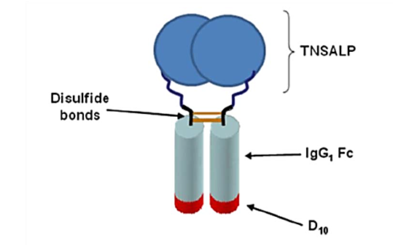

Pharmacokinetics in healthy subjects
Not applicable.

Pharmacokinetics in the target population
Human PK data across studies were pooled and analysed using Pop PK analysis methods due to the following: asfotase alfa PK were found to be impacted by intrinsic (body weight, immunogenicity) and extrinsic (formulation specific activity and total sialic acid content (TSAC)) factors. These factors were time variant in nature. In addition, patients received different doses and regimens over the duration of the treatment.
The terminal monosaccharaides of N-linked complex glycans of recombinant glycoproteins produced in mammalian cell lines (for example chinese hamster ovary cells) are typically occupied by sialic acid. The presence of sialic acid may affect the structural, physical and chemical properties of glycoproteins including charge, sites available for proteolytic degradation and/or for interactions with ligands and receptors. Variations in TSAC have been reported to impact absorption, distribution and elimination of therapeutic proteins (Bork K et al., 2009; Liu L et al., 2013; and Richter WF et al 2012). The proposed mechanisms of impact of TSAC on PK profiles include:
- interactions with asialoglycoprotein receptors in the liver;
- variations in FcRn binding;
- charge driven variations in interactions with extracellular matrices during lymphatic absorption or distribution and
- differences in sites exposed for systemically and/or pre systemically proteolytic degradation during absorption.
The most commonly used dose of asfotase alfa was 6 mg/kg/week, administered SC in divided doses. The doses used in the clinical studies were chosen based on 2 to 6 week pharmacodynamic (PD) nonclinical studies in Akp2-/- mice, toxicology studies in rat and monkey and a clinical safety and tolerability Study in adults with HPP (ENB-001-08 CSR). A pooled pharmacokinetic (PK) exposure versus response (PK PD) modelling analysis examining multiple parameters was conducted to determine the appropriate dose for patients with paediatric onset HPP. The results of this modelling analysis support the administration of 6 mg/kg/week asfotase alfa for the treatment of HPP as the lowest dose which provides near maximal efficacy for most patients.
In studies ENB-001-08 and ENB-002-08, patients were initially administered a dose of asfotase alfa via intravenous infusion for the assessment of pharmacokinetics and safety. In Study ENB- 006-09, patients were randomised to a starting dose of 6 mg/kg/week or 9 mg/kg/week. For all patients who completed Study ENB-006-09, participation in extension Study ENB-008-10 was offered and the starting dose in the extension Study of 3 mg/kg/week was later increased to 6mg/kg/week.
The pharmacokinetic (PK) properties of intravenous (IV) and subcutaneous (SC) asfotase alfa have been studied in paediatric and adult patients with HPP. The absolute bioavailability of SC asfotase alfa ranged from 46% to 98%. Mean clearance in L/day (CL) and volume of distribution (V) values ranged from 7.90 to 11.4 mL/min (11.4 to 16.4 L/day) and 39.7 to 71.0 L respectively. Median times of maximum concentration in the dosing interval (T_{max}) values were 24 to 48 hours after SC injection. The maximum concentration in the dosing interval (mass units/volume) (C_{max}) (U/L) and the AUC₀₋₁₆₈ (U/h/L) of asfotase alfa increased in a dose-proportional manner from 1 mg/kg to 2 mg/kg following SC injection. After SC dosing, asfotase alfa exhibits flip-flop kinetics, where the effective half-life (t^{½}) is rate limited by the relatively slower absorption kinetics. The elimination t^{½} after IV dosing was 59 to 73 hours and was independent of dose, while the effective t^{½} after SC dosing was 112 to 135 hours and was also independent of dose (Kramer, 2009).

Bioequivalence of clinical trial and market formulations
Two batch sizes were evaluated in clinical trials: 2 K and the 20 K. The 20 K batch size used in clinical trials will also be the marketed formulation batch size. A change to a 20K batch size resulted in a slightly lower bioavailability relative to the 2 K Batch size, that is, relative bioavailability F2 K approximate batch size 20 K of 0.869 or 86.9%, yielding an absolute bioavailability of 0.523 or 52.3% (0.602 x 0.869) for the 20 K Batch size. The bioavailability of 20 K batch size relative to 2 K batch size had a 90% CI of 80.0 to 94.3% which was within the default bioequivalence goal-posts of 0.80 to 1.25. These results reflect PK comparability between clinical and to-be-marketed batches. Sialic acid content (TSAC) had a significant impact on CL such that lower clearances were seen at higher TSAC levels.
The Pop PK model identified sialic acid content (TSAC), body weight and immunogenicity status as significant covariates. Over the range of TSAC content of the formulation lots used in the clinical trials, the range of the estimated steady-state of asfotase alfa exposures (expressed as C_{avg,ss}) was approximately 3 fold. The overall impact of immunogenicity on asfotase alfa PK was less than 20%, and hence it does not substantially impact exposure. Other covariates such as age, sex, renal function and liver function tests (AST and ALT) along with bioanalytical method for measuring PK of asfotase alfa as activity were not found to be significant.
In Study ENB-001-08 absolute bioavailability was assessed in HPP patients. In addition, absolute bioavailability for asfotase alfa clinical formulation and relative bioavailability for asfotase alfa clinical formulation versus the, to be marketed formulation were estimated in HPP patients using population PK (pop PK) analysis).

Bioavailability during multiple-dosing
The assessment of absolute bioavailability and formulation factors affecting pharmacokinetic (PK) was studied using data from five clinical studies (ENB-001-08, ENB-002-08/ENB-003-08, ENB-006-09/ENB008-10, ENB-009-10 and ENB-010-10). Extension studies ENB-003-08 and ENB-008-10 were listed with their primary studies (ENB-002-08 and ENB-006-09 respectively).
As dose administration for both IV and an extravascular route (SC) were in the modelling dataset, the absolute bioavailability for asfotase alfa and relative bioavailability between 2 batch sizes following SC administration was estimated.
The absolute bioavailability of asfotase alfa after the first and third SC administration ranged from 45.8% to 98.4%, and was calculated based on non compartmental analysis of data from Study ENB-001-08 (ENB-001-08 CSR). In addition, absolute bioavailability was estimated within the framework of pop PK analysis using data across all 5 studies by accounting for the other covariate effects such as total sialic acid content (TSAC), body weight and immunogenicity. By this approach, the absolute bioavailability following SC administration was 60.2% (95% confidence interval (CI): 56.7 to 63.8%) per day for the lots used in the clinical trials that were manufactured at 2000 (L) scale (2K L).

Distribution

Volume of distribution
The central (V2, 70 kg) and peripheral (V3, 70 kg) volumes of distribution (and 95% CI) were 5.66 (2.76, 11.6) L and 44.8 (33.2, 60.5) L, respectively. These results indicate that asfotase alfa is initially distributed in the intravascular space and then distributes to the extravascular space.

Plasma protein binding
Plasma protein binding studies were not conducted. Plasma protein binding, if any, was not expected to influence the systemic exposures measured as enzyme activity and therefore such assessment was neither conducted nor summarised.

Tissue distribution
Asfotase alfa, a fusion protein with molecular weight of approximately 200 kDa (as a dimer in circulation) and a native ALP epitope with high affinity for its substrate, preferentially partitions into the osteoid tissue, which also is its site of action. The PK of asfotase alfa were expressed as enzyme activity.
From the Pop PK analysis, the central (V2, 70kg) and peripheral (V3, 70kg) volumes of distribution (and 95% CI) were 5.66 (2.76, 11.6) L and 44.8 (33.2, 60.5) L, respectively. These results indicate that asfotase alfa is initially distributed primarily in the intra-vascular space and then distributes to the extra-vascular space reflecting asfotase alfa’s ability to partition into tissues likely including skeletal tissue.

Metabolism
In vitro or in vivo metabolism studies were not conducted based on current regulatory guidance which indicates that the classical biotransformation studies performed for small molecules are not warranted for protein biologics (ICH guideline S6 (R1)).

Excretion

Routes and mechanisms of excretion
The effects of bodyweight, sialic acid content, and immunogenicity on asfotase alfa clearance were well characterised and estimated with precision. Based on examination of simulated average concentration during the dosing interval at steady-state (C_{avg},_{ss}), sialic acid content was the most influential of these three time-varying covariates. Over a range of TSAC of 1.0 to 3.0 mol/mol, C_{avg},_{ss} is expected to range from 967 U/L to 3,149 U/L, within fixed assumptions about other covariates such as weight. The presence of anti-drug antibodies increased asfotase alfa clearance by a factor of 1.09 (95%CI: 1.04 to 1.13). The presence of neutralising antibodies increased clearance by a factor of 1.20 (95% CI: 1.07 to 1.34) relative to the negative anti-drug antibody state. This magnitude of clearance change is unlikely to have clinically meaningful impact on asfotase alfa clinical activity.

Renal clearance
Renal function assessment, as measured by estimated glomerular filtration rate (eGFR) using age appropriate equations, showed that 6 of 53 HPP patients had a lowest eGFR value below 60 mL/min/1.73 m², and 15 of 53 HPP patients had a lowest eGFR value of between 90 and 60 mL/min/1.73m². Based on the population PK analysis of these available data, renal function was not found to influence asfotase alfa clearance.

Pharmacokinetics in other special populations

Pharmacokinetics in subjects developing immunogenicity
Immunogenicity and PK data in HPP patients were collected for a period of up to 3 years to allow testing for asfotase alfa PK immunogenicity interaction. The impact of immunogenicity was investigated using model based and visual assessment approaches.
To assess the impact of antibody development, patients were assigned to groups according to immunogenicity information about their seroconversion (or the development of asfotase alfa ADA and Nab). The impact of immunogenicity on PK was then assessed by examining differences in PK among these subgroups.
To capture more detail regarding the time varying nature of immune response, immunogenicity was determined for each patient at each of their PK sampling times. Each PK sample was then assigned to one of 3 possible subgroups: ADA- (negative for anti-drug antibody, no NAb measured), ADA+/NAb+ (ADA+ and positive for neutralising antibody), and ADA+/NAb- (ADA+ but negative for neutralising antibody). This is the same grouping definition used in the Pop PK analysis.
Table 2 summarises immunogenicity at a population level (% of patients and samples when grouped). Of the 58 patients treated with asfotase alfa, 78% had one or more measurements that were ADA+ during treatment. Most patients were NAb- (71%). A total of 582 samples were collected throughout the development program and tested for ADA and NAb status, and only 15% were found to be ADA+/NAb+. The immunogenicity rates in Table 2 were based on data collected up to 28 January 2013, agreed with the EMA asfotase alfa Rapporteur Meeting with MHRA26 and FDA Meeting Minutes ID 345208227. Additional data up to November 2013 based on the request from EMA (Asfotase alfa Presubmission Meeting with EMA28) are included in the integrated analysis. Studies ENB-00308, ENB-010-10, ENB-008-10 and ENB-009-10 are still ongoing.

Table 2. ADA+/- subgroup breakdown of immunogenic response
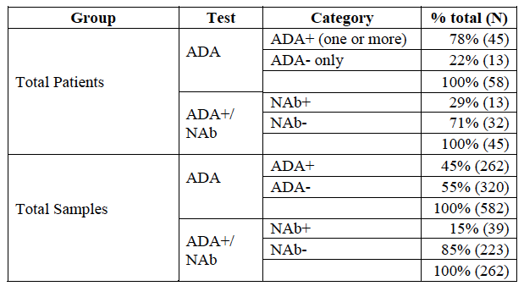
While the data supports the presence of immunogenicity during prolonged treatment with asfotase alfa, its impact appears mild compared to other factors influencing exposure, for example sialic acid content. A Pop PK model was developed that accounted for the possible types of immunogenicity status providing the ability of the model to account for the time varying nature of immunogenicity.

Pharmacokinetics in exposure-response relationship
Two product specifications for the manufacture of asfotase alfa that impact the exposure response relationship are sialic acid content (mol/mol protein) and specific activity (U/mg, drug potency). Based on a covariate sensitivity analysis performed using the developed Pop-PK model (see Figure 2), sialic acid was identified as having a significant impact on exposure in HPP patients, (or increasing sialic acid content results in increasing exposure).
Figure 2. Simulated C_{avg} (or C_{avg,ss}) changes to different covariate combinations
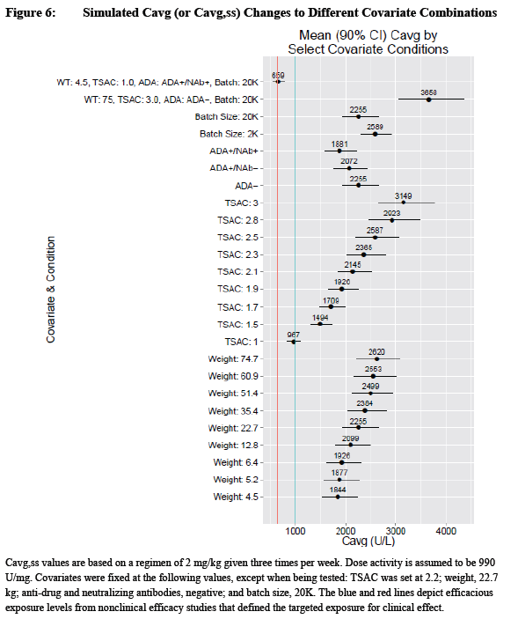

Evaluator’s overall conclusions on pharmacokinetics
The PK of asfotase alfa in humans was derived from 5 interventional clinical studies (ENB-001-08, ENB-002-08/003-08, ENB-006-09/008-10, ENB-009-10 and ENB-010-10. One clinical trial was completed (ENB-001-08). Study ENB-003-08 is the extension phase of Study ENB-002-08 and Study ENB-008-10 is the extension phase of Study ENB-006-09. Study ENB-011-10 was a natural history Study used as control for the perinatal/infantile subgroup patient population.
Extensive preclinical studies of the pharmacokinetics, pharmacodynamics and immunogenicity of asfotase alfa are reported and analysed in depth and extrapolated to the treatment of human subjects particularly infants and young people. Mammalian species including mice, rats, rabbits and monkeys shares a high protein sequence TNSALP homology (ranging from 86 to 97%) compared with the naturally occurring human sequence based on the alignment (performed using UniProt.
The final step from preclinical studies in experimental animal models was to simulate a dose to achieve the anticipated range of efficacious concentrations in humans using the available clinical asfotase alfa PK data from Study ENB-001-08.
For the first Phase II Study in perinatal and infantile disease onset HPP subjects (Study ENB-002-08) a starting SC dose of 1 mg/kg SC thrice weekly was chosen as it was determined that this dose was expected to provide serum asfotase alfa concentrations in the lower portion of the anticipated range of efficacious concentrations. Given the expected risk/benefit in that patient population, this study included an initial IV dose of 2 mg/kg. Based on the available toxicological data and PK/safety data from Study ENB-001-08, a dose titration scheme centred on efficacy assessment was constructed.
The starting dose for SC injections was 1 mg/kg. In the Phase II Study ENB-002-08, after one month of treatment, the SC dose could be increased to 2 mg/kg for lack of efficacy defined as two of the three following outcomes:
- Failure to show radiographic improvement in rickets
- Deterioration of pulmonary function
- Worsening of failure to thrive.
In Study ENB-006-09, children (age ≥ 5 and ≤ 12 years) with open growth plates at the time of enrolment) with HPP were treated with asfotase alfa. The doses selected in this study were 2 mg/kg and 3 mg/kg SC thrice weekly based on the available clinical PK data. These doses were expected to provide serum asfotase alfa concentrations in the anticipated range of efficacious concentrations. The subsequent experience with clinical efficacy and clinical safety established that the dose 6 mg/kg/week given as 6 daily divided doses subcutaneous injections 1 mg/kg is safe and efficacious in children and young people prior to growth plate closure. The Study ENB-008-10 is ongoing and PK data are being collected using a sparse sampling schedule.

Pharmacodynamics
Table 3 below provides details the pharmacodynamic studies used in the evaluation of asfotase alfa and how each study satisfies evaluation of different pharmacodynamic topics.

Table 3 – Submitted pharmacodynamics studies and relationship to relevant pharmacodynamics topic.
PD Topic | Subtopic | Study ID
PD endpoints* | Biomarkers, plasma PPi and PLP | ENB-001-08 (FIH)
PD endpoints* |  | ENB-002-08/ ENB-003-08 (extension of ENB-002-08
PD endpoints* |  | ENB-006-09/ ENB-008-10 (extension of ENB-006-09)
PD endpoints* |  | ENB-010-10
Gender other genetic and Age-Related Differences in PD Response | Effect of gender | N/A
 | Effect of age of disease onset* | ENB-001-08 (FIH)
 | Effect of age of disease onset* | ENB-002-08/ENB-003-08 (extension of ENB-002-08
 | Effect of age of disease onset* | ENB-006-09/ ENB-008-10 (extension of ENB-006-09)
 | Effect of age of disease onset* | ENB-010-10
Population PD and PK PD analyses | Healthy subjects | N/A
Population PD and PK PD analyses | Target population § ‡ | ENB-001-08 (FIH)
Population PD and PK PD analyses | Target population § ‡ | ENB-002-08 (plus ENB-003-08 extension)
Population PD and PK PD analyses | Target population § ‡ | ENB-006-09 (plus ENB-008-10 extension)
Population PD and PK PD analyses | Target population § ‡ | ENB-010-10
*Indicates the primary aim of the Study. §Subjects who would be eligible to receive the drug if approved for the proposed indication. ‡Includes adolescents if applicable.
None of the pharmacodynamic studies had deficiencies that excluded their results from consideration.

Summary of pharmacodynamics
Pharmacodynamics were assessed along with safety and efficacy in 4 clinical studies ENB-001-08 (FIH), ENB-002-08 (plus ENB-003-08 extension), ENB-006-09 (plus ENB-008-10 extension) and ENB-010-10. Standalone human PD studies in healthy volunteers were not conducted as such data would lack of relevance for the understanding of PD in HPP patients, which is the target disease population.

Mechanism of action
HPP is attributed to lack of functional TNSALP. The mechanism of action of asfotase alfa in HPP is to restore the missing TNSALP activity as asfotase alfa is an enzyme replacement therapy. Clinical trials collected response data to assess the effectiveness of asfotase alfa treatment.
The scientific basis for the mode of action of asfotase alfa was confirmed by the drug induced reductions in key enzyme substrates of alkaline phosphatase including plasma PPi and PLP. The benefit of reduction in key enzyme substrates was evident from the data from HPP patients in which biopsies could be performed (Study ENB-006-09/008-10) that showed drug treatment normalising osteoid volume and thickness indicating improved bone mineralisation.
The continuum of interdependent clinical endpoints (Table 4 below) further extended to the normalization of radiographic evidence of rickets measured via radiographic global impression of change (RGI-C) and rickets severity score (RSS).
Table 4. Characterisation of measured responses from the HPP clinical development program used in clinical pharmacology assessment
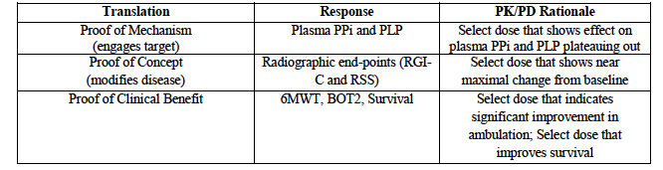
PPi and PLP are substrates of TNSALP. The PD measures for the biomarkers, plasma PPi and PLP were collected in studies where applicable.

Pharmacodynamic effects

Study ENB-001-08
Exploratory objectives included assessment of the PD of asfotase alfa and the effect of asfotase alfa on the clinical signs and symptoms of HPP following repeated dosing.
Six adult patients were recruited. Cohort 1 (n = 3) received asfotase alfa 3 mg/kg IV the first week followed by 3 doses at 1 mg/kg SC at weekly (QW) intervals from weeks 2 to 4. Cohort 2 (n = 3) received asfotase alfa 3 mg/kg IV the first week followed by 3 doses at 2 mg/kg SC at weekly intervals from weeks 2 to 4. Intensive PK samples for asfotase alfa concentrations measured as activity and PD samples for plasma PPi and PLP concentrations were collected over the duration of the study.
Data for plasma PPi are not reported as the method of collection was not optimized for samples containing asfotase alfa, which require a TNSALP inhibitor in blood collection tubes.
Plasma PLP decreased following asfotase alfa administration in 5 of 6 patients while the change in the sixth patient could not be quantified.

Study ENB-002-08/ ENB-003-08
Study ENB-002-08/ ENB-003-08 was a multicentre, open-label study (and its extension) of the safety, tolerability and pharmacology of asfotase alfa in severely affected patients with infantile hypophosphatasia (HPP).
PPi levels were assessed in 8 patients at Baseline. Of those 8, PPi was elevated in 4 patients (median (min/max) = 5.170 µM (2.91, 10.48); normal levels range from 1.33 to 5.71 µM. However, by Week 12, mean PPi levels had fallen to within normal limits (WNL) or below for all 8 patients (median (min/max) = 2.580 µM (1.00, 4.39), with a mean change from Study ENB-002-08 Baseline of -3.200. PPi levels remained within or below normal limits for the remaining assessments before the analysis cut-off date, with the exception of isolated cases for individual patients (one patient: Week 168; another patient: Week 18, and a third patient: Weeks 144 and 168).
PLP levels were assessed in 9 patients at Baseline and were elevated in all 9 patients (mean = 380.022; median (min/max) = 421.000 ng/mL (100.00, 880.00); normal levels on assays performed by Biotrial ranged from 11.76 to 68.37 ng/mL. Median PLP levels dropped to WNL by Week 24 (n = 10; median 47.550 ng/mL (min/max = 16.40/ 1,510.00); the maximum of 1,510.00 ng/mL driven by one outlier result for a single patient), and remained WNL with the exception of Weeks 72 and 120. However, mean levels remained above normal limits, driven mainly by intermittent above normal results in Patients [information redacted] (range 128 to 960 ng/mL), [information redacted]( range95.0 to 428 ng/mL) and [information redacted] (range 81.7 to 391 ng/mL) over the course of study participation through their last assessments. The 1 patient who had a study duration of up to 216 weeks as of the analysis cut-off date for this report [information redacted] was WNL (44.400 ng/mL) at the last assessment.

Study ENB-006-09/ ENB-008-10
Study ENB-006-09/ ENB-008-10 was a multicentre, open label study (and its extension) of the safety, tolerability and pharmacology of asfotase alfa in HPP Patients between the ages of 5 and 12 Years (infantile onset and juvenile onset HPP Patients).
Study ENB 006-09 included a 24 week treatment period. Study ENB-008-10, an extension study for patients who completed ENB 006-09, includes an additional 36 months (144 weeks) of asfotase alfa treatment. A total of 13 patients were randomised in ENB-006-09 to receive either 2 or 3 mg/kg asfotase alfa SC thrice a week (either 6 or 9 mg/kg/week) for 24 weeks. In the extension Study, ENB-008-10, the starting dose of asfotase alfa was 3 mg/kg/week for all patients (n = 12) and was subsequently increased to a total of 6 mg/kg/week. The mean patient age (± SD) was 8.8 (± 2.2) years old.
Analysis of the PD data demonstrated marked reductions in plasma PPi and PLP levels with asfotase alfa treatment. Mean PPi concentrations (5.01 µM) were at the higher end of the normal range (0.75 to 5.71 µM; reference range age dependent). At Weeks 6 and 12, mean PPi concentrations had decreased to the lower end of the normal range (2.15 and 2.50 µM, respectively). Mean PLP concentrations were above normal at Baseline at 214.42 ng/mL (normal range = 5.74 to 61.15 ng/mL). At Week 6, mean PLP concentrations decreased to 12.62 ng/mL. Both PPi and PLP mean concentrations increased slightly at later time points in the study but remained within normal limits.

Study ENB-009-10
Study ENB-009-10 was a randomized, open-label, multicentre, multinational, dose ranging, concurrent control study of the safety, efficacy, and pharmacokinetics of ENB-0040 (human recombinant tissue nonspecific alkaline phosphatase fusion protein) in adolescents and adults with hypophosphatasia (HPP).
The study primarily assessed the safety, tolerability, and pharmacology of asfotase alfa in adolescent (n = 6) and adult (n = 13) patients ages 13 to 66 years. Patients were initially randomized to 1 of 3 treatments for a24 week duration. Upon completion of the 24 week primary treatment period (PTP), all patients were eligible to continue in the open label extension treatment period (ETP) of this study.
PK samples for measuring asfotase alfa activity, sparse PD samples for measuring PPi and PLP and sparse immunogenicity samples for measuring anti-drug antibody (ADA) were collected over the duration of trial.
The primary analysis was the change from Baseline to Week 24 for the co primary endpoints of PPi and PLP compared between the combined treatment group and the untreated control group. Treatment with asfotase alfa significantly reduced PLP levels compared to controls at Week 24 (p = 0.0285). While treated patients experienced an approximately 2 fold greater decrease in PPi than controls at Week 24 (mean change of -2.100 µM in treated versus -1.052 µM in control patients), this difference did not achieve significance (p = 0.0715) most likely because a control patient who received a high dose of Vitamin D and had a high Baseline PPi value (12.1 µM) experienced a decrease in PPi. However, a subsequent analysis of the FA set excluding this patient demonstrated a significantly greater reduction in PPi in the treated patients (p = 0.0044). Importantly, observed decreases in PPi and PLP were maintained after 48 and 96 weeks of exposure. Results of analyses performed using the PP set were supportive of those obtained in the FA set.

Study ENB-010-10
Study ENB-010-10 was a multicentre, open label study of the safety, efficacy, and pharmacokinetics of asfotase alfa in infants and children ≤ 5 years of age with hypophosphatasia (HPP).
The mean (± SD) age at enrolment was 115 (119) weeks old. Patients (n = 15) were required to have perinatal/infantile onset HPP, defined as onset of HPP signs/symptoms prior to 6 months of age.
Analysis of the PD data suggested that asfotase alfa treatment markedly reduced PPi and PLP levels; the largest reductions were observed during the initial weeks of treatment. Mean PPi levels were elevated at Baseline (6.821; normal range = 1.33 to 5.71 µM), fell to within the normal range by Week 6, and remained there for the remainder of the Study, despite rising slightly above the Week 6 mean from Weeks 24 on. Mean PLP levels were also elevated at Baseline (5,083.32 ng/mL; normal range = 11.76 to 68.37 ng/mL) dropped considerably by Week 6 (424.15 ng/mL), and remained below Baseline levels for the remainder of the study despite rising above the Week 6 mean later in the study. Vitamin B6 supplementation for multiple patients in the study is most likely the reason for the elevation observed in mean PLP levels, since a sensitivity analysis removing these patients showed that mean PLP levels remained within normal limits throughout the study.

Time course of pharmacodynamic effects
Five clinical trials were conducted where HPP patients were treated with asfotase alfa (ENB-001-08, ENB-002-08/003-08, ENB-006-09/008-10, ENB-009-10 and ENB-010-10) and PK, PD, immunogenicity, safety and efficacy data were collected. These studies as well as historical control Study ENB011-10 are summarized in Table 5 below. Data from these studies were used in the pooled population analysis of the clinical trials.
The purpose of ENB-011-10, a global, non interventional, retrospective, epidemiologic study with respect to the asfotase alfa clinical development program was to gain additional information on the aetiology, range of manifestations, and clinical progression of HPP in patients with severe perinatal/infantile onset HPP. This information, as appropriate, was used in the interpretation of data collected in the open-label clinical trials (ENB-002-08, ENB-003-08, and ENB-010-10) evaluating patients with perinatal/infantile onset HPP treated with asfotase alfa. Data collected from ENB-011-10 served as the non concurrent control group for the combined analysis of patients from Study ENB-002-08 and its extension Study ENB-003-08, and Study ENB-010-10 that match the inclusion criteria for Study ENB-011-10.
Table 5. Study design attributes for clinical studies with asfotase alfa in patients with HPP
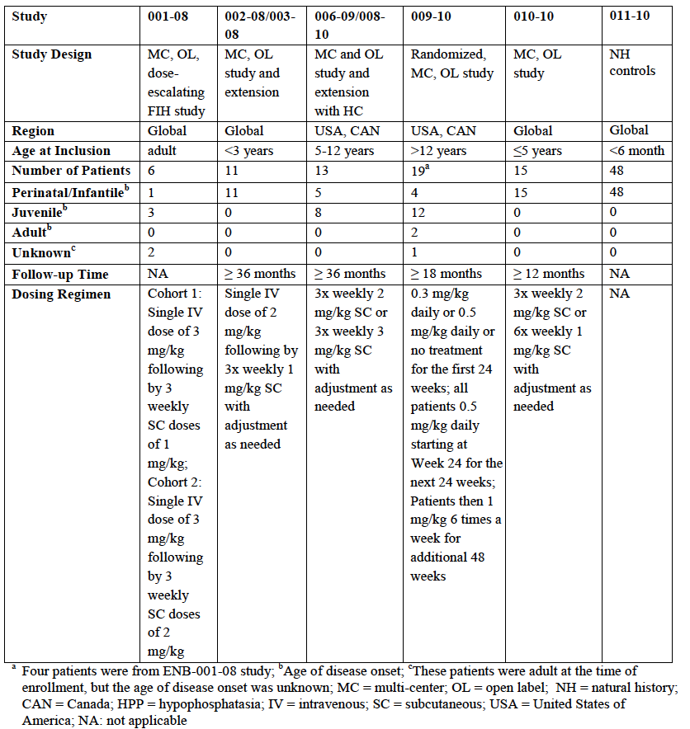

Biomarker (PPi and PLP) modelling
A population PK and pooled pharmacokinetic pharmacodynamic (PK PD) analysis were conducted to characterise independent exposure versus response relationships for change in biomarkers such as plasma PLP and PPi. The objective of Pop PK and PK PD modelling was to support dose and regimen selection for asfotase alfa in the target population, HPP patients with perinatal/infantile or juvenile subgroup onset.
The observation times for the simulated endpoints were as follows: PPi, 7 and 24 weeks; PLP, 24 weeks. These time points were selected to demonstrate the exposure response at a relevant time point for the endpoint.
Data for the biomarker PPi were derived from 60 individuals (see studies listed in Table 5 above), giving rise to 598 PPi observations. Of those, 26 that were below the lower limit of quantification (BLQ) were dropped, 4 points were excluded as outliers, and 87 points were identified as potentially unreliable due to bioanalytical assay problems. This resulted in 481 PPi observations available for analysis. Patients in all studies, across all ages and phenotypes, contributed PPi data. The final PPi analysis data included 60 individuals and 481 observations.
Repeated measures data for the pharmacodynamic biomarker plasma PPi revealed a robust response to initiation of asfotase alfa therapy. The response time profile was characterised by a rapid onset, with nadir occurring within 6 to 8 weeks followed by an increase in plasma PPi concentrations, which generally stayed within the normal range. In some cases the increases resulted in plasma PPi returning to near baseline.
The model based prediction of continuous asfotase alfa activity time course was linked to indirect pharmacodynamic response model, where the feedback effect modulated the zero order production of PPi, while the asfotase alfa effect was mediated as a stimulation of PPi degradation. The observed characteristics in the PPi data and the ability of the model to describe the PPi data can be seen in Figure 3 below.
Figure 3. Model performance for predicting PPi observations
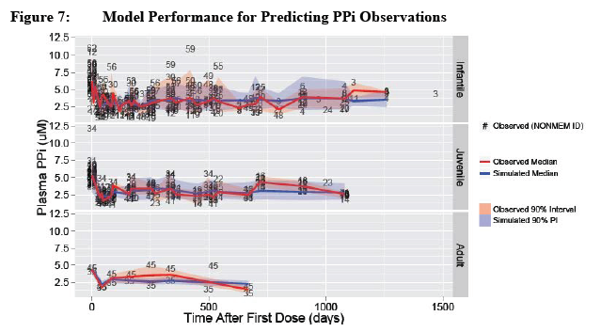
For the PLP biomarker, a total of 58 individuals contributed 655 observations (Figure 4 below). Vitamin B6 supplementation, which dramatically increases the plasma concentration of PLP, was noted for 7 of these individuals, but exact doses and timing were not available. These 7 individuals and 63 associated data points were excluded from the PLP analysis data.
Repeated measures data for the PLP biomarker revealed a robust response to initiation of asfotase alfa therapy, with a rapid drop in baseline concentrations in both vitamin B6 treated and untreated patients. Baseline PLP levels varied considerably across patients but were generally greater in vitamin B6 treated patients. The response time profile was characterised by a rapid onset with nadir occurring within 6 to 8 weeks.
The simple indirect PD response model (with a zero order production of PLP with a stimulatory effect of asfotase alfa on the first order degradation of PLP) provided an adequate description of the observed data. The model based prediction of continuous asfotase alfa PK exposure time course was linked to an indirect pharmacodynamic response model. (Note: patients receiving vitamin B6 were excluded due to an inconsistency generated in model estimates).
Figure 4. Model performance for predicting PLP observations
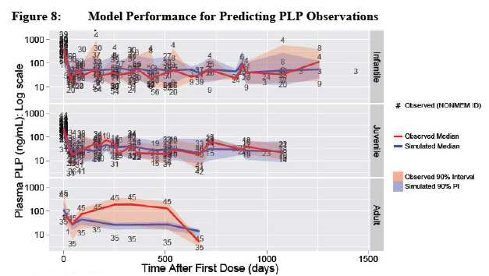

Relationship between drug concentration and pharmacodynamic effects
The objective of pop PK and PK PD modelling was to support dose and regimen selection for asfotase alfa in the target HPP patient population with perinatal/infantile and juvenile onset of disease. Once developed, the models were used to perform simulations exploring exposure-response (E-R) relationships for each response endpoint. Together these independent relationships across response endpoints informed the dose for asfotase alfa in HPP patients.
The E-R models were used to conduct simulations and construct a projected response for variables of interest (for example change from baseline for plasma PLP and PPi, histomorphometric variables such as RGI-C and RSS, and function efficacy variables such as percent predicted 6MWT and BOT2 scores) over time for a dose regimen of 2 mg/kg/three times a week. Figure 5 below demonstrates that a dose of 6 mg/kg/week provides meaningful changes in PK and the continuum of measured responses.
Figure 5. Simulated time course for PK and PD responses over 72 weeks for the 2 mg/kg, 3 x per week regimen
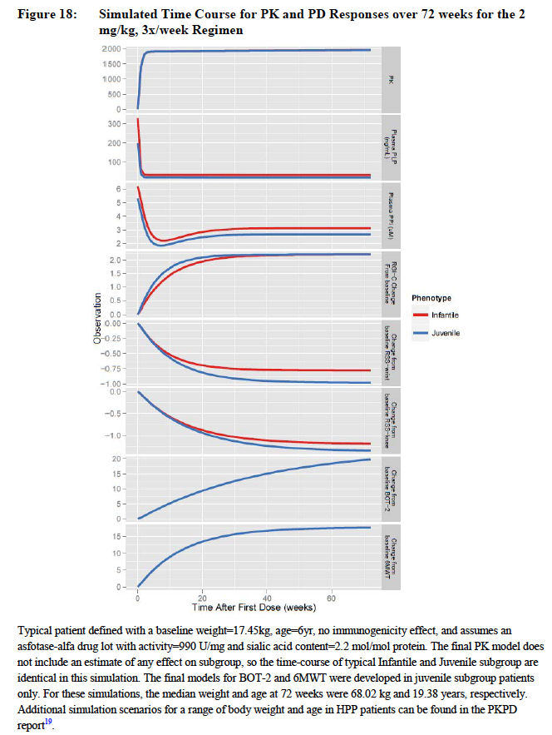

Evaluator’s overall conclusions on pharmacodynamics
The scientific basis for the mode of action of asfotase alfa was confirmed by the drug induced reductions in key enzyme substrates of alkaline phosphatase including plasma PPi and pyridoxal 5-phosphate (PLP). The benefit of reduction in key enzyme substrates was evident from the data from HPP patients in which biopsies could be performed (Study ENB-006-09/ Study ENB-008-10) that showed drug treatment normalised osteoid volume and thickness in a dose dependent direction indicating improved bone mineralisation.

Dosage selection for the pivotal studies
Dosage selection for the pivotal studies resulted from a sequential process of preclinical studies in animal models which permitted an in depth study of the pharmacokinetics and pharmacodynamics and Phase I/II dose ranging studies in volunteer adults (4 females and 2 males with Hypophosphatasia (see below HPP (ENB-001-08)) and the study in severely affected infants and children ≤ 36 months old with onset of HPP signs prior to 6 months of age (ENB-002-08).

Preclinical studies for human dose selection
The following pre-clinical and toxicology data were used to support dose selection for Study ENB-001-08 and subsequently for other HPP studies.
- Pre-clinical efficacy and PK PD modelling studies in Akp2-/- mice
- 4-week GLP intravenous (IV) and 4 week GLP subcutaneous (SC) toxicity studies in juvenile rats
- 4-week GLP IV and 6 month GLP SC toxicity studies in juvenile monkeys.
A dose response relationship with respect to improvements in the bone mineralisation defects was established using the preclinical pharmacology efficacy studies in Akp2-/- mice. Based on the dose response modelling (sigmoidal E_{max} model) the dose to achieve 85% of response (baseline unadjusted; internal consensus at preclinical level); ED85 was 1,451 units/kg/day as illustrated in Figure 6 below:
Figure 6. Dose-Response Relationship of ENB-0040 in Akp2-/- Mice after Daily SC Dosing
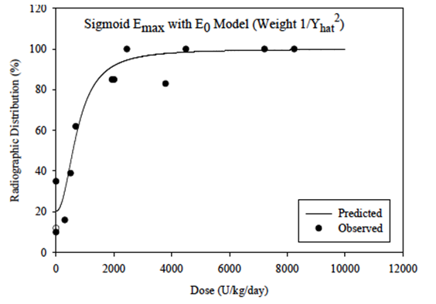
Based on this assessment a steady-state concentration range of ~650 to 1000 Units/L was considered to be therapeutically effective in humans. Notably, in animals receiving less frequent (once every 3 days) SC dosing at 207 to 13390 Unit/kg of asfotase alfa, skeletal mineralisation defects were also effectively prevented. Early PK modelling of human data from Study ENB-001-08 suggested a dose of asfotase alfa of 1 mg/kg/day SC or 2.3 mg/kg SC 3x weekly would provide serum asfotase alfa concentrations (activities) of ~1,000 Unit/L, the upper range of concentration predicted as therapeutically effective using the Akp2-/- mouse model.

First in human studies
The First in Human (FIH) study in adults with HPP was Study ENB-001-08. The starting dose for this FIH trial of asfotase alfa was selected based on sub-chronic (4 week) and chronic (6 month) toxicity studies in juvenile rats and cynomolgus monkeys. These species were selected because of similar protein sequence of tissue nonspecific alkaline phosphatase (TNSALP, the target enzyme) for these species and humans and the mechanism of action and biologic activity of TNSALP (enzymatic activity on several substrates, including PPi and PLP) are species independent. Comparing the findings from the 2 toxicity species evaluated, rat was considered to be the more sensitive species with the no observed adverse event level of 30 mg/kg/dose after IV administration.
Based on these toxicology data, regimens consisting of an IV dose of 3 mg/kg followed by 3 weekly SC doses of either 1 or 2 mg/kg were considered to have adequate safety margin and were used in the FIH trial for asfotase alfa in HPP patients. Six adult subjects (4 females and 2 males) were studied for 3 weeks, in two cohorts receiving either 1mg/kg or 2mg/kg to assess safety and efficacy, PK and bioavailability of asfotase alfa.
Study ENB-002-08 was the first study in severely affected infants and children ≤ 36 months old with onset of HPP signs prior to 6 months of age. The dose selection for Study ENB-002-08 was developed in a step-wise approach:
- First, data from 6 preclinical pharmacology efficacy studies in Akp2-/- mice were used to characterise the pre-clinical target effective dose.
- Then, a steady-state concentration range for the pre-clinical target effective dose was estimated based on the 2 nonclinical mouse studies conducted, a single dose PK study and a multiple repeated dose study. This preclinical steady-state concentration range was defined as the anticipated range of efficacious concentrations for human trials
- As the final step, a dose to achieve the anticipated range of efficacious concentrations in humans was simulated using the available clinical asfotase alfa PK data from Study ENB-001-08.
The most commonly used dose of asfotase alfa was 6 mg/kg/week, administered SC in divided doses. The doses used in the clinical studies were chosen based on 2- to 6-week PD nonclinical studies in Akp2-/- mice, toxicology studies in rat and monkey and a clinical safety and tolerability study in adults with HPP (Study ENB-001-08). A pooled PK-PD modelling analysis examining multiple parameters was conducted to determine the appropriate dose for patients with paediatric-onset HPP. The results of this modelling analysis supported the administration of 6 mg/kg/week asfotase alfa in daily divided doses SC for 6 days per week for the treatment of HPP as the lowest dose that provides near maximal efficacy for most patients.
In Studies ENB-001-08 and ENB-002-08, patients were initially administered a dose of asfotase alfa via intravenous infusion for the assessment of pharmacokinetics and safety. In Study ENB- 006-09, patients were randomised to a starting dose of either 6 mg/kg/week or 9 mg/kg/week. For all patients who completed Study ENB-006-09, participation in extension Study ENB-008-10 was offered, and the starting dose in the extension study of 3 mg/kg/week was later increased to 6 mg/kg/week. In Study ENB-009-10, patients were randomised to a starting dose of either 2.1 or 3.5 mg/kg/week, escalating then to 3.5 mg/kg/week, and eventually 6 mg/kg week in the first and second parts of the extension. Dose adjustments were permitted in all studies for changes in body weight and for reasons of safety and efficacy. Dose increases to optimize efficacy were common among patients < 5 years of age. The most commonly used doses were between 6 and 9 mg/kg/week. The highest dose of asfotase alfa used in clinical studies was 28 mg/kg/week (for example, 4 mg/kg per dose administered 7 times weekly).

Dose selection summary
The most commonly used dose of asfotase alfa was 6 mg/kg/week, administered SC in divided doses for 6 days per week. The results of the modelling analysis support the administration of 6 mg/kg/week asfotase alfa SC for the treatment of HPP as the lowest dose which provides near maximal efficacy for most patients.
Clinical Pharmacology studies of Total Sialic Acid content (TSAC) of the product’s CMC (Chemistry, Marketing and Controls) specification for TSAC (1.2 to 3.0 mol/mol) and specific activity (620 to 1250 U/mg) should provide sufficient exposure at 6 mg/kg/week dose to see an efficacious change from baseline for the functional response of 6MWT consistent to that observed in the clinical trials. This range of exposure is also representative of the exposures associated with efficacy based on other response variables (plasma PPI, plasma PLP, X-ray, RGI-C, RSS, and BOT-2) across the entire studied HPP patient population.

Clinical efficacy

Pivotal efficacy studies
Pivotal open-label studies include ENB-002-08 and its extension ENB-003-08 (extension ongoing); ENB-010-10 (study ongoing); and ENB-006-09 and its extension ENB-008-10 (extension ongoing).
The sponsor initiated 6 efficacy and safety studies of asfotase alfa, including 4 original and 2 extension studies, in patients of all ages and in paediatric and adult onset HPP subgroups:
- Pivotal open label clinical Study ENB-002-08 and its extension ENB-003-08 enrolled paediatric onset patients ≤ 3 years of age with onset of symptoms < 6 months of age (infantile onset subgroup)
- Pivotal open label clinical Study ENB-010-10 (ongoing and open for enrolment) enrolled paediatric onset patients ≤ 5 years of age with onset of symptoms < 6 months of age (infantile onset subgroup)
- Pivotal open label clinical Study ENB-006-09 and its extension ENB-008-10 enrolled paediatric onset patients 5 through to 12 years of age
- A controlled, open label, supportive clinical Study ENB-009-10 enrolled adolescent and adult patients (13 to 66 years of age) regardless of age of symptom onset (paediatric and adult onset).
In addition to these interventional studies, a global, retrospective and epidemiological study (Study ENB-011-010) examining the natural history of patients with perinatal/infantile onset HPP has been completed. Historical control data from this Study were used for comparison to survival and invasive ventilator free survival results obtained in asfotase alfa treated patients.
All asfotase alfa studies were open label. Given the very high unmet medical need, the serious morbidity and mortality risk, the potential for irrevocable harm, and the absence of any alternative disease modifying treatments, no placebo or active comparator controls were used in the studies in infants and children. Nevertheless historical controls were used for evaluating selected endpoints in Studies ENB-002-08/ENB-003-08, ENB-010-10, and ENB-006-09/ ENB-008-10.
Study ENB-011-10 was a retrospective, non interventional, epidemiological study of the natural history of patients with severe perinatal/infantile onset HPP. Data was abstracted from medical records of qualifying children with perinatal/infantile HPP up to 5 years of age and served as the non-concurrent control group for survival analyses in perinatal/infantile HPP patients in Studies ENB-002-08/ENB-003-08 and ENB-010-10.
Study ENB-006-09/ENB-008-10 included historical control patients who had skeletal radiographic data available for the determination of rickets severity scoring. Study ENB-009-10, which was conducted in older patients, included a parallel untreated control group for the first 24 weeks. At 24 weeks, patients in the control group initiated asfotase alfa treatment and continued in the study.
Figure 7 below provides a visual guide to the endpoints across clinical studies and how different endpoints along the timeline relate to one another:
Figure 7. Continuum of inter-related endpoints in clinical studies of patients with paediatric onset HPP
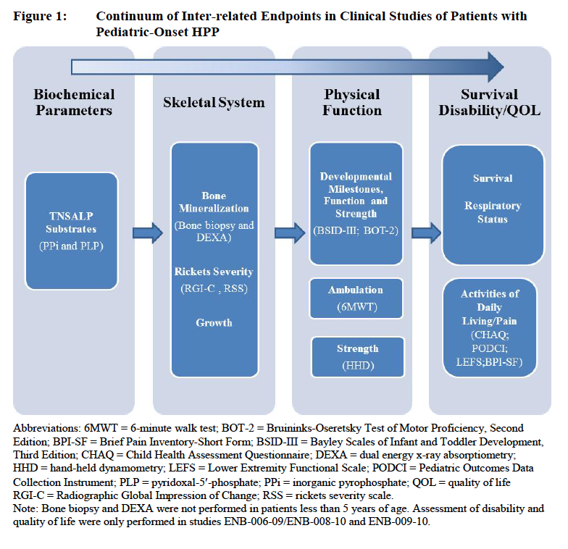
A summary of the efficacy findings is included with the individual study description below but detail is provided in the pooled analysis.

Studies: ENB-002-08/ENB-003-08

Study design, objectives, locations and dates
Study ENB-002-08 was a Phase II, 6 month, international, multicentre, open label study in up to 10 patients to assess the safety, tolerability, and pharmacology of asfotase alfa, bone targeted, human recombinant enzyme replacement therapy, in severely affected infants and young children ≤ 36 months of age with infantile onset HPP (onset of symptoms prior to 6 months of age). Severe HPP was defined in Study ENB-002-08 inclusion criteria. Study ENB-003-08 is an ongoing open label extension of Study ENB-002-08 in patients who were compliant with and completed the initial study.

Primary objectives

ENB-002-08
To determine the following:
- The efficacy of asfotase alfa in treating the skeletal manifestations of infantile HPP
- The safety and tolerability of asfotase alfa given intravenously (IV) in a single dose and subcutaneously (SC) in repeat doses.

ENB-003-08
To determine the following:
- The long-term tolerability of SC asfotase alfa
- The long-term efficacy of asfotase alfa in treating rickets in infants and young children with HPP.

Secondary objectives

ENB-002-08
To evaluate the following:
- The pharmacokinetics (PK) of asfotase alfa given IV as a single dose and SC in repeated doses
- The bioavailability of SC asfotase alfa.

ENB-003-08
To evaluate the following:
- The long-term pharmacodynamics (PD) of SC asfotase alfa
- The effect of SC asfotase alfa on growth and development, mortality, and other clinical signs and symptoms of HPP in infants and young children.

Exploratory objectives

ENB-002-08
To evaluate the effects of asfotase alfa on the following:
- The PD of asfotase alfa given IV and SC
- The effect of asfotase alfa on mortality and other clinical signs and symptoms of infantile HPP

ENB-003-08
Study ENB-003-08 had no exploratory objectives.

Locations
At the time of the Clinical Study Report 11 patients from 10 enrolling investigational sites (6 sites in the United States of America (USA), 2 in the United Kingdom (UK), 1 in Canada, and 1 in the United Arab Emirates (UAE)) met the criteria for inclusion in the interim analysis.

Dates
- Date first patient enrolled ENB-002-08: 06 October 2008
- Last patient completed ENB-002-08: 21 May 2010
- First patient enrolled ENB-003-08: 01 April 2009
- Analysis cut-off date: 16 November 2012.

Inclusion and exclusion criteria
Male and female patients ≤ 36 months of age with a documented diagnosis of severe infantile onset HPP who were otherwise medically stable (patient may have been on ventilator support) were eligible to participate in Study ENB-002-08. Patients must have had onset of HPP symptoms prior to 6 months of age. Patients who were compliant with and completed Study ENB-002-08 and provided informed consent were eligible to participate in the extension Study ENB-003-08.

Inclusion criteria
Patients had to meet all of the following inclusion criteria for enrolment in Study ENB-002-08:
- Legal guardian(s) must have provided informed consent prior to any Study procedures
- Documented diagnosis of severe HPP as indicated by:
- Total serum ALP at least 3 standard deviations (SDs) below the mean for age
- PLP at least 4 times the upper limit of normal
- Radiographic evidence of HPP, characterised by:
- Flared and frayed metaphyses
- Severe, generalized osteopenia
- Widened growth plates
- One or more HPP-related findings:
- History or presence of:
- Non-traumatic post-natal fracture
- Delayed fracture healing
- Elevated serum calcium
- Functional craniosynostosis with decreased head circumference growth
- Nephrocalcinosis
- Respiratory compromise
- Rachitic chest deformity and/or vitamin B6-dependent seizures
- Failure to thrive
- Onset of signs prior to 6 months of age
- Age ≤ 36 months
- Patient was otherwise medically stable (patient may have been on ventilator support)
- Legal guardian(s) was/were willing to comply with the study
In addition, to be eligible to continue treatment in Study ENB-003-08, patients were required to meet the following criteria:
- The patient completed Study ENB-002-08 in a compliant and satisfactory manner (in the opinion of the sponsor and investigator)
- The patient’s parent or other legal guardian provided written informed consent prior to any study procedures being performed
- The patient’s parent or other legal guardian was willing and able to comply with study requirements.

Exclusion criteria
Patients were excluded from enrolment in Study ENB-002-08 if they met any of the following exclusion criteria:
- History of sensitivity to any of the constituents of the study drug
- Current or prior clinically significant cardiovascular, endocrinologic, hematologic, hepatic, immunologic, metabolic, infectious, urologic, pulmonary, neurologic, dermatologic, renal condition, and/or other major disease which, in the opinion of the investigator, precluded study participation
- Treatment with an investigational drug within 1 month prior to the start of study drug administration
- Current enrolment in any other study involving an investigational new drug (IND), device, or treatment for HPP (for example: bone marrow transplantation)
- Low serum calcium, phosphate, or 25-(OH)(serum 25-hydroxy)-Vitamin D
- Current evidence of a treatable form of rickets
- Prior treatment with a bisphosphonate.
In addition, to be eligible to continue treatment in Study ENB-003-08, patients could not meet any of the following criteria:
- The patient had a history of sensitivity to any asfotase alfa constituents
- The patient had a clinically significant disease that precluded study participation, in the investigator’s opinion
- The patient had been enrolled in any study involving an investigational drug, device, or treatment for HPP (for example: bone marrow transplantation).

Study treatments
Patients received an initial single IV infusion of 2 mg/kg asfotase alfa followed by regular administration of SC injections of 1 mg/kg asfotase alfa 3 times/week (total 3 mg/kg per week). Dose adjustments could be made for changes in weight and/or for safety concerns or for lack of efficacy after 1 month (up to 2 mg/kg, 3 times/week) and again after 3 months (up to 3 mg/kg, 3 times/week), up to a maximum of 40 mg per SC injection. Patients could receive asfotase alfa treatment for up to 24 weeks (6 months).
For patients enrolled in Study ENB-003-08, the initial asfotase alfa dose was the same dose being administered at the patient’s Week 24 visit in Study ENB-002-08. Study ENB-003-08 allows patients to receive SC asfotase alfa for 60 months (including the initial 6 months completed in Study ENB-002-08).

Efficacy variables and outcomes
Efficacy was evaluated by examining changes in skeletal manifestations of HPP in children with infantile onset from Baseline to Week 24 (6 months), based on skeletal radiographs measured by the Radiographic Global Impression of Change (RGI-C). Radiographs were assessed by 3 separate readers to derive the average patient score at each assessment. Responder rates were also determined from these scores.
The primary outcome further classified patients as responders or no responders. A patient was considered a responder if the mean of their RGI-C scores at Week 24 was equal to 2 or greater.
Secondary and other efficacy variables included the RGI-C over time through Study ENB-003-08, the Rickets Severity Scale (RSS) (a 10 point scale that evaluates the severity of rickets); respiratory support status; overall survival; growth measurements; and gross motor, physical functioning, and development over time (as measured by the Bayley Scales of Infant and Toddler Development, Edition III (BSID-III)).
Study ENB-003-08 also included the Peabody Developmental Motor Scales, Second Edition (PDMS-2), as age appropriate for evaluation of physical functioning and development; dental assessments; nutritional assessments; and physical therapy assessments (as needed based upon the individual needs of the patient).

Randomisation and blinding methods
Study ENB-002-08 and the ongoing extension Study ENB-003-08 were/are open label studies. No placebo control group was included because of the potentially life threatening nature and significant morbidity associated with HPP, especially in patients with onset of signs in the first 6 months of life. No alternative control treatments were used because no approved therapies for HPP exist. The radiologists who were completing the Radiographic Global Impression of Change (RGI-C) assessments and the expert who was completing the Rickets Severity Scale (RSS) assessments based on patient radiographs were unblinded to Baseline images but for all subsequent imaging they were blinded to patient, clinical status, and the order in which the follow-up images were taken.

Analysis populations
There were 3 analysis sets for this interim analysis: the Full Analysis (FA) set, the Per Protocol (PP) set, and the Safety set. The FA set was referred to as Intent-to-Treat (ITT) in both protocols and was equivalent to the Safety population described in the Study ENB-003-08 protocol.

Sample size
Up to 10 patients were planned for enrolment.
ENB-002-08: Enrolled: 11 patients; Completed: 10 patients.
ENB-003-08: Enrolled: 10 patients; Completed 30 months (36 months total): 9 patients.
All 11 (100.0%) patients were included in the Full Analysis and Safety sets; 7 patients were included in the Per Protocol (PP) set.

Statistical methods
Final 24 week (6 months) data from the completed Study ENB-002-08 are presented and, where applicable, are pooled with the interim data from the ongoing Study ENB-003-08 to provide an integrated analysis of Studies ENB-002-08/ENB-003-08, that is a total follow up of 36 months.
There were 3 analysis sets for this interim analysis: the Full Analysis (FA) set, the Per Protocol (PP) set, and the Safety set. The FA set was referred to as Intent to Treat (ITT) in both protocols and was equivalent to the safety population described in the Study ENB-003-08 protocol.
The FA set was an ITT population, including all patients who received any asfotase alfa treatment, regardless of whether they were lost to follow up or dropped out of the trial.
The PP set includes all patients who received any asfotase alfa treatment and did not have any major protocol deviations deemed to potentially influence treatment effect. This set was determined prior to database lock.
All efficacy analyses were performed primarily on the FA set; some were repeated on the PP set.
In the transition from Study ENB-002-08 to Study ENB-003-08, the last visit on the first protocol typically served as the baseline for the second; however, in some cases study procedures were repeated. Thus, 2 time points were shown for this period: the last visit on Study ENB-002-08 and the record that served as baseline for Study ENB-003-08 (typically the same record). The principal analysis for each outcome used the Study ENB-002-08 baseline; however, most analyses were repeated for the Study ENB-003-08 time points using the Study ENB-003-08 baseline.
In general, descriptive statistics (n, mean, median, SD, minimum, and maximum) were provided for each quantitative variable, and frequencies and percentages were provided for each qualitative variable.

Major protocol violations/deviations

Table 6. Studies ENB-002-08/ENB-003-08: Protocol deviations across all patients
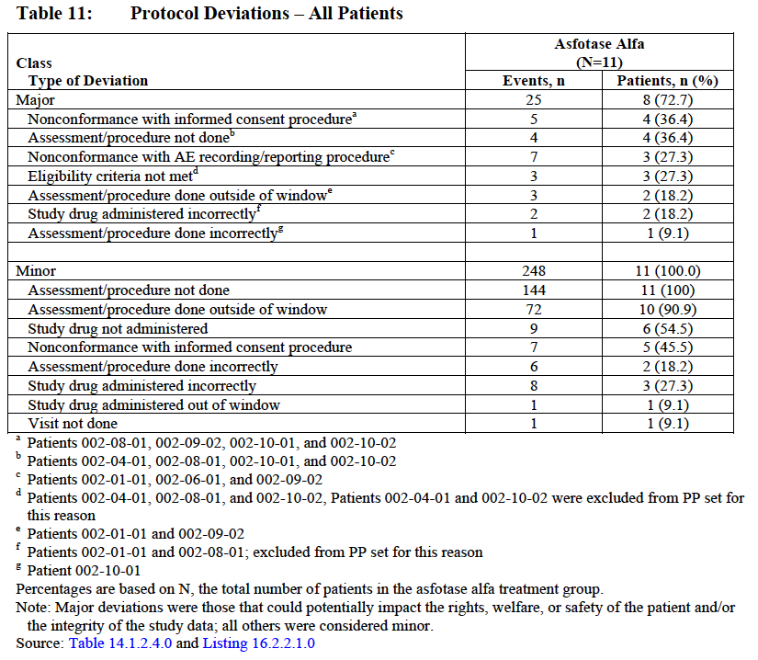

Baseline data
At Baseline, 5 patients (45.5%) required respiratory support: 3 required mechanical ventilation, 1 required CPAP, and one patient was on O₂ via nasal cannula. The mean RSS score of 8.25 was indicative of severe rickets, consistent with an underlying diagnosis of HPP. The patients also had notably low Z scores for length/height and weight at Baseline, with mean Z scores -4.14 (0.00 percentile) and -3.40 (0.03 percentile). These low growth parameters are consistent with a severe HPP phenotype with severe rickets and failure to thrive.

Change in rickets severity from baseline to week 24
The results of the interim analyses indicate that treatment with asfotase alfa was associated with improvements in rickets, respiratory function, growth, and clinically important developmental milestones. Statistically significant results in the primary efficacy endpoint were met (change in rickets severity from Baseline to Week 24, based on assessment of skeletal radiographs using the RGI-C (p = 0.0039, Full Analysis (FA) set)).
The majority of patients in the FA set (7 out of 11; 63.6%) achieved RGI-C scores of 2 to < 3 at Week 24, indicative of at least ‘substantial healing of HPP associated rickets’ compared to Baseline radiographs. None of the patients achieved a score of ‘3’ (complete or near complete healing) by Week 24.
A majority of the patients 4 out of 7; 57.1%) in the PP set had positive changes from Baseline radiographs with RGI-C scores in the 2 to < 3 range, the median RGI-C score was 2 and the Wilcoxon signed rank test p value was 0.0625.

RGI-C responder analysis at week 24
The primary efficacy endpoint was further examined by classifying patients as responders or non responders. Patients with RGI-C scores of 2 (indicative of ‘substantial healing of rickets’) or higher (complete healing) were considered responders. Consistent with the primary efficacy results described previously, 7 of 11 patients (63.6%) were considered responders. One patient had a mean RGI-C score of 0 and was classified as a non responder; another patient with no post baseline assessment was also classified as a non responder.

Results for other efficacy outcomes
Similar results were observed in the secondary endpoints. RGI-C scores demonstrated improvements in rickets severity as early as Week 12 (median: 1.17; min, max: -1.00, 2.00; p value = 0.0313). By Week 48, 8 of 9 patients (88.9%) had RGI-C scores ≥ 2 (substantial and/or complete or near complete healing of HPP associated rickets) and were therefore considered responders, and 3 of those 8 had achieved the highest score of 3. Six patients maintained scores of ≥ 2 at Week 144, suggesting that further improvements are achieved with ongoing asfotase alfa treatment.
Consistent with these results, improvements from a mean Baseline RSS score of 8.25 (indicative of severe rickets) were also observed; the mean (SD) change from Baseline was -3.67 (2.634) at Week 24 (p = 0.0156), and -5.78 (3.212) at Week 48 (p = 0.0078).

Table 7. Changes in rickets severity scale (RSS): ENB-002-08 baseline to each visit in full analysis set
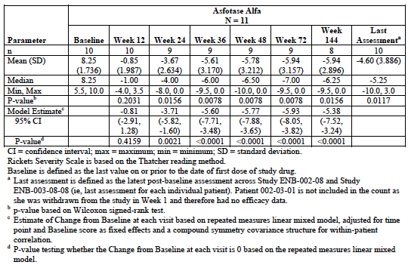
The improvements in the skeletal manifestations of HPP, including the rib cage, were accompanied by benefits in respiratory status. Prior to entry into Study ENB-002-08, 9 of 11 patients had required some form of respiratory support. At Baseline, 5 of 11 patients were receiving respiratory support (ranging from invasive ventilation to only needing supplemental O2). During Studies ENB-002-08/ENB-003-08, 10/11 patients required some form of respiratory support at various time points. At the last patient assessments before the analysis cut-off date, out of 9 evaluable patients, 1 patient had needed no respiratory support at any time and 7of 8 patients who had required support had eventually transitioned off respiratory support (including 2 patients who went from invasive mechanical ventilation to no support). Lastly, 1 of 8 patients who required respiratory support was weaned from invasive mechanical ventilation and only required supplemental O₂ at the last assessment. This represents a clinically significant improvement for the patients who required respiratory support before and/or during Studies ENB-002-08/ENB-003-08.
Patients also showed evidence of growth and functional improvement with asfotase alfa treatment. Mean and median length/height and weight Z scores tended to increase over the course of treatment, reflecting improvements in growth relative to healthy peers. Results of the BSID-III assessments indicated substantial improvements in gross motor, fine motor, and cognitive functioning over time. Regardless of Baseline status, all patients with serial assessments (9 of 9) showed increases from their first assessment in age equivalent scores on all 3 tests over time, indicating the acquisition of new skills and abilities following initiation of asfotase alfa therapy (see Table 8 below).

Table 8. BSID-III gross motor, fine motor and cognitive scaled and age equivalent scores over time: ENB-002-08 all patients
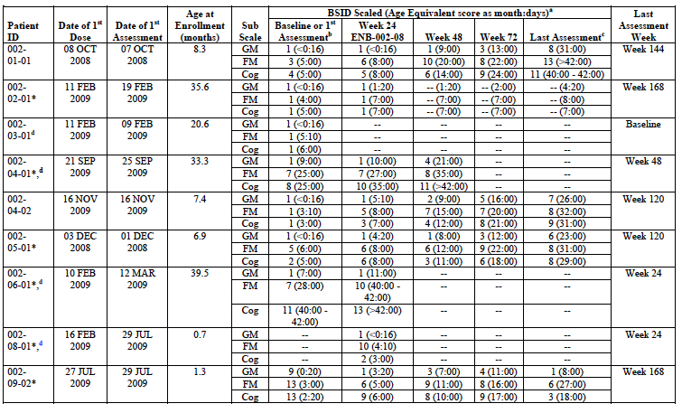
Moreover, more than half of these patients (5 of 9, 56%) also showed increases in scaled scores, (Tables 8 and 9) indicating acquisition of new gross motor, fine motor, and cognitive skills at a faster rate than healthy age matched peers.

Table 9. Changes from baseline in length, weight, body mass index and head circumference z-scores: ENB-002-08/ENB-003-08 in full analysis set
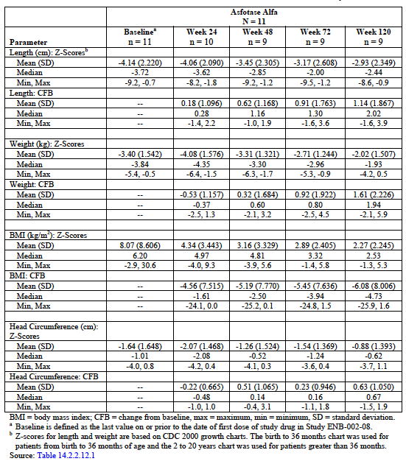

Studies ENB-010-10
Study ENB-010-10 was an open label, multicentre, multinational study of the safety, efficacy, and PK of asfotase alfa in infants and children up to and including 5 years of age with HPP. Patients were required to have perinatal/infantile onset HPP, defined as onset of HPP signs/symptoms prior to 6 months of age, and hereafter referred to as infantile onset HPP.

Primary objectives
The primary objectives of ENB-010-10 were to determine the following:
- Effect of asfotase alfa treatment on skeletal manifestations of HPP as measured by radiographs using a qualitative Radiographic Global Impression of Change (RGI-C) scale for all treated patients
- Safety and tolerability of repeated SC injections of asfotase alfa for all treated patients.

Secondary objectives
The secondary objectives of ENB-010-10 were to evaluate the following:
- For patients who were not mechanically ventilated at the time of enrolment, the percentage who were alive and ventilator free after receiving asfotase alfa as compared to an age matched historical control group
- Effect of asfotase alfa treatment on respiratory function as measured by ventilator status, time on respiratory support (including time on ventilator or supplemental oxygen), ventilator rate or oxygen volume, ventilator pressures, and fraction of inspired oxygen (FiO₂) for all treated patients
- Effect of asfotase alfa treatment on physical growth as measured by body weight, length, arm span, head circumference, and chest circumference for all treated patients
- Pharmacokinetic properties of asfotase alfa
- Effect of asfotase alfa on plasma PPi and plasma PLP
- Effect of asfotase alfa treatment on tooth loss for all treated patients
- Effect of asfotase alfa on serum parathyroid hormone (PTH).

Exploratory objectives
The exploratory objectives of ENB-010-10 were to evaluate the effects of asfotase alfa on the following:
- Gross motor, fine motor, and cognitive development as measured by the Bayley Scales of Infant and Toddler Development, Third Edition (BSID-III), the Peabody Developmental Motor Scales, Second Edition (PDMS-2), and/or the Bruininks-Oseretsky Test of Motor Proficiency, Second Edition (BOT-2), depending on the patient’s age and functional abilities
- Gross motor development as documented using a gross motor milestone checklist developed by the sponsor.

Locations
This is an international multicentre study. As of 22 November 2013, 28 enrolled patients from 10 investigational sites met the inclusion criteria and were included in the interim analysis.

Dates
Date first patient enrolled: 22 July 2010.Analysis cut-off Date: 22 November 2013.

Inclusion and exclusion criteria

Inclusion criteria
Patients had to meet all of the following inclusion criteria for enrolment in this study:
- Parent or legal guardian(s) must provide written informed consent prior to any study procedures being performed and must be willing to comply with all study required procedures.
- Documented diagnosis of HPP as indicated by:
  - Total serum ALP below the lower limit of normal for age
  - Plasma PLP above the upper limit of normal (unless patient is receiving pyridoxine for seizures).
- Radiographic evidence of HPP, characterised by:
  - Flared and frayed metaphyses
  - Severe, generalized osteopenia
  - Widened growth plates
  - Areas of radiolucency or sclerosis.
- Two or more of the following HPP related findings:
  - History or presence of:
    - No traumatic postnatal fracture
    - Delayed fracture healing
  - Nephrocalcinosis or history of elevated serum calcium
  - Functional craniosynostosis
  - Respiratory compromise or rachitic chest deformity
- Vitamin B6 responsive seizures
- Failure to thrive
- Onset of symptoms prior to 6 months of age
- Chronological age (or adjusted age for premature infants born ≤ 37 weeks gestation) of ≤ 5 years
- Otherwise medically stable in the opinion of the investigator and/or the sponsor

Exclusion criteria
Patients were excluded from enrolment in this Study if they met any of the following exclusion criteria:
- Clinically significant disease that precludes study participation, in the opinion of the investigator and/or the sponsor
- Serum calcium or phosphate levels below the normal range
- Serum 25-hydroxy (25OH)-vitamin D below 20 ng/mL
- Current evidence of treatable form of rickets
- Prior treatment with bisphosphonates
- Treatment with an investigational drug within 1 month prior to the start of asfotase alfa treatment
- Current enrolment in any other study involving an investigational new drug, device, or treatment for HPP (for example: bone marrow transplantation) The protocol for the German site specifies that for the first criterion above, ‘clinically significant disease’ includes diseases ‘such as, but not limited to, hepatitis C virus (HCV)/human immunodeficiency virus (HIV)/hepatitis B virus (HBV) that precludes Study participation, in the opinion of the investigator and/or the sponsor.’
The protocol for the German site also includes 3 additional exclusion criteria, as follows:
- Intolerance to the study drug or any of its excipients
- Previous participation in the same study
- Close relation to the investigator.
Note: Historical values for PLP may have been used to determine patient eligibility. Patients with low 25(OH) vitamin D levels were eligible for study participation after correction of levels with vitamin D supplementation.

Study treatments
Patients received a total of 6 mg/kg/week of asfotase alfa administered by SC injection, either 1 mg/kg asfotase alfa 6 times per week or 2 mg/kg asfotase alfa 3 times per week, at the discretion of the investigator and the sponsor. The maximum volume of asfotase alfa per injection was 1 mL. The protocol for the German site further specified that the dose received could not exceed 9 mg/kg/week.

Efficacy variables and outcomes
Efficacy was evaluated by examining changes in rickets severity (as measured by RGI-C and Rickets Severity Scale (RSS) scores), respiratory status, overall survival, growth measurements, dental assessments, and motor and cognitive function (as measured by the BSID-III, PDMS-2 and/or the BOT-2) over time.

Randomisation and blinding methods
ENB-010-10 was open label; thus, all Study staff and participating patients were aware that asfotase alfa was being administered.

Analysis populations
The analysis populations include:
- Full analysis (FA) set ;includes all patients who received at least 3 months of asfotase alfa treatment; treated patients who discontinued were included regardless of time on treatment.
- Per protocol (PP) set; includes all patients in the FA set that did not have any major protocol deviations deemed to potentially influence treatment effect. Safety set; includes all patients who received any asfotase alfa treatment, regardless of whether they were lost to follow-up or dropped out of the trial.
Safety analyses had no imputation performed.

Sample size
The study planned to enrol approximately 60 patients aged ≤ 5 years of age with HPP. For the interim analysis, 28 patients enrolled at 10 sites were included in the Full Analysis (FA) and Safety sets; 24 patients were included in the Per Protocol Set (PP).

Statistical methods
The primary analysis was the change in rickets severity from Baseline to Week 24, as measured by the RGI-C. Patients were assigned the mean of the RGI-C scores assigned by 3 independent radiologists who were aware of which radiographs had been obtained at Baseline, but were blinded to all other patient information and study visits. The primary analysis consisted of a Wilcoxon signed-rank test using a 2 sided alpha of 0.05. If the p value was less than 0.05 and the median RGI-C score was positive, significant positive change from Baseline would be claimed.
Additionally, the primary outcome was examined by classifying patients as responders or non responders. A patient was considered a responder if the mean of their RGI-C scores at Week 24 was 2 or greater (a score of ‘2’ on the RGI-C corresponds to ‘substantial healing (much better, such as substantial healing of HPP associated rickets)). Changes in rickets severity based on skeletal radiographs were also assessed from Baseline to Week 48 as a specific endpoint requested by the European Medicines Agency (EMA).

Major protocol violations/deviations

Table 10. Study ENB-010-10: Protocol deviations across all patients
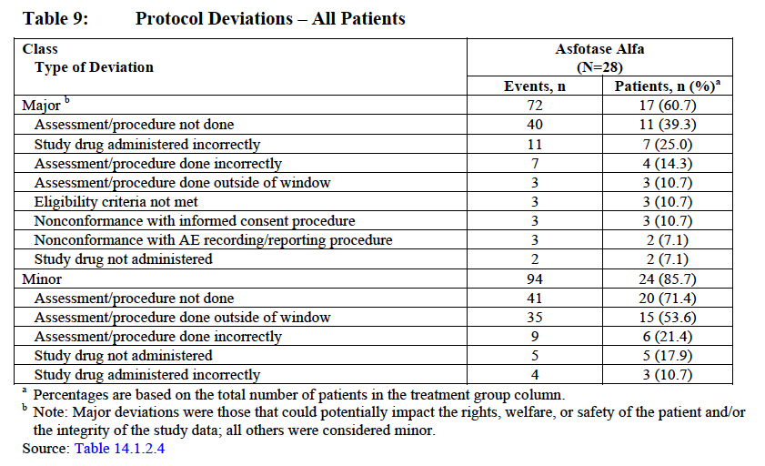

Baseline data
The patients in this study were, on average, 118.24 weeks of age (range: 0.1 to 309.9) at Screening. Approximately half of the patients were female (16 out of 28; 57.1%), and the majority were White. Six patients (21.4%) were Asian; of these, 5 patients were Japanese.
In total, 12 patients were receiving respiratory support at Baseline. Of these, 10 patients required mechanical ventilation at Baseline (9 patients (32.1%) on invasive mechanical ventilation and 1 patient (3.6%] on non-invasive nasal CPAP). Two of the patients (7.1%) were receiving supplemental oxygen. The mean RSS score at Baseline was 5.33, suggesting moderate rickets, consistent with an underlying diagnosis of HPP. The patients also had below normal length/height and weight, consistent with another common symptom of HPP, failure to thrive. The mean Z scores for length/height and weight at Baseline were -3.28 and -3.84, placing these patients in the 0.05 and 0.01 percentiles for these parameters, respectively. Also consistent with a diagnosis of HPP, levels of PPi and PLP, both substrates of TNSALP, were elevated. Mean Baseline levels of PPi were 6.821 µM, while normal levels range from 1.33 to 5.71 µM (CRL Study 315304) and mean Baseline levels of PLP were 5,083.3 ng/mL, while normal levels range from 11.76 to 68.37 ng/mL.

Results for the primary efficacy outcome: Change in rickets severity and responder analysis at week 24
The primary endpoint of the study was the change in rickets severity from Baseline to Week 24, as measured by the RGI-C. At Week 24, the median RGI-C scores for both the FA and PP sets showed statistically significant improvement (RGI C = 1.67 (p < 0.0001) and 1.83 (p < 0.0001), respectively). The majority of evaluable patients included in the primary efficacy analysis (21 of 28 patients, 75% of the FA set) achieved RGI-C scores of 1 or greater, indicative of at least ‘minimal healing of rickets’, while 13 of 28 patients (46.4%) had RGI-C scores of 2 or greater, indicative of ‘substantial healing of rickets’, and 4 of 28 patients (14.30%) achieved scores of 3, indicating ‘complete or near complete healing of rickets’. Patients with evaluable data who received asfotase alfa for 48 weeks continued to achieve high RGI-C scores (FA set: median = 2.00, p < 0.0001; PP set: median = 2.00, p = 0.0001). All but 1 of the 15 patients with Week 48 data (excluding imputed scores: 14 of 15 patients, 93.3%) showed at least substantial improvement in HPP-associated rickets (RGI-C score of 2) and were considered responders. RGI-C scores achieved at Week 48 were, in general, maintained throughout later study time points.

Results for other efficacy outcomes
Similar positive results were seen for the secondary endpoints. Overall, the magnitude of the mean (median) change from Baseline in the RSS score increased throughout the study, from -0.94 (-1.00) at Week 12 and -1.86 (-1.00) at Week 24, to -4.46 (-4.00) at Week 48, with radiographs of the patients showing decreasing rickets severity as the study progressed.
Analyses of the respiratory data were generally consistent with a positive effect of asfotase alfa on respiratory function. Twelve of 28 enrolled patients (42.8%) required some respiratory support at Baseline: 10 required mechanical ventilation and 2 required only supplemental oxygen. Of the 10 patients who began the study on invasive mechanical ventilation, 2 patients transitioned completely off of respiratory support and a third patient transitioned to supplemental oxygen at Week 24; Patient [information redacted] was withdrawn from the study and subsequently died (see Safety results). Of the 16 patients who were free of respiratory support at Baseline, the majority (12 of 16; 75%) remained free of respiratory support over the course of the study. Two patients required temporary support but were able to wean back off and were free of respiratory support at the time of their last assessment, while a third patient who was in respiratory distress at Baseline but not on respiratory support at enrolment, began respiratory support early and had transitioned to supplemental oxygen by the Week 60 visit.
Patient [information redacted] required respiratory support due to pneumonia from Week 15 until his death. With respect to growth, overall the patients increased in length/height and weight, more closely approaching the mean values of the general population during the study, as measured by Z-scores.
The majority of patients also showed evidence of functional improvement with asfotase alfa treatment.
Measureable improvements from Baseline (or first assessment) in age equivalent scores were observed for most patients for BSID-III, the PDMS-2, and/or the BOT-2 over time, indicating the acquisition of new skills and abilities following initiation of asfotase alfa therapy.

Studies ENB-006-09/ENB-008-10
Study ENB-006-09 was a 24 week, randomised, international, multicentre, dose ranging, open label study to assess the safety, efficacy, PK, and PD of asfotase alfa in patients 5 to 12 years in age with infantile or juvenile onset HPP.
Study ENB-008-10 is an ongoing, open label extension study of asfotase alfa in 12 patients who previously received treatment under clinical Study ENB-006-09 and completed the study.

Primary, secondary and exploratory objectives

Table 11. ENB-006-09 and ENB-008-10 study objectives
Primary Objectives | Secondary Objectives | Exploratory Objectives
ENB-006-09
- To assess the efficacy of asfotase alfa in treating HPP-related rickets (as assessed by skeletal radiographs of the wrists and knees) as compared with historical controls using a qualitative Clinical Global Impression of Change (CGI-C) scoring system  - To determine the safety and tolerability of asfotase alfa administered subcutaneously (SC) thrice weekly | - To assess the change in osteomalacia (as measured by transiliac crest bone biopsy)  - To assess the change in height (z-scores)  - To assess the PK of asfotase alfa  - To assess the change in biomarkers of asfotase alfa activity as measured by plasma inorganic pyrophosphate (PPi) and pyridoxal-5’-phosphate (PLP)  - To compare the safety, PK, and PD of 2 doses of asfotase alfa | - Weight and head circumference (z-scores)  - Bone mineral density and content as measured by DEXA  - Osteopenia of the jaw (panorex radiographs)  - Walking ability and cardiovascular endurance, measured by 6MWT with energy expenditure index (EEI)  - Muscle weakness, measured by HHD  - Gross motor function, measured by BOT-2  - Pulmonary function testing (PFT), measured by forced vital capacity (FVC)  - Disability and pain, measured by POSNA PODCI and CHAQ  - Differences between the 2 asfotase alfa doses on all efficacy outcomes
ENB-008-10
- To assess the long-term tolerability of SC asfotase alfa  - To assess the proportion of asfotase alfa-treated patients showing radiographic change in rickets severity (as assessed by skeletal radiographs of the hands/wrists and knees) from the Baseline of ENB-006-09 relative to the End of Study visit in ENB-008-10 using an ordinal Radiographic Global Impression of Change (RGI-C) scale score | - To evaluate the long term PK of SC asfotase alfa  - To evaluate the effect of SC asfotase alfa on reduction in PPi and PLP  - To assess the effect of SC asfotase alfa on:  - Height (z-scores)  - Walking ability as measured by the Six Minute Walk Test (6MWT)  - Gross motor function as measured by the Bruininks-Oseretsky Test of Motor Proficiency, Second Edition (BOT-2)  - Muscle strength as measured by hand held dynamometry (HHD)  - Body mass index (BMI) and arm span (z-scores)  - Bone mineral density and content as measured by dual energy X-ray absorptiometry (DEXA)  - Disability and pain as measured by the Paediatric Orthopaedic Society of North America (POSNA) Paediatric Outcomes Data Collection Instrument (PODCI) and Child Health Assessment Questionnaire (CHAQ) | none

Locations
A total of 13 patients were enrolled in ENB-006-09 at 2 investigational sites (1 each in the United States of America (USA) and Canada). A total of 12 patients completed the 24 week treatment period in the ENB-006-09 study and subsequently enrolled in ENB-008-10, the ongoing extension study to ENB-006-09 (note: 1 patient dropped out after 1 month in ENB-006-09 for pre-planned elective surgery).

Dates
- Date first patient enrolled ENB-006-09: 30 Sep 2009
- Date last patient completed ENB-006-09: 29 Jul 2010
- Date first patient enrolled ENB-008-10: 12 Apr 2010
- Data analysis cut-off date ENB-008-10: 22 Jan 2013.

Inclusion and exclusion criteria

Inclusion criteria
To qualify for participation in ENB-006-09, patients were required to meet the following criteria:
- Parent or legally authorised guardian(s) must have provided informed consent prior to performing any study related procedures
- Patients ≥ 5 and ≤ 12 years of age with open growth plates at time of enrolment
- Tanner stage of 2 or less indicating prepubescence
- Documented history of HPP as evidenced by:
  - Presence of HPP related rickets on skeletal X-rays
  - Serum ALP activity below the age adjusted normal range
  - Plasma PLP level at least twice the upper limit of normal serum 25-hydroxy (25(OH)] vitamin D level ≥ 20 ng/mL
- Ability of patient and patient’s parent(s) or legal guardian(s) to comply with the study protocol
To be eligible to continue treatment in ENB-008-10, patients were required to meet the following criteria:
- The patient completed Study ENB-006-09 in a compliant and satisfactory manner (in the opinion of the sponsor and investigator)
- The patient’s parent or other legal guardian provided written informed consent prior to any study procedures being performed
- The patient’s parent or other legal guardian was willing to comply with study requirements

Exclusion criteria
To qualify for participation in ENB-006-09, patients could not meet any of the following criteria:
- History of sensitivity to any of the constituents of the study drug
- A medical condition, serious inter-current illness, or other extenuating circumstance that, in the opinion of the investigator, may have significantly interfered with study compliance, including all prescribed evaluations and follow up activities
- Treatment with an investigational drug within 1 month prior to the start of study drug administration
- Current enrolment in any other study involving an investigational new drug, device, or treatment for HPP (for example: bone marrow transplantation)
- Serum calcium or phosphorus levels below the age adjusted normal range
- Current evidence of a treatable form of rickets
- Prior treatment with bisphosphonates
- Bone fracture or orthopaedic surgery within the past 12 months that, in the opinion of the investigator, would interfere with the ability of study patients to comply with the study protocol
- A major congenital abnormality other than those associated with HPP
To be eligible to continue treatment in ENB-008-10, patients could not meet any of the following criteria:
- The patient had a clinically significant disease that precluded study participation, in the investigator’s opinion
- Treatment with an investigational drug other than asfotase alfa
- The patient had been enrolled in any study involving an investigational drug, device, or treatment for HPP (for example: bone marrow transplantation)

Study treatments
Upon initial enrolment in ENB-006-09, patients were randomised to receive SC injections of 2 or 3 mg/kg asfotase alfa (a total of 6 or 9 mg/kg/week) 3 times weekly for 24 weeks. The total amount of asfotase alfa was adjusted every 6 weeks to account for changes in body weight. Dose adjustments (including increased frequency of dosing or dose reduction) were also permitted for safety related concerns. The decision to adjust the dosage of asfotase alfa was made by the investigator in consultation with the sponsor’s Medical Monitor.
In the extension, Study ENB-008-10, per protocol, enrolled patients received a total of 3 mg/kg/week of asfotase alfa, followed by 6 mg/kg/week per study wide dose adjustment under Protocol Amendment 4 (issued 01 February 2011), administered by SC injection for at least 42 months or until the product was registered and available to treat patients diagnosed with HPP (in accordance with country specific regulations). Patients received asfotase alfa 3 to 6 times per week at the discretion of the investigator and sponsor. The total amount of asfotase alfa was adjusted every 3 months during the first 48 weeks of the study and every 6 months thereafter to account for changes in body weight. Additional dose adjustments were also considered for lack of efficacy or in response to safety concerns.

Efficacy variables and outcomes
Efficacy was evaluated by examining changes in rickets severity (as measured by RGI-C and Rickets Severity Scale (RSS) scores), bone mineralisation assessed by DEXA and bone biopsy, growth measurements, walking ability, muscle strength, motor function, pain and disability over time, and FVC by PFT.
The primary efficacy analysis in Protocol ENB-006-09 was the change in rickets severity, as measured by RGI-C, from Baseline to Week 24 based on skeletal radiographs of the wrists and knees. Both asfotase alfa-treated patients and historical controls were assigned the mean of the RGI-C scores determined by 3 independent radiologists.
For the 16 historical controls, radiographs were taken from ages 5 to 12 years (inclusive). Each set of radiographs was compared with the subsequent set of radiographs; if multiple sets of follow up radiographs were available, the set closest to a 24 week interval was used. A pair of X-rays was evaluable for determination of RGI-C scores if they were taken no more than approximately 2 years apart. Based on the time interval of the X-rays available for the historical controls, the primary analysis and all related sensitivity analyses could be repeated for another time point if it more closely matched the time interval of the X-rays from historical controls.
The mean RGI-C score was summarised with descriptive statistics for each of the 2 treatment groups and historical controls. The median RGI-C score was compared between the pooled treatment group and historical control group using a Wilcoxon rank sum test. Additionally, the shift in mean score and 95% confidence interval between the pooled treatment group and historical control group was reported using the Hodges-Lehman-Sen estimate and the Moses confidence limits. If the p value was less than 0.05 and the Hodges-Lehman-Sen estimate favoured asfotase alfa, superiority over the historical disease progression was claimed.

Randomisation and blinding methods
Both of these studies were open label; thus, all study staff and participating patients were aware that they were receiving asfotase alfa. However, in ENB-006-09, investigational study staff and participating patients were blinded to dose (2 or 3 mg/kg) until study eligibility was confirmed. After confirmation of eligibility, sequentially enrolled patients were randomised to a dose group for ENB-006-09 through the electronic data capture (EDC) system for the study.

Analysis populations
The analysis populations include:
- Full analysis (FA) set, which included all randomised patients that received any treatment with asfotase alfa and historical controls, where appropriate, even if they discontinued or were lost to follow up during the conduct of the clinical trial
- Per protocol (PP) set included all patients that received any asfotase alfa treatment and did not have any major protocol deviations deemed to potentially influence treatment effect
- Safety set included all patients who received any asfotase alfa treatment.

Sample size
13 patients were randomised to asfotase alfa treatment at 2 study sites in Study ENB-006-09, and 12 patients completed the study and were enrolled in the extension Study ENB-008-10. 16 historical control patients, selected from a natural history database of patients with HPP maintained at Shriner’s Hospitals for Children, St. Louis, Missouri, were also included and were in the Full Analysis set for skeletal radiographic assessments. All 13 (100.0%) asfotase alfa treated patients were included in the Full Analysis and Safety sets; 10 patients were included in the Per Protocol set.

Statistical methods
All efficacy analyses were performed primarily on the FA set, which consisted of all 13 asfotase alfa treated patients. Where noted, these analyses may have been repeated on the PP set, which consisted of 10 (76.9%) patients. Three were excluded from the PP set since they did not meet the entry criteria for vitamin D levels. All 3 patients received vitamin D supplements at various times throughout the study and were excluded from the PP set.
Analyses of exposure and other safety parameters were performed on the Safety set, which was identical to the FA set.

Major protocol violations/deviations

Table 12. Studies ENB-006-09/ENB-008-10: Protocol deviations across all patients
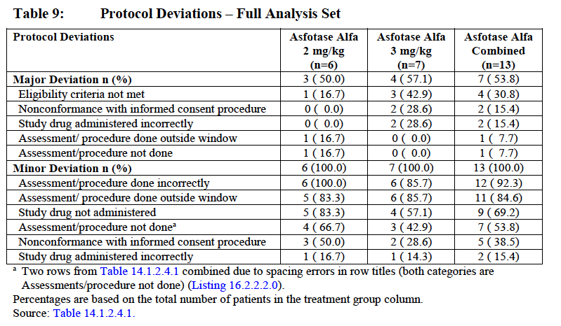

Baseline data
The 11 males and 2 females (n = 13) enrolled in ENB-006-09 ranged from 6 to 12 (mean = 8.8) years of age at Baseline. All patients were White, except for 1 who was of Hispanic/Latino ethnicity. The median age of onset of HPP symptoms was 12 months (range 1 to 22 months). Five patients had infantile onset HPP (defined as onset of HPP signs/symptoms < 6 months) and 8 had juvenile (childhood) onset HPP (onset of HPP signs/symptoms ≥ 6 months and < 18 years).
The majority of patients had a history of unusual gait (100%), premature tooth loss (100%), delayed walking (84.6%), knock knees (76.9%), muscle weakness (61.5%), and high phosphorous levels (53.8%). In addition, approximately half of the patients (46.2%) had a disease history that included abnormally shaped chest, bone pain (severe enough to limit activities), difficulty eating/swallowing, difficulty gaining weight, hypermobility (extremely flexible joints), joint pain, and muscle pain.

Results for the primary efficacy outcome
Change in rickets severity, as measured by RGI-C from Baseline to Week 24.
Efficacy data demonstrated that asfotase alfa treatment in patients aged 5 to 12 years at study entry with infantile or juvenile onset HPP, results in improvement in the radiographic appearance of rickets. Both measures of rickets severity used in this study (the 7 point RGI C and the 10 point RSS) indicated substantial healing of rickets in the wrists and knees after 24 weeks of asfotase alfa treatment with sustained radiographic improvement over time compared to historical controls.
At Week 24, median RGI-C scores were +2.00 and 0.00 for asfotase alfa treated patients and historical controls, respectively (p = 0.0007). The majority of asfotase alfa treated patients (9 of 13 patients (69%)) achieved RGI-C scores of +2 or greater at Week 24, indicative of ‘substantial healing of rickets’, compared to 1 of 16 (6.3%) historical controls demonstrating this same level of improvement. There were no differences in efficacy between the 2 dose groups at Week 24. Consistent with the RGI-C results, total RSS scores decreased over time and the mean change from Baseline was statistically significant at all time points when compared to values observed in the historical control group (see Table 13 below).

Table 13. Study ENB-006-09 /ENB-008-10. Radiographic global impressions of change (RGI-C) scores at Week 24 in full analysis set
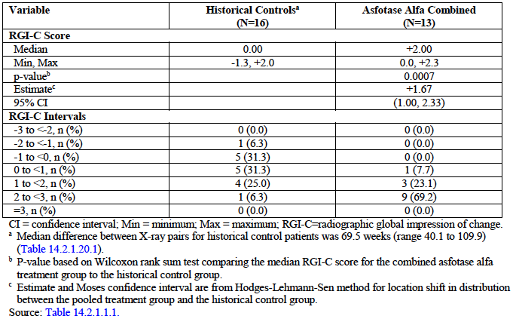
The primary efficacy endpoint was further examined by classifying patients as responders or no responders. Patients with average RGI-C scores of + 2 (indicative of ‘substantial healing of rickets’) or higher were considered responders. Consistent with the primary efficacy results described above, 9 of 13 (69.2%) asfotase alfa patients were considered responders at Week 24 compared to 1 of 16 (6.3%) historical controls (p = 0.0010).

Results for other efficacy outcomes
The change in rickets severity from Baseline to all post baseline visits for asfotase alfa treated patients, as measured by the RGI-C scale, was a secondary efficacy endpoint. Median RGI-C scores demonstrated significant improvement in rickets severity from Week 6 on, with scores increasing up to Week 24 and maintained over time. Average RGI-C scores obtained at each visit closely resembled estimates produced by a repeated measures linear mixed model analysis. Similar results were obtained when these analyses were repeated for the PP set.
Changes in rickets severity over time were also evaluated using the RSS, a 10 point rating scale of the growth plate abnormalities at the wrists and knees, in which a score of 10 represents severe rickets, a score of 0 represents an absence of rickets, and improvements are indicated by decreasing scores. Total RSS scores decreased over time and the median change from Baseline was statistically significant at all time points when compared to values observed in the historical control group.

Table 14. Studies ENB-006-09/ENB-008-10. Radiographic global impression of change (RGI-C) scores over time in full analysis set
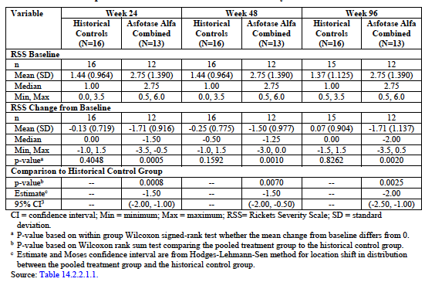
Consistent with the radiographic findings, asfotase alfa treated patients demonstrated marked improvement in bone mineralisation as evidenced by improvement in DEXA parameters, and improvements on trans iliac crest bone biopsies. Importantly, the observed improvements in bone health were supported by measurable improvements in parameters of growth, motor function, strength, agility and pain and disability.
Growth parameters (height, weight and BMI) all increased over the course of treatment with asfotase alfa with respect to healthy, same aged peers. From Baseline to Week 96, there were statistically significant changes in mean Z-scores for height (+0.38; p = 0.0078), weight (+0.82; p = 0.0003), and BMI (+0.54; p = 0.0035).
Asfotase alfa treated patients showed increases in gross motor function as demonstrated by statistically significant and clinically meaningful improvements in ambulation as measured by the 6MWT (reflected in % predicted values) (see Table 15 below), and marked changes in running speed and jumping distance as well as other strength measures as evaluated by the Running Speed and Agility and the Strength subscales of the BOT-2. The magnitude of change from Baseline in mean standard scores and mean percentile ranks indicated that the asfotase alfa treated patients acquired physical skills at a greater rate than would be expected in normal development, and continued to demonstrate improvement throughout the study. Of note, mean increases from Baseline in Strength and Agility Composite Standard scores were statistically significant at every assessment from Week 12 through to Week 144, as were mean increases from Baseline in corresponding percentile rank scores.
Improvements in effort dependent functional tests were supported by parent reported changes in pain and disability as measured by the CHAQ and various types of physical function as measured by the POSNA PODCI.

Table 15. Studies ENB-006-09 / ENB-008-10. Six minute walk test change from Baseline in full analysis set
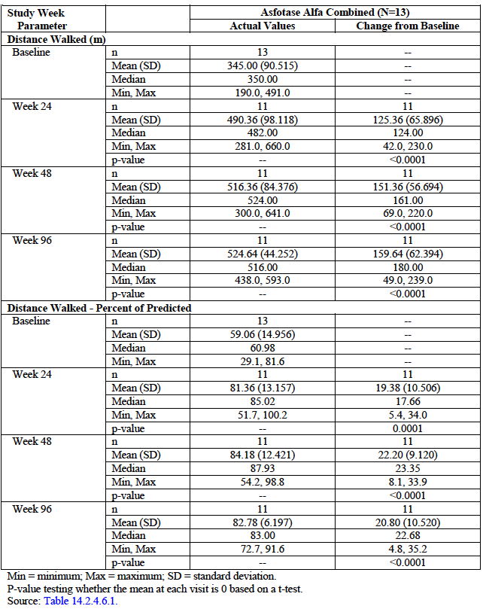
The differences from Baseline in these assessments were clinically meaningful as assessed by the ability to perform activities of daily living and consistent in the asfotase alfa treated patients. The improvements in clinical outcomes suggest increased independence and improved quality of life.

Studies ENB-009-10
Study ENB-009-10 is an ongoing, international, multicentre, open label, concurrent control study to assess the safety, efficacy, and pharmacology of asfotase alfa, a bone targeted, human recombinant enzyme replacement therapy, in adolescent and adult patients ages 13 to 65 years with infantile, juvenile, or adult onset HPP, depending on the patient’s age at diagnosis.
The overall study objectives were to evaluate the efficacy, safety, and pharmacokinetics (PK) of asfotase alfa (formerly known as ENB-0040) in adolescents and adults with HPP. The objectives outlined below were those stipulated in the protocol.

Primary objectives
The primary objectives of ENB-009-10 were the following:
- To evaluate the effect of asfotase alfa on reduction in plasma inorganic pyrophosphate (PPi) and plasma pyridoxal-5’-phosphate (PLP)
- To assess the tolerability of daily subcutaneous (SC) injections of asfotase alfa.

Secondary objectives
To evaluate the effects of asfotase alfa on the following:
- Change in HPP related osteomalacia as measured by trans iliac crest bone biopsy
- Change in bone mineral content and density as measured by dual energy X-ray absorptiometry (DEXA)
- Change in walking ability as measured by the Six Minute Walk Test (6MWT).

Exploratory
To evaluate the effects of asfotase alfa on the following:
- Change in HPP related skeletal abnormalities as measured by skeletal radiographs
- Change in muscle strength as measured by handheld dynamometry (HHD)
- Change in gross motor function as measured by a modified version of the Bruininks-Oseretsky Test of Motor Proficiency – Second Edition (BOT-2)
- Change in self-reported functional disability as measured by the Lower Extremity Functional Scale (LEFS)
- Change in self-reported pain as measured by a modified version of the Brief Pain Inventory-Short Form (BPI-SF)
- Change in pulmonary function as measured by forced vital capacity (FVC) using pulmonary function testing (PFT) with standard spirometry
- Tooth count
- Growth (as measured by height, arm span, and weight) in adolescent patients only
- Disease burden as measured by the Hypophosphatasia Patient Impact Survey (HIPS) version 2.0 (performed at the Screening visit only) (NOTE: The Hypophosphatasia Outcomes Study Telephone (HOST) survey was administered instead of HIPS)
- Differences between the 2 asfotase alfa doses with respect to safety, efficacy, PK, and pharmacodynamics (PD) outcomes.

Sites
A total of 19 patients were enrolled in ENB-009-10 at 3 investigational sites (2 in the United States of America (USA) and 1 in Canada).
Date first patient enrolled: 29 June 2010, Analysis cut-off Date: 29 January 2013.

Inclusion and exclusion criteria

Inclusion criteria
To qualify for participation in ENB-009-10, patients were required to meet the following criteria:
- Patients or their legal representative(s) must have provided written informed consent prior to any study procedures
- Patient must have been ≥ 13 and ≤ 65 years of age of study enrolment
- Female patients of childbearing potential and sexually mature males must have agreed to use a medically acceptable form of birth control; for the purposes of this study, females were considered of non childbearing potential if they were surgically sterile (had undergone a total hysterectomy, bilateral salpingo-oophorectomy, or tubal ligation) or were postmenopausal, defined as having complete cessation of menstruation for at least 1 year after 45 years of age
- Patients must have had a pre-established diagnosis of HPP as indicated by:
- Serum ALP below the age adjusted normal range
- Plasma PLP at least twice the upper limit of normal (no vitamin B6 administered for at least 1 week prior to determination)
- Evidence of osteopenia or osteomalacia on skeletal radiographs
- Patients must have had osteomalacia on bone biopsy with a MLT Z-score of + 2 or more (results from Study ENB-001-08 were used, when applicable)
- Patients must have been willing to comply with study procedures and the visit schedule

Exclusion criteria
Patients were excluded from participation in the study if they met any of the following exclusion criteria:
- Women who were pregnant or lactating
- History of sensitivity to tetracycline
- Serum calcium or phosphate levels below the normal range
- Serum 25(OH) vitamin D below 20 ng/mL
- Serum creatinine or parathyroid hormone (PTH) levels above the normal range
- Medical condition, serious inter current illness, or other extenuating circumstance that, in the opinion of the investigator, may have significantly interfered with study compliance, including all prescribed evaluations and follow up activities
- Orthopaedic surgery within 12 months prior to study entry that may have interfered with the ability to perform functional assessments of the study
- Prior treatment with bisphosphonates within 2 years of study entry for any length of time or for more than 2 years at any time point; for patients with prior bisphosphonate use that was allowed, the bone resorption markers serum C-telopeptide and urine N-telopeptide or urine dexoxypyridinoline must also have been within the normal range or elevated in order for the patient to have participated in the study
- Treatment with PTH within 6 months prior to the start of asfotase alfa administration
- Participation in an interventional or investigational drug study within 30 days prior to study participation.

Study treatments
Patients were randomised to 1 of 3 treatment groups for the PTP: a daily SC dose of 0.3 mg/kg of asfotase alfa (a total of 2.1 mg/kg/week), a daily SC dose of 0.5 mg/kg of asfotase alfa (a total of 3.5 mg/kg/week), or no treatment (hereinafter referred to as the untreated control group).
In the ETP, all patients received 0.5 mg/kg/day of asfotase alfa (a total of 3.5 mg/kg/week) for approximately 24 weeks following the primary treatment period after which time the dose was increased to 1 mg/kg 6 times per week (a total of 6 mg/kg/week) for an additional 48 weeks or until commercial availability of the drug, provided they did not have suppressed PPi levels. Due to the timing for implementation of protocol amendments, some patients received the 3.5 mg/kg/week dosage regimen for 24 to 48 weeks.
Dose adjustments could be made per protocol every 3 months based upon changes in weight in order to maintain the weekly target dose. The maximum daily dose of asfotase alfa was not to exceed 80 mg during the PTP or ETP unless otherwise specified by the investigator and Medical Monitor prior to implementation.
The interim Clinical Study Report (CSR) included all available data from all consented patients who had received asfotase alfa treatment on or before 29 January 2013. Patients received treatment for 24 weeks during the PTP. Upon completion of the PTP, they were eligible to continue in the open label ETP.

Efficacy variables and outcomes
The primary efficacy analyses focused on the pharmacodynamic effect of asfotase alfa on biochemical substrates of TNSALP, PPi and PLP. The efficacy variables included changes in plasma PPi and PLP levels, bone biopsy results, ambulation as measured by the 6MWT, DEXA results, growth measurements (adolescents only, including Tanner staging) motor function, strength, disability, and pain (as measured by the BOT-2, HHD, LEFS, and BPI-SF, respectively), pulmonary function (FVC), dental assessments, and skeletal abnormalities (namely skeletal radiographs) over time.

Randomisation and blinding methods
This study was open label; thus, all study staff and participating patients were aware that they were either receiving asfotase alfa or were in the control group. There was no placebo in this study.

Analysis populations
The analysis populations include:
- Full analysis (FA) set: includes all patients that were randomised; patients were to be analysed by the treatment that they were randomised to receive, although in practice all patients received the treatment to which they were randomised
- Per protocol (PP) set: includes all patients who received asfotase alfa treatment, had post treatment data, and did not have any major protocol deviations deemed to potentially influence treatment effect
- Safety set: includes all patients who received any asfotase alfa treatment, regardless of whether they were lost to follow up or dropped out of the trial. Safety analyses had no imputation performed. Patients were to be analysed by the treatment that they actually received, although in practice all patients received the treatment to which they were randomised.

Sample size
Twenty two adolescent and adult patients with HPP were planned to be enrolled in the study and randomised to one of the 3 treatment groups. Nineteen patients were enrolled at 3 sites. All 19 (100.0%) patients were included in the Full Analysis and Safety sets; 17 were included in the Per Protocol Set. As of the time of this interim report, all 19 patients had completed the primary treatment period and at least 48 weeks of treatment in the extension period; and 13 patients (all except patients from the untreated control group in the PTP) had completed at least 96 weeks of treatment during the extension period. Four patients who were previously enrolled in and completed the Phase I Study ENB-001-08 were enrolled in this study.

Statistical methods
The primary efficacy analyses examined the pharmacodynamic effect of asfotase alfa on tissue nonspecific alkaline phosphatase (TNSALP). Substrate parameters PPi and PLP were co primary endpoints. The primary analyses were the change in plasma PPi from Baseline to Week 24 and the change in plasma PLP from Baseline to Week 24 of the primary treatment period (PTP) comparing all patients randomised to either dosage of asfotase alfa with the control group. Each of the endpoints was compared between the pooled asfotase alfa group and the control group using an exact Wilcoxon rank sum test for each parameter using a two sided alpha of 0.05. If p values were less than 0.05 and the Hodges-Lehman-Sen estimate favoured asfotase alfa (for example, it had a negative sign indicating the between group differences in change from baseline favoured treated patients, then superiority over control was claimed. The primary analysis was repeated within each asfotase alfa group compared with the control group.

Major protocol violations/deviations

Table 16. study ENB-009-10: Protocol deviations in the full analysis set
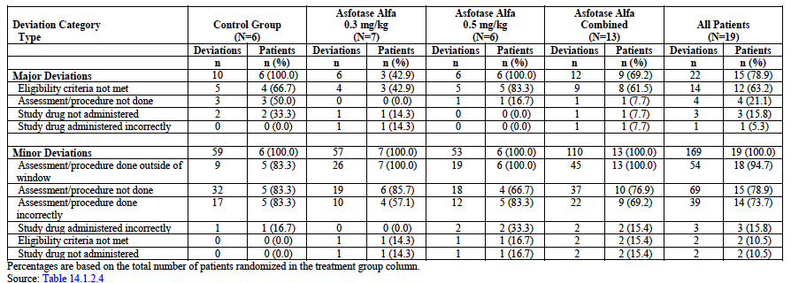

Baseline data
Patient age ranged from 13 to 66 years. The mean age at enrolment was 40.9 years at Baseline, but was imbalanced between the control and treated patients. The median age of the control group was much lower than the combined asfotase alfa treatment group (21.0 years (range: 13, 58) versus 55 years (range: 14, 66), respectively). Most patients were white (94.7%), female (63.2%) adults aged ≥ 18 years (68.4%; 13 adults total: 3 in control group and 5 each in the treatment groups). Enrolment was not restricted by age at HPP symptom onset (HPP phenotype), and age at symptom onset ranged from 0 to 36 years with a mean of 4.9 years. The majority of patients (12 out of 19) had juvenile juvenile-onset HPP; 4 patients had infantile onset HPP; and 2 had adult onset HPP (1 had unknown age of onset).
Mean (SD) Baseline PPi and PLP levels were 5.781 (2.1261) µM and 422.98 (427.466) ng/mL, respectively. Mean (SD) Baseline ALP was 22.6 (7.97) U/L. The percent predicted distance on the 6MWT at Baseline was variable, with 16.7% of control patients walking between 25% and 75% predicted distance compared with 57.1% and 33.3% of patients in the 0.3 mg/kg and 0.5 mg/kg asfotase alfa treatment groups, respectively. However, percent predicted distance wasnot calculated for 3 out of 6 control patients, because they did not walk for the full 6 minutes at Baseline. The majority of patients were ≥ 18 years of age at Baseline; of the 6 adolescent patients Tanner Stage at Baseline was Stage 1 (1 patient), Stage 4 (3 patients), and unknown (2 patients).

Results for the primary efficacy outcome
PPi and PLP analysis:
The primary analysis was the comparison between the combined treatment group and the untreated control group in the change from Baseline to Week 24 for the co primary endpoints of PPi and PLP (both substrates of alkaline phosphatase). The analysis was performed in the FA set using an exact Wilcoxon rank-sum test with a two sided p-value and last observation carried forward (LOCF) for missing data. Treatment with asfotase alfa significantly reduced PLP levels compared to controls at Week 24 (p = 0.0285). While treated patients experienced an approximately 2 fold greater decrease in PPi than controls at Week 24 (mean change of -2.100 µM in treated versus -1.052 µM in control patients), this difference did not achieve significance (p = 0.0715), most likely because a control patient [information redacted], who received a high dose of vitamin D and had a high Baseline PPi value (12.1 µM), experienced a decrease in PPi. A subsequent analysis of the FA set excluding this patient demonstrated a significantly greater reduction in PPi in the treated patients (p = 0.0044). Observed decreases in PPi and PLP were maintained after 48 and 96 weeks of exposure. After 48 and 96 weeks of asfotase alfa, PPi levels had decreased by -1.417 µM and -2.349 µM, while PLP levels had decreased by -342.76 ng/mL and -432.05 ng/mL, respectively. Results of analyses performed using the PP set were supportive of those obtained in the FA set.

Results for other efficacy outcomes

Secondary and exploratory endpoints
Consistent with a diagnosis of HPP, patients in all 3 groups had marked elevations in osteoid volume per bone volume and mineralisation lag time at Baseline. Baseline values of osteoid thickness were more variable among the patients. While no statistical analyses were performed, treated patients showed small improvements in all 3 histomorphometric parameters after 48 weeks of exposure compared to the untreated control group. No clear differences between treated and control patients in DEXA results were observed, perhaps due to high variability in Baseline values. However, treated patients did show modest, but statistically significant improvements from Baseline in lumbar spine bone mineral density (BMD) after 24, 48, and 96 weeks of asfotase alfa exposure.
Trends toward greater clinical improvement in treated versus control patients were generally observed on measures of function and disability, which were secondary and exploratory endpoints. On the 6MWT, patients in the combined asfotase alfa group demonstrated a median improvement of 35.0 metres at Week 24 compared with a median decline of 6.5 metres in the untreated control group. Consistent with the observed trend toward improvement in ambulation in asfotase alfa treated patients, the combined treatment group also showed greater improvements on the BOT-2 Running Speed and Agility test (mean change score at Week 24 of 4.3 in the treated versus -0.5 in controls patients) and in strength (median change at Week 24 in percent predicted hip abduction values of 11.10 in treated versus 6.70 in control patients and median change at Week 24 in percent predicted hip extension values of 7.95 in treated versus -1.90 in control patients). Treated patients also had slightly greater improvements on the LEFS measure of disability compared to untreated controls. In contrast, there were no clear differences between the treated and untreated control groups on the BOT-2 Strength test or the BPI pain assessment at Week 24.

Adults and adolescents subgroup analyses
When a pre specified statistical analysis of asfotase alfa’s effects on adult (n = 13) and adolescent (n = 6) patients was performed, the results in the adult subgroup were generally consistent with the overall results. For the adults, statistically significant reductions in both PPi and PLP were observed at Week 24 in the combined treatment group compared with the untreated control group. In addition, change from Baseline to Week 24 on the 6MWT was greater in the combined treatment group than the control group. Adult patients in the combined treatment group also showed a trend toward greater improvements on the BOT-2 Running Speed and Agility Test, in strength of the proximal muscles of the hip (as measured by HHD), and in lower extremity function (as measured by the LEFS) compared with the untreated control patients. Results in the adolescent subgroup were difficult to interpret due to the small sample size.

Individual patient changes
Although there was considerable variability among the treated patients in terms of response, several patients demonstrated marked clinical effects after treatment with asfotase alfa. Most notably, 5 patients, 2 of whom were predominantly non ambulatory at Baseline, were able partially or completely wean off of assistive devices (wheelchairs, walkers, or canes) following therapy with asfotase alfa. As of the last study assessment prior to analysis cut off, 4 of these patients (80%) not only were no longer using an assistive device, but were also able to walk between 98 and 217 metres more than their pre-treatment Baseline; the 5th patient had graduated from a wheeled walker to a cane, but walked slightly fewer meters (10) than they had at Baseline. The two patients who were largely unable to walk at Baseline were able to walk over 150 metres each (one patient; and 157 metres for another patient) at the last assessment prior to analysis cut off using no assistive devices.

Analyses performed across trials (pooled analyses and meta-analyses)
To examine the efficacy of asfotase alfa across the range of ages and HPP subgroups occurring in the proposed target population, ‘patients with paediatric onset HPP,’ efficacy data from 71 treated patients, who had onset of symptoms anywhere from in utero through adulthood, and who initiated asfotase alfa between the ages 1 day to 66 years of age, were examined using 2 different approaches. Efficacy was examined by age at initiation of treatment with asfotase alfa, taking advantage of the fact that the individual studies comprising the asfotase alfa clinical development program enrolled patients of different ages (namely Study ENB-002-08 enrolled patients ≤ 3 years, ENB-010-10 enrolled patients ≤ 5 years, ENB-006-09 enrolled patients 5 through 12 years, and ENB-009-10 enrolled patients > 12 years). Next, the data were pooled across studies and examined by age at symptom onset; for these analyses, efficacy for the 2 paediatric onset subgroups, infantile and juvenile. In addition the effects of asfotase alfa in treated patients versus untreated control patients were examined for selected endpoints.

Baseline characteristics
Skeletal system
- Skeletal deformities of rickets: metaphyseal flaring, varus, valgus deformities and bowing of the long bones
- Elevated osteoid indices (osteoid volume and thickness) confirming the presence of unmineralised bone matrix and reduced bone mineral content
- Abnormally shaped chest
- History of fractures/delayed fracture healing
- Below normal Z-scores for height and weight
- Arthritis and joint destruction in adolescent and adult patients
Physical Function, Ambulation and Strength; Disability and Pain; Quality of Life
- Difficulty gaining weight/failure to thrive/difficulty eating/swallowing
- Gross motor delays
- Delayed/impaired walking
- Use of supportive devices (such as walker, wheelchair or braces) for ambulation
- Pain
- Impairments in the ability to perform activities of daily living
Respiratory Status and Survival
- Respiratory compromise (up to and including respiratory failure)
Other
- Nephrocalcinosis
- Seizures in the youngest patients (≤ 5 years of age).

Pooled efficacy variables
In the pooled analysis, the main efficacy variables were:
Biochemical Parameters:
- Substrates of TNSALP
Skeletal System (mineralisation, structure and growth:
- Bone mineralisation (histomorphometry, DEXA)
- Rickets severity (RGI-C, RSS)
- Growth (length, height, weight)
Physical Function, Ambulation and strength:
- Function and strength (BSID-III, BOT-2)
- Ambulation (6MWT)
- Strength (HDD)
Disability/Quality of Life:
- Pain/disability (CHAQ, POSNA PODCI, LEFS, BPI-SF).

Pooled efficacy outcomes

Biochemical parameters
The activity of asfotase alfa in patients with paediatric onset HPP was confirmed through asfotase alfa induced reductions in TNSALP substrates PPi and PLP at 24 weeks, the primary efficacy period. The results were consistent, regardless of age at treatment initiation, and reductions in mean/median PPi and PLP plasma concentrations were sustained through at least 96 weeks of treatment (see Table 17 below).

Table17. TNSALP biochemical substrates (PPi and PLP): changes from baseline, patients with paediatric onset HPP ≤ 12 years of age (n = 52)
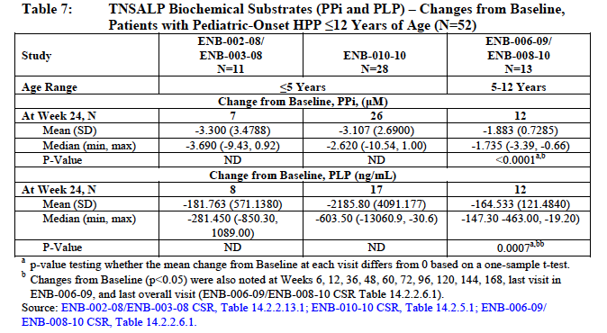

Skeletal system

Bone mineralisation
Both bone biopsies and bone densitometry studies were performed on paediatric onset patients (age 5 to 12 years). Significant improvements from Baseline in osteoid thickness were observed with asfotase alfa treatment, as median osteoid thickness at Baseline of 14.0 µM decreased -5.450 µM (p = 0.0097) at Week 24.
Substantial improvements from Baseline in median osteoid volume/bone volume (%) were observed with asfotase alfa treatment (Figure 8A). At Week 24, median osteoid volume/bone volume was reduced from a Baseline value of 13.9% to 5.75% (p = 0.0269), an approximately 2 fold reduction.
Significant improvements from Baseline in whole body bone mineral content (BMC) by dual energy X-ray absorptiometry (DEXA) were observed with asfotase alfa treatment, as Baseline BMC DEXA of 557.6 g increased by median change from Baseline of 68.26 g (p< 0.0001) at 24 weeks. These improvements were sustained through Week 96 with continued increase from Baseline in BMC of 285.35 g (p< 0.0001) at 96 weeks.
Results in the infantile onset and juvenile onset HPP subgroups for osteoid indices and DEXA (Figure 8B) were generally similar to the paediatric onset patient population as a whole. Across the paediatric onset HPP subgroups, asfotase alfa treatment was associated with significant reductions in osteoid volume and increases of whole body BMC over the course of treatment in both the infantile onset and juvenile onset populations.
Figure 8A and 8B. Osteoid volume/bone volume (%): baseline and week 24 values, in paediatric onset HPP patients (infantile and juvenile onset subgroups) ≤ 12 years of age
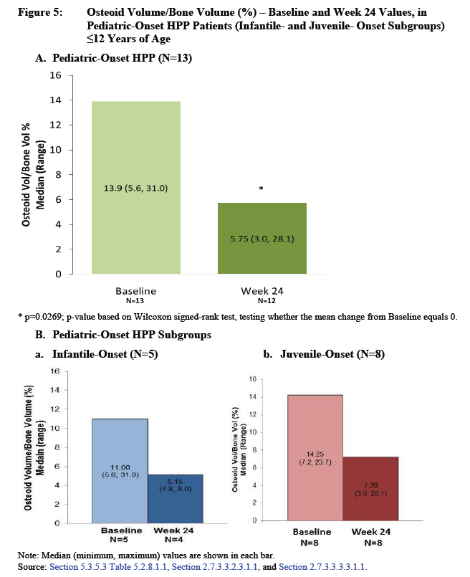

Rickets severity
The primary assessment of bone structure at the macroscopic level was RGI-C. Values > 2 by definition represent ‘substantial’ improvement in rickets. The RGI-C was the primary efficacy variable for the pivotal efficacy studies (ENB-002-08/ENB-003-08, ENB-010-10 and ENB-006-09/ENB-008-10) in paediatric onset HPP patients.
- Significant improvements in median RGI-C scores compared with Baseline were achieved for paediatric onset HPP patients in all pivotal efficacy studies at Week 24 (p < 0.005), the primary analysis period for each study.
- Improvements in RGI-C scores with asfotase alfa treatment were generally rapid and markedly improved from Baseline, and observed as early as 12 weeks after treatment initiation (Figure 9).
- A median RGI-C score of 2 or higher was noted as early as Week 24, indicating ‘substantial healing of rickets,’ and was sustained through Week 240, indicating maintenance of effect.
- The RGI-C results in the infantile onset and juvenile onset HPP subgroups (Figure 9) were similar to the paediatric onset patient population as a whole. Both infantile onset and juvenile onset HPP subgroups showed rapid onset of improvement in rickets severity and ‘substantial improvements of rickets’ which were maintained throughout the duration of treatment.
Figure 9. Changes in rickets severity (RGI-C) in paediatric onset HPP patients (infantile and juvenile onset subgroups) ≤ 12 years of age
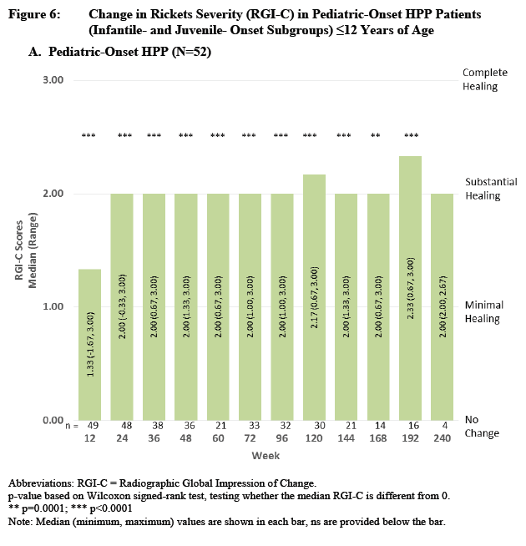
Figure 9 (continued). Changes in rickets severity (RGI-C) in paediatric onset HPP patients (infantile and juvenile onset subgroups) ≤ 12 years of age.
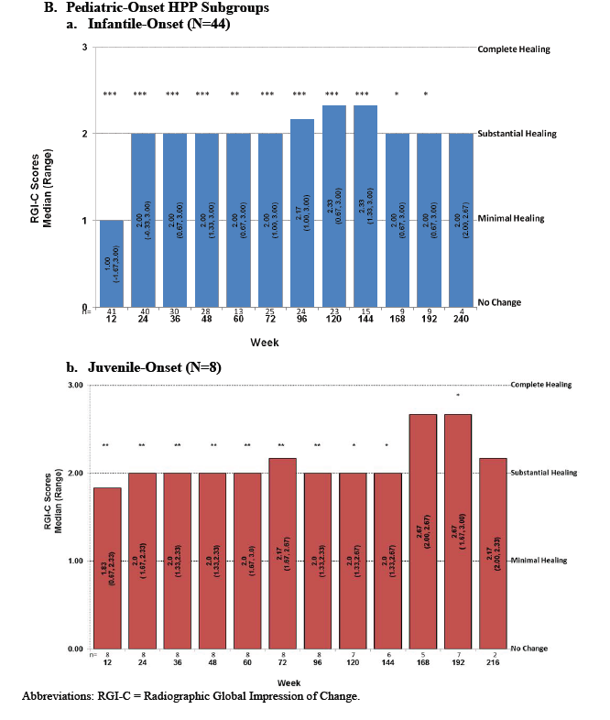
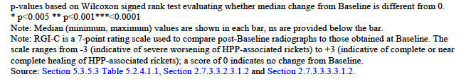
Growth
In patients with paediatric onset HPP, asfotase alfa induced improvements in bone mineralisation and radiographic findings translated into measurable improvements in growth (Figure 10). Growth measurements (height and weight) were collected in all pivotal efficacy studies.
Figure 10. Length/Height Z-Scores: change from baseline, in paediatric onset HPP patients (infantile and juvenile onset subgroups) ≤ 12 years of age: A (top) = Paediatric onset HPP (n = 52) and B.(a) = Paediatric onset HPP subgroups
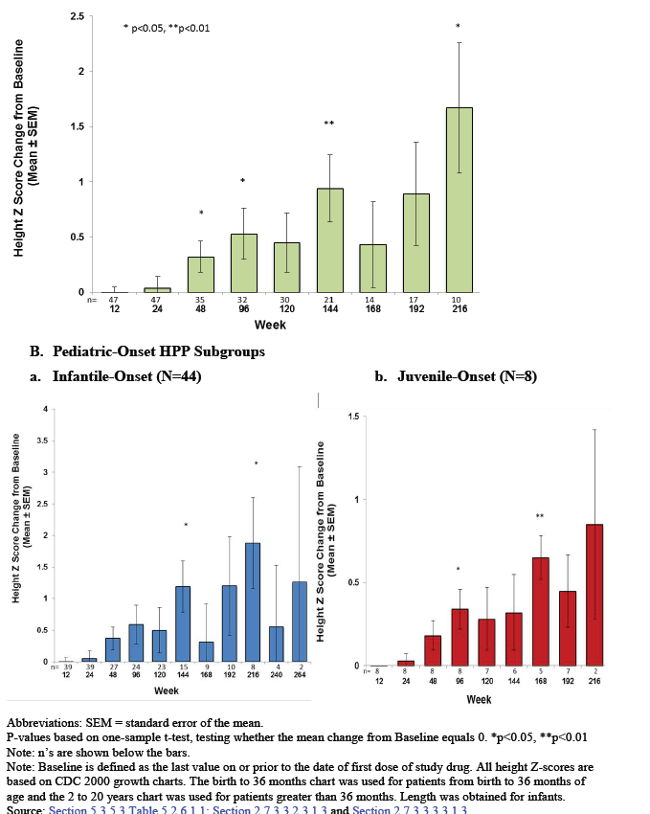

Physical function, ambulation and strength: BSID-III Gross Motor Scale
The BSID-III Gross Motor scale was used to assess strength, developmental milestones and function in paediatric onset HPP patients up to approximately 42 months of age. The BSID-III specifically tests the acquisition of new skills and the development of motor milestones.
Rapid, clinically meaningful, and sustained increases from Baseline were observed with asfotase alfa treatment in mean and median age equivalent scores on the BSID-III Gross Motor Scale, indicating improvements in gross motor function and the acquisition of new skills (such as rolling from side to back, sitting, squatting, and walking without support).
Significant improvements from Baseline were noted as early as 12 weeks with continued improvement (namely, acquisition of new skills) throughout the treatment period.

Six Minute Walk Test (6MWT)
The 6MWT was conducted as a routine physical function assessment in paediatric onset patients 5 to 12 years of age.
- Rapid, clinically meaningful and sustained improvements in 6MWT from Baseline were demonstrated with asfotase alfa treatment in actual distance walked (in meters). Mean improvements from Baseline by Week 120 for paediatric onset HPP subgroups were 189 meters.
- Rapid, clinically meaningful and sustained improvements in 6MWT from Baseline were demonstrated with asfotase alfa treatment in percent predicted values observed as early as Week 12 and was sustained through Week 192.
- Normalization of ambulatory capacity was also noted across the paediatric onset HPP subgroups. The mean improvement from Baseline in both infantile and juvenile onset HPP patients by Week 24 was over 100 meters. The improvements in both subgroups were clinically meaningful. With ongoing asfotase alfa treatment, 6MWT percent predicted values were ≥ 84% for Weeks 72, 120, 144, and 192 (infantile onset) and Week 48 through Week 192 (juvenile onset). (Henricson 2012)

BOT-2
The Bruininks-Oseretsky Test of Motor Proficiency, Second Edition (BOT-2) is a widely used, standardized test of motor proficiency that employs engaging, goal directed activities to measure a wide array of skills in normal children and youth from 4 to 21 years of age as well as in those with moderate deficits. It is based on a normative sample of 1,520 individuals in 38 states and possesses strong psychometric properties. Analyses focused on those subtests that evaluate functions most affected by HPP, including the Running Speed and Agility test, and the Strength test:
- The Running Speed and Agility subtest includes the following items: shuttle run, stepping sideways over a balance beam, one legged stationary hop, one legged side hop, and two legged side hop.
- The Strength subtest includes the following items: standing long jump, knee or full push ups, sit ups, wall sit, and V-up.
The primary source for BOT-2 results is from the ENB-006-09/ENB-008-10 studies, since the other studies included patients who were too young to conduct the BOT-2 at Baseline.
- Clinically meaningful and sustained improvements compared with Baseline were demonstrated with asfotase alfa treatment in BOT-2 Running Speed and Agility age equivalent scores, and BOT-2 Strength age equivalent scores. By Week 120 of treatment, patients had achieved a BOT-2 Running and Agility score within 1 SD of normal.
- BOT-2 results in the infantile onset and juvenile onset subgroups (Figure 10B) were similar to the paediatric onset patient population as a whole. Both infantile onset and juvenile onset HPP subgroups experienced a rapid onset of improvement which continued throughout the duration of treatment.

Disability/Quality of life

Key assessment tools
- The Child Health Assessment Questionnaire (CHAQ) is one of the most widely studied and validated scales for paediatric patients with musculoskeletal disorders. The CHAQ disability index is composed of 30 items in 8 subscales (dressing, grooming, arising (for example, get up from low chair or floor, get in and out of bed), eating, walking, reach, grip, and activities). Disability scores range from 0 to 3, with higher scores indicating greater disability.
- The Paediatric Orthopedic Society of North America’s Paediatric Outcomes Data Collection Instrument (POSNA PODCI) designed to assess general health problems (specifically bone and muscle conditions) in children and adolescents ages 2 through 18 years; scales include assessment of upper extremity and physical function, transfer and mobility tasks, sports/physical functioning, and pain/comfort, as well as a global function scale comprised of the mean of the ‘mean of items’ values for each of these scales. Standardized scores range from 0 to 100, with lower scores indicating greater disability.
- Lower Extremity Functional Scale (LEFS): a self-reported measure designed to assess functional disability in the lower extremities.
- Brief Pain Inventory Short Form (BPI-SF): a self-report questionnaire designed to assess the severity of pain and the impact of pain on daily function. It consists of 11 items that utilize a numeric rating scale to assess pain severity (4 items) and pain interference (7 items) in the 24 hours prior to questionnaire administration. Lower pain scores are associated with less pain.
The functional gains associated with asfotase alfa treatment resulted in sustained reductions in disability, and corresponding improvements in the ability to perform activities of daily living.
In summary there was:
- Improvement in CHAQ Disability Scores (reflecting improvements in tasks involved in dressing and grooming, feeding, arising, and walking) and in PODCI Transfer and Basic Mobility Scores (reflecting improvements in tasks such as getting out of the bed or bath) in patients 5 through 12 years of age
- Improvement in LEFS score in patients 13 through 66 years of age
- Ability to partially or completely wean off of assistive devices (wheelchairs, walkers, and canes) in patients 13 through 66 years of age
- Consistently greater survival in asfotase alfa-treated patients compared to controls regardless of the number of risk factors for mortality and morbidity.
- Improved survival time and invasive ventilator-free survival time in asfotase alfa treated patients when analyses were adjusted for 2 major sources of bias: period/year of diagnosis of control patients and age of treated patients at enrolment.

Other efficacy variables

Assessment of overall and invasive ventilator free survival
The effects of asfotase alfa on survival (overall and invasive ventilator free) were examined in patients with infantile onset HPP at high risk of premature death, in comparison to data obtained from a group of comparable untreated historical control patients. The asfotase alfa treated patients included patients in Studies ENB-002-08/ENB-003-08 and ENB-010-10. The untreated non-concurrent historical control patients were from Study ENB-011-10, a global, retrospective, epidemiological study of the natural history of patients with perinatal/infantile onset HPP.
Asfotase alfa treatment was associated with significantly greater overall survival and invasive ventilator-free survival in patients with infantile onset HPP at risk for premature death compared with untreated historical control patients. Survival was consistently increased in asfotase alfa treated patients compared with controls regardless of the number of risk factors for mortality and morbidity. Asfotase alfa treatment was also associated with improved survival and invasive ventilator-free survival after analyses were adjusted for 2 major sources of bias: period/year of diagnosis of control patients and age of treated patients at enrolment.

Other efficacy studies
Most of the results were pooled due to small sample sizes.

Pharmacokinetic: Pharmacodynamic relationships
Table 18 describes the selection basis for each of the PKPD endpoints in terms of it pharmacologic rationale, how the endpoint informs dose selection, and clinical phenotypes characterised by the endpoint.

Table 18. Endpoint selection rationale
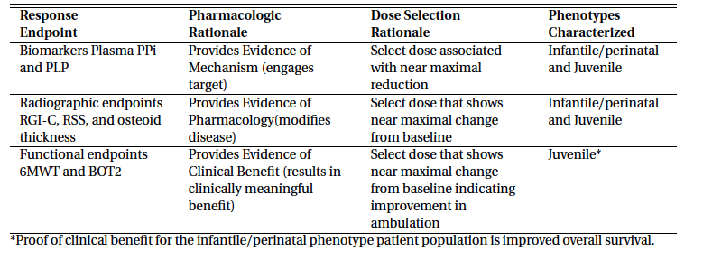

Exposure response and dose regimen
Simulation methods were used to elaborate the exposure response relationship for asfotase alfa and biomarkers, X-ray endpoints, and functional endpoints. Additionally, simulations were used as a basis for comparing the effect of two regimens of asfotase alfa 1 mg/kg given six times per week and 2 mg/kg given three times per week.
For the exposure response simulations, a template dataset was created that contained subcutaneous administration of 0.02, 0.1, 0.25, 0.3, 0.5, 0.75, 1, and 2 mg/kg given seven times per week, 1 mg/kg given six times per week, and 2 mg/kg given three times per week. In the template, one dose regimen was given to one patient repeatedly until the observation time for the endpoint. Half of these regimens were studied in the clinical investigations; half were selected to interpolate or extrapolate exposure data to provide a more extensive understanding of exposure response. The observation times for the simulated endpoints were as follows: PPi, 7 and 24 weeks; PLP, 24 weeks; RSS, RGI-C, BOT-2, and 6MWT, 72 weeks. These time points were selected to demonstrate the exposure-response at a relevant time point for the endpoint. For example, Week 72 was chosen for radiologic endpoints as demonstrable and clinically meaningful response is expected to take more time to achieve than a biomarker such as PPi or PLP.
Data from 60 total patients with HPP were included in the population PK data assembly process. Of that group, 57 individuals contributed a total of 1,318 PK observation records, with 130 below the lower limit of quantification (BLQ) observations ignored (resulting in effectively removing 4 additional subjects), 5 PK observations dropped for data inconsistencies, and 1,183 observations remaining for the population PK analysis. Three individuals had no PK observations (BLQ or otherwise), but contributed dosing records, covariate information, and PD observations to the data set.

Table 19. Flowchart of the PK data disposition
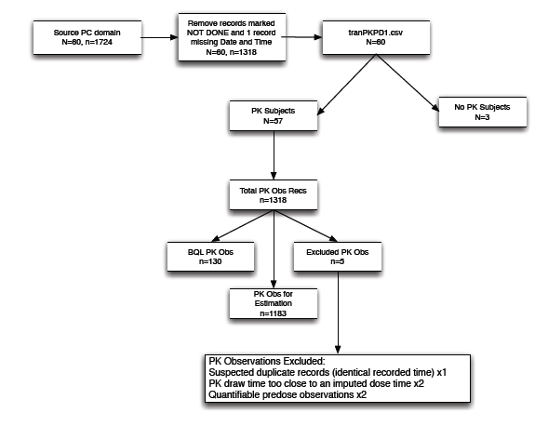
Longitudinal, repeated measures PD biomarker and efficacy endpoint data were also included in the population PK PD data set.
The X-ray imaging efficacy endpoints RGI-C and RSS were included in the PK PD analyses. In addition to imaging-based efficacy endpoints, the functional efficacy endpoints 6MWT and BOT-2, were included in the PK PD analyses.
Data were available for both endpoints from studies ENB-006-09, ENB-008-10, and ENB-009-10. Although functional endpoint data were available from a larger subset (32 individuals for 6MWT and 34 individuals for BOT-2), all analyses were limited to the juvenile phenotype (20 individuals for each endpoint), as specified in the Modelling and Simulation Plan (MSP).
The 6MWT analysis data were comprised of 20 individuals and 161 observations, after eliminating 1 missing value. The BOT-2 data were restricted to 11 individuals with ages from 4 years old to less than 22 years old, as this is the clinically relevant population for this instrument. After excluding missing data values, 71 observations remained. One individual was eliminated from the analysis resulting in a final total of 10 individuals and 64 observations for the BOT-2 analysis.
Data were also collected and assembled for an exploratory population exposure-response analysis of osteoid thickness data. The changes from Baseline to week 24 osteoid thickness data were available from 5 individuals of infantile phenotype and 13 individuals of juvenile phenotype. At week 48, the changes from Baseline data were available from 3 individuals of infantile phenotype and 6 individuals of juvenile phenotype.
The population data set included multiple covariate effects, such as the time dependent variables: age, height, body weight (WT), tanner stage, serum alanine transaminase in U/L (ALT), serum aspartate transaminase in U/L (AST), serum creatinine (SCR), anti-drug antibody, and neutralising antibody status; and the time-independent variables: sex, race, HPP phenotype (DIAG), and concomitant presence of B6, vitamin D, and calcium supplements.
Inferences about appropriateness of dose and regimen selection were supported by trial outcomes and the model based exposure response relationship. Although no specific clinical target exposure range had been defined for asfotase alfa it was evident that a SC dosing regimen of 2 mg/kg, administered three times per week achieved average steady-state concentrations that were above concentrations associated with efficacy in nonclinical studies. Furthermore, when viewed in the context of the exposure-response relationship, this dosing regimen achieved responses that were consistent with near maximal efficacy.
In younger children, where the mg/kg dosing regimen leads to slightly lower steady state exposure than in adolescents and adults, predicted response is still near maximal efficacy, and consistent with findings based on trial outcomes. No further dose adjustment, beyond mg/kg dosing, is likely necessary in these younger individuals. Due to the small sample size necessitated by this ultra-rare disorder, further evaluation of very young patients may be warranted.

Radiographic global impression of change (RGI-C)
Availability of RGI-C data from a historical control group allowed for the evaluation of the natural disease progression in select HPP age ranges and disease onset. Repeated measures data for the historical control group were paired within an individual to match a baseline value to a post-baseline value. The natural disease progression of changes in RGI-C was not included as part of the RGI-C PK PD model for both the Infantile and Juvenile subgroup patients. Therefore, any relation between exposure and RGI-C response is reflective of drug efficacy. For the PK PD analysis, only the active treatment patients within the age range defined by the patients in the historical control group (4 or older and younger than 13) were considered as over this range the disease progression was ruled out.
The simple indirect PD response model provided an adequate description of the observed data as seen in the VPC for RGI-C (Figure 11). The model was characterised by zero order increase in RGI-C with a stimulatory effect of asfotase alfa on K_{in}.
Figure 11. Model performance for describing RGI-C observations
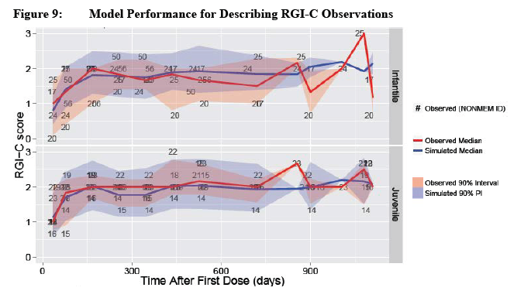

Rickets severity score (RSS)
The analysis of repeated measures RSS data was accomplished by dividing the total score variable into its 2 additive components, RSS wrist and RSS knee. The lower the RSS score, the better improvement in patient conditions. For the PK-PD analysis, only the active treatment patients within the age range defined by the patients in the historical control group (4 or older and younger than 13) were considered as over this range the disease progression was ruled out.
Indirect PD response models were implemented, with asfotase alfa concentration inhibiting production of response (for example, inhibitory E_{max} model on K_{in}). The additive effects of infantile subgroup on R0, relative to juvenile subgroup, were small and the 95% CI included zero, indicating minimal differences between subgroups in the RSS data sets. This model provided a reasonable fit to the individual data. (see Figure 12 below)
Figure 12. Model performance for describing RSS-wrist and RSS-knee observations
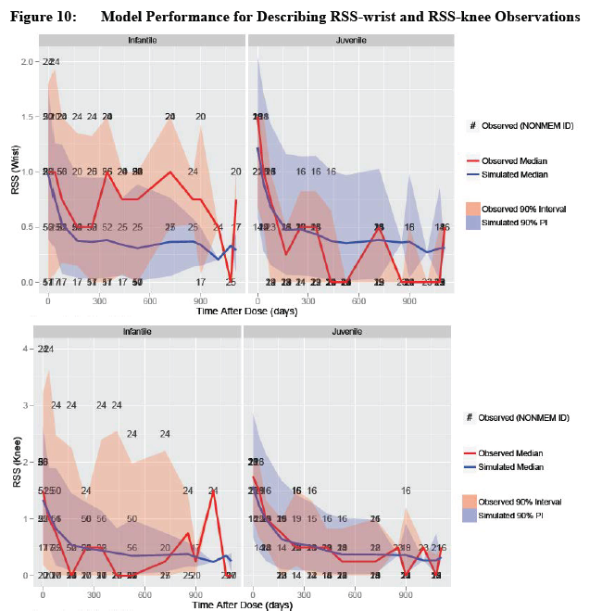

Bruininks-Oserestsky Test of Motor Proficiency, Second Rendition (BOT-2) and Percent-predicted 6-Minute Walk Test (6MWT)
Repeated measures data for the functional efficacy endpoint, BOT-2, revealed a time dependent increase in the strength and agility composite standard score throughout the duration of asfotase alfa therapy. A score of 60 was consistent with the normal range for this instrument, indicating a lack of disease related BOT-2 impairment for this particular individual at the start of the study. For that reason, this patient was excluded from the PK PD analysis.
Repeated measures data for the functional efficacy endpoint, 6MWT, revealed a time dependent increase in the percent of normal response throughout the duration of asfotase alfa therapy. The majority of the treatment population exhibited a baseline 6MWT of approximately 60% of predicted normal, while 2 individuals had baseline values near zero (ENB-009-10-01-04 and ENB-009-10-01-09). This was explained by differences in baseline inclusion criteria across studies (see Figure 13 and 14 below).
Although though BOT-2 and 6MWT data were collected from both infantile and juvenile subgroup patients, only juvenile subgroup patients were used for the PK PD modelling as the primary functional endpoint for infantile disease onset patients was survival.
Figure 13. Model performance for predicting BOT-2 observations
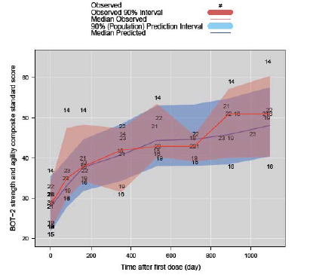
Figure 14. Model performance for predicting 6MWT observations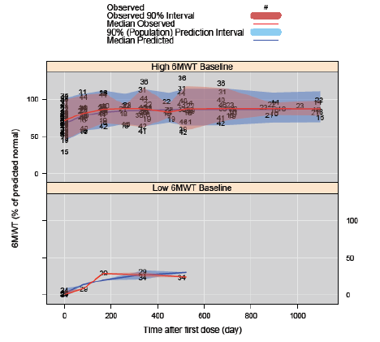

Integrated exposure response across doses
Simulation results for the PD-endpoints (PPi, PLP, X-ray based efficacy endpoints, RGI-C and RSS, and functional efficacy endpoints, BOT-2 and 6MWT) were summarised across asfotase alfa doses and regimens for the Infantile or Juvenile subgroup (Figure 15, Figure 16, Figure 17, Figure 18 and Figure 18). This integrated view of dose regimen-exposure-response revealed consistent trends that overall support a weekly dose of 6 mg/kg as an appropriate dose for the HPP patients. No discernible differences were noted in simulated PD responses across dosing regimens (6 mg/kg/week administered as 3 mg/kg thrice a week versus 1 mg/kg six times a week) for PPi, PLP, RGI-C, RSS-wrist, RSS-knee, percent predicted 6MWT, and BOT-2.
Figure 15. Simulate PD responses across dosing regimens (6 mg/kg/week administered as 3 mg/kg thrice a week versus 1 mg/kg/week six times a week) for PPi, PLP, RGI-C, RSS-wrist, RSS-knee, percent predicted 6MWT, and BOT-2
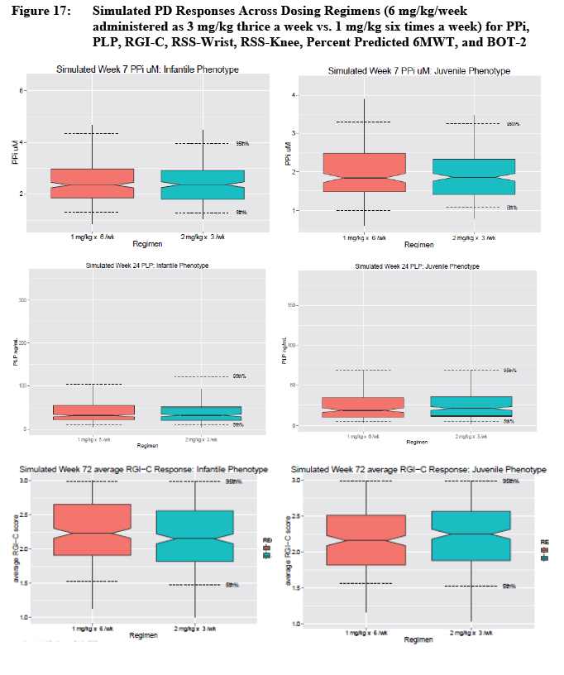
Figure 16. Simulate PD responses across dosing regimens (6 mg/kg/week administered as 3 mg/kg thrice a week versus 1 mg/kg/week six times a week) for PPi, PLP, RGI-C, RSS-wrist, RSS-knee, percent predicted 6MWT, and BOT-2
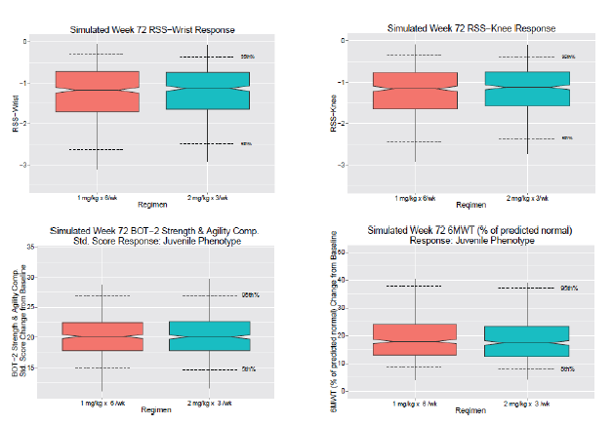
Figure 17. Simulated exposure versus response relationship for PPi (Week 7) and PLP (Week 24)
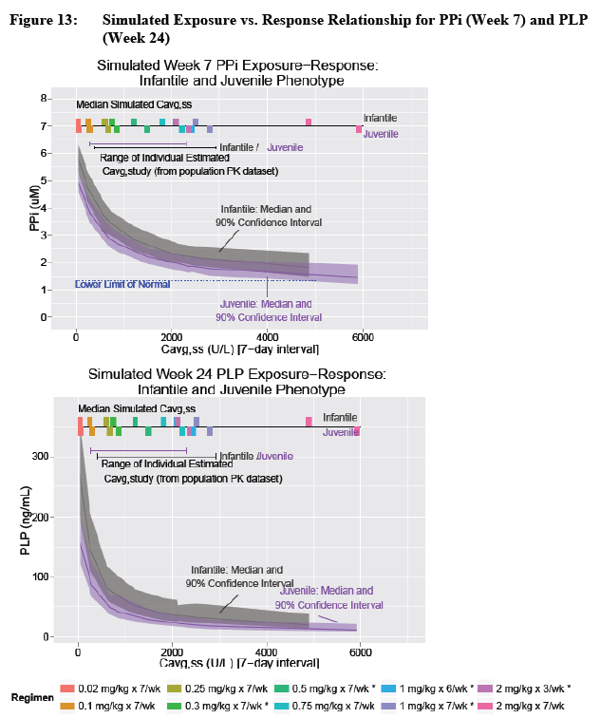
Figure 18. Simulated exposure versus response relationship for RGI-C (Week 72) and RSS (Week 72)
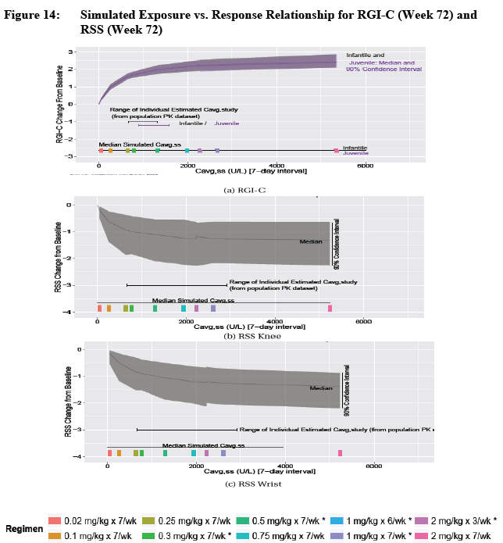
Figure 19. Simulated exposure versus response relationship for BOT-2 (week 72) and 6MWT(week 72)
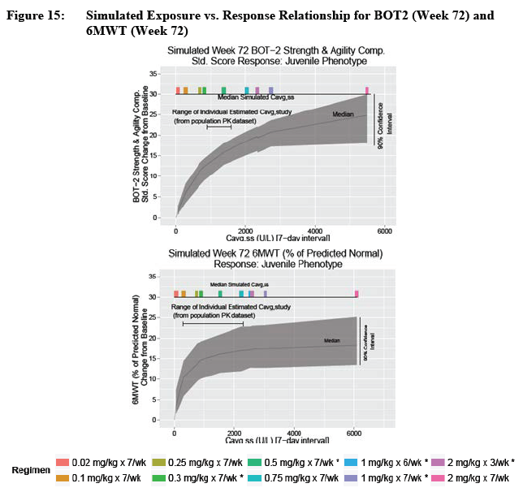

Exposure response relationship for overall survival in perinatal/infantile disease onset subgroup HPP patients
The pop PK model was translated from the analytical algebraic prediction routine to a system of differential equations to allow for numerical integration of continuous PK histories and the derivation of average concentration since first dose, calculated as the cumulative area under the concentration-time curve (AUC_{cumulative})/time since first dose (C_{avg}, over the entire study) for each individual. These individual C_{avg} values were analysed as a continuous covariate along with ‘Year of Diagnosis’ as predictors in a Cox proportional hazard model.
Patients from studies ENB-002-08/ENB-003-08 and ENB-010-10 who met the entry criteria for Study ENB-011-10 (natural history study) and who had drug concentration data available were included. Treated patients who had not died were censored at the time of their last recorded assessment. Historical control patients who had not died were censored at the time of data abstraction. Historical control patients whose status was unknown at the time of data abstraction were censored at the time of last known contact. The average drug concentration of Historical Controls was set to 0 (U/L). Year of diagnosis was used for the Historical Control patients and year of enrolment was used for Treated Patients, because the year of diagnosis was not available for Treated Patients.
For each unit increase in (U/L) of asfotase alfa PK activity the hazard for overall survival was scaled proportionally and statistically significantly (p = 0.0104) by a coefficient of -0.002. The Hazard Ratio for one unit increase in C_{avg} (95% CI) was 0.998 (0.996 to 0.999) (Table 20). Based on this analysis for overall survival, exposures associated with 6 mg/kg weekly (given either as 2 mg/kg three times weekly or 1 mg/kg six times weekly) is expected to improve the odds for overall survival significantly.

Table 20. Overall survival using Cox proportional hazards model with average drug concentration and year of diagnosis as predictors of HPP Phenotype (Perinatal/Infantile)
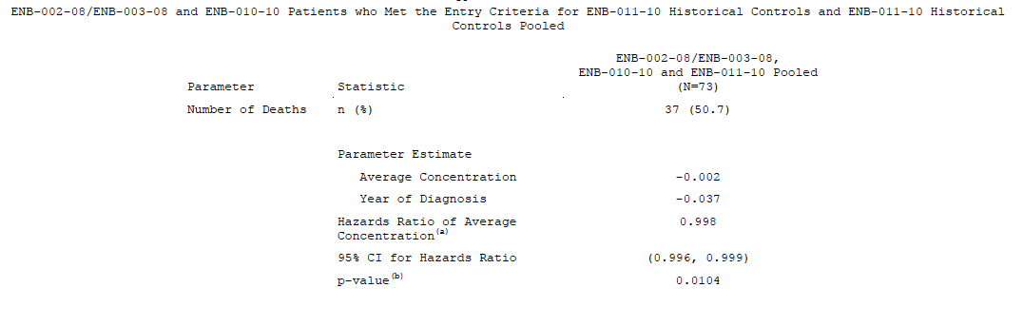
It is important to note the limitations of this survival analysis. The relationship of increased survival with increased asfotase alfa PK activity (C_{avg}) may be confounded by the fact that more events took place in the Natural History arm, which was assigned a C_{avg} = 0 U/L. In addition, the analysis was complicated by the fact that life expectancy was assumed to be similar between historical controls and patients from the clinical trials. A survival analysis using data only from patients treated with drug was not performed as a Cox proportional hazard model with only 2 events (based on the data cut used for this analysis) would not provide meaningful information on the effect of C_{avg}.

Summary of exposure versus efficacy relationships from the pooled-analysis
- As discussed previously asfotase alfa was shown to be efficacious across the range of ages and HPP subgroups occurring in the proposed target population, ‘patients with paediatric onset HPP,” efficacy data from 71 treated patients, who had onset of symptoms anywhere from in utero through adulthood, and who initiated asfotase alfa between the ages 1 day through 66 years of age, were examined using 2 different approaches. Efficacy was examined by age at initiation of treatment with asfotase alfa, taking advantage of the fact that the individual studies comprising the asfotase alfa clinical development program enrolled patients of different ages (therefore Study ENB-002-08 enrolled patients ≤ 3 years, ENB-010-10 enrolled patients ≤ 5 years, ENB-006-09 enrolled patients 5 through 12 years, and ENB-009-10 enrolled patients > 12 years). Next, the data were pooled across studies and examined by age at symptom onset. For these analyses, efficacy for the 2 paediatric onset subgroups, infantile and juvenile. In addition the effects of asfotase alfa in treated patients versus untreated control patients were examined for selected endpoints.
- Significant PK PD relationships were demonstrated for the biomarker (PPi and PLP) and efficacy (RSS, RGI-C) data in the perinatal/infantile subgroup HPP patient population. There was increased survival with increasing asfotase alfa PK activity (C_{avg}) as demonstrated using a Cox hazard proportional analysis (see above). This relationship was confounded because more events took place in patients from Natural History Study.
- Significant PK-PD relationships were demonstrated for the biomarker (PPi and PLP), and efficacy (RSS, RGI-C, BOT-2, and % predicted 6MWT) data in the juvenile subgroup HPP patient population.

Evaluator’s conclusions on clinical efficacy for Hypophosphatasia (HPP)
Asfotase alfa is a particularly effective treatment to reverse the biochemical abnormalities arising from tissue non–specific alkaline phosphatase deficiency, showing rapid correction of the abnormalities in pyrophosphate (PPi) and calcium metabolism and the mineralisation defects in the skeleton of the growing child.
Asfotase alfa also demonstrated a favourable benefit profile in the treatment of patients over the age of thirteen years with non perinatally lethal paediatric onset HPP. Asfotase alfa lowered TNSALP substrates, PPi and PLP, consistent with its intended biological activity. In addition, treated adolescent and adult patients showed small improvements in histomorphometric parameters (osteoid volume, % osteoid thickness, and mineralisation lag time) after 48 weeks of exposure compared to the untreated control group. While there were no clear differences between treated and control patients in DEXA results, treated patients did show modest, but statistically significant improvements from Baseline in lumbar spine bone mineral density (BMD) after 24, 48, and 96 weeks of asfotase alfa exposure. Across the population studied, this biologic effect was associated with a trend toward improvement in strength, ambulation, and physical function. More importantly, a subset of patients with significant HPP disease burden at Baseline experienced a clinically significant response, being able to come off of assistive devices for ambulation. Consequently, they markedly increased their functional capacity in a manner directly relevant to ambulation and the ability to conduct activities of daily living.
In human studies, not all patients have the profound deficiency of alkaline asfotase which is characteristic of patients with homozygous null gene mutations (contrasted with the akp2-/- mouse). Accordingly, there is a wide spectrum of severity grading from historical studies ranging from infants with prenatal onset and perinatally lethal Hypophosphatasia through to infants with perinatal presentation but who are nevertheless ventilator independent. The spectrum continues to include patients with infantile onset, who were not ventilator dependent, and patients with juvenile and adult onset, who present with a broad range of severities. The definitions have been somewhat arbitrary but have served bone and mineral clinicians for several decades in decision making about management. The dramatic improvement in radiographic findings in the chest and growing centres reported in the clinical Study ENB-0040 which formed the report in the New England Journal of Medicine in 2012 (Whyte et al 2012) shows an extreme severity in patient 6 in that report which would have been regarded as Perinatally lethal. In the study report in the New England Journal of Medicine 2012, 5 out of 11 patients were diagnosed as perinatal onset and 9 out of 11 patients had significant respiratory failure at baseline.
In the pivotal study reports, there are a number of patients who show rapid healing of mineralisation defects after 24 weeks of therapy. For example a radiograph from Study ENB-006-09 (see Figure 20) illustrates a marked reversal of the mineralisation defects in the growing centres. It is evident that the treatment for this patient with the diagnosis of Juvenile HPP, shows healing of dysplastic lesions in wrist bones. The efficacy is mirrored in the progressive improvement in the functional assessment by the parent reported of this child PODCI (Paediatric Outcomes Data Collected Instrument).
Figure 20. X-ray of patient in Study 002/003 from Study ENB-006-09-02: left wrist and knee film (baseline) (LHS) compared with film at 6 months (centre) and 36 months (RHS)
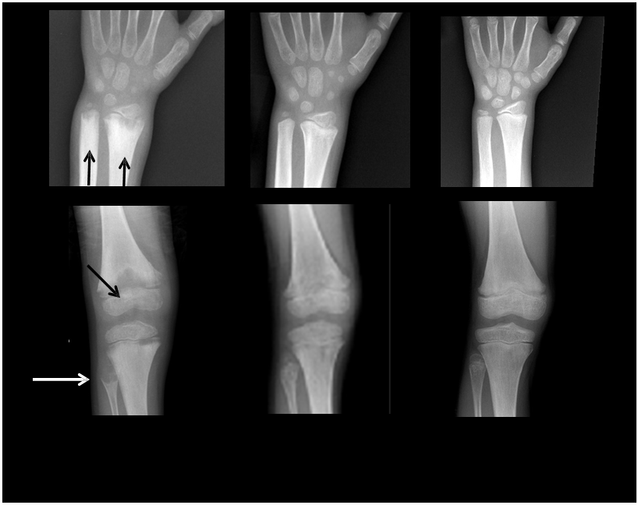
Asfotase alfa is, with some qualifications (see below), an effective therapy for skeletal involvement of young patients with HPP. The evidence for clinical efficacy in selected patients is very strong. A regimen of 1 mg/kg 6 times per week or 2 mg/kg 3 times per week, normalises mineral chemistry, increases whole body mineral content and results in radiographic evidence of healing rickets. This is true across the age groups from the perinatal period (those surviving the newborn period) through Infantile and Juvenile Presentations.

Qualifications on the selection of patients and efficacy

Validity of the comparator case study of severe perinatal/infantile onset HPP
The Comparator study has a number of limitations. It is not strictly an ‘epidemiologic study’ despite the title. It is a voluntary notification cohort study which has cases reported from multiple centres in different countries. The report of the study is more a case study of subjects from multiple sites from around the world and their characteristics. How representative they are of paediatric onset Hypophosphatasia in various regions of the world is questionable. The cohort of 15 Canadian patients (all Mennonite with a common mutation) with perinatal HPP, appears to be a homogeneous cohort in which HPP was uniformly fatal and all patients died by 9 months of age. Only 1 Asian patient was included in the comparator study although there is known to be common mutations in East Asian subjects and possibly a higher frequency of Hypophosphatasia in East Asian populations. Thus this historic cohort is unlikely to be unrepresentative even in North America.
Furthermore, the limitations of this multi-centre, multinational retrospective chart review reflect a restricted physician base and did not include birth defect registers, skeletal dysplasias registers in centres other than the International Skeletal Dysplasia Register in Los Angeles and Skeletal Dysplasia patient management services patients in other centres around the world.
The studies which have been undertaken encompass a small number of patients in each of the pivotal studies and some these patients have also been included in Study ENB-011-10 which was a retrospective, non-interventional, ‘epidemiological’ study of the natural history with patients with severe perinatal/infantile onset HPP. ENB -011-10 is the study which is put forward as the comparator for all the other studies. It is not strictly an ‘epidemiologic study’ but a case finding study from a limited number of sites in United States, Canada (only Mennonite patients), Germany, Australia and single patients from Spain, Switzerland and Taiwan, European and other sites around the world. It is not analysed by radiographic severity grading at diagnosis nor by mutation and predicted phenotype extrapolated from mutation type and known structure function correlations. Mutation analysis was only determined for 35.4% of cases in the ENB-011-10 case series. It is even more disconcerting that 10out of 48 (21%) cases included did not have radiographic confirmation.
The studies reported in ENB-011-10 encompass a small number of subjects with diverse disease severities. The largest group of patients is from a perinatal/infantile onset with age of onset under 5 years of age. These patients are survivors of a large group of infants born but in whom the mortality is exceedingly high. In this case series, of those in whom there was documentation of prenatal evidence of HPP 14 out of 29 (48%) cases were documented as having signs of prenatal HPP. It is not made clear in the conclusions of the study that these infants would almost all have had the diagnosis of perinatally lethal HPP in whom the mortality is exceedingly high. Not only would they have rarely survived for treatment, these infants would have needed invasive ventilatory support. In addition these infants were at high risk for Vitamin B6-responsive seizures, a group with a virtually 100% probability of death with none (0 out of 11) surviving at > 3 to 5 years and often marked disturbance of mineral metabolism.
In the prospective asfotase alfa interventional studies, craniosynostosis developed in 11.3% of subjects. The Comparator group (ENB-011-10) had a frequency of craniosynostosis in the Decease group of 52.6% and the Alive group of 75% but was not strictly comparable give a high frequency of cases ascertained with severe even prenatal onset disease.

Perinatal onset
The perinatal group includes a sub group of patients who have prenatal onset with marked skeletal abnormalities. Radiographic studies in those patients show missing skeletal elements, skeletal deformity, extremely severe mineralisation defects and retarded in utero growth. There is respiratory distress at birth and the majority of these babies would not survive without invasive chronic ventilation. There is good evidence that the same effect seen across the genetic skeletal dysplasias on the maturation of lungs as a result of poor growth of the chest as well as the muscular weakness which accompanies Hypophosphatasia, results in an immaturity in the development of the bronchio alveolar system.
If these infants are sustained on chronic ventilation, these pathological lung features cannot always be reversed despite restoration of bone strength and development. Those infants who have persistent pulmonary immaturity may require tracheostomy for long term airway management. This sub group may have pulmonary outcomes similar to those described by Langston and Bishop in their review of Diffuse Lung Disease in Infancy, 2009. See discussion above on Study ENB-011-10 an international multicentre case study which suggested that the very high mortality in the perinatal/infantile group ascertained historically is biased by inclusion of a large proportion of babies with pulmonary immaturity and bariatric lung damage from attempts at chronic ventilation. On the other hand there are infants with a perinatal presentation who are somewhat milder and may be ascertained because of their skeletal features or seizures in the first 2 years of life. While there is continuum in the severity of these skeletal phenotypic effects, there is clinical discontinuity because of the known historic outcomes prior to the development of an innovative therapy such as asfotase alfa.

Non perinatally lethal Infantile and juvenile patients of ≤ 18 years of age
These children with HPP have skeletal changes of variable severity. The evidence for clinical efficacy is very strong in this group of patients. A regimen of 1 mg/kg 6 times per week or 2 mg/kg 3 times per week, normalises mineral chemistry, increases whole body mineral content and results in radiographic evidence of healing rickets. A sub group of children have very mild changes and do not appear to be included in these study groups. As previously noted this group includes a relatively large group of children in Australia who have odontohypophosphatasia who have no evidence of generalised skeletal disease assessed with skeletal radiology and bone densitometry yet have premature loss of deciduous teeth. At present it is not proposed that this latter group will need therapy. It is important to note that the ‘long term’ natural history of patients with odontohypophosphatasia is not known. In particular, it is not known whether these patients (all children) will develop symptomatic adult onset osteomalacia.

Adult patients
The growing centres of the long bones are closed at puberty and in adult life. These patients have persistent Osteomalacia and propensity to pain and debilitating stress fractures. The case definition of Paediatric onset Hypophosphatasia is not precise.
Asfotase alfa in the adolescent and adult case series with HPP (ENB-009-10) demonstrated a favourable benefit profile series. In this trial, patients were randomised to one of two dosage regimens (2.1 or 3.5 mg/kg/week) for the first 24 weeks only. Following the primary treatment period, the dose was increased to the 6 mg/kg/week. Most functional outcomes were obtained after the 24 week period on the 6 mg/kg/week dosing. This observation foreshadows the question about asfotase alfa authorisation and whether a firm recommendation can be made for an adult dosage regimen.

Should ‘Long Term’ be included in the indication?
When a firm clinical diagnosis with the full range of signs and symptoms and radiographic findings is made in childhood, it is inevitable that the disorder will have ‘long term’ clinical consequences. Once patients reach adult life, it is not clear whether therapy should be ceased. Nor is it clear what the indications will be for continuing therapy and what the dose and frequency of administration of asfotase alfa should be. It is reported that some patients have remissions of their symptoms and signs in young adult life but the usual course historically is one of fluctuating bone pain and episodic stress fractures (Whyte 2012). Historically younger and older adults prior to asfotase alfa therapy have required complex orthopaedic surgeries and have required protracted rehabilitation. The population prevalence in post-pubertal subjects is unknown.
Therapy commenced at any stage of childhood will need to be reviewed when patients reach adult life and perhaps be continued for life. There is very little documentation and evaluation of asfotase alfa therapy, its dose, frequency and monitoring requirements in subjects over the age of 18 and insufficient data to continue therapy without review of the need for ongoing therapy indications. Study ENB-009-10 would suggest that a regimen clearly needs to be derived from the available studies. As with other biopharmaceuticals introduced for disorders treated from childhood, guidelines are needed for a change in dosage at puberty if paediatric dosing can be reduce which is indicated as the trials undertaken by the sponsor indicate the dosage regimens 2.1 mg/kg/week or 3.5 mg/kg/week were both efficacious.
Given the different genetic structure of world populations, the potential for endogamy in some populations and the variability in mutations and phenotypes as listed in the International TNSAP register (Mornet, 2013), it will be important that centres of expertise offering clinical management for patients with HPP, establish their own national or state wide databases of the patterns of the mortality, morbidity and natural history of these disorders. With some assistance from the organisers of a proposed Post marketing Surveillance Program as outlined (ALX-HPP -501) it would be possible for local state based registers to harmonise with this post marketing (PM) surveillance database (included in proposed Risk Manage Plan).

Evidence for the age ranges of patients

Perinatal age range
This age range encompasses children with HPP with perinatally lethal HPP who almost universally will have underdevelopment of the lungs of prenatal onset and subsequent failure to wean from invasive ventilation because of irreversible lung damage. It will be important to establish comprehensive assessment and recommended exclusion criteria where hypoplasia of the lungs is irreversible and the prospect for weaning to invasive ventilator free ventilation is achievable.

Transition from juvenile to adult pharmaceutic responsiveness
As with many therapies primarily trialled in affected children particularly those where the therapy may be life extending, care will need to be taken to determine the effective therapeutic dose post-puberty. ENB-009-10 had a study design which was case controlled and did not have a major bias. Doses of 2.1 mg/kg/weekly and 3.5 mg/kg weekly in 7 SC divided doses gave a favourable response. The evaluator would recommend that the commencing adult dose be 2.1 mg/kg weekly with an option to increase to 3.5 mg/kg weekly if an increase is needed.

Adults with paediatric onset of HPP
Special consideration must be given to indications for treatment of adults given that inclusion/exclusion criteria for adults will need to be quite specific. Study ENB-009-10 included dosing studies to determine minimum effective doses and confirmed that this may be lower for adults compared to the paediatric dose. ENB-009-10 had a study design which was case controlled and did not have a major bias. Doses of 2.1 mg/kg/weekly and 3.5 mg/kg weekly in 7 SC divided doses gave a favourable response.

Adults without paediatric onset but with clinically proven HPP and osteomalacia
There will be the temptation to use asfotase alfa with adults with symptoms and complications of osteomalacia but with a questionable paediatric history of involvement. Future trials in adults with symptomatic osteomalacia need to be undertaken but commencing at the lower 2.1/kg weekly dose.

Clinical safety

Studies providing evaluable safety data
The following studies provided evaluable safety data:
- ENB-001-08
- ENB-002-08/ENB-003-08
- ENB-006-09/ENB-008-10
- ENB-009-10
- ENB-010-10.
Pivotal efficacy studies
In the pivotal efficacy studies, the following safety data were collected:
- Spontaneously reported adverse events (AEs)
- Infusion and injection associated reactions (IARs)
- Laboratory assessments (chemistry, haematology, urinalysis, calcium and phosphorus, and 25(OH) vitamin D)
- Vital signs
- Physical examinations (including funduscopic examinations)
- 12-lead electrocardiograms (ECGs)
- Clinical laboratory tests
- Anti-asfotase alfa antibody testing were assessed for changes from Baseline.
Pivotal studies that assessed safety as a primary outcome
The following were studies that assessed safety as a primary outcome:
- ENB-001-08
- ENB-002-08/ENB-003-08
- ENB-006-09/ENB-008-10
- ENB-009-10
- ENB-010-10.
Methodology for evaluation of asfotase alfa safety and tolerability were comparable across the clinical trials. As part of continuous AE assessment, investigators were instructed to monitor patients for potential signs of asfotase alfa-related reactions, both systemic and localised. Clinical studies also included routine renal ultrasounds and eye examinations, including fundoscopy, to monitor for potential ectopic calcifications as these are known to be influenced by disturbances in calcium homeostasis associated with HPP. Considering that asfotase alfa is an exogenous protein, monitoring for the development of anti-asfotase alfa antibodies and neutralising antibodies was also routinely performed. Other common safety assessments performed in clinical trials of asfotase alfa included physical examinations, vital signs, and routine clinical laboratory testing (that is haematology, blood chemistries, and urinalysis). Any clinically significant changes from Baseline in safety assessments, including worsening of pre-existing conditions(s) from Baseline, were to be reported as AEs.
Clinical trials contributing safety data for the integrated safety analyses are described and displayed in Table 21 and Figure 21, respectively. The 6 clinical trials that contributed safety data to the integrated safety analyses (ENB-002-08, ENB-003-08, ENB-006-09, ENB-008-10, ENB-009-10, and ENB-010-10) enrolled patients across a wide age range (1 day to 66 years) and spectrum of disease.

Table 21. Overview of HHP onset categories and studies included for pooling of safety data
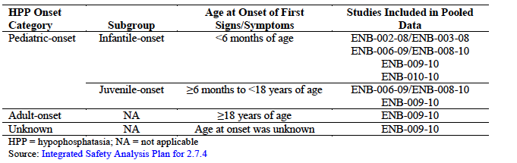
Figure 21. Flow of patient from clinical studies into the pooled safety data set
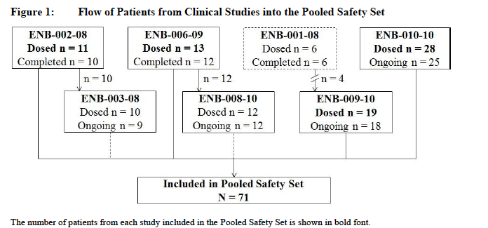
The initial identification of both injection-associated reactions (IARs) and injection-site reactions (ISRs) was undertaken by clinical investigators and reported in the electronic case report form assignment by investigators, where applicable. Clinical review of all AE verbatim terms and Medical Dictionary for Regulatory Activities (MedDRA) coded preferred terms by Alexion Medical Monitoring and Pharmacovigilance staff also occurred to ensure a comprehensive analysis.
The integrated safety analyses (n = 71) included paediatric onset HPP patients (68 of 71 (95.8%] patients), 2 patients with adult onset HPP and 1 patient with undetermined disease onset. For this reason, data summaries and presentations provided in this clinical safety overview are focused on the overall population. Safety observations relevant to infantile onset and juvenile onset subgroups of paediatric onset HPP patients are provided, where appropriate.
Because the initial dose of asfotase alfa (3 mg/kg) in Study ENB-001-08 was administered IV and subsequent treatment (1 or 2 mg/kg SC) was administered less frequently over a shorter duration (once weekly for 3 weeks) compared with other studies, data were excluded from the integrated safety analyses and are also excluded from data summaries and presentations provided in this clinical safety overview. Safety observations for this study were also generally consistent with safety observations for the overall population included in the integrated safety analyses.
The most common safety observations associated with SC administration of asfotase alfa were local ISRs including, but not limited to, injection site erythema, injection site pain, injection site discolouration, injection site pruritus, injection site macule, injection site swelling, lipohypertrophy, injection site atrophy, injection site bruising, injection site induration, injection site reaction (not otherwise specified), and injection site nodule. By definition, these events were localized to the site of study drug administration, were assessed by the investigator as being related to study drug, and occurred at any time during study participation. In addition, IARs were reported, including systemic signs/symptoms (such as pyrexia, chills). By definition, IARs had temporal relationship to study drug administration and were assessed by the investigator as being related to study drug. Approximately 95% of related TEAEs were ISRs or IARs. The majority of TEAEs were assessed as non serious and mild or moderate in intensity.
The majority of serious adverse events (SAEs) occurred in patients with infantile onset HPP, and most were in patients < 5 years of age. These events were generally consistent with the manifestations and complications of underlying HPP, were typical of what has been described for patients with infantile onset HPP, and were assessed as being unrelated to asfotase alfa.
Serious adverse events assessed by the investigator as being treatment-related included craniosynostosis, chronic hepatitis, conductive deafness, and pneumonia. Serious adverse events of chills (also reported as rigors), fever, headache, numbness of the lips, and pain in the extremities were also reported in association with injections of asfotase alfa in 2 patients.
AEs of particular interest
Adverse events of special interest were identified based on the mechanism of action of asfotase alfa, the natural history of HPP, and review of the safety data; additional safety analyses for these events were performed to assist in characterization of the safety profile of asfotase alfa.
Predefined adverse events of special interest (AESIs) were IARs and ISRs (as defined above), lipohypertrophy (as a subset of ISRs), ectopic calcification, pancreatitis, pneumonia/respiratory distress, chronic hepatitis, conductive deafness, and craniosynostosis.
Dose response and non pivotal efficacy studies providing safety data
Study ENB-001-08: A multicentre, open label, dose escalating study of the safety, tolerability, and pharmacology of human recombinant tissue nonspecific alkaline phosphatase fusion protein (ENB-0040) in adults with hypophosphatasia. This dose response and non pivotal efficacy study provided safety data, as follows:
Safety assessments included spontaneously reported adverse events (AEs), infusion /injection associated reactions (IARs), vital signs, physical examinations, 12 lead electrocardiograms (ECGs), clinical laboratory tests, anti-ENB-0040 antibody tests, and change in concomitant medications and therapies.
ENB-001-08 was a 1 month, multicentre, open label, dose escalating, first in human (FIH) study of asfotase alfa in adults with HPP. The primary objective was to assess the safety and tolerability of asfotase alfa when administered by a single IV infusion followed by repeated SC injections. The 6 enrolled Caucasian patients, 4 were female and 2 were male. The mean age and weight (± standard deviation (SD)) were 44.8 (12.6) years old and 70.6 (16.5) kg, respectively. Age at diagnosis of HPP ranged from birth to adulthood. All patients had a history of HPP related clinical symptoms.
The dosing and sampling schedules:
- Cohort 1 (n = 3) received asfotase alfa 3 mg/kg IV the first week followed by 3 doses at 1 mg/kg SC at weekly (QW) intervals from Weeks 2 to 4.
- Cohort 2 (n = 3) received asfotase alfa 3 mg/kg IV the first week followed by 3 doses at 2 mg/kg SC at weekly intervals from Weeks 2 to 4. Intensive PK samples for asfotase alfa concentrations measured as activity and PD samples for plasma PPi and PLP concentrations were collected over the duration of the study.

Pivotal studies that assessed safety as a primary outcome
Studies ENB-002-08/ENB-003-08, ENB-006-09/ENB-008-10, ENB-009-10 and ENB-010-10 were pivotal studies that assessed safety as a co-primary outcome.

Studies ENB-002-08/ENB-003-08
Pivotal open label clinical Study ENB-002-08 and its extension, ENB-003-08 (ongoing), enrolled paediatric onset patients ≤ 3 years of age with onset of symptoms < 6 months of age (infantile onset subgroup).

Safety variables and outcomes
Safety parameters, including spontaneously reported adverse events (AEs, including injection/infusion associated reactions (IARs) and injection site reactions (ISRs)), vital signs, physical examination findings (including funduscopic examinations), laboratory assessments (chemistry, haematology, urinalysis, calcium and phosphorus, and 25(OH) vitamin D), renal ultrasound, and anti-asfotase alfa antibody testing were assessed for changes from Baseline.
Concomitant medications and therapies were recorded and reviewed at each visit.

Results for primary safety outcomes
Asfotase alfa was generally well tolerated by the 11 patients included in Studies ENB-002- 08/ENB-003-08. Only 2 patients were discontinued from Studies ENB-002-08/ENB-003/08 (1 because of IV infusion-associated reactions on Day 1 of treatment and 1 due to disease progression); the patient with disease progression was the only death in either study (sepsis, unrelated to study drug), after approximately 7.5 months of participation. A majority of the treatment emergent adverse event (TEAEs) were either mild (73.2%) or moderate (20.9%) in severity and unrelated (82.0%) to study drug, though 8out of 11 (72.7%) patients were reported to have 31 severe TEAEs overall. The most common TEAEs were upper respiratory tract infection and localized ISRs such as erythema, swelling, and haematoma. All ISRs were mild in severity, with the exception of 6 ISRs in 2 patients that were moderate in severity. All 10 of the patients who continued in Study ENB-003-08 were reported to have at least 1 serious adverse event (SAE) each (64 events total), but only 3 of the SAEs were considered to be related to asfotase alfa (craniosynostosis and conductive deafness (both in 1 patient), and chronic hepatitis (in 1 patient)). The majority of SAEs could be attributed to the underlying disease characteristics of HPP. All but 2 SAEs in continuing patients resolved (chronic hepatitis and craniosynostosis, in 1 patient each, ongoing as of the analysis cut-off date for this CSR). Other SAEs reported in ≥ 10% of patients but considered to be unrelated to study drug were craniosynostosis (5 (45.5%] patients), pneumonia (3 (27.3%] patients) and respiratory distress, convulsion, intracranial pressure increased, and hypoxia (2 (18.2%] patients each).
Safety assessments, including clinical laboratory parameters, funduscopic examinations, renal ultrasound, vital signs, physical examinations, and anti-asfotase alfa antibody testing, revealed no additional clinically significant issues as a result of asfotase alfa treatment, including any results that would indicate patients are at risk for ectopic calcifications.

Studies ENB-006-09/ENB-008-10
Pivotal open label clinical Study ENB-006-09 and its extension ENB-008-10 (ongoing), enrolled paediatric onset patients 5 through 12 years of age with onset of symptoms between 6 months and 18 years of age (infantile- and juvenile onset subgroups).

Safety variables and outcomes
Safety was monitored by collecting adverse events (AEs), including injection associated reactions (IARs) and injection site reactions (ISRs). Additionally, vital signs, physical examinations, laboratory assessments including substrates (PPi and PLP), and anti-asfotase alfa antibody testing results were assessed. Funduscopic examinations were conducted; renal ultrasounds were performed to assess the presence of nephrocalcinosis.
Safety variables collected over the course of the study included AEs (including ISRs and IARs), deaths, laboratory tests (including vitamin D levels), vital signs, physical examinations, funduscopy examinations, renal ultrasounds, and anti-drug antibody measurements.

Results for primary safety outcomes
- All patients experienced at least 1 treatment emergent adverse event (TEAE), almost all of which were either mild (392 out of 456 (86%)) or moderate (63 out of 456 (13.8%)) in severity
- Half of the TEAEs (229 out of 456 (50.2%)) were assessed by the investigator as related to study drug; most of these (220 out of 229) were ISRs reported in 12 patients
- The most common TEAEs were localized ISRs such as injection site erythema (70 out of 220 (31.8%)) and injection site macule (63 out of 220 (28.6%)). All ISRs were assessed by the investigator as mild to moderate in severity. Some patients received pre-treatment and/or acute treatment for ISRs, primarily antihistamines, anti-inflammatory medications, and/or analgesics
- Four patients experienced IARs (10 total events); all were assessed by the investigator as mild in severity. No serious or systemic IARs were observed during the period covered by the study report
- There were no serious adverse events (SAEs), deaths or withdrawals due to TEAEs during the period covered by the study report
- Clinical laboratory parameters were carefully monitored over the course of the study to ensure the safety of the patients. Some patients experienced out of range chemistry, haematology, and/or urinalysis parameters at one or more time points over the duration of study treatment; however, changes observed from Baseline were transient in nature and minor
- Ectopic calcification was observed in 4 patients; all 4 events were conjunctival deposits found on eye examination (slit lab examination, could not be seen on routine inspection), assessed by the investigator as mild and not clinically significant
- Five patients had 13 events of lipohypertrophy (subcutaneous fat deposition near the site of asfotase alfa injection); none of the events were considered serious or severe. There were no dose adjustments in any of the 5 patients in response to the events
- Twelve of 13 (92%) patients tested positive for anti-asfotase alfa antibodies (median 2.7.6 peak titres for the combined asfotase alfa group ranged from 2 to 20 by visit), with 2 of 12 (16.7%) patients testing positive for neutralising antibodies at one or more time points.

Studies ENB-009-10
A controlled, open label, supportive clinical Study ENB-009-10 (ongoing), enrolled adolescent and adult patients (13 through 66 years of age) regardless of age of symptom

Safety variables and outcomes
The safety variables included adverse events (AEs) (including injection-associated reactions (IARs) and injection site reactions (ISRs)), clinical laboratory assessments, vital signs, physical examinations, funduscopic examinations, renal ultrasounds, prior and concomitant medications, 12 lead electrocardiograms (ECGs), nutritional assessments, and anti-asfotase alfa antibody testing results were assessed.
Safety was evaluated by the incidence of AEs and changes in clinical laboratory parameters (including chemistry, haematology, and urinalysis), vital signs, ECG parameters, physical examinations, funduscopic examinations, renal ultrasounds, and anti-drug antibody measurements.

Results for primary safety outcomes
Asfotase alfa was generally well tolerated by all 19 treated patients throughout the course of the study. All patients experienced at least 1 treatment emergent adverse event (TEAE); the majority of events were mild in intensity. Most TEAEs were ISRs, including injection site erythema, injection site haematoma, injection site pain, injection site pruritus, injection site discolouration, and injection site swelling. Four treated patients experienced a total of 6 serious adverse events (SAEs), all of which were unlikely or unrelated to study drug, and did not require dose adjustment. The majority of SAEs resolved without sequelae. Importantly, the occurrence of SAEs did not appear to increase with cumulative exposure to asfotase alfa. No TEAEs led to withdrawal from the study and there were no deaths; however, one patient withdrew from the study voluntarily. Six patients presented with a TEAE of ectopic calcification (verbatim term); all of these events were considered by the investigator to be mild in intensity and possibly or probably related to study drug treatment. Safety assessments, including clinical laboratory parameters, funduscopic examinations, renal ultrasound, vital signs, physical examinations, ECGs, and anti-asfotase alfa antibody testing, revealed no additional clinically significant safety issues as a result of asfotase alfa treatment. Fifteen of 19 (78.9%) evaluable patients tested positive for anti-asfotase alfa antibodies, with a maximum titre across patients of 256; 2 out of 19 (10.5% evaluable patients) tested positive for neutralising antibodies.

Studies ENB-010-10
The pivotal open-label clinical Study ENB-010-10 (ongoing and open for enrolment) enrolled paediatric onset patients ≤ 5 years of age with onset of symptoms < 6 months of age (infantile onset subgroup).

Safety variables and outcomes
Safety variables collected over the course of the study included dosing levels (when available), AEs (including ISRs and IARs), deaths, laboratory tests (including vitamin D levels and calcium: creatinine ratios), vital signs, physical examinations, funduscopic examinations, renal ultrasounds, and anti-drug antibody measurements.

Results for primary safety outcomes
Asfotase alfa was generally well tolerated by the 28 patients included in this interim CSR. All patients experienced at least 1 treatment-emergent adverse event (TEAE), most of which were either mild (557 out of 796 (70.0%)) or moderate (185 out of 796 (23.2%)) in severity. Fifty-four of the 796 TEAEs (6.8%) reported were severe, and occurred in 12 patients; the most common severe AEs reported were respiratory disorder, dyspnoea, pneumonia, and apnoea. The majority of TEAEs were assessed as unrelated to study drug (602 out of 796 (75.6%)). The vast majority of related events were injection site reactions (ISRs: 180 out of 194 events (92.8%)), which were reported in 15 patients (53.6%), and 3 patients experienced IARs. Two of the 3 patients with IARs had a single event which was assessed as mild in severity and possibly/ probably related to study drug, and one patient had 2 IAR events assessed as moderate, serious, and possibly related to study drug. The dose was not changed for any of the events. Seventeen (60.7%) patients experienced SAEs; 3 of 105 total SAEs (< 3%) were considered related to study drug (1 report of pneumonia and 2 reports of IARs).
One patient was consented for the study but failed screening and died of respiratory failure 2 days later before receiving any treatment with study drug. Three enrolled patients who received treatment died during the study. One of these patients had experienced seizures complicated by hypoxic episodes just prior to receiving his first dose of asfotase alfa and was withdrawn from the study by family/medical consensus after 2 doses of study drug when a brain magnetic resonance imaging scan (MRI) showed hypoxia induced lesions and encephalopathy (assessed by the investigator as an SAE unlikely related to study drug and likely related to the underlying disease). The patient died less than a week later of ‘respiratory failure and cerebral death’, again assessed as unrelated to study drug. Another patient required intubation with continuous invasive mechanical ventilation at birth, began receiving asfotase alfa treatment the day after he was born, and remained hospitalized throughout his lifetime. During the course of the study, the patient had experienced multiple serious adverse events, including reports of arrhythmia, atelectasis, pneumothorax, and pulmonary hypertension with multiple episodes of acute respiratory failure. At the time of their death, the patient had received treatment with asfotase alfa for approximately 16 months (62 weeks). In the 2 weeks prior to the death, the patient experienced 3 separate episodes of severe acute respiratory failure with severe bradycardia and cardiopulmonary arrest requiring cardiopulmonary resuscitation (CPR). The patient died of cardiac arrest on study Day 436, which was assessed by the investigator as not related to study drug. The third deceased experienced viral pneumonia and rotavirus gastroenteritis approximately 13 weeks after starting the study and was hospitalized for these events. Over the subsequent 4 months, the patient continued to experience adverse events including cyanosis, respiratory arrest, lung crackles, hypercalcemia, and elevated blood eosinophil count, and he remained on CPAP throughout the 4 months. He was returned to the hospital the day before he died for agitation, observed for 6 hours, treated for constipation, and sent home with close phone contact. The following day the patient’s mother called and stated that part of the oxygen apparatus was broken. The patient was noted to have desaturation of blood oxygen content and was in cardiac arrest by the time he reached the hospital. Although he was resuscitated successfully and admitted to the Intensive Care Unit (ICU), he died later that day from another cardiac arrest. The investigator reported that the SAE of severe pneumonia resulted in chronic pulmonary insufficiency, probably due to fibrosis. The initial impression of the investigator was the event of pneumonia was unrelated to asfotase alfa; however, the relationship was later changed to possible, with investigator impression the patient had a steroid dependent respiratory condition. An autopsy was not performed.
Clinical laboratory parameters were carefully monitored over the course of the study to ensure the safety of the patients. Six patients had abnormal chemistry or haematology results post-Baseline that were assessed as clinically significant by the investigator: 1 patient, low glucose level only at Week 6; 2 patients, elevated alanine aminotransferase (ALT) and aspartate aminotransferase (AST) levels at 1 assessment (1 patient at Week 24 and 1 patient at Week 48); 1 patient, elevated calcium at Week 120; 1 patient, low haematocrit and haemoglobin levels associated with multiple TEAEs of anaemia, and 1 patient elevated serum calcium levels, elevated blast/leukocytes, and elevated eosinophil/leukocyte ratios. There were no clinically significant abnormalities in serum levels of vitamin D. Eleven patients (39.3%) had normal renal ultrasounds throughout the study period.
While 17 patients had evidence of nephrocalcinosis on renal ultrasound during the study, 16 of the 17 patients had a nephrocalcinosis at Baseline prior to initiation of asfotase alfa. Four patients had findings assessed as clinically significant on eye examination including a needle puncture (1 patient), papilledema (2 patients), and ectopic calcification (1 patient). Twenty two of 28 (78.6%) patients tested ever positive for anti-asfotase alfa antibodies post Baseline (ADA) and 13 out of 28 (46.4%) tested ever positive for treatment emergent neutralising antibodies. Of note, ADA antibody titres were generally low (≤ 128) for most patients, with a maximum titre across patients of 1,024. There was no clear relationship between the presence of ADAs and AEs, nor were there any AEs suggestive of immune mediation or tachyphylaxis.

Patient exposure
A summary of patient exposure to asfotase alfa in the Pooled Safety Set overall and by age at disease onset is provided in Table 22. Exposure to asfotase alfa ranged from 0.1 to 260.9 weeks. Median exposure for all patients in the Pooled Safety Set was 2.53 PYs. A majority of patients (n = 42) received at least 120 weeks of treatment, with 29 patients receiving ≥ 144 weeks of treatment. Because HPP is a rare disease and the ability to enrol and treat these patients in clinical studies is challenging, data from patients with > 3 years of exposure are limited (see Table 23 below).

Table 22. Summary of exposure to asfotase alfa in the pooled safety set: overall and age at disease onset
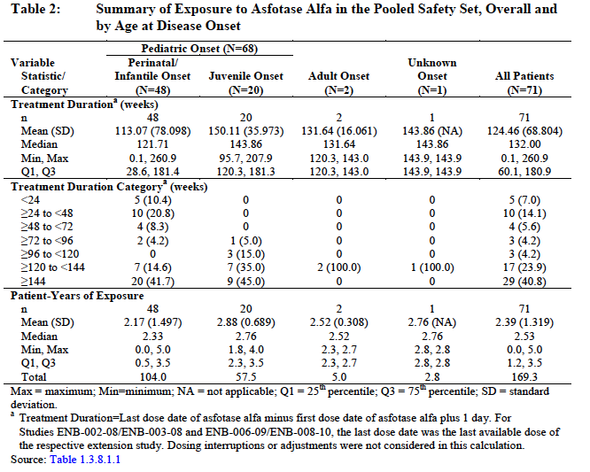
Table 23 provides a summary of the PYs of asfotase alfa exposure by total weekly dose. There have been a total of 169.17 PYs of asfotase alfa exposure, with 97.50 PYs of exposure in patients who received weekly doses ≥ 6 mg/kg and 155.64 PYs of exposure in patients who have received weekly doses < 9 mg/kg. Exposure at higher weekly doses has been limited, with approximately 13.5 PYs exposure at total weekly doses ≥ 9 mg/kg, and < 6 PYs exposure at total weekly doses ≥ 12 mg/kg. The majority of the exposure experience has been at total weekly doses ≥ 3 mg/kg to < 9 mg/kg per week (147.40 PYs); this was largely driven by the design of the clinical studies wherein patients initially received lower doses (for example 3 mg/kg/week) over the duration of a 24 week primary treatment period followed by an increase in total weekly dose (for example 6 mg/kg/week).

Table 23. Patient years of exposure to asfotase alfa by weekly dose, Pooled Safety Set, overall and age at disease onset
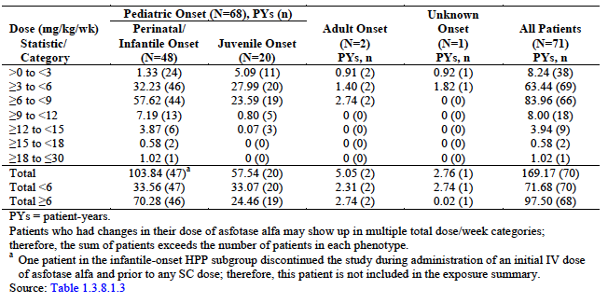

Adverse events

All adverse events (irrespective of relationship to study treatment)

Pivotal studies
All 71 patients in the pooled safety set experienced at least 1 treatment emergent adverse event (TEAE); 2,706 TEAEs were reported through encompassing the subjects in the pivotal studies analysis cut off dates for the integrated analyses. The majority of TEAEs (1800out of 2706 events reported in 70 out of 71; 98.6% patients) were considered by the investigator to be not related to asfotase alfa, and the majority of TEAEs (2,050 out of 2,706 events reported in 69 out of 71; 97.2% patients) were mild in intensity. There were 6 TEAEs in 3 patients that led to discontinuation of treatment and study withdrawal. Almost half (1,314 out of 2,706) of the TEAEs reported occurred within the first 24 weeks of treatment, with all (100%) patients experiencing at least 1 TEAE during that time period. Approximately one third of all TEAEs were ISRs or IARs: these events accounted for the majority of TEAEs that were considered to be related to asfotase alfa (by definition, ISRs and IARs were considered to be related to asfotase alfa).
More TEAEs (1,848 out of 2,706 events) were reported by patients in the infantile onset HPP subgroup compared with patients in the juvenile onset HPP subgroup (752 out of 2,706 events) and patients with adult onset HPP (26 out of 2,706 events) (Table 24); this was not remarkable since patients in the infantile onset HPP subgroup (n = 48) accounted for more than half the Pooled Safety Set (n = 71) and because the manifestations of HPP tend to be more severe in those patients. The majority of TEAEs (1,371 out of 1,848 events) in patients in the infantile onset HPP subgroup were considered by the investigator to be not related to asfotase alfa, whereas approximately half (347 out of 752) of the events in patients in the juvenile onset HPP subgroup and approximately one third (9 out of 26) of the events in patients with adult onset HPP were considered by the investigator to be not related to asfotase alfa treatment. Of the related TEAEs, 449 out of 477 events in patients in the infantile onset HPP subgroup, 385 out of 405 events in patients in the juvenile onset HPP subgroup, and 15 out of 17 events in patients with adult onset HPP were reported as ISRs or IARs. Proportionally more patients in the infantile onset HPP subgroup (50.0%) experienced severe TEAEs compared to patients in the juvenile onset HPP subgroup (20.0%) and patients with adult onset HPP (0%). All 3 of the patients who experienced TEAEs that led to treatment discontinuation and study withdrawal were in the infantile onset HPP subgroup. In patients with infantile, juvenile and adult onset HPP, 44.6%, 56.4%, and 46.2% of the TEAEs, respectively, were experienced by patients during the first 24 weeks of treatment (defined as early onset events).

Treatment-related adverse events (adverse drug reactions)

Pivotal studies
There were 906 related TEAEs experienced by 60 (84.5%) patients in the Pooled Safety Set, with an overall incidence rate of 535.0 events/100 PYs asfotase alfa exposure, that were considered by the investigator to be related to asfotase alfa treatment. The only SOC in which ≥ 50% of patients reported related TEAEs was General Disorders and Administration Site Conditions (77.5%); the 764 related events reported within this SOC accounted for nearly 85% of all related TEAEs in the Pooled Safety Set. Given that the majority of ISRs and IARs were coded to preferred terms within this SOC and that ISRs and IARs were, by definition, considered to be related to asfotase alfa treatment.
Other SOCs in which ≥5% of patients in the Pooled Safety Set reported related TEAEs included:
- Skin and Subcutaneous Tissue Disorders (22.5%)
- Eye Disorders (19.7%)
- Gastrointestinal Disorders (9.9%)
- Musculoskeletal and Connective Tissue Disorders (8.5%)
- Injury, Poisoning and Procedural Complications; Vascular Disorders; and Renal and Urinary Disorders (5.6%, each)
Related TEAEs (preferred terms) reported by ≥ 15% of patients were:
- Injection site erythema (52.1%)
- Injection site discolouration (23.9%)
- Injection site pain (22.5%)
- Injection site pruritus (19.7%)
- Injection site macule and injection site swelling (15.5% each)
Preferred terms with an incidence rate ≥ 15 events/100 PYs of exposure to asfotase alfa included:
- Injection site erythema (159.4 events/100 PYs)
- Injection site discolouration (47.2 events/100 PYs)
- Injection site macule (44.3 events/100 PYs)
- Injection site pain (30.1 events/100 PYs)
- Injection site pruritus (27.2 events/100 PYs)
- Injection site reaction (23.6 events/100 PYs)
- Injection site induration (23.0 events/100 PYs)
- Injection site swelling (20.1 events/100 PYs)
- Injection site hypertrophy (17.1events/100 PYs)
- Erythema (16.5 events/100 PYs)
More TEAEs (1,848 out of 2,706 events) were reported by patients in the infantile onset HPP subgroup compared with patients in the juvenile onset HPP subgroup (752 out of 2,706 events) and patients with adult onset HPP (26 out of 2,706 events) (Table 24); this was not remarkable since patients in the infantile onset HPP subgroup (n = 48) accounted for more than half the Pooled Safety Set (n = 71) and because the manifestations of HPP tend to be more severe in those patients. The majority of TEAEs (1,371 out of 1,848 events) in patients in the infantile onset HPP subgroup were considered by the investigator to be not related to asfotase alfa, whereas approximately half (347 out of 752) of the events in patients in the juvenile onset HPP subgroup and approximately one third (9 out of 26) of the events in patients with adult onset HPP were considered by the investigator to be not related to asfotase alfa treatment. Of the related TEAEs, 449 out of 477 events in patients in the infantile onset HPP subgroup, 385 out of 405 events in patients in the juvenile onset HPP subgroup, and 15 out of 17 events in patients with adult onset HPP were reported as ISRs or IARs.
Proportionally more patients in the infantile onset HPP subgroup (50.0%) experienced severe TEAEs compared to patients in the juvenile onset HPP subgroup (20.0%) and patients with adult onset HPP (0%). All 3 of the patients who experienced TEAEs that led to treatment discontinuation and study withdrawal were in the infantile onset HPP subgroup. In patients with infantile-, juvenile-, and adult onset HPP, 44.6%, 56.4%, and 46.2% of the TEAEs, respectively, were experienced by patients during the first 24 weeks of treatment (defined as early onset events).
The majority of nonfatal SAEs reported (172 out of 183 events) were experienced by 27 (56.3%) patients in the infantile onset HPP subgroup; only 11 nonfatal SAEs were experienced by 5 (25.0%) patients in the juvenile onset HPP subgroup, and no SAEs were experienced by patients with adult onset HPP. All but 5 of the nonfatal SAEs experienced by patients in the infantile onset HPP subgroup were considered by the investigator to be not related to asfotase alfa treatment, and almost half (5 out of 11) of the nonfatal SAEs experienced by patients in the juvenile onset HPP subgroup were considered to be not related.
Consistent with the analysis of all in the Pooled Safety Set TEAEs, proportionally more patients who received a majority of their weekly dosing at ≥ 6 mg/kg (93.3%) experienced nonfatal SAEs compared with those who received the majority of their total weekly dosing at < 6 mg/kg (32.7%). The preferred terms for which ≥ 10% of patients who received a majority of their total weekly dosing at ≥ 6 mg/kg experienced nonfatal SAEs compared with patients who received a majority of their total weekly dosing at < 6 mg/kg were respiratory disorder, pneumothorax, respiratory distress, pneumonia, upper respiratory tract infection, bronchiolitis, viral infection, craniosynostosis, pyrexia, irritability, feeding tube complication, food intolerance, and feeding disorder of infancy or early childhood.

Deaths and other serious adverse events

Pivotal studies
All treatment-emergent deaths reported during the clinical studies were in patients in the infantile onset HPP subgroup
In the Pooled Safety Set, total of 183 nonfatal SAEs were reported by 32 (45.1%) patients; all but 11 of these events (in 4 patients) were considered by the investigator to be not related to asfotase alfa. One nonfatal SAE led to treatment discontinuation and study withdrawal. No ISRs were reported as SAEs. Five deaths were reported in the clinical database, 4 deaths were considered to be treatment-emergent and included in the integrated analyses; one death was reported prior to the first dose of asfotase alfa.
All deaths occurred in patients who were < 1 year of age at enrolment, were in the infantile onset HPP subgroup, and had 1 or more prognostic factors for poor outcome (rachitic chest deformity, respiratory compromise, and/or vitamin B6 responsive seizures). Three patients died within approximately 8 months of treatment initiation; 1 of these patients died within approximately 3 weeks of treatment initiation. Two patients received an asfotase alfa dose > 6 mg/kg/week for disease-related management; 1 patient received a dose of 14 mg/kg/week at initiation of treatment due to general disease severity at enrolment, and 1 patient had a dose increase to 9 mg/kg/week for hypercalcemia. Events preceding death were generally consistent with complications of underlying infantile onset HPP and assessed by the investigator as being unrelated to asfotase alfa; 1 death due to pneumonia was assessed by the investigator as being possibly related to asfotase alfa.
There were 183 nonfatal SAEs experienced by 32 (45.1%) patients in the Pooled Safety Set, with an overall incidence rate of 108.1 events/100 PYs asfotase alfa exposure. The SOCs in which ≥ 10% of patients reported nonfatal SAEs were:
- Respiratory, Thoracic and Mediastinal Disorders (22.5%)
- Infections and Infestations (21.1%)
- Nervous System Disorders (12.7%)
- Investigations and Congenital, Familial and Genetic Disorders (11.3%).
Nonfatal SAEs (preferred terms) reported by >5% of patients in the Pooled Safety Set included:
- Craniosynostosis (11.3%)
- Pneumonia (7.0%)
- Respiratory disorder (5.6%)
The preferred terms with incidence rates ≥ 3 events/100 PYs exposure to asfotase alfa included:
- Craniosynostosis (5.3 events/100 PYs)
- Pneumonia (4.7 events/100 PYs)
- Dyspnoea (4.1 events/100 PYs)
- Respiratory disorder and feeding tube complication (3.5 events/100 PYs, each)

Table 24. Treatment emergent non-fatal serious adverse events reported in ≥ 2 Patients in the pooled safety set, overall and by age of onset
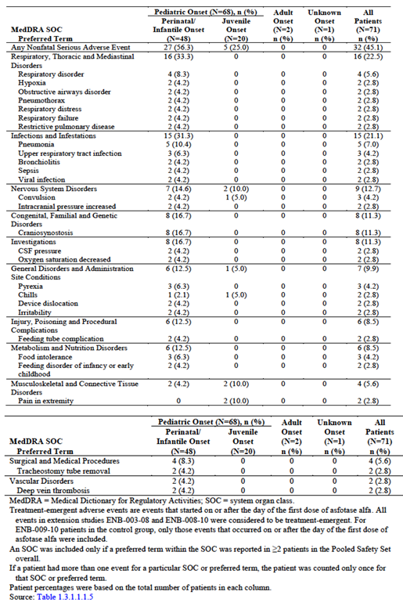

Discontinuation due to adverse events
Three patients experienced TEAEs that led to discontinuation of study drug; all 3 patients were in the infantile onset HPP subgroup. Two patients came from ENB-002-08/ENB-003-08 and one from ENB-010-10.
A fourth patient (who experienced pneumonia) was shown as having discontinued study drug; however, this patient subsequently resumed dosing. Due to the design of the case report form for this early study, it was not possible for the investigator to describe that the patient experienced an interruption in dosing except in the notes.

Laboratory tests

Other clinical chemistry
A summary of TEAEs potentially associated with abnormal clinical chemistry values for patients in the pooled safety set overall and by age at disease onset is provided in Table 25 below.

Table 25. Treatment emergent adverse events associated with abnormal clinical chemistry laboratory results in patients in the pooled safety set, overall and by age at disease onset
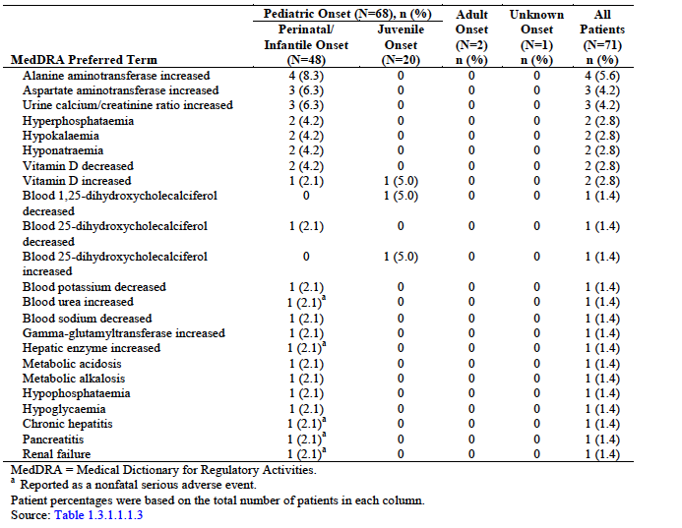
A summary of TEAEs potentially associated with abnormal clinical laboratory parameters that are of interest for patients in the Pooled Safety Set overall and by age at disease onset is provided in Table 26 below.

Table 26. Treatment emergent adverse events potentially associated with abnormal clinical chemistry laboratory parameters of interest in patients in the pooled safety set, overall and by age at disease onset
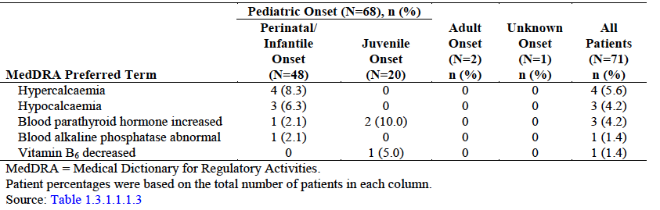

Haematology
There were no consistent changes in routine haematology.
A summary of TEAEs potentially associated with abnormal haematology laboratory results experienced by patients in the Pooled Safety Set overall and by age at disease onset is provided in Table 27. Of the events listed in Table 27 only the event of neutropenia was considered by the investigator to be related to asfotase alfa.

Table 27. Treatment emergent adverse events potentially associated with abnormal haematology laboratory results in patients in the pooled safety set, overall and by age at disease onset
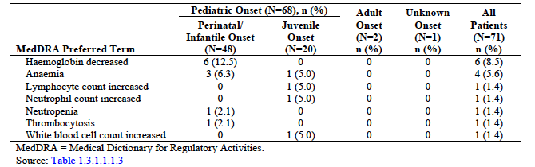
No events potentially associated with abnormal haematology laboratory parameters were reported as SAEs in the Pooled Safety Set

Clinical chemistry
Select clinical chemistry laboratory parameters including alanine aminotransferase (ALT), aspartate aminotransferase (AST), alkaline phosphatase (ALP), total bilirubin (TBil), direct bilirubin (DBil), indirect bilirubin (IBil), blood urea nitrogen (BUN), creatinine, urine calcium/creatinine ratio, albumin, potassium, calcium, phosphate, 25-hydroxy vitamin D (25-OH vitamin D), PTH, PLP, and PPi showed no significant change. Due to the unique nature of some of these parameters and their potential association with other facets of efficacy and safety, ALP, calcium, PTH, PLP, and PPi (as well as eosinophils and eosinophil/leukocyte ratio) were considered to be clinical laboratory tests of interest.
Generally, mean and median clinical chemistry test results associated with hepatic function (ALT, AST, TBil, DBil, and IBil) were relatively stable over time. Mean and median serum BUN and creatinine values tended to decrease from Baseline to Week 24, but these values were slightly higher at the last visit compared with Baseline values.
Changes over time for other clinical chemistry parameters, including potassium, phosphate, and 25-OH vitamin D were not clinically meaningful. Any variability seen in 25-OH vitamin D results may be reflective of concomitant vitamin D supplements taken by some patients.

Table 28. Treatment-emergent adverse events associated with abnormal clinical chemistry laboratory results in patients in the Pooled Safety Set, overall and by age at disease onset
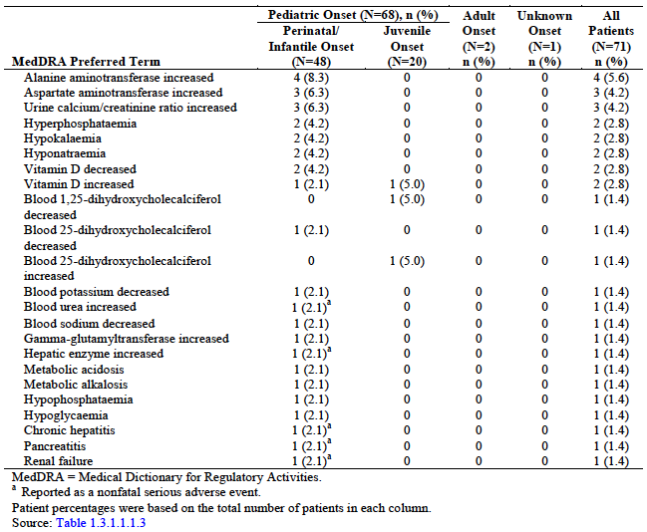

Anti-asfotase alfa and neutralising antibodies: Pivotal studies
Overall, the incidence rate for TEAEs experienced by patients before becoming continuously ADA positive (1,938.8 events/100 PYs of exposure to asfotase alfa) was greater than the incidence rate for TEAEs experienced by patients after becoming continuously ADA positive (1,144.1 events/100 PYs). With the exception of injection site macule and tooth loss, all of the preferred terms noted above (those reported by ≥ 10% more patients categorized as continuously ADA positive compared with patients categorized as not continuously ADA positive) had higher incidence rates before patients became continuously ADA positive than after patients became continuously ADA positive. The incidence rates for these events were:
- Injection site erythema (174.6 versus 139.6 events/100 PYs)
- Injection site pain (44.7 versus 10.9 events/100 PYs)
- Injection site pruritus (37.4 versus 13.7 events/100 PYs)
- Injection site macule (40.5 versus 49.3 events/100 PYs)
- Injection site swelling (27.0 versus 10.9 events/100 PYs)
- Tooth loss (10.4 vs 31.5 events/100 PYs)
- Myalgia (6.2 versus 1.4 events/100 PYs)
These data suggest that, the incidence rates of the events commonly associated with ISRs were generally not greater in patients categorised as continuously ADA positive compared with patients categorised as not continuously ADA positive, even though a greater proportion of patients categorised as continuously ADA positive reported these types of events.

Vital signs
Throughout the clinical studies of asfotase alfa, vital sign measurements were performed as part of the routine safety monitoring. Clinically significant vital sign measurements were to be recorded as AEs.
Analyses of marked, sustained vital sign abnormalities were performed to assess the numbers and proportions of patients who experienced hypertension, increased heart rates, or decreased heart rates.
A summary of TEAEs potentially associated with abnormal vital signs in patients in the pooled safety set, overall and by age at disease onset, is provided in Table 29 below. All but 2 TEAEs potentially associated with abnormal vital signs were experienced by patients in the infantile onset HPP subgroup. This finding was not unexpected given the more severe manifestations of HPP typically observed for patients in this subgroup; the other 2 events were experienced by patients in the juvenile onset HPP subgroup.

Table 29. Treatment emergent adverse events potentially associated with abnormal vital signs in patients in the pooled safety set, overall and by age at disease onset
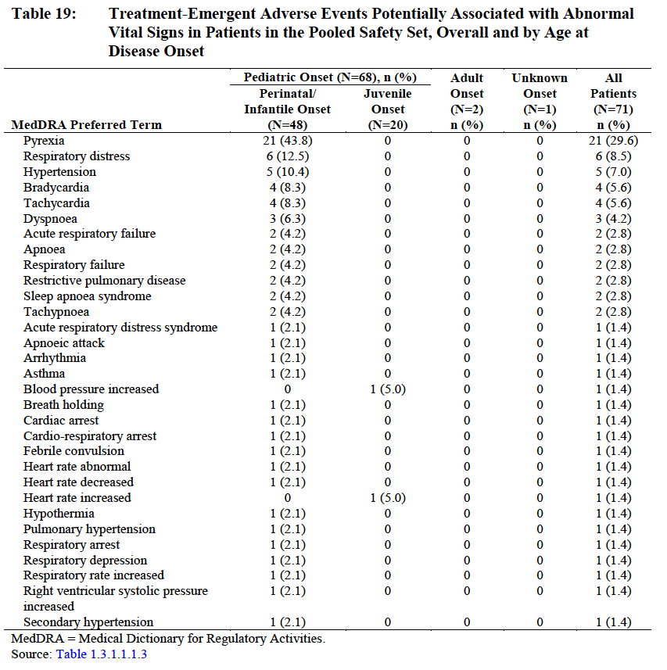

Post-marketing experience
Asfotase alfa is not currently marketed in any country; therefore, no reports of post-marketing experience are included.
However the sponsor supports a compassionate use program globally. Reporting of death in the treatment program and in compassionate use program globally, is valuable to understand the multiple targets of therapy which are needed to ensure the best outcome.
A report of deaths in the compassionate use programs is summarised below:

Table 30. Compassionate use programs, fatal SAEs
Patient details, diagnosis | Fatal SAEs
14 month old female patient had a medical history significant for hyperammonaemia, pulmonary hypoplasia, pulmonary hypertension, chronic lung disease, multiple bullae, and tracheotomy. | The direct cause of death was reported to be due to huge bullae and chronic lung disease. The treating physician considered the events of pulmonary bulla, pulmonary hypertension, pneumothorax, and cardiac tamponade to be unrelated to asfotase alfa treatment, but a natural course of HPP when ventilated for a long time.
A 4 month old male had a medical history significant for severe infantile onset HPP requiring ventilatory support and tracheostomy. | After approximately 8 weeks of asfotase alfa treatment, the patient vomited and became profoundly hypoxic. The treating physician considered the fatal event of severe, acute airway obstruction to be unrelated to asfotase alfa treatment.
A 7 month old male patient had a medical history significant for respiratory difficulties with ventilator dependency since birth. | At 7 months of age, the patient developed severe respiratory insufficiency with decreased oxygen saturations and died.
Comment: Several observations can be made about Compassionate use programs and the challenge of introducing potentially lifesaving therapies in clinical practice. These three deaths during the course of treatment of 3 perinatal cases are instructive however for they support the requirement of the EMEA for post-marketing surveillance and the clear need to document the outcomes of post-marketing experience with asfotase alfa, particularly from the perspective of treatment emergent adverse events.
‘There is an urgent need for clinicians and clinician scientists to re-examine the criteria for case selection of perinatal cases for treatment and case exclusion. Other clinician groups have undertaken this for therapies in disorders where there is therapeutic evidence of poor survival or unacceptable disability outcomes in some subsets of the disorder where the clinical evidence suggested an almost universally poor survival for example, investigators using Myozyme for Infantile Pompe disease have been guided by a research study which showed that long term survival of newborns who were ventilator dependent despite Myozyme treatment had very poor outcomes. This led to recommendations which provided families with clear and supportive care guidelines about treatment options.’

Safety issues with the potential for major regulatory impact

Haematological toxicity
Asfotase alfa is bone targeted. There is no evidence of haematological toxicity from the clinical trials reported by the sponsor.

Serious skin reactions
The high frequency of local site reactions with asfotase alfa SC injections need to be highlighted and guidelines for preventing them need to be clear and communicated clearly to parents and patients.

Cardiovascular safety
Asfotase alfa is bone targeted. There are no pharmacologic effects of asfotase on the heart myocardium.
Secondary pulmonary hypertension may be present pre-treatment in severely affected infants with severe immature lung disease and chronic ventilator dependency.

Unwanted immunological events
Of the 69 patients for whom post Baseline anti-drug antibody (ADA) data were available, 56 (81.2%) tested positive for ADAs at some point post baseline. Generally, ADA titres were low, and ranged from 0 to 2048 (median peak titre of 64.0). The median time to first ADA positive result was 37.0 days (range of 14 to 1,072 days). Of note, not all patients who tested positive for ADAs post baseline remained consistently positive for these antibodies after the initial positive result.
Proportionally more patients categorized as continuously ADA positive experienced TEAEs considered to be related to asfotase alfa (92.9%) compared with patients categorized as not continuously positive (74.1%); this observation was primarily influenced by the greater proportion of patients categorized as continuously ADA positive who experienced ISRs and IARs.
However, the overall incidence rate for TEAEs experienced by patients before becoming continuously ADA positive (1938.8 events/100 PYs of exposure to asfotase alfa) was greater than the incidence rate for TEAEs experienced by patients after becoming continuously ADA positive (1,144.1 events/100 PYs).

Other safety issues

Safety in special populations

Pregnancy
Pregnancy; asfotase alfa should not be used during pregnancy unless medically necessary.
At the present time there are no reports of human exposure in utero and no reports of its safety. There are no human or higher animal studies. From extrapolation in animal studies, it is assumed that Strensiq given to the mother crosses the placenta and appears in the foetal circulation. The study of PK and pharmacotoxicity in mice is insufficient data on which to base a statement about reassurance in human pregnancies. These are far more complex. For example, exposure to chronic vitamin D deficiency on the developing foetus has an impact on mineralisation of the foetal skeleton. Asfotase alfa crosses the placenta where it can impact on the foetal skeleton particularly in the second and third trimester when the foetal skeleton is rapidly accreting mineralisation. The genetic condition of Hyperphosphatasia does exist so that it will be important to demonstrate that there are no foetal effects similar to Hyperphosphatasia or Caffey disease reflecting chronic exposure of the foetal skeleton which is mineralising between the 5th and 40th weeks of gestation. Until this reassurance can be provided, the proposed use in pregnancy category needs to be changed to C, the category which recognizes that there are likely pharmacologic effects on the developing human skeleton but this is not assessable in animal safety studies at the present time.
It is recommended that the PI be changed to Use in Pregnancy – Category C until further knowledge can provide reassurance that there are no long term pathophysiological effects from long term exposure on the foetal skeleton.
The Alexion Pregnancy Reporting and Outcome Form/Breast Feeding. This form is incorporated into the Australian Specific Annex EU Risk Management Plan version 1 December 2014 (riskmgtsystem 2) and its use is supported. Although the risks to the foetus are unknown, experience with other genetic innovative therapies is that some women who are fully informed of the lack of knowledge at the present time will continue with therapy through their pregnancy.

Safety related to drug-drug interactions and other interactions
There was no evidence of drug-drug or protein/protein interactions which would preclude clinical use.

Evaluator’s overall conclusions on clinical safety
Safety data from is derived from 71 patients from the pooled safety dataset of whom 68 Paediatric onset patients had an asfotase exposure of 169.17 patient years with a 97.5 PYs of exposure in patients who received weekly doses of >6 mg/kg.
Although asfotase alfa is a protein, no incidences of anaphylaxis have been observed in the per protocol dose range. Nevertheless there is a high frequency of local site reactions (ISRs) which would be expected for a subcutaneous dosage regimen. The CMI provides clear guidelines on steps to reduce and minimise ISRs. Injection associated reactions are fortunately rare. The per protocol treatment regimen does not recommend IV infusion. A review of data on ectopic calcification concludes that monitoring for both kidney and eye calcification should be carried out. Fortunately the vascular, kidney and eye calcifications are of low clinical significance. It will be essential that these are monitored and reported in the post-market surveillance.
Treatment emergent adverse effects are likely to be seen in patients with a perinatal onset compared to patients with juvenile onset HPP. This may reflect the greater severity in patients who are included on the basis of a class diagnosis of HPP rather than following a protocol of assessments which might predict outcomes.
This evaluator has written questions about
- Development of inclusion and exclusion guidelines for babies with prenatal diagnosis of HPP and perinatal HPP.
- This assessor has raised concerns about treatment in Adult HPP or Paediatric- Onset HPP in adults where there is inadequate trial data about outcomes and safety.
Comment: In view of the extreme rarity and reported low frequency of experience in the management of patients with Paediatric Onset HPP in Australia, this evaluator recommends that the use of asfotase alfa Enzyme Replacement Therapy be initiated and monitored by Centres of Expertise with experience in Genetic Bone and Mineral Disorders, and allied health expertise to evaluate the functional outcomes, including Occupational therapy, Physiotherapy and experience in a clinical trials setting. There will need to be regular reporting of outcomes of therapy and close monitoring (see The Post-market Pharmacovigilance data collection instrument , ALX-HPP-501). Furthermore the high frequency of injection site reactions requires sympathetic and supportive therapy coordination.

First round benefit-risk assessment

First round assessment of benefits
The benefits of asfotase alfa in the proposed usage are:
- Asfotase alfa has been well demonstrated to be an effective therapy for skeletal involvement of young patients with HPP. The evidence for clinical all patients, excepting infants with prenatal diagnosis of severe disease who are ventilator dependent from birth and who remain ventilator dependent despite a trial of therapy, is very strong. A regimen of 1 mg/kg 6 times per week or 2 mg/kg 3 times per week, normalises mineral chemistry, increases whole body mineral content and results in radiographic evidence of healing rickets. The effect on the growing centres in the skeleton (metaphyses) is rapid and seen within the first 6 months of therapy. This is true across the age groups from the perinatal period (those surviving the newborn period) through infantile and juvenile presentations. It is associated with normalisation of walking and physical activity and improved quality of life.
- For children with severe disease there is improvement in respiratory failure and in some children, it has been possible to wean from ventilator dependency and improve their mobility and quality of life.

First round assessment of risks
The risks of asfotase alfa in the proposed usage are outlined in detail in the Safety section of this report. The major risks are:
- A high frequency of infusion site reactions give the mode of subcutaneous administration
- A possibly higher risk from chronic use in pregnancy and the need for further pre-clinical or other experimental data to establish safety; in the meantime the need to revise categorisation of risk in pregnancy to the C category
- A significant proportion of Infants with a prenatal diagnosis will have irreversible lung immaturity, and become invasive ventilator dependent and accordingly not be suitable for institution of long-term therapy. In keeping with the greater severity in this group of children there is a much higher frequency of TEAEs and mortality. Weaning from invasive ventilator support may not be feasible.
- There need to be clinical guidelines outlining indications to treat. These (guidelines) need to recognize that there has historically been a high mortality in the subsets of patients with prenatally diagnosed HPP, the majority of whom have perinatally lethal HPP and are chronically ventilator dependent. Similarly there needs to be a clear clinical guideline in the case of the additional subset of babies with HPP with B6 responsive seizures who despite seizure control historically have had a high infant mortality

First round assessment of benefit-risk balance
As discussed above, asfotase alfa given in the dose and recommended regimen is an effective therapy in selected cases of Hypophosphatasia of Paediatric onset.
The benefit-risk balance of asfotase alfa (rch), given the proposed usage, is favourable.
Uncertainties
- The number of separate subjects in the human studies reported is still small. This is particularly true in certain age cohorts for example subjects over 18 years of age. The sponsors have planned and requested post-market studies as a requirement of use of asfotase alfa by clinicians.
- There is a high frequency of treatment emergent adverse events.
- Just as management has been facilitated in clinical trials settings, achievement of Australian centres of expertise to initiate and monitor therapies will be needed to meet the requirements for high proficiency of monitoring (as proposed by the sponsor).
- Potential outcomes of pregnancy and breast feeding. It is recommended that protocols for management in the case of pregnancy (accidental or intended) be developed rapidly to avoid confusion as to whether a pregnancy should be terminated in the accidental situation. In addition, use of the monitoring protocol ‘Alexion Pregnancy Reporting and Outcome Form/Breast Feeding’ in subjects who elect to continue with their pregnancy, is recommended.
- The sponsor should seek additional expert opinion and scientific findings from learned societies in the bone and mineral medicine field to examine the potential effects on the developing foetal skeleton in the case of inadvertent use in pregnancy.

First round recommendation regarding authorisation
The evaluator having considered all the documentation, recommends that Strensiq be authorised for long term enzyme replacement therapy in patients with paediatric onset hypophosphatasia: The evaluator further recommends that the authorisation be subject to the following conditions:
- Use in patients 0 to 18 years (or skeletal maturity) should employ a dose of 6 mg/kg/SC weekly.
- Use in patients with prenatal diagnosis who are assessed to be extremely severe, and ventilator dependent from birth, the authorisation should be limited to a defined period subject to a review of responsiveness within 2 years of commencing therapy. These infants may have evidence of congenital pulmonary immaturity, in whom there is irreversible lung damage and poor chance of ventilator independent survival. Consideration may be given to withdrawal of therapy in this interval if the patient is unresponsive to therapy.
- For use in adolescent and adult patients after 18 years of age subject to a decision about the minimal effective dose for commencement of therapy and a maintenance dose following the first year reassessment. The commencement and maintenance therapy dose will be guided by the data analysis of the outcomes of ENB-009-10, a patient review every 2 years and review of periodic safety update reports (PSURs).
- That an Australian register of patients who could potentially benefit from asfotase alfa therapy be developed with the cooperation of the centres of expertise in each state (See 11.3.1-The Post-market pharmacovigilance data collection instrument , ALX-HPP-501) That management of patients with paediatric onset HPP should be coordinated through Centres of Expertise.

Clinical questions

Additional expert input
The sponsor should seek additional expert opinion and scientific findings from learned societies in the bone and mineral medicine field to examine the potential effects on the developing foetal skeleton in the case of inadvertent use in pregnancy.

Clinical questions
- Does the sponsor have further pharmacologic and/or clinical trials data which would inform a statement of dosage and dose frequency in post-pubertal subjects?
- Does the sponsor have advice on dosage and dose frequency in postmenopausal patients with HPP?
- Can the sponsor provide documentation as to whether there are interactions with anti-resorptive medications such as the bisphosphonates, denosumab and so on as these are sometimes used in treatment particularly in the post-menopausal period where there may be additive pathologies?

Pharmacokinetics
Nil.

Pharmacodynamics
Nil.

Efficacy
Nil.

Safety
Nil.

Second round evaluation of clinical data submitted in response to questions
Additional expert input
The sponsor should seek additional expert opinion and scientific findings from learned societies in the bone and mineral medicine field to examine the potential effects on the developing foetal skeleton in the case of inadvertent use in pregnancy.
Sponsor response:
Alexion agrees to consult with global experts in the bone and mineral medicine field on the potential effects of asfotase alfa on the developing foetal skeleton. Alexion will implement risk minimization measures if needed based on the recommendations from the global experts.
Evaluation of response:
Sponsor response noted. There are two genetic situations which form a background to treatment of the mother in pregnancy. The mother has homozygous HPP. In this case the foetus will be an obligate heterozygote. There is variability among heterozygotes in terms of biochemical expression and very few systematic studies of phenotype resulting from heterozygosity for various mutations. The other situation is that the mother is a manifesting heterozygote with clinical HPP. This is also called autosomal dominant HPP. There is a 1 in 2 chance that the foetus has inherited the mutation and symptomatic HPP.
Also included below is the evaluator response product documentation:
Treatment with asfotase alpha represents the most significant advance in the management of HPP since the delineation of the underlying pathogenesis and the pioneering work of Dr Mornet on structure function relationships of the NSALP protein. However, it is essential that a consensus be reached on a post marketing review which provides Australian parents and health professionals with reliable guidelines to inform the management of children with asfotase in the future.
Rather than expressing concern about the ‘Futility’ of treatment in patients with perinatal-onset HPP, the evaluator suggests that there may be a severity of Hypophosphatasia in the developing foetus which all authorities agree would present formidable challenges and where the outcome of treatment would be highly experimental at the present time. The evaluator has long been very positive about the therapeutic possibilities of the asfotase alpha therapy including treatment of infants with a perinatal diagnosis. Asfotase alpha therapy should be considered as a potential therapy in all infants born with HPP.
The evaluator is both a clinical and scientific expert and therefore earnest to ensure that claims about clinical outcomes overall are seen in the context of managing the sick, ventilator dependent child with HPP. Ventilation in infancy is a highly hazardous undertaking in the best of settings and is associated with mortality from multiple causes. In the sponsor’s response, 14 patients on ventilation support at baseline, there was a 28% immediate mortality and 19% mortality in treated patients overall.
As observed in the sponsor’s first round of evaluation, post marketing experience (P102), Table 32. Compassionate Use Programs – Fatal SAEs, Case Number [information redacted] had a medical history of pulmonary hypoplasia, pulmonary hypertension, chronic lung disease, and multiple bullae (emphysema) and tracheostomy. Some babies can therefore be expected to develop progressive and irreversible lung disease and respiratory failure. Ultimately, clinician experts determine their therapy.
Even in the most optimistic situations, cases such that reported by Rodriguez in 2012 which are extremely encouraging and informative, have unfortunate outcomes. The cases are even more informative for outcomes in that this child could be discharged at week 32 on room air although presented two weeks after discharge with bilateral pneumonia sepsis and multi organ failure and died ‘despite evidence that the bone and mineral defect had been substantially corrected’. This is not a failure of asfotase alfa therapy but it is an aspect of the overall hazard for infants. The evaluator supports reporting post marketing analysis of outcomes and reporting both worldwide and Australian experience.
Coordinated management requires in depth review of outcomes in infants who are ventilator dependent at baseline and commenced on therapy in Australia in the first two years of commencement. This will ensure the parents obtain the most accurate information about the Australian experience.
- Does the sponsor have further pharmacologic and/or clinical trials data which would inform a statement of dosage and dose frequency in post-pubertal subjects?
Sponsor response:
In summary: Based on theoretical considerations, modelling, and empirical data, no difference from standard dosing is recommended in post pubertal patients.
Bone development changes over the life cycle, with the focus on longitudinal growth prior to puberty, on increased mass during puberty, and on maintenance following growth plate closure during the adult years. The growth plates remain open until well past puberty (up to age 18) so longitudinal growth continues after puberty. After growth plate closure skeletal maintenance is a dynamic process, with constant resorption by osteoclasts and new bone formation by osteoblasts. Therefore impairment in bone mineralization due to deficient tissue nonspecific alkaline phosphatase activity negatively impacts normal bone development before and after puberty and the benefits of asfotase alfa continue after puberty and through adulthood. Impaired mineralization due to insufficient TNSALP in patients with HPP can cause rickets and severe bone deformities during periods of longitudinal growth in children and adolescents and osteomalacia and osteopenia in adults. Thus, to insure bone health, treatment with asfotase alfa in HPP patients is recommended throughout the lifespan.
The totality of evidence supports a similar effect of asfotase alfa before and after puberty. Therefore, dosing recommendations remain the same, regardless of pubertal status. Asfotase alfa is recommended for use at a starting dose of 6 mg/kg/week, divided into either 3 or 6 doses.
Evaluation of response:
Responses noted and are satisfactory.
- Does the sponsor have advice on dosage and dose frequency in postmenopausal patients with HPP?
Sponsor response:
In summary: Menopausal status was not collected in the program. For the purpose of this question, women 55 years or older or any woman with a reported history of menopause were considered to be post- menopausal. Eight patients met this criterion.
As described in the response to Question 1, age is not expected to affect dose PK response or PK-PD response. Using a similar approach to that in Question 1, PK, biochemical endpoints, and clinical endpoints are compared between post-menopausal women and pre-menopausal women on the recommended dose of 6 mg/kg/week.
As noted in response to Q1 above, bone formation throughout the skeleton occurs throughout life. Postmenopausal women typically show increased bone turnover due to oestrogen deficiency. Increased bone turnover in this period results in bone loss due to bone resorption exceeding bone formation. An adequacy of bone mineralisation in newly formed bone will exacerbate the loss of bone mineral density. Thus, it is important to insure newly formed bone is fully mineralised and this is best insured by adequate levels of TNSALP.
Evaluation of response:
Responses noted and are satisfactory.
- Can the sponsor provide documentation as to whether there are interactions with anti-resorptive medications such as bisphosphonates, denosumab and so on as these are sometimes used in the treatment particularly in the post menopausal period where there may be additive pathologies.
Sponsor response:
Anti-resorptive therapy should be avoided in children, adolescents, and adult HPP patients. Bisphosphonates and denosumab act by direct inhibition of osteoclastic bone resorption. As a consequence of inhibition of bone resorption with these bone agents, bone formation associated with bone modelling is reduced and bone formation associated with bone turnover (remodelling) is reduced. In children and adolescents with HPP where longitudinal growth is ongoing and skeletal modelling is occurring, anti-resorptive therapy should not be utilised as that would inhibit bone resorption that is essential for bone modelling and normal bone morphology leading to dysmorphic bones. Further, the bone formation that would be present in children with HPP treated with anti-resorptives would be inadequately mineralised further exacerbating skeletal health.
In adults including postmenopausal women with HPP, osteopenia and increased risk of fractures are present as a result of inadequate mineralisation of bone. Using anti-resorptive therapy in adults with HPP would not overcome the mineralisation defect as each site of bone turnover in the skeleton where bone formation occurs would be undermineralised as a result of TNSALP deficiency. The accumulation of these sites of defective mineralization throughout the skeleton would increase the risk of skeletal fractures. Bisphosphonates also are known to incorporate into mineralising bone matrix and at elevated concentrations can contribute to impairment of bone mineralisation. Thus, any further inhibition of mineralisation with bisphosphonate therapy should be avoided in HPP patients.
In summary, anti-resorptive therapy should be avoided in children, adolescents, and adults with HPP as the risks of increasing skeletal morbidity (skeletal dysmorphology, osteopenia, and skeletal fractures) are increased in this patient population.
Evaluation of response:
Responses noted and are satisfactory.

Second round recommendation regarding authorisation

Second round assessment of benefits
The benefits of asfotase alfa in the proposed usage are:
- Asfotase alfa has been well demonstrated to be an effective therapy for skeletal involvement of paediatric onset patients with HPP. The clinical trials evidence for all patients, excepting infants with perinatal diagnosis of severe disease who are ventilator dependent from birth and who remain ventilator dependent despite a trial of therapy, is very strong. A regimen of 1 mg/kg 6 times per week or 2 mg/kg 3 times per week, normalises mineral chemistry, increases whole body mineral content and results in radiographic evidence of healing rickets. The effect on the growing centres in the skeleton (metaphyses) is rapid and seen within the first 6 months of therapy. This is true across the age groups from the perinatal period (those surviving the newborn period) through Infantile and Juvenile Presentations. It is associated with normalisation of walking and physical activity and improved quality of life.
- For children with severe disease from birth there is improvement in respiratory failure and in some children, it has been possible to wean from ventilator dependency and improve their mobility and quality of life.

Second round assessment of risks
The risks of asfotase alfa in the proposed usage are outlined in detail in the first round assessment of risks. The major risks are:
- A high frequency of Infusion Site Reactions give the mode of subcutaneous administration
- An unknown but possibly small risk for modification to the density of the foetal skeleton from chronic use in pregnancy. Monitoring and reporting of all pregnancies will be mandatory. Skeletal outcomes may be dependent on the genetic status in the foetus. The outcomes of pregnancy and breast feeding will be subject to reporting. In the meantime there is need to revise Categorisation of Risk in pregnancy to the C category
- A proportion of infants with a perinatal diagnosis may have irreversible lung immaturity or postnatal lung pathology, and become invasive ventilator dependent. Institution of therapy in face of long-term invasive ventilation is associated with its own morbidity and mortality independent of the effectiveness of asfotase alfa in reversing the mineralisation defect.
- There need to be clinical guidelines outlining indications to treat. These need to recognise that there has historically been a high mortality in the subsets of patients with prenatally diagnosed HPP, the majority of whom have perinatally lethal HPP and are chronically ventilator dependent. Similarly there needs to be a clear clinical guideline in the case of the additional subset of babies with HPP with B6 responsive seizures who despite seizure control historically have had a high infant mortality

Second round assessment of benefit-risk balance
Asfotase alfa given in the dose and recommended regimen is an effective therapy in selected cases of Hypophosphatasia of Paediatric onset.
The benefit-risk balance of asfotase alfa (rch), given the proposed usage, is favourable.
Uncertainties
- The number of separate subjects in the human studies reported is still small. Post-market studies will be a requirement of use of asfotase alfa by clinicians.
- There is a high frequency of treatment emergent adverse events. Adequate recommendations are given in the PI and CMI
- The sponsors support the concept of Australian centres of expertise to initiate and monitor therapies which will be needed to meet the requirements for high proficiency monitoring and coordination of care.
- Pregnancy and Breast Feeding will be required to be notified to supervising physicians. A monitoring protocol Alexion Pregnancy Reporting and Outcome Form/Breast Feeding will be required of subjects who elect to continue therapy while pregnant.
- The sponsor agrees to seek additional expert opinion and scientific findings from learned societies in the bone and mineral medicine field to examine the potential effects on the developing foetal skeleton in the case of inadvertent use in pregnancy

Second round recommendation regarding authorisation
The evaluator having considered all the documentation, recommends that Strensiq be authorised for long term enzyme replacement therapy in patients with paediatric onset hypophosphatasia: The evaluator further recommends that the authorisation be subject to the following conditions:
- Use in patients 0 to 18 years (or skeletal maturity) and adults should employ a dose of 6 mg/Kg/sc weekly or 2 mg/kg 3 times per week.
- Post-market experience should be reported for patients with perinatal diagnosis who are assessed to be extremely severe, and ventilator dependent from birth, and post-market experience soon after 2 years of age should be analysed as a separate subset for data analysis. Adverse reports indicate that some proportion of infants commenced in the first 2 years of life may have evidence of congenital pulmonary immaturity or chronic lung disease These may have irreversible lung damage and poor chance of ventilator independent survival. Consideration may be given to withdrawal of therapy in this interval if the patient is unresponsive to therapy.
- That an Australian register of patients who could potentially benefit from asfotase alfa therapy be developed with the cooperation of the Centres of Expertise in each state. (See 11.3.1-The Post-market Pharmacovigilance data collection instrument, ALX-HPP-501). This would also involve a specific agreement to separately report the analysis of data on Australian patients collected via the ALX-HPP-501 protocol. That management of patients with Paediatric onset HPP should be coordinated through Centres of Expertise.

References
Adelaide Health Technology Assessment (AHTA). Life-Saving Drugs Programme Review – Technical Assessment. Draft April 2015. Available at http://www.pbs.gov.au/info/reviews/life-saving-drugs
alkaline phosphatase gene. Bone. 2007;40(6):1655-61.
Australian Government, Department of Health. Postmarket Review Issues Paper. April 2015. Available at http://www.pbs.gov.au/info/reviews/life-saving-drugs
Baumgartner-Sigl S, E. Haberlandt, Mumm S, Scholl-Burgi S, Sergi C, Ryan L, et al. Pyridoxine-responsive seizures as the first symptom of infantile hypophosphatasia caused by two novel missense mutations (c.677T>C, p.M226T; c.1112C>T, p.T371I) of the tissue-nonspecific
Bernard GW, Ultrastructural localization of alkaline phosphatase in initial intramembranous osteogenesis. Clin Orthop Relat Res 218-225, 1978
Bork K et al. Increasing the sialylation of therapeutic glycoproteins: the potential of the sialic acid biosynthetic pathway. J Pharm Sci. 2009. 98(10):3499-508.
Caswell AM, Whyte MP, Russell RG. Hypophosphatasia and the extracellular metabolism ofinorganic pyrophosphate: clinical and laboratory aspects. Crit Rev Clin Lab Sci. 1991;28(3):175-232.
Clinical Study Report 16.1 study Information ENB-011-10 Alexion Confidential
Deeb AA, Bruce SN, Morris AAM, Cheethan TD. Infantile hypophosphatasia: disappointing results of treatment. Acta Paediatr. 2000;89:730-3.
Definition from the UK National Institute for Clinical Effectiveness (NICE). 2004. Citizen Council Report on Ultra-Orphan Drugs. Available at http://tinyurl.com/b3qurp3 (last accessed October 09, 2013) and as defined in the following documents: Wales Medicines Strategy Group (AWMSG); Recommendations for a Belgian Plan for Rare Diseases; the EMINET Report commissioned by the European Commission’s Directorate General Enterprise and Industry, the European Union Committee of Experts on Rare Diseases’ (EUCERD).
Fraser D. Hypophosphatasia. Am J Med. 1957 May;22(5):730 46.
Henricson E, Abresch R, Han JJ, Nicorici A, Goude Keller E, Elfring G et al. Percent-Predicted 6-Minute Walk Distance in Duchenne Muscular Dystrophy to Account for Maturational Influences. Version 2. PLoS Curr. 2012 January 25 (revised 2012 February 2); 4: RRN1297.
ICH guideline S6 (R1) – preclinical safety evaluation of biotechnology-derived pharmaceuticals June 2011, EMA/CHMP/ICH/731268/1998.
Kasugai S, Fujisawa R, Waki Y, Miyamoto K, Ohya K. Selective drug delivery system to bone: small peptide (Asp)6 conjugation. J Bone Miner Res. 2000 May;15(5):936-43.
Kramer, W.G. A Multicentre, Open-Label, Dose Escalating Study of The Safety, Tolerability And Pharmacology of Human Recombinant Tissue Non-Specific Alkaline Phosphatase Fusion Protein (Enb-0040) In Adults With Hypophosphatasia (Hpp). Pharmacokinetic analysis and report, Enobia Pharma US (2009).
Langston C, Dishop.M. Diffuse Lung Disease in Infancy: A Proposed Classification Applied to 259 Diagnostic Biopsies. Paediatric and Developmental Pathology 12, 421–437, 2009
Leung ECW, Mhanni AA, Reed M, Whyte MP, Landy H, Greenberg CR. Outcome of perinatal hypophosphatasia in Manitoba Mennonites: a retrospective cohort analysis. JIMD Reports. 2013;11:73-8.
Litmanovitz I, Reish O, Dolfin T, Arnon S, Regev R, Grinshpan G, et al. Glu274Lys/Gly309Arg mutation of the tissue-nonspecific alkaline phosphatase gene in neonatal hypophosphatasia associated with convulsions. J Inherit Metab Dis. 2002;25;35-40.
Liu L et al. The impact of glycosylation on the pharmacokinetics of a TNFR2:Fc fusion protein expressed in Glycoengineered Pichia Pastoris. Pharm Res. 2013. 30(3):803-12.
Millán JL, Narisawa S, Lemire I, Loisel TP, Boileau G, Leonard P, et al. Enzyme replacement therapy for murine hypophosphatasia. J Bone Miner Res. 2008 Jun;23(6):777-87.
Millán JL, Plotkin H. Hypophosphatasia pathophysiology and treatment. Actual Osteol. 2012;8(3):164-82.
Mornet E, Beck C, Bloch Zupan A, Girschick H, Le Merrer M. Clinical utility gene card for: hypophosphatasia. Eur J Hum Genet. 2011 Mar;19(3):e1-e5; published online 27 October 2010.
Mornet E, Yvard A, Taillandier A, Fauvert D, Simon-Bouy B. A molecular-based estimation of the prevalence of hypophosphatasia in the European population. Ann Hum Genet. 2011;75(3):439-45.
Mornet E. The Tissue Nonspecific Alkaline Phosphatase Gene Mutations Database. Laboratoire SESEP. Last update: August 27, 2013. http://www.sesep.uvsq.fr/03_hypo_mutations.php. Last accessed: August 31, 2013.
Morris DC, Masuhara K, Takaoka K et al. Immunolocalization of alkaline phosphatase in osteoblasts and matrix vesicles of human foetal bone. Bone Miner 19:287-298, 1992
Nishioka T, Tomatsu S, Gutierrez MA, Miyamoto K, Trandafirescu GG, Lopez PL, et al. Enhancement of drug delivery to bone: characterization of human tissue nonspecific alkaline phosphatase tagged with an acidic oligopeptide. Mol Genet Metab. 2006 Jul;88(3):244-55.
Nunes M, Mugnol F, Bica I, Fiori RM. Pyridoxine-dependent seizures associated with hypophosphatasia in a newborn. J Child Neurol. 2002;17(3):222-4.
Orton NC, Innes AM, Chudley AE, Bech Hansen NT. Unique disease heritage of the Dutch German Mennonite population. Am J Med Genet A. 2008 Apr 15;146A(8):1072-87. p. 327–60.
Richter WF et al. Mechanistic determinants of biotherapeutics absorption following SC administration. AAPS J. 2012. 14(3):559-70.
Rodriguez EM, Bober MB, Davey L, Zamora A, Li Puma AB, Chidekel A, et al. Respiratory mechanics in an infant with perinatal lethal hypophosphatasia treated with human recombinant enzyme replacement therapy. Pediatr Pulmonol. 2012;47(9):917-22.
Seshia SS, Derbyshire G, Haworth JC, Hoogstraten J. Myopathy with hypophosphatasia. A(rch) Dis Child. 1990;65(1):130-1.
Turan S, Topcu B, Gokce I, Guran T, Zeynep A, Anjumanara O, et al. Serum alkaline phosphatase levels in healthy children and evaluation of alkaline phosphatase z-scores in different types of rickets. J Clin Res Pediatr Endocrinol. 2011;3(1):7-11.
Whyte MP, Greenberg CR, Salman NJ, Bober MB, McAlister WH, Wenkert D, et al. Enzyme replacement therapy in life-threatening hypophosphatasia. N Engl J Med. 2012 Mar;366:904-13.
Whyte MP. Hypophosphatasia. In: Glorieux FH, Pettifor JM, Juppner H, editors. Paediatric bone: biology and diseases. London, UK, Academic Press; 2012. p. 771-94.
Whyte MP. Hypophosphatasia. In: Thakker RV, Whyte MP, Eisman J, Igarashi T, editors. Genetics of bone biology and skeletal disease. San Diego, CA: Elsevier Academic Press; 2013.

Therapeutic Goods Administration
PO Box 100 Woden ACT 2606 Australia
Email: info@tga.gov.au Phone: 1800 020 653 Fax: 02 6232 8605
https://www.tga.gov.au

Bayley Scales of Infant Development (BSID III = Current version). Standard series of measurements used in assessment of the development of infants and toddlers aged 1 to 42 months
Peadbody Development Motor Scales (PDMS-2 = Current version). Six subtest measurement tool used in assessment of gross and fine motor skills in children from birth through five years of age
Ricketts Severity Scale. 10 point eadiographic scoring method for the assessment of the severity of nutritional rickets

