First round clinical evaluation: 23 July 2013
Second round clinical evaluation: 17 February 2014

AusPAR Attachment 2

Extract from the Clinical Evaluation Report for Aripiprazole Monohydrate
  - Proprietary Product Name: Abilify Maintena
  - Sponsor: Lundbeck (Australia) Pty Ltd

About the Therapeutic Goods Administration (TGA)
- The Therapeutic Goods Administration (TGA) is part of the Australian Government Department of Health, and is responsible for regulating medicines and medical devices.
- The TGA administers the Therapeutic Goods Act 1989 (the Act), applying a risk management approach designed to ensure therapeutic goods supplied in Australia meet acceptable standards of quality, safety and efficacy (performance), when necessary.
- The work of the TGA is based on applying scientific and clinical expertise to decision-making, to ensure that the benefits to consumers outweigh any risks associated with the use of medicines and medical devices.
- The TGA relies on the public, healthcare professionals and industry to report problems with medicines or medical devices. TGA investigates reports received by it to determine any necessary regulatory action.
- To report a problem with a medicine or medical device, please see the information on the TGA website <http://www.tga.gov.au>.
About the Extract from the Clinical Evaluation Report
- This document provides a more detailed evaluation of the clinical findings, extracted from the Clinical Evaluation Report (CER) prepared by the TGA. This extract does not include sections from the CER regarding product documentation or post market activities.
- This document has been amended from the original. The words [Information redacted], where they appear in this document, indicate that confidential information has been deleted.
- For the most recent Product Information (PI), please refer to the TGA website <http://www.tga.gov.au/product-information-pi>.
Copyright
© Commonwealth of Australia 2014
This work is copyright. You may reproduce the whole or part of this work in unaltered form for your own personal use or, if you are part of an organisation, for internal use within your organisation, but only if you or your organisation do not use the reproduction for any commercial purpose and retain this copyright notice and all disclaimer notices as part of that reproduction. Apart from rights to use as permitted by the Copyright Act 1968 or allowed by this copyright notice, all other rights are reserved and you are not allowed to reproduce the whole or any part of this work in any way (electronic or otherwise) without first being given specific written permission from the Commonwealth to do so. Requests and inquiries concerning reproduction and rights are to be sent to the TGA Copyright Officer, Therapeutic Goods Administration, PO Box 100, Woden ACT 2606 or emailed to <tga.copyright@tga.gov.au>.

Contents
1. List of common abbreviations used in this AusPAR 5
2. Clinical rationale 5
2.1. Guidance 5
3. Contents of the clinical dossier 6
3.1. Scope of the clinical dossier 6
3.2. Paediatric data 7
3.3. Good clinical practice 7
4. Pharmacokinetics 8
4.1. Studies providing pharmacokinetic data 8
4.2. Summary of pharmacokinetics 9
4.3. Population PK studies 9
4.4. Pharmacokinetics in patients and healthy subjects 20
4.5. Pharmacokinetics in other special populations 24
4.6. Pharmacokinetic interactions 24
4.7. Evaluator’s overall conclusions on pharmacokinetics 24
5. Pharmacodynamics 25
5.1. Summary of pharmacodynamics 25
6. Dosage selection for the pivotal studies 25
7. Clinical efficacy 26
7.1. For the treatment of schizophrenia 26
7.2. Other efficacy studies 43
7.3. Evaluator’s conclusions on clinical efficacy for the treatment of schizophrenia 43
8. Clinical safety 45
8.1. Studies providing evaluable safety data 45
8.2. Patient exposure 47
8.3. Adverse events 48
8.4. Laboratory tests 51
8.5. Safety issues with the potential for major regulatory impact 53
8.6. Other safety issues 55
8.7. Evaluator’s overall conclusions on clinical safety 58
9. First round benefit-risk assessment 58
9.1. First round assessment of benefits 58
9.2. First round assessment of risks 59
9.3. First round assessment of benefit-risk balance 59
10. First round recommendation regarding authorisation 59
11. Clinical questions 60
12. Second round benefit-risk assessment 60
13. Second round recommendation regarding authorisation 60

List of common abbreviations used in this AusPAR
Abbreviation | Meaning
OPC-14597 | aripiprazole
OPC-14857 or BMC-337044 | dehydroaripiprazole a major active metabolite
OPC-3373 | a quinolinone acid metabolite
PANSS | Positive and Negative Syndrome Scale
PSP | Personal and Social Performance Scale

Clinical rationale
Non-adherence to treatment has been identified as a major risk factor for relapse in schizophrenia; it is estimated that approximately 50% of patients miss taking 30% or more of their medications for schizophrenia. Limited data comparing oral and depot formulations suggest that depot formulations may have an advantage over oral antipsychotics for relapse prevention and rates of hospitalization.

Guidance
- pp. 127 - 132 of Rules 1998 (3C) - 3CC6a Clinical Investigation of Medicinal Products for Long-Term Use
- pp. 121 - 125 of Rules 1998 (3C) - 3CC5a The Extent of Population Exposure to Assess Clinical Safety for Medicines Intended for Long-Term Treatment of Non-Life-Threatening Conditions
Adopted by the TGA with the following conditions:
Attention is drawn to:
- Applicability, Section 7, which states that circumstances exist in which the Guidelines may not be applicable. It should be noted that the listing of exceptional circumstances is not exhaustive. Sponsors should give careful attention to whether, in any particular instance, the clinical safety of the product would be adequately supported by the numbers of subjects proposed
- Supplementary data, Section 8 is NOT ADOPTED. To permit decisions within legislated timeframes, the sponsor should include in the initial submission all clinical safety data necessary to support registration
- CPMP/EWP/559/95 Note for Guidance on the Clinical Investigation of Medicinal Products in the Treatment of Schizophrenia
- CPMP/EWP/49/01 Appendix to the Note for Guidance on the Clinical Investigation of Medicinal Products in the Treatment of Schizophrenia - Methodology of Clinical Trials Concerning the Development of Depot Preparations of Approved Medicinal Products in Schizophrenia

Contents of the clinical dossier

Scope of the clinical dossier
There were 34 studies referred to in the submission that had been previously submitted but were not included with this submission:
The submission contained the following clinical information:
Module 5
- Clinical pharmacology studies:
  - CN138-020 - Assessment Of The In Vivo Release Characteristics And Safety Of An Intramuscular Depot Formulation Of Aripiprazole In Subjects With Schizophrenia Or Schizoaffective Disorder
  - 31-07-002 - Assessment of the Safety, Tolerability, and Pharmacokinetics of Aripiprazole IM Depot Formulation by Single Administration in Patients with Schizophrenia - A multicenter, uncontrolled, open-label, single-dose trial of OPC-14597 IMD
  - 31-05-244 - An Open-label, Parallel Arm, Multiple Dose Tolerability, Pharmacokinetics and Safety Study in Adult Patients with Schizophrenia Following Administration of Aripiprazole Intramuscular Depot Formulation Once Every Four Weeks
  - 31-11-289 - An Open-label, Safety and Tolerability Trial of Aripiprazole IM Depot Treatment Initiation in Adult Subjects With Schizophrenia Stabilized on Atypical Oral Antipsychotics Other Than Aripiprazole
  - 031-10-002 - Open-label, multicenter, multiple-dose trial to investigate the pharmacokinetics of aripiprazole IM depot (OPC-14597IMD) in patients with schizophrenia
  - CN138-402 - Effects of Aripiprazole On the Steady-State Pharmacokinetics of Lamotrigine In Subjects with Bipolar I Disorder
  - CN138-139: Assessment of the potential for drug-drug interactions between aripiprazole and five antidepressants in a multicenter, randomized, double-blind, placebo-controlled study of the safety and efficacy of aripiprazole as adjunctive therapy in the treatment of patients with MDD
- Population pharmacokinetic analyses:
  - 31-11-287 - Population pharmacokinetic modelling for the aripiprazole IM depot formulation as maintenance treatment in subjects with schizophrenia
  - 31-12-292 - Aripiprazole Validation of a Previously Developed Population Pharmacokinetic Model for Aripiprazole IM Depot Formulation as Maintenance Treatment in Subjects With Schizophrenia Using Data From Protocol 31-07-247
- Pivotal efficacy/safety studies:
  - 31-07-246 - A 52-week, Multicenter, Randomized, Double-blind, Placebo-controlled Study to Evaluate the Efficacy, Safety, and Tolerability of an Intramuscular Depot Formulation of Aripiprazole as Maintenance Treatment in Patients with Schizophrenia ˝ASPIRE US’
  - 31-07-247 - 38-week, Multicenter, Randomized, Double-blind, Active-controlled Study to Evaluate the Efficacy, Safety, and Tolerability of an Intramuscular Depot Formulation of Aripiprazole as Maintenance Treatment in Patients with Schizophrenia ˝ASPIRE EU’
- Other efficacy/safety studies.
  - 31-08-003 - A Multicenter, Active-controlled Double-blind, Parallel Group-comparison Trial to Investigate the Efficacy and Safety of Aripiprazole IM Depot (OPC-14597IMD) Compared with Aripiprazole Tablets in Patients with Schizophrenia
  - 31-08-248 - A 52-week, Multicenter, Open-label Study to Evaluate the Effectiveness of Aripiprazole Intramuscular Depot as Maintenance Treatment in Patients with Schizophrenia ˝ASPIRE OPEN-LABEL˛ (Aripiprazole Intramuscular Depot Program in Schizophrenia)
  - 31-11-283 - A Multicenter, Open-label Study to Assess Hospitalization Rates in Adult Subjects with Schizophrenia Treated Prospectively for 6 Months with Aripiprazole IM Depot Compared with 6-month Retrospective Treatment with Oral Antipsychotics in a Naturalistic Community Setting in the US
  - 31-10-270 - An Open-Label, Multicenter, Rollover, Long-term Study of Aripiprazole Intramuscular Depot in Patients with Schizophrenia
  - 31-11-284 - A Multicenter, Open-label Study to Assess Hospitalization Rates in Adult Subjects with Schizophrenia
- PSURs 17 Jul 2002 to 16 Jul 2012, Integrated Summary of Efficacy, Integrated Summary of Safety.

Paediatric data
The submission included EU approval of a paediatric investigation plan deferral (for tablets, orodispersable tablets, and oral solution for oral use) and waiver (for solution for injection, and powder for suspension for injection for intramuscular use [Abilify Maintena]). The submission did not include paediatric data.

Good clinical practice
All trials in the clinical program for aripiprazole IM depot were conducted in compliance with Good Clinical Practice (GCP).

Pharmacokinetics

Studies providing pharmacokinetic data
New studies in healthy adults were not undertaken which, with the long half-life of the formulation, is not unreasonable.
Table 1 shows the studies relating to each pharmacokinetic topic and the location of each study summary.
Table 1. Submitted pharmacokinetic studies.
PK topic | Subtopic | Study ID | *
PK in healthy adults | There were no new studies submitted
PK in schizophrenic patients | General PK Single dose | CN138-020
PK in schizophrenic patients |  | 31-07-002 | *
PK in schizophrenic patients |  | 31-11-289 | *
PK in schizophrenic patients |  | 31-05-244 | *
PK in schizophrenic patients | Multi-dose | 31-07-246
PK in schizophrenic patients |  | 31-07-247
PK in schizophrenic patients | Bioequivalence† - Single dose | CN138-020 | *
PK in special populations | Renal impairment - oral | 31-98-208 | *
Population PK analyses | Healthy subjects and Target population | 31-11-287 | *
Population PK analyses | Target population | 31-12-292 | *
* Indicates the primary aim of the study.
† Bioequivalence of different formulations.
Table 2 lists pharmacokinetic studies that were excluded from consideration due to study deficiencies.
Table 2. Pharmacokinetic studies excluded from consideration.
Study ID | Indication | Formulation
31-10-002 | schizophrenia | IM depot
CN138-139 | MDD | oral
CN138-402 | Bipolar I Disorder | oral

Summary of pharmacokinetics
The information in the following summary is derived from conventional pharmacokinetic studies unless otherwise stated.

Physicochemical characteristics of the active substance
The following information is derived from the Sponsor’s summaries in Module 2.
Aripiprazole drug substance used for Aripiprazole Intramuscular (IM) Depot is the sterile aripiprazole monohydrate, which is aseptically manufactured by recrystallization from the aripiprazole oral grade drug substance.
Aripiprazole monohydrate is practically insoluble in water; it is also the most stable crystal form in water.
A deflocculated suspension showed lower local site irritation as compared to the flocculated suspension. Thus the deflocculated and homogeneous aqueous suspension was chosen. When the deflocculated suspension was stored for long time, the sedimentation of particles (hard cake) occurred, resulting in difficulty in their redispersion.
However, when the suspension was homogenized and then lyophilized, it could be reconstituted into a homogeneous suspension easily with Sterile Water for Injection prior to use, and the resulting suspension had no aggregated masses (coarse particles), and the suspension exhibited excellent syringeability. Thus, the final drug product chosen is a homogenized, deflocculated lyophilized product which is reconstituted with Sterile Water immediately prior to injection.

Population PK studies

Report 31-11-287
Population pharmacokinetic modelling for the aripiprazole IM depot formulation as maintenance treatment in subjects with schizophrenia (studies used included Phase I trials in Healthy volunteers).
Report August 3, 2011; Amended: October 24, 2012.
Data Source: Phase I single dose trials of oral aripiprazole (31-98-206, 31-98-207); Phase I single and multiple doses trials of aripiprazole IM Depot (CN138020 and 31-05-244); and a Phase III trial of aripiprazole IM Depot (31-07-246).
The objectives included refining the population PK model to describe the PK disposition of aripiprazole IM Depot in subjects with schizophrenia. The model would then be used to simulate the effects of:
- the influence of CYP-2D6 metabolizing status,
- long-term (chronic) and short-term (14 days) concomitant administration of CYP-2D6, CYP-3A4, and both inhibitors,
- missed doses both prior to and after achieving steady-state conditions,
- initiation of IM Depot administration without concomitant aripiprazole oral administration,
- dose dumping.
The actual elapsed time from the previous dose was calculated and provided in the PK datasets. For trials including an IM Depot treatment arm, elapsed time was relative to the first IM Depot dose, not the first oral dose.
Plasma samples were analysed for aripiprazole and dehydro-aripiprazole using high performance liquid chromatography with mass spectroscopy detection. LLOQ was 1.00ng/mL in Trials 31-98-206, 207, and CN138020 it was improved to 0.50ng/mL in Trials 31-05-244 and 246. Concentration measurements reported as below the LLOQ were deleted from the analysis.
Data pooled for population analysis included demographics, clinical laboratory values, IM Depot dosing covariates, concomitant administration of CYP inhibitor by trial design, and CYP-2D6 status. These data were further pooled with treatment assignment, dosing information, PK sampling information, and plasma aripiprazole concentrations. Observations were deemed outliers and excluded from the analysis based upon the known PK behaviour of the compound or based upon clear evidence of sample mislabelling.
The interindividual variability (IIV) in PK parameters was modelled using exponential error models. A combined additive plus constant coefficient of variation error model was used to describe the RV.
Base model: A previous population PK analysis found a 1-compartment model with linear elimination and first-order absorption to adequately describe the PKs of aripiprazole oral administration. The previous analysis also indicated that LBW is a linear predictor of clearance and that body weight and age are exponential predictors of the volume of distribution.
Cl=CL₀+CL₀ x CL_{LBW} x (LBW-65)/65 x e^{ŋCL}
V=V₀ x e V_{AGE} x (AGE-39)/39 x V_{WTKG} x (WTKG-81)/81 x e^{ŋv}
Since the previous analysis did not include data using the IM Depot formulation, data on metabolizer status, nor data from subjects with concomitant administration of CYP-3A4 and CYP-2D6 inhibitors, as a first development step data was added from subjects with extensive CYP-2D6 metabolizer status who received oral aripiprazole alone in Trial 31-98-207. Data from subjects (in the same trial) with poor CYP-2D6 metabolizer status was then added. The effect of CYP-2D6 metabolizer status on PKs was thus seen. Data was then added and assigned to metabolizer status grouping based on known status or predicted status based upon their observed data.
After the model was determined to adequately describe the data, the model-assigned CYP-2D6 status was added to the dataset as a covariate (AG2D6).
To the model the absorption of the IM Depot formulation was then added. First data from subjects enrolled in the single-dose IM Depot treatment period of Trial CN138020 was added (with CYP-2D6 status as above). Absorption components for the IM Depot formulation were then added to the model.
Data from the Phase Ib trial of multiple IM Depot dosing in schizophrenic subjects, Trial 31-05-244, were added to the dataset in the same manner.
Finally data on the effects of the CYP-2D6 inhibitor (Trial 31-98-207) and CYP-3A4 inhibitor (Trial 31-98-206) on the PKs were added again in the same manner.
Covariate analysis was performed to explore measurable sources of aripiprazole variability.
The error models for IIV and RV in the full multivariable model were evaluated following completion of forward selection. Univariate step-wise backward elimination proceeded after all adjustments were made to the IIV and RV error models. The reduced multivariable model, with all significant covariates, was evaluated for any remaining biases in the IIV and RV error models. Diagnostic plots of the unexplained IIV in the parameters versus all covariates were evaluated to detect any inadequacies or biases in the covariate models and to assure no trends remained that indicated a potential relationship not sufficiently described by the model. The model was checked for possible simplifications of covariate equations. Goodness-of-fit diagnostic plots were also examined for model misfit. The final model was used to simulate 1,000 replicates.
Covariates included in the final model were tested to determine if the magnitude of the covariate effect was potentially clinically significant.
A series of simulations were performed to generate estimates of C_{min}, C_{max}, C_{avg}, and AUC_{0-τ} values for various dosing scenarios, considering the influence of CYP-2D6 metabolizing status, long-term (chronic) and short-term (14 day) concomitant administration of CYP-2D6, CYP-3A4, and both inhibitors, with aripiprazole IM Depot and missed doses at the 2nd, 3rd, 4th, and 10th dose, as well as dose dumping and initiation of IM Depot administration without concomitant aripiprazole oral administration.

Results
A total of 6,153 aripiprazole concentrations from 663 subjects were used.
The population was approximately 64% male, mean age was 39 years (range from 18 to 62y), mean (SD) weight was 81.0 (20.7) kg, 15%, 4%, and 1% of the subjects had 1, 2, or 3, respectively, liver function tests above the upper limit of normal. The mean (SD) CrCL was 119 (27.2) mL/min with 6% of subjects exhibiting renal impairment. The doses listed as ‘unknown’ in Table 3 (9.8% of patients) refers patients receiving oral aripiprazole in doses of 5-15 mg.
Table 3. Overall population dose
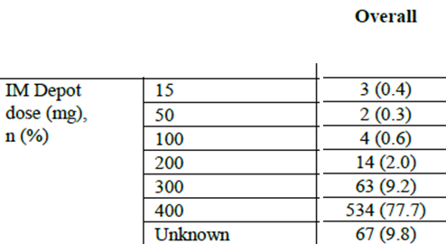
Base model was a 3-compartment model with sigmoid absorption (where the oral dose enters the depot compartment as an infusion and then transfers to the central compartment via a first-order process) best fit the oral data. The 3-compartment model with first-order absorption for the IM Depot dose best described the IM Depot data. The absorption rate for the IM Depot formulation was estimated to be 0.00108 (L/h) with a half-life of approximately 27 days.
Based on oral data CYP-2D6 inhibitors and CYP-3A4 inhibitors was found to significantly reduce the CL of aripiprazole (P value < 0.001).
In the final model Clearance in the presence of strong CYP-2D6 inhibitors and strong CYP-3A4 inhibitors was estimated to be 51% lower and 24% lower, respectively, than the CL of 3.71 L/h in the absence of inhibitors for EM subjects. Clearance for the PM subjects in the absence of inhibitors was estimated to be 1.88 L/h or approximately 51% (1.88/3.71) of the CL for the EM subjects in the absence of inhibitors.
The residual variability for the Phase I and Phase III trials was 24 %CV and 28 %CV.
The typical value of the IM Depot absorption rate for a female with a BMI of 28 kg/m² is 0.000904L/h (half-life ~32 days), whereas the typical value for a male with the same BMI is 0.00122L/h (half-life ~24 days). The rate of IM Depot absorption declines as BMI increases nearly proportional to (BMI/28) for both genders.
The goodness-of-fit plots show an under-prediction bias for observed concentrations > 600ng/mL. However, the inclusion of the covariates has diminished this under-prediction bias a small degree as evidenced by a slightly greater spread of the predicted values for these observed concentrations. The weighted residuals versus time since first dose now show a uniform spread about zero over the full duration of sampling (~9 months) and the weighted residuals versus time since last dose also exhibit a fairly uniform scatter about zero up to 2,100 hours (~88 days) post dose.
Table 4. Final Model - Phase I and Phase III Oral + IM Depot Data
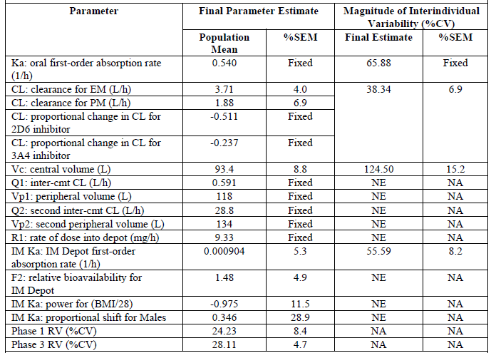
Minimum value of the objective function = 48892.907; cmt = compartmental; EM = extensive metabolizer; NA = not applicable; NE = not estimated; %CV = percent coefficient of variation; %SEM = percent standard error of the mean; PM = poor metabolizer; RV = residual variability. The estimated clearance for extensive metabolisers was correlated with the estimated relative bioavailability for IM Depot (r = 0.901).

Simulations Comparing Dosing for Subjects With Extensive and Poor Metabolism of CYP-2D6 Substrates
The median aripiprazole plasma concentration-time profiles of a CYP-2D6 PM subject following monthly administration of aripiprazole IM Depot doses of 300 mg and 400 mg remain within the therapeutic window.
Figure 1. Median steady-state concentration versus day since previous dose for poor metabolisers, stratified by dose
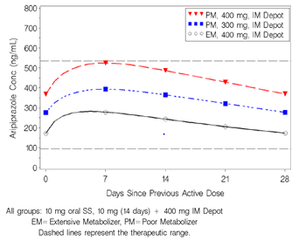
Figure 2. Comparison of steady-state exposure measures for poor metabolisers, stratified by IM depot dose
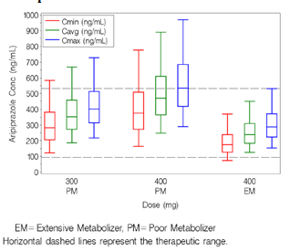

Simulations of dose initiation schemes
The dosing initiation scenarios included the following:
- subjects stabilized on aripiprazole oral doses of 10 mg followed by 14 days of orally administered 10-mg doses beginning with the administration of the first IM Depot 400-mg dose
- subjects stabilized on aripiprazole oral doses of 20 mg followed by 14 days of orally administered 15-mg doses beginning with the administration of the first IM Depot 400-mg dose
- subjects were not administered oral aripiprazole prior to IM Depot dosing and then received orally administered 10-mg doses for 14 days beginning with the administration of the first IM Depot 400-mg dose
- subjects were not administered oral aripiprazole prior to IM Depot dosing and then began IM Depot 400-mg dosing without concomitant oral therapy.
The first 2 aripiprazole IM Depot dose administrations simulations show the median aripiprazole concentration profile to be within the therapeutic window for all dosing initiation schemes by 3 days post IM Depot dosing.
Figure 3. Median Concentration versus Day for First 2 Doses, Stratified by Dosing Initiation Scheme
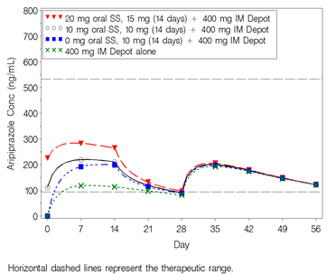

Simulations of delayed dosing during initiation and maintenance of therapy
There were multiple simulations of delayed dosing.
Figure 4. Median concentration versus day for the second IM depot dose, stratified by number of days dose was delayed
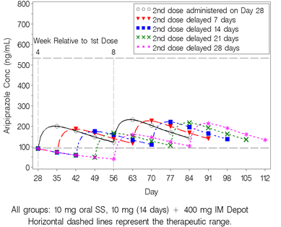
Figure 5. Median concentration versus weeks since previous dose for doses delayed by 28 days, stratified by number of doses administered prior to delay
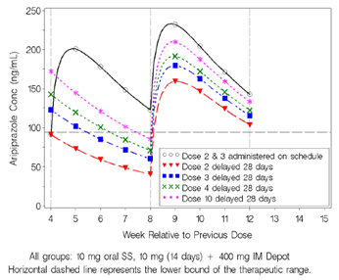

Simulations of long-term concomitant administration of CYP inhibitors
While the combination of long term inhibitor and poor metaboliser status can produce with 400 mg doses C_{max} and C_{avg} levels above therapeutic window, of greater concern are the number of EMs that may be sub therapeutic on 200 mg.
Figure 6. Steady-state median concentration versus day since previous dose: panel A - presence of chronic CYP-2D6 or CYP-3A4 inhibitor; panel B - presence of chronic CYP-2D6 and CYP-3A4 inhibitor
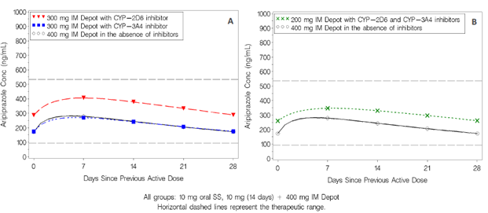
Figure 7. Comparison of steady-state exposure measures with chronic administration of CYP-2D6 inhibitor, stratified by IM depot dose
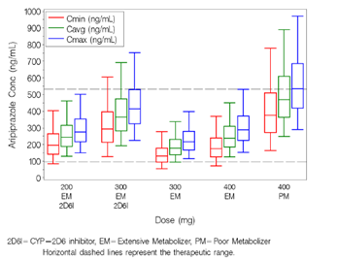
Figure 8. Comparison of steady-state exposure measures with chronic administration of CYP-3A4 inhibitor, stratified by IM depot dose
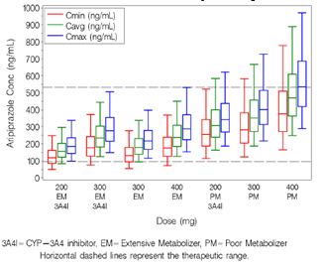
Figure 9. Comparison of steady-state exposure measures with chronic administration of CYP-2D6 and CYP-3A4 inhibitors, stratified by IM depot dose
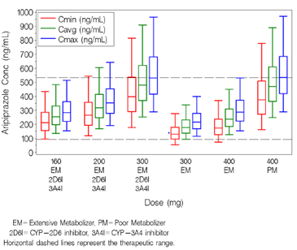

Simulation to evaluate the impact of dose dumping
The most severe form of dose dumping which would involve administration of the first IM Depot dose as a bolus dose directly into the vasculature in conjunction with concomitant oral administration of daily doses of 10 mg for 14 days, reached a peak of approximately 4,500ng/mL, after which the median aripiprazole concentration then fell to values within the therapeutic window by approximately 3 days post dose.
Figure 10. Median concentration versus day when IM depot is administered as an intravenous bolus
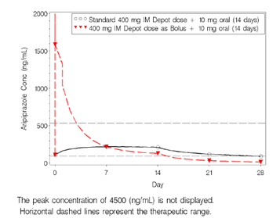

Report 31-12-292
Validation of a Previously Developed Population Pharmacokinetic Model for Aripiprazole IM Depot Formulation as Maintenance Treatment in Subjects With Schizophrenia Using Data From Protocol 31-07-247.
Data Source: From the previous population PK analysis (CSR 31-11-287) with a 6,153 concentration records from 663 subjects with doses ranging from 100 mg to 400 mg IM Depot plus 896 aripiprazole concentration records from 251 subjects enrolled in the 400 mg IM Depot treatment arm for the double-blind period of the study 31-07-247 giving a final total of 7,049 samples and 914 subjects, with doses ranging from 100 mg to 400 mg IM Depot.
This report was to assess the ability of the previously developed oral + IM Depot population PK model (CSR: 31-11-287) to describe data from the recently completed Phase III Trial 31-07-247 of aripiprazole IM Depot.
Following an exploratory analysis, then:
- Using the population prediction errors (%PE), performed a predictive performance assessment of the previously developed population PK model (CSR: 31-11-287) applied to the Initial 247 Dataset.
- Performed a visual predictive check (VPC) of the previously developed population PK model using the Final 247 Dataset.
If the following criteria were met, the previous population PK model (CSR: 31-11-287) was considered adequate to describe the Trial 31-07-247 data:
- The median %PE was within ± 10%. The median |%PE| was less than 40%.
- The results of the visual predictive check were graphically similar and showed similar percentages of observed concentrations below the simulated 5th percentile and above the simulated 95th percentile as the visual predictive check of the previously developed model.
As a supplemental analysis, model parameters were re-estimated using the Combined Analysis Dataset and the re-estimated model parameters were compared with those from the previous analysis (CSR: 31-11-287) using a Wald test. In addition, a visual predictive check of the re-estimated model was performed.

Results
The predictive performance evaluation of the 400 mg IM Depot treatment arm for the Final 247 Dataset showed the median %PE was -6.78% and the median absolute %PE (|%PE|) was 29.22%. Both of these measures met the predefined values of accuracy and precision for acceptance of the previous model to describe the 400 mg IM Depot for Trial 31-07-247.
The visual predictive check of the previous model (CSR: 31-11-287) applied to the 400 mg IM Depot treatment arm of the Final 247 Dataset showed that the previous model predicted the Final 247 Dataset as well as it predicted the Previous Analysis Dataset. The simulated median and 95th percentile fully corresponded with the observed median and 95th percentile of the data. The simulated 5th percentile was slightly lower than the observed 5th percentile of the data as was observed for the visual predictive check of the previous analysis (CSR: 31-11-287).
Supplemental Analysis: The Wald test and visual predictive check of the re-estimated model further confirmed the results of the external validation. Furthermore, PK exposures calculated using Bayesian parameter estimates obtained by applying the previous model to the Combined Analysis Dataset were similar to those from the previous analysis (CSR: 31-11-287).
Table 5. Summary statistics of the bayesian parameter estimates for the combined analysis dataset (final 247 dataset and previous analysis dataset CSR: 31-11-287)
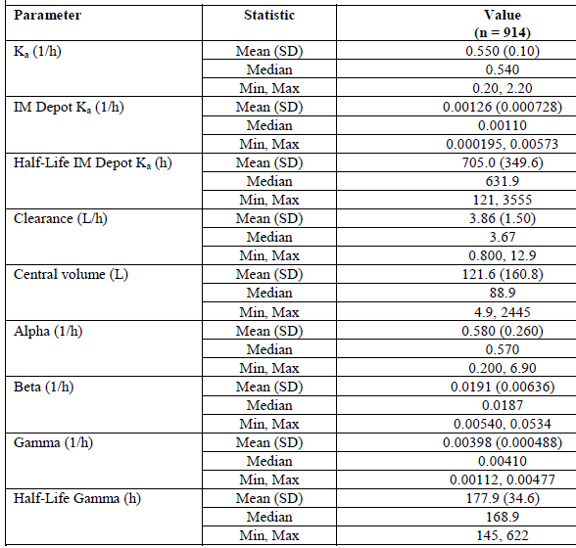
Table 6. Summary statistics of the individual predicted exposure measures for the combined analysis dataset (final 247 dataset and previous analysis dataset CSR: 31-11-287)
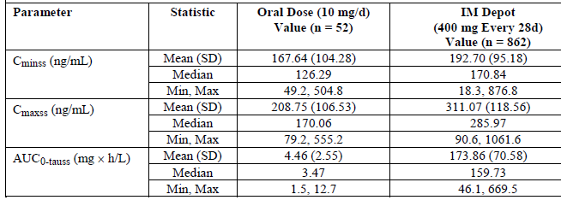
Table 7. Summary statistics of prediction errors for IM depot dose of 300 mg or 400 mg
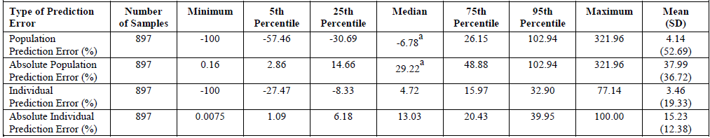
ª Median population prediction error is within ± 10% and median absolute prediction error is less than 40%. Therefore, the previous model adequately describes the data from Trial 31-07-247 for doses of 300 mg or more of IM Depot.

Report 31-00-233 (previously submitted)
The previously conducted evaluation report follows:
Population Pharmacokinetic Pharmacodynamic Analysis of Aripiprazole 31-00-233:
used the data from 4 double-blind studies and 1 open continuation study of aripiprazole in patients with psychosis in a population pharmacokinetic analysis. The trials involved are summarised together with the pharmacokinetic and pharmacodynamic observations, in Appendix 1 (of original CER).
The original dataset comprised assay results on 4,226 samples but the set subjected to NONMEN analysis was reduced by clean-up procedures to 2,563 observations. Observations on efficacy (PANSS scores) from the double-blind studies were used in combined PK/PD analysis; the results from 2,472 out of an original 3,812 values were analysed.
After a computational tour de force the pharmacokinetic data could be modelled as one compartment with first order absorption. This contrasts with the consistent result from pharmacokinetic studies described above which obtained a good fit to a 2 compartment model with a rapid distribution and relatively slow elimination.

Pharmacokinetics in patients and healthy subjects
The principal PopPK study 31-11-287 included data from both patients and healthy subjects.

Absorption
From the Population PK Report 31-12-292 the mean (SD) First-order absorption rate of orally administered drug was 0.550(0.10)L/h, while that for First-order absorption rate of IM Depot administered drug was 0.00126(0.000728)L/h giving a mean (SD) Half-Life IM Depot of 705.0(349.6)h or ~29days. The covariate analysis in 31-11-287 showed that the absorption rate of the IM Depot dose is dependent on BMI and gender. The changes in IM Depot K_{a} relative to gender and BMI are not expected to be clinically relevant based upon the absence of trends in model-predicted steady-state C_{min}, C_{max}, and AUC_{0 - τ} for gender or BMI quartiles.

Relative bioavailability
Lundbeck argued that no study to demonstrate the absolute bioavailability of Abilify Maintena was required because data from the two studies CN138-016 and CN138-020 demonstrate that absorption of aripiprazole is complete following IV, standard IM formulation or Abilify Maintena administration.
Study CN138-016 was an Absolute bioavailability study for the tablet and IM injection formulations, comparing in healthy subjects the pharmacokinetic parameters of the drug following a single dose of 5mg orally, with those after 2mg IV of a preparation intended for IM administration.
Study CN138-020 had the Primary Objective of: To estimate the in vivo release rate of aripiprazole following single doses of 15, 50, 100, 200, 300, and 400 mg doses of aripiprazole IM depot formulation. This was to be done by the in vivo release (absorption) rate of aripiprazole from the IM depot formulation was to be calculated using the technique of deconvolution and the plasma concentration profiles for the IM depot formulation. The unit impulse function required for deconvolution was to be obtained by modelling (fitting) the plasma aripiprazole concentration-time data obtained following the standard IM formulation.
In this study the resulting geometric mean (%CV) dose adjusted relative bioavailability based on AUC_{0 – T} ranged from 0.9 (39.1) to 1.44 (24.1), while that based on C_{max} ranged from 0.04 (72.6) to 0.07 (88.2).
From Population PK Report 31-11-287 Mean (%SEM) relative bioavailability for IM Depot was 1.46 (4.9).
Comment: Interestingly the sponsor in relation to toxicity of IM depot states: Exposures, based on AUC values, following IM injection of aripiprazole were lower than those following comparable doses with oral administration.
Table 8. Summary Statistics for oral, IV, IM Aripiprazole AUC C_{max}
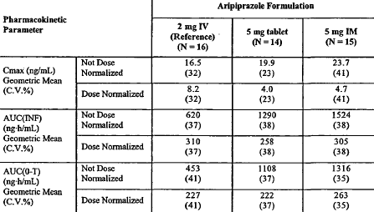

Dose proportionality
Dose-proportional increases in aripiprazole and dehydro-aripiprazole C_{ss,max}, AUC_{τ}, and C_{ss,min} PK parameters were observed after the 300 mg and 400 mg doses of aripiprazole IM depot. No conclusions could be made for the dose-proportionality of aripiprazole and dehydro-aripiprazole PK parameters after the 200 mg dose of aripiprazole IM depot due to limited data.
Figure 11. Plot of individual aripiprazole AUC_{(INF)} versus treatment
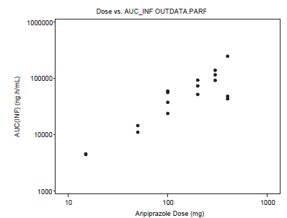
Figure 12. Plot of Aripiprazole C_{max} versus dose
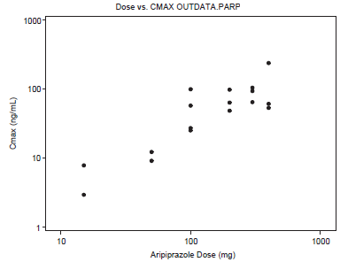

Bioavailability during multiple-dosing
Based on Pop PK model simulation when subjects never receive oral aripiprazole therapy, the median aripiprazole concentration remains near the lower threshold of the therapeutic window for the complete dosing interval. When subjects begin aripiprazole IM Depot dosing in combination with oral aripiprazole therapy for 14 days, the median aripiprazole concentrations are similar by Day 7 whether the subject was stabilized on oral dosing prior to IM Depot dosing or not (see Figure 3).
Based on the mean dose adjusted aripiprazole predose plasma concentrations prior to each IM depot administrations following 400, 300, and 200 mg aripiprazole IM Depot administrations, it appears that steady state was reached by the 4th administration.
Figure 13. Mean Dose Adjusted Aripiprazole Predose Plasma Concentrations Prior to Each IM depot Administration Following 400, 300, and 200 mg Monthly Aripiprazole IM Depot Injections
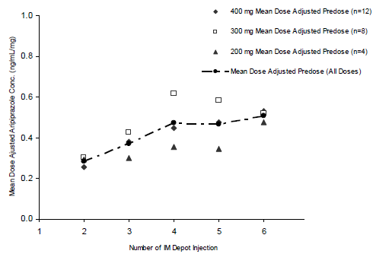

Effect of administration timing
Based on PopPK model simulation the median aripiprazole concentration on the 28th day after the first dose for all dosing initiation groups was near the lower threshold of the defined therapeutic window (see Figure 3).
Multiple simulations of the effect of delayed dosing were made (See Figure 4 and Figure 5).

Pharmacokinetics of metabolites
For dehydro-aripiprazole PKs after 200, 300 and 400 mg see Table 9 below.
Table 9. Mean (SD) Dehydro-aripiprazole PK Parameters in Subjects with Schizophrenia
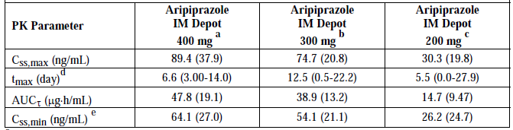
ª n = 10 ^{b} n = 8, ^{c} n = 4, ^{d} Median (minimum-maximum), ^{e} C_{ss,min} = dehydro-aripiprazole concentration at 672 hour.

Consequences of genetic polymorphism
Population pharmacokinetic modelling report 31-11-287 produced median Steady state concentrations for extensive and poor metabolisers that were within the therapeutic range throughout 28 days. However the modelling also produced some in the poor metabolizer range population who were at all times above the Therapeutic range on 300 mg as well as 400 mg and some extensive metabolisers on 400 mg who were sub-therapeutic around the end of the 28 day cycle (C_{min}).
Figure 14. Comparison of steady-state exposure measures for poor metabolisers, stratified by IM depot dose
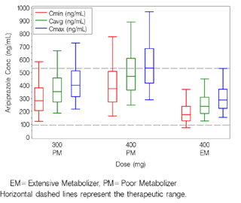

Excretion
In the final Pop PK model (report 31-11-287) Clearance in the presence of strong CYP-2D6 inhibitors and strong CYP-3A4 inhibitors was estimated to be 51% lower and 24% lower, respectively, than the CL of 3.71 L/h in the absence of inhibitors for EM subjects. Clearance for the PM subjects in the absence of inhibitors was estimated to be 1.88 L/h or approximately 51% (1.88/3.71) of the CL for the EM subjects in the absence of inhibitors.
The Pop PK model (report 31-12-292) gives a mean T_{1/2}γ of 7.42 days (see Table 5).
Study 31-05-244 gives mean aripiprazole terminal elimination half-lives of 29.9 days and 46.5 days for aripiprazole IM depot 300 mg and 400 mg, respectively.

Intra- and inter-individual variability of pharmacokinetics
Variability in the Pop PK model (report 31-12-292) is given as a residual variability for the Phase I and Phase III trials of 24 %CV and 28 %CV.

Pharmacokinetics in other special populations
No additional special population studies were conducted for the aripiprazole IM depot formulation.
Study 31-98-208 An open-label study of the PKs of oral aripiprazole in subjects with normal renal function and subjects with severely impaired renal function showed the values of C_{max}, CL/F and CL_{r} of aripiprazole were not statistically significantly different between the subjects with renal impairment and the matched subjects with normal renal function. The 95% CI for the ratio of the geometric means included 1 for all aripiprazole parameters.

Pharmacokinetics related to genetic factors
The typical value of the IM Depot absorption rate for a female with a BMI of 28 kg/m² is 0.000904L/h (half-life ~32 days), whereas the typical value for a male with the same BMI is 0.00122L/h (half-life ~24 days). The rate of IM Depot absorption declines as BMI increases nearly proportional to (BMI/28) for both genders.
For poor versus Extensive metabolisers see above.

Pharmacokinetic interactions

Pharmacokinetic interactions demonstrated in human studies
There were no Interaction studies with the IM depot formulation submitted. However the effects of co-administration of inhibitors of CYP-2D6 and CYP-3A4 were modelled as part of the PopPK study 31-11-28. (see Figures 6-8).

Evaluator’s overall conclusions on pharmacokinetics

Guidance
CPMP/EWP/49/01 Appendix to the Note for Guidance on the Clinical Investigation of Medicinal Products in the Treatment of Schizophrenia - Methodology of Clinical Trials Concerning the Development of Depot Preparations of Approved Medicinal Products in Schizophrenia.
- Of specific interest is the comparison of the concentration time curves after administration of the oral formulation and the depot formulation over the dosing range. This comparison should be used for an adequate dose and dose interval selection of the depot formulation.
- Depending on the type of formulation, the influence of volume, amount and concentrations injected (dose proportionality), or other circumstances (like exercise), on the release characteristics should be discussed or investigated especially with respect to the possibility of dose dumping.
- As the parenteral administration of a depot formulation will release the drug slowly compared to oral formulation, the time to achieve steady state concentration after switching from oral to parenteral treatment should be taken into consideration especially with respect to the efficacy.
- Special attention should be paid to the first pass elimination of the active substance as this may be substantially different between the two routes of administration.

Evaluator’s conclusions
The PKs raise a number of concerns in regard to under and overdosing in poor and extensive metabolisers (see Figure 2).
Steady state is reached by the fourth cycle at which stage even on 400 mg some extensive metabolisers will be at sub-therapeutic levels towards the end of the cycle, with presumably a greater number and for some a greater duration in the preceding months.
When steady state is reached even on 300 mg some poor metabolisers will be at above therapeutic levels throughout the cycle, while the likelihood of increased AEs does not directly affect therapy, the increased risk of discontinuation due to AEs does.
A single 400 mg IM depot dose is shown to achieve mean sub-therapeutic levels for the first and last 3 days of the initial treatment cycle, presumably extensive metabolisers will fare worse (see Figure 3).
Bioequivalence was not shown. Relative bioavailability based on AUC ranged from 0.90 to 1.44 with the smallest CV 19.85%. While relative exposure based on C_{max} was only 0.04-0.07.

Pharmacodynamics

Summary of pharmacodynamics
There were no new PD studies in this submission.

Dosage selection for the pivotal studies
Based on the assessed pharmacokinetic (PK) parameters from Trial CN138-020 and from previous oral steady state studies aripiprazole plasma concentration-time profiles were simulated. These simulations included a proposed switching regimen in which oral dosing was tapered off with concomitant administration of 100, 200, 300, and 400 mg aripiprazole IM depot monthly (that is, every 28 days). Data from these simulations indicated that the lower 95% CI for minimum plasma concentration (C_{min}) for 400 mg/300 mg aripiprazole IM depot would be expected to be above (or very close to) the steady-state C_{min} of daily dosing with aripiprazole 10 mg, and below the mean steady-state maximum plasma concentration (C_{max}) of daily dosing with aripiprazole 30 mg at all times, including tapering off oral dosing.
Trial 31-05-244 showed once-monthly administration of the 200 mg IM depot injections did not result in mean aripiprazole trough plasma concentrations that were comparable to the therapeutic concentrations of 10 mg to 30 mg oral aripiprazole administered daily to schizophrenic subjects. In this multiple-dose trial and in another single-dose trial (Trial CN138-020), the PK profiles and clinical data for aripiprazole IM depot 400 mg/300 mg suggested that these doses would be efficacious and tolerable, and thus, both were further investigated in the Phase III trials.

Clinical efficacy

For the treatment of schizophrenia

Pivotal efficacy studies

Study 31-07-246 ‘ASPIRE US’
The study secondary endpoints were amended on 18 November 2009 (the study having commenced on 30 July 2008).

Study design, objectives, locations and dates
A 52-week, multicenter, randomized, double-blind, placebo-controlled study to evaluate the efficacy, safety, and tolerability of an intramuscular depot formulation of aripiprazole as maintenance treatment in patients with schizophrenia consisting of a screening phase and 4 treatment phases: Conversion (Phase I), Oral Stabilization (2), IM Depot Stabilization (3), and Double-blind, Placebo-controlled (4). Conducted from 30 July 2011 to 3 February 2011 in 108 centres in the US, Mexico, Argentina, Bulgaria, Romania, Serbia, Slovakia, Russia, India, Taiwan, Malaysia, and the Philippines.
The primary objective was to evaluate the efficacy of aripiprazole IM depot compared with placebo, as measured by time to exacerbation of psychotic symptoms/impending relapse, in schizophrenic subjects who had maintained stability on aripiprazole IM depot for at least 12 weeks.
The secondary objective was to evaluate the safety and tolerability of aripiprazole IM depot as maintenance therapy in subjects with schizophrenia.
Subjects who were receiving:
- oral treatment with any other antipsychotic alone or in combination, or
- oral generic aripiprazole
entered the Conversion Phase when they were converted from other antipsychotics to 10 or 15mg/day oral (trial) aripiprazole monotherapy over 4 to 6 weeks.
Subjects who:
- successfully converted to oral aripiprazole monotherapy , or
- who were already receiving ≤ 30 mg/day oral non generic aripiprazole at screening, or
- who had a lapse in treatment with aripiprazole or other antipsychotic treatment prior to trial entry, or
- who received recent treatment with an approved IM depot formulation of an antipsychotic drug
entered the Oral Stabilization Phase of 4 to12 weeks during which subjects were stabilized on oral 10 to 30 mg/day aripiprazole.
Subjects then entered the single-blind IM depot Stabilization Phase of 12 to 36 weeks where all initially received aripiprazole IM depot 400 mg and concomitant oral aripiprazole (10 to 20 mg/day) for the first 2 weeks. They continued on monthly depot aripiprazole (with a possible once only decrease in dose and a once only return to original 400 mg dose) until meeting the stability criteria.
Subjects could then enter the Double-blind, Placebo-controlled Phase where they were randomly assigned in a 2:1 ratio stratified by region to:
- Their stabilisation phase dose of Aripiprazole IM depot 400 or 300 mg/28days (with a possible once only decrease or increase and a once only return to previous dose)
OR
- Placebo.
Comment: by using a Study drug manager to give the injection the sponsors believed they achieved double blind (evaluator and patient) status.
The trial design included 2 pre specified interim analyses for efficacy in order to minimize continued exposure to placebo and the risk of relapse; one was to occur after accrual of 50% of the 125 targeted events (63 events) and the second was to occur after 75% accrual of the events (94 events).

Inclusion criteria
Included:
- A current diagnosis of schizophrenia and a history of the illness for at least 3 years prior to screening, who required chronic treatment with antipsychotic medication.
- Currently being treated with oral or depot antipsychotics other than clozapine with a history of relapse and/or exacerbation of symptoms when not receiving antipsychotic treatment.
- Showed previous response to antipsychotic treatment (other than clozapine) in the year prior to the trial.
- No more than one benzodiazepine beyond screening.
- Adequate washout of prohibited concomitant medications.

Exclusion criteria
Included:
- Schizoaffective disorder, major depressive disorder, bipolar disorder, delirium, dementia, amnestic or other cognitive disorders. Also, subjects with borderline, paranoid, histrionic, schizotypal, schizoid, or antisocial personality disorder.
- Acute depressive symptoms within the 30 days prior to screening.
- Schizophrenia that was considered resistant/refractory to antipsychotic treatment.
- History of failure to clozapine treatment or response to clozapine treatment only.
- A significant risk of violent behaviour or a significant risk of committing suicide.
- Known hypothyroidism or hyperthyroidism.
- Epilepsy or a history of seizures, except for a single childhood febrile seizure, post traumatic, alcohol withdrawal, etc.
- A history of hypersensitivity to antipsychotic agents.
- Likely to have required prohibited concomitant therapy during the trial.
- Receiving CYP2D6 or CYP3A4 inhibitors or CYP3A4 inducers at screening or anticipating use of such agents during the trial.

Efficacy variables and outcomes
The primary endpoint was the time from randomization to exacerbation of psychotic symptoms/impending relapse in the Double-blind, Placebo-controlled Phase.
The following were also evaluated in the Double-blind, Placebo-controlled Phase:
The key secondary endpoint was the Percentage of subjects meeting exacerbation of psychotic symptoms/impending relapse criteria.
Other secondary endpoints included:
- Proportion of responders (that is, response defined as meeting stability criteria) at endpoint.
- Proportion of subjects achieving remission.
- Mean change from baseline to endpoint in PANSS Total Score.
- Mean change from baseline to endpoint in Clinical Global Impression of Severity (CGI-S).
- Mean change from baseline to endpoint in PANSS positive and negative subscales.
- Mean CGI-I score at endpoint.
- Time to discontinuation due to all causes.

Blinding
Two subjects were un-blinded at the site level.

Analysis populations
Included:
Enrolled Sample: All subjects who signed the informed consent form for the trial and entered the Conversion Phase or the Oral Stabilization Phase.
Conversion Phase Safety Sample: All subjects who received at least one dose of oral aripiprazole in the Conversion Phase.
Oral Stabilization Phase Safety Sample: All subjects who received at least one dose of oral aripiprazole in the Oral Stabilization Phase.
Oral Stabilization Phase Efficacy Sample: All subjects who entered the Oral Stabilization Phase (that is, received at least one dose of oral aripiprazole in the Oral Stabilization Phase) and had at least one post baseline efficacy evaluation in the Oral Stabilization Phase.
IM Depot Stabilization Phase Safety Sample: All subjects who received at least one dose of single-blind aripiprazole IM depot in the IM Depot Stabilization Phase.
IM Depot Stabilization Phase Efficacy Sample: All subjects who entered the IM Depot Stabilization Phase (that is, received at least one dose of single-blind aripiprazole IM depot) and had at least one post baseline efficacy evaluation in the IM Depot Stabilization Phase.
Double-blind, Placebo-controlled Phase Safety Sample: All subjects who were randomly assigned to double-blind treatment and received at least one dose of double-blind trial medication in the Double-blind, Placebo-controlled Phase.
Double-blind, Placebo-controlled Phase Efficacy Sample: The Intent-to-Treat (ITT) dataset was composed of all subjects randomly assigned to the double-blind treatment.

Sample size
This was a superiority trial of aripiprazole IM depot (400 mg or 300 mg) versus placebo in the time to exacerbation of psychotic symptoms/impending relapse. Using the log-rank test for statistical significance of differences between the 2 survival curves. Based on trial CN138047 which compared oral aripiprazole versus placebo in time to impending relapse (37% aripiprazole versus 61% placebo), the 6-month rates for impending relapse were set at 55% for placebo and 35% for aripiprazole IM depot. This corresponds to a hazard ratio of 0.54 (aripiprazole IM depot versus placebo).
Sample sizes were estimated to achieve 90% power and to preserve an overall nominal alpha level of 0.05 (2-sided), allowing for 2 interim looks at 50% and 75% of events accrual time points. The Haybittle-Peto group sequential boundaries were applied corresponding to an alpha level of 0.001 at each of the 2 interim looks. The alpha level for the final analysis was 0.0498. The resulting total number of events satisfying these design constraints was 125. Assuming that each subject was followed for 12 months after randomization and allowing for a 25% loss to follow-up, the projected total number of subjects to be randomly assigned to treatment in the trial was 225.
Using a 2:1 randomization ratio, the number of subjects to be randomly assigned to treatment in the aripiprazole IM depot group was 150, and that for the placebo group was 75. Due to the lower than expected impending relapse rate, enrolment and randomization continued beyond the planned estimates (225 planned; 403 actual) to achieve the target number of impending relapse events.

Statistical methods
The primary objective of was to compare aripiprazole IM depot 400/300 mg versus placebo in the time to impending relapse by statistically testing equality of the 2 survival curves by the log-rank test.
A group sequential testing procedure was employed with 2 pre specified interim analyses at approximately 50% (63 events) and 75% (94 events) events accrual time points, and a final analysis using 100% (approximately 125 events). The Haybittle-Peto boundaries were utilized in this analysis for the rejection of the null hypothesis to maintain an overall nominal significance level of 0.05 (2-sided).
Although the primary efficacy analysis was based on the ITT population consisting of all randomized subjects, similar analysis for the primary efficacy endpoint was also performed by excluding 2 subjects who were un-blinded during the trial and 2 subjects who were entered into more than one trial with aripiprazole and received extra doses of aripiprazole IM depot.
In order to preserve the overall type I error rate at 0.05, the key secondary endpoint of the percentage of subjects who met the impending relapse criteria was tested only if the primary hypothesis was rejected at an overall nominal alpha level of 0.05.
In this hierarchical testing procedure, the hypotheses for the secondary endpoints were tested at the same significance level as that of the primary endpoint in both the interim and final analyses. The key secondary efficacy endpoint was analysed using the Chi-square test.

Participant flow
The interim analysis after 50% of events had occurred was conducted using a data cut-off date of 08 June 2010. At the time of the interim analysis, 971 subjects had been screened and 775 subjects enrolled. Approximately 48.3%, (374/775) had discontinued and 18/775 subjects (2.3%) had completed the trial (the Week 52 visit in the Double-blind, Placebo-controlled Phase).
The interim analysis stopping rules had been met (analysis performed after the 64th impending relapse event which occurred on 08 June 2010) and they recommended termination of the trial. The sponsor terminated the trial on 26 July 2010. The last randomized subject was discontinued from the trial on 24 August 2010 and the final subject from a nonrandomized trial phase on 30 August 2010. At the time of the final analysis, the number of impending relapse events was 80.
Table 10. Subject disposition (enrolled sample) - final analysis (80 events)
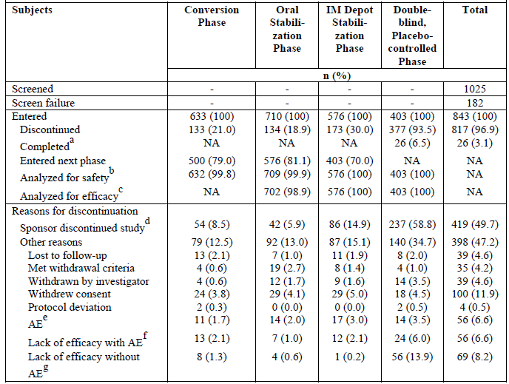
Note: The phases of the trial are referred to in supporting statistical tables as Phase I (Conversion Phase), Phase II (Oral Stabilization Phase), Phase III (IM Depot Stabilization Phase), and Phase 4 (Double-blind, Placebo-controlled Phase). ª Subjects completed the Double-blind, Placebo-controlled Phase, Week 52 visit. ^{b} Subjects receiving at least one dose of trial medication in the corresponding phase are included in the safety analysis. ^{c} Subjects evaluated for at least one efficacy endpoint in the corresponding phase are included in the efficacy analysis. ^{d} Study was terminated early because of positive results of interim analysis. ^{e} Adverse event without lack of efficacy (Conversion, Oral Stabilization, and IM Depot Stabilization phases) or impending relapse (Double-blind, Placebo-controlled Phase). ^{f} Lack of efficacy (Conversion, Oral Stabilization, and IM Depot Stabilization Phases) or impending relapse (Double-blind, Placebo-controlled Phase) with an associated adverse event. ^{g} Lack of efficacy (Conversion, Oral Stabilization, and IM Depot Stabilization Phases) or impending relapse (Double-blind, Placebo-controlled Phase) without an associated adverse event NA = not applicable.

Major protocol violations/deviations
A summary table of major protocol deviations was not submitted, from the text:
The most common were procedural, mainly timing (56.9% and 49.3% of subjects in the aripiprazole IM depot and placebo groups, respectively).
Next most common was deviations in concomitant medication use (34.9% and 34.3% of subjects in the aripiprazole IM depot and placebo groups, respectively).

Baseline data
The demographic characteristics for subjects randomized to the Double-blind, Placebo-controlled Phase were similar in the aripiprazole IM depot and placebo groups. Overall, the baseline disease severity was comparable between the 2 treatment groups. The most common prior medications were antipsychotics, including aripiprazole (29.3%), risperidone (19.1%), haloperidol (9.7%), and quetiapine fumarate (9.4%). The proportion of subjects taking each type of commonly received prior medication was similar across the aripiprazole IM depot and placebo groups.

Results for the primary efficacy outcome
The interim analysis of efficacy data (which included 344 randomized subjects and 64 events of impending relapse - 50% of the projected total of 125 events), showed that time to impending relapse was significantly shorter for subjects on placebo compared to aripiprazole IM depot (p < 0.0001; log-rank test). Accordingly the study was terminated, during the process of which an additional 16 impending relapse events occurred, thus the final efficacy analysis included 403 randomized subjects and 80 impending relapse events, 27/269 (10.0%) on aripiprazole IM depot and 53/134 (39.6%) on placebo.
The final analysis showed that the time to impending relapse was significantly shorter for subjects on placebo compared with subjects on aripiprazole IM depot (p < 0.0001; log-rank test). The hazard ratio from the Cox proportional hazard model for the placebo to aripiprazole IM depot comparison was 5.029 (95% CI = 3.154, 8.018).
Exclusion of subjects with potential data issues (that is, unblinded subjects, double-entry subjects, and subjects from Site 46) had no effect on the results of the primary efficacy analyses with the difference remaining statistically significant for all comparisons (p < 0.0001).
Table 11. Analysis of time to exacerbation of psychotic symptoms/impending relapse (double-blind, placebo controlled phase efficacy sample)
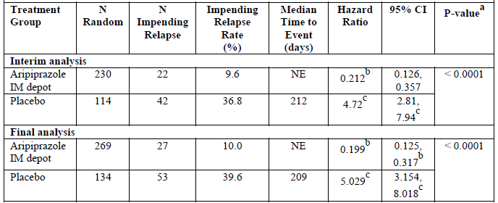
NE = not estimable, Random = randomized. The median time to impending relapse was not estimable because the percentage of subjects in the aripiprazole IM depot group who experienced an impending relapse during the 52-week Double-blind, Placebo-controlled Phase was too low. ª P-value was derived from the log-rank test for time to impending relapse. ^{b} Aripiprazole IM depot/placebo. Hazard ratio and its 95% CI were derived from the Cox proportional hazard model with treatment as a term. Hazard ratio < 1 is in favour of aripiprazole IM depot group. ^{c} Placebo/aripiprazole IM depot. Hazard ratio and its 95% CI were derived from the Cox proportional hazard model with treatment as a term. Hazard ratio > 1 is in favour of aripiprazole IM depot group.
Figure 15.Kaplan-Meier product limit plot of time to impending relapse (double-blind, placebo-controlled phase efficacy sample) - final analysis (80 events)
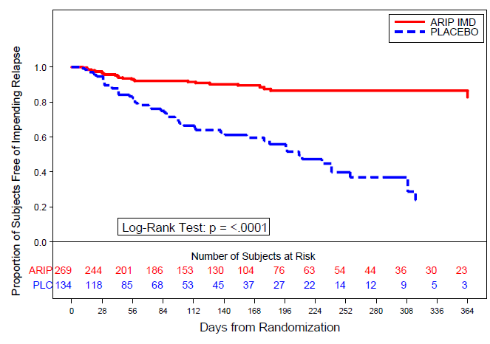
ARIP and ARIP IMD = aripiprazole IM depot; PLC = placebo.

Key secondary efficacy endpoint
Table 12. Percentage of subjects meeting exacerbation of of psychotic symptoms/impending relapse criteria(double-blind, placebo controlled phase efficacy sample) - interim and final analyses
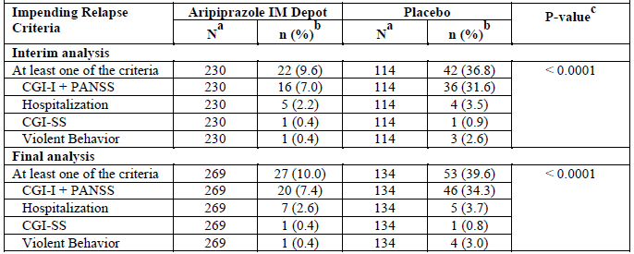
Note: Subjects could meet more than one of the criteria. ª N is the total number of subjects in the Double-blind, Placebo-controlled Phase Efficacy Sample. ^{b} n is the number of subjects who met the impending relapse criteria. ^{c} P-value was derived from the Chi-square test.

Results for other efficacy outcomes
The protocol was amended mid study in relation to the secondary endpoints – an hierarchical system of analysis was removed (this would have meant ceasing the analysis after Proportion of responders and Proportion of subjects achieving remission). PNS was removed from the secondary endpoints.
The proportion of responders at the last visit was 87.6% (234/267) on aripiprazole IM depot was statistically greater compared with 56.0% (75/134) on placebo (p < 0.0001).
The proportion of subjects who achieved remission was 52.9% (46/87) on aripiprazole IM depot was not shown to be statistically different compared with 38.7% (12/31) on placebo (p = 0.1756).

Subgroup analyses
The only subgroup analyses by region were US/non US which showed no effect of region on main outcomes significance.
Table 13. Analysis of time to exacerbation of psychotic symptoms/impending relapse by region (double-blind, placebo controlled phase efficacy sample)
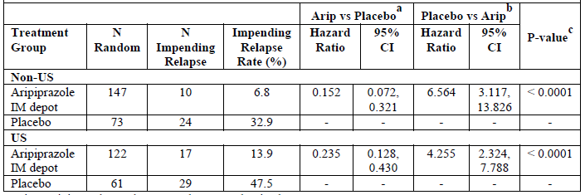
Random = randomized. ª Hazard ratio and its 95% CI were derived from the Cox proportional hazard model with treatment as a term. A hazard ratio < 1 is in favour of the aripiprazole IM depot group. ^{b} Hazard ratio and its 95% CI were derived from the Cox proportional hazard model with treatment as a term. A hazard ratio > 1 is in favour of the aripiprazole IM depot group. ^{c} P-value was derived from the log-rank test for time to exacerbation of psychotic symptoms/impending relapse.

Study 31-07-247 ‘ASPIRE EU’
This was indicated as the pivotal study in the submission, however the primary objective and the primary efficacy endpoint were changed midtrial (including the non-inferiority margin) and following on, the statistical analyses and calculation of the Study population sample size.
The Study Report states No interim analysis was planned or performed. However, the study report explains that the primary efficacy endpoint was changed because of a lower than anticipated relapse rate. The lower than anticipated relapse rate was thought to have resulted from the requirement for 8 consecutive weeks of stabilization prior to randomization and the fact that subjects randomized to the 50/25mg aripiprazole IM depot arm maintained stability of schizophrenic symptoms to a greater degree than anticipated. This change was discussed during a scientific advice procedure with the EMA (16 December 2010). The EMA stated that ‘as an equivalence situation is investigated, visual inspection of the Kaplan-Meier curves would be requested any how to check that development over time is not different for the 2 formulations.
This is presumably reflected in the change in the primary objective but this was not discussed.

Study dates, locations, objectives and design
A non-inferiority 38-week, multicenter, randomized, double-blind, active-controlled study to evaluate the efficacy, safety, and tolerability of an intramuscular depot formulation of aripiprazole as maintenance treatment in patients with schizophrenia consisting of a screening phase and 3 treatment phases: Conversion Phase, Oral Stabilization Phase, and Double-blind, Active-controlled Phase. Conducted from 26 September 2008 to31 August 2012 in 105 centres in Austria, Belgium, Bulgaria, Chile, Croatia, Estonia, France, Hungary, Italy, South Korea, Poland, South Africa, Thailand, and US.
The primary objective (in the Study Report) was to evaluate the efficacy of aripiprazole IM depot compared with oral aripiprazole, as measured by the proportion of subjects experiencing impending relapse by end of 26 weeks of treatment from the date of randomization in the Double-blind, Active-controlled Phase, in schizophrenic subjects who have maintained stability on oral aripiprazole for at least 8 consecutive weeks in the Oral Stabilization Phase of the trial before initiating treatment with aripiprazole IM depot.
The secondary objective was to evaluate the safety and tolerability of aripiprazole IM depot as maintenance treatment in subjects with schizophrenia.
Subjects who were receiving
- oral treatment with any other antipsychotic alone or in combination, or
- oral generic aripiprazole
entered the Conversion Phase when they were converted from other antipsychotics to 10 or 15mg/day oral (trial) aripiprazole monotherapy over 4 to 6 weeks.
Subjects who:
- successfully converted to oral aripiprazole monotherapy, or
- who were already receiving ≤ 30 mg/day oral non generic aripiprazole at screening, or
- who had a lapse in treatment with aripiprazole or other antipsychotic treatment prior to trial entry, or
- who received recent treatment with an approved IM depot formulation of an antipsychotic drug
entered the Oral Stabilization Phase of 8 to 28 weeks during which subjects were stabilized on oral 10 to 30 mg/day aripiprazole.
Subjects in the 38-week Double-blind, Active-controlled Phase were randomly assigned in a 2:2:1 ratio to one of 3 treatment groups, stratified by region (US and non-US):
- Aripiprazole IM depot 400 mg/28d ays (with a possible once only decrease to 300 mg and a once only return to 400 mg) was given with oral 10 to 20 mg aripiprazole for the first 14 days then oral matching placebo
- The stabilization dose of oral aripiprazole (with a possible once only decrease or increase in dose and a once only return) with a randomised IM depot of 50 or 400 mg placebo.
- Aripiprazole IM depot 50 mg/28days (with a possible once only decrease to 25mg and a once only return to 50 mg) was given with oral 10 to 20 mg aripiprazole for the first 14 days then oral matching placebo.

Inclusion criteria
Included:
- A current diagnosis of schizophrenia and a history of the illness for at least 3 years prior to screening, who required chronic treatment with antipsychotic medication.
- Currently being treated with oral or depot antipsychotics other than clozapine with a history of relapse and/or exacerbation of symptoms when not receiving antipsychotic treatment.
- Showed previous response to antipsychotic treatment (other than clozapine) in the year prior to the trial.
- No more than one benzodiazepine beyond screening.
- Adequate washout of prohibited concomitant medications.

Exclusion criteria
Included:
- Schizoaffective disorder, major depressive disorder, bipolar disorder, delirium, dementia, amnestic or other cognitive disorders. Also, subjects with borderline, paranoid, histrionic, schizotypal, schizoid, or antisocial personality disorder.
- Acute depressive symptoms within the 30 days prior to screening.
- Schizophrenia that was considered resistant/refractory to antipsychotic treatment.
- History of failure to clozapine treatment or response to clozapine treatment only.
- A significant risk of violent behaviour or a significant risk of committing suicide.
- Known hypothyroidism or hyperthyroidism.
- Epilepsy or a history of seizures, except for a single childhood febrile seizure, post traumatic, alcohol withdrawal, etc.
- A history of hypersensitivity to antipsychotic agents.
- Likely to have required prohibited concomitant therapy during the trial.
- Receiving CYP2D6 or CYP3A4 inhibitors or CYP3A4 inducers at screening or anticipating use of such agents during the trial.

Efficacy variables and outcomes
The primary efficacy endpoint was the proportion of subjects experiencing impending relapse by end of 26 weeks from the date of randomization in the Double-blind, Active-controlled Phase.
Comment: Almost 3 years after the start of the trial (14 July 2011) the primary efficacy endpoint was changed from ‘time from randomization to exacerbation of psychotic symptoms/impending relapse in Phase III’ to ‘the proportion of subjects experiencing exacerbation of psychotic symptoms/impending relapse by end of 26 weeks of treatment from the date of randomization in Phase III, in schizophrenic subjects who have maintained stability on oral aripiprazole for at least 8 consecutive weeks in Phase II of the study.’ Statistical analysis was also changed.
The secondary efficacy endpoints for the Double-blind, Active-controlled Phase included:
- Time to impending relapse from the date of randomization in the Double-blind, Active-controlled Phase (this was the original primary endpoint).
- Percentage of responders at endpoint in the Double-blind, Active-controlled Phase.
- Percentage of subjects achieving remission.
The endpoint for secondary variables was considered to be the measurement up to Week 38.
Other efficacy endpoints evaluated for the Double-blind, Active-controlled Phase included:
- Mean change from baseline to endpoint in PANSS total score.
- Mean change from baseline to endpoint in Clinical Global Impression of Severity (CGI-S).
- Mean change from baseline to endpoint in PANSS positive and negative subscales.
- Mean CGI-I score at endpoint.
- Time to discontinuation due to all causes.

Analysis populations
Enrolled Sample: All subjects who signed an ICF for the trial and entered the Conversion Phase or the Oral Stabilization Phase.
Conversion Phase Safety Sample: All subjects who received at least one dose of oral aripiprazole in the Conversion Phase of the trial.
Oral Stabilization Phase Safety Sample: All subjects who received at least one dose of oral aripiprazole in the Oral Stabilization Phase of the trial.
Oral Stabilization Phase Efficacy Sample: All subjects who entered the Oral Stabilization Phase (that is, received at least one dose of oral aripiprazole in the Oral Stabilization Phase) and had at least one post-baseline efficacy evaluation in the Oral Stabilization Phase.
Double-blind, Active-controlled Phase Safety Sample: All subjects who were randomized to double-blind treatment and received at least one dose of double-blind trial medication in the Double-blind, Active-controlled Phase.
Double-blind, Active-controlled Phase Efficacy Sample: The Intent-to-Treat (ITT) dataset was composed of all subjects randomized to the double-blind treatment.

Sample size
Comment: These calculations changed from the original with protocol amendment of the primary endpoint midway through the study (14 July 2011).
The sample sizes were estimated to achieve about 93% power for the primary non-inferiority comparison at the 0.05 significance level (2-sided) using large sample normal approximations for the distribution of the difference in binomial proportions. The assumed population proportion of impending relapse at or before Week 26 (Day 182) for the oral aripiprazole (10 to 30 mg) was 18%, and the predefined non-inferiority margin was 11.5%. The resulting sample size was projected to be 260 subjects per arm for the IM depot 400/300 mg and oral aripiprazole 10 to 30 mg arms.
The data from a previous trial (CN138-047)56 which compared time to relapse for oral aripiprazole to placebo were taken into consideration in setting of non-inferiority margin. From this trial, the estimated relapse rates by end of Week 26 (from Kaplan-Meier estimates) were 37.4% for oral aripiprazole and 60.6% for placebo. The associated standard errors for these estimated relapse rates were 4.22% and 4.24% for oral aripiprazole and placebo, respectively. Assuming that the difference between estimated relapse rates was approximately normally distributed led to a 1-sided 97.5% lower CI of 15% for difference in relapse rate at Day 182. Given the compliance advantage of a depot formulation, the conservative 11.5% was selected as the margin in this trial.
For the superiority comparison (assay sensitivity analysis) of IM depot 400/300 mg to IM depot 50/25mg, on a 2:1 randomization, sample sizes of 260 and 130, respectively, were calculated to provide about 95% power at the 0.05 significance level (2-sided). A superiority margin of 17% was assumed. In total, it was estimated that 650 subjects would be randomized.

Statistical methods
Both the primary endpoint and the non-inferiority margin were changed mid trial (14 July 2011).
Based on the ITT Population, the test of non-inferiority of aripiprazole IM depot (400/300 mg) to oral aripiprazole (10 to 30 mg) was performed using a 95% CI (2-sided) for the difference in the estimated proportion of impending relapse (aripiprazole IM depot 400/300 mg versus oral aripiprazole tablets 10 to 30 mg). Non-inferiority was considered confirmed if the upper bound of the 2-sided 95% CI was below the predefined margin, 11.5%.
To compute the CI of difference in the estimated proportion of subjects with impending relapse by end of Week 26, the proportion of subjects with impending relapse for each treatment group was computed using the Kaplan-Meier estimate at Day 182, and its SE was computed using the Greenwood formula.
The 95% CI of difference in proportions of subjects with impending relapse events between aripiprazole IM depot 400/300 mg and oral aripiprazole were provided using the pooled SE with assumption of normality of the estimated difference.
Once non-inferiority was declared, superiority of IM depot 400/300 mg over IM depot 50/25mg was tested by examining the difference between the proportions of subjects experiencing impending relapse with IM depot 400/300 mg and IM depot 50/25mg by end of Week 26 using z-statistic for statistical significance at the 0.05 significance level (2-sided).
The Cox Proportional Hazard model in the model was fitted to the time to impending relapse event data with treatment as factor. The 95% CIs for the hazard ratio (aripiprazole IM depot 400/300 mg to oral aripiprazole, aripiprazole IM depot 400/300 mg to aripiprazole IM depot 50/25mg) were provided. In the event that times were the same, times were handled using the ‘exact’ option in SAS PROC PHREG. The log-rank test was performed to test the equality of survival curves (aripiprazole IM depot 400/300 mg versus aripiprazole IM depot 50/25mg) at the 0.05 significance level (2-sided).
Table 14. Subject disposition (enrolled sample)
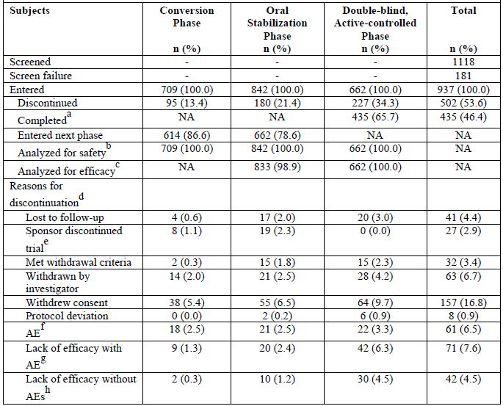
ª Subjects completed the Double-blind, Active-controlled Phase Week 38 Visit. ^{b} Subjects receiving ≥ dose of trial medication in the corresponding phase are included in the safety analysis. ^{c} Subjects evaluated for ≥ 1 efficacy endpoint in the corresponding phase are included in the efficacy analysis. ^{d} Percentages are based on number of enrolled subjects in the corresponding phase; for the ‘Total’ group percentages are based on number of enrolled sample in the trial period. ^{e} Sponsor discontinued randomization into the Double-blind, Active-controlled Phase of the trial after a sufficient number of subjects had been randomized. Subjects who were still enrolled in the Conversion Phase or Oral Stabilization Phase at that time were discontinued. ^{f} AE without lack of efficacy (Conversion or Oral Stabilization Phase) or impending relapse (Double-blind, Active-controlled Phase) with AE ^{g} Lack of efficacy (Conversion or Oral Stabilization Phase) or impending relapse (Double-blind, Active-controlled Phase) with AE. ^{h} Lack of efficacy (Conversion or Oral Stabilization Phase) or impending relapse (Double-blind, Active-controlled Phase) without AE.

Blinding
There were 13 confirmed individual subject unblindings, including 2 intentional (for pregnancy and for neuroleptic malignant syndrome) and 11 unintentional unblindings.

Participant flow
Figure 16. Participant flow
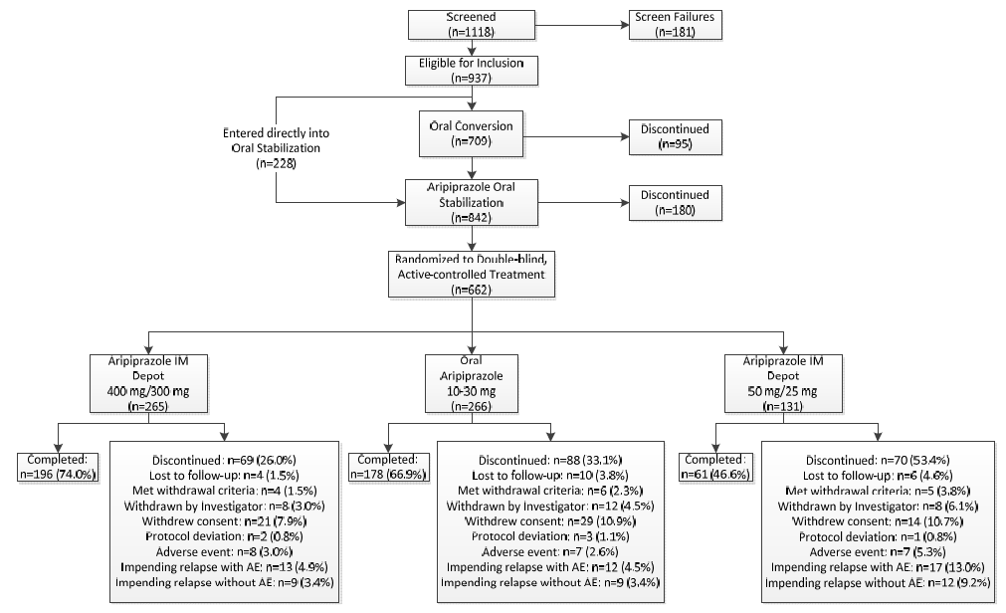

Major protocol violations/deviations
The most common type of major protocol deviation during the entire trial were procedural, primarily procedures that were not completed at the required time point (55.5%, 58.6%, and 64.9% of subjects in the aripiprazole IM depot 400/300 mg, oral aripiprazole tablets 10-30 mg, and aripiprazole IM depot 50/25mg groups, respectively). Major protocol deviations in concomitant medication use were the next most common type of protocol deviation in the aripiprazole IM depot groups (26.8% and 20.6% of subjects in the aripiprazole IM depot 400/300 mg and aripiprazole IM depot 50/25mg groups, respectively).
Table 15. Major protocol deviations by type - Phase III and total (randomized subjects)
Aripiprazole Phase III treatment | Study phase | N¹ | Deviation Classification
Aripiprazole Phase III treatment | Study phase | N¹ | Dosing | Concomitant medications | Procedural | Total
Aripiprazole Phase III treatment | Study phase | N¹ | N² (%)² | N² (%)² | N² (%)² | N² (%)²
ARIP IMD 400/300MG | Phase III | 265 | 30 (11.3) | 46 (17.4) | 109 (41.1) | 141 (53.2)
ARIP IMD 400/300MG | Total | 265 | 35 (13.2) | 71 (26.8) | 147 (55.5) | 180 (67.9)
ARIP 10-30MG | Phase III | 266 | 45 (16.9) | 30 (11.3) | 129 (48.5) | 162 (60.9)
ARIP 10-30MG | Total | 266 | 58 (21.8) | 46 (17.3) | 156 (58.6) | 185 (69.5)
ARIP IMD 50/25MG | Phase III | 131 | 15 (11.5) | 18 (13.7) | 75 (57.3) | 90 (68.7)
ARIP IMD 50/25MG | Total | 131 | 21 (16.0) | 27 (20.6) | 85 (64.9) | 100 (76.3)
¹N is the total number of subjects randomized into the specified Phase III treatment group. ²n is the number of subjects with protocol deviation; the denominator for percentage calculation is N.

Baseline data
Most subjects randomized were male (406/662, 61.3%), Caucasian (387/662, 58.5%), and non-Hispanic/Latino (564/662, 85.2%). The percentages of Black or African American and Asian subjects were 23.1% (153/662 subjects) and 10.4% (69/662 subjects), respectively. The mean age was 41.2 years (range, 18 to 60 years) and mean BMI was 28.8 kg/m² (range, 17.3 to 57.6 kg/m²). Demographics were similar among the 3 treatment groups.

Results for the primary efficacy outcome
The new primary endpoint of the estimated proportion of subjects experiencing impending relapse by end of Week 26 was 7.12% in the aripiprazole IM depot 400/300 mg group and 7.76% in the oral aripiprazole tablets 10-30 mg group, a difference of −0.64%. The 95% CI (−5.26, 3.99) for the difference in the estimated proportion of subjects experiencing impending relapse by end of Week 26 excluded the predefined non-inferiority margin, 11.5%. Based on which aripiprazole IM depot 400/300 mg is non-inferior to the aripiprazole oral tablets 10-30 mg formulation.
When the unblinded and duplicate-entry subjects are excluded the treatment difference between the aripiprazole IM depot 400/300 mg group and the oral aripiprazole tablets group in the estimated proportion of subjects experiencing impending relapse by end of Week 26 was −1.50 (in favour of the aripiprazole IM depot 400/300 mg group), and the 95% CI for the difference was −6.01, 3.02, which excluded the predefined non-inferiority margin, 11.5%.
The proportion of subjects experiencing impending relapse by end of Week 26 for the aripiprazole IM depot 400/300 mg group was 7.12%, which was statistically significantly lower than that in the aripiprazole IM depot 50/25mg group (21.80%; p = 0.0006).
The original primary endpoint required first to show statistical superiority of IM depot 400/300 mg over IM depot 50/25mg group (HR.317 95%CI 0.182, 0.552; p < 0.0001), then non-inferiority of IM depot 400/300 mg to oral tablets 10-30 mg could be tested. If the upper bound of the HR CI was lower than 1.68, then non-inferiority of aripiprazole IM depot (400 or 300 mg) to oral aripiprazole could be declared. The upper bound for the original primary objective and endpoint did exceed 1.68 (0.991, 95% CI 0.545, 1.803; p = 0.9920).
Table 16. Analysis of proportion of subjects with impending relapse by end of week 26 (double-blind, active-controlled phase efficacy sample)
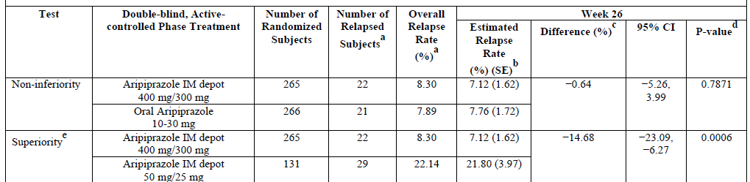
ª The summary statistics are based on all available relapse data for all subjects in the efficacy sample. ^{b} Relapse rates are estimated from the Kaplan-Meier curves for time to impending relapse at Day 182 (Week 26) and SEs were calculated using Greenwood’s formula. ^{c} Difference = estimated relapse rate for aripiprazole IM depot 400 mg/300 mg group minus estimated relapse rate for the oral aripiprazole tablets 10-30 mg group in the non-inferiority test, or aripiprazole IM depot 50 mg/25mg in the superiority test. ^{d} P-values were derived using z-statistics. ^{e} Superiority comparison was done to test assay sensitivity for the non-inferiority study design.
Table 17. Analysis of time to impending relapse (double-blind, active-controlled phase efficacy sample)
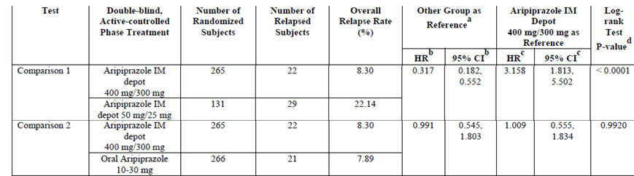
ª Other group is aripiprazole oral tablets 10-30 mg in comparison 1 and aripiprazole IM depot 50 mg/25mg in comparison 2. ^{b} Hazard ratios (HRs) and their 95% CIs were derived from the Cox proportional hazard model with treatment as term. HR < 1 is in favour of IM depot 400 mg/300 mg group for comparison 2. ^{c} Hazard ratios and their 95% CIs were derived from the Cox proportional hazard model with treatment as term. HR > 1 is in favour of IM depot 400 mg/300 mg group for comparison 2. ^{d} P-values were derived from the log-rank test for time to impending relapse.
Figure 17. Kaplan-Meier product limit plot of time to impending relapse (double-blind, active-controlled phase efficacy sample)
ARIP = aripiprazole; IMD = IM depot

Results for other efficacy outcomes
The proportion of responders at last visit was 89.8% (237/264) for IM depot 400/300 mg with 89.4% (235/263) on oral 10 - 30 mg tablets, no significant difference between them could be shown (p = 0.8750). For IM depot 50/25mg the proportion of responders at last visit was 75.2% (97/129) which was statistically significantly from the IM depot 400/300 mg result.
The proportion of subjects achieving remission was 48.8% (105/215) for IM depot 400/300 mg with 53.2% (107/201) on oral 10 -30 mg tablets, no significant difference between them could be shown (p = 0.3700). For IM depot 50/25mg 59.7% (43/72) achieved remission for which no significant difference could be shown from the IM depot 400/300 mg.

Other efficacy studies
There were 5 other efficacy studies, the submitted abbreviated study reports show they were only submitted for safety and were thus not fully evaluated:
- 31-08-003 - A Multicenter, Active-controlled Double-blind, Parallel Group-comparison Trial to Investigate the Efficacy and Safety of Aripiprazole IM Depot (OPC-14597IMD) Compared with Aripiprazole Tablets in Patients with Schizophrenia.
- 31-08-248 - A 52-week, Multicenter, Open-label Study to Evaluate the Effectiveness of Aripiprazole Intramuscular Depot as Maintenance Treatment in Patients with Schizophrenia ‘ASPIRE OPEN-LABEL’ (Aripiprazole Intramuscular Depot Program in Schizophrenia).
- 31-11-283 - A Multicenter, Open-label Study to Assess Hospitalization Rates in Adult Subjects with Schizophrenia Treated Prospectively for 6 Months with Aripiprazole IM Depot Compared with 6-month Retrospective Treatment with Oral Antipsychotics in a Naturalistic Community Setting in the US.
- 31-10-270 - An Open-Label, Multicenter, Rollover, Long-term Study of Aripiprazole Intramuscular Depot in Patients with Schizophrenia.
- 31-11-284 - A Multicenter, Open-label Study to Assess Hospitalization Rates in Adult Subjects with Schizophrenia.

Evaluator’s conclusions on clinical efficacy for the treatment of schizophrenia

Guidance
CPMP/EWP/49/01 Appendix to the Note for Guidance on the Clinical Investigation of Medicinal Products in the Treatment of Schizophrenia - Methodology of Clinical Trials Concerning the Development of Depot Preparations of Approved Medicinal Products in Schizophrenia.
- The efficacy and safety of the compound are known and it is not necessary to show this in itself for the depot formulation, provided no specific claims are made.
- It is of importance to know whether the new formulation affects efficacy or safety in comparison to the oral formulation.
- The purpose of the study is to show non-inferiority of the depot formulation versus the oral formulation. This can be done in various ways, e.g., by showing that the situation at baseline is maintained or improved to the same extent, or by using relapse/deterioration as endpoint.
- The results should demonstrate non-inferiority. The non-inferiority margin should be defined in advance and justified, taking into account among others, the available efficacy data and the patient population, the duration of the trial and the endpoint.
- Assay sensitivity needs to be addressed. One way to address this could be to include a placebo arm. Alternatively the trial could include various dose arms.
- Placebo, as an additional arm would ensure assay sensitivity, but might be less feasible in this setting.
- Efficacy should be scored by using appropriate scales, the choice of which should be justified. Maintenance of effect can be assessed by comparing scores at baseline and end of the trial. Relapse/deterioration, expressed as number of patients relapsing and/or time to relapse is another option and might be a more sensitive.
- Duration of 3 months of the double blind maintenance period will be acceptable, depending on the inter-injection interval, but a longer duration (e.g. 6 months) might increase the assurance that the study indeed has sufficient assay sensitivity.
CPMP/EWP/2330/99 Points to Consider on Application with 1. Meta-Analyses; 2. One Pivotal Study
The fundamental requirement on the Phase III documentation is that it consists of adequate and well-controlled data of good quality from a sufficient number of patients, with a sufficient variety of symptoms and disease conditions, collected by a sufficient number of investigators, demonstrating a positive benefit/risk in the intended population at the intended dose and manner of use.
The minimum requirement is generally one controlled study with statistically compelling and clinically relevant results.
Special attention will be paid to:
- The internal validity. There should be no indications of a potential bias.
- The external validity. The study population should be suitable for extrapolation to the population to be treated.
- Clinical relevance. The estimated size of treatment benefit must be large enough to be clinically valuable.
- The degree of statistical significance. Statistical evidence considerably stronger than p < 0.05 is usually required, accompanied by precise estimates of treatment effects, that is, narrow confidence intervals. The required degree of significance will depend on factors such as the therapeutic indication the primary endpoint, the amount of supportive data and whether the alternative analyses demonstrating consistency are pre-specified. When the aim is to demonstrate non-inferiority, one study is more likely to be accepted if the lower 95% confidence bound is well away from the non-inferiority margin.
- Data quality.
- Internal consistency. Similar effects demonstrated in different pre-specified sub-populations. All-important endpoints showing similar findings.
- Centre effects. None of the study centres should dominate the overall result, neither in terms of number of subjects nor in terms of magnitude of effect.
- The plausibility of the hypothesis tested.

Evaluator’s conclusions
The submission rests for efficacy on 2 studies.
Study 31-07-246 was a comparison with placebo that by its interim analysis was able to show efficacy and in order to minimise exposure of participants to placebo was terminated after the interim analysis. Thus the sponsor says the requirements of efficacy for FDA registration were met.
At 3 months there were 123 patients on aripiprazole IM depot and 47 on placebo. PK data suggests steady state is reached by the 4th injection (that is, at the end of 3 months after the initial injection).
Study 31-07-247 was intended to compare efficacy of the IM depot with the oral formulation and ensure assay sensitivity by using various dose arms. However despite there not being provision for an interim analysis, some analysis was undertaken because, almost 3years into the trial, the primary efficacy endpoint was changed because of a lower than anticipated relapse rate. As a result the primary efficacy endpoint was changed from ‘time from randomization to exacerbation of psychotic symptoms/impending relapse in Phase III’ to ‘the proportion of subjects experiencing exacerbation of psychotic symptoms/impending relapse by end of 26 weeks of treatment from the date of randomization in Phase III, in schizophrenic subjects who have maintained stability on oral aripiprazole for at least 8 consecutive weeks in Phase II of the study.’ Although not submitted there must have been a change to the primary objective too since it refers to the primary endpoint in specific terms. This also means that the non-inferiority margin was no longer predefined. The original primary endpoint failed to meet the non-inferiority margins.
The options this evaluator sees for study 31-07-247are
- To reject it on the basis that it has flawed methodology from changing the primary endpoint (and hence the primary objective) mid-study.
- To accept the methodology as constituting a new trial started mid study. This leaves the original study abandoned as a failure (it failed to achieve its primary endpoint anyway). It also requires a new population since one of the exclusion criteria precluded the use of the original trial participants in the new trial. Even if this is overlooked, and the new trial is accepted as incorporating the original population as well, the 2 results (from the first part of the trial versus the second part of the trial) cancel each other for efficacy.
This evaluator believes the former – rejection on the basis of flawed methodology is the appropriate approach.
The other studies looking at various aspects of efficacy were incomplete at the time of submission and were submitted for evidence of safety. The PK comparison of oral and IM formulations while showing comparability of AUC, show very different C_{max} results as well as there being concerns of sub therapeutic concentrations. The evidence of efficacy of the IM depot formulation thus rests on the single study 31-07-246.

Clinical safety

Studies providing evaluable safety data
The main safety data set was from pooling data from the double-blind phases of the 2 completed Phase III trials (Controlled Trials).
Pooled data from any of the aripiprazole IM depot schizophrenia trials (except Trial 031-08-003) was used to allow detection of rare events, (All Trials).

Pivotal efficacy studies
In the pivotal efficacy studies, the following safety data were collected:
General adverse events (AEs) were assessed by frequency, severity, seriousness, and discontinuation.
AEs of particular interest, including injection site reactions, were assessed by:
- Injection site pain during the IM Depot Stabilization Phase and the Double-blind, Placebo-controlled Phase was assessed by using a visual analogue scale (VAS) as reported by the subject before and 1 hour (± 15 minutes) after each injection together with the investigator rating of pain, redness, swelling, and induration at the injection site.
- The CGI-SS and the Columbia Suicide Severity Rating Scale (C-SSRS) were used to assess the risk of suicidal events and to classify reported suicide events. The Columbia Classification Algorithm of Suicide Assessment (C-CASA) was used to classify potential suicidality events recorded on the AE form.
The incidence of potentially clinically relevant changes was calculated for vital sign abnormalities (including body weight) and laboratory test abnormalities.

Other studies evaluable for safety only
(Data cut-off date 02 April 2012).

Study 31-08-003
Submitted as a synopsis only to provide supportive safety data. Data was not pooled as this study remained double-blinded at the time of submission.
An ongoing, randomized, multicenter, double-blind, double-dummy, active-controlled, parallel group-comparison trial to investigate the efficacy and safety of aripiprazole IM depot (OPC-14597IMD) compared with aripiprazole tablets in patients with schizophrenia. Conducted in 91 sites in Asia, from 7 July 2010 to 2 April 2012.

Study 31-08-248
In this abbreviated CSR, results are presented primarily for an evaluation of safety parameters for data available as of the data cut-off date. No formal statistical analyses were planned due to the open-label nature of this trial.
A, multi-center, open-label study (an extension of Trials 246/247 and de novo subjects) to evaluate the effectiveness of aripiprazole intramuscular depot as maintenance treatment in patients with schizophrenia ‘ASPIRE OPEN-LABEL’ (aripiprazole intramuscular depot program in schizophrenia).

Study 31-11-283
In this abbreviated CSR, results are presented primarily for an evaluation of safety parameters and for selected efficacy parameters for data available as of the data cut-off date (02 April 2012). The primary efficacy endpoint is not analysed for this abbreviated report as only one subject completed the Open-label IM Depot Treatment Phase at the time of the report.
A multicenter, open-label study to assess hospitalization rates in adult subjects with schizophrenia treated prospectively for 6 months with aripiprazole IM depot compared with 6-month retrospective treatment with oral antipsychotics in a naturalistic community setting in the US.
In this interim CSR, results are presented primarily for an evaluation of safety parameters for data available as of the data cut-off date (02 April 2012).

Study 31-10-270
Due to the open-label single-arm nature of the trial, all endpoints are summarized using descriptive statistics.
An Open-Label, Multicenter, Rollover, Long-term Study of Aripiprazole Intramuscular Depot in Patients with Schizophrenia.

Study 31-11-284
The protocol only was submitted for this study.
A Multicenter, Open-label Study to Assess Hospitalization Rates in Adult Subjects with Schizophrenia.

Patient exposure
At the time of cut-off (2 April 2012):
- Overall, 1,624 adult subjects with schizophrenia had received aripiprazole IM depot (15-400 mg),
- 1,539 subjects had received aripiprazole IM depot 400/300 mg,
- 995 subjects have received ≥ 7 aripiprazole IM depot 400/300 mg injections (that is, had been treated for ≥ 6 months),
- 784 subjects had received ≥ 13 injections (that is, have been treated for ≥ 12 months),
- 244 subjects have received ≥ 26 injections (that is, have been treated for ≥ 24 months).
Table 18. Exposure to Aripiprazole IM depot by number of consecutive injections (controlled trials)
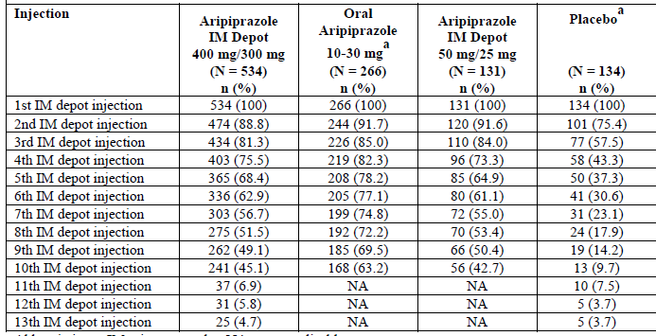
ª Matching placebo injection. NA = not applicable. Up to 10 injections in Trial 31-07-247 and up to 13 injections in Trial 31-07-246.
Table 19. Extent of exposure to Aripiprazole IM depot: subjects having ≥ 1 Aripiprazole IM Depot injection (all trials)
Number of subjects | ARIP-IMD < 300 mg | ARIP-IMD 300-400 mg | ARIP-IMD 15-400 mg
Treated | 168 | 1539 | 1624
Total aripiprazole IMD injections | 948 | 21030 | 21978
Total days of exposure to aripiprazole IMD | 26428 | 590702 | 617130
Total years of exposure to aripiprazole IMD (PEY)¹ | 72.4 | 1617.3 | 1689.6
¹PEY = Subjects total days of exposure to Aripiprazole IMD / 365.25

Adverse events

All adverse events (irrespective of relationship to study treatment)

Controlled trials
The only TEAE reported for ≥ 10% of aripiprazole IM depot 400/300 mg subjects was insomnia (58/534 subjects, 10.9%), which was reported in 37/266 (13.9%) oral aripiprazole tablets 10-30 mg subjects, 18/131 (13.7%) aripiprazole IM depot 50/25mg subjects, and 12/134 (9.0%) placebo subjects. AEs reported for ≥ 5% but < 10% of aripiprazole IM depot 400/300 mg subjects were increased weight (50/534, 9.4%), akathesia (43/534, 8.1%), headache (42/534, 7.9%), anxiety (35/534, 6.6%), decreased weight (35/534, 6.6%), nasopharyngitis (31/534, 5.8%), and injection site pain (28/534, 5.2%).
Table 20. Summary of AEs during double-blind treatment phases (controlled trials)
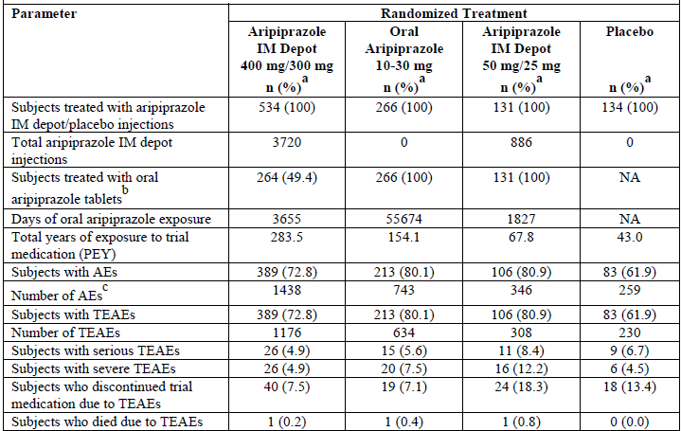
PEY = patient-exposure years; TEAE was defined as an AE which started after commencement of randomized, double-blind trial medication, or an event that continued from baseline or from the end of the specific previous other treatment period, and became serious, worsening, trial medication-related, or resulted in death, discontinuation, interruption, or reduction of trial medication during the current treatment period. Subjects with multiple occurrences of TEAEs are counted only once per specific category. ª Percentages are based on the number of treated randomized subjects. ^{b} During double-blind phase (includes concurrent oral aripiprazole tablet administration in the aripiprazole IM depot treatment groups during the first 14 days of double-blind treatment in Trial 31-07-247; not applicable for Trial 31-07-246 because subjects received concurrent oral aripiprazole in IM Depot Stabilization Phase). ^{c} Number of AEs = Total number of all records of reported AEs.

All trials
Table 21. Summary of AEs in subjects having ≥ 1 Aripiprazole IM depot injection (all trials)
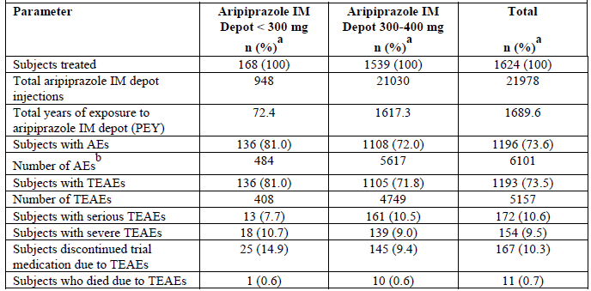
PEY = patient-exposure years; TEAE was defined as an AE which started after commencement of aripiprazole IM depot injection, or an event that continued from baseline or from the end of the specific previous other treatment period, and became serious, worsening, trial medication-related, or resulted in death, discontinuation, interruption, or reduction of trial medication during the current treatment period. Subjects with multiple occurrences of TEAEs are counted only once per specific category. 83 subjects received aripiprazole IM depot 50 mg/25mg in Trial 31-07-247 and also received aripiprazole IM depot 400 mg/300 mg in Trial 31-08-248; these subjects are counted once in the total (aripiprazole IM depot 15-400 mg) column. ª Percentages are based on the number of subjects treated with aripiprazole IM depot. ^{b} Number of AEs = Total number of all records of reported AEs.

Treatment-related adverse events (adverse drug reactions)

Controlled trials
AEs potentially related to trial medication reported for ≥ 5% and < 10% of aripiprazole IM depot 400/300 mg subjects were increased weight (48/534, 9.0%), akathesia (42/534, 7.9%), insomnia (31/534, 5.8%), and injection site pain (27/534, 5.1%). There were 7 (1.3%) subjects on IM depot 400/300 mg with extrapyramidal disorder, 2 (0.8%) on tablets and 0 among those on placebo.
Table 22. Potentially trial medication-related AEs reported for ≥ 1% subjects in any double-blind treatment group (controlled trials). table continued across two pages.
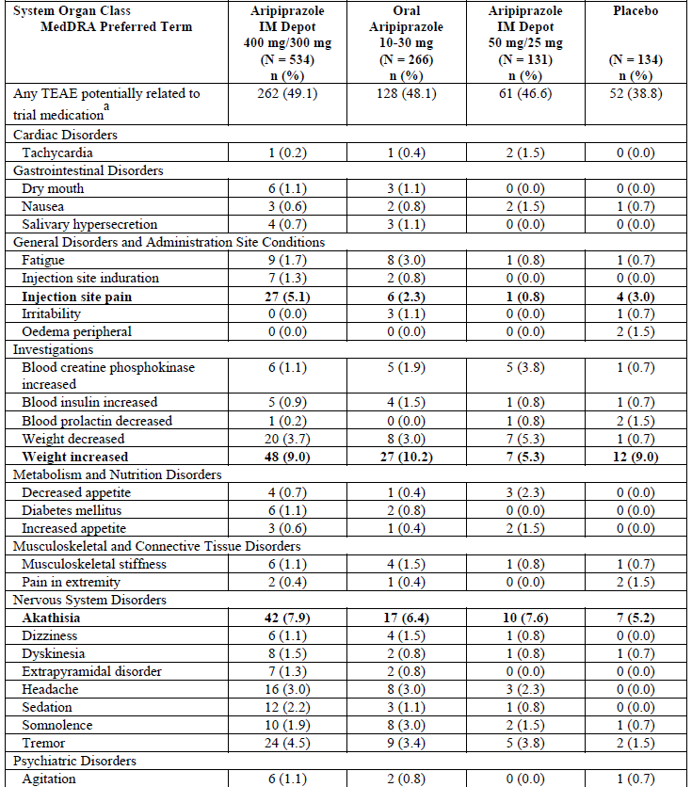
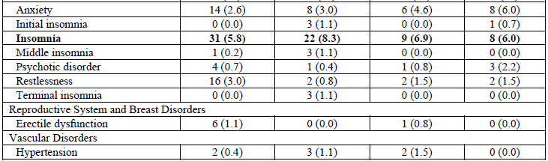
TEAE was defined as an AE which started after commencement of randomized, double-blind trial medication, or an event that continued from baseline or from the end of the specific previous other treatment period, and became serious, worsening, trial medication-related, or resulted in death, discontinuation, interruption, or reduction of trial medication during the current treatment period. Subjects with multiple occurrences of TEAEs are counted only once per specific category. Bolded events were reported for ≥ 5% subjects in the aripiprazole IM depot 400/300 mg group. ª As assessed by investigator.

All trials
AEs potentially related to trial medication for ≥ 5% and < 10% of aripiprazole IM depot 300-400 mg subjects were increased weight (105/1539, 6.8%), akathesia (104/1539, 6.8%), injection site pain (103/1539, 6.7%), and insomnia (79/1539, 5.1%).

Deaths and other serious adverse events

Controlled trials
Deaths. There was 1 death – not related to treatment.
SAEs. The only SAEs reported for ≥ 1% of aripiprazole IM depot 400/300 mg subjects were schizophrenia and psychotic disorder.

All trials
Deaths. There was 1 death felt possibly related in a 34y old who had received IM depot for 6 months who died a sudden cardiac death with a diagnosis of Brugada syndrome. There was 1 death felt possibly related in a 60y old who had received IM depot for 6 months who died of a cardiac arrest.
There were 6 deaths not related to treatment.
SAEs. The only SAEs reported for ≥ 1% of aripiprazole IM depot 400/300 mg subjects were schizophrenia and psychotic disorder.

Discontinuation due to adverse events
The only AEs resulting in trial medication discontinuation reported for ≥ 1% of aripiprazole IM depot 400/300 mg subjects were psychotic disorder and schizophrenia in both data sets. Nervous System Disorders (Dyskinesia, Dystonia and Tremor) caused 4 (0.8%) discontinuations on IM depot, but none on tablets.

Laboratory tests
No clinically relevant mean changes from baseline in serum chemistry, haematology, urinalysis, or other laboratory test (insulin, fasting insulin, and prolactin levels) results were observed during the Double-blind, Active-controlled Phase of Trials 31-07-247 and 31-07-246, nor were there any clinically relevant findings with regard to laboratory values in other aripiprazole IM depot trials, including the IM Depot Stabilization Phase of Trial 31-07-246.

Other clinical chemistry

Controlled trials
AEs related to glucose metabolism occurred in 4/534 (0.7%) subjects on IM depot 400/300 mg (increased blood glucose in 3/534 [0.6%], decreased blood glucose in 1/534 [0.2%], and glucose present in urine in 1/534 [0.2%] subjects); 2/266 (0.8%) subjects on tablets (increased blood glucose in 1/266 [0.4%] and impaired glucose tolerance in 1/266 [0.4%] subjects); and no placebo subject had AEs related to glucose metabolism.
AEs related to lipids occurred in 8/534 (1.5%) subjects on IM depot 400/300 mg (increased blood triglycerides in 5/534 [0.9%], hypercholesterolaemia in 2/534 [0.4%], decreased blood cholesterol in 1/534 [0.2%], and decreased blood triglycerides in 1/534 [0.2%] subjects) and no subjects on tablets or placebo had AEs related to lipid parameters.
Decreased blood prolactin was reported as an AE for 1/534 (0.2%) subjects on IM depot 400/300 mg and 2/134 (1.5%) placebo subjects. Hyperprolactinaemia was also reported in 1/134 (0.7%) placebo subjects. No subjects on tablets experienced an AE related to prolactin levels.

Haematology

Pivotal studies

Study 31-07-246
Potentially clinically relevant low WBC counts (≤ 2.8 thous/mcL) were reported for 3/139 placebo and no aripiprazole 400/300 mg IM depot patients. Potentially clinically relevant low neutrophil counts (≤ 1.5 thous/mcL) were reported for 1/139 placebo and 2/269 aripiprazole 400/300 mg IM depot patients. 1 patient on aripiprazole 400/300 mg IM depot had potentially clinically relevant high eosinophil counts (≥ 10%).

Study 31-07-247
Potentially clinically relevant low WBC counts (≤ 2.8 thous/mcL) 6/260 (2.3%) aripiprazole IM depot 400/300 mg subjects, 2/258 (0.8%) oral aripiprazole tablets 10-30 mg subjects, and no (0/128, 0.0%) aripiprazole IM depot 50/25mg subjects. Four (1.6%) of 258 oral aripiprazole tablets 10-30 mg subjects also had a potentially clinically relevant high WBC count. No aripiprazole IM depot 50/25mg subjects had a potentially clinically relevant low or high WBC value.

Electrocardiograph
No clinically relevant mean changes from baseline were observed in ECG parameters during the Double-blind, Active-controlled Phase of Trials 31-07-247 and 31-07-246, nor were there any clinically relevant mean changes from baseline observed in ECG parameters in other aripiprazole IM depot trials, including the IM Depot Stabilization Phase of Trial 31-07-246.
Potentially clinically relevant ECG abnormalities reported in Trial 31-07-247 for ≥ 1% of subjects on IM depot 400/300 mg during the Double-blind, Active-controlled Phase were supraventricular premature beat (12/253, 4.7%), symmetrical T-wave inversion (11/253, 4.3%), ventricular premature beat (9/253, 3.6%), bradycardia (4/253, 1.6%), and sinus bradycardia (3/253, 1.2%); while reported for ≥ 1% of subjects on tablets they were supraventricular premature beat (12/248, 4.8%), symmetrical T-wave inversion (11/248, 4.4%), ventricular premature beat (9/248, 3.6%), myocardial ischemia (3/248, 1.2%), and QTcB (3/248, 1.2%).

QT interval - controlled trials
1/534 (0.2%) subjects on IM depot 400/300 mg had an AE related to QT interval change (prolonged ECG QT). There were no other QT changes.

Vital signs
No clinically relevant mean changes from baseline were observed in vital signs parameters (including weight, waist circumference, and BMI) during the Double-blind, Active-controlled Phase of Trials 31-07-247 and 31-07-246, nor were there any clinically relevant mean changes from baseline observed in vital signs in other aripiprazole IM depot trials, including the IM Depot Stabilization Phase of Trial 31-07-246.

Orthostasis - controlled trials
2/534 (0.4%) subjects on IM depot 400/300 mg, 2/266 (0.8%) subjects on tablets, had AEs related to orthostasis. No placebo subject had AEs related to orthostasis.

Safety issues with the potential for major regulatory impact

Injection site reactions

Controlled trials
37/534 (6.9%) subjects on IM depot 400/300 mg, 7/266 (2.6%) subjects on tablets, 1/131 (0.8%) subjects on IM depot 50/25mg, and 5/134 (3.7%) placebo subjects experienced AEs related to the injection site. Injection site reactions reported by subjects on tablets included injection site pain (6/266, 2.3%), injection site erythema (3/266, 1.1%), and injection site induration and injection site swelling (each in 2/266, 0.8%). In the placebo group, injection site-related TEAEs included injection site pain (5/134, 3.7%) and injection site erythema (1/134, 0.7%).
In the IM depot 50/25mg group, injection site-related AEs included injection site pain (1/131, 0.8%). In the aripiprazole IM depot 400/300 mg group, injection site-related AEs included injection site pain (28/534 subjects, 5.2%), injection site induration (8/534, 1.5%), injection site swelling (3/534, 0.6%), injection site erythema (3/534, 0.6%), and injection site discomfort, injection site pruritis, injection site reaction, and vessel puncture site pain (each in 1/534, 0.2%).

VAS Scores and Investigator Assessments
Trial 31-07-247 Double-blind, Active-controlled Phase, the subjects mean VAS pain score on IM depot 400/300 mg was 5.6 after the first injection and 3.7 after the last, for subjects on tablets mean VAS was 4.9 (first injection) and 3.5 (last injection), for IM depot 50/25mg mean VAS was 3.3 (first injection) and 2.4 (last injection).
Investigators rated pain, redness, swelling, and induration with IM depot 400/300 mg as absent in 81.4% to 98.1% of subjects after the first injection and absent in 88.3% to 98.9% after the last injection, for subjects on tablets pain, redness, swelling and induration were absent in 83.3% to 98.5% (first injection) and 90.2% to 99.6% (last injection).
For IM depot 50/25mg they were absent in 90.7% to 99.2% (first injection) and 90.0% to 99.2% (last injection).
Trial 31-07-246 Double-blind, Placebo-controlled Phase, the subjects mean VAS pain score on IM depot 400/300 mg was 5.1 after the first injection and 4.0 after the last, for placebo subjects mean VAS were 5.1 (first injection) and 4.9 (last injection).
Investigators rated pain, redness, swelling, and induration for subjects on IM depot 400/300 mg, as absent in 80.1% to 98.1% of subjects after the first injection, and as absent in 84.4% to 98.5% of subjects after the last injection, for subjects on placebo was absent in 72.2% to 97.7% of (first injection) and 77.3% to 97.7% (last injection).

All trials
121/1539 (7.9%) aripiprazole IM depot 400/300 mg subjects had AEs related to the injection site.
The overall incidence of AEs related to the injection site in subjects treated with aripiprazole IM depot 400/300 mg was 9.3% (108/1160) for subjects treated ≥ 3 months and 11.3% (25/221) for subjects treated ≥ 24 months.
There were increases in the incidence of the following injection site-related AEs in subjects with longer exposure to aripiprazole IM depot 400/300 mg injection site pain (95/1160 [8.2%] for subjects treated ≥ 3 months and 20/221 [9.0%] subjects treated for ≥ 24 months) and injection site induration (12/1160 [1.0%] and 6/221 [2.7%], respectively).

Liver toxicity

Controlled trials
No potential Hy’s Law cases were identified during the Double-blind Phase of either study.
One subject in study 31-07-247 had laboratory results meeting the criteria for Hy’s Law during the Oral Stabilization Phase, 2 days later, during the Double-blind, Active-controlled Treatment Phase, abnormal hepatic function was reported as a TEAE for this subject. This event resolved and was considered mild in severity and unrelated to trial medication. No action was taken regarding trial medication due to this event.

Suicide
Controlled Trials: 6/534 (1.1%) subjects on IM depot 400/300 mg, 1/266 (0.4%) subjects on tablets, 3/131 (2.3%) on IM depot 50/25mg and no placebo subjects had an AE that was considered related to suicidal ideation/suicide.

Increased weight
Controlled Trials: Increased weight was a reported AE for 50/534 (9.4%) subjects on IM depot 400/300 mg, 35/266 (13.2%) subjects on tablets and 13/134 (9.7%) placebo subjects. Decreased weight was reported for 35/534 (6.6%) subjects on IM depot 400/300 mg, 16/266 (6.0%) subjects on tablets, and 4/134 (3.0%) placebo subjects.
Table 23. Incidence of potentially clinically relevant weight gain and weight loss in double-blind, active-controlled phase (subjects treated in double-blind phase of trial 31-07-247)
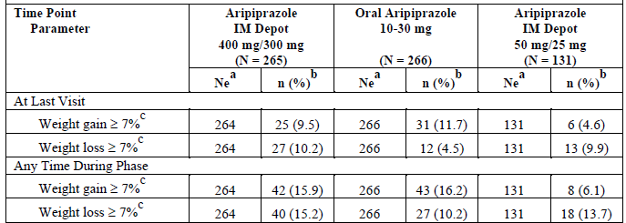
ª Ne is the total number of subjects with a post-baseline weight result at the visit. ^{b} n is the number of subjects meeting the criteria for potential clinical relevance. ^{c} Change from Double-blind, Active-controlled Phase baseline.

Convulsions
Controlled Trials: 1/131 (0.8%) subjects on IM depot 50/25mg and 1/134 (0.7%) placebo subjects had AEs of convulsions/seizures. No aripiprazole IM depot 400/300 mg subjects or tablets subjects had AEs of convulsions/seizures.

All trials
2/1539 (0.1%) aripiprazole IM depot 400/300 mg subjects had AEs related to convulsions/seizures within ≤ 3 months.

Hepatic impairment
This had previously been studied (31-98-205) with a single oral dose. No new studies with IM depot. The sponsor comments Of note, in patients with severe hepatic impairment, the data available may be insufficient to establish recommendations. In these patients dosing should be managed cautiously; use of oral aripiprazole should be considered.

Renal impairment
This had previously been studied (31-98-208) with a single oral dose. No new studies with IM depot. The Abilify PI states In patients with severe renal impairment (creatinine clearance < 30 mL/min), Cmax of aripiprazole (given in a single dose of 15mg) and dehydro-aripiprazole increased by 36% and 53%, respectively, but AUC was 15% lower for aripiprazole and 7% higher for dehydro-aripiprazole. Renal excretion of both unchanged aripiprazole and dehydro-aripiprazole is less than 1% of the dose. No dosage adjustment is required in subjects with renal impairment.

Other safety issues

Safety in special populations

Elderly
Pop PK Report 31-11-287 age ranged from 18 to 62y, Pop PK Report 31-12-292 included that population and those of Study 31-07-247 age range 18 to 60y, Study 31-07-246 age range 18 to 61y.
Of the other Safety /Efficacy studies only Study 31-11-283 had a population range that exceeded 60y (18- 65y) and in that study only 1 (aged 48y) of the 142 patients had completed the full 24-week treatment period at the time of the report.
The sponsor did look at the number of subjects with AEs by age and found little effect but then the grouping comparison was between < 45y and ≥ 45y. However the number of subjects with SAEs were greater with increased age on all treatments except IM depot 50/25mg and subject discontinuations due to AEs were likewise doubled in IM depot 400/300 mg and tablet subjects. The age grouping had an effect on the incidence of some AEs as did sex.

BMI
BMI > 28kg/m² had some increased effect on the number of subjects with AEs but the AEs diabetes and hyperglycaemia were among those AEs.

Safety related to CYP2D6 metabolizer status

Study 31-07-246
Single-blind aripiprazole IM Depot Stabilization Phase:
- Of 31 poor metabolisers none discontinued due to AEs or had SAEs, and 18 (58.1%) had AEs.
- Of 499 extensive metabolisers 25 (5.0%) discontinued due to AEs, 23 (4.6%) had SAEs and 296 (59.3%) had AEs.
- 46 subjects of unknown metabolic status 3 (6.5%) discontinued due to AEs, 2 (4.3%) had SAEs and 31 (67.4%) had AEs.
Double-blind, Placebo-controlled Phase:
IM depot 400/300 mg group:
- Of 13 poor metabolisers 1 (7.7%) discontinued due to AEs, none had SAEs and 10 (76.9%) had AEs.
- Of 239 extensive metabolisers 16 (6.7%) discontinued due to AEs, 9 (3.8%) had SAEs and 148 (61.9%) had AEs.
- Of 17 subjects of unknown metabolic status 2 (11.8%) discontinued due to AEs, 2 (11.8%) had SAEs and 12 (70.6%) had AEs.
Placebo group:
- Of 11 poor metabolisers 1 (9.1%) discontinued due to AEs, 1 (9.1%) had an SAE and 8 (72.7%) had AEs.
- Of 112 extensive metabolisers 14 (12.5%) discontinued due to AEs, 6 (5.4%) had SAEs and 69 (61.6%) had AEs.
- Of 11 subjects of unknown metabolic Status 3 (27.3%) discontinued due to AEs, 2 (18.2%) had SAEs and 6 (54.5%) had AEs.
Study 31-07-247 Double-blind, Active-controlled Phase IM depot 400/300 mg group:
- Of 6 poor metabolisers none discontinued due to AEs or had SAEs, 4 (66.7%) had AEs.
- Of 234 extensive metabolisers 21 (9.0%) discontinued due to AEs, 15(6.4%) had SAEs and 195 (83.3%) AEs.
- Among 25 subjects of unknown metabolic status none discontinued due to AEs or had SAEs, 20 (80.0%) had AEs.

Safety related to drug-drug interactions and other interactions
For the aripiprazole IM depot formulation, no additional drug-drug interaction trials were conducted and simulation and modelling based on results of drug-drug interaction trials of oral aripiprazole as well as the population PK analysis of aripiprazole IM depot were performed to guide dose adjustments in different situations when a drug-drug interaction is expected.
Due to the prolonged-release characteristics of aripiprazole IM depot, and based on the results of simulation and modelling, short-term ≤ 14 days) co administration of inhibitors of CYP3A4 with aripiprazole IM depot does not require a dose adjustment. When long-term co administration of aripiprazole IM depot with CYP3A4 inhibitors is required, the monthly maintenance dose of aripiprazole IM depot should be reduced from 400 mg to 300 mg or 300 to 200 mg.
Due to the slow and prolonged-release characteristics of aripiprazole IM depot, and based on the results of simulation and modelling, short-term (≤ 14 days) co administration of an inhibitor of CYP2D6, such as quinidine, with aripiprazole IM depot does not require a dose adjustment. However, a dose reduction of the recommended monthly aripiprazole IM depot maintenance dose of 400 mg to 300 mg or 300 mg to 200 mg is required with long-term concomitant administration of CYP2D6 inhibitors with aripiprazole IM depot.

Analysis by region
In the Controlled Trials, EU subjects comprised 28.8% (154/534) of subjects treated with IM depot 400/300 mg, and during double-blind treatment the number of subjects with AEs was lower for EU subjects than for non-EU subjects in all treatment groups.

Timing of scoring of adverse effects
Subjects treated with aripiprazole IM depot 400/300 mg who had a dosing gap ≤ 4 weeks had a lower incidence of AEs (629/956, 65.8%) than subjects with longer dosing gaps (range 75.7% to 84.8%). The incidence of serious AEs by dosing gap in subjects treated with aripiprazole IM depot 400/300 mg ranged from 8.3% (27/324) in subjects with a dosing gap 5-8 weeks to 18.2% (6/33) in subjects with a dosing gap of 13-16 weeks. The incidence of AEs resulting in discontinuation of trial medication by dosing gap ranged from 5.4% (2/37) in subjects with a dosing gap of 17-20 weeks to 18.2% (6/33) in subjects with a dosing gap of 13-16 weeks.
Of the 1,539 subjects treated with aripiprazole IM depot 400/300 mg , 1,160 subjects had ≥ 3 months exposure, 997 subjects had ≥ 6 months exposure, 739 subjects had ≥ 12 months exposure, 509 subjects had ≥ 18 months exposure, and 221 subjects had ≥ 24 months exposure. There were increases in the incidence of the following AEs with longer exposure to aripiprazole IM depot 400/300 mg:
- atrioventricular block first degree (0.5% for exposure ≥ 3 months to 1.4% for exposure ≥ 24 months),
- injection site induration (1.0% and 2.7%, respectively),
- injection site pain (8.2% and 9.0%, respectively),
- decreased blood pressure (0.3% and 1.4%, respectively),
- increased weight (9.4% and 13.1%, respectively),
- decreased weight (5.0% and 5.9%,respectively),
- diabetes mellitus (1.0% and 1.4%, respectively),
- hyperlipidaemia (1.0% and 2.7%, respectively),
- arthralgia (5.1% and 8.1%, respectively).

Evaluator’s overall conclusions on clinical safety

Guidance
CPMP/EWP/49/01 Appendix to the Note for Guidance on the Clinical Investigation of Medicinal Products in the Treatment of Schizophrenia - Methodology of Clinical Trials Concerning the Development of Depot Preparations of Approved Medicinal Products in Schizophrenia.
- It is of importance to know whether the new formulation affects efficacy or safety in comparison to the oral formulation.
- Product-related and dose-related adverse effects are known from the oral formulation, but the database of the depot formulation should be checked for comparability and unexpected adverse effects.
- In addition local adverse effects should be assessed specifically.
- Timing of scoring of adverse effects should be justified, especially in case the plasma levels from each injection should exceed the corresponding levels from oral administration for a substantial part of the inter-injection interval.
- Depending on the type of formulation the possibility of a sudden increase in absorption and subsequently in side effects should be addressed.
- Data over a 6-month period will usually be sufficient, but this might depend on the length of the inter-injection interval.

Evaluator’s conclusions
In the controlled studies injection site reactions were greater (6.9%) with IM depot 300/400 mg than with the placebo used with (2.6%) or without (3.7%) oral tablets and they appeared to be dose related (0.8% on 25/50 mg IM depot).
In the controlled trials suicidal ideation/suicide appeared greater (1.1%) with IM depot 400/300 mg than on tablets (0.4%).
Otherwise the AEs were comparable.
The dosing gap appears to be appropriate in terms of incidence of AEs.
There is sufficient duration of safety exposure.
The lack of safety data in the elderly is of concern, particularly as the number of subjects with SAEs were greater with increased age > 45y and discontinuations due to AEs were likewise doubled. However the effect of age >45y on SAEs and discontinuations appears to also apply to the oral formulation.

First round benefit-risk assessment

First round assessment of benefits
The benefits of Abilify Maintena in the proposed usage are:
Study 31-07-246 showed that time to impending relapse was significantly shorter for subjects on placebo compared with subjects on aripiprazole IM depot 400/300 mg in the Double-blind, Placebo-controlled Phase (p < 0.0001 log-rank test). The hazard ratio from the Cox proportional hazard model for the placebo to aripiprazole IM depot comparison was 5.029 (95% CI = 3.154, 8.018).
The provision of a depot formulation for those patients who respond to aripiprazole means:
- The possibility of better adherence/oversight of compliance compared to oral medication.
- A decreased demand on health care providers compared with administration of the IM regimen.

First round assessment of risks
The risks of Abilify Maintena in the proposed usage are:
- An increased risk of suicidal ideation/suicide.
- The risk of injection site reactions.
- The lack of adequate data in the elderly.
- While oral formulation study in patients with severe renal impairment showed AUC was 15% lower for aripiprazole, C_{max} was 36% higher, suggesting the possibility of mean sub-therapeutic levels towards the end of the cycle.
- Most of the existing risks associated with Abilify oral or IM formulations.

First round assessment of benefit-risk balance
The benefit-risk balance of Abilify Maintena is unfavourable given the proposed usage, but would become favourable if the changes recommended in Section 9 are adopted.

First round recommendation regarding authorisation
The sponsors propose the Indication:
For the treatment of schizophrenia.
It is not recommended that the submitted proposed Indication be approved.
In both Studies submitted (31-07-246 and 31-07-247) initial treatment with IM depot was associated with oral treatment for the first 14 days. The sponsors support for the use of a sole injection of 400 mg Abilify Maintena is based on a PopPK analysis with no clinical or PK/PD studies.
Analysis of a single 400 mg IM depot dose is shown to achieve mean sub-therapeutic levels for the first and last 3 days of the initial treatment cycle, presumably extensive metabolisers will fare worse (see Figure 3).
It is recommended that Abilify Maintena be approved for the added Indication of:
For the maintenance of clinical improvement in the treatment of schizophrenia

Clinical questions
The evaluator submitted four questions relating to the draft PI and CMI documents. The details of these are beyond the scope of this AusPAR.

Second round benefit-risk assessment
As in the first round assessment.

Second round recommendation regarding authorisation
As in the first round assessment.

Therapeutic Goods Administration
PO Box 100 Woden ACT 2606 Australia
Email: info@tga.gov.au Phone: 1800 020 653 Fax: 02 6232 8605
http://www.tga.gov.au

2.5 Clinical Overview page 1
Of these 31-98-208 and CN38-022 were incomplete in that submission.
A protocol synopsis only was submitted with no results.
This study treatment comprised aripiprazole tablets (10 to 30 mg/day), for 14days and to patients with a diagnosis of Bipolar I Disorder, who were clinically stable on lamotrigine, that is, not relevant to this submission to register a different formulation with a different Indication.
This study treatment comprised Aripiprazole, 2mg and 5mg tablets, flexibly dosed (2mg, 5mg, 10 mg, 15mg, and 20 mg once daily) for 6 weeks and to patients with a diagnosis of major depressive disorder, that is, not relevant to this submission to register a different formulation with a different Indication.
This study had its primary endpoint ( and hence primary objective and non – inferiority margin) amended almost 3 years into the trial.
These studies looked at various aspects of efficacy but were not completed so were submitted for safety data only.
2.5 Clinical Overview page 7
Data from Trial CN138016 were not used in the analysis, as this trial did not have an IM Depot treatment arm and the oral treatment arm used a low 5mg dose.
1,255 aripiprazole concentration records from 372 subjects enrolled in the 50 mg or 400 mg IM depot
896 aripiprazole concentration records from 251 subjects enrolled in the 400 mg IM Depot treatment arm for the double-blind period
2.7.4 Summary of Clinical Safety page 8
2.7.2 Summary of Clinical Pharmacology Studies page 56
There were 2 new oral Interaction studies in this submission but they were related to Indications other than that applied for in this submission and were thus not evaluated.
defined as > 3 consecutive days without medication
Only after one cycle plus 14 days had elapsed from the date of the last IM depot injection or 60 days since the last injection of an investigational IM depot formulation.
defined as fulfilment of ALL of the following criteria for 8 consecutive weeks, with the possibility of one excursion from stability criteria during the 8-week period, as long as the excursion did not occur on the final visit of the Oral Stabilization Phase: 1) Outpatient status AND 2)PANSS Total Score 80 AND 3) Lack of specific psychotic symptoms on the PANSS as measured by a score of ≤ 4 on each of the following items (possible scores of 1 to 7 for each item): conceptual disorganization, suspiciousness, hallucinatory behaviour, unusual thought content, AND 4) CGI-S ≤ 4 (moderately ill) AND 5) CGI-SS ≤ 2 (mildly suicidal) on Part 1 and ≤ 5 (minimally worsened) on Part 2
a matching placebo was not available (the placebo used was clear, not milky white like IM aripiprazole depot)
defined as meeting any or all of the following 4 criteria: Clinical Global Impression of Improvement (CGI-I) of ≥ 5 (minimally worse) AND an increase on any of the following individual Positive and Negative Syndrome Scale (PANSS) items (conceptual disorganization, hallucinatory behavior, suspiciousness, unusual thought content) to a score > 4 with an absolute increase of ≥ 2 on that specific item since randomization OR an increase on any of the following individual PANSS items (conceptual disorganization, hallucinatory behavior, suspiciousness, unusual thought content) to a score > 4 and an absolute increase of ≥ 4 on the combined 4 PANSS items (conceptual disorganization, hallucinatory behavior, suspiciousness, unusual thought content) since randomization OR Hospitalization due to worsening of psychotic symptoms (including partial hospitalization programs), but excluding hospitalization for psychosocial reasons OR Clinical Global Impression of Severity of Suicide (CGI-SS) of 4 (severely suicidal) or 5 (attempted suicide) on Part 1 and/or 6 (much worse) or 7 (very much worse) on Part 2 OR Violent behaviour resulting in clinically relevant self-injury, injury to another person, or property damage
compared in the Double-blind,Placebo-controlled Phase between the aripiprazole IM depot treatment group and the placebo group
The protocol was amended mid study (see 19.5) in relation to the secondary endpoints an hierarchical system of analysis was removed (this would have meant ceasing the analysis after Proportion of responders and Proportion of subjects achieving remission). PSP(Personal and Social Performance Scale) was removed from the secondary endpoints.
defined as a score of ≤ 3 on each of the following specific PANSS items, maintained for a period of 6 months: delusions (P1), unusual thought content (G9), hallucinatory behavior (P3), conceptual disorganization (P2), mannerisms/posturing (G5), blunted affect (N1), social withdrawal (N4), lack of spontaneity (N6)
considering that, the exacerbation criteria in this trial were somewhat stricter than the relapse criteria in the previous trial
at the endpoint of the Double-blind, Placebo-controlled Phase
The protocol was amended mid study in relation to the secondary endpoints an hierarchical system of analysis was removed (this would have meant ceasing the analysis after Proportion of responders and Proportion of subjects achieving remission). PNS was removed from the secondary endpoints.
defined as > 3 consecutive days without medication
Only after one cycle plus 14 days had elapsed from the date of the last IM depot injection or 60 days since the last injection of an investigational IM depot formulation.
defined as fulfilment of ALL of the following criteria for 8 consecutive weeks, with the possibility of one excursion from stability criteria during the 8-week period, as long as the excursion did not occur on the final visit of the Oral Stabilization Phase: 1) Outpatient status AND 2)PANSS Total Score 80 AND 3) Lack of specific psychotic symptoms on the PANSS as measured by a score of ≤ 4 on each of the following items (possible scores of 1 to 7 for each item):conceptual disorganization, suspiciousness, hallucinatory behaviour unusual thought content, AND 4) CGI-S ≤ 4 (moderately ill) AND 5) CGI-SS ≤ 2 (mildly suicidal) on Part 1 and ≤ 5 (minimally worsened) on Part 2
included as a low-dose aripiprazole group to test assay sensitivity
defined as meeting any or all of the following 4 criteria: 1) Clinical Global Impression of Improvement (CGI-I) of ≥ 5 (minimally worse) AND an increase on any of the following individual PANSS items (conceptual disorganization, hallucinatory behaviour, suspiciousness, unusual thought content) to a score > 4 with an absolute increase of ≥ 2 on that specific item since randomization OR an increase on any of the following individual PANSS items (conceptual disorganization, hallucinatory behaviour, suspiciousness, unusual thought content) to a score > 4 and an absolute increase of ≥ 4 on the combined 4 PANSS items (conceptual disorganization, hallucinatory behaviour, suspiciousness, unusual thought content) since randomization. OR 2) Hospitalization due to worsening of psychotic symptoms (including partial hospitalization programs), but excluding hospitalization for psychosocial reasons OR 3) Clinical Global Impression of Severity of Suicide (CGI-SS) of 4 (severely suicidal) or 5 (attempted suicide) on Part 1 and/or 6 (much worse) or 7 (very much worse) on Part 2 OR 4) Violent behaviour resulting in clinically relevant self-injury, injury to another person, or property damage.
defined as meeting impending relapse criteria;
defined as meeting stability criteria
defined as a score of ≤ 3 on each of the following specific PANSS items, maintained for a period of 6 months: delusions (P1), unusual thought content (G9), hallucinatory behaviour (P3), conceptual disorganization (P2), mannerisms/posturing (G5), blunted affect (N1), social withdrawal (N4), and lack of spontaneity (N6)
Using a 95% (two-sided) CI for the HR (aripiprazole IM depot 400 or 300 mg vs. oral aripiprazole)
Subjects who received any investigational agent in a clinical trial within 30 days prior to screening or who were randomized into a clinical trial with aripiprazole IM depot at any time. NOTE: Subjects who discontinued at any phase of the trial (Conversion Phase to the Double-blind, Active-controlled Phase) were not eligible and could not be rescreened to enter the trial.
Abbreviated Clinical Study Report 31-08-248 page 56
Abbreviated Clinical Study Report 31-11-283 page 56
Abbreviated Clinical Study Report 31-10-270 page 22
Deaths are those recoded on Depot IM aripiprazole
Subjects randomized to placebo and to oral aripiprazole received a placebo IM depot injection
Within 30 minutes before and 1 hour (± 15 minutes) after each IM depot injection and at each trial visit
Subjects assigned to treatment with IM depot received oral matching placebo tablets, and those assigned to oral aripiprazole tablets received IM depot matching placebo (either high-dose IM depot placebo or low-dose IM depot placebo).
For the age subgroup analysis, 45 years was used as a cut-off point as very few subjects enrolled in any aripiprazole IM depot trial were ≥ 60 years of age. 2.7.4 Summary of Clinical Safety p33
Prior to this phase these subjects had received aripiprazole
2.7.4 Summary of Clinical Safety page 141, 142
2.7.4 Summary of Clinical Safety page 143
Dose dumping was considered under PKs
It would be very rare to start a patient on a depot preparation, as e.g. dose titration is not possible, an acute effect may be needed or undesirable effects may occur, in which case the preparation cannot be withdrawn CPMP/EWP/49/01 Appendix to the Note for Guidance on the Clinical Investigation of Medicinal Products in the Treatment of Schizophrenia - Methodology of Clinical Trials Concerning the Development of Depot Preparations of Approved Medicinal Products in Schizophrenia.

