First Round 30 April 2015
Second Round 31 August 2015

AusPAR Attachment 2

Extract from the Clinical Evaluation Report for American House Dust Mite / European House Dust Mite allergen extracts
  - Proprietary Product Name: Actair initiation treatment and Actair continuation treatment
  - Sponsor: Stallergenes Australia Pty Ltd

About the Therapeutic Goods Administration (TGA)
- The Therapeutic Goods Administration (TGA) is part of the Australian Government Department of Health, and is responsible for regulating medicines and medical devices.
- The TGA administers the Therapeutic Goods Act 1989 (the Act), applying a risk management approach designed to ensure therapeutic goods supplied in Australia meet acceptable standards of quality, safety and efficacy (performance), when necessary.
- The work of the TGA is based on applying scientific and clinical expertise to decision-making, to ensure that the benefits to consumers outweigh any risks associated with the use of medicines and medical devices.
- The TGA relies on the public, healthcare professionals and industry to report problems with medicines or medical devices. TGA investigates reports received by it to determine any necessary regulatory action.
- To report a problem with a medicine or medical device, please see the information on the TGA website < https://www.tga.gov.au> .
About the Extract from the Clinical Evaluation Report
- This document provides a more detailed evaluation of the clinical findings, extracted from the Clinical Evaluation Report (CER) prepared by the TGA. This extract does not include sections from the CER regarding product documentation or post market activities.
- The words [Information redacted], where they appear in this document, indicate that confidential information has been deleted.
- For the most recent Product Information (PI), please refer to the TGA website < https://www.tga.gov.au/product-information-pi> .
Copyright
© Commonwealth of Australia 2017
This work is copyright. You may reproduce the whole or part of this work in unaltered form for your own personal use or, if you are part of an organisation, for internal use within your organisation, but only if you or your organisation do not use the reproduction for any commercial purpose and retain this copyright notice and all disclaimer notices as part of that reproduction. Apart from rights to use as permitted by the Copyright Act 1968 or allowed by this copyright notice, all other rights are reserved and you are not allowed to reproduce the whole or any part of this work in any way (electronic or otherwise) without first being given specific written permission from the Commonwealth to do so. Requests and inquiries concerning reproduction and rights are to be sent to the TGA Copyright Officer, Therapeutic Goods Administration, PO Box 100, Woden ACT 2606 or emailed to < tga.copyright@tga.gov.au> .

Contents
List of abbreviations 5
1. Introduction 8
1.1. Drug class and therapeutic indication 8
1.2. Dosage forms and strengths 8
1.3. Dosage and administration 8
2. Clinical rationale 9
2.1. Formulation 10
3. Contents of the clinical dossier 10
3.1. Scope of the clinical dossier 10
3.2. Paediatric data 11
3.3. Good clinical practice 11
4. Pharmacokinetics 11
4.1. Studies providing pharmacokinetic data 11
4.2. Summary of pharmacokinetics 11
5. Pharmacodynamics 12
5.1. Studies providing pharmacodynamic data 12
5.2. Summary of pharmacodynamics 13
5.3. Evaluator’s overall conclusions on pharmacodynamics 15
6. Dosage selection for the pivotal studies 15
7. Clinical efficacy 15
7.1. Pivotal efficacy studies 15
7.2. Other efficacy studies 40
7.3. Analyses performed across trials (pooled analyses and meta-analyses) 53
7.4. Evaluator’s conclusions on clinical efficacy for treatment of HDM allergy 53
8. Clinical safety 54
8.1. Studies providing evaluable safety data 54
8.2. Patient exposure 55
8.3. Adverse events 57
8.4. Laboratory tests 68
8.5. Physical Examination and Vital signs 68
8.6. Post-marketing experience 68
8.7. Other safety issues 69
8.8. Evaluator’s overall conclusions on clinical safety 69
9. First round benefit-risk assessment 69
9.1. First round assessment of benefits 69
9.2. First round assessment of risks 69
9.3. First round assessment of benefit-risk balance 69
10. First round recommendation regarding authorisation 69
11. Clinical questions 69
12. Second round evaluation of clinical data submitted in response to questions 70
13. Second round benefit-risk assessment 70
13.1. Second round assessment of benefits 70
13.2. Second round assessment of risks 70
13.3. Second round assessment of benefit-risk balance 70
14. Second round recommendation regarding authorisation 70
15. References 70

List of abbreviations
Abbreviation | Meaning
AASS | Average Adjusted Symptom Score
ABN | Australian Biological Name
ACS | Average Combined Score
ASS | Adjusted Symptom Score
AdolRQLQ | Adolescent Rhinoconjunctivitis Quality of Life Questionnaire
AE | Adverse Event
AIHW | Australian Institute of Health and Welfare
AIT | Allergen Immunotherapy
AR | Allergic Rhinitis
AUC | Area under the curve
ANCOVA | Analysis of Covariance
ARMS | Average Rescue Medication Score
ARSS | Average Rhinoconjunctivitis Symptom Score
ARTSS | Average Rhinitis Total Symptom Score
ATRSS | Average Total Rhinoconjunctivitis Symptom Score
Ch_{BL} | Change from Baseline
CI | Confidence Interval
CMH | Cochran-Mantel-Haenszel
D far | Dermatophagoides farinae
D pte | Dermatophagoides pteronyssinus
DSMB | data and safety monitoring board
EEC-specific QOLQ | Environmental Exposure Chamber-specific Quality of Life Questionnaire
EMA/CHMP/EWP | European Medicines Agency’s/Committee for Medicinal Products in Human Use/Efficacy Working Party
EPP | Ear Palate Pruritus
EU | Europe
FAS | Full Analysis Set
FDA | Food and Drug Administration (USA)
FEV₁ | Forced Expiratory Volume in one second
GCP | Good Clinical Practice
GINA | Global Initiative for Asthma
HDM | House Dust Mites
ICH | International Conference on Harmonization
Ig | Immunoglobulin
IR | Index of Reactivity
JRQLQ | Japanese Allergic Rhinitis Standard QOL Questionnaire
LOCF | Last Observation Carried Forward
LS | Least Squares
MMRM | Mixed-effects Model for Repeated Measures
NA | Not Applicable
PI | Product Information
PRQLQ | Pediatric Rhinoconjunctivitis Quality of Life Questionnaire
RMP | Risk Management Plan
RQLQ | Rhinoconjunctivitis Quality of Life Questionnaire
RTSS | Rhinitis Total Symptom Score
S-524101 | Sublingual tablet of house dust mite extracts
SC | Subcutaneous
SCIT | Subcutaneous Immunotherapy
SL | Sublingual
SLIT | Sublingual Immunotherapy
SOC | System Organ Class
SPT | Skin Prick Test
TEAE | Treatment-Emergent Adverse Event
TNNSS | Total Non-Nasal Symptom Score
TOSS | Total Ocular Symptom Score
VAS | Visual Analogue Scale

Introduction
This is a full submission to register a new dose form (sublingual tablet) and a new route of administration (sublingual) of the previously approved active substance extracts of American and European house dust mites (DHM).

Drug class and therapeutic indication
The product consists of extracts of allergenic source materials from 2 different HDM species, namely Dermatophagoides pteronyssinus (D. pte) and Dermatophagoides farinae (D. far) (referred to in Australia by the Australian Biological Names (ABN) of European House Dust Mite and American House Dust Mite, respectively).
This application is for Actair which is a sublingual tablet presentation of the same 50% mixture of the European and American house mite allergen extracts as used in the Alustal products. The approved indication of Alustal is:
Alustal treatment is indicated for patients with Type 1 allergy (Gell and Coombs classification), particularly presenting as seasonal or perennial rhinitis, conjunctivitis, rhinoconjunctivitis with or without associated asthma.
The proposed indication for Actair is:
Treatment of house dust mite allergic rhinitis with or without conjunctivitis in adults, adolescents and children (above the age of 5) diagnosed with house dust mite allergy.

Dosage forms and strengths
The following dosage forms and strengths are currently registered:
AUST R 132725: Alustal House Dust Mites Extract European house dust mite and American house dust mite injection suspension vial composite pack - Composite pack containing 3 vials: 1 each of 0.1 IR/mL, 1.0 IR/mL, 10.0 IR/mL
AUST R 132680: Alustal House Dust Mites Extract European house dust mite and American house dust mite injection suspension vial - a single vial containing 10.0 IR/mL
The submission proposes registration of the following dosage forms and strengths:
Actair initiation treatment: a composite pack containing 100 IR and 300IR sublingual tablets
Actair continuation treatment: 300 IR sublingual tablets.

Dosage and administration
The submitted PI contains the following:
Treatment with Actair should only be prescribed and initiated by physicians with adequate training and experience in the treatment of allergic diseases. In the case of paediatric treatment, the physicians should have the corresponding training and experience in children.
It is recommended that the first tablet of Actair is taken under medical supervision and that the patient is monitored for 30 minutes.

Method of administration
On the first day, one 100 IR tablet should be taken. Tablets must be placed under the tongue until complete disintegration and then swallowed. On the second day of treatment, two 100 IR tablets must be placed under the tongue simultaneously and then swallowed.
It is recommended that the tablets be taken during the day in an empty mouth.

Dose regimen in adults, adolescents and children (above the age of 5)
The therapy is composed of an initiation treatment (including a 3 day dose escalation) and a continuation treatment.
The initiation treatment pack corresponds to the first month of treatment with Actair 100 IR and 300 IR sublingual tablets:
Figure 1: Depiction of dosage regime
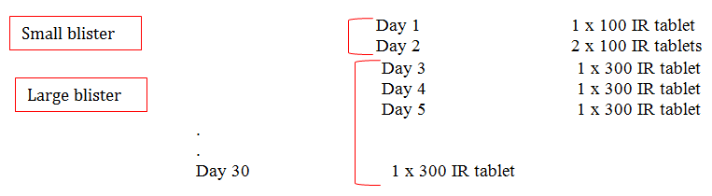
From the 2nd month onwards, treatment must be continued with the continuation treatment packs, with one Actair 300 IR sublingual tablet per day until the end of treatment.
Study 1 has shown that, after one year of treatment in adults, efficacy is demonstrated during the subsequent treatment free year.

Duration of treatment
Efficacy has been demonstrated for one year of treatment with additional clinical data available for one year post-treatment.

Special population
Clinical experience on immunotherapy with Actair in patients older than 65 years is lacking.

Paediatric population
The safety and efficacy of Actair in children below the age of 5 years is lacking.

Clinical rationale
Allergic rhinitis (AR) is a chronic disorder of the upper airways that is caused by allergen exposure and the resulting IgE mediated inflammation of the nose and to a less extent, the eyes (allergic rhinoconjunctivitis). Symptoms include sneezing, runny nose, nasal itching and nasal congestion. Untreated or inadequately treated AR can cause sleep disturbance, daytime fatigue and somnolence as well as depressed mood, irritability, and behavioural problems. Patients affected by AR are also at increased risk for the development of asthma. AR is a worldwide disease affecting over 500 million people including approximately 3.1 million Australians (Bousquet et al 2008 and AIHW 2011).
Current treatment options for AR are allergen avoidance, symptomatic pharmacotherapy, and allergen specific immunotherapy. However, mite avoidance measures are not generally effective. Symptomatic treatment options include antihistamines, intranasal corticosteroids, and leukotriene modifiers. These provide temporary relief from allergy symptoms but are not effective in all patients and are not disease modifying. In addition, pharmacotherapy may be associated with significant side effects such as sedative and anticholinergic effects for antihistamines, dryness and epistaxis for intranasal corticosteroids and neuropsychiatric reactions for leukotriene modifiers.
Allergen specific immunotherapy (AIT) is a therapeutic option for patients whose symptoms are not adequately controlled by avoidance measures or medications, those experiencing unacceptable adverse effects of medications, or those who wish to reduce the long term use of medications. The primary therapeutic goals of AIT include reducing symptoms, reducing medication use, and improving allergy related quality of life. The evidence is strong that AIT achieves these goals and can be disease modifying, with benefits persisting in many patients for several years after treatment discontinuation (Bousquet et al 2008, Lin et al 2013).
The clinical efficacy of subcutaneous immunotherapy (SCIT) is well established for rhinitis (Lin et al 2013). Patients typically receive injections twice monthly or monthly for 3 to 5 years. However, despite the documented benefits of SCIT, less than 5% of the US population with AR, asthma, or both receive this potentially disease modifying treatment. This limited uptake of SCIT is likely due to the risk of near fatal or fatal anaphylaxis as well as the discomfit and inconvenience of frequent injections.
Sublingual immunotherapy (SLIT) is an alternative to SCIT with similar efficacy and a favourable safety profile (Canonica et al 2009). Patients self-administer a liquid or tablet under the tongue daily for periods ranging from 3 to 5 years. As of 2009, approximately 45% of AIT in Europe was SLIT (Cox and Jacobsen, 2009).

Formulation
HDM tablets are solid preparations to be applied under the tongue. HDM tablets are manufactured by direct compression of the drug substance with microcrystalline cellulose, croscarmellose sodium, colloidal anhydrous silica, magnesium stearate, and lactose monohydrate. Except for lactose monohydrate, these direct compression excipients are present in the tablet in fixed quantities (Table 1). The variable amount of drug substance used to obtain the desired dose is compensated for by lactose monohydrate, acting as a direct compression diluent.

Contents of the clinical dossier

Scope of the clinical dossier
The clinical dossier comprised a development program consisting of a dose finding study and efficacy and tolerability studies.
The submission contained the following clinical information:
- No PK/PD studies
- 7 studies in Section 5.3.51 Controlled trials. These studies comprised
  - 1 x clinical pharmacology Study (VO67.10) that provided dose finding and pharmacodynamic data
  - 2 x pivotal efficacy/safety Studies (VO57.07, and 1207D1731)
  - 1 x other study in children (VO64.08)
  - 3 x other safety and tolerability Studies (VO36.04F, 1109D1711 and VO73.13).
The 5 studies numbered VOXX were conducted by the sponsor of the product Stallergenes S.A. while the other 2 studies were conducted by the Japanese partner company Shionogi and Co Ltd.
- Clinical Overview, Summary of Clinical Efficacy, Summary of Clinical Safety and literature references.

Paediatric data
The submission included paediatric efficacy and safety data.

Good clinical practice
The clinical study reports (CSR) state that all studies were conducted and written informed consent obtained in accordance with the ethical principles of the 5th Declaration of Helsinki and any amendments (World Medical Association General Assembly, Tokyo 2004) that were in place when the study started, the International Conference on Harmonisation (ICH) and Good Clinical Practice (GCP) guidelines (CPMP/ICH/135/95, and the explanatory notes and comments, CPMP/768/97), the European Union’s Commission Directives (2001/20/EC, 04 April 2001 and 2005/28/EC, 08 April 2005) as well as the requirements of national drug and data protection laws and other applicable regulatory requirements.
For the studies conducted in Japan the CSR states that the studies were conducted in compliance with the Ministry of Health, Labour, and Welfare Ordinance No. 24 (Feb 29, 2008) Standards for Implementation of Clinical Studies on Drugs (Good Clinical Practice [GCP]).

Pharmacokinetics

Studies providing pharmacokinetic data
Summaries of the pharmacokinetic studies were provided in the CER. Table 1 shows the studies relating to each pharmacokinetic topic.

Table 1: Submitted pharmacokinetic studies
PK topic | Subtopic | Study ID | Primary aim
PK in target population | Dose ranging | VO67.10 | Dose ranging
None of the pharmacokinetic studies had deficiencies that excluded their results from consideration.

Summary of pharmacokinetics
The information in the following summary is derived from conventional pharmacokinetic studies unless otherwise stated.

Physicochemical characteristics of the active substance
The following information is derived from the Sponsor’s summaries.
D. pte and D far belong to the class of Arachnida and to the taxonomic family of Pyroglyphidae.
The drug substance (DS) is an extract of the house dust mites (HDM) Dermatophagoides pteronyssinus (D. pte) and Dermatophagoides farinae (D. far) which has been purified, freeze-dried and sieved. Since mite faeces and bodies contain different allergens known to contribute to patient sensitization, D. far DS and D. pte DS used in HDM sublingual tablets intended for allergen immunotherapy is made from material containing both bodies and faeces. The extracts are mixed together on the basis of a 50%/50% ratio in terms of total allergenic activity.

Pharmacokinetics in healthy subjects
In line with the EU Guideline on the clinical development of products for specific immunotherapy for the treatment of allergic diseases:
“Classical phase I studies in healthy individuals are not appropriate for allergen products, since they do not provide helpful information in terms of safety and tolerability. Non-affected individuals without any hypersensitivity do not react like allergic individuals and do not carry the risk of the targeted patient population. Therefore, products for specific immunotherapy should only be tested in allergic individuals.”

Pharmacokinetics in the target population
In line with the EU Guideline on the clinical development of products for specific immunotherapy for the treatment of allergic diseases:
“Pharmacokinetic studies are not possible for products of specific immunotherapy. During specific immunotherapy usually plasma concentrations of the active substance are not measurable, due to the nature of the product.”

Evaluator’s overall conclusions on pharmacokinetics
No data relevant to PK was provided in the submission. This is accepted given the nature of the product.

Pharmacodynamics

Studies providing pharmacodynamic data
Summaries of the pharmacodynamic studies were provided in the CER. Table 2 shows the studies relating to each pharmacodynamic topic and the location of each study summary.

Table 2: Submitted pharmacodynamic studies
PD Topic | Subtopic | Study ID | Primary Aim
Primary Pharmacology | Effect on Immunological markers | VO67.10 | Dose Ranging
Primary Pharmacology |  | VO57.07 | Efficacy & Safety in adults
Primary Pharmacology |  | VO36.04F | Safety
Primary Pharmacology |  | VO64.08 | Efficacy & Safety in Children
Primary Pharmacology |  | VO73.13 | Safety
Primary Pharmacology |  | 1109D1711 | Safety
Primary Pharmacology |  | 1207D1731 | Efficacy & Safety in Adults
None of the pharmacodynamic studies had deficiencies that excluded their results from consideration.

Summary of pharmacodynamics
The information in the following summary is derived from conventional pharmacodynamic studies in humans unless otherwise stated.

Mechanism of action
The exact mechanism of action of HDM allergen extracts administered within the course of allergen immunotherapy is not yet completely known. Effects on both humoral and cellular immune response have been reported consistently and are likely to contribute to the alleviation of symptoms.
The underlying mechanism of action of sublingual immunotherapy is related to numbers of antigen presenting cells carrying peptides derived from allergens which stimulate resting T cells in the oral lymphoid organs. Serum induction of IgGs represents a pharmacological marker of allergen exposure during treatment with sublingual allergen immunotherapy. Allergen-specific serum IgG4 have been hypothesised to act as blocking antibodies capable of preventing allergen interactions with IgE mediated effector cells leading as a consequence to a decrease in histamine release by basophils and allergen presentation by B lymphocytes.

Primary pharmacodynamic effect
As recommended in the EU guideline, an alternative to classical PD studies is to evaluate the changes in immunological markers in order to document the effect of treatment on the immune system. Therefore changes in the D. pte and D. far specific serum IgE and IgG4 were evaluated in the efficacy and safety clinical trials. In addition the cutaneous reactivity to allergen solutions of D. pte and D. far was assessed by Skin Prick Test (SPT). The cutaneous reactivity to allergen solutions of D. pte and D. far is reflected in the diameter of the wheal induced by the SPT and provides evidence of sensitisation to these allergens.
The results of the immunological markers confirm the immunological activity of HDM tablets in patients with HDM associated allergic rhinitis.
Comment: There is some inconsistency between the study reports and the Summary of Clinical Pharmacology in the results of the serum immunoglobulins and skin allergy reactivity. The Summary presents a more positive response, stating that there were increases, when the study reports state that there was no meaningful change or only a slight numerical increase. The results below are taken from the study reports.

Serum IgE and IgG4
After the 10 day and 14 day treatment period with HDM sublingual tablets in Studies VO36.04F and 1109D1711, a slight increase in serum IgE specific to D pte and D far was observed in the active treatment groups but not in the placebo groups whereas after the 10 day treatment period in Study VO73.13 there was no meaningful change from baseline to end of treatment.
In the studies with a treatment period of 6 to 12 months the ratio (end of treatment period/baseline) of D. pte and D. far specific serum IgE was generally higher in the active groups then in the placebo groups. Serum IgG4 was consistently higher in the active groups than in the placebo groups.

Table 3: Endpoint/Baseline ratio of the D. pteronyssinus and D. farinae specific serum IgE (primary analysis set)
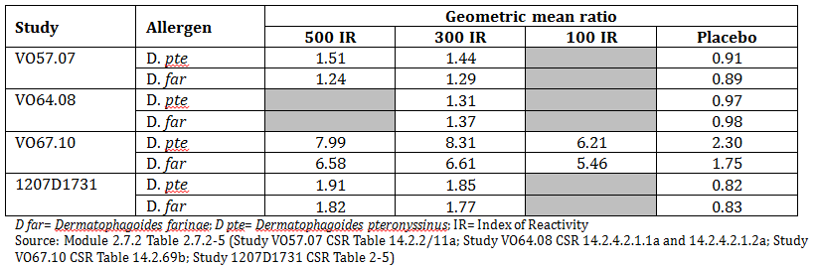

Table 4: Endpoint/Baseline ratio of the D. pteronyssinus and D. farinae specific serum IgG4 (primary analysis set)
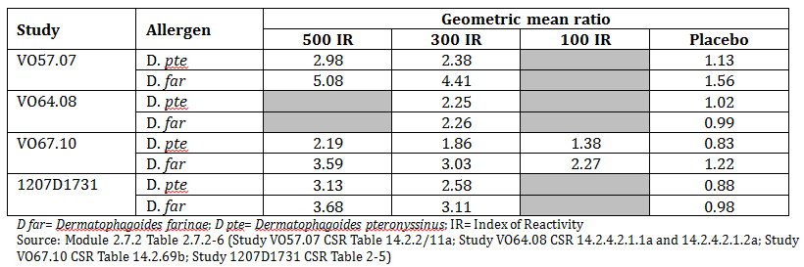

Skin allergic reactivity
In Study VO36.04F where wheal diameters were recorded after the 10 day treatment period the mean D pte and D far SPT wheal diameters were unchanged before and after treatment.
In the longer studies with a treatment periods of 6 to 12 months, the decrease from baseline in mean SPT wheal diameter was larger in the active groups than in the placebo groups.

Table 5: Endpoint change from Baseline of the SPT wheal diameter (mm) for the primary period (primary analysis set)
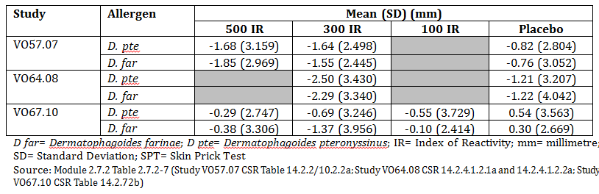

Evaluator’s overall conclusions on pharmacodynamics
The sponsor has made efforts to document the effect of treatment on the immunological markers in each of the clinical studies as required by the EU guideline. The results are confused by the inconsistency in the reporting in the submission with the tendency to overstate the results from the individual studies in the summaries. The results however tend to suggest an immunological activity of the doses of HDM tablets in patients with HDM associated allergic rhinitis.

Dosage selection for the pivotal studies
Comment: The dose selection of 300 IR or 500 IR is not clearly explained in the study reports or the summaries.
The sponsor has established an in-house reference standard for the measurement of total allergenic activity (as required in the EU guideline and EU pharmacopoeia). The potency unit used by the sponsor in this measurement is referred to as the index of reactivity or “IR”. The titre of an allergen extracts corresponds to 100 IR/mL when, in a skin prick test (SPT) performed with the sponsor’s SPT device (the Stallerpoint). In 30 subjects sensitised to the allergen in question, the extract produces a wheal measuring 7 mm in diameter (geometric mean). Skin reactivity in these subjects is simultaneously demonstrated by a positive response to a prick test with 9% codeine phosphate or 10 mg/mL histamine dihydrochloride.
The selection of doses was based on previous experience with sublingual immunotherapy (sublingual solution, Staloral) reported in the literature. Clinical data with this formulation indicated that doses of SLIT with HDM extracts up to 300 IR/day have been well tolerated.
In the Phase I Study VO36.04 incremental doses of SLIT with HDM extracts up to 500 IR and immediate repeated high dose administration of SLIT 300 IR and 500 IR was studied. Three out of five patients included in the immediate 500 IR dose withdrew due to AEs related to treatment indicating that this dose was not considered acceptable. No patients withdrew from the dose escalation to 500 IR suggesting that a longer escalation phase was better tolerated.
A dose response in efficacy was observed across the 100 IR to 500 IR dose range in Study VO67.10
In the pivotal efficacy studies 2 doses were tested 300 IR and 500 IR. In the study in children only the 300 IR dose was tested. The 300 IR dose was chosen as the recommended dose as it was the minimum effective dose in the studies.

Clinical efficacy
Indication: Treatment of House Dust Mite Allergy

Pivotal efficacy studies

Study VO57.07
A randomised, double blind, placebo controlled multi-national Phase II / III Study of the safety and efficacy of two doses of sublingual immunotherapy (SLIT) administered as allergen-based tablets once daily to adult patients suffering from house dust mite allergic rhinitis.

Study design, objectives, locations and dates
A randomised, double blind, placebo controlled, multicentre, multinational study conducted in 48 centres in 7 European countries (Czech Republic, France, Germany, The Netherlands, Poland, Slovakia and Spain) from October 2007 to February 2010.

Primary Objective
To assess the efficacy of approximately 12 months of treatment with HDM SLIT on the Average Adjusted Symptom Score (AASS): a score adjusted according to the daily Rhinitis Total Symptom Scores (RTSSs) and daily rescue medication use, during the increased symptom period in autumn (primary period of year 1).

Secondary Objectives
To assess the efficacy of approximately 12 months of treatment with HDM SLIT, during the increased symptom period (primary period and the complementary period) on:
- Average Rhinitis Total Symptom Score (ARTSS) of the 4 rhinitis symptoms (sneezing, rhinorrhoea, nasal pruritus and nasal congestion)
- Average Rescue Medication Score (ARMS) (antihistamine [oral and eye drops], nasal corticosteroids and oral corticosteroids)
- Average Combined Score (ACS: a score taking into account the RTSS and Rescue Medication Score (RMS)
- Five individual Average Rhinoconjunctivitis Symptom Scores (ARSS) (sneezing, rhinorrhoea, nasal pruritus, nasal congestion and ocular itching)
- Proportion of Symptom Controlled Days (PSCD)
- Overall Rhinoconjunctivitis Quality of Life Questionnaire score (RQLQ)
- Global Evaluation of the efficacy of SLIT by the patient
- Skin Prick Test (SPT) to house dust mite (D. pteronyssinus and D. farinae)
- Immunological markers (IgE and IgG4) specific for HDM allergens
- Asthma assessments
- Sensitisation status change (mono-sensitivity to HDM only or poly-sensitivity (other allergens))
- Onset of action of HDM SLIT
The primary period of year 1 was 1 October to 31 December of year 1 and the complementary period was 1 October to 30 November of study year 1. The complementary period excluded December which is the coldest of the 3 months, to reduce the confounding effect of URTI which are sensitive to conditions of humidity and temperature. The persistence of efficacy was assessed during the treatment free follow up phase in study year 2.
Figure 2: Study VO57.07: Study design
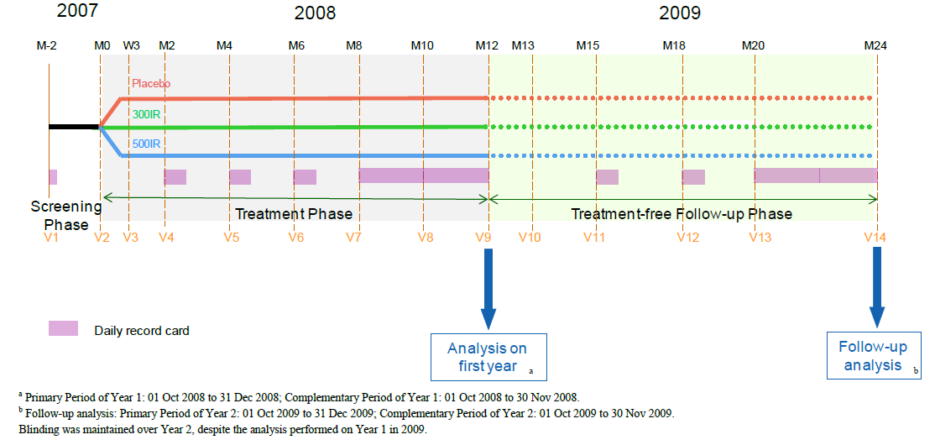

Inclusion and exclusion criteria

Inclusions
- Healthy male or female (non-childbearing potential) outpatients aged 18 to 50 years (inclusive) with history of HDM related rhinitis for at least 1 year
- Diagnosis confirmed by positive SPT to HDM with wheal diameter > 3 mm and specific IgE level of ≥ 0.7 kU/L
- Baseline ARTSS of ≥ 5 on a scale ranging from 0 (no symptoms) to 12 (severe symptoms) during a 7 day period (with at least 4 days of valid data)

Exclusions
- Asthma requiring treatment other than β-2 agonists or with FEV1 < 80% of predicted
- Patients treated with systemic, nasal or inhaled steroids (whatever the indication) within 4 weeks of enrolment
- Co-sensitisation leading to clinically relevant allergic rhinitis, sinusitis, conjunctivitis or asthma likely to significantly change the symptoms of the patient throughout the study (that is patients symptomatic to another allergen than HDMs)
- Patients who had received allergy specific immunotherapy for HDM in the preceding 10 years
- Patients treated with beta-blockers or under continuous corticosteroid therapy or receiving immunotherapy with another allergen.

Study treatments
Patients were randomised to 1 of the 3 treatment groups (either HDM allergen extracts 300 IR or HDM allergen extracts 500 IR or placebo). During the 8 day Incremental Phase, the dose was escalated from 100 IR to the randomised dose. The first dose of the investigational product was administered under the supervision of the Investigator and the patient observed for 30 minutes for the occurrence of any reactions.
During the 8 day Incremental Phase, patients took 2 sublingual tablets daily. Doses were progressively increased by 100 IR every day to reach 300 IR on Day 3 in the 300 IR group, whereas the doses were progressively increased by 100 IR every 2 days to reach 500 IR on Day 9 in the 500 IR group. Patients were instructed to leave the tablet under the tongue until completely dissolved before swallowing.
Rescue medication for the management of severe allergic rhinitis was provided to patients for use only when the rhinitis-related symptoms were severe or intolerable. Each subject was instructed to use the rescue medications in a step-wise manner. First, the subject used an oral or ophthalmic antihistamine (Step 1). If it was difficult to continue the study for the subject with this Step 1 medication alone, the subject was then allowed to use a nasal corticosteroid (Step 2). If it was still difficult to continue the study with this Step 2 medication alone, the subject used an oral or ophthalmic antihistamine in combination with a nasal corticosteroid (Step 3). The allowed medications were:
Step 1: Antihistamine (oral form and/or eye drops); (oral: cetirizine 10 mg, loratadine 10 mg; eye drops: levocabastine 0.5 mg/mL)
Step 2: Nasal corticosteroids if the symptoms did not alleviate (mometasone 50 mcg / dose)
Step 3: If the patient needed oral corticosteroid (Step 3) to manage the rhinitis, the patient was to consult the investigator (prednisone 5 mg, prednisolone 5 mg).

Efficacy variables and outcomes
The primary efficacy outcome was the AASS during the primary period.
The AASS is an average of the daily rhinitis total symptom scores (RTSS) based on the severity of the 4 rhinitis symptoms (sneezing, rhinorrhoea, nasal pruritus and nasal congestion), each graded on a 4 point scale (0 to 3; 0 = absent, 1 = mild, 2 = moderate, 3 = severe) over the previous 24 hours and adjusted for the patient’s rescue medication usage. It was patient specific, and took into account that patients were allowed to make use of any of the 3 categories of rescue medication. When a patient took rescue medication, his/her symptom score was adjusted for the current day and the day after. The AASS ranged from 0 to 12.
Other efficacy outcomes included:
- ARTSS: average of the daily RTSS (that is the sum of the 4 rhinitis symptoms) for each period for each patient. The ARTSS ranged from 0 to 12
- ARMS: average of the daily rescue medication scores (that is the score of rescue medication intake according to a stepwise regimen) for each period for each patient. The ARMS ranged from 0 to 3
- ACS: average of the daily combined score (CS = [RTSS/4 + RMS]/2, ranged between 0 to 3
- ARSS: average of individual rhinoconjunctivitis symptom score: sneezing, rhinorrhoea, nasal pruritus, nasal congestion and ocular itching, each ranging from 0 to 3. Each ARSS was the average of the daily RSS on the considered period and ranged from 0 to 3
- PSCD (%): proportion of symptom controlled days, calculated as 100 x the number of symptom-controlled days for a period/the number of days of the corresponding period of assessment. The PSCD was described in 4 categories: PSCD₀₋₀: proportion of days with RTSS = 0; PSCD₁₋₀: proportion of days with RTSS ≤ 1 and RMS = 0; PSCD₂₋₀: proportion of RTSS ≤ 2 and RMS = 0; PSCD₀₋₀₋₀: proportion of days with ASS_{d} = 0 and RMS_{d-1} = 0 and RMS_{d} = 0
- Onset of action of HDM SLIT, defined as the first visit at which the AASS in the active treatment group differs significantly from the placebo group and the significant difference is maintained for at least 2 consecutive visit periods
- Overall RQLQ score
- Patient Global Evaluation of Treatment Efficacy using a 5 point Likert scale
- Asthma status (yes/no), asthma control test (ACT) score and asthma classification according to GINA 2006
- Change in sensitisation status (mono or poly-sensitisation).
The RQLQ is a self-administered questionnaire developed to measure the problems that adults with rhinoconjunctivitis experience as a result of their nose and eye symptoms. It was designed to evaluate change in a patient’s quality of life over a period of time and was completed at Visit 2 (Randomisation), Visit 9 (Month 12) and Visit 14 (Month 24). Patients were asked to recall their experiences during the previous week and to give their responses on a 7 point Likert scale.
The RQLQ consists of 28 questions, divided into 7 domains as follows:
  - Activities (Questions 1, 2 and 3)
  - Sleep (Questions 4, 5, and 6)
  - Non-nose/eye symptoms (Questions 7, 8, 9, 10, 11, 12 and 13)
  - Practical problems (Questions 14, 15 and16)
  - Nasal symptoms (Questions 17, 18, 19 and 20)
  - Eye symptoms (Questions 21, 22, 23 and 24)
  - Emotions (Questions 25, 26, 27 and 28).
Each item of the RQLQ is evaluated on a 7-point Likert scale (from 0 = ‘not impaired at all’ to 6 = ‘severely impaired’).

Randomisation and blinding methods
Patients were randomised in a 1:1:1 ratio to 1 of the 3 treatment groups using a computer generated randomisation list. The study was double blinded. The investigational products were matched for the number of tablets per treatment box and for the size, shape, colour and taste of the tablets.

Analysis populations

Full Analysis Set (FAS)
The FASY1 included all patients who received at least 1 dose of the investigational product and had at least 1 daily record card evaluation under treatment during Year 1. The FASY2 included all patients who received at least 1 dose of the investigational product in Year 1 and had at least 1 daily record card evaluation during Year 2. FAS_{Y1} = 466 and FAS_{Y2} = 412.

Per Protocol Set (PPS)
The PPSY1 included all patients in the FASY1 who had at least 14 days of valid ASS data on treatment during the Year 1 Primary Period (from 1 October 2008 to 31 December 2008), and who completed Year 1 according to the clinical study protocol and had no major protocol deviations. The PPSY2 included all patients in the FASY2 who had at least 14 days of valid ASS data during the Year 2 Primary Period (from 01 October 2009 to 31 December 2009), and who completed the study according to the protocol and had no major protocol deviations. PPS_{Y1} = 375 and PPS_{Y2} = 344.

Safety set
The Safety Set_{Y1} included all patients who received at least 1 dose of the investigational product. The Safety Set_{Y2} included all patients who completed Year 1. Safety Set_{Y1} = 509 and Safety Set_{Y2} = 427.

Sample size
The sample size was based on the results of a previous study (Study VOX02.94 F not included in the submission). It was determined that a sample size of 136 patients per treatment group would provide at least 80% power to detect a difference of 0.87 between placebo and 300 IR in the AASS, assuming an overall alpha of 0.05 and a common SD of 2.5. Assuming a screening failure rate of approximately 25% and a drop-out rate of approximately 15%, it was estimated that 642 patients would need to be screened and 486 randomised (that is approximately 162 randomised patients per treatment group).

Statistical methods
For the 3 criteria AASS, ARTSS and ARMS and the 5 individual ARSSs, the mean and median relative differences compared to placebo were calculated using descriptive statistics for each period, for both the FAS and PPS. All data analysed descriptively are presented using the following summary statistics:
- Categorical (qualitative) data: absolute frequencies (n), relative frequencies (%), 95% two sided confidence intervals (CIs) for each category of the studied variable, where appropriate
- Continuous (quantitative) data: number of patients (n), number of missing values, mean, standard deviation (SD), 95% two sided CI of the mean, minimum, quartile 1 (25th percentile), median, quartile 3 (75th percentile), maximum.
For all analyses, the probability of a type I error (α) was set at 0.05, unless otherwise specified. All inferential tests were two sided tests.
The AASS during the Year 1 Primary Period (01 October 2008 to 31 December 2008) was analysed using an analysis of covariance (ANCOVA) with treatment and pooled study centre as main effects, and age, gender, asthma status, sensitisation status and baseline ARTSS as covariates (gender, asthma status and sensitisation status being qualitative covariates; age and baseline ARTSS being quantitative covariates). A point estimate and 95% CI for the difference in the adjusted means (also least squares [LS] means) between each active treatment group and the placebo group, as well as for the difference between the 300 IR and the 500 IR group was calculated.
For declaring statistical significance for the primary endpoint, a step-down approach (first 500 IR versus placebo, then 300 IR versus placebo, then 500 IR versus 300 IR) for the ANCOVAs was used in order to control the overall type I error rate at 5%, that is if there was no significance for the 500 IR at the 0.05, then no further statistical significance was declared.
As a first sensitivity analysis, the primary efficacy analysis on the FAS was repeated with imputation of missing data (last observation carried forward [LOCF]). If no valid data for a given period was available, the LOCF approach was used, if appropriate, to impute the AASS, that is, the AASS from the previous period or the baseline ARTSS was used if the previous period AASS was not available. Data from Year 1 were, however, not to be used to impute missing data in Year 2. A second sensitivity analysis was performed using the same model as the primary efficacy analysis, but included the additional qualitative covariate: late randomisation (a dichotomous indicator variable, randomisation (post 1 January 2008, LateRand) was used as a covariate to determine the effect of the randomisation after 1 January 2008 on the endpoints).
The onset of action of HDM SLIT was determined using a repeated measure ANCOVA mixed model. The overall RQLQ score and the change from baseline of overall RQLQ score for each relevant post baseline visit was described by treatment group and analysed by using an ANCOVA. The patient global evaluation of treatment efficacy was analysed by using a Cochran Mantel-Haenszel test.

Participant flow
Figure 3: Study VO57.07: Year 1 overall patient disposition
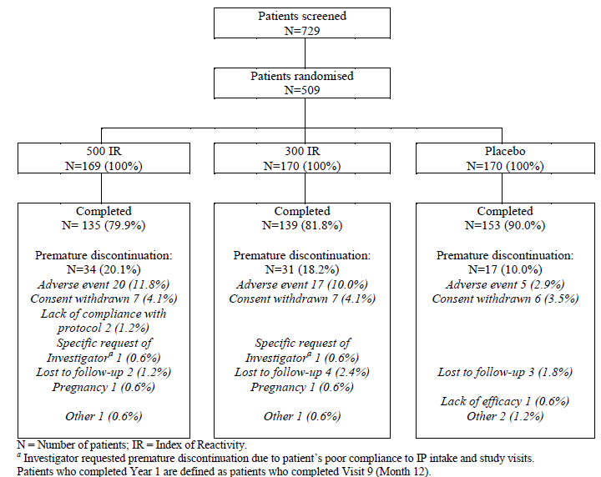
Figure 4: Study VO57.07: Year 2 overall patient disposition
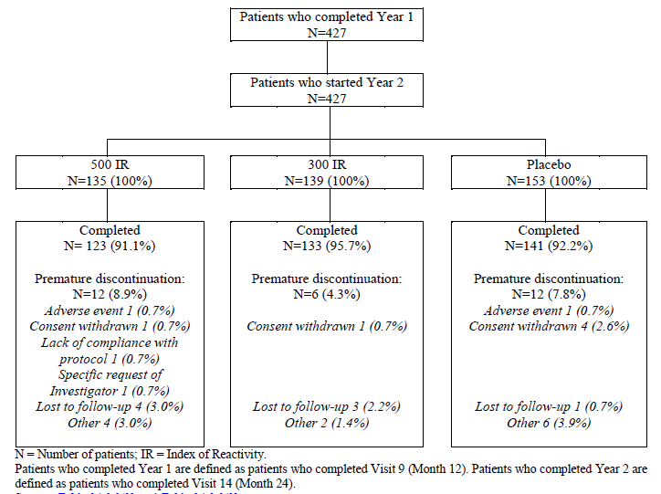

Major protocol violations/deviations
Overall and for each category of major protocol deviation, there was balance between the groups. The most common major deviations were non adherence to visit schedule, not having at least 14 days of valid adjusted symptom score (ASS) data from 01 October 2008 to 31 December 2008 while on treatment, taking prohibited concomitant medications and overall compliance less than 80% and/or greater than 120%.

Baseline data
At study entry, demographic characteristics were similar across the 3 treatment groups. Patient ages were within the range specified in the inclusion criteria. The population was balanced between men and women and most were Caucasian.
At the start of Year 2, demographic characteristics remained similar across the 3 treatment groups. The population was balanced between men and women and most were Caucasian.

Results for the primary efficacy outcome
The primary efficacy endpoint was the average adjusted symptom score (AASS) during the period from 01 October 2008 to 31 December 2008 (Year 1 Primary Period) assessed in the FAS_{Y1}.
For Year 1 Primary Period, there was a statistically significant difference in AASS between the 500 IR group and the placebo group (p = 0.0066). The treatment effect was estimated as the difference in LS means of -0.78 (95% CI [-1.34, -0.22]), corresponding to a relative LS mean difference compared to placebo of -20.2%. According to the step down procedure, the significant difference between 500 IR and placebo allowed a test between the 300 IR and placebo group, for which there was also a statistically significant difference (p = 0.0150) with a difference in LS means of -0.69 (95% CI [-1.25, -0.14]), corresponding to a relative LS mean difference versus placebo of -17.9%. The difference between active treatment groups was not statistically significant (p = 0.7638).

Table 6: Study VO57.07: Primary efficacy variable: ANCOVA of AASS for the Year 1 primary period - FASY1
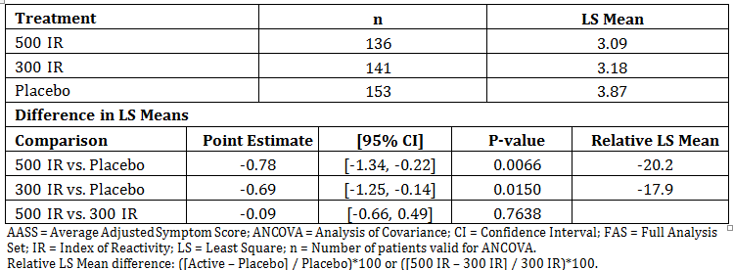
The robustness of the primary analysis using FAS_{Y1} was demonstrated by the consistency of the sensitivity analysis (with LOCF imputation of missing AASS, use of randomisation factor as covariate and a linear mixed model of AASS measurements during the first year).

Results for other efficacy outcomes

PP population; primary efficacy outcome
For the PPS_{Y1}, there was a statistically significant difference between 300 IR and placebo (p = 0.0468) with a corresponding LS mean difference versus placebo of -15.9%. The difference between the 500 IR and placebo groups did not reach statistical significance (p = 0.0541). The corresponding LS mean difference versus placebo was -15.7%. The difference between the 2 active groups was not statistically significant.

Post-hoc analysis; primary efficacy outcome: Sub-population of patients without and with potentially confounding sensitisations
According to the protocol, patients sensitised to one or more allergens other than HDM leading to clinically relevant allergic rhinitis, sinusitis, conjunctivitis or asthma and likely to significantly change the patient’s symptoms were excluded. However, polysensitised patients were permitted to enrol and a number were SPT positive to allergens present during the primary period. A post hoc analysis in patients without potentially confounding sensitisations was conducted.
There was a statistically significant difference in AASS for both 500 IR (p = 0.0008) and 300 IR (p = 0.0062) compared to placebo for the patients without potentially confounding sensitisations. The treatment effect was estimated as the difference in LS means of -1.06 (95% CI [-1.69, -0.44]) for 500 IR and -0.85 (95% CI [-1.46, -0.24]) for 300 IR, corresponding to a relative LS mean difference versus placebo of -27.0% for 500 IR and -21.5% for 300 IR. The difference between the 2 active groups was not statistically significant (p = 0.5087). Results were similar for the PPS_{Y1}.

Post-hoc analysis: relationship between efficacy and disease activity, tertile analysis
A post-hoc analysis assessed the relationship between efficacy and disease activity. Centres pooled according to geographical zone were ranked according to mean AASS in the placebo group. The pooled centres were then grouped into statistical tertiles, each having about a third of patients.
In the tertile with high mean AASS in the placebo group, the relative mean differences of AASS in the 500 IR and 300 IR groups compared to placebo were -30.7% and -39.3%, respectively. In the low and medium tertiles, the AASS in the active and placebo treatment groups were similar. Therefore, the overall treatment effect was driven by efficacy in the tertile of pooled centres in which patients in the placebo group exhibited the highest level of symptoms.

Year 1 Complementary Period
A complementary analysis was performed using the same model as described for the primary efficacy analysis for the AASS and calculated using the daily record card data for the Year 1 complementary period (01 October 2008 to 30 November 2008).
There was a statistically significant difference in AASS for both 500 IR (p = 0.0059) and 300 IR (p = 0.0212) compared to placebo for the Year 1 complementary period in the FAS_{Y1}. The treatment effect was estimated as the difference in LS means of -0.80 (95% CI [-1.36, -0.23]) for 500 IR and -0.66 (95% CI [-1.22, -0.10] for 300 IR, corresponding to a relative LS mean difference versus placebo of -20.5% for 500 IR and -17.0% for 300 IR. The difference between the active treatment groups was not statistically significant (p = 0.6409).

Mean daily ASS
The mean daily ASS decreased in all groups from baseline to Month 2. This decrease continued in the 2 active treatment groups becoming statistically significant at Month 4. The mean daily ASSs in the 500 IR and 300 IR groups were consistently lower than that in the placebo group through the primary period without any overlap.
Figure5: Study VO57.07: mean daily ASS - FAS_{Y1}
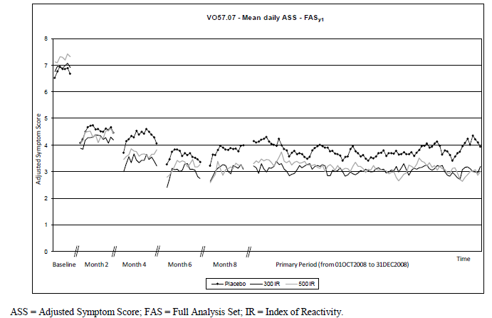

Average adjusted symptom score (AASS) for the Year 2 period
Efficacy was maintained during the treatment free follow up phase (01 October 2009 to 31 December 2009). In the Year 2 primary period there was a statistically significant difference compared to placebo in AASS for both 500 IR group (p = 0.0206) and the 300 IR group (p = 0.0342) For the 500 IR group, the treatment effect was estimated as the difference in LS means of -0.70 (95% CI [-1.29, -0.11]), corresponding to a relative LS mean difference compared to placebo of -19.1%. For the 300 IR group, there was a difference in LS means of -0.62 (95% CI [-1.20, -0.05]), corresponding to a relative LS mean difference versus placebo of -17.0%. The difference between the active treatment groups was not statistically significant (p = 0.8024).

ARTSS during primary period Y1
The average rhinitis total symptom scores (ARTSS) during the Year 1 primary period were consistent with the AASS. The treatment effect for the 500 IR group was estimated as the difference in LS means of -0.58 (95% CI [-1.03, -0.13], p = 0.0117), corresponding to a relative LS mean difference from placebo of -17.4%. In the 300 IR group, the treatment effect was estimated as the difference in LS means of -0.62 (95% CI [-1.06, -0.17], p = 0.0067), corresponding to a relative LS mean difference from placebo of -18.5%. The difference between the 2 active treatment groups was not statistically significant (p = 0.8687).
For the Year 2 primary period, the differences were not statistically significant between the 500 IR and placebo groups (p = 0.1244). There was a statistically significant difference in ARTSS for the 300 IR group (p = 0.0359) compared to placebo. The treatment effect was estimated as the relative LS mean difference compared to placebo of -16.8% for 300 IR. The differences were not statistically significant between the 2 active groups (p = 0.6099).

Table 7: Study VO57.07: ANCOVA of the ARTSS for the Year 1 and Year 2 primary periods - FASY1, FASY2
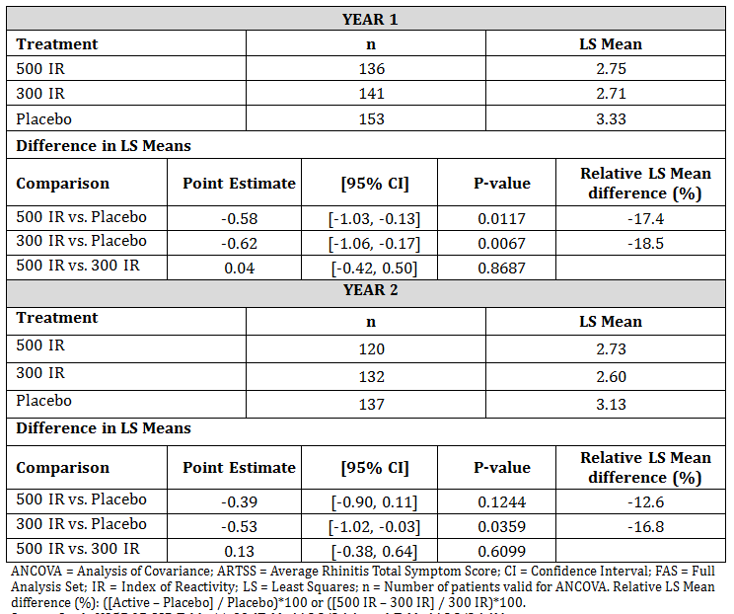

Average Rescue Medication Score (ARMS)
In both year 1 and year 2, ARMS were modest (LS means of 0.23 and 0.19 in the 500 IR group, 0.33 and 0.22 in the 300 IR group and 0.32 and 0.28 in the placebo group, respectively). There were no statistically significant differences between active groups and placebo for both the Year 1 and Year 2 primary periods.

Average Combined Score (ACS)
The ACS analysis showed statistically significant differences versus placebo for 500 IR for both Year 1 (p = 0.0119) and Year 2 (p = 0.0369) primary periods. For 300 IR the difference was not statistically significant (p = 0.1198) in Year 1 but statistically significant (p = 0.0327) for Year 2.

Table 8: Study VO57.07: ANCOVA of the ACS for the Year 1 and year primary periods - FASY1, FASY2
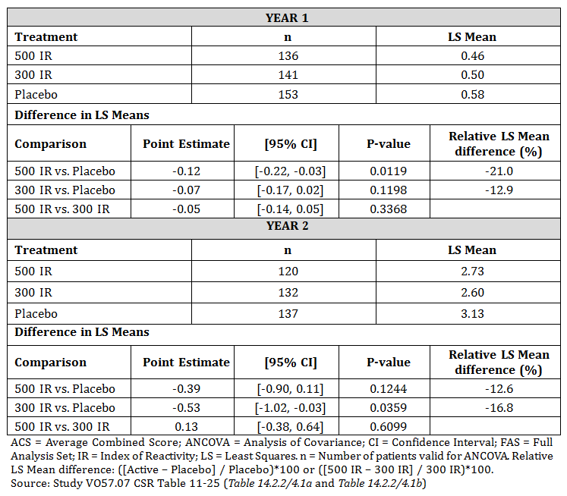

Average rhinoconjunctivitis symptom scores (ARSS)
The ARSS for each of the 5 individual symptoms (sneezing, rhinorrhoea, nasal pruritus, nasal congestion, and ocular itching) were consistently lower in the active treatment groups compared to placebo during both the year 1 and year 2 primary periods but did not show statistical significance for all symptoms.
During the Year 1 primary period, the ANCOVAs of the 5 individual symptom scores showed that there were statistically significant differences for 500 IR versus placebo for sneezing, nasal pruritus and ocular itching and for 300 IR versus placebo for sneezing, nasal pruritus, and nasal congestion. Similar results were observed for the 5 individual symptoms during the Year 1 complementary period.
During the Year 2 primary period, there was a statistically significant difference for 300 IR versus placebo for nasal congestion (p = 0.0389). No statistically significant difference between 500 IR and placebo was observed

Mean Proportion of Symptom Controlled Days (PSCD)
A symptom controlled day was defined as a day with a total symptom score lower or equal to a pre-defined threshold (RTSS ≤ x) and without intake of rescue medication (RMS = 0). 3 proportions of symptom-controlled days (PSCDs) were defined: PSCD₀₋₀, PSCD₁₋₀ and PSCD₂₋₀ corresponding to RTSS ≤ 0, 1 and 2, respectively, and RMS = 0.
The mean PSCD was consistently higher in the 500 IR and 300 IR groups compared to placebo group during both the Year 1 and Year 2 primary periods. Similar results were observed for the Year 1 and Year 2 complementary periods.

Table 9: Study VO57.07: Summary statistics of each PSCD for the Year 1 and Year 2 primary periods - FASY1, FASY2
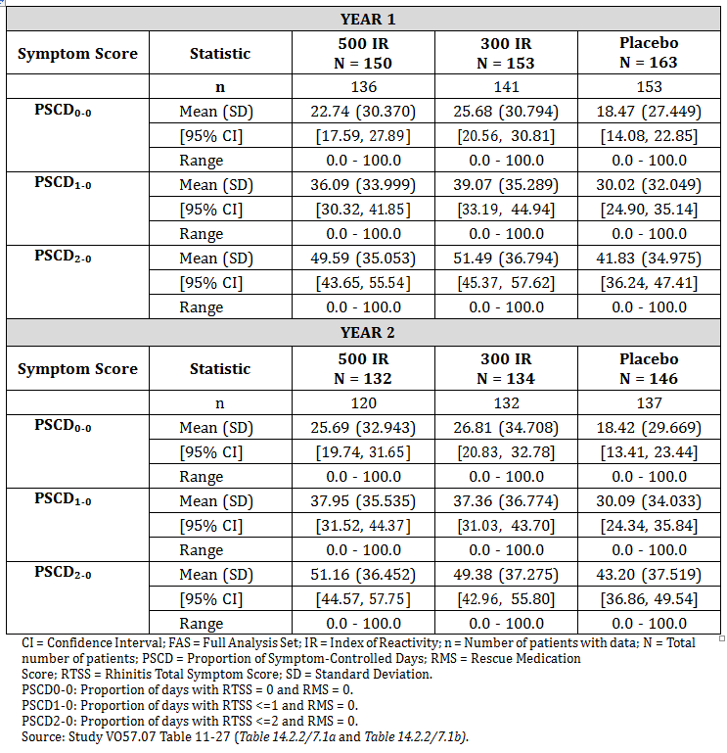

Patient quality of life
Patient quality of life was assessed using the self-administered rhinoconjunctivitis quality of life questionnaire (RQLQ). At endpoint of Year 1, the difference in overall RQLQ score between the 500 IR and placebo groups was not statistically significantly (difference in LS means: -0.15, 95%CI [-0.37, 0.06], p = 0.1666. Although not a pre-specified outcome variable there were some statistically significant differences in the individual domains (nasal symptoms and emotional). There was a statistically significant difference between the 300 IR and placebo group for all domains.
At the end of Year 2, there was no statistically significant difference between the active treatment groups and placebo either overall or for individual domains.

Global evaluation of efficacy
A global evaluation of the efficacy of the sublingual tablets relative to the previous year was made by the patient at Visit 9 (Month 12) and Visit 14 (Month 24). A 5 point Likert scale was used (from marked worsening to marked improvement).
The proportion of subjects who reported ‘marked improvement’ was significantly higher in the 500 IR group (33.1%, p = 0.0023) and the 300 IR group (36.9%, p < 0.0001) than in the placebo group (18.0%). There was a statistically significant difference in treatment success (defined by a mark of 4 = ‘slight to moderate improvement’ or 5 = ‘marked improvement’) at endpoint for both active treatment groups (73.1% [p = 0.0206] for 500 IR and 80.5% [p = 0.0001] for 300 IR) compared to placebo (59.6%).

Skin prick test (SPT)
SPTs were performed at Visit 1 (Screening) or Visit 2 (Month 0), Visit 9 (Month 12) and Visit 14 (Month 24). A SPT was considered ‘Positive’ when the wheal diameter was > 3 mm.
For year 1 at endpoint, the mean wheal diameters after SPT with both D. pte and D. far for patient in the actively treated groups were statistically significantly smaller than those of patients in the placebo group. These differences were maintained for Year 2 for both active groups compared to placebo for both D. pte and D. far.

Immunological markers
Serum samples for the assay of IgE and IgG4 specific to HDM were collected at Visit 1, Visit 9 (Month 12) and Visit 14 (Month 24).
HDM-specific serum IgG4 increased in both active treatment groups between Visit 1 and Visit 9 (Month 12) and remained elevated at Visit 14 (that is, 1 year post-treatment). In the placebo group, levels of D. far-specific serum IgG4 were modestly elevated and those of D. pte were essentially unchanged. Over the study period, HDM-specific serum IgE was little changed across the 3 treatment groups.

Asthma and sensitisation status
Asthma and sensitisation status were unchanged from baseline at the end of Year 1 or Year 2.

Study 1207D1731
A Phase II/III Study of S-524101 in patients with perennial allergic rhinitis. The original study report was in Japanese. An English translation was provided in the submission.

Study design, objectives, locations and dates
A multicentre, double blind, parallel group comparative study conducted at 50 centres in Japan from October 2012 and December 2013.

Primary objective
To evaluate the efficacy of S-524101 [DHM extract] in comparison to placebo.

Secondary objectives
- To evaluate the safety of S-524101
- To assess the PD of S-524101 by analysing specific IgE and IgG4 antibodies against D. pte and D. far
- To explore the biomarker and investigate the mechanism of allergen specific immunotherapy (reported separately and not included in the submission).
The study period was 55 to 79 weeks in total, consisting of a screening period of 1 day to 24 weeks, 2 weeks of pre-treatment observation period, 52 weeks of treatment period, and 1 week of post treatment observation period.
Figure 6: Study 1207D1731: Study design
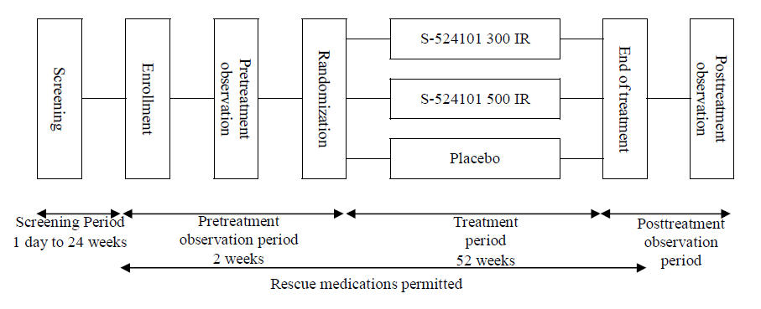

Inclusion and exclusion criteria

Inclusion
Otherwise healthy male and female patients aged between 12 and 65 years with a history of at least 2 years of allergic rhinitis symptoms and a score of 2 or higher on the quantitative analysis of IgE antibody (CAP-RAST) specific to D. pte and/or D. far antigens performed at screening and with a positive nasal provocation test using an allergen disc for house dust (positive results obtained within 2 years prior to screening could replace the test). At enrolment patients had to have an ARTSS (sneezing, rhinorrhoea, nasal congestion and nasal pruritus, range 0 to 15) of ≥ 6/day for 7 days.

Exclusion:
- Patients with seasonal rhinitis to known allergens
- Patients with perennial rhinitis to know allergens other than house dust mite
- Patients with CAP-RAST score for cat dander or dog dander allergens of 2 or higher (positive) at screening and who are exposed to these allergens in daily life (for example having these pets at home)
- Patients with asthma requiring treatment with inhaled corticosteroids
- Patients who had a complication(s) of any nasal disease (including nasal polyp, nasal septal deviation, or hypertrophic rhinitis).

Study treatments
Patients were randomised to 1 of the 3 treatment groups: 300 IR group, 500 IR group, and placebo group. The treatment period was 52 weeks. 2 tablets per day were administered once daily in the dose escalation period and 1 tablet was administered daily in the maintenance period.
The dose escalation was as follows:

Table 10: Study 1207D1731 dose escalation
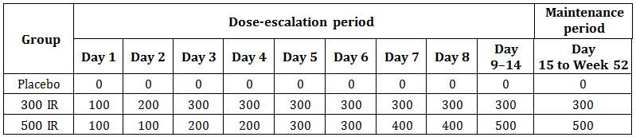

Rescue medication
Rescue medication was used in the same step-wise fashion as for Study VO57.07. The allowed medications were:
- Oral antihistamine: Allegra
- Antihistamine eye drop: Patanol
- Nasal corticosteroid: Aldecin AQ Nasal.

Efficacy variables and outcomes

Primary efficacy outcome
The primary efficacy outcome was the average adjusted symptom score (AASS) during the last 8 weeks of the treatment phase.

Other efficacy outcomes
Other efficacy outcomes included:
- AASS at each time point
- ARTSS (sneezing, rhinorrhoea, nasal congestion, and nasal pruritus)
- Average rescue medication score (ARMS)
- Average Combined Score (ACS) – calculated from RTSS and RMS
- Average total rhinoconjunctivitis symptom score (ATRSS) (sneezing, rhinorrhoea, nasal congestion, nasal pruritus, itchy eyes and watery eyes)
- Proportion of symptom controlled days (PSCD)
- Score on the Japanese allergic rhinitis standard QOL questionnaire (JRQLQ)
- Interference in daily activities
- Global evaluation by patients
- Intranasal examination by investigator/sub-investigator
- House dust mites (D. pte and D. far) specific IgE and IgG4 antibodies, and total IgE antibody.

Randomisation and blinding methods
Patients were randomised at the centres to the treatment groups by the probabilistic minimisation method using the following four stratification factors:
- ARTSS (0-15 points/day) during the last 7 days of the pre-treatment observation period before randomisation: < 10 points/day, ≥ 10 and < 13 points/day, or ≥ 13 points/day
- Use of rescue medication during the pre-treatment observation period: used or not used
- Scores of specific IgE antibodies (CAP-RAST) against ragweed, mugwort, and Japanese hop at screening enrolment: < 2 points for all pollens or 2 points for any pollens
- Age: ≥ 12 and ≤ 17, or ≥ 18 and ≤ 50, or ≥ 51 years old.
The study was double blind with placebo tablets matched in appearance to the active.

Analysis populations
- Full analysis set (FAS): defined as all randomised subjects excluding those receiving no study drug and those without any efficacy data (no entries in the patient diary).
- Per Protocol Set (PPS): defined as the FAS excluding ineligible subjects, withdrawals/dropouts/subjects lost to follow-up, and those with treatment violation.
- Safety Analysis Set: The safety analysis set was defined as subjects receiving the study drugs after randomisation.

Sample size
The sample size was based on the results of the Phase II/III study conducted overseas by the sponsor (Stallergenes) using sensitivity analysis performed by imputing missing data with the last observation carried forward. The results showed that the differences in AASS between each S-524101 group (300 and 500 IR) and the placebo group after approximately 1 year of treatment were 0.74 and 0.65, respectively, with standard deviations (SDs) of 2.74, 2.67, and 2.74 for the 300 IR, 500 IR, and placebo groups, respectively. From these results, the difference in AASS between S-524101 and placebo, the common SD, and the effect size (difference/common SD) were estimated to be 0.7, 2.74, and 0.255 ( = 0.7/2.74). With the assumptions of the number of tests of 2 (300 IR versus placebo and 500 IR versus placebo) and each effect size of 0.255, the same as that for the overseas Phase II/III study, the necessary number of subjects to provide a power of 80% at a 2-sided significance level of 0.05 (using the Holm method for adjustment for multiplicity) was estimated by simulation to be 627 subjects (209 per group). To allow for dropouts, the sample size was determined to be 750 (250 per group).

Statistical methods
Comment: [information redacted]. The following is taken from the synopsis.
For the primary outcome, the AASS, the differences in the AASS during the last 8 weeks were compared between each of the treatment groups. The mixed effects model repeated measures approach (MMRM) was used for the primary analysis.
For the secondary outcomes, AASS, ARTSS, ARMS, ACS, average total rhinoconjunctivitis symptom score, individual rhinoconjunctivitis symptom scores, proportion of symptom-controlled days, JRQLQ, interference in daily activities, and intranasal examination findings were calculated in each evaluation period for each of the treatment groups. In addition, the differences were compared between each of the S-524101 dose and placebo groups using MMRM.
For global evaluation by patients, the frequency and proportion of patients in each category were obtained for each of the treatment groups. The proportion of patients with “improvement” in terms of the global assessment were compared between each of the S-524101 doses and placebo groups with Fisher’s exact test, where “improvement” is defined as the sum of “slight to moderate improvement” and “marked improvement”.
The summary statistics of specific IgE and IgG4 antibodies to house dust mites and total IgE antibody levels were calculated. Antibody levels at Week 52 were compared between each of the S-524101 doses and placebo groups, based on the analysis of covariance (ANCOVA).

Participant flow
Figure 7: Study 1207D1731. Participant flow
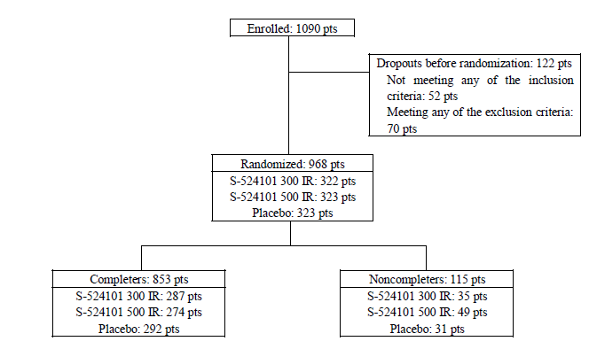

Table 11: Study 1207D1731: List of non-completers (withdrawals/dropouts) by reason
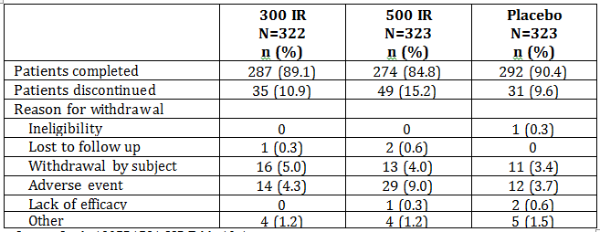

Major protocol violations/deviations
Protocol violations were balanced between the treatment groups and the 2 most common reasons were: prohibited concomitant drug violations; reported in 18 subjects in the 300 IR group, 22 subjects in the 500 IR group, and 20 subjects in the placebo group and observation/examination time frame violations which occurred in 11, 10, and 10 subjects, respectively.

Baseline data
The baseline demographic data was balanced between the treatment groups. The average age was about 30 ± 11 years; approximately 55% female and 45% male; with mean BMI about 21 (± 3.4) kg/m².

Results for the primary efficacy outcome

Average adjusted symptom score during the last 8 weeks (Week 44 to Week 52) (FAS)
The least-squares mean of the AASS was 5.00 in the 300 IR group, 5.32 in the 500 IR group, and 6.11 in the placebo group. The differences between each S-524101 group and the placebo group were -1.11 for the 300 IR group and -0.80 for the 500 IR group. The differences versus the placebo group were statistically significant for both active groups (P < 0.0001 for both groups). The relative LS mean differences in the AASS versus placebo were -18.2% for the 300 IR group and -13.1% for the 500 IR group. In both active groups, the AASS improved compared with the placebo group.

Table 12: Study 1207D1731: Average adjusted symptom score during the last 8 weeks (Week 44 to Week 52) (MMRM) (FAS)
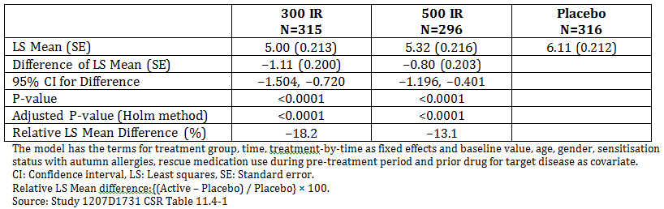

Results for other efficacy outcomes

Average adjusted symptom score at each time point (FAS)
The AASS in the 300 IR group was statistically significantly improved after Week 8 to Week 10 of treatment, that is, the first protocol defined interval of patient diary entry after the initiation of study treatment, when compared with the placebo group (p = 0.0012). The difference between this dose and the placebo was also statistically significant throughout the subsequent evaluation periods. Since the protocol defines the time of onset of action as the first of 2 consecutive time points with a p-value significantly different from the placebo, the time of onset of action with 300 IR of S-524101 was estimated to be between Week 8 and Week 10.
In the 500 IR group, the AASS was statistically significantly improved after Week 8 to Week 10 as compared with the placebo group (p = 0.0448); however, the intergroup difference was not statistically significant from Week 16 to Week 18. The difference between this dose and the placebo was again statistically significant after Week 24 to Week 26 and remained significant throughout the subsequent evaluation periods. The time of onset of action was estimated to be between Week 24 and Week 26.

Average rhinitis total symptom score (ARTSS) (FAS)
The LS mean of the ARTSS during the primary evaluation period (Week 44 to Week 52) was 4.96 in the 300 IR group and 5.25 in the 500 IR group, statistically significantly different from the placebo group (6.03, p < 0.0001 for both active groups).

Average rescue medication score (ARMS)
The LS mean of the ARMS during the primary evaluation period (Week 44 to Week 52) was 0.04 in the 300 IR group, 0.07 in the 500 IR group, and 0.07 in the placebo group. The difference between the 300 IR group and the placebo group was statistically significant (p = 0.0280).

Average combined score (ACS)
The LS mean of the ACS during the primary evaluation period (Week 44 to Week 52) was 0.62 in the 300 IR group and 0.67 in the 500 IR group, statistically significantly different from the placebo group (0.77, p < 0.0001 and p = 0.0003, respectively). The RTSS appeared to have largely contributed to these results because the RMS was low in all groups.

Average total rhinoconjunctivitis symptom score
The LS mean of the average total rhinoconjunctivitis symptom score (ATRSS) during the primary evaluation period (Week 44 to Week 52) was 6.48 in the 300 IR group and 6.91 in the 500 IR group, statistically significantly different from the placebo group (7.79, p < 0.0001 and p = 0.0017, respectively).

Individual Rhinoconjunctivitis Symptom Scores
During the primary evaluation period, the LS means of the individual nasal symptom scores (sneezing, rhinorrhoea, nasal congestion, and nasal pruritus) in the 300 and 500 IR groups were statistically significantly different from the placebo group. Of the individual ocular symptom scores (itchy eyes and watery eyes), the score of watery eyes the 300 IR group was statistically significantly lower than that in the placebo group (p = 0.0113).

Table 13: Study 1207D1731: individual rhinoconjunctivitis symptom scores during the primary evaluation period
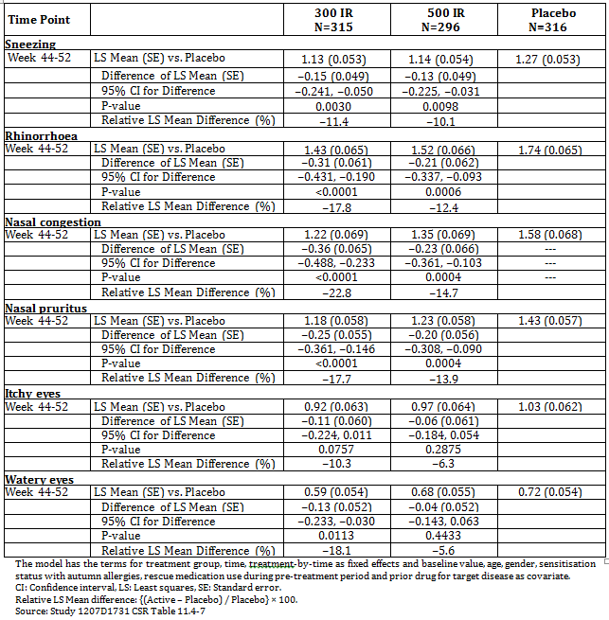

Proportion of symptom controlled days (PSCD)
The PSCD 2-0 (proportion of days with a RTSS of < 2 and a rescue medical score of 0) in the 300 and 500 IR groups were statistically significantly different from the placebo group (p = 0.0061 and p = 0.0098).

Table 14: Study 1207D1731: Proportion of symptom controlled days during the primary evaluation period (MMRM) (FAS)
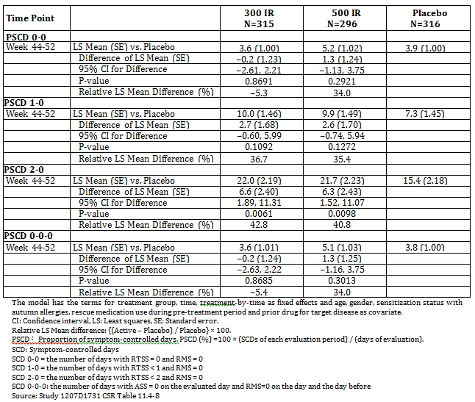

JRQLQ score
In all of the primary domains of the JRQLQ, the differences between the 300 IR group and the placebo group were statistically significant (p = 0.0124 for nasal and eye symptoms, p = 0.0041 for QOL-related questionnaires, p = 0.0310 for general state). There was no statistically significant difference between the 500 IR group and the placebo group in any domain.
In 4 (usual daily activities, outdoor activities, social functioning, physical problems) of the secondary JRQLQ domains, the differences between the 300 IR group and the placebo group were statistically significant (p = 0.0049 for usual daily activities, p = 0.0030 for outdoor activities, p = 0.0038 for social functioning, p = 0.0234 for physical problems). There was no statistically significant difference between the 500 IR group and the placebo group in any domain.

Interference with usual daily activities
The LS mean of interference with usual daily activities during the primary evaluation period (Week 44 to Week 52) was 1.02 in the 300 IR group and 1.11 in the 500 IR group, statistically significantly different from the placebo group (1.28, p < 0.0001 and p = 0.0019, respectively)

Patients’ global evaluation
The percentage of subjects who rated the global response as "Marked improvement" was 22.2% in the 300 IR group, 23.4% in the 500 IR group, and 9.7% in the placebo group, being clearly higher in the 300 and 500 IR groups than in the placebo group. The percentage of subjects with "slight improvement or higher" was 79.7% in the 300 IR group, 78.3% in the 500 IR group, and 64.5% in the placebo group. The improvement rate was statistically significantly higher in the 300 and 500 IR groups than in the placebo group (p < 0.0001 and p = 0.0002, respectively).

Table 15: Study 1207D1731: Patients’ global evaluation at Week 52 (FAS)
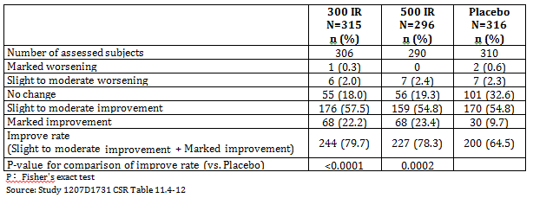

Intranasal findings
For both mucosal swelling of the inferior nasal concha and rhinorrhoea, the differences versus the placebo group were statistically significant for both active groups (p = 0.0025 and p = 0.0007, respectively, for mucosal swelling of the inferior nasal concha, p = 0.0202 and p = 0.0042, respectively, for rhinorrhoea).

Table 16: Study 1207D1731: Intranasal findings at Week 52
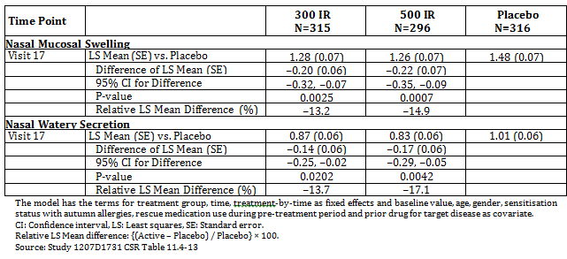

House dust mite-specific IgE and IgG4 antibodies, and total IgE antibodies
The levels of IgG4 antibodies specific to D. pte and D. far antigens at baseline and Week 52 (Visit 17) were compared. There was little change from baseline in the placebo group, while the levels of mite-specific IgG4 antibodies increased 2.580 and 3.105 times in the 300 IR group, and 3.130 and 3.678 times in the 500 IR group, respectively. The levels of IgE antibodies specific to these mite antigens also increased 1.850 and 1.774 times in the 300 IR group and 1.914 and 1.819 times in the 500 IR group, respectively. Likewise, the levels of total IgE antibodies increased 1.417 times in the 300 IR group and 1.519 times in the 500 IR group. The differences from the placebo group were statistically significant for both active groups in all the comparisons between active groups and placebo group (p < 0.0001 for both active groups).

Table 17: Study 1207D1731: House dust mite-specific IgE and IgG4 antibodies, and total IgE antibodies (FAS)
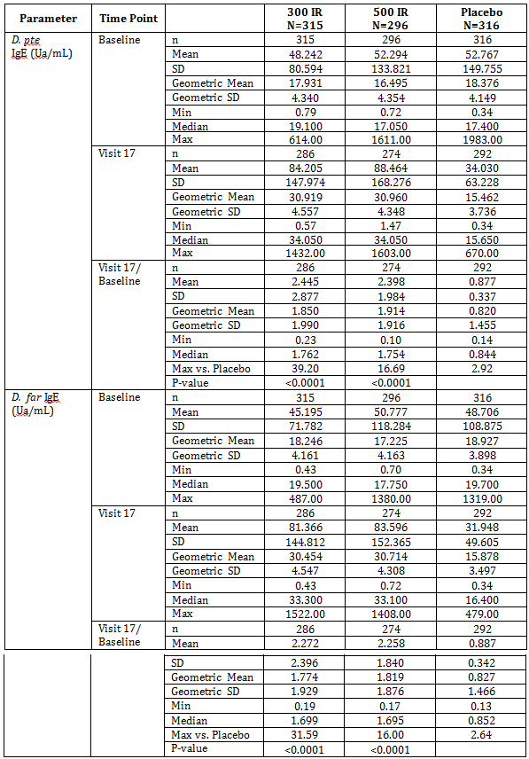

Table 17 (continued): Study 1207D1731: House dust mite-specific IgE and IgG4 antibodies, and total IgE antibodies (FAS)
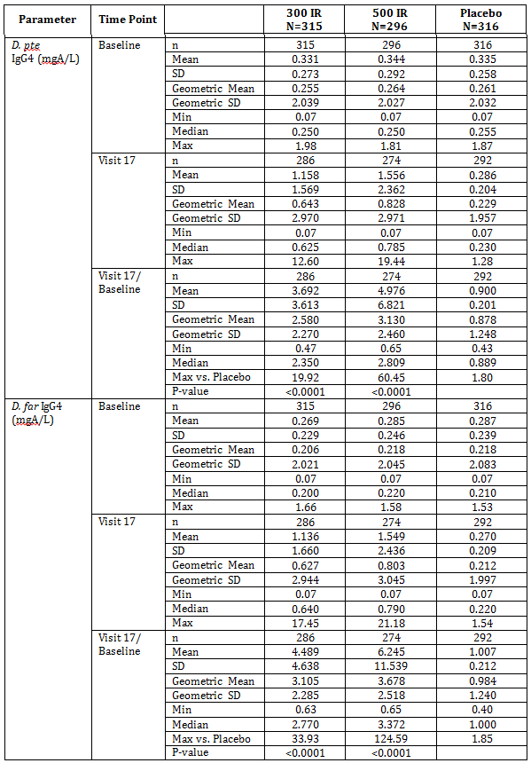

Table 17 (continued): Study 1207D1731: House dust mite-specific IgE and IgG4 antibodies, and total IgE antibodies (FAS)
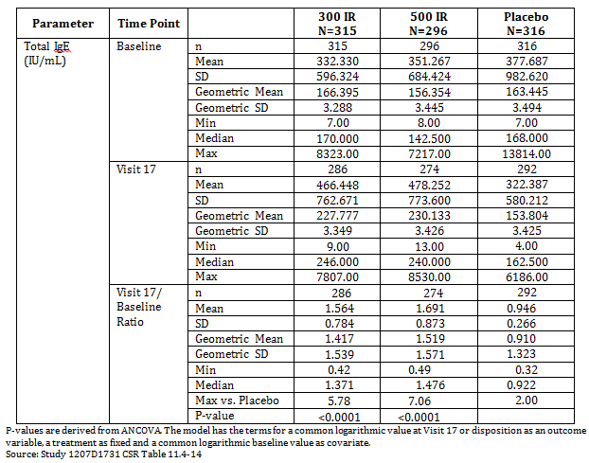

Other efficacy studies

Study VO64.08
A randomised, double blind, placebo controlled, multinational, Phase III Trial to assess the efficacy and safety of 300IR sublingual immunotherapy (SLIT) administered as allergen based tablets once daily to adolescents and children above the age of 5 years, suffering from house dust mite allergic rhinitis.

Study design, objectives, locations and dates
A randomised, double blind, placebo controlled, parallel group study conducted at 62 centres in 9 European countries (Denmark, France, Germany, Hungary, Ireland, Romania, Slovakia, Spain, Ukraine) from October 2009 to September 2011.

Primary objectives
- to determine if sublingual tablet of HDM allergen extracts administered sublingually at a dosage of 300 IR to children and adolescents during approximately 12 months was significantly better than placebo in relieving HDM allergic rhinitis symptoms, as assessed by the magnitude of response observed on the Average Adjusted Symptom Score (AASS)
- To assess the sustained clinical efficacy of 300 IR sublingual tablet of HDM allergen extracts on the AASS after 2 and 3 treatment years
- To assess the post-treatment long-term efficacy (disease-modifying effect) of 300 IR sublingual tablets of HDM allergen extracts on the AASS after one and two treatment-free years.

Secondary Objectives
To assess efficacy of 300 IR sublingual tablet of HDM allergen extracts in rhinitis, treatment sustained clinical efficacy and post treatment long term efficacy on:
- AASS by tertile
- AASS on different periods of evaluation
- ARTSS of the 4 rhinitis symptoms sneezing, rhinorrhoea, nasal pruritus and nasal congestion
- Average rescue medication score (ARMS)
- Each of the 5 individual average rhinoconjunctivitis symptom score (ARSS): sneezing, rhinorrhoea, nasal pruritus and nasal congestion and ocular itching
- Rescue medication usage
- Average combined score (ACS) a score combining the Rhinitis Total Symptom Score (RTSS) and the Rescue Medication Score (RMS)
- Overall rhinoconjunctivitis quality of life questionnaire score (RQLQ)
- Proportion of symptom-controlled days (PSCD)
- Proportion of not-controlled days (PNCD)
- Onset of action of SLIT

Other objectives
- Global evaluation of allergic rhinitis by the patient visual analogue scale (VAS)
- Asthma evaluation: presence/absence, global initiative for asthma (GINA) classification, and symptom scores
- Nasal provocation test (NPT) in a subgroup of patients at start and end of first years of treatment
- Wheal diameters after SPT to mite allergens
- Sera levels of IgE, IgG4 and IgA specific to HDM allergens
- A sub-study of selected immunological markers (HDM specific CD4+ T cell responses)
- Sensitisation status (mono-sensitisation to HDM or poly-sensitisation [other allergens])
Figure 8: Study VO64.08: Study design
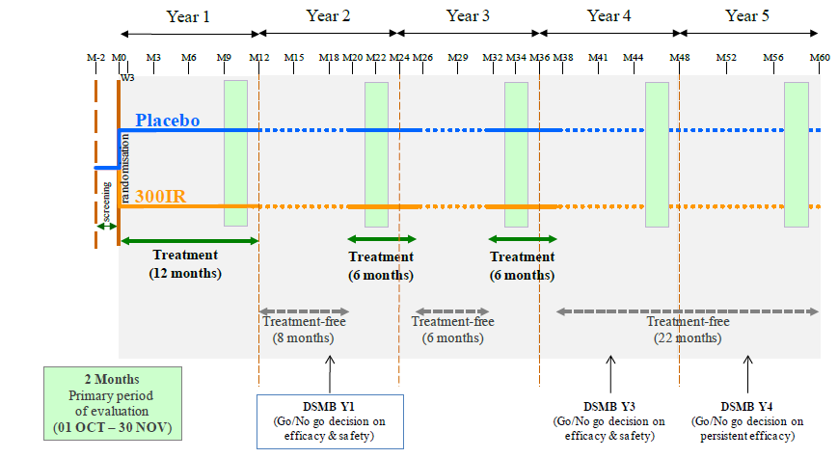
After its first meeting (4 July 2011) to review the efficacy and safety data from Year 1, the data and safety monitoring board (DSMB) provided the recommendation of not pursuing the study into the following years, considering the patients were not symptomatic enough to enable differentiation between active treatment and placebo. There were no safety concerns. Based on the efficacy results of the first study year, the sponsor decided to stop the study for futility. The study was terminated while the patients were in the Year 2 treatment-free period following the Year 1 treatment period. Patients performed a study termination visit at the next scheduled visit.

Inclusion and exclusion criteria

Inclusion
Male or female patients aged 5 to 17 years (inclusive) with a history of HDM related allergic rhinitis for at least 1 year, requiring regular intake of symptomatic treatments. Diagnosis was confirmed by positive SPT to D. pte or D. far with wheal diameter > 3 mm and specific IgE level ≥ 0.7 kU/L. Patients had to have a baseline ARTSS ≥ 5 (7day daily record card with at least 4 days of valid data).

Exclusion
- Existing co-sensitisation to any other allergens with clinically relevant allergic rhinitis, sinusitis, conjunctivitis or asthma
- Any nasal or oral condition that could confound the study
- Moderate or severe persistent asthma to mild persistent asthma controlled by inhaled corticosteroids were eligible
- FEV1 < 80% of predicted at Visit 1
- Treatment for any indication with systemic steroids within 4 weeks of enrolment
- Treatment with antihistamines for any reasons other than HDM allergic rhinitis symptoms
- Allergen specific immunotherapy for HDM in the last 5 years.

Study treatments
Patients were randomised to 1 of the 2 treatment groups (300 IR group or Placebo group) at enrolment and treatment continued for 12 months. After 12 months of treatment there was an 8 month treatment free period and then a 6 month treatment period [Year 2] and a 6 month treatment free period with a final 6 month treatment period [Year 3]); then a 22 month treatment free follow-up phase (Year 4 and Year 5).
For each of the planned treatment periods, after a 2-day incremental phase (1 tablet of 100 IR on the first day, 2 tablets of 100 IR taken together on the second day), patients were to take 1 sublingual tablet of 300 IR each day.
Rescue medication was the same step wise regimen as for the previous studies. The allowed medications were:
Step 1: Antihistamine (oral: cetirizine, levocetirizine, loratadine, desloratadine or eye drops: levocabastine, olopatidine, azelastine)
Step 2: Nasal corticosteroid if the symptoms did not alleviate - mometasone, fluticasone, beclometasone, budesonide
Step 3: If the patient needed oral corticosteroid (prednisolone, methylprednisolone) to manage the rhinitis, the patient was to consult the investigator.

Efficacy variables and outcomes
The primary efficacy outcome was the average adjusted symptom score (AASS) during the primary treatment period (Year 1).
The AASS was derived from the daily (non-missing) rhinitis total symptom score (RTSS) based on the severity of four rhinitis symptoms (sneezing, rhinorrhoea, nasal pruritus and nasal congestion) each graded on the 4 point scale and adjusted for the daily (non-missing) rescue medication usage during the evaluation period. This score is patient-specific and takes into account the use of rescue medications according to a stepwise regimen.
Other efficacy outcomes included:
- Average rhinitis total symptom score (ARTSS)
- Average rescue medication score (ARMS)
- Each individual average rhinoconjunctivitis symptom scores (ARSS)
- Proportion of patients using rescue medication
- Proportion of days patients used rescue medication
- Average combined score (ACS) which takes into account the patient’s daily RTSS and RMS, assuming equivalent importance of symptoms and medication scores,
- Overall rhinoconjunctivitis quality of life questionnaire (RQLQ) score and each domain scores using age specific questionnaires (Paediatric RQLQ ([PRQLQ] for children aged 6 to 11 and the Adolescent RQLQ [AdolRQLQ] for adolescents aged over 11)
- Proportions of symptom controlled days (PSCDs)
- Proportion of Not-Controlled Days (PNCD)
- Global evaluation of allergic rhinitis by the patient using a Visual Analogue Scale (VAS)
- Asthma evaluation

Randomisation and blinding methods
Patients were randomly assigned in a 1:1 ratio to 1 of the 2 treatment groups (300 IR group or placebo group) with stratification by age (5 to 11 and 12 to 17 years) through a centralised IVRS. The system was to ensure that there were at least 45% of patients and no more than 55% in each age stratum, globally.
This was a double blind study. The investigational products were blinded and matched for the number of tablets per treatment box as well as for the size, shape, colour and taste of the tablets.

Analysis populations

Full analysis set (FAS)
- Year 1: The FASY1 included all patients who received at least 1 dose of the investigational product and had at least 1 evaluation of AASS during the Year 1 treatment period. FASY1 was the primary analysis set for the Year 1 efficacy analysis.
- Year 2: The FASY2 included all patients who were included in the Safety SetY2 and had at least one evaluation of ASS during the Year 2 treatment-free period.

Per protocol set (PPS)
- Year 1:The PPSY1 included all patients included in FASY1 and who had:
  - At least 14 days of valid AASS data during the Year 1 primary period
  - Performed the Year 1 treatment period according to the protocol with no major deviation detected during this period.
As the study was discontinued during the Year 2 treatment-free period, no PPS was defined for Year 2.

Safety Sets
- Year 1: The safety setY1 included all patients who received at least one dose of the investigational product during the Year 1 treatment period.
- Year 2: The safety setY2 included all patients who were enrolled in the Year 2 treatment free period and who had been included in the safety setY1.

Sample size
Given an alpha of 0.05 and a common SD of 2.8, and based on the results of Study VO57.07, a sample size of 193 patients per treatment group would provide 85% power to detect a mean difference of 0.87 between placebo and 300 IR SLIT in the AASS during the Year 1 Primary Period. Assuming a drop-out rate of 15% in Year 1, 454 patients were planned to be randomised.

Statistical methods
Summary statistics of all efficacy variables were provided. For all analyses the probability of a Type 1 error (α) was set at 0.05 and the confidence level was set at 0.95 unless otherwise specified. All inferential tests were 2 sided. Statistical significance was declared if the rounded p-value ≤ 0.0500. All p-values were rounded to 4 decimal places with a leading zero (0.0001). Interaction tests in Analyses of Covariance (ANCOVA) were considered significant if p value ≤ 0.1000.
The primary efficacy variable, AASS during Year 1 primary period, was analysed for the Year 1 full analysis set (FASY1) using an analysis of covariance (ANCOVA) with treatment group as main effect, pooled centre and age stratum according to IVRS as stratification factors and gender, baseline ARTSS, baseline asthma presence and baseline sensitisation status as covariates. Adjusted means ([LS means) along with 95% CIs of each treatment group, p values for each effect in the model, adjusted mean (LS means) along with 95% CI for the between-group difference (active - placebo) and relative LS means difference were provided. Validity assumptions of the ANCOVA were checked using normality and homoscedasticity and, if needed, additional appropriate non-parametric tests (2 sample Wilcoxon test and Hodges-Lehman estimate with 95% CI).
The onset of action was determined using a repeated measure ANCOVA mixed model. The onset of action was defined as the first period during which the AASS in the active treatment group differed significantly from the placebo group and the significant difference was maintained for at least two consecutive periods.
The secondary efficacy variables ARTSS, ARMS, ACS and individual ARSS were analysed as for the primary efficacy variable. The proportion of patients who used rescue medications was presented using descriptive statistics. Whether a patient used a rescue medication (all categories) or not during Year 1 primary period was compared between treatment groups using a Cochran-Mantel-Haenszel (CMH) test stratified by age stratum according to the IVRS.
Descriptive statistics were used for the analysis of the proportion of days rescue medication were used, PSCDs, PNCDs and quality of life. Changes from baseline of overall scores and domain scores were compared between treatment groups using an ANCOVA model with treatment groups as main effect, pooled centres as stratification factor and gender, baseline RQLQ overall score/domain scores, baseline asthma presence and baseline sensitisation status as covariates.
Descriptive statistics were also used for analysis of the patient’s global evaluation of allergic rhinitis, asthma evaluation (status, GINA classification and lower airway symptoms) and NPT. Changes from baseline of the VAS score at Year 1 were compared between treatment groups using an ANCOVA with treatment group as main effect, pooled centres and age stratum as stratification factors and gender, baseline FEV1 (% of predicted value) and baseline sensitisation status as covariates.
Descriptive statistics were also used for analysis of SPTs, immunological markers, HDM specific CD4+ T cell response and sensitisation status.

Participant flow
Figure 9: Study VO64.08: Overall patient disposition
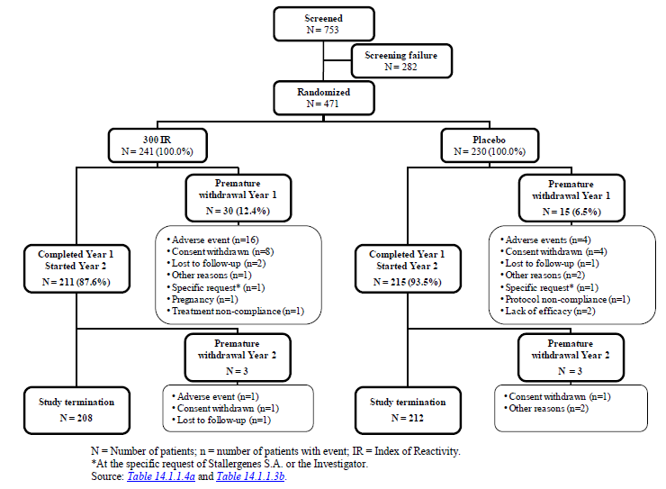

Table 18: Study VO64.08: Number of patients prematurely withdrawn from the study during Year 1 and Year 2 by treatment group and total with reason for withdrawal; all randomised patients
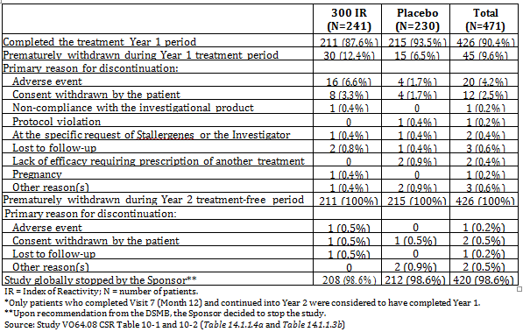

Major protocol violations/deviations
The number of patients with at least 1 major protocol deviation was similar in the 2 treatment groups (57 in the 300 IR group and 58 in the placebo group). The most common reason for exclusion from the PPS were presence of co-sensitisations (20 [9.0%] patients in the 300 IR group and 22 [10.0%] patients in the placebo group), less than 14 days of valid ASS days during the Primary Period (14 [6.3%] patients in the 300 IR group and 11 [5.0%] patients in the placebo group) and compliance outside the range of 70% to 125%.

Baseline data
More males than females were included in the study (64.8% versus 35.2%, respectively). The percentages were similar among treatment groups. The mean age of patients was 11.1 years old, with 53.0% of the population aged 5 to 11 and 47.0% of adolescents aged 12 to 17. Almost all patients were Caucasians. Overall, the demographic characteristics were balanced across the treatment groups.

Table 19: Study VO64.08: Summary of demographic characteristics
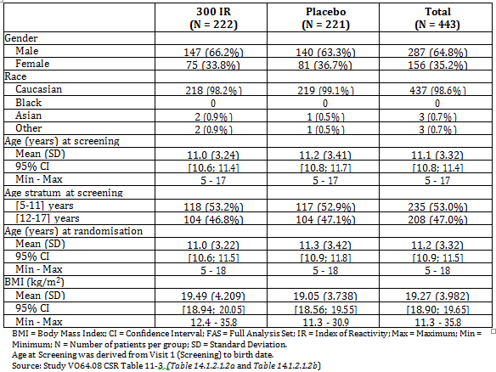

Results for the primary efficacy outcome
No statistically significant difference was observed between the 300 IR and placebo groups during the year 1 primary period (October to November 2010) in the AASS.
To be eligible, all patients were to have a minimum level of symptoms during baseline while they were not allowed to take any rescue medication, that is, ARTSS of at least 5 out of a possible score of 12. The mean ARTSS at baseline was 6.84 in the 300 IR group and 6.65 in the Placebo group. Over the treatment year, the AASS continuously decreased in the placebo group. After 3 months of treatment, it was 3.51 and after 12 months of treatment it was 2.65, leaving little room for improvement.

Table 20: Study VO64.08: ANCOVA of the AASS during Year 1 primary period – FAS_{Y1}
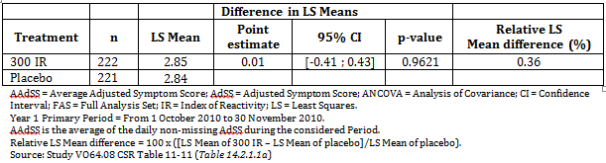

Results for other efficacy outcomes

Average adjusted symptom score in the per protocol set
There was no statistically significant difference between the 300 IR and the placebo group.

Table 21: Study VO64.08: ANCOVA of the AASS during Year 1 primary period – PPS_{Y1}
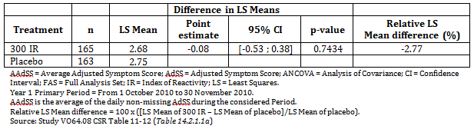

Relationship between efficacy and disease activity
An assessment of the treatment effect as a function of disease severity during the Year 1 primary period was performed. Centres pooled according to geographical zone were ranked according to the mean AASS in the placebo group. The pooled centres were then grouped into statistical tertiles, from the lowest to the highest AASS mean, each having about 1 third of all patients. In each tertile, AASS means were similar in the 300 IR and placebo group.
Figure 10: Study VO64.08: Mean AASS by disease severity tertile over Year 1 primary period – FASY1
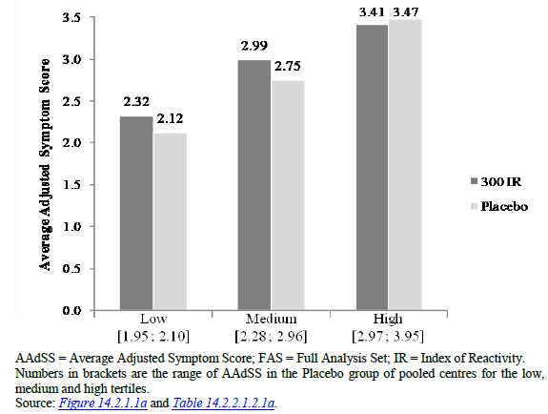
Similar results were observed over the Year 1 complementary period (October to December 2010) for the FAS_{Y1} and PPS_{Y1} as well as for other exploratory and sensitivity analyses. In particular, the analysis showed similar non-significant results in the 2 age strata analysed, that is, children (5 to 10 years) and adolescents (≥ 11 years).

Mean daily adjusted symptom score (ASS)
The mean daily ASS curves for the 300 IR and Placebo groups overlapped over time.
Figure 11: Study VO64.08: Mean daily ASS over the analysis periods - FAS_{Y1}
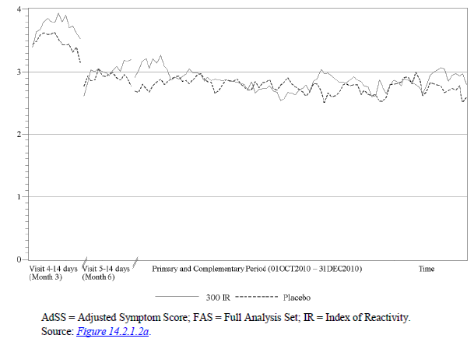

Onset of action
The AASS was assessed over 2 weeks every 2 months during the treatment period to determine the onset of action for FAS_{Y1} and PPS_{Y1}. The onset of action of sublingual tablets of HDM allergen extracts was defined as the first period during which the AASS in the active treatment group differed significantly from that of the placebo group and the significant difference was maintained for at least 2 consecutive periods. Over the treatment year, whatever the evaluation period, the difference versus placebo in LS Mean AASS was not statistically significant. During the Year 2 treatment-free period, with a limited amount of data, the mean AASS remained similar in the 2 treatment groups (FAS_{Y2}).

Average rhinitis total symptom score (ARTSS)
The results on the ARTSS during the Year 1 primary period were consistent with those obtained with the AASS. There was no statistically significant difference between the 2 treatment groups. The ARTSS LS means were 2.38 in the 300 IR group and 2.44 in the placebo group. During the Year 2 treatment free period, the results of the mean ARTSS were consistent with those obtained with the AASS.

Average rhinoconjunctivitis symptom scores (ARSS)
During the Year 1 primary period, all individual symptom scores were similar in the 2 groups. The LS means for the individual ARSS ranged between 0.25 (for ocular pruritus) to 0.73 (for rhinorrhoea). Similar trends were observed during the Year 2 treatment free period.

Average rescue medication score (ARMS)
Patients were allowed to use rescue medication in case of severe rhinitis symptoms; they were instructed to take the rescue medication according to a stepwise regimen. A daily Rescue Medication Score was assigned to the different rescue medications used (from 0: ‘no rescue medication’ to 3: ‘oral corticosteroid’). The ARMS calculated as the average of the daily RMS over a chosen period ranges from 0 to 3. There was no statistically significant difference between 300 IR group and placebo group on the ARMS for Year 1 Primary Period. During the Year 2 treatment free follow-up period, the mean ARMS were similar in the 300 IR and the placebo groups at Month 15 and at Month 18.

Proportion of patients using rescue medications
About 64% of patients in the 2 treatment groups took at least 1 rescue medication during the Year 1 primary period. Similar proportions of patients in both treatment groups used the different categories of rescue medications. The most frequently used rescue medications were oral antihistamines (about 53% of patients overall) and nasal corticosteroids (about 45% of patients overall). No statistically significant difference was found in the proportions of patients using rescue medications.

Average combined score
The ACS is a patient specific score taking into account the patient’s daily RTSS and RMS, assuming equivalent importance of symptoms and medication scores. It ranges from 0 to 3. The results were consistent with those of the AASS. For the Year 1 Primary Period, the ACS LS means were 0.48 in the 300 IR group and 0.45 in the placebo group. There was no statistically significant difference in the ACS between the 300 IR group and the placebo group.

Proportion of symptom-controlled days (PSCDs) and Proportion of not-controlled days (PNCD)
The mean PSCDs were similar in both treatment groups. The proportion of totally controlled days (that is, days with no symptoms and no rescue medication intake) were 25% and 28% over the Year 1 primary period in the 300 IR and placebo groups, respectively. Similarly, the mean proportions of not controlled days (PNCDs) were similar in both treatment groups. These proportions were 26% and 27% in the 300 IR and placebo groups, respectively over the Year 1 primary period. The same level of symptom control in the study population was observed over the second study year (treatment-free period).

Rhinoconjunctivitis quality of life questionnaire (RQLQ)
Patient quality of life was assessed using the age appropriate rhinoconjunctivitis quality of life questionnaire (RQLQ), the PRQLQ (administered by an interviewer) for children aged 6 to 11 and the AdolRQLQ (self-administered) for adolescents aged over 11. For both treatment groups, changes from baseline to Month 12 were limited. Between baseline and Month 12, the overall PRQLQ score and each domain score changed in similar proportions in both treatment groups; no statistically significant difference was evidenced. Similar results were observed on the AdolRQLQ. For the Year 2 treatment-free period, no difference was evidenced.

Patient’s global evaluation of their HDM related allergic rhinitis
At the end of Year 1, the change from baseline in the patient’s global evaluation using a VAS was not significantly different between the 2 treatment groups. Similar results were observed at Year 2 endpoint.

Asthma evaluation
In the asthmatic patients (about 60% of study population), no statistically significant difference was shown between the 300 IR group and the placebo group for any of the lower airway symptom scores over the last period of evaluation during Year 1. For Year 2 similar results were observed. For nearly all patients, asthma status was unchanged from baseline to the end of Year 1 or Year 2.

Nasal provocation test
Due to the very limited number of patients who volunteered (n = 10) for the nasal provocation tests, no meaningful data on the nasal reactivity induced by nasal challenge were obtained.

Skin prick test (SPT)
At baseline, all patients were sensitised to either D. pte or D. far. More than 99% of the patients in both treatment groups were positive for D. pte and D. far. More than 15% of patients of both treatment groups also tested positive for cats and/or dogs and more than 10% tested positive for 5 grasses. Other allergens (cockroach and various pollens) tested positive to a lesser extent (range: 1.8% to 9.4% of patients). The geometric means of D. pte and D. far SPT wheal diameters decreased in both treatment groups from baseline to Year 1 or Year 2 endpoints, with a greater extent in the 300 IR group.

Table 22: Study VO64.08: Descriptive statistics of SPT wheal diameters for D pte and D far at baseline and Year 1 endpoints and Endpoint / Baseline ratios - FAS
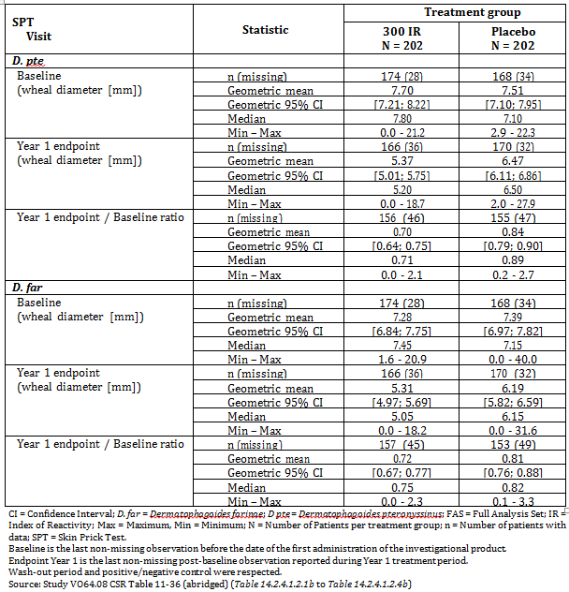

Immunological Markers
The average geometric means of D. pte and D. far specific serum IgE were slightly increased in the 300 IR group at the end of the Year 1 treatment period and went back close to their baseline level at the end of the Year 2 treatment-free period while they remained stable in the placebo group.
The average geometric means of D. pte and D. far specific IgG4 were increased 2 fold at Year 1 endpoint from baseline in the 300 IR group, and were still higher than baseline (1.5 fold) at Year 2 endpoint, while they remained stable in the placebo group.

Sensitisation status
The sensitisation status was unchanged for nearly all patients from baseline to the end of Year 1 or Year 2.

Analyses performed across trials (pooled analyses and meta-analyses)
Not applicable.

Evaluator’s conclusions on clinical efficacy for treatment of HDM allergy
The efficacy of HDM allergen extract is dependent on the results of 2 pivotal studies; VO57.07 which included only adults (18 to 50 years) and Study 1207D1731 which included both adults and adolescents aged 12 to 65 years. In these studies there was statistically significant superiority for both the 300 IR and 500 IR tablets compared to placebo. The difference between the 2 treatments groups was not statistically significant.
The dedicated paediatric Study VO64.08 (5 to 17 years) found no difference between 300 IR and placebo. The study was stopped after the end of the first year of treatment due to the subjects not being sufficiently symptomatic to enable assessment of the efficacy of HDM tablets.
The sponsor claims that the efficacy of the product in children and adolescents is demonstrated from the results of Study 1207D1731. The mean age was 30 ± 11 years and the median age was 30 years. The breakdown of the ages cohorts presented in the study report is as follows.

Table 23: Study 1207D1731: Age cohorts
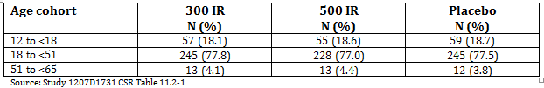
A subgroup analysis in the adolescents (aged 12 to < 18 years) was referenced in the summary of clinical efficacy. This is not included in the study report. No detail is provided with the exception of the conclusion of a statistically significant difference between 500 IR and 300 IR compared to placebo. The treatment effect of the 500 IR group was estimated as the difference in LS means of - 1.88 (95% CI: -2.84, -0.93), corresponding to a relative LS mean difference compared to placebo of -24.8% and the treatment effect of the 300 IR group was estimated as the difference in LS means of -2.04 (p 95% CI: -3.01, -1.08), corresponding to a relative LS mean difference compared to placebo of -26.9%.
There were no children (aged 5 to 12 years) in this study and so the efficacy in this population has not been established.
The EU guideline is clear about the need to establish the efficacy in children and adolescents:
“The efficacy of products for specific immunotherapy has to be evaluated in special trials in the paediatric population and not in combined trials with paediatric population and adults. Adolescents and adults can be investigated as a combined population.”
Study VO64.08 does establish the safety of the product in children and adolescents. It would have been preferable to have been able to fully evaluate the subgroup analysis for the full study outcomes but the AASS has been shown to be statistically significant for the adolescent population. The efficacy has not been established.
There is also a concern about the dose which was used in the studies. The doses selected for study were 300 IR and 500 IR. The selection of these doses is not explained other than as an extrapolation from another sublingual solution product Staloral made by the same sponsor. No details are given about Staloral other than to say in one section of the clinical overview that it is extemporaneously compounded and has been used for decades in Australia and in another part that is contains the same antigens as Actair and that it has been used by over 432,000 patients. It is unclear whether the product has been evaluated for efficacy and safety and how the doses recommended were determined. There is some justification for the choice of 300 IR over 500 IR. Both doses are effective but the 300 IR has a better safety profile than the 500 IR but it is not proven that this is the minimum effective dose. The 100 IR dose is clearly less effective but no doses between 100 IR and 300 IR were tested.

Clinical safety
Comment: The Summary of Clinical Safety does not present an integrated review of the safety but is simply a repeat of the safety section of each study results presented separately.

Studies providing evaluable safety data
The following studies provided evaluable safety data:

Pivotal efficacy studies
In the pivotal efficacy studies, the following safety data were collected:
- General adverse events (AEs) were assessed by specifically monitoring for, or asking about any adverse events using a non-leading question at each visit.
- AEs of particular interest, including anaphylactic shock/severe anaphylactic reactions, severe laryngopharyngeal disorders and autoimmune disorders, were assessed by review of the AE database.
- Laboratory tests, including Haematology: haemoglobin, haematocrit, red blood cells (RBC), platelets, white blood cells (WBC), differential counts (neutrophils, basophils, eosinophils, monocytes, lymphocytes). Biochemistry: Aspartate aminotransferase (AST), alanine aminotransferase (ALT), alkaline phosphatase (ALP), total bilirubin, gamma glutamyltransferase (GGT), lactate dehydrogenase (LDH), total protein, albumin, urea, and creatinine, were performed at enrolment, end of treatment phase and end of observation phase.
- Physical examination; including vital signs (systolic and diastolic blood pressure (BP) and pulse rate) were assessed at each study visit.

Pivotal studies that assessed safety as a primary outcome
Not applicable.

Dose-response and non-pivotal efficacy studies
The dose response and safety and tolerability studies summaries were provided. They provided the same data as for the pivotal studies above.

Other studies evaluable for safety only
Not applicable.

Patient exposure
2,407 patients were exposed to HDM tablet or placebo: 1,571 (1,182 adults, 261 adolescents and 128 children) were exposed to HDM tablet.

Table 24: Exposure to HDM extract and placebo in clinical studies
Rhinitis program |  | Duration | Active (n) | Placebo (n) | Total
Population | Study
Adults | VO36.04F | 10 days | 23 | 8 | 31
Adults | VO57.07 | 12 months | 339 | 170 | 509
Adults | VO67.10 | 6 months | 268 | 87 | 355
Adults | 1109D1711 | 14 days | 27 | 9 | 36
Adults and adolescents | 1207D1731 | 12 months | 646 | 322 | 968
Subpopulation:  adolescents ≥ 12 and < 18 years old | 1207D1731 | 12 months | 121 | 60 | 181
Subpopulation:  Adults ≥ 18 and < 65 years old | 1207D1731 | 12 months | 525 | 262 | 787
Adolescents | VO73.13 | 10 days | 27 | 10 | 37
Adolescents and children | VO64.08 | 12 months | 241 | 230 | 471
Subpopulation:  children ≥ 5 and ≤ 11 years old | VO64.08 | 12 months | 128 | 118 | 246
Subpopulation:  adolescents ≥ 12 and ≤ 17 years old | VO64.08 | 12 months | 113 | 112 | 225
Total |  |  | 1,571 | 836 | 2,407
n = Number of patients exposed Source: Module 2.7.4 Table 2.7.4-7 (amended) (Study VO36.04F CSR Table 12.1; Study VO57.07 CSR Table 14.1.1/1a; Study VO67.10 CSR Table 14.1.1.1b; Study 1109D1711 CSR Table 12.1-1; Study 1207D1731 CSR Table 1-2 and Table 1-3.3; Study VO73.13 CSR Table 14.1.1-2; Study VO64.08 CSR Table 14.1.1.5a and Table 14.1.2.1.1a)

Table 25: Maximum dose patients received
Rhinitis program |  | Maximum dose
 |  | 100 IR  (n) | 200 IR  (n) | 300 IR  (n) | 400 IR  (n) | 500 IR  (n) | 800 IR  (n) | 1,000 IR  (n) |  | 1,500 IR  (n)
Adults | VO36.04F | - | 1 | 7 | - | 15 | - | - |  | -
Adults | VO57.07 | 1 | - | 170 | - | 168 | - | - |  | -
Adults | VO67.10 | 92 | - | 86 | - | 90 | - | - |  | -
Adults | 1109D1711 | 9 | - | 9 | - | 9 | - | - |  | -
Adults and adolescents | 1207D1731 | - | 1 | 322 | 3 | 320 | - | - |  | -
Adolescents | VO73.13 | - | - | - |  | 9 | - | 9 |  | 9
Children and adolescents | VO64.08 | 1 | 1 | 239 | - | - | - | - |  | -
Total |  | 103 | 3 | 833 | 3 | 611 | 0 | 9 | 9
IR = Index of Reactivity; n = Number of patients exposed Source: Module 2.7.4 Table 2.7.4-8 (Study VO36.04F CSR Table 12.1; Study VO57.07 CSR Listing 16.2.5/5a; Study VO67.10 CSR Listing 16.2.1.3b; Study 1109D1711 CSR Section 12.1; Study 1207D1731 CSR Listing 1-1.1, Study VO73.13 CSR Listing 16.2.5-1, Study VO64.08 CSR Listing 16.2.5.1a)

Adverse events

All adverse events (irrespective of relationship to study treatment)

Pivotal studies

Study VO57.07
1,883 treatment emergent adverse events (TEAE) were reported by 427 patients in Year 1; 83.4% of patients in the 500 IR group, 88.2% in the 300 IR group and 80.0% in the placebo group.

Table 26: Study VO57.07: Year 1: Summary of treatment emergent adverse events (safety set)
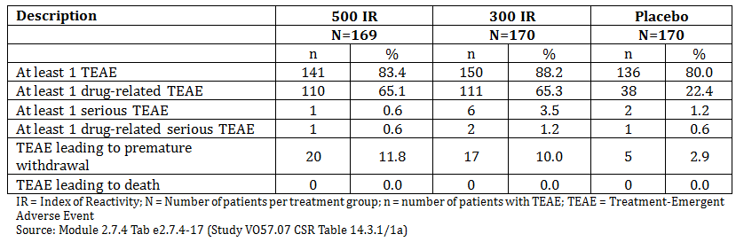
The most commonly reported TEAEs were oral pruritus, nasopharyngitis, and throat irritation. Application site reactions (for example, oral pruritus, mouth oedema, tongue oedema, throat irritation, and pharyngeal oedema) were more commonly reported by patients in the active treatment groups compared to those receiving placebo. Asthma, cough, dyspnoea, and wheeze were reported by a similar percentage of patients in the active and placebo groups.

Table 27: Study VO57.07: Incidence of treatment emergent adverse events reported by at least 5% of patients in any treatment group in Year 1 (safety set)
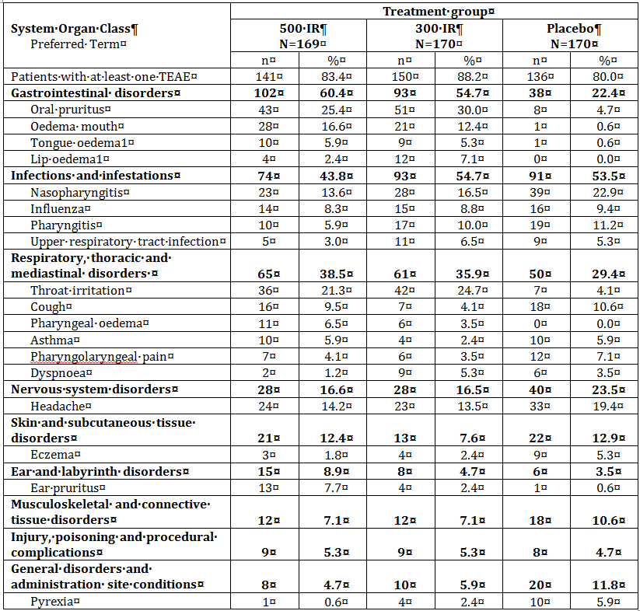
IR = Index of Reactivity; N = Number of patients in each treatment group; n = Number of patients with TEAE; TEAE = Treatment-Emergent Adverse Event 1“Tongue oedema” and “Swollen tongue” are 2 different PT options for events that are similar and were coded using one PT or the other indifferently. Patients who reported these events were grouped under the PT “Tongue oedema” in this table. Similarly, patients who reported “Lip oedema” and “Lip swelling” were grouped under the PT “Lip oedema”. Source: Module 2.7.4 Table 2.7.4-18 (Study VO57.07 CSR Table 14.3.1/2.1a and Table 14.3.1/2.2a)

Study 1207D1731
3,008 AEs were reported by 821 patients (1,132 in the 500IR group; 1,143 in the 300 IR group and 736 in the placebo group). The proportion of patients reporting at least 1 AE ranged from 75.5% in the placebo group to 90.7% in the 500 IR group.

Table 28: Study 1207D1731: Summary of adverse events (safety set)
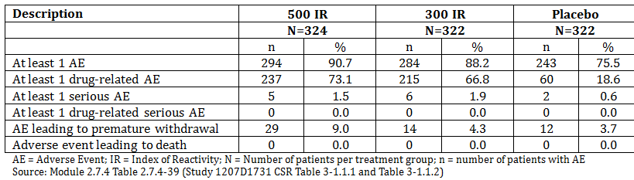
Among the most commonly reported AEs mouth oedema, throat irritation, oral pruritus and ear pruritus were reported by a higher percentage of patients in the active groups than in the placebo group. Asthma or asthma related symptoms (cough, dyspnoea, wheezing) were reported in fewer than 3% of patients per treatment group.
AEs occurred most frequently during the dose-escalation period (Day 1 to Day 14) in all groups.

Table 29: Study 1207D1731: Incidence of adverse events reported by at least 5% of patients in any treatment group (safety set)
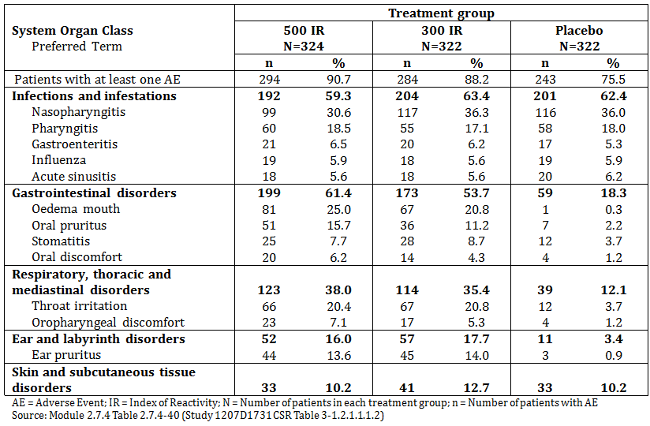

Other studies

Study VO64.08
1,210 TEAEs were reported by 337 patients (71.5%) during year 1. The proportion of patients reporting at least 1 TEAE was 75.1% in the 300 IR group and 67.8% in the placebo group. The incidence of TEAEs was higher in children aged 5 to 11 for both treatment groups (79.7% in the 300 IR group and 76.3% in the Placebo group) than in adolescents aged 12 to 17 (69.9% and 58.9%, respectively).

Table 30: Study VO64.08: Summary of treatment emergent adverse events (safety set)
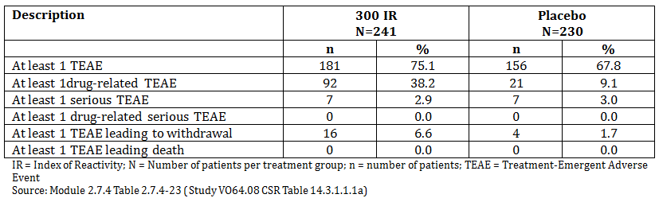
Among the most commonly reported TEAEs, oral pruritus, throat irritation, and tongue oedema were reported by a higher percentage of patients in the active group than in the placebo group.

Table 31: Study VO64.08: Incidence of treatment emergent adverse events reported by at least 5% of patients in any treatment group (safety set)
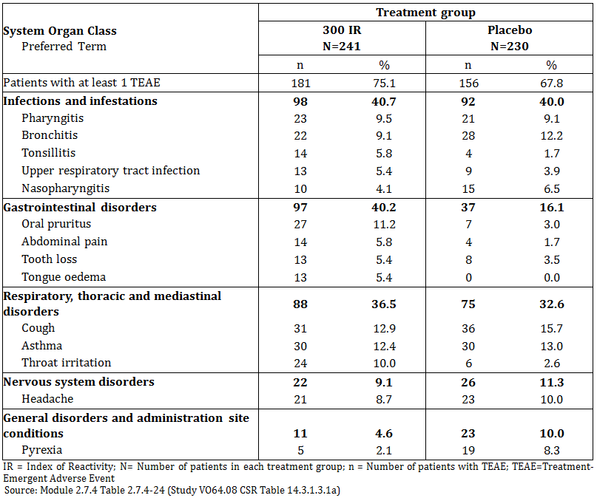

Treatment-related adverse events (adverse drug reactions)

Pivotal studies

Study VO57.07
634 TEAE were considered to be treatment related. The majority (90.4%) were reported following administration of active treatment. The most commonly reported were application site reactions; oral pruritus, throat irritation and mouth oedema. These usually occurred within the first month (mostly the first week) of treatment.

Table 32: Study VO57.07: Incidence of drug related TEAEs reported by at least 5% of patients in any treatment group in Year 1(safety set)
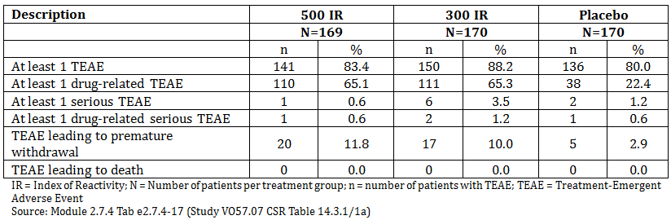
The most commonly reported TEAEs were oral pruritus, nasopharyngitis, and throat irritation. Application site reactions (for example, oral pruritus, mouth oedema, tongue oedema, throat irritation, and pharyngeal oedema) were more commonly reported by patients in the active treatment groups compared to those receiving placebo. Asthma, cough, dyspnoea, and wheeze were reported by a similar percentage of patients in the active and placebo groups.

Table 33: Study VO57.07: Incidence of treatment emergent adverse events reported by at least 5% of patients in any treatment group in Year 1 (safety set)
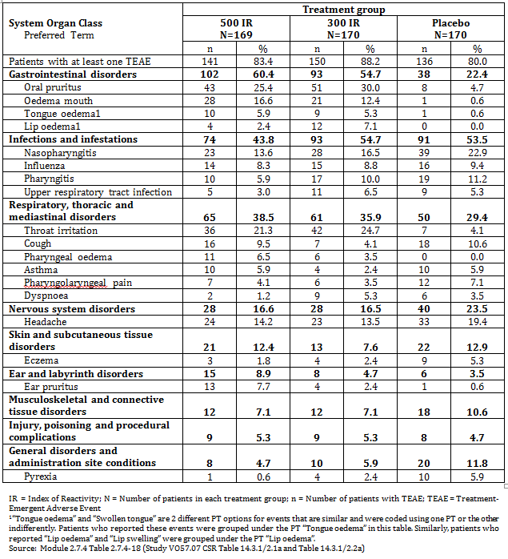

Study 1207D1731
3,008 AEs were reported by 821 patients (1,132 in the 500IR group; 1,143 in the 300 IR group and 736 in the placebo group). The proportion of patients reporting at least 1 AE ranged from 75.5% in the placebo group to 90.7% in the 500 IR group.

Table 34: Study 1207D1731: Summary of adverse events (safety set)
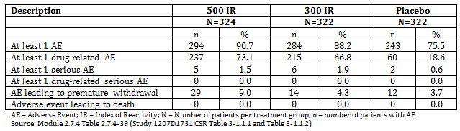
Among the most commonly reported AEs mouth oedema, throat irritation, oral pruritus and ear pruritus were reported by a higher percentage of patients in the active groups than in the placebo group. Asthma or asthma related symptoms (cough, dyspnoea, wheezing) were reported in fewer than 3% of patients per treatment group.
AEs occurred most frequently during the dose-escalation period (Day 1-Day 14) in all groups.

Table 35: Study 1207D1731: Incidence of adverse events reported by at least 5% of patients in any treatment group (safety set)
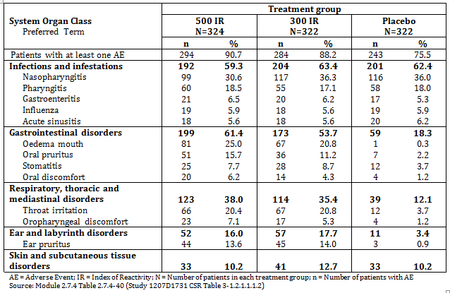

Other studies

Study VO64.08
1,210 TEAEs were reported by 337 patients (71.5%) during year 1. The proportion of patients reporting at least 1 TEAE was 75.1% in the 300 IR group and 67.8% in the placebo group. The incidence of TEAEs was higher in children aged 5-11 for both treatment groups (79.7% in the 300 IR group and 76.3% in the Placebo group) than in adolescents aged 12-17 (69.9% and 58.9%, respectively).

Table 36: Study VO64.08: Summary of treatment emergent adverse events (safety set)
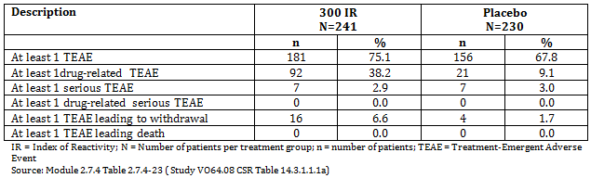
Among the most commonly reported TEAEs, oral pruritus, throat irritation, and tongue oedema were reported by a higher percentage of patients in the active group than in the placebo group.

Table 37: Study VO64.08: Incidence of treatment emergent adverse events reported by at least 5% of patients in any treatment group (safety set)
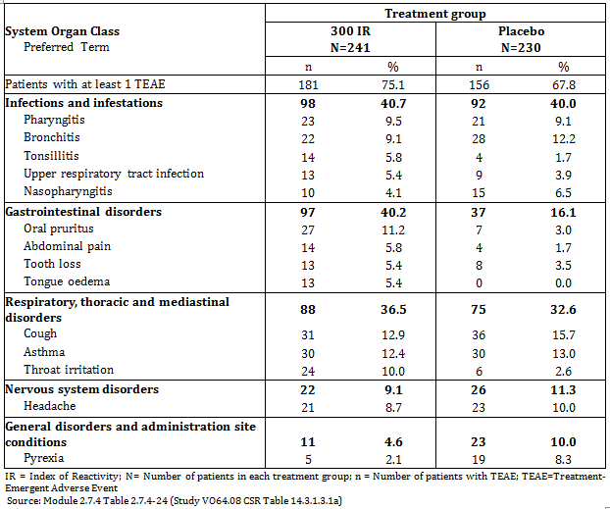

Treatment related adverse events (adverse drug reactions)

Pivotal studies

Study VO57.07
634 TEAE were considered to be treatment related. The majority (90.4%) were reported following administration of active treatment. The most commonly reported were application site reactions; oral pruritus, throat irritation and mouth oedema. These usually occurred within the first month (mostly the first week) of treatment.

Table 38: Study VO57.07: Incidence of drug related TEAEs reported by at least 5% of patients in any treatment group in Year 1(safety set)
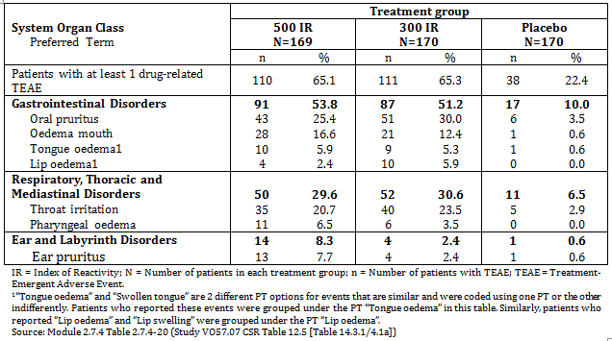

Study 1207D1731
A total of 1,104 AEs out of the 3,008 reported (36.7%) were considered related to the study drug, the majority (1,011; 91.6%) were related to active treatment. The most commonly reported treatment related AEs were application site reactions mouth oedema, oral pruritus and throat irritation.

Table 39: Study 1207D1731: Incidence of adverse events considered as drug related reported by at least 5% of patients in any treatment group (safety set)
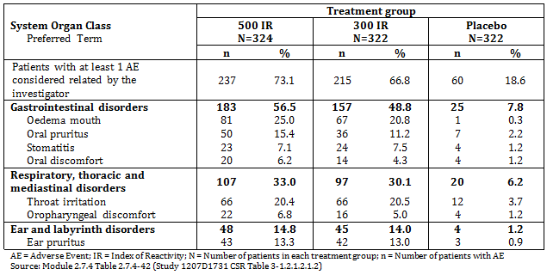

Other studies

Study VO64.08
A total of 219 TEAEs out of the 1,210 (18.1%) were considered drug related, the majority (180, 82.8%) following active treatment. 38.2% of the patients receiving active treatment and 9.1% of patients receiving placebo reported at least 1 drug related TEAE. The most commonly reported related TEAEs were application site reactions - oral pruritus, throat irritation and tongue oedema.
For drug-related TEAEs, the incidence in adolescents was higher than in children for both treatment groups (44.2% and 32.8%, respectively, in the 300 IR group and 12.5% and 5.9%, respectively, in the placebo group).

Table 40: Study VO64.028: Incidence of drug-related treatment emergent adverse events reported by at least 5% of patients in any treatment group (safety set)
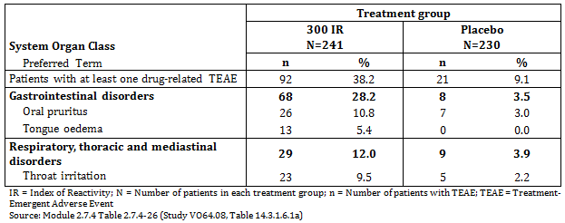

Deaths and other serious adverse events
There were no deaths in any of the studies. There were no reports of anaphylaxis or the use of adrenaline in any study.

Pivotal studies

Study VO57.07
10 SAEs were reported in 9 patients. Four of the 10 SAEs were considered probably, possibly or certainly related to the investigational product by the investigator: respiratory distress in the 500 IR group, pharyngeal oedema and eczema in the 300 IR group, and urticaria in the placebo group. The 6 other SAEs were considered not related to study therapy.

Study 1207D1731
6 SAEs (appendicitis, gastroenteritis, pneumonia bacterial, cholelithiasis, haematuria, and induced abortion) occurred in 6 subjects in the 300 IR group, 8 SAEs (2 cases of diverticulitis, and 1 case each of appendicitis, Escherichia coli gastroenteritis, hepatitis B, inguinal hernia, large intestine polyp, and cholelithiasis) in 5 subjects in the 500 IR group, and 2 SAEs (forearm fracture and ligament injury) in 2 subjects in the placebo group. No SAEs were considered related to study drug.

Other studies

Study VO64.08
14 patients reported 15 SAEs, none of which were considered drug related. In the active group the SAES were: concussion, radius fracture, asthma, appendicitis with asthma, salmonella gastroenteritis, umbilical hernia and abortion (induced). In the placebo group the SAEs were: foot fracture, ligament injury, status asthmaticus, adjustment disorder, suicide attempt, epilepsy and varicocele. All events resolved.

Discontinuation due to adverse events

Pivotal studies

Study VO57.07
A total of 42 patients (8.3%) prematurely discontinued the treatment and withdrew from the study due to an adverse event (500 IR: 20 (11.8%), 300 IR: 17 (10.0%) and placebo: 5 (2.9%)). The most common events leading to discontinuation were dyspepsia, nausea and pharyngeal oedema (4 patients each) and mouth oedema (3 patients). 6 patients withdrew due to serious TEAEs (500 IR: respiratory distress; 300 IR: pharyngeal oedema, both [considered drug related] and vaginal laceration and road traffic accident; placebo group: urticaria, pituitary tumour [not considered drug related]s).

Study 1207D1731
A total of 55 patients (5.7%) prematurely discontinued treatment and withdrew from the study due to an AE (500 IR: 29 (9.0%), 300 IR: 14 (4.3%) and placebo: 12 (3.7%). The most common AEs leading to discontinuation were asthma, dyspnoea, upper abdominal pain, mouth oedema, and nasopharyngitis. Three patients withdrew due to SAEs: gastroenteritis due to E. coli in 1 patient in the 500 IR group, bacterial pneumonia in 1 patient in the 300 IR group and forearm fracture in 1 patient in the placebo group.

Other studies

Study VO64.08
A total of 20 patients prematurely discontinued drug and withdrew from the study due to AEs: 300 IR: 16 (6.6%) and placebo 4 (1.7%). The most common AEs leading to discontinuation were mostly application site reactions (lip and tongue oedema). None were serious, but 3 were severe.

Laboratory tests
In all the completed studies standard haematological and biochemical tests were performed at start and at the end of treatment. While in most studies, out of range values (either above or below the laboratory reference ranges) were found in individuals, none were considered clinically relevant. No patient was withdrawn form a study due to an abnormal laboratory test result. Across all the studies, no notable differences for any haematology or biochemistry parameters were observed between the treatment groups.

Physical Examination and Vital signs
In all the studies, vital signs (systolic blood pressure, diastolic blood pressure and pulse rate) were recorded at each study visit as part of the physical examination. There were no relevant changes over time in mean values of the systolic and diastolic blood pressure and pulse rate and no relevant differences observed between the active and placebo groups. Physical examination findings were generally normal at each scheduled visit.

Post-marketing experience
Not applicable as the product is not commercially available in any country.

Other safety issues

Safety related to drug-drug interactions and other interactions
No drug interaction studies were conducted.

Evaluator’s overall conclusions on clinical safety
Overall the safety of Actair is consistent in the clinical studies. No systemic toxicity has been seen and there were no reports of anaphylactic shock, anaphylaxis or use of adrenaline. The most frequent adverse events were application site reactions such as oral pruritus and throat irritation. Most were mild or moderate severity and were generally reported in the first weeks of treatment but in some cases were significant and led to some patients discontinuing therapy.
The safety profile in children and adolescents were similar to that seen in adults.

First round benefit-risk assessment

First round assessment of benefits
The benefits of Actair in the proposed usage are:
- Statistically significant efficacy compared to placebo in improving symptoms of HDM allergy. 500 IR and 300 IR were equally efficacious in adults and adolescents with no difference between the treatments
- Efficacy at the end of 12 months of treatment in adults is maintained over a treatment free follow up year

First round assessment of risks
The risks of Actair in the proposed usage are:
- Application site adverse reactions are very common
- Efficacy in children (aged 5 to 11 years) has not been demonstrated

First round assessment of benefit-risk balance
The benefit-risk balance of Actair, given the proposed usage, is favourable.

First round recommendation regarding authorisation
Based on the clinical data presented it is recommended that Actair be approved but for the modified indication of only for adults and adolescents aged > 12 years.

Clinical questions
No questions relating to matters other than the PI and CMI were raised in this evaluation.

Second round evaluation of clinical data submitted in response to questions
No questions relating to matters other than the PI and CMI were raised in this evaluation.

Second round benefit-risk assessment

Second round assessment of benefits
No new clinical information was submitted in response to questions. Accordingly, the risks of Actair are unchanged from those identified in the first round assessment of benefits.

Second round assessment of risks
No new clinical information was submitted in response to questions. Accordingly, the risks of Actair are unchanged from those identified the first round assessment of risks..

Second round assessment of benefit-risk balance
The benefit-risk balance of Actair, given the proposed indications for use in adults and adolescents aged > 12 years, is favourable.

Second round recommendation regarding authorisation
Authorisation is recommended, given the proposed indications for use in adults and adolescents aged > 12 years.

References
AIHW 2011 Allergic rhinitis (‘hay fever’) in Australia AIHW 2011 Cat No ACM 23
Bousquet J., Khaltaev N., Cruz A. A. et al Allergic Rhinitis and its Impact on Asthma (ARIA) 2008 Allergy 2008; 63: 8–160
Canonica G. W., Cox L., Pawankar R. Sublingual immunotherapy: World Allergy Organization position paper 2013 update. The World Allergy Organization journal. 2014;7(1):6.
Cox L., Jacobsen L. Comparison of allergen immunotherapy practice patterns in the United States and Europe. Ann Allergy Asthma Immunol. 2009;103:451-459; quiz 459-461, 495.
Lin SY, Erekosima N and Suarez-Cuervo C et al, 2013 Allergen-Specific Immunotherapy for the Treatment of Allergic Rhinoconjunctivitis and/or Asthma: Comparative Effectiveness Review. Executive Summary. Comparative Executive Review No 111. (Prepared by the Johns Hopkins University Evidence based Practice Center under Contract No 290-2007010061-I.) AHRQ Publication No 13-EHC061-EF, Rockville, MD: Agency for Healthcare Research and Quality. March 2013

Therapeutic Goods Administration
PO Box 100 Woden ACT 2606 Australia
Email: info@tga.gov.au Phone: 1800 020 653 Fax: 02 6232 8605
https://www.tga.gov.au

Correction: text should read ‘late randomisation (a dichotomous indicator variable, LateRand, equal to ‘Yes’ if randomisation occurred on or after 1 January 2008, and to ‘No’ if patients were randomised before 1 January 2008 was used as a covariate to determine the effect of the late randomisation on the endpoints’.
Clarification: the text should read There was a statistically significant difference between the 300 IR and placebo group in the overall RQLQ score and for all domains
Clarification. The study report did include the information referenced in the summary of clinical efficacy.
Clarification; nasopharyngitis was more common in the placebo group.
Clarification; nasopharyngitis was more common in the placebo group.

