AusPAR Attachment 2

Extract from the Clinical Evaluation Report for ambrisentan
  - Proprietary Product Name: Volibris
  - Sponsor: GlaxoSmithKline Australia Pty Ltd
1st round report: June 2015
2nd round report: September 2015

About the Therapeutic Goods Administration (TGA)
- The Therapeutic Goods Administration (TGA) is part of the Australian Government Department of Health, and is responsible for regulating medicines and medical devices.
- The TGA administers the Therapeutic Goods Act 1989 (the Act), applying a risk management approach designed to ensure therapeutic goods supplied in Australia meet acceptable standards of quality, safety and efficacy (performance), when necessary.
- The work of the TGA is based on applying scientific and clinical expertise to decision-making, to ensure that the benefits to consumers outweigh any risks associated with the use of medicines and medical devices.
- The TGA relies on the public, healthcare professionals and industry to report problems with medicines or medical devices. TGA investigates reports received by it to determine any necessary regulatory action.
- To report a problem with a medicine or medical device, please see the information on the TGA website <https://www.tga.gov.au>.
About the Extract from the Clinical Evaluation Report
- This document provides a more detailed evaluation of the clinical findings, extracted from the Clinical Evaluation Report (CER) prepared by the TGA. This extract does not include sections from the CER regarding product documentation or post market activities.
- The words [Information redacted], where they appear in this document, indicate that confidential information has been deleted.
- For the most recent Product Information (PI), please refer to the TGA website <https://www.tga.gov.au/product-information-pi>.
Copyright
© Commonwealth of Australia 2017
This work is copyright. You may reproduce the whole or part of this work in unaltered form for your own personal use or, if you are part of an organisation, for internal use within your organisation, but only if you or your organisation do not use the reproduction for any commercial purpose and retain this copyright notice and all disclaimer notices as part of that reproduction. Apart from rights to use as permitted by the Copyright Act 1968 or allowed by this copyright notice, all other rights are reserved and you are not allowed to reproduce the whole or any part of this work in any way (electronic or otherwise) without first being given specific written permission from the Commonwealth to do so. Requests and inquiries concerning reproduction and rights are to be sent to the TGA Copyright Officer, Therapeutic Goods Administration, PO Box 100, Woden ACT 2606 or emailed to <tga.copyright@tga.gov.au>.

Contents
List of abbreviations 5
1. Introduction 7
1.1. Drug class and therapeutic indication 7
1.2. Dosage forms and strengths 7
1.3. Dosage and administration 7
2. Clinical rationale 7
3. Contents of the clinical dossier 8
3.1. Scope of the clinical dossier 8
3.2. Paediatric data 8
3.3. Good clinical practice 9
4. Pharmacokinetics 9
4.1. Studies providing pharmacokinetic data 9
4.2. Summary of pharmacokinetics 9
5. Pharmacodynamics 10
5.1. Studies providing pharmacodynamic data 10
5.2. Summary of pharmacodynamics 10
5.3. Pharmacodynamic interactions 10
6. Dosage selection for the pivotal studies 10
7. Clinical efficacy 10
7.1. Ambrisentan in combination with tadalafil: initial therapy for PAH 10
7.2. Ambrisentan added to tadalafil for PAH 33
7.3. Tadalafil added to ambrisentan for PAH 34
8. Clinical safety 36
8.1. AMBITION study 36
8.2. Patient exposure 37
8.3. Adverse events 37
8.4. Laboratory tests 42
8.5. Post-marketing experience 44
8.6. Other safety issues 44
8.7. Evaluator’s overall conclusions on clinical safety 45
9. First round benefit-risk assessment 45
9.1. First round assessment of benefits 45
9.2. First round assessment of risks 45
9.3. First round assessment of benefit-risk balance 46
10. First round recommendation regarding authorisation 47
11. Clinical questions 47
11.1. Efficacy 47
11.2. Safety 48
11.3. Other 48
12. Second round evaluation of data in response to questions 48
12.1. Efficacy 48
12.2. Safety 50
12.3. Other 51
12.4. Further responses and comments to the evaluation report 51
12.5. Literature submitted and referenced by the sponsor 53
13. Second round benefit-risk assessment 55
13.1. Second round assessment of benefits 55
13.2. Second round assessment of risks 56
13.3. Second round assessment of benefit-risk balance 56
14. Second round recommendation regarding authorisation 56
15. References 56

List of abbreviations
Abbreviation | Meaning
6MWD | 6 minute walk distance
AE | Adverse event
AESI | Adverse events of special interest
BCT | Blinded combination therapy
BDI | Borg dyspnoea index
CAMPHOR | Cambridge Pulmonary Hypertension Outcome Review
CCB | Calcium channel blocker
EMA | European Medicines Agency
EoS | End of Study
ERA | Endothelin receptor antagonist
ET_{A} | Endothelin receptor type A
ET_{B} | Endothelin receptor type B
EU | European Union
FAV | Final assessment visit
FC | Functional class
GSK | Glaxo Smith Kline
HPAH | Heritable pulmonary arterial hypertension
HR | Hazard ratio
IP | Investigational product
IPAH | Idiopathic pulmonary arterial hypertension
ITT | Intention to treat
LVEDP | Left ventricular end diastolic pressure
mITT | Modified intention to treat
mPAP | Mean pulmonary arterial pressure
NT-pro-BNP | N-terminal pro-B-type natriuretic peptide
PAH | Pulmonary arterial hypertension
PCWP | Pulmonary capillary wedge pressure
PDE-5i | Phosphodiesterase type 5 inhibitor
PK | Pharmacokinetics
PVR | Pulmonary vascular resistance
SAE | Serious adverse event
SD | Standard deviation
SF-36 | Short form 36 (health survey)
TEAE | Treatment emergent adverse event
WHO | World Health Organization

Introduction
This is a submission to extend the therapeutic indications of ambrisentan to include combination therapy with tadalafil for the treatment of pulmonary arterial hypertension (PAH).

Drug class and therapeutic indication
Volibris is a selective endothelin receptor antagonist.
Currently, Volibris is indicated for the treatment of
- Idiopathic pulmonary arterial hypertension (PAH)
- Pulmonary arterial hypertension associated with connective tissue disease (PAH-CTD)
in patients with WHO functional class II, III, or IV symptoms.
The proposed additional indication is:
Volibris is indicated for the treatment of pulmonary arterial hypertension (PAH and PAH-CTD) in combination with tadalafil to reduce the risk of clinical failure (a composite of death, PAH hospitalization, disease progression and unsatisfactory clinical response) and to increase satisfactory clinical response and exercise ability.
Tadalafil is a reversible inhibitor of cyclic guanosine monophosphate (cGMP)-specific phosphodiesterase type 5 (PDE-5i). Tadalafil is indicated in adults for the treatment of pulmonary arterial hypertension (PAH) classified as WHO functional class II and III to improve exercise capacity. Efficacy has been shown in idiopathic PAH and PAH related to collagen vascular disease.

Dosage forms and strengths
The following dosage forms and strengths are currently registered: 10 mg and 5 mg tablet blister pack. No new dosage forms or strengths are proposed.

Dosage and administration
Currently, treatment should only be initiated by a physician experienced in the treatment of PAH.
Volibris should be taken orally at a dose of 5mg once daily. Additional benefit may be obtained by increasing the dose to 10mg.
Proposed additional information:
- When used in combination with tadalafil, the Volibris dose should be titrated to 10mg once daily.
- The recommended dose of tadalafil is 40mg daily.

Clinical rationale
Ambrisentan is a selective endothelin receptor type A (ET_{A}) antagonist.
Tadalafil is an orally active selective inhibitor of the enzyme PDE-5, the primary cyclic guanosine monophosphate hydrolysing enzyme in smooth muscle.
There are both clinical and non-clinical data to support the combination therapy of ambrisentan with tadalafil. In an animal model, the combined use of ambrisentan and tadalafil had a synergistic effect on pulmonary hypertension in rat pulmonary arteries (Liang 2012). There were no clinically significant PK interaction between ambrisentan and tadalafil in a study in healthy volunteers. In two small clinical studies in patients with PAH, beneficial effects were observed when tadalafil was added to existing ambrisentan (Oudiz 2011, Shapiro 2012) and when ambrisentan was added to tadalafil (Zhuang 2014).
The main therapies currently used for PAH target the signalling pathways in PAH. These include the prostacyclin derivatives which target the cyclic adenosine monophosphate dependent prostacyclin pathway; the phosphodiesterase type -5 inhibitors which target the cyclic guanosine monophosphate dependent nitric oxide pathway, and the endothelin receptor antagonists which target the phospholipase-C-dependent endothelin pathway. Other medications currently used for PAH include diuretics, anticoagulants and calcium channel blockers. Although the evolution of treatments for PAH has lengthened survival time, improved exercise tolerance, hemodynamics, and quality of life for patients with PAH, it remains a life threatening illness. The mean 3 year survival is around 67%.
The sponsor’s rationale for this submission is to expand the therapeutic indications for ambrisentan to include combination therapy with tadalafil. This is on the basis of clinical trial evidence showing benefits of combined therapy.
Evaluator’s comments:
Both ambrisentan and tadalafil are on the ARTG for the treatment of pulmonary hypertension. There are no barriers to physicians using these two medications as combination therapy.
This application for an extension of indications for use of a medicine in combination with another medicine, but without a new fixed dose combination or combination pack is unusual. Many drugs such as those for diabetes and hypertension are used in combination, but the combined use as such is not specifically stipulated in the indication section of the PI. A number of other drug combinations have been studied for the treatment of PAH, most of these have been small clinical trials. The CPMP/EWP guidelines for the approval of fixed dose combination medicines are applicable to this application. However, unlike a fixed dose combination medicine, an extension of indication to include two tablets does not have the benefits of ease of administration and potential cost saving that a once daily tablet would have.

Contents of the clinical dossier

Scope of the clinical dossier
The clinical dossier contained:
- The results of the AMBITION study (study number AMB112565). This is a pivotal efficacy and safety study for the use of ambrisentan in combination with tadalafil as initial therapy for PAH
- PDF copies of references

Paediatric data
The submission did not include paediatric data. The sponsor has submitted a European Paediatric Investigation Plan, the due date of the first report is February 2014. There is no American paediatric plan as this is not required for orphan drugs. There is a small paediatric population with PAH. The priority in any drug development program for children is to assess the pharmacokinetics, define a safe and efficacious dose, and provide an appropriate formulation.

Good clinical practice
An AUDIT certificate is included in the dossier to verify that the AMBITION study was conducted and reported in accordance with the ethical principles originating in the Declaration of Helsinki and in accordance with the International Conference of Harmonization Good Clinical Practice guidelines.

Pharmacokinetics

Studies providing pharmacokinetic data
No original studies with pharmacokinetic data were submitted.

Summary of pharmacokinetics
Ambrisentan is a white to off white crystalline substance. It is poorly soluble in water but soluble in 0.1N NaOH.

Pharmacokinetics in healthy subjects

Bioavailability
The absolute bioavailability of ambrisentan is unknown. After oral administration, ambrisentan is absorbed rapidly. The maximum peak concentration (C _{max}) typically occurs around 1.5 hours after the dose in fed and fasted conditions. C_{max} and AUC increase dose proportionately over the therapeutic drug range. Steady state is achieved after 4 days of repeat dosing.

Distribution
Ambrisentan is highly protein bound. It is primarily bound to albumin (96.5%) and to a lesser extent alpha acid glycoprotein. The distribution of ambrisentan into red blood cells is low, the mean blood: plasma ratio is 0.57 and 0.61 in males and females respectively.

Metabolism
Ambrisentan is excreted largely unchanged (45.6% of the dose). It is metabolised in the liver by glucuronidation and oxidation. The major metabolite 4-hydroxymethyl ambrisentan has a much lower affinity for the human endothelin receptor, therefore is not likely to contribute to the pharmacological activity of ambrisentan.

Excretion
Ambrisentan and its metabolites are eliminated primarily in the bile following hepatic and extra-hepatic metabolism with 66% of the oral dose excreted in the faeces. Approximately 22% of the oral dose is recovered from the urine. The plasma elimination half-life in humans ranges from 13.6-16.5 hours.

Pharmacokinetic interactions

Pharmacokinetic interactions demonstrated in human studies with tadalafil
In healthy volunteers receiving tadalafil (40mg daily), concomitant administration of ambrisentan had no clinically relevant effect on the pharmacokinetics of either ambrisentan or its metabolite. The single dose pharmacokinetics of tadalafil (40mg) were unaffected by multiple doses of ambrisentan (10mg daily).

Pharmacodynamics

Studies providing pharmacodynamic data
No new pharmacodynamic data was submitted.

Summary of pharmacodynamics
Ambrisentan acts by selective inhibition of the ET_{A} receptor and inhibits phospholipase-C mediated vasoconstriction and protein kinase-C mediated cell proliferation while preserving nitric oxide and prostacyclin production, cyclic GMP and cyclic AMP mediated vasodilatation and endothelin-1 clearance associated with the ET_{B} receptor.
Plasma ET-1 concentrations are increased up to 10 fold in patients with PAH. This has a direct effect on increased mean right atrial pressure and disease severity.

Pharmacodynamic interactions
A nonclinical study in rats demonstrated a synergistic effect of ambrisentan and tadalafil in pulmonary arteries that was not seen with non-selective ERAs. In this study, rat pulmonary arterial rings were isolated and contracted with 8nmol of endothelin-1. The use of 10nmol/L of ambrisentan and 30nmol/L of tadalafil relaxed the arterial ring by 26 ± 3% and 21 ± 1% respectively when used alone, and by 83 ± 6% when used in combination (Liang 2012).

Dosage selection for the pivotal studies
The dosage selected for the clinical studies is consistent with the formulations available in Australia, and what is recommended in the individual product’s PI.

Clinical efficacy

Ambrisentan in combination with tadalafil: initial therapy for PAH

Study design, objectives, locations and dates
The AMBITION study (Study AMB112565) is a pivotal efficacy and safety study for the use of ambrisentan in combination with tadalafil as initial therapy for PAH. The AMBITION study was a Phase III-IV, randomised, double blind, three arm study which compared initiating treatment for PAH with a combination therapy with ambrisentan and tadalafil, monotherapy with ambrisentan or monotherapy with tadalafil. The main efficacy outcome was clinical failure defined as either death, hospitalisation for worsening of PAH, disease progression or unsatisfactory long term clinical response. All patients were to receive at least 24 weeks of treatment. The subjects continued in the study until a clinical failure event occurred, or after data freeze (when the target number of primary endpoints was reached). The study was conducted in 120 centres in 14 countries. It was co-sponsored by GSK and Gilead Sciences. The first subject visit was 18 October 2010; the last was 31 July 2014.

Inclusion and exclusion criteria

Inclusion criteria
- Class I PAH: Includes patients with idiopathic PAH; hereditary PAH; or PAH associated with connective tissue disease, drugs or toxins, HIV, or congenital heart disease repaired > 1 year prior to screening
- WHO functional class II or III
- mPAP ≥ 25mmHg, PVR ≥ 300 dyne.sec/cm⁵, pulmonary capillary wedge pressure or left ventricular wedge pressure or left ventricular end-diastolic pressure ≤ 12mmHg if PVR ≥ 300 to < 500 dyne.sec/cm⁵, or PCWP/LVEDP ≤ 15mmHg if PVR ≥ 500dyne.sec/cm⁵.
- Age 18-75 years
- Weight > 40kg
- Adequate pulmonary function: TLC > 60% predicted, FEV1> 50% predicted, negative VQ scan
- If HIV positive, stable disease
- Able to walk between 125 and 500m at the screening visit
- Resting arterial oxygen saturation > 88% with or without supplemental oxygen

Exclusion criteria
- Subjects with portopulmonary hypertension and pulmonary veno-occlusive disease
- Patients with 3 or more of the following left ventricular disease risk factors (patients who had these features are in the non-mITT population)
  - BMI>30kg/m²
  - Essential hypertension
  - Diabetes mellitus
  - History of significant coronary disease
- Enrolment in exercise training program for pulmonary rehabilitation within 12 weeks of the screening visit
- Treatment with PDE-5i, ERA or prostanoid within 7 days of the screening visit
- Previous intolerance or adverse events due to PDE-5i or ERA
- Known hypersensitivity to the investigational products, metabolites or excipients
- Having received inotropes within 2 weeks of the screening visit
- The following medications : protease inhibitors, systemic ketoconazole, systemic itraconazole or other potent inhibitors of CYP3A4; rifampicin or inducers of CYP3A4; cyclosporine A, calcium channel blockers, HMG CoA reductase inhibitors, nitrates
- AST or ALT > 2X ULN or bilirubin > 1.5XULN; or severe liver disease
- Creatinine clearance < 30ml/minute
- Clinically significant anaemia
- Uncontrolled hypertension >180/110mmHg or hypotension < 90/50mmHg
- Acute MI within 90 days
- Clinically significant cardiac disease
- Non-arteritic anterior ischemic optic neuropathy or hereditary degenerative retinal disorder
- Clinically significant fluid retention
- Malignancy within 5 years
- Recent history of drug or alcohol abuse
Evaluator comment: The exclusion of patients with WHO functional class IV and with LV risk factors resulted in a study population with less severe disease. However in clinical practice, patients with more severe disease are more likely to need (and receive) more intensive treatment such as combination therapy. Patients with WHO functional class IV were included in most of the other combination drug trials listed. The inclusion and exclusion criteria are not reflected in the proposed additional indications for combination therapy.

Study treatments
The combination therapy group received tadalafil and ambrisentan. The target dose of tadalafil was 40mg. This was titrated from a starting dose of 20mg over 4 weeks. The target dose of ambrisentan was 10mg. This was titrated upward from a starting dose of 5mg over 8 weeks.
The ambrisentan monotherapy group received up to 10mg of ambrisentan. The starting dose was 5mg, this was weaned up to 10mg if tolerated over 8 weeks. These patients received a placebo tablet identical to tadalafil.
The tadalafil monotherapy group received up to 40mg of tadalafil. The starting dose was 20mg. This was weaned up to 40mg over 4 weeks. These patients received a placebo tablet identical to ambrisentan. Figure 1 demonstrates the dose titration regime.
Evaluator comment: The reason for the 10mg dose of ambrisentan is unclear. In the ARIES studies, there was minimal difference in outcomes with 5mg versus 10mg or ambrisentan. The long titration period reduced the period of treatment with the target drug dose from 24 weeks to 16-20 weeks.
Figure 1: Schematic Diagram of the AMBITION study.
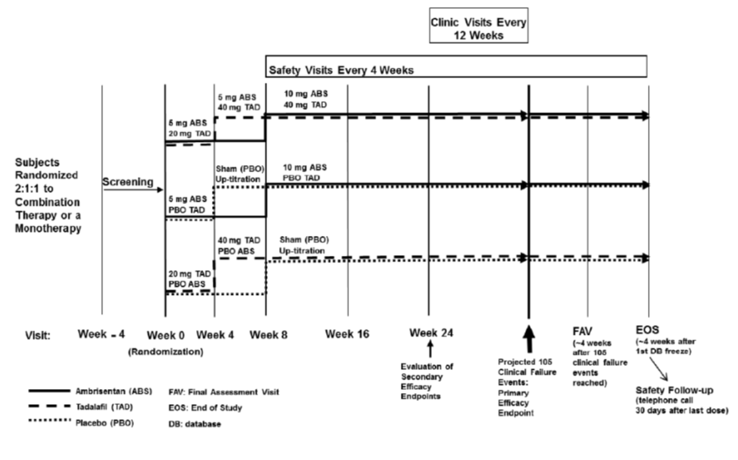
After a clinical failure event, the investigator could elect to either not change treatment, change treatment to blinded combination therapy (BCT), or initiate prostanoids. Patients were encouraged to remain in the study after a clinical failure event. When BCT was initiated, patients randomised to initial monotherapy had the other drug combination added to their medication regime; patients who were randomised to combination therapy remained on combination therapy.

Efficacy variables and outcomes
The primary endpoint was time to first clinical failure event.
The secondary objectives were to compare the change in other clinical measures of PAH after initiating either first line combination therapy or first line monotherapy. Secondary efficacy endpoints included:
- N-terminal pro-B-type natriuretic peptide (NT-pro-BNP) as change from baseline at week 24
- Percentage of subjects with satisfactory clinical response at week 24. This was measured by a 10% improvement in 6MWD compared with baseline and improvement or maintenance of WHO class II or III symptoms and no events of clinical worsening prior to the week 24 visit
- 6MWD as change from baseline at week 24
- WHO functional class as change from baseline at week 24
- Borg Dyspnoea Index- as change from baseline to week 24 following exercise
Exploratory endpoints included an assessment of the effect of peak trough ambrisentan concentrations on exercise capacity in subjects with PAH.
Evaluator comment: The EMEA/CHMP/EWP guidelines for pulmonary hypertension acknowledge that the efficacy of the currently registered medicines for PAH is mainly based on an improvement in exercise capacity and that the objectives of new treatment should be to prolong the survival time, reduce morbidity, ameliorate symptoms and improve quality of life. The use of time to clinical worsening is acknowledged as being an appropriate endpoint. It also states that any endpoint should be adequately defined, well validated, and centrally adjudicated.
The clinical evaluator is concerned about pooling the four groups of clinical failure events. Pooling is considered to be inappropriate if each component end point is of unequal importance to the patient and where the biology of the endpoints differ (Montori). Death is a very different event to hospitalization, disease progression or unsatisfactory clinical response. Clinical worsening is part of the natural history of PAH. There is no gold standard therapy available to prevent this. Current standard of care would be to optimise treatment if a patient is worsening or not responding to current therapy. Hospitalisation thus may not necessarily be a clinical failure event, but an opportunity for clinical improvement with more optimal therapy. In this study, the reason for hospitalisation for PAH is not well described; more information about this will be requested.
As time to first clinical failure event was the main outcome factor, the clinical evaluator has assumed that further clinical events were not included- however this is not clear (For example, if a patient was hospitalised then later died was that included as one or two events?). Each of the events listed as a clinical failure were important outcomes. It would have been more clinically helpful to have each of these events as individual primary efficacy endpoints; however the study was not powered for this.

Randomisation and blinding methods
Subjects and investigators were blinded as to the treatment arm. Tablets were given in a blister pack; placebo and active tablets of each intervention product (IP) were identical. Treatment could be unblinded by the investigator or treating physician in the case of a medical emergency or serious medical condition when knowledge of the IP was necessary for the patient’s care. If this occurred, the clinical event which precipitated the withdrawal was recorded and the patient was discontinued from efficacy evaluations. There were 19 patients unblinded during the study for medical reasons.
Subjects were stratified for underlying aetiology of PAH and WHO stage prior to randomisation. Randomisation was in a ratio of 2:1:1 within each stratum to receive combination therapy: ambrisentan monotherapy: tadalafil monotherapy. Randomisation was performed using the sponsor’s randomisation system, RandAll, and an interactive voice response system.

Analysis populations
The study continued until there had been at least 105 adjudicated first clinical failure events.
The initial database freeze occurred after the last randomised subject had received more than 24 weeks of therapy and the 105th adjudicated first clinical failure event had occurred. Subjects were asked to attend for the end of study (EoS) visit 4 weeks after this time point. A phone call to assess safety was made 30 days after the subject’s last IP dose. After this, a second database lock occurred.
Figure 2: End of Study Strategy.
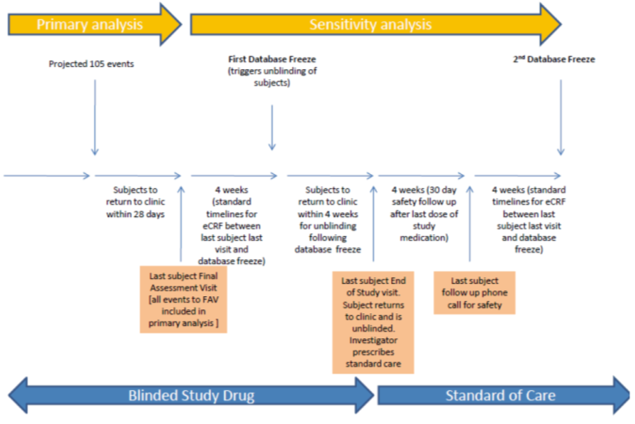
The primary efficacy analysis was performed on the mITT population, which was defined as the ITT population who met the eligibility criteria redefined in protocol amendment 2 (i.e. did not have risk factors for left heart failure).

Sample size
This was an event driven study. It was estimated that 105mITT subjects with an adjudicated clinical failure event were needed for the study to have a power of 97% for the comparison of combination therapy and pooled monotherapy and 85% power for the comparison of combination therapy and each mono-therapy. A type 1 error of 5% was assumed.
The original sample size calculations (based on an overall event rate of 15% and HR of 0.47) were revised after 2 years after a blinded review of the event rate. At that time, the estimated adjudicated events were 77% of the predicted rate, and the overall event rate re-estimated at 12% per year. Using the later event rate and a 148 week recruitment period, it was estimated that to obtain 105mITT subjects with a first event, a total of 614 subjects would be needed to enrol 520 mITT subjects.
Evaluator comment: The proposed sample size would give the study 97% power to assess the difference between combined therapy and both pooled monotherapy, and 85% power to assess the difference between combination therapy and individual monotherapy for the primary efficacy outcomes. The power to assess the difference between sub scores of the composite efficacy measure is not given.

Statistical methods
The null hypothesis tested was that there was no difference in the time to clinical failure of PAH in subjects treated with monotherapy compared to combination therapy.
The primary statistical comparison was the time to first clinical failure event in the combination therapy group compared to the pooled monotherapy group through to the final assessment visit (FAV) for each subject. The comparison was tested at the 5% significance level. Secondary comparisons between the combination therapy group and individual monotherapy groups were to be made if the difference between the combination therapy and pooled monotherapy groups were significant. Secondary efficacy endpoints were to be tested is statistical significance was demonstrated for the primary efficacy endpoint for the comparison between combination therapy and pooled monotherapy groups. These were assessed at week 24 and assessed in a hierarchical step down fashion.
All randomisation subjects were included in the study. For time to event endpoints, all lost to follow up subjects were censored at their last known date in the study. For other endpoints, multiple statistical methods were applied as sensitivity analysis including mixed models repeated measures, and imputation methods for repeated data (worst rank score, worst case, last observation carried forward).
Evaluator comment: The sponsor compared the results for combination therapy with ambrisentan and tadalafil with pooled results for monotherapy with ambrisentan or tadalafil. Although the use of pooling results is statistically advantageous in increasing the power of the study, there are disadvantages. It relies upon an assumption that the variables included were equal, i.e. that the response to ambrisentan or tadalafil was equivalent. Clinically, the comparison between combination therapy and each individual monotherapy is most relevant.
Pooling the efficacy outcomes (death, hospitalisation, disease progression and unsatisfactory long term clinical response) also improves the power of the study. However, the results of such pooled analysis cannot be used to infer there was an improvement in all subscales of the pooled outcome.
Statistical tests for sensitivity the three analysis populations (mITT, non-mITT and ITT) were performed, as well as statistical tests for the two possible endpoints (FAV and EoS). This is appropriate.

Participant flow
This is described below.
Figure 3: Study populations.
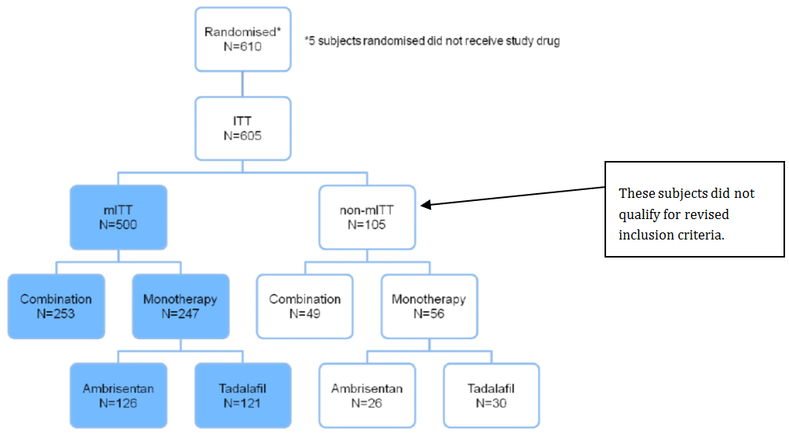

Major protocol violations/deviations
There were a number of significant protocol amendments during the study. Most notably, the inclusion/exclusion criteria were revised in protocol amendment 2 to reduce the number of subjects with multiple left heart failure risk factors. This was performed after a blinded review of data from the first 6 months of the trial demonstrated a high number of patients with risk factors for left ventricular dysfunction compared to previous PAH trials. The sponsor stated the amendment was aimed to prevent patients with coexisting diastolic dysfunction (WHO PAH classification group 2) from being enrolled.
There were a total of 104 (17%) important protocol deviations in the ITT population. These included eligibility criteria not being met (n=53), receiving the wrong treatment or an incorrect dose (n=39), the use of a prohibited medicine or device (n=11), not being withdrawn after developing withdrawal criteria (n=5), or other protocol deviation (n=6). A total of thirty patients were withdrawn due to a protocol deviation.

Baseline data
Of the 610 patients who enrolled in the study, 5 did not receive the investigational product. Over 80% of subjects met the PAH diagnosis and classification criteria defined in protocol amendment 2 and were included in the mITT population.

Table 1: Study populations.
 | Randomised subjects
 | Combination therapy | Pooled monotherapy | Ambrisentan monotherapy | Tadalafil monotherapy | total
ITT | 302 | 303 | 152 | 151 | 605
mITT | 253 | 247 | 126 | 121 | 500
Non-mITT | 49 | 56 | 26 | 30 | 105
In the mITT population, from baseline to day 28 (during dose titration) more patients in the combination therapy group (8%) discontinued compared to the monotherapy groups (3% ambrisentan and 2% tadalafil). The main reason for discontinuing was adverse events. During the 24 weeks of the study from baseline to FAV, a total of 17% of the combination therapy group, 24% of the ambrisentan monotherapy group and 23% if the tadalafil monotherapy group discontinued. The main reason for discontinuation was adverse effects. The risk of discontinuing due to adverse effects was higher for ambrisentan monotherapy than either combination therapy or tadalafil monotherapy.
More patients discontinued in the non-mITT group, 31% in the combination therapy group, 35% in the ambrisentan monotherapy group and 43% in the tadalafil monotherapy group. Adverse events were the most commonly described reason for discontinuing.
Overall, approximately 78% of subjects in the mITT populations and 60% of subjects in the non-mITT population completed the study.

Table 2: Subject disposition to last contact in the mITT population.
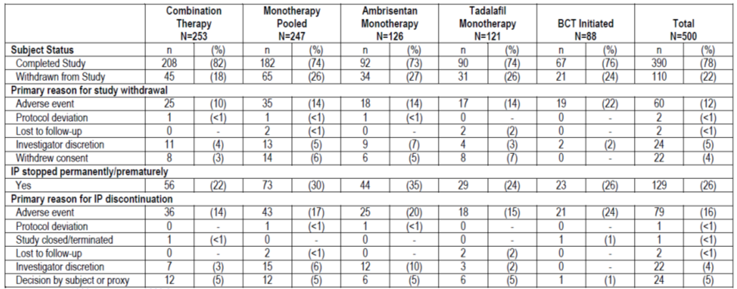

Table 3: Subject disposition to last contact in the non-mITT population.
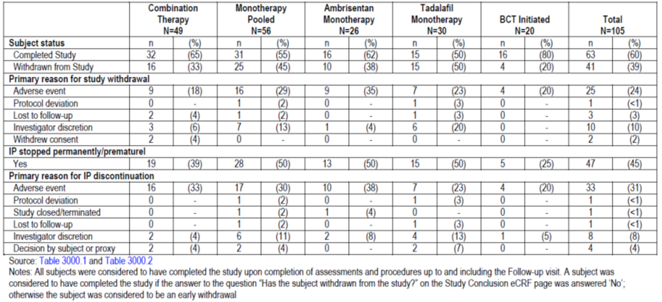
Evaluator’s comment: Over 20% of subjects did not complete the trial. The impact of this on the power of the study is unknown. More patients stopped the IP than withdrew from the study. The difference between these two groups is unclear from the CSR. Clarification will be requested. A larger number of patients in the tadalafil group of the non-mITT population (20%) were withdrawn by the investigator.

Baseline demographics
In the mITT population, the mean age was 54 years, over 70% were female. There were 153 subjects (31%) between 65 and 75 years and 8 (2%) over 75 years. Approximately 90% of subjects were white. Most subjects (> 65%) were not on concomitant calcium channel blockers. There was a discrepancy in the aetiology of PAH and WHO classification based on the interactive voice response system and eCRF. The results of the eCRF are reported as follows. Overall, 53% of subjects had IPAH, 44% has associated PAH and 3% had heritable PAH. There were less patients with WHO functional class II (31% overall) than WHO functional class III (69% overall). The median baseline 6MWD was 357m, and baseline BDI score 3.5-4.

Table 4: Population demographics of ITT.
 | Combination therapy N=302 | Pooled monotherapy N=303 | Ambrisentan monotherapy N=152 | Tadalafil monotherapy N=151 | Total N=605
Mean age (years)  n > 65 years | 55.9  101 (33%) | 55.6  105 (34%) | 55.2  49 (33%) | 55.9  56 (37%) | 55.7  193
Sex, M (%) | 79 | 65 | 35 | 30 | 144
Calcium channel blockers-Y | 93 (31%) | 101 (33%) | 46 (30%) | 55 (36%) | 194
Aetiology of PAH  Idiopathic  Heritable  associated | 156  10  136 | 174  7  121 | 87  3  61 | 87  4  60 | 330  17  257
WHO score  II  III | 93  209 | 99  204 | 46  106 | 53  98 | 192  413
Baseline 6MWD (median) | 355.5m | 359.5m | 365.75m | 352m | 357m
Baseline BDI | 4 | 4 | 4 | 3.5 | 4
Baseline pro-B NP (ng/L) | 819 | 948.5 | 1171.0 | 665.3 | 871
The non-mITT population was older, mean age 62.8 years, and had more severe disease. Overall, 35% were WHO class II and 65% were WHO class III. The median 6MWD was 330.5m and BDI score 4.
Overall, the groups were well matched except there were fewer patients in the tadalafil monotherapy group with WHO III, and the patients had a lower mean BDI, suggesting they had milder disease
Co-morbidities were common. In the ITT population, 46% had hypertension, 21% had Raynaud’s syndrome, 10% had renal disease, 18% had diabetes, and 7% had coronary artery disease.
Fifteen subjects (2%) had received previous treatment for PAH.

Table 5: Previous PAH therapy.
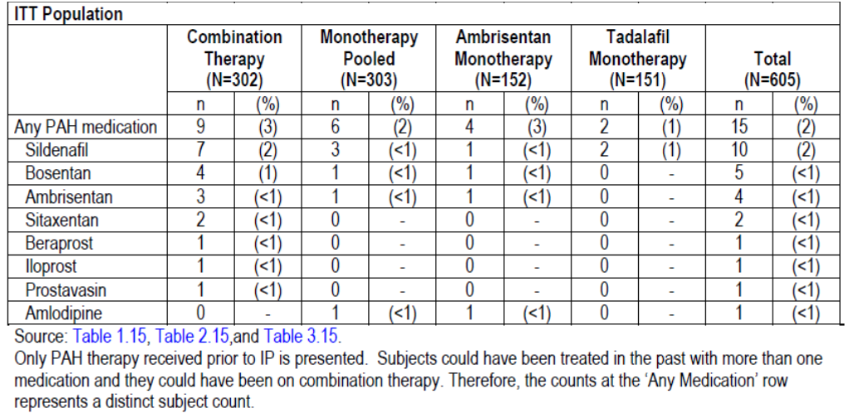
The mean baseline oxygen saturation was 95%. As expected, the baseline haemodynamic parameters were worse in the non-mITT population than the ITT population.

Table 6: Baseline haemodynamic parameters ( from right heart catheterization) in the mITT population.
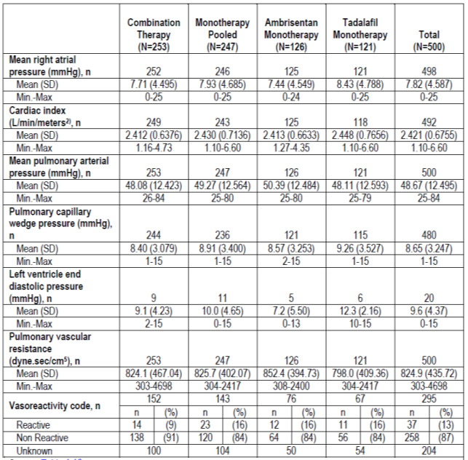

Table 7: Baseline haemodynamic parameters in the non-mITT population.
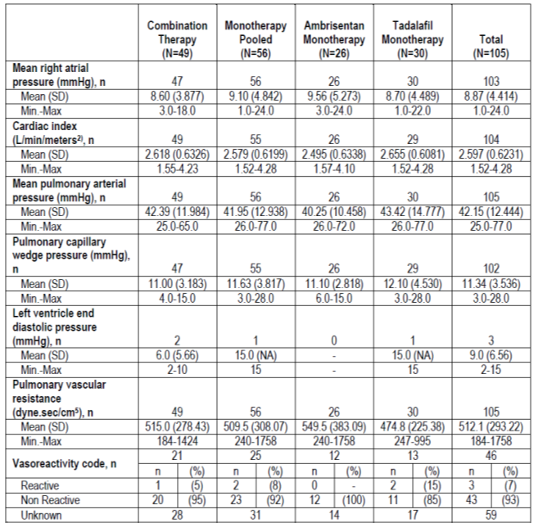
Treatment compliance with medication was over 93%. More patients (around 90%) of patients in the mITT group were titrated upwards to the higher dose of medication, compared to the non-mITT group. Marginally fewer patients on combination therapy were able to tolerate the full dose of tadalafil than were able to tolerate it as monotherapy.

Table 8: Exposure to study drug to FAV in the mITT population.
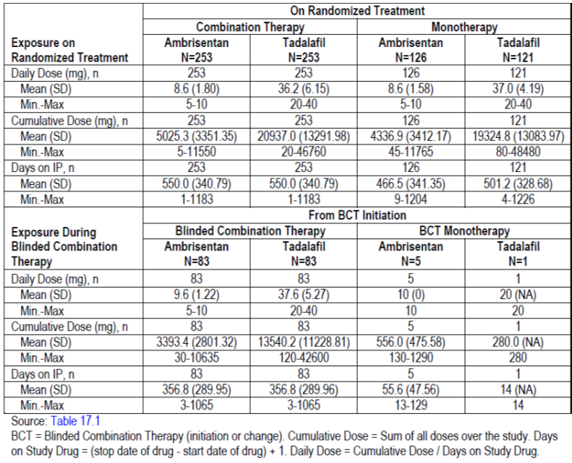

Table 9: Exposure to study drug to FAV in the non-mITT population.
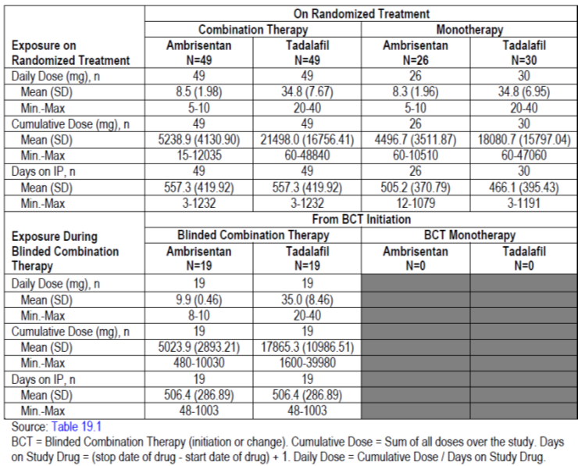

Table 10: Summary of treatment changes between baseline and FAV- mITT population.
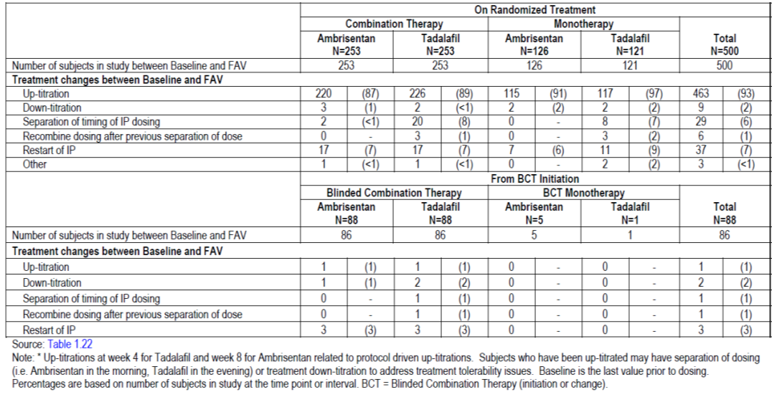

Results for the primary efficacy outcome
Clinical failure events occurred in 123 of 500 (25%) of patients from baseline to FAV in the mITT population. The hazard ratio for a clinical failure event was 0.5 (95% CI 0.348-0.724, log rank p=0.0002) for combination therapy as compared to pooled monotherapy. This represents a 50% reduction in risk of clinical failure with combination therapy as compared to pooled monotherapy. The hazard ratios for ambrisentan monotherapy (HR 0.477, 95% CI 0.314-0.723) and tadalafil monotherapy (HR 0.528, 95% CI 0.338 -0.827) were also clinically and statistically significant. The Kaplan Meier probability of events by 1, 2 and 3 years was significantly lower in the combined therapy group than the pooled monotherapy and each individual monotherapy. A similar pattern was described for the non-mITT population; however events were more frequent.

Table 11: Time to first adjudicated clinical failure event in the mITT population.
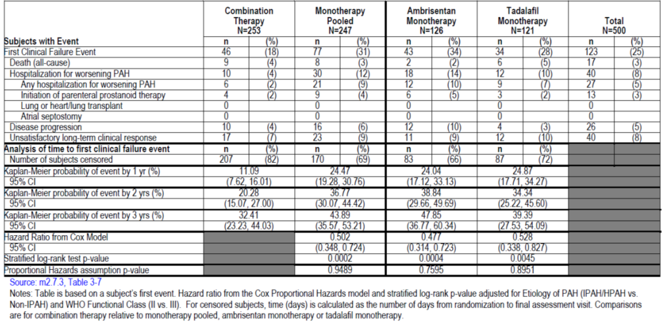
Figure 4: Kaplan Meier Cumulative Curve for time to first investigator assessed clinical failure event (baseline to FAV) in the mITT population.
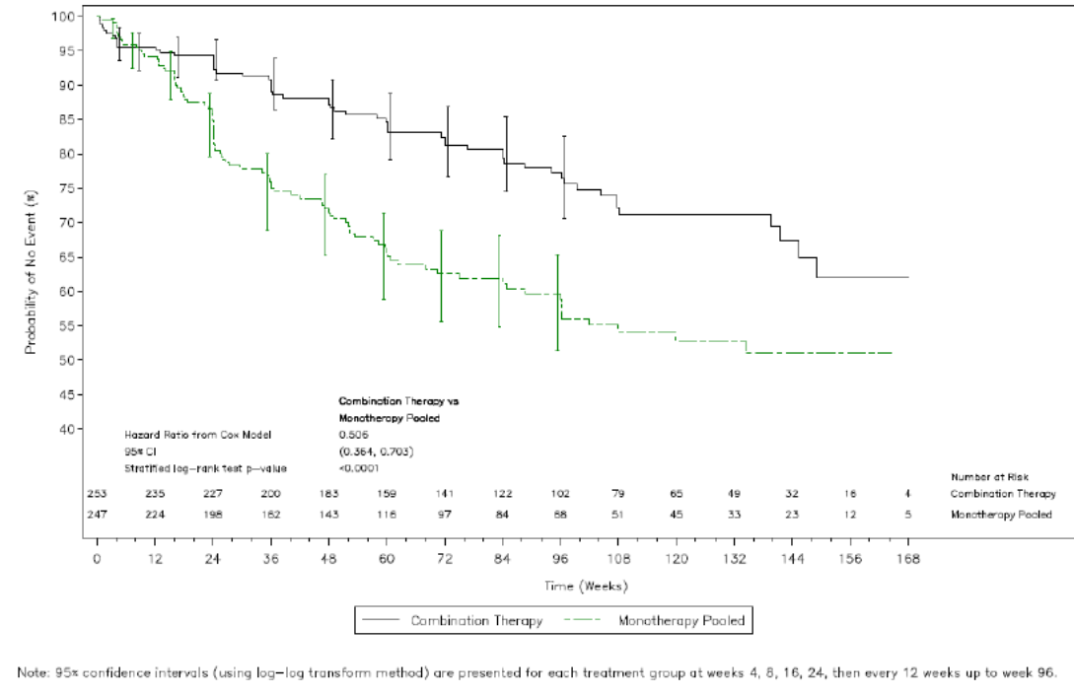
Evaluator comment: A 50% reduction in risk is a significant reduction. However, this was a composite endpoint. The numbers in each individual component of the composite measure were small. When the subsections were evaluated, hospitalisations for PAH were the main determinant for the improvement in the composite measure. Some of these admissions were to initiate prostanoid therapy; however the reason for the other admissions is not given. An important issue to consider is whether hospitalisation for PAH has adequate clinical significance and importance to justify the extension of indication. In clinical practice, hospitalisation is an opportunity to optimise therapy. The design of this study to censor patients after hospitalisation and not record further events would bias results toward the treatment that is helpful in the short term. It would have been important to follow these patients for a longer duration to determine if there was a difference in long term mortality and morbidity. It is unknown if the results we have seen are a result of having combination therapy as initial therapy improving early outcomes, but in the longer term the outcomes being equal between those who failed initial monotherapy but subsequently had treatment optimised.

Time to first adjudicated clinical worsening event
The time to first adjudicated clinical worsening event is a composite endpoint consisting of death, hospitalization for worsening of PAH and disease progression. It was conducted as sensitivity analysis based on the recommendation of European scientific advice.
In the mITT population there was a 49% reduction in the risk of clinical worsening in the combination therapy group (HR 0.514, 95% CI 0.34-0.778, p=0.0013) compared to the pooled monotherapy group. When compared to individual monotherapies, this was statistically significant for ambrisentan (HR 0.443, 95% CI 0.279-0.704, p=0.004) but not tadalafil (HR0.611, 95% CI 0.364-1.028, p=0.06). Kaplan Meier survival estimates for 1, 2 and 3 years were better in the combination therapy group compared to both the pooled and individual monotherapy groups.

Table 12: Time to adjudicated first clinical worsening event in the mITT group.
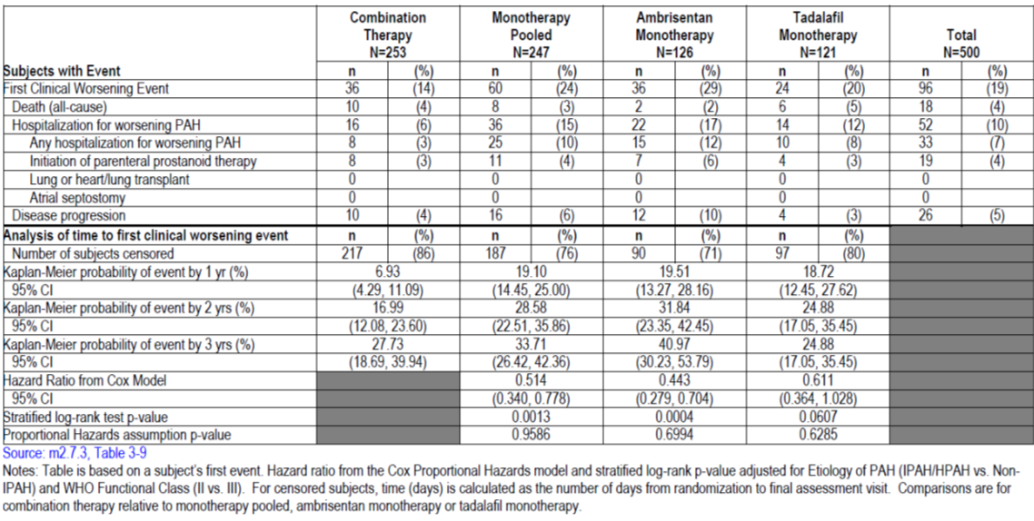
The results were similar in the mITT to the ITT groups, except in the ITT analysis the hazard ratio for combined therapy compared to tadalafil was statistically significant.

Causes of death
The causes of death in the mITT population from baseline to FAV are described in Table 16. The number are too small to make statistical comparisons, therefore any interpretation needs to be mindful of this. However, there does appear to be fewer cardiovascular deaths in the combination therapy group than the pooled or individual monotherapy group.

Table 13: Adjudicated death classifications (baseline to FAV)- mITT population.
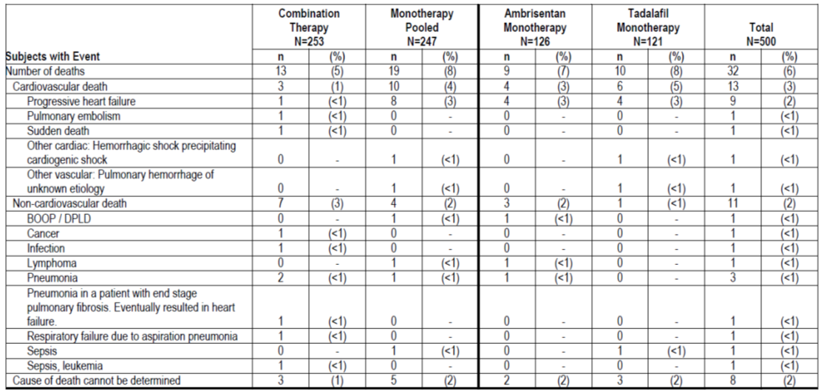

Time to first adjudicated component of clinical failure event
There was a statistically significant improvement in time to first adjudicated hospitalization for worsening of PAH in both the mITT and ITT populations in the combination therapy compared to pooled monotherapy groups. Other components of the clinical failure endpoint (death, disease progression and unsatisfactory long term clinical response) did not reach clinical significance.
The risk reduction for combination therapy compared to pooled monotherapy in time to first hospitalisation for worsening of PAH was 63%, (HR 0.372, 95% CI 0.217-0.639, p=0.0002). Risk reductions in combination therapy were also seen for ambrisentan monotherapy (HR 0.323, 95% CI 0.179-0.583, p<0.001) and tadalafil monotherapy (HR 0.442, 95% CI 0.229-0.853, p=0.0124).
There were numerically fewer deaths in the mITT combination therapy group (5%) compared to individual monotherapies (8%), however this was not statistically significant. There were similar number of deaths with ambrisentan (7%) and tadalafil (8%) monotherapy. In the non-mITT population, the number (and proportion) of deaths were 4 (8%) with combination therapy, 3 (12%) with ambrisentan monotherapy and 1 (3%) with tadalafil (Table 42).
In the mITT population, there were fewer cases of disease progression in the combined therapy group (5%) compared with pooled monotherapy (8%). Disease progression was more common in the ambrisentan group (11%) than with tadalafil (4%). There were fewer cases of unsatisfactory long term clinical outcome in the combination therapy group (7%) compared to the pooled monotherapy group (10%). The number of cases of unsatisfactory clinical response was similar between the ambrisentan (10%) and tadalafil (11%) groups, see Figure 5.
Sensitivity analysis was performed for time to first clinical worsening event with censoring at initiation of blinded combination treatment (as an additional indicator of clinical worsening). Similar results were found.
Figure 5: Forest plot of first adjudicated endpoints in the mITT population.
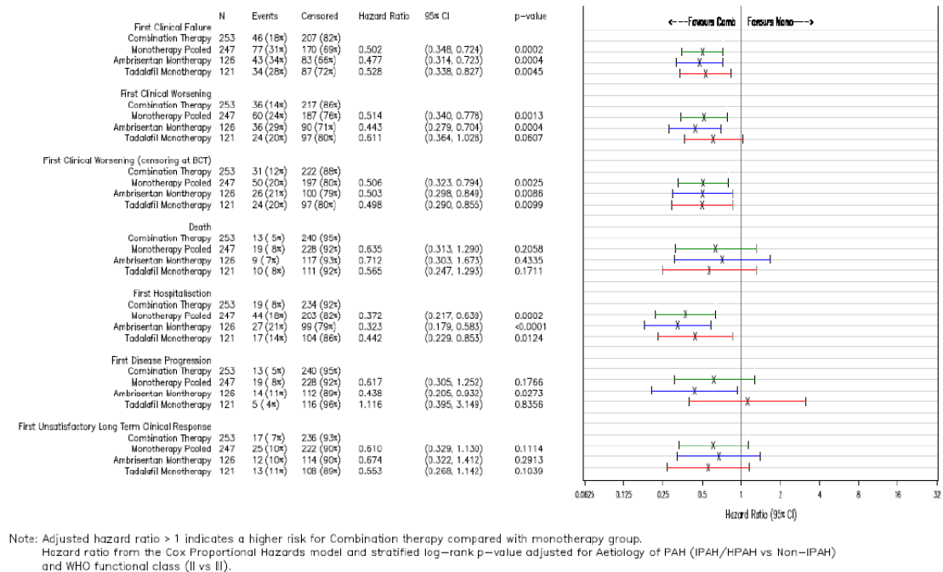

Covariate and subgroup analysis
Covariates were assessed for their impact on the time to clinical failure in a cox regression model. Patients with WHO functional class II and with a younger age responded better to treatment. The aetiology of PAH had no impact on outcome. Subgroup analysis was performed for aetiology of PAH, baseline WHO score, baseline age, and 6MWD. The only significant result was that there was a relatively greater benefit with WHO functional class II compared to III.

Analysis from baseline to end of study visit
Sensitivity analysis of the primary efficacy endpoints to the EoS visit found similar trends as that to the FAV. The first data base freeze had missed some events that had yet to be adjudicated, had not been reported, were not completed or not followed up. A total of 26 events that had occurred before or at the FAV were identified. These included 12 first clinical failure events in the mITT population and 4 in the non-mITT population. Overall, there were 5 additional events in the combination group (4 deaths and 1 disease progression) and 3 additional events in the ambrisentan group (1 death and 2 unsatisfactory long term clinical response).
The clinical evaluator has presented this data in this section as it includes a slightly longer period of follow up and all events rather than just first events. Of the 605 participants, 212 (35%) had a total of 389 events. There were 70 deaths. There were 103 subjects who had 147 admissions for worsening PAH. Of these, 44 subjects had 51 admissions to administer prostanoids. The reason for the other admissions is not stated. Although the number of admissions to hospital for combination therapy was lower than for pooled and individual monotherapy, the number of subjects initiating prostanoid therapy was similar in all groups. The reasons for the other hospitalisations are not given. There were fewer cases of disease progression and unsatisfactory clinical response in the combination therapy group than individual monotherapy groups.

Table 14: Summary of the number of patients with clinical failure events in the ITT population - Baseline to EoS visit.
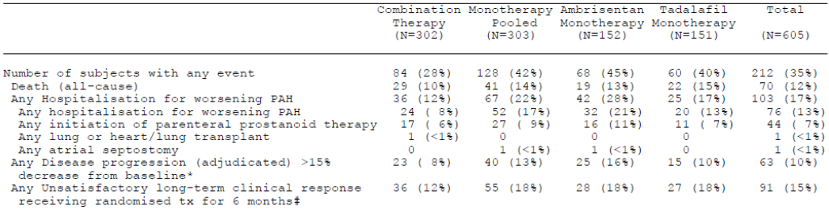

Table 15: Summary of the number of events of clinical failure in the ITT population - Baseline to EoS visit.
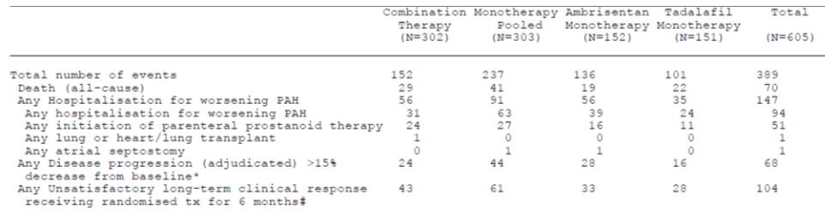

Table 16: Time to clinical failure event in the ITT population - Baseline to EoS visit.
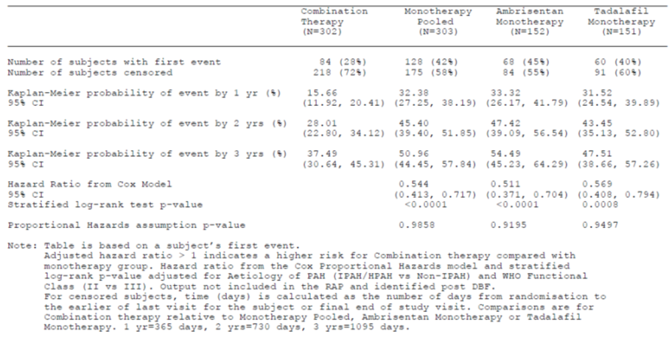

Secondary efficacy analysis
A statistically significant and clinically significant improvement in N-terminal pro-B type natriuretic peptide (NT-pro-BNP) was observed at week 24 in the combination therapy group compared to the pooled and individual monotherapy groups. This was observed early in the study and sustained.
A statistically significant satisfactory clinical response at week 24 in the mITT and ITT populations was found with the combination therapy and tadalafil but not ambrisentan.
There was a statistically significant improvement in 6 minute walk distance (6MWD) in the combination therapy group compared to both pooled monotherapy groups and individual monotherapy groups.
There was no significant change in WHO functional class scores. However, there seemed to be a trend to improvement in WHO functional class in those with grade III at baseline.

Table 17: Summary of secondary efficacy: mITT population.
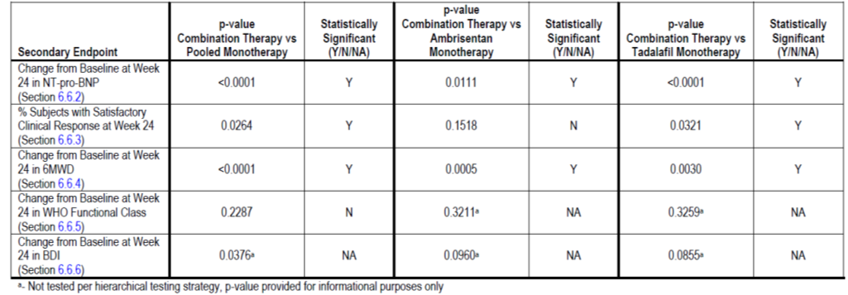

Table 18: NT-Pro BNP natriuretic peptide (ng/L) at week 24 in the mITT population.
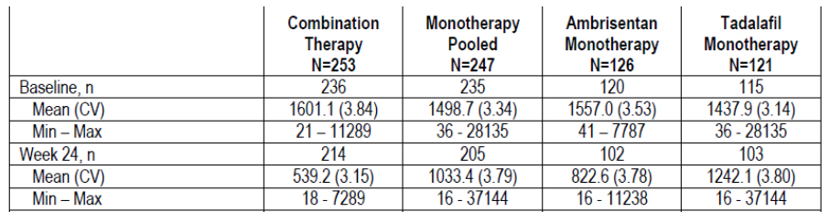
Figure 6: MMRM analysis ratio to baseline and treatment ratios in NT-Pro BNP natriuretic peptide (ng/L) in the mITT population.
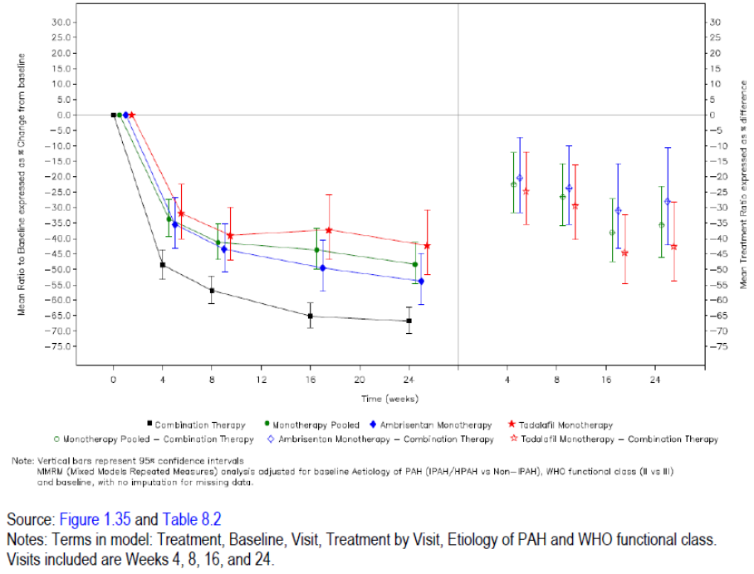

Table 19: Satisfactory clinical response at week 24 in the mITT population.
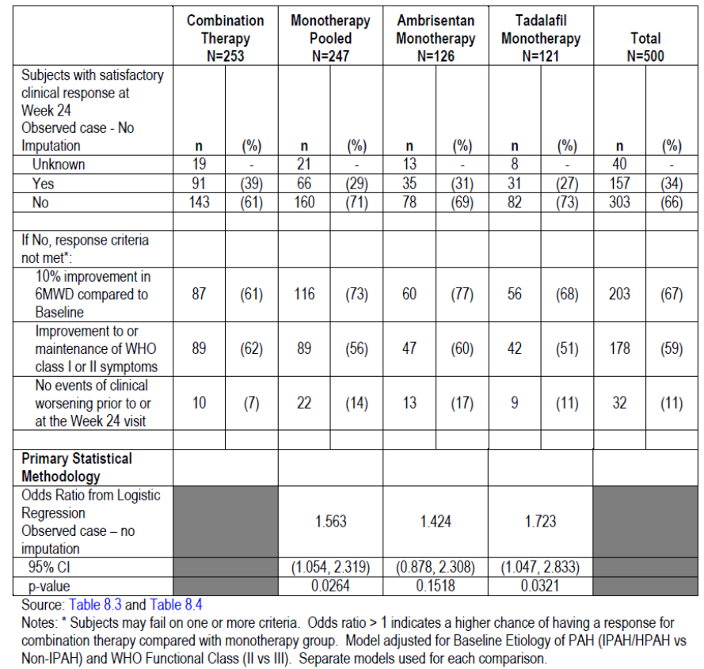

Table 20: 6MWD results (metres) at week 24 in the mITT population.
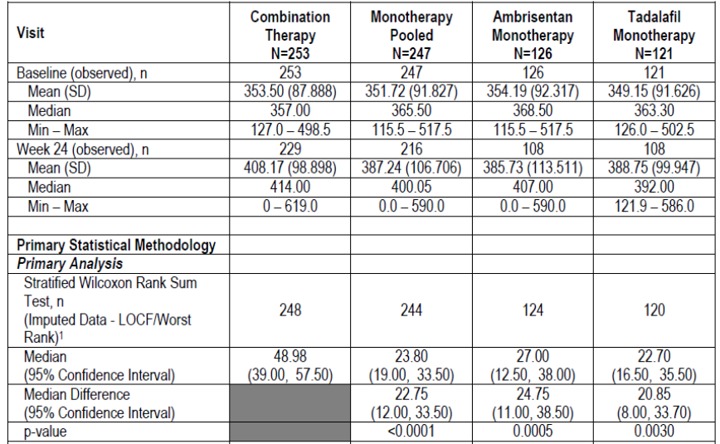
Figure 7: WRS analysis change from baseline and treatment difference in 6MWD results in the mITT population.
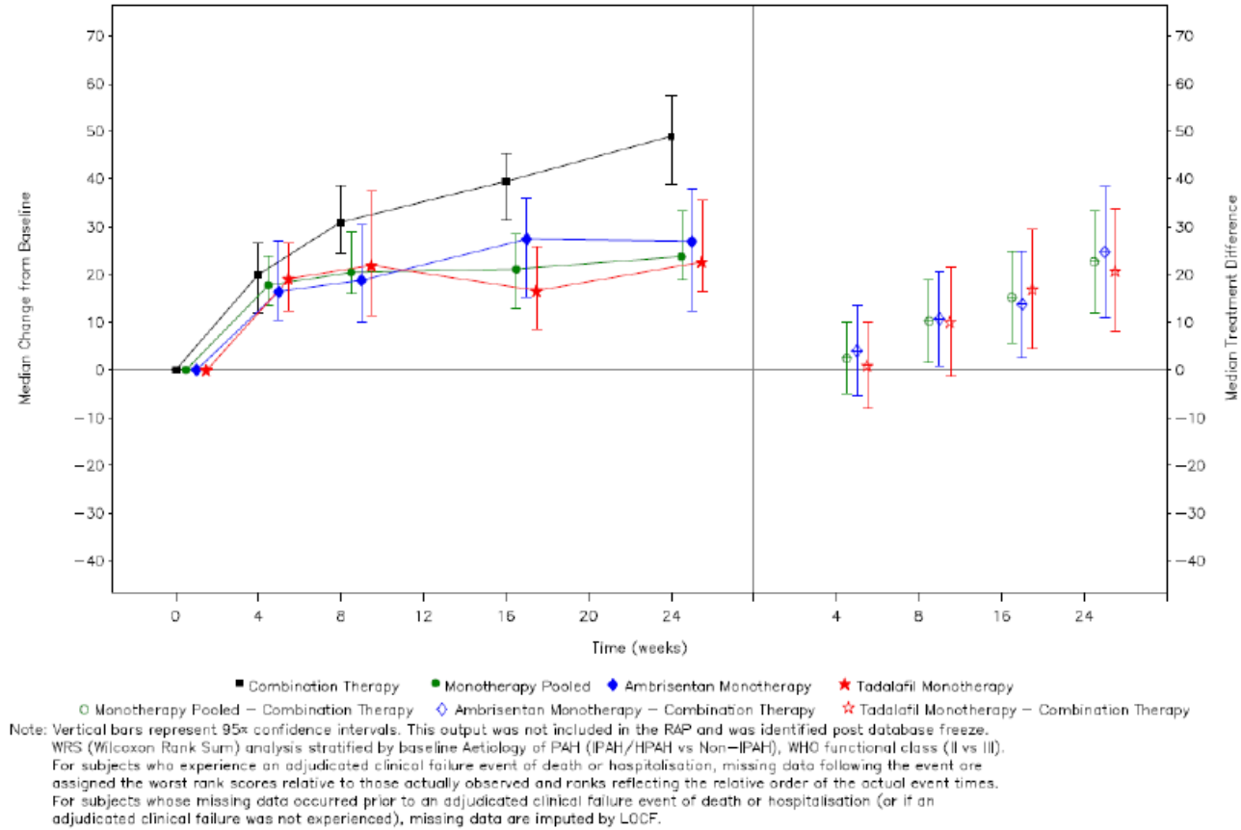

Table 21: Change in WHO functional class in the mITT population.
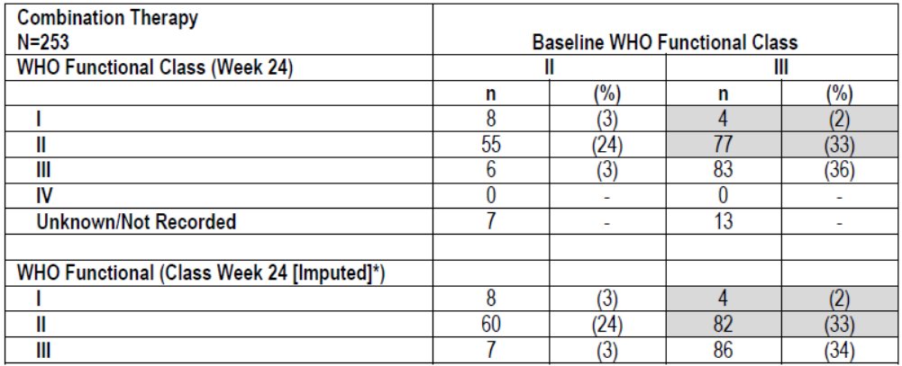

Qualitative health outcomes
Qualitative health outcomes were assessed using the SF36 and CAMPHOR in the geographical areas where these tools were validated. The SF-36 is a multipurpose short form health survey with 36 questions. It gives an 8 scale profile of functional health and wellbeing scores as well as psychometrically based physical and mental health summary measures and a preference based health utility index. Higher scores represent better health. In the mITT group, there was a numerically greater improvement in the combined monotherapy group than the pooled monotherapy group. This was not statistically significant, except for the measure of health transition. There was a numerically greater improvement in those taking tadalafil monotherapy compared to those taking ambrisentan monotherapy.
The CAMPHOR is made up of 3 main dimensions which assess symptoms, functioning and quality of life in patients with PAH. The symptom dimension is made up of 25 symptoms and broken down into 3 subscales: energy, breathlessness and mood. Higher scores indicate worse symptoms, worse quality of life and more functional limitation. All three treatment groups had an improvement in CAMPHOR scores. There were no statistically significant differences between treatment groups.

Table 22: Analysis of CAMPHOR symptoms and symptom subscale in the non-mITT population.
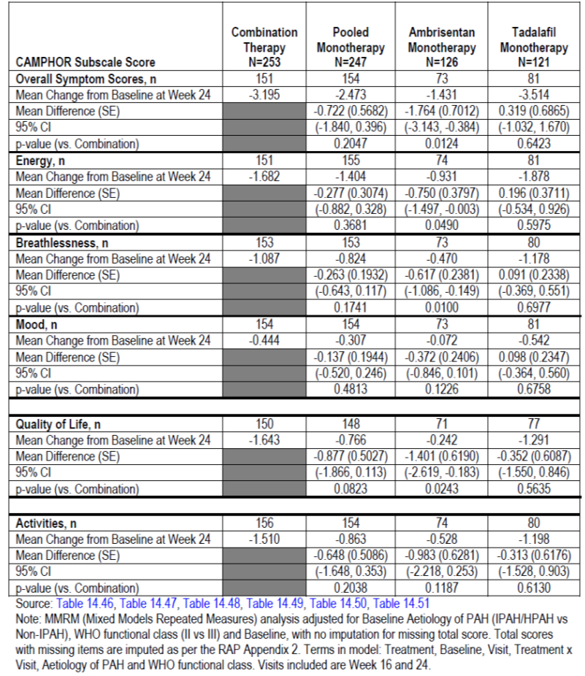
Evaluator comment: It is notable that there was no statistically significant difference in health assessment as measured by health outcome instruments. It would suggest that although there were some measurable changes as a result of therapy, they were not relevant to the patients. Other reasons for the lack of response to this outcome would include the tools used not being specific enough to measure the outcome of interest, or a lack of power in the study.

Evaluator’s conclusions on efficacy for use of tadalafil in combination with ambrisentan in treatment naïve subjects with PAH
The AMBITION study investigated patients with Type 1 PAH and WHO functional class II and III. The study reported combination therapy had a positive effect on a pooled primary efficacy endpoint defined as ‘time to clinical failure’. This was largely due to a reduction in hospitalisation for PAH. There was no significant impact on death rate, although the study was not powered to assess this. Of the secondary efficacy endpoints, there was a statistically significant effect on 6MWD and NT-proBNP. There was no significant improvement in WHO classification scores or quality of life scores.
ANCOVA and subgroup analysis demonstrated those patients with WHO subgroup II and those with younger age responded better to both combined therapy and each monotherapy.
While the study demonstrated a benefit of combination therapy for the composite primary endpoint there were a number of study design issues that limited its ability to address other relevant clinical outcomes. These were:
- The long dose titration therapy resulted in less than 24 weeks at the specified target dose. A longer duration of therapy or follow up would have improved the ability to evaluate a significant effect on mortality.
- The primary analysis compared combination treatment with pooled monotherapy. Although this may increase the power and sensitivity to find a positive result it may also create bias if one monotherapy arm was better than the other. In addition, what is clinically relevant is if combination therapy in treatment naïve patients is better than the current treatment of monotherapy with add on combination therapy for patients who did not improve.
- The design of the study having an end point of first ‘clinical failure event’ limits the ability of the trial to find a potential benefit in ongoing ‘clinical failure’ events or long term mortality. Pooling clinical failure events reduces the power of the study to detect significant changes in individual components. The individual components of the clinical failure event score are examining very different parameters and one cannot extrapolate a benefit from a pooled score to individual components of the score.
- The question the clinician would want to know is if a patient is better started with ambrisentan and stepped up to add tadalafil if there is no improvement, or to use ambrisentan in combination with tadalafil at the onset. This study does not answer this question, as patients who deteriorated or did not achieve the desired improvement with ambrisentan monotherapy were classified as a clinical failure event. This would bias the results towards finding a positive benefit in the combination therapy group.
In the pivotal clinical trials for ambrisentan for PAH (ARIES I and ARIES II), treatment with ambrisentan for 12 weeks resulted in significant improvements in 6MWD (around 30m), BDI, WHO functional class, time to clinical worsening and SF-36 health survey physical functional scale. In long term follow up studies, improvements in 6MWD were sustained and Kaplan-Meier estimates of survival at 1, 2 and 3 years were 93%, 85%, and 79%.
In the pivotal clinical trials for tadalafil (Adcirca), there was a statistically significant dose dependent improvement in 6MWD after 16 weeks of treatment. The mean change in 6MWD in the group treated with 40 mg was 44m. This was accompanied by a statistically significant improvement in quality of life as measured by the SF36. However, there was no significant change in WHO functional class, episodes of clinical worsening or BDI.
Unlike ARIES and ADCIRCA, in the AMBITION study, the improvement in 6MWD was not associated with an improvement in WHO classification or quality of life.
Not including patients with WHO class IV excluded a subgroup of patients with more severe disease who may have benefitted from early combination therapy.

Ambrisentan added to tadalafil for PAH
The sponsor has not submitted any clinical studies for evaluation, but has referred to two abstracts in relation to this indication.
- ATHENA-1: Haemodynamic improvements following the addition of ambrisentan to background PDE-5i therapy in patients with pulmonary arterial hypertension. Oudiz et al 2011
This was an open label efficacy and safety study in 33 subjects with PAH who had suboptimal response with a PDE-5i. Patients were WHO functional class III had a PVR ≥ 400dyne.sec/cm⁵. The intervention was ambrisentan 5mg daily for 4 weeks followed by 10mg daily for 20 weeks. The primary endpoint was PVR at week 24. Secondary endpoints were 6MWD, BDI, NT-proBNP.
Patients had a significant improvement in the haemodynamic endpoints PVR (-249dyne.sec/cm⁵ p <0.001), mPAP (-5.4 p<0.001), cardiac index (+5.8L/min/min²⁾. There was an improvement in 6MWD (+18m, p=0.04), BDI (-0.9, p=0.0097), NT-proBNP (-31%, p=0.02). No patients died. One patient experienced clinical worsening
- ATHENA-1: Long term clinical improvements following the addition of ambrisentan to background PDE-5i therapy in patients with pulmonary arterial hypertension. Shapiro 2012
This was a long term follow up of the study described above. The 48 week endpoints included survival, time to clinical worsening, change in WHO functional class, 6MWD, BDI and NT-proBNP.
At 48 weeks, the Kaplan Meier survival was 96% (95% CI 89-100%), and freedom from clinical worsening 80% (95% CI 66-94%). Nearly all patients (97%) improved or maintained their WHO functional class through to 48 weeks. The improvements in 6MWD (+15m) was overall positive but less than at 24weeks and no longer statistically significant. Similarly, there was an overall improvement in BDI (-0.7) from baseline but less than at 24 weeks and no longer statistically significant. 24% of subjects discontinued due to adverse events.

Tadalafil added to ambrisentan for PAH
The sponsor did not submit any clinical studies for this indication but referred to the following study:
- Randomised study of adding tadalafil to existing ambrisentan in pulmonary arterial hypertension Zhuang 2014
This was a prospective, randomised, double blind study of the addition of tadalafil to 124 patients with PAH who had been receiving ambrisentan for at least 4 months and were aged 18-70 years.
The study treatment was tadalafil 40mg daily. Outcome factors were 6MWD, WHO functional class, clinical worsening score, and haemodynamic improvement.
The mean age of participants was 51 years, most were female. The duration of PAH was 2-4 years in 40 patients and greater than 4 years in 37 patients. There were 71 patients with WHO functional class II and 48 patients with WHO functional class III. Other baseline demographic details are described below.

Table 23: Baseline characteristics of patients in study by Zhuang et al.
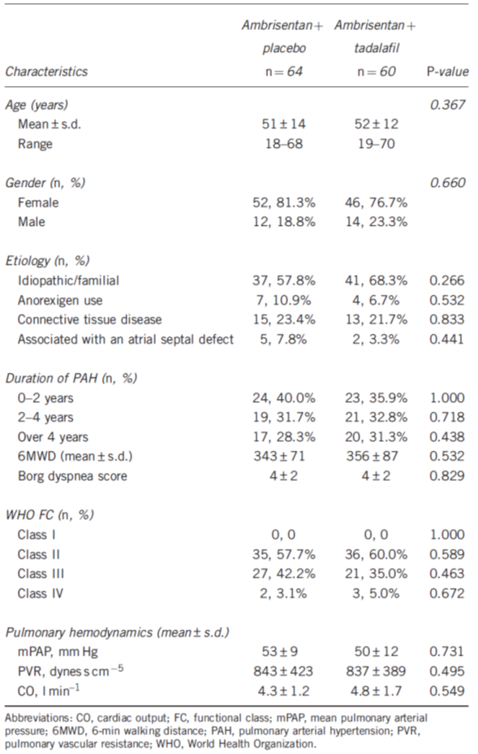
There were numerical improvements in mPAP, PVR and CO in both tadalafil and placebo groups. These were numerically but not statistically greater in the tadalafil group. There was an improvement in 6MWD in the tadalafil but not the placebo group that was statistically significant. Less patients taking tadalafil experienced clinical worsening.
Figure 8: Change in 6MWD by Zhuang.
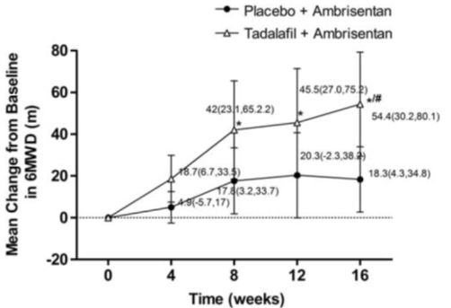
Figure 9: Incidence of clinical worsening from Zhuang.
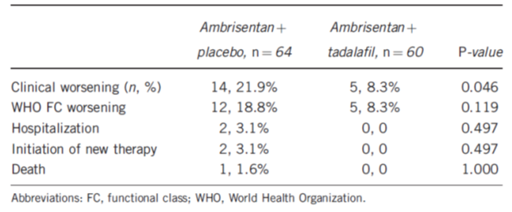

Clinical safety

AMBITION study
The following safety data were collected:
- General adverse events (AEs) were assessed by the investigators. Adverse events were coded using MedDRA version 16. Only treatment emergent adverse events were recorded (defined as those events that started on the day of or after IP initiation, and up to 30 days after the last dose.
- Adverse events of special interest (AESI) included liver events, anaemia, hypersensitivity, hypotension and fluid retention
- Laboratory tests, including those for biochemistry, testicular function and haematology were assessed at each study visit.
- ECG was performed at baseline, week 24 and FAV.

Analysis populations
The mITT, ITT and non-ITT populations were all used to assess safety and adverse events. The clinical evaluator has focused on the ITT population safety results unless otherwise stated.

Statistical methods
Safety data was assessed for multiple time periods. These included from randomization to FAV, FAV to EoS, and EoS to last contact and overall. Treatment assignments were unblinded after the last database freeze, the sponsor considered the most relevant period for safety analysis to be baseline to FAV. Evaluation of other data periods were performed but considered confirmatory.

Patient exposure
Patient exposure in the m-ITT population to the end of study was on average 603 days in the combination therapy group, 500 days in the ambrisentan monotherapy group and 542 days in the tadalafil monotherapy group. There were 88 patients who were exposed to an additional mean of 400 days of combination therapy.

Table 24: Exposure to study drug through to EoS-mITT population.
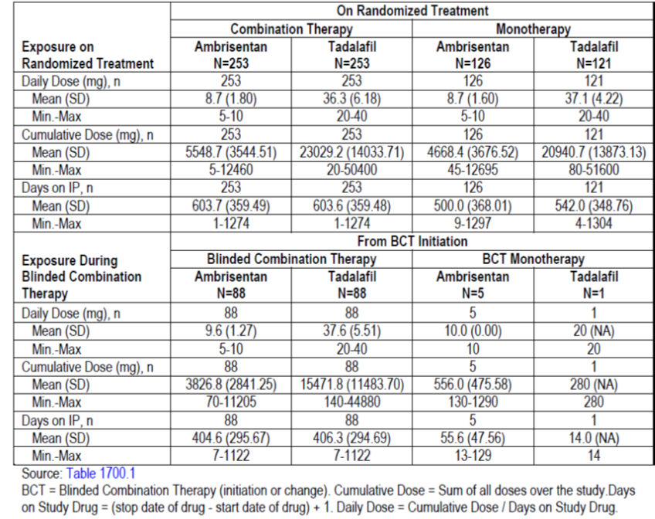

Adverse events

All adverse events (adverse drug reactions)
In the ITT population, more than 94% of patients reported at least one AE. Most were mild or moderate in severity. The number of adverse events considered by the investigator to be related to treatment was higher in the combination therapy group than either monotherapy group. Patients in the non-mITT group experienced more adverse events, SAE, and treatment discontinuation or study withdrawal due to adverse events.

Table 25: Summary overview of subjects with adverse events (baseline to FAV).
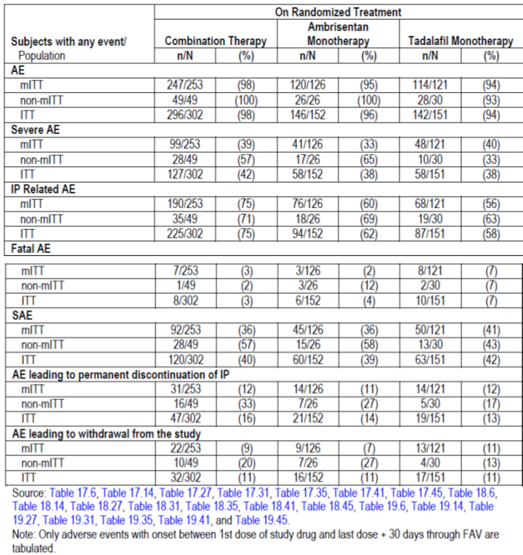
The most commonly reported adverse events with combination therapy in the ITT group were peripheral oedema (45%), headache (41%) and diarrhoea (21%). Other adverse events occurring in 10-20% of the population included nasal congestion, dizziness, cough, dyspnoea, nasopharyngitis, pain in an extremity, nausea, anaemia, back pain, flushing, URTI, arthralgia, fatigue, palpitations, dyspepsia, bronchitis and non-cardiac chest pain.
In the ambrisentan monotherapy group, the most commonly reported adverse events were peripheral oedema (38%), headache (34%), and diarrhoea (22%). Other adverse events occurring in 10-20% of the population included nasal congestion, dizziness, dyspnoea, nasopharyngitis, cough, pain in an extremity, nausea, back pain, flushing, URTI, arthralgia, fatigue, and palpitations.
In the tadalafil monotherapy group, the most commonly reported adverse events were peripheral oedema (28%), headache (35%), and dyspnoea (19%). Other adverse events occurring in 10-20% of the population included diarrhoea, nasal congestion, dizziness, cough, nasopharyngitis, pain in an extremity, nausea, anaemia, back pain, URTI, arthralgia, fatigue, palpitations, dyspepsia, myalgia, gastro-oesophageal reflux, UTI.
Similar proportions of severe AE occurred in the combination therapy group compared to the ambrisentan or tadalafil monotherapy group. More SAE occurred in the non-mITT population than the mITT population.

Table 26: Adverse events on randomised treatment by maximum severity (baseline to FAV).
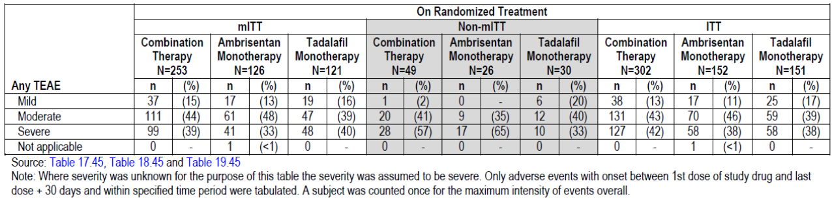
Evaluator comment: Some of these symptoms may have been due to the PAH rather than medication. There is a different pattern of adverse effects from ambrisentan and tadalafil, thus an increased rate of adverse events with combination therapy is not surprising. Overall the rates of adverse events between the three groups were similar; however the investigator attributed more AE in the combination therapy group to be treatment related.

Treatment related adverse events
The percentage of AE that the investigator considered to be related to the IP was 75% in the combination therapy group, 62% in the ambrisentan therapy group and 58% in the tadalafil monotherapy group.

Table 27: The most common (>5%) treatment related adverse events in the ITT population.
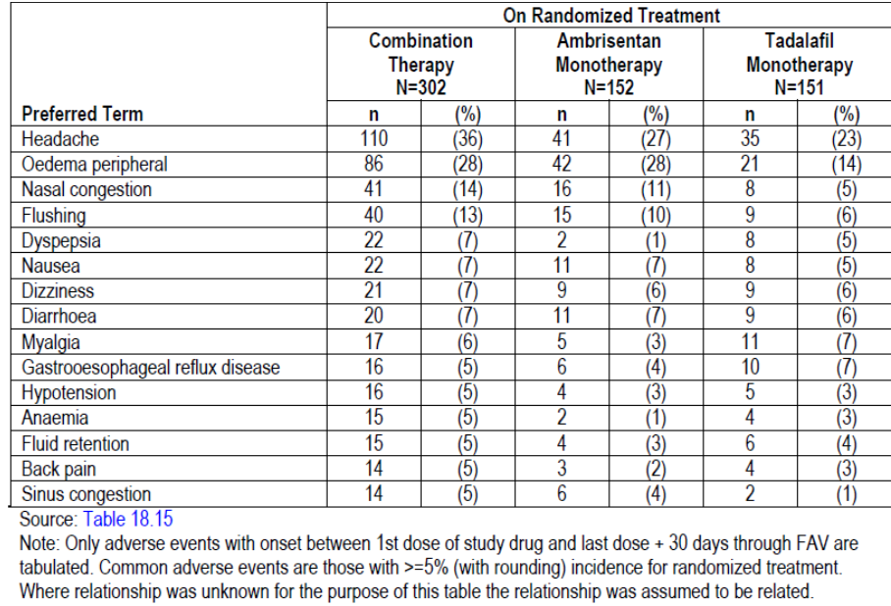

Deaths and other serious adverse events
Deaths reported in the efficacy analysis differ from the fatal AE reported in the safety analysis in that they include data for events that occurred 30days after the last dose of IP. There were fewer deaths in the combination therapy group than the ambrisentan or tadalafil monotherapy groups.

Table 28: Summary of subjects with deaths and fatal AEs.
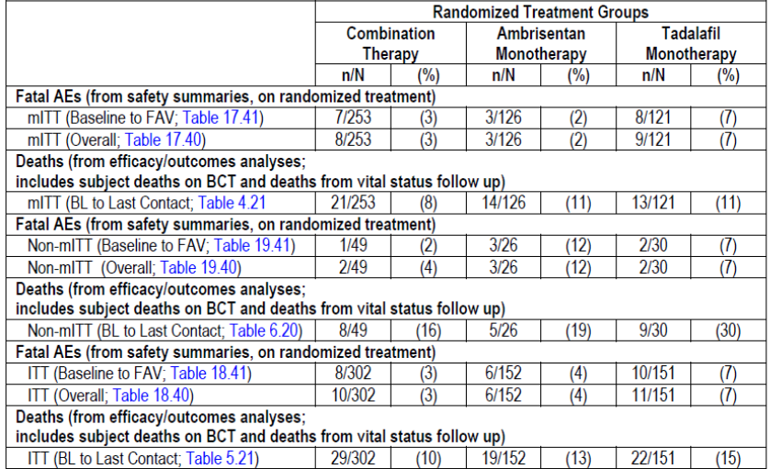
The pattern of fatal AE observed were consistent with what would be expected from a population with PAH. There were less fatal AE in the combination therapy group than with either monotherapy group.
A serious adverse event was defined as any untoward medical occurrence that, at any dose, resulted in death; was life threatening; required hospitalisation; results in disability or incapacity; a congenital birth defect; other medically important adverse event; or liver injury that fulfils the Hys Law criteria. Although the frequency of serious adverse events was similar across the three treatment groups, the pattern of serious adverse events was different. In the combination therapy group, the most frequent serious adverse events were pneumonia (5%), pulmonary hypertension (4%), anaemia (2%) and syncope (2%). There also appeared to be a trend to more problems with bleeding (vaginal haemorrhage in 2 patients and gastrointestinal haemorrhage in 3 patients). In the ambrisentan monotherapy group, the most commonly reported serious adverse events were pulmonary hypertension (11%), pneumonia (7%), RVF (4%), syncope (3%). In the tadalafil monotherapy groups, the most frequently report SAE were pulmonary hypertension (7%), dyspnoea (3%), pneumonia (4%), and syncope (4%).

Discontinuation due to adverse events
In the ITT population, the percentage of subjects with TEAE leading to any discontinuation of IP while on randomised treatment was 16% in the combination therapy group, 14% in the ambrisentan monotherapy group and 13% in the tadalafil monotherapy group. The most common TEAE leading to discontinuation in the combination therapy group were dyspnoea, peripheral oedema and headache. In the ambrisentan monotherapy group, the most frequently reported TEAE were pulmonary hypertension, cardiac failure and peripheral oedema. In the tadalafil monotherapy group, the only TEAE leading to discontinuation, which occurred in more than 2 subjects, was myalgia.
In the ITT population, the proportion of subjects withdrawing from the study with any TEAE was the same in all three treatment groups. The most frequently reported TEAE in the combination therapy group was dyspnoea, peripheral oedema and headache. In the ambrisentan monotherapy group, the only TEAE reported in more than 2 subjects that led to withdrawal from the study was pulmonary hypertension. In the tadalafil monotherapy group, no TEAE leading to withdrawal from the study was reported in more than 2 subjects.

Adverse events of special interest

Fluid retention
In the mITT population, fluid retention was identified in 55% of those on combination therapy, 40% of those on ambrisentan monotherapy and 36% of those on tadalafil monotherapy. Peripheral oedema was the most frequent manifestation of fluid retention in all groups. This was generally mild and rarely led to treatment discontinuation or withdrawal. In the non-mITT population, fluid retention occurred in 61% of those with combination therapy, 69% with ambrisentan monotherapy and 47% with tadalafil monotherapy.

Table 29: Fluid retention adverse events in the mITT population.
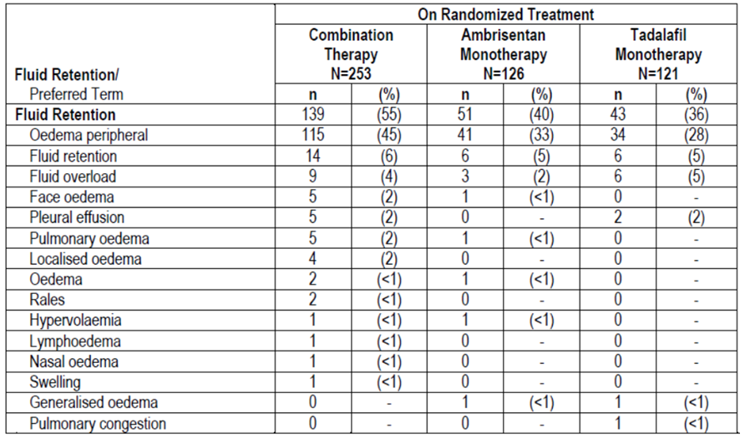

Hypotension
In the mITT population, the percentage of subjects with hypotension on randomised treatment was 32% in the combination therapy group compared to 27% in each monotherapy group. The most frequently reported hypotension event in all three randomised treatment groups was dizziness. The percentage of subjects with dizziness was 20% in the combination therapy group, compared with 19% in the ambrisentan monotherapy group and 12 % in the tadalafil monotherapy group.
In the non-mITT population, hypotension was more common in the ambrisentan (38%) and tadalafil (43%) monotherapy groups than the combination therapy group (24%).

Table 30: Hypotension in the mITT population.
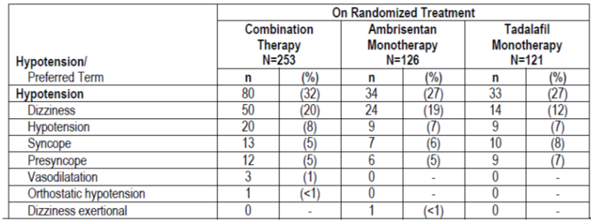

Table 31: Hypotension in the non-mITT population.
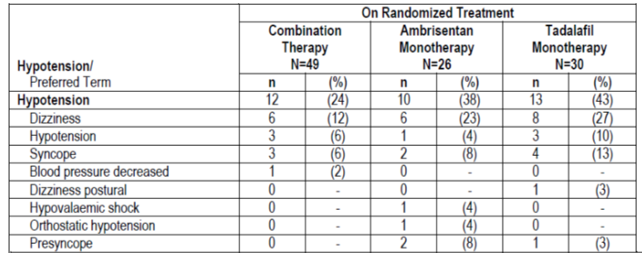

Anaemia
In the mITT population from baseline to FAV, the percentage of subjects with AESI of anaemia was 20% in the combination therapy group, 10% in the ambrisentan monotherapy group and 13% in the tadalafil monotherapy group. In the non-mITT group, the percentage of subjects with AESI of anaemia was 24% in the combination therapy group, 19% in the ambrisentan monotherapy group and 17% in the tadalafil monotherapy group.

Hypersensitivity
In the mITT population, 13% of subjects in the combination therapy group, 10% of subjects in the ambrisentan therapy group and 7% of subjects in the tadalafil therapy group had a hypersensitivity event. Rash was the most frequently reported event. In the non-mITT population, 14% of subjects had a hypersensitivity event in the combination therapy group compared to none in the ambrisentan group and 27% in the tadalafil monotherapy group.

Liver AE
The percentage of patients with any liver AESI was 7% in the combination therapy group, 2% in the ambrisentan monotherapy group and 5% in the tadalafil monotherapy group. In the non-mITT population, 10% of subjects in the combination therapy group had liver AESI compared to 15% in the ambrisentan therapy group and none in the tadalafil monotherapy group.

Laboratory tests

Liver function
In the mITT group, 5 subjects in the combination therapy group and 2 subjects in the tadalafil monotherapy group had ALT or AST values more than 3 X ULN that met the stopping criteria defined in the study protocol.
Two subjects in the non-mITT group, one receiving ambrisentan monotherapy and one receiving tadalafil monotherapy had chemistry criteria that met the Hy’s Law criteria (ALT > 3XULN and bilirubin > 2XULN (or ALT>3XULN and INR>1.5)) but had other conditions that also cause liver disease.
A similar percentage of patients in the combinations therapy group compared to the ambrisentan monotherapy groups developed abnormalities in transaminases.

Table 32: LFT values by range category (baseline to FAV).
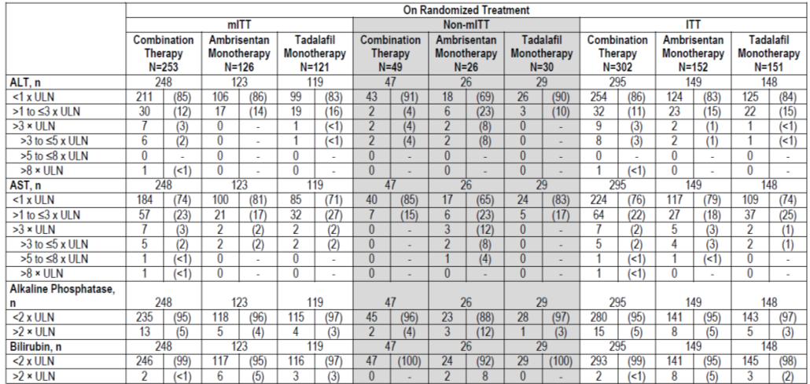

Kidney function
Approximately 10% patients in the combination and ambrisentan monotherapy groups developed a serum creatinine in the high clinical concern range with treatment. There were no significant changes in the results of urinalysis.

Other clinical chemistry
There were no significant between or within group changes in LH, FSH, testosterone or SHBG.

Haematology
The mean haemoglobin and haematocrit values decreased with combination therapy more than with ambrisentan or tadalafil monotherapy.

Table 33: Change in haemoglobin and haematocrit.
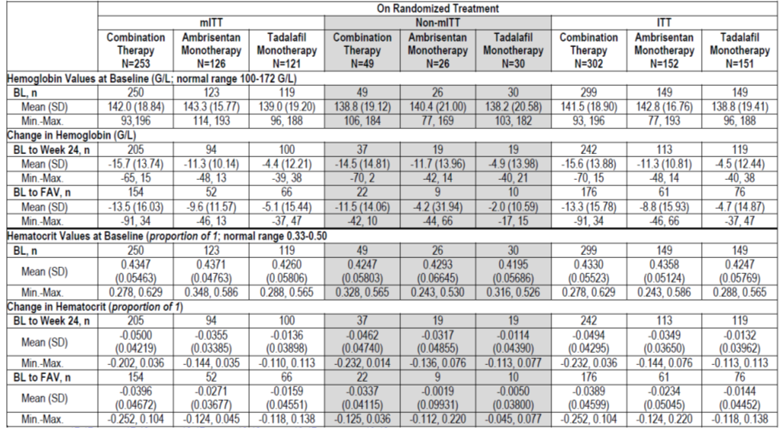
Less than 4% of patients had baseline haemoglobin values less than 100g/L. With treatment in the ITT population, 18% of the combination therapy group, 10% of the ambrisentan monotherapy group and 14% of the tadalafil monotherapy group developed haemoglobin levels of less than 100g/L.

Electrocardiograph
There were similar changes in ECG parameters across the randomised treatment groups, with no remarkable trends.
There were 2 subjects who developed abnormal ECG findings at week 24. The first case was [information redacted] on combination therapy hospitalised for severe cholestasis and was noted to have LBBB (which resolved) and intraventricular delay (which persisted). A [information redacted] on combination therapy developed severe SVT requiring hospitalisation, and subsequent treatment with amiodarone and diltiazem.
Evaluator comment: These events are unlikely to be related to the study drugs.

Vital signs
There were minimal changes in weight; however, it is interesting that in the combination therapy group weight decreased despite the development of pulmonary oedema and fluid overload.
There were small decreases in systolic and diastolic blood pressure and heart rate among all three groups. An average fall in diastolic BP of 7mmHg was observed in the combination therapy group.

Table 34: Changes in vital signs in the mITT population.
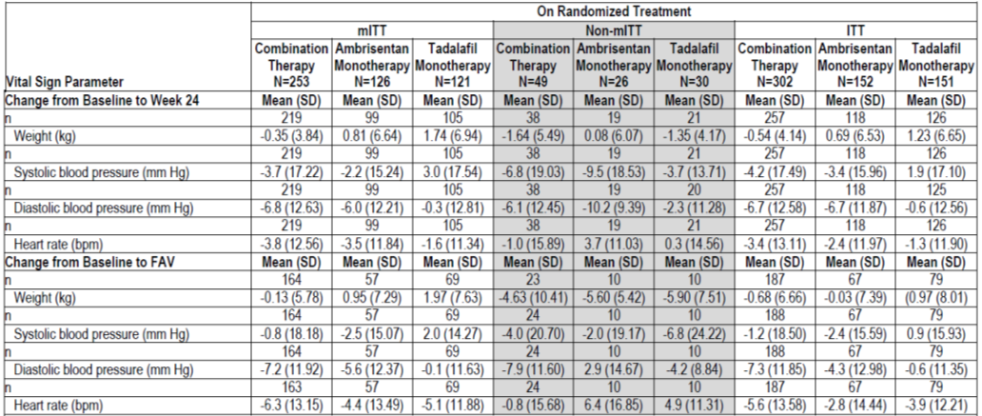

Post-marketing experience
No data submitted

Other safety issues

Safety in special populations
There were no paediatric patients.
Ambrisentan is contraindicated in pregnancy due to its teratogenic effect. Female subjects who were pregnant or breastfeeding were excluded from the study. Women of child bearing potential were counselled regarding the need for contraception. Three pregnancies were reported during the study and terminated.

Evaluator’s overall conclusions on clinical safety
The safety profile described is as expected on the basis of the known safety profile of ambrisentan and tadalafil. Although overall there were similar proportions of subjects with AEs among the three treatment groups, the investigator attributed more adverse events in the combination therapy group to be due to the study drugs. Adverse events were the major cause of withdrawal from the study. As is the case with many chronic diseases, it can be difficult to differentiate the adverse events from the disease versus those of the treatment.
The most common adverse event with combination therapy was peripheral oedema. Headache, flushing, nasal congestion, vomiting and rash were more commonly seen with combination therapy than with either therapy alone. Liver related abnormal events were infrequent and no more common with combination therapy. There was a greater likelihood of anaemia with combination therapy and ambrisentan; this may have been driven by peripheral vasodilatation and volume overload. There was a greater fall in diastolic blood pressure in the combination therapy group.

First round benefit-risk assessment

First round assessment of benefits
The benefits of the use of ambrisentan in combination with tadalafil as initial therapy for grade II-III PAH versus pooled monotherapy with either ambrisentan or tadalafil are:
- A 50% risk reduction in clinical failure event, (predominately less hospitalisation for PAH)
- An improvement in 6MWD. The mean overall improvement with combination therapy was approximately 49m, or approximately 24m better than the pooled monotherapy group
Notably, there was no statistically significant reduction in deaths or disease progression; however the study was not powered to examine this. There were no significant improvements in WHO classification, BDI or qualitative health measures. This raises questions about the clinical significance of the positive results.
Subgroup analysis demonstrated that younger patients and those with WHO functional class II were more likely to respond to combination therapy.
The potential benefits are supported by evidence of a pharmacodynamic effect in an animal model and improvement of a surrogate marker NT-pro-BNP.

First round assessment of risks
The risks of using ambrisentan in combination with tadalafil for PAH as proposed:
- Increased incidence of adverse events attributed to the study medication- in particular peripheral oedema, headache, anaemia, rash and fall in diastolic blood pressure
- Potential for use in groups where the risks and benefits of therapy were not studied (e.g. grade IV PAH) and in groups where the risk of side effects was higher
There is also the risk of accepting the results of the AMBITION study as evidence that combination therapy with ambrisentan and tadalafil as initial therapy as superior to individual monotherapy when the study design was not adequate to address this question. The clinical evaluator is concerned that the monotherapy arms do not reflect current clinical practice, as a real patient with PAH who has inadequate response to one therapy would have treatment optimised with another agent or a prostanoid.

First round assessment of benefit-risk balance
The prognosis in untreated PAH is poor. The median survival time of untreated patients is 2.8 years. The CHMP guidelines state that therapy for PAH should be efficacious for clinically significant endpoints such as mortality and morbidity.
The use of ambrisentan in combination with tadalafil had a statistically significant benefit in the outcome ‘time to clinical failure’. This was primarily driven by less hospitalisation. There were also statistically significant improvements in 6MWD (but questionable clinical significance) and clinical endpoints at 24 weeks. However, there was no reduction in mortality or improvement in efficacy outcomes such as WHO classification or qualitative health outcomes.
Other studies of combination therapy with ambrisentan and tadalafil as add on therapy have also shown positive haemodynamic responses and changes in NT-pro-BNP (Oudiz 2011, Zhuang 2014). Clinical outcomes were more significant after treatment for 48 months (Shapiro 2012). However, these studies were small and underpowered.
Although this submission is not for a fixed dose formulation, the issues surrounding the approval of the use of two medications in combination are similar. According to the guidelines for fixed dose combinations, to extend the indication of ambrisentan for use in combination with tadalafil, the sponsor needs to provide evidence of either:
- a) An improvement in the benefit/risk ratio due to
  - 1. Addition or potentiation of therapeutic activities of the substances which results in:
    - i. A level of efficacy similar to the one achievable by each active substance used alone at higher doses than in combination, but associated with a better safety profile
OR
    - ii. A level of efficacy above the one achievable by a single substance with an acceptable safety profile
  - 2. Counteracting an adverse effect
- b) Simplification of therapy.
and that there is robust evidence for efficacy in this indication.
Category (a.1.ii) best suits this application, as the safety profile demonstrates more adverse effects attributable to the study drugs with combination therapy than individual monotherapy. Although there was an impressive reduction in clinical failure events in the AMBITION study, the clinical evaluator is not convinced of the clinical significance of this due to the lack of efficacy on death rate and quality of life.
Treatment for patients with PAH is generally co-ordinated by a physician with expertise in this area. Although there are no nationally adopted guidelines for management, for patients with type 1 PAH, monotherapy with either a PGE-5i or ET antagonist is recommended as initial therapy, with combination therapy reserved for those who do not respond to one agent and combination therapy or prostanoids for those who remain symptomatic. There are currently no restrictions on physicians choosing a number of different combination therapies for their patients.

First round recommendation regarding authorisation
The sponsor has submitted the results of a pivotal clinical trial of ambrisentan in combination with tadalafil for the management of treatment naïve patients with PAH. At this stage, the clinical evaluator would not recommend approval of the proposed extension of indication for ambrisentan in combination with tadalafil as initial therapy for patients with PAH for the following reasons:
- The level of evidence for efficacy from the AMBITION study is not strong enough to support a new indication.
The improvement in clinical failure event was statistically significant, but the significance of this for clinical practice is uncertain. The positive efficacy endpoint was driven by less hospitalisation, but the reason for hospitalisation is not given. There was no significant difference in death rates, disease progression, unsatisfactory clinical response or quality of life between combination therapy and ambrisentan monotherapy. As standard clinical practice would be to add-on therapy for those who failed monotherapy, a better comparator would have been to include an add-on therapy arm. The improvement in 6MWD between the combination therapy group and monotherapy group was 24m, which was less than what is considered clinically significant and not associated with an improvement in BDI, WHO functional class or patient quality of life.
- The indications proposed do not specify if combination therapy is to be used as initial therapy or add on therapy, accurately reflect the patient population of the AMBITION study or accurately state the positive clinical efficacy endpoints.
However, the sponsor has submitted a pivotal trial for the use of combination therapy with ambrisentan and tadalafil. The clinical evaluator would approve the addition of this information to the clinical trials and adverse events sections of the PI, after some clarification about the design of the trial and suggested amendments to the PI.
It is important to note that the current indications for ambrisentan are sufficient to allow clinicians to use ambrisentan in combination with tadalafil for patients with PAH if this is considered clinically appropriate.

Clinical questions

Efficacy
- Provide clarification how patient events were coded after an initial failure event. For example, if a patient was hospitalised and then discharged, would further events also be coded in the trial? Were some events given more weight than others?
- The provision of a justification for the use of pooled analysis of monotherapy for the primary efficacy outcome rather than comparison with ambrisentan monotherapy.
- An explanation as to why patients with WHO stage IV were not included in the study.
- An explanation as to whether the high dropout rate affected the power of the study.
- Provision of further information concerning the reason for hospitalisations for PAH. For example: What were the indications for hospitalisation? Were the admissions initiated by patient or physician? What treatment was received?

Safety
- Provide an explanation for a difference in the number of patients who discontinued treatment with the IP versus those who withdrew from the study and how these events were defined taking into account if the discontinuation of treatment was a decision of the subject or treating doctor or investigator.
- An explanation as to why in the combination therapy group there was a mean weight loss of the group taking into account that these patients were also more likely to develop fluid overload. Was there any assessment of lean body mass?
- The provision of any information available as to whether the abnormalities in liver function were reversible or not.

Other
- The provision of clarification if the concerns with dose uniformity of the tablets described in the EU also apply to the formulation used in Australia. If so, were there plans to update the Australian PI.
- A request to provide further information in relation to the Paediatric development Plan and the use of ambrisentan in children.

Second round evaluation of data in response to questions

Efficacy

Question 1
Provide clarification how patient events were coded after an initial failure event. For example, if a patient was hospitalised and then discharged, would further events also be coded in the trial? Were some events given more weight than others?

Sponsor’s response
All clinical failure events (initial and subsequent events) were coded and reviewed. A blinded Clinical Events Adjudication Committee (CEAC) adjudicated all investigator-reported clinical failure events, all hospitalisations, and all potential clinical failure events that met protocol criteria for an event but were not reported as an event by the investigator. The CEAC operated under a charter which describes the adjudication process for all events. For all events adjudicated as a clinical failure event, the CEAC determined the date of the clinical failure event. Each clinical failure event was adjudicated and reported separately. The primary analyses were conducted on adjudicated events and first events were given equal weight without respect to type.
There was an analysis of recurrent events post hoc. The recurrent events analysis defines those at risk for a second event as the subset of patients who survive their first event (37 who received combination therapy, 41 who received ambrisentan and 29 who received tadalafil). There were 44 second events. No statistically significant differences were observed between combination therapy and pooled mono-therapy or combination therapy and either monotherapy.

Evaluator’s comments
The response is adequate. The evaluator remains of the opinion that all ‘failure’ events are important, and that those with more serious morbidity should be weighted higher.

Question 2
The provision of a justification for the use of pooled analysis of monotherapy for the primary efficacy outcome rather than comparison with ambrisentan monotherapy.

Sponsor’s response
AMBITION was primarily designed as a treatment strategy study to serve the needs of the PAH community and determine if treatment naive patients treated with a combination of ambrisentan and tadalafil were better off than those initiated on either therapy alone.
Further, if the primary study objective was positive it was planned to compare the combination against each monotherapy. Thus, once statistical significant benefit of combination therapy over pooled mono-therapy had been established, a comparison of combination to each of the individual mono-therapies was planned to further inform on the benefit of initiation of treatment with combination therapy versus monotherapy. In order to control type I error and protect against a false positive result, a step-down procedure was adopted among the outcomes.

Evaluator’s comments
The response is adequate.

Question 3
An explanation as to why patients with WHO stage IV were not included in the study.

Sponsor’s response
Very few treatment naive patients are in Functional Class (FC) IV at diagnosis. Further, the AMBITION scientific steering committee did not consider it ethical to include FC IV patients in the study given: the poor prognosis of FC IV patients, the fact that they had a 50% chance of receiving monotherapy and that the benefit of initiating treatment with combination was unproven at study initiation. Additionally, PAH treatment guidelines recommend that FC IV patients receive IV prostacyclin therapy as first line therapy. Finally, in the majority of countries participating in the AMBITION study, neither ambrisentan nor tadalafil are licensed for the treatment of FC IV patients and this would have constituted off label use.

Evaluator’s comments
The response is acceptable. However, the evaluator noted that:
- Ambrisentan is approved for FC IV in Australia, and
- PAH guidelines recommend ERA or PG5i as second line therapy for patients in FC IV.

Question 4
An explanation as to whether the high dropout rate affected the power of the study.

Sponsor’s response
The study was powered on the number of clinical events and recruitment continued until the required number of events was predicted to occur. As such, the dropout rate was not expected to affect the power of the study, which was confirmed by post-hoc sensitivity analysis.

Evaluator’s comments
This response is acceptable.

Question 5
Provision of further information concerning the reason for hospitalisations for PAH. For example: What were the indications for hospitalisation? Were the admissions initiated by patient or physician? What treatment was received?

Sponsor’s response
The blinded Clinical Events Adjudication Committee (CEAC) adjudicated all investigator-reported clinical events as defined in the protocol. This included hospitalisations to ensure they were for worsening of PAH. All Serious Adverse Events (SAEs) were reviewed by the CEAC to ensure no hospitalisations for worsening PAH were missed. Only hospitalisations for PAH worsening, as adjudicated by the CEAC, were included as clinical events i.e. hospitalisations for treatment management, patient or carer respite, or other reasons unrelated to worsening PAH were not included. The indications for hospitalisation varied. The treatment received in hospital varied by patient, the reason for hospitalisation and local treatment guidelines.

Evaluator’s comments
The response is acceptable.

Safety

Question 6
Provide an explanation for a difference in the number of patients who discontinued treatment with the IP versus those who withdrew from the study and how these events were defined taking into account if the discontinuation of treatment was a decision of the subject or treating doctor or investigator.

Sponsor’s response
If a subject stopped randomised treatment, they were encouraged to stay monitored in the study, regardless of how they were further treated, so that subsequent events could be captured, adjudicated, and included in the analysis. If the patient agreed to ongoing monitoring, this would be defined as an IP discontinuation. However, if the patient declined further participation and monitoring, this would be defined as a study withdrawal. This is why there is a difference between study withdrawal and IP discontinuation numbers.

Evaluator’s comment
The response is adequate.

Question 7
An explanation as to why in the combination therapy group there was a mean weight loss of the group taking into account that these patients were also more likely to develop fluid overload. Was there any assessment of lean body mass?

Sponsor’s response
There was no assessment of lean body mass. It should be noted that subjects who developed fluid overload were treated and in the majority of cases the fluid overload was transient or intermittent. Therefore, this would not contribute to a long term weight change.

Evaluator’s comment
The response is adequate.

Question 8
The provision of any information available as to whether the abnormalities in liver function were reversible or not.
Sponsor’s response
The majority of liver function abnormalities are transient. The incidence of transaminase increases in the AMBITION study was low, < 3%.
Evaluator’s comment
The response is acceptable.

Other

Question 9
The provision of clarification if the concerns with dose uniformity of the tablets described in the EU also apply to the formulation used in Australia. If so, were there plans to update the Australian PI.

Sponsor’s response
Volibris are of the same formulation and presentation in the EU and Australia. Volibris tablets are not scored and there is no dose uniformity. The tablets should not be divided; GSK has proposed to incorporate this into the Australian PI.

Evaluator’s comment
The response is acceptable.

Question 10
A request to provide further information in relation to the Paediatric development Plan and the use of ambrisentan in children.

Sponsor’s response
A paediatric investigation plan from GSK was approved by the EMA on 18 September 2009. The plan describes 3 studies in children aged 2-17 years.

Evaluator’s comment
The response is acceptable.

Further responses and comments to the evaluation report
In addition to the above responses to the questions raised at the end of round 1, the sponsor also provided responses to evaluator comments in the body of the Clinical Evaluation Report. Comments that correct facts or omissions or have the potential to influence the evaluator’s opinion and are not part of the responses in other sections of the report are summarised below.

Sponsor’s Section 31 replies
- GSK has stated that the regulatory label needs to explicitly state the Volibris is indicated in combination with tadalafil to enable physicians to prescribe on-label. The absence of this specific regulatory guidance within the indication is a barrier to prescribing Volibris in combination with tadalafil. There has been precedence with regard to two other treatments for PAH which have been approved in combination: Macitentan and Riociguat.
Evaluator’s comment: In Australia, there is no restriction to physicians prescribing tadalafil in combination with ambrisentan. There may be a cost disincentive as it requires two prescriptions, however the evaluator is unsure if the approval of combination therapy will lead to a cost reduction for patients. This may be something for the sponsor to consider.
The indications of Macitentan and Riociguat are broad and do not include a specific drug:
    - OPSIMUT, as monotherapy or in combination with approved PAH treatments (phosphodiesterase inhibitors or inhaled prostanoids) is indicated for the treatment of idiopathic pulmonary hypertension, heritable pulmonary hypertension, pulmonary arterial hypertension associated with connective tissue disease, pulmonary arterial hypertension associated with congenital heart disease with repaired shunts. In patients with WHO Functional class II, II or IV symptoms.
At this time, it would not be appropriate to approve the use of Ambrisentan with such broad indications as there is insufficient data to support this.
- The study was not a 24 week study but an event driven study. 24 weeks was the minimum time that subjects could spend in the study. The average length of randomised treatment was 550 days in the combination treatment group, 466 days in the ambrisentan group and 501 days in the tadalafil group. Patients were encouraged to continue in the trial after randomised treatment was discontinued. The 10mg dose was chosen as the target dose but patients could stay on 5mg is the 10mg dose was not tolerated.
- PAH is a rare disease and it is not feasible to conduct adequately powered studies using individual outcome measures. The CHMP/EMA guidance, as well as the proceedings of the 4th World Symposium on PAH, recommend that a composite endpoint assessing morbidity and mortality (independently adjudicated) be used as the primary endpoint in (most) PAH trials. Weighting of the individual proposed components is not recommended as all components negatively impact the prognosis of PAH patients. The importance of patients experiencing a PAH related hospitalisation should not be underestimated. Data from the US based REVEAL Registry, PAH-related hospitalization was associated with relatively more re-hospitalizations and worse survival at 3 years
- In a long term study, we would approximately expect 5% of patients per annum to withdraw. The withdrawal rate is similar to that seen in the SERAPHIN study. If a patient stopped randomised treatment, they were encouraged to stay monitored in the study so that subsequent events could be captured, adjudicated, and included in the analysis. It is also worth noting that a number of patients withdrew after a first clinical failure event, so will have counted toward the study analysis. The percentage of subjects who withdrew from the study prior to an adjudicated clinical failure event was 11% in the combination therapy group, and 14% in the ambrisentan and tadalafil monotherapy groups. The most frequently reported reason for study withdrawal prior to an adjudicated clinical failure event was AE, which was reported in 5% of subjects in each of the 3 randomized groups. The percentage of subjects who discontinued IP prior to an adjudicated clinical failure event was 18% in the combination therapy group, 22% in the ambrisentan monotherapy group, and 17% in the tadalafil monotherapy group. The most frequently reported reason for IP discontinuation prior to an adjudicated clinical failure event was AE, which was reported in 11% of subjects in the combination therapy group, 10% of subjects in the ambrisentan monotherapy group, and in 8% of subjects in the tadalafil monotherapy group.
- The importance of hospitalisation to the patient, the physicians and the healthcare system, on patient outcome and prognosis is clearly shown from the REVEAL registry data, indicating a patient’s first hospitalisation is associated with relatively more re-hospitalisations and worse survival at 3 years. As reflected in treatment guidelines it is no longer acceptable to wait for a patient to deteriorate before optimising their therapy, and underlines the benefit of starting with combination therapy.
- Comparison to ARIES or PHIRST studies for secondary endpoints is difficult; the treatment groups in these studies were compared to untreated placebo or placebo with at least a proportion of untreated patients. There was no placebo arm in the AMBITION study and all subjects received proven therapy for PAH. While it is the case that there were no significant differences between the group in terms of WHO FC and QOL, this did not mean that there were no improvements seen. In fact all treatment groups saw an improvement in FC and QOL (from baseline), as reported it the CSR, but a difference between monotherapy and combination was not seen, which may indeed be due to a lack of sensitivity in these endpoints as suggested by the Clinical Evaluator.

Literature submitted and referenced by the sponsor
The sponsor submitted the following references to support their responses to the evaluator’s questions. The evaluator has briefly summarised these below.

Characterization of first time hospitalizations in patients with newly diagnosed pulmonary arterial hypertension in the REVEAL registry
- Burger et al chest 2014; 146 (5) 1263-1273.
The REVEAL registry was a multicentre observational prospective registry involving 55 university affiliated and community hospital based pulmonary hypertension centres in the United States. Patients with PAH were enrolled consecutively between March 2006 to December 2009. First time post enrolment hospitalisations were independently reviewed by 3 investigators and categorised as PAH related or not PAH related based on information in the case report form. Groups were compared using chi squared test or t-tests or Wilcoxon tests; Kaplan Meir survival estimates were generated from baseline- after first hospitalisation and between first and subsequent hospitalisation.

Results
The main reasons for PAH related admissions were congestive heart failure (31.5%), central or peripheral vascular access (38.9%), an escalation in PAH treatment (8.9%), catheter infection (8.2%), or syncope (4.7%). Of the non PAH related admission, the most common reasons were infections (21.1%), pneumonia (15.9%), surgery (11.2%), haemorrhage (8.9%), GIT disorder (5.6%), arrhythmia (5.1%), respiratory failure (5.1%), and anaemia (4.75). Patients with hospitalised for any reason tended to have more severe PAH and have longer periods of follow up after enrolment. For the entire cohort, 45.4% of patients remained free from hospitalisation. Among patients who were hospitalised and discharged alive, 25.4% of those with PAH related and 31.0% of those with PAH unrelated first hospitalisations remained free from a second hospitalisation for 3 years. Inpatient mortality was higher for PAH than PAH unrelated hospitalisations (5.4 vs 1.4%). Among those who were discharged alive following hospitalisation, survival estimates 3 years post discharge was lower for patients with PAH related hospitalisation than those with non PAH related hospitalisations (56.8% vs 67.8%).
Evaluator comments: This article has assisted the evaluator understand the reason for hospitalisation in PAH. There are limitations with this study in terms of the accuracy of data collection. The study did demonstrate that patients who were hospitalised were more likely to be readmitted than those who had not been hospitalised however the risk of readmission for PAH and non PAH indications was similar.

Treatment algorithm of pulmonary arterial hypertension
- Gaile et al 2013. JACC Vol 62, No25, Suppld
The algorithm recommend in this article is described.

Figure 10: Guidelines for the management of PAH (Gaile et al 2013).
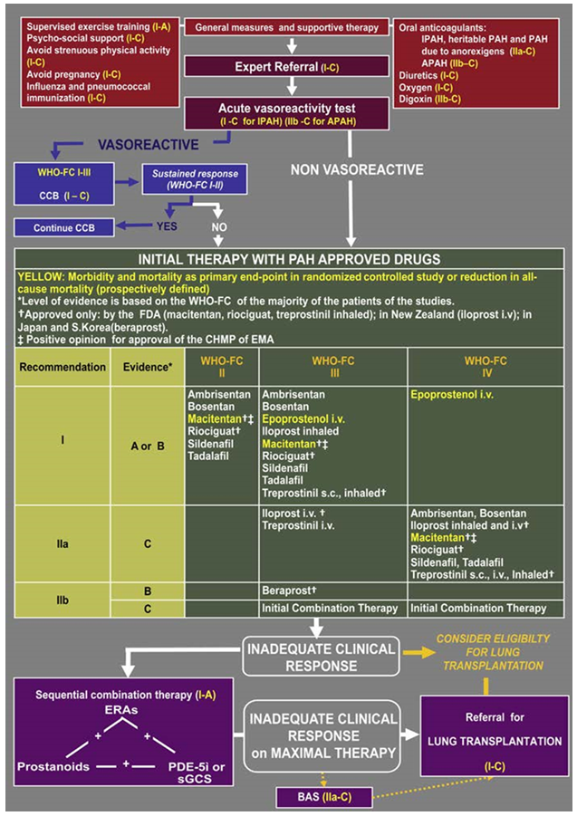

Macitentan and morbidity and mortality in pulmonary arterial hypertension
- Pulido et al NEJM 2013; 369: 809-18
Patient with grade II-IV PAH were randomly assigned to placebo, Macitentan 3mg or Macitentan 10mg. Use of stable oral or inhaled therapy for PAH, other than ERA, was allowed. The primary endpoint was a composite of death, atrial septostomy, lung transplantation, initiation of treatment with intravenous or subcutaneous prostanoids or worsening of PAH (defined as change from baseline to a higher WHO FC, worsening of RHF). Secondary endpoints included change from baseline to month 6 in 6MWD, percentage of patients with an improvement in WHO functional class at month 6, death or hospitalisation due to PAH.

Results
There were 250 in the placebo arm, 250 in the 3 mg Macitentan arm and 242 in the 10mg Macitentan arm. Overall, 63.7% were on background therapy for PAH, 61.4% were taking a PG5I, and 5.4% a prostanoid. There was a significant improvement in event related to PAH or death in the Macitentan groups (HR 0.7 (CI 0.52-0.96) for the 3 mg dose and 0.55 (CI 0.32 -0.76) for 10mg dose). The HR was 0.67 (0.46-0.97) and 0.50 (0.34-0.75) respectively for the secondary outcomes of death due to PAH or hospitalisation for PAH. The placebo adjusted improvement in 6MWD was 16.8m in the Macitentan 3 mg group, and 22.0m in the Macitentan 10 mg group. The WHO FC improved by 13% in the placebo group, 20% in the Macitentan 3 mg group and 22% in the Macitentan 10 mg group.
Evaluator’s comment: The sponsor has referred to the SERAPHIN trial and registration of Macitentan for use with other agents on a number of occasions in the s31 response. There are several notable differences between the SERAPHIN study and the AMBITION study
    - The SERAPHIN study had a placebo arm
    - The SERAPHIN study included patients with stage II-IV PAH
Thus, the SERAPHIN study provided more robust and generalizable evidence for efficacy and in support of the stated indication that was registered in Australia.

Second round benefit-risk assessment

Second round assessment of benefits
The AMBITION study demonstrated a clinically and statistically significant improvement in time to clinical failure with the combination of ambrisentan and tadalafil in patients with untreated grade II-III PAH.
The sponsor’s responses to the questions and comments in relation to the evaluator’s comments did not result in any factual changes in the data but assisted in the interpretation of the data. The evaluator was more informed about the acceptability of composite end points for efficacy in this population and of the clinical relevance of the outcomes measured. Most of the concerns of the study design were addressed.
The evaluator provides indications of an awareness of the difficulties in designing studies of rare diseases, particularly when the outcome events of interest are poorly defined and may occur years after diagnosis. The evidence for efficacy in the AMBITION study was not considered to be as robust as in the SEREPHIN study but does suggest a benefit for the primary, some of the secondary and the surrogate endpoints.

Second round assessment of risks
The risks were assessed as unchanged as a result of the data presented. The risks of combination therapy are those expected from the use of the individual components. The risks are adequately described in the PI.

Second round assessment of benefit-risk balance
After consideration of the sponsor’s responses to the evaluator’s clinical questions and concerns about the efficacy end points, the risk balance ratio for the use of ambrisentan in combination with tadalafil as initial therapy for stage II-III PAH is favourable.
Although there is some evidence of a benefit in using both ambrisentan and tadalafil as initial therapy for patients with stage II-III PAH, it is unknown how this combination compares with the use of Ambrisentan and other PGE-5i (as is recommended in the PAH guidelines).

Second round recommendation regarding authorisation
The clinical evaluator recommends approval of the extension of indication for the use of ambrisentan in combination with tadalafil as initial therapy for stage II-III PAH on the condition that the sponsor amends the indications in the PI to state:
Volibris can be used with tadalafil as initial treatment of WHO stage II and III PAH.
This restricts the use of combination therapy to better reflect the study population in the clinical trial. There is insufficient evidence for the safety or efficacy of combination therapy in patients with stage IV-PAH.
Alternatively, the sponsor could chose not to amend the indications and vary the register with changes to the clinical trials, adverse events and dosing sections of the PI only. This is not to understate the benefits that the AMBITION study demonstrated. But it is the evaluator’s opinion that the latter option allows clinicians a wider scope in the use of ambrisentan as more research and changes in clinical practice emerge.

References
- Oudiz R, Shapiro S, Torres F, Feldmann J, Frost A, Allard M, Blair C, Gillies H. ATHENA-1. Hemodynamic improvements following the addition of ambrisentan to background PDE5i therapy in patients with pulmonary arterial hypertension. Chest. 2011. 140. 905A
- Zhuang Y, Jiang B, Gao H, Zhao W. Randomised study of adding tadalafil to existing ambrisentan in pulmonary arterial hypertension. Hypertension Research. 2014. 37 507-512.
- Shapiro S, Gillies H, Allard M, Blair C, Oudiz RJ. ATHENA-1. Long term clinical improvement following the addition of ambrisentan to background PDE5i therapy in patients with pulmonary arterial hypertension. The Journal of Heart and Lung Transplantation. Vol 31, No 4S, April 2012.
- Anderson JR, Nawarskas JJ. Pharmacotherapeutic Management of Pulmonary Arterial Hypertension. Cardiology in Review. Vol 18, No3. 2010.
- Montori VM, Permanyer-Miralda G et al. Validity of composite endpoints in clinical trials. BMJ 2005; 330; 594-596.
Therapeutic Goods Administration
PO Box 100 Woden ACT 2606 Australia
Email: info@tga.gov.au Phone: 1800 020 653 Fax: 02 6232 8605
https://www.tga.gov.au

Anderson JR, Nawarskas JJ. Pharmacotherapeutic management of pulmonary arterial hypertension. Cardiol Rev. 18: 148-62 (2010).
The sponsor points out that in the SERAPHIN study, 10 mg macitentan (licensed dose) was added to existing therapy in 154 patients, of which 140 were on sildenafil, 2 on tadalafil, 8 on vardenafil (not licensed for treatment of PAH), and 16 on prostanoids. In summary, the majority of combination use with macitentan is as add-on to existing sildenafil therapy. In the AMBITION study 302, patients were initiated on the combination of tadalafil and ambrisentan. A further 70 subjects in the monotherapy groups had sequential combination started (ambrisentan added to tadalafil or tadalafil added to ambrisentan). Additionally, 57 subjects had prostacycline therapy added to a treatment arm containing ambrisentan (monotherapy or combination).
The sponsor states that these should be reported as improvements from baseline as was reported in the AMBITION study. With background therapy: 17.9 m improvement from baseline; without background therapy: 3.1 m improvement from baseline (data taken from supplementary appendix of SERAPHIN study).
The sponsor states that the composite endpoints in AMBITION included all those within the SERAPHIN composite endpoint plus two additional measures: hospitalisation for PAH, and unsatisfactory long-term clinical response. AMBITION was a treatment strategy trial of upfront combination versus monotherapy with already established, efficacious PAH treatments.

