First round CER: 30 March 2015
Second round CER:18 September 2015

AusPAR Attachment 1

Extract from the Clinical Evaluation Report for alprostadil
  - Proprietary Product Name: Proshaeos
  - Sponsor: Commercial Eyes Pty Ltd

About the Therapeutic Goods Administration (TGA)
- The Therapeutic Goods Administration (TGA) is part of the Australian Government Department of Health, and is responsible for regulating medicines and medical devices.
- The TGA administers the Therapeutic Goods Act 1989 (the Act), applying a risk management approach designed to ensure therapeutic goods supplied in Australia meet acceptable standards of quality, safety and efficacy (performance), when necessary.
- The work of the TGA is based on applying scientific and clinical expertise to decision-making, to ensure that the benefits to consumers outweigh any risks associated with the use of medicines and medical devices.
- The TGA relies on the public, healthcare professionals and industry to report problems with medicines or medical devices. TGA investigates reports received by it to determine any necessary regulatory action.
- To report a problem with a medicine or medical device, please see the information on the TGA website <https://www.tga.gov.au>.
About the Extract from the Clinical Evaluation Report
- This document provides a more detailed evaluation of the clinical findings, extracted from the Clinical Evaluation Report (CER) prepared by the TGA. This extract does not include sections from the CER regarding product documentation or post market activities.
- The words [Information redacted], where they appear in this document, indicate that confidential information has been deleted.
- For the most recent Product Information (PI), please refer to the TGA website <https://www.tga.gov.au/product-information-pi>.
Copyright
© Commonwealth of Australia 2016
This work is copyright. You may reproduce the whole or part of this work in unaltered form for your own personal use or, if you are part of an organisation, for internal use within your organisation, but only if you or your organisation do not use the reproduction for any commercial purpose and retain this copyright notice and all disclaimer notices as part of that reproduction. Apart from rights to use as permitted by the Copyright Act 1968 or allowed by this copyright notice, all other rights are reserved and you are not allowed to reproduce the whole or any part of this work in any way (electronic or otherwise) without first being given specific written permission from the Commonwealth to do so. Requests and inquiries concerning reproduction and rights are to be sent to the TGA Copyright Officer, Therapeutic Goods Administration, PO Box 100, Woden ACT 2606 or emailed to <tga.copyright@tga.gov.au>.

Contents
List of abbreviations 6
1. Introduction 8
2. Clinical rationale 8
3. Contents of the clinical dossier 8
3.1. Scope of the clinical dossier 8
3.2. Paediatric data 9
3.3. Good clinical practice 9
4. Pharmacokinetics 9
4.1. Studies providing pharmacokinetic data 9
4.2. Summary of pharmacokinetics 9
4.3. Evaluator’s conclusions on pharmacokinetics 15
5. Pharmacodynamics 16
5.1. Studies providing pharmacodynamic data 16
5.2. Summary of pharmacodynamics 16
5.3. Evaluator’s conclusions on pharmacodynamics 18
6. Dosage selection for the pivotal studies 18
7. Clinical efficacy 19
7.1. Studies providing efficacy data 19
7.2. Major efficacy variables 22
7.3. Pivotal efficacy studies 24
7.4. Supportive efficacy studies 53
7.5. Rejected or marginally relevant efficacy studies 77
7.6. Analyses performed across trials (pooled & meta analyses) 93
7.7. Evaluator’s conclusions on efficacy 95
8. Clinical safety 101
8.1. Studies providing safety data 101
8.2. Pivotal studies that assessed safety as a primary outcome 103
8.3. Patient exposure 103
8.4. Adverse events 105
8.5. Laboratory tests 134
8.6. Post marketing experience 146
8.7. Safety issues with the potential for major regulatory impact 147
8.8. Other safety issues 148
8.9. Evaluator’s conclusions on safety 157
9. First round benefit-risk assessment 159
9.1. First round assessment of benefits 159
9.2. First round assessment of risks 160
9.3. First round assessment of benefit-risk balance 161
10. First round recommendation regarding authorisation 161
11. Clinical questions 162
11.1. Additional expert input 162
11.2. Dose and formulation 162
11.3. Pharmacokinetics 163
11.4. Pharmacodynamics 163
11.5. Efficacy 163
11.6. Safety 164
12. Second round evaluation 165
12.1. Response 1 166
12.2. Response 2 166
12.3. Response 3 169
12.4. Response 4 173
12.5. Response 5 173
12.6. Response 6 174
12.7. Response 7 174
12.8. Response 8 174
12.9. Response 9 176
12.10. Response 10 176
12.11. Response 11 177
12.12. Response 12 178
12.13. Response 13 181
12.14. Response 14 182
12.15. Response 15 182
12.16. Response 16 183
12.17. Response 17 184
12.18. Response 18 186
12.19. Response 19 187
12.20. Response 20 188
12.21. Response 21 189
12.22. Response 22 189
12.23. Response 23 189
12.24. Response 24 189
12.25. Response 25 190
12.26. Response 26 192
12.27. Response 27 193
13. Second round benefit-risk assessment 193
13.1. Efficacy in subjects with mild ED 193
13.2. Safety issues conceded by the sponsor 193
13.3. Safety issues for which the sponsor’s response suggests lower risk 194
13.4. Unresolved issues 194
14. Second round recommendation regarding authorisation 194
15. References 195

List of abbreviations
Abbreviation | Meaning
AE | Adverse event
ALT | Alanine transaminase (SGPT [serum glutamate pyruvate transaminase])
ANCOVA | Analysis of covariance
ANOVA | Analysis of variance
AST | Aspartate transaminase (SGOT [serum glutamic oxaloacetic transaminase])
BP | Blood pressure
bpm | Beats per minute
BUN | Blood urea nitrogen
CFR | Code of Federal Regulations
CMI | Consumer Medicine Information
COSTART | Coding Symbols for a Thesaurus of Adverse Reaction Terms
CRF | Case report form
DB | Double-blind
DBP | Diastolic blood pressure
DDAIP | Dodecyl-2-(N,N-dimethyl-amino-propionate)
ECG | Electrocardiogram
ED | Erectile dysfunction
EF | Erectile function (score) from International Index of Erectile Function
FDA | United States Food and Drug Administration
GAQ | Global Assessment Questionnaire
GCP | Good Clinical Practice
GGT | Gamma-glutamyl-transferase
IIEF | International Index of Erectile Function
IRB | Institutional Review Board
ITT | Intent-to-treat (population)
ITT-E | Intent-to-treat (population) for efficacy
mcg | microgram (µg)
MedDRA | Medical Dictionary for Drug Regulatory Affairs
mm Hg | Millimetres of mercury
ms | Milliseconds
PGE₀ | Prostaglandin E0
PGE₁ | Prostaglandin E1
PI | Product Information
PSAE | Patient Self-Assessment of Erection
RBC | Red blood cell (count)
SAE | Serious adverse event
SBP | Systolic blood pressure
SD | Standard deviation
SE | Standard error
SEP | Sexual Encounter Profile
USP | United States Pharmacopoeia
VPSR | Vaginal Penetration Success Rate
WBC | White blood cell (count)
WHO | World Health Organization

Introduction
This is an application to register Vitaros Cream 0.2% w/w and 0.3% w/w, which is a new topical formulation of alprostadil, an agent that is already registered and in clinical use for the treatment of erectile dysfunction.

Clinical rationale
The development of a penile erection is a complex physiological process in which psychological and physical cues trigger vasodilation of penile blood vessels, which in turn causes compression of venous outflow tracts and vascular engorgement of the penis.
ED is a common problem, which may cause significant psychological distress for men and their partners. There are two broad aetiological categories of ED, psychological and physical, with some subjects having a mixed aetiology. The incidence of ED increases with age, and it is more common in the setting of significant medical conditions such as vascular disease, diabetes, or neurological disorders, particularly those affecting the spinal cord. Endocrine disorders, particularly those that lower levels of male hormones such as testosterone, may also cause ED and are usually treated by correcting the underlying hormonal deficiency.
In addition to addressing any psychological barriers to normal erectile function, and reversing underlying medical problems, treatments for ED have primarily focussed on enhancing vasodilation. Viagra (sildenafil), the best known treatment for ED, as well as the related drugs Levitra (vardenafil) and Cialis (tadalafil), work by inhibiting phosphodiesterase type-5 (PDE5), subsequently producing vasodilation. These drugs are administered orally, potentially leading to systemic side effects, such as hypotension, resulting from more widespread vasodilation. Topical treatments have the potential advantage of reducing systemic side effects, or allowing relatively greater local vasodilation in the target organ than the systemic circulation. Endogenous compounds such as alprostadil also have the potential theoretical advantage of being free of unexpected immunological or other toxicities, so they represent natural targets for research in this area.
Vitaros was developed as a refinement of existing topical approaches to the use of alprostadil in treating ED. Alprostadil has already been available in the parenteral form, Caverject, for many years, but the invasive route of administration is potentially unappealing to many patients, and can cause scarring with repeated use. Alprostadil is also available internationally as a urethral suppository, in the product Muse, but the insertion of a suppository into the urethra may be considered invasive and unappealing to many subjects. Muse is not registered in Australia. Befar cream has been registered in China, and resembles Vitaros in that it is a topical cream applied to the penile meatus, but the sponsor proposes that Vitaros produces better targeted absorption of alprostadil because it uses a permeation enhancing agent, DDAIP HCl.

Contents of the clinical dossier

Scope of the clinical dossier
The submission contained the following clinical information:
- Two clinical pharmacology studies, including one that provided PK data and one that used radiolabelled topical cream to assess migration of the cream into the urethra
- No population PK analyses
- Two pivotal Phase III efficacy/safety studies
- One open label Phase III extension study
- Four Phase II efficacy studies, including a high dose study that was abandoned because of poor tolerability and a single dose crossover study that might be better considered a pharmacodynamic (PD) study
- Eighteen efficacy/safety studies performed in China with various alprostadil formulations differing from the proposed Vitaros formulation
- Studies for unrelated conditions, such as female sexual dysfunction, premature ejaculation, and fungal toe infection (included because the nail lacquer contained the same permeation enhancer, DDAIP, that is contained in Vitaros)
- Integrated Summary of Efficacy
- Integrated Summary of Safety

Paediatric data
The submission did not include paediatric data. The treatment is proposed for use in adult males.

Good clinical practice
All of the major studies, and in particular the pivotal studies, contained statements of compliance with Good Clinical Practice (GCP) and the conduct and reporting of the studies appeared to be consistent with GCP. For some of the studies performed in China, the studies were not submitted in sufficient detail to confirm that they complied with GCP.

Pharmacokinetics

Studies providing pharmacokinetic data
Because Vitaros is a topical preparation, with very limited systemic absorption, a standard PK program was not performed or submitted. Instead, the sponsor provided a single PK study in which subjects were treated with topical Vitaros and serum was collected for assays of prostaglandin E1 (PGE1, equivalent to alprostadil), prostaglandin E0, 15-keto-PGE0 and DDAIP. Levels of PGE1 were below levels of quantitation, so no direct PK analysis of alprostadil could be performed.
The sponsor also submitted a cream migration study that used radiolabelled topical cream to determine how much cream migrated proximally along the urethra after correct and deliberately incorrect application.
No other PK studies were submitted. The PK of alprostadil was initially characterised in the lead up to marketing of Caverject, and the proposed PI for Vitaros largely relies on that original characterisation.

Summary of pharmacokinetics
The information in the following summary is primarily derived from the literature on prostaglandin metabolism, including the Caverject PI, supplemented by the Sponsor’s single PK study.

Physicochemical characteristics of the active substance
The physicochemical characteristics of Vitaros are described in the proposed PI as follows:
Alprostadil is the natural occurring form of prostaglandin E1. It is a white or slightly yellowish, crystalline powder, which is practically insoluble in water, freely soluble in alcohol; soluble in acetone; slightly soluble in ethyl acetate; very slightly soluble in chloroform and in ether.

Pharmacokinetics of prostaglandin E₁ and 15-keto PGE₀

Overview
Alprostadil is a synthetically produced form of prostaglandin E1, and it is chemically identical to the endogenous compound. Endogenous prostaglandins are usually produced for their local effects, and undergo extensive first-pass metabolism in the lungs, so their levels in serum are generally low. Vitaros only contains modest amounts of prostaglandin relative to endogenous production: for instance, the amount of prostaglandin E1 in a standard dose of Vitaros (200 mcg or 300 mcg) resembles the endogenous levels of prostaglandin in a single human ejaculate (~100-200 mcg). Because the dose is relatively low, and it is supplied as a topical preparation, systemic absorption of alprostadil is minimal.
In the Sponsor’s only submitted PK study, twenty men aged 21-75 years, with erectile dysfunction but no other medical problems, were randomly assigned to one of four dose groups: placebo, alprostadil 100 mcg, alprostadil 200 mcg, or alprostadil 300 mcg, which was administered to the penile meatus and glans in 100 mg standard proprietary cream containing DDAIP. Levels of PGE₁, PGE₀, 15-keto-PGE₀ and DDAIP were measured at baseline and frequently over the next few hours, and then analysed where possible, using standard PK formulae.
Plasma levels of PGE₁ (i.e., alprostadil), PGE₀ and DDAIP were low or undetectable in most subjects at most of the post-dose sampling times, so PK parameters could not be estimated for these three compounds. The alprostadil metabolite 15-keto-PGE₀, by contrast, showed a measurable rise and fall after dosing, as shown in the figure below.
Figure 1. Mean 15-Keto-PGE0 Concentrations Versus Time.
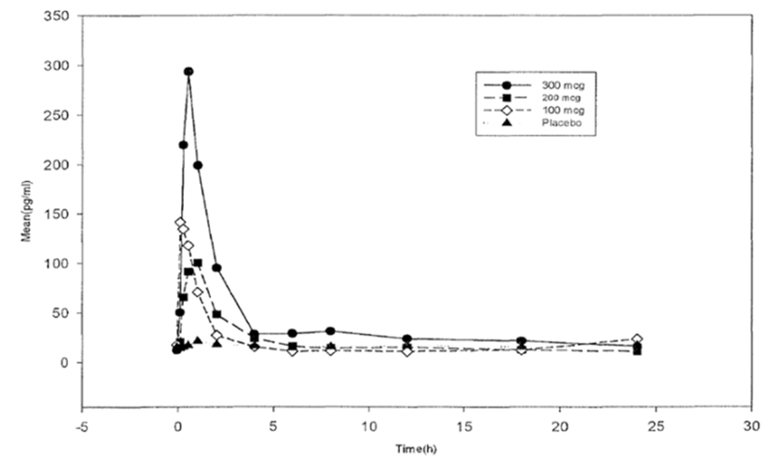
There was a rapid increase in 15-keto-PGE₀ levels post-dosing, peaking in 0.6 to 1 hour, followed by elimination with a half-life of 3-6 hours (see the table below).
Table 1. Mean (SD) PK Parameters for 15-Keto-PGE0.
Parameter | Placebo (n=5) | Alprox-TD 100 mcg (n=5) | Alprox-TD 200 mcg (n=5) | Alprox-TD 300 mcg (n=5)
AUC(0-24) (pg*h/ml) | 388 (256) | 439 (107) | 504 (247) | 960 (544)
Cmax (pg/ml) | 23 (19) | 202 (229) | 120 (103) | 332 (224)
Tmax (h) | 6 (8) | 0.6 (0.4) | 1 (0.7) | 0.7 (0.3)
T1/2 (h) | 4 (--)ª | 5 (3) | 3 (1)^{b} | 6 (6)
a. Only 1 subject had sufficient data for estimation of half-life.
b. Only 3 subjects had sufficient data for estimation of half-life.
The highest dose (300 mcg, equivalent to the maximum proposed Vitaros dose) was associated with a peak 15-keto-PGE₀ level of 332 pg/mL. Lower doses produced lower peaks, but the dose trend was inconsistent; the 100 mcg dose produced a higher mean peak than the 200 mcg dose. Presumably, this reflects the low patient numbers and significant high inter-subject variability, which is also suggested by the large standard deviation, relative to the mean (see the table below).
Table 2. Subjects with Detectable Serum DDAIP Concentrations (ng/mL)
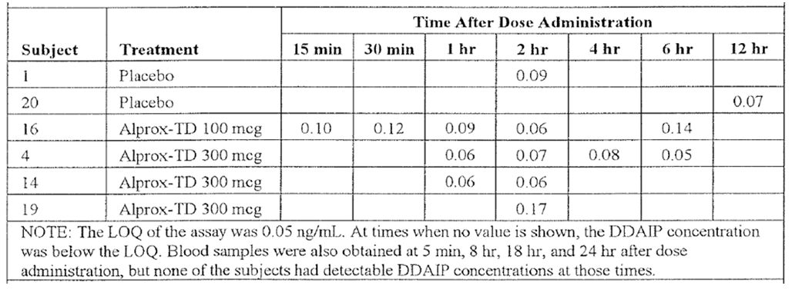
This study also assessed absorption of the permeation agent DDAIP, but levels were low in most subjects and PK parameters could not be derived. The individual DDAIP results are shown below for the subjects who had significant absorption. These levels are low – most subjects had levels below the LOQ of 0.05 ng/mL – and have no known clinical effect.
The only other clinical pharmacology supplied by the Sponsor was a study of radiolabelled cream, which showed that, in one of three subjects who applied the cream incorrectly by inserting the dispenser into the meatus, proximal migration of a small amount of cream occurred. This is an expected finding; whether it has any impact on systemic absorption of alprostadil was not assessed. The PI and Consumer Medicine Information (CMI) sheets contain appropriate warnings advising against this method of administration.
The remainder of the Sponsor’s discussion of the pharmacology of alprostadil rested on a brief review of the literature, which is summarised below under the usual headings. The main sources cited by the Sponsor were the package inserts (Product Information sheets) for Muse and Caverject, two other topical alprostadil products already approved for the treatment of ED. (These inserts were cited via the Physician’s Desk Reference, 56th Edition, Medical Economics Company.) The original studies providing data for those package inserts were not submitted for a critical valuation, and a full critique of those studies is beyond the scope of this report, but the Sponsor’s presentation of this data appears to be accurate.
The proposed formulation does not raise major new PK issues relative to existing products, but it is assumed throughout the submission that the permeation agent DDAIP enhances the local absorption of alprostadil. No direct proof of this was supplied. Although the data discussed above suggests that, even with DDAIP, Vitaros does not generally produce detectable systemic levels of alprostadil in otherwise healthy subjects with ED, it is possible that the enhanced absorption of alprostadil facilitated by DDAIP might lead to higher systemic levels in susceptible individuals, such as those with lung disease who have reduced first-pass metabolism. No Vitaros-specific studies have been performed in such populations.

Absorption

Sites and mechanisms of absorption
After local administration of Vitaros to the meatus and glans of the penis, alprostadil is believed to undergo rapid absorption into the corpus spongeosum and corpus cavernosum through collateral vessels. From here, the active drug passes into the pelvic venous circulation.

Bioavailability

Absolute bioavailability
The bioavailability of alprostadil via the oral route has not been characterised. Availability via the penile meatus appears to be very low, with undetectable levels of alprostadil after administration of the maximum proposed dose. Detectable levels of the metabolite 15-keto-PGE₀ are achieved post-dosing, peaking in 0.6 to 1 hour, confirming that some systemic absorption does occur.
Despite the fact that alprostadil levels after topical administration are very low, use of standard doses must be associated some degree of systemic absorption, either of alprostadil or of an active prostaglandin metabolite, because haemodynamic responses were observed in the Phase 2 and Phase 3 studies, particularly at doses (500 mcg-1500 mcg) above those proposed for marketing (200 mcg-300 mcg). This hypotension was observed despite the fact that the main detectable metabolite, 15-keto-PGE₀ is claimed to have only 1-2% of the activity of alprostadil.

Bioavailability relative to an oral solution or micronised suspension
No data is available.

Bioequivalence of clinical trial and market formulations
The bioavailability of different formulations was not directly assessed, but all of the Phase 2 USA studies and all of the Phase 3 studies used the same formulation as that proposed for market.
Several of the Chinese studies used formulations with no DDAIP or non-standard levels of DDAIP, and those studies are therefore only indirectly supportive of efficacy of Vitaros.

Bioequivalence of different dosage forms and strengths
This has not been directly assessed.

Bioequivalence to relevant registered products
It is assumed by the Sponsor throughout the submission that DDAIP increases the availability of alprostadil or its metabolites, and this improves efficacy, but direct proof of this is lacking.
The PK of Vitaros has not been directly compared to existing products, such as Befar, which lack DDAIP. Phase 2 efficacy studies performed in China with non-Vitaros alprostadil formulations suggest that the addition of DDAIP increases efficacy, and this provides indirect support for the Sponsor’s claim that DDAIP improves absorption, but no data was submitted that directly confirms increased absorption. Such a study would have been possible using 15-keto-PGE₀ levels as a surrogate PK marker.
Also, as suggested by Canadian authorities, inconsistencies in the production of the different alprostadil formulations in China could account for some of the observed efficacy differences in the Phase 2 formulation studies.

Influence of food
Not applicable.

Dose proportionality
The only submitted PK study showed that peak levels of 15-keto-PGE₀ after administration of 300 mcg were higher than peak levels at lower doses, but the dose trend was inconsistent; the 100 mcg dose actually produced a higher mean peak than the 200 mcg dose. Thus, it has not been confirmed that dose-proportionality applies or that different doses and strength have comparable bioequivalence.

Bioavailability during multiple-dosing
No multi-dose PK studies were submitted.

Effect of administration timing
No information was provided that clarifies whether the timing of administration affects the PK of alprostadil, but it seems unlikely that the timing is important.

Distribution
No information was provided regarding the volume of distribution, plasma protein binding, or tissue distribution of alprostadil. According to the Muse and Caverject PIs, no evidence has been found of tissue retention of alprostadil or its metabolites following intravenous administration.

Metabolism
The principal site of systemic metabolism of prostaglandin E1 is the lungs. When administered intravenously, 60 to 90% of prostaglandin E1 has been shown to be metabolized in a single pass through the lungs (Caverject PI). Following topical administration to the penis, prostaglandin E1 is also metabolised by local enzymatic oxidation in the lower genital urinary tract, including urethra, prostate and the corpus cavernosum. The proposed PI states:
Following topical administration, PGE1 is rapidly metabolized locally by enzymatic oxidation of the 15-hydroxyl group to 15-keto-PGE1. The enzyme catalysing this process has been isolated from the lower genitourinary tract including the urethra, prostate, and corpus cavernosum.
The combination of first-pass lung metabolism, local metabolism and renal clearance of metabolic products means that, after intravenous administration of radioactively labelled alprostadil in humans, the radioactivity is rapidly cleared from the plasma within the first ten minutes and only low levels remain in the blood after one hour (Caverject PI). Approximately 90% of an administered intravenous dose is excreted in the urine within a 24-hour period, and the remainder is excreted in the faeces.
The systemic half-life of alprostadil has been estimated to be between 30 seconds to 10 minutes in various body compartments (Muse PI). The half-life cited in the Australian version of the Caverject PI is “less than one minute”.

Metabolites identified in humans
The two main metabolites of PGE₁ are 13,14-dihydro-PGE₁ (PGE₀) and 15-keto-PGE₀ (Cawello et al, 1994). As shown in the Sponsor’s only PK study, discussed above, levels of PGE₀ are below the limits of quantitation after standard doses of Vitaros. 15-keto-PGE_{O} levels rise after topical administration of Vitaros, but only reach low levels, as discussed above.
According to the Sponsor, 15-keto-PGE_{O} has only 1-2% of the biological activity of prostaglandin E1 and is itself rapidly metabolised to metabolites that are subsequently cleared primarily by the kidney and the liver. Given that alprostadil levels are undetectable after topical administration, and systemic hypotensive responses are nonetheless observed in some subjects, clinically significant levels of active metabolites are likely to be present after alprostadil administration.

Consequences of genetic polymorphism
The Sponsor provided no discussion of the potential for genetic polymorphism to alter the PK of alprostadil. Given the very low levels of systemic absorption, this omission is acceptable.

Excretion
As noted above, alprostadil is primarily cleared by metabolism, but the metabolites are then cleared primarily by the kidneys, with 90% of a radioactively labelled dose appearing in the urine. The remainder of the radioactivity appears in the faeces. The Sponsor did not provide any studies assessing the excretion or renal clearance of alprostadil. (Urine was collected in the only PK study, but only for safety monitoring.)

Intra- and inter-individual variability of pharmacokinetics
Given that only one PK study was submitted, there is very little information on the variability of the PK of alprostadil and its metabolites. The data for 15-keto-PGE₀ suggest that variability in absorption is high, but this was based on very low patient numbers (5 subjects per dose) and it is not possible to determine how much variation is due to inter- or intra-subject variability.
As discussed below, there is potential for variation in the extent of first-pass metabolism in subjects with lung disease.

Pharmacokinetics in the target population
The only PK study was performed in men from the target population. Pharmacokinetics in the target population, men with ED, are not expected to significantly differ from the PK in age-matched healthy subjects.

Pharmacokinetics in other special populations
The Sponsor discussed the potential for altered PK in three populations: subjects with lung disease, the elderly, and men in comparison to women. As in other discussions of the PK of alprostadil, the primary references were the PIs for Caverject and Muse.
In the Summary of Clinical Pharmacology, the Sponsor writes:
Since the rapid metabolism of alprostadil by the lungs is the chief factor resulting in its low plasma concentrations, it is especially important to consider the possible effects of pulmonary disease on plasma concentrations of this drug. While the effect of pulmonary disease on plasma levels of alprostadil following administration by the topical route is not known, information does exist on the pulmonary metabolism of alprostadil following intravenous administration. It was found that pulmonary metabolism is reduced approximately 15% in patients with Adult Respiratory Distress Syndrome (ARDS), compared with a control group of patients with normal respiratory function who were undergoing cardiopulmonary bypass surgery.
A reduction of 15% is unlikely to be clinically significant, given that alprostadil cream produced undetectable levels of PGE₁ in serum, but the Sponsor also adds:
Pulmonary metabolism was found to be affected by cardiac output and the intrinsic ability of the lungs to clear alprostadil. In new patients with ARDS or at risk of developing it following trauma or sepsis, the extraction efficiency of alprostadil was found to range from subnormal (11%) to normal (90%) with an overall mean of 67%.
As with similar comments, the Sponsor’s source for these comments is the Caverject PI.
These additional comments referring to the 11% extraction efficiency were not included in the Sponsor’s proposed PI, but the more modest 15% mean reduction in pulmonary metabolism was included in the PI; the net effect is that the potential for reduced pulmonary metabolism is understated in the proposed PI.
This data suggests that major pulmonary disease could reduce the first-pass extraction of alprostadil by a factor of ~9 (to 11% of normal), which could increase susceptibility of subjects to systemic side effects such as hypotension. Given that the subnormal metabolism was demonstrated in an ICU setting, and that topical administration is associated with very low levels of absorption, it seems relatively unlikely that this will be a major issue for subjects using the product at home. It remains possible, though, that patients with very severe lung disease could experience increased exposure to alprostadil or its metabolites because of reduced first-pass metabolism. Even if metabolism were reduced by a factor of 2 to 5 in such patients, this could be clinically significant, given that a high-dose Phase 2 study had to be abandoned because of poor tolerability, using doses only 1.7 to 5 times the proposed 300 mcg dose.
The effect of age on metabolism has not been well studied. According to studies cited in the Caverject PI, performed in patients with ARDS, age did not appear to be a major factor: the average pulmonary metabolism of alprostadil was 72% in 11 elderly patients (≥ 65 years old), compared to 65% in six young patients (≤ 35 years old).
The Caverject PI also refers to the effect of gender on the metabolism of alprostadil, which could be of relevance given that female sexual partners could absorb limited quantities of alprostadil. The evidence cited was not ideal because it involved subjects with ARDS, but pulmonary extraction was 66% in 17 male patients and 69% in the six female patients. Overall, this suggests that the metabolism and pharmacokinetics of alprostadil are not significantly influenced by gender.
The effects of race and renal and hepatic insufficiency have not been studied following the administration of alprostadil cream.

Pharmacokinetic interactions

Pharmacokinetic interactions demonstrated in human studies
No drug-interaction studies were submitted.

Clinical implications of in vitro findings
No relevant in vitro findings were discussed in the clinical submission.

Evaluator’s conclusions on pharmacokinetics
The PK of alprostadil has previously been defined during development of parenteral preparations of alprostadil (Caverject), and the current submission provides very little new information. After administration of the proposed doses, alprostadil levels are undetectable, but its major metabolite 15-keto-PGE0, reaches a peak within one hour and is then cleared over the next few hours. Although this metabolite is said to have only 1-2% of the activity of alprostadil, Vitaros does produce systemic hypotensive responses in some subjects, indicating that clinically relevant systemic levels of active metabolites must be achieved.
There is indirect evidence that lung disease may increase exposure to alprostadil, by reducing first pass metabolism, but this has not been directly assessed with Vitaros. There is also indirect evidence suggesting that age and gender are unlikely to have a major effect on the PK of Vitaros.
The permeation agent, DDAIP, is also absorbed systemically after topical use of Vitaros, but the levels were below the limits of quantitation in most subjects.
No data was submitted that directly confirms that DDAIP, the permeation-enhancing agent, increases absorption of alprostadil.

Pharmacodynamics

Studies providing pharmacodynamic data
The sponsor did not submit any studies characterised as PD studies, but some of the efficacy studies had a design more consistent with a PD study than an efficacy study. Study NM 2000-007, for instance, was presented as a Phase II efficacy study, but it used a crossover design and a laboratory based assessment of the erectile response to different doses of alprostadil.
Many of the efficacy studies performed in China could also be considered as PD studies, but they did not directly assess the PD of alprostadil; instead they assessed the improvement in efficacy that resulted from the addition of various strengths of DDAIP to alprostadil cream. These studies did not use a non-alprostadil placebo arm, so they did not directly assess the efficacy or PD of alprostadil. Three of them had a similar design and were considered together in an integrated study report that provides indirect evidence that the addition of DDAIP improves the efficacy of alprostadil. This integrated data is discussed in the Efficacy Section.
Two of the Chinese studies assessed erectile responses to alprostadil creams, using a penile rigidity recorder in one, and Doppler ultrasound in another, but Vitaros was not used in either of these studies, and both studies lacked a placebo control group, so they do not provide any PD data of direct relevance to Vitaros.
Summaries of the Chinese studies are presented in this report.
No studies were performed that assessed the potential for PD drug interactions, and no study specifically assessed the potential of alprostadil to modify the QT interval.

Summary of pharmacodynamics
The Sponsor’s discussion of the PD of alprostadil was primarily based on published literature and the accepted mechanisms of action of alprostadil, rather than on any submitted study that specifically assessed Vitaros.

Mechanism of action
Alprostadil, like most prostaglandins, causes vasodilation, inhibition of platelet aggregation, inhibition of gastric secretions, and stimulation of intestinal and uterine smooth muscle (Tam et al, 1998).
The mechanism of action of alprostadil in erectile dysfunction is presumed to be relaxation of cavernosa smooth muscle and dilation of cavernosa arteries (Caverject PI). After the smooth muscle relaxes, the sinusoidal spaces engorge with blood and penile arterial inflow increases. The emissary veins become compressed, so venous outflow is retarded and ultimately intracavernosal pressure is increased, resulting in erection.

Pharmacodynamic effects

Primary pharmacodynamic effects (erectile responses)
Study NM 2000-007 used a multicentre, randomised, double-blind, placebo-controlled, crossover design to assess the erectile responses of 27 male subjects while they watched erotic videos. At each visit, subjects received a single dose of placebo or alprostadil at a dose of 100 mcg, 200 mcg or 300 mcg, in random order, and then watched videos while erectile responses were recorded instrumentally. Possibly because of problems with the recording equipment and the erection detection algorithm, this was a negative study that showed no improvement in erections with active treatment compared to placebo.
No other submitted studies directly assessed the primary or secondary pharmacodynamic effects of Vitaros. The efficacy studies, which relied on patient ratings of their sexual experiences rather than on direct measurement, provided indirect evidence that Vitaros improves erectile responses under normal physiological conditions.
The Sponsor cites previous studies in the literature that assessed erectile responses to alprostadil, which support the notion that alprostadil improves erections by increasing vasodilation, but these studies were not submitted in detail. Further indirect support comes from various studies that led to marketing of other topical alprostadil products, such as Caverject, Muse and Befar.

Secondary pharmacodynamic effects (responses in other organ systems)
Because it induces vasodilation, alprostadil may also produce a fall in systemic blood pressure, and, consistent with this, hypotensive responses were observed in some of the clinical efficacy studies (particularly the high-dose study, NM 99-001). Direct assessments of the hypotensive potential of alprostadil at different doses were not submitted.
When used systemically, alprostadil has been observed to increase blood flow to several organs, including the heart, mesentery, and kidney (Tam et al, 1998), but this is not expected to be a major effect after topical use, especially given the low absorption of alprostadil. Systemic hypotension could reduce organ perfusion, but this was not assessed in any submitted study.
Inhibition of platelet aggregation by prostaglandins is presumed to be caused by the dissociation of activating ligands from their platelet receptors. The Sponsor did not discuss whether alprostadil could increase the risk of bleeding by inhibiting platelet aggregation, but the systemic absorption of alprostadil is expected to be so low that this not likely to be a clinically important issue, and bleeding was not observed as a common AE in the pivotal studies.
Alprostadil produces a gastric cytoprotective action against gastric irritants, and also relaxes circular smooth muscle and increases fluid secretion into the intestinal lumen (Tam et al, 1998), but these gastrointestinal effects are not thought to be important following Vitaros administration, given the low systemic absorption.

Time course of pharmacodynamic effects
No direct information was submitted directly characterising the time course of the PD effects. Subjects in the pivotal studies were advised to administer the drug 10-30 minutes before coitus. The onset of the erectile response depends on several other factors, including psychological cues.
A very small number of subjects in the Phase 3 studies developed priapism (defined as persistent erections lasting ≥4 hours), suggesting that the PD effect may in some cases outlast the normal physiological response to sex.

Relationship between drug concentration and pharmacodynamic effects
No data was submitted that characterised the relationship between drug concentrations and PD effects.

Genetic-, gender- and age-related differences in pharmacodynamic response
No PD data was submitted allowing comparison of the PD response in different populations. Subgroup analysis of the pivotal efficacy studies suggested that age did not play a major role in determining the response to alprostadil, even though ED is more common in the elderly.

Pharmacodynamic interactions
No PD interaction studies were submitted. It would be expected that alprostadil could cause synergistic vasodilation when administered with other vasodilators, but the PI merely claims that no drug interactions have been identified.

Evaluator’s conclusions on pharmacodynamics
The PD of alprostadil have been characterised in the development of other alprostadil products, but no new PD data were submitted. The mechanism of action of alprostadil is reasonably well understood, and alprostadil appears to improve erections by enhancing vasodilation.
Significant gaps in knowledge of the PD effects of alprostadil remain, particularly in relation to the systemic hypotensive effects of alprostadil. This issue is discussed further in the Safety section of this report.

Dosage selection for the pivotal studies
Several lines of evidence led to the selection of three doses to be assessed in the pivotal Phase III studies (100 µg, 200 µg and 300 µg). Befar, an alternative alprostadil cream lacking DDAIP, which is registered for treatment of ED in China, is used at two doses: 1000 µg alprostadil in 250 mg of cream and 400 µg alprostadil in 100 mg cream. The Chinese formulation studies showed better efficacy with DDAIP containing formulations than DDAIP free formulations of alprostadil, reflecting improved absorption arising from the addition of DDAIP. The maximum proposed dose of Vitaros, 300 µg, resembles the lower Befar dose, and might be expected to have broadly similar efficacy allowing for improved absorption.
The DDAIP strength adopted for further studies was based on evidence that at least 0.05% was needed to improve efficacy relative to DDAIP free formulations, balanced against the potential for DDAIP to cause some local irritation. The Chinese studies had not shown a clear increase in adverse events across the DDAIP strength range of 0.05% to 5.0%, as shown below, and so it appears that an intermediate dose was chosen for further study. The sponsor has not provided any specific rationale for choosing 2.5% over lower strengths.
Table 3: Adverse Events in Chinese Studies NM-AP-40B, NM-AP-40C-CH and NM-AP-40F-CH.
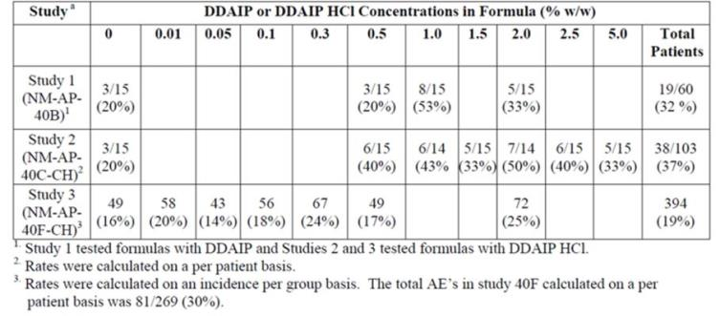
The first USA Phase II study of alprostadil with DDAIP was performed with alprostadil doses similar to the Befar doses: 500 µg, 1000 µg and 1500 µg, in conjunction with 2.5% DDAIP. This study produced unacceptable side effects, with 9 of 21 subjects not tolerating the first test dose, so the dose range was reduced to 50 µg, 100 µg, 200 µg and 300 µg for the other Phase II studies (the study in mild-to-moderate ED used 50-200 µg; the study in severe ED used 100-300 µg; the instrumental study assessed 100-300 µg). Overall, these studies suggested alprostadil had better efficacy at 200 µg and 300 µg than at lower doses, but the efficacy difference between 200 µg and 300 µg appeared to be small and inconsistent. Subsequently, 3 doses (100 µg, 200 µg and 300 µg) were selected for the Phase III studies. The Phase III studies did not assess different DDAIP strengths.
As will be discussed below, the Phase III studies subsequently showed similar efficacy in the 200 µg and 300 µg groups, with inferior results in the 100 µg dose group. Most AEs showed a dose trend across the range 100 µg to 300 µg, but tolerability at the highest dose was acceptable to most subjects. The 200 µg and 300 µg doses have therefore both been proposed for marketing, with the 200 µg dose offered as an alternative lower dose if down titration is needed in response to side effects.
In conclusion, although there is some rationale behind the dose and formulation chosen for the Phase III studies, the evidence is inconclusive. It could be argued that it would be as or more appropriate for subjects to start with an alprostadil dose of 200 µg and titrate upwards to 300 µg, if needed. The limited evidence from formulation studies suggests that a lower strength of DDAIP might offer similar efficacy, with less exposure of subject to the risk of carcinogenesis.

Clinical efficacy

Studies providing efficacy data
The sponsor submitted 7 efficacy studies (three Phase III studies and four Phase II studies) that were performed in the US with Vitaros (or an equivalent formulation containing a higher alprostadil dose, in the case of MED 99-001), as summarised in the tables below.
Table 4: Phase III clinical studies.
Study Number | Patients enrolled / completed | Design | Purpose | Comments
MED 2000-004 | 878 enrolled ITT 850 evaluable efficacy population ITT-E | 3 month home use randomised, placebo controlled, double blind, parallel safety and efficacy study doses of 100, 200, 300 µg alprostadil initial in-clinic safety check | Pivotal safety and efficacy | Well designed and executed. Clear demonstration of efficacy and safety on 100, 200, 300 µg
MED 2000-005 | 854 enrolled ITT 819 evaluable ITT-E | 3 month, home use randomised, placebo controlled, double blind, parallel safety and efficacy study doses of 100, 200, 300 µg alprostadil initial in-clinic safety check | Pivotal safety and efficacy | Second pivotal trial essentially identical to MED 2000-004 above. Demonstration of efficacy and safety on 100, 200, 300 µg
MED 2000-006 | 1161 treated for various lengths of time 999 of these rolled over from other Phase III studies 998 rollover patients treated  163 new patients | Open label safety and efficacy study 12 month intended period. Most patients rolled over from other Phase III studies doses of 100, 200, 300 µg alprostadil | Primarily generated long term safety and efficacy information | Interrupted by sponsor after about 6 months. Provides efficacy and long term safety data
Two of the Phase III studies (MED 2000-004, MED 2000-005) can be considered pivotal Phase III studies. The third Phase III study was an open label extension study with no placebo group, which was prematurely terminated because of toxicity concerns arising from a mouse study, and it should be considered only weakly supportive.
Table 5: Phase II Clinical Studies.
Study Number | Patients enrolled / completed | Design | Purpose | Comments
MED 99-001 | 128 intended 29 randomised | Placebo controlled, randomised, double blind, multiple dose at high levels 500, 1000, 1500 µg alprostadil | Develop preliminary efficacy and safety data on high dose cream | Study stopped by sponsor due to higher than expected AEs
MED 99-002A | 161 randomised 111 evaluable for efficacy | Placebo controlled, double blind, randomised, parallel, 6 week home study in mild to moderate patients treated with 50, 100, 200 µg alprostadil | Develop preliminary efficacy and safety data at low doses | Study successful. Useful data on mild to moderate patients. No 300 µg alprostadil
MED 2000-002A | 142 enrolled ITT 127 completed ITT-E 104 fully evaluated | Placebo controlled, double blind, randomised, parallel, 6 week at home use trial in severe patients 100, 200, 300 µg alprostadil | Develop preliminary safety and efficacy data on severe patients | Demonstrated efficacy and tolerability in severe patients and first use of the extract dose levels later used in Phase III
MED 2000-007 | 27 randomised 26 evaluable | Instrumental measurement of erections in clinic setting, randomised, placebo, 4 way, crossover doses of 100, 200, 300 µg alprostadil | Complement clinical efficacy measures with instrumental in-clinic measurements | Few differences in efficacy between groups. Demonstrated tolerability to study medication
Of the four Phase II studies, two were supportive efficacy studies focussing on mild-to-moderate (MED 99-002A) or severe (MED 2000-002A) ED. One study (MED 99-001) was a high dose study that was abandoned prematurely because of poor tolerance of high doses; this study produced no useful efficacy data, but it provided useful insights into the relatively narrow therapeutic window for Vitaros. One study (MED 2000-007) was presented as an efficacy study but was primarily designed like a PD study; it used instruments to record erectile responses to erotic videos rather than using Vitaros in a natural setting. This study was a negative study, showing no significant therapeutic effect of Vitaros in this setting, but this could be due to technical issues in the recording set-up.
In addition, 18 studies with alprostadil were performed in China, but these studies did not employ the formulation proposed for registration, did not generally include a true placebo group, and in many cases were performed with an open label design. Three of the studies assessed alprostadil for a completely different indication (premature ejaculation), producing, at best, some safety data. Most of the Chinese studies were primarily intended to assess the effect of the DDAIP vehicle, and all subjects received alprostadil, including the so-called “placebo” group (the placebo was actually a placebo for the DDAIP vehicle, not a placebo for alprostadil).
Of the 18 Chinese studies submitted, only one of them compared the efficacy of alprostadil to placebo in a randomised, placebo controlled, double blind design and can therefore be considered a supportive efficacy study: NM-AP-38. This study did not use the proposed Vitaros formulation, but instead used Befar, so it is only indirectly relevant.

Major efficacy variables
The main tool used to assess responses to treatment was the International Index of Erectile Function (IIEF), which is an internationally accepted and validated subjective measure of erectile function (Rosen et al, 1997; Marks et al 1999), based on a questionnaire. The IIEF consists of multiple individual questions that are rated on a six-point scale from 0 to 5, or on a five-point scale from 1 to 5, with higher scores indicating better sexual function.
Each item evaluates one of the following five domains:
- erectile function (Questions #1 to #5, and #15);
- intercourse satisfaction (Questions #6 to #8);
- orgasmic function (Questions #9 and #10);
- sexual desire (Questions #11 and #12); and
- overall satisfaction (Questions #13 and #14).
The IIEF score has been shown to correlate with the severity of ED. In classifying subjects with ED, the Sponsor used the erectile function domain, consisting of six questions with a maximum score of 5 per question. ED was classified into four categories: severe (1 to 10), moderate (11 to 16), mild to moderate (17 to 21), and mild (22 to 25).
In most studies, including all of the Phase 3 studies, subjects were also asked to fill out a diary in which each sexual encounter was documented by a Sexual Encounter Profile (SEP), consisting of 6 yes-no questions as shown below. Positive responses to SEP Questions 3 (penetration) and 4 (ejaculation) were treated as co-primary endpoints in the pivotal study, which is reasonable in that they describe fairly concrete measures of success, whereas Questions 5 and 6 require a subjective judgment. The number of positive responses to Question 1 was used to create a denominator in determining the overall success rate for vaginal penetration (positive responses for Q3/Q1).
Figure 2. Sexual Encounter Profile.
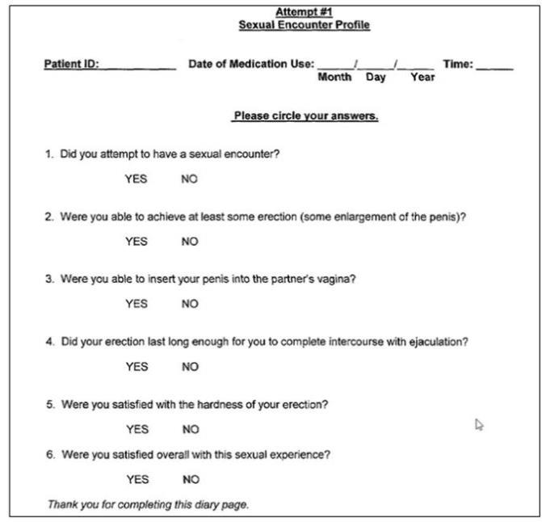
The pivotal studies and most minor studies also assessed the subjects’ global impressions with a Global Assessment Questionnaire, but the precise details of how this was performed were unclear. The integrated study report for Studies 004 and 005 describes the Global Assessment Questionnaire as a simple yes-no binary question:
Global Assessment Questionnaire
The GAQ is a global tool that is utilized widely in clinical trials of ED. The questionnaire consists of a single question with an elicited Yes/No response: “While using the study medication, did you feel that your erections improved?”
An identical description was provided in each individual study report. The Global Assessment Questionnaire provided in the study appendices contradicts this description, however, and instead consists of a 7-point scale, as shown below. Although it is possible for a 7-point scale to be converted to a binary outcome, the integrated study report does not mention such a conversion. The Sponsor should be asked to comment on this discrepancy, although it is unlikely to have had a major impact on the results or their interpretation.
Figure 3. Global Assessment Questionnaire.
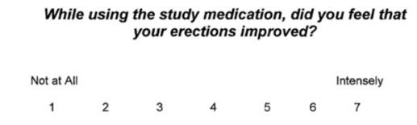
Another measure, used as a secondary endpoint in most studies, was the Patient Self-Assessment of Erection (PSAE), which requires that patients grade their erections for each sexual encounter along a 5-point scale ranging from 1 (no tumescence or erection) to 5 (excessive rigidity), with 4 corresponding to normality (full rigidity).
Figure 4. Patient Self-Assessment of Erection.
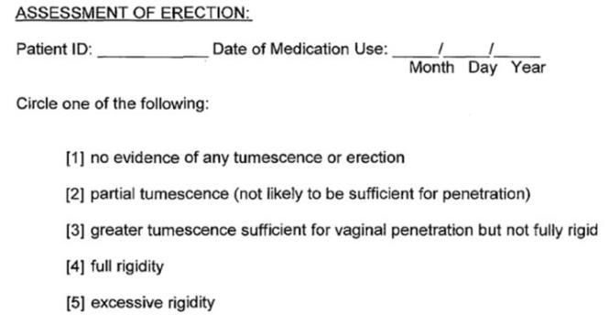

Pivotal efficacy studies

Study MED 2000-004 and MED-2000-005

Study design, objectives, locations and dates
Study MED 2000-004 (enrolled n=878, evaluable n=850) employed a randomised, double-blind, placebo-controlled design to assess the efficacy of alprostadil at 3 different doses (100 mcg, 200 mcg and 300 mcg) in comparison to placebo for the treatment of erectile dysfunction at home over 12 weeks. Study MED 2000-005 (enrolled n=854, evaluable n=819) had an essentially identical design, comparing the same doses for the same duration, with identical endpoints, and the two studies were therefore submitted together in an integrated study report, titled “Randomized, Placebo-Controlled, Double-Blind, Parallel Design Phase Trials of the Efficacy and Safety of Alprox-TD in Male Patients with Erectile Dysfunction” in addition to individual study reports. For convenience, these studies will be referred to as Study 004 and Study 005 within this report.
Both pivotal studies were performed in the USA (Study 004, at 40 sites; Study 005, at 42 sites) over similar time periods (Study 004, from 12 November 2001 to 3 January 2003; Study 005, from 12 November 2001 to 18 December 2002).
Both studies used three co-primary endpoints, which have been described above:
- Change in mean score for the EF domain of the IIEF;
- Change, relative to baseline, in percentage success in vaginal penetration (SEP Question 3)
- Change, relative to baseline, in percentage success at maintaining erection to ejaculation (SEP Question 4)
Other endpoints are described below.
In addition to the assessment of efficacy, the studies had the stated safety objective of assessing “the incidence of adverse experiences (patient and partner) and changes in vital signs, clinical laboratory test results, physical examination findings, and electrocardiograms (ECGs).”

Inclusion and exclusion criteria
The Sponsor summarised the entry criteria as follows:
Men at least 21 years of age were eligible for this study if they had a greater than or equal to 3-month history of ED, defined as the inability to attain and maintain an erection of the penis sufficient to permit satisfactory sexual intercourse and a score of less than or equal to 25 for the Erectile Function (EF) domain score of the International Index of Erectile Function (IIEF) at Visit 3.
This definition is somewhat problematic and contradictory, because the maximum possible score for the EF Domain is 30 (a score of 5 on six different questions), and a score of 25 merely represents mild erectile dysfunction. A subject with mild erectile dysfunction would lose one point for each question if he answered that the erection was adequate “most times” instead of “always”, and would therefore qualify on the basis of his score (see the Appendix of this report for the individual IIEF questions). Thus, subjects with a score of 25 would not ordinarily be characterised as being unable “to attain and maintain an erection of the penis sufficient to permit satisfactory sexual intercourse”; rather they would have this inability occasionally or sometimes.
Eligibility was initially assessed during a screening visit, and confirmed at two follow-up visits approximately 3 and 4 weeks after the initial visit. During this time, patients were required to complete a patient diary indicating at least 4 attempts at sexual intercourse. Subjects were randomised if they still reported EF domain scores ≤25 and had completed the diary and other baseline assessments.
Inclusion criteria were formally listed as shown below. Eligible subjects:
- Were male and at least 21 years of age.
- Provided written, informed consent for patient and his female partner.
- Had a stable monogamous relationship with a consenting female partner (vaginal intercourse was a required study activity).
- Had a history of ED (defined as the inability to attain and maintain an erection of the penis sufficient to permit satisfactory sexual intercourse) of at least 3 months duration.
- Had ED based on an IIEF EF domain score of less than or equal to 25 at Visit 3.
- Had completed and returned at least four diaries at Visit 3, indicating at least four attempts at sexual intercourse during the non-treatment period.
Subjects with orthostatic hypotension were excluded. This was determined by comparing sitting and standing blood pressure (BP) and pulse rate, and it was defined as a decrease in systolic BP ≥ 30 millimetres of mercury (mm Hg) relative to the sitting value, a diastolic BP decrease ≥ 20 mm Hg, or a pulse increase ≥ 30 beats/minute.
Formal exclusion criteria were listed as follows:
- ED caused by untreated endocrine disease, i.e., hypopituitarism, hypothyroidism, or hypogonadism.
- Significant penile pathology including but not limited to curvature, fibrosis, sexually transmitted disease, and penile implant.
- History within the previous 6 months of orthostatic hypotension, syncopal episodes, or presyncopal symptoms.
- Clinically significant hepatic disease as evidenced by aspartate transaminase (AST [SGOT]) or alanine transaminase (ALT [SGPT]) greater than 3 times the upper limit of normal.
- Clinically significant renal disease as evidenced by a serum creatinine greater than 2.5 mg/dL.
- History of myocardial infarction within the previous 6 months.
- Significant neurological diseases within the previous 6 months, e.g., stroke, spinal cord injury, etc.
- Use of any medication, medical device, or herbal preparation for the treatment of ED during the course of the study. Patients who had been using such products had to discontinue their use for the duration of the study.
- Acute or chronic disease requiring frequent changes (changes within previous 2 months or anticipated in following 3 months) in medications or doses of chronic therapy. Hormonal replacement therapy was allowed if the dose was stable and anticipated to remain stable.
- Participation in another study with an investigational drug or device during the 30 days prior to study entry or during the study.
- History of allergy to PGE1-containing drugs or any other components of Alprox-TD® formulation.
- Any condition that would have interfered with the patient’s ability to provide informed consent or to comply with study instructions, or which could have confounded the interpretation of the study results.
- Any condition that could have endangered the participant if he participated in this trial (including alcohol or other drug abuse).
In general, these exclusion criteria are reasonable, and they are clearly aimed at excluding patients in whom treatment would be unsafe or assessment of the response would be difficult. The exclusion of subjects with underlying endocrine disease such has hypogonadism means that the results of the study may not apply to this group of patients; in usual clinical practice, such subjects would have their endocrine deficiencies addressed as the first-line approach to treating their ED anyway. This exclusion criterion did not apply to subjects with diabetes (even though it is an endocrine disorder).
Of note, subjects were not excluded merely on the basis of age, vascular disease other than stroke, or cardiac disease other than myocardial infarction. Subjects who had failed other treatments, such as Viagra, were not excluded. Thus, the cohort of patients studied included a broad range of subjects with various co-morbidities and underlying aetiologies for their ED, so it would be expected that results in the study population would be broadly typical of the responses obtained in actual clinical practice, provided clinicians adhered to the recommended contraindications, including orthostatic hypotension and a history of myocardial infarction.
Importantly, the pivotal studies made no attempt to assess the efficacy of Vitaros in homosexual males, and the lack of information in this subgroup represents a significant deficiency in the submission. Subjects and their partners were explicitly warned against performing oral sex after administration of Vitaros, so there is no information about the efficacy or safety of Vitaros in this setting. Anal intercourse was not explicitly mentioned in the submission.

Study treatments
One deficiency in the reporting of the two pivotal studies was the failure to discuss the excipients in the active and placebo creams. Digital searches of the pivotal study reports for the terms “DDAIP” “propionate” “HCl” and “excipient” all produced no relevant matches. It is implied that these studies used the proposed Vitaros formulation, which contains DDAIP. From the Integrated Summary of Safety, and consideration of the reported Phase 3 exposures to DDAIP, it can be deduced that the placebo groups in both pivotal studies received DDAIP, but this is not clearly stated in the actual study reports.
Twenty-five doses of blinded study medication were available for each patient, including the test dose administered in the clinic at Visit 3, and an additional eight doses dispensed to the patient at each of Visits 3, 4, and 5 for at-home use. This represents two doses per week.

Efficacy variables and outcomes
Each pivotal study had the same three co-primary endpoints:
- Change in score for the EF Domain of the IIEF
- Change in percentage success for vaginal penetration (SEP Q3)
- Change in percentage success for maintaining erection to ejaculation (SEP Q4)
For all major endpoints, both the pooled results of the two studies and the individual results of each study separately are shown and discussed in this report. The pooled analysis was broadly consistent with the results of each individual study, but the pooled analysis had greater statistical power, with more consistently positive results.
The use of three primary endpoints and three active doses creates nine dose-endpoint pairings, which increases the likelihood of finding statistical significance for at least one pairing, and therefore raises methodological concerns about the need to correct for this multiplicity. The Sponsor did not adequately address this issue in their discussion of the studies. In practice the pooled results were positive for all three endpoints and all three doses, so a hierarchical testing procedure would have concluded that the pooled studies were positive for all endpoints. (A hierarchical testing procedure is a standard approach to handling multiple endpoints, in which endpoints are ranked and endpoints lower in the hierarchy are not assessed unless previous endpoints have achieved a positive result).
In two cases, an individual dose group in Study 005 failed to reach statistical significance for a co-primary endpoint whereas significance was achieved for that endpoint in the other dose groups of Study 005 and in the overall pooled analysis of that dose; these discrepancies are noted in the relevant sections below. The Sponsor did not rank the doses or endpoints in such a way that a hierarchical procedure can be applied to these outcomes, and it cannot be concluded that Study 005 had an overall positive result. This would be of considerable concern if it were not for the fact that the pooled results were positive.
Secondary endpoints in both studies consisted of the other domains of the IIEF, the Global Assessment Questionnaire (GAQ) and the Patient Self-Assessment of Erection (PSAE).

Randomisation and blinding methods
Subjects were randomised with equal probability to one of the four dose groups, using a computer-generated randomisation schedule.
Blinding was attempted by using identically appearing creams in all four treatment groups, and keeping subjects and investigators unaware of treatment assignments. The randomisation code was kept in a sealed envelope and was also attached to the individual patient box containing study medication, for use in emergencies.
It is unclear to what extent blinding was successfully maintained. The Phase 1 irritation studies showed that alprostadil had significant local irritation potential, over and above the relatively minor irritation produced by DDAIP-containing creams without alprostadil. Alprostadil produced both erythema and oedema in many subjects (47 of 60 subjects (78%) in Study NM AP-001). Although the irritation was relatively mild and reversible in most Phase 1 subjects, similar reactions in the Phase 3 pivotal studies could easily have led to patients guessing their treatment assignment. Also, the incidence of local urogenital Adverse Events (AEs) was much higher in the active groups than the placebo group of the pivotal studies, as shown in the table below. Thus, it seems very likely that many subjects guessed their treatment assignment. One deficiency of the submission was the Sponsor’s failure to consider this issue, or to assess the degree of unblinding directly by asking subjects to guess their treatment assignment.
Table 6. Urogenital Adverse Events in Pivotal Studies.
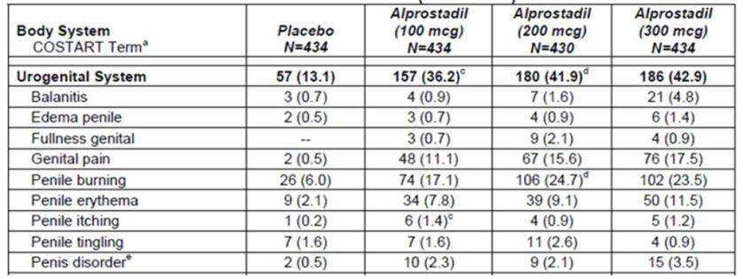

Analysis populations
The intent-to-treat (ITT) population was defined as the set of all randomised patients who received at least one dose of study medication, and it is equivalent to the ITT-safety population.
The ITT-efficacy (ITT-E) population included all treated patients with at least one valid, post-randomisation efficacy evaluation. The ITT-E population was used for all efficacy analyses.

Statistical methods
One of the three co-primary endpoints was the change from baseline in the EF domain score of the IIEF. This was analysed with a two-way analysis of covariance (ANCOVA) model, using treatment and site as main effects and the baseline EF score as a covariate. If the overall treatment effect demonstrated statistical significance, the Fisher criterion within the ANCOVA model was used to conduct pair-wise comparisons relative to placebo. All treatment comparisons were carried out using two-sided tests at the α = 0.05 level.
The absence of treatment-by-site interaction was confirmed by conducting a preliminary ANCOVA with treatment-by-site interaction present and, if p ≤ 0.05, the cause of the interaction was to be investigated and documented.
The other two primary endpoints, based on the SEP, consisted of the overall percentage of successful intercourse attempts while on treatment (Question #3, successful penetration; Question #4, successful ejaculation). Changes in the overall percentage of successes for each question were compared to the treatment-free run-in period was analysed by ANCOVA, using an α level of 0.05 for statistical significance.
As already noted, the Sponsor did not discuss the need to correct the analysis for multiplicity, or propose an overall criteria for judging the positivity of the study in the event of mixed positive and negative results for individual endpoints. The only comments on this issue read as follows:
Multiple Comparisons
No adjustments were made for multiple comparisons.
Most secondary endpoints were examined using the same statistical model as the primary endpoints (e.g. the remaining domains of the IIEF, Questions #1, #2, #5, and #6 of the SEP, and the PSAE). The global assessment (GAQ) was analysed with a logistic model using the response (Yes or No) as the dependent variable, treatment and site as the main effects, and the EF baseline score as the covariate.
Missing baseline values from Week 0 were handled by using the screening scores from Week Minus 4. Missing on-treatment values were replaced by carrying the last observed value forward. For estimating total scores when components of the IIEF were missing, up to two missing baseline components of the IIEF were replaced by using the average of non-missing components. If more than two components were missing from any score, the total score was graded as missing.

Sample size
The Sponsor based sample size calculations on the combined results of two Phase 2 studies (protocols MED 99-002A and MED 2000-002A). For each of the pivotal studies, the Sponsor aimed to achieve a power of at least 95% and a type I error of 0.05 for each of the three primary variables, considered separately.
The Sponsor estimated that, with 185 patients per treatment group per study, it was expected that the power in each of the three primary variables would be ≥ 97% with a type I error of 0.05. They also estimated that the power would still be ≥ 95% if up to 25 patients per treatment group per study were lost to follow-up (leaving 160 per treatment group per study).
The assumptions underlying these calculations are summarised in the table below:
Table 7. Estimated power for each primary endpoint with 185 subjects per treatment group.
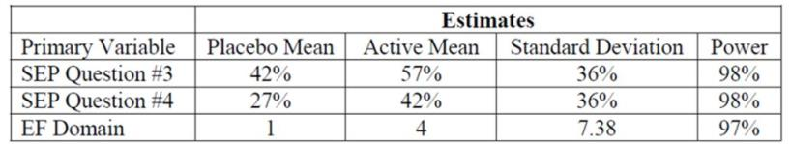
In practice, the number of subjects in each group was in excess of these recruitment targets, and group sizes remained >160 even after losses to follow-up, as discussed in more detail below. The pooled analysis of both studies and the individual analysis of each study achieved positive results for nearly all dose-endpoint pairings (including 5 of 6 co-primary endpoints for the highest dose, across the two studies), suggesting that both studies were adequately powered.

Participant flow
Patient disposition in both pivotal studies combined is summarised in the table below.
Table 8. Patient disposition in pivotal studies (004 and 005).
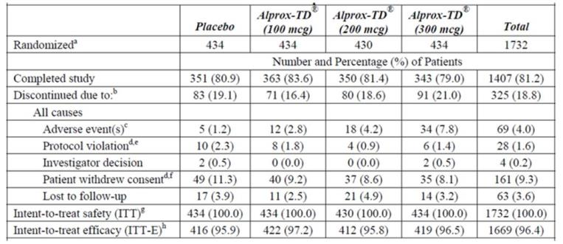
a. All patients who were randomised to receive study medication.
b. Reasons for discontinuation may have been a result of partner issues, such as partner AEs, partner withdrew consents, and partner protocol violations.
c. Partner AEs were included for one partner of a patient in the placebo group [information redacted], the 200 mcg alprostadil treatment group [information redacted], and the 300 mcg alprostadil treatment group [information redacted], and four partners of patients in the 100 mcg alprostadil treatment group [information redacted], and alprostadil treatment group [information redacted].
d. Patients [information redacted] (placebo), [information redacted] (200 mcg alprostadil), and [information redacted] (300 mcg alprostadil) had their reason for discontinuation recorded in the database as “Protocol Violation”, however, per an erratum dated 10/03/03, the reason was changed to “Patient Withdrew Consent”.
e. Partner protocol violations (partners would not participate) were included for one partner of a patient in the placebo group [information redacted] and in the 300 mcg alprostadil treatment group.
f. Partner withdrew consents (including relationship problems, non-participations, and illnesses) were included for three partners of patients in the placebo group [information redacted], six partners of patients in the 100 mcg alprostadil treatment group [information redacted], one partner of a patient in the 200 mcg alprostadil treatment group [information redacted], and nine partners of patients in the 300 mcg alprostadil treatment group [information redacted].
g. All patients who were exposed to at least one dose of study medication.
h. All patients who were exposed to at least one dose of study medication and had at least one post baseline efficacy evaluation.
Approximately 96% of patients in each treatment group had at least one post-baseline efficacy assessment and entered the intent-to-treat efficacy analysis, as shown in the table above. Completion of the study was achieved in a smaller proportion – about 81% in each treatment group, with no substantial differences in completion rates in the active and placebo groups.
In Study 004, a total of 878 patients were treated: 219 received placebo, 218 received 100 mcg alprostadil, 221 received 200 mcg alprostadil, and 220 received 300 mcg alprostadil. Of the patients who received treatment, 712 patients (81.1%) completed the study: 175 patients (79.9%) in the placebo group, 183 (83.9%) in the 100 mcg alprostadil group, 179 (81.0%) in the 200 mcg alprostadil group, and 175 (79.5%) in the 300 mcg alprostadil group.
In Study 005, as total of 854 patients were treated: 215 received placebo, 216 received 100 mcg alprostadil, 209 received 200 mcg alprostadil, and 214 received 300 mcg alprostadil. Of the patients who received treatment, 695 patients (81.4%) completed the study: 176 patients (81.9%) in the placebo group, 180 (83.3%) in the 100 mcg alprostadil group, 171 (81.8%) in the 200 mcg alprostadil group, and 168 (78.5%) in the 300 mcg alprostadil group.
The table below lists reasons for exclusion from the ITT-E population. There was a slight excess of subjects in higher dose groups withdrawing consent or discontinuing due to adverse events, but even in the highest dose group, the number of withdrawals from the ITT-E data set due to AEs was low (3 patients). In the placebo group, a higher number of placebo subjects were lost to follow-up for no specific reason, such that the overall proportion of evaluable subjects was similar in the different treatment groups.
Table 9. Reasons for exclusion from ITT efficacy population, Studies 004 and 005
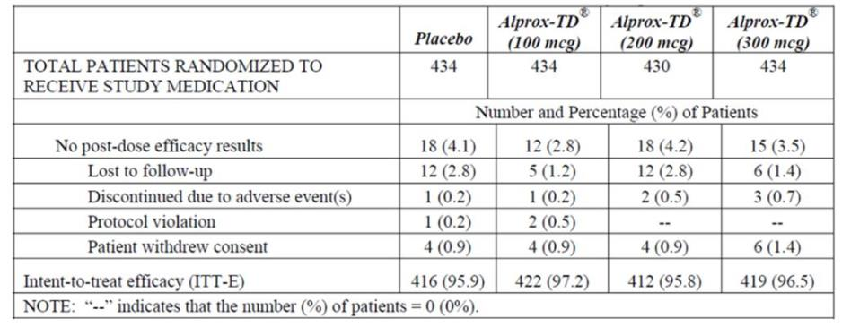
This degree of follow-up is acceptable for studies of this nature, and it is broadly reassuring that roughly equal proportions completed the study in each treatment group. Of some concern is the fact that there was an excess of withdrawals due to adverse events in recipients of active treatment, relative to placebo, amounting to an excess of 6.6% of the highest dose group. This suggests that the study was susceptible to a small degree of withdrawal bias, and also raises the possibility that some patients were unblinded due to telltale side effects.

Major protocol violations/deviations
Twenty-five patients had protocol violations leading to discontinuations across the two pivotal studies (with an additional 3 subjects mistakenly listed as protocol violations in the table above, to give a total of 28; these subjects subsequently had the reason for withdrawal changed to “Withdrew Consent”).
As a proportion of the major protocol violations, the most common reasons for discontinuation were non-adherence to visit schedule (4/25, 16.0%), unavailability of study medication (3/25, 12.0%), and loss of the medication label (3/25, 12.0%).
Other protocol violations included: withdrawal of partner consent, excluded medication use, and patient not meeting exclusion criterion (2/25, 8.0% each). The remaining violations occurred in one patient each: untreated hypogonadism, duplicate randomisation numbers, elevated liver function tests, unacceptable birth control method use, involvement in another study less than 30 days prior to enrolment, Visit 3 IIEF domain score > 25, patient entered another investigational study, non-compliance, and study medication not refrigerated at site.
This level of protocol violations is acceptable for a study of this nature.

Baseline data
The treatment groups appeared reasonably well-matched at baseline in terms of age, other demographics, underlying medical problems, and history of erectile dysfunction. No between-group comparisons showed a significant difference at baseline. Most subjects had suffered from ED for >12 months, and the mean EF Domain Score on the IIEF was ~14 (of a possible 30) in all groups (the range was 1-26, with values >25 representing protocol deviations).
Table 10. Baseline Demographics, ITT Population, Studies 004 and 005.
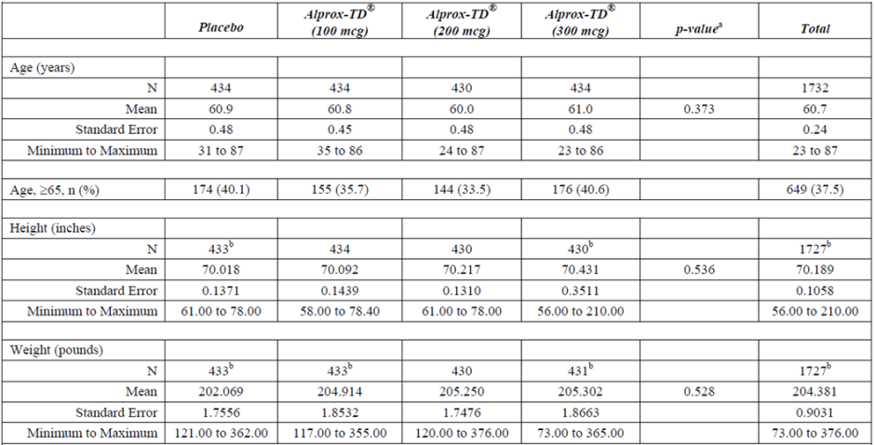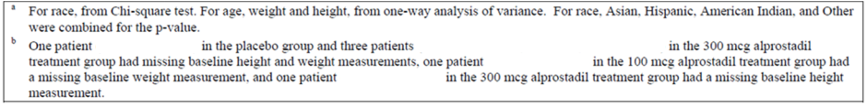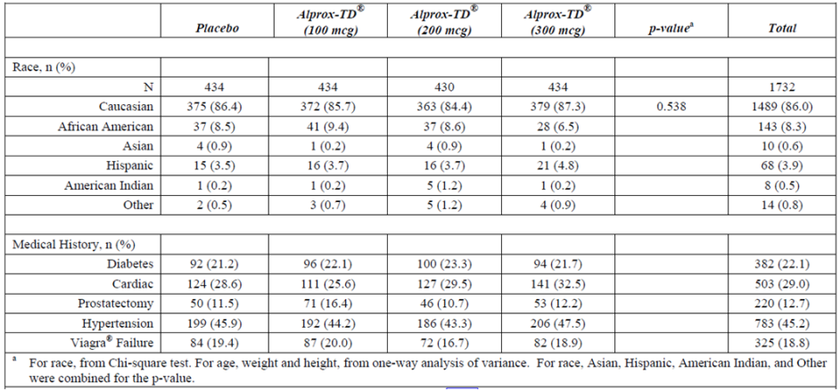
Table 11. Summary of Baseline Primary Efficacy Endpoints.
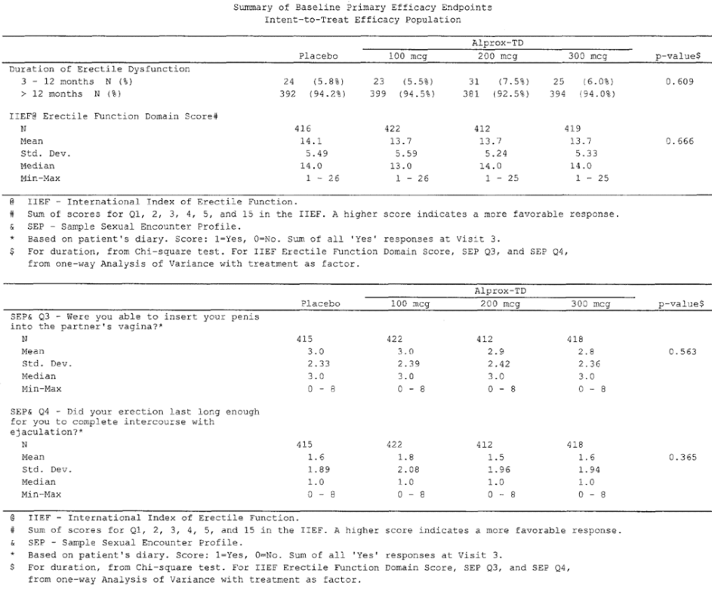
Table 12. Number (%) of Patients with Specific Secondary Diagnoses.
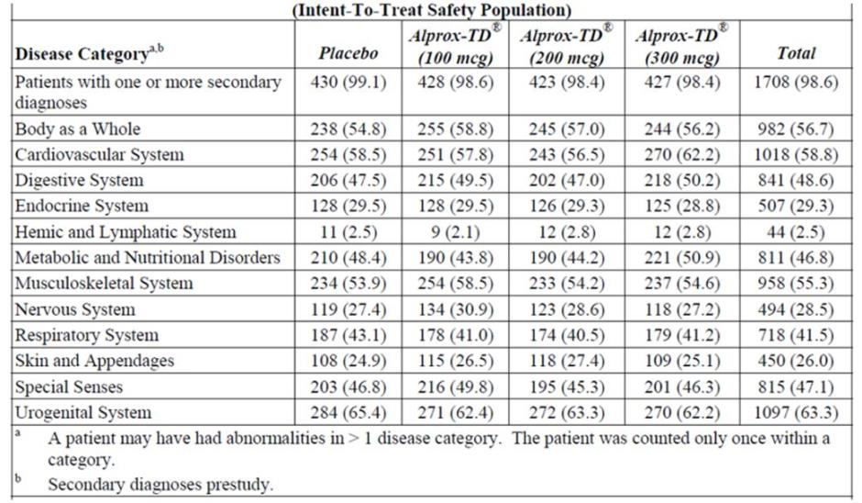
Table 13. Baseline Vital Signs, Studies 004 and 005.
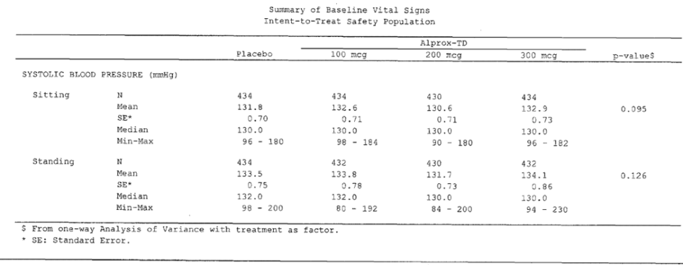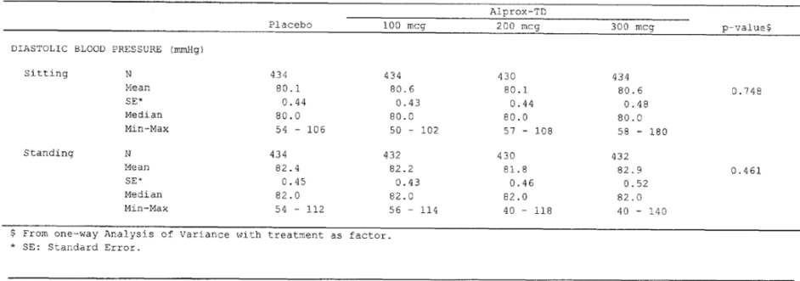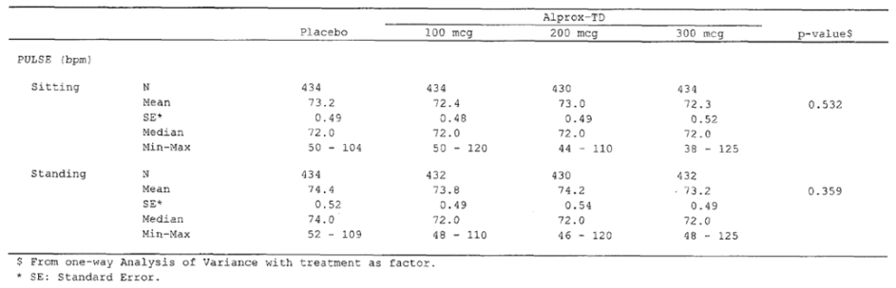

Results for the co-primary efficacy outcomes
Results for all three co-primary endpoints in the pooled pivotal population are shown in the table below. (The individual endpoints and results in individual studies are discussed in subsequent sections.)
All three active doses showed clear statistical superiority to placebo. Results for doses of 200 mcg or 300 mcg tended to be superior to those observed with 100 mcg, but a formal statistical comparison across doses was not provided. Considering least square (LS) mean changes, the highest dose, 300 mcg, produced inferior results to the 200 mcg dose for two of the three co-primary endpoints (IIEF EF Domain and SEP Q4), and superior results for the other co-primary endpoint (SEP Q3). Overall, these results suggest that maximum efficacy is achieved with doses of ≥200 mcg, and further dose increases beyond that do not provide clear benefit. (The proposed PI conveys a different impression, and should be modified to more accurately describe these results.)
Table 14. Pooled Efficacy Results, Pivotal Studies MED 2000-004 and -005.
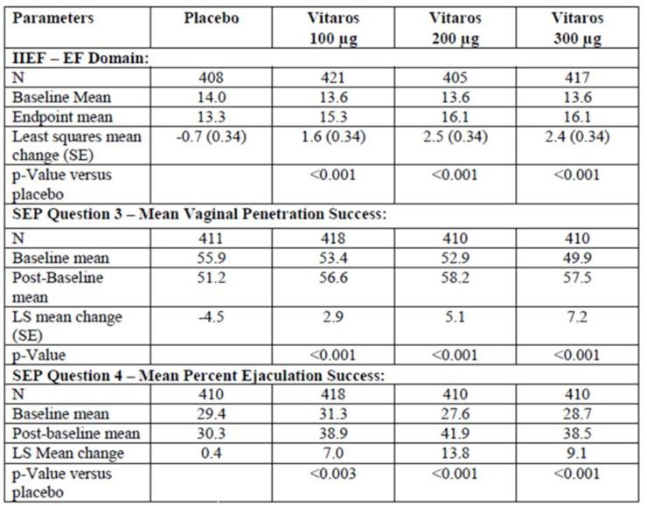

Erectile function domain of IIEF (Q1-5, Q15)
Results in the Erectile Function (EF) Domain for each pivotal study are shown in the table below, reproduced from the Sponsor’s Clinical Overview. The Sponsor’s integrated study report focussed instead on the pooled results, which are shown in the subsequent table.
Each pivotal study showed a highly statistically significant benefit for alprostadil for each active dose group, relative to placebo, and the significance of the results was similar in each study (100 mcg dose groups in each study, p=0.001; 200 mcg and 300 mcg groups in each study, p<0.001). In both studies, the placebo group showed a slight mean worsening of EF during the study (-0.5 in Study 004, -0.9 in Study 005). The magnitude of the treatment effect, expressed as LS mean change from baseline, was broadly consistent across studies, but the 300 mcg dose group of Study 005 had relatively poor results, with a mean increase in EF of only 1.7, worse than the results obtained in the 200 mcg group of the same study (+2.4), the 200 mcg group of Study 004 (+2.5) and the 300 mcg group of Study 004 (+3.1). In Study 004, there was an apparent dose trend, but in Study 005 the relatively poor results for the 300 mcg group broke the pattern. Overall, this suggests that the efficacy of 200 mcg and 300 mcg is similar, and this was also suggested in the pooled analysis of the same variable.
Table 15. Erectile Function Domain Scores, Studies 004 and 005 Individually (ITT-E)
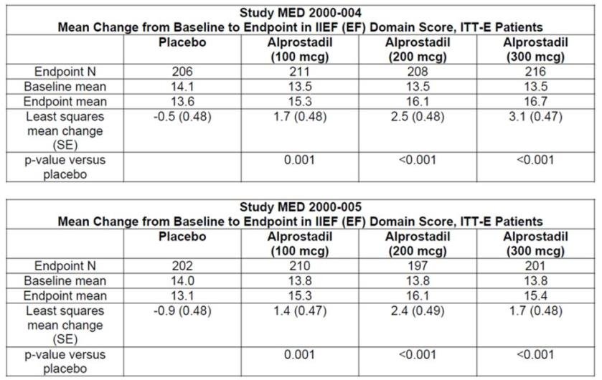
Given that the two studies had identical designs, and were performed at the same time in the USA, it is appropriate to consider the pooled data. For the pooled population of Studies 004 and 005, a significant (p<0.001) group effect in the EF Domain was detected across all active groups (among-group comparison, using ANCOVA with treatment and site as main factors, and baseline EF domain score as covariate). Pairwise comparisons versus placebo showed that this was significant (p<0.001) for all doses tested (100 mcg, 200 mcg and 300 mcg). From a baseline of approximately 14, the mean changes were negative in the placebo group (-0.7) and weakly positive in the 100 mcg group (+1.6), with somewhat better results in the two higher dose groups (+2.5 in both the 200 mcg and 300 mcg groups); the LS mean changes were essentially the same, but the LS mean change was only 2.4 for the 300 mcg group. As suggested by the individual study results, there is an apparent dose trend from 100 mcg to 200 mcg, but the dose-response appears to flatten for doses beyond 200 mcg.
The median changes in EF were broadly consistent with the mean results (placebo 0.0; 100 mcg +1.0, 200mg and 300 mcg, +2.0); note that the table below labels these results as “median of mean change” but appears to be referring to median changes, given that all results are integers.
Table 16. Erectile Function Domain Score, Studies 004 and 005 Pooled (ITT-E).
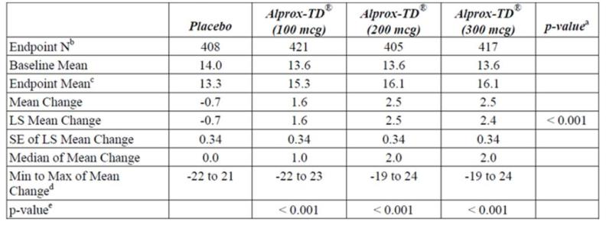
Note: the EF domain score is the sum of scores for Q1, 2, 3, 4, 5 and 15 in the IIEF. A higher score indicates a more favourable response.
a. Among-group comparison, using ANCOVA with treatment and site as main factors, and baseline IIEF EF domain score as covariate.
b. If no post-baseline individual scores were available, baseline individual scores were not carried forward to replace post-baseline missing scores. Therefore, the Endpoint N may be less than the Baseline N.
c. The endpoint analysis includes the last expected assessment as presented in the protocol (Visit 6) for completers or the last available assessment on treatment before the patient drops out or is lost to follow-up.
d. The wide ranges in the min and max values were indicative of the data listings.
e. Least squares mean difference relative to placebo, from ANCOVA.
IIEF = International Index of Erectile Function; LS = least square; Max = maximum; Min = minimum; SE = standard error
The magnitude of the apparent treatment effect is small, amounting to 3.2 points from a possible 30 points, equivalent to 10% of the available points or about half a point on a 5-point scale. Although such a modest improvement might not seem clinically worthwhile, the positive results for this primary endpoint were supported by additional endpoints that, in aggregate, suggest that patients felt the improvement was real.
The evolution of the EF scores over time is displayed in the table below. Such an analysis was not part of the primary efficacy analysis, and a formal statistical between-group comparison was not presented, but it is of interest in that it shows generally consistent results at Visit 4 (after 4 weeks of treatment), Visit 5 (8 weeks) and Visit 6 (12 weeks). Some minor improvements in EF were noted in the active groups from Week 4 to Week 12, which suggests that alprostadil has persistence of efficacy for at least several weeks, but this result should be interpreted with caution given that the differences from Week 4 to Week 12 are very slight and that less responsive patients could have withdrawn, leading to enrichment of the remaining cohort with more responsive patients.
Table 17. EF Domain Scores Over Time, Studies 004 and 005 Pooled (ITT-E).
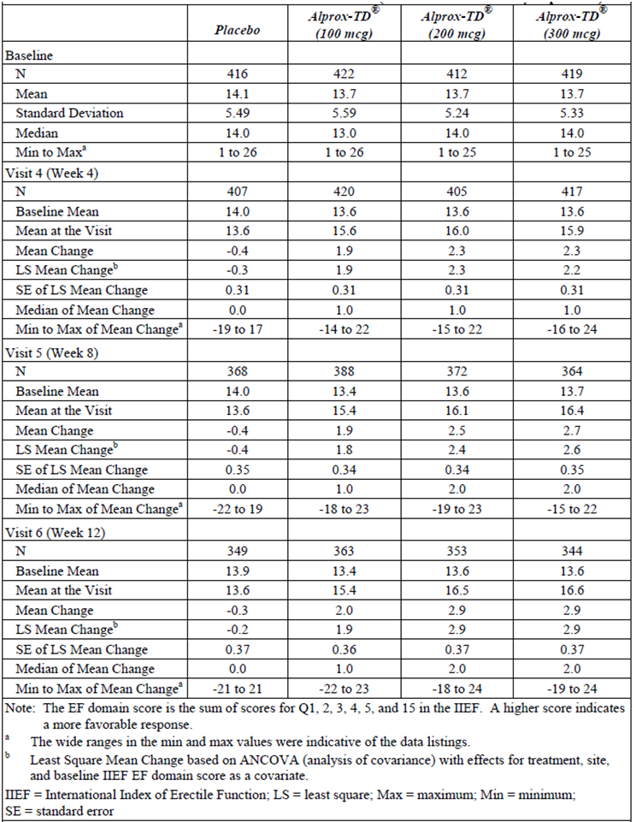

Question 3 of SEP: vaginal penetration
Question 3 of the SEP produces a binary response:
3. Were you able to insert your penis into the partner's vagina? YES NO.
This variable was analysed as the percentage of successful penetrations, but the details of how this was calculated were not clearly described in the main body of the report. The Sponsor wrote:
Since patients had different numbers of attempts at each post-baseline visit, a weighted percent success was used in the analysis.
The weighting technique that was applied is not clearly stated in the main body of the study report, and could not be determined even using a digital search of the study reports using the search term “weight”. Footnotes to the Sponsor’s tables implied that the Sponsor calculated an overall percentage success for each patient, representing the total number of successes as a proportion of the total number of attempts over 12 weeks. If this technique was used, weighting by number of attempts would only be required if these totals had to be deduced by working backwards from percentages derived at each visit.
On reviewing the Phase 2 studies, a more explicit description of a weighting technique was applied:
VPSR [Vaginal Penetration Success Rate] was analyzed as a weighted success rate. The average rate of success for each total number of attempts was first calculated within each dose group, then the mean of those values was calculated for each group. Differences between the groups in the mean VPSR were analyzed using an ANOVA (PROC CATMOD) with treatment and number of attempts as factors.
From this description, it appears that, in Phase 2 studies, a per-patient success rate was not calculated, but instead patient results were binned according to the number of attempts, and then the success rate in each bin was averaged, regardless of how many patients had contributed to that bin. This seems to be an odd approach, because patients would then contribute unequally to the final score. That is, if most patients had, say, four attempts, and only one patient had exactly nine attempts, the result in the single patient with nine attempts would carry the same weight in the final average as all the patients with four attempts. Furthermore, it is not even clear if this approach was used in the Phase 3 studies, because the technique was not described in explicit terms. The Sponsor should be asked to clarify this.
For this endpoint, a significant treatment effect was observed with each active dose group in each study, with the exception of the low-dose (100 mcg) group of Study 005. Given that the two studies had identical designs, the difference in the results remains unexplained, and the overall treatment effect is best appreciated by considering the pooled results, as shown in the subsequent table.
Table 18. Mean Vaginal Penetration Success, Studies 004 and 005 Individually (ITT-E).
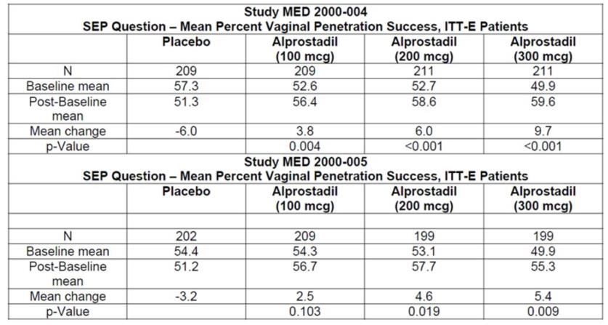
At baseline, successful penetration was achieved in about half of all attempts (50-56% across groups), with slightly better success rates seen in the placebo group.
Overall, the mean change for successful penetration was better in the alprostadil treatment groups (mean increases in success ranged from 3.1% in the 100 mcg alprostadil group to 7.6% in the 300 mcg alprostadil group) than the placebo group (a mean decrease of 4.7%). The median change in percentage success was zero in all groups. A statistically significant overall difference (p < 0.001) across groups was detected by ANCOVA, and the pairwise differences between placebo and active treatment were significant for the 100 mcg alprostadil group (p = 0.001), 200 mcg alprostadil group (p < 0.001), and 300 mcg alprostadil treatment group (p < 0.001).
These improvements are modest, and suggest a success rate about 11-12% higher in the high-dose groups than the placebo group. If some of the observed improvement was due to withdrawal bias or unblinding, the true underlying benefit of active treatment could be even less than this.
Table 19. Mean Vaginal Penetration Success, Studies 004 and 005 Pooled (ITT-E).
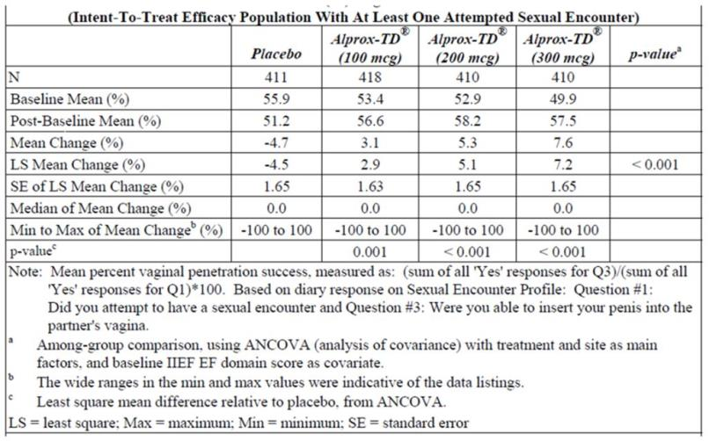
The evolution of penetration success over time is shown in the table below, which presents the data in terms of absolute number of successful penetrations per four-week period, rather than as a proportion of attempts. This was a secondary analysis, but it generally supports the robustness of the primary findings for penetration success. Note that these results were not subjected to a formal statistical comparison: p-values and 95% confidence intervals (95%CIs) were not provided. They should therefore be considered descriptive.
There is no apparent trend towards loss of efficacy in the time span studied. The increase in number of penetrations was generally low in the placebo group (~0.1 to 0.2), but better in the active groups (0.5 to 1.0 in the two higher dose groups). There was a slight trend to increasing success over time in the active groups (increases of 1.0 for 200 mcg and 0.9 for 300 mcg at the final visit).
Table 20. Mean Vaginal Penetration Success Over Time, Studies 004 and 005 Pooled (ITT-E).
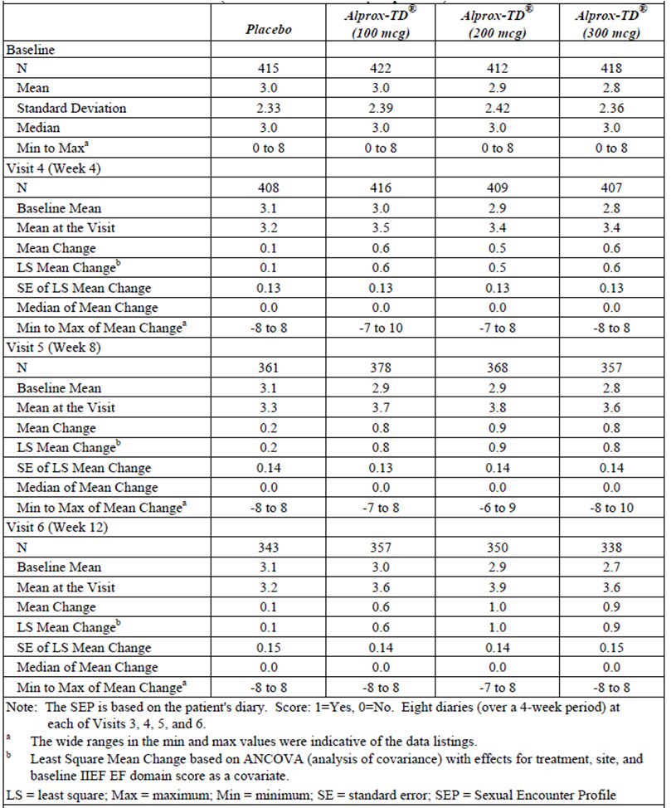

Question 4 of SEP: ejaculation
This question is expressed in the SEP as:
4. Did your erection last long enough for you to complete intercourse with ejaculation? YES NO.
For this question, as had been done with Q3, the Sponsor appears to have calculated an overall percentage success rate across 12 weeks for each patient, and then compared this to baseline.
The results are displayed below for each individual pivotal study, and for the pooled results as presented in the integrated study report.
For this endpoint, the results in the 300 mcg group of Study 005 did not achieve statistical significance (p=0.112). Given that this was a co-primary endpoint, and the Sponsor did not prospectively discuss the statistical method to use to compensate for the use of multiple endpoints, it could be argued that Study 005 was a negative study, as it failed to achieve significance for one of its primary endpoints. On the other hand, there was a trend towards significance for this endpoint in the 300 mcg group (4.9% superiority in change in success rate over placebo), the two lower dose groups in the same study did achieve significance, and the overall pooled results of both studies showed a statistically strong result (p<0.001) for the combined 300 mcg group. Furthermore, the other two co-primary endpoints showed a statistically significant treatment effect for this dose group in both pivotal studies. Thus, on balance, the relatively poor results for this one endpoint in one dose group of one study do not appear to outweigh the overall evidence in favour of a treatment effect, and the lack of significance could be attributable to the poorer statistical power of the individual study relative to the pooled analysis.
Table 21. Mean Ejaculation Success, Studies 004 and 005 Individually (ITT-E).
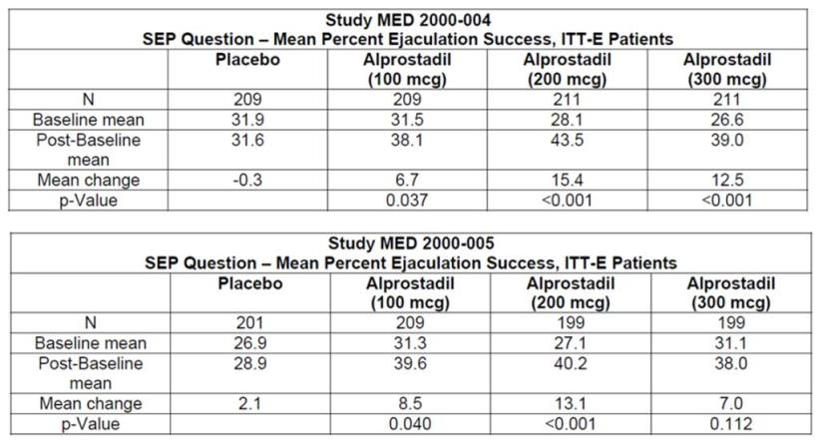
The pooled analysis is shown in the table below. Success rates for the ejaculation question of the SEP were lower than for the penetration question (consistent with the usual requirement that penetration is a precursor to ejaculation). A bit less than a third of coital attempts (28-31% in the pooled analysis) successfully led to ejaculation at baseline, and this improved by 10-14% in the two higher dose groups. Results in the pooled analysis were somewhat better for the 200 mcg dose group (mean increase of 14.3%) than the 300 mcg dose group (mean increase of 9.8%); both of these higher dose groups showed better increases than the 100 mcg group (mean increase of 7.6%) and the placebo group (mean increase of 0.8%). All pooled comparisons with placebo were statistically significant (p=0.003 for 100 mcg, p<0.001 for 200 mcg and 300 mcg), as was the overall group effect (p<0.001). The median change in most groups was zero, but the 200 mcg group showed a median increase of 4.2%.

Table 22. Mean Ejaculation Success, Studies 004 and 005 Pooled (ITT-E).
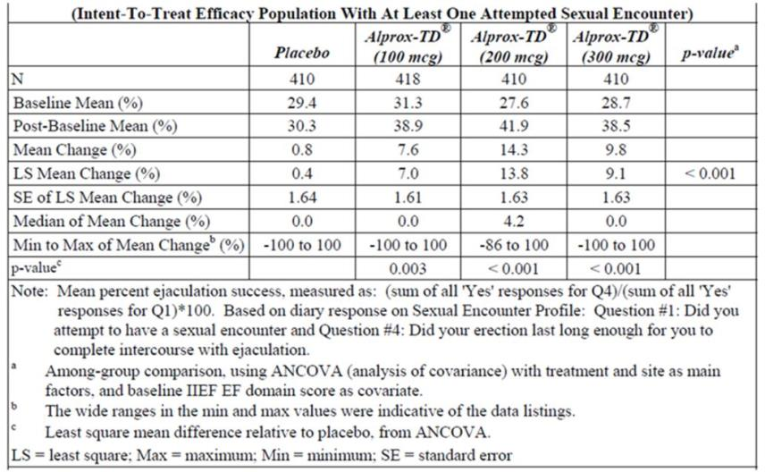
The evolution of ejaculation success over time is shown in the table below, expressed in terms of absolute numbers of successes over 4 weeks, rather than as a proportion of attempts. This secondary analysis suggests that the effects of alprostadil were maintained over time, but again it should be noted that p-values and 95%CIs were not provided, so the analysis is merely descriptive. The placebo group showed a mean increase in successful ejaculations of 0.3 by Week 12, compared to an increase of 1.3 and 0.9 in the 200 mcg and 300 mcg alprostadil groups, respectively.
Table 23. Mean Ejaculation Success Over Time, Studies 004 and 005 Pooled (ITT-E)
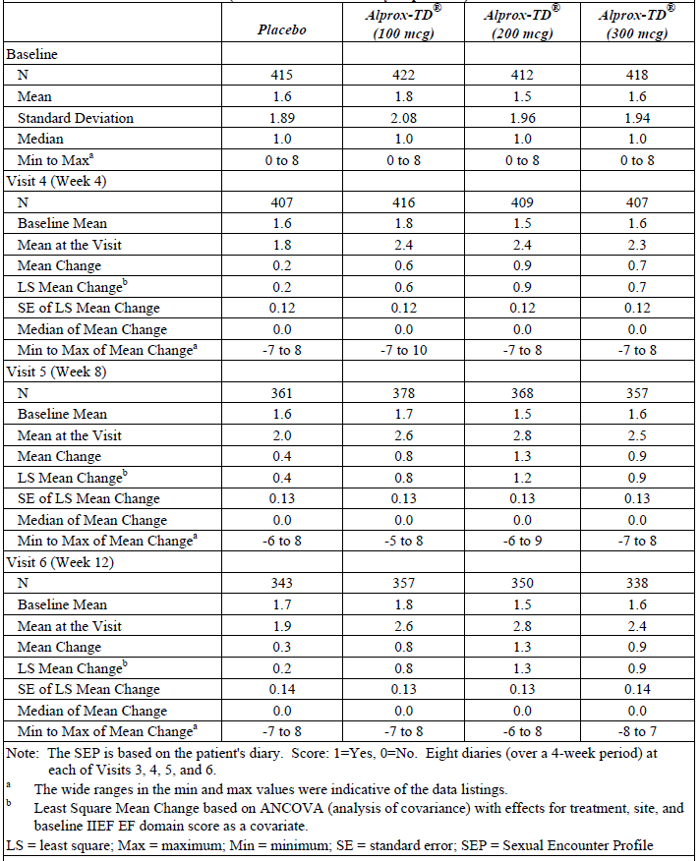

Results for other efficacy outcomes
The secondary endpoint, a positive response on the Global Assessment Questionnaire (GAQ), represents the patient’s overall opinion on whether treatment has led to an improvement, and thus helps to establish whether gains in erectile function are perceived as meaningful for the patient.
According to the individual and integrated study reports, this question was presented as a binary yes-no question, though the Sponsor’s appendix described it as a 7-point scale; it is likely that the 7-point scale was converted to a binary response during analysis, but it is also possible that subjects were shown a question slightly different to that reproduced in the Sponsor’s appendix. The Sponsor should clarify which technique was used, though the approach taken is unlikely to have had a significant impact on the outcome. If a 7-point scale was actually used, this could allow a more detailed assessment of the differing responses across the patient population, and the results would be of interest.
This endpoint was positive for each dose group in each pivotal study, as shown in the table below. Approximately 20% of placebo subjects felt that treatment was associated with an improvement in erections, compared to 38-56% of alprostadil recipients, depending on which dose group and which study is considered. For both studies individually, as shown in the table below, all three active dose groups showed a significantly superior response to placebo (p<0.001). The pooled results were concordant with this (subsequent table). There was an apparent dose trend in the pooled results, with 7% more patients reporting improvement after using 200 mcg, compared to 100 mcg, and a further 5% reporting improvement after 300 mcg, compared to 200 mcg; these dose comparisons were not subjected to formal statistical comparison.
Table 24. Patient’s Global Evaluation, Studies 004 and 005 Individually (ITT-E).
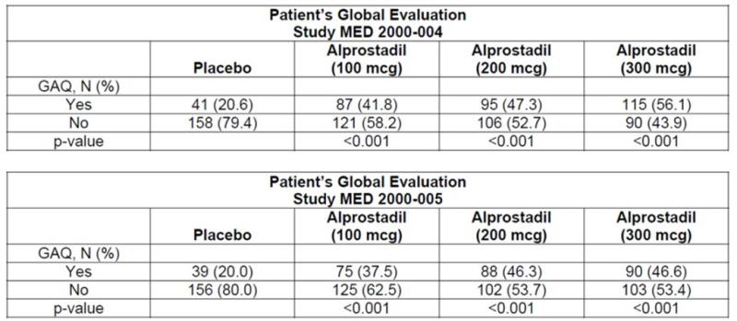
Table 25. Patient’s Global Assessment Questionnaire, Percentage Reporting Improvement, Studies 004 and 005 Pooled (ITT-E).
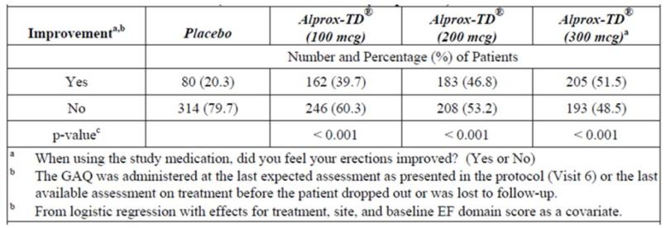
These results suggest that about half the patients who use alprostadil will find it unhelpful in improving their erections, and about one in five (20%) will report an improvement that is due to the placebo effect. The remainder, about one in three subjects, will report an improvement attributable to active treatment. This only represents a modest therapeutic benefit, but could be considered worthwhile by many patients, particularly because they will be able to observe the response to treatment and decide for themselves whether they feel the treatment is worth continuing.
Other domains of the IIEF (Orgasmic Function, Sexual Desire, Intercourse Satisfaction, Overall Satisfaction) were also analysed as secondary variables, and the pooled results are shown in the table below. In most domains, all the active treatment groups showed a significant improvement relative to the placebo group. The exception was Sexual Desire, which represents a psychological interest in sex that would not necessarily be expected to respond to a topical vasodilator. For this domain, the 200 mcg group failed to achieve significance. Of note, the two domains relating to satisfaction (Intercourse Satisfaction and Overall Satisfaction) showed a significant benefit with active treatment, for all active doses, indicating that the erectile function gains, though modest, produced an overall greater sense of satisfaction in recipients of active treatment. Overall, these results are supportive of the primary results and consistent with the GAQ results.
Table 26. Non-erectile Function Domain Scores, Studies 004 and 005, Pooled (ITT-E).
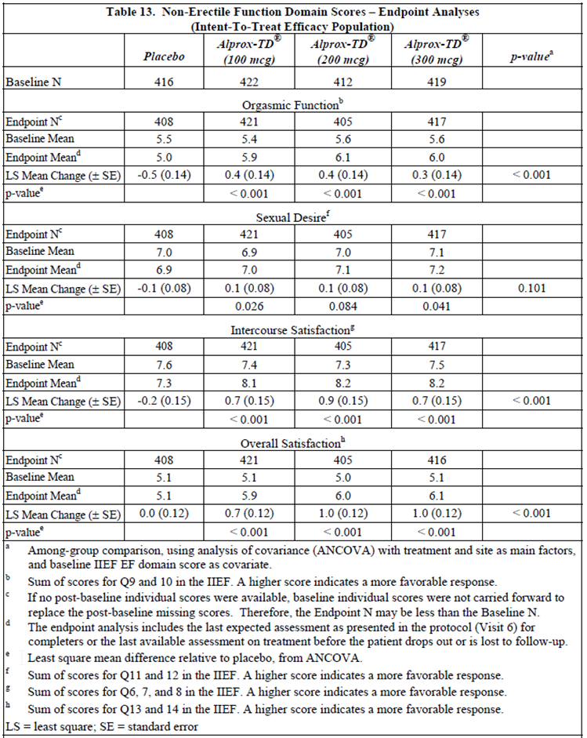
As already noted, two questions from the SEP (Q3 and Q4) were prospectively designated as co-primary endpoints (along with the EF Domain of the IIEF), but the remaining questions of the SEP were analysed as secondary endpoints. The pooled results are shown in the table below.
Table 27. SEP Question Scores, Studies 004 and 005, Pooled (ITT-E).
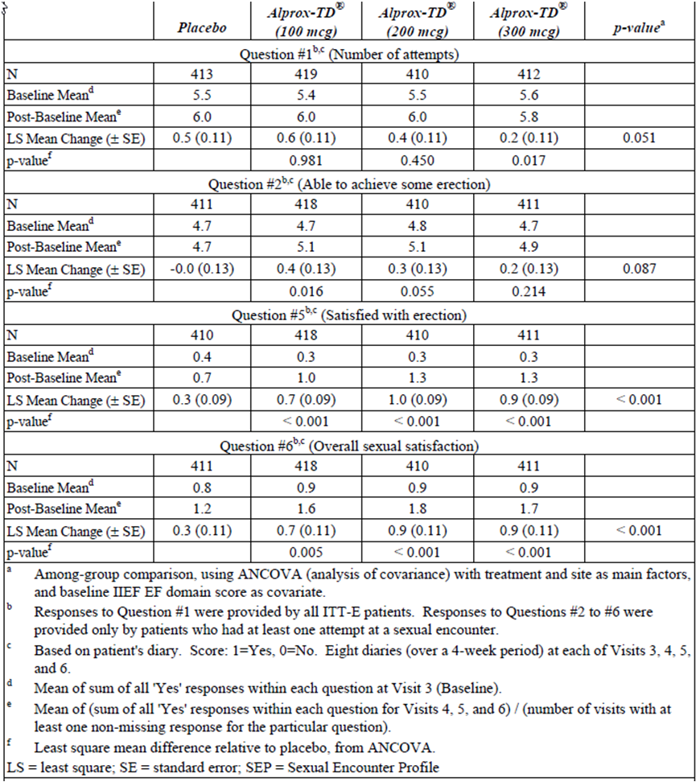
For Question 1, relating to the number of attempts at coitus, there was no evidence of a therapeutic effect – not even a favourable trend – and the 300 mcg dose was associated with a significantly lower increase in attempts at coitus than placebo. (There was also an inverse dose-trend, with progressively higher doses leading to lower increases in the number of attempts). It is unclear whether this represents a chance finding unlikely to be replicated in future studies, or instead reveals a true causal relationship. It is at least plausible that adverse effects from the medication might lead subjects to attempt coitus less often. Even if this were the case, though, it is not necessarily a major problem for the drug as subjects who found the drug inconvenient or had tolerability issues could simply discontinue it.
For Question 2, which relates to the ability to achieve “some” erection, there was a trend in favour of active treatment (p=0.087 for overall group effect), and a significant result for the 100 mcg dose (p=0.016) but there was no dose trend. The results actually showed a weak inverse dose trend, with greater positive changes observed with 100 mcg than with 200 mcg, and the smallest improvement seen with 300 mcg). Overall, the results for this endpoint were much weaker than for other measures of erectile function. This suggests that alprostadil may best be considered as a drug that improves the quality of erections, rather than as one that creates erections. (This is not the impression one would gain from reading the proposed PI.)
Questions 3 and 4 have already been discussed, as these were co-primary endpoints.
For Questions 5 and 6, which both relate to satisfaction (Q5, satisfaction with erection; Q6, overall satisfaction), the pooled results were statistically significant for all dose groups. As with many other efficacy measures an apparent dose trend was observed from placebo to 100 mcg and to 200 mcg but 300 mcg produced no extra benefit.
For the Patient Self-Assessment of Erection Score (PSAE), subjects were asked to rate their erections after each use of medication on a five-point scale ranging from 1 (no tumescence or erection) to 5 (excessive rigidity), with 4 corresponding to normality (full rigidity). From a baseline mean of ~2.4, subjects receiving active treatment showed small but statistically significant mean increases of 0.16 or 0.18 in the two higher dose groups – that is, a mean increase less than one fifth of a single point on the five-point scale (or a mean increase of a third of a point relative to placebo. The final mean scores in every dose group were still less than “3”, correlating to “greater tumescence sufficient for vaginal penetration but not fully rigid”. Overall, results for this endpoint, while statistically robust, suggest that the efficacy of alprostadil is modest.
Table 28. Patient Self-Assessment of Erection Score, Studies 004 and 005, Pooled (ITT-E).
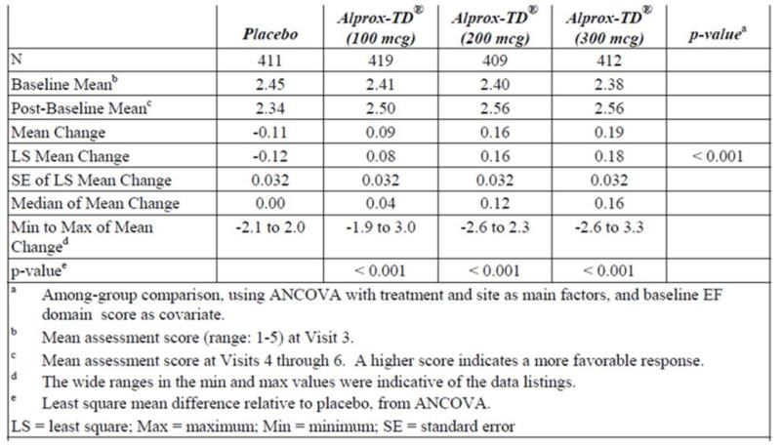
Considering all of the secondary endpoints, the efficacy of alprostadil was consistently demonstrated to be modest in magnitude but statistically robust. In particular, the Global Assessment by patients (GAQ) indicates that, over and above the ~20% of patients reporting an improvement with placebo, another ~30% noted an improvement with alprostadil (200 mcg 26.5%, 300 mcg, 31.2%). That is, 3 patients would need to be treated to have one of them report an improvement over and above the placebo response.

Subgroup analyses
Neither of the pivotal studies was specifically powered to allow subgroup analyses, but the pooled pivotal population was sufficiently large that statistically significant results were obtained for some subgroups. For the co-primary endpoint of EF Domain scores, significant results were obtained for all three dose groups for subjects with cardiac disease, diabetes, hypertension and prostatectomy, but only a favourable trend was achieved in subjects with a history of Viagra failure; the mean EF improvement in Viagra-failure cases was 1.7 and 1.4, in the 200 mcg and 300 mcg dose groups, respectively, compared to 2.5 and 2.4 in the overall study population for the same dose groups, respectively.
For SEP Question 3 (penetration) and 4 (ejaculation), similar overall trends were observed but significance was less commonly achieved. For patients with a history of Viagra failure, significance was achieved for Question 3 in the two higher dose groups, but not for Question 4.
The table below also shows results for the key secondary endpoint of GAQ. All subgroups reported a global improvement more frequently with active treatment, and for most subgroups the difference from placebo was highly significant (p<0.001).
The inferior results in the Viagra-failure cases are not surprising, because Viagra failures might be expected to show pharmacological resistance to treatment, especially considering that Vitaros and Viagra both function as vasodilators. For one co-primary endpoint (SEP Q3) and a key secondary endpoint (GAQ), a significant therapeutic effect was demonstrated even in Viagra failures (as shown in the table). The GAQ results suggest that, amongst Viagra failures, an improvement attributable to Vitaros was achieved in ~25% of cases. (Improvement in the placebo arm of this subgroup was reported in 21% of cases, similar to the total placebo population. Improvement for other dose groups showed a dose trend, with the best results obtained in the 300 mcg group [100 mcg 29%, 200 mcg 37%, 300 mcg 45%]). This implies that four Viagra failures would need to be treated to obtain one report of improvement over and above the placebo response.
Although it is reasonable to mention that some efficacy was achieved in the Viagra-failure subgroup, the inconsistent results across different endpoints were not clearly described in the PI, where a single statement summarises the subgroup analyses as follows:
Similar improvements to those of all patients were generally observed within the subpopulations (diabetic, cardiac, prostatectomy, hypertensive patients, and patients who failed previous therapy with Viagra) and two age groups (≤ 65 and > 65 years) in the IIEF EF domain scores.
Table 29. Response in Subgroups, Studies 004 and 005, Pooled, for 3 Co-Primary Endpoints and Global Assessment.
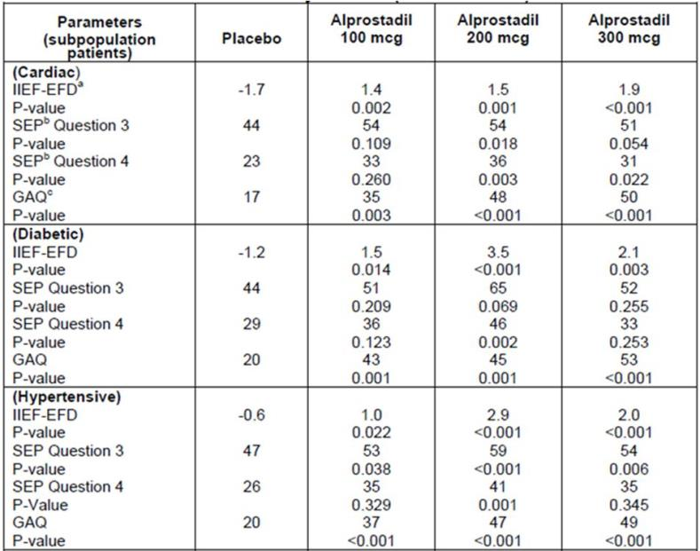
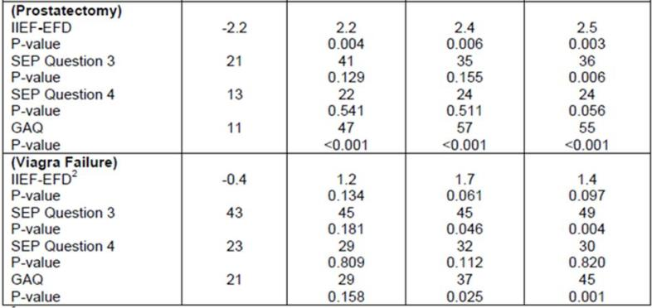
The Sponsor also presented a subgroup analysis based on the severity of erectile dysfunction at baseline, as shown in the table below, but these results were not subjected to a formal statistical comparison. There is an apparent trend towards greater responsiveness in severe cases of erectile dysfunction, and poor responsiveness in mild cases. Indeed, the overall impact of treatment was negative with mild erectile dysfunction (i.e., changes from baseline represented deteriorations). For ejaculation success (labelled “intercourse completion rates” in the table) the two highest dose groups showed a worse outcome than with placebo when the original severity was mild.
Table 30. Response in Subgroups by Severity, Studies 004 and 005, Pooled.
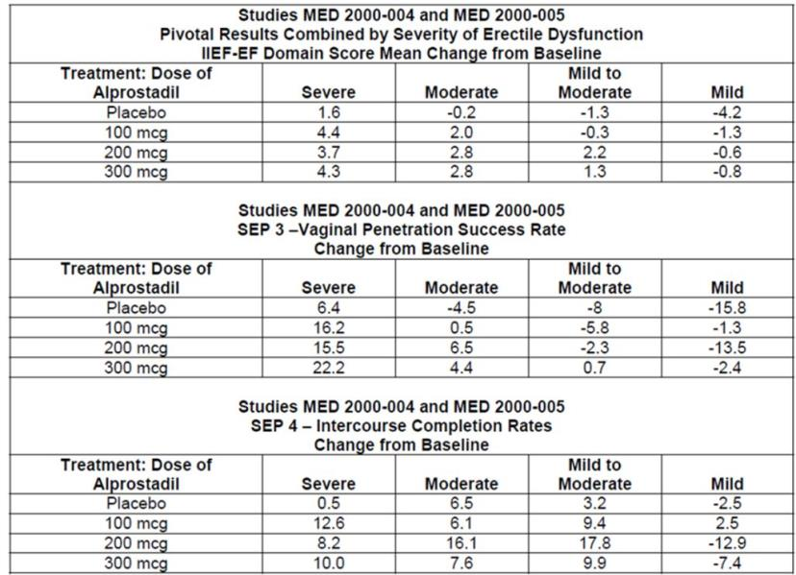
No strong conclusions can be drawn from this analysis, particularly because the results were presented descriptively, but it should be noted that these results are broadly concordant with Phase 2 studies showing a better response in severe cases (Study MED 2000-002A) than in mild to moderate cases (Study MED 99-002A). The main difference is that the Phase 2 study of mild-to-moderate cases showed a small, statistically borderline benefit with active treatment, whereas this subgroup analysis of the pivotal studies suggests a moderately adverse outcome with active treatment. (For some doses, the results with active treatment were better than the placebo results, but still negative overall. Achieving better results than placebo does not necessarily represent a useful outcome if all groups showed deterioration; the inconvenience and intrusion of placebo treatment may have produced a genuine reduction in erectile function that was not fully offset by the pharmacological action of the drug).
The precise causes for the apparent differences in responsiveness in mildly effected subjects are not known, but plausible hypotheses can be raised. For a start, subjects scoring relatively well on the IIEF have less available room for improvement in the scoring system, and greater room for deterioration. The apparent adverse effect of treatment in mild cases could also indicate that the inconvenience and side effects of treatment have a negative psychological impact, making mild impotence worse, and that vasodilatory assistance may not be useful in many mild cases, where psychological factors may be more important. Conversely, when erectile dysfunction is severe, a major physical problem with vasodilation itself may be a more important contributor, leading to a better response to direct topical vasodilators. This is clearly speculative, and it remains possible that further research would not replicate the apparent pattern observed in the Phase 2 and 3 studies; the observed differences in responsiveness across the severity spectrum could merely reflect that the submitted studies were not specifically designed or powered to compare these subgroups. Unfortunately, in the absence of larger Phase 3 studies specifically aimed at clarifying the efficacy of Vitaros in milder cases, it will remain unclear whether alprostadil has a useful role in this subgroup.
The apparent lack of efficacy in milder cases was noted by the Sponsor in their Clinical Overview, but it is not mentioned in the proposed PI. Marketing of Vitaros should provide adequate description of this heterogeneous response, to allow clinicians and patients to make informed choices about the likelihood of efficacy in their particular case. This concern is somewhat ameliorated by the fact that patients will be able to observe directly the success or otherwise of treatment and discontinue it if it is inefficacious.
Finally, the Sponsor performed subgroup analyses based on age, though these were not described in detail and the Sponsor did not provide a convenient summary table. In general, significant results were obtained in subjects ≤ 65 years of age, but the results in subjects > 65 years were not consistently positive, partly reflecting poor statistical power in this age group. For the EF domain score, the results in each study are shown below for each age group. In the older subgroup of Study 005, the 200 mcg dose group achieved statistical superiority over placebo but the magnitude of the benefit was modest; in the 300 mcg dose group, the LS mean change was zero in this age group. The brief comments in the PI (cited above) do not adequately reflect these mediocre results.
Results for other endpoints were broadly comparable (not shown).
Table 31. EF Domain Scores, Study 004, Subjects ≤ 65 Years
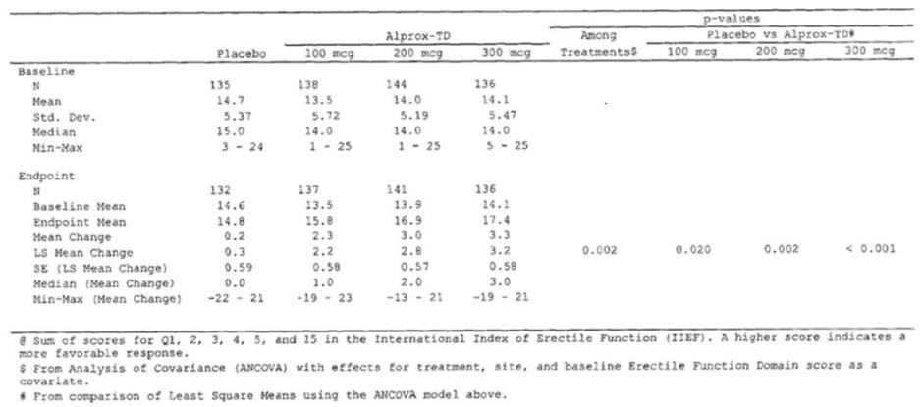
Table 32. EF Domain Scores, Study 004, Subjects > 65 Years
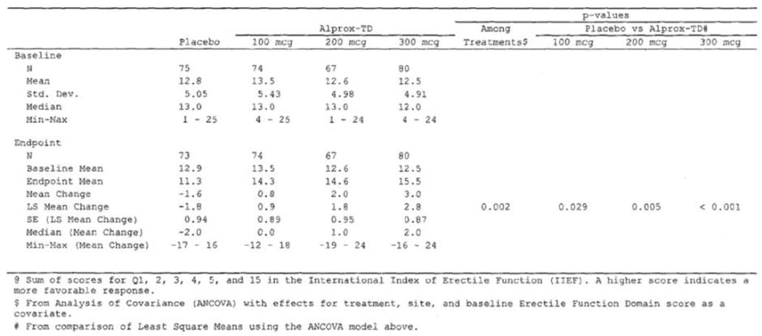
Table 33. EF Domain Scores, Study 005, Subjects ≤ 65 Years.
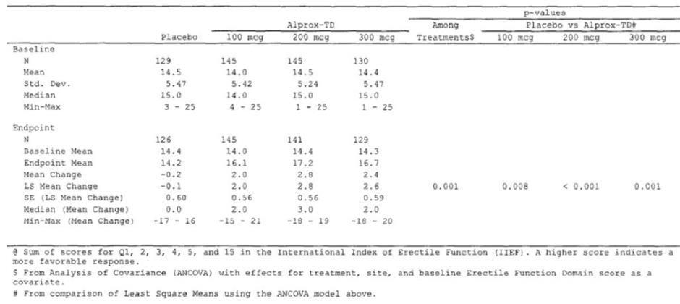
Table 34. EF Domain Scores, Study 005, Subjects > 65 Years
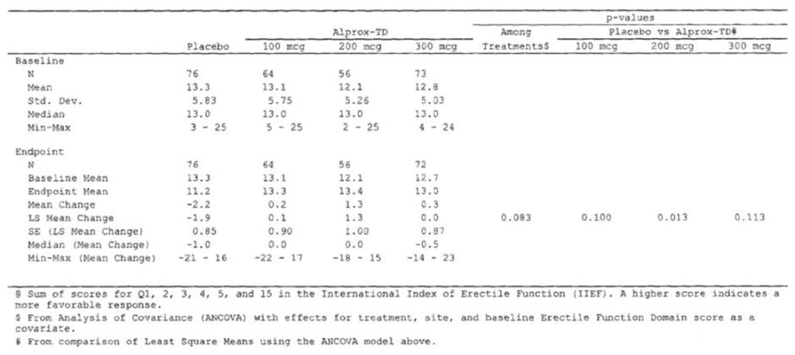

Supportive efficacy studies

Phase 2 study of mild to moderate erectile dysfunction (MED 99-002A)
Randomized, Placebo-Controlled, Double-Blind, Parallel Design Trial of the Efficacy and Safety of Alprox-TD (alprostadil) Cream in Patients With Mild to Moderate Erectile Dysfunction

Study design, objectives, locations and dates
This study (randomised n=161, evaluable n = 111) compared the efficacy of topical alprostadil at three doses (50 mcg, 100 mcg and 200 mcg) in 100 mg of topical cream formulation, in comparison to placebo cream. Note that this study did not assess the proposed default alprostadil dose of 300 mcg.
This was a multi-dose study with treatment continued for up to approximately 6 weeks. First, a single dose of randomised study drug was administered in the clinic at Visit 2 to assess tolerance, and then patients who tolerated the test dose received 5 doses of the assigned medication to be used in conjunction with sexual intercourse over a 3-week period (± 4 days). Finally, patients who used at least 3 of 5 doses received an additional 5 doses at Visit 3, to be administered over a second 3-week period (±4 days). Screening occurred at Visit 1 and a final efficacy and safety assessment was performed at Visit 4.
The stated objectives of the study were:
to evaluate the dose-response relationship of the clinical efficacy and safety of Alprox-TD (alprostadil) topical cream for the treatment of male erectile dysfunction under conditions of in-clinic and home use.
The study was conducted in the USA from April 20, 2000 to September 1, 2000.

Inclusion and exclusion criteria
Subjects were eligible if they were males between 21 and 65 years of age who had mild to moderate erectile dysfunction, of at least 3 months duration, based on an IIEF Erectile Function domain score of 14 to 21. This is a slightly lower cut-off than that used in the pivotal studies, which accepted even milder patients with EF scores up to 25 (30 being a normal, maximum score). Subjects were excluded if they had an endocrine cause for their erectile dysfunction (other than diabetes), a previous myocardial infarction, a major neurological problem, or significant hepatic or renal disease.
Formal entry criteria were listed as shown below. To be eligible, subjects had to:
- Be a male 21 to 65 years of age.
- Provide written, informed consent.
- Have a stable monogamous relationship with a consenting female partner (vaginal intercourse was a required study activity).
- Have a history of erectile dysfunction (defined as a consistent change in the quality of erection that adversely affects the patient's satisfaction with sexual intercourse) of at least 3 months duration.
- Have mild to moderate erectile dysfunction based on an IIEF erectile function domain score of 14 to 21, inclusively.
Exclusion criteria were similar to the pivotal studies, and consisted of:
- Erectile dysfunction caused by untreated endocrine disease, e.g., hypopituitarism, hypothyroidism, hypogonadism.
- Significant penile pathology: curvature, fibrosis, sexually transmitted disease, presence of implant, etc.
- History within the previous six months of orthostatic hypotension, syncopal episodes, or presyncopal symptoms.
- Evidence of clinically significant hepatic disease as evidenced by AST or ALT >3times the upper limit of normal.
- Evidence of clinically significant renal disease as evidenced by a serum creatinine >2.5 mg%.
- History of myocardial infarction within previous 6 months.
- Significant central nervous system diseases within the last 6 months i.e. stroke, spinal cord injury, etc.
- Use of any medication, device, or herbal preparation for the treatment of erectile dysfunction during the course of the study. Patients who had been using such products had to discontinue their use for the duration of the study.
- Acute or chronic· disease requiring frequent changes (changes within previous two months or anticipated in following two months) in medications or doses of chronic therapy. Hormonal replacement therapy was allowed if the dose was stable and anticipated to continue to be stable.
- Participation in another study with an investigational drug or device during the 30 days prior to study entry, or during the study. (Patients who received any treatment in the NexMed-MED-99-001 study were excluded from the current study).
- Any condition which would interfere with the patient's ability to provide informed consent, to comply with study instructions, or which could have confounded the interpretation of the study results.
- Any condition which could endanger the participant if he participated in this trial.

Study treatments
Subjects received placebo, or alprostadil 50 mcg, 100 mcg or 200 mcg in topical cream. (Throughout the study report, the doses were reported in mg, but this report refers to mcg for consistency with other studies). The dose was administered to the penile meatus and surrounding glans.
Specifically, the dosing instructions were as follows:
The patient was instructed to hold the meatus open while gently inserting the tip of the applicator into the urethral opening. The entire dose was to be dispensed slowly over 5 to 10 seconds into the meatus. Then, the meatus was to be gently pinched closed with the fingers for a period of about 30 seconds. Any excess medication escaping from the meatus was to be gently rubbed into the glans penis.
An in-clinic test dose was administered, to assess tolerance, and then subjects were given 5 doses to use in the first 3-week treatment period. If they used 3-5 doses, they were given another 5 doses to use for the second 3-week treatment period. Thus, subjects received a maximum of 10 doses at home, over about 6 weeks.

Efficacy variables and outcomes
The efficacy variables assessed in this Phase 2 Study were similar to those adopted in the later pivotal studies, but only the EF domain score was considered a primary endpoint. The penetration endpoint based on the SEP (Question 3) was considered a key secondary endpoint but ejaculation success (Question 4) was not listed as a key secondary endpoint.
The primary efficacy parameter was the change from baseline to the final visit in the erectile function domain score of the IIEF.
The main secondary efficacy parameters were:
- Change from baseline to final visit in the non-erectile function domains of the IIEF.
- The overall IIEF score.
- Successful vaginal penetrations (relative to number of attempts) based on Q3 from the SEP.
- Patient Self-Assessment of Erection (PSAE).
- Global Assessment Questionnaire (GAQ).
These endpoints have been described previously. They have been validated and they are broadly appropriate in the assessment of treatments for erectile dysfunction.

Randomisation and blinding methods
Subjects were randomised with equal probability to one of the treatment groups. Blinding was attempted by using identically appearing packaging and creams. Telltale side effects could have led to some unblinding, but the Sponsor did not assess this.

Analysis populations
The Sponsor defines two analysis populations:
- The Intent-to-treat (ITT) Population was defined as “All patients who were exposed to at least one dose of study medication.”
- The Per Protocol (PP) Population, which the Sponsor frequently referred to as the “evaluable population” was defined as the set of subjects who:
  - used at least 3 doses of study medication at home in conjunction with attempts at sexual intercourse between Visits 2 and 3 (that is, over the first 3-week on-treatment assessment period);
  - had both baseline and end of treatment data from the lIEF;
  - had a baseline score on the lIEF erectile function domain score of 14 to 21; and
  - tolerated the test-dose at Visit 2.
The Sponsor emphasised results in the PP analysis instead of the ITT analysis throughout the body of the study report, and even more so in the Clinical Overview.. This appeared to be a prospective decision, rather than adopted post hoc in response to poor ITT results, but it nonetheless represents a substantial methodological concern. The definition of the PP population immediately excludes subjects who did not tolerate the drug during the first test dose, as well as any subjects who decided that the side effects were unacceptable during their first one or two uses at home. Of more concern, the definition also excludes subjects who found the drug tolerable but inefficacious, and gave up on it after one or two home uses. These treatment failures are necessarily censored from the PP analysis, potentially inflating the apparent success of treatment. Worse still, there is a great potential for withdrawal bias because placebo recipients who had no therapeutic response might be more likely to continue treatment – because at least they had minimal side effects – whereas recipients of active treatment, faced with the combination of side effects and poor efficacy, might be less inclined to have a third dose and thus enter the PP population. Withdrawal bias is a potential problem in many studies, but could have been exaggerated in this study because dissatisfied patents did not even have to withdraw from the study to leave the main analysis pool; they simply had to fail to use a third dose.
Consistent with this concern, the number of patients dropping out of the PP population was not equal across groups. The ITT population consisted of 40, 42, 39 and 40 subjects across the placebo, 50 mcg, 100 mcg and 200 mcg groups, respectively; the PP population consisted of 31, 31, 29 and 26 patients, respectively, with the number of ITT patients excluded from the PP analysis being 9, 11, 10 and 14, respectively. The excess number of exclusions in the highest dose group, 5 subjects, is about one fifth of the final PP cohort at that dose, and the exclusions are likely to include some of the least responsive patients. Reasons for exclusion from the ITT cohort are tabulated.

Statistical methods
The change from baseline in domain scores was analysed using ANCOVA models, with age, the baseline Erectile Domain score, and site as covariates. The multiple comparison technique was used for comparing placebo and each of the treated groups.

Sample size
The Sponsor aimed for a sample size that would be able to detect “a clinically important difference in mean change of 4.5 [for the EF score] between placebo and treated groups”. Power estimates at the five percent significance level, with a common variance estimate of 25, are given below.
Table 35. Power Estimates, Study MED 99-002A.

The Sponsor aimed for a treatment group size of 36, which they expected to provide more than 95% power to detect a clinically relevant treatment effect and even greater power in assessing dose response.

Participant flow
Patient disposition is summarised in the table below. Discontinuations for any reason were more common in the active treatment groups (50 mcg, 29%; 100 mcg, 36%; 200 mcg, 33%) than the placebo group (12.5%). The most common reason for withdrawal was an adverse event (AE), and AEs sufficient to cause withdrawal were more common at higher doses, reaching 22.5% in the 200 mcg group. Lack of efficacy was also listed directly as the reason for withdrawal in 7 recipients of active treatment (7/121, 5.8%), compared to only one placebo subject (1/40, 2.5%).
Table 36. Patient Disposition, Study MED 99-002A.
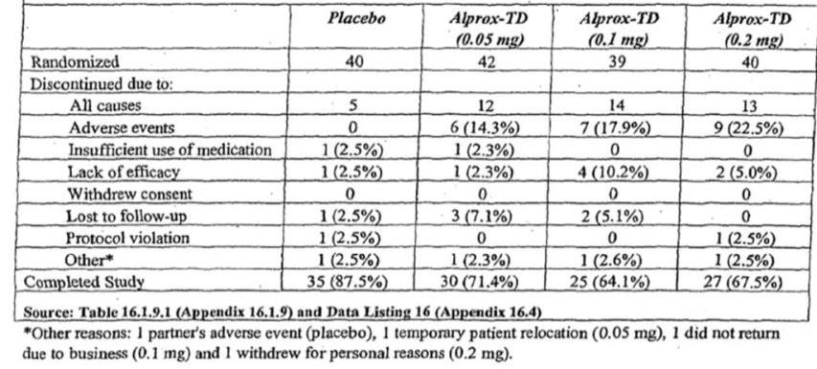
Although the overall number of withdrawals is acceptable for a study of this nature, the unequal withdrawal rates and excess of withdrawals related to side effects in the active groups is of concern. This pattern suggests that the study was at risk of withdrawal bias, with less responsive patients preferentially dropping out if, in addition to poor perceived efficacy, the drug they were receiving was also causing side effects. The unequal distribution of AEs also raises the possibility of significant unblinding.
Finally, as already discussed, some patients were excluded from the Sponsor’s primary analysis not because they completely withdrew from the study, but simply because they did not progress past the first test-dose or only used the drug once or twice at home. Reasons for exclusion from the PP data set are tabulated below.
Table 37. Reasons for Exclusion From Per-Protocol Cohort, Study MED 99-002A.
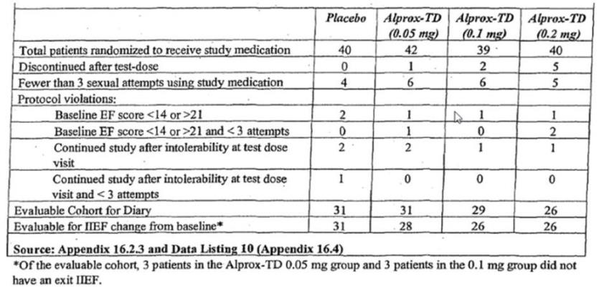

Major protocol violations/deviations
Major protocol violations are listed in the table below. The number of protocol violations was acceptable for a study of this nature.

Table 38. Protocol Violations, Study MED 99-002A.
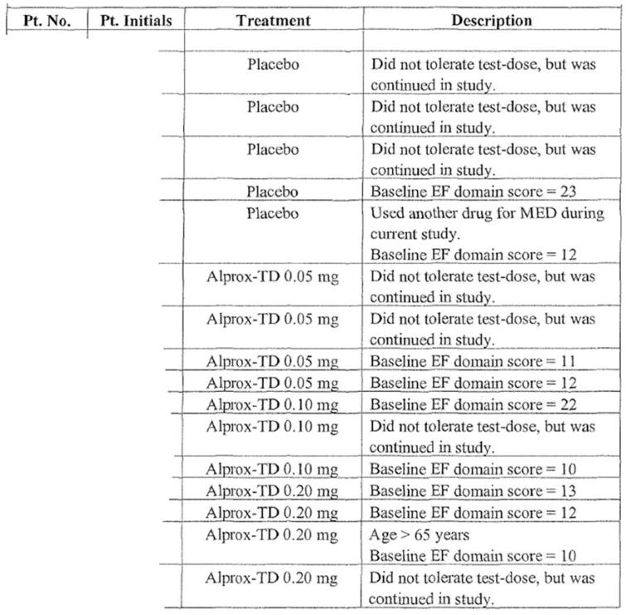

Baseline data
Baseline demographic and disease characteristics are listed in the tables below. The degree of baseline matching was acceptable, and no significant differences between groups were observed at baseline.
Table 39. Baseline Demographics, Study MED 99-002A.
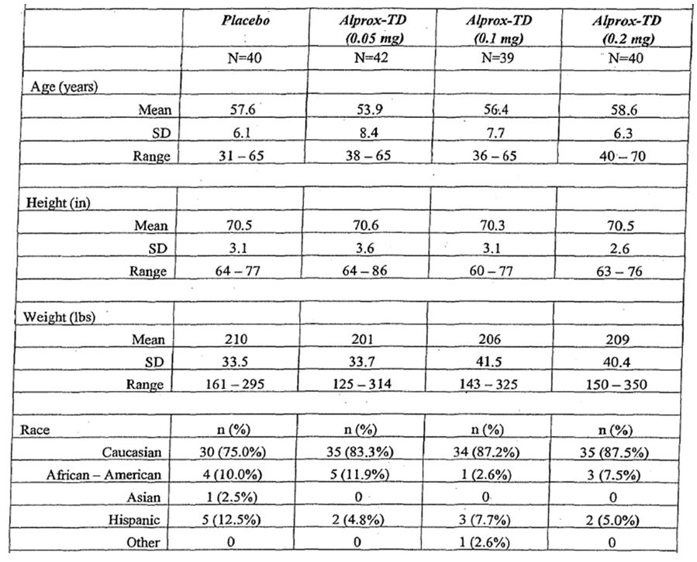
Table 40. Baseline Disease Characteristics, Study MED 99-002A.
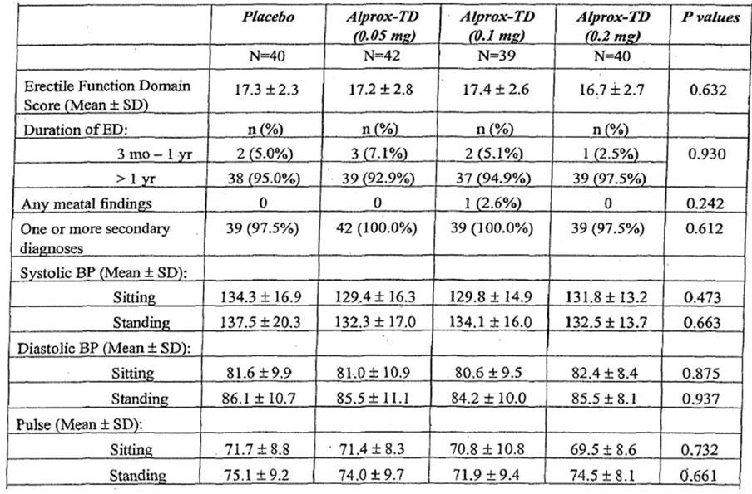

Results for the primary efficacy outcome
The Sponsor performed two analyses of the primary efficacy variable (change in EF from baseline): a per protocol (PP) analysis, which discarded data from subjects with protocol violations, and an ITT analysis, which was considered secondary and given much less emphasis in the study report and Clinical Overview. TGA policy is to favour ITT results over PP results because they are less susceptible to bias, so the ITT results will be given greater emphasis in this report.
In the ITT analysis, the overall among-group ANOVA results narrowly failed to reach statistical significance (p=0.051), a point that was not discussed in the Sponsor’s Clinical Overview. The p-value for the hypothesis of a linear dose trend (the “linear contrast”) was significant (p=0.015), but this was not the primary prospective method of analysis. Pairwise comparisons showed that a significant difference (p=0.007) existed for the highest dose group (200 mcg) in comparison to placebo, but it appears that no statistical adjustment was made for the use of multiple pairwise comparisons. The other dose groups were not significantly superior to placebo.
The magnitude of the benefit over placebo was modest. Whereas the placebo group showed a mean adjusted decrease (deterioration) in EF of 0.8, the alprostadil 200 mcg group showed a mean increase of 3.7, a difference of 4.5 points in a scale potentially spanning from 1 to 30. With other doses, the adjusted mean changes were much lower: an increase of 1.8 with 50 mcg and 0.7 with 100 mcg.
Table 41. Results for Primary Endpoint, ITT Population, Study MED 99-002A.
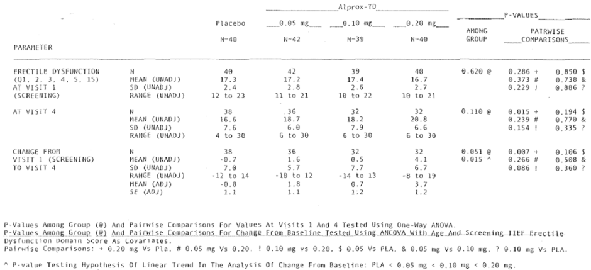
The Sponsor’s study report for MED 99-002A described the ITT results very briefly, as follows:
Although the overall group comparison fell short of statistical significance (p = 0.051), the linear contrast was statistically significant (p = 0.015), and a mean improvement of 4.1 in the 0.2 mg Alprox-TD group was significantly greater than the change in the placebo group (-0.7), p = 0.007.
(The values cited refer to unadjusted means, which were similar to the adjusted means.) Most of the discussion in the study report focussed on the per protocol (PP) results instead, which are presented below.
The Clinical Overview did not discuss the ITT results at all, but instead presented results for the PP or “efficacy” dataset. In this analysis, as in the ITT analysis, the highest dose group (200 mcg) showed significant pairwise superiority over placebo for change in EF Domain scores (p=0.001). The adjusted mean change was an increase (improvement) of 4.3 with 200 mcg, compared to a mean decrease of 1.6 in the placebo group. The next highest dose group (100 mcg) showed a borderline result for this endpoint, arguably reaching statistical significance (p=0.050) with a mean adjusted increase of 1.9. The linear dose trend (“linear contrast”) was statistically significant (p=0.002), as shown in the source table below, copied from the appendices of the study report.
Table 42. Results for Primary Endpoint, Per-Protocol Population, Study MED 99-002A.
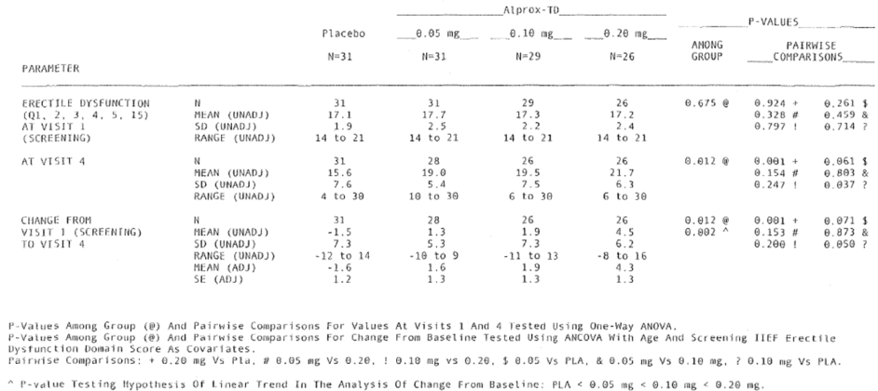
In the body of the study report, the results were tabulated as shown below.
Table 43. Results for Primary Endpoint, Per-Protocol Population, Study MED 99-002A (Alternative Version).
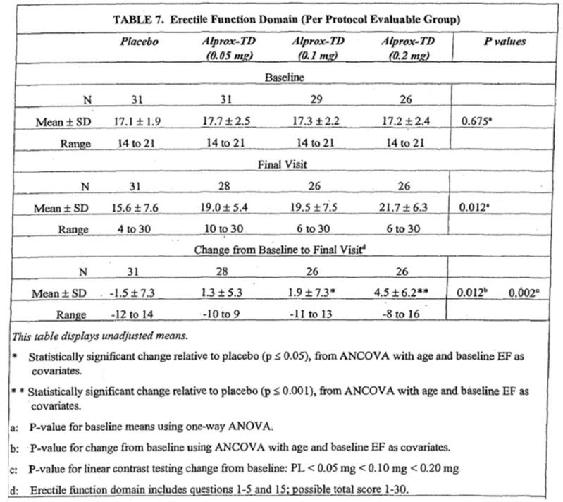
Unfortunately, a couple of errors were made in the presentation of these results. Firstly, in the table above, reproduced from the main body of the study report, the footnote “a” is inappropriately applied to the first mention of the p-value of 0.012, implying that this p-value refers to a comparison of baseline scores, when in fact the placement of this p-value in the table implies that it represents a comparison of final scores. Reference to the source table, reproduced on the previous page, suggests that the latter interpretation is correct. Admittedly this is a minor error, with no major impact on estimations of efficacy.
In the Sponsor’s Clinical Overview, these same results are presented even more inaccurately, and in a way that could inflate a reader’s estimation of the efficacy of the drug. The p-values in the right-hand column of the above table refer to differences among groups at baseline (p=0.675), at the final visit (p=0.012) and in changes from baseline (p=0.012 again). They do not refer to pairwise comparisons for different doses (which were instead associated with the p-values 0.001, 0.050 and 0.071, for the primary endpoint of change from baseline, as marked by the footnote symbols “+”, “?” and “$” in the source table above). In the table below, however, reproduced from the Clinical Overview, these p-values have been erroneously applied to individual doses, falsely implying that the 100 mcg group showed clear statistical superiority over placebo (p=0.012) when in fact the result was borderline (p=0.050). Coupled with the failure of the Clinical Overview to present the ITT results, in which 100 mcg was not significantly different from placebo, the net effect is that the drug is presented as having more efficacy than the results support.
Table 44. Results for Primary Endpoint, Per-Protocol Population, Study MED 99-002A (Clinical Overview Version).
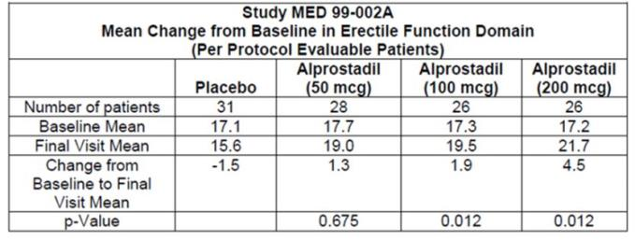
These errors should be corrected. Although this is only a Phase 2 supportive study, and the two larger Phase 3 pivotal studies re-assessed the 100 mcg doses with greater statistical power, the Phase 3 studies did not show a benefit in cases of mild erectile dysfunction. This Phase 2 study is, therefore, the only study providing evidence of benefit at the mild end of the spectrum.

Results for other efficacy outcomes
Secondary endpoints in this study included: the change from baseline to final visit in the non-erectile function domains of the IIEF; the change in total IIEF score; the proportion of successful vaginal penetrations based on Q3 from the SEP; other SEP questions; the PSAE; and the GAQ.

IIEF
Results for the remainder of the IIEF were inconclusive, as shown in the table below for the Per Protocol group. (Note that, in this table, the IIEF scores include the same mistaken use of the “a” footnote discussed above.) A statistically significant mean change from baseline, as assessed by ANCOVA, was not achieved for any of the non-erectile domains of the IIEF, although “Intercourse Satisfaction” showed a strong trend (p=0.057) and the linear contrast (dose trend) was significant for this domain (p=0.021). The total IIEF score (which includes the erectile domain already considered) did show a significant ANCOVA result (p=0.019, linear contrast p=0.006). In pairwise comparisons (not shown in the table), significant superiority over placebo was demonstrated for the 200 mcg dose for Intercourse Satisfaction (p=0.009), but not for any other dose-domain combination. For the total IIEF score, the PP analysis showed a significant pairwise superiority of the 200 mcg dose (p=0.002) and the 50 mcg dose (p=0.045), but the 100 mcg dose merely showed a weak favourable trend (p=0.10).
Table 45. Non-erectile Function Domains, Per-Protocol Population, Study MED 99-002A.
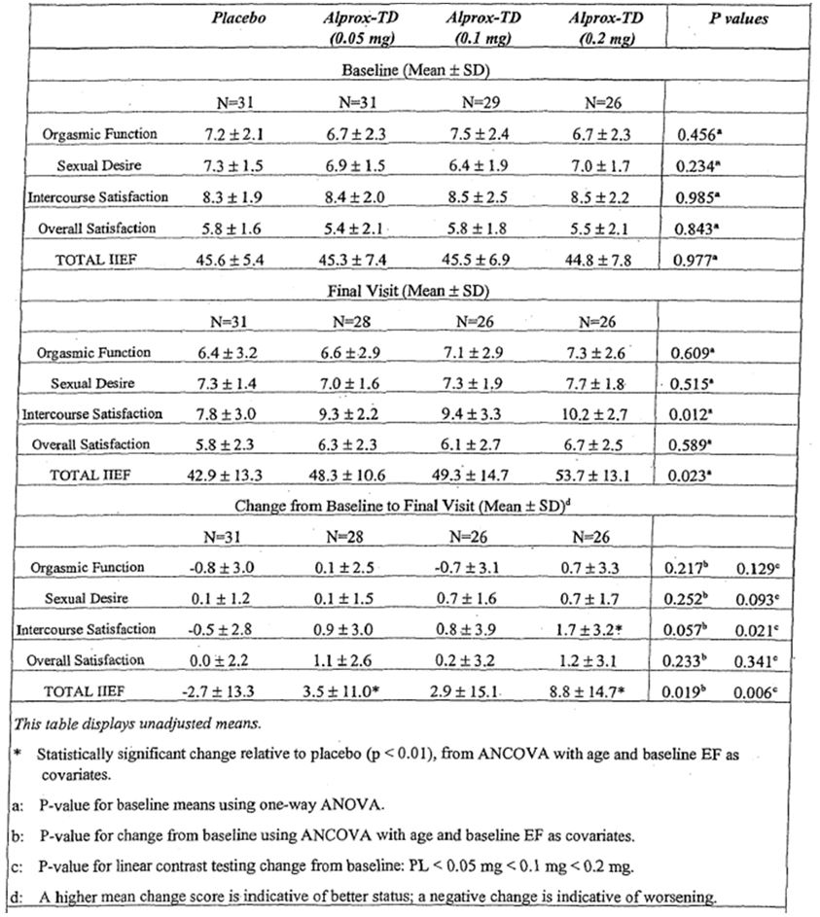
Table 46. Total IIEF Score, Per-Protocol Population, Study MED 99-002A.
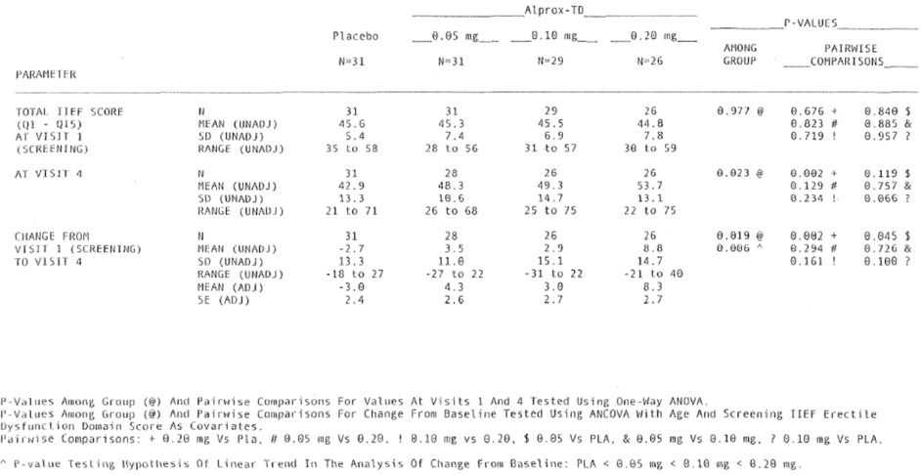
Results in the ITT analysis were broadly similar: none of the individual non-erectile domains produced a significant among-group ANCOVA result, but the total IIEF score did produce a significant result (p=0.042). Considering pairwise comparisons, the 200 mcg dose group was significantly superior to placebo for intercourse satisfaction (p=0.015) and total IIEF score (p=0.008). The 50 mcg dose group achieved a borderline result for total IIEF (p=0.050) but the 100 mcg dose did not (p=0.346). Other pairwise comparisons were not significant.

SEP
Results for the Sexual Encounter Profile (SEP) scores are shown in the table below, for the PP population. For Question 3 of the SEP (penetration success), the PP analysis showed no overall among-group significance (p=0.142) but the highest dose group (200 mcg) was superior to placebo in a pairwise comparison (p=0.023). For half of the SEP questions as well as the total score, an overall among-group ANCOVA showed a significant group effect (see the table for details). For most of the individual domains of the SEP (every domain except “Number of Attempts), as well as the total SEP score, a significant pairwise superiority was demonstrated for the 200 mcg dose.
Table 47. SEP Questions, Per-Protocol Population, Study MED 99-002A.
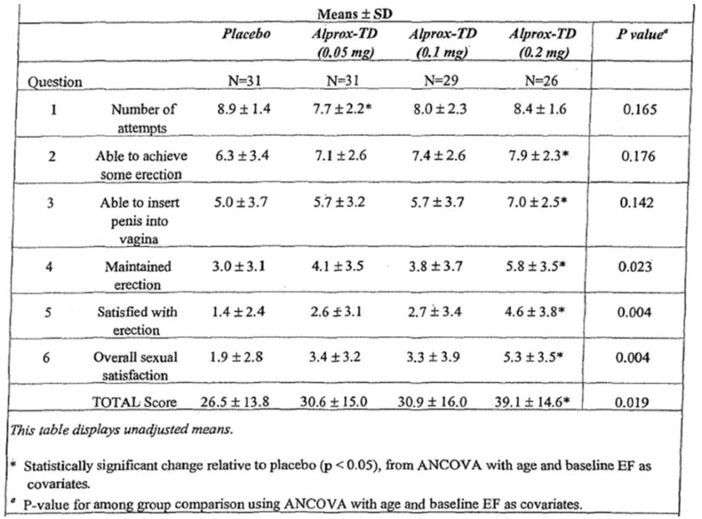
As in the pivotal studies, penetration success was also assessed as a proportion of attempts, by comparing responses to Q3 and Q1. The success rate was expressed as an overall percentage of success while on treatment, rather than as a change from baseline. The results for the PP population are shown in the table below. The ANCOVA showed a significant overall group effect (p=0.035), as well as superiority of the 200 mcg dose in a pairwise comparison with placebo (p<0.01). The mean success rate was 83% in the 200 mcg group, compared to 55% in the placebo group, with lower doses producing intermediate results. About half of the patients (54%) receiving the highest dose reported 100% success, whereas this was relatively uncommon in the placebo group (22%). This suggests that only 3 patients would need to be treated to have one patient achieve a 100% success rate that would not have occurred with placebo – albeit with the important caveat that these are not true ITT results, and the group assessed in the PP population are a selected subset.
Table 48. Vaginal Penetration Success Rates Per Attempt, PP Population, Study MED 99-002A.
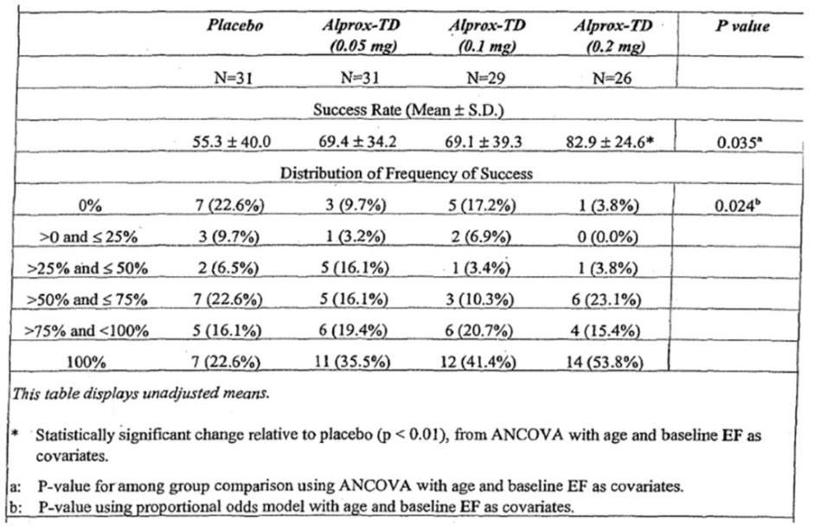
The ITT results were generally inferior to the PP results, and not one of the individual questions showed a significant among-group effect. Among pairwise comparisons, a couple of questions showed a significant result for the 200 mcg group: satisfaction with hardness (Q5) and satisfaction with overall sexual experience (Q6), but no correction was made for using multiple statistical comparisons.
The only measure in the SEP showing a group effect was the number of doses taken in each group, and this revealed a significant reluctance for some patients to take active treatment: patients in the 200 mcg dose group were more likely to take zero doses (15%, compared to 2.5% with placebo), and less likely to take ten doses (27.5%, compared to 62.5% with placebo). The among-group difference for the mean number of doses taken was significant (p=0.037), as was the among-group difference for the distribution of doses (p=0.012). This finding suggests that the treatment had significant tolerability issues, and it also makes it even more likely that the study suffered from unblinding and withdrawal biases. Exclusion of subjects who did not like the treatment may account for some of the differences in the PP analysis and ITT analysis.
Table 49. Sexual Encounter Profile, Doses Taken, ITT Population, Study MED 99-002A.
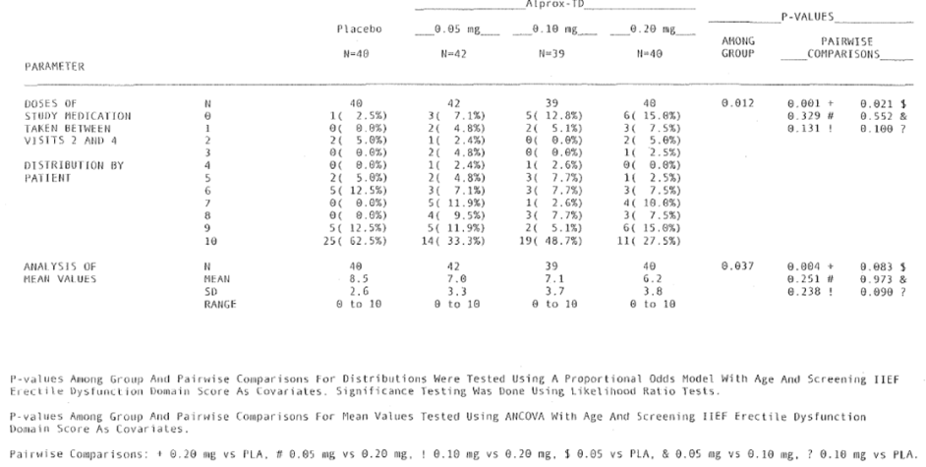
For the assessment of penetration success as a proportion of attempts, the ITT analysis did not achieve statistical significance for the among-group comparison or for any pairwise comparison, in marked contrast to the PP results, as shown in the table below. There was a weak trend to a greater success rates with the 200 mcg group (67%), compared to the placebo group (55%, p=0.138), but the 100 mcg group had a mean success rate (57%) very similar to the placebo rate. Achievement of a 100% success rate was more common with the 200 mcg dose, but the differences from placebo were less marked than in the PP analysis, and the comparison of distributions of success rate were not significant.
Table 50. Sexual Encounter Profile, Penetration Success, ITT Population, Study MED 99-002A.
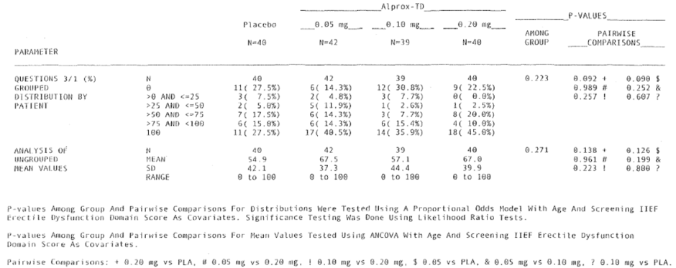
Although the ITT results were clearly inferior to the PP results, the inferiority of the ITT results were not discussed in the main body of the study report or in the Sponsor’s Clinical Overview, but instead became apparent only upon examination of the source tables.

PSAE
The PSAE showed a similar discordance between the PP and ITT analyses. The PP results were tabulated as shown below, and indicated significantly better scores in the 50 mcg and 200 mcg dose groups relative to placebo (p=0.022 and p<0.001, respectively) as well as an overall group effect (p<0.001). For the highest dose, the estimated treatment effect was 0.8, approaching the difference between “partial tumescence” and “greater tumescence sufficient for vaginal penetration”. This would be of clinical value. Of concern, though, the ITT results did not show any significant treatment effect (subsequent table).
Table 51. PSAE, Per-Protocol Population, Study MED 99-002A
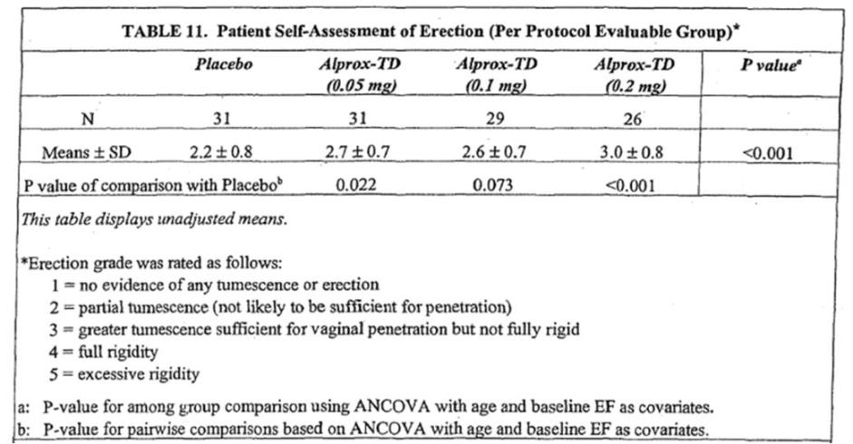
Table 52. Patient Self-Assessment of Erection (PSAE), ITT Population, Study MED 99-002A.
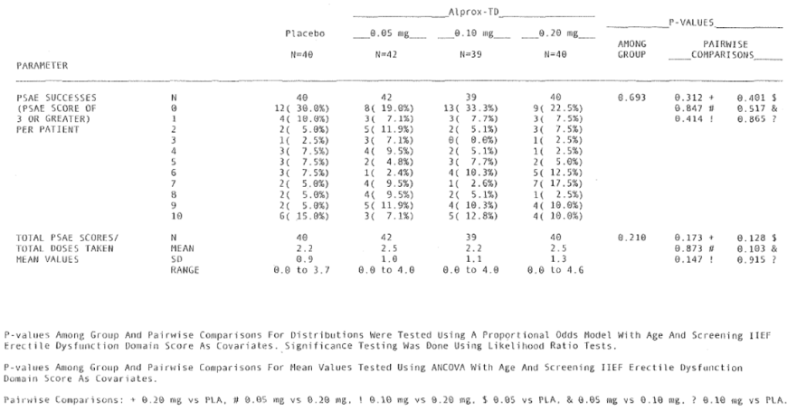

GAQ
For the GAQ, results in the PP and ITT analyses were broadly concordant, with a clear statistical group effect (p<0.001 in both analyses) as well as pairwise superiority of the 200 mcg dose over placebo (p<0.001 in both analyses). The 50 mcg dose group also showed superiority over placebo (PP analysis p=0.008; ITT analysis, p=0.004), whereas the 100 mcg dose produced a favourable trend (PP analysis p=0.063; ITT analysis, p=0.088). Half of the placebo recipients (50%) felt that their erections had not improved at all, whereas only 6.3% of recipients of the highest dose felt that there had been no improvement. Furthermore, the mean score in the 200 mcg group (4.8 in the ITT analysis) was twice that observed in the placebo group (2.4).
This positive result, observed in both the PP and ITT analyses, is reasonably reassuring with respect to the patients’ overall assessment of their response to the drug, particularly because the positive result was not confined to the selected PP population.
Table 53. Global Assessment Question, Per-Protocol Population, Study MED 99-002A.
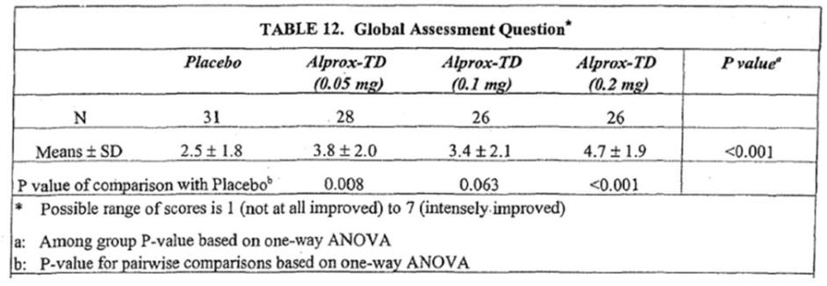
Table 54. Global Assessment Question, ITT Population, Study MED 99-002A.
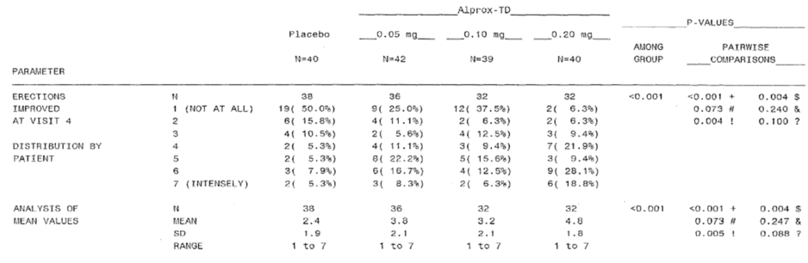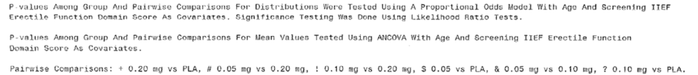

Phase 2 study of severe erectile dysfunction (MED 2000-002A)
Randomized, Placebo-Controlled, Double-Blind, Parallel Design Trial of the Efficacy and Safety of Alprox-TD in Male Patients With Severe Erectile Dysfunction

Study design, objectives, locations and dates
This double-blind, placebo-controlled Phase 2 Study (enrolled n=142, fully evaluated n=104) had an almost identical design to the Phase 2 study described above, with the exception that it recruited patients with severe erectile dysfunction (ED) instead of mild-to-moderate ED, and it assessed a different range of doses (100 mcg, 200 mcg and 300 mcg).
The stated objectives of the study were:
to evaluate the dose-response relationship of the clinical efficacy and the safety of Alprox-TD (alprostadil) topical cream versus placebo for the treatment of severe erectile dysfunction.
The study was performed in the USA, from October 6, 2000 to March 9, 2001.

Inclusion and exclusion criteria
Subjects were eligible if they were men aged between 2 I and 70 years, and they reported ≥ 3 months of severe erectile dysfunction, defined as a score of <14 for the EF domain of the IIEF.
The age limit was thus higher than in the previously described study, consistent with the need to recruit more severe cases. Subjects with EF scores too mild for this study (≥ 14) were eligible for the other study, instead. For this study, there was no lower limit for EF scores.
Exclusion criteria were otherwise the same as in the previous study.

Study treatments
Subjects were randomised with equal probability to receive placebo, or alprostadil at three different doses, but the doses assessed were higher: 100 mcg, 200 mcg or 300 mcg, administered in 100 mg topical cream. A test dose was provided in clinic, and subjects who tolerated the test dose were given 5 doses to use at home over the subsequent 3 weeks, and then given another 5 doses to use over a second 3-week period if they used 3 or more doses in the first treatment period.

Efficacy variables and outcomes
The efficacy variables were as described for the previously described study in mild-to-moderate ED, and the primary endpoint was change in EF Domain score.

Randomisation and blinding methods
Randomisation and blinding were as described for the previous study. Like the other submitted studies, it is possible blinding was incomplete because of tell-tale side effects, but this was not assessed by the Sponsor.

Analysis populations
The Sponsor initially intended to concentrate the efficacy analysis on subjects who used at least 3 doses of medication at home: that is, outright treatment failures who gave up on the treatment after one or two doses were to be excluded from the analysis. The primary study population was changed to an ITT population later.
The Sponsor described the study cohorts as follows:
All patients who were exposed to at least one dose of study medication constituted the intent-to-treat (ITT) cohort and were included in all safety analyses. The statistical analysis section of the protocol stated that only patients who used at least three doses of study medication in conjunction with sexual attempts at home were to be considered for evaluation in the efficacy cohort.
Under the heading “Changes to Statistical Analysis Plan”, the Sponsor added the following comment:
Efficacy analyses were performed on the ITT-E cohort, defined as all patients who were exposed to at least one dose of study medication and had at least one post-baseline efficacy evaluation. Selected efficacy analyses were performed on the fully evaluable cohort, defined as all patients who used at least three doses of study medication at home between Visit 2 and Visit 3 and had a baseline EF domain score of <14.
Thus, there were 3 populations: the ITT population who received at least one dose, the ITT-E population who had at least one dose and one post-treatment efficacy evaluation, and the “fully evaluable” or “Per Protocol” cohort who used at least 3 doses (and had an appropriate baseline EF score). Unlike the previously described study, the primary analysis was performed on the ITT-E group, so concerns about exclusion of treatment failures are less applicable to this study.

Sample size
Sample size was estimated along the same lines as the previously described study.

Statistical methods
For the primary efficacy analysis of changes in EF score, an ANCOVA model with treatment and site as main factors and baseline EF domain score as the covariate was used to analyse differences among the treatment groups in mean change from baseline and pairwise differences between each active treatment group and placebo. Initial analyses showed no significant interaction between treatment and baseline EF domain score, or between treatment and study site, so these terms were removed from the model.
For the GAQ, the distribution of the seven possible responses was examined and the responses were also grouped into two categories: no improvement (GAQ score = 1) or some improvement (GAQ score = 2 to 7). Among-group and pairwise comparisons for both of these distributions were tested using the Cochran-Mantel-Haenszel test.
Group differences in the mean results for each SEP question were analysed with a one-way ANOVA, with treatment as a factor.
Vaginal Penetration Success Rate, derived from the SEP, was analysed as a weighted success rate. (“The average rate of success for each total number of attempts was first calculated within each dose group; then the mean of those values was calculated for each group. Differences between the groups in the mean VPSR were analyzed using an ANOVA (PROC CATMOD) with treatment and number of attempts as factors”). As noted previously, it is unclear if this same approach was used in the pivotal studies, and also unclear whether this approach meant that subjects made unequal contributions to the final score.
Mean values for PSAE were compared across groups with ANCOVA.

Participant flow
Patient disposition is summarised in the table below. As in the previously described Phase 2 study, there was an excess of withdrawals in the active dose groups, largely due to poor tolerance and Adverse Events. This suggests that the study might have suffered from withdrawal bias, and also raises the possibility that significant unblinding occurred due to telltale side effects.
Table 55. Patient Disposition, Study MED 2000-002A.
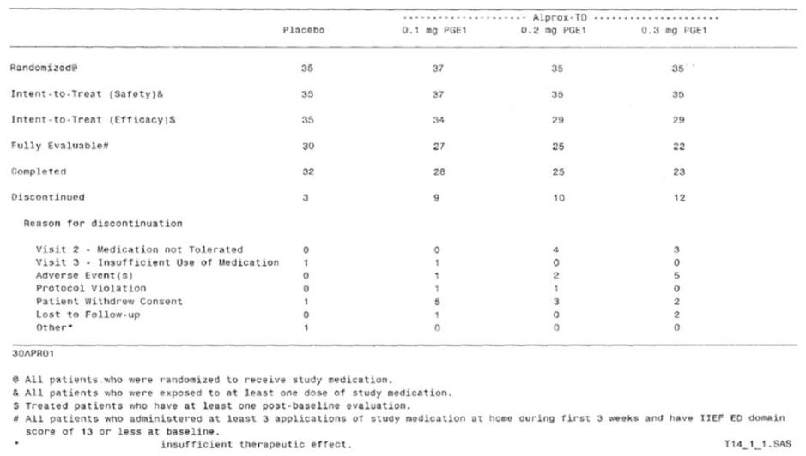

Major protocol violations/deviations
Protocol violations in this study were not listed in a convenient format. As a cause for withdrawal, protocol violations were not common, as shown in the table above. One patient in the 100 mcg group and one in the 200 mcg group withdrew from the study because of a protocol violation.

Baseline data
Baseline characteristics of the different treatment groups are summarised in the tables below. The groups were reasonably well-matched, but the distribution of ages was uneven, and the differences approached statistical significance (p=0.058). The active groups had mean ages both above and below the placebo group, so it is relatively unlikely that age mismatch at baseline had a major effect on the study results. The highest dose group (300 mcg) had a slightly higher mean age (62.4 years) than the placebo group (60.8 years, p=0.058), which is unlikely to have been clinically significant. The groups had broadly similar severity and duration of ED, with no significant differences between groups at baseline

Results for the primary efficacy outcome
Results for the primary endpoint, mean change in EF score, are shown in the table below. There was a significant overall group effect, as assessed with ANCOVA (p=0.009). Individual pairwise comparisons (not corrected for multiplicity) showed significant results for the highest dose group (300 mcg, p<0.001) with favourable trends for the other doses (p<0.06).
Table 56. Changes in EF Domain Score (ITT-E), Study MED 2000-002A.
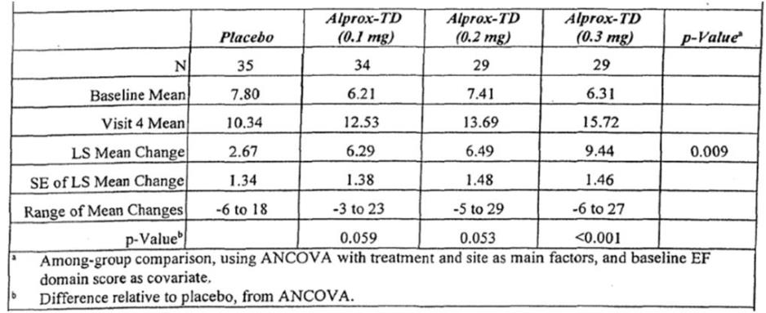
The magnitude of the change was substantial, with EF scores more than doubling in the highest dose group (from 6.31 to 15.72, an increase of 154%); the increase in EF score with 300 mcg (9.44) was >3 times the increase seen with placebo (2.67). The magnitude of the increase in the highest dose group represents about one third of the full range of the EF domain score (1-30), and exceeds the difference between the cut-offs for severe ED (<14) and mild ED (>22). Lower doses produced intermediate benefits. These are changes that are likely to be clinically meaningful, and the fact that they were demonstrated in an appropriate intent-to-treat analysis is generally reassuring.
The results in this study, particularly in contrast to the weaker results of the previously described study, are also concordant with the subgroup analysis of the pivotal Phase 3 studies, in which subjects with more severe erectile dysfunction showed a stronger response to treatment.
Results in the “fully evaluable” (Per Protocol) population were even stronger, as shown in the table below, with a significant pairwise superiority over placebo for all dose groups.
Table 57. Changes in EF Domain Score (Per Protocol Population), Study MED 2000-002A.
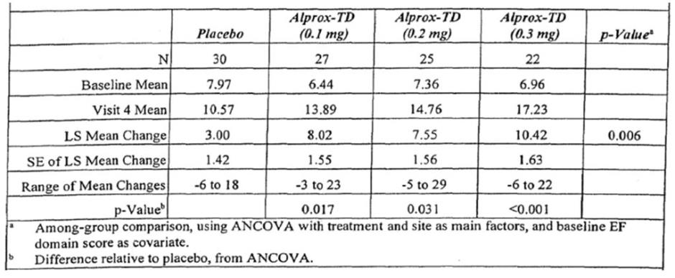

Results for other efficacy outcomes

IIEF
For the non-erectile domains of the IIEF, the results were mixed, with two domains achieving a significant pairwise result for the 300 mcg dose (Orgasmic Function, p=0.021; Intercourse Satisfaction, p=0.037), but no domains showing a significant overall group effect. Lower doses did not produce significant results in any domain. The 300 mcg dose produced a trend to increased Overall Satisfaction in a pairwise comparison with placebo (p=0.093).
Results in the Per Protocol population were broadly similar, with significant pairwise superiority over placebo for the 300 mcg dose in the Intercourse Satisfaction domain, and for the 200 mcg dose in the Orgasmic Function domain (not shown).

Table 58. Changes in Non-Erectile Function Domain Scores (ITT-E), Study MED 2000-002A.
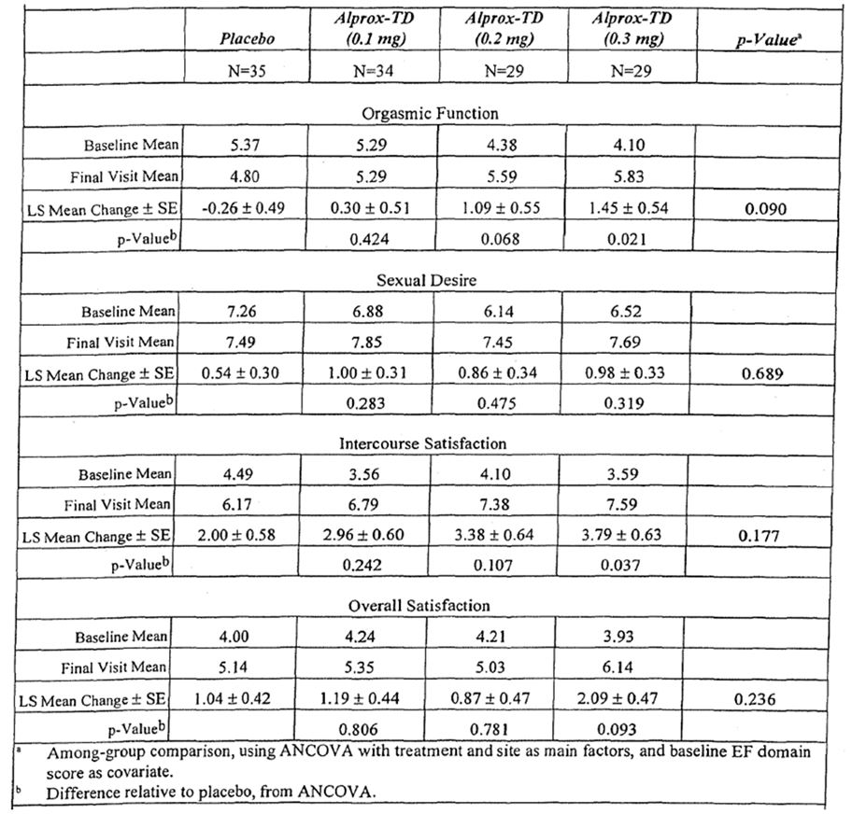

Sexual encounter profile
For the SEP, there was a weak trend to benefit for Q3 (penetration) and Q4 (maintenance of erection to ejaculation) in the overall ANOVA, but the only question with a significant group effect was Q5, relating to the patient’s satisfaction with their erection (p=0.002). Pairwise comparisons were not reported.
Table 59. SEP Questions and Total SEP Score (ITT-E), Study MED 2000-002A.
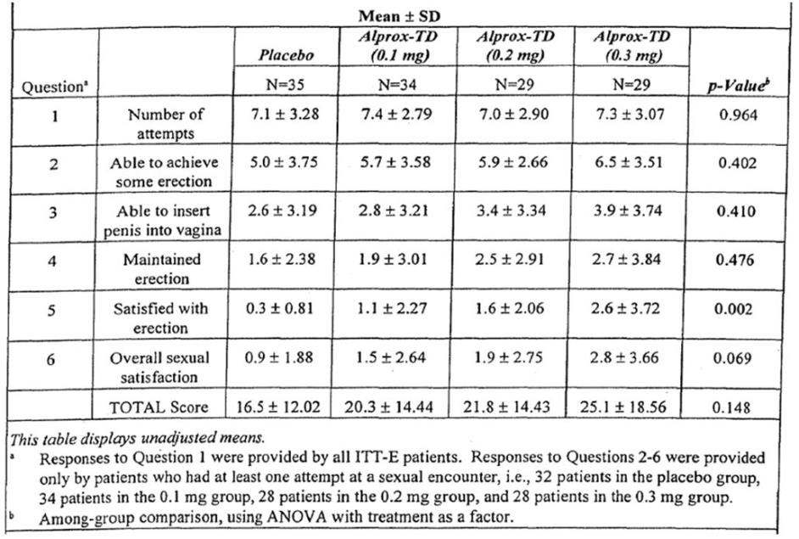

Penetration success rate
When analysed as a proportion of attempts, the Q3 results (successful penetration) showed a trend in favour of active treatment that was numerically strong (success was at least twice as common with active treatment) but statistically weak (p=0.553). If sustained in clinical practice, the observed increase in success rate, from 15.6% with placebo to 38.6% with alprostadil 300 mcg, would be clinically worthwhile. (Subsequent Phase 3 studies produced a qualitatively similar result in the severely affected subgroup with a success rate in the placebo group of 6.4%, increasing to 22.2% in the 300 mcg group.)
Table 60. Penetration Success Rate (ITT-E), Study MED 2000-002A.
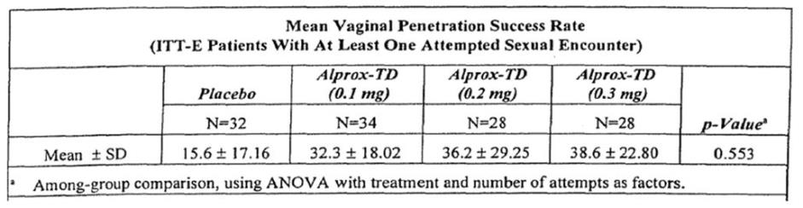

Patient self-assessment of erection
The PSAE showed positive results in all dose groups, as well as a significant overall group effect (p=0.009), as shown in the table below. Although the magnitude of the improvement was less than one point (the placebo-subtracted difference was 0.64 in the highest dose group), it should be noted that this score essentially ranges from 1 (no evidence of any tumescence or erection) to 4 (full rigidity), and the highest score of 5 is reserved for excess rigidity so that the entire spectrum from full disability to normality is covered in just 3 points.

Global assessment questionnaire
The GAQ was assessed in two ways: by the distribution of scores on the entire 7-point scale, as well as through a binary characterisation of the scores as either no improvement in erection (GAQ score of 1) or some improvement in erection (GAQ scores of 2-7). Both approaches showed a significant result, as shown in the table below. Furthermore, each dose showed a significant pairwise superiority over placebo, with stronger results for the two higher dose groups. At 300 mcg, 83% of subjects felt that there had been at least some improvement, compared to only 26% in the placebo group. Visual inspection of the distribution of the scores also suggests that many of the improvements obtained with 300 mcg were at the higher end of the scale, whereas improvements on placebo tended to be minor even when they did occur. These results strongly support the findings for the primary endpoint, with which they are broadly concordant.
Table 61. GAQ (ITT-E).
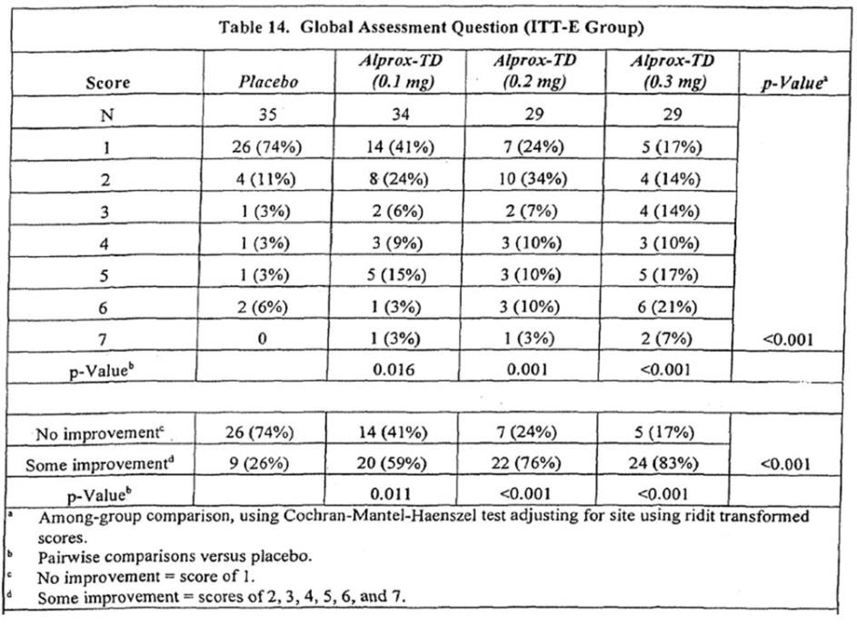

Rejected or marginally relevant efficacy studies
The following studies added little to the understanding of the efficacy of Vitaros, but they are described here for completion.

Phase 3 long-term open-label study (MED 2000-006)
An Open-Label, Parallel Design, Twelve-Month Phase 3 Trial of the Safety and Efficacy of Alprostadil (Prostaglandin E1) Topical Cream in Male Subjects with Erectile Dysfunction

Study design, objectives, locations and dates
Although this study was a relatively large Phase 3 study (n=1162), it used an open-label design so at best it can only be considered a weakly supportive efficacy study and it is primarily useful as a safety study. For most subjects (n=998), the study was an open-label extension of previous use of alprostadil (n=737) or placebo (n=261) in one of the pivotal Phase 3 studies; a small proportion of new subjects were also recruited (n=163).
Subjects began treatment at 200 mcg per dose, and were titrated down to 100 mcg or up to 300 mcg according to tolerability and response. The initial intent was for the study to last 12 months, but it was terminated early, after about 6 months, under the instructions of the FDA, because of concerns arising from a toxicity study in mice. (Those concerns were later dismissed by the Sponsor, but by then the study had been irretrievably compromised.)
The stated objectives of the study were:
- To assess the long-term safety of alprostadil (100, 200, and 300 mcg prostaglandin E1) topical cream in male subjects with erectile dysfunction (ED); and
- To assess the long-term efficacy of alprostadil topical cream in the treatment of male subjects with ED.
The study was performed in the USA, and ran for about six months until premature study closure on November 14, 2002.
Open-label extension studies can provide useful long-term safety information but generally supply poor efficacy data. Without blinding and a placebo control group, it is not possible to put the efficacy findings of such a study into context – it is impossible to know if patients were reporting an improvement because of a pharmacological response, because the natural history of the underlying condition includes fluctuations and recovery, or merely because they felt that an improvement was expected and responded accordingly. Furthermore, the patient population was not a random unbiased population of subjects with erectile dysfunction, but largely consisted of subjects who were prepared to enter an extension study after finishing a previous Phase 3 study; as such the cohort being studied was inevitably enriched for subjects who felt that they both tolerated and responded to active treatment, and they may not be representative of an unselected cohort.
Finally, the study was terminated prematurely, which meant that it does not even provide long-term data. Of 1,161 subjects in the ITT population, only 141 were included in the IIEF analyses at Visit 5 (~6 months). Median follow-up was about 6 months.
Thus, on balance, this study was of marginal utility in establishing the efficacy of alprostadil, and even its utility as a safety study was compromised by its premature interruption.

Inclusion and exclusion criteria
Inclusion and exclusion criteria were formally listed as shown below. These criteria closely resemble those in the original Phase 3 studies, with an identical definition of erectile dysfunction and the same cut-off of 25 in the IIEF EF Domain score. Overall, these criteria were appropriate, and were aimed at excluding subjects in whom treatment would be dangerous or difficult to assess, as well as subjects who would be better managed through other means (such as reversal of an endocrine deficiency).

Inclusion criteria
Subjects were included in the study if they met the following criteria:
- The subject was male and at least 21 years of age.
- The subject and his female partner provided written informed consent.
- The subject had a stable monogamous relationship with a consenting female partner (vaginal intercourse was a required study activity).
- The subject had a history of erectile dysfunction (clinically defined as the inability to attain and maintain an erection of the penis sufficient to permit satisfactory sexual intercourse) of at least 3 months duration; the Erectile Function domain score of the IIEF had to be 25 or less.

Exclusion criteria
Subjects were excluded from the study if they met any of the following criteria:
- The subject had ED caused by untreated endocrine disease, i.e., hypopituitarism, hypothyroidism, hypogonadism.
- The subject had significant penile pathology including but not limited to curvature, fibrosis, sexually transmitted disease, and penile implant.
- The subject had a history (within the previous six months) of orthostatic hypotension, syncopal episodes, or presyncopal symptoms.
- The subject had evidence of clinically significant hepatic disease as evidenced by AST or ALT greater than 3 times the upper limit of normal.
- The subject had a history of clinically significant renal disease as evidenced by a serum creatinine greater than 2.5 mg/dL.
- The subject had a history of myocardial infarction (within the previous 6 months).
- The subject had significant neurological disease such as stroke, spinal cord injury, etc. (onset less than or equal to 6 months prior to Visit 1).
- The subject was receiving therapy (prescription or over-the-counter medication, medical device, or herbal preparation) for the treatment of erectile dysfunction during the course of the study. Subjects who were receiving therapy for the treatment of ED had to discontinue therapy for the entire duration of their participation in the study.
- The subject had acute or chronic disease requiring frequent changes (changes within previous two months or anticipated in following two months) in medications or changes in dosages of chronic therapy. Hormonal replacement therapy was allowed if the dose had been, and was anticipated to continue to be, stable.
- The subject had participated in another study with an investigational drug or device during the 30 days prior to study entry. Subjects entering this study within 14 days of the completion of MED 2000-004 or MED 2000-005 were exempt from this criterion.
- The subject had a condition interfering with his ability to provide informed consent or comply with study instructions, or the subject had a condition that may have confounded the interpretation of the study results.
- The subject had a history of allergy to PGE1-containing drugs or any other components of the Alprox-TD formulation.
- The subject had a condition endangering him if he were to participate in this trial.”

Study treatments
All subjects received alprostadil at doses of 100 mcg, 200 mcg or 300 mcg, diluted in 100 mg of cream. There was no placebo group, and treatment was neither randomised nor blinded. Subjects commenced treatment at 200 mcg, and had this dose adjusted on a follow-up visit at about 30 days, according to tolerability and efficacy: if side effects were present, the dose was adjusted down to 100 mcg; if erectile dysfunction was still substantial, the dose was adjusted up to 300 mcg.
Most subjects received an up-titration, as shown in the Sponsor’s figure below, but it should be noted that this figure is misleading in two important respects. Many subjects in the 200 mcg dose group (166 of 290) did not stay in the study long enough to reach the titration visit; these subjects did not remain on 200 mcg post-titration, as depicted, so the number of subjects in the middle arm of the post-titration phase of the study was actually 124, not 290. Also, most patients did not reach Visit 5 because the study was prematurely terminated, and no patients reached Visit 6 or 7.
Figure 5. Titration of Alprostadil Dose, Study MED 2000-006.
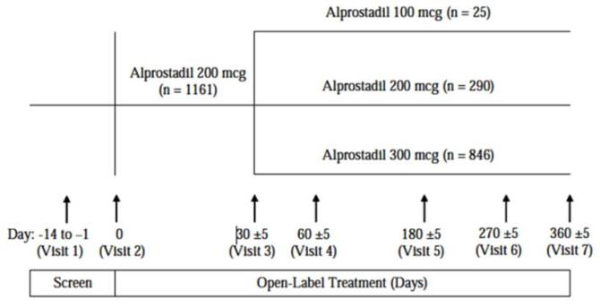

Efficacy variables and outcomes
The primary efficacy endpoint was the change in the IIEF Erectile Function domain score from baseline to the final visit (Visit 7 or Month 12) – no patient reached Visit 7, because of premature study closure, so this endpoint could not be assessed. The protocol specified that results at the 6-month visit (Visit 5) were also to be included as part of the primary analysis and, under the circumstances, can be considered to represent the most appropriate primary efficacy endpoint.
Secondary endpoints were very similar to those previously described in other studies, and were listed as follows:
1. Changes in non-EF Domain Scores of the IIEF
    - Orgasmic Function (Questions 9 and 10)
    - Sexual Desire (Questions 11 and 12)
    - Satisfaction of Intercourse (Questions 6-8)
    - Overall Satisfaction (Questions 13, 14)
2. Responses to a Global Assessment Questionnaire (GAQ), single question (yes/no)
3. Sexual Encounter Profile (SEP) Questionnaire, 5 questions (yes/no) assessing performance if an encounter was attempted
4. Patient Self-Assessment of Erection (PSAE) Questionnaire, one question assessing tumescence/erection with a rating scale of 1 [no erection] through 5 [excessive rigidity]; and one question assessing subject and partner adverse events (diary page was completed by the subject after each use of study medication).

Analysis populations
The Sponsor based their assessment on subjects who received at least one dose of study medication. Some analyses also compared the different dose groups, but this was of limited value given that treatment allocation was non-random.

Sample size
Treatment was non-random and the study design was not capable of demonstrating a treatment effect relative to a control group, so sample size was primarily based on logistical considerations. Because of early study termination, the number of subjects receiving long-term treatment was well below target and, as noted below, the primary statistical approaches had to be abandoned.

Statistical methods
The primary analysis was intended to be a series of one-way ANOVAs on changes from Baseline to Visit 5, from Baseline to Early Termination (ET) and from Baseline to Study Closure (SC), with final dose after titration (100, 200 or 300 mcg) as the study effect.
Because only a minority of subjects reached Visit 5, the sample sizes among the three dose groups were small, and the Sponsor reported that the one-way ANOVAs on the mean IIEF primary domain scores and changes from baseline were “not meaningful”.
Instead, a two-way ANOVA was performed on changes from Baseline through Visits 5, ET, and SC, with dose and Visit interaction as treatment effects.
An exploratory analysis was also conducted by evaluating the proportions of subjects in each final dose group who showed an improvement at each major time point, via the chi-square test. For the non-erectile domain scores, the data were analysed using ANOVA. For SEP, GAQ and PSAE scores, the results were analysed with chi-square tests.
Given the non-random nature of the treatment assignments, all of these analyses should be considered descriptive and exploratory.

Participant flow
Patient disposition is summarised in the table below.
Table 62. Disposition of Study Subjects, Study MED 2000-006.
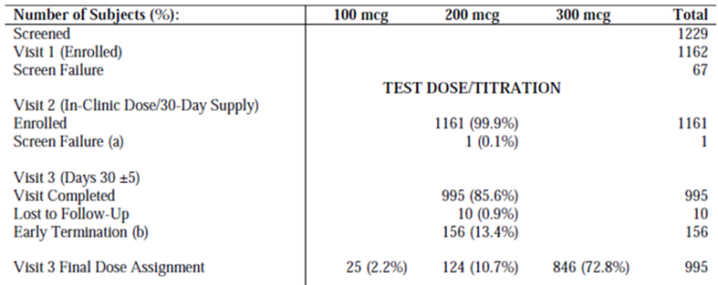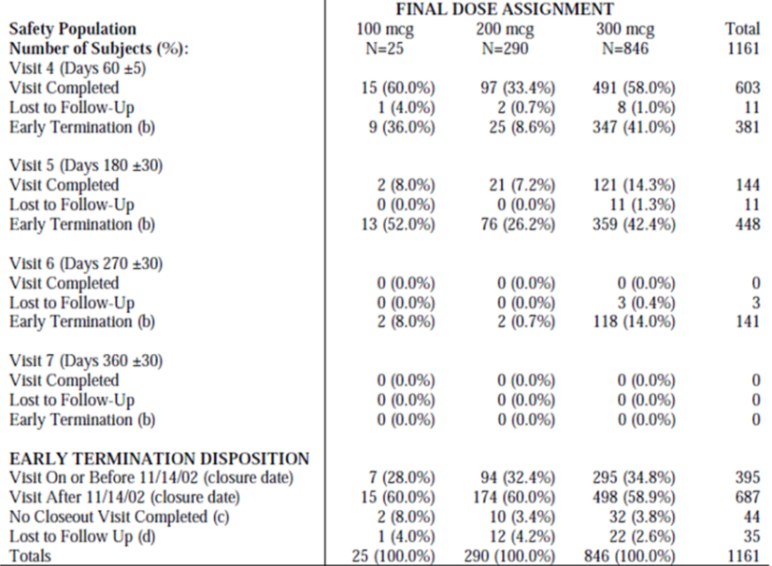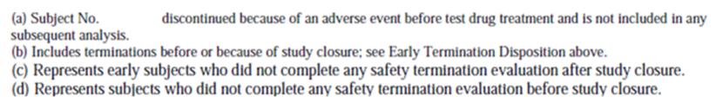
Follow-up was adequate to Visit 3 (completed by 86% of subjects), which was the point at which subjects were titrated to their final dose group, but it was inadequate thereafter. Completion of Visit 4 was only achieved in 603/1161 (52%), with unequal follow-up across different dose groups (33-60%). Completion of Visit 5 was only achieved in 141/1161 subjects (12%).

Major protocol violations/deviations
No patient completed the study according to the original protocol, because of the study’s early termination. Accordingly, some investigators cited this termination as a protocol deviation, whereas the Sponsor argued that the termination should not be considered as a deviation. Regardless of how these terminations are classified, it is clear that the study was markedly compromised and did not run accordingly to plan.
Major protocol violations were not listed in a convenient format, but the table below represents the Sponsor’s listing of deviations. Relative to the problems raised by the early termination of the study, this short list of deviations does not raise any new methodological concerns.
Table 63. Protocol Deviations, Study MED 2000-00.
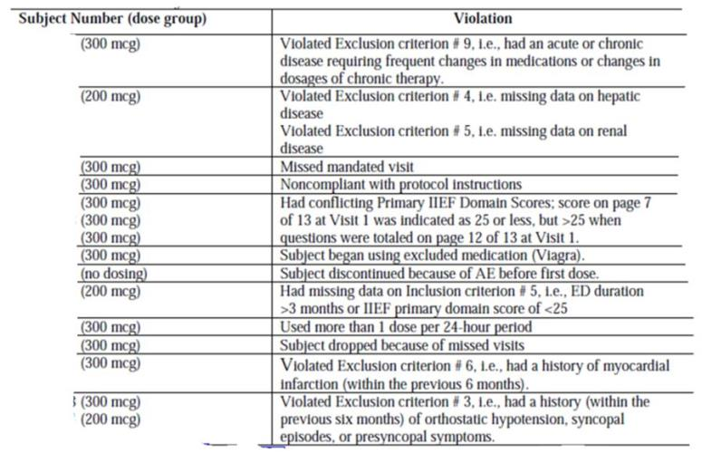

Baseline data
Baseline demographic and disease data are summarised below. In demographic terms, the population studied appears broadly typical of those intended to be treated with alprostadil, and the dose groups were similar. In terms of baseline disease characteristics, the group titrated up to 300 mcg had slightly worse baseline erectile function (mean EF score 12.8) than those left on 200 mcg (mean score 13.5) or down-titrated to 100 mcg (mean score 15.4); this is consistent with the non-random allocation of patients to the final dose, and makes it difficult to draw meaningful comparisons between dose groups.
Table 64. Baseline Demographic Data, Study MED 2000-006.
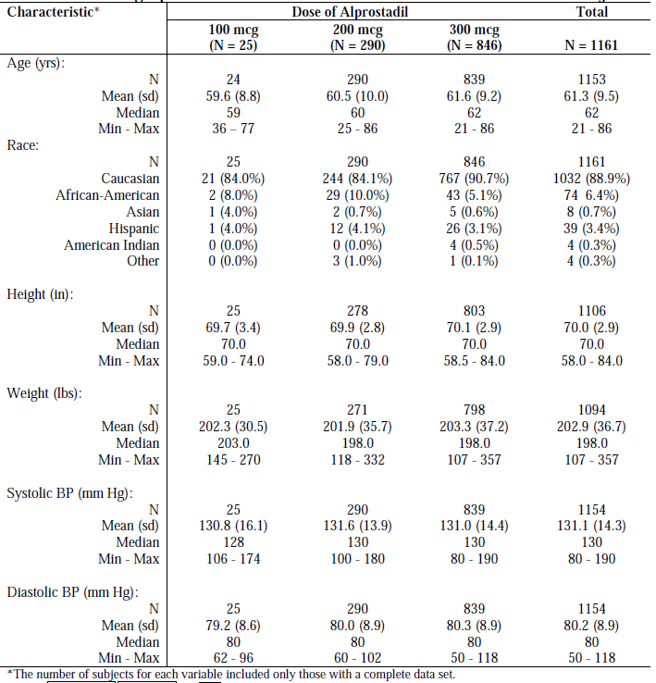
Table 65. Baseline Disease History, Study MED 2000-006.
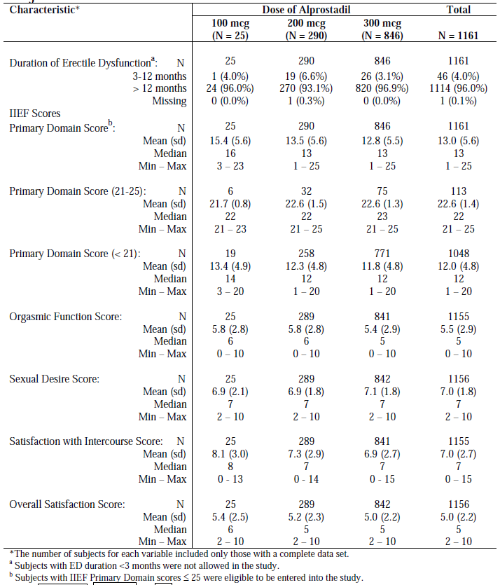

Results for the primary efficacy outcome
For the primary efficacy variable of EF Domain Score in the IIEF (referred to as the “Primary” Domain Score in the study report), results were assessed as changes from Baseline to Visit 5, from Baseline to Early Termination, and from Baseline to Final Visit before study closure. The number of subjects in the 100 mcg group who reached Visit 5 was only 2, preventing meaningful interpretation of the results at this dose, and the number of subjects in the 200 mcg dose group who reached this visit was also low (n=20) – many of the subjects who completed the study on 200 mcg did so because they did not stay in the study long enough to be titrated. The 300 mcg dose group had better representation at Visit 5 (evaluable n=119), but their results are almost impossible to interpret given the non-randomised nature of the study and the lack of any appropriate comparator group.
No significant between-group differences were observed using one-way ANOVA, but this does not allow any conclusions to be drawn about the relative efficacy of the different doses.
Table 66. Mean Changes in the IIEF Erectile Function Domain Score, Study MED 2000-006.
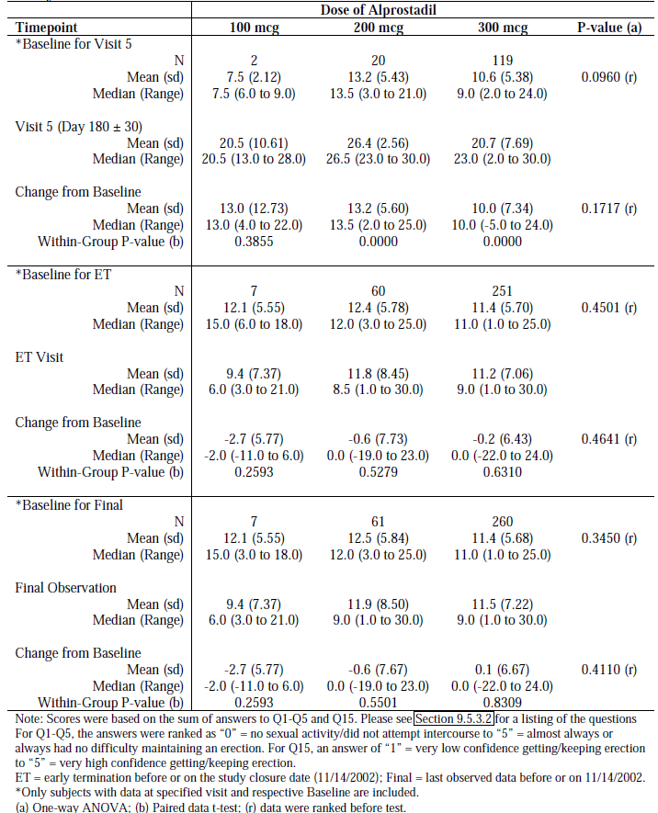
Paired t-tests were also performed, showing statistically significant within-group changes, but without a placebo control group it is not possible to estimate whether any of the observed improvements were due to the pharmacological action of alprostadil. Mean EF scores in the alprostadil 300 mcg group approximately doubled by Visit 5, from a baseline of 10.6 to a final score of 20.7. Potential explanations include natural fluctuations in the underlying condition, selective dropout of patients with poor erectile function, psychological expectations of improvement associated with the unblinded nature of the treatment, or biases or other inaccuracies in the measurement tools that reman uncorrected because of the lack of a placebo control. (The table itself provides evidence that less responsive patients dropped out: mean EF scores for subjects at “Early Termination” were worse than baseline in every dose group.) It is also possible that some of the apparent improvement represents an actual pharmacological response to treatment, but the pivotal Phase 3 studies suggested that the placebo-subtracted treatment effect on EF scores is of the order of 3 points, not 10 as suggested by this open-label study.

Results for other efficacy outcomes
The Sponsor provided results for all of the other secondary endpoints, and statistically significant within-group improvements were noted for several of these endpoints, but in every case it was impossible to estimate how much of the observed improvement represented a pharmacological effect. These results are included, for completion, but add little to the understanding of the efficacy of alprostadil. Between-group comparisons were not meaningful given the low number of subjects in the 100 mcg and 200 mcg dose groups, the non-random allocation of doses, and the unequal duration of follow-up. For some measures and at some time points, there was a statistically significant group effect, with the results in the 300 mcg group showing inferior scores to those seen in the other two dose groups; this is likely to reflect the fact that patients with poor erectile function were more likely to be up-titrated to the higher dose, and reveals nothing about the relative efficacy of the doses.
Overall, the secondary efficacy results were concordant with the primary results of this unblinded study, but discordant with the same efficacy parameters assessed in the blinded, placebo-controlled pivotal studies. The general pattern was that subjects continuing to Visit 5 showed improvement, and subjects reaching early termination showed deterioration in scores. This was most stark in the GAQ, shown below, where the absolute number of subjects on 300 mcg who reached Visit 5 and reported that their erections had improved was 108/119 (90.8%), whereas the number of subjects who terminated early and felt that their erections did not improve was 194/263 (73.8%).
Table 67. GAQ at Visits 3, 4, 5, 6; early termination and final observation.
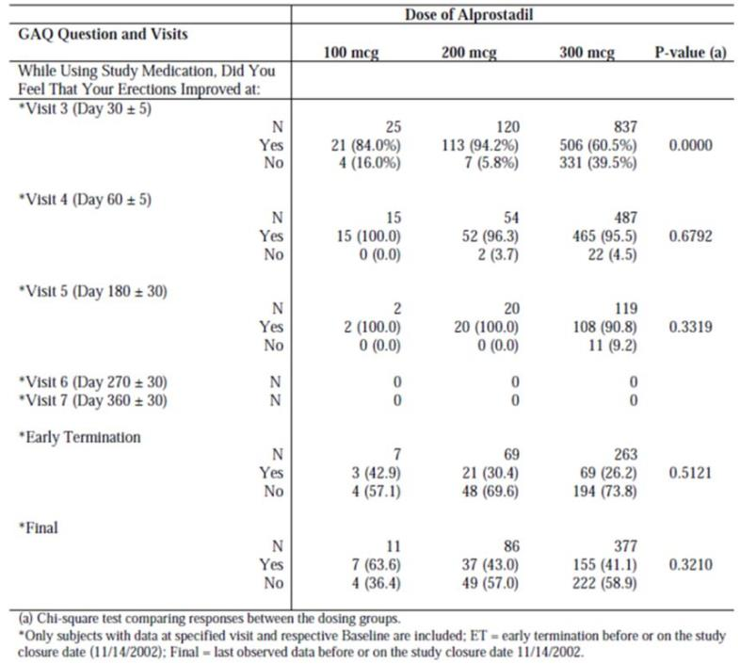

Phase 2 Instrumental Study (MED 2000-007)
A Randomized, Placebo-controlled, Double-blind, Crossover Design Phase 2 Study of the Efficacy and Safety of Alprox-TD in Subjects With Erectile Dysfunction Using Rigidity and Tumescence Monitoring
Study MED 2000-007 was submitted as an efficacy study, but it did not use alprostadil in a natural setting and it lacked natural clinical endpoints. It measured the erectile response to erotic videos, using instruments, and it employed a crossover design more typical of a PD study. (On the other hand, subjects were not completely healthy volunteers but instead had a clinical history of erectile dysfunction.) Although it was a Phase 2 study, patient numbers were low (enrolled n=27, evaluable n=26).
The results of the study were negative, but the Sponsor attributed this to inadequacies in the recording equipment and the event-detection algorithm, and subsequently rejected the study. In support of their claims, the Sponsor provided tracings of the erectile responses of individual subjects, together with the automated analysis of those responses, and pointed out that the number and duration of events was not correctly deduced by the automated system (an example is shown under “Results”, below). The Sponsor also reported that there were systematic differences in the behaviour of the recording equipment across different recording sessions.
Having reviewed this data, the Evaluator agrees that the data collection was probably technically inadequate. Furthermore, the negative results were not concordant with the larger pivotal clinical studies, and, even if the study had been technically adequate, its results would have had unknown applicability to a more natural clinical setting. Thus, overall, the Evaluator agrees that this study should be rejected, and it is only described here for completion.

Design
The study used a randomised, double-blind, placebo-controlled, crossover design. There were 5 clinic visits, including a screening visit followed by 4 treatment visits (~7 days apart). At each visit, subjects received a single dose of placebo or alprostadil at a dose of 100 mcg, 200 mcg or 300 mcg, in random order.
During the screening visit, subjects were connected to a tumescence/rigidity measuring device (RigiScan®) and instructed to select a sexually explicit video for viewing. After a 10-15 minute period of adjustment, a 20-minute baseline RigiScan® measurement was taken while the subject viewed the video.
On subsequent visits, a similar procedure was followed, but after the subject chose the video, a single dose of study medication was administered prior to watching the video. The subject then had three video sessions of 20 minutes each, separated by 20 minutes of rest. Erectile responses during the viewing were recorded and analysed.
To be eligible, subjects had to be heterosexual males over 21 years of age who had a history of erectile dysfunction for at least 3 months. As in the Pivotal Phase 3 studies, ED was defined as “the inability to attain and maintain an erection of the penis sufficient to permit satisfactory sexual intercourse”, but the subject could have an EF score of up to 25 and still be eligible; this is consistent with an occasional inability to have a satisfactory erection, rather than a total inability. The subject was also required to have a RigiScan® response to video sexual stimulation (VSS) of at least 20% rigidity for at least 3 minutes at the screening visit; this excluded subjects with severe ED.
Exclusion criteria were similar to the pivotal efficacy studies, and they were summarised by the Sponsor as follows:
the subject had erectile dysfunction (ED) caused by untreated endocrine disease, i.e., hypopituitarism, hypothyroidism, hypogonadism; the subject had significant penile pathology including, but not limited to, curvature, fibrosis, sexually transmitted disease, and penile implant; the subject had a history within the previous six months of orthostatic hypotension, syncopal episodes, or presyncopal symptoms; or the subject had a history of myocardial infarction within the previous 6 months.
These exclusion criteria were reasonable, and were clearly aimed at excluding subjects in whom treatment would be dangerous or the response would be difficult to interpret, or for whom, in the case of untreated endocrine disease, more appropriate treatments existed.
The study was conducted in the USA, and ran from February 18, 2002 to August 6, 2002.

Treatments
Each subject was randomly assigned to one of the following four treatment sequences:
- Sequence 1: Placebo, 100 mcg, 200 mcg, 300 mcg
- Sequence 2: 300 mcg, placebo, 100 mcg, 200 mcg
- Sequence 3: 200 mcg, 300 mcg, placebo, 100 mcg
- Sequence 4: 100 mcg, 200 mcg, 300 mcg, placebo
As in the pivotal efficacy studies, the assigned dose of alprostadil was diluted in 100 mg of cream, and applied topically to the penile meatus and glans.

Endpoints
The primary efficacy endpoint was an instrumental measurement, rather than a clinical result:
Total cumulative time of rigidity ≥ 60% (base and tip), measured in minutes, observed after the administration of a single dose of active drug versus placebo treatment.
Secondary efficacy endpoints were also instrumental:
- Area under the curve (AUC) for total cumulative time of rigidity ≥ 60% (base and tip).
- Time of onset of rigidity ≥ 60% (base and tip).

Analysis
The cumulative time of rigidity was analysed using repeated measures ANOVA, with initial terms for treatment, sequence, period, treatment by sequence and treatment by period interactions. The model was refined in a stepwise manner until only significant (p ≤ 0.05) terms remained. Comparison of each active dose to placebo was performed through linear contrasts.
Data collection points were 30 seconds apart, and a complex algorithm was used to interpolate and extrapolate from these data points to produce an overall estimate of the number of erectile responses and their duration.
All other baseline continuous variables were presented with descriptive statistics and also analysed with one-way analysis of variance (ANOVA).
Statistical significance was defined as a p-value ≤ 0.05.

Baseline data
Baseline demographics and erectile responses were as shown below, sorted by assigned treatment sequence.
Table 68. Demographic characteristics and baseline variables of ITT population by treatment sequence.
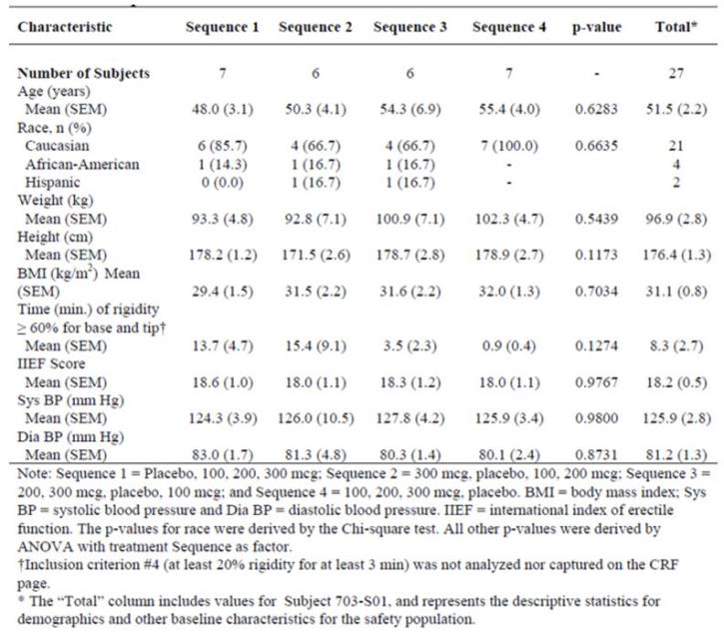

Results
Results for the primary endpoint (cumulative rigidity time) as well as the two main secondary endpoints (AUC for rigidity and time to onset of rigidity) are tabulated below. The best results for cumulative rigidity time were obtained with placebo. There was no apparent dose trend for any measure, and in fact the AUC with placebo was greatly superior to that observed with alprostadil 200 mcg (approximately ten-fold), with the 300 mcg dose ranking second behind placebo and the 100 mcg dose ranking third. The only finding reaching statistical significance was the AUC for the 200 mcg dose, which was significantly inferior to placebo.
Table 69. Cumulative time, AUC and time to onset of rigidity ≥ 60% in each dose group.
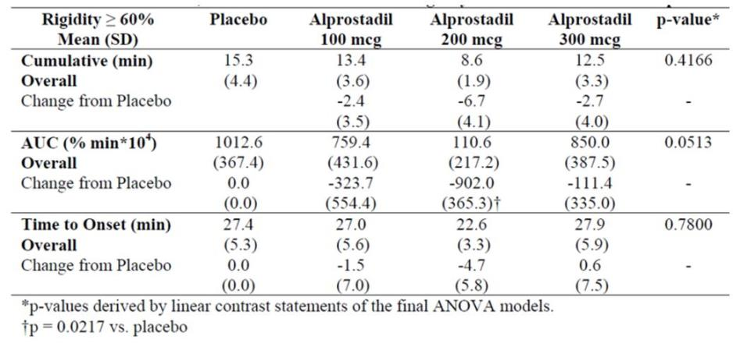
An example of an individual recording is shown below. The Sponsor points out that the automated detection algorithm rated the duration of the erectile response for the second video as longer than for the third, even though the response was below threshold for much of the second video.
Figure 6. RigiScan Recording Example.
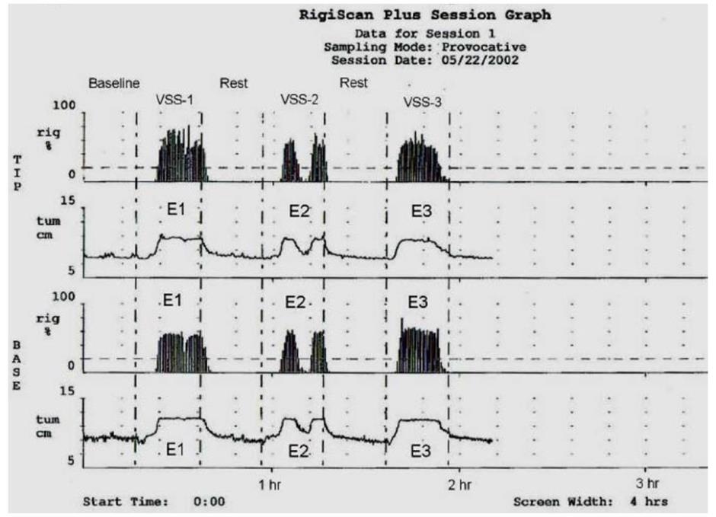
On balance, these results do not seem reliable, especially given that, in larger efficacy studies, the same doses were reported by patients to produce an overall improvement in erections by a number of subjective measures.

Phase 2 high-dose study MED 99-001
Randomized, Placebo-Controlled, Double-Blind, Multicenter, Parallel Design Trial of the Efficacy and Safety of Alprox-TD (alprostadil USP) cream in Patients With Mild to Moderate Erectile Dysfunction.
This study had a similar design to the previously described Phase 2 study in mild to moderate ED, MED 99-002A, but it used higher doses: 500 mcg, 1000 mcg or 1500 mcg in 250mg of topical cream, applied as usual to the meatus and glans.
The study was intended to continue until 32 patients had been recruited to each treatment group. Instead, only 29 patients in total were enrolled into the study and received a randomised double-blind test dose and, of these, 13 patients continued treatment with take-home doses before the study was abandoned because of unacceptable tolerability at the doses used. Among patients who received active treatment, 9 of 21 failed to tolerate the test dose based on the protocol criteria (reasons for poor tolerability are discussed in the Safety section).
In the Clinical Overview, the Sponsor says of this study:
This study will be discussed further in the safety section but it is not considered relevant to the efficacy of the Vitaros preparations that are the subject of this submission.
It was intended that the primary efficacy parameter would be the change from baseline in the
EF score of the IIEF, with secondary parameters including the following:
- Change from baseline in the non-erectile function domains of the IIEF
- Overall IIEF score.
- Successful vaginal penetrations (relative to number of attempts) based on Q3 of the SEP.
- Patient Self-Assessment of Erection rating scale (PSAE).
- Global assessment questionnaire (GAQ).
The primary method of analysis was intended to be an ANCOVA model.
In practice, because the study was terminated early, the Sponsor did not perform any analysis of the results, and did not even provide descriptive statistics for the primary and secondary efficacy parameters. Instead, only individual patient listings were included in the study report. Although it was appropriate to refrain from a formal statistical comparison of the treatment groups given the premature termination of the study, some attempt should have been made to present the information in a comprehensible format for evaluation. Accordingly, the Sponsor should be asked to present the main efficacy variables from this study in terms of means and mean changes in each treatment group, with standard deviations.

Chinese study NM-AP-38 (befar vs placebo)
A Multi-center, Randomized, Double-Blind, Placebo Controlled Clinical Study to Assess the At-home, Efficacy and Safety of Alprostadil Cream for the Treatment of Erectile Dysfunction
This study was not promoted by the Sponsor as a major supportive study, but it was a reasonably large (n=157), randomised, blinded, placebo-controlled Phase 2 study assessing alprostadil at a dose of 300 mcg (equivalent to one of the doses propose for registration), in males with ED, in a home use setting for 4 weeks.
The formulation used did not include any DDAIP, and the quantity of cream (75mg per dose) was different to that proposed for Vitaros, so it can only be considered indirectly supportive, but it achieved statistically significant results that add to the overall level of evidence.
Only a study synopsis was available for evaluation, not a fully detailed study report.

Design
The study used a randomised, double-blind, placebo-controlled design to compare topical Befar (alprostadil 300 mcg in 75mg cream without DDAIP) to matching placebo in subjects with “erectile dysfunction of psychogenic, organic or mixed aetiology” of more than 3 months’ duration. Criteria in terms of IIEF score were not clearly described in the study synopsis.

Treatments
Subjects were randomised with equal probability to alprostadil (n=80) or placebo (n=77). They received a minimum of 4 to a maximum of 16 doses of the drug over a 4 week take-home period.
Initially, patients were given 8 doses and were asked to return to the hospital in 2 weeks for evaluation and to receive 8 more doses of medication. Patients were asked not to use the medication more than once a day.

Endpoints
The primary efficacy variable was the change from baseline in the summed scores of IIEF Question 3 (penetration, range 0-5) and Question 4 (maintenance of erection to ejaculation, range 0-5).
Secondary endpoints were said to include the other questions of the IIEF as well as a GAQ, but details were not provided.

Analysis
A t-test and rank sum test were used for the primary analysis of efficacy (IIEF Q3 and Q4), comparing the alprostadil and placebo groups. Secondary efficacy endpoints from the IIEF (the other 13 Questions of IIEF) were examined similarly, and a chi-squared test or exact probability were used for the global efficacy evaluation questionnaire (GAQ). A p-value of <0.05 was considered significant. SPSS 9.0 and SAS 6.12 were used for performing the statistical calculations.

Results
The study report was not found in the digital submission, but the following description of the efficacy results was provided in the synopsis:
After 4 weeks of therapy, alprostadil cream was shown to be significantly (P<0.001) effective over placebo in the sexual function endpoint analyses. The primary efficacy variable, the change in baseline scores (Question 3 plus question 4 on the International Index of Erectile Function, IIEF) revealed a statistically significant (P<0.001) improvement over placebo. The alprostadil cream had an effective rate of 67.5% vs. 13.0% for placebo. The secondary efficacy results (IIEF question 1, 2, 5-15) fully support the primary efficacy evaluation results. Clinical efficacy evaluated by doctors based on patient’s diary (penile rigidity scores) was 74.03% for the alprostadil cream vs. 18.18% for the placebo. Further analyses using the global assessment questionnaire (GAQ) also showed that 75.3% of the patients using the active cream improved their erections over the 4 week therapy period vs. only 19.5% of the placebo group. The efficacy evaluated by the number of successful intercourse attempts per total intercourse attempts revealed an efficacy rate of 89.5%, 65.0% and 48.9% for mild, moderate and severe ED patients in PGE1 group versus 31.3%, 27.4% and 6.1% in placebo group.
It remains unclear what is meant by the expression “an effective rate of 67.5% vs. 13.0% for placebo”, which could reflect an issue with translation of the Chinese study report; this could refer to net changes in mean scores, or to response rates, and the Sponsor should be asked to provide further details. The number of subjects reporting an improvement on the GAQ was 75.3% for alprostadil, compared to 19.5% with placebo; this is considerably better than the results in the Phase 3 pivotal studies (improvement on placebo 20.3%, alprostadil 200 mcg 46.8%, alprostadil 300 mcg 51.5%).
Overall, despite the fact that this study used a different formulation and was not reported in detail, it adds some external validity to the findings of the pivotal studies.

Analyses performed across trials (pooled & meta analyses)

Pivotal studies
The pivotal studies shared an identical design and were presented in an integrated study report, the results of which have already been discussed.

Phase 2 formulation studies
Several studies performed in China assessed the efficacy of alprostadil creams containing various concentrations of DDAIP. Many of these were small open-label studies, or they were presented in insufficient detail to allow a critical evaluation, but 3 of the studies used an appropriate double-blind, randomised design and also shared enough design features that they could be sensibly pooled for analysis.
The results were presented in an integrated summary report, which concluded that DDAIP at strengths of ≥ 0.05% improves the efficacy of alprostadil cream. These studies lacked a true placebo group, because all subjects received alprostadil, but they employed a zero-DDAIP “placebo” arm, and efficacy in this group was significantly inferior to other groups who received alprostadil in conjunction with DDAIP, as shown in the tables and figure below.
It is assumed by the Sponsor that the group differences in these studies were due to improved local absorption of alprostadil with DDAIP formulations, such that the benefit was mediated through pharmacokinetics, but no direct PK assessment of this effect was performed. (Although levels of alprostadil after topical administration are very low, the metabolite 15-keto-PGE₀ could have been used as a surrogate PK marker.)
Without a true placebo group, these studies are not able to establish the efficacy of alprostadil itself, and it is unclear to what extent the observed improvements or “Response rates” represent a true pharmacological response to alprostadil, rather than a placebo effect or the natural history of the underlying condition.
The Response Rates (derived from Q3 and Q4 of the IIEF) with each formulation are summarised in the table and figure below, with GAQ summarised in the subsequent table. For DDAIP strengths of ≥ 0.05%, the results were better than the DDAIP-free formulations, but no consistent dose trend was observed over the range 0.05% to 5.0%. Results with a DDAIP strength of 0.01% were only slightly better than placebo.
These results broadly support the inclusion of DDAIP in the Vitaros formulation, and suggest that a strength of at least 0.05% is appropriate. These studies do not, however, provide any specific evidence in favour of the proposed strength of 2.5% over lower strengths such as 0.05%. In view of preclinical studies that raised concerns about potential carcinogenicity of DDAIP, and the FDA’s rejection of Vitaros on the grounds of incompletely characterised carcinogenic risk, it would be appropriate to use the lowest possible strength of DDAIP that is compatible with reasonable efficacy. These Phase 2 Chinese studies do not provide an adequate rationale of the chosen DDAIP strength, and the issue has not been explored further in any of the submitted USA studies.
Table 70. Effect of DDAIP on Response Rate (%) in 3 Pooled Chinese Studies.
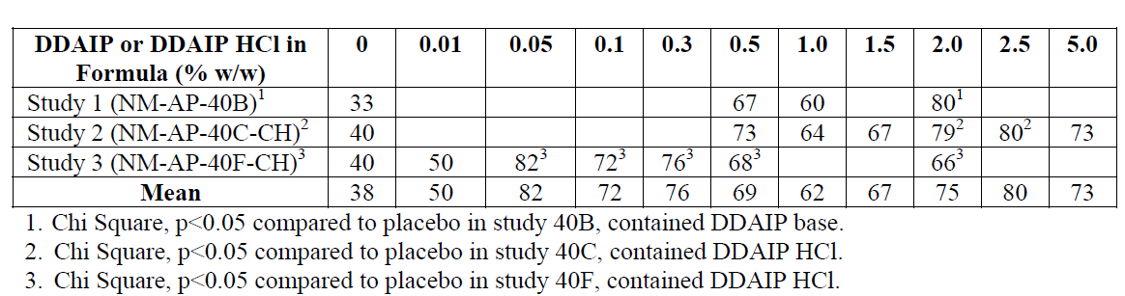
Figure 7. Effect of DDAIP on Response Rate (“Percent Efficacy”) in 3 Pooled Chinese Studies.
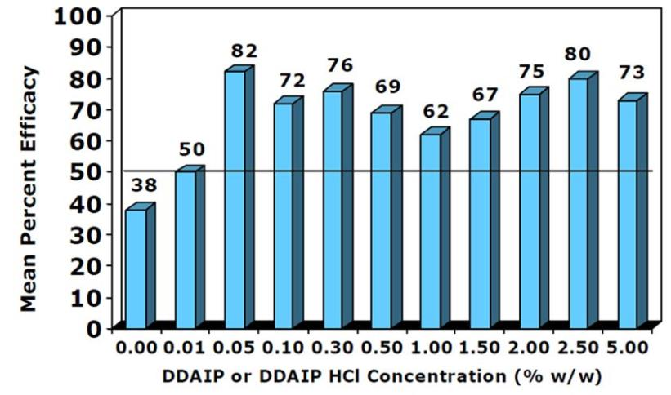
Table 71. Effect of DDAIP on Global Assessment (% Improved) in 3 Pooled Chinese Studies.
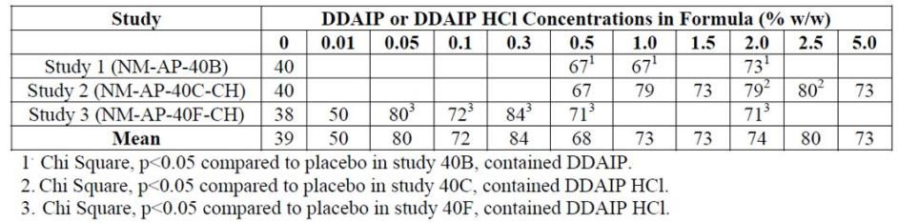

Evaluator’s conclusions on efficacy
The submitted studies characterised the efficacy of Vitaros in men with ED of varying severity and showed a statistically robust but clinically modest benefit over placebo. The benefit appeared to be more consistent in subjects with severe ED.
The main evidence establishing the efficacy of Vitaros came from two identically designed pivotal studies (MED 2000-004 and MED 2000-005), which tested three alprostadil doses (100 µg, 200 µg and 300 µg) in comparison to placebo over 12 weeks. The two highest doses in these studies correspond to the proposed doses. The pooled pivotal population achieved a positive result for each dose and for each of three different co-primary endpoints (giving nine dose endpoint combinations, all positive), as shown in the table below. For two of the endpoints (International Index of Erectile Function [IIEF] Domain scores, and Mean Percent Ejaculation Success), the 200 µg dose group achieved results that were numerically superior to the 300 µg dose group; for the third endpoint (Mean Vaginal Penetration Success), the 300 µg dose group was numerically superior to the 200 µg dose group. For all endpoints, doses of ≥ 200 µg achieved improvements that were numerically superior to those obtained with 100 µg. The individual studies were broadly concordant with these results, but did not achieve significance for every dose endpoint combination. For the 300 µg dose group, five of six co-primary endpoints across the two studies were positive, but significance was not achieved for Mean Percent Ejaculation Success in Study MED 2000-005, as shown in the tables below. For the 200 µg dose, significance was achieved in six of six co-primary endpoints across the two studies.
Table 72: Pooled efficacy results, pivotal studies MED 2000-004 and -005.
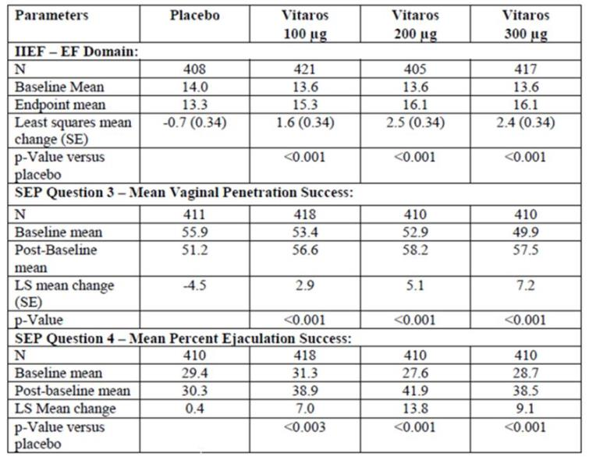
Table 73: Erectile Function Domain scores, Studies 004 and 005 individually (ITT-E).
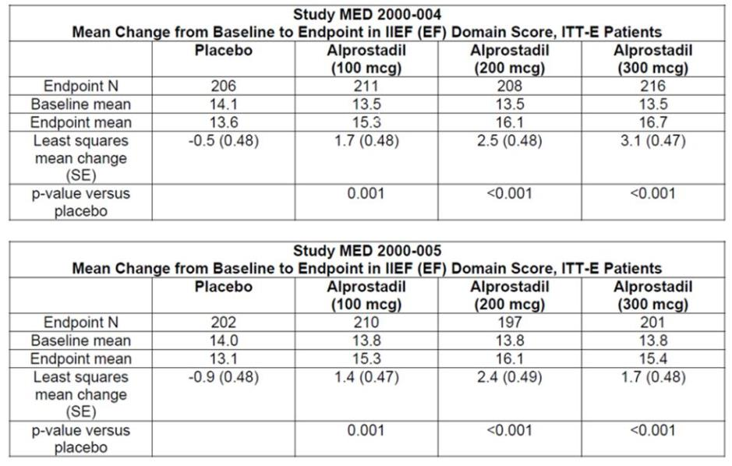
Table 74: Mean Vaginal Penetration Success, Studies 004 and 005 individually (ITT-E).
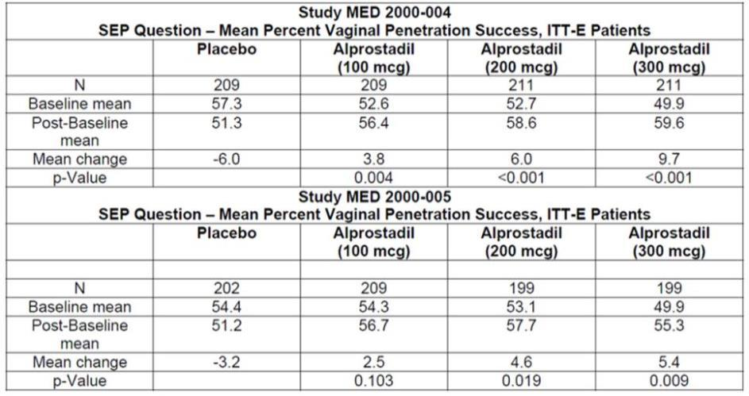
Table 75: Mean Ejaculation Success, Studies 004 and 005 Individually (ITT-E).
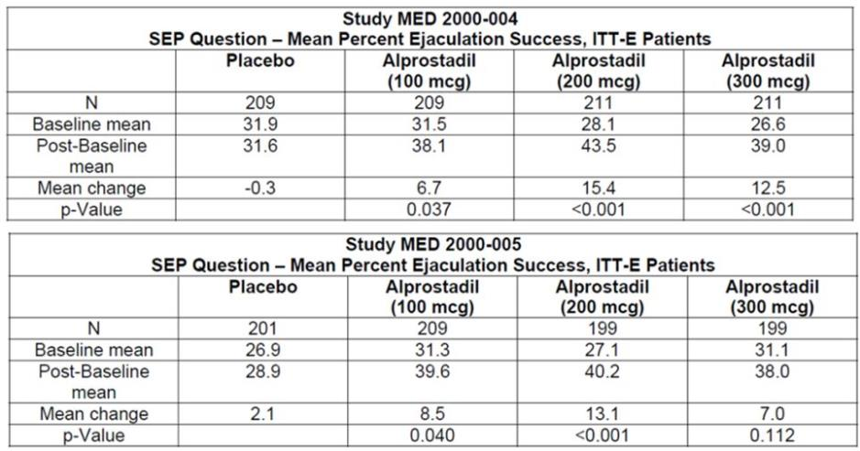
Secondary endpoints generally supported primary endpoints. For the Global Assessment Questionnaire (GAQ), 46-56% of subjects reported improvement (varying across the two studies and two higher dose groups), compared to only 20-21% of placebo subjects.
Table 76: Patient’s Global Evaluation, Studies 004 and 005 Individually (ITT-E).
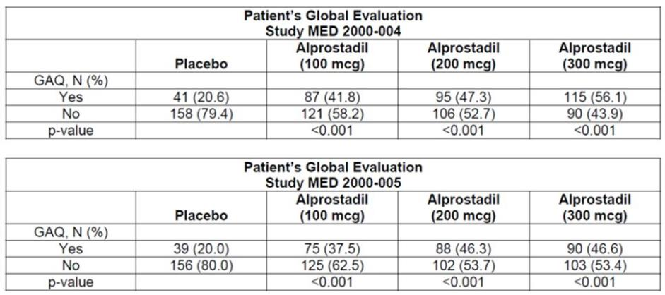
The studies appeared to be methodologically sound, but it is likely that the apparent treatment effect has been inflated by withdrawal bias and by some degree of unblinding due to tell tale side effects.
The improvements seen in the two highest dose groups are modest, only amounting to about 2.5 points from a 30 point range. The improvements are nonetheless likely to be perceived as clinically worthwhile by some patients, particularly because patients finding the treatment useful could self-select to continue treatment, whereas patients finding the treatment inconvenient, intolerable or ineffective could judge the benefit-risk balance for themselves and decide to discontinue treatment. Thus, efficacy in patients choosing to continue treatment is likely to be better than the overall mean change in scores observed in the pivotal studies. From the GAQ results, it can be estimated that one in three subjects would be expected to report an improvement in erectile function on treatment, over and above the improvements observed in the placebo group.
Subgroup analyses showed that Vitaros has broadly similar benefit in a number of subgroups, including those defined by diabetes, hypertension, and cardiac disease. Subgroup analysis according to age (≤65 years or >65 years) was attempted but it was underpowered. Subjects who had tried Viagra and failed did show a partial response to alprostadil, but the magnitude of the benefit was inferior to that achieved in the overall cohort, and statistical significance was not achieved for some endpoints.
One subgroup analysis of the pivotal efficacy data raises concerns about the use of Vitaros in men with mild ED. As shown below, the mean changes in Erectile Function (EF) scores in this subgroup were negative in all treatment groups, and improvements in the mild-to-moderate group were marginal.
Table 77: Response in Subgroups by Severity, Studies 004 and 005, Pooled.
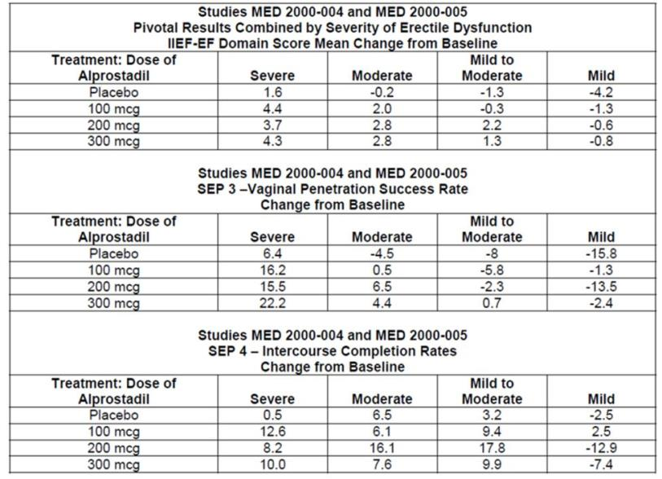
Taken at face value, the negative scores in the mild subgroup indicate that the overall effect of Vitaros may be negative in men with mild ED. Although the deterioration in scores was worse in the placebo arm of the mild subgroup, so that the active groups fared better than placebo, this does not necessarily mean that treatment produced a net benefit – placebo subjects did not necessarily exhibit results equivalent to the natural, untreated history of the condition because they had to undergo a somewhat intrusive treatment with the administration of placebo cream via a dispenser. It is quite possible that the use of a topical cream and a dispenser removes some spontaneity from the sexual act, has other negative psychological effects on sexual function, or produces local side effects that interfere with sexual function. The results shown suggest that, in mild cases, this negative effect is not completely overcome by the pharmacological benefits of treatment. At present, this negative effect is an unconfirmed post hoc observation, about which there is still uncertainty (the results were not presented with comparative statistics but were likely to have been underpowered); it is nonetheless clear that there is no evidence in the pivotal studies of a positive effect in this subgroup. Limited evidence from the Phase II study program is partially reassuring, because positive results were obtained in the mild-to-moderate study, but it is noteworthy that the Phase II program also showed discordant results in subjects with mild versus severe disease.
Only two Phase II studies of Vitaros contributed useful efficacy data. Each focussed on a particular range of ED severity. The study in mild-to-moderate ED (MED 99-002A) showed borderline benefit by the primary analysis method (among group treatment effect on change in EF scores by ANCOVA, p = 0.051 in the ITT analysis, p = 0.050 in the sponsor’s preferred Per Protocol analysis). The pairwise comparisons did strongly favour the 200 mcg dose over placebo, however (p = 0.007), and the test for a linear dose trend was also statistically significant (p = 0.015). Benefit for the 50 µg and 100 µg doses over placebo was not significant. (This study did not employ the main proposed 300 µg dose group, but in other studies 200 µg and 300 µg produced similar efficacy.) Some issues were noted in the reporting of this study in the sponsor’s clinical overview, where the less favourable ITT results were de-emphasised and erroneous p-values were cited.
Table 78: Results for primary endpoint, Intention to Treat (ITT) population, Study MED 99-002A.
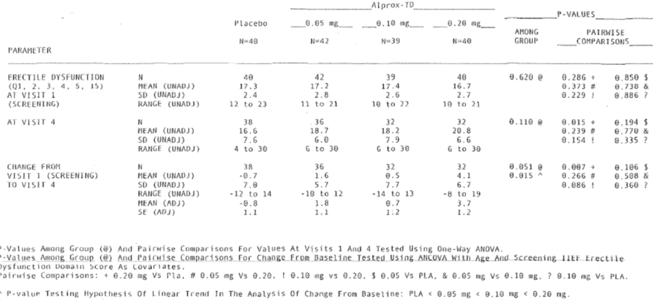
The sponsor did not perform any subgroup analysis of these results, so it is unclear whether subjects with mild ED (as compared to the broader cohort of mild-to-moderate ED) experienced any benefit from treatment.
The study in severe ED (MED 2000-002A) assessed doses of 100 µg, 200 µg and 300 µg, and it showed marked benefit relative to placebo in the highest dose group (an improvement of 9.44 points, compared to 2.67 with placebo, from a 30 point scoring system). Improvements in the EF score were intermediate for lower doses, and did not achieve statistical significance. Results in the GAQ, a secondary endpoint, also showed that active treatment was thought to lead to improvement in a higher proportion of subjects than achieved with placebo. (With alprostadil 300 µg, 83% of subjects felt that there had been at least some improvement, compared to only 26% in the placebo group.) This study therefore provides strong support for the overall pivotal study results, but only in subjects with more severe ED.
Table 79: Changes in EF Domain score (ITT-E), Study MED 2000-002A.
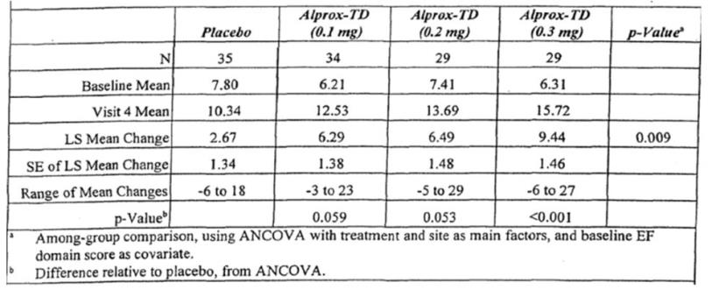
The other Phase II studies produced no useful efficacy data: one high dose study (MED 99-001) was abandoned because of poor tolerance; and, in an instrumental crossover study (MED 2000-007), the recording procedure appeared to be technically inadequate.
A long term Phase III extension study produced results that were of little value because treatment was open label and non-randomised and because the study was terminated prematurely.
Considering all of the submitted efficacy studies, there does not appear to be any good evidence establishing that alprostadil 300 µg has greater efficacy than 200 µg. In fact, in one of the submitted documents, a drug monograph intended for Canada the following statement occurs, at complete odds with the proposed Australian dosing recommendations:
It is preferable that patients be initiated with the lower 220 µg Vitaros dose.
One of the biggest deficiencies in the submitted efficacy data was a failure to defend, in any Phase III study, the need to include DDAIP 2.5% in the Vitaros formulation. Some Phase II Chinese studies of non-Vitaros alprostadil treatment suggested that DDAIP concentrations of ≥0.05 % improved the efficacy of alprostadil, but no consistent benefit was seen across ascending doses above this (Figure 7).
In conclusion, there is reasonably good evidence that Vitaros produces benefit in men with ED, but the magnitude of the benefit is modest, the optimal starting dose is unclear, and the benefit in subjects with mild ED may be particularly weak. The rationale for using DDAIP 2.5% instead of a lower DDAIP concentration is also weak.

Clinical safety

Studies providing safety data
The sponsor’s Integrated Summary of Safety was primarily based on ten studies performed with Vitaros in the US, with the majority of the data coming from two Phase III pivotal studies (MED 2000-004 and MED 200-005) and one Phase III open label extension study (MED 200-006). In the Vitaros studies of men with ED, a total of 3,338 patients were exposed to Vitaros.
All of the Phase III studies assessed the proposed doses (200 µg and 300 µg) and proposed formulation of Vitaros, in addition to the lower dose of 100 µg. The value of the placebo control data was limited by the fact that the placebo cream appeared to contain DDAIP (though this was not clearly described in the study reports). The use of a DDAIP containing placebo means that there is no Phase III DDAIP free control data and it is therefore impossible to gauge the incidence of AEs attributable to DDAIP itself.
The value of the open label extension study, MED 2000-006, was compromised by its premature termination at about six months. This study also lacked a placebo control group, making it difficult to put the observed AEs into context. Finally, it should be recalled that the cohort for this extension study largely consisted of subjects who had already demonstrated tolerance in one of the previous Phase III studies, and the extension study provided relatively few new exposures to active treatment.
In all of the Phase III studies, including the pivotal efficacy studies, the following safety data were collected:
- General AEs were assessed by interviewing subjects and their partners at each follow-up visit.
- AEs related to the site of application, such as local irritation, were also assessed by meatal examinations.
- Haemodynamic responses to alprostadil were assessed by giving each patient a test dose in the clinic at the start of each study, then measuring sitting and standing blood pressure and pulse rate. Patients with local intolerance (penile discomfort) or haemodynamic intolerance (a decrease in systolic blood pressure ≥ 30 mm Hg, a decrease in diastolic blood pressure ≥ 20 mm Hg, or an increase in pulse rate ≥ 30 bpm) were excluded from further treatment; this means that the population studied was not entirely representative of a typical clinical population who would not ordinarily receive a screening test dose at treatment initiation.
- Laboratory tests, including biochemical and haematological monitoring, were performed at baseline and study exit.
- Serious adverse events (SAEs) were collected whenever a subject had an unplanned clinic visit or hospital admission.
- AEs and SAEs occurring in partners were also collected and tabulated, given the potential for transfer of the medication during coitus.
Additional data came from four Phase II Vitaros studies, which similarly involved the tabulation of AEs. Only two of these studies (Med 99-002A and MED 2000-002A) assessed multiple doses of Vitaros at the proposed doses. One of the Phase II studies (MED 2000-007) was a single dose laboratory study. Another study (MED 99-001) assessed doses of 500 µg, 1000 µg or 1500 µg in 250 mg of topical cream, which are higher than that proposed, and this study was terminated prematurely because of poor tolerability.
The final three studies of Vitaros were small, single dose Phase I studies (NM-AP-001, a mixed gender tolerability study, MED 2000-003, a PK study, and NEXSCIN 2001-001, a radiolabelled cream study). AEs were assessed by post treatment interviews and tabulated, but the design of these studies meant that they were only able to detect short term tolerability issues.
The sponsor also submitted several Phase I tolerability studies assessing formulations different to that proposed for marketing, as well as 18 Phase II studies performed in China: the topical cream in those studies variously contained no DDAIP, varying strengths or chemical forms of DDAIP, or varying alprostadil doses.
The irritation studies provided good insight into the irritation potential of alprostadil and DDAIP, but they involved relatively low patient numbers, and the potential for rare idiosyncratic skin reactions or chronic skin reactions was not well characterised with this approach
In general, the safety reports for the Chinese Phase II studies were very brief, but AEs were listed for each study and the overall distribution of AEs resembled that seen in the larger pivotal studies. The information from these minor studies was not integrated into the overall safety database, and this information is of limited value anyway given that the formulations differed from that proposed for marketing and treatment was generally continued for a very short duration, ranging from a single dose to four weeks. In most cases, AEs in the minor studies were limited to local urogenital discomfort.
Additional safety information has come from studies of Femprox, a topical cream being developed to treat sexual dysfunction in women, which is identical to Vitaros but administered at higher doses (500-900 µg). These studies involve 618 female patients treated with alprostadil cream containing up to 0.4% alprostadil and either 5% DDAIP, or 0.5% DDAIP HCl or 2.5% DDAIP HCl.
Some indirect information about the safety of DDAIP also comes from studies of the treatment of fungal toe infections (onychomycosis), where DDAIP was used to improve permeation of the antifungal agent, terbinafine; these studies involved 140 patients treated with 10% terbinafine HCl nail lacquer, containing 0.5% DDAIP HCl (a much lower DDAIP concentration than Vitaros). Systemic absorption via nail lacquer is unlikely to be similar to systemic absorption via a cream applied to a mucosal surface such as the urethra, so these studies are of minimal value and were only included for completion.
Finally, the sponsor described the post marketing experience with Befar (a DDAIP free topical alprostadil cream used to treat ED in China); this exposure amounts to 188,838 doses prescribed and would be equivalent to approximately 517 patient-years of exposure if the product were used once a day (or even more patient-years if the average dosing frequency were less than once per day, as seems almost certain). Unfortunately, details about this post marketing experience were not provided by the Sponsor, merely assurances that it raised no safety concerns.
Overall, the tolerability of Vitaros has been well established. The major deficiency in the submitted information is the lack of long term clinical safety data. It is not possible to rule out, for instance, that DDAIP could be associated with carcinogenesis when used long term.

Pivotal studies that assessed safety as a primary outcome
No pivotal studies assessed safety as their primary outcome, but the open-label Phase 3 extension study, MED 2000-006, was intended to provide long-term efficacy and safety data; this aim was compromised by its early termination. The design of this study is described. Safety data from this study is discussed in the relevant sections below, alongside similar data from the pivotal studies.

Patient exposure

Exposure by study
There were 1,732 patients in the pivotal Phase III studies, MED 2000-004 and MED 2000-005, and 1,161 patients in the long term study, MED 2000-006. Of the subjects in the long-term study, 737 subjects had already received alprostadil in the pivotal. The total number of subjects exposed to alprostadil in the submitted studies was 2,079 and the total number exposed to DDAIP was 3,500.

Exposure by duration
Exposure to alprostadil and DDAIP by time is summarised in the tables below. Exposure in the two pivotal studies was intended to be for 12 weeks and most subjects achieved this. Exposure in the extension study was intended to be for 12 months, but in most cases was <4 months because of premature study closure (median follow-up was just over 3 months). A very small number of patients (n = 4) achieved more than 12 months exposure to Vitaros because they were enrolled into a pivotal study early and/or had relatively long follow-up in the extension study before it was closed.
Table 80: Total Phase III exposure to Vitaros (including exposures to 100 µg dose).
Table 81: Total Phase III exposure to DDAIP (including drug and placebo exposures).
Table 82: Phase III duration in study (includes placebo exposures).
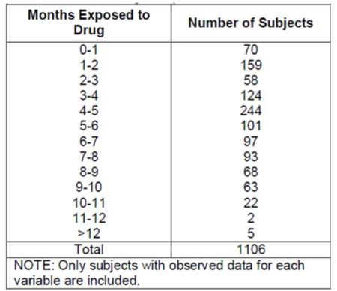
Table 83: Cumulative subject-months of exposure, MED 2000-006.
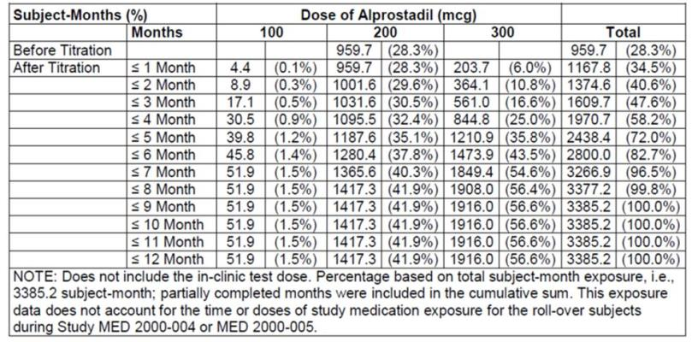

Exposure by dose
Exposure to the proposed doses of 200 µg and 300 µg in pivotal controlled studies is summarised below, and consists of 532 subjects who received 200 µg and 495 who received 300 µg. In the long term extension study, MED 2000-006, subjects were up-titrated to 300 µg if efficacy was inadequate, so the database for the 300 µg dose is increased if this study is considered, but this additional exposure to 300 µg represents uncontrolled, open label exposure without a suitable comparator group. Also, in Study MED 2000-006, all patients began at 200 µg and patients who were intolerant of 200 µg were down-titrated to 100 µg, so the cohort receiving 300 µg in Study MED 2000-006 was triply enriched for high tolerance: first, by passing through a screening test dose at the start of the pivotal study; second, by agreeing to enter a continuation study; and third, by down-titration of intolerant subjects before any patient was assigned the 300 µg dose. Tolerability in this dose group is therefore not likely to be truly representative of tolerability in a naïve, unselected cohort.
Table 84: Phase II and III patients treated by dose.
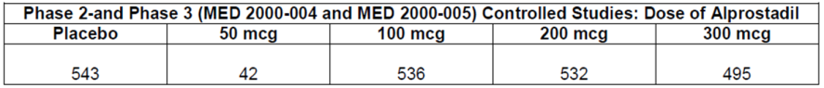
Table 85: Patients in MED 2000-006 treated by dose.
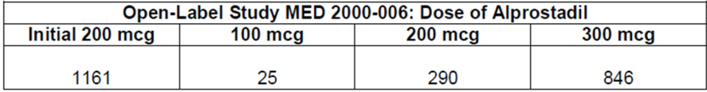

Adverse events

All adverse events (irrespective of relationship to study treatment)

Pivotal studies
The table below summarises the incidence of AEs in the two pivotal studies, MED 2000-004 and 2000-005. AEs were substantially more common with active treatment, occurring in 54%-58% of subjects across the three dose groups, compared to 38% of placebo subjects. This amounts to an absolute attributable incidence of AEs of ~20% in the 300 mcg dose group (58%-38%). Expressed differently, within the 62% of subjects who would not have been expected to have an AE based on the placebo incidence, the 300 mcg dose was associated with an attributable incidence of AEs of 32% (20%/62%).
Even the placebo subjects are likely to have had treatment-related side effects, because they applied cream to the penile meatus – and the placebo cream appears to have contained DDAIP, a possible irritant. Thus, the overall incidence of AEs attributable to treatment cannot be deduced from the available data, and may approach the actual observed incidence of 58%.
There was no major dose trend for AEs, but the two higher dose groups (200 mcg and 300 mcg), which correspond to the doses proposed for marketing, had a slightly higher incidence of AEs than the 100 mcg dose group, as shown in the table below.
Table 86. Summary of AEs, Studies MED 2000-004 and 2000-005 (ITT Safety Population).
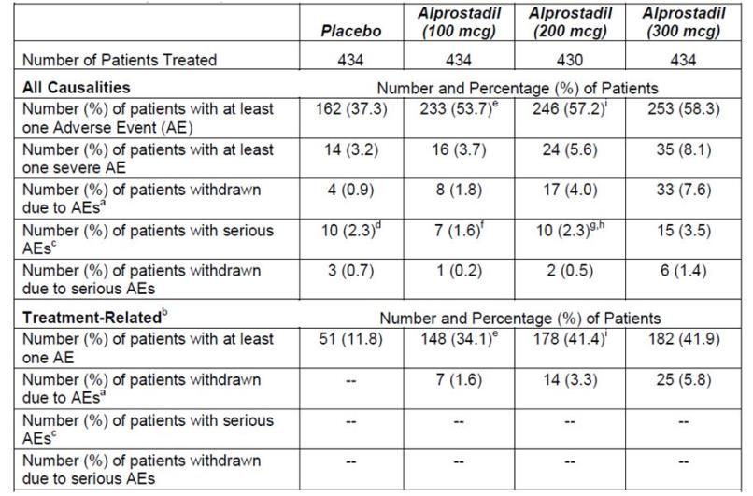
Note: “--“ indicates that the number (%) of patients = 0 (0%).
a. Includes patients who were withdrawn due to intolerance of study medication at Visit 3 and patients whose reason for withdrawal was categorised as “Adverse Event” by the investigator.
b. An AE was considered treatment related if the investigator categorised it as definitely, probably, or possibly related to study medication.
c. Serious adverse events were defined as AEs that resulted in death, a life-threatening event, hospitalisation or prolonged hospitalisation, an important medical event, a persistent or significant disability, or a congenital anomaly.
d. The AE of “myocardial infarction” for patient [information redacted] (placebo) was updated, per an erratum dated 9/19/03, from “Important Medical Event” to “None of the Above” and was not considered an SAE.
e. The AE of “Penile Itching” for patient [information redacted] (100 mcg alprostadil) was updated, per an erratum dated 9/26/03, from a Partner AE to a Patient AE.
f. The AE of “Hernia” for patient [information redacted] (100 mcg alprostadil) was updated, per an erratum dated 10/23/03, from “Hospitalisation/Prolonged Hospitalisation” to “None of the Above” and was not considered as SAE.
g. The AE of “Melena” for patient [information redacted] (200 mcg alprostadil) was updated, per an erratum dated 09/15/03, from “Important Medical Event” to “None of the above” and was not considered as SAE.
h. The AE of “GI Neoplasia” for patient [information redacted] (200 mcg alprostadil) was updated, per an erratum dated 09/15/03, from “None of the above” to “Hospitalisation/Prolonged Hospitalisation” and was considered as SAE.
i. The AE of “Penile Itching” for patient [information redacted] (200 mcg alprostadil) was updated, per an erratum dated 9/26/03, from a Partner AE to a Patient AE.
A review of the individual types of AEs shows that the most common AEs were local urogenital side effects related to administration of the cream, or were consistent with common intercurrent conditions (respiratory tract infections and flu-like illnesses, back pain, chest pain, headache, accidental injury, hypertension, and hyperlipidaemia), which are expected to occur in any typical adult population.
The overall incidence of urogenital side effects was 43% in the highest dose group, compared to only 13% with placebo, and the most common individual urogenital AE was penile burning, reported in 23.5% of the 300 mcg recipients, 24.7% of the 200 mcg recipients, 17.1% of the 100 mcg recipients, and only 6.0% of the placebo recipients. Because the placebo group also received topical treatment and DDAIP, it is likely that most of the urogenital AEs were attributable to treatment, even in the placebo group, not just the excess proportion observed in the active groups relative to placebo.
“Dizziness”, which in some cases could represent presyncopal sensations related to alprostadil-induced hypotension, was reported with very minor excess in the 300 mcg dose group (1.5%, compared to 0.9% in the placebo group), but the incidence in the other active groups resembled the placebo incidence.
Table 87. Summary of Most Common Patient Adverse Events (Adverse Events that Occurred in > 1% of Patients) (Intent-To-Treat Safety Population): MED 2000-004 and MED 2000-005.
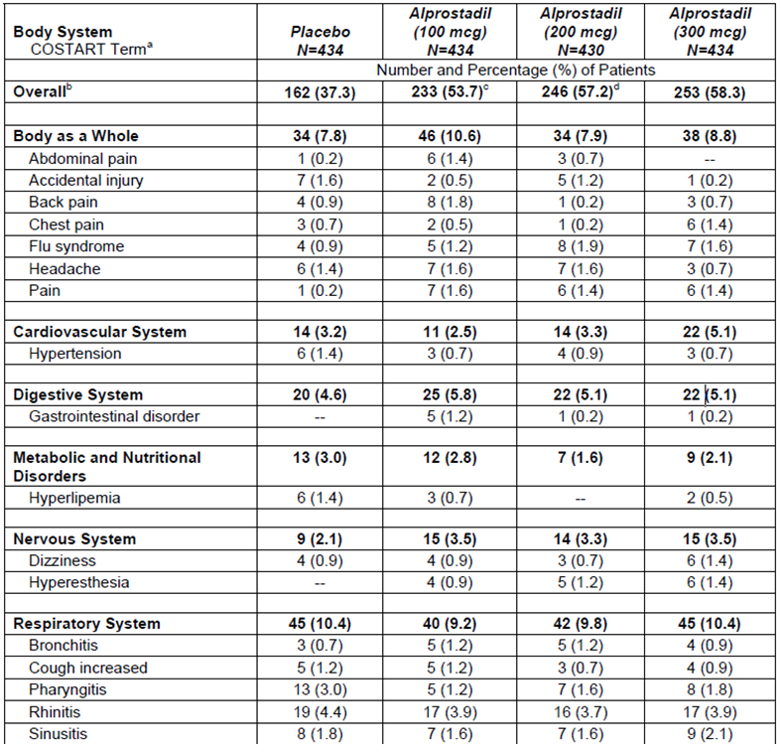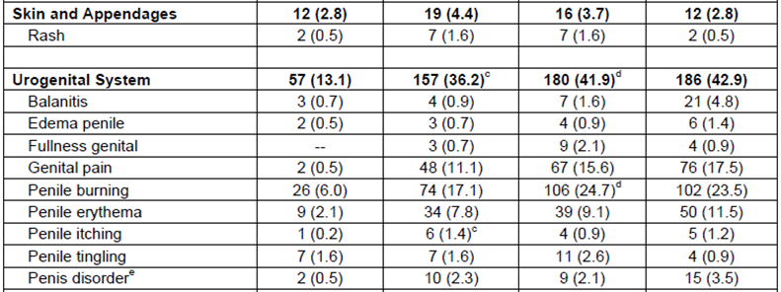
Note: “--“ indicates that the number (%) of patients = 0 (0%).
a. Patients with >1 event within a body system are counted only once in the total for that body system.
c. The AE of “Penile Itching” for patient [information redacted] (100 mcg alprostadil) was updated, per an erratum dated 9/26/03, from a Partner AE to a Patient AE.
d. The AE of “Penile Itching” for patient [information redacted] (200 mcg alprostadil) was updated, per an erratum dated 9/26/03, from a Partner AE to a Patient AE.
e. The following verbatim terms were mapped to the preferred term “penis disorder”: prolonged erection (n = 12), penile throbbing (n = 9), penile numbness (n = 7), excessive rigidity (n = 6), lack of sensation of penis tip (n = 2), bent penis (n = 1), and midshaft corporal plaque worsening (n = 1). Of these 38 events, two patients [information redacted] each had more than one verbatim term mapped to “penis disorder”; however, these patients were counted only once for the preferred term “penis disorder”.
Amongst partners, AEs were reported in 4.8% of the placebo group, compared to 5.7%, 9.5% and 7.6% of the 100 mcg, 200 mcg and 300 mcg dose groups, respectively. Most of the AEs consisted of local urogenital symptoms, such as vaginal burning. It is not possible to determine how many of these partner AEs were likely to be attributable to treatment, to unrelated intercurrent conditions, or to the resumption/increase of sexual activity and vaginal penetration itself. There was an excess of partner AEs in the active groups, compared to placebo, but this could be partly due to the fact that males with improved erectile function were more likely than placebo recipients to engage in intercourse and hence to produce subsequent urogenital complications in their partners. It remains plausible that, in some cases, topical cream was transferred to partners during coitus, with resulting vaginal discomfort, but the incidence of this is difficult to gauge.
Table 88. Partner AEs, Studies MED 2000-004 and 2000-005 (ITT-Safety Population).
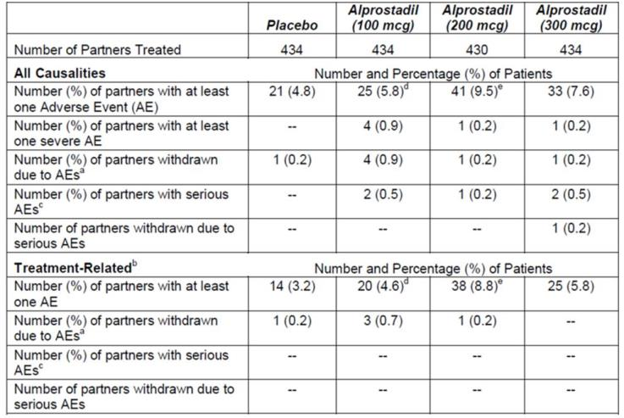
Note: “--“ indicates that the number (%) of patients = 0 (0%).
a. Includes partners whose reason for withdrawal was categorised as an “Adverse Event” by the investigator.
b. An AE was considered treatment related if the investigator categorised it as definitely, probably, or possibly related to study medication.
c. Serious adverse events were defined as AEs that resulted in death, a life-threatening event, hospitalisation or prolonged hospitalisation, an important medical event, a persistent or significant disability, or a congenital anomaly.
d. The AE of “Penile Itching” for patient [information redacted] (100 mcg alprostadil) was updated, per an erratum dated 9/26/03, from a Partner AE to a Patient AE.
e. The AE of “Penile Itching” for patient [information redacted] (200 mcg alprostadil) was updated, per an erratum dated 9/26/03, from a Partner AE to a Patient AE.
Table 89. Summary of Most Common Partner Adverse Events (Adverse Events that Occurred in > 1% of Patients) (Intent-To-Treat Safety Population): MED 2000-004 and MED 2000-005.
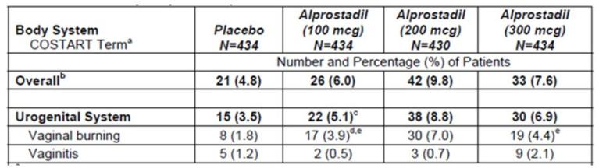
a. Partners with >1 event within a body system were counted only once in the total for that body system.
b. Number of partners with one or more AEs.
c. The AE of “Penile Itching” for patient [information redacted] (100 mcg alprostadil) was updated, per an erratum dated 9/26/03, from a Partner AE to a Patient AE.
d. The AE of “Penile Itching” for patient [information redacted] (100 mcg alprostadil) was updated, per an erratum dated 9/26/03, from “Penile Burning” to “Vaginal Burning”.
e. The AE of “Penile Itching” for patient [information redacted] (100 mcg alprostadil) and [information redacted] (300 mcg alprostadil) had the AE(s) of “Penile Burning” recorded when the AE should have been recorded as “Vaginal Burning”.
All adverse events were rated as mild, moderate or severe. In the highest dose group of the pooled pivotal studies, 35 patients (8.1%) had an AE rated as severe, compared to 14 (3.2%) of the placebo group. The incidence of severe AEs in the other dose groups was intermediate between placebo and 300 mcg, as shown in the table below.
The only point of concern raised by this analysis is that myocardial infarction was reported in 4 (0.9%) subjects receiving alprostadil 300 mcg, and in 1 (0.2%) recipient of alprostadil 200 mcg, but not in any recipients of alprostadil 100 mcg or placebo. Of note, this observation is based on very small numbers. Prostaglandins have a vasodilatory action and they inhibit platelet aggregation, so they would not be expected to increase the risk of myocardial infarction directly, but it is conceivable that systemic vasodilation could lead to cardiac ischaemia via a vascular steal phenomenon. For each of these myocardial infarctions, which were also submitted as serious adverse events (SAEs), the investigators rated the event as “definitely not” or “probably not” related to study medication, and a review of the individual event narratives did not suggest that alprostadil played a causal role.
Table 90. Summary of Common Severe AEs, Studies MED 2000-004 and MED 2000-005.
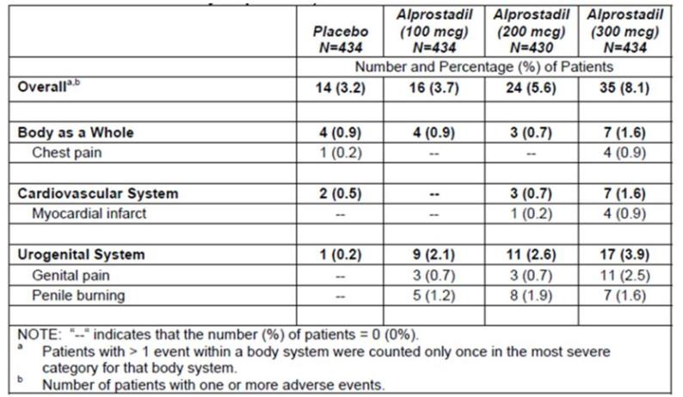

Other vitaros studies
For the long-term open-label Phase 3 study, MED 2000-006, Treatment-Emergent AEs (AEs reported while on treatment and not present at baseline) were tabulated in the study report and the Integrated Summary of Safety, rather than all AEs. The TEAEs are summarised in the table below, grouped into pre-titration TEAEs, when all subjects were on 200 mcg, and post-titration TEAEs, after subjects had been up-titrated to 300 mcg or down-titrated to 100 mcg based on tolerability and efficacy.
TEAEs were reported in 23.4% of subjects before dose titration. Because TEAEs did not include AEs at baseline, and the excluded AEs may have been due to previous treatment in the pivotal studies, this could represent an underestimate of the incidence of AEs. After titration, 34-42% of subjects had TEAEs, with a slightly lower incidence at the highest dose (possibly reflecting an increased willingness to increase the dose in subjects who tolerated it well). TEAEs in partners were much less common, but occurred with a similar frequency as in the pivotal studies.
Table 91. Summary of TEAEs Before Titration, Study MED 2000-006.
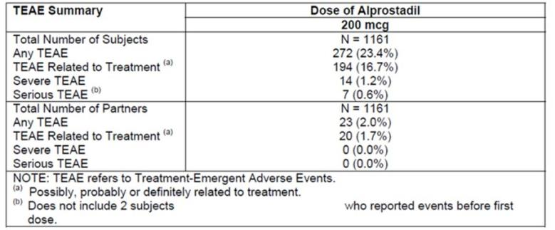
Table 92. Summary of TEAEs After Titration, Study MED 2000-006.
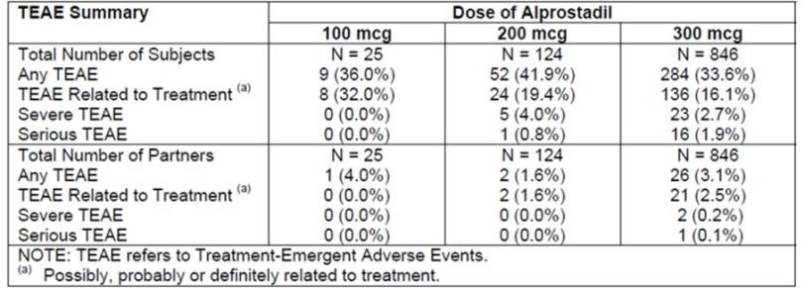
When considering the types of AEs that were observed in this study, no new patterns or safety signals emerged. Apart from rhinitis, which is common in any population, most TEAEs consisted of local urogenital discomfort. Dizziness occurred in 6 subjects (0.5%) prior to titration, and may have reflected hypotension in some subjects, but it was not commonly reported post-titration (<0.5%).
Table 93. Incidence of Individual TEAEs Before Titration, Study MED 2000-006.
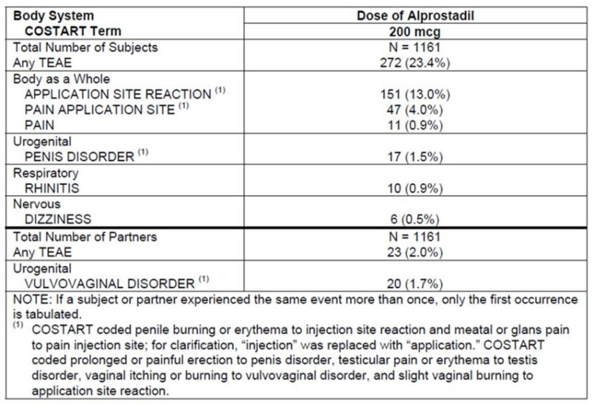
Table 94. Incidence of Individual TEAEs After Titration, Study MED 2000-006.
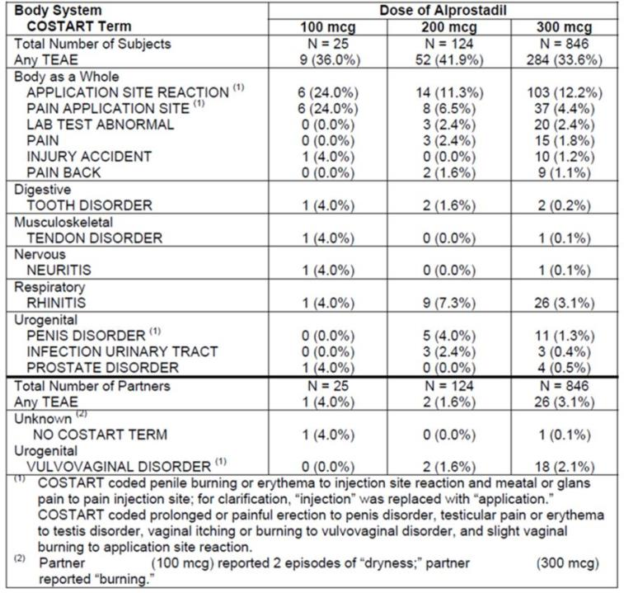
AEs in the Phase 2 Vitaros studies were not conveniently summarised in the Integrated Safety report (and for Study MED 99-002A, the individual study report lacked a clear summary table describing the AEs; instead, a multi-page table listing individual events was provided). The Sponsor has provided summaries of the AEs for each study grouped into the table below (by the Evaluator), followed by summary tables for each study, where available.
Overall, considering these studies, no major new safety concerns were raised about the proposed Vitaros doses, but the high-dose study (500 mcg-1500 mcg) showed that alprostadil doses of ≥ 500 mcg had unacceptable tolerability, with an increased incidence of hypotension and local urogenital discomfort relative to the other Phase 2 and 3 studies: 9 of 21 subjects receiving active treatment did not tolerate the first test-dose, and the study was abandoned. The reasons for first-dose intolerance are shown in the final table of this section; actual haemodynamic changes or subjective dizziness occurred in 7 of the 9 cases, and local discomfort occurred in 8 cases, with many subjects experiencing both.
Table 95. AEs in Phase 2 Vitaros Studies.
Study (Doses) | Summary of AEs in Study Synopsis
MED 99-002A  Placebo, alprostadil 100 mcg, 200 mcg, 300 mcg | “Adverse events of all causality were reported by 22 (55%) patients in the placebo group, 28 (67%) patients in the 0.05 mg Alprox-TD group, 28 (72%) patients in the 0.1 mg group and 31 (78%) patients in the 0.2 mg group. The majority of adverse events were related to the urogenital body system: 20 (50%), 28 (67%), 24 (62%) and 31 (78%) in the placebo, Alprox-TD 0.05,0.1 and 0.2 mg groups, respectively. The most common were penile burning, erythema and pain. The incidence of dizziness was 2.5%, 2.4%, 5.1% and 12.5% in escalating dose groups, while frequency of hypotension was similar among the treatment groups (approximately 5.0% in each treatment group).”
MED 2000-002A  Placebo, alprostadil 100 mcg, 200 mcg, 300 mcg | “Adverse events occurred in 9 patients (26%) in the placebo group, 16 patients (43%) in the 0.1 mg group, 25 patients (71%) in the 0.2 mg group, and 22 patients (63%) in the 0.3 mg group. Most adverse events were drug-related and were mild or moderate in intensity. The most commonly reported adverse events in all four groups were urogenital symptoms (14%, 30%, 57%, and 46% of patients, respectively).”
MED 99-001  Placebo, alprostadil 500 mcg, 1000 mcg, 1500 mcg | “Among the patients treated with Alprox-TD, 9 of 21 failed to tolerate the test dose based on the protocol criteria: 5 of these patients were observed to have significant blood pressure decreases and 4 others, experienced other intolerable events including penile burning and pain, and dizziness. All placebo-treated patients tolerated the test-dose.” [In this statement, the Sponsor has designated one cause of intolerance as the major cause, but many subjects had both haemodynamic intolerance and local intolerance, as shown in a subsequent table.]  “Overall, most adverse events were in the urogenital body system, and were mild or moderate in intensity and resolved within a 3-hour observation period. There were no serious adverse events. Of all patients who received at least one dose of study medication, adverse events of any causality were experienced by 2 of8 (25.0%) patients treated with placebo, 6 of8 (75.0%) patients treated with 0.5 mg, 4 of7 (57.1%) patients treated with 1.0 mg, and 6 of6 (100%) patients treated with 1.5 mg. The two placebo-treated patients who experienced adverse events had mild penile burning or erythema. The most frequent adverse events to occur in all Alprox-treated patients were penile burning (42.9%), genital erythema (42.9%), genital pain (38.1%), hypotension (33.3%), dizziness (28.6%), flushing (19.0%), nausea (19.0%), muscle pain (19.0%), penile pain (14.3%) and headache (14.3%).”
MED 2000-007  Single-dose crossover  Placebo, alprostadil 100 mcg, 200 mcg, 300 mcg | “In the safety population (n = 27), a total of 25 subjects reported treatment-emergent adverse events (TEAEs): 3 (11.1%), 7 (25.9%), 9 (33.3%) and 6 (22.2%) while receiving the placebo, 100 mcg, 200 mcg and 300 mcg alprostadil treatments, respectively.  Although none of the TEAEs were considered serious, the most frequently observed AE was application site reaction, occurring in 2 (7.4% [placebo]), 6 (22.2% [100 mcg alprostadil dose]), 8 (29.6% [200 mcg alprostadil dose]), and 6 [22.2% (300 mcg alprostadil dose)] subjects. The application site reactions were attributed to burning, stinging, tenderness, irritation, numbness and redness at the tip or meatus of the penis.”
Table 96. Common AEs (occurring in >1 patient), Study MED-2000-002.
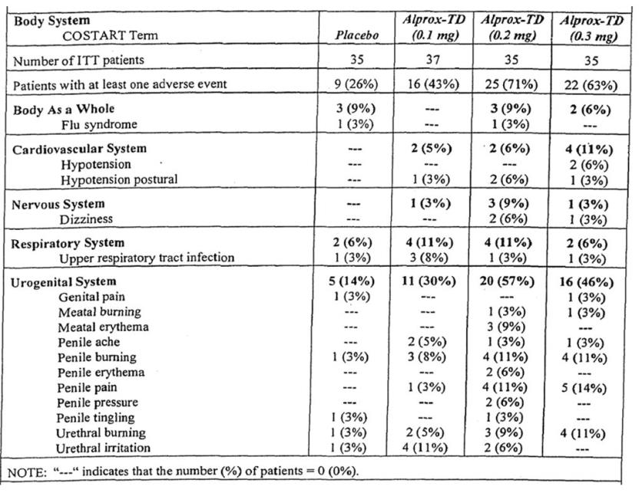
Table 97. Incidence of AEs, Study MED-99-001.
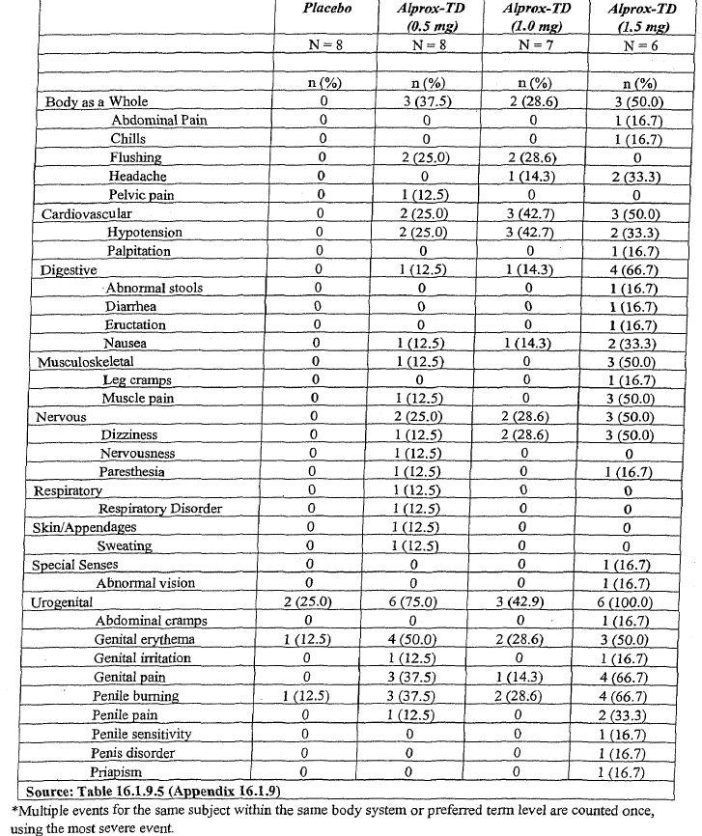
Table 98. Treatment-Emergent AEs by Dose Group, Study MED 2000-007.
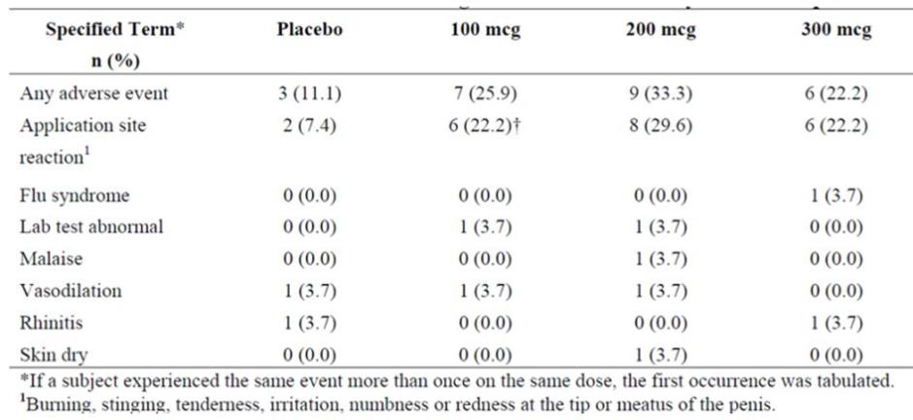
Table 99. Reasons for Test-dose Intolerance, Study MED 99-001.
Treatment | Patient ID | Event
0.5 mg | [information redacted] | Systolic BP decrease, penile burning, nausea, genital pain, muscle pain, diaphoresis
 | [information redacted] | Penile pain
 | [information redacted] | Systolic BP decrease, penile burning, pelvic pain, erythema
 | [information redacted] | Dizziness, tingling of upper extremities, penile burning, meatal erythema, flushing, shortness of breath
1.0 mg | [information redacted] | Hypotension, dizziness, penile burning, erythema
 | [information redacted] | Systolic BP decrease, flushing
 | [information redacted] | Penile burning, dizziness, flushing, hypotension, nausea, headache
1.5 mg | [information redacted] | Systolic and diastolic BP decrease, penile burning, leg cramping, muscle pain, abnormal stools, dizziness, abdominal pain
 | [information redacted] | Systolic and diastolic BP decrease, dizziness, penile pain and burning, nausea, headache, meatal erythema, muscle pain, blurred vision, chills

Femprox studies
The Sponsor has performed several studies of alprostadil in women with sexual dysfunction, but the most relevant safety data comes from the single Phase 3 study, FSAD 2003-1001-CN. This study used Femprox, a Vitaros-like preparation to treat sexual dysfunction in women, assessing three different alprostadil doses (500 mcg, 700 mcg and 900 mcg) in comparison to placebo. There was a dose-related increase in the incidence of side effects. Nearly a third of subjects (31%) reported a urogenital AE at the highest dose (900 mcg), compared to only 14% in the placebo group, with lower doses producing intermediate incidences (22% for 500 mcg, 18% for 700 mcg). Phase 2 studies had a similar spectrum of AEs.
These results support the notion that alprostadil may cause urogenital discomfort in partners of men using Vitaros, but it should be noted that the doses used in the Phase 3 Femprox study were much higher than the proposed dose of Vitaros, and all of it was directly applied to the vulvovaginal region: only a small proportion of a Vitaros dose applied to the penis would be expected to be transferred during coitus. Consistent with this, the incidence of female urogenital discomfort in the pivotal Vitaros studies was relatively low (5-9%). For both the Femprox and the Vitaros studies, some of the observed local side effects could have been due to coitus itself.
Table 100. Summary of AEs, Study FSAD 2003-1001-CN.
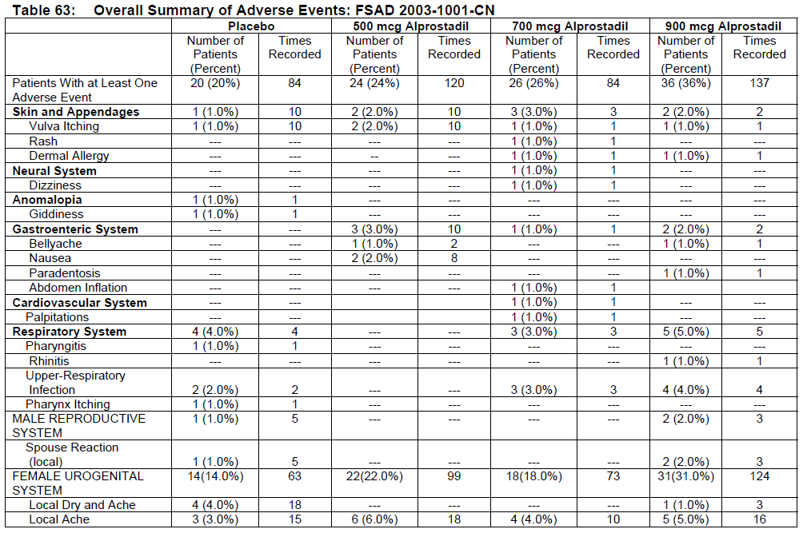
Table 100 (continued). Summary of AEs, Study FSAD 2003-1001-CN.
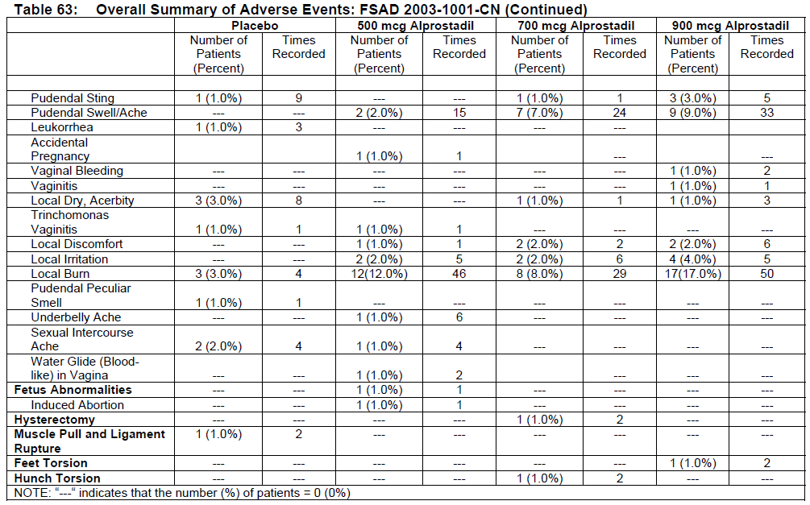

Premature ejaculation studies
Adverse Events in the 3 Chinese Premature Ejaculation (PE) studies were consistent with those observed in the rest of the study program, but these were not integrated into the overall safety database. The AEs in each of the individual studies is tabulated below.
Table 101. Adverse Events in Study PE-01 (n=8).
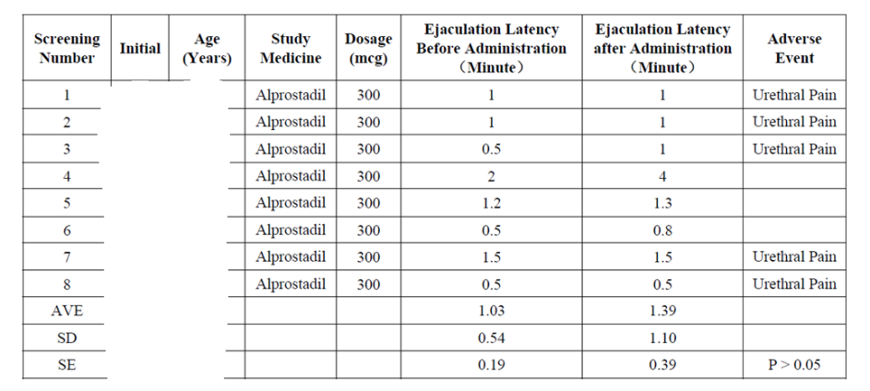
Table 102. Adverse Events in Study PE-02 (n=43).
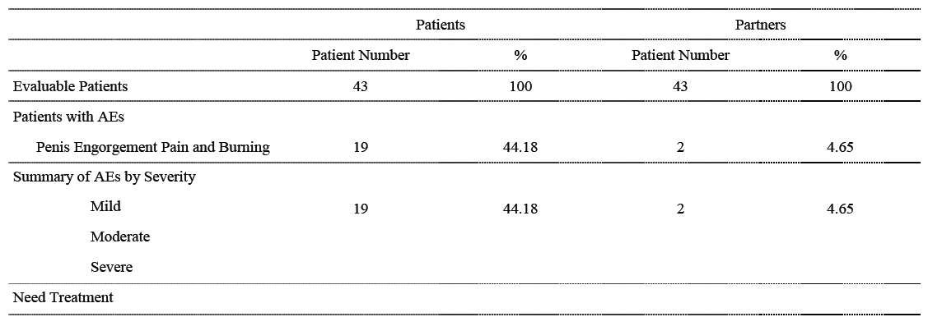
(All AEs consisted of urogenital discomfort or engorgement, and resolved without sequelae).
Table 103. Adverse Events in Study PE-03 (n=30).
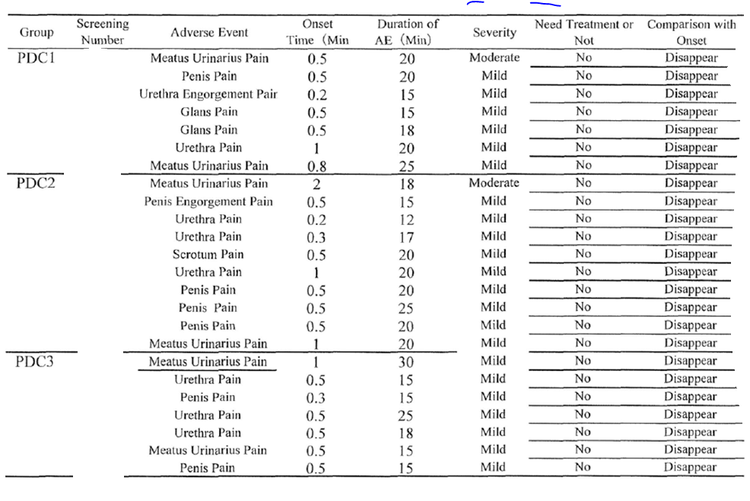

Treatment related adverse events (adverse drug reactions)
In all studies, investigators were asked to grade AEs based on their estimate of the likelihood of a causal relation to treatment. Such a grading is inherently unreliable, as it partly depends on the investigators’ expectations of the likely side effects of a treatment, but it may sometimes reveal causal relationships because investigators have access to causal clues such as the temporal relationship between symptoms and the treatment.
Overall, a consideration of so-called “treatment-related” AEs did not produce any new safety concerns. Investigators were very likely to ascribe a causal role to treatment when the symptoms considered of local urogenital discomfort, and less likely with symptoms in other systems. Dizziness and headache were occasionally thought to be treatment-related, and were more commonly attributed to treatment in the active dose groups. These symptoms could reflect a degree of systemic vasodilation induced by alprostadil or one of its prostaglandin metabolites.

Pivotal studies
Treatment-related, treatment-emergent AEs in the pivotal studies are summarised in the table below. The subsequent table lists the AEs that were not only thought to be treatment-related but also occurred more commonly with active treatment.
Table 104. Treatment-related TEAEs occurring in ≥4 patients, MED 2000-004 and 2000-005.
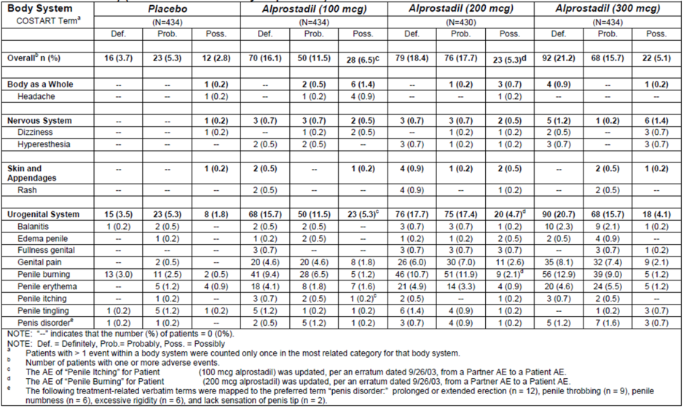
Table 105. Treatment-related AEs reported by ≥ 1% of patients or their partners that were more common with active treatment than placebo, MED 2000-004 and 2000-005 .
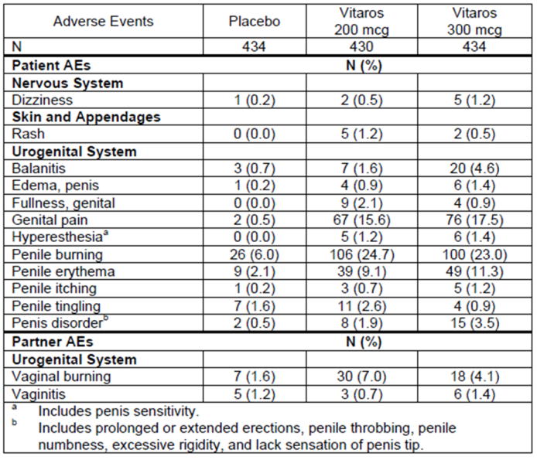

Other studies
Treatment-related AEs in the long-term follow-up study (MED 2000-006) were similar to those observed in the pivotal studies and these are summarised below. Treatment-related AEs in the minor Phase 2 Vitaros studies and with Femprox resembled the overall AEs in those studies.
Table 106. Incidence of treatment-related AEs Before Titration, Study MED 2000-006.
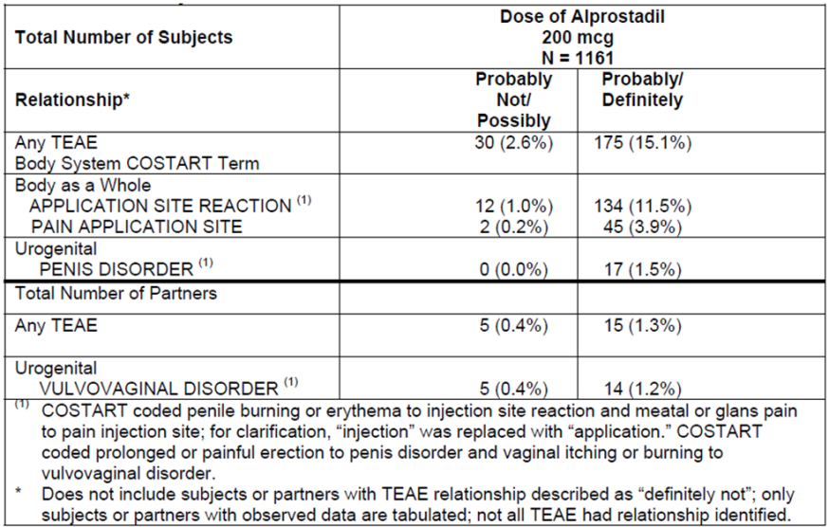
Table 107. Incidence of treatment-related AEs After Titration, Study MED 2000-006.
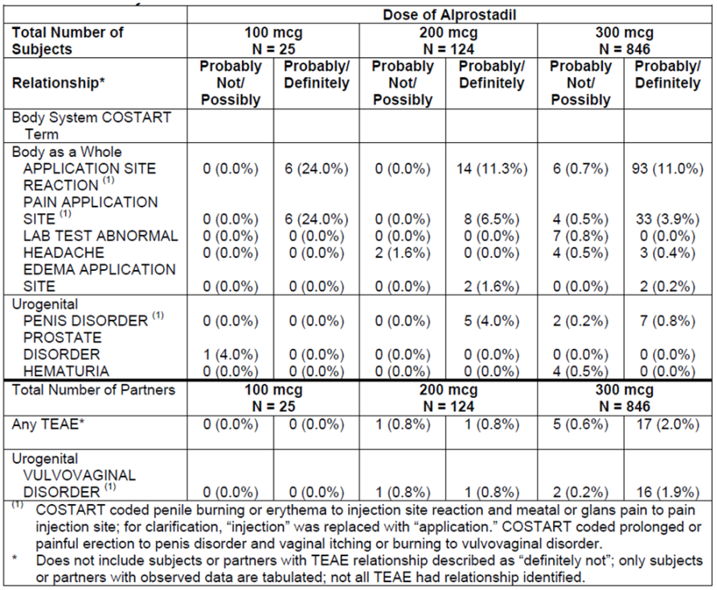

Non-alprostadil nail lacquer studies
The incidence of treatment-related AEs in the Nail Lacquer study, NM-060-1001, is summarised in the table below. Although the nail lacquer assessed in this study contained DDAIP, the active agent and site of application was different and the strength of the DDAIP (0.5%) was lower than in Vitaros, so the results have only marginal relevance to the safety and tolerability of Vitaros. No new safety concerns were raised.
Table 108. Treatment-related AEs with DDAIP-containing Nail Lacquer, Study NM-060-1001.
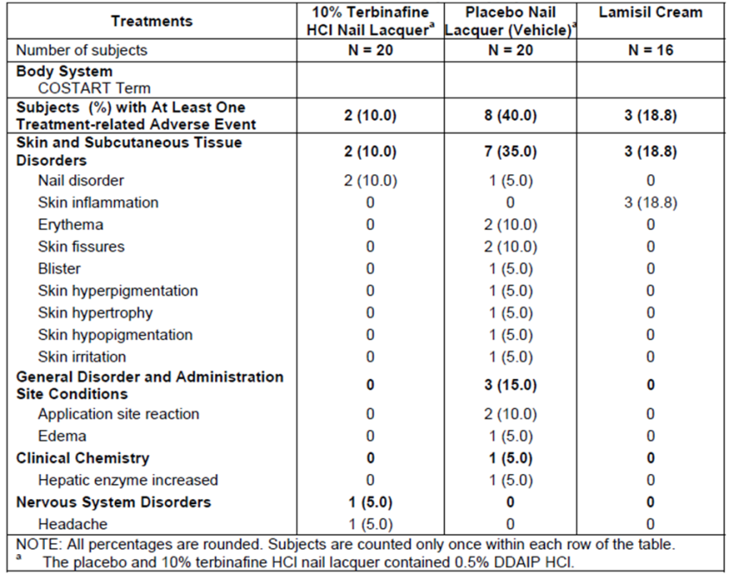

Serious adverse events

Pivotal studies
Serious AEs, defined as AEs leading to or prolonging hospitalisation, causing death or permanent harm, or considered to be life-threatening or serious by the investigator, occurred in 41 (2.4%) subjects in the pivotal studies. Overall, the incidence was not increased with active treatment, but there was a very slight excess of SAEs in the highest dose group: there were 10, 7, 10 and 14 patients in the placebo, 100 mcg, 200 mcg and 300 mcg alprostadil groups who had at least 1 SAE, respectively.
Each individual SAE is listed in the 3-part table below, grouped by dose. As previously noted, myocardial infarction was more common with the highest dose group, reported in 4 subjects (0.9%) receiving alprostadil 300 mcg, and in 1 recipient (0.2%) of alprostadil 200 mcg, but not in any recipients of alprostadil 100 mcg or placebo. This excess occurred despite the exclusion of subjects with recent myocardial infarctions (within 6 months) at the screening phase. Coronary disorders were observed in all treatment groups, including two subjects with placebo, but there was an overall excess of cardiac disorders in the 300 mcg dose group, compared to placebo.
Given that age and vascular disease are both risk factors for ED, the overall incidence of myocardial infarction is not surprising, but the excess in the highest dose group raises the possibility of a causal relationship. Investigators did not feel that any SAE was likely to be related to study medication. In most cases, drug was continued after the infarct, consistent with the investigator’s belief that there was no causal relationship between study drug and the infarct.
A review of the individual study narratives did not suggest a close temporal relationship between commencing the drug and suffering from a myocardial infarct in any individual case. Unfortunately, details about the time interval between the last known use of the medication prior to the infarct and the onset of the infarct were not supplied.
Overall, this evidence is inconclusive. There is no strong evidence of any causal link, but post-marketing surveillance should include monitoring of the incidence of coronary disease, particularly infarction.
Table 109. Serious Adverse Events, Studies MED 2000-004 and MED 2000-005.
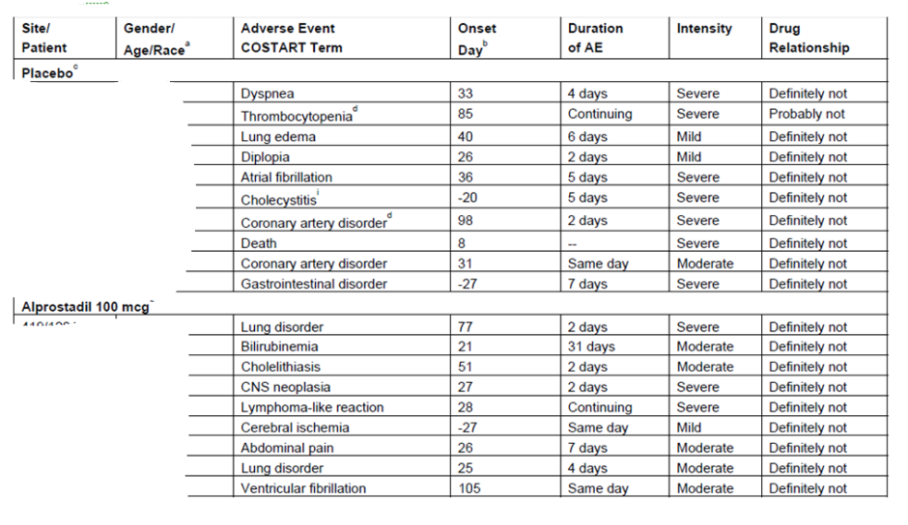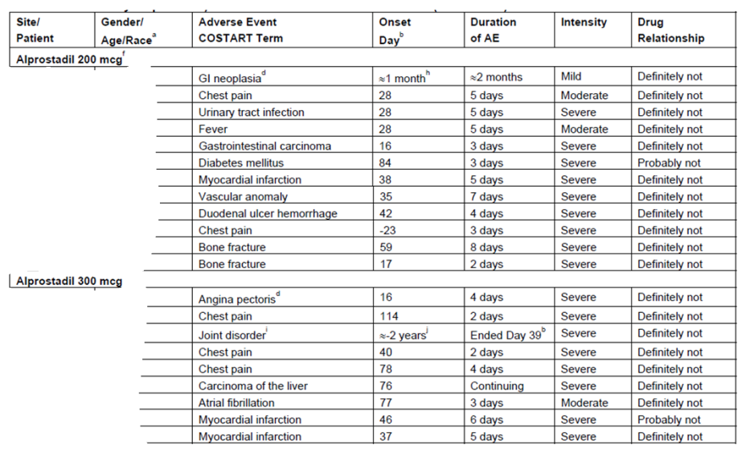
Table 109 (continued). Serious Adverse Events, Studies MED 2000-004 and MED 2000-005.
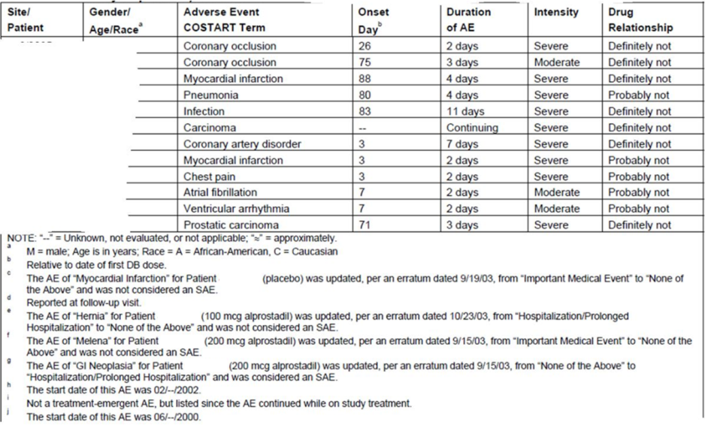
SAEs in partners did not raise any significant safety concerns and were thought not be “definitely not” related to treatment in every case. They are listed below.
Table 110. List of SAEs in Partners, Studies MED 2000-004 and 2000-005.
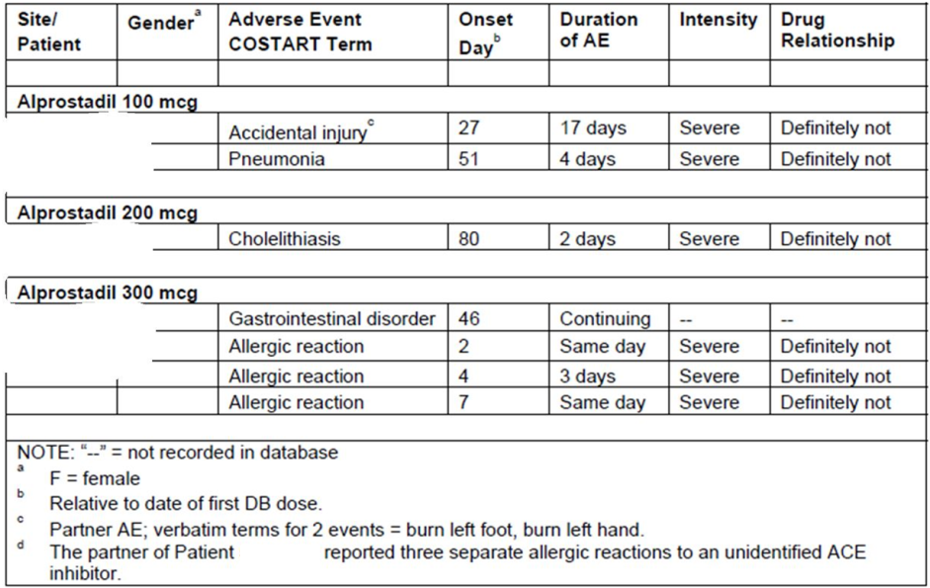

Other studies
In the long-term extension study, MED 2000-006, SAEs occurred in 26 subjects (2.2%) and one partner (0.1%), across all three dose groups. Two of the 26 subjects had SAEs before their first dose. Nearly all of the SAEs were considered by investigators to be “definitely not” or “probably not” related to the study medication. The three exceptions were:
- In one subject, hypotension and dizziness occurred during the test-dose visit, and led to discontinuation of the test drug.
- In one subject, an abnormal ECG was considered moderate, and possibly related to the test drug, but did not cause discontinuation.
- In one subject, sinus bradycardia was considered moderate, and possibly related to the test drug, but did not cause discontinuation.
Serious adverse events in the long-term study that occurred with an incidence ≥ 0.5% in the highest dose group are summarised below, followed by a listing of all individual SAEs for the study.
Table 111. Incidence of TEAEs Occurring in ≥ 0.5% of Subjects and Partners in the 300 mcg Dose Group, MED 2000-006.
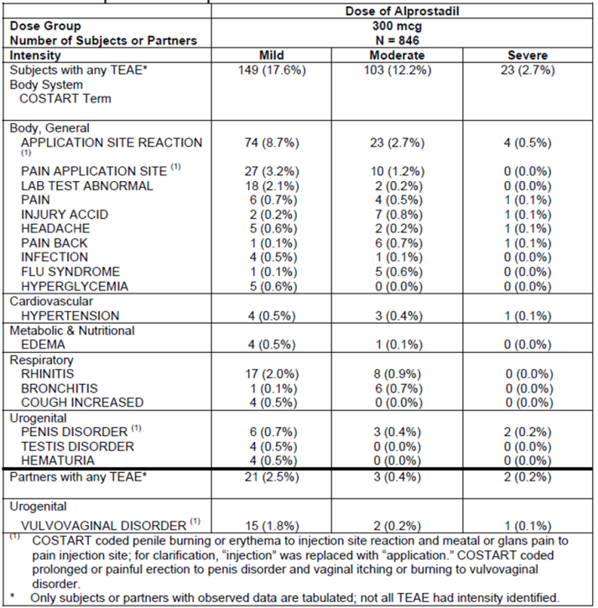
Table 112. Serious Adverse Events, Study MED 2000-006.
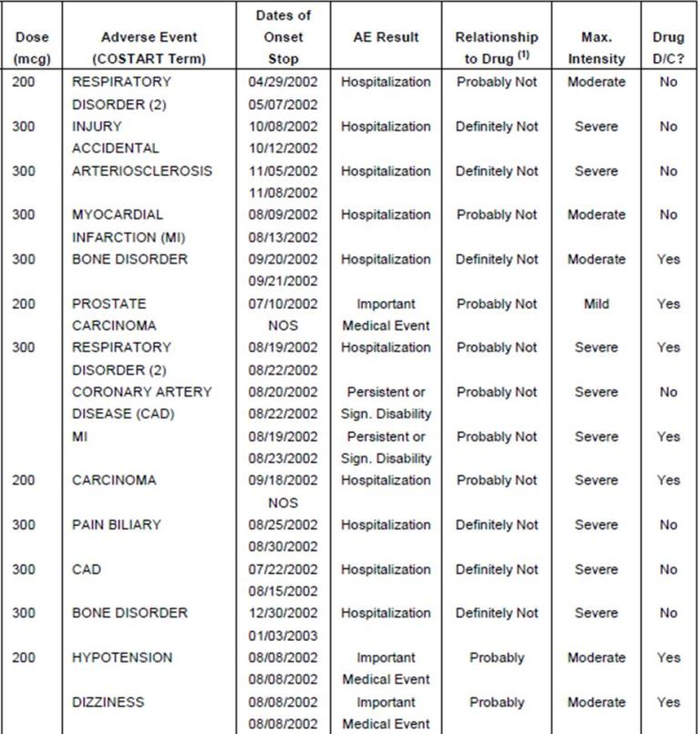
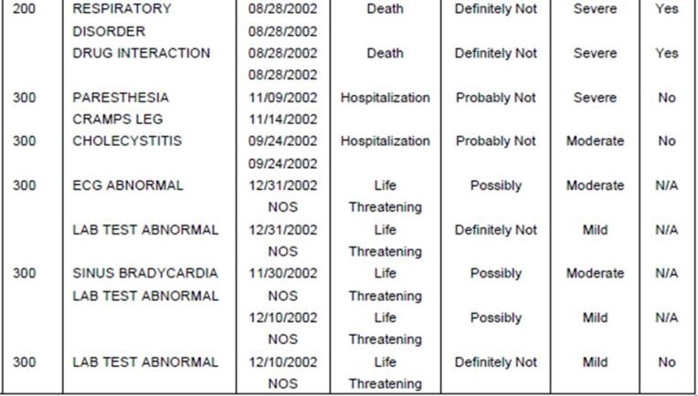
Table 112 (continued). Serious Adverse Events, Study MED 2000-006.
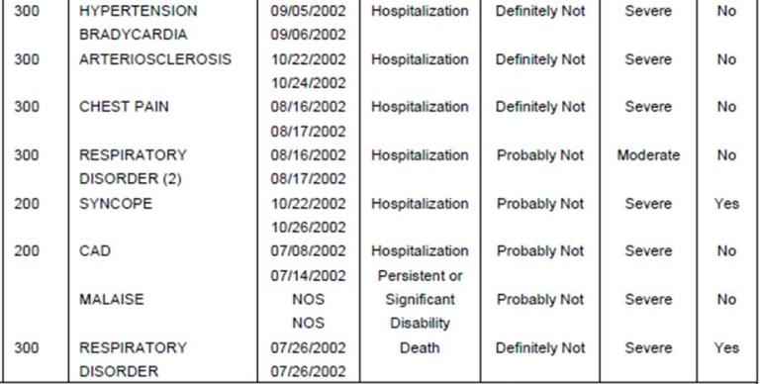
Notes:
1. Relationship determined by the investigator, and may not be in agreement with sponsor.
2. Although these were coded by COSTART as “respiratory disorder”, the reported term was “chest pressure” and was re-defined in the SAE narratives section as “chest pain”.
Note: subjects [information redacted] with an SAE before first dose (Visit 2 in-clinic dose) are not included in this table; NOS = Not Otherwise Specified; N/A = not applicable, event was reported at termination visit and the study was terminated by sponsor.
In the Phase 2 Vitaros studies, SAEs were rare and involved only two subjects, as described below.
In Study MED 99-002A, one SAE occurred, in a [information redacted] patient who received a 200 mcg test dose and then became hypotensive approximately 15 minutes later. He became mildly incoherent, had mild shaking and he reportedly had a very slow pulse, but the brief narrative provided did not clarify this. The patient was given intravenous fluids and recovered uneventfully.
In Study MED 2000-002A, the only SAEs (chest pain and tachycardia, reported in one patient in the 300 mcg group) occurred 3 days after administration of the first dose, but before any at-home doses were used. They were considered definitely unrelated to study medication.
In the high-dose Study MED 99-001, which was abandoned early because of intolerance of the test-doses, no SAEs occurred.
In the crossover instrumental Study MED 2000-007, no TEAEs were considered serious.

Deaths

Pivotal studies
One patient (1/1732, 0.06%) receiving placebo treatment from the MED 2000-004 study died during the course of the studies (on Day 8). He had an unwitnessed cardiac arrest 7 days after his last use of study medication, and there was no indication that his involvement in the study played any causal role.
No other deaths occurred during the pivotal studies, including partners, and no deaths were reported to the Sponsor within 30 days following the studies.

Other studies
In the long-term follow-up study, MED 2000-006, two deaths occurred, involving one subject and one partner. The subject’s death was attributed to chronic obstructive pulmonary disease (COPD) and hydrocodone toxicity, and the partner death was also attributed to COPD. Neither death was thought to be related to the study treatment.
Table 113. Deaths in Study MED 2000-006.
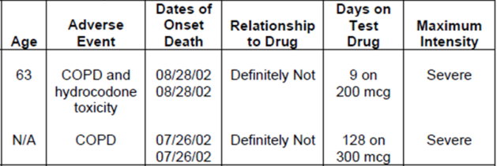

Discontinuation due to adverse events

Pivotal studies
Discontinuations from the pivotal studies that were due to AEs are listed in the table below. The overall distribution of these AEs resembled the general pattern of AEs, with urogenital discomfort being the most common reason for discontinuing treatment in all of the active groups. Local discomfort did not cause any placebo recipient to discontinue, indicating that most of the major local symptoms were likely to be related to the alprostadil itself, rather than excipients such as DDAIP.
Table 114. List of Patients Discontinuing due to AEs, MED 2000-004 and MED 2000-005.
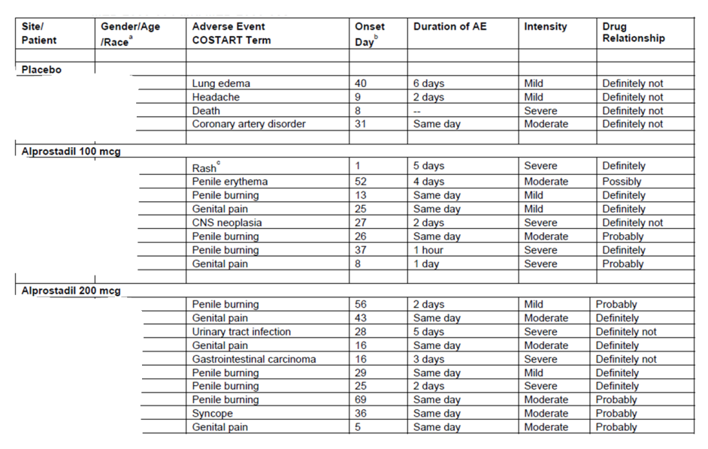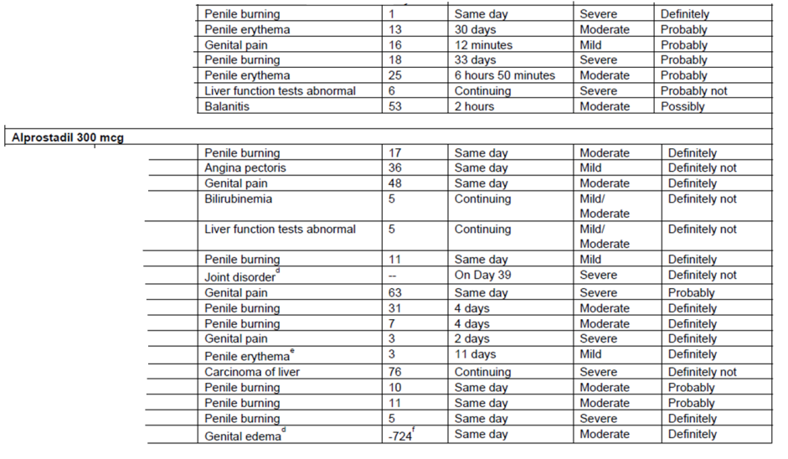
Table 114 (continued). List of Patients Discontinuing due to AEs, MED 2000-004 and MED 2000-005.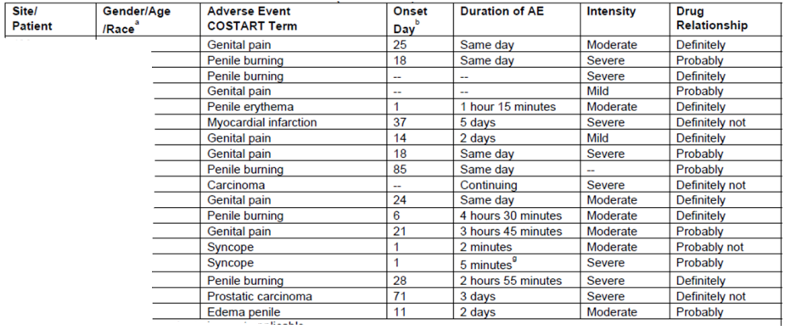
Note: “--“ = unknown, not evaluated, or n/a
a. M = male, age in years; Race, A = African-American, C = Caucasian
b. Relative to date of first DB dose
c. Patient [information redacted] had a rash on the tip and around the penis.
d. Not a treatment-emergent AE, but listed since AE continued while on study treatment.
e. Reported at follow-up visit.
f. The onset day of -724 for genital edema for patient [information redacted] is as reported in the original Final Integrated CSR. After review of the CRF, it appears that this was a treatment-related AE that occurred on Day 1 of treatment.
g. The duration of the AE of “Syncope” for patient [information redacted] (300 mcg alprostadil) was recorded as 725 minutes; however, the duration should have been recorded as 5 minutes.
Amongst partners, the most common reason to discontinue treatment was local urogenital discomfort. It is unclear how often this was due to an effect of alprostadil or DDAIP, and how often it was related to complications of coitus itself, but discontinuations due to urogenital discomfort in partners were not observed in the placebo group.
Table 115. Partners who discontinued due to AEs, MED 2000-004 and MED 2000-005.
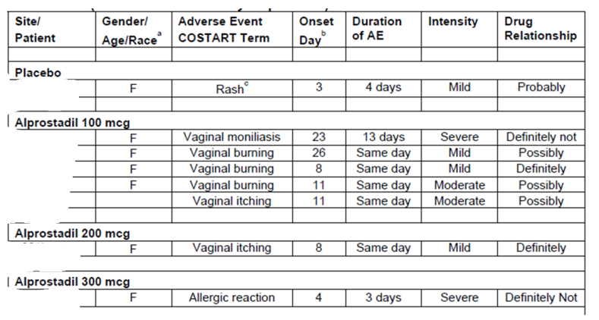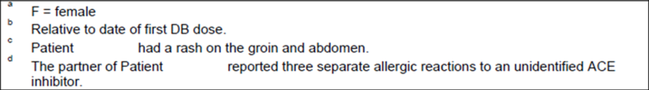

Other studies
Discontinuations from the long-term study, MED 2000-006, are tabulated below, before and after dose titration. In the absence of a placebo control group, and with non-random allocation of subjects to doses, it is difficult to put these results into any meaningful context but the overall pattern of AEs was similar to the previous studies.
Table 116. Discontinuations due to AEs Before Titration, MED 2000-006.
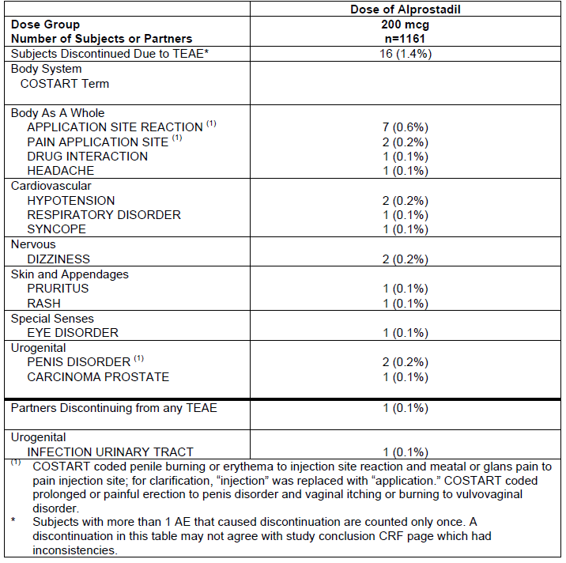
Table 117. Discontinuations due to AEs After Titration, MED 2000-006.
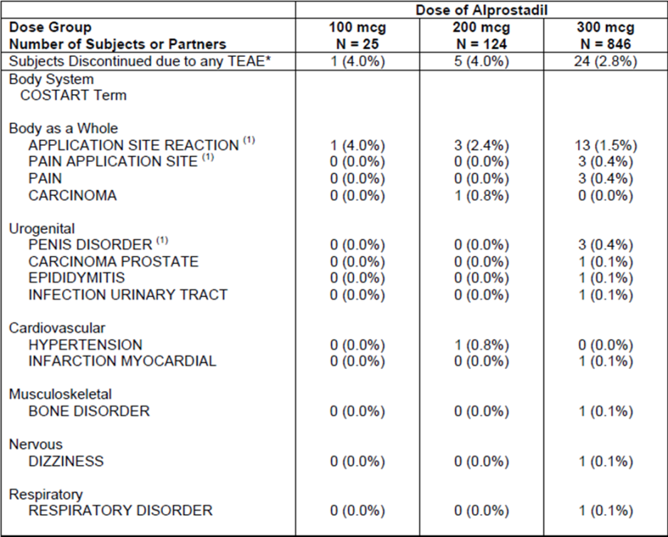
1. COSTART coded penile burning or erythema to injection site reaction and meatal or glans pain to pain injection site; for clarification, “injection” was replaced with “application”. COSTART coded prolonged or painful erection to penis disorder and vaginal itching or burning to vulvovaginal disorder.
† Partner of subject [information redacted] had a vulvovaginal disorder that caused discontinuation of test drug; however, no onset date was recorded and therefore it was not determined to be treatment-emergent in this table.
* Subjects with more than 1 AE that caused discontinuation are counted only once. A discontinuation in this table may not agree with study conclusion CRF page which had inconsistencies.
Review of the discontinuations in the minor Vitaros studies did not raise any new safety concerns.

Laboratory tests
Adverse events relating to laboratory parameters were seen in all treatment groups, with no substantial excess in the active groups relative to placebo, as summarised in the table below. The only individual types of laboratory-based AE that occurred in more than a single subject per dose group and at a higher rate in an at least one active group than the placebo group, were abnormal liver function tests and anaemia.
Table 118. AEs Related to Laboratory Parameters, MED 2000-004 and MED 2000-005.
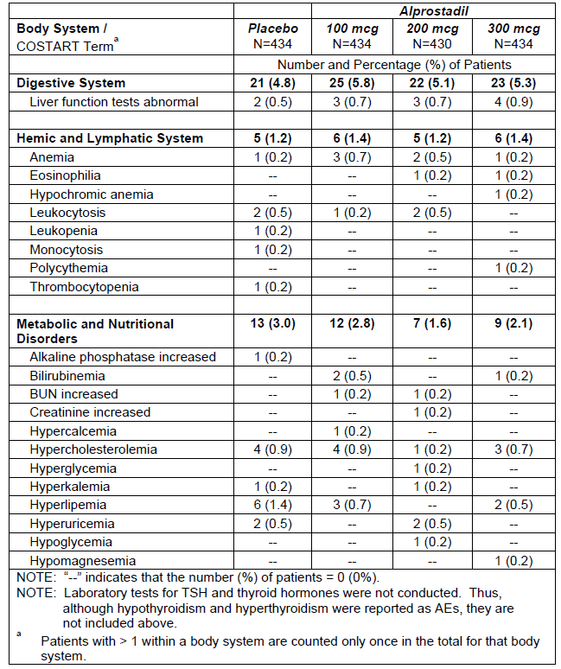
In the extension study, MED 2000-006, isolated AEs occurred that were related to abnormal laboratory tests, but these lacked a clear pattern and are difficult to interpret in the absence of a placebo group.
Table 119. TEAEs Related to Laboratory Parameters, MED 2000-006.
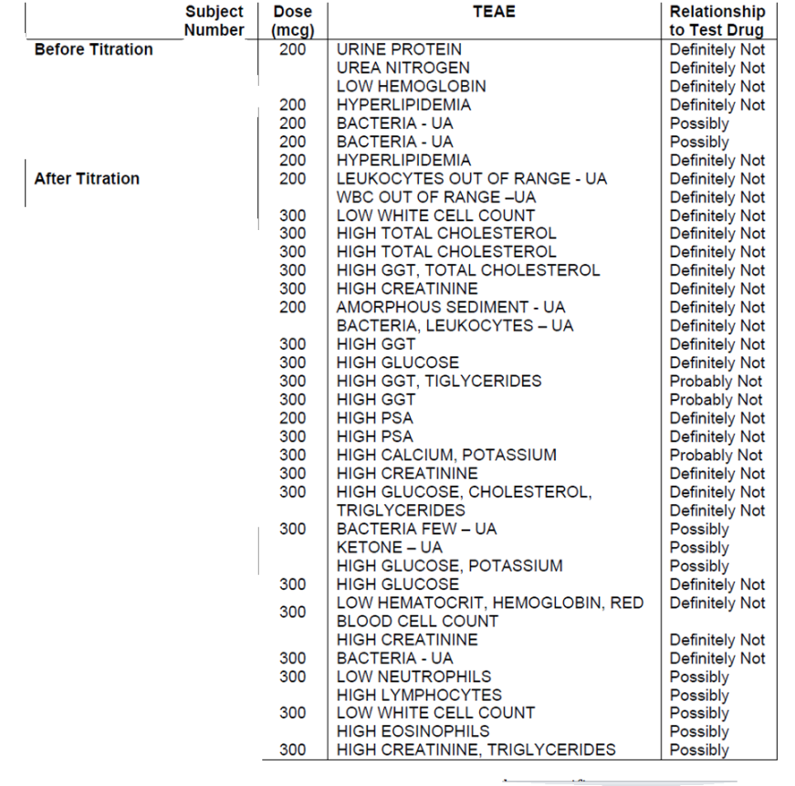
Laboratory monitoring in other studies was minimal, but raised no specific concerns.

Biochemistry (Hepatic, renal and other clinical chemistry)

Pivotal studies
As shown the previous section, there was a very slight excess of abnormal liver function tests (LFTs) in the active groups, with 4 recipients (0.9%) of 300 mcg having an AE related to LFTs, compared to 3 subjects in each of the other dose groups (0.7% each) and 2 in the placebo group (0.5%). None of these patients had severely abnormal results suggesting a significant risk of liver failure or suggestive of a major hepatic drug reaction (i.e. concurrent elevation of bilirubin >2 times the upper limit of normal and AST >3 times the upper limit of normal).
Two patients (0.1% overall) discontinued from the studies due to laboratory-based AEs. This included one patient receiving alprostadil 300 mcg who had abnormal LFTs that were actually worse at baseline (baseline GGT = 184 IU/L and Day 5 GGT = 85 IU/L; baseline total bilirubin = 1.26 mg/dL and Day 5 total bilirubin = 1.14 mg/dL). In another patient, receiving alprostadil 200 mcg, abnormal LFTS developed on treatment (baseline SGPT = 104 IU/L and Day 5 SGPT = 190 IU/L; baseline SGOT = 114 IU/L and Day 5 SGOT = 216 IU/L; baseline GGT = 143 IU/L and Day 5 GGT = 249 IU/L) but these were thought probably not related to study medication.
As shown above, all other individual laboratory-based biochemical AEs in the pivotal studies occurred in very low numbers of patients and were as common in the placebo group.

Other studies
In the long-term study, MED 2000-006, mean laboratory parameters at study entry in blood and urine were compared with those at the end of treatment (early termination or study closure). Mean changes in those parameters are displayed in the tables below. For many parameters, there was a statistically significant within-group change, but the magnitude of the observed change was not clinically significant. The cause of such changes is uncertain, but the changes could be artefactual (relating to imperfect laboratory calibration, for instance); this seems likely given the low levels of systemic absorption of alprostadil and the intermittent dosing associated with as-needed usage.
Table 120. Mean Changes in Chemistry Parameters, MED 2000-006.
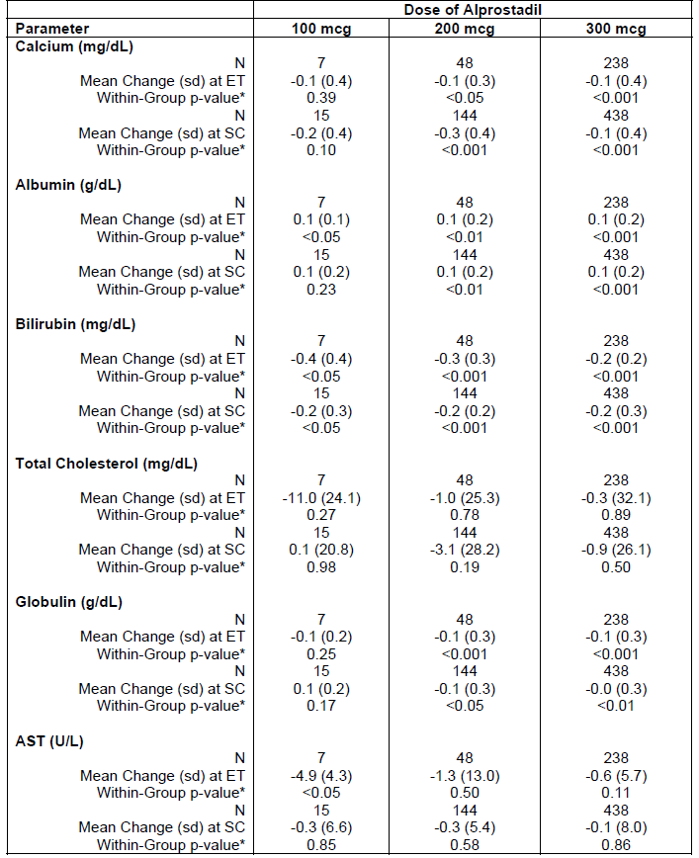
Table 120 (continued). Mean Changes in Chemistry Parameters, MED 2000-006.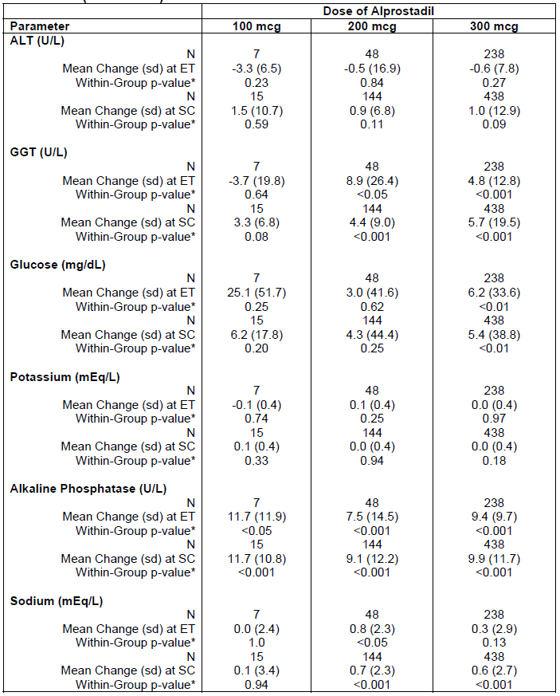
Table 120 (continued). Mean Changes in Chemistry Parameters, MED 2000-006.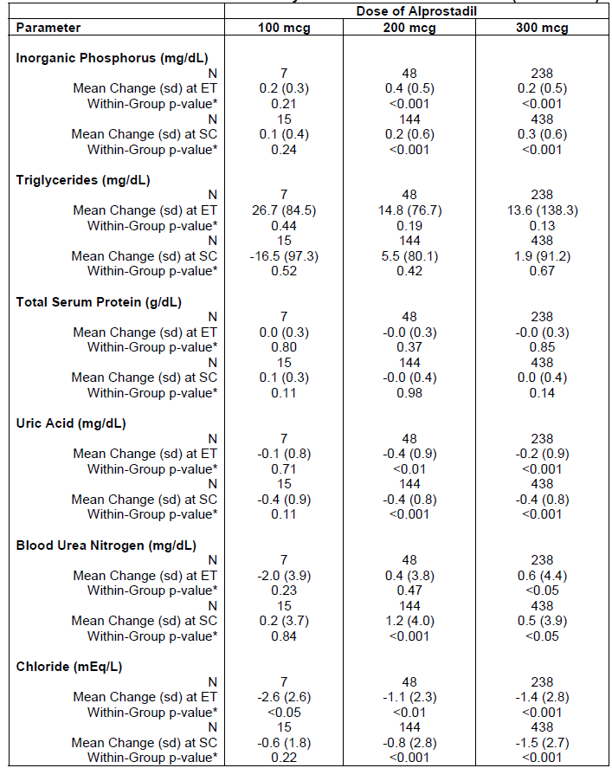
Table 120 (continued). Mean Changes in Chemistry Parameters, MED 2000-006.
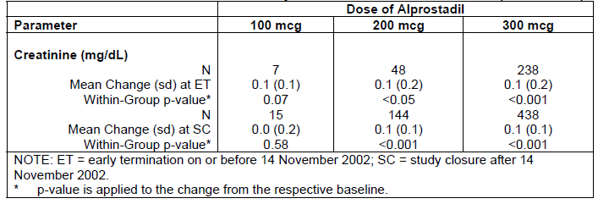
Table 121. Mean Changes in Urinalysis Parameters, MED 2000-006.
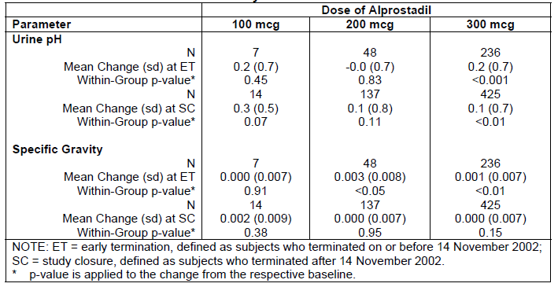

Haematology

Pivotal studies
AEs reported in the pivotal studies showed a very slight excess of anaemia in the alprostadil 100 mcg group (3 cases, 0.7%) compared to both the placebo group (1 case, 0.2%) and the 300 mcg group (1 case, 0.2%); the incidence of anaemia AEs in the 200 mcg group was intermediate (2 cases, 0.5%). None of the cases of anaemia led to discontinuation. Two subjects in the placebo group and two in the 200 mcg group had leukocytosis, but this was not observed in the 300 mcg dose group. Isolated haematological abnormalities occurring in one patient each included eosinophilia, leukopaenia, monocytosis, polycythemia, and thrombocytopaenia, with an overall incidence of haematological abnormalities that was almost identical across groups (1.2% in the placebo and 200 mcg groups, 1.4% in the 100 mcg and 300 mcg groups).
Thus, there was no consistent pattern or dose trend, and overall these results do not suggest that alprostadil or DDAIP has any important haematological effects.

Other studies
For the long-term study, MED 2000-006, baseline haematological parameters were compared with results obtained at early termination or study closure. Statistically significant changes were observed for many parameters, as shown in the table below, but the magnitude of the changes was small, and unlikely to be clinically meaningful. The observed minor changes could have been artefactual.
The Sponsor noted that some subjects had abnormally high monocyte counts at baseline, but this appears likely to be due to a relatively narrow definition of the normal range or monocytes, and did not appear to be of clinical relevance, particularly because it generally preceded treatment. No subject had an AE based on abnormal monocyte counts.
Table 122. Changes in Mean Haematological Parameters.
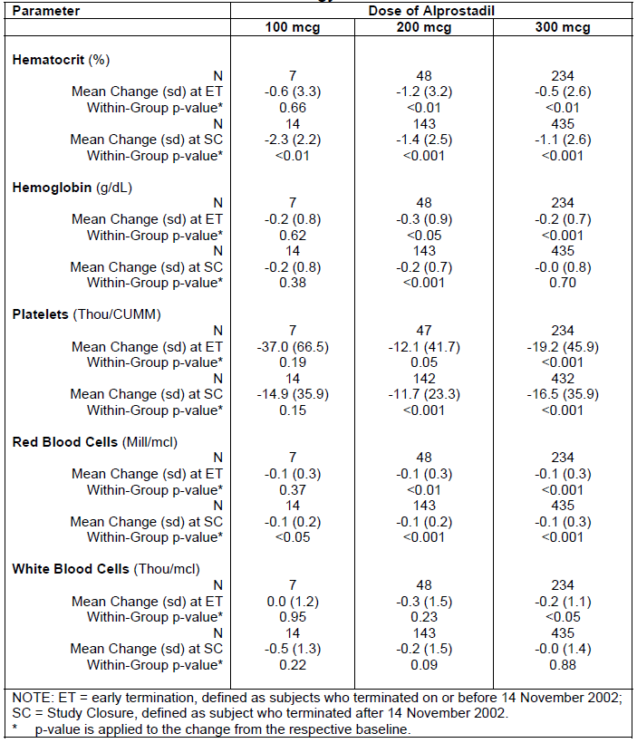

Electrocardiograph
No formal QT study was submitted, which is probably acceptable given the very low systemic absorption of both alprostadil and DDAIP. Overall, no concerning signal arises from the submitted data suggesting that Vitaros has a direct effect in the ECG, beyond the tendency for subjects exposed to higher doses of alprostadil to experience hypotension, which could have secondary ECG effects.

Pivotal studies
Adverse events in the pivotal studies that were potentially related to ECGs were characterised according to their underlying clinical context (coronary disease, myocardial infarction) and have already been considered. Apart from the slight excess of myocardial infarctions that has already been mentioned, no concerning patterns were observed.
A quantitative assessment of mean changes in ECG parameters was also performed, but this did not reveal any clinically significant changes. The Sponsor summarises these results as follows:
Compared to baseline mean values, the greatest mean changes for the quantitative parameters at the final visit (Visit 6, Week 12) occurred in the Alprostadil groups, but not consistently in the highest (300 mcg) dose group. These greatest mean changes (±SD) in the respective groups were as follows: for ventricular rate = -1.1 ± 9.21 bpm (100 mcg alprostadil), for P-R interval = 0.7 ± 17.15 ms (200 mcg alprostadil), for QRS interval = 1.376 ± 37.9523 ms (300 mcg alprostadil), for QTc interval = -0.8 ± 32.29 ms (100 mcg alprostadil) and for axis = 1.593 ± 19.9312 degrees (200 mcg alprostadil).

Other studies
Mean changes in ECG parameters were tabulated in the long-term extension study, MED 2000-006, but this did not reveal any significant safety signals. No within-group or between-dose comparisons were statistically significant, apart from a minor increase in ventricular rate of ~2bpm at study closure in the 300 mcg group; this is not clinically significant.
Table 123. Mean Changes in ECG Parameters from Baseline to Early Termination (ET) or Study Closure (SC) in Study MED 2000-006.
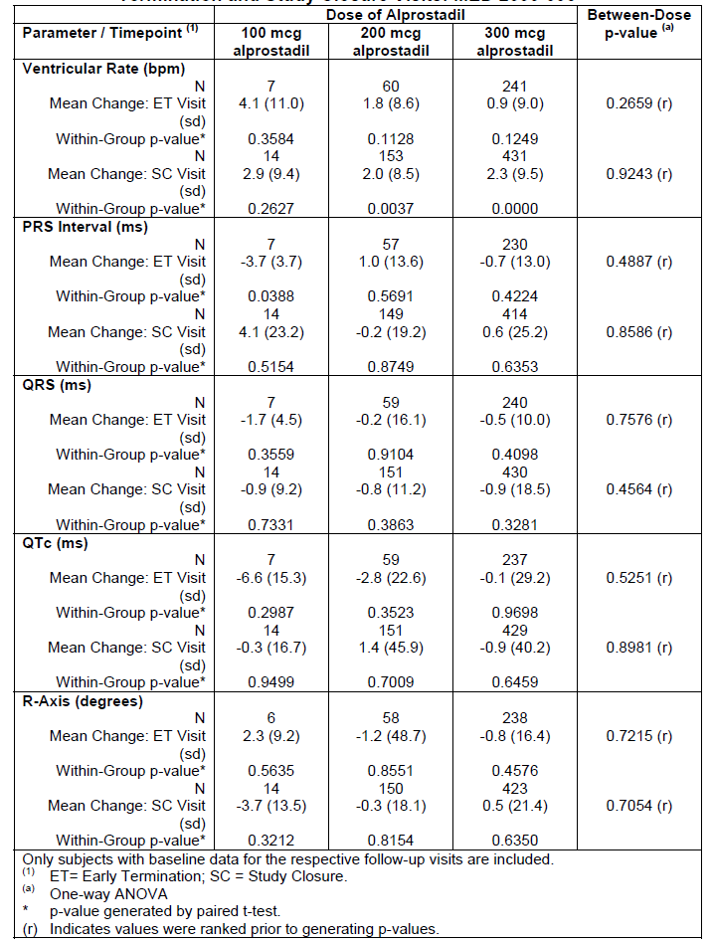

Vital signs

Pivotal studies
Blood pressure and heart rate (pulse) monitoring was conducted at every study visit, but because the study drug was administered pre-coitus, and has a relatively short duration of action, vital signs were generally not measured closely in relation to the time of drug administration. The exception was the first test-dose, which was administered in clinic. Two patients experienced syncope following the test-dose. One of these was observed with alprostadil 200 mcg and the other with placebo.
(One patient from the MED 2000-004, who received alprostadil 200 mcg, had a decrease in standing diastolic blood pressure [DBP] ≥ 20 mm Hg from sitting DBP. This patient completed the study. One patient from MED 2000-005 had a decrease in standing systolic blood pressure [SBP] ≥ 30 mm Hg from sitting SBP). This patient was randomised to placebo and was discontinued from the study due to orthostatic hypotension.)
At follow-up visits, vital sign monitoring did not reveal any significant pharmacological effect: there were no time-related or dose-related trends in mean change values for sitting SBP, DBP, or pulse rate, but this is of little value given that such assessments were not performed close to the time of administration.

Other studies
In the long-term extension study, MED 2000-006, mean changes in vital signs were compared across dose groups and within groups in comparison to baseline, as shown in the table below. The observed changes were not of clinical concern, but it should be noted that patients’ vital signs were generally not recorded close to the time of study drug administration.
Table 124. Mean Changes in Vital Signs, MED 2000-006.
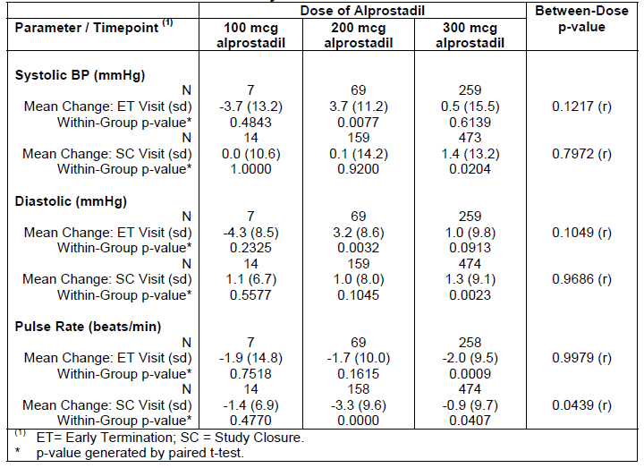
The Phase 2 studies did not raise any significant concerns in relation to the effect of the proposed doses on vital signs. The high-dose study (using 500 mcg-1500 mcg alprostadil) did produce unacceptable haemodynamic responses in several subjects, however, with 7 of 21 subjects either reporting dizziness or demonstrating objective haemodynamic changes in response to the test-dose.

Meatal examination

Pivotal studies
Subjects in the pivotal studies underwent a meatal examination at baseline and at subsequent visits, looking for evidence of erythema, irritation or other local side effects. The number of subjects undergoing shifts from normal meatal examinations to abnormal examinations is shown in the table below. There was no convincing overall increase in the rate of abnormality with active treatment, and no clear dose trend.
Table 125. Meatal Examinations, MED 2000-004 and MED 2000-005.
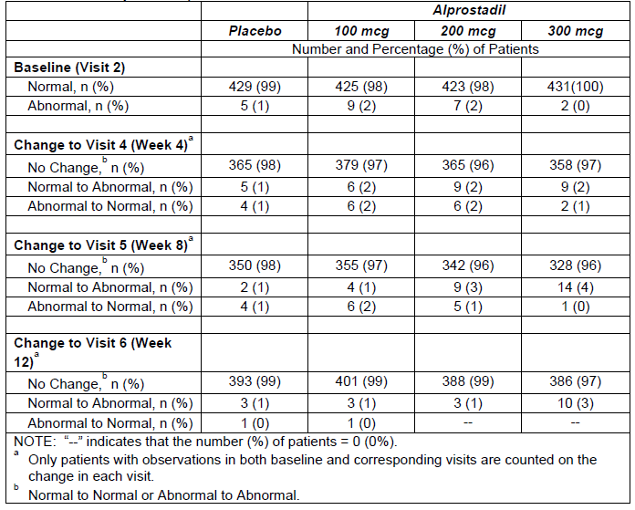
Similar information was not provided for other studies, but meatal or other penile pain was a fairly common AE, as already noted.

Post marketing experience
The Integrated Safety Summary provided only a brief description of the post marketing experience obtained with Befar (a non DDAIP alprostadil cream), and no description of the post marketing experience obtained with Vitaros in Canada and the EU.
The sponsor’s comments in relation to Befar are reproduced below. No details are provided about the incidence of AEs or SAEs, and it is merely asserted that no “new” SAEs occurred. Even if there had been a high incidence of, say, myocardial infarction, it would be correct but unhelpful to say that no new SAEs occurred (because myocardial infarction had already been reported in the pivotal studies, it would not count as “new”).
The sponsor should be asked to extend these comments with sufficient detail that the post marketing experience can be evaluated for safety:
Befar (0.4% alprostadil in a dose strength of 1000 μg alprostadil/250 mg of cream and 400 µg alprostadil/100 mg cream) is a topical cream approved in China and Hong Kong for the treatment of ED in men. Befar was approved for marketing by the State Drug Administration (SDA) in China on February 2, 2001.63 Befar was launched as a 250 mg cream dose in China in July 2001 and as a 100 mg cream dose strength in 2003. Befar was subsequently approved for marketing in Hong Kong in April 2002. The number of units of Befar sold in China and Hong Kong (Asia) in 2001, 2002, 2003, 2004, 2005, and as of June 30, 2006 were 21,000; 88,130; 17,399; 25,398; 25,764; and 11,147 unit doses, respectively. During this same period the cumulative human exposure to Befar in Asia in 2001, 2002, 2003, 2004, 2005, and as of June 30, 2006 was 21,000; 109,130; 126,529; 151,927; 177,691; and 188,838 unit doses, respectively. This represents 517 patient-years of exposure assuming daily dosing. However, this product is used less frequently and intermittently, and thus, if dosed every 2, 3, 4, 5, 6, 7 (once a week) or 14 (once every 2 weeks) days, this represents 1035, 1552, 2069, 2587, 3104, and 3622, and 7243 patient years of exposure, respectively. During this same period (2001 through June 30, 2006), there were no new serious adverse drug reactions (SAEs) reported to NexMed Asia and no ADRs reported to the SDA, nor to the Hong Kong regulatory body. Although the prescribing data is not available to determine if the product was used once or more by patients, it is expected based on the high compliance of continued use and low discontinuation rate from the Phase III studies of Vitaros in the US that the Asia exposure data represents multiple use by the majority of patients.

Safety issues with the potential for major regulatory impact

Liver toxicity
There is no evidence that topical alprostadil has any clinically significant effect on liver function, particularly because systemic absorption of alprostadil and its metabolites is very limited. No patients in any study had a severe disturbance of liver function.

Haematological toxicity
No subjects suffered from haematological reactions that appeared to be related to study drug, and the overall incidence of haematological AEs was similar in the active and placebo groups of the pivotal studies.

Serious skin reactions
Several subjects had local reactions to Vitaros, and irritations studies suggest that alprostadil and DDAIP both contribute to local irritation. In most cases, the local irritation resolved within 24 h.
Severe widespread skin reactions were not reported with Vitaros in the pivotal studies.

Cardiovascular safety
Alprostadil can cause hypotension, and some subjects may be at risk of pre syncope or syncope at the proposed doses of Vitaros. In the pivotal studies, no major changes in vital signs were observed with Vitaros, but vital signs were generally not assessed close to the time of dosing, which was performed at home pre coitus. Test doses in the clinic were occasionally associated with pre syncope, and this was most marked in the high dose study, using doses of 500 µg to 1500 µg, where 7 of 21 subjects had intolerance that was related, in part, to dizziness or hypotension. Three of these cases occurred in subjects who received 500 µg, which is less than double the proposed dose of 300 mcg, indicating that the therapeutic window for Vitaros is narrow. Furthermore, subjects with orthostatic hypotension at screening were excluded from the Phase II and III studies. (This was determined by comparing sitting and standing blood pressure (BP) and pulse rate, and it was defined as a decrease in systolic BP ≥ 30 millimetres of mercury (mm Hg) relative to the sitting value, a diastolic BP decrease ≥ 20 mm Hg, or a pulse increase ≥ 30 beats/minute.) In the pivotal studies, this exclusion applied to two patients (2/1732, 0.1%), but one of these subjects received placebo.
It would be expected that, if alprostadil were administered to subjects with pre-existing orthostatic hypotension, they would experience a greater incidence of syncope than demonstrated in the pivotal studies. The proposed PI does not recommend a screening assessment of orthostatic blood pressure changes, but it does list known orthostatic hypotension as a contraindication to treatment.
A very slight excess of myocardial infarction was observed in the 300 μg dose group in the pivotal studies. Myocardial infarction was reported in 4 (0.9%) subjects receiving alprostadil 300 μg, and in 1 (0.2%) recipient of alprostadil 200 µg, but not in any recipients of alprostadil 100 μg or placebo. There was no clear temporal relation with treatment and investigators did not believe that study treatment played a causal role in any individual case. Importantly, subjects with a recent myocardial infarction were excluded from the pivotal studies, so the subjects with the highest cardiovascular risk were not assessed.
The proposed PI lists the following contraindication to Vitaros:
Underlying disorders such as orthostatic hypotension and myocardial infarction.
The reason for the contraindication of myocardial infarction was not discussed by the sponsor but, in view of the safety findings of the pivotal studies, it seems appropriate.
Overall, the submission does not provide clear evidence that topical alprostadil produces a significant risk of cardiovascular toxicity, but it remains a possibility, and this risk should be further assessed in post marketing surveillance.

Unwanted immunological events
AEs consisting of significant unwanted immunological events were not reported in the pivotal studies or in the long term extension study.

Other safety issues

Safety in special populations
Specific studies directed at special populations have not been performed, but the pivotal studies included several subjects with significant concurrent conditions, including diabetes, cardiac disease (excluding recent myocardial infarction), prostatectomy, hypertension, and previous failure of Viagra therapy.
AEs in each of these populations are summarised in the tables below. In each of these populations, the incidence of AEs was increased with active treatment, but the increase was similar to that observed in the overall study cohort, with no evidence of enhanced risk in the specific subgroup under consideration.
For cardiovascular AEs in cardiac patients, there was no evidence of a dose trend: the incidence of cardiovascular AEs was 5.6%, 6.3%, 3.1% and 7.8% across the placebo, 100 mcg, 200 mcg and 300 mcg dose groups, respectively. The incidence of urogenital AEs was similar in prostatectomy patients and other populations.
Overall, this incidence does not suggest that Vitaros poses a significantly elevated risk of adverse effects in any particular clinical population (with the exception of subjects with myocardial infarction, as already noted). From pharmacokinetic considerations, however, subjects with severe lung disease might be at an increased risk of systemic side effects such as hypotension because of reduced first-pass lung metabolism of prostaglandins. Also, subjects with a history suggestive of postural hypotension, as well as subjects taking other vasodilators, would be expected to be at increased risk of systemic hypotension in response to Vitaros.
Table 126. Summary of TEAEs by Body System in Diabetic Patients, MED 2000-004 and 2000-005.
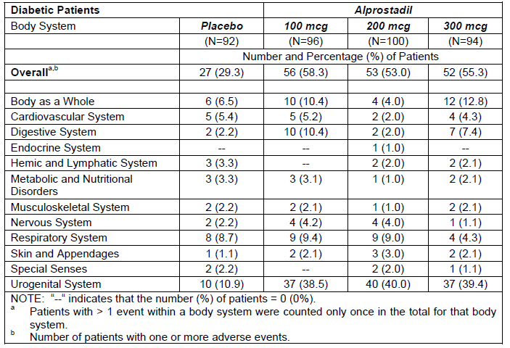
Table 127. Summary of TEAEs by Body System in Cardiac Patients, MED 2000-004 and 2000-005.
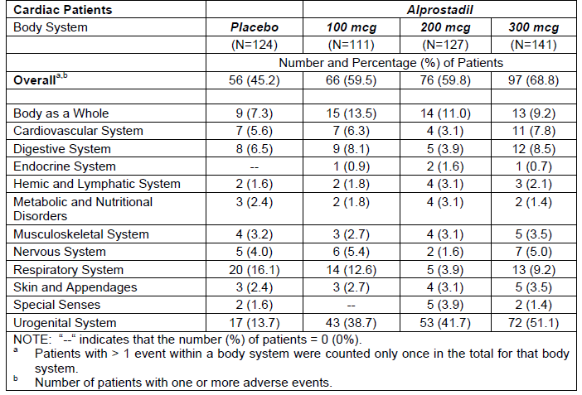
Table 128. Summary of TEAEs by System in Prostatectomy Patients, MED 2000-004 and 2000-005.
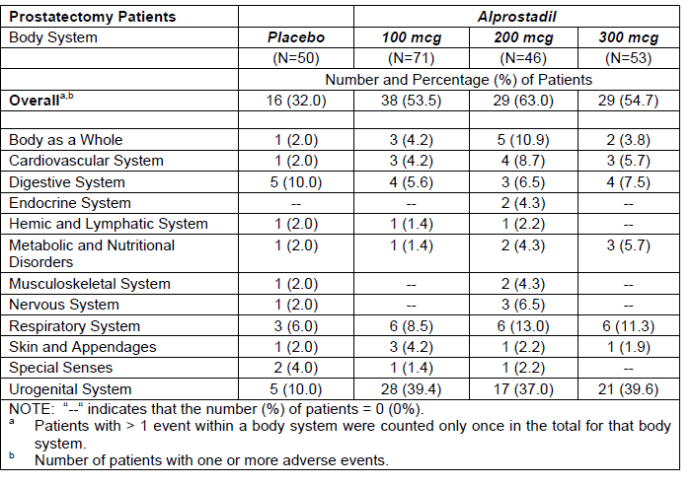
Table 129. Summary of TEAEs by System in Hypertensive Patients, MED 2000-004 and 2000-005.
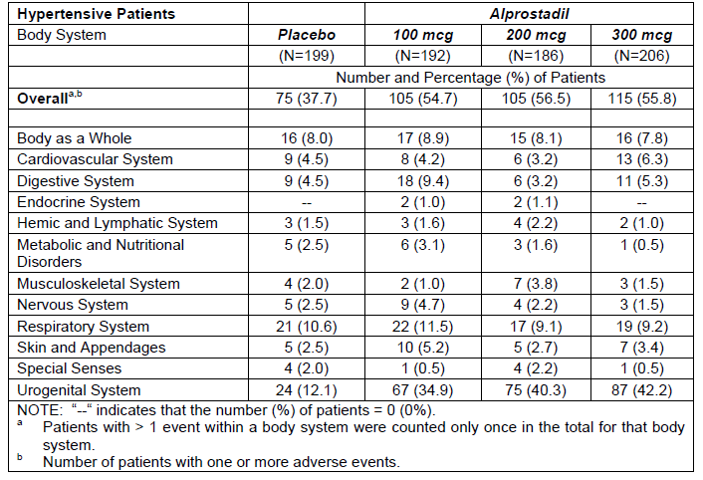
Table 130. Summary of TEAEs by System in Viagra Failure Patients, MED 2000-004 and 2000-005.
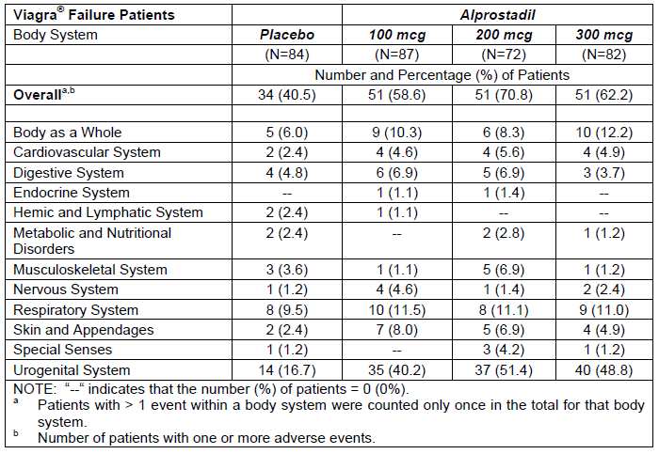

Safety related to drug-drug interactions and other interactions
No drug interaction studies were submitted. The Sponsor’s Summary of Clinical Safety states:
No adverse drug interactions have been reported with alprostadil cream in any clinical studies.
Subjects in the pivotal studies took a variety of concomitant medications, and no obvious pattern of increased AEs was observe with any individual concurrent treatment, but the studies were not designed or powered to detect such patterns.
It would be expected that subjects receiving vasodilators for hypertension would be at increased risk of postural hypotension or syncope if they combined this with alprostadil. Subjects taking PDE5 inhibitors, such as Viagra, would also be expected to be at increased risk, but this combination was not assessed in the studies as other treatments for ED were prohibited.
Given that may subjects continued to have ED despite using alprostadil, it is likely that patients and clinicians will be tempted to combine alprostadil with oral agents such as Viagra. In the absence of studies specifically showing that it is safe to combine such agents, it is appropriate to provide a warning in the PI about the potential for synergistic hypotensive effects.
The proposed PI has the following warning, which is appropriate:
The safety and efficacy for Vitaros in combination with other treatments for erectile dysfunction, especially for the treatment with Phosphodiesterase-5 inhibitors (PDE-5) or sildenafil, tadalafil and vardenafil, has not been studied. As both Vitaros and PDE-5 inhibitors have cardiovascular effects, an additive increased cardiovascular risk cannot be excluded.
A similar warning should be added relating to co-administration of Vitaros with other vasodilators.

Carcinogenesis
The clinical studies were too brief to allow any meaningful assessment of the potential for Vitaros to promote carcinogenesis. Median follow-up in the “long-term” study, MED 2000-006, was about 3 months. If alprostadil or any of the excipients in Vitaros, such as DDAIP, was associated with an increased risk of cancer, it would be expected that this would take years to emerge, and the submitted studies would not have been able to detect this risk.
Although it might be argued that, as an endogenous compound, PGE₁ would be expected to have little carcinogenic risk, non-physiological exposure to other endogenous compounds (such as hormones) has previously been associated with carcinogenesis. On the other hand, existing topical alprostadil products have not been associated with an increased risk of tumours, and preclinical studies have not suggested that alprostadil is associated with carcinogenesis (the same cannot be said of DDAIP).
The addition of DDAIP to the alprostadil formulation has had an unknown effect on the cancer risk of prolonged treatment, and this was a major factor leading to rejection of the drug by the FDA. In particular, a mouse study (a 26-week dermal carcinogenicity study in transgenic mice) suggested that there might be a risk of carcinogenesis, and the FDA asked for clarification of the relevance of this study to human use. The Canadian authorities also expressed concern about the carcinogenic potential of DDAIP, citing the same study, but Canada ultimately approved the marketing of Vitaros. It is unclear what evidence and arguments were raised to allay those concerns.
The Risk Management Plan (RMP) comments on this issue by describing two negative preclinical carcinogenic studies, and then mentioning the positive study, as follows:
A 26-week dermal carcinogenicity study of DDAIP produced positive results in the TgAC mouse and was associated with a significant increase in dermal papillomas at concentrations of 2.5 and 1.0% w/w, which was associated with microscopic evidence of dermal hyperplasia, hyperkeratosis, and inflammation associated with the sebaceous glands.
As with many animal models, the relevance of these results to human exposure is not known. Considerable debate exists in the literature regarding the utility of this particular transgenic model and its use in assessment of human risk.
There are two studies in normal animals that show no carcinogenicity. Additionally, the dose of DDAIP at 1.0 and 2.5% w/v DDAIP corresponds to 50 and 125 mg/kg/day for a 20 g mouse; compared to 0.04 mg/kg/day from one application of Alprostadil Topical Cream in a 70 kg man.
A related compound to DDAIP is lauric acid diethanolamine (LADA) that has been used extensively for more than 25 years in consumer products including those that are considered ‘leave-on’ products and expose mucous membranes.
The Sponsor then points out that LADA also produced positive results in a similar transgenic mouse study, suggesting that the particular mouse model may have poor applicability to human cancer risk.
The fact that another similar compound, LADA, appears not to be carcinogenic is only indirectly and partially reassuring. The suggestion that the mouse model has poor relevance to humans could be plausible, but it is well beyond the scope of this evaluation.
Of some concern is the underlined comment above, offered by the Sponsor as reassurance about the carcinogenic potential of DDAIP. (“Additionally, the dose of DDAIP at 1.0 and 2.5% w/v DDAIP corresponds to 50 and 125 mg/kg/day for a 20 g mouse; compared to 0.04 mg/kg/day from one application of Alprostadil Topical Cream in a 70 kg man”.) This argument is unconvincing. If DDAIP is a carcinogen, it is likely to act locally, not systemically, because systemic absorption of DDAIP is thought to be minimal. The strength of the cream applied to a patch of skin is therefore likely to determine its carcinogenic potential at that site, not the total mass of DDAIP relative to the mass of the rest of the body where the DDAIP is not administered and where it is not diluted.
Although there is reasonably extensive post-marketing experience with alprostadil cream marketed as Befar, in China, it does not contain DDAIP, so it provides no reassurance on this issue. Post-marketing experience with Vitaros in Canada and Europe could help clarify the risk to a limited extent, but no information about the incidence of cancer in post-marketing Vitaros users was submitted.
Thus, while there is no positive clinical evidence of carcinogenic risk, there is also no adequate clinical evidence of low risk, and some preclinical cause for concern. If Vitaros is approved, ongoing surveillance for evidence of carcinogenesis should be a major focus of post-marketing risk management.
In this context, it should be recalled that there is no good clinical evidence that increasing the strength of DDAIP beyond 0.05% improves the efficacy of alprostadil creams, and there is no PK study directly confirming that DDAIP improves absorption (let alone a PK study showing that a strength of 2.5% is needed to achieve this effect). The proposed strength of DDAIP in Vitaros, 2.5%, might be 50 times higher than it needs to be, which is inappropriate for an agent that promoted papilloma formation in mice.

Pregnancy and lactation
Preclinical data suggests that alprostadil could be embryotoxic, as summarised in the proposed PI:
Alprostadil has been shown to be embryotoxic (deceased foetal weight) when administered as a subcutaneous bolus to pregnant rats at doses as low as 500 μg/kg/day. Doses of 2000 μg/kg/day resulted in increased resorptions, reduced numbers of live foetuses, increased incidences of visceral and skeletal variation, gross visceral and skeletal malformations and maternal toxicity (ataxia, lethargy, diarrhoea and retarded body weight gain). The latter dose produced maternal toxicity (ataxia, lethargy, diarrhoea, and related loss of body weight). When administered by continuous intravenous infusion, evidence of embryo toxicity (decrease foetal weight gain, and increased incidence of hydroureter) was observed at 2000 μg/kg/day, a dose that was also associated with a decrease in maternal weight gain. Intravaginal administration of up to 4000 μg/day of PGE1 in a similar marketed product to pregnant rabbits resulted in no harm to the foetus.
The Sponsor’s Integrated Summary of Safety says:
Alprostadil cream has not been studied in partners of patients that are pregnant or breast feeding. Alprostadil cream should not be used in men whose partner is pregnant or breast feeding woman or for oral sex (fellatio), unless the couple uses a condom barrier.
The PI carries a similar warning.
In the absence of better information, this advice seems appropriate, but it does not cope with the situation, likely to be common, in which coitus is continuing before pregnancy has been recognised.

Sexually transmitted diseases
Sexually transmitted diseases (STDs) did not appear to be commonly reported as AEs in the pivotal study safety database, but many symptoms that could be indicative of an STD (urogenital discomfort) were reported; these were usually attributed to direct irritation from the treatment itself. Given that subjects were required to be in a stable heterosexual relationship, the risks of STDs may have been artificially low in the Phase 3 studies, compared to a general population of men with erectile dysfunction. The prevalence and incidence of STDs would be expected to be higher in a more promiscuous population, and might also be different in a homosexual population, who were not studied in any of the clinical studies but who would be expected to be potential users of the product.
It is unknown whether alprostadil or DDAIP have any effect on the risk of transmitting STDs, but concerns were raised in the FDA rejection letter stating that this risk had not been well-defined. It is unclear if any further information has been obtained by the Sponsor since this concern was first raised.

Priapism
Priapism, defined as an erection persisting ≥4 hours, was observed in 1 patient (0.06%) from the two pivotal 3-month studies and in 5 patients (0.4%) in the long-term extension study, MED 2000-006, including 4 (0.3%) in the 200 mcg and 1 (0.1%) in the 300 mcg dose groups.
In subjects at higher risk of priapism (for instance, those with sickle cell anaemia), Vitaros should be avoided. The proposed PI contains appropriate warnings on this issue.

Spermatotoxicity
No clinical data on potential spermatotoxicity was submitted, and the issue was not mentioned in the Summary of Clinical Safety or the Integrated Summary of Safety. The clinical studies did not monitor sperm counts. The European Risk Management Plan (RMP), however, contains the following statements:
Degeneration of the seminiferous tubules was observed in rabbits administered the alprostadil topical cream topically on the penis for 28 days. The degeneration was not completely reversible within the seven-day recovery period.
The relevance to humans is unknown, therefore, a post authorization study assessing sperm toxicity in men administered the alprostadil topical cream will be assessed.
Later, the RMP includes the statement:
In vitro data indicate DDAIP HCl has spermicidal activity.
This issue should be resolved before the drug is marketed, not after, and patients using the drug have a right to know that there is a chance the drug could reduce fertility. If the drug were to be marketed prior to establishing whether it is spermatotoxic in humans, it would be appropriate for the PI to have a warning containing the above information.

Misuse of the dispenser
Some subjects are likely to insert the dispenser into the meatus instead of letting the cream drip down from a distance, despite the fact that the proposed PI and CMI contain diagrams of correct use.
In Study MED 2000-004, the potential for such misuse was characterised, as summarised in the Risk Management Plan:
Based upon 507 patient responses (Study MED 2000-004) to the following question: “Did you insert the tip of the dispenser into the penis since your last visit?”, 23 patients (4.5%) responded “yes” to the question and of these patients, 11 (47.8%) had an AE of the urogenital system including penile burning (n = 6), genital pain (n = 5), penis disorder (n = 2), penile tingling (n = 1), penile erythema (n = 1), and fullness genital (n = 1); the majority of which were mild to moderate in intensity and possible, probably, or definitely related to study drug.
Overall, it appears that this poses minimal risk to the patient and the Sponsor has taken appropriate steps to minimise this risk.

Evaluator’s conclusions on safety
The tolerability of Vitaros has been well defined, and the main issues identified consist of urogenital discomfort and occasional instances of hypotension. The two pivotal studies, pooled for safety analysis, provided the best assessment of tolerability, and the AEs in each pivotal dose group are summarised below. Urogenital AEs were reported in 42-43% of subjects at the proposed doses, and mostly consisted of urogenital discomfort.
Table 131. Summary of Most Common Patient Adverse Events (Adverse Events that Occurred in > 1% of Patients) (Intent-To-Treat Safety Population): MED 2000-004 and MED 2000-005.
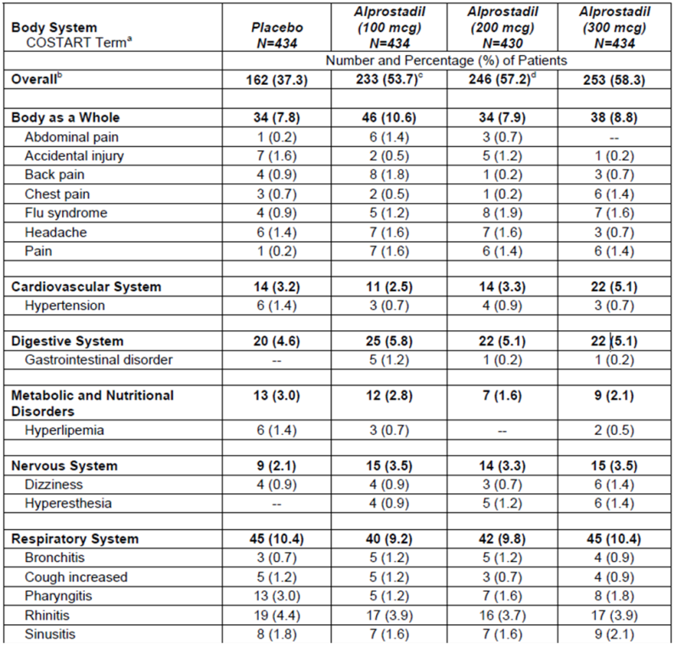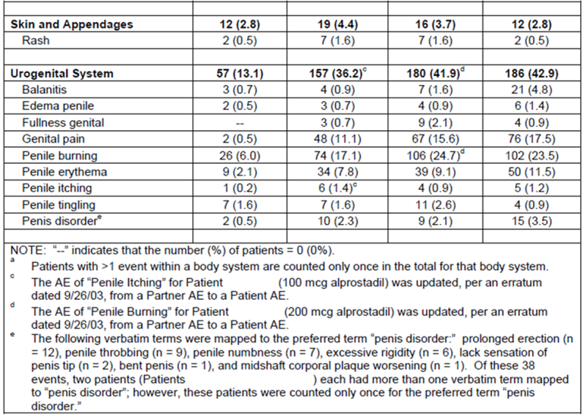
Hypotension in response to individual doses was only assessed with the first test dose, and subjects who were intolerant were subsequently excluded, but the overall incidence of hypotension appeared to be low when Vitaros was used at the proposed dose. In a high dose Phase II study, the incidence of haemodynamic intolerance was much higher, reported in 7 of 21 subjects receiving active treatment.
Priapism appears to be a rare complication of treatment, and subjects at increased risk of priapism should avoid Vitaros. The PI carries appropriate warnings about this issue.
Partners of men using Vitaros appear to be at increased risk of vulvovaginal discomfort, but some of this could be due to coitus and vaginal penetration itself.
More serious safety concerns were less well defined. No overall excess of SAEs was seen with active treatment, and the only death in a pivotal study occurred in a placebo recipient. This is somewhat reassuring, but it is insufficient to prove that the long term safety is acceptable. It should be recalled that only 4 patients in Phase III studies have received alprostadil for ≥12 months, and median follow-up in the “long term” safety study, MED 2000-006, was only about 3 months.
There was an excess of myocardial infarctions with active treatment, but this was an uncommon event overall; no statistical analysis was performed and any statistical comparison of infarct rates between groups would be underpowered. Myocardial infarction was reported in 4 (0.9%) subjects receiving alprostadil 300 µg, and in 1 (0.2%) recipient of alprostadil 200 µg, but not in any recipients of alprostadil 100 µg or placebo. Investigators did not feel that there was a causal relation to treatment in any individual case, but information about the time interval between administration and the infarct was not submitted. Subjects with recent myocardial infarction were excluded from the pivotal studies, so the risk could be higher in an unselected population. The proposed PI lists myocardial infarction as a contraindication to treatment, which is appropriate, but the rationale for this exclusion was not discussed. Post marketing risk management should include monitoring for an increased risk of myocardial infarction.
Of considerable concern, the submitted studies were too brief to allow any meaningful assessment of the potential for Vitaros to promote carcinogenesis. A preclinical study raised the possibility of carcinogenesis, and one of the reasons Vitaros was rejected by the FDA was that the clinical significance of this finding had not been adequately characterised. This still appears to be the case. Subjects responding to Vitaros are likely to use it for many years, and could be at risk of local penile cancers if alprostadil or any of its excipients, such as DDAIP, has a carcinogenic potential. Partners of men using Vitaros could also be at risk, though their exposure would be expected to be much lower.
It is unclear if Vitaros has any effect on the risk of transferring sexually transmitted diseases. This concern was raised by the FDA, but it was not discussed in the Australian submission.
Vitaros is embryotoxic, and although the PI recommends using it in men whose partners are pregnant, it is inevitable that it will occasionally be used in early pregnancy, before pregnancy is recognised.
The post marketing experience with Vitaros was not reported in this submission, even though the drug has already been approved in Europe and Canada. Post marketing experience in China with the DDAIP free alprostadil treatment, Befar, was reported in inadequate detail.

First round benefit-risk assessment

First round assessment of benefits
The benefits of Vitaros in the proposed usage are:
- A mean improvement in erectile function amounting to about 10% of the available points on the IIEF scale.
- A response rate (consisting of any improvement in a GAQ) that is 47-52%, compared to a placebo response rate of 20%.
- More convenient administration than existing alprostadil formulations (such as Caverject, which requires intra penile injection).
The benefit in subjects with mild ED has not been well characterised, but the overall effect of Vitaros may be negative in this subgroup (mean scores in this subgroup showed a negative change in the pivotal studies). Given that subjects will be able to judge the efficacy of treatment for themselves, this is not a major concern.
The dose response relationship for Vitaros has not been clearly defined, but the benefit for the 200 µg and the 300 µg doses appears to be similar.

First round assessment of risks
The risks of Vitaros in the proposed usage are not well defined, but potentially consist of the following:
- Local, reversible urogenital irritation is likely to occur in up to 43% of subjects and up to 9% of partners. Given that such irritation will be evident to subjects, who will be free to decide whether to continue treatment, this is not a major concern unless it promotes transmission of infection.
- Subjects at risk of orthostatic hypotension may respond to alprostadil with presyncope or syncope. This problem was rare in the pivotal studies (dizziness occurred in 1.4% of subjects at 300 µg, and a single subject did not tolerate the test dose), and the risk is appropriately highlighted in the proposed PI.
- Based on preclinical studies, Vitaros may be spermatotoxic, and it caused changes in the seminiferous tubules of rabbits. This risk is not mentioned in the proposed PI and it has not been quantified in any human studies.
- Based on one of three preclinical studies, DDAIP may be carcinogenic. The clinical study program was too brief to assess this risk in humans.
- Vitaros may be embryotoxic, and is likely to be used by couples who are not yet aware that the female partner is pregnant.
- The DDAIP concentration proposed for marketing (2.5%) may not be the lowest effective concentration, with some formulation studies suggesting that a much lower concentration (0.05%) produces a similar benefit. The proposed strength has not been based on any PK studies, and the limited efficacy data provide no specific support for the proposed strength.
- There was a very low incidence of myocardial infarction in the pivotal studies, but all cases occurred in active groups. Individual cases did not suggest a causal relation to treatment, but this risk remains poorly defined.
- It is unknown if Vitaros modifies the risk of sexually transmitted diseases, but it is at least plausible that irritated mucosal surfaces might be more susceptible to transmission of pathogens. This risk has not been assessed in any studies, and the pivotal studies were restricted to couples in a stable heterosexual relationship, so they were not suitable for assessing this risk.
- Other long term safety issues could have been missed given that the sponsor’s only “long term” Phase III study had a median follow-up of about 3 months.
For all of these risks, there is currently inadequate clinical data. Although the available clinical studies have not shown definite concerning safety signals, they have not excluded the potential for harm or adequately explored issues raised in the preclinical program. Given that the drug is not being proposed for use of a life threatening condition, and could be used for many years by otherwise healthy men, it would be inappropriate to expose such men to a poorly defined risk of carcinogenesis, spermatotoxicity, or enhanced transmission of infection, and it would be inappropriate to expose women to an agent that may be embryotoxic. These risks need to be characterised more completely before patients and clinicians can make informed choices about what risks can be considered acceptable.

First round assessment of benefit-risk balance
The benefit-risk balance of Vitaros might be favourable, but it has not been characterised with sufficient detail.
The fact that the clinical benefit is only modest and might not be substantial in mild cases is offset by the fact that subjects can directly observe the response to treatment themselves and decide whether the treatment is worthwhile for them. The AEs that have occurred with treatment largely consisted of local urogenital discomfort, and subjects can decide for themselves if this discomfort is a problem for them.
The problem is that the potential for more serious safety issues has not been adequately explored. If it were known with confidence that Vitaros was not carcinogenic or spermatotoxic, and Vitaros did not have any other safety concerns, the benefit-risk balance would be positive, but these risks are not well defined and long term safety data is minimal. Many subjects would decline treatment if they thought Vitaros posed a significant risk of causing carcinogenesis or spermatotoxicity. These risks are not currently highlighted in the proposed PI, so patients and doctors reading the PI would not be in a position to make an informed judgement about those risks.
Overall, until the residual safety issues have been explored in more detail, it would be premature to approve alprostadil. It could become appropriate to approve the drug after satisfactory responses to the Clinical Questions listed, and after appropriate revision of the PI, but only if the weight of expert opinion was that carcinogenesis and spermatotoxicity were not likely to be clinically significant.

First round recommendation regarding authorisation
The application to register Vitaros should be rejected.
The main objections to registration at this time are:
- No adequate long term safety study has been performed.
- The post marketing experience with Vitaros and Befar has not been adequately characterised in the Australian submission.
- A preclinical study in transgenic mice has raised the possibility of DDAIP promoting carcinogenesis, and the clinical relevance of this study remains poorly characterised.
- A preclinical study in rabbits has shown that Vitaros has adverse effects on seminiferous tubules, but this issue has not been studied in humans.
- Vitaros causes local urogenital irritation, which could promote the transfer of sexually transmitted diseases, but this issue has not been adequately addressed in human studies.
- The strength of DDAIP proposed for Vitaros (2.5%) is potentially much higher than the lowest effective strength (0.05%) required for permeation enhancement, which is of particular concern given the unknown carcinogenic potential of DDAIP.
Expert opinions should be obtained about:
- the risk of carcinogenesis posed by the inclusion of DDAIP in the Vitaros formulation;
- the clinical relevance of preclinical studies suggesting spermatotoxicity;
- the risk of Vitaros enhancing transmission of sexually transmitted diseases.
The sponsor should address the issues outlined above, answer the questions raised, revise the PI along the lines discussed, and then resubmit.

Clinical questions

Additional expert input
Expert opinions should be sought on three issues:
- The capacity for DDAIP to promote carcinogenesis in humans, in relation to the preclinical mouse study of transgenic mice that showed an increased incidence of papillomas when mice were exposed to DDAIP.
- The risk of spermatotoxicity in humans, in relation to the pre-clinical study in rabbits showing changes in the seminiferous tubules.
- The capacity for the local irritation produced by Vitaros to promote transfer of sexually transmitted diseases.
None of these issues was addressed in sufficient detail in the clinical study program to allow an assessment of the actual risk in human users of Vitaros.
For the first two of these issues, the preclinical evaluator may have sufficient expertise.
For the third issue, an expert in sexually transmitted diseases should be consulted. Preferably this expert would have experience in both animal studies and human sexually transmitted diseases.

Dose and formulation

Question 1
In a drug monograph intended for other countries, the doses used in the pivotal studies and proposed for use were referred to as 220 μg and 330 μg instead of 200 μg and 300 μg. Could you please explain the discrepancy?

Question 2
In the same monograph, it was suggested that alprostadil dosing should begin at 220 μg and that 330 μg should be reserved for subjects who need up-titration, whereas the proposed Australian PI suggests starting at 300 μg and down-titrating if side effects occur. Please explain this discrepancy. Given that efficacy in the pivotal studies was similar for 200 μg and 300 μg, why is 300 μg recommended as the starting dose for Australian users?

Question 3
The Chinese formulation studies suggested that DDAIP at concentrations of ≥0.05% enhanced the efficacy of alprostadil. Why was a DDAIP strength of 2.5% selected for Vitaros if a similar benefit could be obtained with lower strengths of DDAIP?

Pharmacokinetics

Question 4
What underlying PK model was used in the PK study, MED 2000-003?

Question 5
What PK evidence is available to support the assertion that DDAIP increases absorption of alprostadil, and is there any PK evidence that specifically supports adoption of the proposed DDAIP strength of 2.5%? Given that 15-keto-PGE₀ can be used as a surrogate PK marker for alprostadil absorption, and that concerns have been raised about the carcinogenicity of DDAIP, why were no PK studies submitted that justified the proposed DDAIP strength?

Pharmacodynamics
See Q25.

Efficacy

Question 6
Please confirm that all of the US Phase III Vitaros studies used the same formulation as that proposed for marketing, including the same strength of DDAIP, and indicate whether the placebo formulation also contained DDAIP at the proposed strength of 2.5%.

Question 7
The GAQ is described as a 7-point scale in some parts of the submission, and as a yes-no question in other parts of the submission. What form of the question as used in the pivotal studies? If a 7-point scale was used and then converted to a yes-no binary response, what was the distribution of the responses before this conversion?

Question 8
In the pivotal studies, a weighting procedure for Q3 and Q4 of the Sexual Encounter Profile (SEP) is mentioned but not well characterised. What weighting procedure was applied to Q3 and Q4 of the SEP, and did this procedure mean that subjects contributed unequally to the final analysis?

Question 9
In the pivotal studies, 3 doses were assessed against 3 endpoints, giving 9 dose-endpoint pairings. Why was there no plan in place to correct the statistical analyses for multiplicity?

Question 10
In the pivotal studies, was any attempt made to assess unblinding? If not, why not?

Question 11
In the pivotal studies, was any attempt made to assess the potential impact of withdrawal bias? If not, why not?

Question 12
In the pivotal studies, the overall effect of Vitaros appeared to be negative in subjects with mild ED. A Phase II study in mild-to-moderate ED (MED 99-002A) produced a positive result in the overall cohort, but a subgroup analysis of those with mild ED was not presented. What were the efficacy results in subjects from MED 99-002A with mild ED, and what evidence exists that shows Vitaros to be useful in this section of the target population?

Question 13
For the high-dose Phase II study, MED 99-001, please present the main efficacy variables from this study in terms of means and mean changes in each treatment group, with standard deviations.

Question 14
The Chinese Study NM-AP-38 was only presented as a synopsis, and the efficacy results were not explained in adequate detail. This sentence was particularly unclear:
The efficacy evaluated by the number of successful intercourse attempts per total intercourse attempts revealed an efficacy rate of 89.5%, 65.0% and 48.9% for mild, moderate and severe ED patients in PGE1 group versus 31.3%, 27.4% and 6.1% in placebo group.
Please explain what is meant by the “efficacy rate” and how the main endpoints were evaluated and then present the results in tabular format.

Question 15
The Chinese Study NM AP-28-OL/DB was not presented in adequate detail. For the double blind portion of this study, please indicate how active treatment compared to placebo treatment.

Safety

Question 16
What was the median follow-up in the “long-term” safety study, MED 2000-006?

Question 17
What is the clinical significance of the positive mouse carcinogenicity study? What evidence or arguments were provided to Canadian and European authorities to allay concerns about this issue?

Question 18
What is known about the effects of Vitaros on the transfer of sexually transmitted disease?

Question 19
What is known about the potential for Vitaros to produce spermatotoxicity in humans?

Question 20
Given that prostaglandins inhibit platelet function, what is known about the clinical effects of alprostadil on bleeding risk?

Question 21
Please provide details of the post-marketing experience observed with the related product, Befar, including a discussion of which AEs have been reported.

Question 22
Please provide details of the post marketing experience observed with Vitaros in the EU and Canada, including a discussion of which AEs have been reported.

Question 23
Does the use of Vitaros by homosexual men or heterosexual couples engaged in anal intercourse raise any specific safety issues? What is known about the safety of Vitaros in this context?

Question 24
In the Chinese study NM-AP-42C, the safety section of the study summary reads as follows:
A total of 70 patients completed the study. Thirty-eight (25.71%) patients experienced adverse events. The investigators confirmed that all adverse events were related to study medication. 76.32% of the AEs were mild and 23.86% of them were moderate. All of the AEs happened in urogenital system and were transient as well. No medical treatment was required. The average duration for adverse events was 25 minutes and the longest duration was 45 minutes.
Please explain the source of the figure “25.71%”. If 38 subjects from a total of 70 had AEs, which represents 54.3%.

Second round evaluation
The Sponsor has submitted a combined response to questions raised during the Non-clinical and Clinical Evaluations. This evaluation report will restrict commentary to the clinical questions raised in the first-round Clinical Evaluation Report (CER). The questions and responses will be considered individually, but the discussion below provides an overview.
Some of the more substantive concerns raised in the first-round CER were partly based on pre-clinical matters, which did not appear to have been adequately addressed in the clinical studies. For instance, non-clinical studies had raised the possibility of both carcinogenicity and spermatotoxicity, and yet the clinical program had not assessed fertility effects in humans, or sought to confirm that these risks were being minimised by using the lowest possible concentration of DDAIP.
The Non-clinical Evaluator was asked to comment on three issues raised in the first-round CER and the Sponsor’s Section 31 response: the extent to which non-clinical studies supported the proposed concentration of DDAIP, the carcinogenicity of DDAIP, and the spermatotoxicity of DDAIP.
Unfortunately, several of the questions raised in the first-round CER were not answered adequately by the Sponsor in their Section 31 response. Although answers were provided, these answers often consisted of a citation of the very material that had been marked as inadequate in the first place. Other answers consisted of a simple statement that the requested information was unavailable. For instance, when asked the median follow-up in Study MED 2000-006, which could be readily calculated by anybody with access to the study database, the Sponsor wrote:
Module 2.5.1 provides details of duration of exposure to DDAIP and drug in the long term follow up study. Median follow up statistic was not calculated in the statistical assessment.
The request for the median follow-up was asked because this information was not calculated in the original statistical assessment.
Similarly, when asked why no correction was made for the use of multiple endpoints in the pivotal studies (Question 9), the Sponsor merely stated that no correction had been made:
In the pivotal studies, 3 doses were assessed against 3 endpoints, giving 9 dose-endpoint pairings. Why was there no plan in place to correct the statistical analyses for multiplicity?
Response:
No adjustments were made for multiple comparisons.
In some cases, when methodological flaws in the main studies were pointed out (such as the potential for withdrawal bias and unblinding), the Sponsor failed to acknowledge these flaws and the Sponsor’s provided answers provided no evidence that the methodological issues had even been understood.
On balance, the overall response was sufficient to allow evaluation of several substantive matters, but has to be considered incomplete in relation to the proposed DDAIP concentration and several minor matters. In particular, Questions 4, 8, 9, 11, 12, 13, 14, 15 and 16 have not been answered adequately. (In the case of Question 15, the question itself was poorly phrased.) For Question 3, relating to the proposed DDAIP concentration, the Sponsor’s response was only partially adequate, and in view of the Non-clinical Evaluator’s assessment of this issue, the unresolved issues in relation to DDAIP concentration represent a barrier to registration.
For each item below, a restatement (in bold) of the original Clinical question is followed by a summary (in italics) of the Sponsor’s response, and then an evaluation of the adequacy of that response.

Response 1

Clinical question
- In a drug monograph intended for other countries (m1-10-2-other-countries-pi.dotx.pdf), the doses used in the pivotal studies and proposed for use were referred to as 220 mcg and 330 mcg instead of 200 mcg and 300 mcg. Could you please explain the discrepancy?

Sponsor’s response
The pivotal studies were labelled as 200 mcg and 300 mcg, but contained a 10% overage of alprostadil resulting in a formulated amount of 220 mcg and 330 mcg. The approved European SPC is consistent with the proposed Australian PI which nominates the doses as 200 mcg and 300 mcg, excluding the overage. The nominated doses are also consistent with published literature on this dose form; and this ensures there is no confusion with dosing when treating physicians access published literature. Health Canada required that the overage be included when nominating doses in the Canadian product monograph.

Evaluator’s comments
This response adequately accounts for the discrepancy. It would have been appropriate to describe the 10% overage more clearly in the Clinical Overview, but this does not represent an issue of significant clinical concern.

Response 2

Clinical question
- In the same monograph, it was suggested that alprostadil dosing should begin at 220 mcg and that 330 mcg should be reserved for subjects who need up-titration, whereas the proposed Australian PI suggests starting at 300 mcg and down-titrating if side effects occur. Please explain this discrepancy. Given that efficacy in the pivotal studies was similar for 200 mcg and 300 mcg, why is 300 mcg recommended as the starting dose for Australian users?

Sponsor’s response
The dosing recommendations in the PI have been amended as follows:
The initial dose should be recommended by a physician. A starting dose with the 300 mcg dose can be considered especially in patients with serious ED, co-morbidity or failure to [sic] PDE-5 inhibitors. Those patients that do not tolerate the 300 mcg dose due to local side effects can be titrated to the lower 200 mcg dose.
The Australian PI is proposed to be aligned with the approved European SPC. This dosing recommendation is considered to provide the best opportunity for a positive clinical outcome for the following reasons. The higher dose is more effective in patients with severe ED and also provided a better response in patients with a comorbidity (cardiac disease, hypertension, diabetes and prostatectomy). Also in the long term study, patients were started on the 200 mcg dose and were provided the opportunity to up titrate to 300 mcg or down titrate to 100 mcg. In this study more than 85% of the patients switched to 300 mcg indicating a slightly better response.
A post hoc responder analysis was performed at the request of the European Medicines Agency (EMA) (IIEF-EF, SEP-2, SEP-3, IIEF-EF.26 and GAQ positive response scores) by severity in the ITT population (MED-2000-004/005) which indicated that Vitaros is a viable option for first-line treatment of erectile dysfunction at 300 mcg for the moderate to severe subjects because it gives the most consistent response based upon the minimal clinically important difference across all severity categories of ED for IIEF and the penetration success rate. Although statistical significance was achieved at 200 mcg in some of these parameters, this dose did not give a consistent response across all severity categories of ED.
Based on the overall safety profile, there is no significant safety advantage of the 200 mcg dose over the 300 mcg dose. For example 34% of patients who used the 100 mcg had at least one drug related adverse effect versus 41% for the 200 mcg dose and 42% for the 300 mcg dose, i.e. the adverse event profile is comparable between the two doses. A similar trend is also observed for penile burning, penile erythema, genital pain and vaginal burning.

Evaluator’s comments
The revised dosing recommendations are an improvement over the initial recommendations. There is no clear evidence favouring one dose, so it is appropriate for the PI to suggest that clinicians should choose the dose based on the individual patient.
The Sponsor’s comments on the superiority of the 300 mcg dose in some subgroups may have some merit, but should be interpreted with caution given that they are partly based on post hoc subgroup analyses. With respect to the overall results of the pivotal studies, the first-round CER noted the following: “Considering least square (LS) mean changes, the highest dose, 300 mcg, produced inferior results to the 200 mcg dose for two of the three co-primary endpoints (IIEF EF Domain and SEP Q4), and superior results for the other co-primary endpoint (SEP Q3).” These results do not suggest that 300 mcg is substantially more effective, overall, than 200 mcg, though it may be possible for clinicians to identify subgroups in which the higher dose is likely to be needed.
The Sponsor’s comments on the relative tolerability of 200 mcg and 300 mcg are somewhat misleading. The adverse event table included in the Sponsor’s response is essentially the same as the one below, which was presented in the first-round CER.
Table 132. Summary of AEs, Studies MED 2000-004 and 2000-005 (ITT Safety Population).
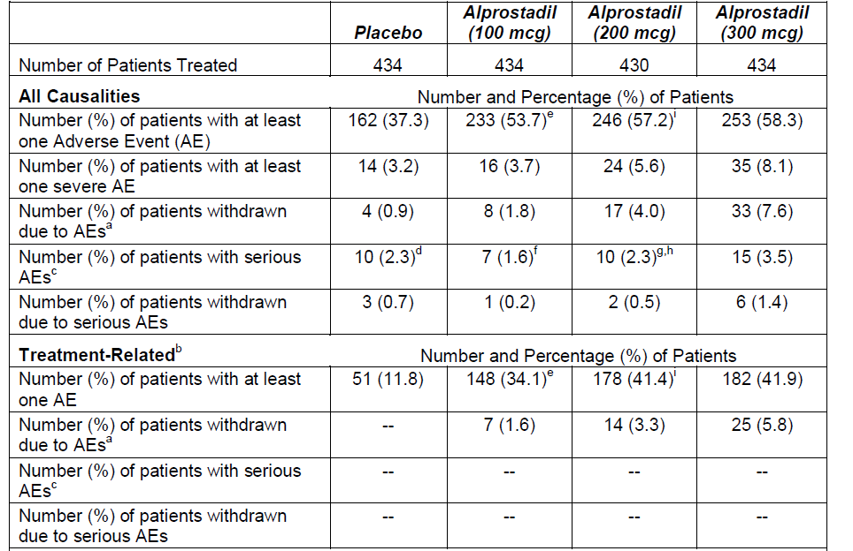
A simple count of AEs at 200 mcg and 300 mcg suggests a similar incidence of AEs in the two dose groups, as the Sponsor notes, but the 300 mcg dose group showed a higher incidence of:
- severe AEs
- AEs leading to withdrawal
- serous AEs
- serious AEs leading to withdrawal
- treatment-related AES leading to withdrawal
For AEs leading to withdrawal, the relative difference in incidence was substantial, with the 300 mcg dose group producing nearly twice as many withdrawals as seen in the 200 mcg dose group (7.6% vs 4%), although the absolute excess of withdrawals was small (3.6%).
In their response to this question, the Sponsor also made the following comments, which are misleading:
Also in the long term study, patients were started on the 200 mcg dose and were provided the opportunity to up titrate to 300 mcg or down titrate to 100 mcg. In this study more than 85% of the patients switched to 300 mcg indicating a slightly better response.
Switching to a higher dose because of an inadequate response to a lower dose does not constitute or confirm a better response at the higher dose, a point discussed in more detail below (Response 26).
Overall, there is weak evidence that 300 mcg may be more effective than 200 mcg in some subgroups, and there is reasonable evidence that tolerability is worse at the higher dose, so it is appropriate to leave final dose selection to clinicians.

Response 3

Clinical question
- The Chinese formulation studies suggested that DDAIP at concentrations of ≥ 0.05% enhanced the efficacy of alprostadil. Why was a DDAIP strength of 2.5% selected for Vitaros if a similar benefit could be obtained with lower strengths of DDAIP?

Sponsor’s response
The DDAIP strength of 2.5% was selected based on in-vitro permeation studies which showed an optimal permeation of alprostadil at 2.5% DDAIP compared to 0.50, 1.00, 1.50, 2.00 and 5.00% DDAIP.
The initial stability studies during formulation indicated that DDAIP levels are reduced over the life of the product. As such the clinical range of its functionality was evaluated in the Chinese formulation studies, which are supportive of the effective range of DDAIP concentration. Based on the Chinese formulation studies it was determined that a minimum 0.5% DDAIP at shelf life was required to achieve a satisfactory clinical effect. Hence the 2.5% DDAIP in the manufacturing formulation allows for reduction over shelf life to meet the minimum effective concentration at the end of shelf life.
DDAIP is a functional excipient that has an effect over a range of concentrations, similar to other functional excipients, such as parabens which are used for preservation, but decrease in potency over time, but still provide for their intended use.

Evaluator’s comments
The proposed concentration (2.5%) is up to 50 times greater than the minimum necessary concentration suggested by clinical studies (0.05%), and even allowing for some degradation during the shelf life of the product, this seems excessive.
In this response, the Sponsor is basically conceding that there is no clinical evidence supporting the proposed DDAIP concentration. The Sponsor suggests, instead, that the concentration was largely based on in vitro permeation studies and the need to compensate for the expected reduction of DDAIP levels during the shelf life of the product.
The Sponsor’s response to this question refers to the following figure (originally numbered Figure 4 in Report TR-023), which was derived from a snake skin model. In this figure, levels of alprostadil appear to increase with increasing DDAIP concentration up to 2.5% DDAIP, but there is little further increase in alprostadil levels achieved with 5% DDAIP.
Figure 8. Non-clinical Study of Effect of DDAIP Concentration in Formula C on the Permeation Profiles of Alprostadil (0.2%).
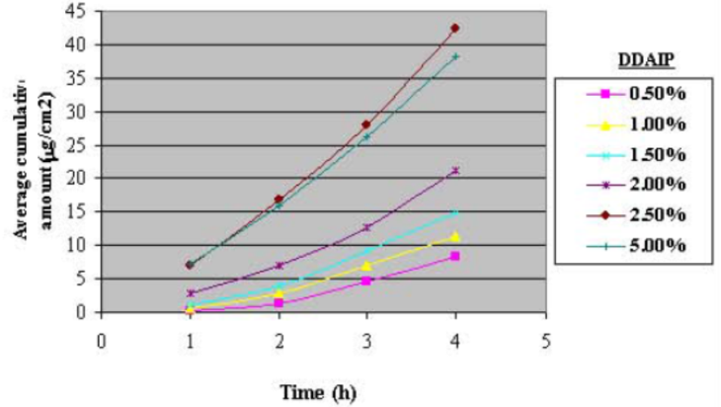
The adequacy of this evidence and the overall pre-clinical rationale for the proposed DDAIP concentration has been assessed by the Non-clinical Evaluator. The Non-clinical Evaluator raises the following points:
It is my opinion that the nonclinical findings cannot be given preference over the clinical data in determining the minimum effective concentration of DDAIP due to the following reasons:
    - Clinical studies are better predictors of clinical efficacy than animal models.
    - Even if the snake skin model was a perfect model for normal human skin permeability to alprostadil, the product is intended for application into the urethral orifice, and the urethra has higher permeability than skin since it lacks a stratum corneum (a relatively impermeable protective layer at the skin surface composed of cornified keratinocytes). The enhanced permeation through the urethral (non-keratinized pseudostratified) epithelium may explain why the absorption was achieved using lower DDAIP concentrations in humans that in nonclinical skin models such as the snake skin model.
    - Furthermore, the differences in permeability in the snake skin model due to differences in DDAIP concentration do not appear to be significant (statistics not provided) at 1 hour post treatment, and it is not known what the permeability would have been before 1 hour (see ‘Figure 4 above). It is expected that a patient would apply VITAROS to his penis around 30 minutes before intercourse, so the lack of significantly increased alprostadil permeability due to a higher concentration of DDAIP within 1 hour of treatment, confirms that there are no nonclinical grounds to override the findings from clinical studies.
    - It is noted that in Response to Clinical question number 3, the Sponsor stated that the reason they want to include 2.5% DDAIP is because at the end of the shelf life a minimum of 0.5% DDAIP will be required to achieve a satisfactory clinical effect. This suggests that the reason the Sponsor chose a concentration of 2.5% is the expected degradation of DDAIP during its shelf life. Therefore, patients using a fresh batch would be exposed to 2.5% DDAIP and patients using the product close to its shelf life would be exposed to around 0.5% DDAIP.”
All of these reservations expressed by the Non-clinical Evaluator appear reasonable. In particular, the following points suggest that the non-clinical evidence cannot alone justify the proposed DDAIP concentration, particularly as it is in conflict with the clinical evidence:
- the Sponsor has not justified their preference for non-clinical evidence when the same issue has been assessed in clinical studies;
- the Sponsor has not acknowledged or explained the discrepancy between the non-clinical studies and clinical studies;
- the Non-clinical Evaluator has identified a likely source of the discrepancy (the lack of a stratum corneum at the clinical site of application), and because of this difference the applicability of the snake skin model to the urethral epithelium seems limited;
- the first 30 minutes after application were not assessed in the snake skin model, even though this is the clinically relevant time frame;
- statistics were not provided for the one-hour snake skin data (and, in keeping with this, the provided figure lacks error bars), so the data in support of higher DDAIP concentrations is statistically uncertain;
Importantly, the Sponsor has not attempted to weigh the clinical and non-clinical evidence on this issue, and they have not addressed a key part of the clinical question:
The Chinese formulation studies suggested that DDAIP at concentrations of ≥ 0.05% enhanced the efficacy of alprostadil.
The Sponsor’s response makes no reference to the value of 0.05% that was in the original Clinical Question. Instead, the Sponsor writes:
Based on the Chinese formulation studies it was determined that a minimum 0.5% DDAIP at shelf life was required to achieve a satisfactory clinical effect.
The Clinical question and the Sponsor’s response disagree on what the clinical data establishes as the minimum effective concentration by a factor of ten, but the Sponsor’s response provides no commentary on this disagreement. The Chinese studies actually showed a substantial effect at 0.05% DDAIP, with no clear superiority of higher concentrations. The results at 0.5%, the Sponsor’s suggested minimum effective concentration, were actually inferior to those observed at 0.05%, as shown in the figure below, derived from three pooled Chinese studies. (A comparison across pooled studies is inherently unreliable, so it cannot be inferred with confidence that 0.05% is an adequate concentration, but it cannot be concluded that a concentration 10 or 50 times this is necessary, either.)
Figure 9. Effect of DDAIP on Response Rate (“Percent Efficacy”) in 3 Pooled Chinese Studies.
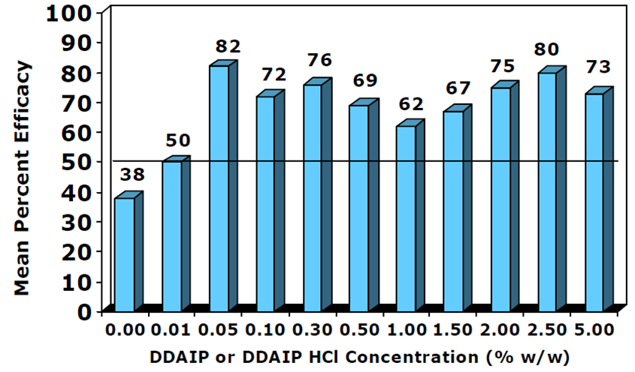
As noted in the first-round CER, no PK studies were performed assessing the absorption of alprostadil with different concentrations of DDAIP, even though it appears that such a study would have been possible using alprostadil metabolites as a surrogate marker of alprostadil absorption (see Response 5).
Overall, there is substantial residual uncertainty about the lowest effective concentration of DDAIP. Although results in a snake skin model suggest that a concentration of 0.5% or 2.5% might offer increased absorption compared to lower concentrations, not even this study shows that statistically significant differences in absorption occur within a clinically relevant timeframe. Furthermore, there is conflicting evidence in clinical studies, and no firm reason to reject the clinical data in favour of an animal model that assessed permeation through a different type of epithelium.
The Sponsor needs to clarify these issues, preferably with new clinical studies that resolve the uncertainty. In particular, they should explain their claim:
Based on the Chinese formulation studies it was determined that a minimum 0.5% DDAIP at shelf life was required to achieve a satisfactory clinical effect.
This claim appears to overstate the minimum necessary DDAIP concentration by a factor of ten. Including the Sponsor’s allowance for degradation of DDAIP during shelf life, the proposed concentration (2.5%) is 50 times the minimum dose established in the Chinese studies (0.05%), and the Sponsor’s Section 31 response does not provide any substantial defence of the 50-fold excess.
The Sponsor’s response also raises a new issue, in relation to the expected degradation of DDAIP during the shelf life of the product. Part of the rationale for the high concentration of DDAIP was that:
The initial stability studies during formulation indicated that DDAIP levels are reduced over the life of the product.
The Sponsor has taken what they believe to be the minimum effective concentration (0.5%) and increased it by a factor of five to account for this degradation (to 2.5%), indicating that they expect up to 80% of the DDAIP to be replaced by degradation products.
The nonclinical evaluator should be asked to consider whether the Sponsor has adequately assessed the identity, carcinogenicity, spermatotoxicity and likely mucosal irritability of these degradation products. If the degradation products are compounds for which there is limited exposure experience in humans, further toxicity and irritability studies should be undertaken with shelf-aged Vitaros formulations.

Response 4

Clinical question
- What underlying pharmacokinetic model was used in the PK study, MED 2000-003?

Sponsor’s response
The applicant directs the evaluator to the statistical analysis section of the Clinical Study Report [...] Pharmacokinetic parameters were to be evaluated for PGE1, 15-keto-PGE0, PGE0, and DDAIP using the statistical package SAS®. Parameters were to include Cmax, Tmax, t½, and AUC(0-24). Data were to be presented in tabular format, and AUC(0-24) plots for each subject per analyte were to be included. Data were also to be calculated and reported with and without baseline correction for endogenous concentrations at T=0 (pre-dosing samples).

Evaluator’s comments
Listing the PK parameters does not constitute an adequate, explicit description of the underlying PK model. The Sponsor should confirm that they used a standard, single-compartment PK model, if this is the case.

Response 5

Clinical question
- What pharmacokinetic evidence is available to support the assertion that DDAIP increases absorption of alprostadil, and is there any evidence that specifically supports adoption of the proposed DDAIP strength of 2.5%? Given that 15-keto-PGEo can be used as a surrogate PK marker for alprostadil absorption, and that concerns have been raised about the carcinogenicity of DDAIP, why were no PK studies submitted that justified the proposed DDAIP strength?

Sponsor’s response
Pharmacokinetic studies of Vitaros cream without DDAIP HCl or with levels other than 2.5% DDAIP HCl were not considered to be required. As mentioned in Question 3, the level of DDAIP HCl in Vitaros was determined via in-vitro permeation studies. The carcinogenic potential of DDAIP in humans has been assessed in the TGA non clinical evaluation report and concludes that it is not expected to be carcinogenic in humans. This conclusion was also reached in the EMA assessment of this product.

Evaluator’s comments
The Sponsor has provided no substantial defence of the lack of clinical PK studies assessing the effect of DDAIP on the absorption of alprostadil, beyond pointing out that they considered the non-clinical permeation studies to be adequate. As discussed above (Response 3), the non-clinical studies are in conflict with the clinical data, and this could in part reflect the fact that the animal model used a different type of epithelium. The Sponsor provided no grounds for favouring the non-clinical data over the clinical data, and given that the clinical and non-clinical data disagree, it would be helpful to clarify the issue in human PK studies.
The response also states that DDAIP is not expected to be carcinogenic in humans, and on this issue there is agreement from the Non-clinical Evaluator. The apparent lack of carcinogenicity is reassuring, and makes the issue of excessive DDAIP concentration less critical, but it is still important to establish the lowest effective concentration, particularly in view of the fact that DDAIP may be spermatotoxic (see Response 19, below). Potentially, this product will be applied for years to a sensitive mucosal surface, and using a 50-fold higher dose than necessary poses unnecessary risks even if there is no clear evidence of carcinogenicity.

Response 6

Clinical question
- Please confirm that all of the USA Phase 3 Vitaros studies used the same formulation as that proposed for marketing, including the same strength of DDAIP, and indicate whether the placebo formulation also contained DDAIP at the proposed strength of 2.5%.

Sponsor’s response
The Sponsor has confirmed that the USA Phase 3 studies used the proposed strength of DDAP.

Evaluator’s comments
This response is adequate, and confirms that the results of the Phase 3 pivotal studies are applicable to the proposed formulation.

Response 7

Clinical question
- The Global Assessment Questionnaire is described as a 7-point scale in some parts of the submission, and as a yes-no question in other parts of the submission. What form of the question is used in the pivotal studies? If a 7-point scale was used and then converted to a yes-no binary response, what was the distribution of the responses before this conversion?

Sponsor’s response
The Sponsor has confirmed that, for the pivotal studies, a binary form of the question was used.

Evaluator’s comments
This response is adequate.

Response 8

Clinical question
- In the pivotal studies, a weighting procedure for Q3 and Q4 of the SEP is mentioned but not well characterised. What weighting procedure was applied to Q3 and Q4 of the SEP, and did this procedure mean that subjects contributed unequally to the final analysis?

Sponsor’s response
The applicant directs the evaluator to the Clinical Study Report for Med-2000-004 and Med-2000-005, where it is stated that “a weighted percent success was used in the analysis.” Furthermore, in Med-004:
The overall percentage of successful intercourse attempts while on treatment was calculated for each of Question #3 and #4 in the SEP. The change in the overall percentage of successful intercourse as compared to that calculated for the treatment-free run-in period was analysed similarly as in the EF domain variable, utilising a level of 0.05 for statistical significance as well.

Evaluator’s comments
This response is inadequate. The response is a statement that a weighting procedure was used, when the Clinical question has asked for an explanation of how the weighting was calculated. The cited description from MED-004 is very brief, and fails to mention any weighting, much less explain what parameter was weighted by what other parameter:
The overall percentage of successful intercourse attempts was calculated for each of Question #3 and #4 in the SEP.
A straightforward calculation of “overall percentage” would not seem to require any weighting.
“The overall percentage of successful intercourse attempts” could mean a number of different things:
- The total number of successes in the entire treatment group divided by the total number of intercourse attempts, expressed as a percentage.
- The mean or median of the per-patient percentage success rate.
- A weighted mean of the per-patient success rate, using some weighting procedure that should be explained in full.
- A process that involving binning success rates according to the number of attempts.
- Some other calculation.
An “overall percentage of successful intercourse attempts”, without any further clues, would tend to be interpreted as the first or second of the suggested methods, but this would not ordinarily be described as a weighted procedure – what is being weighted by what? The simplest approach would have been to calculate a percentage success rate for each patient and then report the mean of this value – the Sponsor should justify why this procedure was not used, or explain what they mean by “weighting”, if this procedure was used.
An indirect clue to what the Sponsor might mean by a weighting procedure is provided in the description of the Phase 2 studies:
VPSR [Vaginal Penetration Success Rate] was analyzed as a weighted success rate. The average rate of success for each total number of attempts was first calculated within each dose group, then the mean of those values was calculated for each group. Differences between the groups in the mean VPSR were analyzed using an ANOVA (PROC CATMOD) with treatment and number of attempts as factors.
It is not clear if the pivotal Phase 3 studies used a similar approach, and it was to clarify this that the Clinical question was originally asked. It is also unclear why this approach was used at all, even in the Phase 2 studies. The description is inadequate, but it appears to be saying that the results were binned according to the number of attempts (probably the number of attempts per week, but this is also unclear), and then the bins were averaged. As described, this would suggest that each number-of-attempts bin contributed equally to the final result, so each individual patient’s results did not contribute equally to the final result. If only a small number of subjects had nine attempts per week, for instance, but many subjects had one attempt per week, the above brief description suggests that the single-attempt results and the nine-attempt results would have contributed equally to the “mean of those values”, which in turns implies that each of the individual nine-attempt subjects would have had a stronger effect on the final result. The number of attempts is likely to have been affected by the success, so the over-representation of those with a higher number of attempts could have inflated the apparent success rate. It was possibly to prevent such an over-representation that a weighting term was introduced, but if so the Sponsor should explain more clearly that this is what they meant.
The Sponsor should provide a complete, plain English account of what they mean by a weighting procedure and how this led to the final percentage success rate. At a minimum, the percentage should be explained in terms of its numerator and denominator, and where these do not represent simple means or sums across all patients, the Sponsor should explain what weighting was used, and why, and discuss how this differs from an unweighted approach.

Response 9

Clinical question
- In the pivotal studies, 3 doses were assessed against 3 endpoints, giving 9 dose-endpoint pairings. Why was there no plan in place to correct the statistical analyses for multiplicity?

Sponsor’s response
No adjustments were made for multiple comparisons.

Evaluator’s comments
This response is inadequate. The Sponsor was asked why they performed no correction for multiplicity, and instead of trying to justify their approach they have merely restated the fact that no adjustment was made. In the relevant sections of the clinical study reports for Study MED-004 and Study MED-005, the entire comment in relation to multiplicity issues reads as follows:
Multiple Comparisons
No adjustments were made for multiple comparisons.
The Sponsor’s failure to adjust for multiplicity means that the p-values obtained for individual endpoints cannot be considered representative of the true significance of each piecemeal result. This deficiency should be highlighted in the PI.

Response 10

Clinical question
- In the pivotal studies, was any attempt made to assess unblinding? If not, why not?

Sponsor’s response
Standard procedures were used in these studies to assure adequate blinding. Unblinding was not assessed.

Evaluator’s comments
The Sponsor has confirmed that they made no attempt to assess unblinding. The brevity of their response implies that they do not consider it likely that unblinding was a serious issue. The reasons for suspecting that some unblinding occurred have been discussed elsewhere in this report, and largely consist of an excess of telltale side effects in the active groups.
It would have been possible to assess unblinding by asking subjects to guess their assigned treatment, and the failure of the Sponsor to address this issue suggests that they were unaware of the potential for unblinding, or they were not interested in assessing the extent of unblinding. Given that all endpoints relied on patient reports and diaries, the potential for unblinding is a serious issue and this represents a substantial deficiency in the submitted evidence. The PI should highlight this deficiency.

Response 11

Clinical question
- In the pivotal studies, was any attempt made to assess the potential impact of withdrawal bias? If not, why not?

Sponsor’s response
The entirety of the Sponsor’s response is quoted below:
Bias due to withdrawal of subjects due to intolerance (as defined in the study protocol specified criteria) or an adverse event reported after the in clinic test dose in the two Phase 3 efficacy studies (MED 2000-004 and MED 2000-005) was minor and does not alter the safety conclusions of the overall study. Only 5 of 1732 (0.3%) subjects discontinued after the test dose. The subjects discontinued due to either a severe rash, penile burning, moderate penile erythema, moderate syncope (probably not related to treatment) and severe syncope. Of the 1732 subjects enrolled only 0 (0%), 1 (0.2%), 1 (0.2%) and 3 (0.7%) discontinued due to treatment with the placebo, 100, 200 and 300 mcg alprostadil doses, respectively.

Evaluator’s comments
The Sponsor’s response is inadequate. Withdrawals during the study were substantially greater than the “5 of 1732 (0.3%) subjects” mentioned in the response, and the withdrawal rates were unequal across the groups, leading to a moderately high risk that the study was affected by withdrawal bias. (The sponsor’s figures only relate to very early discontinuations, after the test-dose).
Two types of withdrawals can be considered: those leading to exclusion from the ITT efficacy population, as listed in the first table below, and those leading to failure to complete the study, as listed in the second table below.
Exclusions from the ITT population amounted to about 3-4% across the different treatment groups, and there was no obvious dose effect. This is not particularly likely to have caused a substantial withdrawal bias.
Table 133. Reasons for exclusion from ITT efficacy population, Studies 004 and 005.
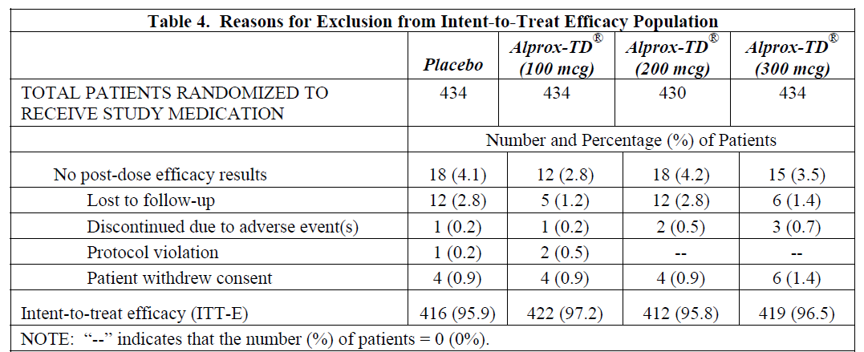
Failures to complete the study were much more common than exclusions from the ITT group, as shown in the table below, and amounted to about 20% of subjects. These withdrawals are more likely to have introduced withdrawal bias, because the higher dose groups had a higher rate of withdrawal due to AEs than the placebo or low-dose groups (7.8% in the highest dose group, compared to 1.2% in the placebo group). For these patients, data in the later phases of the study were missing. The Sponsor used a last-observation carried forward (LOCF) approach to compensate for missing data, but it is unclear if this imputation process was reliable, and the Sponsor has declined the opportunity to provide any reassurance on this issue.
Table 134. Patient disposition in Studies 004 and 005.
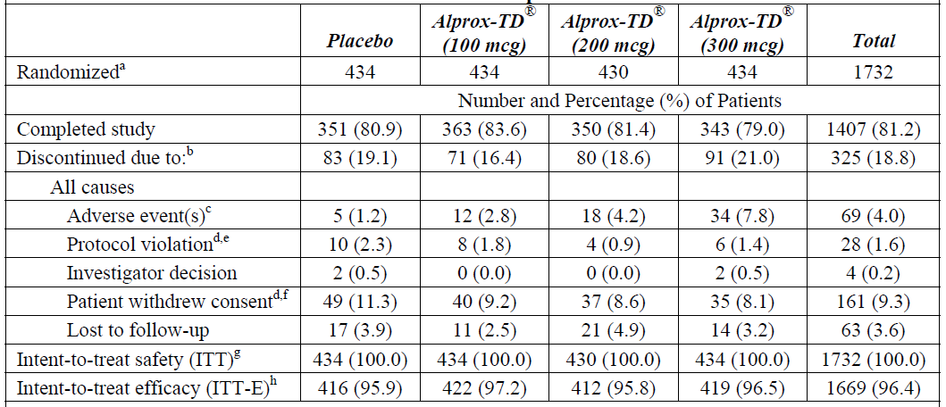

Response 12

Clinical question
- In the pivotal studies, the overall effect of Vitaros appeared to be negative in subjects with mild erectile dysfunction. A Phase 2 study in mild-to-moderate erectile dysfunction (MED 99-002A) produced a positive result in the overall cohort, but a subgroup analysis of those with mild ED was not presented. What were the efficacy results in subjects from MED 99-002A with mild ED, and what evidence exists that shows Vitaros to be useful in this section of the target population?

Sponsor’s response
As discussed in response to Q2 and as requested by the EMA a post hoc responder analysis was undertaken (IIEF-EF, SEP-2, SEP-3, IIEF-EF.26 and GAQ positive response scores) by severity in the ITT population (MED-2000-004/005). This analysis of the pivotal Phase 3 studies is considered more relevant than data generated in the Phase 2 studies where majority of patients were in the moderate to severe cohort.
In general, patients with mild ED showed the highest percentage of patients with a clinically significant change of the IIEF-EF domain followed by moderate and severe patients. For example, at the 300 mcg dose, 51.11% (mild), 40.12% (moderate) and 21.67 % (severe) patients demonstrated a clinically relevant change in their IIEF-EF domain score. A similar pattern was observed for the SEP-2 and SEP-3 mean change from baseline (Table x [sic] and Table x [sic]). On this basis, it is justified that Vitaros would be a useful treatment option for patient with mild ED.

Evaluator’s comments
This response is inadequate. The Sponsor was asked to analyse the efficacy results in subjects with mild erectile dysfunction in the supportive Study MED99-002A, but they have not answered the question asked.
Instead, they have addressed the issue of efficacy in subjects with mild ED by referring to a post hoc responder analysis in the pivotal studies, analysed by severity. The main results of this responder analysis are shown in the tables below. About 51% of the high-dose group showed a change in IIEF classified as a “response”, compared to 33% in the placebo group; results at 200 mcg were slightly better than at the higher dose, and results at 100 mcg were slightly worse. Broadly similar results were obtained for response rates based on the rates of penetration or maintenance of erection to ejaculation (see the subsequent tables), but the p-value for response rates based on maintenance did not reach significance in the Mild subgroup.
Table 135. IIEF-EF Change by Baseline Severity (MED 2000-004/005).
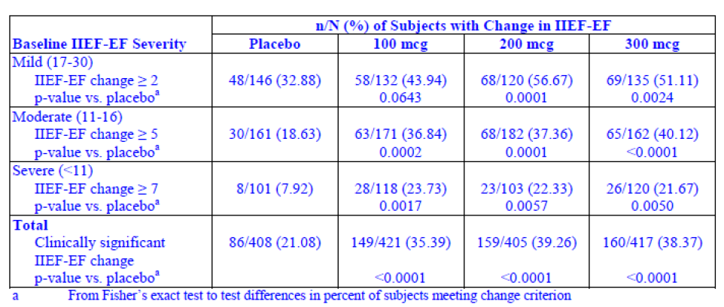
Table 136. Penetration Success Rate by Baseline Severity (MED 2000-004/005).
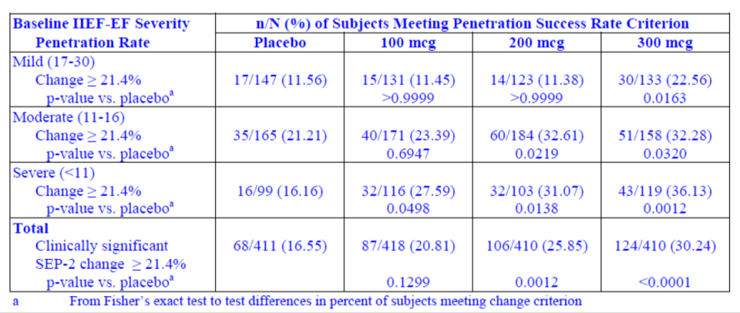
Table 137. Maintenance Success Rate by Baseline Severity (MED 2000-004/005).
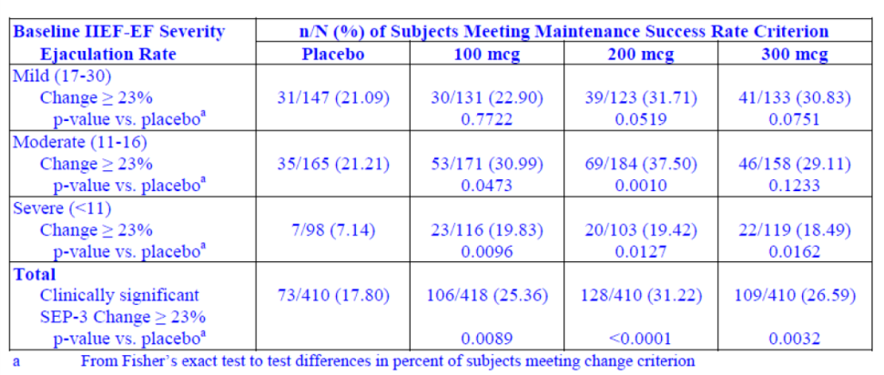
The positive results cited in the Sponsor’s response and shown in the tables above should be considered in the context of the negative results obtained in mildly effected subjects for the three primary endpoints of the pivotal studies, shown in the table below. Although any post hoc analysis should be considered with caution, primary endpoints should be considered to have more validity than secondary endpoints, so the responder rates cited by the Sponsor do not, by themselves, constitute robust evidence of efficacy in this subgroup. Furthermore, it should be noted that statistical superiority in comparison to placebo is not the same as clinical benefit, particularly for intra-urethral treatment of erectile dysfunction. The placebo group did not merely swallow a tasteless tablet; they added a partially invasive procedure to their sexual routine, and the overall effect of this was negative in the cohort with mild ED at baseline, as shown below. Active treatment had a less negative effect, but the effect was still, on average, negative in subjects with mild ED. If the administration procedure itself had a negative effect on mild ED (and the placebo results suggest that this is the case), but the active alprostadil component partially offset this, the overall result would be worse in the placebo group than the active group, but both treatments would still be worse than no treatment at all. The primary endpoints in this subgroup suggest that alprostadil has an overall negative effect on erectile dysfunction, and the additional analysis in terms of responder rates does not overturn these conclusions. (The overall negative effect has not been confirmed statistically, but represents the best current estimate of the mean effect.)
Table 138. Response in Subgroups by Severity, Studies 004 and 005, Pooled.
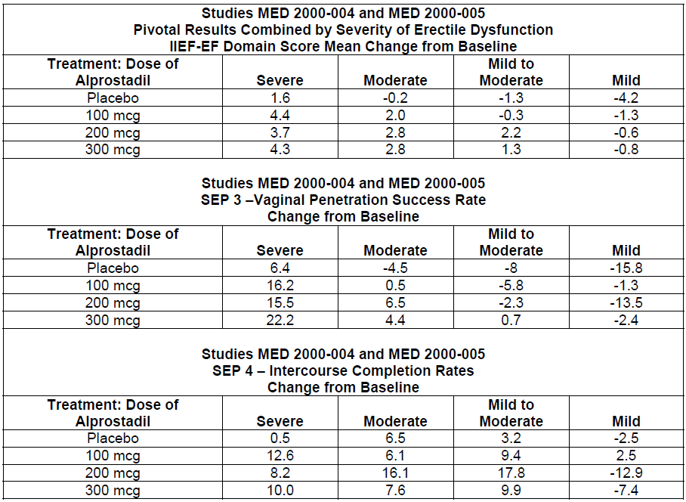
The requested analysis of the Phase 2 study, MED 99-002A, could have clarified this situation, because at least in that study the primary endpoints were positive for the combined mild-to-moderate cohort. Unfortunately, as with many of the other clinical questions raised in the first-round CER, the Sponsor has not performed the requested analysis.

Response 13

Clinical question
- For the high-dose Phase 2 study, MED 99-001, please present the main efficacy variables from this study in terms and mean changes in each treatment group, with standard deviations.

Sponsor’s response
As written in the study report, evaluation of efficacy was not statistically analysed since only 29 patients were randomized and the study terminated early.

Evaluator’s comments
The Sponsor has not provided the requested analysis.
Although the analysis is likely to be of little value, because the study was terminated early and the resulting incomplete dataset was severely underpowered, this analysis was requested because a full reporting of all study results is desirable to prevent reporting bias. In the absence of such a full report, one cannot help wondering if the study would have been reported if initial inspection of the results had shown a strong treatment effect.
Compared to the other analyses the Sponsor has failed to perform in their Section 31 response, this omission is not particularly important.

Response 14

Clinical question
- The Chinese Study NM-AP-38 was only presented as a synopsis, and the efficacy results were not explained in adequate detail. This sentence was particularly unclear:
The efficacy evaluated by the number of successful intercourse attempts per total intercourse attempts revealed an efficacy rate of 89.5%, 65.0% and 48.9% for mild, moderate and severe ED patients in PGE1 group versus 31.3%, 27.4% and 6.1% in placebo group.
Please explain what is meant by the “efficacy rate” and how the main endpoints were evaluated and then present the results in tabular format.

Sponsor’s response
The summary report for study number NM-AP-38 was also provided. “Subject’s diary” of this report the efficacy term of successful intercourse is described as “An activity that your penile erection has enough rigidity and maintain enough time to let your penis insert into vagina and make you feel satisfaction”.

Evaluator’s comments
This response is inadequate. As stated in the clinical question, this study was not provided. A search produced several hits relating to other Chinese studies. If the file was submitted separately from the main submission, the Sponsor should indicate this.
The synopsis referred to in the Clinical question was included in a listing of all Chinese studies, but it lacked adequate detail.
The Sponsor’s response has explained what is meant by successful intercourse, but they have still not explained how this is converted to an overall “efficacy rate”. The possibilities include:
- The ratio of successful intercourse attempts divided by all intercourse attempts, per patient, subsequently averaged across all patients;
- The median of the above ratio;
- The unadjusted pooled success rate of all successful intercourse attempts divided by all attempts, for the entire cohort;
- A statistically adjusted or weighted version of any of the above ratios;
- Some other measure of success rate based on the definition of success.
For any of the above methods of calculating the success rate, there is also the issue of the time period over which it was assessed, as well as the issue of how it compared to baseline, and the results of any statistical comparison across treatment groups. The question asked for these results to be presented in a table, which should be a simple matter if the file can be located.

Response 15

Clinical question
- The Chinese Study NM AP-28-OL/DB was not presented in adequate detail. For the double-blind portion of this study, please indicate how active treatment compared to placebo treatment.

Sponsor’s response
The double-blind crossover study consisted of one dose of active and one dose of placebo with a wash out period. The active treatment consisted of 0.4% alprostadil in 250 mg of cream (1000 μg alprostadil) while the placebo contained the same cream base minus the active. The formula did not contain DDAIP.

Evaluator’s comments
In retrospect, this question was poorly phrased. The question was intended to ask how the treatments were compared – i.e. what method was used to compare the treatments?
The first-round CER summarised what is known about the efficacy analysis of this study as follows:
The endpoints and analysis were not adequately described. The study synopsis described the analysis as follows:
The efficacy response rate was determined as the number of men that had erections sufficient for intercourse out of the total number of men. To be considered a success, a score of 8 to 10 must be achieved after administration of the dose or the patient must have had intercourse. Statistical analysis compared before and after response scores using a paired t-test.
The scoring system, for which a value of 8 out of 10 was considered a success, was not defined. (Based on parallels with another study, NM-AP-36-CH, it is likely to have been a score based on the SEP.)
It remains unclear how efficacy in this study was assessed. If the success rate was based on a count of men with erections sufficient for intercourse, did those men have to achieve an erection just once, or most of the time, or every time they tried to have intercourse? What does the score 8/10 represent?
This is a relatively unimportant issue because it was a minor study using a formulation different to that proposed for registration, but as it stands the study cannot be evaluated.

Response 16

Clinical question
- What was the median follow-up in the “long-term” safety study, MED 2000-006?

Sponsor’s response
The Sponsor has failed to calculate the median follow-up, instead stating the following:
Module 2.5.1 provides details of duration of exposure to DDAIP and drug in the long term follow up study. Median follow up statistic was not calculated in the statistical assessment.

Evaluator’s comments
From the patient disposition tables already considered in the first-round report (one of which is reproduced below), it is likely that the median follow-up was a little more than 60 days, because just over half the patients (603/1161, 52%) completed Visit 4.
The PI should therefore refer to this study as having about two-months of median follow-up, rather than implying, as in the originally proposed PI, that the study produced six months of follow up.
Table 139. Disposition of Study Subjects, Study MED 2000-006.
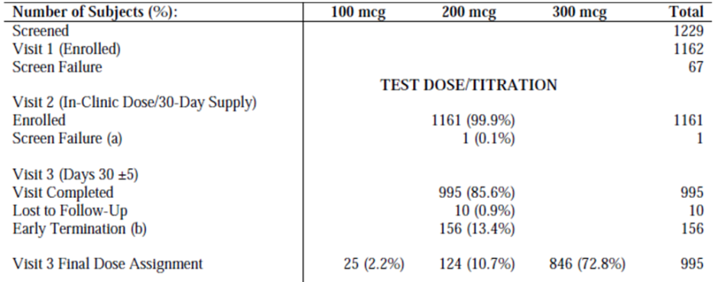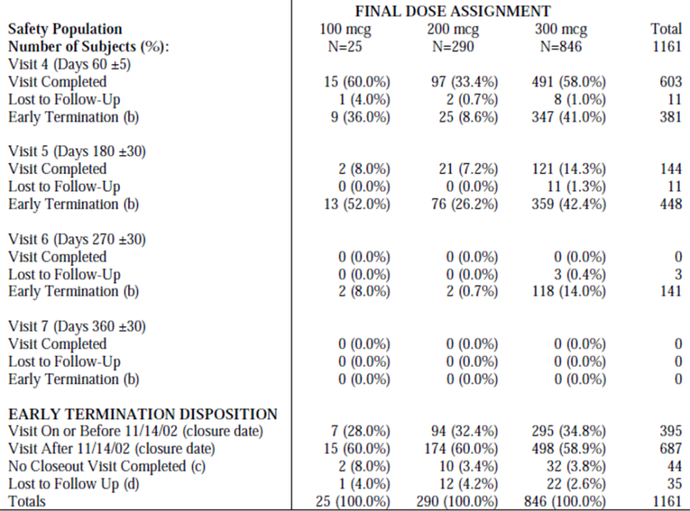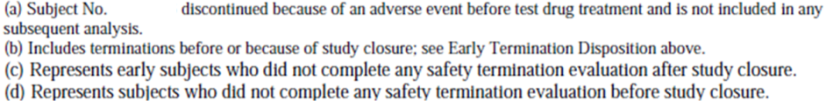

Response 17

Clinical question
- What is the clinical significance of the positive mouse carcinogenicity study? What evidence or arguments were provided to Canadian and European authorities to allay concerns about this issue?

Sponsor’s response
Of all the clinical questions in the first-round CER, this was perhaps the most important, and it is one of the few questions where the Sponsor provided a detailed answer, so their response is reproduced in full below:
We refer to the TGA Non clinical evaluation report which concludes that DDAIP is not expected to have a carcinogenic effect in humans, which is consistent with the conclusion reached by the Canadian and European authorities. The sponsor does not believe these findings are clinically significant. Although the transgenic mouse study showed an increased papilloma incidence in the groups receiving 2.5% DDAIP HCl, this group also had a greater incidence of irritation and a predisposing factor for papilloma development. In subsequent two-year carcinogenicity studies conducted in normal mice and rats, no potential for tumorigenicity was found.
Canada Health Authority
During review Health Canada was provided the final study reports on the two-year dermal carcinogenicity studies on the mouse and rat which were not available at the time of submission. Based on this the reviewer had the following comment:
Reviewer’s comments: The study (i.e. two-year dermal carcinogenicity study on the mouse) was conducted after a 26-week dermal carcinogenicity study using the Tg.AC mouse model found evidence of increased papillomas to be associated with DDAIP HCl doses as low as 0.5% (v/w).
The current 2-year dermal carcinogenicity study did not find any increase in papillomas to be associated with DDAIP HCl. The difference in the results is most likely due to differences in the animal model. While the Tg.AC mouse model has been used to predict dermal effects, it maintains a supporting role to the standard dermal carcinogenicity study.
Overall, the weight of evidence does not suggest that DDAIP HCl is a dermal carcinogen at the doses tested.
European Health Authority:
The European Health Authority was provided information regarding the similarity of DDAIP to LADA, a common ingredient in many products that has tested positive in the transgenic mouse study. Also provided was data on a study evaluating the tumour promotion potential on cells infected with HPV titled “Non-GLP Evaluation of the Influence of DDAIP-HCl on Tumor Growth and In Vivo Expression of E6/E7 in the Subcutaneous CaSki Tumor Model”. This information was also provided to the TGA, dated 19 January 2015. A copy of this response is provided.
The EMA concluded that the answers provided by the company clearly show the similarity between LADA and DDAIP and that the conclusion can be that the papilloma-inducing effect of DDAIP is caused by the irritation in this TG.AC mouse model, and is unlikely to be of human relevance. This is consistent with the conclusion reached by the TGA Non Clinical Evaluator.

Evaluator’s comments
The Sponsor’s response is adequate, and the Non-clinical Evaluator has drawn similar conclusions:
I consider it unlikely that the mechanistic pathway by which papillomas developed due to DDAIP application is relevant to humans, due to the facts that:
    - Tg.AC mice are not only sensitive to carcinogenic compounds but also to proliferative and pro-inflammatory stimuli, and
    - DDAIP was found not to be tumorigenic in long-term (non-transgenic) studies in both mice (5% dermally for 2 years) and rats (subcutaneously for 2 years).
It is reassuring that the Non-clinical Evaluator found no reasons to suspect a substantial risk of carcinogenesis, and it appears that other regulatory bodies have also been satisfied that the two-year dermal carcinogenicity study is more reliable than the Tg.AC mouse model. This substantially lessens concerns about the health risks of Vitaros in humans.
Given that even one animal model raised the issue of carcinogenicity, though, it is of concern that the concentration of DDAIP proposed for use in Vitaros is in substantial excess (possibly a 50-fold excess) of the lowest concentration predicted to be needed on the basis of clinical studies. As discussed in Response 3, above, the justification for this substantial excess rests entirely on pre-clinical studies, and the Non-Clinical Evaluator did not agree that these strongly supported the proposed DDAIP concentration in the face of conflicting data from clinical studies. This issue is less critical if there is general agreement that DDAP is unlikely to be carcinogenic, but it remains important because of the uncertain effects of DDAIP on spermatogenesis, and because other clinically relevant toxicities could eventually be discovered and it is inappropriate to use a higher dose than necessary.
On clinical grounds alone, there is no evidence that Vitaros is associated with a significant risk of carcinogenesis, but if Vitaros were to be registered this would need to be monitored with on-going risk management.

Response 18

Clinical question
- What is known about the effects of Vitaros on the transfer of sexually transmitted disease?

Sponsor’s response
The sponsor agrees that this is an important question about a product with the potential for repeated vaginal exposure. Experience has taught that a product which causes irritation of the vaginal mucosa (i.e., nonoxynol-9) can be associated with increased rates of transmission of STDs. A study in which women are exposed to Vitaros in actual use and are monitored to determine the incidence rate of STDs would be difficult to control, highly impractical to conduct, and ethically questionable. Additionally, there are no validated surrogates which predict whether a product will facilitate or inhibit the transmission of STDs.
We also refer to the Non clinical evaluation report with respect to transfer of drug to sexual partners and relevant safety margins.
The PI includes appropriate precautions on transmission of STDs.

Evaluator’s comments
The Clinical Evaluator agrees that the risk of STDs cannot be easily studied because of ethical constraints on exposing subjects to STDs – this means that the full risk may never be established, or may only emerge from post-marketing surveillance.
The Evaluator does not agree that the proposed PI deals with this issue adequately.
The proposed PI in the initial submission made the following comment about STDs:
Patients should be informed that Vitaros offers no protection from the transmission of sexually transmitted diseases. Patients and partners who use Vitaros need to be counselled about the protective measures that are necessary to guard against the spread of sexually transmitted agents, including the human immunodeficiency virus (HIV).
Note that the PI did not mention that Vitaros may increase the risk of STDs.
The new version of the proposed PI provides a more detailed warning about the risks of STDs, but still fails to acknowledge that Vitaros could increase this risk; the expression used, “offers no protection”, falsely implies a neutral effect of Vitaros on STD risk, when this seems unlikely.
Healthcare professionals should instruct patients to inform sexual partners that they are using alprostadil cream. Partners of alprostadil users can experience adverse events, most commonly vaginal irritation. A condom is therefore recommended.
Patients should be informed that TRADENAME offers no protection from the transmission of sexually transmitted diseases and that a condom should be used for protection against these diseases. Patients and partners who use TRADENAME need to be counselled about the protective measures that are necessary to guard against the spread of sexually transmitted agents, including the human immunodeficiency virus (HIV).
There is no information on the effects on early pregnancy of alprostadil at the levels received by the female partner. A condom barrier should be used for sexual intercourse with women of childbearing age, pregnant or lactating women.
Condom use is recommended when using TRADENAME. This will reduce the potential risk of adverse events results from exposure of the medicine to sexual partners. This is particularly important for sexual intercourse with a woman who is pregnant or lactating, is of childbearing potential, and for anal or oral sex (fellatio). Sexual intercourse with a pregnant woman is not advisable while using alprostadil.
The effects of TRADENAME on the oral or anal mucosa have not been studied. A condom barrier should be used for oral sex (fellatio) or anal sex. [Emphasis added].
The Sponsor has now conceded that the irritation effect of Vitaros could promote transmission of STDs, so it should not be necessary to obtain an expert opinion on this issue as suggested in the first-round CER. Instead, the PI should be modified to reflect the risk. The following underlying sentence should be added.
Healthcare professionals should instruct patients to inform sexual partners that they are using alprostadil cream. Partners of alprostadil users can experience adverse events, most commonly vaginal irritation. It is expected that such irritation could enhance the transmission of sexually transmitted diseases. A condom is therefore recommended.

Response 19

Clinical question
- What is known about the potential for Vitaros to produce spermatotoxicity in humans?

Sponsor’s response
Degeneration of the seminiferous tubules in the testis of rabbits treated locally with DDAIP has been observed and appeared reversible, however, the spermatotoxic effect in humans in unknown. This issued was raised by the EMA and the applicant has committed to perform a post-authorization safety study in which the sperm quality of users of Vitaros is examined. Additionally, a statement on this finding is included in the European SmPC indicating that the relevance to humans is unknown. Additional text has also been recommended in the TGA non clinical evaluation and will be considered for inclusion by the company based on final delegate recommendations.

Evaluator’s comments
The Sponsor’s response has acknowledged that this is a potential issue, but the proposed PI included in the original submission did not acknowledge the problem. The degeneration of seminiferous tubules in rabbits was not mentioned in the proposed PI, but other studies suggesting no spermatotoxicity were mentioned, giving a false impression of the evidence.
The Non-clinical Evaluator has also noted that this is an unresolved issue, stating
I agree that the risk of spermatotoxicity exists, and I confirm my opinion that the following text should be included in the ‘Effects on Fertility’ Section of the Product Information document:
    - The excipient DDAIP caused atrophy of the seminiferous tubules of the testes in rabbits when administered locally at a concentration of 5%. In a direct spermatotoxic study, the excipient DDAIP HCl (at 5%) did not inhibit the sperm motility either initially or after a 30 minutes incubation period. However a formulation containing 0.4% alprostadil and 5% DDAIP HCl inhibited sperm motility after 30 minutes of incubation. DDAIP administered subcutaneously to rats had no effect on fertility.
The Australian PI should mention the rabbit study and warn users that the effects in humans are unknown. This warning should be highlighted, as it seems likely that many potential patients would not want to use this agent until adequate human fertility studies have been completed.
In line with the recommendations of the Non-Clinical Evaluator, the proposed new version of the PI adds the following comments:
The excipient DDAIP caused atrophy of the seminiferous tubules of the testes in rabbits when administered locally at a concentration of 5%. In a direct spermatotoxic study, the excipient DDAIP HCl (at 5%) did not inhibit the sperm motility either initially or after a 30 minute incubation period. However a formulation containing 0.4% alprostadil and 5% DDAIP HCl inhibited sperm motility after 30 minutes of incubation. DDAIP administered subcutaneously to rats had no effect on fertility.
The following additional sentence should be added in bold:
Patients should be warned that the effect of Vitaros on fertility in humans is currently unknown.

Response 20

Clinical question
- Given that prostaglandins inhibit platelet function, what is known about the clinical effects of alprostadil on bleeding risk?

Sponsor’s response
Vitaros, which is a topical product delivered via the meatal opening and the surrounding skin, it metabolises rapidly and is present systemically in very low amounts. Alprostadil levels were difficult to measure in the pharmacokinetic study therefore the metabolite 15-keto-PGE1 was measured as a surrogate (Study MED 2000-003). Adverse events relating to the study drug inhibiting platelet function were not observed in the clinical studies.

Evaluator’s comments
This evaluator agrees that an excess of AEs related to bleeding were not observed in the clinical studies, and that the risk is greatly reduced by the use of a topical route.
The Sponsor’s response does not address the issue of whether 15-keto-PGE-1 has any anti-platelet effect. This could be important for some individual patients at high bleeding risk, but on balance it is a relatively minor issue given the low systemic exposure.

Response 21

Clinical question
- Please provide details of the post-marketing experience observed with the related product, Befar, including a discussion of which AEs have been reported.

Sponsor’s response
The Sponsor reports that they do not have access to post-marketing data on Befar, a product owned by a different company.

Evaluator’s comments
This is a somewhat reasonable response. It would have been appropriate to highlight their lack of access to this data in the original submission. It would have been even more appropriate for the Sponsor to have approached the owners of Befar and to have asked for access to this information, or to report that such an approach had been unsuccessful.

Response 22

Clinical question
- Please provide details of the post-marketing experience with Vitaros in the EU and Canada, including a discussion of which AEs have been reported.

Sponsor’s response
Periodic Safety Update Reports commencing 10 July 2013 through to 31 January 2015 are now available. The alprostadil topical cream was launched in the UK on 16 June 2014 and has not yet been launched in Canada. Hence, the post marketing safety data is limited. To date, no changes have been required as a consequence of the PSUR findings.

Evaluator’s comments
A review of the provided PSUR produced no new safety concerns.

Response 23

Clinical question
- Does the use of Vitaros by homosexual men or heterosexual couples engaged in anal intercourse raise any specific safety issues? What is known about the safety of Vitaros in this context?

Sponsor’s response
Vitaros use in anal intercourse has not been studied. The PI recommends that a condom barrier should be used for anal sex.

Evaluator’s comments
This is appropriate. The proposed PI carries appropriate warnings about the need for a condom.

Response 24

Clinical question
- In the Chinese study NM-AP-42C, the safety section of the study summary reads as follows: “A total of 70 patients completed the study. Thirty-eight (25.71%) patients experienced adverse events. […]
Please explain the source of the figure “25.71%”. If 38 subjects from a total of 70 had AEs, this represents 54.3%.

Sponsor’s response
The Sponsor concedes that this was due to a transcription error. Eighteen subjects of 70 had an AE (18/70, 25.7%).

Evaluator’s comments
This issue is resolved.

Response 25

Clinical question
- The proposed PI contains a description of two ultrasound studies, as follows:
In human studies using Doppler duplex ultrasonography, intraurethral administration of 500 μg of alprostadil resulted in an increase in cavernosal artery diameter and a 5- to 10-fold increase in peak systolic flow velocities. These results suggest that intraurethral alprostadil is absorbed from the urethra, transported throughout the erectile bodies by communicating vessels between the corpus spongiosum and corpora cavernosa, and enable to induce vasodilation of the targeted vascular beds. In another study using Doppler duplex ultrasonography, topical administration of 500 μg of a topical gel containing 0.4% alprostadil onto the glans produced an erection and hemodynamic effect similar to intracavernosal injection of alprostadil.
Please explain which studies are being described, and then submit them in sufficient detail that the claims in the PI can be assessed for accuracy.

Sponsor’s response
The first study is from a literature reference:
Tam, P.T., et al. “Hemodynamic Effects of Transurethral Alprostadil Measured by Color Duplex Ultrasonography in Men with Erectile Dysfunction”, J. Urol., 160, p1321-1324, Oct1998.
The second study is from a literature reference:
Becher, E., “Topical alprostadil cream for the treatment of erectile dysfunction”, Expert Opin. Pharmacother. (2004) 5(3):623-632

Evaluator’s comments
Abstracts for these studies were obtained online, and read as follows:
J Urol. 1998 Oct;160(4):1321-4.
Hemodynamic effects of transurethral alprostadil measured by color duplex ultrasonography in men with erectile dysfunction.
Tam PY, Keller T, Poppiti R, Gesundheit N, Padma-Nathan H.
Abstract
PURPOSE:
We evaluated the hemodynamic effects of transurethral alprostadil in 21 patients with erectile dysfunction using color duplex ultrasonography.
MATERIALS AND METHODS:
Penile arterial diameter, peak flow velocity and end diastolic velocity were compared following intraurethral administration of 500 microg. alprostadil and intracavernosal injection of 10 microg. alprostadil.
RESULTS:
A dose of 500 microg. transurethral alprostadil resulted in significant increases in corporeal blood flow comparable to those achieved with intracavernosal injection of 10 microg. alprostadil as measured by duplex ultrasonography in men with erectile dysfunction. Transurethral alprostadil resulted in statistically significant increases in arterial diameter and peak flow velocity comparable to those achieved with intracavernosal injection. End diastolic velocities were higher after transurethral alprostadil than intracavernosal injections. Color ultrasonography following transurethral alprostadil showed arterial and venous hyperemia of the corpus spongiosum and corpora cavernosa. Furthermore, color ultrasonography revealed communicating vessels between the corpus spongiosum and corpora cavernosa following administration of transurethral alprostadil.
CONCLUSIONS:
The visualization of communicating vessels between the corpus spongiosum and corpora cavernosa after transurethral alprostadil suggests local mechanisms of drug transfer from one to the other. In addition to potential clinical benefits, transurethral alprostadil may be useful to visualize the vascular anatomy of the penis and to test for patient responsiveness to local vasoactive agents.
Expert Opin Pharmacother. 2004 Mar;5(3):623-32.
Topical alprostadil cream for the treatment of erectile dysfunction.
Becher E.
Abstract
Erectile dysfunction (ED) has serious negative consequences on both sexual experience and emotional well being and affects a broad range of age groups. The prevalence of ED is associated with increasing age and has been reported to be as high as 70%. Although the disorder is common and underdiagnosed, its treatment can significantly improve patients' quality of life. Systemic treatment with oral phosphodiesterase type-5 (PDE-5) inhibitors is the current standard of care for patients with ED. Some patients, however, have absolute contraindications for PDE-5 inhibitors. In addition, these agents can be associated with adverse effects. Furthermore, because PDE-5 inhibitors are not as effective in patients who have undergone radical prostatectomy or who have severe vascular disease, a substantial unmet medical need exists among patients who have ED as a result of these conditions. Consequently, PDE-5 inhibitor therapy is associated with a high rate of discontinuation, as are intracavernosal or transurethral therapies, which are inconvenient and invasive. Several studies, including four double-blind, placebo-controlled, Phase II trials, show that alprostadil topical cream is efficacious and well-tolerated in ED in patients with mild-to-severe symptoms, in those undergoing treatment for cardiovascular diseases and diabetes and in otherwise healthy ED patients. Thus, alprostadil topical cream is a potential first-choice alternative for ED in patients who do not respond or who cannot tolerate or do not accept PDE-5 inhibitor therapy.
A full evaluation of these two studies is beyond the scope of this report, but the Sponsor’s reference to them within the PI appears to be accurate and justified.

Response 26

Clinical question
- The proposed PI contains the following sentence.
The majority of patients (73%) prefer the 300 μg dose, and it is more effective in most patients.
What is the justification for this claim? What is the source of the claimed 73% preference? Is it derived from the number of subjects up-titrated to 300 mcg in the extension study (846 patients) divided by the total number of subjects in the study (1161 patients)? If so, how does this automatic, protocol-driven up-titration constitute a “preference”?

Sponsor’s response
This statement is proposed to be modified as stated in response to Question 2 and the claim omitted, consistent with the European SmPC. The justification for the preference is as mentioned by the assessor. It is the number of patients on 300 mcg divided by the total number of patients in the study. In the study MED 2000-006 the patients were initiated treatment with the 200 mcg dose and based upon tolerability and efficacy were given the opportunity to either down-titrate to the 100 mcg dose or up-titrate to the 300 mcg dose. It was not an automatic, protocol-driven up-titration to 300 mcg. As mentioned, at the titration visit the majority of patients decided to up-titrate to the 300 mcg dose.

Evaluator’s comments
The initial claim in the proposed PI was unreasonable and misleading, because the protocol provided an opportunity for up-titration in non-responders, but there was no corresponding opportunity for reassessment of the dose and subsequent down-titration because of continued poor efficacy or new dose-related side effects. In that sense, patients stayed on the higher dose not because they preferred it after trying both doses, but because the protocol automatically led to the patients staying on the higher dose. This does not constitute a “preference” for the higher dose. At the designated, protocol-driven time of the titration, patients had no experience of the higher dose on which to make an informed choice – the change in dose does not, therefore, reveal a “preference”, but simply dissatisfaction with the current treatment. A high number up-titrations could simply indicate poor efficacy of the drug, and it was an automatic consequence of the protocol’s design that subjects who failed to respond to were likely to end up on the higher dose.
Figure 10. Titration of Alprostadil Dose, Study MED 2000-006.
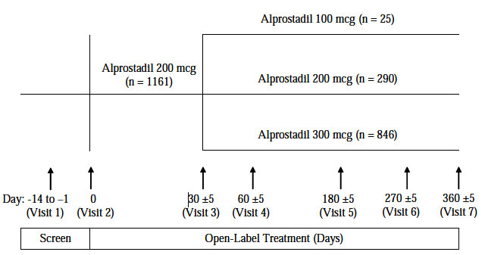
It is appropriate for this sentence to be removed from the PI.

Response 27

Clinical question
- Why does the proposed Australian PI carry no warning about the potential spermatotoxicity of Vitaros?

Sponsor’s response
It is proposed that the Australian PI will be modified to include appropriate warnings, taking into consideration recommendations of both the Nonclinical and RMP evaluators and the delegate’s recommendations.

Evaluator’s comments
It is disappointing that appropriate warnings were not included in the initial PI. As discussed above (Response 19), the Australian PI should include mention of adverse animal studies as well as studies that appear favourable, and the PI should make it clear to prescribers that the effects on human fertility have not been adequately characterised.

Second round benefit-risk assessment
The sponsor’s responses clarify some aspects of the benefit-risk assessment. There was no substantial new evidence provided in relation to efficacy. For a number of safety issues, the sponsor’s responses clarified the risks.

Efficacy in subjects with mild ED
No new evidence was submitted that substantially clarifies the benefits of alprostadil in subjects with mild ED, but the sponsor submitted a new post hoc analysis of the pivotal studies, assessing response rates in subjects according to baseline severity. This analysis suggested that, for this non-primary endpoint, active treatment was significantly superior to placebo in subjects with mild ED. This does not offset the overall negative results for the primary endpoints in subjects with mild ED, already discussed on the first round clinical evaluation report.
The sponsor was asked to perform a subgroup analysis of the major Phase II study in subjects with mild-to-moderate ED, but they did not perform the requested analysis.
In summary, there is some inconsistent evidence that alprostadil might be better than placebo in subjects with mild ED, but no convincing evidence that it is better than no treatment at all. On balance, it appears that there is little or no overall benefit in this clinical group, but individual patients with mild ED may find Vitaros useful. Given that subjects will be able to observe the efficacy of the drug for themselves, and make a decision about whether it is worth continuing, the borderline efficacy in this group is not a barrier for registration.

Safety issues conceded by the sponsor
The sponsor has conceded that the following risks exist, and that they are not yet characterised in humans:
- Vitaros may be spermatotoxic;
- Vitaros may induce irritation that enhances the spread of sexually transmitted diseases.
The PI requires modification to acknowledge these risks. The sponsor has proposed some modifications that represent improvements over the initially proposed PI, but the risks should be acknowledged more explicitly and the PI therefore requires further modification.

Safety issues for which the sponsor’s response suggests lower risk
The sponsor has argued that the risk of carcinogenesis is minimal, and cites the conclusions of the nonclinical evaluator and other regulatory agencies in support of this claim. On balance, it appears that there is general agreement that the two year dermal study in mice and rats was reassuring with respect to carcinogenic risk and that this overrides the results of the Tg.AC mouse study. A full analysis of this nonclinical material is beyond the scope of the clinical evaluation report, but there are no clinical grounds on which to suspect a significant carcinogenic risk.

Unresolved issues
There is a risk that the proposed DDAIP concentration is in substantial excess of the minimum concentration required for a clinically relevant effect on permeation. The Sponsor concedes that there is no direct clinical evidence in support of the proposed concentration of 2.5%, and instead the sponsor has suggested that the DDAIP concentration is justified by nonclinical data, but the nonclinical evaluator and clinical evaluator agree that the clinical studies are more important in predicting actual effects in humans.
The sponsor also makes the claim that clinical studies in China supported a concentration of 0.5%, when in fact the evidence from Chinese studies supports a concentration as low as 0.05%. The sponsor’s response on this matter was inadequate and contained an unsupported assertion that 0.5% was required, despite the fact that Clinical question 3 proposed that ≥ 0.05% was adequate and asked for clarification.
It should be noted that the sponsor has not answered many of the clinical questions posed in the first round clinical evaluation report.

Second round recommendation regarding authorisation
The sponsor’s application to register Vitaros should be rejected.
The main reasons for rejecting the application are:
- there is no clinical evidence justifying the proposed 2.5% concentration of DDAIP;
- the spermatotoxicity of DDAIP has not been well defined in humans;
- the weighting procedure for the pivotal endpoints based on the SEP was not adequately explained, so it remains unclear if it was appropriate.
The combination of the first two of these problems makes each more important: if DDAIP were to be used in substantial excess of the minimum effective dose, and if it proved to be spermatotoxic in humans, then subjects would be exposed to unnecessary spermatotoxicity. However, even if DDAIP were found not to be spermatotoxic, it would still be inappropriate to register a product potentially containing a substantial excess of DDAIP, given the lack of overall experience in using this compound in humans, and the prolonged mucosal exposure anticipated in subjects who could use Vitaros for many years.
The third problem listed could potentially be addressed by the sponsor if they provided an adequate answer to Clinical question 8.
The sponsor has also implied that DDAIP degrades by up to 80% during the shelf life of the product (see response). This issue is beyond the scope of the clinical evaluation, but might represent a barrier to registration depending on the nonclinical evaluation of this issue. The nonclinical evaluator should be asked to comment on whether the sponsor has adequately characterised the identity, carcinogenicity, spermatotoxicity, and likely mucosal irritability of these degradation products. If the degradation products are compounds for which there is limited experience in humans, further toxicity and irritability studies should be undertaken with shelf aged Vitaros formulations.
If registration of Vitaros proceeded, the PI would need to be modified to reflect the risks acknowledged by the sponsor, including:
- spermatotoxicity;
- potentially enhanced transmission of sexually transmitted diseases.
Other necessary changes to the PI are listed.

References
The following references from the Integrated Summary of Safety were used in the preparation of this report:
- Horton E.W. Biological Activities of Pure Prostaglandins. Experientia, XXI:3,113-118, (1965)
- Manecke R.G. and Mulhall J.P. Medical treatment of erectile dysfunction. Ann Medicine. 31: 388-98 (1999)
- Kim E.D., McVary K.T. Topical Prostaglandin-E1 for the Treatment of Erectile Dysfunction. J. Urology. 153:1828-1830 (June, 1995)
- Montorsi F., Guazzoni C., Barbieri L., Rigatti P., Iannaccone S., Santus C., Sartani A. Clinical and Hemodynamic Effects of Transdermal Alprostadil for Mild Arteriogenic Impotence: A Double-blind Placebo Controlled Study. International Journal Impotence Research. 7:10 (1995)
- Tam P.Y., Keller T., Poppiti R., Gesundheit N., Padma-Nathan H., Hemodynamic effects of transurethral alprostadil measured by color duplex ultrasonography in men with erectile dysfunction, J Urol. 1998 Oct; 160 (4) : 1321-1324 (October 1998)
- An Evaluation of the Pharmacokinetic Profile of Alprox-TD® Alprostadil Cream After Administration of a Single Dose to Patients With Erectile Dysfunction (Symbiance Study Report MED 2000-003, December 23, 2002)
- Rosen RC, Riley A, Wagner G, et al. The International Index of Erectile Function (IIEF): A multidimensional scale for assessment of erectile dysfunction. Urology; 49:822-30 (1997)
- Marks LS, Duda C, Dorey FJ, et al. Treatment of erectile dysfunction with sildenafil. Urology; 53:19-24 (1999)
The following reference was also consulted:
- Cawello, W, et al. European Journal of Clinical Pharmacology, April 1994, Volume 46, Issue 3, pp 275-277. Metabolism and pharmacokinetics of prostaglandin E1 administered by intravenous infusion in human subjects.
Pharmacokinetic summaries presented by the Sponsor were largely derived from the USA Product Information sheet for Caverject (parenteral alprostadil); these were checked against the Australian Caverject PI.

Therapeutic Goods Administration
PO Box 100 Woden ACT 2606 Australia
Email: info@tga.gov.au Phone: 1800 020 653 Fax: 02 6232 8605
https://www.tga.gov.au

It is unclear whether a p-value of exactly 0.05 should be considered significant, because the statistical analysis plan was somewhat vague on this point, merely stating “All variables were assessed at the 0.05 alpha level (two-sided),” rather than explicitly citing an inequality of the usual form “p<0.05”.
In the Sponsor’s Section 31 response, this risk was conceded, so additional expert input is no longer required.
The initial version of this question used the abbreviation IIEF, in error, instead of SEP.
Haftek 2002; Ann Dermatol Venereol. Jan;129(1 Pt 2):117-22; Ganor et al., 2013; Mucosal Immunology. 6, 776–786.
The initial version of this question initially used the abbreviation IIEF, in error, instead of SEP. The error was noted by the Sponsor and has been corrected in this version of the Clinical Evaluation Report.

