August 2020

Australian Public Assessment Report for Alpelisib
  - Proprietary Product Name: Piqray
  - Sponsor: Novartis Pharmaceuticals Australia Pty Ltd

About the Therapeutic Goods Administration (TGA)
- The Therapeutic Goods Administration (TGA) is part of the Australian Government Department of Health and is responsible for regulating medicines and medical devices.
- The TGA administers the Therapeutic Goods Act 1989 (the Act), applying a risk management approach designed to ensure therapeutic goods supplied in Australia meet acceptable standards of quality, safety and efficacy (performance) when necessary.
- The work of the TGA is based on applying scientific and clinical expertise to decision-making, to ensure that the benefits to consumers outweigh any risks associated with the use of medicines and medical devices.
- The TGA relies on the public, healthcare professionals and industry to report problems with medicines or medical devices. TGA investigates reports received by it to determine any necessary regulatory action.
- To report a problem with a medicine or medical device, please see the information on the TGA website <https://www.tga.gov.au>.

About AusPARs
- An Australian Public Assessment Report (AusPAR) provides information about the evaluation of a prescription medicine and the considerations that led the TGA to approve or not approve a prescription medicine submission.
- AusPARs are prepared and published by the TGA.
- An AusPAR is prepared for submissions that relate to new chemical entities, generic medicines, major variations and extensions of indications.
- An AusPAR is a static document; it provides information that relates to a submission at a particular point in time.
- A new AusPAR will be developed to reflect changes to indications and/or major variations to a prescription medicine subject to evaluation by the TGA.

Copyright
© Commonwealth of Australia 2020
This work is copyright. You may reproduce the whole or part of this work in unaltered form for your own personal use or, if you are part of an organisation, for internal use within your organisation, but only if you or your organisation do not use the reproduction for any commercial purpose and retain this copyright notice and all disclaimer notices as part of that reproduction. Apart from rights to use as permitted by the Copyright Act 1968 or allowed by this copyright notice, all other rights are reserved and you are not allowed to reproduce the whole or any part of this work in any way (electronic or otherwise) without first being given specific written permission from the Commonwealth to do so. Requests and inquiries concerning reproduction and rights are to be sent to the TGA Copyright Officer, Therapeutic Goods Administration, PO Box 100, Woden ACT 2606 or emailed to <tga.copyright@tga.gov.au>.

Contents
Common abbreviations 4
I. Introduction to product submission 8
Submission details 8
Product background 9
Regulatory status 11
Product Information 11
II. Registration timeline 11
III. Submission overview and risk/benefit assessment 12
Quality 12
Nonclinical 12
Clinical 13
Risk management plan 23
Risk-benefit analysis 25
Outcome 28
Attachment 1. Product Information 29

Common abbreviations
Abbreviation | Meaning
A | Alanine
ACM | Advisory Committee on Medicines
AE | Adverse event
AESI | Adverse event of special interest
AKT | Protein kinase B
ARTG | Australian Register of Therapeutic Goods
ASA | Australian specific Annex
AUC | Area under the plasma concentration time curve
BIRC | Blinded independent review committee
BPI-SF | Brief Pain Inventory - short form
BSEP | Bile salt export pump
BZG791 | Major metabolite of alpelisib
C | Cysteine
CBR | Clinical benefit rate
CDK4/6 | Cyclin-dependent kinase 4/6
CDx | Companion diagnostics, specifically the Qiagen therascreen phosphatidylinositol 3-kinase catalytic alpha subunit RGQ polymerase chain reaction kit
CI | Confidence interval
C_{max} | Maximum plasma (or serum or blood) concentration following drug administration
CMI | Consumer Medicines Information
CR | Complete response
CT | Computed tomography
CTA | Novartis phosphatidylinositol 3-kinase catalytic alpha subunit polymerase chain reaction mutation clinical trial assay
ctDNA | Circulating tumour deoxyribonucleic acid
CYP | Cytochrome P450 enzyme(s)
D | Aspartic acid
DLP | Data lock point
DNA | Deoxyribonucleic acid
E | Glutamic acid
ECG | Electrocardiogram
ECOG | Eastern Cooperative Oncology Group
EORTC | European Organisation for Research and Treatment of Cancer
ET | Endocrine therapy
EU | European Union
FAS | Full analysis set
FDA | Food and Drug Administration (United States of America)
FPG | Fasting plasma glucose
G | Glycine
GI | Gastrointestinal
GnRH | Gonadotropin-releasing hormone
GVP | Good Pharmacovigilance Practices
H | Histidine
HbA1c | Haemoglobin A1c/glycated haemoglobin
HER2 | Human epidermal growth factor receptor 2
HR | Hormone receptor
HR-positive | Hormone receptor-positive
HRQoL | Health related quality of life
IM | Intramuscular
IVD | In vitro diagnostic
K | Lysine
L | Leucine
MATE1 | Multidrug and toxin extrusion protein 1
MRI | Magnetic resonance imaging
MRP2 | Multi-drug resistance-associated protein 2
mTOR | Mammalian target of rapamycin
NGS | Next generation sequencing
NPA | Negative percent agreement
ONJ | Osteonecrosis of the jaw
OPA | Overall percent agreement
ORR | Overall response rate
OS | Overall survival
PCR | Polymerase chain reaction
PFS | Progression-free survival
PI | Product Information
PI3K | Phosphatidylinositol-4,5-bisphosphate 3-kinase
PIK3CA | Phosphatidylinositol 3-kinase catalytic alpha subunit
PK | Pharmacokinetic(s)
PopPK | Population pharmacokinetic(s)
PPA | Positive percent agreement
PR | Partial response
PSUR | Periodic safety update report(s)
Q | Glutamine
QD | Once daily
QLQ-C30 | Quality of life questionnaire – core 30 questions
R | Arginine
RECIST | Response Evaluation Criteria In Solid Tumors
RMP | Risk management plan
SAE | Serious adverse event
SEER | Surveillance, Epidemiology and End Results Program (National Cancer Institute, USA)
T_{max} | Time to maximum plasma concentration after drug administration
USA | United States of America
Y | Tyrosine

I. Introduction to product submission

Submission details
Type of submission: | New chemical entity
Decision: | Approved
Date of decision: | 19 March 2020
Date of entry onto ARTG: | 20 March 2020
ARTG numbers: | 315020, 315055, 315064
Black Triangle Scheme: | Yes. This product will remain in the scheme for 5 years, starting on the date the product is first supplied in Australia
Active ingredient: | Alpelisib
Product name: | Piqray
Sponsor’s name and address: | Novartis Pharmaceuticals Australia Pty Ltd  54 Waterloo Road Macquarie Park, NSW 2113
Dose form: | Film coated tablet
Strengths: | 50 mg, 150 mg, 200 mg
Container: | Blister pack
Pack sizes: | 50 mg and 200 mg film coated tablets composite pack: 14 day* or 28 day calendar packs containing 28 film coated tablets (fourteen 50 mg and fourteen 200 mg) or 56 film coated tablets (twenty eight 50 mg and twenty eight 200 mg).  150 mg film coated tablets pack: 14 day* or 28 day calendar packs containing 28 or 56 film coated tablets.  200 mg film coated tablets pack: 14 day* or 28 day calendar packs containing 14 or 28 film coated tablets.  *Note: Not all pack sizes are supplied.
Approved therapeutic use: | Piqray in combination with fulvestrant, is indicated for the treatment of postmenopausal women, and men, with hormone receptor positive, human epidermal growth factor receptor 2 (HER2)-negative, advanced or metastatic breast cancer with a phosphatidylinositol 3-kinase catalytic alpha subunit (PIK3CA) mutation as detected by a validated test following progression on or after an endocrine-based regimen.
Route of administration: | Oral
Dosage: | Treatment with Piqray should be initiated by a physician experienced in the use of anticancer therapies. Patients with hormone receptor (HR) positive, human epidermal growth factor 2 (HER2) negative advanced breast cancer should be selected for treatment with Piqray, based on the presence of a PIK3CA mutation in tumour or plasma specimens, using a validated test. If a mutation is not detected in a plasma specimen, test tumour tissue if available.  The safety and efficacy of alpelisib in combination with a gonadotropin-releasing hormone (GnRH) agonist in premenopausal or perimenopausal women has not been established. There was no treatment benefit demonstrated in patients without PIK3CA mutations, in the Phase III clinical study.  Adult Dose  Recommended Dosage  The recommended dose of Piqray is 300 mg (two x 150 mg film-coated tablets) taken orally, once daily. Piqray should be taken immediately following food, at approximately the same time each day. The maximum recommended daily dose of Piqray is 300 mg. If a patient vomits after taking the Piqray dose, the patient should not take an additional dose on that day, and should resume the usual dosing schedule the next day, at the usual time.  When co-administered with Piqray, the recommended dose of fulvestrant is 500 mg administered intramuscularly on Days 1, 15 and, 29, and once monthly thereafter. Please refer to the full Product Information (PI) of fulvestrant.  Treatment should continue as long as clinical benefit is observed or until unacceptable toxicity occurs. Dosing modifications may be necessary to improve tolerability.  For further information regarding dosage, refer to the PI.

Product background
This AusPAR describes the application by Novartis Pharmaceuticals Australia Pty Ltd (the sponsor) to register Piqray (alpelisib) 200 mg, 250 mg and 300 mg daily dose blisters for the following proposed indication:
Piqray is an α-specific class I phosphatidylinositol-3-kinase (PIK3CA) inhibitor indicated for the treatment of postmenopausal women, and men, with hormone receptor positive, HER2-negative, advanced breast cancer with a PIK3CA mutation in combination with fulvestrant after disease progression following an endocrine-based regimen.
Breast cancer is typically classified into three subgroups based on whether the cancer is hormone receptor (HR) positive, HER2 is overexpressed (HER2-positive) or whether none of these targets is expressed (triple-negative breast cancer). This application is focused on the subgroup of patients with HR-positive, HER2-negative advanced breast cancer. No Australian-specific data are available for incidence of this specific subgroup, but from the United States Surveillance, Epidemiology and End Results (SEER) Program database; 73% of breast cancers were HR-positive, HER2-negative.
The phosphatidylinositol-4,5-bisphosphate 3-kinase (PI3K) pathway is integral to diverse cellular functions, including cellular metabolism and proliferation, differentiation, and survival. PIK3CA mutations are found in approximately 40% of HR-positive breast cancers and have been implicated in resistance to endocrine therapy (ET). The most common mutations reported are histidine (H) replaced by arginine (R) at position 1047 (H1047R) in exon 20, and glutamic acid (E) replaced by lysine (K) at position 545 (E545K) and at position 542 (E542K) in exon 9., The prognostic implications of PIK3CA mutations in breast cancer remain uncertain. Several PI3K inhibitors have been registered internationally for haematological indications, including idelalisib in Australia, but the development of others has been curtailed by toxicities.
The treatment approach for HR-positive, HER2-negative advanced breast cancer is influenced by a number of variables, including the extent and location of metastases, the symptom burden, the rate of disease progression, prior therapies, age, menopausal status, patient preferences and cost. Initial therapy for advanced disease usually involves ET with or without a targeted agent, noting that premenopausal or perimenopausal women generally require ovarian suppression (for example GnRH agonist) in association with ET. A cyclin-dependent kinase 4/6 (CDK4/6) inhibitor in combination with an aromatase inhibitor or fulvestrant, depending on the prior history of ET, is currently a preferred option. There are multiple other endocrine-based treatment options, but the optimal sequencing remains uncertain. Chemotherapy is usually reserved for patients who are refractory to ET or have extensive symptomatic visceral involvement.
Fulvestrant, the comparator in the pivotal study in this submission, is registered in Australia but is not pharmaceutical benefit scheme-subsidised. The registered indication is:
Faslodex is indicated for the treatment of postmenopausal women with hormone-receptor positive, locally advanced or metastatic breast cancer who have progressive disease following prior tamoxifen therapy.
Alpelisib is an orally bioavailable selective inhibitor of the α-isoform of class I PI3K. Alpelisib inhibits PI3K signalling and prevents downstream protein kinase B (AKT) phosphorylation in cell lines harbouring a PIK3CA mutation. PI3K inhibition by alpelisib increases estrogen receptor transcription in breast cancer cells and has been proposed to sensitise these cells to estrogen receptor inhibition by fluvestrant treatment.

Regulatory status
This product is considered a new chemical entity for Australian regulatory purposes.
At the time the TGA considered this application, a similar application had been approved in the United States of America (USA) on 24 May 2019 for the following indication:
Piqray is indicated in combination with fulvestrant for the treatment of postmenopausal women, and men, with hormone receptor (HR)-positive, human epidermal growth factor receptor 2 (HER2)-negative, PIK3CA-mutated, advanced or metastatic breast cancer as detected by an Food and Drug Administration (FDA)-approved test following progression on or after an endocrine-based regimen.
A similar application was under consideration in the European Union (EU) (submitted on 7 March 2019), Canada (submitted on 16 April 2019), Switzerland (submitted on 6 March 2019) and Singapore (submitted on 30 May 2019).

Product Information
The Product Information (PI) approved with the submission which is described in this AusPAR can be found as Attachment 1. For the most recent PI, please refer to the TGA website at <https://www.tga.gov.au/product-information-pi>.

II. Registration timeline
The following table captures the key steps and dates for this application and which are detailed and discussed in this AusPAR.
Table 1: Timeline for Submission PM-2019-00401-1-4
Description | Date
Submission dossier accepted and first round evaluation commenced | 1 April 2019
First round evaluation completed | 23 October 2019
Sponsor provides responses on questions raised in first round evaluation | 24 December 2019
Second round evaluation completed | 17 February 2020
Delegate’s Overall benefit-risk assessment | 2 January 2020
Sponsor’s pre-Advisory Committee response | Not applicable
Advisory Committee meeting | Not applicable
Registration decision (Outcome) | 19 March 2020
Completion of administrative activities and registration on the ARTG | 20 March 2020
Number of working days from submission dossier acceptance to registration decision* | 195
*Statutory timeframe for standard applications is 255 working days

III. Submission overview and risk/benefit assessment
The submission was summarised in the following Delegate’s overview and recommendations.

Quality
Alpelisib is an oral α-specific class I PI3K inhibitor belonging to the 2-aminothiazole class of compounds (Figure 1).
Figure 1: Structure of alpelisib

The evaluator noted that the labelling presentation has an emphasis on the dose rather than the strength of the tablet. Piqray is proposed to be supplied in blister packs containing daily doses of either 300 mg (2 x 150 mg), 250 mg (1 x 200 mg + 1 x 50 mg) or 200 mg (1 x 200mg). The blister foils are clearly marked with the day each dose should be taken, and where two tablets are required to meet the prescribed dose, the blisters are marked with the same colour backing.
The quality evaluator has recommended registration of the proposed products from a pharmaceutical chemistry and biopharmaceutics perspective.

Nonclinical
There are no nonclinical objections to registration of alpelisib. The nonclinical evaluator has recommended some changes to the PI.
The following points were summarised from the nonclinical evaluation:
- The nonclinical dossier was adequate with no major deficiencies.
- The in vitro and in vivo pharmacology data together provided a mechanism of action of using alpelisib in combination with fulvestrant in HR-positive, breast cancer with a PIK3CA mutation, supporting the drug’s use for the proposed indication.
- No adverse effects on electrocardiogram (ECG), respiration, or neurological behaviour were observed in the conducted safety pharmacology studies.
- Notable target organs for toxicity were haematopoietic and lymphoid organs, gastrointestinal (GI) tract, skin and pancreas affected. Other findings were observed in reproductive organs, bone, teeth and organ/tissues with epithelial/glandular structure and ocular toxicities. The effects (except for effects on growing bone) are expected in adult patients.
- The nonclinical studies predicted effects on fertility and embryofetal toxicity if administered to pregnant patients at the proposed clinical dose.
  - Pregnancy Category D is recommended.
- There are no nonclinical objections to registration.
- The draft PI should be amended as directed.
- The transport of alpelisib and BZG791 (the main human metabolite of alpelisib) by bile salt export pump (BSEP), multidrug and toxin extrusion protein 1 (MATE1) and multidrug resistance-associated protein 2 (MRP2), which are important efflux transporters in the hepatobiliary system, were not studied. These are considered minor deficiencies of the nonclinical data package. It is recommended these should be studied as a post-marketing commitment.

Clinical
The clinical dossier included pharmacokinetic (PK) studies in healthy subjects and adult cancer patients, a physiologically based modelling study of absorption, population pharmacokinetic (popPK) analyses, dose-finding studies and the Phase III Study CBYL719C2301 (SOLAR-1 trial).

Clinical pharmacology
Steady-state alpelisib maximum plasma concentration (C_{max}) and area under the plasma concentration time curve (AUC) increased proportionally over the dose range of 30 mg to 450 mg once daily (QD) under fed conditions. Median time to maximum plasma concentration after drug administration (T_{max}) ranged between 2 to 4 hours. Steady state plasma concentrations are reached within 3 days with daily dosing.
The absolute bioavailability of alpelisib is not known. The sponsor provided a justification for not conducting absolute or relative bioavailability studies. Based on absorption biopharmaceutics modelling, bioavailability was estimated to be very high (> 99%) under fed conditions and lower (68.7% for a 300 mg dose) under fasted conditions. Alpelisib exposure is increased when taken with food. The proposed dosing guidance states that alpelisib should be taken immediately after food.
PopPK studies showed no significant effect from co-administration with acid-reducing agents, but a clinical study showed co-administration with ranitidine in the fed state decreased the AUC of alpelisib by 21% and C_{max} by 36%. Alpelisib can be taken with acid-reducing agents, provided it is taken after food.
The volume of distribution at steady state is estimated at 114 L. Protein binding of alpelisib is 89%, independent of concentration. The mean clearance of alpelisib is predicted to be 9.2 L/hr based on popPK analysis under fed conditions. Alpelisib is primarily metabolised by chemical and enzymatic hydrolysis, and to a lesser extent by cytochrome P450 (CYP) enzyme 3A4. Alpelisib and its metabolites are mostly excreted in faeces (81%).
The 300 mg dosage evaluated in the Phase III study was selected based on the safety profile, exposure and evidence of clinical activity in the dose-finding Study CBLY719X2101. Exposure-response analyses of safety showed an increase in the risk of hyperglycaemia with increasing exposure. The cardiac safety report from Study CBLY719X2101 showed no large effect on QTcF prolongation; (that is > 20 ms) at the proposed 300 mg dose, with or without fulvestrant.
The proposed dosing guidance is supported by the submitted PK and popPK data. Sufficient data have been provided to support the dosing advice with regard to food, hepatic impairment, renal impairment, age, gender, and ethnicity. No dose adjustment is required based on body weight, age, ethnicity, or gender, or in patients with mild or moderate renal impairment, or mild, moderate or severe hepatic impairment. There is no experience with Piqray in patients with severe renal impairment.
There is uncertainty about the potential interactions resulting from induction of CYP2B6, CYP2C9 and CYP3A4.¹¹ As a post-marketing commitment to the FDA, the sponsor is required to conduct a clinical trial to evaluate the effect of repeat doses of alpelisib on the single dose pharmacokinetics of sensitive probe substrates to assess the magnitude of exposure change for sensitive substrates of CYP2B6, CYP3A4 and CYP2C-family enzymes (CYP2C9, CYP2C19 and/or CYP2C8); and to determine appropriate dosing recommendations.

Study CBYL719C2301 (SOLAR-1 trial)
The efficacy and safety of alpelisib in the proposed indication are derived primarily from the Phase III study, SOLAR-1 trial, a multicentre, randomised, double blind, placebo controlled study of alpelisib plus fulvestrant compared to placebo plus fulvestrant in postmenopausal women, and men, with HR-positive, HER2-negative advanced breast cancer which has progressed on or after aromatase inhibitor treatment. The study commenced in July 2015 and is ongoing. It is being conducted at 275 sites in 33 countries.
The primary objective was to determine whether treatment with alpelisib plus fulvestrant prolongs progression-free survival (PFS) based on local investigator assessment compared to placebo plus fulvestrant for patients with PIK3CA mutated advanced breast cancer. The key secondary objective was to determine whether treatment with alpelisib plus fulvestrant prolongs overall survival (OS) compared to placebo plus fulvestrant for patients with PIK3CA mutated advanced breast cancer.
There were several important amendments to the protocol during the study in response to emerging knowledge regarding PIK3CA status. Efficacy in the non-mutant cohort was changed from a primary to a secondary, proof-of-concept objective based on data suggesting that patients with a PIK3CA mutation may derive greater benefit than patients without a mutation. The protocol was also amended during the study to stop endocrine-sensitive patients (relapsed ≥ 12 months after completion of adjuvant ET and not treated for advanced disease) from being enrolled, to focus the trial on the endocrine-resistant population.
Eligibility criteria included postmenopausal women, and men, who had locally confirmed HR-positive, HER2-negative advanced breast cancer, with radiological or objective evidence of recurrence or progression during or after aromatase inhibitor therapy (neoadjuvant, adjuvant, or for advanced disease). Female patients were not eligible if menopausal status was induced by ovarian suppression. Patients had to have adequate tumour tissue for central testing for PIK3CA mutations, and baseline Eastern Cooperative Oncology Group (ECOG) performance status 0 or 1. Patients were excluded if they had previously received chemotherapy for advanced disease or fulvestrant therapy or any PI3K, AKT or mammalian target of rapamycin kinase (mTOR) inhibitor, or had an established diagnosis of type 1 or uncontrolled type 2 diabetes mellitus.
PIK3CA mutation testing was performed centrally on tumour tissue (predominantly archival tissue) prior to enrolment. PIK3CA mutations were identified by real-time polymerase chain reaction (PCR) analysis of defined mutation hotspots on exons 7, 9 and 20 using a Novartis clinical trial assay (CTA) for the first 395 patients enrolled and the Qiagen therascreen PIK3CA RGQ PCR kit; for the subsequent 177 patients. The change in in vitro diagnosis (IVD) was made to support the development of the Qiagen IVD for commercial use as a companion diagnostic for Piqray. The IVDs are discussed in further detail in Section ‘Companion diagnostic’, below.
PIK3CA non-mutant status was defined as all analyses for PIK3CA mutation being interpretable and showing no evidence of a mutation in the PIK3CA gene for the defined hotspots in exons 7, 9, and 20. If the PIK3CA analysis was not fully interpretable (that is at least one hotspot provided a non-interpretable result) the patient was not eligible for the study.
Five hundred and seventy two patients were enrolled to two cohorts (PIK3CA mutant (n = 341) and PIK3CA non-mutant (n = 231)) and then randomised 1:1 to receive either:
- alpelisib 300 mg orally QD + fulvestrant 500 mg intramuscular (IM) on Days 1 and 15 of Cycle 1 and on Day 1 (± 3 days) of each subsequent cycle (28 day cycle); or
- placebo orally QD + fulvestrant 500 mg IM on Days 1 and 15 of Cycle 1 and on Day 1 (± 3 days) of each subsequent cycle (28 day cycle).
Within each cohort, randomisation was stratified according to the presence of lung and/or liver metastases (yes/no) and prior treatment with CDK4/6 inhibitor (yes/no). Treatment was continued until disease progression, unacceptable toxicity, withdrawal of consent, loss to follow-up, death, or discontinuation from the study treatment due to any other reason. Imaging (computed tomography (CT), magnetic resonance imaging (MRI) or both) was performed at screening within 4 weeks of randomisation, every 8 weeks for the first 18 months, and then every 12 weeks until disease progression, death or withdrawal for any other reason. Treatment crossover from placebo plus fulvestrant to alpelisib plus fulvestrant was not permitted. Unblinding was not permitted at disease progression (except in emergency situations).

Primary endpoint
PFS based on investigator assessment using RECIST version 1.1 in subjects with PIK3CA mutant tumours. The primary endpoint was supported by an analysis of PFS by blinded independent review committee (BIRC) using an audit-based approach (random selection of 50% of PIK3CA mutant cohort).

Key secondary endpoint
Overall survival (OS) in subjects with PIK3CA mutant tumours.

Other secondary efficacy endpoints
PFS and OS in the PIK3CA non-mutant cohort; overall response rate (ORR); clinical benefit rate; PFS in subjects where PIK3CA mutation status was determined from circulating tumour deoxyribonucleic acid (ctDNA); time to deterioration of ECOG performance status. Patient reported outcomes were also assessed, including health related quality of life (HRQoL) based on European Organisation for Research and Treatment of Cancer (EORTC) quality of life questionnaire-core 30 questions (QLQ-C30), 5 level EuroQol five-dimensional (EQ-5D-5L) and Brief Pain Inventory - short form (BPI-SF) questionnaires.

Results
The treatment arms were reasonably well balanced with regard to demographic and baseline disease characteristics. In the PIK3CA mutant cohort, the median age was 63 years (range: 25 to 92) and 99.7% of the patients were female (one male patient enrolled). 66.3% of patients were White and 21.7% were Asian. 97.7% had Stage IV disease at Baseline and 2.3% had Stage III disease. Prior treatments were reasonably balanced, but only 6% of patients had received prior treatment with a CDK4/6 inhibitor. 13% were classified as having primary resistance at Baseline, 72% had secondary resistance and 11% were endocrine sensitive. Primary resistance was defined as relapse within 24 months whilst on adjuvant ET or progression within 6 months whilst on ET for advanced disease. Secondary resistance was defined as relapse after at least 24 months on adjuvant ET, relapse within 12 months after ending adjuvant ET, or progression after at least 6 months of ET for advanced disease.
All efficacy analyses were performed on the full analysis set (FAS) (all randomised subjects). Planned analyses of PFS included a futility interim analysis after approximately 97 PFS events, an interim analysis after approximately 185 PFS events, and a final analysis after approximately 243 PFS events. This submission presents the final PFS analysis. The interim clinical study report dated 6 November 2018 has a data cut-off date of 12 June 2018 for the efficacy analysis in the PIK3CA mutant cohort and 23 December 2016 for the PIK3CA non-mutant cohort. Updated data for the non-mutant cohort (to 12 June 2018) were provided with the response to TGA questions to support the evaluation of the clinical utility of PIK3CA mutation testing.
The majority of patients in the PIK3CA mutant cohort had discontinued study treatment as at 12 June 2018 (75.1% in the alpelisib plus fulvestrant arm, 80.8% in the placebo plus fulvestrant arm). The primary reason for discontinuing treatment was progressive disease (55.0% in the alpelisib plus fulvestrant arm versus 68.0% in the placebo plus fulvestrant arm).

Efficacy
The SOLAR-1 trial met its primary objective at the final PFS analysis, demonstrating superiority of alpelisib plus fulvestrant over placebo plus fulvestrant for the primary endpoint of PFS by investigator assessment in the PIK3CA mutant cohort (hazard ratio 0.65, 95% confidence interval (CI) 0.50, 0.85, one-sided p = 0.00065) (Table 2). Median time to a PFS event was 5.3 months longer in the alpelisib plus fulvestrant arm than the placebo plus fulvestrant arm (11.0 versus 5.7 months). Median follow-up in the PIK3CA mutant cohort was 20.2 months.
Table 2: Study CBYL719C2301 (SOLAR-1 trial) Analysis of progression free survival per investigator review (full analysis set, PIK3CA mutant cohort, data cut-off 12 June 2018)
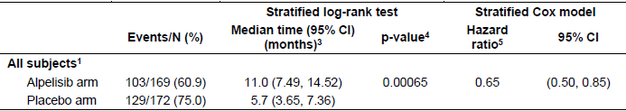
N = total number of subjects included in the analysis; CI = confidence interval.
¹ Both log-rank test and Cox proportional hazard model were stratified by prior CDK4/6 inhibitor usage and presence of lung/liver metastases.
³ Median (time to event) and its 95% CI were generated by Kaplan-Meier estimation.
⁴ p-value was one tailed and was compared to pre-specified significance levels defined by the study.
⁵ Hazard Ratio of alpelisib plus fulvestrant versus placebo plus fulvestrant (placebo plus fulvestrant is the control).
Figure 2: Study CBYL719C2301 (SOLAR-1 trial) Kaplan-Meier plot of progression-free survival per investigator assessment (full analysis set, PIK3CA mutant cohort)
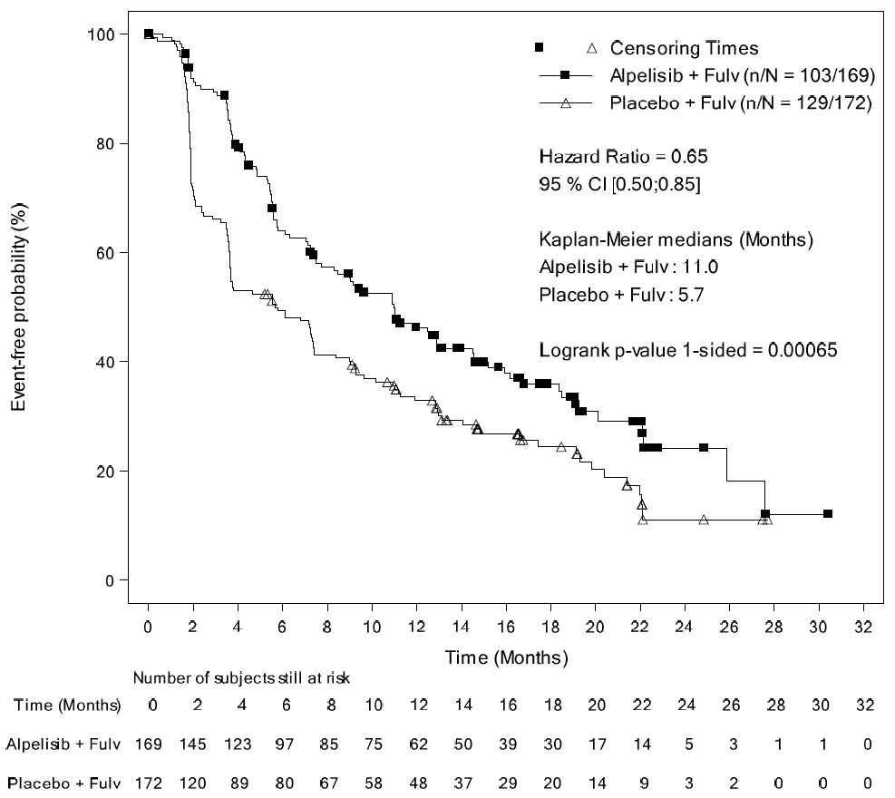
N = total number of subjects included in the analysis; n = total number of events included in the analysis; CI = confidence interval.
The supplementary analysis of PFS by BIRC based on a 50% audit sample (hazard ratio 0.48, 95% CI 0.32, 0.71; median PFS 11.1 months for alpelisib plus fulvestrant versus 3.7 months for placebo plus fulvestrant) was supportive of the primary endpoint.
Subgroup analyses of PFS by stratification factors and other demographic and prognostic factors were broadly consistent with the primary endpoint, though the number of patients and PFS events in some subgroups were too small to draw meaningful conclusions. The PFS outcome for patients aged ≥ 75 years (hazard ratio 1.12, 95% CI 0.54, 2.34) was based on 46 patients. Only 20 (6%) patients in the PIK3CA mutant cohort, 9 in the alpelisib plus fulvestrant arm and 11 in the placebo plus fulvestrant arm, had received prior treatment with a CDK4/6 inhibitor, limiting the conclusions that can be drawn in this subgroup.
Data for OS, the key secondary efficacy endpoint, were immature at this interim analysis, with 92 deaths reported, 40 (23.7%) in the alpelisib plus fulvestrant arm and 52 (30.2%) in the placebo plus fulvestrant arm (hazard ratio 0.73, 95% CI 0.48, 1.10; p = 0.06). The pre-specified stopping boundary was not crossed.
In the PIK3CA non-mutant cohort, PFS was 1.8 months longer in the alpelisib plus fulvestrant arm compared with the placebo plus fulvestrant arm (7.4 versus 5.6 months; estimated HR 0.85, 95% CI 0.58, 1.25). Pre-specified proof-of-concept criteria (hazard ratio ≤ 0.60 and posterior probability (hazard ratio < 1) ≥ 90%) for PFS in the PIK3CA non-mutant cohort were not met, so no further inferential analyses of efficacy in the non-mutant cohort were performed.
In the PIK3CA mutant cohort, ORR was 26.6% in the alpelisib plus fulvestrant arm (1 (0.6%) complete response (CR), 44 (26%) partial response (PR)) and 12.8% in the placebo plus fulvestrant arm (2 (1.2%) CR, 20 (11.6%) PR).
PFS in patients who were PIK3CA mutation positive based on testing of ctDNA in plasma (N = 185; hazard ratio 0.54, 95% CI 0.33, 0.88) was consistent with the primary efficacy endpoint. ORR in patients with a PIK3CA mutation detected in ctDNA (28.3% versus 9.6%) was similar to the results based on tumour tissue testing.
In the PIK3CA mutant cohort, there was no difference between the treatment arms with respect to time to definitive deterioration in ECOG performance status (hazard ratio = 1.0; 95% CI: 0.65, 1.53).
Patient reported outcome data collection declined after Cycle 7, limiting the conclusions that can be drawn about quality of life differences. HRQoL measures in the mutant cohort appeared to be broadly similar across the treatment arms, but there was a pattern of lower EORTC QLQ-C30 scores in the alpelisib plus fulvestrant arm over the duration of the study.

Safety
The evaluation of safety focussed primarily on the Phase III study, SOLAR-1 trial (cut-off date 12 June 2018). Safety data from the two dose finding Studies CBYL719X2101 and CBYL719X1101 were not pooled with SOLAR-1 trial data due to differences in the study populations and dosages, but the data were generally consistent with the safety profile from SOLAR-1 trial.
Of the 571 patients who received at least one dose of study treatment in SOLAR-1 trial, 284 were randomised to alpelisib plus fulvestrant (169 in the PIK3CA mutant cohort and 115 in the non-mutant cohort) and 287 to placebo plus fulvestrant (171 in the PIK3CA mutant cohort and 116 in the non-mutant cohort). The presence or absence of PIK3CA mutations was not expected to affect the safety profile. The incidence of adverse events (AEs), serious adverse events (SAEs), and adverse events of special interest (AESIs) was generally consistent between the PIK3CA mutant and non-mutant cohorts, so safety data from both cohorts were presented together.
In the alpelisib plus fulvestrant arm, median duration of exposure was 5.5 months for alpelisib and 8.2 months for fulvestrant. The median duration of exposure to alpelisib was similar in the two cohorts. In the placebo plus fulvestrant group, median duration of exposure was 5.6 months for each.
AEs, Grade 3 to 4 AEs, SAEs, AEs leading to discontinuation, and AEs leading to dose adjustment/interruption all occurred more commonly in the alpelisib plus fulvestrant group (Table 3). The most frequent AEs (> 10%) are listed in Table 4. Hyperglycaemia was the most commonly reported AE, followed by gastrointestinal (GI) toxicities and fatigue/asthenia. AESI are summarised in Table 5.
AEs requiring > 10% patients to commence additional therapies included hyperglycaemia (54.9%), diarrhea (30.3%), rash (29.2%, plus maculopapular rash 12.3%), nausea (19.7%), stomatitis (19.0%), pruritus (11.3%), mucosal inflammation (10.9%), pyrexia (10.9%), and urinary tract infection (10.2%).
Table 3: Study CBYL719C2301 (SOLAR-1 trial) Overview of adverse events, safety set, data cut-off 12 June 2018
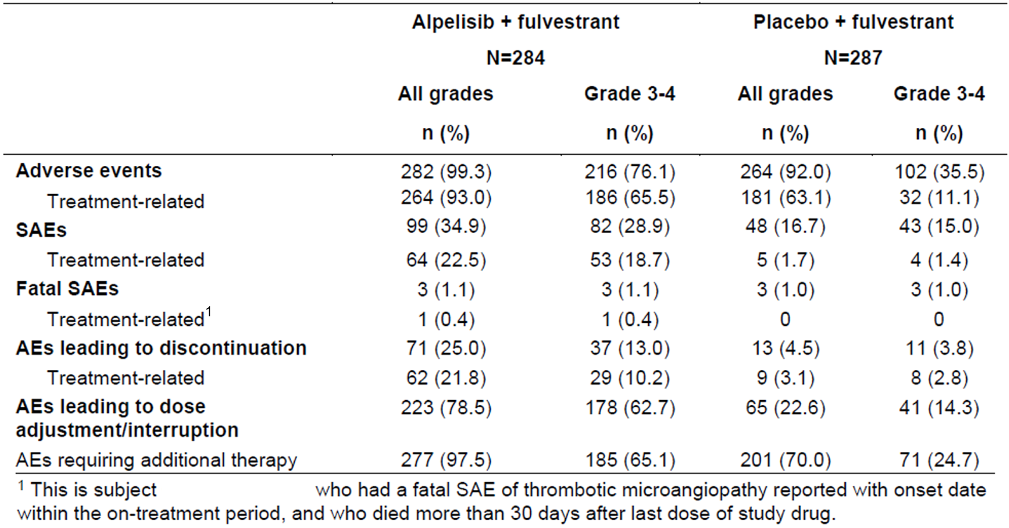
Table 4: Study CBYL719C2301 (SOLAR-1 trial) Adverse events by preferred term and maximum grade (> 10% in either treatment arm), safety set, data cut-off 12 June 2018
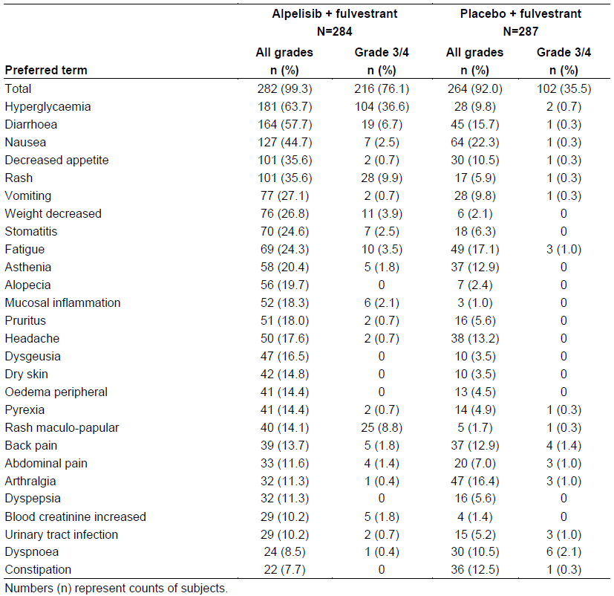
Table 5: Study CBYL719C2301 (SOLAR-1 trial) Overview of adverse events of special interest, safety set, data cut-off 12 June 2018
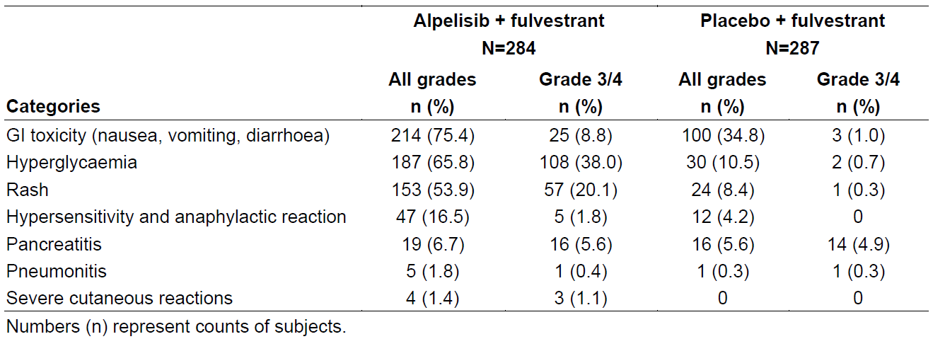
Patients with pre-diabetes (fasting plasma glucose (FPG) 5.6 to < 7.0 mmol/L or glycated haemoglobin A1c (HbA1c); 5.7 to < 6.5%) had a shorter median duration of exposure to alpelisib (5.1 months versus 7.5 months) compared to those without pre-diabetes (FPG < 5.6 mmol/L and HbA1c < 5.7%).
Osteonecrosis of the jaw (ONJ) was reported in 4.2% of patients in the alpelisib plus fulvestrant group compared to 1.4% in the placebo plus fulvestrant group. All of these patients were receiving or had received a bisphosphonate.
There were 78 (27.5%) deaths in the alpelisib plus fulvestrant group and 91 (31.7%) in the placebo plus fulvestrant group. Most deaths were due to the study indication. None of the deaths in the alpelisib plus fulvestrant group appear to be related to study treatment.
Cardiac safety was assessed in the dose escalation Study CBYL719X2101 and the SOLAR-1 trial. In Study CBYL719X2101, analysis of ECG data in patients receiving alpelisib 400 mg QD with or without fulvestrant demonstrated the absence of a large effect (that is > 20 ms) on QTcF prolongation. In SOLAR-1 trial, there was no notable difference in QT prolongation between the two arms. New QTcF values > 500 ms were observed in two patients (0.7%) in the alpelisib plus fulvestrant group compared to one patient (0.4%) in the placebo plus fulvestrant group, and new QTcF values > 480 ms and ≤ 500 ms were observed in 2.6% versus 1.8%, respectively. No clinically significant cardiac sequelae were reported in patients with prolonged QTcF values.

Companion diagnostic
The Novartis CTA was used to detect PIK3CA mutations in the first 395 patients enrolled in SOLAR-1 trial and the Qiagen therascreen PIK3CA RGQ PCR Kit was used for the subsequent 177 patients. The sequential use of the Novartis CTA and Qiagen IVD in this study resulted in 172 of the 177 patients enrolled with the Qiagen IVD being allocated to the PIK3CA mutant cohort and only 5 to the non-mutant cohort.
The Qiagen therascreen PIK3CA RGQ PCR kit is a real-time qualitative PCR test for the detection of 11 mutations in the PIK3CA gene (Exon 7: C420R; Exon 9: E542K, E545A, E545D (1635G > T only), E545G, E545K, Q546E, Q546R; and Exon 20: H1047L, H1047R, H1047Y); using genomic deoxyribonucleic acid (DNA) extracted from tumour tissue or ctDNA in plasma. The Qiagen IVD differs from the Novartis CTA in not detecting the Q546K (glutamine at position 546 replaced by lysine) mutation. Also, the Novartis CTA, based on the Cobas plaform, used a multiplexing strategy which did not differentiate all mutations (E545A/D/G/K mutations reported as E545X, Q546E/K/R mutations reported as Q546X, and H1047L/R/Y mutations reported as H1047X).
The 395 patients enrolled on the basis of the Novartis CTA were retrospectively tested with the Qiagen IVD (tissue companion diagnostics (CDx)). A concordance analysis (Table 6) showed positive percent agreement (PPA), negative percent agreement (NPA) and overall percent agreement (OPA) of 97.0%, 92.5% and 94.4% respectively (including tissue CDx invalid results), meeting the pre-specified acceptance criteria for agreement between the tissue CDx and the CTA. The analytical validity of the Qiagen IVD will be assessed separately as part of the evaluation of the IVD.
PFS analyses were performed based on tissue CDx PIK3CA mutation status. PFS for alpelisib plus fulvestrant in the tissue CDx PIK3CA mutation-positive population (hazard ratio 0.64, 95% CI 0.48, 0.85) was similar to the primary efficacy outcome (hazard ratio 0.65, 95% CI 0.50, 0.85). The hazard ratio for PFS in the tissue CDx PIK3CA non-mutant population was 0.72 (95% CI 0.45, 1.15).
Table 6: Contingency table between the tissue companion diagnostics and clinical trial assay results (full analysis set, clinical trial assay-enrolled)
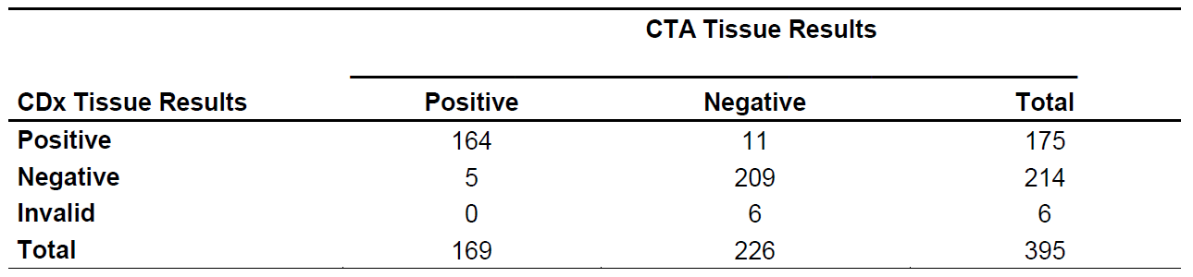
Plasma samples for detection of PIK3CA mutations in ctDNA were collected from 554 patients in SOLAR-1 trial (plasma samples were unavailable for 18 patients) and retrospectively tested using the Qiagen plasma CDx. Concordance analyses for the tissue CDx and plasma CDx (Table 7) showed the PPA of the plasma test compared to tissue test was 54.6% and the NPA was 97.2%. 155 of 543 plasma results were discordant with the tissue result. Of the 6 plasma positive samples that were tissue negative, 5 cases were confirmed plasma positive and 1 case plasma negative by Oncomin next generation sequencing (NGS) testing. Of the 149 plasma negative samples that were tissue positive, 119 cases were confirmed plasma negative by NGS, 28 cases were plasma positive by NGS (27 of these had mutant fraction below the CDx plasma assay limit of detection) and 2 cases had missing NGS results due to insufficient DNA.
PFS for alpelisib plus fulvestrant in the plasma CDx PIK3CA mutation-positive population (hazard ratio 0.54, 95% CI 0.33, 0.88) was similar to the tissue CDx outcome and the primary efficacy outcome.
Table 7: Contingency table between tissue companion diagnostics results and plasma companion diagnostics results (full analysis set)
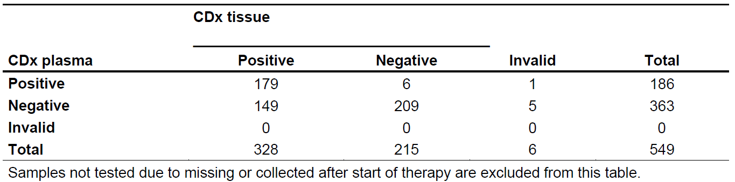

Risk management plan
The sponsor has submitted EU-risk management plan (RMP) version 1.0 (4 December 2018; data lock point (DLP) 12 June 2018) and Australian specific Annex (ASA) version 1.0 (7 February 2019) in support of this application. The proposed pharmacovigilance and risk minimisation activities are listed in Table 8.
Table 8: Summary of safety concerns
Summary of safety concerns |  | Pharmacovigilance |  | Risk minimisation
 |  | Routine | Additional | Routine | Additional
Important identified risks | Hypersensitivity | ✓ | – | ✓ | –
Important identified risks | Hyperglycaemia | ✓ | – | ✓ | ✓*
Important identified risks | Pneumonitis | ✓ | – | ✓ | –
Important identified risks | Severe cutaneous reactions | ✓ | – | ✓ | –
Important identified risks | Osteonecrosis of the jaw* | ✓ | – | ✓ | –
Important potential risks | Reproductive toxicity | ✓ | – | ✓ | –
Missing information | Long term use | ✓ | – | ✓ | –
*Sponsor committed to include at second round of evaluation
The Delegate is satisfied with the sponsor’s responses regarding QTc prolongation (RMP recommendation 4) and patient alert card (RMP recommendation 5), and does not propose further action on these matters.

Recommended conditions of registration
- The Piqray EU-RMP (version 1.0, dated 04 December 2018, DLP 12 June 2018), with ASA (version 1.0, dated 07 February 2019), included with submission PM-2019-00401-1-4 and any subsequent revisions, as agreed with the TGA will be implemented in Australia.
- An obligatory component of risk management plans is routine pharmacovigilance. Routine pharmacovigilance includes the submission of periodic safety update reports (PSURs).
Unless agreed separately between the supplier who is the recipient of the approval and the TGA, the first report must be submitted to TGA no later than 15 calendar months after the date of the approval letter. The subsequent reports must be submitted no less frequently than annually from the date of the first submitted report until the period covered by such reports is not less than three years from the date of the approval letter. The annual submission may be made up of two PSURs each covering six months. If the sponsor wishes, the six monthly reports may be submitted separately as they become available.
The reports are to at least meet the requirements for PSURs as described in the European Medicines Agency’s Guideline on Good Pharmacovigilance Practices (GVP) Module VII-periodic safety update report (Rev 1), Part VII.B Structures and processes. Note that submission of a PSUR does not constitute an application to vary the registration. Each report must have been prepared within ninety calendar days of the data lock point for that report.
- Piqray (alpelisib) is to be included in the Black Triangle Scheme. The PI and Consumer Medicines Information (CMI) for Piqray must include the black triangle symbol and mandatory accompanying text for five years, which starts from the date that the sponsor notifies the TGA of supply of the product.

Risk-benefit analysis

Delegate’s considerations

Efficacy
Treatment with alpelisib and fulvestrant, compared to placebo and fulvestrant, resulted in a clinically meaningful and statistically significant improvement in PFS in patients with HR-positive, HER2-negative, PIK3CA-mutated advanced breast cancer following progression on or after endocrine therapy (hazard ratio 0.65, 95% CI 0.50, 0.85, one-sided p = 0.00065). Median PFS was 11.0 months in the alpelisib with fulvestrant arm and 5.7 months in the placebo with fulvestrant arm.
The key secondary efficacy endpoint was OS. OS data were immature at the first interim analysis and a significant benefit in OS was not demonstrated. The interim analysis of OS favoured alpelisib with fulvestrant.
The pre-specified proof-of-concept criteria for PFS in the PIK3CA non-mutant cohort were not met, so a benefit was not demonstrated in this population.
Other efficacy analyses, including PFS by BICR, ORR and clinical benefit rate (CBR) were supportive of the primary endpoint. Given the testing hierarchy in SOLAR-1 trial, these outcomes do not support efficacy claims independent of the primary endpoint. Analyses of patient-reported outcomes do not support efficacy claims because of uncertainties arising from missing data.

Companion diagnostic
In the SOLAR-1 trial, the Novartis CTA was replaced with the Qiagen IVD during the course of the study to facilitate the commercial development of the Qiagen IVD as a companion diagnostic for Piqray in the proposed indication. The Qiagen therascreen PIK3CA RGQ PCR kit was used to identify PIK3CA mutations in tumour tissue and in plasma (ctDNA).
Efficacy outcomes in the PIK3CA mutant and non-mutant cohorts show that the Qiagen IVD identified a subgroup of patients who were more likely to achieve a benefit in PFS from the addition of alpelisib to fulvestrant in HR-positive, HER2-negative, advanced breast cancer, supporting the clinical utility of the Qiagen IVD in the proposed indication. The analytical validity of the Qiagen IVD will be evaluated separately as part of the assessment of the IVD.
Efficacy outcomes were similar in patients with a PIK3CA mutation detected from ctDNA or from tumour tissue, supporting the use of plasma ctDNA as an acceptable method of detecting PIK3CA mutations for treatment selection. Plasma testing has the advantage of easier accessibility compared to tumour tissue, but plasma testing has a lower sensitivity and negative predictive value, so tumour tissue testing (preferably from a metastatic site) is recommended if plasma testing is negative.

Safety
The safety profile of alpelisib with fulvestrant in the proposed indication has been adequately characterised. The addition of alpelisib to fulvestrant is associated with a substantial increase in toxicity, particularly Grade 3 to 4 AEs. The most common AEs (≥ 20% of patients) in the alpelisib plus fulvestrant group were hyperglycaemia (63.7%), diarrhoea (57.7%), nausea (44.7%), decreased appetite (35.6%), rash (35.6%) (plus maculopapular rash 14.1%), vomiting (27.1%), weight decreased (26.8%), stomatitis (24.6%), fatigue (24.3%) and asthenia (20.4%).
78.5% of patients in the alpelisib plus fulvestrant group required dose adjustment or interruption compared to 22.6% in the placebo plus fulvestrant group. Discontinuations due to AEs occurred more than five times as often in the alpelisib plus fulvestrant group (25%) compared to the placebo plus fulvestrant group (4.5%), with just over half of the discontinuations in the alpelisib plus fulvestrant group being due to a Grade 3 to 4 AE.
An imbalance in cases of ONJ raises the possibility that alpelisib may increase the risk of ONJ beyond the background risk related to use of bisphosphonates or denosumab. The clinical studies demonstrated no clinically relevant effect on ECG parameters.
The addition of alpelisib to fulvestrant results in a substantial increase in toxicity, but this is mostly manageable with clinical monitoring, dose modifications and additional treatments. Section 4.4 of the PI should contain a precaution regarding the risk of diarrhoea, including associated risks of dehydration and acute renal injury. Additional comments on safety references in the PI were provided by the Delegate, but are beyond the scope of this AusPAR.

Limitations of the data
The selection of fulvestrant monotherapy as the comparator in the pivotal study has some limitations from an Australian regulatory perspective. Fulvestrant is not Pharmaceutical Benefits Scheme-subsidised, so the cost of self-funding this treatment is a constraint on its use in Australia. In addition, fulvestrant is registered in Australia only for the treatment of postmenopausal women with HR-positive, locally advanced or metastatic breast cancer who have progressive disease following prior tamoxifen therapy.
The addition of a CDK4/6 inhibitor to ET has become a preferred first-line treatment option of HR-positive, HER2-negative advanced breast cancer. Only 20 (6%) patients in the SOLAR-1 trial had prior treatment with a CDK4/6 inhibitor. Consequently, there is some uncertainty whether the efficacy and safety findings from the SOLAR-1 trial would be replicated in patients who have received treatment with a CDK4/6 inhibitor and ET.
Patients enrolled in the pivotal study did not have the range and severity of medical co-morbidities that would be expected to be seen in clinical practice in Australia, so there is some uncertainty regarding the tolerability of alpelisib plus fulvestrant in the real-world setting.
Only one male patient was enrolled (PIK3CA mutant cohort, alpelisib plus fulvestrant arm), limiting the conclusions that can be drawn regarding efficacy in men, but based on the mechanism of action, the treatment is expected to have similar efficacy across genders.
Efficacy and safety data for patients aged ≥ 75 years are limited, based on small numbers in the pivotal study.
There is uncertainty about potential interactions resulting from induction of CYP2B6, CYP2C9 and CYP3A4. The sponsor is required to conduct a clinical trial to address this uncertainty as a post-marketing commitment to the FDA.

Proposed indication
The proposed indication is:
Piqray is an α-specific class I phosphatidylinositol-3-kinase (PIK3CA) inhibitor indicated for the treatment of postmenopausal women, and men, with hormone receptor positive, HER2-negative, advanced breast cancer with a PIK3CA mutation in combination with fulvestrant after disease progression following an endocrine-based regimen.
The clinical evaluator has recommended the following indication:
Piqray, in combination with fulvestrant, is indicated for the treatment of men and postmenopausal women with hormone receptor-positive, HER2-negative, PIK3CA-mutated advanced or metastatic breast cancer with disease progression on or following an endocrine-based regimen.
The Delegate agrees with the evaluator that the text describing the class of the medicine is not required. The Delegate prefers the sponsor’s approach for ‘men’ to be positioned after ‘postmenopausal women’, given that the majority of patients being considered for treatment with alpelisib would be female. The indication should refer to the use of a validated test for PIK3CA mutation, noting that this wording may need to be revised when proposed regulations regarding companion diagnostic devices are introduced in Australia.
The following wording is suggested:
Piqray, in combination with fulvestrant, is indicated for the treatment of postmenopausal women, and men, with hormone receptor-positive, HER2-negative, advanced or metastatic breast cancer with a PIK3CA mutation as detected by a validated test following progression on or after an endocrine-based regimen.

Conclusion
In the SOLAR-1 trial, treatment with alpelisib and fulvestrant, compared to placebo and fulvestrant, resulted in a clinically meaningful and statistically significant improvement in PFS in patients with HR-positive, HER2-negative, PIK3CA-mutated advanced breast cancer following progression on or after endocrine therapy. A benefit in PFS was not seen in patients without a PIK3CA mutation. The interim analysis of overall survival in the PIK3CA-mutant cohort was immature, but the trend favoured alpelisib plus fulvestrant. Data in patients previously treated with a CDK4/6 inhibitor in association with ET are limited.
Treatment with alpelisib and fulvestrant is associated with considerable toxicity, but in the context of advanced or metastatic breast cancer which has progressed following prior ET, the overall benefit-risk of alpelisib in combination with fulvestrant is favourable.
There are no outstanding clinical questions requiring expert advice.

Proposed conditions of registration
- Submit the final clinical study report for the SOLAR-1 trial when available.
The above condition is in addition to those provided by the RMP evaluator, as outlined in the Section ‘Recommended conditions of registration’, above.

Advisory Committee considerations
The Delegate did not refer this application to the Advisory Committee on Medicines (ACM) for advice.

Outcome
Based on a review of quality, safety and efficacy, the TGA approved the registration of Piqray (alpelisib) 200 mg, 250 mg and 300 mg daily dose blisters, indicated for:
Piqray in combination with fulvestrant, is indicated for the treatment of postmenopausal women, and men, with hormone receptor positive, HER2-negative, advanced or metastatic breast cancer with a PIK3CA mutation as detected by a validated test following progression on or after an endocrine-based regimen.

Specific conditions of registration applying to these goods
- Piqray (alpelisib) is to be included in the Black Triangle Scheme. The PI and CMI for Piqray must include the black triangle symbol and mandatory accompanying text for five years, which starts from the date that the sponsor notifies the TGA of supply of the product.
- The Piqray EU-RMP (version 1.0, dated 04 December 2018, DLP 12 June 2018), with ASA (version 1.0, dated 07 February 2019), included with submission PM-2019-00401-1-4, and any subsequent revisions, as agreed with the TGA will be implemented in Australia.
An obligatory component of risk management plans is routine pharmacovigilance. Routine pharmacovigilance includes the submission of PSURs.
Unless agreed separately between the supplier who is the recipient of the approval and the TGA, the first report must be submitted to TGA no later than 15 calendar months after the date of this approval letter. The subsequent reports must be submitted no less frequently than annually from the date of the first submitted report until the period covered by such reports is not less than three years from the date of this approval letter. The annual submission may be made up of two PSURs each covering six months. If the sponsor wishes, the six monthly reports may be submitted separately as they become available.
The reports are to at least meet the requirements for PSURs as described in the European Medicines Agency’s Guideline on Good Pharmacovigilance Practices (GVP) Module VII-periodic safety update report (Rev 1), Part VII.B Structures and processes. Note that submission of a PSUR does not constitute an application to vary the registration. Each report must have been prepared within ninety calendar days of the data lock point for that report.
- Submit the final clinical study report for the SOLAR-1 trial when available.
- Assessment of the transport potential for BSEP, MATE1 and MRP2 in the liver system is to be performed as a post-marketing commitment.

Attachment 1. Product Information
The PI for Piqray approved with the submission which is described in this AusPAR is at Attachment 1. For the most recent PI, please refer to the TGA website at <https://www.tga.gov.au/product-information-pi>.

Therapeutic Goods Administration
PO Box 100 Woden ACT 2606 Australia
Email: info@tga.gov.au Phone: 1800 020 653 Fax: 02 6232 8605
https://www.tga.gov.au

The Black Triangle Scheme provides a simple means for practitioners and patients to identify certain types of new prescription medicines, including those being used in new ways and to encourage the reporting of adverse events associated with their use. The Black Triangle does not denote that there are known safety problems, just that the TGA is encouraging adverse event reporting to help us build up the full picture of a medicine's safety profile.
The Surveillance, Epidemiology, and End Results (SEER) Program provides information on cancer statistics in an effort to reduce the cancer burden among the United States of America population. SEER is supported by the Surveillance Research Program (SRP) in the National Cancer Institute’s Division of Cancer Control and Population Sciences (DCCPS).
Surveillance, Epidemiology, and End Results (SEER) Program. SEER*Stat Database: Breast Cancer Recent Trends in SEER Age-Adjusted Incidence Rates, 2000-2017. Available from https://seer.cancer.gov/explorer/.
André F et al. (2019) Alpelisib for PIK3CA-mutated, hormone receptor–positive advanced breast cancer. N Engl J Med, 380:1929-1940.
Bachman KE et al. (2004). The PIK3CA gene is mutated with high frequency in human breast cancers. Cancer Biol Ther, 3:772–775.
Karakas B et al. (2006). Mutation of the PIK3CA oncogene in human cancers. Br J Cancer, 94:455–459.
Fritsch C et al. (2014). Characterisation of the novel and specific PI3Kα inhibitor NVP-BYL719 and development of the patient stratification strategy for clinical trials. Mol Cancer Ther, 13:1117-29.
Bosch A (2015). PI3K inhibition results in enhanced estrogen receptor function and dependence in hormone receptor-positive breast cancer. Sci Transl Med, 7 (283), 283ra51.
Australian pregnancy Category D: Drugs which have caused, are suspected to have caused or may be expected to cause, an increased incidence of human fetal malformations or irreversible damage. These drugs may also have adverse pharmacological effects. Accompanying texts should be consulted for further details.
A Phase III randomized double-blind, placebo controlled study of alpelisib in combination with fulvestrant for men and postmenopausal women with hormone receptor positive, HER2-negative advanced breast cancer which progressed on or after aromatase inhibitor treatment (SOLAR-1 trial). ClinicalTrials.gov Identifier: NCT02437318; https://clinicaltrials.gov/ct2/show/NCT02437318
Cytochrome P450 (CYP) enzymes: CYPs are the major enzymes involved in drug metabolism, accounting for large part of the total metabolism. Most drugs undergo deactivation by CYPs, either directly or by facilitated excretion from the body. Also, many substances are bioactivated by CYPs to form their active compounds. Many drugs may increase or decrease the activity of various CYP isozymes either by inducing the biosynthesis of an isozyme (enzyme induction) or by directly inhibiting the activity of the CYP (enzyme inhibition). This is a major source of adverse drug interactions, since changes in CYP enzyme activity may affect the metabolism and clearance of various drugs. Such drug interactions are especially important to take into account when using drugs of vital importance to the patient, drugs with important side-effects and drugs with small therapeutic windows, but any drug may be subject to an altered plasma concentration due to altered drug metabolism
The QT interval is the time from the start of the QRS wave complex to the end of the corresponding T wave. It approximates to the time taken for ventricular depolarisation and repolarisation, that is to say, the period of ventricular systole from ventricular isovolumetric contraction to isovolumetric relaxation. The corrected QT interval (QTc) estimates the QT interval at a standard heart rate. This allows comparison of QT values over time at different heart rates and improves detection of patients at increased risk of arrhythmias. The QTcF is the QT interval corrected for heart rate according to Fridericia’s formula.
ECOG Performance Status: The Eastern Cooperative Oncology Group (ECOG) has developed criteria used by doctors and researchers to assess how a patient's disease is progressing, assess how the disease affects the daily living abilities of the patient, and determine appropriate treatment and prognosis. The following criteria are used: 0 - Fully active, able to carry on all pre-disease performance without restriction; 1- Restricted in physically strenuous activity but ambulatory and able to carry out work of a light or sedentary nature, for example, light house work, office work; 2 - Ambulatory and capable of all selfcare but unable to carry out any work activities. Up and about more than 50% of waking hours; 3 - Capable of only limited selfcare, confined to bed or chair more than 50% of waking hours; 4 - Completely disabled. Cannot carry on any selfcare. Totally confined to bed or chair; and 5 – Dead.
The therascreen PIK3CA RGQ PCR Kit is an in vitro diagnostic test based on real-time qualitative PCR, which is used for the detection of 11 mutations in the PIK3CA gene.
The Response Evaluation Criteria in Solid Tumors (RECIST) is a voluntary, international standard using unified, easily applicable criteria for measuring tumour response using X-ray, CT and MRI.
EQ-5D-5L and BPI-SF are exploratory endpoints.
HbA1c, or glycated haemoglobin, is a form of haemoglobin chemically linked to a sugar via glycation. HbA1c is measured primarily to determine the three month average blood sugar level and is the most accepted method of measuring chronic glycaemia. Measurement can be used as a diagnostic test for diabetes mellitus and as an assessment test for glycaemic control in people with diabetes. An HbA1c of 48 mmol/mol (6.5%) or greater has now been recommended in Australia for diagnosis of type 2 diabetes. https://www.nps.org.au/australian-prescriber/articles/glycated-haemoglobin-for-the-diagnosis-of-diabetes
C420R = cysteine (C) at position 420 replaced by arginine (R); E542K = E at position 542 replaced by K; E545A = E at position 545 replaced by alanine (A); E545D = E at position 545 replaced by aspartic acid (D); E545G = E at position 545 replaced by glycine (G); E545K = E at position 545 replaced by K, Q546E = glutamine (Q) at position 546 replaced by E, Q546R = Q at 546 replaced by R; H1047L = H at position 1047 replaced by leucine (L), H1047R = H at position 1047 replaced by R, H1047Y = H at position 1047 replaced by tyrosine (Y).
Routine risk minimisation activities may be limited to ensuring that suitable warnings are included in the product information or by careful use of labelling and packaging. Routine pharmacovigilance practices involve the following activities: - All suspected adverse reactions that are reported to the personnel of the company are collected and collated in an accessible manner; - Reporting to regulatory authorities; - Continuous monitoring of the safety profiles of approved products including signal detection and updating of labeling; - Submission of PSURs; - Meeting other local regulatory agency requirements.
The ACM provides independent medical and scientific advice to the Minister for Health and the Therapeutic Goods Administration (TGA) on issues relating to the safety, quality and efficacy of medicines supplied in Australia including issues relating to pre-market and post-market functions for medicines. The Committee is established under Regulation 35 of the Therapeutic Goods Regulations 1990. Members are appointed by the Minister. The ACM was established in January 2017 replacing Advisory Committee on Prescription Medicines (ACPM) which was formed in January 2010. ACM encompass pre and post-market advice for medicines, following the consolidation of the previous functions of the Advisory Committee on Prescription Medicines (ACPM), the Advisory Committee on the Safety of Medicines (ACSOM) and the Advisory Committee on Non-Prescription Medicines (ACNM). Membership comprises of professionals with specific scientific, medical or clinical expertise, as well as appropriate consumer health issues relating to medicines.

