Australian product Information - PRALUENT® (alirocumab)

Name of the medicine
Praluent 75mg/mL and 150mg/mL solution for injection

Qualitative and quantitative composition
Alirocumab (rch) 75mg/mL and 150mg/mL
Alirocumab is a fully human monoclonal antibody (IgG1 isotype) that targets PCSK9. Alirocumab is produced by recombinant DNA technology in Chinese Hamster Ovary cell suspension culture.
For full list of excipients, see section 6.1.

Pharmaceutical form
Solution for injection
Praluent is a sterile, clear, colourless to pale yellow solution for subcutaneous injection with pH of about 6.0, containing no antimicrobial preservatives.

Clinical particulars

Therapeutic indications
Primary hypercholesterolaemia
Praluent is indicated as an adjunct to diet and exercise to reduce LDL-C in adults with primary (heterozygous familial or non-familial) hypercholesterolaemia in patients with moderate to very high cardiovascular risk:
- In combination with a statin, or statin with other lipid-lowering therapies in patients unable to reach LDL-C goals with maximum tolerated dose of a statin,
- alone or in combination with other lipid lowering therapies in patients who are statin intolerant or for whom a statin is contraindicated who are unable to reach LDL-C goals.

Prevention of cardiovascular events
Praluent is indicated to reduce the risk of cardiovascular events (myocardial infarction, stroke, unstable angina requiring hospitalisation) in adults with established cardiovascular disease, in combination with optimally dosed statins and/or other lipid-lowering therapies (see section 5.1 Pharmacodynamic properties, CLINICAL TRIALS).

Dose and method of administration
The recommended starting dose of Praluent is 75 mg once every 2 weeks or 300 mg once every 4 weeks (monthly), administered subcutaneously.
The dose of Praluent can be individualised based on patient characteristics such as baseline LDL-C level, goal of therapy and response. Lipid levels may be measured from 4 – 8 weeks of initiating or titrating Praluent, to assess the response and adjust the dose, if needed. If additional LDL-C reduction is needed in patients treated with 75 mg once every 2 weeks or 300 mg once every 4 weeks (monthly), the dosage may be adjusted to the maximum dosage of 150 mg once every 2 weeks.
If a dose is missed, instruct the patient to administer the injection within 7 days from the missed dose and then resume the patient’s original schedule. If an every-2-week dose is not administered within 7 days, instruct the patient to wait until the next dose on the original schedule. If an every-4-week dose is not administered within 7 days, instruct the patient to administer the dose, starting a new schedule based on this date.
No dose adjustments are needed for elderly patients or patients based on weight. No dose adjustments are needed for patients with mild or moderate renal or hepatic impairment (see section 5.2 PHARMACOKINETIC PROPERTIES).

Method of Administration
Praluent is injected as a subcutaneous injection into the thigh, abdomen or upper arm.
To administer the 300 mg dose, give two 150 mg injections consecutively at two different injection sites.
It is recommended to rotate the injection site with each injection.
Praluent should not be injected into areas of active skin disease or injury such as sunburns, skin rashes, inflammation, or skin infections.
The patient may either self-inject Praluent or a caregiver may administer Praluent, after guidance has been provided by a healthcare professional on proper subcutaneous injection technique.
Praluent must not be co-administered with other injectable medicinal products at the same injection site.
Praluent is a sterile product and contains no antimicrobial preservatives. Product is for single use in one patient only.
Before administration, Praluent should be inspected visually for particulate matter and discolouration. If the solution is discoloured or contains particulate matter, the solution should not be used.
To avoid discomfort, Praluent should be allowed to warm to room temperature (up to 25°C) for 30 to 40 minutes prior to use. Do not heat, let it warm up on its own. Praluent should be used as soon as possible after it has warmed up. Time out of refrigeration should not exceed a maximum of 30 days at temperatures below 25°C.
After use, place the Praluent pre-filled pen or pre-filled syringe into a puncture resistant container and discard in accordance with local requirements.

Contraindications
Hypersensitivity to the active substance or to any of the excipients listed in section 6.1.

Special warnings and precautions for use
General allergic reactions, including pruritus, as well as rare and sometimes serious allergic reactions such as hypersensitivity, nummular eczema, urticaria, and hypersensitivity vasculitis have been reported in clinical studies (see section 4.8 ADVERSE EFFECTS). If signs or symptoms of serious allergic reactions occur, treatment with Praluent must be discontinued and appropriate symptomatic treatment initiated.

Immunogenicity
In the ODYSSEY OUTCOMES trial, 5.5% of patients treated with alirocumab 75 mg and/or 150 mg every 2 weeks (Q2W) had anti-drug antibodies (ADA) detected after initiating treatment compared with 1.6% of patients treated with placebo. Most of these were transient responses. Persistent ADA responses were observed in 0.7% of patients treated with alirocumab and 0.4% of patients treated with placebo. Neutralising antibody (NAb) responses were observed in 0.5% of patients treated with alirocumab and in <0.1% of patients treated with placebo in the OUTCOMES trial. Only 1.2% of patients exhibited neutralising antibodies (NAb) in the ten pooled phase 3 studies in the hypercholesterolemia program, all of them in the alirocumab group.
Anti-drug antibody responses, including NAb, were low titre and did not appear to have a clinically meaningful impact on the efficacy or safety of alirocumab for most patients. Patients with treatment emergent ADA experienced a higher rate of injection site reactions compared to patients who were ADA negative (7.5% vs 3.6%).
The long-term consequences of continuing alirocumab treatment in the presence of ADA are unknown.
In a pool of ten placebo-controlled and active-controlled trials of patients treated with alirocumab 75 mg and/or 150 mg Q2W as well as in a separate clinical study of patients treated with alirocumab 75 mg Q2W or 300 mg every 4 weeks (including some patients with dose adjustment to 150 mg Q2W), the incidence of detecting ADA and NAb was similar to the results from the ODYSSEY OUTCOMES trial described above.
Immunogenicity data are highly dependent on the sensitivity and specificity of the ADA assay.

Low LDL-C
Although adverse consequences of very low LDL-C were not identified in the clinical trials, the long-term effects of very low levels of LDL-C are unknown.

Use in hepatic impairment
Patients with severe hepatic impairment (Child-Pugh C) have not been studied. Praluent should be used with caution in patients with severe hepatic impairment.

Use in renal impairment
In clinical studies, there was limited representation of patients with severe renal impairment (defined as eGFR < 30 mL/min/1.73 m²). Praluent should be used with caution in patients with severe renal impairment.

Use in the elderly
In the phase 3 primary hypercholesterolemia controlled studies, 1158 patients (34.7%) treated with Praluent were ≥65 years of age and 241 patients (7.2%) treated with Praluent were ≥75 years of age. In the cardiovascular outcomes controlled study, 2505 patients (26.5%) treated with Praluent were ≥65 years of age and 493 patients (5.2%) treated with Praluent were ≥75 years of age. There were no significant differences observed in safety and efficacy with increasing age.

Paediatric use
The safety and efficacy of Praluent in patients below the age of 18 have not been established.

Effects on laboratory tests
No interactions with laboratory tests have been identified.

Interactions with other medicines and other forms of interactions

Effects of alirocumab on other medicinal products
Since alirocumab is a biologic, no pharmacokinetic effects of alirocumab on other medicinal products are anticipated. In clinical studies where alirocumab was administered in combination with atorvastatin or rosuvastatin, no relevant changes in statin concentrations were observed in the presence of repeated administration of alirocumab, indicating that cytochrome P450 enzymes (mainly CYP3A4 and CYP2C9) and transporter proteins such as P-gp and OATP were not affected by alirocumab.

Effects of other medicinal products on alirocumab
Statins and other lipid-modifying therapy are known to increase production of PCSK9, the protein targeted by alirocumab. Because a component of the clearance of alirocumab is target-mediated, an elevation in target could lead to lower alirocumab exposure. However, this effect does not impact the duration of efficacy when alirocumab is administered every two weeks.

Fertility, pregnancy and lactation

Effects on fertility
There were no adverse effects of alirocumab on surrogate markers of fertility (e.g. oestrous cycling, testicular volume, ejaculate volume, sperm motility, sperm concentration and total sperm count per ejaculate) in a 26-week toxicity study in sexually-mature monkeys. The highest dose in this study resulted in a serum AUC that was about 100 times that expected in patients at the maximum recommended dose. In addition, there were no alirocumab-related macroscopic or microscopic findings in reproductive organs in any rat or monkey toxicity study.

Use in pregnancy (Category B1)
There are no data from the use of Praluent in pregnant women. Animal studies do not indicate direct or indirect harmful effects with respect to reproductive and developmental toxicity.
When pregnant female animals were exposed to alirocumab, measurable alirocumab concentrations in serum were observed in fetal rats (and also infant monkeys), indicating that alirocumab, like other IgG antibodies, crosses the placenta.
There were no effects on fetal growth or development in the rat embryofoetal development study conducted at doses up to 75 mg/kg/dose administered on gestation days 6 and 12. At this dose, serum AUC was about 20 times the AUC expected in patients at the maximum recommended dose.
There was a slight attenuation of secondary anti-KLH IgG antibody response in infant offspring of cynomolgus monkeys dosed with alirocumab during organogenesis to parturition at maternal exposure of 13-fold the exposure at the maximum recommended human dose of 150 mg every two weeks. Alirocumab given at subcutaneous doses of up to 75 mg/kg/week to pregnant monkeys from gestation day 20 until parturition, had no adverse effects on the growth and development of offspring up to 6 months post-birth. At this dose, serum AUC was about 80-fold the AUC expected in patients at the maximum recommended dose.
Animal studies are not always predictive of human response. Therefore, it is not known whether Praluent can cause foetal harm when administered to a pregnant woman and Praluent should be used during pregnancy only if the potential benefit justifies the potential risk to the foetus.

For use in combination therapy with a statin
Statins are contraindicated in pregnant women. Please refer to the current respective product information.

Use in lactation
It is not known whether alirocumab is excreted in human milk. Because immunoglobulins are excreted in human milk, the use of Praluent is not recommended in breast-feeding women.

For use in combination therapy with a statin
Statins are contraindicated in breast-feeding women. Please refer to the current respective product information.

Effects on ability to drive and use machines
Praluent has no or negligible influence on the ability to drive and use machines.

Adverse effects (Undesirable effects)
The safety data are based on pooled results from nine placebo-controlled studies (four phase 2 and five phase 3 studies, all in patients on background statin), and five ezetimibe-controlled phase 3 studies (with three studies in patients on background statin). This reflects exposure to alirocumab in 3340 patients (3451 patient-years of exposure), the majority with high or very high cardiovascular risk, treated with alirocumab at a dose of 75 and/or 150 mg, administered subcutaneously once every 2 weeks, for a treatment duration of up to 18 months (including 2408 patients exposed to alirocumab for at least 52 weeks, and 639 patients exposed to alirocumab for at least 76 weeks).
In ten phase 3 controlled trials, involving patients with primary hypercholesterolemia, the most common adverse reactions (≥1% of patients treated with Praluent) were local injection site reactions, upper respiratory tract signs and symptoms and pruritus. Most common adverse reactions leading to treatment discontinuation in patients treated with Praluent were local injection site reactions.
The safety profile in ODYSSEY OUTCOMES (a long-term cardiovascular outcome trial) was consistent with the overall safety profile described in the phase 3 controlled trials. A total of 9451 patients were exposed to Praluent for a median of 31 months and 9443 patients were exposed to placebo for a median of 32 months.
No difference in the safety profile was observed between the two doses (75 mg once every 2 weeks and 150 mg once every 2 weeks) used in the phase 3 program.
In controlled studies, 1158 patients (34.7%) treated with Praluent were ≥65 years of age and 241 patients (7.2%) treated with Praluent were ≥75 years of age. There were no significant differences observed in safety and efficacy with increasing age.
Table 1 shows the adverse reactions reported in patients treated with alirocumab in pooled phase 3 controlled studies and the ODYSSEY OUTCOMES trial. Frequencies for all events have been calculated based on their incidence in pooled phase 3 clinical trials.
The frequency categories are defined as: very common (≥1/10); common (≥1/100 to <1/10); uncommon (≥1/1,000 to <1/100); rare (≥1/10,000 to <1/1,000); very rare (<1/10,000) and not known (cannot be estimated from the available data).
Table 1 ­ Adverse reactions reported with Praluent in pooled phase 3
controlled studies and ODYSSEY OUTCOMES
System Organ Class | Common | Rare
Immune system disorders |  | hypersensitivity  hypersensitivity vasculitis
Respiratory, thoracic and mediastinal disorders | Upper respiratory tract signs and symptoms*
Skin and subcutaneous tissue disorders | Pruritus | urticaria  eczema nummular
General disorders and administration site conditions | Injection site reactions**
* including mainly oropharyngeal pain, rhinorrhea, sneezing
** including erythema/redness, itching, swelling, pain/tenderness

Table 2 shows the adverse events reported in ≥1% of patients treated with alirocumab and more frequently than with placebo in pooled placebo-controlled studies.
Table 2 ­ Adverse events occurring in ≥1% of patients treated with alirocumab and more frequently than with placebo in the pool of placebo-controlled trials
Primary System Organ Class  Preferred Term n(%) | Placebo  (N=1276) | Alirocumab  (N=2476)
Infections and infestations
Nasopharyngitis | 147 (11.5%) | 301 (12.2%)
Influenza | 63 (4.9%) | 147 (5.9%)
Urinary tract infection | 65 (5.1%) | 129 (5.2%)
Bronchitis | 58 (4.5%) | 113 (4.6%)
Sinusitis | 38 (3.0%) | 80 (3.2%)
Pneumonia | 18 (1.4%) | 37 (1.5%)
Gastroenteritis viral | 10 (0.8%) | 32 (1.3%)
Pharyngitis | 13 (1.0%) | 29 (1.2%)
Tooth abscess | 13 (1.0%) | 26 (1.1%)
Cellulitis | 12 (0.9%) | 25 (1.0%)
Conjunctivitis | 11 (0.9%) | 25 (1.0%)
Blood and lymphatic system disorders
Anaemia | 12 (0.9%) | 27 (1.1%)
Metabolism and nutrition disorders
Diabetes mellitus | 13 (1.0%) | 34 (1.4%)
Gout | 13(1.0%) | 33 (1.3%)
Nervous system disorders
Paraesthesia | 11 (0.9%) | 28 (1.1%)
Cardiac disorders
Angina unstable | 13 (1.0%) | 37 (1.5%)
Respiratory, thoracic and mediastinal disorders
Cough | 31 (2.4%) | 68 (2.7%)
Oropharyngeal pain | 8 (0.6%) | 30 (1.2%)
Gastrointestinal disorders
Diarrhoea | 61 (4.8%) | 128 (5.2%)
Constipation | 21 (1.6%) | 46 (1.9%)
Abdominal pain | 19 (1.5%) | 40 (1.6%)
Abdominal pain upper | 12 (0.9%) | 30 (1.2%)
Skin and subcutaneous tissue disorders
Rash | 16 (1.3%) | 34 (1.4%)
Pruritus | 5 (0.4%) | 31 (1.3%)
Musculoskeletal and connective tissue disorders
Myalgia | 47 (3.7%) | 112 (4.5%)
Muscle spasms | 39 (3.1%) | 82 (3.3%)
Musculoskeletal pain | 20 (1.6%) | 57 (2.3%)
General disorders and administration site conditions
Injection site reaction | 63 (4.9%) | 171 (6.9%)
Oedema peripheral | 16 (1.3%) | 39 (1.6%)
Investigations
Alanine aminotransferase increased | 12 (0.9%) | 29 (1.2%)
Injury, poisoning and procedural complications
Contusion | 17 (1.3%) | 57 (2.3%)
Accidental overdose | 17 (1.3%) | 35 (1.4%)
Laceration | 8 (0.6%) | 27 (1.1%)
Table 3 shows the adverse events reported in ≥1% of patients treated with alirocumab and more frequently than with ezetimibe in pooled ezetimibe-controlled studies.
Table 3 ­ Adverse events occurring in ≥1% of patients treated with alirocumab and more frequently than with ezetimibe in the pool of ezetimibe-controlled trials
 | Primary System Organ Class  Preferred Term n(%) |  | Ezetimibe  (N=618) |  | Alirocumab  (N=864)
 | Infections and infestations
Upper respiratory tract infection |  | 40 (6.5%) |  | 62 (7.2%)
Influenza |  | 23 (3.7%) |  | 37 (4.3%)
Pneumonia |  | 12 (1.9%) |  | 19 (2.2%)
Tooth abscess |  | 3 (0.5%) |  | 9 (1.0%)
Metabolism and nutrition disorders
Type 2 diabetes mellitus |  | 7 (1.1%) |  | 11 (1.3%)
Psychiatric disorders
Insomnia |  | 9 (1.5%) |  | 18 (2.1%)
Nervous system disorders
Headache |  | 24 (3.9%) |  | 43 (5.0%)
Paraesthesia |  | 3 (0.5%) |  | 9 (1.0%)
Eye disorders
Cataract |  | 7 (1.1%) |  | 11 (1.3%)
Ear and labyrinth disorders
Vertigo |  | 5 (0.8%) |  | 9 (1.0%)
Cardiac disorders
Angina pectoris |  | 11 (1.8%) |  | 16 (1.9%)
Acute myocardial infarction |  | 4 (0.6%) |  | 13 (1.5%)
Angina unstable |  | 6 (1.0%) |  | 13 (1.5%)
Atrial fibrillation |  | 8 (1.3%) |  | 13 (1.5%)
Palpitations |  | 6(1.0%) |  | 11(1.3%)
Vascular disorders
Hypertension |  | 28 (4.5%) |  | 42 (4.9%)
Respiratory, thoracic and mediastinal disorders
Cough |  | 13 (2.1%) |  | 20 (2.3%)
Chronic obstructive pulmonary disease |  | 2 (0.3%) |  | 11 (1.3%)
Epistaxis |  | 4 (0.6%) |  | 10 (1.2%)
Gastrointestinal disorders
Diarrhoea |  | 21 (3.4%) |  | 30 (3.5%)
Constipation |  | 11 (1.8%) |  | 20 (2.3%)
Skin and subcutaneous tissue disorders
Rash |  | 7 (1.1%) |  | 13 (1.5%)
Musculoskeletal and connective tissue disorders
Arthralgia |  | 26 (4.2%) |  | 42 (4.9%)
Muscle spasms |  | 15 (2.4%) |  | 25 (2.9%)
Osteoarthritis |  | 14 (2.3%) |  | 21 (2.4%)
Musculoskeletal pain |  | 8 (1.3%) |  | 15 (1.7%)
Renal and urinary disorders
Haematuria |  | 5 (0.8%) |  | 14 (1.6%)
General disorders and administration site conditions
Fatigue |  | 9 (1.5%) |  | 28 (3.2%)
Injection site reaction |  | 13 (2.1%) |  | 25 (2.9%)
Non-cardiac chest pain |  | 14 (2.3%) |  | 22 (2.5%)
Oedema peripheral |  | 9 (1.5%) |  | 14 (1.6%)
Injury, poisoning and procedural complications
Accidental overdose |  | 24 (3.9%) |  | 54 (6.3%)
Fall |  | 11 (1.8%) |  | 22 (2.5%)
Contusion |  | 6 (1.0%) |  | 12 (1.4%)
Table 4 shows the adverse events reported in ≥2% of patients treated with alirocumab 300 mg monthly dose as compared to placebo and alirocumab fortnightly dose, irrespective of concomitant statin therapy.
Table 4 ­ Adverse events occurring in ≥2% of patients treated with alirocumab 300 mg monthly as compared to placebo, irrespective of concomitant statin therapy
Primary System Organ Class  Preferred Term n(%) | Placebo  (N=229) | Alirocumab  75 mg/150 mg Q2W  (N=115) | Alirocumab  300 mg Q4W  (N=458)
Infections and infestations
Upper respiratory tract infection | 18 (7.9%) | 8 (7.0%) | 41 (9.0%)
Nasopharyngitis | 18 (7.9%) | 10 (8.7%) | 39 (8.5%)
Sinusitis | 11 (4.8%) | 4 (3.5%) | 28 (6.1%)
Urinary tract infection | 10 (4.4%) | 7 (6.1%) | 28 (6.1%)
Lower respiratory tract infection | 2 (0.9%) | 3 (2.6%) | 13 (2.8%)
Metabolism and nutrition disorders
Type 2 diabetes mellitus | 2 (0.9%) | 1 (0.9%) | 11 (2.4%)
Nervous system disorders
Headache | 13 (5.7%) | 6 (5.2%) | 29 (6.3%)
Dizziness | 9 (3.9%) | 5 (4.3%) | 19 (4.1%)
Respiratory, thoracic and mediastinal disorders
Nasal congestion | 5 (2.2%) | 4 (3.5%) | 11 (2.4%)
Musculoskeletal and connective tissue disorders
Back pain | 14 (6.1%) | 4 (3.5%) | 29 (6.3%)
Pain in extremity | 2 (0.9%) | 4 (3.5%) | 21 (4.6%)
Osteoarthritis | 6 (2.6%) | 3 (2.6%) | 20 (4.4%)
Myalgia | 8 (3.5%) | 2 (1.7%) | 17 (3.7%)
Musculoskeletal pain | 5 (2.2%) | 4 (3.5%) | 16 (3.5%)
General disorders and administration site conditions
Injection site reaction | 16 (7.0%) | 10 (8.7%) | 74 (16.2%)
Injury, poisoning and procedural complications
Fall | 6 (2.6%) | 1 (0.9%) | 14 (3.1%)

Adverse Reactions in the Cardiovascular Outcomes Trial
In a double-blind, randomised, placebo-controlled cardiovascular outcomes trial (Study 1: ODYSSEY OUTCOMES, NCT01663402), 18,924 patients received at least one dose of PRALUENT or placebo [see Clinical Studies (14.1)]. The mean age was 58 years (range: 39 to 92 years), 25.2% women, 79.4% Caucasian, 2.5% Black, 13.2% Asian, and 16.6% Hispanic/Latino. Patients were exposed to PRALUENT for a median of 31 months; 87% of patients were exposed for ≥12 months, 78% were exposed for ≥24 months, 33% were exposed for ≥36 months, and 6% were exposed for ≥48 months.
The safety profile of PRALUENT in this trial was consistent with the safety profile described above in the placebo-controlled trials involving patients with primary hyperlipidemia and mixed dyslipidemia. Serious adverse events occurred in 23.3% of PRALUENT-treated patients and 24.9% of placebo-treated patients. Adverse events led to discontinuation of study treatment in 3.8% of patients treated with PRALUENT and 3.7% treated with placebo. The only adverse reaction reported in at least 2% of PRALUENT-treated patients, and occurring more frequently than in placebo-treated patients, was local injection site reactions (3.8% PRALUENT, 2.1% placebo). General allergic reactions were similar in PRALUENT-treated patients and placebo-treated patients (7.9% PRALUENT, 7.8% placebo). No difference was seen in the incidence of pruritus.
Table 5 shows the adverse events reported in >1% of patients treated with Praluent and more frequently than with placebo in the ODYSSEY OUTCOMES study.
Table 5 ­ Adverse events occurring in > 1% of patients treated with PRALUENT and more fre- quently than with placebo in the cardiovascular outcomes study (ODYSSEY OUTCOMES)
System Organ Class Preferred Term* | Placebo  (N=9443) | Alirocumab  (N=9451)
Any class | 77.1% | 75.8%
Ear and labyrinth disorders
Vertigo | 1.3% | 1.4%
Gastrointestinal disorders
Nausea | 1.8% | 2.1%
Gastrooesophageal reflux disease | 1.4% | 1.7%
Abdominal pain upper | 1.3% | 1.4%
General disorders and administration site conditions
Non-cardiac chest pain | 6.8% | 7.0%
Injection site reaction | 1.4% | 2.8%
Infections and infestations
Nasopharyngitis | 5.6% | 6.0%
Sinusitis | 1.3% | 1.5%
Lower respiratory tract infection | 1.0% | 1.1%
Injury, poisoning and procedural complications
Contusion | 1.7% | 1.8%
Musculoskeletal and connective tissue disorders
Myalgia | 5.3% | 5.6%
Back pain | 4.2% | 4.3%
Arthralgia | 3.7% | 3.9%
Muscle spasms | 2.1% | 2.3%
Nervous system disorders
Hypoaesthesia | 0.9% | 1.0%
Psychiatric disorders
Insomnia | 1.3% | 1.5%
Reproductive system and breast disorders
Benign prostatic hyperplasia | 1.2% | 1.3%
Erectile dysfunction | 0.9% | 1.0%
Skin and subcutaneous tissue disorders
Rash | 1.1% | 1.2%
Vascular disorders
Hypotension | 1.8% | 1.9%
* coded using MedDRA version 20.1

Local injection site reactions
Local injection site reactions, including erythema/redness, swelling, and pain/tenderness were reported in 6.1% of patients treated with alirocumab versus 4.1% in the control group with Q2W dosing and in 16.6% of patients treated with alirocumab compared to 7.9% in the placebo arm in the Q4W dose regimen. Patients in the alirocumab 300 mg every 4 weeks treatment group received alternating placebo injections to maintain blinding in regard to injection frequency. Excluding injection site reactions (ISRs) that occurred after these placebo injections, the frequency of ISRs was 11.8% in the alirocumab group. Most injection site reactions were transient and of mild intensity. The discontinuation rate due to local injection site reactions was comparable between the two groups (0.2% in the alirocumab group versus 0.3% in the control group) with the Q2W dose regimen, and 0.7% in the alirocumab group versus 0% in the placebo group with the Q4W dose regimen. In the cardiovascular outcomes study (ODYSSEY OUTCOMES), injection site reactions also occurred more frequently in alirocumab-treated patients than in placebo-treated patients (3.8% alirocumab 2.1% placebo).

General allergic reactions
General allergic reactions were reported more frequently in the alirocumab group than in the control group, mainly due to a difference in the incidence of pruritus. The observed cases of pruritus were typically mild and transient. In addition, rare and sometimes serious allergic reactions such as hypersensitivity, nummular eczema, urticaria, and hypersensitivity vasculitis have been reported in controlled clinical studies. (see Section 4.4 SPECIAL WARNINGS AND PRECAUTIONS FOR USE). In the cardiovascular outcomes study (ODYSSEY OUTCOMES), general allergic reactions were similar in alirocumab-treated patients and placebo-treated patients (7.9% alirocumab 7.8% placebo). No difference was seen in the incidence of pruritus.

Low LDL-C values

LDL-C values < 0.65 mmol/L
In all clinical studies background lipid lowering therapies could not be adjusted by trial design. The percentage of patients who reached LDL-C values <25 mg/dL (<0.65 mmol/L) depended both on the baseline LDL-C and the dose of alirocumab.
In a pool of controlled studies using a 75 mg every 2 week (Q2W) starting dose and in which the dose was increased to 150 mg Q2W if the patient’s LDL-C was not <70 mg/dL or < 100 mg/dL (1.81 mmol/L or 2.59 mmol/L), 29.3% of patients with baseline LDL-C <100 mg/dL and 5.0% of patients with baseline LDL-C ≥100 mg/dL treated with alirocumab had two consecutive values of LDL-C <25 mg/dL (<0.65 mmol/L). In the ODYSSEY OUTCOMES study, in which the starting alirocumab dose was 75 mg Q2W and the dose was increased to 150 mg Q2W if the patient’s LDL-C was not <50 mg/dL (1.29 mmol/L), 54.8% of patients with baseline LDL-C <100 mg/dL and 24.2% of patients with baseline LDL-C ≥100 mg/dL treated with alirocumab had two consecutive values of LDL-C <25 mg/dL (<0.65 mmol/L).
Although adverse consequences of very low LDL-C were not identified in alirocumab trials, the long-term effects of very low levels of LDL-C are unknown. In published genetic studies as well as clinical and observational trials with lipid lowering therapies an increased risk of new onset of diabetes has been associated with lower levels of LDL-C.
Although adverse consequences of very low LDL-C were not identified in alirocumab trials, the long-term effects of very low levels of LDL-C are unknown. In published genetic studies as well as clinical and observational trials with lipid lowering therapies an increased risk of new onset of diabetes has been associated with lower levels of LDL-C.

Cardiovascular (CV) events
In pre-specified analysis of the ten pooled phase 3 studies in the hypercholesterolemia program, treatment-emergent CV events confirmed by adjudication, consisting of coronary heart disease (CHD) death, myocardial infarction, ischemic stroke, unstable angina requiring hospitalization, congestive heart failure hospitalization, and revascularization, were reported in 129 (4.1%) patients in the alirocumab group and 63 (3.5%) patients in the control group (placebo or active control) with HR=1.06 (95% CI, 0.79 to 1.44). MACE confirmed by adjudication were reported in 65 of 3182 (2.0%) patients in the alirocumab group and 39 of 1792 (2.2%) patients in the control group (placebo or active control); HR=0.85 (95% CI, 0.57 to 1.27).
In pre-specified final analyses of the LONG TERM study, treatment-emergent CV events confirmed by adjudication occurred in 72 of 1550 (4.6%) patients in the alirocumab group and in 40 of 788 (5.1%) patients in the placebo group; MACE confirmed by adjudication were reported in 27 of 1550 (1.7%) patients in the alirocumab group and 26 of 788 (3.3%) patients in the placebo group. Hazard ratios were calculated post-hoc; for all CV events, HR=0.91 (95% CI, 0.62 to 1.34); for MACE, HR=0.52 (95% CI, 0.31 to 0.90).

All-cause mortality
All-cause mortality in the ten pooled phase 3 studies in the hypercholesterolemia program was 0.8% (26 of 3182 patients) in the alirocumab group and 1.1% (20 of 1792 patients) in the control group. The primary cause of death in the majority of these patients was CV events.

Neurocognitive Events
Neurocognitive events were reported in 0.8% of patients treated with alirocumab and 0.7% of patients treated with placebo. Confusion or memory impairment were each reported in 0.2% of patients treated with alirocumab and in <0.1% (for each) in the placebo group patients. The majority of neurocognitive events were non-serious. The causal relationship between these events and alirocumab has not been established.

Post-marketing experience
The following adverse reactions have been reported during post-approval use of Praluent. The adverse reactions are derived from spontaneous reports and therefore, the frequency is “not known” (cannot be estimated from the available data).
General disorders and administration site conditions
- Flu-like illness
Reporting suspected adverse reactions after registration of the medicinal product is important. It allows continued monitoring of the benefit-risk balance of the medicinal product. Healthcare professionals are asked to report any suspected adverse reactions at www.tga.gov.au/reporting-problems (Australia) or https://nzphvc.otago.ac.nz/reporting/ (New Zealand).

Overdose
In controlled clinical studies, no safety issues were identified with more frequent dosing than the recommended once every 2 weeks dosing schedule.
For general advice on management of overdose, contact the Poisons Information Centre, telephone number 13 11 26 (Australia) or the National Poisons Centre, 0800 POISON or 0800 764 766 (New Zealand).

Pharmacological properties

Pharmacodynamic properties
Pharmacotherapeutic group: Other lipid modifying agents, ATC code: C10AX14
Alirocumab inhibits PCSK9 activity in both in vitro assays and in vivo model systems. Many studies in animals and humans have demonstrated the central role that elevated levels of LDL-C play in the initiation and progression of atherosclerosis.

Mechanism of action
Alirocumab binds with high affinity and specificity to PCSK9 which binds to the low-density lipoprotein receptors (LDLR) on the surface of hepatocytes to promote their degradation. LDLR is the primary receptor that clears circulating low-density lipoprotein (LDL), therefore the decrease in LDLR levels by PCSK9 results in higher blood levels of low-density lipoprotein cholesterol (LDL-C). By inhibiting the binding of PCSK9 to LDLR, alirocumab increases the number of LDLRs available to clear LDL, thereby lowering LDL-C levels.
In genetic studies in humans, PCSK9 variants with either loss-of-function or gain-of-function mutations have been identified. Individuals with single allele PCSK9 loss-of-function mutation have lower levels of LDL-C, which correlated with a significantly lower incidence of coronary heart disease. A few individuals have been reported, who carry PCSK9 loss-of-function mutations in two alleles and have profoundly low LDL-C levels, with HDL-C and triglyceride (TG) levels in the normal range. Conversely, gain-of-function mutations in the PCSK9 gene have been identified in patients with increased LDL-C levels and a clinical diagnosis of familial hypercholesterolaemia (FH).
Observational analyses have demonstrated that the untreated LDL-C levels in patients with gain-of-function mutations in the PCSK9 gene are in a similar range to those observed in patients with the more traditional mutations that cause heterozygous FH (heFH) (such as in the LDLR gene) demonstrating a central role for PCSK9 in LDL-C metabolism and levels. In a multicentre, double-blind, placebo-controlled, 14-week study, 13 patients with heFH due to gain-of-function mutations in the PCSK9 gene were randomised to receive either alirocumab 150 mg once every 2 weeks or placebo. Mean baseline LDL-C was 3.92 mmol/L. At week 2, the mean reduction from baseline in LDL-C was 62.5% in the alirocumab-treated patients as compared to 8.8% in the placebo patients. At week 8, the mean reduction in LDL-C from baseline with all patients treated with alirocumab was 72.4%.

Pharmacodynamic effects
In in vitro assays, alirocumab did not induce Fc-mediated effector function activity (antibody-dependent cell-mediated cytotoxicity and complement-dependent cytotoxicity) either in the presence or absence of PCSK9 and no soluble immune complexes capable of binding complement proteins were observed for alirocumab when bound to PCSK9.
The pharmacodynamic effect of alirocumab in lowering LDL-C is indirect, and mediated through the binding to PCSK9. A concentration-dependent reduction in free PCSK9 and LDL-C is observed until target saturation is achieved. Upon saturation of PCSK9 binding, further increases in alirocumab concentrations do not result in a further LDL-C reduction, however an extended duration of the LDL-C lowering effect is observed.

Clinical trials

EVERY 2 WEEKS (Q2W) DOSING REGIMEN
The efficacy of Praluent was investigated in ten phase 3 trials (five placebo-controlled and five ezetimibe-controlled studies), involving 5,296 randomised patients with 3,188 patients randomised to Praluent. The five placebo-controlled trials involved 3,499 patients of which 36% were patients with heterozygous familial hypercholesterolemia (heFH) and 54% were non-FH patients who had clinical atherosclerotic cardiovascular disease. Three of the ten studies were conducted exclusively in patients with heFH. The majority of patients in the phase 3 program were taking background lipid-modifying therapy (LMT) consisting of a maximally tolerated dose of statin, with or without other LMTs, and were at high or very high cardiovascular (CV) risk. Two studies were conducted in patients who were not concomitantly treated with a statin, including one study in patients with documented statin intolerance. Alirocumab has not been studied in patients with homozygous familial hypercholesterolaemia.
Eight studies were performed with a dose of 75 mg once every 2 weeks, and criteria-based up-titration to 150 mg once every 2 weeks at week 12 in patients who did not achieve their pre-defined target LDL-C based on their level of CV risk at week 8. Two studies (LONG TERM and HIGH FH), involving a total of 2,416 patients, were performed with a 150 mg once every 2 weeks dose only. Baseline demographic characteristics were well matched between the Praluent and control groups. The age of the patients ranged from 18 to 89 years across studies (mean age 60 years); 38% were women; the majority of patients were Caucasian (90%), 5% were Black, 2% were Asian; the mean body mass index (BMI) was 30 kg/m2. In the phase 3 studies, 31% of patients had type 2 diabetes mellitus, and 64% of patients had a history of coronary heart disease.
The primary efficacy endpoint in all of the phase 3 studies was the mean percent reduction from baseline in LDL-C at week 24 as compared to placebo or ezetimibe. All of the studies met their primary endpoint. The effect of Praluent on cardiovascular morbidity and mortality is currently being investigated in an ongoing clinical trial in 18,000 patients (OUTCOMES).
In general, administration of Praluent also resulted in a statistically significant greater percent reduction in Total-C, non-HDL-C, Apo B, and Lp(a) as compared to placebo/ ezetimibe, whether or not patients were concomitantly being treated with a statin. Praluent also reduced triglycerides, and increased HDL-C and Apo A-1 as compared to placebo.
Reduction in LDL-C was seen across age, gender, body mass index (BMI), race and baseline LDL-C levels. LDL-C reduction was consistent regardless of concomitantly used statins and doses. A significantly higher proportion of patients achieved an LDL-C of ˂1.81 mmol/L in the Praluent group as compared to placebo or ezetimibe at week 12 and week 24. In studies using the criteria-based up-titration regimen, a majority of patients achieved the pre-defined target LDL-C (based on their level of CV risk) on the 75 mg once every 2 weeks dose, and a majority of patients maintained treatment on the 75 mg once every 2 week dose.
The lipid-lowering effect of Praluent was observed within 15 days of the first dose reaching maximum effect at approximately 4 weeks. Efficacy was sustained over the duration of study treatment (up to 2 years). Following discontinuation of Praluent, no rebound in LDL-C was observed, and LDL-C levels gradually returned to baseline levels.
Table 6 summarises the mean percent change from baseline in LDL-C with Praluent at week 12 (before up-titration) and at week 24 (primary endpoint) based on analyses across pooled phase 3 studies.
Table 6 ­ Mean percent change from baseline in LDL-C with alirocumab at week 12 (before up-titration) and week 24 (primary endpoint) in analyses of pooled phase 3 studies in patients on background statinª
Week 12 | Placebo controlled studies |  | Ezetimibe controlled studies
Week 12 |  |  | Without Background Statin |  | With Background Statin
Dose | Praluent (additive effect beyond statin) | Placebo (additive effect beyond statin) | Praluent | Ezetimibe | Praluent (additive effect beyond statin) | Ezetimibe (additive effect beyond statin)
75 mg Q2W | -44.5 | 4.1 | -47.0 | -15.6 | -49.2 | -22.3
150 mg Q2W | -62.6 | 1.1 | - | - | - | -
Week 24
Dose | Praluent (additive effect beyond statin) | Placebo (additive effect beyond statin) | Praluent | Ezetimibe | Praluent (additive effect beyond statin) | Ezetimibe (additive effect beyond statin)
75/150 mg Q2W (up-titration studies)^{b} | -48.6 | 4.2 | -45.0 | -14.6 | -48.9 | -19.3
150 mg Q2W | -60.4 | 0.5 | - | - | - | -
ª Based on ITT analysis - intent-to-treat population, includes all lipid data throughout the duration of the study irrespective of adherence to the study treatment.
^{b} Dose was up-titrated to 150 mg once every 2 weeks in 228 (34.5%) patients treated beyond 12 weeks in the placebo-controlled studies and in 180 (22.9%) patients treated beyond 12 weeks in the ezetimibe-controlled studies.
Baseline LDL-C in analyses of pooled up-titration studies (COMBO I, FH I and FH II) was 3.33 mmol/L in the Praluent group and 3.36 mmol/L in the placebo group.
Baseline LDL-C in analyses of pooled studies using the 150 mg once every 2 weeks dose (LONG TERM, HIGH FH) was 3.26 mmol/L in the Praluent group and 3.24 mmol/L in the placebo group.
Baseline LDL-C in analyses of ezetimibe controlled study not on background statin (ALTERNATIVE) was 5.0 mmol/L in the alirocumab group and 5.03 mmol/L in the ezetimibe group.
Baseline LDL-C in analyses of pooled studies on background statin (COMBO II, OPTIONS I and II) was 2.83 mmol/L in the Praluent group and 2.71 mmol/L in the ezetimibe group.

In analyses of pooled phase 3 studies that allowed up-titration, among the subgroup of patients up-titrated, an increase from 75 mg once every 2 weeks to 150 mg once every 2 weeks Praluent at week 12 resulted in an additional 14% mean reduction in LDL-C in patients on a background statin. In patients not on a background statin, up-titration of Praluent resulted in an additional 3% mean reduction in LDL-C, with the majority of the effect seen in approximately 25% of patients who achieved at least an additional 10% LDL-C lowering after up-titration. Patients up-titrated to 150 mg once every 2 weeks had a higher mean baseline LDL-C.
Figure 1 summarises the mean reduction from baseline in LDL-C with Praluent at week 12 (before up-titration) across phase 3 studies. This figure shows the efficacy of the 75 mg once every 2 week and 150 mg once every 2 week doses. Week 24 results are provided in the description of the individual studies.
Figure 1 ­ Summary of mean reduction from baseline in LDL-C with Praluent at week 12 (before up-titration) across phase 3 studies.
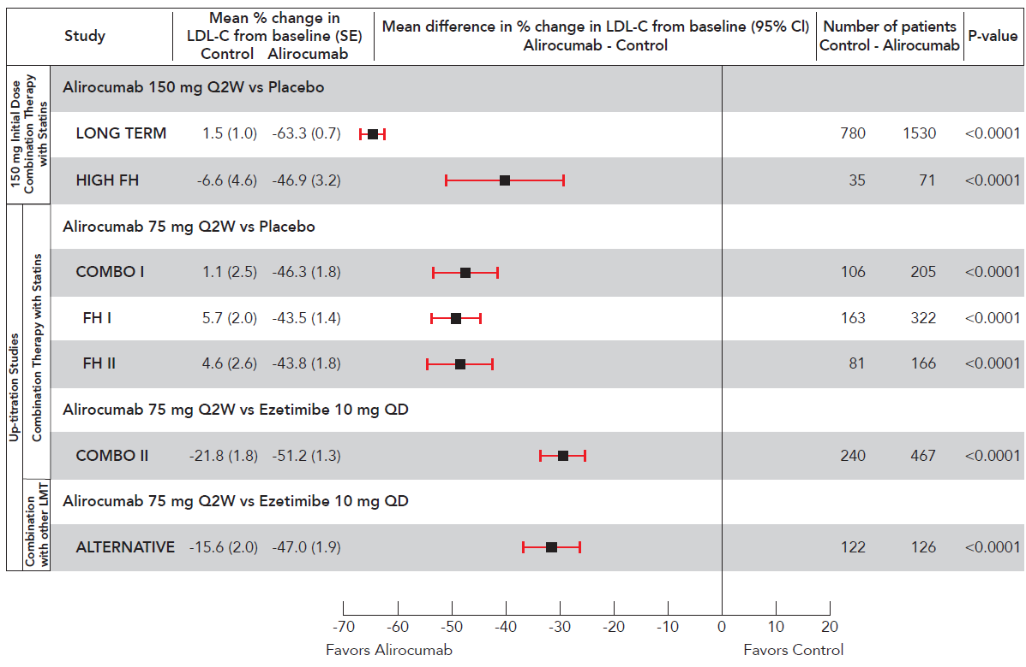

COMBINATION THERAPY WITH A STATIN

Placebo-controlled phase 3 studies

FH I and FH II studies
Two multicentre, placebo-controlled, double-blind 18-month studies included 732 patients (488 in the Praluent group and 244 patients in the placebo group, with a majority of patients treated for a minimum of 52 weeks) with heFH receiving a maximally tolerated dose of statin, with or without other lipid-modifying therapy. Patients received either Praluent 75 mg once every 2 weeks or placebo in addition to their existing lipid modifying therapy. Dose up-titration of Praluent to 150 mg once every 2 weeks occurred at week 12 in patients with LDL-C ≥ 1.81 mmol/L. At week 24, the mean treatment difference from placebo in LDL-C percent change from baseline was -55.8% (95% CI: -60.0%, -51.6%; p-value: ˂ 0.0001). At week 12 (before up-titration), 50.2% of patients reached an LDL-C of ˂1.81 mmol/L as compared to 0.6% in the placebo group. Among the subgroup of patients up-titrated at week 12, an additional 15.7% mean reduction in LDL-C was achieved at week 24. See Table 7 and Figure 2 for details.
Figure 2 ­ LDL-C over time: Mean percent change from baseline up to 52 weeks – pool of FH studies (FH I and FH II) (ITT analysis)
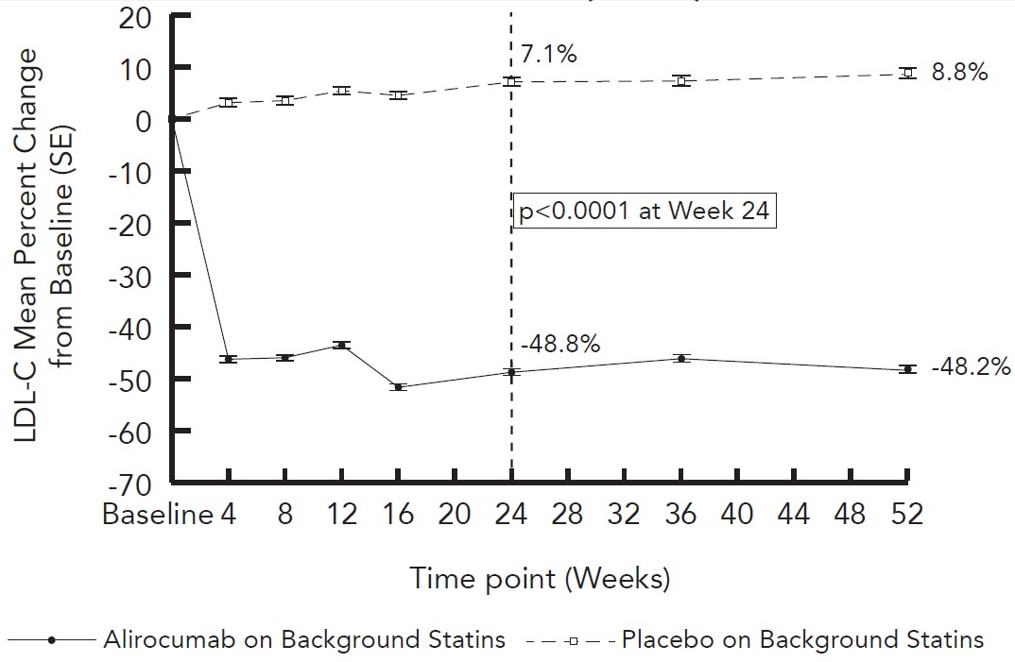

HIGH FH study
A third multicentre, double-blind, placebo-controlled 18-month study included 106 heFH patients (71 patients in the Praluent group and 35 patients in the placebo group with a majority of patients treated for a minimum of 52 weeks) on a maximally tolerated dose of statin, with or without other lipid-modifying therapies, and a baseline LDL-C ≥ 4.14 mmol/L. Patients received either Praluent at a dose of 150 mg once every 2 weeks or placebo in addition to their existing lipid-modifying therapy. Mean baseline LDL-C was 5.08 mmol/L in the Praluent group and 5.20 mmol/L in the placebo group. The mean percent change from baseline with Praluent in LDL-C (ITT analysis) was -46.9% at week 12 and -45.7% at week 24 compared to -6.6% at week 12 and -6.6% at week 24 for placebo. This corresponded to a mean absolute change from baseline at week 24 of -2.35 mmol/L. At week 24, the mean treatment difference from placebo in LDL-C percent change from baseline was -39.1% (95% CI: -51.1%, -27.1%; p-value: ˂0.0001). Mean changes for all other lipids/lipoproteins were similar to the FH I and FH II studies, however statistical significance was not reached for TG, HDL-C and Apo A-1. See Table 7 for details.

COMBO I study
A multicentre, double-blind, placebo-controlled, 52-week study included 311 patients (205 in the Praluent group and 106 in placebo group) categorised as very high CV risk and not at their pre-defined target LDL-C on a maximally tolerated dose of statin, with or without other lipid-modifying therapy. Patients received either 75 mg Praluent once every 2 weeks or placebo in addition to their existing lipid-modifying therapy. Dose up-titration of Praluent to 150 mg once every 2 weeks occurred at week 12 in patients with LDL-C ≥ 1.81 mmol/L. Mean baseline LDL-C was 2.60 mmol/L in the Praluent group and 2.71 mmol/L in the placebo group. The mean percent change from baseline with Praluent in LDL-C (ITT analysis) was -46.3% at week 12 and -48.2% at week 24 compared to 1.1% at week 12 and -2.3% at week 24 for placebo. This corresponded to a mean absolute change from baseline at week 24 of -1.30 mmol/L. At week 24, the mean treatment difference from placebo in LDL-C percent change from baseline was -45.9% (95% CI: -52.5%, -39.3%; p-value: ˂0.0001). At week 12 (before up-titration), 76.0% of patients in the Praluent group reached an LDL-C of ˂ 1.81 mmol/L as compared to 11.3% in the placebo group. The dose was up-titrated to 150 mg once every 2 weeks in 32 (16.8%) patients treated beyond 12 weeks. Among the subgroup of patients up-titrated at week 12, an additional 22.8% mean reduction in LDL-C was achieved at week 24. The difference versus placebo was statistically significant at week 24 for all lipids/ lipoproteins except TG and Apo A-1. See Table 7 for details.

Ezetimibe-controlled phase 3 study (on background statin)

COMBO II study
A multicentre, double-blind, ezetimibe-controlled 2-year study included 707 patients (467 patients in the Praluent group and 240 patients in the ezetimibe group, with a majority of patients treated for a minimum of 52 weeks) categorised as very high CV risk and not at their pre-defined target LDL-C on a maximally tolerated dose of statin. Patients received either Praluent 75 mg once every 2 weeks or ezetimibe 10 mg once daily in addition to their existing statin therapy. Dose up-titration of Praluent to 150 mg once every 2 weeks occurred at week 12 in patients with LDL-C ≥ 1.81 mmol/L. At week 24, the mean treatment difference from ezetimibe in LDL-C percent change from baseline was -29.8% (95% CI: -34.4%, -25.3%; p-value: ˂0.0001). At week 12 (before up-titration), 77.2% of patients reached an LDL-C of ˂ 1.81 mmol/L as compared to 46.2% in the ezetimibe group. Among the subgroup of patients up-titrated at week 12, an additional 10.5% mean reduction in LDL-C was achieved at week 24. See Table 7 for details.

STATIN INTOLERANT THERAPY (ADD-ON TO NON-STATIN LIPID MODIFYING THERAPY)

ALTERNATIVE study
A multicentre, double-blind, ezetimibe-controlled, 24-week study included 248 patients (126 patients in the Praluent group and 122 in the ezetimibe group) with documented statin intolerance due to skeletal muscle-related symptoms. Patients received either Praluent 75 mg once every 2 weeks or ezetimibe 10 mg once daily, or atorvastatin 20 mg once daily (as a re-challenge arm). Dose up-titration of Praluent to 150 mg once every 2 weeks occurred at week 12 in patients with LDL-C ≥ 1.81 mmol/L or ≥ 2.59 mmol/L, depending on their level of CV risk. At week 24, the mean treatment difference from ezetimibe in LDL-C percent change from baseline was -30.4% (95% CI: -36.6%, -24.2%; p-value: ˂0.0001). At week 12 (before up-titration), 34.9% of patients achieved an LDL-C of ˂ 1.81 mmol/L as compared to 0% in the ezetimibe group. Among the subgroup of patients up-titrated at week 12, an additional 3.6% mean reduction in LDL-C was achieved at week 24.
This trial evaluated patients who did not tolerate at least two statins (at least one at the lowest approved dose), and enrolled only patients willing to be re-challenged with a statin. The statin re-challenge arm was included to further validate the diagnosis of statin intolerance in a blinded manner. In these patients with a history of statin intolerance, musculoskeletal adverse events occurred at a lower rate in the Praluent group (32.5%) as compared to the atorvastatin group (46.0%) (HR= 0.61 [95% CI, 0.38 to 0.99]), and a lower percentage of patients in the Praluent group (15.9%) discontinued study treatment due to musculoskeletal adverse events as compared to the atorvastatin group (22.2%). These discontinuation rates due to musculoskeletal adverse events in the ALTERNATIVE study were higher than in other phase 3 studies. In the five placebo-controlled trials in patients on a maximally tolerated dose of statin (n=3752), the discontinuation rate due to musculoskeletal adverse events was 0.4% in the Praluent group and 0.5% in the placebo group. See Table 7 for details.

LONG-TERM EFFICACY IN PRIMARY HYPERCHOLESTEROLAEMIA

LONG TERM study
This multicentre, double-blind, placebo-controlled, 18-month study included 2,310 patients (1,530 patients in the Praluent group and 780 patients in the placebo group) with primary hypercholesterolaemia at high or very high CV risk and on a maximally tolerated dose of statin, with or without other lipid-modifying therapy. Patients received either Praluent at a dose of 150 mg once every 2 weeks or placebo in addition to their existing lipid-modifying therapy. The LONG TERM study included 17.7% heFH patients, 34.6% with type 2 diabetes mellitus, and 68.6% with a history of coronary heart disease. Mean treatment duration was 64.6 weeks, with a majority of patients treated for a minimum of 52 weeks, and 607 patients with 18-month data analysed. At week 24, the mean treatment difference from placebo in LDL-C percent change from baseline was -61.9% (95% CI: -64.3%, -59.4%; p-value: ˂0.0001). For detailed results see Table 7. At week 12, 82.1% of patients in the Praluent group reached an LDL-C ˂ 1.81 mmol/L compared to 7.2% of patients in the placebo group. Reduction in LDL-C was seen across age, gender, body mass index (BMI), race, and baseline LDL-C levels. Efficacy results were consistent in patients with heFH and non-heFH, patients with mixed dyslipidaemia, and diabetic patients. LDL-C reduction was consistent regardless of concomitantly used statins and doses.
Table 7 ­ Mean percent change in LDL-C from baseline in LDL-C and other lipids/lipoproteins in placebo-controlled and ezetimibe-controlled studies
Mean Percent Change from Baseline in Placebo-Controlled Studies on Background Statin
 | LONG TERM (N=2310) |  |  | FHI and FHII (N=732) |  |  | High FH (N=106) |  |  | COMBO I (N=311)
 | Placebo | Alirocumab |  | Placebo |  | Alirocumab | Placebo |  | Alirocumab | Placebo |  | Alirocumab
Number of patients | 780 | 1530 |  | 244 |  | 488 | 35 |  | 71 | 106 |  | 205
Mean Baseline LDL-C in mg/dL  (mmol/L) | 122.0  (3.16) | 122.8  (3.18) |  | 140.9  (3.65) |  | 141.3  (3.66) | 201.0  (5.21) |  | 196.3  (5.10) | 104.6  (2.71) |  | 100.3  (2.60)
Week 12
LDL-C (ITT)ª | 1.5 | -63.3 |  | 5.4 |  | -43.6 | -6.6 |  | -46.9 | 1.1 |  | -46.3
LDL-C (on treatment)^{b} | 1.4 | -64.2 |  | 5.3 |  | -44.0 | -6.6 |  | -46.9 | 1.7 |  | -47.6
Week 24
LDL-C (ITT)ª | 0.8 | -61.0^{c} |  | 7.1 |  | -48.8^{d} | -6.6 |  | -45.7e | -2.3 |  | -48.2^{f}
LDL-C (on treatment)^{b} | 0.7 | -62.8 |  | 6.8 |  | -49.3 | -6.6 |  | -45.5 | -0.8 |  | -50.7
Non-HDL-C | 0.7 | -51.6 |  | 7.4 |  | -42.8 | -6.2 |  | -41.9 | -1.6 |  | -39.1
Apo B | 1.2 | -52.8 |  | 1.9 |  | -41.7 | -8.7 |  | -39.0 | -0.9 |  | -36.7
Total-C | -0.3 | -37.8 |  | 5.5 |  | -31.2 | -4.8 |  | -33.2 | -2.9 |  | -27.9
Lp(a) | -3.7 | -29.3 |  | -8.5 |  | -26.9 | -8.7 |  | -23.5 | -5.9 |  | -20.5
TG | 1.8 | -15.6 |  | 4.3 |  | -9.8 | -1.9 |  | -10.5 | -5.4 |  | -6.0
HDL-C | -0.6 | 4.0 |  | 0.2 |  | 7.8 | 3.9 |  | 7.5 | -3.8 |  | 3.5
Apo A-1 | 1.2 | 4.0 |  | -0.4 |  | 4.2 | 2.0 |  | 5.6 | -2.5 |  | 3.3
Mean Percent Change from Baseline in Ezetimibe-Controlled Studies
 |  |  | On Background Statin |  |  |  |  | Without Background Statin
 |  |  | COMBO II (N=707) |  |  |  |  | ALTERNATIVE (N=248)
 |  |  | Ezetimibe |  | Alirocumab |  |  | Ezetimibe |  |  | Alirocumab
Number of patients |  |  | 240 |  | 467 |  |  | 122 |  |  | 126
Mean Baseline LDL-C in mg/dL  (mmol/L) |  |  | 104.5  (2.71) |  | 108.3  (2.81) |  |  | 194.2  (5.03) |  |  | 191.1  (5.0)
Week 12
LDL-C (ITT )ª |  |  | -21.8 |  | -51.2 |  |  | -15.6 |  |  | -47.0
LDL-C (on treatment)^{b} |  |  | -22.7 |  | -52.4 |  |  | -18.0 |  |  | -51.2
Week24
LDL-C (ITT)ª |  |  | -20.7 |  | -50.6^{g} |  |  | -14.6 |  |  | -45.0^{h}
LDL-C (on treatment)^{b} |  |  | -21.8 |  | -52.4 |  |  | -17.1 |  |  | -52.2
Non-HDL-C |  |  | -19.2 |  | -42.1 |  |  | -14.6 |  |  | -40.2
Apo B |  |  | -18.3 |  | -40.7 |  |  | -11.2 |  |  | -36.3
Total-C |  |  | -14.6 |  | -29.3 |  |  | -10.9 |  |  | -31.8
Lp(a) |  |  | -6.1 |  | -27.8 |  |  | -7.3 |  |  | -25.9
TG |  |  | -12.8 |  | -13.0 |  |  | -3.6 |  |  | -9.3
HDL-C |  |  | 0.5 |  | 8.6 |  |  | 6.8 |  |  | 7.7
Apo A-1 |  |  | -1.3 |  | 5.0 |  |  | 2.9 |  |  | 4.8
ª ITT analysis – intent-to-treat population, includes all lipid data throughout the duration of the study irrespective of adherence to the study treatment
^{b} On treatment analysis – analysis restricted to the time period that patients actually received treatment. The % LDL-C reduction at week 24 corresponds to a mean absolute change of:
^{c} -74.2 mg/dL (-1.92 mmol/L); ^{d} -71.1 mg/dL (-1.84 mmol/mL); ^{e} -90.8 mg/dL (-2.35 mmol/L); ^{f} -50.3 mg/dL (-1.30 mmol/L); ^{g} -55.4 mg/dL (1.44 mmol/L); ^{h} -84.2 mg/dL (-2.18 mmol/L).

OTHER STUDIES

OPTIONS I and OPTIONS II studies
Two additional multicentre, double-blind, active-controlled 24-week studies were performed in 643 patients (combined) with primary hypercholesterolaemia at high or very high CV risk not adequately controlled on a moderate dose of atorvastatin (20 mg or 40 mg, OPTIONS I) or rosuvastatin (10 mg or 20 mg, OPTIONS II). Dose up-titration of Praluent from 75 mg once every 2 weeks to 150 mg once every 2 weeks occurred at week 12 in patients with LDL-C ≥ 1.81 mmol/l or 2.59 mmol/L, depending on their level of CV risk. Mean baseline LDL-C levels ranged from 2.72 mmol/L (OPTIONS I) to 2.88 mmol/L (OPTIONS II). At week 24, the mean percent change in LDL-C from baseline with Praluent added to moderate doses of atorvastatin was -48.5% in OPTIONS I, and -42.7% when added to a moderate dose of rosuvastatin in OPTIONS II.

MONO Study
A multicentre, double-blind, ezetimibe-controlled, 24-week study included 103 patients with a moderate CV risk, not taking statins or other lipid-modifying therapies, and a baseline LDL-C between 100 mg/dL (2.59 mmol/L) to 190 mg/dL (4.91 mmol/L). Patients received either alirocumab 75 mg Q2W or ezetimibe 10 mg once daily. Dose up-titration of alirocumab to 150 mg Q2W occurred at week 12 in patients with LDL-C ≥70 mg/dL (≥1.81 mmol/L). At week 24, the mean treatment difference from ezetimibe in LDL-C percent change from baseline was -31.6% (95% CI: -40.2%, -23.0%; p-value: ˂0.0001). At week 12 (before up-titration), 57.7% of patients reached an LDL-C of ˂70 mg/dL (˂1.81 mmol/L) as compared to 0% in the ezetimibe group. The dose was up-titrated to 150 mg Q2W in 14 (30.4%) patients treated beyond 12 weeks. Among the subgroup of patients up-titrated at week 12, an additional 1.4 % mean reduction in LDL-C was achieved at week 24. The difference versus ezetimibe was statistically significant at week 24 for LDL-C, Total-C, Non-HDL-C and Apo B.

Every 4 Week (Q4W) Dosing Regimen

CHOICE I study
A multicentre, double-blind, placebo-controlled, 48-week study included 540 patients on a maximally tolerated dose of a statin, with or without other lipid-modifying therapy (308 in the Praluent 300 mg Q4W group, 76 in the Praluent 75 mg Q2W group, and 156 in the placebo group), and 252 patients not treated with a statin (144 in the Praluent 300 mg Q4W group, 37 in the Praluent 75 mg Q2W group, and 71 in the placebo group). Patients received either Praluent 300 mg Q4W, Praluent 75 mg Q2W, or placebo in addition to their existing lipid-modifying therapy (statin, non-statin therapy or diet alone). Overall, 71.6% of patients were categorized at high or very high CV risk and not at their LDL-C target. Dose adjustment in the Praluent arms to 150 mg Q2W occurred at week 12 in patients with LDL-C ≥70 mg/dL (≥1.81 mmol/L) or ≥100 mg/dL (≥2.59 mmol/L), depending on their level of CV risk, or in patients who did not have at least a 30% reduction of LDL-C from baseline.
In the cohort of patients on background statin, the mean baseline LDL-C was 112.7 mg/dL (2.91 mmol/L). At week 12, the mean percent change from baseline with Praluent 300 mg Q4W in LDL-C (ITT analysis) was -55.3% compared to +1.1% for placebo. At week 12 (before dose adjustment), 77.3% of patients treated with Praluent 300 mg Q4W reached an LDL-C of ˂70 mg/dL (<1.81 mmol/L) as compared to 9.3% in the placebo group. At week 24, the mean percent change from baseline with Praluent 300 mg Q4W/150 mg Q2W in LDL-C (ITT analysis) was -58.8% compared to -0.1% for placebo. At week 24, the mean treatment difference for Praluent 300 mg Q4W/150 mg Q2W from placebo in LDL-C percent change from baseline was -58.7% (97.5% CI: -65.0%, -52.4%; p-value: ˂ 0.0001). In patients treated beyond 12 weeks, the dose was adjusted to 150 mg Q2W in 56 (19.3%) of 290 patients in the Praluent 300 mg Q4W arm. Among the subgroup of patients dose adjusted to 150 mg Q2W at week 12, an additional 25.4% reduction in LDL-C was achieved at week 24.
In the cohort of patients not treated with a concomitant statin, the mean baseline LDL-C was 142.1 mg/dL (3.67 mmol/L). At week 12, the mean percent change from baseline with Praluent 300 mg Q4W in LDL-C (ITT analysis) was -58.4% compared to +0.3% for placebo. At week 12 (before dose adjustment), 65.2% of patients treated with Praluent 300 mg Q4W reached an LDL-C of ˂70 mg/dL (<1.81 mmol/L) as compared to 2.8% in the placebo group. At week 24, the mean percent change from baseline with Praluent 300 mg Q4W/150 mg Q2W in LDL-C (ITT analysis) was -52.7% compared to -0.3% for placebo. At week 24, the mean treatment difference for Praluent 300 mg Q4W/150 mg Q2W from placebo in LDL-C percent change from baseline was -52.4% (97.5% CI: -59.8%, -45.0%; p-value: ˂ 0.0001). In patients treated beyond 12 weeks, the dose was adjusted to 150 mg Q2W in 19 (14.7%) of 129 patients in the Praluent 300 mg Q4W arm. Among the subgroup of patients dose adjusted to 150 mg Q2W at week 12, an additional 7.3% mean reduction in LDL-C was achieved at week 24.
In both cohorts, the difference vs placebo was statistically significant at week 24 for all lipid parameters, except for Apo A-1 in the subgroup of patients on background statin.

CLINICAL EFFICACY AND SAFETY IN PREVENTION OF CARDIOVASCULAR EVENTS

ODYSSEY OUTCOMES study
A multicentre, double-blind, placebo-controlled trial in 18,924 adult patients (9462 alirocumab; 9462 placebo) followed for up to 5 years. Patients had experienced an acute coronary syndrome (ACS) event 4 to 52 weeks prior to randomisation and were treated with a lipid-modifying-therapy (LMT) regimen that was statin-intensive (defined as atorvastatin 40 or 80 mg, or rosuvastatin 20 or 40 mg) or at maximally tolerated dose of those statins, with or without other LMT. All patients were randomised 1:1 to receive either alirocumab 75 mg once every two weeks (Q2W) or placebo Q2W. At month 2, if additional LDL-C lowering was required based on pre-specified LDL-C criteria (LDL-C ≥50 mg/dL or 1.29 mmol/dL), alirocumab was adjusted to 150 mg Q2W. For patients who had their dose adjusted to 150 mg Q2W and who had two consecutive LDL-C values below 25 mg/dL (0.65 mmol/L), down-titration from 150 mg Q2W to 75 mg Q2W was performed. Patients on 75 mg Q2W who had two consecutive LDL-C values below 15 mg/dL
(0.39 mmol/L) were switched to placebo in a blinded fashion. Approximately 2615 (27.7%) of 9451 patients treated with alirocumab required dose adjustment to 150 mg Q2W. Of these 2615 patients, 805 (30.8%) were down-titrated to 75 mg Q2W. Overall, 730 (7.7%) of 9451 patients switched to placebo. A total of 99.5% of patients were followed for survival until the end of the trial. The median follow-up duration was 33 months.
The index ACS event was a myocardial infarction in 83.2% of patients (34.6% STEMI, 48.6% NSTEMI) and an episode of unstable angina in 16.8% of patients. Prior to the index ACS event, 19.2% had a myocardial infarction and 22.7% had coronary revascularization procedures (CABG/PCI). Most patients (88.8%) were receiving high intensity statin therapy with or without other LMT at randomisation. The mean LDL-C value at baseline was 92.4 mg/dL (2.39 mmo/L).
Alirocumab significantly reduced the risk for the primary composite endpoint of the time to first occurrence of Major Adverse Cardiovascular Events (MACE) consisting of coronary heart disease (CHD) death, non-fatal myocardial infarction (MI), fatal and non-fatal ischemic stroke, or unstable angina (UA) requiring hospitalization (HR 0.85, 95% CI: 0.78, 0.93; p-value=0.0003). Alirocumab also significantly reduced the following composite endpoints: risk of CHD event; major CHD event; cardiovascular event; and the composite of all-cause mortality, non-fatal MI, and non-fatal ischemic stroke. The results are presented in Table 8. In the subgroup of high risk patients with baseline LDL-C ≥100 mg/dL (2.59 mmol/L), primary and all secondary endpoints were improved with alirocumab treatment including CHD death (HR 0.72, 95% CI: 0.53, 0.98), CV death (HR 0.69, 95% CI:0.52, 0.92) and all-cause mortality (HR 0.71, 95% CI:0.56, 0.90).
Table 8 ­ Efficacy of Alirocumab in ODYSSEY OUTCOMES (Overall Population)
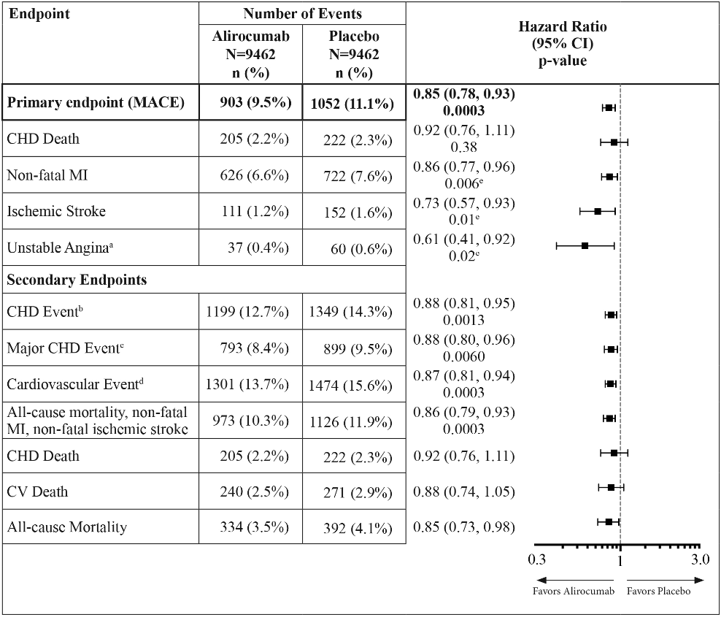
aUnstable angina requiring hospitalization

bCHD event defined as: major CHD eventc, unstable angina requiring hospitalization, ischemia-driven coronary revascularization procedure
cMajor CHD event defined as: CHD death, non-fatal MI
dCardiovascular event defined as follows: CV death, any non-fatal CHD event, and non-fatal ischemic stroke
eNominal significance

The Kaplan-Meier estimates of the cumulative incidence of the primary endpoint and all-cause mortality endpoint for the overall patient population over time are presented in Figure 3 and Figure 4.
Figure 3 ­ Primary Composite Endpoint Cumulative Incidence Over 4 Years in ODYSSEY OUTCOMES – Overall Population
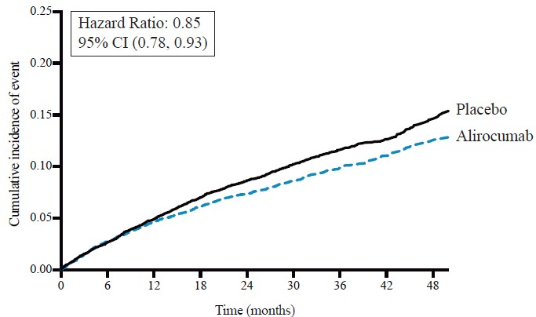

Figure 4 ­ Figure 2 All-cause Mortality Cumulative Incidence Over 4 Years in ODYSSEY OUTCOMES – Overall Population
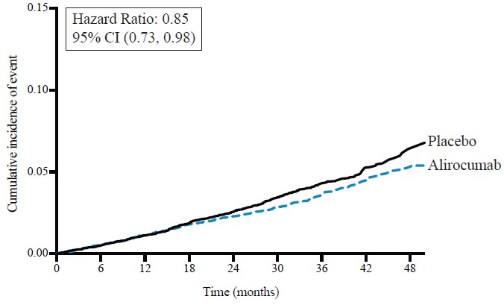

Pharmacokinetic properties

Absorption
After subcutaneous administration of 50 mg to 300 mg alirocumab, median times to maximum serum concentration (t_{max}) were 3-7 days. The pharmacokinetics of alirocumab after single subcutaneous administration of 75 mg into the abdomen, upper arm or thigh were similar. The absolute bioavailability of alirocumab after subcutaneous administration was 85% as determined by population pharmacokinetic analysis. A slightly greater than dose proportional increase was observed, with a 2.1- to 2.7-fold increase in total alirocumab concentrations for a 2-fold increase in dose. Steady state was reached after 2 to 3 doses with an accumulation ratio of up to a maximum of about 2-fold.

Distribution
Following intravenous administration, the volume of distribution was about 0.04 to 0.05 L/kg indicating that alirocumab is distributed primarily in the circulatory system.

Metabolism
Specific metabolism studies were not conducted, because alirocumab is a protein. Alirocumab is expected to degrade to small peptides and individual amino acids.

Excretion
Two elimination phases were observed for alirocumab. At low concentrations, the elimination is predominately through saturable binding to target (PCSK9), while at higher concentrations the elimination of alirocumab is largely through a non-saturable proteolytic pathway.
Based on a population pharmacokinetic analysis, the median apparent half-life of alirocumab at steady state was 17 to 20 days in patients receiving alirocumab as monotherapy at subcutaneous doses of either 75 mg once every 2 weeks or 150 mg once every 2 weeks. When co-administered with a statin, the median apparent half-life of alirocumab was 12 days.

Special Populations

Gender
Based on a population pharmacokinetic analysis, gender has no impact on alirocumab pharmacokinetics.

Elderly
In the phase 3 primary hypercholesterolemia controlled studies, 1158 patients (34.7%) treated with Praluent were ≥ 65 years of age and 241 patients (7.2%) were ≥ 75 years of age. In the cardiovascular outcomes controlled study, 2505 patients (26.5%) treated with Praluent were ≥65 years of age and 493 patients (5.2%) treated with Praluent were ≥75 years of age. Based on a population pharmacokinetic analysis, age was associated with a small difference in alirocumab exposure at steady state, with no impact on efficacy or safety.

Paediatric
The pharmacokinetic effects of alirocumab administration in paediatric patients have not been studied.

Race
Based on a population pharmacokinetic analysis, race had no impact on alirocumab pharmacokinetics. Following single-dose subcutaneous administration of 100 mg to 300 mg alirocumab, there was no meaningful difference in exposure between Japanese and Caucasian healthy subjects.

Body weight
Based on a population pharmacokinetic analysis, body weight had a small impact on alirocumab exposure, with no effect on efficacy or safety.

Hepatic Impairment
In a phase 1 study, after administration of a single 75 mg subcutaneous dose, alirocumab pharmacokinetic profiles in subjects with mild and moderate hepatic impairment were similar as compared to subjects with normal hepatic function. No data are available in patients with severe hepatic impairment.

Renal Impairment
Since monoclonal antibodies are not known to be eliminated via renal pathways, renal function is not expected to impact the pharmacokinetics of alirocumab. Population pharmacokinetic analyses showed that mild and moderate renal impairment did not have a meaningful impact on alirocumab pharmacokinetics. No data are available in patients with severe renal impairment (defined as eGFR < 30 mL/min/1.73m²).

Preclinical safety data

Genotoxicity
Genotoxicity studies have not been conducted with alirocumab. As alirocumab is a monoclonal antibody it would not be expected to have genotoxic potential.

Carcinogenicity
Carcinogenicity studies have not been conducted with alirocumab.

Pharmaceutical particulars

List of excipients
Each 1.0 mL single-use pre-filled pen or pre-filled syringe contains 75 mg or 150 mg alirocumab and the following excipients: histidine, sucrose, polysorbate 20 and water for injection.

Incompatibilities
In the absence of compatibility studies, this medicinal product must not be mixed with other medicinal products.

Shelf life
In Australia, information on the shelf life can be found on the public summary of the Australian Register of Therapeutic Goods (ARTG). The expiry date can be found on the packaging.

Special precautions for storage
Store at 2°C to 8°C (Refrigerate. Do not freeze). Do not expose to extreme heat. Time out of refrigeration should not exceed a maximum of 30 days at temperatures below 25°C. Keep in the outer carton in order to protect from light.

Nature and contents of container
Praluent 75 mg/mL and 150 mg/mL solution for injection is supplied in a siliconised 1 ml Type 1 clear glass syringe, equipped with a stainless steel needle, a styrene-butadiene rubber soft needle shield (does not contain natural latex), and a coated bromobutyl rubber plunger stopper.

Pre-filled pen
75 mg/mL pre-filled syringe components are assembled into a pen with a blue cap and a light green activation button. Available in pack sizes of 1, 2 or 6 per carton.
150 mg/mL pre-filled syringe components are assembled into a pen with a blue cap and a dark grey activation button. Available in pack sizes of 1, 2 or 6 per carton.

Pre-filled syringe*
75 mg/mL pre-filled syringe is equipped with a light green polypropylene plunger rod. Available in pack sizes of 1, 2 or 6 per carton.
150 mg/mL pre-filled syringe is equipped with a dark grey polypropylene plunger rod. Available in pack sizes of 1, 2 or 6 per carton.
* Presentations currently not marketed

Special precautions for disposal
In Australia, any unused medicine or waste material should be disposed of by taking to your local pharmacy.

Physicochemical properties
Alirocumab consists of two disulfide-linked human heavy chains, each covalently linked through a disulfide bond to a fully human kappa light chain. A single N-linked glycosylation site is located in each heavy chain within the CH2 domain of the Fc constant region of the molecule. The variable domains of the heavy and light chains combine to form the proprotein convertase subtilisin kexin type 9 (PCSK9) binding site within the antibody. Alirocumab has an approximate molecular weight of 146 kDa.
Figure 5 ­ Schematic representative of the structure of alirocumab
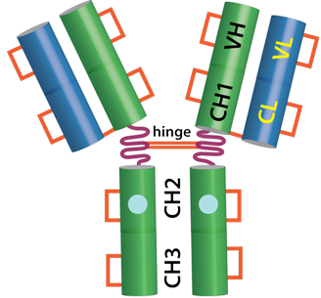
CH = constant region of the heavy chain; CL = constant region of the light chain; VH = variable region of the heavy chain; VL = variable region of the light chain.

CAS number
1245916-14-6

Medicine schedule (Poisons Standard)
Schedule 4 (Prescription Only Medicine)

Sponsor
Australia
sanofi-aventis australia pty ltd
12-24 Talavera Road
Macquarie Park NSW 2113
Australia
Toll Free Number (medical information): 1800 818 806
E-mail: medinfo.australia@sanofi.com
New Zealand
sanofi-aventis new zealand limited
Level 8, 56 Cawley Street
Ellerslie
Auckland
New Zealand
Toll Free Number (medical information): 0800 283 684
Email: medinfo.australia@sanofi.com

Date of first approval
17 May 2016

Date of revision
29 October 2019

Summary table of changes
Section Changed | Summary of new information
All | Revision to new format
4.1, 4.4, 4.8, 5.1, 6.2 | Additional indication and clinical safety and efficacy data based on Odyssey OUTCOMES study

