September 2018

Australian Public Assessment Report for Alirocumab
  - Proprietary Product Name: Praluent
  - Sponsor: Sanofi Aventis Australia Pty Ltd

About the Therapeutic Goods Administration (TGA)
- The Therapeutic Goods Administration (TGA) is part of the Australian Government Department of Health and is responsible for regulating medicines and medical devices.
- The TGA administers the Therapeutic Goods Act 1989 (the Act), applying a risk management approach designed to ensure therapeutic goods supplied in Australia meet acceptable standards of quality, safety and efficacy (performance) when necessary.
- The work of the TGA is based on applying scientific and clinical expertise to decision-making, to ensure that the benefits to consumers outweigh any risks associated with the use of medicines and medical devices.
- The TGA relies on the public, healthcare professionals and industry to report problems with medicines or medical devices. TGA investigates reports received by it to determine any necessary regulatory action.
- To report a problem with a medicine or medical device, please see the information on the TGA website <https://www.tga.gov.au>.
About AusPARs
- An Australian Public Assessment Report (AusPAR) provides information about the evaluation of a prescription medicine and the considerations that led the TGA to approve or not approve a prescription medicine submission.
- AusPARs are prepared and published by the TGA.
- An AusPAR is prepared for submissions that relate to new chemical entities, generic medicines, major variations and extensions of indications.
- An AusPAR is a static document; it provides information that relates to a submission at a particular point in time.
- A new AusPAR will be developed to reflect changes to indications and/or major variations to a prescription medicine subject to evaluation by the TGA.
Copyright
© Commonwealth of Australia 2018
This work is copyright. You may reproduce the whole or part of this work in unaltered form for your own personal use or, if you are part of an organisation, for internal use within your organisation, but only if you or your organisation do not use the reproduction for any commercial purpose and retain this copyright notice and all disclaimer notices as part of that reproduction. Apart from rights to use as permitted by the Copyright Act 1968 or allowed by this copyright notice, all other rights are reserved and you are not allowed to reproduce the whole or any part of this work in any way (electronic or otherwise) without first being given specific written permission from the Commonwealth to do so. Requests and inquiries concerning reproduction and rights are to be sent to the TGA Copyright Officer, Therapeutic Goods Administration, PO Box 100, Woden ACT 2606 or emailed to <tga.copyright@tga.gov.au>.

Contents
Common abbreviations 4
I. Introduction to product submission 7
Submission details 7
Product background 8
Regulatory status 9
Product Information 10
II. Registration time line 10
III. Quality findings 11
IV. Nonclinical findings 11
V. Clinical findings 11
Introduction 11
Pharmacokinetics 13
Pharmacodynamics 13
Dosage selection for the pivotal studies 14
Efficacy 14
Safety 19
First round benefit-risk assessment 25
First round recommendation regarding authorisation 27
Second round evaluation 27
Second round benefit-risk assessment 27
VI. Pharmacovigilance findings 29
Risk management plan 29
VII. Overall conclusion and risk/benefit assessment 30
Introduction 30
Quality 31
Nonclinical 31
Clinical 31
Risk management plan 59
Risk-benefit analysis 59
Outcome 81
Attachment 1. Product Information 82
Attachment 2. Extract from the Clinical Evaluation Report 82

Common abbreviations
Abbreviation | Meaning
ACM | Advisory Committee on Medicines
ADA | Anti-drug antibodies
AE | Adverse event
AESI | Adverse events of special interest
ALT | Alanine aminotransferase
Apo A1 | Apolipoprotein A1
Apo B | Apolipoprotein B
ASA | Australian Specific Annex
ASCVD | Atherosclerotic vascular disease
AUC_{0-x} | Area under the serum concentration versus time curve to time x
BMI | Body mass index
CABG | Coronary artery by-pass graft
CHD | Coronary heart disease
CHMP | Committee for Medicinal Products for Human Use (EU)
C_{max} | Maximum serum concentration observed
CSR | Clinical study report
CV | Cardiovascular
CVD | Cardiovascular disease
eGFR | Estimated glomerular filtration rate
GCP | Good Clinical Practice
HbA1c | Haemoglobin A1c
HDL-C | high density lipoprotein cholesterol
heFH or HeFH | Heterozygous familial hypercholesterolaemia
HMGCR | HMG-CoA reductase (3-hydroxy-3-methyl-glutaryl-coenzyme A reductase)
HR | Hazard ratio
IgG1 | Immunoglobulin G type G1
ISR | Injection site reactions
ISS | Integrated Summary of Safety
ITT | Intent to treat
IVRS | Interactive voice response system
LDL | Low density lipoprotein
LDL-C | Low density lipoprotein cholesterol
LDLR | Low density lipoprotein receptor
LMT | Lipid modifying therapy
Lp(a) | Lipoprotein
LSM | Least squares mean
MACE | Major adverse cardiac event
MI | Myocardial infarction
mITT | Modified intent to treat
MMRM | Mixed effect model with repeated measures
N | Newton
NAb | Neutralising antibody
non-FH | Non familial hypercholesterolaemia
non-HDL-C | Non high density lipoprotein cholesterol
PCI | Percutaneous Coronary Intervention
PCSK9 | Proprotein convertase subtilism kexin type 9
PD | Pharmacodynamics
PI | Product Information
PK | Pharmacokinetics
PopPK | Population pharmacokinetics
PSAB | Pharmacovigilance and Special Access Branch (of the TGA)
PSUR | Periodic safety update report
PT | Preferred term
Q2W | Every 2 weeks
Q4W | Every 4 weeks
RMP | Risk Management Plan
SAE | Serious adverse event
SC | Subcutaneous
SD | Standard deviation
SE | Standard error
SmPC | Summary of Product Characteristics (EMA)
TEAE | Treatment emergent adverse event
TGs | Triglycerides
TRAEs | Treatment related adverse events
ULN | Upper limit of normal

I. Introduction to product submission

Submission details
Type of submission: | Major variation: extension of indications and new dose regimen
Decision: | Approved
Date of decision: | 12 September 2017
Date of entry onto ARTG: | 26 September 2017
ARTG numbers: | 238299, 238204, 238305, and 238285
Active ingredient: | alirocumab
Product name: | Praluent
Sponsor’s name and address: | Sanofi-Aventis Australia Pty Ltd  Locked bag 2227  North Ryde BC NSW 1670
Dose form: | Solution for injection
Strengths: | 75 mg/mL and 150 mg/mL
Containers: | Pre filled syringe and pre filled pen
Pack sizes: | 1 (starter pack), 1, 2, 6
Approved therapeutic use: | Praluent is indicated as an adjunct to diet and exercise to reduce LDL-C in adults with one or more of: heterozygous familial hypercholesterolaemia, clinical atherosclerotic cardiovascular disease, or hypercholesterolemia with high or very high cardiovascular risk.  - In combination with a statin, or statin with other lipid lowering therapies in patients unable to reach LDL-C goals with maximum tolerated dose of a statin or,  - In combination with other lipid lowering therapies in patients who are statin intolerant or for whom a statin is contraindicated who are unable to reach LDL-C goals.
Route of administration: | subcutaneous
Dosage: | The recommended starting dose of Praluent is 75 mg once every 2 weeks or 300 mg once every 4 weeks (monthly), administered subcutaneously. The dose of Praluent can be individualised based on patient characteristics such as baseline LDLC level, goal of therapy and response. For further details please see the Product Information.

Product background
This AusPAR describes the application by Sanofi-Aventis Australia Pty Ltd (the sponsor) to register Praluent alirocumab 75 mg/mL and 150 mg/mL solution for injection for the following extension of indication (changes are highlighted in bold):
Praluent is indicated as an adjunct to diet and exercise in adults with primary hypercholesterolaemia (heterozygous familial and non-familial) or mixed dyslipidaemia
- in combination with a statin or statin with other lipid lowering therapies in patients unable to reach LDL-C goals with the maximum tolerated dose of a statin or,
- alone or in combination with other lipid lowering therapies in patients who are statin intolerant, or for whom a statin is contraindicated.
The effect of Praluent on cardiovascular morbidity and mortality has not yet been determined (see CLINICAL TRIALS).
The currently approved indication is:
Praluent is indicated as an adjunct to diet and exercise in adults with heterozygous familial hypercholesterolaemia or clinical atherosclerotic cardiovascular disease:
- in combination with a statin, or statin with other lipid lowering therapies or,
- in combination with other lipid lowering therapies in patients who are statin intolerant.
The effect of Praluent on cardiovascular morbidity and mortality has not yet been determined (see CLINICAL TRIALS).
Alirocumab is a recombinant human immunoglobulin G isotype G1(IgG1) isotype monoclonal antibody that specifically binds to pro-protein convertase subtilisin kexin type 9 (PCSK9) and inhibits circulating PCSK9 from binding to the low density lipoprotein receptor (LDLR) on the surface of the hepatocyte. By binding to PCSK9 it increases the concentration of LDLR on hepatic cells by inhibiting LDLR degradation and promoting recycling of the receptor. The inhibition also increases LDLR expression. It differs from statins in its mode of action although the action of statins leads to an increase in LDLR on the hepatocyte cell surface by increasing LDLR expression. The alirocumab PCSK9 complex is internalised in the hepatocyte and degraded in lysosomes, thereby removing PCSK9 from circulation.
Alirocumab is currently approved in patients with heterozygous familial hypercholesterolaemia (heFH) and patients with clinical atherosclerotic cardiovascular disease with statins, with statin and other lipid lowering therapies or without statins but with other lipid lowering therapies in statin intolerant patients.
This submission is to extend the indications of alirocumab to include patients with primary hypercholesterolaemia (heterozygous familial and non-familial) and mixed dyslipidaemia, and to include a mention of treatment to target for patients already taking statins. Mixed dyslipidaemia is defined as elevations of triglycerides and Low density lipoprotein cholesterol (LDL-C), often with a low level of high density lipoprotein cholesterol (HDL-C). These abnormalities can be inherited or acquired.
The submission is also to include an alternative starting dose for alirocumab of 300 mg subcutaneously given once monthly (300 mg Q4W (that is, once every 4 weeks)).
Current pharmacotherapy for hypercholesterolaemia includes HMG Co-A reductase (HMGCR) inhibitors (statins), ezetimibe, bile acid binding resins, lipoprotein apheresis and the PCSK9 inhibitors (alirocumab and evolocumab).

Regulatory status
The product received initial registration on the Australian Register of Therapeutic Goods (ARTG) on 17 May 2016.

European Union
Alirocumab was registered in the EU in September 2015 for the following indication:
Praluent is indicated in adults with primary hypercholesterolaemia (heterozygous familial and non-familial) or mixed dyslipidaemia, as an adjunct to diet:
- in combination with a statin or statin with other lipid lowering therapies in patients unable to reach LDL-C goals with the maximum tolerated dose of a statin or,
- alone or in combination with other lipid lowering therapies in patients who are statin intolerant, or for whom a statin is contraindicated.
The effect of Praluent on cardiovascular morbidity and mortality has not yet been determined.
The dosage recommendations were amended in November 2016 to include Q4W dosing and read as follows: The usual starting dose for Praluent is 75 mg administered subcutaneously once every 2 weeks. Patients requiring larger LDL-C reduction (> 60%) may be started on 150 mg once every 2 weeks, or 300 mg once every 4 weeks 9 months), administered subcutaneously.

USA
Alirocumab was registered in the US on 24 July 2015 with the following indication:
Praluent is a PCSK9 (Proprotein Convertase Subtilisin Kexin Type 9) inhibitor antibody indicated as adjunct to diet and maximally tolerated statin therapy for the treatment of adults with heterozygous familial hypercholesterolaemia or clinical atherosclerotic cardiovascular disease, who require additional lowering of LDL-cholesterol (LDL-C)
Limitations of Use
The effect of Praluent on cardiovascular morbidity and mortality has not been determined.
The dosage instructions were amended in April 2017 to include Q4W dosing and read as follows:
The recommended starting dose of Praluent is 75 mg once every 2 weeks administered subcutaneously, since the majority of patients achieve sufficient LDL-C reduction with the dosage. An alternative starting dosage for patients who prefer less frequent dosing is 300 mg once every 4 weeks (monthly).

Canada
Alirocumab is registered in Canada with the following indication:
Praluent (alirocumab) is indicated as adjunct to diet and maximally tolerated statin therapy for the treatment of adults with heterozygous familial hypercholesterolaemia (HeFH) or clinical atherosclerotic cardiovascular disease (CVD, who require additional lowering of LDL-cholesterol (LDL-C)
The effect of Praluent on cardiovascular morbidity and mortality has not been determined.
The recommended dosage recommendations include: The recommended starting dose of Praluent is 75 mg once every 2 weeks (Q2W) administered subcutaneously, since the majority of patients achieve sufficient LDL-C reduction with this dosage. Alternatively, 300 mg once every 4 weeks (monthly) may be administered subcutaneously for patients who prefer less frequent dosing.

Summary
In summary at the time the TGA considered this application; a similar application had been approved or was under consideration in the countries as outlined below:
- USA: Monthly dosing; submitted 24 March 2016 approved 24 April 2017, Q2W studies; not applicable.
- EU centralised procedure: Monthly dosing; submitted 4 May 2016 approved 14 November 2016, Q2W studies; submitted 19 May 2016 approved 21 July 2016.
- Canada: Monthly dosing; submitted 21 June 2016 approved 6 June 2017, Q2W studies submitted 30 June 2016.
- Switzerland: Monthly dosing 20 February 2017, review ongoing.

Product Information
The Product Information (PI) approved with the submission which is described in this AusPAR can be found as Attachment 1. For the most recent PI, please refer to the TGA website at <https://www.tga.gov.au/product-information-pi>.

II. Registration time line
Table 1 captures the key steps and dates for this application and which are detailed and discussed in this AusPAR and Attachment 2.

Table 1: Registration timeline for Submission PM-2016-01950-1-3
Description | Date
Submission dossier accepted and first round evaluation commenced | 31 August 2016
First round evaluation completed | 1 February 2017
Sponsor provides responses on questions raised in first round evaluation | 31 March 2017
Second round evaluation completed | 5 May 2017
Delegate’s Overall benefit-risk assessment and request for Advisory Committee advice | 3 July 2017
Sponsor’s pre-Advisory Committee response | 18 July 2017
Advisory Committee meeting | 4 August 2017
Registration decision (Outcome) | 12 September 2017
Completion of administrative activities and registration on ARTG | 26 September 2017
Number of working days from submission dossier acceptance to registration decision* | 218
*Statutory timeframe for applications is 255 working days

III. Quality findings
There was no requirement for a quality evaluation in a submission of this type.

IV. Nonclinical findings
There was no requirement for a nonclinical evaluation in a submission of this type.

V. Clinical findings
A summary of the clinical findings is presented in this section. Further details of these clinical findings can be found in Attachment 2.

Introduction

Clinical rationale
Alirocumab is currently approved at a starting dose of 75 mg administered subcutaneously (SC) once every 2 weeks (Q2W). The dose can be individualised based on the patients response at 4 weeks after initiation of therapy and if necessary increased to 150 mg Q2W. The aim is to treat with the lowest dose necessary to achieve the desired LDL-C reduction.
The once every 4 weeks (Q4W) dose regimen was developed as an additional dosing option for alirocumab. The submission presents pharmacokinetics (PK), efficacy and safety data in support of the 300 mg Q4W dosing regimen (including as a starting dose) for patients who may find monthly dosing more convenient.

Guidance
The EU guidelines adopted by the TGA relevant to this submission, in addition to the general guidelines are:
- EMA/CHMP/748108/2013 Guideline on clinical investigation of medicinal products in the treatment of lipid disorders
- EMA/CHMP/494506/2012 (EMEA/CHMP/EWP/213057/2010) Paediatric addendum to CHMP guideline on clinical investigation of medicinal products in the treatment of lipid disorders
- EMEA/CHMP/EWP/311890/2007 Guideline on the Evaluation of Medicinal Products for Cardiovascular Disease Prevention
- pp. 127 - 132 of Rules 1998 (3C) - 3CC6a Clinical Investigation of Medicinal Products for Long-Term Use
- CHMP/EWP/89249/2004 Guideline on the Clinical Investigation of the Pharmacokinetics of Therapeutic Proteins.

Contents of the clinical dossier
The dossier documented a development program of pharmacology studies related to the revised dose regimen, one pivotal efficacy study on the new dose regimen and the final study reports for the five studies which were submitted in the initial submission with only interim (first step) analyses relating to the proposed extension of indication.
- Two Population PK (popPK) analyses of the studies using Q4W dosing
- One Pivotal efficacy/safety study of Q4W dosing Study R727-CL-1308
- One new efficacy study; Study EFC13786 starting dose 150 mg Q4W compared with 75 mg Q2W
- Five Other efficacy/safety studies; final reports for studies previously evaluated as interim reports: Studies EFC 11569, EFC 12792, EFC 12732, LTS 11717, and R77-CL-1112; Q2W
- Integrated Summary of Efficacy / Integrated Summary of Safety; tables only
- Literature references
- Two Clinical Overviews; 1 for Q2W studies and 1 for Q4W dosing; Summary of Clinical Pharmacology; Two Summaries of Clinical Efficacy; 1 for Q2W studies and 1 for Q4W dosing; Two Summaries of Clinical Safety; 1 for Q2W studies and 1 for Q4W dosing.

Paediatric data
The submission did not include paediatric data. The paediatric status is unchanged from initial submission.

Good clinical practice
The study reports state that the studies were conducted in compliance with the ethical principles that have their origin in the Declaration of Helsinki and that are consistent with International Conference on Harmonisation (ICH) Good Clinical Practice (GCP) and the laws and regulations, as well as applicable guidelines, of the countries where the studies were conducted. It is stated that all subjects provided informed consent prior to any study related procedures and that the protocol and amendments were submitted to appropriate ethics committees.

Pharmacokinetics

Studies providing pharmacokinetic data
No new pharmacokinetic (PK) data was presented for the Q2W dosing regimen. PK data from two efficacy and safety studies and one population pharmacokinetics (PopPK) study were presented for the Q4W dosing regimen.

Table 2: Submitted pharmacokinetic studies
PK topic | Subtopic | Study ID | Primary Aim
PK in special populations | Target populations§ | R727-CL-1308  EFC13786 | efficacy and safety  efficacy and safety
Population PK analyses | Target population§ | BAY0041 | PopPK
§ Subjects who would be eligible to receive the drug if approved for the proposed indication.

Evaluator’s conclusions on pharmacokinetics
The PK of alirocumab is best described as non-linear, with target mediated clearance, though the deviation from linearity is modest. Body weight, age, free PCSK9 concentrations and statin use were identified as significant covariates affecting alirocumab exposure.
The PK of alirocumab in patients from the new studies submitted in this application were consistent with the PK properties determined in the initial dossier.
At 75 mg and 150 mg using a Q2W dosing regimen, and at 150 mg and 300 mg using a Q4W dosing regimen, steady state concentrations of alirocumab were achieved within 2 or 3 SC administrations when administered alone or in combination with statin.
Monthly exposures observed at 300 mg Q4W are very close to those estimated at 150 mg Q2W, which is consistent with the linear kinetics observed when the target is saturated. As previously characterised, when administered in combination with statins, a more pronounced target mediated clearance of alirocumab was observed, leading to about a 30% decrease in alirocumab steady state exposure for both Q2W and Q4W dosing regimens.

Pharmacodynamics

Studies providing pharmacodynamic data
No new pharmacodynamic (PD) studies were submitted for the Q2W dosing regimen. One PopPK study using the data from the efficacy and safety studies (Studies R727-CL-1308 and EFC13786).

Table 3: Submitted pharmacodynamic studies
PD Topic | Subtopic | Study ID | Primary aim
Population PD and PK-PD analyses | Target population§ | BAY0042 | PopPK
§ Subjects who would be eligible to receive the drug if approved for the proposed indication.
None of the pharmacodynamic studies had deficiencies that excluded their results from consideration.

Evaluator’s conclusions on pharmacodynamics
The PD effect of alirocumab on LDL-C is an indirect relationship, mediated through the direct inhibition PCSK9 on the low density lipoprotein (LDL) receptor. The PK/PD relationship supports the use of the Q4W dosing.

Dosage selection for the pivotal studies

Phase III pivotal studies investigating more than one dose regimen
The dose response relationship for LDL-C reduction was the basis for the selection of the Q4W doses evaluated in the CHOICE Studies R727-CL-1308 and EFC13786. The PD effect of alirocumab on LDL-C is an indirect relationship, mediated through the direct inhibition PCSK9 on the LDL receptor. Results obtained in Study R727-CL-1308 confirmed that the 300 mg Q4W dosing regimen was effective in reducing LDL-C over the dosing interval, in both populations, with and without background statins. In patients not receiving statins, including patients with statin intolerance, 300 mg Q4W provides, as a starting dose, more consistent efficacy than the 150 mg Q4W dose.
The Q4W dosing is proposed as a starting dose option for alirocumab for patients who may find the Q4W (monthly) dosing more convenient than Q2W.

Evaluator’s conclusions on dose finding for the pivotal studies
The sponsor states that the Q4W dosage regimen is proposed as ‘an additional dosing option’ for alirocumab. This is to complement the approved starting dose regimens approved in the EU; 75 mg or 150 mg Q2W. In Australia only the 75 mg Q2W was approved as a starting dose. Patients can have the dose increased to 150 mg Q2W if an adequate response at 75 mg is not achieved.

Efficacy

Studies providing efficacy data
The following clinical efficacy studies were submitted.
Indication 1: Dosing every four weeks (Q4W).
Pivotal studies:
- Study R727-CL-1308 (CHOICE I): A randomised, double blind, placebo controlled study to evaluate the efficacy and safety of an every four weeks treatment regimen of alirocumab in patients with primary hypercholesterolaemia.
Other studies:
- Study EFC13786 (CHOICE II): A randomised, double blind, placebo controlled, parallel group study evaluating the efficacy and safety of alirocumab in patients with primary hypercholesterolaemia not treated with a statin.
Indication 2: Dosing every two weeks (Q2W).
Pivotal studies
- Study 11569: (Combo II): A randomised, double blind, parallel group study to evaluate the efficacy and safety of SAR236553/REGN727 versus ezetimibe in high cardiovascular risk patients with hypercholesterolemia not adequately controlled with their statin therapy.
- Study EFC12492 (FH1): A randomised, double blind, placebo controlled, parallel group study to evaluate the efficacy and safety of SAR236553/REGN727 (alirocumab) in patients with heterozygous familial hypercholesterolaemia not adequately controlled with their lipid modifying therapy.
- Study R727-CL-1112 (FH II): A randomised, double blind, placebo controlled, parallel group study to evaluate the efficacy and safety of alirocumab in patients with heterozygous familial hypercholesterolaemia not adequately controlled with their lipid modifying therapy.
- Study EFC12732 (HIGH FH): A randomised, double blind, placebo controlled, parallel group study to evaluate the efficacy and safety of alirocumab in patients with heterozygous familial hypercholesterolaemia not adequately controlled with their lipid modifying therapy.
- Study LTS11717 (Long Term): Long-term safety and tolerability of REGN727/SAR236553 in high cardiovascular risk patients with hypercholesterolemia not adequately controlled with their lipid modifying therapy: a randomised, double blind, placebo controlled study.
For the full clinical evaluation please see Attachment 2.

Evaluator’s conclusions on efficacy

Indication 1; four weekly dosing (Q4W)

Study R727-CL-1308
Two populations of patients were enrolled in this study, one not receiving concomitant statin therapy (1/3 patients) and one receiving concomitant statin therapy (2/3 patients). Patients within each population were randomised to 1 of 3 groups: alirocumab 300 mg Q4W with the option of dose adjustment to 150 mg Q2W (referred to as 300 Q4W/Up 150 Q2W), or alirocumab 75 mg Q2W with the option of up titration to 150 mg Q2W (referred to as 75 Q2W/Up 150 Q2W), and placebo. Up titration was formally done at Week 12 for patients who did not achieve their pre-specified LDL-C goals at Week 8. The large majority of patients were at high/very high cardiovascular (CV) risk (85.9%who were also on statins and 74.1% not on statins).
With the 300 Q4W/150 Q2W the LS mean percent reduction in calculated LDL-C from baseline was -58% but 15 to 19% of patients had to have their dose regimen changed to a Q2W regimen to achieve stable response.
Given that the sponsor cannot identify the subset of patients who can benefit from a starting dose of 300 mg Q4W or even 150 mg Q4W there does not appear to be sufficient justification for altering the starting dose of 75 mg Q2W and then assessing the response at Week 8 and deciding on up titrating to 150 mg Q2W depending on the individual patients preference, risk factors, target LDL-C level and response. It seems likely that several dose changes may be necessary to achieve optimal treatment at the lowest dose in individual patients.
It is disappointing that the sponsor did not conduct any studies that maintained patients on Q4W therapy having started on a Q2W regimen. All the studies using a Q4W regimen started on Q4W and then moved to a Q2W regimen. It is therefore not possible to know if patients who respond at Q2W can be successfully moved to a Q4W regimen.
Study EFC13786 started patients on a 150 mg Q4W regimen but while this appeared equivalent almost half the patients had to have their dose up titrated and the sponsor found the results not consistent and did not pursue this as a requested indication. Again there was no consideration of starting at 75 mg or 150 mg Q2W and then moving to 150 mg or 300 mg Q4W.

Indication 2; two weekly dosing (Q2W)
The final reports of the five studies which were submitted in the initial application as interim reports demonstrate persistent efficacy to 78 or 104 weeks.

Pivotal or main efficacy studies
The sponsor has provided the final reports for the 5 studies which were submitted as interim reports in the initial application: Studies EFC 11569 (Combo I), EFC 12492 (FHI), R727-CL-1112 (FHII), EFC 12732 (HIGH FH), and LTS11717 (LONG TERM).
All these Phase III studies were double blind, parallel group, randomised, controlled studies with a double blind treatment period of 78 weeks (approximately 18 months) for 4 studies (FHI, FHII, HIGH FH and LONG TERM) and of 104 weeks for Combo II. The four 78 week studies (FH I, FH II, HIGH FH, and LONG TERM) were conducted in patients receiving a background therapy of statin at the maximally tolerated dose and possibly other concomitant lipid modifying therapy (LMT) and used placebo as comparator for alirocumab. Among these studies, FH I, FH II, and HIGH FH enrolled heFH patients; in HIGH FH, patients had to have a LDL-C ≥ 160 mg/dL (4.14 mmol/L) at the screening visit. The LONG TERM Study enrolled both heFH patients and non-FH patients at high risk of atherosclerotic cardiovascular disease (CVD). The 104 week study (COMBO II) was conducted in non-FH patients at high risk of atherosclerotic CVD, receiving a background therapy of statin at the maximally tolerated dose without any other LMT, since the active comparator was ezetimibe.
The primary objective of 4 of these 5 Phase III studies was to demonstrate the reduction of LDL-C at 24 weeks by alirocumab as add-on therapy to stable maximally tolerated daily statin therapy (FH I, FH II, HIGH FH, COMBO II). It was also the primary efficacy objective of the fifth study, LONG TERM, as the overall primary objective was the evaluation of long term safety and tolerability.
The individual study summaries of the final efficacy results were provided.
See below for pooled analyses.

Analyses performed across trials: pooled and meta-analyses
The sponsor provided efficacy results observed at Week 78 across the four Phase III studies that have been completed since the initial dossier and can be pooled.

Results at Week 78 (Studies EFC12482 (FH I), R727-CL-1112 (FH II), EFC12732 (HIGH FH), LTS11717 (LONG TERM))
These four studies were placebo controlled studies, conducted either in heFH patients or in both heFH and non-FH patients at high cardiovascular (CV) risk. In Studies FH I and FH II the initial dose was 75 mg alirocumab Q2W with possible up titration to 150 mg Q2W. In Studies LONG TERM and HIGH FH the initial starting dose was 150 mg Q2W.
Figure 1: Percent change from Baseline in calculated LDL-C at Week 78: MMRM (ITT analysis); Phase III studies
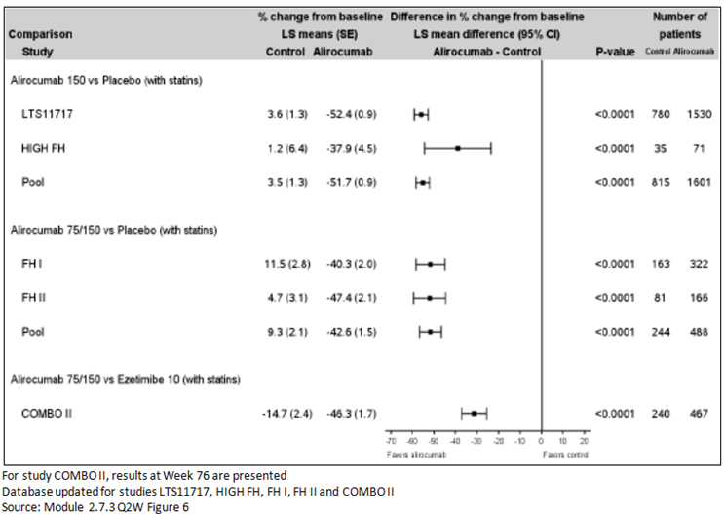
Figure 2: Calculated LDL-C over time: LS mean ± standard error (SE) percent change from Baseline (ITT analysis); Pool of FH studies
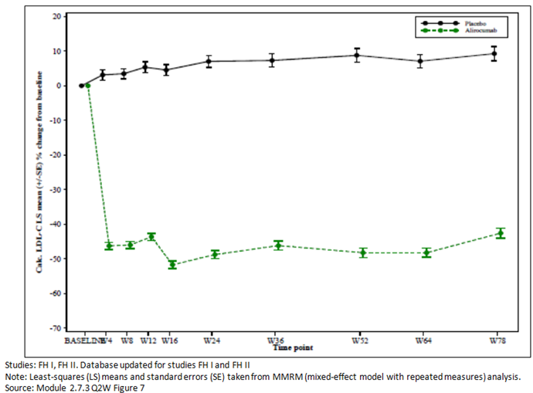
Figure 3: Proportion of patients reaching calculated LDL-C < 70 mg/dL (1.81 mmol/L) at Week 78 (ITT analysis); Phase III studies
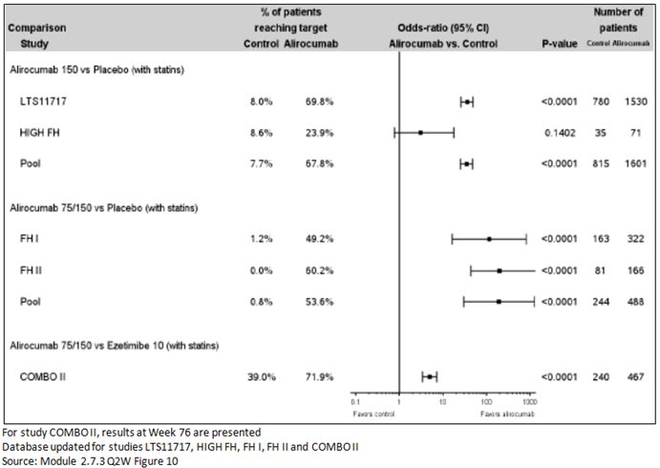

Evaluator’s conclusions on clinical efficacy; Q2W
The sponsor has provided the final study reports for the 5 studies which were submitted in the initial application as ‘first step analysis’ reports. The final reports include patients treated for 78 weeks in four studies and 104 weeks in one study.
The results are consistent with the interim reports and demonstrate a sustained effect for 78 to 104 weeks.
The new data does not support an extension of the indications to remove the requirement for clinical cardiovascular disease as the reservations about approving this in the initial application still exist. No argument to justify this is included in the submission. The concern previously appears to be widening the indication in the absence of cardiovascular outcome data which is still awaiting completion of the specific ongoing study addressing this issue.

Safety

Studies providing safety data
The following studies provided evaluable safety data:
- Study R727-CL-1308: data on starting and maintenance dose regimen of 300 mg Q4W/Q2W treatment for 48 weeks
- Study EFC13786: data on starting and maintenance dose regimen of 150 Q4W/150 Q2W treatment for 24 weeks
- Five Studies (EFC11569, EFC12492, EFC12732, LTS11717 and R727-CL-1112), which had been previously evaluated as interim reports, provided data on longer term safety to 78 weeks and 104 weeks.
Study LTS11717; long term safety and tolerability of REGN727/SAR236553 in high cardiovascular risk patients with hypercholesterolemia not adequately controlled with their lipid modifying therapy: a randomised, double blind, placebo controlled study, assessed safety as the sole primary outcome.

Patient exposure
The sponsor provided two summaries of clinical safety and so exposure is presented for Q4W and Q2W separately.

Indication 1: four weekly dosing (Q4W)

Table 4: Exposure to alirocumab in Study R727-CL-1308; all randomised subjects
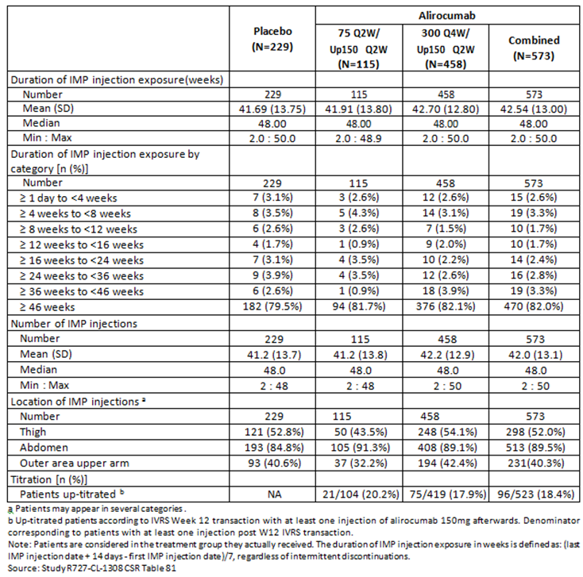

Table 5: Study R727-CL-1308: details of dosing titration
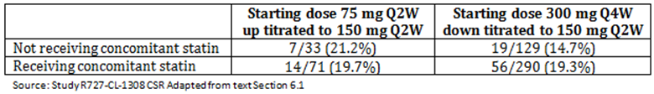

Table 6: Exposure to alirocumab in Study EFC13786; double blind period; Safety population
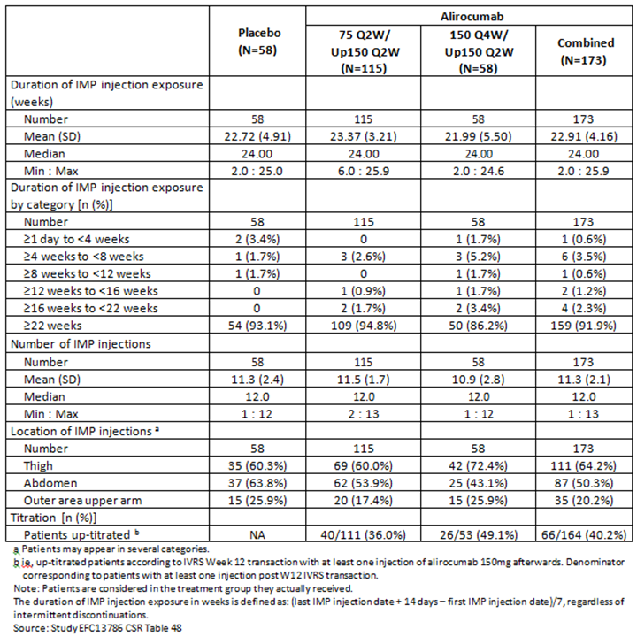

Indication 2: two weekly dosing (Q2W)

Table 7: Studies included in the Summary of Clinical Safety; Q2W
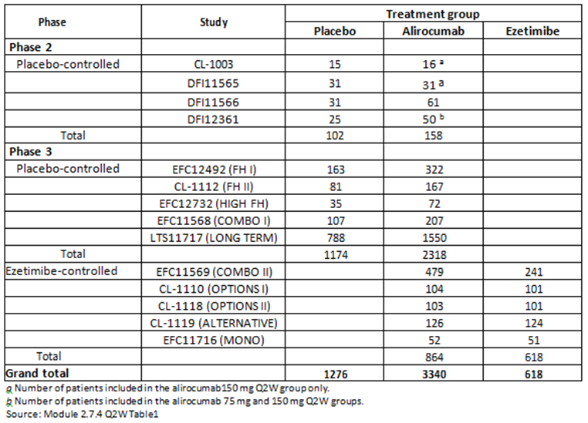
The safety data has been organised into two data pools; the placebo controlled pool and the ezetimibe controlled pool.

Table 8: Exposure to alirocumab; Injection (Safety population); pool of placebo controlled studies and pool of ezetimibe controlled studies
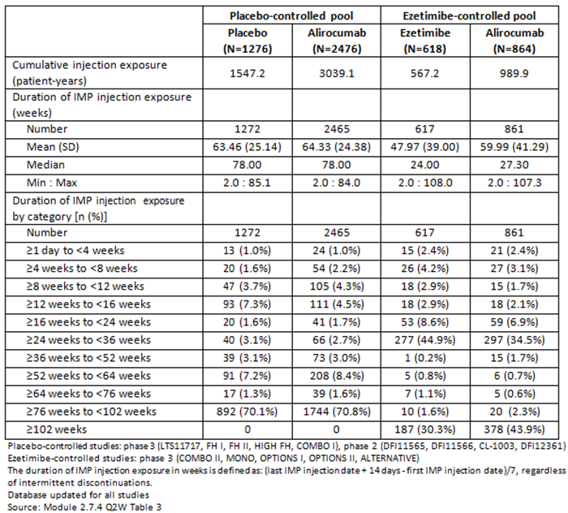

Safety issues with the potential for major regulatory impact

Liver function and liver toxicity

Two weekly dosing (Q2W)
No relevant changes in liver function tests have been identified due to the long term exposure to alirocumab, as compared to the initial submission.

Renal function and renal toxicity
Two weekly dosing (Q2W) No changes in renal function have been identified in relation to the long term exposure to alirocumab, as compared to the initial submission.

Other clinical chemistry
Two weekly dosing (Q2W) No changes in metabolic parameters (albumin, creatine kinase, total protein), electrolytes or cortisol and adrenal function have been identified in relation to the long term exposure to alirocumab, as compared to the initial submission.

Electrocardiograph findings and cardiovascular safety
Two weekly dosing (Q2W) No effects of alirocumab on ECG parameters were identified during the clinical development.

Vital signs and clinical examination findings
Two weekly dosing (Q2W) No clinically meaningful changes in systolic blood pressure, diastolic blood pressure, heart rate, weight or physical examination were observed in any of the treatment groups.

Immunogenicity

Four weekly dosing (Q4W)
Alirocumab 150 mg Q4W or 300 mg Q4W was associated with a low level of immunogenicity. Treatment emergent anti-drug antibody (ADA) positive results were observed in 4.7% of patients in the 300 Q4W/150 Q2W group and in 2.6% of patients in the placebo group in Study R727-CL-1308. In Study EFC13786, 5.4% exhibited treatment emergent ADA positive responses in the 150 Q4W/150 Q2W group versus none in the placebo group. In both studies, most of the anti-drug antibody positive samples exhibited low titres (≤ 240).
Overall, the incidence of neutralising antibody (NAb) was low, with only 2 patients positive in the 300 mg Q4W/150 mg Q2W group. The data in these patients do not suggest a correlation between NAb and alirocumab exposure, LDL-C lowering efficacy.

Two weekly dosing (Q2W)
The data on the development of ADA in the integrated analysis confirmed the results provided in the initial application. Treatment emergent ADAs were reported in 5.1% of patients in the alirocumab group. This corresponds to only eight new treatment emergent ADA positive results over the additional period of the five completed studies. Compared with patients who were ADA negative, patients with an ADA positive status did not exhibit any difference in alirocumab efficacy. NAb were observed in few (38 patients; 1.3%) patients as compared to 36 patients in the initial dossier. Only 11 patients (0.4%) had 2 or more NAb positive samples. The data in these patients do not suggest a correlation between the presence of NAb and LDL-C lowering efficacy.

Post marketing data
No post marketing data is presented for Q4W as it is not approved in any market.
No post marketing experience data is presented in the summary of clinical safety; 2QW.
One periodic safety update report (PSUR) was included in the submission. It covered the period from 23 September 2015 to 24 July 2016. The International Birth Date was 24 July 2015. Cumulative, from 1 July 2015 to 31 March 2016, mean patients exposure to marketed alirocumab was estimated to be 9,842 patients per month (corresponding to 177,170 alirocumab single units (syringe/pre-filled pen) whatever the strength.
- The sponsor has made no changes to the adverse event (AE) profile based on the spontaneous reports and no actions were taken for safety reasons during the period covered by this PSUR. Based on the new data received during the period covered by this PSUR, the sponsor considers that no new safety signals were noted and that no change to the risk minimisation strategy is deemed necessary. The PSUR notes that in addition to the routine pharmacovigilance activities currently in place, the sponsor is planning to undertake four post-authorisation safety studies:
To evaluate safety of long term use or alirocumab (exceeding 5 years)
To further characterise the potential risk of neurocognitive disorders
To evaluate the effectiveness of dosing recommendation for the two currently approved dosages (75 mg Q2W and 150mg Q2W) in avoiding very low LDL-C, and
To gather relevant safety data in patients incted with human immunodeficiency virus

Evaluator’s conclusions on safety
The safety database or patients treated with the Q2W dose regimen is substantial; 5,234 patients with hypercholesterolemia (3,340 alirocumab, 1,276 placebo and 618 ezetimibe) with a treatment duration of up to 18 months. Patient exposure was 2,142 in alirocumab treated for at least 76 weeks and 378 for at least 102 weeks.
No new safety issues were identified that had not been previously seen in the initial application. The most frequently reported AEs are injection site reactions, pruritus and upper respiratory tract infections. The additional safety data did not identify any relationship for neurologic events, neurocognitive events or diabetes. The safety concerns identified for statin therapy (musculoskeletal, liver function, diabetes, neurocognitive AEs) were not observed with alirocumab treatment.
Treatment with 300 mg Q4W did not appear to be associated with an increased risk of increased AEs and no new safety issues were identified.
From the final results of the Q2W studies it was found that treatment emergent ADA were observed in 5.1% of patients in the alirocumab group, corresponding to only eight new treatment emergent ADA assay responses over the additional follow-up period of the five completed studies. Compared with patients who were ADA negative, patients with an ADA positive status did not exhibit any difference in alirocumab efficacy. Neutralising antibodies (Nab) were observed in few (38 patients; 1.3%) patients as compared to 36 patients in the initial dossier. Only 11 patients (0.4%) had 2 or more NAb positive samples. The data in these patients do not suggest a correlation between the presence of NAb and LDL-C lowering efficacy.
The issue of cardiovascular outcomes was not addressed in this submission as the study (Study EFC11570) to address this issue is still ongoing.

First round benefit-risk assessment

First round assessment of benefits

Table 9: First round assessment of benefits
Benefits | Strengths and Uncertainties
300 mg Q4W as starting dose with optional up titration to 150 mg Q2W provided clinically meaningful reduction in LDL-C versus placebo similar to that seen with 75 mg Q2W/Up 150 mg Q3W. | Result at 12 weeks for percent change from baseline (mmol/L): -55.3% (statin) and -58.4% (no statin)  Strength is persistent effect to Week 24: -58.7% (statin) and -52.5% (no statin) and Week 48 -51.9% (statin) and -45.7%(no statin)  Strength is consistent results were found for other lipid parameters; that is, reduced concentrations of Apo B, non HDL-C, total-C, Lp(a) and fasting triglycerides (TGs), and increased concentrations of HDL-C, at Weeks 12 and 24, up to Week 48 in both groups. Reduction in Apo A1 was seen in the no statin group but not in the statin group.  Uncertainty is only one study.  Uncertainty is that only 80.7% (statin) and 85.3% (no statin) of patients could be maintained on Q4W. Other patients had to be dose adjusted to 150 mg Q2W.

First round assessment of risks

Table 10: First round assessment of risks
Risks | Strengths and Uncertainties
AE for Q4W are similar as for Q2W identified in initial application.  Common AEs were injection site reaction, pruritus and upper respiratory tract signs and symptoms.  Injection site reactions were only AE reported more frequently in patients positive for treatment emergent ADA.  Rare and sometimes serious allergic reactions (nummular eczema, urticaria, hypersensitivity vasculitis) were reported. | Strength is large safety database for Q2W – 3340 patients treated with alirocumab at the 75 mg or 150 mg Q2W doses.  Strength is no safety signal in patients who had at least 2 consecutive values of LDL-C < 25 or 15 mg/dL (0.65 or 0.39 mmol/L), particularly with regard to neurological or other adverse effects that could potentially be related to low LDL-C.  Strength is the updated integrated safety database suggests alirocumab is not associated with hepatic effects or muscle related AEs, which are commonly seen with statins.  Strength is low rate of ADA reported in the additional follow up period; total of 5.1%. There does not appear to be a correlation between the presence of Nab and LDL-C lowering efficacy or safety.  Uncertainty is the effect of alirocumab on cardiovascular outcomes is still unknown (Study EFC11570 is ongoing).

First round assessment of benefit-risk balance
Based on the clinical data submitted the overall benefit-risk balance remains favourable.
The sponsor has requested approval for a starting dose of 300 mg Q4W. Using this dose approximately 15 to 20% of patients need to have their dose adjusted to 150 mg Q2W to achieve optimal response. The sponsor cannot identify specific criteria to determine those patients who can be successfully started and maintained on Q4W dosing and those that need dose adjustment. A similar problem existed in the initial application for those patients who could be started on 150 mg Q2W rather than the 75 mg Q2W dose. No studies were conducted that started patients on the lower dose (75 mg Q2W) and then tried to lengthen the dosing regimen to Q4W, so it is not possible to know if this would be successful. Given that the 150 mg Q2W starting dose was not approved initially it is difficult to propose approval for 300 mg Q4W. The response achieved to the 300 Q4W/Up 150 mg Q2W was similar (but not superior) to the response achieved with 75 mg Q2W/Up 150 Q2W.
Approval was also sought for a monotherapy indication which had been declined in the initial application. The monotherapy claim was based on a single study (Study EFC11716). No new data on monotherapy was presented in this application and no argument in favour of approval for monotherapy is presented in the summaries. Monotherapy was previously declined as it was felt that it could not be approved until cardiovascular outcome data was available. As this is still awaited, there is no reason to include monotherapy at this stage.

First round recommendation regarding authorisation
The aim of Study R727-CL-1308 was to evaluate the dose regimen 300 mg Q4W as a starting dose. While the results demonstrated that 300 Q4W was an effective starting dose for some patients, a significant number of patients (15 to 20%) had to have their dose regimen up titrated to 150 mg Q2W. In the initial application for alirocumab a starting dose of 75 mg Q2W was approved rather than 150 mg Q2W because of concerns about lack of experience with the product and no outcome data. Cardiovascular outcome data is not yet available as the study specifically addressing outcomes (Study EFC11570) is still ongoing.
It would therefore not be prudent to approve a starting dose of 150 mg Q2W or 300 mg Q4W until the there is a better indication of those patients who can be started and maintained on this regimen. It is difficult to approve 300 mg Q4W as an ongoing maintenance dose as this was not addressed in any of the studies. It would be helpful to see a study which started patients on 75 mg Q2W and then lengthened the regimen to Q4W.
In the proposed PI submitted the sponsor has requested removal of the requirement ‘or clinical atherosclerotic cardiovascular disease’. No justification for the removal of this is included in the submission. The sponsor has also requested inclusion of use of alirocumab as monotherapy. Again no justification is provided in the submission and as outcome data is still not available monotherapy should not be approved and the requirement for clinical disease should remain.
Given that the studies submitted were based on the same patient groups as those in the initial application, there does not appear to be any basis for changing the wording of the indication. The additional data provided in the final reports demonstrates that the efficacy is persistent for at least 78 weeks with no new safety issues identified and some reassurance about the safety with regard to neurocognitive events and diabetes.

Second round evaluation
For details of the second round evaluation including the issues raised by the evaluator (Clinical questions), the sponsor’s responses and the evaluation of these responses please see Attachment 2.

Second round benefit-risk assessment

Second round assessment of benefits
After consideration of the responses provided, the benefits of alirocumab are unchanged from those identified in the first round assessment of benefits.

Second round assessment of risks
After consideration of the responses provided, the risks of alirocumab are unchanged from those identified in first round assessment of risks.

Second round assessment of benefit-risk balance
The benefit-risk balance of alirocumab, given the proposed usage is favourable.
The sponsor has clarified the request for the change in starting dose and that the only justification for the monthly dosing is patient preference. While it is acknowledged that it is not possible to identify the patient population who will respond to monthly compared to two weekly dosing the response rate were similar for the two regimens: (the LS mean difference over placebo in the percent change in calculated LDL-C from baseline to Week 24 was -58.7% in the ‘statin’ stratum, and -52.4% in the ‘no statin’ stratum for the 300 mg Q4W / 150 mg Q2W and was -51.5% in the ‘no statin’ stratum and -49.8% in in the ‘no statin’ stratum for 75 mg Q2W / 150 mg Q2W).
The sponsor has provided a breakdown of patients and response for patients with mixed dyslipidaemia but no data on the effect on triglycerides. Having reviewed this data there is still insufficient data to approve the change of indication to include non-familial hypercholesterolaemia and mixed dyslipidaemia.

Second round recommendation regarding authorisation
Based on the original submission and the sponsor’s response to the TGA’s post first round evaluation questions, no change in the indication is recommended. The approved indication should remain:
Praluent is indicated as an adjunct to diet and exercise in adults with heterozygous familial hypercholesterolaemia or clinical atherosclerotic cardiovascular disease:
- in combination with a statin, or statin with other lipid lowering therapies or,
- in combination with other lipid lowering therapies in patients who are statin intolerant.
The effect of Praluent on cardiovascular morbidity and mortality has not yet been determined (see CLINICAL TRIALS).
No change in the indication is recommended based on the sponsor not providing data on effect of alirocumab on triglycerides in the subgroup analysis for the populations of non-FH and mixed dyslipidaemia. The dosing information is amended based on a reassessment of the efficacy data for the 300 mg Q4W starting dose.

VI. Pharmacovigilance findings

Risk management plan

Summary of Risk Management Plan (RMP) evaluation
- The most recently evaluated EU-RMP was version 2.0 (date 10 March 2016) and Australian Specific Annexe (ASA) version 1.3 (date 16 May 2016). In support of the extended indications, the sponsor has submitted EU-RMP version 2.0 (date 10 March 2016; DLP 31 January 2016) and ASA version 2.0 (date 15 July 2016).
- An updated EU RMP (version 3.0, date 12 January 2017; DLP 14 December 2016) and an ASA (version 2.1, date 31 March 2017) were submitted with the sponsor’s response.
- The proposed summary of safety concerns and their associated risk monitoring and mitigation strategies are summarised in Table 11 below.
Table 11: Summary of safety concerns
Summary of safety concerns |  | Pharmacovigilance |  | Risk Minimisation
 |  | Routine | Additional | Routine | Additional
Important identified risks | Immunogenicity |  | – |  | –
Important identified risks | Systemic hypersensitivity reactions |  | – |  | –
Important potential risks | Cataract (in context of very low LDL-C*) |  | – | – | –
Important potential risks | Neurocognitive disorders |  |  |  | –
Missing information | Use in children and adolescents |  | – |  | –
Missing information | Use in pregnant and lactating women |  | – |  | –
Missing information | Use in patients with severe hepatic impairment |  | – |  | –
Missing information | Long-term use (> 5 years) |  |  | – | –
Missing information | Clinical impact of very low LDL-C* for extended period of time |  |  |  | –
Missing information | Use in chronic hepatitis C virus (HCV) carrier/hepatitis |  | – | – | –
Missing information | Influence of alirocumab on gonadal steroid hormones and gonadotropins (in men and women) |  |  | – | –
*that is, less than 25 mg/dL (0.65 mmol/L)
- The summary of safety concerns is acceptable. This summary is identical to the safety summary previously agreed upon for this product.
- The absence of risk minimisation activities for this product was previously considered acceptable for Australia, and is consistent with the approach in the EU-RMP.

New and outstanding recommendations from second round evaluation
The sponsor has satisfactorily addressed all but one recommendation. The recommendation that has not been addressed is appending the follow-up forms to the ASA. The sponsor should clarify whether the follow up forms implemented in Australia are identical to the ones appended to the EU-RMP. If so, no further action is required. However, if the EU forms are adapted for use in Australia, then the Australian version of the forms must be appended to the ASA.

Wording for conditions of registration
Any changes to which the sponsor has agreed should be included in a revised RMP and ASA. However, irrespective of whether or not they are included in the currently available version of the RMP document, the agreed changes become part of the risk management system.
The suggested wording is:
Implement EU-RMP (version 3.0, date 12 January 2017; DLP 14 December 2016) with Australian Specific Annex (version 2.1, date 31 March 2017) and any future updates as a condition of registration.

VII. Overall conclusion and risk/benefit assessment
The submission was summarised in the following Delegate’s overview and recommendations:

Introduction
Alirocumab is a recombinant human IgG1 isotype monoclonal antibody that specifically binds to PCSK9 and inhibits circulating PCSK9 from binding to the LDL receptor on the surface of the hepatocyte. By binding to PCSK9 it increases the concentration of LDLR on hepatic cells by inhibiting LDLR degradation and promoting recycling of the receptor. The inhibition also increases LDLR expression. It differs from statins in its mode of action although the action of statins leads to an increase in LDLR on the hepatocyte cell surface by increasing LDLR expression. The alirocumab-PCSK9 complex is internalised in the hepatocyte and degraded in lysosomes, thereby removing PCSK9 from circulation.
Alirocumab is currently approved in patients with heterozygous familial hypercholesterolaemia (heFH) and patients with clinical atherosclerotic cardiovascular disease with statins, with statin and other lipid lowering therapies or without statins but with other lipid lowering therapies in statin intolerant patients.
This submission is to extend the indications of alirocumab to include patients with primary hypercholesterolaemia (heterozygous familial and non-familial) and mixed dyslipidaemia, and to include a mention of treatment to target for patients already taking statins. Mixed dyslipidaemia is defined as elevations of triglycerides and LDL-C, often with a low level of HDL-C. These abnormalities can be inherited or acquired.
The submission is also to include an alternative starting dose for alirocumab of 300 mg subcutaneously given once monthly (300 mg Q4W).

Quality
There was no requirement for a quality evaluation in a submission of this type.

Nonclinical
There was no requirement for a nonclinical evaluation in a submission of this type.

Clinical
The clinical dossier comprised:
- 2 new efficacy/safety studies of Q4W dosing: Studies R727-CL-1118 (CHOICE I), and R727-CL-1308 (CHOICE II)
- 2 population pharmacokinetic analyses of the Q4W dosing data using models presented in PK and PK/PD studies in the original submission.
- 5 other efficacy/safety studies – the final study reports for Studies EFC11569 (Combo I), EFC12732 (HIGH FH), R727-CL-1112 (FHII), EFC12492 (FHI), and LTS11717 (LONG TERM). The ‘first step’ study reports for all of these studies were evaluated as part of the original submission for alirocumab.
- Integrated Summary of Efficacy and Integrated Summary of Safety.
- Literature references.

Pharmacology
No new pharmacokinetic data were presented for the Q2W dosage regimens.
Pharmacokinetic data to support the proposed 300 mg Q4W dose were derived from one efficacy and safety study and one population pharmacokinetic (PopPK) study. The sponsor provided another efficacy and safety study that investigated a 150 mg Q4W dosage regimen. Pharmacodynamic data from the PopPK analysis were provided to support the PD of the Q4W dose. A summary of the findings of these studies is provided below.

Pharmacokinetics
- Steady state concentrations of alirocumab dosed as 150 mg Q4W or 300 mg Q4W were achieved within 2 or 3 SC administrations when administered alone or in combination with statin.
- Week 21 median maximum serum concentration observed (C_{max}) was 7.41 mg/L (75 mg Q2W (no titration)), 18.3 mg/L (150 Q2W up-titrated from 75 mg), 29.5 mg/L (300 mg Q4W), 11.8 mg/L (150 mg up-titrated from 300 mg Q4W). This increased concentration was likely to saturate the target and was felt by the sponsor to be unlikely to impact efficacy or safety.
- The modelling showed similar (within 4%) monthly exposures in patients taking 300 mg Q4W and 150 mg Q2W, and comparing previous studies monthly exposure in the 300 mg Q4W was 1.1 to 1.3 fold greater than fortnightly exposures in 150 mg Q2W dosing, consistent with linear kinetics when the target is saturated.
- In combination with statins target mediated clearance is more marked, with a 30% decrease in steady state exposure for Q2W and Q4W dosing.
- There was no evidence of accumulation in any of the dosage regimens tested between Weeks 20 and 24 in Study R727-CL-1308.
- Prior to up titration the average C trough in the non-up-titrated groups tended to be higher at Week 8 than the up-titrated groups.
- PopPK modelling showed the pharmacokinetics of alirocumab is best described as non-linear, with target mediated clearance.
- Body weight, age and free PCSK9 concentrations and statin use were identified as significant covariates affecting alirocumab exposure (statin use increases PCSK9 levels).

Pharmacodynamics
- The pharmacodynamics of alirocumab is governed by saturable PCSK9 (target) binding.
- Free PCSK9 concentrations fluctuate with either Q2W or Q4W dosage regimen. At Week 12 free PCSK9 concentrations were higher in the group requiring dose adjustment to 150 mg Q2W, and after dose adjustment were similar to those that continued on the 300 mg Q4W dose. Median concentrations of total alirocumab at Week 12 were similar for patients up-titrated to 150 mg Q2W from 75 mg Q2W to those patients remaining on the 75 mg Q2W.
- For both Q2W doses and Q4W regimens, mean ΔLDL-C_{max} values were consistently higher in patients with statins than in patients with no statins, and mean ΔLDL-C_{trough} values were generally higher in statins versus no statins.
- Patients that required up titration from 300 mg Q4W in Study R727-CL-1308 had lower concentrations of total alirocumab, lower total PCSK9 concentrations and greater fluctuations of LDL-C than those commencing on 300 mg Q4W that did not require dose titration. These fluctuations resolved after changing to the 150 mg Q2W regimen.

Efficacy
Two efficacy and safety studies were provided to support the Q4W dosing. Dosing was based on the outcomes of the Phase II Studies DFI11565 and R727-CL-1003 (submission PM-2015-00764-1-3 study report).

Study R727-CL-1308 (CHOICE I)
This was a randomised, double blind, placebo controlled study to evaluate the efficacy and safety of an every four weeks treatment regimen of alirocumab in patients with primary hypercholesterolaemia. This was a multicentre, multinational study to determine the efficacy, long term safety and tolerability of a starting regimen of 300 mg alirocumab Q4W conducted over approximately 59 weeks (up to 3 weeks screening period, double blind treatment period of 48 weeks, and 8… with a LDL-C inadequately controlled (moderate and high CV risk and LDL-C > 2.59 mmol/L) or very high CV risk > 1.81 mmol/L). Patients not on statins or intolerant of statins had to be of moderate CV risk with LDL-C < 4.14 mmol/L if not receiving other non-statin LMT. Patients could take atorvastatin 40 mg or 80 mg, rosuvastatin 20 mg or 40 mg, simvastatin 80 mg (but only if stable on this dose for at least 1 year) or their maximally tolerated dose of one of these statins. Exclusion criteria included heFH, taking another statin, use of fibrates within 6 weeks of screening, not stable on therapy for at least 4 weeks prior to screening, use of red yeast rice products within 4 weeks of screening, known risk of haemorrhagic stroke or history of NYHA Class II or IV heart failure in previous 12 months. The study randomised 803 patients and treated 792 subjects. Patients were randomised 2:1:4 to placebo (n = 230), alirocumab 75 mg Q2W (n = 115) or 300 mg Q4W (n = 498). Each of the alirocumab arm had the opportunity to up-titrate to 150 mg Q2W if target LDL-C was not reached. The 75 mg Q2W alirocumab regimen was used as a calibrator arm to demonstrate similarity of this study with previous Phase III studies using the 75 mg Q2W/150 mg Q2W doses. Randomisation was stratified by statin therapy and moderate versus high and very high cardiovascular disease risk. There was a 25% cap on patients with moderate cardiovascular disease (CVD) risk on statins or statin intolerant patients. The sample size was adequate for the comparisons of efficacy and was set at 400 alirocumab 300 mg Q4W patients to 300 placebo patients to characterise the safety profile.
The mean age of patients was 60.8 years (range 21 to 88 years), 57.5% were male, 87.3% were White and the mean body mass index (BMI) was 31.1 kg/m². More patients with a BMI ≥ 30 kg/m² were in the placebo group (63% versus 43.2% versus 50.7% for the 75 mg Q2W/150 mg Q2W than the 300 mg Q4W/150 mg Q2W groups, respectively. Coronary heart disease (CHD)/CHD risk equivalents were reported for 46.6%/22.0% of the combined alirocumab group and 43.0%/26.1% of the placebo group. heFH was reported in 5.9% of the study population and 94.1% had non-FH. Mixed dyslipidaemia was not reported for this study. Most (96.0%) had a history of LMT use, including statins, but only 68% took statins in the study (2/3 taking high intensity statins). After 8 weeks of therapy patients not at their predetermine treatment target based on cardiovascular risk or with < 30% LDL-C reduction from baseline were up-titrated to 150 mg Q2W. Overall 87% completed 24 weeks of treatment, and 81.3% completed the study. Major protocol violations resulted in the exclusion of 1.4% from the intent to treat (ITT) analysis and 3.4% from the modified intent to treat (mITT) analysis. Overall 12.8% did not complete 24 weeks of treatment with similar proportions across the treatment groups.
The co-primary efficacy outcomes were the percent change LDL-C from baseline to Week 24 in the ITT (Q4W versus placebo) and the percent change from baseline to averaged Weeks 21 to 24 in the ITT. The results for the Q2W are included for reference. The sponsor presented the results by statin use.
Table 12: Co-primary endpoints percent change LDL-C by statin use Study R727-CL-1308 (CHOICE I)
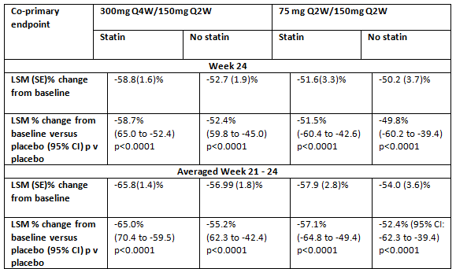
LDL-C at Week 48 was a secondary endpoint.
Table 13: Week 48 LDL-C CHOICE I
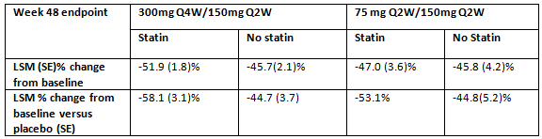
Other key secondary endpoints were numerous and included reductions in LDL-C at Week 12 and Week 52, Week 24 results for total cholesterol, apolipoprotein B (Apo B), non high density lipoprotein cholesterol (non-HDL-C), lipoprotein (a), fasting triglycerides, HDL-C, and Apolipoprotein A1(Apo A1). See Tables 14 to 18.

Table 14: Study R727-CL-1308: Summary of other secondary LDL-C efficacy endpoint results; Binary endpoints; Patients not receiving concomitant statin therapy
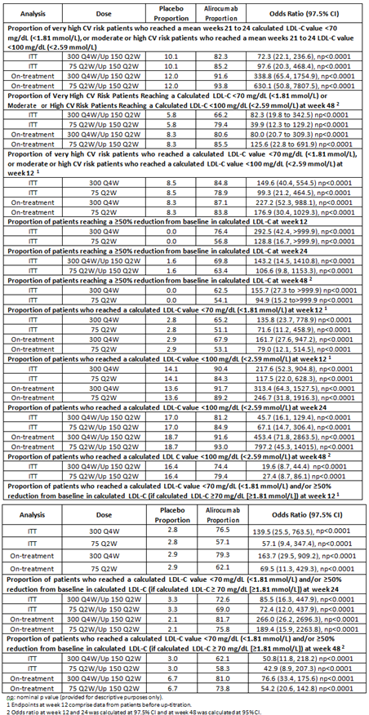

Table 15: Study R727-CL-1308: Summary of key secondary LDL-C efficacy endpoint results; continuous endpoints; Patients receiving concomitant statin therapy
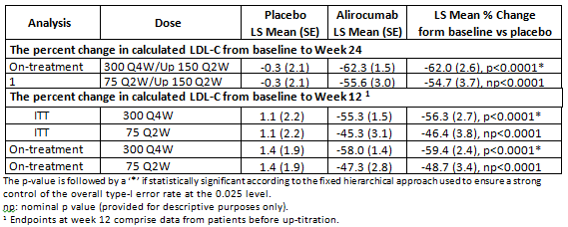

Table 16: Study R727-CL-1308: Summary of key secondary LDL-C efficacy endpoint results Week 24; Binary endpoints; Patients receiving concomitant statin therapy
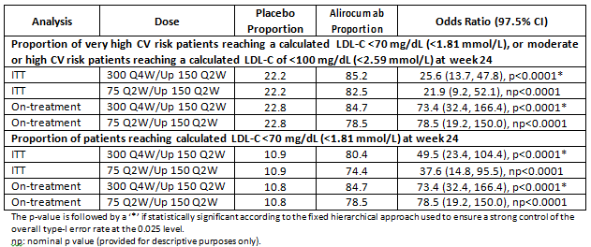

Table 17: Study R727-CL-1308: Summary of other secondary LDL-C efficacy endpoint results; Binary endpoints; Patients receiving concomitant statin therapy
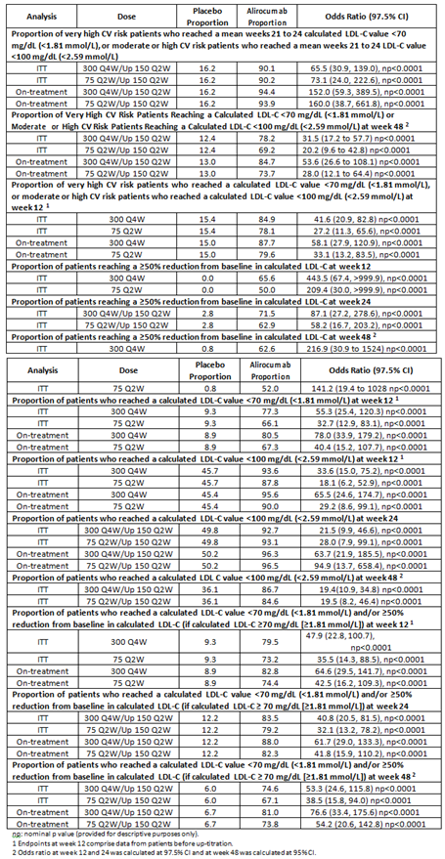

Table 18: Study R727-CL-1308: Summary of other secondary lipid efficacy endpoint results; patients not receiving concomitant statin therapy
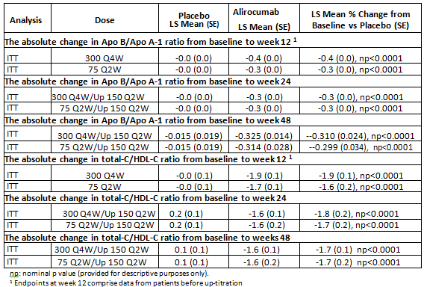
In the 300 mg Q4W alirocumab group in 15% not on statins and 19% on statins, as shown below.
Table 19: Week 12, Week 24 and Week 78 percent change from baseline up-titrated and non up-titrated patients 300 mg Q4W/ 150 mg Q2W alirocumab group Study CHOICE I
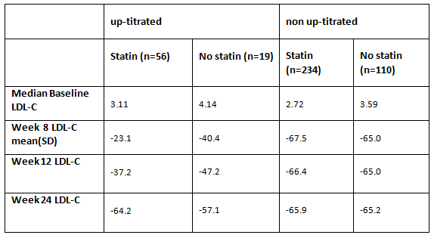

Study EFC13786 (CHOICE II)
A randomised, double blind, placebo controlled, parallel-Group study evaluating the efficacy and safety of alirocumab in patients with primary hypercholesterolaemia not treated with a statin. This was a first step analysis of 24 week efficacy, safety and pharmacology data from a multicentre, multinational study of 233 mostly White (94%) patients with a mean age of 63.1 years, and a mean BMI of 28.9 kg/m² to investigate the efficacy and safety of 150 mg Q4W/150 mg Q2W or 75 mg Q2W/150 mg Q2W or placebo. The study was designed to be conducted 147 weeks including a 3 week screening, 24 weeks double blind period, and an optional open label period up to 120 weeks or with 2 weeks follow-up for those opting out at 24 weeks. Stratification was according to statin tolerance and non-statin LMT and aimed to include 50% statin intolerant patients at moderate, high or very high CV risk, 50% non-statin intolerant patients with moderate CV risk, and 2 out of 3 patients with background therapy (ezetimibe, fenofibrate). The planned randomisation was 1:1:2 for placebo: 75 mg Q2W/150 mg Q2W:150 mg Q4W/150 mg Q2W, but a randomisation error resulted in the randomisation of 1:2:1. So only 59 patients were randomised to the 150 mg Q4W/150 mg Q2W arm, and only 50 completed the double blind period. Up titration to 150 mg Q2W at Week 12 was based on the Week 8 LDL-C, and occurred in 49.8% of the 150 mg Q4W/150 mg Q2W group and 36% of the 75 mg Q2W/150 mg Q2W group.
The primary efficacy endpoint was the Week 24 least squares mean (LSM) difference from baseline versus placebo of LDL-C concentrations:
- Alirocumab 150 mg Q4W/150 mg Q2W -56.4% (95% CI: -62.9 to -49.9), p < 0.0001
- Alirocumab 75 mg Q2W/150 mg Q2W -58.2% (95% CI: -63.8 to -52.7), p < 0.0001
The mean Week 8 LDL-C for the up-titrated group from the 150 mg Q4W/150 mg Q2W arm was -36.9% and for the non up-titrated group was -57.0% and 49.1% of patients were up-titrated.

Five final study reports
Five final study reports were provided for studies with first step analyses evaluated in the previous submission. These studies have concluded.

Study EFC12492 (FH I)
A randomised, double blind, placebo controlled, parallel group study to evaluate the efficacy and safety of SAR236553/REGN727 (alirocumab) in patients with heterozygous familial hypercholesterolaemia not adequately controlled with their lipid modifying therapy. This was the final analysis to Week 78 of this multinational, multicentre study conducted over 3 periods for a total duration of 89 weeks (3 week screening, 78 week double blind, 8 weeks follow-up or entry into extension Study LTS13463). The study randomised 486 patients aged ≥ 18 years with heFH not adequately controlled on maximally tolerated statin (atorvastatin, rosuvastatin or simvastatin) and/or other LMT. It excluded patients with a LDL-C < 1.81 mmol/L; on fibrates other than fenofibrate within 6 weeks of enrolment; using a nutraceutical that may affect lipids within 4 weeks of enrolment; patients with unstable cardiovascular disease or requiring interventions (for example Percutaneous Coronary Intervention (PCI) or coronary artery by-pass graft (CABG)) and newly diagnosed or unstable diabetics (HbA1c > 9%). There was a 2:1 randomisation to alirocumab SC by auto-injector to the abdomen, thigh or outer upper arm (n = 323), or placebo (n = 163). Stratification was according to prior history of myocardial infarction (MI) or ischaemic stroke, statin treatment (high intensity versus low intensity) and geographic region. All patients continued on their maximally tolerated statin therapy. All alirocumab patients commenced with 75 mg SC Q2W from Week 0 to 12, then were up-titrated to 150 mg SC Q2W if the Week 8 LDL-C was ≥ 1.81 mmol/L up, but otherwise continued on 75 mg Q2W. The Week 12 dose was continued up to the last dose at Week 76.
Premature discontinuations occurred in 23.5% and 20.2% of the alirocumab and placebo treatment arms, respectively, with discontinuations due to AEs in 6.1% of the placebo arm and 4.0% of the alirocumab arm. Baseline characteristics were similar between the two patient groups: patients had a mean, standard deviation (SD) age of 52 years, (13), were mostly male (56%), and White (91%), and 83% were taking statins. The mean baseline LDL-C was 3.711 (1.3) mmol/L. While all had high or very high CV risk, 46% had coronary heart disease. The study had a > 95% power to detect a difference in mean percent change in LDL-C of 30% with a 0.05 two-sided significance assuming a standard deviation of 25%. To allow for drop-outs and regulatory considerations the sample size was 471. Most patients (78.6% of the alirocumab arm and 84.7% of the placebo arm) continued into the extension study.
The primary endpoint was the percent change in calculated LDL-C from baseline to Week 24 in the ITT population (mixed effects model with repeat measures analysis):
- Week 24 least squares mean (LSM) standard error (SE)% change from baseline in the alirocumab group: -48.8 (1.6)%
- Week 24 LSM % change from baseline versus placebo: -57.9% (95% CI: -63.3 to -52.6) p < 0.0001.
LDL-C at Week 78 was a key secondary endpoint. In the ITT analysis the results were as follows:
- Week 78 LSM(SE)% change from baseline in the alirocumab group: -40.3 (2.0)%
- Week 78 LSM% change from baseline versus placebo: -51.8% (95% CI: -58.5 to -45.1), p < 0.0001.
In the alirocumab group the LSM LDL-C reduction at Week 4 was generally maintained at all time points throughout the double blind period.
A pre-specified secondary endpoint was treatment to target (LDL-C < 1.81 mmol/L or < 2.56 mmol/L). Approximately 71%/0.9% of the alirocumab/placebo patients achieved a LDL-C of < 2.59 mmol/L and about 49%/1.2% achieved a LDL-C of < 1.81 mmol/L.
The other key secondary endpoints were numerous and included reductions in LDL-C at Week 12 and Week 52, Week 24 results for total cholesterol, Apo B, non-HDL-C, lipoprotein (a), fasting triglycerides, HDL-C, and Apo A1. Analyses were also conducted in subpopulations reaching an LDL-C target of < 1.8 mmol/L. See Attachment 2 for submission PM-2015-000764-1-3 for details. The final Clinical study report (CSR) included results of these endpoints at Week 78 (see Table 20).

Table 20: Study EFC12492: Other efficacy endpoints; Week 78
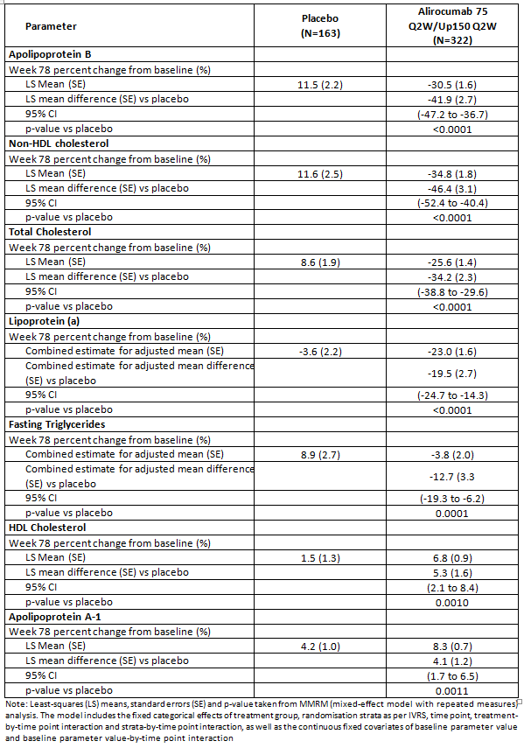
Up-titration occurred in 135 patients, 176 patients remained on 75 mg Q2W, with the following results as shown in Table 21.
Table 21: Week 12, Week 24 and Week 78 percent change from baseline up-titrated and non up-titrated patients alirocumab group Study FH I
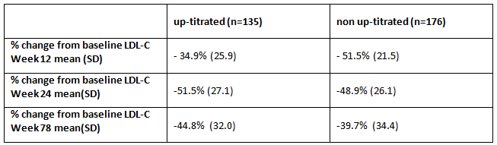

Study R727-CL-1112-(FH II)
This was a randomised, double blind, placebo controlled, parallel group study to evaluate the efficacy and safety of alirocumab in patients with heterozygous familial hypercholesterolaemia not adequately controlled with their lipid modifying therapy. This was the final analysis to Week 78 of this multicentre, multinational (European) study in 249 adult patients conducted over 3 periods for a total duration of 88 weeks (2 week screening, 78 week double blind, 8 weeks follow-up). At the end of the study participants will be eligible to transition to a long term extension study (Study LTS13463, not included in the submission).The inclusion and exclusion criteria, efficacy variables and analysis populations were the same as Study EF12492. There was a 2:1 randomisation to alirocumab SC by auto-injector to the abdomen, thigh or outer upper arm (n = 167), or placebo (n = 81). All patients continued on their maximally tolerated statin therapy. All alirocumab patients commenced with 75 mg SC Q2W from Week 0 to 12, then were up-titrated to 150 mg SC Q2W if the Week 8 LDL-C was ≥ 1.81 mmol/L up, but otherwise continued on 75 mg Q2W. The Week 12 dose was continued up to the last dose at Week 76. Baseline characteristics were similar between the groups. The mean age (SD) was 52(13) years, most were male (53%), and White (98%). The mean baseline calculated LDL-C was 3.5 (1.1) mmol/L and 88% were taking statins.
At least 76 weeks of exposure was reported for 92.2% of the alirocumab and 89% of the placebo group. Premature discontinuations occurred in 12.2% and 10.2% of the placebo and alirocumab groups, respectively, with 1.2% and 3.6% of the discontinuations of the placebo and alirocumab groups due to AEs. The power of the study was similar to Study FH I and the calculation was based on the same assumptions.
The primary endpoint was the percent change in calculated LDL-C from baseline to Week 24 in the ITT population (mixed effects model with repeat measures analysis):
- Week 24 Least squares mean (SE)% change from baseline in alirocumab group: -48.7 (1.9)%
- Week 24 Least squares mean % change from baseline versus placebo:
- -51.4% (95% CI: -58.1 to -44.8) p < 0.0001.
LDL-C at Week 78 was a key secondary endpoint. In the ITT analysis the results were as follows:
- Week 78 LSM(SE)% change from baseline in the alirocumab group: -47.4(2.1)%
- Week 78 LSM% change from baseline versus placebo: -52.1% (95% CI: -59.5 to -44.8), p < 0.0001.
In the alirocumab group the LSM placebo adjusted LDL-C reduction at Week 4 was generally maintained at all time points throughout the double blind period.
A pre-specified secondary endpoint was treatment to target (LDL-C < 1.81 mmol/L or < 2.56 mmol/L). Approximately 85.4%/16.2% of the alirocumab/placebo patients achieved a LDL-C of < 2.59 mmol/L and about 60.2%/0% achieved a LDL-C of < 1.81 mmol/L.
The other key secondary endpoints were numerous and included reductions in LDL-C at Week 12 and Week 52, Week 24 results for total cholesterol, Apo B, non-HDL-C, lipoprotein (a), fasting triglycerides, HDL-C, and Apo A1. Analyses were also conducted in subpopulations reaching an LDL-C target of < 1.8 mmol/L. See the CER for submission PM-2015-000764-1-3 for details.⁴ The final CSR included results of these endpoints at Week 78 (see Table 22).

Table 22: Study R727-CL-1112; Percent change in lipid parameters from Baseline to Week 78 (ITT Analysis); MMRM analysis; ITT population
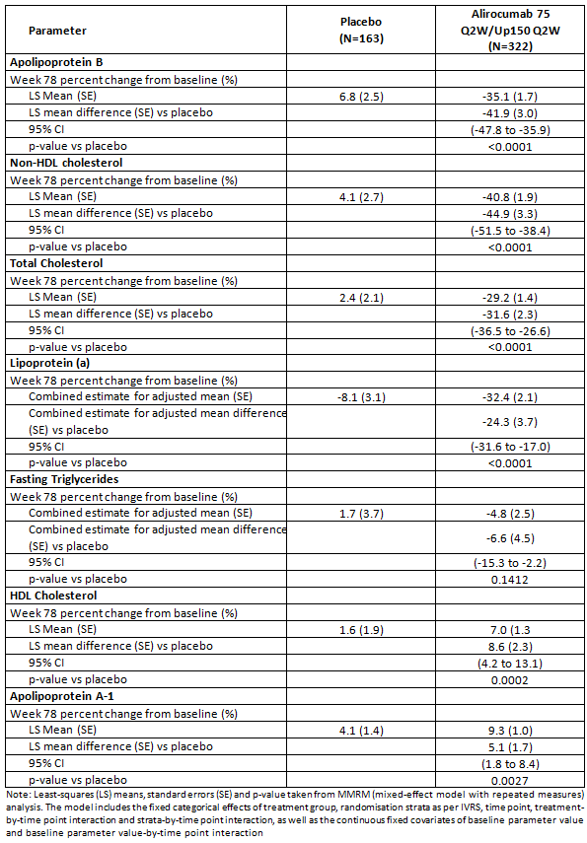
Up-titration occurred in 61 patients, with the following results:
Table 23: Week 12, Week 24 and Week 78 percent change from baseline up-titrated and non up-titrated patients alirocumab group Study FH II
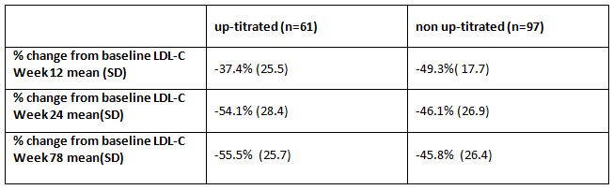

Study EFC12732 (HIGH FH)
A randomised, double blind, placebo controlled, parallel group study to evaluate the efficacy and safety of SAR236553/REGN727 in patients with heterozygous familial hypercholesterolaemia and LDL-C higher or equal to 160 Mg/Dl with their lipid modifying therapy. This was a final analysis to Week 78 of this multinational, multicentre study conducted over 3 periods for a total duration of 89 weeks (3 week screening, 78 week double blind, and 8 weeks follow-up). The inclusion criteria were the same as Studies EFC12492 and R7272-CL-1112 but exclusion criteria limited the study to patients with a baseline LDL-C ≥ 4.14 mmol/L. The study design and randomisation was the same as studies EFC12492 and R7272-CL-1112, but the study treatment was 150 mg alirocumab (n = 72) or placebo SC Q2W (n = 35) by auto-injector pen. The background LMT was managed similarly to the previous studies until Week 24 when therapy could be modified if TG or LDL-C reached threshold levels. The efficacy variables and analysis populations were the same as the previous studies (FH I and FH II). Baseline characteristics were similar at baseline although more alirocumab patients had CHD risk equivalents (9.0% alirocumab and 4.9% placebo). The mean patient age was 51 (13) years, 53% were male and 88% were White. The mean baseline LDL-C was 5.1 (1.4) mmol/L and 79% were taking statins. The sample size was based on the rationale for Study FH I.
Premature discontinuations occurred in 25.7% of the placebo group (5.7% due to AEs) and 40.3% of the alirocumab group (4.2% due to AEs). Protocol violations caused the closure of 2 sites, and major protocol deviations were reported for 13.9% of the alirocumab group and 5.7% of the placebo group.
The primary endpoint was the percent change in calculated LDL-C from baseline to Week 24 in the ITT population (mixed effects model with repeat measures analysis):
- Week 24 Least squares mean (SE)% change from baseline in alirocumab group: -45.7 (3.5)%
- Week 24 Least squares mean % change from baseline versus placebo:
- -39.4% (95% CI: -51.1 to -27.1), p < 0.0001.
LDL-C at Week 78 was a key secondary endpoint. In the ITT analysis the results were as follows:
- Week 78 LSM(SE)% change from baseline in the alirocumab group: -37.9(4.5)%
- Week 78 LSM% change from baseline versus placebo: -39.0% (95% CI: -54.6 to -23.5), p < 0.0001.
In the alirocumab group the LSM placebo adjusted LDL-C reduction at Week 24 was generally maintained to Week 78.
A pre-specified secondary endpoint was treatment to target (LDL-C < 1.81 mmol/L or < 2.56 mmol/L). Approximately 45.1%/8.6% of the alirocumab/placebo patients achieved a LDL-C of < 2.59 mmol/L and about 23.9%/8.6% achieved a LDL-C of < 1.81 mmol/L.
The other key secondary endpoints were numerous and included reductions in LDL-C at Week 12 and Week 52, Week 24 results for total cholesterol, Apo B, non-HDL-C, lipoprotein (a), fasting triglycerides, HDL-C, and Apo A1. Analyses were also conducted in subpopulations reaching an LDL-C target of < 1.8 mmol/L. See the CER for submission PM-2015-000743-1-3 for details.7. The final CSR included results of these endpoints at Week 78 (see Table 24).

Table 24: Study EFC12732: Percent change in lipid parameters from baseline to Week 78 (ITT Analysis): MMRM analysis; ITT population
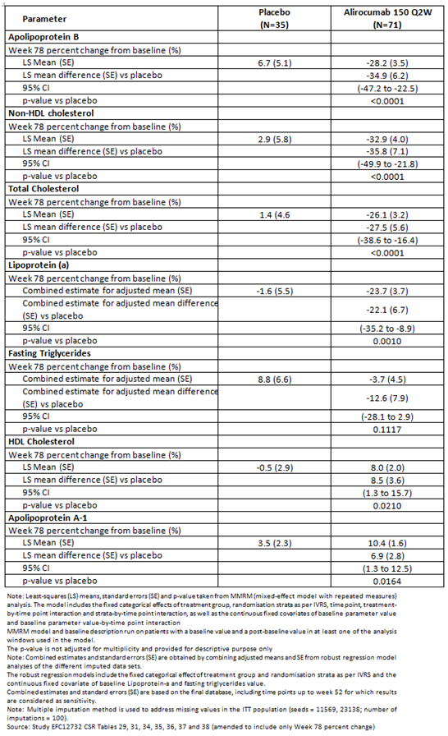

Study EFC11569 (Combo II)
A randomised, double blind, parallel group study to evaluate the efficacy and safety of SAR236553/REGN727 versus ezetimibe in high cardiovascular risk patients with hypercholesterolaemia not adequately controlled with their statin therapy. This was an analysis to Week 104 of this multinational, multicentre study conducted over 3 periods for a total duration of 112 weeks (3 week screening, 104 week double blind, and 8 weeks follow-up). The study included 720 patients aged ≥ 18 years with hypercholesterolaemia and established coronary heart disease (CHD) or CHD risk equivalents not adequately controlled on maximally tolerated statin ± LMT. The exclusion criteria were the same as the Combo I Study. There was a 2:1 randomisation to alirocumab SC Q2W by auto-injector to the abdomen, thigh or outer upper arm (n = 479), or ezetimibe 10 mg daily (n = 241). Randomisation was stratified according to prior history of MI or ischaemic stroke (Yes/No), statin treatment (high intensity statin, as defined by atorvastatin 40 to 80 mg daily or rosuvastatin 20 to 40 mg daily; versus simvastatin whatever the daily dose, atorvastatin below 40 mg daily or rosuvastatin below 20 mg daily) and geographic region. All alirocumab patients commenced with 75 mg SC Q2W from Weeks 0 to 12 then were up-titrated to 150 mg SC Q2W if the Week 8 LDL-C was ≥ 1.81 mmol/L but otherwise continued on 75 mg Q2W. The Week 12 dose was continued up to the last dose at Week 102. Baseline characteristics were similar between the groups. The mean age was 62 years, most (74%) were male, 85% were White and 90% had CHD, including 91% in the alirocumab group. Baseline calculated LDL-C was 2.8 (0.9) mmol/L and 69% were taking statins. A sample size of 96 patients had a 95% power to detect a difference in mean percent change in LDL-C of 20% with a 0.05 two-sided significant assuming a standard deviation of 25%. To allow for dropouts over the duration of the study and to increase the safety set the sample size was 660.
Premature discontinuations occurred in 25.5% of the ezetimibe group (9.2% due to AEs) and 31.1% of the alirocumab groups (8.3% due to AEs). Major protocol deviations occurred in 14.8% of the alirocumab group and 13.3% of the placebo group (mostly missing assessment values). Of those 2.5% of the alirocumab group and 0.4% of the placebo group had no LDL-C value in the Week 24 window and were excluded from the ITT population. The remainder were included.
The primary endpoint was the percent change in calculated LDL-C from baseline to Week 24 in the ITT population (mixed effects model with repeat measures analysis):
- Week 24 Least squares mean (SE)% change from baseline in alirocumab group: -50.6(1.4)%
- Week 24 Least squares mean % change from baseline versus ezetimibe: -29.8% (95% CI: -34.4 to -25.3) p < 0.0001.
LDL-C at Week 104 was a key secondary endpoint. In the ITT analysis the results were as follows:
- Week 104 LSM(SE)% change from baseline in the alirocumab group: -44.2(1.7)%
- Week 104 LSM(SE)% change from baseline in the ezetimibe group -15.2(2.5)%
- Week 104 LSM% change from baseline versus ezetimibe: -28.9% (95% CI: -34.7 to -23.1), p < 0.0001.
In the alirocumab group the LSM ezetimibe adjusted LDL-C reduction at Week 4 was similar to Week 104.
A pre-specified secondary endpoint was treatment to target (LDL-C < 1.81 mmol/L or < 2.56 mmol/L) at Week 104. Approximately 84.3%/72.5% of the alirocumab/ezetimibe patients achieved a LDL-C of < 2.59 mmol/L and about 67.8%/38.6% achieved a LDL-C of < 1.81 mmol/L.
The other key secondary endpoints were numerous and included reductions in LDL-C at Week 12 and Week 52, Week 24 results for total cholesterol, Apo B, non-HDL-C, lipoprotein (a), fasting triglycerides, HDL-C, and Apo A1. Analyses were also conducted in subpopulations reaching an LDL-C target of < 1.8 mmol/L. See CER for submission PM-2015-000764-1-3 for details.⁴ The final CSR included results of these endpoints at Week 78 (see Table 25).

Table 25: Study EFC11569: Other efficacy endpoint; Week 104
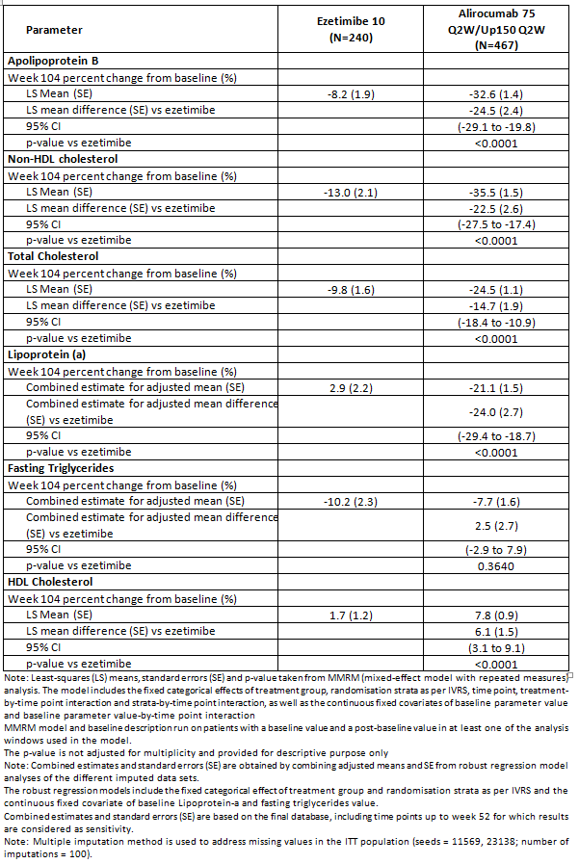
Up-titration occurred in 82 patients, with the following results as shown in Table 26.
Table 26: Week 12, Week 24 and Week 104 percent change from baseline up-titrated and non up-titrated patients alirocumab group Study Combo II
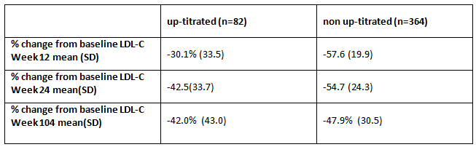

Study LTS11717 (LONG TERM)
A randomised, double blind, parallel group study to evaluate the efficacy and safety of SAR236553/REGN727 versus ezetimibe in high cardiovascular risk patients with hypercholesterolaemia not adequately controlled with their statin therapy. This was a primary safety study and the efficacy variables were secondary endpoints. This was an analysis of this multinational, multicentre, study conducted over 3 periods for a total duration of 86 weeks (3 week screening, 78 week double blind, and 8 weeks follow-up). The study included 2,343 patients aged ≥ 18 years with heFH with or without established CHD or CHD risk equivalents, or patients with hypercholesterolaemia with established CHD or CHD risk equivalents not adequately controlled on maximally tolerated statin for at least 4 weeks prior to screening ± LMT. There was a 2:1 randomisation to alirocumab SC Q2W by pre-filled syringe to the abdomen, thigh or outer upper arm (n = 1,553), or placebo (n = 788). Randomisation was stratified by heFH, prior history of acute or silent MI or ischemic stroke, statin treatment (atorvastatin 40 to 80 mg daily or rosuvastatin 20 to 40 mg daily, versus simvastatin whatever the daily dose, atorvastatin below 40 mg daily or rosuvastatin below 20 mg daily) and geographic region. All alirocumab patients received with 150 mg SC Q2W. Baseline characteristics were well matched between the groups. The mean age was 61 years, most were male (62%), and White (93%). The majority (69%) had a history of CHD, and 46% had coronary revascularisation procedures. The mean calculated LDL-C was 3.2 (1.1) mmol/L and 47% were taking statins. The sample size was based on safety. A sample size of 1400 alirocumab treated allows detecting AEs with a rate ≥ 0.002 with 95% confidence. An alirocumab ophthalmology sub study of 270 patients with 25% discontinuation in 1 year had 95% confidence to detected ophthalmological events with a true occurrence of 0.021 and 0.024. This was described in the original submission.
Premature discontinuations occurred in 24.5% of the placebo patients (6.0% due to AEs) and 28.1% of the alirocumab patients (7.3% due to AEs). Major protocol deviations occurred in 15.3% of the alirocumab group and 15.6% of the placebo group (mostly missing assessment values). Of those 1.5% of the alirocumab group and 1% of the placebo group had no LDL-C value in the Week 24 window and were excluded from the ITT population. The remainder were included.
The primary efficacy outcome was the percent change from baseline in LDL-C at Week 24 in the ITT population.
- Week 24 Least squares mean (SE)% change from baseline in alirocumab group: -61.0(0.7)%
- Week 24 Least squares mean % change from baseline versus ezetimibe: -61.9% (95% CI: -64.3 to-59.4) p < 0.0001.
LDL-C at Week 78 was a key secondary endpoint. In the ITT analysis the results were as follows:
- Week 78 LSM(SE)% change from baseline in the alirocumab group: -52.4(0.9)%
- Week 78 LSM% change from baseline versus ezetimibe:-56.0% (95% CI:-59.1 to-52.8),p < 0.0001.
In the alirocumab group the LSM ezetimibe adjusted LDL-C reduction at Week 4 was similar to Week 78.
A pre-specified secondary endpoint was treatment to target (LDL-C < 1.81 mmol/L or < 2.56 mmol/L) at Week 78. Approximately 83.4%/36.8% of the alirocumab/placebo patients achieved a LDL-C of < 2.59 mmol/L and about 69.8%/8.0% achieved a LDL-C of < 1.81 mmol/L.
The other key secondary endpoints were numerous and included reductions in LDL-C at Week 12 and Week 52, Week 24 results for total cholesterol, Apo B, non-HDL-C, lipoprotein (a), fasting triglycerides, HDL-C, and Apo A1. Analyses were also conducted in subpopulations reaching an LDL-C target of < 1.8 mmol/L. See Attachment 2 for submission PM-2015-000743-1-3 for details. The final CSR included results of these endpoints at Week 78 (see Table 27).

Table 27: Study LTS11717; Other efficacy endpoint; Week 78
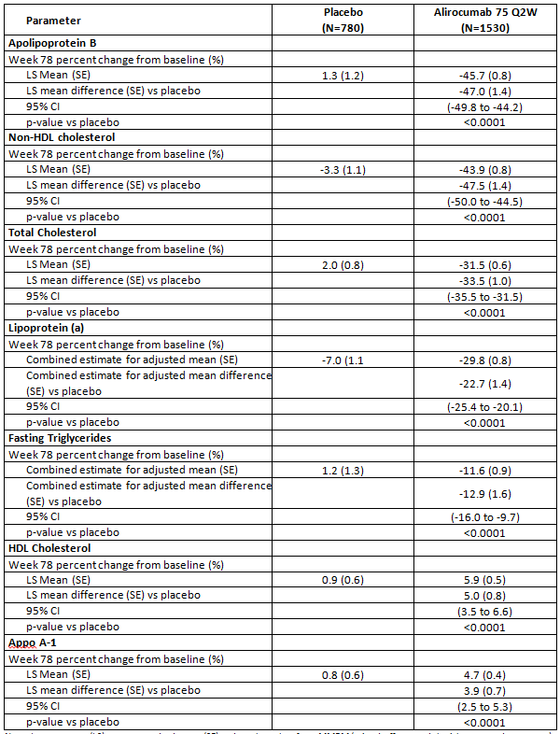
Note: Least-squares (LS) means, standard errors (SE) and p-value taken from MMRM (mixed-effect model with repeated measures) analysis. The model includes the fixed categorical effects of treatment group, randomisation strata as per interactive voice response system (IVRS), time point, treatment-by-time point interaction and strata-by-time point interaction, as well as the continuous fixed covariates of baseline parameter value and baseline parameter value-by-time point interaction MMRM model and baseline description run on patients with a baseline value and a post-baseline value in at least one of the analysis windows used in the model. The p-value is not adjusted for multiplicity and provided for descriptive purpose only. Note: Combined estimates and standard errors (SE) are obtained by combining adjusted means and SE from robust regression model analyses of the different imputed data sets. The robust regression models include the fixed categorical effect of treatment group and randomisation strata as per IVRS and the continuous fixed covariate of baseline Lipoprotein-a and fasting triglycerides value. Combined estimates and standard errors (SE) are based on the final database, including time points up to week 52 for which results are considered as sensitivity. Note: Multiple imputation method is used to address missing values in the ITT population (seeds = 11569, 23138; number of imputations = 100).
The sponsor pooled the efficacy results for Studies EFC12484, R727-CL-1112, EFC12732 and LTS11717, that all demonstrate a benefit versus the comparator for reduction in LDL-C. The Week 78 pooled results are depicted in Figure 4.
Figure 4: Percent change from Baseline in calculated LDL-C at Week 78; MMRM (ITT analysis); Phase III Studies FHI, FHII, HIGH FH, LONG TERM
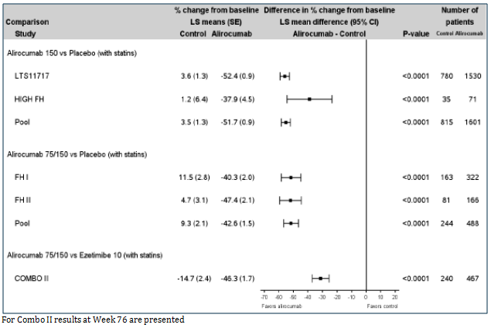

Safety
The sponsor presented the safety of Q2W and Q4W dosing separately.

Safety Q4W dosing studies
Safety of Q4W dosing was derived from the Study EFC13786 and Study R727-CL-1308, from 458 patients receiving 300 mg Q4W/150 mg Q2W and 230 receiving 75 mg/Q2W. Of those 162 patients received 150 mg Q2W after up titration.
In Study R727-CL-1308 treatment emergent adverse events (TEAEs) were reported by 80.6% of the 300 mg Q4W/alirocumab and approximately 75% of the 75 mg Q2w/150 mg Q2w, and placebo treatment arms. The most common TEAES (≥ 5% more frequently reported than placebo) were influenza (7.9%, 9.6%, 7.4%, bronchitis (4.1%, 6.1%, 5.2%), nasopharyngitis (8.5%, 8.7%, 7.9%), sinusitis (6.1%, 3.5%, 4.8%) and upper respiratory tract infection (9.0%, 7.0%, 7.9%), urinary tract infection (6.1%, 6.1%, 4.4%), neoplasms (3.9%, 6.1%, 2.6%), headache (6.3%, 5.2%, 5.7%), One death occurred in each study arm. Serious adverse events (SAEs) occurred in 11.6%, 11.3%, and 14.4% of the 300 mg Q4W /150 mg Q2W, 75 mg Q2W/150 mg Q2W/placebo groups, respectively. TEAEs leading to permanent discontinuation occurred in 6.8%, 6.1% and 7.4% of the 300 mg /150 mg Q2W, 75 mg Q2W/150 mg Q2W, placebo groups. Of the 118 patients with 2 consecutive LDL-C < 0.65 mmol/L 69% experience ≥ 1 TEAE that occurred/worsened/became serious after the first of the 2 low values, but these were most commonly URTI and injection site reaction and 10 had SAEs, including chest pain in 4 patients, 2 patients with diverticulitis, 1 each with a MI, stroke, hypovolaemia and acute renal failure, and 1 with transient visual disturbance in a patient with pre-existing diabetic retinopathy.
In Study EFC13786 77.6%, 73.0%, 63.8% of the 150 mg Q4W/150 mg Q2W, 75 mg Q2W/150 mg Q2W/placebo groups, respectively, reported TEAES. Arthralgia, muscle spasms, injection site reactions fatigue and rash were all more common in the alirocumab groups, and had the highest frequency in the Q4W dosing group. SAEs were reported in 12.1%, 5.2%, 6.9%. TEAEs leading to permanent discontinuation were reported in 6.9%, 1.7%, 3.4%. The numbers in these groups were small. Treatment related adverse events (TRAEs) occurred in 24.1%, 12.2%, 15.5%. Injection site reactions (ISR) occurred in 13.8%, 3.5%, 0%. Among the 3 patients with 2 consecutive LDL-C measurements of < 0.65 mmol/L on reported the TEAEs of nasopharyngitis and headache that resolved on treatment. No meaningful change in mean HbA1C occurred in the treatment groups.

Primary safety study
Study LTS11717 (LONG TERM); a randomised, double blind, parallel group study to evaluate the efficacy and safety of SAR236553/REGN727 versus ezetimibe in high cardiovascular risk patients with hypercholesterolaemia not adequately controlled with their statin therapy. This was a primary safety study. Findings from the first-step analysis were provided in the original dossier. Safety information was provided for Week 78 of the double blind period of this multinational, multicentre, study conducted over 3 periods for a total duration of 86 weeks (3 week screening, 78 week double blind, and 8 weeks follow-up). The study design is described in the Efficacy section of this Delegate’s Overview. The safety set of 2,006 patients exposed to study treatment for ≥ 52 weeks and 1,916 patients (1,267 alirocumab patients and 649 placebo patients) had received ≥ 76 weeks of treatment and 1,912 had completed their Week 78 visit.
In this study 81.0% alirocumab patients and 82.5% placebo patients reported any AE. The most frequently reported TEAEs at the Preferred Term (PT) level (≥ 5% of patients in either treatment group) in the alirocumab versus placebo groups, respectively, were as follows (by decreasing order in the alirocumab group): nasopharyngitis, upper respiratory tract infection, injection site reaction, urinary tract infection, diarrhoea, influenza, back pain, bronchitis, myalgia, and arthralgia and headache. Seven TEAEs (PT) were reported more frequently in the alirocumab group compared with the placebo group (incidence of ≥ 2.0% and ≥ 0.5% difference versus placebo), in order of decreasing frequency: injection site reaction, myalgia, muscle spasms, cough, musculoskeletal pain, contusion, and angina unstable.
For 17.2% of patients in the alirocumab group and 14.3% of patients in the placebo group had TRAEs, most frequently injection site reaction in 91 alirocumab patients (5.9%) and 33 placebo patients (4.2%). Other TRAEs in ≥ 0.5% of either the alirocumab or placebo group, respectively, included: headache (0.8% versus 1.4%), diarrhoea (1.0% versus 0.5%), dizziness (0.6% versus 0.6%), nausea (0.6% versus 0.9%), pruritus (0.5% versus 0.1%), arthralgia (0.5% versus 0.5%), myalgia (1.3% versus 0.4%), muscle spasm (0.6% versus 0.5%), fatigue (0.7% versus0.5%), and decreased blood cortisol (0.4% versus 0.8%).
An analysis of events of special interest was undertaken. Two consecutive LDL-C values < 0.65 mmol/L occurred in 575 patients of which 435 patients (75.7%) reported at least 1 TEAE that occurred, worsened, or became serious after the first of the two LDL-C values < 0.65 mmol/L but no particular safety signal emerged. Cardiovascular events occurred in 4.6% of the alirocumab group and 5.1% of the placebo group, with fewer non-fatal MIs (0.9% versus 2.3%) and fewer with a CHD death (0.3% versus 0.9%) in the alirocumab group. Neurological events occurred in 4.6% of the alirocumab group and 4.8% of the placebo group, most frequently paraesthesia in 19 patients (1.2%) in the alirocumab group and 7 patients (0.9%) in the placebo group. Neurological SAEs were reported in 0.3% of each treatment arm. These events were not from patients with 2 consecutive low LDL-C values. Neurocognitive effects were reported in 18 patients (1.2%) of the alirocumab, 3 were SAEs, and 4 patients (0.5%) of the placebo group. This is unchanged from the first step analysis. Allergy events were reported in 10.1% versus 9.5% of the alirocumab and placebo groups. Most frequently these included seasonal allergy, eczema, dermatitis contact, rhinitis allergic, and erythema.
An ophthalmology sub study was reported in the previous submission. Ophthalmological TEAEs were reported in 45 patients (2.9%) in the alirocumab group and 15 (1.9%) patients in the placebo group, with no clear pattern of events for structure or mechanism, with more patients on alirocumab than placebo with retinal disorders (2.3% versus 1.5%) and optic nerve disorders (1.2% versus 0.4%).
Twenty-four patients in the alirocumab group (1.6%) and 8 patients in the placebo group (1.1%) had positive ADA status at baseline, with titres ranging from 30 to 480 for the alirocumab group and 30 to 120 for the placebo group. None developed a treatment emergent positive ADA response. A total of 72 patients in the alirocumab group (4.8%) and 9 in the placebo group (1.2%) developed a treatment-emergent positive ADA response, within 4 to 12 weeks, with a median time to ADA response of 4.93 weeks. Of the 72 alirocumab patients, 18 had a persistent response, 53 patients had a transient response, and 1 patient had an indeterminate response. Among the 1,489 alirocumab patients with ADA measured population (1.3%) had at least 1 positive neutralising status. This ADA response did not appear to impact the LDL-C efficacy profile but of injection site reaction occurred in 11.3% ADA-positive patients compared with 5.6% ADA negative patients). In most patients, the ADA response was transient and was not associated with any other safety concern apart from mild increase in the incidence of injection site reactions.

Integrated safety analysis
The integrated safety database presented in this submission, including patients from Studies EFC11569, EFC12494, EFC12732, LTS11717 and R727-CL-1112 and the Phase II Studies DFI11565, DFI11566, CL-1003 and DFI12361 (placebo controlled) and COMBO II, MONO, OPTIONS I, OPTIONS II, ALTERNATIVE (ezetimibe controlled). It included the most recent data from the studies included in this submission. The remainder of the studies had been evaluated in the original submission). The safety set included 5,243 patients exposed to study medication (3,340 alirocumab, 1,276 placebo, 618 ezetimibe). The cumulative exposure of the alirocumab patients in the placebo controlled studies was 3,039.1 patient years and in the ezetimibe controlled pool 989.9 patient years. Of those there was 1,349.5 patient years exposure to 75 mg Q2W, 501.4 patient years to 75 mg Q2W followed by 150 mg Q2W and 2,178.1 patient years exposure to the 150 mg Q2W starting dose. There was 3,680.4 patient years exposure to alirocumab (any dose) for at least 52 weeks, 3,403.1 for 76 weeks and 755.3 for 104 weeks. High intensity statins were taken by 54% of the placebo group, 53% of the alirocumab group and 42% of the ezetimibe group. Only 241 alirocumab patients were aged ≥ 75 years, but 3,324 had an estimated glomerular filtration rate (eGFR) < 90 mL/min/1.73 m². Most alirocumab patients (71%) had a history of cardiovascular disease (secondary prevention) and 29% had no history (primary prevention). In the placebo controlled studies Phase III studies 84% of the non-FH and 45% of the heFH had a prior history of cardiovascular disease. No background statin was taken 20% of the alirocumab patients in the ezetimibe controlled studies and < 0.1% in the placebo controlled studies. Approximately 24% of patients across the integrated safety set discontinued the study.
TEAEs were reported in 78.7% and 78.4% of the placebo and alirocumab patients, respectively in the placebo controlled pool. Events more frequent in the alirocumab group compared to placebo (incidence ≥ 2.0% in the alirocumab group and difference ≥ 0.5% versus placebo) were nasopharyngitis (12.2% versus 11.5%), injection site reaction (6.9% versus 4.9%), influenza (5.9% versus 4.9%), myalgia (4.5% versus 3.7%), contusion (2.3% versus 1.3%), and musculoskeletal pain (2.3% versus 1.6%). In the ezetimibe controlled pool, 73.9% and 76.0% of the ezetimibe and alirocumab patients reported TEAEs. Events more frequent in the alirocumab group compared to placebo (incidence ≥ 2.0% in the alirocumab group and difference ≥ 0.5% versus placebo) were URTI (7.2% versus 6.5%), accidental overdose (6.3% versus 3.9%), headache (5.0% versus 3.9%), arthralgia (4.9% versus 4.2%), influenza (4.3% versus 3.7%), fatigue (3.2% versus 1.5%), injection site reaction (2.9% versus 2.1%), fall (2.1% versus 1.8%), constipation (2.3% versus 1.8%) and insomnia (2.1% versus 1.5%). Up-titration occurred in 228 patients in the placebo controlled poo and 180 patients in the ezetimibe controlled pool. No TEAEs were consistently greater in the up-titrated pooled groups.
The proportions of TEAEs from the 408 patients that had their dose up-titrated from 75 mg Q2W to 150 mg Q2W were similar between those up-titrated and those not in both pools. The types of events that were more frequent in the up-titrated versus the non-titrated patients in the placebo controlled pool were back pain (2.8% versus 0.7%), diarrhoea (3.1% versus 1.6%), gastroenteritis (3.5% versus 1.9%), abdominal pain (3.1% versus 0.7%), gout (2.6% versus 0.7%), peripheral oedema (2.6% versus 0.7%), influenza like illness (2.6% versus 1.6%) and blood creatinine kinase increased (2.6% versus 1.2%), and in the ezetimibe pool bronchitis (2.8% versus 1.8%), myalgia, headache (5.0 % versus 2.5%), hypertension (6.1% versus 3.8%) and accidental overdose (9.4% versus 4.6%). It is noted that upper respiratory tract infection, bronchitis, influenza, dizziness and myalgia were all more common in the non-titrated group than the titrated group across both safety pools, and urinary tract infection, muscle spasms, non-cardiac chest pain and dizziness more common in the ezetimibe controlled pool. Discontinuations due to AE occurred in 7% of the alirocumab pool and 7.4% of the control pool. The commonly reported reasons for discontinuation differed between the placebo and ezetimibe controlled groups, however myalgia was the most common in alirocumab groups of both comparisons.
In the Integrated Summary of Safety (ISS) deaths occurred in 0.8% of alirocumab and 1.1% of control group, with CHD death in 0.5% and any cardiovascular death in 0.6% each of the pooled alirocumab and pooled control groups and new or worsening malignancy in 0.3% of the controls and 0.1% alirocumab patients. SAEs were reported for 16.1% and 15.6% of the placebo and alirocumab patients in the placebo controlled pool and 13.9% and 17.1% of the ezetimibe and alirocumab patients in the ezetimibe controlled pool. SAEs were experienced more frequently in non-up-titrated patients than up-titrated patients from either control pool.

Effects on laboratory tests
No new safety concerns about metabolic parameters were identified from the long term data.

Events of special interest

Local injection site reactions
Local injection site reactions were more common in the alirocumab groups than the control groups (4.9 versus 3.5 per 100 patient years, respectively; hazard ratio (HR) (95% CI): 1.47 (1.14 to 1.91)), and all but 1 event were mild to moderate in the alirocumab group, and all but 1 resolved without sequelae. Discontinuations due to local injection site reactions occurred in 0.2% and 0.3% of the alirocumab and pooled control groups, respectively. Injection site reactions occurred in 6.0% ADA negative alirocumab patients and 9.2% ADA positive patients. A higher proportion of patients with ADA titre > 240 (22% (4/18)) and 6/38 (15.8%) NAb positive patients had injection site reactions; however the absolute numbers are small. In CHOICE II up titration resulted in more reports of injection site reactions 4 patients (6.1%) versus 3 patients (3.1%).

Allergic reactions
Allergic reactions were more common in the alirocumab groups than the control groups (placebo controlled pool: 9.6% (alirocumab) versus 8.2% (placebo) respectively; ezetimibe controlled pool: 7.8% (alirocumab) versus 6.1% (ezetimibe) with rash and pruritus the most common with alirocumab in the two pools. Other reactions included nummular eczema, urticaria and one case of hypersensitivity vasculitis.

Neurologic events
Neurologic events were reviewed because cholesterol is a major component of myelin and cell membranes. Rare events of optic neuritis, Miller-Fisher syndrome, demyelination and transverse myelitis were reported for alirocumab in the original submission but no new events were reported following a longer duration of exposure.

Neurocognitive disorders
Neurocognitive disorders; in the ISS these events were reported for 0.7 and 0.5/100 patient years in the alirocumab and placebo groups, respectively (HR1.24 (95% CI: 0.57 to 2.68)), and in 0.9 and 1.2 per 100 patient years in the alirocumab and ezetimibe groups, respectively in the ezetimibe controlled studies (HR 0.81 (95% CI: 0.81 to 2.68)). These results are similar to the analysis conducted in the initial submission. It is noted there was variability in studies, as noted in the Delegate’s Overview for the original submission: for example the LONG TERM study in which 47% of patients were taking statins at baseline, neurocognitive events were reported in 1.2% (18/1550) of alirocumab patients and 0.5% (4/788) of placebo patients, and of those 3 alirocumab and 1 placebo patient had neurocognitive SAEs.

Cataracts
Cataracts were raised as a potential risk in the presence of low LDL-C values. In the integrated safety set in the placebo controlled pool events occurred in 1.3% versus 1.0% in the alirocumab and placebo groups respectively, and in the ezetimibe controlled pool in 1.3% versus 1.3% in the alirocumab and ezetimibe groups, respectively.

Diabetes
Similar proportions of diabetic AEs occurred in the alirocumab and placebo groups in the Q4W study. In the Q2W studies no safety concern for an increased risk of diabetes or a deterioration of HbA1C was demonstrated. The sponsor has been asked to provide an account of patients with new onset diabetes.

Hepatic safety
In the ISS of the second step studies in this submission in the ezetimibe controlled group 1.3% versus 0.3% (alirocumab versus ezetimibe, respectively) had elevations of alanine aminotransferase (ALT) > 3 upper limit of normal (ULN) that all had confounding factors and returned to normal on treatment. The evaluator concluded that overall no hepatic safety signal had been identified in the long term exposure data. In Study R727-CL-1308 0.9% of the alirocumab group and 1.3% of the placebo group reported increases in ALT.

MACE
In the pool of Phase III studies no increased cardiovascular risk was identified in the new safety data. Adjudicated major adverse cardiac event (MACE) events composite endpoint (CHD death, nonfatal MI, fatal or nonfatal ischemic stroke, and unstable angina requiring hospitalisation) occurred in 2.0% of alirocumab patients and 2.2% control patients (HR (95% CI); 0.85 (0.57 to 1.27)).

Safety of very low LDL-C
A total of 839 (25.1%) patients had 2 LDL-C measure of < 0.65 mmol/L and 314 (9.4%) had LDL-C < 0.39 mmol/L. The safety profiles of these patients were similar to other alirocumab patients.

Immunogenicity
In the ISS TEAE ADA responses in the Q2W group occurred in 5.1% and 1.0% of the alirocumab and control groups, respectively. There were no differences in safety in the ADA positive groups compared to the ADA negative groups except for an increase in reported injection site reactions. Thirty eight patients (1.3%), all from the alirocumab group had neutralising antibodies (Nab) and only 11 of those had ≥ 2 NAb+ samples. There was no apparent correlation between NAb and alirocumab efficacy. In Study R727-CL-1308; TEAE ADAs were identified in 12.7% of the 75 mg Q2W/q50 mgQ2W group and 4.7% of the 300 mg Q4W/150 mg Q2W group. All were of low titre with the highest 240. Nab were reported in 0.38%, 1 patient from the 300 mg Q4W/150 mg Q2W group and one from the 75 mg Q2W/150 mg Q2W group.

Device related adverse events
Device related events were reported by approximately 11% of alirocumab patients using the prefilled pen, mostly related to jammed or difficult to activated devices. Most events occurred early in the clinical studies.
At the time of submission there were no post-market data for the Q4W dosing. Two PSURs had been reviewed by the evaluator and who concluded that new safety signals had been identified by the sponsor from the post-market data analysed.

Clinical evaluator’s recommendation
The clinical evaluator recommended approval of the new directions for use but did not recommend approval for the extension of indications.

Risk management plan
The Pharmacovigilance and Special Access Branch (PSAB) has considered the EU-RMP (Version 3.0, dated 12 January 2017) with Australian Specific Annex (Version 2.1, dated 31 March 2017) and has no outstanding issues relating to the RMP.

Risk-benefit analysis

Delegate’s considerations

Once monthly dosing
The sponsor proposes this as an alternative 300 mg Q4W dose starting dose in patients wishing to have a monthly dose. A single clinical study of 420 patients was provided to support the pharmacology, efficacy and safety of 300 mg Q4W dosing with additional support from population pharmacokinetics and PK/PD modelling. The 300 mg Q4W has similar kinetics to Q2W dosing however, as expected has a higher C_{max} than 75 mg and 150 mg dosing. Overall weekly exposure was similar to 150 mg fortnightly exposure. Like the 75 mg Q2W dosing alirocumab levels, PCSK9 levels and LDL-C were influenced by the presence of statins. An acceptable efficacy profile that was similar to the 75 mg Q2W dose was demonstrated at 24 and 48 weeks. Between 15 to 19% of patients required up titration to 150 mg Q2W dosing, and was also influenced by the use of statins. The safety profiles of the 300 mg Q2W/150 mg Q2W dosing and the ‘calibrator arm’ of 75 mg Q2W/150 mg Q2W were similar. However more injection site reactions occurred, which may be explained by the increased antibody load with immunogenic potential with the dose and potential irritant of two injections. The concern is the increased C_{max} compared to the other doses. The sponsor has opined the risk is mitigated by an increase in target mediated clearance. The Advisory Committee on Medicines (ACM) is requested to provide its view on this matter. Overall a 300 mg Q4W dose does offer a reasonable alternative for patients that prefer once monthly dosing. It has only been investigated as a starting dose and it is reasonable that the sponsor includes it only as a starting dose. There are no data to inform changes from the 75 mg Q2W dose to the 300 mg Q4W dose, or a reduction in dose to Q4W dosing if LDL-C levels are persistently very low. The clinical evaluator notes that there is no evidence to support switching from an established Q2W dose to a Q4W dose and this should be highlighted in the PI, as should the increase in injection site reactions with this dosage regimen.

Extension of indication
Extension of indication to include non-familial hypercholesterolaemia and mixed dyslipidaemia, to include mention of treating to target with statin therapy, and to include patients for whom statins are contraindicated.
The final clinical study reports for 5 studies were presented in support of the sponsor’s proposed extension of the approved indication for alirocumab. For each about 24 weeks of additional data were included. Three studies enrolled patients with heFH (FHI, FHII, HIGH FH) and the others patients with non-FH hypercholesterolaemia (COMBO II, LONG TERM). Each of these studies had met the primary endpoint of LDL-C reduction at Week 24. In each of the studies the comparator adjusted (placebo or ezetimibe) reduction in LDL-C from baseline was sustained to 78 weeks or 104 weeks of treatment, depending on the study. In general, improvements in other lipid parameters were sustained over the duration of the studies. Across the studies a 40 to 65% reduction in LDL-C was achieved. Patients on statins tended to have a greater LDL-C reduction than those not on statins.
While an increase in absolute numbers of adverse events was noted in each study alirocumab had a similar safety profile after the inclusion of the data from the completed studies. The most frequent adverse events were similar to those reported for the first step analysis of these studies. Differences in some adverse events had been noted previously in patients whose dose was up-titrated compared with those remaining on the randomised initial dose. Deaths were balanced between the alirocumab and the comparators, including those from CHD. SAEs were in similar proportion to placebo but occurred in 2% more patients than ezetimibe in the ezetimibe controlled studies. Up-titration did not result in more SAEs for that group. A number of events of special interest were identified in the initial submission including local injection site reactions, allergic reactions, neurological and neurocognitive events, cataracts, diabetes, hepatic safety, MACE, the safety of very low LDL-C, immunogenicity and musculoskeletal events. The data in the integrated safety set is dominated by data from the original dossier and small differences in the event numbers and proportions are seen with all these events. Although neurological and neurocognitive events remain a potential concern the safety signal for these events has not strengthened. Immunogenicity remains an event of interest with a monoclonal antibody. ADA occurred in about 5% of the ISS. Overall where positive ADA titres were relatively low and Nab were infrequent. While no effect on efficacy was demonstrated an increased risk of ISR was shown in ADA positive patients, although this finding was not replicated in the 300 mg Q4W data. The data set includes data from up to 2 years of exposure to alirocumab but many of the other Phase III and III studies were shorter studies and it is unclear whether sufficient numbers of patients have been exposed for sufficient time to provide reassurance.
Taking the above into consideration the benefits are sustained and the safety profile from the original submission supported by the new data and overall the benefit-risk balance remains favourable for the approved indication.
The sponsor had proposed to extend the indications to include all those with non-FH. Of the two studies, COMBO II and LONG TERM that include patients with non-FH 69% of the LONG TERM study and 91% of the COMBO II study had a history of CHD at baseline. Therefore 31% of the long term study patients and 9% of the Combo II represent the proposed new population. While a reduction in LDL-C is expected in patients with non-FH and the safety profile is unlikely to be substantially different there are residual concerns about the long term safety with alirocumab. The cardiovascular outcomes study for alirocumab has not yet been provided for evaluation and while there is no signal for cardiovascular harm there is no demonstrated cardiovascular benefit. In patients with clinical atherosclerotic cardiovascular disease or heFH the uncertainties about long term safety and the lack of cardiovascular outcome data from the cardiovascular outcome study are balanced against the high risk nature of those patient groups. The ACM has been requested to provide comment on this aspect of the extension of the indications but the preliminary view of the Delegate is that in the absences of favourable cardiovascular outcome data the benefit–risk balance is unclear for non-FH patients without cardiovascular disease at this time.
The sponsor has proposed to separately mention mixed dyslipidaemia as an indicated population. By separately mentioning this patient group a benefit for other lipid parameters is implied. The Phase III studies specifically excluded patients with triglyceride levels > 400 mg/dL and the mean triglyceride at baseline was normal to borderline high (around 150 mg/dL). The primary outcomes of the studies in this submission are a reduction in LDL-C. The sponsor provided a justification based on a post-hoc LDL-C reduction in patients with mixed dyslipidaemia derived from the efficacy data set from the Phase III studies. This was reviewed by the clinical evaluator who was not persuaded that sufficient evidence had been provided and that the benefit for other lipid reductions was not convincing across the studies to support this claim in the indication. Table 28 shows the findings for triglycerides in the final study reports from the current submission. In three of the five studies the difference from the comparator was not statistically significant. The currently approved indication includes patients with clinical atherosclerotic cardiovascular disease, and therefore does not differentiate between lipid profile abnormalities, or whether the elevated LDL-C is primary or secondary. To make specific mention of mixed dyslipidaemia requires extrapolation of the results to patients that have not been specifically studied and a subgroup of which was specifically excluded from the clinical trials. Again, because the cardiovascular outcome study has not reported these data are not available to inform the benefit risk for alirocumab, the benefit-risk balance for patients without heFH and without clinical cardiovascular disease based on its LDL-C reduction alone is less clear. The Advisory Committee on Medicines (ACM) has been requested to comment on this issue.

Table 28: Fasting triglycerides from final clinical study reports Q2W dosing
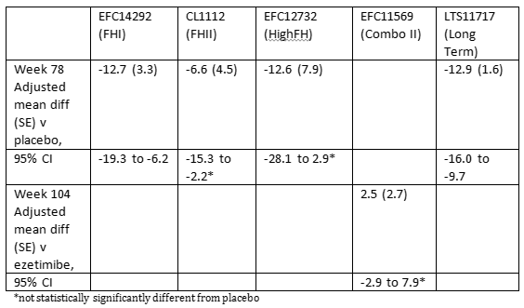
The sponsor has proposed to include a mention of treating to LDL-C target in the statement in the indication that relates to statin therapy. In the proposal the targeted LDL-C reduction applies only to statin therapy and not to other therapies and this distinction has not been justified. As noted by the clinical evaluator patients are not always treated to a specific LDL-C target.
The sponsor has proposed to include patients for whom statins are contraindicated. This group includes pregnant and lactating women. These patients groups were not included in clinical studies and specific inclusion in indication would normally require clinical data that support the safety and efficacy of alirocumab for that group which in this case is missing.
The view of the ACM is sought regarding the sponsor’s request for this indication, but the preliminary conclusion is that the new evidence presented in this submission is not sufficiently persuasive in the absence of cardiovascular outcomes data to broaden the indication.

Dose
Pending the advice of the ACM, the proposed 300 mg Q4W dose as an alternative starting dose is acceptable.

Data deficiencies
As noted with the original submission for alirocumab, there are still no data in patients with severe hepatic impairment, patients with HoFH and patients requiring plasmapheresis. There are limited data in patients with severe chronic kidney disease and no dedicated study to consider the PK, safety and efficacy in these patients. There remain no data in children but the sponsor has not requested paediatric use. Although the new information provides longer term efficacy and safety data the cardiovascular outcome study is awaited.

Conditions of registration
The following is an outline of the conditions of registration upon which the sponsor is invited to comment:
Implement EU-RMP (version 3.0, date 12 January 2017; DLP 14 December 2016) with Australian Specific Annex (version 2.1, date 31 March 2017) and any future updates as a condition of registration.

Questions for the sponsor
- The sponsor has included a new instruction in the Dosage and Administration section of the PI about the administration of the 300 mg SC dose as two injections. How far apart from each other should the injection sites be located? How soon after the first injection should the second be given?
- Have any factors been identified that predict the degree of PCSK9 target engagement and target saturation with initial dosing of alirocumab? If so, have these factors been validated as predictors of the need for up titration to a higher dose early in treatment?
- How has the sponsor addressed the issue of the pre-filled pen jamming or being difficult to activate, as identified in the Integrated Safety Summary?
- In the clinical evaluation report (in Table 20) 6 alirocumab patients had a CHD death but in Table 21 there are only 4. Please explain the reason for the difference.
- Please provide a comparison of the frequencies of new onset diabetes for alirocumab versus the study comparators. Please compare events occurring on 150 mg Q2W with events on other doses.
- The sponsor has added to the statement about individuals with PCSK9 loss of function mutations that they have normal triglycerides. Please justify this inclusion.

Summary of Issues
The sponsor has provided the final study reports for 5 studies, the interim studies from which were provided in the initial submission. The sponsor has not provided the results of the cardiovascular outcomes study that is still underway.
The issue is whether there is now sufficient evidence to support the sponsor’s requested broader indication. In particular, whether there is sufficient evidence to support the use in patients with non-familial hypercholesterolaemia or mixed dyslipidaemia that do not have heFH or clinical atherosclerotic cardiovascular disease, or in the absence of sufficient direct evidence, whether the safety and efficacy is now sufficiently well characterised to allow extrapolation of the safety and efficacy to patients without clinical atherosclerotic cardiovascular disease.
A new starting dose of 300 mg Q4W is proposed. The issue is whether the difference in C_{max} between the currently approved doses and the proposed dose poses a new safety concern.

Proposed action
The Delegate was not in a position to say, at this time, that the application for the extension of indication for alirocumab should be approved.

Request for ACPM advice
The committee is requested to provide advice on the following specific issues:
- The following questions seek the committee’s advice about the evidence provided to support the proposed indication;
- The currently approved populations are heterozygous familial hypercholesterolaemia and patients with clinical atherosclerotic cardiovascular disease. Please comment on the whether there is sufficient data to support the inclusion of all patients with non-familial hypercholesterolaemia, including those without clinical atherosclerotic cardiovascular disease.
- The sponsor has requested alirocumab for the use in patients with mixed dyslipidaemia. Please comment on the efficacy and safety of alirocumab to support the treatment of patients with mixed dyslipidaemia, as distinct from other causes of hypercholesterolaemia.
- The sponsor proposes to include patients in the indication for whom a statin is contraindicated. Typical contraindications for a statin include hypersensitivity to statins, active liver disease or unexplained elevations of serum transaminases, pregnancy and lactation and the concomitant use with fusidic acid. Has sufficient evidence been provided to support the inclusion of these populations in the indication for alirocumab as proposed by the sponsor?
- Please comment on the impact of the increased C_{max} and smaller increase in exposure seen with the proposed 300 mg Q4W dosing on its safety? Does the committee concur that this increase in concentration is likely to be mitigated by an increase in clearance, particularly target mediated clearance?
The committee is (also) requested to provide advice on any other issues that it thinks may be relevant to a decision on whether or not to approve this application.

Response from sponsor

Sponsor’s response to questions raised by the Delegate
- The sponsor has included a new instruction in the Dosage and Administration section of the PI about the administration of the 300 mg SC dose as two injections. How far apart from each other should the injection sites be located? How soon after the first injection should the second be given?
In Study R727-CL-1308 (CHOICE I), as for the previous Phase III studies, patients were instructed to administer SC the study drug in the abdomen, thigh, or outer area of the upper arm with recommendation to rotate within an anatomical area or change the anatomical area based on the patient’s preference. All patients received 2 injections Q2W to maintain the treatment blind for the study; for the alirocumab 300 mg Q4W dose regimen, patients received injections every 2 weeks, with active drug alternating with placebo administration. In this particular study therefore, the instructions by the monitoring team were similar with regard to the 2 injections to be administered at each administration, and patients injected either 1/in the same anatomical area with one injection at one side and the second dose in the opposite side (for example, left abdomen then right abdomen, or right thigh then left thigh, or right outer area upper arm then left outer area upper arm), or 2/ in 2 different anatomical areas (for example, abdomen/thigh, or abdomen/outer area upper arm, or thigh/outer area upper arm) (see Table 29). With regard to the time interval between the two injections patients were instructed to inject the second injection right after the first one. Although patients were requested to record the exact time of the dose administration, the exact time of each individual injection was not recorded. Review of the dosing data confirmed that the dose of 300 mg Q4W (or its matching placebo) was always administered on the same day.

Table 29: CL1308: first injection site; patients regardless of concomitant statin therapy (Safety population)
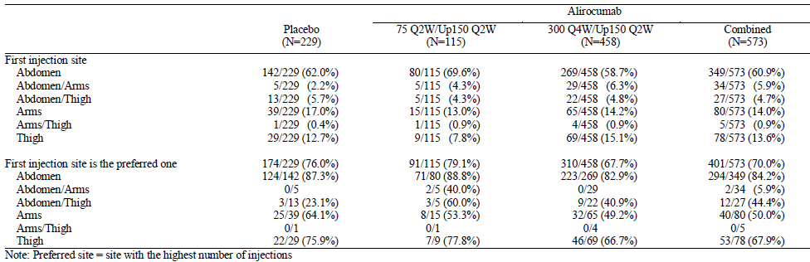
In the current labels approved in the US and in the EU, no specification with regard to the distance between the SC injection sites or the time interval between the two injections is given. The information included in the approved labels in the Section ‘2.2 Important Administration Instructions’ and ‘4.2 Posology and Method of administration’, respectively, consist of the following:
- USPI: ‘Administer Praluent by subcutaneous injection into the thigh, abdomen or upper arm. Rotate the injection site with each injection. To administer the 300 mg dose, give two 150 mg Praluent injections consecutively at two different injection sites. Do not inject Praluent into areas of active skin disease or injury such as sunburns, skin rashes, inflammation, or skin infections.’
- EU Summary of Product Characteristics (SmPC): ‘Praluent is injected as a subcutaneous injection into the thigh, abdomen or upper arm. To administer the 300 mg dose, give two 150 mg injections consecutively at two different injection sites. It is recommended to rotate the injection site with each injection. Praluent should not be injected into areas of active skin disease or injury such as sunburns, skin rashes, inflammation, or skin infections.’
Accordingly, the sponsor is proposing the following text in the AU PI:
Praluent is injected as a subcutaneous injection into the thigh, abdomen or upper arm.
To administer the 300 mg dose, give two 150 mg injections consecutively at two different injection sites.
It is recommended to rotate the injection site with each injection.
Praluent should not be injected into areas of active skin disease or injury such as sunburns, skin rashes, inflammation, or skin infections.
In summary, the proposed updated instructions in the Administration section of the PI for the 300 mg Q4W administration are in agreement with the clinical experience accrued in the CHOICE I Study and in line with the approved US and EU labels.
- Have any factors been identified that predict the degree of PCSK9 target engagement and target saturation with initial dosing of alirocumab? If so, have these factors been validated as predictors of the need for up titration to a higher dose early in treatment?
Overall, patients who were dose adjusted to 150 mg Q2W had, at baseline, higher mean free and total PCSK9 concentrations compared to the patients who were maintained on 300 mg Q4W. After treatment initiation, these patients had lower total alirocumab and total PCSK9 concentrations, less reduction in free PCSK9 concentrations and lower LDL-C reduction. These data are consistent with a higher production of PCSK9 leading to a higher rates of target (that is, PCSK9) mediated clearance of alirocumab. However, in clinical practice it is not feasible to use pre-treatment PCSK9 levels as a clinical factor for determining the patients who will have to be dose adjusted.
It should be noted that in alirocumab clinical development, patients were dose adjusted to the 150 Q2W regimen based on their LDL-C response. After this dose adjustment, these patients achieved a further reduction of free PCSK9 and a further reduction in LDL-C. Patients initiated at 300 mg Q4W achieved, after dose adjustment to 150 mg Q2W, similar concentrations of total and free PCSK9 and similar reduction in LDL-C than patients who did not required a dose adjustment. By using a simple titration step based on the clinical reduction in LDL-C, the level of target engagement achieved with either the 75 mg Q2W/150 mg Q2W dosing regimen or the 300 mg Q4W/150 mg Q2W dosing regimen is consistent for all patients. These results indicate that LDL-C reduction can be used empirically as a clinical marker to identify patients who did not achieve target saturation with the starting dose and require dose adjustment to the 150 mg Q2W dose.
- How has the sponsor addressed the issue of the pre-filled pen jamming or being difficult to activate, as identified in the Integrated Safety Summary?
As described in the ISS, device related events were collected on a case by case basis when a patient faced an issue with the device using a Patient Complaint Form filled in at the site level.
The process related to this complaint implied that once the Patient Complaint Form was completed, the site sent this form to the Research and Development complaint office, where the type of complaint was determined: whether the complaint was packaging related or potentially due to device issue or patient use. All complaint samples which were potentially due to device issue or patient use were then requested to be sent to the Site Frankfurt Devices (SFD)/Product Technical Complaint (PTC) Centre that after investigation, classified into the following categories: ‘activation difficulty/fault’, ‘air bubbles’, ‘broken component’, ‘device is jammed’, ‘click/click sound missing’, ‘injection time’, ‘leakage’, ‘needle’, ‘packaging issue’, ‘other’, or ‘unknown’.
Based on this investigation it was observed that few patients using the prefilled pen (prefilled pen reported device related events (placebo controlled pool: 70 (9.1%) and 23 (6.0%) in the alirocumab and placebo groups, respectively; ezetimibe controlled pool: 72 (8.3%) and 17 (2.8%) for alirocumab and placebo for alirocumab, respectively). More particularly a limited number of these patients reported more than one device related event (18 and 5 patients in the alirocumab and placebo groups respectively for the placebo controlled pool; 23 and 1 patients for alirocumab and placebo for alirocumab, respectively for the ezetimibe controlled pool). The most frequent device related events were ‘device is jammed, ‘activation difficulty / fault’ and ‘click/click sound missing’. No particular safety concern associated with these device related events emerged.
Through this investigation it was also possible, when referring to the total number of doses administered of alirocumab, to determine the frequency of device related events that ranged from 0.51% and 0.62% depending on the pools, placebo or ezetimibe controlled pool.
The process followed at the time of the ODYSSEY Phase III program to record and collect any issue with the prefilled pen is continuing, and was implemented in all clinical studies to allow for identifying any failure of the device and to guide the efforts to evaluate and mediate patient risk through implementation of appropriate action plans.
Since the initiation of the Phase III program, a number of controls have been put in place to modulate the rate of prefilled pen related product technical complaints:
- [information redacted]
- [information redacted]
- To support usability of the prefilled pen, the sponsor has implemented a number of measures related to availability of training videos, training devices, and initial prefilled pen training by health care professionals. These efforts are intended to ensure that patients are able to properly actuate the device by following the instructions for use.
These different measures have led to a rapid reduction in product technical complaints rates estimated now at 0.22%. Continued efforts are maintained to further minimise device defects.
- In the clinical evaluation report (Attachment 2) in Table 20, 6 alirocumab patients had a CHD death but in Table 21 there are only 4. Please explain the reason for the difference.
The sponsor confirmed that data provided in Table 20 and Table 21 are correct.
Table 20 shows the summary of all deaths as per adjudication results, whereas Table 21 shows the summary of the deaths as per adjudication results occurring during the TEAE period. The difference for CHD death in the alirocumab group between Table 20 and Table 21 is explained by the addition in Table 20 of the 2 post treatment emergent deaths (that is, date of death after the end of the TEAE period) adjudicated as ‘CHD death’.
Review of the clinical study report (CSR) Study LTS11717- Section 16.2.7-AE-data (Table 16.2.7.9.6) entitled ‘Listing of deaths – Safety population’ shows that among the 6 alirocumab treated patients who had a CHD death as per adjudication, in 4 patients, the death occurred during the TEAE period and in the 2 other patients, the death occurred in the post TEAE period.
The list of alirocumab patients with CHD death as per adjudication and the time to occurrence of the fatal events are summarised in Table 30.
Table 30: LTS11717: CHD deaths as per adjudication in the alirocumab group. Time to occurrence of the events
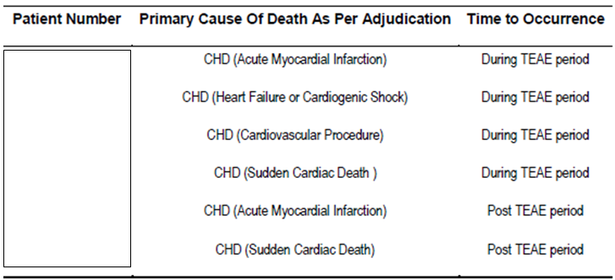
- Please provide a comparison of the frequencies of new onset diabetes for alirocumab versus the study comparators. Please compare events occurring on 150 mg Q2W with events on other doses
As done in the initial submission of the alirocumab Q2W dose regimen that included 5 Phase III studies with the primary endpoint analysis completed but still ongoing, exploratory analyses on the frequencies of new onset diabetes were performed on the updated pool of Phase III placebo controlled studies and the updated pool of ezetimibe controlled studies that assessed the safety of alirocumab Q2W dosing regimen, regardless of the dose of alirocumab. In Study R727-CL-1308 (CHOICE I), the same analysis was performed to compare alirocumab 300 mg Q4W/150 mg Q2W and alirocumab 75 mg Q2W/150 mg Q2W dose regimens to the placebo.
In both the Q2W dosing regimen and the current Q4W dosing regimen submissions, new onset diabetes were defined in patients with normal glucose control at baseline and in patients with impaired glucose control at baseline combining information from AEs and laboratory parameters, as follows:
- Type 1 or 2 diabetes reported as an AE (Custom MedRA Queries (CMQ) ‘Type 1 or Type 2 diabetes’)
- or 2 HbA1c ≥ 6.5%, spaced by at least 2 months
- or 2 consecutive values of fasting blood glucose ≥ 126 mg/dL (7.0 mmol/L).
Potential limitations for these analyses were that;
- many patients had values at baseline close to the defined thresholds between categories, and
- HbA1c was infrequently measured with the changes in drugs or other factors known to possibly affect glucose control/levels that were not accounted for.

Comparison of the frequencies of new onset diabetes for alirocumab versus the study comparators
Analyses were performed on the updated pool of Phase III placebo controlled studies and the updated pool of ezetimibe controlled studies that assessed the safety of the combined alirocumab 75 mg Q2W /150 mg Q2W and alirocumab 150 mg Q2W dosing regimens. These analyses are provided in Table 31.
Table 31: Number of patients with diabetes or impaired glucose control during the TEAE period according to glucose control status at baseline (Safety population); Pool of Phase III placebo controlled studies and Pool of ezetimibe controlled studies
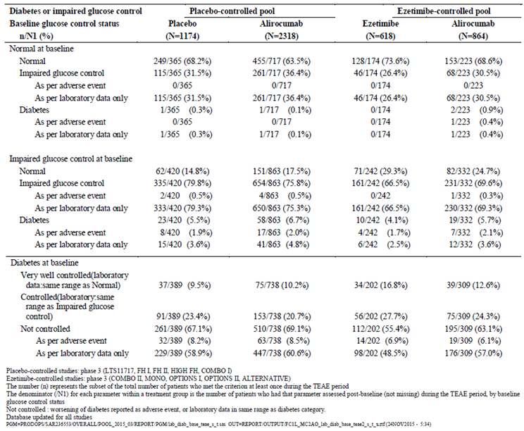
In both pools, the frequencies of new onset diabetes in patients defined with normal glucose control at baseline were low, reported in1 out of 717 patients (0.1%) and 1 out of 365 patients (0.3%) in the alirocumab and the placebo groups, respectively in the pool of Phase III placebo controlled studies, and in 2 out of 223 patients (0.9%) and 0 out of 174 patients in the alirocumab and ezetimibe groups, respectively in the pool of Phase III ezetimibe controlled studies.
In patients defined with impaired glucose control at baseline, new onset diabetes were reported in 58 out of 863 patients (6.7%) and in 23 out of 420 patients (5.5%) in the alirocumab and the placebo groups, respectively in the pool of Phase III placebo controlled studies, and in 19 out of 332 patients (5.7%) and 10 out of 242 patients (4.1%) in the alirocumab and ezetimibe groups, respectively in the pool of Phase III ezetimibe controlled studies.
In summary, in those patients who in majority received concomitant maximally tolerated doses of statins, analysis of the frequencies of new onset diabetes, defined on the combination of adverse event reporting and changes in relevant laboratory parameters did not reveal potentially adverse effects with alirocumab treatment on glucose control, as compared with a placebo or ezetimibe treatment.
The same analysis was performed in Study R727-CL-1308 (CHOICE I). In patients with normal glucose control at baseline, regardless of concomitant statin therapy, new onset diabetes were reported in 1 out of 62 patients (1.6%) in the placebo group, no patients in the alirocumab 75 mg Q2W/ 150 mg Q2W and in 2 out of 122 patients ( 1.6%) in the alirocumab 300 mg Q4W/ 150 mg Q2W group.
In patients with impaired glucose control at baseline, regardless of concomitant statin therapy, new onset diabetes were reported in 3 out of 95 patient (3.2%) in the placebo group, 4 out of 50 (8.0%) in the alirocumab 75 mg Q2W/150 mg Q2W group, and in 8 out of 188 patients (4.3%) in the alirocumab 300 mg Q4W/ 150 mg Q2W group.
In summary, regardless of concomitant statin therapy, the treatment with alirocumab 300 mg Q4W/ 150 mg Q2W does not suggest any effect on the occurrence of new onset diabetes in patients with normal or impaired glucose control at baseline, as compared with the placebo or alirocumab 75 mg Q2W/150 mg Q2W dosing regimen.

Comparison of the frequencies of new onset diabetes events occurring on 75 mg Q2W and 150 mg Q2W
Comparison of the safety data at the dose of 75 or 150 mg Q2W dosing regimen was performed by using the same definition as the analyses performed in the placebo and in the ezetimibe controlled pools, restricted to the subset of studies that included an up titration regimen, that is, according to whether the patients remained on the 75 mg dose or whether they had a dose up titration to 150 mg. Therefore the analysis of the frequencies of new onset diabetes per dose has been performed by considering events from the first injection post Week 12 interactive voice response system (IVRS) transaction to the end of the TEAE period.
In addition, with the potential bias of the analysis due to potential differences in baseline characteristics between patients with dose up titration and patients without dose up titration, another exploratory analysis was performed to compare the frequencies of new onset diabetes between the dose of 150 mg and the up titration regimen in the placebo controlled pool as listed below. The incidences of new onset diabetes are presented in alirocumab group versus placebo group:
- In the sub-pool of Phase III studies using 150 mg Q2W as starting dose: LTS11717, and HIGH FH.
- In the sub-pool of Phase III studies using the up titration regimen (75 mg Q2W potentially up-titrated to 150 mg Q2W): COMBO I, FH I and FH II).

Analyses per dose performed in the placebo- and in the ezetimibe controlled pools restricted to the subset of studies that included an up titration regimen
In studies where an up titration was scheduled at Week 12, based on the LDL-cholesterol results at Week 8 visit, the dose of alirocumab was up-titrated from 75 mg Q2W to 150 mg Q2W from Week 12 onwards until the last injection. Lipid values obtained at Week 8 for the purpose of up titration were not communicated to investigators to maintain the blind. The continuation of the 75 mg dose or dose up titration to the 150 mg dose occurred in an automated process without site or patient awareness.
Approximately one third of patients had an up-titrated dose at Week 12 in both the placebo and the ezetimibe controlled pools. In patients with normal glucose control at baseline, only 2 patients with no dose up titration (1.4%) in the ezetimibe controlled pool were identified with new onset diabetes from the first injection post Week 12. In patients with impaired glucose control at baseline, roughly similar frequencies of new onset diabetes were reported in patients with and without dose up titration in the placebo and the ezetimibe controlled pools (Table 32).
These results do not indicate any potential effect of alirocumab 75 mg or 150 mg Q2W on the occurrence of new onset diabetes.
Table 32: Number of patients with diabetes or impaired glucose control during the TEAE period from first injection post Week 12 according to glucose control status at baseline (Safety population; Patients with at least 1 injection post-IVRS W12 call); Pool of Phase III placebo controlled studies and Pool of ezetimibe controlled studies
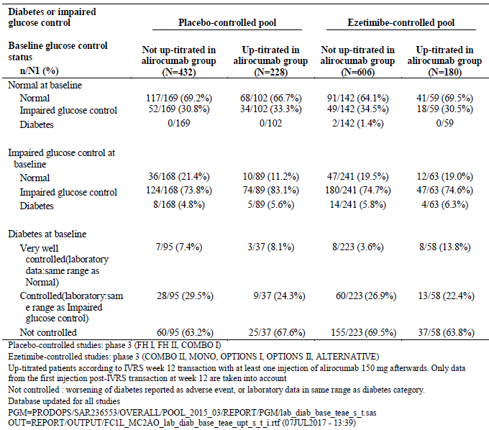
Additional exploratory analyses using the placebo controlled pool
Because no more than one third of alirocumab treated patients had an up titrated dose to 150 mg Q2W at Week 12 in studies with up titration regimen in the placebo controlled pool, the safety of the alirocumab group in these studies is likely more reflecting the safety profile of the 75 mg than the 150 mg dose. Comparison of the safety of alirocumab treated patients in the placebo controlled studies with a starting dose of 150 mg Q2W versus patients with a possible dose up titration provides another head to head assessment of the 150 mg and the 75 mg Q2W dosing regimen. No meaningful differences in the frequencies of new onset diabetes emerged from this comparison both in patients with normal and impaired glucose control at baseline (Table 33).
Table 33: Number of patients with diabetes or impaired glucose control during the TEAE period according to dosing regimen and glucose control status at baseline (Safety population); Pool of Phase III placebo controlled studies
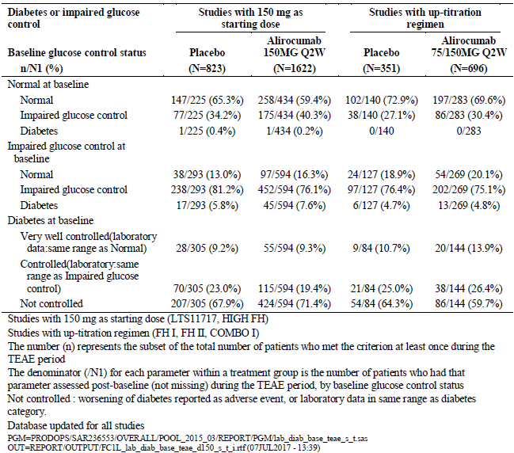

Comparison of the frequencies of new onset diabetes events occurring on 300 mg Q4W and 150 mg Q2W
In the Study R727-CL-1308 (CHOICE I), approximately 20% of the alirocumab treated patients had a dose up titration to 150 mg Q2W, either in the alirocumab 75 mg Q2W/150 mg Q2W or the alirocumab 300 mg Q4W/ 150 mg Q2W group. Therefore the comparison of the alirocumab 75 mg Q2W/ 150 mg Q2W and alirocumab 75 mg Q2W/ 150 mg Q2W groups can be assimilated to the comparison of the alirocumab 75 mg Q2W and 300 Q4W dosing regimens.
Q2W and alirocumab 300 mg Q4W/ 150 mg Q2W is provided above, in the section ‘Comparison of the frequencies of new onset diabetes for alirocumab versus the study comparators’.
While no comparison of 300 mg Q4W with 150 mg Q2W dosing regimen can be derived from the safety data collected in the CHOICE I study, the preceding observation of similar frequencies of new onset diabetes in patients treated with alirocumab 150 mg Q2W and alirocumab 75 mg Q2W (in the placebo or ezetimibe controlled pools), and the results in the Study CHOICE I do not suggest any potential dose related effect of alirocumab on the occurrence of new onset diabetes.
- The sponsor has added to the statement about individuals with PCSK9 loss of function mutations that they have normal triglycerides. Please justify this inclusion.
The sponsor confirms that no new statement has been added to this section of the PI. The proposed change is purely editorial, consisting of an expansion of the abbreviation ‘TG’ to ‘triglyceride’.

Sponsor’s response to Delegate’s request for advice from ACM
The sponsor’s comments on the issues for which the advice of the ACM is sought, as outlined in the Delegate’s Overview of 3 July 2017, are presented below.

Changes to the indication
Currently approved indication
Praluent is indicated as an adjunct to diet and exercise in adults with heterozygous familial hypercholesterolaemia or clinical atherosclerotic cardiovascular disease:
- in combination with a statin, or statin with other lipid lowering therapies or,
- in combination with other lipid lowering therapies in patients who are statin intolerant.
The effect of Praluent on cardiovascular morbidity and mortality has not yet been determined (see CLINICAL TRIALS).
Revised proposed indication
Praluent is indicated as an adjunct to diet and exercise in adults with primary hypercholesterolaemia (heterozygous familial and non-familial) or mixed dyslipidaemia:
- in combination with a statin or statin with other lipid lowering therapies in patients unable to reach LDL-C goals or,
- in combination with other lipid lowering therapies in patients who are statin intolerant, or for whom a statin is contraindicated.
The effect of Praluent on cardiovascular morbidity and mortality has not yet been determined (see CLINICAL TRIALS).

Response to specific request for advice
- The following questions seek the committee’s advice about the evidence provided to support the proposed indication.
- The currently approved populations are heterozygous familial hypercholesterolaemia and patients with clinical atherosclerotic cardiovascular disease. Please comment on whether there is sufficient data to support the inclusion of all patients with non-familial hypercholesterolaemia, including those without clinical atherosclerotic cardiovascular disease.
- The sponsor has requested alirocumab for the use in patients with mixed dyslipidaemia. Please comment on the efficacy and safety of alirocumab to support the treatment of patients with mixed dyslipidaemia, as distinct from other causes of hypercholesterolaemia.
- The sponsor proposes to include patients in the indication for whom a statin is contraindicated. Typical contraindications for a statin include hypersensitivity to statins, active liver disease or unexplained elevations of serum transaminases, pregnancy and lactation and the concomitant use with fusidic acid. Has sufficient evidence been provided to support the inclusion of these populations in the indication for alirocumab as proposed by the sponsor?
It should be noted that the sponsor had agreed to exclude monotherapy from the proposed indication. The sponsor also acknowledges the lack of CV outcome data from the CV outcomes study, however it should be emphasised that data accumulated with alirocumab through the program of Phase III studies were in patients at high and very high risk, that is patients with atherosclerotic vascular disease (ASCVD) for the vast majority, that encompassed the different populations, heFH patients, non FH patients including those with mixed dyslipidaemia, and a positive trend with regard to the CV outcome data was observed along with the substantial reduction in LDL-C.
The ODYSSEY Phase III studies evaluated a broader population, involving 5,296 patients who were either heFH or non FH patients at high CV risk, including patients with other CV risk factors such as diabetes or mixed dyslipidaemia. Overall, 5,138 patients (97.0%) were at high/very high CV risk, and the vast majority had atherosclerotic vascular disease (ASCVD); among those with clinical ASCVD 64.1% had a history of CHD. It has also to be noted that across the ten Phase III studies, 2,025 patients (38.2%) had mixed dyslipidaemia (baseline TG ≥ 150 mg/dL (1.7 mmol/L)) and 1,629 patients (30.8%) reported a history of Type 2 diabetes mellitus.
As mentioned above, 2,025 (38.2%) patients had mixed dyslipidaemia (defined as fasting TGs ≥ 150 mg/dL (1.7 mmol/L) in addition to hypercholesterolemia); this proportion ranged from 21.3% in studies with heFH patients to up to 52.2% in studies carried out in high/very high CV risk patients. A similar pattern in terms of effect on LDL-C was seen in patients with mixed dyslipidaemia as compared with the overall population, regardless of the evaluated population with dyslipidaemia (heFH or non-FH), the background therapy (statins/other LMTs or not), and the dose/regimen of alirocumab (75/150 mg or 150 mg Q2W), as shown in Figures below (Figure 5 for patients with mixed dyslipidaemia and Figure 6 for the overall population).
Figure 5: Percent change from baseline in calculated LDL-C at Week 24: MMRM (ITT analysis in patients with mixed dyslipidaemia); Phase III studies
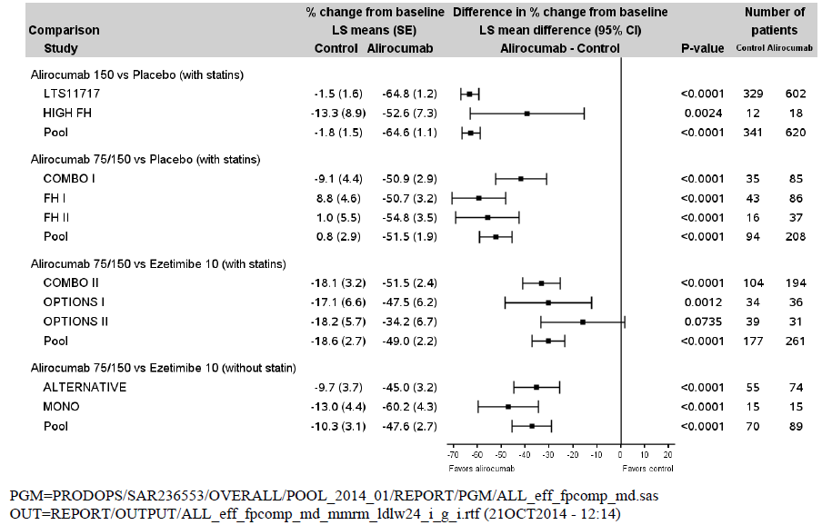
Figure 6: Percent change from baseline in calculated LDL-C at Week 24: MMRM (ITT analysis); Phase III studies
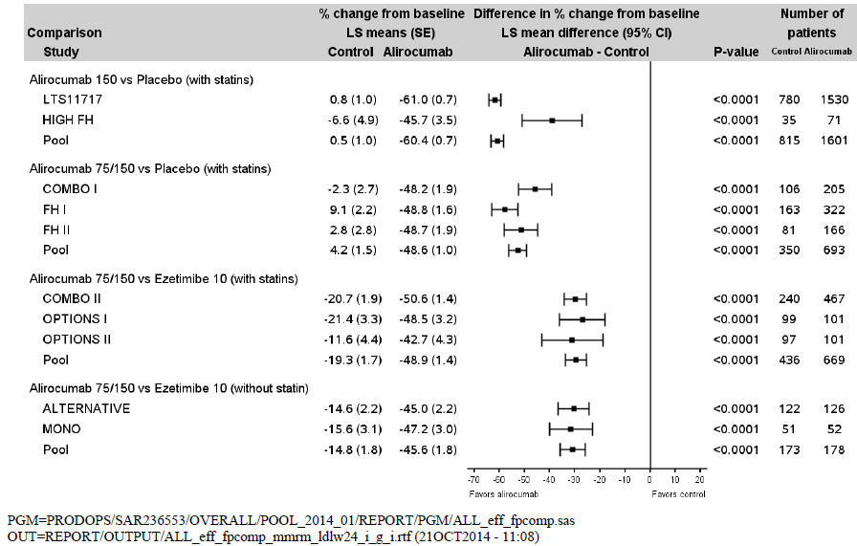
In the context of the clinical development for alirocumab, the incidence of major adverse CV events was found to be reduced in prespecified exploratory analyses, but the number of events was low. In the long-term safety and tolerability of alirocumab in high cardiovascular risk patients with hypercholesterolemia not adequately controlled with their lipid modifying therapy (ODYSSEY LONG TERM) trial, involving adult patients at high risk for CV disease and receiving maximally tolerated dose of statin with or without other lipid lowering therapy, alirocumab (150 mg administered SC every 2 weeks) lowered LDL cholesterol (LDL-C) levels by 61% over 78 weeks, as compared with an increase of 0.8% in LDL-C levels with placebo. The rate of major adverse CV events (death from coronary heart disease, nonfatal myocardial infarction, fatal or nonfatal ischemic stroke, or unstable angina requiring hospitalization) was lower with alirocumab than with placebo (1.7% versus 3.3%; HR, 0.52; 95% confidence interval, 0.31 to 0.90; nominal p = 0.02). It has to be noted that similar observation was seen with evolocumab in 2 open label, randomised extension studies.
Evaluation of the CV benefit with alirocumab is ongoing through the ongoing study, ODYSSEY OUTCOMES, which is a randomised, double blind, placebo controlled trial involving more than 18,000 patients with acute coronary syndrome within a year of entering the trial.
Recent available data from CV outcomes clinical trials support the CV benefit of PCSK9 inhibition with monoclonal antibodies, as summarised below:
- The large CV outcomes study conducted with evolocumab, the further cardiovascular outcomes research with PCSK9 inhibition in subjects with elevated risk (FOURIER) multinational trial, demonstrated the efficacy of evolocumab with regard to CV events in 27,564 high risk patients who were followed for a median of 2.2 years. The primary end point, a composite of cardiovascular death, myocardial infarction, stroke, hospitalization for unstable angina, or coronary revascularization, occurred in 9.8% of evolocumab treated patients, as compared with 11.3% of patients who received matching placebo, which corresponded to a 15% risk reduction (HR, 0.85; 95% confidence interval (CI), 0.79 to 0.92; p < 0.001). In addition, a 20% risk reduction (HR, 0.80; 95% CI, 0.73 to 0.88; p < 0.001) was achieved with respect to the key secondary efficacy end point, a composite of cardiovascular death, myocardial infarction, or stroke.
- As part of the studies of PCSK9 inhibition and the reduction of vascular events (SPIRE) program, two large scale trials to evaluate CV outcomes (designated SPIRE-1 and SPIRE-2) were initiated with the intent of evaluating the clinical efficacy and safety of bococizumab administered at a dose of 150 mg subcutaneously every 2 weeks among patients who had evidence of cardiovascular disease or who were at high risk for a first vascular event. Both studies were prematurely discontinued after data became available from Phase III bococizumab studies, conducted in the LDL-C lowering indication, indicating that bococizumab was commonly associated with the development of high titre antidrug antibodies that resulted in substantive attenuation of LDL-C lowering over time. Bococizumab, unlike evolocumab and alirocumab, is a humanised monoclonal antibody in which approximately 3% of the murine sequence remains in the antigen binding complementarity determining region. In the lower risk, shorter duration trial (SPIRE-1), among the patients who had LDL-C levels of t least 70 mg/dL (1.8 mmol/L) at baseline, the composite primary end point of nonfatal MI, nonfatal stroke, hospitalisation for unstable angina requiring urgent revascularisation, or cardiovascular death occurred in 173 patients each in the bococizumab and the placebo groups (HR, 0.99; 95% confidence interval (CI), 0.80 to 1.22; p = 0.94). By contrast, in the higher risk, longer duration trial (SPIRE-2), in which patients had a baseline LDL-C of at least 100 mg/dL (2.6 mmol/L), the composite primary end point occurred in 179 (3.3%) patients in the bococizumab group and in 224 (4.2%) patients in the placebo group (HR, 0.79; 95% CI, 0.65 to 0.97; p = 0.02). Thus, in these two randomised trials, comparing the PCSK9 inhibitor bococizumab with placebo, that were prematurely discontinued, no significant benefit of bococizumab was observed on the primary end point in the SPIRE-1 trial in which there was a shorter observation period of lower risk patients as compared with a significant benefit in the SPIRE-2 trial where patients were at higher risk and were treated for a longer period.
Based on the initial submission, the data for the ODYSSEY Phase III program supports a favourable benefit-risk profile for alirocumab across the different evaluated populations, with a significant reduction of LDL-C levels in both the heFH and non FH populations and acceptable safety profile. With the completion of the studies still ongoing at the time of the initial submission, efficacy of alirocumab was confirmed over time with a maintenance of the efficacy up to 2 years. As well as longer term alirocumab safety data confirm the good safety profile in long term use and are consistent with the safety profile reported at the time of Praluent registration. In addition the positive trend with regard to the CV outcome data observed in the alirocumab Phase III studies and the confirmation of a significant reduction in CV events seen through the PCSK9 inhibition by other monoclonal antibodies are strong indicators in favour of an effect on the reduction in CV events with alirocumab as well.
Lastly, the sponsor acknowledges the Delegate’s comment related to patients for whom statins are contraindicated. In these statin contraindicated patients for whom treatment choice is restricted, the Praluent PI supports the following:
- statin intolerant patients are included in the approved Praluent indication
- the sponsor acknowledges that pregnant/lactating patients have not been studied in alirocumab clinical studies. Based on evaluated nonclinical data, alirocumab may be considered as a treatment choice during pregnancy only if the potential benefit justifies the potential risk to the fetus (Category B1)
- alirocumab should be used with caution in patients with severe hepatic impairment
- alirocumab may provide a suitable alternative for patients taking concomitant medications that are contraindicated with statin use. Since alirocumab is a biologic, no pharmacokinetic effects of alirocumab on other medicinal products are anticipated. Clinical studies indicate that cytochrome P450 enzymes (mainly CYP3A4 and CYP2C9) and transporter proteins such as P-gp and OATP are unaffected by alirocumab.
- Please comment on the impact of the increased C_{max} and smaller increase in exposure seen with the proposed 300 mg Q4W dosing on its safety? Does the committee concur that this increase in concentration is likely to be mitigated by an increase in clearance, particularly target mediated clearance?
With regard to the pharmacokinetics of the 300 mg Q4W dosing regimen, although an increase in C_{max} was observed, this observation is not translated by a significant increase in exposure and any safety concern as compared with the approved doses of 75 mg and 150 mg Q2W. In particular, in the Study CHOICE I despite a higher frequency in injection site reactions seen with 300 mg Q4W as compared with 75 mg Q2W and placebo, several aspects of the study design may have contributed to this higher frequency in the 300 mg Q4W arm. Our assessment, overall, is that there are no new major safety concerns with injection site reactions under a 300 mg Q4W regimen.
Monthly alirocumab exposures (AUC₀₋₆₇₂) with the 300 mg Q4W dosing regimen are very close to those observed with the 150 mg Q2W dosing regimen, which is consistent with the linear kinetics observed at these high doses when the target (PCSK9) is saturated. This is expected based on the saturation of the target-mediated clearance of alirocumab at these dosages, as explained by a complete or nearly complete binding of free PCSK9 through the whole dosing interval. Although the dose of 300 mg Q4W results in higher mean C_{max} value (1.5 to 1.7 fold increase) compared to that observed at 150 mg Q2W, both of these high concentrations saturate the target and thus any difference with respect to safety or efficacy was not expected as confirmed by the results obtained through the Study CHOICE I.
Alirocumab at a dose of 300 mg Q4W, with dose adjustment to 150 mg Q2W if needed, was generally well tolerated. Consistent with the data in the initial submission, no dose effects were identified in the new data and there were no population effects (concomitant statin versus no statin).
When focusing on the adverse events of special interest (AESI) that included allergic events, local injection site reactions, confirmed haemolytic anaemia, prespecified increases in ALT, neurologic disorders, neurocognitive disorders, ophthalmologic disorders, pregnancy, and overdose, alirocumab 300 mg Q4W/150 Q2W use was not associated with an increased incidence of any AESI with the exception of injection site reactions. However there are several aspects of the Study CHOICE I design that may have contributed to this higher frequency of injection site reactions in the 300 mg Q4W arm.
Indeed, in the CHOICE I Study, two dosing regimens were evaluated, an every two weeks regimen and an every four weeks regimen with possibility of adjustment to Q2W (75 mg/150 mg Q2W, and 300 mg Q4W/150 mg Q2W, respectively). Therefore all patients received 2 injections of study treatment Q2W in order to keep the built in double dummy design, and patients who were randomised to the 300 mg Q4W group received injections Q2W, with active drug alternating with placebo administration.
In the 300 Q4W/150 Q2W arm patients, overall the proportion of patients reporting injection site reactions was 16.6% considering all injections: active or placebo. However, injection site reactions were not only reported after active injections throughout the study, some were indeed reported after the placebo injections only. Therefore, if we censor the injection site reactions reported at or after ‘the placebo injections only’ (4.8%, 22/458), the incidence of injection site reactions reported at or after both ‘active and placebo injections’ and ‘active injections only’ (11.8%, 54/458) is comparable to the incidence rate observed in the 75/150 Q2W arm (9.6%, 11/115) (Table 34).
Table 34: Summary of local injection site reaction TEAE(s) according to placebo or active injections; patients regardless of concomitant statin therapy; Safety population
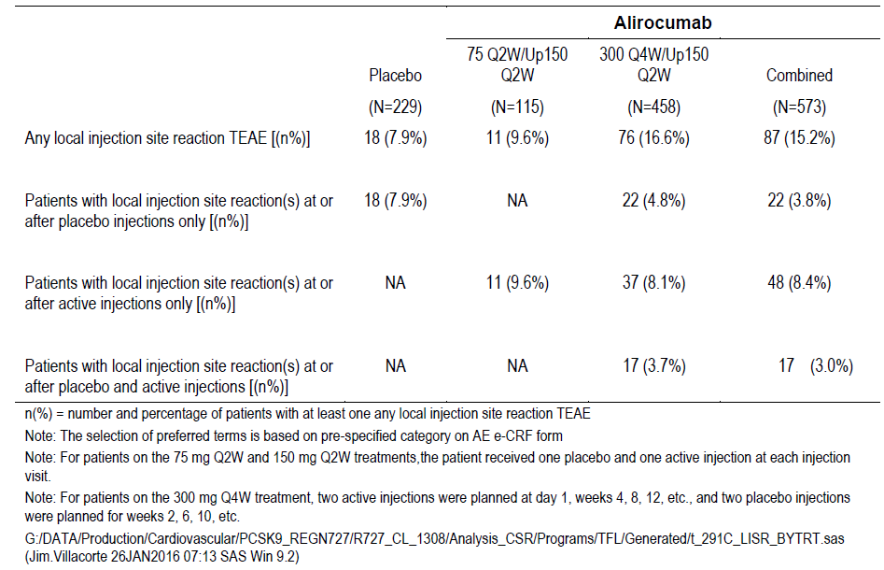
A similar analysis was done when only the 300 mg Q4W dose was administered throughout the study. A total of 344 patients out of the 458 randomised to the 300 mg Q4W arm (75.1%), and a total of 83 patients out the 115 randomised to the 75 mg Q2W arm (72.2%) remained under their respective regimen (that is, no dose adjustment to 150 mg Q2W at Week 12). In this additional analysis of the injection site reactions conducted in these patients receiving the same dose over 48 weeks, it was shown that, in patients receiving 300 mg Q4W the incidence rate of injection site reactions reported overall was 16.0% regardless of whether they received active or placebo injections; however the incidence rate was 6.1% (21 out of 344) for injection site reactions reported at or after ‘the placebo injections only’ and 9.9% (34 out of 344) for injection site reactions reported at or after both, ‘active and placebo injections’ and ‘active injections only’. This incidence rate of 9.9% observed with the 300 mg Q4W dose is again comparable to that of injection site reactions in patients who remained on the 75 mg Q2W dose during the whole 48 week study, 8.4% (7 out of 83). This observation, that is supported by an incidence rate of ISRs of 7.9% (18 out of 229) observed in the placebo arm during the same period, demonstrates the lack of a relationship between the incidence rate of injection site reactions and the amount of the product injected per injection occasion (Table 35).
Table 35: Summary of local injection site reaction TEAE(s) according to placebo or active injections; patients not up-titrated; patients regardless of concomitant statin therapy; Safety population
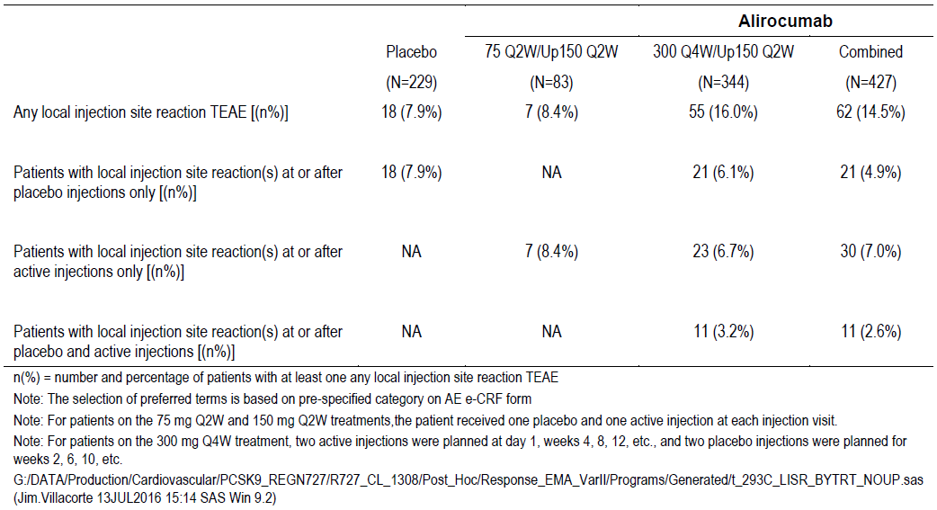
Similar observation was seen in the analysis of injection site reactions occurring up to Week 12, that is, prior to any dose adjustment. In the 300 mg Q4W arm, ISRs occurring regardless of the active or placebo injections had an incidence rate of 12.7%, whereas when considering injection site reactions reported at or after both, ‘active and placebo injections’ and ‘active injections only’ the incidence rate was 7.9% (36/458), which is not different from the incidence rate of injection site reactions observed in the 75 mg Q2W arm over the same period (6.1%, 7/115). The incidence rate of ISRs was 4.8% (11/229) in the placebo arm (Table 36).
Table 36: Summary of local injection site reaction TEAE(s) up to Week 12 according to placebo or active injections; patients regardless of concomitant statin therapy; Safety population
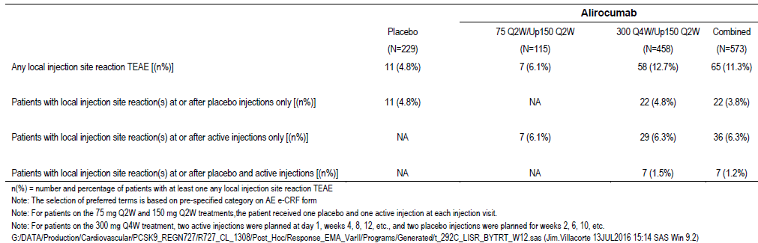
Further, when evaluating the incidence rate of injection site reactions per number of injections received overall for 300 mg Q4W and 75 mg Q2W, the median numbers of injection site reactions per injection occasions are 0.03, and 0.04, respectively. These ratios are comparable to the ratio observed in the placebo group (median of 0.02).
Overall in the Study CHOICE I, the safety profile of alirocumab 300 Q4W/150 Q2W is consistent with that reported in the initial submission despite the observation of an increased C_{max} with this dosing regimen. With regard to the double dummy design, the incidence rate of injection site reactions is comparable to the 75/150 Q2W arm (9.6%) when considering the injection site reactions reported at or after both, ‘active and placebo injections’ and ‘active injections only’ (11.8%). Therefore considering the differences in study design, the incidence of injection site reactions in the Study CHOICE I was not so different from that reported in the initial submission for the 75 /150 Q2W dosing regimen (6.1%). Consequently, the sponsor considers that injection site reactions occur with a similar frequency with the 300 mg Q4W regimen as with the other Praluent regimens.
Taking into account the evaluator’s recommendation for the PI and in light of this updated information, the sponsor has revised the text in the PI in line with the information described in this response.

Advisory committee considerations
The Advisory Committee on Prescription Medicines (ACPM), having considered the evaluations and the Delegate’s overview, as well as the sponsor’s response to these documents, advised the following:
The ACM taking into account the submitted evidence of efficacy, safety and quality, agreed with the Delegate and considered Praluent, pre-filled syringe, pre-filled pen containing 75 mg/mL and 150 mg/mL of alirocumab to have an overall positive benefit-risk profile for the Delegate’s amended indication:
Praluent is indicated as an adjunct to diet and exercise to reduce LDL-C in adults with one or more of: heterozygous familial hypercholesterolaemia, clinical atherosclerotic cardiovascular disease, or hypercholesterolemia with high or very high cardiovascular risk.
- In combination with a statin, or statin with other lipid lowering therapies in patients unable to reach LDL-C goals with maximum tolerated dose of a statin or,
- In combination with other lipid lowering therapies in patients who are statin intolerant or for whom a statin is contraindicated who are unable to reach LDL-C goals.
The effect of Praluent on cardiovascular morbidity and mortality has not yet been determined (see CLINICAL TRIALS).
In making this recommendation the ACM:
- noted sponsor has not provided results of cardiovascular outcomes study (is still underway)
- noted data to support sponsor’s indication
- noted difference in C_{max} between current and proposed starting dose.

Proposed conditions of registration
The ACM agreed with the Delegate on the proposed conditions of registration and advised on the inclusion of the following:
- Subject to satisfactory implementation of the RMP most recently negotiated by the TGA.
- Negotiation of the PI and Consumer Medicine Information to the satisfaction of the TGA.

Specific advice
The ACM advised the following in response to the Delegate’s specific questions on the submission:
- The following questions seek the committee’s advice about the evidence provided to support the proposed indication.
- The currently approved populations are heterozygous familial hypercholesterolaemia and patients with clinical atherosclerotic cardiovascular disease. Please comment on the whether there is sufficient data to support the inclusion of all patients with non-familial hypercholesterolaemia, including those without clinical atherosclerotic cardiovascular disease.
The ACM noted there was not sufficient data to support the inclusion of all patients with non-familial hypercholesterolaemia.
- The sponsor has requested alirocumab for the use in patients with mixed dyslipidaemia. Please comment on the efficacy and safety of alirocumab to support the treatment of patients with mixed dyslipidaemia, as distinct from other causes of hypercholesterolaemia.
The ACM agreed that if the patient group was at very high/high risk only for cardiovascular event and mixed dyslipidaemia then the efficacy and safety data provided for this submission of alirocumab was supportive of the treatment for that patient group.
- The sponsor proposes to include patients in the indication for whom a statin is contraindicated. Typical contraindications for a statin include hypersensitivity to statins, active liver disease or unexplained elevations of serum transaminases, pregnancy and lactation and the concomitant use with fusidic acid. Has sufficient evidence been provided to support the inclusion of these populations in the indication for alirocumab as proposed by the sponsor?
ACM accepts prescription in cases where a statin is contraindicated and the prescriber believes that the benefits outweigh the risks, recognising an absence of data regarding alirocumab use and hypersensitivity to statins, active liver disease or unexplained elevations of serum transaminases, pregnancy and lactation and the concomitant use with fusidic acid.
- Please comment on the impact of the increased C_{max} and smaller increase in exposure seen with the proposed 300 mg Q4W dosing on its safety? Does the committee concur that this increase in concentration is likely to be mitigated by an increase in clearance, particularly target mediated clearance?
The ACM agreed that the increased C_{max} and smaller increase in exposure seen with the proposed 300 mgQ4W dosing, and increase in concentration is acceptable.
The ACM advised that implementation by the sponsor of the recommendations outlined above to the satisfaction of the TGA, in addition to the evidence of efficacy and safety provided would support the safe and effective use of this product.

Outcome
Based on a review of quality, safety and efficacy, TGA approved the registration of Praluent alirocumab (rch) 75 mg/mL and 150 mg/mL solution for injection, pre-filled pen and pre-filled syringe:
Praluent is indicated as an adjunct to diet and exercise to reduce LDL-C in adults with one or more of: heterozygous familial hypercholesterolaemia, clinical atherosclerotic cardiovascular disease, or hypercholesterolemia with high or very high cardiovascular risk.
- In combination with a statin, or statin with other lipid lowering therapies in patients unable to reach LDL-C goals with maximum tolerated dose of a statin or,
- In combination with other lipid lowering therapies in patients who are statin intolerant or for whom a statin is contraindicated who are unable to reach LDL-C goals.
The effect of Praluent on cardiovascular morbidity and mortality has not yet been determined (see CLINICAL TRIALS).

Specific conditions of registration applying to these goods
The alirocumab EU-Risk Management Plan (EU-RMP), version 3.0, date 12 January 2017; DLP 14 December 2016) with Australian Specific Annex (version 2.1, date 31 March 2017), included with submission PM-2016-01950-1-3, and any subsequent revisions, as agreed with the TGA will be implemented in Australia.

Attachment 1. Product Information
The PI for Praluent approved with the submission which is described in this AusPAR is at Attachment 1. For the most recent PI, please refer to the TGA website at <https://www.tga.gov.au/product-information-pi>.

Attachment 2. Extract from the Clinical Evaluation Report

Therapeutic Goods Administration
PO Box 100 Woden ACT 2606 Australia
Email: info@tga.gov.au Phone: 1800 020 653 Fax: 02 6232 8605
https://www.tga.gov.au

The submission included other trade names but these were withdrawn during the process of the submission.
Submission of CHOICE I only, dossier appropriate according to the approved indication
MMRM = Mixed effect model with repeated measures
Routine risk minimisation activities may be limited to ensuring that suitable warnings are included in the product information or by careful use of labelling and packaging. Routine pharmacovigilance practices involve the following activities: - All suspected adverse reactions that are reported to the personnel of the company are collected and collated in an accessible manner; - Reporting to regulatory authorities; - Continuous monitoring of the safety profiles of approved products including signal detection and updating of labelling; - Submission of PSURs; - Meeting other local regulatory agency requirements.
HbA1c (haemoglobin A1c or glycosylated haemoglobin) which identifies average plasma glucose concentration which is used as an indicator of how well the diabetes is controlled.
AusPAR Attachment 2 Extract from the Clinical Evaluation Report for Alirocumab (rch) <https://www.tga.gov.au/sites/default/files/auspar-alirocumab-rch-161213-cer.pdf>
Robinson JG, et al. Efficacy and safety of alirocumab in reducing lipids and cardiovascular events. N Engl J Med 2015; 372: 1489-1499.
Sabatine MS, et al. Efficacy and safety of evolocumab in reducing lipids and cardiovascular events; Open-Label Study of Long-Term Evaluation against LDL Cholesterol (OSLER) Investigators. N Engl J Med 2015; 372: 1500-1509.
Schwartz GG et al., Effect of alirocumab, a monoclonal antibody to PCSK9, on long-term cardiovascular outcomes following acute coronary syndromes: rationale and design of the ODYSSEY outcomes trial, Am Heart J. 2014; 168: 682-689.
Sabatine MS, et al. Evolocumab and clinical outcomes in patients with cardiovascular disease. N Engl J Med 2017; 376:1713-22.
Ridker PM, et al. Evaluating bococizumab, a monoclonal antibody to PCSK9, on lipid levels and clinical events in broad patient groups with and without prior cardiovascular events: rationale and design of the Studies of PCSK9 Inhibition and the Reduction of vascular Events (SPIRE) Lipid Lowering and SPIRE Cardiovascular Outcomes Trials. Am Heart J 2016; 178: 135-44.
Ridker PM, et al. Cardiovascular efficacy and safety of bococizumab in high-risk patients. N Engl J Med 2017; 376: 1527-39.
Pregnancy Category B1 is defined as ‘Drugs which have been taken by only a limited number of pregnant women and women of childbearing age, without an increase in the frequency of malformation or other direct or indirect harmful effects on the human fetus having been observed. Studies in animals have not shown evidence of an increased occurrence of fetal damage.’
The ACM provides independent medical and scientific advice to the Minister for Health and the Therapeutic Goods Administration (TGA) on issues relating to the safety, quality and efficacy of medicines supplied in Australia including issues relating to pre-market and post-market functions for medicines. The Committee is established under Regulation 35 of the Therapeutic Goods Regulations 1990. Members are appointed by the Minister. The ACM was established in January 2017 replacing Advisory Committee on Prescription Medicines (ACPM) which was formed in January 2010. ACM encompass pre and post-market advice for medicines, following the consolidation of the previous functions of the Advisory Committee on Prescription Medicines (ACPM), the Advisory Committee on the Safety of Medicines (ACSOM) and the Advisory Committee on Non-Prescription Medicines (ACNM). Membership comprises of professionals with specific scientific, medical or clinical expertise, as well as appropriate consumer health issues relating to medicines.

