First round report: 30 November 2016
Second round report: 26 April 2017

AusPAR Attachment 2

Extract from the Clinical Evaluation Report for Alirocumab
  - Proprietary Product Name: Praluent
  - Sponsor: Sanofi Aventis Australia Pty Ltd

About the Therapeutic Goods Administration (TGA)
- The Therapeutic Goods Administration (TGA) is part of the Australian Government Department of Health, and is responsible for regulating medicines and medical devices.
- The TGA administers the Therapeutic Goods Act 1989 (the Act), applying a risk management approach designed to ensure therapeutic goods supplied in Australia meet acceptable standards of quality, safety and efficacy (performance), when necessary.
- The work of the TGA is based on applying scientific and clinical expertise to decision-making, to ensure that the benefits to consumers outweigh any risks associated with the use of medicines and medical devices.
- The TGA relies on the public, healthcare professionals and industry to report problems with medicines or medical devices. TGA investigates reports received by it to determine any necessary regulatory action.
- To report a problem with a medicine or medical device, please see the information on the TGA website <https://www.tga.gov.au>
About the Extract from the Clinical Evaluation Report
- This document provides a more detailed evaluation of the clinical findings, extracted from the Clinical Evaluation Report (CER) prepared by the TGA. This extract does not include sections from the CER regarding product documentation or post market activities.
- The words (Information redacted), where they appear in this document, indicate that confidential information has been deleted.
- For the most recent Product Information (PI), please refer to the TGA website <https://www.tga.gov.au/product-information-pi>
Copyright
© Commonwealth of Australia 2018
This work is copyright. You may reproduce the whole or part of this work in unaltered form for your own personal use or, if you are part of an organisation, for internal use within your organisation, but only if you or your organisation do not use the reproduction for any commercial purpose and retain this copyright notice and all disclaimer notices as part of that reproduction. Apart from rights to use as permitted by the Copyright Act 1968 or allowed by this copyright notice, all other rights are reserved and you are not allowed to reproduce the whole or any part of this work in any way (electronic or otherwise) without first being given specific written permission from the Commonwealth to do so. Requests and inquiries concerning reproduction and rights are to be sent to the TGA Copyright Officer, Therapeutic Goods Administration, PO Box 100, Woden ACT 2606 or emailed to < tga.copyright@tga.gov.au>

Contents
List of abbreviations 5
1. Introduction 8
1.1. Submission type 8
1.2. Drug class and therapeutic indication 8
1.3. Dosage forms and strengths 8
1.4. Dosage and administration 9
1.5. Information on the condition being treated 10
2. Current treatment options and clinical rationale 10
2.1. Clinical rationale 11
2.2. Evaluator’s commentary on the background information 11
3. Contents of the clinical dossier 11
3.1. Scope of the clinical dossier 11
3.2. Paediatric data 11
3.3. Good clinical practice 11
3.4. Evaluator’s commentary on the clinical dossier 12
4. Pharmacokinetics 12
4.1. Studies providing pharmacokinetic information 12
4.2. Evaluator’s overall conclusions on pharmacokinetics 14
5. Pharmacodynamics 15
5.1. Studies providing pharmacodynamic information 15
5.2. Evaluator’s overall conclusions on pharmacodynamics 16
6. Dosage selection for the pivotal studies 16
6.1. Phase III pivotal studies investigating more than one dose regimen 16
6.2. Evaluator’s conclusions on dose finding for the pivotal studies 16
7. Clinical efficacy 16
7.1. Studies providing evaluable efficacy data 16
7.2. Indication 1; Four Weekly dosing (Q4W) 17
7.3. Other efficacy studies 42
7.4. Analyses performed across trials: pooled and meta analyses 56
7.5. Evaluator’s conclusions on clinical efficacy 56
7.6. Evaluator’s conclusions on clinical efficacy – Q2W 60
8. Clinical safety 60
8.2. Studies that assessed safety as the sole primary outcome 61
8.3. Patient exposure 73
8.4. Adverse events 77
8.5. Evaluation of issues with possible regulatory impact 98
8.6. Other safety issues 103
8.7. Post marketing experience 104
8.8. Evaluator’s overall conclusions on clinical safety 105
9. First round benefit-risk assessment 106
9.1. First round assessment of benefits 106
9.2. First round assessment of risks 106
9.3. First round assessment of benefit-risk balance 107
10. First round recommendation regarding authorisation 107
11. Clinical questions 108
12. Second round evaluation of clinical data submitted in response to questions 108
12.1. Starting dose regimens 108
12.2. Indication 109
12.3. Non familial hypercholesterolaemia 109
12.4. Mixed dyslipidaemia 109
13. Second round benefit-risk assessment 112
13.1. Second round assessment of benefits 112
13.2. Second round assessment of risks 112
13.3. Second round assessment of benefit-risk balance 112
14. Second round recommendation regarding authorisation 112

List of abbreviations
Abbreviation | Meaning
ADA | Anti-drug antibodies
ADR | Adverse drug reaction
AE | Adverse event
Apo A-1 | Apolipoprotein A-1
Apo B | Apolipoprotein B
AUC | Area under the serum concentration versus time curve to time infinity
AUC_{last} | Area under the serum concentration versus time curve from time zero to real time T_{last}
AUC₀₋₂₈ | Area under the serum concentration versus time curve from time zero to Day 29
BMI | Body mass index
C_{D15} | Serum concentration observed on Day 15
C_{D29} | Serum concentration observed on Day 29
CHD | Coronary heart disease
CHMP | Committee for Medicinal Products for Human Use (EU)
CL/F | Apparent total body clearance of drug from serum
C_{max} | Maximum serum concentration observed
CSR | Clinical study report
CV | Cardiovascular
CVD | Cardiovascular disease
FAS | Full assessment set
GCP | Good Clinical Practice
heFH | Familial hypercholesterolaemia
HLT | High level term
IMP | Investigational medicinal product
ITT | Intent to treat
IVRS | Interactive voice response system
IWRS | Interactive web response system
LC/MS-MS | Liquid chromatography with tandem mass spectrometry
LDL | Low density lipoprotein
LDL-C | Low density lipoprotein cholesterol
LDLR | Low density lipoprotein receptor
LLOQ | Lower limit of quantification
LMT | Lipid modifying therapy
Lp(a) | Lipoprotein
mAb | Monoclonal antibody
MACE | Major adverse cardiac event
MMRM | Mixed effect model with repeated measures
non-FH | Non familial hypercholesterolaemia
non-HDL-C | Non high density lipoprotein cholesterol
PCSK-9 | Proprotein convertase subtilism kexin type 9
PD | Pharmacodynamics
PFP | Prefilled pen
PI | Product Information (Aust.)
PKS | Prefilled syringe
PK | Pharmacokinetics
PopPK | Population pharmacokinetics
PT | Preferred term
Q2W | Every 2 weeks
Q4W | Every 4 weeks
SAE | Serious adverse event
SC | Subcutaneous
SD | Standard deviation
SE | Standard error
SOC | System organ class
SREBP-2 | Sterol regulatory element-binding-protein-2
TEAE | Treatment emergent adverse event
TGs | Triglycerides
T_{last} | Time corresponding to the last concentration above the limit of quantification
T½ | Terminal half life
Total C | Total cholesterol
ULOQ | Upper limit of quantification
Vss/F | Distribution volume at steady state
Vz/F | Distribution volume in the terminal phase

Introduction

Submission type
This is an abridged submission. This submission seeks to register:
- An extension of the indications of Praluent to increase the patient population by removing the need for clinical atherosclerotic cardiovascular disease and including monotherapy
- A change to the dosage to allow a starting dose of 150 mg every 2 weeks or 300 mg monthly; and maintenance on 300 mg monthly dosing
- A change to the PI and the CMI to reflect the above changes
For the purposes of this report the product, which has 3 tradenames (Praluent, (information redacted)) will be referred to as Praluent only.

Drug class and therapeutic indication
Alirocumab is a fully human monoclonal antibody (mAb) (IgG1 isotype) that targets pro-protein convertase subtilism kexin type 9 (PCSK9).
The approved indication is:
Praluent is indicated as an adjunct to diet and exercise in adults with heterozygous familial hypercholesterolaemia or clinical atherosclerotic cardiovascular disease:
- in combination with a statin, or statin with other lipid-lowering therapies or,
- in combination with other lipid-lowering therapies in patients who are statin intolerant.
The effect of Praluent on cardiovascular morbidity and mortality has not yet been determined (see CLINICAL TRIALS).
The proposed revised indication is:
Praluent is indicated as an adjunct to diet and exercise in adults with primary hypercholesterolaemia (heterozygous familial and non-familial) or mixed lipidaemia:
- in combination with a statin or statin with other lipid lowering therapies in patients unable to reach LDL-C goals with a maximum tolerated dose of a statin or,
- alone or in combination with other lipid lowering therapies in patients who are statin intolerant, or for whom a statin is contraindicated
The effect of Praluent on cardiovascular morbidity and mortality has not yet been determined (see CLINICAL TRIALS).

Dosage forms and strengths
The following dosage forms and strengths are currently registered:
- 75 mg/mL and 150 mg/mL, solution for injection, prefilled pen
- 75 mg/mL and 150 mg/mL, solution for injection, prefilled syringe
Each is presented in pack sizes of 1, 2 or 6.
There is no change proposed to the dosage forms or strengths.

Dosage and administration
The currently approved dose regimen and route of administration is:
The recommended starting dose of Praluent is 75 mg administered subcutaneously once every 2 weeks, since the majority of patients achieve sufficient LDL-C reduction with this dosage.
If the LDL-C response is inadequate, the dosage may be increased to the maximum dosage of 150 mg administered every 2 weeks. Lipid levels may be measured from 4 weeks of initiating or titrating Praluent, to assess the response and adjust the dose, if needed.
For mean LDL-C reduction achieved with the 75 mg and 150 mg dose in controlled clinical studies see section clinical trials.
If a dose is missed, instruct the patient to administer the injection within 7 days from the missed dose and then resume the patient’s original schedule. If the missed dose is not administered within 7 days, instruct the patient to wait until the next dose on the original schedule.
No dose adjustments are needed for elderly patients or patients based on weight. No dose adjustments are needed for patients with mild or moderate renal or hepatic impairment (see pharmacokinetics).
Method of Administration
Praluent is injected as a single subcutaneous injection into the thigh, abdomen or upper arm. It is recommended to rotate the injection site with each injection. Praluent should not be injected into areas of active skin disease or injury such as sunburns, skin rashes, inflammation, or skin infections.
The patient may either self-inject Praluent or a caregiver may administer Praluent, after guidance has been provided by a healthcare professional on proper subcutaneous injection technique.
Praluent must not be co-administered with other injectable medicinal products at the same injection site.
Praluent is a sterile product and contains no antimicrobial preservatives. Product is for single use in one patient only.
Before administration, Praluent should be inspected visually for particulate matter and discolouration. If the solution is discoloured or contains particulate matter, the solution should not be used.
To avoid discomfort, Praluent should be allowed to warm to room temperature (up to 25 °C) for 30 to 40 minutes prior to use. Do not heat, let it warm up on its own. Praluent should be used as soon as possible after it has warmed up. Time out of refrigeration should not exceed 24 hours at 25 °C.
After use, place the Praluent pre-filled pen or pre-filled syringe into a puncture resistant container and discard in accordance with local requirements.
The proposed revised dose and administration regimens (changes in bold text) are:
The recommended starting dose of Praluent is 75 mg once every 2 weeks or 300 mg once every 4 weeks (monthly), administered subcutaneously. Patients requiring larger LDL-C reduction may be started on 150 mg administered subcutaneously once every 2 weeks.
The dose of Praluent can be individualised based on patient characteristics such as Baseline LDL-C level, goal of therapy and response. Lipid levels may be measured from 4 weeks of initiating or titrating Praluent, to assess the response and adjust the dose, if needed. If additional LDL-C reduction is needed in patients treated with 75 mg once every 2 weeks or 300 mg once every 4 weeks (monthly), the dosage may be adjusted to the maximum dosage of 150 mg once every 2 weeks.
If a dose is missed, instruct the patient to administer the injection within 7 days from the missed dose and then resume the patient’s original schedule. If the missed dose is not administered within 7 days, instruct the patient to wait until the next dose on the original schedule.
No dose adjustments are needed for elderly patients or patients based on weight. No dose adjustments are needed for patients with mild or moderate renal or hepatic impairment (see pharmacokinetics).
Method of Administration
Praluent is injected as a subcutaneous injection into the thigh, abdomen or upper arm. It is recommended to rotate the injection site with each injection. Praluent should not be injected into areas of active skin disease or injury such as sunburns, skin rashes, inflammation, or skin infections.
To administer the 300 mg dose, give two 150 mg injections consecutively at two different injection sites.
The patient may either self-inject Praluent or a caregiver may administer Praluent, after guidance has been provided by a healthcare professional on proper subcutaneous injection technique.
Praluent must not be co-administered with other injectable medicinal products at the same injection site.
Praluent is a sterile product and contains no antimicrobial preservatives. Product is for single use in one patient only.
Before administration, Praluent should be inspected visually for particulate matter and discolouration. If the solution is discoloured or contains particulate matter, the solution should not be used.
To avoid discomfort, Praluent should be allowed to warm to room temperature (up to 25 °C) for 30 to 40 minutes prior to use. Do not heat, let it warm up on its own. Praluent should be used as soon as possible after it has warmed up. Time out of refrigeration should not exceed a maximum of 30 days at temperatures below 25 °C.
After use, place the Praluent pre-filled pen or pre-filled syringe into a puncture resistant container and discard in accordance with local requirements.

Information on the condition being treated
No new information on the condition to be treated is provided in the new submission. The background information is the same and that presented in the initial submission (PM-2015-00764-1-3).

Current treatment options and clinical rationale
Alirocumab is currently approved at a starting dose of 75 mg administered subcutaneously (SC) once every 2 weeks (Q2W). The dose can be individualised based on the patients response at 4 weeks after initiation of therapy and if necessary increased to 150 mg Q2W. The aim is to treat with the lowest dose necessary to achieve the desired LDL-C reduction.

Clinical rationale
The Q4W dose regimen was developed as an additional dosing option for alirocumab. The submission presents PK, efficacy and safety data in support of the 300 mg Q4W dosing regimen (including as a starting dose) for patients who may find monthly dosing more convenient.

Evaluator’s commentary on the background information
The background information is satisfactory.

Contents of the clinical dossier

Scope of the clinical dossier
The dossier documented a development program of pharmacology studies related to the revised dose regimen, one pivotal efficacy study on the new dose regimen and the final study reports for the five studies which were submitted in the initial submission with only interim (first step) analyses relating to the proposed extension of indication.
- Two Population PK (popPK) analyses of the studies using Q4W dosing
- One Pivotal efficacy/safety study of Q4W dosing Study R727-CL-1308
- One new efficacy study; Study EFC13786 starting dose 150 mg Q4W compared with 75 mg Q2W
- Five Other efficacy/safety studies; final reports for studies previously evaluated as interim reports: Studies; EFC 11569, EFC 12792, EFC 12732, LTS 11717, R77-CL-1112 – Q2W
- ISE/ISS; tables only
- Literature references
- Two Clinical Overviews; 1 for Q2W studies and 1 for Q4W dosing; Summary of Clinical Pharmacology; Two Summaries of Clinical Efficacy; 1 for Q2W studies and 1 for Q4W dosing; Two Summaries of Clinical Safety; 1 for Q2W studies and 1 for Q4W dosing.

Paediatric data
The submission did not include paediatric data. The paediatric status is unchanged from initial submission.

Good clinical practice
The study reports state that the studies were conducted in compliance with the ethical principles that have their origin in the Declaration of Helsinki and that are consistent with ICH GCP and the laws and regulations, as well as applicable guidelines, of the countries where the studies were conducted. It is stated that all subjects provided informed consent prior to any study related procedures and that the protocol and amendments were submitted to appropriate ethics committees.

Evaluator’s commentary on the clinical dossier
Similar to the initial application, the submission is a composite dossier. It includes two sets of Module 2 documentation; each with a Clinical Overview, Summary of Clinical Efficacy and Summary of Clinical Safety and it is based on the European submission which approved a slightly different wording to the indication. It then follows that the submission does not directly address some of the changes being requested, for example wording of the indication; or the fact that the current Australian registration differs from the approved dosing in the EU.
The submission was evaluated from the electronic version. It is generally well presented.

Pharmacokinetics

Studies providing pharmacokinetic information
No new pharmacokinetic (PK) data was presented for the Q2W dosing regimen. PK data from two efficacy and safety studies and one PopPK study were presented for the Q4W dosing regimen.

Table 1: Submitted pharmacokinetic studies
PK topic | Subtopic | Study ID | Primary Aim
PK in special populations | Target populations§ | R727-CL-1308  EFC13786 | efficacy and safety  efficacy and safety
Population PK analyses | Target population§ | BAY0041 | PopPK
§ Subjects who would be eligible to receive the drug if approved for the proposed indication.

Pharmacokinetics in the target population

Study R727-CL-1308
Study R727-CL-1308 was a randomised, double blind, placebo controlled, parallel group, multicentre, 48 week study to assess the efficacy and safety of alirocumab 300 mg Q4W as a treatment regimen, including as a starting dose in patients with primary hypercholesterolaemia. There were three treatment groups: placebo, alirocumab 300 mg Q4W, and alirocumab 75 mg Q2W, with a possible dose adjustment to 150 mg Q2W at Week 12 for alirocumab treatment groups. This trial randomly assigned 458 patients to alirocumab 300 mg Q4W, 115 patients to alirocumab 75 mg Q2W, and 230 patients to placebo with or without concomitant statin therapy, in separate strata.
At 75 mg and 150 mg using a Q2W dosing regimen, and at 150 mg and 300 mg using a Q4W dosing regimen, steady state concentrations of alirocumab were achieved within 2 or 3 SC administrations (at or prior to Week 12) administered alone or in combination with statin.
Monthly exposures observed at 300 mg Q4W were very close to those estimated at 150 mg Q2W, which was consistent with the linear kinetics observed when the target is saturated. As previously characterised, when administered in combination with statins, a more pronounced target mediated clearance of alirocumab was observed, leading to about a 30% decrease in alirocumab steady state exposure for both Q2W and Q4W dosing regimens.
Overall, 19.3% of patients who were on statin and 14.7% of patients who were not on statins required an adjusted dose regimen from alirocumab 300 mg Q4W to 150 mg Q2W to achieve target LDL-C levels.
Prior to Week 12, patients who achieved their target LDL-C levels with the 300 mg Q4W regimen had minimal fluctuations in LDL-C levels and evidence of saturation (or near saturation) of PCSK9 binding throughout the dosing interval was observed. In contrast, patients initially receiving 300 mg Q4W and who required dose adjustment had lower concentrations of total alirocumab, lower total PCSK9 concentrations and less substantial LDL-C lowering with greater fluctuation between doses prior to dose adjustment compared with patients maintained on 300 mg Q4W. After dose adjustment to 150 mg Q2W, LDL-C was effectively lowered over the entire dosage interval in both patients with or without statins.

Study EFC13786
Study EFC13786 was a randomised, double blind, placebo controlled, parallel group, multicentre, 24 week study to assess the efficacy and safety of alirocumab 150 mg Q4W as a treatment regimen, including as a starting dose in patients with primary hypercholesterolaemia not treated with a statin, mostly statin intolerant patients. There were three treatment groups: placebo, alirocumab 150 mg Q4W, and alirocumab 75 mg Q2W, with a possible dose adjustment to 150 mg Q2W at Week 12 for alirocumab treatment groups. This trial randomly assigned 59 patients to alirocumab 150 mg Q4W, 116 patients to alirocumab 75 mg Q2W, and 58 patients to placebo.
Based on individual and mean C_{trough} time profiles, steady state appears to be reached before Week 12, after 2 doses in most of the patients. The treatment regimen of alirocumab 150 mg Q4W/150 mg Q2W for 24 weeks produced statistically significant decreases from Baseline in LDL-C levels in patients receiving non-statin therapy (fenofibrate or ezetimibe), or on diet alone, however about half of the patients (49.1%) required a dose adjustment to 150 mg Q2W. Before dose adjustment, the magnitude of LDL-C lowering with 150 mg Q4W was considered sub-optimal in these patients with high Baseline LDL-C.
During the first 12 weeks, when all alirocumab treated patients were receiving alirocumab 150 mg Q4W or 75 mg Q2W, patients who had dose adjustment to 150 mg Q2W at Week 12 had a lower exposure to alirocumab, lower decrease in mean free PCSK9 concentrations and an associated lower LDL-C efficacy response than patients without dose adjustment. Titration to alirocumab 150 Q2W resulted in a large increase in alirocumab concentrations, an additional decrease in the mean free PCSK9 level associated with an additional decrease in LDL-C.

Population pharmacokinetics

PopPK analysis BAY0041
The objective of this analysis was to provide individual estimates of PK parameters as well as alirocumab exposures in the dosing interval (C_{max} and AUC_{0-τ}) for patients from the Studies R727-CL-1308 and EFC13786 using a Maximum A Posteriori Bayesian approach. PK samples, dosing information and key demographic parameters such as body weight, body mass index, age, sex, race, free and total PCSK9 concentrations at Baseline and throughout the study, and relevant background therapies (statin, fibrate and ezetimibe) were used in these analyses.
A total of 703 patients treated with alirocumab (5040 alirocumab concentrations) were included in this analysis. The NONMEM software (version 7.2) running on a LINUX cluster of multi-processor computers was used. The final PopPK model (Study POH0377) provided in the initial application was applied to the current dataset, with its parameter estimates as prior estimates for the assessment of individual parameters and concentration predictions. The estimation step was omitted using the option MAXEVAL = 0 to compute the individual estimates based on the final population estimates of θ, ω, and σ obtained in the final PopPK model.
The results demonstrated that the demographic and physiologic patient characteristics and laboratory Baseline values for patients from the Studies R727-CL-1308 and EFC13786 were close to the ones included in the Study POH0377. The Pop-PK model predictive ability was confirmed using different approaches such as examination of the goodness of fit plots, weighted residuals and by estimation of several quality criteria such as bias, precision or Average Fold Error. Alirocumab exposures in the dosing interval (C_{max} and AUC_{0-τ}) were predicted for Q2W and Q4W dosing regimens.

Comparison of Q4W and Q2W dosing regimens
Consistent with the expected near linear kinetics of alirocumab at these doses, when comparing the modelled total monthly exposure (AUC_{wk8-12}) for 300 mg Q4W of the randomised Study R727-CL-1308 PK population with a predicted post-hoc monthly exposure (AUC_{wk8-12}) for 150 mg Q2W from these same individual patients, the monthly exposures are found to differ by less than 4%. More generally, the exposures at 300 mg Q4W in Study R727-CL-1308 could be compared to those observed at 150 mg Q2W in the initial dossier, regardless of the potential dose adjustment.

Table 2: Comparison of alirocumab steady state exposures between 300 mg Q4W (CHOICE I) and 150 mg Q2W (FH I, COMBO II, LONG TERM)
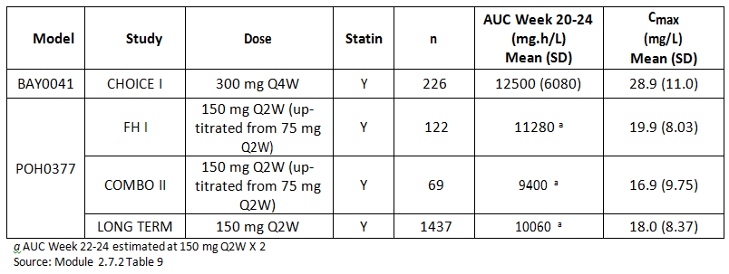
The dose of 300 mg Q4W results in higher mean C_{max} value (1.5 to 1.7 fold increase) compared with that observed at 150 mg Q2W, however these high concentrations saturate the target and thus are unlikely to differ with respect to safety or efficacy.

Evaluator’s overall conclusions on pharmacokinetics
The PK of alirocumab is best described as non-linear, with target mediated clearance, though the deviation from linearity is modest. Body weight, age, free PCSK9 concentrations and statin use were identified as significant covariates affecting alirocumab exposure.
The PK of alirocumab in patients from the new studies submitted in this application were consistent with the PK properties determined in the initial dossier.
At 75 mg and 150 mg using a Q2W dosing regimen, and at 150 mg and 300 mg using a Q4W dosing regimen, steady state concentrations of alirocumab were achieved within 2 or 3 SC administrations when administered alone or in combination with statin.
Monthly exposures observed at 300 mg Q4W are very close to those estimated at 150 mg Q2W, which is consistent with the linear kinetics observed when the target is saturated. As previously characterised, when administered in combination with statins, a more pronounced target mediated clearance of alirocumab was observed, leading to about a 30% decrease in alirocumab steady state exposure for both Q2W and Q4W dosing regimens.

Pharmacodynamics

Studies providing pharmacodynamic information
No new pharmacodynamic studies were submitted for the Q2W dosing regimen. One PopPK study using the data from the efficacy and safety studies (Studies R727-CL-1308 and EFC13786)

Table 3: Submitted pharmacodynamic studies
PD Topic | Subtopic | Study ID | Primary aim
Population PD and PK-PD analyses | Target population§ | BAY0042 | PopPK
§ Subjects who would be eligible to receive the drug if approved for the proposed indication.
None of the pharmacodynamic studies had deficiencies that excluded their results from consideration.

Relationship between drug concentration and PD Effects

PopPK analysis BAY0042
The objective of this analysis was to provide individual estimates of PD parameters and derived PD parameters (ΔLDL C_{max} and ΔLDL C_{trough}) for patients from Studies R727-CL-1308 and EFC13786 using a Maximum A Posteriori Bayesian approach. PD samples, dosing information and key demographic parameters such as body weight, body mass index, age, sex, race, free and total PCSK9 concentrations at Baseline and throughout the study, and relevant background therapies (statin, fibrate, and ezetimibe) were used in these analyses.
A total of 703 patients treated with alirocumab (6387 LDL-C values) were included in these analyses. The NONMEM software (version 7.2) running on a LINUX cluster of multi-processor computers was used. The final Pop-PK/PD model (Study POH0394) provided in the initial application was applied to the current dataset, with its parameter estimates as prior estimates for the assessment of individual parameters and LDL-C predictions. The estimation step was omitted using the option MAXEVAL=0 to compute the individual estimates based on the final population estimates of θ, ω, and σ obtained in the final Pop-PKPD model.
The demographic and physiologic patient characteristics and laboratory Baseline values for the patients from Studies R727-CL-1308 and EFC13786 were close to the ones included in the Study POH0394. The Pop-PK/PD model predictive ability was confirmed using different approaches such as examination of the goodness of fit plots, weighted residuals and by estimation of several quality criteria such as bias, precision or Average Fold Error. PD derived parameters (ΔLDL C_{max} and ΔLDL-C_{trough}) were predicted for Q2W and Q4W dosing regimens.

Evaluator’s overall conclusions on pharmacodynamics
The PD effect of alirocumab on LDL-C is an indirect relationship, mediated through the direct inhibition PCSK9 on the LDL receptor. The PK/PD relationship supports the use of the Q4W dosing.

Dosage selection for the pivotal studies

Phase III pivotal studies investigating more than one dose regimen
The dose response relationship for LDL-C reduction was the basis for the selection of the Q4W doses evaluated in the CHOICE Studies R727-CL-1308 and EFC13786. The PD effect of alirocumab on LDL-C is an indirect relationship, mediated through the direct inhibition PCSK9 on the LDL receptor. Results obtained in Study R727-CL-1308 confirmed that the 300 mg Q4W dosing regimen was effective in reducing LDL-C over the dosing interval, in both populations, with and without background statins. In patients not receiving statins, including patients with statin intolerance, 300 mg Q4W provides, as a starting dose, more consistent efficacy than the 150 mg Q4W dose.
The Q4W dosing is proposed as a starting dose option for alirocumab for patients who may find the Q4W (monthly) dosing more convenient than Q2W.

Evaluator’s conclusions on dose finding for the pivotal studies
The sponsor states that the Q4W dosage regimen is proposed as ‘an additional dosing option’ for alirocumab. This is to complement the approved starting dose regimens approved in the EU; 75 mg or 150 mg Q2W. In Australia only the 75 mg Q2W was approved as a starting dose. Patients can have the dose increased to 150 mg Q2W if an adequate response at 75 mg is not achieved.

Clinical efficacy

Studies providing evaluable efficacy data
The following clinical efficacy studies were submitted.
Indication 1: Dosing every four weeks.
Pivotal studies:
- Study R727-CL-1308 (CHOICE I): A randomised, double blind, placebo controlled study to evaluate the efficacy and safety of an every four weeks treatment regimen of alirocumab in patients with primary hypercholesterolaemia.
Other studies:
- Study EFC13786 (CHOICE II): A randomised, double blind, placebo controlled, parallel group study evaluating the efficacy and safety of alirocumab in patients with primary hypercholesterolaemia not treated with a statin.
Indication 2: Dosing every two weeks.
Pivotal studies
- Study 11569: (Combo II): A randomised, double blind, parallel group study to evaluate the efficacy and safety of SAR236553/REGN727 versus ezetimibe in high cardiovascular risk patients with hypercholesterolemia not adequately controlled with their statin therapy.
- Study EFC12492 (FH1): A randomised, double blind, placebo controlled, parallel group study to evaluate the efficacy and safety of SAR236553/REGN727 (alirocumab) in patients with heterozygous familial hypercholesterolaemia not adequately controlled with their lipid modifying therapy.
- Study R727-CL-1112 (FH II): A randomised, double blind, placebo controlled, parallel group study to evaluate the efficacy and safety of alirocumab in patients with heterozygous familial hypercholesterolaemia not adequately controlled with their lipid modifying therapy.
- Study EFC12732 (High FH): A randomised, double blind, placebo controlled, parallel group study to evaluate the efficacy and safety of alirocumab in patients with heterozygous familial hypercholesterolaemia not adequately controlled with their lipid modifying therapy.
- Study LTS11717 (Long Term): Long-term safety and tolerability of REGN727/SAR236553 in high cardiovascular risk patients with hypercholesterolemia not adequately controlled with their lipid modifying therapy: a randomised, double blind, placebo controlled study.

Indication 1; Four Weekly dosing (Q4W)

Pivotal or main efficacy studies

Study R727-CL-1308 (Odyssey Choice I)
A randomised, double blind, placebo controlled study to evaluate the efficacy and safety of an every four weeks treatment regimen of alirocumab in patients with primary hypercholesterolaemia.

Study design, objectives, locations and dates
A randomised, double blind, placebo controlled, parallel group study conducted at 97 sites in Bulgaria, Canada, Hungary, Israel, Norway, Slovakia, United Kingdom and USA from September 2013 to April 2015.

Objectives
To determine the efficacy, long term safety and tolerability of a dosing regimen of 300 mg alirocumab Q4W and its potential as a starting regimen. This study also investigated the PK/PD profile of alirocumab from weekly data at steady state and evaluated patients for the development of anti-alirocumab antibodies.

Inclusion and exclusion criteria

Inclusion
Healthy men and women (non-childbearing potential), aged > 18 years with elevated LDL-C not adequately controlled, defined as: for moderate and high CV risk LDL-C ≥ 100 mg/dL and for very high CV risk LDL-C ≥ 70 mg/dL.
Patients not on statin therapy had to be at moderate CV risk and had to have LDL-C < 160 mg/dL (< 4.14 mmol/L). Patients who were statin intolerant had to be at moderate CV risk or greater and had to have LDL-C < 160 mg/dL (< 4.14 mmol/L) if they were not receiving any other non-statin LMT. There was no upper limit for LDL-C for patients who were statin intolerant and were receiving clinically appropriate lipid lowering therapy (as they were already on standard of care).
If on statin therapy, patients had to have been on the following for at least 28 days prior to screening: atorvastatin 40 mg or 80 mg, rosuvastatin 20 mg or 40 mg, or simvastatin 80 mg (must be on stable dose of simvastatin for at least 1 year), or their maximally tolerated dose of one of these three statins.

Exclusion
Homozygous FH; taking a statin that is not atorvastatin, rosuvastatin or simvastatin; use of fibrates within 6 weeks of screening; use of allowed LMTs that have not been at a stable dose/regimen for at least 4 weeks prior to screening, use of red yeast rice products within last 4 weeks prior to screening; known risk of haemorrhagic stroke or history of NY Heart Association Class III or IV heart failure within last 12 months.
CV risk categories
Based on the following publication: ESC/EAS Guidelines for the management of dyslipidaemias. The Task Force for the Management of Dyslipidaemias of the European Society of Cardiology (ESC) and the European Atherosclerosis Society (EAS). Eur Heart J. 2011; 32: 1769-1818.
- Very high CV risk is defined as a history of documented CHD, ischemic stroke, transient ischemic attack, carotid artery occlusion > 50% without symptoms, carotid endarterectomy or carotid artery stent procedure, peripheral arterial disease, abdominal aortic aneurysm, renal artery stenosis, renal artery stent procedure, Type 1 or Type 2 diabetes mellitus with target organ damage.
A history of documented CHD includes one or more of the following:
  - Acute myocardial infarction
  - Silent myocardial infarction
  - Unstable angina
  - Coronary revascularization procedure (for example, PCI or CABG surgery).
  - Clinically significant CHD diagnosed by invasive or non-invasive testing (such as coronary angiography, stress test using treadmill, stress echocardiography or nuclear imaging)
- High CV risk is defined as a calculated 10-year fatal CVD risk SCORE ≥ 5%, moderate chronic kidney disease, Type 1 or Type 2 diabetes mellitus without target organ damage, or heFH.
- Moderate CV risk is defined as a calculated 10-year fatal CVD risk SCORE ≥ 1 and < 5%.
Statin intolerance
Statin intolerance is defined as the inability to tolerate at least two statins: one statin at the lowest starting daily dose (defined as rosuvastatin 5 mg, atorvastatin 10 mg, simvastatin 10 mg, lovastatin 20 mg, pravastatin 40 mg, fluvastatin 40 mg or pitavastatin 2 mg), and another statin at any dose, due to skeletal muscle-related symptoms, other than those due to strain or trauma, such as pain, aches, weakness, or cramping that began or increased during statin therapy and stopped when statin therapy was discontinued.
NOTE: Patients who did not receive a daily regimen of a statin (for example, 1 to 3 times weekly) will also be considered as not able to tolerate a daily dose, if they could not tolerate a cumulative weekly statin dose of 7 times the lowest approved tablet size and the criteria outlined above are also met.

Study treatments
Subjects were randomised to one of the following treatments:
- Placebo group: 2 injections of placebo Q2W
- Alirocumab 75 mg Q2W group: 2 injections Q2W; 1 injection of 75 mg alirocumab and 1 injection of placebo Q2W
- Alirocumab 300 mg Q4W group 2 injections Q2W; 2 injections of alirocumab 150 mg Q4W alternating with 2 injections of placebo Q4W.
The injections were provided in prefilled syringes and were administered SC into the abdomen, thigh or outer area of the upper arm at the same time of day based on patient preference. Dosing was allowed to fall within a window of ± 3 days.

Concomitant treatment
Patients continued their background treatment statin (atorvastatin, rosuvastatin or simvastatin) or other LMT. During the double blind treatment period, modification of background LMT was allowed only under pre-specified conditions.

Dose modification
If patients at Week 8 either have not met their predetermined treatment goal depending on their individual level of CVD risk or have not had at least 30% reduction of LDL-C from Baseline at Week 8, the regimen was to be changed in a double blind manner beginning at Week 12 as follows:
- Placebo group: no change, placebo Q2W
- Alirocumab 75 mg Q2W group: 150 mg alirocumab Q2W
- Alirocumab 300 mg Q4W group: 50 mg alirocumab Q2W.
To maintain the blind, the sites and study team were blinded to the LDL-C results and any dose modification.

Efficacy variables and outcomes
There were 2 co-primary efficacy outcomes:
- The percent change in calculated LDL-C from Baseline to Week 24 in the ITT population, using all LDL-C values regardless of adherence to treatment.
- The percent change in calculated LDL-C from Baseline to averaged Weeks 21 to 24 in the ITT population, using all LDL-C values regardless of adherence to treatment.
The percent change in calculated LDL-C from Baseline to Week 24 was defined as follows: 100 x (calculated LDL-C value at Week 24 minus calculated LDL-C value at Baseline)/calculated LDL-C value at Baseline. The Baseline calculated LDL-C value was the last LDL-C level obtained before the first dose of study drug. The calculated LDL-C at Week 24 was the LDL-C level obtained within the Week 24 analysis window.
Secondary efficacy outcomes were:
- The percent change in calculated LDL-C from Baseline to Week 24 in the modified intent to treat (mITT) population, using all LDL-C values during the efficacy treatment period (on treatment)
- The percent change in calculated LDL-C from Baseline to Week 12 (ITT)
- The percent change in calculated LDL-C from Baseline to Week 12 (on treatment)
- The percent change in ApoB from Baseline to Week 24 (ITT)
- The percent change in ApoB from Baseline to Week 24 (on treatment)
- The percent change in non-HDL-C from Baseline to Week 24 (ITT)
- The percent change in non-HDL-C from Baseline to Week 24 (on treatment)
- The percent change in total-C from Baseline to Week 24 (ITT)
- The percent change in ApoB from Baseline to Week 12 (ITT)
- The percent change in non-HDL-C from Baseline to Week 12 (ITT)
- The percent change in total-C from Baseline to Week 12 (ITT)
- The proportion of very high CV risk patients reaching calculated LDL-C < 70 mg/dL (1.81 mmol/L), or moderate or high CV risk patients reaching calculated LDL-C < 100 mg/dL (2.59 mmol/L) at Week 24 (ITT)
- The proportion of very high CV risk patients reaching calculated LDL-C < 70 mg/dL (1.81 mmol/L), or moderate or high CV risk patients reaching calculated LDL-C < 100 mg/dL (2.59 mmol/L) at Week 24 (on treatment)
- The proportion of patients reaching calculated LDL-C < 70 mg/dL at Week 24 (ITT)
- The proportion of patients reaching calculated LDL-C < 70 mg/dL at Week 24 (on treatment)
- The percent change in Lp(a) from Baseline to Week 24 (ITT)
- The percent change in Lp(a) from Baseline to Week 12 (ITT)
- The percent change in HDL-C from Baseline to Week 24 (ITT)
- The percent change in HDL-C from Baseline to Week 12 (ITT)
- The percent change in fasting TG from Baseline to Week 24 (ITT)
- The percent change in fasting TG from Baseline to Week 12 (ITT)
- The percent change in ApoA-1 from Baseline to Week 24 (ITT)
- The percent change in ApoA-1 from Baseline to Week 12 (ITT)
- The percent change in calculated LDL-C from Baseline to Week 48 (ITT and on treatment)
- The proportion of very high CV risk patients reaching calculated LDL-C < 70 mg/dL (1.81 mmol/L), or moderate or high CV risk patients reaching calculated LDL-C < 100 mg/dL (2.59 mmol/L) at Weeks 12 and 48 (ITT)
- The proportion of patients having at least 50% reduction of LDL-C at Weeks 12, 24, and 48 (ITT)
- The proportion of patients reaching LDL-C < 70 mg/dL at Weeks 12 and 48 (ITT)
- The proportion of patients reaching LDL-C < 100 mg/dL at Weeks 12, 24, and 48 (ITT and on treatment)
- The percent change in ApoB, non-HDL-C, total cholesterol, Lp(a), HDL-C, fasting TG, and ApoA-1 from Baseline to Week 48 (ITT)
- The change in ApoB/ApoA-1 ratio from Baseline to Weeks 12, 24, and 48 (ITT)
- The proportion of patients with ApoB < 80 mg/dL (0.8 mmol/L) at Weeks 12, 24, and 48 (ITT)
- The proportion of patients with non-HDL-C < 100 mg/dL at Weeks 12, 24, and 48 (ITT)
- The proportion of patients with calculated LDL-C < 70 mg/dL (< 1.81 mmol/L) and/or ≥ 50% reduction in calculated LDL-C (if calculated LDL-C ≥ 70 mg/dL) at Weeks 12, 24, and 48 (ITT and on treatment)
- The percent change in total-C from Baseline to Weeks 12, 24, and 48 (on treatment)
- The percent change in ApoB from Baseline to Weeks 12 and 48 (on treatment)
- The percent change in non-HDL-C from Baseline to Weeks 12 and 48 (on treatment)
- The proportion of very high CV risk patients reaching calculated LDL-C < 70 mg/dL (1.81 mmol/L), or moderate or high CV risk patients reaching calculated LDL-C < 100 mg/dL (2.59 mmol/L) at Week 12 (on treatment)
- The percent change in Lp(a) from Baseline to Weeks 12, 24, and 48 (on treatment)
- The absolute change in calculated LDL-C (mg/dL and mmol/L) from Baseline to Weeks 12, 24, and 48 (ITT)
- Absolute change in ratio total-C/HDL-C from Baseline to Weeks 12, 24, and 48 (ITT)
- Concentration of alirocumab and, optionally, concentrations of total PCSK9 and free PCSK9
- Anti-alirocumab antibody status (positive/negative) and titres assessed throughout the study
- The percent change in hs-CRP from Baseline to Weeks 12 and 24
- The absolute change in homeostasis model assessment for insulin resistance (HOMA-IR) from Baseline to Weeks 12 and 24
- The absolute change in HbA1c from Baseline to Weeks 12 and 24.

Randomisation and blinding methods
Patients were randomised via an IVRS or IWRS to receive placebo, alirocumab 75 mg Q2W or alirocumab 300 mg Q4W in a ratio of 2:1:4 using a permutated block design to ensure even distribution of the treatment assignments. Randomisation was stratified for subjects receiving statins according to the 2 levels of CVD risk (moderate versus high and very high CVD risk).
Lipid results and any resulting alerts were not communicated to the sites or study teams. An independent external physician closely monitored all subjects who met the calculated LDL-C <25 mg/dL (0.65 mmol/L) criterion and sham alerts were randomly used to maintain blinding. Study teams would know an alert had occurred but would not know it is was sham or a true alert.
Study supplies were blinded by supplying all individual matched prefilled syringes in matching packaging.

Analysis populations
The randomised population = 803 subjects

ITT population
The ITT population (also known as the full analysis set, FAS) was defined as all randomised subjects who had an evaluable primary endpoint. The endpoint was evaluable when the following two conditions are met:
- Availability of at least one measurement value for calculated LDL-C before first dose of study drug (that is, Baseline)
- Availability of at least one measurement value for calculated LDL-C within one of the analysis windows up to Week 24
The ITT population = 792 subjects (98.6% of randomised population).

Modified Intent-to-Treat (mITT) population
The modified intent-to-treat (mITT) population was defined as the all randomised population who took at least one dose or part of a dose of study drug and have an evaluable primary endpoint. The endpoint was considered as evaluable when both of the following conditions are met:
- Availability of at least one measurement value for calculated LDL-C before the first dose of study drug (that is, Baseline)
- Availability of at least one calculated LDL-C value during the efficacy treatment period and within one of the analysis windows up to Week 24. The treatment period was defined the time from the first double blind study drug injection up to 21 days after the last double blind study drug injection.
The mITT population = 776 subjects (96.6%).
The safety analysis set was defined as all randomised subjects who received at least one dose or part of a dose of study drug. The safety population = 802 subjects.

Sample size
For the concomitant statin population, a total sample size of 39 evaluable patients (26 patients on alirocumab 300 mg Q4W and 13 patients on placebo, in a 2:1 ratio) would have 95% power to detect a difference in mean percent change in LDL-C of 35%, with a 2-sided significance level of 0.025 and assuming a common standard deviation of 25%.
For the population without concomitant statin, a total sample size of 30 evaluable patients (20 patients on alirocumab 300 mg Q4W and 10 patients on placebo, in a 2:1 ratio) will have 95% power to detect a difference in mean percent change in LDL-C of 40%, with a 2-sided significance level of 0.025 and assuming a common standard deviation of 25%.
The sample size was increased to 400 patients on alirocumab 300 mg Q4W and 200 patients on placebo to characterise the safety profile of the alirocumab 300 mg Q4W regimen in a larger population. Additionally, 100 patients would be treated with the 75 mg alirocumab Q2W regimen.

Statistical methods
The two primary efficacy analyses in this study compare the alirocumab 300 mg Q4W regimen to placebo; specifically, the first hypothesis is tested in the concomitant statin population and another hypothesis (second) in the population not receiving a concomitant statin. Using the Bonferroni adjustment for the sample size calculation of the treatment comparisons, the efficacy alpha level was modified to 0.025 for treatment comparisons within each concomitant statin (Yes/No) population.
Further, within each concomitant statin (Yes/No) population, the primary efficacy analysis is defined by two co-primary endpoints, specifically: the first treatment testing comparison on the percent change in calculated LDL-C from Baseline to Week 24 and the second treatment testing comparison on the percent change in calculated LDL-C from Baseline to averaged Weeks 21 to 24. The efficacy alpha level is not adjusted further for the two co-primary endpoints, since the study will be considered positive within a given concomitant statin population if statistical significance is met for both co-primary endpoints.
The co-primary efficacy endpoint for both populations was the percent change in calculated LDL-C from Baseline to Week 24 (first efficacy endpoint) and the percent change in calculated LDL-C from Baseline to averaged Weeks of 21 to 24 (second efficacy endpoint). Statistical significance (that is 2-sided significance level of 0.025) of both co-primary efficacy endpoints within each statin population was required to consider the study positive within each concomitant statin population. These two endpoints were analysed in the ITT population using a mixed-effect model with repeated measures (MMRM) approach. All post Baseline data available within Week 4 to Week 24 analysis windows were used and missing data were accounted for by the MMRM model.
For both primary efficacy analyses, the alirocumab 300 mg Q4W treatment group was compared with placebo using an appropriate model contrast, allowing for the pooled variability to also include patients receiving alirocumab 75 mg Q2W. A 97.5% CI was provided for the difference between the two treatment groups. Statistical testing was evaluated at a 2-sided significance level of 0.025 per comparison, adjusting for the concomitant statin (Yes/No) population multiplicity.
Robustness of this statistical method was assessed via sensitivity analyses including different methodologies for missing data (multiple imputations under missing-at-random (MAR) assumption, pattern mixture model with different imputations will be applied to calculated LDL-C values missing during the on treatment period versus calculated LDL-C values missing after treatment).
Continuous secondary variables anticipated to have a normal distribution (that is, lipids other than TG and Lp(a)), were analysed in the analysis populations using the same MMRM model as for the primary endpoint.
Continuous secondary efficacy endpoints anticipated to have a non-normal distribution (that is, TG and Lp(a)), were analysed in the analysis populations using a robust regression model (that is, ROBUSTREG SAS procedure with M-estimation option) with treatment group and randomization strata (‘statin Yes’ population only) as main effect and corresponding Baseline value(s) as covariate. Missing values were addressed using a multiple imputation approach.
Binary secondary efficacy endpoints will be analysed in the analysis populations using stratified logistic regression (using the strata option of the SAS logistic procedure) with treatment group and randomization strata (‘statin Yes’ population only) as the main effect and corresponding Baseline value(s) as the covariate. Missing values will be addressed using a multiple imputation approach.

Participant flow
Two populations of patients were enrolled in this study, one not receiving concomitant statin therapy and one receiving concomitant statin therapy. Patients within each population were randomised to 1 of 3 groups: alirocumab 300 mg Q4W with the option of dose adjustment to 150 mg Q2W (referred to as 300 Q4W/Up 150 Q2W), or alirocumab 75 mg Q2W with the option of up-titration to 150 mg Q2W (referred to as 75 Q2W/Up 150 Q2W), and placebo.

Table 4: Study R727-CL-1308: Patient disposition; All randomised population
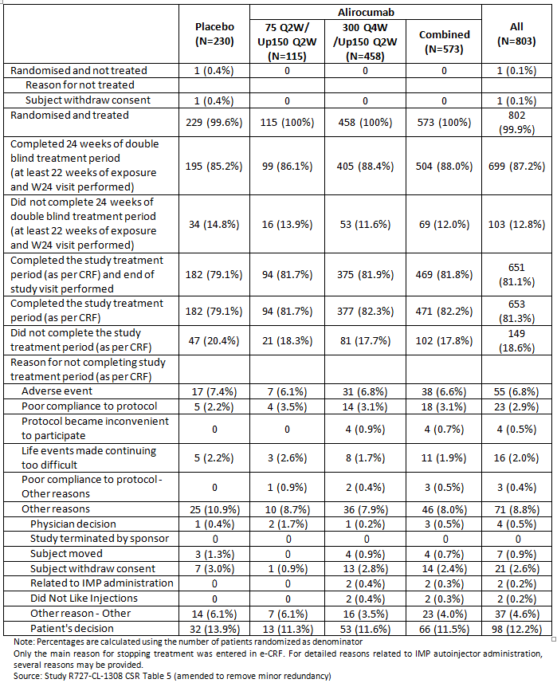

Subpopulations

Patients not receiving concomitant statin therapy
A total of 256 patients who were not receiving concomitant statin therapy enrolled in the study: 146 were randomised to receive alirocumab 300 mg Q4W, 37 were randomised to receive alirocumab 75 mg Q2W, and 73 were randomised to receive placebo.

Patients receiving concomitant statin therapy
A total of 547 patients who received concomitant statin therapy enrolled in the study: 312 were randomised to receive alirocumab 300 mg Q4W, 78 were randomised to receive alirocumab 75 mg Q2W, and 157 were randomised to receive placebo.
Tabulated data on disposition of the subgroups was provided.

Major protocol violations/deviations
Overall, 15.3% (123/803) (from CRF derived protocol deviations) and 1.1% (9/803) (from monitoring derived protocol deviations) of all randomised patients had ‘major protocol deviations that could potentially impact efficacy analyses.’ These major deviations resulted in exclusion of 1.4% (11/803) from the ITT analysis and of 3.4% (27/803) of patients from the mITT analysis, with similar proportions across the three treatment groups.

Baseline data
For all randomised patients the Baseline demographic characteristics were generally similar among treatment groups. The mean (SD) age of patients overall was 60.8 (10.1) years, and ranged from 21 to 88 years. A little more than half of the patients were male (57.5% (462/803)) and 42.5% (341/803) were female; most of the study population was White (87.3% (701/803)) or Black (10.6% (85/803)) and not of Hispanic or Latino descent (96.5% (775/803)). The mean (SD) BMI of the patients overall was 31.1 (6.0) kg/m², and the mean (SD) weight was 89.4 (19.7) kg.
For the population not receiving concomitant statin therapy, there were differences in gender distribution and BMI ≥ 30 kg/m²: more subjects were female (23/37, 62.2%) than males (14/37, 37.8%) in the 75 Q2W/Up 150 Q2W group, and more subjects had a BMI ≥ 30 kg/m² n the placebo group (46/73, 63.0%) compared with the 75 Q2W/Up 150 Q2W group (16/37, 43.2%) and the 300 Q4W/Up 150 Q2W group (74/146, 50.7%). All other demographic and Baseline characteristics were similar among the treatment groups and to the all randomised population.
For the population receiving concomitant statin therapy, the demographic and Baseline characteristics were similar among treatment groups and were similar to the population of all randomised population.
Overall, 52.4% (421/803) of all randomised patients had a history of CHD or CHD risk equivalent that would categorise their CV risk as ‘Very High’; 28.4% (228/803) were categorised as having a moderate CV risk, and 19.2% (154/803) were categorised as having a high CV risk. Most of the patients categorised as very high CV risk (366 of 421 (86.9%)) had a history of CHD. The most common CHD event or procedures was coronary revascularisation procedures (32.5%). A history of acute myocardial infarction and a history of unstable angina were reported in 19.6% of patients and 10.7% of patients, respectively, and 24.7% of patients had a history of other clinically significant CHD.
In the population not receiving concomitant statin therapy, the percentage of patients with a history of CHD or CHD risk equivalent that would categorise their CV risk as ‘Very High’ was lower than that observed in the all randomised population (60/256, 23.4%) versus 421/803, 52.4%) of all randomised population. The majority of subjects not receiving concomitant statin therapy were categorised as having a moderate CV risk (151/256, 59.0%) or a high CV risk (45/256, 17.6%).
Overall, the majority of patients (74.1%) had non-FH with 5.9% with heFH.
Overall 96.0% (771/803) of patients randomised into the study had a history of LMT use, including statins. The majority of randomised patients (83.1% (667/803)) had a history of HMG CoA reductase inhibitor use.

Table 5: Study R727-CL-1308: Background LMT at randomisation; patients not receiving concomitant statin therapy; Randomised population
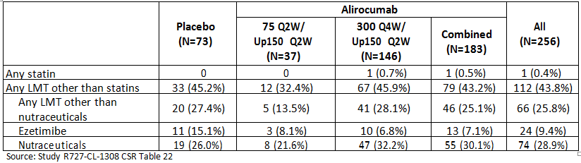

Table 6: Study R727-CL-1308: Background LMT at randomisation; patients receiving concomitant statin therapy; Randomised population
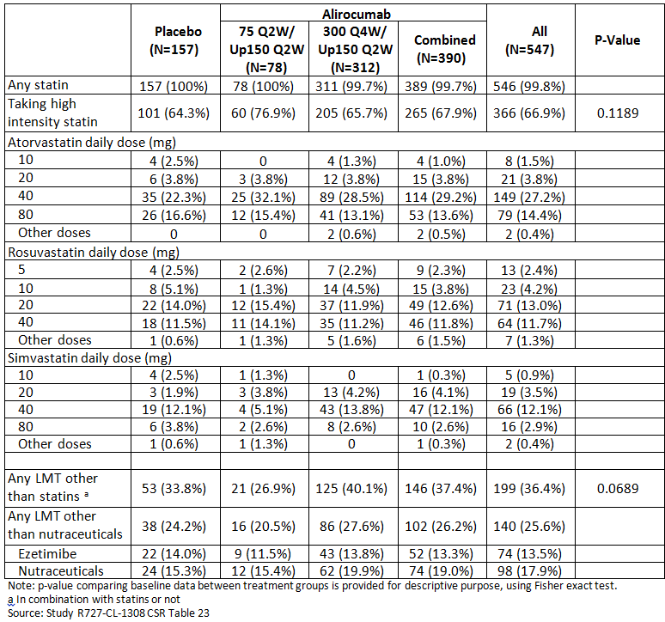
Additional tabulated data was provided for all randomised subjects.

Results for the primary efficacy outcomes
The results are presented for each of the two subpopulations of subjects based on concomitant statin therapy.
While the primary efficacy outcome was the comparison of Q4W to placebo the results for Q2W are included for comparison.

Patients not receiving concomitant statin therapy
A statistically significant decrease in calculated LDL-C from Baseline to Week 24 (ITT analysis) was observed in the 300 Q4W/Up 150 Q2W alirocumab group compared with the placebo group, and the LS mean difference in percent change from Baseline for alirocumab versus placebo was -52.4% (97.5% CI, -59.8% to -45.0%; p < 0.0001).
A reduction in calculated LDL-C in the 300 Q4W/Up 150 Q2W group was observed from the first post-dose measurement at Week 4 and was maintained at all subsequent time points up to Week 48.
A numerically greater decrease in calculated LDL-C from Baseline to Week 24 (ITT analysis) was observed in the 75 Q2W/Up 150 Q2W group compared with the placebo group.
A statistically significant decrease in calculated LDL-C from Baseline to averaged Weeks 21 to 24 (ITT analysis) was observed in the 300 Q4W/Up 150 Q2W group compared with the placebo group. The LS mean difference in percent change from Baseline for alirocumab versus placebo was -55.2% (97.5% CI, -62.3% to -48.1%; p < 0.0001), which was similar to that observed at Week 24.
A numerically greater decrease in calculated LDL-C from Baseline to averaged Weeks 21 to 24 (ITT analysis) was observed in the 75 Q2W/Up 150 Q2W group compared with the placebo group.

Table 7: Study R727-CL-1308: Percent change from Baseline in calculated LDL-C at Week 24 (300 Q4W/Up 150 Q2W versus Placebo): MMRM; patients not receiving concomitant statin therapy; ITT population
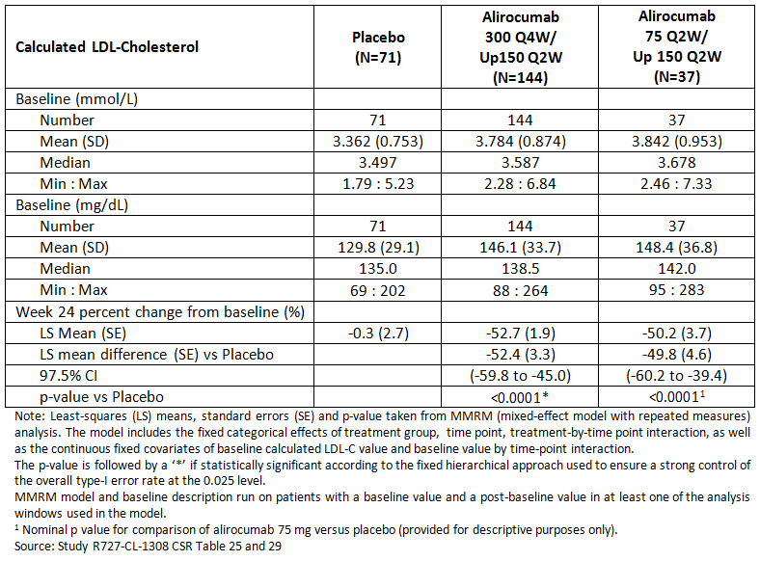

Table 8: Study R727-CL-1308: Percent change from Baseline in calculated LDL-C to averaged Week 21 to 24 (300 Q4W/Up 150 Q2W versus Placebo): MMRM; patients not receiving concomitant statin therapy; ITT population
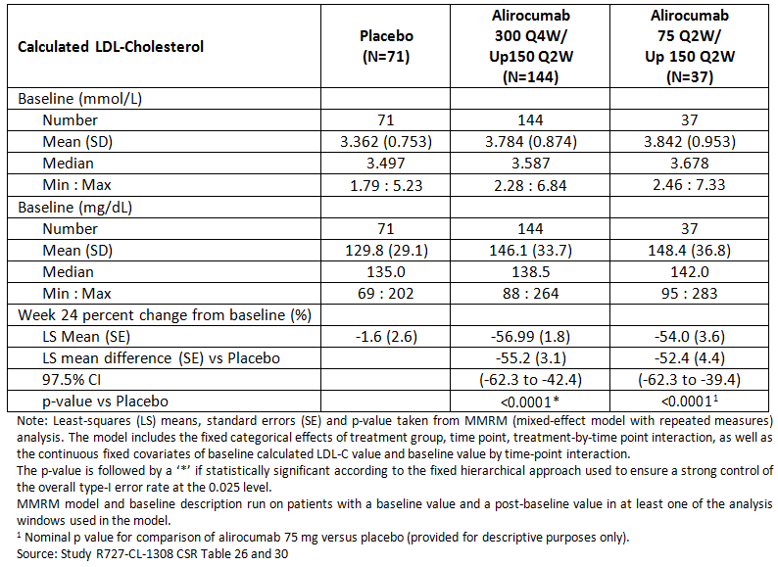
Figure 1: Study R727-CL-1308: Calculated LDL-C LS mean (± SE) percent change from Baseline: time profile - patients not receiving concomitant statin therapy; ITT population
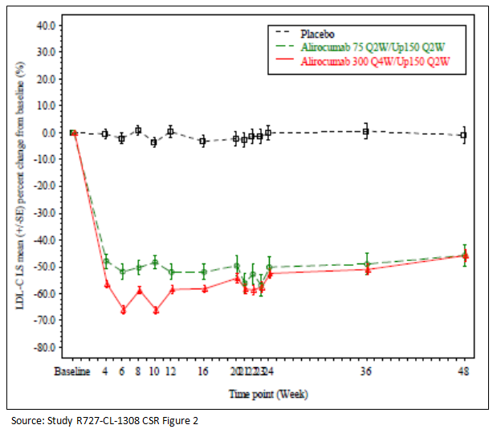

Patients receiving concomitant statin therapy
A statistically significant decrease in calculated LDL-C from Baseline to Week 24 (ITT analysis) was observed in the 300 Q4W/Up 150 Q2W alirocumab group compared with the placebo group, and the LS mean difference in percent change from Baseline for alirocumab versus placebo was -58.7% (97.5% CI, -65.0% to -52.4%; p < 0.0001).
A numerically greater decrease in calculated LDL-C from Baseline to Week 24 (ITT analysis) was observed in the 75 Q2W/Up 150 Q2W group compared with the placebo group, and the LS mean difference in percent change from Baseline for alirocumab versus placebo was -51.5% (97.5% CI, -60.4% to -42.6%; nominal p < 0.0001).
A statistically significant decrease in calculated LDL-C from Baseline to averaged Weeks 21 to 24 (ITT analysis) was observed in the 300 Q4W/Up 150 Q2W group compared with the placebo group, and the LS mean difference in percent change from Baseline for alirocumab versus placebo was -65.0% (97.5% CI, -70.4% to -59.5%; p < 0.0001). This LS mean difference was greater than that seen at Week 24 (-58.7%) due to the lower LDL-C levels at Weeks 21, 22, and 23 compared with Week 24.
A numerically greater decrease in calculated LDL-C from Baseline to averaged Weeks 21 to 24 (ITT analysis) was observed in the 75 Q2W/Up 150 Q2W group compared with the placebo group, and the LS mean difference in percent change from Baseline for alirocumab versus placebo was -57.1% (97.5% CI, -64.8% to -49.4%; nominal p < 0.0001).

Table 9: Study R727-CL-1308: Percent change from Baseline in calculated LDL-C at Week 24 (300 Q4W/Up 150 Q2W versus Placebo): MMRM; patients receiving concomitant statin therapy; ITT population
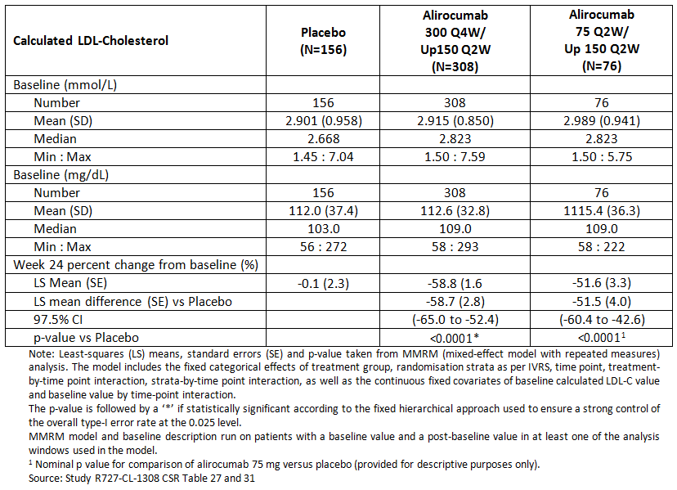

Table 10: Study R727-CL-1308: Percent change from Baseline in calculated LDL-C to averaged Weeks 21 to 24 (300 Q4W/Up 150 Q2W versus Placebo): MMRM; Patients receiving concomitant statin therapy; ITT population
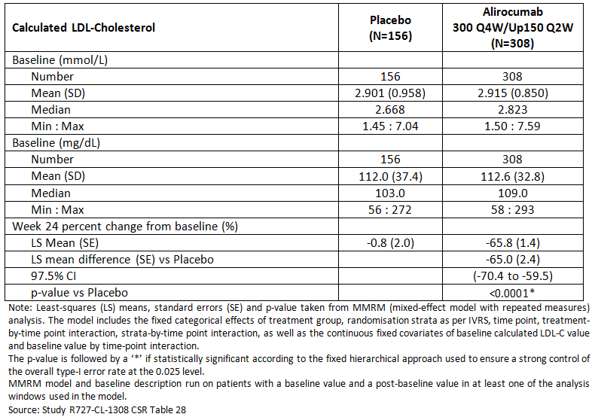
Figure 2: Study R727-CL-1308: Calculated LDL-C LS mean (± SE) percent change from Baseline: Time profile - Patients receiving concomitant statin therapy; ITT population
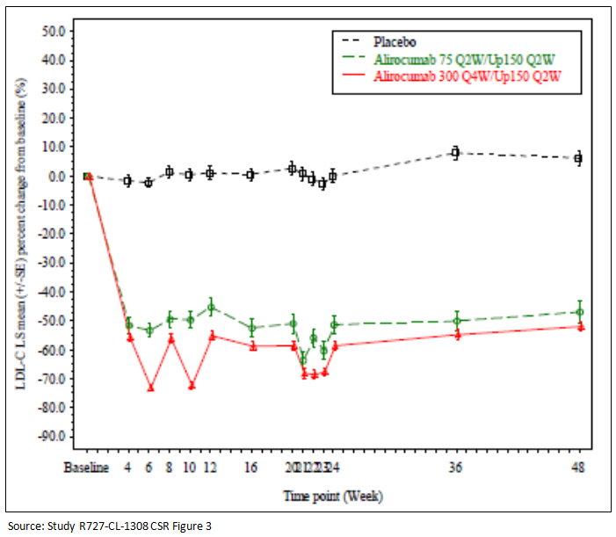
A range of sensitivity analyses all demonstrated similar results to primary analyses.

Results for other efficacy outcomes
A hierarchical procedure was prospectively planned to test the key secondary efficacy endpoints for each concomitant statin (Yes/No) patient population while controlling for multiplicity. For some key secondary endpoints, the ITT and on treatment analyses were prespecified as part of the hierarchical testing procedure.
In the patient population not receiving concomitant statins, statistical significance was met in the 300 Q4W/Up 150 Q2W group versus the placebo group for all key secondary efficacy endpoints.
In the patient population receiving concomitant statins, statistical significance was met in the 300 Q4W/Up 150 Q2W group versus the placebo group for all key secondary efficacy endpoints in the hierarchy with the exception of Apo A-1. Hierarchical testing failed at the 24th endpoint (ITT analysis of percent change in Apo A-1 from Baseline to Week 24, p = 0.0306). Therefore, in the patient population receiving concomitant statins, the statistical testing terminated at this step and statistical significance was not declared for the last efficacy endpoint.

Table 11: Study R727-CL-1308: secondary endpoints; hierarchical testing strategy applied
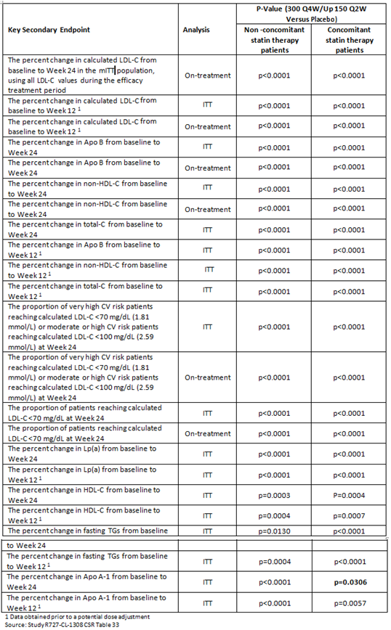

Results at 48 weeks

Table 12: Study R727-CL-1308: Summary of other secondary LDL-C efficacy endpoint results; continuous endpoints; patients not receiving concomitant statin therapy
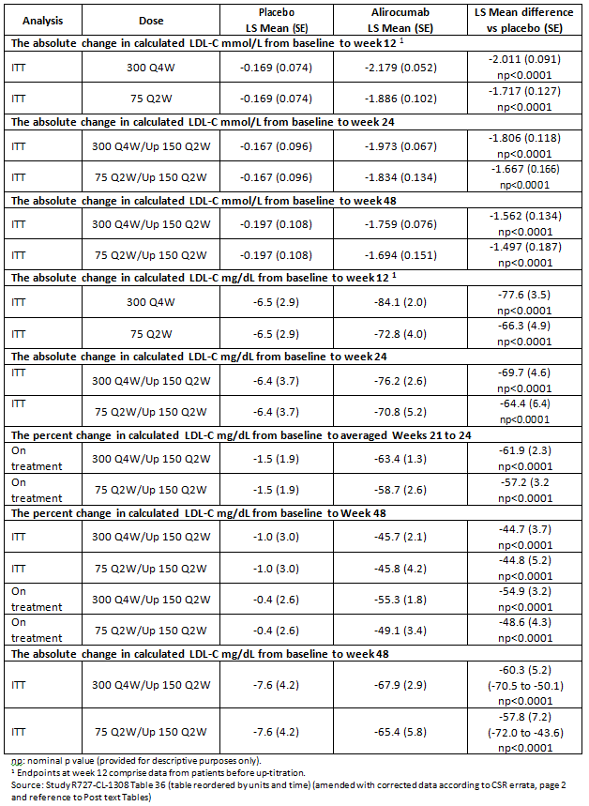

Table 13: Study R727-CL-1308: Summary of other secondary LDL-C efficacy endpoint results; continuous endpoints; patients receiving concomitant statin therapy
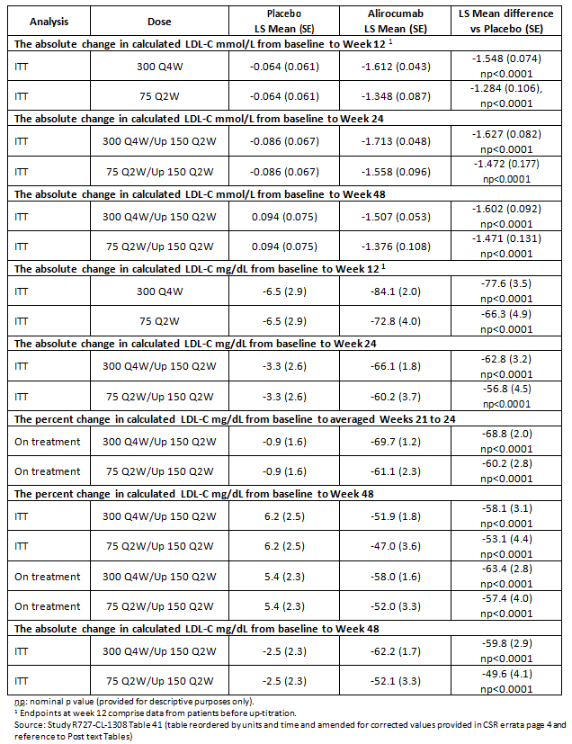
Tabulated results for other efficacy outcomes were provided.

Subgroup analyses
Subgroup analyses of the co-primary efficacy endpoints were conducted for a range of demographic and Baseline characteristics, including gender and age group, BMI, moderate chronic kidney disease, diabetes, Baseline calculated LDL-C, Baseline HDL-C, Baseline fasting TGs, Baseline Lp(a), Baseline total PCSK9, Baseline free PCSK9, statin intolerance, race and ethnicity. These analyses were conducted with Week 24 LDL-C data or averaged Weeks 21 to 24 data, which includes a portion of the patients whose dose was titrated from 300 mg Q4W to 150 mg Q2W.
In both the subjects not receiving or receiving concomitant statin therapy, no clinically meaningful differences in LDL-C reductions from Baseline were identified for any of the subgroups analysed.
Figure 3: Study R727-CL-1308: Percent change from Baseline in calculated LDL-C at Week 24 (alirocumab 300 Q4W/up 150 mg Q2W versus placebo): Forest plot; Patients not receiving concomitant statin therapy; ITT population
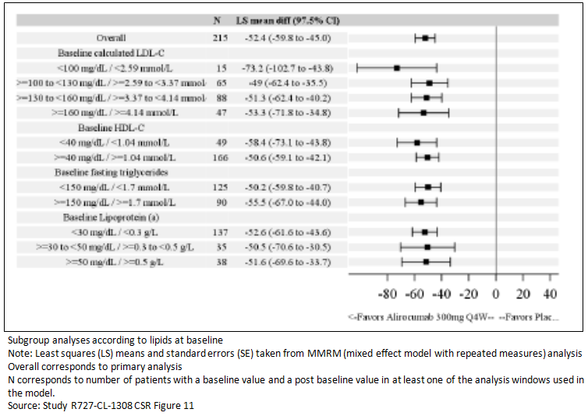
Figure 4: Study R727-CL-1308: Percent change from Baseline in calculated LDL-C averaged Weeks 21 to 24 (alirocumab 300 Q4W/up 150 mg Q2W versus placebo): Forest plot; Patients not receiving concomitant statin therapy; ITT population
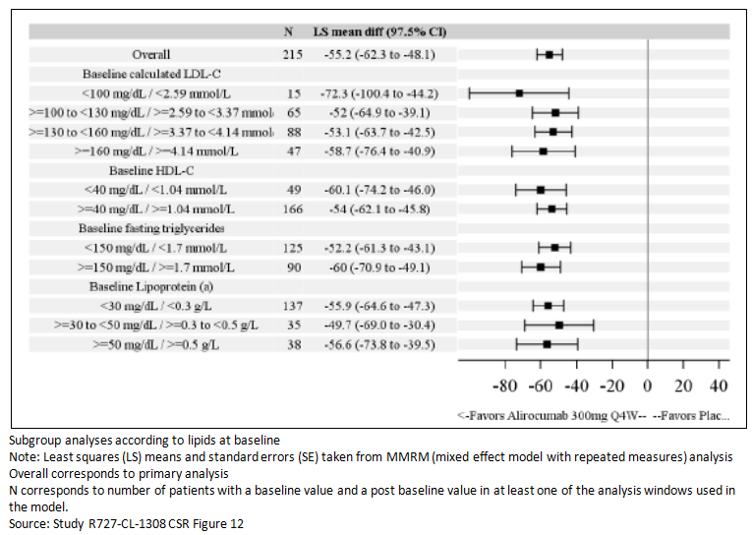
Figure 5: Study R727-CL-1308: Percent change from Baseline in calculated LDL-C at Week 24 (alirocumab 300 Q4W/up 150 mg Q2W versus placebo): Forest plot; ITT analysis; Patients receiving concomitant statin therapy; ITT population
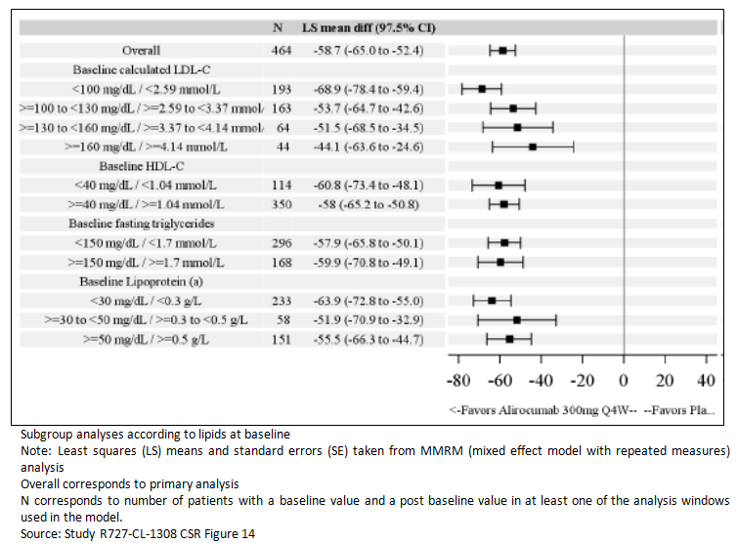
Figure 6: Study R727-CL-1308: Percent change from Baseline in calculated LDL-C to Averaged Weeks 21 to 24 (alirocumab 300 Q4W/up 150 mg Q2W versus placebo): Forest Plot; ITT analysis; Patients receiving concomitant statin therapy; ITT population
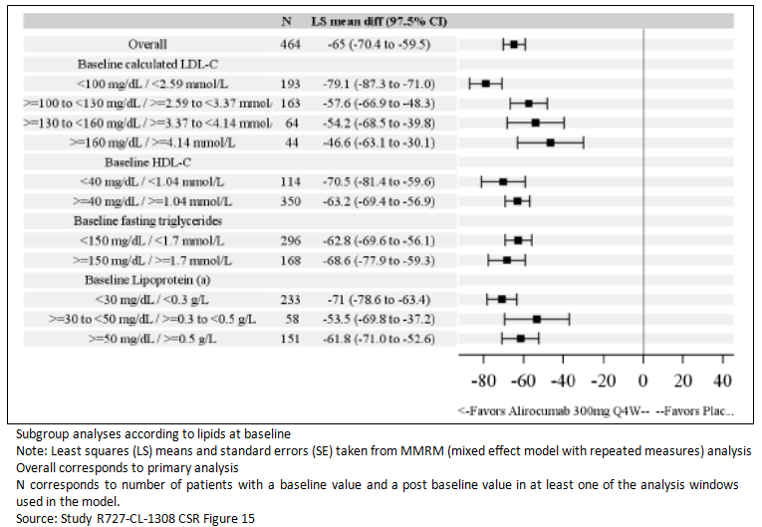

Subgroup analyses by up-titration status

Subjects not receiving concomitant statins
Of the 129 patients that received alirocumab 300 mg Q4W and received at least 1 injection of alirocumab after Week 12, 19 patients (14.7%) were adjusted to the 150 mg Q2W regimen. The mean (SD) calculated LDL-C at Baseline of these 19 patients was 174.3 (49.4) mg/dL (4.515 (1.281) mmol/L), which was higher than the mean (SD) calculated LDL-C at Baseline of the patients who remained on the 300 mg Q4W regimen (143.6 (29.6) mg/dL or 3.719 (0.767) mmol/L).
Patients that were adjusted to the 150 mg Q2W dose regimen also had higher mean concentrations of Total-C, non-HDL-C and Apo B than patients who remained on the 300 mg Q4W dose regimen.
In patients whose dose was not adjusted, mean percent change in LDL-C remained stable from Week 4 and subsequent sampling points (Figure 7). In patients whose dose was adjusted, the mean percent reduction in LDL-C was more variable during the first 12 weeks. Following adjustment to the 150 mg Q2W dose regimen at Week 12, there was less variability in LDL-C levels, and the mean percent change from Baseline was consistently below -50%.
Figure 7: Study R727-CL-1308: Calculated LDL-C LS mean (± SE) percent change from Baseline according to up-titration status (ITT analysis): Time profile; Patients in the alirocumab 300 Q4W/up 150 mg Q2W group - Patients not receiving concomitant statin therapy; ITT population
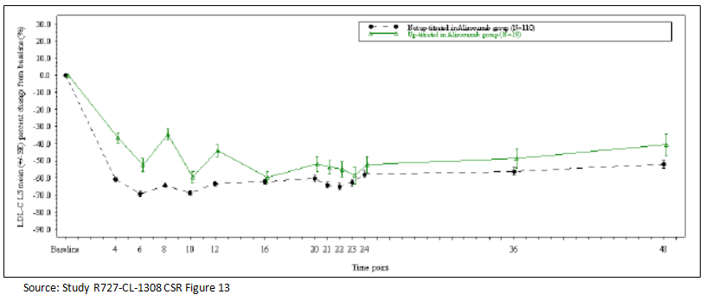

Subjects receiving concomitant statins
Of the 290 patients that received alirocumab 300 mg Q4W and received at least one injection of alirocumab after Week 12, 56 patients (19.3%) were adjusted to the 150 mg Q2W dose regimen.
The mean (SD) calculated LDL-C at Baseline of these 56 patients was 123.5 (39.5) mg/dL (3.200 (1.022) mmol/L), which was higher than the mean (SD) calculated LDL-C at Baseline of the patients that remained on the 300 mg Q4W regimen (110.0 (31.1) mg/dL or 2.849 (0.807) mmol/L).
Ten out of the 56 patients (17.9%) that were adjusted to the 150 mg Q2W dose regimen had a Baseline calculated LDL-C concentration ≥ 160 mg/dL (≥ 4.14 mmol/L), compared with 15/234 (6.4%) of patients that remained on the 300 mg Q4W dose regimen. Patients that were adjusted to the 150 mg Q2W dose regimen also had higher mean concentrations of Total-C, non-HDL-C, Lp(a), Apo B, and Total-C/HDL-C ratio and a higher mean body weight and BMI than patients who remained on the 300 mg Q4W dose regimen.
In patients whose dose was not adjusted, the mean (SD) percent change in calculated LDL-C from Baseline was -63.4% (18.5%) at Week 12 and -62.0% (23.8%) at Week 24. Small variations in the mean percent change from Baseline were seen between the Q4W dosing intervals in these patients. In patients whose dose was adjusted, the mean (SD) percent change from Baseline was highly variable between the Q4W dosing intervals during the first 12 weeks; for example, the mean (SD) percent change from Baseline ranged from -65.1% (22.4) at Week 10 (2 weeks post dose) to -37.0% (25.9%) at Week 12 (4 weeks post dose). Following adjustment to the 150 mg Q2W dose regimen, there was less variability in LDL-C levels between the dosing intervals and the percent change from Baseline was consistently below -58%; for example, the mean (SD) percent change from Baseline ranged from -58.5% (20.1%) at Week 22 to -62.4% (20.1%) at Week 24.
Figure 8: Study R727-CL-1308: Calculated LDL-C LS mean (± SE) Percent change from Baseline according to up-titration status (ITT Analysis): Time profile; Patients in the alirocumab 300 Q4W/up 150 mg Q2W Group; patients receiving concomitant statin therapy; ITT population
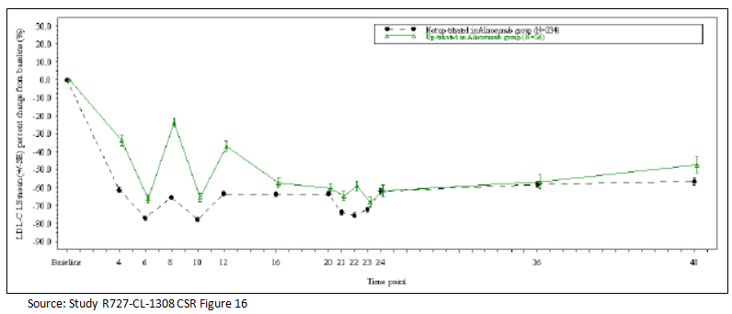

Evaluator commentary
The objectives of this study were to determine the efficacy of 300 mg alirocumab administered Q4W as a starting and maintenance dosing regimen in hypercholesterolaemic patients with and without a background statin therapy who were at very high, high and moderate CV risk. The dosing regimen was compared with placebo.
The efficacy was measured for two primary endpoints at Week 24 and averaged Weeks 21 to 24.
The results found that the regimen was superior to placebo from Week 12 and maintained to 48 weeks.
The study used a 75 mg Q2W regimen as a ‘calibrator’ arm rather than a comparison arm. The aim of the calibrator was to ‘calibrate’ the study to those previously completed studies that used 75 mg Q2W. The results for 75 mg Q2W are similar to that seen in the previous studies and so the data obtained in this study can be considered consistent.

Table 13a: Dose regimens
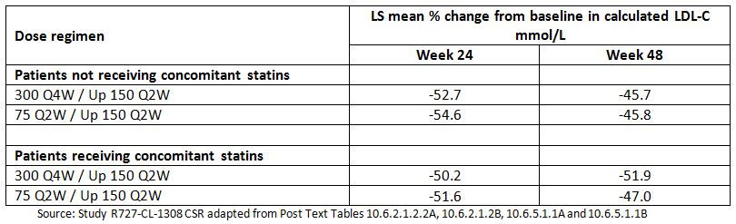
The discussion by the sponsor has relied solely on the results with little discussion of the patient population. The study included patients with HeFH and Non-FH hypercholesterolaemia and all patients had at least moderate CV risk.
Of the 129 patients not receiving concomitant statin therapy, 15% had to have their dose ‘up titrated’ to achieve stable response. For the patients receiving concomitant statin treatment 19% had to have their dose ‘up titrated’ to achieve stable response.
For patients not receiving concomitant statins the mean percent change in LDL-C from Baseline at Week 24 (-52.3%) was comparable in patients who required dose adjustment with that of patients who remained on the 300 mg Q4W dose regimen (-57.4%).
For patients who were receiving concomitant statins the reduction in LDL-C from Baseline at Week 24 was similar in patients who required dose adjustment (-62.4%) to patients who remained on the 300 mg Q4W dose regimen (-62.0%).

Other efficacy studies

Study EFC13786: Summary
A Randomised, Double blind, Placebo controlled, Parallel group Study Evaluating the Efficacy and Safety of Alirocumab in Patients with Primary Hypercholesterolemia Not Treated with a Statin.
Comment: The clinical study report (CSR) is based on the results of the first-step analysis of efficacy data up to Week 24; and safety, PK and other results up to the common cut-off date of 27 October 2014 (the date of the last patient’s Week 24 visit). The CSR is dated 28-Sept-2015. The study appears to be ongoing and the results of the second-step analysis at the end of the optional open label extension treatment period with 150 mg Q4W dosing with a possible up titration to 150 mg Q2W (to Week 120) were not included in this submission.

Study design, objectives, locations and dates
A Phase III, randomised, double blind, placebo controlled, parallel group, multicentre study conducted at 43 (screened) and 31 (randomised at least one patient) centres in 8 countries (Australia, Belgium, Canada, Denmark, Netherlands, New Zealand, Spain and the USA) from December 2013 to cut-off date for first step analysis 27 October 2014.

Objectives
Primary: To demonstrate the reduction of LDL-C by a regimen including an alirocumab starting dose of 150 mg Q4W as add on to non-statin lipid modifying background therapy or as monotherapy in comparison with placebo in patients with primary hypercholesterolaemia not treated with a statin.
Secondary: to evaluate:
- The effect of alirocumab with 150 mg Q4W as starting dose, in comparison with placebo on other lipid parameters (for example apolipoproten B (Apo B), non-HDL-C, Total-C, Lp (a), HDL-C, TGs, and Apo A-1 levels
- The PK, safety and tolerability of alirocumab 150 mg Q4W and the development of anti-alirocumab 150 mg Q4W
The study consisted of 4 periods:
- A screening period of up to 3 weeks
- A double blind, parallel group treatment period of 24 weeks – patients were randomised to one of three treatment groups in addition to their background treatment.
- An optional open label treatment period of up to 120 weeks (patients were continued on either 150 mg Q2W or 150 mg Q4W
- A follow up period of 8 weeks after the end of the 24 weeks for patients who did not enter the open label treatment period.

Study population

Inclusion
Healthy male or female (non-child bearing potential) patients, aged > 18 years with primary hypercholesterolaemia (heFH or non-FH) receiving fenofibrate or ezetimibe or diet alone. Patients were either: intolerant to statins with moderate, high or very high CV risk or those who were not fulfilling the statin intolerant definition (only moderate CV risk were included in this stratum).

Exclusion
Patients defined as statin intolerant and very high CV risk with LDL-C < 70 mg/dL (1.81 mmol/L) at the screening visit; patients defined as statin intolerant and high or moderate CV risk with LDL-C < 100 mg/dL (< 2.59 mmol/L) at the screening visit; patients not fulfilling the statin intolerant definition and who are at moderate CV risk with LDL-C < 100 mg/dL (< 2.59 mmol/L) at the screening visit; patient with LDL-C ≥ 160 mg/dL (≥ 4.1 mmol/L) at the screening visit if receiving diet only, whatever the statin intolerance status or if non fulfilling statin intolerance definition at moderate CV risk and treated with ezetimibe or fenofibrate; a 10-year fatal CVD risk SCORE < 1% (ESC/EAS 2011) at the screening visit; newly diagnosed (within 3 months prior to enrolment or poorly controlled (haemoglobin A1c (HbA1c) > 9%) diabetes; use of statin, red yeast rice products, niacin or bile acid sequestrant within 4 weeks of enrolment.
See Section 7.2.1.1 for definitions of CV risk and statin intolerance.

Study treatments
Patients were to be randomised to one of the three arms, placebo for alirocumab, alirocumab 75 Q2W/Up 150 Q2W or alirocumab 150 Q4W/Up 150 Q2W in a 1:1:2 ratio, during the double blind treatment period:
- Placebo for alirocumab SC Q2W starting at Week 0 (randomisation) and continuing up to Week 22, that is, 2 weeks before the end of the double blind treatment period
- Alirocumab SC 75 mg Q2W starting at Week 0 up to Week 12 and then based on the patients' Week 8 LDL-C level, patients either continued with alirocumab 75 mg Q2W or had their dose up-titrated to 150 mg Q2W up to Week 22
- Alirocumab SC 150 mg Q4W starting at Week 0 up to Week 12 and then based on the patients' Week 8 LDL-C level, patients either continued with alirocumab 150 mg Q4W or had their dose up-titrated to 150 mg Q2W up to Week 22, (the blind was maintained in patients receiving alirocumab 150 Q4W by alternating with placebo SC Q4W).
All IMP injections were administered SC in the abdomen, thigh or outer area of the upper arm, and it was recommended to rotate within an anatomical area or change the anatomical area based on the patient’s preference. Alirocumab or placebo was provided in an auto-injector to be self-injected by the patient or carer.
At the Week 12 visit, based on their LDL-C at Week 8 and Baseline CV risk, patients randomised in the alirocumab groups were, in a blinded manner, either to continue receiving alirocumab 150 Q4W or 75 Q2W or to have their dose up-titrated, as follows:
- Patients with very high CV risk whose Week 8 LDL-C was < 70 mg/dL (1.81 mmol/L) and who had at least a 30% reduction of LDL-C from Baseline at Week 8 continued to receive alirocumab 150 Q4W or 75 Q2W from Week 12 onwards until the last injection at Week 22. If their Week 8 LDL-C was ≥ 70 mg/dL (1.81 mmol/L) or they did not have at least 30% reduction of LDL-C from Baseline at Week 8, they were to receive a dose that was up-titrated to alirocumab 150 Q2W from Week 12 onwards until the last injection at Week 22
- Patients with high or moderate CV risk whose Week 8 LDL-C was < 100 mg/dL (2.59 mmol/L) and who had at least a 30% reduction of LDL-C from Baseline at Week 8 continued to receive alirocumab 150 Q4W or 75 Q2W from Week 12 onwards until the last injection at Week 22. If their Week 8 LDL-C was ≥ 100 mg/dL (2.59 mmol/L) or they did not have at least 30% reduction of LDL-C from Baseline at Week 8, they were to receive a dose that was up-titrated to alirocumab 150 Q2W from Week 12 onwards until the last injection at Week 22

Randomisation and blinding
Patients were randomised using a ratio 1:1:2 with permuted-block randomisation and stratified according to the statin intolerant status (Yes/No) and non-statin lipid modifying background therapy (ezetimibe or fenofibrate, background therapy = yes) or diet alone (background therapy = no). The population was to include 50% statin intolerant patients at moderate, high or very high CV risk and 50% non-statin intolerant with moderate CV risk; and 2/3 patients with background therapy and 1/3 treated with diet alone.

Efficacy outcomes
The primary efficacy endpoint was the percent change in calculated LDL-C from Baseline to Week 24 in the intent to treat (ITT) population using all LDL-C values regardless of adherence to treatment (ITT estimand).
The primary endpoint was defined as 100 x (calculated LDL-C value at Week 24 – calculated LDL-C value at Baseline) / calculated LDL-C value at Baseline.
The secondary efficacy endpoints were analysed in the order of hierarchical testing to handle multiplicity. These analyses used either an ITT or an on treatment estimand as follows:
  - ITT estimand: All lipid values were used regardless of adherence to the treatment and the analyses were performed on the ITT population
  - On-treatment estimand: Lipid values during the efficacy treatment period were used and the analyses were performed on the modified intent to treat (mITT) population
- The percent change in calculated LDL-C from Baseline to Week 24 (on treatment estimand)
- The percent change in calculated LDL-C from Baseline to Week 12 (ITT estimand)
- The percent change in calculated LDL-C from Baseline to Week 12 (on treatment estimand)
- The percent change in calculated LDL-C from Baseline to averaged Week 9-12 (ITT estimand)
- The percent change in calculated LDL-C from Baseline to averaged Weeks 9-12 (on treatment estimand)
- The percent change in Apo B from Baseline to Week 24 (ITT estimand)
- The percent change in Apo B from Baseline to Week 24 (on treatment estimand)
- The percent change in non-HDL-C from Baseline to Week 24 (ITT estimand)
- The percent change in non-HDL-C from Baseline to Week 24 (on treatment estimand)
- The percent change in Total-C from Baseline to Week 24 (ITT estimand)
- The percent change in Apo B from Baseline to Week 12 (ITT estimand)
- The percent change in non-HDL-C from Baseline to Week 12 (ITT estimand)
- The percent change in Total-C from Baseline to Week 12 (ITT estimand)
- The proportion of very high CV risk patients reaching calculated LDL-C < 70 mg/dL (1.81 mmol/L) or moderate or high CV risk patients reaching calculated LDL-C < 100 mg/dL (2.59 mmol/L) at Week 24 (ITT estimand)
- The proportion of very high CV risk patients reaching calculated LDL-C < 70 mg/dL (1.81 mmol/L) or moderate or high CV risk patients reaching calculated LDL-C < 100 mg/dL (2.59 mmol/L) at Week 24 (on treatment estimand)
- The proportion of patients reaching calculated LDL-C < 70 mg/dL (1.81 mmol/L) at Week 24 (ITT estimand)
- The proportion of patients reaching calculated LDL-C < 70 mg/dL (1.81 mmol/L) at Week 24 (on treatment estimand)
- The percent change in Lp (a) from Baseline to Week 24 (ITT estimand)
- The percent change in Lp (a) from Baseline to Week 12 (ITT estimand)
- The percent change in HDL-C from Baseline to Week 24 (ITT estimand)
- The percent change in HDL-C from Baseline to Week 12 (ITT estimand)
- The percent change in fasting TGs from Baseline to Week 24 (ITT estimand)
- The percent change in fasting TGs from Baseline to Week 12 (ITT estimand)
- The percent change in Apo A-1 from Baseline to Week 24 (ITT estimand)
- The percent change in Apo A-1 from Baseline to Week 12 (ITT estimand)
- The proportion of very high CV risk patients reaching calculated LDL-C < 70 mg/dL (1.81 mmol/L) or moderate or high CV risk patients reaching calculated LDL-C < 100 mg/dL (2.59 mmol/L) at Week 12 (ITT estimand)
- The proportion of patients reaching calculated LDL-C < 100 mg/dL (2.59 mmol/L) at Weeks 12 and 24 (ITT estimand)
- The proportion of patients reaching calculated LDL-C < 70 mg/dL (1.81 mmol/L) at Week 12 (ITT estimand)
- The absolute change in calculated LDL-C (mg/dL and mmol/L) from Baseline to Weeks 12 and 24 (ITT estimand)
- The absolute change in ratio Apo B/Apo A-1 from Baseline to Weeks 12 and 24 (ITT estimand)
- The proportion of patients with Apo B < 80 mg/dL (0.8 g/L) at Weeks 12 and 24 (ITT estimand)
- The proportion of patients with non-HDL-C < 100 mg/dL (2.59 mmol/L) at Weeks 12 and 24 (ITT estimand)
- The proportion of very high CV risk patients with calculated LDL-C < 70 mg/dL (1.81 mmol/L) and/or ≥ 50% reduction from Baseline in calculated LDL-C (if calculated LDL-C ≥ 70 mg/dL (1.81 mmol/L)) at Weeks 12 and 24 (ITT estimand)
- The proportion of patients achieving at least 50% reduction in calculated LDL-C from Baseline at Weeks 12 and 24 (ITT estimand)
- The absolute change in ratio Total-C/HDL-C from Baseline to Weeks 12 and 24 (ITT estimand)
- The proportion of patients with non-HDL-C < 130 mg/dL (3.37 mmol/L) at Weeks 12 and 24 (ITT estimand)
- The percent change in Total-C from Baseline to Week 12 and Week 24 (on treatment estimand)
- The percent change in Apo B from Baseline to Week 12 (on treatment estimand)
- The percent change in non-HDL-C from Baseline to Week 12 (on treatment estimand)
- The percent change in Lp (a) from Baseline to Week 12 and Week 24 (on treatment estimand)
- The proportion of very high CV risk patients reaching calculated LDL-C < 70 mg/dL (1.81 mmol/L) or moderate or high CV risk patients reaching calculated LDL-C < 100 mg/dL (2.59 mmol/L) at Week 12 (on treatment estimand)
- The proportion of patients reaching calculated LDL-C < 100 mg/dL (2.59 mmol/L) at Week 24 (on treatment estimand).

Analysis sets
Intent to treat (ITT) population: all randomised patients who had an evaluable primary efficacy endpoint (that is, a Baseline calculated LDL-C and at least one calculated LDL-C within one of the analysis windows up to Week 24 (n = 230).
Modified ITT (mITT) population: all randomised patients who took at least one dose (or part of a dose) and had an evaluable primary efficacy endpoint (as for the ITT) (n = 228).

Determination of sample size
A total sample size of 39 patients (26 in alirocumab 150 Q4W/Up 150 Q2W group and 13 in placebo group) had 90% power to detect a difference in means percent change in LDL-C of 30% with a 0.05 2-sided significance level and assuming a common standard deviation (SD) of 25% and all these 39 patients having an evaluable primary endpoint.
Nevertheless, to obtain additional safety data on the administration of a 150 Q4W/Up 150 Q2W regimen in non-statin treated patients, the total sample size was increased and rounded to 200 (100 planned in alirocumab 150 Q4W/Up 150 Q2W group, 50 planned in alirocumab 75 Q2W/Up 150 Q2W group, and 50 in placebo group).

Statistical methods
The percent change from Baseline in calculated LDL-C at Week 24 was analysed in the ITT population using a mixed effect model with repeated measures (MMRM) approach. All post-Baseline data available within Week 4 to Week 24 analysis windows were used and missing data were accounted for by the MMRM model (ITT analysis). The model included the fixed categorical effects of treatment group (placebo, alirocumab 150 mg Q4W and alirocumab 75 mg Q2W), randomisation strata (as per IVRS/IWRS), time point (Week 4 to Week 24), treatment-by-time point interaction, and strata-by-time point interaction, as well as the continuous fixed covariates of Baseline LDL-C value and Baseline-by-time point interaction.
A hierarchical procedure pre-specified in the protocol using the specified order of key secondary endpoints was used to control the type I error of 5% and handle multiple endpoints.
- Continuous secondary variables anticipated to have a normal distribution (that is, lipids other than TGs and Lp (a)) were analysed using the same MMRM model as for the primary endpoint
- Continuous endpoints anticipated to have a non-normal distribution (that is, TGs and Lp (a)) were analysed using a multiple imputation approach for handling of missing values followed by robust regression model with endpoint of interest as response variable using M-estimation (using the SAS® ROBUSTREG procedure) with treatment group, randomisation mean estimates for treatment groups, as well as the differences of these estimates, with their corresponding standard errors (SEs), 95% confidence intervals (CIs), and p-value were provided through the SAS MIANALYZE procedure
- Binary secondary efficacy endpoints were analysed using a multiple imputation approach for handling of missing values followed by stratified logistic regression with treatment group as main effect and corresponding Baseline value(s) as covariate, stratified by randomisation factors (as per IVRS/IWRS). Combined estimates of odds ratio versus placebo, 95% CI, and p-value were obtained through the SAS MIANALYZE procedure. In the data dependent case in which logistic regression was not applicable (for example, the response rate was 0 (zero) in one treatment arm and thus the maximum likelihood estimate may not exist), the last observation carried forward (LOCF) approach was used for handling of missing values and a stratified exact conditional logistic regression was performed to compare treatment effects.

Participant flow
Overall, 402 patients were screened for this study, of whom 169 patients (42.0%) were screen failures. The most common reasons for screening failures were meeting the exclusion criteria.
A total of 233 patients were randomised. Of these, 59 patients were randomised to receive alirocumab 150 Q4W/Up 150 Q2W, 116 patients were randomised to receive alirocumab 75 Q2W/Up 150 Q2W, and 58 patients were randomised to receive placebo for alirocumab.
The planned ratio of treatment (1:1:2, placebo:alirocumab 75 Q2W/Up 150 Q2W:alirocumab 150 Q4W/Up 150 Q2W) was not achieved due to a systematic error in the algorithm managing treatment allocation (alirocumab 75 Q2W was allocated to patients randomised to alirocumab 150 Q4W and vice versa during the entire double blind period. This issue was discovered by an independent biostatistician after all patients had been randomised.

Table 14: Study EFC13786: patient disposition; randomised population
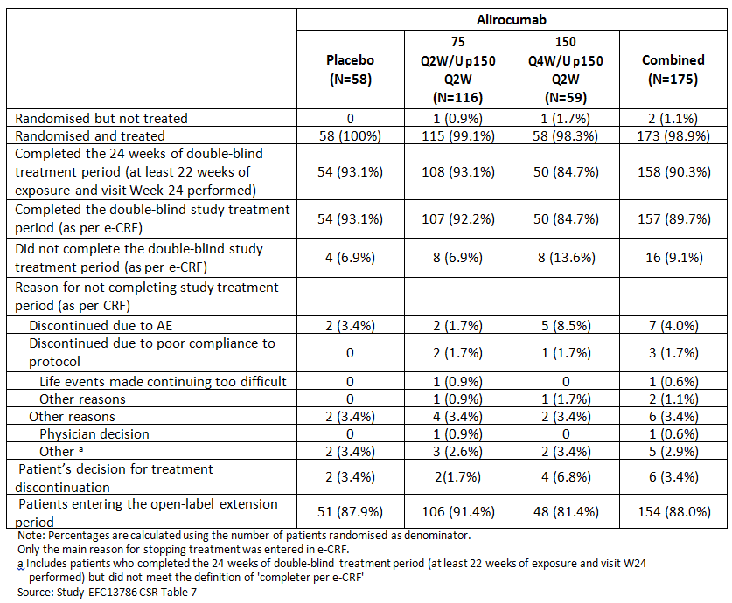
At the time of the cut-off date, about 20 patients has completed their Week 36 visit.

Table 15: Study EFC13786: Patient disposition; open label period; open label extension population
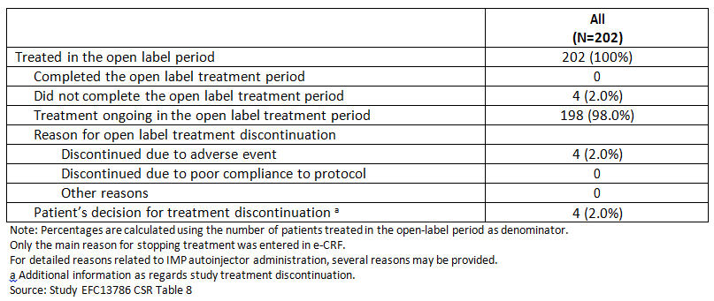

Baseline data
Demographic characteristics at Baseline were generally similar across the groups. Some numerical differences were noted due to the small size of some treatment arms. Patients were mostly White (94%) with a mean age of 63.1 years (range: 23 to 89 years). Overall, the mean BMI was 28.90 kg/m². The percentage of patients with BMI ≥ 30 kg/m² was smaller in the alirocumab 150 Q4W/Up 150 Q2W group (28.8%) than in the alirocumab 75 Q2W/Up 150 Q2W group (39.7%) and the placebo group (35.1%).
Overall 70.8% of patients were receiving a background LMT other than statin at randomisation, with 60.1% receiving ezetimibe and 8.6% receiving fenofibrate; 32.2% were on diet alone. The majority (90.1%) had a documented intolerance to statins.
At the SOC level, the most common medical history CV items were ‘Surgical and medical procedures’ (72.5%), with arterial therapeutic procedures (excl. aortic) being the most frequent high level term (HLT) (38.6%), and ‘Vascular disorders’ (69.1%), with vascular hypertensive disorders NEC being the most frequent HLT (63.5%).
About half of randomised patients (49.8%) across treatment groups had a history of CHD, with history of coronary revascularisation procedures (36.5%) being the most common CHD event or procedure, and 23.6% of patients with a history of acute MI. The majority of patients (57.1%) were considered at very high CV risk, with a slightly higher percentage of patients in the alirocumab 150 Q4W/Up 150 Q2W and 75 Q2W/Up 150 Q2W groups (61.0% and 56.9%, respectively) than in the placebo group (53.4%) 60.9% had hypertension and 16.3% had Type 2 diabetes. Tabulated data was provided.

Results for the primary efficacy outcome
The primary efficacy endpoint was the percent change in calculated LDL-C from Baseline to Week 24 in the ITT population (alirocumab 150 Q4W/Up 150 Q2W versus placebo), using all LDL-C values regardless of adherence to treatment (ITT analysis).
A statistically significant decrease in calculated LDL-C from Baseline to Week 24 (ITT analysis) was observed in the alirocumab 150 Q4W/Up 150 Q2W group (LS mean (SE) versus Baseline: -51.7% (2.3)) compared to the placebo group (LS mean (SE) versus Baseline: + 4.7% (2.3)), with an LS mean difference for alirocumab 150 Q4W/Up 150 Q2W versus placebo of -56.4% ((95% CI: -62.9 to -49.9); p < 0.0001).
At Week 24, there was a decrease in the percent change from Baseline in calculated LDL-C (ITT analysis) for the alirocumab 75 Q2W/Up 150 Q2W group (LS mean (SE) versus Baseline: -53.5% (1.6)), compared to the placebo group (LS mean (SE) versus Baseline: +4.7% (2.3)), with an LS mean difference for alirocumab 75 Q2W/Up 150 Q2W versus placebo of -58.2% (95% CI: -63.8 to -52.7.

Table 16: Study EFC13786: Percent change from Baseline in calculated LDL-C at Week 24: MMRM; ITT analysis
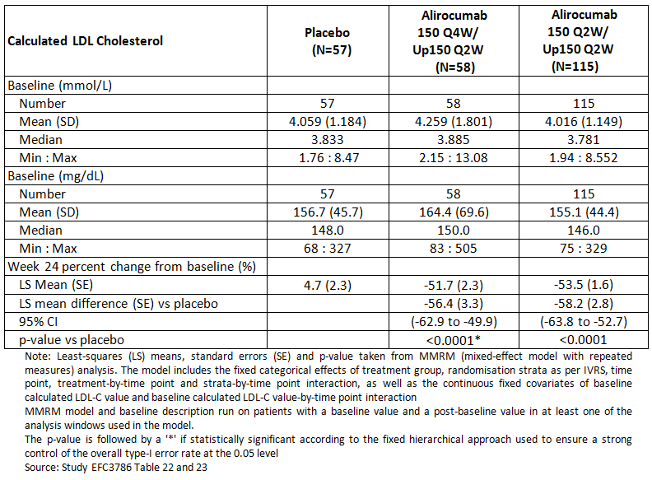
In the alirocumab 150 Q4W/Up 150 Q2W group, there was a rapid decrease in calculated LDL-C from Baseline observed from Week 4. The weekly measurements between Weeks 8 and 12 showed a maximum decrease from Week 9 to Week 11 and at Week 12, the mean LDL-C percent change from Baseline returned to levels observed at Week 8. After Week 12, there was a further decrease in mean LDL-C due to the up-titration to 150 Q2W for patients not reaching pre-defined LDL-C targets at Week 8.
Figure 9: Study EFC13786: LDL-C LS mean (± SE) percent change from Baseline: time profile; ITT analysis; ITT population
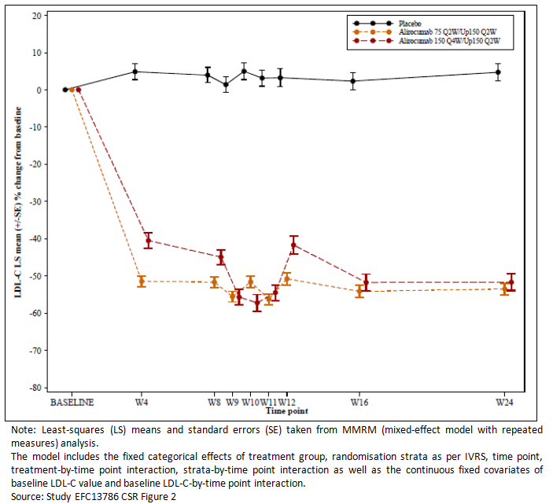
The results of the sensitivities testing were consistent with the results from the primary analysis.

Results for other efficacy outcomes
A hierarchical procedure was used to test the key secondary endpoints for alirocumab 150 Q4W/Up 150 Q2W versus placebo, while controlling for multiplicity. For some key secondary endpoints, both the ITT analysis and the on treatment analysis were pre-specified as part of the hierarchical testing procedure. For these key secondary endpoints, the on treatment analysis is considered part of the hypothesis testing procedure.
Since statistical significance was reached for the primary efficacy endpoint, the hierarchical testing was applied to the key secondary endpoints. All key secondary endpoints are statistically significant according to the hierarchical testing procedure down through the Lp (a) endpoint at Week 24 (ITT analysis) included.
Statistical significance was not reached for the change from Baseline in Lp (a) at Week 12 (ITT analysis). Consequently, subsequent key secondary endpoints were not tested: HDL-C, fasting TGs and Apo A-1 at Week 24 and Week 12. P-values presented in this report for these endpoints are for descriptive purposes.

Table 17: Study RFC13786: Secondary efficacy outcomes; hierarchical testing strategy applied
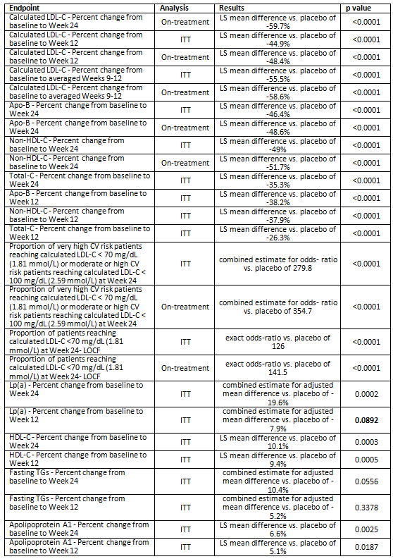

Subgroup analysis
Subgroup analyses of the primary efficacy endpoint (ITT analysis) showed consistent reduction of calculated LDL-C from Baseline with alirocumab 150 Q4W/Up 150 Q2W versus placebo across a range of demographic and Baseline characteristics including age, BMI, region, Baseline calculated LDL-C, HDL-C, fasting TGs, Lp (a), statin intolerant status, prior history of CKD, prior history of type 1 or 2 diabetes mellitus, Baseline total PCSK9 level, and non-statin LMT at randomisation.
No qualitative interactions were identified. A quantitative interaction (that is, p-value < 0.10) has been detected for gender, prior history of MI or ischemic stroke at randomisation and Baseline free PCSK9 level. However, a clinically meaningful reduction in LDL-C was observed, regardless of gender, prior history of MI or ischemic stroke and Baseline free PCSK9 level.
Figure 10: Study EFC13786: Percent change from Baseline in calculated LDL-C at Week 24: Subgroup analyses according to demographic characteristics; Forest plot; ITT analysis; Alirocumab 150 Q4W/Up 150 Q2W versus placebo
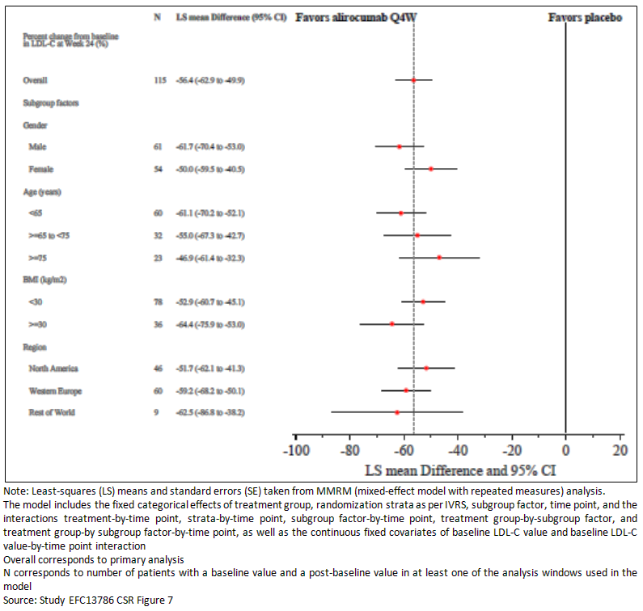
Figure 11: Study EFC13786: Percent change from Baseline in calculated LDL-C at Week 24: Subgroup analyses according to other Baseline characteristics; Forest plot; ITT analysis; Alirocumab 150 Q4W/Up 150 Q2W versus placebo
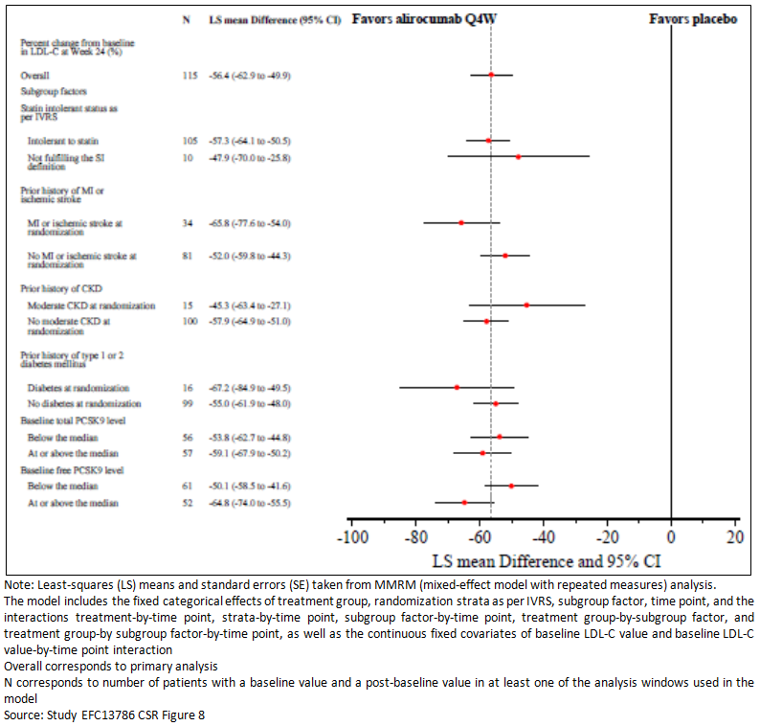
Forest plots of the results according to lipids at Baseline were provided.

Up titration status
Among the 164 patients who received at least 1 injection after Week 12, 26 patients (49.1%) in the alirocumab 150 Q4W/Up 150 Q2W group and 40 patients (36.0%) in the alirocumab 75 Q2W/Up 150 Q2W group received automatic up-titration to alirocumab 150 Q2W at Week 12 in a blinded manner.
For the alirocumab 150 Q4W/Up 150 Q2W, mean calculated LDL-C values at Baseline were 197.5 mg/dL (5.116 mmol/L) in the 26 patients with dose up-titration and 130.3 mg/dL (3.374 mmol/L) in the 27 patients who remained on alirocumab 150 Q4W. For the alirocumab 75 Q2W/Up 150 Q2W group mean calculated LDL-C at Baseline were 188.6 mg/dL (4.884 mmol/L) in the 40 patients with dose up-titration and 137.3 mg/dL (3.555 mmol/L) in the 71 patients who remained on alirocumab 75 Q2W.
For the alirocumab 150 Q4W/Up 150 Q2W group (ITT analysis), calculated LDL-C percent change from Baseline values remained lower through Week 12 among patients whose dose was not up-titrated compared with patients whose dose was up-titrated. In patients in the alirocumab 150 Q4W/Up 150 Q2W group without dose up-titration (ITT analysis), the mean (SD) percent change from Baseline in calculated LDL-C was -49.5% (15.7) at Week 12 and was maintained at Week 24 (-51.5% (12.1)). In patients with dose up-titration, the mean (SD) percent change from Baseline in calculated LDL-C was -39.6% (12.2) at Week 12. At Week 24, further reduction was observed (-59.1% (13.8)), corresponding to an incremental benefit of 18.8%.
For the alirocumab 75 Q2W/Up 150 Q2W group (ITT analysis), calculated LDL-C percent change from Baseline values remained lower through Week 24 among patients whose dose was not up-titrated compared with patients whose dose was up-titrated. In patients in the alirocumab 75 Q2W/Up 150 Q2W group without dose up-titration (ITT analysis), the mean (SD) percent change from Baseline in calculated LDL-C was -57.0% (15.7) at Week 12 and was maintained at Week 24 (-55.1% (19.3)). In patients with dose up-titration, the mean (SD) percent change from Baseline in calculated LDL-C was -42.7% (16.7) at Week 12. At Week 24, further reduction was observed (-53.5% (11.0)), corresponding to an incremental benefit of 11.3%.
Figure 12: Study EFC13786: Calculated LDL-C mean (± SE) percent change from Baseline according to up-titration status: Time profile; ITT analysis; Patients in alirocumab 150 Q4W/Up 150 Q2W group with at least one injection post-IVRS transaction at Week 12
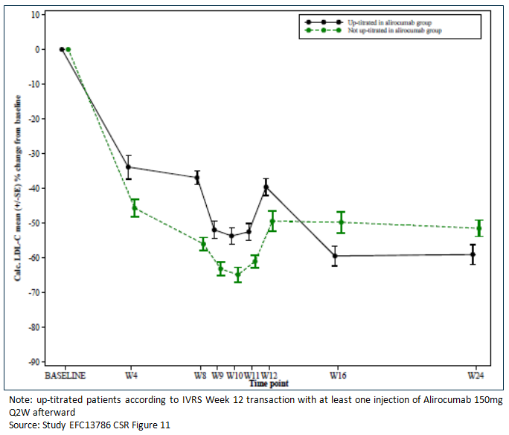

Evaluator commentary: other efficacy studies
A clinically meaningful and statistically significant difference was obtained in the primary efficacy endpoint, where the percent change in calculated LDL-C from Baseline to Week 24 in the alirocumab 150 Q4W/Up 150 Q2W group (LS mean versus Baseline: -51.7%) was greater compared with that in the placebo group (LS mean versus Baseline: + 4.7%) with an LS mean difference versus placebo of -56.4% ((95% CI: -62.9 to -49.9); p < 0.0001). The LS mean calculated LDL-C in the alirocumab 150 Q4W/Up 150 Q2W group was 75.8 mg/dL (1.962 mmol/L) at Week 24 compared with 162.9 mg/dL (4.220 mmol/L) in the placebo group.
Despite having a control group of 75 Q2W/Up 150 Q2W group there is no comparison of the Q4W and the Q2W regimens. The analyses is restricted to comparison to Baseline and placebo only. The results appear similar but there is no discussion of the comparison in the CSR. A greater number of patients had to have the dose up titrated in the 150 Q4W starting dose. However, the sponsor is not requesting 150 mg Q4W as a starting dose. In the Summary of Clinical Efficacy the sponsor explains:
‘This dosing regimen examination was based 1) on results of a Phase 1 study as single dose in monotherapy (CL-904) that suggested that the duration of action of alirocumab may be longer in subjects who are treated with diet modification alone than in those treated with a statin, in line with the knowledge that the statin stimulated production of PCSK9 increases the target mediated clearance of alirocumab; 2) The dose-finding Study CL-1003 conducted in heFH patients treated with statins ± other LMTs; and 3) on data of the Phase 1 Study PKD12910 that suggested limited impact of background therapy with ezetimibe or fenofibrate on the duration of action of alirocumab. All these 3 studies indicated that the dose of 150 mg Q4W did not demonstrate a sustained effect in patients treated with statins but might be of interest in patients not on statins. Although in CHOICE II (EFC13786) the treatment regimen of alirocumab 150 Q4W/150 Q2W for 24 weeks produced clinically meaningful and statistically significant decreases from Baseline in LDL-C levels in patients receiving non-statin therapy (fenofibrate or ezetimibe), or on diet alone, the magnitude of LDL-C lowering with 150 mg Q4W at Week 12 before dose adjustment (41.7%) was considered sub-optimal in these patients mostly at high/very high CV risk and with a Baseline LDL-C close to 160 mg/dL (4.14 mmol/L). As compared, in the initial MAA studies conducted in patients not receiving statin therapy the 75 mg Q2W dose before any potential dose adjustment produced a reduction of -47.0% in ALTERNATIVE (CL-1119) (statin intolerant patients) and -48.1% in MONO (EFC11716) (monotherapy use) regardless of the Baseline LDL-C levels (191.3 mg/dL (4.95 mmol/L), and 139.7 mg/dL (3.62 mmol/L) in ALTERNATIVE and MONO, respectively). It is also noteworthy that in CHOICE II, before any potential dose adjustment the 75 mg Q2W dose, used as calibrator arm, produced similar reduction of -50.8% to that reported in the initial MAA. Since the 300 mg Q4W dose provides more consistent efficacy than the 150 mg Q4W dose in patients not receiving statins, including patients with statin intolerance, with a similar safety profile, the data from CHOICE II are provided for information, but marketing authorization will not be requested for the 150 mg Q4W dosing regimen. Therefore the Applicant will not pursue the request of this dose regimen (that is, 150 mg Q4W).’

Analyses performed across trials: pooled and meta analyses
Not applicable for Q4W dosing as only one study used the proposed dosing regimen.

Evaluator’s conclusions on clinical efficacy

Indication 1 – Q4W

Study R727-CL-1308
Two populations of patients were enrolled in this study, one not receiving concomitant statin therapy (1/3 patients) and one receiving concomitant statin therapy (2/3 patients). Patients within each population were randomised to 1 of 3 groups: alirocumab 300 mg Q4W with the option of dose adjustment to 150 mg Q2W (referred to as 300 Q4W/Up 150 Q2W), or alirocumab 75 mg Q2W with the option of up-titration to 150 mg Q2W (referred to as 75 Q2W/Up 150 Q2W), and placebo. Up titration was formally done at Week 12 for patients who did not achieve their pre-specified LDL-C goals at Week 8. The large majority of patients were at high/very high CV risk (85.9%who were also on statins and 74.1% not on statins).
With the 300 Q4W/150 Q2W the LS mean percent reduction in calculated LDL-C from Baseline was -58% but 15 to 19% of patients had to have their dose regimen changed to a Q2W regimen to achieve stable response.
Given that the sponsor cannot identify the subset of patients who can benefit from a starting dose of 300 mg Q4W or even 150 mg Q4W there does not appear to be sufficient justification for altering the starting dose of 75 mg Q2W and then assessing the response at Week 8 and deciding on up titrating to 150 mg Q2W depending on the individual patients preference, risk factors, target LDL-C level and response. It seems likely that several dose changes may be necessary to achieve optimal treatment at the lowest dose in individual patients.
It is disappointing that the sponsor did not conduct any studies that maintained patients on Q4W therapy having started on a Q2W regimen. All the studies using a Q4W regimen started on Q4W and then moved to a Q2W regimen. It is therefore not possible to know if patients who respond at Q2W can be successfully moved to a Q4W regimen.
Study EFC13786 started patients on a 150 mg Q4W regimen but while this appeared equivalent almost half the patients had to have their dose up titrated and the sponsor found the results not consistent and did not pursue this as a requested indication. Again there was no consideration of starting at 75 mg or 150 mg Q2W and then moving to 150 mg or 300 mg Q4W.

Indication 2 – Two weekly dosing (Q2W)
The final reports of the five studies which were submitted in the initial application as interim reports demonstrate persistent efficacy to 78 or 104 weeks.

Pivotal or main efficacy studies
The sponsor has provided the final reports for the 5 studies which were submitted as interim reports in the initial application: EFC 11569 (Combo I), EFC 12492 (FHI), R727-CL-1112 (FHII), EFC 12732 (High FH), and LTS11717 (Long Term).
All these Phase III studies were double blind, parallel group, randomised, controlled studies with a double blind treatment period of 78 weeks (approximately 18 months) for 4 studies (FHI, FHII, High FH and Long Term) and of 104 weeks for Combo II. The four 78-week studies (FH I, FH II, HIGH FH, and LONG TERM) were conducted in patients receiving a background therapy of statin at the maximally tolerated dose and possibly other concomitant LMT and used placebo as comparator for alirocumab. Among these studies, FH I, FH II, and HIGH FH enrolled heFH patients; in HIGH FH, patients had to have a LDL-C ≥ 160 mg/dL (4.14 mmol/L) at the screening visit. The LONG TERM study enrolled both heFH patients and non-FH patients at high risk of atherosclerotic CVD. The 104 week study (COMBO II) was conducted in non-FH patients at high risk of atherosclerotic CVD, receiving a background therapy of statin at the maximally tolerated dose without any other LMT, since the active comparator was ezetimibe.
The primary objective of 4 of these 5, Phase III studies was to demonstrate the reduction of LDL-C at 24 weeks by alirocumab as add-on therapy to stable maximally tolerated daily statin therapy (FH I, FH II, HIGH FH, COMBO II). It was also the primary efficacy objective of the fifth study, LONG TERM, as the overall primary objective was the evaluation of long-term safety and tolerability.
The individual study summaries of the final efficacy results were provided. See below for pooled analyses.

Analyses performed across trials: pooled and meta analyses
The sponsor provided efficacy results observed at Week 78 across the four Phase III studies that have been completed since the initial dossier and can be pooled.

Results at Week 78 (Studies EFC12482 (FH I), R727-CL-1112 (FH II), EFC12732 (HIGH FH), LTS11717 (LONG TERM))
These four studies were placebo controlled studies, conducted either in heFH patients or in both heFH and non-FH patients at high CV risk. In Studies FH I and FH II the initial dose was 75 mg alirocumab Q2W with possible up titration to 150 mg Q2W. In Studies Long Term and High FH the initial starting dose was 150 mg Q2W.
Figure 13: Percent change from Baseline in calculated LDL-C at Week 78: MMRM (ITT analysis); Phase III studies
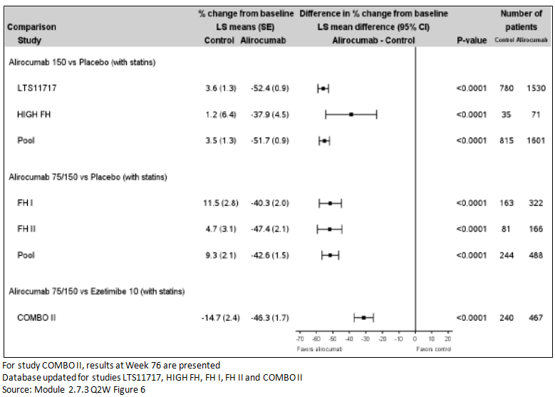
Figure 14: Calculated LDL-C over time: LS mean ± SE percent change from Baseline (ITT analysis); Pool of FH studies
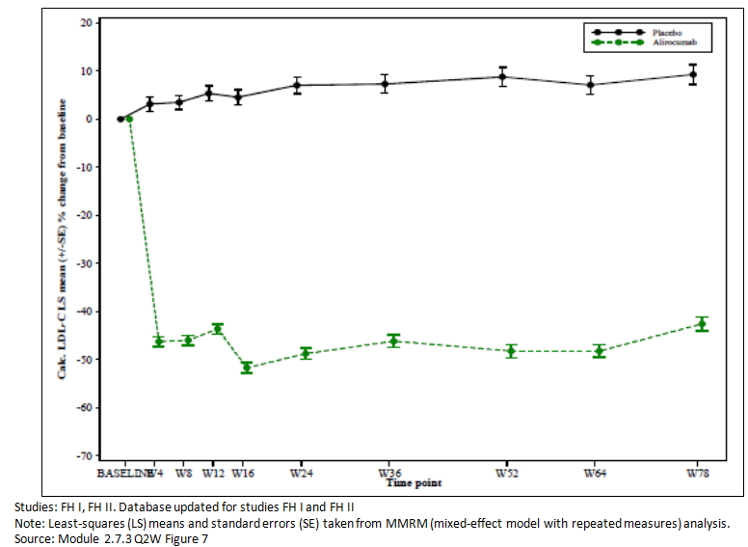
Figure 15: Proportion of patients reaching calculated LDL-C < 70 mg/dL (1.81 mmol/L) at Week 78 (ITT analysis); Phase III studies
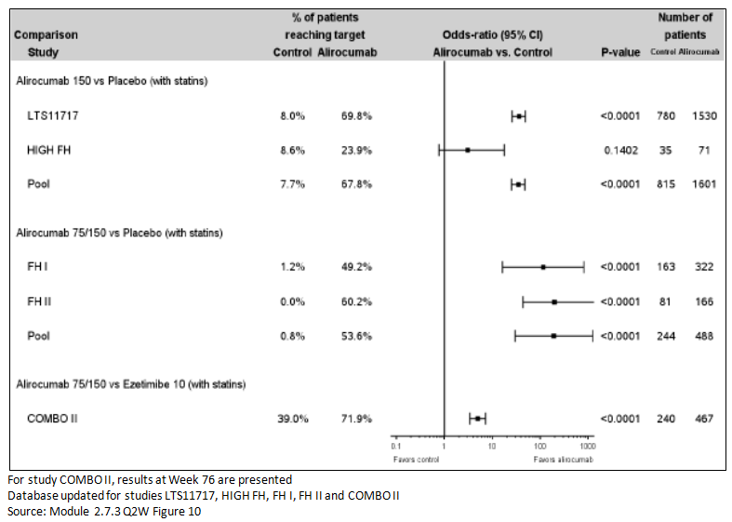

Evaluator’s conclusions on clinical efficacy – Q2W
The sponsor has provided the final study reports for the 5 studies which were submitted in the initial application as ‘first step analysis’ reports. The final reports include patients treated for 78 weeks in four studies and 104 weeks in one study.
The results are consistent with the interim reports and demonstrate a sustained effect for 78 to 104 weeks.
The new data does not support an extension of the indications to remove the requirement for clinical cardiovascular disease as the reservations about approving this in the initial application still exist. No argument to justify this is included in the submission. The concern previously appears to be widening the indication in the absence of cardiovascular outcome data which is still awaiting completion of the specific ongoing study addressing this issue.

Clinical safety
The following studies provided evaluable safety data:
- Study R727-CL-1308: data on starting and maintenance dose regimen of 300 mg Q4W/Q2W treatment for 48 weeks
- Study EFC13786: data on starting and maintenance dose regimen of 150 Q4W/150 Q2W treatment for 24 weeks
- Five Studies (EFC11569, EFC12492, EFC12732, LTS11717 and R727-CL-1112), which had been previously evaluated as interim reports, provided data on longer term safety to 78 weeks and 104 weeks

Studies providing evaluable safety data

Pivotal studies that assessed safety as the sole primary outcome
Study LTS11717; Long-term safety and tolerability of REGN727/SAR236553 in high cardiovascular risk patients with hypercholesterolemia not adequately controlled with their lipid modifying therapy: a randomised, double blind, placebo controlled study.

Pivotal and/or main efficacy studies

Study R727-CL-1308
Safety was assessed by:
- General adverse events (AEs): were collected at each study visit. The methodology for how to identify AEs is not described in the protocol or CSR (definitions and reporting requirements are provided).
- AEs of particular interest: abnormal liver function tests (specified limits), haemolytic anaemia, allergic events (allergic drug reaction and/or local injection site reactions), neurologic events and ophthalmologic events that required investigation or referral were identified by accelerated reporting requirement. Cardiovascular events were referred to safety committee.
- Laboratory tests: standard haematology, clinical chemistry and urinalysis and HbA1c were done at specified visits (screening, Baseline, Weeks 12, 24, 36, 48 and at discontinuation or follow up as necessary.
- Specialty lipid panel - Fasting samples were collected at each study visit for total cholesterol, calculated LDL-C, HDL-C, TG, and non-HDL-C. (LDL-C was measured (via the beta-quantification method) at Week 0 and Week 24). Fasting samples were also collected at Baseline and at Week 6, 12, 24, 36 and end of study for testing for ApoB, ApoA-1, ApoB/ApoA-1 ratio, and Lp(a).
- Other safety variables: vital signs were recorded at each study visit and physical examination and ECG was recorded at study start and finish.

Other studies

Other efficacy studies

Study EFC13786
Safety parameters assessed in the study included occurrence of treatment emergent adverse events (TEAEs), including serious adverse events (SAEs) and adverse events of special interest (AESIs), cardiovascular events, deaths, as well as treatment emergent clinical laboratory abnormalities (urinalysis, blood analysis, haematology, standard chemistry, hepatitis C antibody, liver panel, and creatine phosphokinase (CPK)), and vital signs.

Studies with evaluable safety data: dose finding and pharmacology
Not applicable.

Studies evaluable for safety only
Not applicable.

Studies that assessed safety as the sole primary outcome

Study LTS11717
Comment: This study was submitted in the initial application (PM-2015-00764-1-3) but only interim results were submitted, which contained the analysis of safety endpoints up to Week 52. The full details of the study were presented in the initial application and are not repeated in this report. The summary of the final analysis should be read in association with the previous CER. This final analysis includes safety data to Week 78.

Safety variable and outcomes
Safety parameters assessed included occurrence of TEAEs, including SAEs and adverse events of special interest (AESIs) (including ALT 3 x the upper limit of normal (ULN) if Baseline ALT < ULN or ALT ≥ 2 times the Baseline value if Baseline ALT ≥ ULN, allergic events, local injection site reactions, haemolytic anaemia, neurologic events including neurocognitive events, ophthalmologic events, overdose with investigational medicinal product (IMP), and pregnancy), CV events, deaths, clinical laboratory data (blood analysis, haematology, standard chemistry, hepatitis C antibody, liver panel, creatine phosphokinase (CPK), vitamin E and other fat soluble vitamins, cortisol with reflexive ACTH and ACTH stimulation, and gonadal hormones (including luteinizing hormone, follicle stimulating hormone, total testosterone, and sex hormone binding globulin)), vital signs, and electrocardiogram (ECG).
No single primary safety outcome was identified.

Analysis populations
Safety population: defined as the randomised patients who actually received at least one dose or part of a dose of the double blind IMP injection. Patients were analysed according to the treatment actually received (that is, as-treated treatment group, alirocumab or placebo).

Participant flow
A total of 2,006 patients were exposed to IMP injections for ≥ 52 weeks, of which 1,916 patients were exposed to IMP injections for ≥ 76 weeks (1,267 patients (81.9%) in the alirocumab group and 649 patients (82.8%) in the placebo group). Among the 1,916 patients with ≥ 76 weeks of IMP exposure, 1,912 patients completed the Week 78 visit.

Results for the safety outcomes
The primary objective was to evaluate the long term safety and tolerability of alirocumab in high CV risk patients with hypercholesterolemia not adequately controlled with their lipid modifying therapy.

Table 18: Study LTS11717: Overview of adverse event profile: Treatment emergent adverse events; Safety population
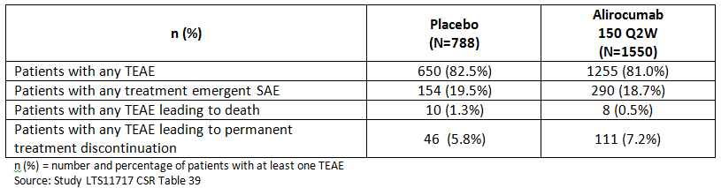

Adverse events
The percentages of patients who experienced TEAEs were similar between the two groups 1255/1550 (81.0%) on alirocumab and 650/788 (82.5%) on placebo. Overall, meaningful treatment differences were not observed at the SOC level for any of the SOC with an incidence of ≥ 3% of patients, in either treatment group.
The most frequently reported TEAEs at the PT level (≥ 5% of patients in either treatment group) in the alirocumab versus placebo groups, respectively, were as follows (by decreasing order in the alirocumab group): nasopharyngitis, upper respiratory tract infection, injection site reaction, urinary tract infection, diarrhoea, influenza, back pain, bronchitis, myalgia, and arthralgia and headache.
The following seven TEAEs (PT) were reported more frequently in the alirocumab group compared with the placebo group (with an incidence of ≥ 2.0% and a difference ≥ 0.5% versus placebo), in order of decreasing frequency: injection site reaction, myalgia, muscle spasms, cough, musculoskeletal pain, contusion, and angina unstable.

Table 19: Study LTS11717: Number (%) of patients with TEAEs that occurred with HLT ≥ 2% in any treatment group by primary SOC, HLT and PT; Safety population
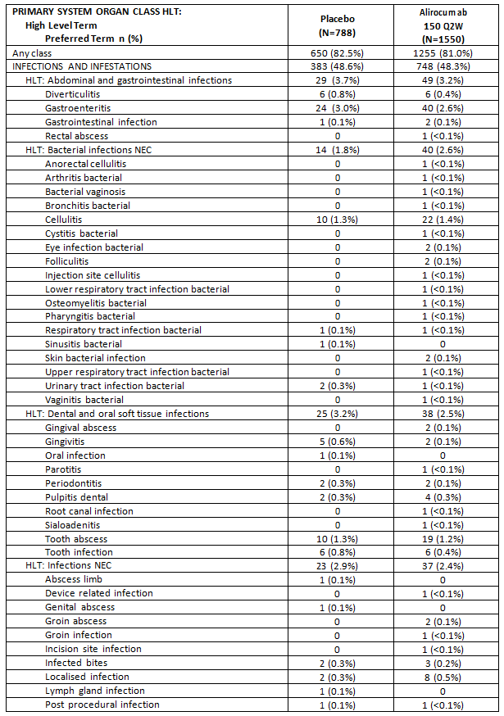

Table 19 (continued): Study LTS11717: Number (%) of patients with TEAEs that occurred with HLT ≥ 2% in any treatment group by primary SOC, HLT and PT; Safety population
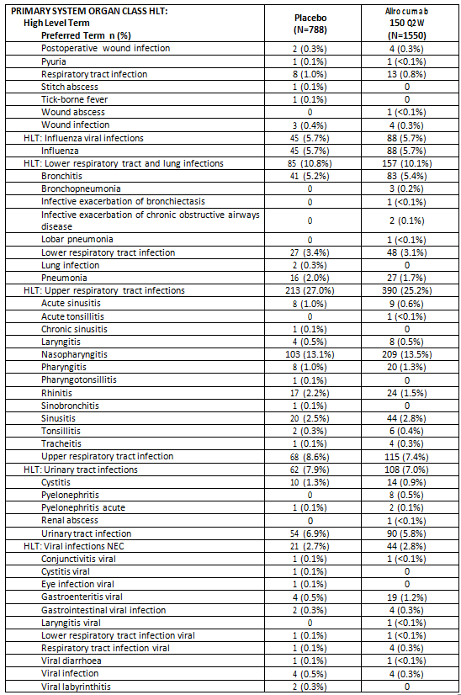

Table 19 (continued): Study LTS11717: Number (%) of patients with TEAEs that occurred with HLT ≥ 2% in any treatment group by primary SOC, HLT and PT; Safety population
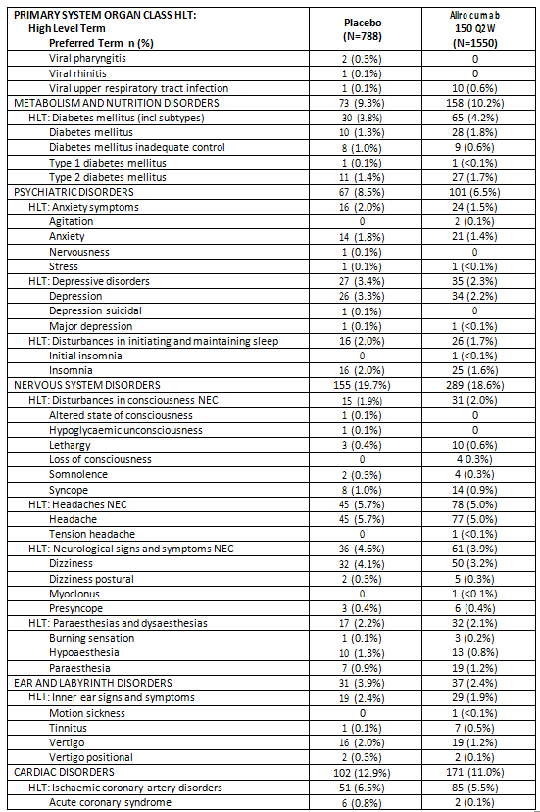

Table 19 (continued): Study LTS11717: Number (%) of patients with TEAEs that occurred with HLT ≥ 2% in any treatment group by primary SOC, HLT and PT; Safety population
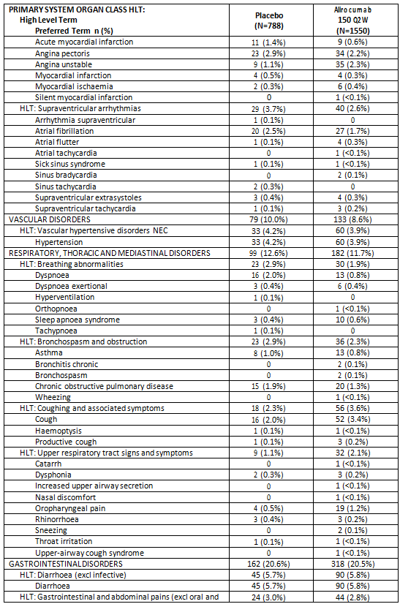

Table 19 (continued): Study LTS11717: Number (%) of patients with TEAEs that occurred with HLT ≥ 2% in any treatment group by primary SOC, HLT and PT; Safety population
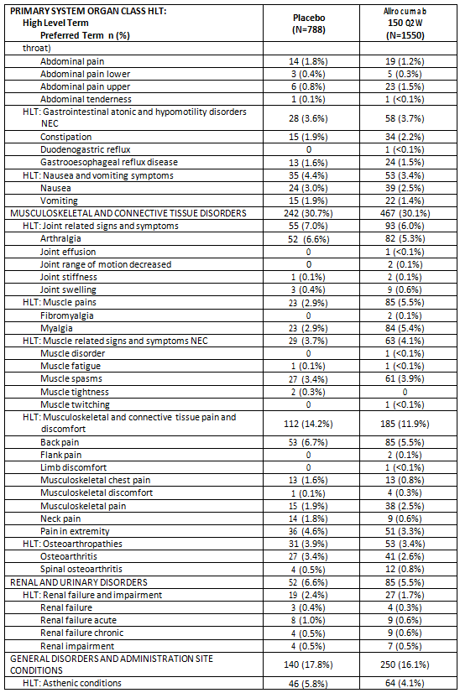

Table 19 (continued): Study LTS11717: Number (%) of patients with TEAEs that occurred with HLT ≥ 2% in any treatment group by primary SOC, HLT and PT; Safety population
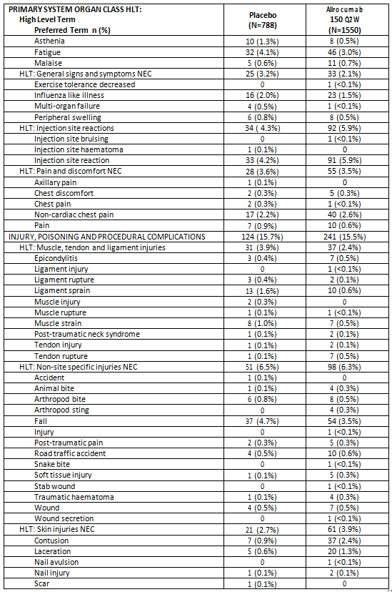

Table 19 (continued): Study LTS11717: Number (%) of patients with TEAEs that occurred with HLT ≥ 2% in any treatment group by primary SOC, HLT and PT; Safety population
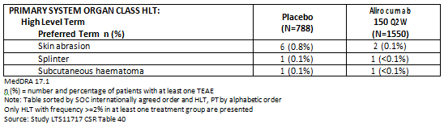

Treatment related AEs
For 17.2% of patients in the alirocumab group and 14.3% of patients in the placebo group, TEAEs were considered to be related to IMP injections by the Investigator. The most frequently occurring TEAE considered related to the IMP was injection site reaction occurring in 91 patients (5.9%) in the alirocumab group and 33 patients (4.2%) in the placebo group. Other TEAEs (PT) that were considered related to the IMP and occurred in ≥ 0.5% of patients in either the alirocumab or placebo group, respectively, included the following: headache (0.8% versus 1.4%), diarrhoea (1.0% versus 0.5%), dizziness (0.6% versus 0.6%), nausea (0.6% versus 0.9%), pruritus (0.5% versus 0.1%), arthralgia (0.5% versus 0.5%), myalgia (1.3% versus 0.4%), muscle spasm (0.6% versus 0.5%), fatigue (0.7% versus 0.5%), and decreased blood cortisol (0.4% versus 0.8%).

AEs in patients with two consecutive LDL-C < 25 mg/dL (0.65 mmol/L)
In this study where patients in the alirocumab group had treatment initiated and maintained at 150 mg Q2W, regardless of their Baseline LDL-C level, two consecutive LDL-C values < 25 mg/dL (0.65 mmol/L) were reported in 575 patients in the alirocumab group and no patients in the placebo group. Among them, 435 patients (75.7%) reported at least one TEAE that occurred, worsened, or became serious after the first of the two consecutive LDL-C values < 25 mg/dL (0.65 mmol/L)). In general, no particular safety profile emerged in the patients who had a two consecutive LDL-C < 25 mg/dL (0.65 mmol/L).

Deaths
There were a total of 21 deaths reported during the study (11 patients (0.7%) in the alirocumab group and 10 patients (1.3%) in the placebo group). In addition, there were two deaths (one in each treatment group) reported post study. Of the 21 patients who died during the on-study period 18 patients had TEAEs leading to death, that is, the AE that led to the patient’s death developed, worsened or became serious during the TEAE period (8 patients (0.5%) in the alirocumab group and 10 patients (1.3%) in the placebo group). None of the TEAEs leading to death were considered by the Investigator to be related to the IMP.

Table 20: Study LTS11717: Summary of deaths adjudication results; Safety population
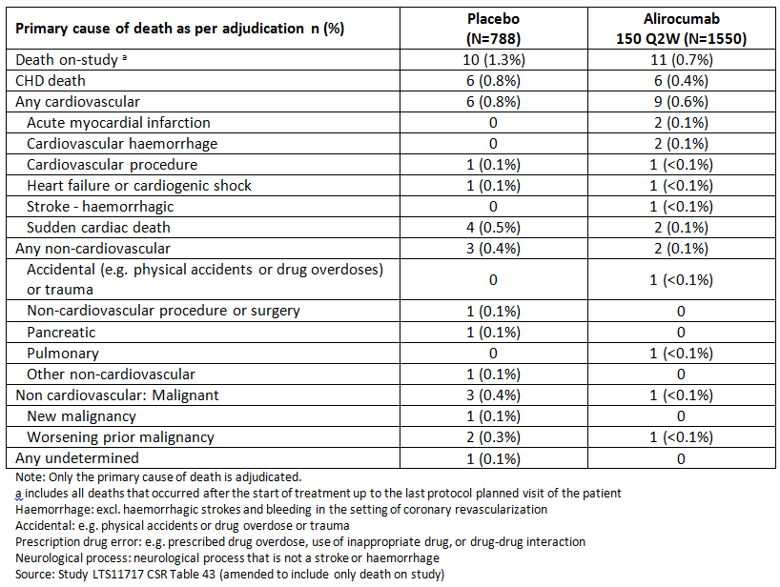

Serious AEs
The percentages of patients who experienced a treatment emergent SAE were similar between treatment groups. Treatment emergent SAEs were reported in 290 patients (18.7%) in the alirocumab group and 154 patients (19.5%) in the placebo group. In general, individual PTs were reported at low frequency with no marked trend.
A table of SAEs occurring in more than one patient was provided.

Discontinuations due to AEs
A total of 111 patients (7.2%) in the alirocumab group and 46 patients (5.8%) in the placebo group experienced TEAE leading to treatment discontinuation. The main drivers of the difference at the primary SOCs level between alirocumab versus placebo were as follows: nervous system disorders (1.0% versus 0.5%), eye disorders (0.5% versus 0.1%), and skin and subcutaneous tissue disorders (0.5% versus 0.1%). No clear preferred term accounted for the treatment group difference in these SOCs.
The most frequently reported TEAEs (PTs) leading to permanent treatment discontinuation that occurred in ≥ 0.2% of patients in either the alirocumab or placebo group, respectively, were (by decreasing order in the alirocumab group): injection site reaction, ALT increased, myalgia, pruritus, acute MI, renal failure chronic, fatigue, dizziness, alcohol abuse, abdominal pain, back pain, blood cortisol decreased, and atrial fibrillation.

Adverse events of special interest

Allergic events
The percentage of patients with at least one general allergic TEAE was similar in the alirocumab group (156 patients (10.1%)) and the placebo group (75 patients (9.5%)). The most frequently reported allergic TEAE (by ≥ 0.5% of patients) were: rash, pruritus, conjunctivitis, asthma, seasonal allergy, eczema, dermatitis contact, rhinitis allergic, erythema, and rash pruritic.
Ninety-one patients (5.9%) in the alirocumab group and 33 patients (4.2%) in the placebo group had at least one local injection site reaction TEAE. Most patients who experienced a local injection site reaction TEAE had a single episode (59 patients (64.8%) in the alirocumab group and 28 patients (84.8%) in the placebo group.

Confirmed haemolytic anaemia
No cases of confirmed haemolytic anaemia were reported during the study.

Neurologic events
Seventy-two patients (4.6%) in the alirocumab group and 38 patients (4.8%) in the placebo group experienced TEAEs related to neurologic disorders. The most frequently occurring neurologic AE was paraesthesia which occurred in 19 patients (1.2%) in the alirocumab group and 7 patients (0.9%) in the placebo group.
Neurologic SAEs were reported for five patients (0.3%) in the alirocumab group (including ataxia, demyelination, Miller Fisher syndrome, optic neuritis, and dysarthria) and two patients (0.3%) in the placebo group (both cases of hypoesthesia).
Because of the hypothetical connection between disturbances in the myelin sheath of nerves and low LDL-C, neurological TEAEs in patients with two consecutive LDL-C < 25 mg/dL (0.65 mmol/L) were reviewed. Among the most common neurologic disorders identified (that is, paraesthesia, decreased vibratory sense, hypoesthesia) there was no increased incidence of these AEs noted to have occurred, worsened, or become serious after the first of the two consecutive low LDL-C values in the subgroup of alirocumab treated patients with two consecutive LDL-C values < 25 mg/dL (0.65 mmol/L) compared with those patients who did not have two consecutive LDL-C values < 25 mg/dL (0.65 mmol/L) in the alirocumab group.

Neurocognitive events
Eighteen patients (1.2%) in the alirocumab group and four patients (0.5%) in the placebo group experienced TEAEs related to neurocognitive disorders. Neurocognitive SAEs were reported for three patients (0.2%) in the alirocumab group (including confusional state, dementia, and frontotemporal dementia) and one patient (0.1%) in the placebo group (dementia).

Ophthalmological disorders
Overall, 45 patients (2.9%) in the alirocumab group and 15 patients (1.9%) in the placebo group experienced TEAEs related to ophthalmological disorders. A higher percentage of patients had ophthalmological TEAEs in alirocumab compared with the placebo group for the following AEs: retinal disorders (2.3% versus 1.5%) and optic nerve disorders (1.2% versus 0.4%). All ophthalmological AEs for retinal disorder and optic nerve disorder occurred with an incidence < 0.5%.
Selected sites participated in an ophthalmologic sub-study. Ophthalmologic assessments (including colour vision testing, best corrected visual acuity, slit lamp ophthalmoscopy, intraocular pressure assessment, dilated lens and fundus examination, or optic disc and fundus photographs) were performed periodically throughout the study as per the usual practice of the ophthalmologist/optometrist involved in this sub-study. Abnormalities identified during the ophthalmological assessments were reported as AEs.
Among the 139 patients who participated in the ophthalmological sub-study, 7 patients had an ophthalmological TEAE (5 patients (5.7%) in the alirocumab group and 2 patients (3.9%) in the placebo group). In the alirocumab group the following ophthalmological TEAEs were reported in one patient each: age related macular degeneration, corneal abrasion, demyelination, detachment of the retinal pigment epithelium, and retinal haemorrhage. In the placebo group, one patient each had diabetic retinopathy and macular degeneration.

Adjudicated cardiovascular events
A total of 112 patients had treatment emergent CV events (AEs and procedures) that were confirmed by adjudication, including 72 patients (4.6%) in the alirocumab group and 40 patients (5.1%) in the placebo group. The most frequently reported CV event was ischemia driven coronary revascularisation procedure, reported for 48 patients (3.1%) in the alirocumab group and 24 patients (3.0%) in the placebo group. A lower percentage of patients in the alirocumab group experienced a nonfatal MI compared with the placebo group (0.9% versus 2.3%), and a lower percentage of patients in the alirocumab group experienced CHD death compared with the placebo group (0.3% versus 0.9%).

Table 21: Study LTS11717: Summary of cardiovascular TEAEs according to adjudication; Safety population
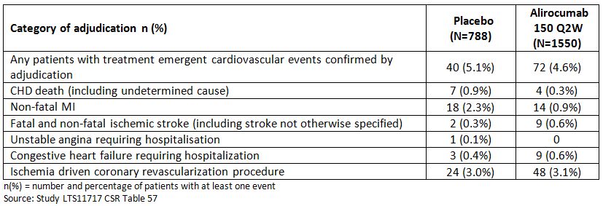
A post hoc analysis of MACE and other CV composite endpoints was conducted and found that the incidence of patients with MACE composite endpoint was lower in the alirocumab group compared with the placebo group (1.7% versus 3.3%). The hazard ratio was 0.523 (95% CI: 0.305 to 0.897) for alirocumab compared with placebo.

Hepatic disorders
A total of 36 patients (2.3%) in the alirocumab group and 14 patients (1.8%) in the placebo group experienced TEAEs related to hepatic disorders. The most frequently occurring hepatic disorder PT was ALT increased, which occurred in 15 patients (1.0%) in the alirocumab group compared with 5 patients (0.6%) in the placebo group. The percentage of patients with a TEAE of γGT increased was also higher in the alirocumab group (6 patients (0.4%) in the alirocumab group versus no patients in the placebo group).

Clinical laboratory evaluations and vital signs
There were no relevant changes with regard to haematology, electrolytes, liver enzymes, renal function, cortisol, gonadal hormones (in men), or vitamins A and D. Vitamin E decreased post Baseline in the alirocumab group compared with the placebo group.
Overall, none of the clinical laboratory parameters evaluated or the vital signs showed a clinically relevant difference between treatment groups. No safety concerns were identified by ECG.

Anti-alirocumab antibodies
Twenty-four patients in the alirocumab group (1.6%) and 8 patients in the placebo group (1.1%) had positive ADA status at Baseline, with titres ranging from 30 to 480 for the alirocumab group and from 30 to 120 for the placebo group, and none of them developed a treatment emergent positive ADA response during the study.
A total of 81 patients developed a treatment emergent positive ADA response: 72 patients in the alirocumab group (4.8%) and 9 in the placebo group (1.2%). The time to onset of ADA response for most patients in the alirocumab group was between 4 and 12 weeks, with a median time to ADA response of 4.93 weeks. Among these 72 patients in the alirocumab group with a treatment emergent positive ADA response, 18 patients had a response classified as persistent, 53 patients had a transient response, and 1 patient had an indeterminate response. Among the 1,489 patients in the alirocumab group of the ADA population, 19 patients (1.3%) had at least 1 positive neutralising status.
Overall, a treatment emergent ADA positive response was observed in 4.8% of patients treated with alirocumab. This ADA response did not appear to impact the LDL-C effect or safety profile of alirocumab, with the possible exception of injection site reaction, which occurred with a higher incidence in ADA-positive patients compared with ADA negative patients (11.3% versus 5.6%). In most patients, the ADA response was transient and was not associated with any safety concern apart from mild increase in the incidence of injection site reactions. Nineteen patients, all from alirocumab treatment group, had a positive neutralising status.

Evaluator commentary
This is a large study of 2,341 patients at high CV risk (with a history of CHD or CHD risk equivalents or HeFH) who were exposed to alirocumab for a total of 78 weeks.
The frequency of TEAEs, SAEs, and TEAEs leading to death were similar between treatment groups. Seven TEAEs occurred in the alirocumab group with a higher incidence than the placebo group (with an incidence of ≥ 2.0% and a difference ≥ 0.5% versus placebo): injection site reaction, myalgia, muscle spasms, cough, musculoskeletal pain, contusion, and angina unstable.
Eleven patients in the alirocumab group and 10 patients in the placebo group died during the on-study period. None of the deaths on study were considered related to the IMP.
The frequency of injection site reaction was higher in the alirocumab group compared with the placebo group (5.9% versus 4.2%, respectively) but they were mostly mild and of short duration and rarely led to treatment discontinuation.

Patient exposure
The sponsor provided two Summaries of Clinical Safety and so exposure is presented for Q4W and Q2W separately.

Q4W

Table 22: Exposure to alirocumab in Study R727-CL-1308; all randomised subjects
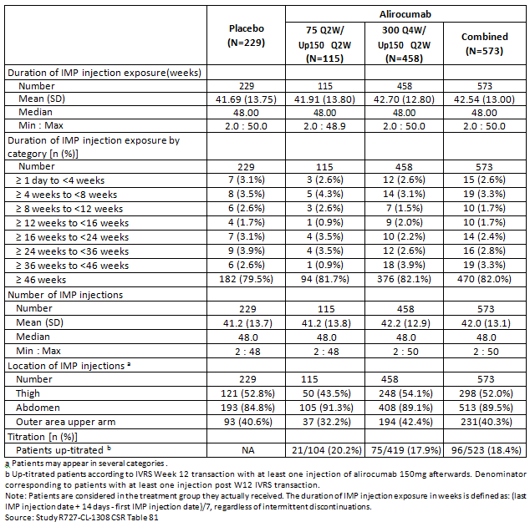

Table 23: Study R727-CL-1308: details of dosing titration
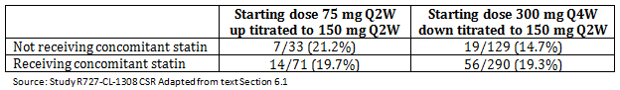

Table 24: Exposure to alirocumab in Study EFC13786; double blind period; Safety population
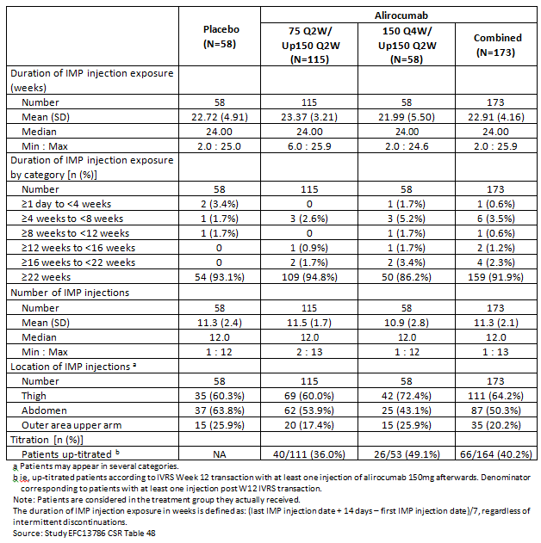

Q2W

Table 25: Studies included in the Summary of Clinical Safety; Q2W
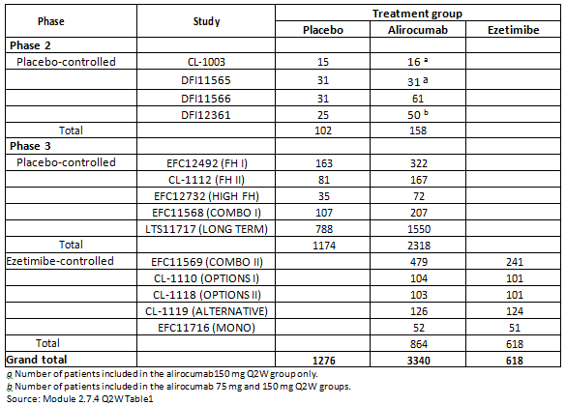
The safety data has been organised into two data pools; the placebo controlled pool and the ezetimibe controlled pool.

Table 26: Exposure to alirocumab; Injection (Safety population); pool of placebo controlled studies and pool of ezetimibe controlled studies
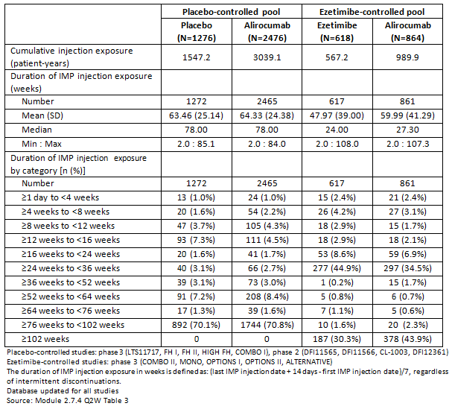

Adverse events

All adverse events (irrespective of relationship to study treatment)

Integrated safety analyses

Q4W
Not applicable.

Q2W
In both treatment pools, the incidences of TEAEs across treatment pools were generally similar.

Table 27: Overview of adverse event profile: TEAE (Safety population); Pool of placebo controlled studies and pool of ezetimibe controlled studies
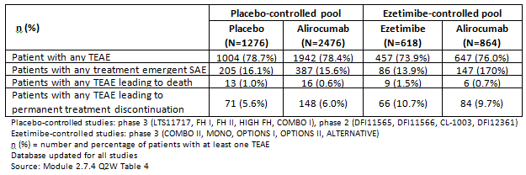

Placebo controlled pool
TEAEs (PT) reported in a higher proportion of patients in the alirocumab group compared with placebo (that is, incidence ≥ 2.0% in the alirocumab group and difference ≥ 0.5% versus placebo) were: nasopharyngitis (12.2% in the alirocumab group versus 11.5% in the placebo group), injection site reaction (6.9% versus 4.9%), influenza (5.9% versus 4.9%), myalgia (4.5% versus 3.7%), contusion (2.3% versus 1.3%), and musculoskeletal pain (2.3% versus 1.6%).
Compared with the analysis submitted in the initial application, new TEAEs reported in ≥ 5% of patients in any group included urinary tract infection, diarrhoea, and back pain, with no meaningful differences between alirocumab and placebo groups. New TEAEs reported at an incidence ≥ 2.0% in the alirocumab group and with a difference ≥ 0.5% versus the placebo group included nasopharyngitis. Muscle spasms no longer meet these criteria compared with the initial analysis.
In summary, compared with the initial analysis, oropharyngeal pain was no longer identified as being reported at a significantly higher rate with alirocumab as compared with placebo. Injection site reactions, pruritus, and upper respiratory tract signs and symptoms remain common AEs.

Ezetimibe controlled pool
TEAEs (PT) reported in a higher proportion of patients in the alirocumab group compared with the ezetimibe group (incidence ≥ 2.0% in the alirocumab group and difference ≥ 0.5% versus ezetimibe) were: upper respiratory tract infection (7.2% in the alirocumab group versus 6.5% in the ezetimibe group), accidental overdose (6.3% versus 3.9%), headache (5.0% versus 3.9%), arthralgia (4.9% versus 4.2%), influenza (4.3% versus 3.7%), fatigue (3.2% versus 1.5%), injection site reaction (2.9% versus 2.1%), fall (2.5% versus 1.8%), constipation (2.3% versus 1.8%), and insomnia (2.1% versus 1.5%).
Compared with the initial analysis submitted in the initial application, new TEAEs reported in ≥ 5% of patients in any group included accidental overdose and headache, which were both most frequently reported in the alirocumab group as compared to the ezetimibe group. Upper respiratory tract infection, arthralgia, fall, and insomnia are new TEAEs reported at a higher incidence with alirocumab as compared to ezetimibe since the initial analysis.
In summary, compared with the initial analysis, fatigue was newly identified as a common AE reported at a significantly higher rate with alirocumab as compared with ezetimibe; bronchospasm and obstruction (HLT) was no longer identified as being reported at a significantly higher rate with alirocumab as compared with ezetimibe.

Effect of up titration
A total of 228 patients whose dose of alirocumab was up-titrated and 432 patients whose dose of alirocumab was not up-titrated were identified in the placebo controlled pool, and 180 patients with dose up-titration and 606 patients with no dose up-titration in the ezetimibe controlled pool.
No TEAEs were consistently reported at higher rates in patients with dose up-titration as compared with patients with no dose up-titration, in both placebo and ezetimibe controlled pools. Influenza, upper respiratory tract infection, and dizziness were reported at higher rates in patients with no dose up-titration, consistently in both pools.

Local injection site reactions
Overall, the percentages of patients who reported local injection site reactions were 6.3% and 4.3% in the alirocumab and pooled control groups, respectively. The incidence rate was higher in the alirocumab group compared with the pooled control group (4.9 and 3.5 per 100 patient years, respectively), with HR (95% CI) of 1.47 (1.14 to 1.91). Compared with the analysis submitted in the initial application, the incidence rates decreased in both the alirocumab and placebo groups (respectively, 6.0 and 4.2 per 100 patient-years in the initial analysis), and the HR remained stable (1.50 (95%CI: 1.15 to 1.95)).

Main/pivotal studies that assessed safety as the sole primary outcome

Q4W
Not applicable.

Q2W
See Section 8.2

Pivotal and/or main efficacy studies

Q4W

Study R727-CL-1308
The percentage of patients who experienced TEAEs was higher in the 300 Q4W/Up 150 Q2W alirocumab treatment group (80.6%) than the placebo group, and was similar in the placebo group (74.7%) and 75 Q2W/Up 150 Q2W group (74.8%). The AE profiles for the population of patients receiving concomitant statin therapy and the population not receiving concomitant statin therapy were similar to the overall safety population and to each other.

Table 28: Study R727-CL-1308: overview of adverse event profile; TEAEs; patients regardless of concomitant statin therapy; Safety Population
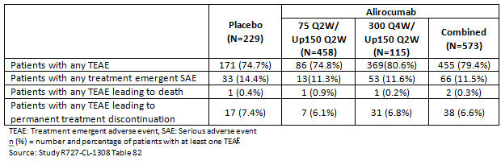

Table 29: Number (%) of patients with TEAEs that occurred with HLT ≥ 2% in any treatment group by primary SOC, HLT, and PT; patients regardless of concomitant statin therapy; Safety Population
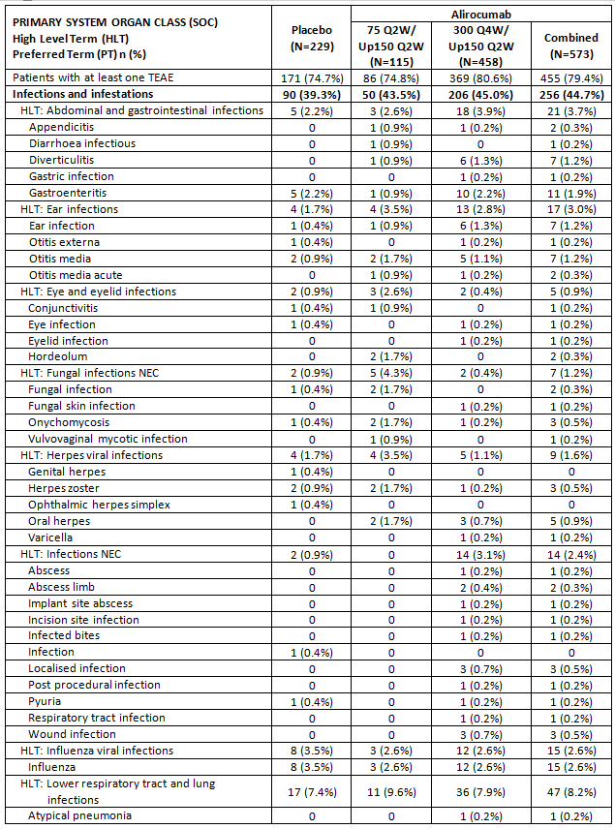

Table 29 (continued): Number (%) of patients with TEAEs that occurred with HLT ≥ 2% in any treatment group by primary SOC, HLT, and PT; patients regardless of concomitant statin therapy; Safety Population
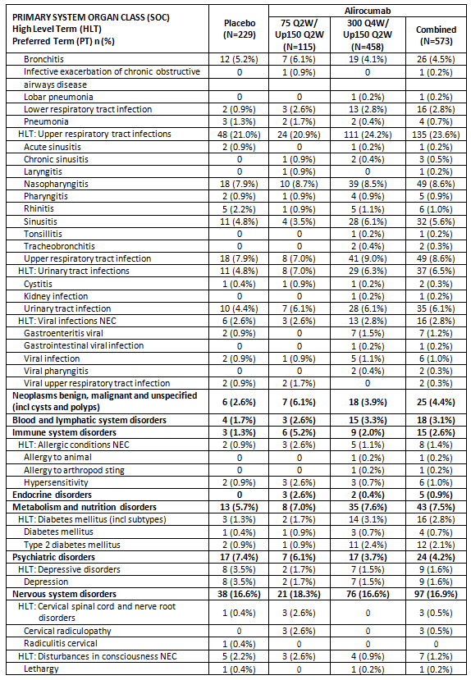

Table 29 (continued): Number (%) of patients with TEAEs that occurred with HLT ≥ 2% in any treatment group by primary SOC, HLT, and PT; patients regardless of concomitant statin therapy; Safety Population
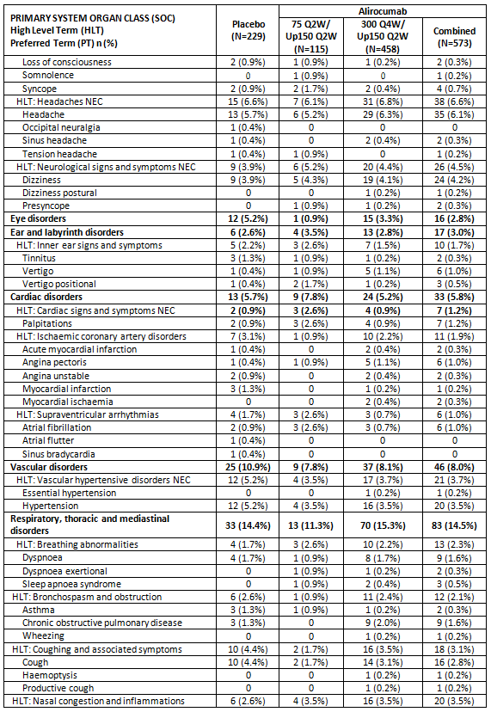

Table 29 (continued): Number (%) of patients with TEAEs that occurred with HLT ≥ 2% in any treatment group by primary SOC, HLT, and PT; patients regardless of concomitant statin therapy; Safety Population
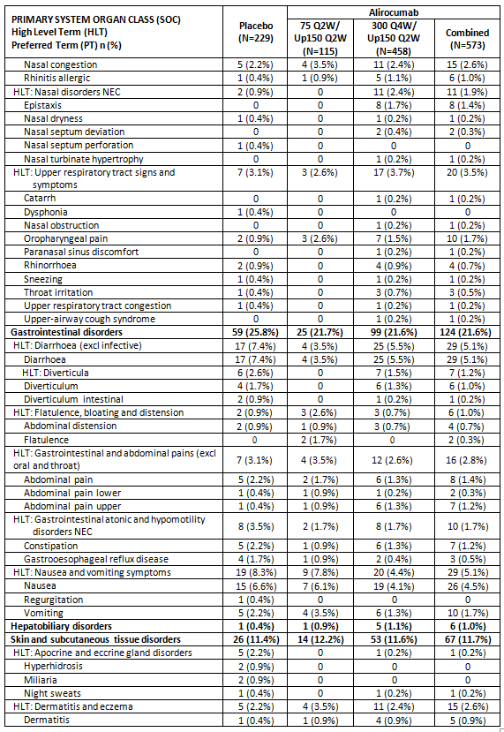

Table 29 (continued): Number (%) of patients with TEAEs that occurred with HLT ≥ 2% in any treatment group by primary SOC, HLT, and PT; patients regardless of concomitant statin therapy; Safety Population
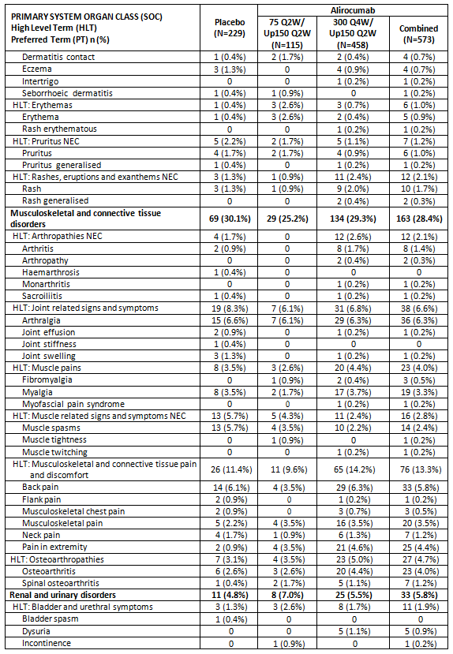

Table 29 (continued): Number (%) of patients with TEAEs that occurred with HLT ≥ 2% in any treatment group by primary SOC, HLT, and PT; patients regardless of concomitant statin therapy; Safety Population
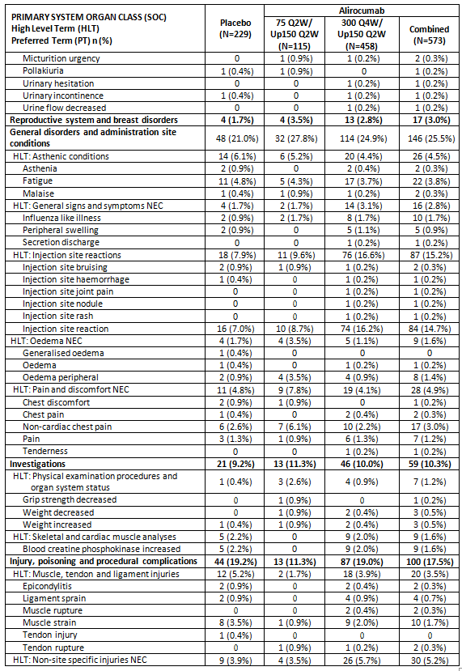

Table 29 (continued): Number (%) of patients with TEAEs that occurred with HLT ≥ 2% in any treatment group by primary SOC, HLT, and PT; patients regardless of concomitant statin therapy; Safety Population
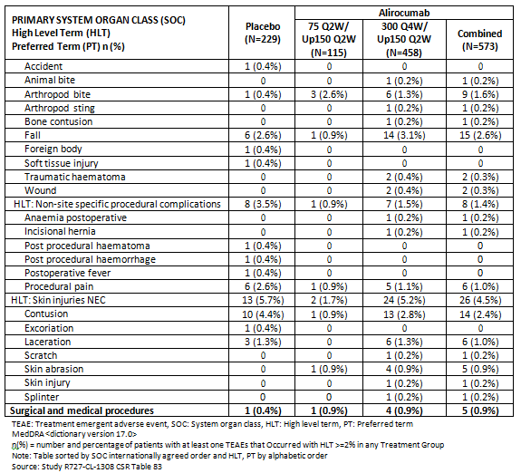

Q2W
See integrated analysis.

Other studies
Other efficacy studies.

Q4W

Study EFC13786
During the double blind period, TEAEs were reported by 45 patients (77.6%) in the alirocumab 150 Q4W/Up 150 Q2W group, 84 patients (73.0%) in the alirocumab 75 Q2W/Up 150 Q2W group, and 37 patients (63.8%) in the placebo group.

Table 30: Study EFC13786: Overview of adverse event profile: Treatment emergent adverse events; Double blind period; Safety population
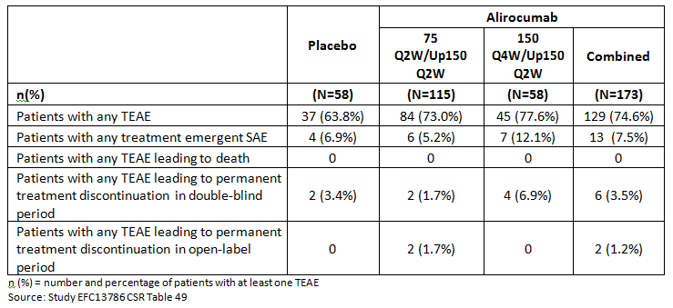
The SOCs with a notably high frequency in the alirocumab 150 Q4W/Up 150 Q2W group were:
- Musculoskeletal and connective tissue disorders:
  - Arthralgia was reported in seven patients (12.1%) in the alirocumab 150 Q4W/Up 150 Q2W group, seven patients (6.1%) in the alirocumab 75 Q2W/Up 150 Q2W group and two patients (3.4%) in the placebo group
  - Muscle spasms were reported in the alirocumab groups only, with three patients (5.2%) in the alirocumab 150 Q4W/Up 150 Q2W group, eight patients (7.0%) in the alirocumab 75 Q2W/Up 150 Q2W group, and no patient in the placebo group.
- General disorders and administration site conditions:
  - Injection site reactions were reported in the alirocumab groups only, with eight patients (13.8%) in the alirocumab 150 Q4W/Up 150 Q2W group, four patients (3.5%) in the alirocumab 75 Q2W/Up 150 Q2W group, and no patient in the placebo group
  - Fatigue was reported in the alirocumab groups only, with four patients (6.9%) in the alirocumab 150 Q4W/Up 150 Q2W group, five patients (4.3%) in the alirocumab 75 Q2W/Up 150 Q2W group, and no patient in the placebo group.
- Skin and subcutaneous tissue disorders:
  - Rash was reported in the alirocumab groups only, with 3 patients (5.2%) in the alirocumab 150 Q4W/Up 150 Q2W group and one patient (0.9%) in the alirocumab 75 Q2W/Up 150 Q2W group. Of note, rash maculopapular was reported only in the placebo group by one patient (1.7%).

Table 31: Study EFC13786: Number (%) of patients with TEAE(s) that occurred with HLT ≥ 2% in any treatment group by primary SOC, HLT and PT; Double blind period; Safety population
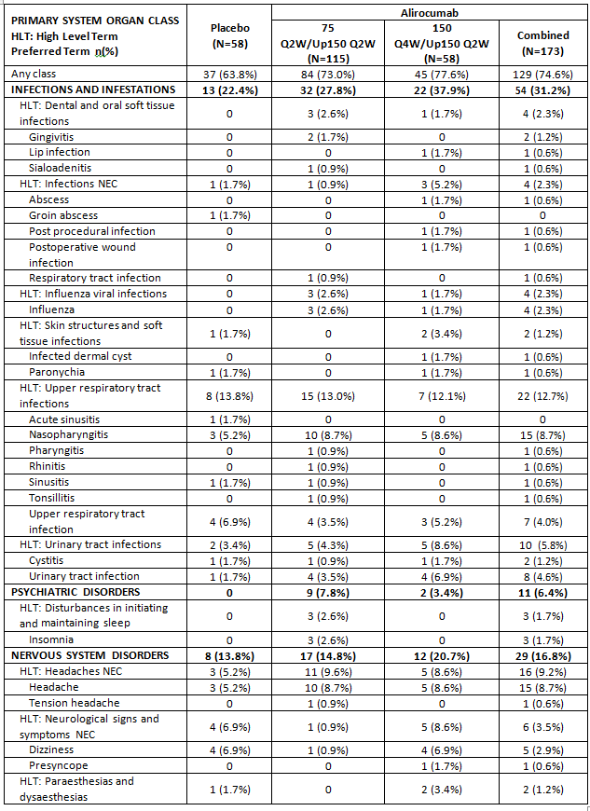

Table 31(continued): Study EFC13786: Number (%) of patients with TEAE(s) that occurred with HLT ≥ 2% in any treatment group by primary SOC, HLT and PT; Double blind period; Safety population
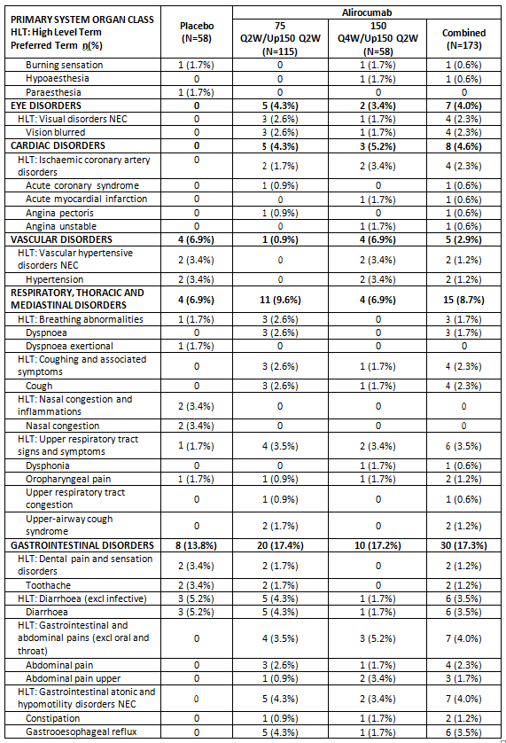

Table 31(continued): Study EFC13786: Number (%) of patients with TEAE(s) that occurred with HLT ≥ 2% in any treatment group by primary SOC, HLT and PT; Double blind period; Safety population
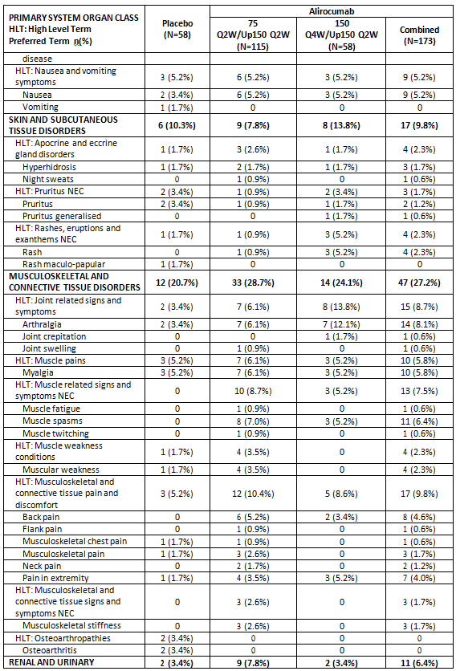

Table 31(continued): Study EFC13786: Number (%) of patients with TEAE(s) that occurred with HLT ≥ 2% in any treatment group by primary SOC, HLT and PT; Double blind period; Safety population
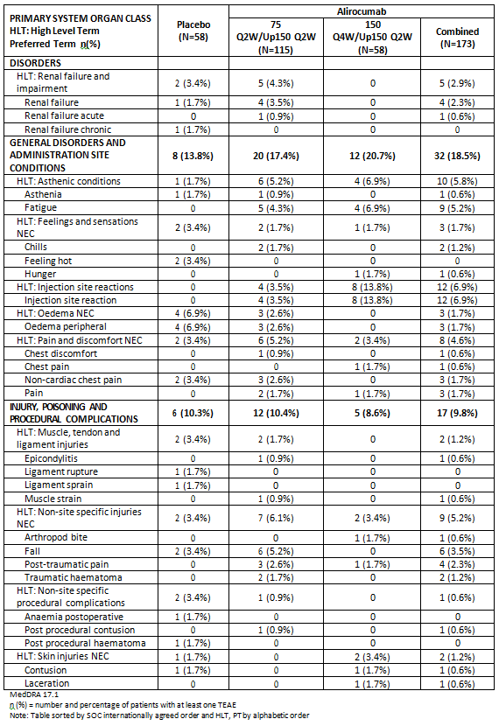
Only HLT with frequency > =2% in at least one treatment group are presented Source: Study EFC1378 CSR Table 50.
About 1 quarter of patients (25.2%) entering the open label extension period experienced at least 1 TEAE. The most common AE reported was myalgia.
A full tabulation of the AEs reported during the open label population was provided.

Q2W
Not applicable.

Treatment related adverse events (adverse drug reactions)

Integrated safety analyses

Q4W
Not applicable.

Q2W
The percentage of patients who experienced any TEAE leading to permanent treatment discontinuation was similar between the alirocumab and placebo groups and between the alirocumab and ezetimibe groups.

Main/pivotal studies that assessed safety as the sole primary outcome

Q4W
Not applicable.

Q2W
See results for integrated analyses.

Pivotal and/or main efficacy studies

Q4W

Study R727-CL-1308
In the overall safety population, 194/802 patients (24.2%) experienced at least one TEAE that was considered by the Investigator to be related to study drug. The proportion of patients reporting treatment-related TEAEs was higher in the 300 Q4W/Up 150 Q2W group (122/458 or 26.6%) than in the placebo group (47/229 or 20.5%) and in the 75 Q2W/Up 150 Q2W group (25/115 or 21.7%). This imbalance was primarily due to an increased incidence in the HLT of Injection Site Reactions (72/458 or 15.7% in the 300 Q4W/Up 150 Q2W group versus 17/229 or 7.4% in the placebo group). The incidence of treatment-related Injection Site Reactions in the 75 Q2W/Up 150 Q2W group was 10/115 patients (8.7%).
Adverse Events from patients with two consecutive LDL-C < 25 mg/dL (0.65 mmol/L)
AEs were analysed in the subset of patients who had two or more consecutive LDL-C values < 25 mg/dL (0.65 mmol/L). 118/802 (14.7%) patients had two consecutive LDL-C values < 25 mg/dL (0.65 mmol/L): 5/115 patients (4.3%) in 75 Q2W/Up 150 Q2W group, 113/458 patients (24.7%) in the 300 Q4W/Up 150 Q2W group, and 0/229 patients in the placebo group. The majority of these patients (109/118) were in the population receiving concomitant statin therapy, all 5 in the 75 Q2W/Up 150 Q2W group and 104 of the 113 were in the 300 Q4W/Up 150 Q2W group. Of the 118 patients with two consecutive LDL-C values < 25 mg/dL (0.65 mmol/L), 81 (68.6%) experienced at least one TEAE that occurred, worsened, or became serious after the first of the two low LDL-C values The most commonly occurring PTs were upper respiratory tract infection and injection site reaction.

Other studies
Other efficacy studies

Q4W

Study EFC13786
TEAEs were considered to be related to the IMP injections by the Investigator for 14 patients (24.1%) in the alirocumab 150 Q4W/Up 150 Q2W group, 14 patients (12.2%) in the alirocumab 75 Q2W/Up 150 Q2W group and 9 patients (15.5%) in the placebo group.
Injection site reactions, which were reported only in the alirocumab groups, were all considered to be related to the IMP by the Investigators and occurred in 8 patients (13.8%) in the alirocumab 150 Q4W/Up 150 Q2W group and 4 patients (3.5%) in the alirocumab 75 Q2W/Up 150 Q2W group. TEAEs considered to be related to the IMP with an incidence of > 3% in either of the alirocumab groups were reported by 1 to 3 patients (1.7% to 5.2%) in the alirocumab 150 Q4W/Up 150 Q2W group versus 0 to 1 patient (0.0% to 1.7%) in the placebo group.
Two consecutive LDL-C values < 25 mg/dL (0.65 mmol/L) were reported by 3/113 patients (2.7%), all in the alirocumab 75 Q2W/Up 150 Q2W group. None of these patients required up-titration. Among these patients, only one patient reported TEAEs after the first of the two low LDL-C values: nasopharyngitis (onset day: Day 50) and headache (onset day: Day 111). These TEAEs were considered resolved on Day 65 and Day 111 respectively.

Deaths and other serious adverse events

Integrated safety analyses

Q4W
Not applicable.

Q2W
The incidence of on-study death was 0.8% (26 or 3182) in the alirocumab group compared with 1.1% (20 of 1792) in the control groups. Compared with the analysis submitted in the initial application, six additional deaths were observed in the alirocumab group and three additional deaths in the control group. As noted in the initial analysis, the primary causes of death were CV events. The sponsor states that ‘the current data are insufficient to draw any conclusion on the effect of alirocumab on the incidence of death. A large ongoing study (OUTCOMES) is powered to investigate the potential benefit of alirocumab on CV mortality and morbidity.’

Table 32: Summary of deaths adjudication results (Safety population); Global pool of Phase III studies
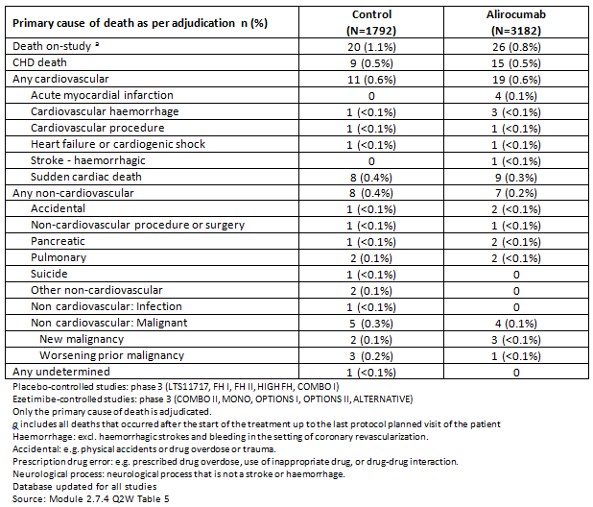
The overall incidence of treatment emergent SAEs were similar in the alirocumab and placebo groups: 387 (15.6%) versus 205 (16.1%), respectively and in the alirocumab and ezetimibe groups: 147 (17.0%) versus 86 (13.9%), respectively. No relevant difference between the treatment groups was observed for any individual SOC. As compared to the initial analysis, no changes in the pattern of SAEs were observed.

Main/pivotal studies that assessed safety as the sole primary outcome
Q4W: Not applicable.
Q2W: see Section 8.2

Pivotal and/or main efficacy studies

Q4W

Study R727-CL-1308
A total of three patients died during the study (one in the placebo group (myocardial infarction) and one in each of the active treatment groups (one patient in the 75 Q2W/Up 150 Q2W developed pneumonia on Day 211 and died on Day 234; one patient in the 300 Q4W/Up 150 Q2W committed suicide by intentional overdose of tramadol, hydrocodone and diphenhydramine on Day 383) and one patient died post treatment (due to cardiac failure on Day 340).
The incidence of treatment emergent SAEs was similar among treatment groups (11.3% (75 Q2W/Up 150 Q2W), 11.6% (300 Q4W/Up 150 Q2W), and 14.4% (placebo)).
Consistent with these patients’ Baseline CV risk status, the only SOC for which ≥ 2% of patients in all groups reported treatment emergent SAEs was the SOC of cardiac disorders (3.9% for the placebo group, 3.5% for the 75 Q2W/Up 150 Q2W group, and 2.4% for the 300 Q4W/Up 150 Q2W group). At the PT level, all treatment emergent SAEs were reported in < 2% of patients in any treatment group. Most treatment emergent SAEs (PT) occurred in only 1 or 2 patients in the combined alirocumab or placebo groups. There was no pattern at the PT level among treatment groups and there was no evidence for a dose dependent effect of alirocumab.
A tabulated list of SAEs was provided.

Q2W
Not applicable.

Other studies

Other efficacy studies

Study EFC13786
There were no deaths during the double blind period or the open label extension period.
During the double blind period, treatment emergent SAEs were reported by seven patients (12.1%) in the alirocumab 150 Q4W/Up 150 Q2W group, six patients (5.2%) in the alirocumab 75 Q2W/Up 150 Q2W group and four patients (6.9%) in the placebo group. Individual PTs were generally reported at low frequency with no particular clinical pattern.

Table 33: Study EFC13786: Number (%) of patients with treatment emergent SAE(s) by Primary SOC and PT; Double blind period; Safety population
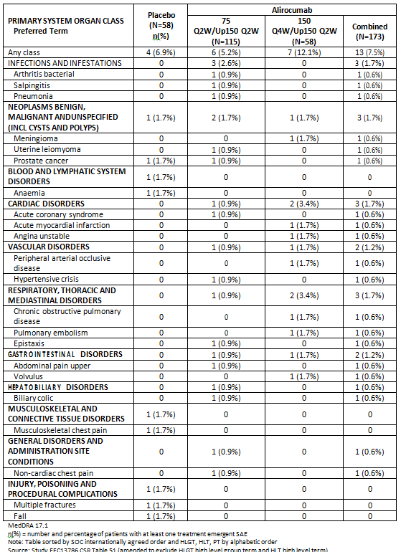

Discontinuations due to adverse events

Integrated safety analyses

Q4W
Not applicable.

Q2W

Placebo controlled group
The overall incidence of TEAEs leading to treatment discontinuation was similar in the alirocumab (148 (6.0%)) and placebo (71 (5.6%)) groups. In the alirocumab group, the most frequently reported (in at least three patients) TEAEs (PTs) that led to treatment discontinuation were myalgia (6 (0.2%)), injection site reaction, alanine aminotransferase (ALT) increased, and nausea (5 (0.2%) each); fatigue (4 (0.2%)), and anaemia, vertigo, diarrhoea, acute MI, chronic kidney disease, and pruritus (3 (0.1%) each); other TEAEs were isolated cases reported in one or two patients.

Ezetimibe controlled group
The overall incidence of TEAEs leading to treatment discontinuation was similar in the alirocumab (84 (9.7%)) and ezetimibe (66 (10.7%)) groups. In the alirocumab group, the most frequently reported (in at least three patients) TEAEs (PTs) that led to treatment discontinuation were myalgia (21 (2.4%)), headache, diarrhoea, and injection site reaction (three (0.3%) each); other TEAEs were isolated cases reported in one or two patients. In the ezetimibe group, the most frequently reported (in at least three patients) TEAEs (PTs) that led to treatment discontinuation were myalgia (23 (3.7%)); arthralgia (4 (0.6%)), headache, and muscular weakness (3 (0.5%) each); other TEAEs were isolated cases reported in one or two patients.

Main/pivotal studies that assessed safety as the sole primary outcome
Q4W: not applicable.
Q2W: see Section 8.2.

Pivotal and/or main efficacy studies

Q4W

Study R727-CL-1308
The incidence of TEAEs leading to treatment discontinuation was similar among the treatment groups; 6.1% (75 Q2W/Up 150 Q2W), 6.8% (300 Q4W/Up 150 Q2W) and 7.4% (placebo).
Three patients discontinued due to hepatic disorders. All three were in the 300 Q4W/Up 150 Q2W group; one patient developed Hepatitis C but the other two were considered drug related:
- A 64 year old White female in the 300 Q4W/UP 150 Q2W group, reported AE of increased hepatic enzymes on Day 35 (six days after last administration of study drug) which was subsequently permanently discontinued. No other cause was found and Hepatitis antibody tests were negative. The values returned to normal by Day 70. The patient had a mild intensity increase on study Day 253 (post dose) which did not resolve and was not considered drug related.
- A 68 year old White male in the 300 Q4W/Up 150 Q2W group receiving concomitant statin therapy, reported an AE of increased hepatic enzymes of moderate intensity on study Day 253. The study drug was discontinued. The patient was also taking Diclofenac. Both increased transaminases subsequently declined to within normal limits on Day 263 but were elevated again on Day 307 but were within normal limits at Day 349 and thereafter.

Q2W
See integrated analysis.

Other studies

Other efficacy studies
Q4W.

Study EFC13786
There were four patients (6.9%) in the alirocumab 150 Q4W/Up 150 Q2W group, two patients (1.7%) in the alirocumab 75 Q2W/Up 150 Q2W group and two patients (3.4%) in the placebo group) with TEAEs leading to permanent discontinuation of study treatment. No specific clinical pattern was noted among the TEAEs leading to permanent treatment discontinuation, with most individual PTs reported at single occurrence.

Table 34: Study EFC13786: Number (%) of patients with TEAE(s) leading to permanent IMP discontinuation during the double blind period by Primary SOC and PT; Double blind period; Safety population
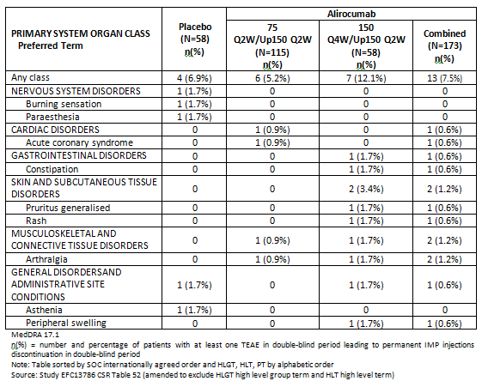

Evaluation of issues with possible regulatory impact

Liver function and liver toxicity

Integrated safety analyses

Q4W
Not applicable.

Q2W
No relevant changes in liver function tests have been identified due to the long term exposure to alirocumab, as compared to the initial submission.

Main/pivotal studies that assessed safety as the sole primary outcome

Q4W
Not applicable.

Q2W
See Section 8.2.

Pivotal and/or main efficacy studies

Q4W

Study R727-CL-1308
In all 3 populations evaluated (the overall safety population and the concomitant statin (Yes/No) populations), there were no clinically relevant changes in liver function parameters from Baseline to Week 12, Week 24, Week 36, or Week 48.
In the overall safety population, increases in ALT meeting the prespecified criteria were reported for five of 562 (0.9%) patients in the combined alirocumab group (all in the 300 Q4W/Up 150 Q2W group) and for three of 225 (1.3%) patients in the placebo group.

Other studies
Other efficacy studies

Q4W

Study EFC13786
There were no relevant changes across the treatment groups during the double blind period.

Q2W
Not applicable.

Renal function and renal toxicity

Integrated safety analyses
Q4W: Not applicable.
Q2W: No changes in renal function have been identified in relation to the long term exposure to alirocumab, as compared to the initial submission.

Main/pivotal studies that assessed safety as the sole primary outcome.
Q4W: Not applicable.
Q2W: See Section 8.2.

Pivotal and/or main efficacy studies

Q4W

Study R727-CL-1308
There were no clinically meaningful trends regarding changes in renal function parameters observed from Baseline to Week 12, Week 24, Week 36 or Week 48 value in any treatment groups.

Q2W
See Integrated analysis.

Other studies

Other efficacy studies
Q4W

Study EFC13786
Renal function was investigated based on both creatinine and eGFR categories for renal impairment based on US FDA guidelines. There were no relevant changes across the treatment groups during the double blind period.

Other clinical chemistry

Integrated safety analyses
Q4W: Not applicable.
Q2W: No changes in metabolic parameters (albumin, creatine kinase, total protein), electrolytes or cortisol and adrenal function have been identified in relation to the long term exposure to alirocumab, as compared to the initial submission.

Main/pivotal studies that assessed safety as the sole primary outcome
Q4W: Not applicable.
Q2W: See Section 8.2.

Pivotal and/or main efficacy studies

Q4W

Study R727-CL-1308
Metabolic parameters include fasting glucose, albumin, protein, and creatine kinase were measured during the study. No meaningful changes from Baseline in mean HbA1c were observed during the treatment period in any treatment group. There were no clinically meaningful trends concerning changes in metabolic parameters observed cross treatment groups from Baseline to Week 12, Week, 24, Week 36, or Week 48 on treatment values.
Two SAEs of hyperglycaemia were reported during the study. Both were also receiving concomitant statin therapy. One patient receiving 75 Q2W/Up 150 Q2W had ongoing Type 2 diabetes and had hyperglycaemia on two occasions which was considered related to treatment with steroids for an allergic reaction; and one patient receiving 300 Q4W/Up 150 Q2W with a history of diabetes but not receiving anti-diabetic treatment at Baseline, had an episode of stress hyperglycaemia on the same day as being hospitalised for an acute myocardial infarction and congestive cardiac failure.
The incidence of diabetes mellitus or diabetic complications TEAEs in patients with diabetes at Baseline was 15/152 (9.9%) in the combined alirocumab group (4/26 or 15.4% in the 75 Q2W/Up 150 Q2W group and 11/126 or 8.7% in the 300 Q4W/Up 150 Q2W group) and 9/67 (13.4%) for the placebo group. In patients without diabetes at Baseline, the incidence was 9/421 (2.1%) in the combined alirocumab groups (0 in the 75 Q2W/Up 150 Q2W group and 9/332 or 2.7% in the 300 Q4W/Up 150 Q2W group) and 2/162 (1.2%) in the placebo group.

Q2W
See integrated analysis.

Other studies - other efficacy studies

Q4W

Study EFC13786
Metabolic parameters included fasting glucose, albumin and creatinine kinase. There were no relevant differences across the treatment groups in the descriptive statistics for metabolic function during the double blind period.
No meaningful change from Baseline in mean HbA1c was observed during the double blind treatment period, with a mean absolute change (SD) from Baseline at Week 24 of -0.02% (0.26) in the alirocumab 150 Q4W/Up 150 Q2W group and of -0.00% (0.36) in the alirocumab 75 Q2W/Up 150 Q2W group versus 0.01% (0.19) in the placebo group.

Q2W
Not applicable.

Haematology and haematological toxicity

Integrated safety analyses

Q4W
Not applicable.

Q2W
No changes in haematological parameters have been identified in relation to the long term exposure to alirocumab, as compared to the initial submission.

Main/pivotal studies that assessed safety as the sole primary outcome

Q4W
Not applicable.

Q2W
See Section 8.2.

Pivotal and/or main efficacy studies

Q4W

Study R727-CL-1308
There were no clinically meaningful trends in changes from Baseline to Week 12, Week 24, Week 36, or Week 48 in any haematology parameter in any treatment groups.

Q2W
See integrated analysis.

Other studies - other efficacy studies

Q4W

Study EFC13786
There were no relevant changes across the treatment groups during the double blind treatment period.

Q2W
Not applicable.

Electrocardiograph findings and cardiovascular safety

Integrated safety analyses

Q4W
Not applicable.

Q2W
No effects of alirocumab on ECG parameters were identified during the clinical development.

Main/pivotal studies that assessed safety as the sole primary outcome

Q4W
Not applicable.

Q2W
See Section 8.2.

Pivotal and/or main efficacy studies

Q4W

Study R727-CL-1308
There were no differences in the incidence of patients with abnormal ECG interpretations between the combined alirocumab group (63/231 (27.3%) patients with normal/missing Baseline ECG data) and the placebo group (31/99 (31.3%) patients). Three patients, two in the 300 Q4W/Up 150 Q2W group and not receiving concomitant statin therapy and one in the 75 Q2W/Up 150 Q2W group and receiving statin, experienced SAEs that were associated with abnormal ECGs but none were considered related to study drug.

Q2W
See integrated analysis.

Other studies - other efficacy studies

Q4W

Study EFC13786
Electrocardiogram variables were assessed as normal/abnormal and there were no relevant differences across the treatment groups during the treatment period of the double blind period. None of the ECGs reported as abnormal were considered clinically significant by the Investigator.

Vital signs and clinical examination findings

Integrated safety analyses

Q4W
Not applicable.

Q2W
No clinically meaningful changes in systolic blood pressure, diastolic blood pressure, heart rate, weight or physical examination were observed in any of the treatment groups.

Pivotal studies that assessed safety as the sole primary outcome

Q4W
Not applicable.

Q2W
See Section 8.2

Pivotal and/or main efficacy studies

Q4W

Study R727-CL-1308
There were no clinically significant changes in systolic blood pressure, diastolic blood pressure, heart rate, measurements ECG or physical examination during the study in any treatment groups.

Other studies - other efficacy studies

Q4W

Study EFC13786
Across treatment groups, mean changes from Baseline were generally similar for DBP, SBP, and HR. None of the changes from Baseline in DBP, SBP, HR, or weight over the treatment period or at follow-up were relevant across treatment groups.

Q2W
Not applicable.

Other safety issues

Safety in special populations
No new clinical relevant changes were identified, as compared to the initial submission.

Safety related to drug-drug interactions and other interactions
Alirocumab is a monoclonal antibody and as such, it was not anticipated to interact with cytochrome P450 (CYP) or transporters. Therefore, drug-drug interactions between alirocumab and other drugs were not anticipated.
No new data on drug interaction data was presented.

Neurocognitive events

Q4W
In Study R727-CL-1308 no meaningful difference was identified for neurological or neurocognitive events.

Q2W
In the integrated safety analysis neurocognitive impairment was reviewed in detail. In the placebo controlled pool, neurocognitive events were reported at an incidence rate (per 100 patient-years) of 0.7 and 0.5 in the alirocumab and the placebo groups, respectively (HR: 1.24 (95% CI: 0.57 to 2.68)). In the ezetimibe controlled pool, neurocognitive events were reported at incidence rate (per 100 patient-years) of 0.9 and 1.2 in the alirocumab and the ezetimibe groups, respectively (HR: 0.81 (95% CI: 0.32 to 2.08)). Compared with the initial application, the incidences of neurocognitive events in the alirocumab group, as compared with the control groups remain unchanged. In the initial application, the HR (95% CI) was 1.18 (0.54 to 2.58) and 0.94 (0.32 to 2.74) in the pool of placebo controlled studies and the pool of ezetimibe controlled studies, respectively.

Diabetes

Q4W
In Study R727-CL-1308 no meaningful difference was identified for diabetes reported as AEs. The number of patients reporting diabetes as AEs was 20 (4.4%) on alirocumab 300 Q4W/ Up150 Q2W and 11 (4.8%) on placebo.

Q2W
In the integrated safety analysis, diabetes mellitus and diabetic complications TEAEs were infrequent events, reported at similar incidence rates in the alirocumab group versus control in the placebo controlled and ezetimibe controlled pools. In the placebo controlled pool, the incidence rates per 100 patient-years were 3.4 and 3.7 in the alirocumab and placebo groups, respectively, (HR (95% CI): 0.91 (0.67 to 1.25)) and the incidence rate per 100 patient-years were 3.7 in the alirocumab group and 4.6 in the ezetimibe group, with HR (95% CI) versus control of 0.80 (0.49 to 1.30). In the initial application (addendum dated on 03 April 2015) the incidence rate per 100 patient-years was 3.7 and 3.4 in the alirocumab and placebo groups, respectively (HR (95% CI): 1.07 (0.76 to 1.50)). In the ezetimibe controlled pool, the incidence rate per 100 patient-years was 3.5 in the alirocumab group and 4.8 in the ezetimibe group (HR: 0.71 (0.40 to 1.26)).
Similar to the initial application, the new analysis of the TEAEs and the changes in fasting glucose and HbA1c during the treatment period, suggested no safety concern with regard to a potential risk of diabetes mellitus or diabetic complications was associated with the use of alirocumab, either in patients defined as diabetic or nondiabetic at Baseline.

Immunogenicity

Q4W
Alirocumab 150 mg Q4W or 300 mg Q4W was associated with a low level of immunogenicity. Treatment emergent ADA positive results were observed in 4.7% of patients in the 300 Q4W/150 Q2W group and in 2.6% of patients in the placebo group in Study R727-CL-1308. In Study EFC13786, 5.4% exhibited treatment emergent ADA positive responses in the 150 Q4W/150 Q2W group versus none in the placebo group. In both studies, most of the ADA positive samples exhibited low titres (≤ 240).
Overall, the incidence of neutralising antibody (NAb) was low, with only 2 patients positive in the 300 mg Q4W/150 mg Q2W group. The data in these patients do not suggest a correlation between NAb and alirocumab exposure, LDL-C lowering efficacy.

Q2W
The data on the development of ADA in the integrated analysis confirmed the results provided in the initial application. Treatment emergent ADAs were reported in 5.1% of patients in the alirocumab group. This corresponds to only eight new treatment emergent ADA positive results over the additional period of the five completed studies. Compared with patients who were ADA negative, patients with an ADA positive status did not exhibit any difference in alirocumab efficacy. NAb were observed in few (38 patients; 1.3%) patients as compared to 36 patients in the initial dossier. Only 11 patients (0.4%) had 2 or more NAb positive samples. The data in these patients do not suggest a correlation between the presence of NAb and LDL-C lowering efficacy.

Post marketing experience
No post marketing data is presented for Q4W as it is not approved in any market.
No post marketing experience data is presented in the Summary of Clinical Safety; 2QW.
One PSUR was included in the submission. It covered the period from 23 September 2015 to 24 July 2016. The International Birth Date was 24 July 2015. Cumulative, from 1 July 2015 to 31 March 2016, mean patients exposure to marketed alirocumab was estimated to be 9,842 patients per month (corresponding to 177, 170 alirocumab single units (syringe/pre-filled pen) whatever the strength.
The sponsor has made no changes to the AE profile based on the spontaneous reports and no actions were taken for safety reasons during the period covered by this PSUR. Based on the new data received during the period covered by this PSUR, the sponsor considers that no new safety signals were noted and that no change to the risk minimisation strategy is deemed necessary.
The PSUR notes that in addition to the routine pharmacovigilance activities currently in place, the sponsor is planning to undertake four post-authorisation safety studies:
- to evaluate safety of long-term use of alirocumab (exceeding 5 years)
- to further characterise the potential risk of neurocognitive disorders
- to evaluate the effectiveness of dosing recommendation for the two currently approved dosages (75mg bi-weekly and 150 mg bi-weekly) in avoiding very low LDL-C, and
- to gather relevant safety data in patients infected human immunodeficiency virus.

Evaluator’s overall conclusions on clinical safety
The safety database or patients treated with the Q2W dose regimen is substantial; 5,234 patients with hypercholesterolemia (3,340 alirocumab, 1,276 placebo and 618 ezetimibe) with a treatment duration of up to 18 months. Patient exposure was 2,142 in alirocumab treated for at least 76 weeks and 378 for at least 102 weeks.
No new safety issues were identified that had not been previously seen in the initial application. The most frequently reported AEs are injection site reactions, pruritus and upper respiratory tract infections. The additional safety data did not identify any relationship for neurologic events, neurocognitive events or diabetes. The safety concerns identified for statin therapy (musculoskeletal, liver function, diabetes, neurocognitive AEs) were not observed with alirocumab treatment.
Treatment with 300 mg Q4W did not appear to be associated with an increased risk of increased AEs and no new safety issues were identified.
From the final results of the Q2W studies it was found that treatment emergent ADA were observed in 5.1% of patients in the alirocumab group, corresponding to only eight new treatment emergent ADA assay responses over the additional follow-up period of the five completed studies. Compared with patients who were ADA negative, patients with an ADA positive status did not exhibit any difference in alirocumab efficacy. NAb were observed in few (38 patients; 1.3%) patients as compared to 36 patients in the initial dossier. Only 11 patients (0.4%) had 2 or more NAb positive samples. The data in these patients do not suggest a correlation between the presence of NAb and LDL-C lowering efficacy.
The issue of cardiovascular outcomes was not addressed in this submission as the study (Study EFC11570) to address this issue is still ongoing.

First round benefit-risk assessment

First round assessment of benefits

Table 35: First round assessment of benefits
Indication
Benefits | Strengths and Uncertainties
300 mg Q4W as starting dose with optional up titration to 150 mg Q2W provided clinically meaningful reduction in LDL-C versus placebo similar to that seen with 75 Q2W/Up 150 Q3W. | Result at 12 weeks for percent change from Baseline (mmol/L): -55.3% (statin) and -58.4% (no statin)  Strength is persistent effect to Week 24: -58.7% (statin) and -52.5% (no statin) and Week 48 -51.9% (statin) and -45.7%(no statin)  Strength is consistent results were found for other lipid parameters; that is, reduced concentrations of Apo B, non HDL-C, total-C, Lp(a) and fasting triglycerides (TGs), and increased concentrations of HDL-C, at Weeks 12 and 24, up to Week 48 in both groups. Reduction in ApoA1 was seen in the no statin group but not in the statin group.  Uncertainty is only one study.  Uncertainty is that only 80.7% (statin) and 85.3% (no statin) of patients could be maintained on Q4W. Other patients had to be dose adjusted to 150 mg Q2W.

First round assessment of risks

Table 36: First round assessment of risks
Risks | Strengths and Uncertainties
AE for Q4W are similar as for Q2W identified in initial application.  Common AEs were injection site reaction, pruritus and upper respiratory tract signs and symptoms.  Injection site reactions were only AE reported more frequently in patients positive for treatment emergent ADA.  Rare and sometimes serious allergic reactions (nummular eczema, urticaria, hypersensitivity vasculitis) were reported. | Strength is large safety database for Q2W – 3340 patients treated with alirocumab at the 75 mg or 150 mg Q2W doses.  Strength is no safety signal in patients who had at least 2 consecutive values of LDL-C < 25 or 15 mg/dL (0.65 or 0.39 mmol/L), particularly with regard to neurological or other adverse effects that could potentially be related to low LDL-C.  Strength is the updated integrated safety database suggests alirocumab is not associated with hepatic effects or muscle related AEs, which are commonly seen with statins.  Strength is low rate of ADA reported in the additional follow up period; total of 5.1%. There does not appear to be a correlation between the presence of Nab and LDL-C lowering efficacy or safety.  Uncertainty is the effect of alirocumab on cardiovascular outcomes is still unknown (Study EFC11570 is ongoing).

First round assessment of benefit-risk balance
Based on the clinical data submitted the overall benefit-risk balance remains favourable.
The sponsor has requested approval for a starting dose of 300 mg Q4W. Using this dose approximately 15 to 20% of patients need to have their dose adjusted to 150 mg Q2W to achieve optimal response. The sponsor cannot identify specific criteria to determine those patients who can be successfully started and maintained on Q4W dosing and those that need dose adjustment. A similar problem existed in the initial application for those patients who could be started on 150 mg Q2W rather than the 75 mg Q2W dose. No studies were conducted that started patients on the lower dose (75 mg Q2W) and then tried to lengthen the dosing regimen to Q4W, so it is not possible to know if this would be successful. Given that the 150 mg Q2W starting dose was not approved initially it is difficult to propose approval for 300 mg Q4W. The response achieved to the 300 Q4W/Up 150 mg Q2W was similar (but not superior) to the response achieved with 75 mg Q2W/Up 150 Q2W.
Approval was also sought for a monotherapy indication which had been declined in the initial application. The monotherapy claim was based on a single study (Study EFC11716). No new data on monotherapy was presented in this application and no argument in favour of approval for monotherapy is presented in the summaries. Monotherapy was previously declined as it was felt that it could not be approved until cardiovascular outcome data was available. As this is still awaited, there is no reason to include monotherapy at this stage.

First round recommendation regarding authorisation
The aim of Study R727-CL-1308 was to evaluate the dose regimen 300 mg Q4W as a starting dose. While the results demonstrated that 300 Q4W was an effective starting dose for some patients, a significant number of patients (15 to 20%) had to have their dose regimen up titrated to 150 mg Q2W. In the initial application for alirocumab a starting dose of 75 mg Q2W was approved rather than 150 mg Q2W because of concerns about lack of experience with the product and no outcome data. Cardiovascular outcome data is not yet available as the study specifically addressing outcomes (Study EFC11570) is still ongoing.
It would therefore not be prudent to approve a starting dose of 150 Q2W or 300 Q4W until the there is a better indication of those patients who can be started and maintained on this regimen. It is difficult to approve 300 Q4W as an ongoing maintenance dose as this was not addressed in any of the studies. It would be helpful to see a study which started patients on 75 mg Q2W and then lengthened the regimen to Q4W.
In the proposed PI submitted the sponsor has requested removal of the requirement ‘or clinical atherosclerotic cardiovascular disease’. No justification for the removal of this is included in the submission. The sponsor has also requested inclusion of use of alirocumab as monotherapy. Again no justification is provided in the submission and as outcome data is still not available monotherapy should not be approved and the requirement for clinical disease should remain.
Given that the studies submitted were based on the same patient groups as those in the initial application, there does not appear to be any basis for changing the wording of the indication. The additional data provided in the final reports demonstrates that the efficacy is persistent for at least 78 weeks with no new safety issues identified and some reassurance about the safety with regard to neurocognitive events and diabetes.

Clinical questions
There were no clinical questions from the first round report.

Second round evaluation of clinical data submitted in response to questions
The sponsor has provided further arguments for the 300 mg Q4W starting dose regimen and to change the indication to remove the requirement for clinical atherosclerotic disease and to include non-familial primary hypercholesterolaemia and mixed dyslipidaemia.

Starting dose regimens
It is understood that in the initial application for alirocumab a starting dose of 75 mg Q2W was approved rather than 150 mg Q2W because of concerns about lack of experience with the product and no outcome data. The studies submitted in this application do not address the issue of the outcome data as the study addressing this is still ongoing. The results of this study are still awaited.
In this application the sponsor is only seeking approval for the 300 mg Q4W starting dose and not for the 150mg Q2W starting dose. The only argument the sponsor offers for the monthly starting dose is patient convenience. The sponsor argues that:
‘Patients who represent suitable candidates for the 300 mg Q4W regimen are those who meet the approved indication and prefer the monthly dosing as being more convenient treatment option.’
The starting dose regimen of 300 mg Q4W was only able to be maintained in 80 to 85% of patients. Those patients who will respond cannot be identified and the sponsor argues it should be left to patient preference. It is noted that those patients who do not respond to the monthly dosing will need to be changed to Q2W dosing, in some as early as 8 weeks (after 2 injections).
The majority of patients can be initiated on 75 mg Q2W and can be maintained on this dose long term. If the patient does not respond sufficiently then the dose is increased to 150 mg Q2W. Up-titration was required in 42% and 36% of patients in the FH-I and FH-II studies and 43% in the Alternative study and in smaller percentages of patients in the other studies. Therefore it seems reasonable to commence at 75 mg Q2W and up-titrate to 150mg Q2W as required.
As stated previously, it seems more logical to start on Q2W dosing and if a satisfactory response it achieved to move to Q4W dosing, but unfortunately this was not tested and therefore there is no evidence to support this regimen.
However, the data submitted does support a 300 mg Q4W starting dose and in those patients who respond the efficacy is sustained for at least 48 weeks. If this should be approved, the patients should be warned that they may not be able to be maintained on a monthly dosing.

Indication
The approved indication is:
Praluent is indicated as an adjunct to diet and exercise in adults with heterozygous familial hypercholesterolaemia or clinical atherosclerotic cardiovascular disease:
  - in combination with a statin, or statin with other lipid-lowering therapies or,
  - in combination with other lipid-lowering therapies in patients who are statin intolerant.
The effect of Praluent on cardiovascular morbidity and mortality has not yet been determined (see CLINICAL TRIALS).
The sponsor is requesting the indication be amended to:
Praluent is indicated as an adjunct to diet and exercise in adults with primary hypercholesterolaemia (heterozygous familial and non-familial) or mixed dyslipidaemia:
  - in combination with a statin or statin with other lipid lowering therapies in patients unable to reach LDL-C goals or,
  - in combination with other lipid-lowering therapies in patients who are statin intolerant, or for whom a statin is contraindicated.
The effect of Praluent on cardiovascular morbidity and mortality has not yet been determined (see CLINICAL TRIALS).
The differences in the indications are highlighted in bold italics.
In support of the inclusion of non-FH and mixed dyslipidaemia the sponsor has provided the following breakdown of the data in the submission.

Non familial hypercholesterolaemia
The sponsor states that of the total Phase III population (n = 1,257 in specific studies, n = 1,377 overall) that approximately 25% had heFH and 75% non-FH.

Mixed dyslipidaemia
The sponsor has provided an analysis of the data from the 10 clinical studies by subgroup analysis of those patients with diabetes and those with mixed dyslipidaemia. The sponsor provided data on the LDL-C response but no information on triglycerides or the other lipid parameters.

Diabetes
Overall, 1,629 (31%) of the total study population in the 10 studies reported a history of Type 2 diabetes mellitus. The results by subgroup analysis showed similar results in lowering LDL-C.
Figure 16: Percent change from Baseline in calculated LDL-C at Week 24: Subgroup analysis according to diabetes (ITT analysis)
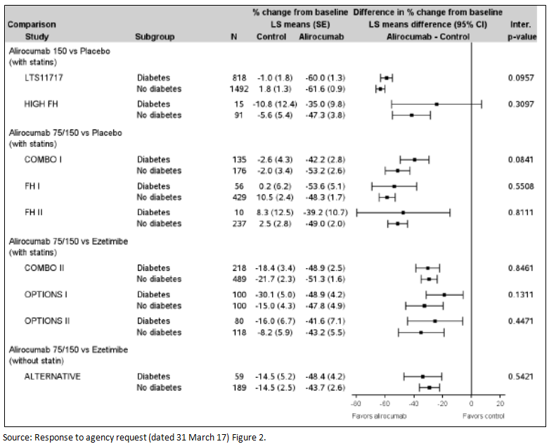

Mixed dyslipidaemia
Of the 5,296 randomised Phase III patients, 2,025 (38.2%) patients had mixed dyslipidaemia (defined as fasting TGs ≥ 150 mg/dL (1.7 mmol/L) in addition to hypercholesterolaemia). This proportion ranged from 21.3% in heFH patients to up to 52.2% in studies carried out in high/very high CV risk patients. History of Type 2 diabetes was reported in 39.2% of these patients, who also tended to be more obese and older than the general population.
A similar pattern in terms of effect on LDL-C was seen in patients with mixed dyslipidaemia as compared with the overall population, regardless of the evaluated population with dyslipidaemia (heFH or non-FH), the background therapy (statins/other LMTs) and the dose regimen of alirocumab (75/150 mg or 150 mg Q2W). The results are shown below for the subgroup with mixed dyslipidaemia and the whole group.
Clinically significant decreases in LDL-C were seen in all studies.
Figure 17: Percent change from Baseline in calculated LDL-C at Week 24: MMRM (ITT analysis in patients with mixed dyslipidaemia); Phase III studies
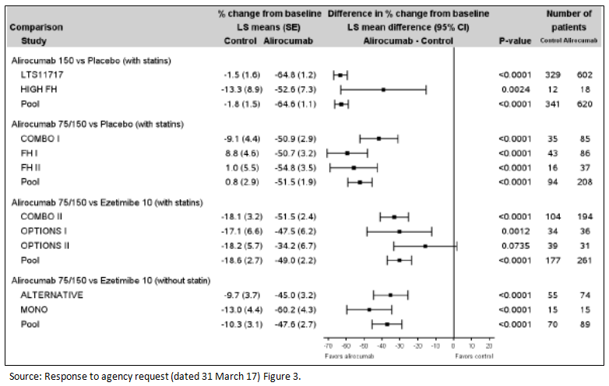
Figure 18: Percent change from Baseline in calculated LDL-C at Week 24: MMRM (ITT analysis); Phase III studies
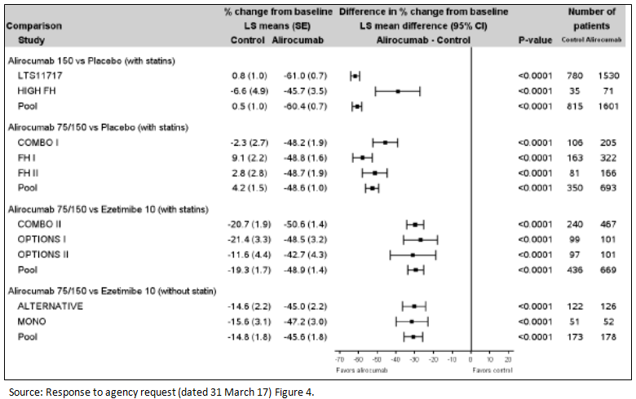
While this new data provided evidence of efficacy for LDL-C, having defined mixed dyslipidaemia as increased triglycerides as well as increased cholesterol, a positive effect on TG would be expected to be seen with an effective product. This data was not provided. The sponsor appears to focus only on LDL-C as they have added, without explanation, the words ‘patients unable to reach LDL-C goals’ to the indication. However, the current practice is to move away from a simple focus on a target LDL-C value, but rather to focus on an approach that deals with the total lipid profile.
Therefore it does not seem appropriate to recommend approval for the indication of mixed dyslipidaemia for a product that only reduces one element of the dyslipidaemia, namely the LDL-C, without a documented effect on triglycerides and the other lipid parameters.
Therefore the indication should remain as previously approved.
Praluent is indicated as an adjunct to diet and exercise in adults with heterozygous familial hypercholesterolaemia or clinical atherosclerotic cardiovascular disease:
  - in combination with a statin, or statin with other lipid-lowering therapies or,
  - in combination with other lipid-lowering therapies in patients who are statin intolerant.
The effect of Praluent on cardiovascular morbidity and mortality has not yet been determined (see CLINICAL TRIALS).

Second round benefit-risk assessment

Second round assessment of benefits
After consideration of the responses provided, the benefits of alirocumab are unchanged from those identified in the first round assessment of benefits.

Second round assessment of risks
After consideration of the responses provided, the risks of alirocumab are unchanged from those identified in first round assessment of risks.

Second round assessment of benefit-risk balance
The benefit-risk balance of alirocumab, given the proposed usage is favourable.
The sponsor has clarified the request for the change in starting dose and that the only justification for the monthly dosing is patient preference. While it is acknowledged that it is not possible to identify the patient population who will respond to monthly compared to two weekly dosing the response rate were similar for the two regimens: (the LS mean difference over placebo in the percent change in calculated LDL-C from Baseline to Week 24 was -58.7% in the ‘statin’ stratum, and -52.4% in the ‘no statin’ stratum for the 300 mg Q4W / 150 mg Q2W and was -51.5% in the ‘no statin’ stratum and -49.8% in in the ‘no statin’ stratum for 75 mg Q2W / 150 mg Q2W).
The sponsor has provided a breakdown of patients and response for patients with mixed dyslipidaemia but no data on the effect on triglycerides. Having reviewed this data there is still insufficient data to approve the change of indication to include non-familial hypercholesterolaemia and mixed dyslipidaemia.

Second round recommendation regarding authorisation
Based on the original submission and the response to the TGA Section 31 request no change in the indication is recommended. The approved indication should remain:
Praluent is indicated as an adjunct to diet and exercise in adults with heterozygous familial hypercholesterolaemia or clinical atherosclerotic cardiovascular disease:
  - in combination with a statin, or statin with other lipid-lowering therapies or,
  - in combination with other lipid-lowering therapies in patients who are statin intolerant.
The effect of Praluent on cardiovascular morbidity and mortality has not yet been determined (see CLINICAL TRIALS).
No change in the indication is recommended based on the sponsor not providing data on effect of alirocumab on triglycerides in the subgroup analysis for the populations of non-FH and mixed dyslipidaemia. The dosing information is amended based on a reassessment of the efficacy data for the 300 mg Q4W starting dose.

Therapeutic Goods Administration
PO Box 100 Woden ACT 2606 Australia
Email: info@tga.gov.au Phone: 1800 020 653 Fax: 02 6232 8605
https://www.tga.gov.au

Evaluated in initial application PM-2015-00764-1-3
Evaluated in initial application PM-2015-00764-1-3
Studies CL-904, CL-1003, PK12910, CL119, EFC 11716 were evaluated in the initial submission. See CER for PM-2015-00764-1-3

