Date of first round report: 10 November 2017

AusPAR Attachment 2

Extract from the Clinical Evaluation Report for Alectinib
  - Proprietary Product Name: Alecensa
  - Sponsor: Roche Australia Pty Ltd

About the Therapeutic Goods Administration (TGA)
- The Therapeutic Goods Administration (TGA) is part of the Australian Government Department of Health, and is responsible for regulating medicines and medical devices.
- The TGA administers the Therapeutic Goods Act 1989 (the Act), applying a risk management approach designed to ensure therapeutic goods supplied in Australia meet acceptable standards of quality, safety and efficacy (performance), when necessary.
- The work of the TGA is based on applying scientific and clinical expertise to decision-making, to ensure that the benefits to consumers outweigh any risks associated with the use of medicines and medical devices.
- The TGA relies on the public, healthcare professionals and industry to report problems with medicines or medical devices. TGA investigates reports received by it to determine any necessary regulatory action.
- To report a problem with a medicine or medical device, please see the information on the TGA website <https://www.tga.gov.au>.
About the Extract from the Clinical Evaluation Report
- This document provides a more detailed evaluation of the clinical findings, extracted from the Clinical Evaluation Report (CER) prepared by the TGA. This extract does not include sections from the CER regarding product documentation or post market activities.
- The words [Information redacted], where they appear in this document, indicate that confidential information has been deleted.
- For the most recent Product Information (PI), please refer to the TGA website <https://www.tga.gov.au/product-information-pi>.
Copyright
© Commonwealth of Australia 2018
This work is copyright. You may reproduce the whole or part of this work in unaltered form for your own personal use or, if you are part of an organisation, for internal use within your organisation, but only if you or your organisation do not use the reproduction for any commercial purpose and retain this copyright notice and all disclaimer notices as part of that reproduction. Apart from rights to use as permitted by the Copyright Act 1968 or allowed by this copyright notice, all other rights are reserved and you are not allowed to reproduce the whole or any part of this work in any way (electronic or otherwise) without first being given specific written permission from the Commonwealth to do so. Requests and inquiries concerning reproduction and rights are to be sent to the TGA Copyright Officer, Therapeutic Goods Administration, PO Box 100, Woden ACT 2606 or emailed to <tga.copyright@tga.gov.au>.

Contents
List of common abbreviations 5
1. Submission details 11
1.1. Identifying information 11
1.2. Submission type 11
1.3. Drug class and therapeutic indication 11
1.4. Dosage forms and strengths 11
1.5. Dosage and administration 11
2. Background 12
2.1. Information on the condition being treated 12
2.2. Current treatment options and clinical rationale 12
2.3. Clinical rationale 15
2.4. Guidance and references 15
2.5. Evaluator’s commentary on the background information 16
3. Contents of the clinical dossier 16
3.1. Scope of the clinical dossier 16
3.2. Paediatric data 16
3.3. Good clinical practice 16
3.4. Evaluator’s commentary on the clinical dossier 16
4. Pharmacokinetics 17
4.1. Phase III Study BO28984 (ALEX) 17
4.2. Summary of pharmacokinetics 19
4.3. Population pharmacokinetic analyses 19
4.4. Exposure-efficacy analyses 27
4.5. Exposure-safety analyses 29
4.6. Results 29
4.7. Exposure-response analyses 31
4.8. Evaluator’s overall conclusions on population pharmacokinetics 33
5. Pharmacodynamics 33
Not applicable. 33
6. Dosage selection for the pivotal studies 33
7. Clinical efficacy 33
7.1. Pivotal or main efficacy studies 33
7.2. Other efficacy studies 86
7.3. Analyses performed across trials: pooled and meta analyses 86
7.4. Evaluator’s conclusions on clinical efficacy 86
8. Clinical safety 88
8.1. Studies providing evaluable safety data 88
8.2. Patient exposure 88
8.3. Adverse events 89
8.4. Adverse events of special interest 103
8.5. Selected adverse events 104
8.6. Subgroup analyses/special populations 120
8.7. Laboratory parameters 121
8.8. Other safety issues 123
8.9. Post marketing experience 124
8.10. Evaluator’s overall conclusions on clinical safety 124
9. First round benefit-risk assessment 125
9.1. First round assessment of benefit-risk balance 125
10. First round recommendation regarding authorisation 126
11. Clinical questions 126
11.1. IVD 126
11.2. Efficacy 126
11.3. Safety 127

List of common abbreviations
Abbreviation | Meaning
AE | Adverse event
ALK | Anaplastic lymphoma kinase
ALP | Alkaline phosphatase
BID | Twice daily
C-DOR | CNS duration of response
C-ORR | CNS objective response rate
C-PR | CNS progression rate
CR | Complete response
CT | Computed tomography
CTCAE | Common Terminology Criteria for Adverse Events
DOR | Duration of response
DOT | Duration of treatment
ECOG PS | Eastern cooperative oncology group performance status
eGFR | Estimated glomerular filtration rate
EGFR | Epidermal growth factor receptor
EORTC | European Organization for the Research and Treatment of Cancer
FDA | U.S. Food and Drug Administration
FISH | Fluorescence in situ hybridization
FSH | Follicle-stimulating hormone
GGT | Gamma-glutamyl transferase
GI | Gastrointestinal
HR | Hazard ratio
HRQoL | Health-related quality of life
ICH | International Conference on Harmonisation
IHC | Immunohistochemistry
ILD | Interstitial lung disease
IRB | Institutional review board
IRC | Independent review committee
ITT | Intent-to-treat
KRAS | Kirsten rat sarcoma viral oncogene homolog
MET | Mesenchymal-epithelial transition factor
MRI | Magnetic resonance imaging
NSCLC | Non−small cell lung cancer
ORR | Objective response rate
OS | Overall survival
P-gp | P-glycoprotein
PD | Progressive disease
PFS | Progression-free survival
PK | Pharmacokinetic
PS | Performance status
QLQ-C30 | Quality of Life Questionnaire−Core
QLQ-LC13 | Quality of Life Questionnaire lung cancer module
QTcF | QT interval corrected using Fridericia’s formula
RANO | Revised Assessment in Neuro Oncology
RCR | Roche clinical repository
RECIST | Response Evaluation Criteria in Solid Tumors
ROS1 | C-ros oncogene 1
SAE | Serious adverse event

Common abbreviations used in Population PK report
Abbreviation | Meaning
AE | Adverse events
AJCC | American Joint Committee on Cancer
ALT | Alanine amino transferase
ALP | Alkaline phosphatase
AST | Aspartate amino transferase
AUC | Area under the plasma concentration-time curve between 2 consecutive doses
AUC12hr | AUC for a 12-hour interval
AUCss | steady-state AUC
BID | Twice daily
BLQ | Below the limit of quantification
BMI | Body mass index
BOR | Best overall response
BPV | Between patient variability
BW | Body weight
C_{average}_6wk | Individual C_{average} computed for the first 6 weeks
CL/F | Apparent clearance
C_{ss,max} | Maximum concentration at steady-state
C_{max} | Maximum concentration
CNS | Central nervous system
CPK | Creatine phosphokinase
C_{ss,trough} | Trough/minimum concentration at steady-state
C_{trough} | Trough/minimum concentration
CrCL | Creatinine clearance
CR | Complete response
CRF | Case Report Form
CTCAE | Common terminology criteria for adverse events
CV | Coefficient of variation
CWRES | Conditional weighted residual
D1 | Duration of zero-order absorption
D1formation | Duration of zero-order formation
DOR | Duration of response
DV | Dependent variable (Observed concentration)
ECOG | Eastern Cooperative Oncology Group Score
FO | First order
FOCE | First order conditional estimation
g | Gram
GAM | Generalized additive models
GGT | γ-glutamyl-transferase
GI | Gastrointestinal tract
HPC | High performance computing
HR | Hazard ratio
HT | Height
IPRED | Individual predicted value
IRF | Independent review facility
IWRES | Individual weighted residual
KA | Absorption constant
K_{formation} | Formation rate constant
kg | kilogram
L | Liter
LOESS | Locally weighted scatterplot smoothing
LOQ | Limit of quantification
LRT | Log likelihood ratio test
μ | Micro
M | Molar
m2 | Square meter
M4 | RO5468924
mg | Milligram
min | Minutes
mL | Milliliter
mol | Mole
M/P | Metabolite/Parent
n | Nano
NCI | National Cancer Institute
NSCLC | Non-small cell lung cancer
No | Number
NONMEM | Nonlinear Mixed-Effect Model
OFV | Objective function value (NONMEM)
OS | Overall survival
PD | Pharmacodynamic
PD | Progressive disease
PFS | Progression free survival
PK | Pharmacokinetic
PR | Partial response
PRED | Population Predicted value
Q | Inter-compartmental clearance
Racc | Accumulation ratio
RECIST | Response evaluation criteria in solid tumors
RP2D | Recommended Phase 2 dose
RSE | Relative standard error
RUNID | Run ID
SAE | Serious adverse events
SD | Standard deviation
SD | Stable disease
SDTM | Study data tabulation model
SEX | Gender
ss | Steady-state
T1/2 | Half-life
TAD | Time after last drug intake
U | Units
UA | Unable to assess
V/F | Apparent volume of distribution
VPC | Visual posterior predictive check
Vss | Volume of distribution at steady state
WRES | Weighted residuals
WT | Weight

Submission details

Identifying information
Submission number | PM 2017-03324-1-4
Sponsor | Roche Australia Pty Ltd
Trade name | Alecensa
Active substance | Alectinib

Submission type
This was a Category C application to register an extension of indication.
Priority Review designation granted 21 August 2017.

Drug class and therapeutic indication
Alectinib is a tyrosine kinase inhibitor that targets anaplastic lymphoma kinase (ALK) and Rearranged during Transfection (RET) tyrosine kinase. In preclinical nonclinical studies, alectinib inhibits ALK tyrosine kinase activity, leading to blockage of downstream signalling pathways including STAT3 and PI3K/AKT, and inhibits proliferation of cancer cells harbouring ALK fusion proteins.
The currently approved indication is
Alecensa is indicated for the treatment of patients with anaplastic lymphoma kinase (ALK)-positive, locally advanced or metastatic non-small cell lung cancer (NSCLC) who have progressed on or are intolerant to crizotinib.
Note to Indication: This indication is approved based on tumour response rates and duration of response. An improvement in survival or disease-related symptoms has not been established.
This application includes the CSR for Study BO28984 (ALEX), the confirmatory Phase III clinical trial for the initial registration on early data, and its submission meets one of the conditions of the initial registration. Thus in addition to broadening the indication, it is proposed that the Note to Indication be removed:
Alecensa is indicated for the treatment of patients with anaplastic lymphoma kinase (ALK)-positive, locally advanced or metastatic non-small cell lung cancer (NSCLC).

Dosage forms and strengths
Alecensa is available as a hard capsule which contains 161.3 mg alectinib HCl equivalent to 150 mg alectinib.

Dosage and administration
From the draft PI:
The recommended dose of Alecensa is 600 mg (four 150 mg capsules) given orally, twice daily with food (total daily dose of 1200 mg).
Alecensa hard capsules should be swallowed whole and must not be opened or dissolved.

Background

Information on the condition being treated
Anaplastic lymphoma kinase, a receptor tyrosine kinase, was first identified as a fusion protein resulting from chromosomal translocation in the majority of anaplastic large cell lymphoma (ALCL). When fused to other proteins, ALK becomes constitutively active, leading to increased catalytic kinase function, signal transduction activity, and oncogenic function. ALK gene rearrangement is found in about 5% of patients with NSCLC (Shaw et al, 2013) and is thought to be mutually exclusive with EGFR and KRAS mutations (Gainor et al 2013). It has been associated with a younger age, non-smoking status, and adenocarcinoma histology and a more advanced state at presentation (Shaw et al 2009). In particular, there is a high lifetime risk of brain metastases and in a study of twenty-one newly diagnosed patients, 23.8% were reported to have brain metastases at presentation with a cumulative incidence of post-baseline brain metastases of 45.5% at 2 years, and 58.4% after 3 years of survival with the use of targeted therapies (Rangachari et al, 2015). Thus ALK gene rearrangements define a unique molecular subset of NSCLC (Shaw et al, 2013), and effective means of preventing or treating central relapse is an area of unmet need.
The prevalence of ALK-positive lung cancer in Australia was estimated by the TGA to be approximately 1200 in 2015.

Current treatment options and clinical rationale

First generation ALK inhibitor - Crizotinib
ALK gene rearrangements were identified as an oncogenic driver in this subset of NSCLC and this potential target has been confirmed by the improvement in response rates and progression free survival with crizotinib. This non-specific small molecule ALK, cMET and ROS-1 inhibitor is the only targeted agent currently approved for first-line treatment of locally advanced or metastatic ALK-positive NSCLC. Phase III trials in patients who had received one prior line of chemotherapy demonstrated a response rate of 65% (95% CI: 58, 72) for crizotinib compared with 20% (95% CI: 14, 26) with chemotherapy (P<0.001). The median PFS was 7.7 months compared with 3.0 months in patients who received single-agent chemotherapy (Hazard ratio 0.49; 95% confidence interval (CI): 0.37, 0.64; p<0.001). Improvement in OS was not demonstrated and crossover to crizotinib on progression in the chemotherapy arm is likely to account for this. This study also includes one of the first reports of chemotherapy response rates in ALK-positive NSCLC (compared with NSCLC not otherwise specified). This trial followed single-arm trials of crizotinib in patients with ALK-positive NSCLC where response rates of 50 to 61% and duration of response of 6 to 10 months were reported (Ou 2011). In a Phase III open label trial in the first line setting, crizotinib resulted in a significantly increased median PFS compared with pemetrexed and platinum doublet chemotherapy of 10.9 months versus 7.0 months, HR 0.45; 95% CI:0.35, 0.6, p<0.001). Quality of life and symptom control were also reported to be improved with crizotinib (Solomon, 2014). This confirmed the standard of care to be better with crizotinib in patients newly diagnosed with locally advanced or metastatic ALK-positive NSCLC.
Crizotinib is currently the only TGA approved targeted therapy for ALK-positive NSCLC for use in previously untreated patients:
Crizotinib (Xalkori) is registered by the TGA for the treatment of patients with ALK-positive advanced non-small cell lung cancer.

Acquired resistance and brain metastases
Acquired drug resistance to crizotinib remains a problem, and may result from the development of resistant ALK mutations, ALK amplification, and/or activation of alternate aberrant signalling pathways (Katayama et al 2012, Doebele et al 2012). Crizotinib does not cross the blood-brain barrier efficiently, resulting in low levels in the cerebrospinal fluid and limited CNS activity (Costa et al, 2011; Rangachari et al, 2015) but the results presented in this application do indicate an overall CNS response rate in the crizotinib arm. Brain metastases are common in NSCLC and often the first site of progression while patients are on crizotinib (Yang et al 2012, Camidge and Doebele 2012, Camidge et al 2012). Therefore, effective management of brain metastases remains an issue in this disease.
Furthermore, not all patients respond to, or tolerate crizotinib treatment. Crizotinib has the following significant toxicities: hepatotoxicity (including fatal cases), pneumonitis (including fatal cases), QT prolongation, bradycardia (usually asymptomatic), and vision disorders. A more recent signal of renal toxicity has been detected.

Second-generation ALK inhibitors
Second-generation ALK inhibitors registered by the TGA include ceritinib and alectinib, which are discussed below. Both were given approval on single arm Phase II studies on the basis of response rates in those previously treated with crizotinib (either with disease progression or intolerance) and the notes to the indication identify the preliminary nature of the data supporting the findings in these submissions in this uncommon cancer.

Alectinib
Alectinib is currently approved in Australia for the following indication:
Alecensa is indicated for the treatment of patients with anaplastic lymphoma kinase (ALK)-positive, locally advanced or metastatic non-small cell lung cancer (NSCLC) who have progressed on or are intolerant to crizotinib.
Note to Indication: This indication is approved based on tumour response rates and duration of response. An improvement in survival or disease-related symptoms has not been established.
Alectinib is reported to be a selective and potent oral next generation lipophilic ALK inhibitor that is not a P-glycoprotein (P-gp) substrate. Thus, it is able to penetrate the blood-brain barrier and has the potential to reach higher concentrations in the brain as compared to substrates of P-gp such as crizotinib.
In patients with crizotinib-refractory ALK-positive NSCLC treated with alectinib in a Phase II study, the CNS objective response rate in 35 patients with baseline measurable CNS lesions was 57% (95% CI, 39% to 74%) (Ou et al., 2016). In a pooled analysis from two Phase II studies, alectinib demonstrated significant disease activity in patients previously treated with crizotinib with brain metastases (some patients had also received prior CNS radiation) (Gadgeel et al, 2016).
Use in patients with Study AF-001JP, assessing alectinib in patients with ALK-positive NSCLC who are crizotinib-naive and have disease progression after at least one line of chemotherapy, reported that the median treatment duration in the study had not been achieved as 86% of patients were still active on the study, but the projected median duration of therapy is estimated to be at least 14 months at the final point of data collection (Inoue et al. 2013).
The clinical development program for alectinib in first-line NSCLC comprises three Phase III studies: JO28928 (J-ALEX), ALEX and YO29449 (ALESIA). J-ALEX was a study conducted only in Japan and led by the co-development partner (Chugai) with a dose of 300 mg twice daily (BID) (Hida et al. 2017). The ALESIA study was initiated in June 2016 and is currently ongoing to evaluate the efficacy and safety of alectinib 600 mg BID versus crizotinib 250 mg BID and to evaluate the PK of alectinib in Asian patients with treatment-naive ALK-positive advanced NSCLC.
In a first-line head-to-head study of 207 Japanese patients with ALK-positive NSCLC, randomly assigned to crizotinib or alectinib, at a planned interim analysis, results demonstrated improved PFS with alectinib (median PFS was not reached in the alectinib arm and was 10.2 months in the crizotinib arm (hazard ratio [HR] 0.34, 99.7% CI 0.17-0.70)) (Hida et al, 2017). The current submission includes the CSR for the larger Phase III global study of 303 patients randomly assigned to first-line alectinib versus crizotinib (ALEX), with the published results reported to indicate superior efficacy (including CNS activity) and safety for alectinib in comparison with crizotinib (Peters et al, 2017).
This application meets the condition of registration of previous submission of the confirmatory Phase III study in those not previously treated for metastatic ALK-positive NSCLC, randomised either to receive alectinib or crizotinib. On the basis of very promising PFS data, the TGA has given alectinib priority review designation.
Note is made that both the EMA and FDA have received the data from the J-ALEX study for evaluation as part of the review for the first line indication application.
Ceritinib
Ceritinib is an oral medicine and is stated to be a potent inhibitor of ALK kinase, with activity against ALK-positive NSCLC that has developed resistance to crizotinib. It was approved by the TGA on 24 March 2016 for the following indication:
ZYKADIA is indicated as monotherapy for the treatment of adult patients with anaplastic lymphoma kinase (ALK) positive locally advanced or metastatic non-small cell lung cancer (NSCLC) whose disease has progressed on or who are intolerant of crizotinib.
Note to Indication: This indication is approved based on tumour response rates and duration of response. An improvement in survival or disease –related symptoms has not been established.
A recent Phase III study compared ceritinib as first line treatment with platinum-doublet chemotherapy in those with metastatic or unresectable ALK-positive NSCLC and was published recently (Soria et al, 2017), and led to the approval for use in the first line setting in the EMA and FDA in 2017. This places ceritinib as a potential alternative to chemotherapy and crizotinib. Ceritinib has significant toxicities including hepatotoxicity, GI toxicity and QT prolongation as well as potential for deleterious drug interactions.
Brigatinib and lorlatinib are other ALK inhibitors, but neither is currently approved for use in Australia. Brigatinib was approved in the USA (28 April 2017) and lorlatinib had not been approved in the US or EU at the time of writing this report.

Other therapies post-targeted therapy
After exhausting all ALK targeted therapies, patients may be treated with chemotherapy or with immunotherapy, with both pembrolizumab and nivolumab approved for the treatment of patients with ALK-positive NSCLC who have been previously treated with targeted therapy. Other palliative treatment modalities include radiation therapy, and where appropriate surgery.

Clinical rationale
Currently, the only approved first line therapy for ALK-positive NSCLC is either crizotinib or chemotherapy. There is a strong, unmet clinical need for improvement upon the gains made in the treatment of advanced ALK-positive NSCLC with the use of crizotinib, and in particular, for better ways to treat the brain metastases that are either present at baseline or develop during crizotinib treatment. The current submission includes a pivotal study of patients with ALK-positive NSCLC not previously treated with systemic therapy randomised to receive either alectinib or crizotinib, the current standard of care. This study assesses the effect of alectinib on progression-free survival, with a particular focus on the CNS efficacy in those with brain or developing metastases, and provides data to support the use of a companion diagnostic assay for alectinib (Ventana IHC), noting the current requirement for access in Australia is a FISH test following initial detection by IHC.

Guidance and references
Beal, S et al, ‘Ways to fit a PK model with some data below the quantification limit.’ J. Pharmacokin. Pharmacodyn. 28: 481-504, 2001.
Costa, D et al, ‘CSF concentration of the anaplastic lymphoma kinase inhibitor crizotinib.’J Clin Oncol. 2011 May 20; 29(15):e443-5
FDA Guidance for Industry E14 Clinical Evaluation of QT/QTc Interval Prolongation and Proarrhythmic Potential for Non-Antiarrhythmic Drugs, October 2005.
FDA website for updated label for alectinib following approval on 6 Nov 2017 https://www.accessdata.fda.gov/drugsatfda_docs/label/2017/208434s003lbl.pdf accessed 8 Nov 2017.
Gadgeel, S et al ‘Pooled analysis of CNS response to alectinib in two studies of pretreated patients with ALK-positive non-small cell lung cancer’, Journal of Clinical Oncology 2016 34:4079-85.
Hida et al Alectinib versus crizotinib in patients with ALK-positive non-small-cell lung cancer (J- ALEX): an open-label, randomised phase 3 trial Lancet 2017 390:29-39.
Ou, S et al, Alectinib in crizotinib-refractory ALK-rearranged non-small-cell lung cancer: a Phase II global study. Journal of Clinical Oncology 2016 34: 661-8. doi: 10.1200/JCO.2015.63.9443. Epub 2015 Nov 23.
Peters et al Alectinib versus crizotinib in untreated ALK-positive non-small-cell lung cancer NEJM 2017 www.nejm.org/doi/full/10.1056/NEJMoa1704795
Rangachari, D et al ‘Brain metastases in patients with EGFR-mutated or ALK-rearranged non-small-cell lung cancers’ Lung Cancer. 2015 Apr; 88(1): 108–111.
Solomon, B et al, ‘First-Line Crizotinib versus Chemotherapy in ALK-Positive Lung Cancer’ N Engl J Med 2014; 371:2167-2177
Soria et al, ‘First-line ceritinib versus platinum-based chemotherapy in advanced ALK-rearranged non-small-cell lung cancer (ASCEND-4): a randomised, open-label, phase 3 study.’ Lancet 2017; 389: 917-29.
Shaw, A and Solomon, B. Anaplastic lymphoma kinase (ALK) fusion oncogene positive non-small cell lung cancer UpToDate https://www.uptodate.com/contents/anaplastic-lymphoma-kinase-alk-fusion-oncogene-positive-non-small-cell-lung-cancer?source=search_result&search=alk%20positive%20lung%20cancer&selectedTitle=1~150 accessed 12 October 2017.
Wen PY, Macdonald DR, Reardon DA, et al. Updated response assessment criteria for high-grade gliomas: response assessment in neuro-oncology working group. J Clin Oncol 2010; 28: 1963–72.

Evaluator’s commentary on the background information
Alectinib has already demonstrated efficacy in previously treated patients with ALK-positive NSCLC, including those with brain metastases, and this randomised controlled Phase III trial comparing alectinib with crizotinib will help to determine the standard of care for patients who are newly diagnosed with locally advanced or metastatic disease. Note is made that the website UpToDate, co-authored by Drs Alice Shaw and Ben Solomon, recommends alectinib for use for the first line treatment of locally advanced or metastatic ALK-positive NSCLC.

Contents of the clinical dossier

Scope of the clinical dossier
This dossier included:
- Phase III BO28984 ‘ALEX’ randomised controlled open label trial comparing alectinib with crizotinib in patients with treatment-naïve NSCLC.
- Population PK report (1080486) based on the BO28984 (ALEX) population.

Paediatric data
No paediatric data were submitted consistent with this being a disease primarily diagnosed in adults.

Good clinical practice
The sponsor states in the Clinical Overview The ALEX study was conducted in accordance with Good Clinical Practice (GCP) guidelines. The appropriate Ethics Committees and Institutional Review Boards reviewed and approved this study.
Audits were conducted by Roche at three investigator sites. No critical or major finding(s) involving non-compliance with GCP were observed in any of these audits. Appropriate corrective and preventive actions were undertaken for all findings and these are not considered to have had any impact on the integrity of the ALEX data.

Evaluator’s commentary on the clinical dossier
The dossier includes the global ‘ALEX’ study but note is made that the EMA and FDA have both received the ‘J-ALEX’ conducted exclusively in Japanese patients using the lower dose approved in Japan of 300 mg bd. J-ALEX has not been submitted and the evaluator has requested safety data from that study where considered relevant.
Overall, the dossier was at times difficult to navigate.
Within the data package itself, some of the fundamental baseline information required to evaluate the balance between the arms was not presented clearly, and narratives for significant adverse events do not appear to have been included.
No overseas reports were provided as this application had not been approved elsewhere at the time of submission, and the FDA approved the sNDA on 6 November 2017.

Pharmacokinetics

Phase III Study BO28984 (ALEX)
in ALK Inhibitor-Naïve Patients with ALK-Positive Non- Small Cell Lung Cancer Studies providing pharmacokinetic information

Sample collection
152 patients were enrolled in the alectinib arm of the Phase III study ALEX, and received alectinib 600 mg BID, the global dose, in the morning and evening, taken with food. The PK evaluable population included 144 patients who received at least one dose and had at least one evaluable post-baseline sample.

Intensive sampling
Intensive plasma PK samples were obtained from a subset of patients (n = 10) at:
- Visit 0 (Baseline) following a single dose administration of alectinib at 600 mg
  - all 10 patients had PK samples collected up to 8 hours post-dose;
  - 6 patients also had PK samples collected up to 12 hours post-dose.
- Visit 1 (Week 4; steady state) following continuous administration of alectinib at 600 mg BID.
  - 9 patients had PK samples collected up to 8 hours post-dose;
  - 4 patients also had PK samples collected up to 12 hours post-dose.
Evaluator note: Since all patients had PK collected at least up to 8 hours, it was decided to calculate and report AUC 0-8. The original PK sample scheme was amended throughout the study in order to facilitate collection and patient time at the clinic. See Protocol Amendment 2 (Version 3) [14 May 2015]

Sparse sampling
All patients randomised to receive alectinib treatment had sparse PK sampling taken pre-dose (C_{trough}; within 2 hours before intake of alectinib):
- at Visit 0 (Baseline before dosing)
- Visit 1 (Week 4)
- Visit 2 (Week 8) and
- At all subsequent visits (every 8 weeks) until progressive disease or death/treatment discontinuation.
For the PK C_{trough} analysis, patients participating in intensive and sparse PK sampling were combined. A total of 1111 PK time points collected over a time of over 2 years after randomisation were included in the C_{trough} PK analysis and summary statistics.
The PK time points of patients who had a dose deviation within 8 days of a PK samples collection or pre-dose PK samples taken after drug administration were excluded from the PK analysis and summary statistics.
From review of the summaries of C_{trough} by visit, more than half of the study population has continued to provide C_{trough} samples up to one year, after which the numbers decline. M4 ratio to alectinib is just under half, and the geometric mean values do not change substantially during until the 24-month visit.

Table 1: C_{trough} plasma concentration (ng/ml) of alectinib (upper) and M4 (lower) by visit PK evaluable population
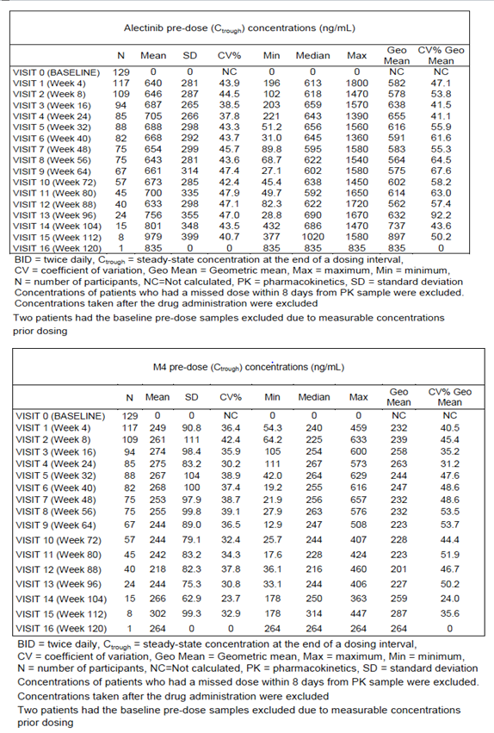

C_{trough} PK sampling
The summary of observed pre-dose (C_{trough}) concentration data by visit for alectinib and M4 is provided in Table 1.
The geometric mean alectinib observed pre-dose (C_{trough}) concentrations across visits ranged from 562 to 897 ng/mL and were associated with a moderate to high variability (geometric mean CV%) ranging from 41.1% to 92.2% across visits (Table 1). The geometric mean M4 observed pre-dose (C_{trough}) concentrations across visits ranged between 201 to 287 ng/mL and were associated with a moderate variability (geometric mean CV%) ranging from 24.0 % to 53.7% across visits (Table 1).
Evaluator comment: The alectinib and M4 C_{trough} levels in this first line population are approximately 10% higher than that recorded in the PI currently. The relevance of this degree of difference is uncertain, and although there are limitations in the Population PK model as presented below, modeled exposure-response relationships for safety and efficacy do not suggest this is a clinically relevant difference and the PI does not require updating.
Results suggested that steady-state was achieved for both alectinib and M4 plasma concentrations during treatment and concentrations remained stable throughout the visits.
The geometric mean of individual median observed pre-dose (C_{trough}) concentrations across visits was 579 ng/mL for alectinib (geometric mean CV%: 48.9) and 238 ng/mL (geometric mean CV%: 41.9) for M4. The geometric mean M4 to alectinib parent (M/P) ratio was approximately 44% across patients and visits.

Table 2: Statistical summary of the individual C_{trough} across patients and visits - PK evaluable population
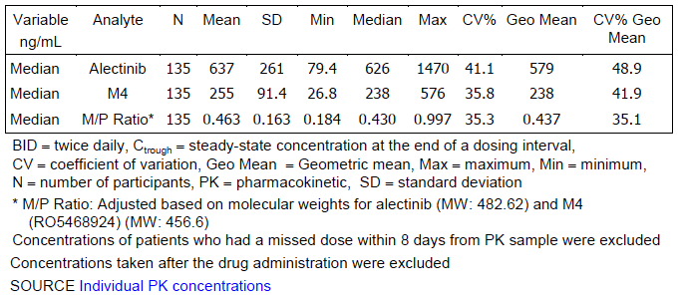

Summary of pharmacokinetics
The pharmacokinetics in this first line population is similar to previously studied populations as outlined in the PI. No changes to the PI are required.

Population pharmacokinetic analyses

Population Pharmacokinetic analysis and Exposure-Efficacy and -Safety Analyses of Alectinib and M4 of Phase III Study BO28984 in ALK Inhibitor-Naïve Patients with ALK-Positive Non- Small Cell Lung Cancer dated 31st July 2017
This report is based on the randomised, open label, active-controlled Phase III Study BO28984 (ALEX) submitted in support of registration for first line use of alectinib in this population. It is recommended that the sections on clinical efficacy and safety be read prior to reading this section in order to understand the study design, efficacy and safety outcomes.

Objectives
The objectives of the population pharmacokinetic (PK) analyses of the Phase III Study
ALEX were to:
- Describe the PK of alectinib and its major active metabolite M4 in ALK-positive NSCLC patients who are ALK inhibitor-naïve;
- Confirm the effects of covariates which contribute significantly to the between-patient variability in PK parameters of alectinib and M4 in ALK inhibitor-naïve ALK-positive NSCLC patients,
- Determine individual estimates for derived secondary PK parameters for exposure-efficacy and -safety analyses and for summary statistics.
The objectives of the exposure-efficacy and -safety analyses of the Phase III Study
ALEX were to:
- Investigate the exposure-efficacy and -safety relationship for alectinib and M4 in ALK-positive NSCLC patients who are ALK inhibitor-naïve,
- Determine whether the variability in efficacy and the occurrence of safety events could be attributed to the variability in alectinib and M4 exposure,
- Characterise the relationship between alectinib and M4 exposure and progression free survival (PFS) following 600 mg BID using a Cox proportional hazards regression model,
- Characterise the relationship between alectinib and M4 exposure and time to central nervous system (CNS) progression using a Cox proportional-hazards regression model.

Sample collection
152 patients were enrolled in the alectinib arm of the Phase III study ALEX, and received alectinib 600 mg BID, the global dose, in the morning and evening, taken with food. The PK evaluable population included 144 patients who received at least one dose and had at least one evaluable post-baseline sample.

Intensive sampling
Intensive plasma PK samples were obtained from a subset of patients (n = 10) at:
- Visit 0 (Baseline) following a single dose administration of alectinib at 600 mg
  - all 10 patients had PK samples collected up to 8 hours post-dose;
  - 6 patients also had PK samples collected up to 12 hours post-dose.
- Visit 1 (Week 4; steady state) following continuous administration of alectinib at 600 mg BID.
  - 9 patients had PK samples collected up to 8 hours post-dose;
  - 4 patients also had PK samples collected up to 12 hours post-dose.
Evaluator note: Since all patients had PK collected at least up to 8 hours, it was decided to calculate and report AUC 0-8. The original PK sample scheme was amended throughout the study in order to facilitate collection and patient time at the clinic. See Protocol Amendment 2 (Version 3) [14 May 2015]

Sparse sampling
All patients randomised to receive alectinib treatment had sparse PK sampling taken pre-dose (C_{trough}; within 2 hours before intake of alectinib):
- at Visit 0 (Baseline before dosing)
- Visit 1 (Week 4)
- Visit 2 (Week 8) and
- At all subsequent visits (every 8 weeks) until progressive disease or death/treatment discontinuation.

Analytical methods
Determination of the concentration of alectinib and M4 were conducted using the Quintiles assay, which was an established and validated LC-MS/MS method and the lower limit of quantification (LOQ) was 1.50 ng/mL for both alectinib and M4.

Baseline covariate data
Covariate data was available in various datasets on the Unix-BioSas as SDTM datasets. The covariates investigated in the population PK analyses are provided in Table 3, and the covariates investigated in the Cox proportional-hazards analyses are provided in Table 4.

Table 3: Baseline covariate data for population PK analyses
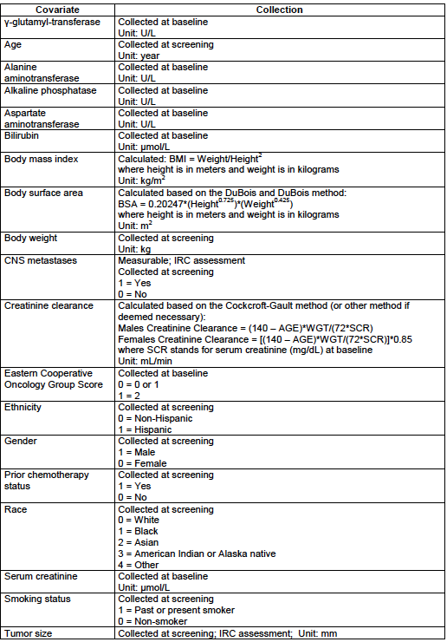

Table 4: Baseline covariate data for Cox Proportional Hazards analysis
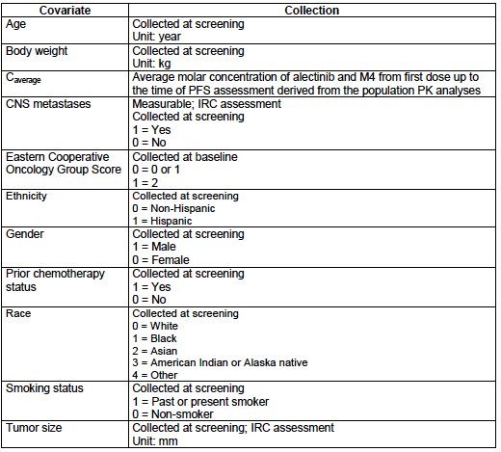

Data checking and Handling of outlying data
In addition of validation checks by data managers, index plots of all population pharmacokinetic data variables were created and reviewed for possible identification of outlying errors in the dataset. These outliers were reviewed on an individual basis and then corrected, left as is, or excluded from the population analysis.
Outliers, which are data points in the dataset that appear to be outside the norm for that particular dataset (for example, data with conditional weighted residuals > 5), were identified based on inspection of the results from initial satisfactory runs. The analysis then proceeded with the outliers omitted. However, the final model was re-run with the outlying data points included, and results from this run were analyzed.
Evaluator comment: The final determinant of which model was to be accepted, that is, with or without outliers, is not clear.

Data assembly

PK datasets
The NONMEM data files used for the population PK analyses contained the data items provided in Table 5.

Table 5: Data items for the NONMEM dataset
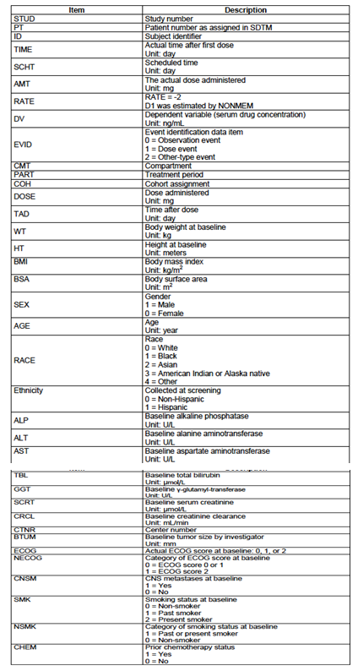

Handling of missing data
Patients who had missing covariate information were not excluded from the analysis. Instead, the median value of that covariate for the patient population was used for those patients who had missing covariate information.
For the baseline tumour size, assessments from the investigators were used when the independent radiological review committee (IRC) assessments were not available.
For missing sampling times or missing observation results, the corresponding sampling information was omitted.
Evaluator comment: Study entry and baseline measurements were investigator-assessed, and the data items in Table 6 indicate the intention to use the investigator assessments of target lesions. Substitution of investigator assessments where IRC values are missing is not an acceptable way to manage discordance, which is the reason for ‘missing’ IRC data. The model should be run with one dataset versus another rather than a composite of the investigator and IRC measurements. How this model will handle discordance between the investigators and IRC over baseline disease status, declaration of PFS and the timing of disease progression is unclear.

Handling of observations below the limit of quantification
The observations below the limit of quantification (BLQ) were omitted initially. Different likelihood-based methods (for example, M2, M3 or M4 described by Beal et al, 2001) for handling BLQ data were investigated during the analyses.

Efficacy and safety datasets
The efficacy and safety data analysed in the exposure-response analyses are described in Table 6 and the data file used for the Cox proportional-hazards analyses contained the data items provided in Table 7.

Table 6: Data items for the efficacy and safety dataset
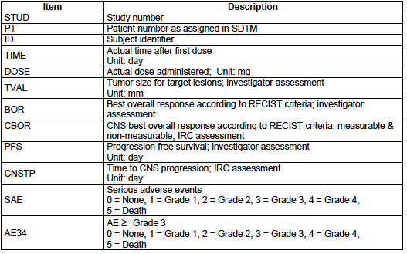

Table 7: Data items for the Cox proportional hazards analysis for PFS
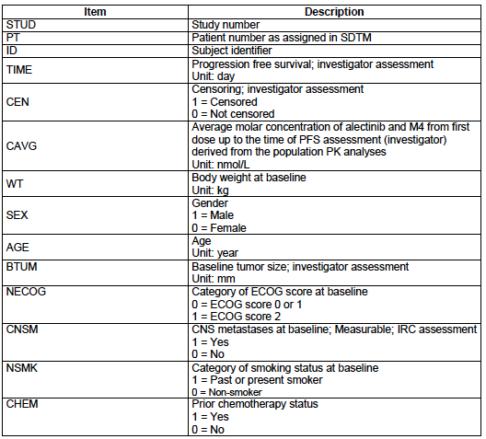

Table 8: Data items for the Cox proportional hazards analysis for time to CNS progression
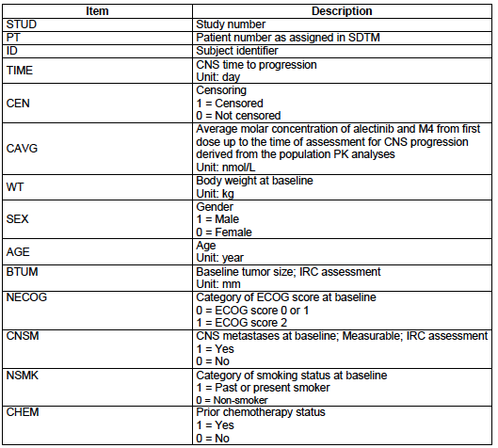

Population PK analysis
A Bayesian feedback analysis was conducted to analyse data from ALEX utilising the population PK models previously developed for alectinib and M4 in ALK-positive NSCLC patients who have progressed on or intolerant to crizotinib (NONMEM version 7.2.0). For the Bayesian feedback analysis, the original models developed for alectinib and M4 were used by fixing the population parameters to their final values and by fixing to zero the number of maximal evaluation (that is, MAXEVAL) in the estimation subroutine (that is, $Estimation) in the NONMEM control streams.
Compared with the PK sampling schedule in previous Phase II studies, the PK sampling scheme in ALEX was very sparse, with mainly trough samples collected from each patient. As a consequence, the Bayesian feedback analysis was conducted by fixing the between-subject variability of absorption parameters (absorption constant KA and duration of zero-order absorption D1) to zero as the individual data contained no or very limited information about the variability in the absorption phase.
Bayesian feedback predictions (that is, post-hoc) of individual PK parameters for alectinib and M4 were then derived from the individual observed concentration-time profiles.
All diagnostic plots used during development of the original models and simulation-based diagnostics were utilized to assess the performance of the population PK models in describing alectinib and M4 data in ALK-positive NSCLC ALK inhibitor-naïve patients
There were two types of assumptions: modeling assumptions and assumptions related to this population analysis.

Modeling assumptions
The following modeling assumptions were made for the population pharmacokinetic analysis:
- Eta (η) variables (between-subjects random variables) were symmetrically distributed.
- Epsilon (ε) variables (random variables related to the error model) were symmetrically distributed.
- Conditional weighted residuals were normally distributed (Section 3.4.3).

Analysis assumptions
The date and time of drug intake, the actual amount of drug intake and the actual PK sampling times were assumed to be recorded accurately.

Patient data inclusion criteria
Patient data were included in the PK analysis if it contained sufficient dosing information and at least one adequately documented and quantifiable alectinib and M4 concentration per patient.

Model evaluation

Graphical evaluation
The ability of the population model to describe the data was assessed by graphical analysis. The following goodness-of-fit plots were required as part of the graphical evaluation:
- Plots of population and individual predictions versus observations and versus time
- Plots of conditional weighted residuals versus population predictions and versus time
- Plots of individual weighted residuals versus individual predictions and versus time
- Plot of absolute conditional weighted and individual weighted residuals versus population and individual predictions, respectively
- QQ plot of conditional weighted and individual weighted residuals
- Histogram of conditional weighted and individual weighted residuals
- Histogram of the etas (η)
- Individual plots comparing observed and individual predictions over time
Individual weighted residuals (IWRES) were calculated as follows:
IWRES = (Individual predicted values - Observed values) / Weighting
Similar plots using logarithmic scales were also used to detect any discernible trends in the individual and population predictions.
Mean and median η values were examined to ensure that they were centered at zero and showed no obvious bias.

Model predictive performance
The predictive performance of the population PK model was evaluated by conducting a visual predictive check (VPC) to verify the agreement between observed data and values simulated using the final population PK model.
Model parameters were randomly sampled from their estimated distributions, and the alectinib and M4 plasma concentrations were simulated using the sampled PK parameter values and residual variability. For each individual, the covariate values, dosing information, and sampling times were identical to those contained in the original ALEX dataset. This simulation was repeated 300 times for the entire data set.
For each simulation run, the median, the 5th and 95th percentiles were first calculated. Then for each of these three statistics, the 90% confidence interval (using the 5th and 95th percentiles) were computed from results of the 300 simulation runs and were displayed on the graph as shaded areas. The median, the 5th, and 95th percentiles derived from the observed data were then superimposed on the same graph and compared with the 90% confidence intervals predicted.

Individual predictions for secondary PK parameters
Individual estimates of the PK parameters for each patient in ALEX obtained from the final population PK models were used to simulate individual plasma concentration-time profiles for alectinib and M4 for each patient following per protocol dosing of 600 mg BID.
Secondary PK parameter steady-state area under the plasma concentration-time curve for a 12-hour interval (AUC12hr) for alectinib and M4 was then derived from the simulated plasma concentration-time profiles for each patient.

Exposure-efficacy analyses

Graphical analyses
To investigate whether the variability in alectinib and M4 exposure could explain partly the variability in efficacy at the dose of 600 mg BID in ALK-positive NSCLC patients who were ALK inhibitor-naïve, patients from ALEX who were included in the population PK analyses were assessed. The following efficacy parameters were investigated graphically:
- Change in tumour size from baseline [investigator assessment]
- Systemic best overall response (BOR) [RECIST 1.1; investigator assessment],where partial response (PR) and complete response (CR) were grouped together and stable disease (SD) and progressive disease (PD) were grouped together
- CNS BOR [measurable and non-measurable, IRC assessment], where PR and CR were grouped together and SD and PD were grouped together
- Progression free survival (PFS) [investigator assessment]
- Time to CNS progression
Evaluator comment: While the use of CR and PR separately would potentially explore a more significant relationship to efficacy, SD is a clinically meaningful endpoint for clinicians and patients, and a reason to continue therapy – taken together with the CR and PR, SD is often defined as ‘clinical benefit rate’; PD indicates treatment failure and a reason to stop. The combination of SD and PD and any associated analyses do not reflect what is relevant in making clinical decisions about efficacy, and thus will not inform regarding the utility of alectinib. This was further compromised by the low numbers in this group. The analyses in italics indicate where these limitations apply.
Logistic regressions were used to investigate the exposure-efficacy relationships between exposure and systemic BOR and CNS BOR, and the Chi-square statistic was used (SAS 9.4 TS). Kaplan Meier plots and log-rank statistics (SAS 9.4 TS) were used to graphically investigate the exposure-efficacy relationships between exposure and PFS and time to CNS progression.
Individual C_{average}, defined as the average concentration from first dose up to the time of efficacy assessment derived from the population PK model, was used as the surrogate for exposure. For each efficacy assessment, individual C_{average} was derived for each patient for the respective efficacy parameter. To assess the exposure-response relationship using change in tumour size from baseline, individual C_{average} was computed by taking the average concentration from first dose up to the time of last tumour assessment.
Since M4 has been shown to have similar in vitro potency and plasma protein binding to alectinib, the C_{average} was defined as the average molar concentration over time for the sum of alectinib and M4 molar concentrations.

Cox proportional-hazards analyses for PFS and time to CNS progression
A Cox proportional-hazards analysis was conducted to characterize the relationship between alectinib and M4 exposure and PFS following 600 mg BID in ALK-positive NSCLC patients who were ALK inhibitor-naïve. PFS by investigator was analysed.
To characterise the relationship between alectinib and M4 exposure and time to CNS progression at 600 mg BID in ALK-positive NSCLC patients who were ALK inhibitor-naïve, time to CNS progression data from ALEX was analysed.

The cox proportional-hazards model
The hazard function of an individual i at time t can be written as the following:
h_{i}(t)=h_{o}(t) x exp (β₁X_{i1}+β₂X_{i2}+•••• +β_{k}X_{ik})
where ho(t) is the baseline hazard function, Xik = {Xi1, Xi2,…, Xik} is the vector of covariates for individual i, and βk is the coefficient which corresponds to covariate k. The model assumes a baseline hazard which is common to all individuals included in the study population. The covariates have multiplicative effect on the baseline hazard.
In the Cox proportional-hazards model, the baseline hazard function ho(t) is left unspecified. Therefore, the hazard ratio for the two observations i and i’ can be written as follows:
h_{i}(t)/h_{i’}(t)=h_{o}(t)x exp (β₁X_{i1}+β₂X_{i2}+•••• +β_{k}X_{ik})/ h_{o}(t)x exp (β₁X_{i’1}+β₂X_{i’2}+•••• +β_{k}X_{i’k}) =
exp (β₁X_{i1}+β₂X_{i2}+•••• +β_{k}X_{i})/ exp (β₁X_{i’1}+β₂X_{i’2}+•••• +β_{k}X_{i’k})
which is independent of time t.
The log partial likelihood for the Cox proportional-hazards model for all events is then computed as the following:
Log L(β)=Σ^{N}_{j=1}{βX_{i}-log{Σ_{kεRj} exp(βX_{k})}
where N is the number of events in the data set, Xi is the covariate vector for subject with an event at time j, Rj is the set of subjects at risk at time j, β is the covariate coefficient vector and Xk is the covariate vector for subject k.

Covariate selection
Covariates were assessed in the Cox proportional-hazards model by univariate addition and ranked in descending order according to the change in log likelihood ratio test (LRT). Variables were then tested by stepwise addition to the model. Covariates were included in the model at a significance level of p < 0.05. When no further significant covariates could be included at the p < 0.05 significance level, a backwards deletion was carried out at the p < 0.01 significance level where the relative influence of each covariate on the model was re-evaluated by deleting it from the full model on an individual basis.

Exposure-safety analyses
Graphical analyses were performed to investigate whether the occurrence of safety events could be attributed to the variability in alectinib and M4 exposure at the 600 mg BID dose in ALK-positive NSCLC patients who were ALK inhibitor-naïve. Patients from ALEX who were included in the population PK analyses were included in these analyses.
The following safety parameters were selected for the analyses (‘selected AEs of interest’):
- Serious adverse event (SAE)
- Adverse event (AE) Grade 3 or above
Logistic regressions were used to investigate the exposure-safety relationships between exposure and the safety parameters selected, and the Chi-square statistic was used (SAS 9.4 TS).
Similar to the exposure-efficacy analyses, the individual C_{average}, which was defined as the average concentration from first dose up to the time of the safety event derived from the population PK model, was used as the surrogate for exposure. For those patients who did not have a safety event, their individual C_{average} was defined as the average concentration from first dose up to the time of last dose received on record.
Since M4 has been shown to have similar in vitro potency and plasma protein binding to alectinib, the C_{average} was defined as the average molar concentration of alectinib and M4.

Results

Population PK analyses

Plasma concentrations
A total of 1486 alectinib and 1486 M4 plasma concentrations measured from 143 ALK-positive ALK inhibitor-naïve NSCLC patients in ALEX were available for the population PK analyses for each of these two entities.
1302 alectinib and 1302 M4 plasma concentrations collected from 143 patients in ALEX were included in the final PK dataset after exclusion of:
- 1.8% (24) and 2.0% (27) of the plasma concentrations for alectinib and M4, respectively, collected after start of treatment which were BLQ; and
- 2.1% (29) and 1.9% (26) of the plasma concentrations for alectinib and M4, respectively, due to their extremely inconsistent plasma concentration levels.
Evaluator comment: the reported levels of missing or excluded data are low.

Covariates
Differences and similarities in demographics and disease characteristics between the alectinib arms in the ALEX and the Phase I and II studies previously included in PopPK modelling included:
A higher proportion of Asian patients in ALEX compared to Phase II studies
A substantially higher baseline tumour size (median 70mm versus 40mm and 44 mm), and a higher rate of CNS metastases in ALEX (37% versus 25% in Phase II NP28673 and 18% NP28761; 0% Phase I study)
Similarly low ECOG PS 2 enrolment
Similar weight, gender, smoking distribution

Alectinib
Diagnostic plots of inter-individual random effects versus covariates confirmed body weight to be the only significant covariate, consistent across studies and lines of therapy. Race and gender were reported to have no effect.
Graphical evaluation was reported to demonstrate a good quality of the goodness-of-fit plots of the Bayesian feedback analysis, the estimated individual parameters for alectinib were therefore considered suitable for estimating exposure parameters for the exposure-efficacy and exposure-safety analyses for ALEX.

Model predictive performance
Result of the visual predictive check utilizing the population PK model previously developed for alectinib is presented in Figure 1. The 95th percentile of raw data generally fall in the lower part of the 90% prediction interval, and the observed PK data from a few visits fall slightly outside of the simulated 90% prediction interval. These trends are minor, as this was an external evaluation conducted by fixing all population PK parameters obtained from the previous analysis.
Evaluator comment: the 90% CI around the simulated mean exceeds the 95th percentile, with values that appear at some points on the right side of the curve to be as much as 40-50%. When being used to simulate model exposure relationships, this level of ‘error’ is unlikely to be helpful and may lead to an overestimate of any effects modelled for a higher level of exposure.
Figure 1: Visual posterior predictive check for alectinib
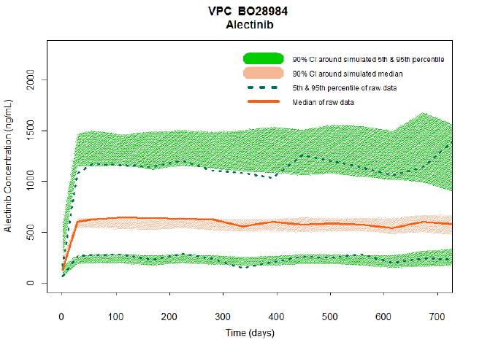

M4
As identified in the previous population PK analyses, diagnostic plots of inter-individual random effects versus covariates confirmed that body weight is the only significant covariate for M4 and the relationship between body weight and the PK of M4 remains consistent across studies and across treatment lines. All other covariates investigated in the previous population PK analyses, including race and gender, were confirmed to have no significant effect on the PK of M4.
Result of the visual predictive check utilizing the population PK model previously developed for M4 is presented in Figure 2. The 95th percentile of raw data collected at later time points fall in the lower part of the 90% prediction interval, and the observed PK data from a few visits fall slightly outside of the simulated 90% prediction interval. These trends are minor, as this was an external evaluation conducted by fixing all population PK parameters obtained from the previous analysis.
Figure 2: Visual posterior predictive check for M4
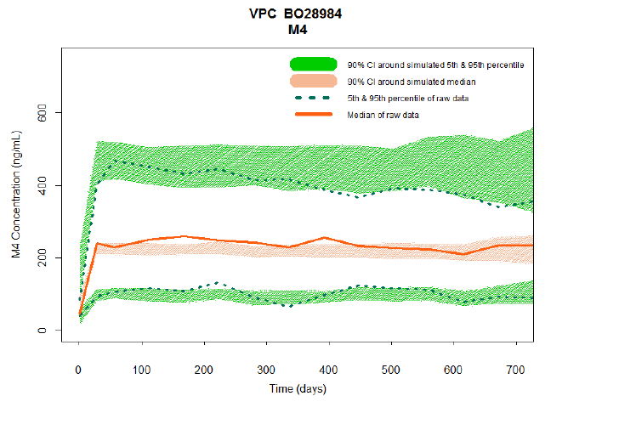
Evaluator comment: The model does not predict as closely for the median or 5th percentile, and as stated above for alectinib, there is a large ‘error’ for the 90th CI around the simulated 95th centile likely to limit any conclusions that can be drawn from exposure analyses.

Impact of body weight on the secondary PK parameters for alectinib and M4
The report indicates body weight was the only covariate found to statistically influence the CL/F and V/F for both alectinib and M4. To illustrate the body weight effect on secondary PK parameter AUC_{ss,12hr}, distribution of the steady-state 12-hour AUC for alectinib and M4 for patients in different body weight categories are shown in Figure 12 [not shown here] for patients in ALEX and Phase II studies. As shown in Figure 12 [not shown here] in the PopPK report, alectinib and M4 exposure decreases with increasing body weight. Summary statistics for the steady-state 12-hour AUC for alectinib and M4 is also provided.

Exposure-response analyses

Efficacy and safety data
For the tumour size analysis, data from 141 patients who had both pre and post baseline tumour size measurements were utilised. For the analysis on systemic best overall response, data from 141 patients were available, and a summary of the number of patients within each response category is presented below.

Table 9: Summary of patients within each response category
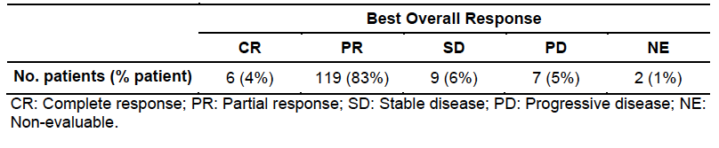
For analysis on the CNS best overall response for measurable and non-measurable disease, the exposure-efficacy database was composed of 57 patients, and the summary of the number of patients within each response category is presented below.

Table 10: Summary of patients within each response category
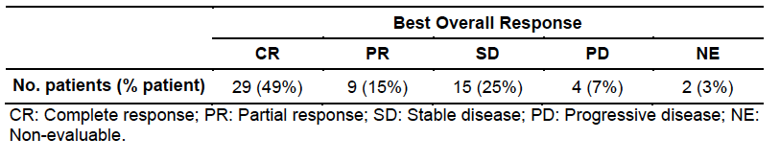

Analysis of exposure-response
Change in tumour size was presented and there was no relationship between the exposure and the average change in tumour size or magnitude of response, defined as 75% decrease. Molar concentration of alectinib and M4 (C_{average}) was not correlated with the probability of a CR and PR. No relationship of exposure with CNS best overall response for measurable or non-measurable disease, or time to CNS progression was found.
Evaluator comment: The numbers in these analyses are small; the error inherent in the model for predicting higher exposures mean any of these results should be interpreted with caution. In addition, the levels of alectinib and M4 in the CNS have not been demonstrated to be predicted accurately by this model.
Progression-free survival was not related to exposure.

Cox proportional hazards analysis for PFS, time to CNS relapse
After inclusion of the alectinib treatment effect into the Cox proportional-hazards model, baseline tumour size, baseline CNS metastasis status, and baseline ECOG score were also identified as significant covariates on PFS during the stepwise forward-inclusion process. During the backward deletion process, baseline ECOG score was removed from the model. Results of the Cox proportional-hazards analysis for PFS by investigator showed that alectinib treatment effect, CNS metastasis at baseline, and baseline tumour size were the only statistically significant predictors of PFS.
Similarly, after only retaining CNS metastasis in the model, results of the Cox proportional-hazards analysis for time to CNS progression showed that alectinib treatment effect and CNS metastasis at baseline were the only two statistically significant predictors of time to CNS progression.
Evaluator comment:
- Very few patients had ECOG PS 2, and therefore the difference between those with ECOG PS 0 and 1 may not have been readily detectable. Poorer ECOG PS is an independent poor prognostic factor, not adequately tested within this model due to imbalances in the recruited population.
- The presence of CNS metastases and tumour burden are known independent risk factors for poor prognosis, confirmed by this model.
- The findings from this simulation, model and analyses confirm existing understanding of advanced NSCLC, and add no new information and generate no hypotheses for testing in future clinical trials.

Analyses of exposure-safety relationship
For patients receiving 600 mg BID in ALEX, logistic regression analyses have shown that there was no significant relationship between combined molar concentration of alectinib and M4 (C_{average}) and the occurrences of SAEs. There was also no significant relationship between C_{average} and the occurrences of AEs Grade 3 or above. In addition, there was no apparent effect of C_{average} on the severity of the first event for SAEs and AEs Grade 3 or above.
Evaluator comment: SAEs and AEs ≥ Grade 3 occur for a variety of reasons in patients with advanced cancer, not necessarily related to treatment. This, together with the large error around the 95th centile, the likelihood of detecting a treatment-related event is uncertain. No conclusions can be drawn about exposure and occurrence of adverse events.

Evaluator’s overall conclusions on population pharmacokinetics
None of the conclusions based on the population PK modelling have been proposed as new information in the PI and this is appropriate. The analyses did not expand on what was known from the efficacy and safety in the pivotal trial, and prognostic factors that are well-established for a range of malignancies.

Pharmacodynamics

Not applicable.

Dosage selection for the pivotal studies
Not applicable.

Clinical efficacy

Pivotal or main efficacy studies

Study BO28984 also known as and hitherto referred to as, ‘ALEX’ – a randomised, active controlled open label trial comparing alectinib with crizotinib.

Study design, objectives, locations and dates
This is an ongoing randomised, multicentre, Phase III, open-label, active-controlled study of alectinib 600 mg twice daily versus crizotinib 250 mg twice daily in adult patients (≥ 18 years) with non-resectable, locally advanced, recurrent or metastatic anaplastic lymphoma kinase-positive advanced Non−Small Cell Lung Cancer (ALK-NSCLC) who have not received systemic therapy in the advanced setting.
The sponsor’s rationale for the open-label study design was that it was ‘considered more appropriate for patients enrolled in this particular trial, with the ultimate goal to ensure patient compliance as much as possible, notably due to the high pill count and complexity of dosing that would be required for a blinded study design.’
Evaluator comment: Ideally, it would have been preferable to have both investigators and patients blinded given the primary endpoint is investigator-assessed and to minimize bias in collection of patient-reported data, respectively. However, the dose reduction schedule for toxicities would have been complex given the two dose presentations for crizotinib (250 mg and 200 mg) and the recommended reduction from the starting dose of 250 mg bd to 200 mg for initial toxicities, and then to 250 mg once daily if further dose reductions required. In addition, differences between the drug-drug interactions of two study drugs mean specific concomitant therapies need to be avoided for one but not the other and not knowing which treatment the patient is receiving may lead to effective therapies for supportive or for managing other medical conditions not being used, when these are in fact safe. The sponsor’s rationale is accepted.
1298 patients were screened for inclusion in this study of whom, 995 failed screening mostly due to not having ALK-positive NSCLC (95%). A total of 303 patients were randomised at 98 sites in 29 countries, 151 to the crizotinib arm, and 152 to the alectinib arm.
Evaluator comment: No summary of the sites or countries could be located and these were provided in the sponsor’s response to questions.

Table 11: Study BO28984 countries, sites and patients enrolled
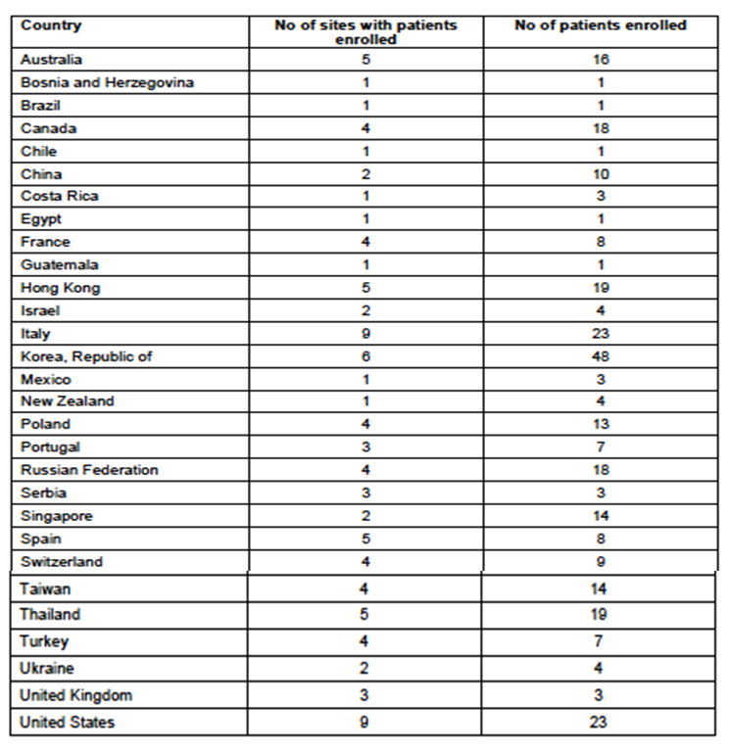
To be eligible for the study, determination of ALK positivity was performed centrally using the IHC assay that is being developed by Ventana Medical Systems as a companion diagnostic to alectinib. Subsequently, patient samples were centrally tested using the Vysis FISH and potentially other ALK assays to establish performance characteristics of these assays, including those patients who were not deemed eligible for the trial. This was conducted at four different central sites. Eligible patients were randomised 1:1 to treatment with either crizotinib (250 mg BID) or alectinib (600 mg BID). Randomisation was stratified by ECOG PS (0/1 versus 2), race (Asian versus non-Asian) and baseline CNS metastases (present versus absent).
Evaluator comments:
- The use of crizotinib as the comparator is appropriate and reflects the standard of care in Australia for patients with newly diagnosed advanced ALK-positive NSCLC.
- The use of an IHC assay, with retrospective validation using FISH testing (as is currently required for funded access to ALK-positive therapies in Australia) was undertaken on both patients accepted onto the trial and those deemed to fail screening to support the registration of the IHC as a companion diagnostic for alectinib. Concordance of these two assays was an exploratory outcome, and there may well be information on false negatives if patients deemed negative by IHC were also tested by other means. This was initially included in the clinical study protocol, but deemed no longer necessary after the FDA approval of the Ventana D5F3 ALK IHC assay as a companion diagnostic for crizotinib.
Patients will be treated until disease progression, unacceptable toxicity, withdrawal of consent, or death. After disease progression (as per RECIST v1.1), patients should discontinue the study medication, although the study medication could be continued in the setting of isolated CNS relapse treated with local therapy or if the investigator considered the patient would continue to benefit from ongoing treatment. After disease progression, patients will be treated at the discretion of the investigator according to local practice. Information regarding the nature and the duration of subsequent therapies will be collected.
Figure 3: Study BO28984 study design
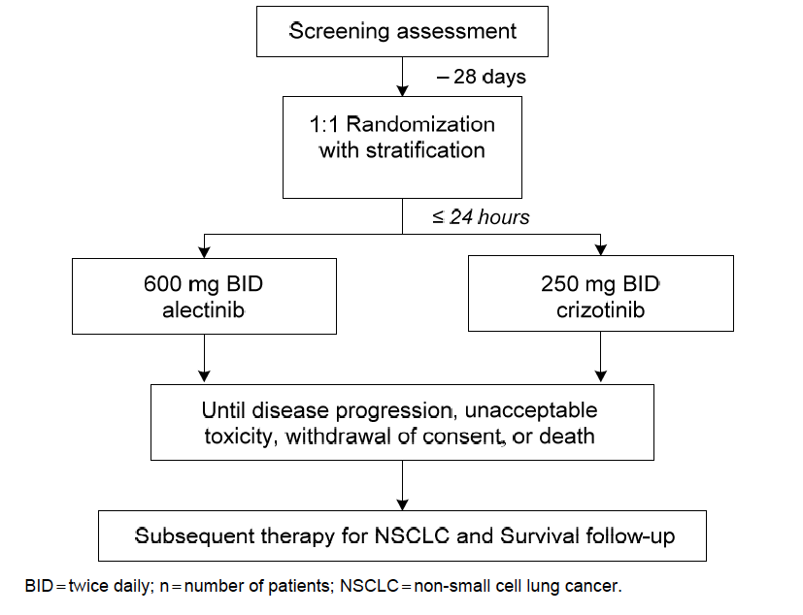
Tumour assessments were performed every 8 weeks according to RECIST version 1.1 until disease progression. Patients were treated until disease progression, unacceptable toxicity, withdrawal of consent, or death, whichever occurs first. Patients who discontinued treatment were planned to be followed for safety and OS; these patients could remain in the study.
AEs were collected up to 4 weeks after last dose; thereafter only serious AEs were reported.
Study Dates
First patient entered 19 August 2014
Last patient entered 20 January 2016
Data cut-off 09 February 2017
Database lock 31 March 2017

Primary objective
- To evaluate and compare the efficacy of alectinib compared to crizotinib in patients with treatment-naive anaplastic lymphoma kinase (ALK)-positive advanced non−small cell lung cancer (NSCLC), as measured by investigator assessed progression-free survival (PFS).

Secondary objectives

Efficacy
- To evaluate and compare the Objective Response Rate (ORR) and Duration of Response (DOR).
- To evaluate and compare the time to progression in the CNS on the basis of IRC review of radiographs by RECIST v1.1 and Revised Assessment in Neuro Oncology (RANO) criteria, as well as:
  - To evaluate CNS objective response rate (C-ORR) in patients with CNS metastases who have measurable disease in the CNS at baseline.
  - To assess CNS duration of response (C-DOR) in patients who have a CNS Objective Response.
  - To assess CNS progression rates (C-PR) at 6, 12, 18, and 24 months on the basis of cumulative incidence.
  - To evaluate and compare the PFS assessment by the IRC.
  - To evaluate and compare the OS.

Safety
To evaluate the safety and tolerability of alectinib compared with crizotinib.

PK
To characterise the pharmacokinetics of alectinib and metabolite(s)

Patient-reported outcomes
- To evaluate and compare time to deterioration (TTD) in patient reported lung cancer symptoms of cough, dyspnoea (single item and multi item subscales), chest pain, arm and shoulder pain, and fatigue as measured by the European Organization for the Research and Treatment of Cancer (EORTC) Quality of Life Questionnaire-Core (QLQ-C30) and the supplemental lung cancer module (QLQ LC13) as well as a composite of three symptoms (cough, dyspnoea, chest pain).
- To evaluate and compare PROs of health-related quality of life (HRQoL), patient functioning, and side effects of treatment as measured by the EORTC QLQ-C30 and EORTC QLQ-LC13.

Exploratory objectives
- To evaluate and compare patient’s health status as assessed by the EuroQoL 5 Dimension (EQ-5D 3L) questionnaire to generate utility scores for use in economic models for reimbursement.
- To evaluate and compare the onset of hypogonadism in adult men by measuring total testosterone and free testosterone (either by direct measurement or by calculation using albumin and sex hormone-binding globulin [SHBG]), follicle stimulating hormone (FSH), and luteinizing hormone (LH) levels in blood.
- To evaluate and compare efficacy in patients with treatment-naive ALK-positive NSCLC as assessed by the FISH Vysis ALK Break Apart FISH Probe Kit (Abbott).
- To evaluate and compare efficacy and safety in patients having treatment-naive ALK-positive NSCLC as assessed by plasma ALK assays (polymerase chain reaction [PCR] and/or sequencing).
- To determine the correlation between ALK status as assessed by plasma ALK PCR and/or plasma ALK sequencing tests, with ALK status obtained using the Ventana ALK IHC and FISH Vysis ALK Break Apart FISH Probe Kit (Abbott).
- To investigate molecular mechanisms of resistance to ALK inhibitors.
- To investigate detection of ALK mutations/fusions in plasma.
- Data pertaining to these endpoints were not included in the CSR as per SAP Version 4, dated 4 March 2017
An independent Data Monitoring Committee (iDMC) was established to monitor the progress of the study and ensure that the safety of patients enrolled in the study was not compromised.
A central IRC was established to perform independent radiological review of all scans to determine the secondary endpoints of the overall disease PFS and time to CNS progression, both on the basis of RECIST v1.1. The independent review of MRI and CT scans was not to determine either eligibility or treatment modification. All treatment-related decisions were made by the investigator using local assessments.

Inclusion and exclusion criteria

Inclusion criteria
Patients who met the following criteria were eligible for study entry:
- Histologically or cytologically confirmed diagnosis of advanced or recurrent (Stage IIIB not amenable for multimodality treatment) or metastatic (Stage IV) NSCLC that is ALK-positive as assessed by the Ventana IHC test. Sufficient tumour tissue to perform ALK IHC and ALK FISH was required. Both tests were performed at designated central laboratories.
- Age ≥ 18 years old.
- Life expectancy of at least 12 weeks.
- ECOG PS of 0–2.
- No prior systemic treatment for advanced or recurrent NSCLC (Stage IIIB not amenable to multimodality treatment) or metastatic (Stage IV) NSCLC.
- Adequate hematologic function:
Platelet count ≥ 100 x10⁹/L. ANC ≥ 1500 cells/µL.
Haemoglobin ≥ 9.0 g/dL.
- Adequate renal function:
An estimated glomerular filtration rate (eGFR) calculated using the Modification of Diet in Renal Disease equation of at least 45 mL/min/1.73 m².
- Patients must have recovered from effects of any major surgery or significant traumatic injury at least 28 days before the first dose of study treatment.
- Measurable disease (by RECIST v1.1) prior to the administration of study treatment.
- Prior brain or leptomeningeal metastases allowed if asymptomatic (for example, diagnosed incidentally at study baseline). Asymptomatic CNS lesions might have been treated at the discretion of the investigator as per local clinical practice. If patients had neurological symptoms or signs due to CNS metastasis, patients needed to complete whole brain radiation or gamma knife irradiation treatment. In all cases, radiation treatment must have been completed at least 14 days before enrollment and patients must have been clinically stable.
- For all females of childbearing potential, a negative pregnancy test must have been obtained within 3 days before starting study treatment.
- For women who are not postmenopausal (≥ 12 months of non-therapy-induced amenorrhoea) or surgically sterile (absence of ovaries and/or uterus), agreement to remain abstinent or use single or combined contraceptive methods that result in a failure rate of < 1% per year during the treatment period and for at least 3 months after the last dose of study drug. Abstinence was only acceptable if it was in line with the preferred and usual lifestyle of the patient. Periodic abstinence (for example, calendar, ovulation, symptothermal or postovulation methods) and withdrawal were not acceptable methods of contraception. Examples of contraceptive methods with a failure rate of < 1% per year include tubal ligation, male sterilization, hormonal implants, established and proper use of combined oral or injected hormonal contraceptives, and certain intrauterine devices. Alternatively, two methods (for example, two barrier methods such as condom and cervical cap use) may have been combined to achieve a failure rate of < 1% per year. Barrier methods must always have been supplemented with the use of a spermicide.
- For men, agreement to remain abstinent or use a condom plus an additional contraceptive method that together result in a failure rate of < 1% per year during the treatment period and for at least 3 months after the last dose of study drug.
- Abstinence was only acceptable if it was in line with the preferred and usual lifestyle of the patient. Periodic abstinence (for example, calendar, ovulation, symptothermal, or postovulation methods) and withdrawal were not acceptable methods of contraception.
- Able and willing to provide written informed consent prior to performing any study-related procedures and to comply with the study protocol, including patients must have been willing and able to use the electronic patient-reported outcome (ePRO) device.
Evaluator comments:
- The option to treat or not to treat any asymptomatic brain metastases or leptomeningeal disease identified at baseline with other modalities prior to enrolment, may have introduced some imbalances between the arms between those with untreated brain metastases, as well as the effect of very recently treated brain metastases (which might delay relapse independently of the systemic therapy). Note is made that patients had to have completed any radiation treatment at least 14 days prior to enrollment therefore treatment allocation would not be known prior to making a decision about whether to use other modalities. This is partly addressed as the sponsor provides a breakdown for each arm of the CNS response rates for patients with CNS metastases that have not been previously treated. Ideally, it would have been helpful to have a further breakdown by time since treatment for those previously treated, but the resulting subgroup numbers would have been very small.
- Patients with recent wounds from surgery or trauma were required to have had at least 28 days’ recovery time. This was not an exclusion study in the initial registration study and it is not known if this was also required for enrolment into the other Phase III study J-ALEX (the sponsor is requested to confirm this). The sponsor is requested to state what evidence exists to support this being an exclusion criteria (both clinical and nonclinical) and what led to its introduction into this Phase III study. This criterion is not currently included in the Clinical Trials section of the PI. If there is evidence to support an issue, such as with wound healing, the PI Clinical Trials section should include this exclusion, the RMP Safety Specification and possibly the CMI should be updated accordingly. (Clinical Question)
The sponsor has indicated in Response-5 that there were ‘Per protocol, patients who did not recover from major surgery or significant traumatic injury 28 days before the first dose of study treatment were also not included in the initial Phase II registration studies (NP28761 and NP28673).’ The sponsor stated that no instances of impaired wound healing have been reported in the Phase II studies, ALEX or J-ALEX and this exclusion criterion is used as standard by the sponsor. While clotting abnormalities were observed in repeat dose studies in rats, no impact on coagulation parameters was observed in clinical studies.
Evaluator comment: This response is satisfactory, and the evaluator is in agreement with the sponsor that no PI or CMI updates is warranted at this time.

Exclusion Criteria
Patients who met any of the following criteria were excluded from study entry:
- Patients with a previous malignancy within the past 3 years were excluded (other than curatively treated basal cell carcinoma of the skin, early gastrointestinal [GI] cancer by endoscopic resection, in situ carcinoma of the cervix, or any cured cancer that was considered to have no impact in PFS and OS for the current NSCLC).
- Any GI disorder that may have affected absorption of oral medications, such as malabsorption syndrome or status post-major bowel resection
- Liver disease characterised by:
ALT or AST > 3 x ULN (≥ 5 x ULN for patients with concurrent liver metastasis) confirmed on two consecutive measurements
OR
Impaired excretory function (for example, hyperbilirubinaemia) or synthetic function or other conditions of decompensated liver disease such as coagulopathy, hepatic encephalopathy, hypoalbuminemia, ascites, and bleeding from oesophageal varices
OR
Acute viral or active autoimmune, alcoholic, or other types of acute hepatitis
- National Cancer Institute Common Terminology Criteria for Adverse Events (NCI CTCAE) (version 4.0) Grade 3 or higher toxicities due to any prior therapy such as radiotherapy (excluding alopecia), which had not shown improvement and were strictly considered to interfere with current study medication
- History of organ transplant
- Co-administration of anti-cancer therapies other than those administered in this study
- Patients with baseline QTc > 470 ms or symptomatic bradycardia
- Administration of strong/potent cytochrome P450 (CYP)3A inhibitors or inducers within 14 days prior to the first dose of study treatment and while on treatment with alectinib or crizotinib (described in Appendix 3 of the protocol)
- Administration of agents with potential QT interval prolonging effects within 14 days prior to the first administration of study drug for all patients and while on treatment through the end of the study for crizotinib-treated patients only
- History of hypersensitivity to any of the additives in the alectinib drug formulation
- History of hypersensitivity to any of the additives in the crizotinib drug formulation
- Pregnant or lactating women
- Known HIV positivity or AIDS-related illness
- Any clinically significant concomitant disease or condition that could interfere with, or for which the treatment might interfere with, the conduct of the study or the absorption of oral medications or that would, in the opinion of the Principal Investigator, pose an unacceptable risk to the patient in this study
- Any psychological, familial, sociological, or geographical condition potentially hampering compliance with the study protocol requirements and/or follow-up procedures; those conditions should be discussed with the patient before trial entry.
Evaluator comment: The sponsor provided a list to investigators of the medicines of substrates, inducers of drug-metabolising enzymes and transporters. It is noted that many of these are antiretroviral therapies used to treat HIV and also other cancer treatments, neither of which was permitted in the study. However, within this list (copied below) are some medications which are available over the counter (St John’s wort), those used commonly for the treatment of infections including quinolone and macrolide antibiotics and antifungal therapies, and also used for the treatment of seizures, which is relevant for this population, 40% of whom had brain metastases at study entry. The sponsor should include a list of relevant medications in the PI and CMI to advise prescribers and patients of medicines to avoid.

Table 12: Potent CY3A inducers and inhibitors, P-gp substrates and inducers and dual UGT1A1/CYP3Asubstrates, inhibitors and inducers
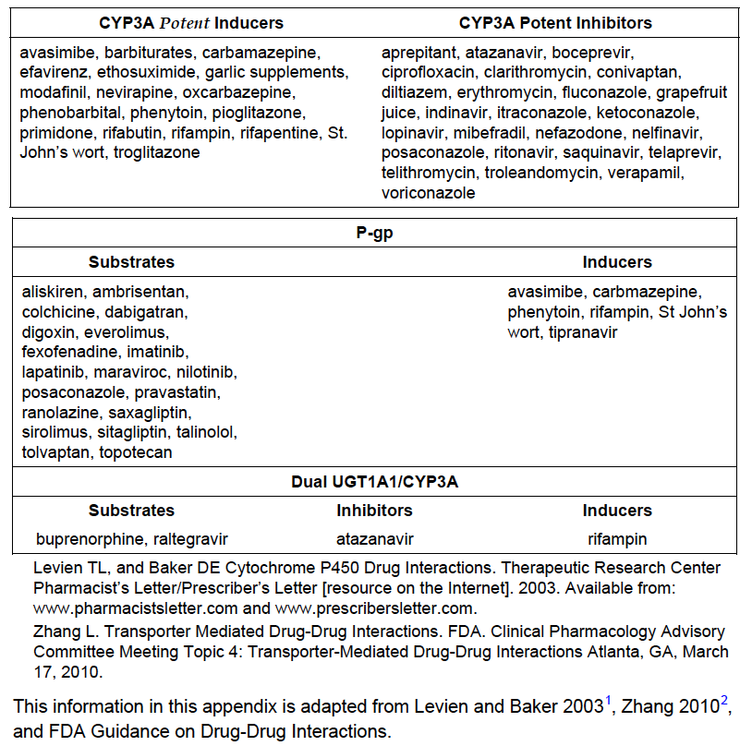

Study treatments
Alectinib 600 mg was administered orally BID with food in the morning and evening and crizotinib at 250 mg was administered orally BID (with or without food) in the morning and evening. If a patient missed a dose, it could be taken within 6 hours of the scheduled time. If the time was greater than 6 hours, or if the patient vomited the dose, the patient was instructed to wait until the next scheduled time and take the next scheduled dose.
Patients were eligible for treatment switching/post-study access if all of the following conditions were met:
- The patient has a life-threatening or severe medical condition and requires continued study drug treatment for his or her well-being
- There are no appropriate alternative treatments available to the patient
- The patient and his or her doctor comply with and satisfy any legal or regulatory requirements that apply to them
- The sponsor has reasonable safety concerns regarding the study drug as treatment for ALK-positive NSCLC
- Provision of study drug is not permitted under the laws and regulations of the patient's country
A patient will not be eligible to receive study drug after the end of the study if any of the following conditions are met:
- The study drug is commercially marketed in the patient's country and is reasonably accessible to the patient (for example, is covered by the patient's insurance or would not otherwise create a financial hardship for the patient)
- The sponsor has discontinued development of the study drug or data suggest that the study drug is not effective for ALK-positive NSCLC
Evaluator comment: Arguments could be made for most of the patients in Australia to meet the criteria for treatment switching from crizotinib to alectinib post-progression or for intolerance. For those progressing on alectinib, the treatment options are less clear as there is no evidence at this time to support a benefit for changing to other ALK inhibitors. Potential options in Australia at the time of this study include crizotinib, ceritinib or chemotherapy.

Concomitant therapies
Caution was recommended when using medications known to be potentially affected by alectinib (a potent P-gp transport and breast cancer resistance protein transporter) or crizotinib (a moderate inhibitor of CYP3A, CYP2B6 and from in vitro studies, P-gp transport inhibitor). Crizotinib is known to cause bradycardia and therefore avoidance of medications causing bradycardia was recommended.

Prohibited therapies/food
The following were prohibited unless discussed and documented with the investigator and Sponsor’s Clinical Pharmacologist:
- Potent inducers or inhibitors of CYP3A
- Any concomitant medications known to affect QT interval within 2 weeks before commencement for all medications, and while on study for patients receiving crizotinib
- Systemic immunosuppressive drugs, cytotoxics or chemotherapeutics, ergot derivatives, probenecid, bile acid derivatives
- Radiotherapy/radionuclide therapy except for palliative radiotherapy to bone lesions or for pain control
- Additional investigational drug except in follow-up period
- Grapefruit products

Efficacy variables and outcomes

Primary efficacy variable
PFS is defined as the time from date of randomization to the date of first documented disease progression or death, whichever occurs first. The primary endpoint of PFS will be determined on the basis of investigator assessment of progression using RECIST v1.1. Clinical lesions will be documented by colour photography (with caliper measurement for measurable lesions), computed tomography (CT) scans, and other modalities (for example, MRI, brain scans), using RECIST v1.1 at baseline and every 8 weeks or sooner if clinically indicated, until disease progression and during post-progression on treatment (isolated asymptomatic CNS progression) and at the post-treatment visit (4 weeks after permanent discontinuation). The same modality should be used to document lesions throughout the study. PET scan, bone scan and ultrasound cannot be used to measure lesions as per RECIST v1.1.
Patients who discontinue treatment prior to disease progression (for example, due to toxicity) will continue on study and will be followed until disease progression and for OS regardless of whether they subsequently receive anti-cancer therapy.

Secondary efficacy endpoints
PFS by IRC will be based on the same methodology as the investigator-assessed PFS.
Time to CNS progression is defined as the time from randomization until radiographic evidence of CNS progression, as determined by independent central radiological review for all patients, regardless of their baseline status of CNS metastases. CNS progression is defined as progression due to newly developed CNS lesions and/or progression of preexisting baseline CNS lesions as per RECIST v1.1.
In the subgroup of patients with measurable CNS lesions at baseline, an exploratory analysis of C-ORR defined as the percentage of patients who achieve a best overall response of CR or PR (defined by RECIST v1.1 as a 30% decrease in the sum of longest diameters of measurable CNS lesions referencing baseline) will also be performed. Duration of CNS response C-DOR in patients who have a CNS Objective Response, and C-PR at 6, 12, 18, and 24 months will be analysed.
An exploratory analysis of these endpoints will also be performed on the basis of RANO criteria assessed by the IRC.
ORR, on the basis of investigator assessment, is defined as the percentage of patients who attain a CR or PR. Per RECIST v1.1, confirmation of objective response is not required for this secondary endpoint. Patients without a post-baseline tumour assessment will be considered non-responders, as will patients with a best overall response of stable disease (SD), PD, or NE (not evaluable).
DOR, which is defined as the time from when response (CR or PR) was first documented to first documented disease progression or death (whichever occurs first). This will only be calculated for patients who have a best overall response of CR or PR. Patients who do not progress or die after they have had a response are censored at the date of their last tumour measurement.
OS is defined as the time from the date of randomization to the date of death due to any cause. Patients without an event will be censored at the last date known to be alive. Patients without any follow-up information will be censored at the date of randomization. A survival follow-up will be performed based on more mature data.
Safety assessments will include monitoring and recording of: AEs, SAEs and non-SAEs of special interest, protocol-specified vital signs, ECOG PS, Laboratory investigations, ECGs (heart rate, RR, PQ, QRS and QT duration, and QT interval corrected using Fridericia’s formula (QTcF).
The PK outcome measures for this study are as follows:
- Sparse (pre-dose) PK samples for measurement of alectinib and its major metabolite(s) will be collected in all study patients receiving alectinib treatment
- Serial/intensive PK sampling will be collected in a subset of consenting patients enrolled to receive alectinib treatment (approximately 10% to 15%, at least approximately n = 20)
- PK parameters will be determined as appropriate and where data allow:
The pharmacokinetics of alectinib (and metabolite[s], if appropriate) will be described, and the between-patient variability will be estimated using a population PK approach. The potential influence of covariates that contribute significantly to the between-patient differences in PK parameters of alectinib will also be explored and quantified.
Non-compartmental analysis may be conducted in patients undergoing serial/intensive PK sample collection, as appropriate and where data allow.
The Patient-reported outcomes (PROs) measures for this study are as follows:
- EORTC QLQ-C30 and the EORTC QLQ-LC13 to determine the impact of alectinib compared with crizotinib as measured by TTD in patient-reported lung cancer symptoms (for example, cough, dyspnoea [single item and multi-item scales], pain in chest, pain in arm/shoulder, fatigue)
- The EORTC QLQ-C30 and EORTC QLQ-LC13 to measure PROs of HRQoL, patient functioning, and side effects of therapy compared between patients treated with alectinib and those treated with crizotinib
Patient responses were captured using an ePRO device to capture PRO data (EORTC QLQ-C30, QLQ-L13, and EQ-5D responses) and maintain a diary of daily drug intake (crizotinib arm) or drug intake with food (alectinib arm). The data will be transmitted via pre-specified transmission method (for example, web or wireless) automatically after entry to a centralized database at the ePRO vendor.

Exploratory endpoints
The exploratory outcome measures for this study are as follows:
- EQ-5D-3L to generate utility scores for use in economic models for the purpose of reimbursement
- Total testosterone and free testosterone levels (either by direct measurement or by calculation using albumin and SHBG), FSH, and LH in blood to measure an onset of hypogonadism in adult men
- Results from the FISH Vysis® ALK Break Apart FISH Probe Kit (Abbott) to evaluate and compare efficacy in patients with treatment-naive NSCLC that is ALK-positive by FISH test
- ALK fusion status in circulating tumor nucleic acids from plasma to evaluate and compare efficacy and safety in patients with treatment-naive NSCLC that is ALK-positive by plasma ALK tests (PCR and/or sequencing) for diagnostic purposes
- Post-progression tumor mutation status to study molecular mechanisms of resistance to ALK inhibitors
- ALK mutation status in plasma DNA to monitor efficacy and disease progression
With appropriate consent, post-progression tumour biopsies may be collected to investigate resistance mechanisms.
Mandatory blood and plasma samples were collected to determine:
- mutation in ALK and other escape genes (e.g. KRAS, EGFR)
- ALK rearrangement in plasma samples.
- Pharmacogenomics in those in the alectinib arm to understand inter-individual variability and safety and alectinib PK
Optional blood samples were collected to:
- Develop diagnostic ALK plasma testing for those testing negative on IHC
- Optional genomic sequencing research
- Use as a source of healthy tissue for genomic sequencing research

Randomisation and blinding methods
There was no blinding as this is an open label trial for clinical sites or patients. The protocol states that the independent review of scans for the secondary endpoints of PFS and time to CNS progression on the basis of IRC will be performed in a blinded fashion.
Central randomization will be performed via an interactive voice or web-based response system (IxRS) using the following stratification factors:
Eastern Cooperative Oncology Group Performance Status (ECOG PS) (0/1 versus 2) race (Asian versus non-Asian), and
CN metastases at baseline (yes versus no)
Evaluator comment: the sponsor has been asked to provide a breakdown for each arm of those patients with CNS metastases at baseline which had been treated versus not treated before study entry.

Analysis populations as per SAP Version 4

Efficacy
The primary analysis population for efficacy is the intent-to-treat (ITT) population defined as all randomised patients. Patients will be assigned to the treatment group to which they were randomised.

Safety
The primary analysis population for safety is the Safety Analysis Population (SAP) defined as all patients who received at least one dose of study medication. Patients will be assigned to treatment groups as treated, and all patients who received any dose of alectinib will be included in the alectinib treatment arm.

Secondary analysis populations

FISH Positive Population (FPP)
This is defined as all patients in the ITT population who were ALK-positive using the Vysis FISH assay. Patients will be assigned to the treatment group to which they were randomised. This analysis population will be used to perform a supportive analysis of the study data based on the Vysis FISH assay.

Pharmacokinetic-evaluable population
The Pharmacokinetic-Evaluable Population is defined as all patients who received any dose of study medication and who have at least one post-baseline pharmacokinetic (PK) sample available.

PRO-evaluable population
The Pharmacokinetic-Evaluable Population was defined as all patients who received any dose of study medication and who have at least one post-baseline PK sample available.

Sample size (SAP version 4)
At the time of writing the trial protocol, no data on the median PFS for the first line treatment of patients with crizotinib were available, so an estimate of 9.8 months was used based on results from the second-line Phase III trial and a single arm Phase II for crizotinib in patients receiving crizotinib after prior chemotherapy. When the Phase III PROFILE 1014 study of crizotinib versus standard pemetrexed-platinum-based chemotherapy in previously untreated patients with ALK-positive non-squamous NSCLC reported a median PFS of 10.9 months for crizotinib, this estimate for this study was revised to 10.9 months. ‘An HR of 0.65 for alectinib versus crizotinib (i.e., an increase from 10.9 months median PFS to 16.8 months) will be targeted.’
In this study, 286 patients will be enrolled in a 1:1 randomization allocation over 24 months, assuming a non-linear recruitment.
Enrollment will take approximately 24 months on the basis of an assumption of non-linear recruitment as follows:
- Month 1: 1 patient per month
- Month 2: 2 patients per month
- Month 3: 4 patients per month
- Month 4: 6 patients per month
- Month 5: 8 patients per month
- Month 6: 10 patients per month
- Month 7: 12 patients per month
- Months 8− 12: 13 patients per month
- Months 13− 14: 14 patients per month
- Month 15 onwards: 15 patients per month
A total of 170 PFS events are required to achieve 80% power at a two-sided alpha level of 5%. This number of PFS events is estimated to occur approximately 33 months after the first patient has been enrolled.
To illustrate sensitivity, if only 160 PFS events are observed by the clinical cutoff, the study has 78.1% power; if only 165 PFS events are observed, the study has 79.3% power with the assumed HR of 0.65 and an alpha of 0.05.
No interim analyses for efficacy or futility are planned.
An analysis of overall survival (OS) will be performed at the time of the final analysis of the primary endpoint of PFS. A survival follow-up analysis will be performed once approximately 50% of patients (i.e., 143 patients) have died. The median OS in the crizotinib arm is assumed to be 24 months and the expected median OS in the alectinib treatment arm is 30 months, equating to an HR of 0.83. On the basis of the sample size (n = 286), the trial will not be powered to demonstrate a statistically significant difference in OS of this magnitude. At the time of the final analysis of the primary endpoint of PFS, on the basis of the above assumptions, 106 OS events are expected to have occurred. The events required for the survival follow-up analysis are expected to occur approximately 42 months after the first patient has been enrolled.

Statistical methods and statistical analysis plan
The Statistical Analysis Plan version 4 dated 3 March 2017 was located.
The earlier Versions were dated, 30 November 2015, 1 November 2016, and 9 December 2016.
Evaluator comment: The final version of the SAP was produced after the data cut-off date for the CSR (07 February 2017).
No other documents were provided in the Module 5 folder ‘bo28984’.

Primary efficacy endpoint analysis
Patients who have not experienced disease progression or death at the time of analysis will be censored at the last tumour assessment date either during study treatment or during follow-up. Patients with no post-baseline tumour assessment will be censored at the date of randomization.
The treatment comparison of PFS will be based on a stratified log-rank test at the 5% level of significance (two-sided). The randomization stratification factors are ECOG PS (0/1 versus 2) and race (Asian versus non-Asian), as recorded on the eCRF, and CNS metastases at baseline (yes versus no). These factors will be included in the stratified log-rank analysis as long as an individual stratum includes > 10% of the ITT population. For analysis purposes, stratification according to CNS metastases at baseline will be performed on the basis of the IRC assessment rather than the investigator assessment, given that the independent assessment by neuroradiologists is deemed to be the most reliable and will correspond to the populations used to assess the CNS efficacy endpoints. Results from an unstratified log-rank test will also be presented as a supportive analysis.
Because patients were stratified on the basis of CNS metastases at baseline by investigator assessment, baseline characteristics grouped by CNS metastases at baseline by IRC will be summarized by treatment arm. Concordance of CNS metastases at baseline between investigator and IRC will also be reported.
Additional supportive analyses include Kaplan-Meier and Cox modelling approaches. The Kaplan-Meier method will be used to estimate the median PFS for each treatment arm with 95% confidence limits, and a Kaplan-Meier curve will be constructed to provide a visual description of the difference between the treatment arms. A stratified Cox proportional hazard regression model will be used including treatment in order to provide an estimate of the treatment effect expressed as an HR (alectinib versus crizotinib), as well as a 95% CI. The proportional hazards assumption will be assessed both graphically from the Kaplan-Meier plot as well as by adding a treatment by time interaction term to the Cox regression model. If the proportional hazards assumption is not met, alternative appropriate methods will be used.
The difference between the two treatment groups will be assessed and tested for the following hypothesis: the survival distribution function (SDF) of the alectinib treatment group is the same as for the crizotinib treatment group versus the alternative that the two distributions are different:
H0: SDF (alectinib) = SDF (crizotinib)
versus
H1: SDF (alectinib) ≠ SDF (crizotinib)
where SDF denotes the survival distribution function of the parameter PFS.
A secondary analysis of the primary endpoint of investigator-assessed PFS based on the FPP will be performed at the time of the primary analysis. A major discrepancy between the Ventana IHC assay and the Vysis FISH assay may necessitate a follow-up analysis of the primary endpoint based on 170 PFS events observed in the FPP to ensure 80% power of the log-rank test under the assumption of a hazard ratio of 0.65 in this secondary population.
The final analysis of the primary endpoint of PFS will occur when 170 PFS events have occurred, on the basis of the investigators’ assessments. This is estimated to occur approximately 33 months after the first patient has been enrolled. A survival follow-up analysis will be performed once approximately 50% of patients (i.e., 143 patients) have died, which is estimated to occur approximately 42 months after the first patient has been enrolled.

Sensitivity analyses
The following sensitivity analyses will be performed on the primary endpoint of PFS with the following changes from the primary analysis:
- Censor patients at the last adequate tumour assessment prior to the start of non−protocol-specified anti-cancer therapy received prior to observing progression
- Censor patients for whom documentation of disease progression or death occurs after ≥ 2 missed tumour assessments. These patients will be censored at the last tumour assessment prior to the missed assessments.
- Censor patients who discontinue study treatment (due to personal preference or toxicity) and/or withdraw or are lost to follow-up prior to observing progression.
Two additional sensitivity analyses for PFS include:
- The effect of missing tumour assessments will be assessed if the number of missing assessments in either arm is > 5%. For patients with progression determined following one or more missing tumour assessments, the progression will be backdated to the first missing tumour assessment.
- The effect of loss to follow-up will be assessed depending on the number of patients who are lost to follow-up. If > 5% of patients are lost to follow-up for PFS in either treatment arm, a ‘worst-case’ analysis will be performed in which patients who are lost to follow-up will be considered to have progressed at the last date they were known to be progression-free.

Subgroup analyses
PFS by investigator and IRC assessments will be presented separately for important subgroups including age (< 65, ≥ 65), sex, race (Asian, non-Asian), and smoking status and baseline prognostic characteristics including baseline ECOG PS, CNS metastases at baseline as determined by IRC, and prior brain radiation (in patients with CNS metastases at baseline). The HR including a 95% CI will be presented separately for each level of the categorical variables.
Evaluator comment: in the Version 4 of the SAP, the following subgroup analysis appears to have been removed (it was mentioned in the study protocol):
Subgroup analyses of PFS will be performed for patients with baseline CNS metastases and for patients without baseline CNS metastases. In addition, a subgroup analysis of Time to CNS Progression will be performed, excluding patients who had pre-treatment radiation therapy for CNS lesions.
While this addresses the concern about the potential for imbalances based on prior treatment of brain metastases the numbers are small with only 15 and 14 patients in the crizotinib and alectinib arms, respectively.
A survival follow-up analysis will be performed once approximately 50% of patients (i.e., 143 patients) have died. The median OS in the crizotinib arm is assumed to be 24 months, and the expected median OS in the alectinib treatment arm is 30 months, equating to an HR of 0.83. On the basis of the sample size (N = 286), the trial will not be powered to demonstrate any statistically significant difference in OS of this magnitude.
At the time of the final analysis of the primary endpoint of PFS, on the basis of the above assumptions, 106 OS events are expected to have occurred. The survival follow-up analysis is expected to occur approximately 42 months after the first patient has been enrolled.
If the primary endpoint of PFS is statistically significant at a two-sided 5% significance level, the following secondary endpoints will be tested in the following sequential order, each at a two-sided 5% significance level:
- PFS by IRC
- Time to CNS progression - In order to account for the competing risks inherent in such an analysis, HRs, including statistical inference on the basis of a two-sided log-rank test, to compare the risk of CNS progression between the alectinib and crizotinib treatment groups, will be computed on the basis of cause-specific hazard functions.
The probability of CNS progression, non-CNS progression, and death will each be estimated using cumulative incidence functions.
For descriptive purposes, estimates of the CNS progression rates over time with 95% CIs on the basis of cumulative incidence functions will be presented. A Gray’s test to compare the risk of CNS progression between alectinib and crizotinib will also be performed as a supportive analysis.
An exploratory analysis of CNS Time to Progression on the basis of RANO criteria will also be performed on the basis of the IRC assessments.
- ORR An estimate of ORR and its two-sided 95% CI will be calculated using the Clopper-Pearson method for each treatment arm. Response rates in the treatment groups will be compared using a stratified Mantel-Haenszel test on the basis of the randomization stratification factors. The difference in ORR between the two treatment arms will be presented together with a two-sided 95% CI on the basis of a normal approximation to the binomial distribution.
- ORR Because the determination of duration of response (DOR) is based on a non-randomised subset of patients, formal hypothesis testing will not be performed. DOR will be estimated using Kaplan-Meier methodology and an HR on the basis of a Cox proportional regression model will be calculated.
- OS SAP Version 4 states that a survival follow-up analysis will be performed based on more mature data.

Safety
Descriptive summary tables of change from baseline over time will be provided for vital signs and descriptive statistics will be tabulated for ECOG PS. ECG findings over time will be summarized.

PK analyses
Summary statistics (for example, means, standard deviation, coefficient of variation %, geometric means, medians and ranges) for plasma concentrations and/or PK parameters for alectinib and metabolite(s) will be presented by treatment and nominal collection times (plasma concentrations only), as appropriate. Additional plots or summary statistics may be constructed or calculated, as appropriate.
Results of PK and/or any PK/pharmacodynamic analyses may be reported outside the CSR.
Nonlinear mixed-effects modeling (with software NONMEM) will be used to analyze the sparse and/or serial/intensive plasma concentration-time data for alectinib. The PK data from this study may be pooled with data from other studies.
Population and individual PK parameters will be estimated and the influence of various covariates (such as age, gender, and body weight) on these parameters will be investigated.
Exploratory analyses will be conducted to investigate the relationship between alectinib
PK exposure and efficacy/safety parameters.
Details of the mixed-effects modeling and exploratory analyses will be reported in a document separate from the clinical study report.

Clinical study protocol and amendments
Five versions of the Protocol were presented in reverse order within the pdf listed as CSR-BO28984. The first four were global changes and the 5th version was country-specific.
Protocol version 1 10 Feb 2014
Protocol version 2 08 Oct 2014
Protocol BO28984 was amended to include the latest clinical and safety information, FDA label instructions regarding managing crizotinib toxicity, and incorporate feedback from various Ethics Committees.
Key amendments:
- specified that local treatment of patients with isolated, asymptomatic CNS metastases could occur on study, and also that patients could be treated prior to study entry as per local clinical practice
- updated statistical considerations based on publication of data on median PFS in patients treated first line with crizotinib
- described post-trial access to alectinib
- updated information about adequate renal function
- other updates were largely administrative
Protocol version 3, 14 May 2015
Changes include those to the specific timing of dose administration, pharmacokinetic objectives, concomitant therapy, and exploratory objectives.
Key amendments:
- amended PK sample collection to optimise optional participation
- amended requirement for timing in relation to meals for alectinib
- amended concomitant medications permitted to reflect updated information on alectinib
Protocol version 4 15 April 2016
Key amendments:
Changes include those to adverse events (AEs) relating to alectinib data and management of alectinib AEs guidelines, restrictions related to QT-prolonging concomitant medications for alectinib, and guideline for the management of missing doses of alectinib.
- Change of the risk of hepatobiliary laboratory tests elevations to hepatotoxicity
- Change of the risk of muscular adverse events and CPK elevations to severe myalgia and CPK elevations for alectinib
- Restrictions related to concomitant medications known to prolong the QT interval have
- Been modified and advice regarding management of QT prolongation removed for alectinib (but still in place for crizotinib)
- The FISH Positive Population (FPP) was intended to be used for possible registration purposes in the event that the Ventana IHC companion diagnostic for Alectinib would not be registered. All analyses would, in that event, have been based on the FPP-population and the same pre-specified testing strategy of secondary endpoints would have been applied for the FPP. Following the FDA approval in June 2015 of the Ventana ALK IHC assay as companion diagnostic for crizotinib the fully powered analyses of the FPP have become redundant and are removed from the BO28984 study protocol. The ALK FISH positive secondary population will be used to perform a supportive analysis of the study data based on the Vysis FISH assay (Section 6 and Section 6.8, Clinical Study Protocol).
- Introduced use of sunscreen for alectinib-related photosensitivity
- Update
- Presentation of selected adverse events, nominating the toxicities under this heading presented in the CSR; previously this stated those related to ALK inhibitors and TKIs.
Protocol amendment, Version 5 10 February 2017(Canada) – Country-specific
Key amendment: inclusion of gastric perforation to align with the Product Monograph for alectinib
First patient entered 19 August 2014
Last patient entered 20 January 2016
Data cut-off 09 February 2017
Evaluator comments: As can be seen, the 3 amendments occurred during the course of the study, with the final version amended nearly 3 months after the final patient was enrolled.

Participant flow
As of the data cut-off of 09 February, 70% in the crizotinib arm and 45% in the alectinib arm had discontinued treatment, most commonly due to progressive disease followed by AEs in both arms (see Figure 4). Discontinuations from the study were 45.7% in the crizotinib arm and 23% in the alectinib arm; most commonly due to death followed by withdrawal by subject in both arms (see Table 13).
Figure 4: Summary of patient disposition
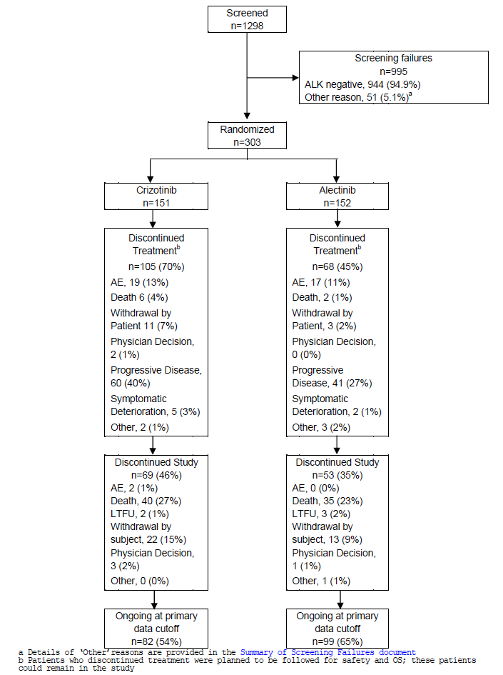

Table 13: Patient disposition - ITT population
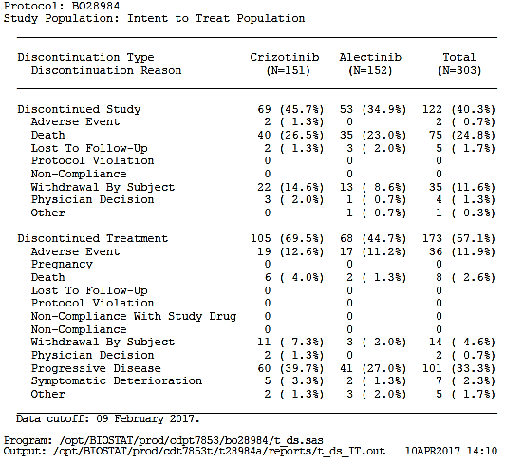

Table 14: Analysis populations
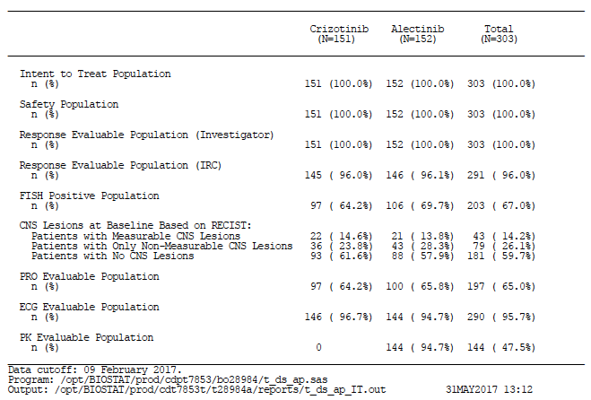
All randomised patients received at least one dose of their allocated study drug. 96% of patients deemed by investigators to have measurable disease were confirmed by independent review of the scans. The PRO evaluable population was mow at only 65% overall.
Evaluator comment: the PRO data were collected by ePRO, which has been estimated to increase responses. However, those providing at least one post baseline response are very low and this limits any conclusions that can be drawn about the effects on quality of life and any potential differences between the two treatments. The sponsor states this is due it insufficient site training in use of ePRO tool.

Major protocol violations/deviations
A total of 22% patients in the crizotinib arm, and 20% patients in the alectinib arm had a major protocol deviation. Overall, most of these would be unlikely to affect the overall study outcome but the following were of concern:
Higher dose of crizotinib administered for between visit 0 and 1
Lower dose of alectinib administered (duration not stated)
CNS disease not asymptomatic/treated/stable in patient randomised to receive crizotinib
Incorrect staging of lung cancer – patient was ineligible

Table 15: Major Protocol deviations ITT population
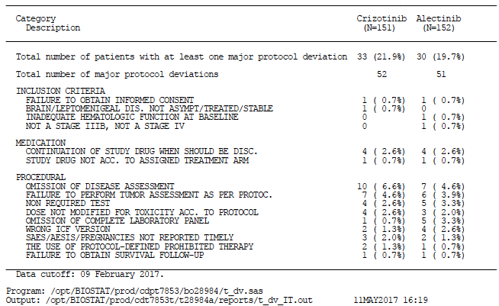

Baseline data

Baseline patient characteristics
Baseline patient characteristics were reasonably balanced except that the patients in the crizotinib arm were slightly younger (median age 54 versus 58 years, and 21.9% ≥ 65 years versus 24.3%) compared with the alectinib arm and had fewer CNS lesions at baseline compared with the alectinib arm (38.4% versus 42.1%). ECOG PS was similar between the groups, but notably despite those with PS 2 being eligible, there were only 6.6% in each arm.
97/303 patients had ECOG PS 0: 54 patients in the crizotinib arm and 43 patients in the alectinib arm had ECOG status 0 at baseline; 186 patients had ECOG status 1 at baseline: 87 patients in the crizotinib arm and 99 patients in the alectinib arm.
Evaluator comments:
- No breakdown for ECOG 0 versus 1 is provided – the sponsor is requested to provide this, together with a presentation of PFS separately for those with ECOG PS 0 and 1. (Clinical Question). Note, this information was provided in the s31 response and is included above, with PFS is considered in the Primary efficacy endpoint section.
- The arms were reasonably balanced aside from the slightly lower age in the crizotinib arm as well as the lower percentage with CNS metastases in the crizotinib arms. The importance of the latter in part depends upon the proportion who had received treatment prior to study entry, and how recently. Numerically similar but opposing imbalances between ECOG PS 0 and between ECOG PS 1 for each arm are unlikely to influence the study outcomes.
Otherwise, the demographic characteristics in both arms were generally consistent with that of an anaplastic lymphoma kinase (ALK)-positive non−small cell lung cancer (NSCLC) patient population, with a higher proportion of women (58% crizotinib; 55% alectinib) and generally no smoking history (65% crizotinib; 61% alectinib). The majority of patients had good functional status (baseline ECOG PS 0 or 1 [93% crizotinib; 93% alectinib], Stage IV disease (96% crizotinib; 97% alectinib), and adenocarcinoma histology (94% crizotinib; 90% alectinib). There were more non-Asian patients (54% crizotinib; 55% alectinib) compared with Asian patients (46% crizotinib; 45% alectinib) in both arms.

Table 16: Demographic and baseline characteristics - ITT population
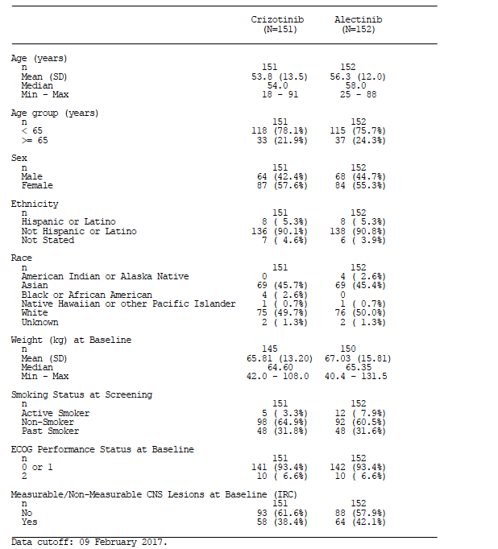

Baseline disease characteristics
At the time of study entry, the majority of patients in both arms (96% crizotinib, 97% alectinib) had Stage IV NSCLC; with the most common histological subtype in both arms was adenocarcinoma (94% crizotinib, 89.5% alectinib). Median time from initial diagnosis to study treatment was comparable between treatment arms (1.91 months crizotinib versus 1.68 months alectinib) consistent with the majority in both arms having metastatic disease at presentation. However, the mean and the range (nearly 13 years in the crizotinib arm, and 8.75 years in the alectinib arm) of time since diagnosis time since diagnosis indicates the wide variability in both arms.

Table 17: Disease history of NSCLC - ITT population
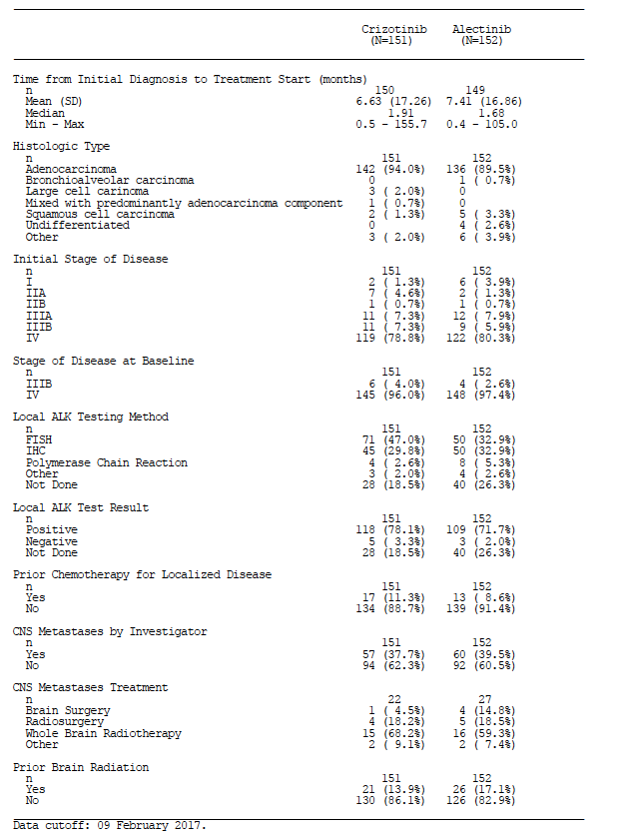
CNS metastases as assessed by the investigator were present at baseline in 38% of patients in the crizotinib arm and 40% of patients in the alectinib arm (38% and 41%, respectively by IRC). Of these, fewer in the crizotinib arm had received treatment for CNS metastases (39% versus 45% in the alectinib arm); of those that had, 68% and 59% respectively had received whole brain radiotherapy, but patients with baseline CNS metastases may have received more than one prior local treatment. Concordance was high for the presence of CNS lesions at baseline as determined by IRC according to RECIST and investigators between treatment arms.
Evaluator comments:
- There are some differences between this ALK-positive population and those in the first line studies for crizotinib (PROFILE 1014; Solomon et al, 2014) and ceritinib (ASCEND-4; Soria et al, 2017);
  - The proportion of patients with brain metastases is higher in this study (39% overall, and 42% in the alectinib arm), compared with 32% in ASCEND-4, and 27% in PROFILE 1014. Peters et al (2017) postulate this may in part be due to the systematic brain imaging at baseline.
  - The histological subtypes include a relatively higher proportion of non-adenocarcinoma subtypes particularly in the alectinib arm, such as squamous cell carcinoma and a group listed as ‘other’. In the PROFILE study, 94% had adenocarcinoma, and in ASCEND-4, 96.5% had adenocarcinoma.
- 10.5% of patients in the alectinib arm and 6% in the crizotinib arm had a histological subtype other than adenocarcinoma (ADC), the most common ALK-rearranged subtype and the focus of the pathology literature on ALK-positive NSCLC. This higher proportion of patients with a subtype other than ADC in the alectinib arm, differs from the histological subtypes in the ‘ASCEND-4’ which also used the Ventana IHC to select patients, but where only 4% in the study overall had a histological subtype other than ADC; in the PROFILE 1014 study of first line crizotinib used the Vysis FISH assay. The effect of imbalances in the histological subtype is uncertain and the sponsor is requested to:
  - State how many of the non-ADC ALK-positive tumours in each arm by the Ventana IHC were confirmed as ALK-positive by the Vysis FISH test on the planned retrospective analysis.
This information was included in the Response-7 a, s31 Response: In the ALEX study, 9 patients in the crizotinib arm and 16 in the alectinib arm had nonadenocarcinoma NSCLC, confirmed as ALK-positive by Ventana IHC central test. Of these, 5 patients in the crizotinib arm and 10 patients in the alectinib arm were also ALK-positive by Vysis FISH test. 3 patients in each arm were ALK-negative by FISH test. One patient in the crizotinib arm had unknown FISH test result and 3 in the alectinib arm did not have a FISH result.
Evaluator comment: similar proportions in both arms had positive ALK status by IHC confirmed on Vysis FISH
  - Perform a sensitivity analysis on ORR and PFS for the non-ADC subtypes as a group in each arm. (Clinical Question)
This information was included in the Response-7 a, s31 Response ‘In the subgroup analysis of ORR by investigator assessment in non-ADC patients 5 of 9 patients (56%) in the crizotinib arm and 11 of 16 (69%) in the alectinib arm achieved an objective response. 89% of patients in the crizotinib arm and 50% of patients in the alectinib arm (8 patients in each arm) had progressed or died at the time of data cutoff (investigator assessment). The HR for PFS was 0.31 (95% CI: 0.11-0.86), with median PFS of 3.6 months (95% CI: 1.7-5.4) in the crizotinib arm and 14.6 months (95% CI: 7.3- NE) in the alectinib arm. These data suggest a substantial benefit of alectinib for the patients with non-ADC disease; however, given the small numbers of patients and events in this subgroup, it has to be interpreted with caution.’
Evaluator comment: It is uncertain whether the 5/9 patients with a response in the crizotinib arm were those with the FISH-positive results identified in the response to question a above, and similarly whether the 11 responders in the alectinib group included the 10 patients with FISH-positive confirmation of ALK-status. The response rates indicate that non-ADC subtypes respond to both the ALK inhibitors, with a single CR noted in the alectinib arm. Whether FISH testing is of value in determining the likelihood of a response in these more uncommon subtypes is unclear.
- It is noted that there were four central testing laboratory sites used for the different geographic regions. A table with a column with a heading of ALK Ventana IHC and Vysis FISH results of the positive and negative for each laboratory site, together with the concordance data between the two tests by each site would assist in determining how consistently the ALK IHC reporting was across sites.

Baseline ALK status
The CSR states, ‘All patients in both arms had ALK-positive NSCLC according to central analysis by Ventana IHC according to inclusion criteria in the protocol. A comparable proportion in both arms (64% crizotinib versus 70% alectinib) had ALK-positive NSCLC according to central analysis using Vysis FISH; therefore a total of 203 patients had a positive ALK IHC and FISH result, and 39 patients had a positive ALK IHC and a negative FISH result. Concordance between ALK by IHC and ALK by FISH was 84%.’

Table 18: Central ALK test results by Vysis FISH assay and IHC - ITT population
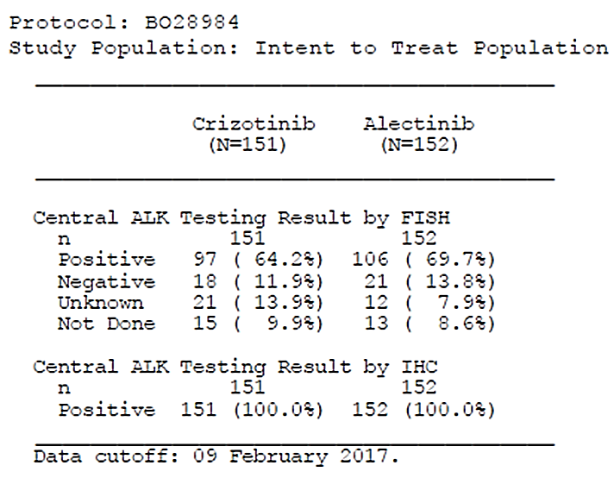

Baseline target lesions
The median number of investigator-assessed target lesions at baseline was 2.0 in both treatment groups and the median number of sites was 2.0 in both treatment arms. The most common sites of lesions were lung, pleura, or pleural effusion (82% crizotinib versus 82% alectinib) and lymph nodes (47% versus 51%). A higher proportion of patients in the crizotinib arm had liver metastases (23.2% versus 17.8%).
Evaluator comments:
- No information on the baseline disease burden including total numbers and sites of metastases could be located, other than this list of target lesions which is a subset of disease burden. The sponsor is requested to provide this. (Clinical Question)
The sponsor provided the following in Response -8 of the s31 response: The median number of all investigator-assessed lesions (including all target lesions and non-target lesions (see Table 19)) at baseline was 5.0 in both treatment arms, and the median number of sites was 3.0 in both treatment arms. The most common sites of lesions were lung, pleura, or pleural effusion (93% in the crizotinib arm versus 94% in the alectinib arm) and lymph nodes (66% versus 74% respectively).
Evaluator comment: the median number of lesions is similar between the arms, and the distribution of lesions indicates fewer in the crizotinib arm with CNS lesions but a higher proportion with liver metastases. The extent of the tumour burden within these critical sites cannot be evaluated but overall, is unlikely to influence the very substantial benefit of treatment with alectinib compared with crizotinib.

Table 19: Number and distribution of all (that is, including target) lesions at baseline (investigator-assessed) (Source s31 response, response-8)
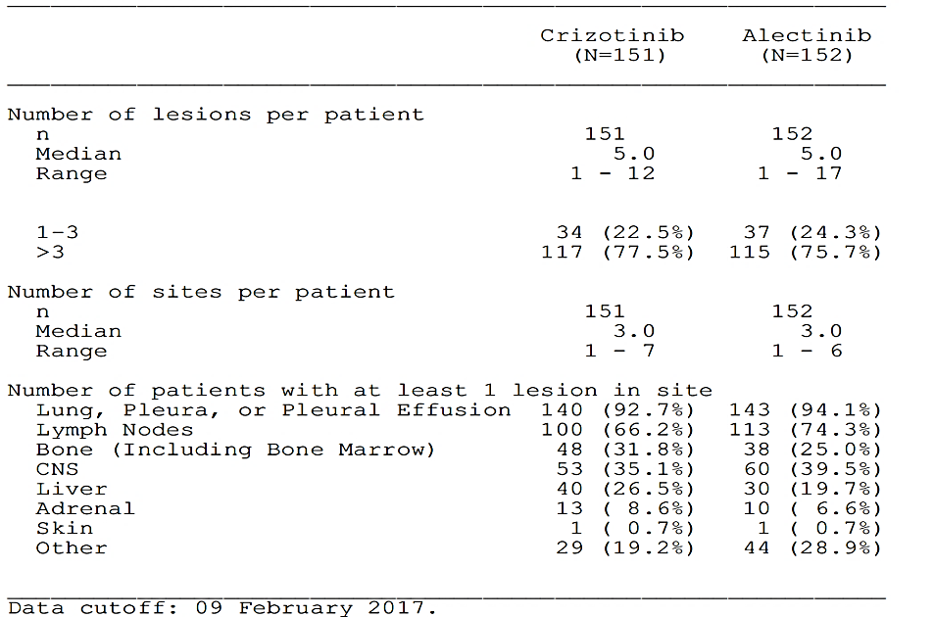
- No specific information was provided on weight loss prior to study entry, but one patient in the crizotinib arm was noted to have weight loss listed as a condition in the previous medical history although the relevance of this is not certain.
- Overall, on the information provided, the following are noted, but there do not appear to be any significant imbalances in poor prognostic factors favouring one particular arm and as such, these imbalances are unlikely to have a substantial influence the outcome of the trial: 5.4% more patients in the crizotinib arm had liver metastases, and while 3.8% fewer patients in crizotinib arm had brain metastases at baseline, among these, 6% fewer patients had received any treatment.
- As determined by the investigator, Table 20 indicates 18 patients (11.8%) in the alectinib arm and 13 patients (8.6%) in the crizotinib arm had CNS lesions appropriate to be target lesions (that is, not previously treated) as a subset of the ‘measurable CNS disease’ by the IRC. It does not appear that the IRC had information about previously treated lesions to permit a subgroup analysis by prior radiation to target lesions.

Table 20: Target lesions at baseline (Investigator) -ITT population
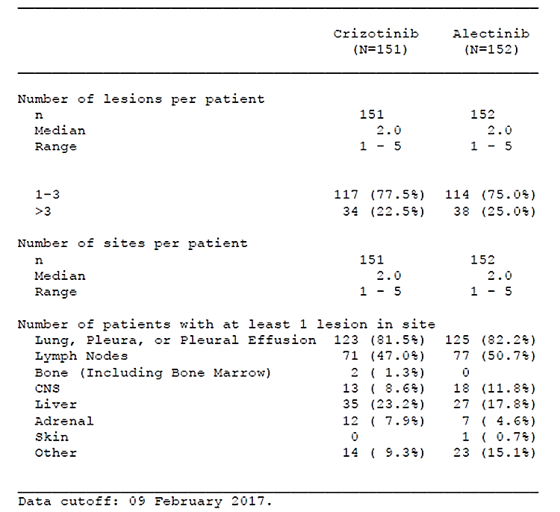

Previous medical history
A list of past medical conditions was included, but whether these are current, active problems are uncertain. Notably, 10 patients (6.6%) in the alectinib arm had been previously diagnosed with 10 neoplasms (6 malignant including prostate cancer, rectal cancer, breast cancer (2)) and 7 patients (4.6%) in the crizotinib arm had been previously diagnosed with a total of 8 neoplasms (4 of which were malignant including ovarian cancer, uterine cancer, rectal adenocarcinoma).

Concurrent medical history
89% patients in the crizotinib arm and 94% patients in the alectinib arm had at least one concurrent medical condition. The most common individual terms recorded were cough (33% crizotinib versus 38% alectinib), hypertension (24% versus 38%), dyspnoea (16% versus 24%), chest pain (11% versus13%), constipation (9% versus 12%), decreased appetite (8% versus 11%), and back pain (12% versus 9%).
Evaluator comment: With the exception of hypertension, many of these conditions are likely to be related to the lung cancer and metastases, or possibly medications to manage the symptoms. In addition, 6 patients (4%) and 5 patients (3.3%) in the alectinib arm had reported weight decreased, a poor prognostic factor in lung cancer.

Concomitant medications
A total of 89% and 86% patients received concomitant medications in the crizotinib and alectinib arms, respectively during the study (i.e., those which started after first dose of study drug).
Evaluator comment: A review of these medications indicates that most were for the management of common conditions and no antineoplastic agents were included.

Previous and Concomitant Procedures for NSCLC
11.3% and 8.6% of patients in the crizotinib arm had received prior chemotherapy in the adjuvant or neoadjuvant setting in the crizotinib and alectinib arms, respectively. No information could be located in the CSR as to what these treatments were, as the hyperlink directed to the table below only.

Table 21: Adjuvant or neoadjuvant chemotherapy by treatment arm for NSCLC - ITT population
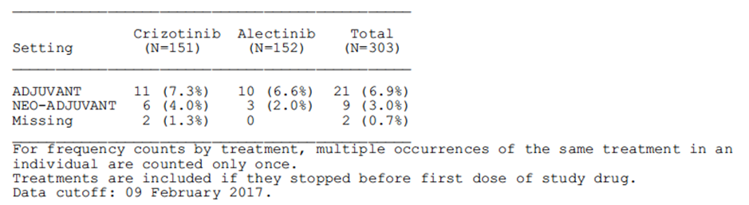
A total of 27% of patients in the crizotinib arm, and 26% of patients in the alectinib arm had received previous radiotherapy for NSCLC, most commonly in a metastatic setting (18% in both treatment arms) to the brain (14% crizotinib, 17% alectinib).
Evaluator comment: Currently the PI reports these patients to be ‘treatment-naïve’ in the Clinical Trials section of the PI, whereas they are better described as not having received systemic therapy for relapsed, unresectable (?) or metastatic disease. It is noted that neoadjuvant treatment was used in a small proportion and it is unclear if this was for disease unresectable at the time of treatment. The sponsor is requested to clarify, and based on this response, to update the PI with a more specific definition, more closely reflective of the study population (Clinical Question).

Table 22: Previous radiotherapy by treatment arm for NSCLC - ITT population
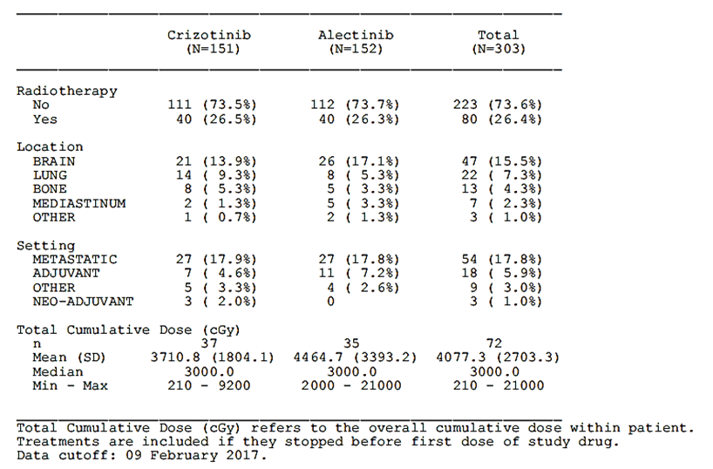
A total of 32% patients in the crizotinib arm and 36% patients in the alectinib arm had undergone previous surgery for NSCLC; the most common procedures were biopsies (15% in both treatment arms), the most common site was the lung (19% crizotinib, 25% alectinib).

Previous and concomitant procedures for CNS metastases
Of 49% patients in the crizotinib arm and 53% patients in the alectinib arm with investigator-assessed measurable or non-measurable CNS metastases at baseline, 34% patients in the crizotinib arm and 43% in the alectinib arm had received radiation therapy to the brain.

Results for the primary efficacy outcome

Summary of efficacy
The Phase III BO28984 study met its primary objective to demonstrate superiority of alectinib over standard of care (crizotinib) with respect to PFS in patients with unresectable, recurrent or metastatic ALK-positive NSCLC who have not received prior systemic therapy in the recurrent or metastatic setting. The treatment effect was consistent across the majority of prespecified subgroups. The first two key secondary endpoints (PFS by IRC and time to CNS progression) tested in the pre-specified hierarchy were statistically significant.
The overall response rate was high in both arms (75.5% in the crizotinib arm compared with 82.9% in the alectinib arm, and this difference was not statistically significant.
OS data are immature with only 40 events in the crizotinib arm and 35 in the alectinib arm.
Evaluator comment: Patients were permitted to switch to alectinib following disease progression, and this may well affect the ability to demonstrate OS superiority.

Table 23: Summary of primary and secondary endpoints - ITT population
Data cut-off 9 February 2017
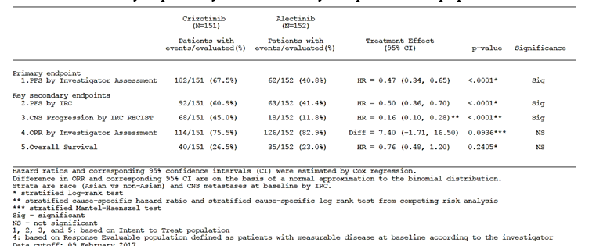

Primary endpoint
The study met its primary endpoint of demonstrating statistically significant superiority of alectinib over standard of care (crizotinib) with respect to investigator-assessed PFS in treatment-naïve patients with advanced, recurrent or metastatic, ALK-positive NSCLC (Table 24 and Figure 5).
At the time of data cutoff (09 February 2017), a greater proportion of patients in the crizotinib arm (68%) had progressed or died (investigator-assessed PFS) compared with the alectinib arm (41%). Alectinib significantly reduced the risk of disease progression or death by 53% compared to crizotinib (HR=0.47 [95% CI: 0.34–0.65], stratified log-rank p=0.0001]. The median PFS was 11.1 months (95% CI: 9.1–13.1) in the crizotinib arm, and had not been reached in the alectinib arm (95% CI: 17.7-NE).
The Kaplan-Meier plot of PFS (Figure 5) shows a separation of curves for the treatment arms starting at approximately 6 months of follow-up.
The median duration of follow-up was comparable in both arms; 17.6 months (range: 0.3 – 27.0 months) in the crizotinib arm and 18.6 months (range: 0.5 – 29.0 months) in the alectinib arm.
The 1-year event free rate was significantly higher in the alectinib arm (68%) compared with the crizotinib arm (49%; a difference of -19.8% (95% CI: -30.9 – -8.7, p = 0.0005).

Table 24: Time to event summary of investigator-assessed PFS - ITT population
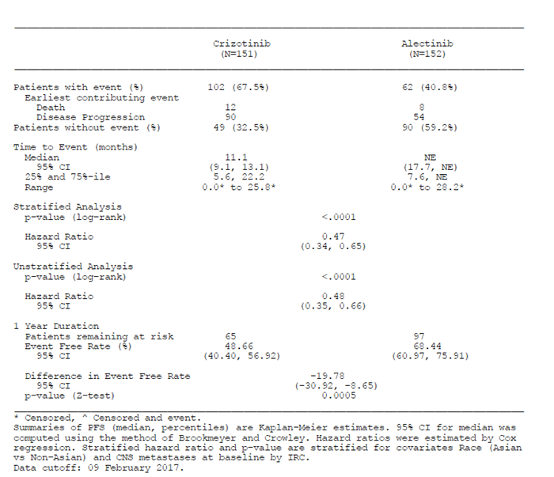
Figure 5: Kaplan-Meier plot of investigator-assessed PFS - ITT population
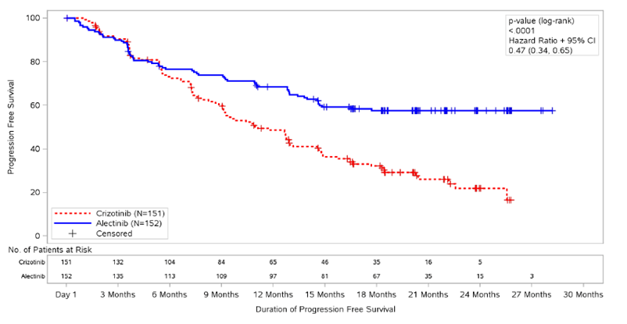

Sensitivity analyses

Subgroup analyses
For the primary endpoint of investigator-assessed PFS, the treatment effect was consistent across the majority of pre-specified subgroups. Alectinib was superior to crizotinib in terms of investigator-assessed PFS, with the upper limit of the CI for the HR less than 1 in all subgroups except active smokers, and patients with ECOG PS of 2 at baseline; however, the number of patients in these latter subgroups was small, making interpretation difficult.
Evaluator comments:
- ALK rearrangement is more common in never smokers, and it is possible these cancers are more heterogeneous, with a mixed histology and/or there are other drivers of proliferation.
- Those with ECOG PS 0 had the lowest rates of progression in the alectinib arm compared with ECOG PS1 and ECOG PS 2 (30%, 43% and 60%, respectively), and were numerically superior compared with crizotinib for ECOG PS 0 and 1, resulting in a hazard ratio that favours alectinib across all 3 levels (see Figure 6). The ECOG PS 2 patients have a poorer prognosis overall, but there were some responders among the population. It should be stated clearly in the PI how few patients with ECOG PS 2 were enrolled (PI Comments). The reasons for this are not clear, but low enrolment was seen across all the ALK inhibitor trials where such patients were eligible.
Figure 6: Forest plot of hazard ratio for PFS (investigator) by subgroup, unstratified analysis - ITT population

Sensitivity analyses

The following pre-specified sensitivity analyses were conducted with changes from the primary analyses as described in the section above on Sensitivity analysisSensitivity analyses
The main sensitivity analysis was undertaken after censoring patients at the last adequate tumour assessment prior to the start of non-protocol-specified anti-cancer therapy received prior to observing progression and censoring patients at the last tumour assessment prior to the missed assessment for which documentation of disease progression or death occurs after ≥ 2 missed tumour assessments. This supported the primary outcome and the superiority of alectinib versus crizotinib, reducing the risk of disease progression or death (investigator-assessed PFS) by 60% (HR = 0.40; 95% CI: 0.28 – 0.58, p=0.0001) (Table 25 and Figure 7).

Table 25: Time to event summary of investigator-assessed PFS - sensitivity analysis - ITT population
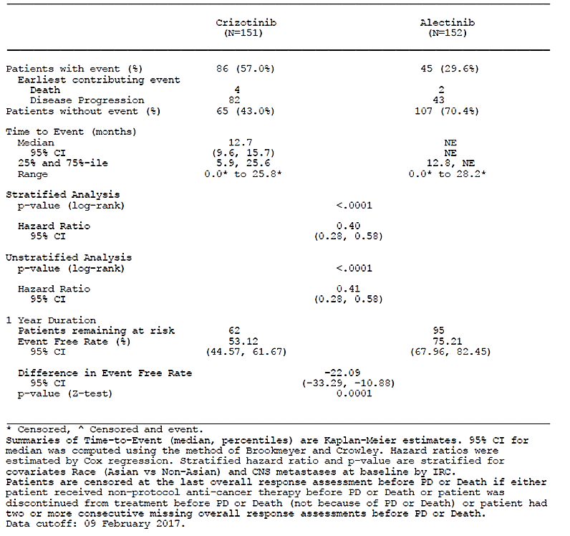
Figure 7: Kaplan Meier plot of investigator-assessed PFS sensitivity analysis - ITT population
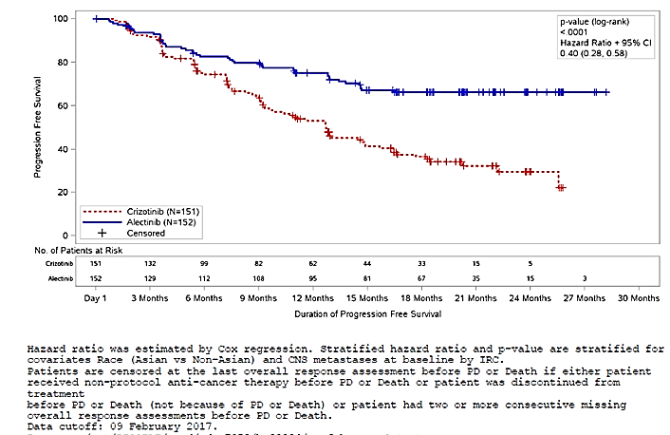
Results of the following additional sensitivity analyses of the primary endpoint, using different analysis criteria described below (see Sensitivity analyses for further detail), were also consistent with those of the primary analysis:
- Sensitivity analysis based on stratification factors at randomization in the IxRS system: HR = 0.48 (95% CI: 0.35 – 0.66); p = 0.0001;
- Sensitivity analysis to assess the effect of missing tumor assessments: HR = 0.47 (95% CI: 0.34 – 0.65); p = 0.0001;
- Sensitivity analysis to assess the effect of patients lost to follow-up: HR = 0.48 (95% CI: 0.35 – 0.66), p = 0.0001.

Results for other efficacy outcomes

Secondary endpoints

Progression-free survival – IRC-assessed
Results from the IRC-assessed PFS (secondary endpoint) were consistent with those of the investigator-assessed PFS (primary endpoint). A statistically significant improvement in IRC-assessed PFS was observed with alectinib compared to crizotinib (HR=0.50 [95% CI: 0.36 to 0.70], stratified log-rank p=0.0001). The median PFS was 10.4 months (95% CI: 7.7 to 14.6) in the crizotinib arm and 25.7 months (95% CI: 19.9 to NE) in the alectinib arm.
The 1-year event free rate was 66.5% in the alectinib arm compared with 46.1% in the crizotinib arm; a difference of -20.4% (95% CI: -31.7 to -9.1, p = 0.0004).
Sensitivity analysis of IRC-assessed PFS with IxRS stratification was consistent, with HR = 0.53 (95% CI: 0.38 to 0.73); p = 0.0001.

Table 26: Time to event summary of PFS- IRC, RECIST 1.1 - ITT population
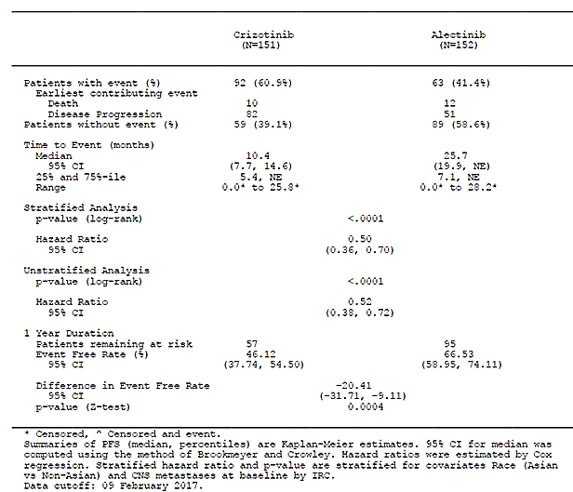
Figure 8: Kaplan-Meier plot of PFS (IRC, RECIST) - ITT population
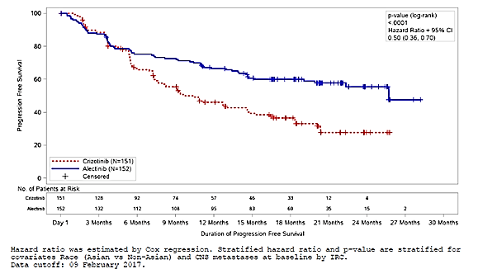

Concordance analysis between IRC and investigator
A concordance analysis between the IRC and Investigator assessments of PD status was performed on all patients enrolled in the study (Table 27). Overall, a concordance rate of 88.1% was observed in the alectinib arm and 79.7% was observed in the crizotinib arm. Where there was discordance of PD occurrence, the greatest proportion (7.7% alectinib versus 12.8% crizotinib) was PD as assessed by the investigator, versus no PD as assessed by the IRC.
Concordance of PD occurrence and timing of PD was 74.8% in the alectinib arm, and 55.4% in the crizotinib arm, with concordance within 14 days for 16.8% assessments in the alectinib arm and 23.6 % in the crizotinib arm.
Where there was a difference in timing between investigator-assessed PD and IRC-assessed PD, PD assessed by both investigator and IRC, differed in date of assessment by > 14 days occurred in 13.3% assessments in patients in the alectinib arm and 24.3% patients in the crizotinib arm.

Table 27: Concordance analysis between IRC and Investigator-determined PD status – ITT population
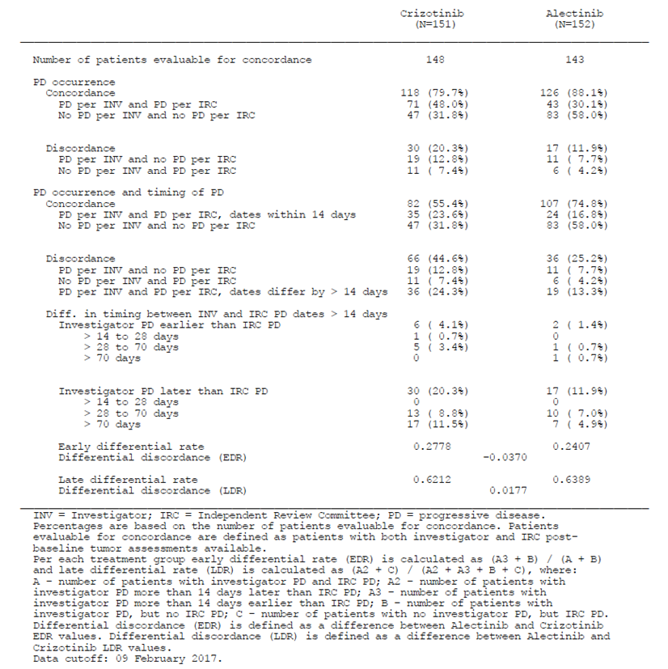
Evaluator comments:
- Concordance regarding PD was greater in the alectinib arm than the crizotinib arm for investigator and IRC declarations of PD: 88.1 versus 79.7%. The net effect on events declaration between the IRC (blinded both to the local investigator assessment and treatment allocation) and investigators is that the IRC determined progression in 10 fewer patients in the crizotinib arm and 1 more patient in the alectinib arm. In an open label study, bias cannot be ruled out but the magnitude of the treatment effect is such that these differences make little difference to the HR obtained using either dataset. The response to alectinib is significantly improved compared with crizotinib and of high clinical significance.
- Discordance over timing was much greater in the crizotinib arm compared with alectinib arm: 44.6% versus 25.2%, with the majority of these >28 days’ difference consistent with the scan intervals. Investigators appear to have generally declared a later PD in the crizotinib arm than the IRC, and the sensitivity analysis of PFS on IRC-determined PD indicates:
  - A shorter IRC-determined median PFS in the crizotinib arm (10.4 months compared with 11.1 months by the investigators)
  - A median PFS was now provided in the alectinib arm from the IRC of 25.7 months (95% CI: 19.9 months, NE) compared with ‘NE’ by investigators and the lower bound of the 95% CI being 19.9 months.
  - More mature data will provide a better understanding of the magnitude of the treatment effect, once the median PFS has been reached, but the IRC confirms a very statistically and clinically significant improvement in PFS with alectinib.

Time to CNS progression (IRC-assessed by RECIST 1.1)
All patients in the ITT Population were included in the analysis of time to CNS progression regardless of their baseline status of CNS metastases.
CNS progression occurred in 68/151 patients (45%) in the crizotinib arm compared with 18/152 patients (11.8%) in the alectinib (HR = 0.16; 95% CI: 0.10 – 0.28, p = 0.0001) (Table 28).
Evaluator comments:
- Alectinib resulted in much lower rate of CNS progression compared with crizotinib in this population where a high proportion of brain metastases at baseline. Fewer patients had been pretreated for their brain metastases at baseline in the crizotinib arm, but that does not explain the striking difference observed here.
- Use of the ITT population allows capture of patients with new development of CNS disease, a common cause of disease progression on crizotinib. For those with CNS disease at baseline, prior treatments may be relevant as well as how recently the lesions were treated. More patients in the crizotinib arm with CNS disease at baseline had no prior CNS disease treatment for that disease, in some ways a risk as one of the limitations of crizotinib is its low CNS levels and activity.
The risks of non-CNS Progression without prior CNS Progression (HR: 0.81, 47, 95% CI: 0.49-1.31), and the risk of death without Prior CNS- or Non-CNS Progression (HR: 0.68, 95% CI: 0.26-1.77) were not substantially different between treatment arms.
Evaluator comment: The similar rates of non-CNS progression (at 21.9 versus 23.7%, just marginally in favour of alectinib) indicate that both drugs have significant activity outside the CNS in patients who have not received prior systemic treatment in the advanced or metastatic setting. This suggests that one of the principal differences between these two treatments is activity in the CNS, and also highlights the proclivity for CNS relapse or progression in this disease. This is best demonstrated in Figures 9 and 10. CNS activity had previously been demonstrated with alectinib, and it should be noted that this study specifically allowed recruitment of patients with CNS disease with or without prior treatment, and had the highest proportion of patients with CNS disease to date in a Phase III trial of ALK-positive NSCLC.

Table 28: Cause-specific hazards (IRC, RECIST) - ITT population
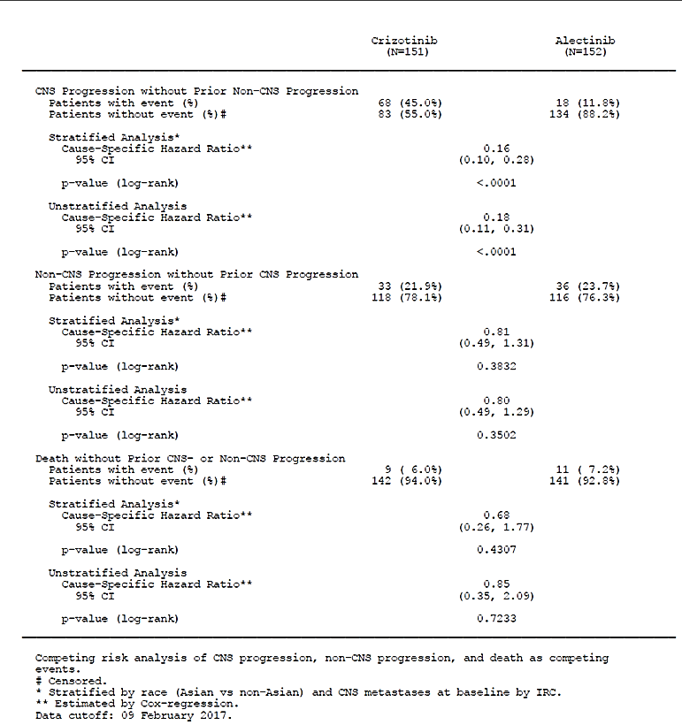
The cumulative incidence of CNS progression was consistently lower across time in the alectinib arm compared with crizotinib (Figure 9), and Gray’s test comparing the cumulative incidence of CNS progression between alectinib and crizotinib showed that time to observed CNS progression was significantly longer (p<0.0001) for patients in the alectinib treatment arm compared with crizotinib. There was no significant difference between treatment groups in terms of cumulative incidence for patients with non-CNS progression without prior CNS progression or death without prior CNS- or non-CNS progression (Table 28).
Figure 9: Cumulative incidence curves based on RECIST (IRC) – CNS progression without prior non-CNS progression – ITT population
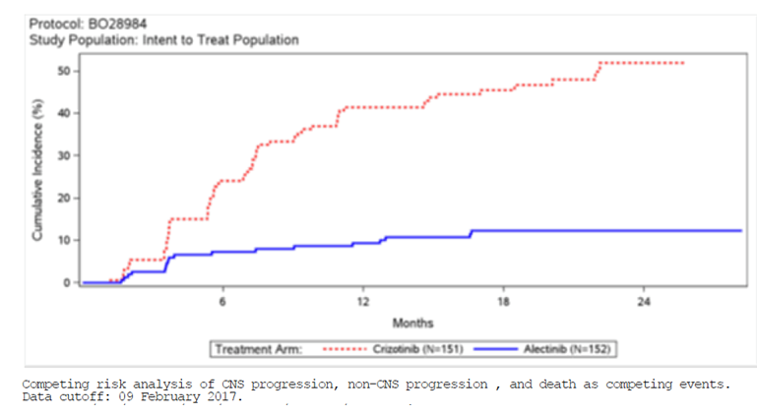
Figure 10: Cumulative incidence curves based on RECIST (IRC) – non- CNS progression without prior CNS progression – ITT population
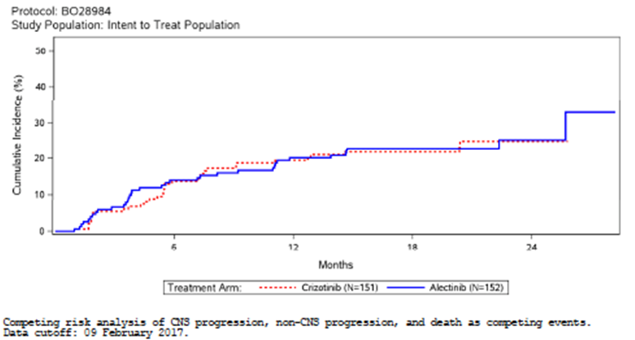
Estimated cumulative incidences of CNS progression at selected time points are presented in Table 29. The 1-year cumulative incidence of CNS progression was higher in the crizotinib arm (41.4% [95% CI: 33.2, 49.4]) compared with the alectinib arm (9.4% [95% CI: 5.4, 14.7]).

Table 29: Gray's test and cumulative incidence functions based on RECIST (IRC) - ITT population
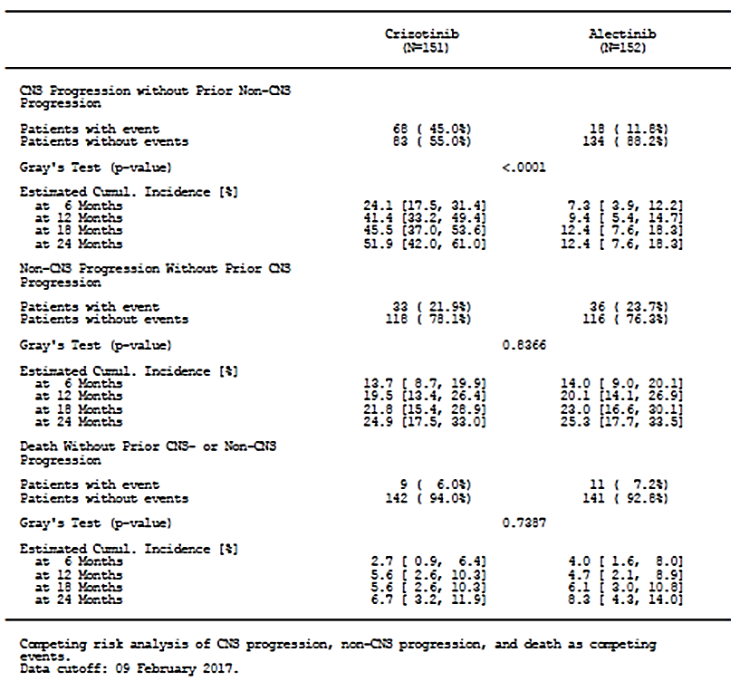

Time to CNS progression (IRC-assessed by RANO criteria)
CNS progression assessed by RANO criteria was supportive of the analysis by RECIST; alectinib significantly decreased the risk for CNS progression without prior non-CNS progression or death compared with crizotinib (HR: 0.18, 95% CI: 0.10–0.33, p=0.0001), and the risks of non CNS Progression without prior CNS Progression (HR: 0.80, 95% CI: 0.50–1.28), and the risk of death without Prior CNS- or Non-CNS Progression (HR: 0.69, 95% CI: 0.27–1.78) were not substantially different between treatment arms .
Evaluator comment: The criteria for RANO are summarised below (from Wen et al, 2010). These criteria differ from RECIST 1.1, in that a confirmatory scan at least 4 weeks later whereas RECIST does not require a follow-up scan. By these more stringent criteria, the numbers with CNS progression without prior non-CNS progression decreased by 14 patients to 54 in the crizotinib arm and by two patients to 16 in the alectinib arm, and the difference was still a statistically and clinically significant improvement in outcome with alectinib.
RANO criteria (Source Table 3, Wen et al, 2010)
As per the CSR table, the cumulative incidence of CNS progression was consistently lower across time in the alectinib arm compared with crizotinib, and Gray’s test comparing the cumulative incidence of CNS progression between alectinib and crizotinib showed that time to observed CNS progression was significantly longer (p<0.0001) for patients in the alectinib treatment arm compared with crizotinib. Cumulative incidence of Non-CNS Progression without CNS Progression and death without prior CNS or non-CNS progression were also consistent.

Table 30: Cause-specific hazards (IRC, RANO) - ITT population
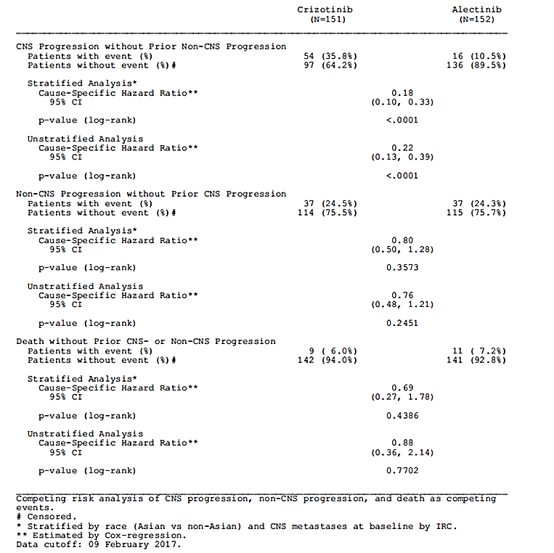

Objective response rate (investigator-assessed)
Based on the inclusion criteria of investigator-assessed measurable disease, all patients were considered evaluable, and the population used in this analysis is the ITT population. Overall, 83% patients in the alectinib arm, and 76% in the crizotinib arm achieved an objective response; a difference of 7.4% (95% CI: -1.71 to 16.50) (Table 31).

Table 31: Objective response rate (Investigator) - ITT population
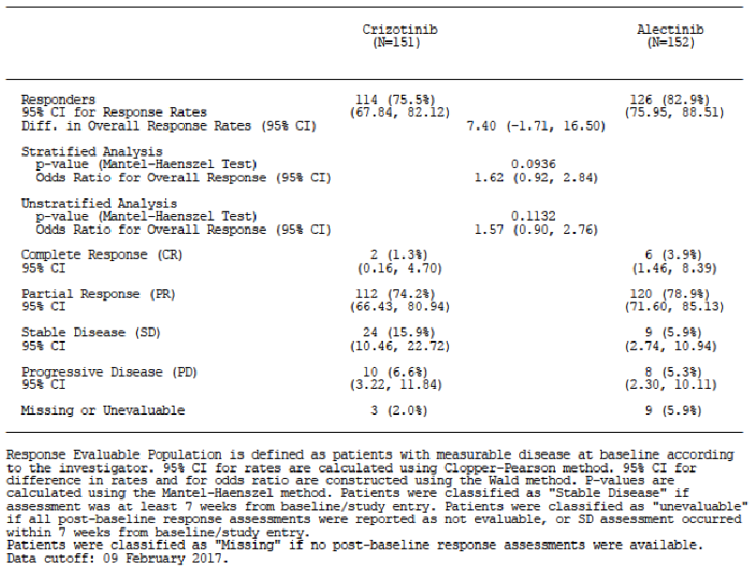
Of the patients with an objective response, 4% of patients in the alectinib arm and 1% of patients in the crizotinib arm were complete responders, and 79% patients in the alectinib arm and 74% patients in the crizotinib arm were partial responders.

Objective Response Rate (IRC-assessed)
Fewer patients were assessed by IRC to have baseline evaluable disease (145 and 146 in the crizotinib and alectinib arms, respectively) and the ORR assessed by the IRC in patients identified to have measurable disease at baseline was 81% patients in the alectinib arm and 74% in the crizotinib arm, a difference of 7.0% (95% CI: -2.6 to 16.6).
Both the absolute numbers and the proportion of patients reported to have a CR were increased but those with a PR decreased, in this analysis. Of the patients with an IRC assessed objective response, 12% in the alectinib arm, and 5% in the crizotinib arm were complete responders, and 69% in both arms were partial responders.
The ORR figure as assessed by the IRC in the ITT Population showed comparable results with those of the investigators, with an ORR of 72% in the crizotinib arm and 79% in the alectinib arm.

Table 32: Response results
Evaluator comment:
- The response rates in investigator-determined measurable disease, which is likely to be predominantly extracranial, are similar for both treatments in this first-line population and indicate the activity of both treatments.
- As per the investigators, the ORR is slightly higher in the alectinib arm, and disease control rate (CR+PR+SD) at the time of the data cut-off appears higher in the crizotinib arm, but the data may be immature and do not include all patients unless they have a scan at 7 weeks post-baseline.
- CR rates were low in both arms by investigator analysis but higher in the independent review. This reporting difference is clinically meaningful for patients.
- Broadly, all the analyses support that the response to both treatments are having a treatment effect but there is clearly superior CNS activity of alectinib, important in this population where this is a commonly involved at presentation and as a site of relapse.

Duration of response
Fewer patients who achieved an objective response (by investigator assessment) progressed or died in the alectinib arm (32%) compared with the crizotinib arm (64%). The median DOR had been reached in the crizotinib arm (11.1 months [95% CI: 7.9 to 13.0]) but was not estimable [95% CI: NE] in the alectinib arm due to the low number of contributing events of disease progression or death (Table 33 and Figure 11).
Evaluator comment: No data are presented for duration of response by IRC as this was not an endpoint, but given the reasonable consistency between the analyses so far, this is not required to demonstrate a substantially longer response time with alectinib.

Table 33: Duration of response (investigator) - ITT population
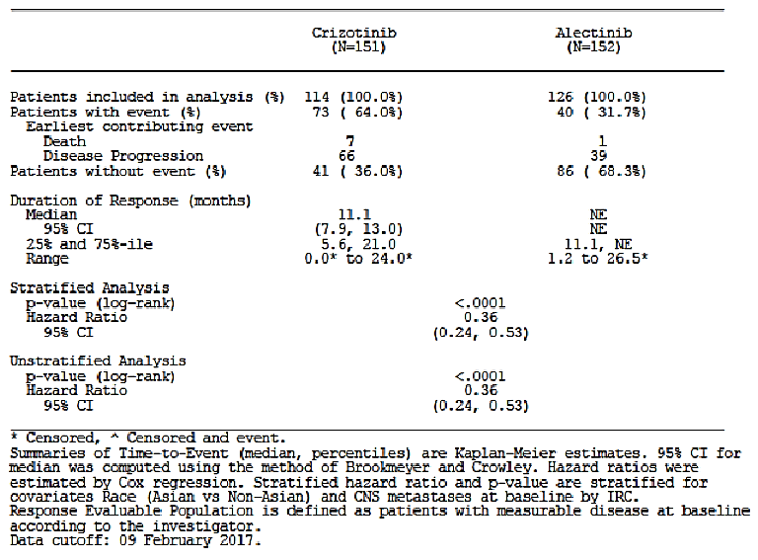
Figure 11: Kaplan-Meier plot of duration of response (Investigator) - ITT population
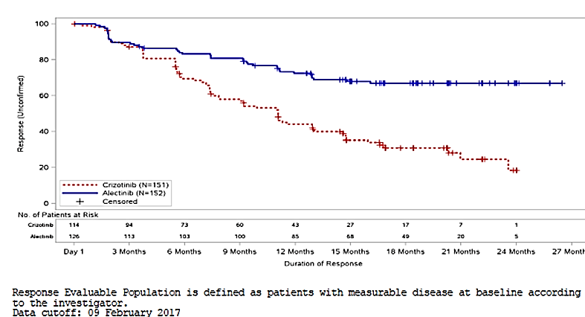

Overall survival
As the previous key secondary endpoint of investigator-assessed ORR in the pre-specified hierarchy was not statistically significant, OS was not formally tested. At the data cut-off point, 23% patients in the alectinib arm and 27% patients in the crizotinib arm had died.
Evaluator comment: These data are too immature to indicate a longer term benefit. Submission of the outcomes when these are available could be a requirement of registration, to update the PI and inform patients and clinicians. Treatment switching from crizotinib to alectinib may affect the ability to demonstrate OS. The benefit of any switching from alectinib to crizotinib is unknown and PFS2 for these patients would be informative.

CNS objective response rate (IRC-assessed)
In patients with measurable and non-measurable CNS lesions at baseline (42% of patients in the alectinib arm, 38% of patients in the crizotinib arm) (assessed by IRC according to RECIST v1.1), a greater proportion of patients in the alectinib arm achieved a CNS objective response (CNS ORR: 59.4% of patients [95% CI: 46.4% to 71.5%]) compared with the crizotinib arm (CNS ORR: 25.9% of patients [95% CI: 15.3% to 39.0%].)
More patients (45%) in the alectinib arm achieved a CNS complete response (CR) compared with crizotinib (9%).

Table 34: Objective response rate (IRC, CNS RECIST) for patients with measurable CNS and non-measurable CNS lesions at baseline - ITT population
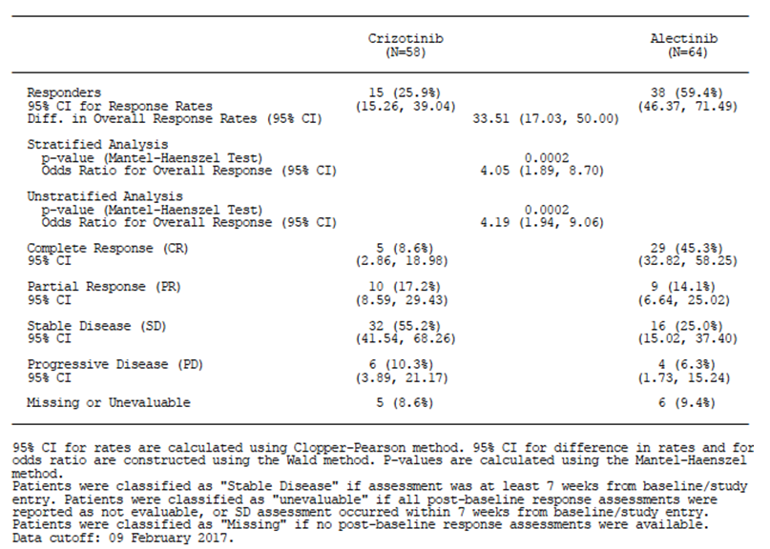
In patients with measurable CNS lesions at baseline (assessed by IRC according to RECIST v1.1), a greater proportion of patients in the alectinib arm achieved a CNS objective response (CNS ORR: 81.0% of patients [95% CI: 58.1% to 94.6%]) compared with the crizotinib arm (CNS ORR: 50.0% of patients [95% CI: 28.2% to 71.8%]).
More patients (38%) in the alectinib arm achieved a CNS CR compared with crizotinib (5%).

Table 35: ORR (IRC, CNS RECIST) for patients with measurable CNS lesions at baseline – ITT population

Subgroup analysis
A subgroup analysis of ORR (IRC-assessed by CNS RECIST) for patients with measurable CNS lesions at baseline by subgroup of prior brain radiation was performed (Table 36).
In patients with measurable CNS lesions at baseline (assessed by IRC according to RECIST v1.1) who:
- Had received prior brain radiation,
  - A greater proportion of patients in the alectinib arm achieved a CNS objective response (CNS ORR: 85.7% [95% CI: 42.13% to 99.64%]) compared with the crizotinib arm (CNS ORR: 71.4% [95% CI: 29.04% to 96.33%]);
  - 2/7 in the alectinib arm achieved a CR compared with 0/7 in the crizotinib arm;
  - However, patient numbers were small (5 patients in the crizotinib arm, 6 in the alectinib arm).
- Not received prior brain radiation,
  - A greater proportion of patients in the alectinib arm achieved a CNS objective response (CNS ORR: 78.6% [49.20% to 95.34%]) compared with the crizotinib arm (CNS ORR: 40.0% [95% CI: 16.34% to 67.71%]);
  - 6/14 in the alectinib arm achieved a CNS CR compared with 1/15 (7%) in the crizotinib arm;
  - Again, patient numbers were small (6 patients in the crizotinib arm versus 11 in the alectinib arm).

Table 36: ORR (IRC, CNS RECIST) for patients with measurable CNS lesion at baseline by subgroup of prior brain radiation – ITT population, measurable CNS lesions at baseline
Evaluator comments:
- 11/22 patients in the crizotinib arm and 17/21 patients in the alectinib arm had either a CR or PR. This equates to 6 more patients in the alectinib arm achieving an overall response.
- Accepting the small numbers in the subgroup analyses, the absolute number and the proportion of responses as well as the depth of the responses achieved, were consistently higher in the alectinib arm. This was more marked in those patients who had not received prior brain radiation and it is noted that more patients in the crizotinib arm entered the trial with untreated CNS disease at baseline.
- For those with prior brain radiation, the analysis did not take into account the recency of the radiation treatment, and it is possible a treatment difference will emerge over time, as the treatment effect of radiation is lost.
- These results indicate that alectinib provides a very acceptable first line option, potentially ahead of other modalities, for patients presenting with brain metastases at diagnosis.

CNS objective response rate according to RANO criteria
In patients with measurable CNS lesions at baseline (assessed by IRC according to RANO criteria), a greater proportion of patients in the alectinib arm achieved a CNS objective response (CNS ORR: 53.3% of patients [95% CI: 26.6% to 78.7%]) compared with the crizotinib arm (CNS ORR: 29.4% of patients [95% CI: 10.3% to 56.0%]).
More patients (33%) in the alectinib arm achieved a CNS CR compared with crizotinib (0%).
Evaluator comment: 17/22 and 15/21 patients met RANO criteria (e.g. had follow-up scans). Based on these stricter criteria, CRs were confirmed in 0/1 in the crizotinib arm and 5/8 in the alectinib arm. It is not possible to determine if that is because there was no follow up scan in the single patient in the crizotinib arm or because it was not a durable response. In either case, response rates were proportionally higher in the alectinib arm.

CNS duration of response according to RECIST v1.1 criteria
In patients with measurable and non-measurable CNS lesions at baseline (assessed by IRC according to RECIST v1.1), a greater proportion of patients in the crizotinib arm (87%) experienced an event compared with the alectinib arm (29%), (HR: 0.23, 95% CI: 0.10–0.53).
Median DOR had not yet been reached (95% CI: 17.3–NE) at time of the data cutoff in patients in the alectinib arm. Median DOR was 3.7 months (95% CI: 3.2 – 6.8) in the crizotinib arm (Table 37).
Evaluator comment: alectinib leads to a higher rate and durability of CNS responses, which is a very meaningful clinical benefit. Rates of progression and new onset of CNS disease are higher in the crizotinib and treatment responses shorter.
In patients with measurable CNS lesions at baseline (assessed by IRC according to RECIST v1.1), a greater proportion of patients in the crizotinib arm (82%) experienced an event compared with the alectinib arm (35%), (HR: 0.42, 95% CI: 0.15–1.24).
Median DOR was 17.3 months (95% CI: 14.8 – NE) at time of the data cutoff in patients in the alectinib arm compared with 5.5 months (95% CI: 2.1 – 17.3) in the crizotinib arm (HR: 0.42 [95% CI: 0.15–1.24])

Table 37: CNS duration of response (IRC, CNS RECIST) for patients with measurable and non-measurable CNS lesions at baseline - ITT population

Subgroup analyses
These are discussed in the relevant section for each endpoint.
Exploratory outcomes
Exploratory Analysis of Progression-Free Survival in FISH-Positive Patients
The CSR states, ‘As baseline demographics and disease characteristics were well balanced between treatment arms, no adjustment for the PFS analysis was made for the FISH Positive Population.’
Evaluator comment: Given FISH testing was performed on only 97/151 and 106/152 patients in the crizotinib and alectinib arms, respectively, randomisation has been broken and balance between the stratification factors, individual and disease characteristics is not assured. The sponsor is requested to present these for the FISH-tested subset of the ITT population. (Clinical Question) The s31 response is provided below.
An analysis of the ITT population who were positive by Vysis FISH did not reveal any imbalances in the stratification factors (Table 38). Table 38 in response 3 of the s31 response did not indicate any significant imbalances between the arms in this FISH-positive group within the ITT. The evaluator is in agreement that no adjustment for potential confounding factors for the PFS analysis is required.

Table 38: Patients in each arm with Vysis FISH positive tumours
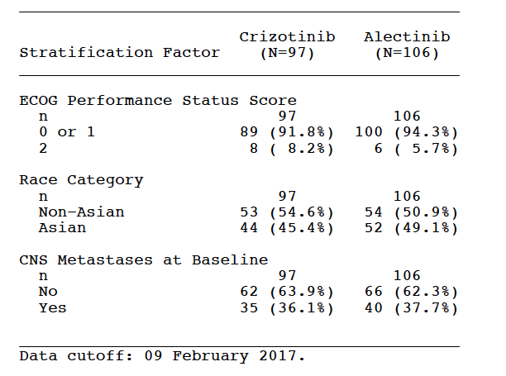
Based on the investigator-assessed results as presented, alectinib reduced the risk of disease progression or death by 60% compared with crizotinib (HR=0.40 [95% CI: 0.27, 0.61]; p = 0.0001). Median time to PFS was shorter in patients in the crizotinib arm (12.7 months) compared with patients in the alectinib arm (median not reached).
The 1-year event free rate was 75.1% in the alectinib arm compared with 52.1% in the crizotinib arm; a difference of -23.0% (95% CI: -36.2 to -9.8, p = 0.0006).

Table 39: Time to event summary of PFS (Investigator) for patients with positive Vysis FISH assessment (ITT population
Figure 12: Kaplan-Meier plot of PFS (Investigator) for subjects with positive Vysis FISH assessment - ITT population
Evaluator comment: The sponsor has presented a PFS analysis for the patient population in each arm who were deemed positive by both IHC and FISH and was requested to present the PFS and ORR for those 39 patients in each arm whose samples were positive by IHC and negative by FISH to determine if those negative by FISH responded to treatment with either ALK inhibitor.

Vysis-negative FISH - s31 response (response 4 and response 2)
The baseline characteristics in the Ventana ALK IHC positive / Vysis ALK FISH negative patient subgroup were generally well balanced between the treatment arms with the exception of smoking status: more active and past smokers were included in the alectinib arm (non-smokers: crizotinib, n=12 [66.7%]; alectinib, n=7 [33.3%]) active smokers: crizotinib, n=1 [5.6%]; alectinib, n=5 [23.8%]) past smokers: crizotinib, n=5 [27.8%]; alectinib, n=9 [42.9%]).
Exploratory efficacy in terms of PFS by investigator for the Ventana ALK IHC positive / Vysis ALK FISH negative patients (18 patients in the crizotinib arm and 21 patients in the alectinib arm) showed a HR in favour of the crizotinib arm, however the results are based on few patients and PFS events, which is reflected in the very wide confidence interval for the HR. The observed HR was 1.24 (CI 95% 0.56, 2.75) and the median time to event was 7.4 (2.7, NE) months for crizotinib and 3.8 (1.9, NE) months for alectinib. The response rates were lower than in the ITT population (ORR ITT by investigator: 76% crizotinib arm, 83% alectinib arm; see section 5.3.3 in ALEX CSR) with 44.4% versus 28.6% for crizotinib and alectinib, respectively with no complete responders (CR) and 8 partial responders (PR) for crizotinib and 1 CR and 5 PR for alectinib.
Table 40 indicates the best overall response rates among the 39 patients (Crizotinib, 18; alectinib, 21) whose tumours were negative by FISH but positive by IHC. The median PFS was longer in the crizotinib arm compared with the alectinib arm, but the critical information is the response rate, which indicated a clinically meaningful ORR of 36% in these 39 patients (1 CR, 13 PRs) with the CR in the alectinib arm. No meaningful comments can be made about the relative progression-free survival between the arms, as this was not a prespecified subgroup. The intent of the evaluator’s question was to determine whether there were still clinically significant responses in those determined to be negative by Vysis FISH. (See Section below)

Table 40: Best overall response rates (Investigator-assessed) in patients with tumours that were ALK IHC positive/FISH-negative
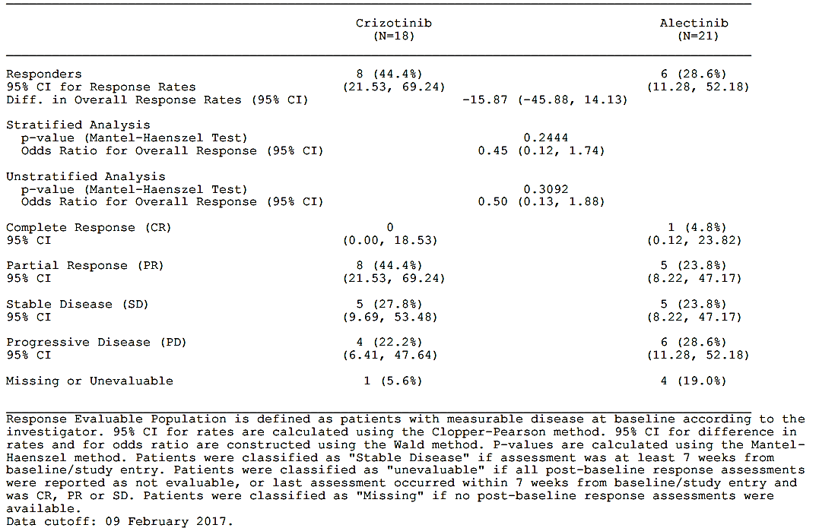

Ventana ALK (D5F3) IHC assay versus Vysis FISH assay
Evaluator comment: The response rate amongst those negative for the Vysis FISH test indicate that this has a higher false negative rate than the ALK IHC test. The sponsor was requested to state whether the Ventana IHC assay has been registered as a Class 3 IVD in Australia and is currently marketed, and whether it has been evaluated by the TGA. The sponsor is requested to discuss the use of sequential testing by ALK IHC and FISH, taking into account the results in this trial. (Clinical Question)

S31 response-4, response-2 and response-15
‘The Ventana ALK immunohistochemical (IHC) assay (D5F3) is registered in Australia as an Included Medical Device – IVD Class 2 (ARTG 248292). The Class 2 designation is determined by the Intended Purpose which is to aid in the assessment of NSCLC patients who might benefit from treatment with an ALK inhibitor. It is not currently approved as a companion diagnostic to determine eligibility for treatment, which would require Class 3 inclusion.
Currently in Australia, the fluorescence in situ hybridisation (FISH) test is used to determine eligibility for treatment with an ALK inhibitor, since this is mandated by the Pharmaceutical Benefits Scheme (PBS) Authority criteria for Xalkori® (crizotinib) and Zykadia® (ceritinib). The Ventana IHC assay is used as a screening test, as documented evidence of ALK immunoreactivity by IHC examination is a requirement to access the FISH test on the Medicare Benefits Scheme (MBS).
The established ALK inhibitor testing algorithm described above is also acceptable for Alecensa (alectinib) and therefore no changes are proposed as a result of the current application.
To be eligible for the ALEX study, prospective determination of ALK positivity was performed centrally using the Ventana ALK IHC (D5F3) assay. The Abbott Vysis FISH test was used as an exploratory assay, after patients were enrolled in the study. Ventana ALK IHC was considered to be faster, easier to perform and easier to read compared to FISH-based identification of ALK rearrangement and requires less equipment compared with the FISH. In addition, IHC has high concordance with FISH and a lower false-negative rate (Kim et al. 2011).
Following the FDA approval in June 2015 of the Ventana ALK IHC assay as a companion diagnostic for crizotinib, the fully powered analyses of the FISH-positive population (FPP) in the ALEX study became redundant and were removed from the study protocol (Amendment 3). Instead, a supportive analysis of the ALK FISH positive secondary population study data based on the Vysis FISH assay was performed.
In the ALEX study, the Ventana ALK IHC has proven to be a robust and reliable patient selection assay. This assay is approved by the FDA for use as a companion diagnostic for crizotinib and ceritinib and is currently under evaluation by the FDA as a companion diagnostic for alectinib (in association with the 1L application for the product).’
‘In anticipation of the TGA approval for Alecensa in 1L, applications to amend the MBS listing for the FISH test (to include reference to alectinib) and to have Alecensa® listed on the PBS have been recommended for approval by the Medical Services Advisory Committee (MSAC) and the Pharmaceutical Benefits Advisory Committee (PBAC), respectively. As for Xalkori and Zykadia, the PBS population criteria for Alecensa will include:
‘Patient must have evidence of an anaplastic lymphoma kinase (ALK) gene rearrangement in tumour material, defined as 15% (or greater) positive cells by fluorescence in situ hybridisation (FISH) testing.’
Evaluator comments:
- The ALK IHC is being used to screen prior to undertaking a FISH test, which is part of the selection process for patients for treatment, which is then finalized by ALK FISH under the current process; as such, the evaluator considers this to be a Class 3 IVD as patients with a negative IHC do not then proceed to a FISH and are deemed ‘ALK-negative’.
- Note is made that this has been deemed a companion diagnostic by the FDA for other ALK inhibitors based on its consideration to be essential to the use of the associated medicine. The FDA approval of alectinib on 6 November 2017 indicates that an FDA-approved test is required but as yet, this has not been uploaded to the companion diagnostic website (accessed 8 Nov 2017) – it is noted that the ‘VENTANA ALK (D5F3) CDx assay’ is referred to in the trials section of the US label. The results presented in this study are supportive of the clinical validity of this IHC assay, and also raise concerns about the higher false negative rate seen with Vysis FISH.
- Defining and restricting ALK-positive status to those who have tumours that are Vysis FISH-positive/IHC-positive that is, excluding those with a negative FISH test result, would have excluded from treatment in this trial, a population where the investigator-assessed ORR was 36% overall (1 CR and 13 PRs) and a further 10 patients who had investigator-assessed stable disease.
- The clinical implications of deeming patients to be ALK-positive only if positive on a FISH test are potentially broad – from missing treatment with this ALK inhibitor, as well as the increasing number of lines of ALK-inhibitor targeted therapies available to patients with ALK-positive NSCLC (including crizotinib and ceritinib, although formal data on the false negative and false positive rates with Vysis FISH and Ventana IHC have not been evaluated by this evaluator), as well as compromising clinical trial opportunities for agents that target ALK, and those in patients who have disease progression following prior ALK therapy (currently an area of active investigation, with some trials requiring no prior chemotherapy for advanced disease https://www.clinicaltrials.gov/ct2/show/record/NCT03242915?cond=ALK+Gene+Mutation&draw=2&rank=14 accessed Nov 9, 2017).
- The assay used for patient selection for this study is named in the Clinical Trials section of the PI and makes the process of selection of patients for this trial clear, and it would not be unreasonable to include the response rates among those with Vysis FISH negative test results. It is noted that funded access may be restricted to patients positive on both tests, but this is important clinical information for patients and prescribers.

Patient reported outcomes
The CSR states,
‘Compliance rate reflects the number of patients who completed the questionnaires by the number of subjects who were known to be alive, without progressive disease (as per investigator) and still in the study at a given time point.
Baseline compliance for both treatment arms was moderate in the ITT Population with 100 (65.8%) alectinib-treated patients and 97 (64.2%) crizotinib-treated patients completing their baseline assessment. This was due to suboptimal initial site training to introduce electronic device to the patients.
Among patients who had PRO baseline data, moderate-to-high compliance rates (60% or greater) throughout the study with the exception of Week 112 and 116 were observed in the alectinib-treated arm. Compliance rates in the crizotinib arm were lower than alectinib compliance dropping to ≤60% from Week 68 onwards (with the exception of Week 120–128 assessments where one patient remained on treatment). The last PRO assessment completed where there was ≥ 20% of the PRO-evaluable Population remaining in each arm, was Week 84 in the crizotinib arm and Week 96 of the alectinib arm, reflecting the longer duration of PFS in the alectinib arm.
Reasons for non-compliance were not captured.’
Evaluator comment:
- No link to any data on compliance was included to provide absolute numbers of questionnaire responses in either arm. However, it appears from the statement above, that the study sites were not adequately trained, and a large proportion of critical baseline assessment data are missing, thereby very unfortunately, compromising the utility of any subsequently collected data.
- For many of the symptom scores reported, event rates in each arm were low, and with the missing baseline data, cannot be interpreted. Therefore, these results are not discussed further in this report.
- No information is included in the draft PI and this is appropriate.

Other efficacy studies
Not applicable.

Analyses performed across trials: pooled and meta analyses
Not applicable.

Evaluator’s conclusions on clinical efficacy
In this open-label, randomised Phase III trial, alectinib demonstrated clear superiority in the primary efficacy endpoint of investigator-assessed progression-free survival over crizotinib in a population with NSCLC selected for ALK-positivity by the Ventana anti-ALK D5F3 IHC assay. Patients with measurable disease who had not received prior systemic therapy in the advanced/metastatic setting, but may have received chemotherapy in the adjuvant or neoadjuvant setting, prior radiation treatment or surgery for localised or for metastatic disease, were randomised to receive either alectinib or crizotinib, stratified by race (Asian versus non-Asian), ECOG PS 0/1 versus 2 and presence (yes/no) of CNS metastases. Patients with ECOG performance status 0-2 were eligible, but so few patients with ECOG PS 2 enrolled that efficacy and safety data are limited. Patients with asymptomatic CNS disease were eligible and could have been treated surgically or with radiation treatment or had no prior therapy.
Baseline demographic and disease characteristics were reasonably balanced between the arms, and reflect the population likely to present in Australia with ALK-positive lung cancer. Apart from the rates of CNS involvement and the lower proportion of adenocarcinoma subtype in the alectinib arm, the population was not dissimilar to those recruited in other ALK inhibitor first-line Phase III trials. Median progression-free survival was yet to be reached by investigator (primary endpoint) in the alectinib arm, and was 11.1 months (95% CI 9.1, 13.1) in the crizotinib arm. The hazard ratio for the risk of progression or death was 0.47 (95% CI 0.34, 0.65; p<0.0001) in favour of alectinib.. The results for crizotinib arm were comparable with the 10.9 months reported in the Phase III PROFILE 1014 study comparing crizotinib with chemotherapy for first line systemic therapy of advanced disease (Solomon et al, 2014). Subgroup analyses confirmed superiority in all but those who were active smokers, and crossed 1 for those of ECOG PS 2. Sensitivity analyses, including an independent review of PFS, were all supportive the primary efficacy endpoint findings. Observed responses were more durable in the alectinib arm than the crizotinib arm.
The benefit of improvement in PFS was most evident in those with CNS progression without prior non-CNS progression, and both agents at this time appear active to a similar extent against non-CNS systemic in the absence of CNS progression. Cumulative time to CNS progression was significantly longer in the alectinib arm compared with patients receiving crizotinib but was similar for non-CNS progression. Treatment with alectinib resulted in higher CNS response rates and longer time to CNS progression (based on IRC, RECIST assessments or RANO assessments) of patients with both measurable and non-measurable disease. Although numbers were small, a higher response rate was consistently reported with alectinib, in those who had received prior radiation or had no prior brain radiotherapy, compared with crizotinib.
Objective response rates by investigator assessments were not statistically significant between the two treatments, although numerically more patients achieved a complete response in the alectinib arm. IRC assessments of response rates, including reported CR, were higher in the alectinib arm than the investigator arm. The median duration of response has yet to be reached in the alectinib arm, and was 11.1 months (95% CI: 7.9, 13.0) in the crizotinib arm.
Overall survival data are immature and the effect of treatment switching to alectinib from the crizotinib arm, and of subsequent therapies in both arms known to affect survival, may make results difficult to interpret. It is recommended that these results be submitted to the TGA when available.

Selection of patients for treatment
PFS based on a retrospective assessment of, and limited to those who tested positive for ALK status by Vysis FISH was supportive of a superior treatment effect with alectinib. Notably, results were not available or were negative for 100/303 study participants (61 patients no result possible, 39 patients tested negative), therefore only 66% of patients tested positive for both Ventana IHC/Vysis FISH. The sponsor provided additional data which indicate, that of the 39 tumours that were negative for FISH and positive by IHC treated with either alectinib or crizotinib, a 36% ORR was observed, including a complete response in one patient receiving alectinib, and partial responses and stable disease reported by investigators in a further thirteen and ten patients, respectively with either drug. No Vysis FISH results were presented for 61 samples (20.1% of all samples) due to a combination of limitations with the sample (n=28, 9.2%) or uninterpretable results (n=33, 10.9%). The evaluator did not request a breakdown of the treatment outcomes in this last group, but issues with interpretation of the results and availability of an adequate sample, and signal limitations will require this additional test.
It is noted that the FDA has approved the Ventana ALK D5F3 assay as a companion diagnostic for ceritinib and crizotinib and while not currently seen on the FDA Companion Diagnostics list on their website, the updated US label for alectinib includes this assay in the Clinical Trials section following the very recent first line approval. The data from this trial suggest a high and clinically relevant false negative rate with the Vysis FISH test (where it was possible to obtain a result), with 12.8% discordance with the ALK IHC results for the overall study population, and 62% of these patients achieving the clinically relevant outcome a complete or partial remission or stable disease. These patients would not have been deemed eligible based on Vysis FISH for this treatment or for the growing list of effective ALK inhibitors; furthermore, these patients would not be eligible for clinical trials evaluating optimal sequencing or new agents if they have not received prior treatment with ALK inhibitors if eligibility in Australia remains driven by FISH results. The evaluator has recommended inclusion of the efficacy outcomes for those who are ALK IHC-positive/ Vysis FISH-negative to inform patients and prescribers. For the following reasons, re-evaluation of the data supporting the need for Vysis FISH confirmation is required: the clinical utility of the VENTANA ALK (D5F3) IHC assay and the significant false positive rate with the Vysis FISH demonstrated in this trial, the use of the IHC to select patients not only in this trial, but also in the first line ceritinib study published this year (Soria et al, 2017), which resulted in the recent FDA approvals of the Ventana ALK (D5F3) IHC assay as a companion diagnostic for all three ALK inhibitors currently approved in Australia.
The evaluator does not accept the sponsor’s rationale for, and self-classification of the Ventana ALK (D5F3) IHC assay as a Class 2 in vitro device IVD and considers it to be a Class 3 IVD given its role in the selection of patients for this a cancer therapy in this trial, and the use of IHC as pre-screening prior to FISH testing in Australia. It is recommended that an application be required for inclusion as a Class 3 IVD.

Conclusion
Overall, these data support a highly statistically significant and clinically important improvement in efficacy outcomes for patients with metastatic ALK-positive NSCLC when treated with alectinib compared with the current standard of care, crizotinib.

Clinical safety

Studies providing evaluable safety data

Safety data are from the pivotal randomised Phase III ALEX study described in detail in the section above; see Efficacy, Study design, objectives, locations and dates. Study design, objectives, locations and dates

Patient exposure
All patients in the ITT Population received at least one dose of study drug and were included in the Safety Population.
The median duration of treatment was notably shorter in patients in the crizotinib arm (10.7 months; range: 0 – 27 months) compared with the alectinib arm (17.9 months; range: 0 – 29 months); this was mainly driven by fewer treatment discontinuations due to disease progression in the alectinib arm (Table 41).
A lower proportion of patients in the crizotinib arm completed > 12 months and > 18 months of study treatment (45% and 27%, respectively) compared with the alectinib arm (66% and 49% patients, respectively).
The mean dose intensity was comparable between treatment arms (92% for crizotinib and 96% for alectinib); however, the proportion of patients in the crizotinib arm (42%) who missed at least one dose of treatment was higher than in the alectinib arm (32%).

Table 41: Study treatment exposure - Safety population

Adverse events
In addition to the standard presentation of adverse events by treatment, the following selected adverse events are identified in Protocol Version 4 as follows:
- Hepatotoxicity
- Interstitial lung disease
- Vision disorders
- Skin disorders (for example, photosensitivity, rash)
- Anaemia
- Gastrointestinal disorders (for example, nausea, vomiting, diarrhoea)
- Abnormal renal function (for example, serum creatinine increase, renal impairment, renal failure)
- Severe myalgia and CPK elevations
- Oedema
- Bradycardia

Table 42: Overview of adverse events - Safety population

All adverse events (irrespective of relationship to study treatment)
Most patients experienced a least one AE: 97% in the crizotinib arm and 97% in the alectinib arm.
Overall, the most common SOCs (≥ 30% of patients in either arm) in which AEs were reported were (crizotinib versus alectinib), with the summary of events by PT occurring in ≥ 10% in either arm in:
- Gastrointestinal Disorders (80% versus 55%); the most common individual PTs were constipation, nausea, diarrhoea, and vomiting.
- General Disorders and Administration Site Conditions (57% versus 51%); the most common individual PTs were peripheral edema, and fatigue.
- Investigations (46% versus 46%); the most common individual PTs were increased ALT, increased AST, and increased blood bilirubin.
- Nervous System Disorders (45% versus 26%); the most common individual PTs were dizziness, and dysgeusia.
- Infections and Infestations (30% versus 40%); no individual PT occurred in ≥ 10% patients in either treatment arm.
- Musculoskeletal and Connective Tissue Disorders (28% versus 36%); the most common individual PTs were arthralgia, and myalgia.
- Respiratory, Thoracic and Mediastinal Disorders (30% versus 32%); no individual PT occurred in ≥ 10% patients in either treatment arm.
- Eye disorders (33% versus 8%); most commonly visual impairment and vision blurred.
A summary of events by PT occurring in ≥ 10% of patients in either arm is presented in Table 43.
The most common individual AE PTs experienced by ≥ 10% of patients in the alectinib arm were constipation (34% patients), anaemia (20%), fatigue (19%), oedema peripheral (17%), myalgia (16%), ALT increased (15%), blood bilirubin increased (15%), nausea (14%), AST increased (14%), diarrhoea (12%), arthralgia (11%), and rash (11%).
The most common individual AE PTs experienced by ≥ 10% patients in the crizotinib arm were nausea (48%), diarrhoea (45%), vomiting (38%), constipation (33%), ALT increased (30%), oedema peripheral (28%), AST increased (25%), dysgeusia (19%), fatigue (17%), dizziness (14%), and visual impairment (12%).
Evaluator comment: Gastrointestinal AEs, increases in liver enzymes and bilirubin, peripheral oedema and visual problems were much higher with crizotinib, while rates of constipation, anaemia, and myalgia and arthralgia were more prominent with alectinib.

Table 43: Adverse events by PT with an incidence rate of ≥ 10% in either arm - Safety population
A summary of adverse events with a difference of at least ≥ 5% between the treatment arms is presented in Table 44.

Table 44: Adverse events with a difference ≥ 5% incidence between the treatment arms - Safety population
AEs occurred in a higher proportion of patients (≥ 5% absolute difference) in the crizotinib arm than in the alectinib arm, included:
- Nausea (48% versus 14%)
- Diarrhoea (45% versus 12%)
- Vomiting (38% versus 7%)
- ALT increased (30% versus 15%)
- AST increased (25% versus 14%)
- Gamma glutamyltransferase increased (7% versus1%)
- Oedema peripheral (28% versus 17%),
- Dizziness (14% versus 8%)
- Dysgeusia (19% versus 3%)
- Visual impairment (12% versus 1%), vision blurred (7% versus 2%),
- Photopsia (6% versus 0%)
- Alopecia (7% versus 1%).
AEs which occurred at a higher incidence (≥ 5% of patients) in the alectinib arm were:
- Increased blood bilirubin (15% versus 1%),
- Increased weight (10% versus 0%)
- Myalgia (16% versus 2%)
- Musculoskeletal pain (7% versus 2%)
- Anaemia (20% versus 5%)
- Photosensitivity reaction (5% versus 0%).
Constipation, fatigue, arthralgia, and rash were reported with a similar rate between treatment arms.
Increased blood bilirubin, myalgia, musculoskeletal pain, anaemia, and photosensitivity reaction are known adverse drug reactions (ADR) for alectinib and a new ADR of weight gain was identified.

Weight gain (also included by the sponsor in the Summary of Clinical Safety as a selected adverse event, but presented and discussed here)
Weight gain has been recorded as a new ADR for alectinib, given
  - It occurred only in patients treated with alectinib
  - The majority of AEs (9/15) were reported as related by the investigator
  - The majority of patients (9/15) experienced a weight gain of ≥ 10% from baseline.
Increased weight gain was not reported in patients receiving crizotinib and in 10% of patients receiving alectinib, including one patient with a Grade ≥ 3 AE (noting Grade 3 is the maximum level of AE as defined in CTCAE v 4.0 and equates to ≥ 20% increase from baseline), and events were considered treatment-related in 6% of patients. The median time to onset and reporting of the AE was 136 days (range 16-500 days), but 7/15 had an AE of weight increase reported within 2 months of starting treatment (Source of data, Appendix 10 SCS). Five patients appear to continue on treatment (with ongoing events of response or stable disease) and have an end date for their adverse events included in the data. The sponsor should include a discussion of the management of the weight gain that resulted in an end to the AE.
The sponsor indicates that a detailed assessment showed no evidence of an association between weight increased and oedema. Appendix 10 of the SCS provided the treatment responses of the 15 patients: 1 patient had a CR, 13 patients had and one had SD, as assessed by investigators.
Evaluator comments: A summary of the sponsor’s responses from the s31 response (response-12 are included between following each question)
- It is quite possible that with increased awareness of this event among clinicians and routine weighing of patients, that reporting and attribution rates would have been higher. The number of patients gaining weight overall as a clinical measurement, together with adverse event reporting would capture the extent of this, but has not been presented.
- Cachexia and weight loss are common in patients with advanced NSCLC. Unlike the crizotinib arm, weight loss was not a prominent baseline comorbid condition for patients in the alectinib arm, and therefore it seems less likely to be related to efficacy and reversal of an advanced disease-related cachectic state. Hypothalamic/central causes are possible and the sponsor is requested to state if this was unwanted weight gain, and to provide the following information:
  - What were the genders of the patients involved?
Sponsor’s response: In the alectinib treatment arm of the ALEX study, the AE of weight increased is equally distributed amongst gender, with 7 AEs reported in males (out of 68 male patients overall) and 8 AEs reported in females (out of 84 female patients overall).
  - Comment on the nature of the weight gain, such as whether it associated with an altered fat distribution in these 15 patients.
Sponsor’s response: A potential association with oedema was explored and none found to explain the weight gain for the majority of the 15 patients. There were no concurrent AEs reported, which might indicate an altered fat distribution. Further detailed information related to the AE of weight increased and its distribution in the body was not collected as part of the ALEX study and therefore is not available.
  - Was there a reported increase in appetite?
Sponsor’s response: Increased appetite was reported in one patient treated with alectinib and no patient treated with crizotinib in the ALEX study. The AE of weight increased was reported on the same day (Day 29; [information redacted]). No other patients treated with alectinib (N=152) reported increased appetite as an AE.
  - Is there a signal for weight gain in preclinical studies?
Sponsor’s response: There were no signals for potential body weight gain in the repeat-dose toxicity studies. Instead, the data indicated reduced body weight gain. (Additional details in response-12)
  - Provide any concomitant medications and conditions that these 15 patients were on that may have led to weight gain e.g. corticosteroids, thyroid dysfunction
Sponsor’s response: The sponsor presented concomitant medications and conditions that might predispose to some degree of weight gain. The evaluator is in agreement that these do not explain the degree of weight gain observed and that this is most likely to be due to treatment with alectinib.
  - Was this an adverse event in J-ALEX? Please present relevant data from that study for this adverse event.
In Study JO28928 (J-ALEX), increased weight had a similar incidence rate between treatment arms (2.9% [3 patients] in the alectinib arm versus 1.9% [2 patients] in the crizotinib arm). For 1 patient in each arm, increased weight was reported as related to study treatment. For 1 patient in the alectinib arm and 2 patients in the crizotinib arm, a weight gain of Grade 2 (10% to <20% from baseline) was observed. One patient in the alectinib arm had a Grade 3 weight increase of ≥ 20% from baseline.
Evaluator conclusions on weight gain:
This is a new signal for alectinib, detected more clearly in the larger ALEX study, and to a lesser extent, the J-ALEX study, although as noted above, in the absence of collection of objective data such as regular weight measurements, it may have been unrecognized and/or unreported. It appears to be unrelated to gender, and not explained concomitant medications or conditions including oedema. Weight gain is a manageable adverse event, but should be included in the PI and CMI to make both prescribers and patients aware.

Treatment related adverse events (adverse drug reactions)
Overall, 89% of patients in the crizotinib arm, and 77% in the alectinib arm experienced at least one AE considered related to treatment. The sponsor did not present a summary table showing adverse reactions and comparison between the arms, and listed the most common (≥ 20% of patients in either arm,) treatment-related AEs as follows:
- Nausea (42% crizotinib versus 7% alectinib)
- Constipation (21% versus 26%)
- Diarrhoea (38% versus 6%)
- Vomiting (29% versus 3%)
- Increased ALT (29% versus 13%)
- Increased AST (22% versus 14%)
- Peripheral oedema (23% versus 9%).
In addition to constipation mentioned above, the following toxicities noted by the evaluator on reviewing the 7 pages of tables (CSR) included the following toxicities noted to be more common in the alectinib arm (crizotinib percentages versus alectinib percentages presented as above):
- Blood bilirubin increased (1.3% versus 12.5%)
- Weight increased (0 versus 9%)
- Myalgia (2% versus 11.2%)
- Anaemia (2.6% versus 11.8%)
- Acute kidney injury (2% versus 0)
Of these common adverse reactions, only constipation was more common in the alectinib arm.

Grade 3-5 adverse reactions
Overall, 50% of patients in the crizotinib arm, and 41% of patients in the alectinib arm experienced at least one Grade 3 – 5 AE.
The most common (≥ 5% in either arm, crizotinib versus alectinib) Grade 3 – 5 AEs were:
- ALT increased (15% versus 5%)
- AST increased (11%vs. 5%)
- Anaemia (1% versus 5%).
A summary of Grade 3 – 5 AEs, with a difference in incidence of ≥ 2% of patients between treatment arms is presented in Table 45.
Grade 3 – 5 AEs which occurred at a higher frequency (≥ 2% difference, crizotinib versus alectinib) in patients in the alectinib arm were:
- Anaemia (1% crizotinib versus 5% alectinib)
- Urinary tract infection (1% versus 3%)
- Acute kidney injury (0% versus 3%)
- Blood bilirubin increased (0% versus 2%)
- Lung infection (0% versus 2%).
Evaluator comment: Acute kidney injury is a new safety signal; was severe and necessitated treatment discontinuation. There is no mention of this in the Precautions section and given the severity, this should be included. Anaemia and increases in blood bilirubin are known toxicities of alectinib, and the latter is encompassed in hepatotoxicity (Precautions section) and the PI contains information in the laboratory abnormalities tables to communicate these.

Table 45: Grade 3-5 AEs with a difference ≥ 2% between treatment arms - Safety population
Details of the cases of infection revealed no clear attribution possible to alectinib, particularly as pneumonia is common in those with lung cancer.
Four acute kidney injury cases were reported: in one woman and three men. In addition, the evaluator considers that the cause of death in another case, discussed below, with a cause of death listed as ‘blood creatinine increased’ cannot be ruled out. The outcomes of the events were:
- Death in one patient (discussed below in detail in an 88-year old woman)
- Hemodialysis, event declared resolved after 30 days
- Grade 3 event requiring admission, declared resolved after 6 days, alectinib restarted, with no recurrence of renal failure
- Grade 3 event requiring admission, declared resolved after 10 days, alectinib discontinued.
Although all patients had normal baseline renal function, due to age (88 years) or comorbidities (all three males had diabetes), renal reserve may have been diminished in all of these patients. It is unclear if this contributed to the severity of the observed events, and increased risk in those with renal impairment or diminished renal reserve and consideration could be given to including this in the safety specification of the RMP.
AEs of Grade 3 – 5 which occurred at a higher frequency (≥ 2% difference) in patients in the crizotinib arm were:
- AST increased (11% crizotinib versus 5% alectinib)
- ALT increased (15% versus 5%)
- Neutropenia (4% versus 0%)
- Electrocardiogram QT prolonged (3% versus 0%)
- Nausea (3% versus 1%)
- Vomiting (3% versus 0%)
- Diarrhoea (2% versus 0%)
- Pulmonary embolism (3% versus 1%)
- Pneumonitis (2% versus 0%).

Deaths and other serious adverse events
40/151 (27%) patients in the crizotinib arm and 35/152 (23%) patients in the alectinib arm died; 31/151 [21%] and 29/152 [19%] of patients, respectively died due to disease progression.
Seven patients in the crizotinib arm and 5 patients in the alectinib arm died of causes other than progressive disease, and of these, attribution to the treatment was made in 2 patients for crizotinib and none in the alectinib arm.
Evaluator comment: From the reviews of the narratives, discussed below, the evaluator considers the death of two patients likely to be related to alectinib, and further support the need for a new Precaution for Acute kidney injury in the PI.
The following table copied from page 945 of the CSR, indicates the primary cause of deaths:

Table 46: Cause of death by primary cause
Narratives for the deaths were provided, and the following is the review of the patient who died from acute kidney injury, another death with the AE of ‘blood creatinine increased’, two sudden and unexplained deaths, and a death due to infection. The two deaths that are considered by the evaluator likely to be related to treatment are discussed further.

Acute kidney injury in patient no [information redacted]
Narrative for Study/, presented the history of the 88 year-old woman, with ECOG PS of 1 with nodal involvement as the only site of disease, who developed acute renal failure, and was hospitalized with Grade 4 acute kidney injury on Day 14 of treatment with alectinib, having previously had normal baseline function. Toxicities encountered secondary to the renal failure included acute digitalis overdose and poorly tolerated anti-digitalis therapy, dabigatran toxicity resulting in a coagulation disorder), and acute pulmonary oedema. Her management was changed to supportive care in light of her age and diagnosis of NSLCLC
‘On 08 September 2015 (Study Day 15), the patient died due to acute kidney injury. No autopsy was performed.’
Evaluator comment: The cause of death is acute kidney injury, which at that time, was perhaps not recognised as a new safety signal for alectinib, and therefore attribution to the study drug has not been made. It is noted that this patient died before version 4 of the Clinical Trial protocol was released, which was the first to state to investigators that adverse events of special interest included abnormal renal function, thus the investigator would not have been aware of this new safety signal. Since then, there is a clear, emerging signal from this Phase III trial, and the other Phase III trial conducted at a lower dose in Japanese patients (J-ALEX) for an increased risk of acute kidney injury related to alectinib.
Currently, there is no information or warning of this in the PI and a Precautions section, stating that severe and fatal events of acute kidney injury have been observed in patients receiving alectinib. Appropriate recommendations for regular monitoring should be included, avoiding the term ‘periodically’ which outside of the US, means ‘from time to time’ or ‘occasionally’. (PI Comments)

Event of blood creatinine increased in patient no [information redacted]
This event started as Grade 2, necessitated hospitalisation due to acute renal failure which did not resolve. The narrative states, ‘The patient developed extreme anasarca and on 06 May 2016 (Study Day 452), she died due to increased blood creatinine.’
Evaluator comment: This death appears to have been due to deteriorating renal function without other apparent cause or explanation. The event and death were not considered to be related to alectinib by the study investigator, and the narrative states, ‘The other possible etiological factor for the event included concomitant medication’. A review of the patient’s medications, many of which had been in place for years, does not yield an obvious candidate on which to blame such a severe event. The evaluator considers a possible causative effect of alectinib cannot be ruled out.

Serious adverse events
Serious adverse events (SAEs) occurred at a similar frequency in patients in both treatment arms (29% crizotinib versus 28% alectinib).
Serious adverse events that occurred more commonly in the alectinib arm include:
- Acute kidney injury (0% crizotinib versus 3.3% alectinib)
- Lung infection (0% versus 2%])
Table 47presents SAEs affecting ≥ 2% of patients (a minimum of 3 patients) and it is noted that there are 5 SAEs of renal and urinary disorders. A review of the narratives for these indicates that one of these was a urinary tract infection, and the rest are discussed above.

Table 47: Summary of SAEs by MedDRA PT occurring in ≥ 2% patients in either arm - Safety population

Discontinuations, dose modifications due to adverse events
Nineteen (11.2%) patients and 25 (12.6%) patients in the alectinib and crizotinib arms, respectively, discontinued the study medication due to an adverse event. These are summarised in Table 48 and indicate that the most common causes of discontinuation in the alectinib arm compared with crizotinib were:
- Hepatobiliary disorders 2.6% versus 0%
- Acute kidney injury 2% versus 0%
(noting 0.7% versus 0% for blood creatinine increased was also recorded in the laboratory abnormalities)
- Anaemia 0.7% versus 0%
- Infections 1.3% versus 0.7%
- Oedema 0.7% versus 0%
- Chest pain 0.7% versus 0%
Adverse events that occurred more commonly in the crizotinib arm compared with the alectinib arm were:
- Investigation abnormalities 6.6% versus 2.6% (including QT prolonged 0.7% versus 0%)
- Pneumonitis 2.6% versus 0.7%
- Cardiac arrest 0.7% versus 0%
- Fatigue 0.7% versus 0
Evaluator comments:
- The investigations section is somewhat unclear as there are more events than patients, and there also appears some duplication of events due to capture with different PT e.g. ‘liver function abnormalities’ and ‘hyperbilirubinaemia’.
- This list of discontinuations does not clarify regarding the tolerability or toxicity of either treatment without treatment attribution, which is nor presented. Events such as ovarian cancer are not attributable to crizotinib, and infections occur frequently and appear in this setting to be related to the underlying condition and not the treatment. The sponsor is requested to reproduce this table, restricted to events that were considered treatment-related adverse events, noting the disputed treatment attribution for the renal events discussed above.
- No information has been included in the PI.

Adverse events leading to dose modification, interruption or reduction
Median times to dose reduction or dose interruption were notably shorter for patients in the crizotinib arm compared with the alectinib arm.
Median time to dose reduction was 56.5 (95% CI: 0.0 – 528.0) days in the crizotinib arm compared with 116.0 (95% CI: 17.0 – 749.0) days for patients in the alectinib arm.
Median time to dose interruption was 58.5 (95% CI: 3.0 – 468.0) days in the crizotinib arm compared with 114.0 (95% CI: 8.0 – 632.0) days in the alectinib arm. Median length of dose interruptions was longer for patients in the crizotinib arm (18.5 [95% CI: 2.0 – 91.0] days) compared with the alectinib arm (14.0 [95% CI: 1.0 – 59.0] days).
A total of 25% of patients in the crizotinib arm, and 19% of patients in the alectinib arm experienced AEs requiring an interruption of treatment.
AEs leading to dose interruption which occurred more commonly (≥ 2.0% difference) in patients in the alectinib arm were pneumonia (0% crizotinib versus 3% alectinib) and hyperbilirubinaemia (0% versus 2%)
The more common individual AE PTs in the crizotinib arm were AST increased (4% crizotinib versus 2% alectinib), neutropenia (3% versus 0%), ALT increased (2% versus 3%), pneumonia (0% versus 3%), vomiting (3% versus 1%), and diarrhoea (2% versus 0%).
Evaluator comment: A review of the table of AEs leading to dose interruption did not identify any new signals for alectinib or crizotinib.

Table 48: Adverse events leading to study treatment discontinuation - Safety population

Dose reduction
21% patients in the crizotinib arm, and 16% patients in the alectinib arm experienced AEs requiring a dose reduction, most commonly ALT increased (9% crizotinib versus 2% alectinib) and AST increased (6% versus 3%). AEs leading to dose reduction which occurred more commonly (≥ 2% difference) in patients in the alectinib arm compared with the crizotinib arm were anaemia and hyperbilirubinaemia (both 0% versus 2%).
The median time to dose reduction was notably shorter for patients receiving crizotinib (56.5 days, 95% CI: 0.0 – 528.0 days) compared with alectinib (116.0 days, 95% CI: 17.0 – 749.0 days).
Evaluator comment: The shorter time to onset for crizotinib may in part, reflect the greater toxicity but also the greater clinical experience and familiarity with crizotinib (for example, based on the range for the time to dose reduction, at least one patient must have had a reduced starting dose), and reluctance or uncertainty about the need to reduce the dose of alectinib. This would not have happened in a blinded setting, and represents a clinical bias – albeit one that potentially protects patients – of an open label trial design.

Table 49: Adverse events leading to dose reduction - Safety population
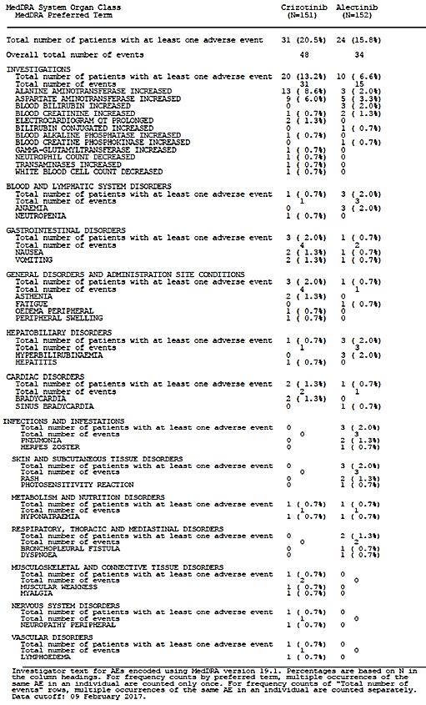
Evaluator comment: Most of the AEs leading to dose reduction are readily detectable with monitoring, particularly regular blood tests and awareness of the potential for the clinical event. The PI is adequate, with the exception of renal disorders, which were both severe and resulted in discontinuation or death for some patients.

Adverse events of special interest
Adverse events of special interest AESI), which are considered distinct from the other term, ‘Selected adverse events’ used by the sponsor, were listed below in the Summary of Clinical Safety, with further clarification in the Protocol Version 4:
- Cases of drug-induced liver injury
- Suspected transmission of an infectious agent by the study drug
Evaluator comment: The inclusion of potential to transmit an infectious agent was only to be considered in the context ‘when contamination of the study drug is suspected’. No data were presented for this particular AESI.

Liver function and liver toxicity
Hy’s law cases
The scatter plot analysis of total bilirubin versus ALT, and AST revealed 5 patients (2 in the crizotinib arm and 3 in the alectinib arm) falling into the potential Hy’s law quadrant.

Crizotinib arm
Patient [information redacted] and Patient [information redacted] (crizotinib arm) experienced Grade 4 drug-induced liver injury, both events were considered treatment-related. Patient 267469/1541 was permanently discontinued, due to the event.
Patient [information redacted] had been discontinued due to Grade 4 elevated ALT prior to the diagnosis of drug-induced liver injury.

Alectinib arm
Patient [information redacted] met Hy's law criteria, having experienced Grade 4 hepatotoxicity which was considered treatment-related and led to treatment discontinuation.
Two cases (both in the alectinib arm [Patient [information redacted], and Patient [information redacted]]) did not qualify as true Hy’s law cases after detailed review, due to not having a close temporal relationship between increase of the transaminases and bilirubin, or being indicative of cholestasis and underlying hepatic pathology. However, Patient [information redacted] experienced Grade 4 drug-induced liver injury, which was considered treatment-related and treatment was permanently discontinued, due to the event.
Evaluator comment: No narratives could be located for the two patients in the alectinib arm who were stated not to meet Hy’s law, noting that one of these was considered a drug-induced liver injury. In all, the two, possibly three cases of drug-induced liver injury have been identified in this study, and given the seriousness should be reported clearly and early in the information section in the PI. A simple message is required stating that events of hepatotoxicity were common in the clinical trials, including drug-induced liver injury and recommendations for monitoring. Priority should be given to data from the randomised controlled trial as it provides a comparison. (PI Comments)
The sponsor provided a further analysis in the s31 response (response-11) of events of drug-induced liver injury by Asian versus non-Asian ethnicity. Only two cases were listed (one as drug-induced liver injury and one as hepatotoxicity), both occurring in non-Asian patients. The PI recommendations above are sufficient, but it is also considered an incomplete presentation of information regarding patients with liver-related toxicities.

Selected adverse events
The following selected adverse events were presented for the crizotinib and alectinib arms in the Clinical Study report (Table 50). Note is made that the Summary of Clinical Safety also included the following as Adverse Events of Special Interest, although these were not prespecified in the Clinical Protocol or specifically discussed as selected adverse events in the CSR:
- Oedema
  - MedDRA PTs: oedema peripheral, oedema, generalised oedema, eyelid oedema, periorbital oedema, face oedema, and localised oedema
- Bradycardia
  - MedDRA PTs: bradycardia and sinus bradycardia
- Dysgeusia
  - MedDRA PTs: dysgeusia and hypogeusia
- Weight increased
  - MedDRA PT: weight increased
Evaluator comments:
- The pre-specified selected adverse events have been presented in the CSR for all adverse treatment-emergent events, which will provide an overarching view of the relative toxicities in the crizotinib arm compared with the alectinib arm, but does not help particularly for identifying manageability of the events or for detecting new signals in the alectinib arm given the very broad SOC terms, and the overlap within the PT reporting.
- The Summary of Clinical Safety – perhaps more of a re-analysis than a summary, per se - provided further analysis restricted to those considered treatment-related, as well as the median time to onset and a more comprehensive reference to the actions required (dose reductions, delays although often the figures were not actually presented but referred back to the Dose reduction table in the CSR) but no standardisation by duration of therapy (much longer in the alectinib arm), which remains a limitation in comparing the two arms.
- The addition of terms in the ‘Summary of Clinical Safety’ further expands the analysis.
- Time to onset in an open label trial where there is considerably more awareness and experience of toxicities in one arm, may have influenced the likelihood of an earlier dose reduction, delay in the crizotinib arm, and represents a potential bias – albeit one likely to protect patients.

Table 50: Summary of selected adverse events
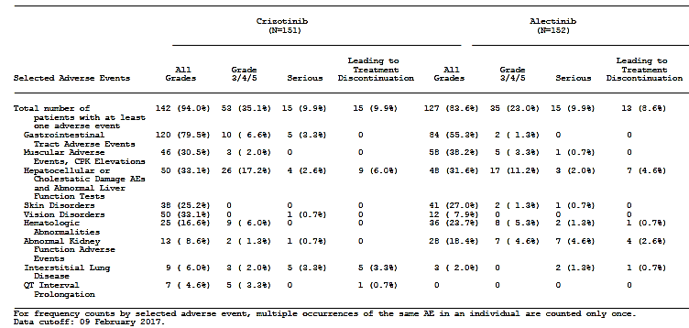

Table 51: Additional overview of selected adverse events - Safety population
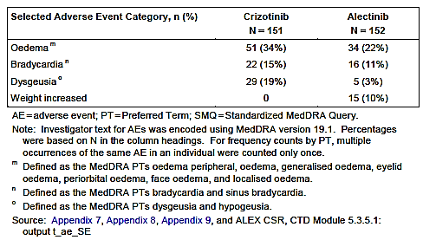

Gastrointestinal disorders (AEs in the MedDRA gastrointestinal disorders SOC)
Definition (Summary of Clinical Safety)
- MedDRA SOC: GI disorders
- Stomatitis
MedDRA PTs: stomatitis and mouth ulceration
Gastrointestinal tract disorders treatment-emergent AEs were more common in the crizotinib arm (80% patients) compared with the alectinib arm (55% patients).
The most common individual events were constipation, nausea, diarrhoea and vomiting, all of which were more frequent in patients in the crizotinib arm. The majority of events were Grade 1 or 2 in severity; Grade ≥ 3 GI AEs were reported by 7% of patients in the crizotinib arm and 1% of patients in the alectinib arm. In the crizotinib arm 3% experienced SAEs compared with no patients in the alectinib arm. No patients in either treatment arm discontinued study treatment due to a GI AE (Table 52).
Evaluator comment: The higher rate of adverse events is noted in the crizotinib arm, but very few patients required dose reductions (3 in the crizotinib arm and 1 in the alectinib arm) and there were no discontinuations, suggesting this is readily manageable and not dissimilar between the arms. Whether this similarity of events and outcomes would be maintained outside of a clinical trial setting, or with patients of poorer performance status, is less certain.

Table 52: Selected adverse events: gastrointestinal tract AEs - Safety population
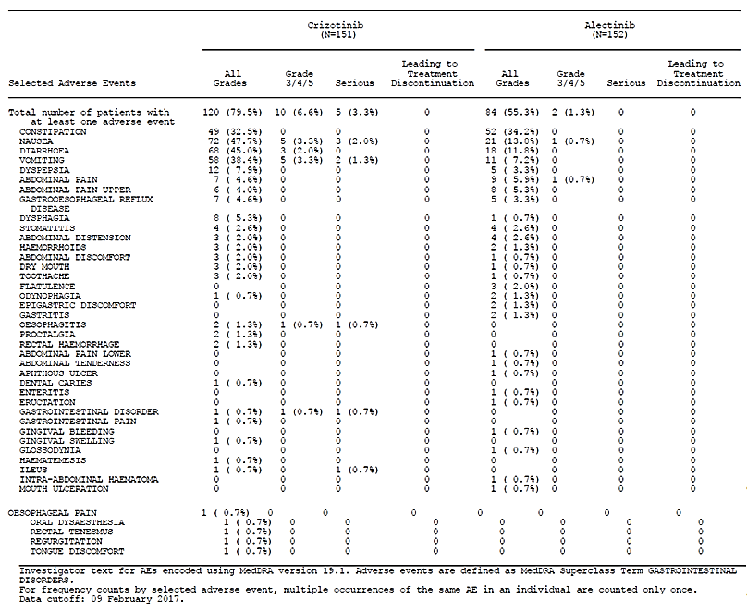
Evaluator comment: The reported rates of stomatitis using the PT described above in the Summary of Clinical Safety Table 10, SCS, was higher than reported in the table above (5 patients (3%)) in the alectinib arm. Higher rates of reporting in other clinical trials are also relevant and this information should be added, rather than replace information already in the PI as proposed in the Note to the evaluator.

Muscular Adverse Events and Creatinine Phosphokinase Elevations (MedDRA high level group terms of ‘musculoskeletal and connective tissue disorders NEC’, ‘enzyme investigations nec’ and ‘muscle disorders’)
Definition (Summary of Clinical Safety) Muscular AEs and creatine phosphokinase (CPK) elevations:
- MedDRA HLGTs: Musculoskeletal and connective tissue disorders not elsewhere classified (NEC), Enzyme investigations NEC, and Muscle disorders
- Myalgia
MedDRA PTs: myalgia and musculoskeletal pain
A lower proportion of patients in the crizotinib arm (31%) compared with the alectinib arm (38%]) experienced muscular AEs and CPK elevations. The most common individual AE PTs reported were blood CPK increased, blood alkaline phosphatase increased, myalgia, back pain, pain in the extremity and musculoskeletal pain, which were more frequently seen in patients in the alectinib arm (Table 53).

Table 53: Selected adverse events: Muscular adverse events, CPK elevations
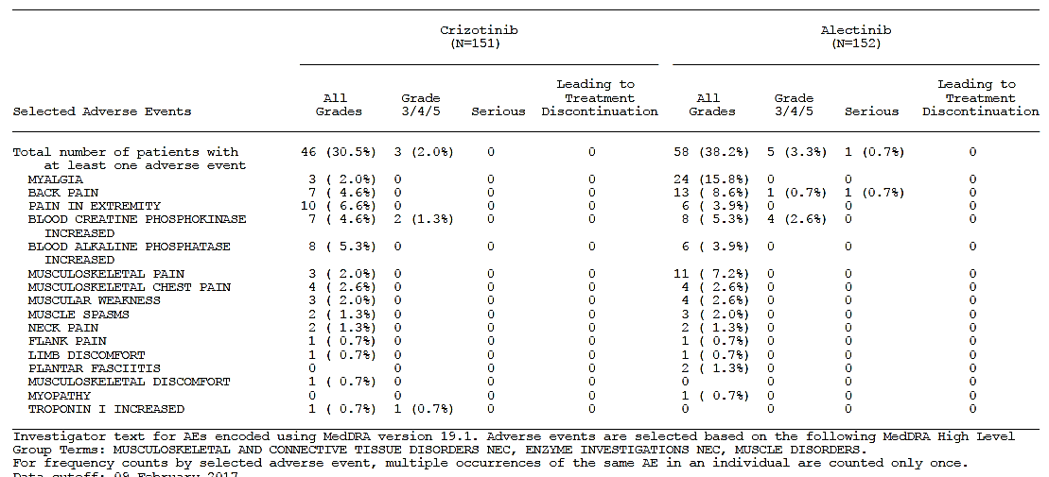
The majority of events were Grade 1 or 2 in severity; 2% of patients in the crizotinib arm and 3% of patients in the alectinib arm experienced Grade ≥ 3 muscular AEs or CPK elevations compared with 1.3% in the crizotinib arm (removing the patient with the Troponin I from this arm). One event in the alectinib arm was reported as serious versus none in the crizotinib arm (Table 53).
In both treatment arms, 5% of patients experienced CPK increase as AEs; however, median time to onset was notably longer in the crizotinib arm (281.0 days) compared with the alectinib arm (30.5 days). The majority of events (63%) occurred within the first 2 months in the alectinib arm, compared with after the first 3 months in the crizotinib arm.
Two patients in the crizotinib arm and no patients in the alectinib arm required dose reduction, while no patients in either treatment arm discontinued study treatment due to muscular AEs or CPK elevations.
Evaluator comment: Alectinib generally caused a greater number of musculoskeletal events and slightly higher and more severe elevations of CPK. This supports the PI Comments regarding changing the heading of this Precaution. Most of these events are manageable as no patients discontinued, and a single patient required dose reduction(s) for elevated CPK in the alectinib arm.

Hepatocellular and cholestatic damage liver AEs and abnormal LFTs
Definition (Summary of Clinical Safety)
- Hepatocellular and cholestatic damage, liver AEs, and abnormal liver laboratory tests
  - MedDRA SMQ: Drug related hepatic disorders, narrow
A comparable proportion of patients in both treatment arms (33% crizotinib versus 32% alectinib) experienced hepatocellular or cholestatic damage AEs and abnormal liver function tests. Grade ≥ 3 hepatocellular or cholestatic damage AEs and abnormal liver function tests occurred more frequently in patients in the crizotinib arm (17% versus 11%). 3% of patients in the crizotinib arm experienced SAEs compared with 2% of patients in the alectinib arm.
The CSR states, ‘The most frequent events were ALT increased and AST increased, both of which occurred more frequently in the crizotinib arm. One AE of drug-induced liver injury was reported in each treatment arm (Section 7.10).’
Discontinuations were required due to hepatocellular or cholestatic damage AEs and abnormal liver function tests (6% crizotinib versus 5% alectinib) (Table 54). It should be noted that there was a greater incidence of ALT or AST AEs reported in the crizotinib arm (31%) compared with the alectinib arm (16% patients); however, median time to onset was comparable between treatment arms (29 days crizotinib versus 32 days alectinib) and the majority of events occurred within the first six weeks of treatment in both arms.
A lower proportion of patients in the crizotinib arm (1%) compared with the alectinib arm (21%) experienced elevation of bilirubin AEs; median time to onset was comparable between treatment arms (51.5 days versus 57.0 days), and the majority of events occurred within the first 2 months of treatment in both arms.

Table 54: Selected adverse event: Hepatocellular and Cholestatic damage liver AEs Abnormal LFTs
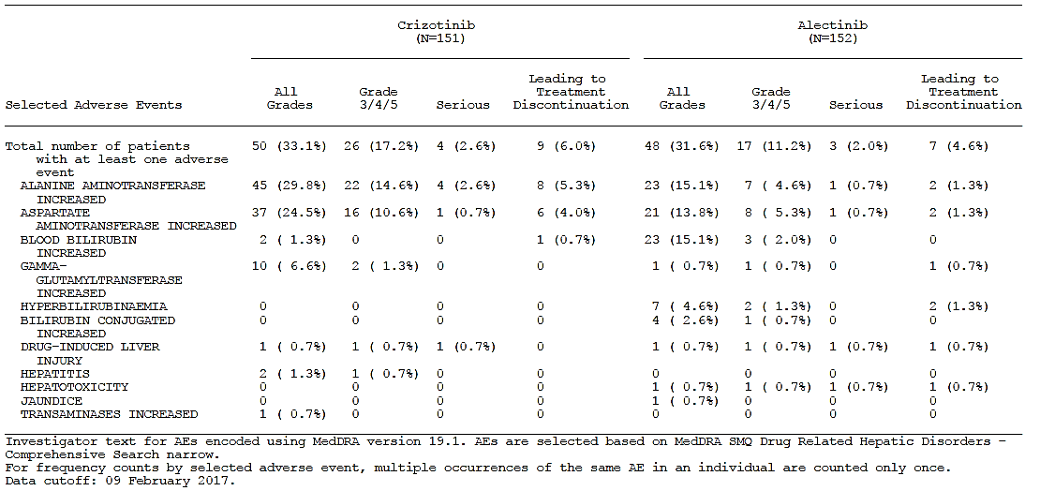
Evaluator comments:
- This reporting of events by PT, without further analysis, does not incorporate the clinical assessment of the events, for example, as presented above, where it was judged that 3 patients in the alectinib arm met the criteria for drug-induced liver injury after consideration of the severity of the enzyme changes and the event more holistically.
- Both drugs may lead to changes in LFTs, some of which will be associated with serious liver injury, necessitating dose reductions and discontinuations, and this should be communicated more clearly in the alectinib PI, including the relatively short time to onset. (PI Comments)

Skin disorders (AEs in the MedDRA skin and subcutaneous tissue disorders SOC)
Definition
- MedDRA SOC: Skin and subcutaneous tissue disorders
- Rash
MedDRA PTs: rash, rash maculo-papular, dermatitis acneiform, erythema, rash generalised, rash macular, rash papular, exfoliative rash, and rash pruritic
- Photosensitivity
MedDRA PT: photosensitivity reaction
A comparable proportion of patients in both treatment arms (25% crizotinib versus 27% alectinib) experienced skin disorders (Table 55).
The most frequent skin disorder in both treatment arms was rash, which was more common in the alectinib arm (15.1% versus 12.6%; Source, Appendix 5 SCS). It should be noted that photosensitivity reaction occurred in no patients in the crizotinib arm compared with 5% in the alectinib arm.
The majority of events were Grade 1 or 2 in severity, and two Grade ≥ 3 events were reported in the alectinib arm (none in the crizotinib arm), one event of photosensitivity reaction (Patient No [information redacted]), and one event of rash (Patient No. [Information redacted]); both were considered related to treatment. One event of Grade 4 rash (Patient No. [Information redacted]), considered related to treatment in the alectinib arm, was reported as serious (none in the crizotinib arm).

Table 55: Selected Adverse Events: Skin Disorders - Safety Population
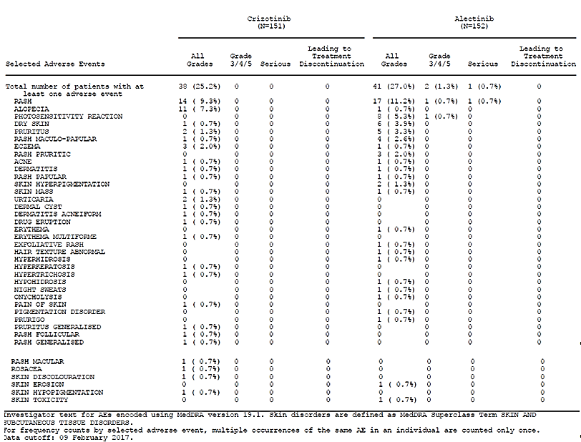
Evaluator comments:
- Patient No. [information redacted]) experienced a Grade 3 photosensitivity reaction which was still ongoing according to the only information that could be located on p 1713 of the dossier.
- Photosensitivity is a significant but manageable issue for Australian patients, and familiar to oncologists as it a side effect with a range of chemotherapeutic agents. The current CMI and the PI information are adequate.
- It is unclear if radiation recall or increased toxicity with radiation treatment is an issue with alectinib and the sponsor was asked to provide any information from the development program and this trial.
The sponsor provided a response to this question in the s31 response (response-10) and indicates there have been no such events.
Evaluator comment: No further action is required.

Vision disorders (AEs in the MedDRA SOC: eye disorders)
Definition
- MedDRA SOC: Eye disorders
A greater proportion of patients in the crizotinib arm (33%) compared with the alectinib arm (8%) experienced vision disorders (Table 56).
All events were of Grade 1 or 2 severity. One event in the crizotinib arm was reported as serious (vision blurred, in Patient No. [information redacted], considered related to treatment, versus none in the alectinib arm). No patients in either treatment arm discontinued study treatment due to a vision disorder.
Evaluator comment: This is a known AE for crizotinib and does not appear a significant problem with alectinib.

Table 56: Selected Adverse Events: Vision Disorders - Safety Population
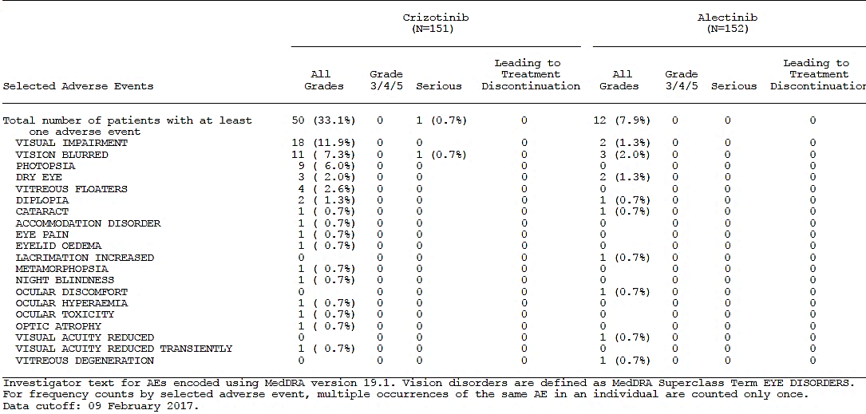

Abnormal kidney function defined as the combination of MedDRA SMQ acute renal failure narrow and MedDRA superclass term renal and urinary disorders and MedDRA high level group term renal and urinary tract investigations and urinalyses
Definition
- MedDRA SMQ: Acute renal failure, narrow
- MedDRA SOC: Renal and urinary disorders
- MedDRA HLGT: Renal and urinary tract investigations and urinalyses
More patients in the alectinib arm (18%) experienced abnormal kidney function compared with the crizotinib arm (9%) (Table 57). The most frequently occurring individual event was blood creatinine increased (8% alectinib versus 4% crizotinib). There were four cases (3%) of acute kidney injury in the alectinib arm and none in the crizotinib arm. Severe abnormal kidney function AEs are described above.
While the majority of events were Grade 1 or 2 in severity, Grade ≥ 3 events were reported in 5% of patients in the alectinib arm (1% of patients in the crizotinib arm). Two patients had a Grade 5 AE related to kidney function (acute kidney injury and blood creatinine increased), both were in the alectinib arm and these cases have been discussed in the section on Deaths above.
SAEs were reported in 5% of patients in the alectinib arm and 1% of patients in the crizotinib arm. Four patients in the alectinib arm discontinued study treatment and two required dose reductions due to abnormal kidney function compared with a single patient requiring dose reduction and no discontinuations in the crizotinib arm. These events were acute kidney injury (2%) and blood creatinine increased (1%) (Table 57).
Evaluator comment: This new signal and these events indicate a risk of potentially severe renal injury and death in patients receiving alectinib. The evaluator is not in agreement with the sponsor’s assessment of the two deaths not being treatment-related. Whether diminished renal reserve increases that risk further is uncertain (RMP), and until that is clarified, the Precaution should include a statement that the risk in those with risk factors for, or pre-existing renal impairment is not known and such patients should be monitored closely. With this being a relatively new signal, the sponsor was asked to provide information about dose reductions, interruptions and discontinuations and patient outcomes from all trials to date. As previously stated in this report, a Precautions section is required to warn prescribers and include a comment on dose modification recommendations. It should also be stated that some events were fatal. (Clinical Question)

S31 response – response-14
Clinical question: The sponsor is requested to provide a summary of all AEs relating to abnormal renal function (as per the terms for selected abnormal renal function AE) for the J-ALEX study, including whether the events required dose reduction, delay or discontinuation. The sponsor should discuss whether dose interruption and/or reduction were a successful strategy for managing such AEs in both Phase II trials, ALEX and J-ALEX. Outcomes for AEs of abnormal renal function outcomes should be discussed following these treatment alterations as well as for rechallenge.
The sponsor provided the following information in the s31 response regarding the events of abnormal renal function in the J-ALEX Phase III study (as of cut-off date 4 July 2016) and Phase II studies (response-14):
J-ALEX
Overall, 17 (17%) out of the 103 patients in the alectinib treatment arm of the J-ALEX study experienced 38 events falling into the abnormal renal function category.
The majority of the events (33 out of 38, 14% of patients) were reported as treatment-related and were of Grade 1 and/or Grade 2 intensity. Grade ≥ 3 events were experienced by 1 patient (1.0%, 3 events). Two patients (1.9%) experienced a serious event of blood creatinine increased (one event each). There were no fatal cases falling into the abnormal renal function and 3 (2.9%) out of 103 patients had a dose interruption and one patient (1.0%) was discontinued due to such events.
The events falling in the abnormal renal function basket included mainly blood creatinine increases (12% of the patients, 1.9% serious, none of Grade ≥ 3). In addition, 2.9% of the patients experienced pollakiuria (none serious, none of Grade ≥ 3 – Evaluator comment: Pollakiuria cannot be graded more highly than Grade 2 under the CTCAE v4.0 category of urinary frequency), 1.9% renal impairment (none serious, 1.0% of Grade ≥ 3) and 1.0% glucose urine present and urinary sediment present each (none serious, none of Grade ≥ 3).
In the alectinib treatment arm of J-ALEX, 27/38 events of abnormal renal function resolved without sequelae: 14/38 events after a dose interruption and 13/38 without any dose interruption. A total of 5 out of the 38 events remained unresolved; for 4 of these events, the dose was not changed (not permitted as per protocol), while for one event the study drug was withdrawn. The outcome of 6 out of the 38 events was unknown; the dose was not changed due to these events.
Overall, there was one event (renal impairment) in one patient leading to treatment discontinuation. Despite drug withdrawal, this event remained unresolved. 14 events in 3 patients were managed with a drug interruption in the alectinib treatment arm of J-ALEX. These events included renal impairment (2 events in one patient) and blood creatinine increases (12 events in 2 patients).
Dose interruptions in J-ALEX (NB dose reductions were not permitted)
In the alectinib treatment arm of J-ALEX, there were 3 out of 103 patients who experienced a total of 14 events (blood creatinine increases and renal impairment), which were managed with a dose interruption. For the two patients experiencing events of blood creatinine increases, the next event(s) generally occurred after one month since the previous event. Both patients had concurrent diseases which could have contributed to the AE (renal impairment, hypertension and diabetes for the first patient, and diabetes and nephrolithiasis for the second patient). The third patient experienced non-serious renal impairment of Grade 3 intensity on Study Day 251, which resolved within 15 days after dose interruption. A second event of this type occurred within one month (29 days) since the first event (and resolved after dose modification). A third event of this type occurred after one month (after 113 days) since the previous event, and finally led to drug withdrawal; the event remained unresolved at time of data cutoff. This patient had certain risk factors, such as age (83 years), and concurrent diseases (chronic renal impairment, hypertension and chronic cardiac failure) which could have contributed to the AEs.

Phase I trial Phase II trials NP28761 and NP28673
In the Phase II trials, four events of renal function abnormality in patients receiving 600 mg bd required dose modification:
- dose reduction in one patient for blood creatinine increased, no recurrence;
- drug interruptions were required for 4 events occurring in 4 patients:
  - recovery but recurrence on rechallenge for 2 patients, leading to discontinuation in 1 patients
  - recovery and no recurrence in 1 patient
The evaluator cannot locate the details for the 4th patient.
Two of the 4 patients had concurrent diseases (hypertension for both patients and diabetes mellitus for one patient) and concomitant medication (acetylsalicylic acid) which could have contributed to the AEs. One patient’s age (79 years) was an additional risk factor for developing abnormal renal function events (see CSRs for NP28761 and NP28673).
A further patient in the Phase I study on a dose other than 600 mg bd (not specified) also required a dose interruption for renal failure following an initial report of blood creatinine increased.
Evaluator comments:
- Treatment-related renal adverse events were very common in the J-ALEX study, which used a lower dose of 300 mg bd compared with the 600 mg bd in the ALEX study. Assessment of the optimal management of these events is limited because only dose interruptions but not reductions were permitted. Dose interruptions were required to manage 12/29 events and one patient discontinued treatment as a result of continued events of renal impairment, and which did not resolve after discontinuation.
- The total number of abnormal renal function events in the J-ALEX alectinib arm was three times that in twice as many patients compared with the crizotinib arm (where dose reductions and delays were permitted) but the CSR has not been evaluated by the TGA to take into account differences in duration of exposure between the arms.
- Abnormal renal function requiring dose reduction, interruption were reported in 5 patients and discontinuation in 1 patient in the Phase I/II studies.
- The recurrence of the renal events for 3 patients in the J-ALEX study, and in one patient in the Phase II studies when re-challenged indicates the need for close monitoring after initial resolution.
- Notably, as with the severe and fatal renal adverse events in the ALEX study, those with limited renal reserve appeared most vulnerable. This information should be conveyed in the Precautions section. (PI Comments)

Table 57: Study J-ALEX Selected adverse events: abnormal renal function in alectinib arm (300 mg BID) -Safety population
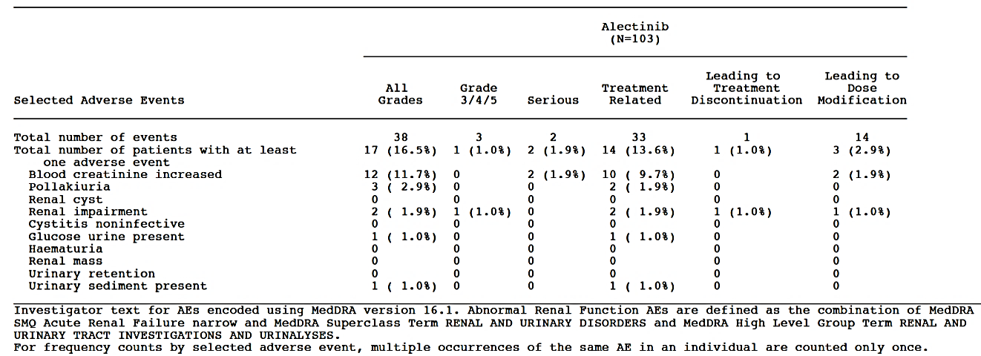
The sponsor provided additional information in the s31 response (response-11) from the ALEX study for renal adverse events for Asian versus non-Asian patients and no clear signal emerges for there being an increased risk in either group.

Table 58: Selected abnormal renal function ALEX study – Safety population
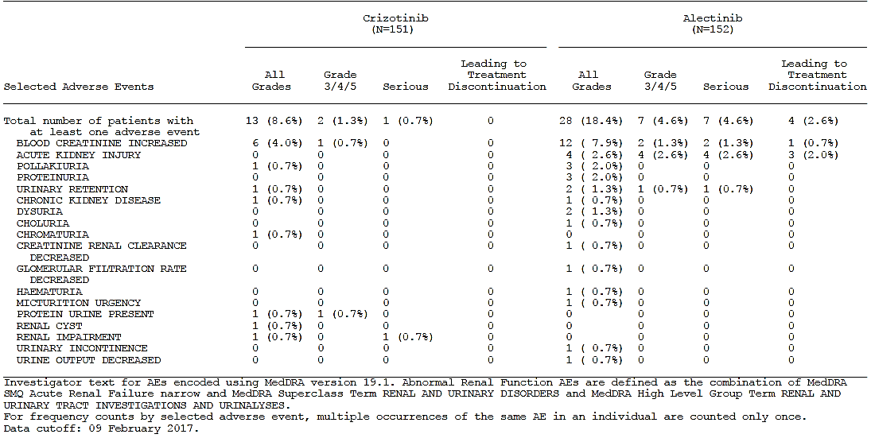

Haematological abnormalities (based on the MedDRA SMQ haematopoietic cytopenias wide)
Definition
- MedDRA SMQ: Haemotopoietic cytopenias, wide
- Anaemia
- MedDRA PTs: anaemia and haemoglobin decreased
A lower proportion of patients in the crizotinib arm (17%) compared with the alectinib arm (24%) experienced haematological abnormalities (Table 59). Anaemia was more common in the alectinib arm, (20% alectinib versus 5% crizotinib) and neutropenia (3% versus 7%).
The majority of events were of Grade 1 or 2 severity; with comparable proportions of patients in both treatment arms (6% crizotinib versus 5% alectinib) experiencing Grade ≥ 3 events. Two patients in the alectinib arm experienced events of anaemia considered to be SAEs (no relationship was provided), while no patients in the crizotinib arm experienced haematologic abnormalities considered to be SAEs.
Patients with AEs that led to dose reduction experienced neutropenia, decreased neutrophil count, and decreased white blood cell count (1% crizotinib versus 0% alectinib for each) and anaemia (0% crizotinib versus 2% alectinib). Patients with AEs that led to study drug interruption reported neutropenia (3% crizotinib versus 0% alectinib), decreased neutrophil count (1% crizotinib versus 0% alectinib), and anaemia (0% crizotinib versus 1% alectinib). One patient in the alectinib arm discontinued study treatment due to anaemia (Table 59).
Evaluator comment: The mechanism for anaemia is not discussed, but with regular monitoring, this is a manageable adverse event. It does not appear that alectinib is associated with other significant cytopenias.

Table 59: Select adverse events: haematological abnormalities - Safety population
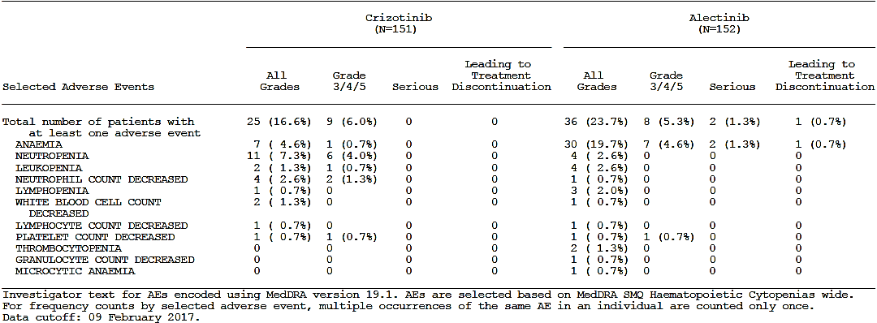

Interstitial lung disease (defined as MedDRA SMQ interstitial lung disease narrow)
Definition
- MedDRA PTs: ILD and pneumonitis
A greater proportion of patients in the crizotinib arm (6%) compared with the alectinib arm (2%) experienced interstitial lung disease AEs (Table 60).
The majority of events were of Grade 1 or 2 severity; 2% of patients in the crizotinib arm experienced ILD AEs of Grade ≥ 3 versus none in the alectinib arm. Serious events of ILD were experienced by 3% of patients in the crizotinib arm, and 1% of patients in the alectinib arm; 3% and 1% of patients, respectively, discontinued treatment due to ILD AEs.
Evaluator comment:
- This is a well-recognised risk with cancer therapies, including the ALK inhibitors, and familiar to oncologists.
- The sponsor proposes to withdraw the following information in red from the PI from the J-ALEX Phase III study, including a 4.9% rate of treatment withdrawal: ‘In a Phase III clinical trial conducted in 103 Japanese patients with ALK-positive NSCLC treated with a dose of 300 mg twice daily, 8 patients in the Alecensa arm (7.8%) had an ILD event. Five patients (4.9%) treated with Alecensa had a Grade 3 ILD, leading to withdrawal from treatment.’ The evaluator does not support removing it from the PI, solely on the basis of this dataset ‘superseded by availability of first-line data with the registered dose (600 mg twice daily)’ as stated by the sponsor in the comment box in the annotated draft PI. The rate was much lower in the ALEX study and the reasons for this are not clear. The J-ALEX study used a lower dose (300 mg bd) also in the first line metastatic setting, and was conducted solely in Japanese patients; however, an analysis provided in the s31 response of these AEs in the ALEX study does not suggest a unique risk for Asian patients, although the number of events was small.

Table 60: Select adverse events of interstitial lung disease - Safety population
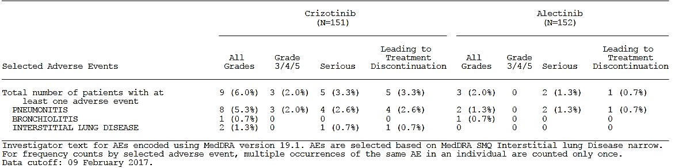

QT interval prolongation (based on MedDRA SMQ torsade de points QT prolongation narrow)
Definition
- MedDRA SMQ: Torsade de Pointes QT Prolongation, narrow
Overall, 5% of patients in the crizotinib arm were reported to have events of QT interval prolongation (Table 61) compared with none in the alectinib arm; the majority (3%) were Grade ≥ 3 in severity.
One patient in the crizotinib arm discontinued treatment due to an AE of Electrocardiogram QT Prolonged.
The following table was included in the CSR section on ECG findings rather than QT prolongation, and is presented here for continuity and to clarify potential risk for QT prolongation with alectinib.

Table 61: Changes in QTcF from baseline – ECG evaluable population
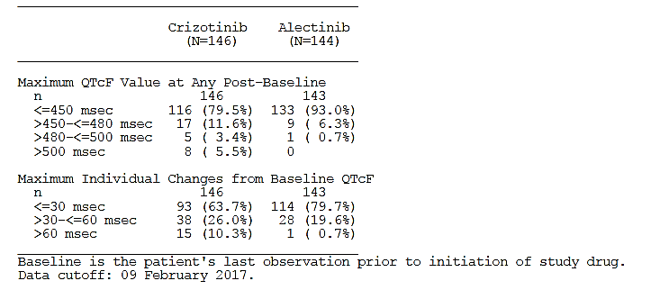
Evaluator comments:
- The MedDRA terms used will identify those with ECG abnormalities but it is possible to have clinical events (syncope, seizure, collapse), which have not been captured in this analysis. It is noted that two patients died suddenly at home in the alectinib arm.
- 20.3% had an increase from baseline of ≥ 30msec, which is not the cut-off 20 msec used in the FDA Guidance on QT interval, and makes the assessment of those potentially at risk at least that figure, given the following statement from page 14 of that document: ‘Drugs that prolong the mean QT/QTc interval by >20 ms have a substantially increased likelihood of being proarrhythmic, and might have clinical arrhythmic events captured during drug development.’
- Based on the information provided, alectinib can be stated to have a lower risk of QT prolongation compared with crizotinib. However, a potential proarrhythmic risk cannot be ruled out, especially when used in a population which is not selected on a restricted baseline QT interval (required to be <470msec and without symptomatic bradycardia in the ALEX study). While patients on alectinib were permitted to have concomitant medications that prolong the QT interval if necessary after the study commenced, the requirement that these not be used for at least 14 days before study entry, and the continued prohibition in the crizotinib arm, may have introduced a cognitive bias against their use during the study.
- QT prolongation and associated clinical outcomes remain potential identified risks and should be included in the RMP.

Oedema
Oedema AEs were reported in a higher proportion of patients receiving crizotinib (34%) compared with alectinib (22%). Peripheral oedema was reported in the majority of patients with events in both treatment arms (28% crizotinib versus 17% alectinib). SAEs or Grade ≥ 3 events of oedema were reported in 1% of patients in each arm.
A single patient, who was in the alectinib arm, discontinued treatment as a result of serious, Grade 3 oedema.
Evaluator comment: It is also noted that the patient who died following an essentially unexplained rise in blood creatinine while receiving alectinib, was documented to have anasarca but it is not clear if this is the case presented in this discussion, or an additional more severe case.
Peripheral oedema accounted for the majority of treatment-related oedema AEs reported by patients (23% crizotinib versus 9% alectinib). Dose reduction was also required for this AE in one patient (1%) receiving crizotinib; no patients required study drug interruption as a result of oedema AEs.

Table 62: Selected adverse events: oedema - Safety population
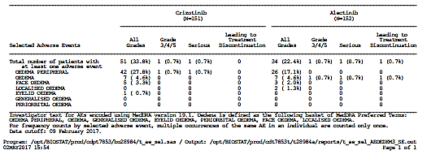

Bradycardia, pulse rate shift and ECG findings
Evaluator comment: These have all been reported in the CER together, given they are related although were presented in different sections of the CSR.

Bradycardia
For reasons of continuity and clinical correlation, the evaluator has included the reporting of the events of bradycardia from the Summary of Clinical Safety, and the evaluator’s assessment of the clinical events reported in the CSR in the section on ‘Vital signs’ as ‘Pulse rate shift’. The former is an ECG observation based on absolute rates (usually defined as <60 bpm), while the assessment of low pulse rate takes into account shifts from baseline.
Bradycardia events (defined by the PTs bradycardia and sinus bradycardia) were reported in 15% of patients in the crizotinib arm compared with 11% in the alectinib arm. Bradycardia (PT) was reported in more patients receiving crizotinib (9%) compared with alectinib (5%); sinus bradycardia occurred in an equal proportion of patients in both treatment arms (5% each).
No patients had events of Grade ≥ 3 severity or that led to treatment discontinuation, and only one patient, who was in the crizotinib arm, had an SAE (sinus bradycardia). Treatment-related events occurred in more patients receiving crizotinib than alectinib, primarily owing to the bradycardia (PT) (8% crizotinib versus 4% alectinib).
Few patients in each treatment arm experienced bradycardia AEs leading to dose reduction (1% each); two patients in the crizotinib arm required study drug interruption, compared with none in the alectinib arm.

Table 63: Selected adverse events: sinus bradycardia and bradycardia - Safety population (Source SCS, Appendix 8)
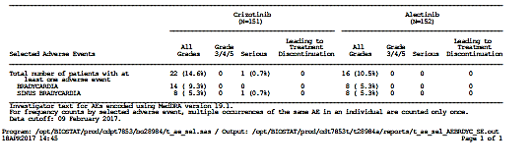

Pulse rate shift
52% in the crizotinib arm and 42.8% in the alectinib arm, experienced at some point, a pulse rate that was <60 beats per minute, with similar proportions recording a pulse rate of 50-60 bpm and a slightly higher proportion recording rates of <50 bpm in the crizotinib arm (16.2% versus 10.4%) and one patient in the alectinib arm had a pulse of 30-40 bpm from a baseline of 50-60 bpm. The decrease from the baseline median was greater in the crizotinib arm - up to -22 bpm compared with a maximum decrease of 17 bpm from the baseline median in the alectinib arm.
Evaluator comments:
- Dizziness was reported in both arms and the observed bradycardia may have been contributory. Patients with symptomatic bradycardia were excluded from this trial.
- The PI currently has a Precaution section on Bradycardia and this requires updating with this information, but the management advice is satisfactory.

Table 64: Pulse rate shift - Safety population
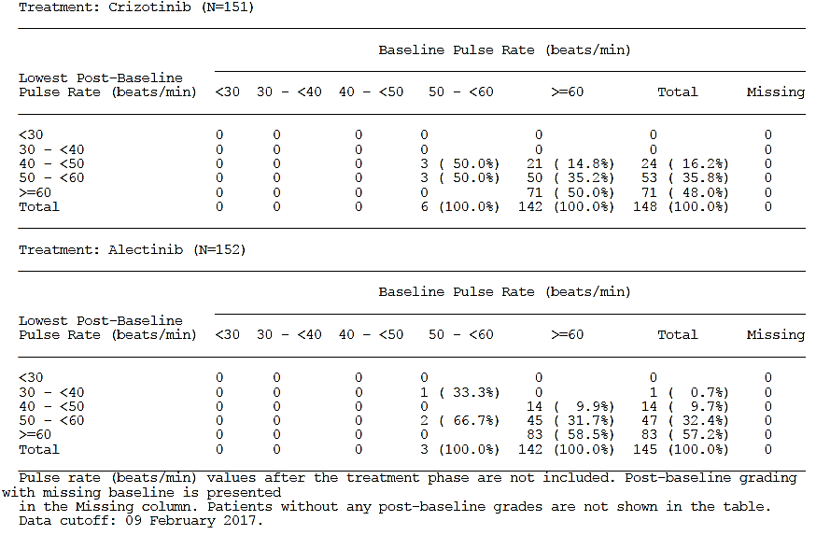

Electrocardiograph findings and cardiovascular safety
The CSR states, ‘Post-baseline increases in median values of ECG parameters were observed for PR, QT, and QTcF in both treatment arms, while a decrease in heart rate was also observed in both treatment arms; changes were largely comparable between treatment arms.
A comparable proportion of patients in both treatment arms were reported to have clinically significant (4% crizotinib versus 5% alectinib) or non-clinically significant (58% in both arms) ECG abnormalities post-baseline.’
Evaluator comments:
- The sponsor is requested to detail what the abnormal ECG findings were in the 4% of the crizotinib arm and 5% in the alectinib arm, as there is no link provided to any data from which this statement was derived.
- No information on bradycardia as an ECG term was presented but this was discussed in the section on low pulse in Vital signs in the next section.
The sponsor provided the following information in addition to the data tables in support of the ECG changes in the s31 response (response-13)
‘In addition to the quantitative information on the ECG parameters (heart rate, RR, PR, QRS, QT and QTcF intervals) captured in the eCRF, the ALEX study investigators were requested to provide a qualitative assessment of the ECG findings. For this assessment, the investigators had to choose from the following four options: (1) ‘normal’, (2) ‘abnormal, not clinically significant’, (3) ‘abnormal, clinically significant’, (4) ‘unable to evaluate’. For those ECGs assessed ‘abnormal, clinically significant’ no further details on the reported clinical significant abnormality were captured, except abnormal value of ECG parameters.
ECG abnormalities were assessed by the investigator as clinically significant in 6 crizotinib treated patients (4%) and in 7 alectinib treated patients (5%).
A review of the ECG parameters heart rate, RR, PR, QRS, QT and QTcF for the patients reported with clinically significant ECG abnormalities showed no particular pattern deviating from that of the entire patient group in the respective treatment arm for those parameters. …. none of the 7 patients with clinically significant ECG abnormalities in the alectinib treatment arm had an increase of the QTcF interval >60 ms versus baseline or QTcF intervals >500 ms. For 5 of those 7 patients in the alectinib treatment arm, the recorded heart rate was <50 bpm at time instances when an ECG with clinically significant abnormality was recorded.
In summary, signs of clinically relevant QT prolongation were present in the majority of ECGs evaluated by the investigators as abnormal with clinical significance in the crizotinib treatment arm, whereas the majority of ECGs evaluated as abnormal with clinical significance in the alectinib treatment arm showed bradycardia <50 bpm. These ECG findings are in line with the known safety profile of both alectinib and crizotinib.
Evaluator comment: The utility of the information collected without any clarifying statement from the investigators regarding the clinical significance of the abnormalities, is a significant limitation in the interpretation of these data. However, it is notable that almost all patients in the alectinib arm experienced a slowing of their heart rate compared with baseline, and that the clinicians appear to be signaling when this became both severe and probably symptomatic in 5/7 cases, as similar heart rates (just a few bpm faster) were recorded as abnormal but not clinically significant. An event of 37 bpm was not recorded in Patient [information redacted] as this patient was bradycardic on entry into the study.
The sponsor is specifically requested to state the rates of bradycardia in the two treatment arms as this is a Precaution in the PI and requires updating from this trial. It is noted that patients with symptomatic bradycardia were excluded and this should be stated in the Clinical Trials section.

Dysgeusia
Dysgeusia events (defined by the PTs dysgeusia and hypogeusia) were reported in a higher proportion of patients receiving crizotinib (19%) compared with alectinib (3%), and considered treatment-related in 19% and 1%, respectively. Dysgeusia (PT) accounted for all patients with these events except for one patient in the alectinib arm who had Grade ≥ 3 hypogeusia.
All other events in both treatment arms were Grade 1 or 2 in severity, and none were serious or led to dose reduction, interruption, or discontinuation.

Table 65: Selected adverse events: dysgeusia - Safety population
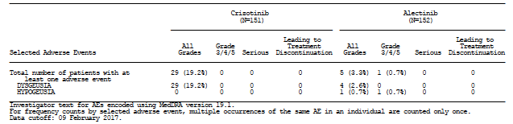
Evaluator comment: Change in sense of taste is a common adverse event with many chemotherapeutic agents, and generally well tolerated by patients.

Increased weight
See section 8.3.1.1 Weight gain above for discussion of this new ADR.

Subgroup analyses/special populations

AEs by sex
Some differences in the incidence of individual AEs were observed between subgroups within each treatment arm. In the crizotinib arm, the greatest (>10% absolute) differences between subgroups were seen for nausea (36% male patients, versus 56% female), vomiting (30% versus 45%), and increased ALT (22% versus 36%), which were all reported in a greater proportion of female than male patients.
In the alectinib arm, increased blood bilirubin was reported in a higher proportion (>10% absolute difference) of male patients (21%) compared with female patients (11%). A review of Table 54 in the CSR did not identify any consistent differences in the alectinib arm.
Evaluator comment: Differences in exposure could be account for higher rates of AEs among females, but the differences observed in this trial may also be due to chance, particularly in the alectinib arm. No comment in the PI is warranted.

AEs by age
There were only 33/151 and 37/152 patients that were ≥ 65 years of age in the crizotinib and alectinib arms, respectively. In the crizotinib arm, many of the most frequently occurring AEs were reported in greater proportions (≥ 10% absolute difference) of patients aged ≥ 65 years; this trend was not consistently seen with alectinib.
Evaluator comment: Caution should be exercised in interpreting the results presented due to the small numbers. No PI change required.

AEs by race (asian/non-asian)
The following differences were identified based on the analysis presented requiring a 20% difference in the AEs in the alectinib arm:
In the crizotinib arm, notably higher proportions (≥ 10% absolute difference) of non-Asian patients reported nausea (42% Asian, versus 52% non-Asian), diarrhoea (39% versus 50%), fatigue (7% versus 24%); and dysgeusia (13% versus 24%) whereas vomiting (48% versus 31%), constipation (42% versus 24%), and increased ALT (38% versus 23%) were reported in higher proportions of Asian patients.
Differences were for alectinib included a higher rate of peripheral oedema reported in non-Asian patients (7% Asian, 25% non- Asian), whereas constipation (41% versus 29%), increased ALT (22% versus 10%), and increased AST (20% versus 8%) were reported in higher proportions of Asian patients.
Evaluator comment: This does not include those events that occurred less commonly. Given the findings in J-ALEX study, the sponsor is requested to provide a breakdown by Asian/non-Asian for the following events in the alectinib arm:
- ILD/pneumonitis
- Renal function abnormalities
- Drug-induced liver injury
The sponsor provided further information in the s31 response (response-11), which does not indicate a higher risk for these events in Asian versus non-Asian patients, but the numbers are small and thus limiting any firm conclusions.

AEs occurring in ≥ 20% by CNS metastases at baseline
Overall, a comparable proportion of patients with and without CNS metastases (Table 57, CSR) at baseline in each treatment arm experienced an AE.
Evaluator comment: A review of Table 57 in the CSR did not identify any clear pattern in the AEs by CNS metastases at baseline and the evaluator is in agreement with the sponsor that, ‘The most frequently occurring AEs in each subgroup were consistent with the overall population for the respective treatment arm’ and that …’ due to small sample sizes, conclusions are difficult to draw, and clear trends were not identified.’ No PI comment required.

Laboratory parameters

Haematology and haematological toxicity
Overall, few patients in either treatment arm experienced a clinically relevant shift (from Grade 0, 1 or 2 at baseline to Grade 3 or 4 post-baseline) in laboratory haematology parameters during study treatment; a greater proportion of patients in the crizotinib arm experienced a clinically relevant decrease in neutrophils compared with the alectinib arm (7% versus 0%); a lower proportion of patients in the crizotinib arm compared with the alectinib arm experienced a clinically relevant decrease in haemoglobin (1% versus 7%).
Evaluator comment: These have been discussed earlier in the report.

Table 66: Clinically relevant shifts in haematology parameters - Safety population
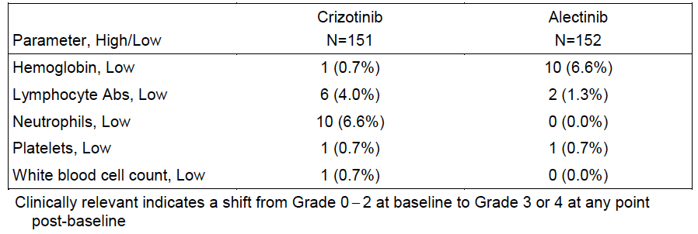

Clinical chemistry
A greater proportion of patients in the crizotinib arm experienced clinically relevant shifts in elevations in ALT (16% crizotinib versus 6% alectinib) and AST (11% versus 6%) compared with the alectinib arm.
Overall, few patients in either treatment arm experienced a clinically relevant shift (from Grade 0, 1 or 2 at baseline to Grade 3 or 4 post-baseline) in chemistry parameters during study treatment. In the alectinib treatment group an increase of bilirubin median values with an approximate doubling in comparison to baseline was observed and considered clinically significant, while no increase of bilirubin was observed in the crizotinib treatment arm.
Evaluator comment: The most common Grade ≥ 3 AEs in blood chemistry parameters were abnormalities in LFTs (for example, elevations in ALT, AST and bilirubin).

Coagulation
Clinically relevant shifts (from Grade 0, 1 or 2 at baseline to Grade 3 or 4 post-baseline) in coagulation parameters were rare, affecting 3 patients in both treatment arms.
Evaluator comment: Coagulopathies do not appear to be an issue with either crizotinib or alectinib, and no PI changes are required.

Urinalysis
Clinically relevant shifts in urinalysis parameters were rare in both treatment arms; 2 patients in each arm experienced a shift from Grade 0+/1+ to Grade 3+ in both arms.
Evaluator comment: Proteinuria does not appear to be an issue with either crizotinib or alectinib and no PI changes are required.

Testosterone serology
The CSR states, ‘While mean testosterone serum concentrations decreased by approximately 30% in patients on treatment with crizotinib, mean testosterone levels in the alectinib treatment arm showed to be largely stable.
At each time point, a greater proportion of patients in the crizotinib arm experienced abnormal decreases from normal (not low) levels of testosterone to low, compared with the alectinib arm; there were few incidences of shifts from normal, to high, in each arm, with no apparent trends seen. For concentrations of free testosterone changes from baseline were small with no clear trends in both treatment arms over time.’
Evaluator comment:
- Baseline samples were available in 56/64 and 58/68 males in the crizotinib and alectinib arms, respectively and these were determined using local laboratory reference ranges and assays. Therefore, while median values generally appear to decline in the crizotinib group (a reported adverse event with crizotinib), and also but to a lesser extent in the alectinib arm, the clinical relevance of this is uncertain without a universal standard reference range and the number of patients falling into a range that would be considered low for their age. No comment can be made on the effect of alectinib on testosterone levels based on this information.
- The evaluator could not follow the way in which the data in the tables from pages 1189-1193 for testosterone and free testosterone were presented, with apparently fluctuating numbers being assessed and potential for those affected to drop out of the analysis. No comment can be made.

Table 67: Clinically relevant shifts in chemistry parameters - Safety population
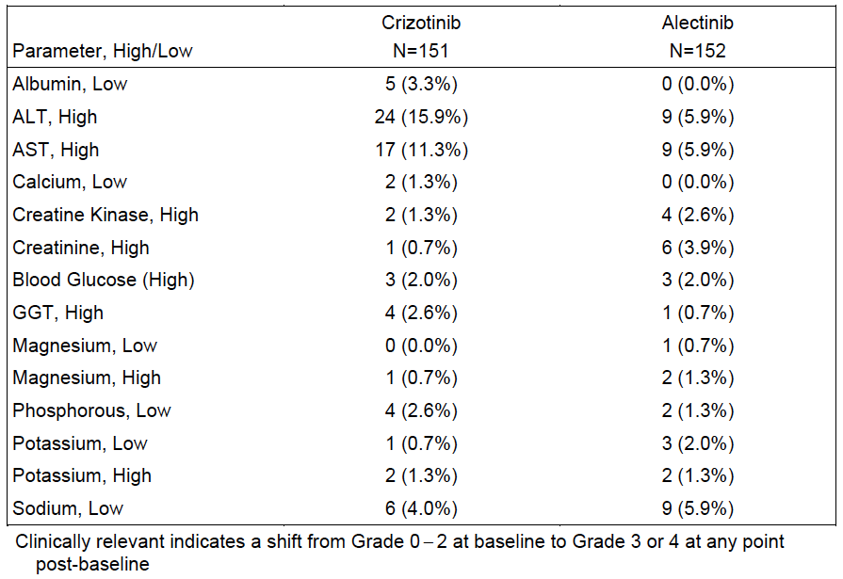

Vital signs and clinical examination findings

Blood pressure
Patients in both the alectinib and crizotinib arms experienced a mild decrease in SBP and DBP at each assessment, and the evaluator is in agreement that the median shifts appear unlikely to be clinically relevant.

ECOG performance status change
The CSR states, ‘A lower proportion of patients in the crizotinib arm (25%) compared with the alectinib arm (38%) experienced an improvement of their functional state with at least a 1 point decrease in ECOG PS; the majority of these patients experienced decreases from PS 1 at baseline to PS 0 (best value).
A greater proportion of patients in the crizotinib arm (25%) compared with the alectinib arm (19%) experienced a worsening of their functional state with at least a 1 point increase in ECOG PS; the majority of these patients experienced increases from PS 0 at baseline to PS 1 (worst value).’
Evaluator comment: The sponsor reported ECOG changes to be more favourable with alectinib, but this is complex as patients had shifts both up and down from their baseline status and limited conclusions can be drawn from this clinician-assessed endpoint. Note is made that the more relevant PRO data was compromised by insufficient investigator site training. No changes to the PI are based upon this, which is appropriate.

Immunogenicity and immunological events
None are anticipated and no data were provided.

Other safety issues

Safety in special populations
Discussed above.

Safety related to drug-drug interactions and other interactions
No data provided.

Post marketing experience
The CSR states, ‘As of 29 April 2017, the estimated cumulative market exposure to alectinib is 6275 patients (300 mg BID: Japan, n = 3831; 600 mg BID: US, n = 2238; European Economic Area, n = 47; Rest of World, n = 159) since its International Birth Date of 04 July 2014. The alectinib safety profile in the post-marketing period is consistent with safety data from clinical trials of alectinib.’
No PSUR was evaluated as part of this clinical evaluation report.

Evaluator’s overall conclusions on clinical safety
The safety profile of alectinib differs from, but overall, is more favourable than for crizotinib in the treatment of patients who have not received prior systemic therapy for advanced recurrent or metastatic ALK-positive NSCLC. Despite the shorter median duration of treatment with crizotinib of 10.7 months compared with 17.9 months, a greater proportion of patients in the crizotinib arm experienced treatment-related AEs (89% versus 77%), Grade 3 – 5 AEs (50% versus 41%). Adverse events that led to treatment discontinuation (13% versus 11%), dose interruption (25% versus 19%) or dose reduction (21% versus 16%) were higher in the crizotinib arm, but still significant in the alectinib arm.
New safety signals for alectinib include acute kidney injury and weight gain. For the former, the rate of adverse events was much higher than in the crizotinib arm (18% versus 9%) and included two fatal events. At this time, it is not clear if dose reduction or interruption is sufficient to manage the renal toxicity that appeared rapidly in some patients; recurrence with rechallenge was observed across all the clinical trials. Pre-existing risk factors for diminished renal reserve were present in those who developed acute kidney injury, and whether this is associated with a poorer outcome is not clear at this time. The evaluator considers that it is important that these questions be addressed, a new Precaution included in the PI for kidney injury including recommendations for management and acknowledgment of any uncertainties surrounding those recommendations. This needs to be examined prospectively as an adverse event of special interest in any future clinical trials, and consideration should be given to a dedicated trial of alectinib in patients with renal impairment or inclusion of a subgroup with baseline renal impairment or risk factors for diminished reserve, in future clinical trials, to understand this better. In the interim, diminished renal reserve as a risk for renal injury has been included a potential identified risk in the RMP.
Weight gain of greater than 10% was observed in fifteen patients and the mechanism for this is not clear. This is an unusual issue for patients with advanced NSCLC, where weight loss is often significant problem and being reported as an adverse event suggests it was problematic to the affected patients. Information regarding the nature of the weight gain (for example, any unusual fat distribution) was not collected and patients do not appear to have been weighed at each visit. It is recommended that data be collected to inform in future trials. As this was reported as an adverse event, information should be included in the PI and especially in the CMI.
Rates of hepatotoxicity (defined as Hepatocellular or cholestatic damage AEs and abnormal liver laboratory tests, as per the selected adverse events) were similar between the arms, and additional risks confirmed for alectinib in this study include drug-induced liver injury (and higher rates of hyperbilirubinaemia than seen with crizotinib).
Additional adverse events confirmed for alectinib and which occurred at a higher rate than in the crizotinib arm include anaemia, photosensitivity, severe myalgia and musculoskeletal pain and CPK rise. The following adverse events were also observed with alectinib, but at lower rates than for crizotinib: interstitial lung disease/pneumonitis (although at lower rates than reported in the J-ALEX study) and peripheral oedema.
A decrease from baseline heart rate was almost universal, and 5% of patients were reported as having bradycardia which was clinically significant, in a population where patients with symptomatic bradycardia were excluded, and dizziness was reported in patients on alectinib. The changes in QTcF >30msec in at least 20% of patients indicate a substantial proarrhythmic potential for alectinib, albeit at a lower level than crizotinib. Based on these findings, it would appear reasonable to require a baseline ECG prior to commencement in order to document any existing risk factors for cardiac risk, and to refer back to in the event of onset of a significant clinical problem. The safety of concomitant medications known to increase the QT interval in patients receiving alectinib is unlikely to have been adequately demonstrated in this clinical trial, as such medications were not permitted in any patients for 14 days prior to enrolment, and then allowed only for those in the alectinib arm.
Gastrointestinal toxicities occurred but at much lower rates than for crizotinib and visual toxicities do not appear to be a significant clinical issue for patients receiving alectinib.

First round benefit-risk assessment

First round assessment of benefit-risk balance
This trial randomised patients to receive either the current standard of care, crizotinib, or alectinib. Compared with crizotinib, alectinib improved progression-free survival, particularly delaying the development or progression of CNS metastases, which is a very significant problem for patients with this disease. CNS response rates were higher and the duration of observed responses was longer, and this appears to be one of the key factors in the observed improvement in progression-free survival. Non-CNS disease response rates were not statistically significantly different between the two treatments.
The safety of alectinib compares favourably with crizotinib, but there are specific toxicities that are noteworthy including the potential for severe, and sometimes fatal, events of renal failure which appear most common in those with limited renal reserve. Very unusually for patients with NSCLC, weight gain was observed and the reasons for this are not clear. Both of these events require inclusion in the CMI and PI to inform prescribers and patients. Lower rates of some adverse events such as ILD/pneumonitis were recorded in the ALEX Phase III study compared with the J-ALEX Phase III study conducted in Japanese patients only, which used a lower dose. The evaluator considers it important to retain this information rather than replace it as currently proposed by the sponsor.
The false negative rate of the Vysis FISH was significant in this trial with 24/39 patients (8% of the study population) who were IHC-positive/FISH-negative receiving clinical benefit from treatment with either alectinib or crizotinib. With the current algorithm for testing in Australia, a significant proportion of patients (at least 12.8% in this study, but that figure may have been higher given no Vysis FISH test outcomes were available in 61/303 patients) will not be deemed ALK-positive for access to targeted therapies including alectinib, crizotinib and ceritinib. Not only might such patients not be eligible for access to ALK inhibitors, and may and be directed down the chemotherapy or potentially a PD-1 inhibitor pathway, but may also be ineligible for future clinical trials where prior ALK inhibitor use is required and/or chemotherapy not permitted.
The Ventana ALK (D5F3) IHC assay is currently which is not consistent with its use in this trial (where it was used for treatment selection) or its recent approvals by the FDA as a companion diagnostic for ALK inhibitors.

First round recommendation regarding authorisation
Subject to satisfactory amendments being made to the PI, it is recommended that the sponsor’s proposed indication be approved.

Clinical questions
The questions were submitted to the sponsor during the course of the preparation of this report. Answers are incorporated in the relevant section of the report.

IVD
- The efficacy results are similar where Vysis FISH testing was completed but 39 tumour samples were positive by IHC and not by FISH and the results for these 39 patients have been requested. The sponsor is requested to state whether the Ventana IHC assay has been registered as a Class 3 IVD in Australia and is currently marketed, and whether it has been evaluated by the TGA. The sponsor is requested to discuss the use of sequential testing by ALK IHC and FISH, taking into account the results in this trial. Given FISH testing was performed on only 97/151 and 106/152 patients in the crizotinib and alectinib arms, respectively, randomisation has been broken and balance between the stratification factors, individual and disease characteristics is not assured. The sponsor is requested to present these for the FISH-tested subset of the ITT population.
- The sponsor is requested to state why the Vysis FISH analysis was not done in 28 patients, and what is meant by ‘unknown’ in a further 33 patients. The sponsor has presented a PFS analysis for the patient population in each arm who were deemed positive by both IHC and FISH but is requested to present the PFS and ORR for those 39 patients in each arm whose samples were positive by IHC and negative by FISH to determine if those negative by FISH responded to treatment with either ALK inhibitor.
- Given FISH testing was performed on only 97/151 and 106/152 patients in the crizotinib and alectinib arms, respectively, randomisation has been broken and balance between the stratification factors, individual and disease characteristics is not assured. The sponsor is requested to present these for the FISH-tested subset of the ITT population.

Efficacy
- The sponsor is requested to provide a list of the number of countries, and clinical sites in each country, involved in the ALEX trial.
- Patients with recent wounds from surgery or trauma were required to have had at least 28 days’ recovery time. This was not an exclusion study in the initial registration study and it is not known if this was also required for enrolment into the other Phase III study J-ALEX (the sponsor is requested to confirm this). The sponsor is requested to state what evidence exists to support this being an exclusion criteria (both clinical and nonclinical) and what led to its introduction into this Phase III study. This criterion is not currently included in the Clinical Trials section of the PI. This may need to be included if there is evidence to support an issue, such as with wound healing, and the PI and CMI should be updated accordingly.
- No breakdown for ECOG 0 versus 1 is provided – the sponsor is requested to provide this for each arm. The sponsor is requested to provide an assessment separately of PFS in each arm for the PFS status 0 and 1.
- 10.5% of patients in the alectinib arm and 6% in the crizotinib arm had a histological subtype other than adenocarcinoma (ADC), the most common ALK-rearranged subtype and the focus of the pathology literature on ALK-positive NSCLC. This higher proportion of patients with a subtype other than ADC in the alectinib arm, and differs from the histological subtypes, including the ‘ASCEND-4’ which also used the Ventana IHC to select patients, but where only 4% in the study overall had a histological subtype other than ADC; in the PROFILE 1014 study of first line crizotinib used the Vysis FISH assay. The effect of imbalances in the histological subtype is uncertain and the sponsor is requested to:
  - State how many of the non-ADC ALK-positive tumours in each arm by the Ventana IHC were confirmed as ALK-positive by the Vysis FISH test on the planned retrospective analysis. (Clinical Question)
  - Perform a sensitivity analysis on ORR and PFS for the non-ADC subtypes as a group in each arm.
- No information on the baseline disease burden including total numbers and sites of metastases could be located, other than this list of target lesions which is a subset of disease burden. The sponsor is requested to provide this.
- Currently the PI reports these patients to be ‘treatment-naïve’ in the Clinical Trials section of the PI, whereas they are better described as not having received systemic therapy for recurrent unresectable or metastatic disease. It is noted that neoadjuvant treatment was used in a small proportion and it is unclear if this was for disease unresectable at the time of treatment. The sponsor is requested to update the PI with a more specific definition, more closely reflective of the study population (Clinical Question)

Safety
- Have there been any instances of radiation recall, or increased radiation reactions in patients either currently taking or recently taken alectinib? Please discuss any such cases and if so, include this in, and amend the heading to include PI Precaution on Photosensitivity and Radiation Treatment/Recall as necessary.
- The sponsor is requested to provide summaries of the TEAEs, Treatment-related AEs, Deaths and SAEs, Deaths broken down by Asian/non-Asian race in the alectinib arm for ILD/pneumonitis, Renal function abnormality AEs and Hepatotoxicity including specifically, events of drug-induced liver injury.
- The sponsor should discuss further, the new signal of weight gain, and include the following information:
  - What were the genders of the patients involved?
  - Comment on the nature and distribution of the weight gain, such as whether it associated with an altered fat distribution in these 15 patients.
  - Was there a reported increase in appetite?
  - Is there a signal for weight gain in preclinical studies?
  - Provide, and discuss the role of, any concomitant medications or conditions (new or that developed) that these 15 patients were on that may have led to weight gain e.g. corticosteroids, thyroid dysfunction
  - Was this an adverse event in J-ALEX? Please present relevant data from that study for this adverse event.
- The sponsor is requested to detail what the abnormal ECG findings were in the 4% of the crizotinib arm and 5% in the alectinib arm, as there is no link provided to any data from which this statement was derived.
- The sponsor is requested to provide a summary of all AEs relating to abnormal renal function (as per the terms for selected abnormal renal function AE) for the J-ALEX study, including whether the events required dose reduction, delay or discontinuation. The sponsor should discuss whether dose interruption and/or reduction were a successful strategy for managing such AEs in both Phase II trials, ALEX and J-ALEX. Outcomes f AEs of abnormal renal function outcomes should be discussed following these treatment alterations as well as for rechallenge.
The PI entry from the J-ALEX Phase III study, included a 4.9% rate of treatment withdrawal for ILD, as outlined in the following PI statement: ‘In a Phase III clinical trial conducted in 103 Japanese patients with ALK-positive NSCLC treated with a dose of 300 mg twice daily, 8 patients in the Alecensa arm (7.8%) had an ILD event. Five patients (4.9%) treated with Alecensa had a Grade 3 ILD, leading to withdrawal from treatment.’ The rate was much lower in the ALEX study and the reasons for this should be discussed by the sponsor.
Therapeutic Goods Administration
PO Box 100 Woden ACT 2606 Australia
Email: info@tga.gov.au Phone: 1800 020 653 Fax: 02 6232 8605
https://www.tga.gov.au

Atezolizumab was approved for this indication in July 2017.

