PRODUCT INFORMATION

EYLEA®
aflibercept (rch)

NAME OF THE MEDICINE

Active ingredient: Aflibercept

Chemical names: Vascular endothelial growth factor receptor type VEGFR-1 (synthetic human immunoglobulin domain 2 fragment) fusion protein with vascular endothelial growth factor receptor type VEGFR-2 (synthetic human immunoglobulin domain 3 fragment) fusion protein with immunoglobulin G1 (synthetic Fc fragment), dimer des-432-lysine-[human vascular endothelial growth factor receptor 1-(103-204)-peptide (containing Ig-like C2-type 2 domain) fusion protein with human vascular endothelial growth factor receptor 2-(206-308)-peptide (containing Ig-like C2-type 3 domain fragment) fusion protein with human immunoglobulin G1-(227 C-terminal residues)-peptide (Fc fragment)], (211-211’:214-214’)-bisdisulfide dimer

CAS number: 862111-32-8

Molecular weight: 97 kDa (protein molecular weight)
115 kDa (total molecular weight)

Structure: The secondary and tertiary structures of aflibercept as well as the amino acid structure are shown in Figures 1 and 2.

Figure 1: Aflibercept secondary and tertiary structures

Figure 2: Aflibercept amino acid structure

DESCRIPTION

EYLEA is a sterile, clear, colourless to pale yellow, preservative-free, iso-osmotic aqueous 40 mg/mL solution for intravitreal injection.

Excipients: Polysorbate 20, sodium phosphate - monobasic monohydrate, sodium phosphate - dibasic, sodium chloride, sucrose, water for injections.

PHARMACOLOGY

Pharmacodynamic properties

Pharmacotherapeutic group: Ophthalmologicals / Antineovascularisation agents
ATC Code: S01LA05

Aflibercept is a recombinant fusion protein consisting of portions of human VEGF receptor 1 and 2 extracellular domains fused to the Fc portion of human IgG1. Aflibercept is produced in Chinese hamster ovary (CHO) K1 cells by recombinant DNA technology.

Mechanism of action

Vascular endothelial growth factor-A (VEGF-A) and placental growth factor (PlGF) are members of the VEGF family of angiogenic factors that can act as potent mitogenic, chemotactic, and vascular permeability factors for endothelial cells. VEGF acts via two receptor tyrosine kinases, VEGFR-1 and VEGFR-2, present on the surface of endothelial cells. PlGF binds only to VEGFR-1, which is also present on the surface of leukocytes. Excessive activation of these receptors by VEGF-A can result in pathological neovascularisation and excessive vascular permeability. PlGF can synergise with VEGF-A in these processes, and is also known to promote leukocyte infiltration and vascular inflammation. A variety of ocular diseases is associated with pathologic neovascularisation and vascular leakage, and/or can result in thickening and oedema of the retina, which is thought to contribute to vision loss.

Aflibercept acts as a soluble decoy receptor that binds VEGF-A and PlGF with higher affinity than their natural receptors, and thereby can inhibit the binding and activation of these cognate VEGF receptors. The equilibrium dissociation constant (K_{D}) for aflibercept binding to human VEGF-A₁₆₅ is 0.5 pM and to human VEGF-A₁₂₁ is 0.36 pM. The K_{D} for binding to human PlGF-2 is 39 pM.

Pharmacodynamic effects

Neovascular (wet) age-related macular degeneration (wet AMD)

Wet AMD is characterised by pathological choroidal neovascularisation (CNV). Leakage of blood and fluid from CNV may cause retinal oedema and/or sub-/intra-retinal haemorrhage, resulting in loss of visual acuity.

In patients treated with EYLEA (one injection per month for three consecutive months, followed by one injection every 2 months), retinal thickness decreased soon after treatment initiation, and the mean CNV lesion size was reduced, consistent with the results seen with ranibizumab 0.5 mg every month.

In pivotal phase III clinical studies, VIEW 1 and VIEW 2, there were mean decreases in retinal thickness on optical coherence tomography (OCT) at week 52: -130 and -129 microns for the EYLEA 2 mg every two months and ranibizumab 0.5 mg every month study groups, respectively, in VIEW 1; -149 and -139 microns for the EYLEA 2 mg every two months, and ranibizumab 0.5 mg every month study groups, respectively, in VIEW 2.

The reduction of CNV size and reduction in retinal thickness were generally maintained in the second year of the studies.

Macular oedema following central retinal vein occlusion (CRVO)

In CRVO, retinal ischaemia occurs and signals the release of VEGF which in turn destabilises the tight junctions and promotes endothelial cell proliferation. Up-regulation of VEGF is associated with the breakdown of the blood retina barrier and this increased vascular permeability results in retinal oedema, stimulation of endothelial cell growth and neovascularisation.

In patients treated with EYLEA (one injection every month for six months), there was consistent, rapid and robust response in morphology (central retinal thickness [CRT] as assessed by OCT). Improvements in mean CRT were maintained through week 24.

Retinal thickness on OCT at week 24 compared to baseline was a secondary efficacy endpoint in both the COPERNICUS and GALILEO studies. In both studies, the mean change in CRT from baseline to week 24 statistically significantly favoured EYLEA.

Table 1: Pharmacodynamic parameter at week 24, week 52 and week 76/100 (Full Analysis Set with LOCF) in COPERNICUS and GALILEO studies

Efficacy Outcomes | COPERNICUS |  |  |  |  |  | GALILEO
 | 24 Weeks |  | 52 Weeks |  | 100 Weeks |  | 24 Weeks |  | 52 Weeks |  | 76 Weeks
 | Control  (N = 73) | EYLEA  2 mg Q4  (N = 114) | Control ^{c)}  (N = 73) | EYLEA  2 mg  (N = 114) | Control ^{c, d)}  (N = 73) | EYLEA ^{d)}  2 mg  (N = 114) | Control  (N = 68) | EYLEA  2 mg Q4  (N = 103) | Control  (N = 68) | EYLEA  2 mg  (N = 103) | Control ^{e)}  (N = 68) | EYLEA ^{e)}  2 mg  (N = 103)
Mean change in retinal thickness from baseline | -145 | -457 | -382 | -413 | -343 | -390 | -169 | -449 | -219 | -424 | -306 | -389
Difference in LS mean ^{a,b,c)}  (95% CI) |  | -312  (-389, -234) |  | -28  (-121, 64) |  | -45  (-142, 53) |  | -239  (-286, -193) |  | -167  (-217, -118) |  | -44  (-99, 10)
p-value |  | p < 0.0001 |  | p = 0.5460 |  | p = 0.3661 |  | p < 0.0001 |  | p < 0.0001 |  | p = 0.1122
^{a)} Difference is EYLEA 2 mg Q4 minus control
^{b)} LS: Least square mean difference and confidence interval (CI) based on an ANCOVA model with baseline value as covariate and factors treatment group, region (America vs. rest of the world for COPERNICUS and Europe vs. Asia/Pacific for GALILEO) and baseline BCVA category (> 20/200 and ≤ 20/200)
^{c)} In COPERNICUS study, control group patients could receive EYLEA on an as-needed basis as frequently as every 4 weeks during week 24 to week 52; patients had visits every 4 weeks
^{d)} In COPERNICUS study, both control group and EYLEA 2 mg patients received EYLEA 2 mg on an as-needed basis as frequently as every 4 weeks starting from Week 52 to Week 96; patients had mandatory quarterly visits but may have been seen as frequently as every 4 weeks if necessary
^{e)} In GALILEO study, both control group and EYLEA 2 mg patients received EYLEA 2 mg on an as-needed basis every 8 weeks starting from Week 52 to Week 68; patients had mandatory visits every 8 weeks

Diabetic macular oedema (DME)

Diabetic macular oedema is characterised by increased vasopermeability and damage to the retinal capillaries which may result in loss of visual acuity.

In patients treated with EYLEA, rapid and robust response in morphology (central retinal thickness [CRT]) as assessed by OCT was seen soon after treatment initiation. The mean change in CRT from baseline to week 52 was statistically significant favouring EYLEA and was maintained through week 100.

Table 2: Pharmacodynamic parameter (Full Analysis Set with LOCF) in VIVID^{DME} study (at week 52) and VISTA^{DME} study (at week 52 and week 100)
Efficacy Outcomes | VIVID^{DME} |  |  | VISTA^{DME}
Efficacy Outcomes | 52 Weeks |  |  | 52 Weeks |  |  | 100 Weeks
Efficacy Outcomes | EYLEA  2 mg Q8 ª  (N = 135) | EYLEA  2 mg Q4  (N = 136) | Active Control  (laser)  (N = 132) | EYLEA  2 mg Q8 ª  (N = 151) | EYLEA  2 mg Q4  (N = 154) | Active Control  (laser)  (N = 154) | EYLEA  2 mg Q8 ª  (N = 151) | EYLEA  2 mg Q4  (N = 154) | Active Control  (laser)  (N = 154)
Mean change in CRT score from Baseline (SD) | -192.4  (149.89) | -195.0 (146.59) | -66.2  (138.99) | -183.1 (153.50) | -185.9 (150.68) | -73.3  (176.72) | -191.1 (160.66) | -191.4 (180.01) | -83.9  (179.29)
Difference in LS mean ^{a, b}  (97.5% CI)  p-value | -142.8  (-179.3,  -106.3)  p < 0.0001 | -157.0  (-190.9,  -123.1)  p < 0.0001 |  | -113.47  (-144.19,  -82.75)  p < 0.0001 | -110.78  (-141.34,  -80.22)  p < 0.0001 |  | -110.99  (-142.94,  -79.04)  p < 0.0001 | -104.89  (-139.58,  -70.21)  p < 0.0001
^{a)} LS mean and CI based on an ANCOVA model with baseline BCVA measurement as a covariate and a factor for treatment group. Additionally, region (Europe/Australia vs. Japan) had been included as factor for VIVID^{DME}, and history of MI and/or CVA as a factor for VISTA^{DME}).
^{b)} Difference is EYLEA group minus active control (laser) group

Pharmacokinetic properties

EYLEA is administered directly into the vitreous to exert local effects in the eye.

Absorption / Distribution

Aflibercept is slowly absorbed from the eye into the systemic circulation after intravitreal administration and is predominately observed in the systemic circulation as an inactive, stable complex with VEGF; however only free aflibercept is able to bind endogenous VEGF.

In a pharmacokinetic sub-study with frequent sampling in wet AMD patients, maximum plasma concentrations of free aflibercept (systemic C_{max}) were low, with a mean of approximately 0.02 µg/mL (range 0 to 0.054) within 1 to 3 days after 2 mg intravitreal injection, and were undetectable two weeks following dosage in almost all patients. Aflibercept does not accumulate in the plasma when administered intravitreally every 4 weeks.

The mean maximum plasma concentration of free aflibercept is approximately 50 to 500 times below the aflibercept concentration required to inhibit the biologic activity of systemic VEGF by 50% in animal models. It is estimated that after intravitreal administration of 2 mg to patients, the mean maximum plasma concentration of free aflibercept is more than 100-fold lower than the concentration of aflibercept required to half-maximally bind systemic VEGF. Therefore, systemic pharmacodynamic effects are unlikely.

The pharmacokinetics of aflibercept in patients with CRVO are similar to those in patients with wet AMD. Aflibercept is slowly absorbed into the systemic circulation following intravitreal injection in patients with CRVO. With dense pharmacokinetic sampling, following the first 2 mg intravitreal injection the geometric mean systemic C_{max} of free aflibercept was 0.046 μg/ml (range 0.024 to 0.081 μg/mL) and occurred at approximately 1 day (t_{max}) after administration. After reaching C_{max}, aflibercept concentrations decline rapidly to levels below the level of quantification at approximately 4 days after administration. No systemic accumulation of free aflibercept was observed following 2 mg intravitreal injections administered every 4 weeks in patients with CRVO.

These pharmacokinetic results were confirmed in a pharmacokinetic sub-study in patients with DME (mean C_{max} of free aflibercept in plasma 0.032 µg/mL (range: 0 to 0.076 µg/mL); undetectable concentrations reached within 1 week).

Elimination

As EYLEA is a protein-based therapeutic, no metabolism studies have been conducted.

Free aflibercept binds VEGF to form a stable, inert complex. As with other large proteins, both free and bound aflibercept are expected to be cleared by proteolytic catabolism.

Patients with renal impairment

No special studies in patients with renal impairment were conducted with EYLEA. Pharmacokinetic analysis of patients in the VIEW 2 study, of which 40% had renal impairment (24% mild, 15% moderate, and 1% severe), revealed no differences with respect to plasma concentrations of active drug after intravitreal administration every 4 or 8 weeks.

Similar results were seen in patients with CRVO in the GALILEO study.

Similar results were seen in patients with DME in the VIVID^{DME} study.

CLINICAL TRIALS

Neovascular (wet) age-related macular degeneration (wet AMD)

The safety and efficacy of EYLEA were assessed in two pivotal phase III randomised, multi-centre, double-masked, active-controlled studies in patients with wet AMD. A total of 2412 patients were treated and evaluable for efficacy (1817 with EYLEA) in the two studies (VIEW 1 and VIEW 2). In each study, patients were randomly assigned in a 1:1:1:1 ratio to 1 of 4 dosing regimens:

- EYLEA administered at 2 mg every 8 weeks following 3 initial monthly doses (EYLEA 2Q8)
- EYLEA administered at 2 mg every 4 weeks (EYLEA 2Q4)
- EYLEA administered at 0.5 mg every 4 weeks (EYLEA 0.5Q4)
- Ranibizumab administered at 0.5 mg every 4 weeks (Ranibizumab 0.5Q4)

Patient ages ranged from 49 to 99 years with a mean of 76 years. Approximately 89% (1616/1817) of the patients randomised to treatment with EYLEA were 65 years of age or older and approximately 63% (1139/1817) were 75 years of age or older.

In the follow-up exploratory phase of the studies (i.e. from week 52 onwards to week 96), patients continued to receive the dosage strength to which they were initially randomised but on a modified dosing schedule where injections were given as frequently as every 4 weeks, but no less frequently than every 12 weeks based upon pre-specified retreatment criteria guided by assessment of visual and/or anatomic outcomes. After the first year of the studies, 90% of patients originally treated with EYLEA 2Q8 received 6 doses or less and 72% received 4 doses or less among the patients completing the follow-up exploratory phase of the studies.

In both studies, the primary efficacy endpoint was the proportion of patients in the Per Protocol Set who maintained vision, defined as losing fewer than 15 letters of visual acuity at week 52 compared to baseline. The studies were intended to test for non-inferiority against ranibizumab 0.5 mg given every 4 weeks.

In the VIEW 1 study, at week 52, 95.1% of patients in the EYLEA 2Q8 treatment group maintained vision compared to 94.4% of patients in the ranibizumab 0.5Q4 group. EYLEA treatment was shown to be non-inferior to the ranibizumab 0.5Q4 group.

In the VIEW 2 study, at week 52, 95.6% of patients in the EYLEA 2Q8 treatment group maintained vision compared to 94.4% of patients in the ranibizumab 0.5Q4 group. EYLEA treatment was shown to be non-inferior to the ranibizumab 0.5Q4 group.

The VIEW 1 and VIEW 2 studies included four secondary efficacy endpoints: mean change in Best Corrected Visual Acuity (BCVA), proportion of patients who gained ≥15 letters, change in the total National Eye Institute Visual Function Questionnaire (NEI VFQ-25) score, and change in CNV area.

Detailed results from the combined analysis of both studies (primary* and secondary# endpoints) are shown in Table 3 and Figure 3 below.

Table 3: Efficacy outcomes at week 52 (primary analysis) and week 96; combined data from the VIEW 1 and VIEW 2 studies ^{(b)}
Efficacy outcome | EYLEA  2 mg Q4  (n = 613) |  | EYLEA  2 mg Q8 ^{(e)}  (n = 607) |  | Ranibizumab  0.5 mg Q4  (n = 595)
 | Week 52 | Week 96^{(h)} | Week 52 | Week 96^{(h)} | Week 52 | Week 96^{(h)}
Mean number of injections from baseline | 12.3 | 16.0 | 7.6 | 11.2 | 12.3 | 16.5
Mean number of injections during week 52 to week 96 | N/A | 4.1 | N/A | 4.2 | N/A | 4.7
Proportion of patients with maintained visual acuity (<15 letters of BCVA ^{(a)} loss) (Per Protocol Set) * | 95.35%^{(b)} | 92.17% | 95.33%^{(b)} | 92.42% | 94.42%^{(b)} | 91.60%
Difference ^{(c)}  (95% CI) ^{(d)} | 0.9%  (-1.7, 3.5)^{(f)} | 0.6%  (-2.5, 3.6)^{(f)} | 0.9%  (-1.7, 3.5)^{(f)} | 0.8%  (-2.3, 3.8)^{(f)} | N/A | N/A
Mean change in BCVA as measured by ETDRS ^{(a)} letter score from baseline # | 9.26 | 7.60 | 8.40 | 7.62 | 8.74 | 7.89
Difference in LS ^{(a)} mean (ETDRS letters) ^{(c)}  (95% CI) ^{(d)} | 0.60  (-0.94, 2.14) | -0.20  (-1.93, 1.53) | -0.32  (-1.87, 1.23) | -0.25  (-1.98, 1.49) | N/A | N/A
Proportion of patients who gained at least 15 letters of vision from baseline # | 33.44% | 31.16% | 30.97% | 33.44% | 32.44% | 31.60%
Difference ^{(c)}  (95% CI) ^{(d)} | 1.0%  (-4.3, 6.3) | -0.4%  (-5.6, 4.8) | -1.5%  (-6.8, 3.8) | 1.8%  (-3.5, 7.1) | N/A | N/A
Mean change in total score as measured by NEI VFQ-25 from baseline # | 5.60 | 5.03 | 5.00 | 5.31 | 5.56 | 5.24
Difference in LS ^{(a)} mean (NEI VFQ-25 score) ^{(c)}  (95% CI) ^{(d)} | -0.75  (-2.20, 0.71) | -0.99  (-2.56, 0.58) | -1.26  (-2.72, 0.20) | -0.61  (-2.19, 0.97) | N/A | N/A
Mean change in CNV area as measured by FA ^{(a)} from baseline # | -5.30 | -5.09 | -4.28 | -4.26 | -4.21 | -4.27
Difference in LS ^{(a)} mean (CNV area) ^{(g)}  (95% CI) ^{(d)} | -0.74  (-1.27, -0.21) | -0.45  (-1.01, 0.10) | 0.08  (-0.46, 0.61) | 0.11  (-4.4; 0.67) | N/A | N/A
(a) BCVA: Best Corrected Visual Acuity; ETDRS: Early Treatment Diabetic Retinopathy Study;
LS mean: least squares mean; FA: Fluorescein angiography
(b) Full Analysis Set (FAS), Last Observation Carried Forward (LOCF) for all analyses except proportion of patients with maintained visual acuity at week 52 which is Per Protocol Set (PPS)
(c) The difference is the value of the EYLEA group minus the value of the ranibizumab group.
A positive value favours EYLEA.
(d) Confidence Interval (CI) calculated by normal approximation
(e) After treatment initiation with three monthly doses
(f) A confidence interval lying entirely above -10% indicates a non-inferiority of EYLEA to ranibizumab
(g) The difference is the value of the EYLEA group minus the value of the ranibizumab group
(h) Beginning at week 52, all groups were treated using a modified quarterly treatment paradigm where patients could be dosed as frequently as every 4 weeks but not less frequently than every 12 weeks based upon pre-specified retreatment criteria
* Primary endpoint
# Secondary endpoint – see statistical comment below

Figure 3: Mean change in visual acuity from baseline to week 96*; combined data from the VIEW1 and VIEW2 studies
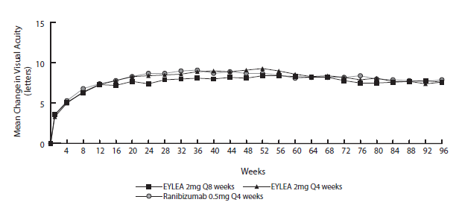
*) From Baseline to Week 52, EYLEA was dosed every 8 weeks following 3 initial monthly doses (EYLEA 2 mg Q8 weeks) or every 4 weeks (EYLEA 2 mg Q4 weeks). From Baseline to Week 52, ranibizumab 0.5 mg was dosed every 4 weeks (Ranibizumab 0.5 mg Q4 weeks). Beginning at Week 52, all groups were treated using a modified quarterly treatment paradigm where patients could be dosed as frequently as every 4 weeks but not less frequently than every 12 weeks based upon pre-specified retreatment criteria.

While there were small differences between EYLEA and ranibizumab, no clinically relevant differences were seen between the treatment groups across all four secondary efficacy endpoints, based on the confidence intervals for the differences between EYLEA and ranibizumab. All statistical tests on secondary efficacy endpoints were considered to be exploratory in the combined analysis of both studies. All secondary endpoint analyses supported the comparability of the efficacy of all 3 EYLEA treatment schedules and ranibizumab.

In combined data analysis of the VIEW 1 and VIEW 2 studies EYLEA demonstrated clinically meaningful changes from baseline in NEI VFQ-25 scores and subscales (near activities, distance activities, and vision-specific dependency). The magnitude of these changes was similar to that seen in published studies, which corresponded to a 15-letter gain in BCVA.

After the first year of the studies, efficacy was generally maintained through the last assessment at week 96. Over the 96 weeks period, patients in the EYLEA 2Q8 group received an average of 11.2 doses and patients in the ranibizumab group received an average of 16.5 doses.

Exploratory analyses of efficacy results in all evaluable subgroups (e.g. age, gender, race, baseline visual acuity, lesion type, lesion size) in each study and in the combined analysis were consistent with the results in the overall populations.

Macular oedema secondary to central retinal vein occlusion (CRVO)

The safety and efficacy of EYLEA were assessed in two randomised, multi-centre, double-masked, sham-controlled studies in patients with macular oedema secondary to CRVO. A total of 358 patients were treated and evaluable for efficacy (217 with EYLEA) in the two studies (COPERNICUS and GALILEO). In both studies, patients were randomly assigned in a 3:2 ratio to either 2 mg EYLEA administered every 4 weeks (2Q4) or the control group receiving sham injections every 4 weeks for a total of 6 injections.

After 6 monthly injections, patients received treatment only if they met pre-specified retreatment criteria, except for patients in the control group in the GALILEO study who continued to receive sham (control to control) until week 52. Starting from this time point, all patients were offered treatment if they met pre-specified criteria.

Patient ages ranged from 22 to 89 years with a mean of 64 years. Approximately 52% (112/217) of the patients randomised to treatment with EYLEA were 65 years of age or older and approximately 18% (38/217) were 75 years of age or older.

In both studies, the primary efficacy endpoint was the proportion of patients who gained at least 15 letters in BCVA at week 24 compared to baseline. The studies were designed to evaluate superiority against the control group (receiving sham injections).

Change in visual acuity at week 24 compared to baseline was an important secondary endpoint in both COPERNICUS and GALILEO studies.

The difference between treatment groups was statistically significant in favour of EYLEA in both studies, for the proportion of patients who gained at least 15 letters in BCVA and for mean change in visual acuity, at week 24 compared to baseline. In both pivotal studies, the maximal improvement in visual acuity was achieved at month 3 with subsequent stabilisation of the effect on visual acuity and central retinal thickness until month 6. The statistically significant difference was maintained through week 52. A difference was maintained through week 76/100.

Three other secondary endpoints were included in the studies: change in central retinal thickness (CRT), as assessed by OCT, at week 24 compared to baseline (see PHARMACOLOGY, Pharmacodynamic properties, Pharmacodynamic effects); proportion of patients progressing to neovascularisation (anterior segment neovascularisation, neovascularisation of the optic disk, or neovascularisation of the retina elsewhere) at week 24; and change in the NEI VFQ-25 total score at week 24 compared to baseline.

Detailed results from the analysis of both studies (primary* and secondary# endpoints) are shown in Table 1 (see PHARMACOLOGY), Table 4 and Figure 4 below.

Table 4: Efficacy outcomes at week 24, week 52 and week 76/100 (Full Analysis Set with LOCF^{c)}) in COPERNICUS and GALILEO studies

Efficacy Outcomes | COPERNICUS |  |  |  |  |  | GALILEO
 | 24 Weeks |  | 52 Weeks |  | 100 Weeks |  | 24 Weeks |  | 52 Weeks |  | 76 Weeks
 | Control  (N = 73) | EYLEA  2 mg Q4  (N = 114) | Control ^{e)}  (N = 73) | EYLEA  2 mg  (N = 114) | Control ^{e,f)}  (N = 73) | EYLEA ^{f)}  2 mg  (N = 114) | Control  (N = 68) | EYLEA  2 mg Q4  (N = 103) | Control  (N = 68) | EYLEA  2 mg  (N = 103) | Control ^{g)}  (N = 68) | EYLEA ^{g)}  2 mg  (N = 103)
Proportion of patients who gained at least 15 letters in BCVA^{c)} from baseline* | 12% | 56% | 30% | 55% | 23.3% | 49.1% | 22% | 60% | 32% | 60% | 29.4% | 57.3%
Weighted difference ^{a,b,e)}  (95% CI) |  | 44.8%  (33.0, 56.6) |  | 25.9%  (11.8, 40.1) |  | 26.7%  (13.1, 40.3) |  | 38.3%  (24.4, 52.1) |  | 27.9%  (13.0, 42.7) |  | 28.0%  (13.3, 42.6)
p-value |  | p < 0.0001 |  | p = 0.0006 |  | p=0.0003 |  | p < 0.0001 |  | p = 0.0004 |  | p=0.0004
Mean change in BCVA as measured by ETDRS ^{c)} letter score from baseline (SD)# | -4.0  (18.0) | 17.3  (12.8) | 3.8  (17.1) | 16.2  (17.4) | 1.5  (17.7) | 13.0  (17.7) | 3.3  (14.1) | 18.0  (12.2) | 3.8  (18.1) | 16.9  (14.8) | 6.2  (17.7) | 13.7  (17.8)
Difference in LS mean ^{a,c,d,e)}  (95% CI) |  | 21.7  (17.4, 26.0) |  | 12.7  (7.7, 17.7) |  | 11.8  (6.7, 17.0) |  | 14.7  (10.8, 18.7) |  | 13.2  (8.2, 18.2) |  | 7.6  (2.1, 13.1)
p-value |  | p < 0.0001 |  | p < 0.0001 |  | p < 0.0001 |  | p < 0.0001 |  | p < 0.0001 |  | p=0.0070
Proportion of patients who developed any neovascularization# | 6.8% | 0% | 6.8% | 0% | 11.0% | 5.3% | 4.4% | 2.9% | 8.8% | 5.8% | 8.8% | 7.8%
CHM adjusted  difference ^{a,c,d,e)}  (95% CI) |  | -6.8  (-12.4, -1.2) |  | -6.8  (-12.4, -1.2) |  | -5.4  (-13.7, 2.8) |  | -1.5  (-7.4, 4.4) |  | -2.5  (-10.8, 5.8) |  | -0.6  (-9.3, 8.1)
p-value |  | p=0.0059 |  | p=0.0059 |  | p=0.1810 |  | p=0.5947 |  | p=0.5185 |  | p=0.8887
LS mean change in total score as measured by NEI VFQ-25 ^{c)} from baseline# § | 2.5 | 8.8 | 6.9 | 9.3 | 3.6 | 6.3 | 0.3 | 4.5 | 1.7 | 5.3 | 1.1 | 4.0
Difference in LS mean ^{a,c,d,e)}  (95% CI) |  | 6.3  (2.6, 9.9) |  | 2.4  (-1.4, 6.2) |  | 2.7  (-2.0, 7.3) |  | 4.2  (1.7, 6.8) |  | 3.6  (1.1, 6.0) |  | 2.9  (0.1, 5.7)
p-value |  | p=0.0009 |  | p=0.2164 |  | p=0.2628 |  | p=0.0013 |  | p=0.0049 |  | p=0.0445
^{a)} Difference is EYLEA 2 mg Q4 weeks minus control
^{b)} Difference and confidence interval (CI) are calculated using Cochran-Mantel-Haenszel (CMH) test adjusted for region (America vs. rest of the world for COPERNICUS and Europe vs. Asia/Pacific for GALILEO) and baseline BCVA category (> 20/200 and ≤ 20/200)
^{c)} BCVA: Best Corrected Visual Acuity
ETDRS: Early Treatment Diabetic Retinopathy Study
LOCF: Last Observation Carried Forward
NEI VFQ-25: National Eye Institute Visual Function Questionnaire
LS: Least Square means derived from ANCOVA
SD: Standard Deviation
^{d)} LS mean difference and confidence interval based on an ANCOVA model with factors treatment group, region (America vs. rest of the world for COPERNICUS and Europe vs. Asia/Pacific for GALILEO) and baseline BCVA category (> 20/200 and ≤ 20/200)
^{e)} In COPERNICUS study, control group patients could receive EYLEA on an as-needed basis as frequently as every 4 weeks during week 24 to week 52; patients had visits every 4 weeks
^{f)} In COPERNICUS study, both control group and EYLEA 2 mg patients received EYLEA 2 mg on an as-needed basis as frequently as every 4 weeks starting from Week 52 to Week 96; patients had mandatory quarterly visits but may have been seen as frequently as every 4 weeks if necessary
^{g)} In GALILEO study, both control group and EYLEA 2 mg patients received EYLEA 2 mg on an as-needed basis every 8 weeks starting from Week 52 to Week 68; patients had mandatory visits every 8 weeks
* Primary endpoint
# Secondary endpoint
§ In GALILEO, n=65 in the control group and n=96 in the EYLEA group at week 24; n=67 in the control group and n=98 in the EYLEA group at week 52

Figure 4: Mean change from baseline to week 52 and week 76/100 in visual acuity# by treatment group for the COPERNICUS and GALILEO studies (Full Analysis Set)
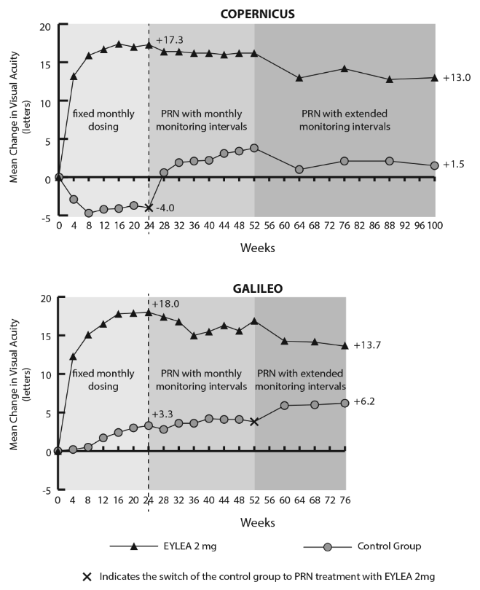

Exploratory analyses of efficacy results in all evaluable subgroups (e.g. age, gender, race, baseline visual acuity, retinal perfusion status, CRVO duration) in each study were in general consistent with the results in the overall populations.

Diabetic macular oedema (DME)

The safety and efficacy of EYLEA were assessed in two randomised, multi-centre, double-masked, active-controlled studies in patients with DME. A total of 862 randomised and treated patients were evaluable for efficacy. Of those, 576 were randomised to the EYLEA groups in two studies (VIVID^{DME} and VISTA^{DME}). In each study, patients were randomly assigned in a 1:1:1 ratio to 1 of 3 dosing regimens:

- EYLEA administered at 2 mg every 8 weeks following 5 initial monthly injections (EYLEA 2Q8);
- EYLEA administered at 2 mg every 4 weeks (EYLEA 2Q4); and
- macular laser photocoagulation (active control).

Beginning at week 24, patients meeting a pre-specified threshold of vision loss were eligible to receive additional treatment: patients in the EYLEA groups could receive laser and patients in the laser group could receive EYLEA.

Patient ages ranged from 23 to 87 years with a mean of 63 years. Approximately 47% (268/576) of the patients randomised to treatment with EYLEA were 65 years of age or older, and approximately 9% (52/576) were 75 years of age or older. Efficacy and safety outcomes were consistent with the outcomes of the overall population.

In both studies, the primary efficacy endpoint was the mean change from baseline in BCVA at Week 52 as measured by ETDRS letter score. Both EYLEA 2Q8 and EYLEA 2Q4 groups were shown to have efficacy that was statistically significantly superior to the laser control group. This benefit was maintained through week 100.

Detailed results from the analysis of the VIVID^{DME} and VISTA^{DME} studies are shown in Table 5 and Figure 5 below.

Table 5: Efficacy Outcomes (Full Analysis Set with LOCF) in VIVID^{DME} study (at week 52) and VISTA^{DME} study (at week 52 and week 100)
Efficacy Outcomes | VIVID^{DME} |  |  | VISTA^{DME}
Efficacy Outcomes | 52 Weeks |  |  | 52 Weeks |  |  | 100 Weeks
Efficacy Outcomes | EYLEA  2 mg Q8 ª  (N = 135) | EYLEA  2 mg Q4  (N = 136) | Active Control  (laser)  (N = 132) | EYLEA  2 mg Q8 ª  (N = 151) | EYLEA  2 mg Q4  (N = 154) | Active Control  (laser)  (N = 154) | EYLEA  2 mg Q8 ª  (N = 151) | EYLEA  2 mg Q4  (N = 154) | Active Control  (laser)  (N = 154)
Mean change in BCVA as measured by ETDRS ^{e} letter score from Baseline (SD) | 10.7  (9.32) | 10.5  (9.55) | 1.2  (10.65) | 10.7  (8.21) | 12.5  (9.54) | 0.2  (12.53) | 11.1  (10.70) | 11.5  (13.75) | 0.9  (13.94)
Difference in LS mean ^{b, c, e}  (97.5% CI)  p-value | 9.1  (6.3, 11.8)  p < 0.0001 | 9.3  (6.5, 12.0)  p < 0.0001 |  | 10.45  (7.73, 13.17)  p < 0.0001 | 12.19  (9.35, 15.04)  p < 0.0001 |  | 10.14  (6,96, 13.32)  p < 0.0001 | 10.64  (7.09, 14.18)  p < 0.0001
Proportion of patients who gained at least 10 letters in BCVA ^{e} from Baseline | 53.3% | 54.4% | 25.8% | 58.3% | 64.9% | 19.5% | 59.6% | 63.6% | 27.9%
Adjusted Difference ^{c, d, e}  (97.5% CI)  p-value | 27.5  (14.6, 40.5)  p < 0.0001 | 28.7  (15.8, 41.6)  p < 0.0001 |  | 38.8  (27.2, 50.3)  p < 0.0001 | 45.9  (34.7, 57.0)  p < 0.0001 |  | 31.6  (19.5, 43.7)  p < 0.0001 | 36.2  (24.3, 48.1)  p < 0.0001
Proportion of patients who gained at least 15 letters in BCVA ^{e} from Baseline | 33.3% | 32.4% | 9.1% | 31.1% | 41.6% | 7.8% | 33.1 | 38.3 | 13.0
Adjusted Difference ^{c, d, e}  (97.5% CI)  p-value | 24.2%  (13.5, 34.9)  p < 0.0001 | 23.3%  (12.6, 33.9)  p < 0.0001 |  | 23.3%  (13.5, 33.1)  p < 0.0001 | 34.2%  (24.1, 44.4)  p < 0.0001 |  | 20.1  (9.6, 30.6)  p < 0.0001 | 25.8  (15.1, 36.6)  p < 0.0001
Proportion of patients with an improvement of >= 2 steps on the ETDRS DRSS ^{e, f} from Baseline | 27.7% | 33.3% | 7.5% | 29.1% | 33.8% | 14.3% | 37.1% | 37.0% | 15.6%
Adjusted Difference ^{c, d}  (97.5% CI)  p-value | 19.3  (6.6, 32.1)  p = 0.0006 | 25.8  (12.2, 39.4)  p < 0.0001 |  | 14.9  (4.4, 25.4)  p = 0.0017 | 19.7  (9.0, 30.4)  p < 0.0001 |  | 21.5  (10.4, 32.5)  p = 0.0001 | 21.7  (10.8, 32.6)  p < 0.0001
See Table 2 for Mean Change in CRT from Baseline
Mean change in  NEI VFQ-25 e near activities subscale from Baseline | 5.29  (19.058) | 5.73  (18.932) | 3.54  (16.768) | 9.4  (18.50) | 9.0  (20.60) | 5.4  (20.44) | 12.8  (21.36) | 10.9  (23.12) | 8.1  (22.10)
Difference in LS mean ^{b, c, e}  (97.5% CI)  p-value | -1.21  (-5.79, 3.37)  p = 0.5537 | 2.41  (-2.01, 6.82)  p = 0.2208 |  | 4.36  (-0.21, 8.93)  p = 0.0323 | 5.19  (0.33, 10.04)  p = 0.0168 |  | 5.05  (0.12, 9.98)  p = 0.0218 | 4.59  (-0.73, 9.90)  p = 0.0529
Mean change in  NEI VFQ-25 ^{e} distance activities subscale from Baseline | 5.32  (18.475) | 0.94  (16.487) | 2.26  (15.923) | 7.3  (19.32) | 8.6  (20.99) | 6.7  (19.85) | 8.5  (20.35) | 10.9  (22.05) | 6.1  (20.42)
Difference in LS mean ^{b, c, e}  (97.5% CI)  p-value | -0.37  (-4.79, 4.05)  p = 0.8498 | -1.19  (-5.29, 2.91)  p = 0.5138 |  | 1.65  (-2.83, 6.13)  p = 0.4067 | 2.86  (-1.82, 7.54)  p = 0.1702 |  | 3.57  (-0.96, 8.11)  p = 0.0772 | 5.80  (0.97, 10.64)  p = 0.0072
ª After treatment initiation with 5 monthly injections
^{b} LS mean and CI based on an ANCOVA model with baseline BCVA measurement as a covariate and a factor for treatment group. Additionally, region (Europe/Australia vs. Japan) had been included as a factor for VIVID^{DME}, and history of MI and/or CVA as a factor for VISTA^{DME}.
^{c} Difference is EYLEA group minus active control (laser) group
^{d} Difference with confidence interval (CI) and statistical test is calculated using Mantel-Haenszel weighting scheme adjusted by region (Europe/Australia vs. Japan) for VIVID^{DME} and medical history of MI or CVA for VISTA^{DME}
^{e} BCVA: Best Corrected Visual Acuity
ETDRS: Early Treatment Diabetic Retinopathy Study
LOCF: Last Observation Carried Forward
SD: Standard deviation
LS: Least square means derived from ANCOVA
DRSS: Diabetic Retinopathy Severity Scale
CI: Confidence interval
NEI VFQ-25: National Eye Institute Visual Function Questionnaire
^{f} VIVID^{DME} based on the patients with gradable images at baseline and post-baseline: N = 83 (EYLEA 2 mg Q8), N = 81 (EYLEA 2 mg Q4), N = 80 (laser)

Figure 5: Mean change in BCVA as Measured ETDRS Letter Score from Baseline to Week 52 in VIVID^{DME} Study and to Week 100 in VISTA^{DME} Study

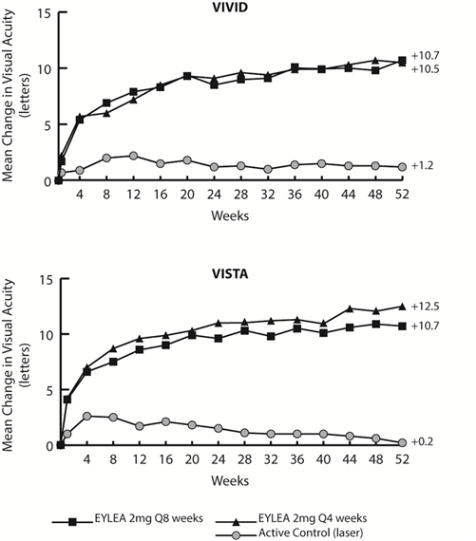

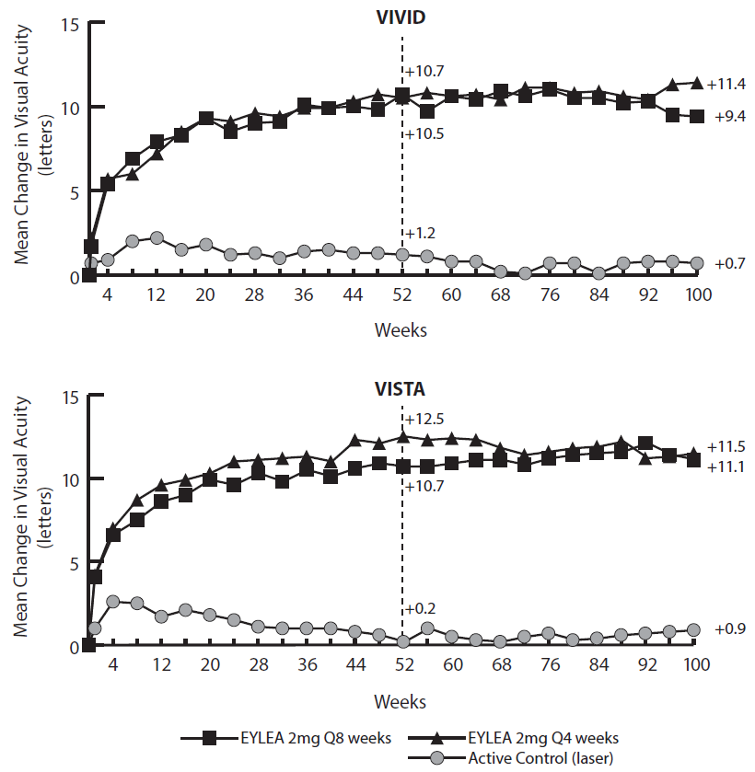

At week 52, 33.3% and 33.8% of 2Q4 patients, 27.7% and 29.1% of 2Q8 patients, and 7.5% and 14.3% of laser control patients in the VIVID^{DME} and VISTA^{DME} studies, respectively experienced an improvement in the severity of diabetic retinopathy, as measured by a ≥ 2 step improvement in the diabetic retinopathy severity scale (DRSS). This improvement was maintained through week 100 (see Table 5).

Treatment effects in evaluable subgroups (e.g., age, gender, race, baseline HbA1c, baseline visual acuity, prior anti-VEGF therapy) in each study and in the combined analysis were generally consistent with the results in the overall populations.

In the VIVID^{DME} and VISTA^{DME} studies, 36 (8.9%) and 197 (42.9%) patients received prior anti-VEGF therapy, respectively, with a 3-month or longer washout period. Treatment effects in the subgroup of patients who had previously been treated with a VEGF inhibitor prior to study participation were similar to those seen in patients who were VEGF inhibitor naïve prior to study participation.

Patients with bilateral disease were eligible to receive anti-VEGF treatment in their fellow eye. In the VISTA^{DME} study, 217 (70.7%) of EYLEA patients received bilateral EYLEA injections until week 100; in the VIVID^{DME} study, 70 (26%) of EYLEA patients received a different anti-VEGF treatment in their fellow eye until week 52.

INDICATIONS

EYLEA (aflibercept) is indicated in adults for the treatment of:
- neovascular (wet) age-related macular degeneration (wet AMD)
- visual impairment due to macular oedema secondary to central retinal vein occlusion (CRVO)
- diabetic macular oedema (DME).

CONTRAINDICATIONS

- Known hypersensitivity to aflibercept or to any of the excipients
- Ocular or periocular infection
- Active severe intraocular inflammation.

PRECAUTIONS

Endophthalmitis

Intravitreal injections, including those with EYLEA, have been associated with endophthalmitis (see ADVERSE EFFECTS). Proper aseptic injection technique must always be used when administering EYLEA. Patients should be instructed to report any symptoms suggestive of endophthalmitis without delay and should be managed appropriately.

Increase in intraocular pressure

Increases in intraocular pressure have been seen within 60 minutes of an intravitreal injection, including with EYLEA (see ADVERSE EFFECTS). Special precaution is needed in patients with poorly controlled glaucoma. In all cases both the intraocular pressure and the perfusion of the optic nerve head must therefore be monitored and managed appropriately.

Immunogenicity

As this is a therapeutic protein, there is a potential for immunogenicity. Patients should be instructed to report any signs or symptoms of intraocular inflammation, e.g. pain, photophobia, or redness, which may be a clinical sign attributable to hypersensitivity.

Arterial thromboembolic events

There is a potential risk of arterial thromboembolic events (ATEs) following intravitreal use of VEGF inhibitors (see ADVERSE EFFECTS). ATEs include vascular death (e.g., due to stroke or myocardial infarction), non-fatal strokes and non-fatal myocardial infarction.

The risk of stroke may be greater in patients with known risk factors including a history of stroke or transient ischaemic attack (TIA). Patients should be carefully evaluated by their doctor to assess whether the benefits of treatment outweigh the potential risks.

Other

The safety and efficacy of EYLEA therapy administered to both eyes concurrently have not been systematically studied (see CLINICAL TRIALS). As with other intravitreal injections, if bilateral treatment is performed at the same time this could lead to an increased systemic exposure, which could increase the risk of systemic adverse events.

Risk factors associated with the development of a retinal pigment epithelial tear after anti-VEGF therapy for wet AMD, include a large and/or high pigment epithelial retinal detachment. When initiating anti-VEGF therapy, caution should be used in patients with these risk factors for retinal pigment epithelial tears.

Treatment should be withheld in patients with rhegmatogenous retinal detachment or stage 3 or 4 macular holes.

In the event of a retinal break the dose should be withheld and treatment should not be resumed until the break is adequately repaired.

In the event of either a decrease in best-corrected visual acuity (BCVA) of ≥30 letters compared with the last assessment of visual acuity; or a subretinal haemorrhage involving the centre of the fovea or if the size of the haemorrhage is ≥50% of the total lesion area, the dose should be withheld and treatment should not be resumed earlier than the next scheduled treatment.

The dose should be withheld in the event of performed or planned intraocular surgery within the previous or next 28 days.

In patients presenting with clinical signs of irreversible ischaemic visual function loss, the treatment is not recommended.

Populations with limited data
- Diabetic macular oedema due to type 1 diabetes
- Diabetic patients with HbA1c > 12%
- Proliferative diabetic retinopathy
- Active systemic infections
- Concurrent eye conditions (e.g., retinal detachment, macular hole)
- Uncontrolled hypertension

Effects on fertility

Effects on male and female fertility were assessed as part of a 6-month study in monkeys with intravenous administration of aflibercept at doses ranging from 3 to 30 mg/kg every one to two weeks. Absent or irregular menses associated with alterations in female reproductive hormone levels and changes in sperm morphology and motility (considered consequential to male fertility) were observed at all dose levels. Based on C_{max} and AUC for free aflibercept observed at the 3 mg/kg intravenous dose, the systemic exposures were approximately 4900-fold and 1500-fold higher, respectively, than the exposure observed in humans after an intravitreal dose of 2 mg. All changes were reversible.

Use in pregnancy (Category D)

There are no data on the use of aflibercept in pregnant women. Studies in animals have shown reproductive toxicity, including a series of external, visceral, skeletal malformations, after systemic administration. EYLEA should not be used during pregnancy unless the potential benefit outweighs the potential risk to the fetus. Women of childbearing potential have to use effective contraception during treatment and for at least 3 months after the last intravitreal injection of aflibercept.

Aflibercept produced malformations and other fetal abnormalities in pregnant rabbits with intravenous administration (at 3 to 60 mg/kg once every 3 days during the period of organogenesis) and with subcutaneous administration (0.1 to 1 mg/kg on gestational days 1, 7, and 13). A No Observed Effect Level (NOEL) for adverse effects on embryo-fetal development was not established. At the lowest dose tested (0.1 mg/kg), the systemic exposures based on C_{max} and cumulative AUC for free aflibercept were approximately 13- and 10-fold higher, respectively, when compared to corresponding values observed in humans after an intravitreal dose of 2 mg.

Use in lactation

It is unknown whether aflibercept is excreted in human milk. A risk to the breast-fed child cannot be excluded. EYLEA is not recommended during breast-feeding. A decision must be made whether to discontinue breast-feeding or to abstain from EYLEA therapy.

Paediatric use

The safety and efficacy of EYLEA have not been studied in children or adolescents.

Use in the elderly

No special considerations are needed. There is limited experience in patients older than 75 years with DME (see CLINICAL TRIALS).

Genotoxicity

No studies have been conducted on the mutagenic or clastogenic potential of aflibercept. As a large protein molecule, aflibercept is not expected to interact directly with DNA or other chromosomal material.

Carcinogenicity

No studies have been conducted on the carcinogenic potential of aflibercept.

Effects on ability to drive or use machines

Patients may experience temporary visual disturbances after an intravitreal injection with EYLEA and the associated eye examinations. They should not drive or use machinery until visual function has recovered sufficiently.

INTERACTIONS WITH OTHER MEDICINES

No formal drug interaction studies have been performed with EYLEA.

ADVERSE EFFECTS

Summary of the safety profile

A total of 2890 patients treated with EYLEA constituted the safety population in seven Phase III studies. Amongst those, 2289 patients were treated with the recommended dose of 2 mg.

Serious adverse reactions related to the injection procedure have occurred in less than 1 in 2600 intravitreal injections with EYLEA and included cataract, retinal detachment, vitreous detachment, endophthalmitis, and increased intraocular pressure (see PRECAUTIONS).

The most frequently observed adverse reactions (in at least 5% of patients treated with EYLEA) were conjunctival haemorrhage (24.7%), eye pain (10.1%), intraocular pressure increased (7.1%), vitreous detachment (6.8%), vitreous floaters (6.7%) and cataract (6.6%).

In wet AMD, these adverse reactions occurred with a similar incidence in the ranibizumab treatment group.

Tabulated list of adverse reactions

The safety data described below include all adverse reactions (serious and non-serious) from seven Phase III studies with a reasonable possibility of causality to the injection procedure or medicinal product over the 96 weeks study duration for wet AMD, over 100 weeks for CRVO and over 100 weeks for DME.

The adverse reactions are listed by system organ class and frequency using the following convention: very common (≥1/10), common (≥1/100 to <1/10), uncommon (≥1/1,000 to <1/100), rare (≥ 1/10,000 to < 1/1,000 patients). Within each frequency grouping, adverse drug reactions are presented in order of decreasing seriousness.

Table 6: All treatment-emergent adverse reactions reported in patients in Phase III studies

System Organ Class | Very common  (≥1/10) | Common  (≥1/100 to <1/10) | Uncommon  (≥1/1,000 to <1/100) | Rare  (≥ 1/10,000 to < 1/1,000)
Immune system disorders |  |  | Hypersensitivity***
Eye disorders | Conjunctival haemorrhage,  Visual acuity reduced,  Eye pain | Retinal pigment epithelial tear*,  Detachment of the retinal pigment epithelium,  Retinal degeneration,  Vitreous haemorrhage,  Cataract,  Cataract nuclear,  Cataract subcapsular,  Cataract cortical,  Corneal erosion,  Corneal abrasion,  Intraocular pressure increased,  Vision blurred,  Vitreous floaters,  Corneal oedema,  Vitreous detachment,  Injection site pain,  Foreign body sensation in eyes,  Lacrimation increased,  Eyelid oedema,  Injection site haemorrhage,  Punctate keratitis,  Conjunctival hyperaemia  Ocular hyperaemia | Blindness, Endophthalmitis**,  Retinal detachment,  Retinal tear,  Iritis,  Uveitis,  Iridocyclitis,  Lenticular opacities,  Corneal epithelium defect,  Injection site irritation,  Abnormal sensation in eye,  Eyelid irritation,  Anterior chamber flare | Vitritis,  Hypopyon
* Conditions known to be associated with wet AMD. Observed in the wet AMD studies only.
** Culture positive and culture negative endophthalmitis
*** including allergic reactions

Description of selected adverse reactions

In the wet AMD phase III studies, there was an increased incidence of conjunctival haemorrhage in patients receiving anti-thrombotic agents. This increased incidence was comparable between patients treated with ranibizumab and EYLEA.

Arterial thromboembolic events (ATEs) are adverse events potentially related to systemic VEGF inhibition. There is a theoretical risk of arterial thromboembolic events following intravitreal use of VEGF inhibitors.

ATEs, as defined by Antiplatelet Trialists' Collaboration (APTC) criteria, include nonfatal myocardial infarction, nonfatal stroke, or vascular death (including deaths of unknown cause). The incidence of adjudicated APTC ATEs in the VIEW 1 and VIEW 2 wet AMD studies during the 96 weeks study period was 3.3% (60 out of 1824) in the combined group of patients treated with EYLEA (2.4% in the EYLEA 2Q4 arm and 3.6% in the EYLEA 2Q8 arm), compared to 3.2% (19 out of 595) in patients treated with ranibizumab.

The incidence of adjudicated APTC ATEs in the CRVO studies (GALILEO and COPERNICUS) during the 76/100 weeks study duration was 0.6% (2 out of 317) in patients treated with at least one dose of EYLEA compared to 1.4% (2 out of 142) in the group of patients receiving only sham treatment.

The incidence of adjudicated APTC ATEs in the DME studies (VIVID^{DME} and VISTA^{DME}) during the 100 weeks study duration was 6.4% (37 out of 578) in the combined group of patients treated with EYLEA compared with 4.2% (12 out of 287) in the control group.

As with all therapeutic proteins, there is a potential for immunogenicity with EYLEA.

DOSAGE AND ADMINISTRATION

EYLEA is for intravitreal injection only.

It must only be administered by a qualified ophthalmologist experienced in administering intravitreal injections.

Dosage regimen

The recommended dose for EYLEA is 2 mg aflibercept, equivalent to an injection volume of 50 μL. The interval between doses injected into the same eye should not be shorter than one month.

Advice on treatment initiation and maintenance of therapy specific to each patient population is described in the section below. Once optimal visual acuity is achieved and/or there are no signs of disease activity, treatment may then be continued with a treat-and-extend regimen with gradually increased treatment intervals to maintain stable visual and/or anatomic outcomes. If disease activity persists or recurs, the treatment interval may be shortened accordingly. Monitoring should be done at injection visits. There is limited information on the optimal dosing interval and monitoring interval especially for long-term (e.g. > 12 months) treatment. The monitoring and treatment schedule should be determined by the treating ophthalmologist based on the individual patient’s response. If visual and anatomic outcomes indicate that the patient is not benefiting from continued treatment, EYLEA should be discontinued.

Treatment of neovascular (wet) age-related macular degeneration (wet AMD)

EYLEA treatment is initiated with one injection per month for three consecutive months, followed by one injection every two months. Long term, it is recommended that patients continue to be treated with EYLEA every two months.

Generally, once optimal visual acuity is achieved and/or there are no signs of disease activity, the treatment interval may be adjusted based on visual and/or anatomic outcomes.

The dosing interval can be extended up to every three months (see CLINICAL TRIALS for dosing experience).

Treatment of visual impairment due to macular oedema secondary to central retinal vein occlusion (CRVO)

EYLEA treatment is initiated with one injection per month for three consecutive months. After the first three monthly injections, the treatment interval may be adjusted based on visual and/or anatomic outcomes.

Treatment of diabetic macular oedema (DME)

EYLEA treatment is initiated with one injection per month for five consecutive months, followed by one injection every two months. After the first 12 months, the treatment interval may be adjusted based on visual and/or anatomic outcomes.

Special populations

Patients with hepatic and/or renal impairment

No specific studies in patients with hepatic and/or renal impairment were conducted with EYLEA. Available data do not suggest a need for a dose adjustment with EYLEA in these patients (see Pharmacokinetic properties).

Method of administration

Intravitreal injections must be carried out according to medical standards and applicable guidelines by a qualified ophthalmologist experienced in administering intravitreal injections. In general, adequate anaesthesia and asepsis, including topical broad spectrum microbicide, have to be ensured. Surgical hand disinfection, sterile gloves, a sterile drape, and a sterile eyelid speculum (or equivalent) are recommended.

Immediately following the intravitreal injection, patients should be monitored for elevation in intraocular pressure. Appropriate monitoring may consist of a check for perfusion of the optic nerve head or tonometry. If required, sterile equipment for paracentesis should be available.

Following intravitreal injection patients should be instructed to report any symptoms suggestive of endophthalmitis (e.g. eye pain, redness of the eye, photophobia, blurring of vision) without delay.

Each pre-filled syringe or vial should only be used for the treatment of a single eye.

The pre-filled syringe and the glass vial contain more than the recommended dose of 2 mg. The excess volume should be expelled before injecting. Injecting the entire volume of the glass vial or the pre-filled syringe could result in overdose.

After injection any unused product must be discarded.

Instructions for use / handling

The pre-filled syringe and the vial are for single use only.

Prior to administration visually inspect the solution for injection. Do not use the vial or pre-filled syringe if particulates, cloudiness, or discolouration are visible.

Prior to usage, the EYLEA unopened vial or pre-filled syringe blister pack may be stored at room temperature (25°C) for up to 24 hours. After opening the vial or blister pack, proceed under aseptic conditions.

For the intravitreal injection a 30 G x ½ inch injection needle should be used.

Pre-filled syringe

1. | When ready to administer EYLEA, open the carton and remove the sterilised blister pack. Carefully peel open the blister pack ensuring the sterility of its contents. Keep the syringe in the sterile tray until you are ready for assembly.
2. | Using aseptic technique, remove the syringe from the sterilised blister pack.
3. | To remove the syringe cap, hold the syringe in one hand while using your other hand to grasp the syringe cap with the thumb and forefinger. Please note: Snap off (do not turn or twist) the syringe cap.
4. | To avoid compromising the sterility of the product, do not pull back on the plunger.
5. | Using aseptic technique, firmly twist the injection needle onto the Luer-lock syringe tip.
6. | Remove the plastic needle shield.
7. | Holding the syringe with the needle pointing up, check the syringe for bubbles. If there are bubbles, gently tap the syringe with your finger until the bubbles rise to the top.
8. | To eliminate all bubbles and to expel excess drug, slowly depress the plunger to align the cylindrical base of the dome plunger with the black dosing line on the syringe (equivalent to 50 µL). | 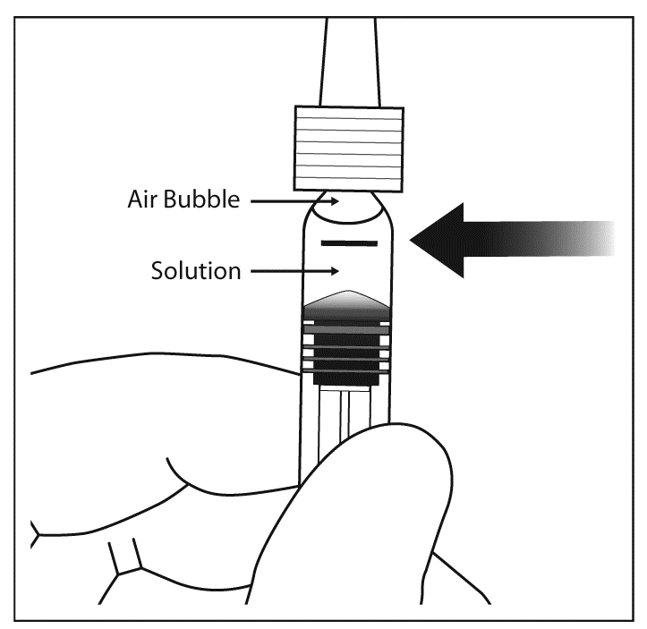

Vial

1. | Remove the plastic cap and disinfect the outer part of the rubber stopper of the vial.
2. | Attach the 18 G, 5-micron filter needle supplied in the carton to a 1 mL sterile, Luer-lock syringe.
3. | Push the filter needle into the centre of the vial stopper until the needle is completely inserted into the vial and the tip touches the bottom or bottom edge of the vial.
4. | Using aseptic technique withdraw all of the EYLEA vial contents into the syringe, keeping the vial in an upright position, slightly inclined to ease complete withdrawal. To deter the introduction of air, ensure the bevel of the filter needle is submerged into the liquid. Continue to tilt the vial during withdrawal keeping the bevel of the filter needle submerged in the liquid. | 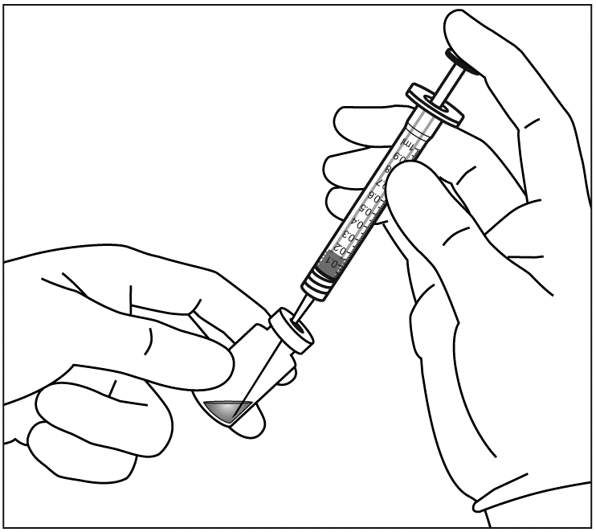  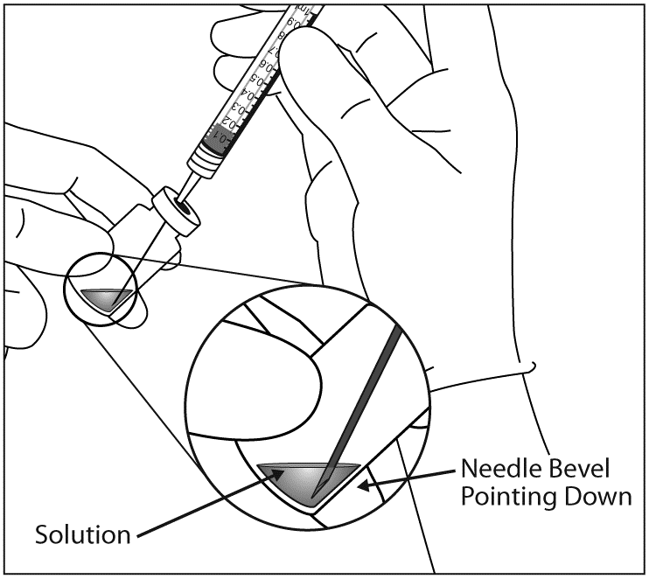
5. | Ensure that the plunger rod is drawn sufficiently back when emptying the vial in order to completely empty the filter needle.
6. | Remove the filter needle and properly dispose of it. Note: Filter needle is not to be used for intravitreal injection.
7. | Using aseptic technique, firmly twist a 30 G x ½ inch injection needle to the Luer-lock syringe tip.
8. | When ready to administer EYLEA, remove the plastic needle shield.
9. | Holding the syringe with the needle pointing up, check the syringe for bubbles. If there are bubbles, gently tap the syringe with your finger until the bubbles rise to the top.
10. | Eliminate all bubbles and expel excess drug by slowly depressing the plunger so that the plunger tip aligns with the line that marks 0.05 mL (equivalent to 50 µL) on the syringe. | 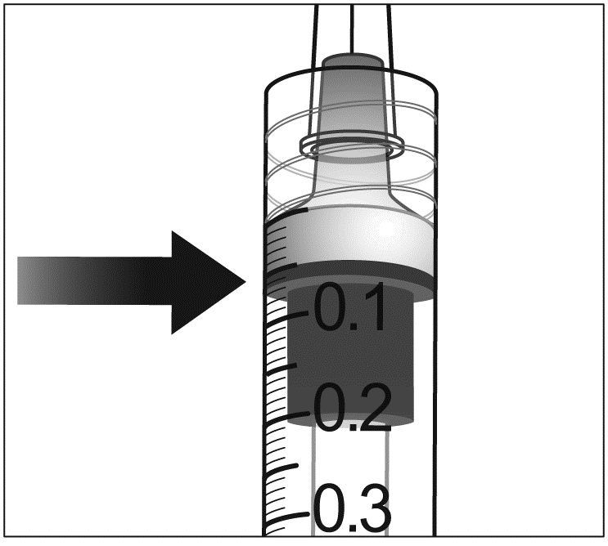  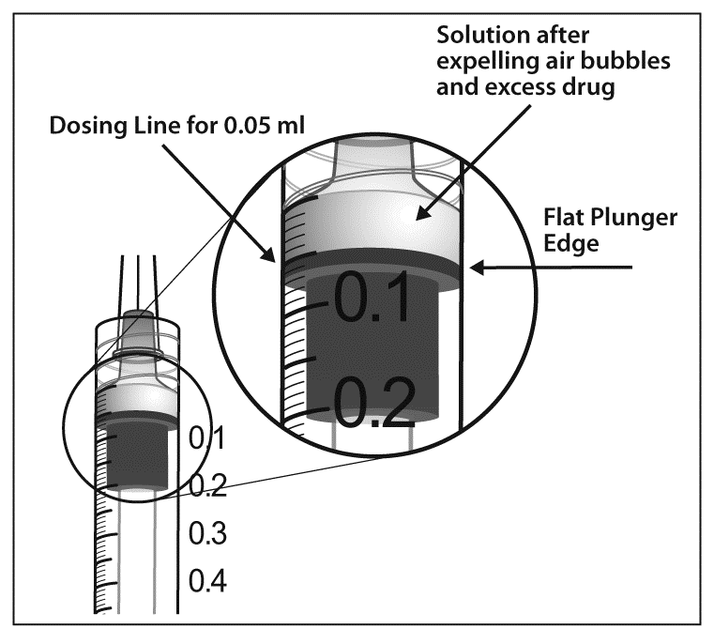

Incompatibilities

EYLEA must not be mixed with other medicinal products.

OVERDOSAGE

In clinical trials doses of up to 4 mg in monthly intervals and isolated cases of overdoses with 8 mg were generally well tolerated. Overdosing was associated with increased injection volume and subsequently with increased intraocular pressure. Therefore, in case of overdosage intraocular pressure should be monitored and if deemed necessary by the treating physician, adequate treatment should be initiated. It is advisable to contact the Poisons Information Centre (131126) for recommendations on the management and treatment of overdose.

PRESENTATION AND STORAGE CONDITIONS

Presentation

EYLEA is a sterile, clear, colourless to pale yellow, preservative-free, iso-osmotic aqueous solution for intravitreal injection containing 40 mg/mL aflibercept.

EYLEA is supplied in a single-use vial or pre-filled syringe.

Each vial and pre-filled syringe provides a usable amount to deliver a single dose of 50 µL solution for intravitreal injection containing 2 mg aflibercept.

Not all presentations are being distributed in Australia.

Pre-filled syringe

Each carton includes a sealed blister pack with a sterile pre-filled type I glass syringe, containing approximately 90 µL of extractable volume, sealed with an elastomeric plunger stopper and an elastomeric tip cap that is part of a closure system with Luer lock adaptor. The syringe has a pre-attached plunger rod and a finger plate.

Vial

Each carton includes a type I glass vial containing approximately 100 µL of extractable volume, with an elastomeric rubber stopper, and an 18 G filter needle.

Storage conditions

Store at 2°C to 8°C (Refrigerate. Do not freeze). Protect from light.

Keep the pre-filled syringe in its blister pack and carton in order to protect from light.

Keep the vial in its carton in order to protect from light.

NAME AND ADDRESS OF THE SPONSOR

Bayer Australia Ltd
ABN 22 000 138 714
875 Pacific Highway
Pymble, NSW 2073

POISON SCHEDULE OF THE MEDICINE

PRESCRIPTION ONLY MEDICINE (S4)

DATE OF FIRST INCLUSION IN THE ARTG

7 March 2012

Date of most recent amendment: 15 April 2015

