1 May 2014

AusPAR Attachment 2

Extract from the Clinical Evaluation Report for Aflibercept
  - Proprietary Product Name: Eylea
  - Sponsor: Bayer Australia Ltd

About the Therapeutic Goods Administration (TGA)
- The Therapeutic Goods Administration (TGA) is part of the Australian Government Department of Health, and is responsible for regulating medicines and medical devices.
- The TGA administers the Therapeutic Goods Act 1989 (the Act), applying a risk management approach designed to ensure therapeutic goods supplied in Australia meet acceptable standards of quality, safety and efficacy (performance), when necessary.
- The work of the TGA is based on applying scientific and clinical expertise to decision-making, to ensure that the benefits to consumers outweigh any risks associated with the use of medicines and medical devices.
- The TGA relies on the public, healthcare professionals and industry to report problems with medicines or medical devices. TGA investigates reports received by it to determine any necessary regulatory action.
- To report a problem with a medicine or medical device, please see the information on the TGA website <https://www.tga.gov.au>.
About the Extract from the Clinical Evaluation Report
- This document provides a more detailed evaluation of the clinical findings, extracted from the Clinical Evaluation Report (CER) prepared by the TGA. This extract does not include sections from the CER regarding product documentation or post market activities.
- The words [Information redacted], where they appear in this document, indicate that confidential information has been deleted.
- For the most recent Product Information (PI), please refer to the TGA website <https://www.tga.gov.au/product-information-pi>.
Copyright
© Commonwealth of Australia 2014
This work is copyright. You may reproduce the whole or part of this work in unaltered form for your own personal use or, if you are part of an organisation, for internal use within your organisation, but only if you or your organisation do not use the reproduction for any commercial purpose and retain this copyright notice and all disclaimer notices as part of that reproduction. Apart from rights to use as permitted by the Copyright Act 1968 or allowed by this copyright notice, all other rights are reserved and you are not allowed to reproduce the whole or any part of this work in any way (electronic or otherwise) without first being given specific written permission from the Commonwealth to do so. Requests and inquiries concerning reproduction and rights are to be sent to the TGA Copyright Officer, Therapeutic Goods Administration, PO Box 100, Woden ACT 2606 or emailed to <tga.copyright@tga.gov.au>.

Contents
List of abbreviations 4
1. Clinical rationale 6
2. Contents of the clinical dossier 6
2.1. Scope of the clinical dossier 6
2.2. Paediatric data 6
2.3. Good clinical practice 6
3. Pharmacokinetics 6
3.1. Studies providing pharmacokinetic data 6
3.2. Summary of pharmacokinetics in target population 7
3.3. Evaluator’s overall conclusions on pharmacokinetics 8
4. Pharmacodynamics 8
4.1. Studies providing pharmacodynamic data 8
4.2. Summary of pharmacodynamics in target population 9
4.3. Evaluator’s overall conclusions on pharmacodynamics 13
5. Dosage selection for the pivotal studies 13
6. Clinical efficacy 14
6.1. Macular oedema secondary to diabetic retinopathy (DME) 15
6.2. Evaluator’s conclusions on clinical efficacy for Diabetic Macular Oedema 26
7. Clinical safety 26
7.1. Studies providing evaluable safety data 26
7.2. Patient exposure 27
7.3. Adverse events 28
7.4. Laboratory tests 33
7.5. Post-marketing experience 35
7.6. Evaluator’s overall conclusions on clinical safety 35
8. First round benefit-risk assessment 36
8.1. First round assessment of benefits 36
8.2. First round assessment of risks 36
9. First round recommendation regarding authorisation 36
10. Clinical questions 36
11. Second round evaluation of clinical data submitted in response to questions 36
12. References 36

List of abbreviations
Abbreviation | Meaning
2PRN | 2 mg VEGF Trap as needed
2Q4 | 2 mg every 4 weeks
2Q8 | 2 mg every 8 weeks
ADAs | anti-drug antibody
AE | adverse event
AMD | age-related macular degeneration
ANCOVA | Analysis of co-variance
ATE | arterial thromboembolic events
BCVA | best corrected visual acuity
BP | blood pressure
CRT | central retinal thickness
CRVO | central retinal vein occlusion
CVA | cerebrovascular accident / stroke
DBP | diastolic blood pressure
DME | diabetic macular oedema
DRAE | drug-related adverse event
DRSS | diabetic retinopathy severity score
ECG | electrocardiogram
ETDRS group | Early treatment of diabetic retinopathy study group
EU | European Union
FAS | full analysis set (including all randomized subjects who received any study drug, had baseline assessments and at least one post-baseline assessment)
FA | fluorescein angiography
FP | fundus photography
IgG1 Fc | constant region of Immunoglobulin G type 1
IOP | intra-ocular pressure
IVT | intra-vitreal therapy
LLOQ | lower limit of quantification
LOCF | last observation carried forward
LPC | laser photocoagulation
MI | myocardial infarction
NEI VFQ-25 | National Eye Institute Visual Functioning Questionnaire-25
OCT | optical coherence tomography
PI | product information
PK | pharmacokinetic
PP | Per protocol
QT (corrected) | A measure of the time between the start of the Q wave and the end of the T wave in the heart's electrical cycle. It is dependent on the heart rate (the faster the heart rate the shorter the QT interval) and may be adjusted to improve the detection of patients at increased risk of ventricular arrhythmia. A lengthened QT interval is a marker for the potential of ventricular tachyarrhythmias like torsades de pointes and a risk factor for sudden death.
SBP | systolic blood pressure
TEAEs | treatment-emergent adverse effects
VA | visual acuity
VEGF | vascular endothelial growth factor
VEGF-R1 | VEGF receptor type 1
VEGF-R2 | VEGF receptor type 2
VEGF Trap | aflibercept (VEGF Trap-Eye is the intravitreal formulation)
VTE | aflibercept (VEGF Trap-Eye)
Wet AMD | neovascular (wet) age-related macular degeneration

Clinical rationale
This is a submission to extend the indications of aflibercept in preparations suitable for intravitreal injection to include diabetic macular oedema (DME).
The clinical rationale for the use of aflibercept (also referred to in the application as ‘VEGF Trap’ and ‘VEGF Trap-Eye) in DME is related to its action in binding to, and therefore inactivating, VEGF within the eye. The pathogenesis of DME involves overexpression of VEGF and consequent vascular leakage into and under the retina, as well as development of new vessels (neovascularization). Vascular leakage in the region of the macula (the part of the retina capable of clear vision required for reading and other focus-requiring activities) leads to oedema, with consequent blurring and distortion of vision, and loss of visual acuity.
Aflibercept is a recombinant protein, expressed in Chinese Hamster ovary cells, consisting of specific domains of the human VEGF receptors, VEGF-R1 and VEGF-R2, fused to an IgG1 Fc. Aflibercept binds to VEGF with a higher affinity than its natural receptors and the stability of the aflibercept-VEGF complex then does not allow VEGF to bind to sites of action within the retina. The mechanism of action is identical to that involved in the other approved indications. All of these conditions are associated with overexpression of VEGF. Another product that is currently licensed for use in DME (ranibizumab) is also an inhibitor of VEGF. The clinical rationale is therefore appropriate.

Contents of the clinical dossier

Scope of the clinical dossier
The following studies were provided:
- 1 clinical pharmacology study in subjects with DME that provided pharmacokinetic data and 1 that provided pharmacodynamic data, including safety and initial bioeffect
- 2 pivotal efficacy/safety studies.

Paediatric data
The submission did not include paediatric data. This is appropriate given that the proposed indication is a condition of middle-aged and elderly people and is very rare in the paediatric population.

Good clinical practice
Evidence is provided in the study reports that the studies were audited for compliance with Good Clinical Practice (GCP) according to the current GCP guideline.

Pharmacokinetics

Studies providing pharmacokinetic data
Pharmacokinetics of intravitreal aflibercept in both healthy subjects and in target populations have been considered previously in relation to the indications that are already approved. The two studies evaluated in this report in relation to subjects with DME are:
- Study 13336 (Pharmacokinetic analysis of VEGF Trap following IVT administration of VEGF Trap-Eye in Subjects with DME; original protocol number VGFT-OD-0706.PK, a sub-study to VGFT-OD-0706 [DA VINCI])
- Study VGFT-OD-0307 (An exploratory study of the safety, tolerability and biological activity of intravenously administered VEGF Trap in patients with diabetic macular edema).
The latter study is of limited relevance in terms of pharmacokinetics for this indication, given that subjects with DME received aflibercept as an intravenous infusion rather than an intravitreal injection. Aflibercept is formulated to be delivered directly to the eye, thereby maximizing local ocular effects (reduction in macular oedema) while minimizing the potential for systemic adverse effects (particularly a dose-dependent rise in blood pressure). In subjects with wetAMD or CRVO, aflibercept was slowly absorbed into the systemic circulation after IVT injection, reaching peak concentrations well below those associated with systemic effects. Both free and bound aflibercept is expected to be cleared by proteolytic catabolism, as is the case for other large proteins.
Table 1 shows the studies relating to each pharmacokinetic topic. In addition, pharmacokinetic data were derived from a substudy of the Phase II clinical study (DA VINCI), which had primary objectives related to tolerability and biological effect.

Table 1: Submitted pharmacokinetic studies.
PK topic | Subtopic | Study ID | *
PK in special populations | Target population § - Single dose | Study VGFT-OD-0512 (CLEAR-IT) | *
 | - Multi-dose | Study VGFT-OD-0307 (IV infusions x 4)  Study 13336 (Protocol VGFT-OD-0706.PK; sub-study of DA VINCI)
* Indicates the primary aim of the study. § Subjects who would be eligible to receive the drug if approved for the proposed indication.
Table 2 lists pharmacokinetic results that were excluded from consideration due to study deficiencies.

Table 2: Pharmacokinetic results excluded from consideration.
Study ID | Subtopic(s) | PK results excluded
VGFT-OD-0307 | PK after intravenous infusion | All (because no information provided concerning assay method)
VGFT-OD-0512 (CLEAR-IT) | PK after IVT administration | All (because no information provided concerning assay method)

Summary of pharmacokinetics in target population
The following information is derived from the sponsor’s summaries in Module 2, as well as a direct consideration of the results of the relevant studies. All results have been checked by the evaluator. Pharmacokinetic assessment was made using the commercial formulation (Eylea ®), an iso-osmotic formulation developed specifically for IVT administration and identical to the product referred to as ‘VEGF Trap-Eye’ in much of the documentation.
Given that aflibercept is administered directly into the site of desired action, the systemic pharmacokinetics are relevant mainly to its safety profile. The only reliable PK data provided in the dossier are from the substudy of the Phase II clinical study VGFT-OD-0706.PK (DA VINCI), and these demonstrate, albeit in only eight subjects, that free aflibercept (the active form) is slowly absorbed into the plasma from the site of injection (intravitreal) and reaches only low concentrations that are unlikely to cause systemic effects. The PK substudy of DA VINCI was conducted in subjects who had been participating in a clinical trial and had received aflibercept IVT at varying intervals over a 48 weeks period. The PK part of the study was conducted separately, and the single 2 mg dose was given at varying times after the previous dose (in some individuals who had been in the laser photocoagulation arm of DA VINCI, it was their first dose of active aflibercept). An appropriate sampling schedule was employed for a substance expected to have a slow absorption into plasma from its site of injection, and slow clearance from plasma. Calculation of conventional, non-compartmental pharmacokinetic parameters was attempted but was limited by the large number of samples that returned results below the lower limit of quantification. Free aflibercept reached a peak in plasma at about 24 hours post dose, and declined to very low levels by Day 7, while aflibercept bound to VEGF (an inactive complex) reached a plateau at Day 7 and started a very slow decline from Day 14.
The usual pharmacokinetic parameters (absorption, distribution, metabolism, excretion) are not relevant to the local effect of a protein injected directly into its site of action. No studies were provided or are necessary in relation to drug interactions, individuals with renal or hepatic impairment, or paediatric populations.

Evaluator’s overall conclusions on pharmacokinetics
The data provided support the sponsor’s contention that systemic exposure to both free and bound aflibercept is very low following intravitreal injection. Other aspects of systemic pharmacokinetics have limited relevance to the application for intravitreal administration for local activity within the eye.

Pharmacodynamics

Studies providing pharmacodynamic data
The primary pharmacological basis for the mechanism of action of aflibercept in DME is the same as in wetAMD and oedema following CRVO – binding and inactivation of VEGF, thus preventing the action of VEGF on increasing leakage of fluid from capillaries leading to formation of oedema. The primary pharmacodynamic endpoint in the clinical studies is the central retinal thickness (CRT) measured via optical coherence tomography (OCT). This provides a direct objective measure of retinal thickness, which is directly related to the amount of oedema within the retina. Measurements of CRT are available from the Phase II trial (DA VINCI) and the two pivotal Phase III studies (VISTA DME and VIVID DME). Clinical outcomes from these trials (particularly visual outcomes) are considered in the section on efficacy.
Table 3 shows the studies relating to each pharmacodynamic topic and the location of each study summary.

Table 3:. Submitted pharmacodynamic studies.
PD Topic | Subtopic | Study ID | *
Secondary Pharmacology | Effect on central retinal thickness (indicator of oedema) in target population§ | VGFT-OD-0706 (DA VINCI) | *
Secondary Pharmacology |  | 91745 (VIVID DME)
Secondary Pharmacology |  | VGFT-OD-1009 (VISTA DME)
* Indicates the primary aim of the study. § Subjects who would be eligible to receive the drug if approved for the proposed indication.
None of the pharmacodynamic studies had deficiencies that excluded their results from consideration.

Summary of pharmacodynamics in target population
The mechanism of action of aflibercept has been established in relation to its other approved indications, and is identical for the proposed indication, diabetic macular oedema.
A Phase II dose-ranging study in DME (VGFT-OF-0706; DA VINCI) showed a rapid reduction in CRT (indicating a reduction in oedema) that was detectable 4 weeks after a single dose of aflibercept, and was sustained throughout the treatment period (52 weeks) at doses ranging from 0.5 mg every 4 weeks to 2 mg every 4 weeks. This study was a Phase II, double-masked, randomized, parallel-group, controlled (laser photocoagulation) design, carried out in 39 centres in the US, Canada and Austria, involving adult patients with visual impairment due to DME. The inclusion and exclusion criteria were satisfactory. 219 subjects completed the study, having been randomized into five groups. Four received aflibercept at the following doses: 0.5 mg 4 weekly (0.5Q4; n-43), 2 mg 4 weekly (2Q4; n=42), 2 mg 8 weekly after three initial monthly doses (2Q8; n=40) and 2 mg as required following three initial monthly doses (2PRN; n=45); the fifth group received laser photocoagulation (LPC; n=44) as an active control.
In summary the CRT was significantly more reduced in all aflibercept groups at Week4, compared with laser photocoagulation (LPC). On a baseline mean CRT of about 430-450 μm, at Week4 there was a reduction of 2.3 μm (LPC), 98.9 μm (0.5Q4), 145.1 μm (2Q4), 107.3 μm (2Q8) and 124.1 μm (2PRN). All aflibercept groups had statistically significantly greater reductions in CRT than the control group. Since all the aflibercept groups had only received one dose at this stage of the trial, the results can be combined to give a mean change in the aflibercept-treated patients of 119.2 μm, which is highly statistically significantly different from the control group. Similarly, by week 8, all aflibercept groups had received three doses, and at Week12 the effects of these doses can be combined to give a mean reduction of 172 μm compared with patients receiving LPC, who had a reduction of 64.4 μm. At the end of the study, at Week 52, the LPC group had achieved a mean reduction of 58.4 μm, compared with 165.4, 227.4, 187.8 and 180.3 μm respectively for the four aflibercept groups (in the same order as reported previously). Thus the aflibercept groups maintained their greater reduction in CRT throughout the 52 weeks of the study, in comparison to LPC.
Although it is stated in the submission that the effect of the 2 mg dose was greater than that of the lower dose, leading to the choice of this dose for further development, this is not clearly apparent in relation to the CRT results at Week 12 of the DA VINCI study, when all groups had received three doses at 4 weekly intervals, and the mean reductions in CRT (in μm) were 123.6 for 0.5Q4, 167.2 for 2Q4, 138.0 for 2Q8 and 152.7 for 2PRN. There is a small difference at the end of the study (Week 52) when the latter two groups had received less frequent dosing than the former two (results summarized in previous paragraph). There was considerable inter-individual variability in all groups, with very large standard deviations, and a statistical comparison across different aflibercept groups is not provided in the report.
The effect of aflibercept in the various dosing regimens on CRT is shown in the following figure, sourced from DA VINCI study report.
Figure 1. Effect of aflibercept versus laser photocoagulation on central retinal thickness in DA VINCI study (from DA VINCI study report). Change from baseline in central retinal thickness (μm) by Visit to Week 52. LOCF (FAS)
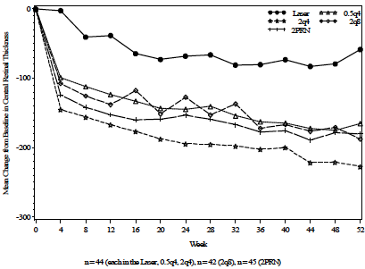
The impact of reducing the frequency of dosing to bimonthly, following three monthly injections was investigated via the 2Q8 group, and there was no apparent reduction in the effect on CRT, although a small reduction of effect following each of the visits at which an active injection was not administered can be seen in the figure above.
The primary efficacy endpoint of the DA VINCI study was improvement in BCVA (measured as ETDRS letter score) from baseline to Week 24. Treatment continued to Week 52, and subjects were followed up to week 76. Of the 220 unique subjects randomized, 219 were treated and analysed. The mean change in BCVA from baseline (measured as letters gained) was 2.5 in the LPC group, 8.6 in the 0.5Q4 group, 11,4 in the 2Q4 group, 8.5 in the 2Q8 group and 10.3 in the 2PRN group. Thus the mean change was very similar in the 0.5Q4 group to the 2Q8 group, and it is not clear from these results why the latter was chosen as the dose for further exploration, given the much greater exposure to aflibercept associated with this dose (mean 7.67 mg compared with 2.81 mg).
A summary of the results for the primary efficacy endpoint is shown in the following table extracted from the DA VINCI study report.

Table 4: Results of primary efficacy endpoint in DA VINCI study (Phase II). Analysis of change in BCVA from baseline to Week 24. LOCF (FAS)
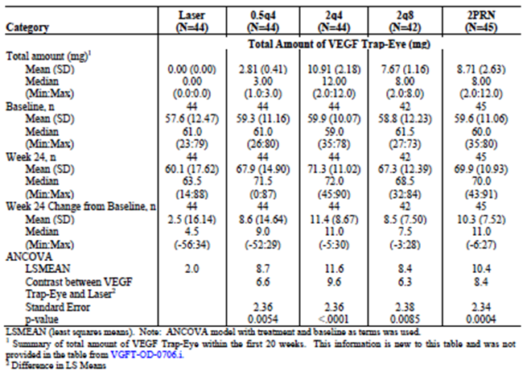
Secondary vision-related endpoints included change in BCVA from baseline to Week 52, which showed very similar relative results, with the improvement in the 0.5Q4 and 2Q8 groups being very similar, to each other and better than the LPC group. The proportion of patients gaining at least 15 letters in their ETDRS letter score compared to the laser group was greater in all aflibercept groups than the LPC group, and both 0.5Q4 and 2Q4 appeared to have better results than 2Q8 (see table below from DA VINCI report).

Table 5: Results of secondary efficacy endpoints in DA VINCI study (Phase II). Patients with gains in ETDRS letter score of at least 15 letters at Week 24 and at Week 52. LOCF (FAS)
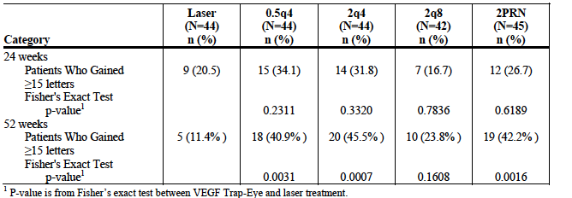
Figure 2: Mean change in visual acuity over 52 weeks in DA VINCI study (Phase II). Figure from DA VINCI study report. Mean change from baseline in ETDRS letters by Visit. LOCF (FAS)
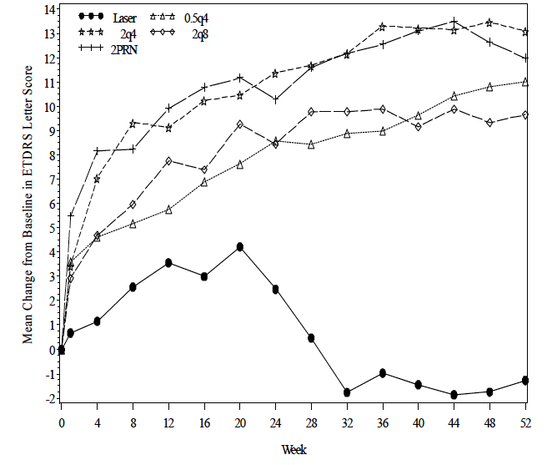
Pharmacodynamic measurements made during the two pivotal clinical efficacy and safety trials (VIVID DME and VISTA DME) support these observations. They were both Phase III, randomized, double-masked, active-controlled (LPC) parallel-group, multi centre studies, that used measurement of CRT by OCT as a secondary endpoint. In both studies, aflibercept IVT (2 mg Q4 weekly and 2 mg Q8 weekly) was compared with LPC.
In the VIVID study, the 52 week data showed mean reductions in CRT (in μm) of 53.1 for LPC (n=132) compared with 210.1 (97.5% CI 190.9, 123.1) for aflibercept 2 mg Q4 weekly (n=136) and 196.0 (179.3, 106.3) for 2 mg Q8 weekly after 5 initial monthly doses (n=135). The reductions in both aflibercept groups were statistically significantly greater than for the LPC group. Although the time profile of CRT for the two aflibercept groups shows that the 2Q8 group had some loss of improvement in CRT following the 8 week interval between doses, this was only small and remained significantly better than the LPC group throughout (see Figure 3 below, demonstrating a ‘saw-tooth’ pattern in the 2Q8 group with better reductions in CRT following visits with active dosing).
In the VISTA study, the 52 week data showed mean reductions in CRT (in μm) of 73.3 for LPC (n=154) compared with 185.9 for aflibercept 2 mg Q4 weekly (n=154) and 183.1 for aflibercept 2 mg Q8 weekly (n=151). The 97.5% confidence intervals for the difference between each aflibercept group and the LPC group were (141.3, 80.2) and (144.2, 82.8) respectively, indicating significantly greater reductions in both aflibercept groups compared with LPC. A similar ‘saw-tooth’ pattern in CRT was observed for the 2Q8 group, with a very small increase in CRT following the visits without active dosing, but again the overall impact at Week 52 was very similar for both groups.
Figure 3. Mean change from baseline in central retinal thickness over 52 weeks in VIVID study (from VIVID clinical trial report)
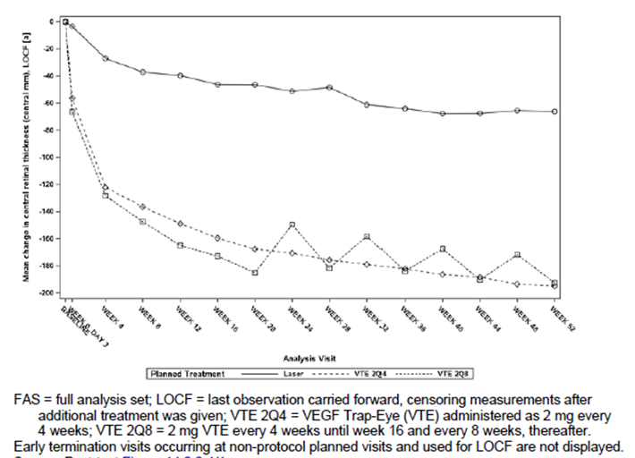

Evaluator’s overall conclusions on pharmacodynamics
The evidence provided from three large, well-designed clinical studies indicates that aflibercept causes a rapid and large reduction in central retinal thickness, which is a direct measure of reduced macular oedema. The reduction in CRT is much greater in all dosing regimens of aflibercept studied than that observed in the active control groups, treated with laser photocoagulation. The ‘saw-tooth’ pattern observed in CRT measurements in all of the 2Q8 groups, who received active injections at every second visit after the first five doses, is a strong indicator that the reduction in CRT is directly due to the effect of aflibercept, and is partially lost when there is an eight week gap between doses. However, the loss of effect is very small and the overall effect on CRT over 52 weeks is similar in the 2Q4 and 2Q8 groups.

Dosage selection for the pivotal studies
The lower dosage group in the DA VINCI study (0.5 mg Q4 weekly) had a significantly better reduction in CRT than the laser photocoagulation subjects, and the effect was only marginally smaller than that observed in the higher dose (2 mg) groups at various dosing frequencies. In addition, the change in best corrected visual acuity (BCVA) was similar in the 0.5Q4 group compared with the other groups receiving 2 mg. In summary, at Week 52, the mean improvement in BCVA (expressed as number of letters gained) was -1.3 for the LPC group, 11.0 for the 0.5Q4 group, 13.1 for the 2Q4 group, 9.7 for the 2Q8 group and 12.0 for the 2PRN group. It is not clear to this evaluator that the choice of the 2 mg Q8 weekly dosing regimen is well justified by these data, particularly taking into account the mean total amount of aflibercept ( mg) administered to the four aflibercept groups (5.9, 21.6, 14.4 and 14.8 respectively). It could be argued on the basis of these results that a very similar effect could be achieved using 0.5 mg Q4 weekly, with much lower exposure to aflibercept.
Similarly, in DA VINCI the effectiveness of the 2 mg PRN dosing regimen was also comparable to the other groups in relation to its impact on CRT (see Figure 1 of this report). The primary visual acuity endpoint of the study (change from baseline to Week 24) was significantly better in terms of gains in ETDRS letter score in the 2PRN group compared with the LPC group. The statistical comparison is not provided for 2PRN versus 2Q8, but there was a numerical advantage for 2PRN in terms of mean letters gained (10.3, SD 7.5 for 2PRN versus 8.5, SD 7.5 for 2Q8) and in the proportion of patients who gained ≥ 15 letters (42.2% versus 23.8%). The total exposure of patients to aflibercept was similar in the two groups (mean 8.71 mg versus 7.67 mg). Safety results did not appear to differ among the various dosing groups, with the exception of an apparently lower rate of non-ocular severe TEAEs in the 2PRN group compared with the other three (LPC 11.4%, 0.5Q4 20.5%, 2Q4 18.2%, 2Q8 21.4%, 2PRN 11.1%).
The submission argues that there were more subjects in the 0.5Q4 group compared with the 2Q8 group who had a reduction in BCVA (≥10 lost letters) at Week24 (6.8% versus 0%) and at Week 52 (also 6.8% versus 0%) and this has been the major consideration in determining that the dose of 2 mg Q8 weekly would be tested in the pivotal clinical studies. Although this was not a predetermined primary or secondary endpoint in the DA VINCI study, it is probably a reasonable argument, although it would have been interesting to see the results of a larger group receiving 0.5 mg Q4 weekly. It should also be noted that no subject in the 2PRN group lost ≥10 letters over 24 weeks, although 2 subjects did so over 52 weeks. A second argument is that there is evidence in the literature that intraocular VEGF levels may be higher in DME patients compared to those in AMD patients, and that a similar dose to the one shown to be effective in AMD would be likely to be required. This is reasonable, but could have been tested more rigorously.
In summary, the choice of dose for the Phase III studies, based on the key Phase II study, could have been any of the three dosing regimens tested. The arguments against the 0.5 mgQ4 dose are reasonable, but the data would not support superiority of any one of the 2 mg regimens over the others. In particular, few arguments can be sustained to support the 2Q8 regimen compared with the 2PRN regimen, which may be more practicable but was not tested in the Phase III trials. Logistical considerations may be important in determining which dosing regimen is preferred.

Clinical efficacy
The submission contains two pivotal clinical efficacy studies, known as VIVID DME and VISTA DME, both of which were carried out in subjects with clinically significant macular oedema with central involvement. The clinical overview in the submission presents a summary of the two trials combined, because their methods and measurements were very similar. In this report, each trial will be summarized separately, but there were some common features that, for efficiency, will be described only once. All information is drawn directly from the full study reports.
The definition of ‘clinically significant macular oedema’ requires that it meets at least one of the following three criteria (developed by the ETDRS Group in 1985)
- retinal thickening at or within 500 μm from the centre of the macular
- hard exudates at or within 500 μm from the centre of the macular associated with thickening of the adjacent retina
- an area or areas of retinal thickening at least one disk area in size, at least part of which is within one disk diameter of the centre of the macula.
Retinal thickness is measured using optical coherence tomography (OCT), a well-established non-invasive technique for imaging cross-sections of the retina with a high degree of accuracy.
The active control used in both studies is laser photocoagulation, which has been widely used since the 1980s for the treatment of diabetic retinopathy. Its role is primarily to prevent further visual loss, and it is recognised that it has limited capacity to restore lost vision or resolve macular oedema (Virgili et al 2012). Nevertheless, given its position as the treatment of choice prior to the development of anti-VEGF treatments, laser photocoagulation is a reasonable control.
Both studies used identical dosing regimens: 2 mg Q 4 weekly (2Q4) for one group and 2 mg Q4 weekly for 5 doses followed by 2 mg 8 weekly (2Q8) for a second group. The active control was laser photocoagulation (LPC). The studies were well designed in terms of maintaining masking, with all groups receiving both intravitreal injections (sham in the case of the control group) and LPC (sham in the case of the aflibercept groups). Masked observers assessed endpoints. The primary endpoint for the VIVID study was.
The Phase II study previously described (DA VINCI) also provided some efficacy data in terms of changes in visual acuity, and these generally support the results of the two pivotal studies.

Macular oedema secondary to diabetic retinopathy (DME)

Pivotal efficacy studies

Study 91745 (VIVID DME)

Study design, objectives, locations and dates
Phase III, double-masked (double-dummy design), randomized, active-controlled (laser photocoagulation), parallel groups, repeat dose, multi-centre (73 centres in Japan, Europe and Australia); carried out between May 2011 and June 2013.
Objectives: evaluation of efficacy, safety and tolerability of IVT aflibercept in patients with DME.

Inclusion and exclusion criteria
Inclusion: Adult subjects with diabetes type 1 or 2, and significant DME involving the central macular region detected by OCT, and associated with visual impairment determined to be primarily due to DME in the study eye; retinal thickness as assessed by OCT of ≥300 μm in the study eye; BCVA ETDRS letter score of 73 to 24 (20/40 to 20/320) in the study eye; compliant, consenting.
Exclusions: Ocular exclusions: ocular conditions with a poorer prognosis in the fellow eye than in the study eye, history of vitreoretinal surgery, laser photocoagulation in the study eye within 90 days, more than 2 previous macular laser treatments in the study eye or no potential for benefit from LPC, previous use of ocular corticosteroids in the study eye within 120 days, previous treatment with anti-angiogenic drugs within 90 days, active proliferative DR in the study eye, history of idiopathic or autoimmune uveitis in the study eye, cataract surgery within 90 days in the study eye, vitreomacular traction or epiretinal membrane in the study eye, current iris neovascularization, vitreous haemorrhage or tractional retinal detachment, pre-retinal fibrosis involving the macular, structural damage to the centre of the macula in the study eye that was likely to preclude improvement in BCVA following the resolution of macular oedema, ocular inflammation, infectious blepharitis, keratitis, scleritis or conjunctivitis, filtration surgery for glaucoma, IOP ≥25 mmHg, myopia of ≥-8 diopters, concurrent disease in the study eye, other than DME, that could compromise VA or require intervention during the study period, only one functional eye, ocular media of insufficient quality to obtain fundus and OCT images.
Systemic exclusions: current treatment for a serious systemic infection, administration of systemic anti-angiogenic agents within 180 days, uncontrolled diabetes with HbA1c>12%, uncontrolled BP with SBP >160 mmHg or DBP >95 mmHg while sitting, history of CVA or MI within 180 days , renal failure requiring renal replacement therapy, history or evidence of any other disease contraindicating the use of an investigational drug or potentially affecting interpretation of the results or rendering the subject at high risk for treatment complications, pregnant or breast-feeding women, women of childbearing potential with no pregnancy test at baseline, sexually active men or women of childbearing potential unwill to practice adequate contraception during the study, allergy to fluorescein, participation in investigational study within 30 days.

Study treatments
Three groups, randomized 1:1:1.
- Aflibercept 2 mg Q4 weekly (2Q4)
- Aflibercept 2 mg Q4 weekly for 5 doses, followed by Q 8 weekly (2Q8)
- Laser photocoagulation according to ETDRS protocol (no more than once every 12 weeks)

Efficacy variables and outcomes
The main efficacy variables were:
- BVCA by ETDRS letter score
- CRT measured by OCT
- Fundus assessment including photography
- Questionnaires assessing quality of life and vision-related quality of life.
The primary efficacy outcome was change from baseline in BCVA in ETDRS letter score at Week 52.
Other efficacy outcomes included:
Secondary outcomes:
- Proportion of subjects who gained ≥ 10 ETDRS letters from baseline to Week 52
- Proportion of subjects who gained ≥ 15 ETDRS letters from baseline to Week 52
- Proportion of subjects with a ≥ 2-step improvement from baseline in the ETDRS DRSS as assessed by FP
- Change in CRT from baseline to Week 52 as assessed on OCT
- National Eye Institute Visual Functioning Questionnaire-25 (NEI VFQ-25) near activities subscale change from baseline to Week 52
- NEI VFQ-25 distance activities subscale change from baseline to Week 52
Additional efficacy variables (all analysed at Week 52):
- Proportion of subjects who gained ≥ 0 and ≥ 5 ETDRS letters from baseline
- Proportion of subjects who lost ≥ 5, ≥ 10 and ≥ 15 ETDRS letters from baseline
- Time to first gain of ≥ 15 ETDRS letters from baseline
- Time to confirmed gain of ≥ 15 ETDRS letters from baseline
- Proportion of subjects with a ≥ 2- or ≥ 3-step worsening, or a ≥ 3-step improvement from baseline in the ETDRS DSS as assessed by FP
- Change from baseline in NEI VFQ-25 total score and subscales over time

Randomisation and blinding methods
Potential subjects who met all eligibility criteria were randomized into the 3 treatment groups in a 1:1:1 ratio, stratified by geographic region (Japan versus Europe/Australia). A central randomization system was used (via phone call or web-based response system). Each centre had ‘masked’ (i.e blinded) investigators, whose role was to assess AEs, perform the assessment of efficacy, assess re-treatment criteria and assess additional treatment criteria. A separate unblinded physician administered the treatment and a double dummy approach was used such that the subjects randomized to IVT aflibercept also received sham laser treatment, and those randomized to LPC also received sham IVT injections. Other unblinded staff (including pharmacists) did not have any role in the study beyond the management of study drug supplies, and all were trained in the maintenance of the masking measures used in the study. Overall, the study design in relation to randomization and blinding was excellent.

Analysis populations
The data were analysed using both a full analysis set (FAS; n=403)) and a per-protocol set (PPS; n=344). The FAS included all randomized subjects who received any study treatment, had a baseline measurement of BCVA and had at least one post-baseline assessment of BCVA, and was analysed according to intention to treat. The per-protocol set included all subjects in the FAS who did not have any major protocol deviations up to Week 52; this set was analysed according to the treatment the subject actually received. The FAS was considered the primary analysis.

Sample size
Total 406 randomized (135 in 2Q4 group, 136 in 2Q8 group and 135 in LPC group).

Statistical methods
Statistical analyses of the primary endpoint were carried out using analysis of covariance (ANCOVA), with baseline BCVA measurement as a covariate and using geographic region as fixed factors. Separate variances were estimated for each of the three treatment groups. To adjust for multiple comparisons, and maintain a type I error rate of 5%, for each of the two aflibercept groups a 2-sided hypothesis regarding its comparative performance against LPC was tested at a significant level of α=0.025 within the ANCOVA model. Secondary endpoints expressed as proportions were tested using a Cochran-Mantel-Haenszel test.

Participant flow
A total of 604 subjects were screened, of which 406 were randomized (135 in 2Q4 group, 136 in 2Q8 group and 135 in LPC group). Two randomized subjects in the LPC group discontinued before receiving treatment due to protocol deviations. A total of 360 subjects completed the first year of the study. Of the 46 who did not complete, the major reason was adverse event (18), withdrawal by subject’s request (12), loss to follow-up (5) and death (4). Additional details are shown in the table below.

Table 6. Subject disposition in VIVID study (from VIVID study report).
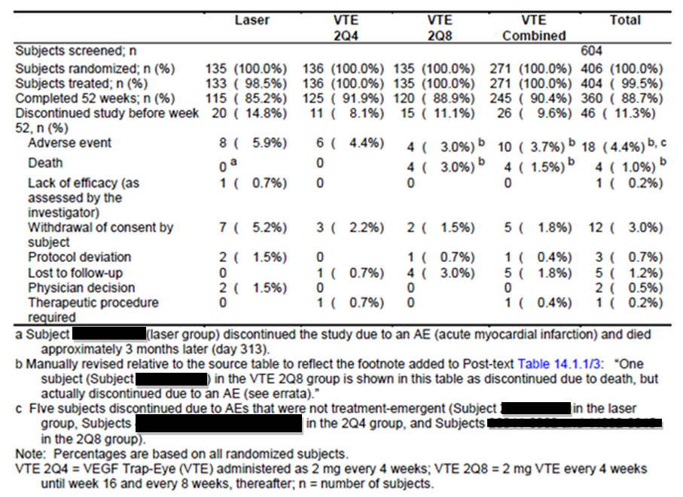
Patient identification numbers have been blacked out in the table footer.

Major protocol violations/deviations
Major protocol deviations occurred more commonly in the LPC group than in the aflibercept groups. The majority of major deviations were treatment deviations (either missing two consecutive injections [active or sham] or receiving fewer than 9 injections [active or sham] in Year 1), which were reported in 11.1% of the LPC group, 7.4% of the aflibercept 2Q4 group and 4.4% of the aflibercept 2Q8 group.

Baseline data
Baseline demographics and visual acuity data are shown in the table below (from VIVID study report). All baseline characteristics were well matched across groups.

Table 7. Baseline demographics and visual acuity data from VIVID study (VIVID study report). Overview of subgroups relevant to efficacy analysis.
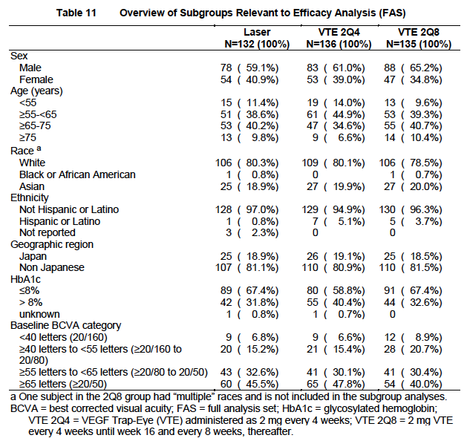

Results for the primary efficacy outcome
The mean change in BVCA, measured by ETDRS letter score, from baseline to Week 52 was similar in both aflibercept groups, and both were statistically superior to LPC (p<0.0001). The differences were also clinically significant, with both aflibercept groups gaining a mean of 10 letters in visual acuity, while the LPC group gained one letter. The results are shown below in graphical form.
Figure 4. Results for primary efficacy endpoint from VIVID study (from VIVID study report). Mean change in BCVA from baseline to Week 52 by Visit (LOCF) (FAS)
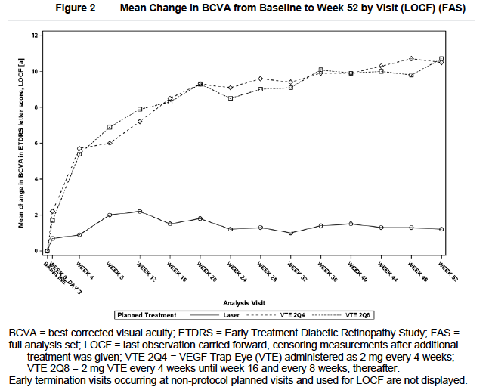

Results for other efficacy outcomes
The secondary and other efficacy outcomes were generally consistent with the primary endpoint. The CRT results have already been discussed in the Pharmacodynamics section, and in summary showed a rapid and significant reduction in retinal thickness following aflibercept treatment. The proportion of subjects achieving specific improvements in BVCA was significantly higher in the aflibercept groups compared with LPC. Interestingly, the quality of life questionnaires (near and distance activities subscales) were not significantly different between treatments, raising a question about the direct patient relevance of the improved visual acuity in daily life. However, it is noted that these subscales measure visual function of both eyes together and, since the study eye was usually the eye with the poorer vision, it is not surprising that there was little difference in the questionnaire outcomes despite the improvement in visual acuity in the less functional eye.

Study VGFT-OD-1009 (VISTA-DME)

Study design, objectives, locations and dates
Randomized, double-masked, active controlled (LPC), repeat-dose, parallel group, multi-centre Phase III study, carried out in 65 centres within the United States of America between 26 May 2011 and 22 January 2013.
Primary objective was to assess the efficacy of IVT-administered aflibercept compared to laser treatment in improving BCVA in subjects DME. The secondary objective was to evaluate safety of aflibercept in subjects with DME.

Inclusion and exclusion criteria
Note that inclusion and exclusion criteria were very similar (but not identical) to those in the VIVID study. The differences would be very unlikely to make any material difference to the results.
Inclusion criteria: Adult subjects with diabetes type 1 or 2, and significant DME involving the central macular region detected by OCT, and associated with visual impairment determined to be primarily due to DME in the study eye; BCVA ETDRS letter score of 73 to 24 (20/40 to 20/320) in the study eye; compliant, consenting.
Exclusions: Ocular exclusions: history of vitreoretinal surgery, laser photocoagulation in the study eye within 90 days, subject unlikely to benefit from LPC, previous use of ocular corticosteroids in the study eye within 120 days, previous treatment with anti-angiogenic drugs within 90 days, active proliferative DR in the study eye, history of idiopathic or autoimmune uveitis in the study eye, cataract surgery within 90 days in the study eye, aphakia in the study eye, Yttrium aluminium garnet capsulotomy in the study eye within 30 days, vitreomacular traction or epiretinal membrane in the study eye, current iris neovascularization, vitreous haemorrhage or tractional retinal detachment in the study eye, pre-retinal fibrosis involving the macular, structural damage to the centre of the macula in the study eye that was likely to preclude improvement in BCVA following the resolution of macular oedema, intraocular inflammation, evidence of infections in either eye, uncontrolled glaucoma in the study eye (filtration surgery for glaucoma in the past or likely to be needed in future), IOP ≥25 mmHg, concurrent disease in the study eye, other than DME, that could compromise VA or require intervention during the study period, ocular conditions with a poorer prognosis in the fellow eye than in the study eye, only one functional eye, ocular media of insufficient quality to obtain fundus and OCT images.
Systemic exclusions: current treatment for a serious systemic infection, administration of systemic anti-angiogenic agents within 180 days, uncontrolled diabetes, uncontrolled BP with SBP >160 mmHg or DBP >95 mmHg while sitting, history of CVA or MI within 180 days, renal failure, dialysis or history of renal transplant, history or evidence of any other disease contraindicating the use of an investigational drug or potentially affecting interpretation of the results or rendering the subject at high risk for treatment complications, pregnant or breast-feeding women, women of childbearing potential with no pregnancy test at baseline, sexually active men or women of childbearing potential unwill to practice adequate contraception during the study, serious allergy to fluorescein, participation in investigational study within 30 days.

Study treatments
Three groups, randomized 1:1:1.
- Aflibercept 2 mg Q4 weekly (2Q4)
- Aflibercept 2 mg Q4 weekly for 5 doses, followed by Q 8 weekly (2Q8)
- Laser photocoagulation according to ETDRS protocol (no more than once every 12 weeks)

Efficacy variables and outcomes
Note that all variables and outcomes were identical to those used in the VIVID study.
The main efficacy variables were:
- BCVA measured by ETDRS letter score
- DRSS assessed by retinal fluorescein angiography and fundal photography
- CRT, measured by OCT
- NEI VFQ-25 near activities and distance activities subscales
The primary efficacy outcome was change in BCVA (measured by ETDRS letter score) from baseline to Week 52.
Other efficacy outcomes included:
- Proportion of subjects who gained ≥ 10 ETDRS letters from baseline to Week 52
- Proportion of subjects who gained ≥ 15 ETDRS letters from baseline to Week 52
- Proportion of subjects with a ≥ 2-step improvement from baseline in the ETDRS DRSS as assessed by FP
- Change in CRT from baseline to Week 52 as assessed on OCT
- National Eye Institute Visual Functioning Questionnaire-25 (NEI VFQ-25) near activities subscale change from baseline to Week 52
- NEI VFQ-25 distance activities subscale change from baseline to Week 52
Additional efficacy variables (all analysed at Week 52)
- Proportion of subjects who gained ≥ 0 and ≥ 5 ETDRS letters from baseline
- Proportion of subjects who lost ≥ 5, ≥ 10 and ≥ 15 ETDRS letters from baseline
- Time to first gain of ≥ 15 ETDRS letters from baseline
- Time to confirmed gain of ≥ 15 ETDRS letters from baseline
- Proportion of subjects with a ≥ 2- or ≥ 3-step worsening, or a ≥ 3-step improvement from baseline in the ETDRS DSS as assessed by FP
- Change from baseline in NEI VFQ-25 total score and subscales over time

Randomisation and blinding methods
Similar to VIVID study; but in this case, randomization was stratified by history of MI and/or CVA (yes versus no). Within each stratum, subjects were randomized 1:1:1 to the three treatment groups, according to a predetermined central randomization scheme provided by an interactive voice response system or web response system.
Similarly to the VIVD study, sham injections were performed in the LPC group, and sham laser treatment were performed in the aflibercept groups. Unblinded staff provided the actual treatment, but were not involved in assessment of outcome variables. A masked (blinded) physician was assigned to assess AEs, perform the assessment of efficacy, assess re-treatment criteria, and assess additional treatment criteria.

Analysis populations
The data were analysed using both a full analysis set (FAS; n=459) and a per-protocol set (PPS; n=430). The definitions of these populations were identical to those in the VIVID study. The FAS included all randomized subjects who received any study treatment, had a baseline measurement of BCVA and had at least one post-baseline assessment of BCVA, and was analysed according to intention to treat. The per-protocol set included all subjects in the FAS who did not have any major protocol deviations up to Week 52; this set was analysed according to the treatment the subject actually received. The FAS was considered the primary analysis.

Sample size
A total of 687 potential subjects were screened, 466 were randomized (156 in the LPC group, 156 in the aflibercept 2Q4 group, and 154 in the aflibercept 2Q8 group) and 461 received treatment.

Statistical methods
ANCOVA model with treatment as the main effect, history of MI and/or CVA as a fixed factor, and baseline BCVA as the covariate; each of the two comparisons on the primary efficacy endpoint were performed at the 2.5%, 2-sided significance level. Secondary endpoints expressed as proportions were analysed using a Cochran-Mantel-Haenszel test, adjusted for history of MI and/or CVA, as well as a 97.5% 2-sided confidence interval of the difference between each aflibercept group and the LPC group. Very similar to the methods used in the VIVID study.

Participant flow
Of the 466 randomized subjects, three did not meet inclusion criteria and were inadvertently randomized and then withdrawn, and two withdrew consent. Four hundred and thirty-five subjects completed the first year of the study. Three subjects died (one in the laser group and 2 in the 2Q4 group), 31 prematurely discontinued the study, and 42 prematurely discontinued study medication. The most common reason for premature discontinuation was withdrawal by the subject. Additional details are shown in the table below.

Table 8. Disposition of all randomized subjects in VISTA study (from VISTA study report).
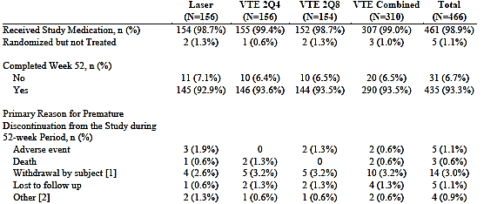

Major protocol violations/deviations
Thirty subjects had major protocol deviations, 29 of which were treatment deviations, defined as for the VIVID study. These were spread evenly across the treatment groups.

Baseline data
A summary of the baseline demographics and BCVA is shown in the table below. All relevant characteristics, including baseline visual acuity, were well balanced among the treatment groups. In addition, the stratification factors (MI and CVA) were distributed evenly across the treatment groups, as were baseline vital signs, particularly blood pressure.

Table 9. Baseline demographics and visual acuity data from VISTA study (Phase III). (from VISTA study report) (FAS)
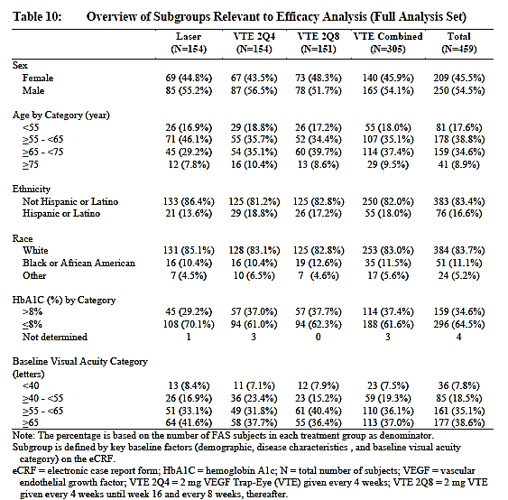

Results for the primary efficacy outcome
Figure 5. Results for primary efficacy endpoint from VISTA study (VISTA report). Mean change in BCVA from baseline to Week 52. LOCF (FAS)
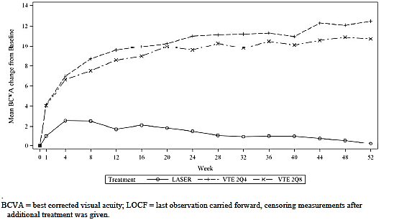
The results for the primary efficacy endpoint were very similar to those for the VIVID study, and demonstrate that aflibercept in both dosing regimens has a significantly better effect on improving BCVA at 52 weeks, with the differences being both statistically and clinically significant.

Results for other efficacy outcomes
Results for the other efficacy outcomes were again very similar to the VIVID study results, and are shown in the following table.

Table 10. Results for secondary efficacy end points from VISTA study (from VISTA report) LOCF (FAS)
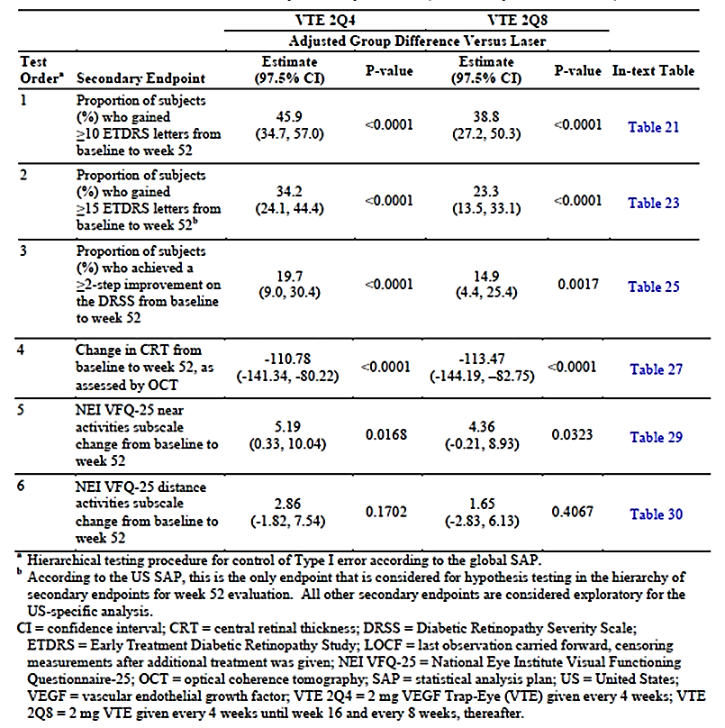
All endpoints related to proportions of subjects achieving improvement in both BCVA and in assessment of retinal disease (DRSS) were significantly better in the aflibercept groups compared with LPC. Again, the differences in vision-related quality of life were less clearly different, although in this study the near activities subscale of the NEI VFQ-25 did demonstrate statistical significance.

Other efficacy studies
The DA VINCI study, which has been discussed as a predominantly pharmacodynamics study, also provided data on changes in BCVA, and these support the observations in the VIVID and VISTA studies. The major vision-related endpoint of this study was change in BCVA (by ETDRS letters) at Week24. A graphical form of these results appears in Figure 2 above.

Analyses performed across trials (pooled analyses and meta-analyses)
The submission contains, within the Summary of Clinical Efficacy, an overview and integrated analysis of the efficacy results from the two Phase III clinical studies (VIVID-DME and VISTA-DME). This is a reasonable approach because of the similarity of the study designs and study populations of these two studies, and the consistency of the results.
The combined analysis, as would be expected, showed that the two aflibercept-treated groups had statistically significantly greater improvement in BCVA as compared with the LPC group. Given a baseline mean number of letters of about 60, a mean improvement of 10-12 letters indicates a clinically significant improvement, and an ability to accurately identify letters on at least two further lines of the ETDRS chart (which contains 5 letters per line in progressively decreasing size).

Table 11. Pooled analysis of primary endpoint from VIVID and VISTA studies (from Summary of Clinical Efficacy). Change in BCVA from baseline to Week 52. LOCF¹ (Integrated; FAS).
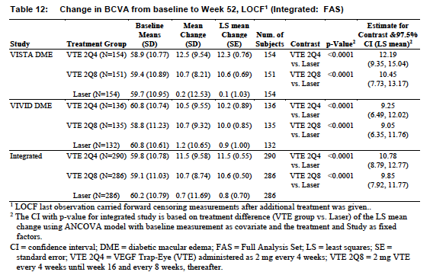
Figure 6. Pooled results for primary efficacy endpoint from VIVID and VISTA (from Summary of Clinical Efficacy p.40). Mean change in BCVA from baseline to Week 52. LOCF¹ (Integrated; FAS)
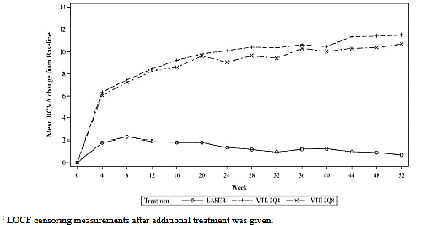
An integrated analysis of the secondary endpoints gave the expected results, given the results of the individual studies. All vision-related endpoints related to changes in BCVA were statistically superior in the aflibercept groups compared with the LPC group. The proportion of subjects with an improvement of ≥ 2 steps from baseline in ETDRS DRSS (a measure of retinal disease severity based on fluorescein angiography and fundus photography) from baseline to Week 52 was 33.6% for the 2Q4 group, 28.6% for the 2Q8 group and 12.0% for the LPC group (both differences significant with p<0.0001). The lower limit of the 97.5% confidence intervals for the advantage of the 2Q8 group (the proposed dosing regimen for clinical use) over the LPC group was 8.6% (adjusted difference 16.7%; 97.5% CI 8.6, 24.9).
Integrated analysis of the questionnaire-based results (NEI VFQ-25) showed numerical superiority of the near activities subscale for both aflibercept groups compared with LPC, but the difference was small and only significant for the 2Q4 treatment regimen. As mentioned already, near activities are a function of both eyes, and the results are primarily reflective of the better seeing eye, which was not usually the study eye in these studies. This may have reduced the impact of the improved BCVA on reported daily function.

Evaluator’s conclusions on clinical efficacy for Diabetic Macular Oedema
The three clinical studies investigating clinical efficacy (one small Phase II study – DA VINCI, and two large Phase III studies – VIVID and VISTA) have provided evidence for clinical efficacy of aflibercept, administered IVT, in diabetic macular oedema. Questions remain about the translation of the dosage schedule, used in the Phase III trials, to clinical practice in Australia.

Clinical safety

Studies providing evaluable safety data
The following studies provided evaluable safety data:
- VGFT-OD-0706 (DA VINCI) (n=219; 175 treated with aflibercept and 44 with LPC for 52 weeks
- 91745 (VIVID DME) (n=404; 271 treated with aflibercept and 133 with LPC for 52 weeks at time of reporting; study on-going)
- VGFT-OD-1009 (VISTA DME) (n=461; 307 treated with aflibercept and 154 with LPC for 52 weeks).
The latter two studies are regarded as pivotal efficacy studies.
The following studies provided in the dossier are less relevant to the current application and will not be considered further:
- VGFT-OD-0307 (n=6 subjects with DME exposed to aflibercept administered intravenously); no detailed safety results provided in targeted pharmacokinetic report
- VGFT-OD-0512 (n=5 subjects with DME exposed to aflibercept given IVT but at double the currently proposed dose); a brief summary of AEs is included in the Summary of Clinical Safety, and states that four subjects had ocular AE (most commonly conjunctival haemorrhage), all of which were mild, and that four subjects had a total of 11 systemic AEs, no single one of which occurred in more than one subject, and none of which were considered related to study drug. Two subjects had serious AEs (coronary artery disease in one, and serious infectious conditions with systemic complications in the other; neither were likely to have been related to treatment). No increase in systemic blood pressure occurred (increased BP is a marker of systemic effect of aflibercept).
These two studies were not fully reported in the submission and insufficient detail was provided regarding adverse effects. The dose and route of administration was also different from the proposed dosing regimen. For these reasons, and the small number of subjects involved, they will not be considered further.
The relevant studies therefore provide evaluable safety data on 753 subjects treated with aflibercept and 331 controls treated with laser photocoagulation. The dose regimens studied include the proposed dosing for DME (2 mg Q8 weekly following 5 initial monthly doses).

Pivotal efficacy studies
In the pivotal efficacy studies (VIVID and VISTA), the following safety data were collected:
- General adverse events (AEs) were assessed by:
  - Collection of patient-reported clinical adverse events at each visit
  - Physical examination at screening and Week 52
  - Monitoring of vital signs, particularly BP and heart rate at each visit
  - Monitoring of ECGs at baseline and Week 52
  - Serum sample for anti-drug antibody (ADA) assessment at baseline and Week 52
- AEs of particular interest, including ocular adverse effects, were assessed by:
  - Ophthalmic examinations at each visit, including indirect ophthalmoscopy, slit lamp biomicroscopy,
  - Intraocular pressure monitoring at each visit, before and after IVT injection
  - Gonioscopy (in VIVID DME only)
- Laboratory tests were performed at baseline and then approximately every 6 months, including
  - blood chemistry, urinalysis and haematology

Pivotal studies that assessed safety as a primary outcome
There were no pivotal studies that assessed safety as a primary outcome. In both pivotal efficacy studies, safety was a secondary outcome.

Dose-response and non-pivotal efficacy studies
The dose-response and non-pivotal efficacy study that provided safety data was as follows:
- Study VGFT-OD-0706 (DA VINCI)

Other studies evaluable for safety only
Nil.

Patient exposure
In the three submitted studies with adequate details provided, the control group was laser photocoagulation. A total of 753 patients were exposed to aflibercept in these three studies, with 11 further subjects being exposed in the early phase studies. Given the absence of detail regarding safety outcomes in these latter studies, these 11 are not considered further in this report.

Table 12: Exposure to aflibercept and comparator (LPC) in clinical studies.
Study type/Indication | Controlled studies |  | Uncontrolled studies | Total Aflibercept
Study type/Indication | Aflibercept | LPC | Aflibercept
Clinical pharmacology |  |  | 6¹
Clinical pharmacology |  |  | 5²
Diabetic macular oedema Pivotal | 578 | 287 |  | 578
Other | 175 | 44 |  | 175
TOTAL | 753 | 331 | 11 | 753
¹IV dose 0.3 mg/kg; No details provided. ²IVT at 4 mg; few details provided
The exposure of patients to aflibercept in the three relevant clinical studies (DA VINCI, VIVID and VISTA) included the proposed dosing regimen to be used in DME (2 mg Q8 weekly after 5 initial monthly doses), as well as lower and higher doses. All treatments were given over at least a 12 month period, and the pivotal clinical studies are on-going and planned to continue for three years. Data from the 52 week time-point is provided for all three studies in this submission.

Adverse events

All adverse events (irrespective of relationship to study treatment)

Pivotal studies
The Summary of Clinical Safety contains an integrated summary of TEAEs from the two pivotal clinical trials, and this is appropriate, given their very similar design and identical dosing regimens and monitoring.
Treatment-emergent adverse events (TEAEs) were defined as AEs that were observed or reported after first administration and not later than 30 days after last administration of study medication, regardless of causal relationship to study treatment. These have been collected and analysed using a safety analysis set (SAF) which included all randomized subjects who received at least one study treatment. This is an appropriate approach. Subject disposition using the SAF is presented for the two pivotal studies in the table below (from Summary of Clinical Safety).

Table 13. Subject disposition for safety set (pooled VIVID and VISTA studies). All randomised subjects.
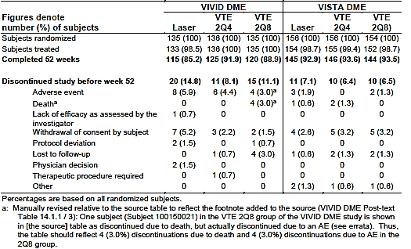
A smaller proportion of subjects from the aflibercept groups discontinued because of AEs than from the LPC group.
An overview of TEAEs for the integrated analysis of the pivotal studies is presented below in a table from the Summary of Clinical Safety. Almost all subjects (about 90% in each treatment group) experienced at least one TEAE during the 52 weeks of the study, and about 75% in each treatment group (including the control) experienced a systemic AE. The incidences of drug related or injection related TEAEs were higher in the aflibercept groups and the incidence of laser related TEAEs was higher in the laser group, as expected (see Table 14 below). Injection-related AEs were common in all groups receiving injections, being experienced by 40-44% of subjects in the aflibercept groups.
With respect to Serious Adverse Events (SAEs), there was a greater frequency of study eye SAEs in the laser group than in the aflibercept combined group (4.2% versus 1.7%). The incidences of TEAEs leading to discontinuation, TE SAEs and deaths were low.

Table 14. Pooled analysis of treatment-emergent adverse events from VIVID and VISTA studies (from Summary of Clinical Safety). Integrated analysis; SAF.
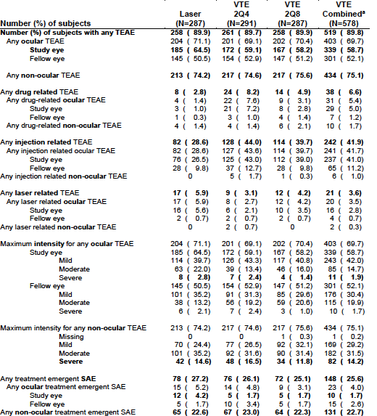
Non-ocular TEAEs were less frequent than ocular AEs, and occurred in about 75% of subjects in both the aflibercept and LPC groups. The most common were hypertension and nasopharyngitis. TEAEs that appeared to be more common in aflibercept-treated subjects included anaemia (LPC 2.4%, aflibercept 4.8%), peripheral oedema (2.8% versus 4.5%), immune system disorders 1.7% versus 3.6%), neoplasms (benign, malignant and unspecified including cysts and polyps; 2.4% versus 4.7%) and cardiac failure (which was increased in the VISTA study but not in VIVID). The most important systemic TEAE of interest was hypertension, as this has been shown to be an effect of systemically-administered aflibercept, but there was no increase in the frequency of hypertension in the aflibercept group (17.5%) compared with the control (17.8%).

Other studies
The safety analysis set for the DA VINCI study consisted of 219 subjects who were randomized and received at least one study treatment. This group was the same as the full analysis set (FAS) analysed for the efficacy data. Subject disposition in the DA VINCI study is shown below.

Table 15. Subject disposition for safety population in DA VINCI study (from Summary of Clinical Safety). All randomised subjects.
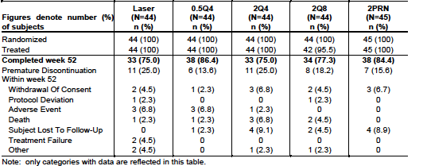

Table 16. Incidence of ocular and non-ocular TEAEs by treatment group in DA VINCI study (from Summary of Clinical Safety) (SAF)
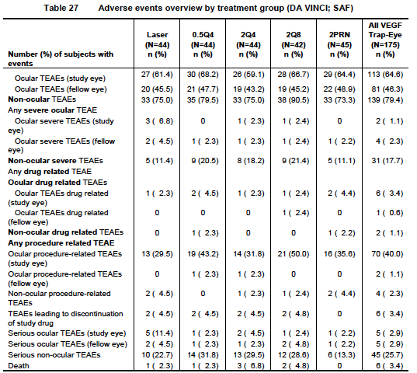
The most common ocular TEAEs in the DA VINCI study that were over-represented in the aflibercept treatment groups compared with the LPC group were conjunctival haemorrhage, eye pain, increased intraocular pressure, and vitreous floaters. All of these are common adverse effects of IVT injection.
Non-ocular TEAEs in the DA VINCI study that were over-represented in the aflibercept groups included metabolic disorders, particularly hypercholesterolaemia and disordered diabetic control, gastrointestinal disorders, particularly nausea, diarrhoea and constipation, and cardiac disorders (7% versus 13%, the difference being due mainly to an increased frequency of congestive cardiac failure and coronary artery disease). It is worth noting that a higher proportion of subjects in the aflibercept groups had a medical history of cardiac disorders prior to entering the study (33%-48% compared with 18% in the LPC group), but the consistency of this observation with that of the integrated analysis of the pivotal studies means that the possibility that aflibercept may exacerbate cardiac failure should not be dismissed. There was no excess of reports of neoplasms in the aflibercept-treated subjects in the DA VINCI study.

Treatment-related adverse events (adverse drug reactions)

Pivotal studies
The incidence of TEAEs judged to be related to study drug was low. The following table, derived from the Summary of Clinical Safety, summarized the number of treatment-related AEs in the pivotal clinical studies.

Table 17. Incidence of treatment-related adverse events by treatment group in pooled VIVID and VISTA dataset (from Summary of Clinical Safety) SAF
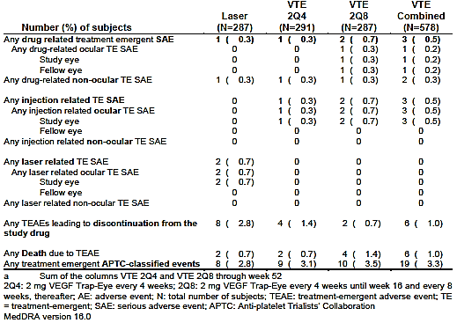
The most common ocular DRAEs in the study eye following aflibercept treatment were raised intraocular pressure and ocular hyperaemia (both occurring in ≤ 1% of treated subjects). This analysis excludes AEs related to the injection process itself (predominantly conjunctival haemorrhage and eye pain), which occurred in 26.5% of subjects in the LPC group (receiving sham injections) and 41% in the aflibercept groups (active injections). This result raises the possibility of an effect of the injected substance on the tolerability of the injection. Systemic DRAEs were uncommon, the most common being hypertension and nasopharyngitis, which were observed in < 1% of subjects in both the aflibercept and LPC groups.

Other studies
In the DA VINCI study, ocular DRAEs were reported in one subject in the LPC group and 6 subjects in the aflibercept groups. These included eye pain (2 aflibercept subjects), cataract (1 aflibercept, 1 LPC), ocular hyperaemia (1 aflibercept), blurred vision (1 aflibercept) and vitreous floaters (1 aflibercept).
Two subjects were judged to have had systemic DRAEs in this study and both were in the aflibercept-treated groups. One subject in the low dose group had an acute myocardial infarction, pleural effusion and respiratory failure. One subject in the 2 mg as required group had nausea, vomiting, asthenia, increased blood pressure, dizziness and hyperhidrosis.
Similar procedure-related AEs were reported in DA VINCI, in similar proportions as the combined pivotal studies. In particular, injection-related conjunctival haemorrhage was reported slightly more commonly following aflibercept injections (23.4%) than sham injections (18.2%), but eye pain post-injection was reported in 10.3% of the aflibercept group versus 4.5% of the LPC group.

Deaths and other serious adverse events

Pivotal studies
Serious AEs occurred in 18.1% of the LPC group and 16.8% of the combined aflibercept groups in the integrated safety set. Of these, severe ocular TEAEs included the following:
- LPC group: conjunctival haemorrhage, dry eye, posterior capsule opacification, retinal exudates retinal haemorrhage, retinal neovascularization, sudden vision loss, vitreous haemorrhage (all 1 report each); abnormal visual acuity test (2 reports)
- Aflibercept 2Q4 group: conjunctival haemorrhage, cystoid macular oedema, dry eye, retinal artery occlusion, visual acuity reduction, vitreous haemorrhage, increased intraocular pressure, abnormal visual acuity test (all 1 report each); eye pain (2 reports)
- Aflibercept 2Q8 group: cystoid macular oedema, macular oedema, retinal detachment and vitreous haemorrhage (1 report each).
Non-ocular SAEs were balanced across groups (that is, no more common in the aflibercept than the LPC groups), including the specific AEs of interest given the pharmacological effects of aflibercept (hypertension-related conditions, myocardial infarction, other vascular disorders).
There were 8 deaths in the pivotal studies, as follows:
- LPC group (total n = 287): 2 deaths - myocardial infarction, sudden cardiac death
- Aflibercept groups (total n=578): 6 deaths – cardiac arrest secondary to hypertensive heart disease, lung neoplasm, B-cell lymphoma, cardiac failure secondary to ischaemic heart disease, acute myocardial infarction, and one with unknown cause.
The causes of death are common conditions in this age group, and particularly in subjects with diabetes mellitus. Although the death related to hypertensive heart disease was judged by the investigator to have been related to study drug, it seems unlikely to have been a significant factor. No particular concerns are raised by these data.

Other studies
In the DA VINCI study, 7% of subjects in the LPC group and 1% of the combined aflibercept groups had severe ocular TEAEs:
- 1 LPC subject had severe diabetic retinal oedema
- 2 LPC subjects had severe vitreous haemorrhage
- 1 aflibercept subject had severe angle closure glaucoma
- 1 aflibercept subject had severe punctate keratitis.
Non-ocular SAEs occurred in 11.4% of LPC subjects and 17.7% of aflibercept subjects. Most were single reports, but the following were reported by more than one subject in the aflibercept groups:
- congestive cardiac failure (2 subjects)
- hyperglycaemia (2 subjects)
- cellulitis (3 subjects).
There were 7 deaths in the DA VINCI study, 1 (2.3%) in the LPC group and 6 (3.4%) in the aflibercept groups:
- LPC group: cardiac arrest
- Aflibercept groups: multi-organ failure, cerebral infarction, non-small cell lung cancer, sudden death, renal failure, acute coronary syndrome (most likely acute myocardial infarction).
None of these deaths were considered by the investigator to be related to study drug or study procedures, and this is a reasonable assessment, as all of the causes of death are common in this demographic.

Discontinuation due to adverse events

Pivotal studies
The rate of withdrawal due to TEAEs was low (2.8% in the LPC group and 1% in the combined aflibercept groups). There are no patterns of concern in the data (not shown).

Other studies
In the DA VINCI study, study drug was withdrawn from 2 subjects (5%) in each of the treatment groups. Again there are no concerning safety signals in the data (not shown).

Laboratory tests

Liver function

Pivotal studies
Changes in liver function parameters from baseline to Week 52 were very uncommon in the pivotal studies, occurring in 0.4% of the LPC group and 1.5% of the combined aflibercept groups.

Other studies
In the DA VINCI study, there was an elevation in liver enzymes in 0% of the LPC group and 4% of the aflibercept groups. No clinically meaningful elevations were observed.

Kidney function

Pivotal studies
Elevations in creatinine were observed in the same proportion of the LPC group (4%) and combined aflibercept groups (3.9%).

Other studies
In the DA VINCI study, creatinine was increased in 2.3% of the LPC group and 4% of the aflibercept groups. Again, no clinically meaningful elevations were observed.

Other clinical chemistry

Pivotal studies
A summary of the treatment-emergent abnormalities in clinical chemistry at Week 52 is shown in Table 18.

Table 18. Incidence of abnormalities in clinical chemistry in pooled VIVID and VISTA studies (from Summary of Clinical Safety). Predefined laboratory abnormalities for Clinical chemistry at Week 52. (SAF)
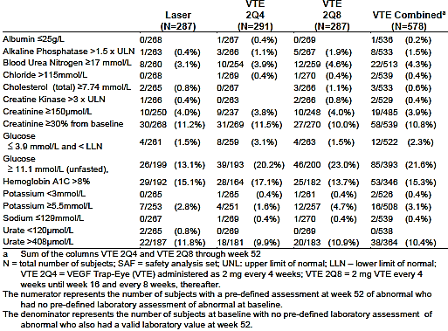
The only change that appeared to be over-represented in the aflibercept groups was hyperglycaemia (13.1% in LPC group versus 21.6% in combined aflibercept groups).

Other studies
The only clinically meaningful changes in clinical chemistry in the DA VINCI study were elevation of potassium (0 in LPC group versus 4% in combined aflibercept groups). The majority of changes in clinical chemistry observed during this study were elevations in blood glucose (2.3% versus 10.9% respectively, which interestingly is consistent with the observations in the pivotal trials.

Haematology

Pivotal studies
No trend towards an increase or decrease in mean values over time was seen in any of the treatment groups at Week 52. Shifts in individual subjects showed that the incidence of clinically meaningful abnormalities was balanced between groups with the exception of reduced haemoglobin levels, which were reduced more frequently in the LPC group, although the incidence of a reduction of 20 g/L or more from baseline was the same in both groups, suggesting that the LPC group had a slightly lower baseline value (within the normal range).

Other studies
There were few haematological abnormalities in the DA VINCI study, and these were balanced across treatment groups.

Electrocardiograph

Pivotal studies
ECGs were recorded at baseline and at Week 52 in both pivotal trials. No clinically meaningful changes were noted in ventricular rate, PR interval, QRS duration, or QT interval (corrected) in any treatment group. The overall frequency of any ECG abnormality at Week 52 was similar in all treatment groups.

Other studies
In the DA VINCI study, ECGs were performed at baseline and Week 52, and no clinically significant changes were observed in any subject at Week 52. In particular, there were no significant changes in QT interval (corrected).

Vital signs

Pivotal studies
Blood pressure was a potential systemic effect of particular interest in these studies, because of the known effect of systemically-administered aflibercept to cause an increase in BP. Mean SBP and DBP did not show any rises over time in any treatment group in the combined pivotal studies between baseline and Week 52.
No changes were observed in other vital signs (body temperature, heart rate).

Other studies
In the DA VINCI study, there were no changes over time in mean BP parameters. Although there were reports of hypertension-related AEs during the study, they were balanced across all treatment groups. No clinically meaningful changes occurred in other vital signs.

Immunogenicity

Pivotal studies
Serum samples were collected and examine for the presence of ADAs. A total of 19 subjects had positive results during the study (1.4% in LPC group and 2.5% in the combined aflibercept groups). Of these, 9 were positive only at baseline, suggesting pre-existing immune-reactivity rather than a treatment-emergent response. Thus only 7 (2 in the LPC group, 3 in the 2Q4 group and 2 in the 2Q8 group) developed a treatment-emergent positive response. At Week 52, one subject from each of the aflibercept groups were positive in the ADA assay and also in the neutralizing antibody assay. There were no clinical correlations between safety issues and antibody status.

Other studies
In the DA VINCI study, only two subjects (both in the 0.5Q4 group) had positive responses to ADA, and neither was positive in the neutralizing antibody assay.

Post-marketing experience
Aflibercept has been available in the US since November 2011, and in the EU and other countries, including Australia, since 2012. In Australia, aflibercept was marketed for use in wetAMD initially, and oedema due to CRVO was approved at the end of 2013. The Sponsor has received AE reports in relation to patients with both of these indications. A total of 1761 reports have been made over a period during which about 996,000 vials of aflibercept have been sold. Of these reports, 1444 were made by health care providers, and of these, 866 were serious. The most common category of AE was ocular (59%), followed by infections (10%). More detail as to the nature of the AEs is provided in the Summary of Clinical Safety. There are no issues of particular concern in these data.

Evaluator’s overall conclusions on clinical safety
No issues are raised in the submission that suggest any alteration in the assessment of clinical safety of aflibercept, as previously evaluated for its approved indications of wetAMD and macular oedema secondary to CRVO. Aflibercept is generally well tolerated when administered by IVT in patients with DME, and its most common adverse effects are related primarily to the process of injection. There is little evidence for significant systemic adverse effects, and this is consistent with the pharmacokinetic evidence for very low systemic absorption from the site of administration within the eye.

First round benefit-risk assessment

First round assessment of benefits
The benefits of aflibercept in the proposed usage (diabetic macular oedema) are:
- Significant reduction in central retinal thickness, measured by OCT, indicating reduced macular oedema, commencing within 4 weeks of the first treatment and maintained to 52 weeks with maintenance injections either at 4 weekly or 8 weekly intervals
- Significant improvement in best corrected visual acuity, measured by ETDRS letters.

First round assessment of risks
The risks of aflibercept in the proposed usage (diabetic macular oedema) are:
- Moderate to high risk (about 50%) of intra-vitreal injection-related adverse effects (not directly related to the drug itself), particularly conjunctival haemorrhage and eye pain
- Low risk (≤5%) of minor ocular reactions (conjunctival haemorrhage and eye pain)
- Very low risk (≤1%) of severe ocular reactions
- Very low risk (≤1%) of treatment-related severe systemic reactions.

First round recommendation regarding authorisation
Evaluator unable to comment until the Dosage & Administration section of the PI is clarified.

Clinical questions
- Please comment on the translation of the dosage regimen used the Phase III trials to clinical practice in Australia.

Second round evaluation of clinical data submitted in response to questions
No second round evaluation was conducted. The Delegate noted the sponsor’s response to the Clinical question and dosing is discussed in the section Overall conclusion and benefit-risk assessment in the AusPAR).

References
No references were included in the submission.
Virgili G, Parravano M, Menchini F, Brunetti M. Antiangiogenic therapy with anti-vascular endothelial growth factor modalities for diabetic macular oedema. Cochrane Database of Systematic Reviews 2012, Issue 12. Art. No.: CD007419. DOI: 10.1002/14651858.CD007419.pub3. (accessed 16 April 2014)
Therapeutic Goods Administration
PO Box 100 Woden ACT 2606 Australia
Email: info@tga.gov.au Phone: 1800 020 653 Fax: 02 6232 8605
https://www.tga.gov.au

