Date of CER: April 2013

AusPAR Attachment 2

Extract from the Clinical Evaluation Report for afatinib (as dimaleate)
  - Proprietary Product Name: Giotrif
  - Sponsor: Boehringer Ingelheim Pty Ltd
About the Therapeutic Goods Administration (TGA)
- The Therapeutic Goods Administration (TGA) is part of the Australian Government Department of Health, and is responsible for regulating medicines and medical devices.
- The TGA administers the Therapeutic Goods Act 1989 (the Act), applying a risk management approach designed to ensure therapeutic goods supplied in Australia meet acceptable standards of quality, safety and efficacy (performance), when necessary.
- The work of the TGA is based on applying scientific and clinical expertise to decision-making, to ensure that the benefits to consumers outweigh any risks associated with the use of medicines and medical devices.
- The TGA relies on the public, healthcare professionals and industry to report problems with medicines or medical devices. TGA investigates reports received by it to determine any necessary regulatory action.
- To report a problem with a medicine or medical device, please see the information on the TGA website <http://www.tga.gov.au>.
About the Extract from the Clinical Evaluation Report
- This document provides a more detailed evaluation of the clinical findings, extracted from the Clinical Evaluation Report (CER) prepared by the TGA. This extract does not include sections from the CER regarding product documentation or post market activities.
- The words [Information redacted] indicate confidential information has been deleted.
- For the most recent Product Information (PI), please refer to the TGA website <http://www.tga.gov.au/hp/information-medicines-pi.htm>.
Copyright
© Commonwealth of Australia 2014
This work is copyright. You may reproduce the whole or part of this work in unaltered form for your own personal use or, if you are part of an organisation, for internal use within your organisation, but only if you or your organisation do not use the reproduction for any commercial purpose and retain this copyright notice and all disclaimer notices as part of that reproduction. Apart from rights to use as permitted by the Copyright Act 1968 or allowed by this copyright notice, all other rights are reserved and you are not allowed to reproduce the whole or any part of this work in any way (electronic or otherwise) without first being given specific written permission from the Commonwealth to do so. Requests and inquiries concerning reproduction and rights are to be sent to the TGA Copyright Officer, Therapeutic Goods Administration, PO Box 100, Woden ACT 2606 or emailed to <tga.copyright@tga.gov.au>.

Contents
List of abbreviations 5
1. Clinical rationale 7
2. Contents of the clinical dossier 7
2.1. Scope of the clinical dossier 7
2.2. Paediatric data 7
2.3. Good clinical practice 7
3. Pharmacokinetics 8
3.1. Studies providing pharmacokinetic data 8
3.2. Summary of pharmacokinetics 9
3.3. Evaluator’s overall conclusions on pharmacokinetics 15
4. Pharmacodynamics 16
4.1. Studies providing pharmacodynamic data 16
4.2. Summary of pharmacodynamics 16
4.3. Evaluator’s overall conclusions on pharmacodynamics 16
5. Dosage selection for the pivotal studies 16
6. Clinical efficacy 17
6.1. Pivotal efficacy study 17
6.2. Main supportive study 29
6.3. Other supportive efficacy studies 39
6.4. Analyses performed across trials (pooled & meta analyses) 42
6.5. Evaluator’s conclusions on clinical efficacy 43
7. Clinical safety 45
7.1. Studies providing evaluable safety data 45
7.2. Pivotal studies that assessed safety as a primary outcome 46
7.3. Patient exposure 46
7.4. Adverse events 47
7.5. Discontinuation due to adverse events 58
7.6. Laboratory tests 64
7.7. Post-marketing experience 67
7.8. Safety issues with the potential for major regulatory impact 67
7.9. Other safety issues 68
7.10. Evaluator’s overall conclusions on clinical safety 68
8. First round benefit-risk assessment 69
8.1. First round assessment of benefits 69
8.2. First round assessment of risks 70
8.3. First round assessment of benefit-risk balance 71
9. First round recommendation regarding authorisation 72
10. Clinical questions 72
10.1. Pharmacokinetics 72
10.2. Pharmacodynamics 72
10.3. Efficacy 72
10.4. Safety 72

List of abbreviations
Abbreviation | Meaning
AE | Adverse Event
AUC | Area Under the Curve
BCRP | Breast Cancer Resistance Protein
CTD | Common Technical Document
DLT | Dose Limiting Toxicity
ECG | Electrocardiogram
EGFR | Epidermal Growth Factor Receptor
EGFR-TKI | Epidermal Growth Factor Receptor Tyrosine Kinase Inhibitor
EMA | European Medicines Agency
EORTC | European Organisation for Research and Treatment of Cancer
GCP | Good Clinical Practice
GIT | Gastrointestinal Tract
HER-2 | Human EGF-like receptor 2
HPLC | High Performance Liquid Chromatography
HPLC MS/MS | High Performance Liquid Chromatography coupled to tandem mass spectrometry
HRQoL | Health Related Quality of Life
ICH | International Conference on Harmonisation
LLQ | Lower Limit of Quantification
LVEF | Left Ventricular Ejection Fraction
MTD | Maximum Tolerated Dose
MUGA | Multiple Gated Acquisition
NSCLC | Non-Small Cell Lung Cancer
PD | Pharmacodynamics
P-gp | P-glycoprotein
PK | Pharmacokinetics
SAE | Serious Adverse Event
TKI | Tyrosine Kinase Inhibitor
ULN | Upper Limit of Normal

Clinical rationale
In Western populations approximately 10% of NSCLCs have mutations in the EGFR that result in activation of the receptor. The proportion is ~30% in Asian populations. Activation results in increased downstream signalling which supports cell survival and proliferation. EGFR-mutant NSCLC cells depend upon this signalling for survival and hence blockade of the EGFR results in cell death.
The rationale behind the development of afatinib for these tumours is acceptable, as there are currently two EGFR TKIs registered in Australia for the treatment of NSCLC with activating mutations of EGFR: gefitinib (Iressa) and erlotinib (Tarceva).

Contents of the clinical dossier

Scope of the clinical dossier
The clinical dosser documented a full clinical development program of clinical pharmacology, efficacy and safety studies. It contained the following clinical information:
- 12 clinical pharmacology studies, including 11 that mainly provided PK data and 1 that mainly provided pharmacodynamic data (on effects on the QT interval);
- 4 population PK analyses;
- 1 pivotal and 1 main supportive efficacy/safety studies in NSCLC;
- 4 other efficacy/safety studies in NSCLC;
- 9 other efficacy/safety studies in other indications;
- Individual case reports (referred to as ‘augmented narratives’) of significant adverse events that had occurred in 12 other ongoing clinical trials; and
- Literature references.

Paediatric data
The submission did not include paediatric data. The sponsor justified the absence of paediatric data on the grounds that NSCLC is a disease of adults.
Comment: The sponsor’s justification is acceptable.

Good clinical practice
For each clinical study included in the dossier, the sponsor gave assurances that the study was conducted in accordance with the International Conference of Harmonisation (ICH) Harmonised Tripartite Guideline for Good Clinical Practice (GCP) and in accordance with the Declaration of Helsinki.

Pharmacokinetics

Studies providing pharmacokinetic data
Table 1 shows the studies relating to each pharmacokinetic topic and the location of each study summary.
Table 1: Submitted pharmacokinetic studies.
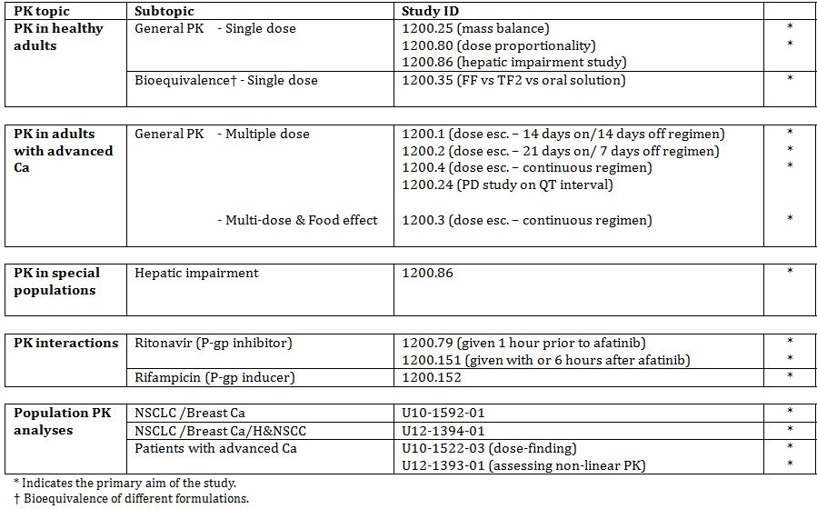
Table 2 lists PK studies that were that were included in the submission but have not been reviewed in this report.
Table 2: Pharmacokinetic studies excluded from consideration.
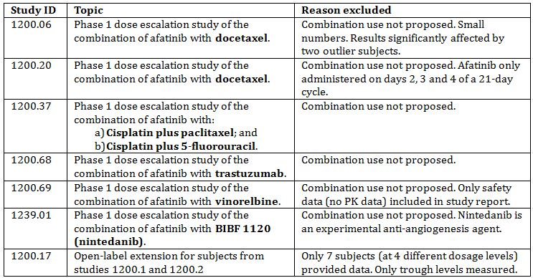
Six of the studies were phase 1 trials examining the use of afatinib in combination with other anticancer agents in patients with advanced cancer. The primary objective of these trials was to identify the maximum tolerated dose (MTD) of the combination under study and collection of PK data was a secondary objective. The conclusions of the studies were generally that afatinib did not affect the PK of the co-administered drugs. The studies were not designed to examine the effect of the other drugs on the PK of afatinib. The sponsor is only seeking approval for use of afatinib as monotherapy, and hence the data on combination use with these agents are not considered relevant to the application. Two studies examined combination with docetaxel, which is a substrate for CYP3A4, and hence may have provided some interaction data relevant to concomitant use of afatinib with other CYP3A4 substrates. However, due to design deficiencies the studies are not considered to provide firm evidence of an absence of an effect of afatinib on CYP3A4.

Summary of pharmacokinetics
The information in the following summary is derived from conventional pharmacokinetic studies unless otherwise stated.

Physicochemical characteristics of the active substance
Afatinib dimaleate appears as a white to brownish-yellow powder and has a molecular weight of 718.1. Afatinib free base has a molecular weight of 485.9. The molecular formula of the dimaleate salt is C₂₄H₂₅ClFN₅O₃ x 2 C₄H₄O₄. Afatinib has two ionisable groups with pKa1 = 8.2 and pKa2 = 5.0. The drug is highly soluble in aqueous media throughout the physiologically relevant pH range of 1.0 to 7.5. It has one chiral centre and is presented as a single isomer.

Pharmacokinetics in healthy subjects and subjects with advanced cancer
PK studies were conducted in patients with advanced cancer (not specifically NSCLC patients) and in healthy volunteers. All studies conducted in healthy volunteers were single dose studies.

Absorption

Sites and mechanisms of absorption
After single doses, median Tmax values were usually 5.0-6.0 hours, suggesting slow absorption. Following oral administration of C-14 labelled afatinib, 4.29% of the administered radioactivity was excreted in the urine, indicating that at least this amount is absorbed.
An in vitro study (U04-1771) examined the passive and active transport of afatinib across confluent Caco-2 cell monolayers, a model for the intestinal epithelium. Afatinib was reported to have high passive permeability and was also reported to be a substrate for the drug efflux transporter P-glycoprotein (P-gp). In another in vitro study using Caco-2 cell monolayers (U11-2809-01) afatinib was reported to be a substrate for the drug efflux transporter BCRP (Breast Cancer Resistance Protein).

Bioavailability

Absolute bioavailability
The sponsor has not conducted an absolute bioavailability study. A justification for not conducting such a study has been provided.

Bioavailability relative to an oral solution
Bioavailability relative to an oral solution was examined in study 1200.35 (Table 3). Bioavailability of the proposed market formulation was only marginally lower than that of the oral solution, suggesting that it is optimally formulated.
Table 3: Bioavailability and PK of the final, to-be-marketed, formulation of afatinib (‘Final Formulation’ or ‘FF’) compared to a) an oral solution of afatinib and b) a tablet formulation of afatinib used in phase 2 and some phase 1 studies (‘Trial formulation II’ or TFII’).
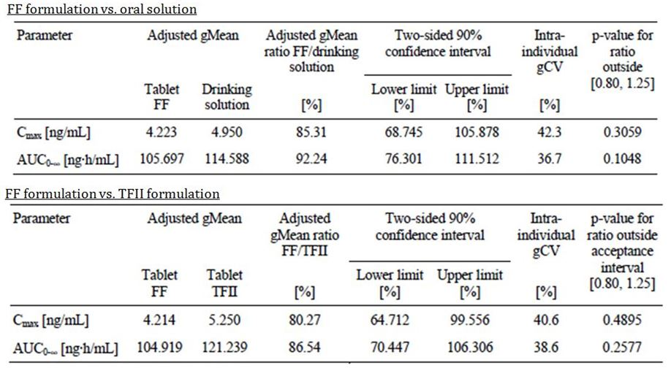

Bioequivalence of clinical trial and market formulations
Study 1200.35 also examined the relative bioavailability of the proposed market formulation compared to the TF2 formulation used in some phase 1 and phase 2 studies. The two formulations were not bioequivalent according to conventional criteria with the AUC of the proposed formulation being 86.5% (90% CI: 70.4 – 106.3) of that obtained with the TF2 formulation (Table 3).
Comment: The lack of bioequivalence between the proposed market and TF2 formulations is not considered to be a clinically significant issue, as the market formulation was the one used in the pivotal and main supportive efficacy and safety studies.

Influence of food
The effect of food was examined in study 1200.3 in subjects with advanced cancer. Subjects received single doses of 40 mg taken either fasted or with a high fat, high calorie meal. Food had a significant effect on bioavailability, causing a 39% reduction in AUC and a 50% reduction in Cmax. Absorption was also significantly delayed with Tmax being prolonged from 3.02 to 6.90 hours.
Food intake was also shown to have a significant effect on AUC in a population PK analysis of patients with NSCLC or breast cancer. AUC was reduced by 26.1 % in patients who had consumed food less than 3 hours before, or less than 1 hour after, afatinib administration.

Dose proportionality
Dose proportionality over the proposed dose range of 20 – 50 mg was examined in a single dose study in healthy volunteers, study 1200.80. After single doses, the PK of afatinib were shown to be non-linear, with greater than proportional increases in AUC and Cmax with increasing dose.
A population PK analysis examined the potential causes of this nonlinearity. The concentration vs. time profiles were best described by a model that included an increase in bioavailability with increasing dose (up to 70 mg, with constant bioavailability at higher doses). Non-linear distribution or elimination could not adequately describe the data.
Comment: The sponsor proposes that saturation of P-gp efflux transport is the reason for the observed non-linear PK of afatinib. As indicated above, in vitro data had demonstrated that afatinib is a substrate for P-gp. Drug interaction data (see below) indicate that inhibition of P-gp results in increased bioavailability and induction of P-gp results in decreased bioavailability. The sponsor’s explanation therefore appears plausible.

Bioavailability during multiple-dosing
Afatinib accumulates in plasma with continuous once daily dosing. Accumulation ratios were of the order of 2.0 to 4.0. Steady state trough concentrations were reached after 7 days.

Distribution

Volume of distribution
No clinical studies using intravenous administration have been conducted, and hence the volume of distribution for afatinib has not been determined. In patients with advanced cancer receiving continuous once daily dosing with 40 or 50 mg per day (in studies 1200.3 and 1200.4) the apparent volume of distribution at steady state (Vz/F,ss) ranged from 2220 to 3150 L, suggesting extensive tissue binding.
Comment: The conclusion that afatinib is extensively distributed should be treated with caution in the absence of any data on absolute bioavailability.

Plasma protein binding
In an in vitro study (U12-1548-01), plasma protein binding of afatinib in pre-dose plasma samples taken from healthy volunteers was 94.6% ± 0.7%. Similar values were obtained in plasma taken from patients with mild or moderate hepatic impairment.
According to the clinical summary, in other in vitro studies, plasma protein binding was independent of the afatinib concentration tested (24-240 ng/mL) and was predominantly to albumin (79.6%). Binding to α-1 acid glycoprotein (AGP) was dependent upon the concentration of the protein (11.6% at 0.1 g/L AGP to 90.6% at 10.0 g/L AGP).

Erythrocyte distribution
According to the clinical summary, an in vitro study showed that “afatinib was distributed into blood cells as indicated by a ratio of concentration in blood cells versus concentration in plasma that decreased from 2.21 at 2 min after spiking to 1.02 at 3 hours after spiking and was equal until 48 hours after spiking”.

Metabolism

Sites of metabolism and mechanisms / enzyme systems involved
In an in vitro study (U09-1568-01) afatinib was incubated with human hepatocytes for 24 hours. Unchanged afatinib accounted for 34.6% of drug-related material, and metabolites for the remaining 65.4%. The major metabolites were:
- The N-oxide metabolite (m15), which accounted for 47.8% of the metabolites. Another in vitro study (U05-1723-01) demonstrated that this metabolite was produced by flavin-containing monooxygenase 3 (FMO3);
- A range of metabolites (including m2, m3, and m4) formed by covalent binding of afatinib by Michael addition to proteins. These metabolites accounted for 41.6% of the metabolites;
- Metabolites which were potentially the products of metabolism by the CYP450 enzyme system (m10, m14, m18 and m20) accounted for only 9.0% of the metabolites;
- A glucuronide conjugate of afatinib accounted for 1.0% of the metabolites.
Another in vitro study analysed the metabolites in plasma, urine and faeces samples from subjects who participated in C14-radiolabelled study (1200.25). In plasma, covalently bound radioactivity and unchanged afatinib were detectable (Figure 1).
Figure 1. Metabolites in plasma.
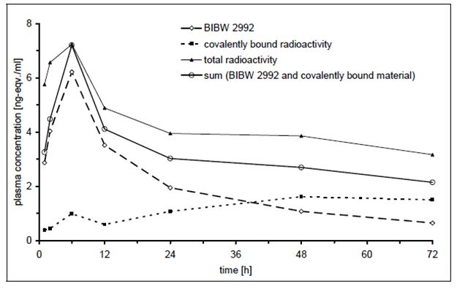
Excluding covalently bound radioactivity, unchanged afatinib accounted for >97% of the radioactivity in plasma. Other individual metabolites were not detected.
The metabolites in urine and faeces detected in the first 72 hours are summarised in Table 4.
Table 4: Metabolites in urine and faeces.
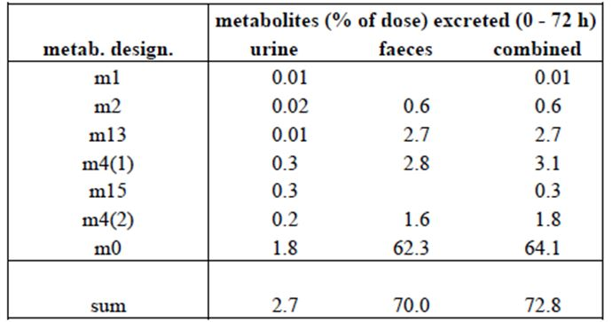
Comment: These data suggest that the predominant mechanism of metabolism is covalent bonding of afatinib to proteins/peptides and that the other identified mechanisms (via FMO3 or CYP450) do not play a significant role in vivo. A large proportion of an orally administered dose is excreted unchanged in the faeces. In the absence of data on absolute bioavailability, it is not clear whether this represents unabsorbed drug or drug excreted unchanged in the bile or by the intestine.

Non-renal clearance
No clinical studies using intravenous administration have been conducted, and hence the clearance of afatinib has not been determined. In patients with advanced cancer receiving continuous once daily dosing with 40 or 50 mg per day (in studies 1200.3 and 1200.4) the mean apparent clearance at steady state (CL/F,ss) ranged from 689 – 1390 mL/min.
Apparent renal clearance is low (11.4 mLs/min) suggesting that non-renal mechanisms are predominantly responsible for clearance.

Excretion

Mass balance studies
In a mass balance study 1200.25, approximately 85% of an orally administered dose was excreted in the faeces and approximately 4% in the urine.

Renal clearance
In study 1200.25, only 4.29% of a radiolabelled oral dose of afatinib was excreted in the urine. Only 0.69% of the dose was excreted in the urine as unchanged afatinib. Apparent renal clearance was 11.4 mLs/min. These findings suggest that the primary routes of clearance of afatinib are non-renal.

Intra- and inter-individual variability of pharmacokinetics
Intra-individual variability in PK parameters (e.g. as in variation in trough concentrations over time) was moderate. Inter-individual variability in PK parameters was moderate to high, with % co-efficient of variation often exceeding 100%.

Pharmacokinetics in the target population
The PK of afatinib in patients with NSCLC were only examined in population PK studies. The values obtained for PK parameters (e.g. Vz/F,ss and CL/F,ss) were consistent with those obtained in studies in healthy volunteers or patients with advanced cancer.

Pharmacokinetics in other special populations

Pharmacokinetics in subjects with impaired hepatic function
Study 1200.86 examined the effect of mild and moderate hepatic impairment on the PK of afatinib. Systemic exposure, as assessed by AUC, was not increased in either group compared to subjects with normal liver function. Cmax was increased by approximately 10% in subjects with mild impairment, and by approximately 27% in subjects with moderate impairment.
Additionally, in a population PK analysis, mild hepatic impairment had no significant effect on the PK of afatinib.
Comment: The proposed PI recommends that no dosage reduction is necessary in subjects with mild or moderate impairment. The effect of severe hepatic impairment has not been studied, and the draft PI states that use in this population is not recommended. These recommendations are considered acceptable.

Pharmacokinetics in subjects with impaired renal function
No conventional PK studies on the effect of renal impairment have been conducted. In a population PK analysis, decreased renal function was shown to have a statistically significant effect on afatinib AUC, as shown in Figure 2.
Figure 2. Effect of renal impairment on afatinib AUC.
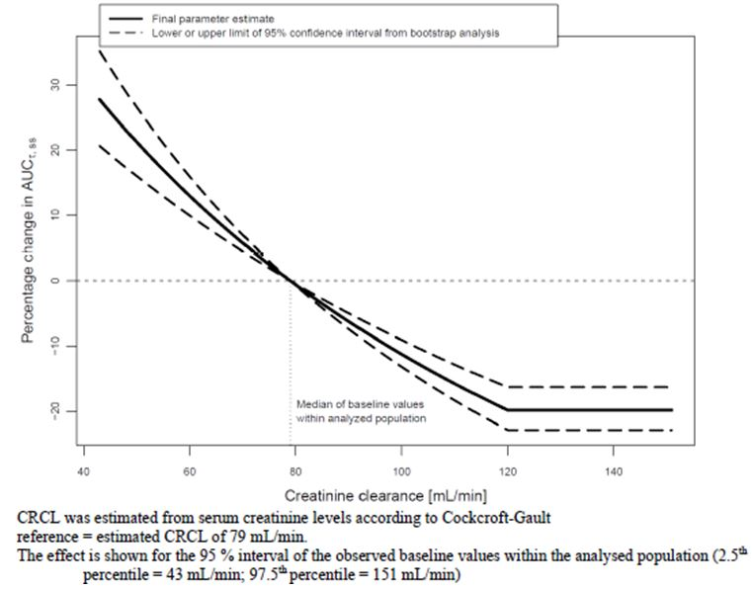
The sponsor notes that renal elimination of afatinib is a minor mechanism of clearance and that therefore this effect would not have been expected. The sponsor considers that the effect can be explained by a reduced expression of intestinal P-gp in subjects with renal impairment. Published references to support this argument were included in the dossier.
Comment: In the draft PI, no dosage reduction is recommended for patients with mild renal impairment (CrCl 50-80 mL/min) or moderate renal impairment (CrCl 30 - <50 mL/min). The population PK analysis suggested that a subject with CrCl = 43 mL/min (moderate impairment) would experience an increase of AUC of only 28.7% compared to a subject with a CrCl of 79 mL/min. The dosage advice is therefore considered acceptable. The analysis included very few PK measurements from patients with severe renal impairment (CrCl < 30 mL/min). The proposed PI states that the drug is not recommended in this population.

Pharmacokinetics according to age
No conventional PK studies on the effect of age have been conducted. In a population PK analysis, age was not found to have any significant effect on the PK of afatinib.

Pharmacokinetics according to race
In the same population PK analysis, there were no differences in PK detected between Caucasian and Asian populations.

Pharmacokinetics related to other population characteristics
In a population PK analysis, female sex and low weight were both associated with a significantly higher afatinib AUC. The magnitude of the effect was modest and did not warrant dosage adjustment.

Pharmacokinetic interactions

Pharmacokinetic interactions demonstrated in human studies

Ritonavir (P-gp inhibitor)
The PK of afatinib was altered by the P-gp inhibitor ritonavir. When ritonavir was administered 1 hour prior to afatinib, the afatinib AUC was increased by 47.6% and Cmax by 38.5%. However, when ritonavir was administered together with afatinib, or 6 hours after afatinib, there were no clinically significant effects on the PK of afatinib.

Rifampicin (P-gp inducer)
The PK of afatinib were also altered by the P-gp inducer rifampicin. Pre-treatment with rifampicin for 1 week resulted in a 34% reduction in AUC and a 22% reduction in Cmax.

Clinical implications of in vitro findings
In vitro studies were reported to demonstrate the following:
- In human liver microsomes, afatinib did not inhibit the following CYP450 enzymes: 1A1, 1A2, 2A6, 2B6, 2C8, 2C9, 2C19, 2D6, 2E1, 3A4 or 4A11;
- In human liver microsomes, afatinib did not induce the following CYP450 enzymes: 1A2, 2B6, 2C8, 2C9, 2C19 or 3A4;
- In human liver microsomes, afatinib inhibited the following UDP-glucuronosyltransferases: UGT1A1 and UGT2B7. However, inhibition only occurred at afatinib concentrations well in excess of afatinib Cmax;
- In a Caco-2 cell line, afatinib inhibited the action of P-gp. However, inhibition only occurred at afatinib concentrations well in excess of afatinib Cmax;
- In a Caco-2 cell line, afatinib inhibited the action of BCRP. The IC50 (0.75 μM) was above the Cmax for afatinib (0.158 μM) but the sponsor considers that an interaction may still be possible;
- In other models, afatinib was not found to be a substrate for, or inhibitor of, OATP, OAT or OCT mediated drug transport.
These in vitro findings suggest that afatinib treatment is unlikely to be associated with drug interactions involving these mechanisms.

Evaluator’s overall conclusions on pharmacokinetics
The submission did not include an absolute bioavailability study. The sponsor provided a justification for not performing such a study. In brief, the justification argued the following:
- Afatinib has high passive permeability, and the effect of P-gp/BCRP on absorption is ‘mild’;
- A significant first pass effect would not be expected as afatinib is only metabolised to a minor extent;
- Bioavailability would therefore be expected to be reasonably high. This was confirmed in rats where absorption was 68% and absolute bioavailability was 45%;
- As the drug has nonlinear PK, exposure after IV administration would need to be tested at different dosage levels, and this would represent an unacceptable burden for study subjects;
- Afatinib is only intended for oral administration and safety and efficacy have been established.
The sponsor concluded that an absolute bioavailability study would provide only limited additional information and that therefore it would not be ethically justified.
Comment: The justification is not considered acceptable. A PK study on IV administration would provide data on the fundamental parameters of clearance and volume of distribution, which remain unknown for afatinib. Determination of absolute bioavailability would allow a greater understanding of the elimination of the drug (for example, whether it is eliminated unchanged in bile or simply not absorbed), the importance of the effect of P-gp and a clearer understanding of the importance of renal clearance (given the finding that renal impairment affects afatinib PK). It is noted that the TGA’s Australian Regulatory Guidelines for Prescription Medicines (ARGPM) Appendix 15 (1) states:
‘...absolute bioavailability studies are normally required for all new chemical entities except those intended for intravenous administration.’
Given the important PK information that could be generated, it is the opinion of this evaluator that such a study would not be unethical.
The argument that absolute bioavailability would need to be tested at different dosage levels is not accepted. The nonlinear PK of afatinib is due to saturable absorption, which would not affect IV administration. As the relative bioavailabilities of the various proposed oral dosages are known, comparison of one oral and one IV dosage level should be feasible.
The sponsor has not argued that formulation issues or poor local tolerance of an IV preparation are barriers to the conduct of an absolute bioavailability study.
The submission did not include adequate data on the effect of severe hepatic impairment or severe renal impairment. However, the draft PI excludes use of the product in these populations and this is considered acceptable.
Apart from the lack of an absolute bioavailability study, the PK data included in the submission are considered adequate.

Pharmacodynamics

Studies providing pharmacodynamic data
Table 5 shows the studies relating to each pharmacodynamic topic and the location of each study summary.
Table 5: Submitted pharmacodynamic studies.
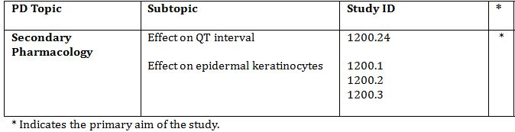

Summary of pharmacodynamics
The information in the following summary is derived from conventional pharmacodynamic studies in humans unless otherwise stated.

Mechanism of action
Afatinib irreversibly binds to the TKI domain of the EGFR receptor, blocking cell signalling.

Pharmacodynamic effects

Primary pharmacodynamic effects
There were no clinical studies on the primary pharmacodynamics of afatinib.

Secondary pharmacodynamic effects

Effects on QT interval
The submission included a study (1200.24 – see Table 16) designed to examine the effects of afatinib on the QT interval. The drug did not produce any evidence of clinically significant T prolongation.

Effects on epidermal keratinocytes
In three early studies in patients with advanced cancer (1200.1, 1200.2, 1200.3) the effect of afatinib on epidermal keratinocyte proliferation in skin biopsies was examined. In two of these studies, proliferation was reduced, consistent with the drug’s mode of action.

Evaluator’s overall conclusions on pharmacodynamics
The sponsor has adequately examined the effect of afatinib on QT interval. There are no deficiencies in the submission with respect to clinical pharmacodynamic data.

Dosage selection for the pivotal studies
In phase 1 dose-ranging studies using continuous once daily dosing (studies 1200.3 and 1200.4) the maximum tolerated dose (MTD) was 50 mg daily. Therefore, this dose was selected for use in phase 2 and phase 3 studies.
Studies 1200.3 and 1200.4 were conducted in patients with advanced cancer who had generally received prior therapy. Previously untreated, EGFR mutation positive, disease may be more sensitive to EGFR TKIs than previously treated disease. Therefore in a phase 2 study in previously untreated subjects (1200.22), 40 mg and 50 mg doses were tested and found to have comparable efficacy. The 40 mg dose was therefore chosen for the pivotal efficacy study in previously untreated patients.

Clinical efficacy

Pivotal efficacy study

Study 1200.32 (‘LUX Lung 3’)

Study design, objectives, locations and dates
Study 1200.32 (also referred to as the ‘LUX-Lung 3’ trial) was a Phase 3, randomised (2:1), open-label trial with 2 parallel groups. The trial objective was to compare the efficacy and safety of afatinib with pemetrexed/cisplatin combination chemotherapy as first-line treatment in patients with advanced or metastatic adenocarcinoma of the lung harbouring an EGFR mutation.
It was a multinational trial conducted at 133 sites in 25 countries. Most of the randomised subjects (70%) were in Asia, with 21% in Europe, 1% in North America and 8% in other countries (including Australia).
The first patient was enrolled on 17 August 2009 and the last patient enrolled on 28 February 2011. Follow up is ongoing and the database cut-off for the study report was 9 February 2012. The date of the study report itself was 4 July 2012.

Inclusion and exclusion criteria
Full inclusion and exclusion criteria are shown in Table 6.
Table 6: Inclusion and exclusion criteria.
Inclusion:
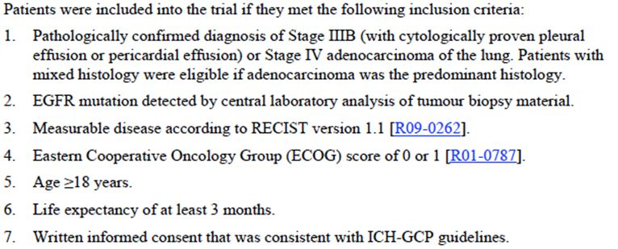
Exclusion:
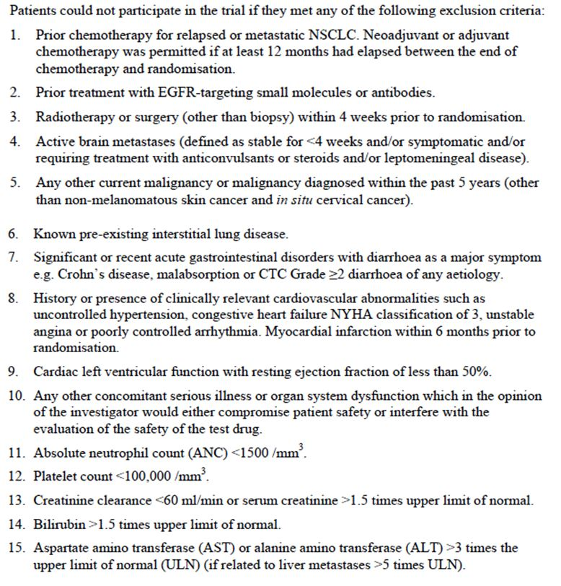
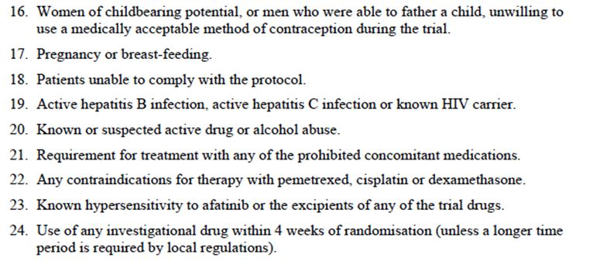
Comment: For inclusion in the trial subjects were required to have tumour biopsy material available, and this must have demonstrated an EGFR mutation. EGFR mutation testing was done centrally using a specific testing kit (TheraScreen Mutation Kit; Qiagen UK). Afatinib also inhibits the HER-2 receptor and other drugs in this class (trastuzumab, lapatinib) have been associated with the development of cardiac failure. Subjects with an LVEF <50% were excluded from this trial.

Study treatments
Subjects were randomised (2:1) to receive one of the following two treatments:
- Afatinib 40 mg once daily. Subjects were instructed to take the drug at approximately the same time every day, at least one hour before and 3 hours after food intake. Subjects who tolerated the drug well in the first 3 weeks had their dose increased to 50 mg daily. Subjects who experienced toxicity could have the dose reduced to 30 mg, and if needed, 20 mg. If 20 mg daily could not be tolerated the drug was permanently discontinued. Treatment was continued until disease progression occurred, unacceptable toxicity developed or the patient or investigator requested discontinuation.
- Combination chemotherapy with pemetrexed (500 mg/m²) and cisplatin (75 mg/m²), with both being given on day 1 of a 21-day cycle. Dose adjustments were made according to the approved prescribing information documents for the two drugs. Treatment was continued for a maximum of 6 cycles, and was discontinued earlier in the event of disease progression, unacceptable toxicity or at the request of the patient or investigator.
Comment: The pemetrexed/cisplatin combination is registered in Australia for the initial treatment of patients with advanced or metastatic NSCLC (with other than predominantly squamous cell histology). At the time of the commencement of this trial (2009), the combination would have been considered a standard first-line treatment for NSCLC with EGFR mutation. The choice of comparator is therefore considered acceptable.

Efficacy variables and outcomes
The primary efficacy outcome was progression-free survival (PFS), defined as the time from randomisation to disease progression (or death if the patient died before progression). Disease progression and tumour response were assessed by a central independent review panel that included two radiologists and an oncologist. RECIST criteria (version 1.1) were used to determine disease progression and response. The central reviewers were blinded to treatment allocation.
One to five target lesions were identified for each patient at baseline and were followed for evidence of progression. Tumour imaging (CT scan or MRI) was done at baseline and then at 6 weekly intervals until progression. After week 48, scans were performed at 12 weekly intervals until progression. Progression was considered to have occurred if one of the following criteria applied: a) a 20% increase in the sum of the diameters (SoD) of the target lesions, together with an absolute increase in the SoD of at least 5mm; b) the appearance of 1 or more new lesions; or c) unequivocal progression of existing non-target lesions.
‘Key’ secondary efficacy outcomes were:
- Objective Response Rate (best overall response of complete response [CR] or partial response [PR] according to RECIST criteria). In patients achieving an objective response, the time to response and duration of response were also measured;
- Disease Control Rate (best overall response of CR, PR, stable disease [SD] for at least 35 days, or Non-CR/Non-PD).
- Overall survival (OS) defined as time from randomisation to death from any cause.
Comment: The primary and key secondary endpoints are standard for oncology trials and comply with the EMA ‘Guideline on the Evaluation of Anticancer Medicinal Products in Man’(4) which has been adopted by the TGA.
‘Other’ secondary efficacy outcomes were:
- Tumour shrinkage – the change from baseline in size of target lesions (as measured by the SoD);
- Change from baseline in bodyweight;
- Change from baseline in ECOG performance status;
- Health-Related Quality of Life (HRQOL). Two validated instruments were used – the EORTC’s QoL Questionnaire C30 (QLQ-C30) and lung cancer module (QLQ-LC13). Questions from these instruments were used to assess three specific symptoms – cough, dyspnoea and pain. For each of these symptoms, the following analyses were undertaken:
  - The distribution of patients that were improved, stable or worsened;
  - The time to deterioration of the symptom; and
  - The change in the symptom score over time.
Raw scores from the questionnaires were standardised such that all scores ranged from 0 to 100 points, with higher scores representing a worse level of symptoms. Worsening or deterioration was defined as a 10-point increase from baseline and improvement was defined as a decrease of 10 points.

Randomisation and blinding methods
Patients were randomised (2:1) to either afatinib or chemotherapy using a validated random number generating system. Randomisation was performed centrally via an Interactive Voice/Web Response System (IVRS/IWRS). The randomisation was stratified according to EGFR mutation category (L858R vs. Del 19 vs. Other) and race (Asian vs. Non-Asian).
Neither the investigators nor the subjects were blinded to study treatment. However, the primary endpoint and most key secondary endpoints were based on imaging assessed by the central independent review panel. This panel was blinded to study treatment.

Analysis populations
Two analysis populations were defined. The randomised set (RS) included all patients who were randomised to receive treatment, whether treated or not. The RS was used for primary analysis of efficacy. The treated set (TS) included all randomised patients who were documented to have received at least one dose of either afatinib or chemotherapy. The TS was used for the analysis of safety.

Sample size
In a previous trial of gefitinib vs. chemotherapy in patients with EGFR mutation (the IPASS trial), the upper 95% CI for the hazard ration for PFS was 0.64. Assuming a median PFS of 7 months in the chemotherapy arm, and a hazard ratio of 0.64 (producing a median PFS of 11 months in the afatinib arm) with 90% power and one sided 0.025 significance level, it was estimated that 217 PFS events would be required, and a total of 330 patients would be needed.
The trial protocol was subsequently amended to state that a two-sided significance level of 0.05 would be used. No interim analyses were planned for PFS.

Statistical methods
For the primary endpoint, a stratified log-rank test (two-sided, 0.05 significance level) was used. The test was stratified by the two randomisation stratification variables of EGFR mutation group and race.
A Cox proportional hazards model, stratified by EGFR mutation group and race was used to estimate the hazard ratio and 95% confidence interval (CI) between the two treatment groups. Kaplan-Meier estimates and 95% CIs were tabulated at 3-monthly time points and included a comparison of the treatment groups using a z-test (approximation of the normal distribution). Kaplan-Meier curves for the two treatment groups were also produced.
Various sensitivity analyses of PFS were also undertaken to assess the robustness of the primary efficacy analysis. Subgroup analyses were also undertaken for various demographic and baseline characteristics. A Cox proportional hazards model (without the terms used to stratify the randomisation) was used for each subgroup category, along with the corresponding log-rank test.
If a statistically significant difference between the treatment arms was obtained for the primary efficacy endpoint of PFS, formal statistical testing was to be performed on the key secondary endpoints. Each key secondary endpoint was only to be formally analysed if the previous endpoint was found to be statistically significant. The key secondary endpoints were analysed in the following order:
- Objective response rate (ORR) – rate between groups was compared using a logistic regression model, stratified by EGFR mutation category and race. Rates were presented with exact 95% Clopper-Pearson CIs. For patients with an objective response, time to response and duration of response was analysed descriptively. Kaplan-Meier curves for the 2 treatment arms were also produced for the duration of response.
- Disease control rate (DCR) – using the same methods as for ORR;
- Overall survival (OS) – using the same methods as for PFS. A second analysis of OS is planned when OS data are more mature.
Comment: The statistical methods used were appropriate.

Participant flow
A total of 1269 subjects were enrolled. Of these, only 345 were randomised and 340 were treated. A total of 924 subjects were enrolled but not randomised. Most of these (817) had a tumour that was EGFR mutation negative. Other reasons for non-randomisation were failure to meet inclusion/exclusion criteria (n=58), withdrawn consent (n=24), not randomised due to AEs (n=5), lost to follow up (n=5) and other reasons (n=15).
Comment: The incidence of EGFR mutations in the enrolled population was 36% (452/1269). This is a high incidence and probably reflects the large proportion of subjects recruited from Asian countries.

Major protocol violations/deviations
Important protocol violations are shown in Table 7. None of the protocol violators were excluded from the primary efficacy analysis. There were more protocol violations in the afatinib arm, with most of the excess being due to subjects not following the specific protocol for dose escalation or reduction.
Table 7: Pivotal study 1200.32: Important protocol violations.
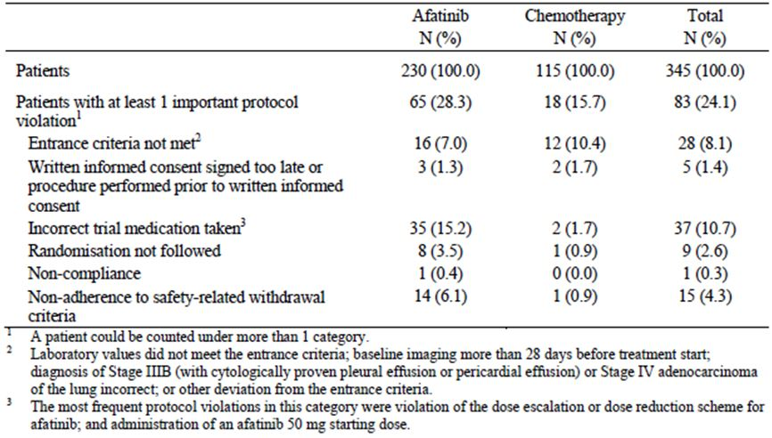
Comment: The protocol violations were unlikely to have influenced the study outcome.

Baseline data
Stratification factors at baseline are shown in Table 8 and patients with ‘other’ mutations in Table 9.The median (range) time in months since diagnosis was 1.1 (0.0 – 103.1) in the afatinib group and 1.0 (0.0 – 91.6) in the chemotherapy group.
Table 8: Pivotal study 1200.32: Stratification factors at baseline.
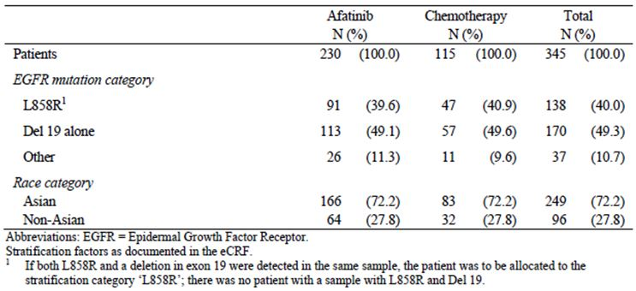
Table 9: Pivotal study 1200.32: Patients with ‘other’ mutations.
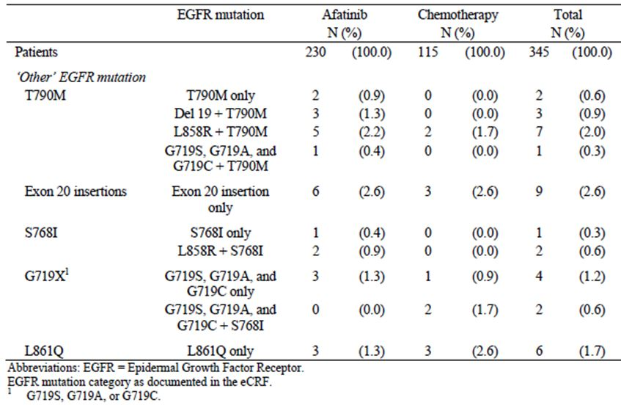
Comment: The two groups were well balanced with respect to baseline characteristics.

Results for the primary efficacy outcome
The median follow-up time for PFS was 16.4 months. By the data cut-off data, there had been a total of 221 PFS events documented - 219 disease progressions and 2 deaths without progression (both in the afatinib group). The results for PFS are shown in Table 10. For the primary endpoint, afatinib treatment was associated with a statistically significant prolongation of PFS with a hazard ratio of 0.58 (95% CI: 0.43 – 0.78) and a p-value of 0.0004. Median PFS was prolonged by 4.2 months (11.1 vs. 6.9). The Kaplan Meier curve for PFS is shown in Figure 3. The probability of being alive and progression-free at 12 months was doubled (46.5% vs. 22.0%).
Table 10: Pivotal study 1200.32: PFS results.
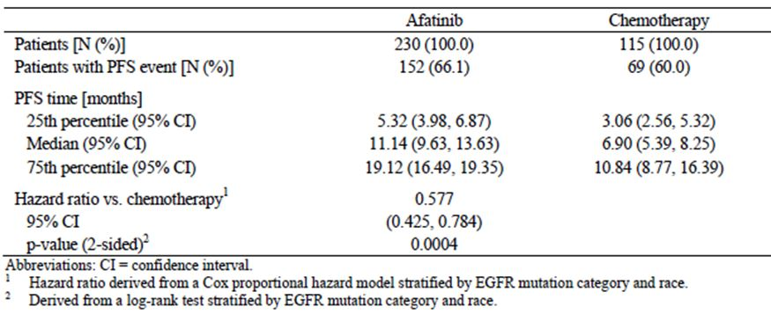
Figure 3. Effect of renal impairment on afatinib AUC.
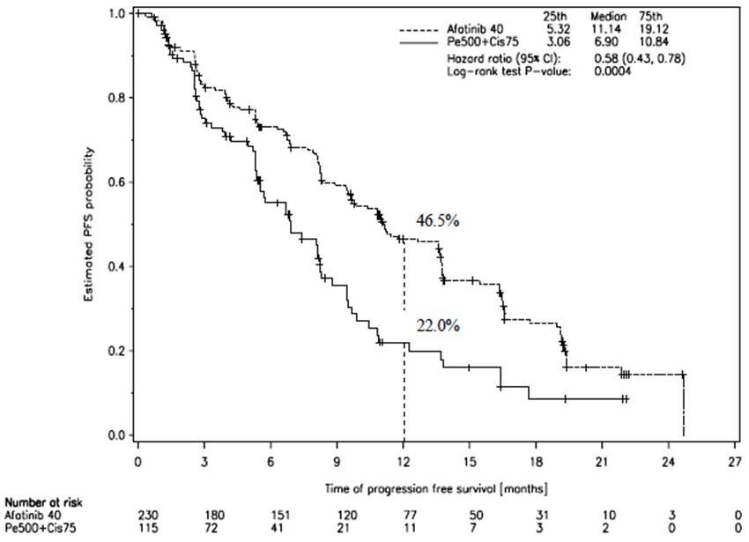
All sensitivity analyses conducted confirmed the findings of the primary analysis. The results of subgroup analyses for PFS are summarised in Figure 4.
Figure 4. Pivotal study 1200.32: Results of subgroup analyses for PFS.
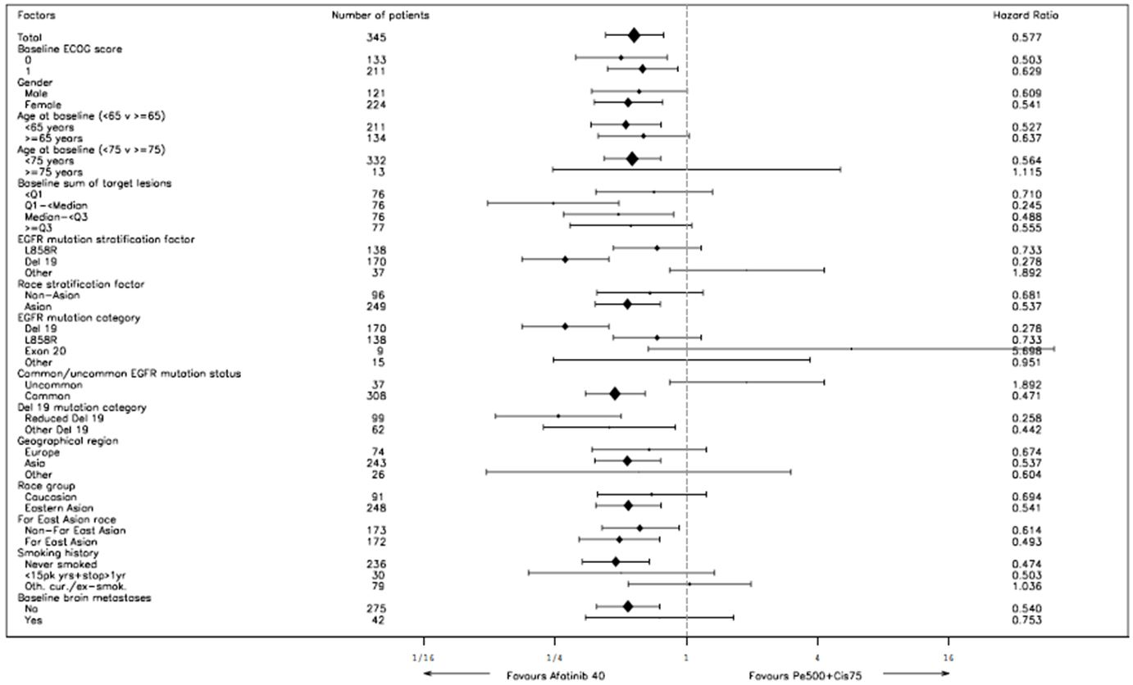
Comment: The benefit of afatinib over chemotherapy was consistent across most subgroups with hazard ratios being less than 1.0. In the subgroup of patients with uncommon EGFR mutations (those other than del 19 and L858R) afatinib appeared to have a negative effect (HR = 1.89). However, there were only 37 subjects in total who fell into this category, and there were multiple different types of mutations. When assessing individual mutations, there were imbalances between the two treatment groups in baseline disease characteristics. For these reasons it is considered a harmful effect of afatinib in these patients cannot be concluded.

Results for other efficacy outcomes

Overall response and disease control rates
The results for ORR and DCR are summarised in Tables 11-13. Afatinib treatment was associated with a significantly higher ORR (56.1% vs. 22.6%; Odds ratio: 4.660; p-value < 0.0001) and DCR (90.0% vs. 80.9%; Odds ratio: 2.140; p-value = 0.0189). Responses achieved with afatinib were twice as durable as those achieved with chemotherapy (median duration 11.1 vs. 5.5 months).
Table 11: Pivotal study 1200.32: Time to and duration of objective response.
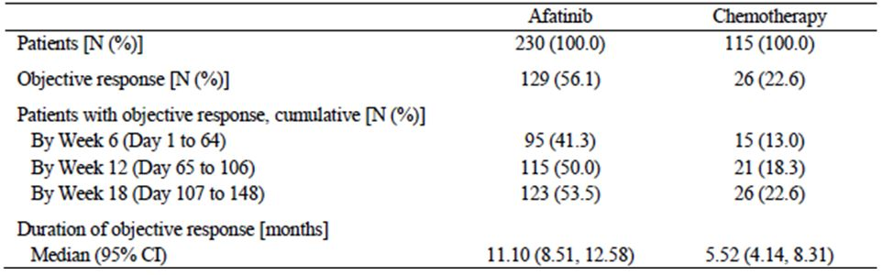
Table 12: Pivotal study 1200.32: Overall survival results.
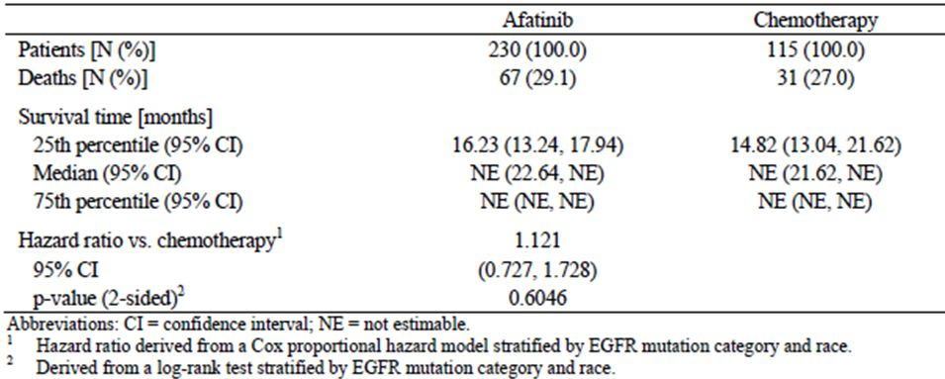
Table 13: Pivotal study 1200.32: Anticancer treatments received after discontinuation of study medication.
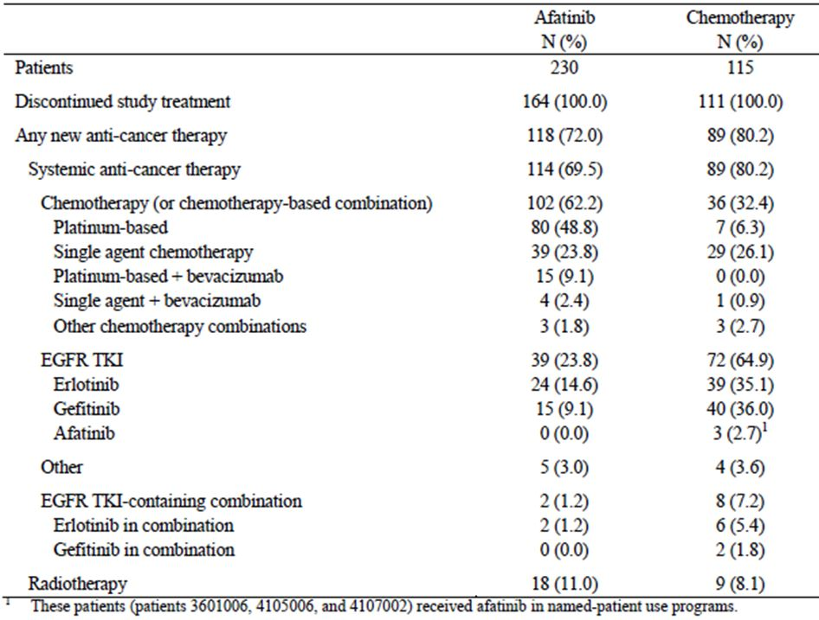

Overall survival
Results for overall survival are summarised in Table 12 and Figure 5. Table 13 shows the anticancer treatments received after discontinuation of study medication.
Figure 5. Pivotal study 1200.32: Overall survival – Kaplan-Meier curve.
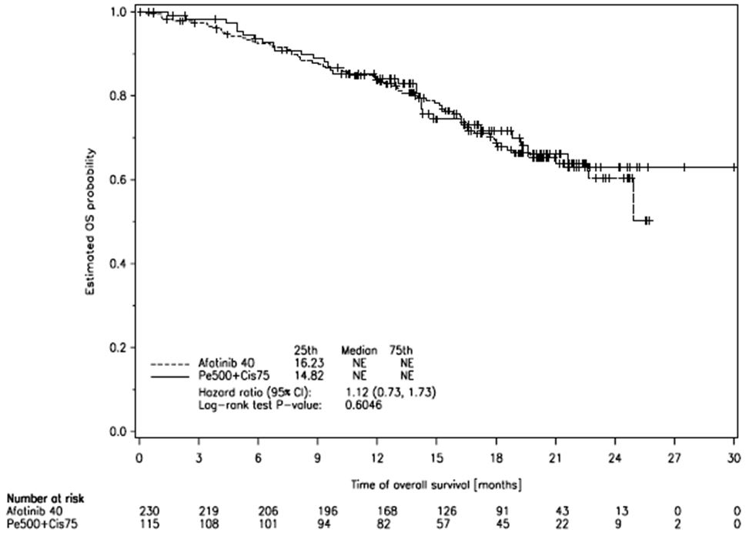
Comment: Survival data were immature with less than 30% of patients having died at the time of database cut-off. Approximately two-thirds of subjects randomised to the chemotherapy arm went on to receive an EGFR-TKI as part of subsequent treatment. Given this and other imbalances in subsequent treatments, demonstration of a survival benefit in the afatinib arm may not be possible, even with further follow-up.

Tumour shrinkage
Afatinib treatment was associated with a greater degree of tumour shrinkage compared to chemotherapy. The mean (SD) percentage decrease from baseline (in the sum of target lesion diameters) was -39.7% (26.7) for afatinib and -22.9% (20.1) for chemotherapy.

Changes in body weight and ECOG performance score
Data on the changes in bodyweight did not demonstrate any notable differences between the two treatment groups. Mean (SD) change from baseline at the last visit was -0.97 (5.51) kg in the afatinib group and -0.40 (3.92) kg in the chemotherapy group.
Improvement in ECOG PS compared to baseline occurred in 11.8% of afatinib patients and 4.5% of chemotherapy patients. Maintenance of the same ECOG PS occurred in in 64.5% of afatinib patients and 73.0% of chemotherapy patients.

HRQoL measures
Compliance with questionnaire completion was good (87 to 99%) and comparable in both treatment arms. The results showed:
- A greater proportion of afatinib-treated patients had an improvement in dyspnoea (64% vs. 50%). There was no significant difference between groups in the proportion of patients who had improvement in cough (67% vs. 60%) or pain (59% vs. 48%), although some individual items assessing pain demonstrated benefit with afatinib (Table 14). There was no significant effect on the proportion of patients who had improvement in global health status.
- Afatinib significantly delayed the time to deterioration of cough and dyspnoea. There was no significant effect on time to deterioration in pain (Figure 6). The median time to deterioration of coughing in the chemotherapy group was 8.0 months and the median had not been reached in the afatinib group. The median time to deterioration of dyspnoea in the chemotherapy group was 2.9 months compared to 10.3 months in the afatinib group. There was no significant effect on time to deterioration in global health status.
- Mean scores over time were significantly lower in the afatinib group for cough and dyspnoea, but not for pain (Figure 7). Mean scores over time for global health status were significantly lower in the afatinib group.
Table 14: Pivotal study 1200.32: HRQoL – Improvement in symptoms.
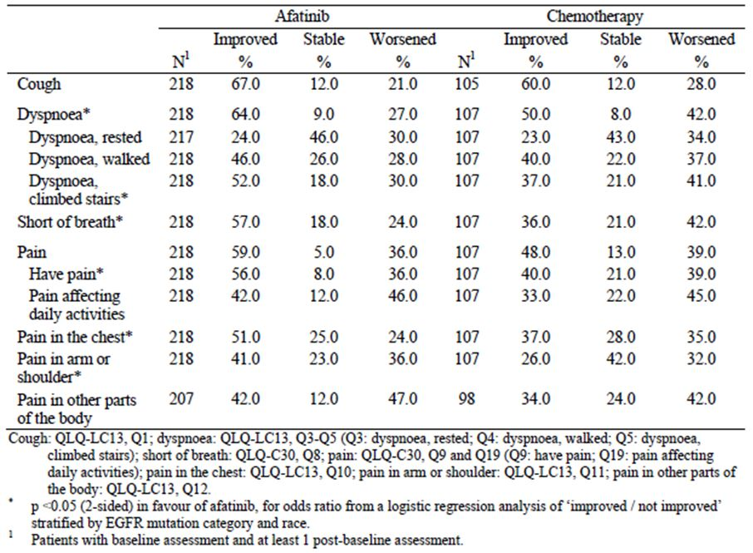
Figure 6. Pivotal study 1200.32: HRQoL – time to deterioration of symptoms.
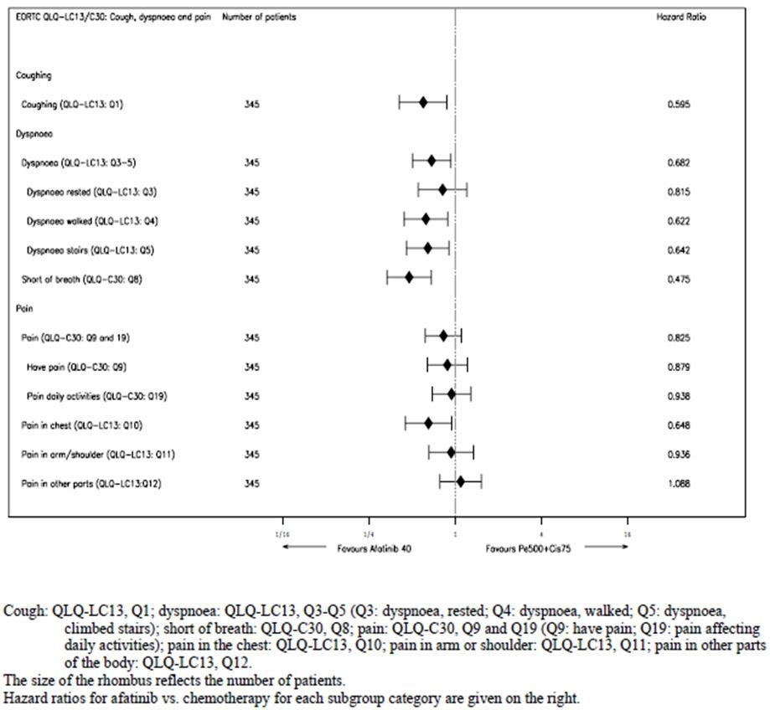
Figure 7. Pivotal study 1200.32: HRQoL – changes in symptoms over time.
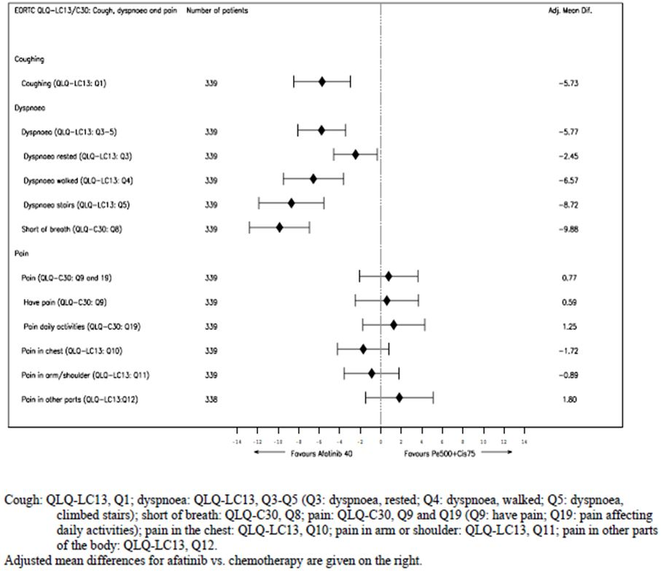
Comment: The overall impression of these HRQoL data is that afatinib may have an effect on reducing dyspnoea and cough. None of the three types of analyses indicated an effect on overall pain. A benefit in terms of global health status was demonstrated in only one of the three analyses.

Main supportive study

Study 1200.23 (‘LUX Lung 1’)
The sponsor designated this study as ‘supportive’, even though it was a large well-designed randomised controlled trial, which enrolled more patients than the pivotal study. It is an important study as it provides the main evidence to support use of afatinib in subjects who have already failed a previous EGFR-TKI. For these reasons the study will be reviewed in detail.

Study design, objectives, locations and dates
Study 1200.23 (also referred to as the ‘LUX Lung 1’ trial) was a Phase IIb/III, randomised (2:1), double blind trial with two parallel groups. The primary objective of the trial was to compare the efficacy of afatinib to that of placebo in patients with advanced or metastatic NSCLC who had already received treatment with 1 or 2 lines of cytotoxic chemotherapy and at least 12 weeks treatment with erlotinib or gefitinib (or both).
It was a multinational trial conducted at 86 sites in 15 countries. Most of the randomised subjects (62%) were in Asia, with 26% in Europe and 12% in North America.
The first patient was enrolled on 2 April 2008. The database cut-off for the study report was 8 July 2010. The date of the study report itself was 15 December 2011. The study has been published.

Inclusion and exclusion criteria
Inclusion and exclusion criteria are shown in Table 15.
Table 15: Supportive study 1200.23: Inclusion and Exclusion criteria.
Inclusion:
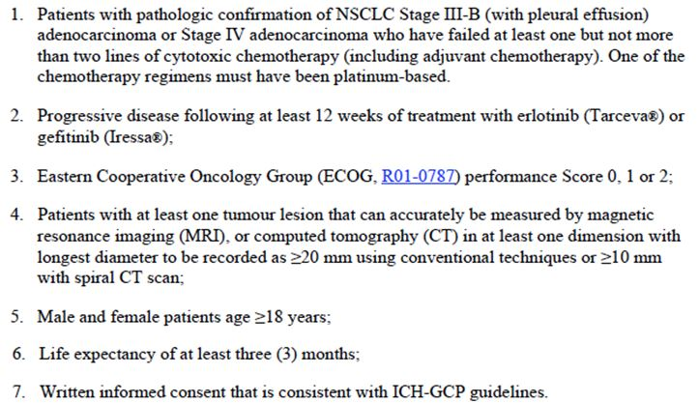
Exclusion:
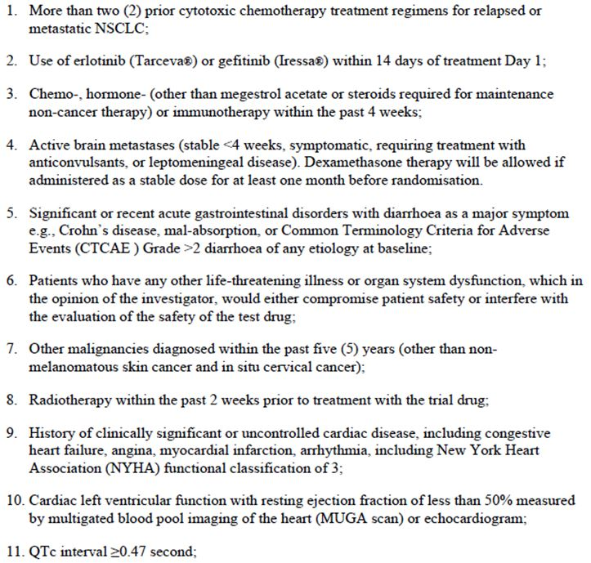
Table 15 (continued): Supportive study 1200.23: Inclusion and Exclusion criteria.
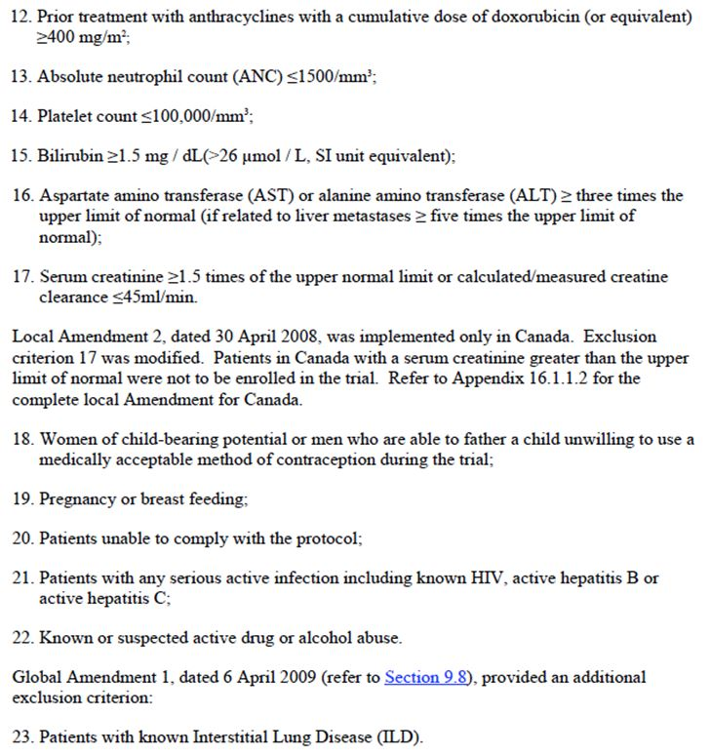
Comment: Documentation of EGFR mutation positive disease was not an entry requirement for the trial. However it was a requirement that subjects must have had at least 12 weeks of prior treatment with erlotinib or gefitinib. Subjects enrolled could therefore be considered to have obtained some prior benefit from these drugs in that they would have achieved at least stable disease for 12 weeks. Patients with EGFR mutation positive disease are the most likely to respond to these drugs. Hence the trial population would be ‘enriched’ for patients with EGFR mutation positive disease.
Patients with cardiac failure or an LVEF of < 50% were excluded.

Study treatments
Subjects were randomised (2:1) to receive one of the following two treatments:
- Afatinib 50 mg once daily. Subjects were instructed to take the drug at approximately the same time every morning, one hour before food intake. Subjects who experienced toxicity could have the dose reduced to 40 mg, and if needed, 30 mg. If 30 mg daily could not be tolerated the drug was permanently discontinued. Treatment was continued indefinitely until disease progression occurred or unacceptable toxicity developed.
- Placebo (given as per afatinib).
Both afatinib and placebo-treated subjects also received Best Supportive Care (BSC).
Comment: Patients included in this trial had received 2-3 previous lines of therapy for advanced disease. There are no established treatments available that have demonstrated a favourable risk-benefit balance in this setting. The use of placebo plus BSC as the comparator arm is therefore considered acceptable.

Efficacy variables and outcomes
The primary efficacy outcome was overall survival, defined as time from the date of randomisation to the date of death.
Secondary efficacy outcomes included:
- PFS defined as the time from date of randomisation to date of disease progression (according to RECIST version 1.0 criteria) or death, whichever occurred earlier;
- Objective response rate according to RECIST version 1.0 criteria.
Assessment of imaging (CT/MRI etc.) for the determination of disease progression or tumour response was done by a central imaging unit comprised of two radiologists and an oncologist. The reviewers were blinded to treatment allocation.
Other efficacy outcomes included:
- Duration of disease control, defined as the time interval from the date of randomisation to the date of disease progression or death, among patients with initial tumour response (CR, PR) or SD;
- Duration of objective response, defined as the time at which RECIST Version 1.0 was first met for CR / PR (whichever was first recorded) to the date of tumour progression or death;
- Health-related quality of life (HRQoL). The main HRQoL endpoints were the time to deterioration for the following three symptoms measured on the QLQ-C30 or QLQ-LC13 questionnaire:
  - Cough (Question 1 on the QLQ-LC13);
  - Dyspnoea (composite of Questions 3-5 on the QLQ-LC13);
  - Pain (composite of Questions 9 and 19 on the QLQ-C30).
The percentage of patients with improved vs. stable vs. worsened scores for each of the three symptoms was also analysed.

Randomisation and blinding methods
Patients were randomised (2:1) to receive afatinib plus BSC or placebo plus BSC. Allocation to a treatment group was determined by a computer generated random sequence randomisation, in blocks of 3, via an interactive voice response system. Randomisation was stratified according to ECOG performance score (0 or 1 vs. 2) and gender (male vs. female).
The trial was double-blinded through the use of matched placebo tablets. Personnel involved in the central reading of imaging (CT, MRI, etc.) were also blinded to treatment allocation.

Analysis populations
Two analysis populations were defined. The randomised set (RS) included all patients who were randomised to receive treatment, whether treated or not. The RS was used for primary analysis of efficacy. The treated set (TS) included all randomised patients who were documented to have received at least one dose of either afatinib or chemotherapy. The TS was used for the analysis of safety.

Sample size
In a previous trial of erlotinib vs. placebo as 2nd/3rd line therapy in patients with advanced NSCLC, patients treated with placebo had a median OS of 4.7 months and patients with treated with erlotinib had a median OS of 6.7 months. The sponsor hypothesized a similar hazard ratio would occur in this trial (i.e. 4.7/6.7 = 0.70). With a one sided 0.025 significance level, it was calculated that 359 deaths would be required to obtain a study power of 90%. It was estimated that 560 patients would need to be randomised. No interim analyses were planned.

Statistical methods
For the primary endpoint, a stratified log-rank test (one-sided, 0.025 significance level) was used. The test was stratified by the two randomisation stratification variables of baseline ECOG performance score and gender.
A Cox proportional hazards model, stratified by EGFR mutation group and race was used to estimate the hazard ratio and 95% confidence interval (CI) between the two treatment groups. Kaplan-Meier estimates and 95% CIs were tabulated at pre-specified time points (weeks 4, 8, 12 etc.) and treatment groups were compared using a z-test. Kaplan-Meier curves for the two treatment groups were also produced.
Subgroup analyses were also undertaken for various demographic and baseline characteristics. A Cox proportional hazards model (without the terms used to stratify the randomisation) was used for each subgroup category.
PFS was analysed using the same methods for OS. In addition, various sensitivity analyses were conducted for PFS. A logistic regression model, stratified by gender and baseline ECOG score, was used to compare the objective response rate between afatinib and placebo. Time to deterioration of HRQoL measures was analysed using a stratified log-rank test.
Comment: The statistical methods were appropriate.

Participant flow
A total of 697 subjects were enrolled. Of these, only 585 were randomised and all of these were treated. A total of 112 subjects were enrolled but not randomised.

Major protocol violations/deviations
There was increased incidence of these in the afatinib group (15.6% vs. 9.7%), mainly due to non-compliance with the trial entry criteria.
Comment: For each particular type of violation, the difference in incidence between the two treatment groups was small. It is unlikely that the violations would have affected the trial outcome.

Baseline data
Documentation of EGFR mutation status was not required for enrolment in the study. However, testing of tissue was performed in 186 subjects and the results were known for 141 of these. Results are shown in Table 16. Mutation testing was positive in 68% of subjects (96/141).
Table 16: Supportive Study 1200.23: Baseline EGFR mutation status.
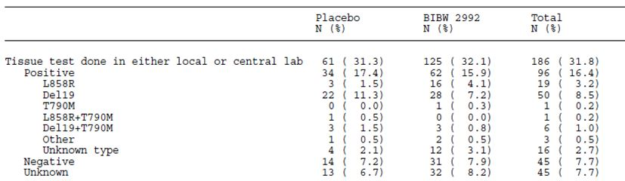
Comment: The two groups were well balanced with respect to baseline characteristics. Patients had received fairly prolonged therapy with prior gefitinib or erlotinib (median = 43 weeks). The high rate of positive mutation testing (68%) in the subpopulation tested reflects the inclusion criteria.

Results for the primary efficacy outcome
The survival data were mature with 60% (358/595) of patients having died at the date of data cut-off (8 July 2010). Results for overall survival are shown in Table 17 and the Kaplan-Meier curve is shown in Figure 8. The study failed to show a survival benefit for afatinib over placebo, with a hazard ratio of 1.077 (95% CI: 0.862 – 1.346); p-value = 0.7428.
Table 17: Supportive study 1200.23: OS results.
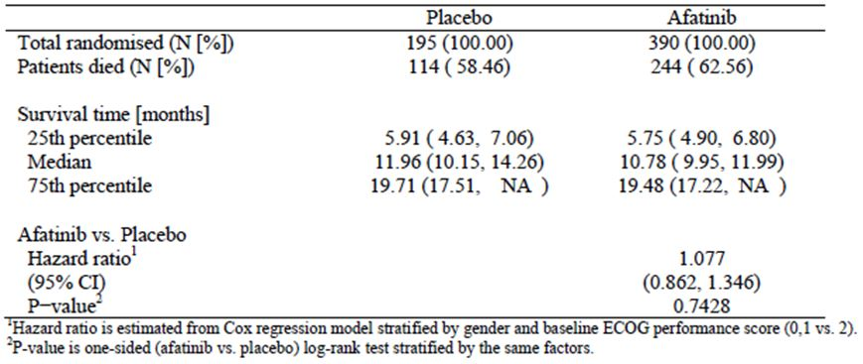
Figure 8. Supportive study 1200.23: Kaplan-Meier curve for OS.
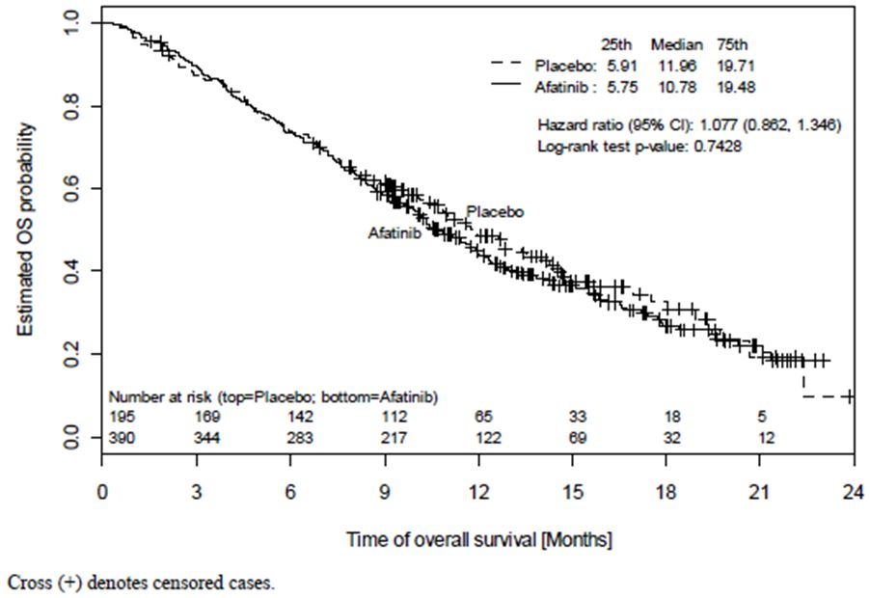
Subjects who developed disease progression while on the trial had their study treatment discontinued and were then able to receive further anticancer therapy as determined by their treating physician. A greater proportion of patients in the placebo group received additional anticancer therapy. For example, more placebo-treated patients received subsequent systemic anticancer treatment (76.3% vs. 64.7%) and subsequent EGFR-TKI or other targeted therapy (23.7% vs. 12.1%). The sponsor argues that that this imbalance may explain the lack of a survival benefit for afatinib. Two further statistical analyses were undertaken to investigate the effect of subsequent anticancer treatments:
- An inverse probability of censoring weighted (IPCW) Cox model in which patients who received other anti-cancer therapy before death were censored at the time they began other anti-cancer therapy; and
- A Cox model that included time to other-cancer therapy as a time-dependent covariate.
Both of these analyses were pre-specified in the trial Statistical Analysis Plan as ‘secondary analyses’.
The IPCW analysis showed a statistically significant benefit for afatinib treatment as shown in Table 18. The results of the time-dependent Cox model were not significant.
Table 18: Supportive study 1200.23: Overall survival adjusted for subsequent anticancer therapy.
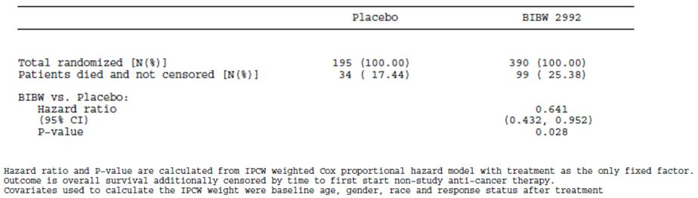
The Kaplan-Meier curves for OS in patients with and without subsequent systemic anticancer therapy are shown in Figure 9. In the subgroup of patients who did not receive subsequent therapy, estimated median survival was 5.8 months in the afatinib group and 4.6 months in the placebo group. No difference was observed between treatments in the subgroup of patients who did receive subsequent anticancer treatments.
Figure 9. Supportive study 1200.23: Kaplan-Meier curves for patients without and with subsequent systemic anticancer treatment.
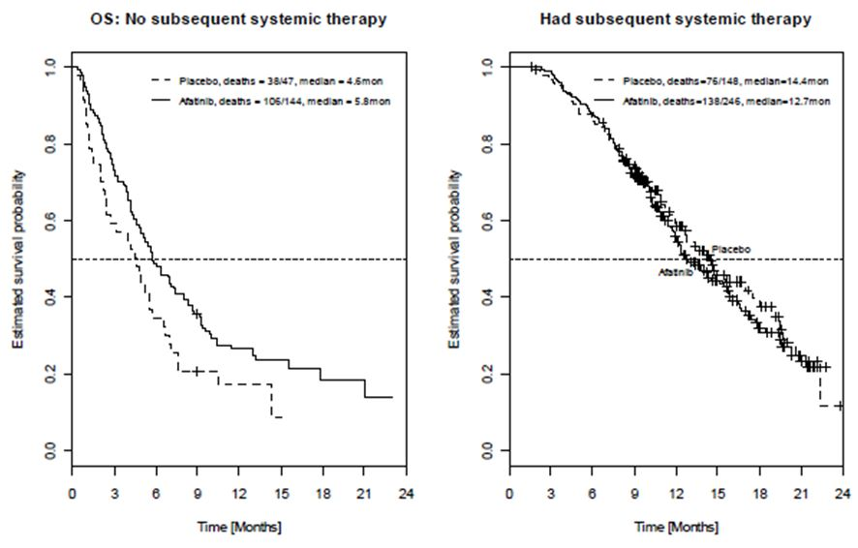
Comment: The sponsor’s argument that imbalances in subsequent anticancer treatments may have obscured a survival benefit produced by afatinib is plausible. However, the increase in median survival achieved with afatinib in the subgroup of patients who did not receive subsequent anticancer therapy was only 1.2 months. This suggests that any survival benefit produced by afatinib, in patients who have already been treated with an EGFR-TKI and chemotherapy, may be very modest.
Subgroup analysis for OS did not suggest that the drug was likely to be more or less effective in any of the subgroups studied.
The summary of clinical efficacy included details of an updated analysis of OS with a data cut-off date of 13 February 2012. By this time 86% of patients had died. There was still no significant benefit for afatinib (HR = 1.011; 95%CI: 0.839 – 1.218). Median survival was 10.87 months in the afatinib arm and 11.73 months in the placebo arm.

Results for other efficacy outcomes

Progression-free survival
Results for PFS are summarised in Table 19 and Figure 10. By the time of the data cut-off, 93.5% of patients had progressed or died. Afatinib treatment was associated with a statistically significant prolongation of PFS compared to placebo (HR = 0.381 [95%CI: 0.306 – 0.475]; p<0.0001). Median PFS was prolonged by approximately 2.2 months (3.29 vs. 1.08 months). Various sensitivity analyses (including investigator assessment of PFS) gave consistent results.
Table 19: Supportive study 1200.23: PFS results.
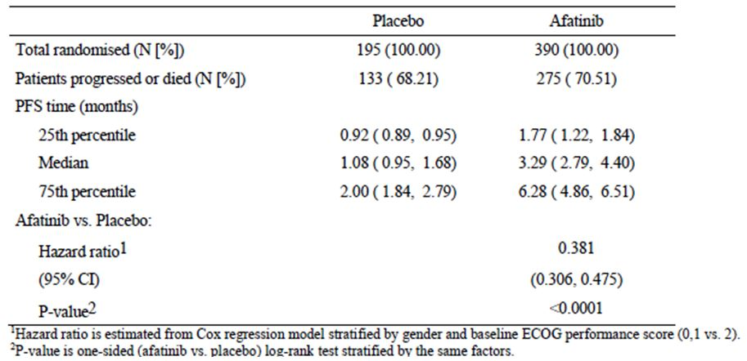
Figure 10. Supportive study 1200.23: Kaplan-Meier curve for PFS.
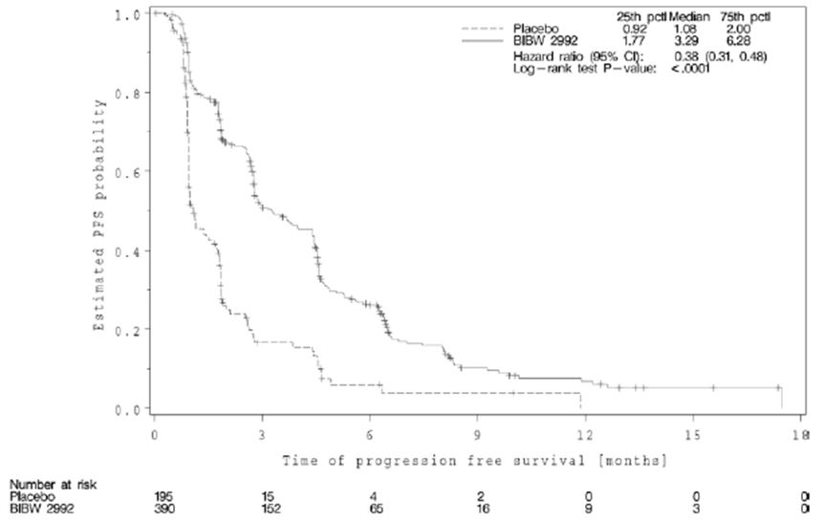
Subgroup analysis suggested that the benefit was consistent across subgroups. In patients who had a positive EGFR mutation test (n=96), afatinib treatment was associated with a statistically significant improvement in PFS compared to placebo (HR = 0.51 [95%CI: 0.31 – 0.85]; p=0.009). Median PFS was increased from 1.0 month in placebo-treated subjects to 3.3 months in afatinib treated patients. There was no significant difference between treatments in the group of patients who had tested negative for EGFR mutations (n=45).

Objective response rate / Disease control rate
Results for ORR and DCR are summarised in Table 20. Afatinib treatment was associated with statistically significantly higher rates than placebo for both endpoints.
Table 20: Supportive study 1200.23: Best Overall Response Rate / Disease Control Rate.
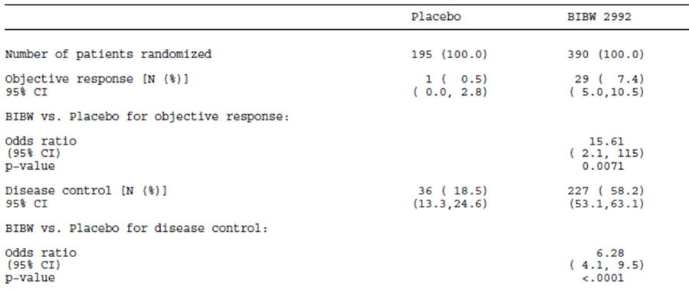
Comment: Afatinib was associated with a very low ORR (7.4%) in this trial compared to the pivotal study where the ORR was 56.1%. This reflects the fact that subjects in this trial were heavily pre-treated and their tumours were not required to be EGFR mutation positive.

Duration of ORR / DCR
Median duration of response in the afatinib group was 23.6 weeks (29 responders) and 23.4 weeks in the placebo group (only one responder).
Median duration of disease control in the afatinib group was 20.0 weeks (227 subjects) and 15.2 weeks in the placebo group (36 subjects).

HRQoL measures
Afatinib treatment was associated with a significant prolongation of time to deterioration in coughing. The median time to deterioration in coughing was 8.5 months in the afatinib arm and 4.6 months in the placebo arm. There was no statistically significant effect on time to deterioration in dyspnoea or pain.
The percentage of patients who showed improvement was significantly greater in the afatinib arm for each of these three symptoms - cough 46% vs. 25%; dyspnoea 51% vs. 36% and pain 50% vs. 32%. However there was no significant increase in the percentage of patients who had an overall improvement in global health status (38% vs. 29%; p=0.0842).

Post hoc analysis of PFS/OS
The proportion of patients in this trial who were EGFR mutation positive was 68%, based on the 141 subjects for whom test results were available. The sponsor conducted a post hoc analysis investigating PFS and OS results in subpopulations with higher rates of EGFR mutation. Among the 141 subjects with available results, the duration of prior EGFR-TKI therapy correlated with rate of mutation. In subjects who had received < 24 weeks of therapy, the mutation rate was only 33%, whereas in those who had received ≥ 48 weeks of therapy, the mutation rate was 83%. In patients who had achieved an objective response with their previous EGFR-TKI the rate was higher still (88%). The degree of PFS and OS benefit appeared to improve with higher mutation rates (Table 21).
Table 21: Supportive study 1200.23: Post-hoc analysis of PFS according to EGFR mutation positivity rate.
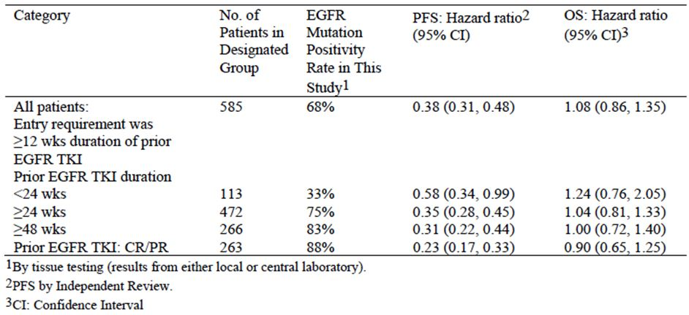
Comment: A possible interpretation of this analysis would be that more impressive overall trial results would have been obtained if 100% of subjects had been mutation positive. This would be an incorrect interpretation. Analysing only the population who had remained on therapy for a long period, or those who had achieved a prior objective response, not only excludes EGFR mutation negative subjects, but also EGFR-mutation positive subjects who are resistant to EGFR-TKI therapy. Such analyses are therefore likely to overestimate efficacy.
In 2010, criteria were proposed (by Jackman and colleagues) for standardising the definition of EGFR-TKI resistant patients. The purpose of the criteria was to allow a uniform approach for all clinical trials investigating this patient group. The criteria are summarised in Table 22. In this study, 214 subjects (37%) met the Jackman criteria. The PFS and OS results in this subgroup were comparable to those obtained for the study population as a whole. HR for PFS was 0.37 (95%CI: 0.26 – 0.52) with a p-value of <0.001. Results for OS were not significant (HR = 1.09; p=0.64).
Table 22: Criteria for defining acquired EGFR-TKI resistance (Jackman and colleagues).
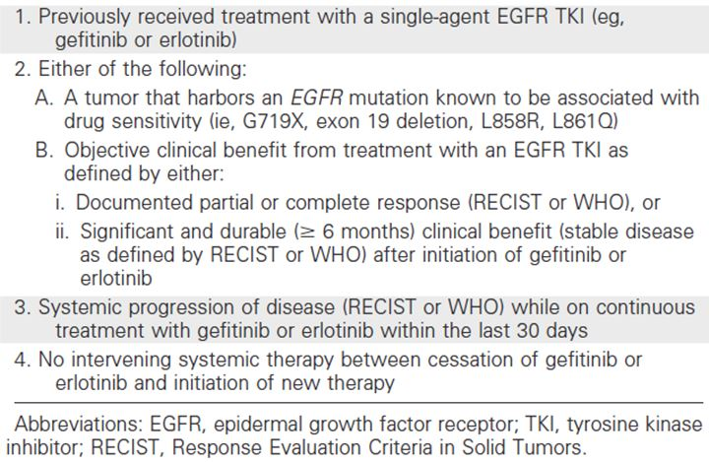

Other supportive efficacy studies

Study 1200.22 (‘LUX-Lung 2’)

Study methods
This study was a single-arm, open, phase II trial. It included subjects with stage IIIB or IV adenocarcinoma of the lung with documented mutations of the EGFR. The trial was initially designed to include subjects who had disease progression after 1 prior chemotherapy regimen, with a stating dose of 50 mg daily. The protocol was subsequently amended to include previously untreated patients and a starting dose of 40 mg daily. The primary endpoint was ORR (by RECIST 1.0) and secondary endpoints included OS and PFS. This study commenced in 2007 and data cut-off for the report was December 2011. The summary of clinical efficacy contained updated survival data with a data cut-off of 9 February 2012. The study was conducted at 28 centres in the USA and 7 centres in Taiwan. 81% of patients were recruited in Taiwan.
A total of 129 subjects were treated in the trial
- First-line treatment (n=61): 40 mg n=23; and 50 mg n=38.
- Second-line treatment (n=68): 40 mg n=7; and 50 mg n=61.
Mean (SD) age was 62 (11.1) years. Gender was 58% female. 87% of patients were of Asian race and 12% were Caucasian. 94% of patients had stage IV disease, with the mean number of metastatic sites being 2. Deletion 19 (40%) and L858R (42%) were the most common EGFR mutations.

Results
The efficacy results for patients receiving afatinib as first-line therapy are shown in Table 23, with the results of the pivotal first-line study (1200.32) included for comparison. The results for patients receiving afatinib as second-line therapy are shown in Table 24, with the results of the main supportive study (1200.23) for comparison.
Table 23: Supportive study 1200.22: Efficacy results for first line use of afatinib.
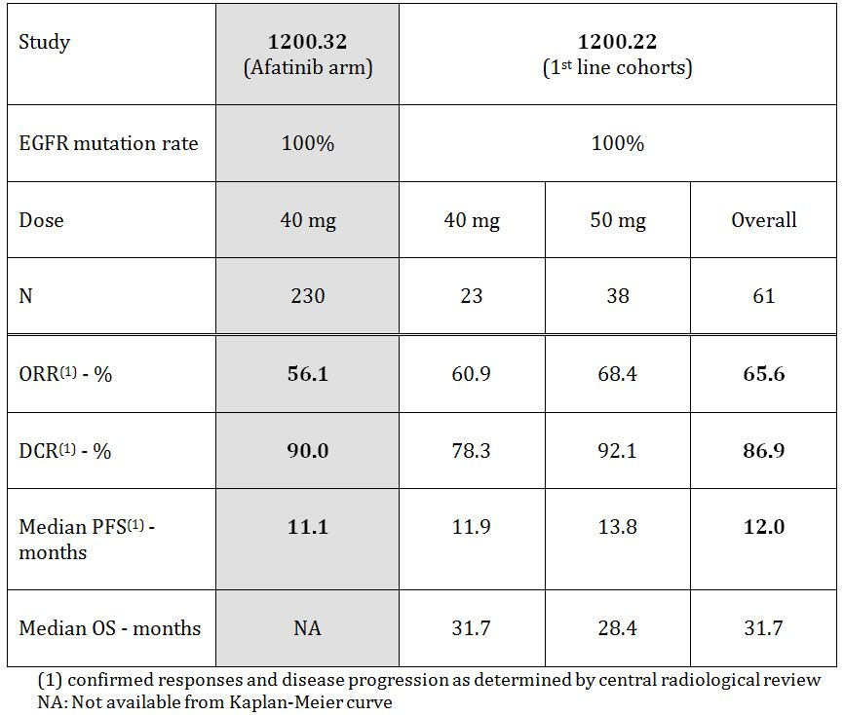
Table 24: Supportive studies: Efficacy results for second/later line use of afatinib.
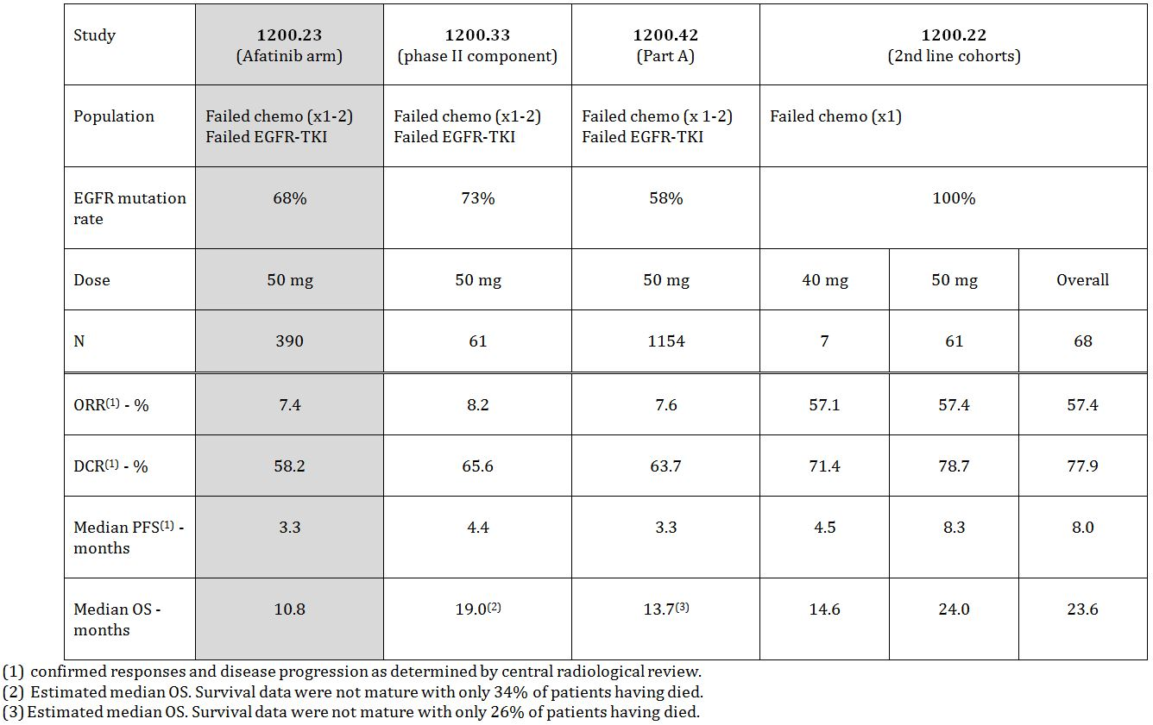
Comment: In the first-line setting the 40 and 50 mg starting doses gave comparable efficacy results and this finding was used to justify the 40 mg starting dose in the pivotal study. The results for first-line treatment in this study, in terms of ORR, DCR and median PFS, were consistent with those obtained in the pivotal study.
For second line use, the efficacy results were notably better than those obtained in the main supportive (study 1200.23). This is expected given that patients in 1200.23 had already failed treatment with an EGFR-TKI and had also been more heavily pre-treated with conventional chemotherapy.

Study 1200.33 (‘LUX-Lung 4’)

Study methods
This study was an open, phase I/II trial conducted in Japan. The objective of the phase I component was to establish the MTD in Japanese patients using a conventional dose-escalation design commencing at 20 mg per day. This part of the study was conducted in Japanese patients with NSCLC who had failed conventional treatment or for whom no established therapy existed. Twelve patients were treated with 20 mg (n=3), 40 mg (n=3) or 50 mg (n=6). Although DLT occurred in 3 of 6 subjects at the 50 mg dose, this dose was chosen as the starting dose for the phase II component, as the toxicity was manageable.
The phase II component was conducted in patients with stage IIIB or IV NSCLC, who:
- had received 1-2 chemotherapy regimens; and
- had received at least 12 weeks treatment with gefitinib or erlotinib; and
- had achieved a CR, PR or SD with their gefitinib or erlotinib treatment.
The primary endpoint was ORR (by RECIST 1.0) and secondary endpoints included DCR, OS and PFS. This study commenced in 2009 and data cut-off for the report was December 2011.
A total of 62 subjects were treated in the phase II component. Mean (SD) age was 63.7 (10.3) years. Gender was 77% female. 92% of patients had stage IV disease, with the mean number of metastatic sites being 2.1. EGFR mutation testing was not a requirement for enrolment but was available for 56/62 subjects. The test was positive in 45/56 (73%) of patients tested. Deletion 19 (n=22) and L858R (n=15) were the most common EGFR mutations.

Results
The efficacy results for the phase II component are shown in Table 25, with the results of the main supportive study (1200.23) for comparison. One patient had no post-treatment imaging available and hence the efficacy results are available for only 61 subjects.
Table 25: Results for Phase III studies of first line use of EGFR TKIs in EGFR mutation positive NSCLC.
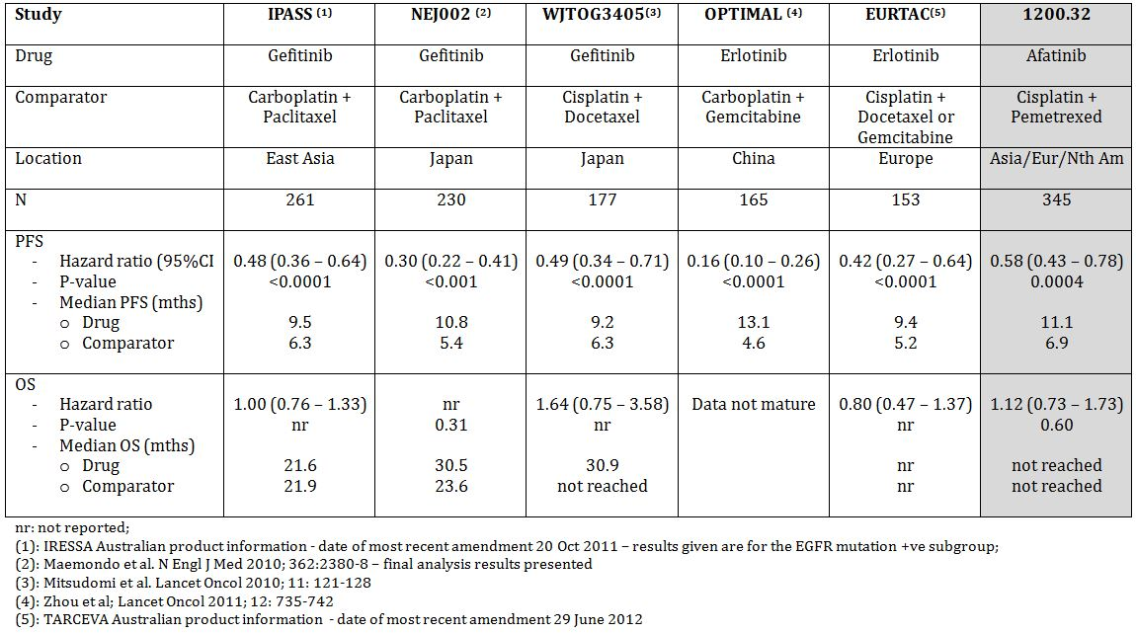
Comment: The population enrolled in the phase II component of this study was very similar to that in the main supportive trial (1200.23). Subjects had received 1-2 lines of chemotherapy and at least 12 weeks of an EGFR TKI with subsequent disease progression. The overall EGFR mutation positivity rate was also comparable (73% vs. 68%). The efficacy results are consistent with those seen in study 1200.23. Median overall survival appeared longer (19.0 vs. 10.8 months) although the survival data in this study are not mature and should be interpreted with caution.

Study 1200.42 (‘LUX Lung 5’)

Study methods
This study was conducted in patients with stage IIIB or IV NSCLC, who:
- had received at least 1 chemotherapy regimen; and
- had received at least 12 weeks treatment with gefitinib or erlotinib; and
- had subsequently developed progressive disease.
The study was to be conducted in two parts. In Part A all subjects were treated with afatinib 50 mg once daily, continued until disease progression or unacceptable toxicity occurred. Subjects who achieved a CR, PR or SD for at least 12 weeks prior to disease progression were then eligible to be included in Part B of the study. In Part B subjects would be randomised to either a combination of afatinib with paclitaxel or to the investigator’s choice of chemotherapy. Only the results of Part A were included in the original submission. The sponsor subsequently provided some late-breaking information from Part B of the trial, which is reviewed in section 8.8.2 of this report.
The primary endpoint for Part A was PFS and secondary endpoints included DCR, ORR and OS. This study commenced in April 2010 and data cut-off for the report was December 2011.
A total of 1154 subjects were treated in Part A. 53% of patients were from Europe and Australia, 43 % from East Asia and the remainder from various other countries. Mean (SD) age was 60.1 (10.9) years. Gender was 57% female. 99% of patients had stage IV disease, with 56% having more than one metastatic site. EGFR mutation testing was not a requirement for enrolment but testing results from a central laboratory were available for 84 subjects. The test was positive in 49/84 (58%) of patients tested. Deletion 19 (n=27) and L858R (n=20) were the most common EGFR mutations.

Results
The efficacy results for Part A are shown in Table 24, with the results of the main supportive study (1200.23) for comparison.
Comment: The patient population enrolled in this study was very similar to that enrolled in the main supportive study (1200.23). The efficacy results were consistent with those obtained in 1200.23 although the OS data were not mature.

Study 1200.72
The submission also included this study, which was a single-arm phase II trial of subjects with NSCLC harbouring wild-type EGFR (i.e. tumours which were negative for EGFR mutations). Subjects were also required to have failed two previous lines of chemotherapy. As the sponsor is not seeking approval for use of afatinib in this population, the efficacy data are not considered relevant to the application and they have therefore not been reviewed. The study report indicates that no confirmed objective responses were observed in the 42 patients treated.

Analyses performed across trials (pooled & meta analyses)
There were no pooled analyses or meta-analyses of the efficacy data.

Evaluator’s conclusions on clinical efficacy
The indication for which the sponsor is seeking approval is as follows:
‘For the treatment of patients with locally advanced or metastatic non-small cell lung cancer (NSCLC) with Epidermal Growth Factor Receptor (EGFR) mutation(s).’
Evidence provided in the submission has investigated the efficacy of afatinib in the following clinical situations:
- first line use in previously untreated patients;
- second line use after failure of first line chemotherapy;
- Use after failure of chemotherapy and a previous EGFR TKI.

First line use in previously untreated patients
Data to support use of afatinib in this group of patients come primarily from the pivotal Study 1200.32. The design and conduct of this study were consistent with the relevant EMA guidelines for anticancer agents, which have been adopted by the TGA. The trial demonstrated a statistically significant benefit in terms of the primary endpoint of progression free survival (PFS). There have been several previous Phase III randomised controlled trials comparing EGFR TKIs with platinum based doublet chemotherapy in the first line treatment of EGFR mutation positive advanced NSCLC. The PFS and overall survival (OS) survival results for these and Study 1200.32 are summarised in Table 25. The hazard ratio for PFS achieved in Study 1200.32 (0.58) was somewhat higher than in these other studies. However, the prolongation of median PFS achieved in 1200.32 (4.2 months) was comparable to that achieved in the studies used for the TGA approval of gefitinib and erlotinib (IPASS and EURTAC, respectively). It is notable that none of the Phase III studies have demonstrated a survival advantage for EGFR TKIs. The pivotal study also demonstrated some benefits in the control of symptoms (cough and dyspnoea).
A Phase II study (Study 1200.22) in the first line setting gave results consistent with the pivotal study.
In summary, the efficacy data to support first line use are considered adequate.

Second line use after failure of first line chemotherapy
Current clinical guidelines recommend the use of an EGFR TKI for the first line treatment of advanced EGFR mutation positive NSCLC. However, in Australia, PBS subsidy for the existing EGFR TKIs gefitinib and erlotinib is restricted to use in patients who have failed cytotoxic chemotherapy. Therefore, use of afatinib in this setting may be possible.
Evidence for efficacy of afatinib in this setting is limited to one Phase II study (1200.22). This study also enrolled patients in the first line setting. The efficacy results for subjects receiving afatinib as second line treatment after chemotherapy appeared only slightly inferior to those achieved with first line use (Tables 23 and 24). Given the clear evidence from the pivotal study for efficacy of afatinib in first line use, the submitted data, although limited, are considered adequate to support use of the drug in the second line setting following failure of chemotherapy.

Use after failure of chemotherapy and a previous EGFR TKI
With the currently registered agents gefitinib and erlotinib, development of resistance generally occurs after approximately 12 months. There are currently no therapies registered for this population and the availability of an effective agent in this setting would represent a significant advance.
The primary evidence to support efficacy of afatinib in this setting comes from the main supportive study (1200.23). The design and conduct of this study were consistent with the relevant EMA guidelines for anticancer agents, which have been adopted by the TGA. The results indicate that efficacy of afatinib is less clear cut, compared to use as early therapy. Limitations of the efficacy data include the following:
- The study was not limited to subjects with EGFR mutation positive disease;
- The study failed to demonstrate a statistically significant effect for afatinib over placebo on the primary endpoint (OS);
- Even if the sponsor’s argument that subsequent therapies obscured a survival benefit is accepted, the size of the survival benefit appears limited (an increase in median survival of ~1.2 months);
- Efficacy assessed by PFS also appears short-lived. Although the relative risk reduction appears impressive (a HR of 0.38), the absolute risk reduction is modest, with an increase in median PFS of only 2.2 months. PFS at 6 months was increased from 6% with placebo subjects to 26% with afatinib, but 9 month PFS was only increased from 4% to 10%.
- The overall response rate (ORR) was low (7.4%).
The results of two Phase II studies in similar patient populations (Studies 1200.33 and 1200.42), gave comparable results to those obtained in 1200.23.
There have been reports of “re-responses” to EGFR TKIs occurring in patients following re-introduction of treatment after a short hiatus. It is therefore not certain that the efficacy benefits demonstrated for afatinib in Study 1200.23 indicate an advantage for the drug over gefitinib or erlotinib.
Overall, it is considered that the efficacy of afatinib, in patients who have already failed treatment with an EGFR TKI and cytotoxic chemotherapy, is modest.

Other settings
There are no data in the submission to support use of afatinib as maintenance therapy following initial chemotherapy, an indication that is currently registered for erlotinib.

Clinical safety

Studies providing evaluable safety data

Pivotal and main supportive efficacy studies (1200.32 and 1200.23)
These two studies are considered the most informative on the safety of afatinib for the proposed indication. Both were randomised controlled trials. Study 1200.23 was a double blind comparison with placebo and Study 1200.32 was an open label comparison with an established chemotherapy regimen (cisplatin + pemetrexed).
In these two studies, the following safety data were collected:
- General adverse events (AEs) were assessed at each study visit. Identification of AEs relied on spontaneous reporting by subjects.
- AEs of special interest were:
  - Events often seen in patients treated for oncological indications (nausea/vomiting, leukopenia, neuropathy, hepatic impairment); and
  - Events seen in association with EGFR/HER2 inhibition (diarrhoea with associated dehydration and renal impairment, rash/acne, stomatitis, ocular effects, heart failure, and Interstitial Lung Disease [ILD] like events).
These events were subjected additional analyses.
- Laboratory tests, including full blood count; biochemistry (sodium, potassium, calcium, creatinine, urea, glucose, AST, ALT, alkaline phosphatase [ALP], lactate dehydrogenase [LDH], bilirubin, uric acid and creatine phosphokinase [CPK]) and urine dipstick were performed at each study visit (every 4 weeks for Study 1200.23 and every 3 weeks for Study 1200.32). Coagulation parameters (prothrombin time [PT] and activated partial thromboplastin time [APTT]) were assessed at each study visit in Study 1200.23 but not in 1200.32.
- ECG and measurement of left ventricular ejection fraction (LVEF) (by echocardiography [ECHO] or multiple gated acquisition [MUGA] scan) were performed every 12 weeks for Study 1200.23 and every 9 weeks for Study 1200.32.
- Vital signs were assessed at each study visit.

Pivotal studies that assessed safety as a primary outcome
There were no studies that assessed safety as a primary outcome.

Dose response and non pivotal efficacy studies
The following dose response and non pivotal efficacy studies provided safety data. The safety data collected were adverse events, physical examination including vital signs, laboratory testing for haematology, biochemistry, coagulation parameters and urinalysis, ECGs and LVEF testing.
- Studies 1200.01, 1200.02, 1200.03 and 1200.04 (and the open label extension study 1200.17) were dose response studies conducted in subjects with advanced cancer. These studies also provided information on dose limiting toxicities.
- Studies 1200.42, 1200.22, 1200.33 and 1200.72 were open label, non comparative Phase II studies conducted in patients with advanced NSCLC.

Other studies evaluable for safety only
The submission included full study reports for a number of other studies that examined the use of afatinib in other indications. These studies were early Phase II trials exploring efficacy in a variety of malignancies. Treatment was generally continued until disease progression or unacceptable toxicity occurred. The studies collected data on AEs, laboratory testing (haematology, biochemistry and urinalysis in all studies and coagulation parameters in most studies), and physical examination including vital signs. Most of the studies also included ECGs and monitoring of LVEF.
Many of the studies were single arm, non comparative studies and/or enrolled small numbers of patients. The safety data are therefore of limited value.

Clinical pharmacology studies
There were 7 studies conducted in healthy volunteers (1 included patients with hepatic impairment). These were all single dose studies. These studies included monitoring of AEs, physical examination including vital signs, laboratory testing for haematology, biochemistry, coagulation parameters and urinalysis, and ECGs.
There was one pharmacodynamic study (1200.24), which investigated QT interval and other ECG effects. It also included monitoring of AEs, physical examination including vital signs, laboratory testing for haematology, biochemistry, coagulation parameters and urinalysis, and LVEF testing.

Other studies
There were several studies included in the submission that examined the use of afatinib in combination with cytotoxic agents. These studies provided no evaluable data on the safety of afatinib as monotherapy. The sponsor also included some safety data (patient narratives) from various ongoing studies for which study reports are not yet available.

Pivotal studies that assessed safety as a primary outcome
Not applicable.

Patient exposure
The sponsor prepared various analyses of pooled data from submitted and ongoing studies. The relevant datasets for the current application are:
- SAF-1 – this dataset included only those patients treated in the pivotal study (1200.32) and provides a randomised comparison of the safety of afatinib in advanced NSCLC against an established chemotherapy regimen.
- SAF-2 – this dataset pooled safety data on patients with NSCLC with EGFR mutations who were naïve to treatment with an EGFR-TKI and were treated with a starting dose of 40 mg. It included afatinib-treated patients from the pivotal study, the supportive study 1200.22 and two ongoing trials (1200.34 and 1200.123).
- SAF-3 - this dataset included only those patients treated in the main supportive study (1200.23) and provides a randomised comparison of the safety of afatinib in advanced NSCLC against placebo.
- SAF-4 – this dataset pooled safety data on patients with NSCLC who had previously received treatment with an EGFR-TKI and were treated with a starting dose of 50 mg. It included afatinib-treated patients from the main supportive study (1200.23) and the supportive studies 1200.33 and 1200.42 and one ongoing trial (1200.41).
- SAF-5 – this dataset pooled safety data from all completed and ongoing trials in patients with any form of cancer. Data were pooled from a total of 47 studies.
Patient exposure according to these safety sets and duration of treatment is shown in Table 26. Mean duration of treatment with afatinib in the 1st line setting was 11.0 months, whereas in the 2nd line setting (after prior EGFR-TKI) it was only 4.3 months.
Table 26: Exposure to afatinib and comparators in clinical studies.
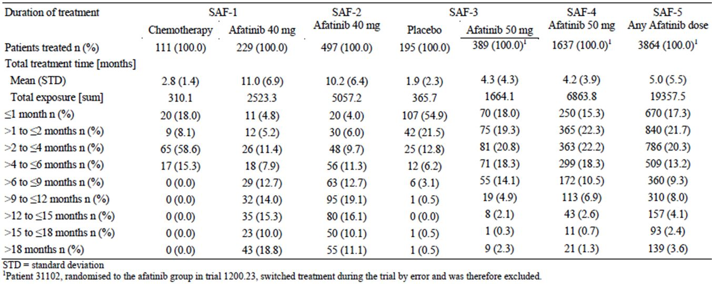

Adverse events

All adverse events (irrespective of relationship to study treatment)

Study 1200.23 (vs. placebo)
The incidences of common AEs compared to placebo are shown in Table 27. Patients treated with afatinib remained on study for a longer period than those treated on placebo and hence a higher incidence of AEs might be expected. The incidence of any AEs was high in the placebo group (86.7%) reflecting the advanced state of disease in these patients. The incidence was higher in the afatinib group (98.5%). Grade 3 (41.0% vs. 16.9%) and grade 4 (4.9% vs. 1.0%) AEs were more common in the afatinib group. With regard to specific AEs, notable increases in incidence were apparent in the afatinib group for the following:
- Gastrointestinal tract (GIT) toxicity – especially diarrhoea and stomatitis, but also decreased appetite and vomiting;
- Skin / integument toxicity – rash, acne, nail effects, pruritus and dry skin;
- Pyrexia;
- Epistaxis and rhinorrhoea;
- Ocular effects (generally grade 1 or 2) – most commonly conjunctivitis (4.6% vs. 1.0%), dry eye (3.3% vs. 0%), eye irritation (1.5% vs. 0.5%), blurred vision (1.5% vs. 0%), keratoconjunctivitis sicca (1.3% vs. 0%) and increased lacrimation (1.0% vs. 0%).
Table 27: Incidence of Common AEs vs. placebo.
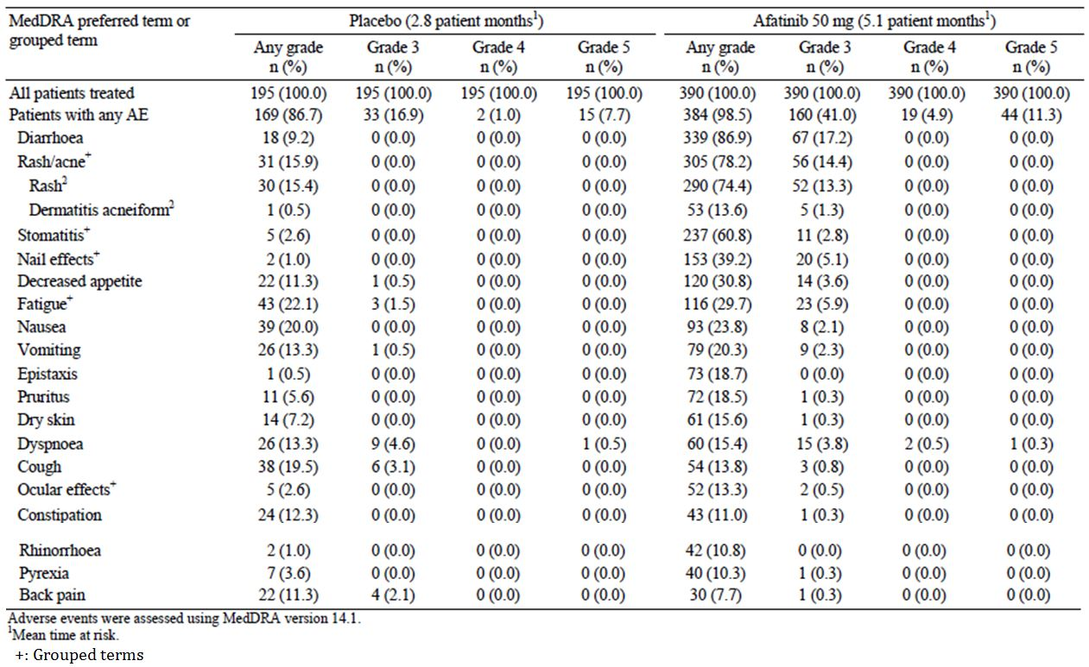

Study 1200.32 (vs. chemotherapy)
The incidences of common AEs compared to cisplatin/pemetrexed chemotherapy are shown in Table 28. Treatment duration in the afatinib arm was again longer than in the comparator arm. The overall incidence of AEs was similar in the two arms (100% with afatinib vs. 98.2% with chemotherapy). The incidence of grade 3 or 4 AEs was also similar (55% vs. 54%). A similar pattern of afatinib toxicity was observed with a notably higher incidence of diarrhoea and stomatitis, skin events, epistaxis and nasopharyngitis, ocular effects and pyrexia.
Table 28: Incidence of Common AEs vs. cisplatin/pemetrexed chemotherapy.
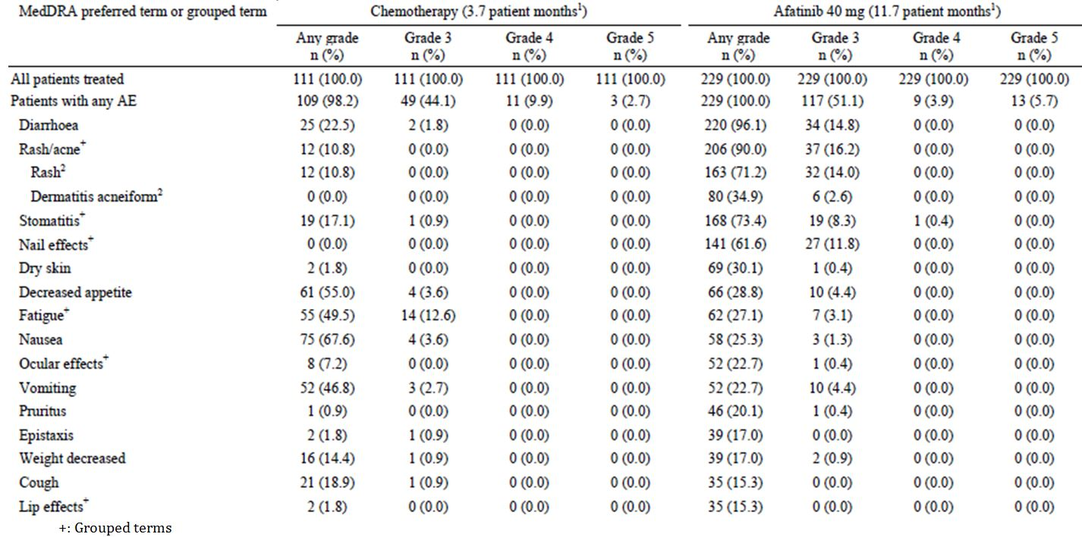
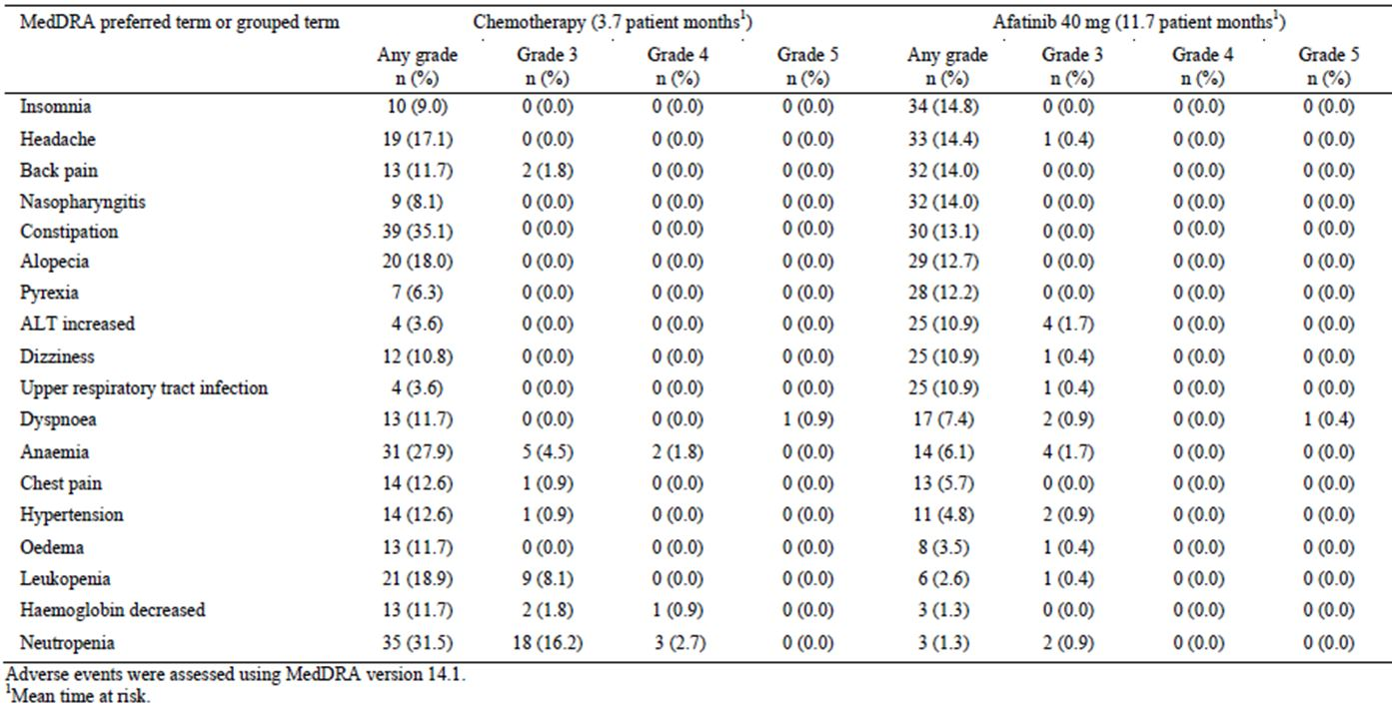
In this study, increased ALT was common in the afatinib arm (10.9% vs. 3.6% with chemotherapy).
In this study it was notable that afatinib was associated with a notably lower incidence of some AEs typically associated with chemotherapy, for example:
- Haematological toxicity – anaemia, decreased haemoglobin, leukopaenia and neutropaenia;
- Some GIT toxicities – nausea, vomiting, decreased appetite, constipation;
- Fatigue;
- Alopecia.

Other studies
The pattern of common AEs was similar in the SAF-2, SAF-4 and SAF-5 datasets (Tables 29-31).
Table 29: Incidence of common AEs in the SAF-2 dataset.
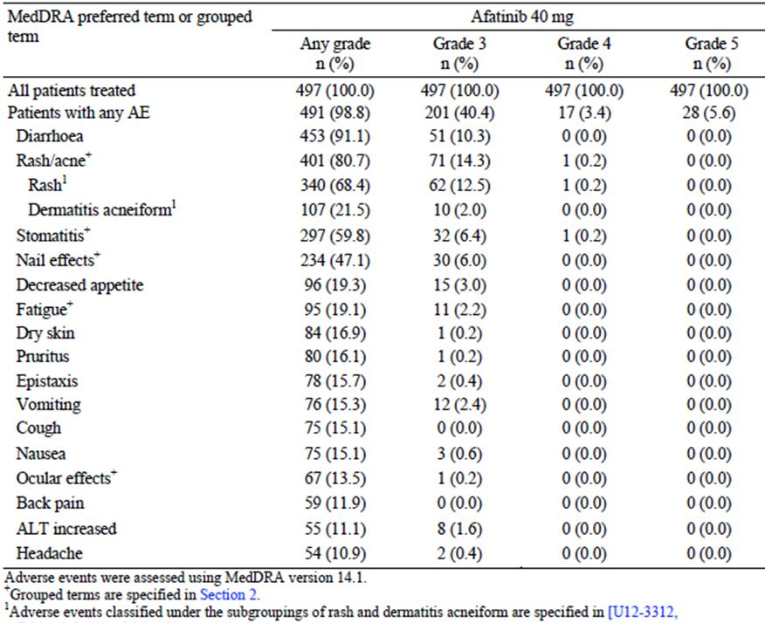
Table 30: Incidence of common AEs in the SAF-4 dataset.
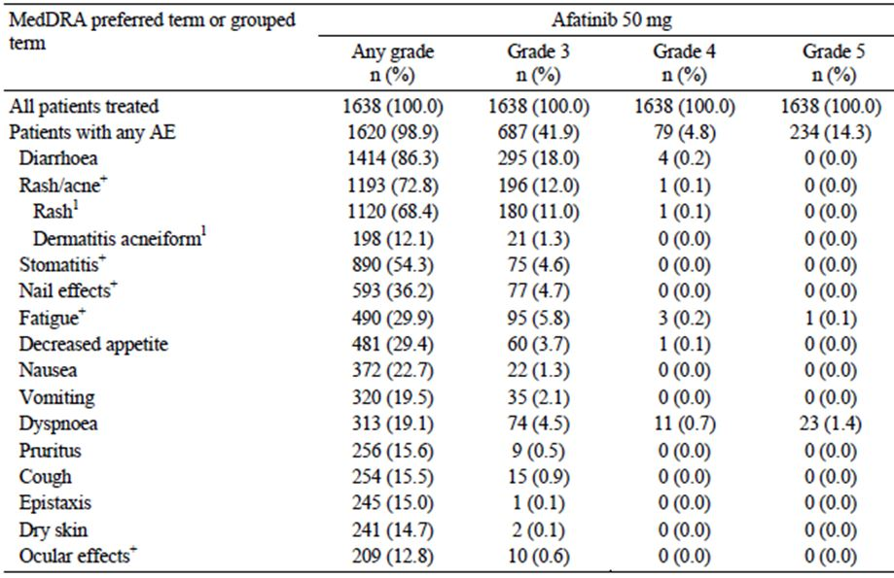
Table 31: Incidence of common AEs in the SAF-5 dataset.
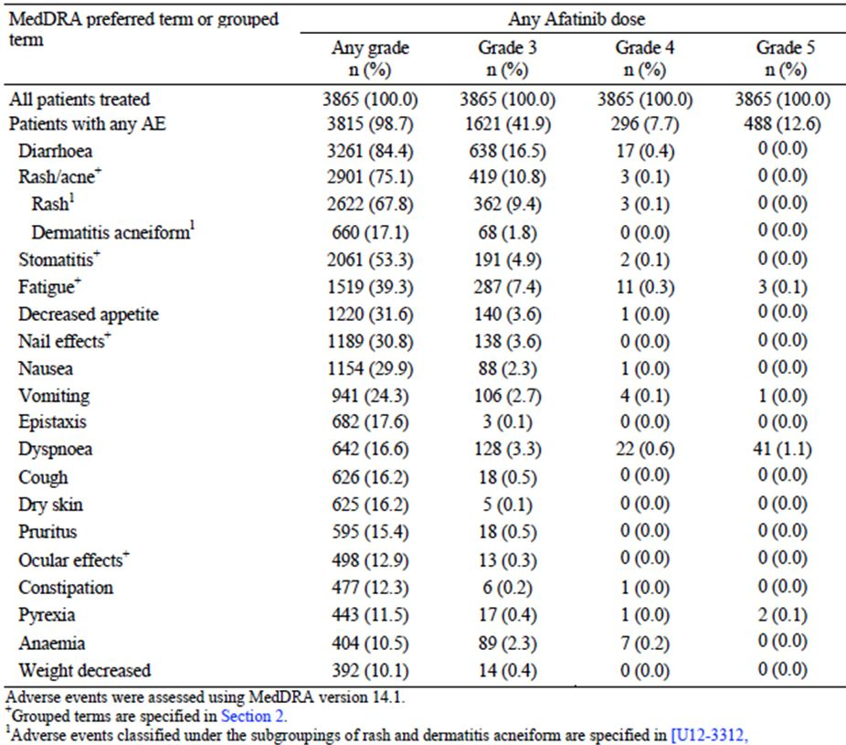
In phase I dose ranging studies the dose limiting toxicities were gastrointestinal (principally diarrhoea) and dermatological.

Treatment-related adverse events (adverse drug reactions)

Study 1200.23 (vs. placebo)
Drug-related AEs from study 1200.23 are shown in Table 32. Drug related AEs were recorded for 95.4% of afatinib-treated subjects but only for 37.9% of those receiving placebo. A pattern of toxicity similar to that shown in the analysis of all AEs was apparent, with diarrhoea and skin AEs being prominent. Among the skin AEs, palmar-plantar erythrodysaethesia (PPE) syndrome was notably more common in the afatinib group (7.7% vs. 0%).
Table 32: Incidence of drug-related AEs vs. placebo.
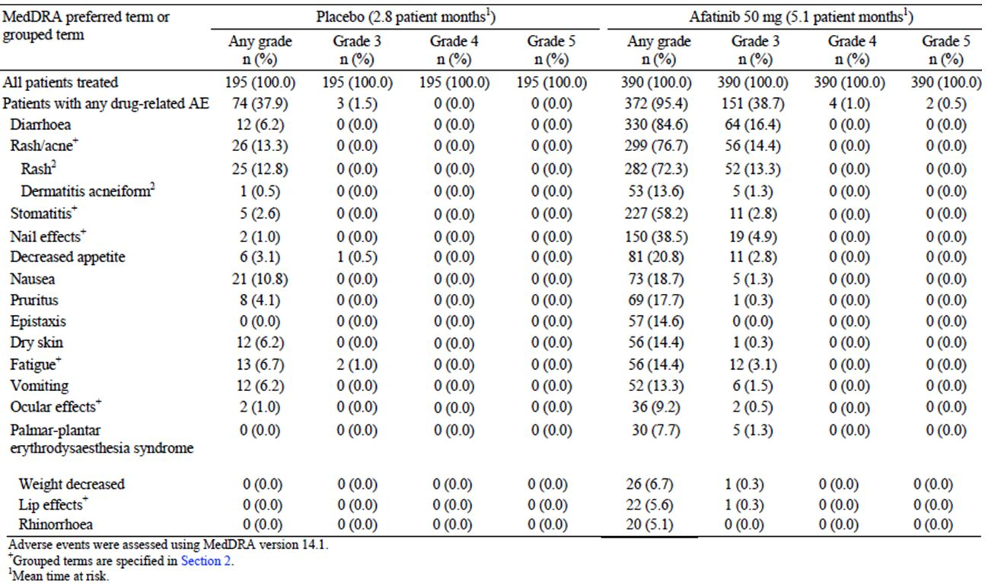

Study 1200.32 (vs. chemotherapy)
Drug-related AEs from study 1200.32 are shown in Table 33. The overall incidence was comparable in the two treatment groups (99.6% vs. 95.5%) as was the incidence of grade 3 or 4 drug related AEs (47.1% vs. 47.7%). The pattern of toxicities was again consistent with that described above. Typical chemotherapy-associated toxicities were more common in the chemotherapy arm.
Table 33: Incidence of drug related AEs vs. chemotherapy.
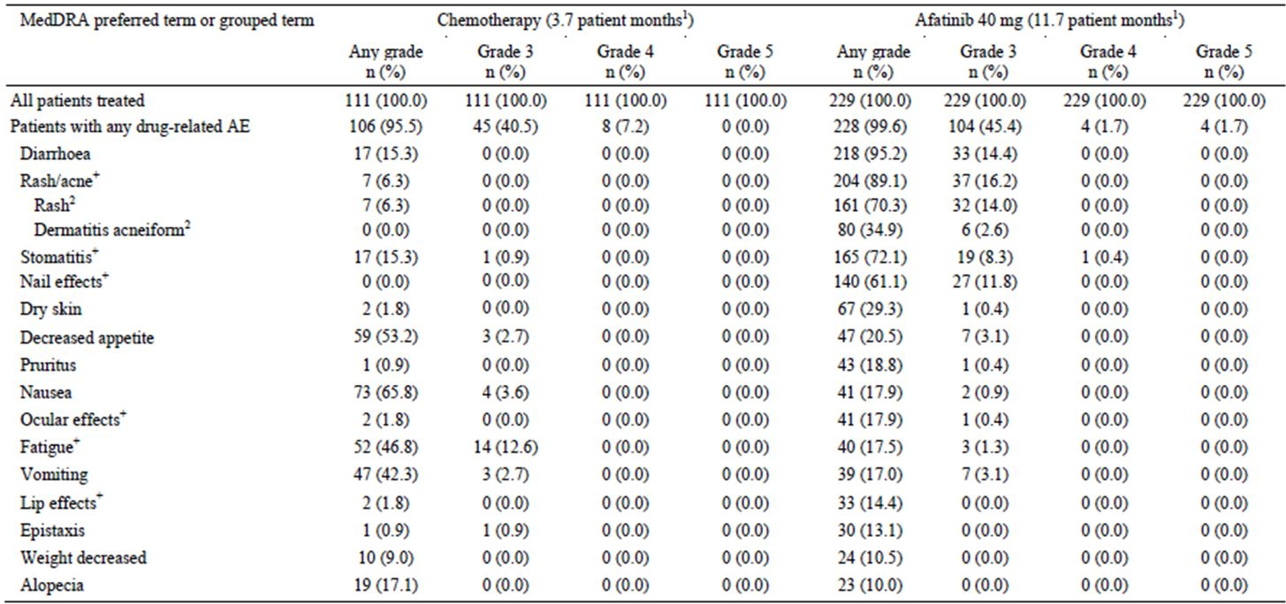
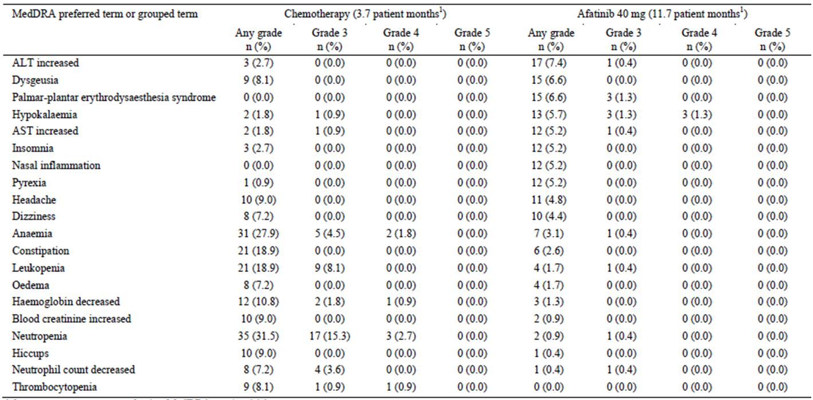
Both ALT and AST increases were more common in the afatinib arm (7.4% vs. 2.7% and 5.2% vs. 1.8% respectively). Hypokalaemia was also more common (5.7% vs. 1.8%) with 3 cases of grade 3 and 3 cases of grade 4 toxicity.

Other studies
The pattern of drug related AEs in the SAF-2 and SAF-4 datasets was similar to that described above. Drug-related AES in the SAF-5 dataset were not reported.

Deaths and other serious adverse events
A serious adverse event (SAE) was defined as “any AE which resulted in death, was immediately life-threatening, resulted in persistent or significant disability / incapacity, required or prolonged patient hospitalization, was a congenital anomaly / birth defect, or was deemed serious for any other reason if it was an important medical event, based upon appropriate medical judgement and which might jeopardise the patient and require medical or surgical intervention to prevent one of the aforementioned outcomes”.

Serious Adverse Events

Study 1200.23 (vs. placebo)
Serious AEs (SAEs) from study 1200.23 are shown in Table 34. The overall incidence was higher in the afatinib arm (34.6% vs. 19.0%). SAEs that were more frequent in the afatinib arm included:
- Diarrhoea (4.6% vs. 0%). Other SAEs that may have been a consequence of diarrhoea were also more frequent in the afatinib arm – dehydration (2.1% vs. 0%), increased blood creatinine (1.0% vs. 0%), acute renal failure (1.8% vs. 0%) and hypokalaemia (1.3% vs. 0%);
- Deep venous thrombosis (DVT) and pulmonary embolism (1.3% vs. 0.5% for both);
- Pancreatitis (1.0% vs. 0%).
Table 34: Incidence of Serious AEs vs. placebo.
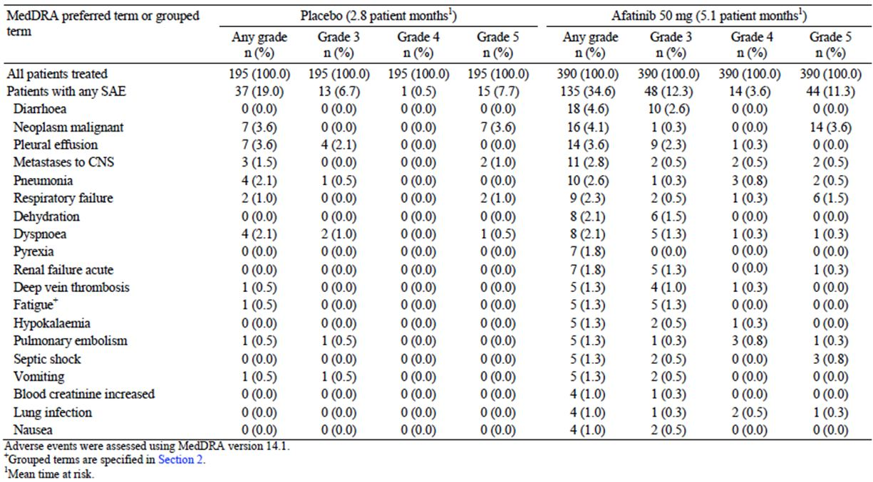
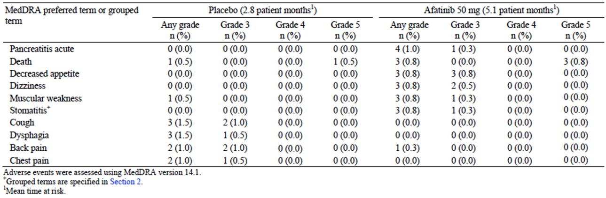
As might be expected in a population with advanced NSCLC, respiratory SAEs were prominent. However, their incidence appeared to be comparable in the two treatment arms.

Study 1200.32 (vs. chemotherapy)
SAEs from study 1200.23 are shown in Table 35. SAEs occurred slightly more frequently in the afatinib arm (28.8% vs. 22.5%). Diarrhoea was again the most common SAE in the afatinib arm. The incidence of DVT was slightly higher in the afatinib arm (0.9% vs. 0%).
Table 35: Incidence of Serious AEs vs. chemotherapy.
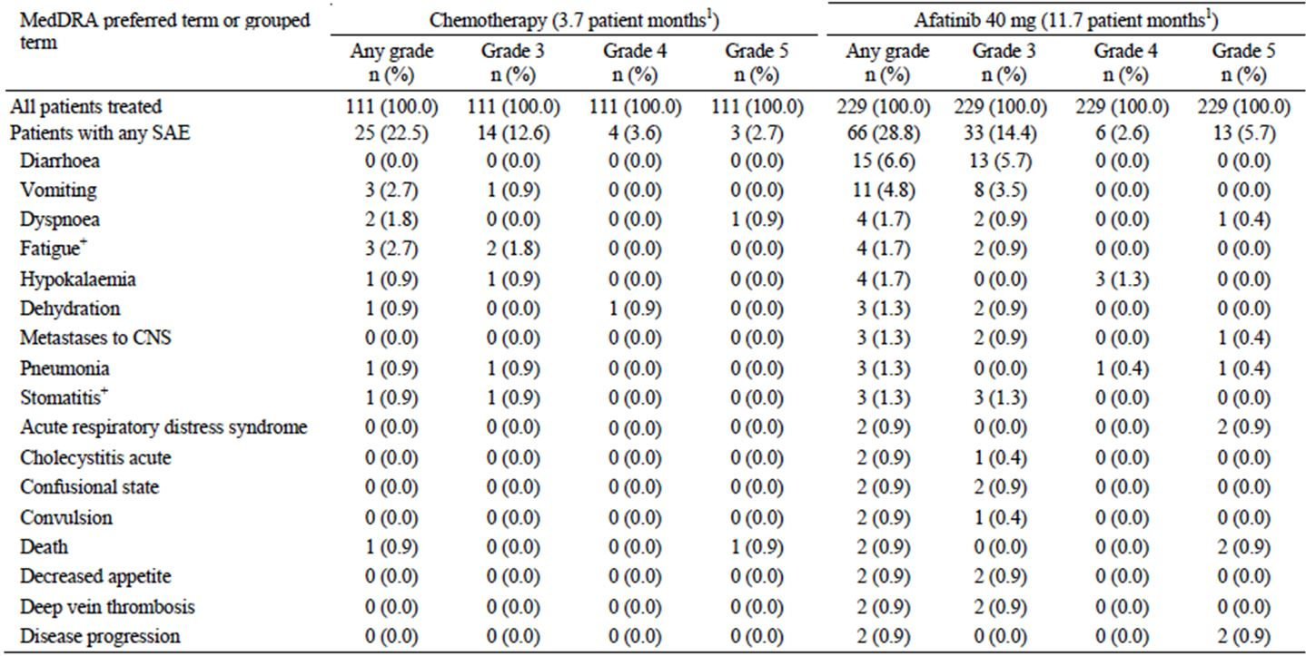
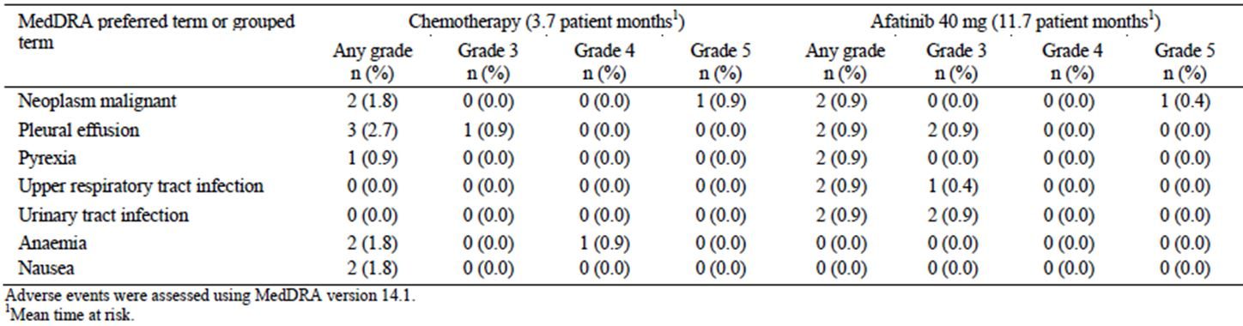

Other studies
The incidence and pattern of SAEs in the SAF-2, SAF-4 and SAF-5 datasets were comparable to those described above.

Deaths

Study 1200.23 (vs. placebo)
AEs with a fatal outcome from this study are summarised in Table 36. There was a higher incidence in the afatinib group (11.3% vs. 7.7%). The fatal AEs were generally those that might be expected in a population of patients with advanced NSCLC. Only 2 of the fatal AEs were considered to be drug related and these were both in the afatinib group:
- 1 case of acute renal failure with acute hepatic failure in a [information redacted] male after approximately 10 days of afatinib exposure. The patient had had frequent vomiting while on the drug. According to the summary of clinical efficacy, the patient also had hepatitis B infection.
- 1 case of acute left ventricular failure in a [information redacted] female patient exposed to afatinib for approximately 1 month. She had no prior history of cardiac disease but had a concomitant lung infection due to candida albicans.
Table 36: Fatal AEs vs. placebo.
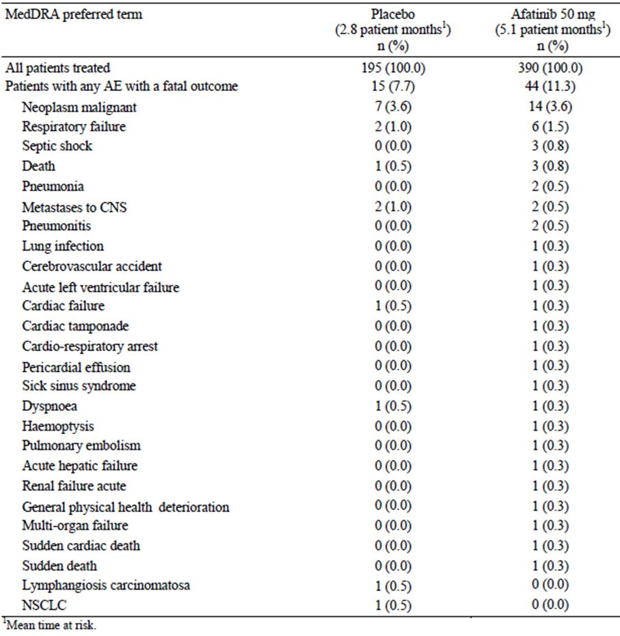

Study 1200.32 (vs. chemotherapy)
AEs with a fatal outcome from this study are summarised in Table 37. There was again a higher incidence in the afatinib group (5.7% vs. 2.7%). None of the fatal AEs in the chemotherapy group were considered drug related. Four of the fatal adverse events were considered drug related:
- 1 case of acute respiratory distress syndrome occurring after 11 days of treatment with afatinib in a [information redacted] female;
- 1 case of chest tightness, dyspnoea and sudden death at home in a [information redacted] female, after about 4 months of afatinib treatment.
- 1 case of a [information redacted] male who developed acute dyspnoea after 5 days of afatinib treatment. The cause of the dyspnoea was thought to be aspiration pneumonia, interstitial pneumonia or disease progression.
- 1 case of sepsis in a [information redacted] female following the development of grade 3 diarrhoea after approximately 2 months treatment.
Table 37: Fatal AEs vs. chemotherapy.
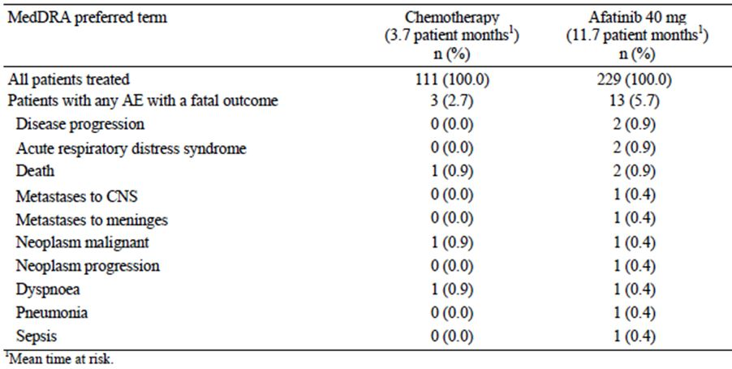

Other studies
AEs with fatal outcome in the SAF-2 dataset are shown in Table 38. Those considered drug related were 1 case each of acute respiratory distress syndrome, sudden death, dyspnoea and sepsis (all from study 1200.32) and additional single cases respiratory failure and death.
Table 38: Fatal AEs vs. chemotherapy.
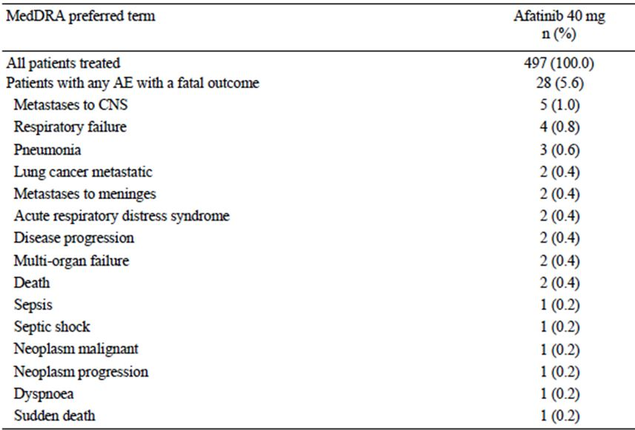
AEs with fatal outcome in the SAF-4 dataset are shown in Table 39. Those considered drug related were 2 cases of ILD, 2 cases of left ventricular failure and events in individual patients of dyspnoea, pneumonia, dehydration, acute hepatic/renal failure, hepatic failure, cytolytic hepatitis and progressive disease.
Table 39: Fatal AEs vs. chemotherapy.
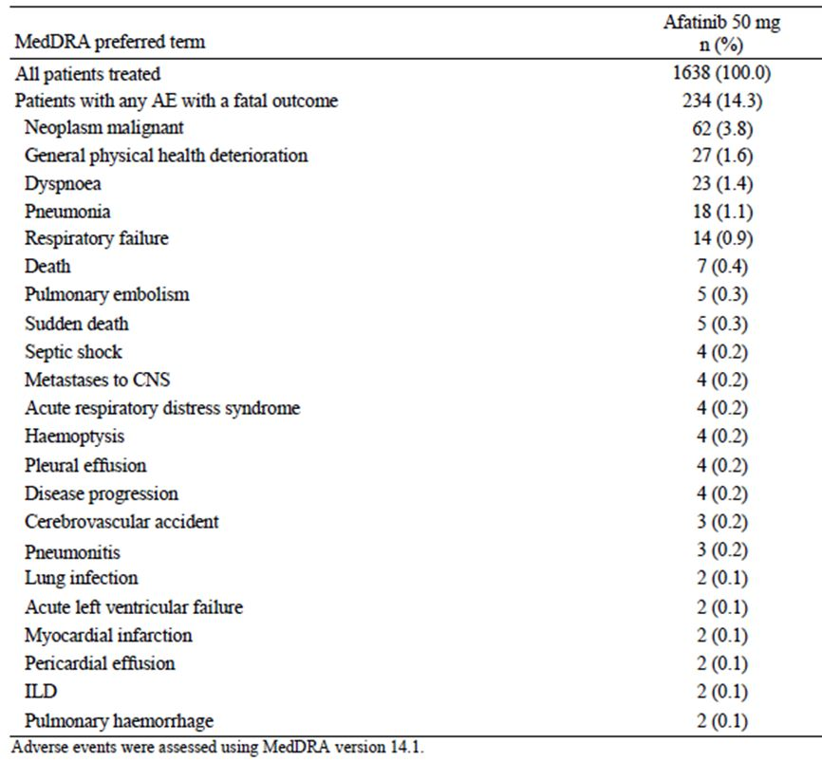
In the SAF-5 dataset, 12.6% (488/3865) of subjects experienced fatal AEs. The pattern of events was similar to that described for the other datasets, with most being attributable to disease progression or comorbidities.

Discontinuation due to adverse events

Study 1200.23 (vs. placebo)
The incidence of AEs leading to discontinuation was higher in the afatinib group (17.9% vs. 6.2%). For drug-related AE’s the incidences were 7.7% vs. 0.5%. These figures suggest that the toxicity of afatinib is manageable (by dose reductions etc.) in that only 7-12% of patients have to discontinue treatment. The pattern of individual adverse events leading to discontinuation was similar to that previously described (predominantly GIT and skin toxicity) and is shown in Table 40.
Table 40: Drug related AEs leading to discontinuation vs. placebo.
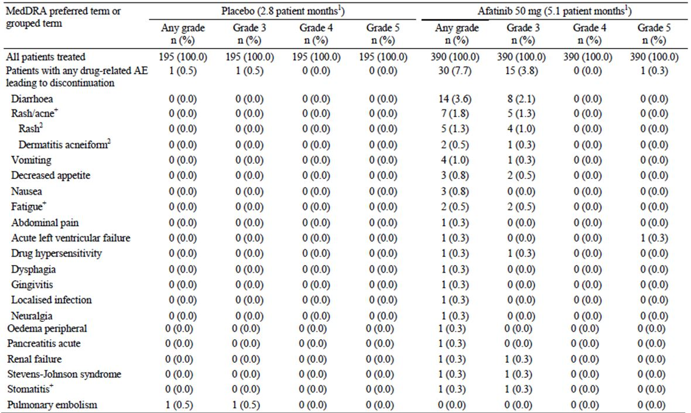

Study 1200.32 (vs. chemotherapy)
The incidence of AEs leading to discontinuation was comparable in the 2 groups (14.0% for afatinib and 15.3% for chemotherapy). For drug-related AE’s the incidences were 7.9% and 11.7%. These figures suggest that the toxicity of afatinib can be managed in a manner similar to chemotherapy. The pattern of individual adverse events leading to discontinuation is shown in Table 41. From this table it is notable that respiratory events (ILD and ARDS) were responsible for a number of discontinuations.
Table 41: Drug related AEs leading to discontinuation vs. chemotherapy.
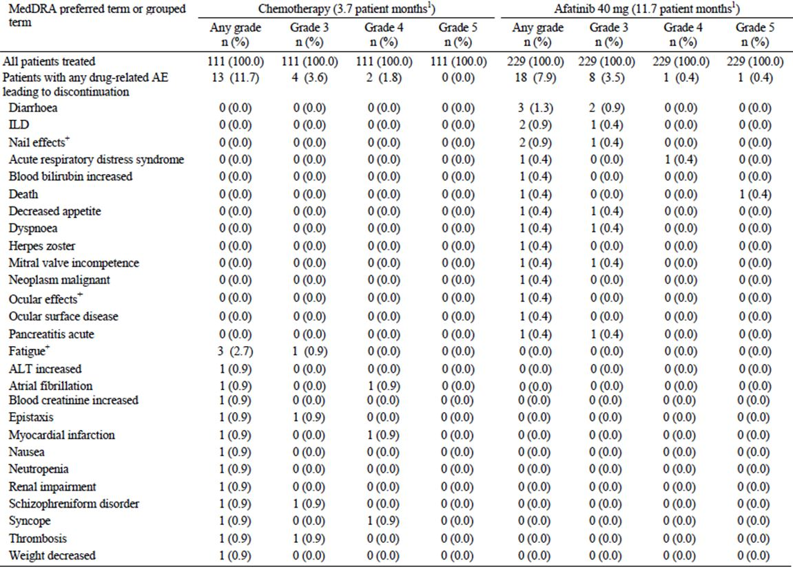

Other studies
In the SAF-2, SAF-4 and SAF-5 datasets, the pattern of adverse events leading to discontinuation was similar to that described above, with GIT and skin toxicity being prominent.

Adverse events of special interest

Diarrhoea and its consequences
In both the randomised controlled trials (RCTs), the incidence of diarrhoea was higher in the afatinib group than in the comparator group.
All protocols in the development program for afatinib included guidance on the management of diarrhoea, advising close monitoring and proactive management with hydration and use of loperamide. Any patient with grade 2 or 3 diarrhoea who did not respond to treatment was required to interrupt afatinib administration and undergo dose reduction; patients not recovering within 14 days were to discontinue afatinib treatment. In the RCTs approximately 20% of subjects required dose reduction or interruption because of diarrhoea. As a result of the management recommendations, few patients discontinued treatment due to diarrhoea. Analysis of the time to onset indicated that most patients who developed diarrhoea did so within the first 14 days.
Dehydration was reported as an AE in 3.1% of afatinib-treated subjects in study 1200.32 and 4.6% in study 1200.23.

Rash/acne
Rash/acne was a very common toxicity with afatinib in the RCTs, with incidences of 90% in 1200.32 and 78% in 1200.23. Dose interruption or reduction was required in 15-20% of subjects because of rash or acne. However, few patients were discontinued (<2%). For patients who developed rash/acne, >65% did so by day 28 of treatment.
PPE syndrome was reported by 6.6% of afatinib-treated subjects in 1200.32 and 7.7% in 1200.23.

Stomatitis
Stomatitis was also a very common adverse event, occurring in 73% of subjects in 1200.32 and 61% in 1200.23. Dose reduction was required in up to 10% of subjects. In the majority of patients the condition developed within the first 28 days of treatment.

Ocular effects
The incidence of ‘ocular effects’ was higher in the afatinib group in both the RCTs. The most common AEs were conjunctivitis and dry eye. The effects were generally grade 1 or 2 in severity.

Cardiac failure
Afatinib is an inhibitor of HER-2. Other HER-2 inhibitors (lapatinib and trastuzumab) have been associated with the development impaired left ventricular function and cardiac failure.
LVEF was monitored in both of the RCTs, by echocardiography or MUGA scan. Potentially clinically significant changes in LVEF were defined as a ≥20% reduction from baseline and a decrease to below the institutional lower limit of normal (or to below 50% if the institutional lower limit of normal was not known). In study 1200.23 the incidence of such a change was 1.3% (5 subjects) with afatinib and 1.0% (2 subjects) with placebo. In study 1200.32, the incidence of such a change was 1.3% (3 subjects) with afatinib and 0.9% (1 subject) with chemotherapy. Details are show in Table 42.
Table 42: Changes in LVEF.
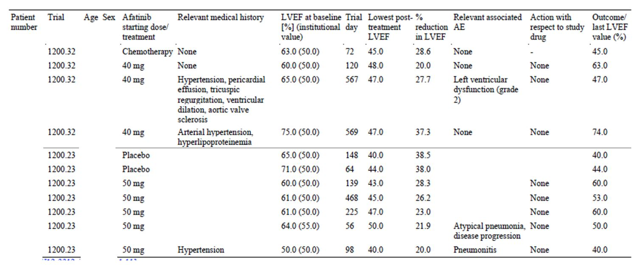
The incidence in the 2 RCTs of adverse events suggestive of cardiac failure is shown in Table 43. The incidence of such events was only slightly higher in the afatinib arms. It should be noted that subjects at risk of cardiac failure were generally excluded from clinical trials.
Table 43: Cardiac failure AEs.
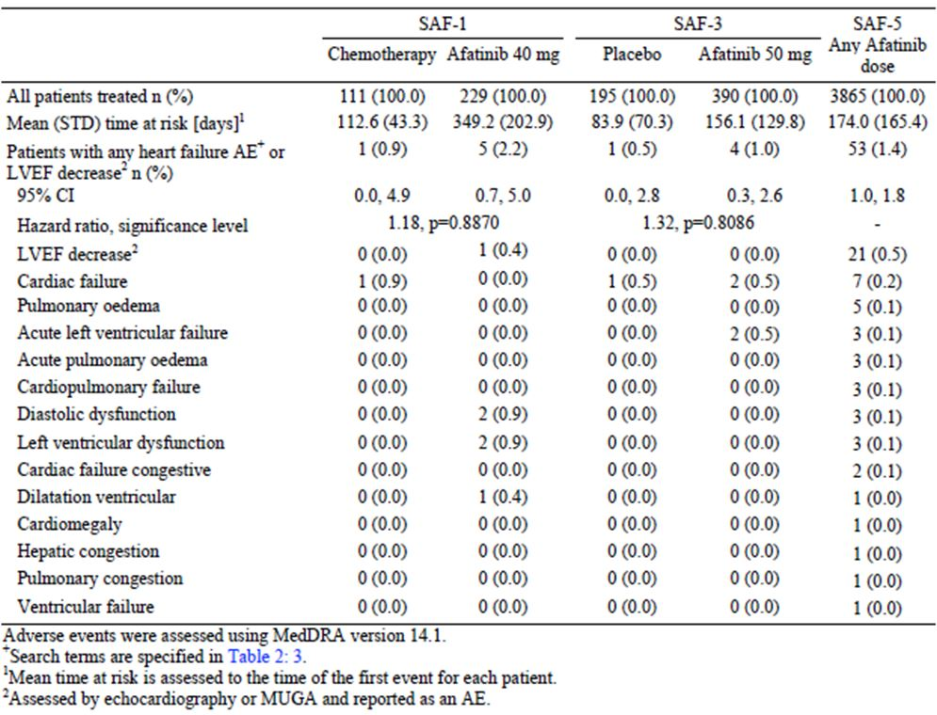

Interstitial lung disease (ILD)
ILD is a potentially serious AE that is known to occur with gefitinib and erlotinib. The incidence of ILD-like events in the two RCTs is shown in Table 44, and the incidence in the SAF-5 data set is shown in Table 45. ILD-like events were more common in the afatinib groups in the 2 RCTs but overall incidence was low.
Table 44: ILD AEs in randomised controlled trials.
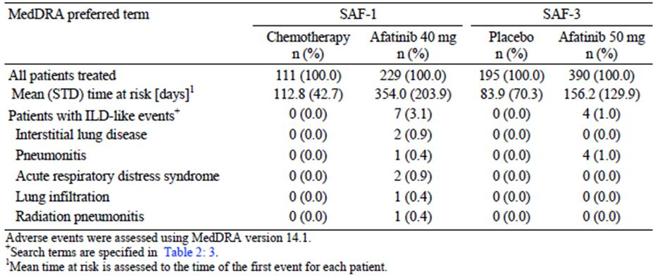
Table 45: ILD AEs in SAF-5 dataset.
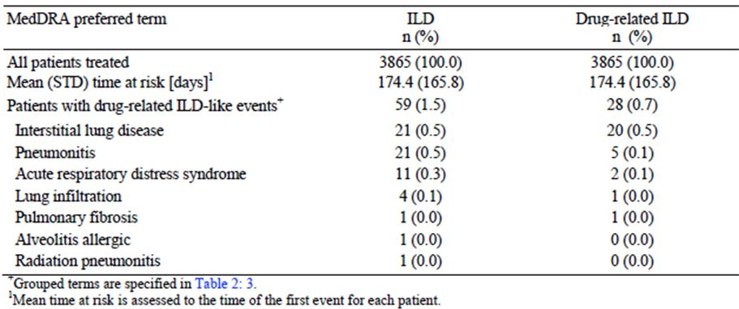
Of the 28 drug-related cases identified in the SAF-5 dataset, 20 cases (71%) were classified as SAEs and 5 cases (18%) had a fatal outcome, illustrating the serious nature of this condition.

Other AEs of special interest
In study 1200.23, the incidence of vomiting was higher with afatinib compared to placebo (20.3% vs. 13.3%) but the incidence of nausea was comparable. In study 1200.32, the incidence of nausea and vomiting was significantly lower in the afatinib arm than in the chemotherapy arm.
In study 1200.32 the incidence of leukopaenia (including the AE terms of leukopenia, lymphopaenia, neutropenia, decreased neutrophil count, and decreased white blood cell count) was higher with chemotherapy (43.2% vs. 4.8%). Similarly the incidence of peripheral neuropathy (including the terms hypoaesthesia, peripheral neuropathy, paraesthesia, peripheral sensory neuropathy, and muscular weakness) as was lower with afatinib (19.8% vs. 10.9%).

Other potentially clinically significant adverse events
The sponsor analysed a number of other clinically significant AEs occurring in the 2 RCTs. Given that the twice as many patients were randomised to afatinib, these data do not indicate an increased risk of cerebrovascular accident or myocardial infarction with the drug. Similar analyses did not suggest an increased risk of anaphylaxis or GIT perforation.

Pancreatitis
In study 1200.23, there were 4 cases of pancreatitis in the afatinib arm vs. none in the placebo arm. In study 1200.32 there was 1 case in the afatinib arm. In the SAF-5 dataset, a total of 13 cases were reported.
Comment: It is noteworthy that asymptomatic grade 3 and grade 4 lipase elevations were observed in a number of the clinical pharmacology studies (1200.86, 1200.151 and 1200.152). Lipase or amylase were not routinely monitored in the 2 RCTs. Pancreatitis is listed as an uncommon adverse reaction in the Australian PI for gefitinib, but not for erlotinib. In the opinion of this evaluator, the evidence is sufficient to indicate that afatinib treatment may cause pancreatitis.

Embolic and thrombotic events
In study 1200.23, there was an increased incidence of embolic or thrombotic AEs in the afatinib arm (22 vs. 4 patients) as shown in Table 46. When corrected for the longer period of treatment with afatinib, the difference was less notable (0.13 vs. 0.09 events per patient year of treatment). In study 1200.32 there was no apparent increase (7 patients in each arm) and when corrected for treatment duration, afatinib treatment was associated with a decreased incidence compared to chemotherapy (0.03 vs. 0.21 events per patient year).
Table 46: Embolic and thrombotic AEs in study 1200.23.
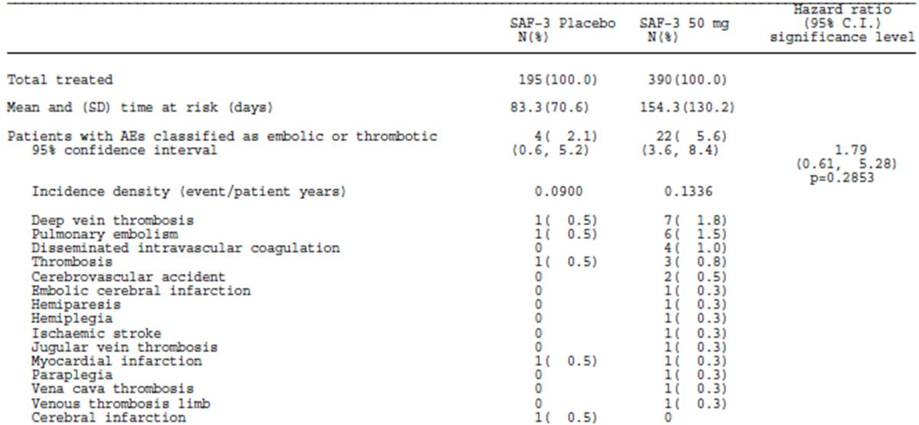
Incidence rates are calculated using number of patients with the respective events per treatment divided by time at risk expressed as patient years. Cut off date: 9 February 2012.
Comment: On balance it is reasonable to include that afatinib does not increase the risk of these events.

Laboratory tests

Liver function
Results of liver function testing (AST, ALT and ALP) are shown in Table 47. In both of the RCTs, afatinib treatment was associated with an increased incidence of elevated LFTs.
Table 47: Liver function tests.
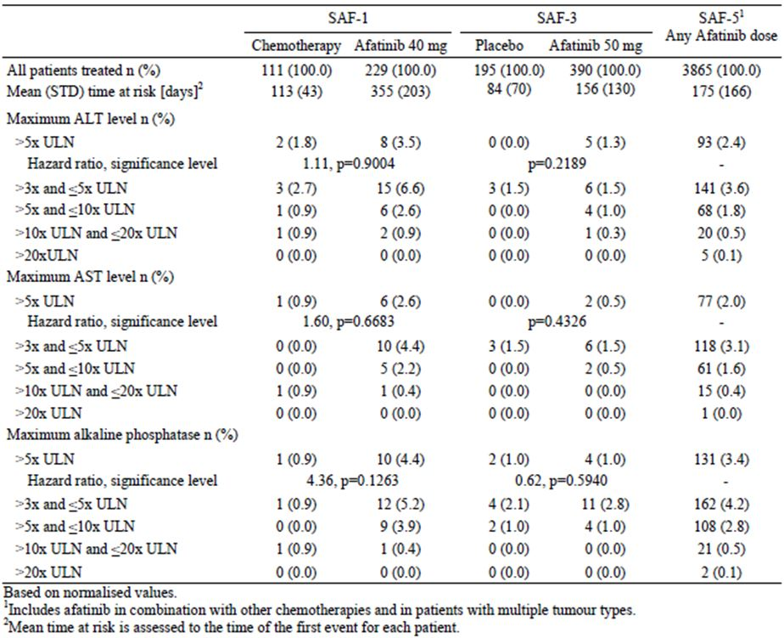
The incidences of hepatic impairment adverse events in the 2 RCTs are shown in Table 48. Again the incidence of these events was higher in the afatinib arms of the trials.
Table 48: Hepatic impairments AEs.
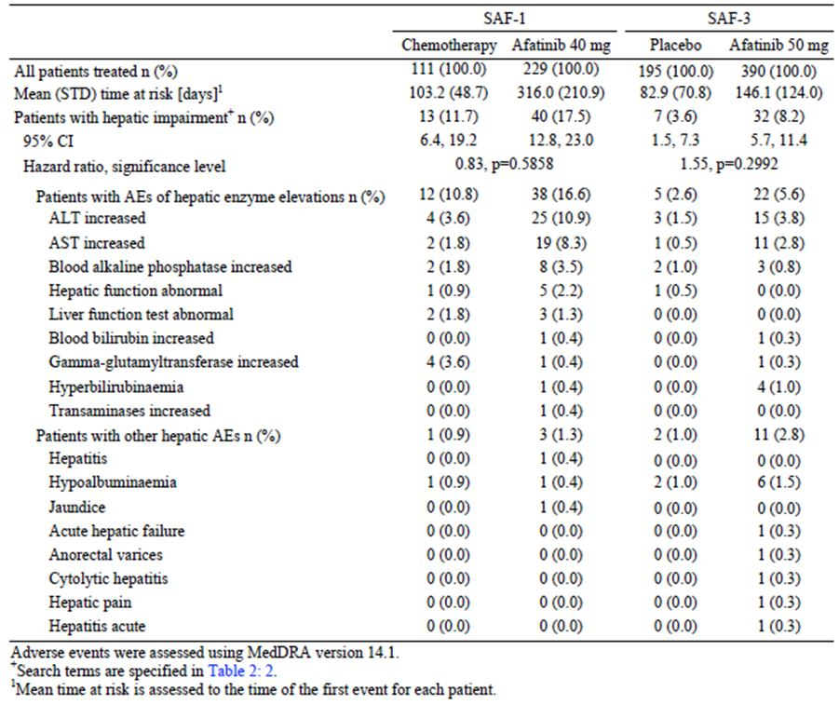
The sponsor presented an analysis of those patients who could potentially be considered as meeting Hy’s Law criteria (i.e. elevated AST/ALT to ≥3× the ULN, elevated bilirubin to >2× ULN, normal ALP and no other cause found). In the SAF-5 dataset, 7 patients met the LFT criteria for Hy’s Law. Four of these patients were receiving afatinib in combination with chemotherapy, and the other 3 were receiving the drug as monotherapy. None of the 7 was considered to fully meet the Hy’s Law criteria. All 4 combination therapy cases had increasing alkaline phosphatase elevations at the time of the bilirubin elevation and of the 3 patients receiving afatinib monotherapy 1 patient had confirmed tumour obstruction of the bile duct, 1 patient had infectious hepatitis, and 1 patient with a history of cholecystitis had transient elevations with rapid recovery and continued afatinib treatment without recurrence of the event.
Hy’s Law cases are predictive of an increased risk idiosyncratic severe drug-induced liver injury (DILI) – i.e. liver injury that results in death or liver transplant. There were three hepatic adverse events with fatal outcome that were considered by the investigator to be at least possibly related to afatinib. None of these events provide convincing evidence of severe drug-induced liver injury due to afatinib:
- One subject [information redacted] in study 1200.23 who developed frequent vomiting, oliguria and acute renal failure after approximately 10 days of afatinib exposure. The patient was diagnosed with acute hepatic failure at the same time, but no LFT results were provided. According to the summary of clinical efficacy, the patient also had hepatitis B infection. The patient died approximately 1 month later. No autopsy was performed.
- One subject [information redacted] in study 1200.42 who received afatinib for 78 days and presented with acute dyspnoea and a large pleural effusion. The subject died 2 days later. At presentation she was also diagnosed as having ‘acute cytolytic hepatitis’ but LFT results were not reported. Liver histology at autopsy showed shock liver.
- One subject [information redacted] in study 1200.42 presented with severe hepatic failure after 9 days of afatinib treatment, and died the following day. Liver histology at autopsy showed centrilobular necrosis, ‘large drops of fat’, cholestasis and minimal inflammatory changes. However, the patient had abnormal LFTs prior to commencing afatinib.

Kidney function
The incidences of renal laboratory testing abnormalities, and other renal AEs, in the 2 RCTs are shown in Table 49. In the placebo-controlled study, the incidence of renal impairment events was higher in the afatinib arm (5.4% vs. 1.5%). In study 1200.32, the comparator regimen included cisplatin, a known nephrotoxic agent. The incidence of renal impairment events was significantly higher in the chemotherapy arm. In both trials, the incidence of grade 3 renal impairment was low in the afatinib groups (1.8% and 1.3%). There were no cases of grade 4 impairment.
Table 49: Renal impairment AEs.
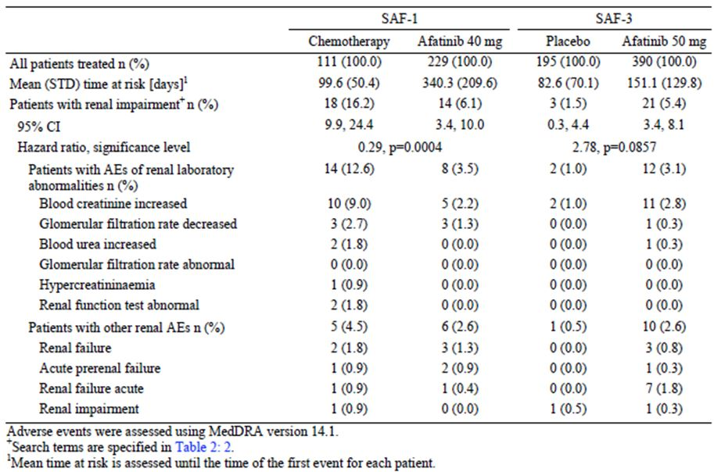

Haematology and other clinical chemistry parameters
The incidences of clinically significant changes in biochemistry and haematology laboratory tests in the 2 RCTs are shown in Table 50.
- Abnormalities of sodium and potassium were more frequent with afatinib treatment. This probably reflects the high incidence of diarrhoea with the drug.
- In study 1200.32, abnormalities of haematological parameters were much more common in the chemotherapy arm.
- In study 1200.23, there was no increase in the incidence of coagulation parameter abnormalities compared to placebo.
Table 50: Haematology and biochemistry: clinically significant abnormalities.
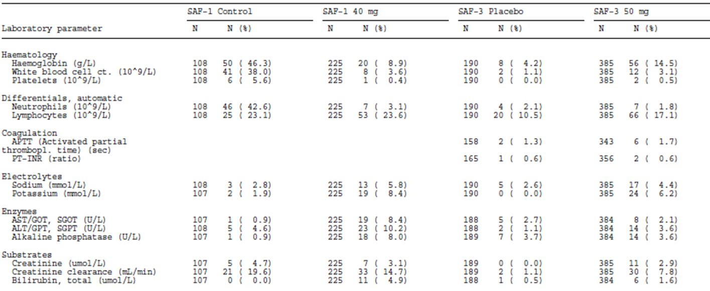
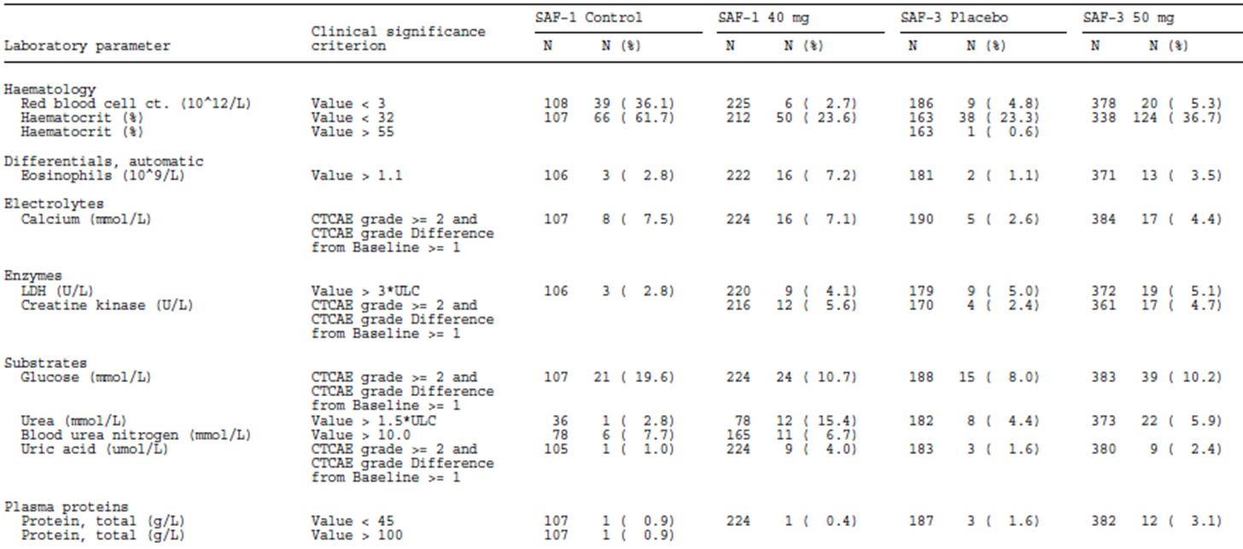

Electrocardiograph
Analysis of ECGs performed during the 2 RCTs did not reveal any clinically significant changes.

LVEF
Data obtained from the monitoring of LVEF have been discussed.

Vital signs
There were no clinically significant changes in the mean values for vital signs in the 2 RCTs.

Post-marketing experience
There were no post-marketing data submitted.

Safety issues with the potential for major regulatory impact

Liver toxicity
Afatinib is associated with hepatic toxicity. However, no cases met the criteria for Hy’s Law. At the current time the evidence does not suggest that the drug will be associated with severe drug-induced liver injury.

Haematological toxicity
The submitted data demonstrate that afatinib has less haematological toxicity than cisplatin/pemetrexed chemotherapy. In the SAF-5 dataset there were no reports of drug-related agranulocytosis or aplastic anaemia. However there were 4 reports of drug-related pancytopaenia and 3 reports of drug-related bone marrow failure. The sponsor should be asked to clarify whether there is any suggestion that these events might represent episodes of idiosyncratic drug-induced haematological toxicity.

Serious skin reactions
As discussed above, skin toxicity occurs frequently with afatinib. Among patients treated in the clinical trials there were 2 patients who were considered to have Stevens-Johnson syndrome.

Cardiovascular safety
The submitted data indicate that, in common with other inhibitors of HER-2, afatinib treatment may be associated with a risk of impaired left ventricular function and cardiac failure.
Study 1200.24 demonstrated that afatinib is not likely to be associated with QT prolongation. The adverse event data do not suggest that the drug is associated with an increased risk of other cardiovascular events (e.g. myocardial infarction).

Unwanted immunological events
A search of the SAF-5 dataset using a standardised MEDRA query (SMQ) for anaphylaxis/hypersensitivity events identified 9 patients. However none of these had events consistent with severe immunological reactions. Four patients had shock (1 patient with shock due to sepsis and 3 patients with shock or circulatory collapse attributed to disease progression). In 1 patient the event was attributed to a bee sting. The remaining 4 patients experienced grade 1, non-serious events that recovered with no need for modification of afatinib therapy.

Other safety issues

Safety in special populations
The sponsor presented analyses of adverse events occurring in various subgroups. There were no notable differences in the incidence or pattern of AEs between genders. Patients aged ≥ 65 years had a higher incidence of grade 3 toxicities compared to younger patients. Similarly, patients with bodyweight ≤ 50 kg experienced more toxicity than heavier patients. There were no consistent notable differences between persons of Caucasian or Asian race. Impaired renal function at baseline was associated with a higher incidence of grade 3 toxicities.

Evaluator’s overall conclusions on clinical safety
The main safety issues associated with afatinib are as follows:
- Diarrhoea: This is a very common toxicity occurring in up to 96% of patients. Diarrhoea of grade 3 severity is also very common, occurring in ~15% of subjects, whereas no cases grade 4 diarrhoea occurred in the 2 randomised controlled trials (RCTs). Episodes meeting the definition of a serious adverse event (SAE) occurred in ~5-7% of subjects. The consequences of diarrhoea, such as dehydration, renal impairment and electrolyte disturbances, were also more common in afatinib treated subjects. In the clinical studies, diarrhoea was actively managed with dose interruption and reduction, rehydration and loperamide. These measures appear to have been successful in managing the condition as < 5% of patients discontinued afatinib due to diarrhoea.
- Stomatitis: This is also a very common AE, occurring in up to 73% of subjects. Grade 3 toxicity was common (3-8%) but grade 4 toxicity was uncommon. Serious AEs of stomatitis were infrequent (~1%). In the placebo controlled study only one subject discontinued treatment due to stomatitis and none in the pivotal study.
- Skin toxicity: Rash or acne was very common, being seen in up to 90% of subjects. Other skin and integument effects (nail effects, pruritus, dry skin) were also very common. Grade 3 events of rash were also very common, but the other skin/integument effects were mostly of grade 1 or 2 severity. Serious skin events were uncommon and less than 2% of subjects had to discontinue treatment due to skin effects.
- Ocular effects: These were generally conditions such as conjunctivitis, dry eyes and blepharitis. Severity was generally mild to moderate. However, cases of keratitis were also observed. Discontinuation of afatinib due to ocular effects was uncommon (<1%).
- Hepatic toxicity: In both RCTs, afatinib treatment was associated with an increased incidence of LFT abnormalities. At the current time the evidence does not suggest that the drug will be associated with severe drug induced liver injury.
- Interstitial lung disease (ILD): ILD like AEs occurred with a higher incidence in the afatinib group of both RCTs. The overall incidence in the SAF-5 database was 0.7%. Although uncommon, such events are usually serious and often fatal.
- Nasal effects: The incidence of minor nasal effects such as epistaxis, rhinorrhoea and nasopharyngitis was increased in the afatinib arms of the 2 RCTs.
- Impaired LVEF/cardiac failure: The data suggest that afatinib treatment may possibly be associated with a slightly increased risk of these events. The trials excluded subjects with pre existing cardiac failure.
- Pancreatitis: The data suggest that afatinib treatment may be associated with an increased risk of acute pancreatitis.
The above safety issues have generally been observed with other EGFR or HER-2 inhibitors.
In the pivotal Study 1200.32, the incidence of AEs, grade 3 or 4 AEs, SAEs, and AEs leading to discontinuation was approximately comparable in the afatinib and chemotherapy arms. However, the pattern of AEs differed, with more haematological toxicity, nausea, vomiting and constipation in the chemotherapy arm, and more diarrhoea, stomatitis, skin and ocular toxicity in the afatinib arm.
It should be noted that use of the incidence data from the 2 RCTs might overestimate the toxicity of afatinib relative to its comparators, as the duration of treatment in the afatinib arms was longer.

First round benefit-risk assessment

First round assessment of benefits
The benefits of afatinib in the proposed usage are:
In the first line setting (as shown in the pivotal Study 1200.32):
- A 42% reduction in the risk of PFS events (tumour progression or death), and a prolongation of median PFS of ~4.2 months (from 6.9 to 11.1), compared to cisplatin/pemetrexed chemotherapy.
- An increase in the probability of achieving an objective response (from 23% to 56%) compared to cisplatin/pemetrexed chemotherapy.
- An increase in the probability of achieving disease control (from 81% to 90%) compared to cisplatin/pemetrexed chemotherapy.
- Less cough and dyspnoea compared to cisplatin/pemetrexed chemotherapy.
- A reduction in the incidence of certain adverse effects associated with chemotherapy, including haematological toxicity, nausea and vomiting and constipation.
In the second line setting, after chemotherapy (as shown in Study 1200.22):
- An objective response in ~57%;
- A disease control rate of ~78%;
- A median PFS of ~8 months;
- A median OS of ~24 months.
After failure of chemotherapy and a prior EGFR TKI (as shown in Study 1200.23):
- A 62% reduction in the risk of PFS events, and a prolongation of median PFS of ~2.2 months (from 1.1 to 3.3), compared to placebo.
- An increase in the probability of achieving an objective response (from 0.5% to 7.4%) compared to placebo.
- An increase in the probability of achieving disease control (from 18.5% to 58.2%) compared to placebo.
- A delay in deterioration of cough, and an increase in the percentage of patients who had improvement in cough, dyspnoea or pain compared to placebo.

First round assessment of risks
The risks of afatinib in the proposed usage are:
- Gastrointestinal (especially diarrhoea and stomatitis) and dermatological adverse effects. These are very frequent and may be so severe as to warrant discontinuation of the drug in a small proportion of subjects;
- Ocular and nasal adverse effects. These are common but generally mild to moderate in severity;
- Hepatic toxicity usually manifested as abnormal liver function tests (LFTs). At this stage the available evidence does not indicate a potential for afatinib to cause severe drug induced liver impairment;
- Interstitial lung disease, which is uncommon but potentially life threatening when it occurs;
- Pancreatitis, which is also uncommon but serious;
- A possible increased risk of impaired LVEF and cardiac failure.
Overall, the incidence of adverse events etc. with afatinib appears comparable to that seen with an established NSCLC chemotherapy regimen (cisplatin/pemetrexed), although the pattern of individual adverse events differs. The pattern of AEs is similar to that seen with other EGFR TKIs such as gefitinib and erlotinib. The toxicity of the drug appears manageable (by dose reductions etc.) in that only 7-12% of patients have to discontinue treatment due to adverse events.

First round assessment of benefit-risk balance

First line use
The benefit-risk balance of afatinib, given as first line treatment, is favourable. The evidence indicates that the drug is more effective than cisplatin/pemetrexed with comparable overall toxicity. The risks associated with chemotherapy regimens such as cisplatin/pemetrexed are considered acceptable in the setting of advanced NSCLC. The other registered EGFR TKIs (gefitinib and erlotinib) are approved for use in the first line setting, and the efficacy results of the pivotal study appear comparable to those achieved with these agents in Phase III trials.

Second line use (after chemotherapy)
Although the evidence is limited to Phase II data, the benefit-risk balance of afatinib in this setting is considered favourable. The data on ORR and disease control rate (DCR) suggest that the drug remains highly effective even after failure of chemotherapy.

Use after failure of chemotherapy AND a prior EGFR TKI
The sponsor is proposing to include in the PI specific claims of efficacy in this population, as well as a specific starting dose of 50 mg per day. Use in this late line setting represents a novel use of EGFR TKIs, as neither of the other two drugs in the class has had such a claim approved. Patients with EGFR mutation positive advanced NSCLC who have already failed both chemotherapy and a prior EGFR TKI have no established therapeutic options and hence availability of a safe and effective agent would be an advance.
However, in the opinion of this evaluator, the benefit-risk balance of afatinib in this setting is considered is unfavourable. The efficacy benefits in terms of PFS, OS and response rate are modest, and are outweighed by the drug’s toxicity. Although there was some benefit associated with afatinib treatment in terms of delay in deterioration of coughing, this is likely to be outweighed by other symptoms caused by afatinib toxicity.
It is noted that, in the commentary that accompanied the publication of Study 1200.23, the activity of afatinib in patients progressing after erlotinib or gefitinib was describe as ‘marginal’.
If afatinib’s irreversible inhibition of EGFR gives it a true clinical advantage over the reversible inhibitors gefitinib and erlotinib, then the logical place for it would be in early therapy, not as a last resort after failure of these drugs. It is noteworthy that the sponsor has the following ongoing trials:
- A Phase IIb study comparing afatinib with gefitinib for the first line treatment EGFR mutation positive adenocarcinoma of the lung (‘LUX Lung 7’) with an estimated enrolment of 264 subjects; and
- A Phase III study comparing afatinib with erlotinib for the treatment of squamous cell lung cancer after at least one prior platinum based chemotherapy regimen (‘LUX Lung 8’) with an estimated enrolment of 800 subjects.

First round recommendation regarding authorisation
It is recommended that the application to register afatinib be approved, but with the following indication, which is more limited than that proposed by the sponsor:
As monotherapy, for the treatment of patients with locally advanced or metastatic non-small cell lung cancer (NSCLC) with activating mutations of the Epidermal Growth Factor Receptor (EGFR):
    - As first line therapy; or
    - After failure of cytotoxic chemotherapy.
The indication should specify use as monotherapy because the safety and efficacy of use in combination with chemotherapy have not been established.
It is recommended that the term ‘activating mutations’ be used, as it is used in the PIs for gefitinib and erlotinib and consistency of terminology would seem desirable.
The lack of an absolute bioavailability study is a significant deficiency in the application. However, as the risks and benefits of afatinib have been adequately characterised this deficiency is not considered grounds for rejection of the application.

Clinical questions

Pharmacokinetics
None.

Pharmacodynamics
None.

Efficacy
None.

Safety
In the SAF-5 dataset, there were 4 reports of drug related pancytopaenia and 3 reports of drug related bone marrow failure. Please provide any further information to address the concern that these events might represent episodes of idiosyncratic drug induced haematological toxicity.

In cardiology, the QT interval is a measure of the time between the start of the Q wave and the end of the T wave in the heart’s electrical cycle.
Miller VA, et al. (2012) Afatinib versus placebo for patients with advanced, metastatic non-small-cell lung cancer after failure of erlotinib, gefitinib, or both, and one or two lines of chemotherapy (LUX-Lung 1): a phase 2b/3 randomised trial. Lancet Oncol. 13: 528-538.
Jackman D, et al. (2010) Clinical Definition of Acquired Resistance to Epidermal Growth Factor Receptor Tyrosine Kinase Inhibitors in Non-Small-Cell Lung Cancer. J Clin Oncol. 28: 357-360.
European Medicines Agency, “Committee for Medicinal Products for Human Use (CHMP): Guideline on the evaluation of anticancer medicinal products in man (EMA/CHMP/205/95/Rev.4)”, 13 December 2012; European Medicines Agency, “Appendix 1 to the guideline on the evaluation of anticancer medicinal products in man: methodological consideration for using progression-free Survival (PFS) or disease-free survival (DFS) in confirmatory trials (EMA/CHMP/27994/2008/Rev.1)”, 13 December 2012.
National Comprehensive Cancer Network (NCCN), “NCCN Clinical Practice Guidelines in Oncology – Non-Small Cell Lung Cancer”, Version 2.2013.
Pao W, Chmielecki J. (2010) Rational, biologically based treatment of EGFR-mutant non-small-cell lung cancer. Nature Rev. Cancer 10: 760-774.
European Medicines Agency, “Committee for Medicinal Products for Human Use (CHMP): Guideline on the evaluation of anticancer medicinal products in man (EMA/CHMP/205/95/Rev.4)”, 13 December 2012; European Medicines Agency, “Appendix 1 to the guideline on the evaluation of anticancer medicinal products in man: methodological consideration for using progression-free Survival (PFS) or disease-free survival (DFS) in confirmatory trials (EMA/CHMP/27994/2008/Rev.1)”, 13 December 2012.
Pao W, Chmielecki J. (2010) Rational, biologically based treatment of EGFR-mutant non-small-cell lung cancer. Nature Rev. Cancer 10: 760-774.
Hirsch FR, Bunn PA. (2012) A new generation of EGFR tyrosine-kinase inhibitors in NSCLC. Lancet Oncol. 13: 442-443.
Miller VA, et al. (2012) Afatinib versus placebo for patients with advanced, metastatic non-small-cell lung cancer after failure of erlotinib, gefitinib, or both, and one or two lines of chemotherapy (LUX-Lung 1): a phase 2b/3 randomised trial. Lancet Oncol. 13: 528-538.
US National Institutes of Health, Clinical Trials.gov – NCT 01466660.
US National Institutes of Health, Clinical Trials.gov – NCT 01523587.

