This medicinal product is subject to additional monitoring in Australia. This will allow quick identification of new safety information. Healthcare professionals are asked to report any suspected adverse events at www.tga.gov.au/reporting-problems.

For further information on the scheme, see the Information for sponsors on the TGA website.

Australian Product Information
SCENESSE® afamelanotide Implant for subcutaneous use

Name of the medicine
Afamelanotide

Qualitative and quantitative composition
SCENESSE® (afamelanotide) implant is a controlled-release dosage form for subcutaneous administration. The active ingredient is afamelanotide acetate. Each SCENESSE® implant contains 16 mg of afamelanotide (equivalent to 18 mg of afamelanotide acetate), and 15.3-19.5 mg of polyglactin.
For the full list of excipients, see Section 6.1 List of excipients

Pharmaceutical form
SCENESSE® implant is a single, rod-shaped, solid white to off-white, bioresorbable and sterile implant approximately 1.7 cm in length and 1.45 mm in diameter. The implant core is comprised of the drug substance admixed with a polyglactin bioresorbable copolymer.

Clinical particulars

Therapeutic indications
SCENESSE® is indicated for prevention of phototoxicity in adult patients with erythropoietic protoporphyria (EPP).

Dose and method of administration
SCENESSE must only be initiated by a specialist physician having expertise in the management of Erythropoietic Protoporphyria (EPP).
SCENESSE should be administered by a healthcare professional. All healthcare professionals should be proficient in the subcutaneous implantation procedure and have completed the training program provided by CLINUVEL prior to administration of the SCENESSE® implant.
A single SCENESSE® 16 mg implant is inserted subcutaneously above the anterior supra-iliac crest every 2 months.
Method of administration
For subcutaneous use.
Instruction for use
Insert a single SCENESSE implant (containing 16 mg of afamelanotide) subcutaneously above the anterior supra-iliac crest.
Implant SCENESSE observing an aseptic technique. The following equipment is needed for the implant insertion:
- SCENESSE implant
- A 14 gauge (1.6 mm inner diameter) catheter with needle. Alternatively, a trocar and obturator of similar dimension can be used
- Sterile gloves
- Local anaesthetic, needle and syringe
- Blunt forceps suitable for removing the SCENESSE implant from the glass vial and placement of the SCENESSE implant
- Sterile gauze, adhesive bandage, pressure bandage
Step 1
Take the carton containing SCENESSE out of the refrigerator to allow the product to gradually warm up to ambient temperature.
Remove the seal and stopper from the glass vial containing SCENESSE. Use your hand to grasp the outer edge of the locking ring. Pull upwards using light to moderate force. Once the locking ring is removed, flip off the rubber stopper.
Remove the implant from the vial using the blunt forceps under aseptic conditions and place the implant on a sterile gauze.
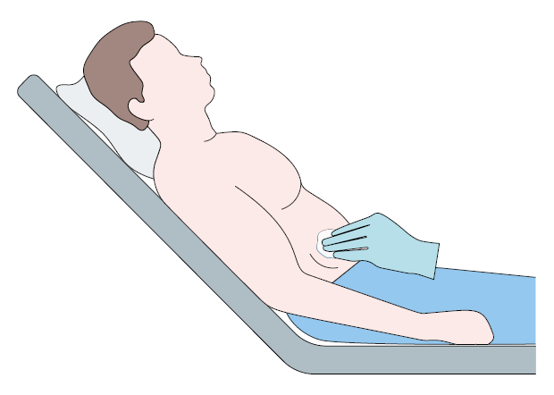 | Step 2  Put the patient in a comfortable reclined supine position. Identify the insertion site 3-4 cm above the anterior supra-iliac crest and disinfect the skin surface.
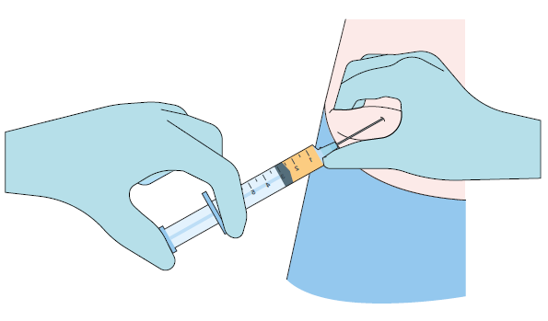 | Step 3 (optional)  Anesthetize the area of insertion (puncture) if deemed necessary and in consultation with the patient.
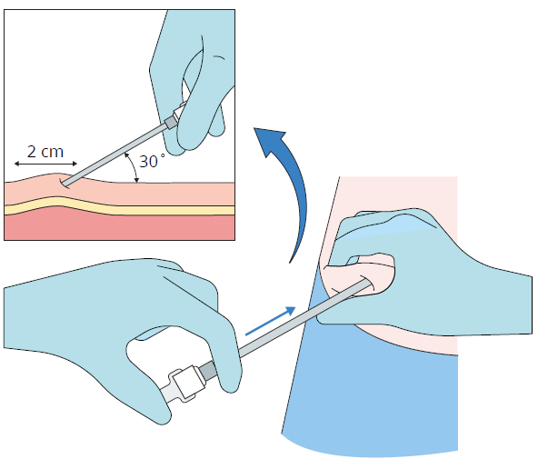 | Step 4  While pinching the skin of the insertion site, insert the catheter/trocar with the bevel facing upwards (away from the abdomen) at a 30-45° angle into the subcutaneous layer. Advance the catheter/trocar 2 cm into the subcutaneous layer.
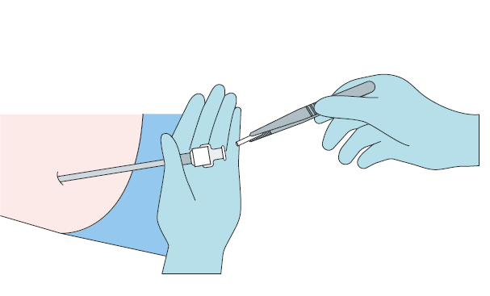 | Step 5  Remove the needle/obturator from the catheter/trocar sleeve maintaining aseptic precautions.  Load the implant into the catheter/trocar sleeve.  Using the needle/obturator gently push the implant down the full length of the catheter/trocar lumen.
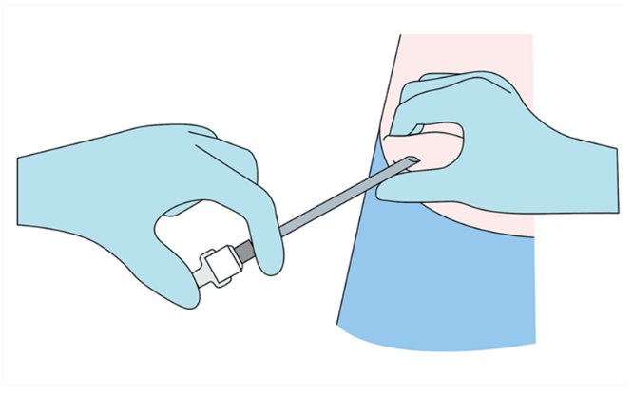 | Step 6  Apply some pressure to the site of the implant while removing the needle/obturator and the catheter/trocar sleeve. Verify that no implant or implant portion remains in the catheter/trocar sleeve.
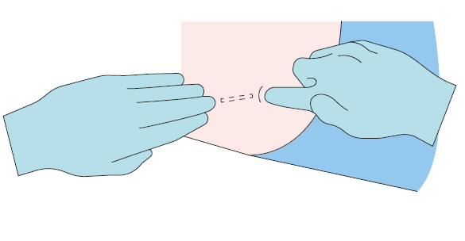 | Step 7  Verify the correct insertion and placement of the implant by palpating the skin overlying the implant with two fingers.
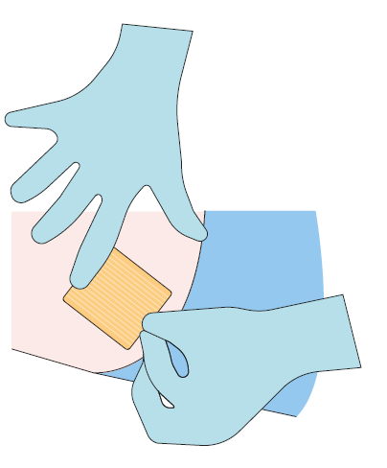 | Step 8  Apply dressing to the insertion site. Leave dressing in place for 24 hours.
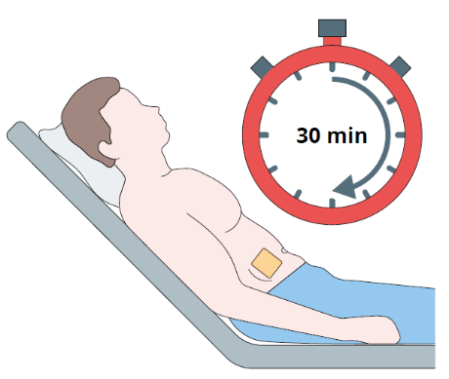 | Step 9  Monitor the patient for 30 minutes after the implant administration.
The implant can be surgically removed if needed. If it is necessary, implant removal is recommended within 96 hours of implantation.

Contraindications
- Hypersensitivity to the active substance or to any of the excipients listed in section 6.1
- Presence of severe hepatic disease
- Hepatic impairment (see section 4.4)
- Renal impairment (see section 4.4)

Special warnings and precautions for use
Concomitant disorders not studied
Clinically significant disorders of the gastrointestinal, cardiovascular, respiratory, endocrine (including diabetes, Cushing’s disease, Addison’s disease, Peutz-Jeghers syndrome), neurological (including seizures) and haematological (especially anaemia) systems have not been evaluated.
A careful decision must be made whether to treat patients with any of these conditions with this medicinal product. If such patients are treated, they must be monitored after each implant administration, including vital signs, routine haematology, and biochemistry.
Sun protection
It is recommended that sun protection measures routinely adopted by each patient to manage their photosensitivity related to EPP and in accordance with their skin type (Fitzpatrick scale) are maintained during treatment with this medicinal product.
Skin monitoring
Afamelanotide may induce darkening of pre-existing pigmentary lesions due to its pharmacological effect. A regular full body skin examination (every 6 months) is recommended to monitor all pigmentary lesions and other skin abnormalities.
If the skin changes noted are consistent with skin cancer or its precursors, or are ambiguous to the porphyria specialist, dermatology specialist consultation should be sought.
The two total full body skin examinations per year are intended to:
- detect early any skin cancers and their precursors induced by UV-exposure, as EPP patients can be expected to significantly increase their exposure to sunlight and UV light while on treatment with afamelanotide. EPP patients with fair skin may be more likely to request treatment and are more prone to developing UV light-associated skin changes, including cancer;
- detect and monitor changes in pigmentary lesions, thus allowing early detection of melanoma.
Special caution is warranted in patients with an:
- individual or family history of melanoma (inclusive of in-situ melanoma, e.g. lentigo maligna) or suspected or confirmed susceptibility to cutaneous melanoma (CMM1, MIM #155600, synonyms: familial atypical mole-malignant melanoma syndrome, FAMMM; dysplastic naevus syndrome, DNS; B-K mole syndrome; CMM2 MIM #155601)
and/or an
- individual history of basal cell carcinoma, squamous cell carcinoma (inclusive of carcinoma in situ, e.g. Bowen’s disease), Merkel cell carcinoma, or other malignant or premalignant skin lesions.

Use in the elderly
Since available data in treatment of the elderly are limited, afamelanotide should not be used in patients over 70 years of age. If such patients are treated, they must be monitored after administration of every implant, including vital signs, routine haematology and biochemistry.

Paediatric use
The safety and efficacy of afamelanotide in children and adolescents aged 0 to 17 years have not yet been established.

Effects on laboratory tests
No data available.

Long-term use
Long-term safety data for afamelanotide are limited.
The safety of this medicinal product has not been evaluated in clinical trials of duration longer than 2 years (see section 5.1).

Interactions with other medicines and other forms of interactions
No drug interaction studies were conducted with afamelanotide.
Inhibition of CYP enzymes and transporters by afamelanotide is not expected, nor for such inhibition to affect the pharmacokinetics of afamelanotide.
Patients taking substances which reduce coagulation, such as vitamin K antagonists (e.g. warfarin), acetylsalicylic acid and non-steroidal anti-inflammatory drug (NSAIDs) may experience increased bruising or bleeding at the site of implantation.

Fertility, pregnancy and lactation

Effects on fertility
There are no clinical data on the effects of afamelanotide on fertility. No effects on male or female fertility were observed with afamelanotide in rats at subcutaneous doses up to 20 mg/kg/day (12 times the maximum recommended human dose, based on body surface area comparison).

Use in pregnancy – Category B1
There are no or limited amounts of data from the use of afamelanotide in pregnant women.
No adverse effects on embryofoetal development were observed with afamelanotide in rats (albino and pigmented strains) at subcutaneous doses up to 20 mg/kg/day (12 times the maximum recommended human dose, based on body surface area comparison).
SCENESSE® should only be used during pregnancy, and for a period of three months following discontinuation of treatment, if the benefit to the mother outweighs the potential risk to the foetus.

Use in lactation
It is unknown whether afamelanotide or any of its metabolites are excreted in breast milk.
No clinical data are available on the use of afamelanotide in breastfeeding women.
Use of SCENESSE® during breastfeeding should consider the developmental and health benefits of breastfeeding, the clinical need of the mother, and the potential for adverse effects in the newborn/infant.

Effects on ability to drive and use machines
Afamelanotide has moderate influence on the ability to drive and use machines, especially within 72 hours of administration. Following administration of this medicinal product, somnolence, fatigue, dizziness, and nausea have been reported. Patients should not drive or use machines in case they are affected by these symptoms.

Adverse effects (Undesirable effects)
Clinical Trials Experience
The majority of subjects in both active and placebo groups experienced at least one Treatment Emergent Adverse Event (TEAE). For the majority of these subjects, the greatest severity of any TEAE was mild or moderate. In both groups, fewer than 50% reported any TEAE that was considered to be related to study drug.
Table 1 below presents a summary of the most common events (≥ 5%) observed in both afamelanotide and placebo groups. The most frequently observed AEs across patient populations were headache, nausea, nasopharyngitis, back pain and influenza.
Table 1
 | Number (%) of Subjects, Number of Events
Preferred term | All Studies**  Active  (N=230) | All Studies**  Placebo  (N=219)
Any event
Headache | 87 (38%) 258 | 75 (34%) 251
Nausea | 60 (26%) 107 | 35 (16%) 53
Nasopharyngitis | 41 (18%) 46 | 36 (16%) 43
Back pain | 23 (10%) 34 | 21 (9.6%) 43
Influenza | 23 (10%) 25 | 15 (6.8%) 17
Diarrhoea | 20 (8.7%) 25 | 22 (10%) 28
Fatigue | 19 (8.3%) 30 | 14 (6.4%) 30
Dizziness | 17 (7.4%) 23 | 9 (4.1%) 32
Abdominal pain | 16 (7.0%) 20 | 11 (5.0%) 14
Oropharyngeal pain | 14 (6.1%) 16 | 16 (7.3%) 24
Implant site pain | 14 (6.1%) 15 | 13 (5.9%) 15
Migraine | 13 (5.7%) 38 | 15 (6.8%) 32
Implant site discolouration | 13 (5.7%) 16 | 0 (0.0%) 0
Cough | 12 (5.2%) 13 | 13 (5.9%) 16
Arthralgia | 10 (4.3%) 14 | 12 (5.5%) 22
Toothache | 8 (3.5%) 11 | 12 (5.5%) 16
Sinusitis | 6 (2.6%) 6 | 12 (5.5%) 18
** Integrated Summary of Safety population: CUV010, CUV017, CUV029, CUV030 and CUV039
Summary of the safety profile
The safety profile is based on pooled data from clinical studies in 425 patients.
The most commonly reported adverse reactions are nausea, experienced by approximately 19% of subjects who received treatment with this medicinal product, headache (20%), and implant site reactions (21%; mainly discolouration, pain, haematoma, erythema). In most cases these adverse reactions are reported to be mild in severity.
Tabulated list of adverse reactions
The adverse reactions reported during clinical trials conducted with afamelanotide are listed in Table 2 below by MedDRA system organ class and frequency convention.
Frequencies are defined as: very common (≥1/10), common (≥1/100 to <1/10), uncommon (≥1/1,000 to <1/100), rare (≥1/10,000 to <1/1,000), very rare (<1/10,000) and not known (cannot be estimated from the available data).
Table 2
System Organ Class | Very common | Common | Uncommon
Infections and infestations |  | Upper respiratory tract infection | Influenza  Gastrointestinal infection  Gastroenteritis  Folliculitis  Candidiasis  Nasopharyngitis
Neoplasms benign, malignant and unspecified (incl cysts and polyps) |  |  | Haemangioma
Blood and lymphatic system disorders |  |  | Leukopenia
Metabolism and nutrition disorders |  | Decreased appetite | Hypercholesterolaemia  Increased appetite
Psychiatric disorders |  |  | Depression  Depressed mood  Insomnia
Nervous system disorders | Headache | Migraine  Dizziness  Lethargy  Somnolence | Syncope  Restless leg syndrome  Hyperaesthesia  Presyncope  Post-traumatic headache  Burning sensation  Poor quality sleep  Dysgeusia
Eye disorders |  |  | Eyelid oedema  Ocular hyperaemia  Dry eye  Presbyopia
Ear and labyrinth disorders |  |  | Tinnitus
Cardiac disorders |  |  | Palpitations  Tachycardia
Vascular disorders |  | Flushing  Hot flush | Haematoma  Diastolic hypertension  Hypertension
Respiratory, thoracic and mediastinal disorders |  |  | Dysphonia  Sinus congestion  Rhinitis  Nasal congestion
Gastrointestinal disorders | Nausea | Abdominal pain  Abdominal pain upper  Diarrhoea  Vomiting | Lip oedema  Lip swelling  Gastroesophageal reflux disease  Gastritis  Dyspepsia  Cheilitis  Abdominal distension  Gingival pain  Abdominal discomfort  Toothache  Abdominal symptom  Bowel movement irregularity  Flatulence  Gingival discolouration  Hypoaesthesia oral  Lip discolouration  Tongue discoloration
Skin and subcutaneous tissue disorders |  | Erythema  Melanocytic naevus  Pigmentation disorder  Skin discolouration  Skin hyperpigmentation  Ephelides  Pruritus | Lichen planus  Rash vesicular  Pruritus generalised  Rash  Rash erythematous  Rash papular  Rash pruritic  Skin irritation  Vitiligo  Acne  Eczema  Pigmentation lip  Post inflammatory pigmentation change  Seborrhoea  Skin exfoliation  Skin hypopigmentation  Hair colour changes  Hyperhidrosis
Musculoskeletal and connective tissue disorders |  | Back pain | Arthralgia  Myalgia  Pain in extremity  Muscle spasm  Musculoskeletal pain  Musculoskeletal stiffness  Joint stiffness  Groin pain  Sensation of heaviness
Renal and urinary disorders |  |  | Cystitis
Reproductive system and breast disorders |  |  | Menorrhagia  Dysmenorrhoea  Breast tenderness  Menstruation irregular  Vaginal discharge  Libido decreased
General disorders and administration site conditions |  | Implant site hypersensitivity  Implant site reaction  Implant site pain  Implant site haematoma  Implant site erythema  Implant site irritation  Asthenia  Fatigue  Implant site discolouration  Feeling hot | Oedema peripheral  Oedema mucosal  Pain  Implant site oedema  Pyrexia  Chills  Injection site haematoma  Injection site irritation  Implant site hypertrophy  Implant site pruritus  Device expulsion  Application site discolouration  Hangover  Influenza like illness
Investigations |  | Blood creatine phosphokinase increased | Alanine aminotransferase increased  Aspartate aminotransferase increased  Liver function test abnormal  Transaminases increased  Transferrin saturation decreased  Blood cholesterol increased  Blood glucose increased  Blood iron decreased  Blood pressure diastolic increased  Blood urine present  Biopsy skin
Injury, poisoning and procedural complications |  |  | Wound complication  Open wound  Fall  Procedural nausea
Post-marketing Experience
Marketing authorisation was obtained in the European Union in December 2014. SCENESSE® has been commercially distributed in Europe, predominantly via a post-authorisation safety study (PASS)/ disease registry study, and partly through an expanded access program in Switzerland and Italy. All treating physicians within the European Union follow a treatment protocol which mandates reporting of adverse reactions.
Adverse reactions reported to CLINUVEL under these programs are listed in Table 3 and include data obtained from approximately 1,200 SCENESSE® administrations. Given the limited clinical use of SCENESSE® in a relatively small patient population since obtaining marketing authorisation in Europe, the reported adverse reaction incidence should be regarded as preliminary at this time.
Table 3
System Organ Class | Very common | Common | Uncommon
Infections and infestations |  |  | Influenza  Viral upper respiratory tract infection
Metabolism and nutrition disorders |  | Decreased appetite
Psychiatric disorders |  |  | Insomnia
Nervous system disorders | Headache | Dizziness  Somnolence | Dysgeusia  Migraine
Ear and labyrinth disorders |  |  | Tinnitus
Vascular disorders |  | Flushing  Hot flush | Haematoma
Gastrointestinal disorders | Nausea |  | Abdominal distension  Abdominal discomfort  Abdominal pain  Abdominal pain upper  Diarrhoea  Dyspepsia
Skin and subcutaneous tissue disorders |  | Pigmentation disorder | Acne  Erythema  Hyperhidrosis  Pruritus  Pigmentation lip  Rash  Seborrhoea
General disorders and administration site conditions |  | Asthenia  Fatigue  Implant site pain | Feeling hot  Implant site discoloration  Implant site haematoma  Implant site haemorrhage  Implant site pruritus  Influenza like illness  Malaise  Pain

Reporting suspected adverse effects
Reporting suspected adverse reactions after registration of the medicinal product is important. It allows continued monitoring of the benefit-risk balance of the medicinal product. Healthcare professionals are asked to report any suspected adverse reactions at www.tga.gov.au/reporting-problems.

Overdose
There are no data available on symptoms or treatment of overdose with afamelanotide.
For information on the management of overdose, contact the Poisons Information Centre on 13 11 26 (Australia).

Pharmacological properties

Pharmacodynamic properties
Pharmacotherapeutic group: Emollients and protectives, protectives against UV-radiation for systemic use, ATC code: D02BB02

Mechanism of action
Afamelanotide is a synthetic tridecapeptide and a structural analogue of α-melanocyte stimulating hormone (α-MSH). Afamelanotide is a melanocortin receptor agonist and binds predominantly to the melanocortin-1 receptor (MC1-R). It acts with 4-fold greater potency than α-MSH in vitro and, due to increased resistance to proteolysis, has a longer duration of action in vivo.
Activation of the MC1-R receptor by afamelanotide stimulates the synthesis of eumelanin in melanocytes.
Eumelanin contributes to photoprotection through different mechanisms including:
- strong broadband absorption of UV and visible light, where eumelanin acts as a filter
- antioxidant activity through scavenging of free radicals; and
- inactivation of the superoxide anion and increased availability of superoxide dismutase to reduce oxidative stress.

Clinical trials
Five clinical studies were undertaken to establish the safety and effectiveness of SCENESSE® in patients with EPP. These included a pilot study, a study involving a multiple crossover (alternating active and placebo) design and three placebo-controlled studies.
The three placebo-controlled trials of SCENESSE® were conducted in subjects with EPP. Of these trials, two trials (Study CUV039 and Study CUV029) were designed to assess exposure to direct sunlight on days with no phototoxic pain. The two trials differed in the number of days of follow-up, the time windows within a day in which time spent outdoors was recorded, and how the amount of time spent in direct sunlight on each day was characterised. The subjects enrolled in these trials were primarily Caucasian (98%), the mean age was 40 years (range 18 to 74 years), and 53% of subjects were male and 47% were female.
Study CUV039 enrolled 93 subjects, of whom 48 received SCENESSE® (16 mg of afamelanotide administered subcutaneously every 2 months), 45 received vehicle. Subjects received three implants and were followed for 180 days. On each study day, subjects recorded the number of hours spent in direct sunlight and in shade (between10am and 6pm), and whether they experienced any phototoxic pain that day. The primary endpoint was the total number of hours spent in direct sunlight on days with no pain, over 180 days. The median total number of hours spent in direct sunlight on days with no pain was 64.1 hours for subjects receiving SCENESSE® and 40.5 hours for subjects receiving placebo.
Study CUV029 enrolled 74 subjects, of whom 38 received SCENESSE® (16 mg of afamelanotide administered subcutaneously every 2 months), 36 received vehicle. Subjects received five implants and were followed for 270 days. On each study day, subjects recorded the number of hours spent in direct sunlight, shade, or a combination of both (between 10am and 3pm), and whether they experienced any phototoxic pain that day. The primary endpoint was the total number of hours over 270 days spent outdoors with no pain for which “most of the day” was spent in direct sunlight. The median total number of hours over 270 days spent outdoors on days with no pain for which “most of the day” was spent in direct sunlight was 6.0 hours for subjects in the SCENESSE® group and 0.75 hours for subjects in the placebo group.
There is no clinical evidence to determine whether SCENESSE is protective against long term effects of phototoxicity such as scarring or skin changes resulting from exposure to light.

Pharmacokinetic properties
The pharmacokinetics of afamelanotide following administration of a single subcutaneous implant of SCENESSE® were evaluated in 12 healthy adults. High variability was observed in the plasma concentrations of afamelanotide and for most subjects (9 out of 12), the last measurable afamelanotide concentration was at 96 hours post-dose. The mean ± SD C_{max} and AUC_{0-inf} were 3.7 ± 1.3 ng/mL and 138.9 ± 42.6 hr*ng/mL, respectively.

Absorption
The median T_{max} following implant administration was 36 hr.

Metabolism
Afamelanotide is degraded into smaller peptide fragments by hydrolysis and not via oxidative metabolism by CYP enzymes.

Excretion
The apparent half-life of afamelanotide is approximately 15 hr when administered subcutaneously in a controlled release implant. Peptide fragments of afamelanotide are excreted renally.

Preclinical safety data

Genotoxicity
Afamelanotide was negative for genotoxicity in the bacterial reverse mutation assay (Ames test), in vitro mouse lymphoma assay, and in vivo mouse bone marrow micronucleus assay.

Carcinogenicity
Carcinogenicity studies have not been conducted with afamelanotide. In vitro, afamelanotide was shown not to stimulate cell proliferation in cultured human melanoma cells expressing MC1-R.

Pharmaceutical particulars

List of excipients
Polyglactin

Incompatibilities
Incompatibilities were either not assessed or not identified as part of the registration of this medicine.

Shelf life
In Australia, information on the shelf life can be found on the public summary of the Australian Register of Therapeutic Goods (ARTG). The expiry date can be found on the packaging.

Special precautions for storage
Store in a refrigerator at 2°C – 8°C. Protect from light.

Nature and contents of container
SCENESSE® (afamelanotide) implant, 16 mg, for subcutaneous administration is supplied in a Type I amber glass vial sealed with a PTFE coated rubber stopper. Each vial contains one afamelanotide implant and is packaged individually in a cardboard box.
SCENESSE® implants are not supplied with an implantation device for subcutaneous administration [see Dosage and Administration].

Special precautions for disposal
For instructions on correct administration and preparation see section 4.2.
In Australia, any unused medicine or waste material should be disposed of in accordance with local requirements.

Physicochemical properties

Chemical structure
Ac-Ser-Tyr-Ser-Nle-Glu-His-(D)Phe-Arg-Trp-Gly-Lys-Pro-Val-NH₂
1 2 3 4 5 6 7 8 9 10 11 12 13

CAS number
75921-69-6

Medicine schedule (Poisons Standard)
Schedule 4 – Prescription Only Medicine

Sponsor
CLINUVEL PHARMACEUTICALS LTD
Level 11, 535 Bourke Street
Melbourne VIC 3000
Phone: 03 9660 4900
www.clinuvel.com.au

Date of first approval
22 October 2020

Date of revision
N/A

Summary table of changes
Section Changed | Summary of new information
n/a

